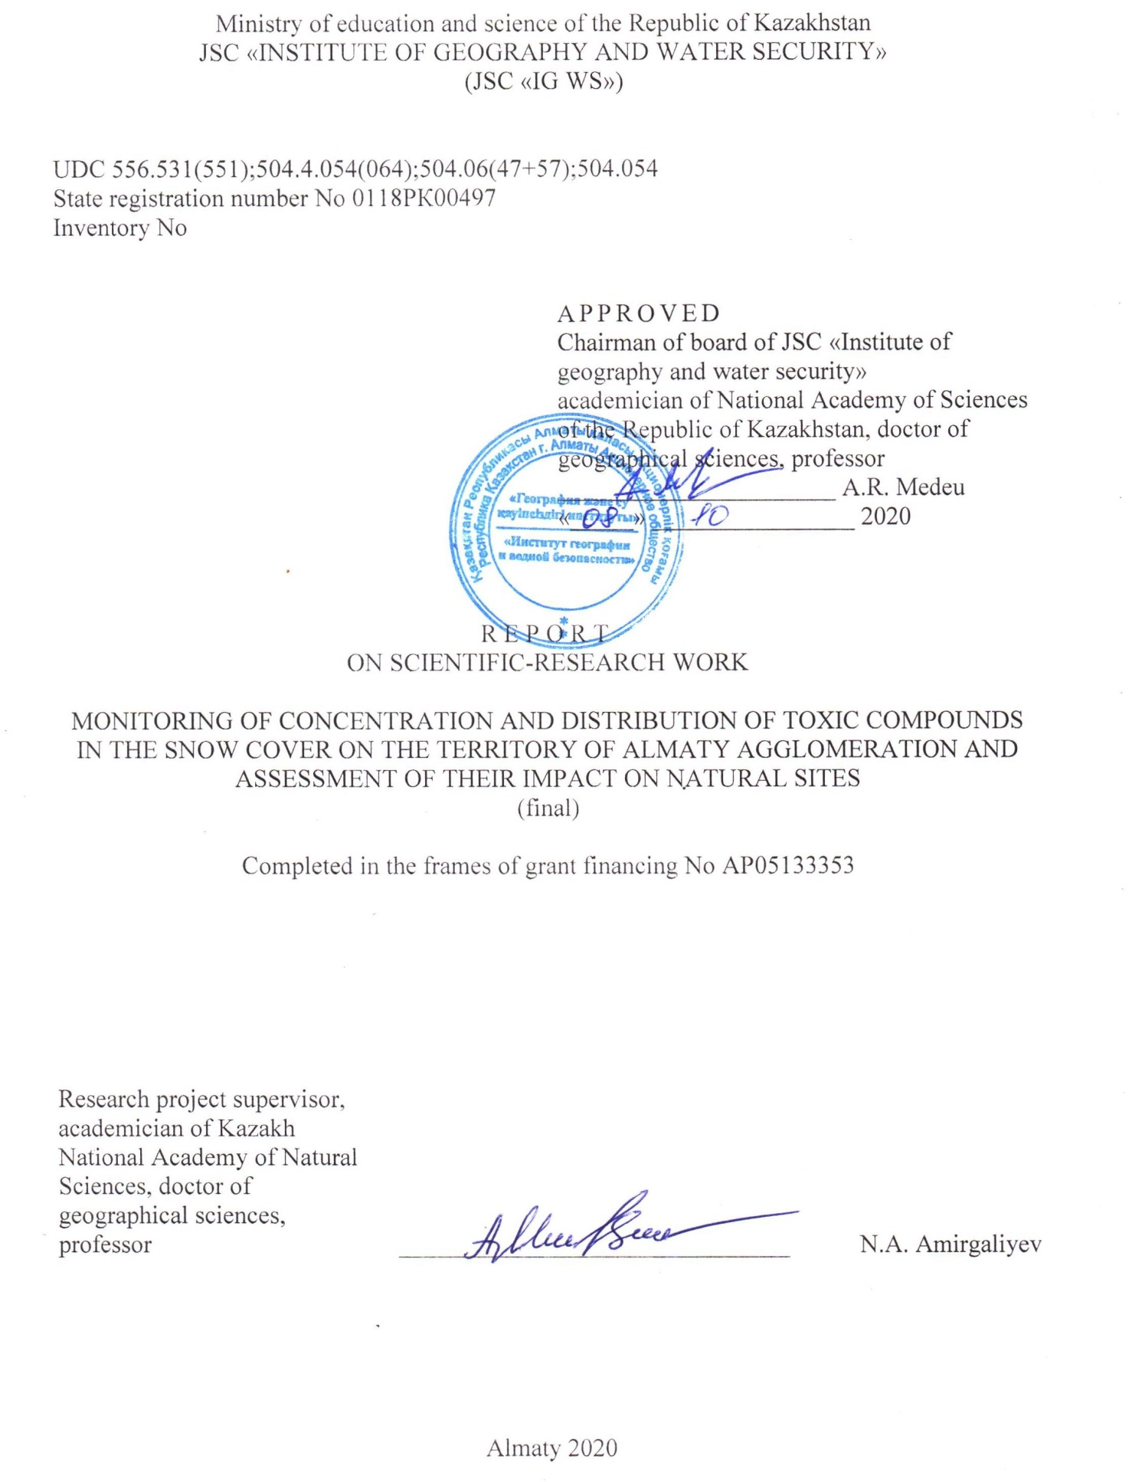

LIST OF PARTICIPANTS

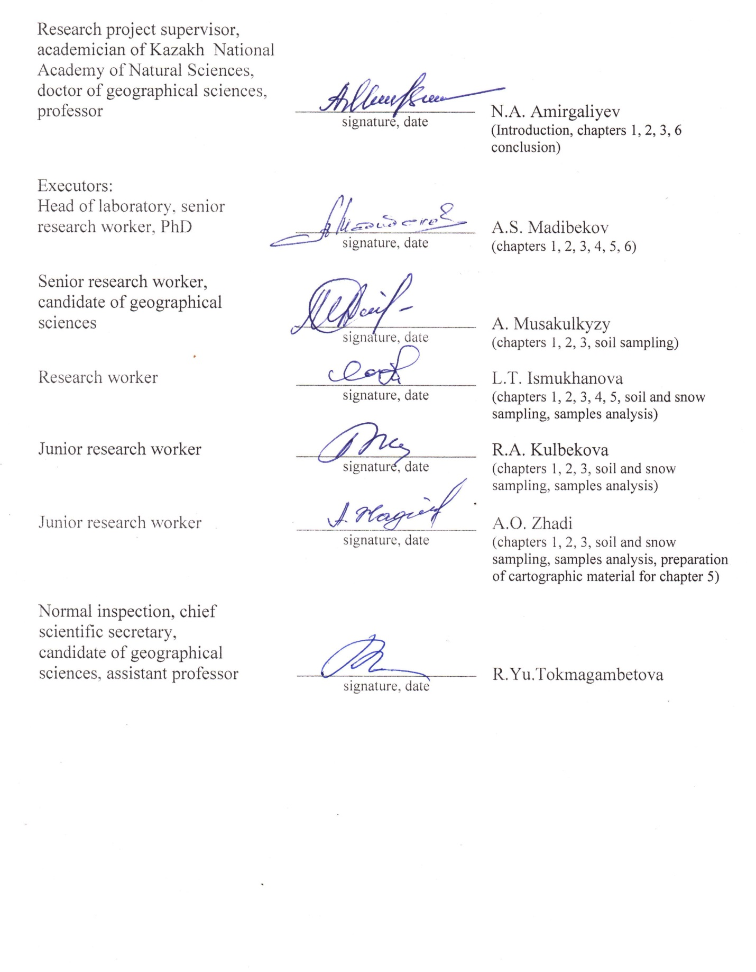

ABSTRACT

Report 159 p., 3 tables, 76 references, 10 appendices.
AGGLOMERATION, SNOW COVER, HYDROCHEMISTRY, TOXICOLOGY, CONTAMINANTS
The object of study is the territory of Almaty agglomeration.
Project Goal – To provide a comprehensive environmental and analytical assessment of the degree of pollution of natural object by toxic compounds by their content in snow cover
In the course of research, chemical-analytical, chromatographic, atomic absorption, technologies for information processing were used.
The obtained results and novelty: in the final report for 2018-2020, in accordance with the requirements specification during the field researches, samples of snow, water and soil were collected, which were subsequently analyzed in the laboratory conditions. Chemical analyzes were made for: pH, salt composition, organic matters by permanganate oxidizability, mineralization and suspended matters. Spectrophotometric determination of heavy metals (HM) and chromatographic determination of polychlorinated biphenyls (PCBs) were made. On the basis of the obtained analytical material, the characteristics of chemical composition of snow cover (SC), water of Kapshagai reservoir (KR), as well as HM and PCBs in SC, water and soil are presented, taking into account peculiarities of their distribution in Almaty agglomeration (AA).
For the first time for the territory of AA, a comprehensive assessment of the pollution of SC and assessment of the impact of toxic compounds to the natural objects was made. The ranking of the agglomeration territory according to the degree of pollution was carried out and recommendations for the maintaining the normative level of quality of the studied natural environments were developed.
The main constructive indicators: The obtained data will make it possible to give objective assessment of the chemical composition and degree of SC pollution and on that basis, the degree of anthropogenic load to the ecosystem of AA territory is ranked.
Degree of implementation – published in total 12 (twelve) articles, from them 3 (three) articles in scientific edition indexed in the Scopus database, 1 (one) article in peer-reviewed foreign scientific editions with a non-zero impact factor and 7 (seven) articles in materials of international scientific and practical conferences, 1 (one) in journals recommended by the Committee for Control in the sphere of Education and Science. In print – 1 (one) article of the Scopus database (Appendix A).
Area of implementation: The research results can be used by environmental agencies for assessing the current condition of the environment.
CONTENTS

INTRODUCTION…………………………………………………………………………... | 8
- Researches overview……...……………………………………………………………... | 10
- Research materials and methods …………………….……………………………..…... | 15
- Main research resuls ……………………………………………….…………………... | 17
- Determination of the amount of incoming pollutant per unit area of Almaty agglomeration territory …………………………………………………………………. | 35
- Ranking of the agglomeration territory by pollution degree ………………………..… | 37
- Development of recommendations for maintaining the normative level of quality of the studied natural environments of AA territory…………………………………………… | 41
CONCLUSION ………………………………………………………………………….…. | 43
List of cited REFERENCES ………………………………………………………….. | 48
APPENDIX A List of scientific publications of the project research team ..……………… | 55
APPENDIX B Calendar plan of scientific-research works……………………………….... | 58
APPENDIX C Research results ……………………………………………………………. | 69
APPENDIX D Results of analysis for heavy metals ………………………………………. | 96
APPENDIX E Chromatograms of analyzes for polychlorinated biphenyls ……….……… | 100
APPENDIX F Extract from the protocol …………………………………………………... | 104
APPENDIX G Research review from the third parties ……………………………………. | 105
APPENDIX H Research review from JSC "Institute of Geography and Water security" .... | 107
APPENDIX J Use in work of foreign informational sources ...……………………………. | 109
APPENDIX K Documents confirming publications ………………………………………. | 110
TERMINOLOGY AND DIFINITIONS

In this research report, the following terms are used with appropriate definitions
Accumulation | – accumulation of various mineral, organic and organomineral substances in the soil, river beds, living organisms
Agglomeration | – a territory covering several adjacent settlements, where the large number of industrial enterprises are located, and due to this there is interconnection of economic, environmental, social and other interests. The existing administrative-territorial units maintain their independence, but their bodies must interact with each other in solving common problems. Urban agglomeration is a compact cluster of settlements. Regional agglomeration is a compact territorial location of urban settlements, united by intensive economic, labor, cultural and household ties
Air pollution | – should be understood as any change in its composition and properties that has negative impact on human and animal health, condition of plants and ecosystems
Bioaccumulation | – accumulation of substances (technogenic pollutants) in organisms of higher trophic levels
Contamination protection | – system of measures aimed at protecting plants, animals and people, as well as material values from the harmful effects of pollutants
Ecological norms ranking | – determination of threshold values of factors of human influence to ecosystems or to human health, after exceeding of which, their significant negative impact is registered
Ecological monitoring | − complexe monitoring of the environment condition, including components of the natural environment, natural ecological systems, of the processes occurring in them, phenomena, assessment and forecast of changes of the environment condition
Ecotoxicology | – study of the impact of toxic chemicals to organisms (including humans) and ecosystems
Environment quality | – degree of natural conditions correspondence to the needs of people or other living organisms
Infrastructure | − complex of interconnected service structures or objects that compose and provide the basis for the system functioning
Long-distance transfer of pollution | – redistribution of the pollutant in the atmosphere vertically due to turbulent motion, or horizontally (mainly by advection) over considerable distances
Maximum permissible concentration of pollutants (MPC) | – the amount of harmful substance in the environment, referred to the mass or volume of its specific component, which, by constant contact or by impact in a certain period of time, has practically no effect on human health and does not cause adverse effects for the posterity
Migration | − transfer and redistribution of chemical elements in the earth's crust and on the surface of the Earth
Pollutants | – technogenic pollutants of the environment
Source of pollution | – object that spreads air pollutants (State Standard 17.2.1.04-77)
Sustainability (экологическая) | – ability of ecosystem to maintain its structure and functional characteristics by impact of external and internal factors
Toxicant | – poisonous substance
Toxicity | – poisonousness, the ability of a substance to harm organisms, as well as human health
Urbanization | − process of increasing the role of cities, urban culture and "urban relations" in the development of society, increase of the urban population in size, in comparison with the rural one and "translation" of the higher cultural samples formed in cities outside the cities

LIST OF SYMBOLS AND ABBREVIATIONS

In this research report, the following abbreviations and symbols are used
AA | - Almaty agglomeration
AP | - Atmospheric precipitation
EBR | - Eastern Bypass Road
ECD | - Electron capture detector
GLC | - Gas-liquid chromatograph
HM | - Heavy metals
HMR | - High mountain resort
HPP | - Heat and power plant
IAG | - Fedorov Institute of Applied Geophysics
IMGCCRE | - Institute of Mineralogy, Geochemistry and Crystal Chemistry of Rare Elements
MI | - Methodical instructions
MMP | - Methodology of measurement procedure
MPC | - Maximum permissible concentration
MPC_{de} | - Maximum permissible concentration (domestic-economic)
MPC_{fe} | - Maximum permissible concentration (fishery-economic)
MS | - Meteorological station
NBR | - Northern Bypass Road
P | - Pollutants
PCBs | - Polychlorinated biphenyls
POPs | - Persistent organic pollutants
RK | - Republic of Kazakhstan
SC | - Cnow cover
SRW | - Scientific-research work
SS | - Suspended substances
SSOCEC | - State Service for Observation and Control of the Environment Condition
WMO | - World Meteorological Organization

INTRODUCTION

There are 87 cities in Kazakhstan, two of which are cities of republican subjection - Almaty and Astana. Today, high rates of urbanization are observed in these two large cities and in Almaty region. Urbanization is expected to increase by another 10 % over the next 20 years, which will naturally increase the load on the country's social sphere. The total area of AA lands is 939,5 thousand hectares. The agglomeration zone includes 188 settlements of Almaty region, the center of the agglomeration is Almaty city, and it includes parts of five administrative districts of the Almaty region: Karasai, Talgar, Ile, Yenbekshikazakh and Zhambyl, as well as the cities Kaskelen, Kapshagay, Talgar and Yesik.
The complete and high-quality functioning of the agglomeration, the life and productivity of its fauna and flora is directly dependent on the natural environment quality. The increasing rates of urbanization of megalopolises provide the real threat to the ecosystem of the surrounding natural complexes, creating conditions that are unsafe for human health. The most effective method for assessing the degree of impact of anthropogenic pressure on the urban environment and public health is monitoring of atmospheric precipitation pollution.
The object of the study is snow cover (SC) of the territory of AA, which has a high sorption capacity and is most informative in the study of technogenic pollution of atmosphere. Snow absorbs a significant part of the products of technogenesis, accumulates them during the winter period, and during the spring snow melt these substances enter the natural environment, mainly water and soil and polluting them. Consequently, the chemical analysis of snow will allow to make forecast of the composition of future migrants in various natural objects of urban landscapes and to determine the sources of pollution.
The main priority pollutants of urbanized areas are heavy metals, which are the dominant toxic components of atmospheric emissions from industrial, energy facilities and vehicles.
The study and control of distribution of the toxic substances (persistent organic pollutants (POPs), especially those included in their list of polychlorinated biphenyls (PCBs)), which are very dangerous for humans and natural environment are extremely actual in modern conditions. According to the requirements of the global Stockholm convention, by 2028 they must be completely destroyed on a planetary scale, naturally also on the territory of the Republic of Kazakhstan, which is a supporter of the convention. Our earlier studies have determined significant PCBs contamination of water resources and atmospheric precipitation in the region, which includes the territory of AA. The reason for this is the presence in the region of the powerful sources of environmental pollution.
Consequently, in the course of the project implementation, particular importance was attached to the study of the level of pollution of SC and soils of AA by the mentioned toxic compounds and to the laws of their distribution in the agglomeration under the influence of existing pollution sources. The obtained results also made it possible to quantitatively assess the level of deposition of pollutants in soil cover of AA and to map their distribution on its territory. The quantitative aspects of the accumulation of mineral salts and solid particles in SC and soils, the rates of accumulation of toxicants in the water and ice of Kapshagai Reservoir were also detailed studied.
Scheduled works, in accordance with the Scheduled work plan (Appendix B), completed in full. The reliability of the results is ensured by the use of a complex of modern highly sensitive physical devices and generally accepted certified methods of chemical and toxicological analyzes.
At the first stage of work on the project IRN AR05133353 (Report on scientific-research work 2018, state registration No. 0118RK00497, inventory No. 0218RK00036), special importance was paid to the creation of information database, collection and analysis of materials. At the second stage of work on the project IRN AR05133353 (Report on scientific-research work 2019, state registration No. 0118RK00497, inventory No. 0219RK00079), scientific and methodological database of the chemical composition of snow cover in the territory of AA was formed and complex studies of snow cover were conducted.
One PhD student of the Faculty of Geography of KazNU named after al-Farabi took a part in researches.
Based on the results of research in total for 2018-2020 were published: in 2018: 1 (one) article in peer-reviewed local scientific edition with a nonzero impact factor and 4 (four) articles in materials of international scientific-practical conferences; in 2019: 2 (two) articles in scientific edition indexed in the Scopus database and 2 (two) articles in the materials of international scientific-practical conferences; in 2020: 1 (one) article in scientific journal indexed in the Scopus database, 1 (one) article in peer-reviewed foreign scientific journal with a nonzero impact factor and 1 (one) article in materials of international scientific-practical conferences. In print – 1 (one) article in proceedings indexed in the Scopus database.
Appendices C, D, and E contains research results, Appendix F – extract from the protocol of the academic Council meeting, Appendices G and H – research review from the third parties and research review from JSC “Institute of Geography and water security”, Appendix J – use in work of foreign informational sources and Appendix K – documents confirming publications.

1 Researches overview

One of the important aspects of studying of the migration of soluble substances on the land surface is study of the chemical composition of atmospheric precipitation (AP). It is known that the chemical composition of AP is related to the chemical composition of the air basin, pollutants (P) in the atmosphere are captured and dissolved by precipitation. In the work [1], there is a data that ordinary rain (1 mm of precipitation per hour) removes up to 30% of dust and aerosols in 15 minutes. And snowfalls capture 1,5-4,.0 times more aerosols from the atmosphere than rains by the same amount of precipitation. It should be noted that scientific information in the field of chemistry of AP is limited. As far as we know there are two monographic works [2,3], published in the 70th of the last century. These include the work carried out mainly by scientists of the Hydrochemical Institute of the State Institution of Hydrometeorological Service by the Council of Ministers of the USSR [4-7]. The published works cited above are devoted to the study of dust in AO in aeolian transfer, mineralization, ionic composition, and organic matter. For example, the total amount of substances supplied by atmospheric precipitation to the surface of the Otkaznen reservoir located on Kuma river, amounted 53,6 t/km² of dissolved substances, including insoluble impurities of 35,4 t/km², or 66 % [4]. It was determined [6] that significant part of the sum in AP and SC of the high-mountainous zone of the Caucasus, made up of organic and biogenic compounds, mainly organic acids, esters, as well as NH₄⁺.
According to researches [7], in the western part of the North Caucasus, AP of the plain zone in terms of chemical composition belonged to the sulphate-calcium class [8] with an average mineralization of about 34,0 mg/dm³ and range of fluctuations from 13,5 to 141,6 mg/dm³, and by strong storms up to 1,0 g/dm³. In precipitation of the high-mountainous region, the average mineralization was 9 mg/dm³ with an interval of fluctuations from 1,7 to 16,5 mg/dm³. In the soluble part of atmospheric and aeolian precipitation prevailed SO₄⁺ и NH₄⁺.
The chemistry of AP on the territory of Kazakhstan has not yet been studied enough. The number of publications in this area, based on the monitoring data of RSE "Kazhydromet" net, made by scientists from KazNU named after al-Farabi, the main results of which are summarized in the work [9]. There are monitoring materials of RSE "Kazhydromet" for the chemical composition of AP from the meteorological station (MS) Mynzhilki, located in the high mountains at the altitude of 3017 m. and from MS Almaty, located within the city. Analysis of the material of these MS showed [1] that the background mineralization of precipitation in Mynzhilki area varied from 4,0 to 25,9 and 27,3 mg/dm³ with a maximum in June and July. For MS Almaty, fluctuations in salinity ranged from 17,4 and 18,4 mg/dm³ in September and December, and the maximum values up to 96,0 and 108 mg/dm³ in January and February.
Earlier studies [10] showed in AP on the territory of Almaty increased content (mg/dm³) of zinc 700, copper 35, lead 12, mercury 0,1-0,7 and oil products up to 3,4. The high pollution of the air basin of Almaty, as a large industrial center, is noted in a number of scientific and official publications [11-13]. In work [14], a certain correlation was revealed between the average annual values of the air pollution index (API) and the water pollution index (WPI) for a number of small rivers flowing through Almaty.
It should be noted that in published literature, including in Kazakhstan, it is not possible to find publications devoted to the study of POPs in AP, observations are not carried out by RSE "Kazhydromet" and by any other environmental agencies. Here it is necessary to provide relevant information characterizing these highly toxic pollutants, about the problems associated with them in Kazakhstan, as well as about state of knowledge about them in AP and soils. PCBs are classified as POPs and represent industrially produced chemicals. They are recognized by the international community as substances of great danger to human health and environment. To take measures to protect human health and environment, the global international agreement was adopted in 2001 – the Stockholm Convention on POPs. It entered into force in 2004, by now 170 countries have ratified the Convention, Kazakhstan has ratified it in 2007.
The Republic of Kazakhstan, becoming a Party to the Convention, will have to carry out the following activities [15]:
– to prohibit the export, import, production of POPs containing substances;
– to stop using PCBs containing equipment by 2025.;
– to destroy by 2028 all POPs wastes in a safe manner;
– to inform public about the dangers of POPs and measures taken to protect the environment from their impacts.
PCBs are among the most toxic and widespread POPs on a global scale. Sources of PCBs entering the environment are leaks from transformers, capacitors, heat exchangers, evaporation from various technical installations where they were used as dielectrics, hydraulic fluids, liquid industrial waste [16,17]. An important role in the distribution of PCBs in nature is played by their emissions in atmosphere from the burning of urban and industrial waste [18-20]. The danger of PCBs is explained by their high persistence, ability to penetrate the skin and mucous membranes, system of digestive organs with food and, accumulating, lead to chronic poisoning. Unlike poisons that infect certain organs, PCBs destroy the internal regulation system, disrupt normal biological functions. PCBs are characterized by a long period of existence in the atmosphere and can be transported over long distances, as a result of which their global distribution occurs [21]. Due to intercontinental transport and high stability, the presence of PCBs was noted in the components of ecosystems of territories in all parts of the world: in soil and snow cover of Greenland and northern regions of Sweden, in precipitation in the area of St. Lawrence Bay, in organisms of Antarctica penguins [22,23] etc.
Based on generalization of the data of long-term studies, general assessment of the level of bioaccumulation of PCBs in objects of natural environment was provided [24], which is represented by the following data: atmosphere in cities – 5,0 ng/m³, in rural areas – 0,05 ng/m³, in soils – 0,2 ng/m³. In Russia, the MPC values for PCBs have the following values [25]: atmospheric air – 1 μg/m³; water (water bodies of economic and cultural and household water use) – 1 μg/l; 2nd class of hazard (Sanitary and Epidemiological Rules and Norms No. 4630-88); soil – 0,1 mg/kg. According to some regulatory documents of the Russian Federation [26-28], the MPC of PCBs in soils is 0,060 mg/kg and the foreign regulatory level for soils is 0,020 mg/kg [29].
Now, briefly about the sources of environmental pollution of the RK by PCBs. According to the results of preliminary inventory carried out in 2003, PCB-containing equipment in the amount of 116 transformers and about 50 thousand capacitors were identified in the territory of the republic. The volume of PCBs they contain is approximately 980 tons. This equipment represent potential hazard in case of decapsulation [30-33].
Inventory data of 2013 made it possible to identify ~ 2725 transformers in Kazakhstan, including in operation 2568, decommissioned 24, in reserve – 133 with PCBs. According to far from complete data, the total amount of PCBs is 1804 tons, and only transformers contain about 256 tons of PCBs [34]. In terms of presence of POPs waste, Kazakhstan ranks second among the countries of Central and Eastern Europe and CIS countries after Russia. The carried out inventories also determined the presence of eight "hot spots" of territories contaminated by PCBs in the republic. The main contaminated area is the territory of the Condensing Plant in Ust-Kamenogorsk, where the area of up to 1200 hectares of moderately contaminated soils was detected [35]. It is of interest to consider more detailed the results of inventory of the former military bases "Daryal-U", since they are located on the shores of the lake Balkash, i.e. near AA territory. According to preliminary results, the largest volume of contaminated soil is concentrated in "Daryal-U". The territory of the North-West Balkash region, including the lake Balkash is subject to a huge anthropogenic load due to many large sources of PCBs pollution. In the soils of a number of former military objects the concentration of PCBs reaches 394,5 and 1360,6 mg/kg. The level of these contaminants can be represented if we bear in mind that the existing MPC for PCBs for soils is 0,1 mg/kg [25]. Heavily contaminated soils, with PCB content of up to 50 mg/kg are located at the very coastal zone of the lake, which is unacceptable. According to available information, no measures are currently being taken to for the rehabilitation of these territories, although the territory of "Daryal-U" was identified for the project concept of priority rehabilitation works based on risk assessment and a large amount of contaminated soil and equipment [36].
In natural objects of Kazakhstan, PCBs are studied extremely insufficiently. Until recently, some information was available only about the levels of industrial chemicals POPs, including PCBs in natural objects of the region of Ust-Kamenogorsk [35,37,38]. The content of PCBs in soils reached 460,6 and 643,2 mg/kg, in waste water from 12 to 46 μg/dm³, in water of Yertis river and fish pond reached 44 and 0,015 μg/dm³, respectively; in snow up to 3,24 μg/dm³ and in the muscles of pond fish from 0,009 to 0,093 mg/kg. We have obtained some important information about the distribution and concentration of PCBs in water and fish in certain water bodies of Kazakhstan since the last decade of the last century [39-43].
A review of the literature data available in our database about the distribution and levels of accumulation of PCBs in environmental objects, the results of early studies, as well as detailed materials about the level of PCB contamination of water and biological resources of Ile-Balkash basin are presented in the work [44]. Below, purposeful considered the literature data devoted to the study of PCBs in AO, including SC, as well as in soils, since these natural objects are the subject of research for this Project. Single snow samples were taken in 1985 in the area of Ust-Kamenogorsk Condenser Plant, which were subjected to chromatographic analysis in the Institute of Applied Geophysics named after academician Ye.K. Fedorov (Moscow). The PCBs content in SC at a distance from the plant from 250 to 600 m, depending on the direction of the wind, made from 0,28 to 4,56 μg/dm³ [30].
Of greatest interest is information about the PCB contamination of soil cover of urban areas, ecological condition of which directly affects the health and well-being of the population. According to the researches [45], the total content of PCBs in the soils of Moscow was: in the city as a whole in average 14,4 μg/kg and maximum of 60,6 μg/kg, in industrial zone – 18,2 and 60,6 μg/ kg, in park and recreational zone – 12,1 and 58,9 μg/kg. In the Russian Federation, the MPC/APC for PCBs in soils have not been determined, however, the country's current APC values for the total MPC equal to 60 μg/kg are often used [45-48]. According to the criteria for assessing the level of PCBs introduced by the Stockholm Convention on POPs [49] and the Environmental Protection Agency, by content in soils of PCBs more than 50 and 500 mg/kg, respectively, these substrates are subject to disposal.
The following data can be indicated about the levels of PCBs contamination of soils in Kazakhstan. According to [35], for the effective remediation of PCBs-contaminated soils in the area of Ust-Kamenogorsk Condenser Plant and sludge from the reservoir pond, which contain about 80% of all PCBs-waste of Kazakhstan, it is necessary to carry out detailed zoning of vast area (10 km²). There are about 57 thousand pieces of PCB-containing equipment with a total weight of 3200 tons; the reservoir pond contains 60000 tons of heavily PCB-contaminated water.
According to the data of Tatykhanova G.S. et al. [38], PCBs were found in all 112 samples of soils, water, bottom sediments, plants and fish taken in 2013 in Ust-Kamenogorsk and in the suburban area. In particular, in the soils near the territory located to the Condenser Plant and reservoir pond, the PCB content reached 460,6 mg/kg, in soils in the area of the municipal solid waste dump and agricultural territory – up to 330,1 mg/kg. Analysis of the information available in the scientific literature and official documents suggests that there are many powerful sources of PCBs in the territory of Kazakhstan in the form of heavily PCBs-contaminated areas and equipment containing these dangerous toxicants. In the process of research, great importance is attached to the issue of soil pollution of the agglomeration by HM [46, 47].
Monitoring of the condition of soil pollution in the territory of the Republic of Kazakhstan is carried out by RSE "Kazhydromet". The main criteria for assessing soil quality during the state monitoring are MPC standards [48, 49].
Panin M.S. in his work [37] indicates that the range of HM content in soils of large cities of the Republic of Kazakhstan fluctuates within wide limits, often exceeding sanitary standards, in particular, in the city of Almaty for Pb (2,9 times), for Cu (4,4 times).
The above review of literature and fund materials shows an extremely insufficient level of study in the Republic of Kazakhstan of the condition of pollution of atmospheric precipitation and soils of the territory by highly toxic compounds of technogenic nature.
2 Research materials and methods

The final report presents the results of researches conducted in AA territory in 2018-2020. Analysis of the obtained material in the first year of study (2018) showed the variability of the chemical composition and level of contamination of SC and soils by heavy metals and PCBs across the territory of AA. Taking into account these results, in 2019 in the high-mountainous region, samples were taken at 3 points and a number of additional points were taken in the flat part, as a result, the territory of AA in 2019 was studied at 30 points instead of 22 in the previous year. In accordance with the Calendar Plan for 2020, it was planned to rank the territory of AA by the degree of pollution by toxic substances using cartographic materials. Therefore, for larger-scale coverage of AA territory by research in the final year, snow cover samples were taken from 75 points, and soil samples from 41. The amount of collected and analyzed material is presented in table 1, and the location of observation points and coordinates of sampling points for 2018-2020 are shown in table С.1, figure C.1.

Table 1 – Number of collected samples and made chemical and toxicological analyzes
Natural object,  number |  | 2018 | 2019 | 2020 | Total
Snow cover | samples | 66 | 90 | 75 | 231
Snow cover | analyzes | 726 | 990 | 825 | 2541
Soil | samples | 22 | 25 | 41 | 88
Soil | analyzes | 154 | 225 | 396 | 775
Ice | samples | 9 | 5 | - | 14
Ice | analyzes | 99 | 55 | - | 154
Water | samples | - | - | 5 | 5
Water | analyzes | - | - | 55 | 55

For the general assessment of ecological condition of ice cover and water of Kapshagai Reservoir, located on the territory of AA, 20 samples were collected and analyzed. In total, 338 samples were collected during the project implementation period; 3525 physical-chemical and toxicological measurements and analyzes were made.
For the studying of the physical-chemical parameters and level of HM accumulation, snow sampling was carried out in 2018 and 2019 in three stages in the months of January and February. Samples for determination of PCBs were collected during 2 surveys. In 2020, according to expanded sampling scheme (75 points), an expeditionary trip was carried out for snow samples. Collecting soil samples was carried out at the same constant points in April after snowmelt.
The territory of AA, where the sampling points are located, was conditionally divided into 5 zones according to the degree of anthropogenic load: mountainous territory; territory of Almaty; small towns, urban-type settlements; small settlements; coast of Kapshagai reservoir (table C.1).
During the expeditionary research, the range of carried out observations included the collection of snow samples for the analysis of 4 physical and chemical parameters (suspended matter, pH, organic matter (by permanganate oxidizability), mineralization), as well as for 6 HM and PCBs. These indicators were determined in each sample of snow, ice, soil and water.
Hydrochemical analyzes of snow and ice was carried out in accordance with modern generally accepted methodological guidelines [8,51] and State Standards [52,53]. Hydrophysical indicators were determined using multiparameter portable device "Horiba" U-53 and Consort C933 thermo-oximeter.
HM in the samples was determined by the flame atomic absorption spectrometric method using AA-7000 atomic absorption spectrophotometer (Appendix D) with a hollow cathode lamp and nozzle burner operating by acetylene-air mixture [54]. To assess the pollution level of SC, the current regulatory documents were used [55-57].
To determine chemicals in soil samples in the laboratory, they were dried to an air-dry condition, having previously been cleaned from inclusions. Using the quartering method, the soil weighing 0,2 kg was ground in a mortar and sifted through a sieve with a hole diameter of 1 mm. To determine the mobile forms of metals, samples weighing about 5,0 g were taken for soil treatment by acetate-ammonium buffer solution with pH of 4,8.
For chromatographic analysis, samples of melted snow, ice, water, and soil samples were extracted with n-hexane for PCBs. About 50 ml of the extract from each sample was analyzed in the "Nutritest" testing laboratory (Appendix E).
Modern methods and approaches used in the analysis for PCBы content make it possible to determine all congeners. The dominant methods are: gas-liquid chromatography (GLC) with the use of electron capture detector (ECD), selective to chlorine-containing compounds [25,55]; low resolution GC-MS (gas chromatography and mass-spectrometry) combination [58,59]; high resolution GC/MS combination [60].
A number of methods were developed by M.A. Klisenko (All-Union Scientific Research Institute of Hygiene and Toxicology of Pesticides, Polymeric Materials and Plastics) and by the Institute of Nutrition (Russian Academy of Medical Sciences) [61]. Determination of PCBs in water was carried out according to MU 1792-77 using gas chromatograph "Chromos GKh-1000" with software; electron capture detector (DCE).

3 Main research resuls

Research results obtained in 2018
Physical-chemical parameters of snow cover. The minimum content of suspended substances (SS) was registered at the point "Shymbulak" (table C.2), decreasing in time from 83,9 mg/dm³ of the first survey to 4,0 mg/dm3 of the third survey. The highest values reached: within the city of Almaty 348,0 and 392,0 mg/dm³, in Kaskelen and Kapshagay towns – 282,4 and 576,0 mg/dm³, respectively. Among the large settlements, the following differed: Shamalgan – 317 mg/dm³, Otegen batyr – 500 mg/dm³ and Zhetigen 324,0 mg/dm³. During almost all 3 surveys, the maximum of SS up to 548 and 576 mg/dm³ was registered on the territory of small towns, in the area of railway junctions, highways. The range of fluctuations in pH values is generally small, on average in the limits of 5,44-6,75. Extreme values were in the limits of 5,0-7,98, with the highest pH values of 7,12 and 7,98 recorded in the snow water of the right bank of Ile river and KR near the railway and major highway. In this area, the average pH value of three surveys was 6,75, which is slightly higher than in the snow water of other areas. It can be seen that lower pH values in snow water (5,6-5,9) were observed in the western and southwestern territories of the agglomeration. In the central and eastern parts of agglomeration, pH values were 5,9-6,2. The oxidizability of snow water varied over a wide range from 1,1 to 15,2 mgO/dm³. The maximum values of this indicator in SC of all zones were noted during the first survey conducted on February 8-11, and the minimum during the second (February 19-22).
Mineralization of snow water at the background point turned out to be the least and during three surveys it varied in the range from 50,3 to 111,5 mg/dm³. The highest values of mineralization, reaching 209,7 and 225,8 mg/dm³, were recorded at points located in small settlements, which, apparently, is due to the influence of the nearby highway and railway, as well as the atmospheric transfer of dust-sand formations from adjacent irrigated areas. Noticeable increase in mineralization of SC is also observed in the right-bank of KR plain, which averaged 171,7 mg/dm³ during the first survey and 187,3 mg/dm³ during the last survey.
Heavy metals in snow cover. The lowest concentration of copper was found in the background zone "Shymbulak". Its average values in the agglomeration reached 13,6 and 13,7 μg/dm³. They were found at certain points located in small settlements, as well as on the right bank of KR. In SC of all zones, an increased content of this element was noted during the second and third surveys, which indicates gradual accumulation of the element (table C.3). The maximal concentrations in certain settlements reached 15,8 and 16,5 μg/dm³ during the second survey, and 12,9 and 15,1 μg/dm³ during the last survey. The lowest level of copper accumulation recorded during the first survey was 0,7-1,5 μg/dm³. The values of zinc concentration are noted in the range of 0,3-56,9 μg/dm³. At the same time, the maximal values of 56,0 and 56,9 μg/dm³ were found at points located on the territory of Almaty during the first survey, and the minimal during the last survey in the amount of 0,3-1,0 μg/dm³ were registered on the territory of such settlements as Uzynagash, Krasnyi Vostok, Kargaly.
The highest concentrations of cadmium – 8,9 μg/dm³ and 10,4 μg/dm³ were found at observation points located in the territory of Almaty. It is also noteworthy that its increased content was found in SC of the background point up to 6,0 μg/dm³, while at the points of the other zones it did not reach 5,0 μg/dm³ (table C.3). It should also be noted that higher concentrations of the element were noted during the second survey, which was also observed for copper. The minimum concentrations of this element, noted during the last survey, were at station Shamalgan – 1,7 mcg/dm³, Kaskelen town. High concentrations of cadmium in AP of the territory of Kazakhstan, reaching 6 MPC, are noted in a number of publications [62,63]. The values of its concentration in snow waters varied in the range from 0,0 to 12,9 and 14,3 μg/dm³ during the first survey and up to 10,1 and 10,6 μg/dm³ during the second and third ones.
In 11 cases, Co was not detected, in the background point "Shymbulak" it was practically absent. Its high values, according to average data, reached 7,3 and 8,7 μg/dm³ near the coast of KR and small settlements.
The Ni concentration in the snow water of the studied area is generally low. During the study period in 19 cases of sampling it was not detected. The maximal concentrations up to 15,6 and 20,7 μg/dm³ were detected respectively at the railway station Shamalgan and EBR of Almaty during the first survey. Increased concentration (9,4 μg/dm³) was also found in SC of the background point "Shymbulak" during the second survey, and it was absent during the last one.
The lead content in time dynamics was within the range during the first survey – 0,8-18,3 μg/dm³, second – 7,4-27,0 μg/dm³, third – 13,9-44,5 μg/dm³, so by the end of the winter period it increased rather intensively. A similar regime was typical for mineral salts and copper. According to the table C.3, there is heterogeneity in the accumulation of lead in certain zones, with the maximum values on the coast of KR and within settlements. On the territory of AA, the concentration of these metals reached 56,9 μg/dm³ for zinc, 16,5 μg/dm³ for copper, 44,5 μg/dm³ for lead.
Polychlorinated biphenyls in snow cover. PCBs were studied during the two expedition trips in the preiof of 19.02.-24.02. and 25.02.-28.02.2018. The obtained results (table C.4) indicate the temporal variability of the level of PCBs accumulation in SC of the studied area. If we compare the registered concentrations of PCBs, then a noticeable difference in the content of toxicant is found at points No. 1 (background), 5, 8, 9, 12, 14, 16, 18, 19 and 22. At points No. 12, 16 and 22 during the second survey PCBs were not detected.
The highest concentrations of the toxicant in SC, exceeding 0,1 μg/dm³, were detected at 9 points during the first survey, and at 4 points during the second one. The maximal level of PCBs accumulation was recorded during the second survey in the snow water of the background point (1,942 μg/dm³) and Shamalgan station in the amount of 1,283 μg/dm³.
In total 22 individual PCBs congeners were determined in the snow samples. The dominant position is possessed by “light” congeners: during the first survey – PCBs 44, 49 belonging to the homologous group tetraCB, as well as PCB 151, which is part of the homologous group of hexaCB, and during the second survey – PCBs 49 and 151.The largest number of congeners was recorded during the first survey in SC of point No. 5 (NBR) – 7 congeners, and during the second survey in the precipitation of Talgar town – 4.
It is known [57] that the presence of a greater number of congeners in SC samples is an indicator of the presence of various sources of PCBs atmospheric pollution in this area. In the snow samples taken at the indicated points with a wide spectrum of PCBs congener composition were registered strictly controlled "marker" PCBs congeners 101 and 138, as well as PCB congener 118, belonging to the group of highly toxic dioxin-like congeners. "Marker" PCB congener 52 and dioxin-like PCB congener 118 were also found in SC of points 2 and 3 in the territory of Almaty city and Kargaly village. No highly toxic congeners were found in SC of "Shymbulak". In SC of the background point during the first survey, the relative proportion of congeners of PCBs 44 and 151 made 50 % for each, and during the second survey the content of PCB 49 reached 81 %.
In the SC of the territory of Almaty (figure C.2) the relative prevalence was recorded for PCBs congeners 49 (92 %), 52 (90 and 77 %), 151 (up to 88 and 100 %). The “marker” congeners of PCBs 101 and 138 found in the SC of Northern Ring, accounted for 11 and 10 %, respectively. Only at this point the dioxin-like congener PCB 118 was registered in the amount of 23 %. In the SC there were registered "marker" congeners of PCBs 52 and 138 in the amount of 100 and 15 %, respectively, and dioxin-like PCB 118 (39 %). Moreover, these isomers were present in the SC of the towns of Talgar and Kapshagai (figure C.3).
In the snow water of small settlements (zone 4), light congeners of PCB 44 – up to 97 and 100 % and PCB 49 – up to 77 % dominated in relative concentration during the first survey (figure C.4). During the second trip, the relative proportion of congener PCB 151 increased quite sharply at almost all sampling points from 64 to 100 %. The only case of the presence of dioxin-like congener PCB 118 in SC of Kargaly village, located close to the territory of Almaty was registered in the amount of 75 %. Thus, the obtained results allow us to note that the SC of AA territory is contaminated by PCBs and the level of their accumulation in the snow, as well as the congener composition of the toxicant, is highly dynamic in time. The congener composition of PCBs in SC is represented by water-soluble "light" isomers, the degree of toxicity of which is low.
The samples collected on the territory of Almaty and some small towns were different by a wider spectrum of PCBs congener composition. Exactly in these zones SC contained strictly controlled “marker” and dioxin-like congeners. Such differences between these territories are caused by the influence of different sources of PCBs contamination to the natural environment. In the SC of territories remote from industrial cities, the concentration of PCBs noticeably decreases and their absence was noted.
Chemistry of the ice cover of Kapshagai reservoir. As it can be seen from the table С.5, there is a gradual increase in mineralization of the ice mass during the February. From the first to the third survey, the ice mineralization at the first point (the area of Kaskelen River inflow) increased by 3,2 times and at the other two points by 2 times. Similar picture of temporal dynamics turned out to be typical for such HMs as lead, copper and zinc. The concentration range was: for copper – 2,2-13,6 μg/dm³, zinc – 1,3-38,8 μg/dm³, lead – 5,8-35,7 μg/dm³, while its maximal values were registered during the third survey (table C.5). The lead content during the last survey, in comparison to the first, increased at three sampling points, respectively, by 4,3; 2,1 and 4,8 times.
The level of accumulation of cadmium, cobalt and nickel in ice is generally low, the highest values in rare cases for cobalt reached 13,4 μg/dm³. Nickel was not found in almost half of the taken samples. Comparative analysis of data for the level of HM accumulation in SC and ice revealed a certain similarity. In the SC of the agglomeration and in ice mass of the reservoir, lead, zinc and copper differed by the highest concentration. Direct comparability of the range of fluctuations is observed in the concentrations of cadmium, cobalt and nickel in ice with their average concentration in SC.
Polychlorinated biphenyls in ice. We could not find scientific publications devoted to the study of POPs, in particular about PCBs in the ice cover of water bodies. In the process of AA research, it was decided to draw attention to this practically unexplored issue, which is the assessment of the level and characteristics of the accumulation of PCBs in the ice cover of water bodies. Ice samples were taken at three points of KR water area located on the territory of agglomeration. The obtained results, first of all, show the presence of PCBs in all analyzed ice samples. The level of PCBs accumulation in ice is on the whole of the same order of magnitude as that recorded for SC. However, the highest total concentration of PCBs in ice, reaching 0,075 and 0,085 μg/dm³ is significantly lower than these indicators for SC (table C.6).
In the analyzed ice samples were found 8 PCBs congeners. The congener composition of PCBs in ice is similar to their composition in SC of the agglomeration territory. It is noteworthy that three (PCBs 52, 38 and 153) of the eight detected congeners belong to the category of “marker” congeners strictly controlled in the environment. Moreover, two of them – PCBs 52 and 138 were registered in ice samples taken in the area where Kaskelen river flows into the reservoir. Apparently, this is not an accidental phenomenon, if we bear in mind that, according to our studies [44] in 2013 and 2014, exactly in the water of this area of the reservoir were registered the highest PCBs concentrations, reaching 4,86 and 7,80 μg/dm³. In the water of this point, “marker” congeners of PCBs 52, 101 and dioxin-like PCBs 118 were found. The specific weight of “marker” congeners of PCBs 52 and 138 detected in ice is generally low, 28 and 63 %, respectively. Among the "light" congeners, the specific weight of PCB 49 reached 100 %, the content of PCB 151 was in the range of 54-71 %.
Resuls of soils study
Heavy metals in soils. According to the results of the work carried out, the high concentrations of copper, zinc, cadmium, lead and nickel with excess of MPC were recorded in the territory of Almaty in the area of the Institute (table C.7). In soil samples of the territory of Institute of Geography the content of copper and cadmium made 8,18 MPC and 8,15 MPC. The content of lead made 2,7 MPC, zinc 1,8 MPC and nickel 1,16 MPC. In the territory of Almaty, the excess of MPC was recorded in the Northern Ring for copper and zinc, respectively 6,3 MPC and 1,5 MPC. The rest of the metals under consideration were within the normal range.
Polychlorinated biphenyls in soils. The lowest concentration of toxicants was registered in the soils of the background point "Shymbulak", its average value was 0,063 μg/kg. The sample contained 4 individual congeners belonging to the homologous groups: tetraCB (PCB 85), pentaCB (PCB 119) and hexaCB (PCBs 153, 155). Among the isomers detected, there was a strictly controlled in the environment "marker" congener PCB 153.
The highest concentration of PCBs amounted 18,9 μg/kg was noted in the territory of Almaty (Park of the First President (PFP)). The average concentration in the soils of the territory of Almaty was 6,681 μg/kg (table C.8). Increased content of PCBs up to 3,090 and 5,360 μg/kg was found in the soils of Altyn Orda and Northern Ring, where there was heavy traffic.
The territory of the city is characterized by a wide congener composition of PCBs, their number is 13. The largest number of them (8 congeners) were registered in the soils of the territory of the PFP and Northern Transport Ring. Among the congeners found in the soils of the city territory, there were highly toxic dioxin-like PCBs 114 and 118, and the first one was found in the soils of all sampling points with a maximal concentration (0,699 μg/kg) in the soil of PFP. PCB 118 congener was found in the soils of 3 out of 6 urban points with a maximum (0,920 μg/kg) in the soil of the Northern Ring. In the soils of the city territory, "marker" congeners of PCBs 138 and 153 were also registered (table C.8). These toxicants were found in the soils of PFP and NBR (3,070 and 1,89 μg/kg) respectively, and in the soil on the territory of the Institute (PCB 153 – 0,151 μg/kg).
In general, similar results were obtained by analyzing soils collected in the 3-rd zone. Here, the average concentration of 14 detected congeners was 4,784 µg/kg, its maximum (18,40 µg/kg) was found in the soil of Yesik town. As can be seen from the data in table C.8, among the registered congeners there were 3 dioxin-like PCBs 105, 114, 118, as well as the "marker" PCB congener 138. It should be noted that all of them were found in the soil of Turgen town. PCBs are also found in the soils of small settlements (zone 4). The highest concentration here (4,31 μg/kg) was detected in the soil of Krasnyi Vostok village and the sum of 5 congeners in the amount of 12,60 μg/kg were also found in the soils of this settlement. In the soils of 6 out of 9 settlements in this zone, the PCB 85 congener was present, which was found in the soils of all settlements of the 3-rd zone. It is also interesting to note that in the soils of Krasny Vostok village were registered highly toxic dioxin-like (PCBs 114 and 118) and "marker" (PCB 138) congeners; and as indicated above, the maximal content of the toxicant was registered here.
Research results obtained in 2019
Physical-chemical parameters of snow cover. The results obtained from the analysis of SС samples collected during the three expeditions are presented in table C.9. For the time of the research by zones of AA territory, the average pH values of snow water varied slightly from 5,1 to 5,9. The territory of the Kapshagai-Akshi highway has relatively neutral properties in snow (pH 6,4). The content of SS of the first survey at Shymbulak high mountain resort and Big Almaty Lake (BAL) is 2,0 mg/dm³. According to the results of the second and third surveys, the SS values increase to 12,0 and 7,0 mg/dm³ at Shymbulak high mountain resort; 8.3 and 5.2 mg/dm³ at the Big Almaty Lake (BAL), respectively. High values of SS in mountainous areas were typical for the point Izvestkovyi: the first survey – 62,5 mg/dm³, the second and third surveys – 29,2 and 45,8 mg/dm³, respectively. On average, for the three surveys, the high content of SS was recorded during the first survey up to 22,2 mg/dm³, with a slight decrease by 16,5 mg/dm³ by the second survey. On the territory of Almaty, the high values of SS on average for three surveys were characteristic at the sampling points Altyn Orda – 24,3 mg/dm³, EBR – 39,1 mg/dm³ and NBR – 22,8 mg/dm³, i.e. in the areas of major motorways. In 2019, the oxidizability of snow water varied widely from 3,90 to 12,6 mgO/dm³.
In general, in the whole territory of AA during the second survey the SC mineralization was significantly lower compared to the first and third surveys and the average values for the certain zones ranged from 60,3 to 83,5 mg/dm³. In the mountainous regions of agglomeration during the first and third surveys the average mineralization of SC was 147 mg/dm³ and 114 mg/dm³, respectively, and during the second – 69,0 mg/dm³. The maximal values of mineralization were noted for HMR "Shymbulak" (2260 m a.s.l.) – up to 194 mg/dm³ and 124 mg/dm³. At BAL (2511 m a.s.l.) the values of mineralization were high also during the third survey – 134 mg/dm³ and at the point Izvestkovy (1678 m a.s.l.) they were 115 mg/dm³ during the first survey and 84,0 mg/dm³ during the last one, i.e. they varied in wide range. In the territory of Almaty, which is the core of the agglomeration, the mineralization of snow water varied during the first survey from 131 to 206 mg/dm³; high values during the first survey were typical for the point Altyn Orda and during the second and third surveys for the city center (Institute of Geography) up to 81, 9 and 113 mg/dm³, respectively. According to the ionic composition, the snow water is of the hydrocarbonate class of the calcium group. The average value of the sum of salts in SC for the city was 109,5 mg/dm³.
Heavy metals in snow cover. The smallest concentration of copper is found in SC of the sampling point Izvestkovyi, which was 0,2 μg/dm³ and high concentrations are found at the sampling point Shamalgan station – 12,2 μg/dm³. The increased content of copper is observed in the mountainous part of the agglomeration, in small settlements and in the right bank of KR.
The maximal concentrations of Cu were observed during the first survey in the area of Almaty city and small urban-type settlements. The concentration of Cu in all areas exceeded the MPC only by 2,9 times.
The values of zinc concentration were noted in the range of 0,7-269,0 μg/dm³. The maximal values of one order of magnitude higher than last year were found during the second survey in Kaskelen and Kapshagay towns - 269,0 and 198,0 μg/dm³, the excess of MPC was 27 and 20 times, respectively (table C.10). By the high concentrations are also characterized Yesik town – 69,5 μg/dm³ and EBR – 92,2 μg/dm³, and by the lowest – BAL, Izvestkovyi, Turar dachi, Kossozen, Mezhdurechensk (on average, their concentrations do not exceed the standards). At the same time, there is no excess of standards for domestic drinking and cultural household water use throughout the territory of AA.
The cadmium content in SC is significantly lower than the values found in the winter period of the last year. In the spatial distribution were allocated the areas of the urban environment such as EBR (3,2 μg/dm³), NBR (3,4 μg/dm³), Kaskelen (1,8 μg/dm³) and small settlements of Baidibek bi (4,0 μg/ dm³) and Boraldai (3,0 μg/dm³). As can be seen, the Cd content in these territories exceeds the background level by up to 6 times, at the point (Izvestkovyi), where the values on average do not exceed 0,7 μg/dm³, and the MPC_{de} from 1,4 to 4,0 times.
The content of cobalt in snow cover varies within a wide range from 0,35 μg/dm³ to 18,2 μg/dm³. The average cobalt content for the studied period is one order of magnitude higher than the values of the previous period. So if in 2018 the average concentration of cobalt reached 4,5 μg/dm³, then already in 2019 it was 7,8 μg/dm³. Its increased concentrations were found in the territory of Almaty (Altyn Orda – 12,7 μg/dm³, EBR – 14,7 μg/dm³, NBR – 18,3 μg/dm³).
During the study period, Ni was not detected in eight cases. The maximal concentrations up to 29,8 and 25,3 µg/dm³ were registered, respectively, in the territory of Almaty (EBR and NBR during the second survey). At the background point "Izvestkovyi" it was found in concentrations (from 6,3-11,9 μg/dm³). In the average, its content in SC of AA territory increased from 5,3 to 9,6 μg/dm³. During the third survey, nickel concentrations were absent in mountainous areas, such as HMR "Shymbulak" and BAL.
In comparison to the previous research period, the average lead content in SC has increased from 18,0 to 24,4 μg/dm³. At the same time, its increased values detected even at the background point; during the second survey, the concentrations exceed the normatively established ones (35,4 μg/dm³). In average, the limits of lead values varied within wide limits from 11,8 to 43,7 μg/dm³. Its extreme values were found at the point Mezhdurechensk (68,8 and 56,2 µg/dm³) during the first and second surveys, Shamalgan (60,4 µg/dm³) by the second survey. It is characteristic that the Shymbulak ski resort in 2019 is also marked by high concentrations from 10,4 to 43,8 μg dm³. That means that the level of accumulation of this element in SC of almost the whole territory of the agglomeration by the end of the winter period increased rather intensively.
Polychlorinated biphenyls in snow cover. According to the results of studies in 2019, it can be noted the relatively low level of pollution of SC by the studied pollutants in agglomeration. The maximal values of PCBs concentration in SP at certain points of the territory of Almaty and small towns were 0,140 and 0,148 μg/dm³ during the first survey. In the majority of permanent points the PCBs were not found. During the first survey, they were registered in SC of 12 points, during the second in 6 out of 30. Of the three points of the mountainous zone only in one, PCB was found during the first survey. The increased content of pollutants in SC of the mountain zone (HMR "Shymbulak") and in the area of Turar dachas, during the first survey was registered at the level of 0,077 μg/dm³ and 0,087 μg/dm³, respectively. During the second survey in conditions of extremely rare PCB detection, their increased concentrations were registered in SC of Kaskelen town (0,082 μg/dm³) and Mezhdurechinsk (0,070 μg/dm³).
The average concentrations of the toxicant for certain zones according to the analysis of samples from the first survey ranged from 0,016 μg/dm³ to 0,044 μg/dm³ with a maximum for the urban zone. According to the data from the second survey, they reached 0,016 μg/dm³ for the zone of small towns. The values of these indicators during the second survey in SC of 3-rd and 4-th zones were two times lower than in the first survey, and in SC of 2-d zone almost five times lower.
In SC of agglomeration in 2019, the dominant position was held by “light” congeners, mainly belonging to the homologous group of tetra- and hexa-chlorinated biphenyls. In the snow water of two points of the urban zone were registered indicator PCB congener 101 (0,017 μg/dm³ – park of the first president) and dioxin-like congener PCB 114 (0,038 μg/dm³ – Altyn Orda). During the first survey (January 2019), a total of 10 PCBs congeners were registered in SC of AA territory, of which 7 were found in SC of the territory of Almaty. In the snow samples taken here with a wider spectrum of PCBs congener composition, indicator (101 PCB) and dioxin-like (114 PCB) congeners were registered, as indicated above (table C.11). Analysis of the research materials indicates the spatial-temporal variability of the level of PCBs accumulation in SC of the studied area. This is, obviously, due to the influence to this process of many natural and anthropogenic factors.
Chemistry of the ice cover of Kapshagai reservoir. Chemistry of the ice cover of Kapshagai reservoir was studied before the high-volume melting in the 3rd decade of February. The pH value of the ice varied in the range from 7,3 to 7,8 with maximal values in the area of Kaskelen river inflow. The content of organic matter in KR ice cover is low and ranged from 2,.4 to 7,5 mgO/dm³. The values of ice mineralization varied from 205 to 702 mg/dm³, with an average for the reservoir of 327 mg/dm³ (table C.12). High values of mineralization are detected in the area of Kaskelen river inflow (up to 702 mg/dm³). From the dam zone to the upper reaches of the reservoir the content of mineral salts in the ice decreases.
Heavy metals in ice cover ice cover of Kapshagai reservoir. In the current year, for more objective assessment, the number of sampling points was increased, so we additionally sampled at the point "9-pumping station", the results are presented in table C.13. The following is shown: the values of copper, zinc, cobalt, lead and nickel exceeded the MPC_{fe} level, reaching maximum concentrations up to 2,3; 20,5; 17,15; 43,8 μg/dm³, respectively. Cadmium in small concentrations was found at the mouth of Kaskelen river and at the point "prudkhoz" (2,2 μg/dm³), the same applies to nickel, which is found in insignificant concentrations.
It can be seen from the presented data that the distribution in time has varied character. So this year the average content of copper in ice decreased from 8,3 to 1,5 μg/dm³ and cadmium from 4,2 to 1,5 μg/dm³. The reviewed materials indicate a significant impact to the environment (at the regional and local levels), including and ice cover of KR. Contamination of the ice cover, according to the results of chemical and analytical work, was noted in the whole water area of KR.
Polychlorinated biphenyls in the ice cover of Kapshagai reservoir. As mentioned in chapter 2, ice samples at KR in 2019 were taken from 5 points located in the dam and upper zones of the reservoir. In contrast to the data of the previous year, the chromatographic analyzes of the samples collected in the last decade of the current year differed in an extremely insignificant content of PCBs. From the 5 taken samples, this pollutant was present only in the ice cover of the railway bridge area near the KR dam in amount of 0,118 μg/dm³. From the number of individual congeners only in one sample the “light” congener of PCB 44, belonging to the group of tetra-chlorinated biphenyls, was registered.
Results of soils study
Heavy metals in soil. For the soils of AA territory, the pH value was characteristic in the range from 7,0 to 8,9. Neutral properties (pH-6,0) were characteristic for the soil in the area of BAL, located outside the zone of industrial emissions and less subjected to pollution (table C.14). Low mineralization of soils throughout the territory of AA was characteristic for HMR "Shymbulak" – 50,0 mg/kg, Kargaly village – 75 mg/kg, recreation area Karoi (Sorbulak) – 100 mg/kg, BAL, Kapshagai, Arna village – 150 mg/kg. High values of mineralization from 900 to 2000 mg/kg were characteristic for the soils of the villages of Kyrbaltabai, Tolkyn and Zhetigen. Based on the results of comparing the average HM values in the soil, an excess of clarkes was observed for cadmium throughout the territory of AA. High average concentrations of copper and lead in soil of the territory of Almaty are observed only in the area of NBR (table C.15). The average cadmium content in the soils of the agglomeration lies between 0,25 and 0,93 mg/kg, while the background levels, according to [64], do not exceed 0,5 mg/kg and higher values indicate the anthropogenic contribution in the upper soil layer.
Polychlorinated biphenyls in soils. The soil cover of AA in 2019 was characterized by еру lower level of PCBs contamination compared to the data of the previous year. From the 30 points at which soil samples were taken, PCBs were registered at 15. From the five permanent observation points located in the territory of Almaty, PCBs were found only in the soil of the Park of the first President (PFP) in the amount of 4,040 μg/kg. In the soil sample were registered congeners of PCB 85 belonging to the homologous series of tetra-chlorinated biphenyls and PCB 114 from the group of dioxin-like congeners. The average concentration of PCBs in the soils of the territory of Almaty was 0,808 μg/kg.
The results obtained in 2019, as in the previous year, showed a large variability in the PCBs concentration in the soils of AA territory. Such a condition of the soils of urbanized cities and adjacent territories, according to literature data [20,45], indicates a large number of different types of pollution sources by these toxicants.
Research results obtained in 2020
Physical-chemical parameters of snow cover. The average acidity (pH) of snow waters for the studied objects varies from 5,3 to 6,7, depending on the sampling place, type of planting and the year of study. In general, the reaction of snow water is subacid. In mountainous areas, lower pH values are observed with the exception of Kensai gorge in 2020 (pH-7,0) and slightly high values were recorded in the snow water of the right bank of KR and near the motorways.
High values of SS are due to the air pollution, which in its turn is characterized by the maximal content of solid particles and mineralization of snow cover. The smallest content of SS in the agglomeration was typical for the Aikym (1,0 mg/dm³), Zhyngyldy (4,0 mg/dm³) and Sorbulak (6,0 mg/dm³) settlements, i.e. less subjected to anthropogenic pollution.
The oxidizability of snow water varied over a wide range from 1,12 to 11,7 mgO/dm³. The highest values of oxidizability were recorded in the territory of Yesik, and the lowest values in Boraldai. According to the zones of AA territory, the maximal values of this indicator in SC, as can be seen from the table C.16, are noted in small towns, urban-type settlements (5,41 mgO/dm³) and the minimal values in the coastal zones of KR (2,66 mgO/dm³).
According to the data obtained in 2020, the average mineralization of SC of the territory of AA is 82,1 mg/dm³. In territorial terms, the higher mineralization of SC is the eastern and southeastern part of agglomeration (up to 122,3 mg/dm³), as well as the eastern part of Almaty city (up to 175,0 mg/dm³) (figure C.5). For most of the territory of the agglomeration, mineralization values are widespread in the limits from 43,2-95,9 mg/dm³, up to 120,0-148,0 mg/dm³ and were observed in small towns, i.e. in the northern, northeastern and southeastern parts of the agglomeration.
Heavy metals in snow cover. High values of copper were typical for the territory of Almaty city on average – 26,1 µg/dm³, exceeding the standards up to 49,0 µg/dm³ in Zhastar park. Mountain areas also differed by high values from 17,2 (Leskhoz) to 52,5 μg/dm³ (HMR "Shymbulak"), which made in the average 25,9 μg/dm³. In the territories of small towns, small settlements and coast of KR, the values of copper in SC were in the range from 15,5 to 31,0 μg/dm³ and in the average amounted to 23.6 μg/dm³ (table C.17).
In the territories of small towns, the values of zinc ranged from 9,2 (Boraldai) to 43,5 μg/dm³ (Yesik), averaging 22,9 μg/dm³. For the years of study, high values zinc were registered in 2019, which is 3,2 times higher than in 2018 and 1,7 times than in 2020. The zinc content in a wide range is found in small settlements (from 8,0 μg/dm³ up to 110 μg/dm³. High values were found at points: the place without name (N 43°27'51.71 E 76°33'22.95) 110 μg/ m³ and Ulan 101 μg/dm³. On the coast of KR, zinc values reached 59,9 μg/dm³.
In 2020, no cadmium was found at BAL, Almaarasan and HMR "Shymbulak". At the remaining points of mountainous regions, the standards for the household value were exceeded from 1,8 to 5,4 MPC; for the fishery value – 0,4 MPC ("Medeu"), the cadmium values were in the range from 0,0 to 5,4 μg /dm³. In the territory of Almaty, its values were in the range of 0,8-4,8 μg/dm³, with maximal concentrations in the park zones of Zhastar, M. Gandhi, M. Gorkiy and Lake Sairan.
High values of cadmium were also registered in the town of Kapshagai – 5,6 μg/dm³ and Boraldai – 5,0 μg/dm³, in towns Yesik and Talgar they were low – 1,6 μg/dm³. In small settlements, the cadmium content in SC was in the range from 0,2 to 8,8 μg/dm³, which averaged 2,4 μg/dm³, exceeding the MPC_{de} by 2,4 times, and in the KR coastal zone up to 3,3 times, with a high cadmium value at Akzhal point – 4,6 μg/dm³.
In 2020, the concentration of cobalt in mountainous areas ranged from 1,8 to 26,4 μg/dm³, which averaged 15,3 μg/dm³. Concentrations below the normative ones were typical for Butakovka (1,8 μg/dm³) and BAL (6,3 μg/dm³). Across the territory of Almaty, at all 14 sampling points, 100% occurrence and excess of fishery-economic standards were registered – 1,7 times. In small towns, the minimal values were recorded in Kapshagai – 9,6 μg/dm³, the maximal at the Boraldai point up to 20,8 μg/dm³. In small settlements, the MPCfe is exceeded by up to 1,4 times with the range from 7,4 to 27,6 μg/dm³. The cobalt content along the KR coast was in the range 1,8-17,5 μg/dm³, i.e. was in a wide range. In general, in 2020, during the period of maximum snow conditions, the MPC_{fe} exceedances were recorded in 4 zones of the territory, with the exception of the 5-th zone of KR coast. Its occurrence in the selected samples is 100 %, the excess of MPC_{fe} was 83 %, while MPC_{de} was not exceeded.
High concentrations of nickel, as well as copper, zinc and cobalt were recorded in 2020, with the exception of mountainous regions, the average values of which did not exceed the standards. At the sampling points Orman, Leskhoz and "Medeu" high values of nickel reached up to 29,8 μg/dm³. A greater number of occurrence of high nickel values in SC exceeding MPC_{fe} up to 3,5 times were found in the territory of Almaty, up to 2,2 times in small towns, up to 4,4 times in small settlements and up to 2,5 times on the coast of KR. In general, throughout the agglomeration, the nickel content was in the range of 3,8-21,6 μg/dm³, which averaged 15,2 μg/dm³.
In 2020, the concentration of lead in snow throughout the agglomeration exceeded the standards for fishery and domestic economy values. Only in the first zone the excess was recorded for MPCfe – 2,5 times. In mountainous areas, the concentration of lead in SC did not exceed the considered standards at Koklaisai point and Kensai gorge. At the other points of the 1-st zone, high lead values were in the range from 18,8 to 47,9 μg/dm³, which averaged 25,0 μg/dm³. In the territory of Almaty and small towns, the excess of standards is up to 5,2 MPC_{fe} and 1,7 MPC_{de} (Zhastar Park – zone 2); up to 7,3 MPC_{fe} and 2.5 MPC_{de} (Boraldai – 3 zone). The lead content in SC of 4-th zone reached from 43,8 to 72,9 μg/dm³ in the settlements of Aikym, Birlik, Mezhdurechenskoye, Chapaev, Otegen Batyr, Kossozen and Zarechnoye. In small concentrations, lead is found in the villages of Kyrgauyldy, Aitey, Baiserke, Zhalkamys and Daulet, reaching only up to 6,2 μg/dm³. In the snow of the coastal territory of the reservoir, the lead content was in the range of 18,8-39,6 μg/dm³, exceeding the established standards in the average up to 3,2 MPC_{fe} and 1,1 MPC_{de}.
Polychlorinated biphenyls in snow cover. In 2020, PCBs in SC were registered at 27 of 41 sampling points (figure C.6). From the 7 points newly included this year in the mountainous territory, PCBs in the amount of 0,038 μg/dm³ were found only in the snow of HMR "Shymbulak". No toxicants were present in 6 newly included points. Thus, in the mountainous territory, the constant presence of PCBs in 2018-2020, with the exception of the 2-nd survey in 2019, turned out to be typical for SC of point of HMR "Shymbulak" (0,031 and 1,942 μg/dm³ in 2018; 0,077 and 0,038 μg /dm³ in 2019 and 2020, respectively).
The maximal concentrations of PCBs in SC in the territory of Almaty reached 0,137 μg/dm³ in the NBR area; in the territory of small towns and urban-type settlements (UTS) the toxicant content reached 0,447 and 0,492 μg/dm³ in SC of Talgar and Uzynagash village, respectively; in the village Boraldai amounted to 0,209 μg/dm³. Sources of pollution of SC of Talgar town and Boraldai village can be emissions from industrial objects, as well as from HPP-2, located near the village Boraldai. UTS Uzynagash is apparently also affected by various coal-fired economic objects and Almaty-Bishkek highway.
PCBs were registered in SC of 16 out of 22 surveyed small settlements. High concentrations of PCBs were noted in SC of Ulan village (0,396 μg/dm³), as well as Zhetigen station and settlements of Kossozen, Mezhdurechinskoe, Turar dachas. Atmospheric precipitation (Zhetigen station) is impacted by railway depots and other objects as well as coal bases. Emissions from heating stoves of the population, obviously, are the main reason for the accumulation of PCBs in SC of other rather large settlements. An increased concentration of PCBs (0,087 μg/dm³) in the area of Turar dachas was also noted in the winter of 2019.
According to the results of studies in 2020, the highest average concentration of PCBs (0,207 μg/dm³) turned out to be characteristic for SC of the zone of small towns and UTS; for SC of the urban area and small settlements these indicators are approximately equal in value. The average concentration of PCBs for 7 points of the mountain zone was 0,005 μg/dm³ (by PCB concentration of 0,038 μg/dm³ found at one single point).
In 2020, the congener composition of PCBs in SC of the territory of AA did not differ significantly from that observed in 2019 (table C.18). A total of 7 individual PCB congeners were recorded in the snow samples. The dominant position is possessed by "light" congeners 44, 49, belonging to the homologous group tetra-chlorinated biphenyls. Congener 44 was present in 22 snow samples out of 27 samples in which PCBs were detected. Only in one snow sample taken in the area of the Northern Bypass Road (NBR) was found highly toxic dioxin-like congener PCB 114 (0,045 μg/dm³) from the pentaCB group. The highest concentrations of the congener PCB 44 were recorded in the snow of Talgar town (0,225 μg/dm³) and Ulan village (0,360 μg/dm³), where the maximum PCB content was noted. In SC of these and other points where the highest concentrations of PCBs were found, the largest number of congeners was also present.
The distribution of the relative content of congeners is characterized by the following data. The relative share of the congener PCB 44 in SC of the urban area was in the range of 35-53 % (figure C.7). At one point, 100 % presence of PCB 74 congener was noted, at other points the share of this congener ranged from 32 to 63 %. The most toxic congener PCB 114 was present in SC of SBR in amount of 33%. 100 % of the PCB congeners 44 and 74 in SC of the small towns and UTS were found in the territory of two towns (figure C.8). The same congeners were found in SC of other points. The relative content of other congeners is low. These isomers are reported to have moderate toxicity.
A total of 5 PCBs congeners were found in SP of small settlements (figure C.9). PCBs congeners 44, 49 and 74 have reached 100 % content. The relative share of each of the identified congeners in SC of settlements of this zone varies in a rather wide range from 3 to 100 %. In this, the distribution of PCBs isomers over the territory of this zone noticiably differs from that for the urban area.
Chemical composition of water. The pH value during the study period was in the range from 7,6 to 7,9 and the water environment was characterized by faintly alkaline reaction. The values of organic matter (by permanganate oxidizability) in the reservoir water was insignificant, 2,2-3,0 mgO/dm³. As studies of past years have shown, the amount of organic matter in the ice cover of KR was in the range from 2,2 to 7,5 mgO/dm³, with maximum values in the area of Kaskelen river inflow, which, apparently, was associated with the entry into the reservoir of easily oxidized organic substances with the water of Kaskelen river.
The content of SS in the reservoir water varied over a wide range from 2,0 to 41,0 mg/dm³. Small values of SS 2,0-9,0 mg/dm³ were typical for the water of the right bank of reservoir, because in the under-ice space, the flow of water slows down, suspended solids settle to the bottom and their concentration in the water decreases, which is typical for the winter period. In the southern shallow part, near the mouth of the Kaskelen river and prudkhoz, the content of SS in the water was significantly higher - 19,0 and 41,0 mg/dm³, respectively (table C.19). This is due to the early melting of ice on the southern coast of the reservoir and, as a consequence, the wind turbidity of water masses, which increases the content of SS.
The values of the total mineralization of the reservoir's under-ice water in the indicated period amounted to 461-561 mg/dm³ and the water is classified as low-mineralized (table C.19). The maximal values of water mineralization are observed in the southern shallow part of the reservoir (up to 561 mg/dm³). By the ionic composition, water, according to the classification scheme of O.A. Alekin, belongs to the hydrocarbonate class of the Na-Ca group.
The study of the winter hydrochemical condition of the Kapshagai reservoir was carried out for the first time. The material provided above, although limited in volume, gives reason to believe that the regime of the main hydrochemical parameters of the reservoir in winter is quite satisfactory.
Heavy metals in the water of Kapshagai reservoir. The content of HMs in water of KR is presented in table C.20. The average content of metals in the water area was: for copper – 23,0 μg/dm³, zinc – 9,2 μg/dm³, cadmium – 2,4 μg/dm³, cobalt – 10,5 μg/dm³, nickel – 12,1 μg/ dm³, lead – 40,4 μg/dm³.
In all water samples, the concentration of copper and zinc exceeds the norms from 2,7 to 27,0 MPC, the maximum values of copper were recorded in the area near the railway bridge – up to 26,6 μg/dm³, and lead in the area of the 9-th pumping station – 52,1 μg/dm³. The range of fluctuations in the concentration of zinc in water is not large from 7,0 to 10,4 μg/dm³, i.e. the excess of MPC was insignificant. The cadmium content in water during the study period did not exceed the MPC. The concentration of cobalt in KR water varied from 6,3 to 14,1 μg/dm³. The maximum amount of nickel was noted in the area of Kaskelen river inflow – 26,4 μg/dm³, the minimum was in the area of Shengeldy Island - 0,7 μg/dm³.
Polychlorinated biphenyls in the water of Kapshagai reservoir. In 2020, in winter, according to the Schedule Plan, from the water area of the KR, were taken water samples. The presence of PCBs was registered at all 5 points. Their concentration throughout the entire water area varied in the range from 0,066 μg/dm³ (in the area of Shengeldy Island) to 0,353 μg/dm³ (in the area of the prudkhoz). The average concentration of PCBs in the reservoir water was 0,168 μg/dm³ (table C.21).
Higher concentrations of PCBs were noted in the water of Kaskelen river mouth and in the area of prudkhoz, which are located in the zone of distribution of the southern tributaries of Ile river, contaminated by various toxic substances, including PCBs [44].
Unlike ice samples, in 2020 the toxicants in water were represented by a wide composition of congeners. Much more diverse composition of PCB congeners was registered in the zones of Kaskelen river mouth, 9 pumping station and Shengeldy Island, in the water of which up to 4 isomers were found. In all water samples subjected to chromatographic analysis, a total of 7 PCB congeners were identified (table C.21). Among the individual congeners, the "light" congeners of PCBs 40, 41, and 44, belonging to the group of tetra-chlorinated biphenyls, have been registered. From the 7 priority "marker" and strictly controlled congeners adopted by the International Society, only one is registered in the water of the reservoir – PCB 52.
The character of the distribution of the occurrence of PCB congeners is shown on the example of data from three stations - Kaskelen river mouth, 9 pumping station and Shengeldy island, in the water of which in 2020 was registered the more diverse isomeric composition. The largest share falls on the share of PCB congeners 66 (up to 80 %). The range of occurrence of the remaining PCB congeners 41, 44, 74, and 171 in KR water is up to 40 %, and the PCB congeners 40 and 52 are only 20 %. The found congener composition (PCBs 40, 41, 44, 52, 66, 74) in the water area of KR belongs to the homologous group of PCBs. There is a noticeable difference in the congener composition of PCBs at points of prudhoz and pumping station 9, where heavy PCB congener 171 is present.
Results of soils study
Granulometric and physical-chemical parameters of soils. For the territory of AA, the average values of soil acidity in 2019 were in the range of pH 6,0-8,9, in 2020 pH 6,1-7,7. Neutral properties (pH 5,6-6,9) were characteristic for the soils in mountainous areas that are outside of the zone of industrial emissions and are less subjected to the pollution (table C.22). Soil mineralization of the AA territory was determined by solid residue. Low mineralization of soils throughout the territory of AA in 2019 was characterized for HMR "Shymbulak" - 50,0 mg/kg and Kargaly village - 75 mg/kg. High values of mineralization from 900 to 2000 mg/kg were characteristic for the soils of the villages of Kyrbaltabay, Tolkyn and Zhetigen. The mineralization of loamy soils and sand of the KR coast averaged 125 mg/kg, while small settlements differed by higher values up to 500 mg/kg, and in the mountainous area, Almaty city and small towns it varied from 125 to 320 mg/kg.
Heavy metals in soils. As can be seen from the figure C.10, the character of the distribution of copper in the soil over the territory of AA is uneven, the maximal average values of copper were recorded in the territory of Almaty in 2019 (43,72 mg/kg). The highest value of copper in the soil in 2019 reached 216,7 mg/kg in the area of the Northern Ring of Almaty. In 2020, the average value of copper in the soil in the city decreased significantly, and averaged 0,61 mg/kg. In mountainous areas, urban-type settlements and on the coast of KR, the copper content in the soil showed tendency to increase slightly.
The content of cadmium in the soil of the agglomeration ranges from 0,03 to 0,63 mg/kg, and according to [64] the excess of its concentration of 0,5 mg/kg indicates anthropogenic contribution in the upper soil layer. According to the results of the study for 2020, the pH of AA soil averages 7,1 (table C.22), having an alkaline environment, and, according to the authors [65-67], in alkaline soils occurs deposition of cadmium compounds. The concentration of other elements is much lower than their clarkes, which may indicate a low migration activity [68].
Polychlorinated biphenyls in soils. Soil sampling for analysis for PCBs in 2020 was carried out at 41 points of AA. The increase in the number of observation points is associated with the purpose of more detailed ranking of the character of pollution of AA territory by PCBs and other toxic substances. In the soils of the mountainous territory, the highest PCBs content (7,935 μg/kg) was noted at the Ushkonyr point located at the altitude of 1844 m above sea level. At points of HMR "Shymbulak" and Orman, the level of soil pollution by toxicants reached 1,512 and 1,215 μg/kg. The average concentration of PCBs in the mountainous zone was 1,70 μg/kg.
In the soil cover of the territory of Almaty, the highest level of PCBs accumulation reached 4,420 μg/kg in the area of the pond in the Bukhtarminskaya street, as well as 3,996 μg/kg, which is registered in the area of the busy Altyn Orda highway. High concentrations of the toxicant were also noted in soils in the area of PFP and EBR. In the zone of small towns and UTS, the level of PCBs accumulation in soils was in the range from 0,093 to 9,160 μg/kg. The greatest contamination of the soil cover occurs in the towns of Kaskelen up to 5,001 μg/kg and Boraldai (9,160 μg/kg). The average toxicant content for this zone was 2,63 μg/kg, which is significantly higher than for the previous zones. An increased level of PCBs contamination was found to be characteristic for the soil cover of small settlements. From the 22 points located in this zone, in12 points the content of PCBs in the soil was higher than 1 μg/kg, i.e. 1000 ng/kg, and in the soil cover of 7 settlements it was higher than 5 μg/kg. The average value of the toxicant in the soil of this zone was 3,57 μg/kg.
The high level of accumulation of PCBs in the soils of settlements located in the southwestern part of the territory of AA is quite clearly traced. Thus, in the soils of Kargaly, Turar dachi and Kydyrbekuly, the content of PCBs was 6,331; 8,204 and 11,521 μg/kg, respectively. In soils of Ulan village, the PCBs content was 6,162 μg/kg, and in the area of Sorbulak storage pond, the maximum concentration of 13,721 μg/kg was recorded.
In the composition of PCBs accumulated in the soils of the territory of AA, a total of 13 congeners of different toxicity were registered (table C.23). The dominant position belongs to the congener PCB 44, the occurrence of which from all analyzed samples (41) is 41 %; 90 and 95 % belongs to the congeners PCB 74 and PCB 97, respectively.
In soil samples collected in the mountainous zone, prevailed the congeners of PCBs 74 and 97, belonging to the groups of tetra- and penta-chlorinated biphenyls. The highest content, reaching 1,403 and 7,900 μg/kg is typical for PCB 97. A similar distribution of PCB congeners is observed for the soil cover of the urban zone. The composition of congeners in the soil cover of the zone of small towns and UTS is somewhat diverse. And in this zone, the increase in the total concentrations of PCBs in soils occurs due to the increased concentration of congener 97. In the samples from Yesik town and Uzynagash village in the amount of 0,045 and 0,046 μg/kg, respectively, the highly toxic congener of PCB 114 was registered.
The congener composition of PCBs in the soil cover of small settlements turned out to be more diverse. It revealed the presence of 9 congeners, dioxin-like congener of PCB 114 and a "marker" congener of PCB 138.

4 Determination of the amount of incoming pollutant per unit area of Almaty agglomeration territory

To assess the incoming pollutants to the underlying surface (SC) of the AA territory in 2018–2020, methodological recommendation was used [69], where by recalculation was used the data of the mass concentration of each component in snow per unit area. It should be noted that for the territory of AA, the assessment of deposition of pollutants in snow cover was carried out for the first time.
Entry of chemical elements to the underlying surface in 2018 and 2019 was calculated taking into account snow cover resorces. The water in snow cover is determined by the formula (1):
$Q=10·g·h$ | (1)
where, g is average snow density according to snow measurements data on the field route for the same date;
h – is average height of snow cover in gullies, calculated by dividing the sum of the measured heights by the total number of height determining points.
The product gh is multiplied by 10 to convert the calculation data to millimeters.
In 2020, pollution assessment was carried out using the data of the mass concentration of each component in snow per unit area by recalculating using the following formula (2) [70]:

$$P=\frac{Cm·V}{S·n}·10$$ | (2)

where, P – is mass of the component to be determined per unit of land surface area for the entire period of SC existence, g/m² or mg/m²;
Cm – is mass concentration of a component in melt water, mg/dm³ or μg/dm³;
V – is melt water volume of the whole sample, dm³;
S – is internal cross-sectional area of the snow sampling pipe, cm²;
n – is number of snow cover cores sampled at certain point;
10 – is coefficient for dimension concordance.
The amount of incoming pollutants per unit area of the territory of AA for 2018-2020 are presented in tables C.24-C.26. High values of zinc in 2018 were up to 0,63 mg/m², cadmium up to 0,37 mg/m², copper and lead up to 0,40 and 0,83 mg/m², respectively. In distribution of incoming heavy metals in the territory of AA, changes are observed with the lowering in altitude from mountainous areas to plains (decrease in concentration). Of no small importance by the incoming of toxic compounds to the mountainous territory is the mountain-valley circulation, where pollutants with convective flows are carried up the gorges, reaching the heights of the location of the ski base and Big Almaty Lake. Also, there is a close relationship between the amount of SC and amount of deposited metals, so in towns Yesik and Talgar, the water equivalent of SC is 65 and 53 mm, while the zinc deposition values are 2,45 and 5,17 mg/m², respectively.
In 2019, the values of zinc were higher than in 2018 – up to 1,82-1,84 mg/m² in mountainous areas and in the territory of Almaty; up to 5,18 mg/m² in small towns, and lead values were up to 2,06 mg/m² at HMR "Shymbulak". As described above, the values of metals in 2020 had higher values than in previous years – zinc up to 4,13 mg/m²; lead – 2,72 mg/m²; copper – 2,01 mg/m² and nickel – 1,69 mg/m².
The relationship between metal deposition per unit area was observed in 2018 for Zn-Cu (r = 0,8) and Cu-Pb (r = 0,9), the character of metal deposition in 2019 changes and the relationship appears between Ni-Zn (r = 0,5), Ni-Pb (r = 0,6) and Pb-Zn (r = 0,7), and in 2020 a weak Ni-Pb relationship is noticeable (r = 0.47). Some exceptions are observed for еру areas subjected to strong anthropogenic impact. At the sites of snow sampling EBR and NBR the HM incoming per unit area is also high, due to the strong anthropogenic load caused by exhaust gases from vehicles using gasoline with lead additive [71] and HPP. This fact proves that SC plays the role of a natural accumulator of atmospheric dust for several winter months, and indicates that a significant part of accumulations in snow is formed due to the dry deposition from the surface layer of the atmosphere and has predominantly anthropogenic character.
As a result of the calculated analysis of the HM incoming per unit area of the territory of Almaty agglomeration, it showed that:
- among the metals under consideration most of all with the snow coming zinc, copper, lead, while the centres of incoming are characteristic for the territories of small settlements, mountainous regions and territory of Almaty, where the main pollutants are motor vehicles and heating by solid fuel;
- the smallest values of the total masses coming to the underlying surface were typical for cadmium in the coastal area of KR and small towns.

5 Ranking of the agglomeration territory by pollution degree

The assessment of the transfer of pollutants based on the results of the study (2018-2020) about conditione of pollution of snow cover and soils makes it possible to rank the territory of AA by the degree of pollution. The assessment of the degree of pollution of the territory of AA was calculated by one of the characteristics of soil and SC pollution, which are the total indicators of pollution (Zc), which is determined by the degree of accumulation of the pollutant in comparison with the background point. The background points were selected throughout the study area, which is not exposed to pollution or experiences it to a minimum extent separately for each metal. The background approach for assessing the degree of pollution of SC has a number of disadvantages, since the choice of the site for sampling is accidental, the values of the background indicators depend on the character of the meteorological conditions and change annually due to the complete change of SC (in our studies, the background indicators of certain metals of different years differed several times) , there is no possiblility to determine the real amount of pollutant per unit of territory. This method was used in [72], and the toxicity class of the elements was not taken into account by calculating the total cofficient of HM concentration. In this regard, it would be logical to assume that by studying the pollution of snow cover, the background assessment method in a "pure" form has no practical value.
The calculation of the total indicator of soil and SC pollution was carried out according to the following formulas (3), (4):

$$Kc=\frac{Ci}{Cф}$$ | (3)
$$Zc=Kc-(n-1)$$ | (4)

where, Кс is concentration coefficient of the pollutant;
Ci is concentration of the pollutant;
Cф is concentration of the pollutant in background point;
n – is number of determining elements.
On the basis of the obtained total indicators of soil and snow pollution, the maps of the distribution of metals over the territory of AA were made. The assessment of the danger of pollution of snow and soil by HM according to the corresponding indicators reflecting the differentiation of pollution of the territory of AA was carried out by approximate rating scales [73-75] (tables 2 and 3).
Table 2 – Approximate rating scale of danger of SC pollution by the total indicator of pollution (Zc)
Level | total indicator of SC pollution (Zc) | Category of SC pollution
Low | 32-64 | Not dangerous
Middle | 64-128 | Moderate dangerous
High | 128-256 | Dangerous
Very high | > 256 | Extremely dangerous

Table 3 – Approximate rating scale of danger of soils pollution by the total indicator of pollution (Zc)
Value of Zc | Levelь | Category of soil pollution | Changes in health indicators of population in pollution centres
Less than 16 | Low | Acceptable | The lowest children sickness rate and the lowest frequency of occurrence of functional abnormalities
16-32 | Middle | Moderate dangerous | Increase of common sickness rate
32-128 | High | Dangerous | Increase in the common sickness rate of the number of frequently ill children, children with chronic diseases, disorders of the functional condition of the cardiovascular system
More than 128 | Very high | Extremely dangerous | Increased of the sickness rate of the child population, disorder of women's reproductive function

Several approaches are used to assess the contrast and ecological danger of technogenic HM in soils. The indication of pollution for air and snow is based on a comparison of polluted urban soils with their background analogs, with calculation of the coefficient of technogenic concentration or abnormality (Kc), showing how many times the content of element in urban soils is higher than its content in background soils. The Kc coefficient reflects the intensity of pollution, but does not directly indicate its danger [76].
Based on the results of calculations of the total indicators of pollution of SC and soil were made the maps, processed in ArcGIS, which make it possible to clearly rank the territory of AA according to the degree of anthropogenic load, which will allow to identify the regional features of pollution of associated geographic environments: low SC throughout the winter; formation of toxic smog that does not disperse for several days; high concentration of aerosol emissions located in a limited area. The made maps by the category of snow and soil pollution denger are shown in figures C.11-13.
The total indicators of pollution of SP and soil for 2018 are shown in figure C.11. In the territory of the agglomeration, the mountainous areas (Zc > 15), settlements (Kaskelen, Talgar) located in the foothills, the eastern part of Almaty city and the northern coast of KR (Zc = 15-25) were differed by a low level of pollution. At the rest of the territory of AA, the pollution level was within Zc = 25-45, but not reaching the low level (Zc = 36-64). In the eastern part of the study area, where the small settlements of Tolkyn and Baidibek bi are located, the total indicator of SC pollution was of average level of Zc < 65. SC pollution is caused by the high coefficient of concentration in SC of such metals as Co (36,9), Ni (29,2), Zn (6,6) and Pb (2,4). The level of soil contamination by metals throughout the territory is of a different caracter, for example, the small settlements (Kargaly, Sorbulak) had a low level of Zc = 8-16. The average level of soil pollution of the territory includes Altyn Orda (territory of Almaty city); Otegen batyr, Turgen (small settlements) and recreation area (coast of KR), the total indicator of which is in the range from 16 to 32. A high level is registered in HMR Shymbulak, EBR, small towns (Kapshagai, Yesik, Kaskelen) and small settlements (Shamalgan station, Otegen batyr, Kyrbaltabai, Tolkyn) with a total indicator of up to 128. The territory of Almaty city (Kabanbai batyr str., corner of Pushkin str., park of the first president, NBR) and the small settlement of Baidibek bi had very high level of soil cover pollution Zc < 128. NBR should be especially noted; the level of soil pollution reaches 1474, associated with very high concentrations of Pb (86 mg/kg), Zn (41 mg/kg) and Cu (25 mg/kg) in soil.
In general, in the conditions of agglomeration in 2018, the level of pollution of SC and soil is at satisfactory level, with the exception of certain local zones, due to the technogenic influence of vehicles and thermal power plants. At the same time, an important role is played by the location of the zones relative to the wind rose, which in winter leads to the intensive transfer of pollutants, and then they are sorbed in SP and in the process of melting coming into the soil.
In 2019, the total indicator of SC pollution in a large area of the agglomeration is of a very low level (Zc > 32), also the low level (from 32 to 64) of the main pollution occurs in the territory of Almaty (figure C.12). Pollution of SC in 2019 occurs due to the high concentrations of lead, zinc and copper, which mainly cover large highways, i.e. NBR (Zc = 40), EBR (Zc = 35), railway tracks – Shamalgan station (Zc = 39) and also small towns – Kapshagay (Zc = 44) and Kaskelen (Zc = 34). A similar trend can be observed for the level of soil pollution in the same year, especially highlighting the zone of NBR, which is located in the zone of maximum traffic load (figure C.12). The total indicator of soil contamination of the NBR reached Zc = 22253, where the main pollutants were Cu, Pb and Zn, with concentration factors (Kc) – 21677, 339 and 208, respectively.
In 2020, as indicated in chapter 2, the sampling points were increased to up to 75 for SC, 41 for soil, and this allowed us to increase the details of the ranking maps. As a result of the increase in sampling points, it is possible to observe a detailed picture of the level of contamination of the territory, both For SC and soil.
The middle level of contamination of SC up to 90 % is occupied by the territory of Almaty, with a total index (Zc) from 72 to 110. In mountainous areas, it is necessary to note "Medeu" and Orman, the mountain zones with a total index of 75 and 81, respectively (figure C.13). In small towns of Kapshagai and Boraldai, these values reached 79 and 94, and some settlements with an average level of pollution – 80, expressed by high concentration coefficients of Cu, Zn, Pb, Cd and Co. The detected Cd contamination in 2020 is probably associated with the widespread use of boiler houses that do not have smoke aftertreatment systems and for which the main fuel is coal, with high ash content. Small commercial boilers often use car tires, plastics and other combustible garbage as fuel, which significantly degrades air quality and contributes to еру pollution of air and snow. The rest of the agglomeration was characterized by the low level of snow pollution, but also with a slight increase in the above mentioned metals. These metals are the most dangerous and aggressive for biota and are characterized by high mobility, ability to biotransformation and accumulation in the soil cover and biomass.
The level of soil pollution of the whole agglomeration territory in 2020 varied from 47 to 348. The high level of pollution in the territorial respect includes the core of the agglomeration – Almaty and some small settlements (figure C.13). In this regard, the type of heating raw material plays an important role, since in the western part of the agglomeration the gasification is carried out mainly in all settlements, while in the northeastern, eastern and central parts, solid fuel is used.

6 Development of recommendations for maintaining the normative level of quality of the studied natural environments of AA territory

The results of our research conducted in 2018-2020 have convincingly shown that the general ecological situation and the level of pollution of SC, soils and other natural objects in the territory of AA is formed under the influence of stationary and mobile sources of pollution located on the territory of Almaty and partly in small towns of Kaskelen, Talgar, etc. Therefore, for ensuring the normative quality of atmospheric precipitation and other natural objects on the territory of the AA, it is extremely important to implement cardinal environmental measures on the territory of the AA core - Almaty.
Based on our observations and analysis of the obtained analytical results, in order to reduce anthropogenic impacts and preserve the normative qualities of natural objects in AA, it is necessary to carry out the following measures:
- to take measures to reduce the emissions of toxic pollutants from stationary sources in Almaty and small towns as soon as possible by introducing advanced technologies at energy and production enterprises, changing HPP-2 and other energy facilities for gas operating;
- to introduce improved methods to reduce the level of air pollution by vehicles;
- nature protection authorities of Almaty and the region must ensure strict quality control of the supplied fuels and lubricants, fuel for vehicles, coal for thermal power plants and over the technical condition of road transport;
- city environmental protection authorities should consider the possibility of change of the vehicles for gas operating equipment in order to reduce anthropogenic load;
- the Ministry of Ecology, Geology and Natural Resources and RSE "Kazhydromet" need:
- to expand the network of monitoring stations in the territory of Almaty and AA for more detailed monitoring of the level of pollution of precipitation, SC and soils by toxic compounds;
- to take urgent measures to organize at the observation stations a systematic analysis of PCBs (in the air, SC and soi), which are especially dangerous for people and nature and belong to the group of persistent organic pollutants, taking into account their wide distribution in the territory of AA and the presence of powerful sources of pollution in Pribalkhashie;
- to organize monitoring of the level of pollution of the territory of the sewage storage reservoir – Sorbulak and of its impact to the environment due to the fact that the polluted waters of the reservoir are used for irrigation;
- the environmental authorities of Almaty and of the region need to provide strict control over the compliance with environmental law of the Republic of Kazakhstan by industrial and energy enterprises.
CONCLUSION

The report provides quite detailed literary review of scientific and normative-methodological works of local and foreign researchers on the study of chemical and toxic parameters in SC and underlying surface. Received in 2018-2020 information indicates insufficient knowledge of the chemistry and pollutants in SC, soils of large urban agglomerations. This work is the first attempt in Kazakhstan to study this important ecological and social problem.
The chapter "Materials and Methodology" provides information about the volumes of collected and analyzed samples from natural objects of the territory of AA, about the methods of analysis and used modern physical devices.
Results of physical-chemical parameters: average acidity (pH) of snow waters of the studied objects varies from 5,3 to 6,7, depending on the sampling site, type of vegetation and year of study. In general, the reaction of snow water is weakly acidic. The highest indicators of the content of suspended particles were noted in 2018 in the range from 40,4 to 384,3 mg/dm³ and the minimum were typical for the winter of 2019 and ranged in the limits of 19,3-41,5 mg/dm³. During the study period, the oxidizability of snow water varied widely: in 2018 from 1,10 to 15,20 mgO/dm³, in 2019 from 3,85 to 12,50 mgO/dm³, and in 2020 from 1,12 to 11,7 mgO/dm³. According to the research results of 2018-2020, the mineralization value of the SC in large agglomeration zones changed insignificantly, for example, in 2018 – from 89,5 to 127 mg/dm³, in 2019 – from 109 to 111 mg/dm³. In 2020, there was a decrease in it, which is especially clearly seen in small towns, as well as in small settlements, to 100 and 77,0 mg/dm³, respectively.
Analysis of HM content in SC of the agglomeration territory in 2018-2020 showed the following results:
The copper content in the SC at all sampling points exceeds MPC_{fe}, so in 2018 the lowest copper concentration was found in the background zone "Shymbulak" – 13,6 and 13,7 μg/dm³. In the average, the concentration of copper in the territory of AA exceeded the MPC_{fe} by 8,4 times and ranged from 5,7 to 10,1 MPC; in 2019 the excess was observed by 2,9 times. In 2020, the average excess of MPC_{fe} for copper in the agglomeration reached 24,4 times. Its high values were typical for SC of the territory of Almaty city on average – 26,1 μg/dm³. The values of zinc concentration in 2018 were noted in the range of 0,3-56,9 μg/dm³. At the same time, the maximum values of 56,0 and 56,9 μg/dm³ were found at points located on the territory of Almaty. In 2019, the zinc content in SC ranges from 0,7 to 269 μg/dm³. In 2020, there was a significant increase in zinc concentration up to – 21,9 μg/dm³. The average concentration of cadmium in the territory of the agglomeration does not exceed the MPC_{fe}, while the MPC_{de} exceed up to 2.7 MPC. On the annual basis, the average values of cobalt in SC tended to increase from 3,6 μg/dm³ in 2018 to 8,0 μg/dm³ in 2019 and to 13,8 μg/dm³ in 2020. Higher number of occurrence of high nickel values in SC exceeding MPCfe (up to 3,5 times) was found in the territory of Almaty; up to 2,2 times in small towns; up to 4,4 times in small settlements and up to 2,5 times on the coast of KR. In general, in the territory of AA, the nickel content averaged 15,2 μg/dm³. The character of the lead content in SC of the entire territory of AA in the annual section tends to increase from 17,7 μg/dm³ in 2018; 22,7 μg/dm³ in 2019 and 32,6 μg/dm³ in 2020, which indicates an increasing anthropogenic load to the ecological condition of the environment.
Analysis of the results obtained over the years of research shows the distribution of PCBs in SC of the whole territory of AA. In 2018, the maximum level of PCBs accumulation was recorded in the snow water of Shymbulak ski sports base (1,942 μg/dm³) and in the area of Shamalgan station in the amount of 1,283 μg/dm³. A total of 22 individual PCBs congeners were recorded in the snow samples. The dominant position is held by "light" congeners. According to the results of studies in 2019, it can be noted about the relatively low level of contamination of SC of AA by the studied pollutants. Their maximal values in SC of the certain points of the territory of Almaty and small towns were 0,140 and 0,148 μg/dm³ during the first survey and 0,039 and 0,044 μg/dm³ during the second one. In 2020, PCBs in SC were registered at 27 out of 41 sampling points. From the 7 points newly selected this year in the mountainous territory, PCBs in the amount of 0,038 μg/dm³ were found only in the snow of HMR "Shymbulak". The maximal PCBs concentrations in SC of the territory of Almaty reached 0,137 μg/dm³ in the NBR area; in the territory of small towns and urban-type settlements they were 0,447 and 0,492 μg/dm³.
In snow samples of the year 2020, 7 individual PCB congeners were registered. The dominant position is possessed by "light" congeners 44, 49 belonging to the homologous group tetra-chlorinated biphenyls. Only in one snow sample, highly toxic dioxin-like congener PCB 114 (0,045 μg/dm³) from the pentaCB group was registered.
Based on material obtained in 2018-2020 it can be noted that the contamination of the territory of AA by PCBs continues, namely under the influence of regional sources.
The pH value of KR ice varied in the range from 7,3 to 7,8 with maximum values in the area of Kaskelen riverthe inflow. The content of organic matter in KR ice cover is low and ranged from 2,4 to 7,5 mgO/dm³. In 2018 and 2019 the maximum values of organic matter were noted in the ice cover of the area of Kaskelen river inflow. The range of changes in the content of suspended matter in the ice of KR is quite wide - from 4,0 to 11,0 mg/dm³. The maximum concentration of suspended matter was found in the area of Kaskelen river inflow – 11,0 mg/dm³. The values of ice mineralization varied within the range from 205 to 702 mg/dm³; average for the reservoir was 327 mg/dm³, and the high values were recorded in the area of Kaskelen river inflow – up to 702 mg/dm³.
In the chemical composition of KR water in the winter period of 2020, slight spatial changes in pH, oxidizability and water mineralization were observed. The water environment was characterized by slightly alkaline reaction, the values of organic substances were insignificant (2,2-3,0 mgO/dm³). The content of SS in water of KR varied from 2,0 to 41,0 mg/dm³. In the southern shallow part, near the mouth of Kaskelen river and prudkhoz, the content of SS in water was much higher – 19,0 and 41,0 mg/dm³, respectively. The values of the mineralization of the under-ice water of reservoir were 461-561 mg/dm³ and belonged to the category of low-mineralized. The maximum values of water mineralization reached 561 mg/dm³ and belonged to the hydrocarbonate-sodium-calcium group.
In 2018 and 2019 studies of the KR ice for the content of HM showed the following: the value of copper, zinc, cobalt and lead exceeded the MPC level, reaching maximal concentrations up to 9,3; 20,5; 17,1; 47,9 μg/dm³, respectively. Cadmium and nickel are found in small concentrations and did not exceed the MPCfe. HM concentration is on average from 0,4 to 40,4 μg/dm³.
The average content of HM in the water of KR was: for copper 23,0 μg/dm³, zinc – 9,2 μg/dm³, cadmium – 2,4 μg/dm³, cobalt – 10,5 μg/dm³, nickel – 12,1 μg /dm³, lead – 40,4 μg/dm³. In all water samples, the concentration of copper and lead exceeds the norms from 2,7 to 27,0 MPC, the maximal values of copper were recorded in the area near the railway bridge – up to 26,6 μg/dm³, and lead in the area of the 9th pumping station – 52,1 μg/dm³.
The results obtained in 2018 showed the presence of PCBs in all analyzed samples of KR ice. The highest total concentration of PCBs in ice reached 0,075 and 0,085 μg/dm³; 8 PCBs congeners were found. Three "marker" congeners (PCB 52, 138 and 153) were registered in the area of the Kaskelen river inflow, in water of which were recorded the highest PCBs concentrations (4,86 and 7,80 μg/dm³).
The samples of KR ice in 2019 had an extremely low PCBs content (amounted 0,118 μg/dm³). Under the conditions of KR, which has a flow rate even in winter, apparently due to the creation of a certain positive temperature gradient by the flowing river water, there is a gradual migration of salts and toxicants to the ice-water border, which caused the decrease and absence of PCBs in ice.
In winter 2020, the presence of PCBs in KR water was recorded in the range from 0,066 to 0,353 μg/dm³. Their average concentration was 0,168 μg/dm³, and the high ones were noted in the zone of Kaskelen river inflow and prudkhoz, located in the zone of distribution of the flow of Ile river southern tributaries, which are contaminated by various toxic substances, including PCBs. In the water were identified 7 PCBs congeners, including "Marker" PCB congener 52.
The average soil pH values in 2019 were in the range of 6,0-8,9; in 2020 – 6,1-7,7. Low soil mineralization in 2019 and 2020 was characterized by HMR "Shymbulak" – 50 mg/kg and Kargaly village – 75 and 50 mg/kg. High values of mineralization from 900 to 2000 mg/kg were characteristic for the soils of the villages of Kyrbaltabai, Tolkyn and Zhetigen.
According to the results of the work carried out in 2020, the average content of HMs in the soil of the territory of Almaty has significantly decreased compared to previous years. The comparison of the obtained results with background indicators, i.e. clarkes of elements in the lithosphere and soil cover of the region showed the excess of clarkes only for cadmium for the whole territory of agglomeration. The cadmium content in the soil of agglomeration ranges from 0,03 to 0,63 mg/kg. According to existing standards, excess of its concentration of 0,5 mg/kg indicates anthropogenic contribution in the upper soil layer.
In April 2018, the lowest PCBs concentration was registered in the soils of HMR "Shymbulak", its average value was 0,063 μg/kg. The highest concentration of PCBs, reaching 18,9 μg/kg was noted in the territory of Almaty, the average concentration was 6,681 μg/kg. High content of PCBs up to 3,090 and 5,360 μg kg was found in the soils of Altyn Orda and NBR. The soils of the city territory contained PCBs 114 and 118, as well as "marker" congeners of PCBs 138 and 153.
The soil cover of AA in 2019 was characterized by the lower level of PCBs contamination. The average concentration of PCBs in the soils of the territory of Almaty was 0,808 μg/kg, and in the soil cover of small towns – 1,203 μg/kg. Analysis of the relative content of PCBs provides some understanding about the toxicity levels of the detected total PCB concentrations. So, for example, in the soil of Izvestkovyi point by the total PCB concentration of 0,762 μg/kg, the share of highly toxic dioxin-like congener PCB 118 was 59,1 %, and in the soils of small settlements it reached 99 and 95 %.
In 2020, PCBs were registered in the soils of all sampling points. The average indicator of PCBs concentration in the mountainous zone was 1,70 μg/kg. In the soil cover of the territory of Almaty, the highest level of PCBs accumulation reached 4,420 µg/kg. The greatest contamination of the soil cover occurs in the town of Kaskelen – up to 5,001 μg/kg and Boraldai village (9,160 μg/kg), which is located near the Almaty TPP-2. The accumulation of PCBs in the soils of Almaty and their wide distribution in the territory of AA indicate quite high and large-scale pollution of natural objects of the region and presence of powerful sources of pollution.
As a result of the calculated analysis of the HM incoming per unit area to the territory of the AA, it was shown that among the considered metals with the snow precipitation are coming mostly zinc, copper and lead, and the centre of deposition is characteristic for the territories of small settlements, mountainous areas and Almaty city, where the main pollutants are vehicles and heating by solid fuels; the smallest values of the total incoming masses to the underlying surface were typical for cadmium in the coastal area of KR and small towns.
The results of the study (2018-2020) about the condition of pollution of snow cover and soils made it possible to rank the territory of AA by the degree of pollution.
Analysis of the contamination of the territory of AA by the values of the coefficients of concentration of metals for 2018-2020 showed that the largest contribution falls on copper, zinc and lead in the soil, while for the SC it is mainly cobalt, nickel, copper and lead, which were also some times higher than the permissible norms. By the total indicators of soil pollution of the territory of AA for the studyed years, it was in the range from average (Zc < 16) to very high level (Zc > 128).
Cartographic survey of the urbanized territory showed that the ecological condition of the environment mainly has an anthropogenic load due to HM, namely, by high concentrations of metals of the 1-st and 2-nd class of danger. In 2018 and 2019 the total indicators of SC pollution were in the category of "not dangerous" and "low level of pollution", both by zones and by certain points. Relatively high total pollution rates were recorded in 2020: zones II, III, V and IV, which were most subjected to pollution, the sources of which are power plants, domestic ovens, coal-fired TPP and road transport.
The values of soil pollution indicators by zones indicate that the territory of the agglomeration belongs to the high level, with the exception of the coast of KR, which belongs to the average level (2018 and 2019) and the territory of Almaty city to the very high level in all of the years under the study.
Proper time realization of suggested actions can provide the certain effect for decreasing of anthropogenic load and maintaining of normative quality of the natural objects of AA; for the creation of favourable environment for the population.

LIST OF CITED REFERENCES

- Smolyar V.A., Mustafaev S.T. Hydrogeology of Balkhash lake basin. – Almaty: Gylym, 2007. – 352 p. (in Russian)
- Drozdova V.M., Petrenchuk O.P., Selezneva E.S., Svistov P.F. Chemical composition of atmospheric precipitation over the European territory of the USSR. – L.: Hydrometeoizdat, 1964. – 207 p. (in Russian)
- Junge X. Chemical composition and radioactivity of the atmosphere. – M.: Mir, 1965. – PP. 335–401. (in Russian)
- Bashmakova O.I., Matveev A.A., Tarasov M.N. Chemical composition of atmospheric precipitation from observations in the area of the Otkaznensky reservoir // Hydrochemical materials. – L.: Hydrometeoizdat, 1969. – T. XLIX. – PP. 19–24. (in Russian)
- Matveev A.A., Bashmakova O.I. Transfer of the soluble substances from the atmosphere to the surface of small reservoirs // Hydrochemical materials. – L.: Hydrometeoizdat, 1968. – V. 44. – PP. 5–15. (in Russian)
- Matveev A.A., Bryzgalo V.A. The content of some organic substances and biogenic elements in atmospheric precipitation, snow cover, melt and river waters of the high-mountain zone of the Caucasus // Hydrochemical materials. – L.: Hydrometeoizdat, 1969. – V. 49. – P. 115–123. (in Russian)
- Matveev A.A., Bashmakova O.I., Tkacheva V.I., Krupenya L.M. Assessment of the incoming of substances from the atmosphere with dust and atmospheric precipitation // Proceedings IV all-Union hydrol. congress's. Water quality and scientific bases of their protection. – L.: Hydrometeoizdat, 1976. – V. 9. – PP. 261–270. (in Russian)
- Alekin O. A. Fundamentals of hydrochemistry. – L.: Hydrometeoizdat, 1970. – 442 p. (in Russian)
- Madibekov A.S. "The spatial distribution of the chemical composition of precipitation in the southern part of Kazakhstan" Abstract of the dissertation for the academic degree of Cand. geogr. Sciences. – Bishkek, 2012. – 22 p. (in Russian)
- Kobzar A.P., Tavrish L.I. Geochemical assessment of the environment of Almaty and development of recommendations for its improvement. – Alma-Ata, 1987. – 105 p. (in Russian)
- Murtazin E.Zh., Bultekov N.U. About the condition of environmental pollution of the Republic of Kazakhstan in the 3-rd quarter of 2005 // Hydrometeorology and ecology. – Almaty, 2005. – № 4. – PP. 194–222. (in Russian)
- Shingisova P.K., Sareva T.G. About the condition of the environment of the Republic of Kazakhstan in the 1-st half of 2008 // Hydrometeorology and ecology. – Almaty, 2008. – № 2,3. – PP. 134–142. (in Russian)
- Information Bulletin about the condition of the environment of the Republic of Kazakhstan. Ministry of environmental protection of the Republic of Kazakhstan. Kazhydromet. – URL: http://www.eco.gov.kz/ekoiog_arch.php (accessed 19.06.2018). (in Russian)
- Abramov A.S. About the relationship between pollution of rivers and air basin of Almaty // Hydrometeorology and ecology. – Almaty, 2011. – № 3. – PР. 132–137. (in Russian)
- About ratification of the Stockholm Convention on persistent organic pollutants Law of the Republic of Kazakhstan dated June 7, 2007 N 259. – URL: http://adilet.zan.kz/rus/docs/Z070000259 (accessed 19.06.2018) (in Russian)
- Stockholm Convention on persistent organic pollutants, as amended in 2009. Text and applications. – URL: http://chm.pops.int/Portals/0/sc10/files/a/stockholm_convention_text_r.pdf (accessed 19.06.2018). (in Russian)
- Galiulin R.V., Galiulina R.A. Persistent organochlorine compounds in the South-Eastern region of the sea of Azov // Water: chemistry and ecology. – 2012. – № 10. – PP. 3–8. (in Russian)
- Tiler W., Voto G., Donega M., Kahr G. Analysis of PCBs in emission samples: non ortho, mono-ortho and homolog totals by level of chlorination. – 2007. Expert Environmental. – URL: http://www.environmental-expert.com (accessed 24.06.2018).
- Erickson M.D. Analytical Chemistry of PCBs. ISBN 0-87371-923-9. – 1997. – 287 р.
- Kannan N. The Handbook of Environmental Chemistry Part К New Types of Persistent Halogenated Compounds, ISBN 3-540-65838-6. – 2000. – Vol. 3. – РР. 258-267.
- Konoplev A.V., Nikitin V.A., Samsonov D.P., Chernik G.V., Rychkov A.M. Polychlorinated biphenyls and organochlorine pesticides in the atmosphere of the far Eastern Russian Arctic // Meteorol. and hydrology. – 2005. – № 7. – PP. 38–44. (in Russian)
- Isidorov V.A. Introduction to chemical ecotoxicology. Textbook. – Saint-Petersburg, 1999. – 90 p. (in Russian)
- Maistrenko V.N., Klyuev N.A. Ecological and analytical monitoring of persistent organic pollutants. – Moscow, 2004. – 323 p. (in Russian)
- Polychlorinated biphenyls and terphenyls. – Geneva, 1980. – Issue 2. – 98 p. (in Russian)
- Klyuev N.A., Brodskiy E.S. Determination of polychlorinated biphenyls in the environment and biota // Polychlorinated biphenyl. Supertoxicants of the XXI century. – M, 2000. – № 5. – PP. 31–63. (in Russian)
- Mamontov A.A., Tarasov Ye.N., Mamontova Ye.A., Kerber Ye.V. Changes in the content of polychlorinated biphenyls in the soils of the coastal zone of lake Baikal in 1997-2012. – 2015. – V. 24. – №. 3. – PP. 129–136. (in Russian)
- HS 2.1.72041–06. Hygiene standards "Maximum permissible concentrations (MPC) of chemicals in the soil". – 25 р. (in Russian)
- HS 2.1.7.2042–06. Hygiene standards "Approximate permissible concentrations (ODC) of chemicals in the soil". – 29 р. (in Russian)
- SR 11-102–25 р. 97. Code of rules "Engineering-ecological surveys for construction". Criteria for ecological assessment of soil pollution in accordance with "Neue Niederlandische Liste. Altlasten Spekrtrum 3/95". – M., 1997. – 36 р. (in Russian)
- Report program 001 "Ensuring the activities of the authorized body in the field of environmental protection". Preparation of the first National report on persistent organic pollutants to the Secretariat of the Stockholm Convention on POPs. – Astana, 2010. – 105 p. – URL: http://www.uzluga.ru/portd/Отчет+программа+001+«Обеспечение+деятельности+уполномоченного+органа+в+области охраны+окружающей+среды»d/part-9.html (accessed 02.06.2018). (in Russian)
- Environmental and Sustainable Development in Central Asia and Russia. – URL: http://www.caresd.net/site.html?en=533#0 (accessed 02.06.2018).
- Implementation plan of the Republic of Kazakhstan's obligations under the Stockholm Convention on persistent organic pollutants for 2015-2028 as of 30.12.2014 – Astana, 2014. – 76 p. (in Russian)
- Information campaign in support of the Stockholm Convention. Informing the public of the Republic of Kazakhstan and other Central Asian countries about POPS and the Stockholm Convention. The situation with environmental pollution in the Republic of Kazakhstan. – URL: http://www.greenwomen.kz/stokg3.htm (accessed 02.06.2018). (in Russian)
- Kabdrahmanova S., Kabdysalym K., Shaymardan Ye., Kudaibergenov S. Inventory of pcb equipments in Kazakhstan // The international workshop «Sustainable management of toxic pollutanats in Central Asia: towards a regional ecosystem model for environmental security», Proceedings Nato SfP -983931 Project. – Almaty, 2014. – РP. 128–136.
- Berkinbaev G.D., Fedorov G.V. Problems of persistent organic pollutants in Kazakhstan // Bulletin of the KazNU. Series of environmental. – Almaty, 2009. – № 2 (25). – PP. 3–8. (in Russian)
- Condition of the environment and used natural resources. 2011-2013. Chapter 3. National report. – 311 p. – URL: http://www.ecogosfond.kz/ (accessed 02.06.2018). (in Russian)
- Panin M.S. Environmental pollution. – Almaty: Publishing house "Raritet", 2011. – 668 p. (in Russian)
- Tatykhanova G.S., Kabdrakhmanova S.K., Kudaibergenov S.E. PCB-contaminated area of Ust-Kamenogorsk town (East Kazakhstan): Analysis of water, soil, bottom sediments and biota // The international workshop «Sustainable management of toxic pollutants in Central Asia: towards a regional ecosystem model for environmental security». Proceedings NATO SfP-983931 Project. – Almaty, 2014. – PР. 95–101.
- Amirgaliev N.A. Hydrochemical indicators and level of pesticide pollution of the water environment of the Bukhtarma reservoir // Ecosystem and fish resources of reservoirs in Kazakhstan. – Almaty: publishing house "Bastau", 1997. – PP. 176–182. (in Russian)
- Amirgaliev N.A., Ismailova Zh.B., Tagaeva F.Ye., Nakupbekov S.T. Hydrochemical indicators and level of pesticide pollution of the ecosystem of Shardara reservoir // Fish resources of reservoirs of Kazakhstan and their use. – Almaty: Publishing house "Bastau", 1995. – PP. 60–69. (in Russian)
- Amirgaliev N.A., Supieva Kh.T. About the level of pesticide contamination of ecosystems Kapchagay reservoir // Fish resources of reservoirs of Kazakhstan and their use. – Almaty: publishing house "Bastau", 1993. – PP. 83–87. (in Russian)
- Amirgaliev N.A. Aralo-Syrdarya basin: hydrochemistry and problems of water toxicology. – Almaty: Publishing house "Bastau", 2007. – 224 p. (in Russian)
- Amirgaliev N.A. To the issue spreading polychlorinated biphenyls in reservoirs of Kazakhstan // The international workshop "Sustainable management of toxic pollutants in Central Asia: towards a regional ecosystem model for environmental security", Proceedings NATO SfP -983931 Project. – Almaty, 2014. – РP. 106–111.
- Amirgaliev N.A. Polychlorinated biphenyls in the water ecosystem of Ile-Balkash basin. – Almaty: LLP "Nuray Print Service", 2016. – 192 p. (in Russian)
- Agapkina G.I., Efimenko Ye.S., Brodsky Y.S., Shelepchikov A.A., Feshin D.B. Content and distribution of polychlorinated biphenyls in Moscow soils // Bulletin of the Moscow University. Episode 17. Soil Science. – 2011. – № 1. – PP. 39–45. (in Russian)
- Control of chemical and biological parameters of the environment // Saint-Petersburg: Ecological and analytical center "Soyuz", 1998. – 34 р. (in Russian)
- List of maximum permissible concentrations (MPC) and approximate permissible amounts (APA) of chemicals in the soil. Approved. Ministry of health of the USSR 19.11.1991. № 6229–91. – 26 р. (in Russian)
- The procedure for determining the level of damage from land pollution by chemical Westway. Ministry of environmental protection and natural resources of the Russian Federation. Letter no. 04-25.61-5678. – 28 р. (in Russian)
- Stockholm Convention on persistent organic pollutants. Published by the interim Secretariat of the Stockholm Convention on persistent organic pollutants. UNEP. – 2001. – 259 р. (in Russian)
- CRF: Protection of the Environment. Part 761-polychlorinated biphenyls (PCBs): manufacturing, processing, distribution in commerce, and use prohibitions. USF. – 2007.
- Unified methods of water analysis // Under the general editorship of Yu.Yu. Lurie. – M.: Chemistry, 1973. – 376 p. (in Russian)
- FERD 14.1:2.22–95 Quantitative chemical analysis of water. Method for measuring the mass concentration of iron, cadmium, lead, zinc, and chromium ions in natural and wastewater samples by flame atomic absorption spectrometry. Approved by the Ministry of environmental protection of the Russian Federation 28.08.1995. – Moscow: LLP "Kortek", 1995. – 17 p. (in Russian)
- ST RK ISO 8288–2005 "Water quality. Determination of cobalt, nickel, copper, zinc, cadmium and lead. Flame atomic absorption spectrometric methods" (ISO 8288:1986). Introduced 2005-01–09. – Astana, 2005. – 20 p. (in Russian)
- Felenberg G. Pollution of the natural environment: Introduction to ecological chemistry // Translated from German. – Moscow: Mir, 1997. – 458 р. (in Russian)
- Guidelines for air pollution control. Guidance document 52.04.186–89 part III (effective from 01.07.1991). – Moscow: Goskomgidromet, 1991. – 124 p. (in Russian)
- SERN 28.07.10. Sanitary and epidemiological requirements for water sources, household and drinking water supply, places of cultural and domestic water use and water safety № 554. – Astana, 2010. – 136 p. (in Russian)
- HS 2.1.5.1315–03. Maximum permissible concentrations (MPC) of chemical substances in the water of water objects of economic and drinking and cultural water use: Hygienic standards. – M.: Ministry of health of the Russian Federation, 2003. – 84 p. (in Russian)
- Brodsky Y.S., Klyuev N.A., Tarasova O.G., Zhilnikov V.G., Shestak N.M. // Hydrological journal. – 1992. – Vol. 28. – №. 6. – PP. 104–107. (in Russian)
- Heidman W.A. Chromatographia. – 1986. – № 71. – РР. 363–372.
- EPA Method 1668. Chlorinated biphenyls congeners in water, soil, sediment and tissue by HRGC/HRMS. – 1999. – 133 p.
- Reference book "Methods for determining the micro-quantities of pesticides in food, forage and the external environment" / Ed. by M.A. Klisenko. – M.:"Kolos", 1992. – 565 p. (in Russian)
- Cherednichenko V.S., Madibekov A.S., Cherednichenko A.V., Nysanbayeva A.S., Zhumalipov A.R. Features of distribution of heavy metal concentrations in sediments over the territory of Kazakhstan // Materials of the VII Intern. scientific and practical Conf. "Heavy metals and radionuclides in the environment" – Semipalatinsk, 2012.– PP. 311–316. (in Russian)
- Cherednichenko V.S., Cherednichenko A.V., Madibekov A.S., Nyssanbaeva A.S., Zhumalipov A.R. Heavy metal content in the snow cover in the Republic of Kazakhstan/ Advances in Environmental Biology, 8(5) April 2014. – PР. 1393–1398.
- Sanitary and epidemiological requirements for soil quality. № 2.1.7.1287–03. – Moscow: SanPiN. RF, 2003. – 25 р. (in Russian)
- Gadde R.R., Laitinen H.A.Studies of heavy metal adsorption by hydrous iron and manganese oxides // Anal. Chem. – 1974. – № 46. – 2022 р.
- Forbes E.A., Posner A.M., Quirk J.P. The specific adsorption of divalent Cd, Co, Cu, Pb and Zn on goethite // J. Soil Sci. – 1976. – № 27. – 154 р.
- Street Lindsay W.L., Sabey В.R. Solubility and plant uptake of cadmium in soils amended with cadmium and sewage sludge // J. Environ. Qual. – 1977. – № 6. –72 р.
- Perelman A.I. Geochemistry of landscape. – Moscow: Higher school, 1975. – 341 p. (in Russian)
- Methodological recommendations for the assessment of aerotechnogenic pollution of natural environments by chemical elements based on the results of snow cover monitoring. – Kazan, 2010. – 36 р. (in Russian)
- Vasilevich M.I., Shanov V.M., Vasilevich R.S. Application of satellite research methods in the assessment of snow cover pollution around the industrial enterprises in tundra zone // Modern problems of remote sensing of the Earth from space. – 2015. – Vol. 12. – № 2. – PP. 50–60. – URL: http://d33.infospace.ru/d33_conf/sb2015t2/50-60.pdf (accessed 05.09.2019). (in Russian)
- Adilbaeva T.Ye., Talovskaya A.V., Yazikov Ye.G. Assessment of aerotechnogenic pollution in the vicinity of the thermal power plant (TPP-3) in Karaganda according to snow survey data (Republic of Kazakhstan). News of the National Academy of Sciences of the Republic of Kazakhstan. Series of geology and technical sciences. – Almaty, 2017. – № 4 (424). – PP. 237–247. (in Russian)
- Stepanova N.V., Khamitova R.Ya., Petrova R.S. Assessment of urban area pollution by the content of heavy metals in the snow cover // Hygiene and sanitation. – 2003. – № 2. – PP. 18–21. (in Russian)
- Methodological recommendations for assessing the degree of atmospheric air pollution of localities by metals based on their content in snow cover and soil: approved. Chief state sanitary doctor of the USSR from 15.05.1990, № 5174-90. – URL: http://www.normacs.ru/Doclist/doc/12590.html (accessed 12.06.2020). (in Russian)
- Revich B.A., Say Yu.Ye., Smirnova R.S., Sorokina Ye.P. Methodological recommendations for geochemical assessment of pollution of urban territories by chemical elements. – Moscow: IMGRE, 1982. – 110 p. (in Russian)
- G. 2.1.7.730-99 Guidelines. Hygienic assessment of soil quality in populated areas. – M., 1999. – URL: http://docs.cntd.ru/document/1200003852 (accessed 14.06.2020). (in Russian)
- Soil cover: heavy metals. – URL: http://medbiol.ru/medbiol/ecology/000305f4.htm (accessed 17.06.2020). (in Russian)
APPENDIX А

List of scientific publications of the project research team

Publications, participation in conferences, media appearances in 2018-2020.
Publications in scientific journals

In 2018, the performers of the project "Monitoring of concentration and distribution of toxic compounds in the snow cover on the territory of almaty agglomeration and assessment of their impact on natural sites" published 5 scientific papers:
An article in the peer-reviewed domestic scientific journal with a non-zero impact factor, in journals recommended by the Committee for Control in the sphere of Education and Science of the Republic of Kazakhstan:
1. Аmirgaliyev N.А., Маdibekov А.S., Ismukhanova L.Т., Кulbekova R.А., Мusakulkyzy А., Zhadi А.O. Modern physico-chemical parameters of the snow cover Almaty agglomeration // Issues of Geography and Geoecology. – Almaty, 2018. – № 3. – PP. 113–118. (in Russian)
Articles in materials of international scientific and practical conferences:
2. Аmirgaliyev N.А., Маdibekov А.S., Ismukhanova L.Т., Кulbekova R.А. Monitoring of physico-chemical indicators of snow cover of Almaty agglomeration // Reports of second Baikal International Scientific and Practical Conference «Snow cover, atmospheric precipitation, aerosols: tehnology, climate and ecology» (June, 25-30, 2018). – Irkutsk, 2018. – PP. 29–33. (in Russian)
3. Cherednichenko A.V., Cherednichenko V.S., Cherednichenko Al.V., Nysanbayeva A.S., Madibekov A.S., Zhumalipov A.R. Aerosynoptical conditions of extremely high concentrations of pollutants in the snow cover // Reports of second Baikal International Scientific and Practical Conference «Snow cover, atmospheric precipitation, aerosols: tehnology, climate and ecology» (June, 25-30, 2018). – Irkutsk, 2018. – PP. 105–109. (in Russian)
4. Cherednichenko A.V., Cherednichenko V.S., Cherednichenko Al.V., Nysanbayeva A.S., Madibekov A.S., Zhumalipov A.R. Heavy metals in the snow cover of Kazakhstan // Reports of second Baikal International Scientific and Practical Conference «Snow cover, atmospheric precipitation, aerosols: tehnology, climate and ecology» (June, 25-30, 2018). – Irkutsk, 2018. – PP. 110–115. (in Russian)
5. Madibekov A.S., Nysanbayeva A.S., Kogutenko L.V. Spatial distribution of values of heavy metals with atmospheric sediments in Kazakhstan // Reports of second Baikal International Scientific and Practical Conference «Snow cover, atmospheric precipitation, aerosols: tehnology, climate and ecology» (June, 25-30, 2018). – Irkutsk, 2018. – PP. 129–135. (in Russian)
In 2019, the performers of the project "Monitoring of concentration and distribution of toxic compounds in the snow cover on the territory of almaty agglomeration and assessment of their impact on natural sites" published 4 scientific papers:
Articles in a scientific journal indexed in the Scopus database:
1. Amirgaliev N., Askarova M., Normatov I., Ismukhanova L., Kulbekova R. Оn the choice of optimal parameters for the integrated assessment of surface water quality // News of the National Academy of Sciences of the Republic of Kazakhstan. Series of geology and technical sciences. – Almaty, 2019. – № 3 (435). – PP. 150–158. https://doi.org/10.32014/2019.2518-170X.81 (Scopus: CiteScore 0.8/SJR 0.209/ SNIP 0.842/ Q3) (http://www.geolog-technical.kz/images/pdf/g20193/150-158.pdf)
2. Amirgaliyev N., Madibekov A., Normatov I. Аbout the criteria of estimation of surface water quality of Kazakhstan on the basis of accounting of its natural features // News of the National Academy of Sciences of the Republic of Kazakhstan. Series of geology and technical sciences. – 2019. – № 4 (436). – PР. 188–198. https://doi.org/10.32014/2019.2518-170X.114 (Scopus: CiteScore 0.8/SJR 0.209/ SNIP 0.842/ Q3) (http://www.geolog-technical.kz/images/pdf/g20194/188-198.pdf)
Articles in materials of international scientific and practical conferences:
3. Amirgaliev N., Madibekov A., Mussakulkyzy A., Ismukhanova L., Kulbekova R. Polychlorinated biphenyls in the snow cover of Almaty agglomeration of the republic of Kazakhstan // 19th International Multidisciplinary Scientific GeoConference SGEM 2019. Conference proceedings. Volume 19. Ecology, economics, education and legislation. Ecology and Environmental protection. (30 June – 6 July, 2019). – Albena, Bulgaria, 2019. – PP. 541–549. DOI: 10.5593/sgem2019/5.1/S20.068 (Scopus Cite Score 0.4| SJR 0.232| SNIP 0.392). (https://www.sgem.org/index.php/elibrary?view=publication&task=show&id=6018).
4. Amirgaliyev N.A., Madibekov A.S., Musakulkyzy A., Ismukhanova L.T., Zhadi A.O. Spatial distribution of heavy metals in the snow cover for Almaty agglomeration // 19th International Multidisciplinary Scientific GeoConference SGEM 2019. Conference proceedings. Volume 19. Ecology, economics, education and legislation. Ecology and Environmental protection. (30 June – 6 July, 2019). – Albena, Bulgaria, 2019. – РP. 679–685. DOI: 10.5593/sgem2019/5.1/S20.084 (Scopus Cite Score 0.4| SJR 0.232| SNIP 0.392). (https://www.sgem.org/index.php/elibrary?view=publication&task=show&id=6034).

In 2020, the performers of the project "Monitoring of concentration and distribution of toxic compounds in the snow cover on the territory of almaty agglomeration and assessment of their impact on natural sites" published 4 scientific papers:
Articles in a scientific journal indexed in the Scopus database:
1. Amirgaliev N.A., Christian Opp, Askarova M., Kulbekova R.A., Ismukhanova L.T. About ratio and values of the empirical coefficient of alkali metals (Na⁺ and K⁺) in surface waters of Kazakhstan on the example of the Ile river // News of the National Аcademy of Sciences of the Republic of Kazakhstan. Series of geology and technical sciences. – 2020. – V. 1, № 439. – PP. 6–13. https://doi.org/10.32014/2020.2518-170X.1 (Scopus: CiteScore 0.8/SJR 0.209/ SNIP 0.842, Q3). (http://www.geolog-technical.kz/images/pdf/g20201/6-13.pdf)
Articles in materials of international scientific and practical conferences:
2. Madibekov А., Ismukhanova L., Mussakulkyzy А., Kulbekova R., Zhadi A. Results of AAS-measurements of atmospheric deposition of copper and lead in the snow cover of Almaty agglomeration // Snow cover, atmospheric precipitation, aerosols: chemistry and climate: reports of the III Baikal international scientific conference endorsed by IUPAC (March 23 – 27, 2020). – Irkutsk: Ltd «Reprocenter A1», 2020. – PP. 200–205.
3. Ismukhanova L.T., Kulbekova R.A., Amirgaliyev N.A., Madibekov A.S., Zhadi A. Results of research of physical and chemical characteristics of snow cover in Almaty agglomeration (South-East of Kazakhstan) // ^{XXth} International Multidisciplinary Scientific GeoConference Surveying, Geology and Mining, Ecology and Management – SGEM 2020 (16 – 25 august, 2020). – Albena, Bulgaria, 2020. (Scopus Cite Score 0.4| SJR 0.232| SNIP 0.392) (in print).
Articles in a peer-reviewed foreign scientific publication with a non-zero impact factor:
4. Musakulkyzy A., Ismukhanova L.T., Amirgaliyev N.A., Madibekov A.S., Kulbekova R.A. Results of the study of the soil cover of the Almaty agglomeration // Journal «Vestnik KRSU». Series of natural and technical sciences. – Bishkek, 2020. – V. 20, № 8. – PP. 105–111. (in Russian)

APPENDIX B
Calendar plan of scientific-research works

Attachment 1.2
to the Agreement №__ from _______2018
for grant financing

TECHNICAL SPECIFICATION AND
CALENDAR PLAN OF WORKS

According to the Agreement №_120_ from _05 of March___2018

1. JSC «INSTITUTE OF GEOGRAPHY»

1.1 By priority: 1. Rational use of natural resources, including water resources, geology, processing, new materials and technologies, safe products and constructions.
1.2 By subpriority: 1.6 Monitoring of objects of environment and "green" technologies.
1.3 By project topic: № AP05133353/GF4 “Monitoring of concentration and distribution of toxic compounds in the snow cover on the territory of the Almaty agglomeration and assessment pf their impact on natural sites”.
1.4 The total amount of the project is 24 160 000 (twenty-four million one hundred sixty thousand) tenge, including detalization by years, for the performance of work in accordance with item 3:
- for 2018 – in amount of 8 000 000 (eight million) tenge;
- for 2019 – in amount of 8 072 000 (eight million seventy two thousand) tenge;
- for 2020 – in amount of 8 088 000 (eight million eighty eight thousand) tenge.

2. Characteristics of scientific and technical products by qualification characteristics and economic indicators
2.1 Work direction: Applied researches
2.2 Application area: The research results of the Project will be widely used in the field of environmental sciences, ecology, nature protection, water and biological resources. They will be useful in solving of number of important problems in the use of natural environment. Scientific publications will be of interest to scientists and specialists in a number of branches of economy and science.
2.3 Final result:
- for 2018: Results of monitoring and laboratory studies for assessment of the level of snow cover pollution (hydrochemical indicators, content of toxic compounds) in the territory of the Almaty agglomeration. Annual report.
- for 2019: Formation of scientific and methodological database about chemical composition of snow cover of the territory of Almaty agglomeration. Annual report.
- for 2020: Complexe assessment of pollution of snow cover of Almaty agglomeration and assessment of the impact to natural objects. Final report.
2.4 Patentability: not planned
2.5 Scientific and technical level (novelty): Recent progress in the use of snow cover as an indicator of environmental pollution will serve as a basis for the transition to high-quality types of work for monitoring of snow cover pollution, which will allow prognosing the condition of pollution of environmental objects, as well as implementing the concept of the balanced rational use of natural resources.
The actuality of the study is determined by the fact that the complexe study of the quantitative and qualitative indicators of the characteristics of chemical composition of snow cover in the territory of the Almaty agglomeration is planned for the first time. The stations (available in the department of Kazhydromet) for monitoring of the characteristics of chemical composition of snow cover in this territory are located in the foothills of Almaty (MS Mynzhylki and MS Almaty agro), the data of which cannot be representative for the entire territory of the agglomeration. In addition, for the first time, the studies are planning to determine the levels of concentration of polychlorinated biphenyls (PCBs) in the snow cover. It should be noted that organochlorine compounds, characterized by high toxicity, extreme biological activity, resistance to the activity of natural factors and ability to be accumulated in different food chains, can affect all parts of natural ecosystems, including humans. In this regard, taking into account given Kazakhstan's commitment to fulfilling its obligations to implement the Stockholm Convention, which the republic ratified in 2007, carrying out research work for the assessment of PCBs in the natural environment is one of the National tasks.
The implementation of this project will allow determining the content of pollutants in the air, precipitation and snow cover, which will make it possible to rank the degree of anthropogenic load to the ecosystem as a whole. Also, for the first time for considered territory, the calculations will be carried out to determine the volume of pollutant inflows per unit area, which will reveal the zonal features of their distribution.
2.6 Use of scientific and technical products is carried out by: Customer and Contractor
2.7 Type of use of the result of research and (or) scientific-technical activities: The use of research results of work by the Customer and distribution among the potential users is carried out in the prescribed manner: in the form of annual reports and scientific recommendations. Distribution to communities of scientists - by publishing the results in scientific journals, in the form of scientific reports and publication of monograph.

3. Type of works, terms of their realization and results
Number of task, stage | Name of works according to the agreement and main stages of realization | Terms of realization |  | Expected results
Number of task, stage |  | beginning | end | Expected results
2018
1 | Creation of information database. Collection and analysis of material | January  2018 | 1-st of November  2018 | Information database will be created. Collection and analysis of material. Information database by the studied parameters
1.1 | Determination of the sampling points and preparation of the necessary equipment. Research at monitoring points (hydrochemical indicators, content of toxic compounds in snow cover (SC), soil) of the study area | January  2018 | March  2018 | Sampling points will be identified and required equipment prepared. Research will be conducted at monitoring points (hydrochemical indicators, content of toxic compounds in snow cover (SC), soil) of the study area. Scheme of sampling points of the studied object. Research materials from the monitoring points
1.2 | Laboratory studies of collected samples | April  2018 | June  2018 | Laboratory studies of the collected samples will be carried out. Results of the laboratory studies by hydrochemical and toxic indicators of SC
1.3 | Creation of information database by hydrochemical and toxicological indicators of SC of the studied object | July  2018 | September  2018 | Informational database by hydrochemical and toxicological indicators of SC of the studied object will be created. Information database about the quantitative and qualitative condition of SC
1.4 | Making assessment of the concentration level and spatial distribution of the toxic compounds in SP of the study area. Annual report | October  2018 | 1-st of November  2018 | The level of concentration and spatial distribution of the toxic compounds in SC of the study area will be assessed. Assessment of the level of SC pollution by toxic compounds in the territory of Almaty agglomeration (AA). Will be published  1 (one) article in a peer-reviewed local scientific journal with a nonzero impact factor. Annual report
2019
2 | Formation of scientific and methodological database about the chemical composition of SC in the territory of AA and conducting of complex research of SC | January  2019 | 1-st of November  2019 | Scientific and methodological database about the chemical composition of SC in the territory of AA will be formed and complex studies of SC will be carried out. Scientific and methodological database about the chemical composition of SC
2.1 | Conducting comprehensive studies at monitoring points (sampling of SC, soils, as well as in the water area of the Kapshagai reservoir (KR)) for polychlorinated biphenyls (PCBs), heavy metals (HM) at points most subjected to anthropogenic influence | January  2019 | March  2019 | Complexe studies will be carried out at monitoring points (sampling of SC, soils, as well as in the water area of the Kapshagai Reservoir (KR)) for polychlorinated biphenyls (PCBs), heavy metals (HM) in points with the highest anthropogenic impact. Materials about the studied parameters, the main laws of their distribution in the territory of large settlements, cities of AA
2.2 | Conducting laboratory studies of collected samples based on the results of complexe studies at monitoring points | April  2019 | June  2019 | Laboratory studies of the collected samples will be carried out based on the results of complexe studies at monitoring points. Results of the contamination level of SC, soil and water area of KR
2.3 | Additions to the scientific and methodological database in the field of study and laws of spatial distribution of pollutants in SC | July  2019 | September  2019 | The scientific and methodological database in the field of studying and laws of spatial distribution of pollutants in SC will be supplemented. Scientific and methodological database for the study of spatial distribution of pollutants in SC
2.4 | Determination of the amount of pollutant inflow per unit area. Publication of scientific research results in peer-reviewed international scientific journals, indexed in Web of Science or Scopus databases with a non-zero impact factor. Annual report | October  2019 | 1-st of November 2019 | The amount of pollutant inflows per unit area will be determined. Calculations of atmospheric deposition per unit area. One (1) article will be published in a peer-reviewed international scientific journal indexed in the Web of Science or Scopus database with a non-zero impact factor. Annual report
2020
3 | Complexe assessment of pollution of SC of AA and assessment of the impact to natural objects | January  2020 | 1-st of November  2020 | Complexe assessment of the pollution of SC of AA and assessment of the impact to the natural objects will be provided
3.1 | Conducting of complexe studies at monitoring points and in the water area of the KR (sampling SC, soils) | Janyary  2020 | March  2020 | Complexe studies will be carried out at monitoring points and in the water area of the KR (sampling of SC, soils). Materials of complexe studies of the content of PCBs and HM in SC, soil and water
3.2 | Study of the concentration in SC, soil of PCBs, HM and the character of their distribution in large settlements of the agglomeration territory | April  2020 | June  2020 | Concentrations in SC, soil of PCBs, HM and the character of their distribution in large settlements of the agglomeration will be studied. Materials of the studied parameters, main laws of their distribution in the territory of large settlements, cities of AA
3.3 | Complexee assessment of the impact of toxic compounds to the natural objects of AA territory | July  2020 | September  2020 | Complexe assessment of the impact of toxic compounds to the natural objects of AA territory will be carried out. Factual and analytical materials about the level of pollution of SC, soil, water by HM, PCBs
3.4 | Ranking of the agglomeration territory according to the degree of pollution. Development of recommendations for maintaining the standard quality level of the studied natural environments of AA territory. Publication of scientific research results in peer-reviewed international scientific journals, indexed in Web of Science or Scopus databases with a non-zero impact factor. Final report | October  2020 | 1-st of november  2020 | The territory of the agglomeration will be ranked according to the degree of pollution. Recommendations will be developed for maintaining the standard quality level of the studied natural environments of AA territory. Spatial distribution of toxic compounds in SC. 1 (one) article will be published in a peer-reviewed international scientific journal indexed in the Web of Science or Scopus database with a non-zero impact factor, as well as 1 (one) article in a peer-reviewed international scientific journal with a non-zero impact factor. Final report

From Customer:  Chairman of SA “Committee of Science of the Ministry of Education and Science of the Republic of Kazakhstan”  __signed___Abdrasilov B.S.  sealed | From Contractor:  Director of  LLP «Institute of geography»  ____ signed _____ Medeu A.  sealed

Acquainted:
Research Project Supervisor

____ signed ____ Amirgaliyev N.A.
(signed)

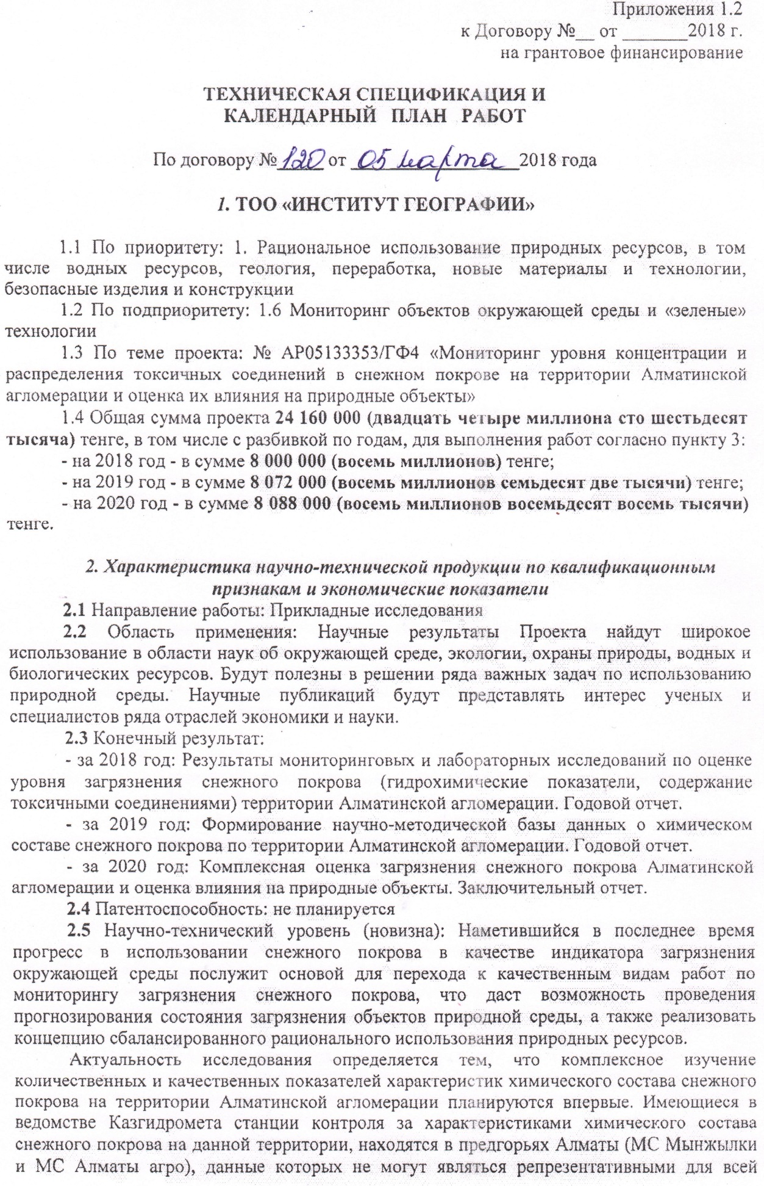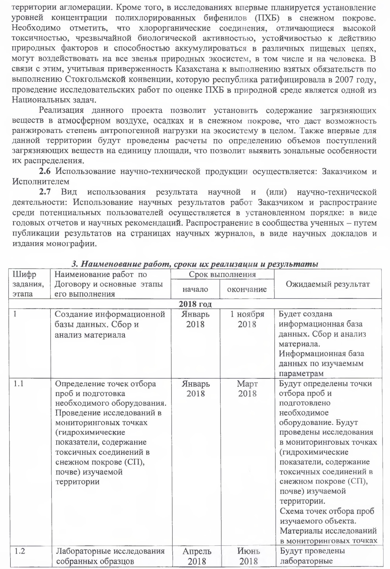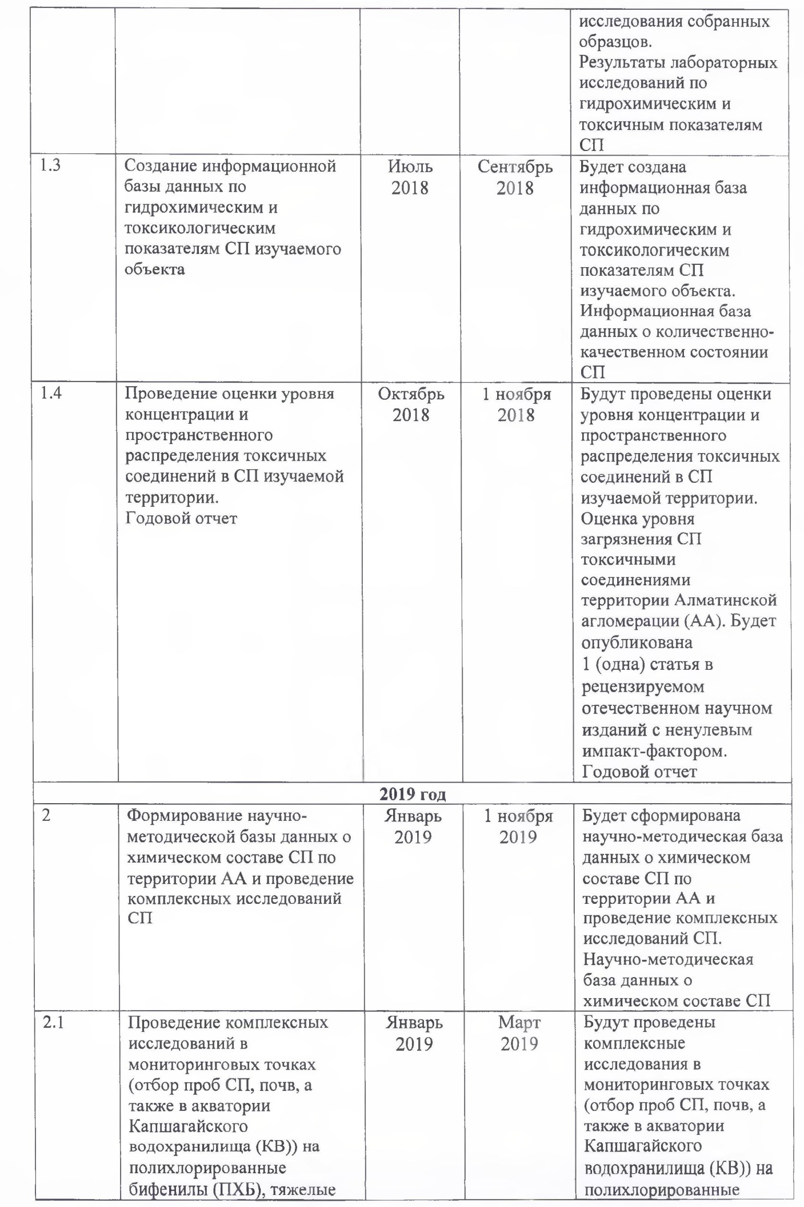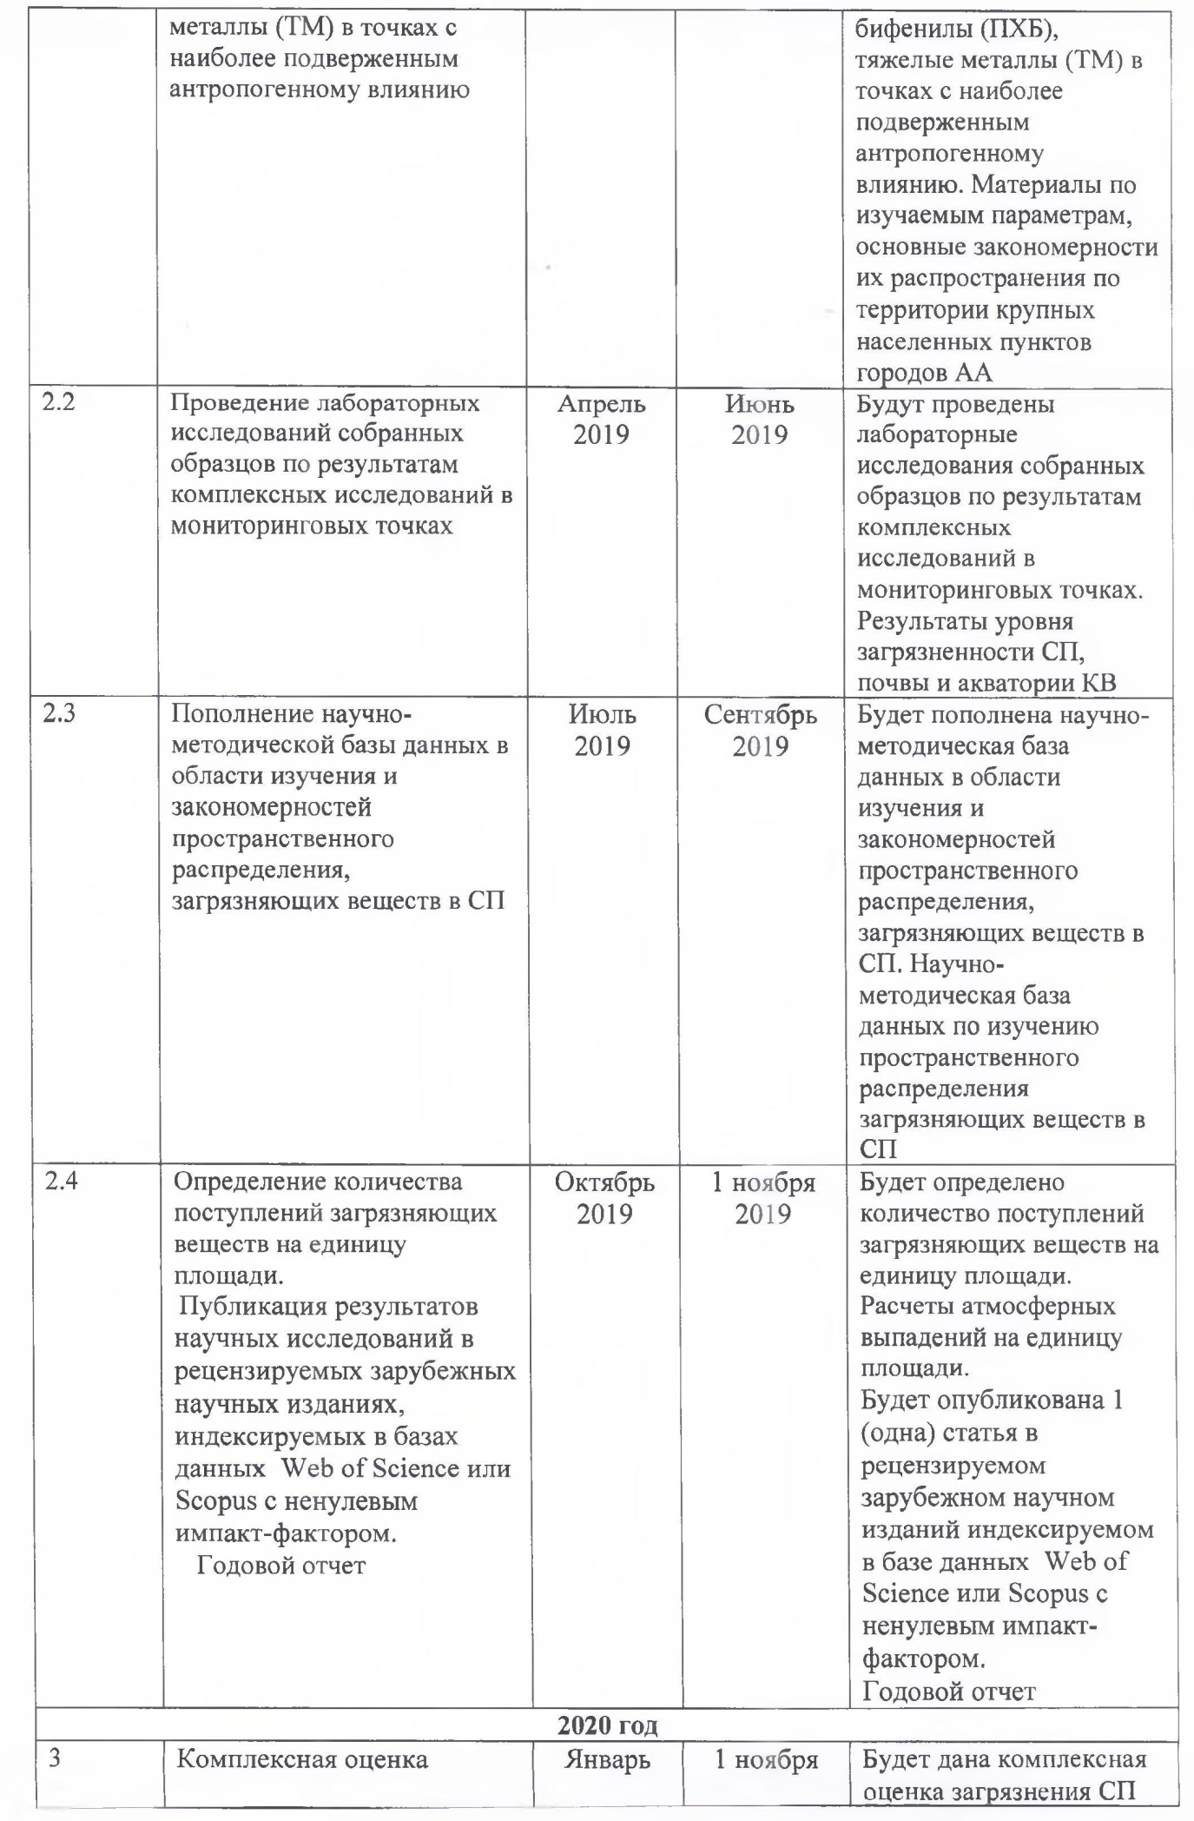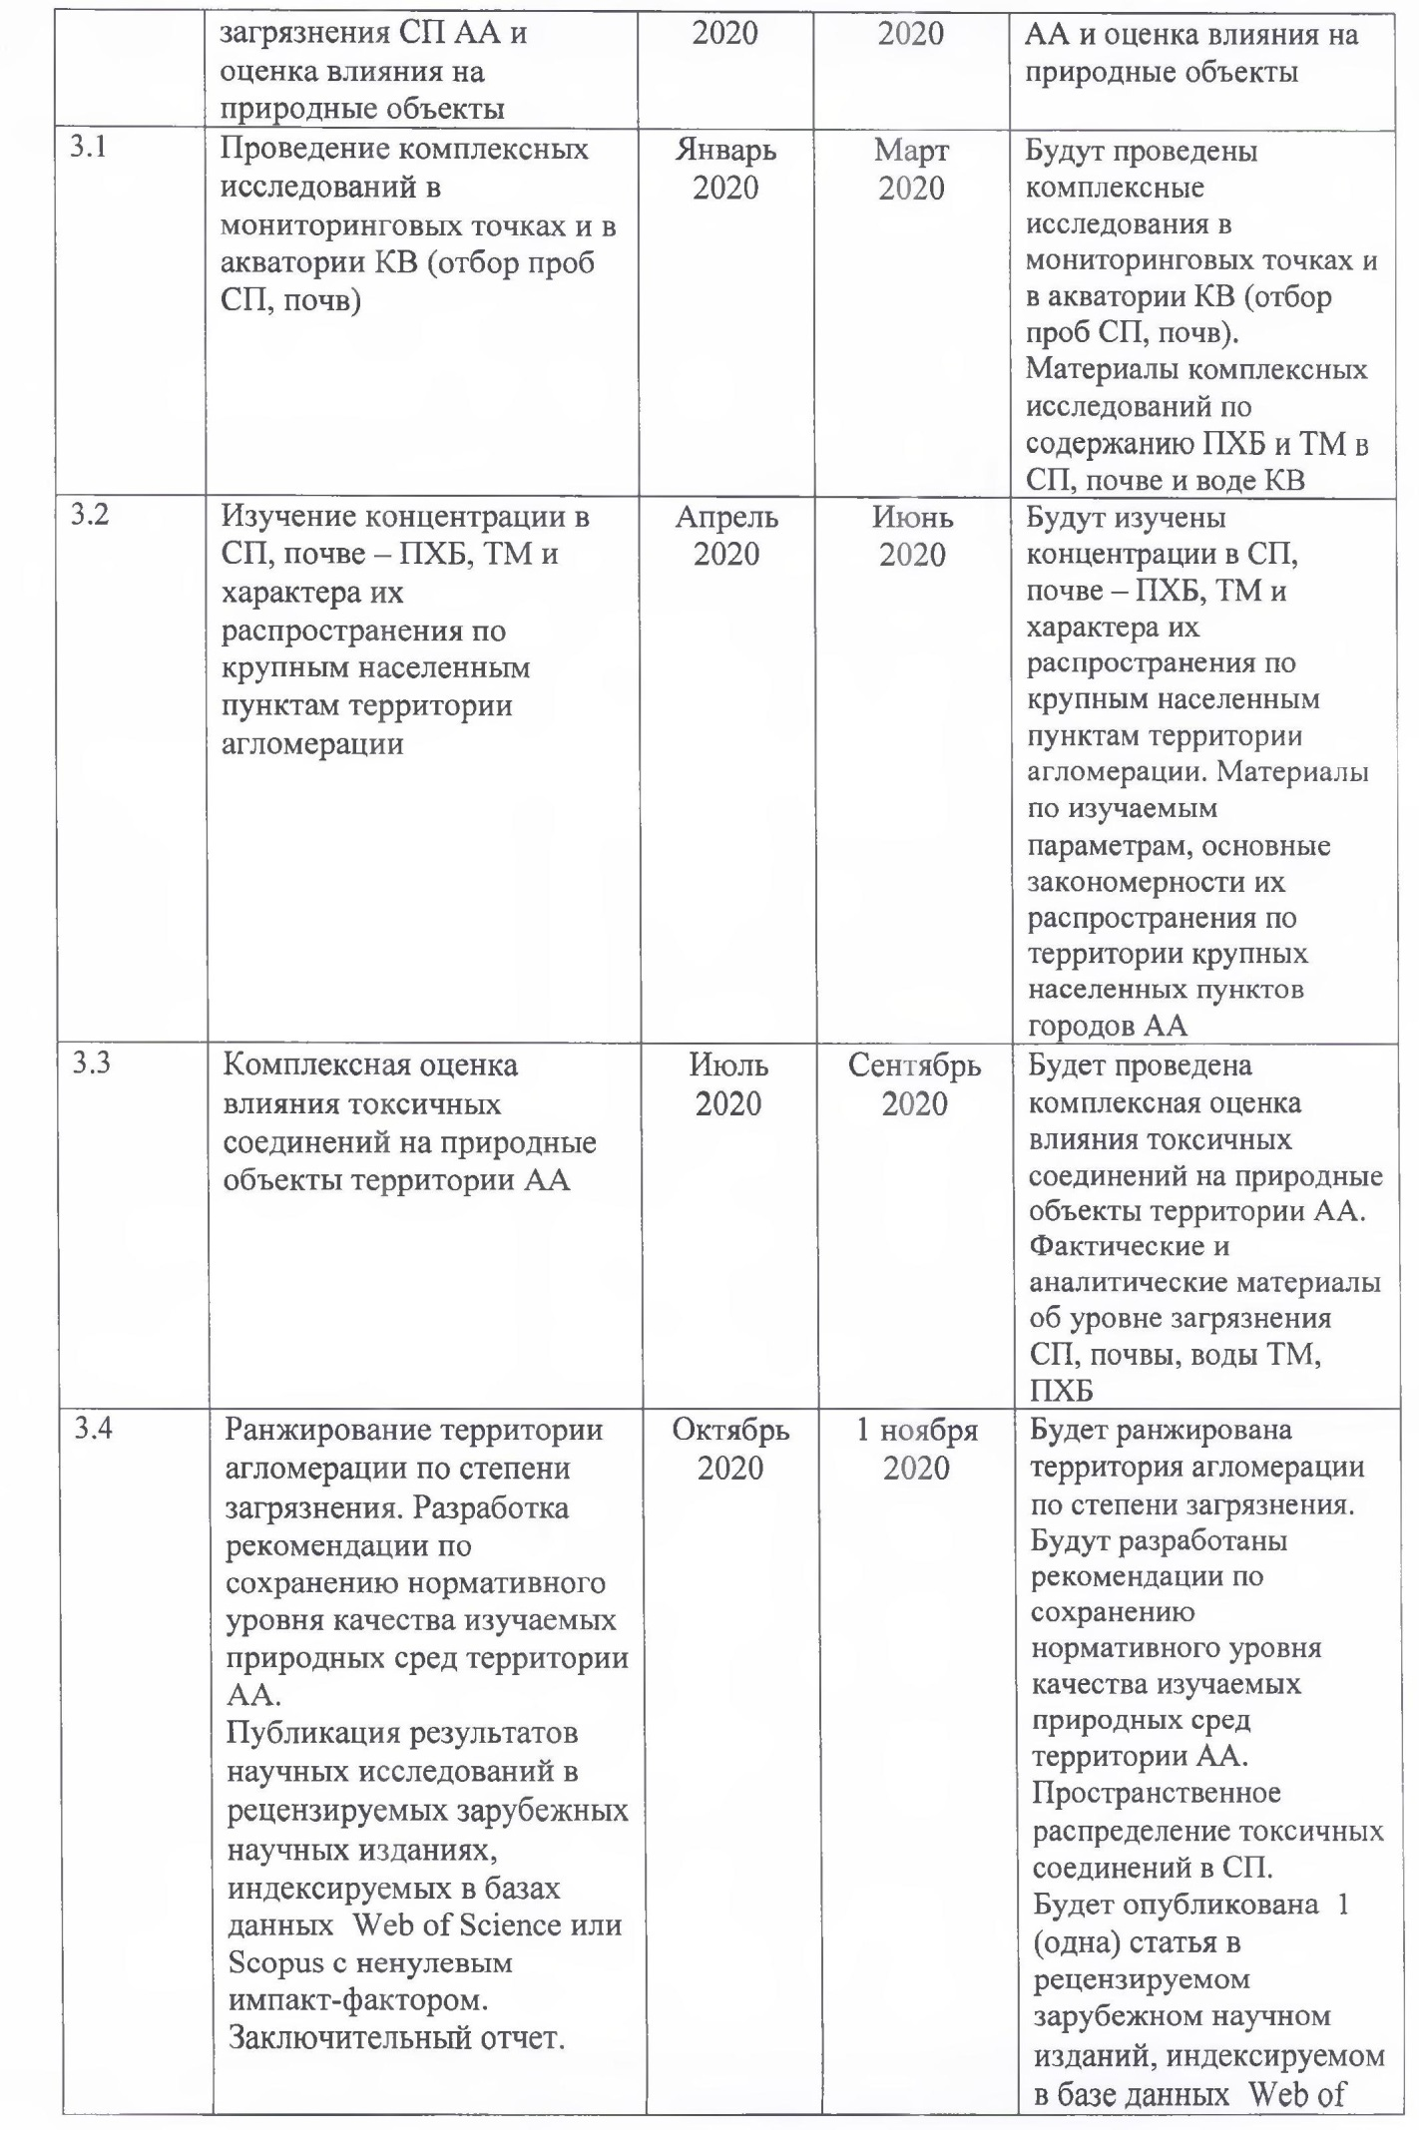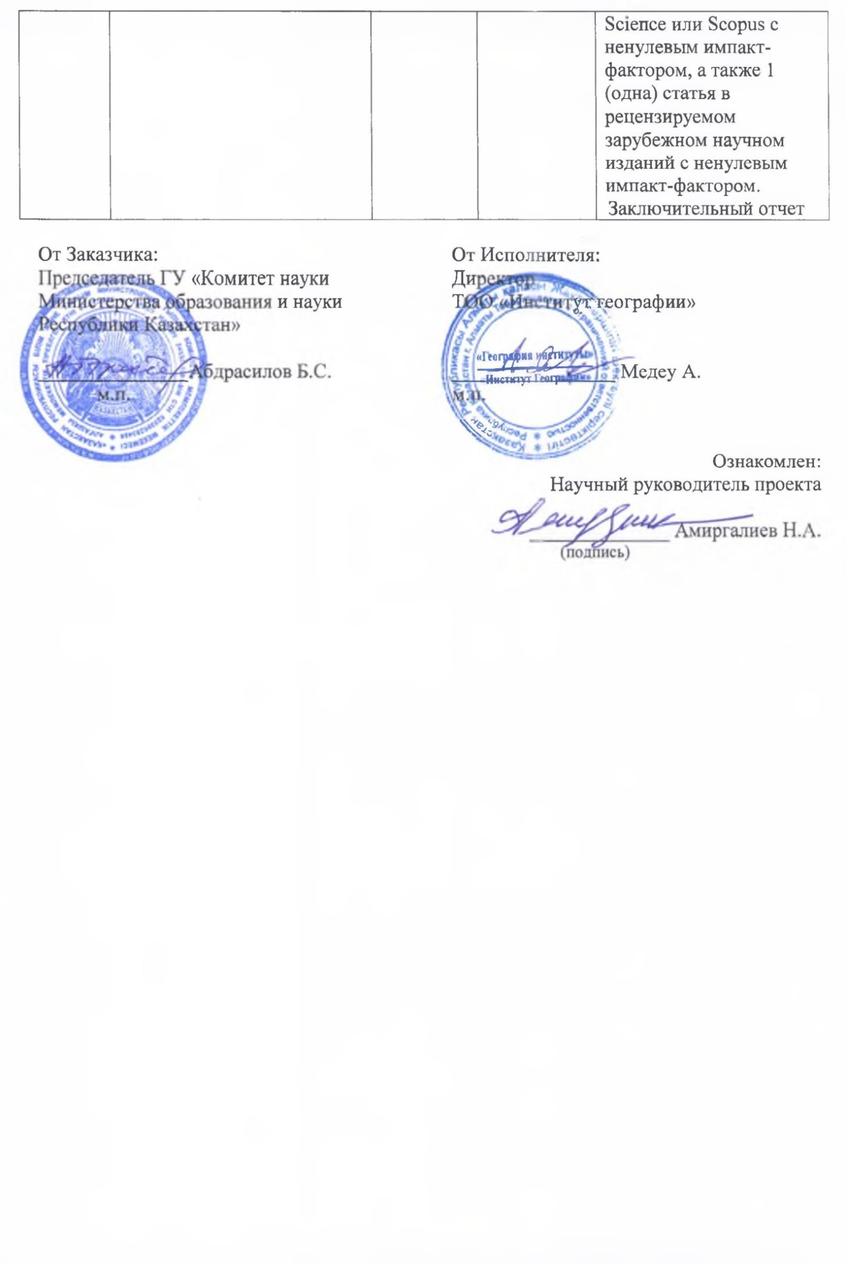
APPENDIX C

Research results
2018 | 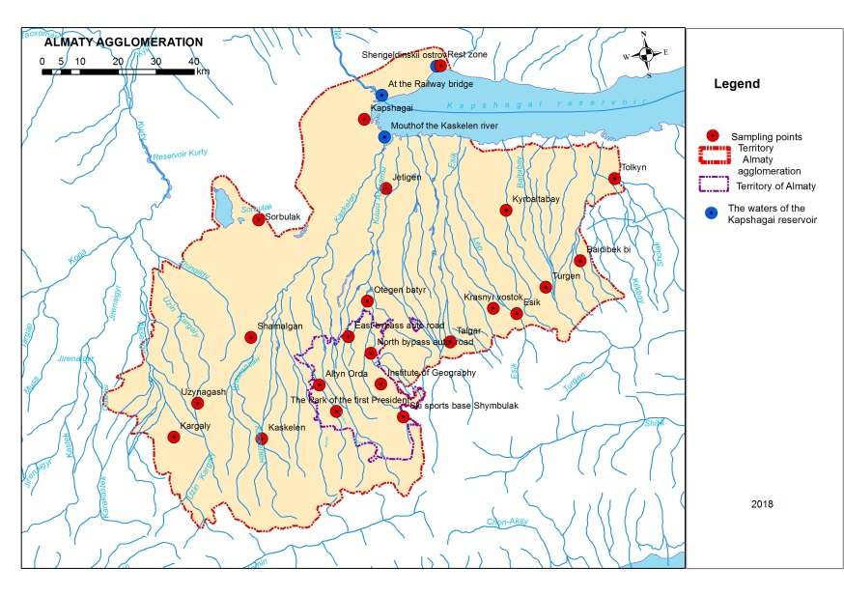
2019 | 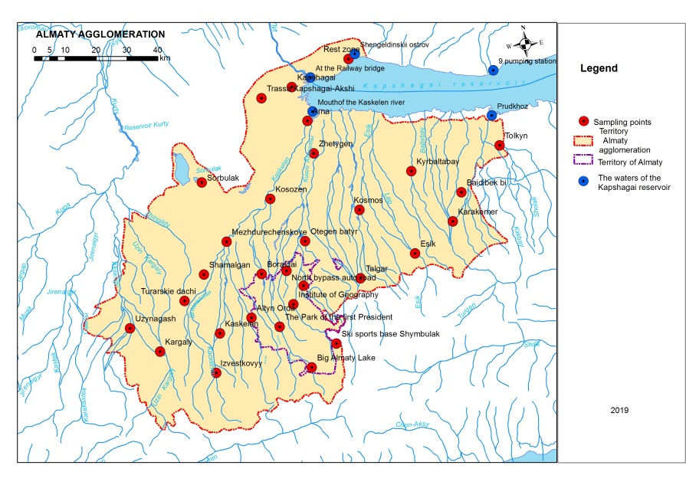
2020 | 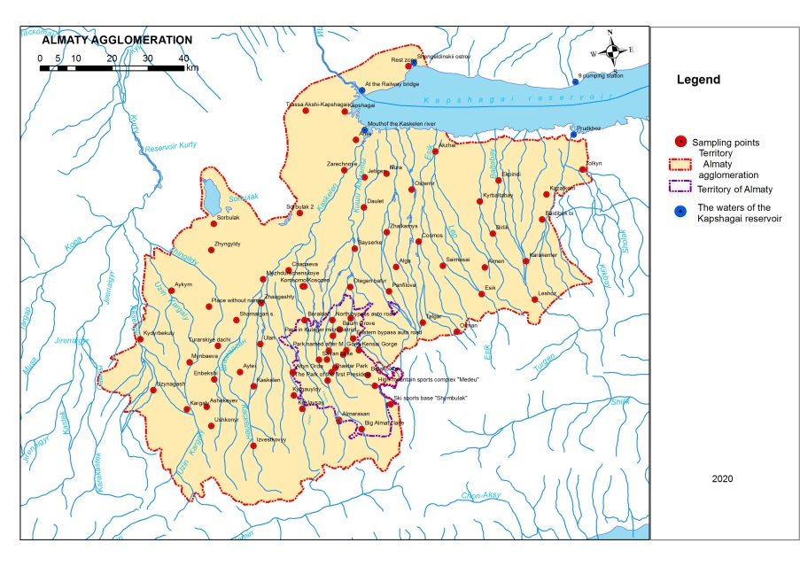
Figure C.1 – Diagram of snow and ice Sampling points
Table C.1 – Sampling points and their coordinates
Zones | The sampling site | Coordinates
name | The sampling site | N (Northern latitude) | E (East longitude)
1  Mountainous territory | HMR "Shymbulak" | 43°7'7.67"N | 77°5'45.48" E
1  Mountainous territory | Big Almaty Lake (BAL) | 43°3'31.60" N | 76°59'19.03" E
1  Mountainous territory | Izvestkovyi | 43°4'37.05" N | 76°36'28.27" E
2  Territory of Almaty | Institute of Geography | 43°15'2.25" N | 76°57'12.41" E
2  Territory of Almaty | Park of the First President (PFP) | 43°15'5.25" N | 76°57'11.56" E
2  Territory of Almaty | Altyn Orda | 43°7'7.67" N | 77°5'45.48" E
2  Territory of Almaty | Eastern bypass road (EBR) | 43°17'49.39" N | 76°59'52.42" E
2  Territory of Almaty | Northern bypass road (NBR) | 43°21'12.32" N | 76°56'20.85" E
3  Small towns, urban-type settlements | Kaskelen | 43°11'27.59" N | 76°53'9.69" E
3  Small towns, urban-type settlements | Uzynagash | 43°21'12.32" N | 76°56'20.85" E
3  Small towns, urban-type settlements | Shamalgan | 43°22'13.94" N | 76°36'18.00" E
3  Small towns, urban-type settlements | Kapshagay | 43°51'14.64" N | 77°4'6.13" E
3  Small towns, urban-type settlements | Yesik | 43°20'58.13" N | 77°27'38.11" E
3  Small towns, urban-type settlements | Talgar | 43°17'53.16" N | 77°13'36.18" E
4  Small settlements | Kargaly | 43°13'39.45" N | 76°45'49.20" E
4  Small settlements | Turar dachi | 43°18'9.77" N | 76°30'54.28" E
4  Small settlements | Mezhdurechensk | 43°27'49.55" N | 76°42'48.53" E
4  Small settlements | Karaoi (Sorbulak) | 43°36'59.93" N | 76°42'45.43" E
4  Small settlements | Kossozen | 43°33'57.95" N | 76°53'57.82" E
4  Small settlements | Zhetigen | 43°41'3.91" N | 77° 6'21.96" E
4  Small settlements | Otegen batyr | 43°36'59.93" N | 76°42'45.43" E
4  Small settlements | Kosmos | 43°30'47.92" N | 77°15'3.05" E
4  Small settlements | Kyrbaltabay | 43°35'12.00" N | 77°29'35.00" E
4  Small settlements | Baidibek bi | 43°17'53.16" N | 77°13'36.18" E
4  Small settlements | Tolkyn (Prudkhoz) | 43°37'52.95" N | 77°53'32.10" E
4  Small settlements | Karakemer | 43°25'37.88" N | 77°38'2.10" E
4  Small settlements | Boraldai | 43°21'10.75" N | 76°50'10.24" E
4  Small settlements | Kapshagai-Akshi highway | 43°51'36.69" N | 76°55'58.02" E
5  Coast of Kapshagai reservoir (KR) | Rest zone | 43°56'16.30" N | 77°18'1.46" E
5  Coast of Kapshagai reservoir (KR) | Arna | 43°46'40.06" N | 77° 8'30.47" E
6  Water area of Kapshagay reservoir | mouth of Kaskelen river | 43°48'5.46" N | 77° 7'40.50" E
6  Water area of Kapshagay reservoir | at the railway bridge | 43°53'59.10" N | 77° 7'56.40" E
6  Water area of Kapshagay reservoir | Shengeldy Island | 43°56'12.50" N | 77°19'6.61" E
6  Water area of Kapshagay reservoir | 9-pumping station | 43°50'20.33" N | 77°51'9.42" E
6  Water area of Kapshagay reservoir | Prudkhoz | 43°42'56.82" N | 77°52'54.17" E

Table C.2 – Average values of pH and content of suspended substances, chemical parameters of SC of the AA, 2018
Zones |  | Surveys | Suspended substances,  mg/dm³ | рН | Oxidizability, mgO/dm³ | Mineralization, mg/dm³
№ | name
1 | Mountain territory | 1 | 83,9 | 6,31 | 10,6 | 50,3
1 | Mountain territory | 2 | 33,3 | 5,19 | 2,4 | 111,5
1 | Mountain territory | 3 | 4,0 | 6,01 | 2,0 | 106,8
2 | Territory of Almaty | 1 | 118,2 | 6,75 | 12,7 | 76,6
2 | Territory of Almaty | 2 | 117,0 | 5,67 | 2,8 | 101,6
2 | Territory of Almaty | 3 | 230,4 | 5,69 | 11,5 | 136,7
3 | Small towns, urban-type settlements | 1 | 138,4 | 6,72 | 7,8 | 80,1
3 | Small towns, urban-type settlements | 2 | 196,1 | 5,7 | 5,1 | 143,5
3 | Small towns, urban-type settlements | 3 | 94,8 | 5,46 | 8,3 | 149,4
4 | Small settlements | 1 | 132,3 | 6,78 | 10,7 | 73,9
4 | Small settlements | 2 | 107,6 | 5,8 | 6,3 | 148,6
4 | Small settlements | 3 | 234,0 | 5,82 | 9,8 | 166,3
5 | KR, its coast | 1 | 548,0 | 7,98 | 15,2 | 171,7
5 | KR, its coast | 2 | 97,0 | 6,22 | 1,1 | 165,4
5 | KR, its coast | 3 | 508,0 | 6,07 | 5,9 | 187,3

Table C.3 – Average values of heavy metal concentrations of SC of the AA, 2018
Zones |  | Surveys | Cu | Zn | Cd | Co | Ni | Pb
№ | name | Surveys | μg/dm³
1 | Mountain territory | 1 | 0,0 | 13,5 | 4,4 | 0,0 | 6,8 | 7,4
1 | Mountain territory | 2 | 8,6 | 8,0 | 6,0 | 0,0 | 9,4 | 9,5
1 | Mountain territory | 3 | 8,6 | 5,1 | 5,3 | 0,8 | 0,0 | 18,3
2 | Territory of Almaty | 1 | 3,6 | 39,0 | 4,8 | 2,1 | 14,0 | 6,4
2 | Territory of Almaty | 2 | 9,9 | 16,7 | 6,8 | 1,3 | 5,2 | 16,1
2 | Territory of Almaty | 3 | 10,4 | 7,7 | 3,7 | 2,8 | 2,5 | 16,9
3 | Small towns, urban-type settlements | 1 | 4,7 | 19,9 | 3,5 | 5,6 | 6,4 | 11,2
3 | Small towns, urban-type settlements | 2 | 11,1 | 15,9 | 4,6 | 3,0 | 6,0 | 17,6
3 | Small towns, urban-type settlements | 3 | 9,9 | 1,3 | 2,8 | 5,8 | 2,1 | 27,3
4 | Small settlements | 1 | 5,3 | 13,0 | 3,2 | 8,7 | 7,1 | 10,3
4 | Small settlements | 2 | 13,7 | 13,1 | 4,4 | 4,1 | 3,9 | 19,3
4 | Small settlements | 3 | 11,1 | 6,8 | 3,1 | 5,8 | 3,7 | 31,6
5 | KR, its coast | 1 | 5,0 | 3,0 | 3,6 | 5,0 | 5,6 | 18,3
5 | KR, its coast | 2 | 13,6 | 15,6 | 4,5 | 1,2 | 0,0 | 11,7
5 | KR, its coast | 3 | 10,1 | 5,5 | 4,5 | 7,3 | 0,0 | 44,5

Table C.4 – Concentration and congener composition of PCBs in SC of the AA, 2018
Zones | Sampling points and their numbers | PCBs congeners |  | Concentration, μg/dm³
Zones | Sampling points and their numbers | 1 | 2 | amount |  | average by zone
 |  |  |  | 1 | 2 | 1 | 2
1  Mountain territory | HMR "Shymbulak" | 44, 151 | 40, 42, 49 | 0,031 | 1,942 | 0,031 | 1,942
2  Territory of Almaty | Institute of Geography | 44, 151 | 52, 151 | 0,164 | 0,132 | 0,066 | 0,058
2  Territory of Almaty | Park of the First President (PFP) | 41/64/71, 52 | 52, 151 | 0,003 | 0,053 | 0,066 | 0,058
2  Territory of Almaty | Altyn Orda | 87/115, 151 | 49, 151 | 0,046 | 0,025 | 0,066 | 0,058
2  Territory of Almaty | NBR | 44, 66/95, 101, 110, 118, 119, 138 | 49, 151 | 0,112 | 0,038 | 0,066 | 0,058
2  Territory of Almaty | EBR | 49, 151 | 151 | 0,006 | 0,043 | 0,066 | 0,058
3  Small towns, urban-type settlements | Kaskelen | 49, 128, 155 | 49, 151 | 0,065 | 0,041 | 0,129 | 0,225
3  Small towns, urban-type settlements | Uzynagash | 44, 119, 128 | 151 | 0,421 | 0,064 | 0,129 | 0,225
3  Small towns, urban-type settlements | Shamalgan | 44, 49, 85 | 44, 49, 151 | 0,077 | 1,283 | 0,129 | 0,225
3  Small towns, urban-type settlements | Talgar | 44, 49, 151 | 44, 110, 118, 138 | 0,180 | 0,169 | 0,129 | 0,225
3  Small towns, urban-type settlements | Yesik | n/d | n/d | n/d | n/d | 0,129 | 0,225
3  Small towns, urban-type settlements | Turgen | 44, 97 | n/d | 0,115 | n/d | 0,129 | 0,225
3  Small towns, urban-type settlements | Kapshagay | 40, 49, 151 | 52 | 0,043 | 0,018 | 0,129 | 0,225
4  Small settlements | Rest zone | 44, 151 | 49, 151 | 0,110 | 0,038 | 0,093 | 0,028
4  Small settlements | Kargaly | 44, 49, 118 | 49, 151 | 0,038 | 0,044 | 0,093 | 0,028
4  Small settlements | Otegen batyr | 44, 151 | n/d | 0,205 | n/d | 0,093 | 0,028
4  Small settlements | Zhetigen | 40, 49 | 151 | 0,026 | 0,024 | 0,093 | 0,028
4  Small settlements | Karaoi (Sorbulak) | 40, 121 | 49, 151 | 0,172 | 0,037 | 0,093 | 0,028
4  Small settlements | Krasnyi Vostok | 44, 49, 151 | 49, 151 | 0,192 | 0,054 | 0,093 | 0,028
4  Small settlements | Malovodnoe | 44 | 97, 151 | 0,078 | 0,056 | 0,093 | 0,028
4  Small settlements | Tolkyn (Prudkhoz) | n/d | n/d | n/d | n/d | 0,093 | 0,028
4  Small settlements | Kyrbaltabay | 151 | n/d | 0,016 | n/d | 0,093 | 0,028
Note – 1 and 2 – survey number, n/d – not detected

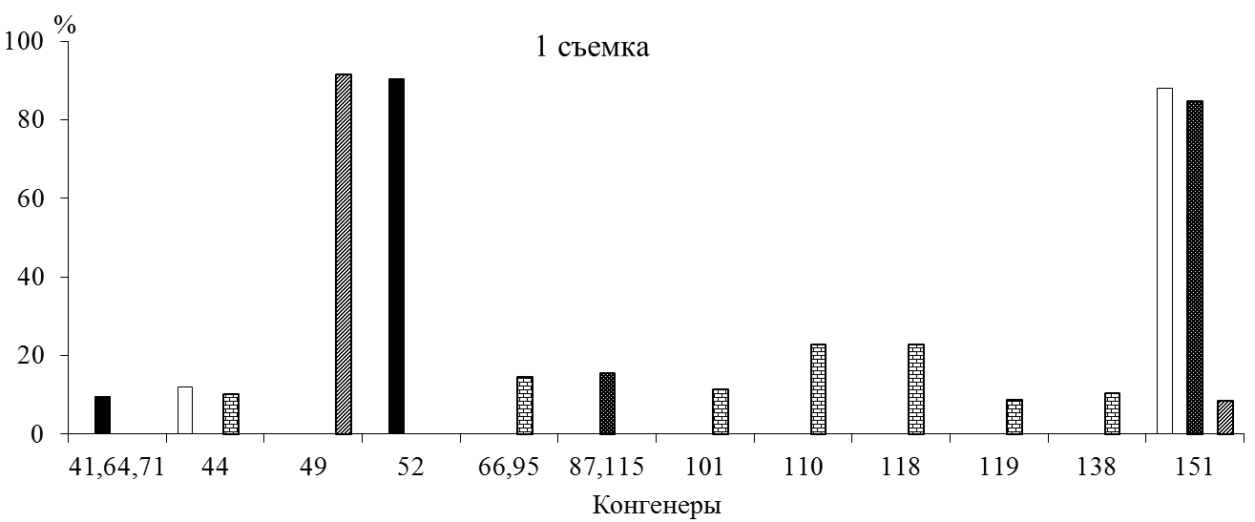
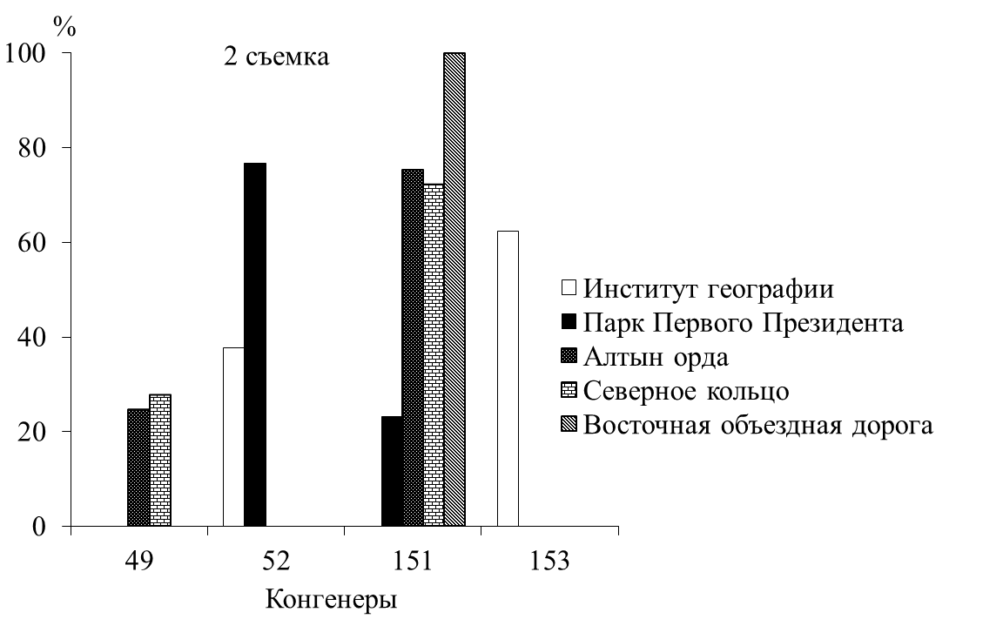
Figure C.2 – Relative content of PCBs congeners in SC on the territory of Almaty, 2018

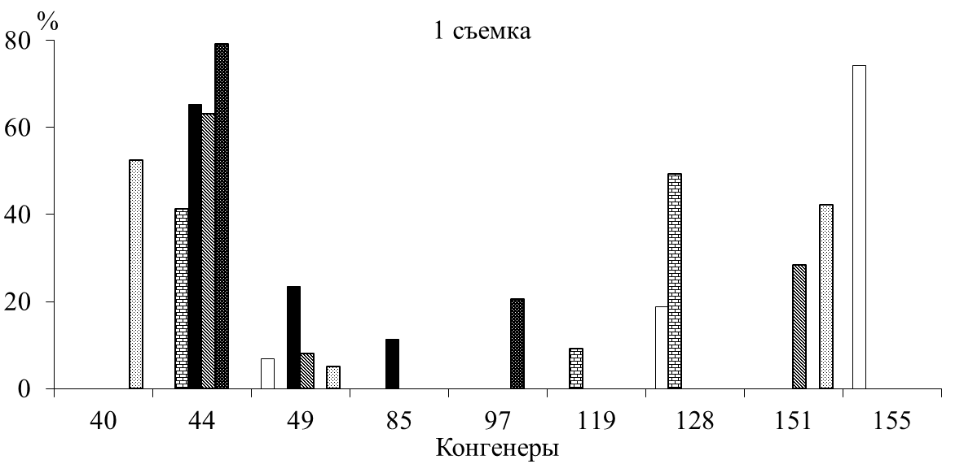
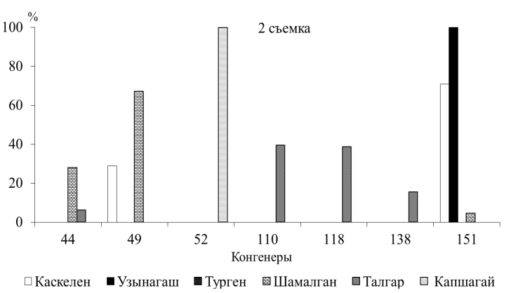
Figure C.3 – Relative content of PCBs congeners in SC of the small towns and urban-type settlements, 2018

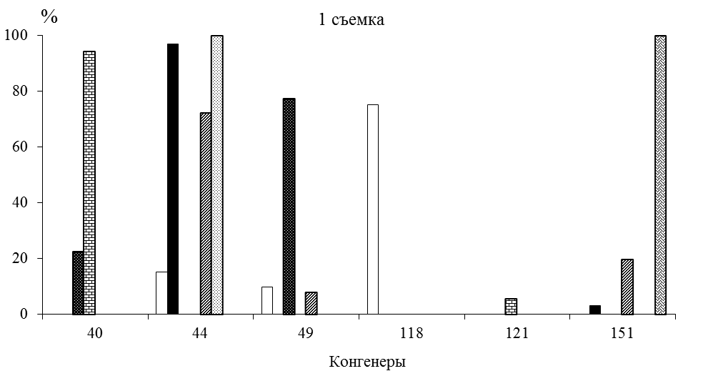
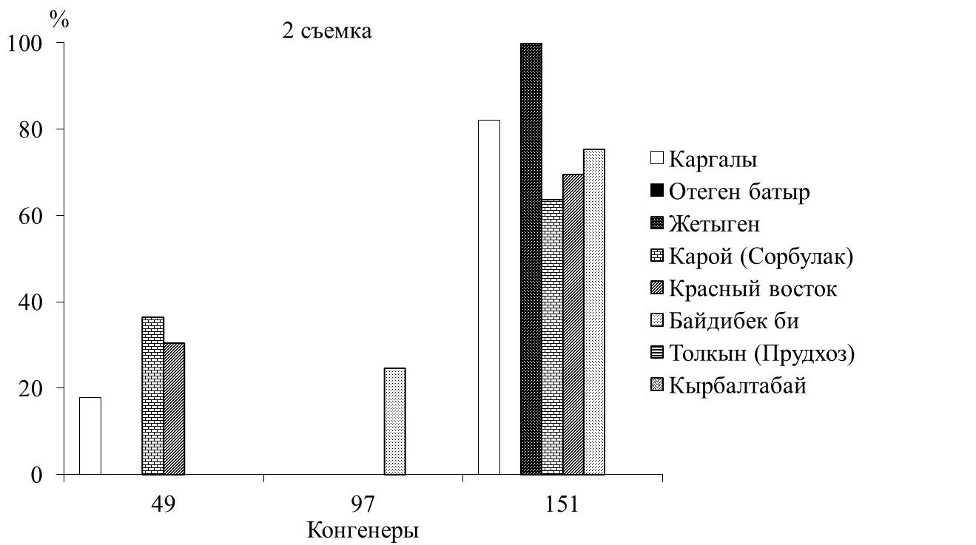

Figure C.4 – Relative content of PCBs congeners in SC of the small settlements, 2018

Table C.5 – Level of accumulation of mineral salts and HM in the ice of the KR, 2018
The sampling site | Surveys | Mineralization, mg/dm³ | Cu | Zn | Cd | Co | Ni | Pb
The sampling site | Surveys | Mineralization, mg/dm³ | μg/dm³
The area of Kaskelen River inflow | 1 | 124 | 2,2 | 4,4 | 4,0 | 13,4 | 5,6 | 5,8
The area of Kaskelen River inflow | 2 | 176 | 13,6 | 4,8 | 4,9 | 0,0 | 1,8 | 18,3
The area of Kaskelen River inflow | 3 | 395 | 12,2 | 1,3 | 3,6 | 2,2 | 0,0 | 24,8
At the dam | 1 | 129 | 2,2 | 3,0 | 3,9 | 7,8 | 0,0 | 16,1
At the dam | 2 | 131 | 9,3 | 5,9 | 5,0 | 0,0 | 0,0 | 20,5
At the dam | 3 | 258 | 10,8 | 38,8 | 4,7 | 5,0 | 0,0 | 33,6
Areas Shengeldy Islands | 1 | 161 | 2,9 | 3,2 | 2,6 | 6,4 | 4,3 | 7,4
Areas Shengeldy Islands | 2 | 174 | 12,9 | 5,1 | 4,4 | 2,6 | 3,1 | 13,9
Areas Shengeldy Islands | 3 | 300 | 8,6 | 26,9 | 5,1 | 13,4 | 9,4 | 35,7

Table C.6 – Concentration and congener composition of PCBs in the ice of the KR, 2018
The sampling site | Surveys | Concentration of PCBs congeners, μg/dm³ |  |  |  |  |  |  |  | Amount  of PCBs, μg/dm³
The sampling site | Surveys | 40 | 44 | 49 | 52 | 82 | 138 | 151 | 153 | Amount  of PCBs, μg/dm³
The area of Kaskelen River inflow | 1 |  | 0,005 |  | 0,008 |  |  | 0,015 |  | 0,028
The area of Kaskelen River inflow | 2 |  |  | 0,014 |  |  | 0,023 |  |  | 0,037
At the dam | 1 |  |  |  |  |  |  | 0,041 | 0,034 | 0,075
At the dam | 2 |  |  | 0,008 |  |  |  | 0,020 |  | 0,028
Areas Shengeldy Islands | 1 | 0,054 |  |  |  | 0,031 |  |  |  | 0,085
Areas Shengeldy Islands | 2 |  |  | 0,009 |  |  |  |  |  | 0,009

Table C.7 – Heavy metal content in the soil cover, 2018
Zones | Name | mg/kg
Zones | Name | copper | lead | nickel | zinc | cobalt | cadmium
1  Mountain territory | HMR "Shymbulak" | 0,10 | 1,91 | 2,97 | 5,1 | 1,08 | 1,76
2  Territory of Almaty | Institute of Geography | 24,55 | 86,36 | 4,63 | 40,9 | 2,84 | 16,30
2  Territory of Almaty | Park of the First President (PFP) | 0,89 | 11,89 | 3,17 | 9,0 | 0,83 | 1,09
2  Territory of Almaty | Altyn Orda | 0,23 | 0,73 | 3,07 | 1,4 | 0,77 | 1,10
2  Territory of Almaty | Northern bypass road (NBR) | 18,99 | 13,50 | 3,05 | 35,6 | 1,05 | 1,39
2  Territory of Almaty | Eastern bypass road (EBR) | 0,77 | 5,24 | 3,12 | 3,9 | 0,80 | 1,00
3  Small towns, urban-type settlements | Kaskelen | 0,46 | 5,66 | 2,59 | 3,5 | 0,63 | 1,27
3  Small towns, urban-type settlements | Uzynagash | 0,33 | 4,16 | 2,70 | 4,7 | 0,55 | 1,04
3  Small towns, urban-type settlements | Shamalgan | 0,24 | 4,05 | 2,85 | 1,3 | 0,86 | 0,98
3  Small towns, urban-type settlements | Talgar | 0,46 | 1,91 | 2,54 | 3,8 | 0,44 | 0,38
3  Small towns, urban-type settlements | Yesik | 0,44 | 2,34 | 2,29 | 11,0 | 0,41 | 0,50
3  Small towns, urban-type settlements | Turgen | 0,47 | 0,94 | 2,27 | 2,8 | 0,33 | 0,45
3  Small towns, urban-type settlements | Kapshagay | 1,32 | 10,71 | 2,37 | 6,5 | 0,58 | 0,59
4  Small settlements | Kargaly | 0,56 | 0,08 | 2,59 | 1,4 | 0,91 | 0,91
4  Small settlements | Otegen batyr | 0,29 | 3,95 | 2,32 | 3,7 | 0,58 | 0,89
4  Small settlements | Zhetigen | 0,43 | 1,59 | 2,14 | 0,9 | 0,69 | 0,63
4  Small settlements | Karaoi (Sorbulak) | 0,37 | 0,41 | 2,34 | 0,8 | 0,35 | 0,62
4  Small settlements | Krasnyi Vostok | 0,43 | 2,77 | 2,12 | 5,0 | 0,24 | 0,50
4  Small settlements | Baidibek bi | 0,22 | 16,50 | 2,02 | 13,4 | 0,63 | 0,42
4  Small settlements | Tolkyn (Prudkhoz) | 0,39 | 6,63 | 1,97 | 10,6 | 0,47 | 0,41
4  Small settlements | Kyrbaltabay | 0,37 | 4,70 | 2,02 | 6,3 | 0,27 | 0,28
5 KR, its coast | Rest zone | 0,44 | 1,26 | 2,24 | 0,5 | 0,49 | 0,60
Table C.8 − Concentration and congener composition of PCBs in the soils of AA by zone, 2018
Zones |  | PCBs congeners | Concentration, μg/kg
№ | Name | PCBs congeners | Concentration, μg/kg
1 | Mountain territory | 85; 119; 153; 155 | 0,015-0,114  0,063
2 | Territory of Almaty | 44; 49; 66,95; 85; 86; 110; 114; 118; 121; 137; 138; 153; 155 | 0,008-18,9  6,681
3 | Small towns, urban-type settlements | 40; 41,64,71; 44; 85; 86; 97; 105; 110; 114; 118; 138; 155 | 0,031-18,4  4,784
4 | Small settlements | 85; 86; 97; 110; 114; 118; 128; 138 | 0,187-11,31  4,124
Note – in the denominator – limits, in the numerator – the average value

Table C.9 – Average values of pH, suspended substances and oxidizability of the SC of the AA, 2019
№ | Zones | Surveys | рН | Suspended substances,  mg/dm³ | Oxidizability, mgO/dm³
№ | Name
1 | Mountain territory | 1 | 5,3 | 22,2 | 10,9
1 | Mountain territory | 2 | 5,4 | 16,5 | 7,68
1 | Mountain territory | 3 | 5,1 | 19,3 | 3,84
2 | Territory of Almaty | 1 | 5,4 | 20,7 | 12,5
2 | Territory of Almaty | 2 | 5,3 | 22,0 | 6,59
2 | Territory of Almaty | 3 | 5,5 | 21,4 | 6,88
3 | Small towns, urban-type settlements | 1 | 5,2 | 24,9 | 11,5
3 | Small towns, urban-type settlements | 2 | 5,5 | 20,2 | 8,59
3 | Small towns, urban-type settlements | 3 | 5,4 | 22,5 | 3,85
4 | Small settlements | 1 | 5,3 | 18,4 | 4,4
4 | Small settlements | 2 | 5,9 | 36,0 | 6,56
4 | Small settlements | 3 | 5,8 | 27,2 | 3,92
5 | Coast of the KR | 1 | 5,2 | 46,1 | 11,5
5 | Coast of the KR | 2 | 5,5 | 38,8 | 6,67
5 | Coast of the KR | 3 | 5,4 | 39,6 | 4,49

Table C. 10 – Average values of heavy metal concentrations in SC of the AA, 2019
Zones | Surveys | Cu | Zn | Cd | Co | Ni | Pb
Name | Surveys | μg/dm³
1  Mountainous territory | 1 | 2,6 | 5,3 | 1,2 | 5,4 | 7,8 | 7,6
1  Mountainous territory | 2 | 3,2 | 19,5 | 0,2 | 8,6 | 6,8 | 20,1
1  Mountainous territory | 3 | 1,3 | 11,7 | 1,4 | 3,9 | 2,1 | 25,7
2  Territory of Almaty | 1 | 4,9 | 18,6 | 1,4 | 7,9 | 12,8 | 30,4
2  Territory of Almaty | 2 | 4,0 | 40,7 | 2,0 | 9,2 | 16,8 | 14,6
2  Territory of Almaty | 3 | 1,7 | 13,6 | 2,0 | 11,9 | 6,3 | 25,4
3  Small towns, urban-type settlements | 1 | 3,8 | 14,1 | 0,8 | 3,6 | 12,1 | 32,6
3  Small towns, urban-type settlements | 2 | 3,2 | 93,7 | 1,2 | 9,2 | 9,2 | 29,8
3  Small towns, urban-type settlements | 3 | 2,0 | 12,2 | 1,5 | 12,0 | 10,6 | 22,2
4  Small settlements | 1 | 2,5 | 7,5 | 0,8 | 4,4 | 9,3 | 20,2
4  Small settlements | 2 | 2,2 | 14,1 | 1,3 | 7,5 | 4,0 | 30,0
4  Small settlements | 3 | 2,7 | 10,0 | 2,4 | 10,3 | 14,3 | 25,9
5  KR and its coast | 1 | 3,7 | 13,7 | 0,1 | 6,2 | 9,7 | 20,8
5  KR and its coast | 2 | 1,1 | 16,4 | 0,3 | 12,4 | 2,4 | 25,0
5  KR and its coast | 3 | 3,9 | 11,3 | 2,3 | 7,6 | 18,1 | 10,4
Average |  | 2,9 | 20,2 | 1,3 | 8,0 | 9,5 | 22,7

Table C.11 – Concentration and congener composition of PCBs in SC of the AA, 2019
Zones | The sampling site | PCBs congeners |  | Concentration PCBs, μg/dm³
Zones | The sampling site | 1 | 2 | amount |  | average by zone
name | The sampling site | 1 | 2 | 1 | 2 | 1 | 2
1 | HMR "Shymbulak" | 40, 42, 48, 86 | n/d | 0,077 | n/d | 0,026 | 0,0
Mountainous territory | Big Almaty Lake (BAL) | n/d | n/d | n/d | n/d | 0,026 | 0,0
Mountainous territory | Izvestkovyi | n/d | n/d | n/d | n/d | 0,026 | 0,0
2  Territory of Almaty | Institute of Geography | n/d | n/d | n/d | n/d | 0,044 | 0,009
2  Territory of Almaty | Park of the First President (PFP) | 40, 41/71, 44, 101 | 86 | 0,148 | 0,047 | 0,044 | 0,009
2  Territory of Almaty | Altyn Orda | 41/64/71, 44, 114 | n/d | 0,071 | n/d | 0,044 | 0,009
2  Territory of Almaty | Eastern bypass road (EBR) | n/d | n/d | n/d | n/d | 0,044 | 0,009
2  Territory of Almaty | Northern bypass road (NBR) | n/d | n/d | n/d | n/d | 0,044 | 0,009
3 | Kaskelen | n/d | 74 | n/d | 0,082 | 0,029 | 0,016
3 | Uzynagash | n/d | n/d | n/d | n/d | 0,029 | 0,016
Small towns, urban-type settlements | Shamalgan | n/d | n/d | n/d | n/d | 0,029 | 0,016
Small towns, urban-type settlements | Kapshagay | 44 | n/d | 0,14 | n/d | 0,029 | 0,016
Small towns, urban-type settlements | Yesik | 42 | n/d | 0,018 | n/d | 0,029 | 0,016
Small towns, urban-type settlements | Talgar | 42 | 86 | 0,018 | 0,016 | 0,029 | 0,016
4  Small settlements | Kargaly | n/d | n/d | n/d | n/d | 0,016 | 0,007
4  Small settlements | Turar dachi | 44 | n/d | 0,087 | n/d | 0,016 | 0,007
4  Small settlements | Mezhdurechensk | n/d | 86 | n/d | 0,07 | 0,016 | 0,007
4  Small settlements | Karaoi (Sorbulak) | n/d | n/d | n/d | n/d | 0,016 | 0,007
4  Small settlements | Kossozen | n/d | n/d | n/d | n/d | 0,016 | 0,007
4  Small settlements | Zhetigen | 42 | 86 | 0,018 | 0,02 | 0,016 | 0,007
4  Small settlements | Otegen batyr | 42, 86 | n/d | 0,06 | n/d | 0,016 | 0,007
4  Small settlements | Kosmos | n/d | n/d | n/d | n/d | 0,016 | 0,007
4  Small settlements | Kyrbaltabay | n/d | n/d | n/d | n/d | 0,016 | 0,007
4  Small settlements | Baidibek bi | n/d | n/d | n/d | n/d | 0,016 | 0,007
4  Small settlements | Tolkyn (Prudkhoz) | 86 | n/d | 0,05 | n/d | 0,016 | 0,007
4  Small settlements | Karakemer | n/d | 86 | n/d | 0,015 | 0,016 | 0,007
4  Small settlements | Boraldai | n/d | n/d | n/d | n/d | 0,016 | 0,007
4  Small settlements | Kapshagai-Akshi highway | n/d | n/d | n/d | n/d | 0,016 | 0,007
4  Small settlements | Rest zone | 42 | n/d | 0,031 | n/d | 0,016 | 0,007
4  Small settlements | Arna | 86 | n/d | 0,012 | n/d | 0,016 | 0,007
Note – n/d – not detected

Table C.12 – Chemistry of the ice cover of Kapshagai reservoir, 2019
The sampling site | рН | Oxidizability, mgO/dm³ | Suspended substances,  mg/dm³ | Mineralization, mg/dm³
Mouth of Kaskelen river | 7,8 | 7,5 | 11,0 | 702
Shengeldy Island | 7,3 | 3,0 | 4,0 | 267
At the railway bridge | 7,3 | 2,6 | 8,0 | 205
9-pumping station | 7,3 | 2,4 | 10,0 | 223
Prudkhoz | 7,4 | 2,9 | 5,0 | 236

Table C.13 – Level of accumulation of HM in the ice of KR and average values, 2019
The sampling site | Cu | Pb | Zn | Cd | Co | Ni
The sampling site | μg/dm³
Shengeldy Island | 2,3 | 27,1 | 7,3 | 1,2 | 6,5 | 3,0
9-pumping station | 1,2 | 39,6 | 7,7 | 1,4 | 17,2 | 0,0
Mouth of Kaskelen river | 1,2 | 43,8 | 7,7 | 2,2 | 14,3 | 0,7
Prudkhoz | 2,3 | 47,9 | 20,5 | 2,2 | 11,0 | 0,0
At the railway bridge | 0,6 | 43,8 | 15,4 | 0,4 | 8,7 | 1,8
Average | 1,5 | 40,4 | 11,7 | 1,5 | 11,6 | 1,1

Table C.14 – Chemical and mechanical composition of the soils of the AA, 2019
Zones | Name | Granulometric  type of soil  (according to  M. M. Filatov) |  | рН | Mineralization  by TDS, mg/kg
Mountainous territory | HMR "Shymbulak" | Clay |  | 7,3 | 50
Mountainous territory | Big Almaty Lake (BAL) | Loam |  | 6,0 | 150
Mountainous territory | Izvestkovyi | Clay |  | 7,8 | 450
Territory of Almaty | Institute of Geography | Sandy loam |  | 8,0 | 350
Territory of Almaty | Park of the First President | Sandy loam |  | 8,0 | 350
Territory of Almaty | Altyn Orda | Sandy loam |  | 8,3 | 250
Territory of Almaty | EBR | Loam |  | 8,2 | 350
Territory of Almaty | NBR | Sandy loam with gravel |  | 8,2 | 300
Small towns, urban-type settlements | Kaskelen | Sandy loam |  | 7,3 | 300
Small towns, urban-type settlements | Uzynagash | Clay |  | 8,0 | 300
Small towns, urban-type settlements | Shamalgan | Sand |  | 8,5 | 300
Small towns, urban-type settlements | Talgar | Clay |  | 8,1 | 350
Small towns, urban-type settlements | Yesik | Loam |  | 8,3 | 300
Small towns, urban-type settlements | Kapshagay | Sand |  | 8,7 | 150
Small settlements | Kargaly | Sandy loam |  | 7,0 | 75
Small settlements | Turar dachi | Loam |  | 8,3 | 250
Small settlements | Mezhdurechensk | Loam |  | 8,1 | 300
Small settlements | Karaoi (Sorbulak) | Песок |  | 8,2 | 100
Small settlements | Kossozen | Loam |  | 8,3 | 250
Small settlements | Zhetigen | Loam |  | 8,8 | 2000
Small settlements | Otegen batyr | Sandy loam with gravel |  | 8,2 | 300
Small settlements | Kosmos | Clay |  | 8,3 | 400
Small settlements | Kyrbaltabay | Clay |  | 8,1 | 900
Small settlements | Baidibek bi | Clay |  | 8,1 | 350
Small settlements | Tolkyn (Prudkhoz) | Loam |  | 8,5 | 1150
Small settlements | Karakemer | Clay and sandy loam |  | 8,3 | 300
Small settlements | Boraldai | Sandy loam |  | 8,4 | 450
Small settlements | Kapshagai-Akshi highway | Sand |  | 8,5 | 200
Coast of Kapshagai reservoir | Rest zone | Sand |  | 8,9 | 100
Coast of Kapshagai reservoir | Arna | Sand |  | 8,6 | 150

Table C.15 – Heavy metal content in the soil cover, 2019
Zones | Name | mg/kg
Zones | Name | copper | lead | nickel | zinc | cobalt | cadmium
Mountainous territory | HMR "Shymbulak" | 0,06 | 1,71 | 1,02 | 0,09 | 0,28 | 0,37
Mountainous territory | Big Almaty Lake (BAL) | 0,01 | 1,12 | 0,19 | 0,24 | 0,28 | 0,26
Mountainous territory | Izvestkovyi | 0,24 | 2,54 | 1,20 | 0,17 | 0,15 | 0,28
Territory of Almaty | Institute of Geography | 0,34 | 5,38 | 0,44 | 2,40 | 0,45 | 0,48
Territory of Almaty | Park of the First President | 0,41 | 2,79 | 0,55 | 0,38 | 0,10 | 0,39
Territory of Almaty | Altyn Orda | 0,65 | 5,38 | 0,98 | 1,11 | 0,14 | 0,25
Territory of Almaty | EBR | 216,8 | 71,12 | 1,98 | 4,15 | 0,71 | 0,55
Territory of Almaty | NBR | 0,41 | 4,96 | 0,95 | 0,37 | 0,22 | 0,42
Small towns, urban-type settlements | Kaskelen | 0,19 | 7,04 | 0,75 | 2,39 | 0,25 | 0,50
Small towns, urban-type settlements | Uzynagash | 0,32 | 2,46 | 0,31 | 0,09 | 0,15 | 0,39
Small towns, urban-type settlements | Shamalgan | 0,23 | 1,79 | 0,31 | 0,04 | 0,15 | 0,32
Small towns, urban-type settlements | Talgar | 0,27 | 1,88 | 0,80 | 0,29 | 0,21 | 0,42
Small towns, urban-type settlements | Yesik | 0,13 | 4,21 | 0,60 | 0,60 | 0,22 | 0,43
Small towns, urban-type settlements | Kapshagay | 0,20 | 2,12 | 0,48 | 0,37 | 0,19 | 0,52
Small settlements | Kargaly | 0,02 | 1,88 | 1,20 | 0,13 | 0,21 | 0,30
Small settlements | Turar dachi | 0,29 | 3,62 | 0,13 | 0,08 | 0,17 | 0,37
Small settlements | Mezhdurechensk | 0,21 | 2,54 | 0,37 | 0,05 | 0,18 | 0,41
Small settlements | Karaoi (Sorbulak) | 0,05 | 0,21 | 0,08 | 0,05 | 0,14 | 0,68
Small settlements | Kossozen | 0,53 | 3,04 | 0,55 | 0,23 | 0,23 | 0,56
Small settlements | Zhetigen | 0,71 | 6,79 | 0,73 | 0,15 | 0,29 | 0,93
Small settlements | Otegen batyr | 0,27 | 4,79 | 0,62 | 0,49 | 0,33 | 0,55
Small settlements | Kosmos | 0,19 | 4,54 | 0,60 | 0,23 | 0,29 | 0,41
Small settlements | Kyrbaltabay | 0,22 | 3,12 | 0,53 | 0,42 | 0,22 | 0,57
Small settlements | Baidibek bi | 0,34 | 3,96 | 0,66 | 0,30 | 0,22 | 0,68
Small settlements | Tolkyn (Prudkhoz) | 0,34 | 2,29 | 0,98 | 0,29 | 0,22 | 0,43
Small settlements | Karakemer | 0,20 | 5,71 | 0,24 | 0,46 | 0,22 | 0,50
Small settlements | Boraldai | 0,18 | 3,12 | 0,73 | 0,16 | 0,26 | 0,25
Small settlements | Kapshagai-Akshi highway | 0,11 | 0,71 | 0,35 | 0,03 | 0,20 | 0,49
Coast of KR | Rest zone | 0,07 | 0,96 | 0,35 | 0,02 | 0,22 | 0,75
Coast of KR | Arna | 0,08 | 1,62 | 0,48 | 0,09 | 0,28 | 0,63

Table C.16 – Average values and limits of pH, suspended substances and oxidizability of the SC, 2020
№ | Zones | Years | рН | Suspended substances, mg/dm³ | Oxidizability, mgO/dm³
№ | name
1 | Mountainous territory | 2018 | 5,1-6,3  5,8 | 4,0-83,9  40,4 | 2,0-10,6  5,00
1 | Mountainous territory | 2019 | 5,1-5,4  5,3 | 16,5-22,2  19,3 | 3,84-10,9  7,47
1 | Mountainous territory | 2020 | 4,7-7,0  5,5 | 5,0-48,0  17,4 | 1,28-5,76  3,16
2 | Territory of Almaty | 2018 | 5,6-6,7  6,0 | 117,0-230,4  155,2 | 2,80-12,70  9,00
2 | Territory of Almaty | 2019 | 5,3-5,5  5,4 | 20,7-22,0  21,4 | 6,59-12,5  8,66
2 | Territory of Almaty | 2020 | 5,9-6,7  6,2 | 29,0-238,0  77,4 | 2,40-6,72  3,73
3 | Small towns, urban-type settlements | 2018 | 5,4-6,7  5,9 | 94,8-196,1  143,1 | 5,10-8,30  7,07
3 | Small towns, urban-type settlements | 2019 | 5,2-5,5  5,4 | 20,2-24,9  22,5 | 3,85-11,5  7,98
3 | Small towns, urban-type settlements | 2020 | 5,3-6,9  6,2 | 21,0-147,0  81,8 | 1,12-11,68  5,41
4 | Small settlements | 2018 | 5,8-6,7  6,1 | 107,6-234,0  157,9 | 6,30-10,70  8,93
4 | Small settlements | 2019 | 5,3-5,9  5,7 | 18,4-36,0  27,2 | 3,92-6,56  4,96
4 | Small settlements | 2020 | 4,2-8,0  5,6 | 1,0-349,0  35,6 | 1,12-10,24  4,65
5 | Coast of KR | 2018 | 6,0-7,8  6,7 | 97,0-548,0  384,3 | 1,10-15,20  7,40
5 | Coast of KR | 2019 | 5,2-5,5  5,4 | 38,8-46,1  41,5 | 4,49-11,50  7,55
5 | Coast of KR | 2020 | 4,9-5,6  5,3 | 18,0-27,0  21,3 | 2,08-6,88  4,43
Note – in the numerator – limits, in the denominator – averages

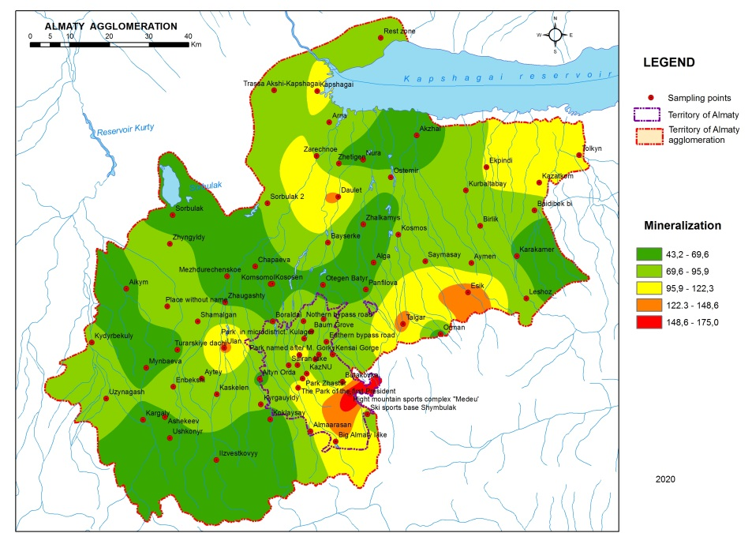
Figure C.5 – Spatial distribution of the average values of mineralization of the snow cover of the territory of Almaty agglomeration, 2020

Table C.17 – Average heavy metal content in SC of the AA, 2020
Zones | Cu | Zn | Cd | Co | Ni | Pb
name | μg/dm³
1  Mountainous territory | 25,9 | 21,9 | 2,1 | 15,3 | 6,8 | 25,0
2  Territory of Almaty | 26,1 | 35,8 | 3,0 | 16,4 | 21,6 | 36,0
3  Small towns, urban-type settlements | 24,2 | 22,9 | 2,6 | 13,8 | 16,4 | 38,2
4  Small settlements | 23,4 | 25,1 | 2,4 | 14,1 | 13,9 | 31,3
5  Coast of KR | 24,6 | 27,5 | 3,3 | 9,6 | 17,1 | 32,7
Limits | 23,4-26,1 | 21,9-35,8 | 2,1-3,3 | 9,6-16,4 | 6,8-21,6 | 25,0-38,2
Average | 24,8 | 26,6 | 2,7 | 13,8 | 15,2 | 32,6

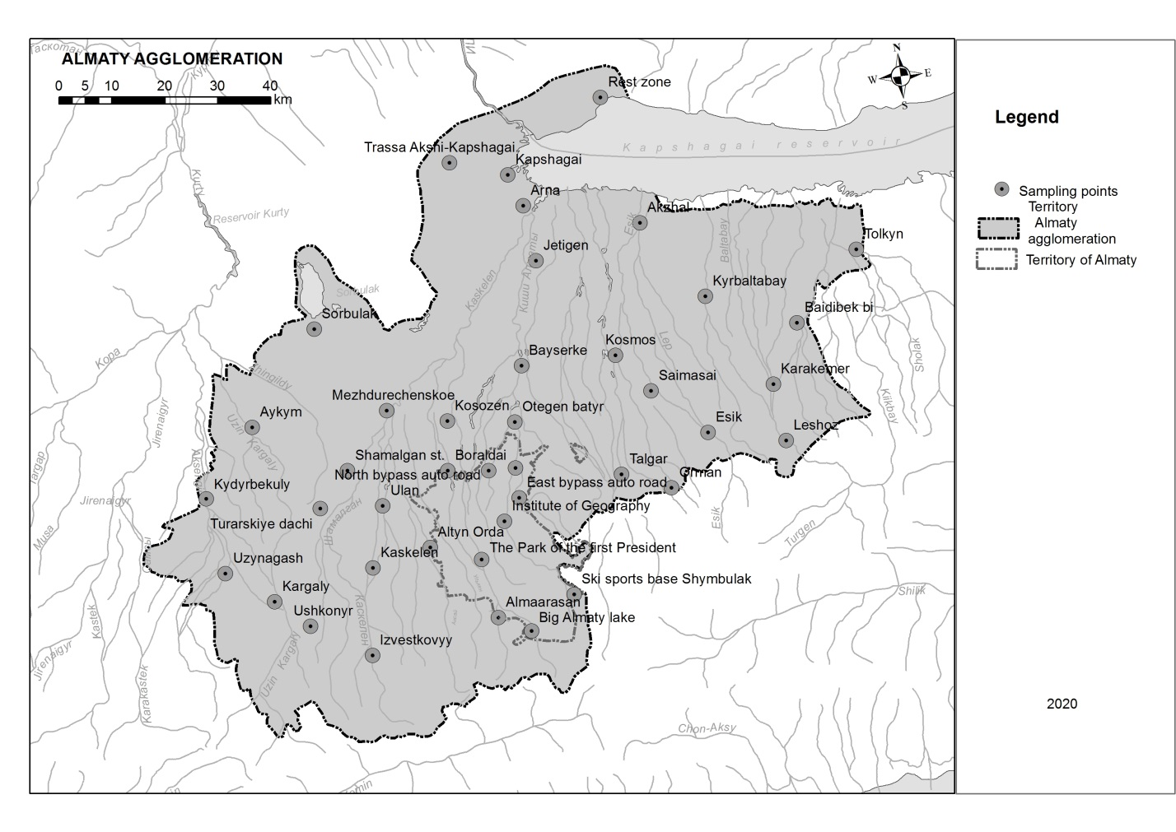
Figure C.6 – Diagram of snow and soil sampling points for PCBs analysis, 2020

Table C.18 – Average content and congener composition of PCBs in SC of the AA, 2020
Зона | PCBs congeners | Concentration PCBs, μg/dm³
1. Mountainous territory | 44, 49 | 0,005  (0,038)
2. Territory of Almaty | 44, 74, 114, 137 | 0,071
3. Small towns, urban-type settlements | 44, 66/95, 74, 97 | 0,207
4. Small settlements | 44, 48, 49, 74, 97 | 0,068

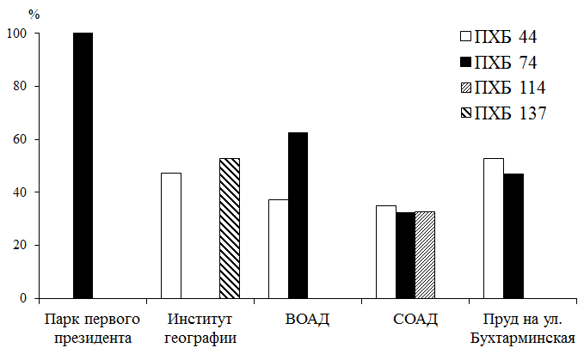
Figure C.7 – Relative content of PCBs congeners in the snow cover
of the territory of Almaty, 2020

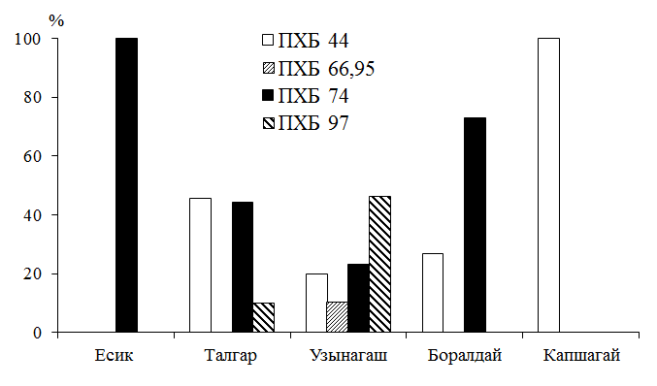
Figure C.8 – Relative content of PCBs congeners in the snow cover of small towns
and urban-type settlements, 2020

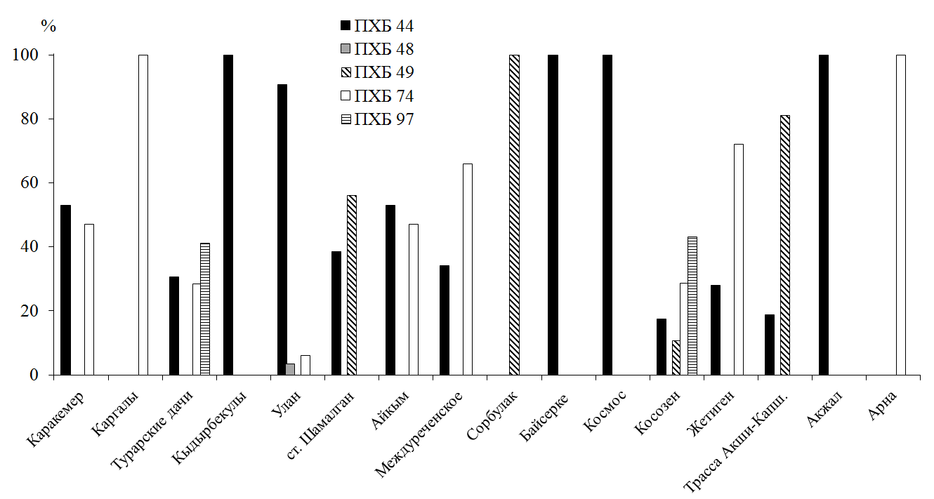
Figure C.9 – Relative content of PCBs congeners in the snow cover of small settlements, 2020

Table C.19 – Chemical composition of the water of Kapshagai reservoir, 2020
The sampling site | рН | Oxidizability, mgO/dm³ | Suspended substances,  mg/dm³ | Mineralization, mg/dm³
Mouth of Kaskelen river | 7,9 | 2,7 | 19,0 | 531
Prudkhoz | 7,9 | 2,7 | 41,0 | 561
9-pumping station | 7,6 | 3,0 | 6,0 | 469
At the railway bridge | 7,8 | 2,2 | 9,0 | 461
Shengeldy Island | 7,9 | 2,6 | 2,0 | 463

Table C.20 – Level of accumulation of heavy metal in water KR, 2020
The sampling site | Cu | Zn | Cd | Co | Ni | Pb
The sampling site | μg/dm³
Mouth of Kaskelen river | 19,8 | 10,4 | 5,0 | 11,9 | 26,4 | 35,4
Prudkhoz | 22,3 | 8,2 | 1,8 | 13,0 | 11,9 | 27,1
9-pumping station | 21,5 | 10,3 | 2,0 | 6,3 | 15,3 | 52,1
At the railway bridge | 26,6 | 10,1 | 2,0 | 7,4 | 6,3 | 39,6
Shengeldy Island | 24,9 | 7,0 | 1,0 | 14,1 | 0,7 | 47,9
limits  average | 19,8-26,6  23,0 | 7,0-10,4  9,2 | 1,0-5,0  2,4 | 6,3-14,1  10,5 | 0,7-26,4  12,1 | 27,1-52,1  40,4
MPC_{fishery} | 1 | 10 | 5 | 10 | 10 | 10

Table C.21 – Content of PCBs and their congeners in water of KR, 2020
The sampling site | Congeners | Amount of PCBs,  μg/dm³
Mouth of Kaskelen river | 41; 52; 66; 74 | 0,155
Prudkhoz | 66; 171 | 0,353
9-pumping station | 40; 44; 171 | 0,136
At the railway bridge | 66; 74 | 0,130
Shengeldy Island | 41; 44; 66 | 0,066

Table C.22 – Granulometric and physico-chemical parameters of the soil, 2019-2020
Zones | The sampling site | Type of soil (rock) | pH |  | Mineralization  by TDS, mg/kg
Zones | The sampling site | Type of soil (rock) | 2019 | 2020 | 2019 | 2020
Mountainous territory | HMR "Shymbulak" | chernozem, gravel | 7,3 | 6,1 | 50 | 350
Mountainous territory | BAL | chernozem, gravel | 6,0 | 6,5 | 150 | 350
Mountainous territory | Almaarasan | chernozem | - | 6,7 | - | 150
Mountainous territory | Izvestkovyi | chernozem, gravel | 7,8 | 7,0 | 450 | 450
Mountainous territory | Leshoz | chernozem, gravel | - | 7,0 | - | 400
Mountainous territory | Orman | chernozem | - | 7,4 | - | 500
Mountainous territory | Uwkonyr | chernozem, gravel | - | 6,5 | - | 250
Territory of Almaty | Institute of Geography | chernozem, gravel | 8,0 | 6,9 | 350 | 350
Territory of Almaty | Park of the First President | chernozem, gravel | 8,0 | 6,6 | 350 | 350
Territory of Almaty | Northern bypass road (NBR) | loam, sand | 8,2 | 7,1 | 300 | 300
Territory of Almaty | Eastern bypass road (EBR) | chernozem, clay | 8,2 | 6,9 | 350 | 200
Territory of Almaty | Pond on Bukhtarminskaya street | loam, clay, sand | - | 7,0 | - | 300
Territory of Almaty | Altyn Orda | sandy loam | 8,3 | 7,3 | 250 | 250
Small towns, urban-type settlements | Kaskelen | chernozem, gravel | 7,3 | 6,7 | 300 | 350
Small towns, urban-type settlements | Uzynagash | chernozem | 8,0 | 6,7 | 300 | 350
Small towns, urban-type settlements | Kapshagay | sand, sandy loam | 8,7 | 7,0 | 150 | 250
Small towns, urban-type settlements | Boraldai | loam, clay | - | 7,1 | - | 350
Small towns, urban-type settlements | Yesik | chernozem | 8,3 | 7,0 | 300 | 300
Small towns, urban-type settlements | Talgar | chernozem | 8,1 | 6,9 | 350 | 300
Small settlements | Ulan | chernozem, gravel | - | 7,4 | - | 300
Small settlements | Shamalgan | chernozem | 8,5 | 7,3 | 300 | 350
Small settlements | Turar dachi | loam | 8,3 | 7,3 | 250 | 250
Small settlements | Kargaly | sandy loam | 7,0 | 6,1 | 75 | 50
Small settlements | Kydyrbekuly | chernozem | - | 7,4 | - | 400
Small settlements | Aikym | sandy loam | - | 7,6 | - | 350
Small settlements | Sorbulak | sand, loam | 8,2 | 7,7 | 100 | 200
Small settlements | Mezhdurechensk | clay | 8,1 | 7,3 | 300 | 250
Small settlements | Kossozen | loam | 8,3 | 7,5 | 250 | 250
Small settlements | Otegen batyr | fine sand, sandy loam | 8,2 | 7,0 | 300 | 300
Small settlements | Bayserke | clay | - | 7,4 | - | 350
Small settlements | Zhetigen | loam, sand | 8,8 | 7,4 | 2000 | 300
Small settlements | Kosmos | chernozem | 8,3 | 7,4 | 400 | 400
Small settlements | Kyrbaltabay | chernozem | 8,1 | 7,2 | 900 | 450
Small settlements | Tolkyn | sand, clay | 8,5 | 7,1 | 1150 | 1050
Small settlements | Baidibek bi | chernozem, clay | 8,1 | 6,9 | 350 | 350
Small settlements | Karakemer | chernozem, gravel | 8,3 | 6,6 | 300 | 600
Small settlements | Saimasai | chernozem | - | 7,4 | - | 700
Small settlements | Kapshagai-Akshi highway | sandy loam | 8,5 | 7,4 | 200 | 200
Coast of KR | Akjal | loam | - | 7,5 | - | 500
Coast of KR | Arna | loam, sand | 8,6 | 7,3 | 150 | 200
Coast of KR | Rest zone | sand | 8,9 | 7,3 | 100 | 150
Note – "-" – no samples were taken in 2019
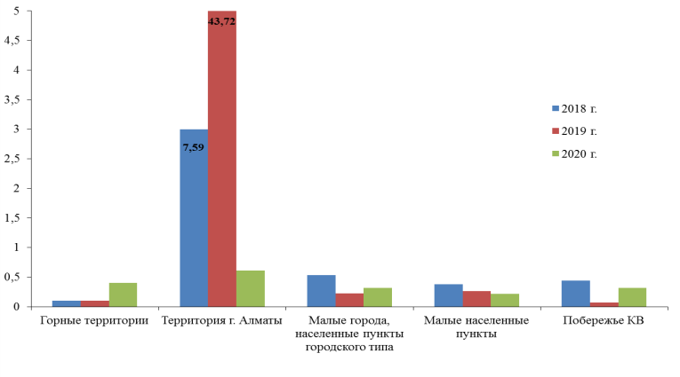 | 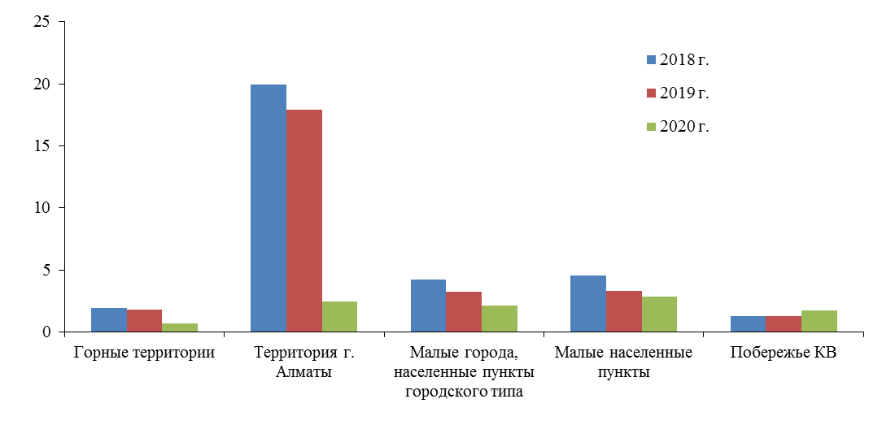
copper | lead
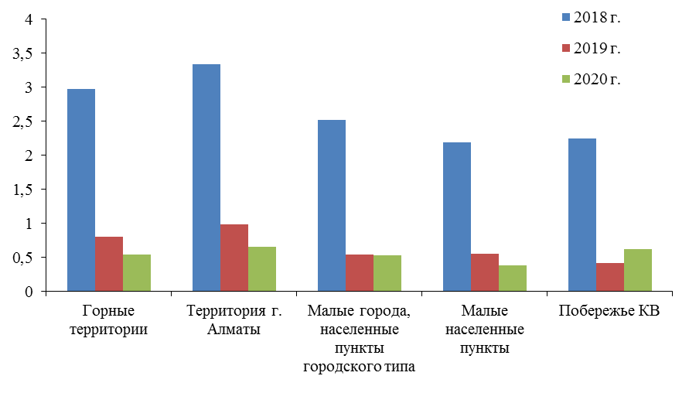 | 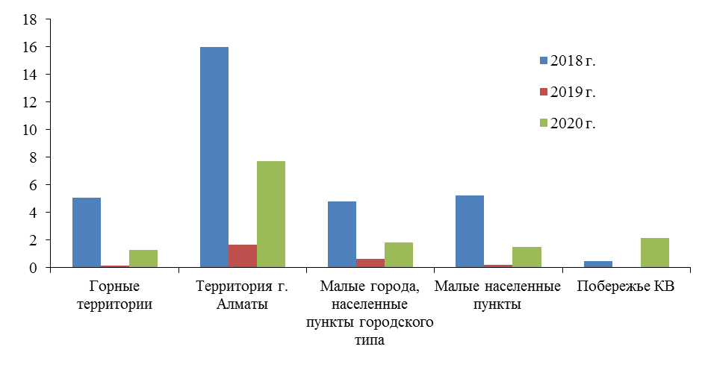
nickel | zinc
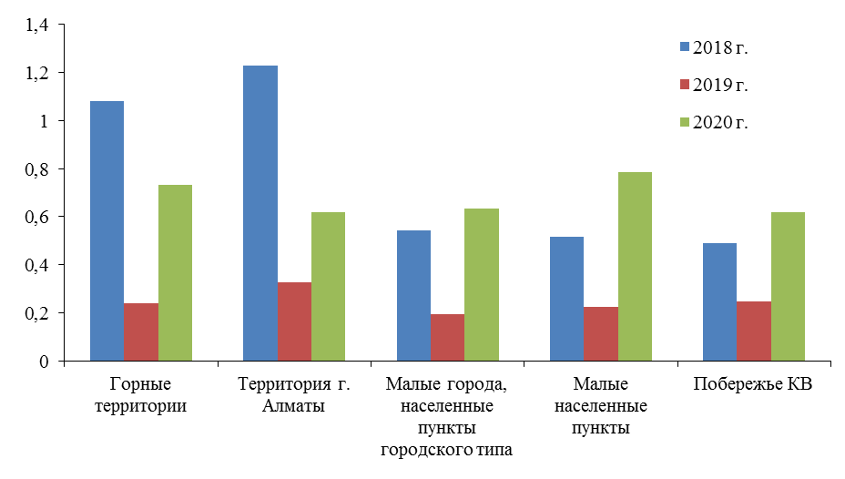 | 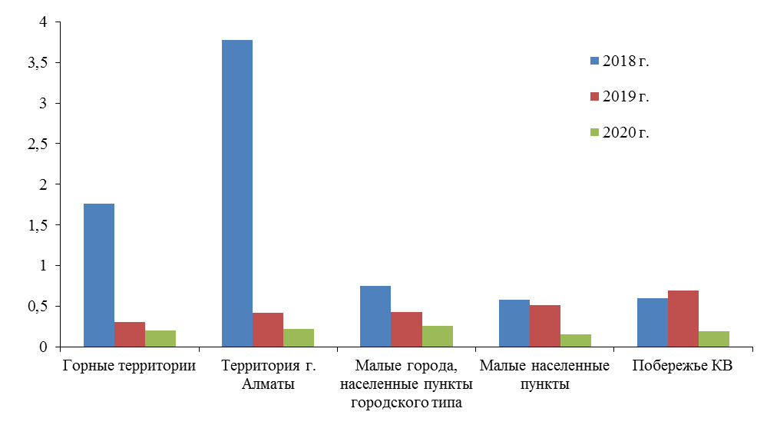
cobalt | cadmium
Figure C.10 – Average content of heavy metals in the soil cover of AA, 2020

Table C.23 – Concentration and congener composition of PCBs in soil of AA by zone, 2020
Zones |  | PCBs congeners | Concentration PCBs, μg/kg
№ | name | PCBs congeners | Concentration PCBs, μg/kg
1 | Mountainous territory | 74; 82; 86; 87/115; 97 | 0,043-7,935  1,70
2 | Territory of Almaty | 44; 74; 87/115; 97 | 0,223-4,420  2,17
3 | Small towns, urban-type settlements | 41/64/71; 44; 74; 97; 114 | 0,093-9,160  2,63
4 | Small settlements | 44; 49; 70/76; 74; 82; 87/115; 97; 114; 138; 171 | 0,107-13,721  3,57
Note – in the numerator – limits, in the denominator – average values

Table C.24 – Amount of incoming pollutants per unit area in 2018
The sampling site | Heavy metal concentration, μg/dm³ |  |  |  |  |  | The mass of the incoming heavy metals, mg/m²
The sampling site | zinc | cadmium | copper | nickel | lead | cobalt | zinc | cadmium | copper | nickel | lead | cobalt
HMR "Shymbulak" | 8,9 | 5,2 | 5,7 | 5,4 | 11,7 | 0,3 | 0,630 | 0,372 | 0,408 | 0,384 | 0,832 | 0,019
Yesik | 18,2 | 3,7 | 10,0 | 5,2 | 24,1 | 4,2 | 1,221 | 0,246 | 0,672 | 0,346 | 1,613 | 0,283
Park of the First President | 24,8 | 6,1 | 5,3 | 10,2 | 14,6 | 1,1 | 1,166 | 0,288 | 0,249 | 0,479 | 0,686 | 0,053
Karakemer | 15,0 | 3,4 | 9,8 | 3,7 | 23,4 | 7,3 | 0,872 | 0,197 | 0,570 | 0,216 | 1,354 | 0,421
Talgar | 12,3 | 4,0 | 9,6 | 0,4 | 24,8 | 5,4 | 0,503 | 0,164 | 0,391 | 0,016 | 1,011 | 0,221
Kargaly | 8,7 | 3,9 | 7,9 | 6,4 | 18,3 | 1,2 | 0,368 | 0,165 | 0,336 | 0,273 | 0,776 | 0,052
Institute of Geography | 24,3 | 6,5 | 9,5 | 11,7 | 10,8 | 1,8 | 1,191 | 0,317 | 0,467 | 0,573 | 0,529 | 0,087
Kaskelen | 12,5 | 2,4 | 6,2 | 2,5 | 15,5 | 1,8 | 0,341 | 0,065 | 0,170 | 0,067 | 0,423 | 0,048
Uzynagash  88 | 11,7 | 3,7 | 6,5 | 11,0 | 11,0 | 2,8 | 0,428 | 0,136 | 0,237 | 0,402 | 0,400 | 0,103
Altyn Orda | 23,1 | 4,3 | 8,2 | 4,6 | 14,6 | 2,4 | 0,827 | 0,155 | 0,292 | 0,163 | 0,523 | 0,085
Eastern bypass road (EBR) | 11,5 | 3,8 | 7,9 | 9,2 | 13,9 | 3,4 | 0,466 | 0,154 | 0,321 | 0,372 | 0,564 | 0,139
Northern bypass road (NBR) | 21,9 | 4,7 | 8,8 | 0,6 | 11,7 | 1,7 | 1,014 | 0,216 | 0,409 | 0,028 | 0,542 | 0,077
Shamalgan | 13,0 | 3,3 | 8,6 | 6,2 | 16,8 | 5,1 | 0,491 | 0,127 | 0,327 | 0,236 | 0,637 | 0,194
Baidibek bi | 10,7 | 3,6 | 11,0 | 8,5 | 26,3 | 10,0 | 0,404 | 0,135 | 0,417 | 0,322 | 0,994 | 0,378
Karaoi (Sorbulak) | 10,3 | 3,8 | 12,2 | 1,0 | 24,1 | 5,1 | 0,312 | 0,113 | 0,368 | 0,031 | 0,726 | 0,155
Otegen batyr | 10,7 | 3,9 | 9,4 | 2,9 | 11,0 | 4,7 | 0,312 | 0,114 | 0,273 | 0,085 | 0,320 | 0,137
Kyrbaltabay | 10,2 | 3,4 | 10,3 | 6,4 | 21,2 | 5,7 | 0,371 | 0,125 | 0,376 | 0,233 | 0,772 | 0,209
Rest zone | 8,0 | 4,2 | 9,6 | 1,9 | 24,8 | 4,5 | 0,297 | 0,155 | 0,354 | 0,069 | 0,918 | 0,167
Tolkyn (Prudkhoz) | 7,4 | 3,5 | 10,5 | 5,6 | 26,3 | 8,7 | 0,245 | 0,115 | 0,347 | 0,185 | 0,866 | 0,287
Zhetigen | 21,4 | 3,4 | 9,1 | 4,0 | 17,5 | 6,5 | 0,325 | 0,052 | 0,139 | 0,060 | 0,267 | 0,100
Kapshagay city | 3,8 | 3,6 | 9,1 | 5,0 | 15,3 | 7,0 | 0,089 | 0,086 | 0,216 | 0,118 | 0,363 | 0,166

Table C.25 – Amount of incoming pollutant per unit area in 2019
The sampling site | Heavy metal concentration, μg/dm³ |  |  |  |  |  | The mass of the incoming heavy metals, mg/m²
The sampling site | zinc | cadmium | copper | nickel | lead | cobalt | zinc | cadmium | copper | nickel | lead | cobalt
Big Almaty Lake (BAL) | 8,5 | 1,1 | 2,4 | 1,4 | 11,8 | 3,9 | 0,782 | 0,104 | 0,221 | 0,129 | 1,086 | 0,359
HMR "Shymbulak" | 21,5 | 0,9 | 4,5 | 5,3 | 24,3 | 6,1 | 1,820 | 0,079 | 0,381 | 0,449 | 2,057 | 0,516
Izvestkovyi | 6,6 | 0,7 | 0,2 | 10,0 | 17,3 | 7,8 | 0,174 | 0,019 | 0,005 | 0,263 | 0,456 | 0,205
Yesik | 37,7 | 1,1 | 2,3 | 8,6 | 14,6 | 4,8 | 2,451 | 0,070 | 0,150 | 0,559 | 0,949 | 0,312
Park of the First President | 21,3 | 1,4 | 3,6 | 5,9 | 11,8 | 5,6 | 1,336 | 0,088 | 0,226 | 0,370 | 0,740 | 0,351
Karakemer | 8,3 | 1,3 | 3,6 | 10,4 | 14,6 | 7,1 | 0,343 | 0,055 | 0,149 | 0,430 | 0,603 | 0,293
Talgar | 11,7 | 1,2 | 2,6 | 14,5 | 27,1 | 8,0 | 0,507 | 0,052 | 0,113 | 0,628 | 1,173 | 0,346
Kargaly | 7,3 | 0,6 | 1,7 | 8,2 | 27,1 | 7,1 | 0,243 | 0,017 | 0,048 | 0,230 | 0,759 | 0,199
Institute of Geography | 20,0 | 1,5 | 5,2 | 5,6 | 25,7 | 8,7 | 0,840 | 0,064 | 0,218 | 0,235 | 1,079 | 0,365
Kaskelen | 97,7 | 1,8 | 1,0 | 8,9 | 34,0 | 8,2 | 5,178 | 0,095 | 0,053 | 0,472 | 1,802 | 0,435
Uzynagash | 9,0 | 1,6 | 1,4 | 10,1 | 29,8 | 9,9 | 0,324 | 0,058 | 0,050 | 0,364 | 1,073 | 0,356
Turar dachi | 7,3 | 1,1 | 1,9 | 7,6 | 29,9 | 11,0 | 0,183 | 0,027 | 0,048 | 0,190 | 0,748 | 0,275
Altyn Orda | 13,7 | 1,1 | 3,3 | 9,7 | 25,7 | 11,4 | 0,311 | 0,024 | 0,075 | 0,220 | 0,583 | 0,258
Eastern bypass road (EBR) | 39,9 | 2,4 | 2,3 | 17,9 | 27,1 | 10,6 | 1,847 | 0,111 | 0,106 | 0,829 | 1,255 | 0,491
Boraldai  89 | 9,6 | 2,7 | 2,8 | 5,6 | 24,3 | 3,9 | 0,233 | 0,066 | 0,068 | 0,136 | 0,590 | 0,095
Northern bypass road (NBR) | 26,5 | 2,6 | 3,4 | 20,8 | 27,1 | 11,9 | 0,935 | 0,092 | 0,120 | 0,734 | 0,957 | 0,420
Shamalgan | 9,9 | 0,7 | 6,3 | 10,6 | 41,0 | 8,9 | 0,168 | 0,012 | 0,107 | 0,180 | 0,697 | 0,151
Baidibek bi | 15,3 | 2,5 | 1,5 | 8,6 | 25,7 | 8,7 | 0,459 | 0,074 | 0,045 | 0,258 | 0,771 | 0,261
Mezhdurechensk | 8,7 | 0,7 | 1,7 | 6,8 | 43,7 | 11,2 | 0,171 | 0,013 | 0,033 | 0,134 | 0,860 | 0,220
Karaoi (Sorbulak) | 8,1 | 1,1 | 2,7 | 7,2 | 21,5 | 7,3 | 0,126 | 0,017 | 0,042 | 0,112 | 0,333 | 0,113
Otegen batyr | 13,3 | 1,7 | 3,4 | 11,2 | 32,6 | 5,6 | 0,346 | 0,043 | 0,088 | 0,291 | 0,848 | 0,146
Kosmos | 11,4 | 1,5 | 2,6 | 12,3 | 27,1 | 8,2 | 0,351 | 0,047 | 0,080 | 0,379 | 0,835 | 0,253
Kyrbaltabay | 15,5 | 2,1 | 3,4 | 14,1 | 39,6 | 5,8 | 0,330 | 0,044 | 0,072 | 0,300 | 0,843 | 0,124
Kossozen | 4,8 | 1,3 | 1,9 | 9,8 | 13,2 | 8,6 | 0,099 | 0,026 | 0,039 | 0,203 | 0,273 | 0,169
Rest zone | 10,4 | 1,1 | 4,9 | 10,0 | 18,8 | 9,9 | 0,250 | 0,027 | 0,118 | 0,240 | 0,451 | 0,238
Tolkyn (Prudkhoz) | 11,3 | 2,3 | 1,3 | 7,8 | 11,8 | 4,1 | 0,215 | 0,044 | 0,025 | 0,148 | 0,224 | 0,078
Zhetigen | 15,0 | 1,1 | 1,4 | 8,2 | 22,9 | 9,1 | 0,135 | 0,010 | 0,013 | 0,074 | 0,206 | 0,082
Kapshagai-Akshi highway | 12,0 | 1,1 | 4,7 | 11,2 | 21,5 | 6,2 | 0,172 | 0,015 | 0,067 | 0,160 | 0,307 | 0,089
Arna | 74,0 | 0,7 | 4,5 | 11,2 | 22,9 | 9,9 | 0,483 | 0,004 | 0,029 | 0,073 | 0,150 | 0,065
Kapshagay city | 17,2 | 0,7 | 1,0 | 10,0 | 18,7 | 7,6 | 0,303 | 0,012 | 0,018 | 0,176 | 0,329 | 0,134

Table C.26 – Amount of incoming pollutant per unit area in 2020
The sampling site | Heavy metal concentration, μg/dm³ |  |  |  |  |  | The mass of the incoming heavy metals, mg/m²
The sampling site | zinc | cadmium | copper | nickel | lead | cobalt | zinc | cadmium | copper | nickel | lead | cobalt
HMR "Shymbulak" | 25,0 | 0,0 | 52,5 | 4,1 | 18,8 | 26,4 | 0,958 | 0,000 | 2,011 | 0,157 | 0,720 | 1,011
HMSC "Medeu" | 29,1 | 5,4 | 31,0 | 14,1 | 27,1 | 26,4 | 1,056 | 0,196 | 1,125 | 0,512 | 0,984 | 0,958
Butakovka | 16,4 | 3,6 | 24,1 | 1,8 | 35,4 | 1,8 | 0,546 | 0,120 | 0,803 | 0,060 | 1,179 | 0,060
Kensai gorge | 46,0 | 4,6 | 25,8 | 0,0 | 6,2 | 23,1 | 1,992 | 0,199 | 1,117 | 0,000 | 0,268 | 1,000
Koklaisai | 14,7 | 1,8 | 30,1 | 1,8 | 0,0 | 13,0 | 0,545 | 0,067 | 1,117 | 0,067 | 0,000 | 0,482
BAL | 14,2 | 0,0 | 18,0 | 1,8 | 18,8 | 6,3 | 0,345 | 0,000 | 0,437 | 0,044 | 0,457 | 0,153
Almaarasan | 16,8 | 0,0 | 19,8 | 0,7 | 31,2 | 10,8 | 0,489 | 0,000 | 0,576 | 0,020 | 0,908 | 0,314
Izvestkovyi | 12,1 | 0,8 | 23,2 | 1,8 | 43,8 | 14,1 | 0,330 | 0,022 | 0,633 | 0,049 | 1,196 | 0,385
Leshoz | 26,2 | 2,0 | 17,2 | 18,6 | 39,6 | 15,2 | 0,768 | 0,059 | 0,504 | 0,545 | 1,160 | 0,445
Orman | 21,4 | 2,2 | 22,3 | 29,8 | 47,9 | 10,8 | 1,216 | 0,125 | 1,267 | 1,693 | 2,721 | 0,613
Ushkonyr  90 | 19,5 | 2,2 | 20,6 | 0,7 | 6,2 | 20,8 | 0,669 | 0,075 | 0,707 | 0,024 | 0,213 | 0,713
Institute of Geography | 15,7 | 2,8 | 22,3 | 35,4 | 35,4 | 18,6 | 0,323 | 0,058 | 0,459 | 0,729 | 0,729 | 0,383
Park of the First President | 33,0 | 2,6 | 24,9 | 1,8 | 47,9 | 15,2 | 1,000 | 0,079 | 0,754 | 0,055 | 1,451 | 0,461
Baum Grove | 39,0 | 2,8 | 28,4 | 26,4 | 35,4 | 14,1 | 0,363 | 0,026 | 0,264 | 0,246 | 0,329 | 0,131
Rayymbek Batyr Avenue corner of Baizakov street | 33,9 | 3,8 | 37,0 | 17,5 | 39,6 | 13,0 | 0,485 | 0,054 | 0,529 | 0,250 | 0,566 | 0,186
Park named after M. Gorky | 24,8 | 4,4 | 24,1 | 24,2 | 22,9 | 16,4 | 0,553 | 0,098 | 0,537 | 0,540 | 0,511 | 0,366
Sairan Lake | 20,9 | 4,8 | 25,8 | 28,7 | 39,6 | 17,5 | 0,173 | 0,040 | 0,214 | 0,238 | 0,329 | 0,145
Park named after Gandhi | 23,1 | 4,4 | 23,2 | 19,7 | 56,2 | 15,2 | 0,400 | 0,076 | 0,401 | 0,341 | 0,972 | 0,263
Zhastar Park | 46,4 | 4,6 | 49,0 | 33,2 | 52,1 | 18,6 | 1,545 | 0,153 | 1,632 | 1,106 | 1,735 | 0,619
Al-Farabi Kazakh national University | 13,3 | 4,0 | 21,5 | 25,3 | 31,2 | 20,8 | 0,301 | 0,090 | 0,486 | 0,572 | 0,705 | 0,470
Northern bypass road (NBR) | 28,7 | 3,6 | 16,3 | 34,3 | 43,8 | 19,7 | 0,324 | 0,041 | 0,184 | 0,388 | 0,495 | 0,223
BAC Park in the Kulager neighborhood | 23,1 | 2,8 | 25,8 | 35,4 | 47,9 | 8,5 | 0,619 | 0,075 | 0,691 | 0,949 | 1,284 | 0,228
Eastern bypass road (EBR) | 69,5 | 0,0 | 21,5 | 3,0 | 14,6 | 15,2 | 3,204 | 0,000 | 0,991 | 0,138 | 0,673 | 0,701
Pond on Bukhtarminskaya street | 105,9 | 1,2 | 25,8 | 3,0 | 18,8 | 24,2 | 1,303 | 0,015 | 0,317 | 0,037 | 0,231 | 0,298
Altyn Orda | 24,3 | 0,2 | 19,8 | 14,1 | 18,8 | 13,0 | 0,530 | 0,004 | 0,432 | 0,307 | 0,410 | 0,283
Kaskelen | 23,1 | 2,0 | 27,5 | 17,5 | 35,4 | 16,4 | 0,538 | 0,047 | 0,641 | 0,408 | 0,825 | 0,382
Uzynagash | 22,7 | 0,0 | 24,1 | 0,7 | 31,2 | 14,1 | 0,182 | 0,000 | 0,193 | 0,006 | 0,250 | 0,113
Kapshagay | 20,0 | 5,6 | 24,9 | 22,0 | 31,2 | 9,6 | 0,471 | 0,132 | 0,586 | 0,518 | 0,735 | 0,226
Boraldai | 9,2 | 5,0 | 20,6 | 17,5 | 72,9 | 20,8 | 0,225 | 0,122 | 0,504 | 0,428 | 1,782 | 0,509
Yesik | 43,5 | 1,4 | 24,1 | 20,9 | 31,2 | 10,8 | 1,231 | 0,040 | 0,682 | 0,591 | 0,883 | 0,306
Talgar | 18,6 | 1,8 | 24,1 | 19,7 | 27,1 | 10,8 | 0,595 | 0,058 | 0,771 | 0,630 | 0,867 | 0,346
Ulan | 101,3 | 0,0 | 24,1 | 16,4 | 39,6 | 7,4 | 4,133 | 0,000 | 0,983 | 0,669 | 1,616 | 0,302
Kyrgauildi | 47,6 | 0,4 | 30,1 | 6,3 | 2,1 | 13,0 | 1,561 | 0,013 | 0,987 | 0,207 | 0,069 | 0,426
Aitei | 22,7 | 0,0 | 23,2 | 8,6 | 0,0 | 11,9 | 0,649 | 0,000 | 0,664 | 0,246 | 0,000 | 0,340
Enbekshi | 19,0 | 0,0 | 24,1 | 1,8 | 14,6 | 14,1 | 0,433 | 0,000 | 0,549 | 0,041 | 0,333 | 0,321
Station Shamalgan | 43,5 | 8,8 | 25,8 | 5,2 | 18,8 | 20,8 | 1,088 | 0,220 | 0,645 | 0,130 | 0,470 | 0,520
Zhaugashty | 14,4 | 3,0 | 26,6 | 17,5 | 22,9 | 14,1 | 0,472 | 0,098 | 0,872 | 0,574 | 0,751 | 0,462
Turar dachi | 45,5 | 2,0 | 21,5 | 18,6 | 31,2 | 13,0 | 1,197 | 0,053 | 0,565 | 0,489 | 0,821 | 0,342
Mynbaeva  91 | 16,2 | 2,6 | 19,8 | 32,0 | 35,4 | 17,5 | 0,167 | 0,027 | 0,204 | 0,330 | 0,365 | 0,180
Ashekeev | 12,8 | 2,4 | 20,6 | 5,2 | 18,8 | 19,7 | 0,337 | 0,063 | 0,542 | 0,137 | 0,494 | 0,518
Kargali | 14,9 | 0,8 | 28,4 | 0,7 | 35,4 | 15,2 | 0,362 | 0,019 | 0,690 | 0,017 | 0,860 | 0,369
Kydyrbekuly | 21,7 | 0,0 | 25,8 | 5,2 | 39,6 | 9,6 | 0,451 | 0,000 | 0,537 | 0,108 | 0,824 | 0,200
Aikym | 41,4 | 0,4 | 31,0 | 18,6 | 43,8 | 22,0 | 1,379 | 0,013 | 1,032 | 0,619 | 1,459 | 0,733
Zhyngyldy | 28,1 | 1,6 | 25,8 | 19,7 | 31,2 | 10,8 | 1,419 | 0,081 | 1,303 | 0,995 | 1,576 | 0,545
Sorbulak | 23,6 | 0,2 | 26,6 | 9,7 | 22,9 | 27,6 | 0,680 | 0,006 | 0,766 | 0,279 | 0,660 | 0,795
Sorbulak-2 | 11,6 | 0,8 | 20,6 | 19,7 | 31,2 | 17,5 | 0,299 | 0,021 | 0,531 | 0,508 | 0,805 | 0,452
Place without a name | 109,7 | 0,0 | 31,0 | 9,7 | 39,6 | 13,0 | 3,543 | 0,000 | 1,001 | 0,313 | 1,279 | 0,420
Mezhdurechensk | 10,1 | 5,4 | 22,3 | 14,1 | 52,1 | 17,5 | 0,240 | 0,129 | 0,531 | 0,336 | 1,240 | 0,417
Chapaev | 10,8 | 5,2 | 23,2 | 17,5 | 47,9 | 14,1 | 0,430 | 0,207 | 0,923 | 0,697 | 1,906 | 0,561
Komsomol | 25,3 | 0,0 | 20,6 | 10,8 | 56,2 | 13,0 | 0,562 | 0,000 | 0,457 | 0,240 | 1,248 | 0,289
Kossozen | 8,0 | 1,2 | 26,6 | 14,1 | 72,9 | 13,0 | 0,179 | 0,027 | 0,596 | 0,316 | 1,633 | 0,291
Otegen batyr | 19,8 | 3,6 | 21,5 | 16,4 | 68,8 | 14,1 | 0,581 | 0,106 | 0,631 | 0,482 | 2,020 | 0,414
Baiserke | 21,9 | 3,8 | 21,5 | 11,9 | 6,2 | 13,0 | 0,626 | 0,109 | 0,615 | 0,340 | 0,177 | 0,372
Zhalkamys | 14,5 | 3,2 | 30,1 | 11,9 | 2,1 | 11,9 | 0,323 | 0,071 | 0,671 | 0,265 | 0,047 | 0,265
Daulet | 9,6 | 4,4 | 21,5 | 14,1 | 6,2 | 8,5 | 0,030 | 0,014 | 0,067 | 0,044 | 0,019 | 0,026
Ostemir | 20,0 | 4,8 | 18,9 | 8,6 | 18,8 | 14,1 | 0,546 | 0,131 | 0,516 | 0,235 | 0,513 | 0,385
Akjal | 9,4 | 4,6 | 23,2 | 13,0 | 18,8 | 1,8 | 0,228 | 0,112 | 0,564 | 0,316 | 0,457 | 0,044
Nura | 21,2 | 4,2 | 21,5 | 26,4 | 14,6 | 16,4 | 0,621 | 0,123 | 0,630 | 0,774 | 0,428 | 0,481
Zhetigen | 14,9 | 3,0 | 17,2 | 13,0 | 31,2 | 10,8 | 0,235 | 0,047 | 0,272 | 0,205 | 0,493 | 0,171
Арна | 59,9 | 3,8 | 28,4 | 25,3 | 39,6 | 17,5 | 1,707 | 0,108 | 0,809 | 0,721 | 1,129 | 0,499
Zarechnoe | 32,3 | 4,8 | 27,5 | 44,3 | 43,8 | 8,5 | 0,753 | 0,112 | 0,641 | 1,032 | 1,021 | 0,198
Rest zone | 13,3 | 1,4 | 22,3 | 13,0 | 39,6 | 9,6 | 0,200 | 0,021 | 0,335 | 0,195 | 0,594 | 0,144
Panfilov | 25,7 | 1,6 | 24,1 | 5,2 | 35,4 | 7,4 | 0,635 | 0,040 | 0,595 | 0,128 | 0,874 | 0,183
Alga | 18,3 | 2,4 | 24,9 | 11,9 | 35,4 | 14,1 | 0,452 | 0,059 | 0,615 | 0,294 | 0,874 | 0,348
Kosmos | 34,4 | 2,4 | 17,2 | 7,4 | 35,4 | 7,4 | 1,171 | 0,082 | 0,586 | 0,252 | 1,205 | 0,252
Kyrbaltabay  92 | 17,3 | 1,4 | 24,9 | 11,9 | 31,2 | 15,2 | 0,685 | 0,055 | 0,986 | 0,471 | 1,236 | 0,602
Ekpindi | 14,4 | 3,0 | 22,3 | 16,4 | 27,1 | 15,2 | 0,398 | 0,083 | 0,617 | 0,453 | 0,749 | 0,420
Kazatkom | 11,6 | 3,0 | 20,6 | 23,1 | 27,1 | 10,8 | 0,317 | 0,082 | 0,562 | 0,631 | 0,740 | 0,295
Tolkyn | 10,1 | 3,0 | 20,6 | 4,1 | 35,4 | 10,8 | 0,084 | 0,025 | 0,171 | 0,034 | 0,294 | 0,090
Baidibek bi | 14,2 | 1,8 | 21,5 | 17,5 | 31,2 | 16,4 | 0,352 | 0,045 | 0,533 | 0,434 | 0,774 | 0,407
Karakemer | 11,6 | 1,8 | 24,9 | 6,3 | 31,2 | 19,7 | 0,404 | 0,063 | 0,867 | 0,219 | 1,086 | 0,686
Aimen | 27,0 | 3,0 | 15,5 | 11,9 | 31,2 | 22,0 | 0,791 | 0,088 | 0,454 | 0,349 | 0,914 | 0,645
Birlik | 16,1 | 2,0 | 18,0 | 33,2 | 43,8 | 13,0 | 0,496 | 0,062 | 0,554 | 1,023 | 1,349 | 0,400
Saimasai | 24,3 | 2,8 | 26,6 | 15,3 | 35,4 | 15,2 | 0,826 | 0,095 | 0,904 | 0,520 | 1,204 | 0,517
Kapshagai-Akshi highway | 21,0 | 4,4 | 21,5 | 7,4 | 35,4 | 7,4 | 0,453 | 0,095 | 0,463 | 0,159 | 0,763 | 0,159

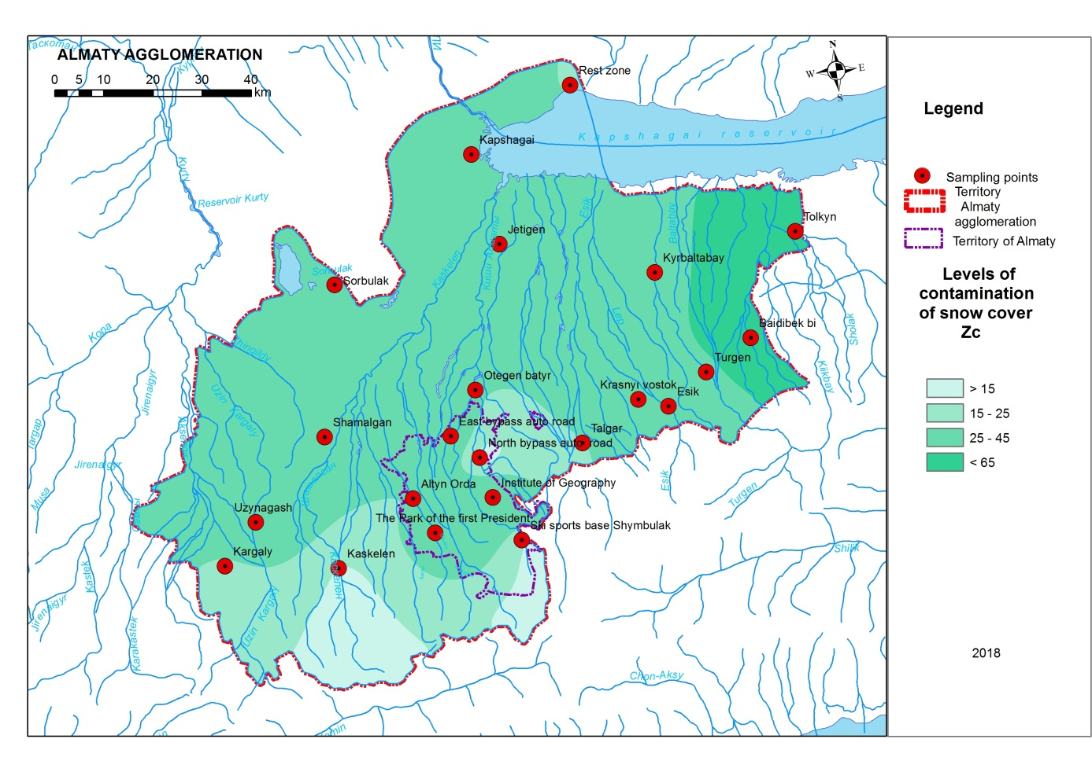
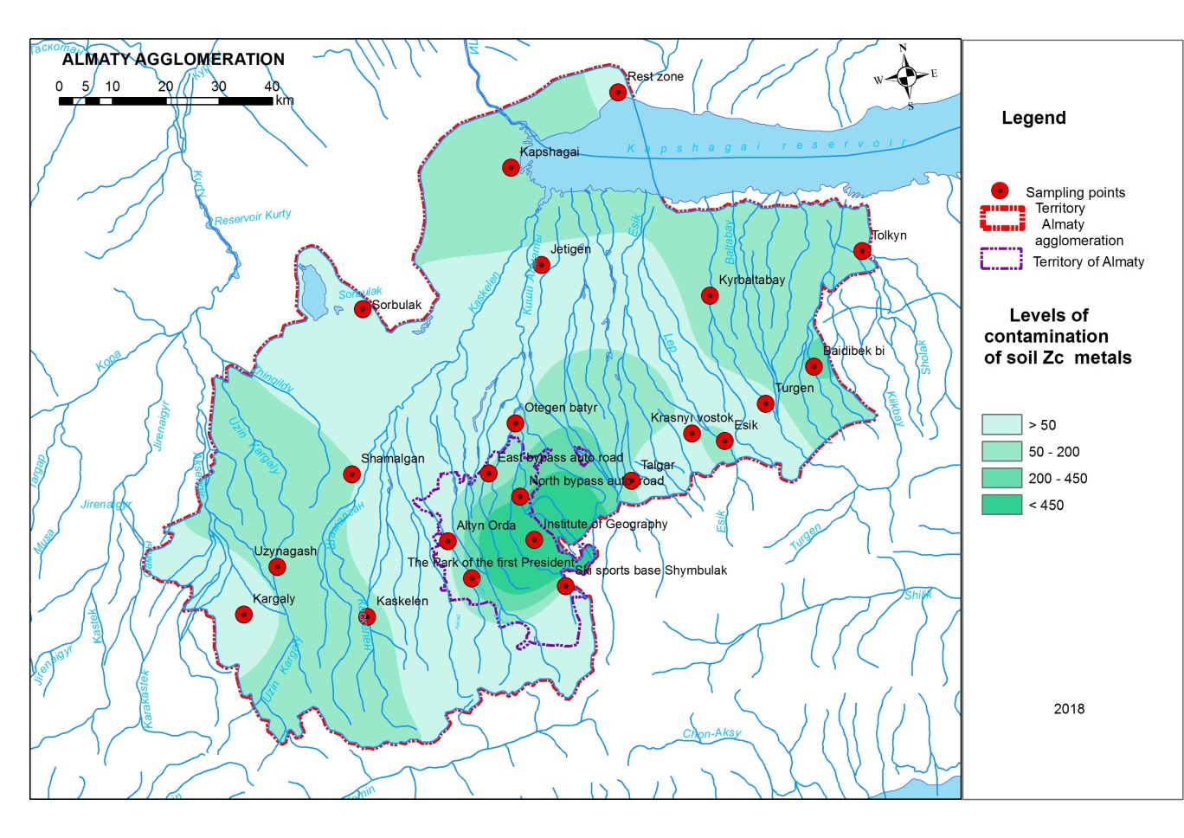
Figure C.11 – Ranking of the agglomeration territory by the pollution degree of SC and soil, 2018

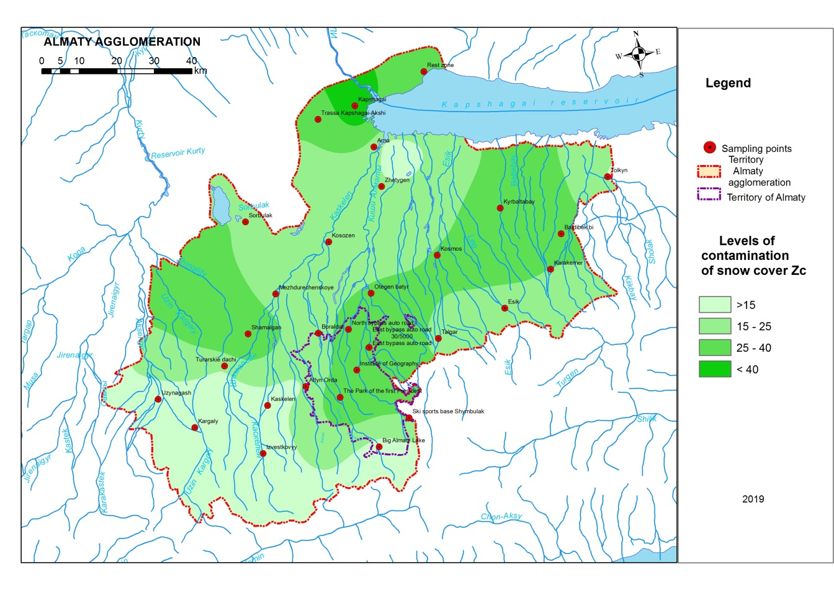
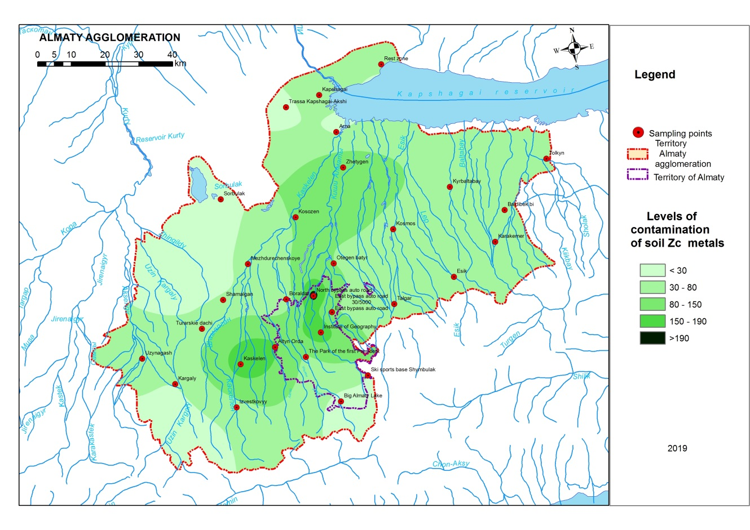
Figure C.11 – Ranking of the agglomeration territory by the pollution degree of SC and soil, 2019
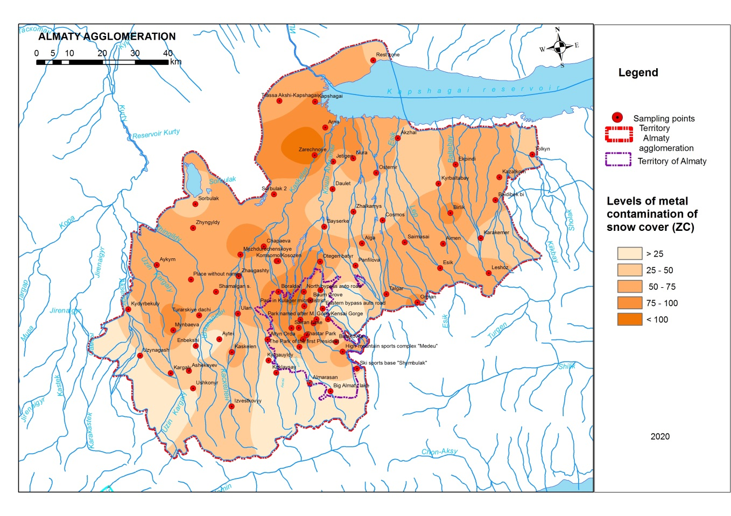
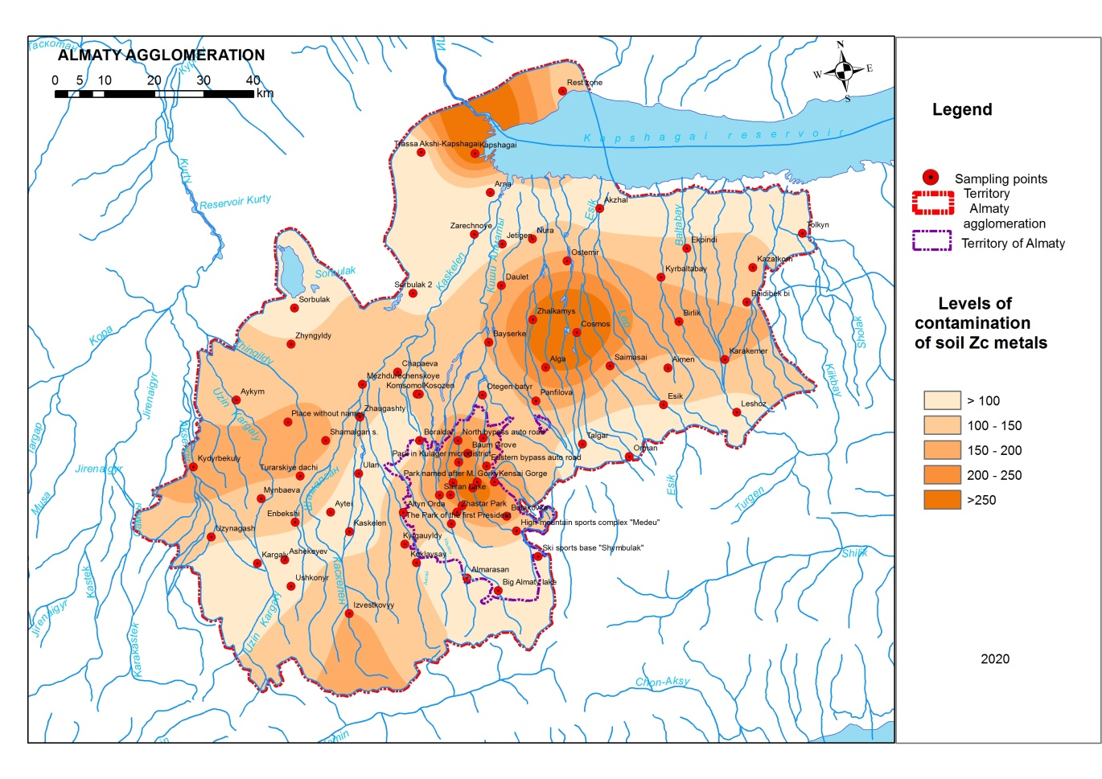
Figure C.11 – Ranking of the agglomeration territory by pollution degree of SC and soil, 2020

APPENDIX D

Results of analysis for heavy metals
Samples of snow (the sampling site of Talgar) 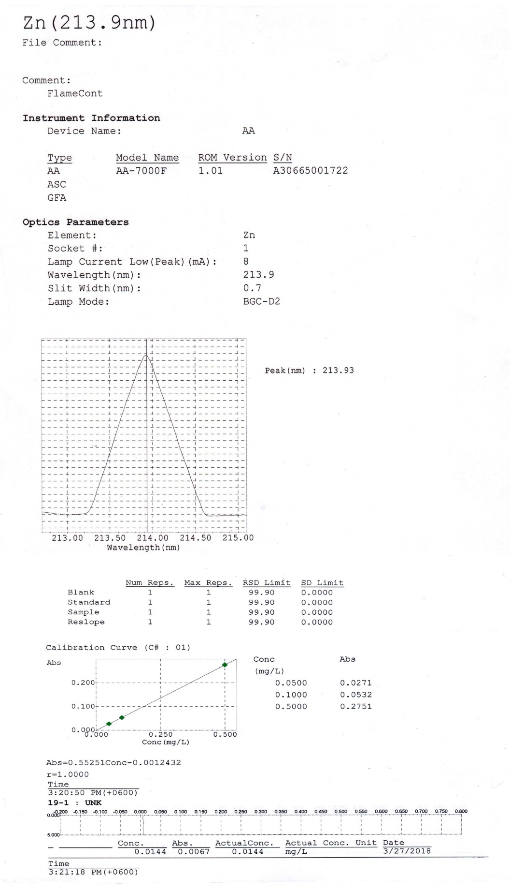

Ice sampling (the sampling site of Kapshagay reservoir, at the railway bridge)
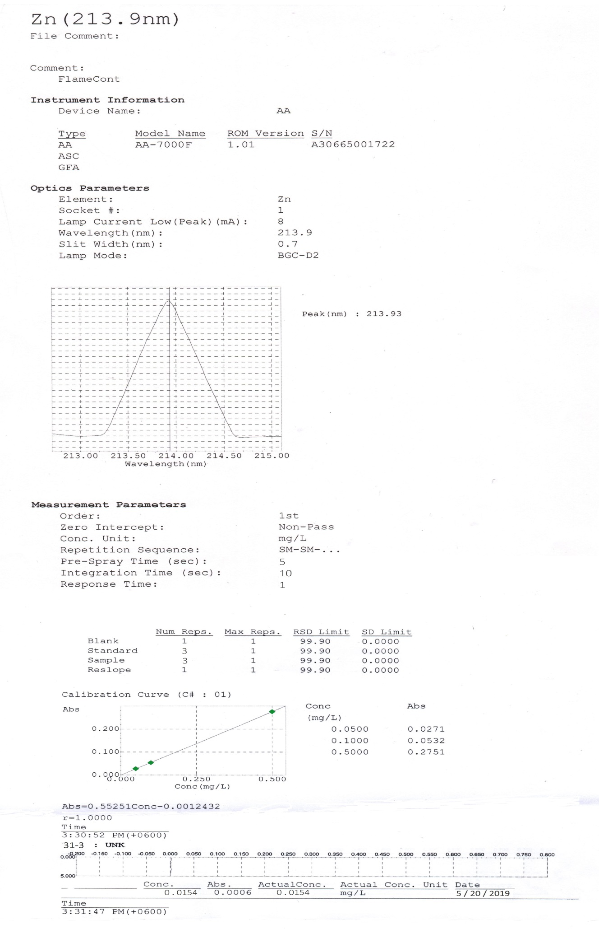

Soil samples (sampling site of Shamalgan station)
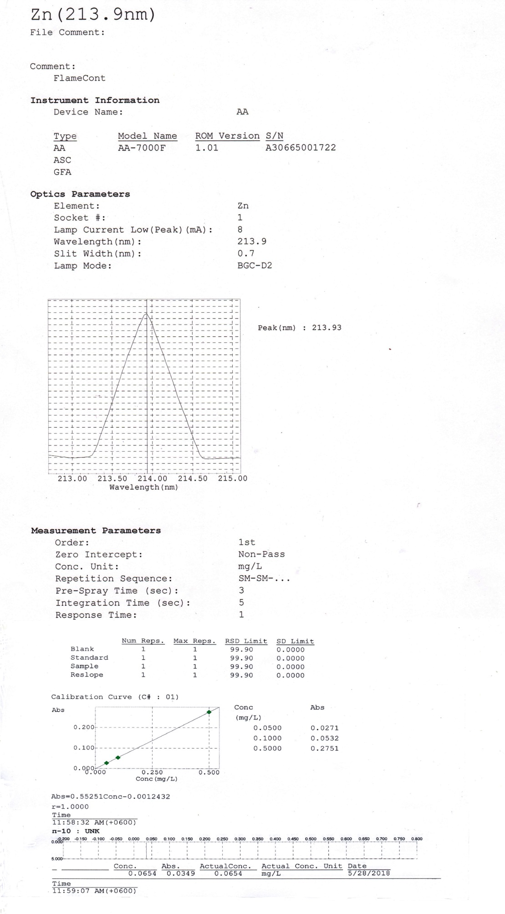

Water samples (sampling site of Kapshagay reservoir, at the railway bridge)
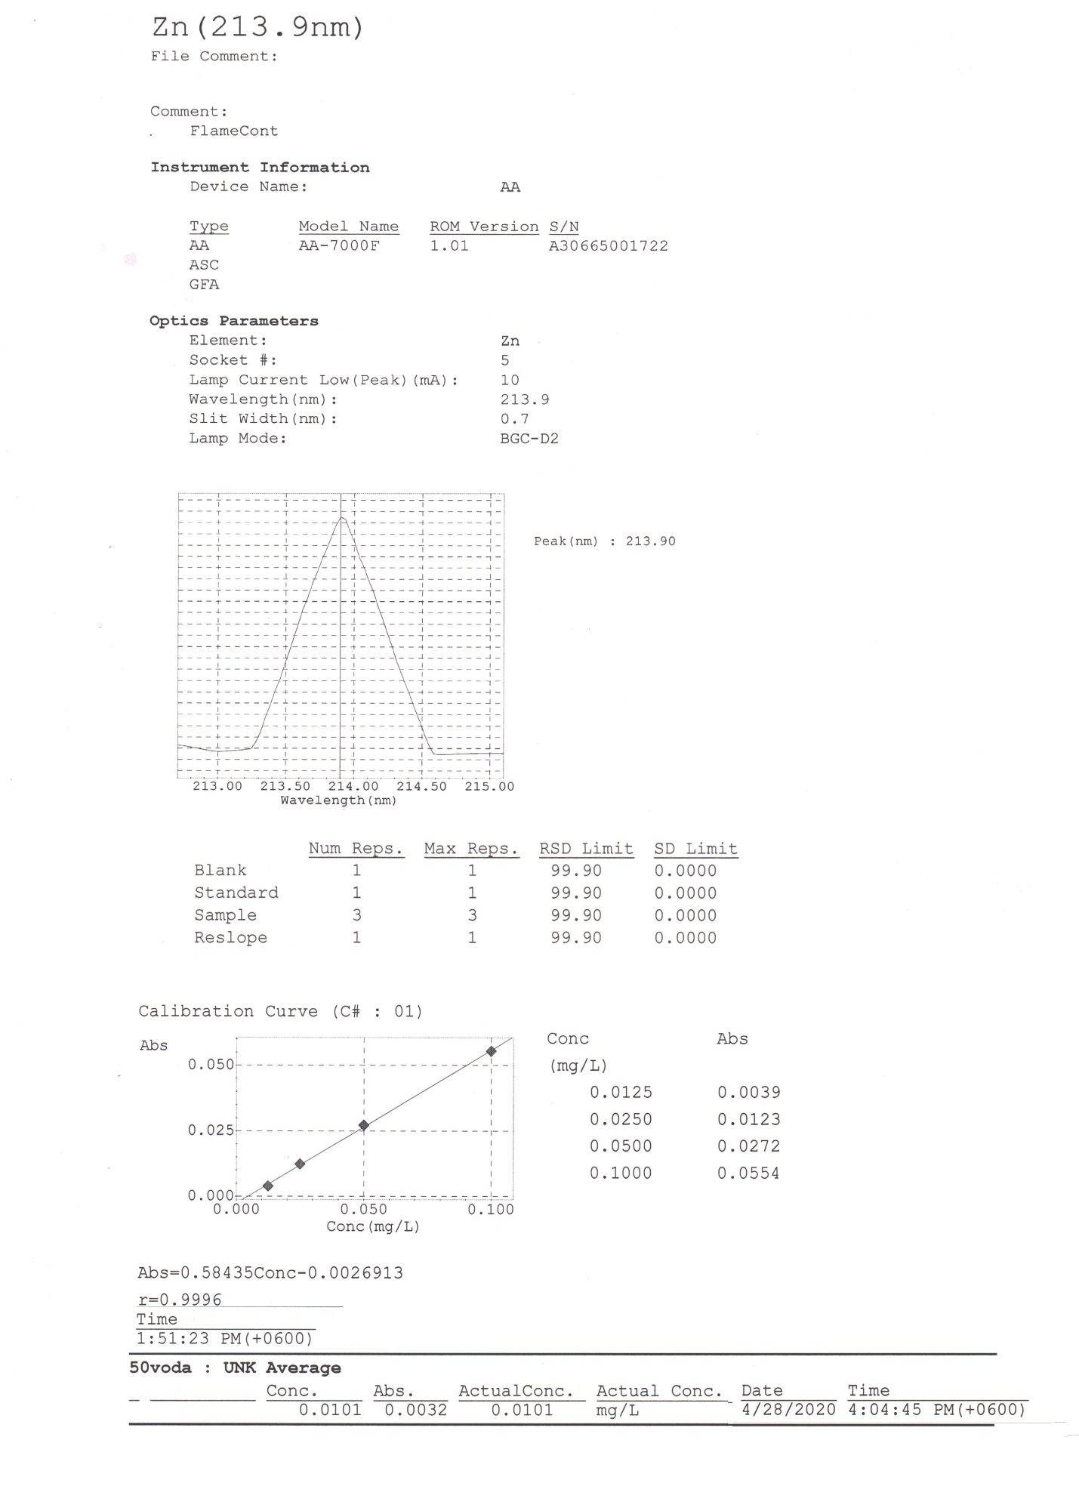

APPENDIX E

Chromatograms of analyzes for polychlorinated biphenyls
Snow samples (the sampling site of Talgar)
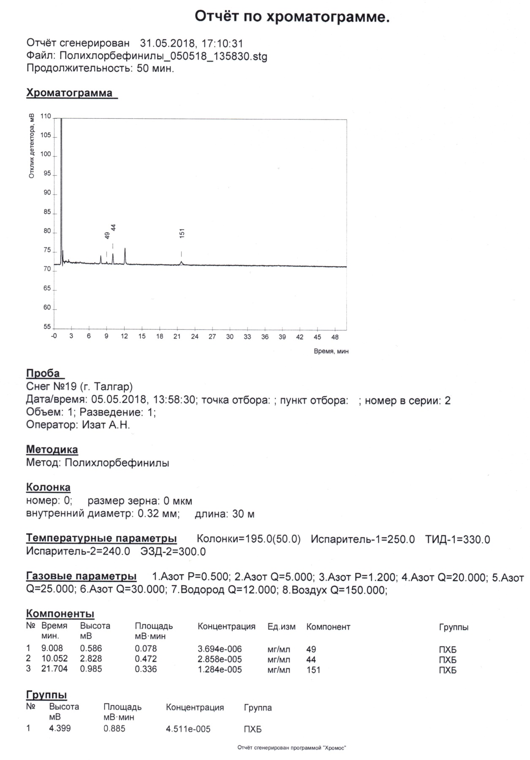

Ice sampling (the sampling site of Kapshagay reservoir, at the railway bridge)
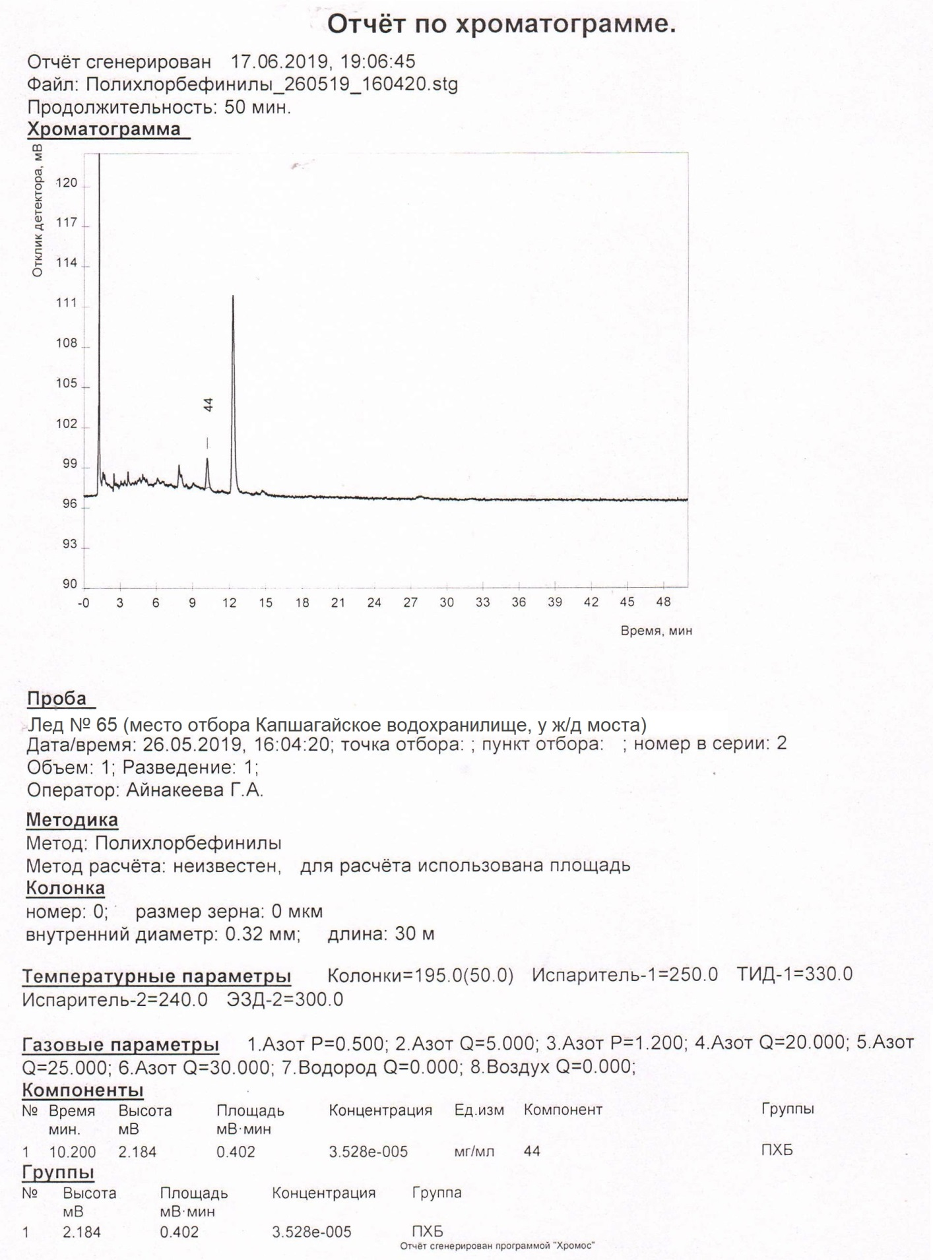

Soil samples (the sampling site of Park of the first President, Almaty)
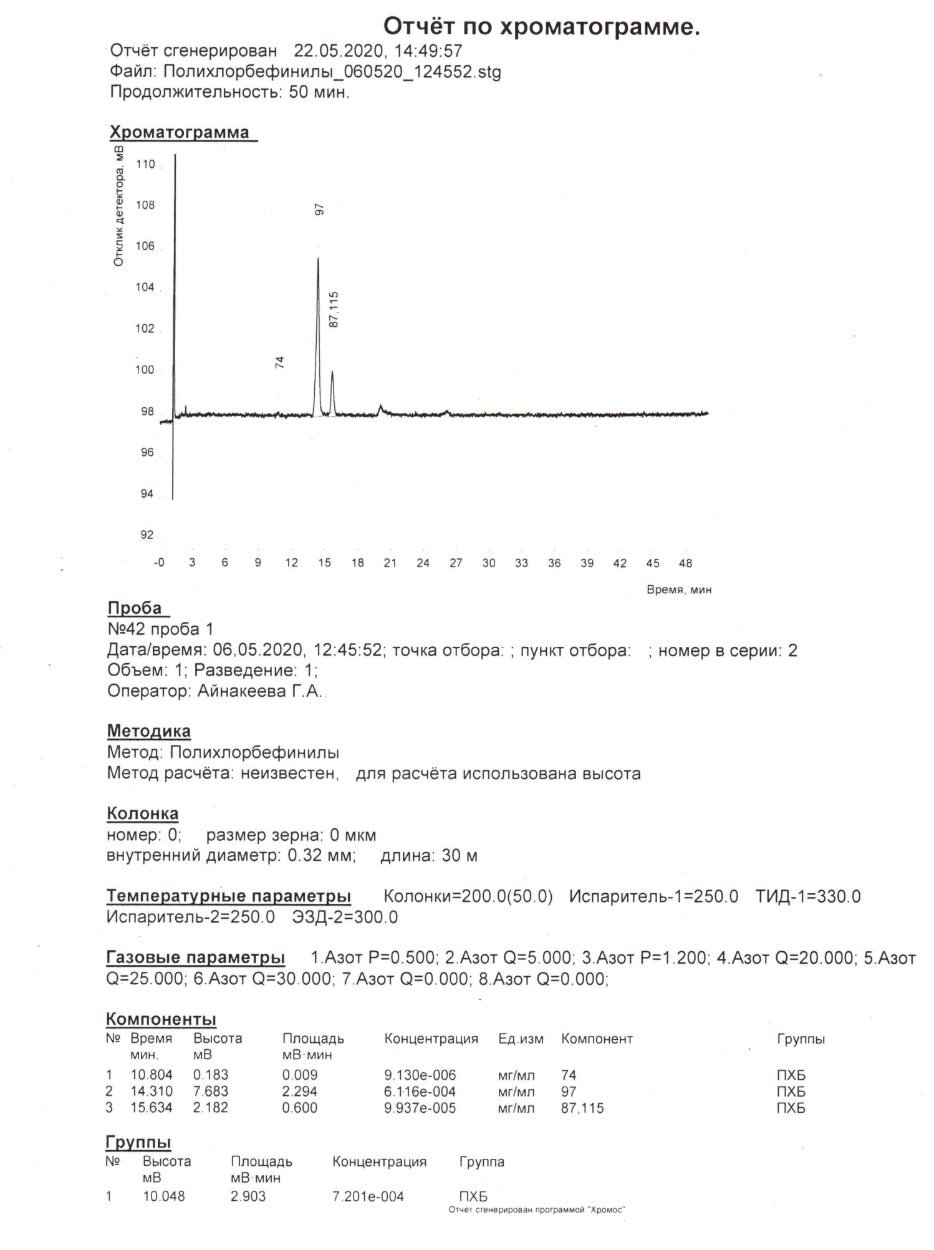

Samples of snow (the sampling site of Uzynagash)
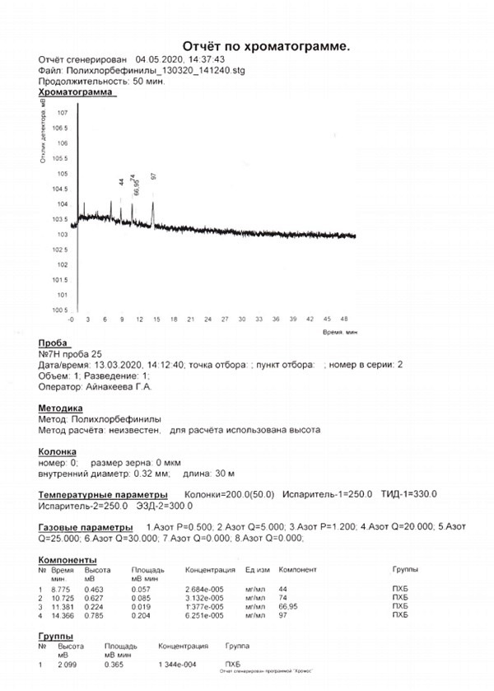

APPENDIX F

Extract from the protocol
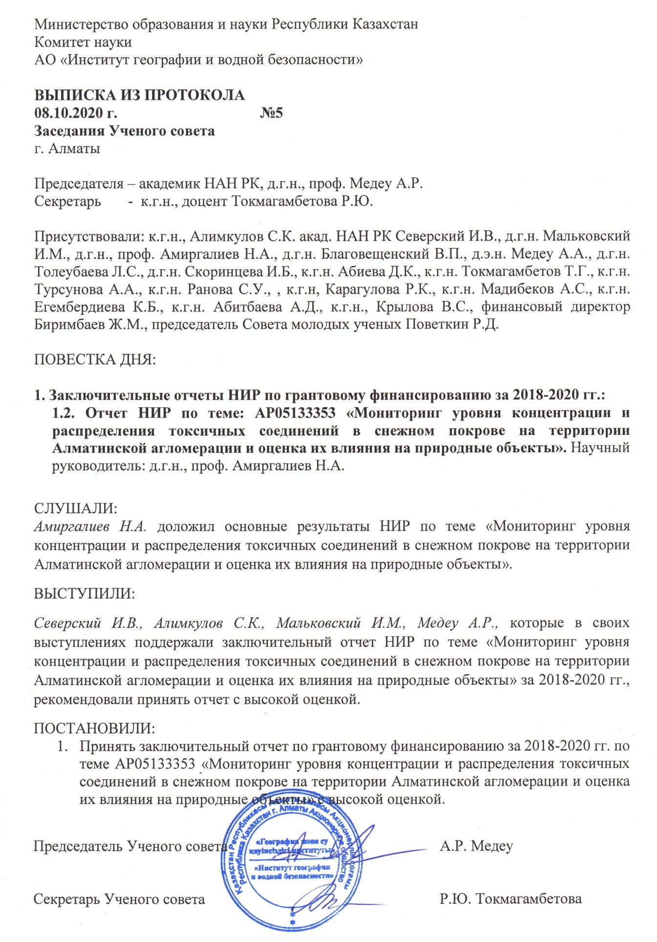
APPENDIX G

Research review from the third parties
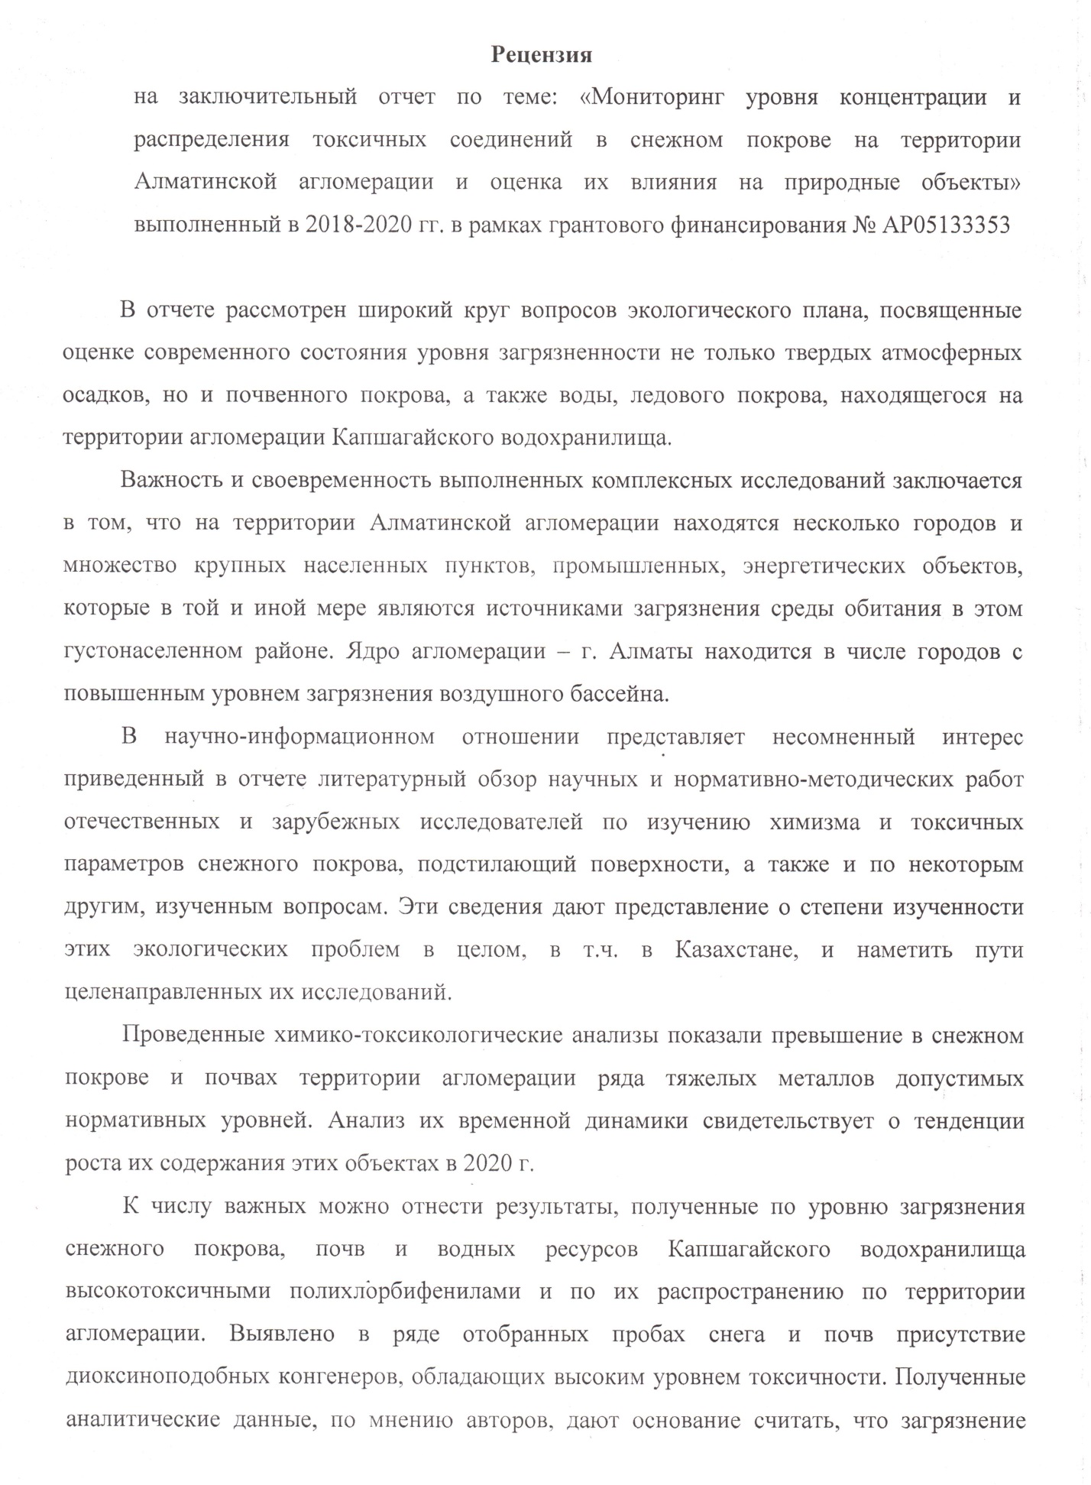

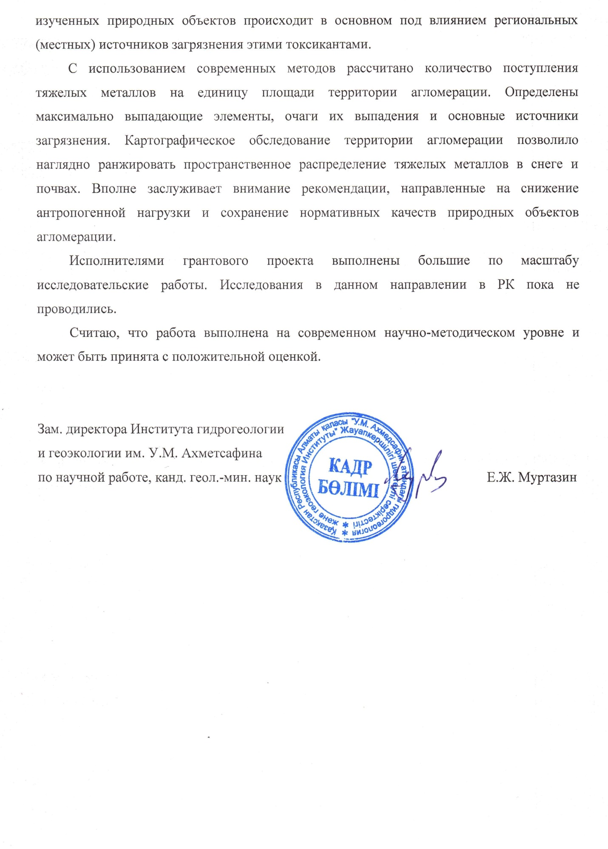

APPENDIX H

Research review from JSC "Institute of Geography and Water security"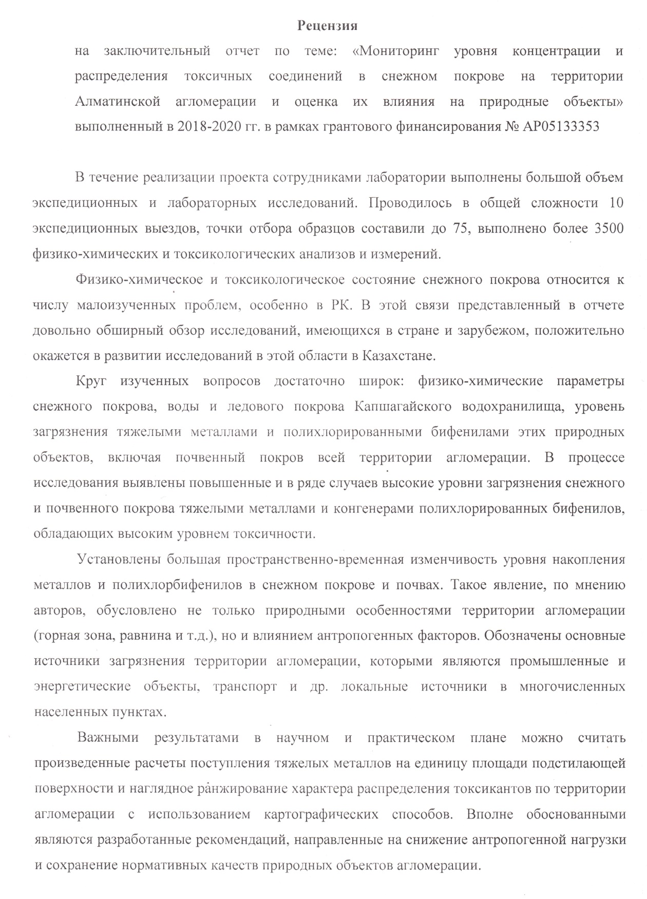
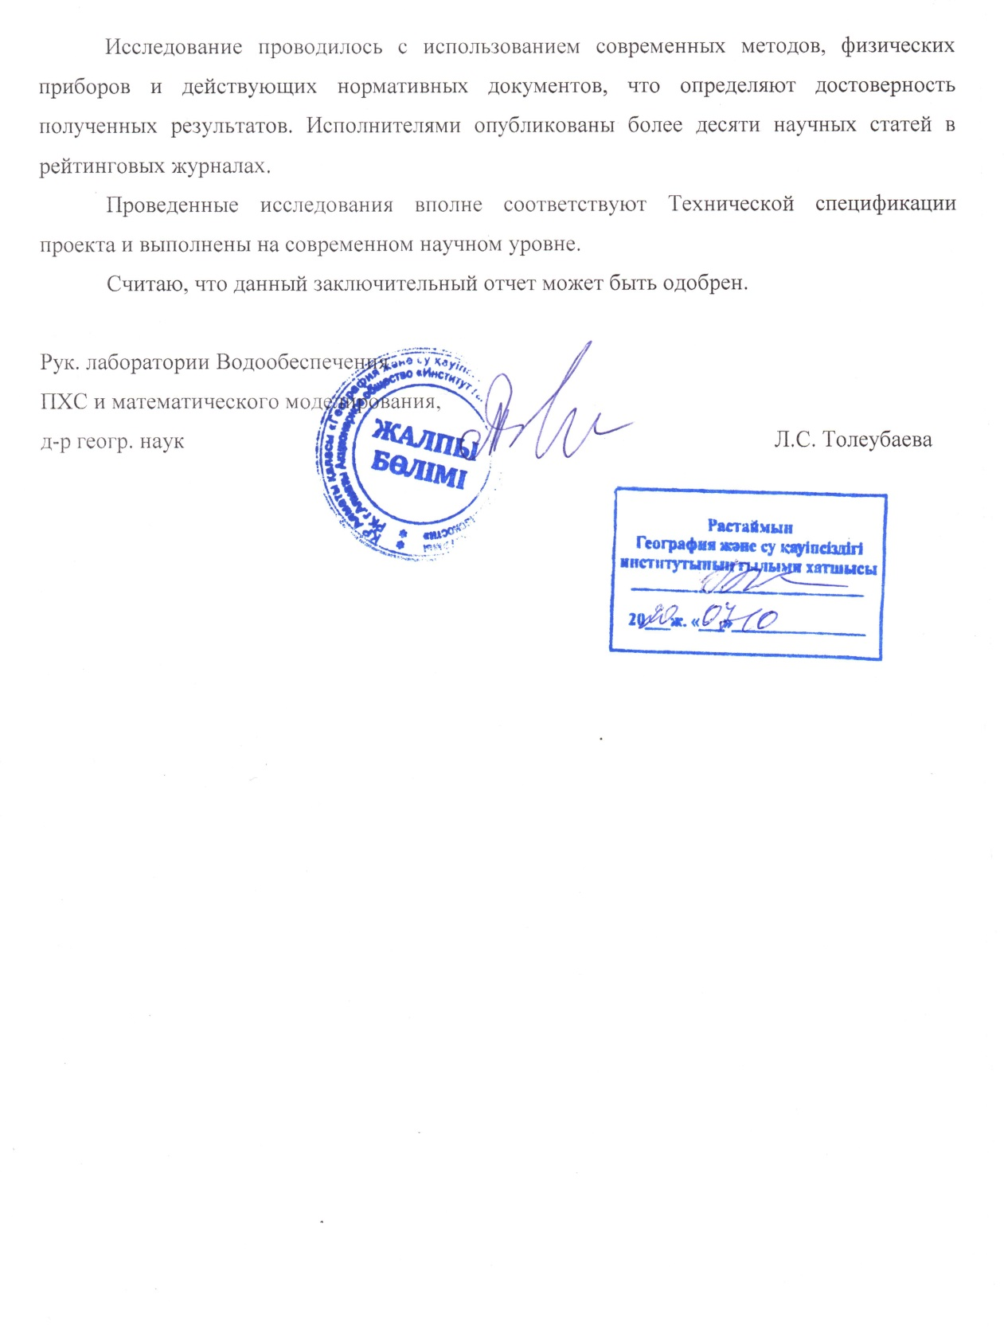

APPENDIX J

Use in work of foreign informational sources

1 "Scopus" is a bibliographic and abstract database and a tool for tracking the citation of articles published in scientific publications.
In the "Scopus" database (www.scopus.com) we tracked the citation index of authors of articles on the subject of natural, chemical and environmental Sciences.
2 Elsevier is the world's largest publisher of scientific, technical and medical literature and a provider of information solutions in the field of science and education.
During the project, we studied the literature and individual publications in the section of ecotoxicology and environmental safety on the website: www.sciencedirect.com

APPENDIX K

Documents confirming publications

Documents confirming publications for 2018
1. Аmirgaliyev N.А., Маdibekov А.S., Ismukhanova L.Т., Кulbekova R.А., Мusakulkyzy А., Zhadi А.O. Modern physical-chemical parameters of the snow cover of Almaty agglomeration // Issues of Geography and Geoecology. – Almaty, 2018. – № 3. – PP. 113–118. (in Russian)

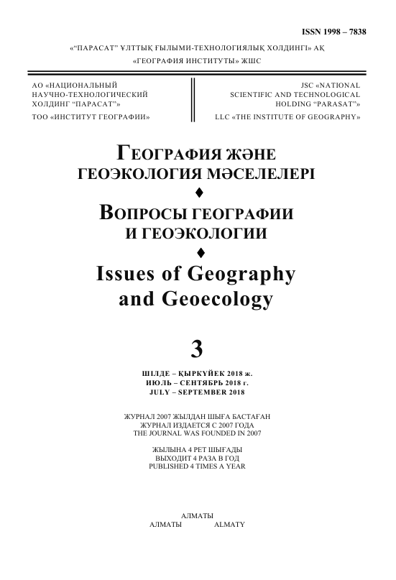
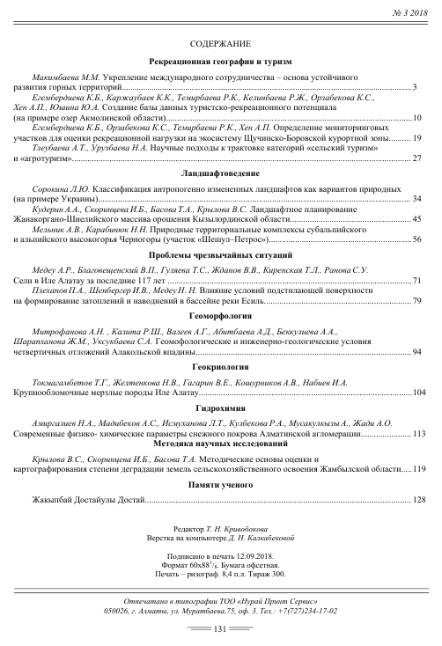
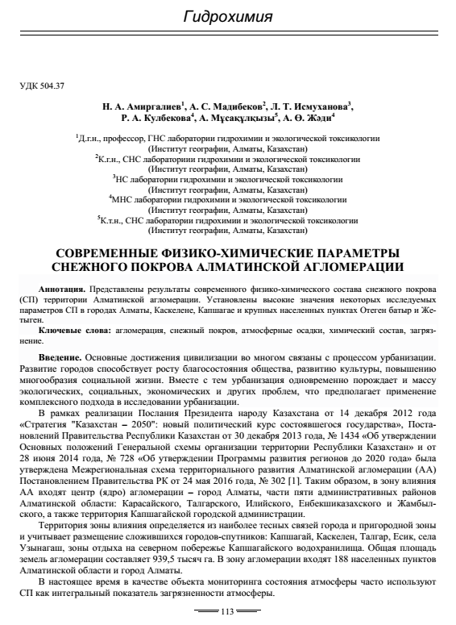

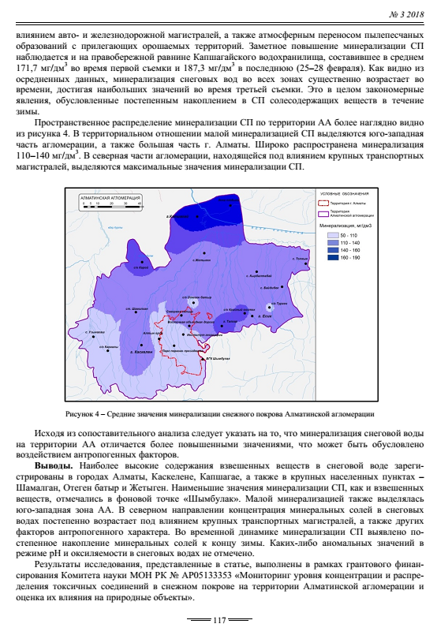

2. Аmirgaliyev N.А., Маdibekov А.S., Ismukhanova L.Т., Кulbekova R.А. Monitoring of physical-chemical indicators of snow cover of Almaty agglomeration // Reports of second Baikal International Scientific and Practical Conference «Snow cover, atmospheric precipitation, aerosols: tehnology, climate and ecology» (June, 25-30, 2018). – Irkutsk, 2018. – PP. 29–33. (in Russian)

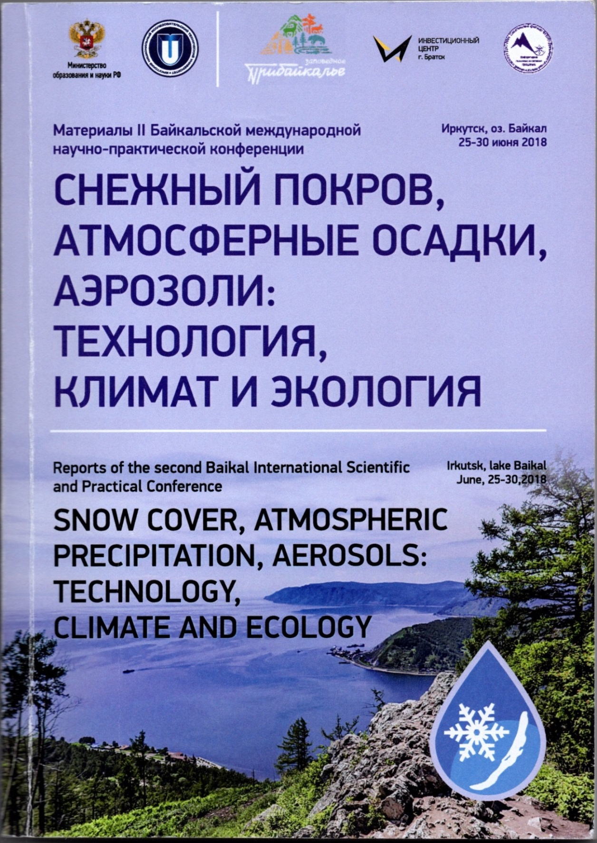

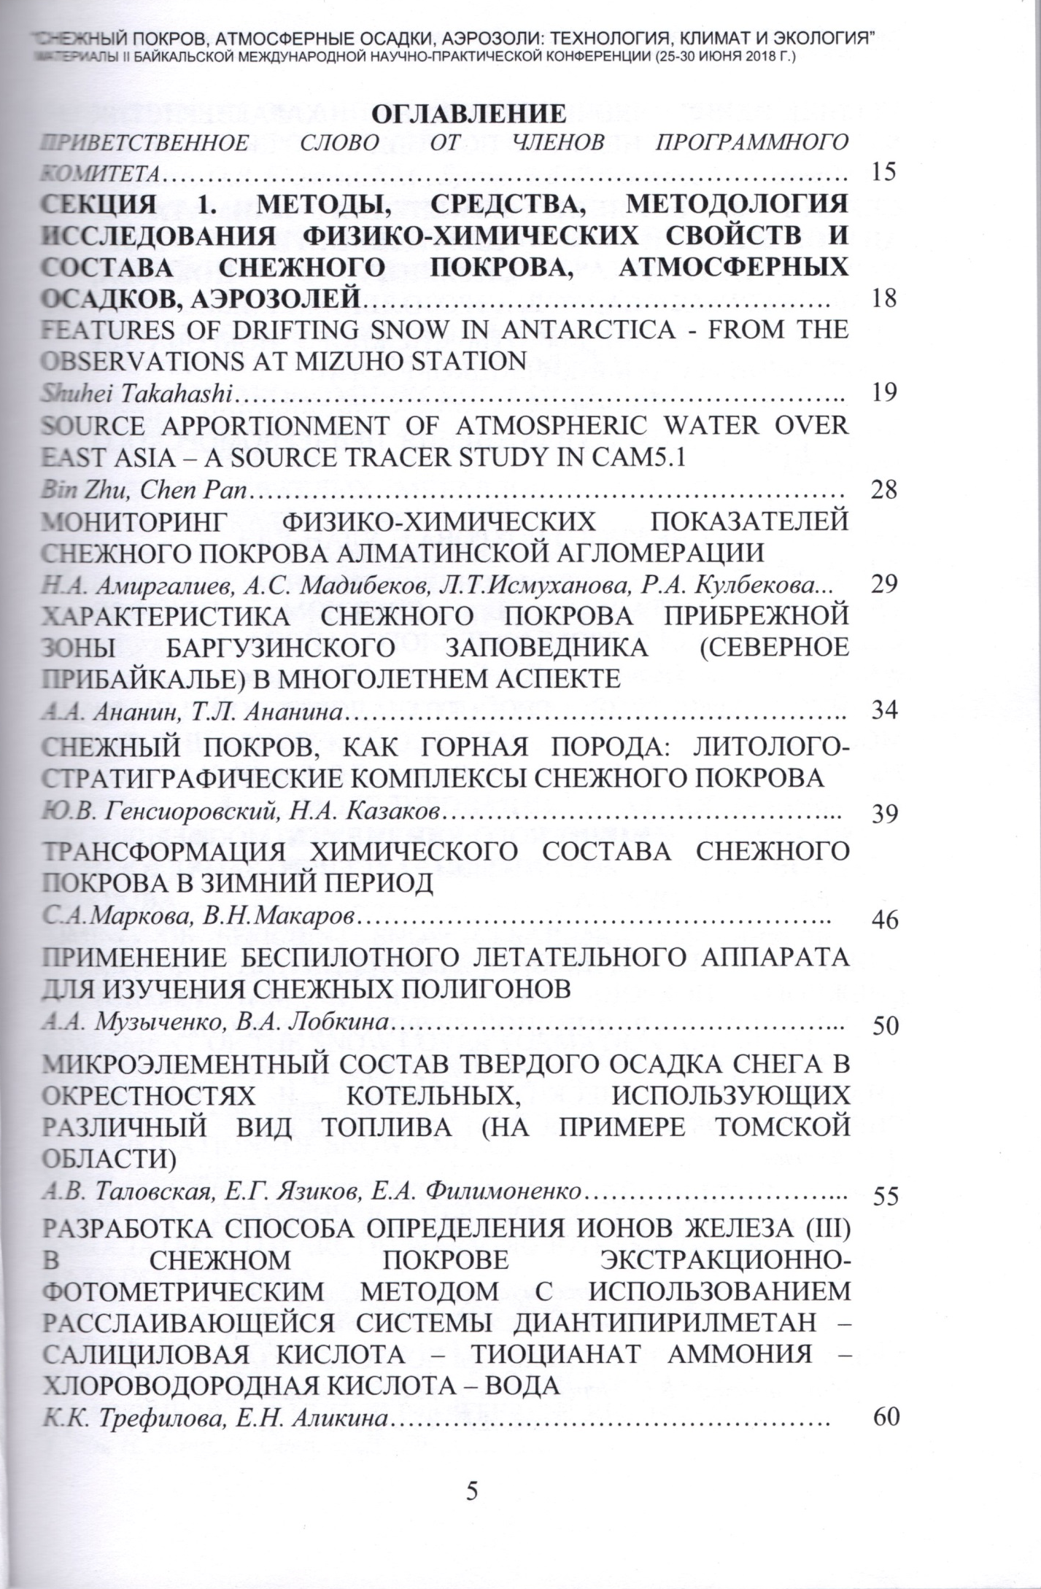
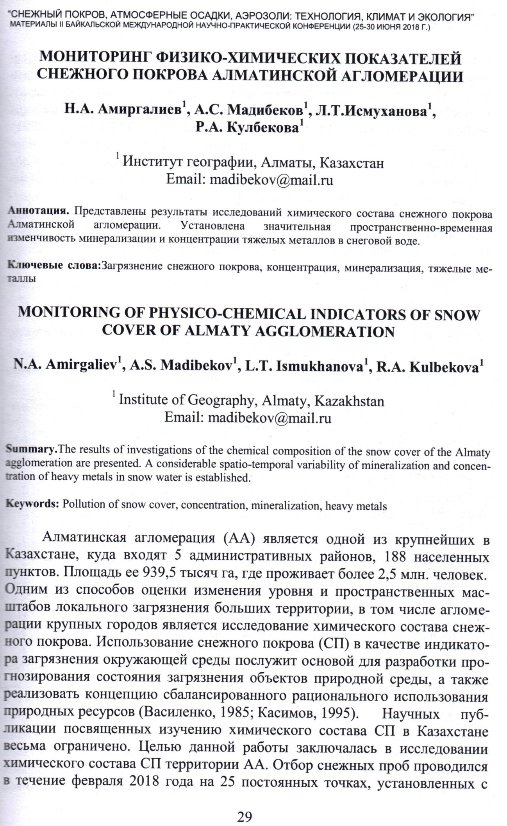
3. Cherednichenko A.V., Cherednichenko V.S., Cherednichenko Al.V., Nysanbayeva A.S., Madibekov A.S., Zhumalipov A.R. Aerosynoptical conditions of extremely high concentrations of pollutants in snow cover // Reports of second Baikal International Scientific and Practical Conference «Snow cover, atmospheric precipitation, aerosols: tehnology, climate and ecology» (June, 25-30, 2018). – Irkutsk, 2018. – PP. 105–109. (in Russian)

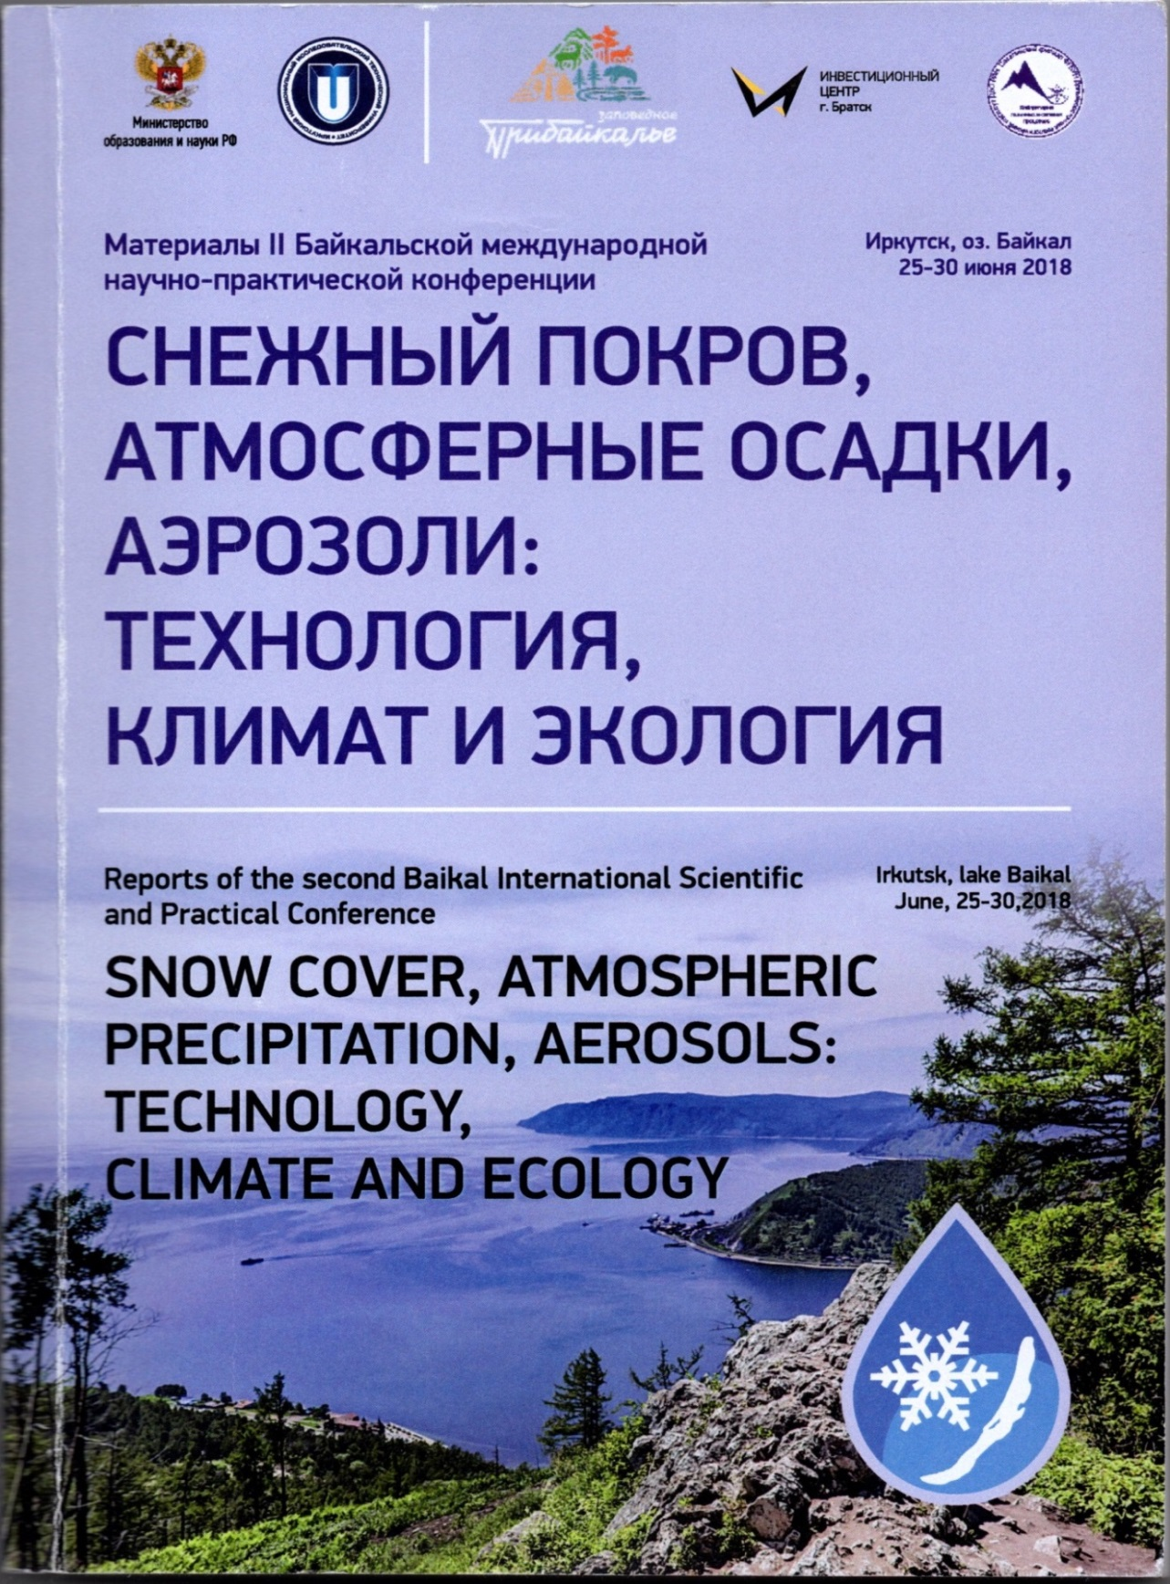

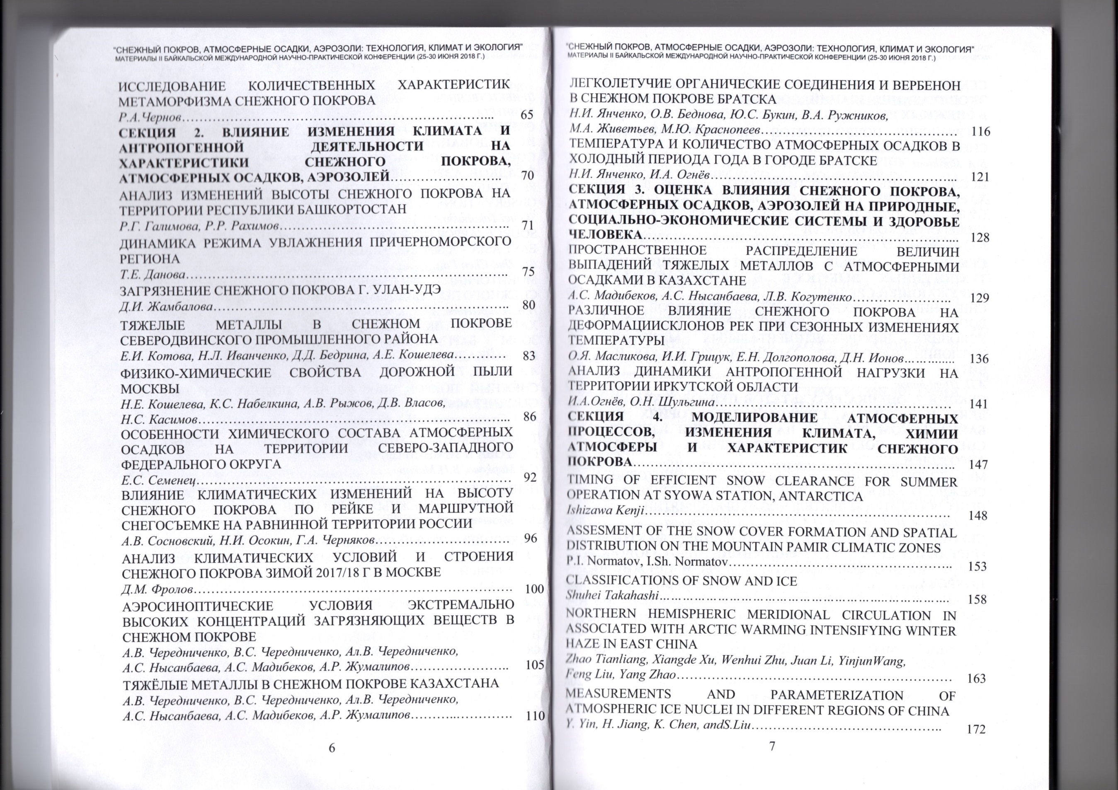
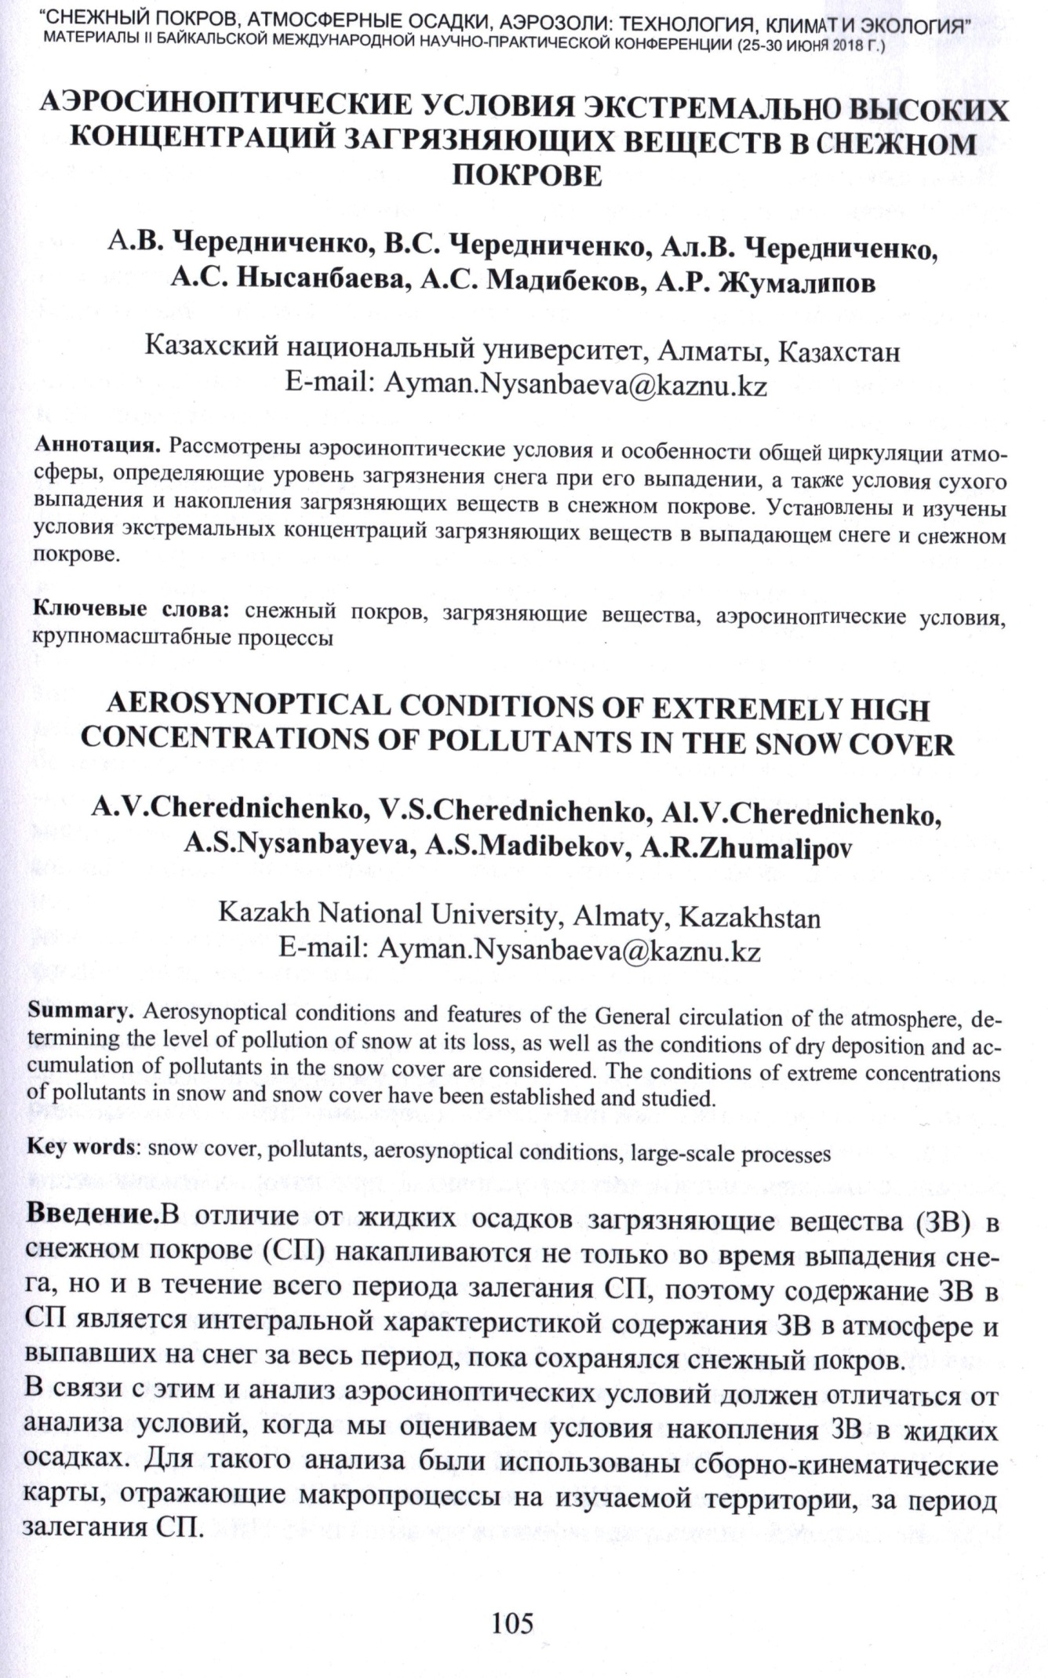

4. Cherednichenko A.V., Cherednichenko V.S., Cherednichenko A.V., Nysanbayeva A.S., Madibekov A.S., Zhumalipov A.R. Heavy metals in the snow cover of Kazakhstan // Reports of second Baikal International Scientific and Practical Conference «Snow cover, atmospheric precipitation, aerosols: tehnology, climate and ecology» (June, 25-30, 2018). – Irkutsk, 2018. – PP. 110–115. (in Russian)

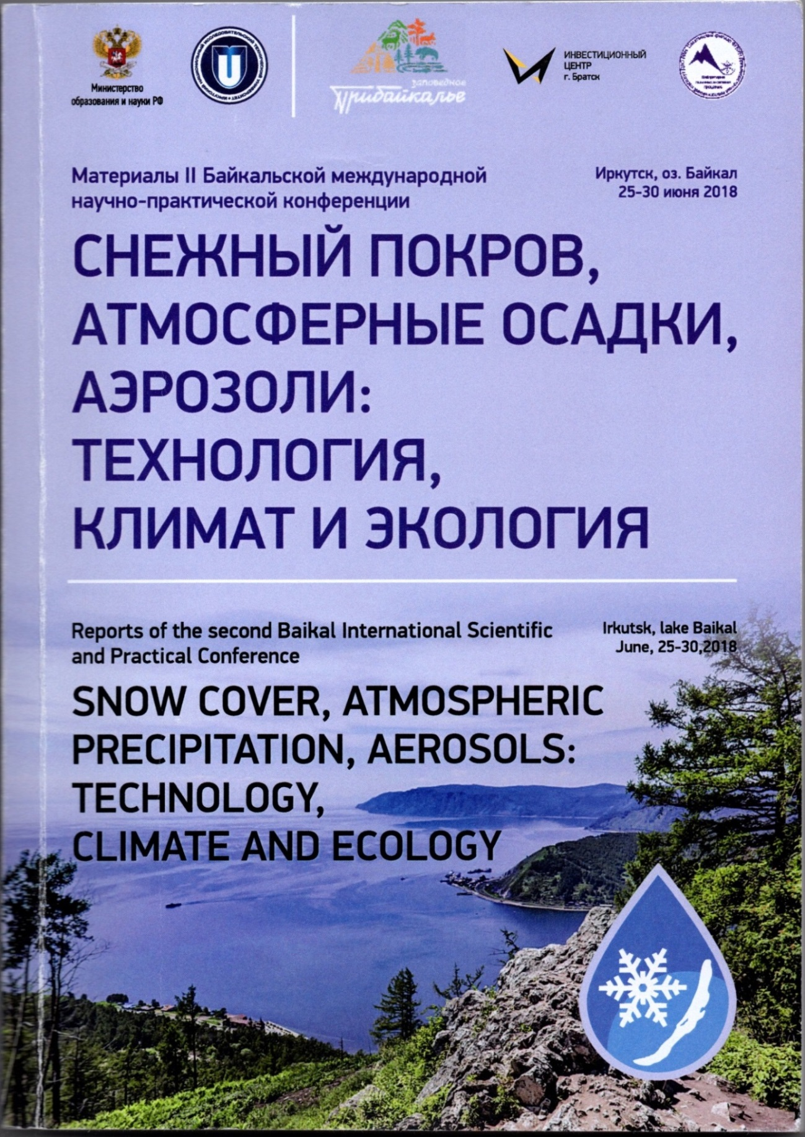

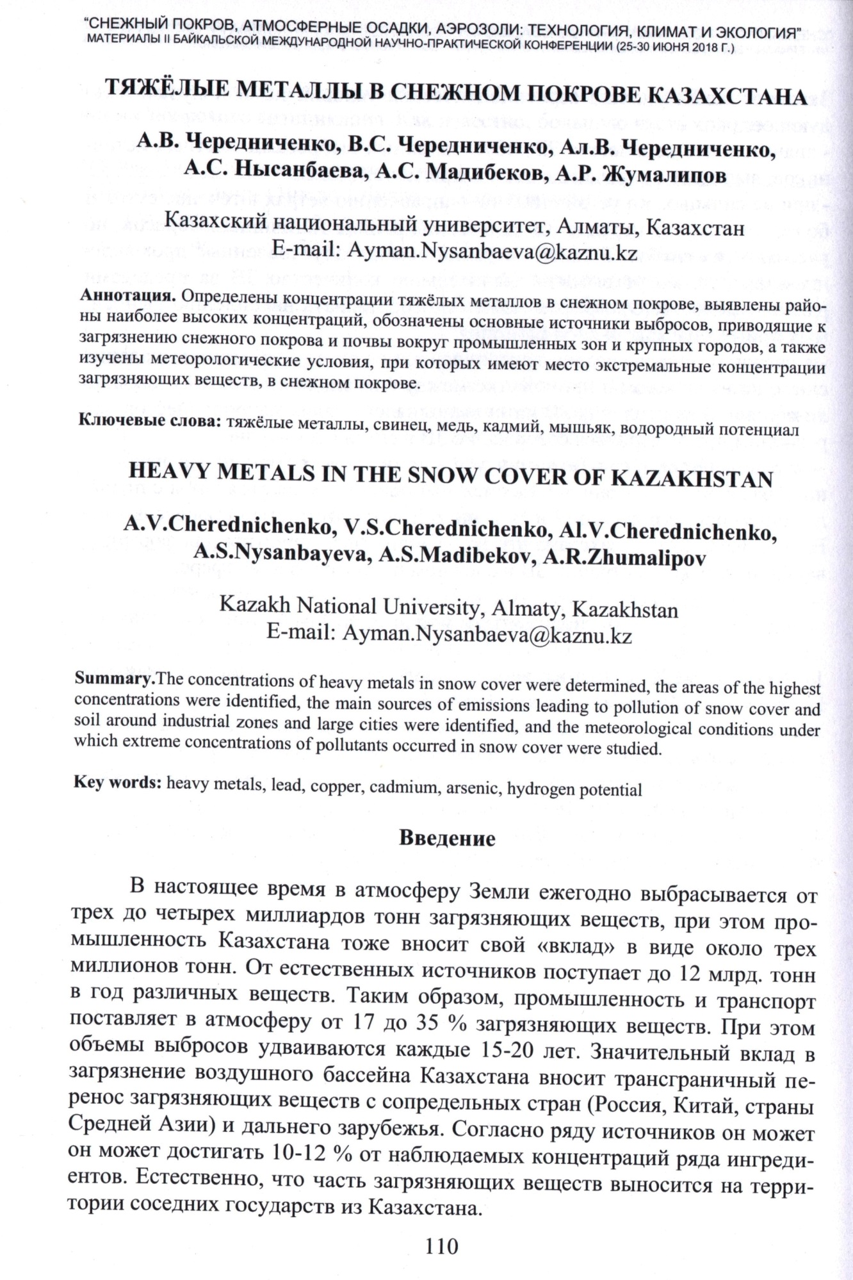

5. Madibekov A.S., Nysanbayeva A.S., Kogutenko L.V. Spatial distribution of values of heavy metals with atmospheric precipitation in Kazakhstan // Reports of second Baikal International Scientific and Practical Conference «Snow cover, atmospheric precipitation, aerosols: tehnology, climate and ecology» (June, 25-30, 2018). – Irkutsk, 2018. – PP. 129–135. (in Russian)

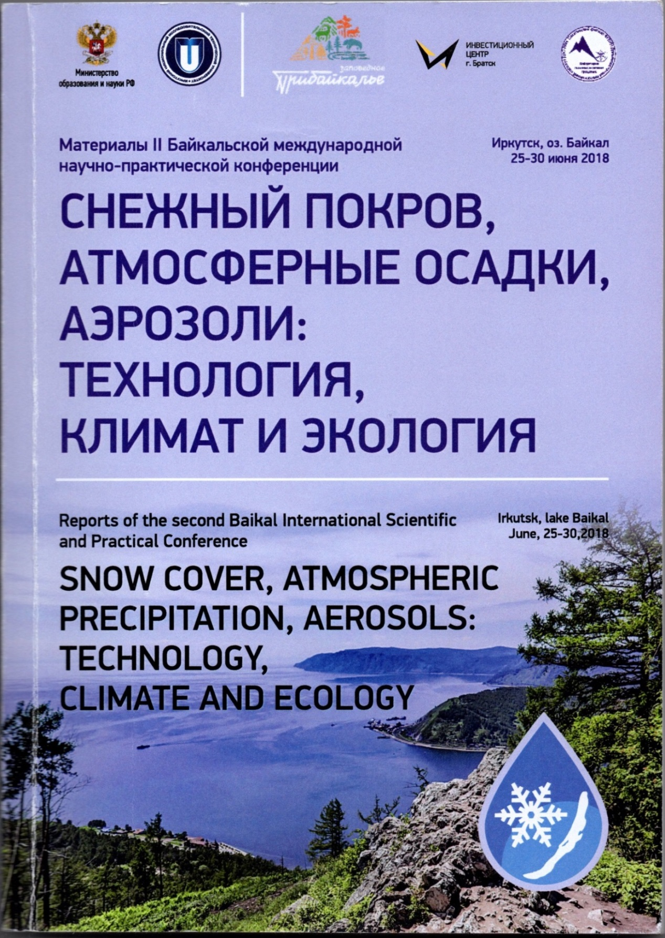

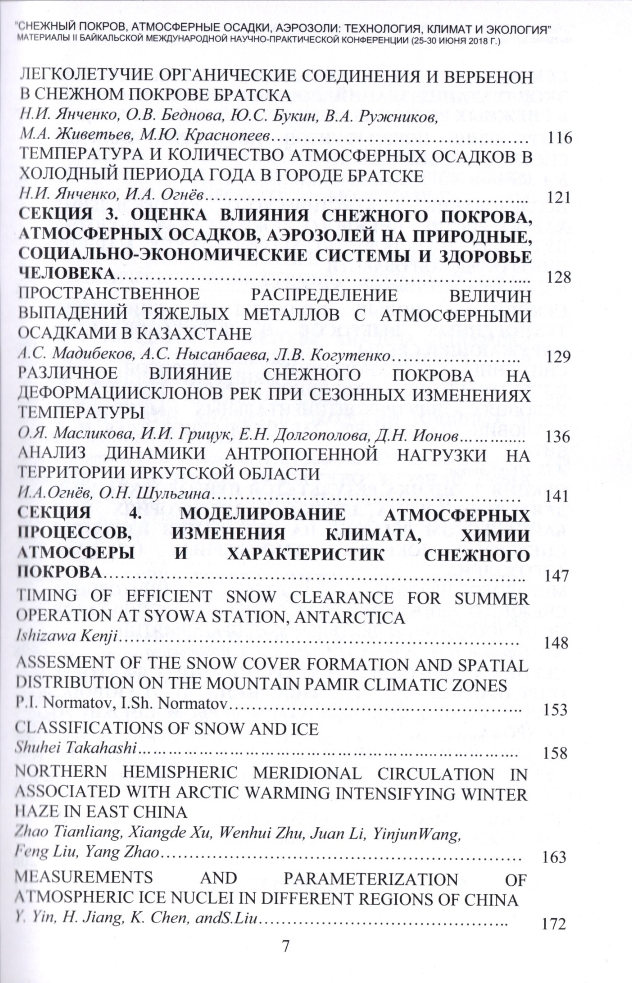

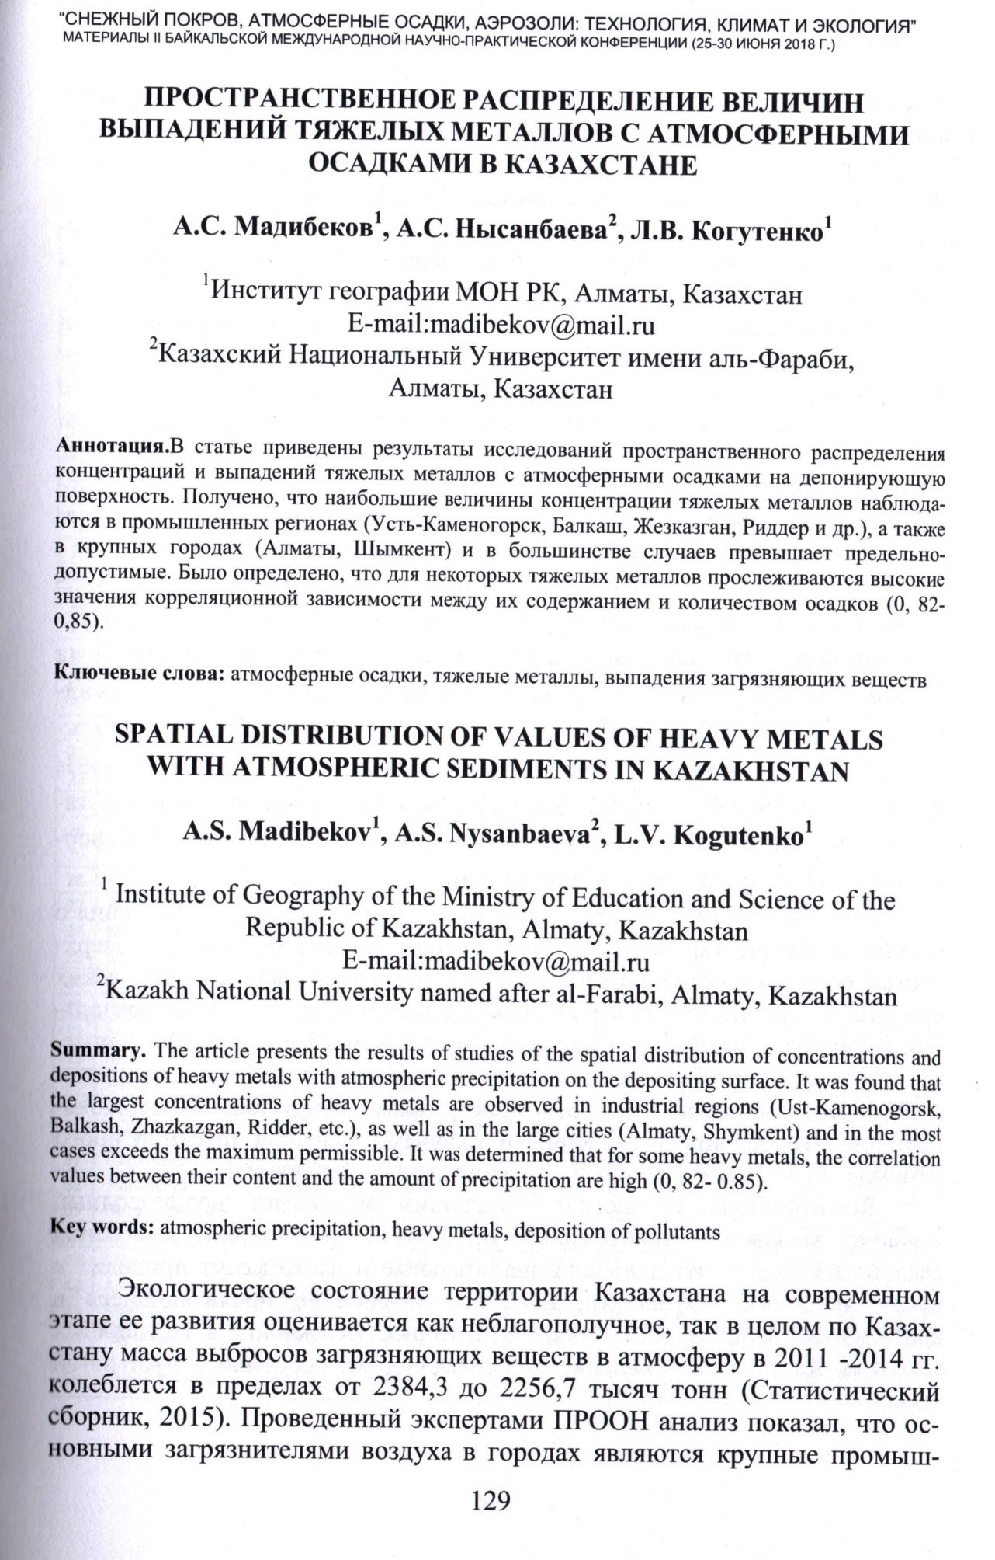

Documents confirming publications for 2019 г.

1. Amirgaliev N., Askarova M., Normatov I., Ismukhanova L., Kulbekova R. Оn the choice of optimal parameters for the integrated assessment of surface water quality // News of the National Academy of Sciences of the Republic of Kazakhstan. Series of geology and technical sciences. – Almaty, 2019. – № 3 (435). – PP. 150–158. https://doi.org/10.32014/2019.2518-170X.81 (Scopus: CiteScore 0.8/SJR 0.209/ SNIP 0.842/ Q3) (http://www.geolog-technical.kz/images/pdf/g20193/150-158.pdf)
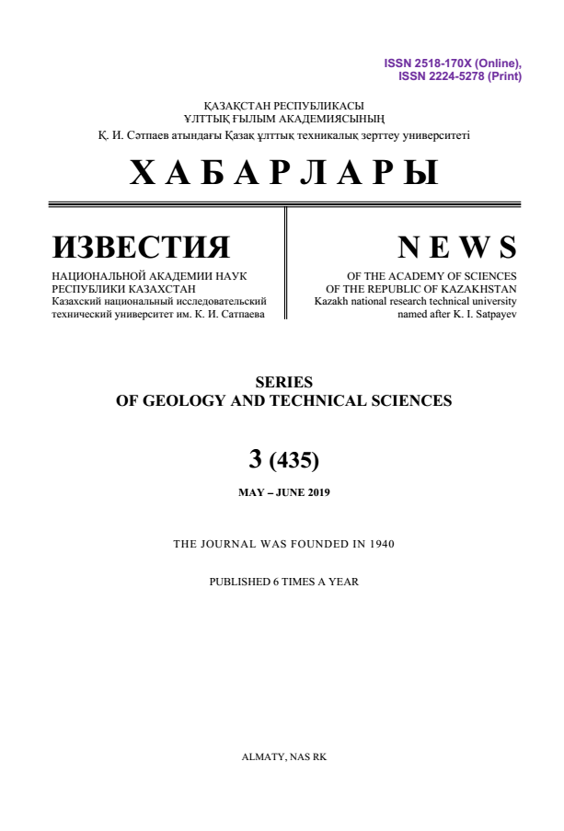

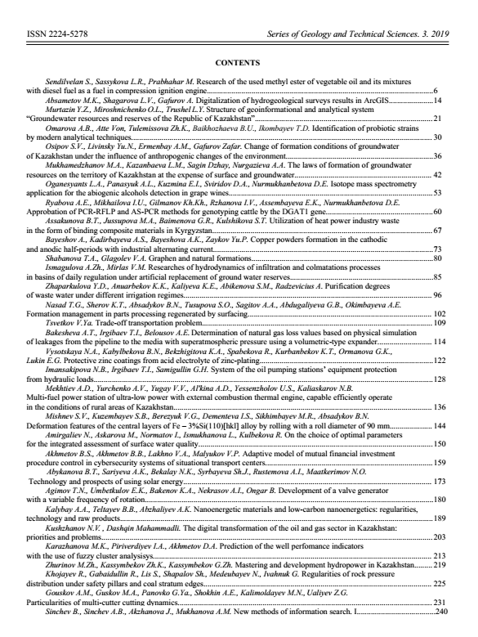

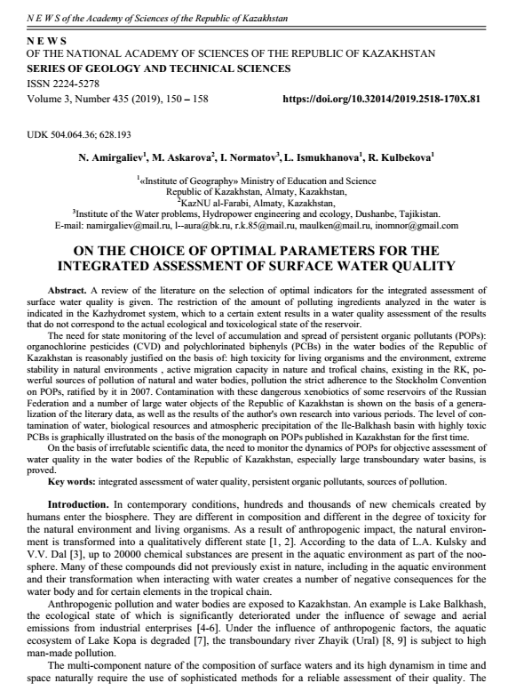

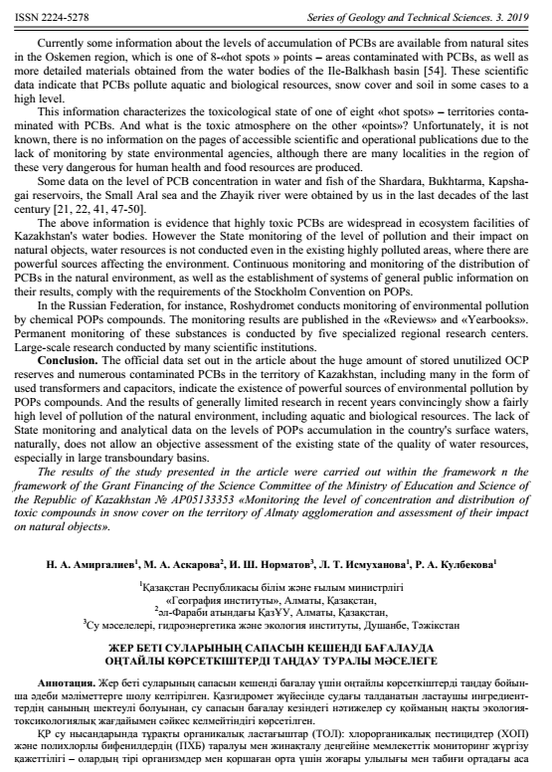

2. Amirgaliyev N., Madibekov A., Normatov I. Аbout the criteria of estimation of surface water quality of Kazakhstan on the basis of accounting of its natural features // News of the National Academy of Sciences of the Republic of Kazakhstan. Series of geology and technical sciences. – 2019. – № 4 (436). – PР. 188–198. https://doi.org/10.32014/2019.2518-170X.114 (Scopus: CiteScore 0.8/SJR 0.209/ SNIP 0.842/ Q3) (http://www.geolog-technical.kz/images/pdf/g20194/188-198.pdf)

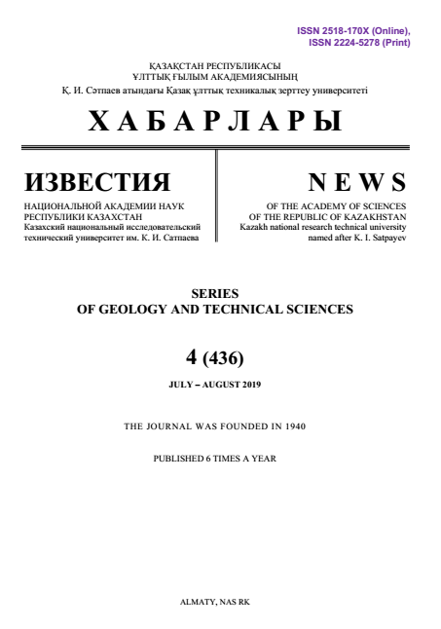
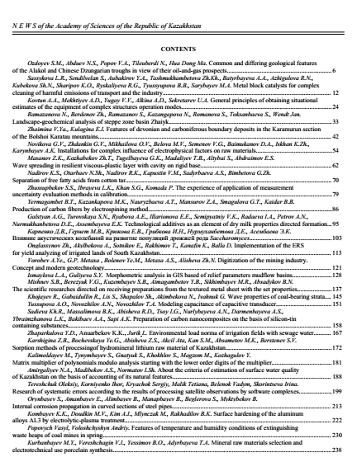

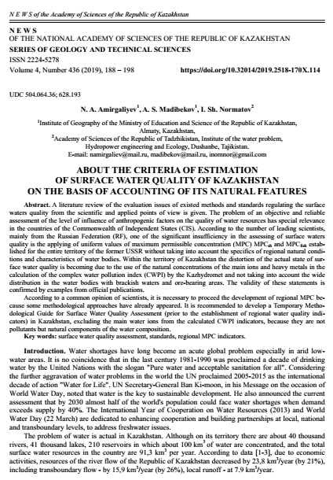

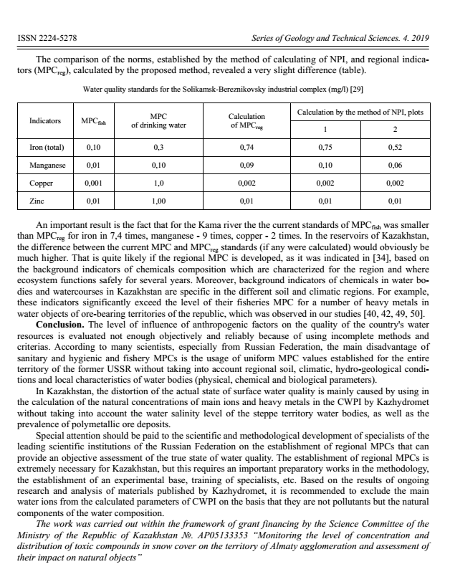

3. Amirgaliev N., Madibekov A., Mussakulkyzy A., Ismukhanova L., Kulbekova R. Polychlorinated biphenyls in the snow cover of Almaty agglomeration of the republic of Kazakhstan // 19th International Multidisciplinary Scientific GeoConference SGEM 2019. Conference proceedings. Volume 19. Ecology, economics, education and legislation. Ecology and Environmental protection. (30 June – 6 July, 2019). – Albena, Bulgaria, 2019. – PP. 541–549. DOI: 10.5593/sgem2019/5.1/S20.068 (Scopus Cite Score 0.4| SJR 0.232| SNIP 0.392). (https://www.sgem.org/index.php/elibrary?view=publication&task=show&id=6018).
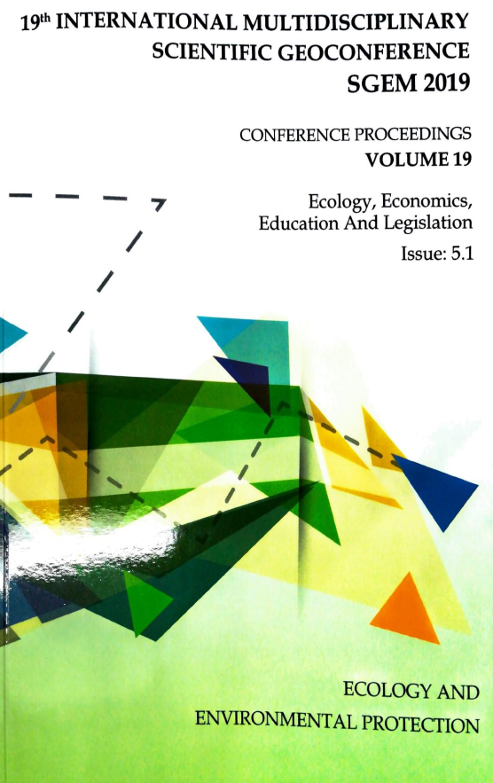
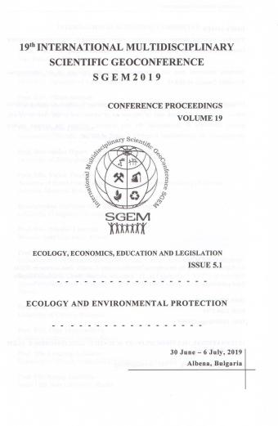

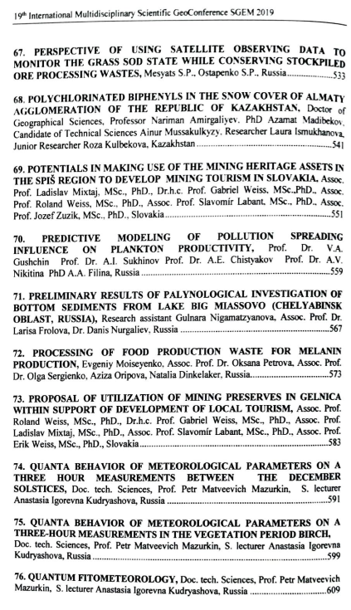
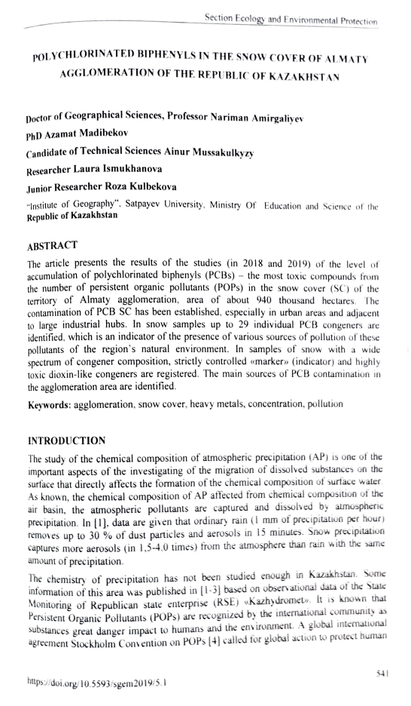
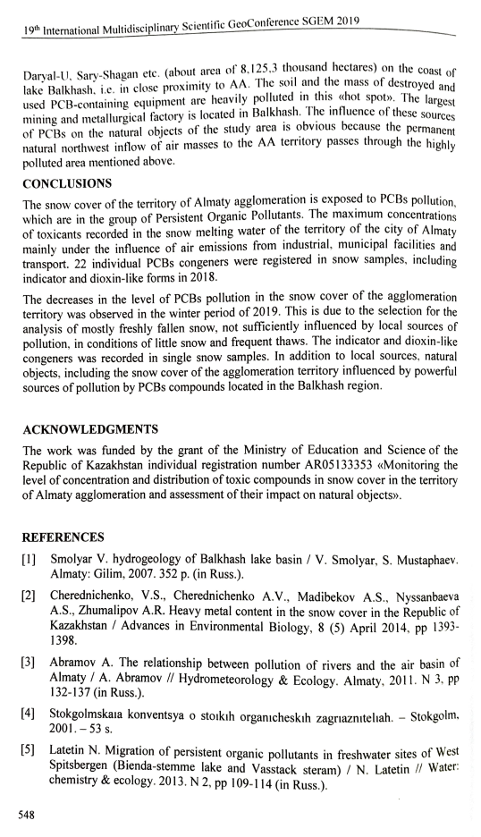

4. Amirgaliyev N.A., Madibekov A.S., Musakulkyzy A., Ismukhanova L.T., Zhadi A.O. Spatial distribution of heavy metals in the snow cover for Almaty agglomeration // 19th International Multidisciplinary Scientific GeoConference SGEM 2019. Conference proceedings. Volume 19. Ecology, economics, education and legislation. Ecology and Environmental protection. (30 June – 6 July, 2019). – Albena, Bulgaria, 2019. – РP. 679–685. DOI: 10.5593/sgem2019/5.1/S20.084 (Scopus Cite Score 0.4| SJR 0.232| SNIP 0.392). (https://www.sgem.org/index.php/elibrary?view=publication&task=show&id=6034).

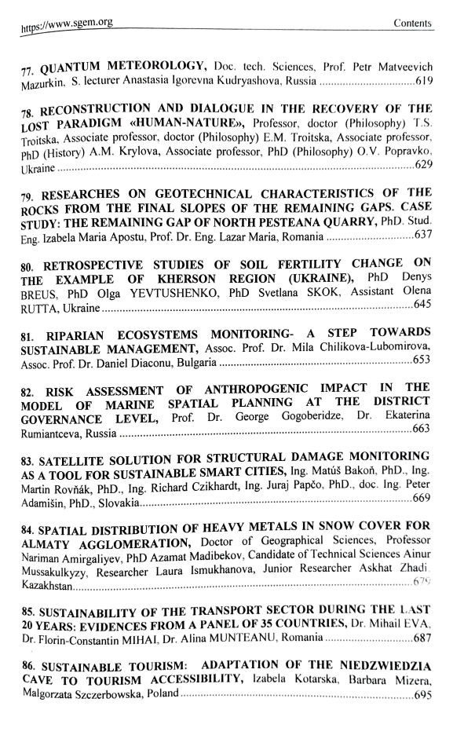

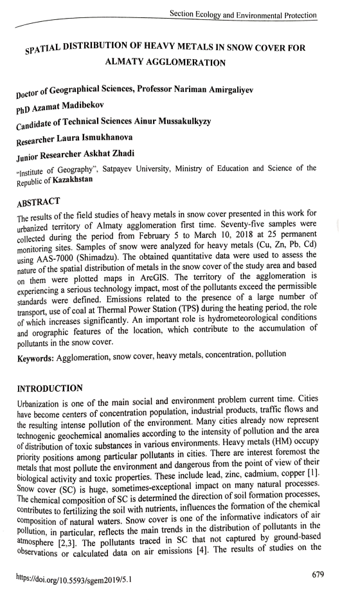

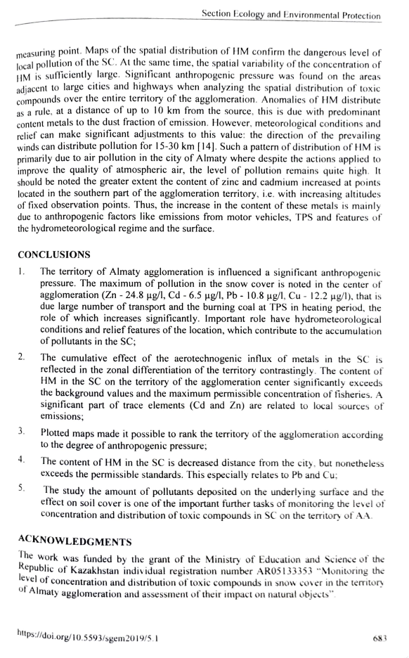

Documents confirming publications for 2020 г.

1. Amirgaliev N.A., Christian Opp, Askarova M., Kulbekova R.A., Ismukhanova L.T. About ratio and values of the empirical coefficient of alkali metals (Na⁺ and K⁺) in surface waters of Kazakhstan on the example of the Ile river // News of the National Аcademy of Sciences of the Republic of Kazakhstan. Series of geology and technical sciences. – 2020. – V. 1, № 439. – PP. 6–13. https://doi.org/10.32014/2020.2518-170X.1 (Scopus: CiteScore 0.8/SJR 0.209/ SNIP 0.842, Q3). (http://www.geolog-technical.kz/images/pdf/g20201/6-13.pdf)
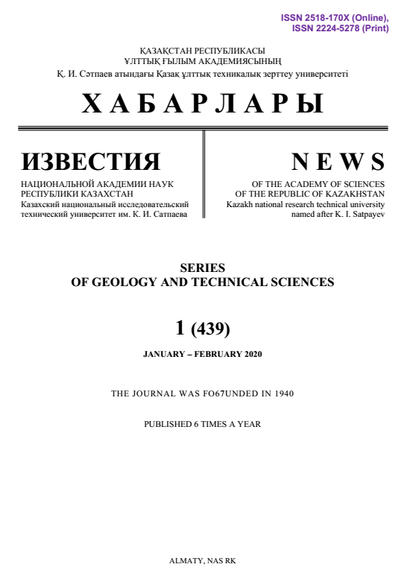
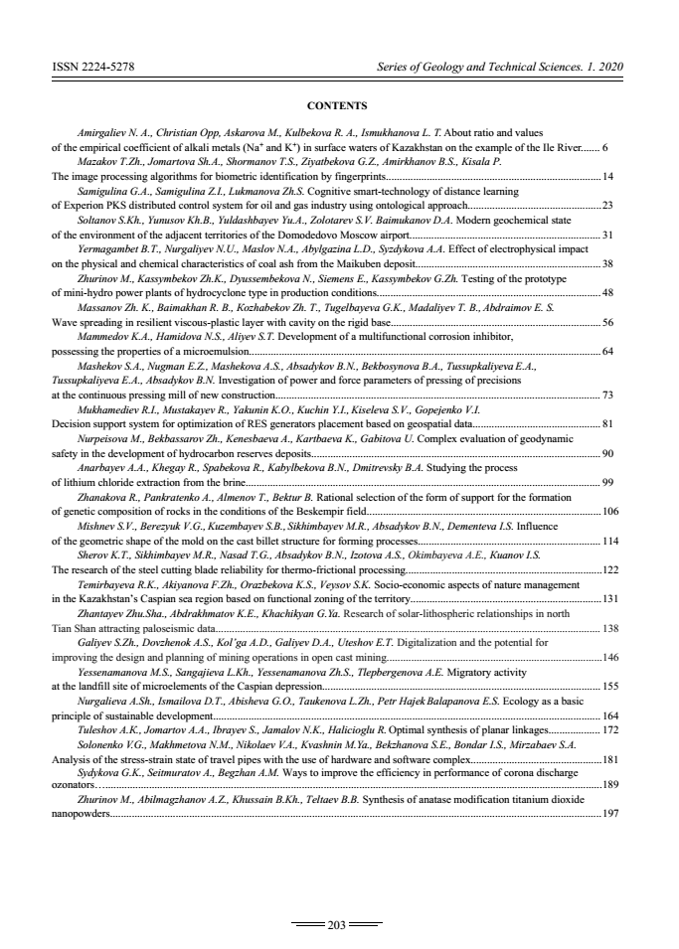
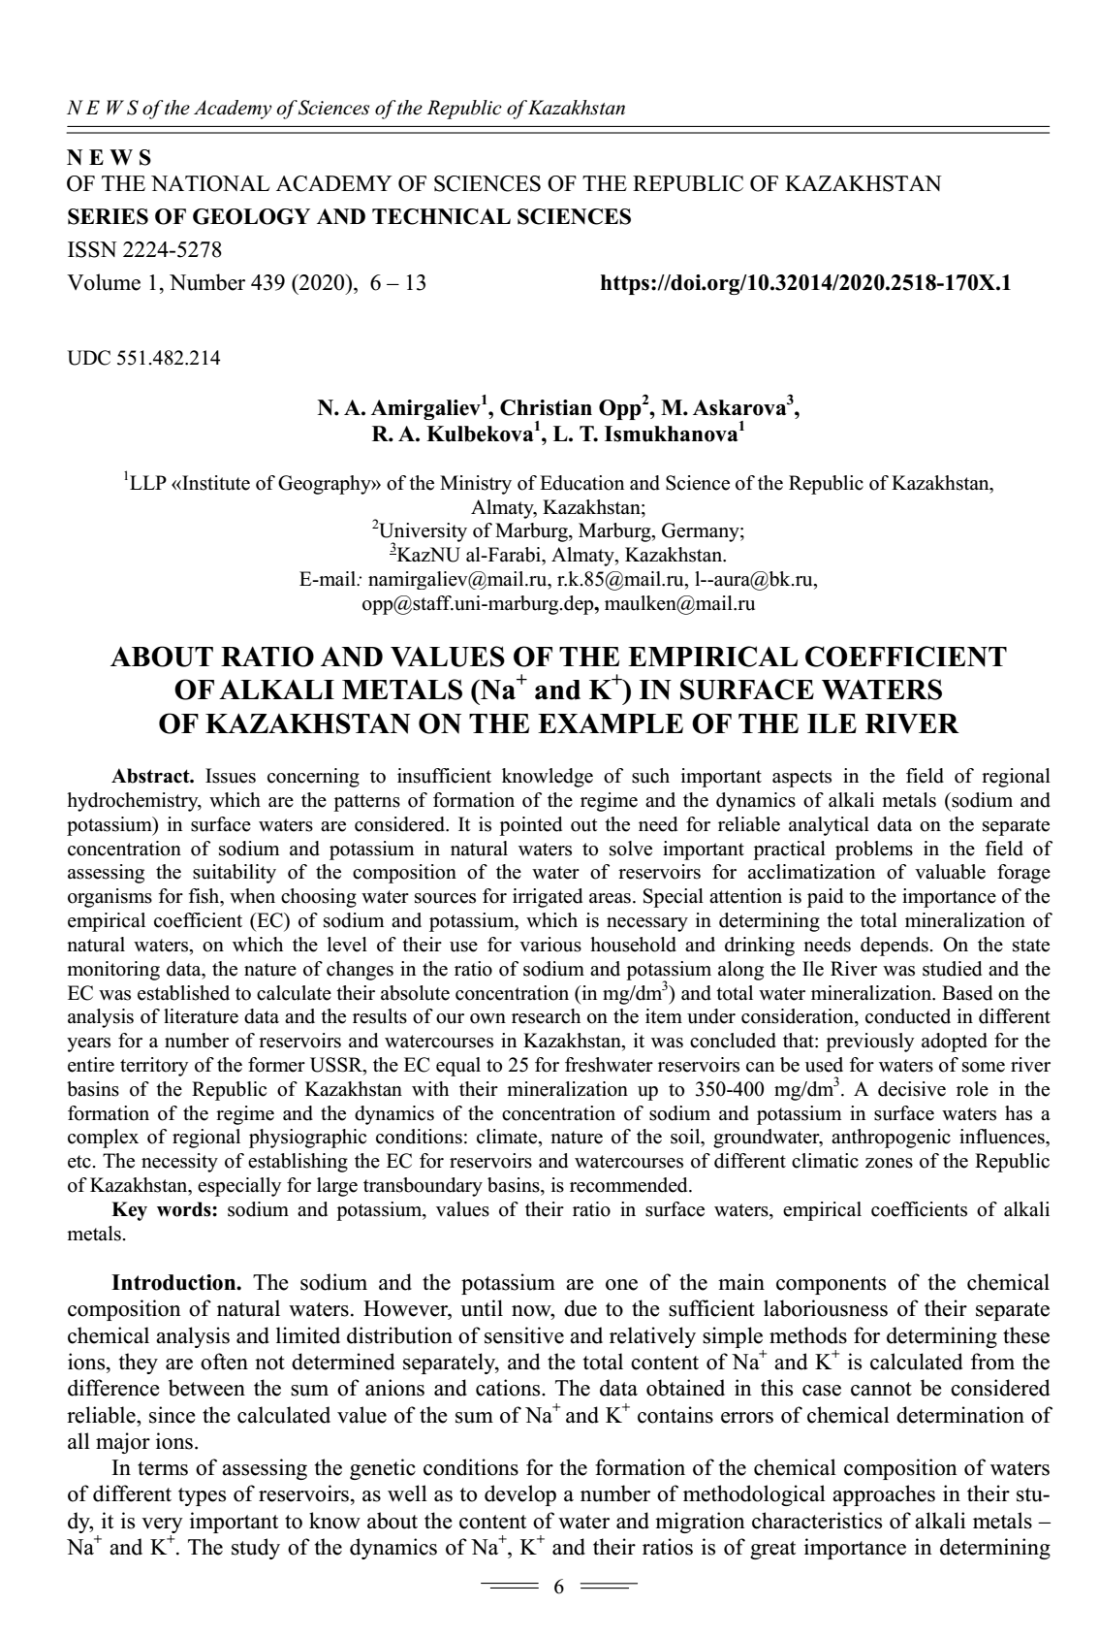
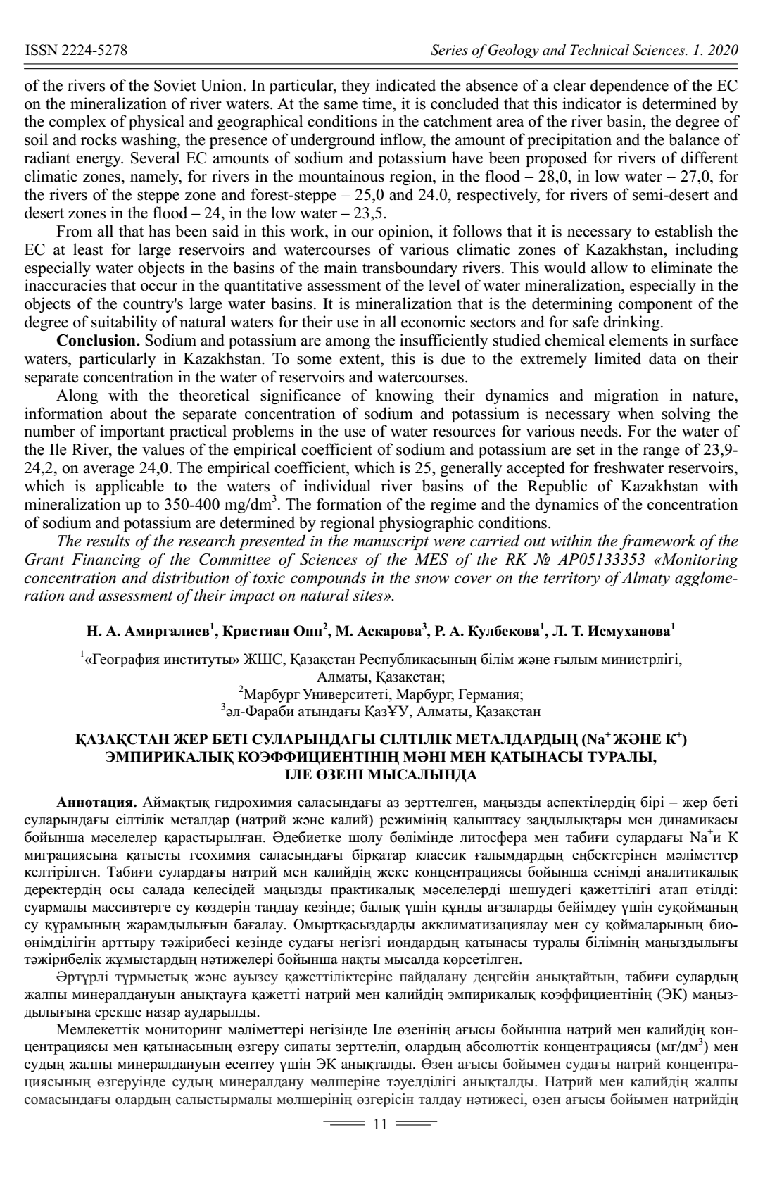

2. Madibekov А., Ismukhanova L., Mussakulkyzy А., Kulbekova R., Zhadi A. Results of AAS-measurements of atmospheric deposition of copper and lead in the snow cover of Almaty agglomeration // Snow cover, atmospheric precipitation, aerosols: chemistry and climate: reports of the III Baikal international scientific conference endorsed by IUPAC (March 23 – 27, 2020). – Irkutsk: Ltd «Reprocenter A1», 2020. – PP. 200–205.
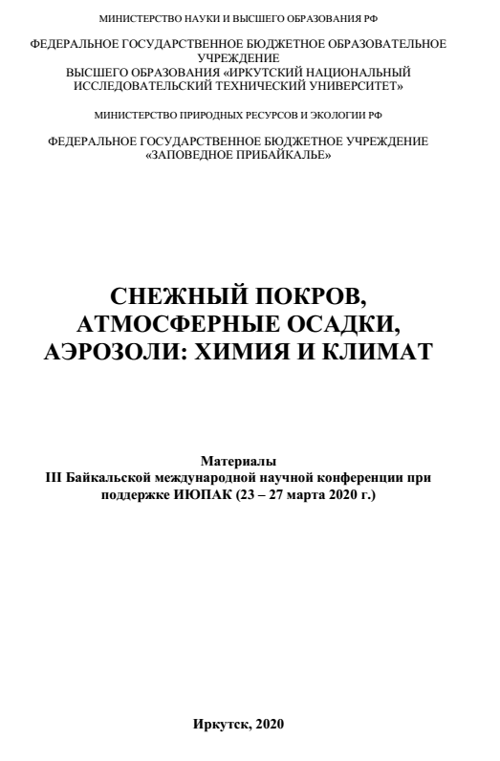
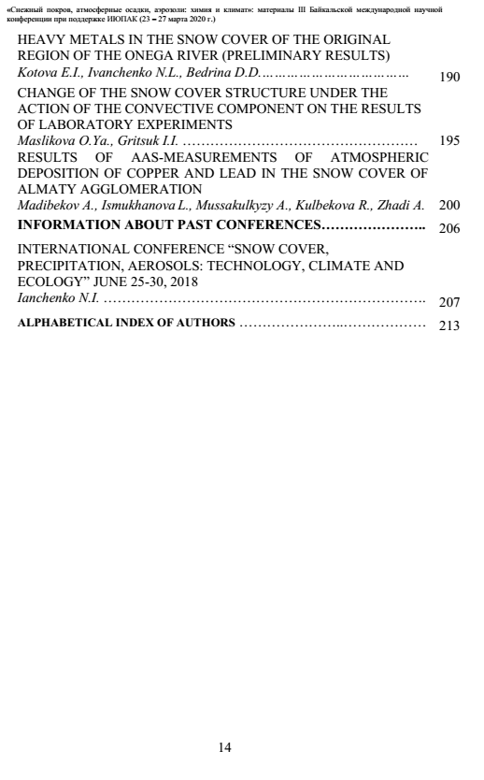
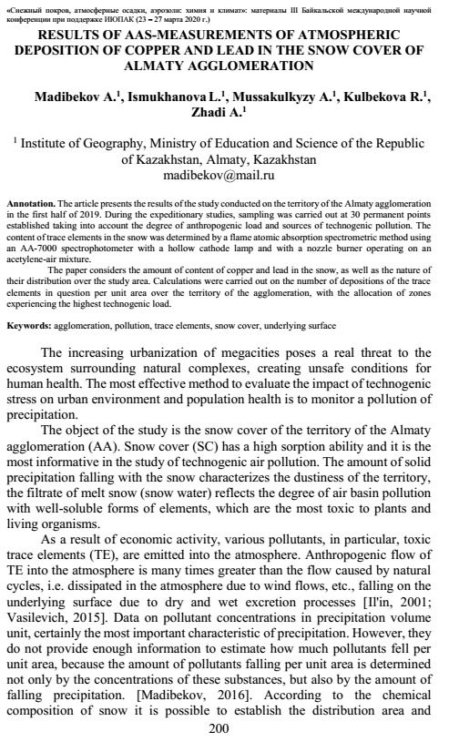
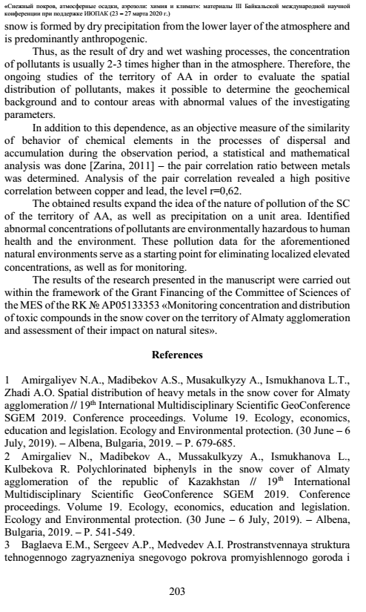

3. Musakulkyzy A., Ismukhanova L.T., Amirgaliyev N.A., Madibekov A.S., Kulbekova R.A. Results of the study of the soil cover of Almaty agglomeration // Journal «Vestnik KRSU». Series of natural and technical sciences. – Bishkek, 2020. – V. 20, № 8. – PP. 105–111. (in Russian)
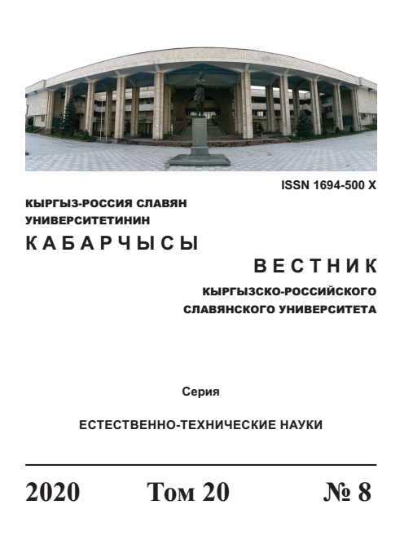

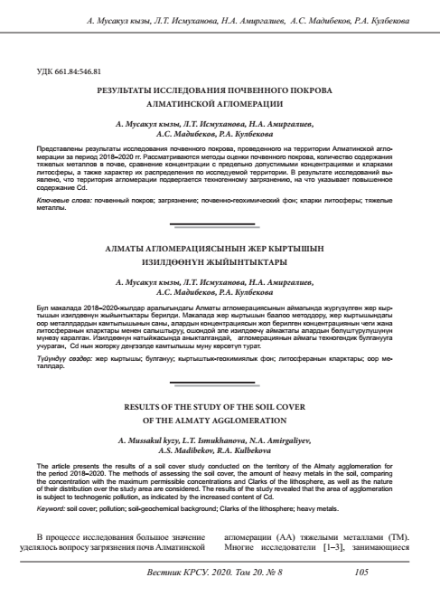

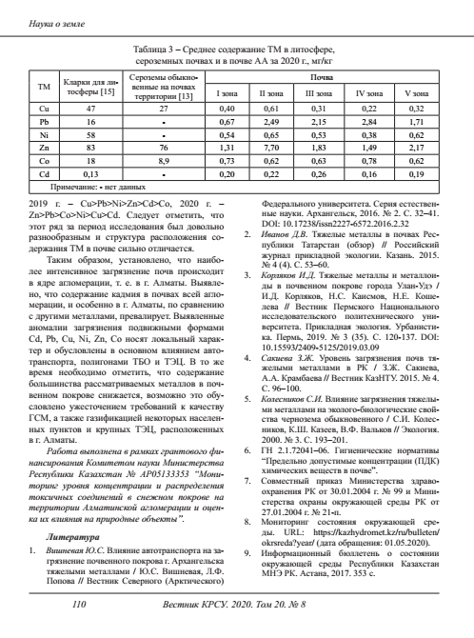
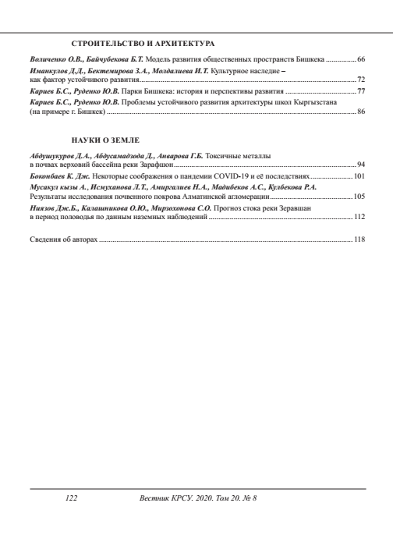

4. Ismukhanova L.T., Kulbekova R.A., Amirgaliyev N.A., Madibekov A.S., Zhadi A. Results of research of physical and chemical characteristics of snow cover in Almaty agglomeration (South-East of Kazakhstan) // ^{XXth} International Multidisciplinary Scientific GeoConference Surveying, Geology and Mining, Ecology and Management – SGEM 2020 (16 – 25 august, 2020). – Albena, Bulgaria, 2020. (Scopus Cite Score 0.4| SJR 0.232| SNIP 0.392) (in print)
