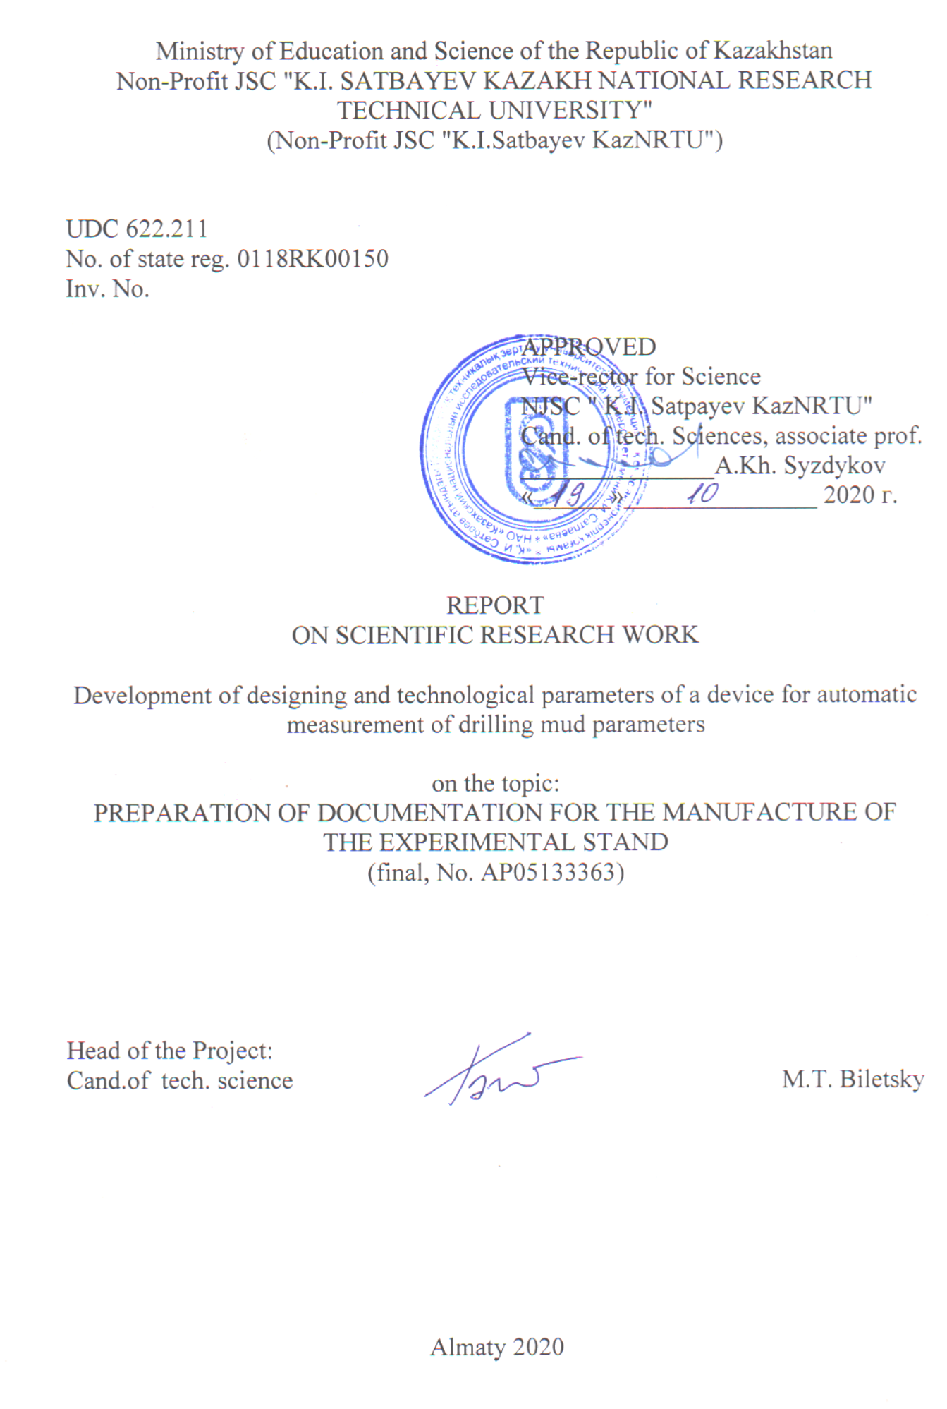

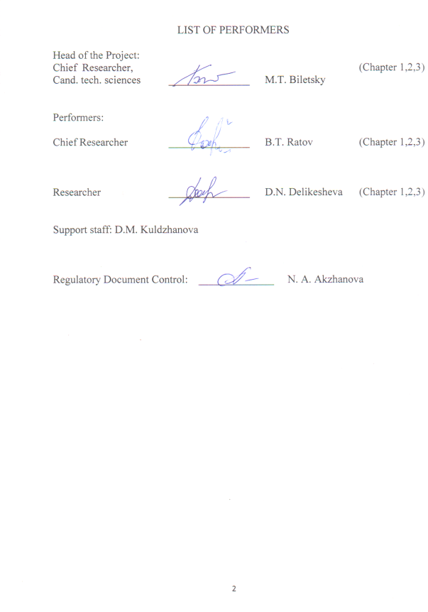
ABSTRACT
The report consists of 1 book, 54 pages, 11 figures, 4 tables, 34 sources and 8 appendices.
DRILLING FLUID PARAMETERS, AUTOMATION OF MEASUREMENTS, DENSITY, FUNNEL VISCOSITY, RHEOLOGICAL PARAMETERS, COMPUTER MODELING, DESIGN DOCUMENTATION
Research object: Measurement of parameters of the quality of drilling fluids.
Purpose of work: Providing continuous automatic monitoring of the quality parameters of drilling fluids.
Methods of work: Theoretical research, virtual experiments on computer models, laboratory and industrial tests.
The obtained results of the work: Documentation was developed for an automatic measuring device of the funnel viscosity (FV), as well as for a complex device for measuring density, FV, plastic viscosity (PV) and yield piont (YP) of a drilling mud. The last device is based on the created new method for measuring PV and YP. The documentation for the manufacture of the experimental stand has been developed. An automatic HC meter was manufactured and brought to the stage of a working model. Published 8 articles, including 4 in the Scopus database; (2 reports at international conferences); 2 more articles were submitted to the editor. Received 1 patent for invention, 1 positive decision; 3 more applications have been submitted.
Novelty: A general scheme for the automation of manual measurements of drilling mud parameters has been developed. A new method for measuring the PV and YP of drilling mud has been developed. The novelty of both developments is confirmed by several patents for inventions.
Main design characteristics: The current model of an automatic viscosity meter measures this parameter in the range from 15 to 120 s. with a measurement period of 5 min.
Degree of implementation: Implementation of the devices is not foreseen in the timetable, as they have not passed all the required stages of design development.
Applications: Exploration and production drilling for oil, gas, water and solid minerals, as well as construction and mining.
Significance of work: When using automatic continuous monitoring devices for drilling mud parameters, the number of complications and accidents in boreholes will be reduced, which will significantly reduce the cost of drilling operations.
Forward-looking proposals on the development of the research object: The work on this topic was terminated by the decision of the administration of Satpayev University for formal reasons.
CONTENT

TERMS AND DEFINITIONS |  | 6
LIST OF ABBREVIATIONS |  | 7
INTRODUCTION |  | 8
MAIN PART |  | 11
1 Theoretical research and development of a documentation preliminary version |  | 11
 | 1.1 Choosing the direction of research | 11
 | 1.2 Theoretical and experimental research | 12
 | 1.3 Development of the design documentation on manufacturing a preliminary version of the funnel viscosity meter | 14
 | 1.4 Conclusion | 15
2 Preparation of documentation for the manufacturing of experimental models of systems for automatic measurement of drilling mud parameters |  | 17
 | 2.1 Development of the terms of reference on the appliance for automatic measurement of funnel viscosity (аиувр) | 17
 | 2.2 Theoretical research | 20
 | 2.3 Development of terms of reference on an integrated appliance for automatic measurement of density, funnel viscosity and rheological parameters of drilling fluid аси-пвнс | 22
 | 2.4 Conclusion | 25
3 Preparation of documentation for the manufacturing of an experimental appliance |  | 26
 | 3.1 Development of documentation for the manufacture of an experimental stand | 26
 | 3.2 Adjusting the automatic viscosity meter to the stage of the current model | 40
CONCLUSION |  | 50
REFERENCES |  | 52
APPENDIX А – WORK SCHEDULE FOR 2018-2020 |  | 55
APPENDIX B – LIST OF PUBLISHED WORKS FOR 2020 |  | 63
APPENDIX C – COPIES OF PUBLISHED WORKS FOR 2020 |  | 64
APPENDIX D - PROJECT PATENTS FOR 2020 |  | 97
APPENDIX E – TERMS OF REFERENCE FOR THE MANUFACTURE OF AN EXPERIMENTAL STAND |  | 102
APPENDIX F – DOCUMENTATION FOR THE MANUFACTURE OF THE EXPERIMENTAL STAND |  | 110
APPENDIX G – DOCUMENTATION APPROVAL ACT |  | 117
APPENDIX H – EXTRACT FROM THE MINUTES OF THE SCIENTIFIC AND TECHNICAL COUNCIL OF K.I. SATPAYEV KAZNRTU |  | 118

TERMS AND DEFINITIONS

In this report, the following terms are used with appropriate definitions
Drilling rig - a machine located on the surface and transmitting external loads to the rock cutting tool through the drill string: axial load, torque, as well as the supply of drilling fluid to the bottom of the wells.
Drilling mud - a complex multicomponent dispersed system of suspension, emulsion and aerated fluids used for flushing wells while drilling.
Yield point - a value that indirectly characterizes the strength resistance of a drilling fluid to flow, determined by a segment on the axis of shear stress, cut off by a straight line that reflects the dependence of the shear stress on the shear rate gradient.
Plastic viscosity - one of the parameters of the Bingham plastic rheological model, is the slope of the shear stress / shear rate ratio line over the dynamic shear stress.
Mud density - is the mass per unit volume.
Funnel viscosity - of a drilling fluid is a value that indirectly characterizes the hydraulic resistance to flow.

LIST OF ABBREVIATIONS AND SYMBOLS

In this research report, the following abbreviations and symbols are used
FV - funnel viscosity
YP – yield point
PV - plastic viscosity
- density;
- coefficient of hydraulic resistance;
a - stream compression ratio;
g - acceleration of gravity;
- flow rate of the outflowing liquid;
η - plastic viscosity of the drilling fluid;
τ - yield point of the drilling fluid
Re - Reynolds number;
γ - dynamic viscosity of water;

INTRODUCTION

Assessment of the current state of the ongoing research. Drilling mud is the most important means of preventing accidents in the wellbore [1, 3, 5, 12, 30]. If there are rocks in the section of the well that threaten with certain complications, to prevent them, the composition of the drilling mud is selected, i.e., its components and their exact dosage. The adequacy of this or that composition of the drilling mud is controlled by measuring its qualitative parameters, namely, density, viscosity, pH, filtration, static shear stress, the content of foreign (in relation to the planned composition) particles, and a number of other parameters. The composition of the drilling mud that provides a given combination of these parameters during drilling changes as a result of the consumption of the introduced components, as well as during mechanical and chemical interaction with the geological formations being penetrated. During drilling, it is necessary to replenish the content of the introduced components, and, if necessary, introduce new ones, since otherwise the drilling mud will cease to meet its purpose. The parameters of the drilling mud should be available for continuous monitoring, since in its absence, the moment of irreversible and fraught with complications changes in its quality can be missed.
Basis and initial data for the development of the theme. Despite the fact that all other parameters of the drilling mode (load on the bit, frequency of its rotation, supply of drilling fluid, pressure on the mud pump, deepening speed, etc.) are measured automatically and continuously [10], the measurement of the parameters of the drilling fluid up to is still done manually, at intervals measured by hours and even days [3]. The reason for such significant intervals is a certain complexity of the measurement procedures and the need for special qualified personnel to carry them out. The need for automatic continuous monitoring of drilling fluid parameters is evident for all of the above reasons.
Justification of the need for research. The urgent need for continuous automatic monitoring is indicated by a number of articles [1, 3, 6, 12, 15, 16, 17], which emphasize the particular relevance of this issue due to the complication of geological conditions and new advances in drilling fluid technology. Examples of large losses associated with a delayed response to emerging problems are given.
Information about the planned scientific and technical level of development, about patent research and conclusions from them. To solve the stated problem, the authors proposed an automatic system for continuous monitoring of drilling mud parameters. The essence of the system is that the well-known manual measuring instruments are mounted on a turntable rotating at a given speed. During each turn, stops are made and the device is filled with the measured drilling mud in turn; measurement of this parameter with the conversion of the measuring signal into digital form and demonstration of the result on the scoreboard; and finally - removal of the drilling mud with cleaning the device from its traces. The traditional measurement procedure is retained, which gives reasonably accurate results that are not subject to various restrictions (such as a density measurement system using a Coriolis flow meter [16]). Patents were obtained for general schemes of devices for measuring the relative viscosity of a drilling mud [22], its density [20], static shear stress [25] and filtration [26], as well as for a combined device for measuring the relative viscosity and density [23].
Of all the parameters for the primary detailed development and practical assessment of the proposed system as a whole, a system for measuring the relative viscosity using a Marsh funnel was chosen [1]. Theoretical studies of the dependence of the conditional viscosity on the geometric parameters of the funnel, as well as the density, plastic viscosity and dynamic shear stress of the drilling mud were carried out. Using the known positions of hydraulics [27], an algorithm was compiled and on its basis a computer program, the final version of which is designated as FUNNEL4. The virtual experiments carried out using the program played an important role in the research in 2019. In addition, the authors compiled the QPN1 program, which allows calculating the pressure loss in all sections of the drilling mud movement through the circulation system, depending on the geometric parameters of its elements, as well as the density and viscosity of the drilling mud. The program also allows, if necessary, to calculate the required fluid flow when passing through rocks of this type, and the required power of the mud pump. In the process of production tests carried out in 2019, the results of calculating the pressure using the QPN1 program were compared with the readings of the pressure gauge installed at the outlet of the mud pump.
On the basis of theoretical studies, preliminary drawings of general views of the device for automatic measurement of the relative viscosity were drawn up.
When evaluating the possibilities of this project, one of the reviewers emphasized the need to control the parameters of the true viscosity of drilling fluids, namely, plastic viscosity (PV) and dynamic shear stress (DS): “What the industry needs is rheological properties to evaluate pressure losses in the drilling column; what is necessary from the rheological properties is PV and BPS. However, the industry is currently unable to measure the rheological properties of drilling fluids on a continuous basis. If rheological properties were automatically measured as well, the project would be very important also strategically. ” In the course of the theoretical and laboratory studies, the possibilities of a simple and adequate drilling mud to this problem began to become apparent, which was done in the form of an addition to the calendar plan for 2019.
Information about the metrological support of research work. There is a standard laboratory for manual measurement of drilling mud parameters. As part of the project, a rotary viscometer of the RC-35S type was purchased. The work was carried out in the Sutbaev University Engineering Laboratory accredited in accordance with the requirements of GOST ISO / IEC 17025-2009 (No. KZ.T.02.1177 of 23.11.2017).
Relevance of the project. Drilling mud is the most important element of the drilling technological scheme. With the existing technology, drilling mud parameters are measured manually, while their continuous monitoring is not ensured, which in some cases leads to severe accidents with a significant investment of time and money. It is necessary to switch to automation of measurements with the output of the results on the scoreboard.
The novelty of the project lies in the fact that for the first time a general scheme for the automation of manual measurements of drilling fluid parameters is being developed. A new method for measuring the PW and BPS of drilling mud has been developed. The novelty of both developments is confirmed by several patents for inventions
The relationship of this work with other research works. Earlier in the KazNRTU named after K.I. Satpayev, research was carried out and schematic diagrams of automation of measurements of the 6 most important parameters of the drilling mud were developed. The schematic diagrams were patented by Kazakhstan patents [19 - 26]. This work is a continuation of the above studies from 2012 to 2016.
Goals and objectives of the stage and their place in the implementation of research. The aim of the work is to provide continuous automatic monitoring of drilling fluid parameters.
To achieve this goal, the following tasks were set:
- Development of design and technological parameters of a device for automatic measurement of drilling mud indicators. For this task, all work was completed according to the schedule and a report was prepared in 2018 (Inventory number 0218RK00602);
- Preparation of documentation for the manufacture of prototypes of systems for automatic measurement of drilling mud parameters. For this task, all work was completed according to the schedule and a report was prepared in 2019 (Inventory number 0219RK00499);
- Preparation of documentation for the manufacture of an experimental setup.

MAIN PART

1 Theoretical research and development of a documentation preliminary version

1.1 Choosing the direction of research

It is believed that about 10% of the funds spent on well construction [1] goes to combat complications and break downs in the wellbore. Drilling fluids play a special role in their prevention [2]. The composition of drilling mud is reflected in measured parameters, such as density, viscosity, filtration, jell strength and yield point, solids content, hydrogen ion content, etc. The availability of a drilling mud necessary to prevent a concrete complication is confirmed by the required combination of its measured parameters.
Modern drilling rigs are equipped with means for automatic monitoring parameters for controlling the drilling process [3]: weight on bit, speed of its rotation, pump’s delivery rate, its pressure, rate of penetration, torque on the drilling tool, etc. However, at present the parameters of drilling fluids are still measured manually by single point measurements. The intervals between measurements are measured in hours, and sometimes days [1]. In this mode, the danger of complications due to the inconsistency of the quality of the drilling mud with the changed geological environment is always present.
The aim of the work is to provide continuous automatic monitoring the drilling mud parameters.
To achieve this aim, the following tasks were set:
1. Analysis of publications that can contribute to the achievement of the aim.
2. Theoretical and experimental studies of the funnel viscosity meter operation
3. Development of a general scheme for transition from manual measurements to continuous automatic monitoring
4. Basing on the general scheme, developing specific drilling mud parameters automatic monitoring schemes.
5. Development of a preliminary version of design documentation on manufacturing the automatic funnel viscosity meter
The reviewed publications are pointing out the importance of continuous automatic monitoring the drilling fluids parameters, and in particular, in connection with the increase in well depth and the associated complication of geological conditions and drilling of technology. Examples of significant losses of time for the break downs elimination, as well as for the associated loss of well diameter [4,5], are given. However, devices which can solve the problem of automatic continuous monitoring the drilling mud parameters that can be widely used in drilling practice have not been found in current publications on the issue [6,7,8, 9].
The problem of automatic continuous measurement of drilling mud parameters is most effectively solved by automatizing the traditional manual method [10]. Long-term practice has shown that this method can be successfully applied to a wide range of drilling conditions. An important advantage represents the observing continuity with respect to the existing technology.
The proposed general method for automatizing the measurement of drilling mud parameters is as follows: traditional manual measurement tools are installed upon a turntable, which at each turn makes stops in the positions of filling with the fluid, measurement as such and cleaning out traces of the fluid with a stream of water to prepare for the next measurement. There are also present converters of measured values into electrical voltage and further into digital form, as well as automatic control systems for table movement, lines for supplying fluid, water and electricity, and a line for off leading the electrical measurement signal.

1.2 Theoretical and experimental research

Basing on the known positions of hydraulics [11], an algorithm for the operation of the funnel viscosity meter (Marsh funnel) and the corresponding computer model were worked out.
D - maximum inner diameter; d - inner diameter of the nipple; H - length of the conical part; Н_{М} - length of the measured volume of the fluid; L - length of the nipple; S - step of imaginary dividing the cone height; i - number of steps; D_{i} - diameter of the funnel in the middle of the i –th step.
Figure 1.1 - The funnel viscosity meter
In Figure 1.1, the volume of the drilling mud, released during the measurement of the funnel viscosity, is divided into a number of elementary volumes with a thickness S and a height H. For any such element, an equation of the balance of hydrostatic pressure (left) and the sum of pressure drops on the nipple and due to contraction of the flow is valid:

+ (1.1)
where - flow rate of the draining liquid; - its density; - coefficient of hydraulic resistance (depends on the Reynolds number), a - coefficient of flow contraction. For this element

(1.2)

Basing on the geometry of the funnel, the thickness S and the ordinal number of the elementary volume, its dimensions and height H are determined. Thereafter Q is found, and the velocity ϑ of the liquid in the nipple calculated. Basing on the velocity, and taking into account the rheological parameters of the liquid, the Reynolds criterion and coefficient (at the beginning, its arbitrary value is entered into the equation, but afterwards computer iterations make it possible to obtain this coefficient with a required accuracy). By Q, for a known cross-sectional area of the element, the rate of lowering of the liquid in it and the drainage time of that elementary volume is determined. The funnel viscosity of the liquid is defined as the sum of the lowering time values for all the elements into which the measured volume is divided. The model with the parameters of the funnel viscosity-measuring funnel ВБР-2 [13] was calibrated on water to obtain the water number 15 s, corresponding to the geometry of the given funnel.

- velocity in the nipple; - velocity of the level lowering; T – draining time.
Figure 1.2 - Dependences of the velocities and time of water draining on the height of its column H according to the results of virtual experiments
1.3 Development of the design documentation on manufacturing a preliminary version of the funnel viscosity meter

Table 1.1 - Characteristics of the device for funnel viscosity automatic measurement
Name
Measurement time , s, | 15-100
Cleaning time (, s | 60
Water draining time out of funnel , s | 19
Mud filling time, , s | 30
Table rotation frequency, rpm | 1.9
Total time of one measurement , s | 107-192
* ВБР-2

I - funnel assembly; II – turntable; III - bearing and sealing assembly; IV - contact disc assembly; V - table shaft drive unit
Figure 1.3 - Automatic appliance for funnel viscosity measurement

1.4 Conclusion

1. Carried out the analysis of publications on the topic of the work.
2. Carried out theoretical and experimental studies of the funnel viscosity meter operation.
3 Developed a general scheme for transition from manual measurements of drilling fluid parameters to their continuous automatic monitoring.
4. On the basis of the general scheme, developed a scheme of automatic monitoring of the drilling fluid funnel viscosity.
5. Developed a preliminary version of the design documentation on manufacturing the funnel viscosity meter
The work bears features of a pioneer and breakthrough research. According to analysis of the latest worldwide publications no devises of drilling fluids continuous automatic monitoring have been found, the need for such devices being urgent, especially in connection with the increase in the depth of the wells and development of new more advanced drilling fluid formulations.

2 Preparation of documentation for the manufacturing of experimental models of systems for automatic measurement of drilling mud parameters

2.1 Development of the terms of reference on the appliance for automatic measurement of funnel viscosity (АИУВР)

The following is an excerpt from the text of the Terms of Reference, which relates directly to the design and technological parameters of the device:
Purpose: Prototype for bench tests.
Characteristics: The device is basing on use of the funnel viscosity meters of the drilling mud such as "Marsh Funnel" or ВБР-2. They are currently used for manual measurements and at randomly assigned intervals. The АИУВР device ensures the use of these devices in the continuous automatic monitoring mode. The device sensor block includes: a turntable; funnel ВБР-2 mounted on it, with a device for dosing the volume of the draining drilling mud in the form of a float with a shank and a cam at its end; a cylindrical housing containing a live contact assembly and a turntable shaft. The lower box shaped housing contains the electric motor and replaceable gears. A stand of the live contact of the dosing device is mounted upon the housing. The appliance also includes a power block with controller and monitor block with display.
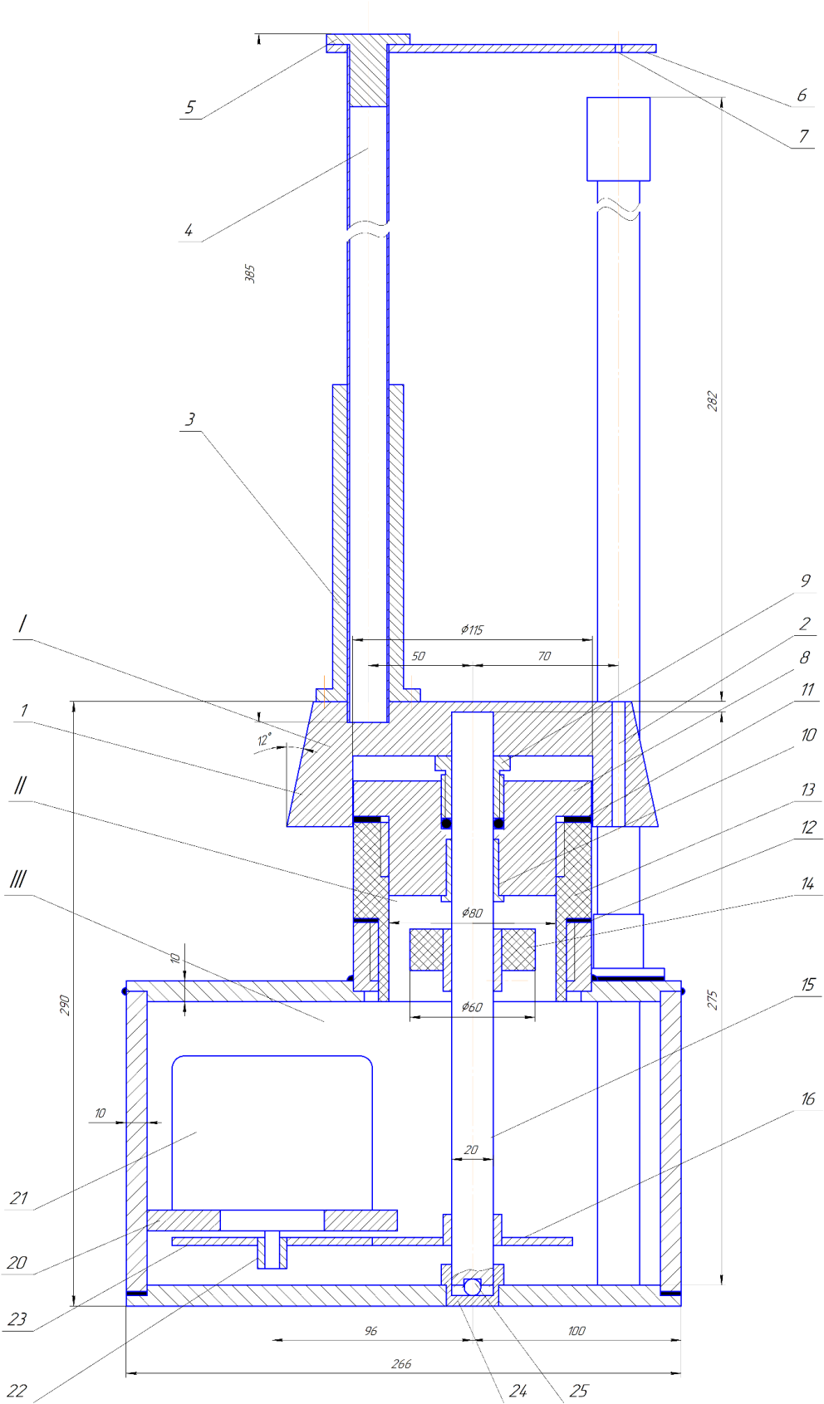
I – turntable assembly: 1 - table; 2 - borehole for installing the funnel; 3 - bushing; 4 - stand; 5 - plug; 6 - plate; 7 - centering hole of the float shank. II – cylindrical housing assembly: 8 - lid; 9 - seal; 10 - bearing; 11, 12 - packing; 13 - housing; 14 - cam disk; 15 - shaft; 16 - gear; III – box shaped housing assembly: 17 - bottom plate; 18 - top plate; 19 - side wall; 20 - shelf; 21 - motor; 22 – shaft; 23 - gear wheel; 24 - bearing; 25 - ball; 26 - box; 27 - bushing; 28 - bracket; 29 - contact board; 30 - seal; 31 - cable inlet; 32 - measuring funnel.
Figure 2.1 - Assembly drawing of a device for automatic monitoring of the funnel viscosity of the drilling fluid. Sectional side view
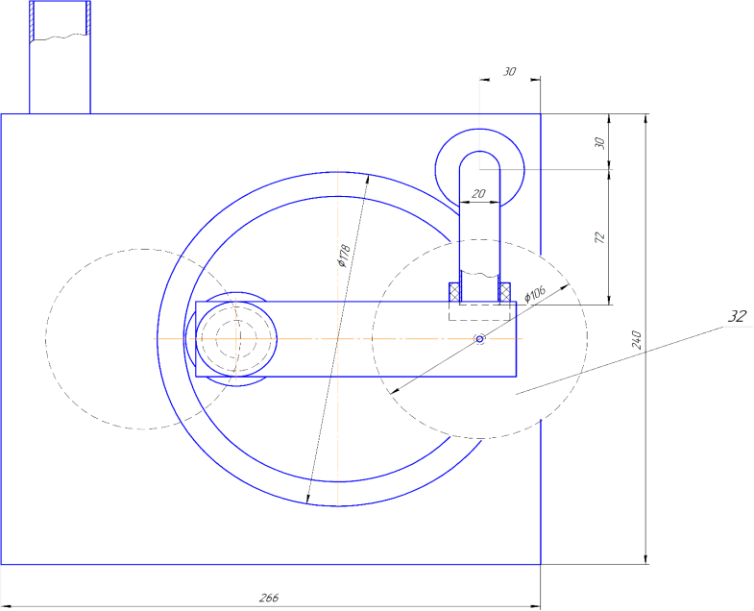
Figure 2.2 - Assembly drawing of a device for automatic monitoring the funnel viscosity of the drilling fluid. Top view
Operation of the device: The turntable is revolved by an electric motor at a given frequency. Under the influence of the controller and the time relay, it makes stops of a given duration in positions of the fluid loading and cleaning the funnel from its residues. The start of the device for measuring the funnel viscosity time is fixed by the moment, when the table resumes its motion after the loading time has elapsed The stop is effected by opening the contact on the rack by the cam of the float shank, which goes down together with the level of the draining liquid. Following the measurement, the table after a predetermined period of time stops in the position of “cleaning the funnel” under running water. Further, the above-described cycle of measuring the funnel viscosity is repeated. The numerical result of each measurement is kept on the monitor until it is replaced with the result of the turntable next revolution.
Requirements for principal characteristics: The measurement volume of drilling fluid: 0.5 l; The interval of the measured values of the funnel viscosity : 15 - 120 s; The turntable period (without stops) : 30 s; The stop for cleaning the funnel: 60 s; the maximum measurement time: 120 s; the period of measurements –no more than 210 s.; the diameter of the turntable: no more than 280 mm. Dimensions (no more than): length: 400 mm, width: 350 mm, height without contact stand: 260 mm, with it :560 mm.

2.2 Theoretical research
Average hydrostatic pressure at draining the mud volume V_{M} out of the Marsh funnel at the average height of H_{M} and the diameter of the nipple d:
+, (2.1)
where ρ - density, g - gravity acceleration, L - length of the nipple, ϑ - average fluid velocity in the nipple (determined by the draining time), a - flow contraction coefficient (determined at calibrating the funnel on water).
Hence the average hydraulic resistance coefficient in the nipple
(2.2)
Reynolds criterion for non-Newtonian fluids

(2.3)
where η and τ - plastic viscosity and yield point of the mud
On the other hand, at the laminar flow, which always takes place [9,10] with non-Newtonian liquids draining from the measuring funnel:

(2.4)
Transforming the equation (2.3):
(2.5)

Equation (2.5) makes it possible to find η and τ in two ways:
A) By draining two different measuring volumes, and obtaining two linear equations (1.5) with two unknowns;
B) The usual measurement of the funnel viscosity makes it possible to obtain by its results one of the two equations (2.5). Assigning zero value to one of the unknowns (2.5), the maximum possible value of the second unknown is obtained, half of which is taken as its most probable value. Testing the two methods of finding rheological parameters η and τ under laboratory and industrial conditions gave positive results.
In order to assess the adequacy of the last “express method”, laboratory studies (Table 2.1) were carried out on measuring the viscosity of a drilling mud prepared on a low dissolving clay powder. The rheological parameters measured by the FANN35 device (columns 2,3) were entered into the computer model of the funnel ВБР-2 described above (see the report for 2018), obtaining the corresponding funnel viscosity (column 5). The funnel viscosity was also measured directly by the ВБР-2 funnel (column 4). From this value, together with the corresponding density, rheological parameters were calculated using the express method (columns 6 and 7). The latter, like the FANN35 data, were also entered into the funnel model and the value of the funnel viscosity was also obtained (column 8).
The discrepancies between the values, obtained on the basis of FANN35 and those obtained dy the express method in lines 1, 2, 3, 4, 5, 6, are respectively: +2.4; +1.2; +1.2: +5.0; +8.8; +5.3. Average discrepancy is 3.98%.

Table 2.1 - Comparison of viscosity values determined according to FANN35 and according to the proposed express method
№ | Density  kg/m³ | FANN35 |  | ВБР-2  T,s | FUNNEL,  s | METHOD |  | FUNNEL,  s
№ | Density  kg/m³ | ἠ,  Pa*s | τ,  Pa | ВБР-2  T,s | FUNNEL,  s | ἠ,  Pa*s | τ,  Pa | FUNNEL,  s
 | 1 | 2 | 3 | 4 | 5 | 6 | 7 | 8
1 | 1050 | 0.001 | 0.48 | 15.37 | 15.55 | 0.0019 | 4.30 | 15.93
2 | 1100 | 0.002 | 0.48 | 15.49 | 15.72 | 0.002 | 4.65 | 15.91
3 | 1150 | 0.003 | 0.72 | 15.70 | 15.84 | 0.0023 | 5.12 | 16.03
4 | 1200 | 0.004 | 0.96 | 16.31 | 15.92 | 0.0028 | 6.08 | 16.72
5 | 1250 | 0.005 | 3.12 | 18.10 | 17.10 | 0.0042 | 8.15 | 18.61
6 | 1300 | 0.0085 | 7.44 | 22.31 | 21.72 | 0.0071 | 11.27 | 22.88

Similar work was carried out at the Uzen oil field on the ZJ-20 drilling rig. In the well the conductor with an internal diameter of 226.7 mm was run down to 450 m, an open hole - 220.7 mm. Drilling pipes 102/85 mm; internal diameter of their couplings 65 mm, drill collar 65 mm, 82 m. PDC bits, 6 nozzles: 3 diam. 14 and 3 - 16 mm.

Table 2.2 - Conditions for taking measurements at the Uzen well
L_{СК},  m | L_{ОС},  m | V,  m/h | Q,  l/sec | P_{М},  MPa | ƿ,  kg/m³ | T,  s | FANN35 |  | Express method
 |  |  |  |  |  |  | η.  Pa*s | τ,  Pa | η,  Pa*s | τ,  Pa
1525 | 1075 | 8.3 | 32 | 12.8 | 1330 | 26.32 | 0.014 | 3.84 | 0.0097 | 13.08
L_{СК} - well depth; L_{ОС} - open hole length; V – penetration rate; Q - pump delivery; PМ - pressure on the pump manometer ρ – drilling mud density T - funnel viscosity; η - PV; τ - YP.

Table 2.3 - Calculated values of pressure drops
Method | Р_{Т},  MPa | Р_{С},  MPa | Р_{ТС},  MPa | Р_{ТК},  MPa | Р_{У},  MPa | Р_{УС}, MPa | Р_{Д}, MPa | Р_{Ш}, MPa | Р, MPa | Р-Рм  MPa | %
FANN35 | 7.22 | 1.63 | 0.24 | 0.10 | 1.56 | 0.13 | 0.64 | 0.05 | 11.58 | -1.22 | -8.1
ETTA1 | 7.38 | 1.63 | 0.35 | 0.15 | 1.56 | 0.14 | 0.64 | 0.05 | 11.91 | -0.89 | -6.9
Рт - pressure droip in the drill. pipes; Рс – drops in their connections; Р_{ТС} - drops between drill pipes and well; R_{ТК} - drops between the conductor and the well; Р_{У} - drops inside the drill collar; Р_{УС} - drops between drill collar and well; Рд - drops on the bit nozzles Рш - drops for lifting cuttings, Р - total pressure drop.

The total pressure drop calculated on the basis of the express method is 2.8% higher than those related to FANN35. Deviations from the mud pump manometer readings (Table 1.2) are 6.9%, downward, while for FANN35 - by 8.1% - also downward.

2.3 Development of terms of reference on an integrated appliance for automatic measurement of density, funnel viscosity and rheological parameters of drilling fluid АСИ-ПВНС

In accordance with the general scheme of automatizing the drilling fluid parameters manual measurements, patents on density measurement appliance [16,17] as well as on an integrated appliance of density and funnel viscosity automatic continuous measurement were obtained [18]. The last devise was made a base for the below considered appliance.
What follows is an excerpt from the text of the Terms of Reference, which relates directly to the design and technological parameters of the device:
The purpose: Prototype for bench and industrial tests.
The structure: The sensor unit includes turntable driven by an electric motor; a funnel mounted on the table with a device for dosing the measured volume of drilling mud: a sensor of the density, upon which the funnel with the drilling mud rests; a cylindrical housing containing the turntable shaft with a cam disk mounted on it; a box-shaped housing containing the electric motor and replaceable gears; the mounted on the housing stand of the live contact. There is a power block also housing the controller and time relay. The monitor represents a small standard display.
The operation. The turntable makes, under the influence of a time relay, stops in the positions of filling with the tested drilling mud, and flushing the funnel with water. After the stop time under the drilling mud supply channel has expired, at the instant of revolving resumption, voltage is supplied to the density sensor, the signal of which is fed to the input of the microcircuit. The voltage lasts for a fraction of second, so that the drilling mud level does not have time to drop. The electronic stopwatch starts at the same time. At the moment, when the specified volume of the fluid has drained, the cam on the float shank opens the live contact on the stand and stops the stopwatch. The time of the funnel viscosity is fed to the microcircuit, which calculates the plastic viscosity and yield point - equations (1-5) option B. After the time sufficient to measure the maximum funnel viscosity, the turntable stops for a specified time in the flushing position under the water supply channel. Thereafter the relay starts the electric motor in the opposite direction and returns the funnel to the position of filling with drilling mud. The values ​​of all measured parameters are displayed on the monitor until the next cycle results appear.

I- Density gauge assembly; 1 -core; 2 - exciter coil; 3 - measurement coil; 4 – centralizer; 5 –disk; 6 - casing; 7 -housing; 8-thrust washer; 9 –spring; 10 - carrier; 11,12 - undercutting; 13 –flange; 14 – packing II - Funnel viscosity sensor assembly; 15 - funnel; 16 – nipple; 17 – float; 18 – shank; 19 - washer cam; 20 - contact housing; 21 - flat; 22 – hole; 23 - contact housing base; 24 – coupling, 25 – window 26 - funnel cap; 27 - dash board; III - turntable assembly; 28 – table; 29 – borehole for the funnel nipple; 30 - shaft; 31, 32 –bearings; 33 - Cam disk; 34 – gear; IV -contact housing assembly; 35 –head; 36 - plastic housing; 37 – seal; V - base assembly; 38 –wall; 39 – shelf; 40 –electric motor; 41 – gear; 42 – coupling.
Figure 2.3 - Assembly drawing of a device for integrated automatic monitoring of density, funnel viscosity and rheological parameters of drilling mud. Sectional side view

2.4 Conclusion

1. Compiled the Terms of Reference for the development of the appliance for the drilling fluid funnel viscosity automatic measurement
2. Developed construction documentation for manufacturing a prototype device for automatic measurement of the drilling fluid funnel viscosity.
3. Developed two simple methods to measure the rheological parameters of a drilling fluid, based on using Marsh funnel.
4. The proposed methods were tested under laboratory and industrial conditions in comparison with traditional means. The resulting discrepancies were from 2 to 5%
5. One of the proposed methods is based on the results of routine measurements of the funnel viscosity and density with subsequent calculation of the rheological parameters on their basis. This method does not require special measuring instrument or a special measurement procedure.
6. Developed а scheme of the device for automatic measurement of density, funnel viscosity and rheological parameters of drilling mud.
7. Compiled the Terms of Reference on the development of an integrated appliance for automatic measurement of density, funnel viscosity and rheological parameters of drilling mud.
8. Developed construction documentation for manufacturing the integrated device.

3. Preparation of documentation for manufacturing an experimental stand

3.1 Development of documentation for the manufacturing an experimental stand

3.1.2 Requirements for the stand
According to GOST 34.602, which regulates the composition and content of the work on development of new products, the development must go through the following stages:
1) Carrying out research work;
2) Preparation, coordination and approval of the Terms of Reference;
3) Development of documentation for the manufacture of a prototype;
4) Сoordination of technical documentation with the manufacturer;
5) Accepting the manufactured parts;
6) Installation of a prototype and its bench tests;
7) Correction of technical documentation in order to eliminate the identified deficiencies;
8) Manufacturung the corrected sample;
9) Industrial tests;
10) Correction of technical documentation;
11) Manufacturing the pilot series of devices;
12) Tests of a pilot series in order to determine the reliability indicator and establish the economic effect.
Carrying out the bench tests (item 6) of the developed automatic devices, which require to perform measuring process repeatedly at a given period, is impossible without a special stand. The main requirements for the stand are as follows:
- Connection to a water supply line, for preparation of the water-based drilling muds and cleaning the systems
- Connection to the sewerage system for the disposal of waste liquids
- Connection to power supply through a step-down transformer
- Connection of the tested device to the power supply and to the measurement signal off leading line.
- Connection of the signal processing unit with the monitor.
- Availability of sites for placing the tested device, as well as the power block and the monitor
- Availability of a mixing device for the preparation of drilling mud of specified parameters
- Availability of containers for tested drilling mud, tap water and waste liquids
- Availability of pumps for water and tested fluids
- Availability of pipelines connecting the tested device with containers of fluids and water
- Availability of pipelines connecting the water container with the system for preparing and supplying drilling mud (mixer, container, pipeline, pump) for cleaning it when switching to testing a drilling mud of a different type
- Availability of pipelines for discharge of waste fluids into their collector and further into the sewer
- Availability of devices for supplying liquids in a given direction (taps, valves and needle valves
- Availability of devices for the repeated using the tested drilling mud and preventing it from mixing with the waste liquid
- Availability of pump communication devices with the tested appliance, which automatically ensure their automatic switching on and off depending on the position of the turntable: starting the drilling mud pump in the “loading” position and stopping it at the moment of resuming rotation, as well as turning on and off the cleaning water pump

TERMS OF REFERENCE
on development of the experimental stand for testing drilling mud parameters automatic control devices
Introduction
This terms of reference (TOR) establishes technical requirements for development of an experimental stend for testing devices for automatic control of drilling fluid parameters.
The composition and content of this terms of reference are developed based on the requirements of GOST 34.602.
1. General information
1.1. Full name of the device:
An experimental stand for testing automatic control devices for drilling mud parameters
1.2. Device short name:
ЭУ-ПАКБР
1.3 Project code:
Project No. 2018 / AP05133363
1.4. Name of company:
Customer - K.I. Satbaev KazNRTU
Contractor - Performers of the project No. 2018 / AP05133363
1.5. Basis for development:
Project work plan
1.6. Work order:
The planned terms of work correspond to the calendar plan for project No. 2018 / AP05133363
1.7. The work is funded by the Ministry of Education of the Republic of Kazakhstan within the framework of project No. 2018 / AP05133363
The requirements for the installation of the ЭУ-ПАКБР, established by this TOR, should not limit the Contractor in the search and implementation of the most effective technical and economic drilling muds. Changes to this TOR are drawn up in the form of a protocol or an addendum to the TK, agreed by all interested parties and approved by the Customer and the Contractor. Once approved, the protocol or addition becomes an integral part of the TOR.
2. Purpose and aim of the device
2.1. Purpose of the device:
Bench laboratory tests of prototypes of devices for automatic monitoring of drilling fluid parameters.
2.2. Purpose of creating the device:
Preparation of prototypes of devices for automatic monitoring of drilling fluid parameters for industrial tests, including:
- Fixation of partial faults of design
- Establishing ways to eliminate them
- Establishing ways to further improve the design
3. Characteristics of the developt object
3.1 Brief information about the ЭУ-ПАКБР
It represents an experimental stand, on which prototypes of automatic monitoring various parameters of the drilling fluid can be placed, with the possibility of their functioning in specified modes. The appliance is equipped with systems of supplying the tested drilling fluid, electricity and water, as well as systems for leading off the measurement signal and removing waste water. In addition, there is a system for preparing the drilling fluid of the required parameters and a system that ensures its multiple use.
3.2. Description of the design of the ЭУ-ПАКБР
The central part of the stand is the table on which the tested device is mounted. Directly under its top frame there is a fixed to it sink, designed to collect the worked out drilling mud and waste water. In the lower part of the sink, there is an automatically controlled two-position valve that alternately opens the channel for returning the drilling mud to its collector and the channel for draining the waste water into a special container.
The stand contains containers for drilling mud and clean water, as well as a container for waste water. The first two containers are equipped with pumps that take liquid from them and supply it to the tested device through pipelines. The container for clean water should be connected to the tap valve supplying water from the water supply network, the container for the waste water should be connected to the sewer.
A fluid mixer with an electric motor is installed on a special base above the container with the drilling fluid. There are storage containers for 2 - 3 different types of clay and for 3 - 6 types of chemicals for drilling mud quality control.
The room contains an electrical panel with circuit breakers, as well as a system of cables for supplying voltage to the electric motors of the test device, pumps, the mechanical valve and the clay mixer.
The stand should be completed with a portable mud laboratory for manual measurements of drilling mud parameters. There should also be an electronic meter to determine the mass of clay and chemical reagents added to the prepared drilling fluids.
3.3. Description of the operation of the ЭУ-ПАКБР
In accordance with the set purpose of experimental studies, the calculated mass of clay is placed in the mixer, filled with water and mixed until the required density and funnel viscosity are gained. These parameters are measured with instruments from a portable mud laboratory. If it is necessary to impart special properties, chemical reagents are added during mixing. A volume of drilling mud is prepared corresponding to the volume of its collector.
The tested device is fixed on the table and connected to the channels for supplying water, drilling mud and electricity. The turntable starts rotating. When a container (for example, a Marsh funnel) approaches the drilling mud supply channel, a cam connected to the rotating table opens the power contact of the rotary table motor, which stops. At the same time, the same cam (or interlocked with it) starts a micro-pump for supplying drilling mud from its collector to the tested device, as well as to the two-position valve motor, which, while moving, opens the way for the fluid from the device back to the collector, and shuts the hole leading to the waste water tank. After the estimated time of filling the device with a drilling mud, the time relay resumes the rotation of the table and at the same time turns off the pump supplying the drilling mud. At the drilling mud continuing to flow from the sink into the collector. After the time sufficient for the complete drainage of the drilling mud has elapsed, the following on rotation cam, applying voltage to the valve motor, moves it, closing the channel for the drilling mud and opening the channel supplying dirty water to its container. A few seconds later, the container stops under the water supply channel, simultaneously turning on the water supply pump. Thus, the valve ensures the immiscibility of the drilling mud with the cleaning water. After a time sufficient to clean the capacity of the device, the time relay resumes rotation and stops the water pump. With the resumed rotation, water continues to flow out of the container. The moment the device returns to the drilling mud supply channel is determined by the time sufficient to completely drain the water from the sink.
3.4 Operating conditions.
The ЭУ-ПАКБР is located in a room where there are tap valves for supplying cold and hot water from the water supply system, as well as the possibility of draining the used liquids into the sewer. In addition, there must be a power supply for the electric motors of the micro-pumps, the clay mixer, the gate valve and the tested device. It is desirable to maintain the temperature in the room within 20 ± 5 C.
4. Requirements for the stand
4.1. Requirements for the structure and functioning
Due to the fact that the tested devices are constantly in contact with water and drilling fluid, protection must be provided against uncontrolled spread of liquids throughout the room and their harmful effect on surrounding objects and devices. In particular:
- The table must have a metal or plastic cover;
- The area where the tested device is placed on the table should be enclosed to prevent splashing and moisture from spreading outside this area.
- The tested device should be located on a special base (grate, bars), which ensures free drainage of liquids into the sink
The area of ​​the table, located outside the fenced area, should allow measurements of the the drilling mud parameters using a portable laboratory of drilling fluids, as well as dosing the necessary masses of clay and chemical reagents using an electronic meter. A log of the results obtained should also be kept here.
4.2. Requirements for number and qualifications of personnel
A special person should be responsible for the condition, performance and reliability of the stand, as well as for the safety of work on it. This person must have sufficient qualifications and must be instructed by the authors of the project.
Number of persons participating in experiments at the stand can be from 2 to 3, depending on the type of work carried out. These individuals will be staff members of the project and will be suitably qualified. The number of persons present can be increased by demonstrating experiments to interested individuals or organizations. Experiments on the stand can be included in the classes for students in special disciplines. In this case, the presence of a teacher who is responsible for the safety of students and compliance with the rules for operating the stand is mandatory.
4.3. Requirements for indicators of appointment
- Table cover dimensions: 1.2 x 3 m
- Table height: 1m
- Dimensions of the table area with barriers 1.2 x 1.2 m
- Height of the barrier 0.05 m
- Dimensions of the base of the pyramidal sink 1 x 1 m
- Sink height with two-position valve: 0.6 m
- The volume of the tank for clean water is 0.4 m³;
- Its dimensions are 1 x 1 x 0.4 m (0.4 - height)
- The volume of the waste water container is about 0.4 m³;
- Its dimensions are 1 x 1 x 0.4 m
- The volume of the collector for the drilling mud is 0.024 m3
- Its dimensions are 0.2 x 0.3 x 0.4 m
- The volume of the containers for the reserved fluids and reagents: one container 20 l, two containers 5 l each, four 1 l each
- Containers for various types of clay: three containers of 20 liters
- Performance of micropumps up to 10 l / min
- Pressure up to 50 m. water column
- Clay mixer capacity 10 l
- The production of the clay mixer is not less than 20 l / h of fluid
- The installation’s maximum total energy consumption: 1 kW
- Power supply parameters must meet the requirements of GOST 34.602
4.4 Reliability requirements
According to GOST 34.602, the EU-PAKBR must guarantee 4000 hours of uptime with a confidence level of 90%.
4.5. Safety requirements
All power supply units must be grounded. They must be mounted in accordance with the requirements of GOST 12.1.030.
To ensure safety, the operating voltage of the EU-PAKBR, as well as all its elements, including the device under test, should not exceed 127 V.
The power supply unit, which includes step-down transformers and a number of other electrical devices, must be located far from the experimental setup and its elements.
Mechanical elements must comply with safety requirements in particular for assembly and disassembly. They must not have sharp edges or corners.
4.6 Requirements for ergonomics and technical aesthetics
Convenient access to all elements of the installation should be provided, including the power supply unit, clay mixer, pumps, two-position valve, as well as the tested device. The stand should be easy to assemble and disassemble and convenient for transportation. It should occupy the smallest possible area.
4.7. Operation, maintenance, repair and storage requirements
The experimental stand assembled in the designated place must be kept in working order. Access to it by unauthorized persons should be limited. The elements of the installation in contact with the fluid and water must be protected from rusting. Before starting work with the tested devices, it is necessary to bring the appliance into readiness, namely, to check the operability of the clay mixer, pumps and the two-position valve, to make sure that the power supply and clean water supply channels, as well as the communication channel with the sewage system, are in good working order. It is necessary to fill the container with clean water. Next, you should prepare the required amount of a drilling mud of a given quality, carry out one-time measurements of its parameters and fill the collector with it. Finally, it is necessary to mount the tested device on the table and connect it to the supply lines of the water, power and drilling mud. During the tests, the described preparatory measures are carried out daily before starting work. In the process of work, it is necessary to monitor the condition of the drilling mud and water supply channels and exclude their blockage in case of accidental ingress of undisclosed particles of clay or chemical reagents. If a pump, a mixer or a two-position valve breaks down, it is necessary to have a supply of the most intensively wearing parts, such as glands, couplings and hoses. In case of complete failure of mechanical devices, they are overhauled or replaced with new purchased elements.
4.8. Requirements for standardization and unification
The stand will include standard elements:
- Portable laboratory for measuring parameters of drilling mud;
- Micropumps;
- Mixer;
- Containers for drilling mud, water and waste fluid.
5. Composition and content of work on the development of the installation
5.1. Carrying out research work with the establishment of the required structure of the stand and its operating parameters
5.2. Drawing up and approval of the Terms of Reference;
5.3. Development of technical documentation for manufacturing;
5.4. Coordination of technical documentation with the manufacturer;
5.5. Manufacturing control and problem solving
5.6. Acceptance of manufactured parts;
5.7. Installation of the initial sample and its testing;
5.8. Correction of technical documentation
5.9. Improvement of the appliance, manufacturing the required new elements
5.10. Assemblage of the stand and putting it in operation
All these stages of work should be carried out in accordance with the timetable for project No. 2018 / AP05133363
6. Procedure for control and acceptance
In the course of manufacturing, the executors of project No. 2018 / AP05133363 advise the manufacturer and solve emerging problems.
In the process of acceptance of finished products, the authors carry out quality control of manufacturing and compliance with the requirements specified in the technical documentation
The installation is being assembled, its performance is assessed. If non-observance of the specified design parameters is detected, the part must be corrected or re-manufactured
In accordance with the Terms of Reference, technical documentation was prepared. The stand shown in Figures 7 and 8 has the shape of a table. At the top it has a frame 1 made of channels, resting on four tubular legs 2. The legs have at the bottom shoes 6 and at the top they are connected to the frame through headrests 5 and bolts 16, which also connect the sides of the frame. A sink 3 is installed in the frame. Diagonally it is divided by a partition 15. which forms two compartments and has two nipples 12. One compartment serves to collect the drilling mud and return it to the its container for reuse; in the second compartment, waste liquid (dirty water) is collected with its subsequent descent into an appropriate container and further into the sewer. A guard 4 is mounted on the frame, which does not let spray out of the table. Beams (rods) 10 are installed on the fence in special recesses, on which the saddle 11 rests - a platform for installing the tested device. The saddle has vertical projections on the sides for centering the instrument. The pipes 7 for supplying drilling mud and water pass through the centralizers 8 (at different sides of the table). On the top of the pipes there are nipples 13 to accurately direct the liquid into the funnel of the device and avoid splashing. At the bottom, the pipes end with nipples 12 for connecting hoses coming from the pumps. The position of the pipes is fixed by clamps 9 resting on centralizers 8 welded to the legs. Welding is used to connect the walls of the sink to each other and to the bottom, as well as to install a dividing wall 15 in it. All other elements are connected with screws, which ensures the separation of the unit into easily transportable elements. To collect splashes and drops, the table is installed on a tray 14.
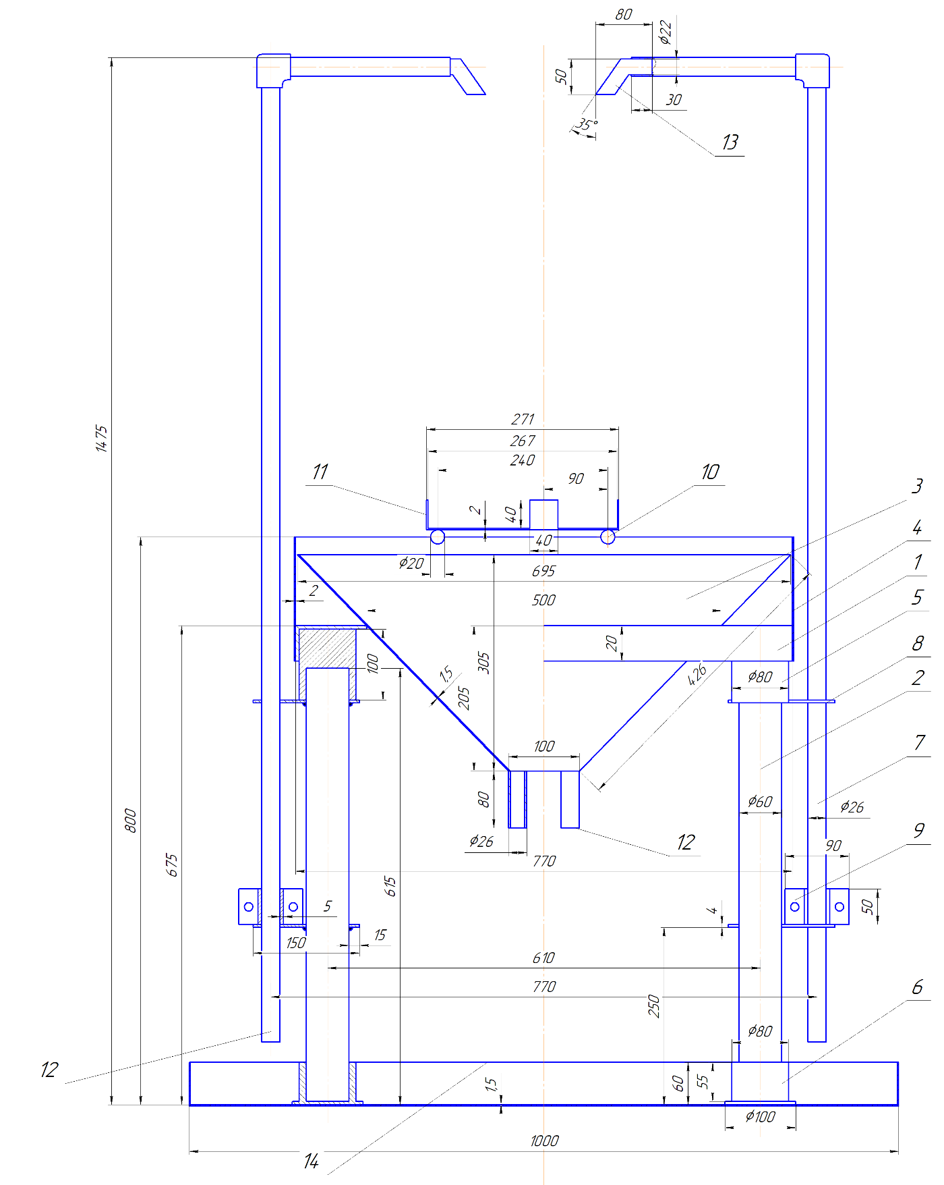

1– frame; 2 - leg; 3 - sink; 4 - fence; 5 - headgear; 6 - shoe; 7 - pipeline; 8 - centralizer; 9 - clamp; 10 - beam; 11 - saddle (it shows a device with a funnel); 12; 13 - nipple; 14 - tray.
Figure 3.1 - Assembly drawing of an experimental stand for testing devices for automatic control of drilling mud parameters (side section) view
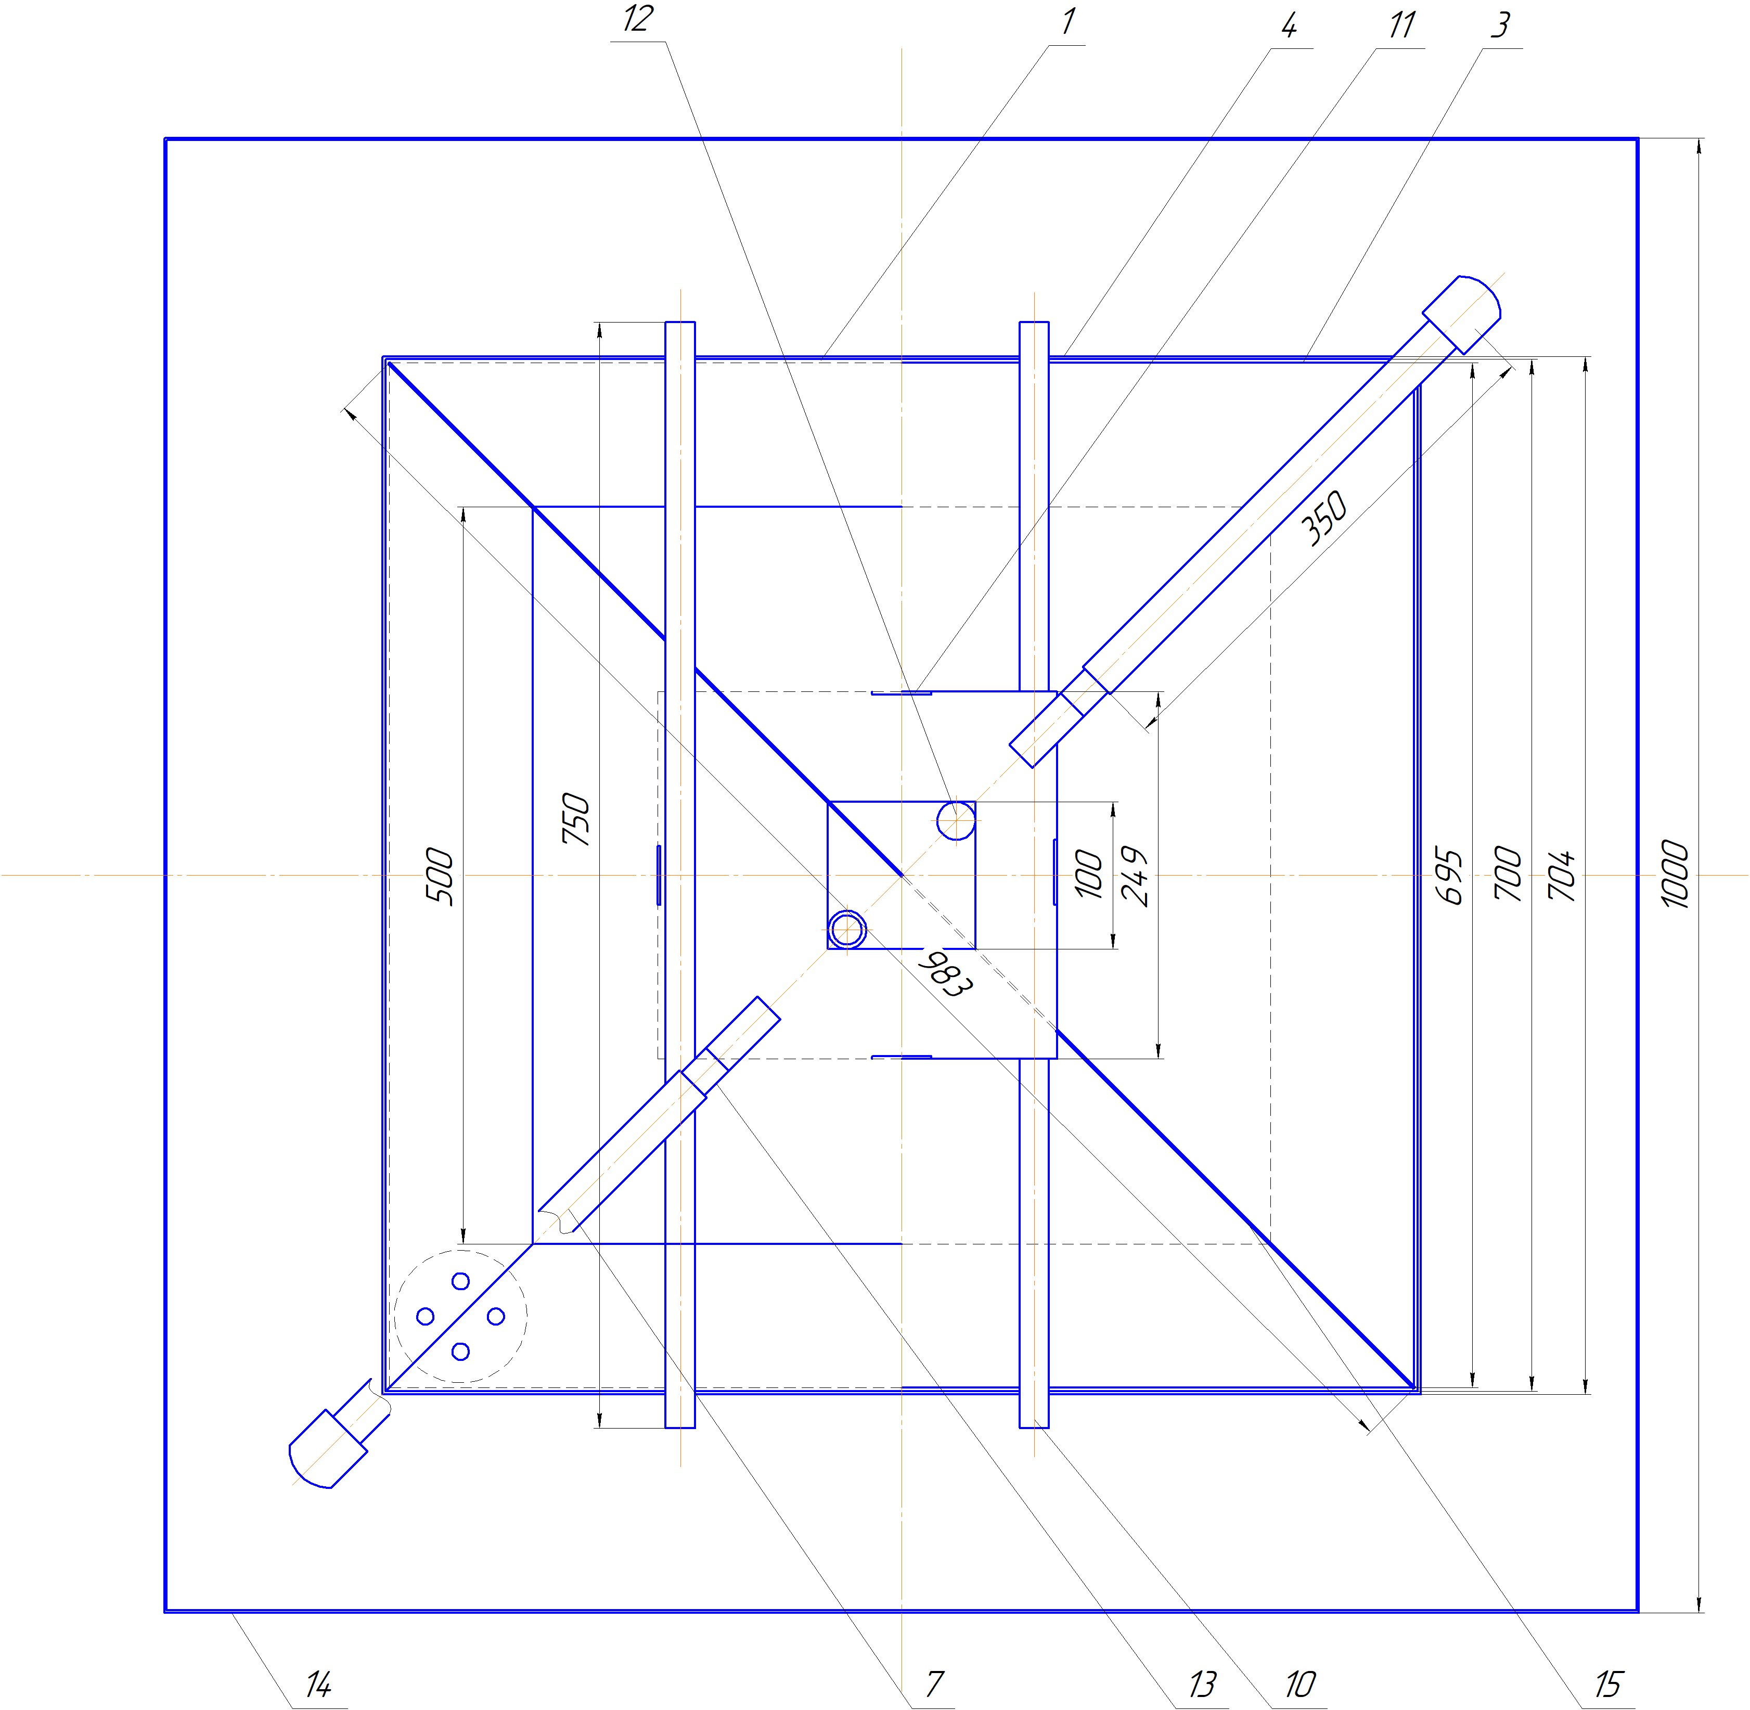
15 - partition; 16 - bolt
Figure 3.2 - Assembly drawing of an experimental stand for testing devices for automatic control of drilling mud parameters (top view)

The diagram of the pump manifold shown in Figure 3.3 works as follows:
- When filling the reservoir P with a drilling mud prepared in the MX mixer: Valve 3 and valve 4 are open, other valves and needle valves are closed. The HP pump sucks the drilling mud from the mixer and pumps it into the manifold;
- When the device under test is in operation and its funnel is in the loading position: Valve 1 and valve 2 are open, other valves are closed. The HP pump sucks the drilling mud from the collector P and pumps into the funnel of the tested device, from where it drains through the corresponding compartment of the sink to the drilling mud collector;
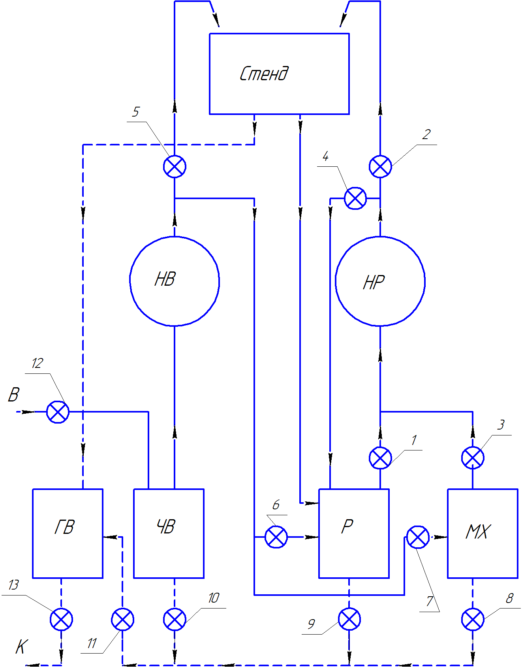
НВ - water supply pump; НР - drilling mud supply pump; GW - dirty water capacity; ЧВ - pure water capacity; Р - drilling mud capacity; MX - mixer; K - sewerage; B - water supply; 1 - 13 - taps and valves
Figure 3.3 - pump manifold

- When the funnel of tested device is in the loading position and, if it is necessary to adjust the delivery of the mud downward, in addition to valve 1 and valve 2, valve 4 is also open, returning part of the drilling mud back to the container P. By turning valves 2 and 4, the desired fluid delivery is obtained. A strong jet of drilling mud, when it is loaded into the funnel, leads to its losses due to spraying. In addition, it creates a depression in the surface of the mud in the funnel and for that reason the measured volume turns out to be less than the set value,which causes an error in the final measurement result in the direction of its decrease. The use of a pump with a high productivity with return of a part of it to the mud collector provides two important advantages: firstly, the regulation with the help of valves makes it possible smoothly to set any optimal liquid supply and, secondly, it makes intensive stirring the drilling mud in its collector, preventing gelation errors increasing the real value of the funnel viscosity
- When the tested device is operating and its funnel is in the cleaning position: Tap 5 is open, other taps are closed. The HB pump sucks the drilling mud from the CW pure water collector and pumps it into the funnel of the tested device, from where it drains through the corresponding sink compartment to the dirty collector of waste water.
- When cleaning the system before using a new type of drilling mud: Valves 6, 7, 8, 9, 11 are open, other valves are closed. The HB pump sucks water from the CW collector and injects it into the drilling mud collector P and the MX mixer, passing through which the drilling mud enters the discharge line (dotted line) and then into the waste water tank.
- When loading the clay mixer with water: Tap 7 is open, other taps are closed. The HB pump sucks the drilling mud from the CW pure water collector and pumps it into the MX mixer.
- When loading the CW tank with water (during the tests it is constantly consumed): Tap 12 is open, other taps are closed. The water comes from the mains supply.
- When unloading the dirty water collector (during the tests it constantly arrives): Tap 13 is open, other taps are closed. The spent liquid dreains into the sewer.
Technical characteristics of the stand
1.Dimensions, mm:
Length and width: 1000
Height: without fluid lines 813
Height of pipelines (the stand with them) 1500
2. Sink size, mm
Length x Width: 695
Height: without nipples 305
The same with nipples 385
Distance from the bottom of the funnel to the tray 470
3. Dimensions of the fence, mm
Length and width 704
Height above frame 123
4. Dimensions of the "saddle" (installation platform), mm
Length 271
Width 249
Height 42
5. Diameter of pipelines, outside / inside, mm 26/22
6. Dimensions of water tank, mm
Length and height 1000
Width 400
Capacity, 400 liters
7. Dimensions of the waste water tank, mm
Length and width 1000
Height 200
Capacity, 200 liters
8. Dimensions of the drilling mud container, mm
Length and width 140
Height 250
Capacity, 5 liters
9. Water and drilling mud pumps
Output, l / min 10
Maximum pressure, MPa 0.5
10. Funnel filling time 15 s
11. Mixer
Capacity, l 2
Verification calculations of the stand operation (at the example of testing a device for automatic continuous measurement of funnel viscosity)
According to the laws of hydraulics, the pressure loss in the vertical pipeline is
(3.1)
ρ - density of the liquid, g - acceleration gravity, H - height of the pipeline, d - inner diameter.
Liquid velocity in the pipeline
ϑ = Q/(0.7854d²) (3.2)

Q - pump output
Converting the values from the technical characteristics, we get Q = 0.438 m / s
Since the highest liquid flow (full pump capacity) is required when flushing with water, the calculation is performed for water.
Reynolds number is
Re=ρϑd/γ (3.3)

γ - dynamic viscosity of water equals to 0.0001 Pa * s
We get Re = 96360, which practically means the region of turbulent regime, for which the coefficient of hydraulic resistance

ג=0.0121/d^{0.226} (3.4)

We get ג = 0.029
Entering all known values into equation (3.1), we obtain Р = 0.015 MPa
When the drilling mud is supplied to the device, its amount is less than the pump capacity and the pressure loss, even at a higher density of the liquid, will be lower than the pressure specified in the pump characteristics.
We determine the liquid supply by the pump necessary for the required time of filling the funnel with liquid specified in the characteristic. This flow rate is equal to:

Q= (Q_{d}+ Q_{F})К (3.5)

Qd - flow rate of spontaneous draining of water from the funnel

Q_{d}= V/T_{d} (3.6)

V - total volume of the funnel - 0.7 liters; Td - time of water draining therefrom. According to the 2018 report, Td = 19 s
We get Qd = 2.21 l / min
QF - flow rate of the liquid stream when filling an empty funnel

Q_{F}= V/T_{А} (3.7)

T_{A} - filling time specified in the characteristic
We get Q_{d} = 2.80 l / min
We take the reserve factor K = 1.2
According to equation (3.5), we obtain Q = 6.01 l / min
In this case, 4 liters must be returned back to the mud collector. The calculation is made for water, which has a maximum Qd compared to other drilling fluids
Duration of testing the device with a drilling mud of this type is taken equal to 30 minutes
Time of one measuring cycle 5 min
Number of measurement cycles for employing a given type of drilling mud 30/5 = 6
Drilling mud consumption per test (drilling mud container volume) 5 l
The volume of the loaded drilling mud for 1 cycle (volume of the funnel
ВБР-2 with a reserve factor K = 1.2): 0.7x1.2 = 0.84 l
Loading time 15 s
Water flow 10 l / min (full pump capacity)
Pump running time for 1 cycle at funnel flushing 1 min (60 s)
Pump run time for cleaning drilling mud capacity and mixer 5 min
The volume of water for flushing the funnel for 1 measurement cycle 10x1 = 10 liters
Water volume for flushing the system 10x5 = 50 liters
Total water expenditure for testing with a given type of drilling mud 10 + 50 = 60 l
Total waste liquid 60 l
The number of types of drilling mud, the test on which provides the volume of the water tank 400/60 = 7
The number of types of drilling mud, the test on which provides the volume of the tank for the wastet liquid 200/60 = 3
To ensure the movement of the waste liquid by gravity into the waste liquid container with a side wall height of 200 mm, the bottom of the drilling mud containers and the mixer must be located above this wall. At the same time, to ensure complete discharge of the drilling mud from the funnel into the drilling mud container, the bottom of the funnel (the distance of which to the tray is 470 mm) must be higher than the upper edge of this container. The actual height difference provided by the technical specification is 470-250 + 200) = 20 mm.
That ensures the fulfillment of the specified conditions.

3.2 Developing the automatic viscosity meter to the stage of the working model

3.2.1 Mechanical development
In 2109, the enterprise IE “Palchikov” manufactured the mechanical part of the device. However, further work ran into a serious problem. The mechanical part was created with the expectation that a low-speed reversible electric motor RD09, which in the USSR was widely used in various automatic devices, would be used as a drive for the device.
Internet searches have made it possible to identify suppliers of such an electric motor in Almaty, Lviv and Moscow. However, in the first two cities at the indicated addresses there was no one, and in Moscow they said that these small electric motors can only be supplied in the form of batches of at least 20 units, which for experimental work exceeded the need many times over. After several months of searching (including during a business trip to Lviv), these electric motors were found and purchased on the technical market of Almaty.
However, a new complexity has emerged. The power of the purchased engines was only 1 W, which was clearly not enough for a rather massive device made. A new agreement was concluded with the same enterprise for the adjustment of the mechanical part. The main purpose of the stand work was to minimize the power required for the turntable movement. It was decided to reduce the friction in the bearings caused by misalignment. This was done by expanding the contact of the shaft walls with the lower bearing, which ceased to be angular contact, but became only a thrust bearing. Only the upper bearing began to play the role of radial centering, which turned out to be sufficient in view of the very slow rotation of the shaft, which, with the help of the manufacture of a new pair of gears, was reduced by 3 times in comparison with the speed of the RD09 shaft. The lightening of the rotating parts and, in particular, the turntable was carried out by removing the excess metal (see Fig. 4). Simultaneously with the drilling mud of the main task - reducing the power for rotation, attention was paid to improving the tightness and insulation of live elements. In addition, the possibility of improving some of the nodes came to light. In particular, it was decided to install the box-shaped body on screw-out supports to ensure that the liquid level in the measuring funnel is strictly horizontal. Below is a program for making changes and additions to the device design, which was sent to the manufacturer along with the corresponding drawings.
The program of work on setting up the mechanical part of the automatic viscosity meter in order to ensure its coordination with the electrical part.
1. Make the rotation of the turntable as free as possible: An electric motor that has just been purchased has a power of only 1 W).
It is necessary:
A) Extend the inner diameter of the lower bearing, or narrow the lower 17 mm of the shaft by 0.1 - 0.5 mm, until the rotation is completely free.
B) The oil seal should not slow down the rotation by tightening - make the oil seal from a loose material such as hemp with a maximum of solid oil.
2. Inability to remove the intermediate plate. On it, as on a special shelf, the engine must be mounted: RD09 (see drawing): This plate is clamped between the walls of the base.
Necessary: ​​Remove the shelf and grind it off from the sides - to ensure that after unscrewing the screws it would be easily removed.
3. The need to reduce the required power to go to lower speeds and work at low gears of rotation of the table: In the available version there is a pair of gears of the same size - 96 mm, which does not reduce the speed of the table.
Required: To make a pair of gears 48-144 mm and to make fastening sleeves for them
4. Lack of rigid fixation of the centralizer bar in the post of the float shank. The resulting backlash will cause it to jam in the centering hole.
It is necessary:
A) Shorten the length of the centralizer post from 385 to 320 mm - see drawing) B) Weld the fastening plug to the post and to the bar, keeping the bar strictly horizontal (or make a new plug so that there is a press connection everywhere).
5. Danger of water ingress on live parts (127 V).
It is necessary:
A) Replace the spot welding in the joint of the steel ring of the body with the upper base plate with a solid one.
B) Do the same for the bushing of the contact post (according to the drawings, it should have been on 4 screws with a rubber gasket, but it is possible for welding)
C) Make a splash guard with a diameter of 190 mm of tin (see drawing) and install it on the centralizer bar (grab it with welding, screws or rivets - whatever is best)
D) So that if the motor insulation is broken, there is no short circuit to the entire housing, glue a 100 X 100 X 2 mm textolite plate with a 25 mm central hole on its mounting shelf on top of its mounting shelf or take on screws and make holes on this plate for mounting the motor (see drawing ). At the same time, expand the hole on the shelf from 50 to 80 mm (so that the engine mounting screws do not touch the steel
6. Difficulty in assembling and disassembling the device: The model is experienced, will often be assembled and disassembled when installing electrical parts and during testing.
It is necessary:
A) Make rubber gaskets - as in the drawings (instead of a sealing tape).
B) Smooth sharp edges.
C) Achieve a free joint when assembling all assembled parts.
D) On the case cover and on the textolite chamber, make a turnkey deepening - a crescent.
7. Measuring funnel does not fit into the unit: When preparing the documentation, we were guided by a different measuring funnel that was obtained later.
It is necessary:
A) Drill the mounting hole on the table from 6 to 8 +0.1 mm
B) Move the upper part of the contact post further from the center of rotation using squares (see drawing).
C) Drill 8 mm holes in the lower part of the contact post and in the plastic plate for cable entry (see drawing).
D) When assembling the rack, pass a wire through it (if you pass the wire into an already assembled rack, it will get stuck in the connections).
8. Place the engine on the shelf.
It is necessary:
A) Drill on the shelf in accordance with the mounting holes on the RD09 engine casing holes for the textolite plate (15 mm from the corners) and install the plate with the engine in the center of the hole in the shelf.
B) Install the small gear on the motor shaft (see drawing), and on the table shaft - the large gear in contact with the small gear.
9. Coat the outside of the steel parts with a moisture-resistant rustproof paint.
10.In order to ensure the horizontal level of the liquid level in the funnel, on the lower board at a distance of 25 mm from the corners (diagonally), make 4 holes with M6 threads and make (or select) 4 bolts 25 mm long with a 10 mm wrench head
In addition to the positions mentioned, it is also necessary to remove excess metal from the turntable as much as possible (see figure 3.4).
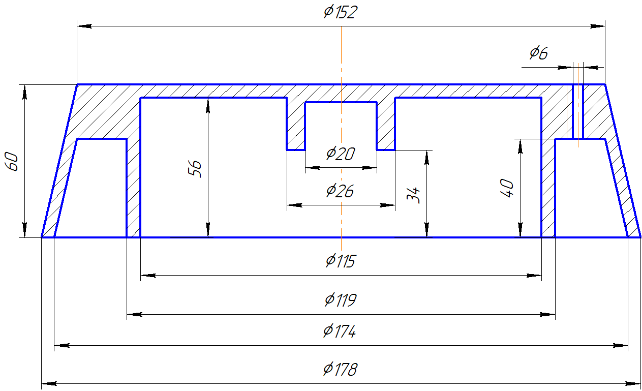
Figure 3.4 - Lightweight version of the rotary table
Purposes of lightening are cutting metal along the outer tapered surface of the table and thinning the top wall.
All of these prescriptions have been met. A sharp reduction in the frictional forces in the bearings and stuffing box was achieved. In addition, the rotation speed was reduced from 8 rpm, (the engine shaft that was purchased was rotated at this speed) to 2.7 rpm by making a pair of gears that reduce the speed by 3 times. As a result, the RD09 engine began to freely rotate the turntable with a measuring funnel installed on it, loaded to the brim with liquid.
2.2. Development and installation of electrical parts
The possibility of bringing the automatic viscosity meter to the stage of an operating model was in doubt, since this required the presence of analog-to-digital converters, as well as programmed microcircuits, the possibility of acquiring which in Kazakhstan or even in Russia was in doubt. For this reason, this stage of work was not included in the schedule. However, it turned out that in Almaty such work can be performed by Poly Tech Electronics, with which a corresponding contract was concluded. The company received a set of documentation, as well as a program containing provisions that are most important from the point of view of manufacturing and installation of an electronic automatic control system for a device:
Work program for the manufacture and installation of the electrical part of the model of the relative viscosity meter.
Rotary table motion control.
From a safety point of view, special attention should be paid to reliable insulation of assemblies with parts under electrical voltage, these are:
- Engine on a shelf-mounted plastic plate
- Plastic case with contacts
- A plastic plate with a contact, installed on the stand and protected from below from liquid splashes flying from the surface of the funnel by a tin shield
- A step-down transformer, relays and microcircuits located in a separate unit.
The movement of the rotary table according to a given program is provided as follows.
- Rotation of the table is driven by the RD-09 engine; its shaft speed is 8 rpm, the corresponding rotary table frequency (through the 3/1 gearbox) –2.7 rpm (160 / s)
In the position "filling with drilling mud and measuring"
A cam on a plastic shaft disc (or two interlocked cams) has the following functions:
1) Opens the normally closed contact on the plastic housing and stops the table motor. In this case, the funnel stops directly under the drilling mud supply channel, and the float shank is close to the contact on the rack;
2) Closes the activation contact of the drilling mud pump located on the motor stand.
After 60 seconds (required to fill the funnel), the time relay stops the pump;
At the same time the time relay starts a stopwatch that measures the relative viscosity;
After the measurement time (flowing out of 0.5 l from the 0.7 l funnel), the cam at the end of the float shank, having descended to the specified distance, stops the stopwatch;
After 140 s from the time the drilling mud pump was stopped (to ensure the measurement of the drilling mud with the maximum conditional viscosity and the complete flow of the drilling mud from the funnel), the time relay resumes the rotation of the table;
In the "flush" position
- after 11 s (after turning the table by 1800): the second cam on the shaft disk:
1) Stops the table motor, and the funnel moves into position under the water inlet.
2) Starts the water pump; After 60 seconds required to clean the funnel and its nozzle from the traces of drilling mud, the time relay stops the water supply pump.
- After another 20 seconds (necessary for emptying the funnel from water), the time switch resumes rotation of the table until reaching the position "filling with drilling mud"
In this way; the time of one cycle of measuring the conditional viscosity is equal to the time of pure rotation of the table with its full rotation, - 22 s, plus the time of stops of 251 s;
- total 273 s, i.e. 4.55 min
Access to the elements of the relative viscosity meter:
- Remove the bottom plate
- Remove the large gear
- Remove the shelf with the engine
- Remove the top board
In the course of work on the device, Ph.D. R. Utebayev made several suggestions for improving the design of the device
1. Since the RD09 engine is reversible, it is possible to abandon the circular rotation of the table, but to make it reciprocating: from the loading position to the washing position and vice versa. This proposal made it possible to abandon the contact stand of the mechanism for dosing the measured volume of the drilling mud and to establish this contact on the centralizer stand installed on the turntable itself. A separate stand was needed so as not to apply voltage to the rotating table, since this requires slip rings and the associated inconvenience. To solve the problem with reciprocating motion, instead of slip rings, it was sufficient to give the lead cable a little slack.
2. Cam contacts have been replaced by magnetic contacts, which simplifies the design
The electrical manufacturer made an attempt to reject the volumetric dispenser. Two more modern methods of monitoring the liquid level have been tried.
The ultrasonic method for tracking the lowering of the drilling mud level was rejected due to interference associated with the reflection of ultrasound from the walls of the funnel.
The use of infrared radiation for the same purposes also turned out to be unacceptable due to fluctuations of the liquid surface, the presence of splashes and the impossibility of covering the top of the funnel, if necessary, with a mesh filtering large particles of sludge. Thus, it was necessary to return to the originally proposed float dispenser.
All elements required for the electrical part of the device (except for the electric motor) were purchased by the manufacturer independently at the expense of the contract amount. It was a power supply with a step-down transformer, an analog-to-digital converter, a relay, and a programmable microcircuit. All this is mounted in a common housing - a control unit, which was located remotely from the sensor by means of a cable and was not exposed to the risk of exposure to liquid.
The control unit has a display with a numerical indicator of the relative viscosity time, as well as the number and time of the measurement. There were also four buttons for controlling the operation of the automatic device.
It was very difficult to test the automatic device assembled into a single whole on drilling mud in the absence of a special stand, so the device was tested on tap water. During the tests, the rotary table automatically performed several measuring cycles, and the water number was obtained in the range from 14 to 18 s. This inaccuracy (should be 15 plus - minus 0.5 s.) Was supposed to be eliminated during tests at the stand.

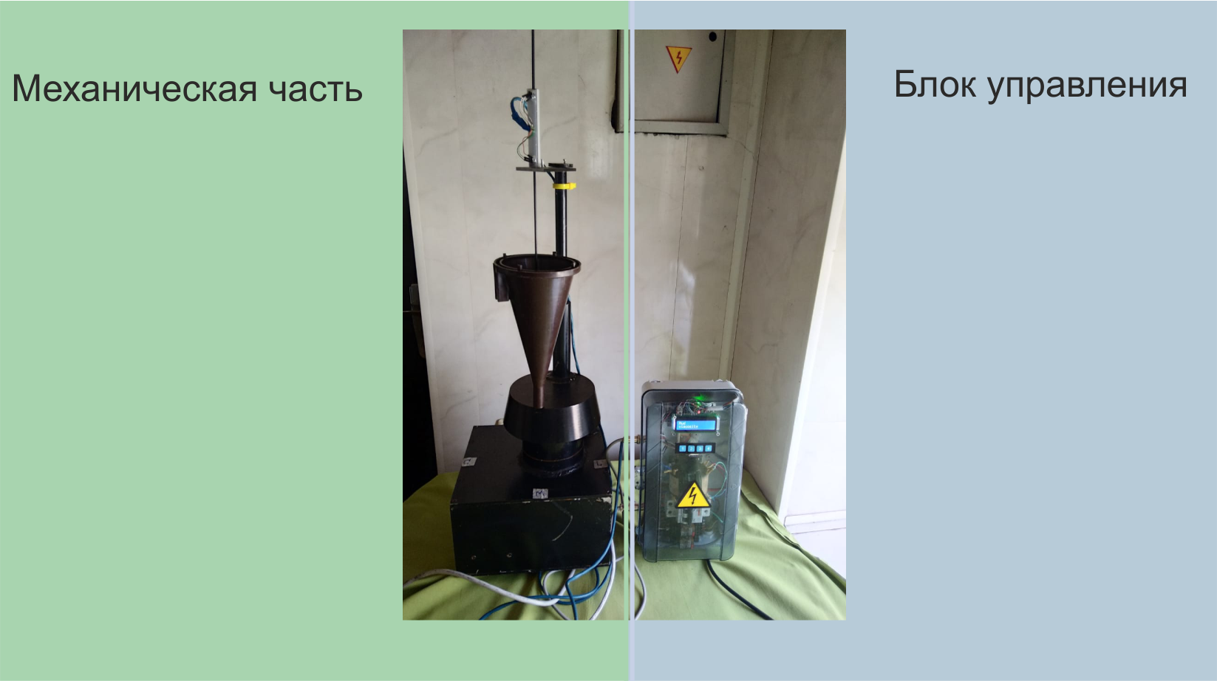
Figure 3.5 - Device for automatic monitoring of the conditional viscosity of the drilling fluid

Figure 3.5 shows a photograph of a working model of a device for automatic continuous monitoring of a mud viscosity meter.
The left half shows the sensor unit. The funnel of the D<H-2 device is visible, with the help of which manual measurements are made. The funnel is mounted on a turntable with tapered walls, which rests on the bottom of a cylindrical body (inside it passes the rotation shaft of the table with a cam disk mounted on it), In turn, the cylindrical body is mounted on a box-shaped body (inside which there is a drive motor and a gear reducer). In addition to the funnel, a centralizer stand is mounted on the rotary table - it is visible to the right of the funnel center. Up from the center of the funnel is the float shank (the float itself is not visible). The shank goes through the hole in the horizontal centralizer plate. Above the plate, a normally closed magnetic contact block is visible.
On the right, the figure shows the control unit: four control buttons are visible and a small display above them
The control system implemented with this unit can operate in the following modes:
Calibration mode.
This mode can be entered by simultaneously pressing buttons 3 and 4. The display will show calibrate and the float position. The float position can be full, no, empty, i.e. full, undefined and empty, respectively. In this mode, you can calibrate the position of the funnel or float position sensors. To exit the mode, press the button 1.
Setting mode.
In this mode, you can set the values ​​of the following time parameters - in s:
- Tmax_load - maximum time for loading the funnel with the drilling mud flow.
–Tmax_meusre - maximum time for measuring the conditional viscosity of the drilling fluid.
- Tmax_clear - The maximum time for stopping the table rotation to clear the funnel with a stream of water from the traces of the drilling mud after measurement.
- trickling_time - waiting time for residual water to drain off the funnel walls after it has been rinsed.
The setup mode can be entered by pressing button 2. The display will show setup mode. After one second, the display will show the name of the parameter being set and its value. You can scroll through the list of parameters by pressing buttons 3 and 4. After selecting a parameter, you can change its value by pressing button 2. The name of the variable and its value will start blinking. While flashing, pressing buttons 3 and 4 can increase or decrease the value of the variable. After setting the value, to save the change, you must press the button 2, while the inscription save appears, indicating saving in memory.
Memory view mode
When scrolling through the variables, the item mesures is selected, by pressing button 2, the menu for viewing the measurements recorded in the memory is entered. The inscription show mesures will appear. By pressing buttons 3 and 4, you can scroll through and view the recorded values ​​of the drilling mud flow time. The top line of the display will show the date and time of the corresponding measurement. The maximum number of recorded values ​​in the memory is 20. Recordings are carried out according to the principle of "circular closure". Those. after recording the 20th measurement, the next recording will overwrite the 1st recording. To exit the mode of viewing the recorded values, press the button 1. In this case, the return to the previous menu of scrolling variables is carried out. To exit the setup mode, press the button 1. Save data will appear, and after a second, ready start will appear, indicating the readiness for automatic operation.
Automatic operation mode.
To enter this mode, press button 1. In automatic mode, the installation performs the following sequential actions: search for the loading position; - waiting for the filling of the funnel for a given loading time; - search for a measurement position; - measurement of the time of liquid flowing out of the funnel; - after the end of the measurement, search for the cleaning position of the funnel - waiting for the specified time for cleaning the funnel and removing water from it - searching for the loading position. In this cycle, the unit works until button 2 is pressed or the power is turned off. In any of the positions, while waiting for the required position of the float, for example, in the loading mode, the installation can remain indefinitely.

CONCLUSION

Brief conclusions based on the results of research. In the course of work in accordance with the schedule for 2020 for the stage "Drawing up documentation for the manufacture of an experimental setup" the following was done:
1. Justification of the need for an experimental stand for testing automatic meters of drilling mud parameters
2. The calculation of the main elements of the stand
3. The Terms of Reference for the development of the experimental stand was drawn up and approved
4. The technical documentation for the stand has been developed.
5. A program and documentation has been developed for carrying out adjustment work on the mechanical part of the device for an automatic meter of the conditional viscosity of the drilling fluid
6. A program and documentation for the manufacture of the electrical part of the relative viscosity meter has been developed
7. The program for the manufacture of the electrical part was agreed with the manufacturer and, at his suggestion, changes were made to the design of the device
8. Monitoring of the manufacture of the electrical part and bringing the automatic measuring device of the relative viscosity to the stage of the operating model was carried out.
Published 8 articles, including 4 in the Scopus database; (2 reports at international conferences); 2 more articles were submitted to the editor. Received 1 patent for invention, 1 positive decision; 3 more applications have been submitted.
Thus, all the works stipulated by the schedule for 2020 have been completed in full.
Evaluation of the completeness of drilling muds to the tasks. The work performed will form the basis for the next stage of the implementation of the theme, planned for 2020, which provides for the preparation of documentation for the manufacture of an experimental installation.
Development of recommendations for the use of research results: The results of the studies presented in the work will be used to manufacture devices for automatic measurement of drilling fluid parameters. Additional research is recommended in 2020.
Results of assessing the technical and economic efficiency of implementation: When using automatic continuous monitoring devices for drilling mud parameters, the number of complications and accidents in boreholes will be reduced, which will significantly reduce the cost of drilling operations.
There is an economy in the developed new method for measuring the rheological parameters of drilling fluids (as well as other suspensions used in the economy). The price of the device - measuring rheological parameters FANN35 is equal to 3 420 000 tenge, - The method for measuring rheological parameters created during the work on this project has zero costs both for the measuring device and for the measurement procedure.
The results of assessing the scientific and technical level of the completed research work in comparison with the best achievements in this area. This work bears the features of a pioneering and breakthrough research, since according to the analysis of a fairly representative number of the latest published works in the world:
- No analogues have been found, both in design and in the ability to achieve the goal - automatic monitoring of the quality parameters of drilling fluids.
- An urgent need for appropriate devices has been identified, especially in connection with an increase in the depth of wells and the associated complication of geological and technical conditions for drilling, as well as in connection with the development of new and more advanced formulations of drilling fluids.

REFERENCES

1. Pustovojtenko, I.P. Rukovodstvo mastera po slozhnym rabotam v burenii / I.P. Pustovojtenko, A.P. Selivashchuk. - M.: Nedra. – 1983. –248 s
2. Grej, Dzh. R. Sostav i svojstva burovyh agentov / Dzh. R.Grej, G.S.G. Darli. – M.: Nedra. – 1985. –460 s.
3. KazNTU im. K.I.Satpaeva. Otchet po teme “Sovershenstvovanie tekhnologii sooruzheniya geotekhnologicheskih skvazhin v slozhnyh usloviyah mestorozhdeniya Horasan” 2009 g
4. Shach C.N. and others. The future challenges in the area of the drilling fluids and their rheological measurements. American association of drilling engineers. AADE-10-DF-HO-41, 2010
5. Spelta at al. Real time monitoring system improves drilling efficiencies. The 13-th Ofsfore Mediterranean Conference, Ravenna, 2017
6. Mullins M.P. Automatic device for measurement of the mud properties in the drilled shafts. University of the South Florida. Thesis. 2016
7. Saasen A. at al. Automatic measuring the properties of drilling fluids and cuttings. SPE Well drilling and finishing. December 2009
8. B.Shoesser: Marsh funnel testing for rheology analysis of bentonite slurries for slurry shields. Promoting tunneling in sea region TTA WTC 2015 Congress and 41-st General Assembly
9. M.Balhof et al: Rheologocal and yield stress measurements of non-Newtonian fluids, using Marsh funnel. Journal of petroleum science and engineering 77(2011) 393-402
10. Biletskiy M.T et a. lMethod of automatic measurements of drilling mud quality parameters Int. J.Chem.Sci.:11(4), 2013, 1705– 1712 ISSN 0972–768X www.sadgurpablications.com/
11. Mitel'man, B.I. Spravochnik po gidravlicheskim raschetam v burenii / B.I. Mitel'man.- M.:Gostoptekhizdat, 1963. –254 c.
12. H. Marsh, Properties and Treatment of Rotary Mud .Petroleum Development and Technology, Transactions of the AIME (1931), pp. 234–251.
13. Spravochnik burovogo mastera[Tekst]: v 2-h t. / N.A. Aksenova [i dr.]. – M. : Infra Inzheneriya,2006. - T.1. -608 s.
14. Ustrojstvo dlya izmereniya uslovnoj vyazkosti burovogo rastvora [Tekst]: innov. pat. Respubliki Kazahstan № 25680 / Bileckij M. T., Sushko S. M., Kasenov A. K., Begun A. D.; zayavitel' ipatentoobladatel' KazNITU im. K.I. Satpaeva. – opubl.16.04.2012, Byul. № 4.
15. Ustrojstvo dlya izmereniya uslovnoj vyazkosti burovogo rastvora [Tekst]: Pat. Respubliki Kazahstan № 25680 / Bileckij M. T., Sushko S. M., Kasenov A. K., Begun A. D.; zayavitel' ipatentoobladatel' KazNITU im. K.I. Satpaeva. - opubl. 16.06.2014. - Byul. № 6.
16.Ustrojstvo dlya izmereniya plotnosti burovogo rastvora[Tekst]: innov. pat. Respubliki Kazahstan № 25681 / Bileckij M. T., Sushko S. M., Kasenov A. K., Begun A. D.; zayavitel' ipatentoobladatel' KazNITU im. K.I. Satpaeva. – opubl.16.04.2012, Byul. № 4.
17. Ustrojstvo dlya izmereniya plotnosti burovogo rastvora[Tekst]: pat. Respubliki Kazahstan № 25681 / Bileckij M. T., Sushko S. M., Kasenov A. K., Begun A. D.;zayavitel' ipatentoobladatel' KazNITU im. K.I. Satpaeva. - opubl.16.06.2012, Byul. № 4.
18. Ustrojstvo dlya kompleksnogo avtomaticheskogo izmereniya uslovnoj vyazkosti i plotnosti burovogo rastvora[Tekst]: innov. pat. Respubliki Kazahstan № 29630 / Bileckij M. T., Kasenov A. K., Battalov D., SHegulov D.; zayavitel' ipatentoobladatel' KazNITU im. K.I. Satpaeva. –opubl.16.03.2015, Byul. № 3.
19. Bileckij, M.T., Analiz oslozhnenij pri burenii geotekhnologicheskih skvazhin v slozhnyh usloviyah. Nauchnye i tekhnologicheskie vyzovy pri burenii skvazhin /M.T. Bileckij, B.T. Ratov, A.K. Kasenov // DrilingProgres, IOPKonf. Razdel: Zemlya i Ekologiya. Nauka 24 (2015), 012026 Izdatel'stvo IOP
20. Testirovanie haraktera stenok skvazhiny ili porody po dannym burovogo rastvora ili shlama. Doremus E. G. E21B49/005. US3409092AUS Grant
21. Profilaktika kavernoobrazovaniya pri burenii vysoko-dispersnyh glin na uranovyh mestorozhdeniyah Kazahstana [Tekst] /
M.T. Bileckij [i dr.] // 15-ya mezhdunarodnaya mul'tidisciplinarnaya nauchnaya GeokonferenciyaSGEM2015, 2015. - S. 157-164.
22. Rejber F. E21B21/8 Monitoring davleniya ili raskhoda burovogo flyuida na primere avtomaticheskogo dolivav stvolah skvazhin, avtomaticheskoe upravlenie zabojnym davleniem. US6257354(B1) US Grant
23 Ispol'zovanie komp'yuternoj modeli dlya predotvrashcheniya zashlamovaniya skvazhin pri vysokoskorostnom burenii [Tekst] / M.T.Bileckij[i dr.] // Novosti nauki Kazahstana: nauchno-tekhnicheskij sbornik № 3 ot 11.09.2009
24. Dahlem, A. Automatic Adjustment of Drilling Fluid Properties:master’s thesis: 17.06.2013 / A. Dahlem. – Stavanger, 2013. – 95 p.
25. Rojdzhmans R. F. N. Osnovannaya na modelirovanii optimizacii plotnosti i vyazkosti burovogo flyuida. Del'tfskij tekhnologicheskij universitet. Dissertaciya, 2016
26. L. Karlsen i dr. Ispol'zovanie oborudovannogo priborami stoyaka dlya monitoringa dinamiki burovogo rastvora s cel'yu uluchsheniya avtomatizirovannyh operacij v burenii. Raboty 12-go seminara po avtomaticheskomu upravlenii. offshornoj dobychi nefti i gaza. Tornhejm, iyun' 2012
27. Kontrol' i avtomatizaciya dobychi nefti i gaza[Tekst]: ucheb.dlya vuzov / Isakovich R. YA. [i dr.]. – M.: Nedra, 1985. – 353 s.
28. Ustrojstvo dlya kompleksnogo avtomaticheskogo izmereniya plotnosti burovogo rastvora i soderzhaniya v nem shlama[Tekst]: innov. pat. Respubliki Kazahstan № 31786 / Bileckij M. T.; zayavitel' ipatentoobladatel' KazNITU im. K.I. Satpaeva. - opubl. 30.12.2016, Byul. № 6.
29. Ustrojstvo dlya izmereniya staticheskogo napryazheniya sdviga burovogo rastvora[Tekst]: innov.pat. Respubliki Kazahstan № 26483 / Bileckij M. T., Sushko S. M., Kasenov A. K., Begun A. D.; zayavitel' ipatentoobladatel' KazNITU im. K.I. Satpaeva. - opubl.14.12.2012, Byul.№ 12.
30. Ustrojstvo dlya izmereniya vodootdachi burovogo rastvora [Tekst]: innov.pat. Respubliki Kazahstan № 28588 /Bileckij M. T., Sushko S. M., Kasenov A. K., Begun A. D.;zayavitel' ipatentoobladatel'KazNITU im. K.I. Satpaeva. - opubl. 16.06.2014, Byul. № 6.
32. Kalitkin, N.N. CHislennye metody / N.N. Kalitkin. - M.: Nauka, 1978. – 511 s.
33. Hofman, D. Tekhnika izmerenij i obespechenie kachestva / D. Hofman. – M.:Energoizdat, 1983. – 192 s.
34. Ivachyov, L.M. Promyvka i tamponirovanie geologorazvedochnyh skvazhin. / L.M. Ivachyov // - M.: Nedra, 1989.- 247 s.

APPENDIX А

WORK SCHEDULE FOR 2018-2020 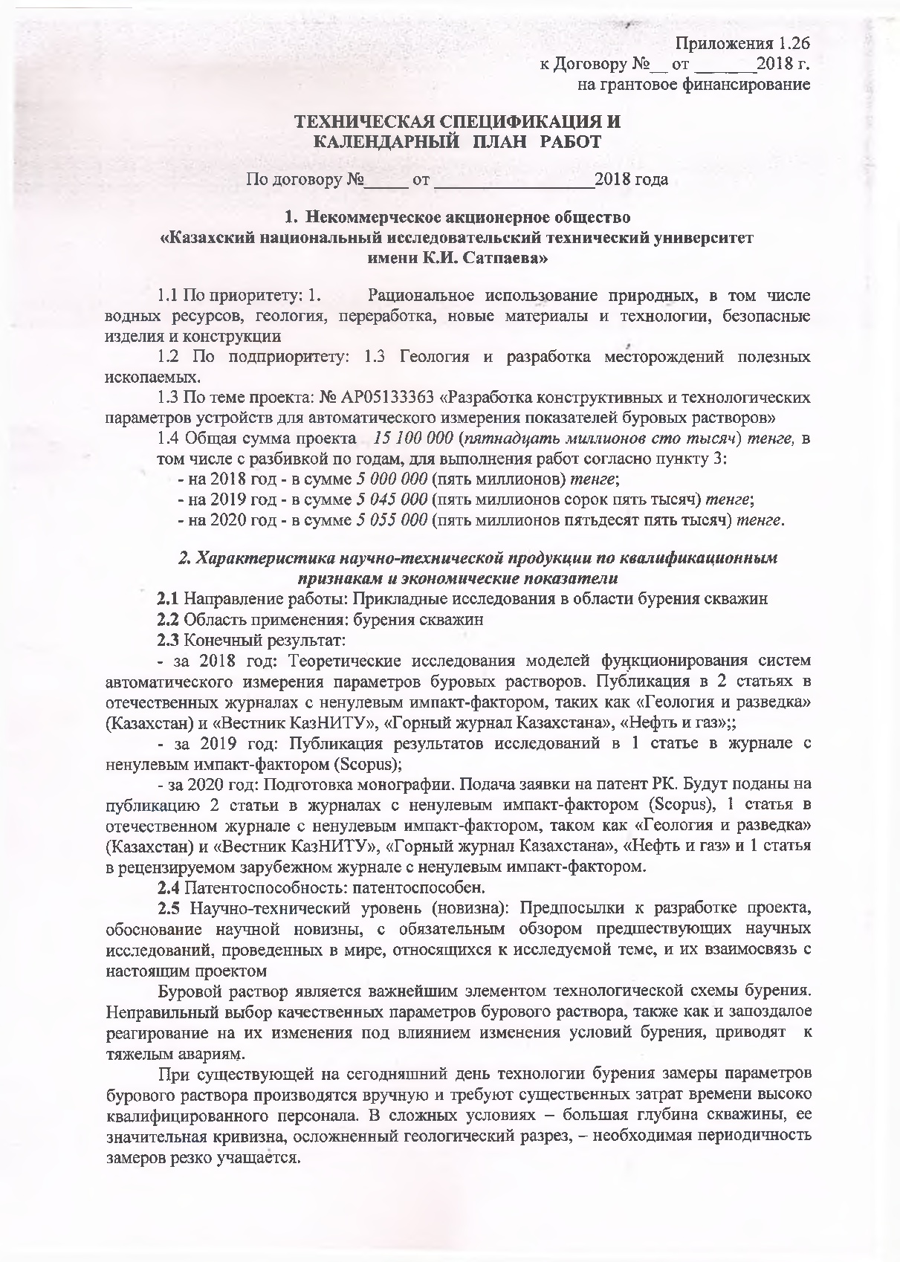

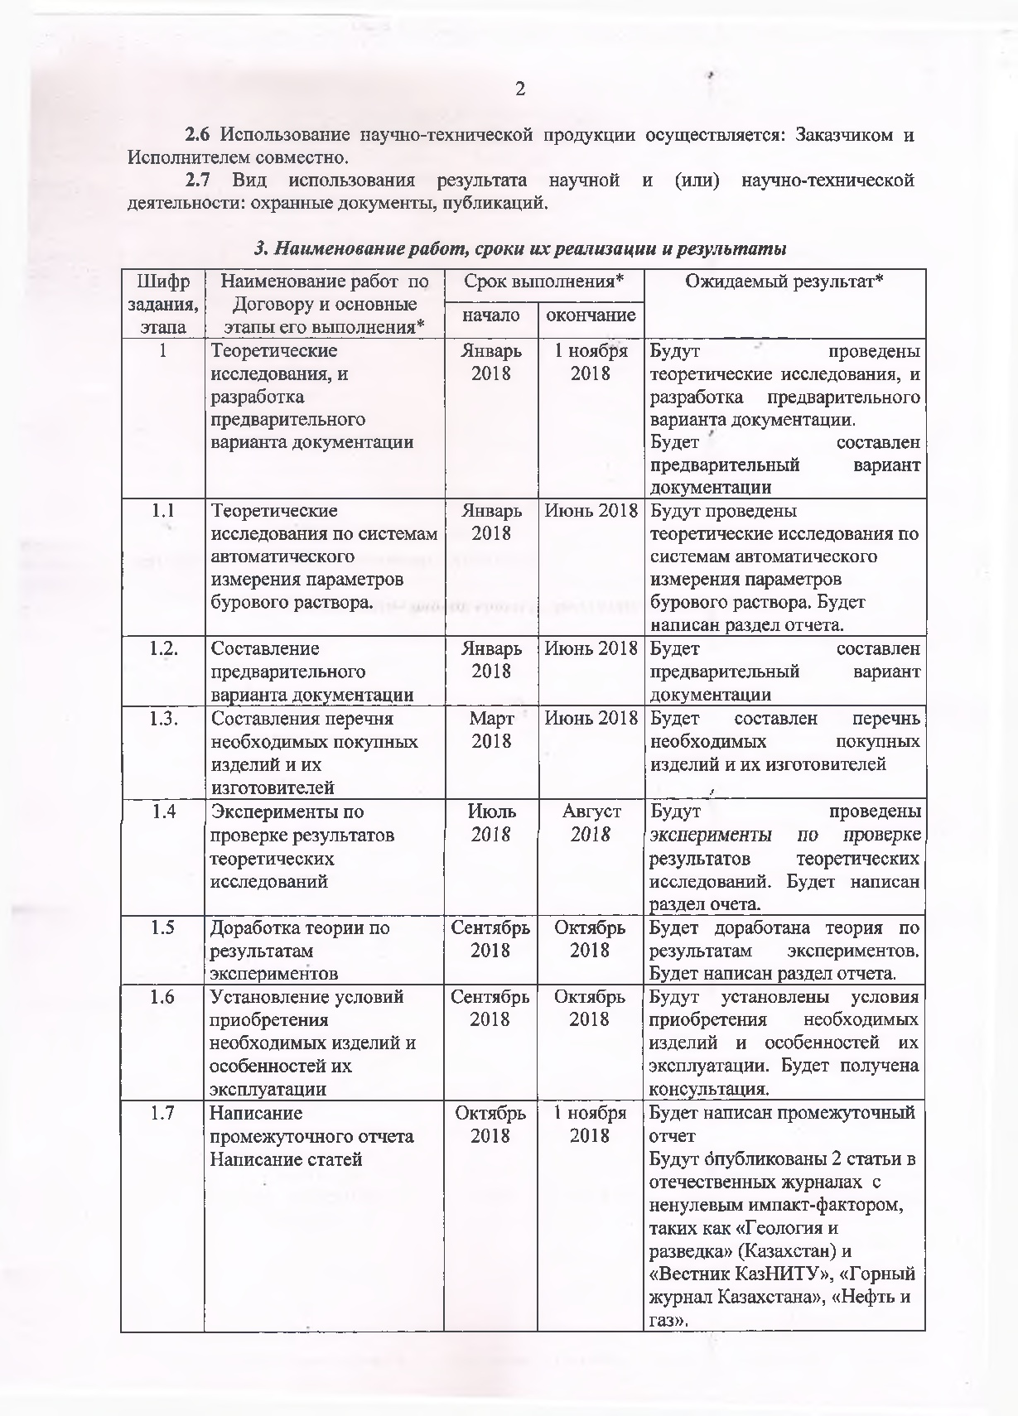
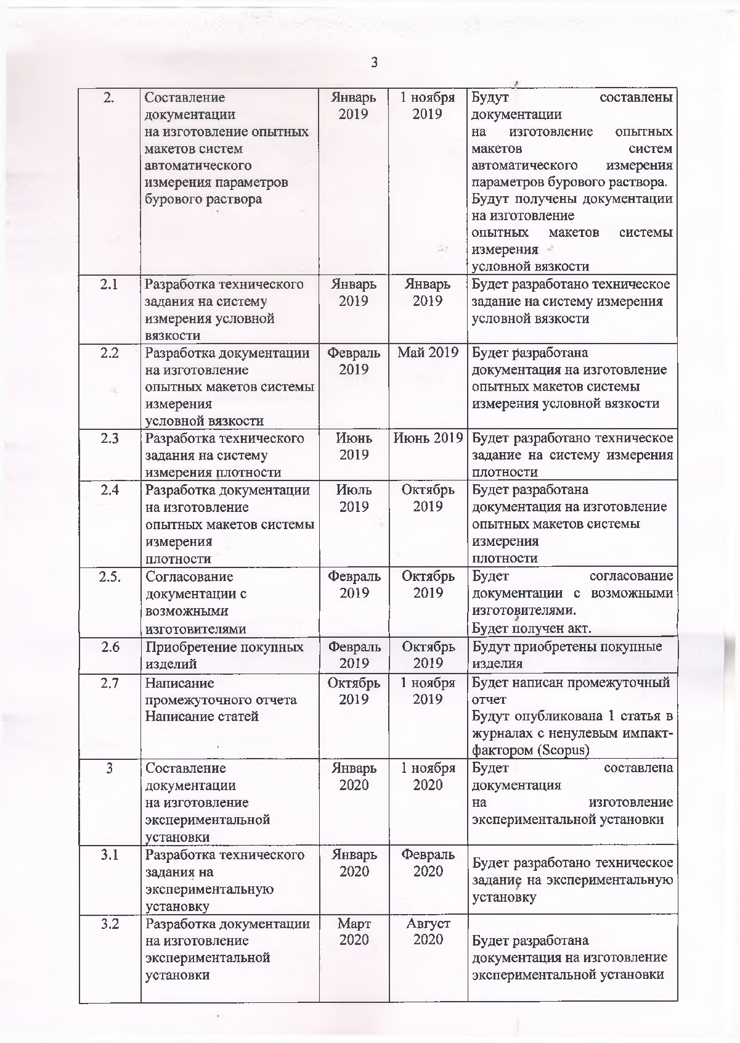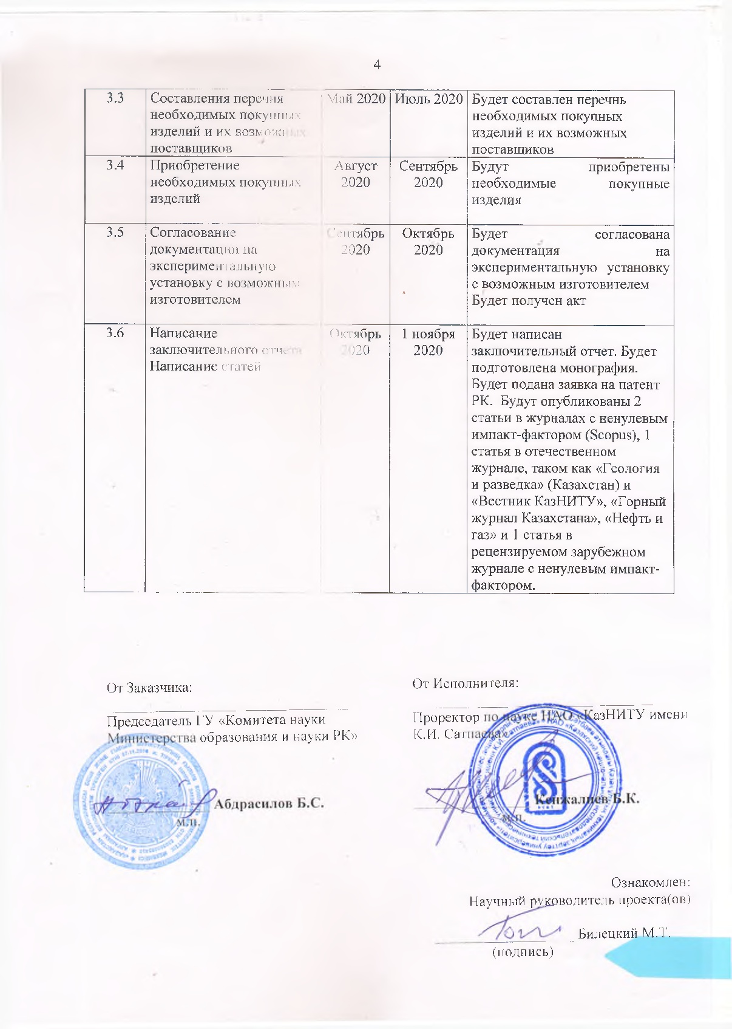

Applications 1.26
to the Agreement No. from 2018
for grant funding
TECHNICAL SPECIFICATIONS AND
CALENDAR WORK PLAN
Under contract Ns from 2018

1.Non-profit joint stock company "Kazakh National Research Technical University
named after K.I. Satpayev "
1.1 By priority: 1. Rational use of natural resources, including water resources, geology, processing, new materials and technologies, safe products and structures
1.2 For sub-priority: 1.3 Geology and development of mineral deposits.
1.3 On the topic of the project: № AR05133363 "Development of designing and technological
parameters of device for automatic measurement of drilling mud parameters"
1.4 The total amount of the project is 15,100,000 (fifteen million one hundred thousand) tenge, including with a breakdown by years, for the performance of work in accordance with paragraph 3:- for 2018 - in the amount of 5,000,000 (five million) tenge;
- for 2019 baking - in the amount of 5,045,000 (five million forty-five thousand) tenge;
- for 2020 - in the amount of 5,055,000 (five million fifty-five thousand) tenge.
2. Characteristics of scientific and technical products for qualification
featured and economic performance
2.1 Direction of work: Applied research in the field of well drilling 2.2 Scope: drilling wells
2.3 Final result:
- for 2018: Theoretical studies of models of functioning of systems for automatic measurement of parameters of drilling fluids. Publication in 2 articles in domestic journals with a non-zero impact factor, such as "Geology and Exploration" (Kazakhstan) and "Vestnik KazNITU", "Mining Journal of Kazakhstan", "Oil and Gas" ;
- for 2019: Publication of research results in 1 article in a journal with a non-zero impact factor (Scopus);
- for 2020: Preparation of a monograph. Submission of an application for a patent of the RK. 2 articles will be submitted for publication in journals with a non-zero impact factor (Scopus), 1 article in a domestic journal with a non-zero impact factor, such as "Geology and Exploration" (Kazakhstan) and "Vestnik KazNTU", "Mining Journal of Kazakhstan", "Oil and Gas" and 1 article in a peer-reviewed foreign journal with a non-zero impact factor.
2.4 Patentability: patentable.
2.5 Scientific and technical level (novelty): Prerequisites for the development of the project, justification of scientific novelty, with a mandatory review of previous scientific research conducted in the world related to the topic under study, and their relationship with this project
Drilling mud is the most important element of the drilling technological scheme. The wrong choice of qualitative parameters of the drilling fluid, as well as the delayed response to their changes under the influence of changes in drilling conditions, lead to severe accidents.
With the current drilling technology, drilling mud parameters are measured manually and require a significant investment of time from highly qualified personnel. In difficult conditions - a great depth of the well, its significant curvature, complicated geological section - the required frequency of measurements becomes sharply more frequent.
2.6 The use of scientific and technical products is carried out: by the Customer and the Contractor together.
2.7 Type of use of the result of scientific and (or) scientific and technical activities: titles of protection, publications.

3. Name of work, terms of their implementation and results

Cipher  tasks,  stage | Name of works under the Agreement and main stages of its implementation * | Period of execution* |  | Expected Result*
Cipher  tasks,  stage |  | start | end | Expected Result*
1 | Theoretical research, and development of a preliminary version of the documentation | January 2018 | 1 November 2018 | Theoretical studies will be carried out, and a preliminary version of the documentation will be developed.  A preliminary version of the documentation will be drawn up
1.1 | Preparation a list of necessary purchased products and their manufacturers | January  2018 | June 2018 | Theoretical studies will be carried out on systems for automatic measurement of drilling mud parameters. A section of the report will be written.
1.2 | Theoretical studies on systems for automatic measurement of drilling mud parameters. | January  2018 | June 2018 | A preliminary version of the documentation will be drawn up
1.3 | Compilation of a list of necessary purchased products and their manufacturers | March 2018 | June 2018 | A list of necessary purchased products and their manufacturers will be compiled
1.4 | Experiments to verify the results of theoretical research | July 2018 | August 2018 | Experiments will be carried out to verify the results of theoretical studies. A section of the report will be written.
1.5 | Refinement of the theory based on the results of experiments | September 2018 | October 2018 | The theory will be finalized based on the results of experiments.  A section of the report will be written
1.6 | Setting conditions  acquisitions  necessary products and  particularities of their  exploitation | September 2018 | October 2018 | The conditions for the purchase of the necessary products and the features of their operation will be established. A consultation will be received.
1.7 | Writing an interim report  Writing Articles | October 2018 | 1 November 2018 | Interim report will be written 2 articles will be published in Russian journals with non-zero impact factor, such as "Geology and Exploration" (Kazakhstan) and "Vestnik KazNITU", "Mining Journal of Kazakhstan", "Oil and Gas".
2 | Preparation of documentation for the production of prototypes of automatic parameter measurement systems drilling mud | January 2019 | 1 November 2019 | Documentation will be drawn up for the manufacture of experimental  models of systems for automatic measurement of drilling mud parameters.  Documentation will be received for the manufacture of prototypes of the system for measuring the funnel viscosity
2.1 | Development of terms of references for a system for measuring the funnel viscosity | January 2019 | January 2019 | Terms of reference for the measurement system will be developed funnel viscosity
2.2 | Development of documentation for the manufacture of prototypes of the system for measuring the funnel viscosity | February 2019 | May 2019 | Documentation will be developed for the manufacture of prototypes of the system for measuring the funnel viscosity
2.3 | Development of technical specifications for a density measurement system | June 2019 | June 2019 | Terms of reference for a density measuring system will be developed
2.4 | Development of documentation for manufacturing prototypes of the density measurement system | July 2019 | October 2019 | Documentation for the manufacture of prototypes of the density measurement system will be developed
2.5 | Coordination of documentation with potential manufacturers | February 2019 | October 2019 | The documentation will be coordinated with potential manufacturers.  Act will be received
2.6 | The acquisition of purchased items | February 2019 | October 2019 | Purchased items will be purchased
2.7 | Writing an interim report  Writing Articles | October 2019 | 1 November 2019 | Interim report will be written  1 article will be published in journals with non-zero impact factor (Scopus)
3 | Preparation of documentation for the manufacture of an experimental appliance | January 2020 | 1 November 2020 | Documentation for the manufacture of an experimental appliance will be drawn up
3.1 | Development of technical specifications for an experimental appliance | January 2020 | February 2020 | Terms of reference for an experimental appliance will be developed
3 | Development of documentation for the manufacture of an experimental appliance | March 2020 | August 2020 | Documentation for the manufacture of an experimental appliance will be developed
3.3 | Compilation of a list of necessary purchased products and their possible suppliers | May 2020 | July 2020 | A list of the necessary purchased products and their possible suppliers will be drawn up
3.4 | Acquiring the necessary items purchased | August 2020 | September 2020 | The necessary purchased items will be purchased
3.5 | Coordination of the documentation for the experimental appliance with a possible manufacturer | September 2020 | October 2020 | The documentation for the experimental appliance will be agreed with a possible manufacturer  Act will be received
3.6 | Final report writing  Writing Articles | October 2020 | 1 November 2020 | A final report will be written. A monograph will be prepared.  RK patent application will be filed. To be published 2  articles in journals with non-zero impact factor (Scopus), 1  article in a domestic journal such as "Geology  and exploration "(Kazakhstan) and" Vestnik KazNTU "," Gorny journal of Kazakhstan ”,“ Oil and Gas ”and 1 article in a peer-reviewed foreign journal with a non-zero impact factor.

APPENDIX B

LIST OF PUBLISHED WORKS FOR 2020

№ | Output data of works | Link
2020 y
1 | - “The problem of drilling mud parameters continuous monitoring and its solution at the example of automatic measurement of its density”. News of the National Academy of Sciences of the Republic of Kazakhstan, Series of Geology and Technical Sciences. Volume 6, Issue 438, 2019, Pages 46-53. DOI: 10.32014 / 2019.2518-170X.154, авторов Biletsky, M., Nifontov, I.U., Ratov, B., Deliskesheva, D.  - IF= 0.8, Q3 (26%). | DOI: 10.32014 / 2019.2518-170X.154  https://www.scopus.com/record/display.uri?eid=2-s2.0-85077472111&origin=resultslist  Copy attached
2 | Delikesheva D.N.,Syzdykov, A.Kh., Ismailova, J.A., Kabdushev, A.A., Bukayeva, G.A., Measurement of the plastic viscosity and yield point of drilling fluids, International Journal of Engineering Research and Technology,ISSN:0974-3154, Volume 13, Number 1 (2020), pp. 58-65. IF= 0.2, Q4 (13%). At the time of publication IF= 0.7, Q3 (48%). | http://www.irphouse.com/ijert20/ijertv13n1_7a.pdf  https://www.scopus.com/record/display.uri?eid=2-s2.0-85082074616&origin=resultslist&sort=plf-f&src=s&sid=b7ef8c38edfd864742ad07788195d5d8&sot=autdocs&sdt=autdocs&sl=18&s=AU-ID%2857211373829%29&relpos=0&citeCnt=0&searchTerm=  Copy attached
3 | Fedorov B.V., Kudaikulova G.A., Ratov B.T., Baiboz A.R. Comprehensive Research on Development of the New Blade Bits Design. American Journal of Engineering and Technology Management. Vol. 5, No. 1, 2020, pp. 12-17. Received: January 8, 2020; Accepted: January 31, 2020; Published: February 20, 202 | doi:10.11648/j.ajetm.20200501.1.  Copy attached
4 | А.Sudakov, A. Dreus, Б. Ratov, О. Sudakova, O. Khomenko, S. Dziuba, D. Sudakova, S. Muratova, M.Ayazbay. Substantiation of thermomechanical technology parameters of absorbing levels isolation of the boreholes // News of the national academy of sciences of the republic of Kazakhstan series of geology and technical sciences. ISSN 2224-5278 Volume 2, Number 440 (2020), 63 – 71.  IF= 0.8, Q3 (26%). | https://doi.org/10.32014/2020.2518-170X.32  Copy attached

APPENDIX C
COPIES OF PUBLISHED WORKS FOR 2020 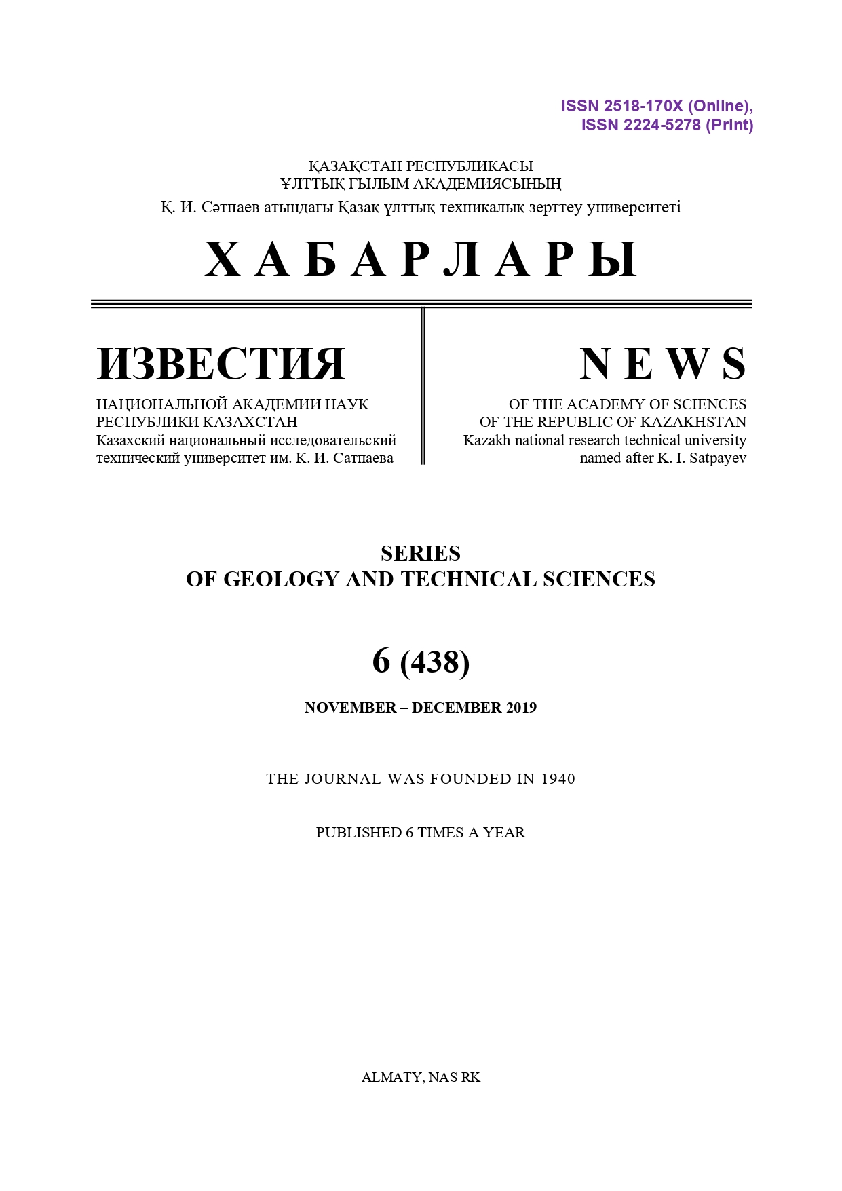
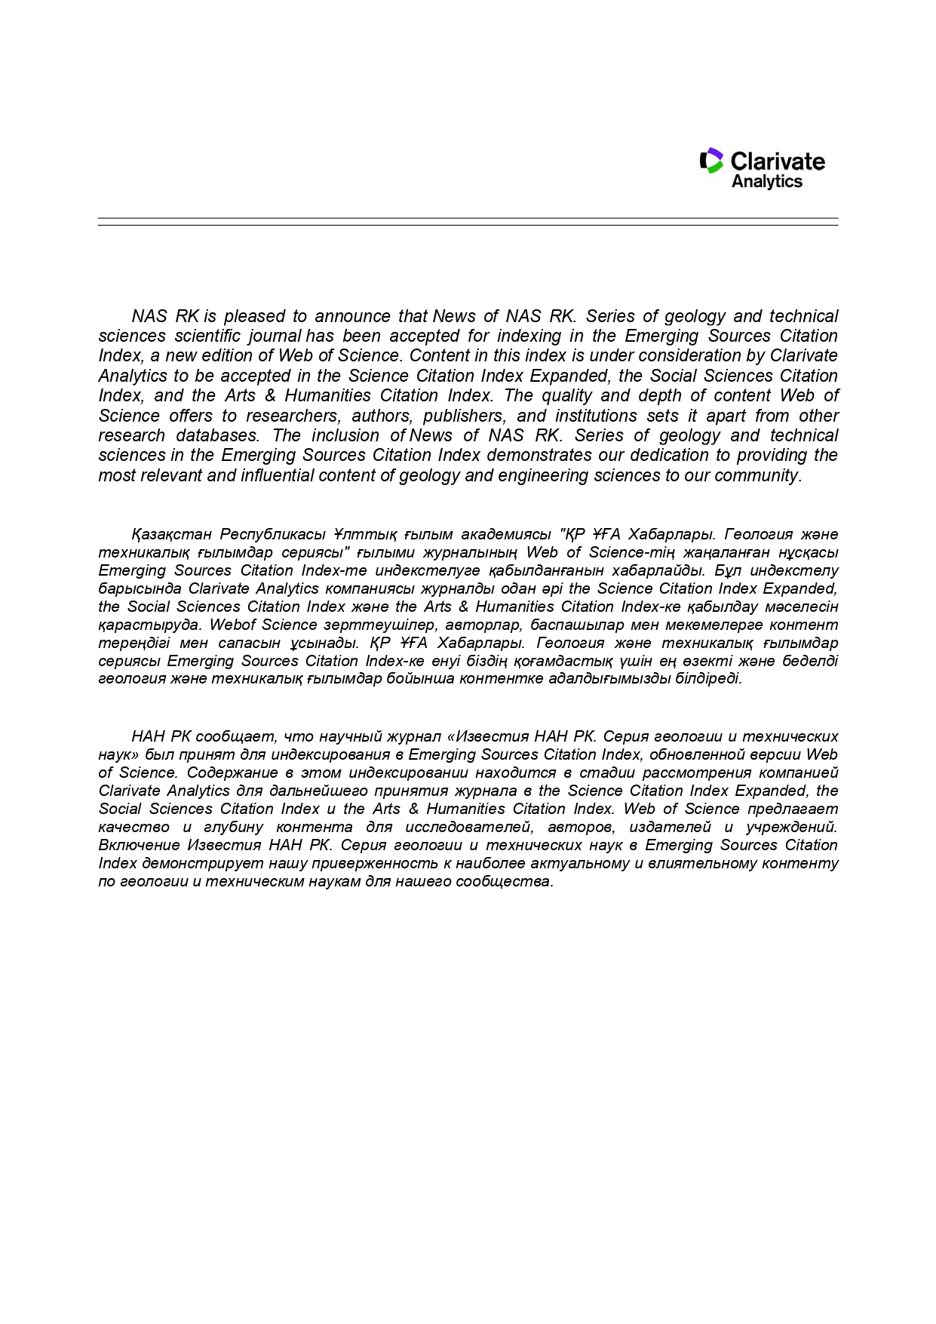

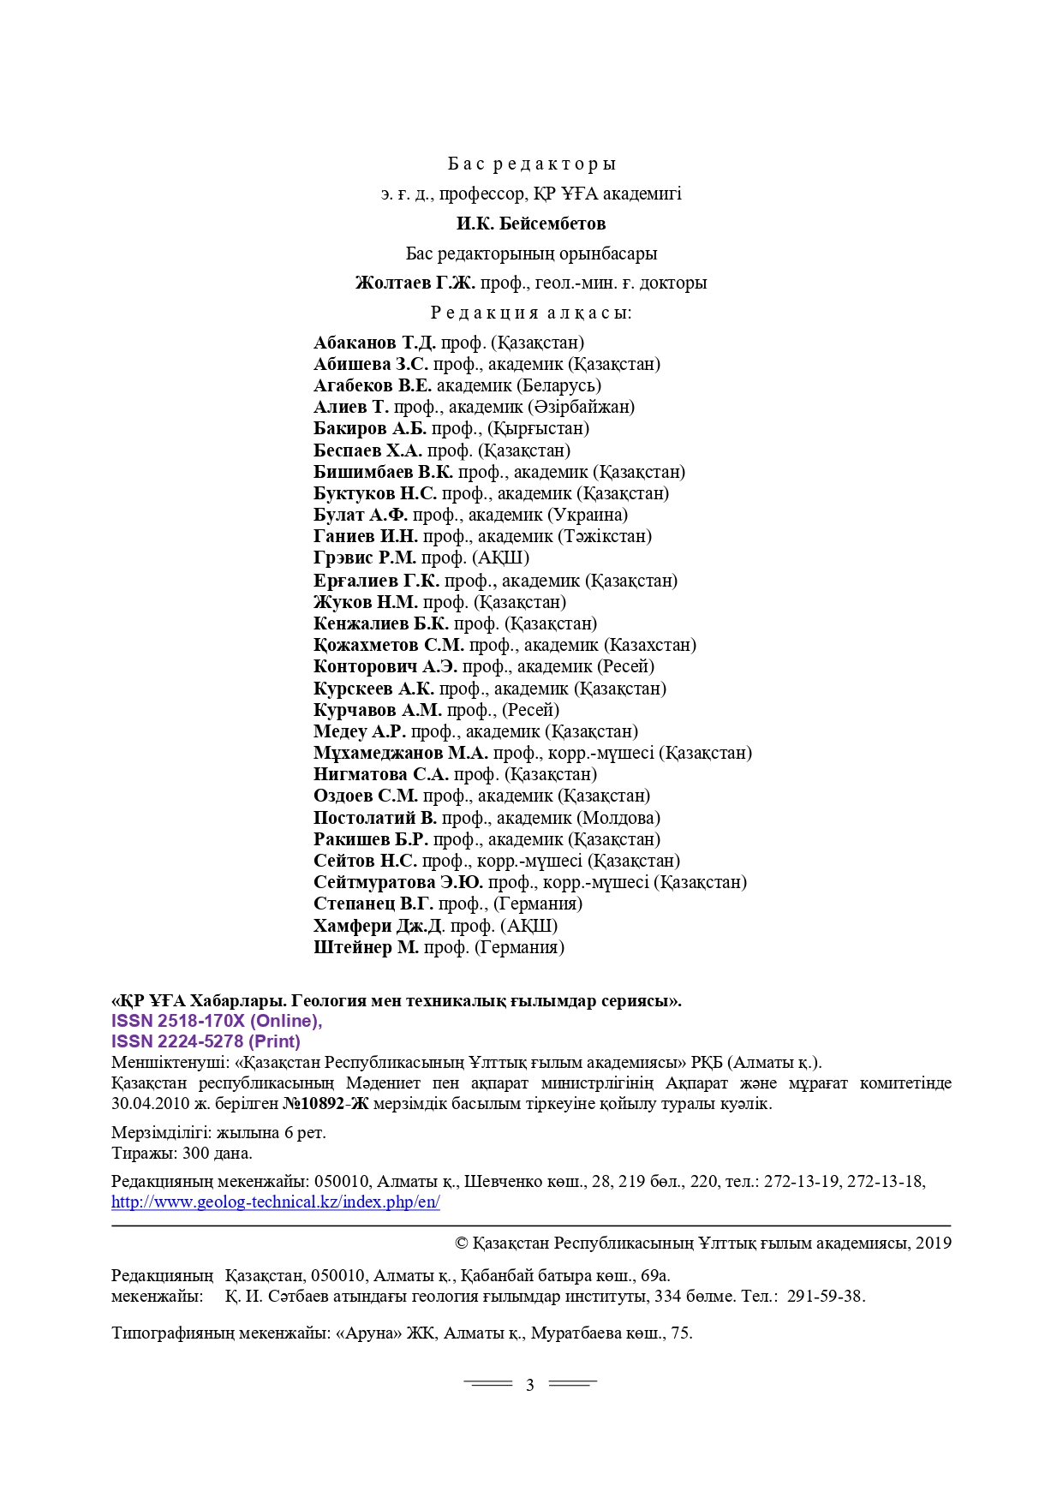

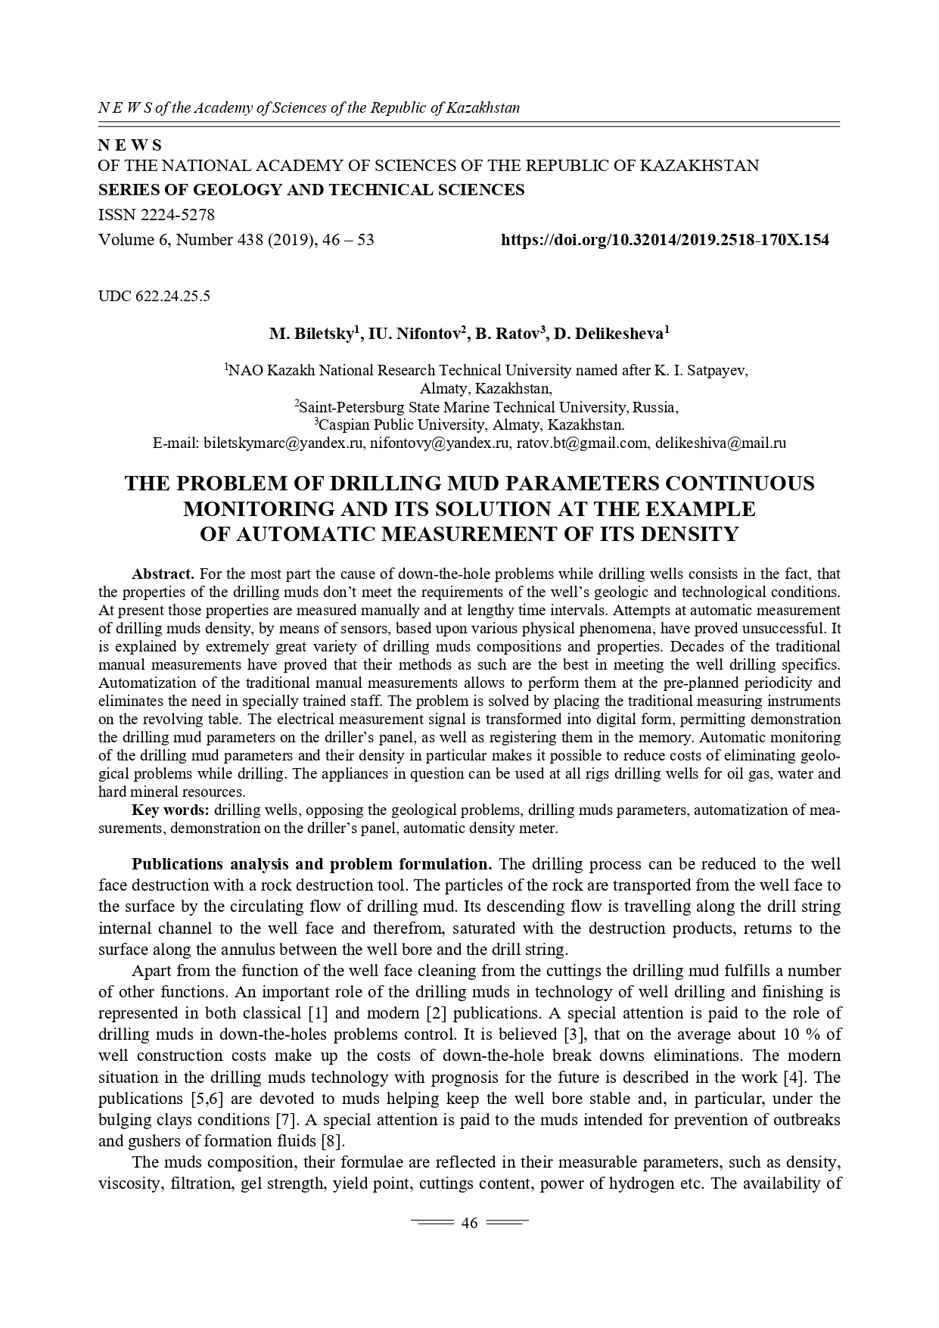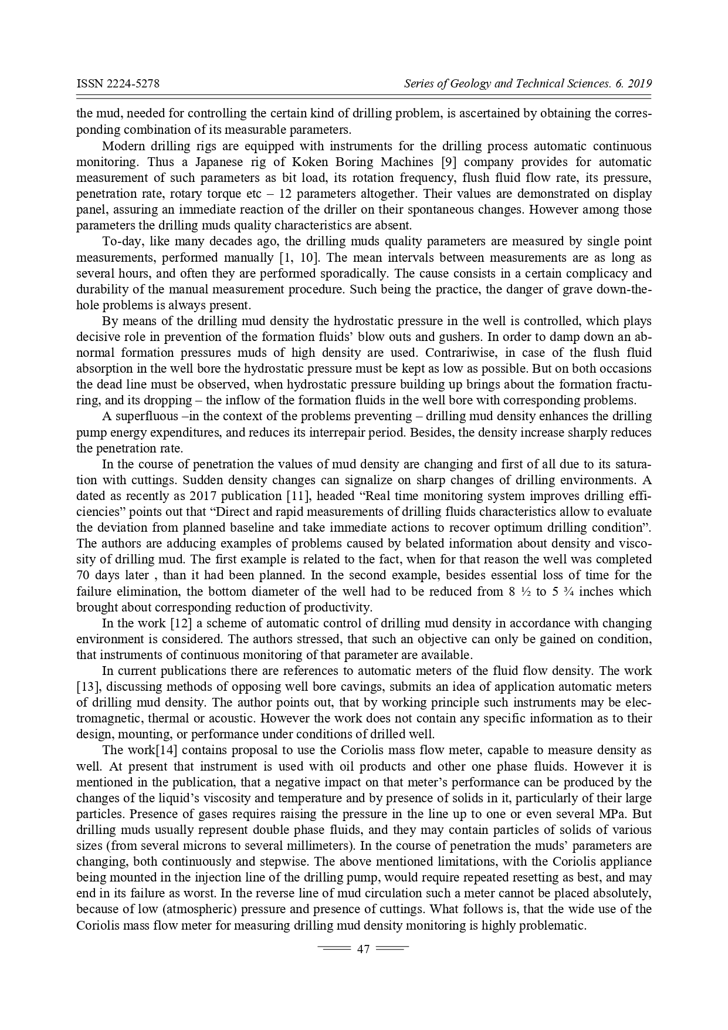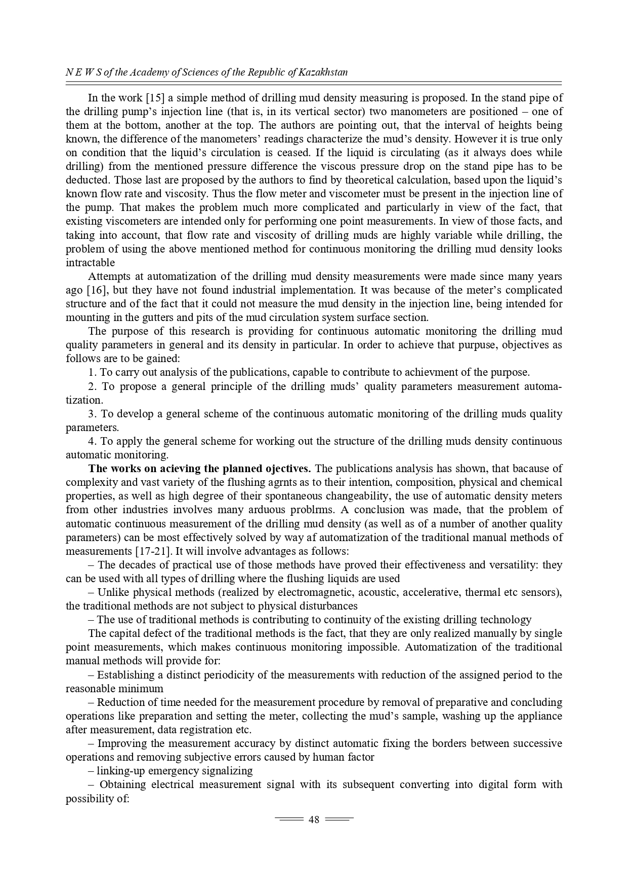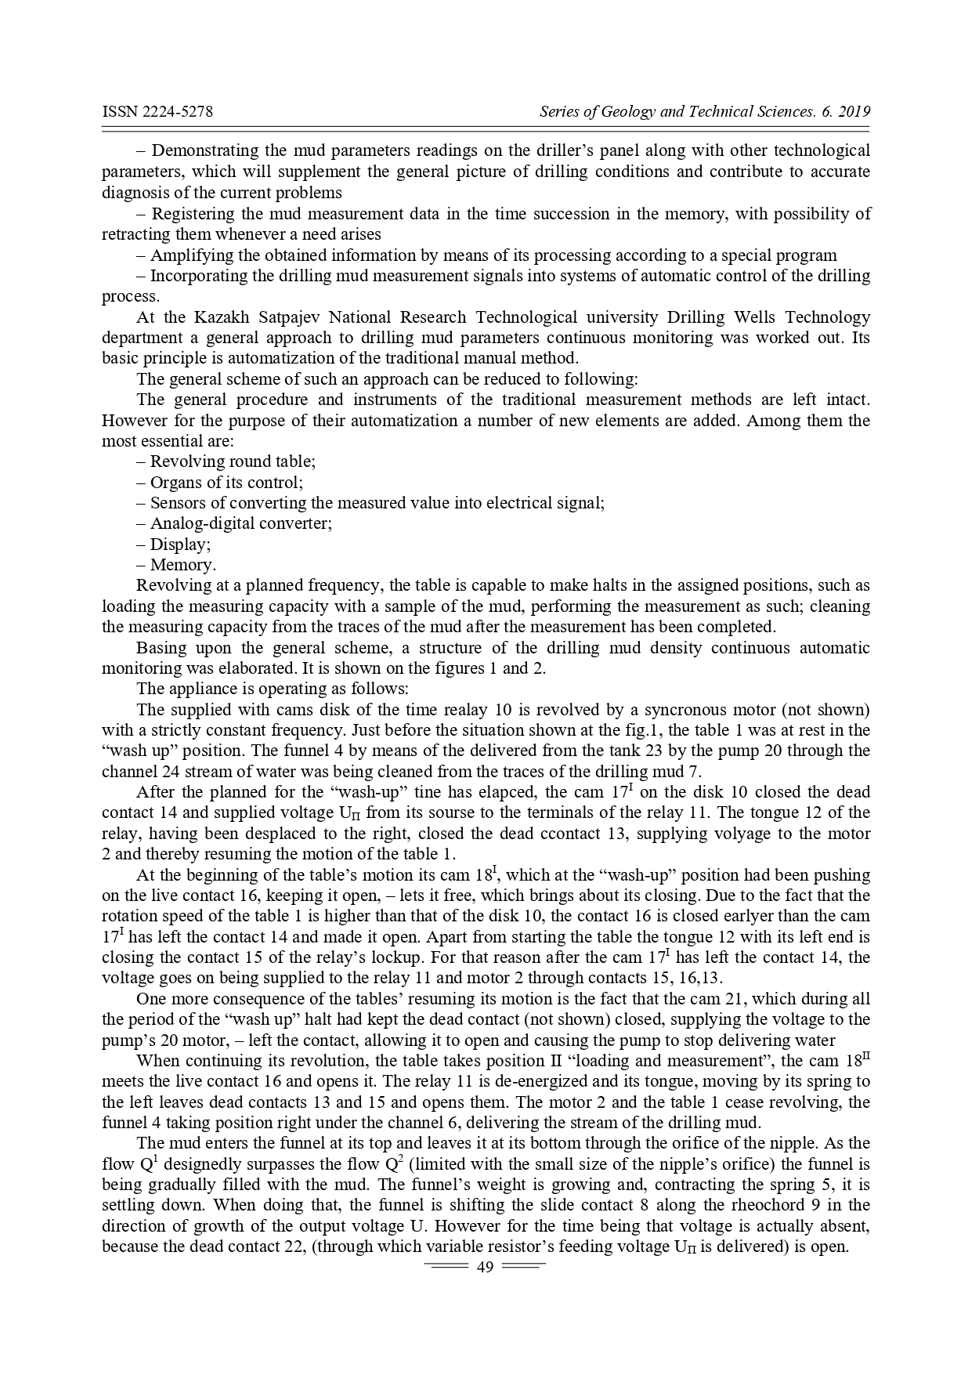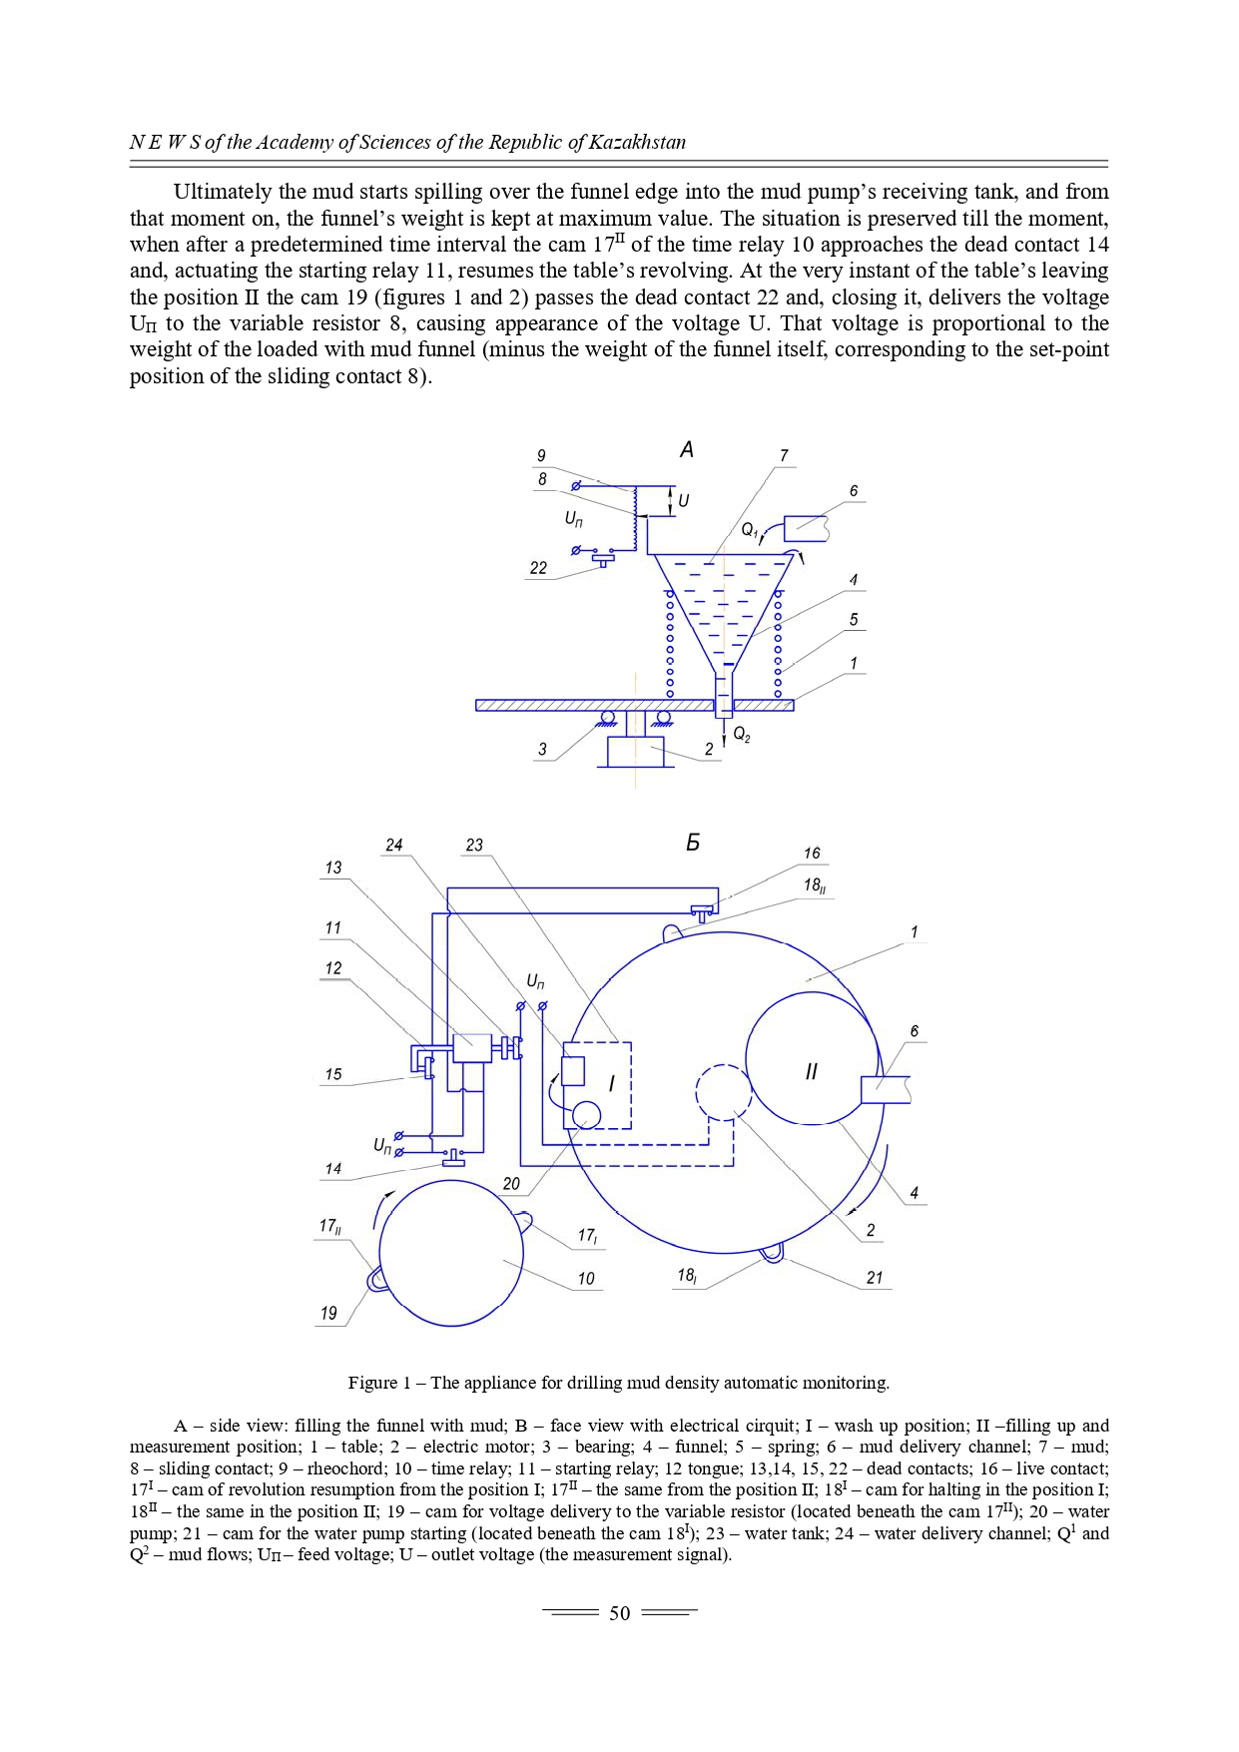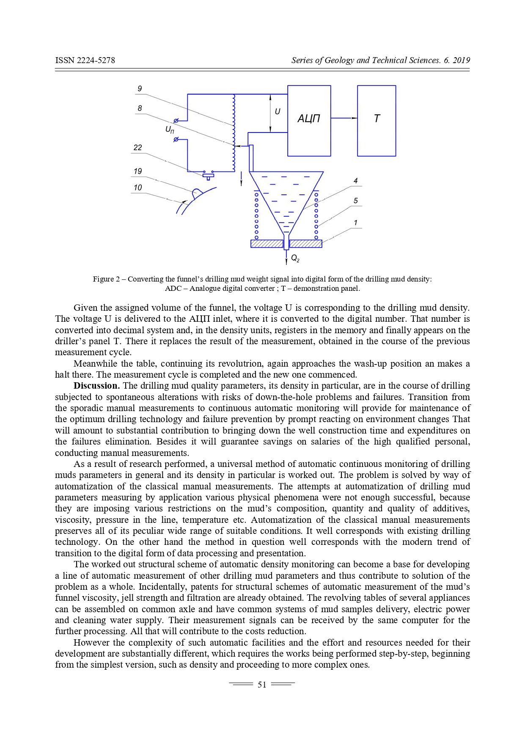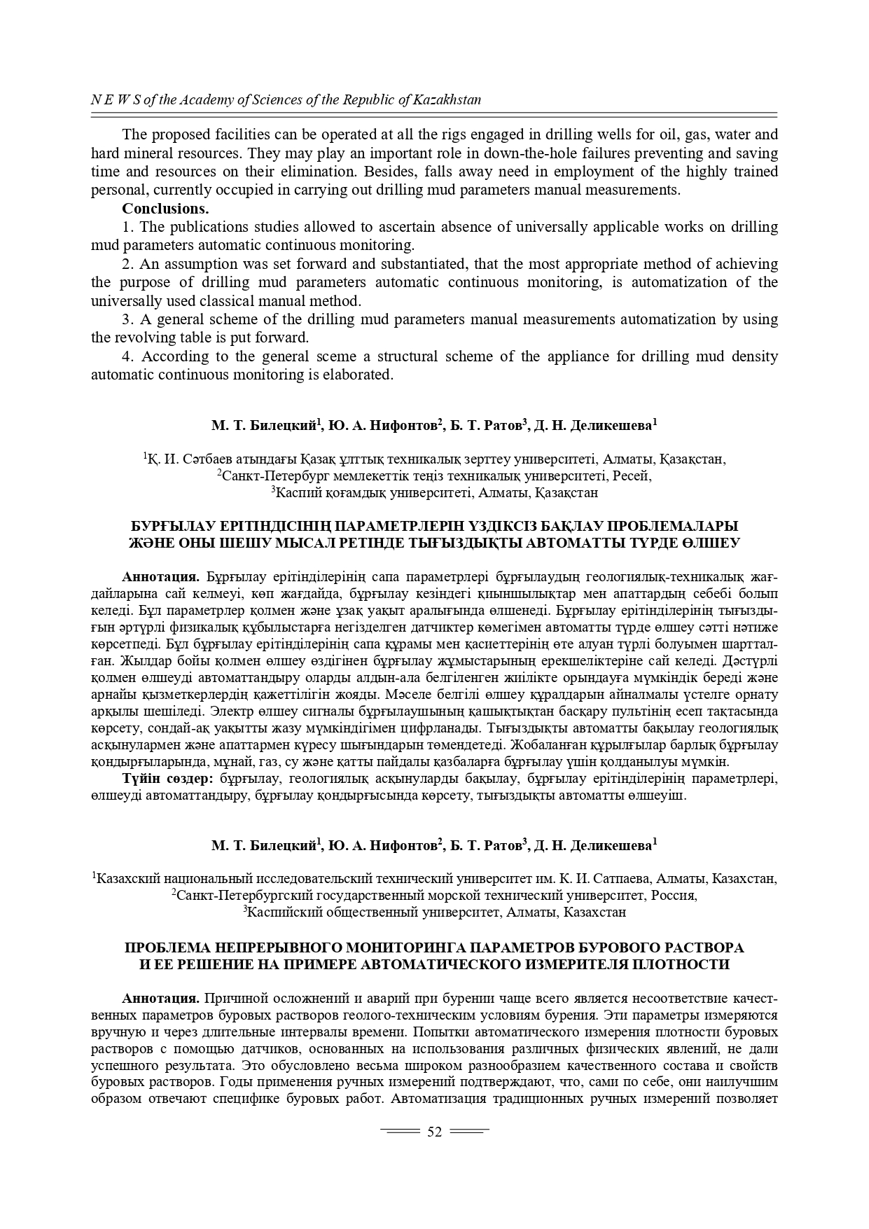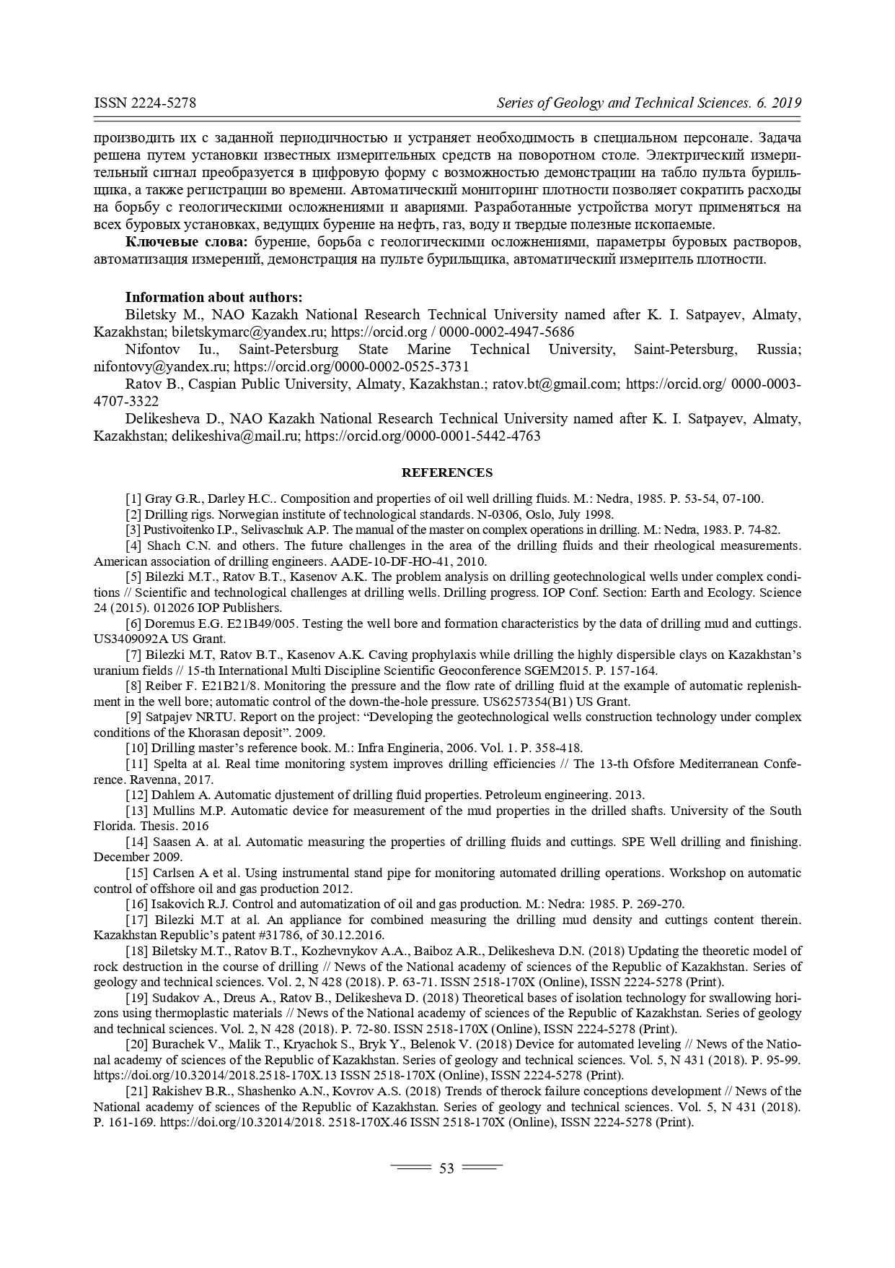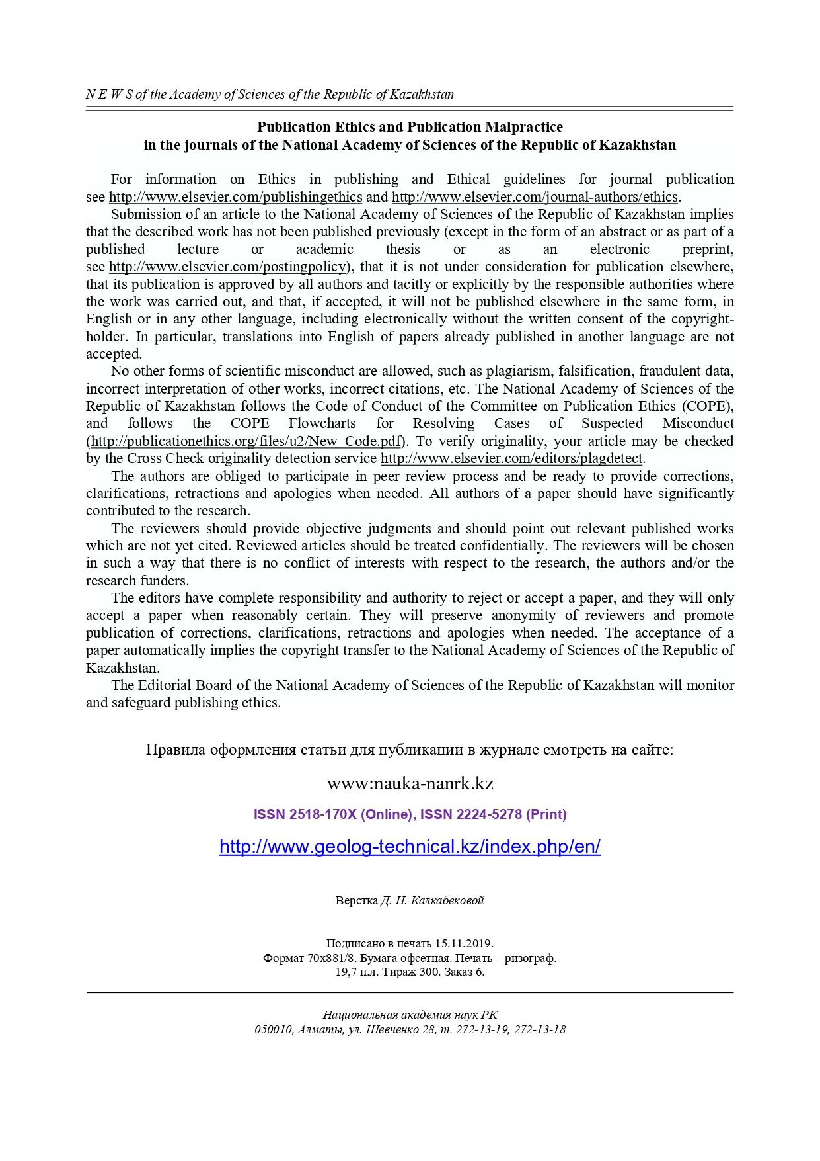

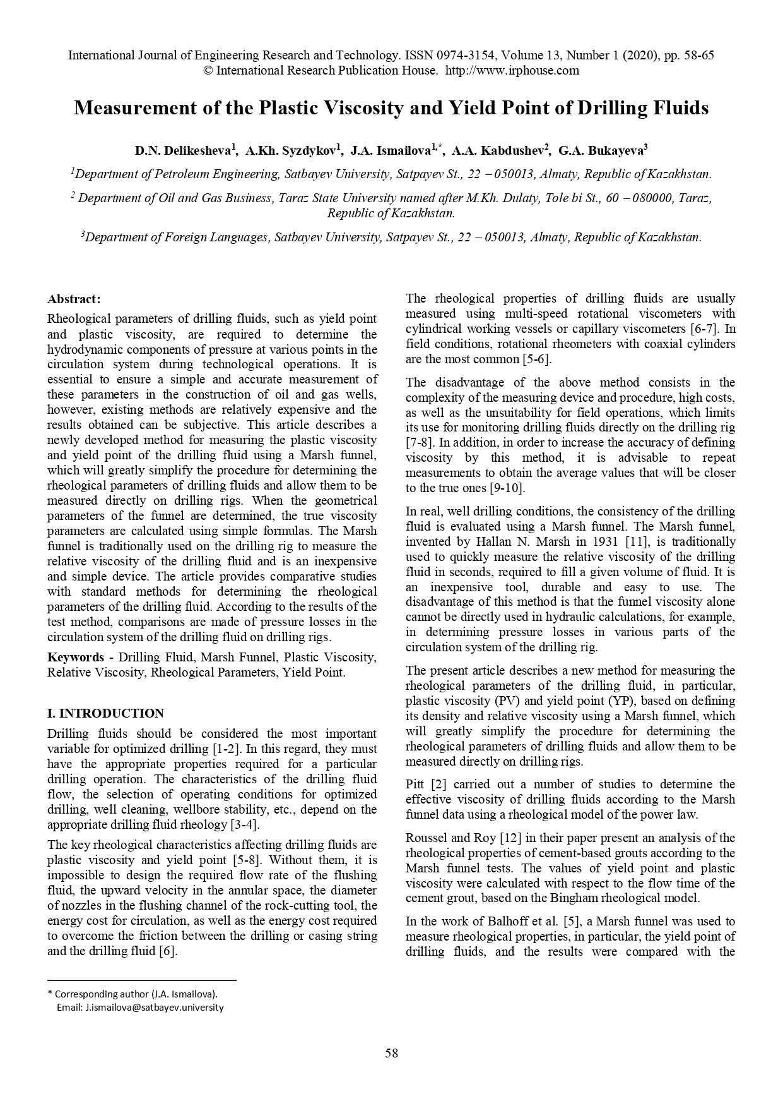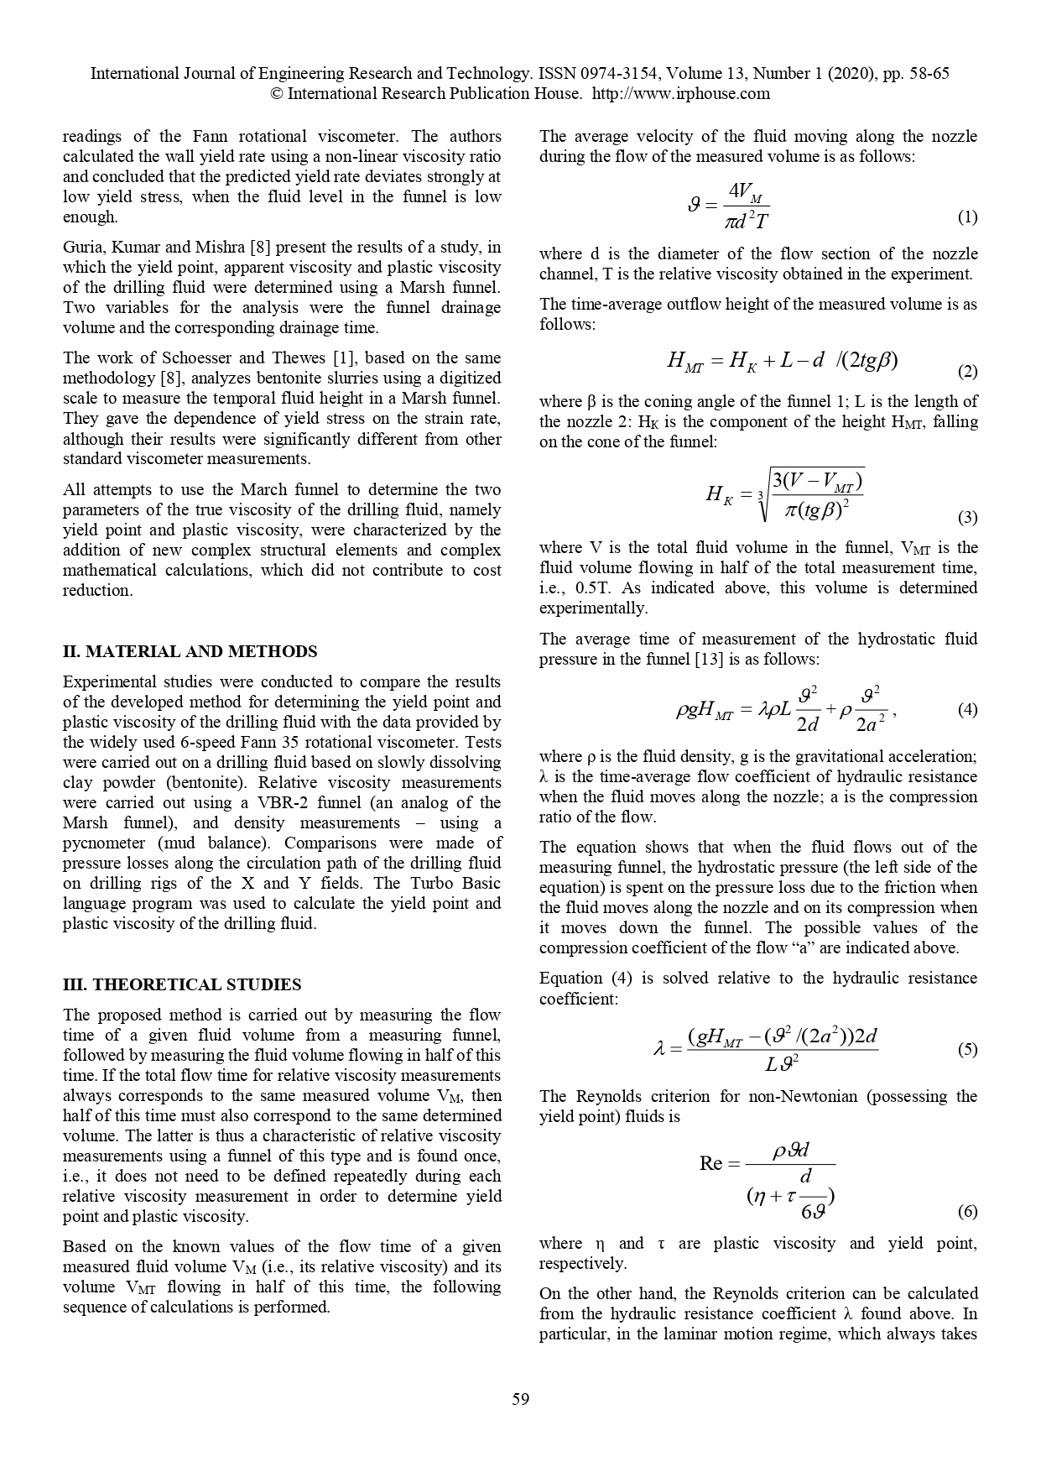
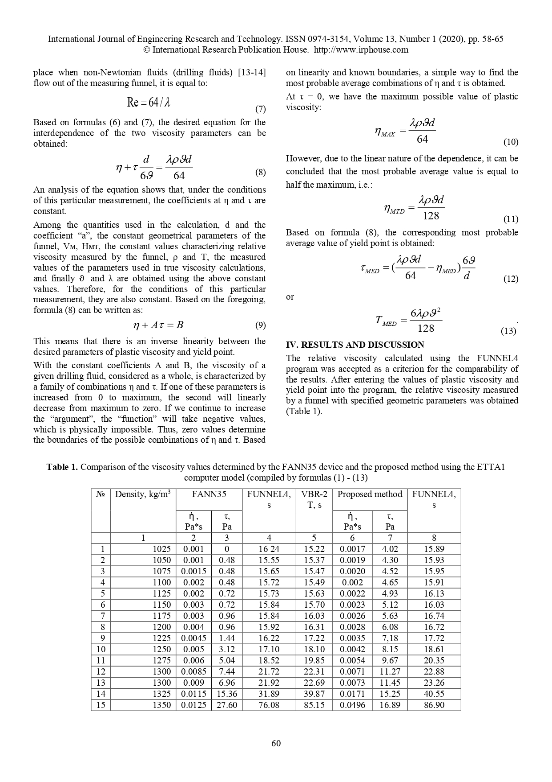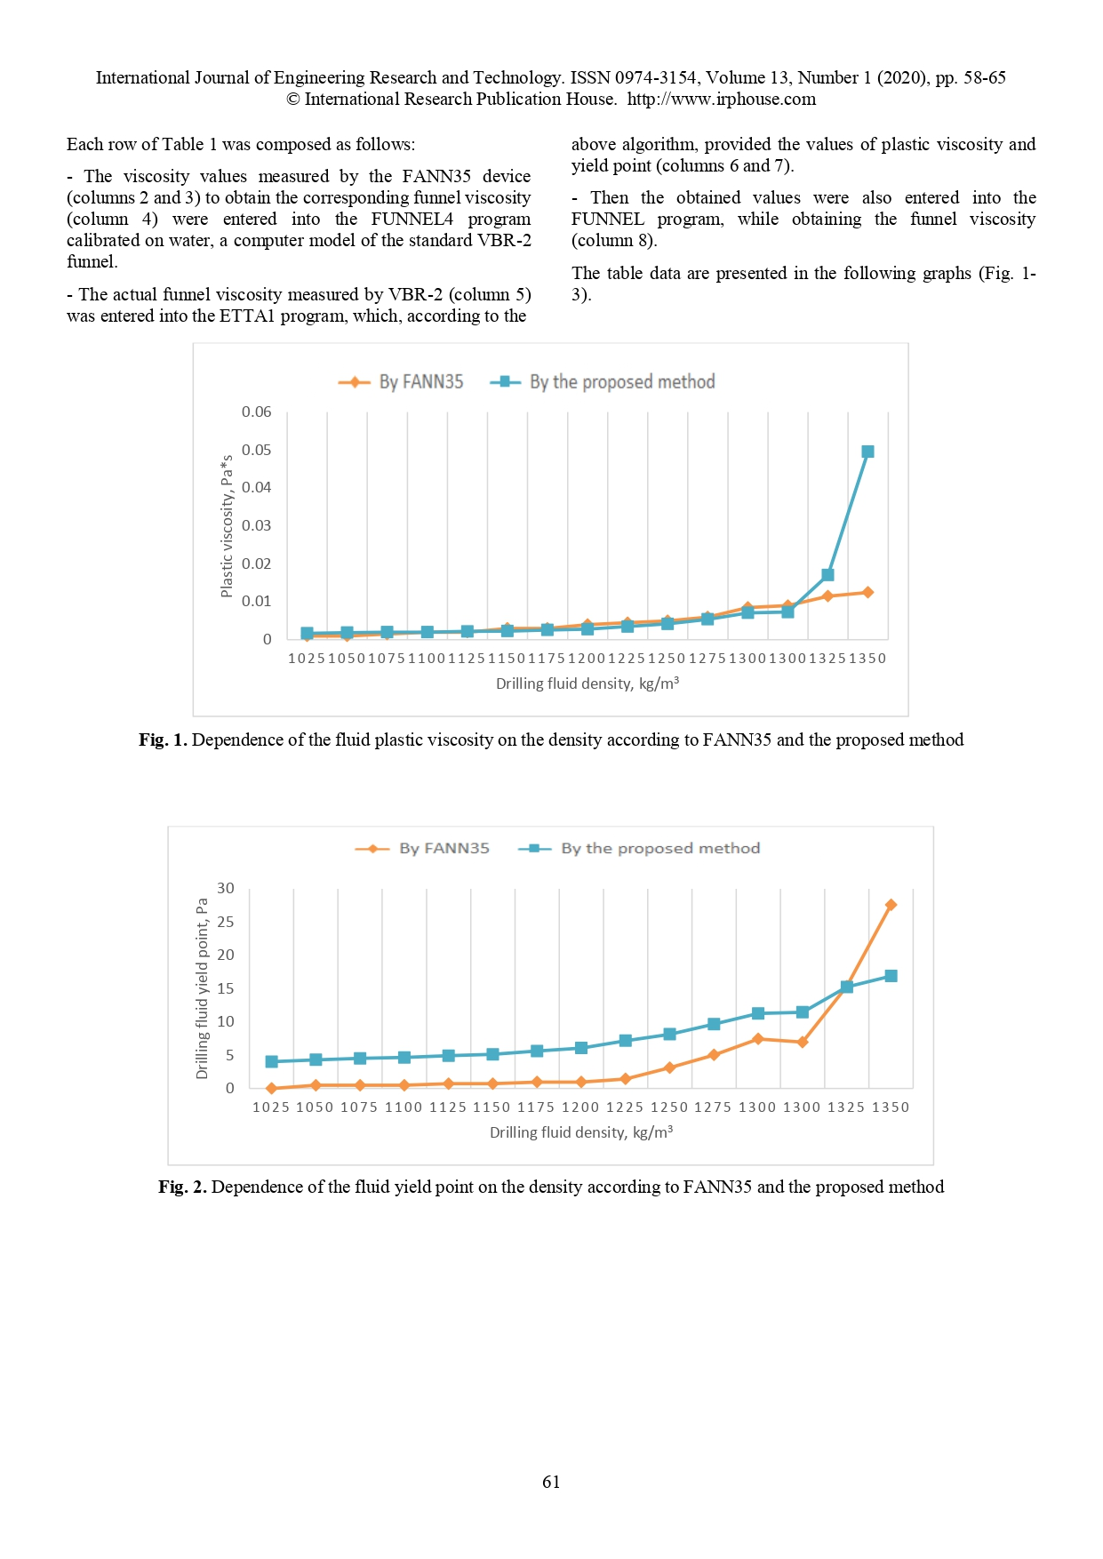
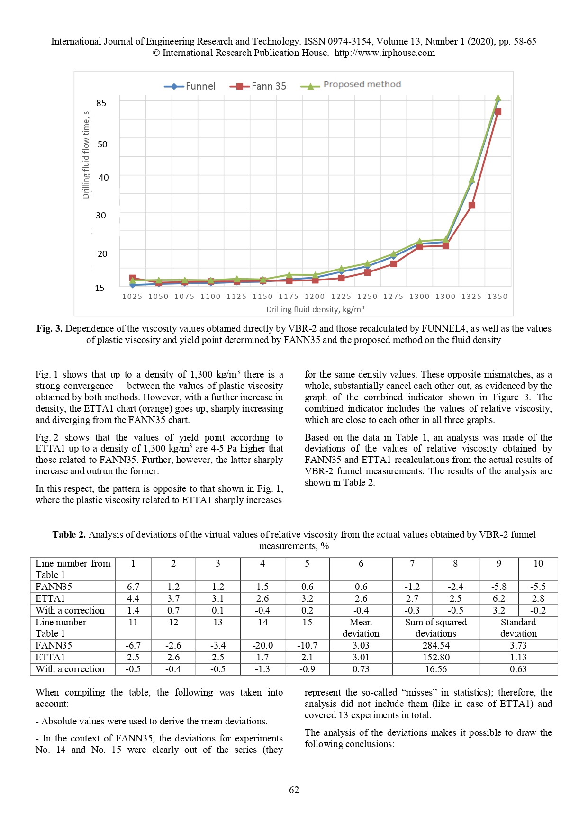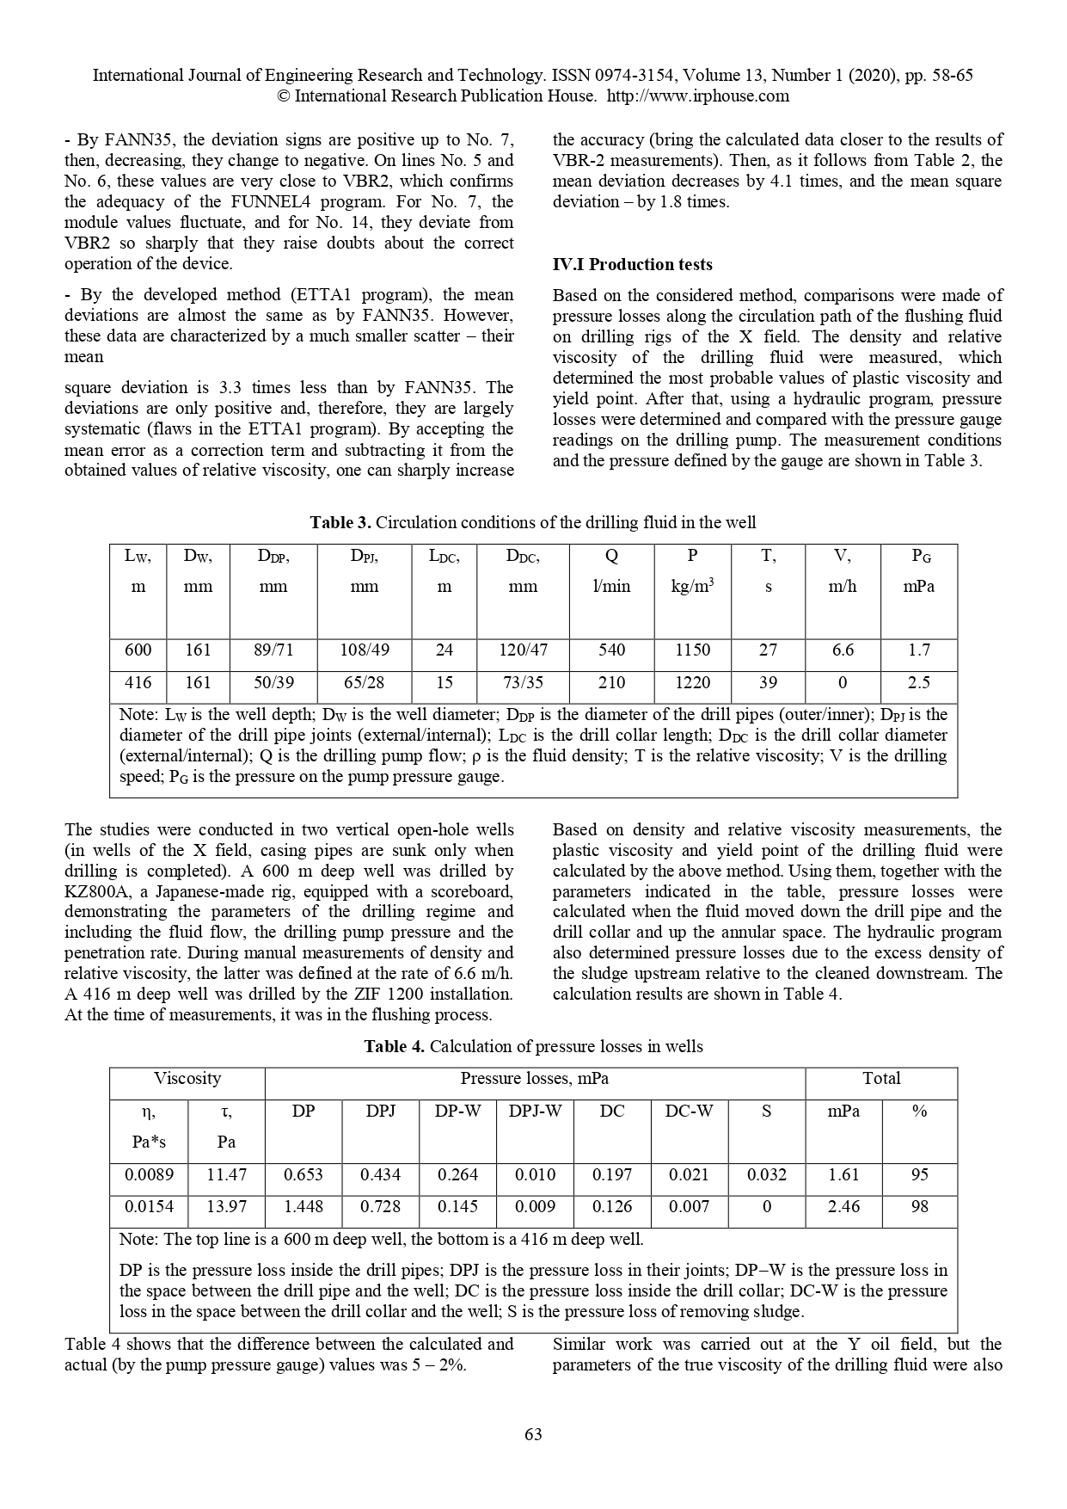
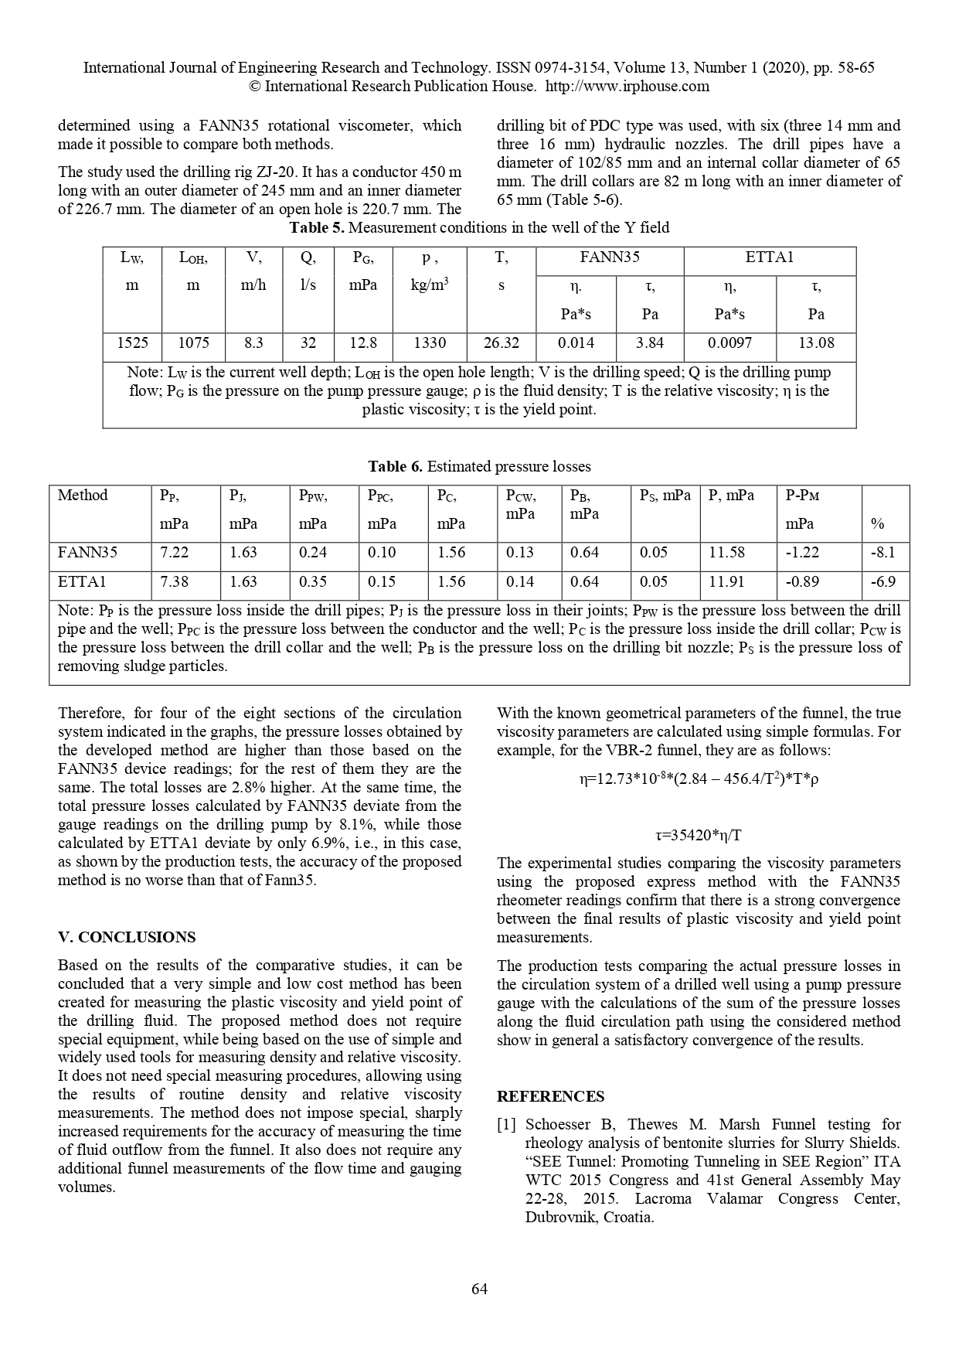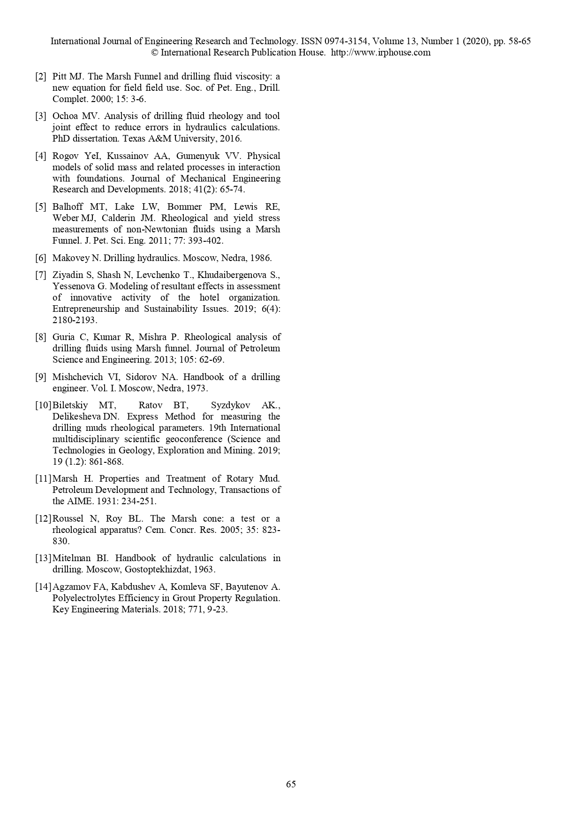

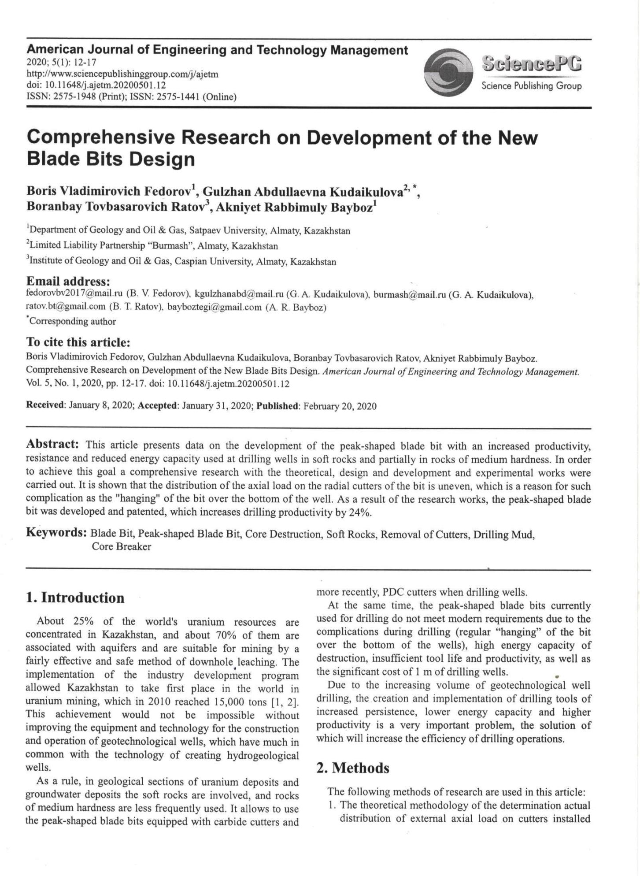

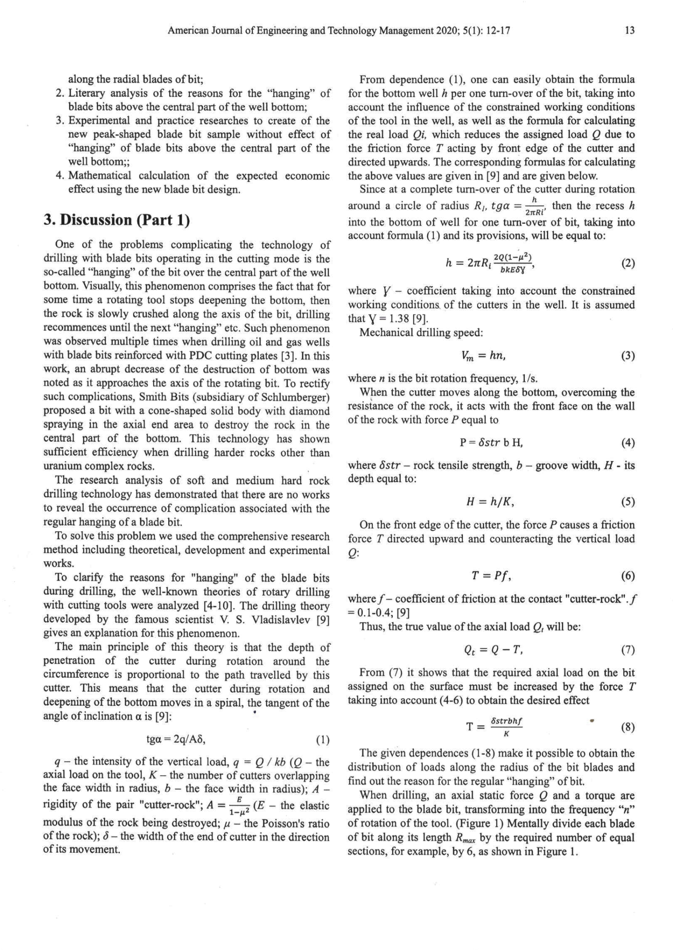

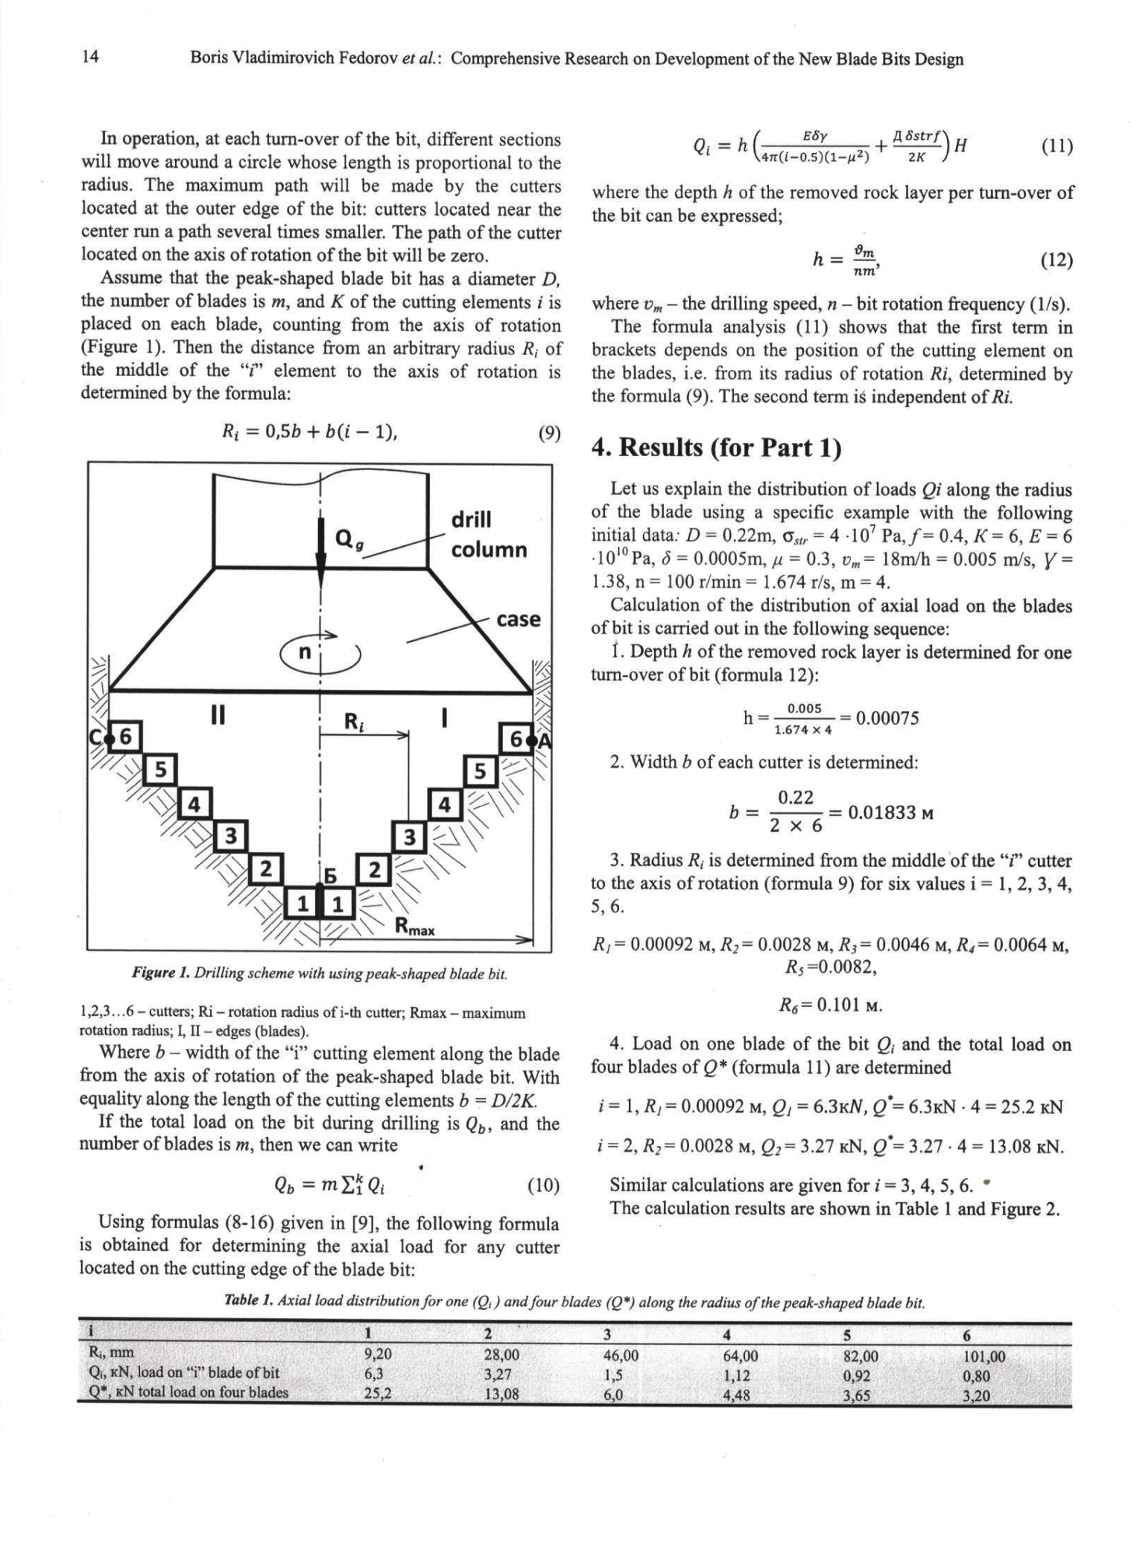
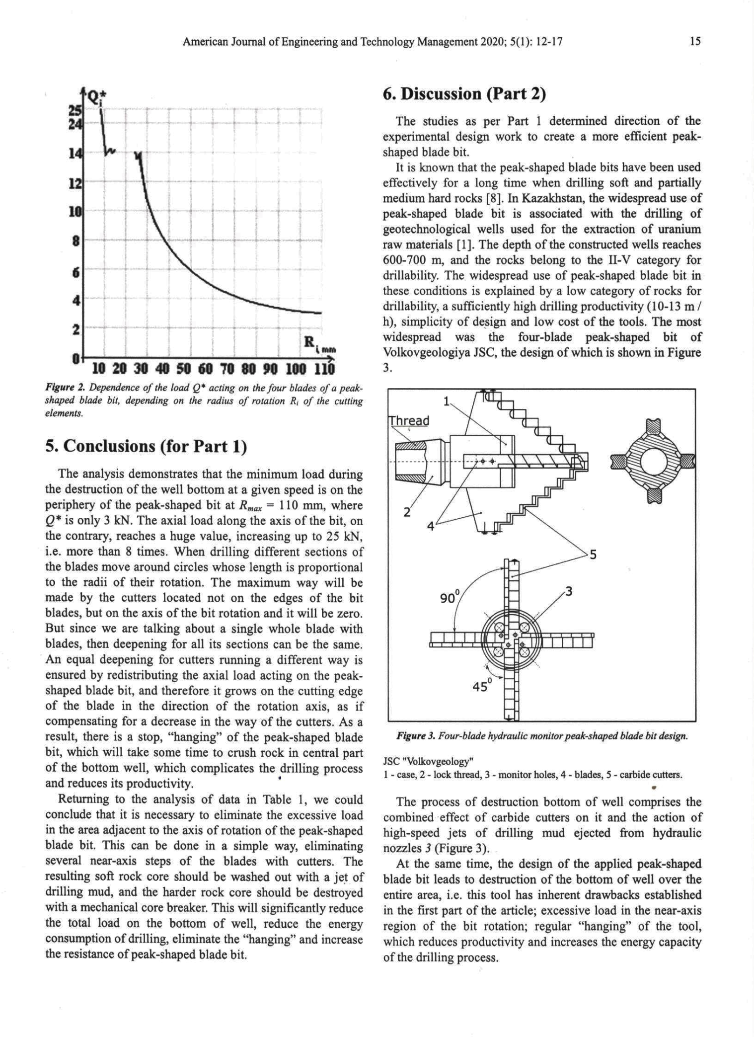

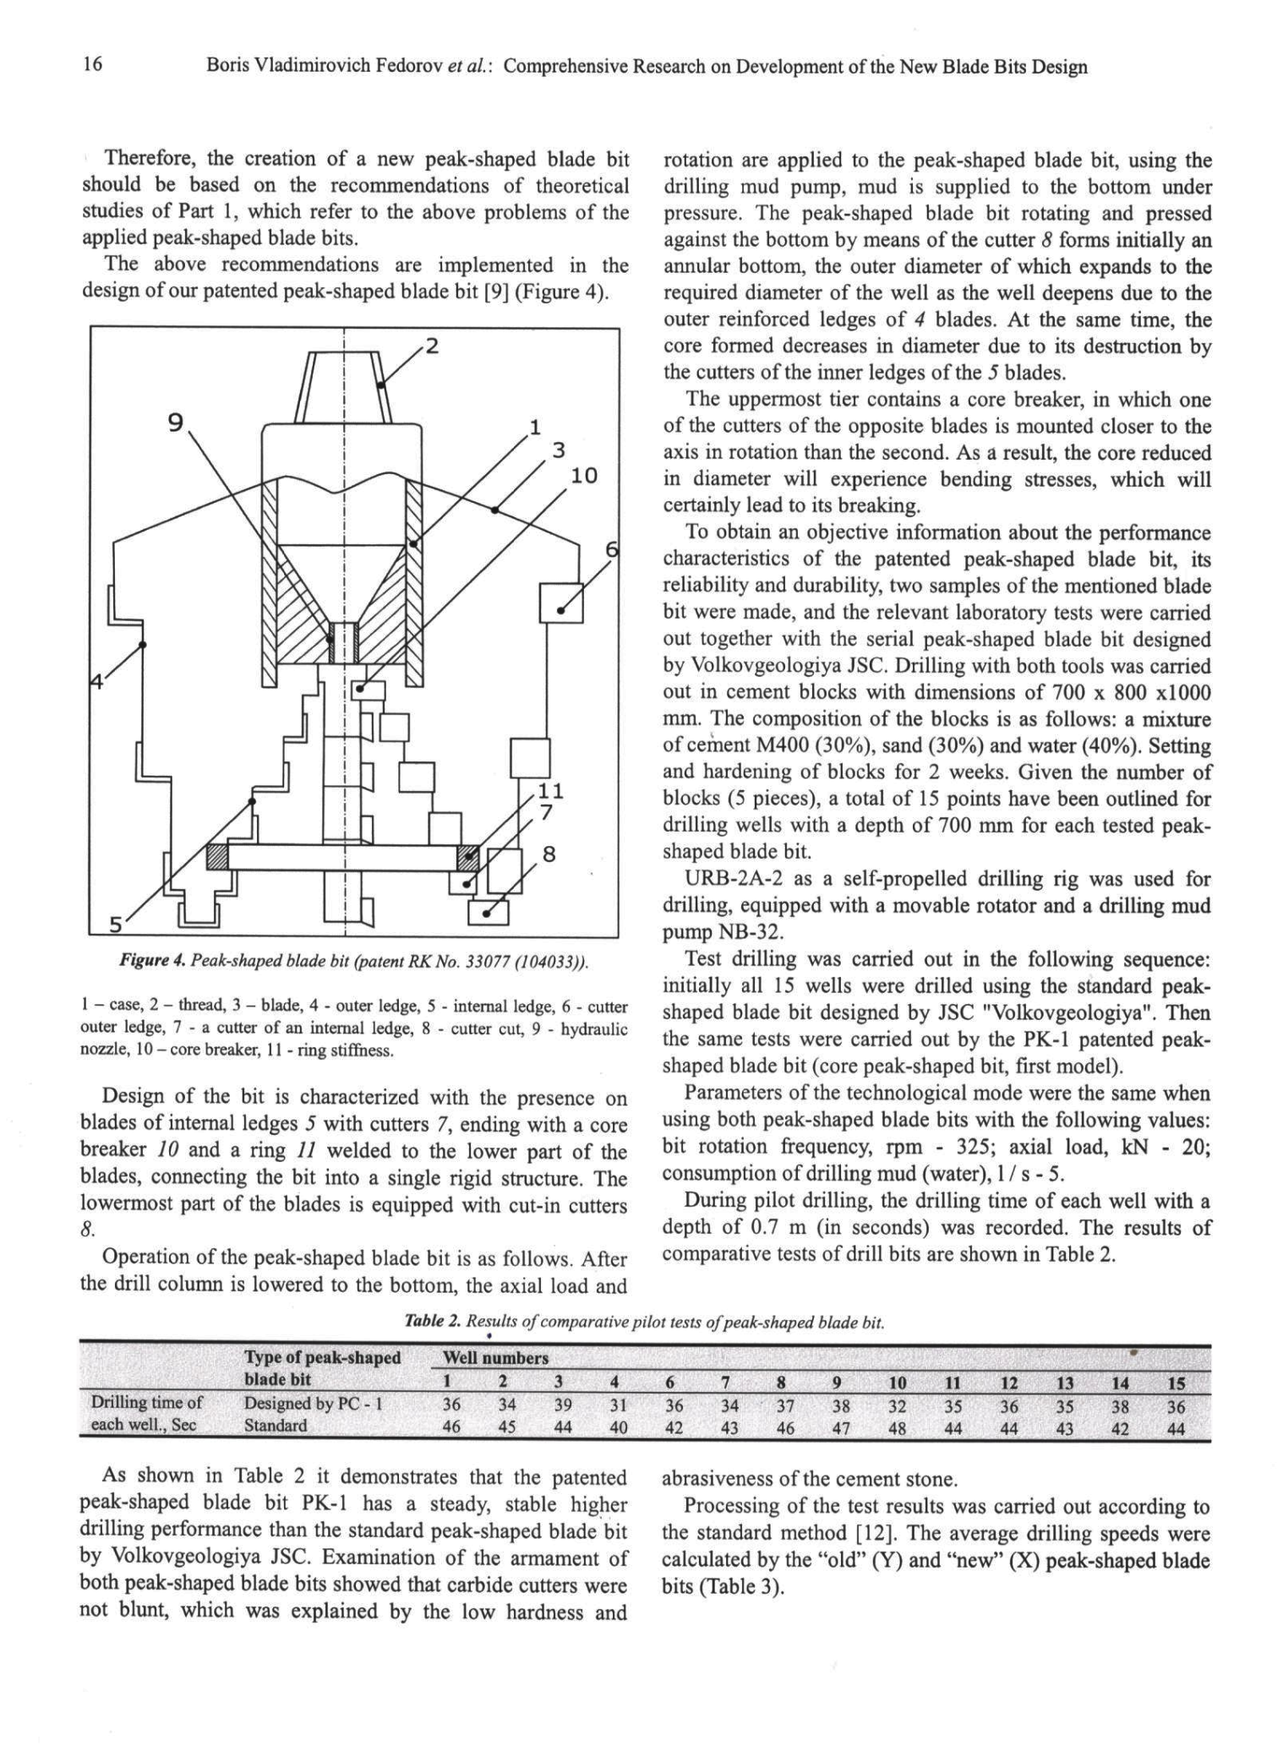

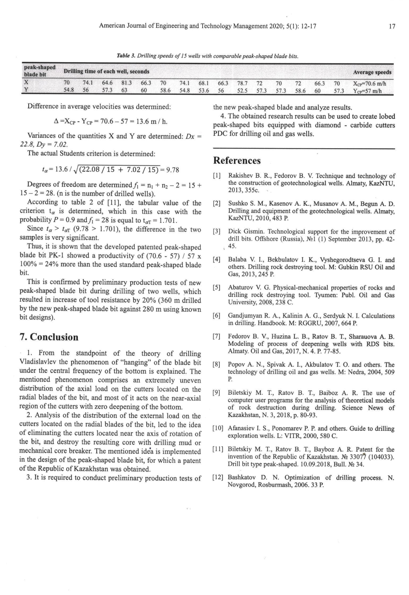
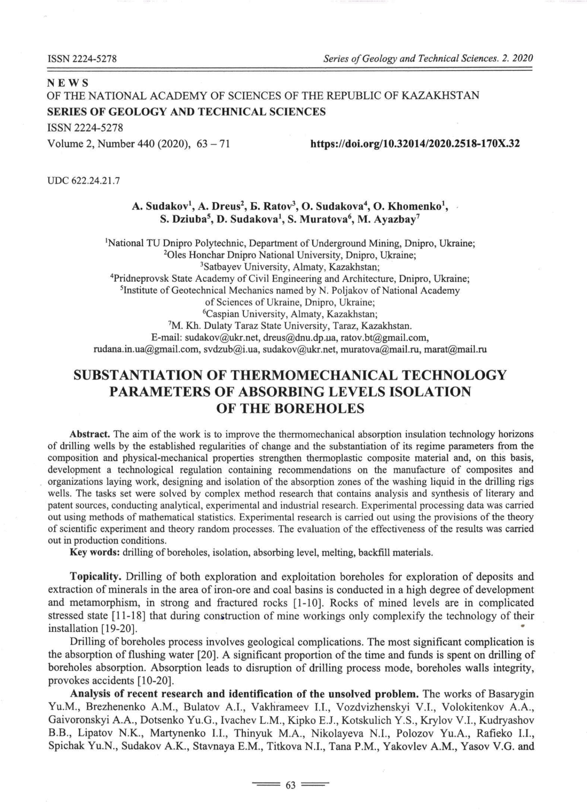

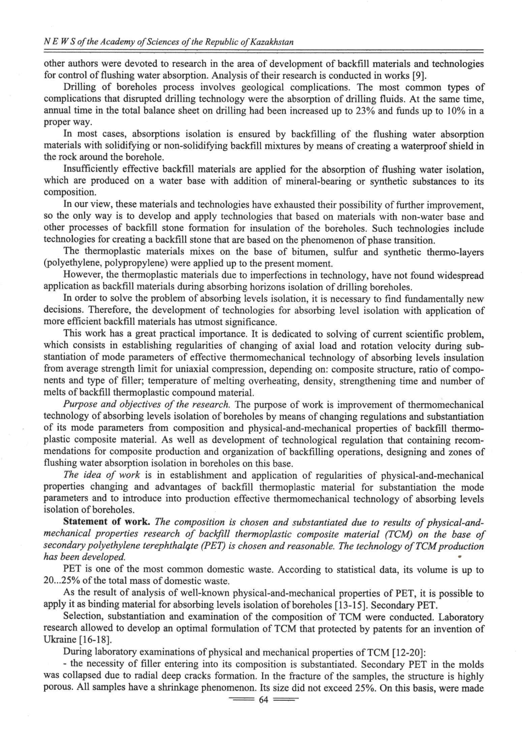
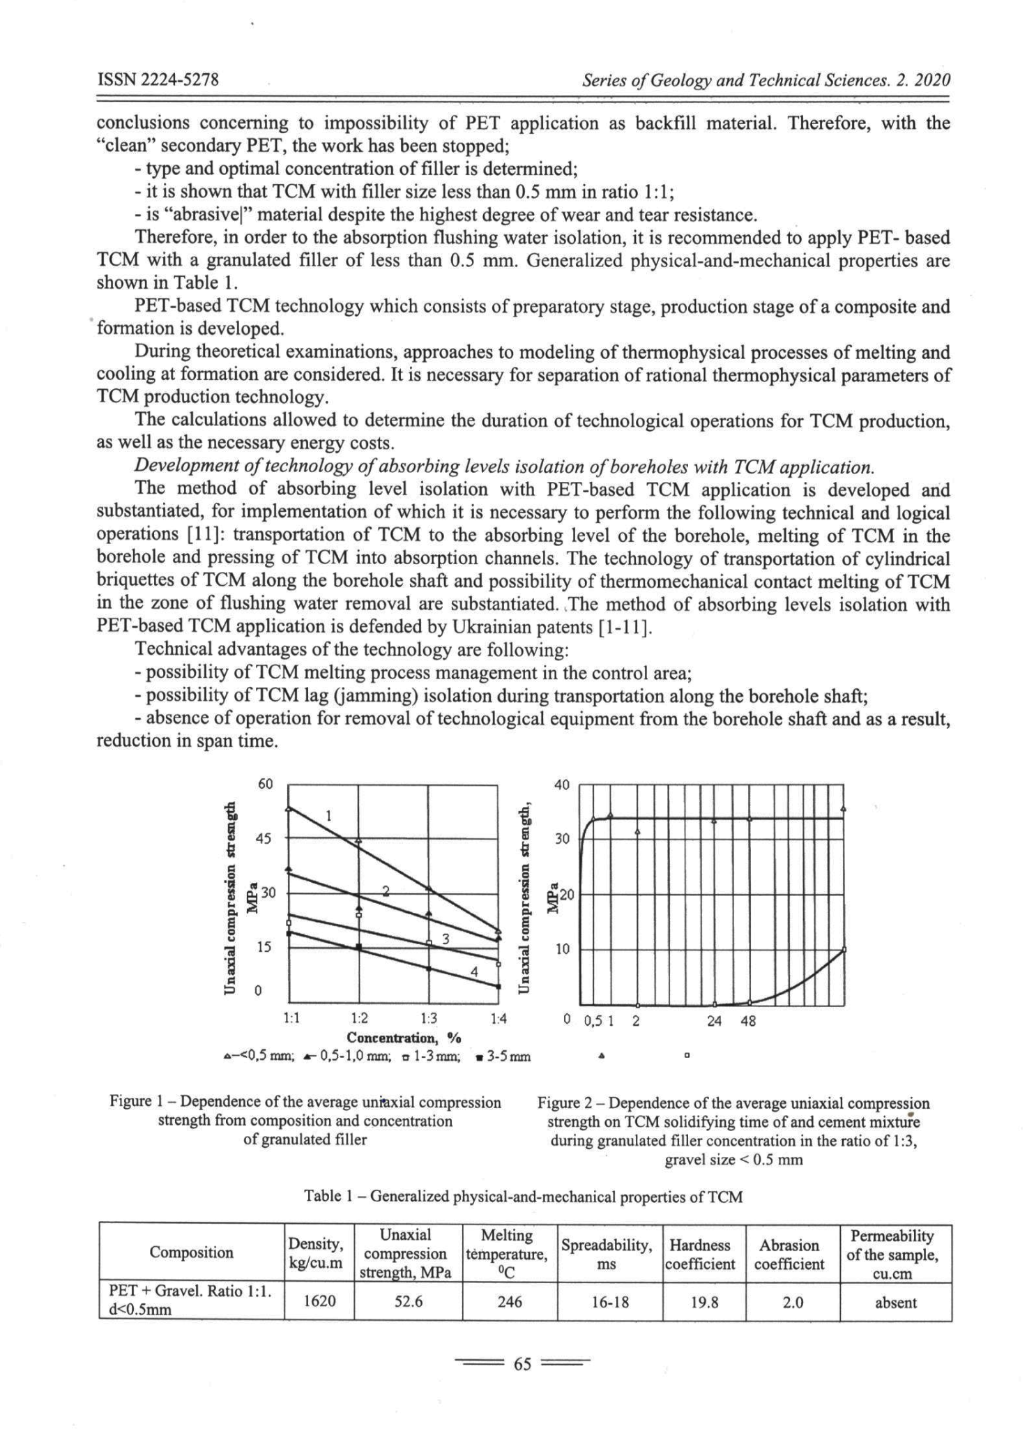
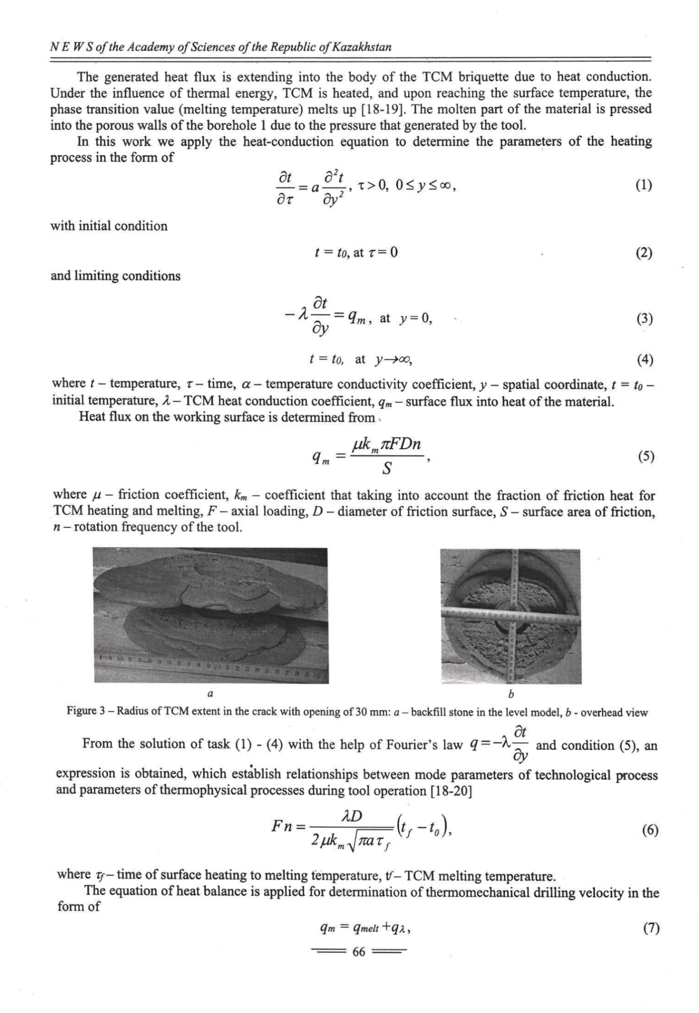
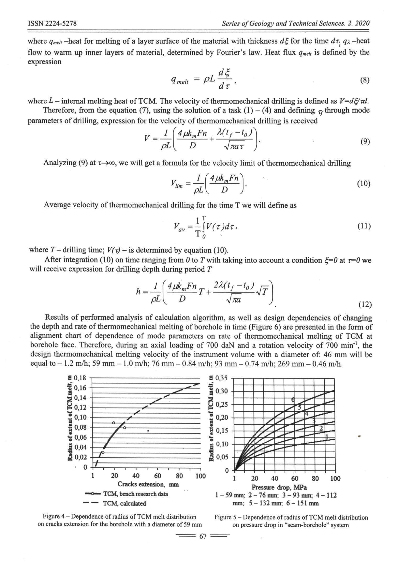
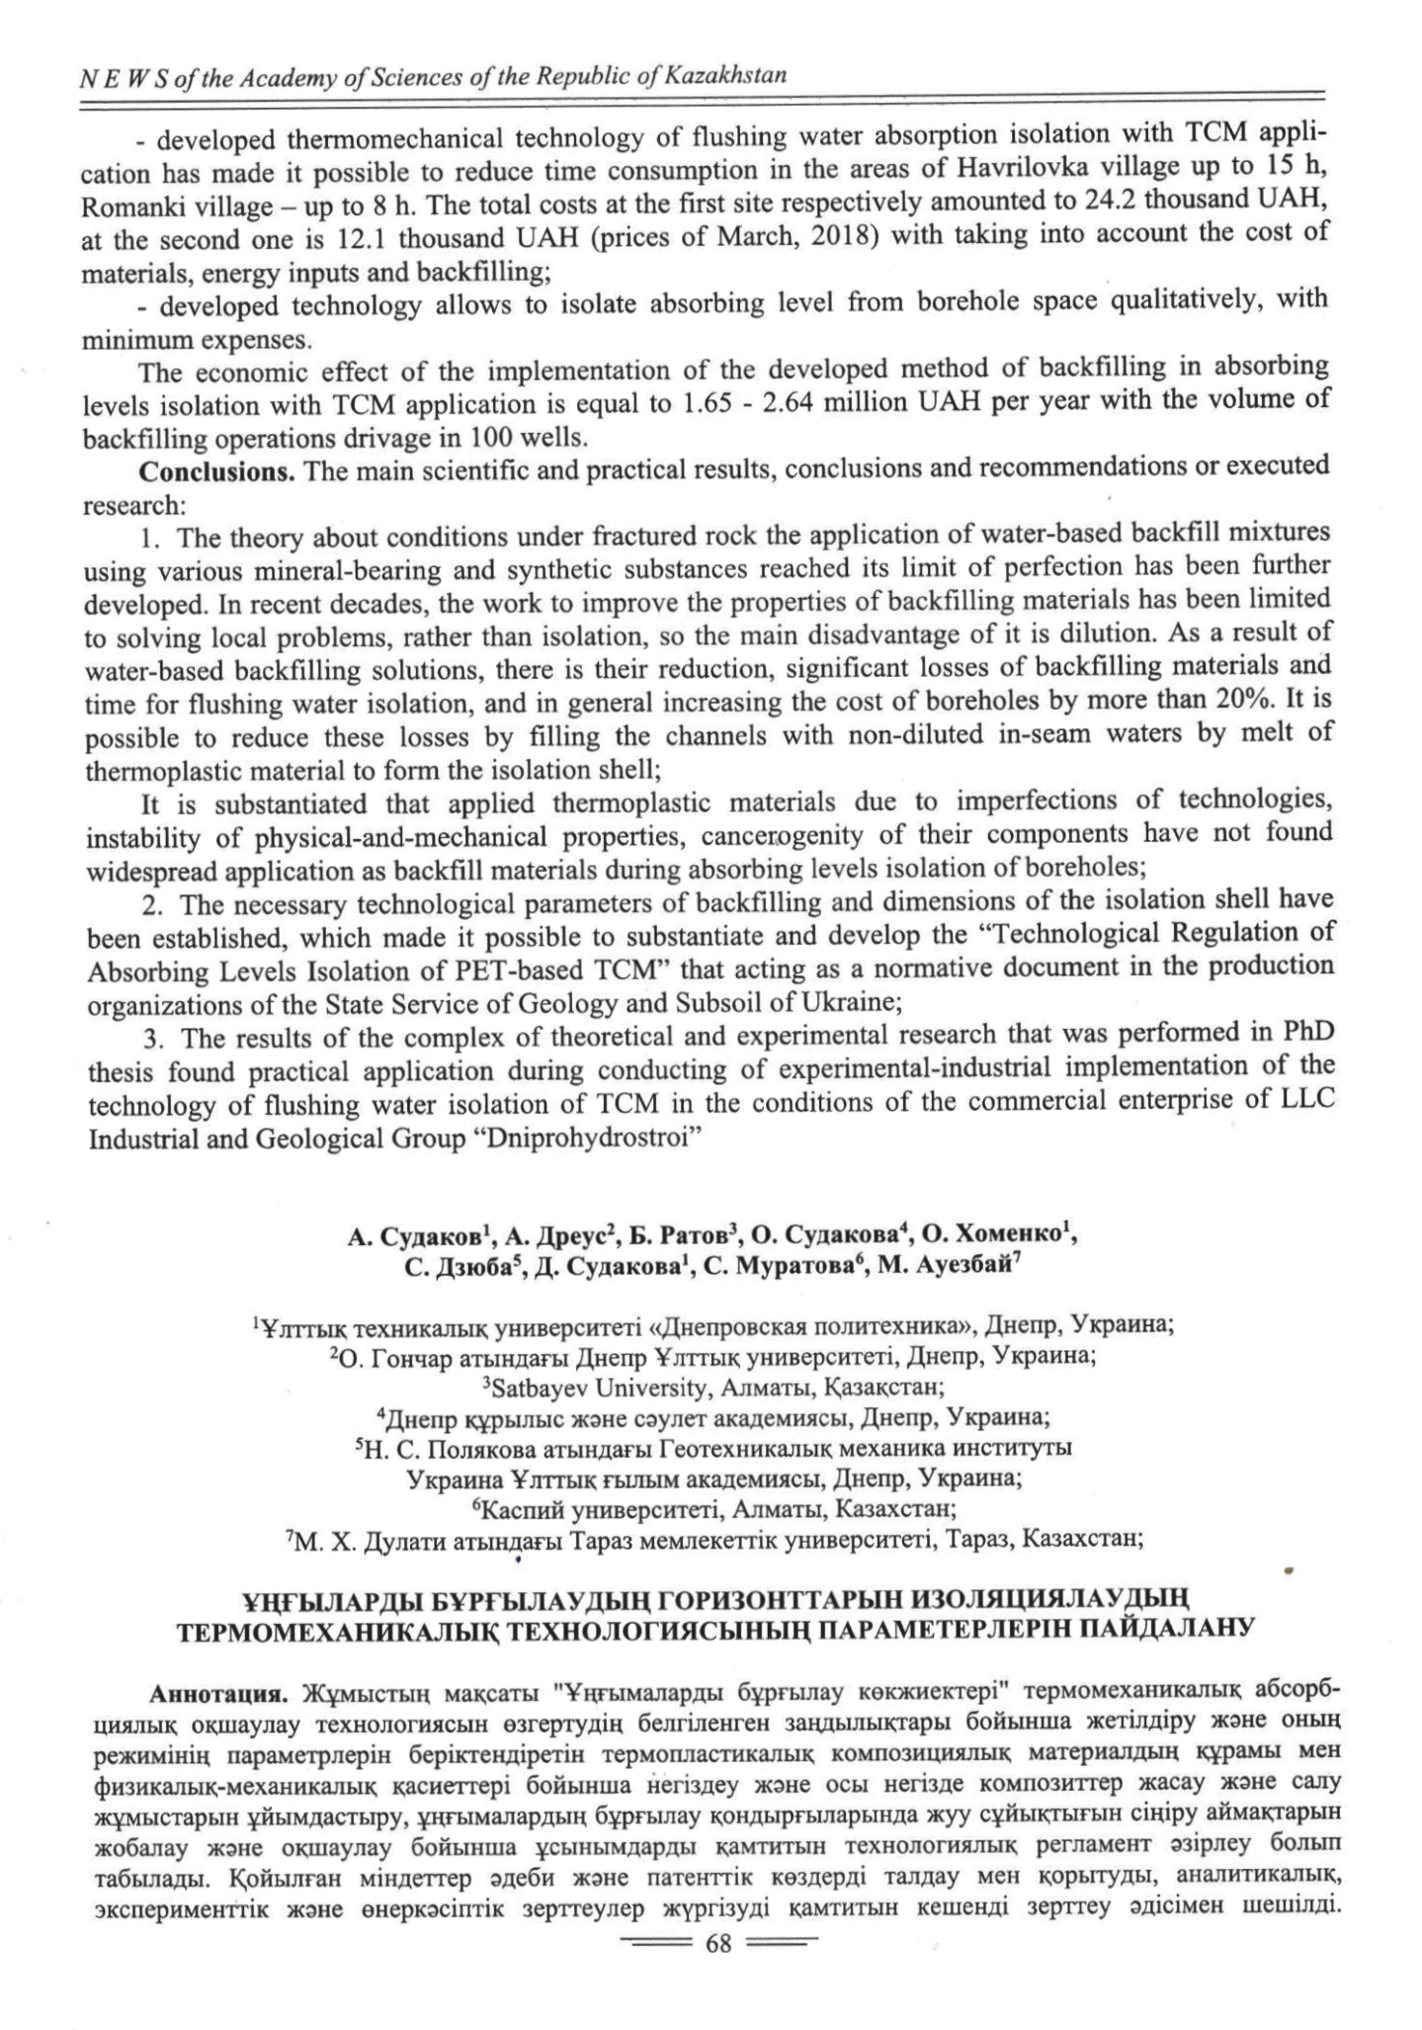
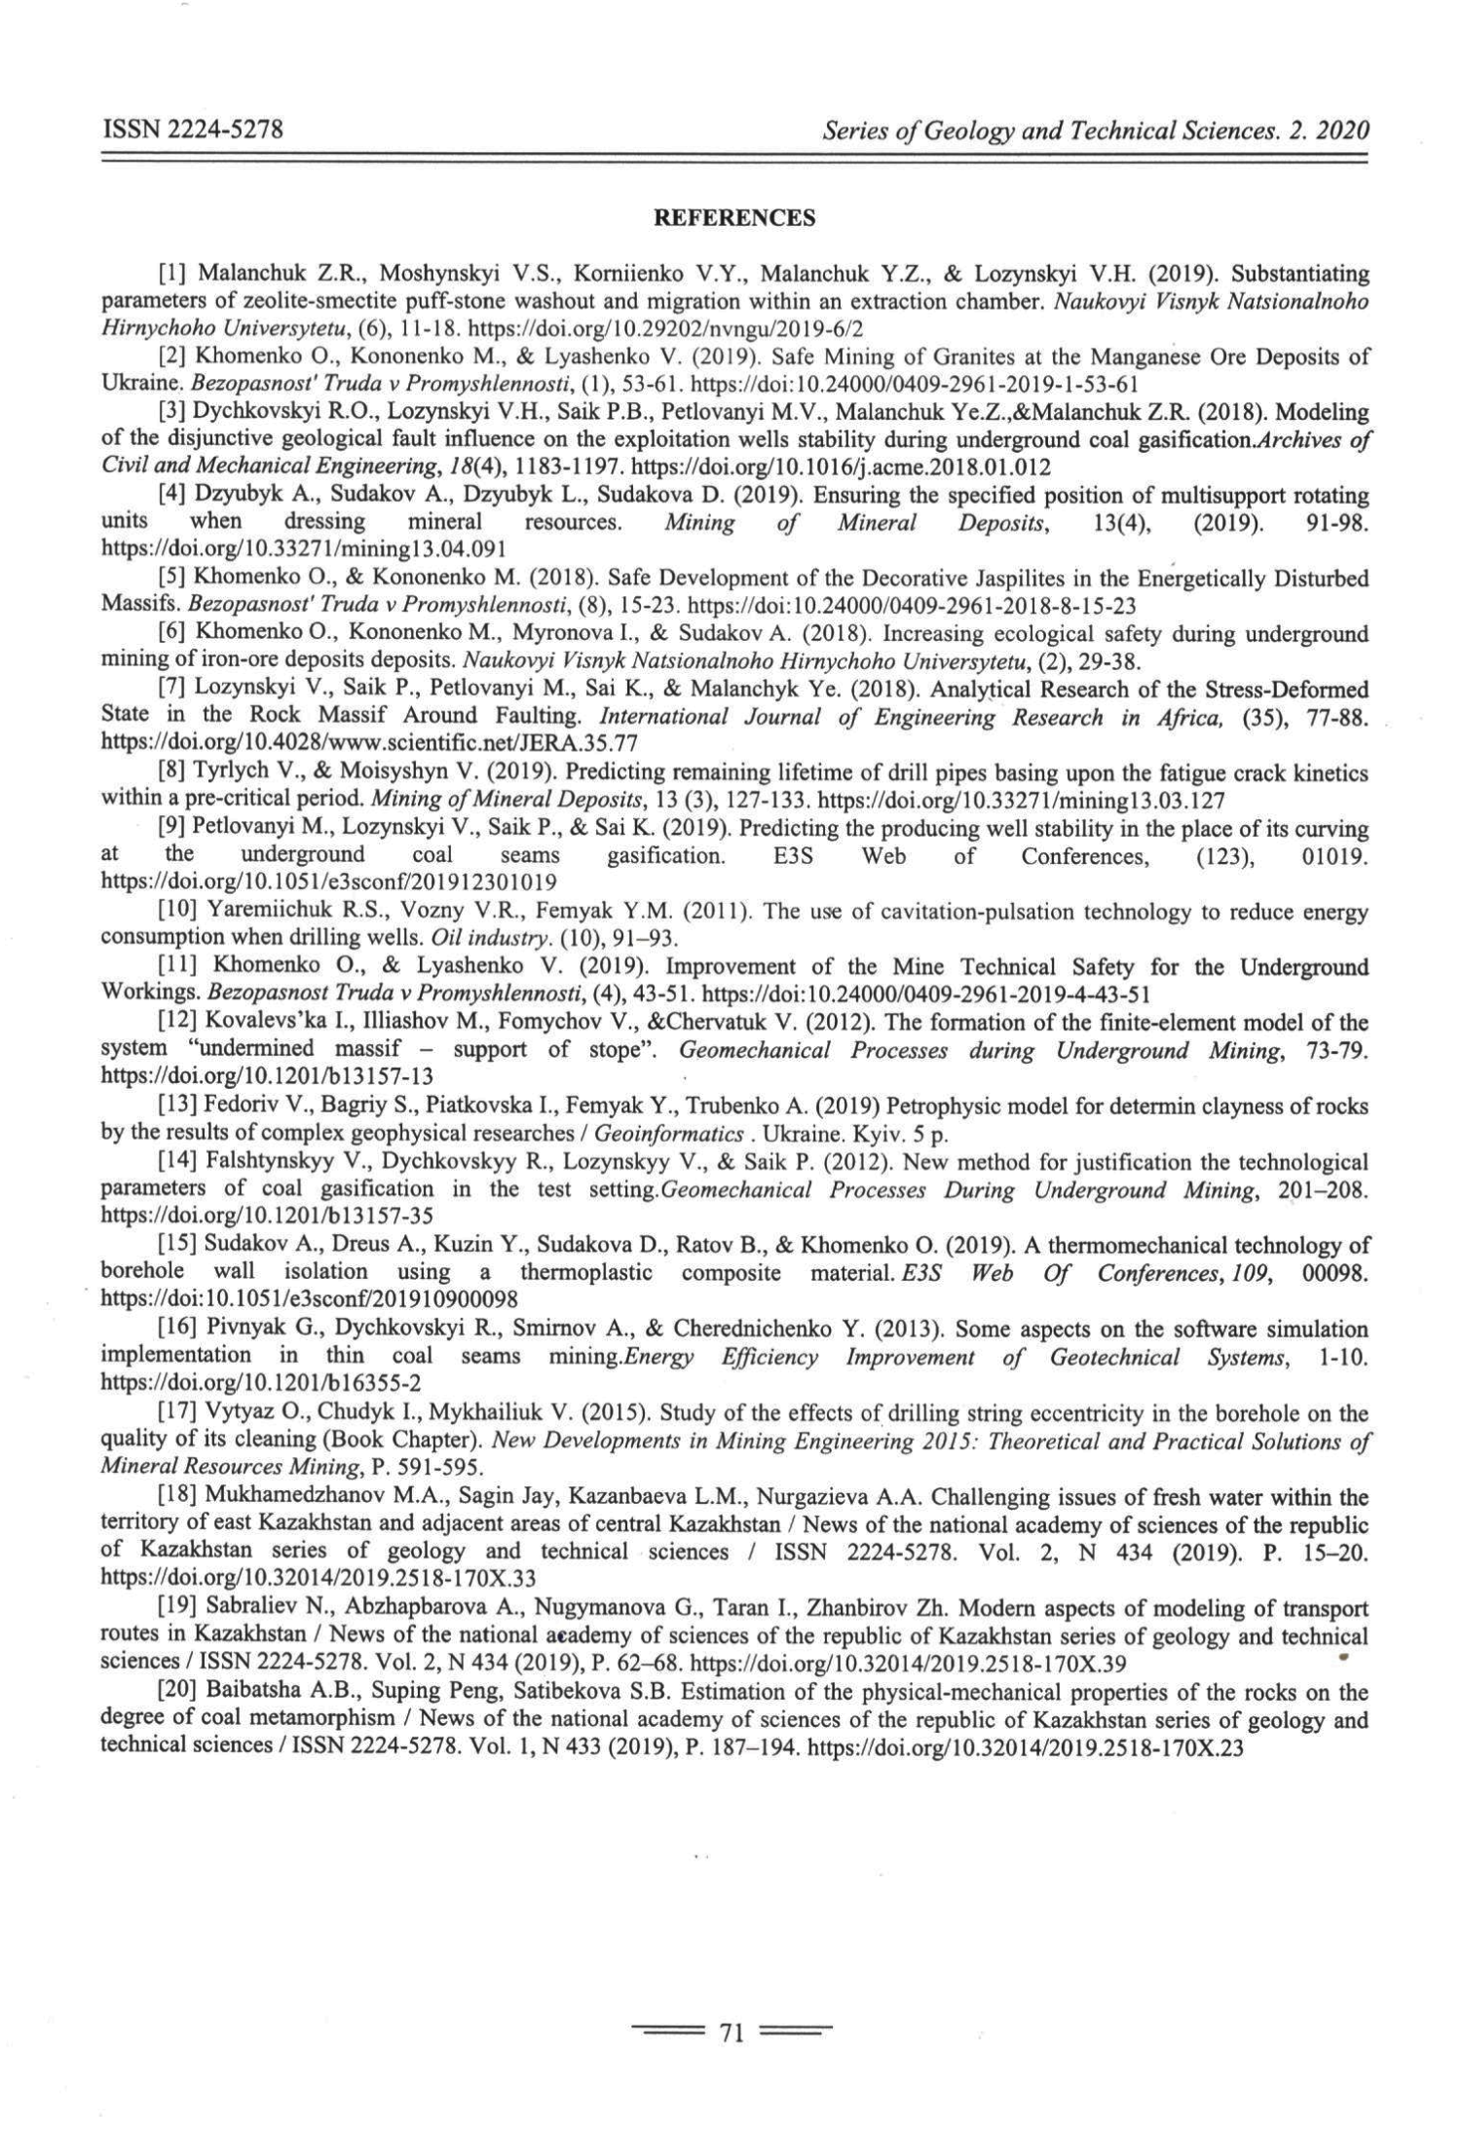
APPENDIX D
PROJECT PATENTS FOR 2020 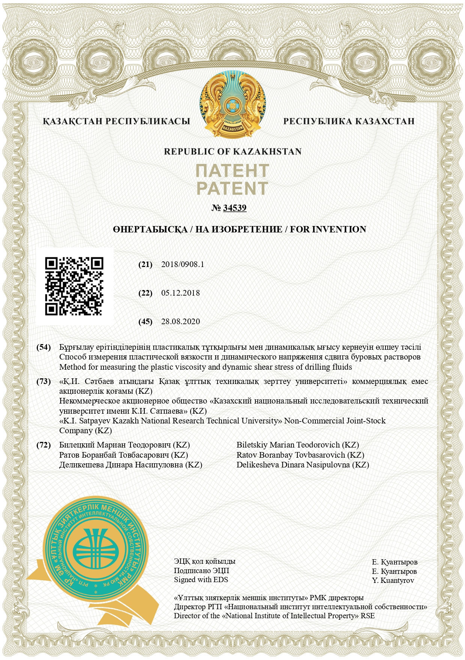
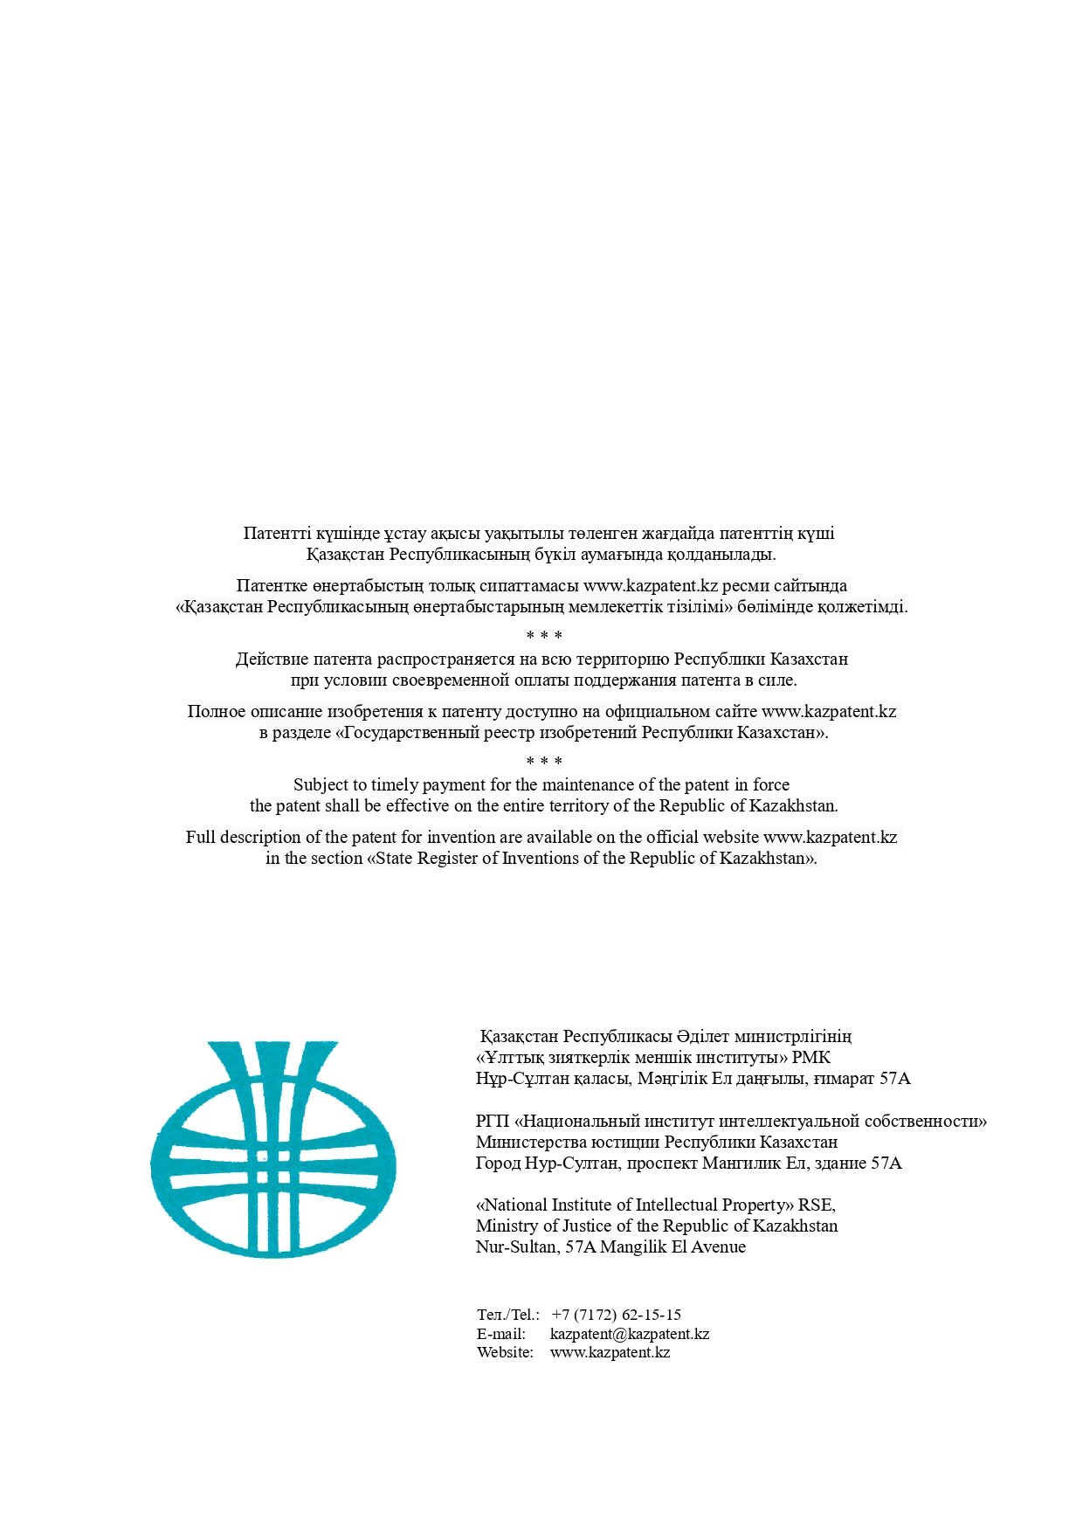

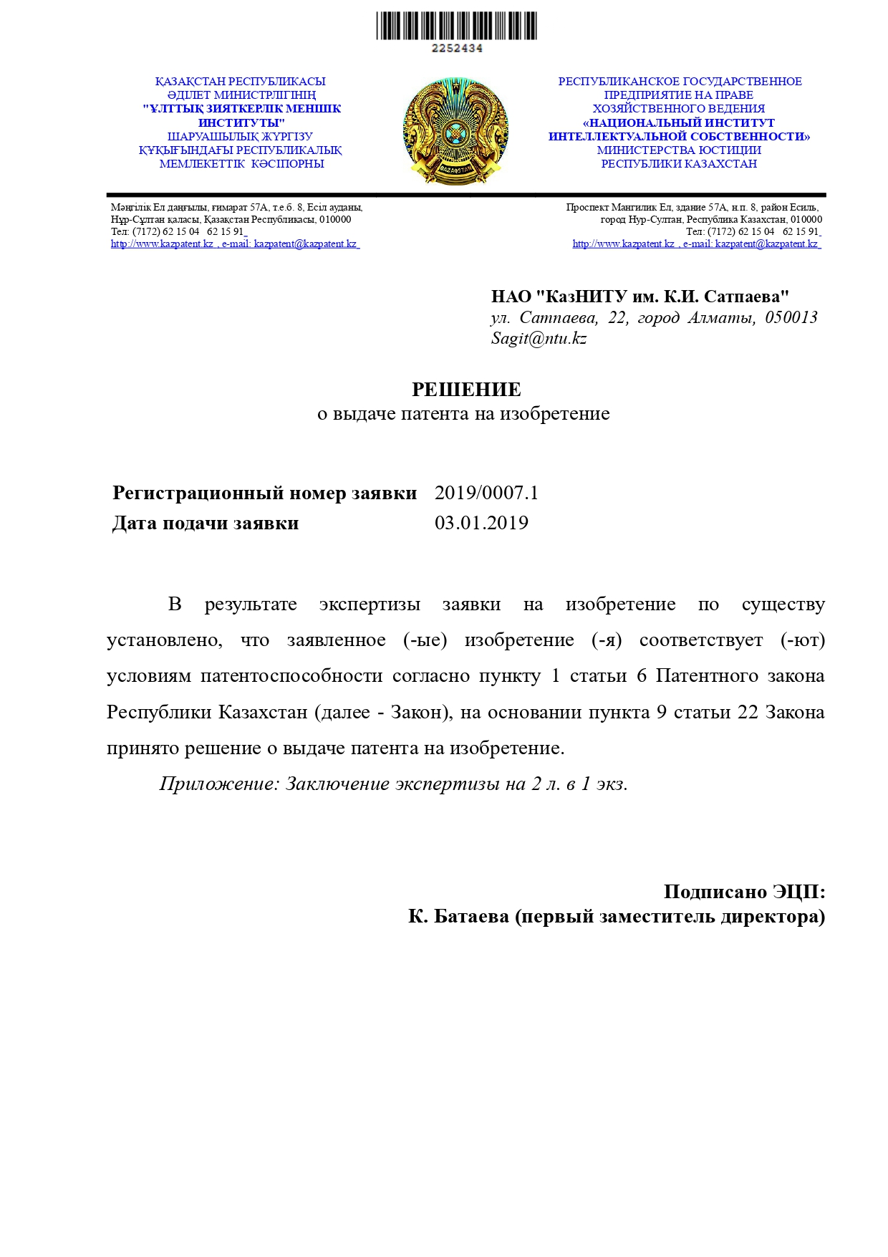

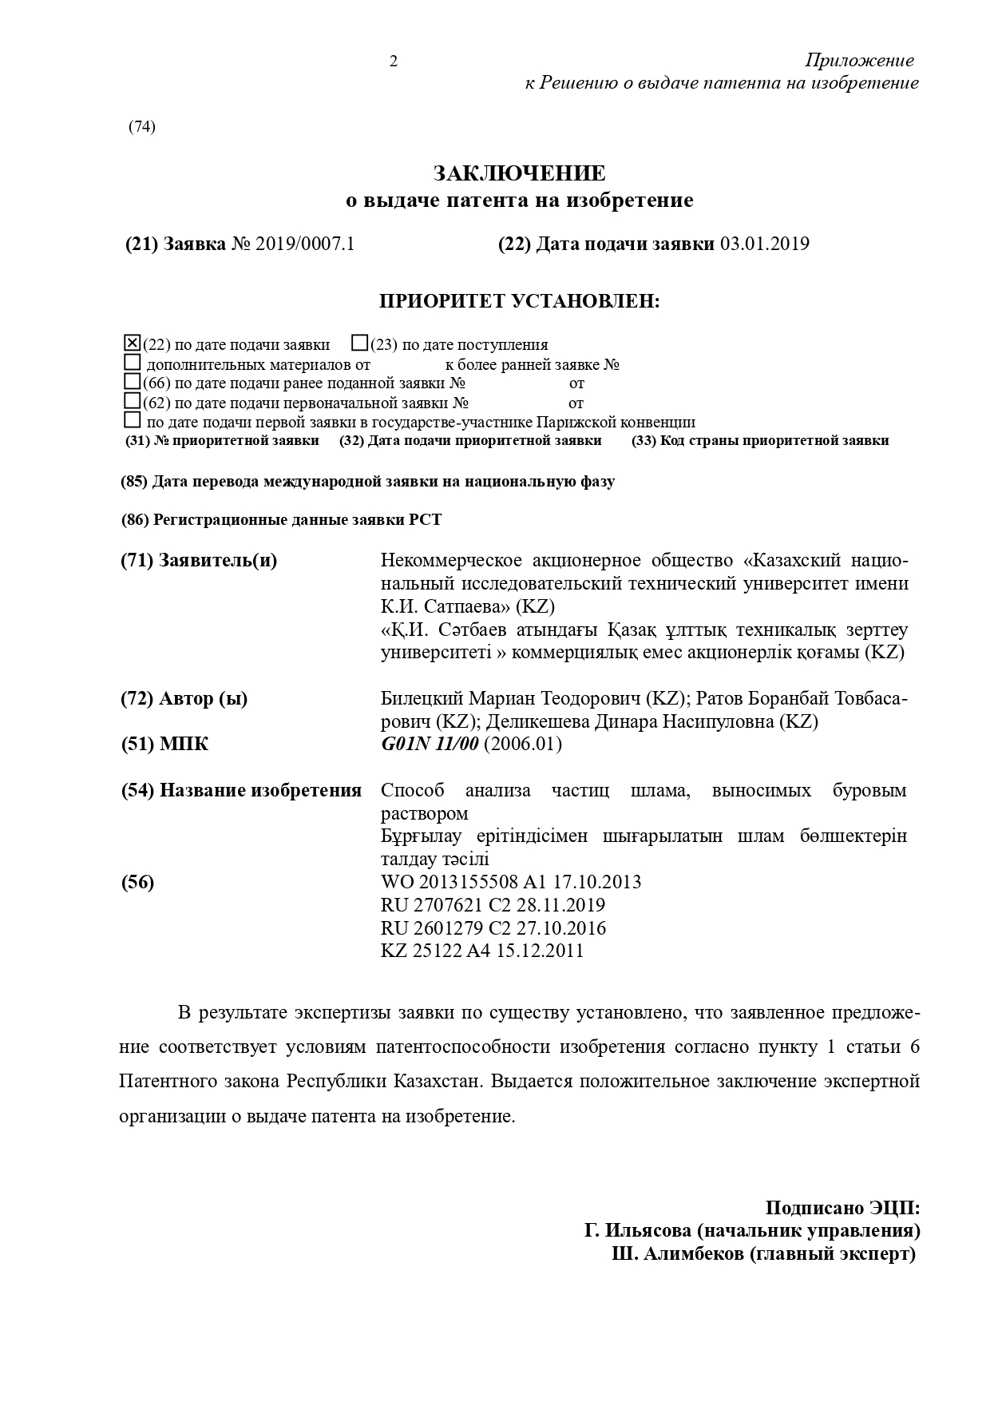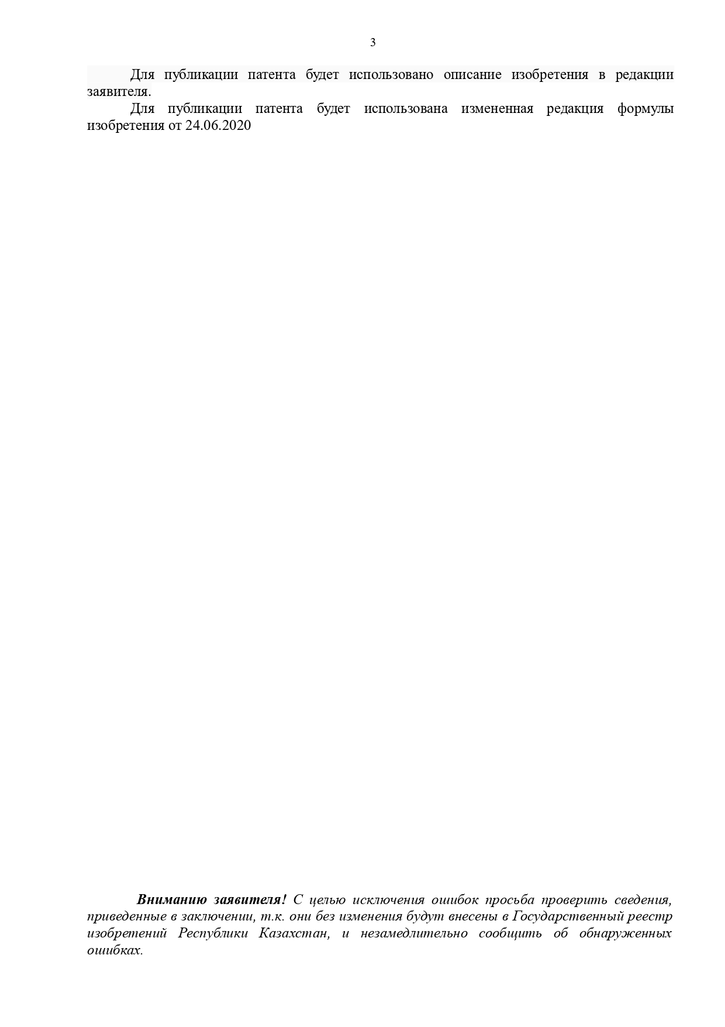

APPENDIX E
TERMS OF REFERENCE FOR THE MANUFACTURE OF AN EXPERIMENTAL STAND 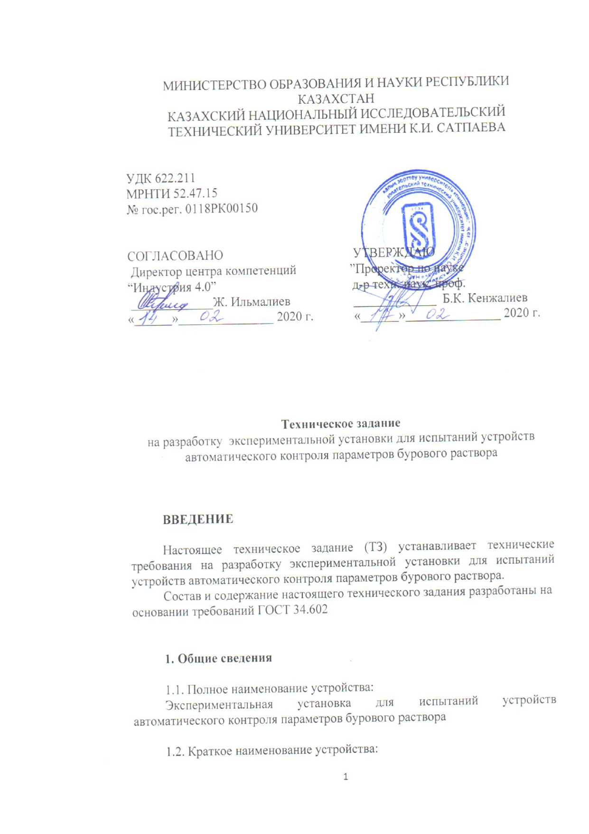
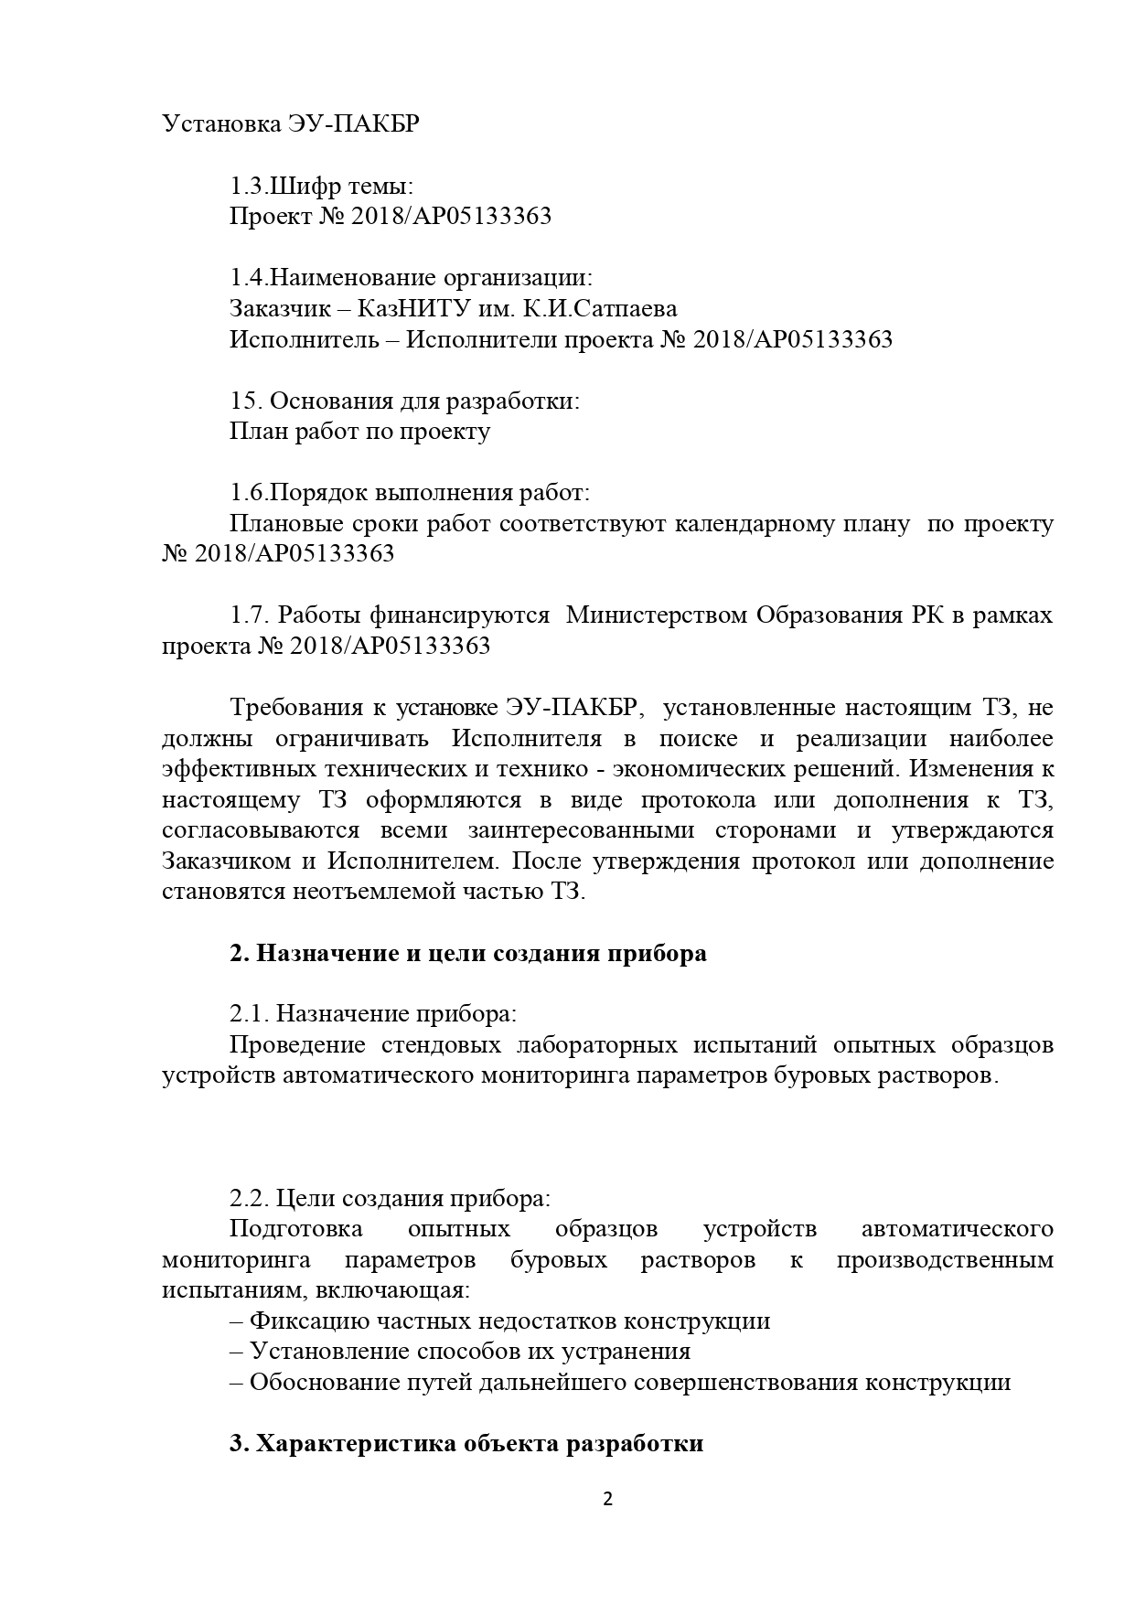

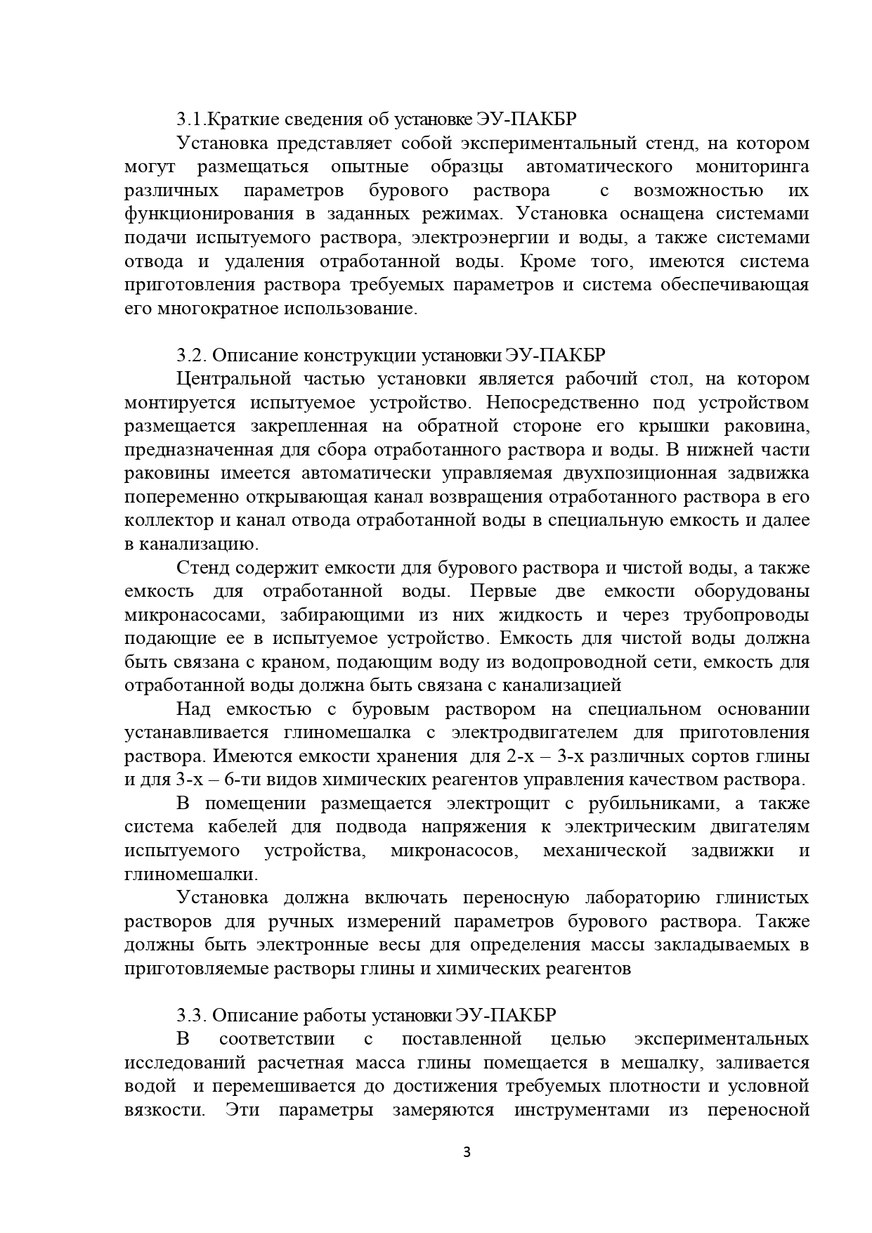

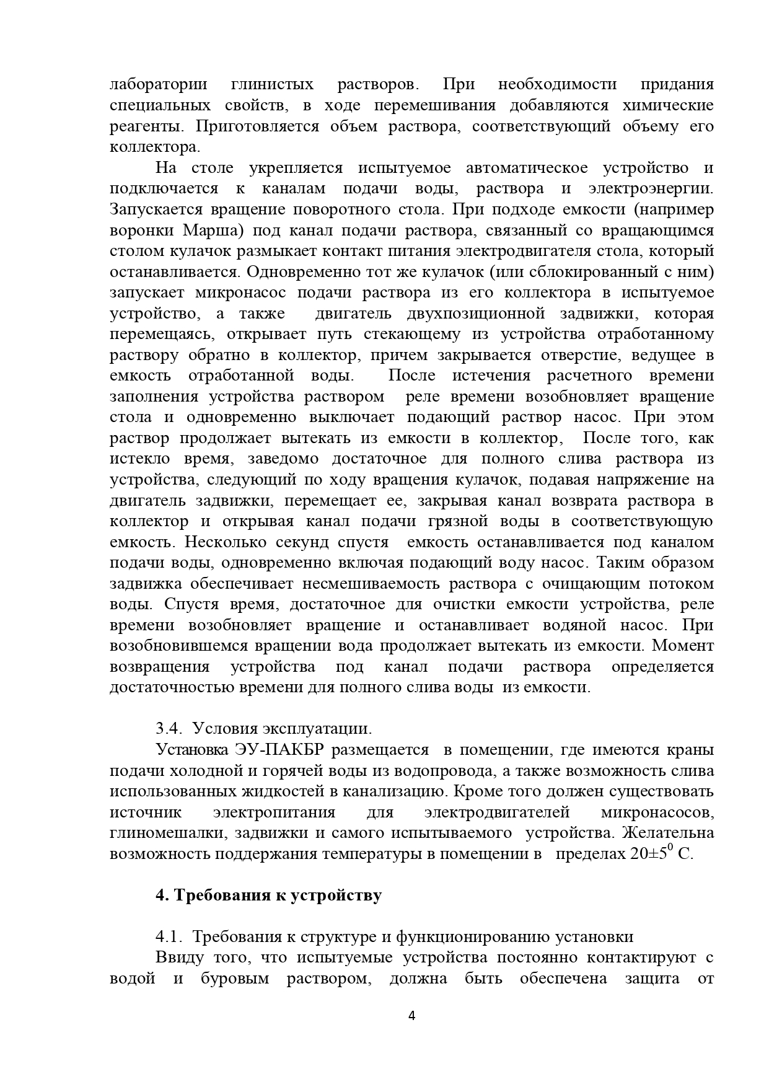

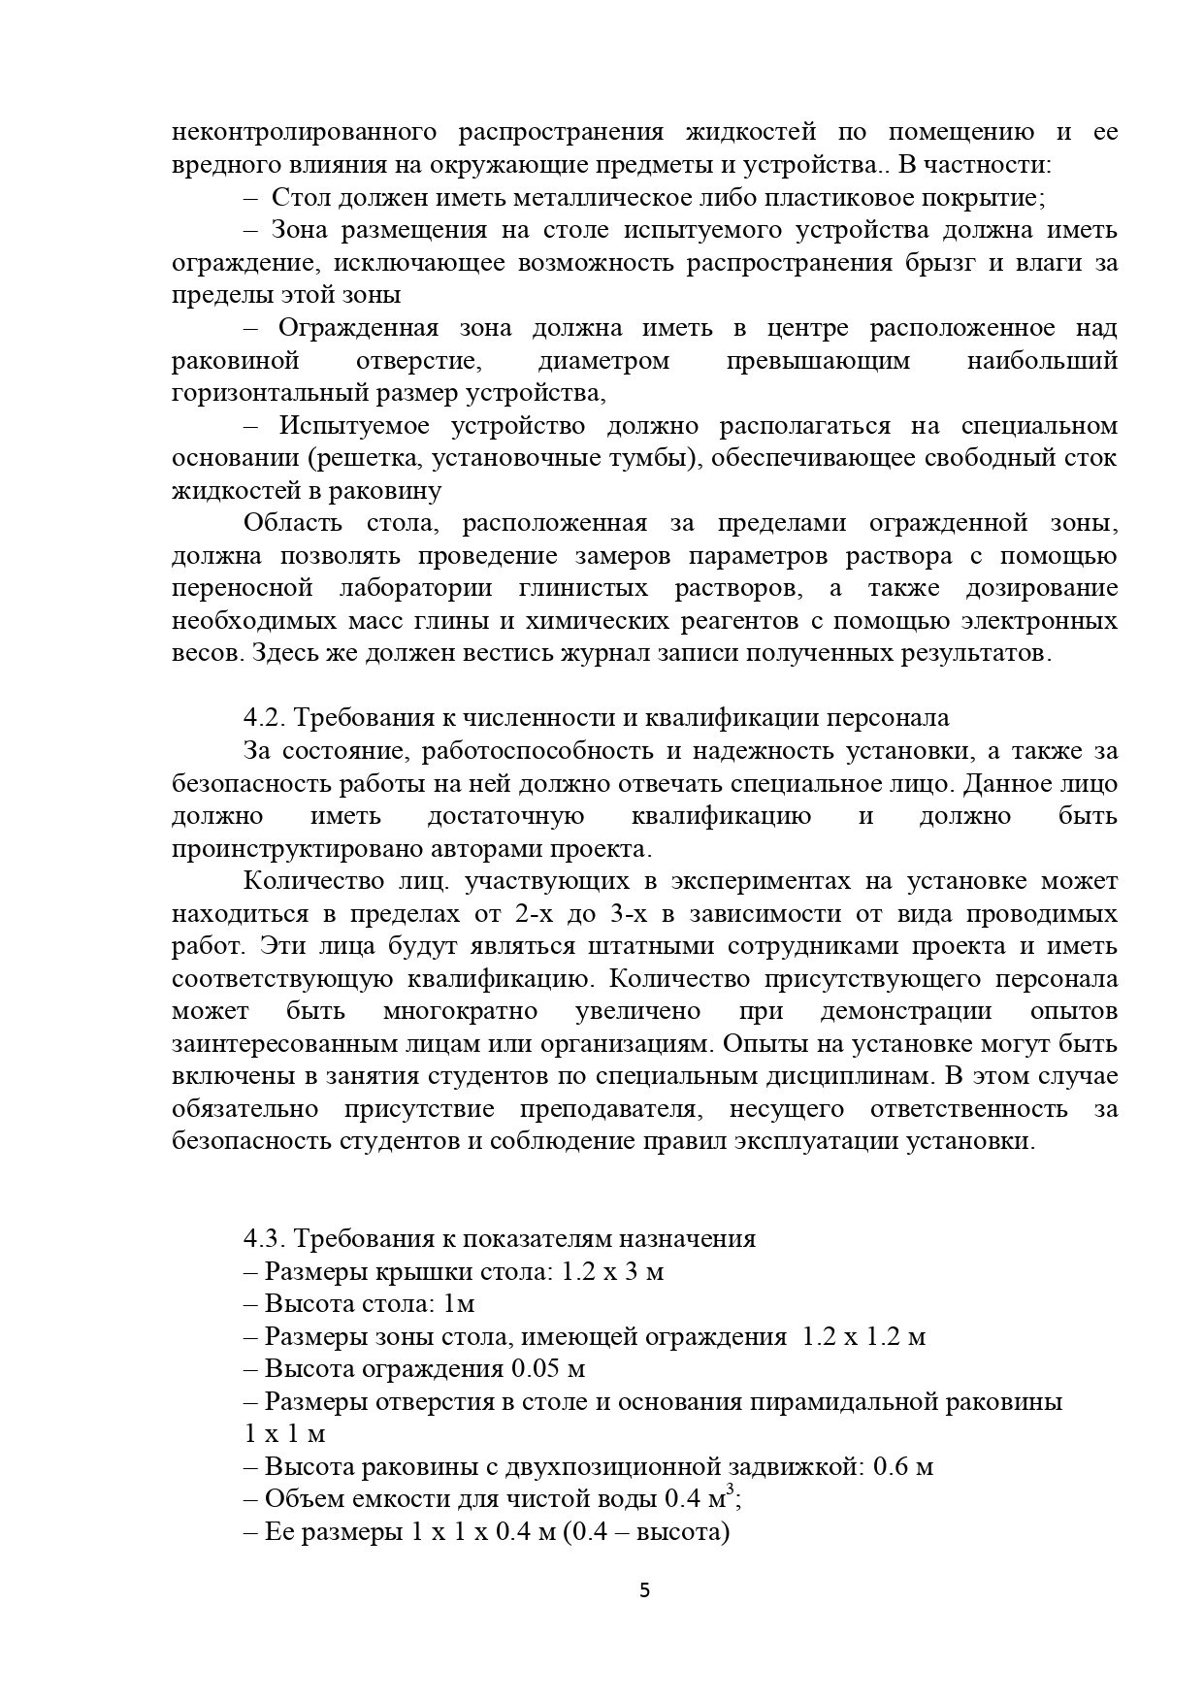

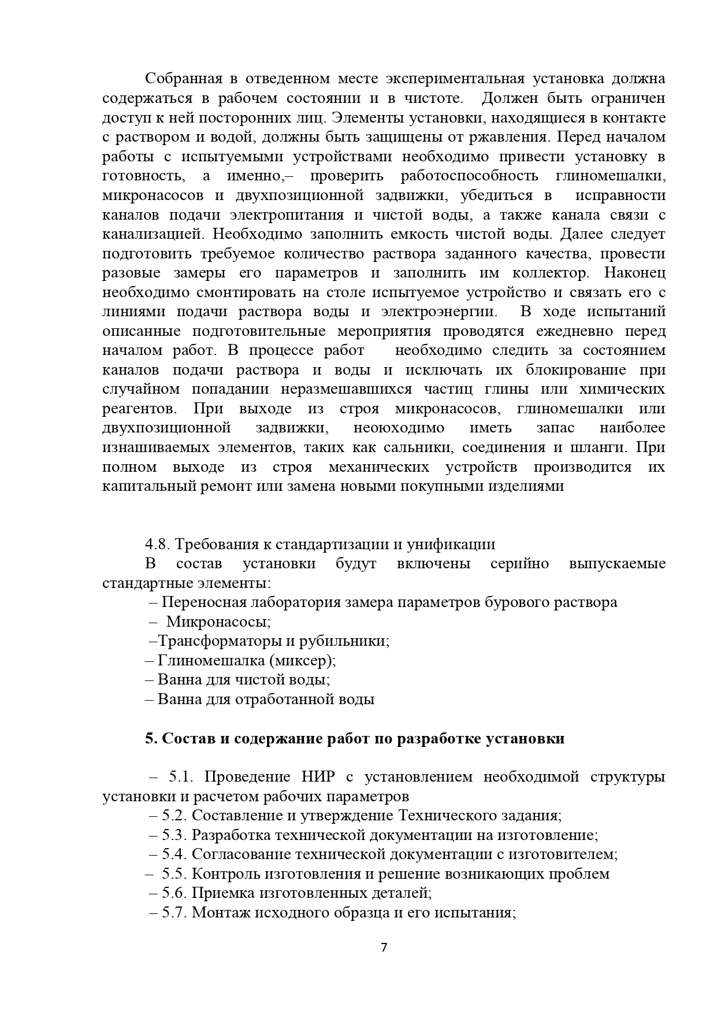

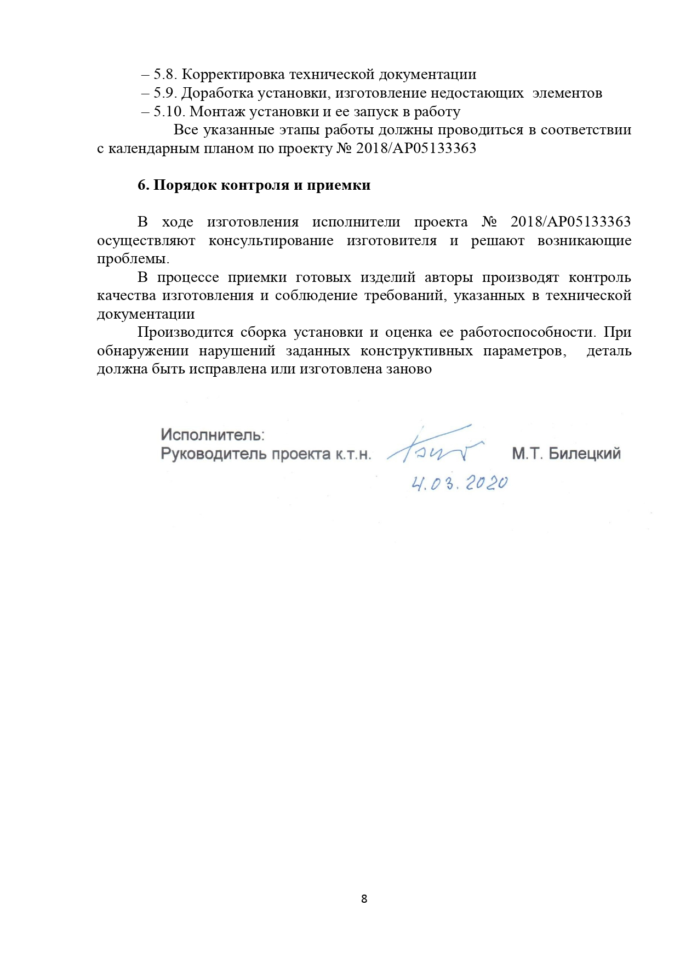

APPENDIX F

DOCUMENTATION FOR THE MANUFACTURE OF THE EXPERIMENTAL STAND 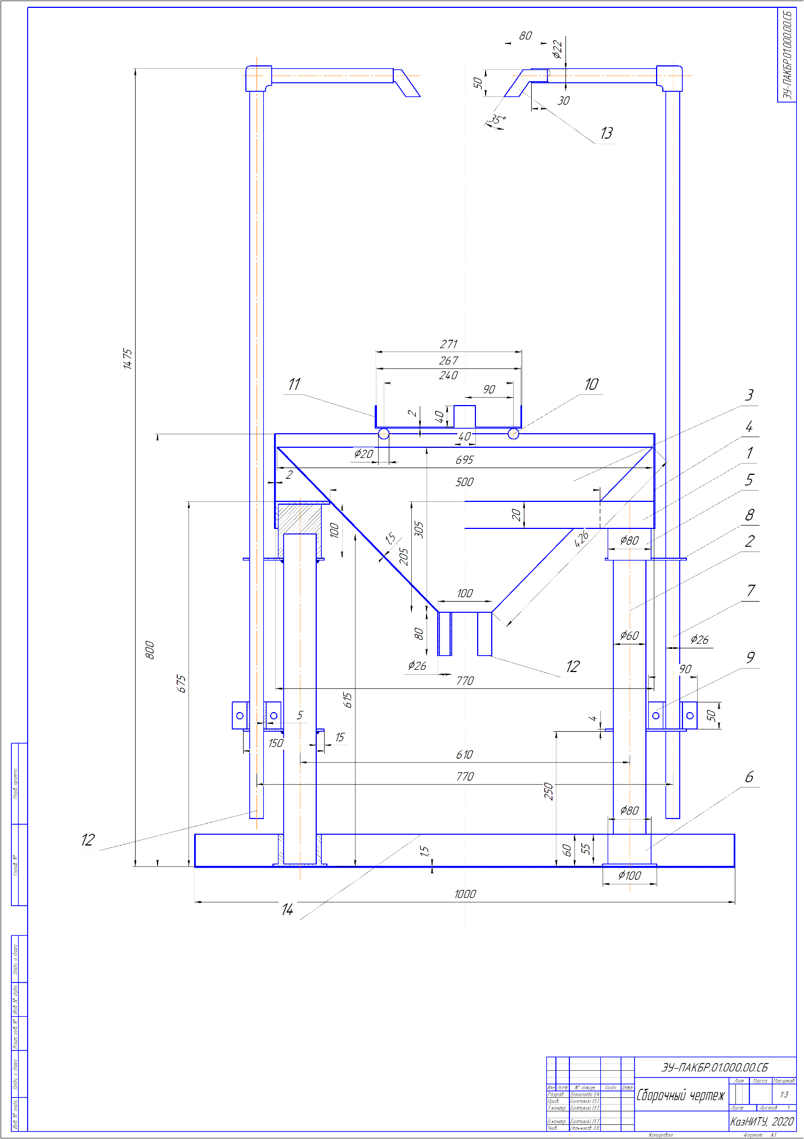

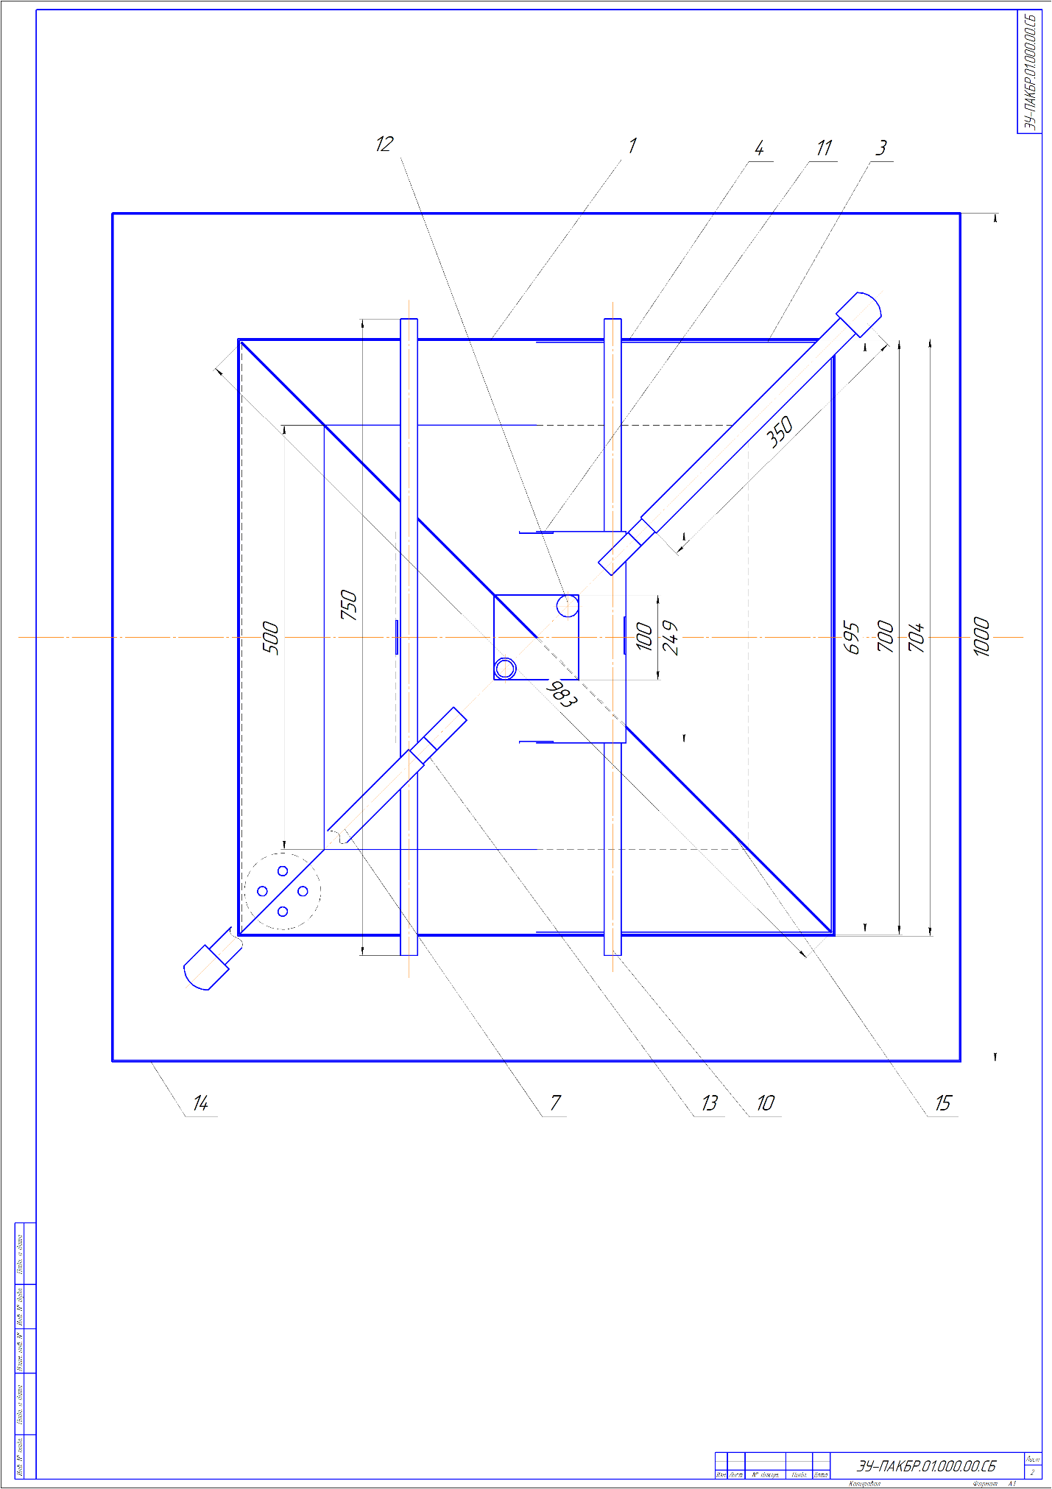

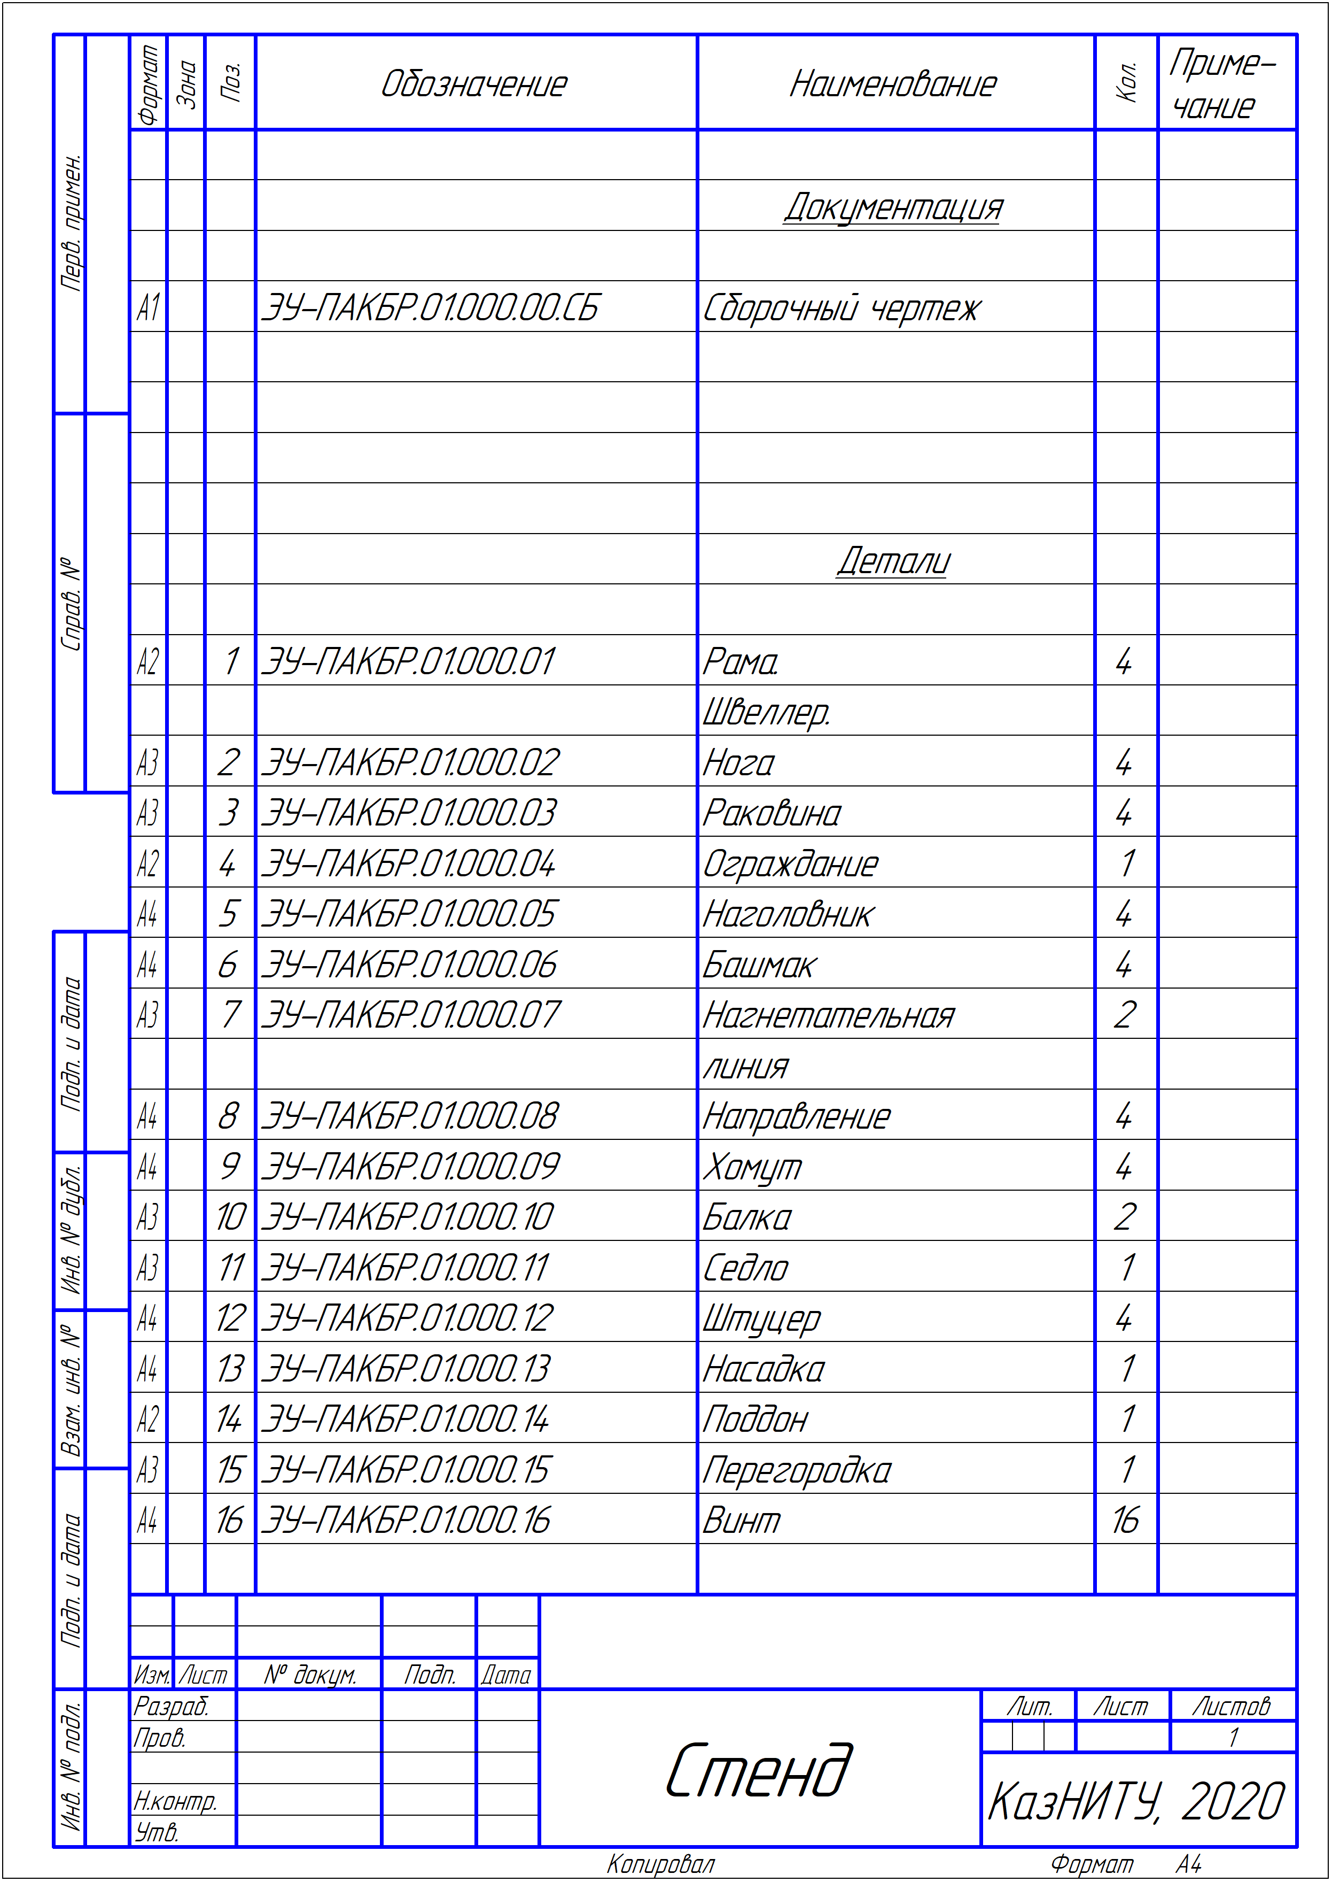

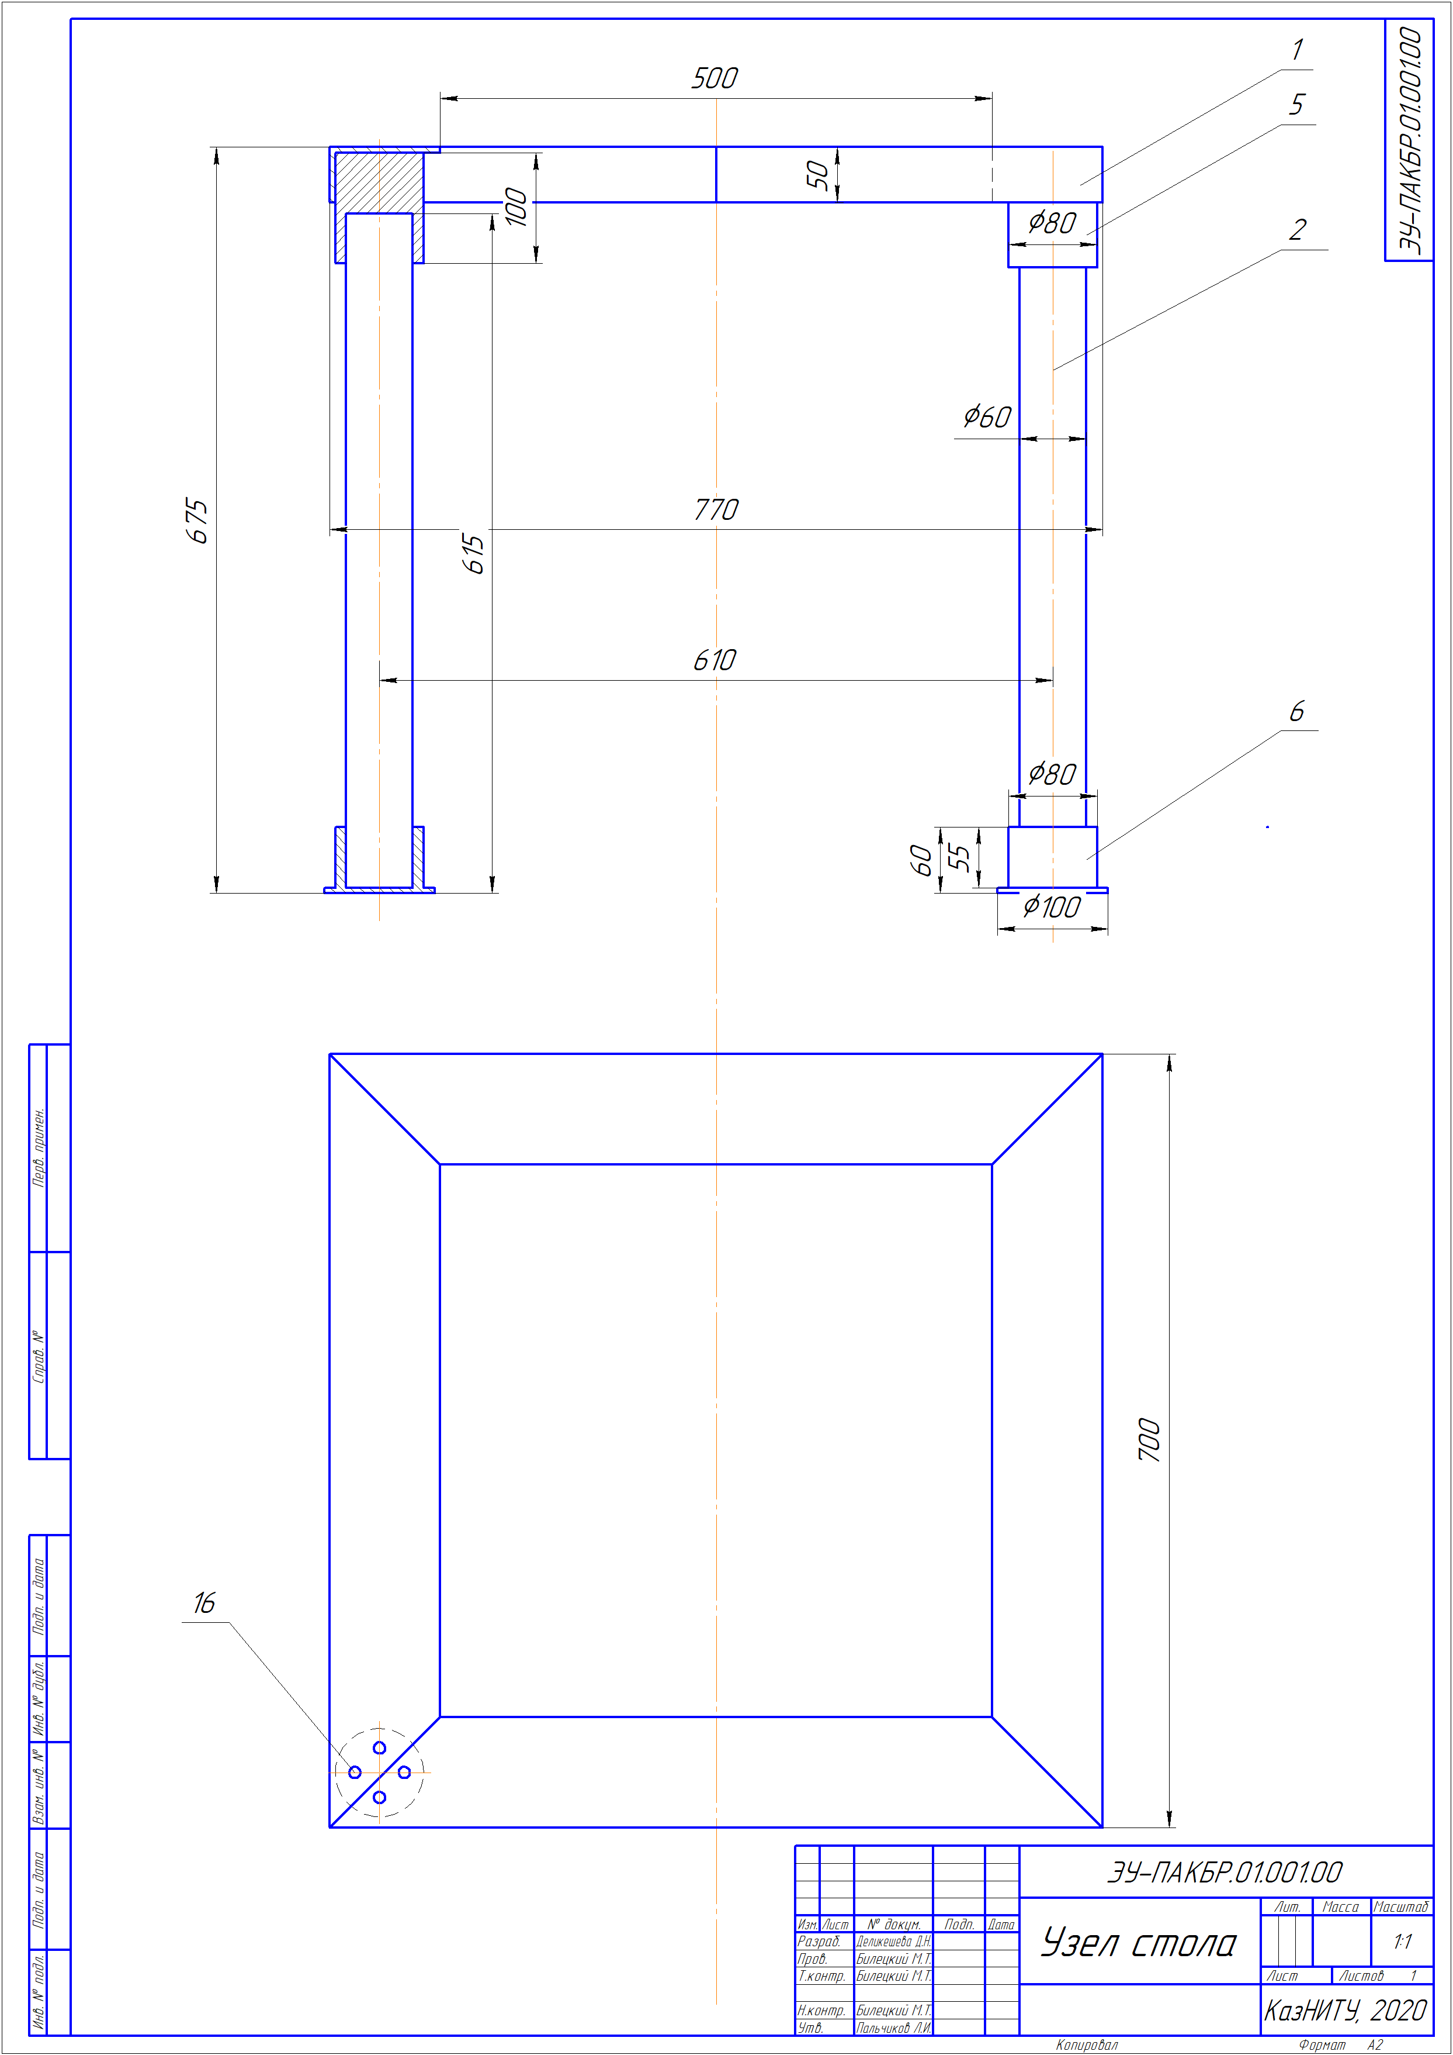
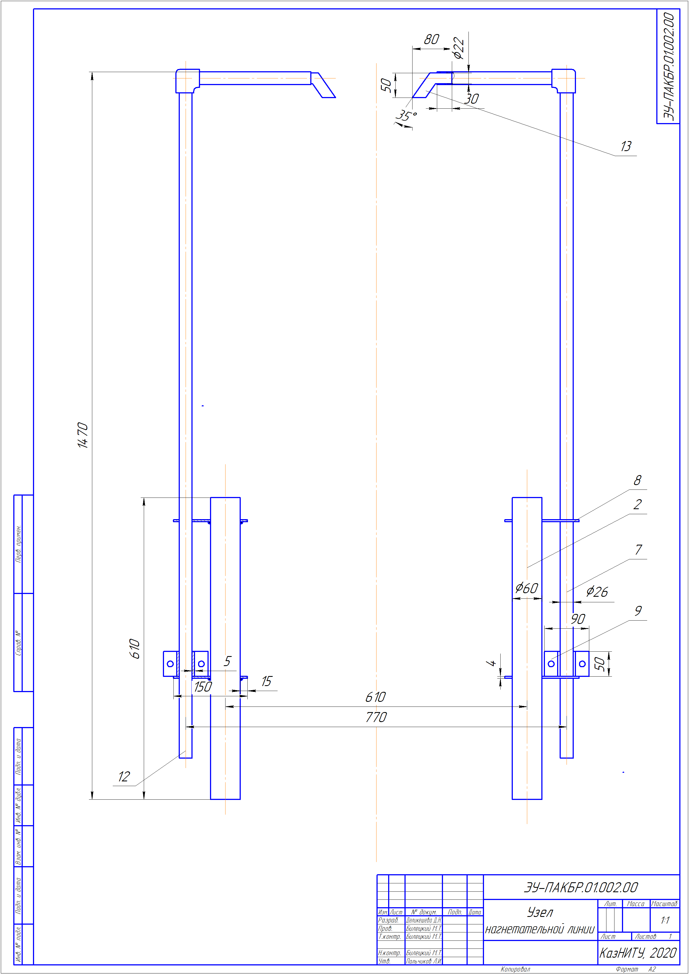

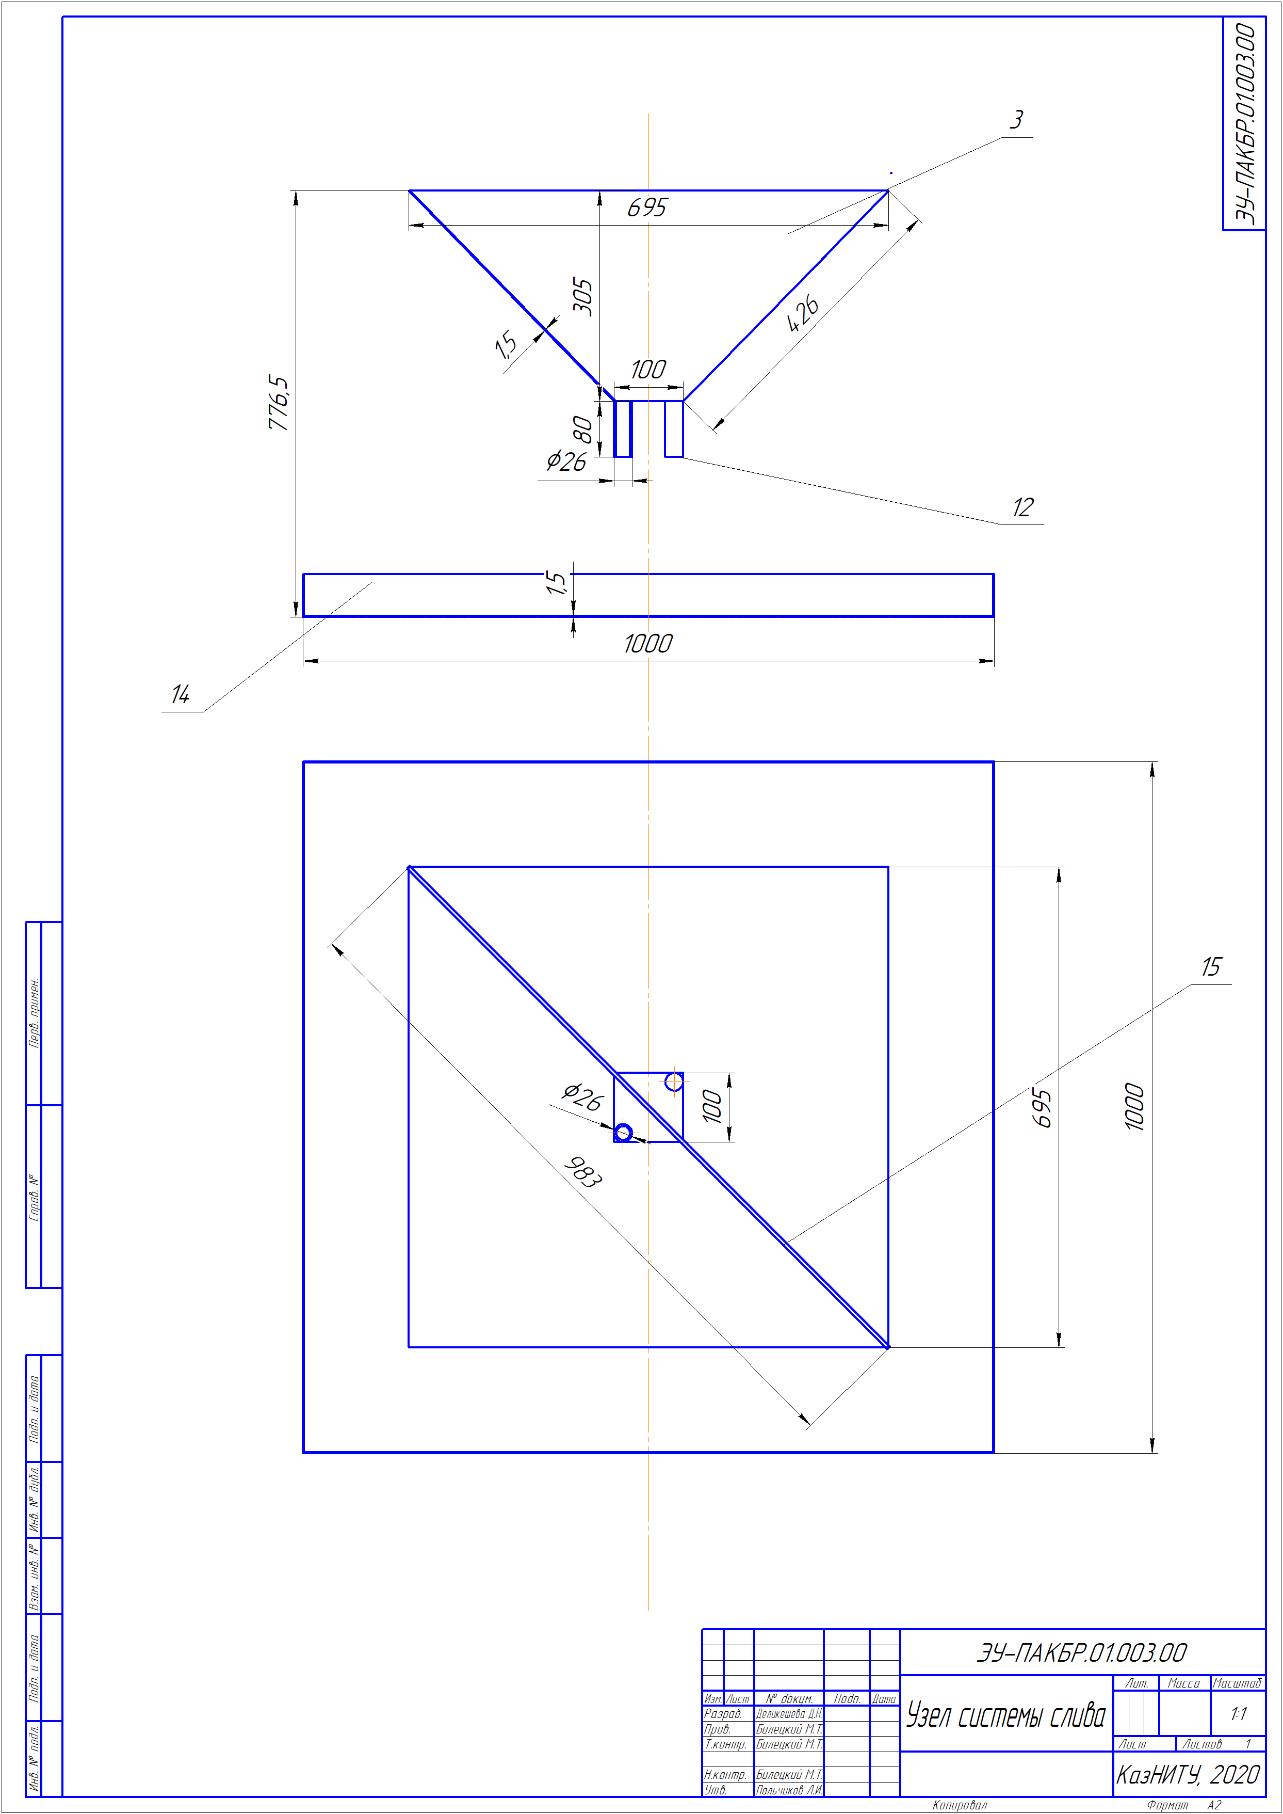

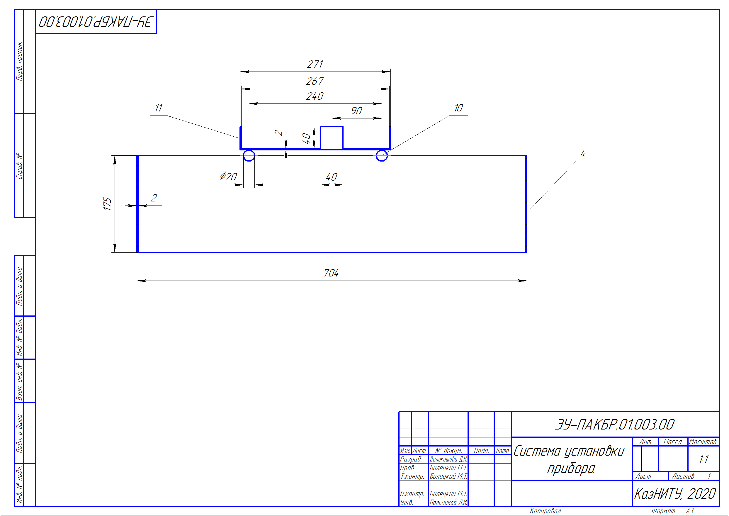

APPENDIX G

DOCUMENTATION APPROVAL ACT 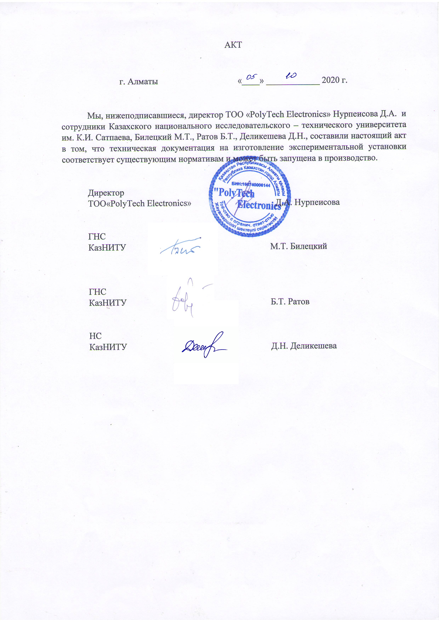

APPENDIX H
EXTRACT FROM THE MINUTES OF THE SCIENTIFIC AND TECHNICAL COUNCIL OF K.I. SATPAYEV KAZNRTU 