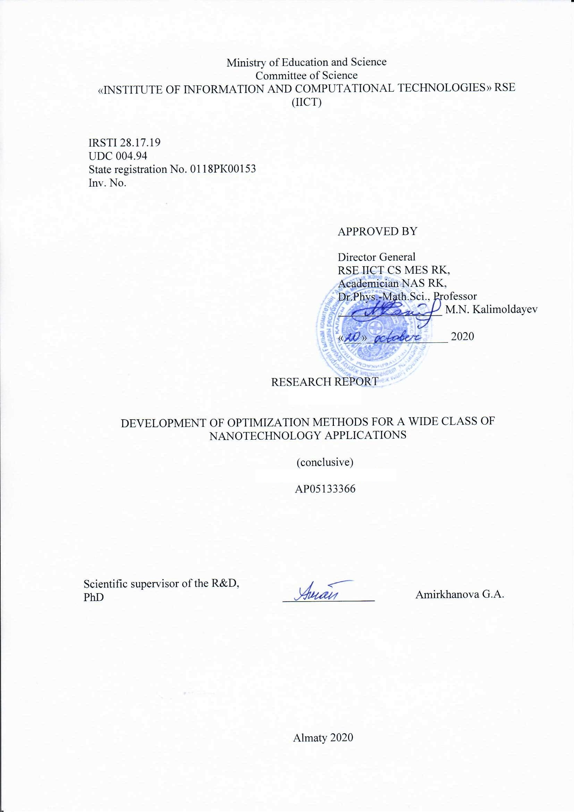


ABSTRACT

Report has 70 p., 17 fig., 3 tab., 28 references, 4 appendix.
OPTIMIZATION PROBLEMS, SOFTWARE PACKAGE, MODELING, NANOTECHNOLOGY, HIGH PERFORMANCE COMPUTER SYSTEMS
The object of research is two-dimensional crystal structures.
The main objectives of the project are:
– creation of new methods for solving optimization problems arising in structural materials science;
– implementation on the basis of the developed methods of a software package for solving urgent problems of nanotechnology, focused on high-performance computing systems;
– carrying out a computational experiment aimed at modeling the characteristics of nanomaterials.
The main idea of the project is to develop existing and create new optimization methods aimed at solving problems of modeling the properties of nanomaterials.
Scientific and technical level (novelty): development of new universal hybrid optimization algorithms based on a combination of local and global optimization methods with the ability to adjust the algorithm parameters to the problem being solved.
Applications: structural materials science, creation of new materials.
Implementation recommendations: project results can be implemented in enterprises involved in the development and production of new materials.
Cost-effectiveness and significance of the work; predictive assumptions about the development of the research object: The new model of two-dimensional crystal structures proposed in the project will make it possible to make significant progress in solving problems of modeling the structure and properties of flat crystals.

РЕФЕРАТ

Есеп 70 б., 17 сур., 3 кесте, 28 дереккөз, 4 қосымша.
ОҢТАЙЛАНДЫРУ МІНДЕТТЕРІ, БАҒДАРЛАМАЛЫҚ ҚАМТАМАСЫЗДАНДЫРУ, МОДЕЛЬДЕУ, НАНОТЕХНОЛОГИЯЛАР, ЖОҒАРЫ ӨНІМДІ ЕСЕПТЕУІШ ЖҮЙЕЛЕР
Зерттеу нысаны - екі өлшемді кристалды құрылымдар.
Жобаның негізгі мақсаттары:
- құрылымдық материалтануда туындайтын оңтайландыру мәселелерін шешудің жаңа әдістерін құру;
- жоғары өнімді есептеу жүйелеріне бағытталған нанотехнологияның өзекті мәселелерін шешуге арналған бағдарламалық жасақтаманың әзірленген әдістері негізінде жүзеге асыру;
- наноматериалдардың сипаттамаларын модельдеуге бағытталған есептеу экспериментін жүргізу.
Жобаның негізгі идеясы наноматериалдардың қасиеттерін модельдеу мәселелерін шешуге бағытталған қолданыстағы әзірлеу және жаңа оңтайландыру әдістерін құру болып табылады.
Ғылыми-техникалық деңгей (жаңалық): алгоритм параметрлерін шешілетін мәселеге сәйкестендіре отырып, жергілікті және ғаламдық оңтайландыру әдістерін біріктіру негізінде жаңа әмбебап гибридті оңтайландыру алгоритмдерін құру.
Қолдану: құрылымдық материалтану, жаңа материалдар құру.
Іске асыру бойынша ұсыныстар: жоба нәтижелері жаңа материалдарды әзірлеумен және өндірумен айналысатын кәсіпорындарда жүзеге асырылуы мүмкін.
Жұмыстың экономикалық тиімділігі немесе құндылығы; зерттеу объектісінің дамуы туралы болжамдық болжамдар: Жобада ұсынылған екі өлшемді кристалды құрылымдардың жаңа моделі жазық кристалдардың құрылымы мен қасиеттерін модельдеу мәселелерін шешуде айтарлықтай жетістіктерге жетуге мүмкіндік береді

CONTENT

INTRODUCTION 8
1 General characteristics of the approach 10
2 Verification of the considered model 12
2.1 Search for the minimum energy of elements of a fragment of a crystal lattice and determination of its parameters 12
2.2 Model verification results 14
3 Creating an Atlas of configurations using cluster analysis methods 17
3.1 A single configuration analysis 18
4 Review of modern methods for producing ZnO thin films doped with Al 25
CONCLUSION 31
LIST OF USED SOURCES 33
APPENDIX A. Calendar plan 36
APPENDIX B. List of publications for 2020 43
APPENDIX C. Reprints of publications 46
APPENDIX D. List of information resources used 70

TERMS AND DEFINITIONS

In this research report, the following terms are used with corresponding definitions:
MeanShift is a feature space nonparametric analysis technique to determine the location of the maximum probability density, so-called mode search algorithm. The area of application of the technique is cluster analysis in computer vision and image processing. This study uses a specialized Python library.
OpenMP (Open Multi-Processing) is an open standard for parallelizing C ++ programs. Describes the set of compiler directives, library routines, and environment variables for programming multithreaded applications on shared memory multiprocessor systems.
RadiusNeighborsTransformer is a Python library function to transform object X into a (weighted) graph with neighbors closer than a certain radius.
Adequacy of the mathematical model - the coincidence of the properties (functions / parameters / characteristics, etc.) of the model and the corresponding properties of the modeled object.
Verification of the mathematical model - checking the adequacy of the model.
High performance computing systems are applications and work tasks associated with performing resource-intensive computing operations using various resources.
Hexagonal crystal lattice is a lattice, the material of which looks like a prism with the base of a regular centered hexagon.
Hybrid Algorithm is an algorithm that combines two or more other algorithms that solve the same problem, either by choosing one or switching between them during the algorithm.
Global optimization is a branch of applied mathematics and numerical analysis that deals with the problems of finding global extrema of functions. In most cases, the minimization problem is solved.
Global minimum is the extremum of a function at a point whose value is minimal over the entire domain of definition.
Rough modeling of structures is a modeling of structures with low accuracy.
Diffraction maximum is the lightest band obtained when light is incident on a diffraction grating.
Cluster analysis is a classification analysis method; its main purpose is to divide the set of objects and features under study into homogeneous groups, or clusters.
Cluster is a complex union (group) of several atoms or molecules that stand out from other similar molecules and combine into a stable [separate] formation.
Control sample is a sample of a crystal, the characteristics of which are taken as a basis for modeling and verification.
Piecewise homogeneous material is a material consisting of layers, in which each layer consists of the same atoms located at the same distances, but in different layers the atoms may differ.
Local optimization is an iterative optimization method based on finding a local extremum in a limited neighborhood of the current search point at each iteration and moving the current point to the found local extremum point.
Local minimum is the extremum of a function at a point whose value is minimal in some local domain of definition.
Micro- and nano-sizes - sizes from 10⁻⁹m to 10⁻⁶m.
Plane crystal, planar crystal structure is a crystal with translational symmetry in only two directions.
Lattice constant is the size of the crystal unit cell.
Tersoff potential - energy of a particle system.
Stream (progr.) is an abstract sequence of instructions or data in general, tied to the corresponding descriptor (can be represented by the name of the stream).
Rectangular crystal lattice is a crystal lattice, the cell of which is a rectangle.
Equilibrium structures are structures with a minimum of free energy
Silicene is a two-dimensional allotropic silicon compound.
Layered heterogeneous structures is an inhomogeneous system consisting of homogeneous parts (phases) separated by an interface.
Phosphorus is a two-dimensional allotropic modification of phosphorus, which is obtained from black phosphorus divided into monoatomic layers.

INTRODUCTION

The study of flat crystals began in 1912, when the German physicist M. Laue formulated the conditions for the appearance of diffraction maxima when X-rays pass through crystals [1].
One of the priority directions in the development of modern science is the creation of new materials. Thanks to the development of materials sciences and, in particular, nanotechnology, it was possible to achieve a significant technological breakthrough in many industries. Modern nanomaterials are used in medicine, space and military industries, manufacturing of various types of products, construction and many other fields. Mathematical modeling methods used in materials sciences make it possible to study the properties of various materials numerically without performing a real physical experiment. This approach allows you to achieve significant cost savings and speed up the process of creating new materials.
When creating new high-tech products in industry, especially when working with objects of micro- and nano sizes, it is necessary to know in detail the characteristics, properties and structure of materials. It is known that the properties of materials are determined not only by their chemical composition, but also by their structure. The use of optimization methods for numerical simulation of the structures and properties of new materials, based on a detailed understanding of their structure at the atomistic level, is currently very relevant and promising. This project proposes the development of existing and development of new optimization methods focused on a wide class of nanotechnology problems.
The project describes the development of parallel optimization methods for solving a wide class of nanotechnology problems using modern high-performance computing systems and software. In this project, the task of determining the stiffness parameters of plane problems of deformation of heterogeneous layered structures is completed. For this, a significant amount of calculations was carried out using molecular modeling and optimization methods when calculating equilibrium structures within the framework of a discrete concept of the structure of materials. The scientific novelty of the task is that it is planned to develop new universal hybrid optimization algorithms based on a combination of local and global optimization methods with the possibility of adjusting the algorithm parameters to the problem being solved.
Materials with a flat crystal structure are widely used in modern industry. A striking example of such a material is graphene - a one-dimensional carbon crystal. Recently, other planar crystals have appeared, for example, phosphorene, silicene, etc. Many works are devoted to the study of such structures and the study of their mechanical properties. In this project, a planar model of the crystal structure is proposed, which can be used both for modeling planar crystals and serve as a basis for rough modeling of layered heterogeneous structures.
In the project all the major problems have been solved, as reflected in the planned schedule for 2020.
Results: Developed a program and methods for conducting experimental studies, methods for classifying stationary states of matter based on cluster analysis approaches.
The used mathematical model is verified, the simulation accuracy is estimated based on comparison with the known values of the physical characteristics of the simulated two-dimensional crystals. The stability of the model to errors of optimization methods and empirical potentials is investigated. The analysis of the efficiency of parallelization of the applied optimization methods is carried out. Prepared atlas configurations obtained by methods of cluster analysis.
The study is carried out according to the approved schedule (Appendix A). 10 articles published for 2020 (Appendix B).
Prepared interim reports:
2018: Development of optimization methods focused on a wide class of applied nanotechnology problems, inv. № AP05133366-OT-18.
2019: Development of optimization methods focused on a wide class of applied nanotechnology problems, inv. № AP05133366-OT-19.

1 General characteristics of the approach

A plane model of a multilayer piecewise homogeneous material is considered. The material is presented in the form of a periodic piecewise homogeneous multilayer structure, within which the types of atoms in different layers may differ [2-3]. The model imposes a number of restrictions on the layer structure:
- each layer consists of the same atoms, different atoms can be in different layers;
- the distances between neighboring atoms in the same layer are the same, but in different layers they may differ;
- in the system under consideration, a group of K parallel layers is distinguished, which periodically repeats in the direction of the y axis;
- the number of atoms in each layer and the total number of layers is considered potentially unlimited.
Figure 1 shows an example of a model in which a group of three layers is repeated. Each layer consists of atoms of its own kind.

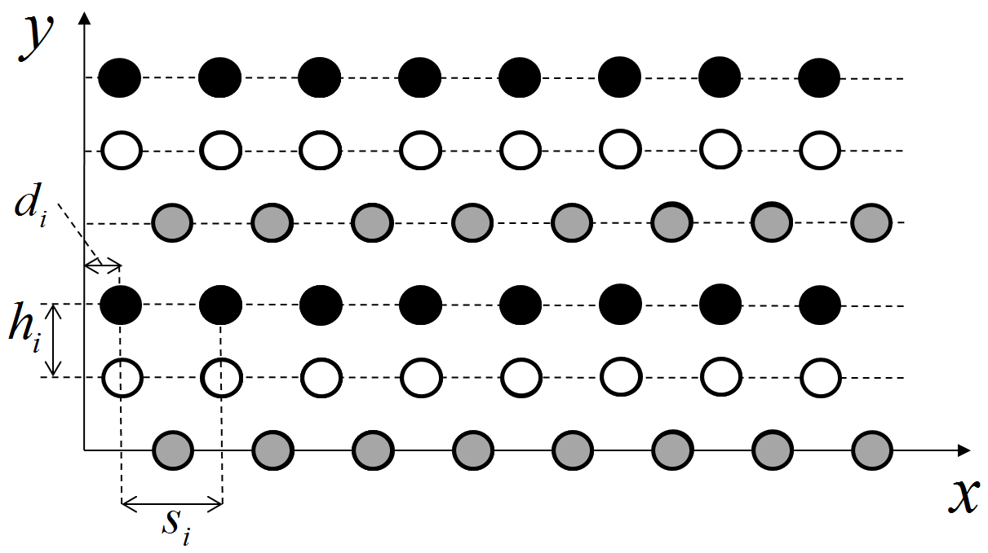
Figure 1 - Two-dimensional model of a piecewise homogeneous material

Within the framework of this model, the position of atoms is determined by the following parameters:
$h_{i},i=1,…,K$ is a distance between layer i and the previous layer;
$d_{i},i=1,…,K$ is a displacement of the first atom in layer i with a positive abscissa relative to the zero mark;
$s_{i},i=1,…,K$ is a distance between atoms in layer i.
$d_{i}=0,d_{i}<s_{i},i=2,…,K$
The set of values of the listed parameters will be called a configuration. The situation when the material is in an unloaded state is considered below. It is required to determine the configuration corresponding to the minimum interaction energy of atoms included in the simulated fragment of the material.
Two statements are considered (hereinafter - Statement I and Statement II). In both cases, the energy $E(x)$ of a set of atoms located on $K$ neighboring layers is minimized. The parameters of the optimization problem are the variables $x=\left(h_{1},d_{1},s_{1},...,h_{K},d_{K},s_{K}\right)$, constituting a vector of dimension $n=3K$. Thus, the optimization problem to be solved belongs to the so-called problems with parallelepiped constraints and is mathematically formulated as follows:

$E(x)→min,{l_{i}}≤x_{i}≤u_{i},i=1,...,n$. (1)

In Statement I, the simulated set includes atoms whose abscissa lies in a given interval $[0,L]$. In this case, depending on the values of the parameters defining the configuration, the number and composition of atoms included in the simulated set can change. In Statement II, it is assumed that the atoms included in this set do not change.
The lattice energy is calculated using the interaction potentials. The energy of a finite set of neighboring atoms ("fragment") is calculated. The energy of a fragment is equal to the sum of the energies of interaction of its constituent atoms with the rest of the lattice atoms. In this work, the Tersoff potential was used with two different sets of parameters, the original [4] and the optimized [5].

2 Verification of the considered model

The verification task in modeling the crystal structure is an integral stage of the modeling process, as well as proof of the adequacy of the model and the performance of the program and calculations.
The model is verified as follows:
Stage 1. Checking the source code of the program in order to identify syntax / logical errors. It allows you to prevent incorrect calculations and implicit errors that occur when the wrong sign (addition, subtraction) or minor errors in data type conversion, which some compilers may not explicitly indicate, and thus mislead the researcher about the correctness of the calculations. For more reliable operation of the program in the future, special tests should be developed that cover most of the possible problems and cases.
Stage 2. Checking formulas and calculations. It is carried out according to the scheme: to submit the initial data to the input and compare the result with the control samples, which were calculated in advance for these initial data. If a mismatch occurs in the formulas, changes are made and the verification process is repeated. This check lasts until the discrepancy between the results obtained and the control samples is below a predetermined value.
After passing through all the stages, it is possible to use new data for which the result has not yet been calculated, but the limitations on it are known.
After verification of the model, it is considered that this model can be used for further research and experiments.

2.1 Search for the minimum energy of elements of a fragment of a crystal lattice and determination of its parameters

To search for the minimum energy of atoms of the crystal lattice, the multistart method was used in combination with the coordinate descent method [6]:
- Login: MSTART (f (x), l, u), where f (x) – objective function; l, u - box limitation.
- Received a set of points $X^{0}=\{X^{0,k}∈R^{n}:|\left|x_{i}^{0,k}=U\left(l_{i},u_{i}\right)\right\},i = 1, ..., n, k = 1, ..., K$, where $U\left(l_{i},u_{i}\right)$ – random value with continuous uniform distribution over the interval [$l_{i},u_{i}$].
- Received a set of points $X^{*}=\left\{x^{*,k}∈R^{n}\right\}$ as follows: for everyone $x^{0, k}∈ X^{0}$ run the method of finding a local minimum, take as a starting point $x^{0,k}$, add result to $X^{*}$.
- As a result, return $X^{*}$
The scheme of the method is quite simple - a starting point is randomly selected and the method of finding a local minimum is launched from it. As a result, we get a certain number of local minima and, as a result, a solution with the minimum energy value is returned. Taking into account the fact that the multistart method is a non-deterministic method for finding the global minimum and does not guarantee its finding in a finite number of steps, we are forced to take the number of initial approximations with a sufficient margin.
First, the optimization problem in Statement I is solved, then the best solutions are selected and the solution to the problem in Statement II is started.
Determination of the constant of the crystal lattice and the angles between the main translation vectors is performed as follows:
а) set some radius $r=1,846A^{o}$, atoms located at a distance less than r, will be considered neighbors;
б) for each atom, we determine its neighbors using the function RadiusNeighborsTransformer [7]; and subtract its coordinates from the coordinates of neighboring atoms;
в) using Mean Shift [7-8], we divide all the atoms into clusters, according to the type of atom environment; an example of clustering is shown in Figure 2.
г) we calculate the distances between atoms of the same type and determine the angle between the main translation vectors. we also use MeanShift.

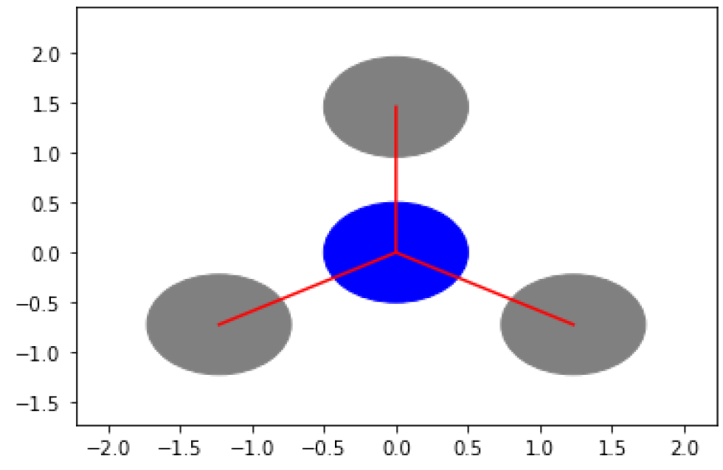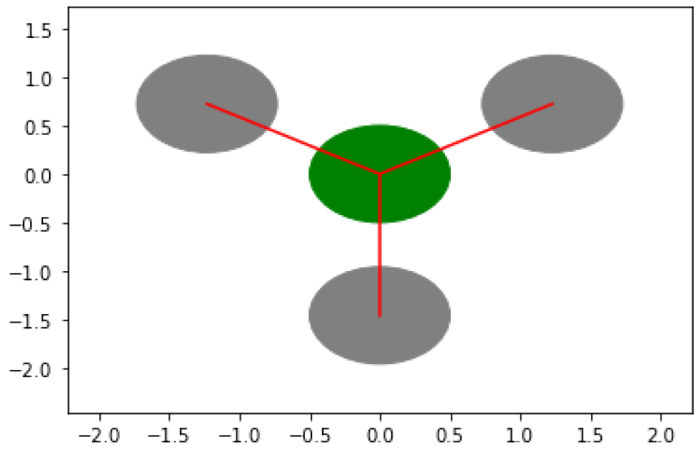
Figure 2 - Atoms with different types of environment

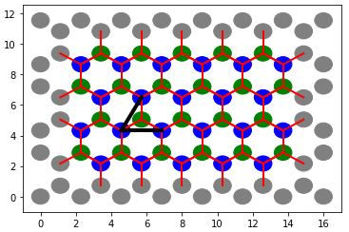
Figure 3 - The result of clustering atoms by their environment type and the main translational vectors. Blue and green circles are atoms with different type of environment.Black lines are the main translational vectors

2.2 Model verification results

The calculations were performed using the infrastructure of the Computer science center of the IU RAS [9]. The multistart method was parallelized using OpenMP directives for 160 threads. For each potential, we obtained 32,000 local minima of the problem in statement I. Then, for 20% of the best values, we solved the problem in statement II.
For the original set of parameters of the Tersoff potential, a solution was found with an energy of -443.73 (-419.42 for statement I). Translation vectors are shown in Table 1.

Table 1 - Translation vectors for the original Tersoff potential
Statement I |  | Statement II
Vector length | The angle with the X axis | Vector length | The angle with the X axis
2.29 | 0 | 2.53 | 0
2.45 | 62.18 | 2.53 | 60
2.45 | 117.82 | 2.53 | 120
2.29 | 180 | 2.53 | 180
2.45 | -117.82 | 2.53 | -120
2.45 | -62.18 | 2.53 | -60

As can be seen from Table 1, the use of the problem in statement I leads to some distortion of the lattice associated with a significant influence of the fragment boundaries. These distortions disappear when you switch to setting II. The angles between the main translation vectors coincide with the control samples, and the lattice constant (control value 2.46) is determined with an error of less than 3%.
For the optimized set of parameters of the Tersoff potential, a solution was found with an energy of -1067.49 (-999.59 for statement I). Translation vectors are shown in Table 2.

Table 2 - Translation vectors for the optimized Tersoff potential
Statement I |  | Statement II
Vector length | The angle with the X axis | Vector length | The angle with the X axis
1.23 | 0 | 1.29 | 0
11.52 | 90 | 13.84 | 90
1.23 | 180 | 1.29 | 180
11.52 | -90 | 13.84 | -90

As can be seen from Table 2, the obtained values are far from the values of the control sample. The ratio of the lengths of the translation vectors is equal to about 1/10. This is due to the fact that the material does not form a periodic structure along the y axis (more precisely, the period is equal to the sum of $h_{i}$).
Analysis of the results of the experiments has shown that the use of the considered model of a flat crystal lattice in combination with the original set of parameters of the Tersoff potential makes it possible to determine the type and constant of the crystal lattice with sufficient accuracy. It can be seen that the solutions to the problem in statement I are close to the control samples, but the errors introduced by the statement lead to an inequality of the X and Y axes, which is not observed in practice. Only consistent use of statements I and II allows you to get the correct result.
The use of optimized parameters of the Tersoff potential leads to the appearance of many "sparse" configurations (either on the Y-axis or on the X-axis). For the best solution found, a rectangular lattice is obtained instead of a hexagonal one. Therefore, in our case, the use of an optimized set of parameters is not recommended.

3 Creating an Atlas of configurations using cluster analysis methods

Clustering methods were used to determine the type of crystal lattice obtained as a result of a numerical experiment. Using the multistart method, we obtained 128 thousand local minima of energy, from which we then selected 20% of the best solutions. For each result, we determined the" appearance " of the crystal lattice and divided the results into 16 clusters. Then we analyzed which grid appeared in each cluster.
The energy distribution of 128 thousand configurations of a flat crystal lattice with an energy distribution is shown in Figures 4a, 4b.
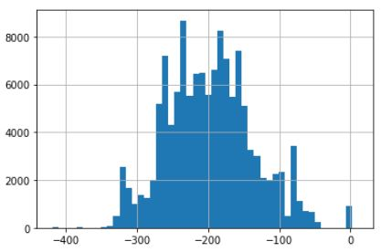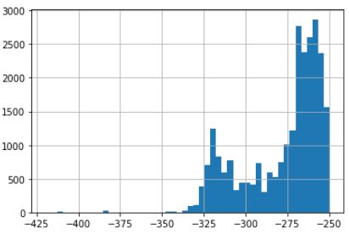
a) 1 energy distribution 128 thousand configurations of a flat crystal lattice with energy distribution
b) 2 energy distribution 128 thousand configurations of a flat crystal lattice with energy distribution
Figure 4-energy Distribution of local minima in statement 1

In order to reduce the number of calculations, configurations with energy E ≤ -250.0 were taken, and the minimization problem in statement II was solved for each configuration, provided that this energy is used as an initial approximation. Figure 5 shows that the energy distribution has not changed significantly (especially in the energy range [-350,0, -250,0]), except for the appearance of configurations with energies less than -420,0.

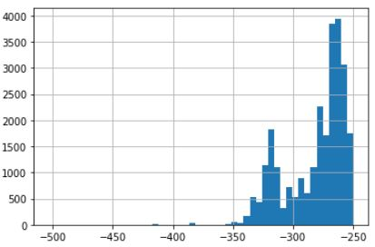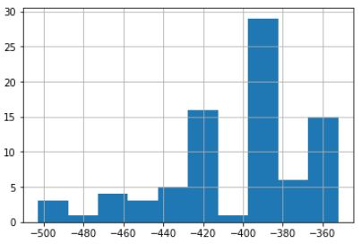
а) 1 local minimum energy distribution
b) 2 local minimum energy distribution
Figure 5-energy Distribution of the local minimum in statement 2

3.1 A single configuration analysis

For the resulting configurations, by analogy with the section verification Mat. for example, we have determined how many neighbors each atom can have. A characteristic feature of this set is that it contains both single and multi-neighboring atoms (from one to four).
As a result of clustering the sample by the number of neighbors, 16 clusters were obtained (Table 3), their energy is distributed unevenly, there are peaks and troughs, which can be seen in Figure 6.
Table 3-clustering Result sorted by number of neighbors
 | n0 | n1 | n2 | n3 | n4 | E_{min} | E_{max}
0 |  |  |  | X |  | -502.89 | -303.32
1 |  |  |  |  | X | -357.14 | -332.17
2 |  |  |  | X | X | -362.91 | -252.28
3 |  |  | X |  |  | -347.21 | -256.83
4 |  |  | X | X |  | -389.12 | -250.06
5 |  |  | X | X | X | -363.03 | -250.05
6 |  |  | X |  | X | -316.91 | -252.53
7 | X |  | X | X | X | -289.43 | -263.91
8 | X |  | X | X |  | -296.50 | -250.28
9 |  | X |  | X | X | -294.68 | -252.32
10 |  | X |  | X |  | -319.29 | -250.75
11 |  | X | X | X |  | -337.76 | -250.07
12 | X | X | X | X |  | -315.17 | -250.66
13 |  | X | X | X | X | -345.71 | -259.10
14 | X | X | X | X | X | -266.36 | -259.13
15 | X |  |  | X | X | -257.67 | -257.57

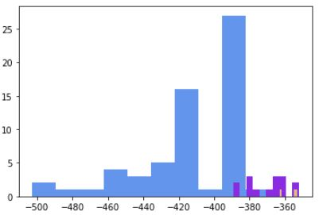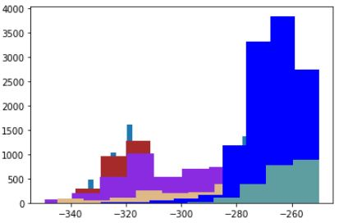
a) Energy distribution of configurations taking into account the number of neighbors for the interval [-502.89, -316.91]
b) Energy distribution of configurations taking into account the number of neighbors for the interval [-316.91, -257.67]
Figure 6-energy Distribution of configurations taking into account the number of neighbors

Next, we analyzed the configurations contained in each cluster.
To do this, the data were collected in a single sample and grouped into three clusters with the following energy intervals and types of atoms (Figure 7):
1) A0. 1 [-502.89, -384.57], atoms of type a, b (Figure 4);
2) A0.2 [-333.65, -303.32], atoms of type e, f (Figure 8);
3) A0.3 [-416.62, -307.20], atoms of type a, b, c, d (Figure 8).

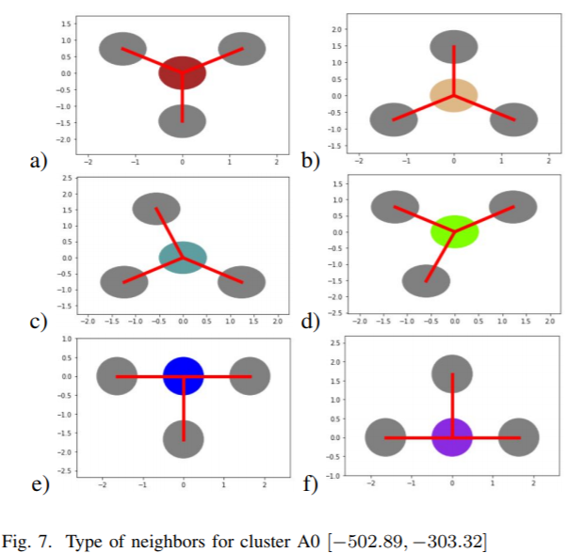
- the type of neighbors for the cluster A0.1
- the type of neighbors for the cluster A0.2
- the type of neighbors for the cluster A0.3
- the type of neighbors for the cluster A0.4
- the type of neighbors for the cluster A0.5
- the type of neighbors for the cluster A0.6
Figure 7 - Types of neighbors for a cluster A0 [-502.89, -303.32]

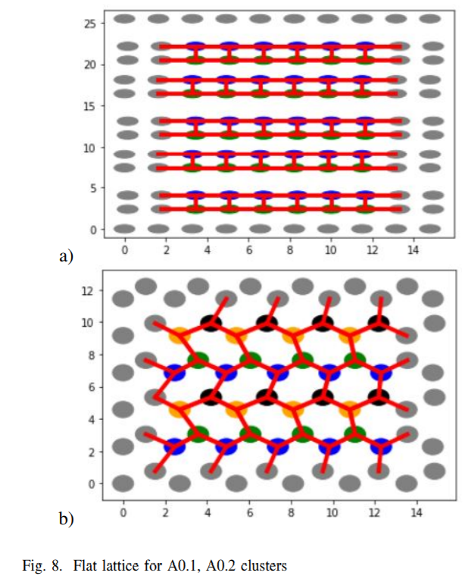
a) Cluster А0.1
b) Cluster А0.2
Figure 8 - Flat grid for clusters А0.1, А0.2

1) Cluster A1 [-357,14, -332,17] contains 23 configurations.
The configuration energies of this cluster are in the range [-357.14, -332.17].
The cluster contains atoms of the same type as in Figure 9a.
The crystal lattice of the first cluster is shown in Figure 9b.
Comparing clusters A1 and A0.1, it is clear that A0.1, that the third cluster is a distortion of the first, and the second cluster is qualitatively different from them.

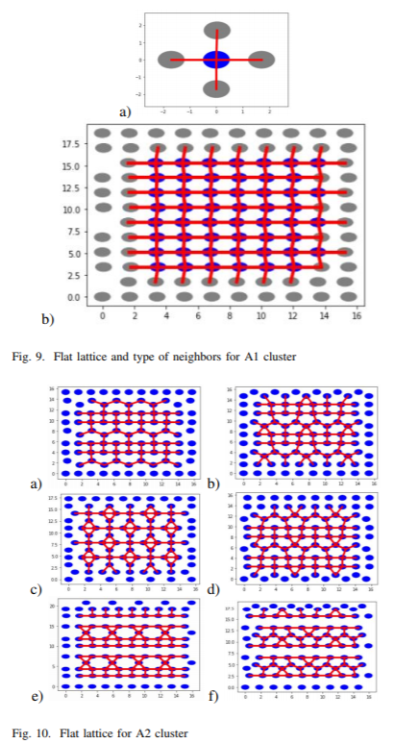
a) Cluster A1
b) Crystal lattice of the first cluster
Figure 9 - Flat grid and neighbor types for cluster A1

2) Cluster A2 [-362,91-252,28]
Cluster A2 contains 131 configurations.
The energies of the configurations of this cluster lie in the range [-362.91 - 252.28].
Cluster A2 contains 6 clusters:
а) A2.1,
b) A2.2,
c) A2.3,
d) A2.4,
e) A2.5,
f) A2.6, shown in figure 10.

- Cluster A2.1
- Cluster A2.2
- Cluster A2.3
- Cluster A2.4
- Cluster A2.5
- Cluster A2.6
Figure 10 - Flat grid for a cluster А2

As you can see, clusters a A2.2 and A2.4 are mirror images of each other. The types of atoms that make up these clusters are shown in figure 11.

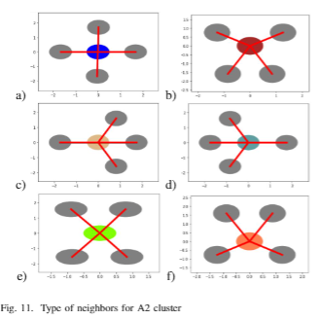
- Type of neighbors for cluster А2.1
- Type of neighbors for cluster А2.2
- Type of neighbors for cluster А2.3
- Type of neighbors for cluster А2.4
- Type of neighbors for cluster А2.5
- Type of neighbors for cluster А2.6
Figure 11 - Types of neighbors for cluster А2

3) Cluster A3 [-347,21, -256,83]
The cluster contains 3455 configurations.
The energies of the configurations of this cluster lie in the range [-347.21, -256.83].
This cluster includes "sparse" configurations with sufficiently large distances between atoms.
Since we use a certain radius to determine neighbors, each atom in the cluster contains exactly two neighbors.
Among the results obtained, there are no atoms with vertical neighbors.
The types of atoms can be seen in figure 12.
It makes no sense to list all kinds of crystal lattices; for example, two lattices are shown in figure 13.

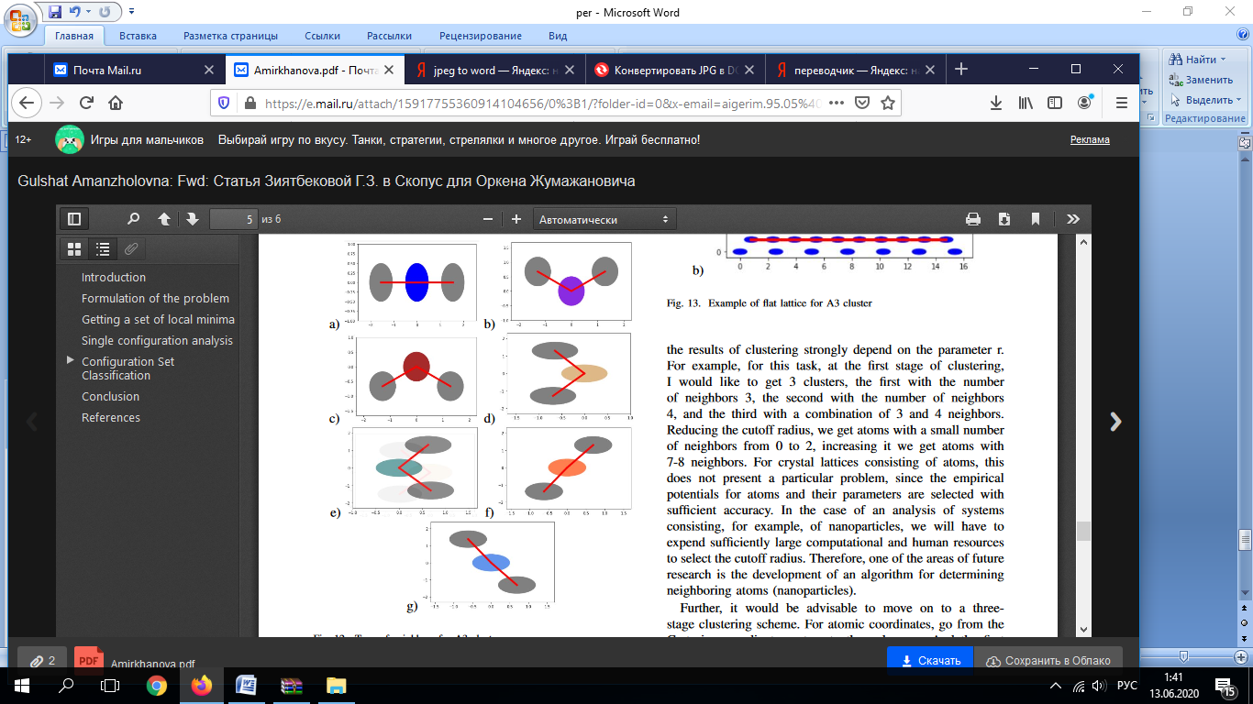
- Type of neighbors for cluster А3.1
- Type of neighbors for cluster А3.2
- Type of neighbors for cluster А3.3
- Type of neighbors for cluster А3.4
- Type of neighbors for cluster А3.5
- Type of neighbors for cluster А3.6
- Type of neighbors for cluster А3.7
Figure 12 - Types of neighbors for cluster А3

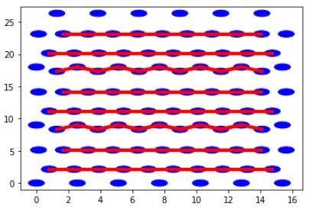
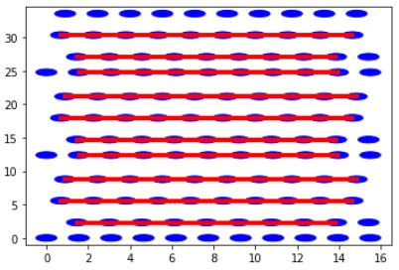
а) Example of a flat grid for cluster A3.1
b) Example of a flat grid for cluster А3.2
Figure 13 - Example of a flat grid for cluster А3

4 Review of modern methods for producing ZnO thin films doped with Al
Zinc oxide (ZnO) is a straight-band semiconductor material with a band gap of 3.37 eV, high exciton binding energy (60 MeV) at room temperature, and effective ultraviolet luminescence. It can be used as components of gas sensors [10], photocatalysts [11], solar cells [12], piezoelectric nanogenerators [13], luminescent materials, light-emitting diodes, lasers [14], composite materials, and is also a safe biocompatible material with antiseptic properties [15,16]. To improve the conductivity, ZnO is doped with aluminum (ZnO:Al), gallium, and indium. The greatest attention is paid to ZnO: Al, whose transparency is ∼ 90% in the visible and IR range [17], and the resistivity is about 10⁻²−10⁻⁴ Ohms*cm.
Let us consider in detail several chemical and physical methods for producing ZnO and ZnO:Al thin films.
Sol-gel deposition methods. The Sol-gel method is a method for obtaining materials that involves obtaining Sol and then converting it into a gel, i.e., into a colloidal system consisting of a liquid dispersion medium enclosed in a spatial grid formed by joined particles of the dispersed phase. This method has a number of advantages due to the simplicity of the technological process of deposition of large-area coatings, the low cost of the equipment used, and a wide range of reagents used, such as zinc acetate (Zn(CH₃COO)₂-2H₂O, purity 99.95%), anhydrous methanol with an increasing concentration of aluminum impurities, (98.5% pure AlCl₃) and polyvinylpyrrolidone [18]. Depending on the deposition conditions, ZnO:Al films obtained by Sol-gel deposition have different microstructures that determine their electrical and optical parameters. Thus, by changing the composition and concentration of solvents, the sintering and annealing temperatures, it is fashionable to control the properties of films [19]. Figure 13 shows a diagram of the process of obtaining ZnO films:Al by Sol-gel deposition
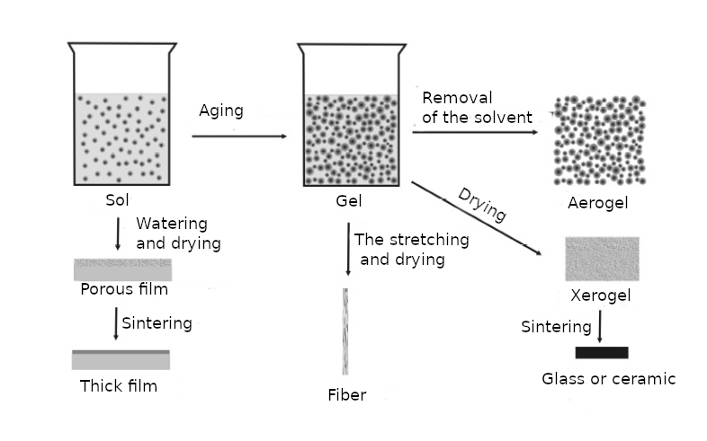
Figure 13-Diagram of the process of obtaining ZnO films:Al by Sol-gel deposition
The disadvantages of Sol-gel technology include the high cost of some pure chemical reagents, technological difficulties encountered in obtaining films over large areas (cracking of gels during drying and heat treatment), an increased content of hydroxyl groups in glass, and the duration of the production process.
Hydrothermal deposition method. The chemical hydrothermal deposition method is attractive for the following reasons: low cost, synthesis at relatively low temperatures, the possibility of using flexible substrates, and easy control of the morphology and properties of the resulting material. The hydrothermal method makes it possible to obtain arrays of ZnO nanorods on various substrates with a thin-film sublayer of zinc oxide. The morphology of the arrays is determined by the thickness and crystal structure of the sublayer [20]. In a typical hydrothermal process, ZnO nanorods are synthesized by the following reactions [21]:

(CH₂)₆N₄+6H₂O→4NH₃+6HCHO

NH₃+H₂O↔NH₃·H₂O↔NH₄⁺+OH⁻ (2)

Zn²⁺+2OH⁻↔Zn(OH)₂↔ZnO+H₂O

During the growth of nanorods, urotropin is hydrolyzed to form formic aldehyde and ammonia, acting as a pH buffer, providing a low and controlled concentration of ammonia, which, in turn, is hydrolyzed to form ammonium ions NH₄⁺ and hydroxides of OH⁻. Zn²⁺ ions are solvated in an alkaline medium to form a number of hydroxides of the composition: ZnOH⁺, Zn(OH)₂, Zn(OH)⁻₃ and Zn(OH)²⁻₄. then, in the process of dehydration, the centers of crystallization of ZnO nanocrystals are formed. ZnO nanocrystals continue to grow as a result of condensation of zinc hydroxide on their surface. The rate of these reactions can be controlled by adjusting reaction parameters, such as reagent concentrations, reaction medium temperature, and process time [22]. The low synthesis temperature of zinc oxide nanorods, about 70-90°C, allows them to be deposited on various materials, including flexible polymer substrates. The disadvantages of this method include the rather difficult to control production of doped ZnO:Al films.
Magnetron sputtering method. Magnetron sputtering is a technology for applying thin films to a substrate by cathodic sputtering of a target in a magnetron diode discharge plasma in crossed fields. The operation of a modern magnetron sputtering device (figure 14) is based on the properties of the cathode region of an anomalous glow gas discharge, in which the cathode (target) is atomized by ion bombardment [23].
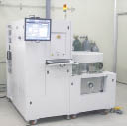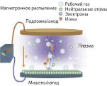

Figure 14-General appearance (left) and schematic representation of the operating mechanism (right) of the CS-1000 Sputter& PVD Deposition System magnetron spray system

The magnetron sputtering method makes it possible to obtain high-quality thin films with good physical characteristics (thickness, porosity, adhesion, etc.), as well as to perform layer-by-layer synthesis of new structures (structural design), creating a film literally at the level of atomic planes. The growth rate of epitaxial and uniaxial-epitaxial films reaches 7 nm / s and is limited by the thermal power sustained by the target: the ZnO sputtered target is destroyed under high current loads [24]. However, the magnetron sputtering method, as well as all methods, has its drawbacks, which include low performance, high cost of the equipment used, and difficulties in matching the magnetron power source with the load when operating at high frequencies.
Chemical gas phase deposition (CVD) method. In the CVD process, the substrate is placed in pairs of one or more substances that react and / or decompose to produce the desired substance on the surface of the substrate. In General, the literature data describe the production of ZnO films, the morphology of which is an array of nanorods (figure 15). To produce such films, metal zinc of 99.99% purity and oxygen of 99.999% purity are used as precursors. The deposition process is carried out at a temperature of 500-600⁰С, in an argon medium [25].

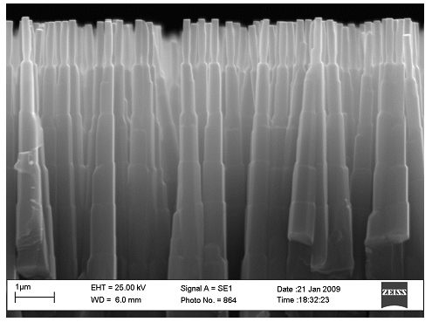
Figure 15-SEM Image of ZnO nanorods obtained by CVD on a single-crystal silicon substrate

The following advantages of the CVD method can be noted: the use of relatively simple and cheap equipment, does not require ultra-high vacuum, and allows achieving high deposition rates of up to several mm / h [25]. There are also disadvantages, one of which is the rather high temperature of the process, which limits the range of substrates used. In addition, a temperature above 400⁰С is also unacceptable because it activates the diffusion of alloying impurities in the semiconductor, depriving it of the specified functional properties. In some cases, along with the main CVD reaction, undesirable side reactions may occur in parallel, and then the film may be contaminated with impurities, for example, carbon and metal carbide.
Gas phase deposition method with the presence of ORGANOMETALLIC compounds (MOCVD). MOCVD is a modernized CVD method in which chemical deposition from the gas phase occurs by thermal decomposition of ORGANOMETALLIC compounds. To produce ZnO films, diethylzinc (DEZ) and water vapor (H₂O) are used as precursors. The advantages of this method in comparison with CVD are the possibility of reducing the reaction temperature to 110 – 380⁰С and simultaneously increasing the deposition rate of ZnO films, as well as obtaining smoother films [26]. Figure 16 shows a schematic representation of the operation of the MOCVD reactor. The main disadvantage of this technology is the high cost of the equipment and raw materials used.
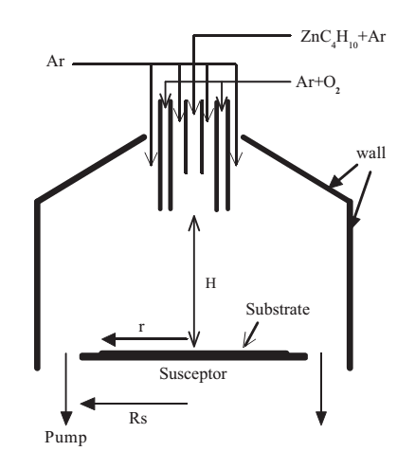
Figure 16-Schematic representation of the operation of the MOCVD reactor

Layer-by-layer atomic deposition (ALD) method. ALD is a method for growing thin films based on the sequential use of self-terminating gas-solid transition reactions, which makes it possible to obtain structures on various substrates up to atomic dimensions. During the formation of ZnO: Al films by the ALD method, the processes of formation of thin layers (on the order of several nm) of ZnO and Al₂O₃ alternate with a given period in the reactor. Intermediate processes of nitrogen purging are automatically carried out between the processes of layer formation [27]. The working diagram of the ALD reactor is shown in figure 17. The films are deposited at relatively low temperatures of 150-250°C. Trimethylaluminium (TMA), diethylzinc (DEZ), and deionized water (H₂O) are also used as precursors.
So, the advantages of the ALD method are uniform thickness of the film on a complex surface, which can not be achieved by other technological methods, such as Sol-gel method, CVD, etc., the possibility of obtaining a uniform structure, good control of the level of doping with an impurity. The only significant drawback of this technology is the high cost of equipment and used precursors [28].

Figure 17-Schematic representation of the ALD reactor

CONCLUSION

As a result of the experiment, the developed model of a flat crystal lattice was tested, in which graphene is used as an example. For the configuration with the lowest energy value, the main translation vectors were determined, the angle between them was 60% + 10⁻⁵, and the lattice constant 2.53 A◦ was calculated (the lattice constant for graphene is 2.46, the error does not exceed 3%).
The use of optimized parameters of the Tersoff potential leads to the appearance of many "sparse" configurations (either on the Y-axis or on the X-axis). For the best solution found, a rectangular lattice is obtained instead of a hexagonal one. Therefore, in our case, the use of an optimized set of parameters is not recommended.
It was also shown that the model has the maximum safety margin: the global minimum value is -502.89 (the lowest value in the cluster A0. 1, whose configurations have a hexagonal structure or are close to it) is significantly less than the minimum of the nearest cluster A0.3 (cluster with configurations close to rectangular), equal to -416.62, that is, the relative difference between them is approximately 20%.
A technology for analyzing the resulting configurations was developed, namely two-stage configuration clustering:
1) First stage: clustering by number of neighbors,
2) the Second stage: clustering by the coordinates of neighboring atoms.
Using this technology, an Atlas of flat crystal lattice configurations obtained as a result of a numerical experiment was compiled.
Additionally, experiments were successfully conducted to adapt optimization methods for computing clusters based on the Message Passing Interface (MPI).
Results:
2020: a program and methods for conducting experimental studies, methods for classifying stationary States of matter based on cluster analysis approaches have been Developed.
Verification of the mathematical model used and evaluation of the simulation accuracy based on comparison with the known values of the physical characteristics of the simulated two-dimensional crystals are carried out. The stability of the model to errors of optimization methods and empirical potentials is investigated. The efficiency of parallelization of the applied optimization methods is analyzed. An Atlas of configurations obtained by cluster analysis methods has been compiled
2019: The project solved all the main tasks reflected in the calendar plan for 2019. Optimization methods focused on solving the problems under consideration are developed. The resulting optimization algorithms, focused on the challenges of nanotechnology. A software package has been created for solving optimization problems that arise in nanotechnology.
Theoretical research aimed at developing optimization methods is carried out. Local and global extremum search algorithms and hybrid algorithms are obtained. Component diagrams and class diagrams of the software package are made. A numerical experiment was performed for the - K-means, Mini Batch K-Means, and AffinityPropagation methods.
The report offers an algorithm for searching for a global extremum with interval constraints on the problem parameters. This algorithm was implemented programmatically and applied to solve the practical problem of determining the energy-optimal conformation of a flat crystal. The results of the numerical experiment showed a significant advantage of the proposed method for selecting starting points in comparison with the pseudorandom method. One-dimensional optimization problems can be solved independently. Therefore, the proposed algorithm is well suited for applying parallel and distributed computing to speed up work. Further research is planned to conduct a large-scale numerical experiment using a library of test functions in order to identify classes of problems for which the algorithm is most effective.
Software implementation of optimization modules in C++is implemented. A software package has been created that includes modules for working with the crystal lattice model and modules that implement the developed optimization methods.
2018: The project solved all the main tasks reflected in the calendar plan for 2018. A two-dimensional model of a flat crystal is developed. A theoretical justification is obtained and a software implementation of the flat crystal lattice model is developed. The model is applied for the case of a two-dimensional crystal. Optimization problems for calculating the geometric structure of a flat crystal are formulated.
A model of a flat crystal lattice was developed. Methods for localization of a flat lattice fragment are developed. Algorithms were developed for calculating the energy of a lattice fragment in a force field.
A software implementation of the flat crystal lattice model was obtained. Software modules that are part of the plane model of the material and calculate the positions of atoms based on the lattice parameters are obtained. Software components for determining and calculating the energy of a periodic lattice fragment are obtained. A software implementation of the C++ model of a flat crystal lattice is obtained. the software implementation includes modules that calculate the positions of atoms based on the lattice parameters. The Lennard-Jones, Morse, and Tersoff potentials are implemented. The flat crystal lattice model is integrated with the free package for classical molecular dynamics LAMMPS (Large-scale Atomic/Molecular Massively Parallel Simulator) for calculating the rebo/AIREBO potential.

LIST OF USED SOURCES
- Condensed Matter Physics: study pos. / N.I. Filimonova, R.P. Dikareva. - Novosibirsk: Publishing house of NSTU, 2016 .-- 136 p. (original in Russian)
- Lurie S.A., Posypkin M.A., Solyaev Yu.O. Method of identification of scale parameters of gradient elasticity theory based on numerical experiments for plane composite structures // Internat. J. of Open Informat. Technol. - 2015. - T. 3. No. 6. - S. 1-6. (original in Russian)
- SOUTH. Evtushenko, S.A. Lurie, M.A. Posypkin, Yu.O. Solyaev. Application of optimization methods for finding equilibrium states of two-dimensional crystals // Zh. Vychisl. mat. and mat. physical - 2016. - T. 56., No. 12. - S. 50-59.(original in Russian)
- Tersoff J. Empirical interatomic potential for carbon, with applications to amorphous carbon Physical Review Letters.- 1988. - Vol. 61. P. 25.
- Lindsay, L., & Broido, D. A. (2010). Optimized Tersoff and Brenner empirical potential parameters for lattice dynamics and phonon thermal transport in carbon nanotubes and graphene. Physical Review B, 81(20), P. 205-441.
- Amirkhanova G.A., Gorchakov A.Yu. Verification of one model of a planar crystal lattice // Mater. V Int. scientific conference. "Informatics and Applied Mathematics" IIVT. - Almaty: IIVT MES RK, 2020 .-- S. 114-119.(original in Russian)
- Scikit-learn: Machine Learning in Python, Pedregosa et al.// JMLR 12, P. 2825- 2830, 2011.
- Comaniciu D., Meer P. Mean shift: A robust approach toward feature space analysis //IEEE Transactions on pattern analysis and machine intelligence. – 2002. – Т. 24, №. 5. – С. 603-619.
- Regulations on the Center for Collective Use "Informatika" // http://www.frccsc.ru/ckp: 10/22/2020.
- Govender K., Boyle D. S., Kenway P. B., O'Brien P. Understanding the factors that govern the deposition and morphology of thin films of ZnO from aqueous solution // J. Mater. Chem. - 2004. –Vol. 14. –P. 2575–2591.
- Li С., Liang H., Zhao J., Feng Q., Bian J., Liu Y., Shen R., Li W., Wu G., Du G.T. Influence of high-pressure hydrogen treatment on structural and electrical properties of ZnO thin films // Applied Surface Science. -2010. –Vol. 256. –P. 6770–6774.
- Law M., Greene L. E., Johnson J. C., Saykally R., Yang P. D. Nanowire dyesensitized solar cells //Nat. Mater. -2005. –Vol. 4. –P. 455–459.
- Pronin A., Kaneva N.V., Bozhinova A.S. et. al. Photocatalytic oxidation of pharmaceuticals on thin nanostructured Zinc Oxide films // Kinetics and Catalysis. - 2014, P.166–170.
- Wang Z. L. Song J. H. Piezoelectric nanogenerators based on zinc oxide nanowire arrays // Science. -2006. –Vol. 312. –P. 242–246.
- Xie Ya., He Y., Irwin P. L., Jin T., Shi X. Antibacterial activity and mechanism of action of zinc oxide nanoparticles against campylobacter jejuni // Applied and Environmental Microbiology. – 2011. –Vol. 77. –P.2325-2331.
- Kumar R., Umar A., Kumar G., Nalwa H.S. Antimicrobial properties of ZnO nanomaterials: A review // Ceramics International. -2017. –Vol. 43. –P. 3940- 3941.
- Dakal T., Nandur A.S., Christian R., Vasekar P., Desu S., Westgate Ch., Koukis D.I., Arenas D.J., TannerD.B. Transmittance from visible to mid infrared in AZO films grown by atomic layer deposition system // Solar Energy. -2012. –Vol. 86. –P. 1306- 1312.
- Park W. I., Yi G. C. Electroluminescence in n‐ZnO nanorod arrays vertically grown on p‐GaN // Adv. Mater. -2004. –Vol. 16. –P. 87–90.
- Govender K., Boyle D. S., O'Brien P., Binks D., West D., Coleman D. Room‐ temperature lasing observed from ZnO nanocolumns grown by aqueous solution deposition // Adv. Mater. -2002. –Vol. 14. –P. 1221–1224.
- Yokoo T., Nagashima K., Yanagita T., Obukuro Yu., Okuyama T. Evaluation of crystal structure and surface-to-molecule interaction in hydrothermally grown titanium oxide nanowires // Microscopy. -2011. –Vol. 22. –P. 24-56.
- de Queiroz J., Cesar A., de Azevedo F. J.B., de Medeiros N. J., Nascimento I. O., de Souza I.A., de Oliveira Q.M.G., de Melo E.B., Melo J.D. D., de Carvalho C. Th. H. Structural and optical properties of Al-doped ZnO thin films produced by magnetron sputtering // Processing and Application of Ceramics. -2003. –Vol. 15. –P. 464–466.
- Electronics time (in Russian) // http://www.russianelectronics.ru: 22.10.2020.
- Al-Thuaeli S.A. Synthesis of thin films of zinc oxide by magnetron sputtering at high growth rates // All-Ukrainian International Conference of Young Scientists "Chemistry, Physics and Technology of Surface". - Kiev., 2012. - P.76-78.(original in Russian)
- Kononenko O.V., Redkin A.N., Panin G.N., Baranov A.N., Firsov A.A., Levashov V.I., Matveev V.N. and Vdovin, E.E. ZnO nanorods: synthesis by catalyst-free CVD and thermal growth from salt composites and application to nanodevices // Nanotechnologies in Russia. -2009. –Vol.4. –P. 822–827.
- Syrkin V.G. CVD method. Chemical vapor deposition. - M .: Nauka., 2000.-496s.
- Nicolay S., Benkhaira M., Ding L., Escarre J., et al. Control of CVD-deposited ZnO films properties through water/DEZ ratio: Decoupling of electrode morphology and electrical characteristics // Solar Energy Materials & Solar Cells. -2012, -Vol.105. –P. 46–52.
- Jeong J.-K., Yun H.-J., Yang S.-D., Eom K.-Y., Che S.-W., Park J.-H., Lee H.- D., Lee G.-W. Investigation of atomic-layer-deposited Al-doped ZnO film for AZO/ZnO double-stacked active layer thin-film transistor application // Thin Solid Films. -2017, - Vol. 683. -P. 89-95.
- Ritala M., Saloniem H., Leskela M., Prohaska T., Friedbacher G., Grasserbauer M. Studies on the morphology of Al2O3 thin films grown by atomic layer epitaxy // Thin Solid Films. -1996. –Vol. 286. –P. 54.

APPENDIX A
Calendar plan
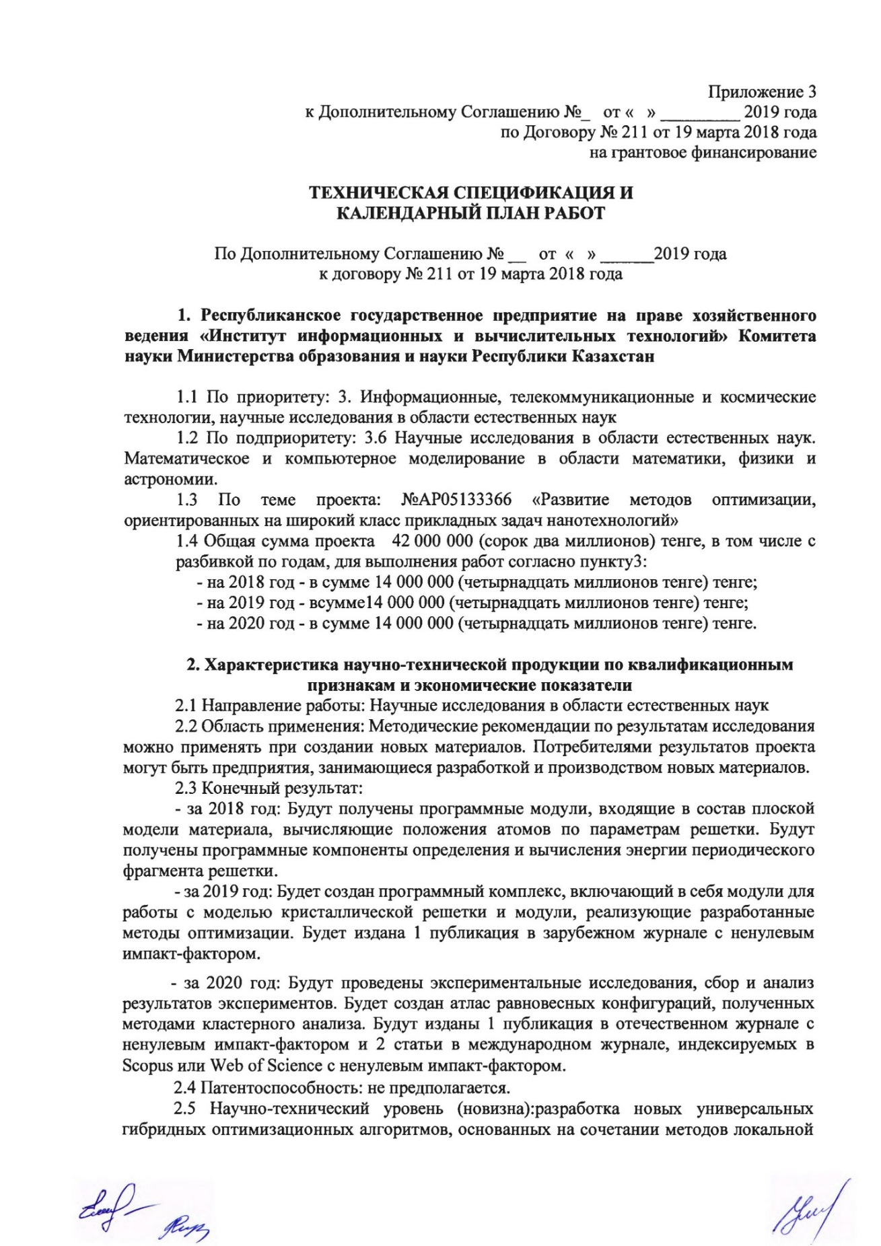
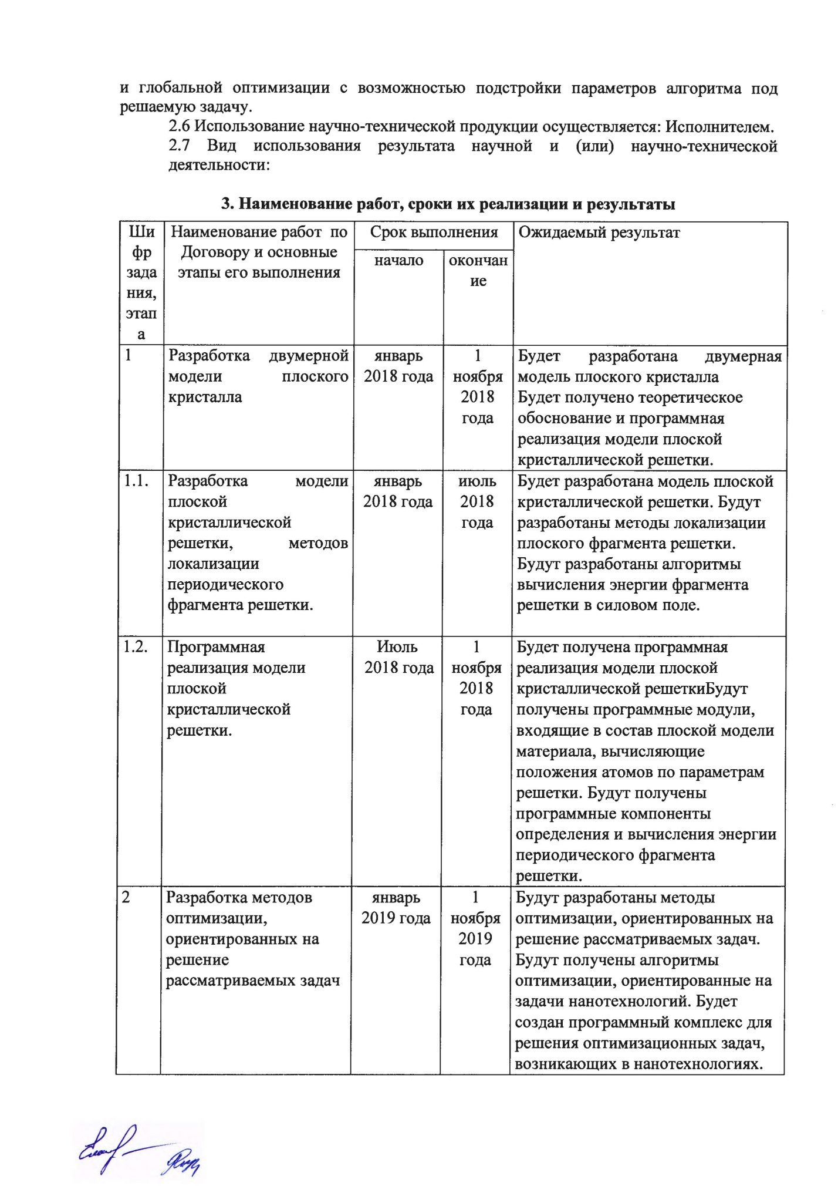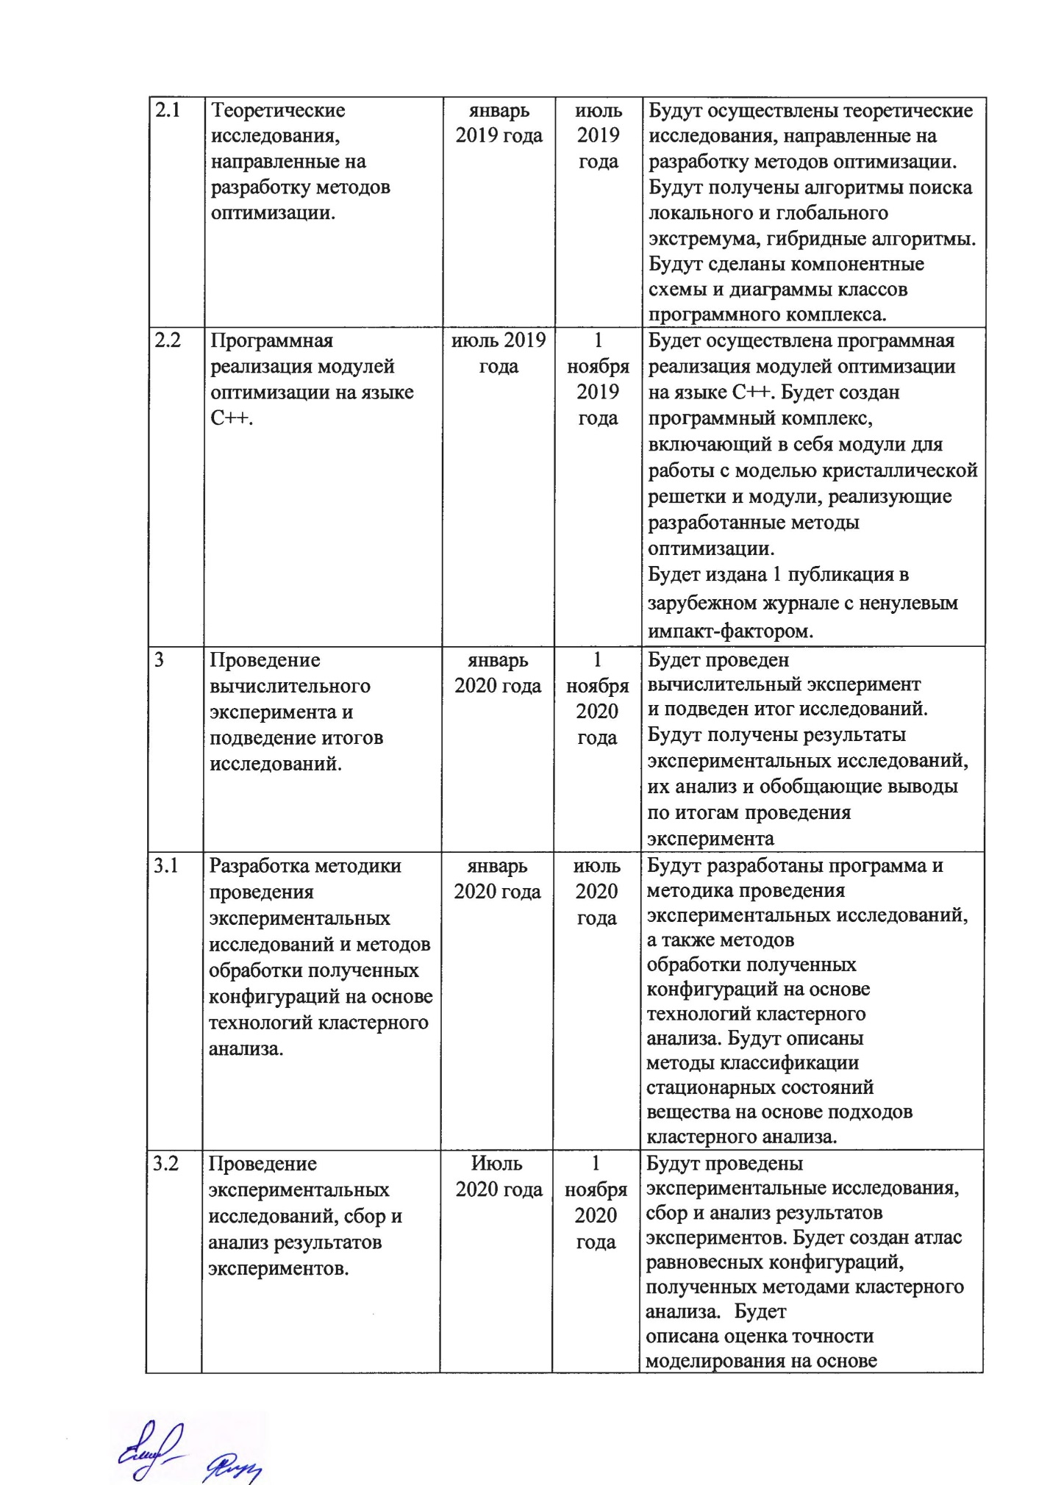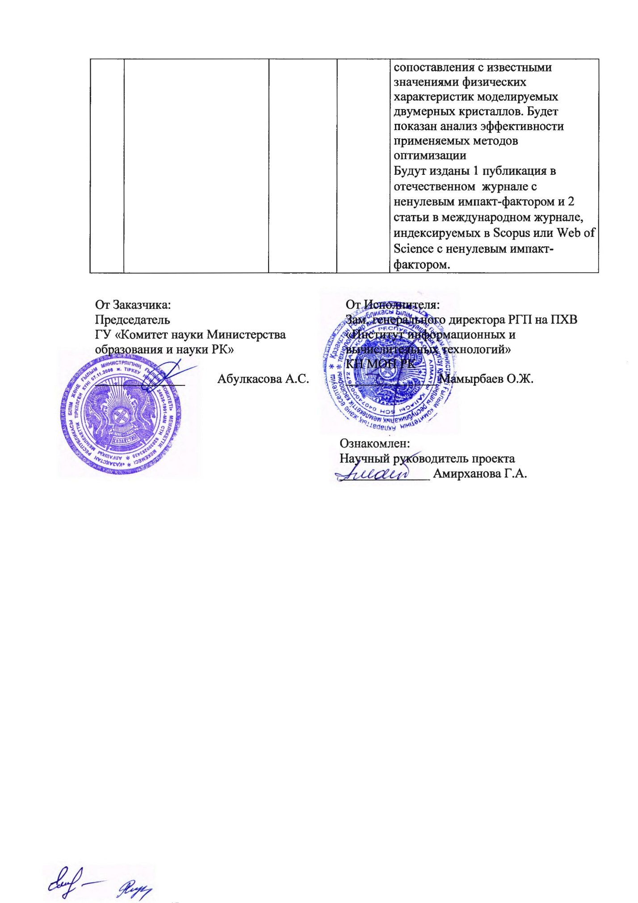

Appendix 3
to Supplementary Agreement No.__ dated "" _______2019
under Agreement No. 211 dated March 19, 2018
for grant funding

TECHNICAL SPECIFICATIONS AND
CALENDAR WORK PLAN

under Supplementary Agreement No.__ dated "" _______2019
to Agreement No. 211 dated March 19, 2018

1. Republican state enterprise on the right of economic management "Institute of Information and Computing Technologies" of the Science Committee of the Ministry of Education and Science of the Republic of Kazakhstan

1.1 By priority: 3. Information, telecommunication and space technologies, scientific research in the field of natural sciences
1.2 For sub-priority: 3.6 Scientific research in the field of natural sciences. Mathematical and computer modeling in the field of mathematics, physics and astronomy.
1.3 On the topic of the project: No. AP05133366 "Development of optimization methods focused on a wide class of applied nanotechnology problems"
1.4 The total amount of the project is 42,000,000 (forty-two million) tenge, including by year, for the performance of works in accordance with paragraph 3:
- for 2018-in the amount of 14,000,000 (fourteen million tenge) tenge;
- for 2019 - in the amount of 14,000,000 (fourteen million tenge) tenge;
- for 2020-in the amount of 14,000,000 (fourteen million tenge) tenge.

2. Characteristics of scientific and technical products by qualification criteria and economic indicators
2.1 Field of work: Scientific research in the field of natural Sciences
2.2 Scope: Methodological recommendations based on the research results can be used when creating new materials. Consumers of project results can be enterprises engaged in the development and production of new materials.
2.3 Final result:
- for 2018: software modules that are part of the planar material model will be obtained that calculate the positions of atoms based on lattice parameters. Software components for determining and calculating the energy of a periodic lattice fragment will be obtained.
- for 2019: A software package will be created that includes modules for working with the crystal lattice model and modules that implement the developed optimization methods. There will be 1 publication in a domestic journal with a non-zero impact factor and 1 publication in an international journal indexed in Scopus or Web of Science with a non-zero impact factor.
- for 2020: experimental research, collection and analysis of experimental results Will be carried out. An Atlas of equilibrium configurations obtained by cluster analysis methods will be created. There will be 1 publication in a domestic journal with a non-zero impact factor and 2 articles in an international journal indexed in Scopus or Web of Science with a non-zero impact facto
2.4 Patentability: not assumed.
2.5 Scientific and technical level (novelty): development of new universal hybrid optimization algorithms based on a combination of local and global optimization methods with the ability to adjust the algorithm parameters to the problem being solved.
2.6 The use of scientific and technical products is carried out by: the Contractor.
2.7 Type of use of the result of scientific and (or) scientific and technical activities:

3. Name of works, terms of their implementation and results
Task code, stage | Name of work under the Agreement and the main stages of its implementation | Period of execution |  | Expected Result
Task code, stage |  | Start | Finish | Expected Result
1 | Development of a two-dimensional model of a flat crystal | January of 2018 | November 1, 2018 | A 2D model of a flat crystal will be developed  A theoretical basis and software implementation of the model of a planar crystal lattice will be obtained.
1.1. | Development of a model of a planar crystal lattice, methods for localizing a periodic fragment of the lattice. | January of 2018 | July  Of 2018 | A planar crystal lattice model will be developed. Methods for localizing a flat lattice fragment will be developed. Algorithms for calculating the energy of a lattice fragment in a force field will be developed.
1.2. | Software implementation of the flat crystal lattice model. | July  of 2018 | November 1, 2018 | A software implementation of the model of a planar crystal lattice will be obtained. Software modules that are part of a plane model of a material will be obtained, which calculate the positions of atoms by the lattice parameters. The software components for determining and calculating the energy of the periodic fragment of the lattice will be obtained.
2 | Development of optimization methods focused on solving the problems under consideration | January of 2019 | November 1, 2019 | Optimization methods will be developed to solve the problems under consideration. Optimization algorithms focused on nanotechnology problems will be obtained. A software package will be created to solve optimization problems arising in nanotechnology.
2.1 | Theoretical studies aimed at developing optimization methods. | January of 2019 | July  of 2019 | Theoretical studies will be carried out aimed at developing optimization methods. Algorithms for finding local and global extremum, hybrid algorithms will be obtained. Component diagrams and class diagrams of the software package will be made.
2.2 | Programming implementation of optimization modules in C ++. | July  of 2019 | November 1, 2019 | The software implementation of optimization modules in C ++ will be implemented. A software package will be created that includes modules for working with a crystal lattice model and modules that implement the developed optimization methods.  1 publication will be published in a domestic journal with a non-zero impact factor and 1 publication in an international journal indexed in Scopus or Web of Science with a non-zero impact factor.
3 | Conducting a computational experiment and summing up the research results. | January of 2020 | November 1, 2020 | The results of experimental studies, their analysis and general conclusions based on the results of the experiment will be obtained.
3.1 | Development of a methodology for conducting experimental studies and processing methods for the resulting configurations based on cluster analysis technologies. | January of 2020 | July  of 2020 | A program and methodology for conducting experimental research will be developed. Methods for classifying stationary states of matter based on cluster analysis approaches will be developed.
3.2 | Experimental research, collection and analysis of experimental results. | July  of 2020 | November 1, 2020 | Experimental research, collection and analysis of experimental results will be carried out. An atlas of equilibrium configurations obtained by cluster analysis methods will be created. 1 publication in a domestic journal with a non-zero impact factor and 2 articles in an international journal indexed in Scopus or Web of Science with a non-zero impact factor will be published.

APPENDIX B

List of publications for 2020

Foreign:

- Amirkhanova G. A., Gorchakov A. Y., Duysenbaeva A. J., Posypkin M. A. Multistart method with deterministic restart mechanism. Vestnik of Saint Petersburg University. Applied Mathematics. Computer Science. Control Processes.- 2020,- Vol. 16, iss. 2.- P. 100–111.// https://doi.org/10.21638/11701/spbu10.2020.202 (In Russian). (Scopus, Процентиль - 0.72)
- Mussabek G., Alekseev S.A., Manilov A.I., Tutashkonko S., Nychyporuk T., Shabdan Ye., Amirkhanova G., Litvinenko S.V., Skryshevsky V.A. and Lysenko V. Kinetics of Hydrogen Generation from Oxidation of Hydrogenated Silicon Nanocrystals in Aqueous Solutions / Nanomaterials 2020. – Vol.10, - P.1-14.// doi:10.3390/nano10071413. (Scopus, Процентиль - 4.08)
- Mussabek G., Lysenko V., Yermukhamed D., Sivakov V., Timoshenko V.Yu. Thermally induced evolution of the structure and optical properties of silicon nanowires // Results in Physics. -2020. –Vol.18, - P. 1-6.// https://doi.org/10.1016/j.rinp.2020.103258. (Scopus, Процентиль - 4.019)
- Olenev N., Jacimovic M., Khachay M., Malkova V., Posypkin M. Golden Rule Saving Rate for an Endogenous Production Function // Optimization and Applications. OPTIMA 2019. Communications in Computer and Information Science. - Springer, Cham., 2020. - Vol.1145. – P.267-279.// doi 10.1007/978-3-030-38603-0_20.

Domestic:

- Musabek G. K., Ermukhamed D., Baktygerey S. Z., Asilbayeva R. B., Kalimoldaev M. N., Amirkhanova G. A., Sivakov V. pros and cons of using silicon nanostructures in light-stimulated hydrogen generation / / Bulletin kaznu, physics series, - 2020, -№3 (74), -pp. 61-74. (in Kazakh)
- Gorchakov A. Yu., Amirkhanova G. A., Duisenbayeva A. Zh., Musabek G. K., Baisalbayeva K. N. Cluster analysis of the local minimum energy of a plane lattice fragment // Mat. scientific conf. IICT MES RK "Modern problems of Informatics and computing technologies".- Almaty: IICT MES RK, 2020. - P. 139-150. (in Russian)
- Musabek G. K., Dikhanbaev K. K., Amirkhanova G. A. Review of modern methods for obtaining thin ZnO films doped with Al / / Mat.scientific conf. IICT MES RK "Modern problems of Informatics and computing technologies". - Almaty: IICT MES RK, 2020. - P. 122-128. (in Russian)
- Amirkhanova G. A., Gorchakov A. Yu. Verification of one model of a flat crystal lattice // Materials of the V International scientific conference "Informatics and applied mathematics" IICT. - Almaty: IICT MES RK, 2020. - pp. 114-119.
- Musabek G. K., Dikhanbaev K. K., Amirkhanova G. A. Review of modern methods for obtaining thin films of ZnO doped with Al // Vesnik KazNRTU named after K.I. Satpayev. – 2020. -№4 (140). - pp. 237-242. (in Russian)
- G. K. Musabek, D. Ermukhamed, S. Z. Baktygerey, R. B. Asilbaeva, M. N. Kalimoldaev, G. A. Amirkhanova, V. Sivakov Advantages and prospects of using silicon nanostructures for photocatalytic hydrogen generation// Bulletin KazNRTU, series physical. - 2020. - No. 3. - pp. 62-74. (in Russian)

List of publications for 2019

1 Amirkhanova G. A., Duisenbayeva A. Zh., Comparison of two variants of the multistart method // Mat. scientific conf. IICT MES RK "Innovative IT and Smart technologies".- Almaty, 2019 - pp. 304-309. (in Russian)
2 G.A. Amirkhanova, K.N. Baisalbayeva, A. Zh. Duisenbayeva, Application of optimization methods for numerical modeling of the structure and properties of new materials // Journal of Statistics, accounting and audit, 2 (73). - Almaty: AESA, 2019. -№2(73).- pp. 90-93. (in Russian)
3 Amirkhanova G.A., Duisenbaeva A.Zh., On the application of one clustering method to search for the minimum energy of a plane crystal, Mat. scientific conf. IICT MES RK "Modern problems of informatics and computing technologies." - Almaty, 2019. - pp.88-94 (in Russian)
4 Amirkhanova G.A., Gorchakov A.Yu., Duisenbaeva A.Zh., On the application of one clustering method to search for the minimum energy of a plane crystal, Mater. IV Int. scientific-practical conf. "Informatics and Applied Mathematics" - Almaty, 2019 - pp.418-425. (in Russian)
5 G.Mussabek, D.Yermukhamed, G.Shokobaeva, G.Amirkhanova, Silicon nanostructures for solar hydrgen generation: advantage and perspectives // Conference Proceedings 19th International Multidisciplinary Scientific Geoconference SGEM 2019. - Bulgaria, 2019. Vol. 19–С.395-400.
6 Gulshat Amirkhanova, Andrei Gorchakov, Aigerim Duysenbaeva, The Application of the Methodology of Fast Automatic Differentiation to Calculate the Gradient of the Potential REBO (LAMMPS) // // Conference Proceedings 2018 IX International Conference on Optimization and Applications.- Montenegro, 2019.– С.103-113. (The publication was not included in the 2018 report.)

List of publications for 2018

- Amirkhanova GA, Duisenbaeva A.Zh. Two-dimensional model of a flat crystal // Mat. scientific conf. IICT MES RK "Modern problems of computer science and computer technology". - Almaty, 2018 - pp.14-17 - 2018. (in Kazakh)
- D. Ermuhamed, G.K. Musabek, G.T. Shokobaeva, G.A. Amirkhanova, V.A. Sivakov, Obtaining silicon nanonites by the method of metal-stimulated chemical grass at different concentrations of hydrochloric acid // Labor V. Science. conf. "Modern problems of physics of condensed matter, nanotechnology and nanomaterials" (Sarsembinov readings). - Almaty, 2018 - P.136-140. (in Russian)
- Amirkhanova G.A., Gorchakov A.Yu., Duisenbaeva A.Zh., Posypkin M.A., Application of the method of precise penalty functions to the task of minimizing the energy of a flat crystal // Mater. XIV International. Asian school-seminar "Problems of optimization of complex systems". - Almaty, 2018. - pp.107-113 (in Russian)
- Amirkhanova G.A., Gorchakov A.Yu., Duisenbaeva A.Zh. Hybridization of Monte Carlo methods, imitation of burnout and local search // Materials of the III International Scientific Conference "Informatics and Applied Mathematics", dedicated to the 80th anniversary of prof. Biyasheva R.G. and the 70th anniversary of prof. Aidarkhanova M.B. - Almaty, 2018. - V.2. - pp.266-274. (in Russian)
- Kalimoldaev A.M., Amirkhanova G.A., Olenyev N.N. Study of the impact of the nanotechnology sector on macro-indicators of economic development of Kazakhstan // Materials of the III International Scientific Conference "Informatics and Applied Mathematics", dedicated to the 80th anniversary of prof. Biyasheva R.G. and the 70th anniversary of prof. Aidarkhanova M.B. - Almaty, 2018. -V.2. - pp.298-307. (in Russian)

APPENDIX C

Reprints of publications
- Musabek G.K., Ermukhamed D, Baktygerey S.Z., Asilbaeva R.B., Kalimoldaev M.N., Amirkhanova G.A., Sivakov V. Advantages and prospects of the use of silicon nanostructures in the generation of light-stimulated hydrogen // Bulletin of KazNU, physical series, - 2020, -№3 (74), - pp. 61-74. (in Kazakh)
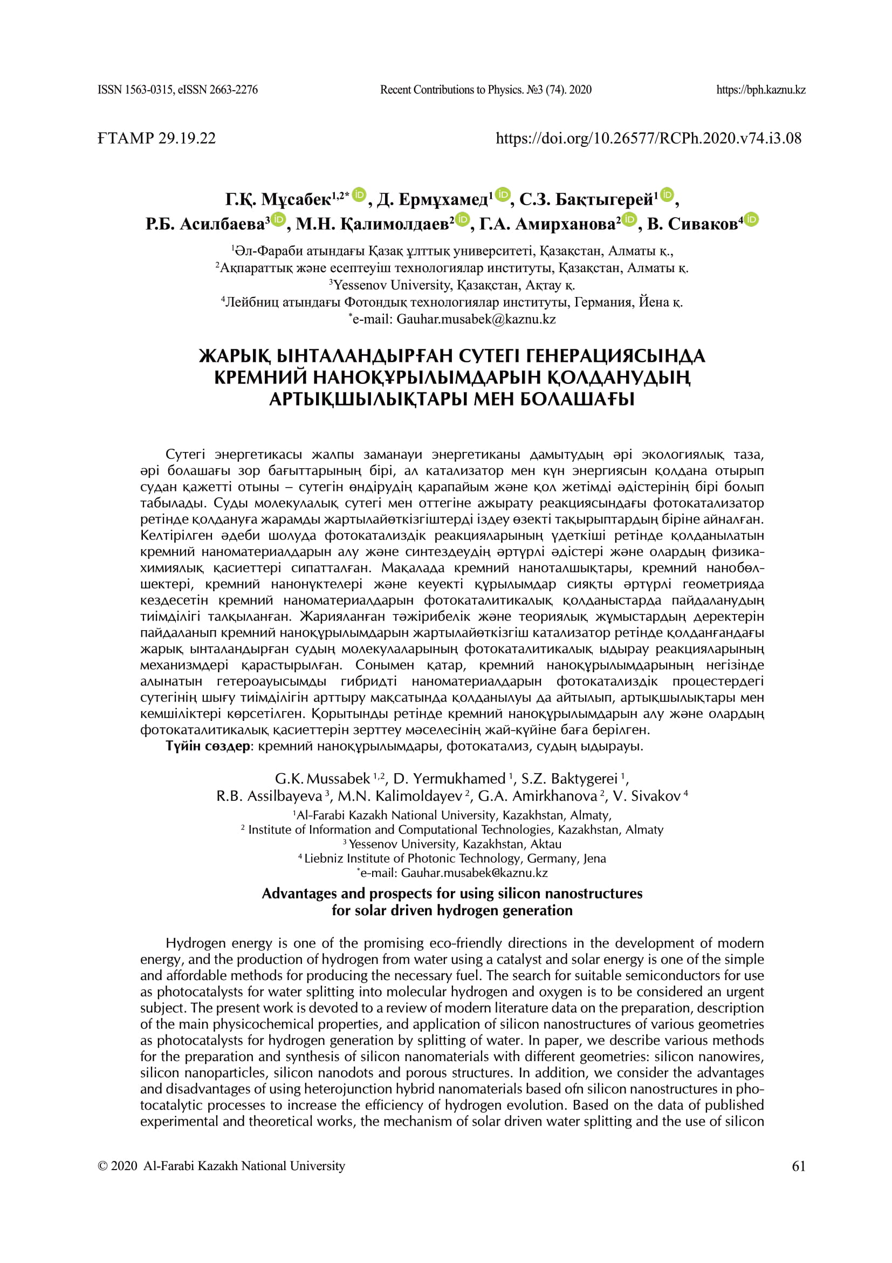
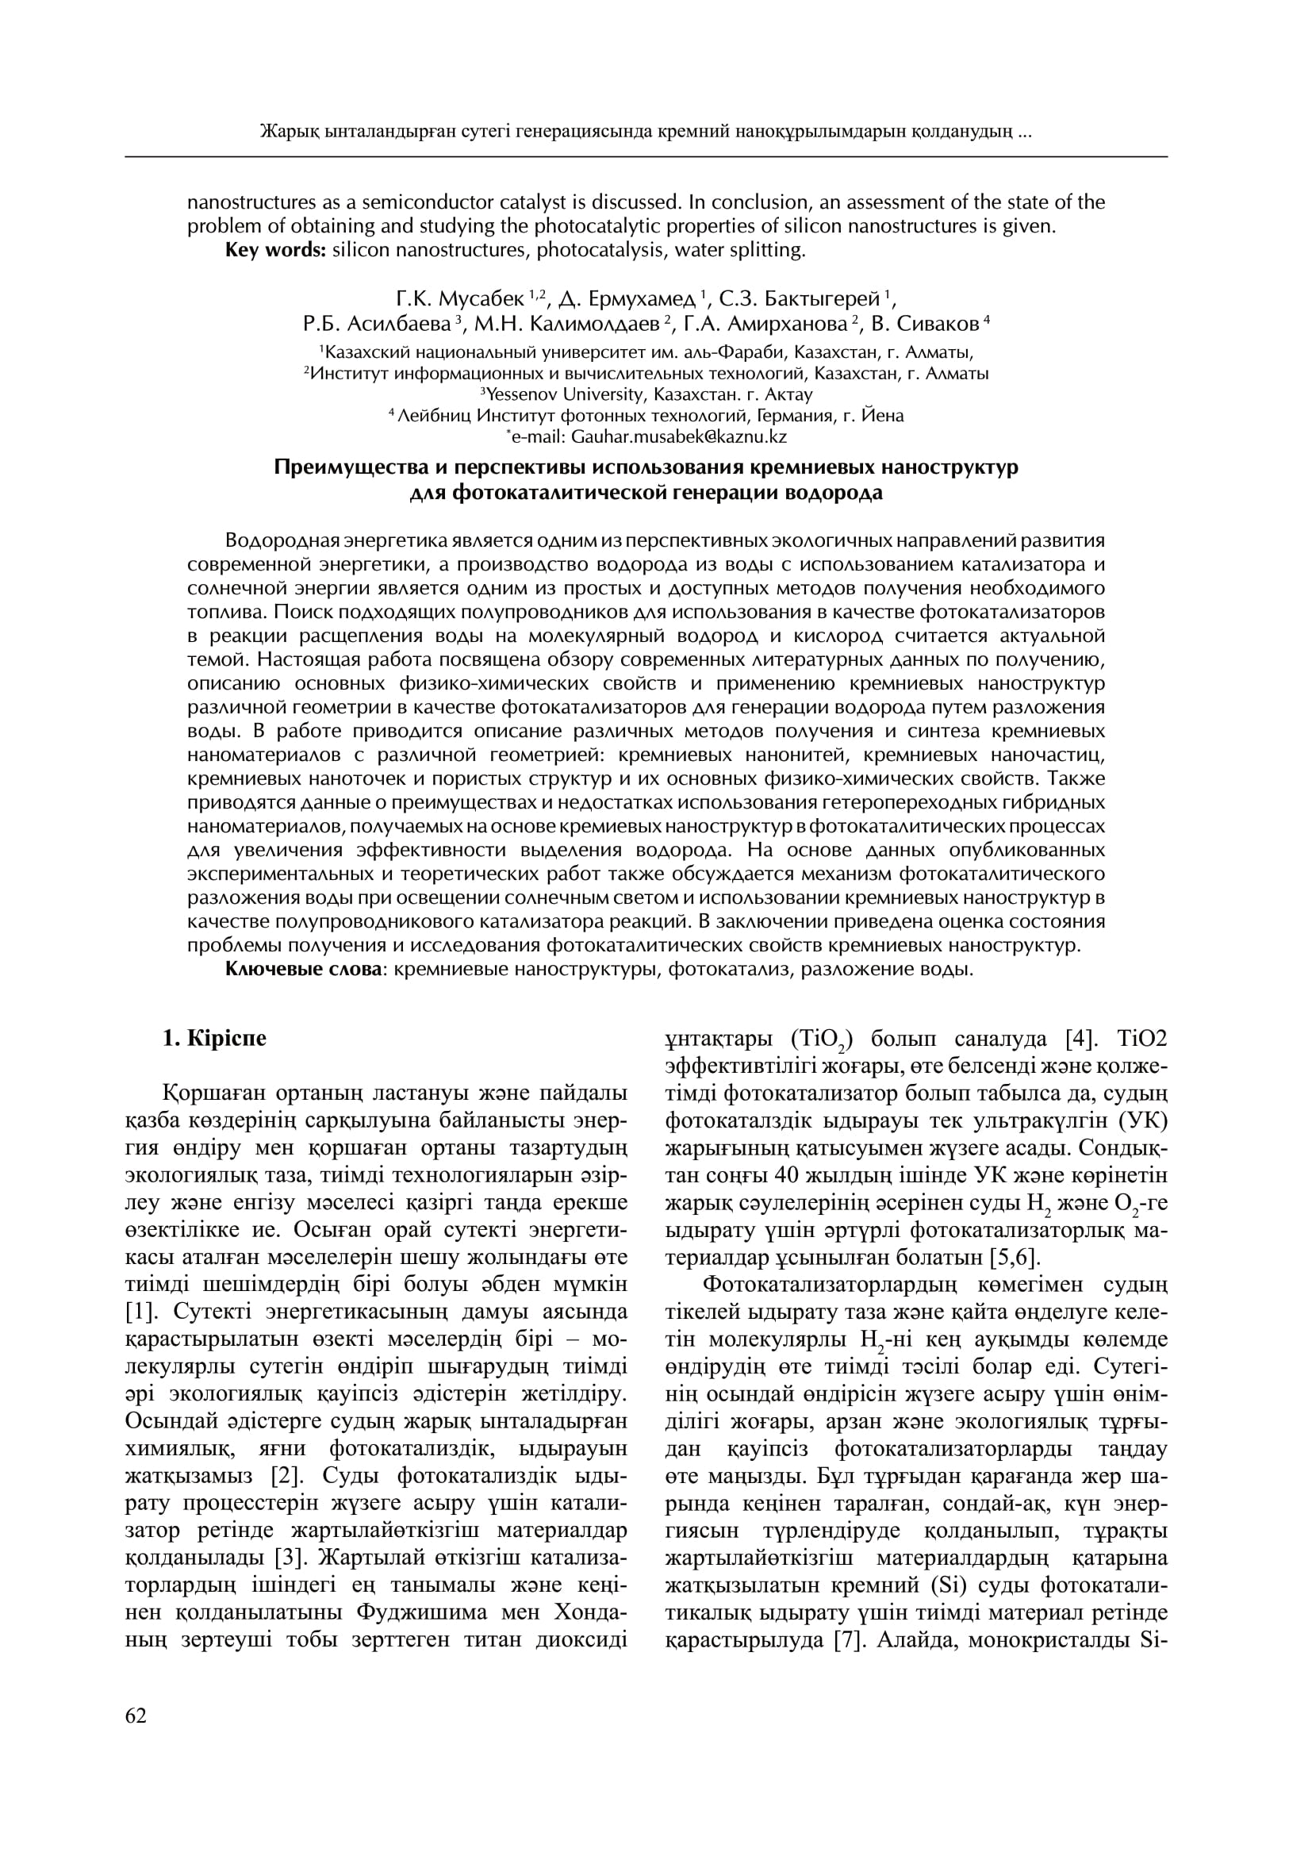

- Amirkhanova G. A., Gorchakov A. Y., Duysenbaeva A. J., Posypkin M. A. Multistart method with deterministic restart mechanism. Vestnik of Saint Petersburg University. Applied Mathematics. Computer Science. Control Processes.- 2020,- Vol. 16, iss. 2.- P. 100–111.// https://doi.org/10.21638/11701/spbu10.2020.202 (In Russian).
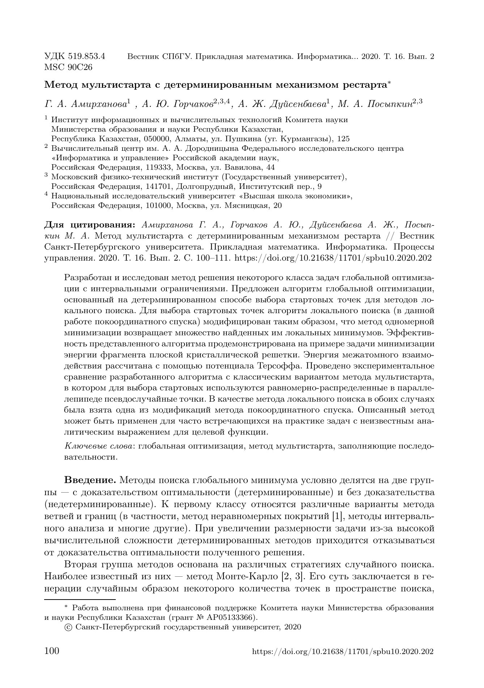
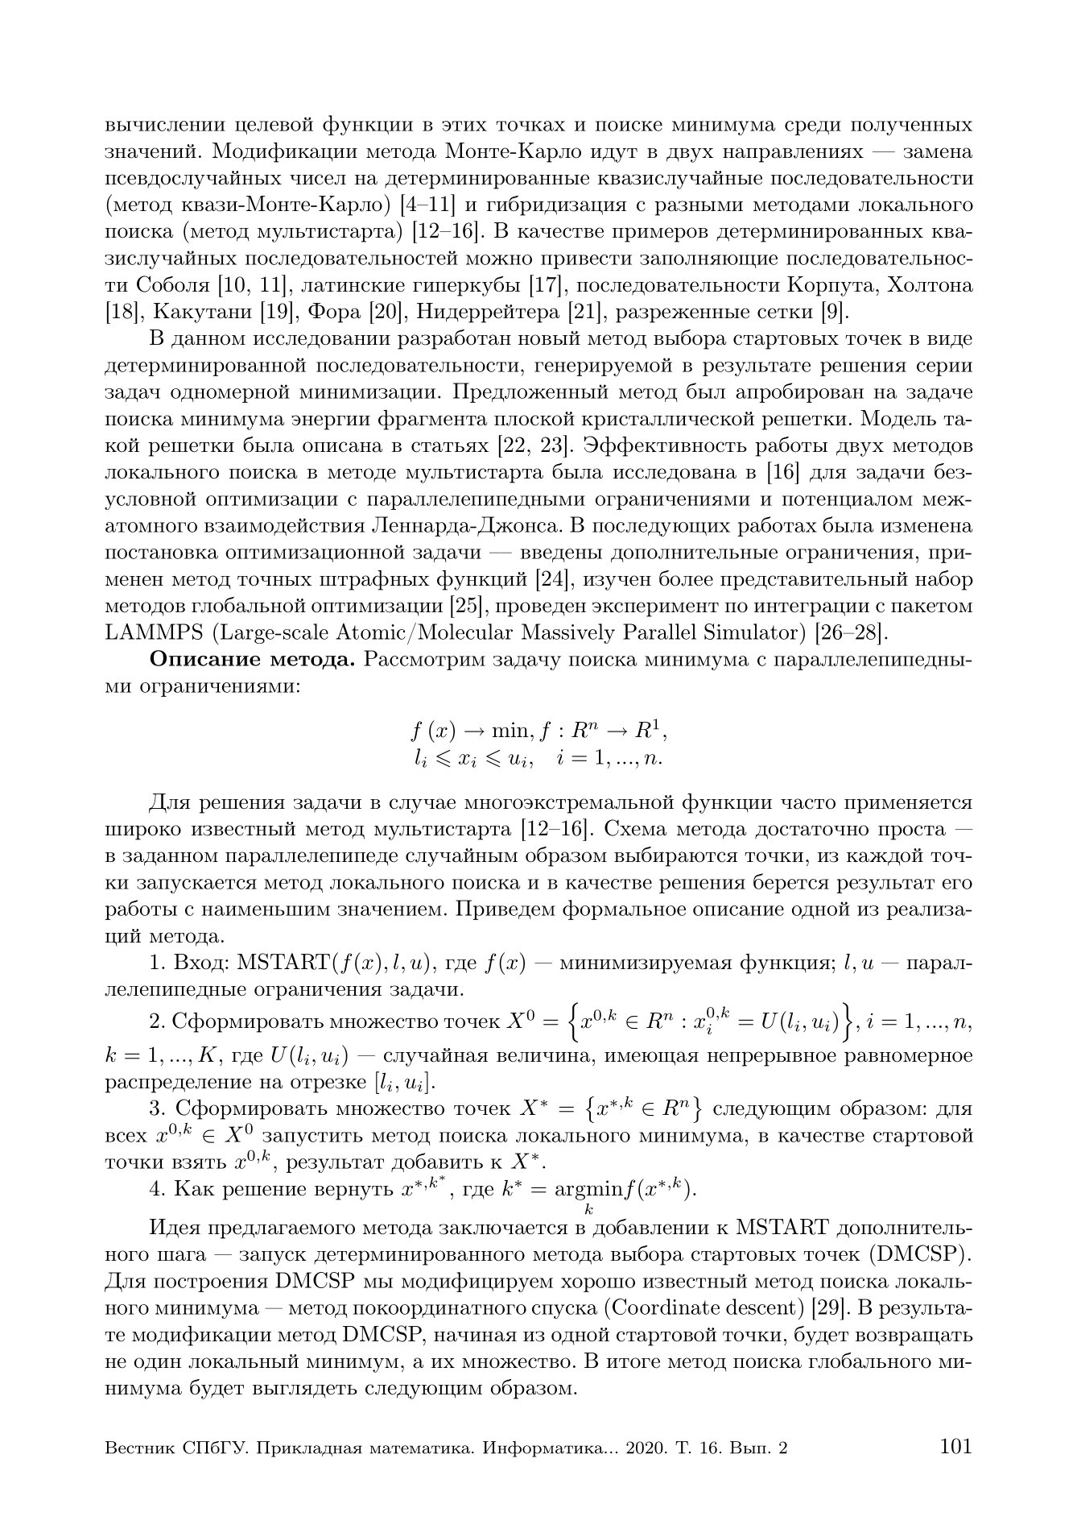

- Gorchakov A.Yu., Amirkhanova G.A., Duisenbaeva A.Zh., Musabek G.K., Baisalbaeva K.N. Cluster analysis of the local minimum energy fragment of a flat lattice // Materials of the scientific conference IICT MES RK "Modern problems of computer science and computing technologies" .– Almaty: IICT MES RK, 2020. - pp. 139-150. (in Russian)
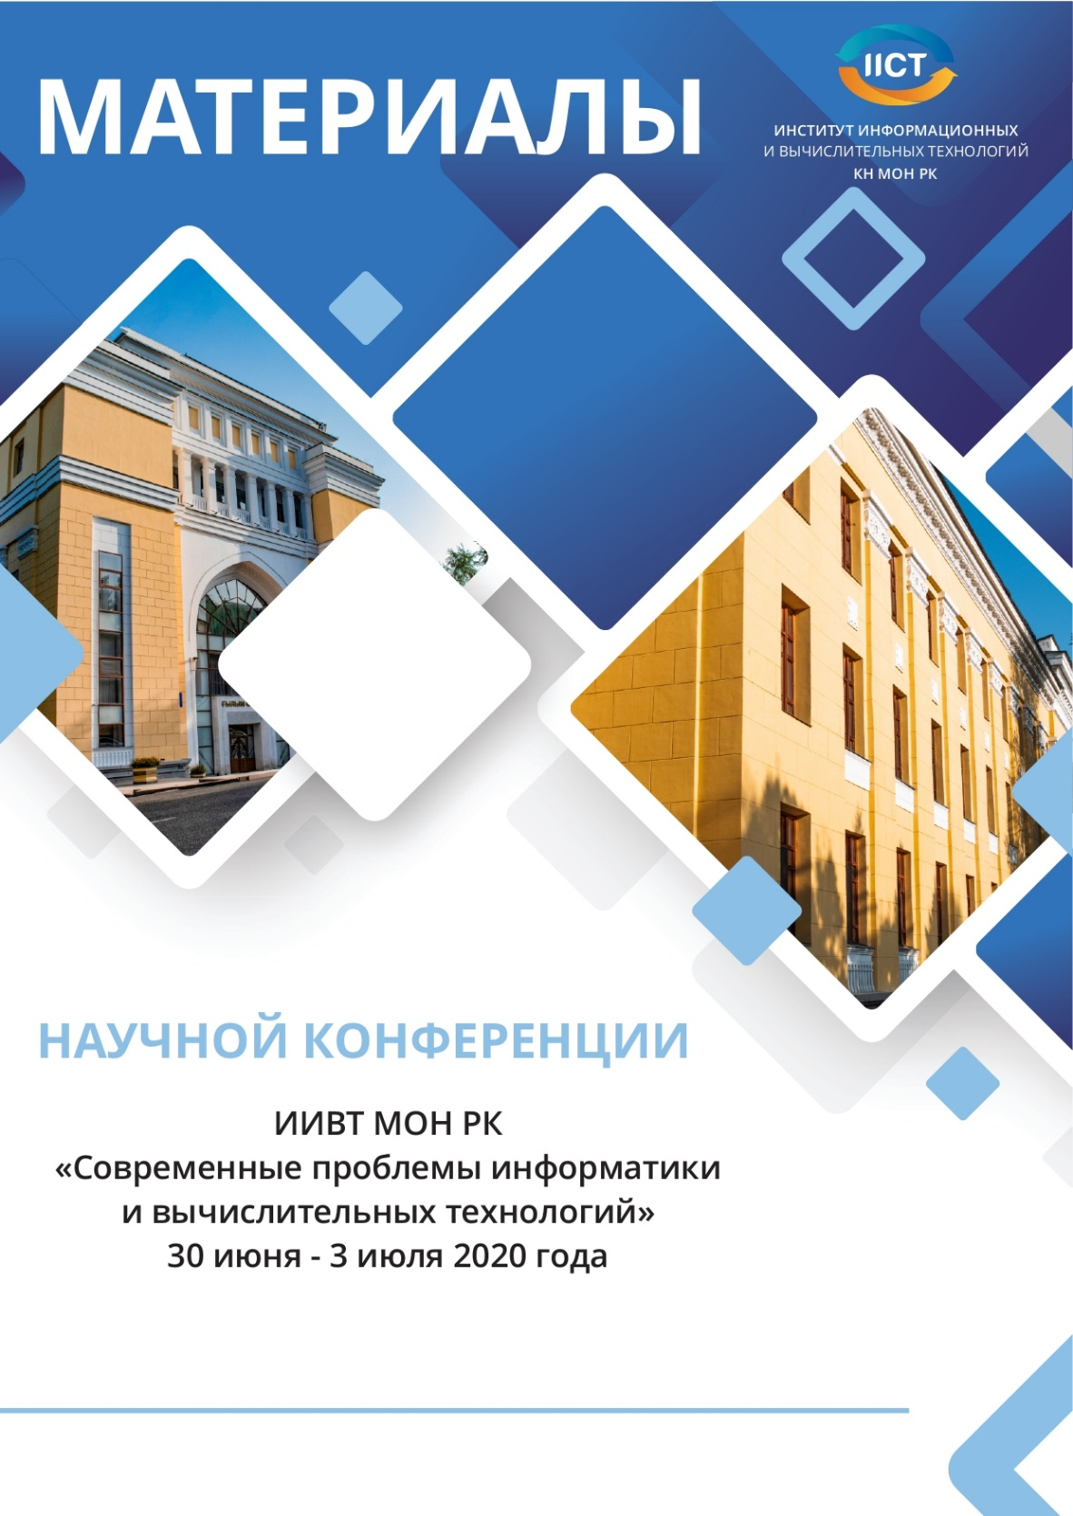

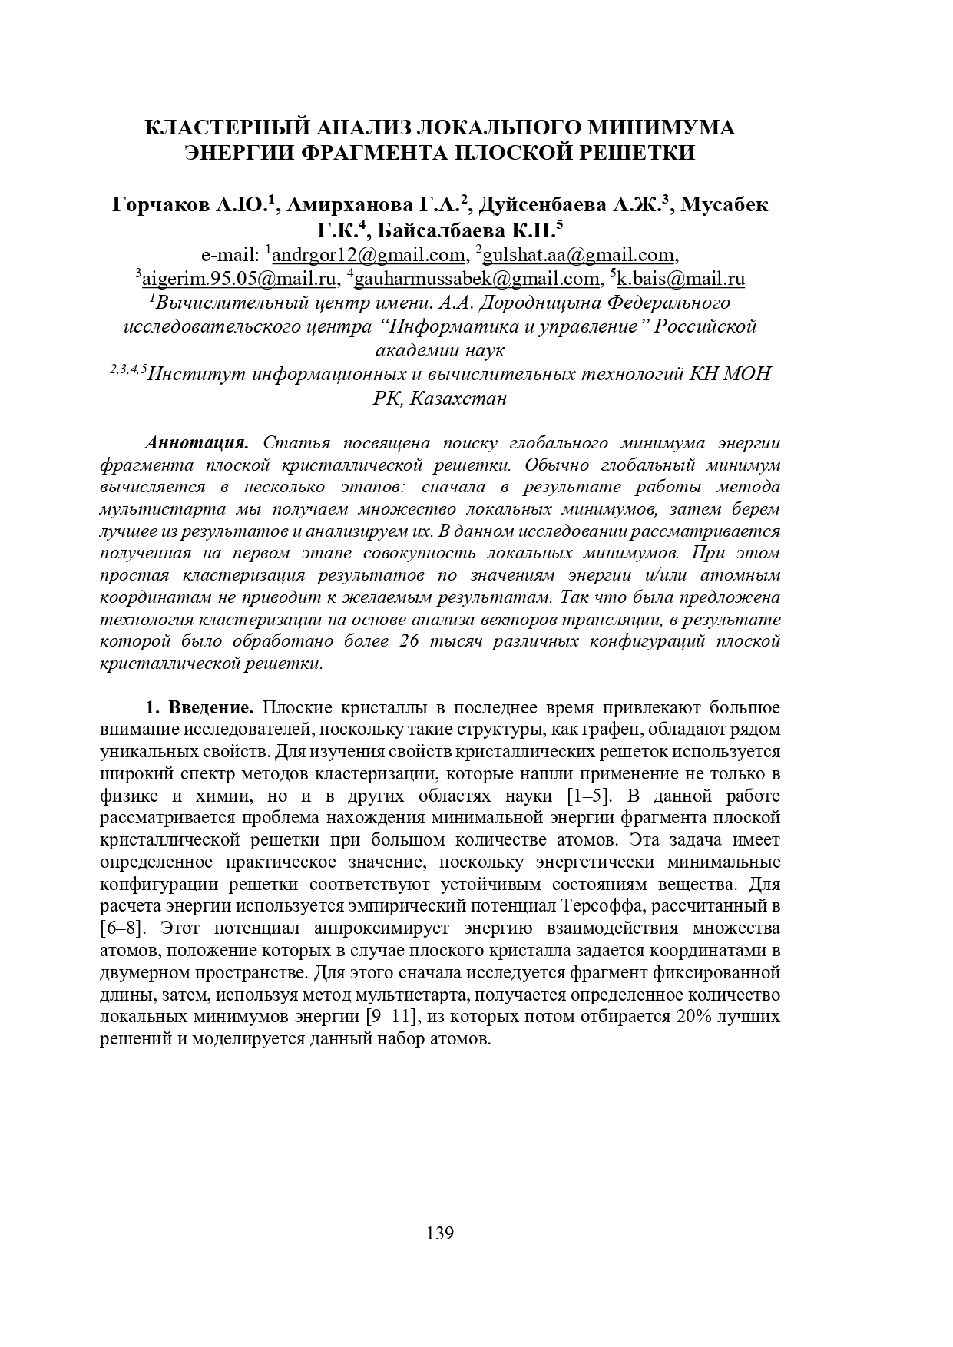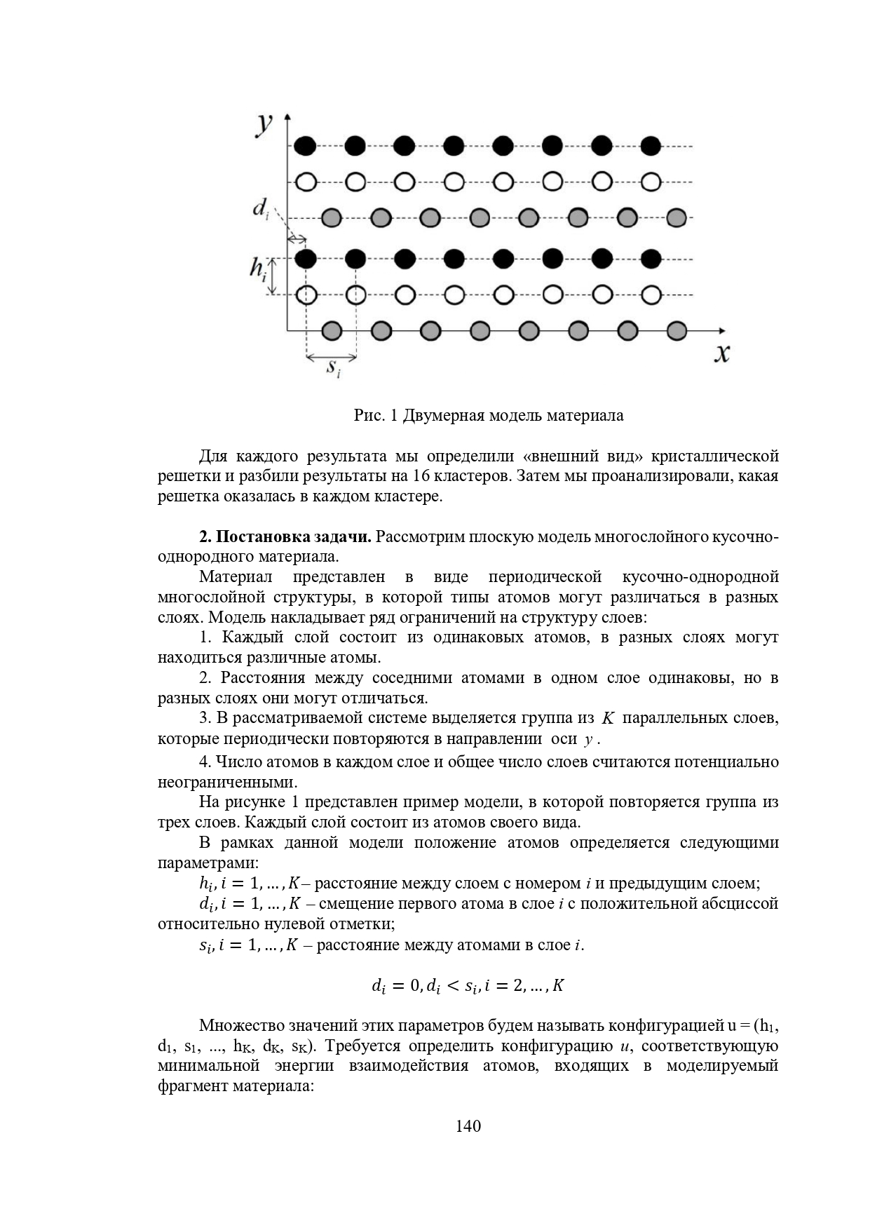

- Musabek G.K., Dikhanbaev K.K., Amirkhanova G.A. Review of modern methods of obtaining thin films ZnO, alloyed Al // Materials of the scientific conference IICT MES RK "Modern problems of computer science and computer technology". - Almaty: IICT MES RK, 2020. - pp. 122-128. (in Russian)
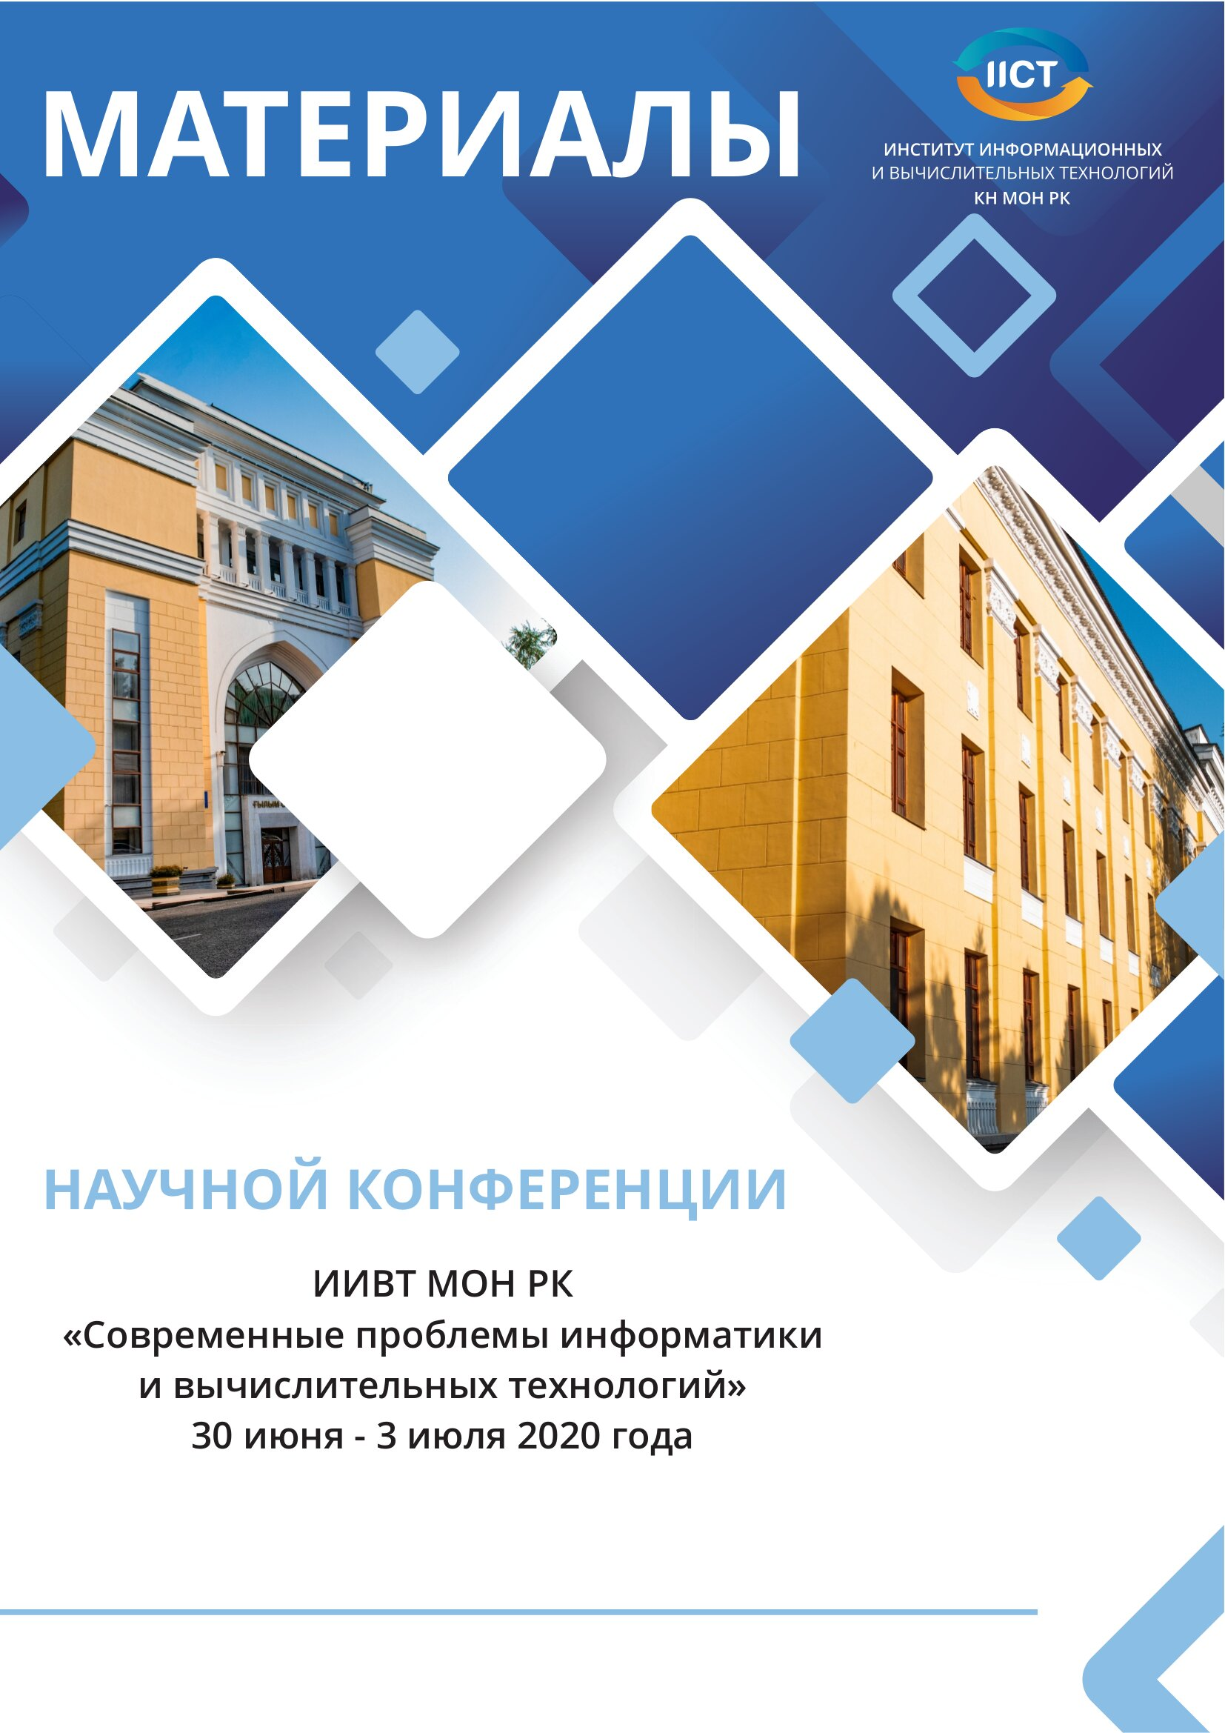

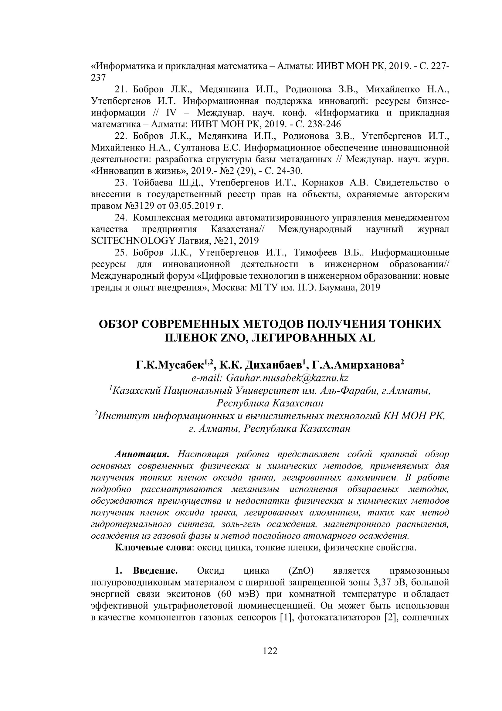
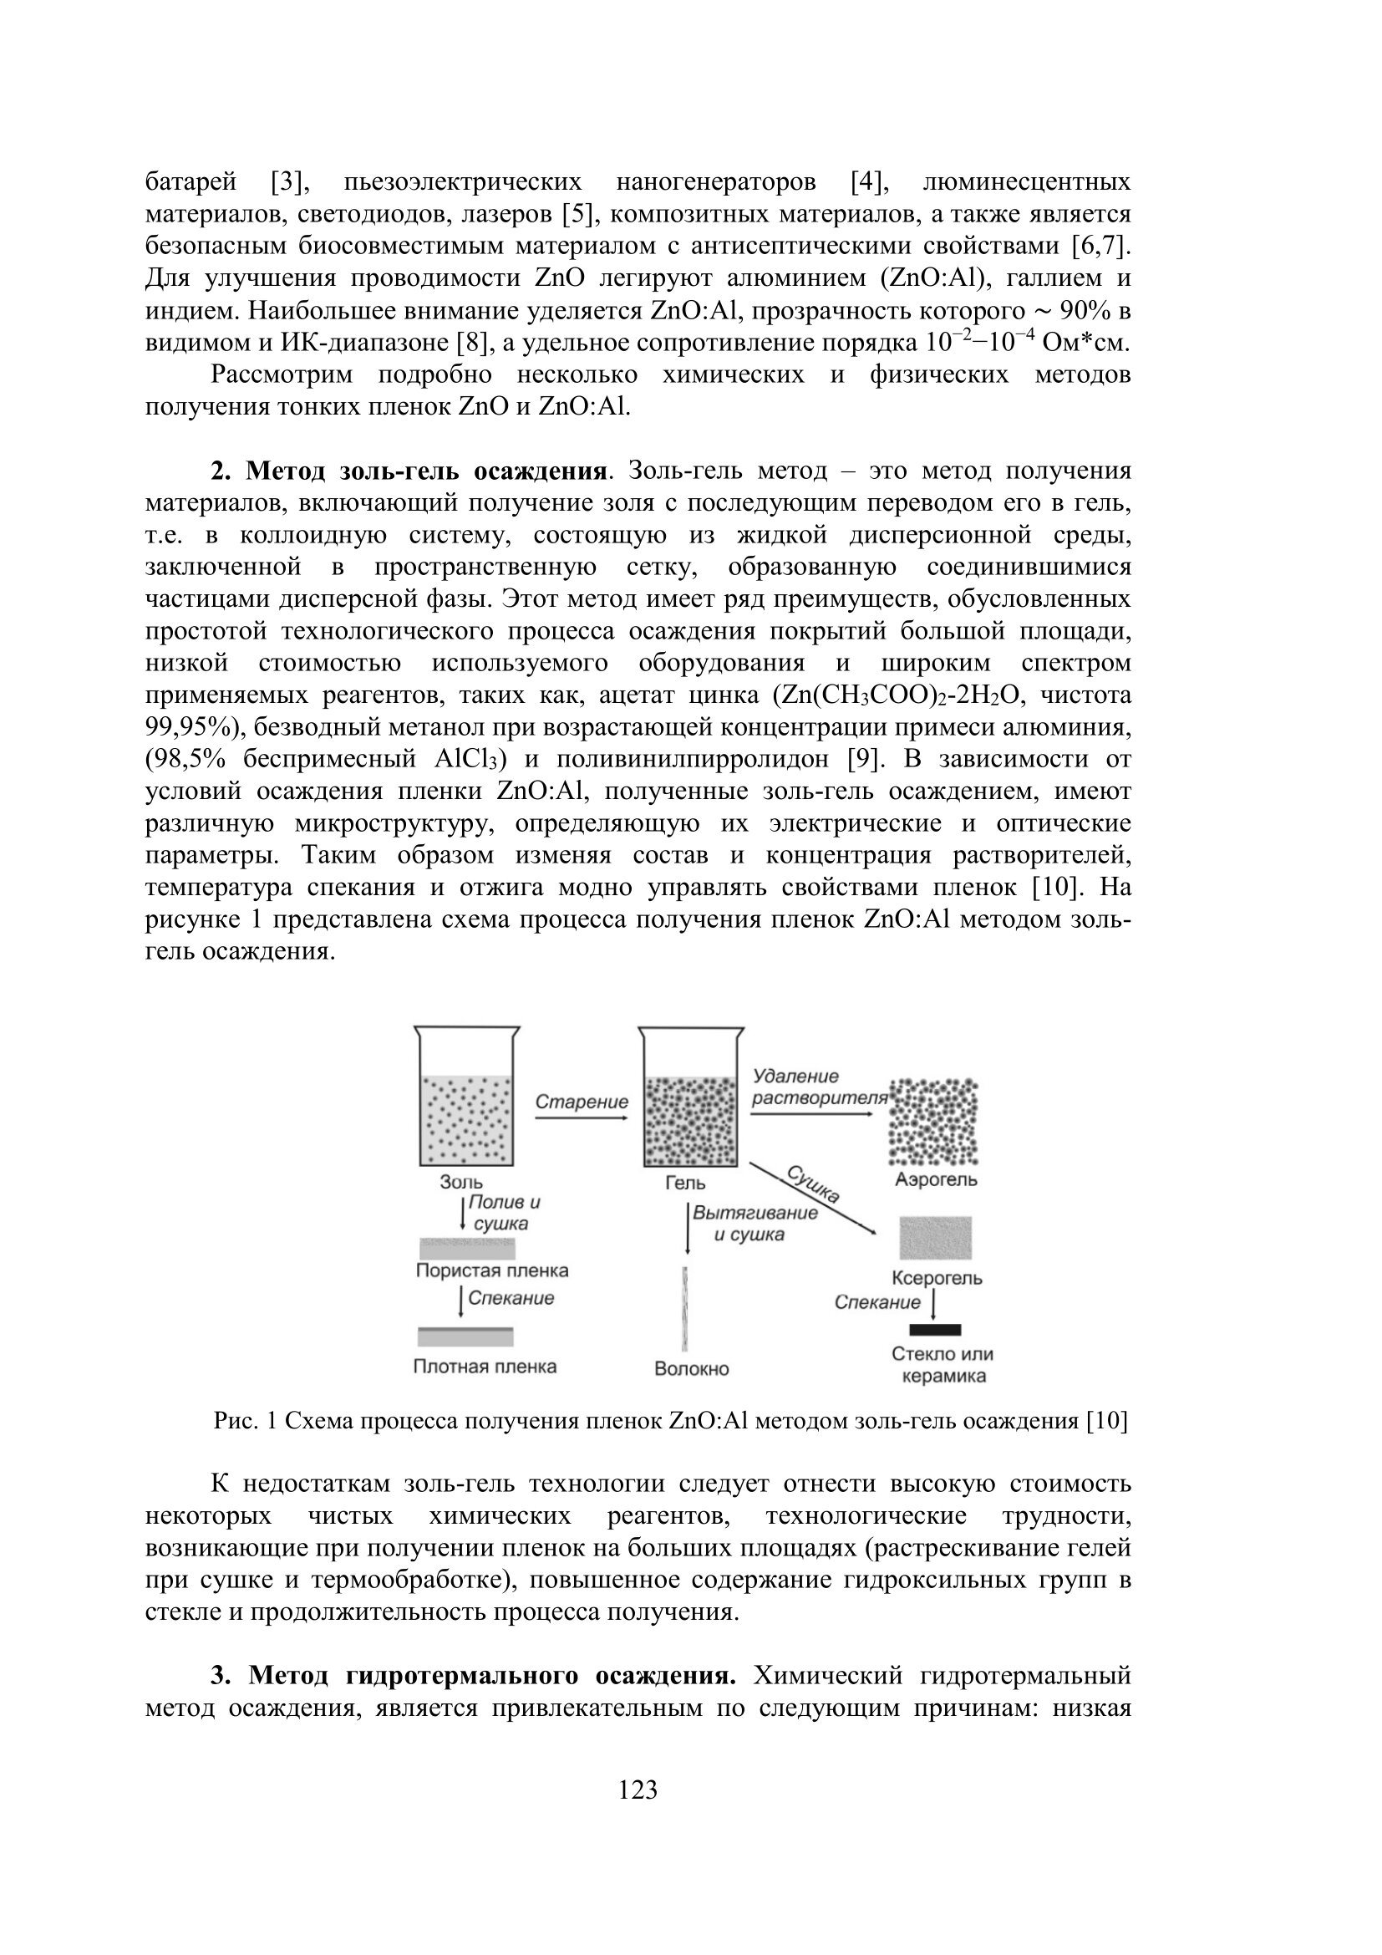
- Amirkhanova GA, Gorchakov A.Yu. Verification of a single model of a flat crystal lattice // Proceedings of the V International Scientific Conference "Informatics and Applied Mathematics" IICT. - Almaty: IICT MES RK, 2020. - pp. 114-119. (in Russian)
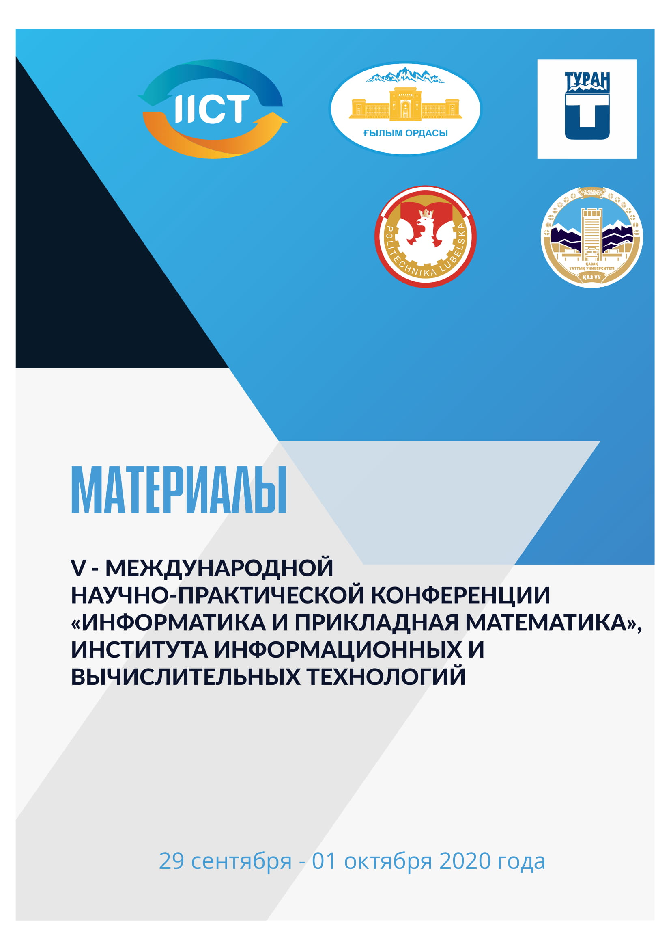

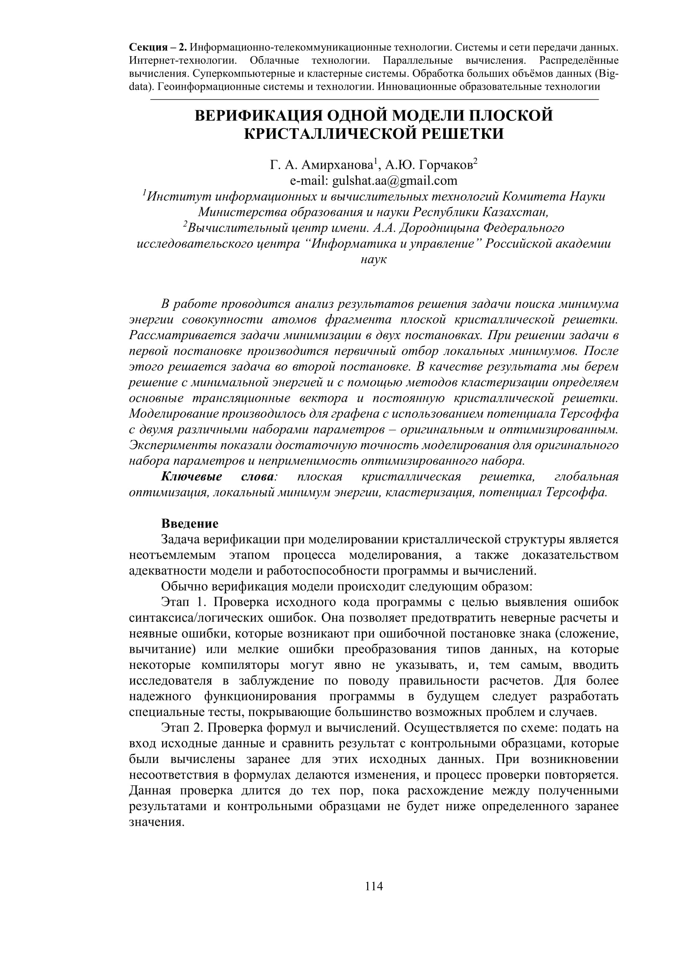

- Mussabek G., Alekseev S.A., Manilov A.I., Tutashkonko S., Nychyporuk T., Shabdan Ye., Amirkhanova G., Litvinenko S.V., Skryshevsky V.A. and Lysenko V. Kinetics of Hydrogen Generation from Oxidation of Hydrogenated Silicon Nanocrystals in Aqueous Solutions / Nanomaterials 2020. – Vol.10, - P.1-14.// doi:10.3390/nano10071413.
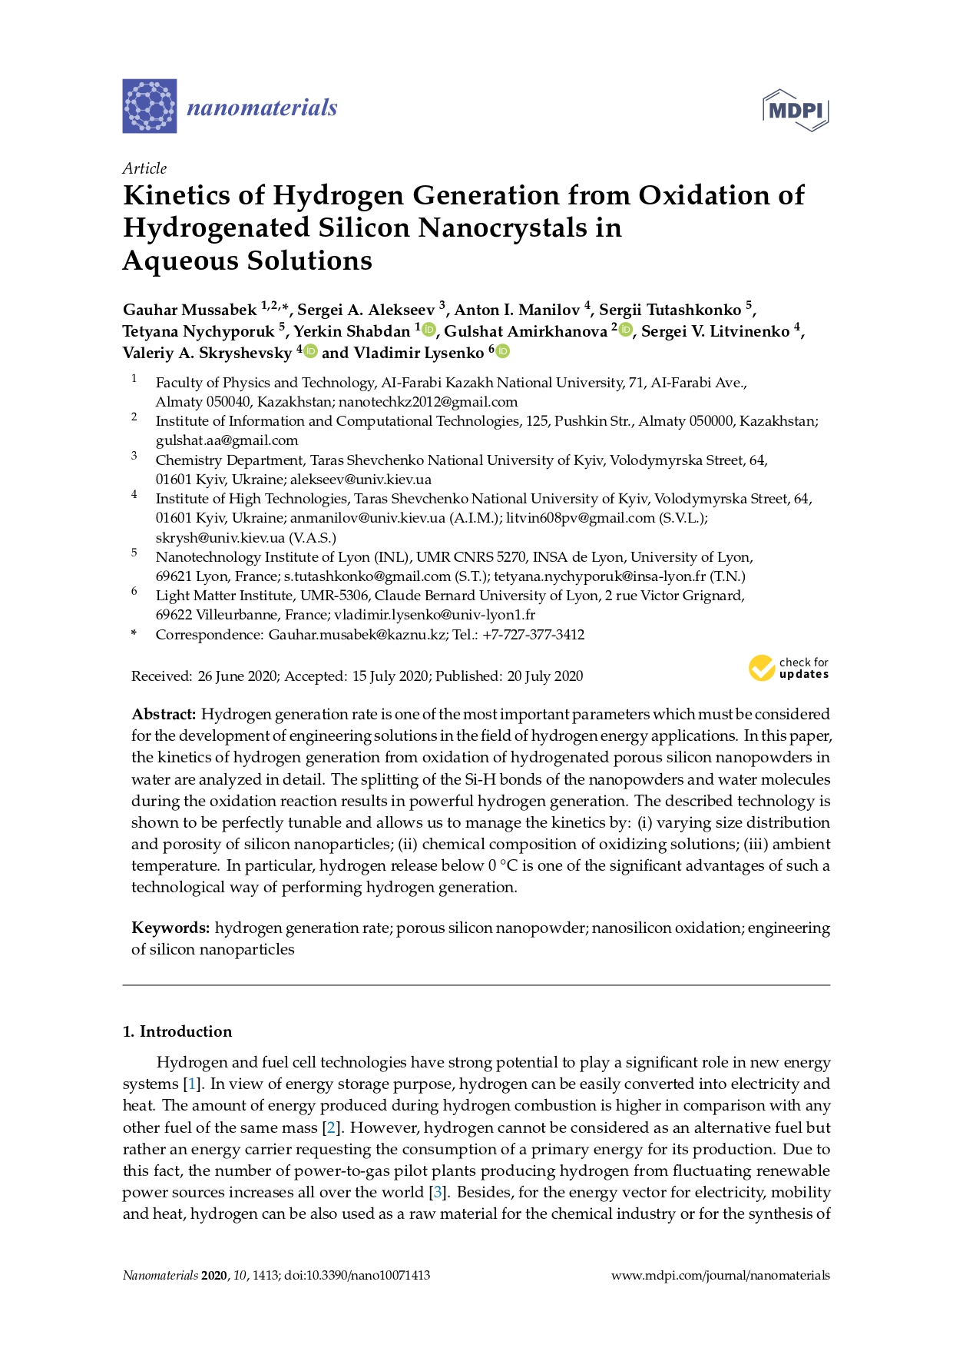
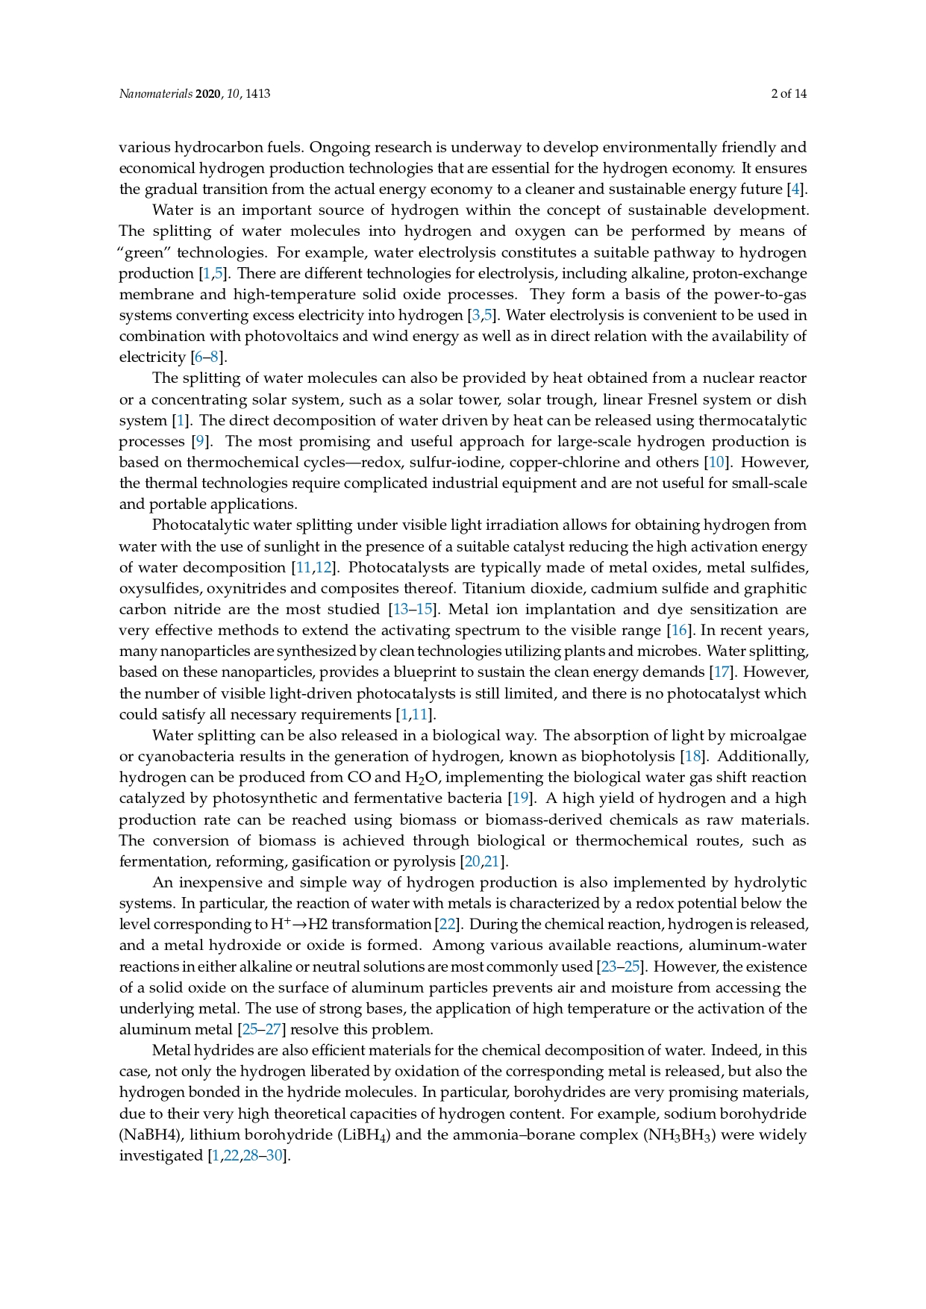
- Mussabek G., Lysenko V., Yermukhamed D., Sivakov V., Timoshenko V.Yu. Thermally induced evolution of the structure and optical properties of silicon nanowires // Results in Physics. -2020. –Vol.18, - P. 1-6.// https://doi.org/10.1016/j.rinp.2020.103258
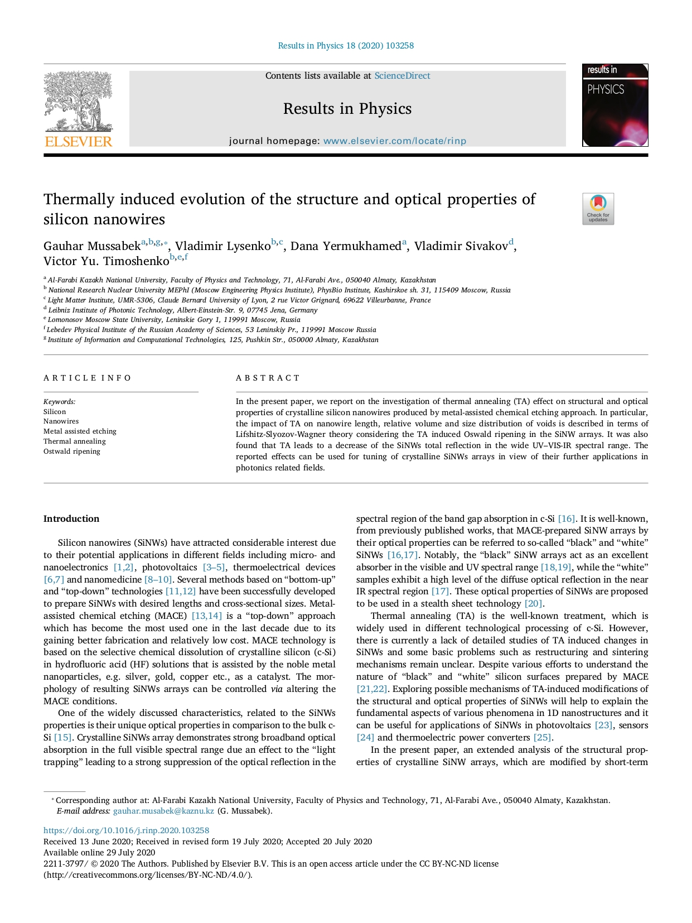
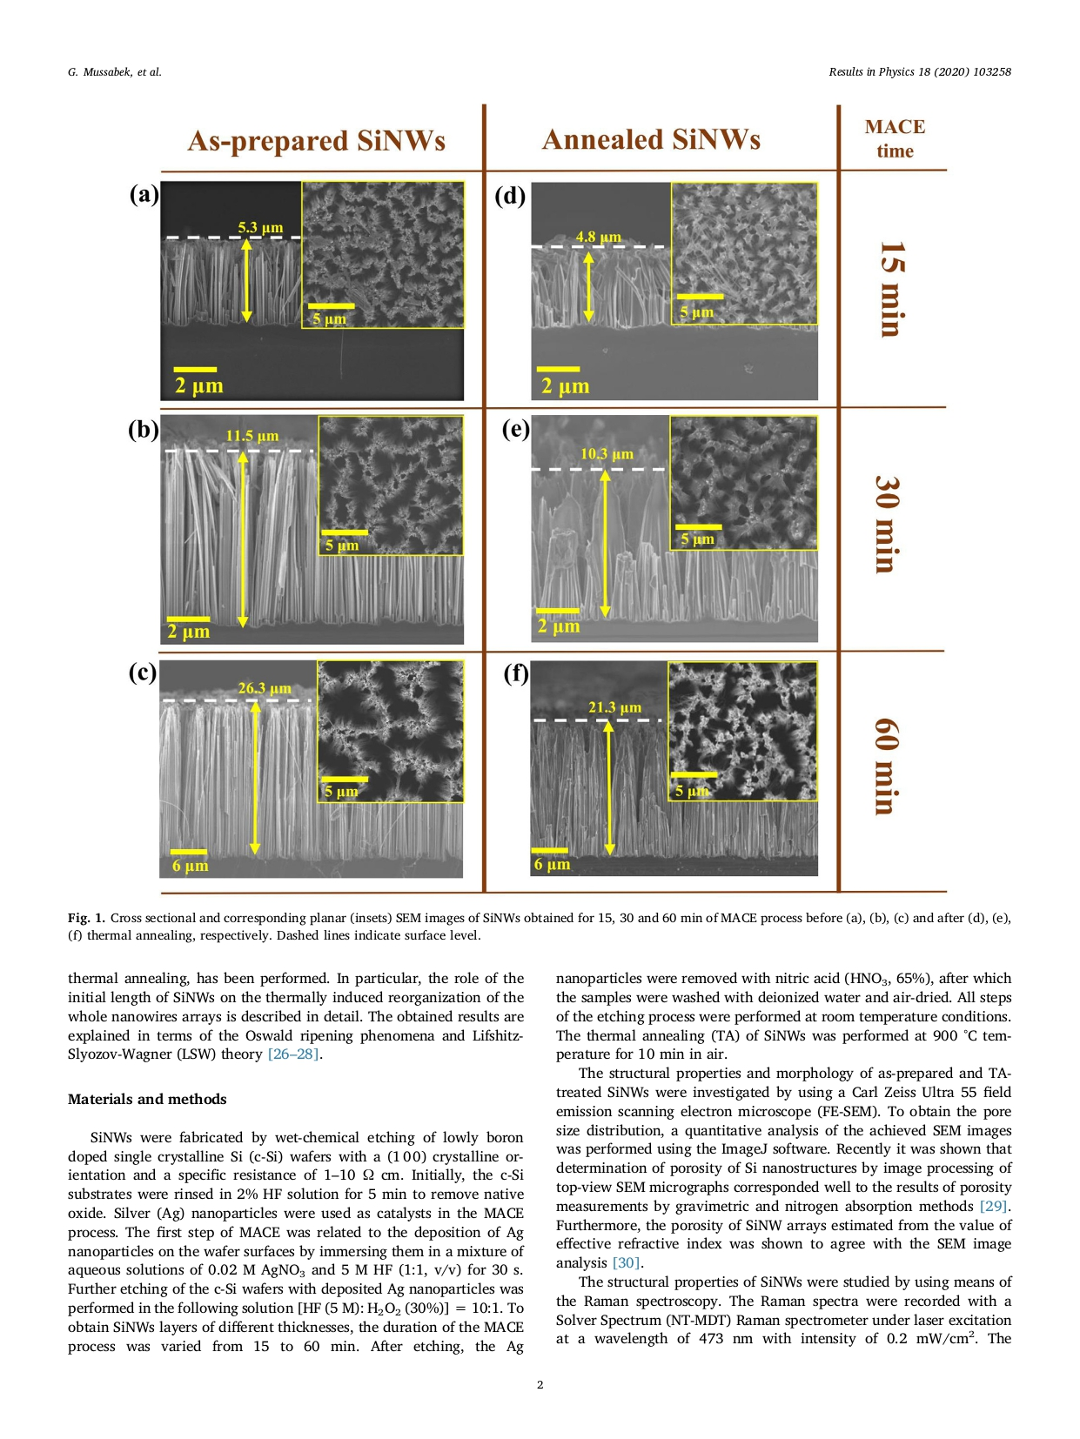

- Musabek G.K., Dikhanbaev K.K., Amirkhanova G.A. Review of modern methods of obtaining thin films ZnO, alloyed Al // Bulletin of KazNRTU named after K.I. Satpayeva. - 2020. -№4 (140). - pp. 237-242. (in Russian)
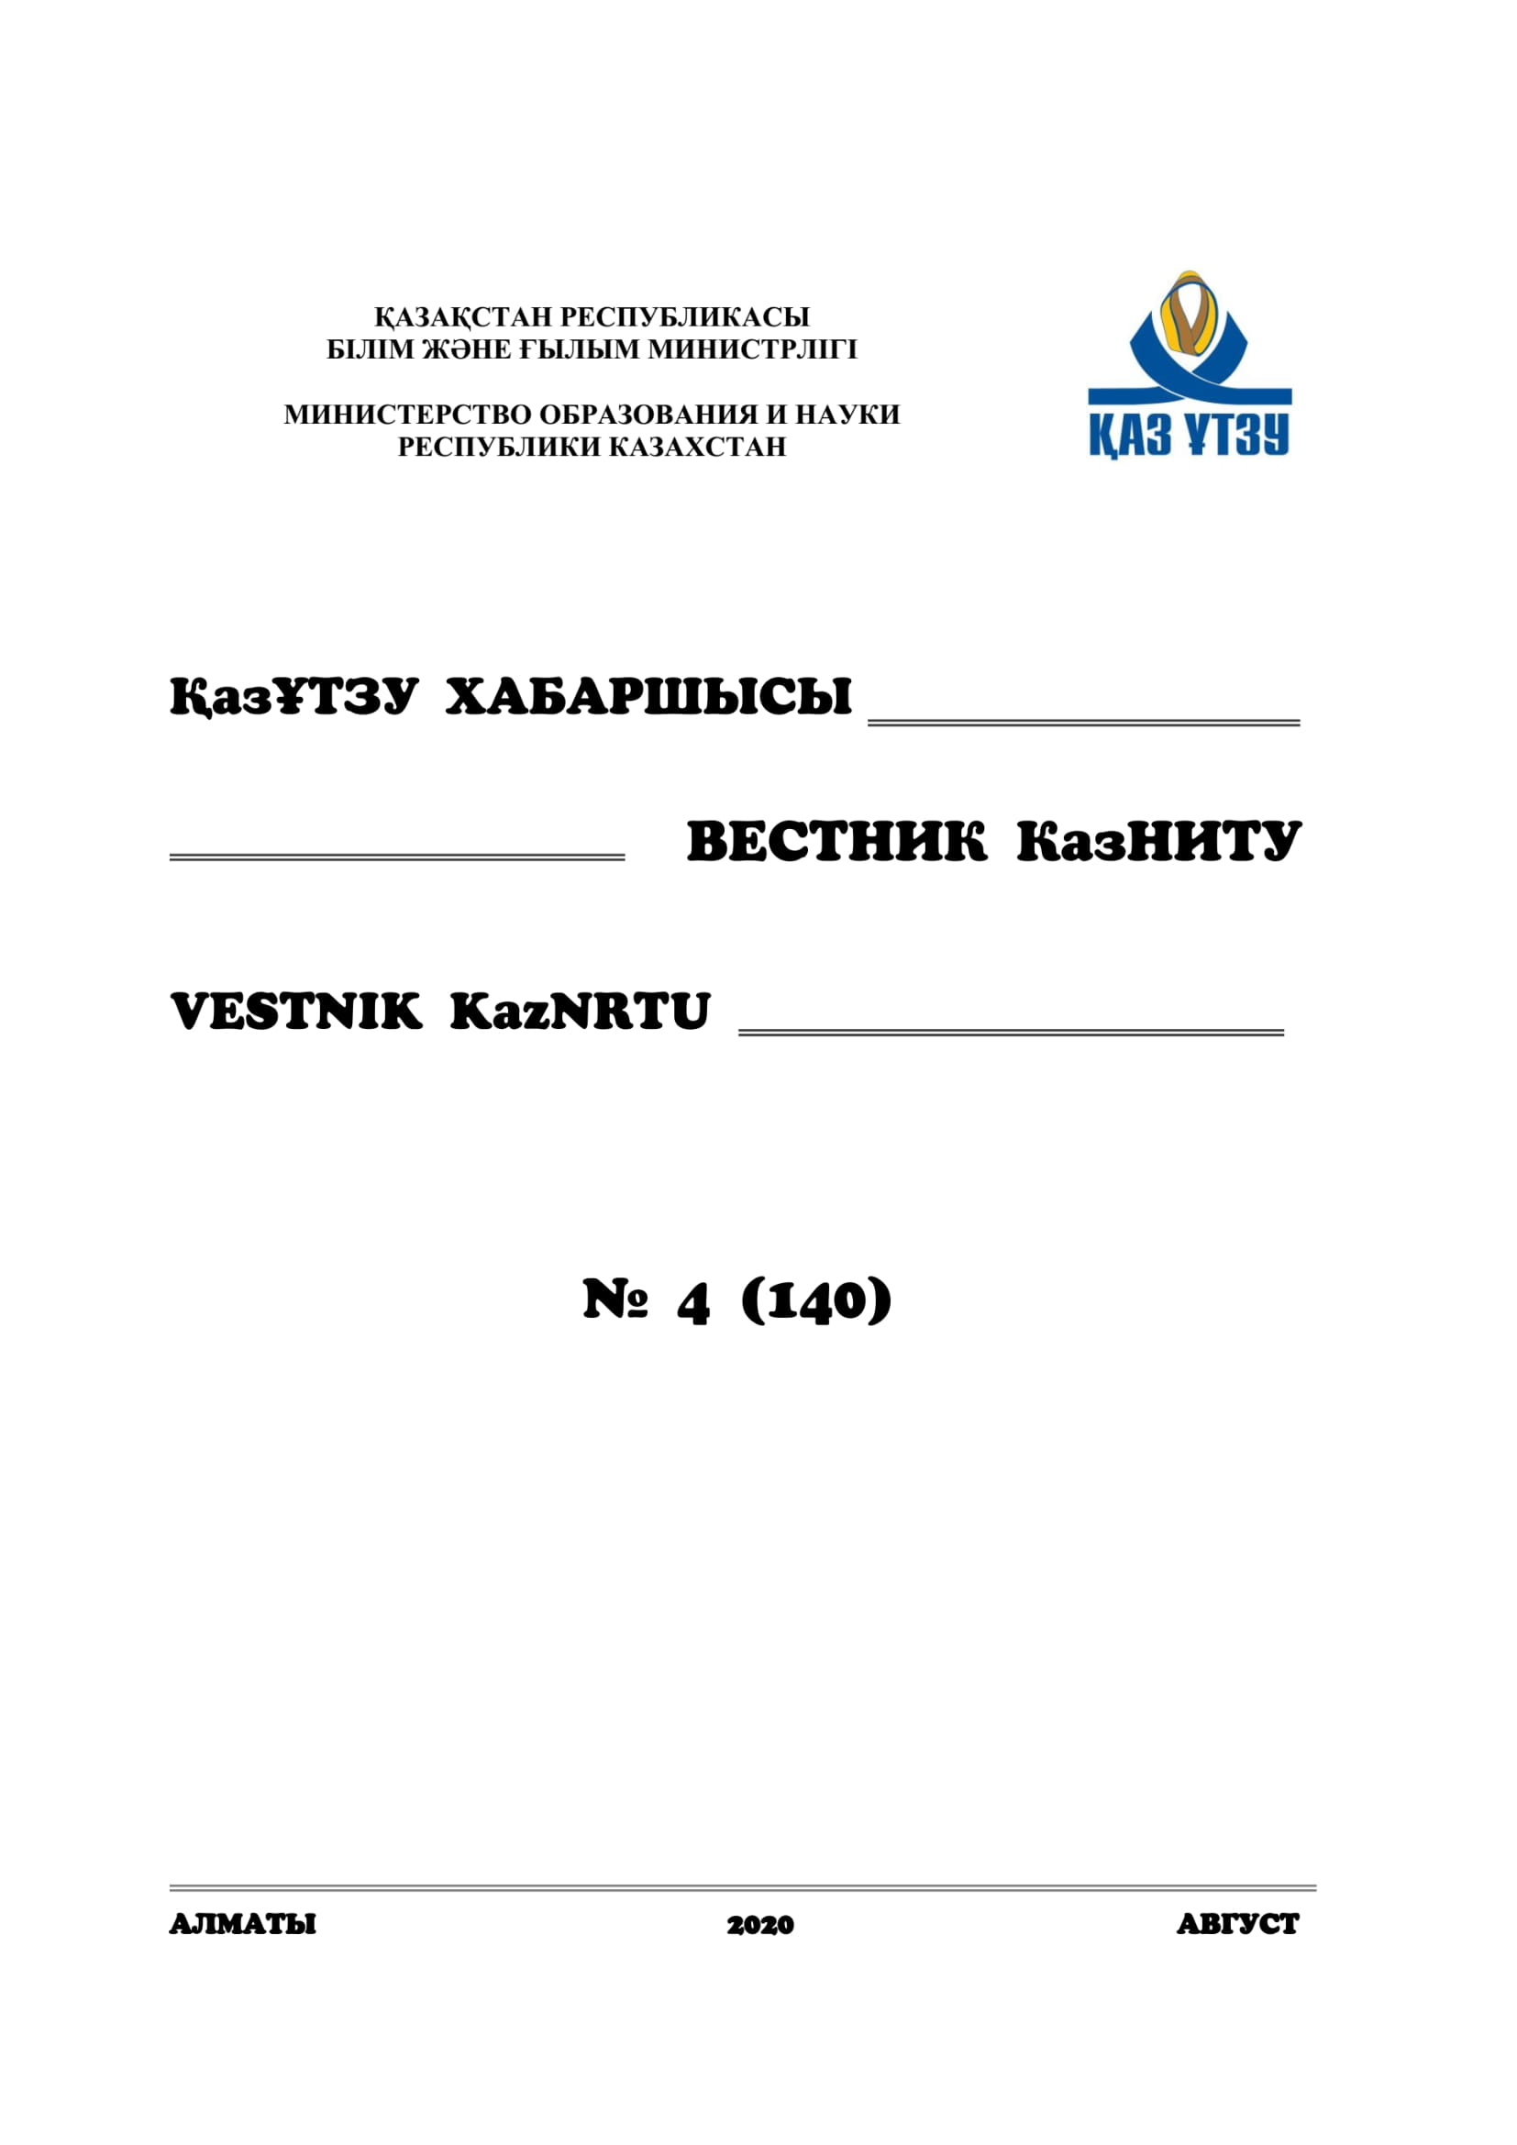
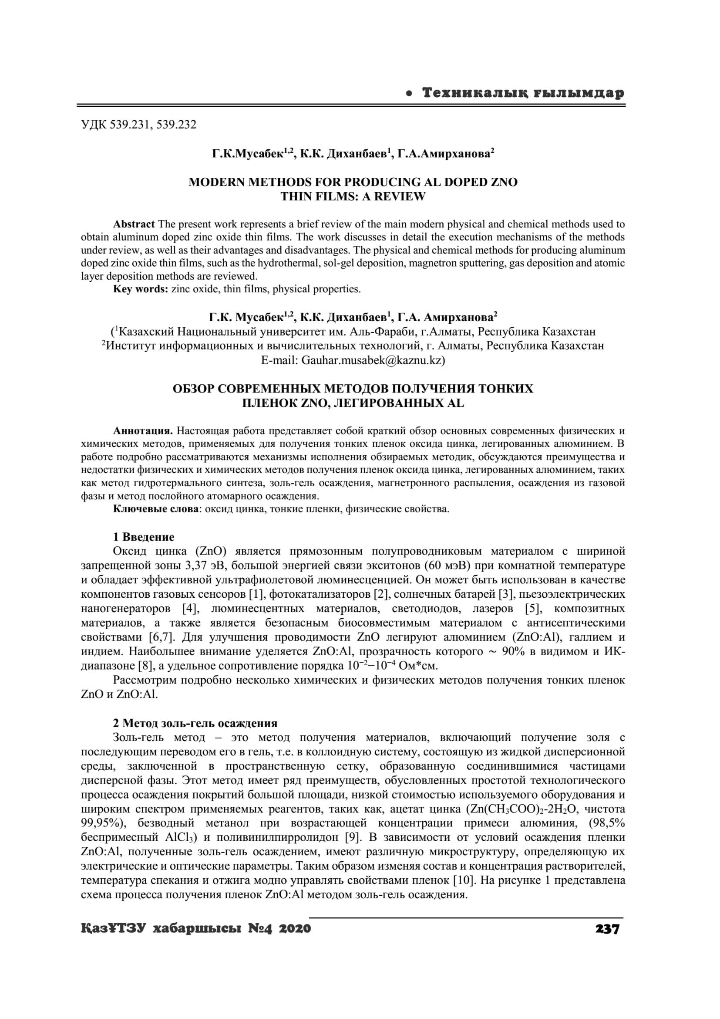

- Musabek G. K., Dikhanbaev K. K., Amirkhanova G. A. Review of modern methods for obtaining thin films of ZnO doped with Al // Vesnik KazNRTU named after K.I. Satpayev. – 2020. -№4 (140). - pp. 237-242. (in Russian)

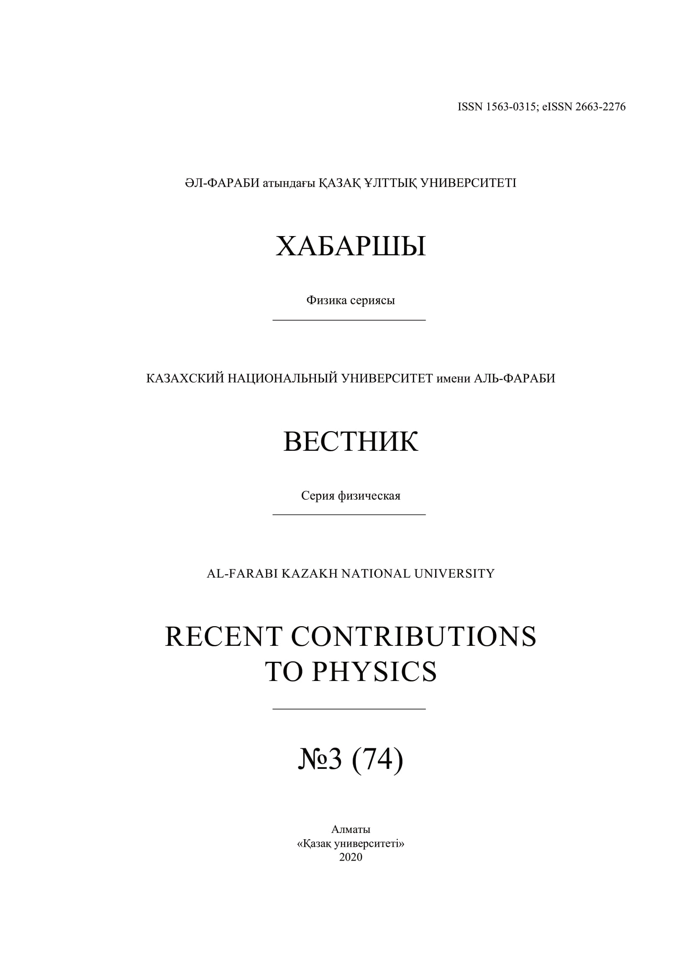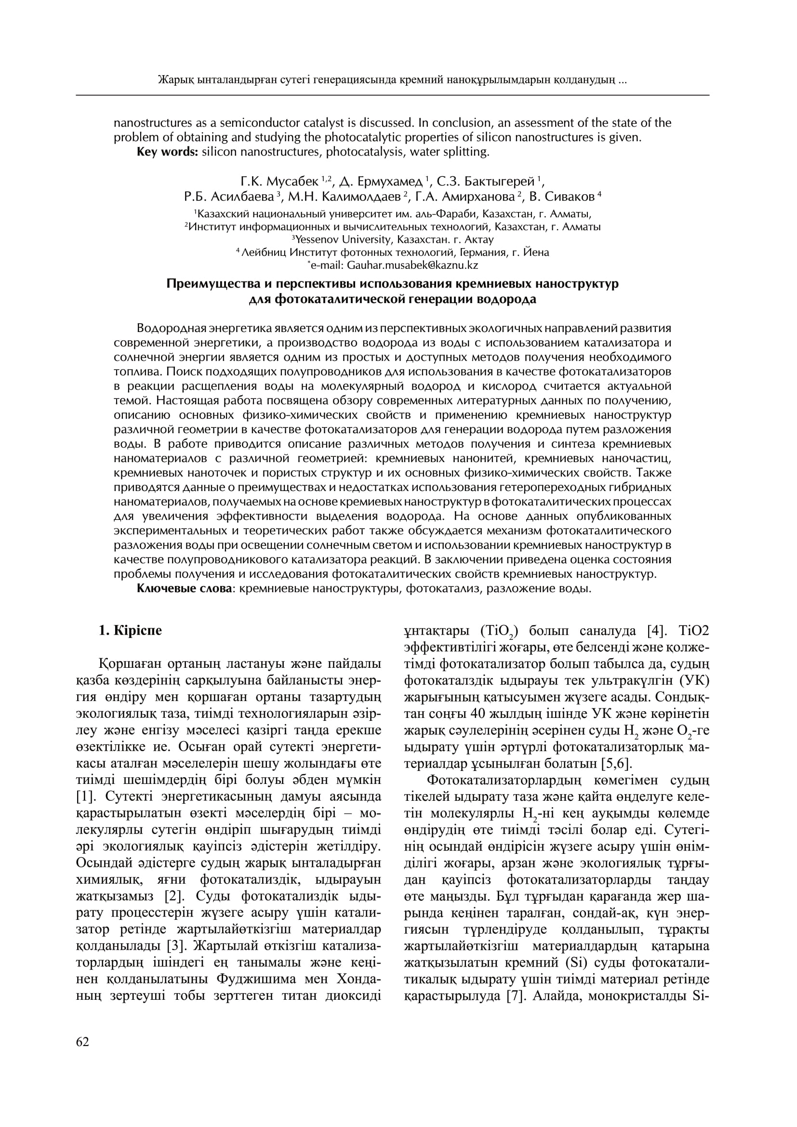

- Olenev N., Jacimovic M., Khachay M., Malkova V., Posypkin M. Golden Rule Saving Rate for an Endogenous Production Function // Optimization and Applications. OPTIMA 2019. Communications in Computer and Information Science. - Springer, Cham., 2020. - Vol.1145. – P.267-279.// doi 10.1007/978-3-030-38603-0_20.
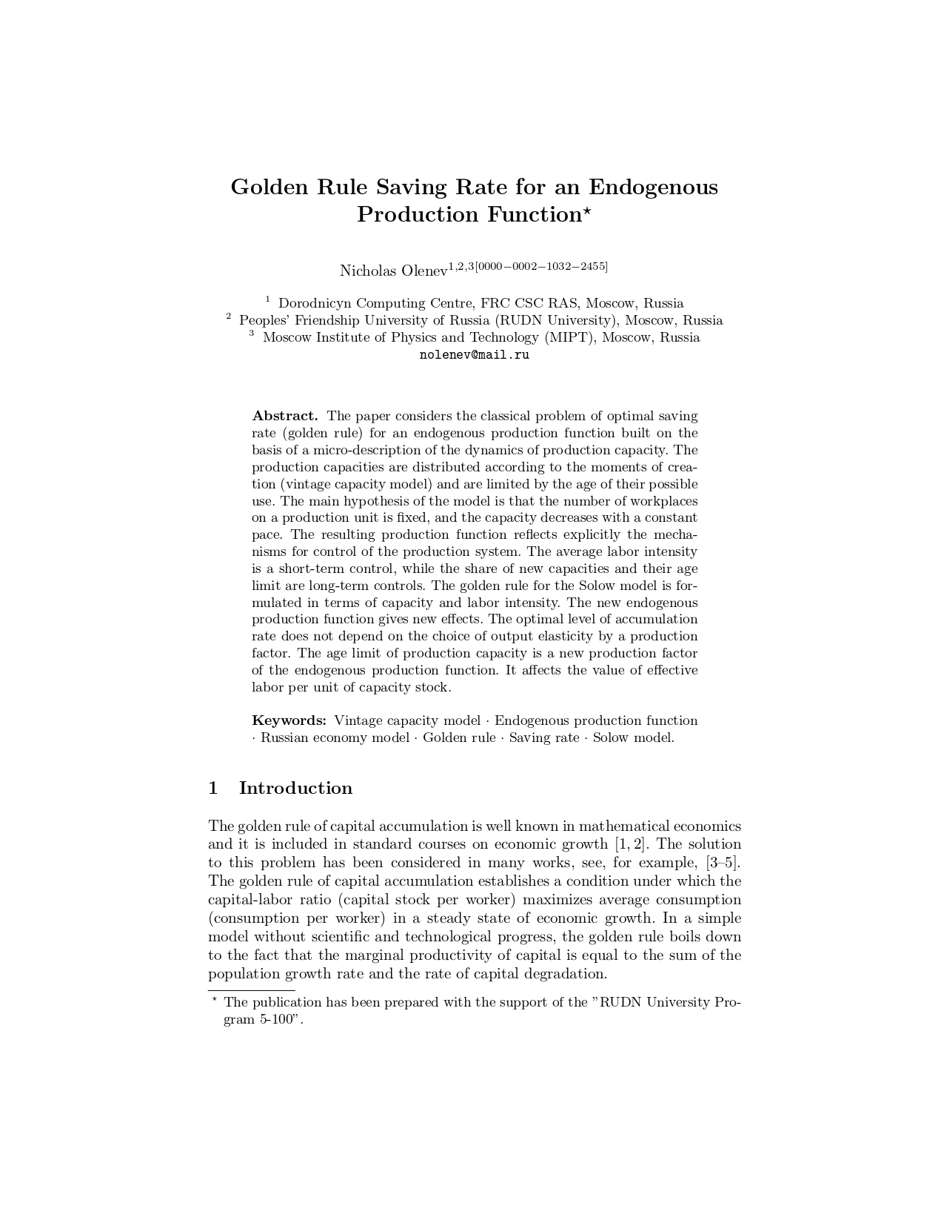

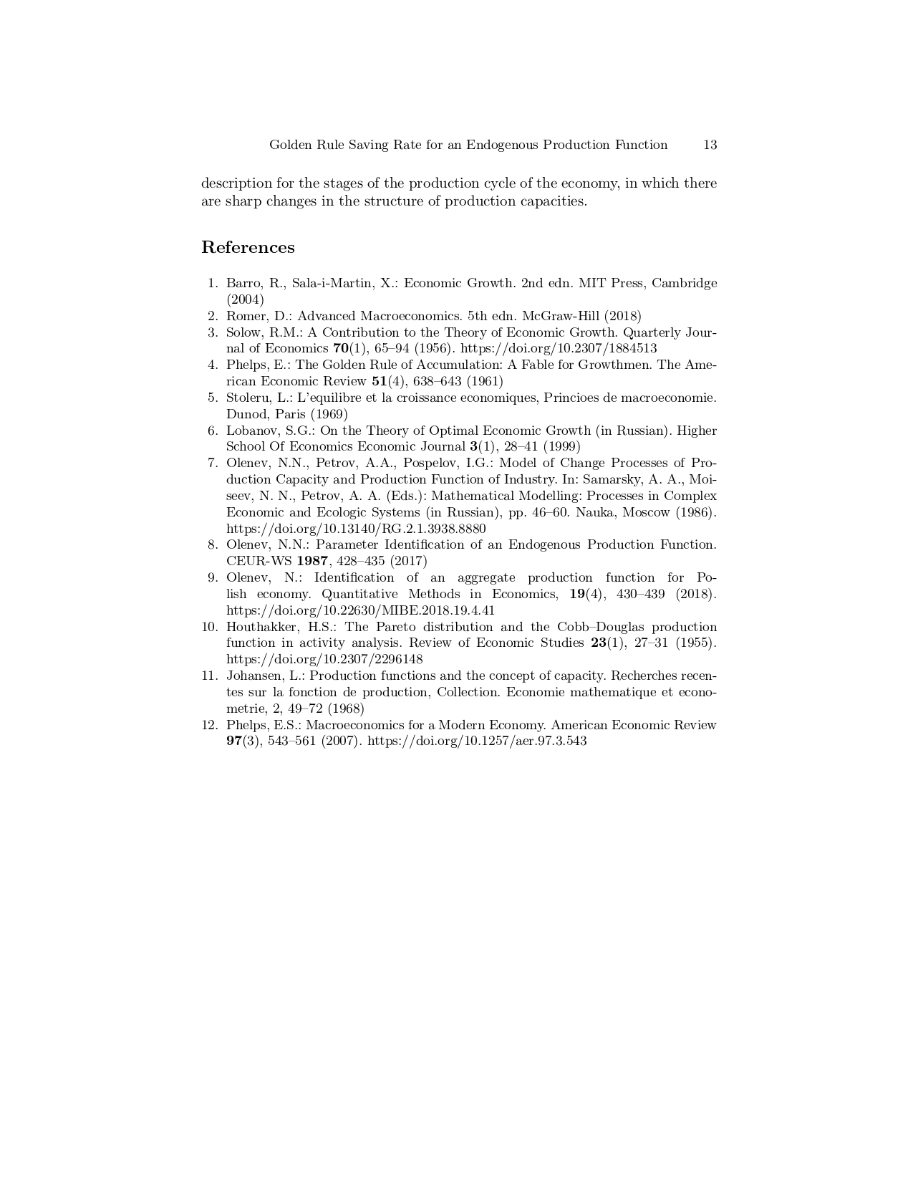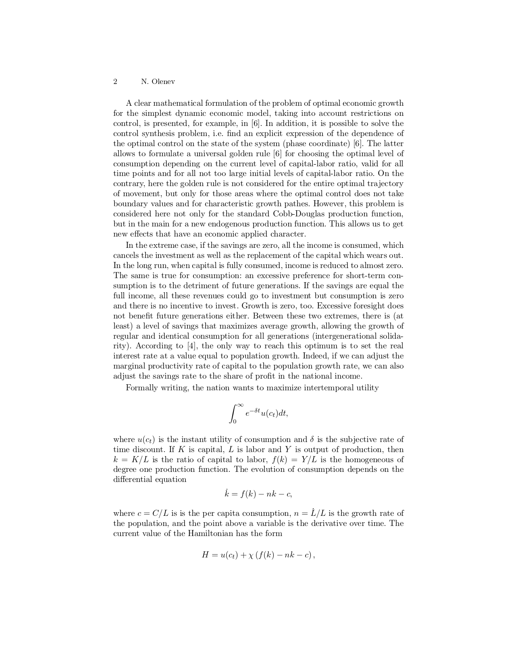

APPENDIX D

List of information resources used

The following foreign information resources were used in the course of the interim report:
- Scopus;
- Clarivate Analytics;
- dblp Computer science bibliograghy.

