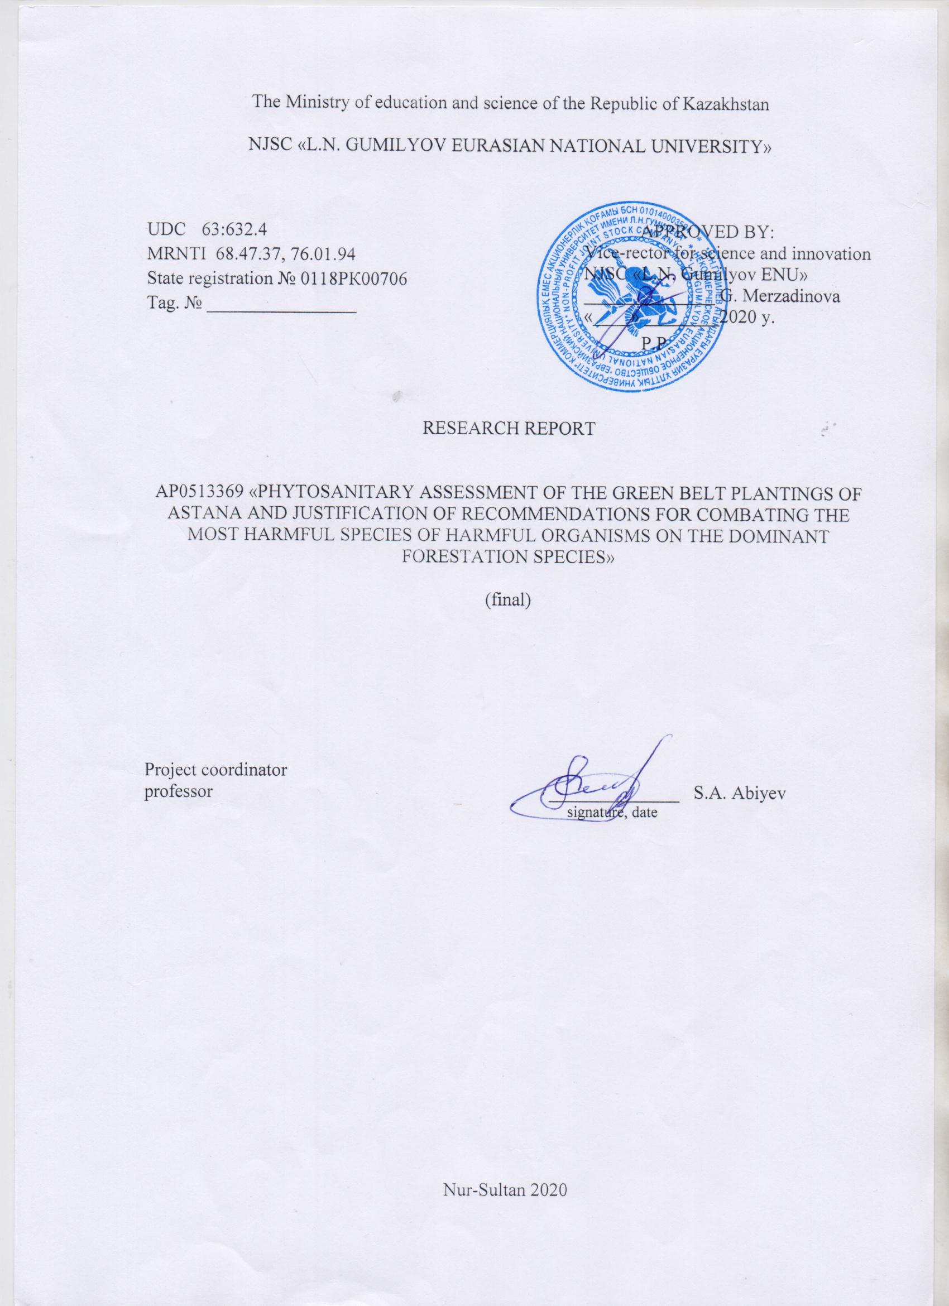

ABSTRACT
Report 67 P., 25 drawings., 3 tables, 25 source, applications А, В, С, D.
Keywords: Green belt, green spaces, phytopathogenic organisms, bacterial dropsy, bacterial burn, leaf spotting, cultural features, molecular identification.
Object of research: green spaces of the Green belt around Nur-Sultan and diseases affecting tree and shrub plants in the Belt.
Target: Identification of species of phytopathogenic organisms of forest stands and phytosanitary assessment of the state of the Green belt of Nur-Sultan.
Method of research: Common Botanical and phytopathological methods were used to implement the project objectives. The conditions and infectability of plantings with diseases were determined by route surveys. Monitoring studies were conducted on model sites. Identification of the identified phytopathogenic organisms was carried out on the basis of their morphometric and cultural characteristics. Molecular identification of bacterial dropsy strains was performed by determining the direct nucleotide sequence of the 16srrna gene fragment.
Obtained results: Based on the results of route surveys and identification of diseases of forest stands of all 7 forest farms, the phytopathological state of green spaces of the Green belt around Nur-Sultan was assessed. The affected plants were collected for the herbarium (about 300 sheets) and then morphometrically processed to make a summary of phytopathogen species. Live materials (more than 90 samples) were collected for morphometric (micro - and macro-) studies of affected plant organs, as well as cultural and morphological studies of facultative parasites. 350 macro-and micro-images of affected plant organs and their microstructures were taken, some of which are attached to the report (APPLICATION D ). The list of references includes 25 titles. 4 articles were published in publications recommended by the CCSON and 1 article in Scopus publications, 2 articles were published (APPLICATION A): one in the CCSON edition, the second in the international edition with a percentile higher than 35.
Application area: For gardening and forestry organizations implementing the Republican program "Zhasyl El", organizations of quarantine inspection and plant protection service, as well as for institutions of RSE "Zhasyl Aimak", "Zelenstroy", RSE "phytosanitary", Botanical gardens of Kazakhstan.

CONTENT
 | CONTENT …………………………………………………………………………. | 4
 | INTRODUCTION ..………………………………………………………………… | 6
1 | Overview of the issue status ……………………………………………………….. | 8
1.1 | Literature review on the issue …..………………………………………………….. | 8
1.2 | Natural and climatic features of the research area …………………………………. | 11
2 | Method of research …..…………………………………………………………….. | 12
3 | Research results ………….…………………………………………………………. | 13
3.1 | Forest stands’ phytopathological state and monitoring of the major diseases development in forest plantations .....………………………………………………. | 14
3.2 | Morphometric characteristics of affected plant organs …………………………….. | 24
3.3 | The dynamics monitoring of the forest plantations’ major diseases development on model objects …........................……….……………………………………………. | 29
3.4 | Cultural, morphological and molecular identification of plant diseases’ causal agents …………………...………..…………………………………………………. | 31
 | CONCLUSION .……………………………………………………………………. | 36
 | LIST OF SOURCES USED ……………………................................................. | 39
 | APPLICATION ..…………………………………………………………………... | 41

SYMBOLS AND ABBREVIATIONS
JPS – global positioning system or satellite navigation system.
All other symbols and abbreviations used in the text are well-known, so they are not given here.

INTRODUCTION
Nur-Sultan is the administrative and political center of Kazakhstan. It is located in the North of the Sary-ARKA Kazakh small hill in a zone of sharply continental climate.
From the day the capital of the Republic moved to Akmola, under the new name Nur-Sultan, the priority task was to rebuild the former ordinary city into a modern one, with original architectural structures, surrounded by greenery not only from the inside, but also from the outside. For a record period of time by historical standards, the city of Akmola has been transformed beyond recognition, and a new Eurasian city Nur-Sultan has appeared in its place – the pride of the nation, the symbol of sovereign Kazakhstan. The General Plan for the development of the city, developed under the direct supervision of the President of the country, included a project to create a green belt around the capital for 100 thousand hectares until 2023. This year, the area of man-made forest around the city has reached 87 thousand hectares. We can say with confidence that the project is being improved every year, and the green forest has almost surrounded our young capital. Its length from North to South is 115 kilometers, from West to East – 130. And now the most important task of the creators of the man-made miracle is to combine it with the natural forest of Shchuchinsk and Borovoe [1,2].
Today, about 10 million trees and more than 2 million shrubs grow in green zone forests. According to the Department of natural resources of the capital, the area of landings increases by 300 hectares annually. Currently, the Green belt has already formed a real forest, it has already become a habitat for wild animals. Pheasants, hares, and foxes settled in the steppe where nothing had grown before. Next year, 40,000 trees are planned to be planted in the city, and 15,000 will be allocated for the Botanical garden under construction. The most common trees are pine, spruce, willow, poplar, birch, maple, ash, and elm. In addition, every year decorative species are added: Altai Linden, Tatar maple, oak and other trees that bloom brightly in spring.
On the eve of the capital day, the Head of state made a traditional flyby of the "Green belt" of the city and got acquainted with the progress of its development. Then the Head of state held a meeting on the current state and further development of the" Green belt " in Nur-Sultan. He stressed that "the green belt has also become a place of recreation for people, and most importantly-it is "the lungs of our country", as long as people live here, this forest will stand for as long as possible. This will be a great monument to our generation, " the head of state expressed confidence.
Creating an artificial forest in the steppe, in a sharply continental climate on such a huge area is a unique case. The experiment that initially seemed utopian has now become a reality – in just 20 years, a huge forest area has appeared in Sary-ARKA. This is a huge result of a large team of specialists and workers led by the General Director of the RSE "Zhasyl Aimak" Zh. o. Suyundikov. Every year, pheasants and other game are released into this man-made forest, and representatives of wild fauna (hares, foxes, birds) also take up residence in the forest. In the green belt, a "Safari Park" is opened on an area of 300 hectares for recreation of citizens and visiting tourists. The green area already has a positive impact on the microclimate of the capital, and the strength and frequency of gusty winds have decreased. In 2014 and 2016, the second stage of this unique Project was launched-the planting of 1.1 million new seedlings [1,2].
It should be noted that the implementation of this unique project involves planting not only the necessary plant species, but also appropriate care for them throughout their entire life. Among them, the prevention and control of harmful organisms of forest crops is of no small importance [3,4]. At the same time, it is necessary to take into account that in creating a forest belt, forest species are used not only in this region, but also in other regions, which is fraught with the introduction of new species of phytopathogenic organisms that are not typical for this region. The latter together with native species form a new complex of harmful organisms of forest stands here [4].
Harmful organisms (pests and diseases), as the name itself sounds, have a strong negative impact on the vital state of the host plant, reduces its resistance to other adverse environmental factors, reduces their age and ultimately leads to their premature death. If timely measures are not taken to eliminate or treat such diseased plants, they, in turn, themselves become sources of infection and the spread of the disease to other healthy plants. Therefore, it is extremely important to conduct a phytosanitary assessment of the state of forest plantations In the green belt of Nur-Sultan, which was created with a lot of financial resources and human labor.
Initially, when this project was compiled, it included the entire complex of harmful organisms (pests and diseases) of green belt forest crops. However, the reduction of funding from the requested amount by more than 4 times and, accordingly, the staff of performers from 8 units to 2.5, including the project Manager, led to a significant adjustment to the original project plan. The pests section was reduced, leaving only the "diseases of forest crops" section. In this form, the project was approved. This report summarizes the results of the project for the entire period of its implementation (2018-2020) in accordance with the approved calendar plan.
The results of the project will be significant for gardening organizations implementing the Republican program "Zhasyl El" in all regions of the country, organizations of quarantine inspection and plant protection service, as well as for institutions of RSE "Zhasyl Aimak", RSE "Zelenstroy", RSE "phytosanitaria", Botanical gardens of Kazakhstan.

1. OVERVIEW OF THE ISSUE STATUS
1.1 Literature review on the issue
The harmfulness of woody plants pathogens is caused by a variety of biogenic factors, abiogenic and anthropogenic origin, which directly and indirectly affect the interactions in the host-pathogen-associated organisms-environment system. The causes of non-communicable diseases can be environmental factors that negatively affect plants and cause them to have violations of physiological and biochemical functions and anatomical and morphological changes. These include adverse weather and soil conditions, environmental pollution, recreational loads, and other anthropogenic factors.
Fungal diseases (powdery mildew, rusty fungi, pine Shute, blackness, spots, scab, deformity, mosaic, bark necrosis, cancer, wilt (wilt), rot, witchy spots, burns) are most common on woody and shrubby plants. bacterial and viral diseases are less common [1,2,3] .
Rust fungi are widely distributed around the globe. All representatives of this class are obligate parasites, mainly on the vegetative organs of many plants, including shrub and woody plants, both cultivated and wild, are distinguished by a wide range of trophic specialization and exceptional harmfulness. There are over 400 species of this class in Kazakhstan [4].
Diseases such as Schutte are manifested in redness, Browning or yellowing of needles and their fall. They affect plants of different ages, but are most dangerous for nurseries, crops and young plantings in urban areas. Sources of infection are diseased plants and fallen needles with spores of the pathogen. Common pine Schutte (pathogen – fungus Lophodermium seditiosum) affects seedlings in nurseries, seedlings and pine crops up to 6 years of age. In spring, the affected needles turn red, and it forms a sporulation of the fungus in the form of numerous small black strokes. In summer, the fruit bodies of the pathogen appear on the needles, which have the form of oval black pads, often connecting at the ends [5].
A significant contribution to the weakening of plantings is made by various diseases, the most dangerous of which are bacterioses. Currently this disease of birch trees is widespread in many regions of the European part of Russia and Belarus [6]. Vascular parenchymal bacteriosis of woody plants that affects the wood tissue of trunks and branches of a number of valuable forest species in the United States, dropsy lesions were noted as early as the 20s.by the 50s, it covered many States. In Colombia and other States, the disease has been observed on a large scale in pine, spruce, and other species. In 1945, J. C. Carter described a bacteriosis called wet wood on rocks and its pathogen – Erwinia nimipressuralis Carter [7]. In the summer of 1949, the Department of forest Phytopathology of the U.S. Department of agriculture conducted research in Idaho and Brittany, and the adjacent States of Montana and Washington, where it was recorded the defeat of conifers with typical signs of bacterial dropsy [8]. Studies of the causes of coniferous drying have shown that "dark water layer", wet wood, watermark disease are symptoms of a bacterial disease. The pathogen was isolated, its participation in the infectious process was proved, its biology and ability to infect many forest species were studied [9]. In Ukraine, R. I. Gvozdyak and L. M. Yakovleva identified bacterial dropsy on beech, oak, and poplar by 1979, and the pathogen - Erwinia nimipressuralis was studied in detail [10]. In 1985, T. M. Rybalko and A. B. Gukasyan studied bacterial dropsy on coniferous rocks of Central Siberia and described the pathogen Erwinia nimipressuralis [11]. In 1979 – 2013, the list of species affected by bacterial dropsy for this bacterium was expanded By V. V. Cherpakov [12, 13, 14]. Bacterial dropsy of forest species is a widespread systemic bacteriosis that usually occurs in a chronic form, affecting deciduous and coniferous forest, ornamental and garden tree species. Symptoms of bacteriosis are associated with watering of the core and sapwood of trunks, with cracks and cancer wounds of trunks and branches, swellings and nodules of the bark and periderm, necrotic wet ulcers in places of external penetration of infection, fluxes, abundant sputum and streaks of mucus, which served as the basis for the name. Coniferous trees are also characterized by tarring of the affected tissues, tarring of trunks. Chronic pathogenesis is accompanied by dryness, desiccation and death of the tree [15]. In the Russian literature, bacteriosis and its pathogen were first described in 1963 by A. L. Shcherbin-Parfenenko, on 22 species of coniferous and deciduous species, which gave the name of the disease – bacterial dropsy [15].
In Kazakhstan, only small pockets of it were previously observed, but after 2010 the disease became widespread, and the course of the disease became quite aggressive, which was presumably triggered by the drought, which significantly weakened the protective mechanisms of plants. In the Akmola region (Burabay, Kokshetau, and Zhasyl Aimak), this disease was studied by O. N. Mironenko and S. A. Kabanova, since huge areas of birch stands were under threat of death [16]. On the territory of the Zhasyl Aimak RSE, birch forests account for 31.2% of the area covered by forest vegetation. Also in the North Kazakhstan region, this disease is being studied by I. V. Savenkova [17]. Phytopathogenic bacteria also cause spots, rot, necrotic cancers and vascular diseases. Examples of widespread bacterial diseases of tree species are transverse cancer of oak, tuberous cancer of pine, wet ulcerative vascular cancer of poplar, bacterial burn [18].
In recent years, a new quarantine disease of fruit trees – bacterial burn, which was absent in our region, has largely spread in the fruit plantations of the Republic. The disease was first detected on the territory of the Republic in 2010. A. O. Sagitov, M. M. ISIN, A. A. and others [19] believe that the pathogen entered our gardens much earlier. One of the ways to spread the disease is planting material. From 2003 to 2005 seedlings of fruit and ornamental crops were imported to our country from Germany, Belgium, Poland, France, Italy, Turkey and other countries where bacterial burn was widespread.
The transfer of phytopathogenic bacteria from diseased plants to healthy ones or from affected parts of plants to unaffected ones occurs in several ways during the growing season. In most cases, phytopathogenic bacteria cannot spread over long distances directly through the air. This method of transport, especially in dry air, has limited local significance. This is due to the fact that most phytopathogenic bacteria are non-spore sticks, which die quite quickly in dry air, especially under the influence of sunlight. Their distribution is more successful in humid air. Humidity of the environment is one of the conditions for the successful spread of phytopathogenic bacteria. During rain, most bacteria can spread with water drops, including those that cause leaf spots, shoot burns, and so on. Insects in some cases have a close relationship with pathogens of bacteriosis. They are able to spread bacterial infection throughout the growing season. Most often, there is a mechanical transfer of bacteria. Insects (bark beetles, barbels, goldfinches) from diseased parts of the plant transfer them on the covers of their body or on the oral organs to healthy plants.
Bacterial diseases of leaves (mainly spots, less often burns) and some viral diseases such as mosaics are widespread. Non-infectious diseases of leaves are also known, which are manifested in the form of burns, changes in the shape, size and color of leaves, and their death. Leaf diseases are dangerous mainly in nurseries, young crops, protective forest stands and urban plantings. In leaf diseases, photosynthesis, respiration, transpiration and other physiological processes are disrupted, hypertrophy, tissue necrosis, and pathological changes occur. Leaf diseases lead to a decrease in the intensity of assimilation, premature leaf fall, deterioration of decorative qualities, reduced growth, reduced winter hardiness and General weakening of plants. With annual repeated plant damage, leaf diseases can lead to stunting, and with a strong degree of damage, to the death of young plants.
Dzhaymurzina A. A., Kopzhasarov B. K. and others [20]. received a patent for an innovative invention studying a method for diagnosing bacterial diseases of fruit and forest crops. The proposed invention will make it possible to quickly and simply diagnose bacterial diseases in forest tree crops and correctly select and purposefully carry out protective measures, including quarantine ones, and prevent losses from the disease.
Phytopathogenic bacteria affecting woody plants, due to the specificity of their biology, and, accordingly, the specificity of pathogenesis, differ greatly in the nature of exposure from fungal lesions and insect damage.
Viruses cause diseases such as mosaic and jaundice. Of viral diseases in forest plantations are frequently encountered virus of the ring leaf spot of elm, ash, witches ' brooms on pine and spruce. Viral diseases that affect woody plants do not have much economic significance.

1.2. Natural and climatic features of the research area
The climate of Nur-Sultan is sharply continental with dry summers and cold snowy winters. The average annual temperature is 3.2 °C. The average annual precipitation is 307 mm. Nur-Sultan is the second coldest capital in the world (after Ulaanbaatar). Astana is located on the Bank of the Ishim river. Because of its remote location from the oceans, winter is colder here than in cities located West of it at the same latitude (Uralsk, Voronezh, London). Summers are warm and dry, and despite this, most precipitation falls during the warm period (April-October).
The warmest month is July, with an average temperature of 23.9 °C. The coldest month is January with an average temperature of -20.2 °C. Absolute maximum temperature: +41.6 °C (recorded July 22, 1936). The Absolute minimum temperature: -51.6 °C (recorded January 5, in 1893).
The annual maximum precipitation is 780 mm (in 1892), and the annual minimum is 113 mm (in 1951). The record maximum precipitation per day is 86 mm (recorded in July 1972).
The daily and annual temperature amplitudes are very large. Weakly expressed spring and autumn. There are a lot of Sunny days, and the amount of solar heat received by the earth in summer is almost as great as in the tropics. The cloud cover is not so significant. Annual precipitation decreases from North to South, with a maximum in June and a minimum in February. Snow cover is maintained for an average of 150 days. Winds in the Akmola region are very strong [21].
The waters of the Akmola region are scarce. Rivers are shallow, non-navigable, and are fed by meltwater and, to a lesser extent, by ground sources. In the summer the river is dry, the water becomes brackish. The main rivers of the Akmola region: Ishim (Irtysh tributary) and its tributaries: TERS-Akkan-on the left, Zhabay, Koluton, etc. - on the right. Many rivers end in drainless lakes (the Nura, Selenta, and Ulenta rivers). A lot of lakes are occupied by small-hill basins and elevated plains of the Akmola region. The largest of them are salt lakes Tengiz (near the border with the Karaganda region) about 40 km wide, Kalmyk-Kol, etc., smaller in size - freshwater Ala-Kol, Shoindi-Kol, and many others. Due to low-lying shores, many lakes change their shape in strong winds [22].
The flora of the Akmola region is represented by steppe and partly semi-desert plant elements and communities. Depending on the terrain and underlying rocks, soil complexes and plant associations are quite variegated and diverse. To the North of Ishim there are grass-grass steppes on the southern chernozems with a large number of salt flats on the depressions and skeletal soils on the hills. The vegetation is drought-resistant, mainly grows feather grass, tipchak, and pine forests are often found on the hills.
The third part of the West of the Akmola region is occupied by grass steppes on dark chestnut soils. The soil cover is only 30-40 %. To the East of Astana in soil large, the role of salt licks and vegetation - sagebrush, and regards. In the southern part of the Akmola region, in the area of lake Tengiz, an unclosed cover of sagebrush and tipchaks is spreading on salt flats and salt marshes.
The territory of the green belt of Astana is located in the steppe zone of chestnut soils in the subzone of dark chestnut soils. The latter are zonal soils. In addition to them, introsonal soils are widely distributed: meadow-chestnut, meadow-marsh, salt marshes and salt marshes. Saline soil-forming rocks caused salinization of soils over a large area to some extent [23,24]. The specifics of the terrain and soil-forming rocks predetermined a large mosaic of soil differences.
The main limiting factor affecting the growth, condition and life expectancy of woody vegetation is: the capacity of the desalinated root-accessible soil layer, limited by the depth of depressing toxic concentrations of harmful easily soluble salts [25].

2 METHOD OF RESEARCH
The study and assessment of the forest pathological state of green spaces in the green belt of Nur Sultan was carried out by route surveys during the entire growing season, and disease development was monitored on model plots. The sample was a part of allotments (plots) or blocks of forest plantations that are used to judge the state of all plantings. Locations of areas with affected plants were marked using JPS, and photos of affected plants and plant organs were taken using a Canon digital camera.
The assessment of plantings ' infestation with diseases was made in % of the total number of trees, and the intensity of plant damage in the affected area was made from the total leaf surface of this tree.
Identification of the identified phytopathogenic organisms was carried out on the basis of their morphometric characteristics. Morphometric, including micrometric descriptions and photographs of identified phytopathogenic organisms were carried out visually and using an Olympus BH-2 microscope with a built-in Canon camera and displaying images on a computer screen, as well as measuring objects in the MS Exsel dialog box with data counting using Cameram.
To identify plant pathogens, their visual appearance is not enough. Artificial culture media ("Potato Dextrose Agar", Endo, standard and meat-peptone agars) were used to study the cultural features of the development of semi - ligate phytopathogenic fungi, as well as phytopathogenic bacteria, and thermostats were used for their incubation.
Molecular identification of bacterial dropsy pathogen strains was performed by determining the nucleotide sequence of the 16SrRNA fragment of the gene and then comparing its identity with the nucleotide sequences of species strains deposited in the international Gene Bank database. The PCR reaction was performed with universal primers 8f5’ - AgAgTTTgATCCTggCTCAg-3 and 806R-5'ggACTACCAgggTATCTAAT in a total volume of 20 µl [22,23,24]. Molecular identification of the causative agent of dropsy was conducted on the basis of specialized research laboratories National center for Biotechnology Ministry of Education and Science of the Republic of Kazakhstan.

3 RESEARCH RESULTS
Assessment of the Green zone phytopathological state was carried out by annual surveys of forest plantations of all 7 forest farms. The area of each forest area is, on average, 10-13 thousand hectares, and the total area is about 90 thousand hectares. Today, 26 species of woody and shrubby plants grow on this territory, including about 10 million trees and more than 2 million shrubs.
Before starting the survey, our routes were previously agreed with the employees of the forest districts, so that the surveyed blocks and areas would be representative of the forest plantations of the corresponding forest district in all parameters. Depending on the weather conditions of the year, route surveys were started in the II – III decades of may and ended in the II-decade of October. At the same time, all aboveground vegetative and generative organs of plants were examined. The affected plants showed which organs were affected, to what extent, and the nature of the lesion. The locations of such plants were noted by JPS. Various magnifying glasses and binoculars were used for visual assessment of plant damage (to examine the upper crown of tall trees). For laboratory analysis (morphometric description of the affected plant organs and pathogens and their isolation in pure culture), the affected parts of plants were collected (herbarium).
The summary (generalized) results of the survey and assessment of the phytopathological state of forest plantations for all Green belt forests for the Project implementation period (2018-2020) are given below.as for the results obtained in individual years of the study, they were presented in annual reports.

3.1 Forest stands’ phytopathological state and monitoring of the major diseases development in forest plantations
Kyzylzhar forestry. The total area is 12090 ha. On the territory of the forest area there are old forest plantations of the 50s and 60s of the last century. New plantings started from the day of the organization of the RSE "Zhasyl Aimak" (1997).
The rose hip (Rósa canína L.) Individual rosehip bushes are still in the flowering phase affected by rust to a strong extent. Leaves and branches with strong curvature and deformity are affected. In General, 85-90% of the examined plants were affected (drawing D 3). Urediniopustules on the affected organs of plants are yellow-rusty in color, merging, powdering, completely covering the stems, the covering tissues of plants in such places are torn. The crumbling mass of urediniospores settling and covering healthy parts of plants give such a Bush a fiery yellow appearance. In 40-45% of the affected plants, rust pustules were noted only on the leaves, the stems were not affected. Microscopically, the urediniospores are rounded, slightly oval, 15-20 microns in diameter, the spore shell is dark, smooth, without spines. No teliospores were detected. The diagnosis is a rust fungus (Phragmidium disciflorum James), which often affects rosehip in Central Asia.
Scots pine (Pinus sylvestris L.) Young plantings. 40-50% of the plants examined were affected. Individual plants are affected with an intensity of 70% or more and die. On young branches, the needles are light brown to rusty brown. Needles are affected, mainly at the base of branches, on individual branches all needles are affected, without exception. There are plants that are partially (lower, middle and upper parts of the plant) or completely affected. Diagnosis-Schutte (Lophodermium seditiosum Minter and L. pinastri Chev).
Scots pine (Pinus sylvestris L.) On individual branches, mainly lower and middle, the needles are yellowed, starting from the tip and spreading to the base. From this type of tree variegated-yellow-green.Such needles dry out and fall off when they touch. Visually, they do not show any other changes except for the loss of green color.In this series, all plants are affected with an intensity of 20-25%. On some of these needles, there are many small (0.5-1.5 mm long) black spots on the surface. Individual spots along silkily narrowly opened. In most spots, the integumentary tissue is not disturbed. Darkened areas occupy the entire width of the needles, along a length of 1 2 mm. The base of the needles - the place of attachment to the branch is destroyed, turned into a black-brown shapeless loose structure. The cause of death of needles is probably a blockage of blood vessels due to their damage by phytopathogenic organisms. Diagnosis-yellowing of conifers (Naemocyclus minor Butin.).
Yellow acacia (Caragana arborescens Lam.). Mainly on the upper side of the leaf blade there are grayish-brown spots with a light side border. Spots occupy 10-15% of the leaf surface and are spread out. Microscopy does not detect fungal structures. Diagnosis Identification of the causative agent of the disease lasts (drawing D 17).

Triploid aspen (Populus tremula L.). Old disorderly landings. On some groups of plants, only the upper branches are preserved, the trunks are thin, 10-15 cm in diameter, and up to 5-6 m high. On the trunks of the dried traces of liquid yellow-brown color from the wet fluid. In some places there are black bumps with ulcers and drops of amber exudate and an unpleasant smell. Diagnosis-bacterial cancer (Erwinia multivora Scz.-Parf.).
Hanging birch (Betula pendula Roth.). The Affected areas of the trunk have notched cracks with a convex rim measuring up to 3-6 cm wide and up to 30-35 cm long along the trunk. In places of such cracks, the surface of the crust is destroyed, black-soot, and when pressed, a cloudy-transparent liquid flows out (drawing D 19). The affected areas are located 1-2 m higher from the soil surface. Trees with an age of about 45-50 years. Diagnosis-bacterial dropsy (Erwinia multivora Scz.-Parf.).
Scots pine (Pínus sylvéstris L.). Interculse young plantings up to 1 meter high, on the lower branches of the needles dead (Schutte disease), the upper branches with restored green needles. In most plants, the tips of the needles are yellowed (70-80%). Diagnosis-Schutte (Lophodermium seditiosum Minter и L. pinastri Chev.).
Arshalinsky forestry: The total area of landings of the forestry is 3363 ha. Landings were made in 2012-2013. Composition of plant species tree species: peristaltic elm, common elm, ash-leaved maple, narrow-leaved Loch; shrubs: Tatar honeysuckle, red currant. Backstage landings, 6-row, 24 m wide, interstage -12 m; total width 36 m. The length of landings along the Karaganda highway is 15 km, width-5 km.
Black currant (Ribes nigrum L.). Was in the fruit setting phase. No illnesses were detected.
Tatar honeysuckle (Lonícera tatárica L.). Development Phase-mass flowering and fruiting.
Peristaltic elm (Ulmus pinnato-ramosa Dieck.). Beginning of flowering. In 40% of plants, 80% of the leaves are affected by the caterpillar of the mottled elm moth-Calospilossylvata Scop. The leaves are shriveled, as if charred. Chemical treatment against the pest with insecticides was carried out. The remaining tree and shrub species of forest plantations are in good condition, and no diseases were found on them. The water supply of forest crops is satisfactory. Care of landings at the proper level, fire protection measures are observed.
The Forest Batis. The total area of forest plantations is 10088 ha, divided into 140 blocks. Landings since 2008 4 blocks were sampled. Of these, 3 and 12 blocks were re-examined in order to monitor the phytopathological state of forest stands. The wings are 5-6-row.
On the hanging birch (Betula pendula Roth.), Leaf damage was noted by a mining fly, tatar ash was damaged by leaf eaters, and only leaf petioles remained on some branches. In a row of birch trees there are dead plants, on some plants the initial stage of development of bacterial dropsy is marked (drawing D 4).
In a row of hanging birch (Betula pendula Roth.) there are completely dead plants (N 51o202251; E 070o441661). In a row of turf there are plants with shrinking of the upper part. Near this quarter there are old landings (up to Zhasyl Aimak). Among them there are dead plants of small-leaved elm (Ulmus parvifolia Jaco), along with healthy ones (drawing D 6).
Quarter 3. 29 ha. Landings 2009 JPS reading: N 51o201131; E 070o448321. Backstage 6-row: Loch, poplar, ash (2 rows), willow, loch.
State of forest plantations. In a row of poplars there are places in a row of dead plants. In addition, old water spots (bacterial cancer) with dried wood bark are found on living poplar plants.
Quarter 19. 97 ha. Feather-grass steppe. Planting 2009 6-row wings: maple, Loch, willow, poplar, Loch, currant; or: currant, bessea cherry, maple, loch, poplar. On the willow tree, almost half of the leaves are yellowed (lack of moisture). No noticeable deviations from the norm were observed on other plant species.
In the backstage area – maple, in the other – shadberry. Condition: willow mostly dies; single branches with single yellowed leaves on the poplar, bacterial cancer is present on the trunk (drawing D 15). In another stage, 90% of the plants were also killed by willow. The condition of other breeds is normal. In the protective lane, along the road to Kustanai, on elm dryness.
On birch, individual leaves are completely or partially yellowed, such leaves per plant on average 40-50%. In this quarter, in some places in many wings, the entire row or individual sections in a row with a birch tree were completely destroyed. There are areas where birch trees were partially lost. The same pattern is observed, although to a somewhat lesser extent, in the Tatar honeysuckle, and occasionally in the ash-leaved maple (drawing D 1). In General, in this quarter, in some places there are large areas with completely dead plants of an abiotic nature. This shows that the soil of these places is clearly not suitable for planting the above-mentioned species, and possibly other trees. Apparently, in this section of the block, aggressive ground water lies close to the surface of the soil. This is indicated by the fact that all plants took root during planting and even grew normally for several years, until their roots reached salty ground water, which can be seen by their height and crown volume. Then they all died at once. This indicates the need to conduct an agrochemical analysis of the soil on this site, for the possibility of using this territory for re-planting.
Quarter 4. (90 ha) ((JPS: N-510201881. E-0700425841). Planting scheme: honeysuckle 1, poplar 1, maple 1, willow 1, maple 1, honeysuckle 1 = 6 rows. The condition of the landings is good, but there is a plot where, on an area of 20x700 m. all landings are dead. This is also the case as in the 2nd quarter of this forest area.
Quarter 6. (175 ha) ((JPS: N-51⁰204161. E-070⁰429881). Planting scheme: maple 1, birch-4, maple 1 = 6 rows. Planting in 2007. The plantings are in good condition. In some areas, the birch has marginal yellowing of the leaves. There is a backstage area where all the dead were killed in places. InterCool planting 2018 maple or elm in two rows, their condition is normal.
Quarter 7. (178 ha) ((JPS: N-51⁰204161. E-070⁰429881). Landing pattern: the same as in the 6th quarter. The condition is very good.
Quarter 12. (49 ha) ((JPS: N-51⁰ 204681. E-070⁰446591). Planting scheme: honeysuckle 1, birch-4, honeysuckle 1. the Condition is very good. In some scenes near the birch tree, individual branches are completely dead.
Quarter 13. (105 ha) ((JPS: N-51⁰ 199811. E-070⁰ 450881). Planting scheme: maple 1, Loch 1, willow-2, Loch 1 = 5 rows; currant 1, Loch 1, elm -2, Loch 1, currant 1 = 6 rows.
On the small-leaved elm there were traces of damage to the leaves by the moth. In addition, the lower branches of this plant are dried up.
Quarters 18. (45 ha) ) и 18 (33 га) (JPS: N-51⁰ 196011. E-070⁰ 471801). Planting scheme: Golden currant, maple, currant; currant, ash, maple, Loch, birch. The plantings are in good condition. However, there are places where there are bald areas with partially dead maple. InterCool planting this year-maple, Apple tree.
Tartar honeysuckle (Lonícera tatárica L.). The leaf blade and fruit are partially covered with a sooty dark mass. The leaves and fruits are shriveled, as if charred, dried up. On young leaves, the lesion is marked from the tips of the leaves and gradually spreads to the middle part and to the base. Young twigs are also blackened. The upper branches are more affected. The affected leaves are completely dried up and dead. Diagnosis: bacterial burn – (Erwinia amylovora (Burrill) Winslow et al.).
Green ash (Fraxinus lanceolata). The leaf blade is severely damaged by insects. Some of the leaves have only the Central veins, others have been partially eaten, half or a quarter, etc.
Narrow-leaved Loch (Elaeagnus orientalis L.). Strongly affected by cicadas. In addition, the leaves on the upper side have many necrotic spots of brown, dark brown color, Especially closer to the edges of the leaves, scattered against the background of yellowed discolored areas of the leaf blade. In the middle part of the larger spots, discolored, on which there are many small black spots. Discoloration of leaf areas is more likely a consequence of their defeat by cicadas (drawing D 2).
White dogwood (Cornus alba L.). Leaf damage by insects. All the edges of the leaf blade are eaten by insects.
Astana forestry. The total area of forest plantations is 9636 ha. divided into 140 blocks. 5 blocks were sampled. Landings were made in 2003, inter-stage landings there in 2016), 2009-2012 and 2016-2017. Species composition: woody plants - 13 species, including coniferous 2 species (pine and larch); shrub species-10 species. The wings are 5-6-row. Landings of 7. 12 sq. m were examined. (JPS: N-510116511. E-0710041561), 26, 29 sq. (JPS: N-500599001. E-0710241211), 30-33 sq. (JPS: N-500561501.E-0710232281). Order of landing backstage, 5-6 rows.
Quarter 17. Planting in 2009 60 ha. Backstage 6-row: ash, Loch, maple (2 rows), Loch, currant.
Ash-leaved maple (Ácer negúndo L.) lacks moisture.
Narrow-leaved Loch (Elaeagnus orientalis L.), in a row there are attacks (according to the stories of foresters it happened 3 years ago). No obvious diseases were observed on other landings.
Quarter 20. Planting in 2009 80 ha. 6-row wings: currant (2 rows), Loch (2 rows), maple (2 rows); or: currant, Loch, maple (2 rows), Loch, currant. In mikulici grows wild clover.
In the rows of narrow-leaved loch and ash-leaved maple there are continuous attacks on a significant area.
Quarter 19. Planting in 2009 70 ha. 6-row wings: birch (5 rows), turf. State of forest plantations. All plantings are deficient in moisture.
On a hanging birch (Betula pendula Roth.) almost half (on some up to 70%) of the leaves are dried. Rather, it may be the result of leaf damage by a caterpillar of mining flies. In a row of turf, blood-red hawthorn grows in places. Hawthorn fruiting is very weak, which is more likely due to a lack of moisture, and possibly with salinity of the soil.
Quarter 49. Planting in 2009 170.6 ha. 6-row wings: Loch (2 rows), elm (2 rows), pine (2 rows), or: turf, poplar (2 rows), maple (2 rows), honeysuckle.
In the row of Scots pine, almost all the plants died. In ash-leaved maple, 20-30% of the leaves are yellowed (abiotic factor). All plants (maple, poplar) on the site with the area of a football field were completely destroyed (soil factor – salinity of ground water). The condition of honeysuckle is average. In the wings: honeysuckle (2 rows), maple (2 rows), poplar (2 rows) poplar and maple are 90% dead. The honeysuckle is preserved in good condition.
Quarter 25. Planting in 2009 54 ha. 6-row wings: birch, hawthorn (5 rows).
Among the birch trees there are plants that died from dropsy. The condition of plants not affected by dropsy is satisfactory, but their leaves are still 30-55% yellowed. On plants affected by dropsy, characteristic yellow-brown smudges are found on the lower part of the trunk. The hawthorn is also 20-30% of the leaves yellowed.
Quarter 7. Kazakhstan poplar (Pópulus kazakhstanica). At the base of small branches, many twisted, wrinkled leaves are 10-13 times smaller than normal, normal and dark brown flowers. At the end of these branches, starting from the middle, normal, normal-sized leaves are developed (3.5-5.5 cm in diameter). Diagnosis-Taphrina sp. "witch's broom". Microscopic analysis revealed no fungal structures (drawing D 10).
Green-fleshed hawthorn (Crataégus) mass destruction of leaves and fruits. Brushes from fruits are affected by 80-90%, turned into black, wrinkled and undeveloped formations. Some of the leaves on the branches with affected fruits are completely dried, yellow-gray-brown in color. Diagnosis: bacterial burn - (Erwinia amylovora (Burrill) Winslow et al.) (drawing D 11).
Quarter 12. There are many dead plants in a row of birch trees. The reasons may be related to abiotic environmental factors (frostbite in winter, or lack of moisture, aggressive ground water). The biotic factor of death of adult plants (2010, planting) is not visually observed. In some areas in a row of birch trees, individual plants grow normally, although there are also plants with partially dead branches.
Hanging birch (Bétula péndula Roth.) - yellow-brown spots on 4-10% of leaves, occupying the leaf surface up to 40-75%. There is no particular pattern in the location of spots: they occupy one half of the main vein, or the upper half, including both sides of the main vein, etc. No obvious fungal structures are detected.
Quarter 29. Black currant (Ríbes nígrum L.).– 70-80% of the leaves, starting from the edges going deeper to the middle, are eaten by insects.
Hanging birch (Betula pendula Roth.). Many of the plants in the row are dead.
Quarter 32. on a pine tree (2010) in some places, some plants have individual branches or the lower part of the branches dried up, the needles easily fall off. During external examination of needles, there are no signs of an infectious nature. The upper part (3/4) of the plants develops normally, maintaining an intensely green color.
Quarter 33. on willow in some areas, 10-15% of the leaves in the branches are yellowed, possibly due to abiotic environmental factors. There are plants with dried lower branches. In some scenes, a number of poplars are 45-50% dead, there are rows with completely dead poplars. On such dried plants, there are no signs of infection. On the narrow-leaved Loch in some rows on yellowed leaves there are dark, dark brown spots, in other rows of plants without signs of damage. In this quarter, there are areas with completely dead plantings of poplars and willows, and next to the planting of willows in good condition, which clearly shows the mosaic of soil conditions of the area. In the castle of Kulis, the willows in places died by 20% along the length of the row. In the next row of poplars, on average, 30% of the lower branches were lost.
Narrow-leaved Loch (Elaeagnus orientalis L.), - 40-60% of leaves with gray-brown spots, arranged in groups or randomly. In places where spots are located, the leaf tissue is somewhat light yellow. Microscopic view of the presence of obvious fungal structures were not detected (drawing D 9).
Herbaceous plant of the Euphorbiaceae family (Euphorbiaceae Juss.). Interculis plant community, on the leaves of both sides a lot of rounded, powdery yellow to light brown pustules of rust, 1-2 mm in DM, the same spots on the stems, larger, longer. On the underside of the leaves and stems, the parasite's teliostadias are dark and large, covered with the epidermis. The leaves are shriveled and dry. Diagnosis: milkweed Rust – (Uromyces striatus Hawksworth et al.).
Broad-leaved elm (Ulmus L.). On the upper side of the leaf blade, there are many vague dark, often merging spots, from 3 to 7.9 mm in diameter. in some places, such spots merge and occupy 25-30 of the leaf surface. The underside of the leaves is perfectly healthy.
Tartar honeysuckle (Lonícera tatárica L.). The leaf blade and fruit are partially covered with a sooty dark mass. The leaves and fruits are shriveled, as if charred, dried up. On young leaves, the lesion is marked from the tips of the leaves and gradually spreads to the middle part and to the base. Young twigs are also blackened. The upper branches are more affected. The affected leaves are completely dried up and dead. Diagnosis: bacterial burn – (Erwinia amylovora (Burrill) Winslow et al.).
Shortandinsky forestry. The total area of forest plantations is 12.4 thousand hectares. the forestry Is divided into 49 blocks. Landings have been made since 2003. Composition of species: woody plants-8 species (pine, birch, elm, ash, poplar, willow, Loch, hawthorn) shrub species-5 species (Golden currant, S. black, Irga, cherry, cherry bessea,). 6-row landings. Landings of 7, 8, 10, 17, and 30 blocks were examined. 6 blocks were sampled, including 7.8, and 30 blocks were re-examined in order to monitor the phytopathological state of forest stands.
Quarter 5. Backstage 6-row: currant, birch (5 rows). There are scenes with a different composition of plant species. An entire field of ash-leaved maple fell from unfavorable environmental conditions.
Quarter 4. Backstage 4-row: maple, Loch (2 rows), maple. There are scenes with a different composition of plant species. Narrow-leaved loch with partially dried branches.
7,8,12 and 30 blocks of this forest area were also surveyed. In all quarters, the condition of plants is from satisfactory to good. However, it should be noted that the entire surface of the leaf blade of blood-red hawthorn (Crataégus sanguinea Pall.) is affected by spotting, necrotic areas occupy 10-90% of the leaf area. Diagnosis: pleospora – (Phleospora oxyacanthae Roum.).
Narrow-leaved loch (Elaeagnus orientalis L.). In some plants, the tops and especially the side branches are dried up, and some plants are completely dead, the leaves are withered, and there are many different sizes of spots on the green leaves.
In the forest area there are plantings of Scots pine (Pínus sylvéstris L.), 50-ies of the last century with partially yellowed needles.Among the pine plantings there are ground cap mushrooms buttermilk and syroezhki. Individual branches of pines with completely yellowed needles, such dried needles are easily separated from the branches, fall off. Near normal healthy branches. On healthy branches, the cones are small. Yellowing of needles begins at the tip, spreading to the base. The latter are loosely attached to branches, easily separated (fall off). Diagnosis: cancer of the Resin (ceranka) – (Cronartium flaccidum (Alb. & Schwein.) G. Winter и Peridermium pini).
Hanging birch (Bétula péndula Roth.). on yellowed and still green leaves there are rounded slightly oval spots of dark brown color with clearly defined edges. Green areas of the leaf are preserved in a narrow band around the spots. Spots are located on the upper side of the leaf and they are viewed from the lower side of the leaf with a cloudy color. Leaf infestation 1-6 spots per leaf, size 2-4 mm., spots have three color zones: outer green, medium-dark and inner grayish-dark. Microscopic examination does not reveal fungal or other structures.
Yerementau forestry. The total area of forest plantations is 6381.6 ha. 7 blocks were sampled, including 2, 7, 9, 10, 16 and 20 blocks repeatedly for the purpose of monitoring the phytopathological state of forest stands.of these, 5803 hectares are occupied by forest plantations. The forest area is divided into 49 blocks. Landings were made in 2012, 2014 and 2015. Species composition: woody plants-8 species (ash-leaved maple, pyramidal poplar, T. Kazakhstansky, willow, triploid aspen, narrow-leaved Loch, broad-leaved elm, narrow-leaved elm) shrub species-4 species (Golden currant, p. black, Tatar honeysuckle, yellow acacia). 6-row landings. Landings examined 2, 7, 9, 10, 16, 20 quarters'.
Quarter 2. 74 ha. Landings 2014 JPS reading: N 51o310481; E 071o574961. Backstage 5 6-row: currant, Loch, honeysuckle (2 rows), Loch, currant.
In honeysuckle, the tops of all branches are affected by bacterial burns, shriveled, as if charred. In the narrow-leaved Loch, the lower branches (15-20%) are dried up, the upper young branches are healthy. On currants, marginal necrosis of the upper leaves, colored orange.
In some honeysuckle bushes, the tops of all branches are affected by bacterial burns, shriveled, as if charred. Next to another Bush without signs of such a lesion. Diffuse spread of the disease within the plant. There are scenes the condition of plants in them is good, without signs of disease.
Quarter 9. 130 ha. Landings 2014 JPS reading: N 51o299121; E 071o586591. Backstage 6-row: currant, Loch (2 rows), honeysuckle, Loch, currant.
In the narrow-leaved Loch, all the leaves of this year are completely dried up, due to damage by a cloud of Loch cicadas.
Acacia yellow (Caragana arborescens Lam.). the Leaf surface on the lower side is covered with dark brown spots from 70-75%. The plant epidermis is torn, the spot is convex, 0.2-1 mm. in diam. On the branches there are large, single, merging pustules. On the upper side of the leaf blade there are single pustules or no pustules. Microscopy: urediniospores are light brown, rounded, slightly oval, ovoid. No teliospores were found. Diagnosis: rust – (Melampsora ribesiipurpureae Kleb.).
Black and Golden currants (mixed plantings). On the leaves, the spots are light and dark brown, necrotic, without noticeable fungal structures (drawing D 8). Quarter 7. (JPS: N-51⁰282851. E-072⁰0001391).
Kazakhstan poplar (Pópulus kazakhstanica). Planting in 2015. In a row of most plants, the upper part, mostly died, but the shoots recovered from the root. The cause of death is probably freezing, or is related to the soil (drawing. D 7).
Poplar pyramidal (Populus pyramidalis Rozier.). Individual leaves along the veins on both sides of the leaf are painted in a whitish-grayish color. The spots are indented, the surface of the spots is felt-like, dark. On the underside of the leaf along the veins, on the yellowed areas are met many small, dark, almost black, powdery spots. Identification of the pathogen continues (drawing D 13).
Quarter 9. (JPS: N-51⁰310311. E-071⁰575431).
Tatar honeysuckle (Lonícera tatárica L.). Part of a Bush with bright yellowed leaves, on some bushes the tips of branches with curves down, and with numerous small whorls of leaves like "witch's broom". Such small leaves are shriveled, dried up, completely blackened. Preliminary diagnosis: most likely – a viral or bacterial infection. On healthy branches of some plants, on the leaves, on the upper side, starting from the tip, it is covered with a dense soot mass, which occupies up to 80% of the interstitial areas of the leaf.
Identification of the causative agent continues.
Narrow-leaved Loch (Elaeagnus orientalis L.). On some plants, the upper branches of the yellowing leaves are marked with vague dark brown spots. On the green areas of the leaf blade on the upper side of the leaf, there are many small, white, slightly convex, filmy spots (0.1-0.2 mm) of various shapes. Planting in 2015. The plantings are in good condition.
Quarter 16. (JPS: N-51⁰280991. E-071⁰594381).
Ash-leaved maple (Ácer negúndo L.) and pyramidal poplar (Populus pyramidális Rozier.) on a large area of plantings, the plants are dried up, possibly from salinity of the soil.
Broad-leaved elm. On the underside of the leaves, dark brown, almost black, indistinct spots (0.4-3-4 mm) with dense whitish isolated spots in the center are marked. These spots are located on the edges of the leaf, bordering the entire leaf. The inner parts of the leaf are healthy.
Quarter 20. (JPS: N-51⁰280991. E-071⁰594381).
Black currant (Ribes nigrum L.). on the underside of the leaf blade, mainly at the base, red, brownish, blurry spots as they age. Large spots merge, many small spots (2-3 mm.) are single. On some large spots, the Central part is occupied by rounded, oval, compacted, necrotic, convex, whitish-yellowish rather large spots. On individual leaves, areas with spots occupy up to 50-70% of the leaf surface.
Vyacheslav forestry. The total area of forest plantations is 13369 ha. Planting in 2004, 2005, 2011-2013 and 2015-2016. 5 quarters' were sampled.
Quarter 71. 53.2 per ha. Landings 2015 The composition of woody plant species - 10 species (warty birch, ash-leaved maple, Tatar maple, peristaltic elm, common pine, narrow-leaved Loch, green ash, Siberian Apple, Kazakhstan poplar, tree willow), shrub species-9 species (red mountain ash, Golden currant, black cherry, bisea cherry, Irga, Tatar honeysuckle, yellow acacia, almond, Hungarian cherry). Landings are made by the backstage method, 6 rows each.
On the Siberian Apple tree leaf spot. Ash maple is affected by bacterial leaf burn.
Common maple 20-30% of the leaves are completely yellowed, against the background of such leaves there are many dark brown spots with a black fringing rim. The size of the spots is 1-2 mm, scattered, in groups, single, sometimes merging. Microscopy does not detect fungal structures. The spots may be of bacterial origin. There are no spots on green leaves (drawing D 16).
Quarter 72. Of 68.5 hectares. Landing in 2015, the wings are 6-row. Blocks surveyed: 49, 140
State of forest plantations. In some places, the lower branches of the small-leaved elm are dead, the upper ones are well vegetated.
Narrow-leaved Loch in good condition, plentiful fruit.
Quarter 51. 44.2 ha . Planting 2011 6-row wings: currant, maple, elm (2 rows), maple (2 rows) or Irga, maple, elm (2 rows), maple (2 rows).
On the elm, there is marginal and perforated leaf spotting.
Quarter 49. Of 36.8 hectares . Planting 2011 Backstage 6-row: currant, maple, elm (2 rows), Apple tree (2 rows), maple, acacia.
The lower branches of the black currant are dried up, which is why the Bush is sparse and weakened.
Loch strongly affected by cicadas, few fruits, underdeveloped, some branches without fruit. Maple is also thin, weakened.
Elm pinnate. Severely affected by the moth. On some plants, 70-80% of the leaves are affected. The General condition of plants is very depressed (drawing D 12).
White willow. On individual leaves, there is a spotting of an elongated oval shape, somewhat swollen, dark brown, in groups or single, 3 4.5 x 6 8 mm. Microscopy does not detect fungal structures.
Broad-leaved elm. On the upper side of the leaf blade, there are many vague dark, often merging spots, from 3 to 7.9 mm in diameter. in some places, such spots merge and occupy 25-30 of the leaf surface. The underside of the leaves is perfectly healthy.
Golden currant.10-15% of the leaves are spotted with a dark green coyote or with a wide dark rim, oval and angular shape, 2 3 x 3 3.5 mm, possibly of fungal origin.
Tatar honeysuckle. The leaf blade and fruit are partially covered with a sooty dark mass. The leaves and fruits are shriveled, as if charred, dried up. On young leaves, the lesion is marked from the tips of the leaves and gradually spreads to the middle part and to the base. Young twigs are also blackened. The upper branches are more affected. The affected leaves are completely dried up and dead.
Diagnosis: bacterial burn.

3.2 Morphometric characteristics of affected plant organs
Narrow-leaved Loch (Elaeagnus orientalis L.). 9 and 10 blocks (Yereymentau l / h). This year's growth (3 rows in the wings) leaves twisted dried, partially fallen, partially preserved on the branches. Cause of the disease: Loch cicadas. On some bushes there is a cloud, a swarm of cicadas. The surface of affected leaves is covered with black, very small, lots of little dots paralamas - sporulation polyaritony mushrooms (nigrospora) is a result of the damaged outer plant tissue piercing-suckling mouthparts of the insect and weakening the General condition and resistance of the host plant. The twigs are partially exposed. Dried fruits are also covered with spores, black merging, crowded dots. Diagnosis: locust Cicada, nigrospora - (Nigrospora sp.)
In the 2nd quarter. Loch: the leaves are mostly 15-20% dry on the lower branches, healthy on the upper ones. On some leaves, significant areas on the upper surface of the leaf are yellow-brown with small (1.5 mm) dark brown spots with a rim. The underside of these leaves is also uniformly colored in a solid pale yellow color, without spots. The remaining sections of leaves on the upper side retain a dark green color, without spots. The flowers did not form fruit, empty, dried up. Diagnosis: the Exact diagnosis is not established.
Tatar honeysuckle (Lonícera tatárica L.). 2 and 7 quarters (Yerementau l / h). The tops of branches with leaves are wrinkled, as if charred, collected heads consisting of many small (0.7-1.5 x 0.2-0.5 cm) leaves (healthy leaves - 4x5-6 cm). Small leaves are twisted, some of them blackened and dried. The blackening of the leaves is either solid or only at the top. These leaves are curved. folded in two and acquire a Crescent shape, crumble. On some healthy leaves there are, usually from the edges, small necrotic, black, without plaque, areas. There are bushes located in the neighborhood, but healthy, which suggests that the disease is viral (pupation-a lot of twisted small leaves) or bacterial (blackening and burn) character's. Diagnosis: bacterial burn – (Erwinia amylovora (Burrill) Winslow et al.).
Black and Golden currants. 2 quarter (Yereymentau l/h). Individual bushes have few branches, the upper part of the leaves entirely or their individual sections are colored from light to dark pink. On the surface of these leaves there are spots with a dark rim, the Central part of the spot has a light-dark brown color. On both sides of the leaf blade there are rounded, oval spots, without plaque, the size of the spots is 2-4 mm. Spots with a thick dark brown rim, light gray and smooth in the center. Microscopy: no obvious fungal structures are detected.
Hanging birch (Betula pendula Roth.). (l / h Batys). The leaves are partially or completely necrotic. On such spots, the epidermis exfoliates. Spots are large, light, dark brown in color, occupy different parts of the leaf surface: the tip, center, or entire one half, starting from the edges of the leaf. Next to the yellowed leaves on the same branch, there are normal green leaves. Microscopically, no fungal structures are found on the leaves except for tissue fragments. Diagnosis: - Brown spotting – (Gloeosporium betulinum West. и Marssonina betulae (Lib.) Magn.).
Willow tree (Sálix cáprea L.). (l / x Batys). On one branch there are both healthy and sick, partially or completely yellowed leaves. At the beginning, the Central vein and the veins extending from it on the sides at the base retain a green color. Gradually, they begin to turn yellow, merging in color with the rest of the leaf blade. The disease is abiotic in nature. Diagnosis: not established.
Bessey cherry (Cerasus vulgaris L. subsp. bessea).17-quarter (Astana l/h). Leaf spot is brown with a dark brown clearly defined rim, on both sides of the leaf, without plaque, 3-5 mm in diameter. Microscopy: spores are rounded, oval, oblong, with a double, clearly visible dark brown shell, a light stripe between the shells, the outer shell is warty. Morphometric processing of micro-and macro-signs of the pathogen is performed. Diagnosis: Ascomycotina spotting – (Ascochyta chlorospora Speg.)
Tree willow (Sálix cáprea L.). 17 and 20 quarters (Astana l/h). Lunges in a row in a row. In one area, solid falls of willow, Loch and maple –soil factor (probably from lack of moisture and excess salt). In another section of the Loch 10-15% of the leaves are partially or completely yellowed, on both sides of the leaf 1-3 spots of light brown color with a dark brown border, depressed, spot sizes 2-5 mm. The surface of the spot is smooth, dry, and there are no obvious fungal or other structures. Microscopy: egg-shaped spores with a transverse septum are rarely found on the scraping of spots. Diagnosis: in the first case, the abiotic factor, Ascochyta sp.
Hanging birch (Bétula péndula Roth.). 25 quarter (Astana l/h). There are birch trees that have died from bacterial dropsy. The condition of healthy plants from dropsy is good, but the leaves are 30-35 % yellowed. Yellow necrotic (dried) sections of the leaf are sharply separated from the green areas. The color of the dried sections of the leaf on the lower side is lighter, light yellow, on the upper side - light brown, brown. Affected areas of the leaf are wrinkled. There are no distinct separating borders between the diseased and healthy areas. There are two leaves on a twig with thin long petioles, usually one leaf is affected, the other is completely healthy, or both leaves are healthy. The surface of the affected areas is smooth, although finely wrinkled, without plaque or other foreign structures. Diagnosis: Brown spotting – (Gloeosporium betulinum West. и Marssonina betulae (Lib.) Magn.).
Bessey cherry (Cerasus vulgaris L. subsp. bessea). 17 quarter (Astana l/h). On the leaves, mainly along the edges of the holes eaten by insects and brown spots. Spots with a pronounced (thick) dark brown border, the Central part of the spot is light brown, brown, 2-5 mm in diameter, round, oval, necrotic, smooth, without plaque, on the upper side of the leaf rim spots are more pronounced, darker. On one leaf, on average, from 1 to 3-4 spots. Spots on almost all leaves, healthy as an exception. The rims on the upper side of the leaf are more pronounced and have a clearer border from the inner part of the spot. Leaf tissue scrapings were taken from the affected areas, fungal and bacterial structures were not found. Diagnosis: it may be a lack of some nutrients.
Small-leaved ligature. (Astana l/h). The sheet is all in holes (1-9 holes on the sheet), located singly, randomly. Around the holes, the rim is brown-brown. Holes are through, round, oblong, angular, 1.5-2x2-5 mm in diameter. Diagnosis: perforated spotting (Clusterosporium sp.) on individual leaves, the tips or part of the leaf, usually starting from the edges, are brown, necrotic, as if charred. The remaining sections of the leaf blade retain their normal color. The surface of such spots is smooth, without damage, the color is brown, brown-brown.
Pyramid poplar (Populus pyramidalis Rozier.). 49 quarter (Astana l/h). White spotting, round, oval spots, groups, spread, merging, white, whitish-gray, dark brown border around, uniform thickness, 11-15 mm.in diam. The spots on the underside of the leaf are slightly paler. On yellowing leaves, the spots are more pronounced, large, clearly defined 1.5-2x5-6 mm in diameter. There are small black dots on the spots. Microscopy: Scrapings from black dots: many narrow-toothed slightly curved spores with a single transverse septum, colorless, uniform thickness, black and clearly defined shell. Diagnosis: Gray spot– (Septoria populi (Lib.) Hand.)
Ash-leaved maple (Ácer negúndo L.) 49 quarter (Astana l / h). 20-30% of the leaves are yellowed, the entire branch with such completely yellowed leaves. Against the background of such leaves, the spots are dull, without a border or rim, blurry, gray-brown, and scattered. On the reverse side of the leaf, the spots are dimmer. Some leaves are shriveled, and the rest, except for the loss of green color, have retained their normal shape. Microscopy: No other structures were observed. Diagnosis: brown necrosis
Blood red hawthorn - (Crataégus sanguínea Pall.) 25 quarter (Astana l / h). On one rosette, 2-4 leaves with petioles, 2-4 cm long. the leaves are dark green, with dark brown necrotic areas of various shapes, with a outlined, slightly convex rim. The spots are small, large, confluent, mainly on the yellowing parts of the leaf . The yellowness of the leaf may be a consequence of dark brown spots. The color of the leaf is variegated: two( yellow, dark brown)-three (green, yellow, dark brown) colored. The spots are shapeless. On the upper side of the leaf, there are many small dots on dark brown spots, like on a pyramidal poplar. There are only a few such points on the lower side. Microscopy: found quite long, slightly curved, without partitions, inside with fat drops with a thin shell of spores. Diagnosis: brownish spotting – (Monochaetia crataegina Syd.).
Blood red hawthorn - (Crataégus sanguínea Pall.) 30 - quarter (Shortandinskoe forestry). On the leaves spotting, severe damage, necrosis, on the upper side of the leaf brown, brown-brown, on the reverse side light brown, merging, scattered throughout the leaf blade, separated from the green areas of the leaf. On average, it occupies 40-50% of the leaf area. Diagnosis: brown spotting – (Ascochyta crataegi Fuck).
Kazakhstan poplar (Pópulus kazakhstanica). 4 - quarter (Shortandy forestry). Part of the leaves (10-12%) are yellowed to varying degrees, the intensity of color of such leaves: yellow, sometimes brown necrotic, green; brown necrotic areas are more isolated. On the leaf blade, both on yellowed and green areas, there are shiny, black, small spots. Usually yellowing begins at the edges of the leaf spreading to the middle, local, blurry necrotic and strongly wrinkled, folded, dark-light brown, occupy both sides of the leaf blade, crumble. Next to other sheets, absolutely healthy. Diagnosis: Brown spotting (Marssonina populi Lib.).
Ash-leaved maple (Ácer negúndo L.) (Shortandin forest area). All leaves on twigs are evenly yellowed, yellow-greenish, on individual leaves the upper part of the leaf blade is 1/3 or entirely light brown, brown, necrotic. Necrotic spots of the same color are present on the upper side of the leaf, 1, 5x3-4 mm in diameter, on the lower side of such spots the color is somewhat dull, in the middle of the spot light brown, on the edges dark brown. Some spots merge. Diagnosis: brown spotting - (Cercospora acerina (R. Hartig) Deighton).
Scots pine (Pínus sylvéstris L.) (Shortandinskoe forestry). Needles on branches, mostly on the top of branches, partially yellowed. Paired needles from the base are easily separated from the branches, dried, yellow, showering bares branches. The base of paired conifers is blackened, the cover fabric is dark blue, flaking. There are healthy branches, there are branches with partially yellowed needles, there are branches with the upper part completely yellowed needles. Diagnosis: cancer of the Resin (ceranka) - Cronartium flaccidum и Peridermium pini
Black currant (Ríbes nígrum L.). (Shortandinskoe forestry). Currant leaves are 30% yellowed: one half (one slice) or the entire leaf blade. On some leaves, the tips of the lobes are darkened. The plant lacks moisture. Microscopy: no noticeable other structures were found. Diagnosis: not established.
Blood red hawthorn - (Crataégus sanguínea Pall.) 25 quarter (Astana forestry). 20-25% of the leaf surface of plants is affected: yellowing, brown, dark brown spots of various sizes. Leaf damage is partial, solid, variegated. For more information, see other forest areas.
Ash-leaved maple (Ácer negúndo L.) 49-quarter (Astana forestry). 20-30% of the leaves on the tree are completely yellowed. In this quarter, planting, including maple and poplar trees on an area larger than a football field, was completely destroyed. On the leaf surface scattered spots, light brownish, dull color. Diagnosis: black leaf spot – (Rhytisma acerinum (Pers.) Fr.).
Poplar pyramidal (Populus pyramidalis Rozier.). 49-quarter (l / h Astana). Many spots on the background of dull green, yellowed leaves, scattered, merging, single, necrotic with convex dark rims. In the center of the spots are light, dark brown to the rim, 2-4 mm in diameter. Some spots have very small, black, convex dots in groups, invisible without a magnifying device. Microscopy: single star-shaped samples were found. Diagnosis: White spot – (Septoria populi (Lib.) Hand.).
Siberian Apple tree (Malus baccata L.) 71-quarter (Vyacheslav forestry). The leaves are colored in different colors: green, yellow, brown, on their background various dark black spots up to 7-8 mm in diameter with a brown rim, inside the spots the leaf tissue is compacted, the surface is shiny, smooth. On other parts of the leaf surface, a lot of inclusions - very small spots, some of which have an intensely shiny brown color, sharply separates from the yellow areas. The Diagnosis Of Phyllosticta – (Phyllosticta Michailowskoensis Elenk.).
Tatar maple (Ácer tatáricum L.). 71-quarter (Vyacheslav forestry). Bacterial blight, leaf spot. All catkins are yellowed with blackened areas such as bacterial burns. Microscopy: no results.

Broad-leaved elm (Ulmus macrophylla) 51 - quarter (Vyacheslav forestry). On the leaves there are many black spots of various sizes that are collapsing from the center. On some of the leaves, there are charred, shriveled dried areas at the edges. Spots are scattered, in groups, merging. Diagnosis: Black spot – (Dothidella ulmi Wint.)
Black currant (Ríbes nígrum L.). 45-quarter (Vyacheslav forestry). The condition is poor, sparse attacks, the leaves are pink-yellow, crumble, a lot of branches are bare. Plants are weakened, the leaves remaining on the branches are green-pink, yellow-brown. The fruits hang on the branches. The branches are partially dead. Diagnosis: edaphic factor.
Kazakhstan poplar (Pópulus kazakhstanica). 45-quarter (Vyacheslav forestry). Large areas of leaves on the upper side are blackened, as if charred, on the lower side gray-brown. The spots are solid, occupy up to half of the leaf surface, and crack. Diagnosis: Brown spotting – (Drepanopeziza populorum Desm.)
Small-leaved elm (Ulmus pinnato-ramosa Dieck.). 51-quarter (Vyacheslav forestry). Spotting on the tips of the toothed leaves, similar to traces of damage by a moth. All the leaves in the holes are damaged by leaf beetles. Some leaves are completely necrotic, the color is light to dark brown or yellow. Diagnosis: eaten by insects.
Dog rose (Rósa canína L.) 51-quarter (Vyacheslav forestry). On the underside of the leaves there are many small spots, 0.7-1 mm in diameter, powdery, brown, dark. Microscopy: single-celled urediniospores. Teliospores have not yet formed. Diagnosis: rust (Phragmidium disciflorum James.).
Dog rose (Rosa canina L.) (Kyzylzhar forestry). On all overground organs of yellow-brown porozumie of urediniospore rust. Bushes die from severe damage. Diagnosis: rust (Phragmidium disciflorum James.).

3.3 The dynamics monitoring of the forest plantations’ major diseases development on model objects
The objects of monitoring were the most harmful diseases of pine, poplar, birch and rosehip that are annually manifested in the Green zone in the Kyzylzhar forest area (quarter 46. JPS: N-510 336651; E-0710 072251). The choice of these plants as model objects is due, in addition to the exceptional harmfulness of their diseases, to the proximity to the city of these objects, which somewhat facilitates regular monitoring of them.
On young seedlings of Scots pine (Pinus silvestris), a disease – Schutte (pathogen of the fungus - Phacidium infestans) was noted. 40-50% of the surveyed landings were affected. Individual plants are affected with an intensity of 70 percent or more, some of which die.
Date of observation: 10.10.2018. The percentage of affected plants remained at the same level (40-50 %). On some plants, 75-80% of the needles are dry. 20-23% of the plants in the observed area died.
Date of observation: 25. 10. 2018. On the upper branches, the number of new healthy conifers growing becomes larger.
Date of observation: 15. 11. 2018. On the affected branches, dried needles remain, partially fall off, but new needles do not appear on such branches. Newly appeared young branches with small green needles develop normally, without signs of damage. These new branches make up, in General, about 50-60% of the model Bush.
On the hanging birch (Betula pendula), bacterial dropsy, wet necrosis (the causative agent of the bacterium is Erwinia multivora and other types of bacteria) was noted. The susceptibility of plants –mainly old plants.
Date of observation: 10.10.2018. On the bast of the trunk, the ulcer has become larger, the color is darker, the smell is somewhat weaker. Not all spots develop ulcers. The flow of fluid from the ulcer is no longer observed.
Date of observation: 25. 10. 2018. an increase in the number of black spots on the trunk does not occur, they become drier, less noticeable. Ulcers become woody, with strong pressure on them, you can still squeeze out a drop of darkish liquid with an unpleasant smell. Among the old birch plantings, there are dried-up trees with large notched wound lesions on the trunks from dropsy.
Date of observation: 15. 11. 2018. The picture is the same as in the third decade of October.
Bacterial cancer (Pseudomonas cepacia and P. syringae f. populi) was detected on aspen (Populus tremula).
Date of observation: 10.10.2018. On the trunks of aspen brown smudges, mostly dried.
Date of observation: 25. 10. 2018. The consistency of the affected area of the aspen trunk has not changed. The color has become slightly darker.
Date of observation: 15. 11. 2018. The bark of the wood on the affected area has become rough, has acquired a dark brown, sometimes almost black color.
Dog rose hips (Rosa canina) are marked with rust (the causative agent of the fungus is Phragmidium disciflorum). The first signs of the disease were noted at the end of the second decade of may on the leaves on the upper side of the leaf blade in the form of small numerous brown spots. Repeated examination of these rose bushes in the first decade of June (6.06.2018) showed that individual specimens of the plant (35-37 %) are severely affected.
Date of observation: 10.10.2018. Individual bushes of the plant (40-45 %) are strongly affected (the intensity of the lesion is 85-90%). Amazed at all the aerial organs of plants, branches with strong curvature and pustules of uredinia of the parasite.
Date of observation: 25. 10. 2018. The condition of the plants is the same as in the first quarter of this month. Uredinii slightly decreased due to the replacement of their bodies by 30-35%.
Date of observation: 15. 11. 2018. Most of the branches in the bushes had dried up. Uredinia on the branches replaced by 65-70% telemi.
The results of monitoring the dynamics of diseases during the growing season on the above-mentioned breeds of this forest area in 2019 and 2020 gave almost the same results as in 2018, with minor deviations expressed in their intensity of development and the onset of certain stages of development of pathogens and their host plants. This was due to the weather features of the research area.

3.4 Cultural, morphological and molecular identification of plant diseases’ causal agents
From the birch and aspen wood affected by dropsy, transverse and longitudinal cuts were taken, as well as cores using special drills. Descriptions were made of the affected tissues of the interior of the wood. It is noted that there are wet pathological grooves in the form of a star or circle, and there is also a strong pus on the wound part of the bark, from which the mucous fluid flow flows. It to feed, breed and grow in the intercellular spaces of the pathogen, highlighting the enzymes and breaks down the tissue of the wood.
Such enzymes include pectinase. In the affected parenchyma of the trunk, the affected tissue fibers are clearly visible. After the decomposition of pectin substances, only thin fibers remain in the wood layer, and free space is formed under a thick layer of fabric. After Erwinia multivora bacteria enter plant tissue, they spread through their vessels. When the bacteria reach the nodes of the xylem vessels, they begin to multiply. The accumulation of phytopathogenic bacteria is found on parts of the bark and bast.
Phytopathogenic bacteria enter the plant cell in a different way from pathogenic fungi. There are two ways for bacteria to enter the wood tissue of the host plant: active bacterial penetration and penetration through areas of damage to plant tissues. Active penetration of bacteria takes place through the natural passages of plants (stomata, headtone holes). The second type of infection is possible through areas of the plant that are injured for various reasons (mechanical damage).
To study the features of the development of bacterial dropsy (cancer) of birch and aspen, we took cores from the affected areas of these plants. For this purpose, special drills with an internal diameter of 0.5 cm were used. the depth of sampling (core length) depended on the thickness of the plant wood and was 3-12 cm.
To isolate and identify the causative agent of dropsy – bacteria, after appropriate sterilization of the core surface, pieces of affected wood tissue were taken from its inner part and planted on a sterile nutrient medium in Petri dish (potato agar). The medium inoculated in this way was placed in a thermostat at 26.4 ° C. Morphological features of a 5-day culture on a nutrient medium are shown (Table 1).

Table 1 - Morphological features of a 5-day bacterial culture on potato agar
Attribute | The silver birch | Aspen
shape | rounded | oblong, rounded
size of colonies | 5-7 mm | 3-6 mm
color (pigment) | white | white
edges of colonies | uneven | uneven
consistency | gelatinous | gelatinous

When viewed microscopically (EVOS FLc microscope), bacteria are found to have an ocular and occasionally shelf-like shape.
From birch trunks with morphologically altered disease signs, cores were removed horizontally using a special haglof drill (length 100-500 mm, DM 4.3 mm) (Fig. 2). The resulting cores (3 - 12 cm) were wiped on the outside with 90% ethyl alcohol, placed in sterile test tubes and stored in the refrigerator at 3 – 4 C before use. From the core of the affected tree trunk (periderm), you can see damage to the cambium, wood, tracheal elements (phloem, xylem), wood fibers (libriform) and trunk parenchyma. This proves that the disease is a tubular-parenchymal infection.
Various artificial media (standard agar, potato agar, meat-peptone agar, endo) were used to isolate pathogenic microorganisms from cores and obtain pure strains. Under sterile conditions in the laminar box chamber, 0.8–1 mm pieces were cut out (Fig. 3, a) and placed in nutrient media on Petri dishes. The inoculated medium was incubated in a thermostat at 26.5°C. Emerging inoculated colonies were monitored daily and their characteristics (colony formation and shape, density, color, and growth rate) were determined. Re-seeding was used to remove bacterial colonies from other microorganisms in the culture medium. The characteristics of 5-day bacterial colonies that began to grow in the culture medium (Fig. 3, b) are as follows: the colonies are located along the edge of the disk core, the edges are not branched, uneven, wavy, white, at a distance of 0.2-0.4 cm from the core disks. Purified 5-day inoculated colonies have a round shape, glossy white, pale, smooth edges, dense consistency, size 9x10 mm, 4x7 mm, 3x6 mm, 4x6 mm, 5x9 mm.
The influence of nutrient media (EPA agar standards, agar cartopts) on the morphotype of colonies of the bacterial dropsy pathogen (Erwinia multivora Enter) taken from a hanging birch (Betula pendula Roth.) affected by this disease was studied. (Table 2) shows the characteristics of a 10-day culture of this bacterium.

Table 2 – Morphological features of Erwinia multivora Enter 10-day culture
Signs | Potato agar | The MPA | Standard agar
shape | rounded | is uneven | round-oblong
size | 3.5-4, 0x2-3.7 mm | 2-3, 5x1, 5-2, 3 mm | 2.5-4, 5x2, 5-3, 5 mm
color (pigment) | white-brown | brown and white | milky white
middle of colonies | mucous | mucous | mucous
the edges of the colonies | uneven | uneven | uneven
consistency | gelatinous mucosa | gelatinous mucosa | gelatinous mucosa

The following works were performed for molecular identification of isolated pure bacterial cultures:
The isolated pure cultures were transferred to plastic test tubes. DNA was isolated by the Kate Wilson method. The samples were centrifuged at 12,000 rpm for 10 minutes, the supernatant was removed, and the precipitate was suspended in 500 µl of TE buffer, 20 µl of lysozyme was added, and incubated for 1 hour at 37°C. After that, 30 µl of 10% SDS and 3 µl of proteinase K (20 mg/ml) were added. Then incubated for 12 hours at 37°C. To remove fragments of the cell wall of residual proteins and polysaccharides, 100 µl of 5M NaCl was added. Then, thoroughly mixed and added 80 µl of CTAB solution (10% CTAB in 07 M NaCl). Stirred on a vortex, incubated for 10 minutes, at 65°C. Final cleaning was performed using the chloroform method. To this end, 700 µl of chloroform/isoamyl alcohol (24/1) was added, thoroughly shaken and centrifuged at 12,000 rpm for 10 minutes. The water phase was transferred to a new test tube. The cleaning procedure was repeated with chloroform / isoamyl alcohol (24/1). DNA was precipitated with 0.6 volumes of isopropyl alcohol. The DNA was precipitated by centrifugation at 12,000 rpm for 10 minutes. The DNA precipitate was washed once with 70% ethyl alcohol. The purified DNA sample was dissolved in 100 µl of a single TE buffer and stored at -20°C. The DNA concentration was measured using a spectrophotometric method using a NanoDrop spectrophotometer at a wavelength of 260 nm (Table 3).
Table 3 - Концентрация выделенного ДНК
Name of samples | Concentration ng/ul | A260/280
1 | 968 | A260/280
2 | 292 | A260/280

The PCR reaction was performed with universal primers 8f5’ - AgAgTTTgATCCTggCTCAg-3 and 806R-5'ggACTACCAgggTATCTAAT in a total volume of 20 µl. The PCR mixture contained 150 ng. DNA, 1 Unit Maxima Hot Start Taq DNA Polymerase (Fermentas), 0.2 mM of each dNTP, 1 PCR buffer (Fermentas), 2.5 mM MgCl2, 10 pmol of each primer. The PCR amplification program included prolonged denaturation at 95°C for 7 minutes; 30 cycles: 95°C-30 seconds, 55°C-40, 72°C-1 minute; final elongation of 7 minutes at 72°C, the PCR program was performed using an amplifier BioRad T100(BioRad).
Definition nucleotide chain. To purify PCR products from unbound primers, the enzymatic method Exonuclease I (Fermentas) and alkaline phosphatase (Shrimp Alkaline Phosphatase, Fermentas) were used. The sequencing reaction was performed using the BigDye ® Terminator v3.1 cycle sequence detection kit (Applide Biosystems) in the 3730x automatic genetic analyzer DNA Analyzer (Applide Biosystems) using a sequencer that sequenced the nucleotide chain into fragments.
Based on sequencing of pure culture strains isolated from the trunks of affected trees (cores), as described above, the sequences of their 8S and 806R 16SrRNA nucleotide chains were determined. The resulting chain is included in SeqMan (ApplideBiosystems). Then their end fragments (low-quality primers and nucleotide sequences of fragments) were removed. The resulting chain was generated in the GeneBank database using BLAST - (Basic Local Alignment Search Tool) and a phylogenetic genealogy showing related species and their relationships (similarities). The results were calculated for 650 sites of the 16srrna serial chain. The phylogenetic genealogy was created using the Clustal Omega <Multiple Sequence Alignment <EMBL-EBI software package. As a result, the nucleotide sequence of the studied bacterial cancer strains showed 96.72% homologation (similarity) of the 16srrna nucleotide chains of bacteria in GeneBank to Dickeya dadantii subsp. Based on the analysis of the nucleotide sequence of this strain, its phylogenetic relationship with other species was established (APPLICATION C). On the dendrogram, the DDdd-1 strain of Dickeya dadantii (our strain) corresponded to a group of Erwinia chrysanthemi strains selected in the Gene Bank. Consequently, the dddd-1 strain corresponded to a cluster combining two closely related species (Dickeya dadantii and Erwinia chrysanthemi).
As a result of cultural-morphological and molecular-genetic studies and comparative analysis of bacterial strains isolated from bacterial dropsy of the hanging birch in the Kyzylzhar region of the Green belt of the capital, we identified it as Dickeya dadantii pv. Betulae. Its phylogenetic relationship with other Pectobacteriaceae species can be seen in the genealogy of the studied specimen.

CONCLUSION
Assessment of the Green zone phytopathological state was carried out by annual surveys of forest plantations of all 7 forest farms. The area of each forest area is, on average, 10-13 thousand hectares, and the total area is about 90 thousand hectares. Today, 26 species of woody and shrubby plants grow on this territory. This report summarizes the results of the project for the entire period of its implementation (2018-2020) according to the approved calendar plan. As for the results obtained in individual years of the study, they were given in the annual reports.
Depending on the weather conditions of the year, annual route surveys of the Green belt were started in the II-III decades of may and completed in the II-decade of October. At the same time, all aboveground vegetative and generative organs of plants were examined. The affected plants showed which organs were affected, to what extent, and the nature of the lesion. The locations of such plants were noted by JPS. Various magnifying glasses and binoculars were used for visual assessment of plant damage (to examine the upper crown of trees). For laboratory analysis (morphometric description of the affected plant organs and pathogens and their isolation in pure culture), the affected parts of plants were collected (herbarium). Naturally, a detailed survey of such a huge territory (more than 87 thousand hectares) with a small team (2.5 units) was out of the question. Therefore, our routes were previously agreed with the employees of forest districts, so that the blocks and areas we selectively surveyed would be representative of the forest plantations of the corresponding forest district, according to all the parameters we are interested in.
The General conclusions are as follows:
1. The scale of work carried out by the team of RSE "Zhasyl Aimak"to organize and create a Green zone around the capital of the country is amazing. The total area of the green zone today is more than 87 thousand hectares. By 2023, it will reach 100 thousand hectares. Today, about 10 million trees and more than 2 million shrubs grow in the forest plantations of the Green zone.. In the future, the task is to connect this man-made forest with the natural forest of Borovoe and Shchuchinsk. The General condition of green belt forest plantations, with the exception of some relatively small areas associated with soil conditions, is good. Proper agrotechnical care of plantings and chemical plants is carried out in a timely manner. treatment against dangerous pests, fire safety is observed, selection of plant varieties for new plantings is carried out, etc. The height of some trees already exceeds 4-5 meters. We can say with great confidence that the man-made forest took place. This is evidenced by the fact that it has become a permanent habitat for local fauna (foxes, hares, birds), human-populated species (pheasants, ROE deer) began to multiply, and fungi appeared under the canopy of trees. For example, foresters say that if mushrooms appeared in a young forest, it means that it has already taken place as a forest.
2. Among the diseases of forest plantations caused by abiotic factors, the most important are the spring-summer lack of moisture, salinity of the soil and shallow occurrence of aggressive (saline) ground water. In such areas, sometimes over a large area, partial or complete loss of plantings was recorded. For example, narrowly locally or on a significant area, there are falls of the hanging birch in Batys (in blocks 3,6, and 12) and Astana (12 and 29), Kazakhstan poplar in Batys (3.29), Astana (17 and 49) and Yerementau (16); peristaltic elms in Batys (sq.3, 29), tree willow in Batys (sq. 3,29) and Astana (sq. 33), ash-leaved maple in Batys (sq. 3) and Yerementau (sq. 16), Astana (sq. 49), Shortandinsky (sq. 5), narrow-leaved Loch in Astana (sq. 17) and Shortandinsky (sq. 4), pines Kazakhstan in l/h Astana (sq. 49). There are sections of the Green belt where (l/h Batys, sq. 4) whole rows of birch and maple died in a row, and on an area of 200x700 sq.all plantings (honeysuckle, poplar, maple, willow) were completely destroyed, which clearly indicates the soil factor of the causes of plant death.
3. Among the diseases of forest stands caused by abiotic factors, the most harmful are bacterial dropsy of birch and poplar. Although this disease is found on these species in many forestry enterprises of the Green belt, in the Kyzylzhar forest area it kills or has already killed a whole section of continuous non-backstage planting of poplars of relatively young age (10-15 years). In the same place, birch trees of various ages are affected by this disease.
The apical bacterial burn is very harmful to the condition of the Tatar honeysuckle (Yerementau l / h, sq. 2 and 7; Vyacheslav l / h, sq.71). Hawthorn is strongly affected by solid leaf necrosis (up to 90% of the leaf surface) in the Shortandinskoe l / x (sq. 7,8,17,30).
Rosehip is strongly affected by rust in the Kyzylzhar l/x. All branches of this shrub are covered with a rusty-yellow urediniostadii parasite that from this disease the thickets of this shrub sometimes die.
4. The most common diseases of forest stands in all forestry enterprises are leaf spots caused by various obligate and facultative parasites. The Siberian Apple tree, bessea cherry, narrow-leaved Loch, Tatar honeysuckle, broad-leaved elm and small-leaved elm, blood-red hawthorn and other breeds suffer greatly from this disease.
5. The General phytopathological picture of the Green belt is that there are more abiotic diseases in the Western and North-Western parts of the Belt. As for diseases of forest stands of a biotic nature, they are distributed approximately equally everywhere and depend more on the precipitation that falls each year during the spring and summer vegetation period of plants and on the species or species of plants in specific conditions.
6. As a result of cultural-morphological and molecular-genetic studies and comparative analysis of bacterial strains isolated from bacterial dropsy of the hanging birch in the Kyzylzhar region of the Green belt of the capital, it was identified as Dickeya dadantii pv. Betulae. Its phylogenetic relationship with other pectobacteriaceae species can be seen in the gynecology of the study sample.
7. Although the task of the study does not include entomopathogenic forest plantations of the green belt, we conducted observations of the most widespread of Them, such as cicadas and piadenica, along with our objects. The peristaltic elm in the Arshalinsky and Viacheslavsky forest farms suffers the most from the moth. Cicadas are even more widespread and affect a number of forest species, but they cause particularly severe damage to narrow-leaved Loch (l/x Vyacheslav, Yereymentau, Astana) and, in part, tree willow (l / x Batys, Astana, Yereymentau). From a cloud of such insects it is impossible even to approach such trees. Every year, chemical treatment is carried out against these pests, but only in insect foci and only in small areas, which is not very effective.
Processing of a part of the collected large volume of material (morphometric description and identification of phytopathogens, study of their cultural features) continues. Their completion was prevented by the quarantine that lasted the entire 3rd calendar year of the Project and the lack of access to laboratory devices. These results, which are not included in this report, will be published in the form of scientific articles and reported in the materials of specialized scientific forums. Map diagram of diseases of greenbelt forest stands are shown in the attachment (APPLICATION D 16).

LIST OF SOURCES USED

1 S. V. Zalesov, B. O. Abaev, A. N. Rakhimzhanov, M. R. Rozanov, J. O. Suyundikov Artificial afforestation around Astana // Modern problems of science and education, 2014. - № 4. С. 33-45
2 B. O. Abaev, A. N. Rakhimzhanov, M. R. Rozanov, J. O. Suyundikov, S. V. Zalesov Efficiency of forest growing around Astana / / Scientific creativity of youth-to the forest complex of Russia: mater. X Is All Right. scientific-technical Conf. - Yekaterinburg: Ural state forest engineering. UN-t, 2014. Ч. 2. С. 170 – 173.
3 Cherpakov V. V. Study of the causes of drying and death of ILM rocks in the far East
Eastern// Current problems of the forest complex/ Under the General editorship of E. A. Pamfilov. Collection of proceedings. Issue 30. - Bryansk: BGITA, 2011. -С.104-108.
4 E. V. Rakhimova, G. A. Nam, S. A. Abiev. A brief illustrated determinant of rust fungi in Kazakhstan. Almaty, 2015. -С.307
5 Akhmatovich, N. A., A.V. Selikhovkin, N. G. Magdeev Risk management in the Republic of Tatarstan: pests and diseases of the main forest-forming species. Forest magazine.– 2015. – № 1. – С. 33–38.
6 Shvets M. V. Bacterial dropsy of the hanging birch (Betula pendula Roth.) in Zhytomyr Polesie of Ukraine / / Lesn. journal. 2017. № 4. С. 84–94.
7 Carter J.C. Wetwood of elms. Bull Illinois Nat Hist Surv 23: - 1945. – P. 401–448.
8 Cherpakov V. V. Research of pathogenic properties of bacteria "wet wood" / / Actual problems of the forest complex / Collection of scientific papers. Issue 41. - Bryansk: BGITA, 2015. - С.158–163.
9 Hartley C.C., Ross W., Dovidson W. Wetwood in living trees. – Phytopathology. – 1950. Vol. 40, N 8. – P. 871.
10 Gvozdyak R. I., Yakovleva L. M. Bacterial diseases of forest tree species. - Kiev: Naukova Dumka,1979. – 244 с..
11 Shcherbin-Parfenenko A. L., Cherpakov V. V. Bacteriosis of main crops and its diagnostics of Scoops / / Phytopathogenic bacteria. - Kiev: Naukova Dumka, 1975. – С. 300-302.
12 Rybalko T. N., Gukasyan A. B. Bacterioses of coniferous trees in Siberia. - Novosibirsk: Nauka, 1986. – 80 с..
13 Voronin V. I., Morozova T. N. Bacterial damage to cedar forests of the Baikal region / / Forestry, 2013, № 3, С. 39–41.
14 Cherpakov V. V. Bacterial dropsy: affected coniferous species in Russia //Current problems of the forest complex/ Under the General editorship of E. A. Pamfilov. Collection of proceedings. Issue 33. - Bryansk: BGITA, 2012. - С. 111–115
15 Cherpakov V. V. Bacterial burn of forest breeds / V. V. Cherpakov / / III all-Union. Conf. on bacterial diseases of plants. -Tbilisi, 1976. - С. 195-197.
16 Mironenko O. N., Kabanova S. A., Baranov O. Yu., Danchenko M. A. Bacterial disease of birch trees in Kazakhstan // Bulletin of the Volga state technological University. Ser.: Les. Ecology. Nature management. 2016. № 3 (31). С. 87–93.
17 N. Zhagiparova, G. Rasuli and I. V. Savenkova. Changes in the structural parameters of foci of bacterial dropsy of birch in the dynamics of the vegetation period of plantings. // "Kozybayev readings-2013: Kazakhstan in the world cultural and civilizational processes": Materials of the international scientific and practical conference. - 2013. - Т.5.- С.191-195.
18 Cherpakov V. V. Peculiarities of harmfulness of bacterial diseases of woody plants in connection with the specialization of agents of the Academy of Marketing and socially-information technologies (IMSIT) Krasnodar.
19 Jaimurzina A. A., Kopzhasarova B. K. Sagitov A. O., J. B. Omiralieva Description inventions for an innovative patent. Limited liability partnership "Kazakh research Institute for plant protection and quarantine". А01С 1/00 (2006.01).
20 A. O. Sagitov, M. ISIN, A. A. Jaimurzina, B. K. Kopzhassarov, J. K. Djumanov, J. Miralieva. Bacterial burn of fruit crops in Kazakhstan. // International scientific conference 2012. – С. 12-15.
21 Encyclopedia "Astana", Almaty, "Atamura"", 2008 г
22 ClaytonR. A., SuttonG., HinkleP. S., BultJr. C., FieldsC.. 1995. Intraspecific variation in small-subunit rRNA sequences in GenBank: why single sequences may not adequately represent prokaryotic taxa // International Journal of Systematic Bacteriology. – 1995. – Vol. 45. – P.595–599.
23 Zhang Q., Kennon R., Koza M. A., Hulten K., Clarridge III J. E.. 2002. Pseudoepidemic due to a unique strain of Mycobacterium szulqai: genotypic, phenotypic, and epidemiological analysis // Journal of Clinical Microbiology. – 2002. – Vol. 40. – P. 1134–1139.
24 Clarridge III J. E.. Impact of 16S rRNA Gene Sequence Analysis for Identification of Bacteria on Clinical Microbiology and Infectious Diseases // Clinical Microbiology Reviews. – 2004. - Vol. 17. - P. 840–862.
25 Kumar S., Tamura K., Nei M. MEGA3: Integrated software for Molecular Evolutionary Genetics Analysis and sequence alignment // Briefings in bioinformatics. – 2004. – Vol. 5, №2. – P. 150–163.
APPLICATION А

List of published works on the project
Published articles in the list of publications of KKSON MES RK:
1 Abiyev S. A., Asilkhanova R. Z., Suhanova R. N. Baubekova A. K. Plant diseseases of Green Zone in Astana. //Bulletin of Gumilyov National University (Вестн. ЕНУ. им. Л.Н. Гумилева). Астана, 2019. 19-25 рр.
2 Abiyev S. A., Asilkhanova R. Z., Suhanova R. N. Baubekova A. K. Preliminary phytopathological assessment of the Green belt of Astana. // Bulletin of S. Seifullin KazATU No. 1 (100)) Nur-Sultan 2019. P-4-11.
3 Abiyev S. A., Baubekova A. K. Removal of microorganisms from the wet trunk of a wart Birch affected by bacterial cancer. Materials of the III international scientific and cancer conference " Science and education in the modern world:challenges of the XXI century» . P 191-195.
4 Abiyev S. A., Baubekova A. K. Bacterial cancer of birch trees in the Green belt of Nur-Sultan. / / XXVII international scientific conference of students, postgraduates and young scientists " LOMONOSOV 2020»P. 1.
5 Nurlygul Utarbayeva, Saira Aipeisova, Irina Bodykova, Erzhan Kazkeev, Raila Amanova and Sardarbek Abiyev. Heavy metal accumulation capacity of trees grown in the Aktobe city (Republic of Kazakhstan).// Bioscience Research Print ISSN: 1811-9506 Online ISSN: 2218-3973 Journal by Innovative Scientific Information & Services Network. Bioscience Research, 2018 volume 15(4): 4012-4019

APPLICATION В

TECHNICAL SPECIFICATION AND WORK SCHEDULE
1. Republican state enterprise on the right of economic management "L. N. Gumilyov Eurasian national University" of the Ministry of education and science of the Republic of Kazakhstan»

1.1 By priority: Science of life and health.
1.2 By sub priority: Development of the preventive environment as a base of public health. Ecology and health..
1.3 By project topic: AP05133369 «Phytosanitary assessment of the green belt plantings of Astana and justification of recommendations for combating the most harmful species of harmful organisms on the dominant forestation species».
1.4 Total amount of the project: 15,000,000 (fifteen million) tenge, including by year, for the performance of works in accordance with paragraph 3:
- for 2018-in the amount of 5,000,000 (five million) tenge;
- for 2019-in the amount of 5,000,000 (five million) tenge;
- for 2020-in the amount of 5,000,000 (five million) tenge;

2. Characteristics of scientific and technical products by qualification criteria and economic indicators
2.1 Field of work: Basic research. Phytopathological assessment of forest plantations.
2.2 Scope of application: Gardening organizations and forest parks of the Republic, including the green zone of Astana and the "Zhasyl El" program.
2.3 the Final result:
- for 2018: the species and systematic composition of phytopathogenic organisms (diseases) of forest plantations in the South-Eastern direction of the green belt of Astana (Karaganda direction) will be studied, ecological groups and seasonal dynamics of significant species will be determined.
- for 2019: the species and systematic composition of phytopathogenic organisms (diseases) of forest plantations in the Western direction of the green belt of Astana (Kokshetau direction) will be studied, ecological groups and seasonal dynamics of significant species will be determined.2 publications will be published in peer-reviewed foreign and domestic scientific publications.
- for 2020: the species and systematic composition of phytopathogenic organisms (diseases) of forest plantations in the Northern direction of the green belt of Astana (Yerementau direction) will be studied,ecological groups and seasonal dynamics of significant species will be determined. A phytosanitary map of the green belt has been created. For some species, molecular genetic verification of identification is performed based on the determination of ITS sequence of ribosomal RNA nucleotides. 2 articles will be published in Scopus publications with a non-zero impact factor.
During the project, events will be held to exchange research results and work experience with interested organizations, participate in presentations at exhibitions, seminars, conferences, and meetings of environmental organizations.
2.4 Patentability: none
2.5 Scientific and technical level (novelty): For the first time, a full-scale phytopotological survey of forest stands of all ages in the green belt of Astana is planned. Based on its results, a phytosanitary assessment of the current state of green spaces will be given. If dangerous diseases are detected, they will be monitored throughout the vegetation period of the plants. Features of the biology of development and distribution of significant plant pathogens, especially foreign introduced plants, will be studied. The study will end with the preparation of a phytosanitary map and recommendations for preventing the spread of the most harmful types of diseases in the green belt of Astana.
2.6 Use of scientific and technical products: Carried out in the selection of plant species and breeds for the implementation of the subsequent stages of the expansion of the green belt of Astana, will allow timely identification of particularly dangerous species of woody and shrubby plants and effectively carry out proactive measures to combat them.
The results of the project are significant for gardening organizations implementing the Republican program "Zhasyl El" in all regions of the country, organizations of the quarantine inspection and plant protection service, as well as for institutions of the RSE "Zelenstroy", RSE "Zhasyl Aimak", RSE "phytosanitary", "Botanical gardens" of the Republic.
2.7 Type of use of the result of scientific and (or) scientific and technical activities: the results of research in the form of recommendations will be used by interested organizations (gardening, quarantine, city plant protection services).

3. Name of works, terms of their implementation and results
The cipher of the task stage | Name of work under the Contract and the main stages of its implementation | Due date |  | Expected result
The cipher of the task stage |  | beginning | ending
1 | Phytosanitary assessment of forest conditions and monitoring of the seasonal dynamics of the harmful organisms of the plantings in the southeastern direction of the green belt Astana (the Karaganda direction) | January  2018 | until November 1. 2018 | Phytosanitary assessment of forest conditions and monitoring of the seasonal dynamics of the harmful organisms of the plantings in the southeastern direction of the green belt Astana (the Karaganda direction)
1.1 | Preparatory work for the project implementation.  Route (10-dayly, monthly, quarterly) survey of the plantings for the phytosanitary status assessment and material compilation (the affected parts of the plants and pests). | January  2018 | September 2018 | Preparatory work for the project implementation.  Phytosanitary status assessment of the plantings and material compilation (affected parts of plants and pests) has been carried out.
1.2 | The species identification of the harmful organisms of the plantings in this forest based on the morphometric traits. | October 2018 | until November 1. 2018 | The species identification of the harmful organisms of the plantings in this forest area.
1.3 | Monitoring of seasonal dynamics of the main pests and diseases of the forest plantings on model objects has been carrioed out. | May  2018 | October 2018 | Monitoring of seasonal dynamics of the main pests and diseases of the forest plantings on model objects has been carrioed out.
1.4 | Comparison of dubious species of the phytopathogens with typical types of the herbarium fund of the IBF MES RK to verify their identity. Study of the morphological cultural features of the semiobligate phytopathogens development. | October 2018 | until November 1. 2018 | The verification identification of the dubious species of the phytopathogens has been carried out by comparing them with the typical species of the herbarium fund.
2 | The phytosanitary assessment of the forest conditions and monitoring of the seasonal dynamics of the harmful organisms of the plantings in the western direction of the green belt Astana (the Kokshetau direction) | January  2019 | until November 1. 2019 | The phytosanitary assessment of the forest conditions and monitoring of the seasonal dynamics of the harmful organisms of the plantings in the western direction of the green belt Astana (the Kokshetau direction)
2.1 | Selection and study of the morphological cultural features of the semiobligate phytopathogens in 2018.  The summary compiling of the species of anticrop agents and pests of the forest plantations.  Route survey of the forest plantations for the phytosanitary status assessment and material compilation (the affected parts of the plants). | January  2019 | September 2019 | The morphological cultural features of the semiobligate phytopathogens determined in 2018 has been identified and studied.  The summary compiling of the species of anticrop agents and pests of the forest plantations.  Phytosanitary status assessment of the plantings and material compilation (affected parts of plants) has been carried out.
2.2 | Monitoring of seasonal dynamics of the main pests and diseases of the forest plantings on model objects has been carrioed out. | May  2019 | October 2019 | Monitoring of seasonal dynamics of the main pests and diseases of the forest plantings on model objects has been carrioed out.
2.3 | The morphological cultural features of the semiobligate phytopathogens determined in this year has been identified and studied. | June  2019 | until November 1. 2019 | The morphological cultural features of the semiobligate phytopathogens determined in this year has been identified and studied.
2.4 | Comparison of dubious species of the phytopathogens with typical types of the herbarium fund of the IBF MES RK to verify their identity. | October 2019 | until November 1. 2019 | The verification identification of the dubious species of the phytopathogens has been carried out by comparing them with the typical species of the herbarium fund.
2.5 | Identification of particularly significant pathogens by the molecular-genetic diagnosis method (allocation of the total DNA; locus of the DNA, (sequence analysis);  comparative analysis with the NCBI GenBank database (identification) using the BLAST program. | June  2019 | until November 1. 2019 | Identification of particularly significant pathogen method of molecular-genetic diagnosis has been carried out.  2 publications will be published in peer-reviewed foreign and domestic scientific publications.
3 | Selection and study of the morphological cultural features of the semiobligate phytopathogens identified in 2018-2019.  The summary compiling of the species of anticrop agents and pests of the forest plantations.  The phytosanitary assessment of the forest area condition and monitoring of the seasonal dynamics of the harmful organisms of the plantings in the northern direction of the green belt of Astana (the Ereimentau direction)  A synthesis of the research findings on the three areas of the green belt; preparation of the phytosanitary forest plantation maps around Astana | January  2020 | until November 1. 2020 | The morphological cultural features of the semiobligate phytopathogens determined in 2018-2019 has been identified and studied.  The phytosanitary assessment of the forest area condition and monitoring of the seasonal dynamics of the harmful organisms of the plantings in the northern direction of the green belt of Astana (the Ereimentau direction)  A synthesis of the research findings on the three areas of the green belt; preparation of the phytosanitary forest plantation maps around Astana
3.1 | Selection and study of the morphological cultural features of the semiobligate phytopathogens identified in the recent years.  Route survey of the forest plantations for the phytosanitary status assessment and material compilation (the affected parts of the plants). | January  2020 | until November 1. 2020 | The morphological cultural features of the semiobligate phytopathogens determined in the recent years has been identified and studied.  The forest plantations examination for the phytosanitary assessment of the condition and material compilation (the affected parts of the plants) has been carried out.
3.2 | Monitoring of seasonal dynamics of the main pests and diseases of the forest plantings on model objects has been carrioed out. | May  2020 | October 2020 | Monitoring of seasonal dynamics of the main pests and diseases of the forest plantings on model objects has been carrioed out.
3.3 | Comparison of dubious species of the phytopathogens with typical types of the herbarium fund of the IBF MES RK to verify their identity. | October 2020 | until November 1. 2020 | The verification identification of the dubious species of the phytopathogens has been carried out by comparing them with the typical species of the herbarium fund.
3.4 | Identification of particularly significant pathogens by the molecular-genetic diagnosis method (allocation of the total DNA; locus of the DNA, (sequence analysis);  comparative analysis with the NCBI GenBank database (identification) using the BLAST program. | June  2020 | until November 1. 2020 | Identification of particularly significant pathogen method of molecular-genetic diagnosis has been carried out.
3.5 | The summary compilation of the anticrop agent species and pests in the green belt of Astana identified in the recent years has been carried out on the basis of the morphometric and cultural traits and data on the molecular-genetic identification. | June  2020 | until November 1. 2020 | The summary of the anticrop agent species and pests in the green belt of Astana identified in the recent years has been carried out.
3.7 | A synthesis of research findings on the three arrays of green belt: taxonomic and systematic analysis of the identified species of pests and diseases, a consolidated species summary compilation; compilation of the phytosanitary maps of the forest plantations around Astana. | October 2020 | until November 1. 2020 | A synthesis of research findings on the three arrays of green belt: taxonomic and systematic analysis of the identified species of pests and diseases, a consolidated species summary compilation; compilation of the phytosanitary maps of the forest plantations around Astana.  2 articles will be published in Scopus publications with a non-zero impact factor.
3.8 | Development and protection of the consolidated final report on the project. | January  2020 | until November 1. 2020 | Prepared and protected consolidated final report on the project.

APPLICATION С

Dendrogram 1. Phylogenetic tree of the studied strains Dickeya dadantii
NR_1188597. Brenneria rubrifaciens
NR_041977.1 Brenneria rubrifaciens
NR_119372.1 Brenneria rubrifaciens
NR_116758.1 Brenneria rubrifaciens
NR_114714.1 Brenneria salicis
NR_119371.1 Brenneria salicis
NR_118273.1 Brenneria goodwinii
NR_041971.1 Pectobacterium carotovorum
NR_118226.1 Pectobacterium carotovorum
NR_116047.1 Pectobacterium carotovorum
NR_118224.1 Pectobacterium carotovorum
NR_115173.1 Pectobacterium carotovorum
NR_159083.1 Pectobacterium polaris
NR_159086.1 Pectobacterium polaris
NR_125698.1 Brenneria roseae
LC043145.1 Dickeya dianthicola
LC275915.1 Dickeya dianthicola
LC275916.1 Dickeya dianthicola
LC275918.1 Dickeya dianthicola
LC275919.1 Dickeya dianthicola
LC275920.1 Dickeya dianthicola
LC275921.1 Dickeya dianthicola
NR_041921.1 Dickeya dadantii
NR_134020.1 Dickeya aquatica
KX836379.1 Dickeya chrysanthemi
NR_118856.1 Dickeya chrysanthemi
NR_041972.1 Dickeya chrysanthemi
NR_117737.2 Dickeya chrysanthemi
MF279209.1 Dickeya zeae
NR_026538.1 Dickeya paradisiaca
JN709491.1 Dickeya sp. PC1
MG890360.1 Dickeya chrysanthemi
AF373202.1 Erwinia chrysanthemi
AY360397.1 Erwinia chrysanthemi
GU252371.1 Erwinia chrysanthemi
MH012168.1 Dickeya dadantii
HM222417.1 Erwinia chrysanthemi
KJ541470.1 Erwinia chrysanthemi
DDdd-1 Dickeya dadantii
AF373175.1 Erwinia chrysanthemi
NR_041921.1 Dickeya dadantii
JQ867399.1 Erwinia chrysanthemi
HQ287572.1 Dickeya sp.
KP322608.1 Dickeya chrysanthemi
FM946179.1 Pectobacterium chrysanthemi
JX995135.1 Erwinia chrysanthemi
KF906518.1 Dickeya dadantii
GQ293898.1 Erwinia chrysanthemi
GQ293897.1 Erwinia chrysanthemi
JX575747.1 Dickeya dadantii
NR_151914.1 Dickeya fangzhongdai
MK256333.1 Dickeya fangzhongdai
HM590189.1 Erwinia chrysanthemi

APPLICATION D

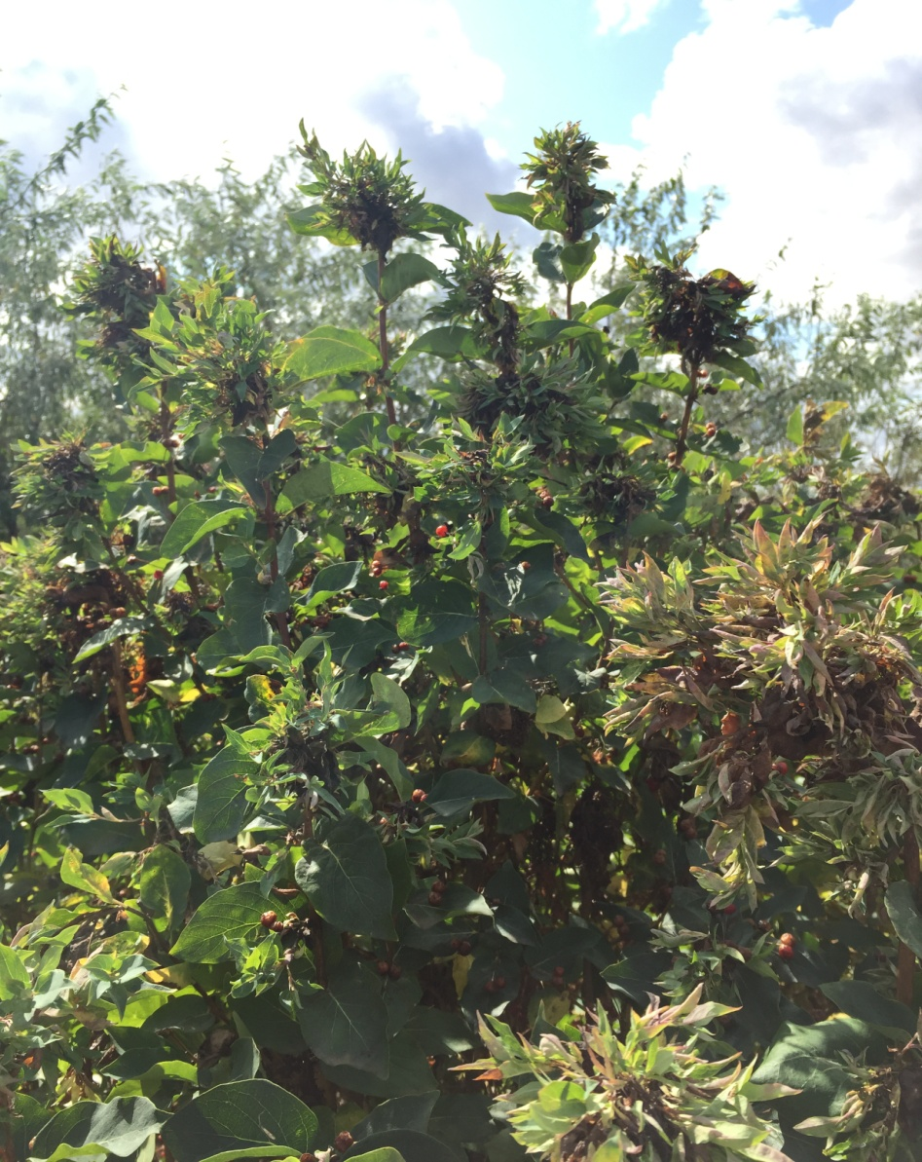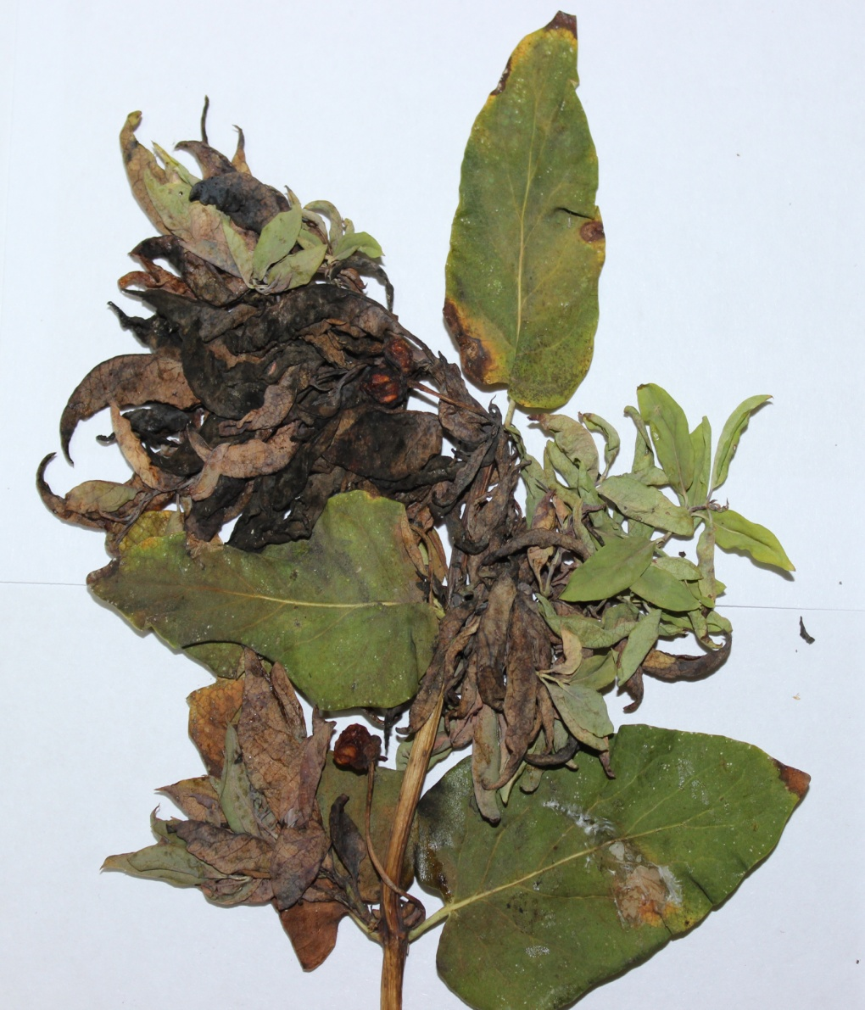
Drawing D 1. Apical bacterial burn of Tatar honeysuckle
APPLICATION D 1
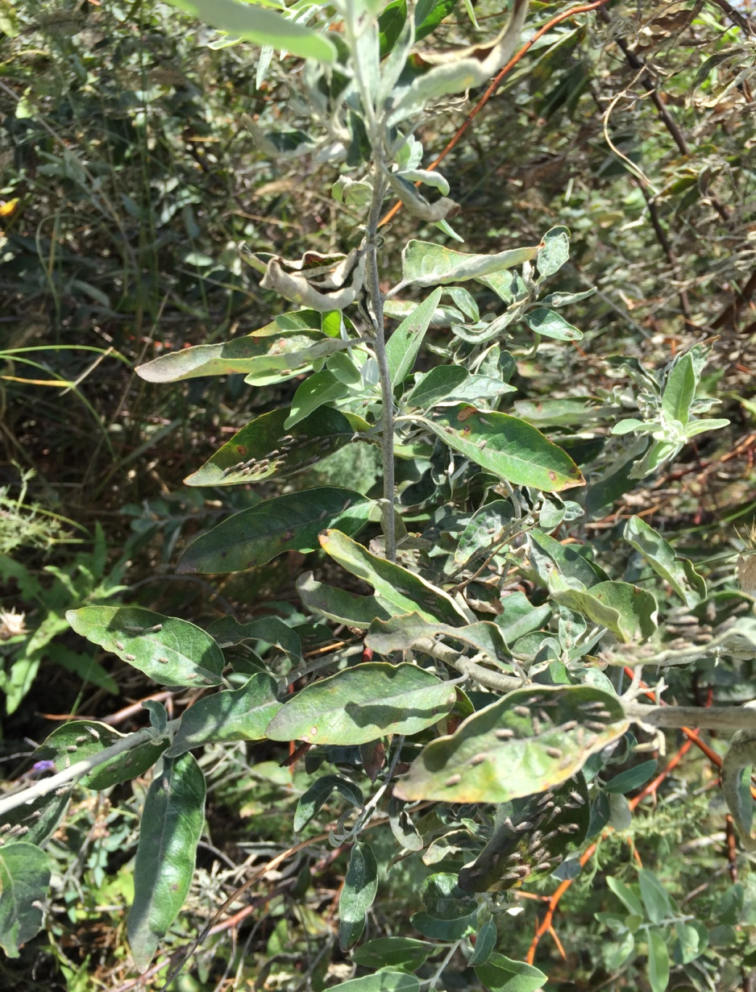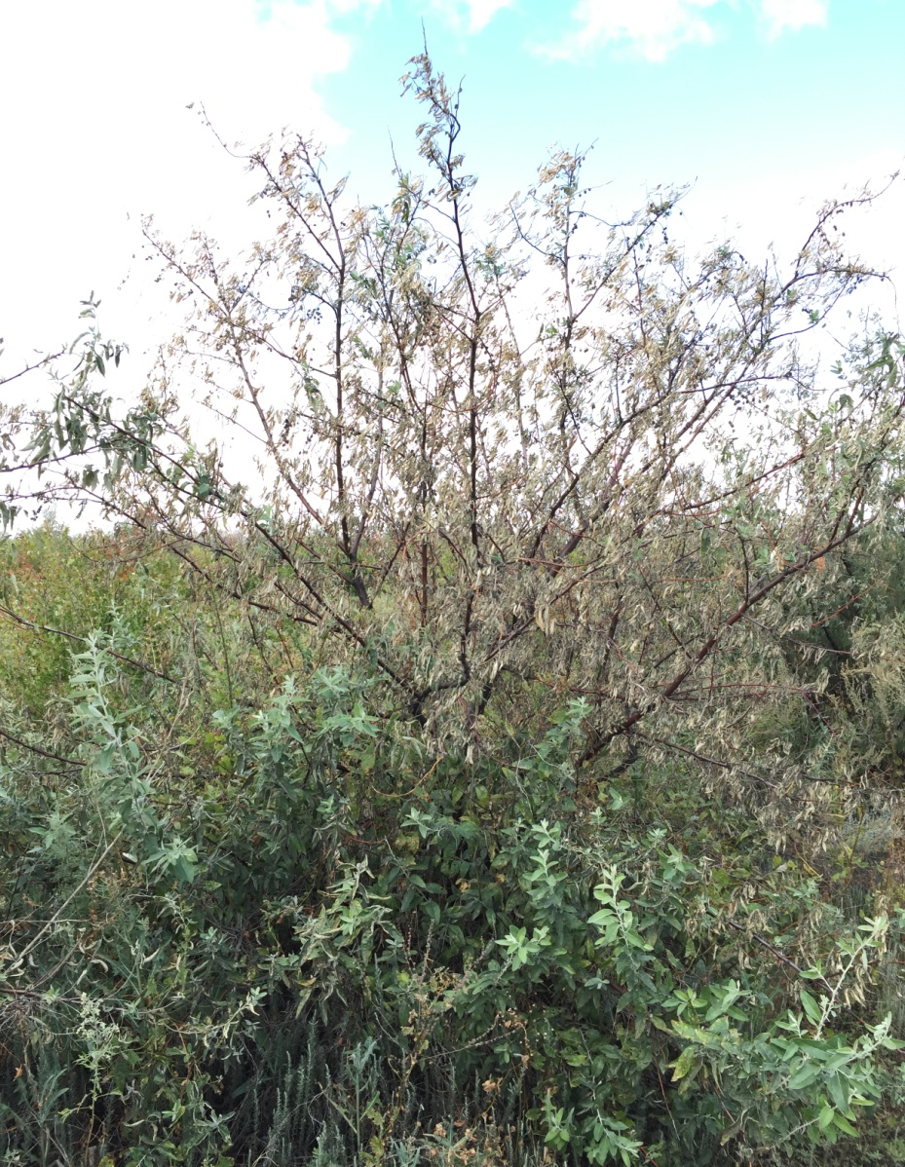
Drawing D 2. Narrow-leaved Loch affected by Loch cicadas: leaves with cicadas (left), General view of the affected plant (right)
APPLICATION D 2
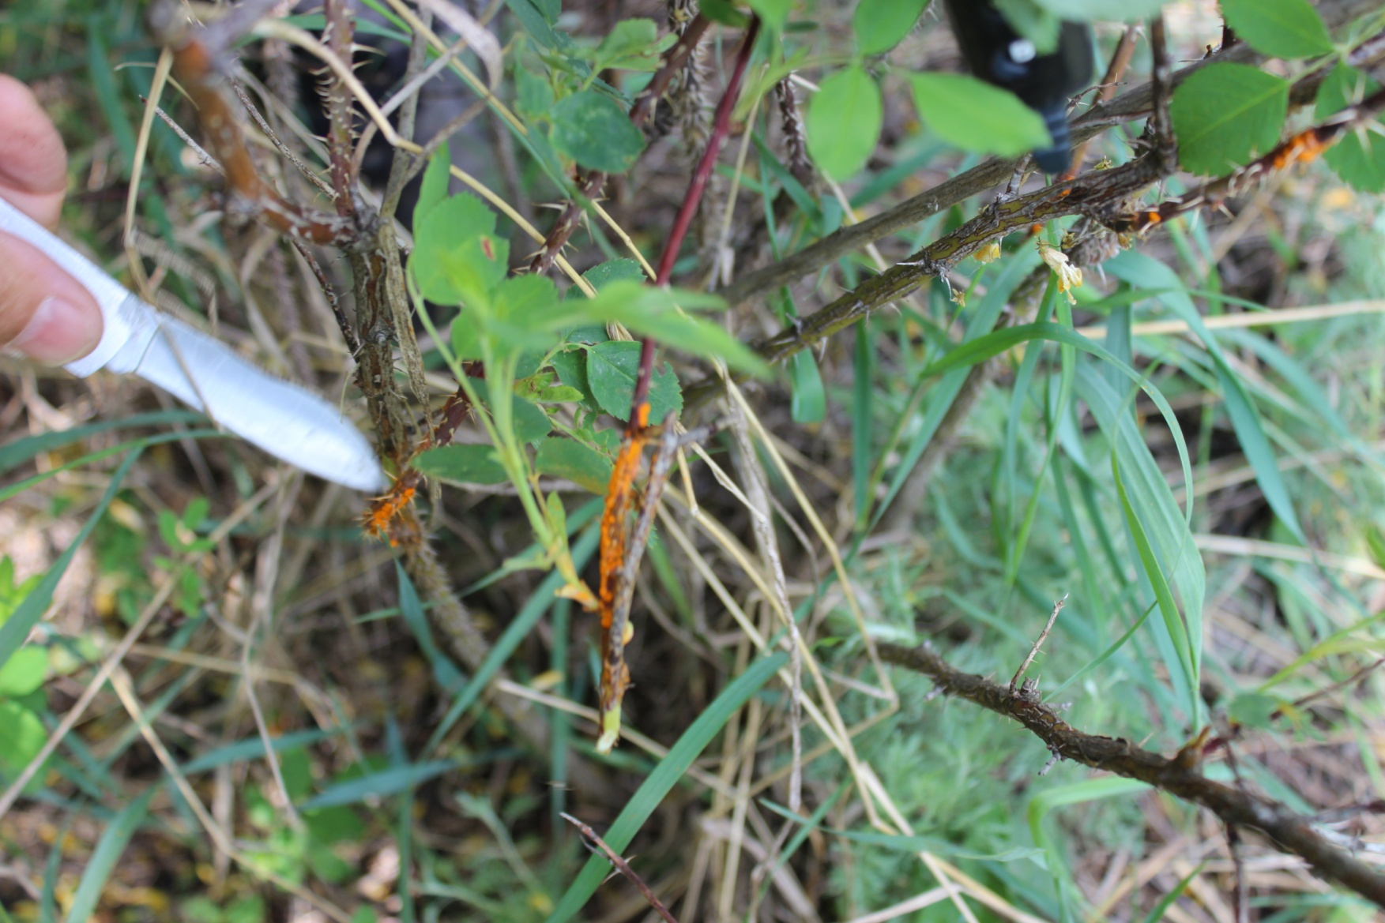
Drawing D 3. The rose hip, rusted (Urednistvo parasite)

APPLICATION D 3
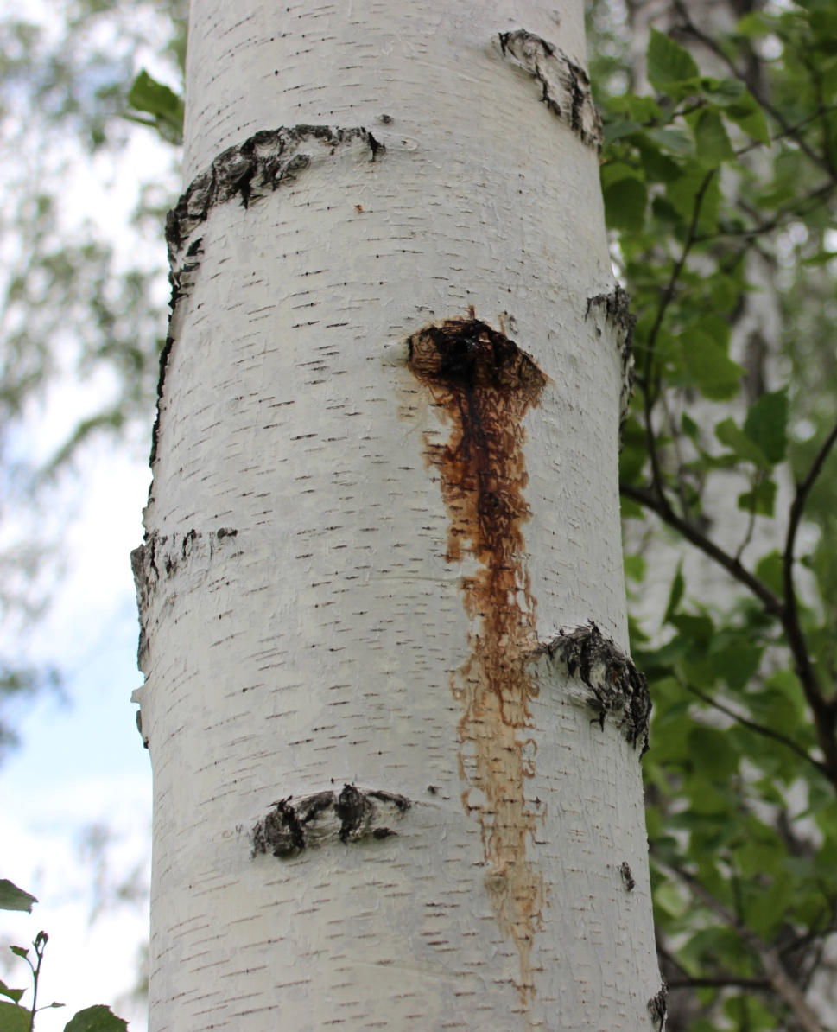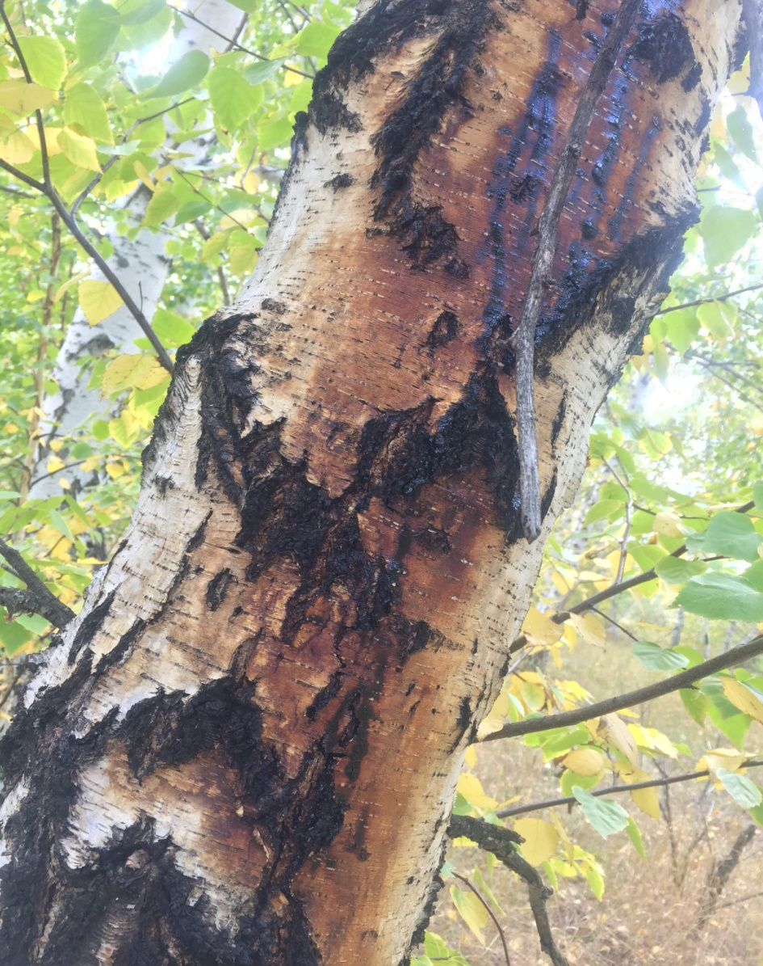
Drawing D 4. Hanging birch, affected by bacterial dropsy: on the left – the initial stage, on the right-a severely affected trunk

APPLICATION D 4
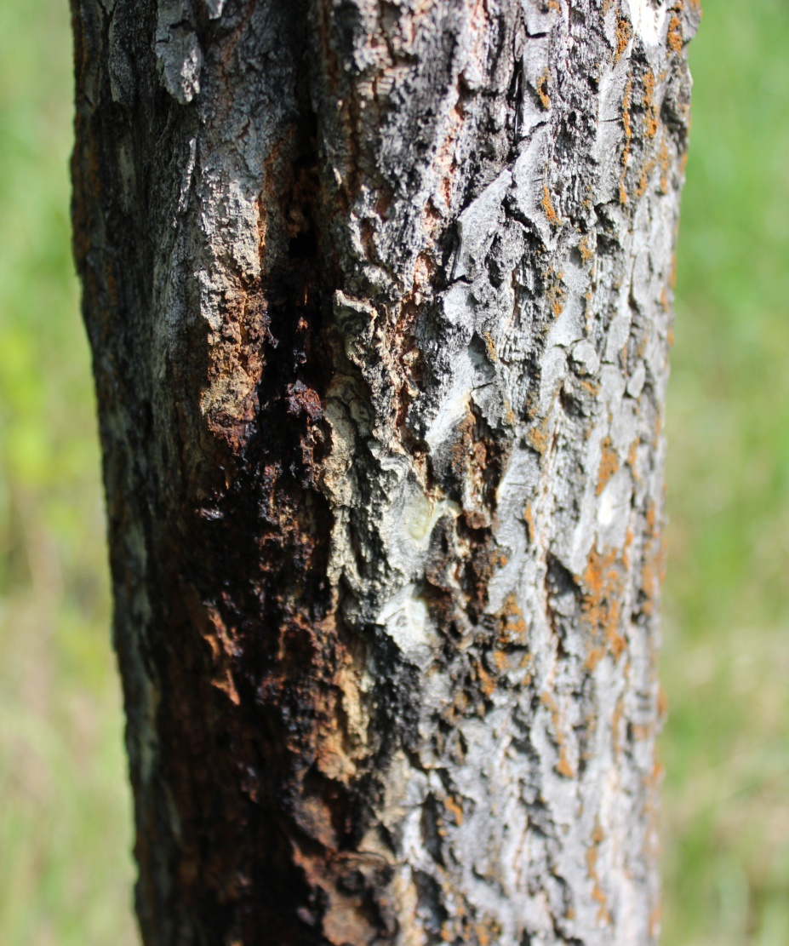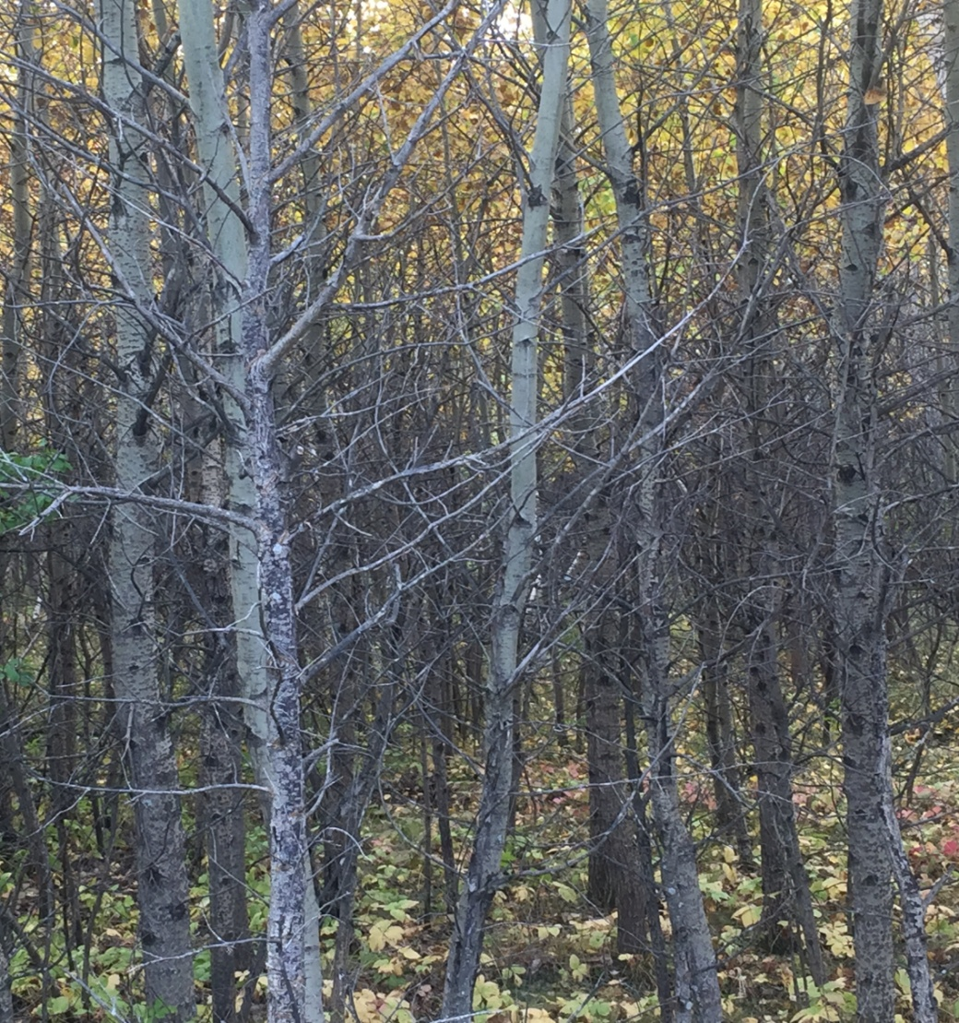
Drawing D 5. Aspen affected by bacterial cancer: on the left-the affected trunk, on the right-mass desiccation of affected trees

APPLICATION D 5
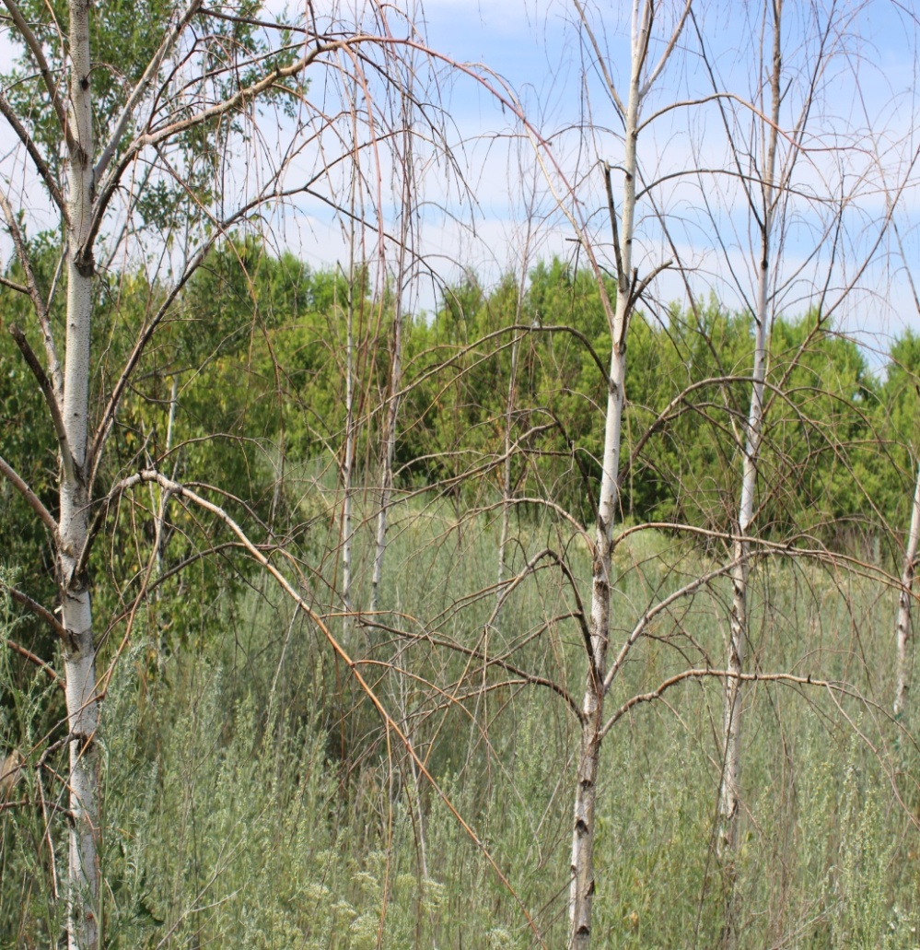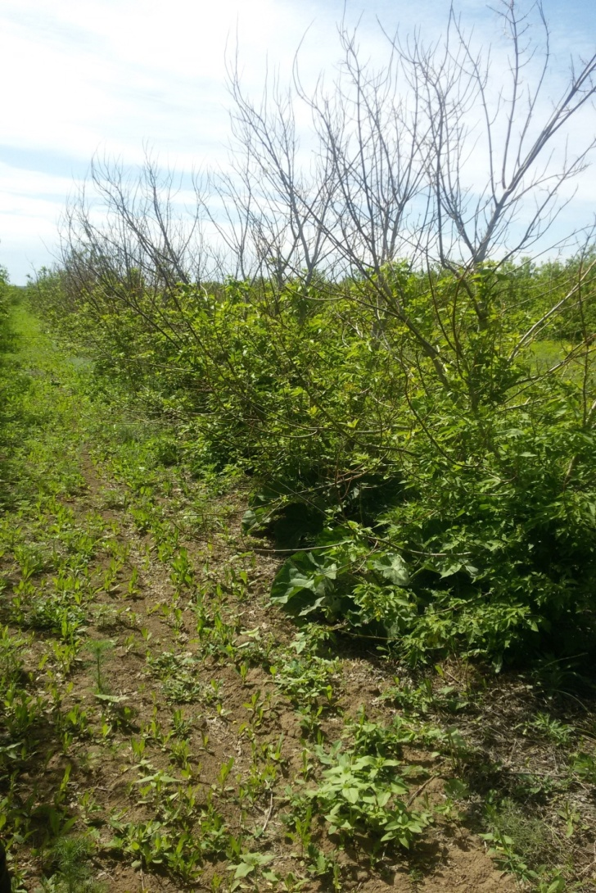
Drawing D 6. Shrinking of birch (left) and ash-leaved maple (right) due to unfavorable soil conditions

APPLICATION D 6
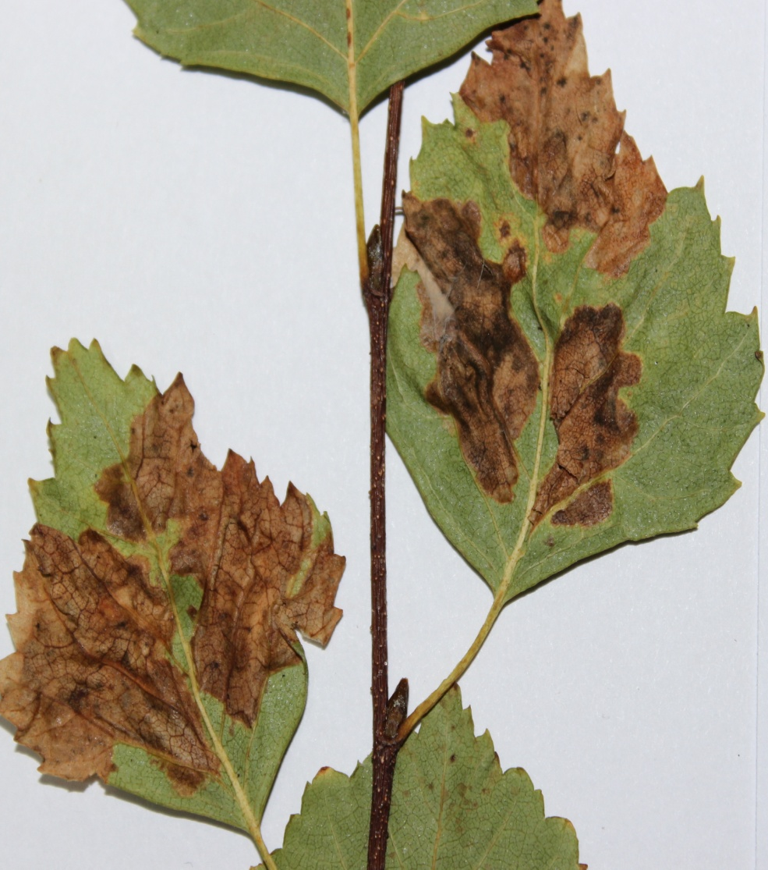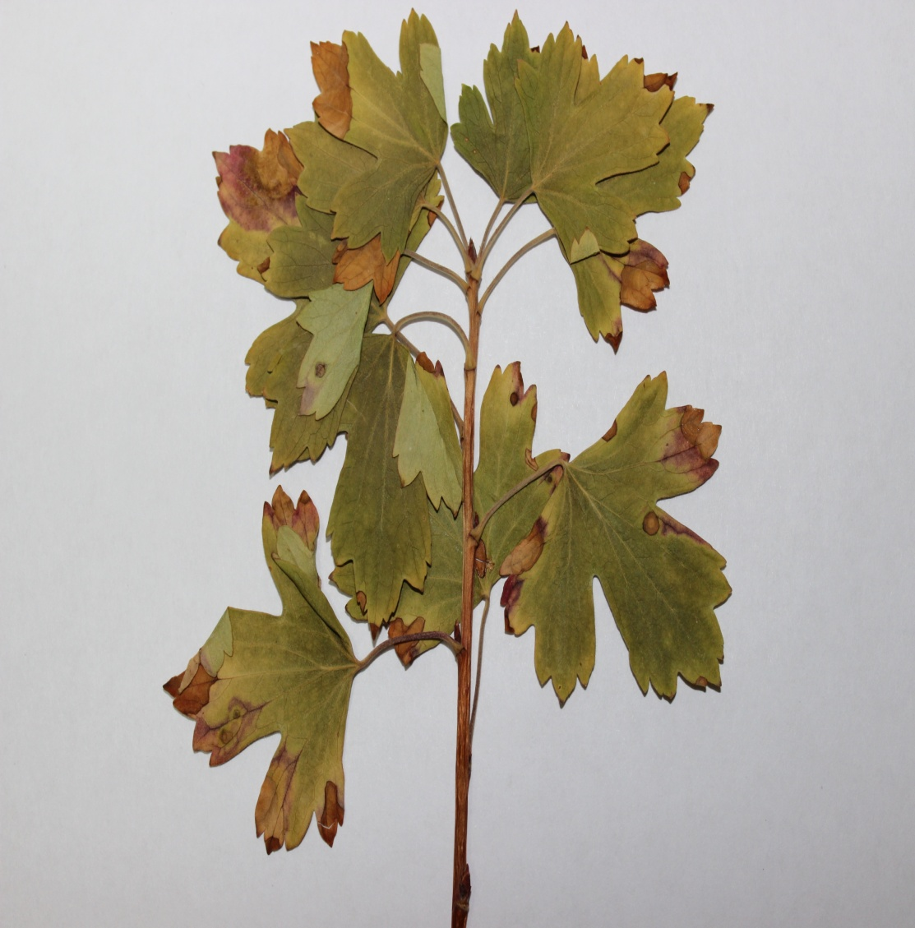
Leaf necrosis: Drawing D 7. Kazakhstan poplar Drawing D 8. Golden currant

APPLICATION D 7
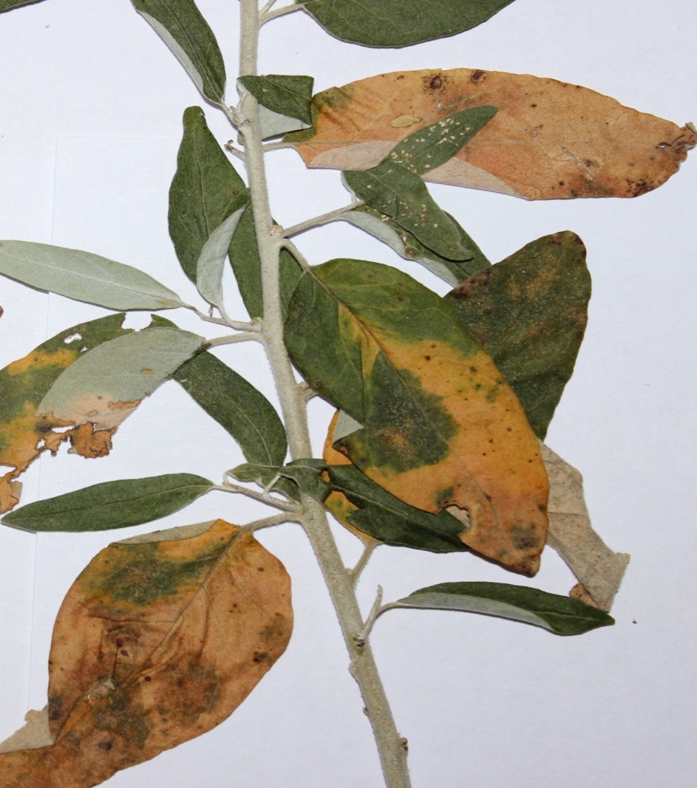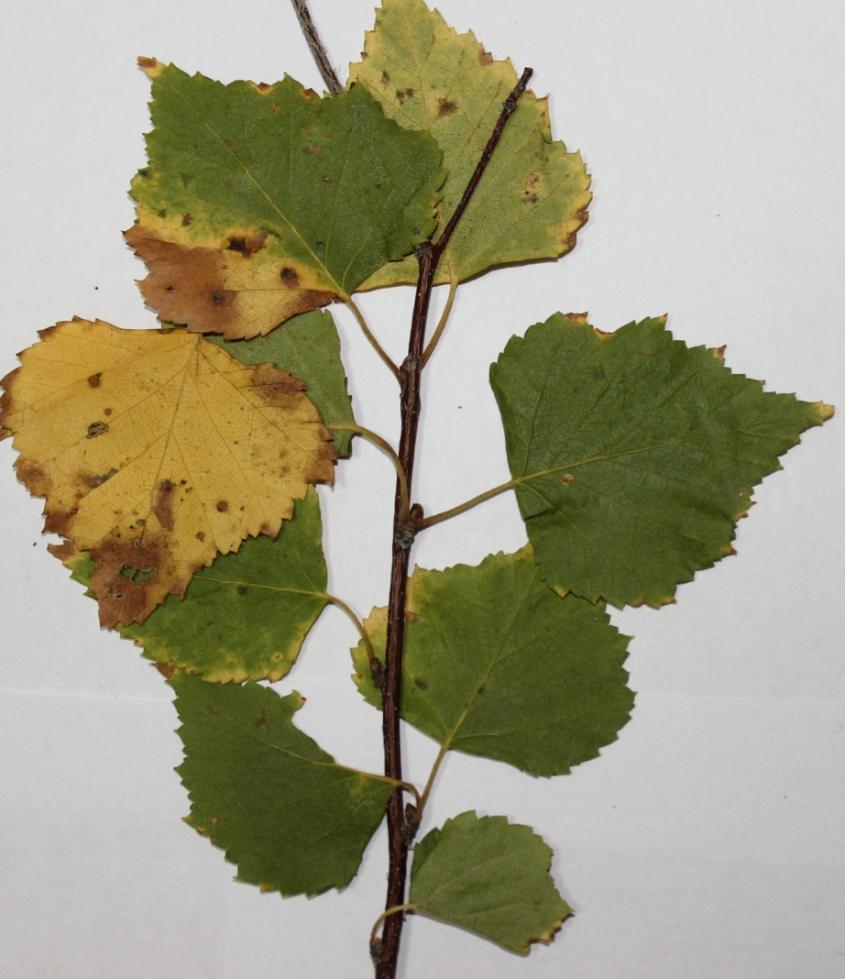
Yellowing and leaf necrosis:
Drawing D 9. Narrow-leaved Loch Drawing D 10. Kazakhstan poplar

APPLICATION D 8
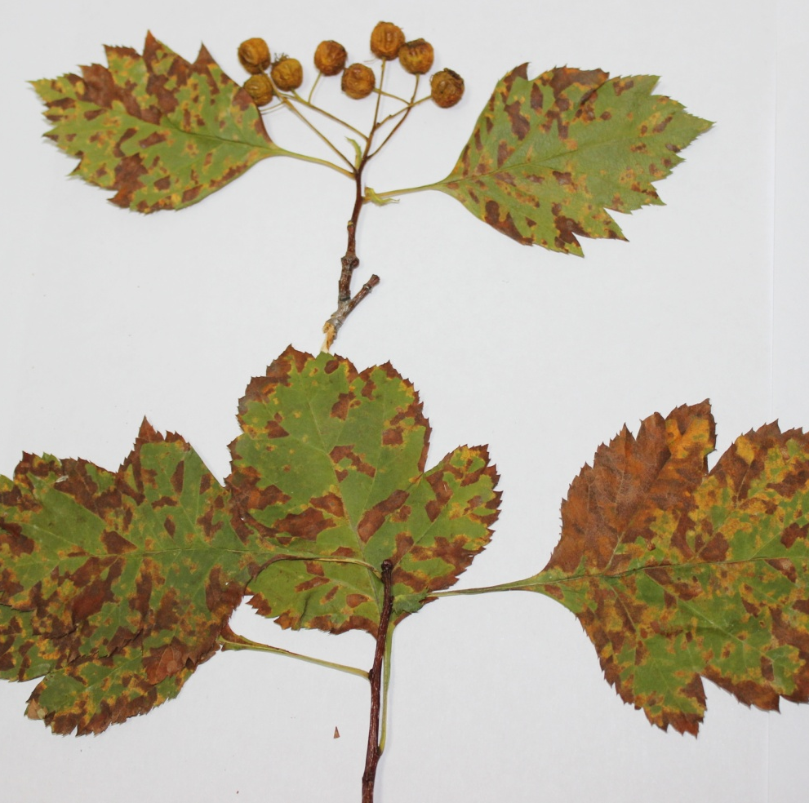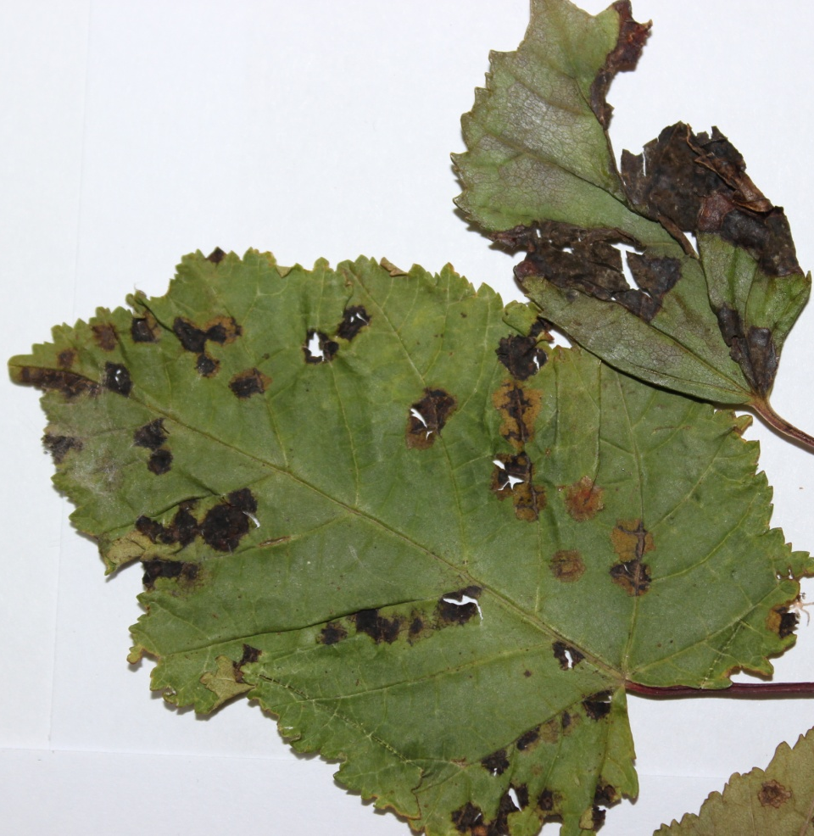
Drawing D 11. Brown leaf spot of hawthorn blood-red Drawing D 12. Black spot of elm, broad-leaved

APPLICATION D 9
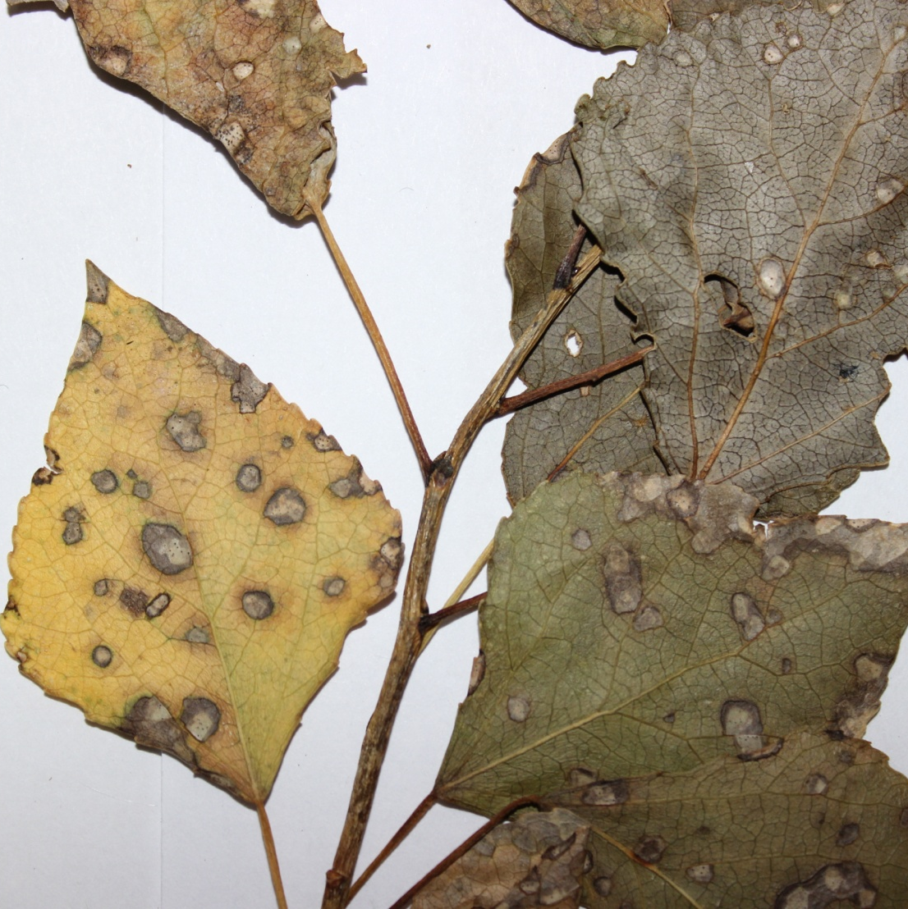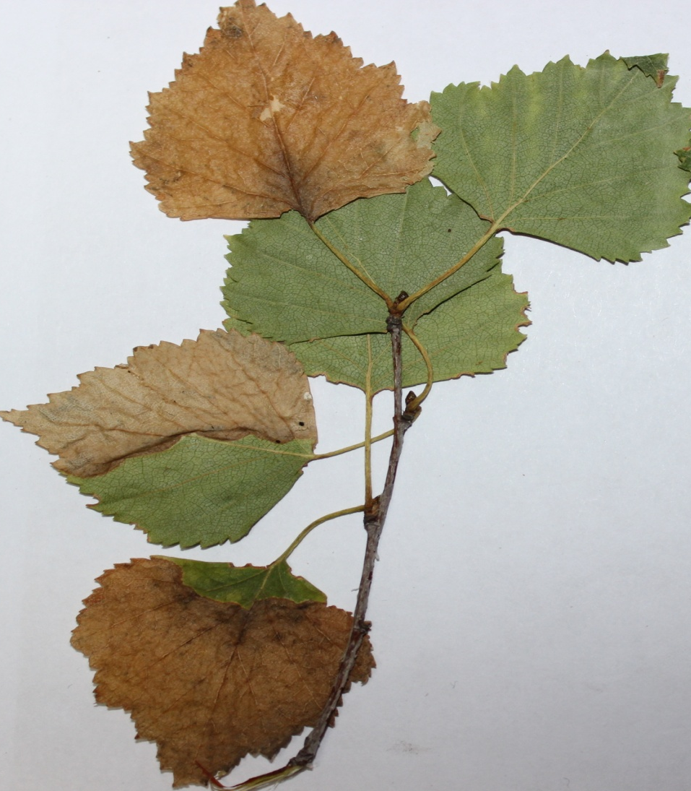
Drawing D 13. White spotting of pyramidal poplar Drawing D 14. Necrosis of Kazakhstan poplar leaves

APPLICATION D 10
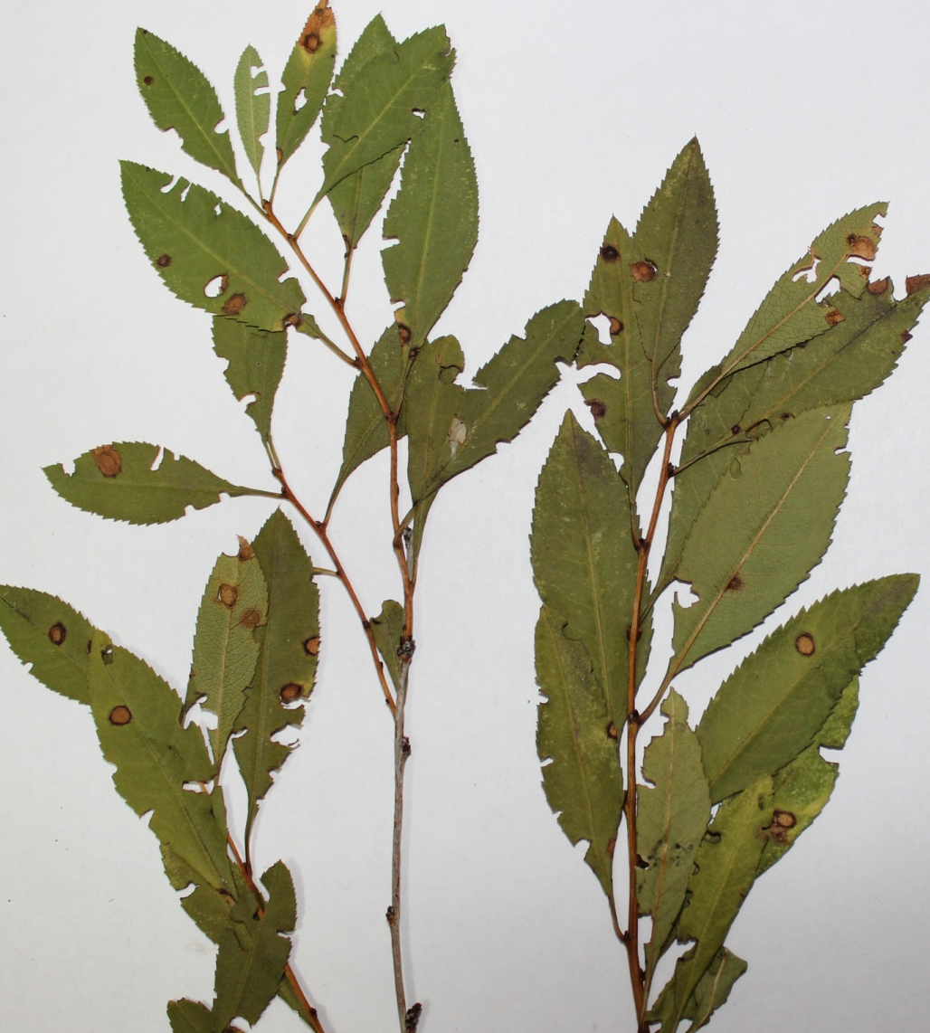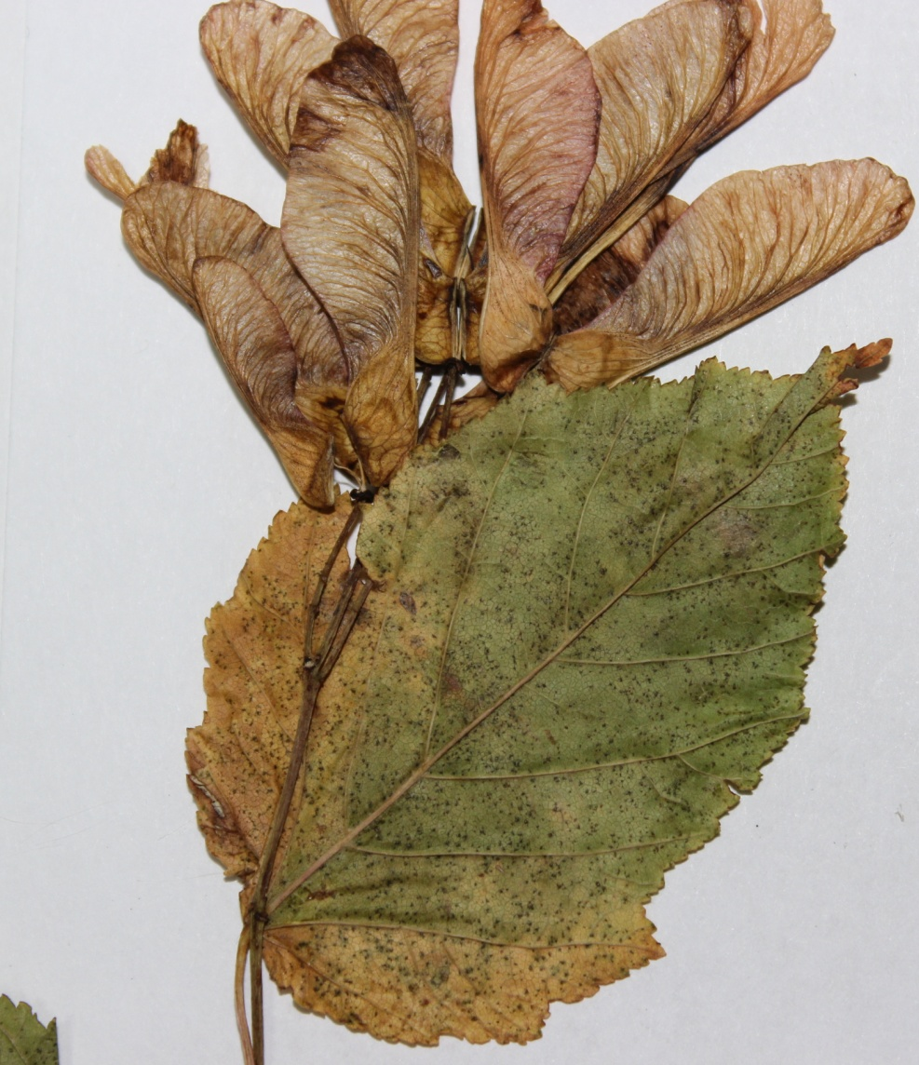
Drawing D 15. Holey spotting of tree willow Drawing D 16. Brown necrosis of ash-leaved maple leaves

APPLICATION D 11
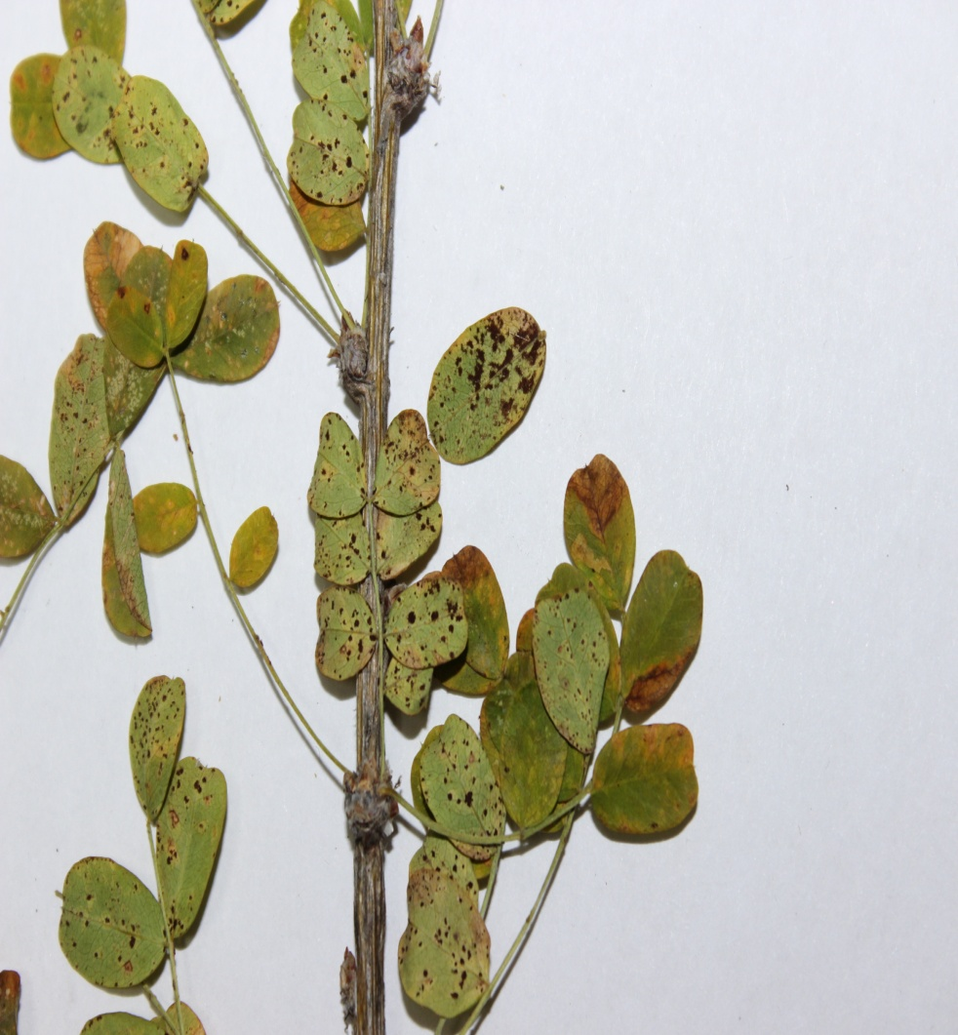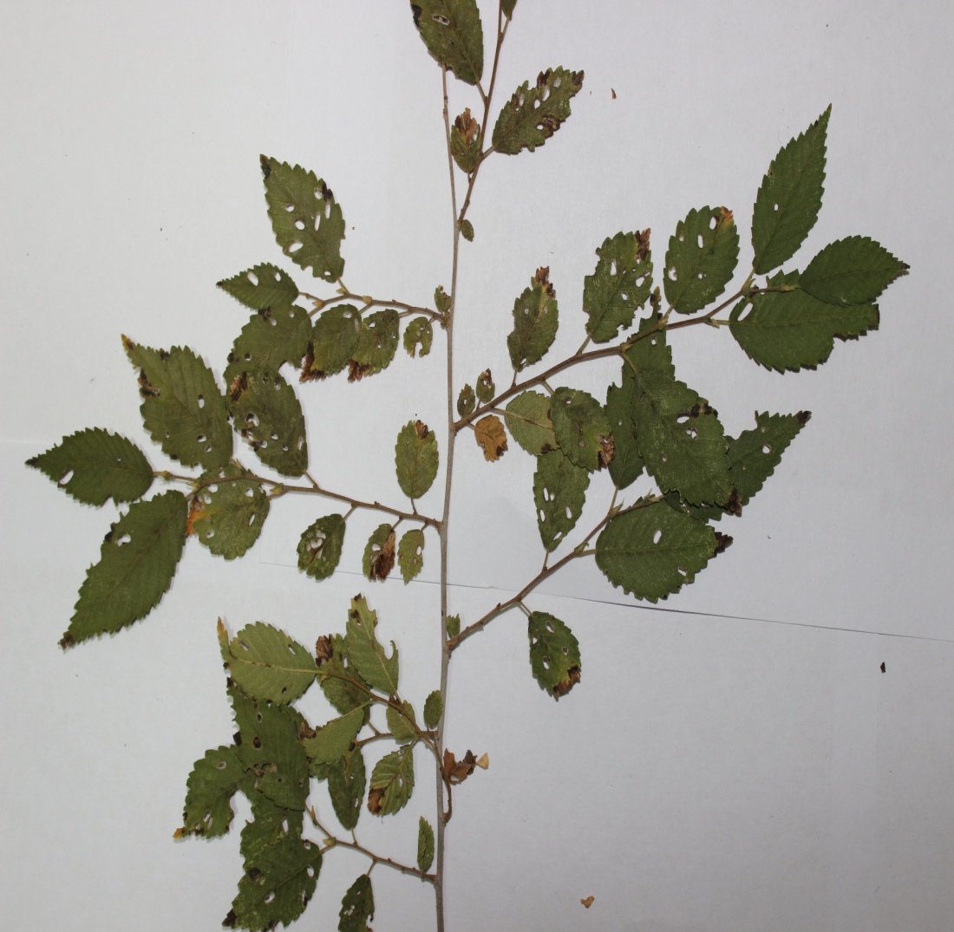
Drawing D 17. Yellow acacia rust Drawing D 18 Insect-infested leaves of narrow-leaved elm

APPLICATION D 12
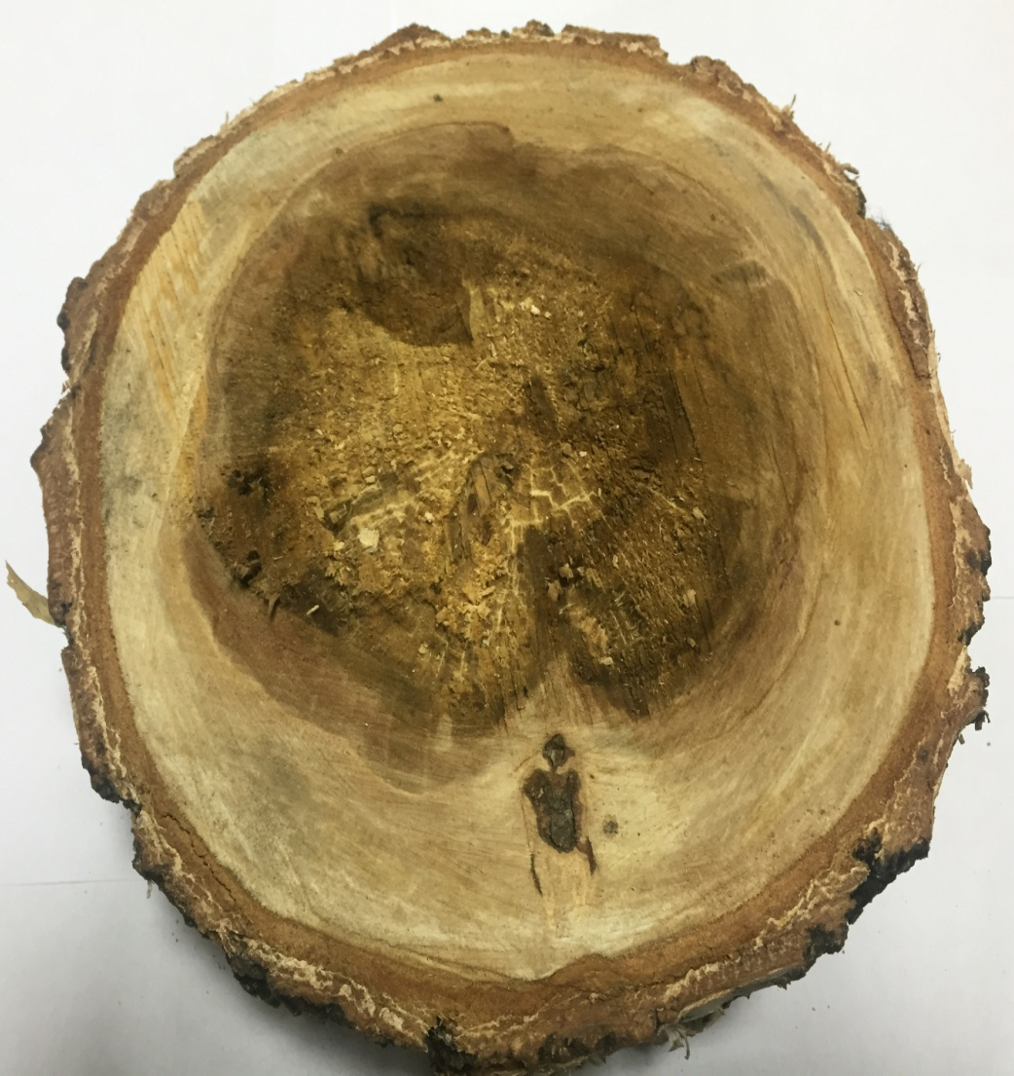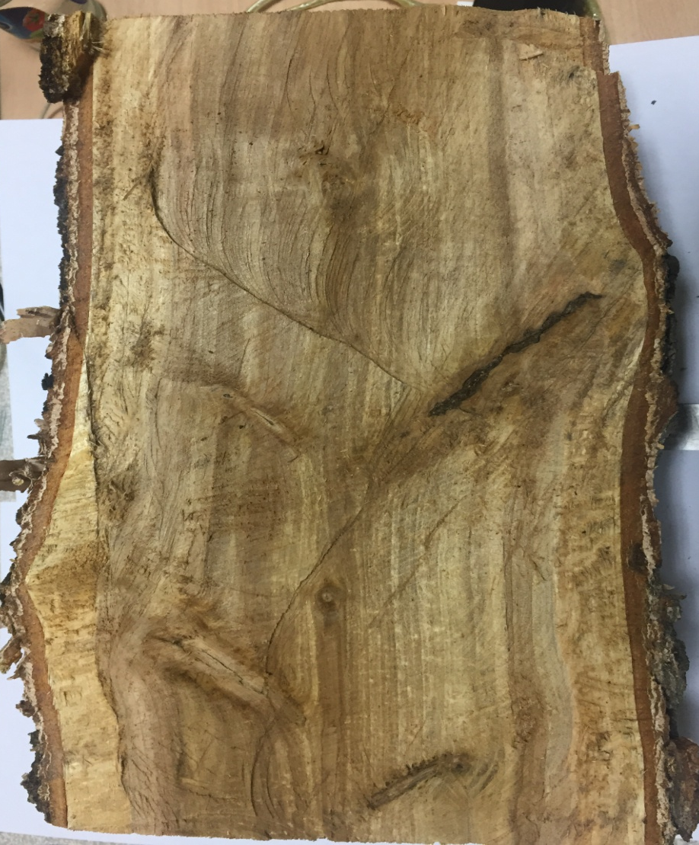
Drawing D 19. Hanging birch affected by bacterial dropsy: left-transverse cut; right-longitudinal cut

APPLICATION D 13
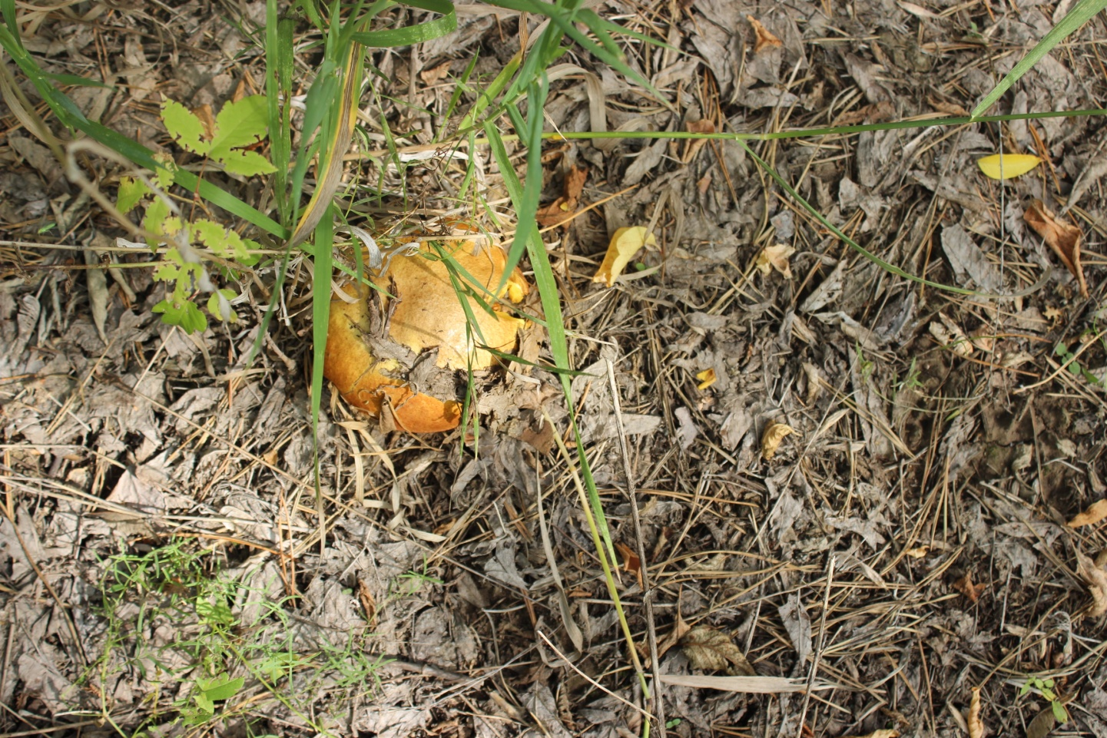
Drawing D 20. Mushrooms among woodlands

APPLICATION D 14
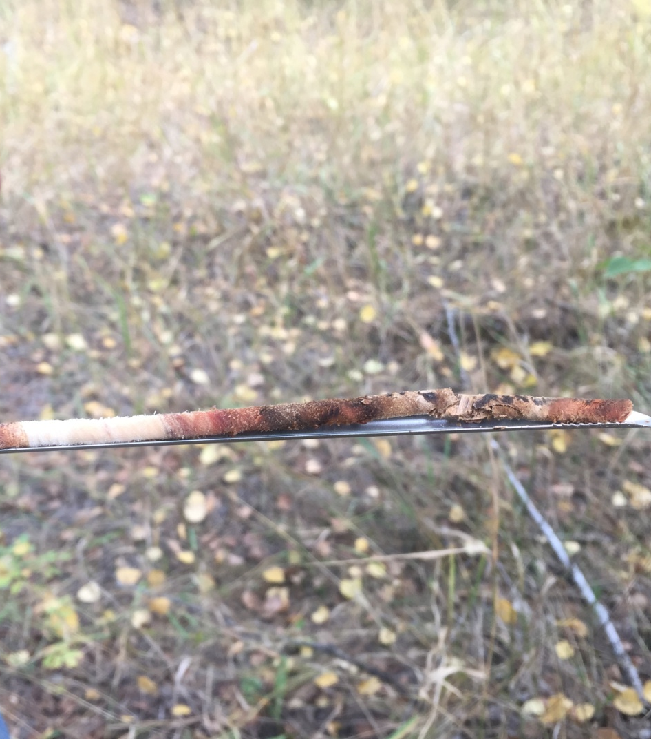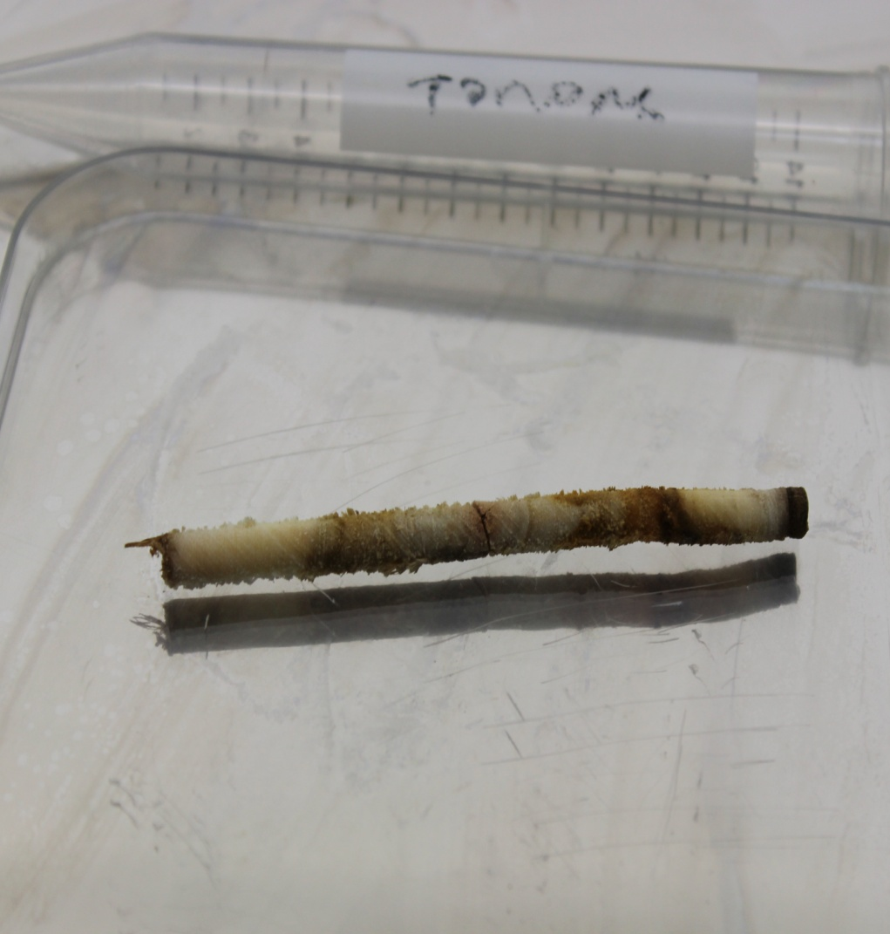
Drawing D 21. Cores from affected bacterial dropsy wood: on the left-hanging birch, on the right-Kazakhstan poplar

APPLICATION D 14
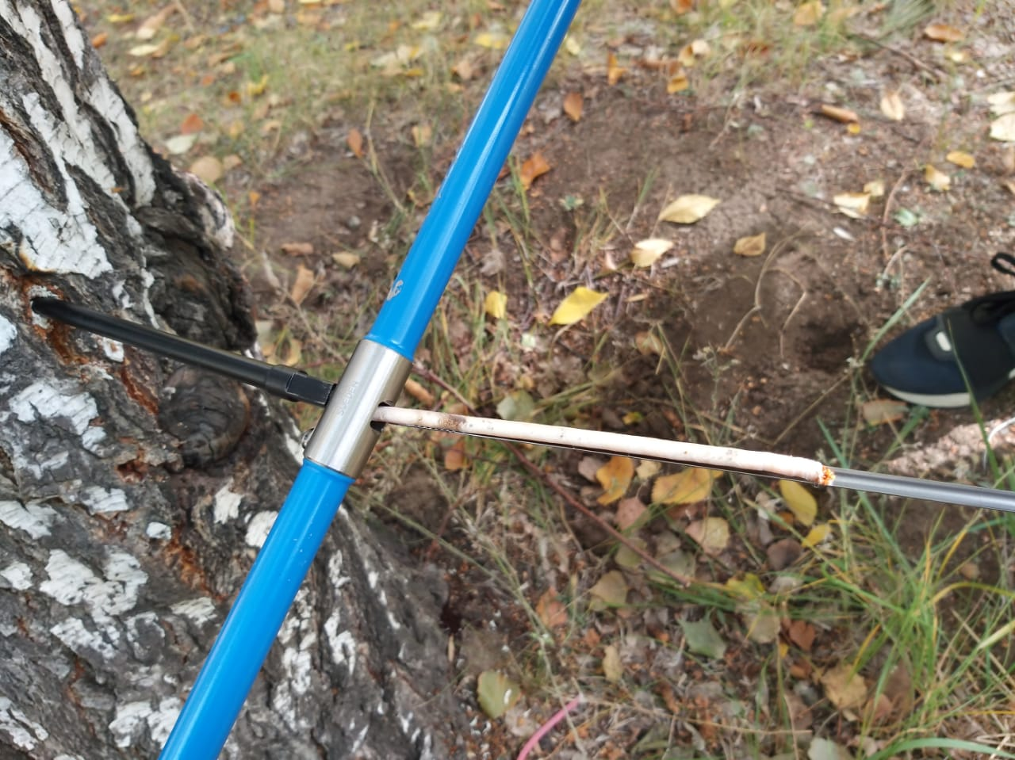
Drawing D 22. Taking a core from an aspen trunk using a drill

APPLICATION D 14
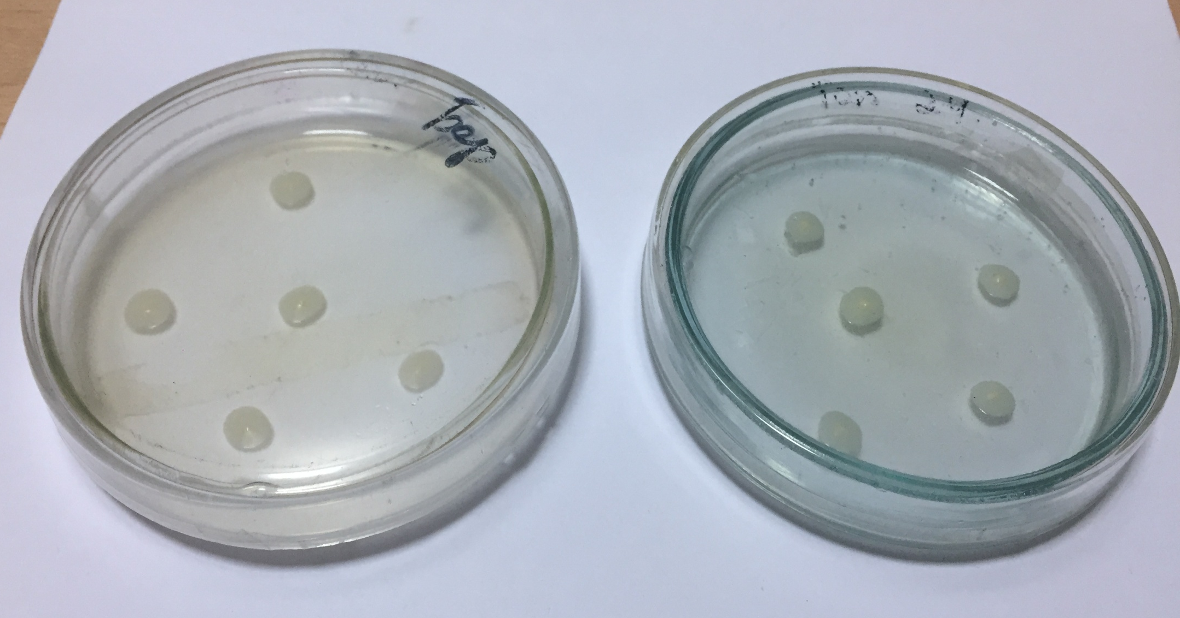
Drawing D 23. 5-day culture of bacterial dropsy of hanging birch (left) and Kazakhstan poplar (right)

APPLICATION D 15
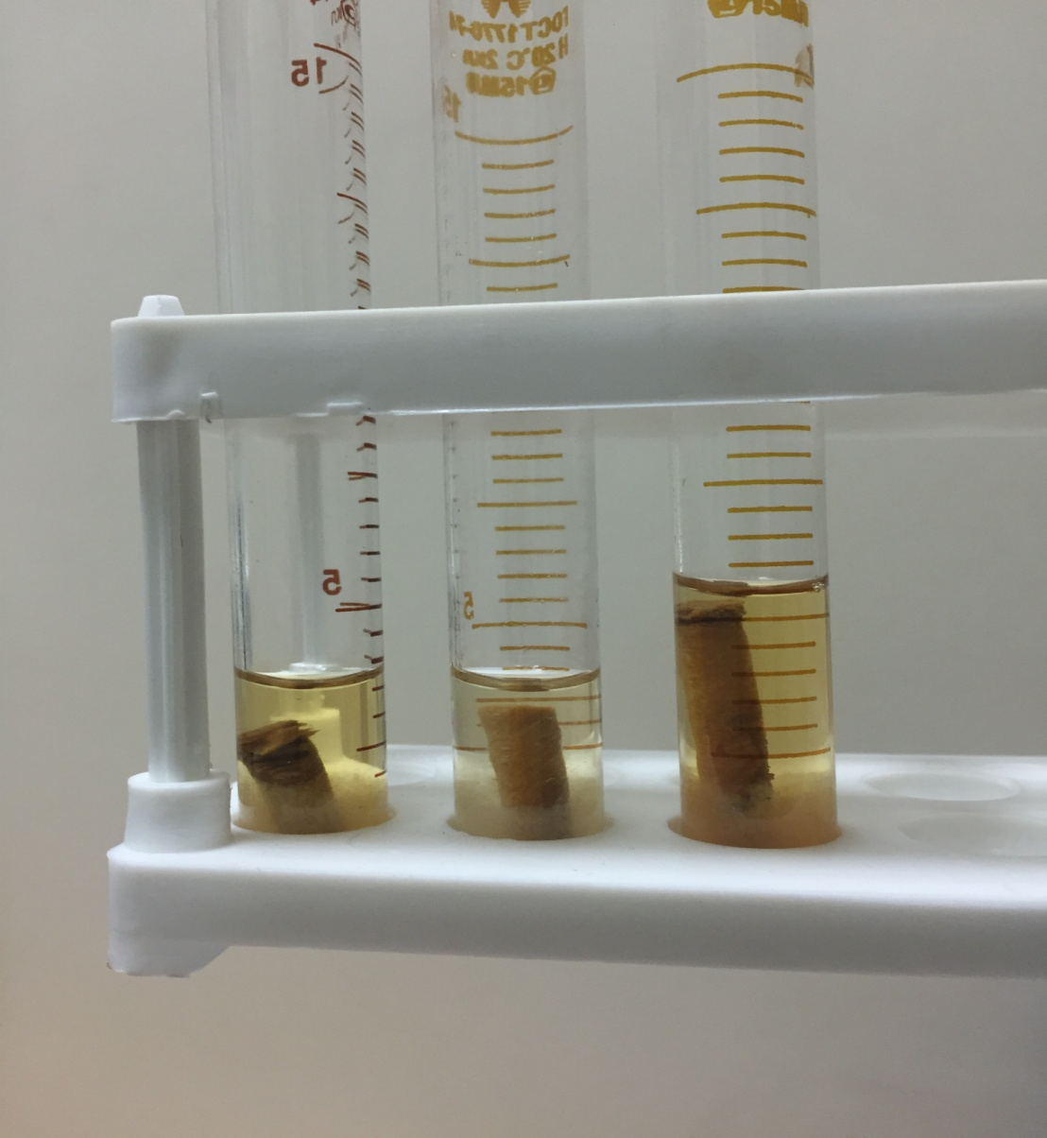
Drawing D 24. Bacterial dropsy culture isolated in potato broth
APPLICATION D 16
Map diagram of the main diseases of green spaces of the Green belt of Nur-Sultan
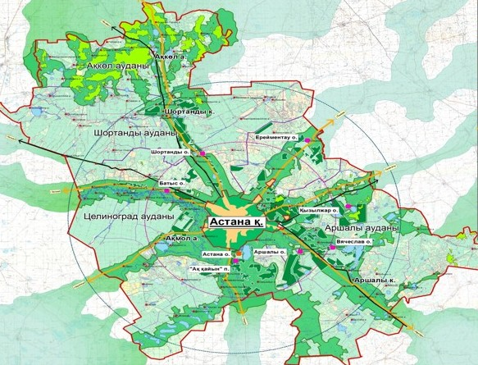
- plantations - forestry
- leaf spots of the main species; - Dropsy of birch and poplar; - Bacterial burn of Tatar honeysuckle;
- desiccation (attacks) of tree species (willows, elms, poplars, birches, lochs). Quarters location of diseases marked in the map see the text and conclusion.

