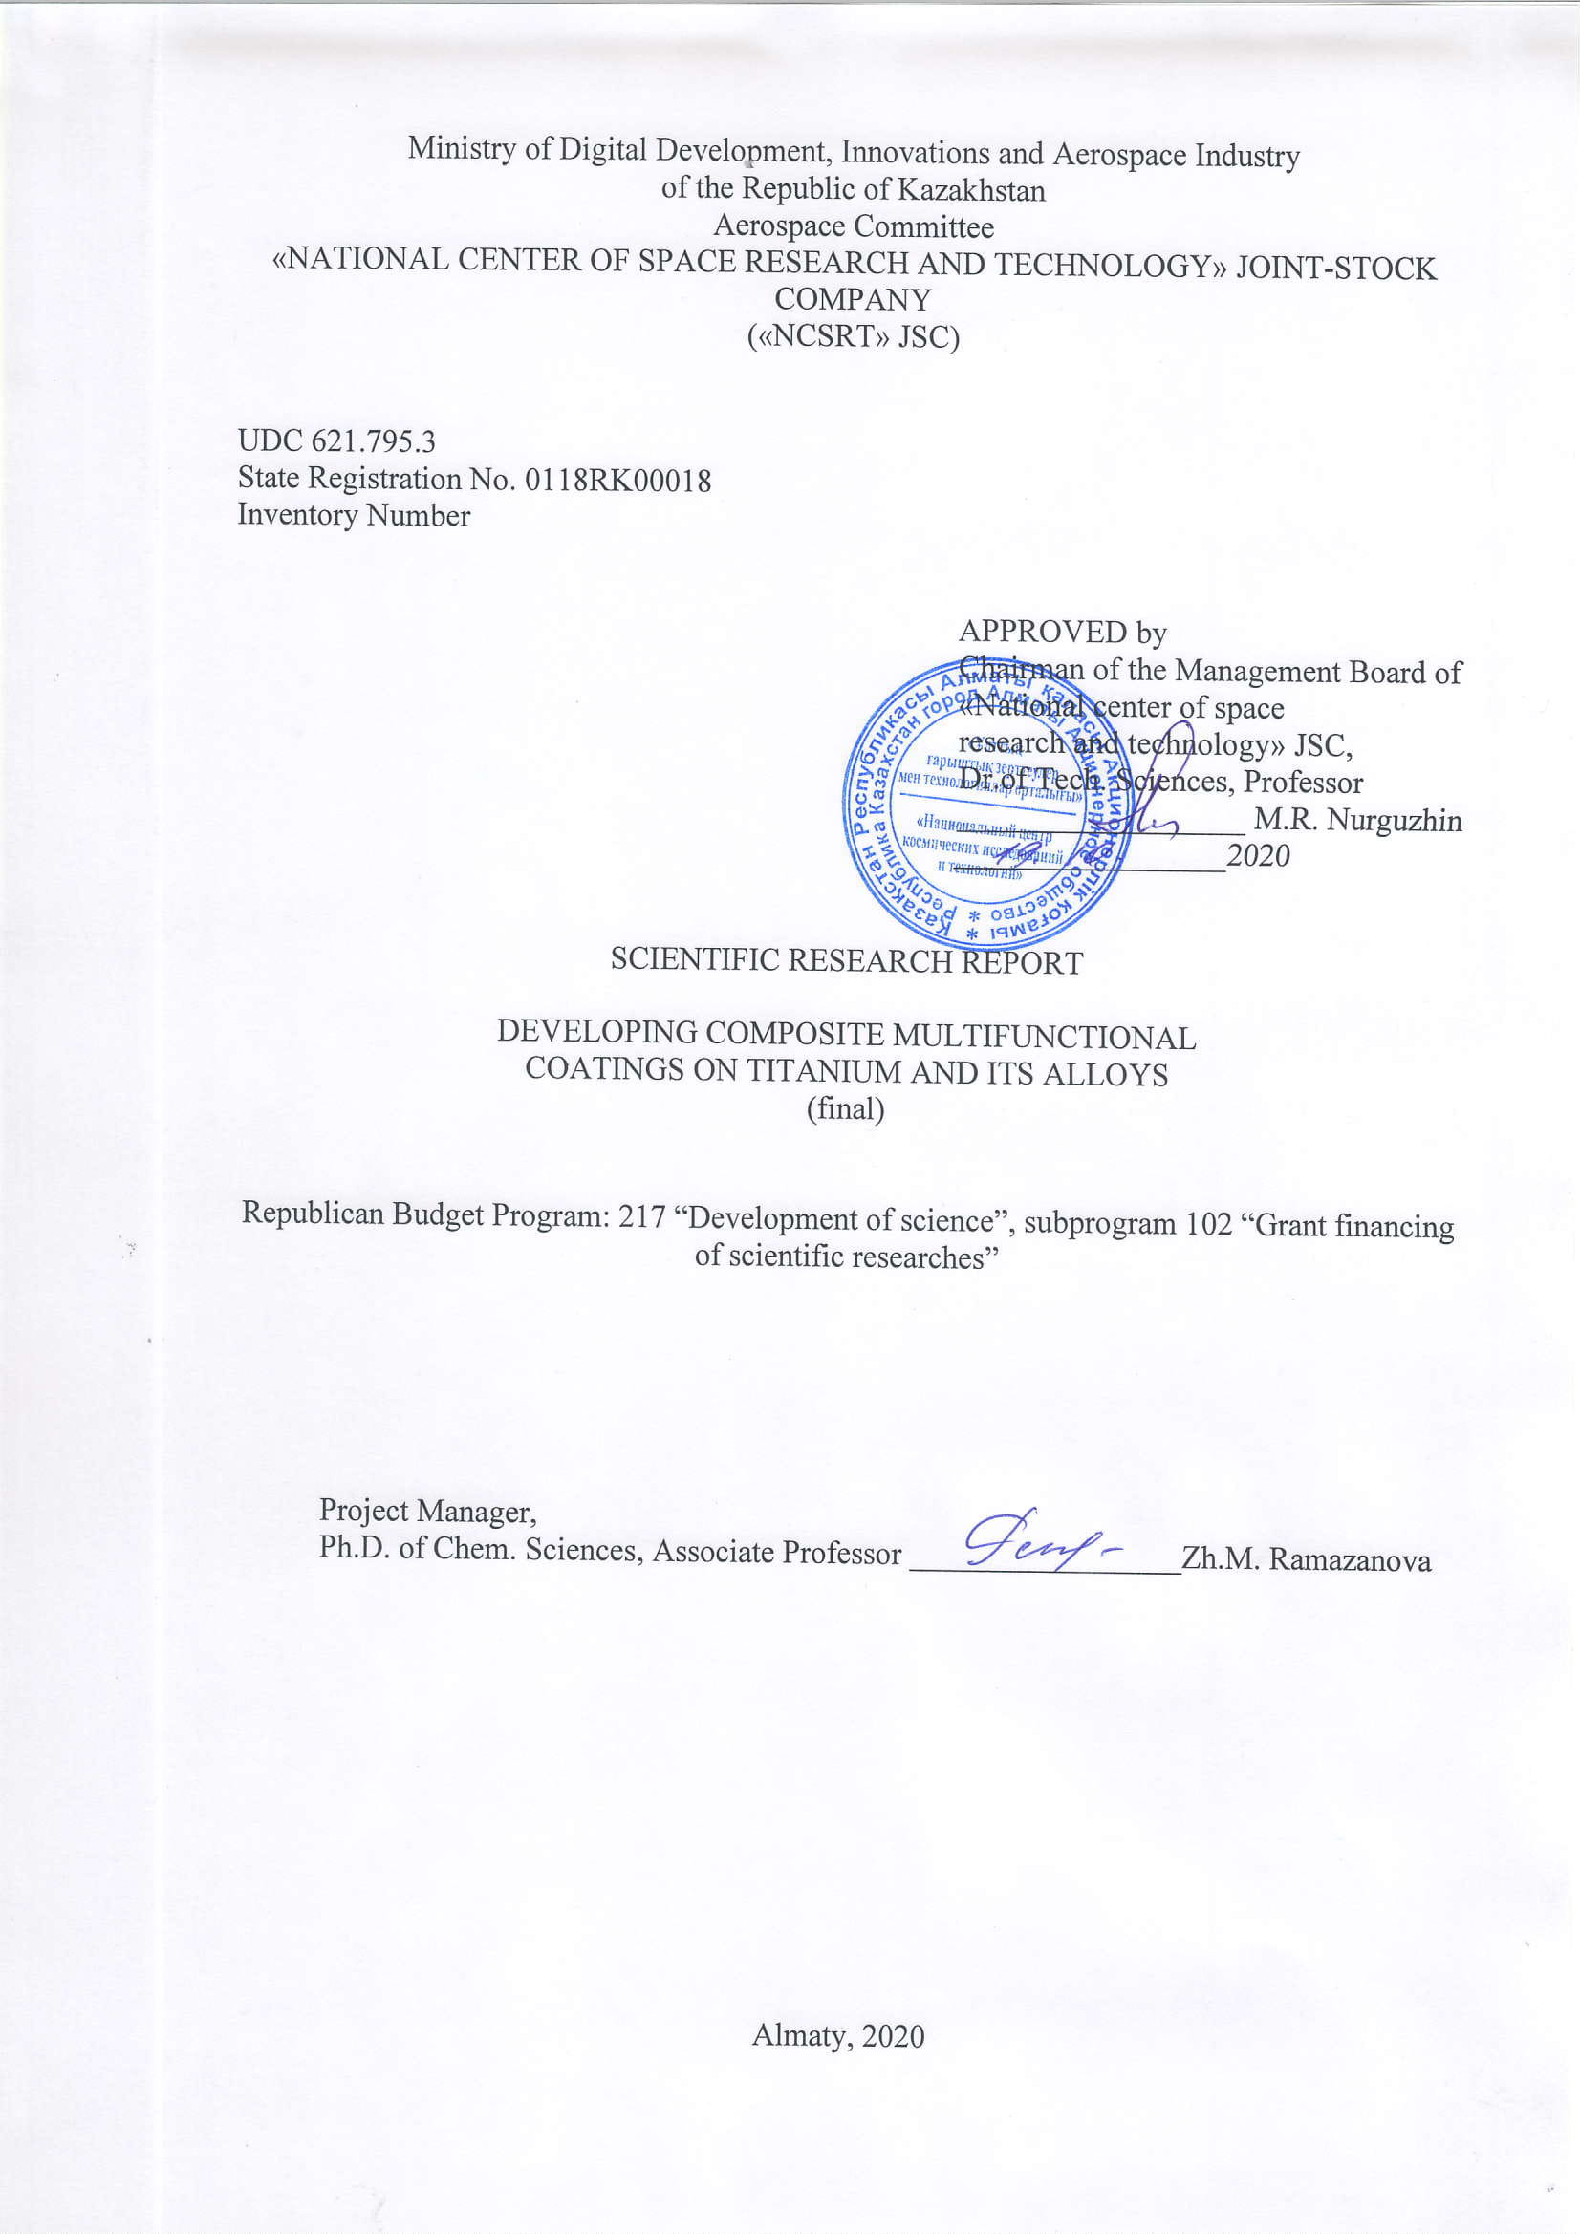

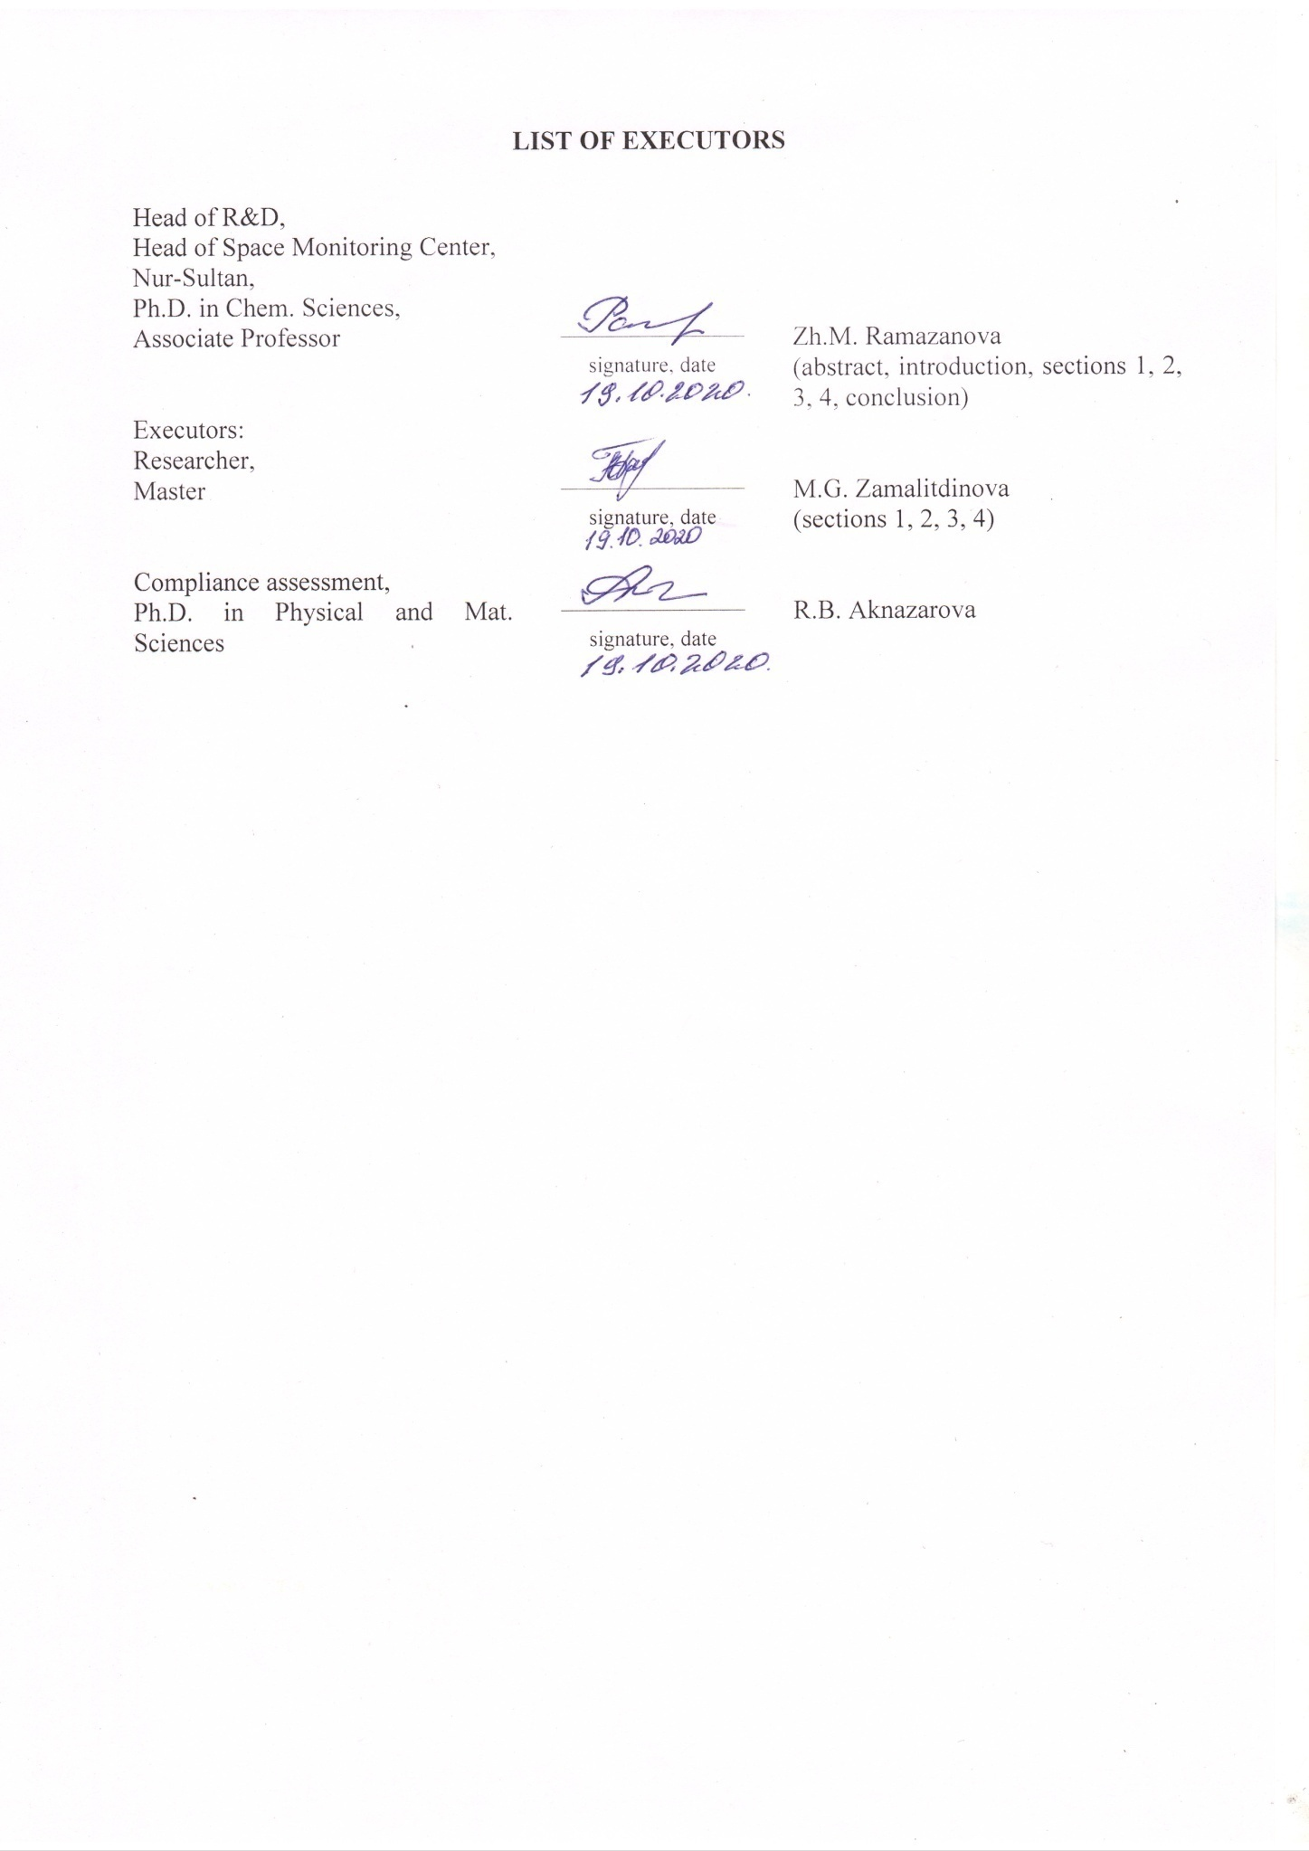
ABSTRACT

Report 143 pages, 1 book, 10 figures, 11 tables, 56 sources, 6 appendices
PLASMA ELECTROLYTIC OXIDATION, CURRENT PULSE DURATION, OXIDE COATING, OXIDE - POLYMER COATING, CORROSION RESISTANCE
The subjects of study are protective oxide coatings obtained in the pulsed anodic-cathodic mode by plasma electrolytic oxidation and composite oxide-polymer coatings.
The goal of the work is to obtain oxide-polymer coatings on titanium and its alloys by filling the pores of oxide layers synthesized by the method of plasma electrolytic oxidation.
Research methods: modern method of plasma electrolytic oxidation was used to modify the surface of titanium and its alloy. When implementing this method, a pulsed anode-cathodic mode with a short anode current pulse duration of 250 μs was used. The corrosion resistance of oxide and composite coatings was studied in neutral salt fog under GOST 9.308-85 and gravimetric method.
Research results: materials to fill the pores of the oxide coating have been studied according to literature data. The results of the analysis of available materials to fill pores to increase the protective properties were obtained according to the literature data. Composite oxide coatings are obtained by filling the pores. Samples with oxide-polymer coatings were obtained. The corrosion behavior of composite coatings is investigated. The results of corrosion tests were obtained. Research results are summarized and analyzed.
Fields of application: consumers of scientific and technological foundations can be universities of the Republic of Kazakhstan, which train bachelors and masters in technical specialties in the field of creating new materials. The multifunctional coatings developed as a result of the project can be used in the space industry, medicine, and other industries.
Predictive assumptions about the development of the object of research: results of this project study will make it possible to proceed to the development of a technology for the formation of oxide coatings by the method of plasma electrolytic oxidation on articles made of titanium and its alloys.

TABLE OF CONTENTS

INTRODUCTION………………………………………………………………………... | 6
THE MAIN PART OF THE SRW REPORT...................................................................... | 10
- Study materials to fill the pores of the oxide coating according to literature data. Results of the analysis of available materials to fill the pores of the coating to increase the protective properties according to the literature data …………………… | 10
- Obtain composite oxide coatings by filling pores …………………………………..... | 17
- Investigate the corrosion behavior of composite coatings …………………..……....... | 22
3.1 Corrosion resistance of titanium ……………………………………………...…..… | 22
3.2 Corrosion behavior of the obtained composite and oxide coatings………………..... | 22
3.2.1 Corrosion tests of samples with an oxide coating under GOST 9.308-85…..... | 23
3.2.2 Corrosion testing of samples with a composite oxide-polymer coating by the gravimetric method ……………………………………………………............ | 24
4 Summarize and analyze the research results …………………………………...………. | 32
CONCLUSION…………………………………………………………………………... | 39
LIST OF REFERENCES………………..……………...………………………………... | 44
ANNEX A – Timetable for 2018-2020 .............................................................................. | 50
ANNEX B – List of publications, reference from NCSTE JSC, reprints of articles …...... | 62
ANNEX C – Staff Training Certificate…………..…………………………...…….......... | 139
ANNEX D – Certificate of industrial practice, the scientific internship of students …..... | 140
ANNEX E – Photographs of Specimens with oxide coatings with improved physical and mechanical, protective properties ………..………………………..…………… | 141
ANNEX F – Test report No. 3 ............................................................................................ | 144

LIST OF ABBREVIATIONS AND DESIGNATIONS

In this research report, the SRW following abbreviations and designations are used.
ARIAM | - All-Russian Institute of Aviation Materials
CP | - chemically pure
MАO | - microarc oxidation
OC | - oxide coating without sealing
ОCC-ER | - oxide-polymer coating compacted with epoxy resin
ОCC-F-32-1 layer | - oxide-polymer coating compacted with fluoroplastic F-32 – 1 layer
ОCC-F-32-2 layer | - oxide-polymer coating compacted with fluoroplastic F32 – 2 layers
P | - pure
PEO | - plasma electrolytic oxidation
PEPA | - polyethylene polyamine
PS | - power supply
RAS SB | - Siberian Branch of Russian Academy of Sciences
RG | - reagent grade
RK MES | - Ministry of Education and Science of Republic of Kazakhstan
SAS | - surface-active substance
UKTMP JSC | - "Ust-Kamenogorsk titanium and magnesium plant" JSC
UPTFE | - ultrafine polytetrafluoroethylene
 | - negative corrosion rate
 | - positive corrosion rate
m₀ | - sample weight before corrosion, g
M_{cor} | - sample weight after corrosion tests, g
Δm | - decrease/increase in the mass of the test material during the test
Т_{cor} | - corrosion test temperature

INTRODUCTION

Assessment of the current state of the solved scientific and technical problem. Titanium and its alloys, widely used as structural materials, have a limited set of properties, which does not allow their use for the creation of promising and modernization of existing products. The introduction of alloying additions significantly improves the physical and mechanical properties of the material, but this leads to an increase in the mass of the structure and a rise in the cost of products. Besides, the resulting composite materials are narrowly functional.
At present, Ust-Kamenogorsk titanium and magnesium plant JSC (hereinafter – UKTMP JSC) is the leading titanium producer in the country from raw material extraction to titanium ingots and alloys used in the aerospace, oil and gas, medical industries. The enterprise is successfully implementing new projects that will allow us to enter a new market for critical and rotating products in the aerospace segment.
Because of this, a promising method for treating the surface of valve metals is of interest – the method of plasma electrolytic treatment (PET). This method makes it possible to obtain fundamentally new coatings with a unique set of properties, characterized by high performance. The technology is based on the phenomenon of micro-arc discharges that promote the formation of porous oxide layers on the surface of metals. Filling porous structures with polymers, drugs, metals makes it possible to obtain materials with improved functional properties such as wear resistance, corrosion resistance, electrical conductivity, biocompatibility, etc. mechanical engineering.
Basis and initial data for project development – the decision of the National Scientific Council on grant financing for the priority “Rational use of natural resources, including water resources, geology, processing, new materials and technologies, safe products and structures” (Protocol No. 2 dated January 25, 2018), an agreement with Science Committee of the Ministry of Education and Science of Republic of Kazakhstan No. 93 dated March 5, 2018.
Project goal. To develop composite coatings with different functional properties by plasma electrolytic oxidation on titanium and its alloy.
Relevance. Currently, work is underway to create domestic samples of space equipment and technology, which are priority activities in the space industry. For some parts of new technology, coatings with a set of properties are required. Therefore, it is important to study the issue of creating oxide coatings for various purposes with improved physical and mechanical characteristics. The oxide layers formed as a result of PET have different porosities, which can affect the protective properties of the coatings. Various materials can be introduced into the pores of the coating, giving them the necessary functional properties: a decrease in the friction coefficient, corrosion rate, etc.
The novelty and perspective of research lies in the use of one of the most modern and promising approaches with the use of fast-flowing pulsed actions for the formation of multifunctional coatings and obtaining new information on the physic-mechanical and protective properties of oxide layers on titanium and its alloy. The results of the research will serve as the foundation for development of domestic technologies for the surface modification of titanium alloys and products made from them.
Justification of the need for research. Titanium and its alloys are used in various fields of technology due to the combination of their physicochemical properties and increased corrosion resistance in atmospheric conditions. However, in some corrosive environments, they are subject to corrosive destruction. Because of this, research on the modification of the surface of titanium and its alloys by the method of plasma electrolytic oxidation followed by pore filling is dictated by the need to obtain materials with improved functional characteristics. The introduction of various materials into the pores of oxide coatings significantly expands the range of their application.
Information on the scientific and technical level of development, on patent research and conclusions from them, information on the metrological support of research. The project is provided with the necessary materials, equipment, and qualified performers. Communication was established with laboratories at the branch of the Institute of Nuclear Physics in Nur-Sultan, the Institute of Strength Physics and Materials Science of the RAS SB, Tomsk. The literature study has been completed. Normative and methodological support of scientific research is based on modern certified research methods, the latest databases.
Relation to other research projects. There is a close relationship with the Institute of Strength Physics and Materials Science of RAS SB (Tomsk); L.N. Gumilyov Eurasian National University (Nur-Sultan); laboratories in the branch of the Institute of Nuclear Physics in Nur-Sultan.
Under the work schedule, tasks for 2020 were completed in 4 stages.
Stage 1 task – Studying materials to fill the pores of the oxide coating according to literature data.
Expected results. Study of materials to fill the pores of the oxide coating according to literature data. Obtaining the results of the analysis of available materials to fill the pores of the coating to increase the protective properties according to the literature data.
Obtained results. Analysis of literature data showed that to give coatings antifriction, wear-resistant, corrosion-resistant properties, polymeric materials can be used as a sealing material: epoxy resin, ultra-high molecular weight polyethylene, etc. Copper can be used as a solid lubricant when filling the pores of the coating, MoS₂. To improve biocompatibility and reduce the corrosion rate, materials such as polytetrafluoroethylene, poly-(L-lactide) polymer, various bactericidal agents, etc. are used to seal the pores of oxide layers. ARIAM researchers to increase the protective properties of porous coatings propose to seal them in a solution of the sodium water glass, triethanolamine. Compaction with these materials is performed by immersion in sealant solutions, or by the electrophoretic method.
Stage 2 task–Obtaining composite oxide coatings by filling pores.
Expected results. Obtaining composite oxide coatings by filling pores. Obtaining samples with oxide and polymer coatings.
Obtained results. 12 batches of coatings have been received. Obtaining composite oxide coatings was performed in two stages: Stage 1 – obtaining an oxide coating by the PET method; Stage 2 – filling the pores of the oxide coating with polymeric materials. At the first stage, the PET process was performed under the following conditions: duration of the anodic current pulse 250 ± 25 μs; duration of the cathodic current pulse – 5 ± 0.5 ms; pulse repetition rate – 50 ± 0.5 Hz; duration of the pause between the anodic and cathodic currents – 250 ± 25 μs. The electrolyte temperature was maintained within 20 – 30⁰ С. The processing time for all samples was 600 sec. Alkaline solutions were used as electrolytes to obtain oxide coatings. At the second stage, the pores were filled in a polymer solution. Fluoroplastic F32, the epoxy resin in butyl acetic acid ester were used as polymers.
Stage 3 task – Investigating the corrosion behavior of composite coatings.
Expected results. Investigation of the corrosion behavior of composite coatings. Obtaining the results of corrosion tests.
Obtained results.
Studies of accelerated corrosion tests under GOST 9.308-85 showed that PET-coatings on BT1-0 and BT5 alloys without compaction are corrosion-resistant and have protective properties. The results of accelerated corrosion tests in an aggressive environment showed that oxide coatings on BT1-0 alloy without compaction and composite oxide-polymer coatings at a test temperature of 39⁰ C have protective corrosion-resistant properties. On BT5 alloy, oxide-polymer coatings compacted with epoxy resin at a test temperature 39⁰С.
Stage 4 task – Summarizing and analyzing research results.
Expected results. Generalization and analysis of research results.
Obtained results. The research results for the 2018 - 2020 years of the project are generalized and analyzed. It is shown that during the project implementation, oxide coatings with improved physical and mechanical properties were obtained. It was found that the composition of the coating includes both the components of the processed material and the electrolyte solution. X-ray phase analysis showed the presence in the composition of oxide coatings of titanium dioxide in the modification of anatase and rutile. The obtained coatings with porosity in the range of 4.41 – 12.2%. A technological scheme for processing titanium alloys by the PET method is proposed.
Terms of implementation: 05.03.2018 – 31.12.2020.
The amount of financing for the entire period of the project implementation for 2018 – 2020: 18,120 000 (eighteen million one hundred twenty thousand) tenge.
Including by years:
for 2018 – 6,000,000 (six million) tenge;
for 2019 – 6,054,000 (six million fifty-four thousand) tenge;
for 2020 – 6,066,000 (six million sixty-six thousand) tenge.
This report is the final one on the development of composite multifunctional coatings on titanium and its alloys. Based on the results of the work on the project, the following interim reports were prepared.
The research report “To develop composite multifunctional coatings on titanium and its alloys”, 621.795.3, reg. No. 0218RK00186, 2018
In 2018, work was performed on the following main stages:
1) studying the effect of electrolyte solutions for obtaining coatings on titanium and its alloys with improved physical and mechanical properties during PET according to literature data;
2) studying the process of modification of the titanium and its alloy surface in a pulsed mode;
3) investigating the surface microhardness of the coating; 4) conducting tribological tests of coatings.
The research report “To develop composite multifunctional coatings on titanium and its alloys”, 621.795.3, reg. No. 0219RK00267, 2019
In 2019, work was performed on the following stages:
1) studying the effect of the composition of electrolyte solutions used in PET on the porosity of the oxide coating according to literature data;
2) obtaining oxide coatings with different porosities;
3) calculating the porosity of oxide coatings;
4) investigating the effect of PET on the microhardness of the transition layer deep into the metal from the oxide-metal interface.
This report shows the research results for 2020.

THE MAIN PART OF THE SRW REPORT

- Study the materials to fill the pores of the oxide coating according to the literature data. Results of the analysis of available materials to fill the pores of the coating to increase the protective properties according to the literature data
Technical solutions aimed to improve the protective, durable properties of products and mechanisms are aimed at creating surface oxide layers by various methods. Recently, the process of plasma electrolytic oxidation (microarc oxidation) in various electrolyte solutions has been increasingly used for this.
Plasma electrolytic oxidation (PEO) produces ceramic-like oxide layers with a wide range of properties. A distinctive feature of the process is that micro-discharges arising in the process of PEO have a significant and specific effect on phase and structure formation.
Along with the unique properties of the resulting coatings, the porosity of the oxide layers has a positive effect. Further processing of oxide layers makes them multifunctional [1 - 5]. At the same time, there is no clear distinction that the seal improves one or another property of the coating.
In this section, we will consider what materials and by what method are porous oxide layers obtained by the PEO method compacted.
In this direction, many works are devoted to improving the physical and mechanical properties of oxide coatings on valve metals by filling their pores with various materials. Thus, the authors of [6, 7] used epoxy resin as a sealant. The resulting oxide coating on the 7075 -T7351 Al alloy was additionally sealed by filling micropores and microcracks with epoxy resin [6]. Epoxy impregnation was performed by hand spraying at ambient temperature followed by drying in an oven at 180 °C. Micrographs of coatings are shown in Figure 1.
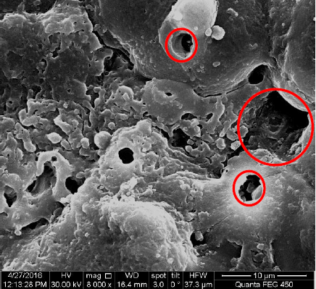 |  | 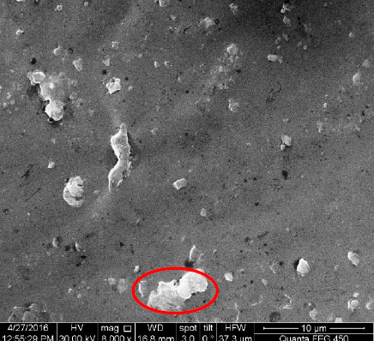
a |  | b
a – oxide coating without pore compaction; b – oxide coating with pore compaction
Figure 1 – Micrographs of the surface structures of the samples
As shown in Figure 1, the large and small pores of the coating are filled with epoxy, however, resin agglomeration may form during filling (Figure 1b).
The composite coating obtained by filling the pores of the oxide layer with epoxy resin has optimal characteristics of corrosion fatigue in air and 5.0 wt.% of aqueous NaCl solution. Sealing of pores of the coating on cast Mg alloy AZ31B by applying paint (E-paint) showed thatthe composite coating has a higher fatigue strength in an aggressive environment of 3.5 wt.% NaCl in comparison with an untreated MAO coating and helps to slow down the occurrence of a fatigue crack [8].
To obtain a self-lubricating protective composite coating of polytetrafluoroethylene with PEO, it was successfully fabricated on the surface of pure titanium by combined methods: PEO, immersion, and sintering [9]. An alkaline solution was used to obtain the oxide coating by the PEO method. The coating was formed at a voltage of 420 V, a frequency of 500 Hz, and a coating formation time of 25 minutes. Oxide-coated samples were then immersed in a PTFE dispersion, heated to 50°C and held for 20 minutes, and then placed in a muffle furnace. The samples were heated in a muffle furnace from room temperature to 150°C at a heating rate of 5°C/min, the holding time at 150°C was 20 min. Then the temperature was increased to 3,50°C, the holding time at this temperature was 20 min. The samples were cooled to room temperature inside the oven. Tribological studies have shown that the wear rate of the PEO-PTFE coating is 5 times lower than that of the coating without compaction. The value of the coefficient of friction is also lower.
The aim [10] to improve the tribological properties of the MАO coating was filled with ultra-high molecular weight polyethylene. This composite material has been tested under various friction conditions and has shown a significant reduction in the coefficient of friction for many pairs of friction in various lubricating media.
To seal the pores of oxide coatings obtained by the PEO method, the method of electrophoretic polymer deposition can be used [11, 12]. To precipitate the polymer, a solution of the composition: 70-78 wt.% deionized water, 17-25 wt.% epoxy resin, 3.2 wt.% titanium dioxide, and 1.8 wt.% aluminum silicate. The deposition was performed at a voltage of 225 V for 2 minutes [11]. The curing of the polymer was performed in a drying chamber at a temperature of 179 °C for 30 minutes. Micrographs of unconsolidated and compacted coatings are shown in Figure 2.
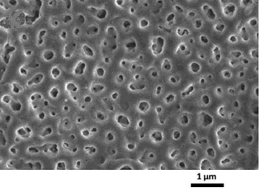 | 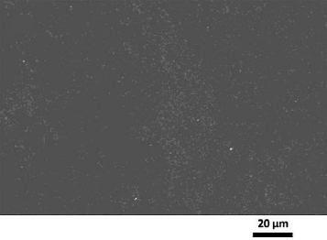
a | b
a – coating without compaction; b – coating with a seal
Figure 2 – Micrographs of the surface of the sample
The results of thermal shock, abrasion, adhesion, impact resistance tests showed that the composite coating meets all the requirements. The resulting coating is recommended for surface treatment of magnesium alloys for serial cars [11]. In [12], polytetrafluoroethylene at concentrations of 10, 20, 30, and 40 g/l was used as a sealant. Precipitation was performed from an aqueous suspension with an anionic surfactant. Researchers have found that polymer-containing coatings reduce the corrosion current density by three orders of magnitude and wear rate by two orders of magnitude compared to base PEO coating.
Additional sealing of PEO coatings by application of DLC (Diamond-Like Carbon) layers in the magnetron installation enablesus to significantly increase the wear resistance and corrosion resistance of the coating in comparison with the uncoated sample [13].
Using MoS₂ oxide layers on an alloy of valve metals as seals for oil or solid copper grease made it possible to increase the wear resistance of moving joints of machine parts by 1.7-4.5 times, reduce the friction coefficient by 30-50%, and improve corrosion resistance [14, 15].
Consolidation of PEO coatings, in addition to improving wear resistance, reducing roughness, significantly increases the corrosion resistance of oxide layers [16 - 18].
In [16], several methods of sealing (filling) the pores of oxide layers obtained on valve metals by the PEO method are considered. In a simple method, the pores of the coatings are sealed in liquid glass by the sol-gel method, which leads to an improvement in protective properties in aggressive liquids.
In [19], several methods of densification of oxide layers on magnesium alloys are considered to improve the protective properties of coatings. As corrosion-resistant coatings, two-layer layers on the AZ31 magnesium alloy (3.1% Al; 0.73% Zn; 0.25% Mn; 0.02% Si), obtained by oxidation followed by the application of a polymer layer (MAO + polymer) [19]. The polymer layer on a polyester base was applied in an electrostatic field, followed by curing at 200°C for 20 min. The resulting coating has protective properties. Filling MAO coatings in a suspension electrolyte containing ZrO₂ particles, silane (organosilicon compounds) significantly increased the corrosion-protective properties of the composite coating.
Composite coatings obtained on the AZ91 alloy by micro-arc oxidation with subsequent compaction [20] are related to a significant increase in corrosion resistance. A self-assembled polyethyleneimine (PEI) / kappa carrageenan (KC) coating was applied as the second filler layer. The addition of a second coating layer also increases the adhesion strength of the MАO-coated specimen by filling the pores and increasing the mechanical adhesion of the coating to the substrate.
To improve the corrosion resistance of PEO coatings on an alloy of a valve metal of magnesium, subsequent plasma treatment was performed for chemical vapor deposition to fill the pores of the oxide coating [21]. The fillers used were tetraethylorthosilicate (TEOS), hexamethyldisiloxane (HMDSO), and tetramethylorthosilicate (TMOS). It is shown that hexamethyldisiloxane, in comparison with other fillers, significantly improves the corrosion resistance of PEO coatings.
It was demonstrated for the first time in [22] that this relatively thin composite coating based on PEO on magnesium alloy ZE41 has high barrier properties and provides excellent corrosion protection for 1 month of continuous exposure to 3% NaCl. This composite coating was obtained by sealing PEO coating with corrosion inhibitor 1, 2, 4 - triazole, and sealed with a sol-gel film based on silica modified with titanium oxide.
It was shown in [23] that sealing the oxide layer on a magnesium alloy enables obtaining a composite coating with superior corrosion resistance compared to an unsealed anode layer. The oxide coating was sealed with an epoxy dip seal. It has also been found that a multi-layer (three-layer) epoxy coating results in a more sealed coating. Sealing treatment in a solution containing 12 g/l La(NO₃)₃ at pH 4 at different temperatures and for different processing times, the oxide layer on the AZ91 alloy leads to a significant increase in corrosion resistance [23]. It has been shown that sealing treatment at 50 °C for 30 minutes is more promising for increasing the corrosion properties of the samples treated with PEO. PEO coatings were fabricated on samples of AZ91 magnesium alloy using an alkaline solution containing sodium hydroxide, sodium phosphates, and sodium silicates.
The authors of [24], by modifying PEO coatings on titanium by means of densification (impregnation) in nitrate solutions followed by annealing, obtained oxide composites Co₃O₄ / SiO₂ + TiO₂ / Ti, CuO / SiO₂ + TiO₂ / Ti and Co₃O₄ + CuO / SiO₂ + TiO₂ / Ti. The morphological studies and the composition of the coating showed that the surface morphological structures with the highest contents of the transition metal can serve as catalytically active centers: “flakes” (Co₃O₄), “grains” (CuO), and “hedgehog”(Co₃O₄ + CuO).
Currently, the PEO method is increasingly being used to form biologically active composite corrosion-resistant coatings on titanium, magnesium, and their alloys intended for the bioengineering of bone tissue. To impart specific properties to oxide coatings, an additional compaction process is used [25 - 27].
Thus, to improve the corrosion resistance and biocompatibility of implants, oxide coatings are compacted in a solution of 5–7 wt. % PCL in dichloromethane by immersion method. The filling time was 10 minutes, drying was performed at a temperature of 25°C – 40°C [28]. Additional sealing of the porous coating with superfine polytetrafluoroethylene powder significantly reduces the corrosion rate (> 4 orders of magnitude) of magnesium alloy in physiological solution [29]. The oxide coating was obtained on the surface of the Mg-Mn-Ce alloy during the PEO process in an electrolyte containing calcium glycerophosphate and sodium fluoride. And no doubt, the use of composite coatings to stimulate biological activity and control corrosion degradation of absorbable Mg implants is considered promising.
Compaction of the oxide layer obtained by the PEO method on pure magnesium in a silane solution containing berberine at concentrations of 0 g/L, 2 g/L, 4 g/L, 6 g/L improves corrosion resistance and promotes bone growth [30]. It was shown that with an increase in the concentration of medicinal berberine, the surface pores of the coating became smaller and more uniform.
To obtain multifunctional coatings with improved biocompatible properties, it is proposed to include Ag, chitosan, and other bactericidal agents into coatings obtained by plasma electrolytic oxidation [31].
The results of tests for corrosion resistance in Hank’s saline solution showed positive results when sealing the pores of oxide coatings on magnesium in a 3 M NaOH solution at 60 °C for 1 h [32]. The compaction process seals smaller pores and reduces the size of medium and large pores.
In [33], to localize the degradation of magnesium-based implants in the body fluid, the oxide coating obtained on the surface of the implant by the PEO method was sealed. Poly-(L-lactide) (PLLA) polymer was used to fill the pores of the coating. To seal the pores in the PEO layer, the PLLA was coated by a two-stage centrifugation method.
Poly-(lactic-co-glycolic acid) (PLGA) material, which is a biodegradable, biocompatible polymer, can also be used as a filler for a porous oxide coating [34]. The oxide coating on the titanium alloy was filled by immersion. The resulting composite coating improves the corrosion resistance of the product in Ringer’s solution. According to the authors, the formation of a hybrid polymer-oxide layer on the surface of the Ti-15Mo alloy is a promising approach for obtaining “smart materials”.
In [35], to improve the anticorrosive properties, bioactive PEO coatings were additionally compacted with ultradispersed polytetrafluoroethylene and composite coatings were obtained. Polymer on PEO coating was applied in two ways: 1) by immersion in a suspension based on isopropyl alcohol containing particles of UPTFE with a size of 0.2-0.6 μm (100-150 g/l) and OC-10 (6-8 g/l) followed by heat treatment in an oven at 200°C – 250°C for 3 minutes; 2) by the electrophoretic method with anodic polarization at 200 V from a suspension containing UPTFE particles (20 g/l), wetting agent OP-10 (1 g/l) and anionic surfactant (0.5l), for 25 s, followed by 15-minute heat treatment at 315°С.
In [36], an effective method of sealing the pores of oxide MAO coatings on a magnesium alloy is considered. Composite coatings were obtained by sealing pores under low-pressure conditions using a sol-gel process. To prepare a solution to fill the pores, we used triethyl phosphite ((CH₃CH₂O)₃P) and calcium nitrate (Ca(NO₃)₂), which were chosen as the source for P and Ca, respectively. In vitro electrochemical corrosion and bioactivity tests have shown that composite coatings not only improve corrosion resistance but also enhance the biological activity of AZ31 Mg alloy.
The sealing of PEO coatings in SBF-liquid, which corresponds to the composition of Tadashi Kokubo, improves the biocompatibility of titanium implants. This solution is identical in its chemical composition to the human interstitial fluid (blood plasma). It was compacted by dipping [37]. Using artificial interstitial fluid, it is possible to obtain hydroxyapatite coatings on various surfaces. However, the process is rather slow – 7 days at a temperature of 37°C.
To improve the biocompatibility and corrosion resistance of oxide coatings on magnesium alloys obtained by the PEO method, they are filled with Mg-Al-layered double hydroxides (LDH) [38]. The special structure of the LDH provides a surface for drug delivery.
At present, the All-Russian Research Institute of Aviation Materials (VRIAM) is the leading materials science center of the Russian Federation. Develops and supplies a wide range of metallic and non-metallic materials, coatings, technological processes and equipment, methods, and means of protection against corrosion damage and biological damage. VRIAM offers its developments for solving problems in aircraft and mechanical engineering, space industry, energy, construction, medicine, and other fields [39, 40]. Magnesium alloys are of great interest in modern aircraft construction due to their high specific strength characteristics; however, the issue of their protection against corrosion has not been completely resolved. The most promising method of protecting magnesium alloys is plasma electrolytic oxidation. In the work of VRIAM employees, the effectiveness of increasing the protective properties of a plasma electrolytic coating on a VML20 casting magnesium alloy by filling in a solution of sodium water glass was investigated [41]. It was found that after exposure in a 3% aqueous solution of NaCl for 48 hours, the most stable coating is treated in a solution of 2 g/L of sodium water glass. This makes it possible to increase the total resistance of the PEO coating by a factor of 7.3 relative to the unfilled one. Boiling treatment in distilled water also ensures the preservation of relatively high characteristics of the coating and makes it possible to increase the total resistance of the coating by a factor of 5.7, while better stability of the inner layer of the PEO coating is observed.
It is known that aluminum alloys are the main structural material of the aviation industry. Particular attention is paid to aluminum-lithium alloys and hybrid materials based on them, such as SIAL. The work [42] touches upon the issues of protecting such alloys from corrosion and imparting special properties to their surfaces. After anodic oxidation, compaction in a solution containing a plant extract, an aluminum indicator, and triethanolamine, coatings have high protective properties (after exposure for 432 hours in a salt fog chamber without corrosive damage) and when used for surface preparation, the strength of adhesive bonds was 34.0 MPa.
Analysis of the literature data showed that the coatings formed as a result of treatment with plasma electrolytic oxidation have different porosities. Sealing pores with various materials can give them certain functional properties. To impart anti-friction, wear-resistant, protective properties to coatings, polymeric materials can be used as sealing material: epoxy resin, polytetrafluoroethylene, ultra-high molecular weight polyethylene. Copper can be used as a solid lubricant when filling the pores of the coating, MoS₂.
A significant number of works are devoted to obtaining biologically active coatings on titanium and magnesium alloys. The application of oxide coatings followed by their densification with drugs and bactericidal agents improve the biocompatibility of orthopedic implants and reduce the rate of magnesium corrosion under physiological conditions. Seals made of polytetrafluoroethylene, polymer poly-(L-lactide), etc. significantly reduce the corrosion rate.
To increase the protective properties of porous coatings, VRIAM researchers propose to seal them in a solution of the sodium water glass, triethanolamine. Compaction with these materials is performed by immersion in sealant solutions, or by the electrophoretic method.

- Obtain composite oxide coatings by filling pores
Obtaining composite oxide coatings was performed in two stages: Stage 1 – obtaining an oxide coating by the PEO method; Stage 2 – filling the pores of the oxide coating with polymeric materials.
- The first stage of obtaining a composite oxide coating
At the first stage, the oxide coating was obtained by PEO on a setup consisting of a two-electrode electrochemical cell and a power source (Figure 3). The cell consisted of a bath, an auxiliary electrode made of 12Kh18N10T stainless steel (in the form of a sheet 2 mm thick bent along the walls and bottom of the bath at right angles), and a working electrode — a sample of metal and its alloy, and an electrolyte cooling system. A thyristor-type "Korund M0" switching power supply was used as a power source.

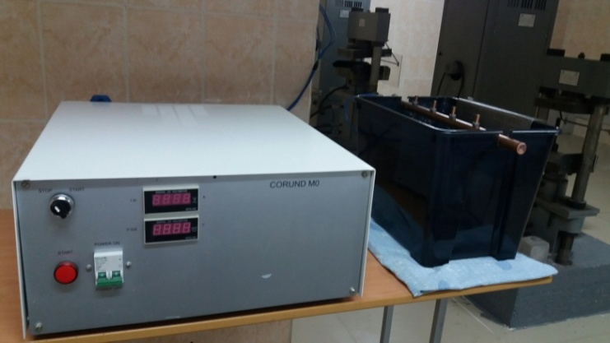
2
1

1 – Korund M0 power supply; 2 – electrochemical cell
Figure 3 – Installation for modification of the titanium and its alloy surface
"Korund M0" power supply enables to form alternating positive and negative trapezoidal voltage pulses. When using pulses of this form, the maximum full use of the supplied energy occurs, while the duration of the pause between the pulses is sufficient so that strong overheating of the near-electrode layer does not occur.
The technical data of the power supply unit are as follows: 1) output voltage – pulse bipolar, frequency (50 ± 0.5) Hz; 2) value of the positive voltage pulse (600 ± 60) V; 3) value of the positive current pulse (800 ± 80) A; 4) duration of the positive current pulse (250 ± 25) μs; 5) value of the negative voltage pulse (300 ± 30) V; 6) the magnitude of the negative current pulse (44 ± 4) A; 7) duration of the negative current pulse (5 ± 0.5) μs; 8) power consumed from the network does not exceed 9 kVA.
A sample attachment system was used, which consisted of a suspension rigidly fixed on a copper rod to ensure a rigid contact of the sample with the current - carrying part of the power source.
The thickness of oxide coatings was measured using a NOVOTEST TP-1 thickness gauge with an NF-2 sensor with digital indexing of indicators. When measuring the thickness of the oxide coatings, 7 measurements were performed on both sides of the sample. The arithmetic mean of the coating thickness was calculated. For surface modification by the PEO method, samples of a titanium alloy VT1-0 (Grade 2) and VT5 (Grade 6) of rectangular shape with a thickness of 0.3 cm and sizes of 2x4 cm and 1.5x4 were subjected. The composition of the alloys is given in Table 1.
Table 1 – Composition of alloys
Grade | Mass fraction of chemical elements, %
Grade | Ti | Al | V | Mo | Zr | Si | Fe | oxygen | hydrogen | nitrogen | carbon | other impurities
VT1-0 | basis | - | - | - | - | 0.10 | 0.25 | 0.20 | 0.010 | 0.04 | 0.07 | 0.30
VT5 | basis | 4.5-6.2 | 1.2 | 0.8 | 0.30 | 0.12 | 0.30 | 0.20 | 0.015 | 0.05 | 0.10 | 0.30
The samples were preliminarily subjected to grinding to remove the oxide film and scratches. Then the surface was cleaned from organic contaminants, the samples were washed with distilled water, a solution of ethyl alcohol C₂H₅OH, and again with distilled water. Samples were dried at room temperature.
When choosing electrolyte solutions, the combination of such indicators as porosity and physical and mechanical characteristics of coatings, which were studied by us in previous years, was taken into account. The planimetric method was used to calculate the porosity of the coatings [43]. The total porosity was determined from the analysis of micrographs as the ratio of the area of the pore image F_{p} to the total area of the observation site F. This method is laborious, but the results obtained are reliable and accurate [43].
Electrolyte solutions that were used to form an oxide layer on titanium alloys are shown in Table 2. For the preparation of electrolyte solutions, we used chemical reagent brands P, CP, RG.
The process of plasma electrolytic oxidation on all samples was performed under the following conditions: duration of the anodic current pulse – 250 ± 25 μs; duration of the impulse of the cathodic current – 5 ± 0.5 ms; pulse repetition rate is 50 ± 0.5 Hz; duration of the pause between the anodic and cathodic currents – 250 ± 25 μs. The electrolyte temperature was maintained within the range of 20 – 30 °C. The processing time for all samples was 600 sec. The voltage and current density of the PEO process depend on the electrolyte solution used and the basis of the processed material. The conditions of the PEO process and the obtained properties of the coatings are shown in Table 2.
Table 2 – Conditions of the PEO process and the properties of oxide coatings on samples of titanium alloys VT1-0 and VT5
Electrolyte composition and number | Voltage, V |  | Current density, A/dm ² |  | Coating thickness, microns |  | Coating porosity ΔS, %
Electrolyte composition and number | VT1-0  alloy | VT5  alloy | VT1-0  alloy | VT5  alloy | VT1-0  alloy | VT5  alloy | VT1-0  alloy | VT 5  alloy
- Na₂HPO₄.12H₂O (40 g/l) + Na₂B₄O₇.10H₂O (30 g/l) + H₃BO₃ (22 g/l) + NH₄F (10 g/l) | 360 | 360 | 113 | 115 | 19.0 | 24.5 | 6.2 | 5.4
- Na₃PO₄.12H₂O (70 g/l) + Al₂O₃ (20 g/l) | 360 | 360 | 110 | 113 | 15 | 10 | 4.4 | 12.1
- Na₂HPO₄.12H₂O (40 g/l) + Na₂B₄O₇.10H₂O (30 g/l) + H₃BO₃ (22 g/l) + NH₄F (10 g/l)+ NaVO₃ (1.0 g/l) | 360 | 360 | 84 | 86 | 20.5 | 23.5 | 7.4 | 7.7
On samples from VT1-0 dense uniform coatings of light gray color are formed. On samples of VT5 alloy, dense uniform quartz-colored coatings (gray shade) were obtained. Administration of NaVO₃to the solution (solution No.3, Table 2) enables to obtain black coatings on VT1-0 and VT5 titanium alloys. Obtaining black coatings is due to the introduction of vanadium oxide into the coating, which is formed under the influence of high temperatures during a microarc discharge. Currently, the production requires black coatings on titanium, which must be obtained on various instrument cases, optical instruments, etc.
- The second stage of obtaining a composite oxide coating
At the second stage of obtaining a composite oxide coating on samples from titanium alloys, the pores of the oxide coating were filled with polymer materials. The pores of the oxide coating were filled by immersion in polymer solutions. For this, polymer solutions were preliminarily prepared. Fluoroplastic F-32 and epoxy resin ED-20 with hardener PEPA (polyethylene polyamine) were chosen as polymers.
It is known that fluoroplastics have a unique set of properties. This is unsurpassed chemical resistance, excellent antifriction, anti-adhesive, dielectric and insulating properties, hydrophobicity, as well as the ability to maintain these properties in a wide temperature range, from – 260°С to + 260°С [44, 45].
Fluoroplast–32L[(-CF₂-CFCl)_{n}-CF₂-CH₂-]_{m} — copolymer of trifluorochlorethylene and vinylidene fluoride is a soluble polymer with high elasticity, possessing an extremely low diffusion coefficient, and is readily soluble in esters, ketones, and freons [46]. It has a high resistance to concentrated sulfuric, nitric, hydrochloric, acetic acid, alkalis, and other aggressive media. The dielectric properties of fluoroplastic are retained in high humidity conditions. High weather resistance. For sealing, fluoroplastic–32L of N grade (with low molecular weight) was used, which has increased manufacturability [47].
The second polymer, epoxy resin, chosen as a filler for pores of oxide coatings, occupies a leading place among the mass of various polymeric materials because it possesses unique physical and mechanical properties and broad technological capabilities [48]. The characteristics of the cured resin ED-20 are the following: strong adhesion to metal, plastic; refractoriness; the ability to maintain adhesion and tightness for a long time; thermal conductivity, and thermal resistance. A distinctive feature of epoxy resins during curing is the absence of volatile matter emission and low shrinkage (0.1 – 3%) [48].
Acetic acid butyl ester (GOST 22300-76) and fluoroplastic F-32LN (OST 6-05-432-78, powder fineness 30 - 40 μm) were used to prepare the fluoroplastic solution. Fluoroplastic F-32LN in an amount of 9-10 grams was dissolved in 100 ml of acetic acid butyl ester to prepare a polymer solution. First, the PEPA hardener was poured into the ED-20 resin (GOST 10587-84) very slowly, constantly stirring to prepare a solution of epoxy resin. Then, acetic acid butyl ester was slowly poured into the resulting homogeneous mixture of resin and hardener, constantly stirring until a homogeneous solution was obtained. The quantitative ratios of the prepared solution were: ED-20 - 16-20 g; hardener PEPA 3 - 4 g (20 % of resin weight); acetic acid butyl ester - 50 ml.
When obtaining oxide-polymer composite coatings on VT1-0 and VT5 titanium alloys, 3 batches of samples were obtained for each alloy: 1 batch — oxide-polymer coatings with one layer of fluoroplastic; 2nd batch — oxide-polymer coatings with two layers of fluoroplastic; 3rd batch - oxide-polymer coatings with one layer of epoxy resin.
Obtaining an oxide-polymer coating was performed by immersing a sample with an oxide coating in a polymer solution for 5 - 7 minutes. Specimens with an oxide coating were preliminarily heated to a temperature of 40 °C – 50 °C before compaction. In the process of compaction in the polymer solution, the pores of the oxide coating are filled with the polymer. Further, during drying, the polymerization process is performed. Polymerization time for fluoroplastic was 60 minutes, for epoxy resin 30 hours at room temperature.
The preparation of the second layer of fluoroplastic was performed by immersing the samples in the fluoroplastic solution after the polymerization of the first layer of polymer for 1 - 2 minutes. In this case, the sample was not heated before immersion in the solution. Then the sample was dried at room temperature for 60 minutes.
Figure 4 shows photographs of samples with an oxide coating obtained in electrolyte No.1 (Table 2) on VT1-0 alloy, without polymer and with an oxide - polymer coating.
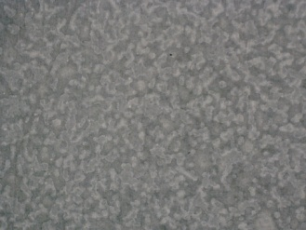 | 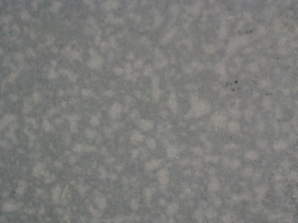 | 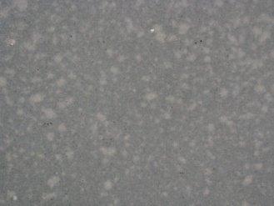 | 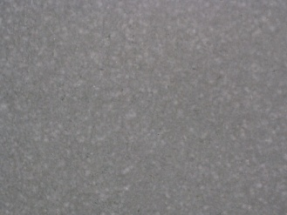
a | b | c | d
a — a sample with an oxide coating; b — a sample with an oxide-polymer coating with 1 layer of fluoroplastic; c — a sample with an oxide-polymer coating with 2 layers of fluoroplastic; d — a sample with an oxide-polymer coating with 1 layer of epoxy resin
Figure 4 — Samples with coatings
Under Figure 4, it can be seen that microroughness of the oxide coating are filled with the polymer.
Thus, three batches of composite oxide-polymer coatings were obtained.
- Investigate the corrosion behavior of composite coatings
  - The corrosion resistance of titanium
Titanium is highly resistant to corrosion in many corrosive environments. This is due to the presence of an oxide film on the metal surface [49 - 51].
Titanium and titanium alloys are corrosion resistant in the atmosphere and seawater. Besides, titanium is stable in many dilute acids. It differs in stability in nitric acid of any concentration and temperature. When interacting with fuming nitric acid, supersaturated with free nitrogen dioxide, titanium reacts violently. In hydrochloric acid, titanium is resistant only under the following conditions: temperature 333 K, and concentration not higher than 3%; temperature 373 K and acid concentration not higher than 0.5% [49].
At low temperatures (up to 308 K), titanium is resistant to phosphoric acid at a concentration of up to 30%. Titanium corrodes in hydrofluoric acid. Even in 1% HF, titanium corrosion proceeds at a high rate. Metal corrodes in sulfuric acid. The most intense dissolution of titanium in sulfuric acid is observed in dilute sulfuric acid (20% — 50%) [50]. When interacting with most organic acids (tartaric, acetic, lactic), titanium corrosion is very weak.
Titanium is resistant to most dilute alkalis. However, when heated and the concentration of alkali increases, titanium dissolves to form a salt Na₂TiO₃.
The corrosion resistance of titanium can be increased by introducing alloying additives into it [51, 52]. Aluminum, vanadium, molybdenum, silicon, chromium, zirconium, and others can be used as alloying additives. The introduction of alloying additives in titanium smelting, in addition to corrosion resistance, has a positive effect on the mechanical characteristics of titanium alloys. But it should be borne in mind that alloying titanium leads to a significant increase in their cost and an increase in the mass of the material, which is of no small importance in space technology.
However, the corrosion resistance of titanium is highly dependent on the nature of the corrosive environment. Besides, the corrosion behavior of titanium also depends on its structural state.
3.2 Corrosion behavior of the obtained composite and oxide coatings
The corrosion resistance of oxide and composite coatings was investigated by two methods:
- In salt fog at a temperature of (35 ± 2)°С for 1,000 hours under GOST 9.308-85, neutral salt fog. Oxide coatings without polymer compaction were subjected to this test.
- By gravimetric method in sulfuric acid solution. Composite oxide-polymer coatings were tested.

3.2.1. Corrosion tests of samples with an oxide coating under GOST 9.308-85
Oxide coatings on VT1-0 and VT5 titanium alloys without compaction, obtained by the PEO method at the first stage, were subjected to corrosion testing under GOST 9.308-85. The conditions to perform PEO and the compositions of electrolytes are described above, are given in Table 2.
The corrosion resistance of samples with oxide coatings was performed under the influence of neutral salt fog at a temperature of (35 ± 2)°C for 1,000 hours in an Ascott CC 450 chamber. The tests were performed at MANEL JSC (Tomsk, Russian Federation). We have long-term good scientific relations with this enterprise, the tests were performed free of charge. Cameras manufactured by Ascott (UK) are one of the most modern and versatile salt spray systems, their design is impeccable, and the quality is at the highest level.
Samples with coatings were placed in the chamber at a distance of at least 20 mm from each other, from the walls — at least 100 mm, from the bottom of the chamber at least 200 mm, and kept at a temperature of (35 ± 2) оС in a continuously sprayed solution with a concentration of chloride sodium (50 ± 5) g/dm³. The pH of the solution was 6.5-7.2. The salt spray was sprayed in such a way that the volume of condensate during the operation of the chamber for 24 hours was 1.2-1.5 cm³/h. The change in the state of the coatings was determined by visual inspection after 2, 24, 96, 294, 460, 720, 1,000, and 1,500 hours of testing. For this, the samples were removed from the chamber, washed with tap water to remove the brine, and dried with filter paper, and the appearance was assessed for the presence of corrosion damage according to the following indicators: color change, corrosion by dots, and spots.
Visual inspection of oxide coatings after the stages of corrosion tests after 2, 24, 96, 294, 460, 720, 1,000, 1,500 hours showed no traces of corrosion destruction.
Table 3 shows the results of corrosion tests.
Table 3 – Results of corrosion tests
Test stage, hours | The appearance of the samples treated with PEO | Coating appearance
1 | 2 | 3
0 | 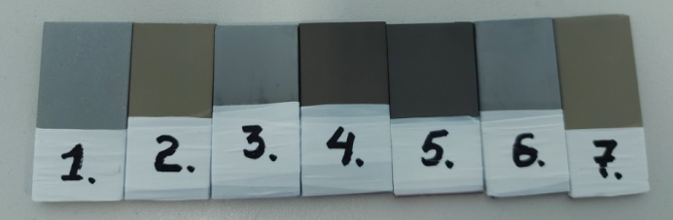 | Initial samples
2 | 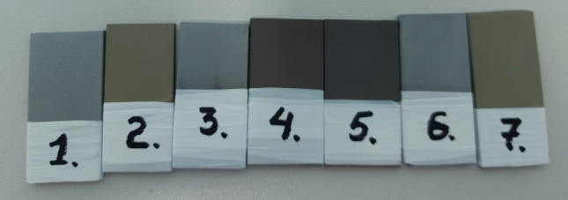 | Without changes
Table continuation 3
1 | 2 | 3
24 | 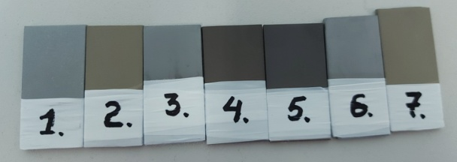 | Without changes
96 | 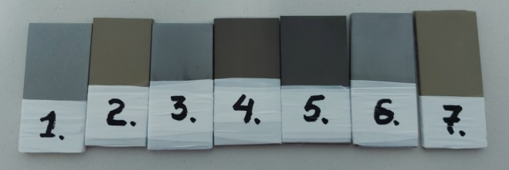 | Without changes
294 | 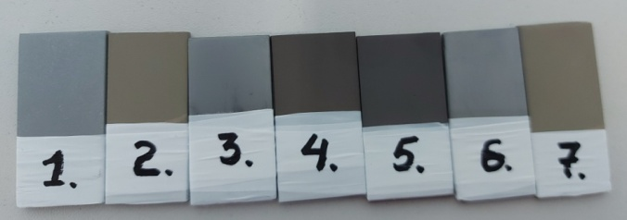 | Without changes
460 | 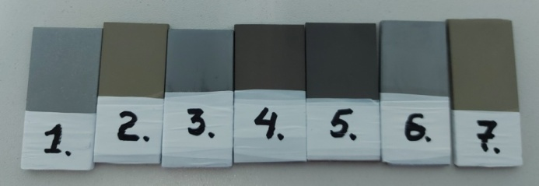 | Without changes
720 | 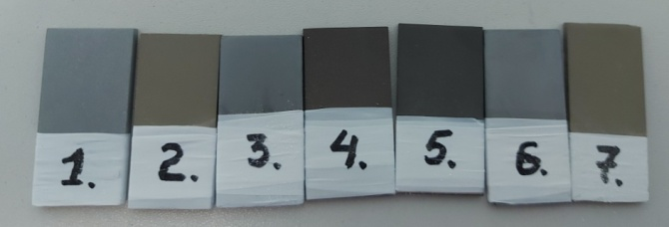 | Without changes
1,000 | 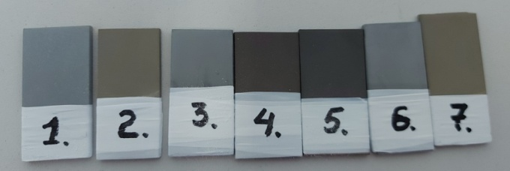 | Without changes
1,500 | 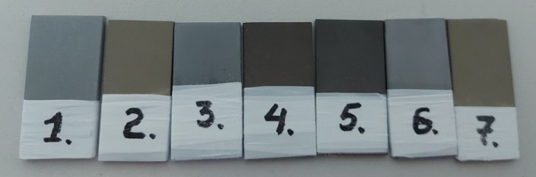 | Without changes
Thus, all samples with an oxide coating under conditions of exposure to neutral salt fog at a temperature of 35°C for 1,500 hours at a solution concentration of 50 g/l sodium chloride, solution pH 6.5-7.2 proved to be corrosion-resistant.
3.2.2 Corrosion testing of samples with a composite oxide-polymer coating by the gravimetric method
For a correct assessment of the corrosion resistance of a material, it is important to choose the correct corrosion indicator. Corrosion resistance indicators, taking into account [53]:
- change in sample weight;
- amount of oxygen absorbed in the process of corrosion, or released hydrogen;
- changes in the mechanical properties of the material as a result of corrosion;
- change in the electrical resistance of the material as a result of corrosion;
- depth of development of corrosion destruction;
- time required for the development of corrosion on a certain part of the surface.
In studying the corrosion behavior of the obtained coatings on VT1-0 and VT5 titanium alloys, we chose the gravimetric method. This method is the easiest to implement and illustrative for determining the corrosion resistance of materials. When using this method, the corrosion rate of a material is characterized by a mass index, which determines the mass of corroded material per unit area per unit time [53, 54].
Corrosion resistance was evaluated by conducting accelerated laboratory tests. Samples in the experiment were batches of plates with coatings obtained on VT1-0 and VT5 titanium alloys of four types: 1) oxide coating without compaction (hereinafter – OC); 2) oxide-polymer coating compacted with epoxy resin (hereinafter – OPC-ER); 3) oxide-polymer coating compacted with fluoroplastic F-32 – 1 layer (hereinafter – OPC-F-32 – 1 layer); 4) oxide-polymer coating compacted with fluoroplastic – 2 layers (hereinafter – OPC-F-32 – 2 layers).
A 24% sulfuric acid solution was used as a corrosive medium. It is known that the rate of corrosion processes is strongly influenced by the process temperature. With an increase in temperature, the processes of corrosion destruction proceed much faster. In this regard, corrosion tests were performed at temperatures of a sulfuric acid solution of 39°C and 75°C. Oxide coatings during PEO are formed with different pore sizes and porosities. Corrosion processes occur at the bottom of the pores, dissolution of the base material (metal) occurs. This leads to separation (destruction) of the coating.
To assess the level of corrosion resistance of all samples, a test bench was assembled (Figure 5). The stand included an electric heating surface; a cylindrical container filled with water; two flasks with an aggressive medium. The flasks were equipped with a reflux condenser. The position of the flasks was fixed by the upper and lower tripod holders. The water temperature was monitored with a thermometer installed near the flask. The duration of the test in an aggressive environment was taken as 50 minutes. The test time was chosen based on the condition that the weight loss of the VT1-0 and VT5 alloys were measured reliably. For each batch of samples, the aggressive solution was replaced with a fresh solution every 24 hours. Since the experiment was performed in an aggressive hot solution of sulfuric acid, a polymer-insulated wire was used to fix the samples in the flask, and the upper part of the samples at the attachment point was insulated with a polytetrafluoroethylene tape. Three samples from each type of coating batch were subjected to corrosion tests.
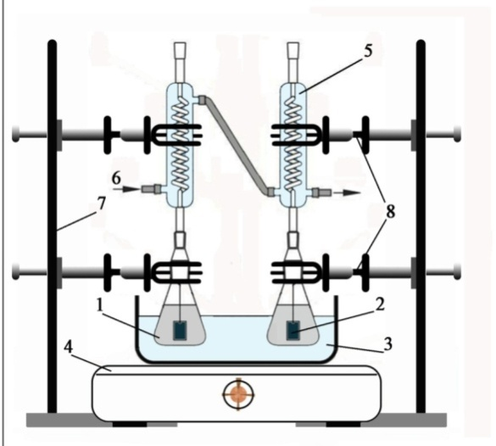
1 – flask with an aggressive solution; 2 – test sample; 3 –container with water; 4 – heating element; 5 – reflux condenser; 6 – water for cooling; 7 – tripod; 8 – holders

Figure 5 – Test bench for determining the corrosion resistance of materials in an aggressive environment

After holding in a corrosive environment, the samples were removed from the flask and washed with water. Further, corrosion residues were removed from the test specimens. After the removal of corrosion products, the samples were dried. The corrosion products in these tests were detached coatings. Weighing the mass before testing and after testing the coatings was performed on an analytical balance with an accuracy of 0.0001 g. Each sample was measured 3 times. The arithmetic mean values of the sample masses were calculated (Table 4). Negative corrosion values were calculated based on these values. The results of all tests are shown in Tables 4 to 9.
Table 4 – Corrosion indicators for coatings on VT1-0 alloy obtained in electrolyte 1
VT1-0 alloy. Electrolyte 1: Na₂HPO₄.12H₂O + Na₂B₄O₇.10H₂O + H₃BO₃ + NH₄F
Coating type | Т_{cor}=39⁰ С |  |  |  | Т_{cor}=75⁰С
Coating type | m_{0aver.}, g | M_{cor. aver.}, g | Δm_{aver.}, g | , g/m²·h | m_{0aver.}, g | m_{cor. aver.}, g | Δm_{aver.}, g | , g/m²·h
OC | 10.8831 | 10.8814 | 0.0017 | 2.36 | 10.4651 | 10.4489 | 0.0162 | 21.18
ОPC-ER | 10.9136 | 10.9133 | 0.0003 | 0.45 | 11.2544 | 11.2527 | 0.0017 | 2.06
ОPC-F-32-1 layer | 11.8201 | 11.8193 | 0.0008 | 0.87 | 10.9031 | 10.8979 | 0.0052 | 6.19
ОPC-F-32-2 layers | 11.1007 | 11.1002 | 0.0005 | 0.65 | 11.5341 | 11.5312 | 0.0029 | 3.83

Table 5 – Corrosion indicators for coatings on VT1-0 alloy obtained in electrolyte 2
VT1-0 alloy. Electrolyte 2: Na₃PO₄.12H₂O + Al₂O₃
Coating type | Т_{cor}=39⁰ С |  |  |  | Т_{cor}=75⁰С
Coating type | m_{0aver}, g | m_{cor.aver.}, g | Δm_{aver}, g | , g/m²·h | m_{0aver}, g | m_{cor.aver}, g | Δm_{aver.}, g | , g/m²·h
OC | 11.6272 | 1.6266 | 0.0053 | 0.92 | 9.7041 | 9.6989 | 0.0052 | 8.31
ОPC-ER | 12.0367 | 12.0365 | 0.0002 | 0.18 | 10.1089 | 10.1078 | 0.0011 | 1.61
ОPC-F-32-1 layer | 10.6222 | 10.6221 | 0.0001 | 0.17 | 10.7496 | 10.7455 | 0.0042 | 4.96
ОPC-F-32-2 layers | 10.5323 | 10.5323 | 0.0 | 0.0 | 12.9727 | 12.9687 | 0.004 | 4.09

Table 6 – Corrosion indicators for coatings on VT1-0 alloy obtained in electrolyte 3
VT1-0 alloy. Electrolyte 3: Na₂HPO₄.12H₂O + Na₂B₄O₇.10H₂O + H₃BO₃ + NH₄F + NaVO₃
Coating type | Т_{cor}=39⁰ С |  |  |  | Т_{cor}=75⁰С
Coating type | m_{0aver.}, g | m_{cor.aver.}, g | Δm_{aver.}, g | , g/m²·h | m_{0aver.}, g | m_{cor.aver.}, g | Δm_{ср}, g | , g/m²·h
OC | 10.4147 | 10.4126 | 0.0021 | 2.47 | 10.5614 | 10.5265 | 0.0349 | 45.54
ОPC-ER | 10.3991 | 10.3990 | 0.0001 | 0.12 | 11.3343 | 11.3340 | 0.0003 | 0.39
ОPC-F-32-1 layer | 11.1430 | 11.1409 | 0.0021 | 2.39 | 10.3231 | 10.3140 | 0.0091 | 11.92
ОPC-F-32-2 layers | 10.1472 | 10.1454 | 0.0018 | 2.15 | 10.2398 | 10.2352 | 0.0046 | 6.24

Table 7 – Corrosion indicators for coatings on VT5 alloy obtained in electrolyte 1
VT5 alloy. Electrolyte 1: Na₂HPO₄.12H₂O + Na₂B₄O₇.10H₂O + H₃BO₃ + NH₄F
Coating type | Т_{кор}=39⁰ С |  |  |  | Т_{кор}=75⁰С
Coating type | m_{0aver.}, g | m_{cor.aver.}, g | Δm_{aver.}, g | , g/m²·h | m_{0aver.}, g | m_{cor.aver.}, g | Δm_{ср}, g | , g/m²·h
OC | 10.1657 | 10.1136 | 0.0521 | 67.94 | 10.1888 | 10.1070 | 0.0818 | 106.70
ОPC-ER | 8.8847 | 8.8809 | 0.0038 | 4.53 | 8.7275 | 8.6738 | 0.0537 | 67.01
ОPC-F-32-1 layer | 10.3289 | 10.2891 | 0.0398 | 45.33 | 8.4935 | 8.4332 | 0.0603 | 90.89
ОPC-F-32-2 layers | 9.0212 | 8.9865 | 0.0347 | 41.33 | 9.9788 | 9.9390 | 0.0398 | 49.52

Table 8 – Corrosion indicators for coatings on VT5 alloy obtained in electrolyte 2
VT5 alloy. Electrolyte 2: Na₃PO₄.12H₂O + Al₂O₃
Coating type | Т_{cor}=39⁰ С |  |  |  | Т_{cor}=75⁰С
Coating type | m_{0aver.}, g | m_{cor.aver.}, g | Δm_{aver.}, g | , g/m²·h | m_{0aver.}, g | m_{cor.aver.}, g | Δm_{ср}, g | , g/m²·h
OC | 9.4166 | 9.4152 | 0.0014 | 1.65 | 7.9417 | 7.9371 | 0.0046 | 8.97
ОPC-ER | 10.2485 | 10.2485 | 0.00 | 0.00 | 9.7445 | 9.7439 | 0.0006 | 0.79
ОPC-F-32-1 layer | 9.3003 | 9.2987 | 0.0016 | 1.82 | 7.1849 | 7.1812 | 0.0037 | 8.88
ОPC-F-32-2 layers | 9.0533 | 9.0525 | 0.0008 | 1.09 | 9.4746 | 9.4691 | 0.0055 | 6.31
Table 9 – Corrosion indicators for coatings on VT5 alloy obtained in electrolyte 3
VT5 alloy. Electrolyte 3: Na₂HPO₄.12H₂O + Na₂B₄O₇.10H₂O + H₃BO₃ + NH₄F + NaVO₃
Coating type | Т_{cor.}=39⁰ С |  |  |  | Т_{cor.}=75⁰С
Coating type | m_{0aver.}, g | m_{cor.aver.}, g | Δm_{aver.}, g | , g/m²·h | m_{0aver.}, g | m_{cor.aver.}, g | Δm_{ср}, g | , g/m²·h
OC | 9.1639 | 9.1079 | 0.056 | 80.80 | 7.3910 | 7.2951 | 0.0959 | 201.27
ОPC-ER | 8.9135 | 8.9135 | 0.00 | 0.00 | 10.5198 | 10.4996 | 0.0202 | 25.20
ОPC-F-32-1 layer | 10.2665 | 10.2326 | 0.0338 | 30.86 | 10.3446 | 10.2672 | 0.0774 | 84.74
ОPC-F-32-2 layers | 7.8263 | 7.8235 | 0.0028 | 6.20 | 9.1840 | 9.1159 | 0.068 | 82.00
The coatings were conditionally divided into 4 categories to identify the nature of corrosion destruction according to the results of the calculated data presented in Tables 4 - 9 and visual external inspection.
1) Corrosion rate (K –_{m}) is zero. Separation (destruction) of the coating does not occur. The integrity of the coatings is not damaged over the entire surface of the sample. These include the coating on VT1-0 alloy, obtained in electrolyte No.2, compacted with F-32 – 2 layers atТ_{cor.}=39⁰С (Table 5). This category also includes coatings on VT5, obtained in electrolytes No.2 and No.3, compacted in epoxy resin at Т_{cor.}=39⁰С (Table 8, 9).
2) Negative corrosion rate is within the following limits: 0.17 g/m²∙h – 4.96 g/m²∙h. The coating does not separate from the base on samples. The integrity of the coatings is maintained. On all samples after corrosion tests, a change in the color of the coatings is observed. The coatings after corrosion tests become lighter. The change in the weight of the sample can be explained by the partial insignificant dissolution of the metal base through the pores, which does not lead to delamination and destruction of the oxide layer, but a change in the color of the coating occurs.
3) Negative corrosion rate is within the following limits: 6.19 g/m²∙h – 11.92 g/m²∙h. All samples demonstrate a color change. Partial (micro) destruction of coatings is observed. The diameter of point fractures is about 1 mm, and they are located mainly along the edges of the sample.
4) Negative corrosion rate is within the following limits: 21.18 g/m²∙h – 201.27 g/m²∙h. At these values of the corrosion index, the delamination of the coating from the base is observed. The integrity of the coatings is broken.
Comparative diagrams based on the data in Tables 4 - 9 are shown in Figures 6 - 7.
а | b
а – the temperature of corrosion testing Т_{cor.}=39°С; b - the temperature of corrosion testing Т_{cor.}=75°С
Figure 6 – Corrosion resistance of coatings obtained on VT1-0 alloy
а | b
а – the temperature of corrosion testing Т_{cor.}=39°С; b – the temperature of corrosion testing Т_{cor.}=75°С
Figure 7 – corrosion resistance of coatings obtained on VT5 alloy
As it is seen in figures 6, 7, the analysis of the results of corrosion tests with usage of weight method indicates that the greatest resistance in an aggressive environment is showed by oxide coatings on VT1-0 alloy obtained in electrolytes 1 - 3 (Table 2) and sealed in epoxy resin at corrosion test temperatures of 39 °С, 75°С. The negative corrosion index for these samples is in the range of 0.12 g/m²∙h – 2.06 g/m²∙h. The visual inspection of these coatings after corrosion tests showed that no visible damage to the coating was detected during the test time. Oxide coatings on VT5 alloy obtained in electrolyte No.2 (Table 2) and sealed in epoxy resin are corrosion-resistant at test temperatures of 39 °С and 75°С (= 0.0 g/m² ∙ h – 0.79 g/m²∙h).
Fluoroplasticsealing improves the corrosion-resistance properties of coatings on both VT1-0 and VT5 alloys compared to coated samples without sealing. The application of a double layer of F-32 tends to improve the corrosion-resistance of ОPC in comparison with a single layer of F-32. As the temperature of the aggressive medium increases, the rate of corrosion increases (Figure 6, 7).
The comparison of data on the corrosion resistance of oxide coatings without sealing and with sealing obtained in various electrolytes shows that the best result is observed in OC, ОPC obtained in electrolyte No.2. This is quite consistent with the values of the surface porosity of these coatings on VT1-0 titanium alloy (Table 2). However, VT5 alloy has more increased porosity of OC in electrolyte No.2 than that of OC obtained in electrolytes No.1 and No.3. This is because the pores, which are formed with the growth of the oxide layer in the PEO process in this electrolyte, are to a greater extent not through.
Based on the results of corrosion tests, the following statements can be made. Oxide coatings are proved to be corrosion-resistant coatings as was shown by the results of tests in the salt mist under standard GOST 9.308-85
The tests, which were performed in the aggressive environment at a temperature of 39°С, 75°С, showed that coatings on VT1-0 alloy, both oxide and oxide-polymer, are more corrosion-resistant than similar coatings on VT5 alloy. All the types of coatings obtained on VT1-0 alloy are corrosion-resistant at the test temperature of 39°С (Tables 4 − 6). The following types of coatings on VT5 alloy are corrosion – resistant: oxide coatings obtained in electrolytes 1- 3 (Table 2), sealed with epoxy resin at a test temperature of 39°С (Tables 7 – 9); oxide coatings obtained in electrolyte No.2 (Table 2), sealed in all polymers at a test temperature of 39°С (Table 8).
4 Summarize and analyze the research results
This section of the report contains the summary results for the entire project implementation period.
According to the research results for 2018, it is shown that in the pulsed mode of PEO on the installation shown in Figure 3, oxide coatings with improved physical and mechanical properties were obtained on titanium alloys VT1-0 and VT5 in comparison with uncoated samples. The formation of oxide coatings was performed at current densities in the range of 84 – 115 A/dm² and a voltage of 360 – 366 V. The current and voltage densities depend on the composition of the electrolyte solutions used. The solutions shown in table 10 were used as electrolytes.
Table 10 – electrolyte compositions
Electrolyte No. | Electrolyte composition
1 | Na₂HPO₄.12H₂O (40 g/l) + Na₂B₄O₇.10H₂O (30 g/l) + H₃BO₃ (22 g/l) + NH₄F (10 g/l)
2 | Na₃PO₄.12H₂O (70 g/l) +Al₂O₃ (20 g/l, degree of dispersion 1,1 – 1,5 µm)
3 | Na₃PO₄.12H₂O (70 g/l) + Al(OH)₃ (20 g/l)
4 | Na₂HPO₄.12H₂O (40 g/l) + Na₂B₄O₇.10H₂O (30 g/l) + H₃BO₃ (22 g/l) + NH₄F (10 g/l)+Al₂O₃ (20 g/l)
5 | Na₂HPO₄.12H₂O (40 g/l) + Na₂B₄O₇.10H₂O (30 g/l) + H₃BO₃ (22 g/l) + NH₄F (10 g/l)+ NaVO₃ (1,0 g/l)
6 | Na₂HPO₄.12H₂O (40 g/l) + Na₂B₄O₇.10H₂O (30 g/l) + H₃BO₃ (22 g/l) + NH₄F (10 g/l)+ER
The thickness of the coatings obtained on VT1-0 and VT5 alloys was 10.0 – 24.5 µm. the studies of the physical and mechanical properties of coatings were performed using modern methods: high-temperature tribometer ТНТ-S-АХ0000; contactless 3D-profilometer MICRO MEASURE 3D station; hardness tester Vickers KB 30S Pruftechnik GmbH at the Institute of strength physics and materials science in Tomsk (Russian Federation), due to the lack of certified tribology testing equipment in Kazakhstan.
In the literature data, in 2018, it was stated that tribological analysis is not always performed when studying the wear resistance of coatings. High microhardness PEO coatings containing rutile TiO² in their composition are considered to be wear-resistant. However, microhardness of the coating is not always proportional to the wear-resistance. Therefore, it was relevant to conduct tribological tests.
Tribological tests had the following conditions: load 1N, linear speed 4 cm/s, measurements were taken at a temperature of 25°С, air humidity 50%, track radius 3 mm, number of rotations 1000. Wear resistance was estimated by the square of the track depth, which was measured using a contactless 3D-profilometer MICRO MEASURE 3D. The program automatically determined the depth area of the track, at nine points equally spaced from each other along the entire length of the track. Figure 8 shows comparative diagrams of the wear resistance of oxide coatings on VT1-0 and VT5 alloys.
 | without coating
а | b
а on VT1-0 alloy; B – on VT5 alloy in various electrolytes (Table 10)
Figure 8 – comparative data on the wear resistance of oxide coatings obtained
Figure 8 shows that the PEO process in pulsed mode enables to obtain wear-resistant coatings on titanium alloys VT1-0 and VT5 in comparison to the uncoated sample. The best result, where the wear resistance increases by 15 times, was obtained on sample No.2 on VT1-0 alloy. This coating is formed in an electrolyte containing sodium phosphate acid with the addition of aluminum oxide powder. Aluminum oxide embedded in the coating affects the wear resistance of the coating. The maximum wear resistance of oxide coatings on VT5 alloy is observed in sample No.5, and the wear resistance increases by 6 times compared to the material without coating.
The friction coefficient curves obtained by us showed that the oxide coatings do not break down to the base (Figure 9).
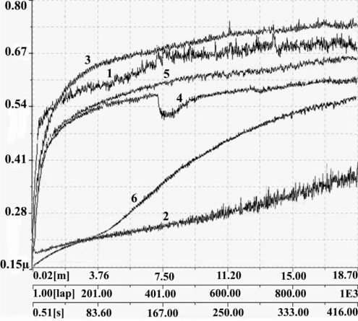 | 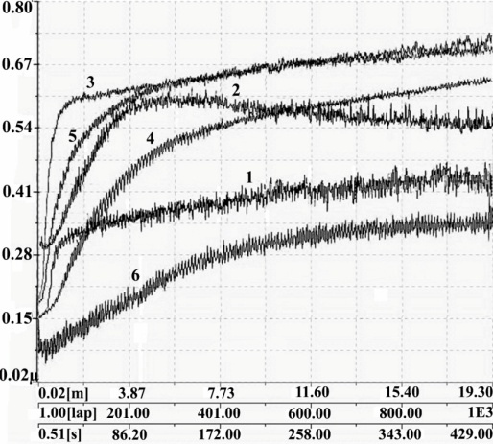
а | b
а − on VT1-0 alloys; b – on VT5 alloys
Figure 9 - Curves friction coefficient for coating obtained in various electrolytes (Table 10)
In Figure 9 one can observe the process of the break-in of the product/counterbody pair, coatings adapt to each other while rubbing. At the break-in stage, there is a non-stationary state of the tribological system, which is accompanied by a high wear rate. Then the stage of steady wear begins, this stage has the longest duration. It is characterized by stable friction conditions and almost constant and relatively low wear intensity. There is no sharp increase in the coefficient of friction after the stage of steady wear begins, this indicates that the destruction of the coating does not occur.
Comparing the results of tribological tests with other works [55], in which an increase in wear resistance was obtained by 10, we obtained more improved results on VT1-0 alloy. We also note that in work [55], an increase in wear resistance was obtained due to subsequent heat treatment of the oxide coating formed in the PEO mode.
The studies of coating sealing in polymer have shown that composite oxide-polymer coatings on VT1-0 (Figure 8A, sample No.6), VT5 (Figure 8b, sample No.6) increase wear resistance compared to samples with an oxide coating without sealing (Figure 8A, 8b samples No.1) due to the reduction of the friction coefficient.
The studies of the surface microhardness of oxide coatings obtained on VT1-0 and VT5 alloys in various electrolytes have shown that all obtained coatings show an increase in the surface microhardness of both VT1-0 and VT5 alloys in comparison with uncoated samples. The microhardness increases by 2 – 3.3 times compared to the uncoated sample.
The increase in the microhardness and wear resistance of oxide coatings is directly related to the composition of the coating. The energy-dispersive analysis of oxide layers on VT1-0 and VT5 titanium alloys was performed with the use of a Hitachi TM3030 scanning electron microscope with Oxford Instruments energy-dispersive analysis attachment in 2019, it showed that the coating includes components of both the metal base and the electrolyte solution. So the main elements of the electrolyte No.1 contained in its composition are oxygen and titanium, other elements are boron, phosphorus, fluorine, and sodium. Similar results were obtained for other electrolyte solutions. The X-ray phase analysis performed on a D8 ADVANCE ECO diffractometer (Bruker) showed the presence of titanium dioxide in the anatase and rutile modifications in all oxide coatings on VT1-0 and VT5 alloys (Figure 10). These data were obtained by the branch of the Institute of nuclear physics in Nur-Sultan city.
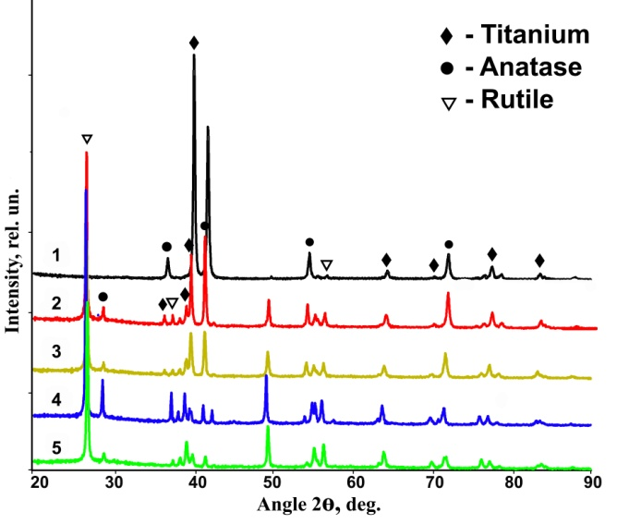 | 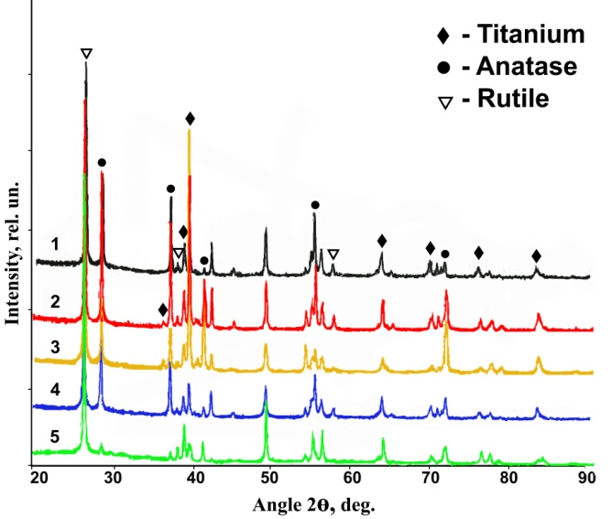
a | b
a – on VT1-0 alloys; b – on VT5 alloys
Figure 10 – X-ray patterns of oxide coatings obtained in the electrolytes 1 - 5 (Table 10)
The study of micrographs of oxide coatings on VT1-0 and VT5 alloys showed that the formed coatings have a porosity in the range of 4.41 – 12.2 %. The pores have a round shape. The average pore diameter ranges from 0.09 to 0.7 µm. The number of pores per 1 cm² of the coating is 6,2·10⁶ – 2,5·10⁷. The coatings obtained in solutions containing calcium compounds (Na₂HPO₄.12H₂O + Al(OH)₃ + C₁₂H₂₂CaO₁₄), as well as liquid glass-based electrolyte (Na₂SiO₃.9H₂O + NaOH + Al₂O₃) were additionally studied during the study of the porosity of coatings. Fine-porous coatings are formed in these electrolytes. The average pore diameter of the oxide coating obtained in an electrolyte based on liquid glass was 0.09 – 0.2 µm (nanoscale pores are also detected) and in an electrolyte containing a calcium compound — 0.2 – 0.4 µm.
In 2019 the following question was also studied: whether microplasma discharges affect the microhardness of the transition layer from the oxide/metal section deep into the metal during the implementation of the PEO process. It is established that when VT1-0 alloy is processed during 180 sec., 300 sec., 600 sec. using PEO method, it shows a tendency to increase the microhardness of the base from the oxide - metal section deep into the metal up to 200 µm in comparison with the untreated sample. This is most likely because when microarc discharges occur on the surface of the treated electrode (anode), high temperatures and high pressures develop in the gas cavity of the microarc [56]. The simultaneous influence of these factors can affect not only the formation of an oxide layer with certain properties but also of the transition layer stretching from the oxide-metal section to the depth of the metal. It was found that the processing time affects the microhardness of the studied part of the base. The preferred PEO processing time was 180 seconds.
In the case of VT5 alloy, there is no change in microhardness in the metal section stretchingfrom the oxide/metal section to the metal depth. This may be explained by the fact that VT5 alloy is alloyed.
The microhardness of the layers was measured on a cross-section.
The studies of the corrosion resistance of oxide coatings obtained in electrolytes (Table 2) showed that the oxide layers are protective in salt fog under standard GOST 9.308-85 (neutral salt fog).
In an aggressive environment (24% H₂SO₄ solution), all coatings on VT1-0 alloy show the best corrosion resistance at the test temperature of 39°С. In the case of VT5 alloy, ОPC-ERis corrosion-resistant at the test temperature of 39°С. Also in the case of VT5, OC, ОPC obtained based on electrolyte No.2 are corrosion-resistant at the test temperature of 39°С.
Thus, oxide coatings obtained by plasma-electrolytic oxidation in a pulsed mode at short durations of the anode current pulse, both with and without sealing, are characterized by an improvement in their physical, mechanical, and protective properties. The results of the research were obtained on a large amount of experimental data. The developed coatings can be recommended as wear-resistant and corrosion-resistant under certain conditions.
Based on the results of the research, a technological scheme is proposed that reflects the main stages of the formation of oxide coatings by plasma electrolytic oxidation. The proposed flow chart is shown in Table 11.
Table 11 – Flow chart of the technological process for applying an oxide coating to parts made of titanium and its alloys using the PEO method
Name of the operation | Name of the equipment | Materials g/l | Т,  °С | I,  А/dm² | U,  V | Time,  min
1 | 2 | 3 | 4 | 5 | 6 | 7
Installation, mount parts on the suspension | - | - | - | - | - | 2 - 5

Table continuation 11
1 | 2 | 3 | 4 | 5 | 6 | 7
Chemical degreasing,  degrease parts | Degreasing tank | trisodium phosphate  (15 - 35);  technical calcined soda (15 - 35);  synthanol ДС-10 (3 - 5) | 40 - 60 | - | - | 5 - 20
Washing,  wash the parts in cold water | Cleaning tank | Water | 18 - 20 | - | - | 0,5 - 2
Plasma electrolytic oxidation,  apply an oxide layer | Tank PEO | phosphatic sodium 3 – sub. 12 water (70 - 80);  aluminium oxide (1,1 – 1,5 µm) powder (20 – 25) | 18 - 25 | 100 - 120 | 350 - 400 | 25 - 30
Rinsing,  rinse the parts in cold water | Rinsing tank | Water | 18 - 20 | - | - | 0,5 - 2
Drying, dry the parts in the drying chamber | - | - | 40 - 50 | - | - | 5 - 7
Filling of coatings,  perform the filling of the coating | Filling tank | solution of polymers | 20 - 25 | - | - | 2 - 3
Drying, dry the parts in the drying chamber |  |  | 40 - 50 |  |  | 30 - 40
Dismantling,  remove parts from the suspension | - | - | - | - | - | 2 - 5
Control  check the coating for the absence of uncovered areas and other defects | - | - | - | - | - | 0,5 - 1
Preliminary preparation of parts can also be performed using other cleaning methods. The degreasing process is recommended to be performed by mixing the solution and when a large amount of foam is formed, emulsifiers with foam - reducing properties can be added to the solution.
Within the frame of the PEO process, the coating solution is selected depending on the purpose of the coating, and the current and voltage densities will depend on the selected solution.
The drying time after filling the oxide coatings may vary depending on the brand of the selected polymer.
If there is no need to fill the oxide coatings, then the operations of filling the oxide coatings and subsequent drying are excluded (Table 11). At this, each technological operation is characterized by certain physical and chemical processes.
CONCLUSION

The presented report under the project “Development of multifunctional composite coatings on titanium and its alloys” is final and made under the decision of the National scientific council concerning the grant funding on the priority “Rational use of natural resources, including water resources, geology, processing, new materials and technologies, safer products and structures” (Protocol No.2 dated 25 of January 2018), under agreement with the Committee of the science of Ministry of Education and Science of Republic of Kazakhstan No.93 dated 5 of March 2018. The report is prepared under the calendar plan (Annex A).
1 Brief conclusion on the results of R&D
Key results for 2018
The process to modify the surface of titanium and its alloy by plasma-electrolytic treatment was studied. The physical and mechanical properties of oxide coatings were studied. The impact of electrolyte solutions on the receipt of coatings on titanium and its alloys with improved physical and mechanical properties during PEO was studied using the reported data and their analysis was performed. 7 batches of samples with oxide coatings on VT1-0 and VT5 alloys were obtained. The thickness of the coating amounted to 10 - 25 µm. The resulting coatings are characterized by uniformity over the entire surface of the sample. When sodium metavanadate was introduced into an alkaline solution, black coatings were obtained. The receipt of black coatings can be explained by the introduction of vanadium oxide for the coating that is formed under the influence of high temperatures during microarc discharge. Currently, black coatings on titanium are in demand in production, which must be obtained on various instrument housings, optical devices, etc.
It is shown that the surface microhardness of oxide coatings for all batches of samples increases in comparison with uncoated samples. The highest value of surface microhardness on VT1-0 alloys was 792.8 HV, and on VT5 - 790.2 HV, which is an increase by 3.3 and 2 times, respectively, in comparison with uncoated samples.
Tribological tests have shown that an oxide coating, which was formed on VT1-0 titanium alloy asa result of the PEO method, increases the wear resistance by 15 times compared to the uncoated sample. Oxide coatings on VT5 alloy increase wear resistance by 6 times compared to the uncoated sample.
The inclusions of polymer material into the pores, in particular inclusions of epoxy resin, increase the wear resistance of coatings compared to the sample without inclusions.
Key results for 2019
The studies have been conducted to determine the porosity of oxide coatings, as well as of the transition layer at the edge of the oxide – metal section. The impact of electrolyte solutions, which are used in PEO, on the porosity of the oxide coating was studied based on the reported data and the results of their analysis were obtained. 7 batches of samples with oxide coating were obtained for each of VT1-0 and VT5 titanium alloys of different porosity. The porosity, shape, and pore size distribution were analyzed as the ratio of the pore image area to the total area of the observation area by processing micrographs of the surface of the studied samples using planimetry methods. The porosity of the obtained oxide coatings ranged from 4.4% to 12.2%. The average pore diameter is 0.09 - 0.7 µm. The value of the number of pores per 1 cm² was within 6,2·10⁶- 2,5·10⁷. The coatings with nanoscale pores were obtained in the electrolyte containing silicic sodium, sodium hydroxide, and aluminum oxide.
The transition layer was studied by measuring the microhardness deep into the metal from the edge of the oxide – metal section. It is shown that the PEO process affects the microhardness of the transition layer on an unalloyed VT1-0 alloy. The increase in microhardness values is observed in the studied metal area at different processing times. This effect is not observed on VT5 alloy.
The energy-dispersive analysis of the composition of oxide coatings was performed. It is shown that the composition of oxide coatings includes elements, both of the base of the coated material and the electrolyte solution.
The X-ray phase analysis of oxide coatings was performed. It was determined that oxide coatings, which contain titanium dioxide in the anatase and rutile modifications, are formed as a result of plasma electrolytic oxidation.
Key results for 2020
Materials for filling the pores of the oxide coating were studied according to the reporteddata. The results of the analysis of available materials for filling the pores of the coating to increase the protective properties are obtained based on reported data. The following polymer materials can be used as a sealing material to give coatings anti-friction, wear-resistant, protective properties: epoxy resin, polytetrafluoroethylene, ultra-high molecular weight polyethylene. Copper and MoS₂ can be used as a solid lubricant when filling the coating pores. A significant number of scientists' works are devoted to the improvement of the biocompatibility and protective properties of titanium implants. Sealing with medicinal products and bactericidal agents helps to improve the biocompatibility of orthopedic implants and reduces the rate of magnesium corrosion under physiological conditions. Sealing made of polytetrafluoroethylene, poly - (L-lactide) polymer, etc. significantly reduces the rate of corrosion. The researchers of the All - Russian Institute of Aviation Materials suggest sealing porous coatings in a solution of sodium liquid glass, triethanolamine to improve their protective properties. The researchers used an immersion method or an electrophoretic method to fill the pores of the oxide coating.
The composite oxide coatings were obtained by filling the pores. The samples with oxide-polymer coatings were obtained. The preparation of composite oxide – polymer coatings was performed in 2 stages: stage 1 – preparation of the oxide coating using the PEO method; stage 2 – filling the pores of the oxide coating with polymer materials.
The pore filling of the oxide coating was performed by immersion in solutions containing polymers: Fluoroplastic F-32; epoxy resin ЭД-20 with a PEPA hardener. Butyl acetate was used as the solvent. 4 batches of samples with coatings were obtained: 1) oxide coatings without sealing; 2) oxide coatings sealed with Fluoroplastic F-32 – 1 layer; 3) oxide coatings sealed with Fluoroplastic F-32 – 2 layers; 4) oxide coatings sealed with epoxy resin.
The corrosion behavior of oxide and composite coatings was studied. The results of corrosion tests were obtained.
No corrosion damage was observed in the result of accelerated corrosion tests of oxide coatings obtained using the PEO method according to standard GOST 9.308-85 under the influence of neutral salt mist at the temperature of 35°С for 1500 hours, the concentration of the solution was 50 g/l of sodium chloride, the pH of the solution was 6.5 – 7.2. Under these conditions, oxide coatings are corrosion-resistant and have protective properties.
The accelerated corrosion tests in an aggressive environment (24% sulfuric acid solution), showed that oxide coatings without sealing, oxide-polymer coatings sealed with Fluoroplastic F-32 (1, 2 layers) and epoxy resin on VT1-0 alloy have the best corrosion-resistant properties at the test temperature of 39°С.
In the case of the VT5 alloy, oxide-polymer coatings sealed with epoxy resin are corrosion-resistant at a test temperature of 39°С. Also for this alloy OC, ОPC obtained based on electrolyte No.2 are corrosion-resistant at the test temperature of 39°С.
As the temperature of the aggressive solution increases, the rate of corrosion increases.
The research results are summarized and analyzed. Based on the research results, oxide coatings and composite oxide-polymer coatings can be recommended as wear-resistant and corrosion-resistant coatings under certain conditions. Pulse mode enables to form coatings with much lower energy costs. A technological scheme for obtaining oxide and oxide-polymer coatings are offered.
2 The assessment of the completeness of solutions to the tasks set
The tasks set for 2018 – 2020 have been completed in full.
Based on the research results the following was published:
- 2 publications were published in 2018, namely: 1 publication in the materials of the international symposium; 1 article in the international collection of research papers (Annex B);
- 4 publications were published in 2019, namely: 1 article in peer-reviewed foreign publication with a nonzero impact-factor, 1 article in a national scientific journal with nonzero impact-factor, 1 publication in an international symposium, 1 article in a national scientific journal (Annex B);
- 2 publications were published in 2020, namely: 2 articles in peer-reviewed international scientific publications indexed in Scopus databases with a non-zero impact factor: Eurasian Chemico-Technological Journal (CiteScore 0.6; percentile 21, Q3, with the identification of individual registration number of the project); Journal of Advanced Research in Dynamic and Control Systems (CiteScore 0.4; percentile 14, Q3, with the identification of individual registration number of the project) (Annex B)
In 2018 - 2020, 3 master's theses and 1 diploma thesis were defended at the Department of Space engineering and technology of L.N. Gumilyov Eurasian National University within the framework of training of young specialists (Annex С). In 2018 – 2020, 63 students of the bachelor program and 23 students of the master program completed practical training and scientific training (Annex D).
3 Recommendations and initial data on the specific use of research results
The results of the study are the basis for the development of domestic technologies for the receipt of multifunctional coatings on titanium and its alloys. These coatings with different porosities with and without sealing can be used to improve the quality, reliability, and durability of separate components, assemblies, and devices as a whole, as well as to reduce the cost of designing and manufacturing of mechanisms in the space industry and general engineering. Research in this area may be important for the receipt of bioactive materials on titanium implants. Currently, UTMK JSC is working on the production of alloys for the manufacture of products (implants) for the medical industry. The project resulted in black coatings on titanium alloys, which can be used on various device housings, optical devices, etc.
4 Assessment of technical and economic efficiency of implementation
The introduction of research results was not planned for the result of the project. Therefore noassessment of technical and economic efficiency of implementation was performed.
5 Evaluation of the scientific and technical level of research conduct in comparison with the best achievements in this field
During the performance of the research on the project, a fundamentally new method of processing of vent materials – plasma electrolytic oxidation was used. In comparison with the best achievements in this field, a fast-flowing pulse mode of process conduct is used, which can significantly reduce power consumption.
The studies of the physical and mechanical properties of oxide coatings were performed using modern methods: with the use of high - temperature tribometer ТНТ-S-АХ0000; contactless 3D-profilometer MICRO MEASURE 3D station; hardness tester Vickers KB 30S Pruftechnik GmbH.
The porosity of oxide coatings was calculated using a planimetric method for studying of micrographs of the coating surface that were obtained using a Hitachi TM 3030 scanning electron microscope in SEI mode at the accelerating voltage of 15 kV with Oxford Instruments attachment for energy dispersion analysis.The X-ray phase analysis was performed using D8 ADVANCE ECO (Bruker) diffractometer.
The samples of oxide coatings with improved physical and mechanical properties and protective properties were obtained as new materials as a result of the project, (Annex E).
Corrosion test report for samples with oxide coatings is given in Appendix F.
Thus, this work was conducted in line with new directions of materials science at the level of the best achievements in the field of surface modification of titanium and its alloy with the use of modern methods for the study of the properties of the obtained coatings.

LIST OF REFERENCES

- Clyne T.W., Troughton S.Ch. A review of recent work on discharge characteristics during plasma electrolytic oxidation of various metals // International Materials Reviews. - 2019. - Vol. 64, № 3. - P. 127-162. // DOI:10.1080/09506608.2018.1466492. (in Eng.)
- Famiyeh L., Huang X. Plasma Electrolytic Oxidation Coatings on Aluminum Alloys: Microstructures, Properties, and Applications // Modern Concepts in Material Science. - 2019. - Vol. 2, Issue 1. - Р. 1-13. - URL: https://www.researchgate.net/publication/327477932 (date of visit 2020-16-01). (in Eng.)
- Zhenwei Li, Shichun Di. Preparation and Properties of Microarc Oxidation Self-Lubricating Composite Coatings on Aluminum Alloy // Metals. – 2017. - Vol. 7, № 127. - Р. 1–15. doi:10.3390/met7040127. (in Eng.)
- Serdechnova M., Mohedano M., Kuznetsov B., Mendis C.L., Starykevich M., Karpushenkov S., Tedim J., Ferreira M.G., Blawert C., Zheludkevich M.L. PEO Coatings with Active Protection Based on In-Situ Formed LDH-Nanocontainers // Journal of the Electrochemical Society. - 2017. - Vol. 164, № 2. - P. 36-45. // DOI: 10.1149/2.0301702jes. (in Eng.)
- Hussein R.O., Northwood D.O. Production of Anti-Corrosion Coatings on Light Alloys (Al, Mg, Ti) by Plasma-Electrolytic Oxidation (PEO) // Developments in Corrosion Protection. - 2014. - P. 201-239. - URL: http://dx.doi.org/10.5772/57171(date of visit 30.01.2020). (in Eng.)
- Hui-Hui Yang, Xi-Shu Wang, Ya-Ming Wang, Yan-Ling Wang, Zhi-Hao Zhang. Microarc Oxidation Coating Combined with Surface Pore-Sealing Treatment Enhances Corrosion Fatigue Performance of 7075-T7351 Al Alloy in Different Media // Materials. - 2017. - Vol. 10. - P. 609-622. // DOI:10.3390/ma10060609. (in Eng.)
- Yang J., Di Sh., Blawert C., Lamaka S.V., Wang L., Fu B., Jiang P., Li Wang, Zheludkevich M.L. Enhanced Wear Performance of Hybrid Epoxy-Ceramic Coatings on Magnesium Substrates // ACS Applied Materials & Interfaces. - 2018. - Vol. 10, № 36. - P. 30741-30751. // DOI.org/10.1021/acsami.8b10612. (in Eng.)
- Xue Y., Pang X., Jiang B., Jahed H. Corrosion and corrosion fatigue performances of micro-arc oxidation coating on AZ31B cast magnesium alloy // Materials and Corrosion. - 2018. - P. 1–13. // DOI.org/10.1002/maco.201810293. (in Eng.)
- Ren L., Wang N., Chen Zh., Li Yu., Qian L. Self-Lubricating PEO–PTFE Composite Coating on Titanium // Metals. - 2019. - Vol. 9. - P. 170-181. // DOI:10.3390/met9020170. (in Eng.)
- Malyshev V.N, Volkhin A.M. Antifriction properties increasing of ceramic MAO-coatings // Engineering Tribology. - 2014. - Vol. 228, № 4. - P. 435–444. // DOI: 10.1177/1350650113513570. (in Eng.)
- Yanfeng Ge, Bailing Jiang, Ming Lu, Congjie Wang, Wenning Shen. Preparation and characterization of the micro-arc oxidation composite coatings on magnesium alloys // Journal of Magnesium and Alloys. - 2014. - Vol. 2, Issue 4. - P. 309-316. // DOI.org/10.1016/j.jma.2014.11.006. (in Eng.)
- Gnedenkov S.V., Sinebryukhov S.L., Mashtalyar D.V., Imshinetskiy I.M. Composite Fluoropolymer Coatings on Mg Alloys Formed by Plasma Electrolytic Oxidation in Combination with Electrophoretic Deposition // Surface & Coatings Technology. - 2015. - Vol. 283. - P. 347-352. // DOI: 10.1016/j.surfcoat.2015.10.066. (in Eng.)
- Sukuroglu E.E, Totik Ya., Ersin A., Efeoglu I. Analysis of Tribo-corrosion Properties of MAO/DLC Coatings Using a Duplex Process on Ti₆Al₄V Alloys // Journal of Bio- and Tribo-Corrosion. - 2015. - Р. 1-22. // DOI:10.1007/s40735-015-0022-z. (in Eng.)
- Kolomeichenko A.V., Sharifullin S.N., Kuznetsov Yu.A., Logachev V.N., Titov N.V. Increase of the resource of machine parts working by combined methods using plasma electrolytic oxidation // Journal of Physics: Conf. Series 1058. - 2018. - Vol. 871, Issue 1. - P. 1-7. // DOI:10.1088/1742- 596/1058/1/012074. (in Eng.)
- Antonova N.M., Andreev E.V., Lisnichenko I.A. Formation of materials with controlled porosity at modification of the Na- CMC biopolymer with highly dispersed AlOOH particles to obtain functional coatings // Engineering Bulletin of the Don. - 2017. - No. 4. - P. 1-12. - URL: ivdon.ru/ru/magazine/archive/n4y2017/4541 (date of visit 18.02.2020). (in Rus.)
- Clyne T.W., Troughton S.Ch. A review of recent work on discharge characteristics during plasma electrolytic oxidation of vari ous metals // International materials reviews. - 2019. - Vol. 64, № 3. - P. 127–162. // DOI.org/10.1080/09506608.2018.1466492. (in Eng.)
- Ming Sun, Yerokhin A., Matthews A., Thomas M., Laukart A., Margret von Hausen, Klages Claus-Peter. Characterization and Electrochemical Evaluation of Plasma Electrolytic Oxidation Coatings on Magnesium with Plasma Enhanced Chemical Vapour Deposition Post-Treatments // Plasma Process and Polymers. - 2016. - № 13. - P. 266–278. // DOI: 10.1002/ppap.201500059. (in Eng.)
- Arbuzova S.S.,Butyagin P.I., Bol’shanin A.V., Kondratenko A.I., Vorob’ev A.V. Microarc Oxidation of Metal Surfaces: Coating Properties and Applications // Russian Physics Journal. - 2020. - Vol. 62. - P. 2086–2091. // https://doi.org/10.1007/s11182-020-01950-7. (in Eng.)
- Vladimirov B.V., Krit B.L., Lyudin V.B., Morozova N.V., Rossiiskaya A.D., Suminov I.V., Epel’feld A.V. Microarc Oxidation of Magnesium Alloys: A Review // Surface Engineering and Applied Electrochemistry. - 2014. - Vol. 50, № 3. - P. 195–232. // DOI: 10.3103/S1068375514030090. (in Eng.)

Golshirazi A., Kharaziha M., Golozar M.A. Polyethylenimine/Kappa Carrageenan: Micro-arc Oxidation Coating for Passivation of Magnesium Alloy // Carbohydrate Polymers. - 2017. - Vol. 167. - P. 185-195. // DOI.org/10.1016/j.carbpol.2017.03.025. (in Eng.)
- Sun M., Yerokhin A., Matthews A., Thomas M., Laukart A., von Hausen M., Klages C.P. Characterisation and Electrochemical Evaluation of Plasma Electrolytic Oxidation Coatings on Magnesium with Plasma Enhanced Chemical Vapour Deposition Post-Treatments // Plasma Processes and Polymers. - 2016. - Vol. 13 Issue 2. - P. 266-278. (in Eng.)
- Ivanov D.K., Yasakau K.A., Kallip S., Lisenkov, A.D., Starykevich, M., Lamaka, S.V., Ferreira M.G., Zheludkevich, M.L. Active Corrosion Protection Coating for a ZE41 Magnesium Alloy Created by Combining PEO and Sol-gel Techniques // RSC Advances. - 2016. - Vol. 6, Issue 15. - P. 12553-12560. // DOI:10.1039/C5RA22639B. (in Eng.)
- Yang J.J., Blawert C., Lamaka S.V., Snihirova D., Lu X., Di S., Zheludkevich M.L. Corrosion Protection Properties of Inhibitor Containing Hybrid PEO-epoxy Coating on Magnesium // Corrosion Science. - 2018. - Vol. 140. - P. 99-110. // DOI: 10.1016/j.corsci.2018.06.014. (in Eng.)
- Lukiyanchuk I.V., Chernykh I.V., Rudnev V.S., Tyrina L.M., Ustinov A.Yu. Silicate Coatings on Titanium Modified by Cobalt and/or Copper Oxides and Their Activity in CO Oxidation // Fizikokhimiya Poverkhnosti i Zashchita Materialov. - 2015. - Vol. 51, № 3. - P. 323-333. // DOI: 10.1134/S207020511503017X. (in Eng.)
- Pezzato L., Brunelli K., Babbolin R., Dolcet P., Dabala M. Sealing of PEO Coated AZ91 Magnesium Alloy Using La-Based Solutions // International Journal of Corrosion. - 2017. - Vol. 1. - Р. 1-13. // DOI.org/10.1155/2017/5305218. (in Eng.)
- Yu-Kyoung Kim, Yong-Seok Jang, Young-Hee Lee, Ho-Keun Yi, Tae-Sung Bae, Min-Ho Lee. Effect of Ca-P compound formed by hydrothermal treatment on biodegradation and biocompatibility of Mg-3Al-1Zn- 1.5Ca alloy; in vitro and in vivo evaluation // Scientific Reports. - 2017. - Vol. 17, № 712. - Р. 1-12. // DOI:10.1038/s41598-017-00656-0. (in Eng.)
- Zhang Yu., Feyerabend F., Tang Sh., Jin Hu, Lu X., Blawert C., Lin T. A study of degradation resistance and cytocompatibility of super-hydrophobic coating on magnesium // Materials Science and Engineering. - 2017. - № 78. - P. 405–412. // DOI.org/10.1016/j.msec.2017.04.057. (in Eng.)
- Yu-Kyoung Kim, Kwang-Bok Lee, Seo-Young Kim, Yong-Seok Jang, Jin Hyeok Kim, Min-Ho Lee. Improvement of osteogenesis by a uniform PCL coating on a magnesium screw for biodegradable applications // Scientific Reports. - 2018. - № 8. - P. 1-11. // DOI:10.1038/s41598-018-31359-9. (in Eng.)
- Sinebryukhov S.L., Gnedenkov S.V., Khrisanfova O.A., Puz A.V., Egorkin V.S., Zavidnaya A.G. Anticorrosion Coatings Obtained by Plasma Electrolytic Oxidation on Implant Metals and Alloys // Corrosion science and technology. - 2018. - Vol. 17, № 3. - P .91-100. // DOI.org/10.14773/cst.2018.17.3.91. (in Eng.)
- Liting Mu, Zhen Ma, Shidan Yuan, Muqin Li. Study on Micro-arc Oxidation-Silica-Berberine Composite Bio-coating of Magnesium Alloy // Conference Series: Earth and Environmental Science. 199 (2018) 042053. DOI:10.1088/1755-1315/199/4/042053. (in Eng.)
- Wing Kiu Yeung. Investigation of Plasma Electrolytic Oxidation Processes for Production of Porous Biocompatible Coatings on Ti alloys: diss. doc. of Phil / The University of Sheffield. – Sheffield, 2016. – 224 p. (in Eng.)
- Sankara Narayanan T.S.N., Min-Ho Lee. Surface modification of magnesium for biomedical applications // RSC Advances. - 2017. - Vol. 6, № 19. - P. 16100–16114. (in Eng.)
- Alabbasi A., Mehjabeen A., Mathan B.K., Blawert C. Biodegradable polymer for sealing porous PEO layer on pure magnesium: An in vitro degradation study // Applied Surface Science. - 2014. - Vol. 301. - P. 463-467. // DOI:10.1016/j.apsusc.2014.02.100. (in Eng.)
- Kazek-Kesik A., Jaworska Jo., Krok-Borkowicz M., Głoda-Cepa M., Pastusiak M., Brzychczy-Włoch M., Pamuła El., Kotarba A., Simka W. Hybrid oxide-polymer layer formed on the Ti-15Mo alloy surface enhancing antibacterial and osseointegration functions // Surface and Coatings Technology. - 2016. - Vol. 302. - P. 158-165. // DOI.org/10.1016/j.surfcoat.2016.05.073. (in Eng.)
- Zaporozhets T.S., Puz A.V., Sinebryukhov S.L., Gnedenkov S.V., Smolina T.P., Gazha A.K. Comparative analysis of the immunological compatibility of bioactive calcium-phosphate coatings on MA8 magnesium alloy and VT1-0 titanium // Universities Bulletin. Chemistry and chemical technology. - 2017. - T. 60, No. 2. - P. 45-51 // DOI: 10.6060 / tcct.2017602.5456. (in Rus.)
- Hui Tang, Wei Tao, Chao Wang, Huilong Yu. Fabrication of hydroxyapatite coatings on AZ31 Mg alloy by micro-arc oxidation coupled with sol-gel treatment // RSC Advances. - 2018. - № 8. - P. 12368–12375. // DOI: 10.1039/c7ra10951b. (in Eng.)

Fan X.P. Effects of process parameters on microarc oxidation film layers of porous titanium // Applied ecology and environmental research. - 2019. - Vol. 17, № 4. - Р. 8631-8641. // DOI: http://dx.doi.org/10.15666/aeer/1704_86318641. (in Eng.)
- Feng Peng, Donghui Wang, Yaxin Tian, Huiliang Cao, Yuqin Qiao, Xuanyong Liu. Sealing the Pores of PEO Coating with Mg-Al Layered Double Hydroxide: Enhanced Corrosion Resistance, Cytocompatibility, and Drug Delivery Ability // Scientific Reports. - 2017. - № 7. - Р. 1-12. // DOI:10.1038/s41598-017-08238-w. (in Eng.)
- Kuznetsova V.A., Semenova L.V., Shapovalova G.G. Trends of development in the field of anticorrosive polymer compositions for corrosion protection of fasteners of contact pairs of combined structures (review) // Aviation Materials. – 2017. - No. 1 (46). – P. 25-31. // DOI: 10.18577 / 2071-9140-2017-0-1-25-31. (in Rus.)
- Antipov V.V., Medvedev I.M., Kutyrev A.E., Volkov I.A. Development of an express method for assessing the protective properties of anodic oxide coatings filled with hot water during testing in a NaCl solution // Works of All-Russian Institute of Aviation Materials. – 2019. - No. 8 (80). – P. 67-78. // DOI: 10.18577 / 2307-6046-2019-0-8-67-78. (in Rus.)
- Kozlov I.A., Duyunova V.A. Influence of filling in sodium liquid glass solution on electrochemical properties of plasma electrolytic coating on ВМЛ20 alloy // Aviation materials and technologies. – 2015. - No. 4. – P.61-66. // DOI: 10.18577/2071-9140-2015-0-4-61-66. (in Rus.)
- Antipov V.V., Chesnokov D.V., Kozlov I.A., Volkov I.A., Petrova A.P. Preparation of the surface of В-1469 aluminum alloy before using it in the composition of a layered hybrid material // Works of All-Russian Institute of Aviation Materials. – 2018. - No. 4 (64). – P. 59-65. // DOI: 10.18577/2307-6046-2018-0-4-59-65. (in Rus.)
- Saltykov S.A. Stereometric metallography – Moscow: Metallurgy, 1970. – 375 p. (in Rus.)
- Panshin Yu.A., Malkevich S.G., Dunaevskaya Ts.S., Fluoroplastics – L.: Chemistry, 1978. – 232 p. (in Rus.)
- Pugachev A.K. History of the creation of domestic fluoropolymers // Russian Chemical Journal. – 2008. – V. 52. – No. 3. – P. 5-12. (in Rus.)
- Standard ОСТ 6-05-432-78 Fluoroplastic – 32Л. Technic specifications. (in Rus.)
- Yarysheva G.M., Loginova N.N., Andreeva A.I. Fluoroplastics. Catalog – Cherkasy.: Research Institute of Technical and Economic Research in the Chemical Complex, 1983. – 211 p. (in Rus.)
- Kerber M.L., Vinogradov V.M., Golovkin G.S., Gorbatkina Yu.A., Kryzhanovsky V.K., Kuperman A.M., Simonov-Emelyanov I.D., Khaliulin V.I., Bunakov V.A. Polymer composite materials: structure, properties, technology: teaching guide – Saint Petersburg: Professiya, 2008. – 560 p. (in Rus.)
- Tavadze F.N., Manzhgaladze S.N. Corrosion resistance of titanium alloys. Moscow: Metallurgy, 1969. – 208 p. (in Rus.)
- Galitsky B.A., Abelev M.M., Schwartz G.L. Titanium and its alloys in chemical engineering. – M.: Mechanical Engineering, 1968. –339 p. (in Rus.)
- Duyunova V.A., Leonov A.A., Molodtsov S.V. The contribution of All-Russian Institute of Aviation Materials to the development of light alloys and the fight against corrosion in products of rocket and space technology. Works of All-Russian Institute of Aviation Materials. – 2020. - No. 2 (86). // DOI: org / 10.18557 / 2307-6046-2020-0-2-22-30. (in Rus.)
- Aleksandrov V.M. Materials Science and Technology of Structural Materials: тeaching guide. Part 1. Materials science. Third generation standard. – Arkhangelsk: Northern (Arctic) Federal University, 2015. – 327 p. (in Rus.)
- Semenova I.V. Corrosion and protection against corrosion / I.V. Semenova, G.M. Florianovich, A.V. Khoroshilov. – M.: Fizmatlit, 2002. – 336 p. (in Rus.)
- Morozov I.V., Boltalin A.I., Karpova E.V. Oxidation-reduction processes. Teaching guide – M.: Moscow University Publishing House, 2003. – 79 p. (in Rus.)
- Kazantsev I.A., Krivenkov A.O., Rosen A.E., Chugunov S.N. Wear resistance of titanium-based composite materials obtained in the result of micro-arc oxidation // Technical sciences. Mechanical engineering and mechanical engineering science. – 2008. No. 1. – P. 159-164. (in Rus.)
- Suminov I.V., Epelfeld A.V., Lyudin V.B., Borisov A.M., Crit B.L. Microarc oxidation: Theory, technology, equipment. – M.: EKOMET, 2005. – 368 p. (in Rus.)

ANNEX A

Timetable for 2018-2020
Annexes 1.2
to Agreement No. 93 dated 05.03. 2018
for grant funding

TECHNICAL SPECIFICATION AND
IMPLEMENTATION SCHEDULE

Under Agreement No. 93 dated 05/ 03/2018 year

1. "National Center of Space Research and Technology" JSC.

1.1 Priority: Rational use of natural resources, including water resources, geology, processing, new materials and technologies, safer products, and structures.
1.2 Sub-priority: Production and processing of metals and materials.
1.3 Project topic: No. AP05133376 “Development of composite multifunctional coatings on titanium and its alloys”.
1.4 The total amount of the project is 18,120,000 (eighteen million one hundred and twenty thousand) tenge, including by year, for the performance of works under item 3:
- for 2018 – in the amount of 6 000 000 (six million) tenge;
- for 2019 – in the amount of 6 054 000 (six million fifty-four thousand) tenge;
- for 2020 – in the amount of 6 066 000 (six million sixty-six thousand) tenge.
2. The characteristics of scientific and technical products according to the educational characteristics and economic indicators
2.1 The direction of work: Research of receipt of multifunctional coatings on titanium and its alloy by using plasma electrolytic oxidation.
2.2 The field of application: mechanical engineering, universities of the Republic of Kazakhstan that train bachelors and masters in technical specialties in the field of creating new materials.
2.3 Final concrete result
- for 2018: oxide coatings on titanium and its alloy were obtained, their physical and mechanical properties were studied. 1 publication was published in the materials of an international scientific conference or symposium.
- for 2019: studies were conducted on the production of oxide coatings with different porosity. Published: 1 article in a foreign peer-reviewed publication with non-zero impact factor; 1 article in a national scientific journal with non-zero impact factor; 1 publication in the materials of international scientific conference or symposium.
- for 2020: studies on the corrosion behavior of composite coatings were conducted. The scientific articles were published in peer-reviewed foreign scientific publications indexed in the Web of Science or Scopus databases with a non-zero impact factor, presumably such as the Indian Journal of Engineering & Materials Sciences, Eurasian Chemico-Technological Journal.
2.4 The patentability: there is no object of patenting.
2.5 The scientific and technical level (novelty): the novelty of research lays in the application of one of the most modern and promising approaches for the receipt of multifunctional oxide coatings with new increased physical, mechanical and operational characteristics on titanium and its alloy.
2.6 The use of scientific and technical products is performed: by the Contractor.
2.7 The type of use of the result of scientific and (or) scientific and technical activities: research report, scientific publications.
3. The name of the work, terms of its implementation, and results
 | Or.No. | Name of work under the Agreement and the main stages of its implementation | Implementation term |  |  | Expected result
 | Or.No. |  | start |  | completion | Expected result
 | 1 | Study of the process to modify the surface of titanium and its alloy by plasma-electrolytic treatment. To study the physical and mechanical properties of oxide coatings. | January 2018 |  | November 1,  2018 | The process to modify the surface of titanium and its alloy by using a plasma-electrolytic treatment will be studied. The physical and mechanical properties of oxide coatings will be studied.  Oxide coatings will be obtained on samples made of titanium and its alloy. The physical and mechanical properties of the coatings will be determined.  1 publication will be published in the materials of an international scientific conference or symposium.
 | 1.1 | Study of the effect of electrolyte solutions for obtaining coatings on titanium and its alloys with improved physical and mechanical properties in PEO based on the reported data. | January 2018 |  | March 2018 | The influence of electrolyte solutions for obtaining coatings on titanium and its alloys with improved physical and mechanical properties during PEO will be studied based on the reported data.  The results of the analysis of available electrolyte solutions for obtaining coatings on titanium and its alloys with high physical and mechanical characteristics will be obtained based on the reported data.
 | 1.2 | Study of the process to modify the surface of titanium and its alloy in a pulsed mode. | April 2018 |  | June 2018 | The process to modify the surface of titanium and its alloy in a pulsed mode will be studied. Titanium samples with an oxide coating will be obtained.
 | 1.3 | Studyof the surface microhardness of the coating. | July 2018 |  | September 2018 | The surface microhardness of the coating will be studied. The data on the microhardness of oxide coatings will be obtained.
 | 1.4 | Performance of tribological tests of coatings. | October 2018 |  | November 1,  2018 | Tribological tests of coatings will be performed. Data on the wear resistance of coatings will be obtained.
 | 2 | Performance of research to determine the porosity of oxide coatings. Study of the transition layer at the oxide-metal section. | January 2019 |  | November 1,  2019 | Studies will be conducted to determine the porosity of oxide coatings. The transition layer at the oxide-metal section will be studied. The results ofthe researchof the porosity of the coatings will be obtained. The values of the microhardness of the transition layer will be obtained. The following publications will be made: 1 article in a foreign peer-reviewed publication with non-zero impact factor; 1 article in a national scientific journal with non-zero impact factor; 1 publication in the materials of an international scientific conference or symposium.
 | 2.1 | Study of the effect of the composition of electrolyte solutions used in PEO on the porosity of the oxide coating based on the reported data. | January 2019 - |  | March 2019 | The influence of the composition of electrolyte solutions used in PEO on the porosity of the oxide coating will be studied based on the reported data. The results of the analysis of the composition of available electrolyte solutions for obtaining coatings with a wide pore distribution based on the reported data will be obtained.
 | 2.2 | Production of oxide coatings with different porosity. | April 2019 |  | June 2019 | Oxide coatings with different porosities will be obtained. Samples of oxide coatings with different porosity will be obtained.
 | 2.3 | Calculation of the porosity of oxide coatings. | July 2019 |  | September 2019 | The porosity of oxide coatings will be calculated. The data onthe calculation of the porosity of oxide coatings will be obtained.
 | 2.4 | Study of the effect of PEO on the microhardness of the transition layer deep into the metal from the oxide-metal section. | October 2019 |  | November 1,  2019 | The effect of PEO on the microhardness of the transition layer deep into the metal from the oxide-metal section will be studied. The data on the microhardness of the transition layer will be obtained.
 | 3. | Conduct research to obtainprotective corrosion-resistant oxide coatings on titanium and its alloy. | January 2020 |  | November1,  2020 | The research will be conducted concerning the receiptof protective corrosion-resistant oxide coatings on titanium and its alloy. Protective corrosion-resistant coatings will be obtained. The following publications will be made:articles in peer-reviewed foreign scientific publications indexed in Web of Science or Scopus databases with a non-zero impact factor, presumably such as the Indian Journal of Engineering & Materials Sciences, Eurasian Chemico-Technological Journal.
 | 3.1 | Study of materials for filling the pores of the oxide coating based on the reported data. | January 2020 - |  | March 2020 | Materials for filling the pores of the oxide coating will be studied based on the reporteddata. The results of the analysis of available materials for filling the coating pores to increase the protective properties based on the reporteddata will be obtained.
 | 3.2 | Receipt of the composite oxide coating by filling of the pores. | April 2020 |  | June 2020 | Composite oxide coatings will be obtained by filling the pores. Samples with oxide-polymer coatings will be obtained.
 | 3.3 | Research of the corrosion behavior of composite coatings. | July 2020 |  | September 2020 | The corrosion behavior of composite coatings will be studied. The results of the corrosion test will be obtained.
 | 3.4 | Summary and analysis of research results. | October 2020 |  | November1,  2020 | The results of the research will be summarized and analyzed.
From the requester:  Chairman of the Science Committee of the Ministry of Education and Science of the Republic of Kazakhstan State Institution  _______________ B.S. Abdrassilov  place for seal |  |  |  | From the Contractor:  President of National Center for Space Research and Technology JSC  __________________ Ch.T. Omarov  placeforseal  Review by:  academic adviser on the project  ________________ Zh.M. Ramazanova

ANNEX B

List of publications, reference from NCSTE JSC, reprints of articles
Year 2020
1. Zh.M. RamazanovaandM.G. Zamalitdinova. Study of the Properties of Oxide Coatings Formed on Titanium by Plasma Electrolytic Oxidation Method // Eurasian Chemico-Technological Journal. - 2020. - №22. - P. 51-58. (CiteScore 0.6; percentile 21, Q3, with the identification of individual registration number of the project). (in Eng.)
2. Zhanat Ramazanova, Marina Zamalitdinova, Artem Kozlovskiy, Pavel Butyagin, Svetlana Arbuzova. Synthesis and properties of coatings obtained by plasma electrolytic oxidation of titanium alloys in alkaline solutions // Journal of Advanced Research in Dynamical and Control Systems. - 2020. - Vol. 12, Special Issue 06. - P. 858-865. // DOI:10.5373/JARDCS/V12SP6/SP20201103. (CiteScore 0.4; percentile 14, Q3, with the identification of individual registration number of the project). (in Eng.)
Year 2019
1. Zh.M. Ramazanova, M.G. Zamalitdinova. Research of the properties of oxide coatings on VT5 titanium alloy // Modern knowledge-intensive technology. - 2019. - No. 3. - P. 239-243. (Impact factor Russian Science Citation Index 0.969 (two-year)). (in Rus.)
2. Ramazanova J.M., Zamalitdinova M.G. Physical and mechanical properties investigation of oxide coatings on titanium // Complex use of mineral raw materials. - 2019. - No. 2. - P. 34-41. (Impact factor Russian Science Citation Index 0.222 (two years)). (in Eng.)
3. Zh.M. Ramazanova, M.G. Zamalitdinova, M.M. Zhangabyl, M.T. Sultanov, D.S. Yergaliyev Treatment of surface of titanium alloys VT1-0 and VT5 by plasma electrolytic oxidation // Works of the International Symposium “Reliability and Quality”. May 27-June 1, Penza. - 2019. - Vol. 2. - P. 21-23. (in Rus.)
4. Zh.M. Ramazanova, M.G. Zamalitdinova, M.M. Zhangabyl Research of the process of modification of titanium and its alloys by plasma-electrolytic oxidation // Bulletin of L.N. Gumilyov Eurasian National University. Engineering Science and Technology Series. - 2019. - No. 2 (127). - P. 64-69. (in Rus.)
Year 2018
- Zh. Ramazanova, D.K. Kudassova, M.G. Zamalitdinova, D.M. Orazaliyeva Review of technologies for the production of coatings on titanium and its alloys by using plasma electrolytic oxidation // Worksof the International Symposium “Reliability and Quality”. Penza May 21-31, - 2018 – Vol. 2. – P. 153-156 (IF Russian Science Citation Index 2016, 0.286). (in Rus.)
- Zh.M. Ramazanova, M.G. Zamalitdinova, Ye.A. Adambekov, D.S. Yergaliyev Study of the process of plasma electrolytic oxidation of titanium in a pulsed mode // Anthology of scientific research papers “Space Engineering, Technologies & Exploration”. Berlin - 2018. - P. 139-141. (in Rus.)

Reference from NCSTE JSC

Reprints of articles for 2020

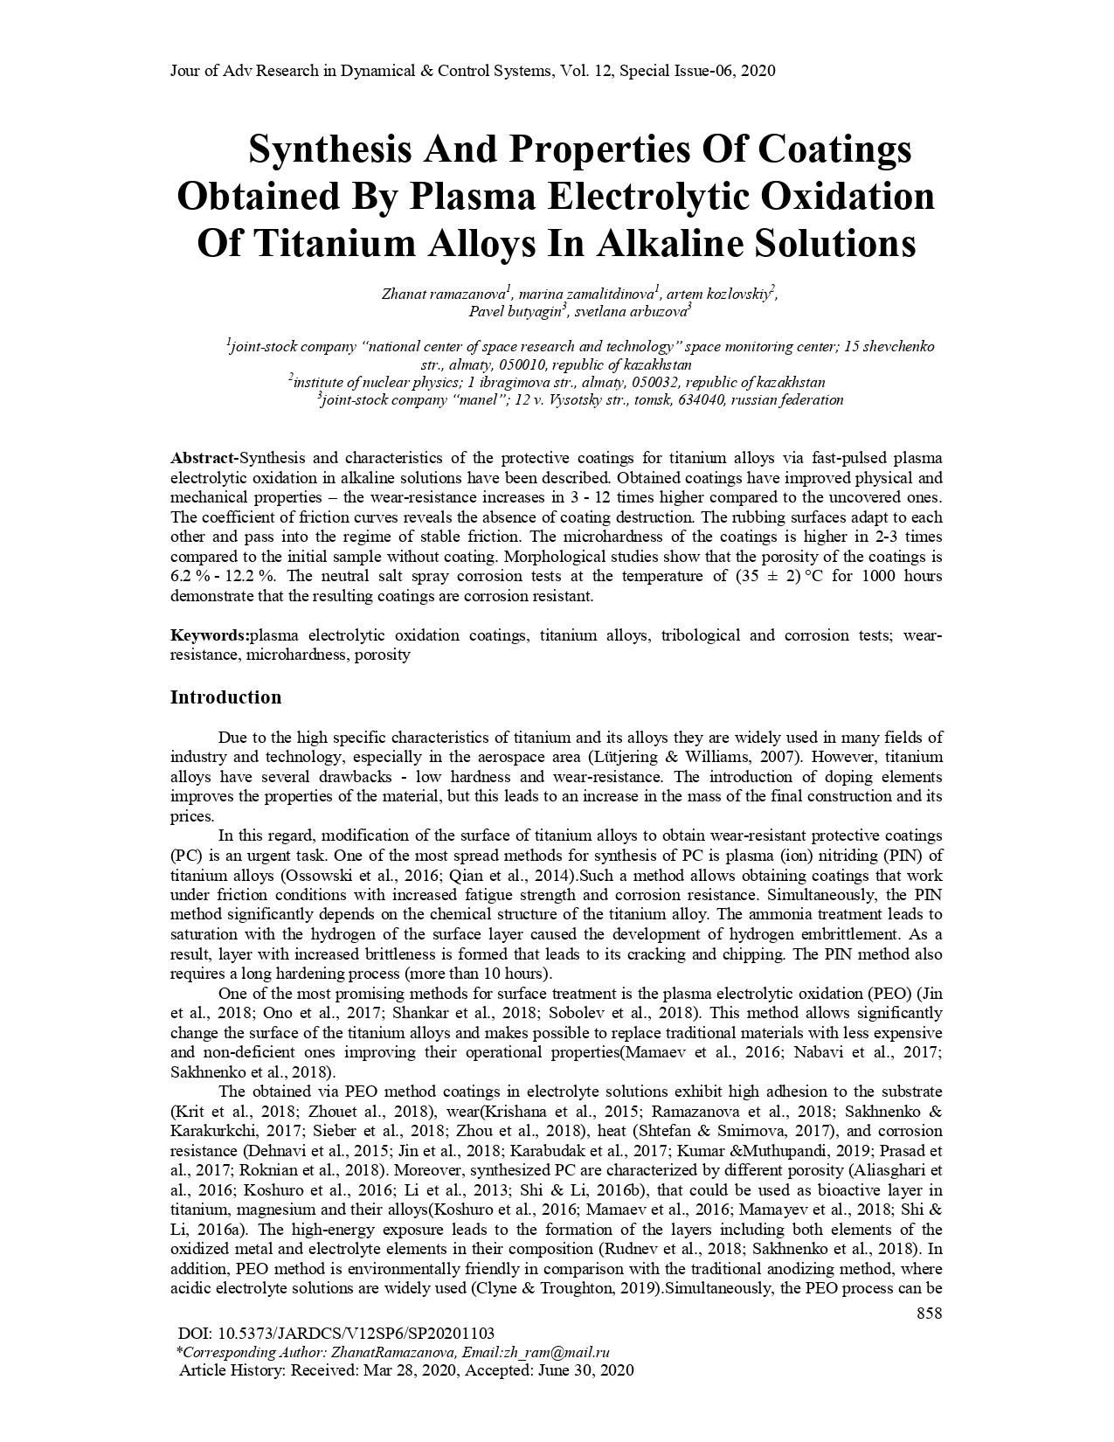

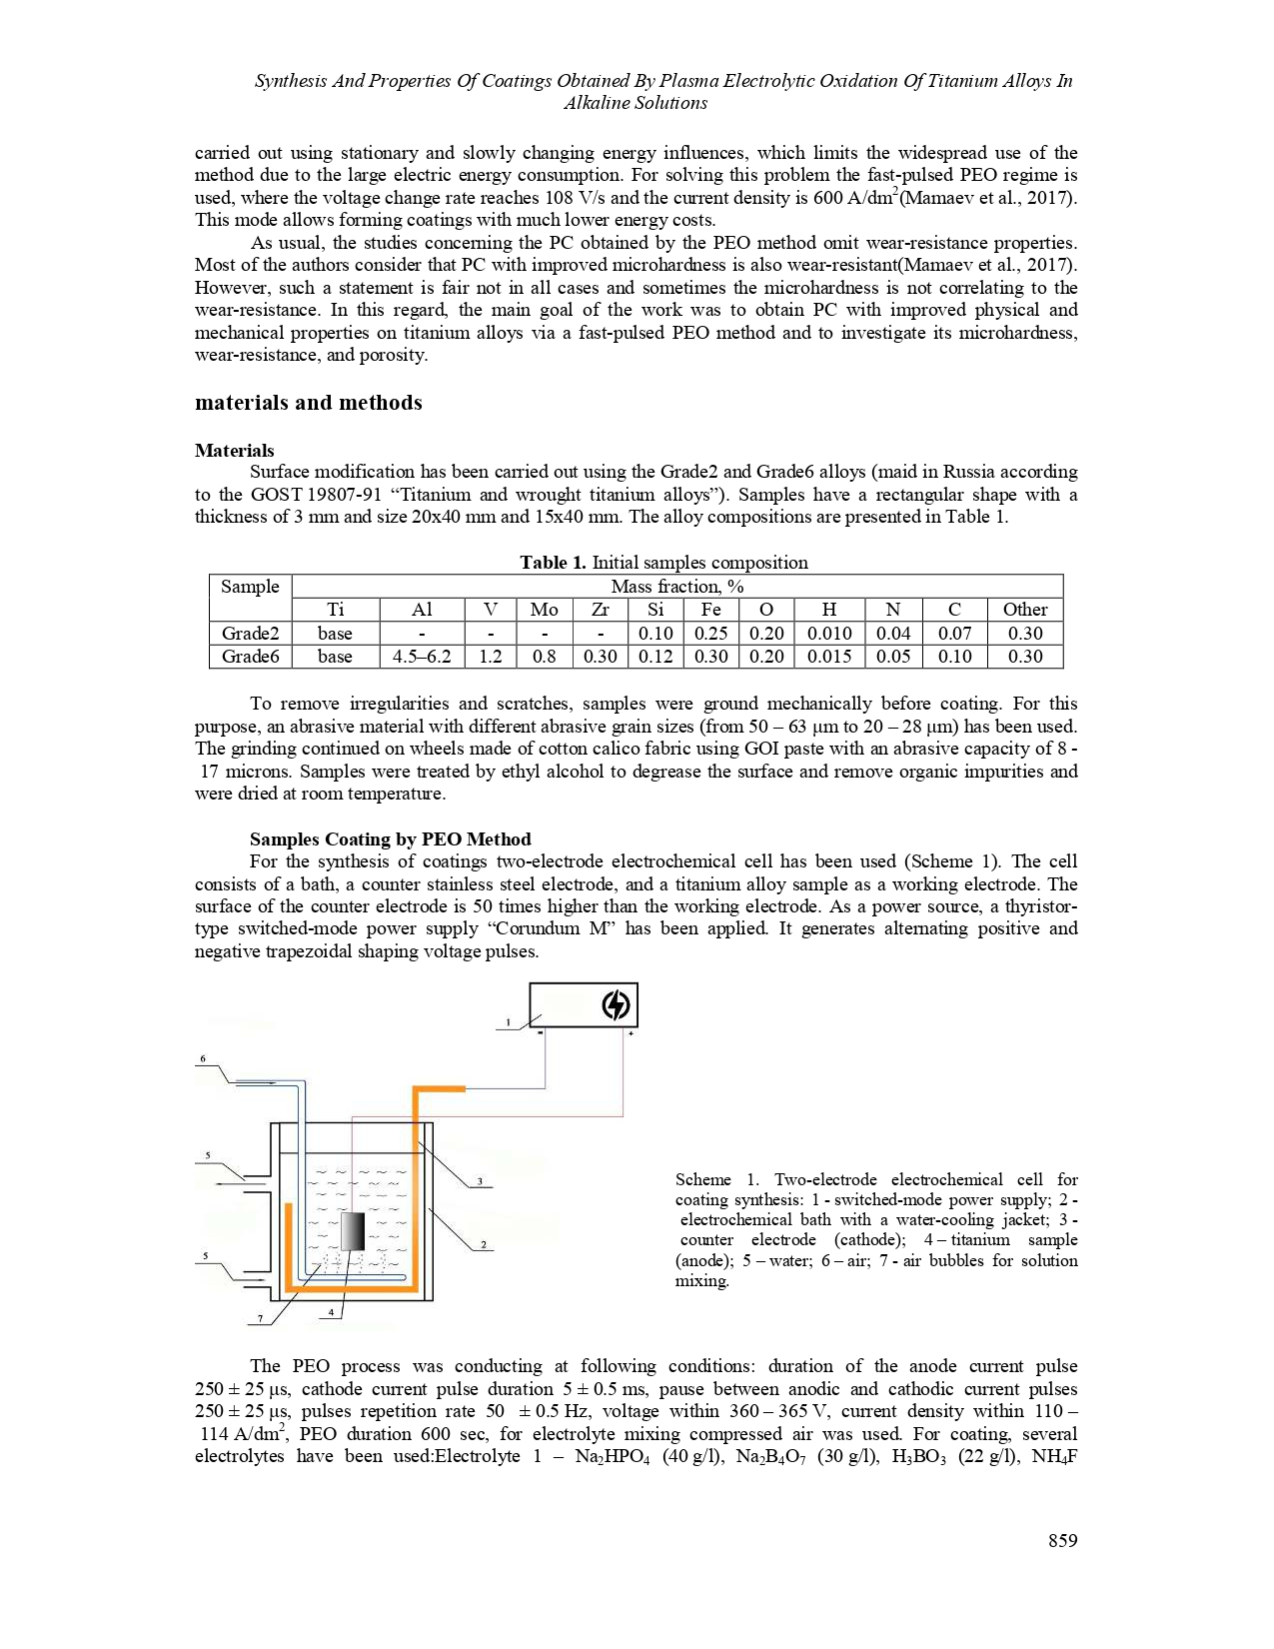

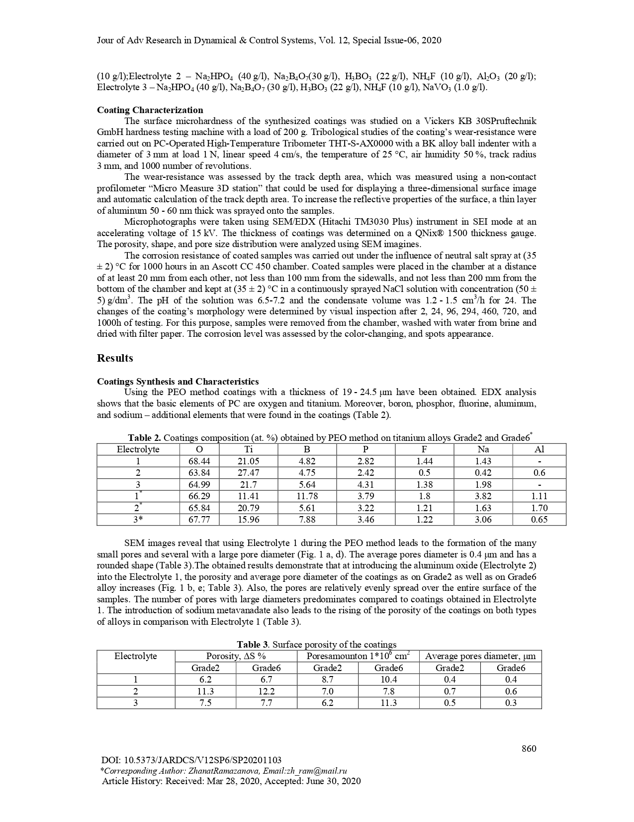

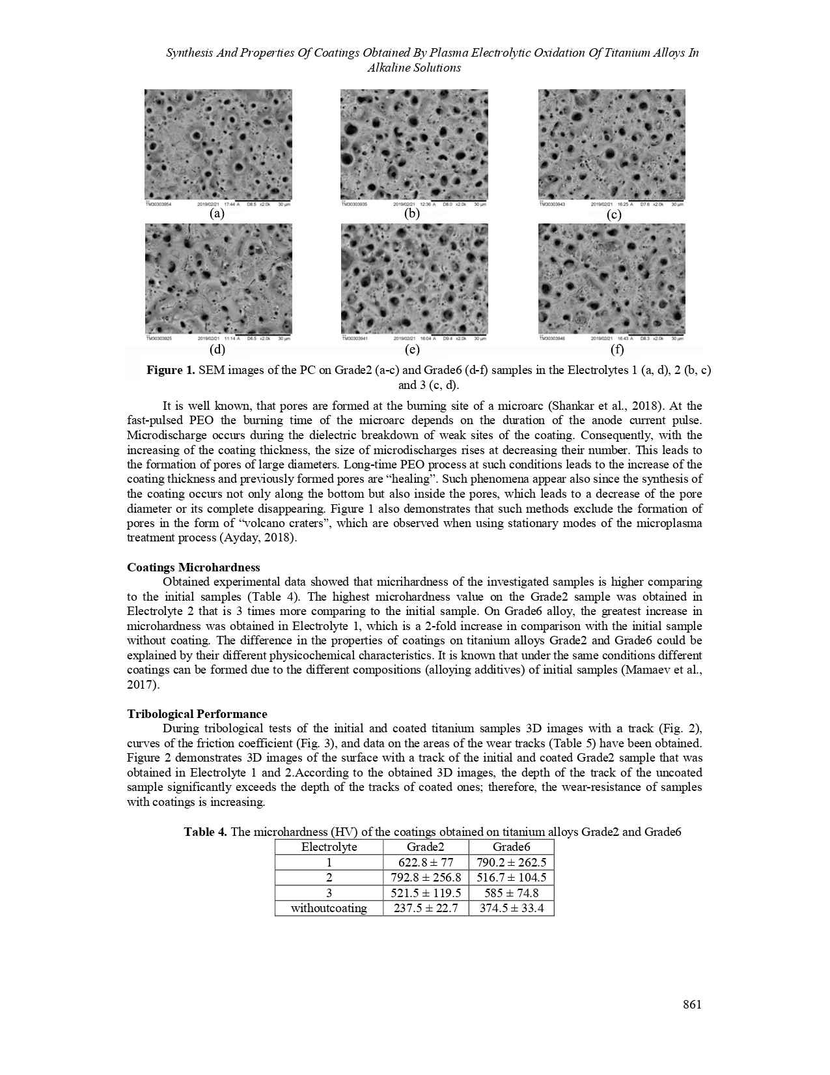

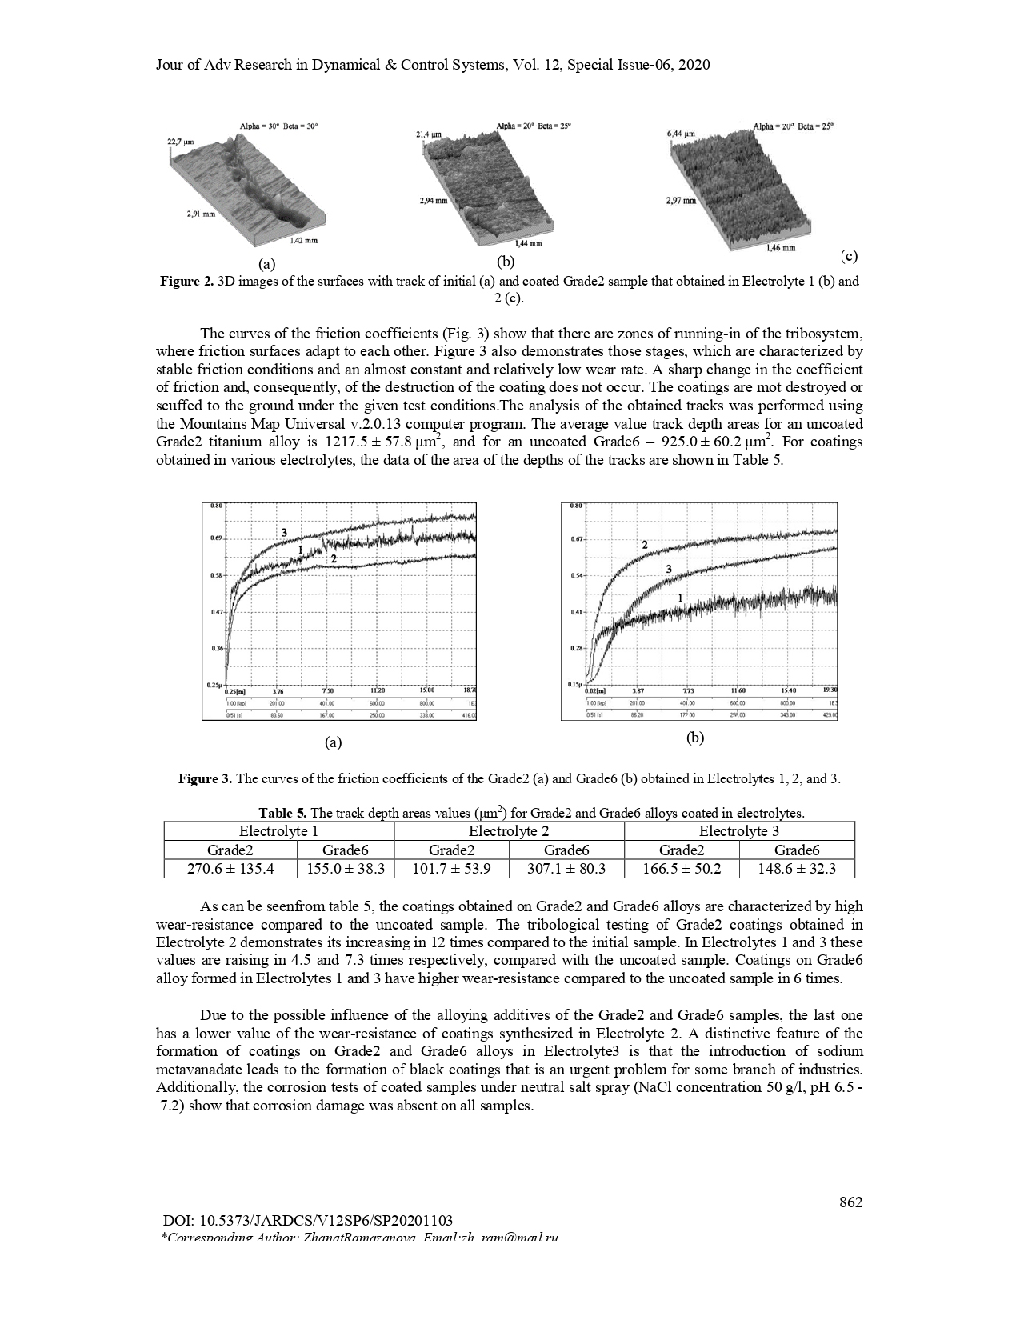

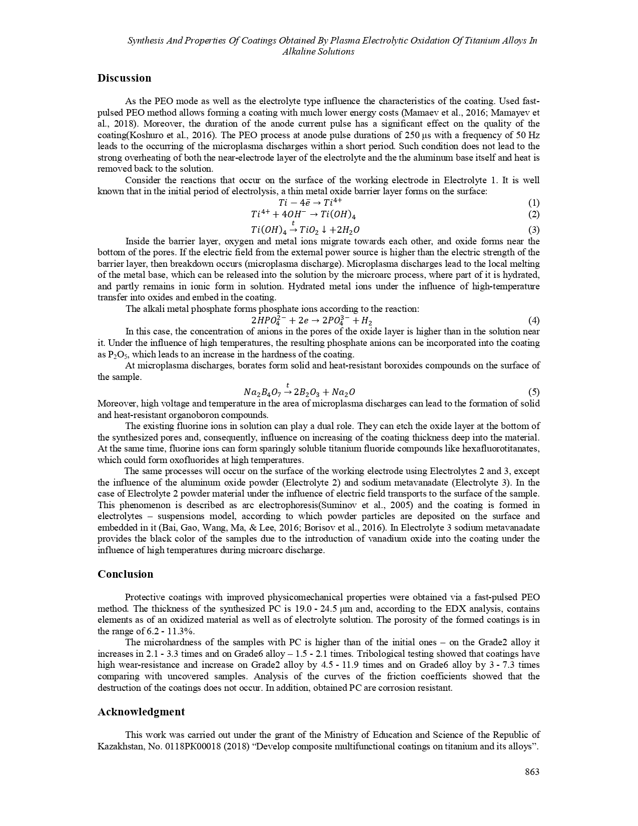

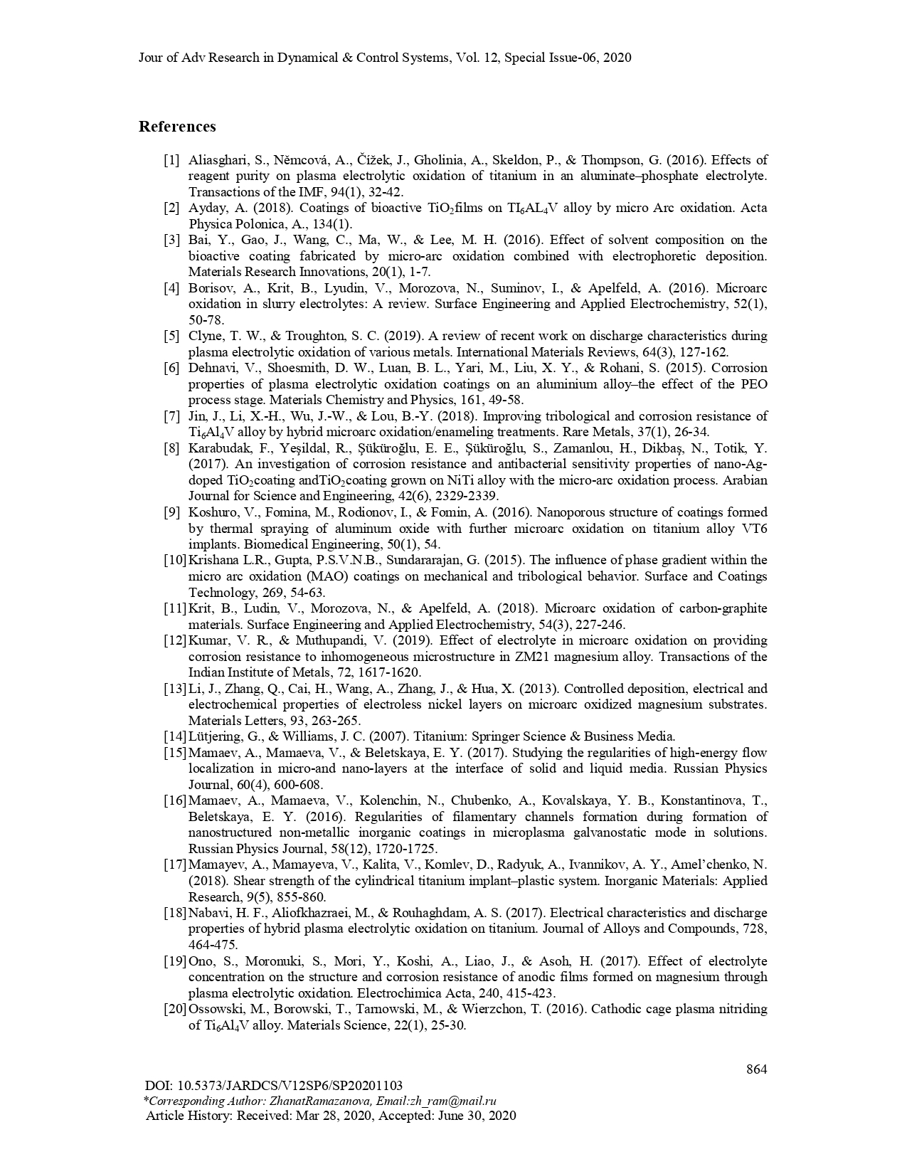

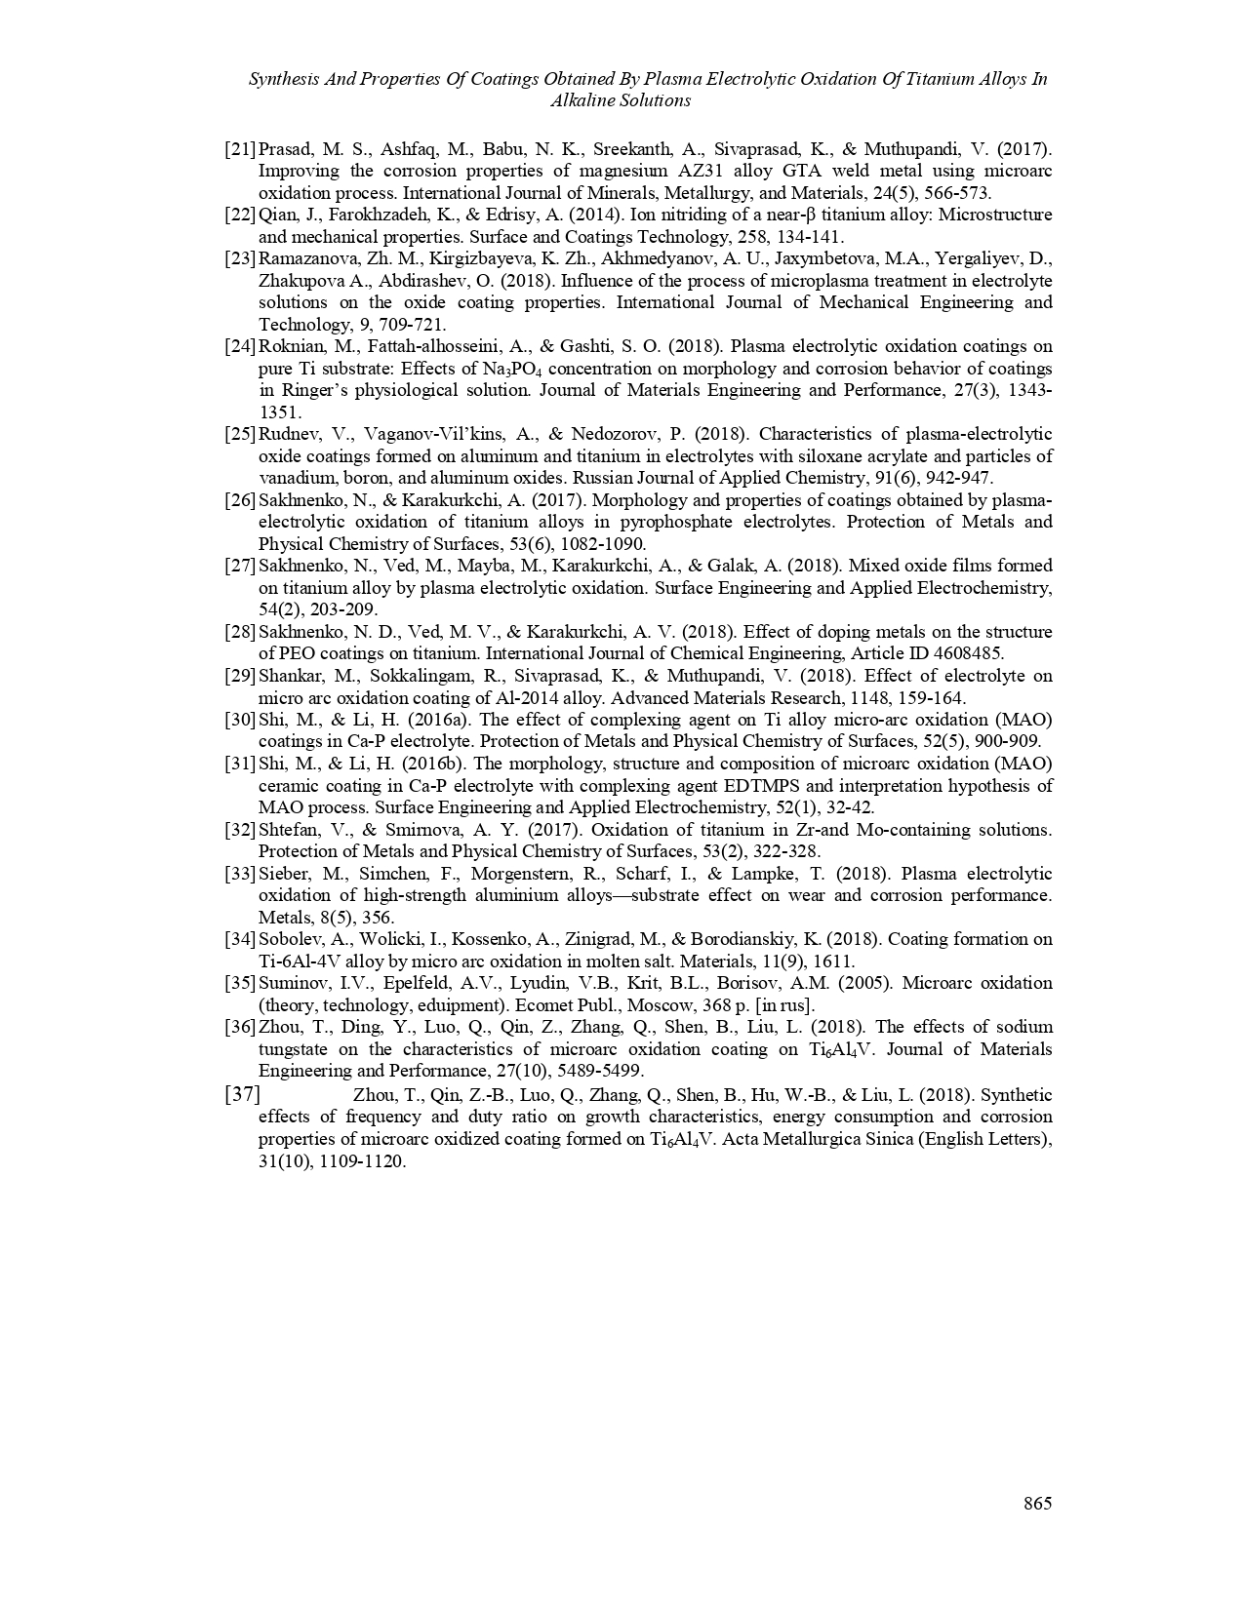

Reprints of articles for 2019

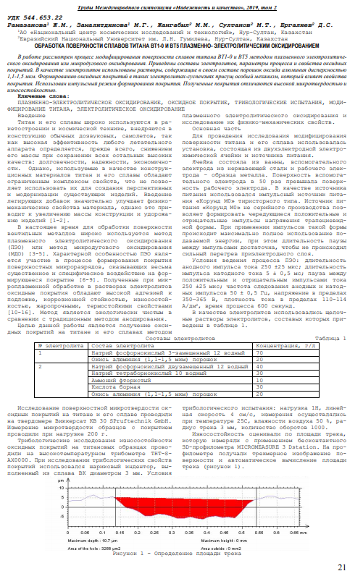

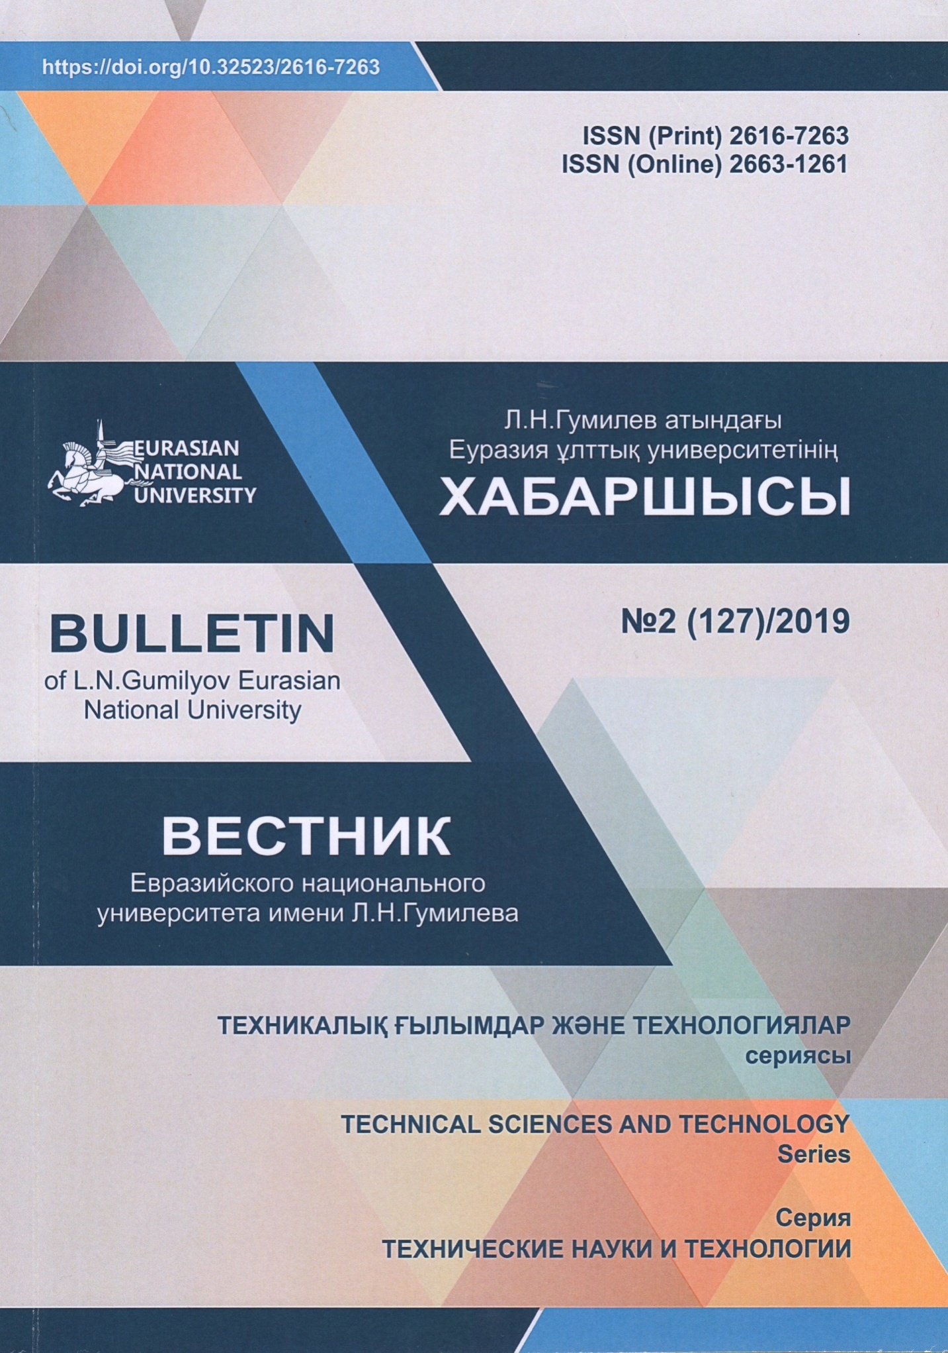

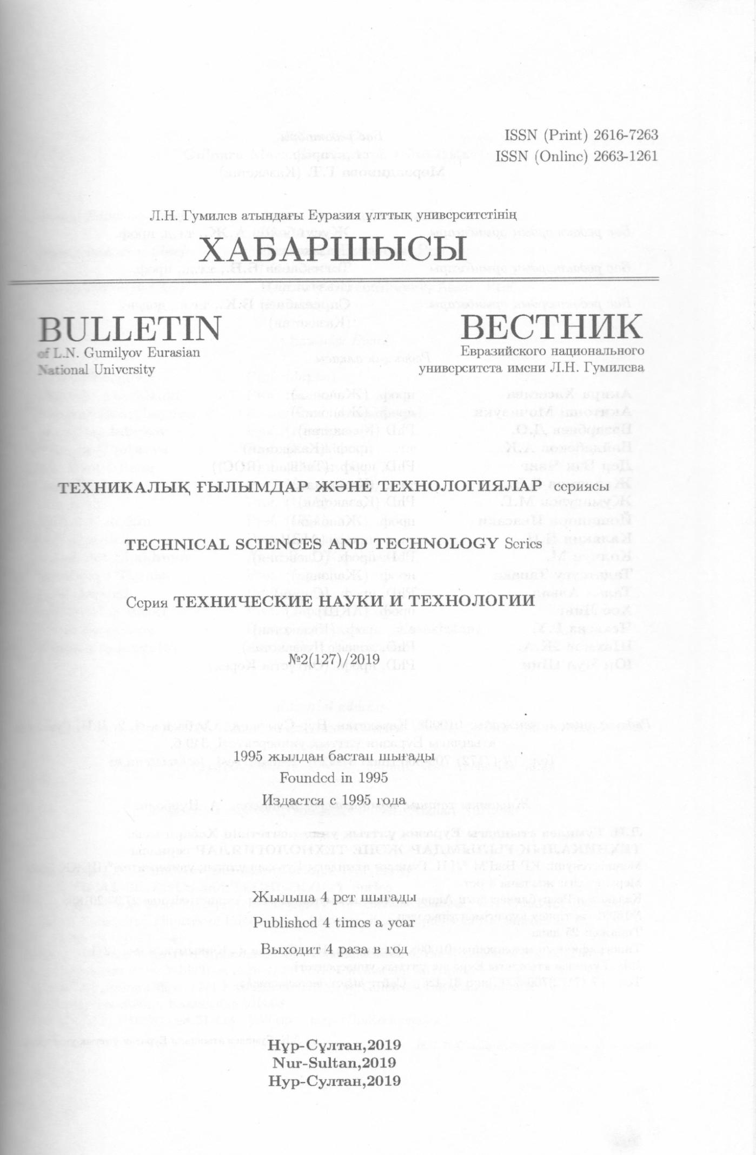
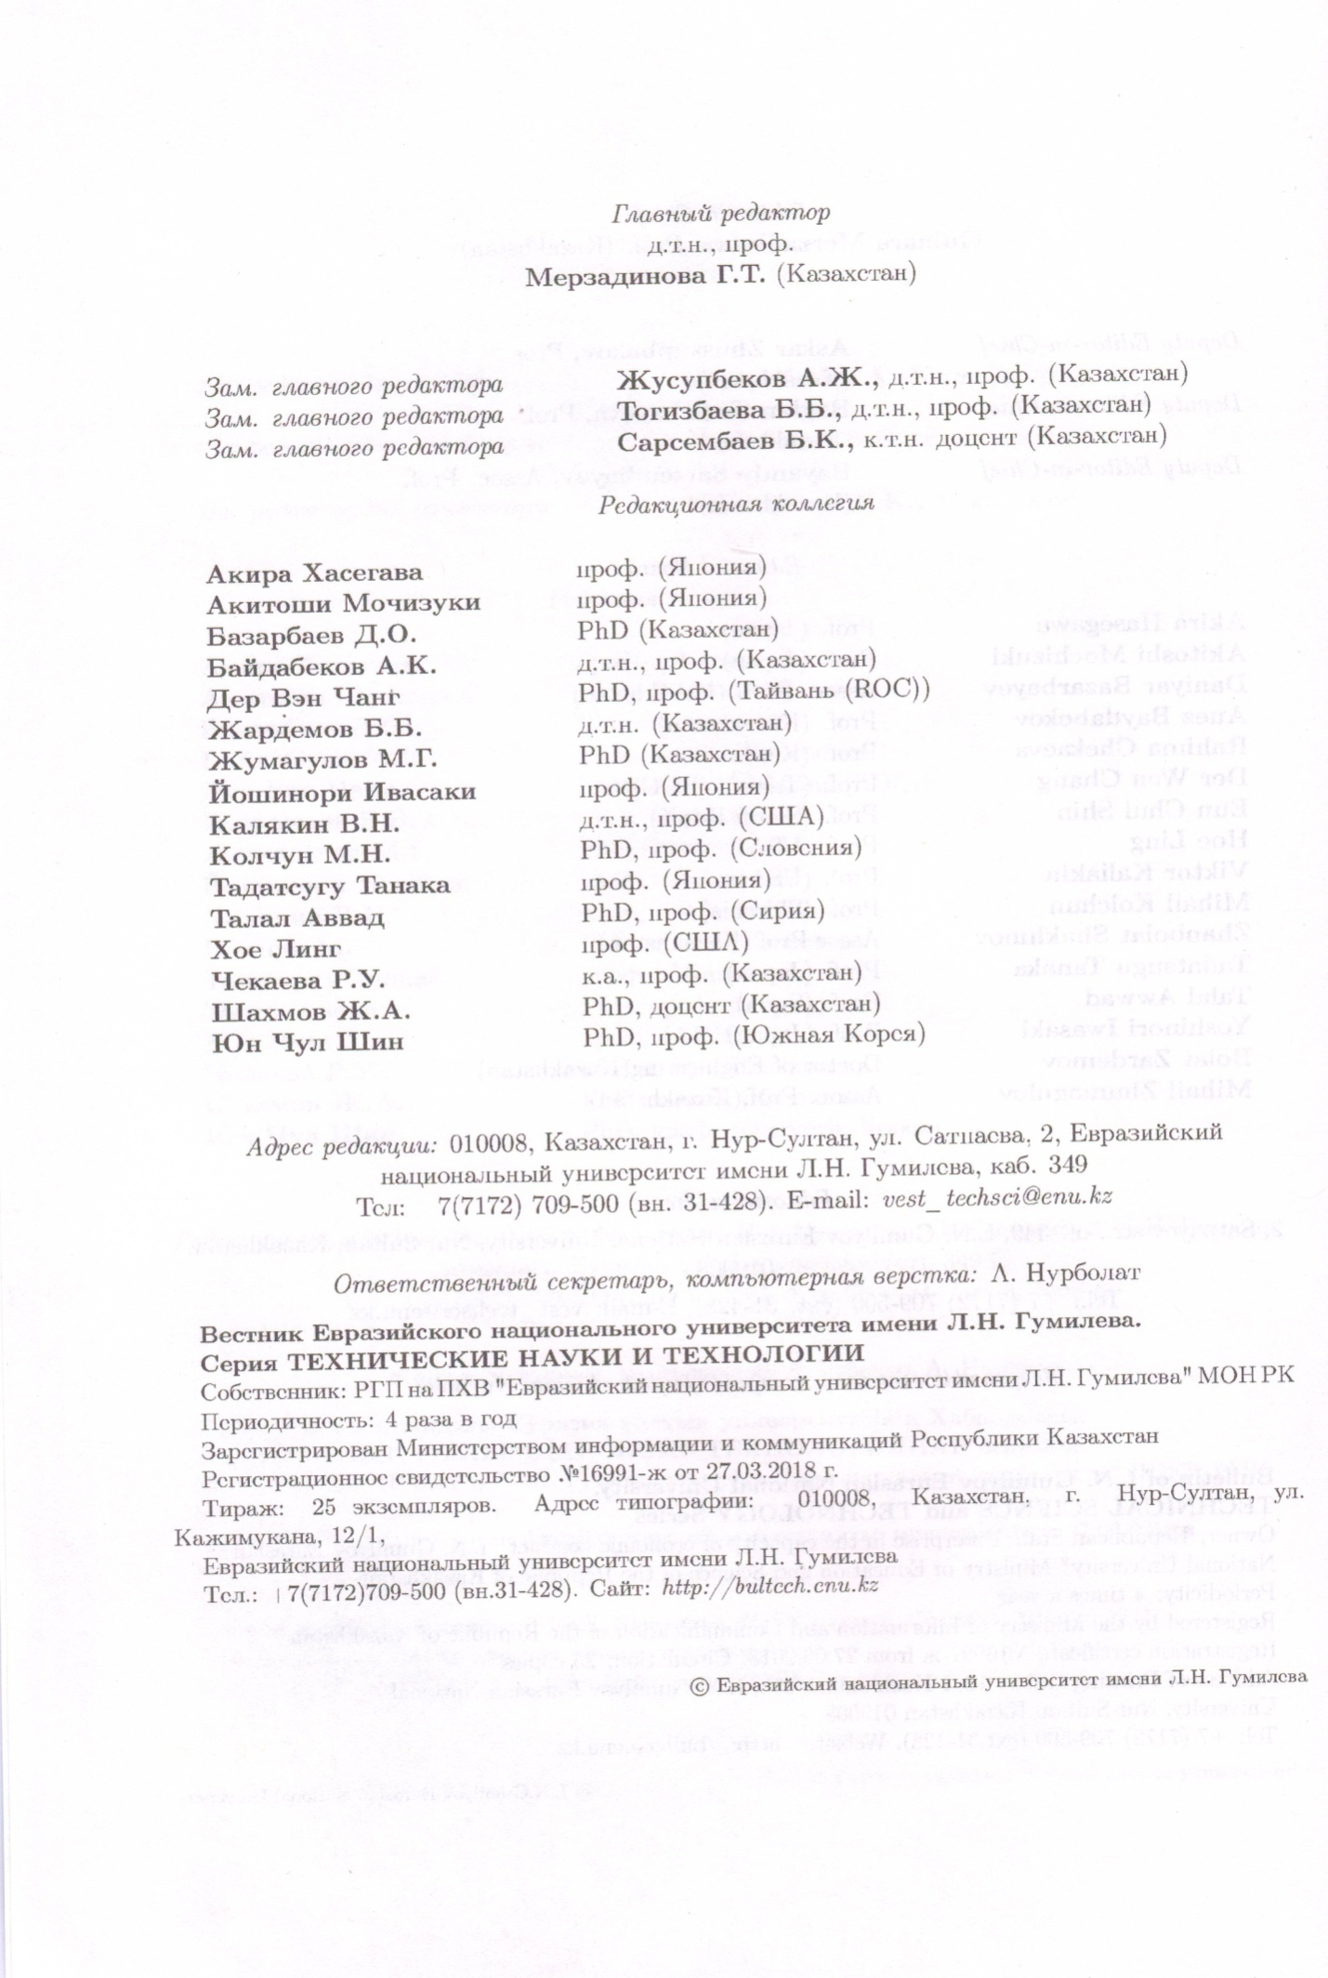

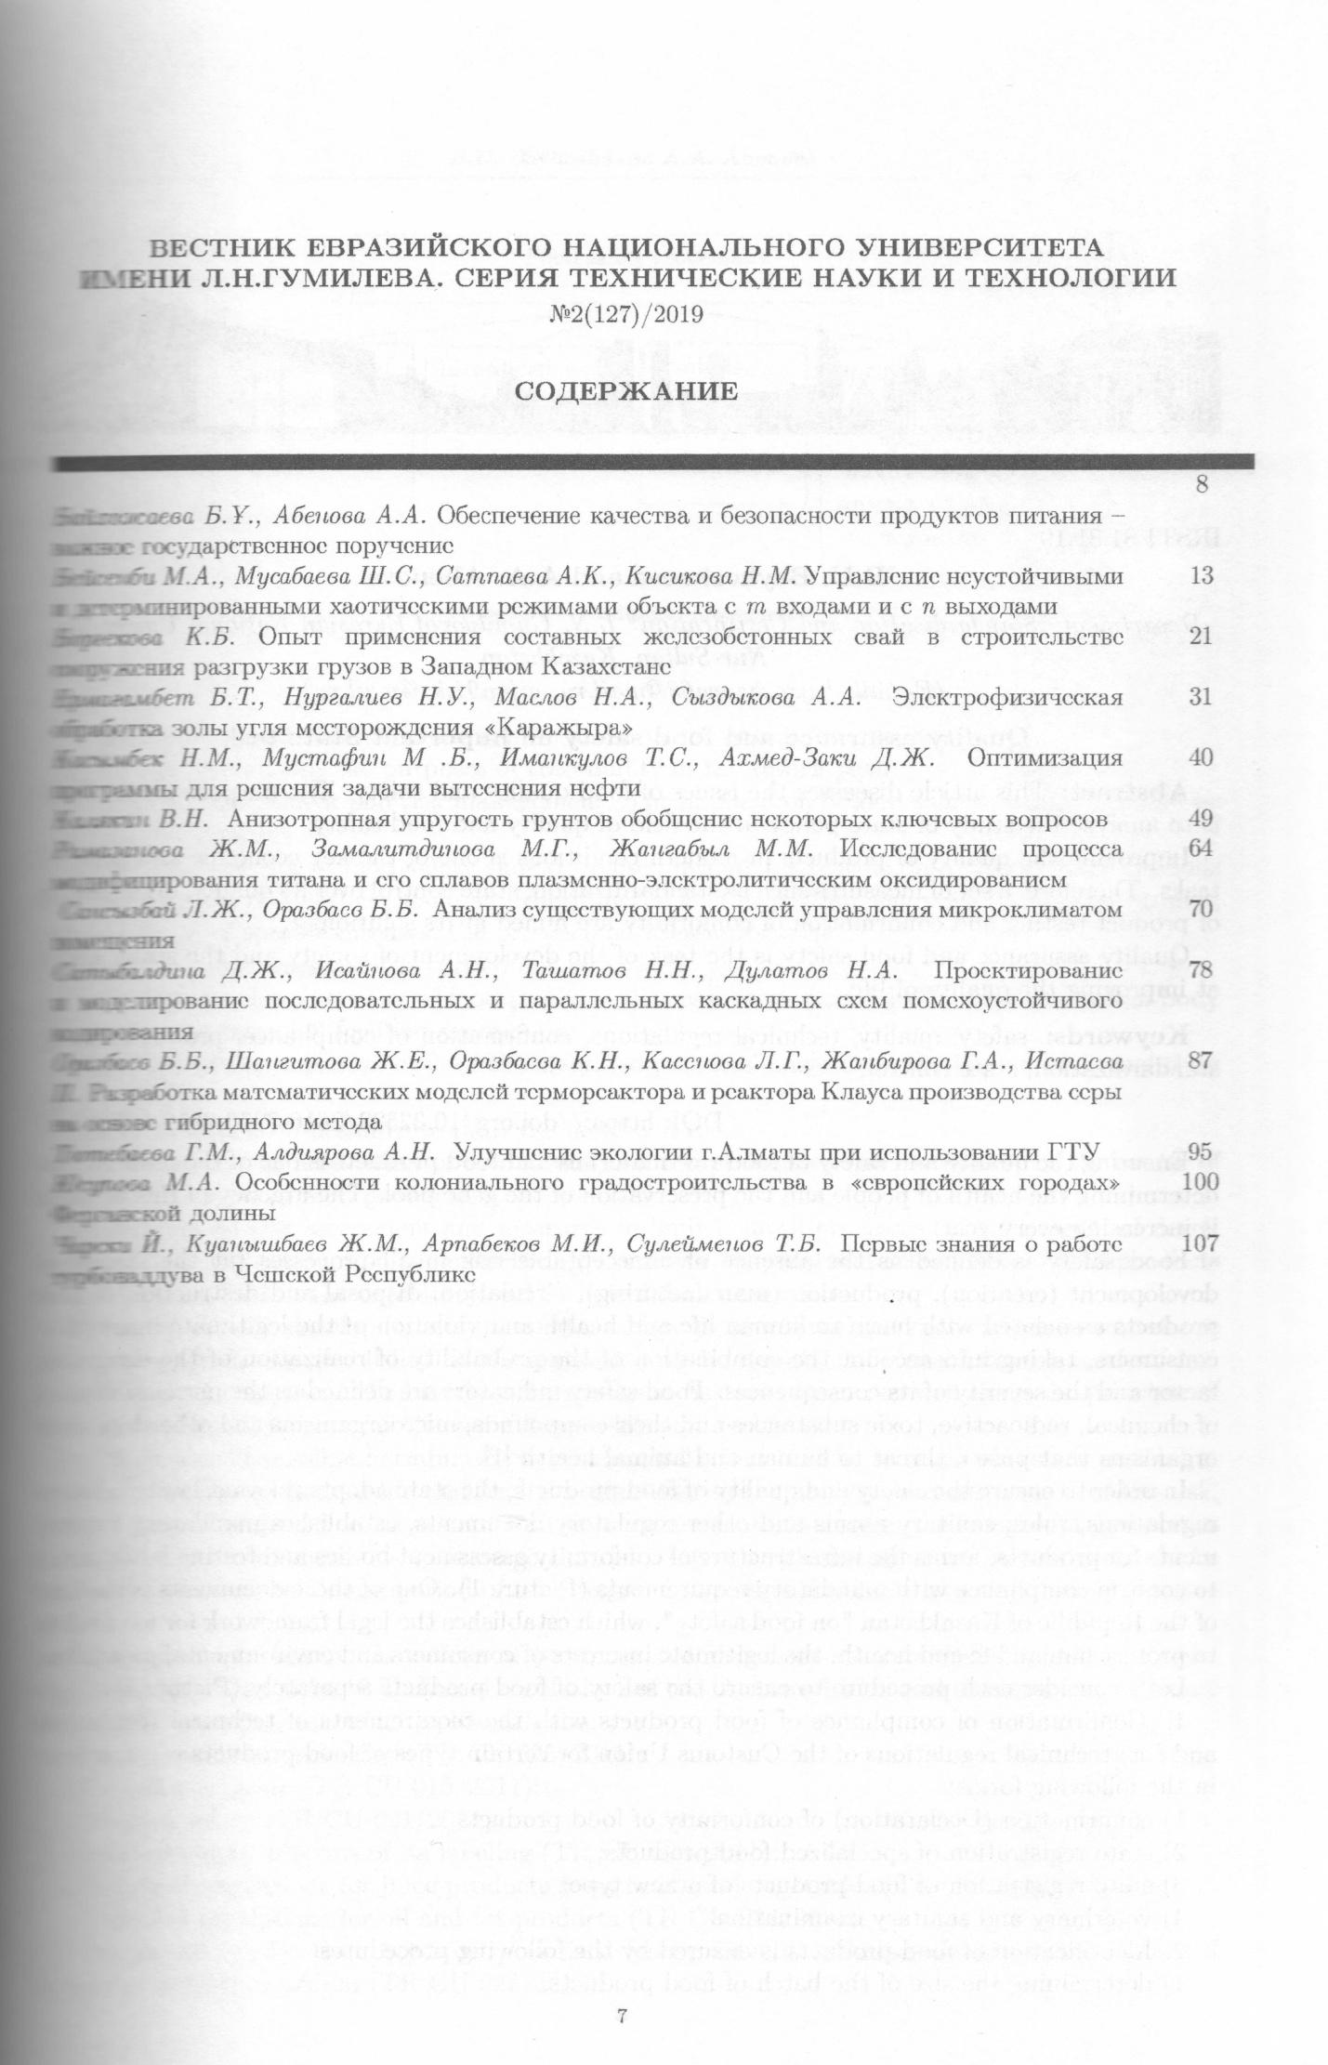
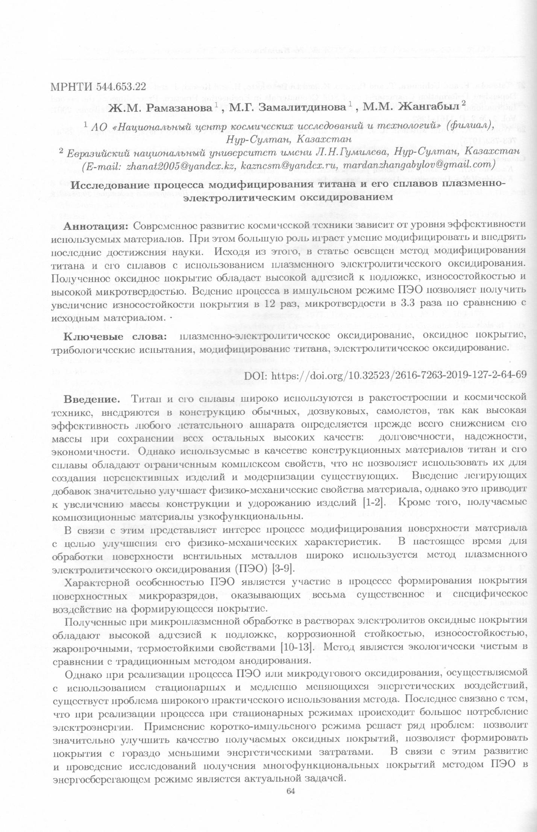
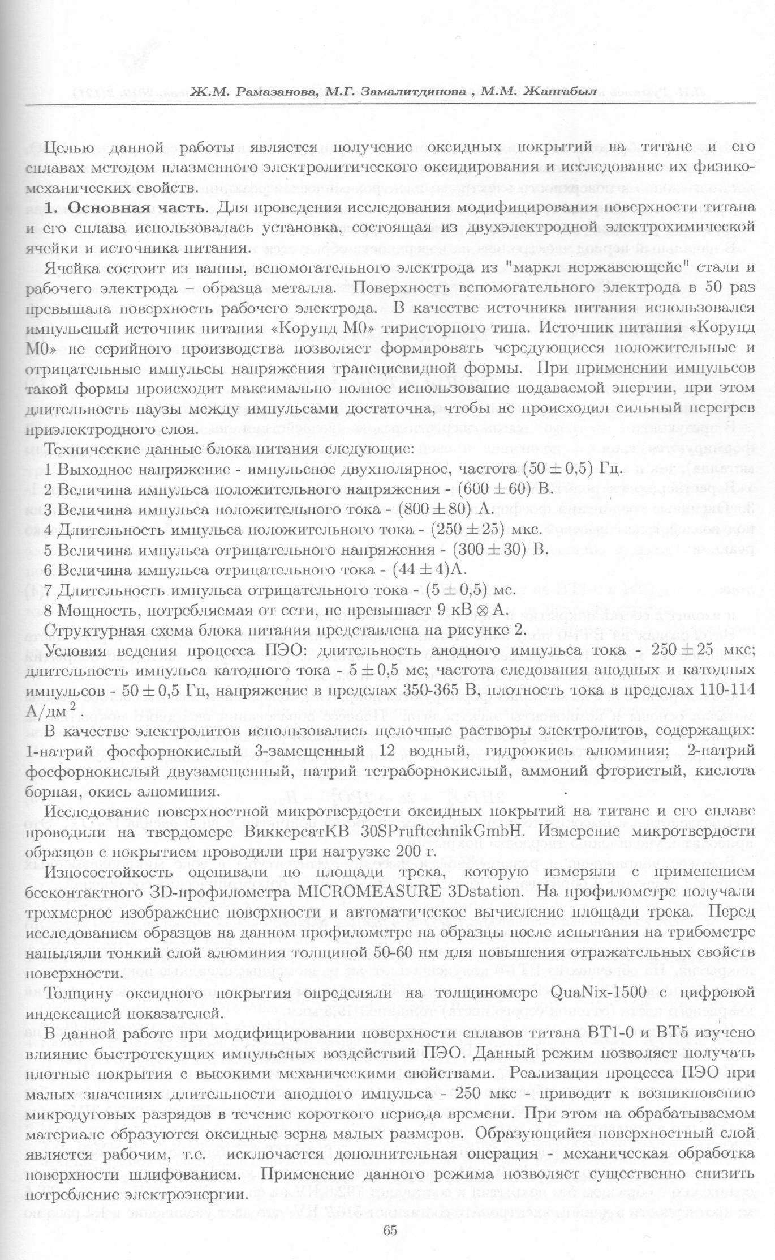
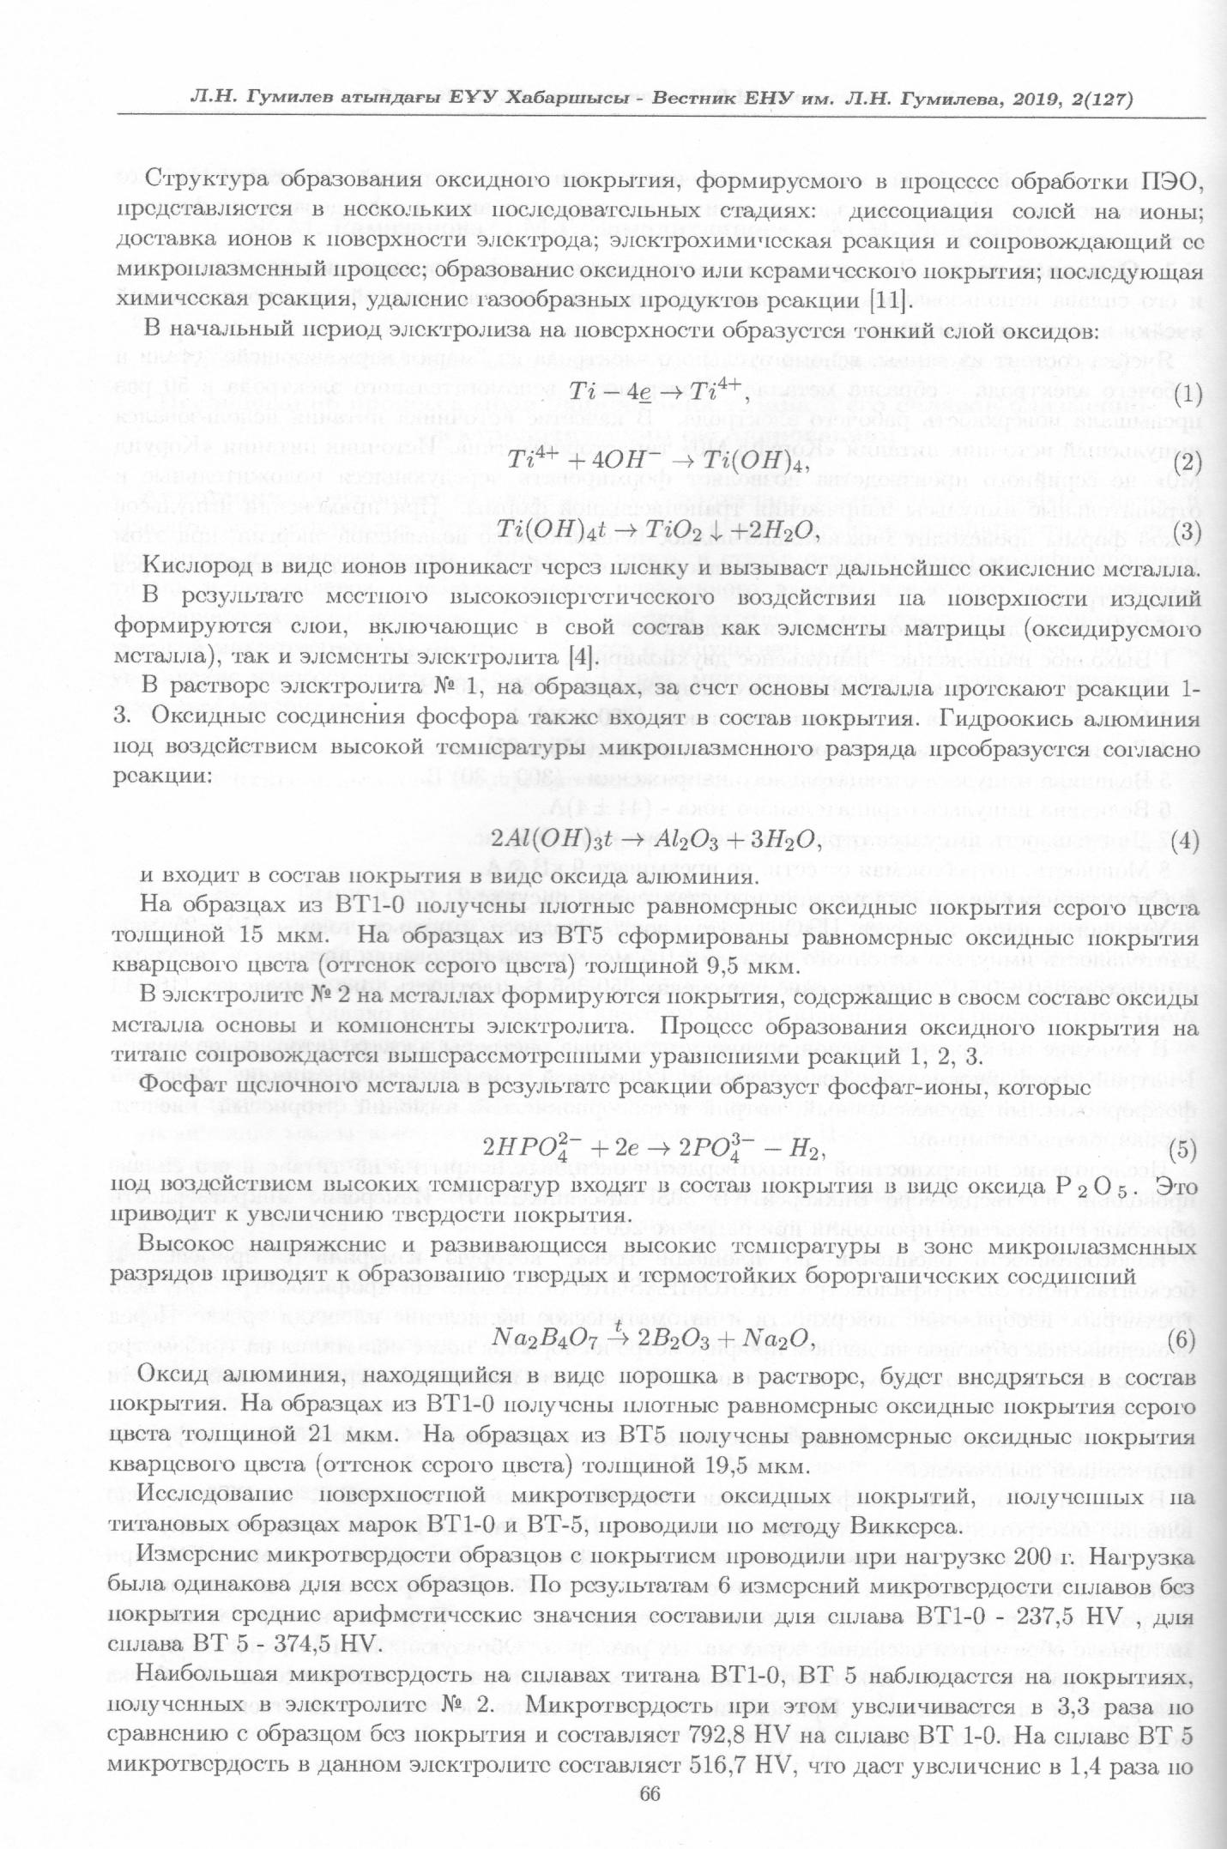
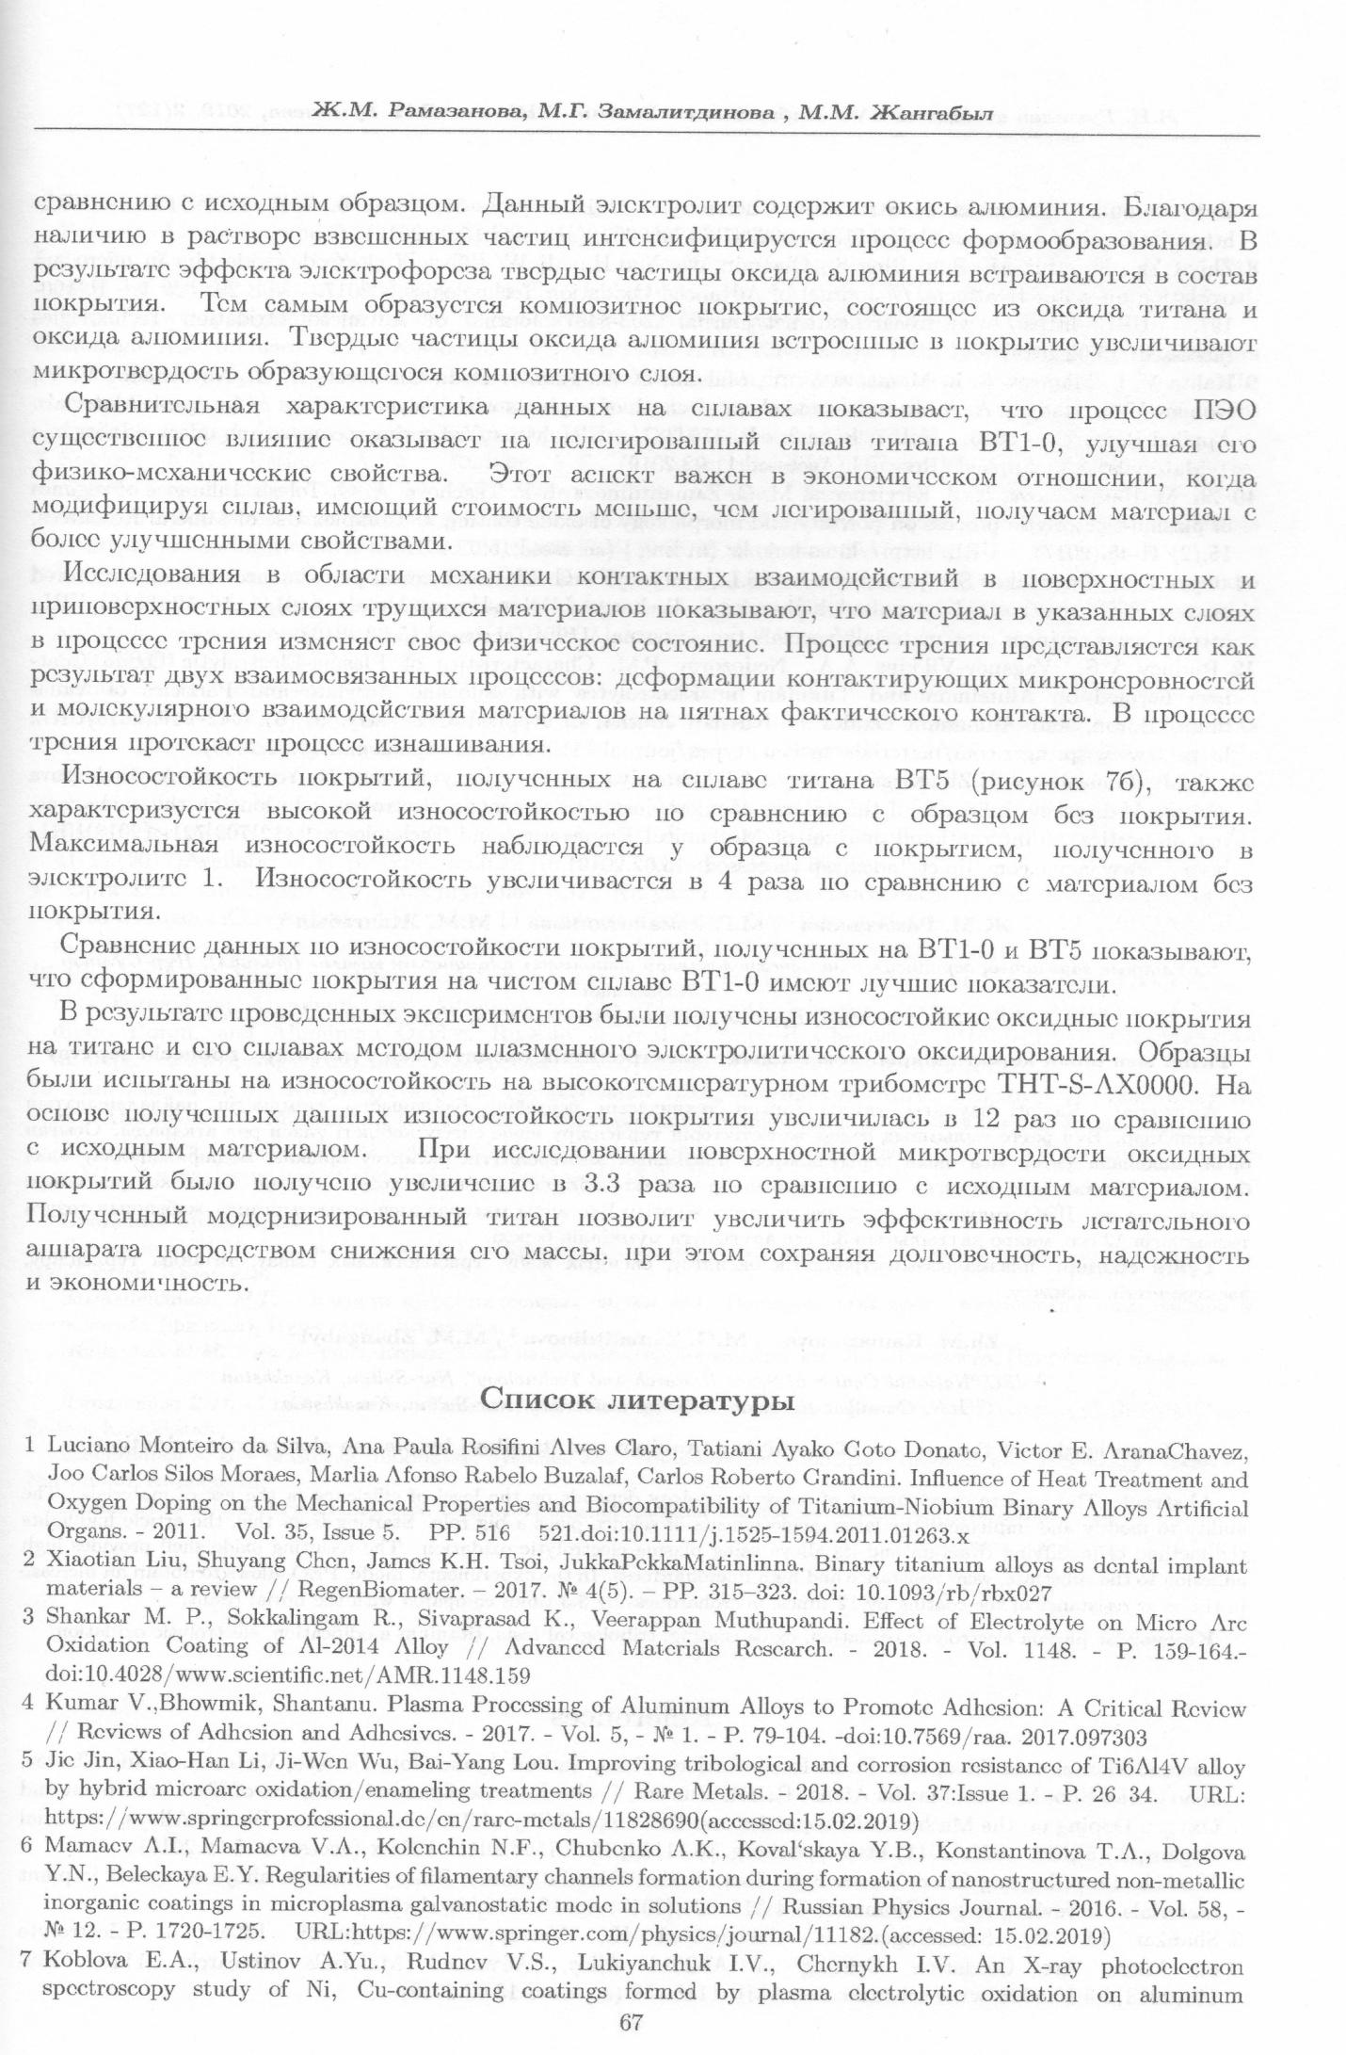
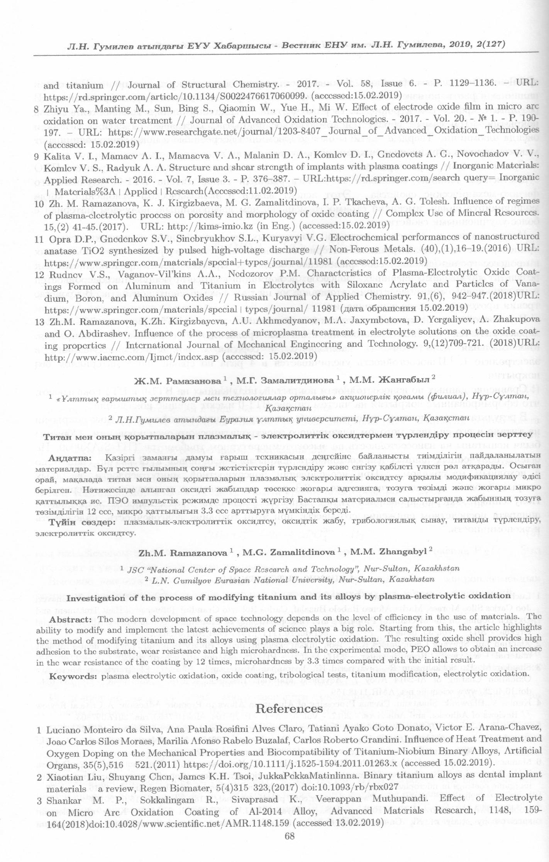
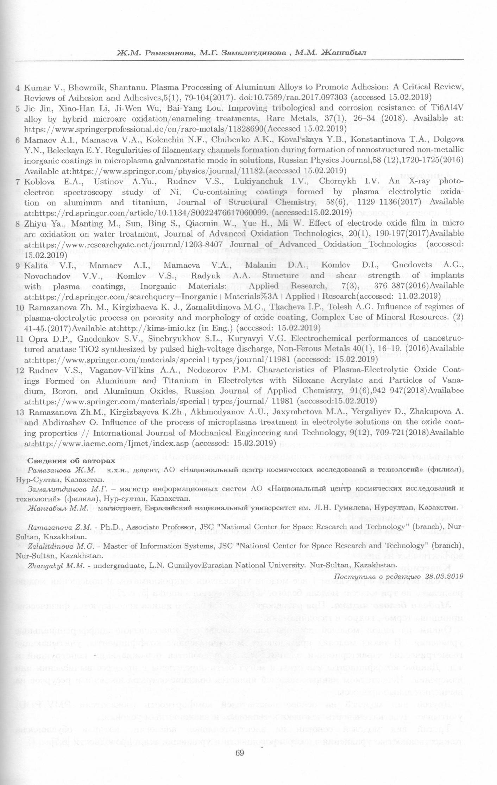
Reprints of articles for 2018

ANNEX C

Staff Training Certificate 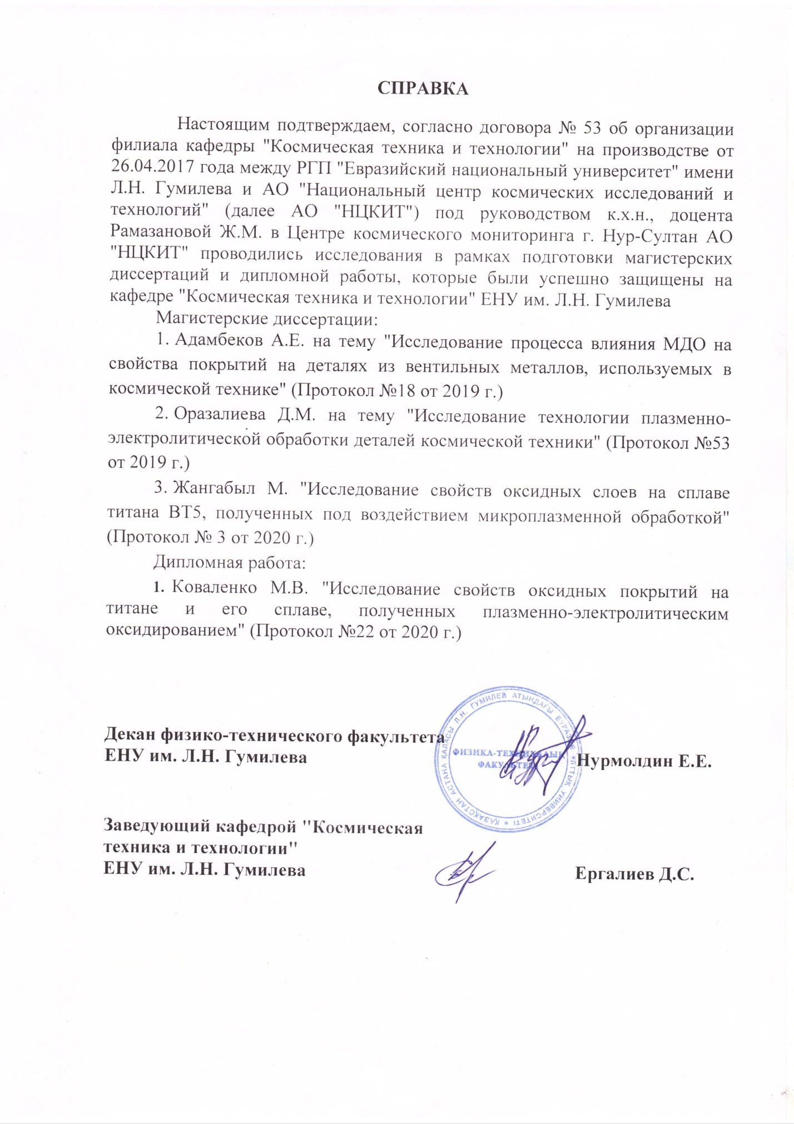
ANNEX D

Certificate of industrial practice, the scientific internship of students 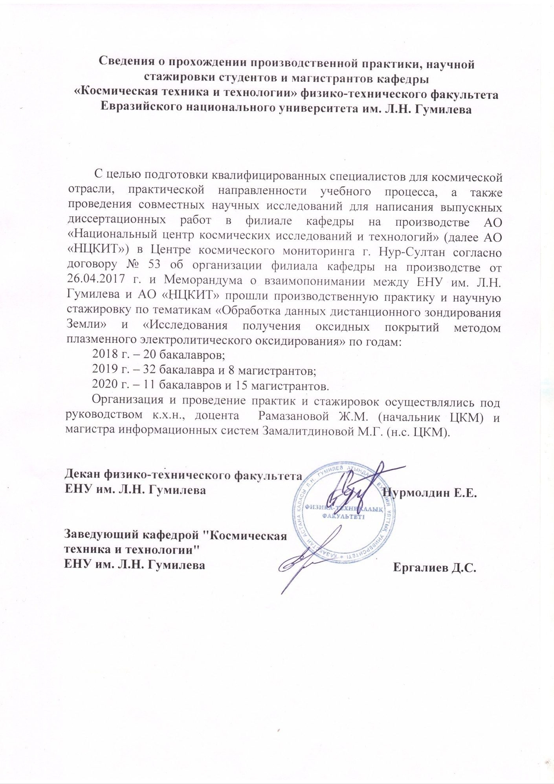
ANNEX E

Photographs of specimens with oxide coatings with improved physical and mechanical, protective properties
Table Е. 1 – Photographs of specimens with oxide coatings with improved physical and mechanical, protective properties
No | Electrolyte
No | Electrolyte | VТ1-0 | VТ5
1 | 2 | 3 | 4
1 | Na₂HPO₄.12H₂O (40 г/л) + Na₂B₄O₇.10H₂O (30 г/л) + H₃BO₃ (22 г/л) + NH₄F (10 г/л).  . | 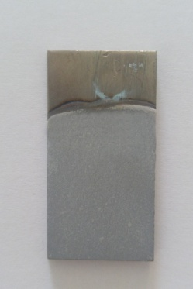 | 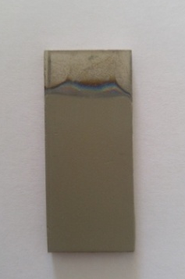
2 | Na₂SiO₃.9H₂O (100 г/л) + NaOH (8 г/л) + Al₂O₃ (20 г/л) | 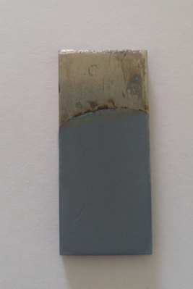 | 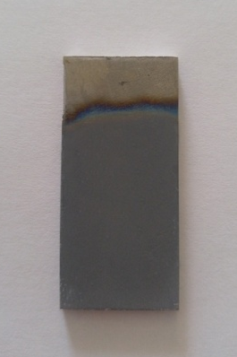
3 | Na₃PO₄.12H₂O (70 г/л) +Al₂O₃ (20 г/л) | 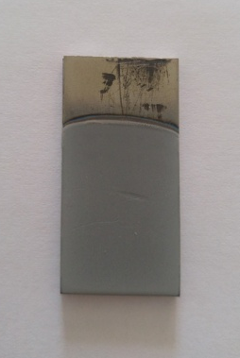 | 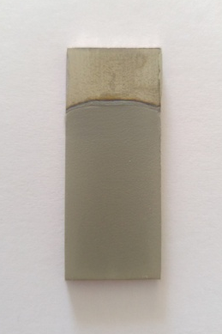
4 | Na₃PO₄.12H₂O (70 г/л) +Al(OH)₃ (20 г/л) | 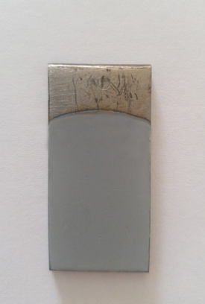 | 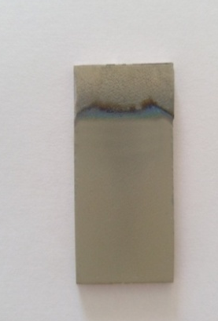

Table continuation E. 1
1 | 2 |  |  |  |  |  |  |  | 3 |  |  | 4
5 | Na₂HPO₄.12H₂O (40 г/л) + Na₂B₄O₇.10H₂O (30 г/л) + H₃BO₃ (22 г/л) + NH₄F (10 г/л)+Al₂O₃ (20 г/л). |  |  |  |  |  |  |  | 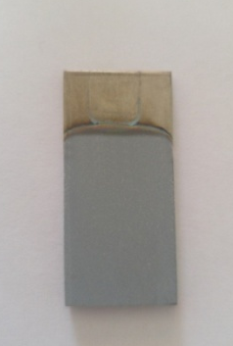 |  |  | 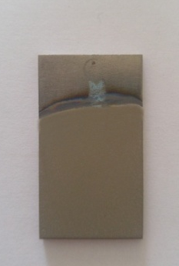
6  6 | Na₂HPO₄.12H₂O (40 г/л) + Na₂B₄O₇.10H₂O (30 г/л) + H₃BO₃ (22 г/л) + NH₄F (10 г/л)+ NaVO₃ (1,0 г/л). |  |  |  |  |  |  |  | 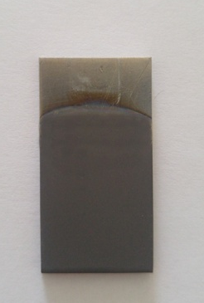 |  |  | 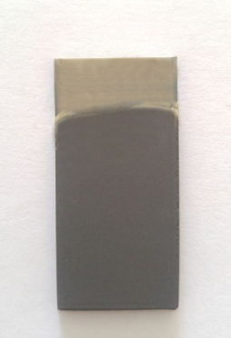
Electrolyte densified oxide coatings: Na₂HPO₄.12H₂O (40 г/л) + Na₂B₄O₇.10H₂O (30 г/л) + H₃BO₃ (22 г/л) + NH₄F (10 г/л).
VТ 1-0 |  |  |  |  |  |  | VТ 5
F-32, 1 layer |  | F-32, 2 layer |  | Epoxy resin |  |  | F-32, 1 layer |  |  | F-32, 2 layer |  |  |  | Epoxy resin
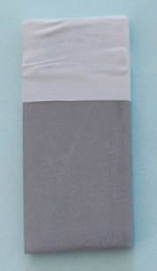 |  | 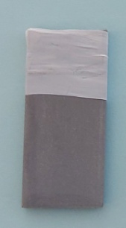 |  | 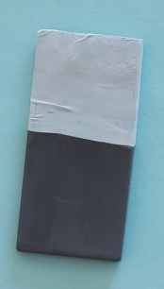 |  |  | 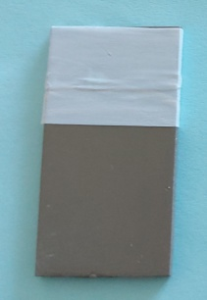 |  |  | 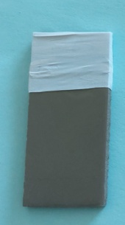 |  |  |  | 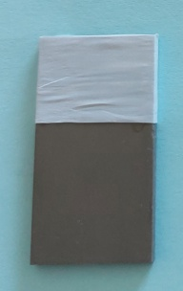
Electrolyte densified oxide coatings: Na₃PO₄.12H₂O (70 г/л) +Al₂O₃ (20 г/л)
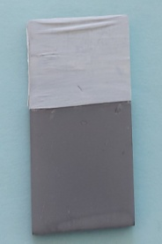 |  |  | 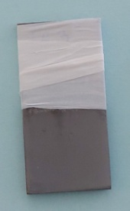 |  | 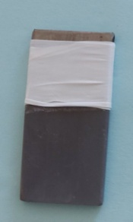 |  |  | 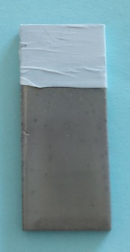 |  |  | 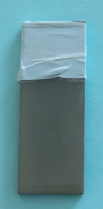 |  | 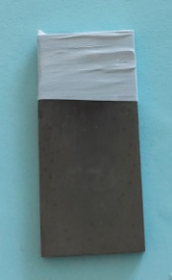
Electrolyte densified oxide coatings: Na₂HPO₄.12H₂O (40 г/л) + Na₂B₄O₇.10H₂O (30 г/л) + H₃BO₃ (22 г/л) + NH₄F (10 г/л)+ NaVO₃ (1,0 г/л).
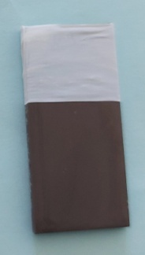 |  |  | 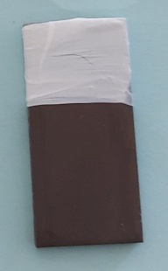 |  |  | 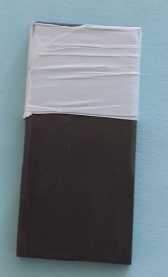 |  | 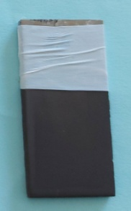 |  |  | 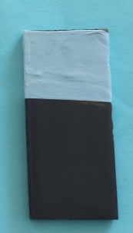 |  | 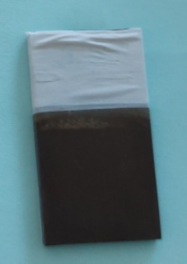
In 2018, 7 batches of oxide coated samples were received, 8 samples in each batch.
In 2019, 7 batches of oxide coated samples were received, 8 samples in each batch.
In 2020, 12 batches of oxide coated samples were received, 6 samples in each batch.

ANNEX F

Test report No. 3 