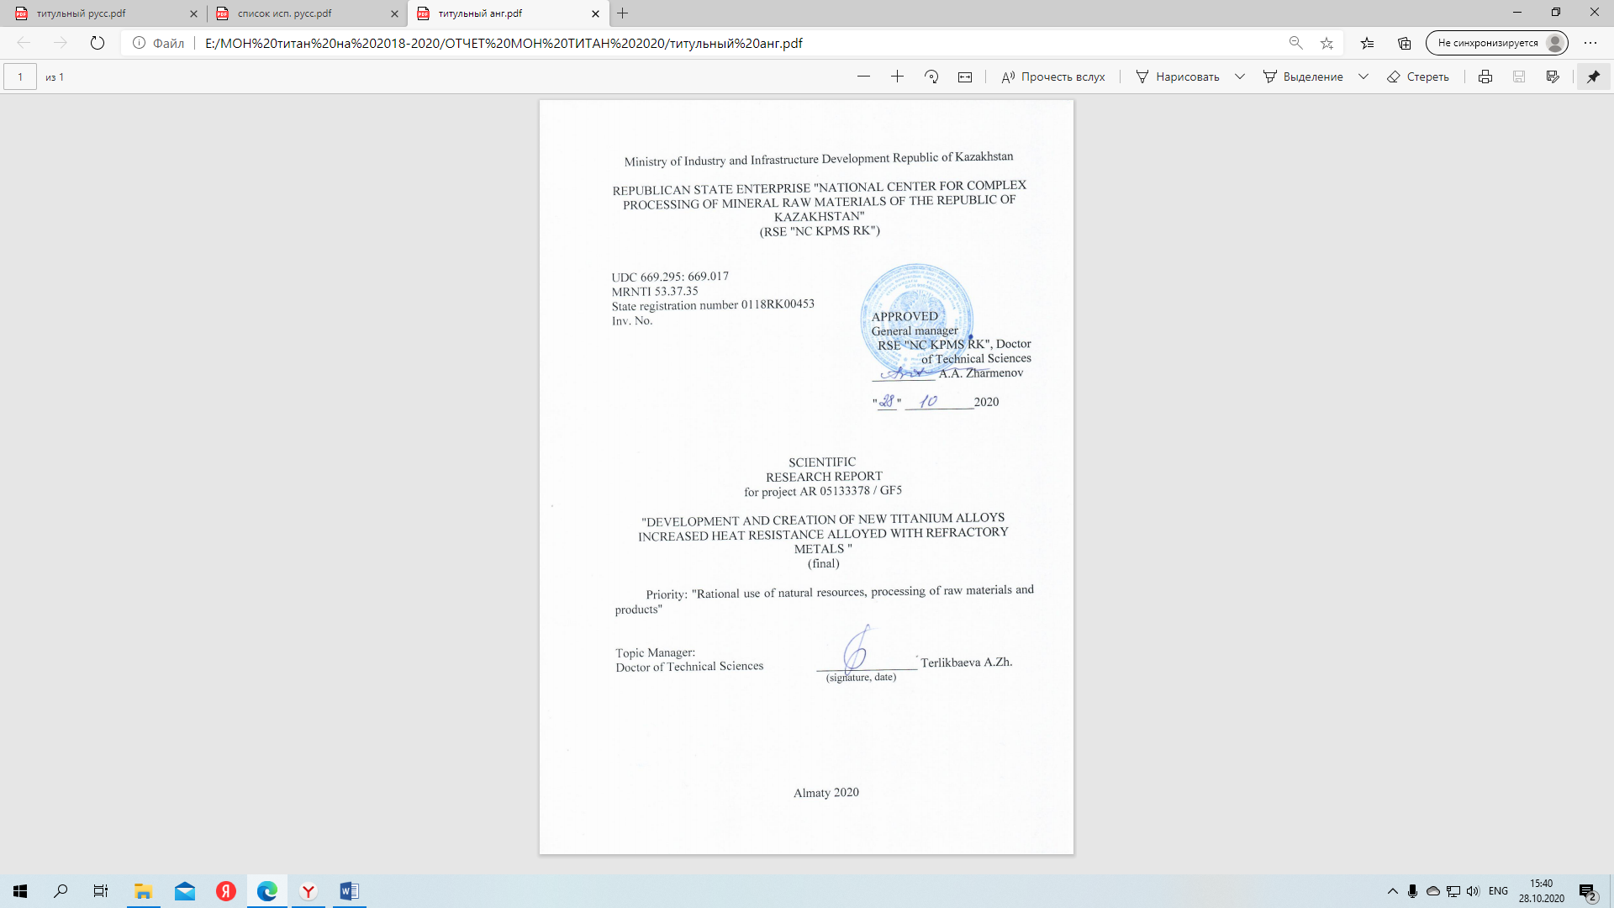


ABSTRACT

Report 71 p., 15 figures; 7 tables, 14 sources, 6 appendices.
Keyword:titanium alloys, rhenium-containing alloys, heat-resistant alloys, strengthening phases, alloying, phase diagrams, isothermal sections, phase transformations.
Object of research: promising heat-resistant titanium alloys.
Purpose: development of high-heat-resistant titanium alloys doped with rhenium.
Results and their novelty. Titanium alloys of high heat resistance doped with rhenium have been developed. High-temperature tests of the mechanical properties of these alloys for compression and tension at a temperature of 600ºC were performed. It is shown that the addition of 1% rhenium to Ti-5Al-5Mo-5V-3Cr alloy has a positive effect on the morphology of the crystal lattice, which increases the high-temperature strength characteristics of the alloy in the area of elastic and plastic deformations. Replacing chromium with 3% rhenium reduces the strength properties of the alloy in the area of elastic deformations, improving them in the area of plastic.
The microstructure of the alloys under consideration is investigated. It is shown that a two - phase (α+ β) structure of alloys with an α-phase content of 30-40% was formed during heat treatment. It was found that after reaching the critical values of high-temperature deformation, recrystallization and polygonal processes occurred due to the movement of dislocations.
The results obtained will allow us to scientifically justify the choice of ligatures in multicomponent systems based on titanium.
Significance of the work. Development and creation of samples of new alloyed heat-resistant titanium alloys containing rhenium will increase their high-temperature strength characteristics and increase the temperature range of operation of titanium alloys.
The developments relate to the field of titanium metallurgy and materials science.

ABSTRACT

Report 72 p., 15 figures; 7 tables, 14 sources, 6 appendices.
Keyword:titanium alloys, rhenium-containing alloys, heat-resistant alloys, strengthening phases, alloying, phase diagrams, isothermal sections, phase transformations.
Object of research: promising heat-resistant titanium alloys.
Purpose: development of high-heat-resistant titanium alloys doped with rhenium.
Results and their novelty. Titanium alloys of high heat resistance doped with rhenium have been developed. High-temperature tests of the mechanical properties of these alloys for compression and tension at a temperature of 600ºC were performed. It is shown that the addition of 1% rhenium to Ti-5Al-5Mo-5V-3Cr alloy has a positive effect on the morphology of the crystal lattice, which increases the high-temperature strength characteristics of the alloy in the area of elastic and plastic deformations. Replacing chromium with 3% rhenium reduces the strength properties of the alloy in the area of elastic deformations, improving them in the area of plastic.
The microstructure of the alloys under consideration is investigated. It is shown that a two - phase (α+ β) structure of alloys with an α-phase content of 30-40% was formed during heat treatment. It was found that after reaching the critical values of high-temperature deformation, recrystallization and polygonal processes occurred due to the movement of dislocations.
The results obtained will allow us to scientifically justify the choice of ligatures in multicomponent systems based on titanium.
Significance of the work. Development and creation of samples of new alloyed heat-resistant titanium alloys containing rhenium will increase their high-temperature strength characteristics and increase the temperature range of operation of titanium alloys.
The developments relate to the field of titanium metallurgy and materials science.

CONTENT

INTRODUCTION …..………………………………………………… | 8
MAIN part of the research report……………………………………… | 10
1 Development of high heat resistant titanium alloys doped with rhenium …………………………………...…………………………… | 10
2 Research and development of optimal technological modes for obtaining titanium alloys with high heat resistance……………………. | 13
3 Creating samples of new heat-resistant titanium alloys and studying their physical and chemical properties ………………………………… | 14
3.1 Research methods ……………………………………………….. | 14
3.2 investigation of the density of heat-resistant titanium alloys  Ti-5Al-5Mo-5V-3sgiti-5Al-5Mo-5V-3Cr-1Re………………………… | 18
3.3 Study of the mechanical properties of new alloys with recommendations for their use ………..……………………………… | 24
CONCLUSION ……………………………………………………….. | 31
LIST OF SOURCES USED ……………………….………………… | 35
APPENDIX A Calendar plan …………………………………………. | 36
APPENDIX B Extract from minutes No. 3-US-20 meetings of the Academic Council ………………………………………………………... | 39
APPENDIX B The list of published works in the area of research for 2018-2020 ……………………… ………………………………………... | 41
APPENDIX G Results for 2020 of the grant financing project ……….. | 42
APPENDIX D Reprints of published works ………………………….. | 43
APPENDIX E List of used foreign information resources ..................... | 71

TERMS AND DEFINITIONS

The following terms and definitions are used in this research report

Alloy - a product of joining two or more components, one of the required metal, obtained by co-melting or dissolving ratios that meet GOST and specifications.
Heat resistance - the ability of structural materials to resist deformation and destruction at elevated temperatures (0.3-0.8 Tm) for a long time.
A phase is a certain part of the system that has a clear interface, when passing through from which the structure and properties change.
Liquidus - a line or surface on the phase diagram showing the temperature of the onset of crystallization of the alloy.
Solidus - a line or surface on the phase diagram showing the temperature of the end of crystallization of systems.
State diagram (phase diagram) - a graphical representation of all possible states of a thermodynamic system depending on temperature, pressure and composition (usually expressed in molar or mass fractions of components).
A component is a chemical individual, the smallest number of which is sufficient for the formation of all phases of a thermodynamic system.
Alloying - adding impurities to the alloy composition to change the physical and / or chemical properties of the base material.
Polymorphism is the ability of some minerals and other crystalline substances to exist at the same chemical composition in states with different atomic crystalline structure.
A chemical compound is a complex substance consisting of chemically bound atoms of two or more elements (heteronuclear molecules).

LIST OF ABBREVIATIONS AND DESIGNATIONS

The following abbreviations and designations are used in this research report

PD - phase diagrams
TD - thermodynamic properties
GPU - hexagonal close-packed lattice
(Ti) - titanium solid solution
(Al) - aluminum solid solution
ZhTS - heat-resistant titanium alloy

INTRODUCTION

Titanium alloys are widely used in the chemical and aerospace industries due to their high specific strength and good thermal and corrosion resistance [1]. Most titanium alloys are two-phase in which the low-temperature α-phase has high strength and corrosion resistance, and the high-temperature β-phase shows the best plasticity and formability. The existence of the α↔ β transformation means that as a result of heat treatment in the alloy, various microstructural combinations can be achieved, which makes it possible to adapt the obtained properties to the specific requirements of customers [2–3].
Ti-5Al-5V-5Mo-3Cr alloy is one of the most successful structural materials for aircraft that can withstand high-load conditions for a long time in a wide temperature range. Well-matched balance between alloying elements: Al, α -phase stabilizer, which reduces alloy density; V and Mo are isomorphic β– stabilizers, imparting plasticity and refractory properties; Cr, a eutectoid-forming stabilizer that increases the temperature range of existence of (α + β) - phases, gives interesting properties such as high specific strength, good ductility, acceptable heat and corrosion resistance [4, 5].
One of the important aspects of increasing the temperature range of operation of titate alloys is alloying with rhenium, which has a large number of valence electrons, which change the phase structure of the alloys and increase its operating temperature by 80-100 C [6-8].
The stages of the synthesis of titanium alloys and their final result depend significantly on the method of introducing alloying elements and their ratio. The use of ligatures gives more stable results. The composition of the ligatures is selected so that they have the most favorable properties for better assimilation of alloying components. Therefore, in the development of technological methods for preparing master alloys, it is envisaged that the alloying elements are bound into chemical compounds that are less exposed to evaporation and have lower melting points [9]. In this case, a decrease in the difference in the densities of the master alloy and the melt is achieved, which will not allow the alloying component to sink to the bottom of the crucible, or float on the surface if its density significantly differed from the density of the melt.
Aims and objectives of research, their place in the implementation of research work in general. The aim of the project is to develop and create new titanium alloys of increased heat resistance alloyed with refractory metals. Research task in 2018: selection of the chemical composition of new promising high-temperature titanium alloys, temperature regime and processing conditions based on model calculation and construction of isothermal phase diagrams of high-temperature titanium alloys using modern software (2018 report, inv. No. 0218RK00574). Research objective in 2019: study and selection of technological modes for obtaining promising high-temperature rhenium-containing titanium alloys (report 2019, inv. No. 0219RK00902). The aim of the 2020 research phase was to create samples of new heat-resistant titanium alloys and study the physicochemical and mechanical properties. The task of research in 2020 was to obtain new heat-resistant alloys of the Ti-5Al-5Mo-5V-3Cr, Ti-5Al-5Mo-5V-3Re and Ti-5Al-5Mo-5V-3Cr-1Re systems from ligatures, to study their mechanical properties in heat-treated state at a temperature of 600 ° C, as well as a study of the effect of mechanical loads on deformation mechanisms.

MAIN PART OF THE RESEARCH REPORT

1 Development of titanium alloys with increased heat resistance alloyed with rhenium

To develop titanium alloys of increased heat resistance doped with rhenium, in 2018, the selection of the optimal composition of rhenium-containing titanium alloys was carried out using the Thermo-Calc software (TCW5 version) and the TTTIAL1 database. The program made it possible to obtain the necessary results without carrying out a large number of experiments.
For this purpose, model calculations of heat-resistant titanium alloys of the systems Ti-5Al-5Mo-5V-3Cr, Ti-Al-Mo-V-Cr-Re were carried out at temperatures of 400-800 ° C.
Isothermal sections of alloys of the Ti-5Al-5Mo-5V-3Cr, Ti-Al-Mo-V-Cr-Re systems calculated at 400 and 800 ° C are shown in Figures 1-4.

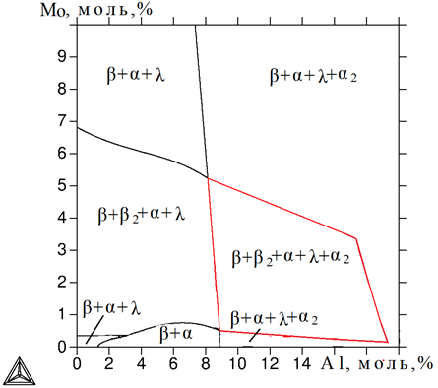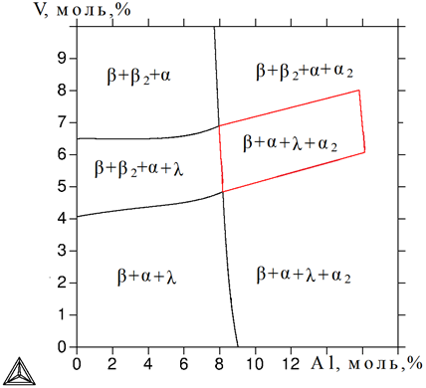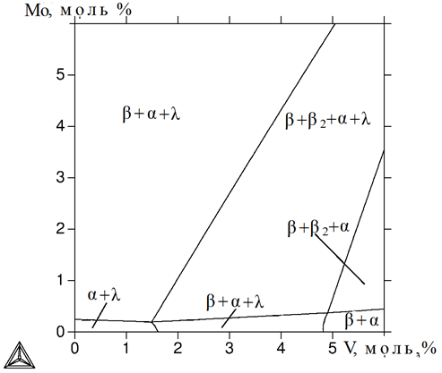
а) b) c)
а) Ti-5V-3Cr; b) Ti-5Mo-3Cr; c) Ti-5Al-3Cr

Figure 1 - Isothermal section Ti-Al-Mo-V-Cr at 400 ° C

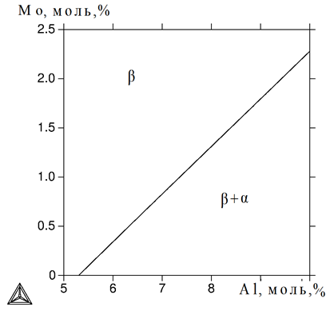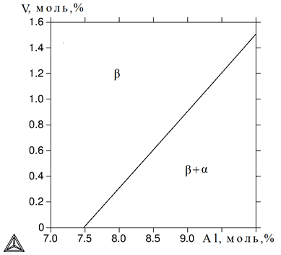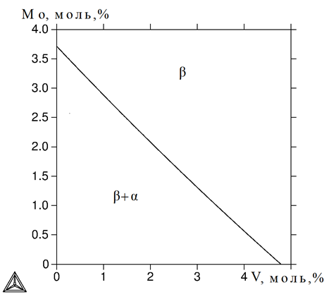
а) b) c)
а) Ti-5V-3Cr; b) Ti-5Mo-3Cr; c) Ti-5Al-3Cr

Figure 2 - Isothermal section Ti-Al-Mo-V-Cr at 800 ° C
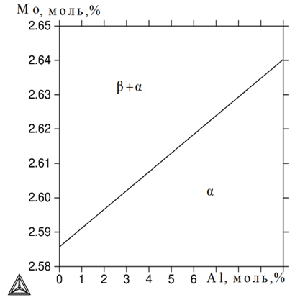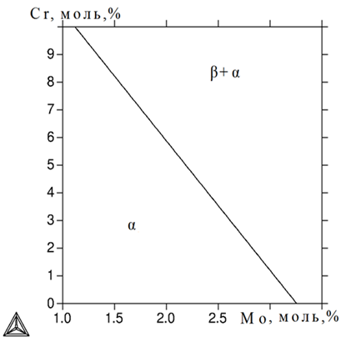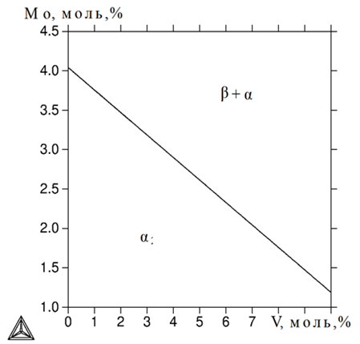
а) b) c)
а) Ti-5V-3Cr-1Re;b) Ti-5Al-5V-1Re; c) Ti-5Al-3Cr-1Re

Figure 3 - Isothermal section Ti-Al-Mo-V-Cr-Re at 400 ° С

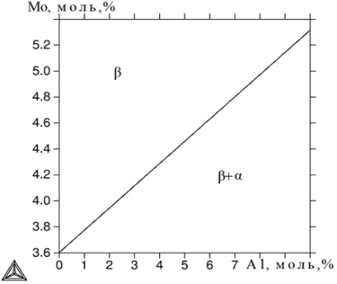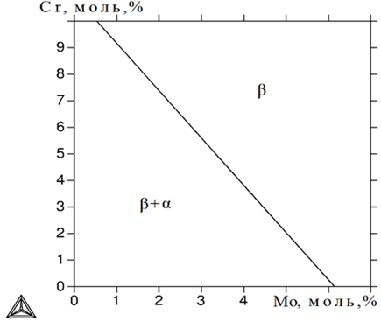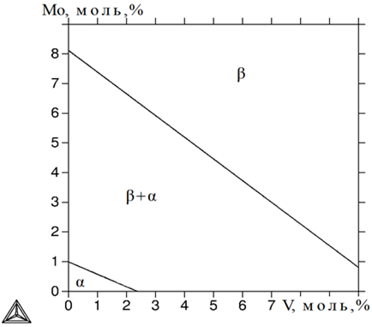
а) b) c)

Figure 4 - Isothermal section Ti-Al-Mo-V-Cr-Re at 800 ° C

From the data presented it follows that the introduction of an additional alloying component of rhenium into the titanium alloy increases its melting point by 100 ° C. The recommended temperature for melting the alloy of the Ti-5Al-5V-5Mo-3Cr-1Re system is 1800 - 1900 º C.
Heat treatment of castings of these alloys, which makes it possible to eliminate casting defects and improve mechanical properties, must be carried out below the temperature of nonequilibrium crystallization, i.e. below 880 ⁰С, and for the alloy of the Ti-5Al-5V-5Mo-3Cr system, heat treatment of castings can be carried out at a higher temperature (1530⁰ С).
In this case, it is of particular interest to determine the proportion of excess phases (QM), which is very problematic to do using traditional experimental methods. The calculation methods from these positions look much more attractive. In addition to the mass quantities of phases (Qm), the calculation allows one to determine their chemical composition. The results are shown in the table

Table 1 - Quantitative parameters of the phase composition of the Ti-5Al-5Mo-5V-3Cr-1Re alloy (mol %) at characteristic temperatures
Т, ºС | Phase | QM, % (маss.) | Content of elements,% (mass.)
Т, ºС | Phase | QM, % (маss.) | Ti | Al | V | Mo | Cr | Re
1400 | β | 100,0 | 76,19 | 2,65 | 5,00 | 9,42 | 3,06 | 3,65
1200 | β | 100,0 | 76,19 | 2,65 | 5,00 | 9,42 | 3,06 | 3,65
800 | β | 100,0 | 76,19 | 2,65 | 5,00 | 9,42 | 3,06 | 3,65
700 | β | 63,87 | 73,38 | 2,43 | 6,19 | 12,93 | 3,60 | 1,44
700 | α | 36,12 | 81,23 | 3,03 | 2,86 | 3,14 | 2,11 | 7,62
600 | β | 31,95 | 65,30 | 2,10 | 7,84 | 19,76 | 4,27 | 0,72
600 | α | 68,04 | 81,63 | 2,92 | 3,59 | 4,27 | 2,46 | 5,12
500 | β | 16,83 | 55,73 | 1,79 | 9,10 | 28,14 | 4,78 | 0,43
500 | α | 83,16 | 80,81 | 2,84 | 4,07 | 5,20 | 2,67 | 4,38
400 | β | 10,42 | 45,71 | 1,50 | 9,98 | 37,34 | 5,19 | 0,26
400 | α | 89,57 | 80,38 | 2,81 | 4,31 | 5,59 | 2,77 | 4,12

Thus, the compositions of rhenium-containing titanium alloys of the Ti-5Al-5Mo-5V-Cr-Re system were studied, depending on the content, mol%: rhenium 0.5-2.0; chromium 1-5. The temperatures of liquidus and solidus were determined for equilibrium and non-equilibrium crystallization for each composition. Recommended rhenium-containing titanium alloys of optimal composition, mass. %: 2.7 Al, 4.7 Mo, 9.4 V, 3.1 Cr, 3.7 Re, the rest is titanium. The temperature of the melting process is 1800 - 1900 ° C. The temperature of the annealing processes should not exceed 880 ° C.

2 Research and development of optimal technological modes for obtaining titanium alloys with increased heat resistance

To develop heat-resistant titanium alloys of the Ti-5Al-5Mo-5V-3Cr and Ti-5Al-5Mo-5V-3Cr-1Re systems, we carried out thermodynamic calculations and constructed polythermal sections of phase diagrams.
Fragments of polythermal sections of the Ti-5Al-5Mo-5V-3Cr system,
Ti-5Al-5Mo-5V-3Cr-1Re applied to β-stabilizers, calculated at constant concentrations of three components and varying concentrations of the fourth component are shown in Figures 5-6.

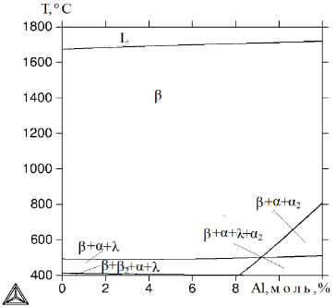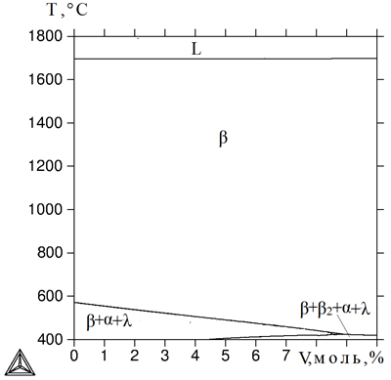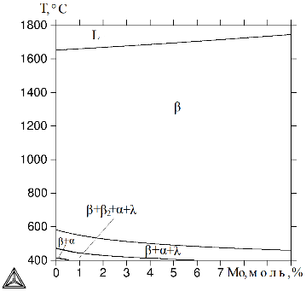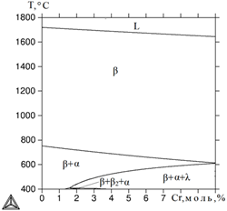
a) b) c) c)
a) Ti-5Mo-5V-3Cr, variable Al; b) Ti-5Al-5Mo-3Cr, variable V;
c) Ti-5Al-5V-3Cr, variable Mo; c) Ti-5Al-5Mo-5V, variable Cr

Figure 5 - Polythermal section of the Ti-5Al-5Mo-5V-3Сr system

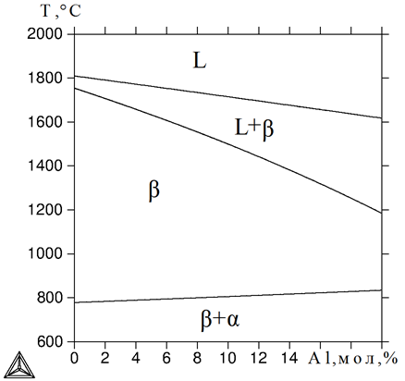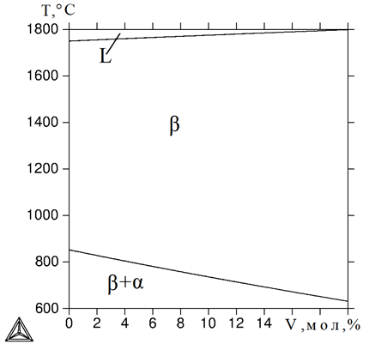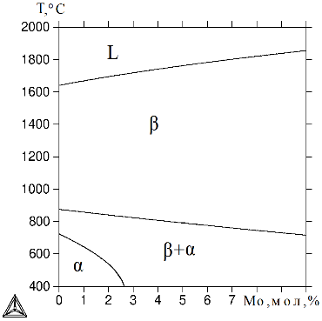
а b c
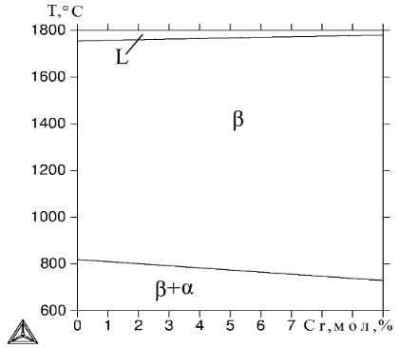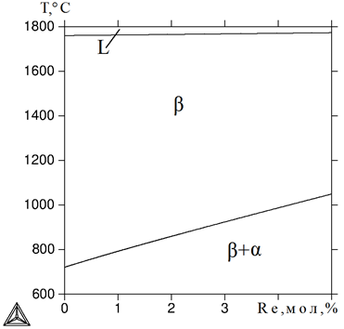
d e
a) Ti-5Mo-5V-3Cr-1Re, variable Al; b) Ti-5Al-5Mo-3Cr-1Re, variable V; c) Ti-5Al-5V-3Cr-1Re, variable Mo- d) Ti-5Al-5Mo-5V-1Re, variable Cr, e) Ti-5Al-5Mo-5V-3Cr-1Re variable Re

Figure 6 - Polythermal section of the Ti-5Al-5Mo-5V-3Cr-1Pe system
It has been established by computer simulation methods that the introduction of rhenium into a heat-resistant alloy of the Ti-5Al-5Mo-5V-3Cr system in an amount of 1% leads to a significant change in the phase composition. In the alloy under consideration, a two-phase (β+α) transformation takes place, instead of three-phase(β+α+λ+α₂) and four-phase (β+α+α₂) for the same systems without rhenium, in addition, in alloys of the Ti- 5Al-5Mo-5V-3Cr-1Re the formation of a two-phase (β+α)- area occurs almost 100˚С higher, which will increase their operating temperature range.
The technological modes of obtaining rhenium-containing titanium alloys have been studied and selected. Alloying with Ti-Re, Ti-V, Ti-50 Mo master alloys has been proposed, which give stable results on the composition of the alloys.
Technological modes of heat treatment of titanium alloys have been developed. It was found that the investigated Ti-5Al-5Mo-5V-3Cr and Ti-5Al-5Mo-5V-3Cr-1Re alloys after heat treatment have a two-phase structure, consisting of solid solutions based on α- and β-titanium, making the alloys more plastic ...

3 Creating samples of new heat-resistant titanium alloys and studying their physical and chemical properties

3.1 Research methods
The alloys were smelted in a laboratory vacuum arc furnace "Arc200" with a cooled copper hearth in Figure 7.

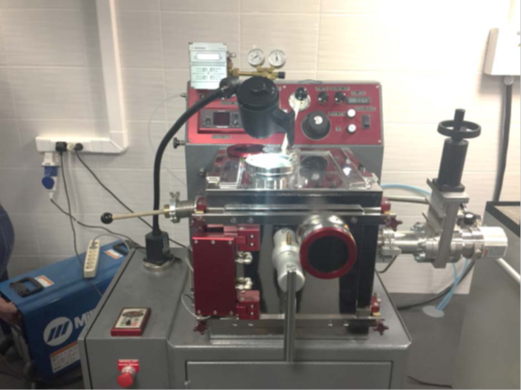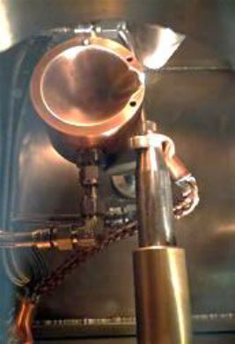
a - general view b - copper water-cooled
crucible

Picture 7 - Vacuum arc furnace with a copper water-cooled crucible
«Arcast Arc200»

After loading the charge, the furnace was evacuated to a pressure of 10⁻³ Pa and filled with argon with a purity of 99.995% to a pressure of 0.6 atm. To homogenize the composition over the cross-section of the alloy, 5 turns of the ingot were carried out, followed by remelting. The resulting melt was poured into a metal mold, which made it possible to obtain cylindrical ingots with a diameter of 15 mm.
For the preparation of ligatures and alloys used titanium iodide TU 48-4-286-82, aluminum A99 GOST 11069-2001 (table 2), vanadium VnM-1 TU 48-4-272-73, molybdenum MCh-1 TU48-19-245 -84, electrolytic chromium ERH-0 GOST 5905, rhenium Re-0 TU 48-19-92-80. They were used to obtain ligatures Ti-50% Mo (mass.), T_{pl}. 1945 ° C; Ti-20% Re (mass.), Mp - 1910 ° C; Ti-30% V (mass.) T_{pl} 1605 ° C, which were used to prepare the studied alloys.

Table 2 - Chemical composition of aluminum A995 and titanium
Material | Content of basic elements,% mass.
Material | impurities, no more
Material | Ni | C | Si | Fe | Cu | Mn | Mg | Ti | Ga
Al(А995) | - | - | 0,0015 | 0,0015 | 0,001 | 0,001 | 0,001 | 0,001 | 0,0030
Iodide titanium | 0,005 | 0,01 | - | 0,005 | - | - | - | - | -

After blending, the methods of casting and heat treatment are important aspects in the technology for producing titanium alloys, since the chemical and phase composition, mechanical and operational properties of castings depend on them. The obtained samples were subjected to heat treatment at a temperature of 850 oC for 3 hours, cooling with an oven to 760 oC; exposure 3 hours; air cooling to room temperature; heating to 650 C for 4 hours followed by quenching in oil.
Heating and subsequent cooling at a certain rate and under certain conditions was established based on the properties and structure of the initial alloy and the corresponding phase diagrams of heat-resistant titanium alloys [6, 9]. Considering that the decomposition of the β-phase in the alloys under study occurs very slowly, the completion of the phase synthesis after cooling was carried out with holding at a temperature of 760 ° C, which ensured the formation of a (α + β) microstructure close to equilibrium.
Such a variation in the heating and holding temperature is also used to obtain similar titanium alloys from powdery materials [10] and allows one to adjust the ratio between the achieved degree of chemical homogeneity and microstructural parameters. The implementation of these high-temperature processes with the ability to change the phase composition of the metal provides a flexible tool for creating materials with the required properties.
Procedure for determining the mechanical properties of titanium alloy samples
The cast specimens were tested for mechanical properties (ultimate strength –σv, yield point –σ0.2, and elongation – δ) according to the results of uniaxial tensile tests on a tensile testing machine of the R-10 type. The tests were carried out in accordance with GOST 1497-84. The test speed was 5mm / min.
Compression test. Compression tests for all samples were carried out on a Zwick Z250 universal electromechanical testing machine (Figure 16a). Cylinders 6 mm in diameter and 10 mm in height were used. the samples were heated by direct transmission of an electric current. Thermocouples (S-type) were welded to the sample surface to control the temperature directly. Tests with a depth of about 10-4 mm Hg were carried out in a vacuum.
The dependences of Young's modulus were determined by the test results, the proportionality limit and the yield point in the temperature range 20-100 ° C.
Tensile tests. To carry out tensile tests, rods were cast from each alloy into a metal mold in accordance with GOST 1583-93.
Tensile tests for all samples were carried out on a Zwick Z250 universal electromechanical testing machine (Figure 8). The mechanical properties of the samples were evaluated according to the values ​​of ultimate strength (σw), conditional yield stress (σ0.2) and relative elongation (δ).

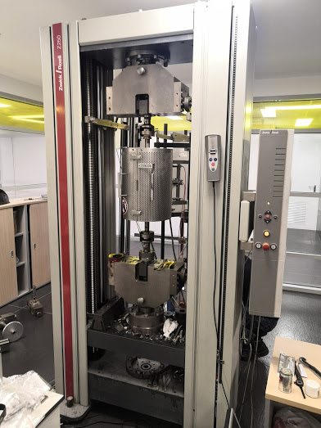

Figure 8 - Zwick Z250 universal electromechanical testing machine

Force measurement range 0.5 to 250 kN, traverse speed from 0.0005 to 600 mm / min, force measurement accuracy 0.5-1%, automatic contact strain gauge TC-EXMACRO for measuring elongation / deformation of a sample with an initial calculated length of 10 -100 mm.
Hardness measurement. In this work, standard measurements of Brinell hardness were carried out in accordance with GOST 6012-59 [22]. To measure the hardness, a multi-functional stationary hardness tester HB 250 kgf (Figure 9) with a steel ball indenter diameter of 2.5 mm was used. A load of 62.5 kg was applied to the indenter. The time for each test was 15 seconds. A series of three measurements was made for each sample.

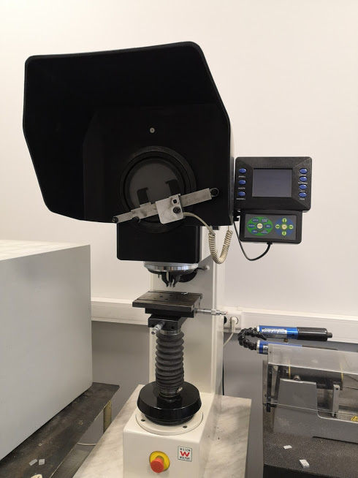

Picture 9 - Universal hardness tester DIGI-TESTOR 930 HB 250 kgf

The purpose of these studies was to determine the critical temperatures of phase transformations in alloys for plotting fragments of phase diagrams and to compare the results with calculated data.
3.2 Investigation of the density of heat-resistant titanium alloys Ti-5Al-5Mo-5V-3Cr and Ti-5Al-5Mo-5V-3Cr-1Re
Preparation of alloys Ti-5Al-5Mo-5V-3Cr and Ti-5Al-5Mo-5V-1Re was carried out on a laboratory argon-vacuum arc furnace "Arcast Arc200" with a water-cooled copper tray. After loading the charge, the furnace was evacuated and filled with argon. To homogenize the composition over the cross section of the ingot, 5 turns of the ingot were carried out, followed by remelting. The melt was poured into a metal mold and cylindrical ingots with a diameter of 15 mm were obtained.
The obtained samples were subjected to heat treatment at a temperature of 850 ° C for 3 hours, followed by holding at a temperature of 760 ° C for 4 hours and quenching in oil, which ensured the formation of an α + β- microstructure close to equilibrium.
The phase composition and microstructure of cast and heat-treated samples were studied using a Tescan Vega 3 LM scanning electron microscope (SEM) with an EDX Oxford X-Max80 attachment. X-ray phase analysis was carried out on a Bruker D8 Advance diffractometer using Cu K_{α} monochromatic radiation. The microstructure of the investigated alloys was revealed by chemical etching in a mixture of acids 2.5% HNO₃ + 1% HF + 1.5% HCl. Typical microstructures of Ti-5Al-5Mo-5V-3Cr-1Re alloys obtained by SEM are shown in Figure 10.

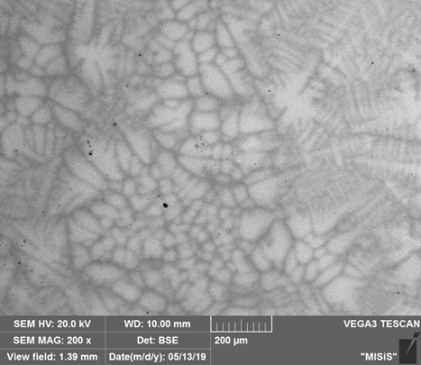 | 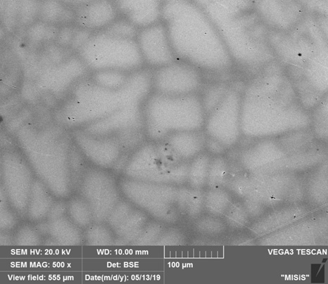
a - an increase of 200, b - an increase of 500

Figure 10- Microstructure of SEM alloy Ti-5Al-5Mo-5V-3Cr-1Re:
The figures show microstructural inhomogeneity arising from the existence of a concentration gradient of alloying elements. The internal structure of grains is formed mainly in the form of small colonies of β - phases with interlayers of α - plates, which is caused by incomplete processes of chemical homogenization. A similar behavior was noted for other titanium alloys with refractory metals [6]. The light zones in the photo show the places where the alloys are enriched in heavy elements, in our case, these are Mo and Re.
The compositions of the alloys Ti-5Al-5Mo-5V-3Cr and Ti-5Al-5Mo-5V-1Re, measured by micro X-ray spectral analysis (MRSA), are shown in Table 3.

Table 3 - Compositions of Ti-5Al-5Mo-5V-3Cr and Ti-5Al-5Mo-5V-1Re alloys according to MRSA data
Alloy | Content of alloying elements, wt. %
Alloy | Ti | Al | Mo | V | Cr | Re
Ti-5Al-5Mo-5V-3Cr | 82,1 | 5,1 | 5,2 | 4,8 | 2,9 | -
Ti-5Al-5Mo-5V-3Cr-1Re | 81,0 | 4,9 | 4,9 | 5 | 3,1 | 1,2

The density of the obtained alloys was determined by the method of hydrostatic weighing on a laboratory balance "Vibra" with a gravimeter function to determine the density of the samples. In the gravimeter mode, the alloy samples were weighed in air and in distilled water. The results of measuring the density (ρ_{ex}) of alloys
Ti-5Al-5Mo-5V-3Cr and Ti-5Al-5Mo-5V-1Re are shown in Table 4, column 2.

Table 4 - Experimental and calculated densities of Ti-5Al-5Mo-5V-3Cr and Ti-5Al-5Mo-5V-1Re alloys, g / cm³
Alloy | ρ_{экс} | ρ_{ад} | ∆ρ_{ад}/ ρ_{экс}, % | ρ_{уд} | ∆ρ_{уд}/ ρ_{экс}, %
Ti-5Al-5Mo-5V-3Cr | 4,603 | 4,852 | 5,41 | 4,583 | 0,43
Ti-5Al-5Mo-5V-3Cr-1Re | 4,656 | 5,053 | 8,46 | 4,633 | 0,49

The increased density of the Ti-5Al-5Mo-5V-3Cr-1Re alloy is explained by the presence of heavy rhenium atoms in it.
Often, when determining any properties of mixtures, alloys or other complex substances, the method of additive addition is used. Its essence lies in the assumption that the properties of complex mixtures change linearly and depend mainly on the concentration of the added components. The density of the alloys with the additive approximation ρ_{ad} is calculated by the following formula:

$ρад= \sum_{i}{(ηi × ρi)}$ (1)

where i is Ti, Al, Mo, V, Cr or Re, and η_{i} and ρ_{i} are their mass fraction in the alloy and density, respectively.
For all alloys in expanded form, formula (1) will have the following form:

pсп=ηTi× ρTi + ηAl × ρAl+ ηMo × ρMo+ ηV ×ρV+ ηCr х ρCr + ηRe × ρRe (2)

The calculated ρad data for alloys of the Ti-5Al-5Mo-5V-3Cr and Ti-5Al-5Mo-5V-1Re systems, depending on the composition of the analysis obtained from the MRSA analysis and the metal density data [9], are given in Table 3, column 3.
It can be seen that the calculated data differ from the obtained experimental results by 5.5–8.5% (column 4). This is because this addition results in a significant averaging of the results obtained. For a more accurate determination of density, the method of specific volumes can be used, the essence of which is that the total volume of the alloy V_{sp} consists of the sum of the volumes of the components that make up the alloy.

$Vсп=\sum_{сп}{Vi}$ (3)

where V_{i} = m_{i} / ρ_{i} is the volume occupied by Ti, Al, Mo, V, Cr or Re atoms, and mi and ρ_{i} are their mass and density, respectively.
Taking this into account, the calculated dependence of the density of the alloy will have the following form:

$Mсп/ ρуд = \sum_{i}{(mi}/ρi)$ (4)

Since m_{i} = η_{i} * M_{sp}, the density value after appropriate transformations of the above expression, calculated by the method of specific volumes, can be represented as:

$ρуд = 1/\sum_{i}{(ηi}/ρi)$ (5)

in expanded form, expression (3) looks like this:

$ρсп+1/(ηTi/ρTi+ηAl/ρAl+ηMo/ρMo+ηV/ρV +ηCr/ρCr+ηRe×/ρRe)$ (6)

The values of the density of alloys of the systems Ti-5Al-5Mo-5V-3Cr -1Re and Ti-5Al-5Mo-5V-1Re, calculated by the method of specific volumes, are also presented in Table 3 (column 5) and have a much better agreement with the experimental results than in the method of additive addition (column 6).
The good agreement between the calculated and experimental densities can be explained by the fact that the volume of the mixture is not in all cases equal to the sum of the volumes of the individual components. This is due to the interpenetration of substances (atoms or molecules) into free spaces. In addition, alloying the alloy with atoms of different sizes leads to distortion of the crystal structure, which changes the average sizes between atoms and, accordingly, also affects its density. Most likely, in this case, there was a mutual attenuation of these influences, which led to a good coincidence of the calculated data obtained by the method of specific volumes with experiment.
The above calculations were performed without taking into account the phase structure of the alloy. In practice, most real alloys have a complex multiphase structure. If the alloy in the solid state has a structure consisting of solid solutions α and β-phases, then in the calculation formulas it is necessary to take into account the fractional component and composition of each phase.
In this case, the densities of each phase are first calculated using formula 4 or 6, depending on the calculation method, and then the total density is calculated. For additive addition, use the formula:

$ρсп = η× +η×$ (7)

In the method of specific volumes:

$ρсп = 1/( η / +η / )$ (8)

where η_{α}, η_{β} are the content of each of the phase components in the alloy, ρ_{α}, ρ_{β} are their densities, respectively.
The phase composition, the compositions of the structural components, measured by the MRSA method, as well as the calculated values of the densities of various phases of the alloys of the Ti-5Al-5Mo-5V-3Cr-1Re and Ti-5Al-5Mo-5V-1Re systems performed by various methods are shown in Table 5.

Table 5 - Calculated values of the densities of various phases and alloys, depending on the composition
Analysis area | Phase fraction,% | Content of alloying elements, wt. % |  |  |  |  |  | ρ_{ад} | ρ_{уд}
Analysis area | Phase fraction,% | Ti | Al | Mo | V | Cr | Re | ρ_{ад} | ρ_{уд}
1 | 2 | 3 | 4 | 5 | 6 | 7 | 8 | 9 | 10
Ti-5Al-5Mo-5V-3Cr
α-phase | 30 | 89,5 | 7,9 | 0,9 | 1,3 | 0,4 | - | 4,458 | 4,323
β-phase | 70 | 78,97 | 3,9 | 6,5 | 6,59 | 4,05 | - | 5,021 | 4,704
Calculation of the density of the alloy ρ_{ad} by the formula (3), ρ_{sp} by the formula (4) |  |  |  |  |  |  |  | 4,851 | 4,582
Ti-5Al-5Mo-5V-3Cr-1Re
α-phase | 35 | 89,1 | 7,1 | 0,9 | 1,6 | 0,4 | 0,8 | 4,617 | 4,383
β-phase | 65 | 76,79 | 3,72 | 7,05 | 6,83 | 4,25 | 1,36 | 5,277 | 4,781
Calculation of the density of the alloy ρ_{ad} by the formula (3), ρ_{sp} by the formula (4) |  |  |  |  |  |  |  | 5,048 | 4,632

It is clearly seen that with all calculation methods, the α-phase containing an increased amount of aluminum is noticeably lighter than the β-phase enriched in molybdenum and chromium. With an additive addition in Ti-5Al-5Mo-5V-3Cr alloys, the difference in the densities of the α and β- phases is 10.1%, and in Ti-5Al-5Mo-5V-3Cr-1Re alloys, 12.5%. In the method of specific volumes, the difference in the densities of the α and β- phases of the same alloys is 6.65% and 8.3%, respectively.
The calculation of the density of the alloy, taking into account the density of the α and β- phases, by the methods of additive addition and specific volumes, coincides well with the density of these alloys obtained by the same methods without taking into account the phase state of the alloy, Table 4 (columns 3 and 5).
Thus, experimentally, the density of heat-resistant titanium alloys Ti-5Al-5Mo-5V-3Cr and Ti-5Al-5Mo-5V-3Cr-1Re was determined by the method of hydrostatic weighing.
Based on the MRSA data, the densities of these alloys were calculated by the methods of additive addition and specific volumes taking into account their composition. It was revealed that with additive addition the discrepancy with the experiment is 8-10%, and in the method of specific volumes 0.3-0.5%.
Calculations of the density of titanium alloys Ti-5Al-5Mo-5V-3Cr and Ti-5Al-5Mo-5V-3Cr-1Re are also performed taking into account the phase structure. It is shown that the difference in the densities of the and β -phases for all alloys is 6.5 - 10.1%, while good agreement with the calculated density of these alloys made without taking into account the phases is noted.
Based on the above, when calculating the density of complex alloyed titanium alloys, it is recommended to use the method of specific volumes and ignore the phase component of the alloy.

2.3 Study of mechanical properties of new alloys with recommendations for their use
The microstructure and phase composition of heat-treated samples were studied using a tescan Vega 3 LM scanning electron microscope with an EDX Oxford X-Max 80 prefix. The microstructure of the studied alloys was detected by chemical etching in a mixture of 2.5% HNO3+ 1% RA + 1.5% HC acids.
The mechanical properties of the obtained samples were determined using a universal testing machine Zwick Z250. Compression tests were performed at a temperature of 600oC on cylindrical samples with a diameter of 8 mm and a height of 12 mm to a degree of deformation of 50%. The results of mechanical compression tests are shown in figure 11.

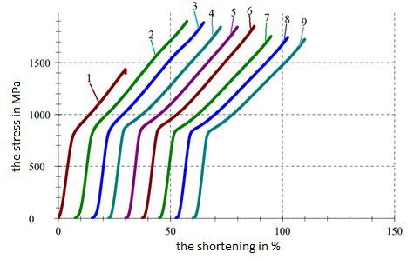

Figure 11 - mechanical compression tests of ti-5Al-5Mo-5V-3Re (1 - 3), Ti-5Al-5Mo-5V-3Cr-1Re (4 - 6), Ti-5Al-5Mo-5V-3Cr (7-9) alloys in the heat-treated state

It can be seen that all alloys initially have elastic deformation up to the stress of 750-900 MPa, which then turns into plastic deformation caused by the processes of dynamic recrystallization and polygonation. Adding 1% rhenium to the ti-5Al-5Mo-5V-3Cr alloy increases the strength properties of the alloy in the zone of elastic deformation by 2 - 3% , and in the zone of plastic deformation it reduces by 3-4%. In the ti-5Al-5Mo-5V-3Re alloy, where chromium is replaced by rhenium, the strength properties deteriorated by 1.5-2% in the elastic deformation zone, and in the plastic deformation zone (if sample №1 is not taken into account), the strength properties increased by 2-3%. The relative shortening of all alloys is approximately the same and is approximately 36-38%.
The mechanical properties of the tested tensile samples were also carried out on a Zwick Z250 test machine at a temperature of 600 oC. For this purpose, cylindrical samples of a special shape were used. The results of mechanical tensile tests are shown in figure12.

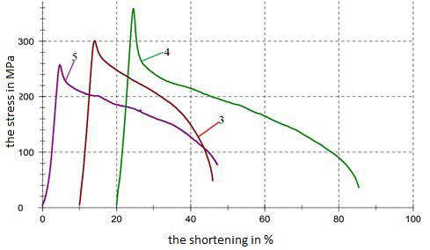

Figure 12 - Mechanical tensile tests of ti-5Al-5 M5 V3 (1) ti-5Al-5 M5 V3 (2) and Ti-5Al-5 Mo-5V-3 Cr1 Re (3) alloys at 600 C.

For all alloys, the transition from elastic to plastic deformation is clearly marked as peaks. In this case, these peaks can be considered the beginning of the dynamic recrystallization process and polygons that occur during hot deformation in a certain range of strain rates.
Replacement of chromium in ti-5Al-5 Mo-5V-3 Cr alloy with rhenium leads to a 13-15% decrease in strength properties, and the elongation increases to 45%. Adding 1% rhenium to this alloy increases the tensile strength by 20% and the elongation by up to 64%.
One of the important physical and mechanical properties of alloys is the hardness, which was determined in the samples under study using the Brinell method. During the tests, the following parameters were used: the diameter of the inductor is 2.5 mm, the load is 62.5 kg, and the holding time is 15 seconds. The hardness values of heat-treated samples are shown in table 6, where they are compared with the mechanical properties of these alloys during compression and tensile tests.

Table 6 - Hardness, yield strength and relative shortening under compression and tension
Alloy | Hardness,  HB | Compression |  | Stretching
Alloy | Hardness,  HB | σ_{0,2}, МПа | Ψ,% | σ_{0,2}, Мпа | δ, %
Ti-5Al-5Mo-5V-3Cr | 280 | 775 | 37 | 297 | 35
Ti-5Al-5Mo-5V-3Re | 275 | 765 | 36 | 256 | 45
Ti-5Al-5Mo-5V-3Cr-1Re | 315 | 798 | 38 | 358 | 64
After adding rhenium to the Ti-5Al-5Mo-5V-3Cr alloy, the hardness increased by 12.5%, however, in alloys where chromium is replaced by rhenium, the hardness decreased by 2%. This is due to the fact that the addition of a larger rhenium atom in the alloys, which also has a significant number of collectivized electrons, increases the lattice period, increasing the stacking fault energy. All this affects the diffusion mobility of titanium atoms and alloying components, thereby changing the resistance to high-temperature creep of the alloy.
When 1% rhenium is added to the titanium alloy Ti-5Al-5Mo-5V-3Cr, changes in the morphology of the crystal lattice have a positive effect on the strength characteristics of the alloy in the range of elastic and plastic deformations. As a result of replacing chromium by 3% rhenium, the distortions in the crystal lattice are greater and the increased stacking fault energy already reduces the strength properties of the alloy in the region of elastic deformations, however, facilitates diffusion mobility and simplifies the sliding of dislocations, which improves the mechanical properties of these alloys during plastic deformation [11- 12].
Since the investigated alloys operate mainly in elastic deformation zones, the optimal alloying should be the addition of 1% rhenium to the Ti-5Al-5Mo-5V-3Cr alloy, and the replacement of 3% chromium by 3% rhenium in these alloys worsen these properties.
Typical photographs of the microstructure of heat-treated alloys of the Ti-5Al-5Mo-5V-3Cr, Ti-5Al-5Mo-5V-3Re and Ti-5Al-5Mo-5V-3Cr-1Re systems after compression and tensile tests at various magnifications are shown in the figures 13-15.

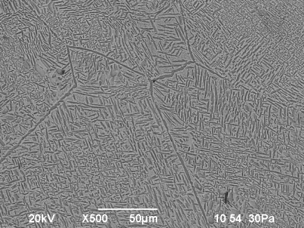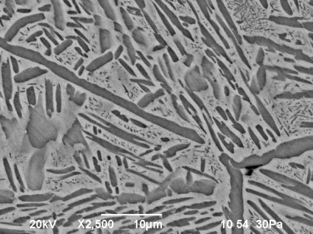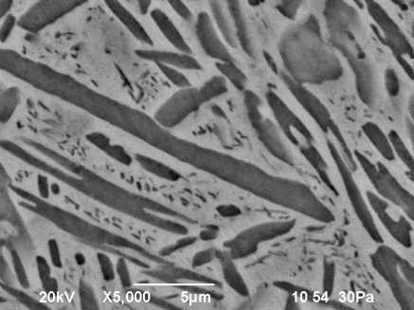
а

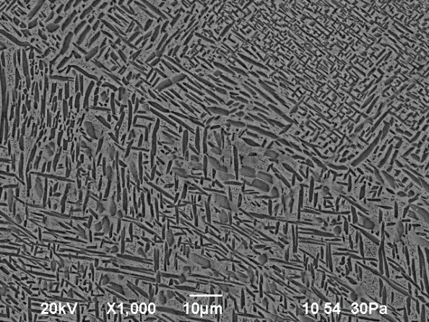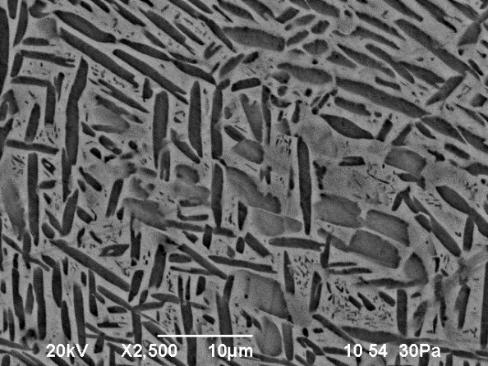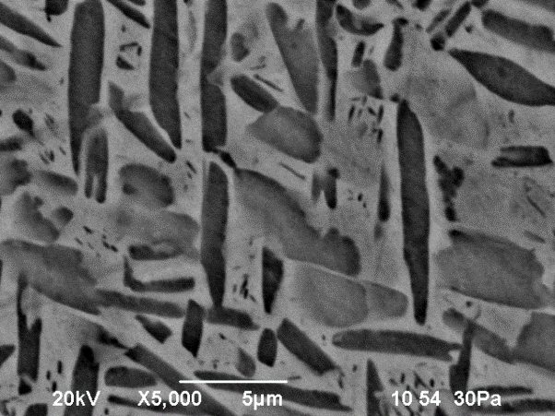
b

Figure 13 - Typical microstructures of heat-treated alloys of the Ti-5Al-5Mo-5V-3Cr systems after tensile (a) and compression (b) tests at various magnifications

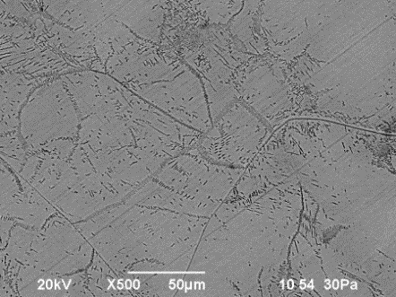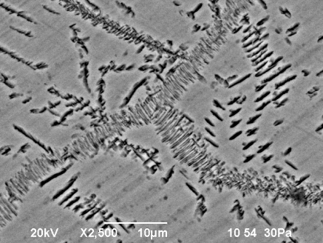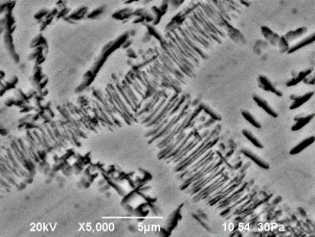
а
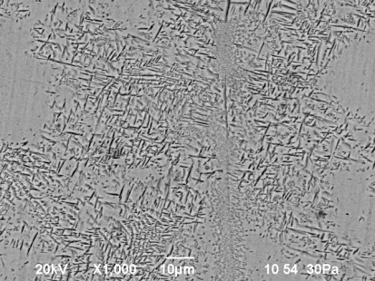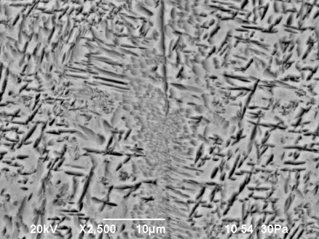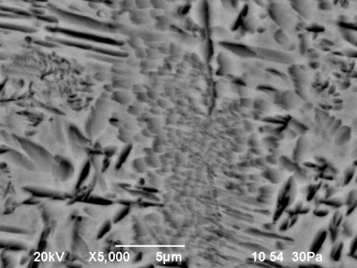
b

Figure 14 - Typical microstructures of heat-treated alloys of the
Ti-5Al-5Mo-5V-3Re systems after tensile and compression tests at various magnifications

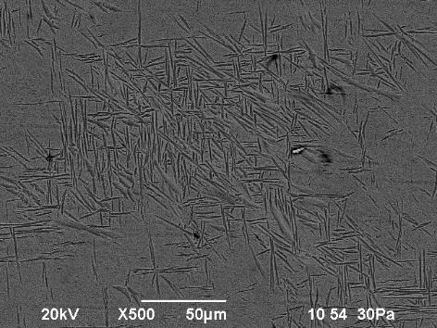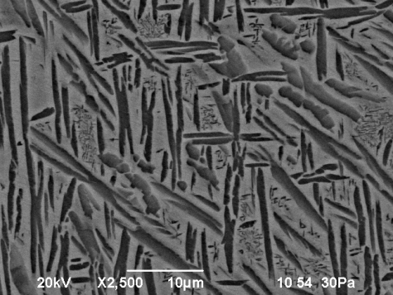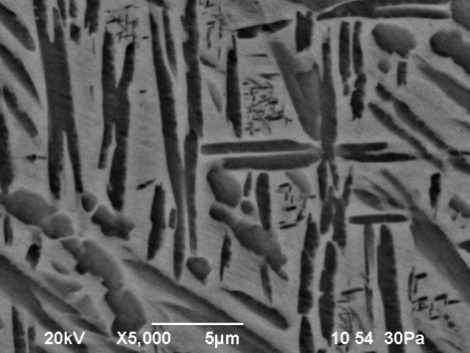
а
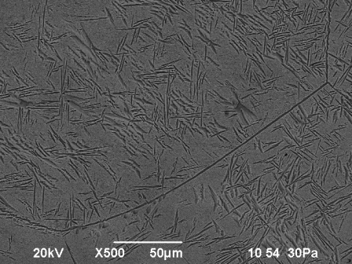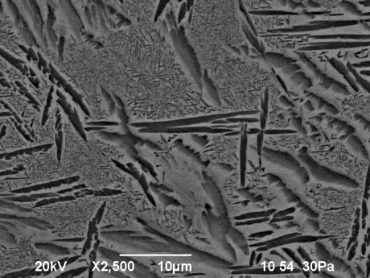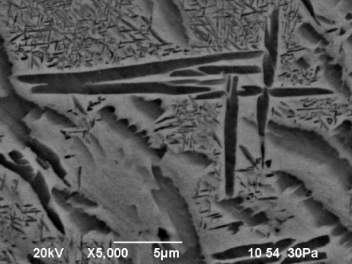
b
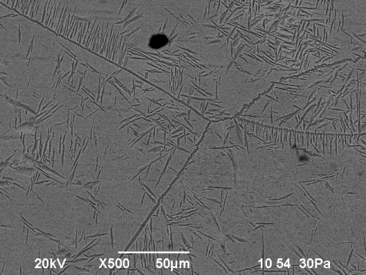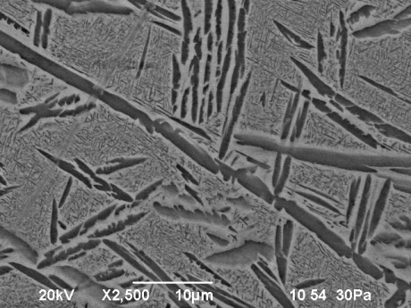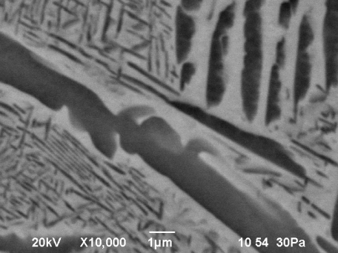
c
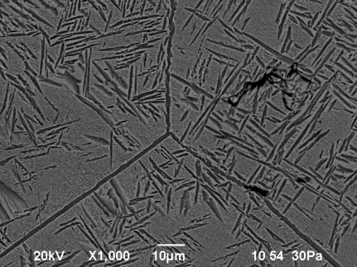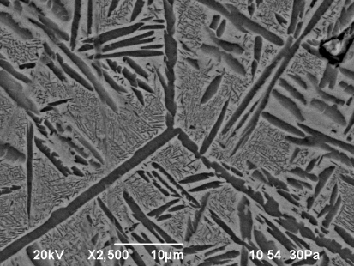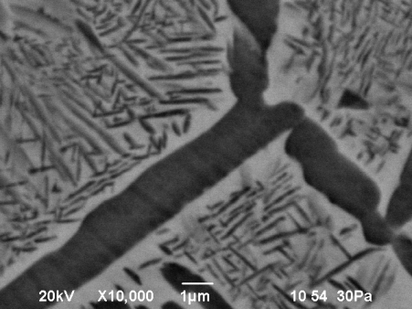
d

Figure 15 - Typical microstructures of heat-treated alloys of the Ti-5Al-5Mo-5V-3Cr-1Re systems after tensile (a, b) and compression (c, d) tests at different magnifications

The structure of these alloys is a two-phase mixture. Allocations of the α-phase are dispersed, mainly in the form of plates and are located in the body of the β-phase. The particle sizes of the α-phase and their volume fraction are presented in Table 7.

Table 7 - Particle size of the α -phase and their volume fraction
Alloy | Particle size of the α-phase, microns |  | Volume fraction  α - phases, %
Alloy | Length | Width | Volume fraction  α - phases, %
Ti-5Al-5Mo-5V-3Cr | 10± 3 | 1,0± 0,3 | 30
Ti-5Al-5Mo-5V-3Re | 3± 1 | 0,5± 0,1 | 15
Ti-5Al-5Mo-5V-3Cr-1Re | 15± 5 | 1,5± 0,5 | 35

In the alloys of the Ti-5Al-5Mo-5V-3Cr and Ti-5Al-5Mo-5V-3Cr-1Re systems, the size of the α-phase particles is approximately the same, and in the alloys of the Ti-5Al-5Mo-5V-3Re systems, their size is almost three times less. In this case, the volume fraction of particles of the α-phase in the Ti-5Al-5Mo-5V-3Re alloy is also smaller.
No distortions of the structure of particles of the α-phase and microstructural changes in the bodies of the β-phase after high-temperature mechanical loads were found in the alloys under study. This suggests that the processes of polygonization and dynamic recrystallization took place in polycrystalline bodies of the β-phase, the mechanism of which can be described as the nucleation and growth of new grains when critical values of plastic deformation are reached at a sufficiently high temperature [13].
The mechanisms of dynamic recrystallization and polygony are controlled by the stored energy of deformation and cannot be determined only by the processes of elemental diffusion, since they will be absorbed by the high energy of the stacking fault in complex alloyed titanium alloys. The state of the internal structure has a decisive influence on the mechanical properties of polycrystalline materials. Recrystallization takes place with a change in a number of physical properties and structure of the material. First of all, the shape and size of the grains change. The nature of the changes depends on the temperature, the amount of deformation, the chemical composition of the alloy, the initial grain size, while the shape of the recrystallized grains is predominantly equiaxed.
At present, the process of dynamic recrystallization is recognized as one of the main mechanisms of softening during hot deformation of crystalline materials [14] and is largely determined by the motion of dislocations, which are found in the form of etching pits in the places where dislocations emerge on the crystal surface, which is clearly seen in Figures 13b and 14b. ). For Ti-5Al-5Mo-5V-3Cr and Ti-5Al-5Mo-5V-3Cr-1Re alloys, their dimensions are 5-10 microns (Figures 13b and 14b), and for Ti-5Al-5Mo-5V-3Re 3 alloys -5 μm (Figure 15a).
At a high degree of deformation, the density of dislocations increases and their manifestations after mechanical loads can look like solid lines formed as a result of etching out the deformed regions. The number of the latter is insignificant, however, they have rather large sizes up to 200 μm for the Ti-5Al-5Mo-5V-3Cr and Ti-5Al-5Mo-5V-3Cr-1Re alloys (Figures 13a and 14c, 15d).
In Ti-5Al-5Mo-5V-3Re alloys, due to the high energy of the stacking fault in the crystal lattice, dislocation manifestations are hindered, the sizes of the deformed regions are smaller and amount to 3-5 microns, but their number in some areas is quite large and appear as small lines (Figure 15 a) or wrinkled sweet (Figure 14b). It should be noted that the morphology of the lamellar structure is preserved after deformation and almost all recrystallization and polygonic processes occur in the β− phase, practically without affecting the harder α- phase.
Microstructural observations indicate that the dynamic recrystallization of grains in Ti-5Al-5Mo-5V-3Cr alloys upon deformation leads to the alignment of grains along the direction of compression (Figure 15a). The resulting grains remain straight, slightly elongated, and run in two directions. The structure of grains in Ti-5Al-5Mo-5V-3Cr-1Re alloys is generally rectangular, the newly formed grains are located at right angles to each other (Figures 15a, 15b). In Ti-5Al-5Mo-5V-3Re alloys, many of the newly formed grains are significantly smaller and are also mutually perpendicular, similar to the previous alloy (Figure 15).

CONCLUSION
Basic research results. New titanium alloys of high heat resistance alloyed with refractory metals have been developed.
At the stage of 2018, using modern software products, model calculations were carried out and isothermal phase diagrams of heat-resistant titanium alloys of the systems Ti-5Al-5Mo-5V-3Cr, Ti-5Al-5Mo-5V-3Cr-Re at temperatures of 400-1400°C were constructed.
Compositions of rhenium-containing titanium alloys of the Ti-5Al-5Mo-5V-Cr-Re system have been studied depending on the content, mol%: chromium 1-5, rhenium 0.5-3.0. It has been established that the introduction of rhenium into a heat-resistant alloy of the Ti-5Al-5Mo-5V-3Cr system in an amount of 1% leads to a significant change in the phase composition. In the alloy under consideration, a two-phase (β+ α) transformation takes place, instead of three-phase (β+ α+ α₂), four-phase (β+α+λ+α₂) for the same systems without rhenium, the presence of this phase increases the heat-resistant properties of the alloy.
Recommended rhenium-containing titanium alloys of optimal composition, wt. %: 2.7 Al, 4.7 Mo, 9.4 V, 3.1 Cr, Re, the rest is titanium; melting process temperature 1800 - 1900°C; annealing temperature not higher than 880ºC.
At the stage of 2019, technological methods for introducing alloying components into titanium alloys were developed. It is recommended to use ligatures of the following composition, %mass, for their uniform distribution and obtaining stable results on the composition of alloys. : Ti-20Re, Ti-30V, Ti-50 Mo.
It was found that in alloys of the Ti-5Al-5Mo-5V-3Cr-1Re system, the formation of a two-phase (β+α)-region occurs almost 100°C higher than in the known alloys of the Ti-5Al-5Mo-5V-3Cr system. This contributes to an increase in the temperature range of operation of rhenium-containing titanium alloys.
Technological modes of heat treatment of titanium alloys have been proposed, which make it possible to regulate the ratio between the achieved degree of chemical homogeneity and microstructural parameters: temperature 850ºC for 3 hours, cooling with a furnace to 760ºC; exposure 3 hours; air cooling; heating to 650 C for 4 hours followed by quenching in oil.
It was found that the investigated Ti-5Al-5Mo-5V-3Cr and Ti-5Al-5Mo-5V-3Cr-1Re alloys after heat treatment have a two-phase structure consisting of solid solutions based on α- and β-titanium, making the alloys more ductile. In the alloys under study, the α-phase is enriched only with aluminum, the concentration of all other alloying agents is higher in the β-phase. This is especially noticeable for molybdenum and chromium, metals with large atomic sizes, the concentration of which increases by 8.2 and 1.6 times, respectively. Rhenium is concentrated mainly in the α-phase.

At the stage of 2020, samples of new heat-resistant titanium alloys were created and their physical and chemical properties were investigated.
High-temperature tests of the mechanical properties of the created new heat-resistant alloys 5Al-5Mo-5V-3Re and Ti-5Al-5Mo-5V-3Cr-1Re for compression and tension at a temperature of 600ºC have been carried out.
It is found that the addition of 1% rhenium to the Ti-5Al-5Mo-5V-3Cr alloy has a positive effect on the morphology of the crystal lattice and increases the high-temperature strength characteristics of the alloy in the range of elastic and plastic deformations. It is shown that replacing chromium by 3% rhenium reduces the strength properties of the alloy in the region of elastic deformations, improving them in the plastic region.
The microstructure of new complex alloyed alloys 5Al-5Mo-5V-3Re and Ti-5Al-5Mo-5V-3Cr-1Re is investigated. It is shown that during heat treatment a two-phase (α + β) structure of alloys with an α-phase content of 30-40% was formed. No structural or microstructural distortions were found in the alloys under study after high-temperature mechanical loads.
The absence of distortion of the microstructure in the samples under study suggests that, after reaching the critical values of high-temperature deformation, recrystallization and polygonal processes occurred in them, due to the motion of dislocations. The presence of etching pits in the places where these dislocations emerge onto the crystal surface are noted. At a high dislocation density, they look like solid lines and have sizes up to 200 μm.
The density of heat-resistant titanium alloys Ti-5Al-5Mo-5V-3Cr and Ti-5Al-5Mo-5V-3Cr-1Re was determined experimentally, by the method of hydrostatic weighing, as well as by calculation methods of additive addition and specific volumes. It was revealed that with additive addition the discrepancy with the experiment is 8-10%, and in the method of specific volumes 0.3-0.5%. The use of the specific volume method is recommended.
Assessment of the completeness of the solution of the tasks. New titanium alloys of increased heat resistance alloyed with refractory metals have been developed and created. All tasks set in the project were completed in full accordance with the schedule.
Recommendations and initial data on the specific use of research results. Assessment of the technical and economic efficiency of implementation. The results obtained during the implementation of the project will allow the creation of new heat-resistant titanium alloys operating at higher temperatures than the known ones.
Assessment of the scientific and technical level of the performed research work in comparison with the best achievements in this area. This development was carried out at a high scientific and technical level using modern research equipment, based on the latest achievements in the field of metallurgy and materials science of titanium alloys.
The most important advantages of titanium alloys over other structural materials are their high specific strength and corrosion resistance. However, titanium alloys can operate at relatively low temperatures up to 500°C. One of the topical aspects of increasing the temperature range of operation of titanium alloys is alloying them with refractory metals.
This work shows the possibility of obtaining new alloyed heat-resistant titanium alloys containing rhenium. Additional alloying with rhenium changes the phase structure of the alloys and increases its operating temperature by 80-100°C.
The research results were reported at an international scientific-practical conference, 3 scientific articles were published in a domestic scientific publication with a non-zero impact factor, 2 scientific articles in a journal with a non-zero impact factor of the Web of Science database.
Organizational and material - technical provision for performing research. Scientific research work on the project was carried out in the RSE «National Center on complex processing of mineral raw materials of the Republic of Kazakhstan», Almaty, "Kazakh National Research Technical University" named after K.I. Satpayev, Almaty and NUST MISIS, Moscow.
The team of performers, including 1 doctor of technical sciences, 3 candidates of sciences, 1 PhD, 2 PhD students, has significant research and practical experience in the field of metallurgy and metal science.
The project executors are provided with the necessary regulatory and methodological materials, have hosted devices and certification methods for carrying out experimental work.
For the successful implementation of the tasks of the project, there are laboratory facilities equipped with the appropriate infrastructure, as well as an experimental workshop for conducting enlarged laboratory tests. The laboratories are equipped with instruments and equipment necessary for conducting research and enlarged laboratory tests.
During the implementation of the project, modern research and analytical equipment was used. To carry out the research, we used computer programs for the analysis and processing of experimental data, as well as programs for calculating phase transformations Thermo-Calc.
The alloys were melted in a laboratory argon-vacuum arc furnace "Arcast Arc200" with a water-cooled copper tray. The microstructure of cast and heat-treated samples was studied using a Tescan Vega 3 LM scanning electron microscope (SEM) with an EDX Oxford X-Max80 attachment. X-ray phase analysis was carried out on a Bruker D8 Advance diffractometer using Cu K_{α} monochromatic radiation.
The mechanical properties of the obtained samples were determined using a Zwick Z250 universal testing machine. The density of the alloys was determined by the method of hydrostatic weighing on a laboratory balance "Vibra" with a gravimeter function.
Economic feasibility of the requested amount of funding for R&D. Project costs include the following items: salary with deductions, travel expenses, purchase of materials, others (translations, registration fees), project support.

LIST OF USED SOURCES

1 Inozemtsev A.A., Bashkatov N.G., Koryakovtsev A.S. Modern titanium alloys and problems of their development. - M.: VIAM, -2010. Р. 43-45.
2 Reda R., Nofal A.A., Hussein A.A. Effect of quenching temperature on the mechanical properties of cast Ti–6Al–4V alloy // J. Metall. Eng. 2013. 2(1), 48–54.
3 Hu D., Wu X., Loretto M.H. Advances in optimization of mechanical properties in cast TiAl alloys // Intermetallics. -2005. V.13. P. 914.
4. Hua K., Xue XY., Kou HC., Fan JK., Tang B., Li JS. High temperature deformation behaviour of Ti-5Al-5Mo-5V-3Cr during thermomechanical processing // Materials Research Innovations. -2014. № 18(Suppl 4). S4-202-206.
5. Matsumoto H., Kitamura M., Li Y., Koizumi Y., Chiba A. Hot forging characteristic of Ti-5Al-5V-5Mo-3Cr alloy with single metastable ß microstructure // Materials Science and Engineering. A. -2014. №611. P. 337-344.
6 Terlikbaeva А.Zh., Osipov P.А., Shayakhmetova R.А., Alimzhanova А.М. Study of the influence of rhenium on the structure and properties of heat-resistant titanium alloys” by // Journal of the Balkan Tribological Association. - 2019. Vol. 25, No 4. P. 845–855.
7 YANG Shang-lei, LOU Song-nian. Calculation on the Solid Solution forming enthalpies of Re-Mo-Ti gradient alloy in thermodynamics // J. Shanghai Univ.(Sci). -2011. №16(2). P. 180-185.
8 Kablov E.N. Physicochemical and technological features of the creation of heat-resistant alloys containing rhenium // Bulletin of Moscow University, Series 2, Chemistry. -2005. T. 46. No. 3. P.155-167.
9 Ilyin A.A., Kolachev B.A., Polkin I.S. Titanium alloys. Composition, structure, properties // Reference. M .: VILS-MATI. -2009. P. 520.
10 Ivasishin O.M., Savvakin D.G., Matviychuk M.V., Bondarchuk V.I. Synthesis of titanium alloy Ti-5Al-5V-5Mo-3Cr by powder metallurgy // Metallofizika i newest technologies. -2009.31, No. 8, Р. 21-29.
11. Seshacharyulu T., Medeiros SC., Frazier WG., Prasad YVRK. Microstructural mechanisms during hot working of commercial grade Ti-6Al-4V with lamellar starting structure // Materials Science and Engineering: A. -2002. №(1-2). P.112-125.
12. Warchomicka F., Poletti C., Stockinger M. Study of the hot deformation behaviour in Ti-5Al-5Mo-5V-3Cr-1Zr // Materials Science and Engineering. A. -2011. 528(28). P. 8277-8285.
13. Jones NG., Dashwood RJ., Jackson M., Dye D. ß Phase decomposition in Ti-5Al-5Mo-5V-3Cr // Acta Materialia. -2009. №57(13). P. 3830-3839.
14. Jones NG., Dashwood RJ., Dye D., Jackson M. The Flow Behavior and Microstructural Evolution of Ti-5Al-5Mo-5V-3Cr during Subtransus Isothermal Forging // Metallurgical and Materials Transactions A. -2009. №40(8). P. 1944-1954.

APPENDIX А
Calendar plan

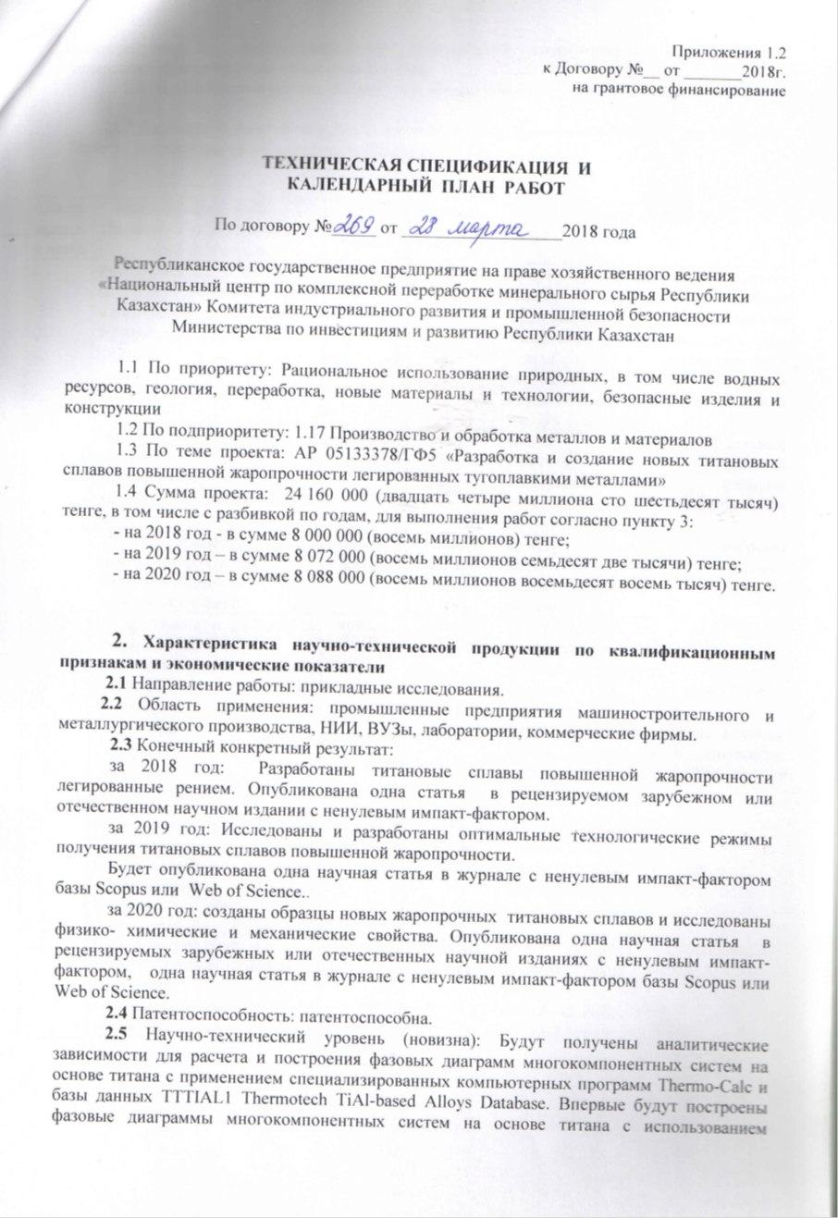

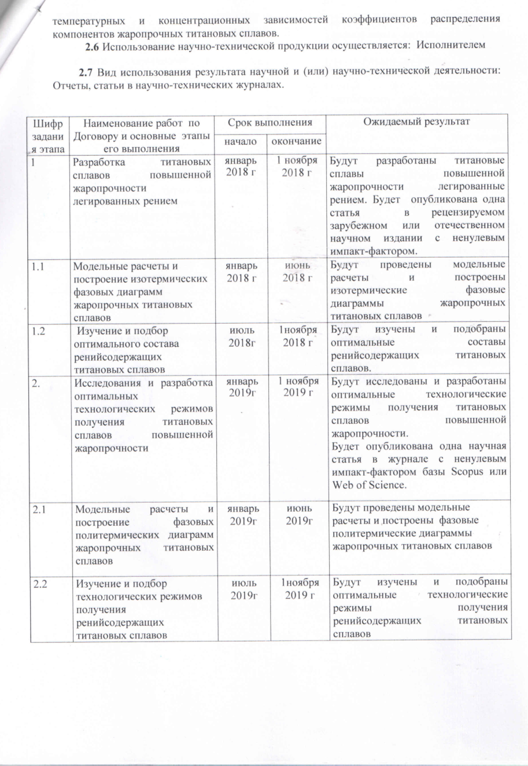

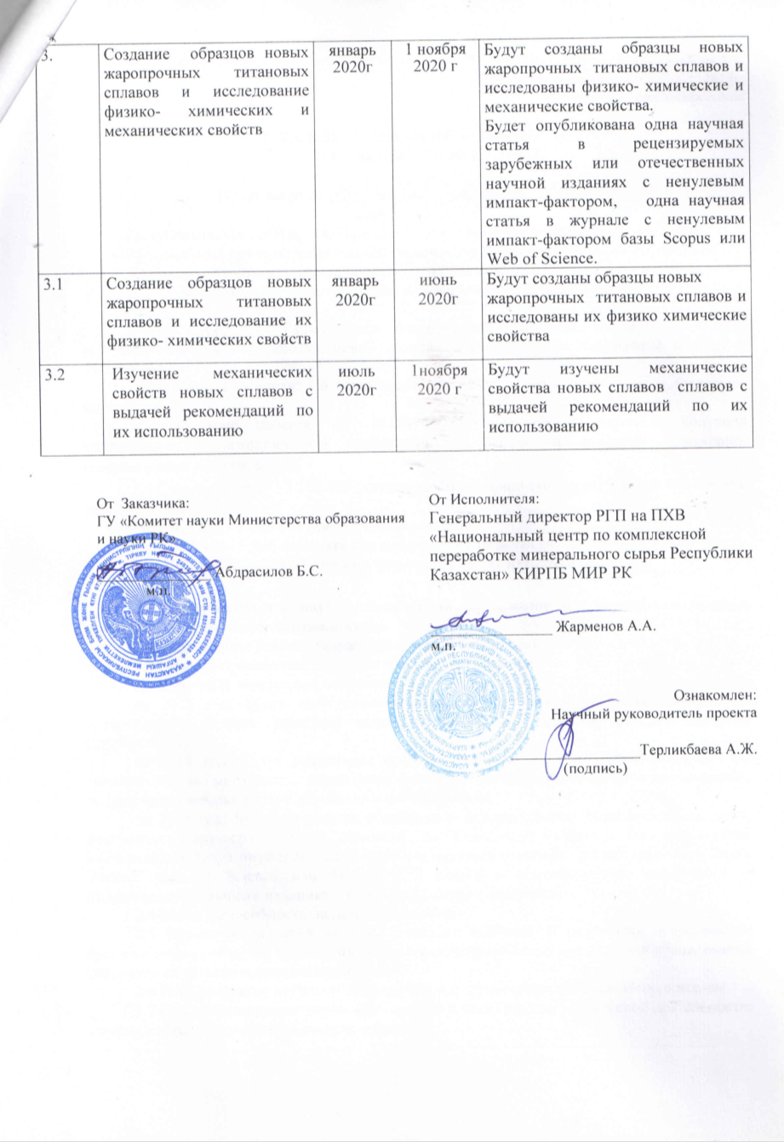

APPENDIX B

Extract from Protocol No. 3-US-20

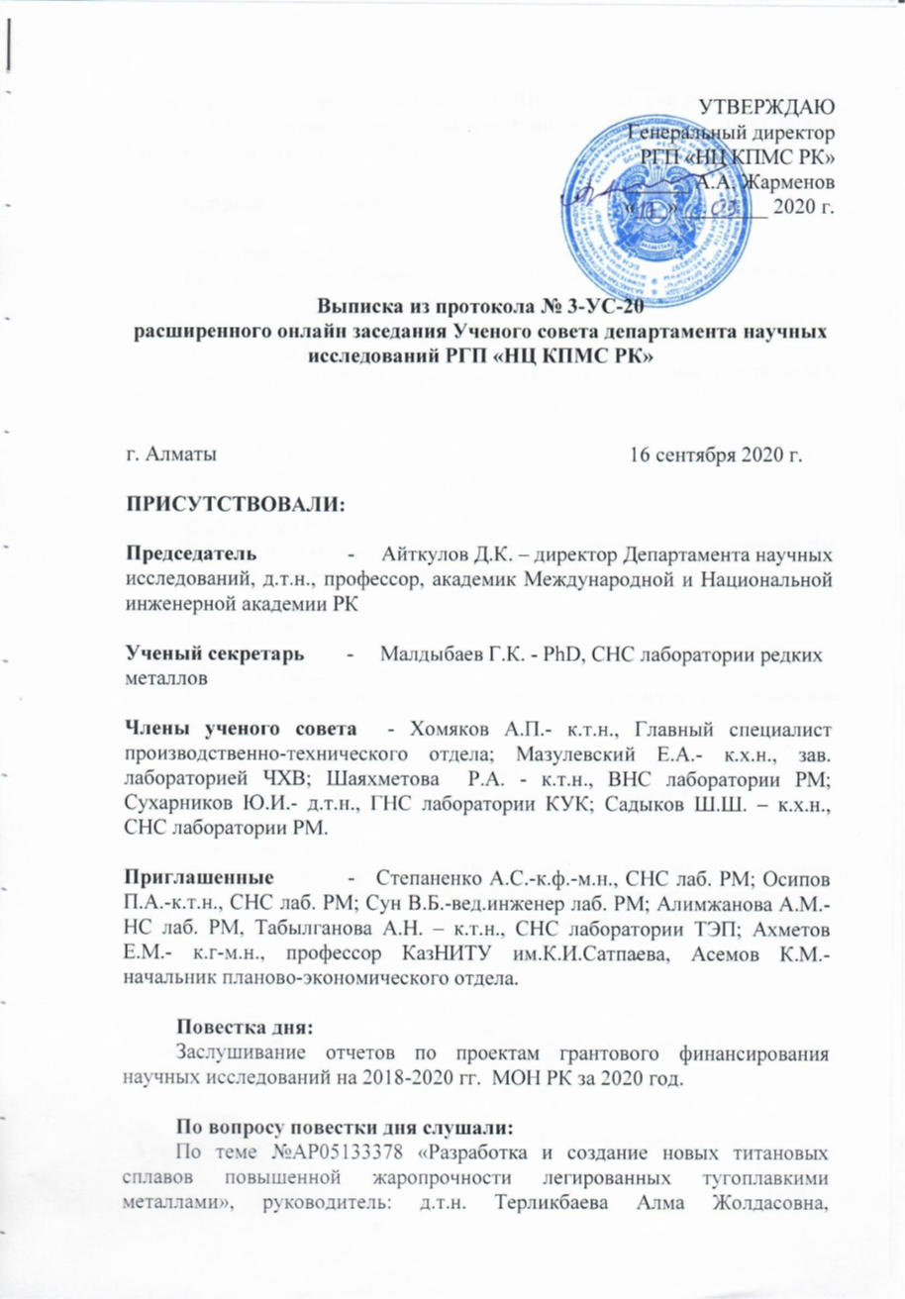
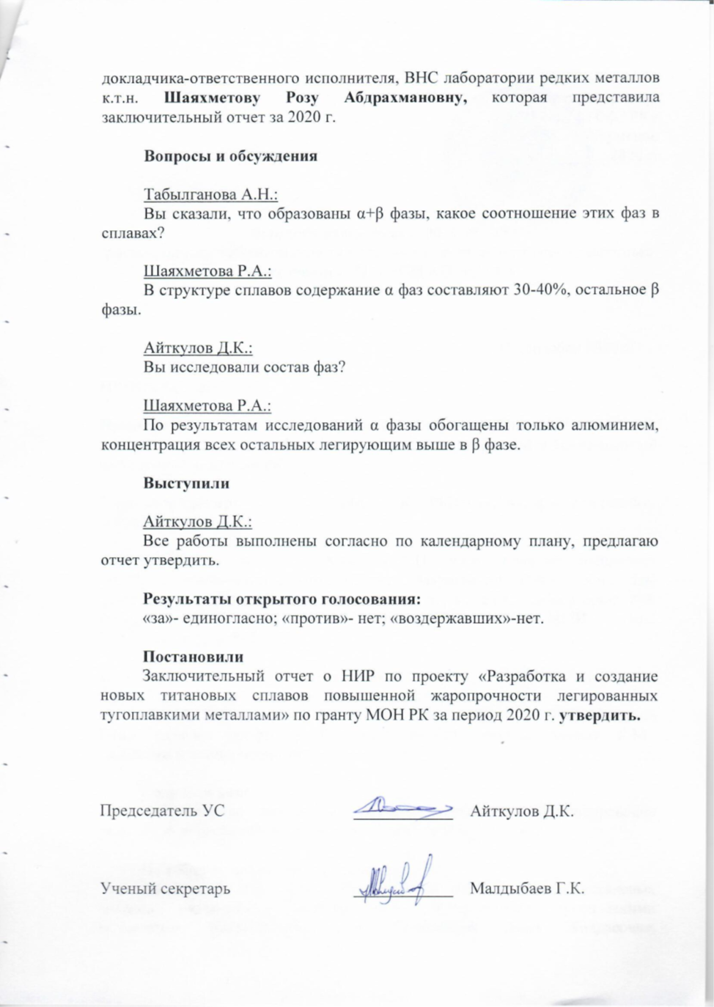

APPENDIX С

List of published works in the area of research
for 2018-2020

for 2018

in the Republic of Kazakhstan:
1. Terlikbaeva A.Zh., Shayakhmetova R.A., Alimzhanova A.M., Osipov P.A., Smagulov D.U. Isothermal calculations of heat-resistant titanium alloys // ndustry of Kazakhstan. - 2018. - № 2(103). - С. 32-35. ISSN 1608 8425.
2.Alimzhanova A.M., Terlikbaeva A.Zh., Shayakhmetova R.A., Osipov P.A., Smagulov D.U., Belov N.A. Mechanical properties of gamma alloys of systems Ti-Al-Nb-Mo, Ti-Al-Nb-Mo-Cr / International scientific-practical conference "Effective technologies for the production of non-ferrous, rare and precious metals", Institute of Metallurgy and Beneficiation, Almaty.- 2018. – С. 392-395. ISBN 978-601-323-132-7.

for 2019

Foreign:
3. А.Zh. Terlikbaeva, P.А. Osipov, R.А. Shayakhmetova, А.М. Study of the influence of rhenium on the structure and properties of heat-resistant titanium alloys” by // Journal of the Balkan Tribological Association.- 2019.-Vol. 25, No 4.- Р.845–855. (The Journal has been awarded by ISI Thomson-Reuters with Impact Factor 0.737 for 2015).

for 2020
in the Republic of Kazakhstan:
4. P.A. Osipov, R.A. Shayakhmetova, A. Zh. Terlikbaeva, A.M. Alimzhanova. Density of heat-resistant titanium alloys Ti-5Al-5Mo-5V-3Cr and Ti-5Al-5Mo-5V-3Cr-1Re // Industry of Kazakhstan.– 2020. –№1(110). С. 86-88.

Foreign:

5.R.A. Shayakhmetova, A. Zh. Terlikbaeva, P.A. Osipov, A.M. Alimzhanova. Investigation of the influence of rhenium on the mechanical properties and microstructure of heat-resistant titanium alloys // Metallurgist

APPENDIX D

Results for 2020 of the grant financing project


APPENDIX E
Reprints of published works for 2018-2020

for 2018

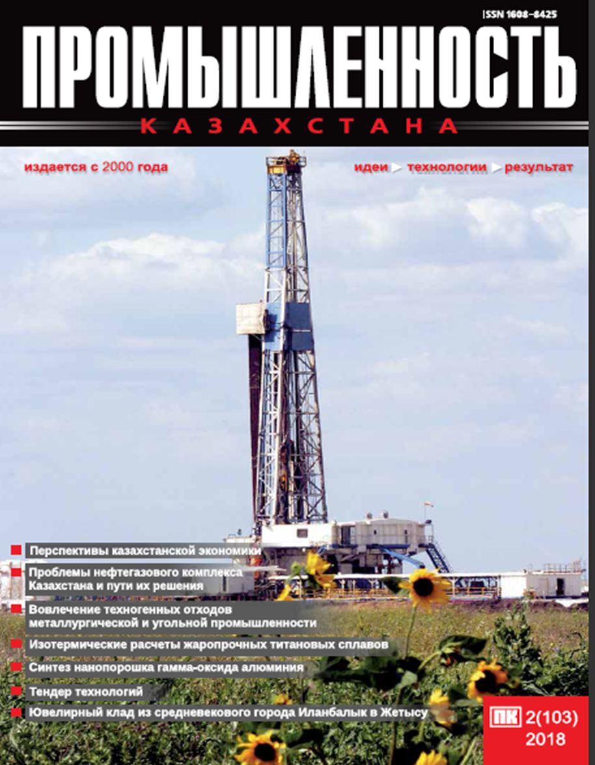
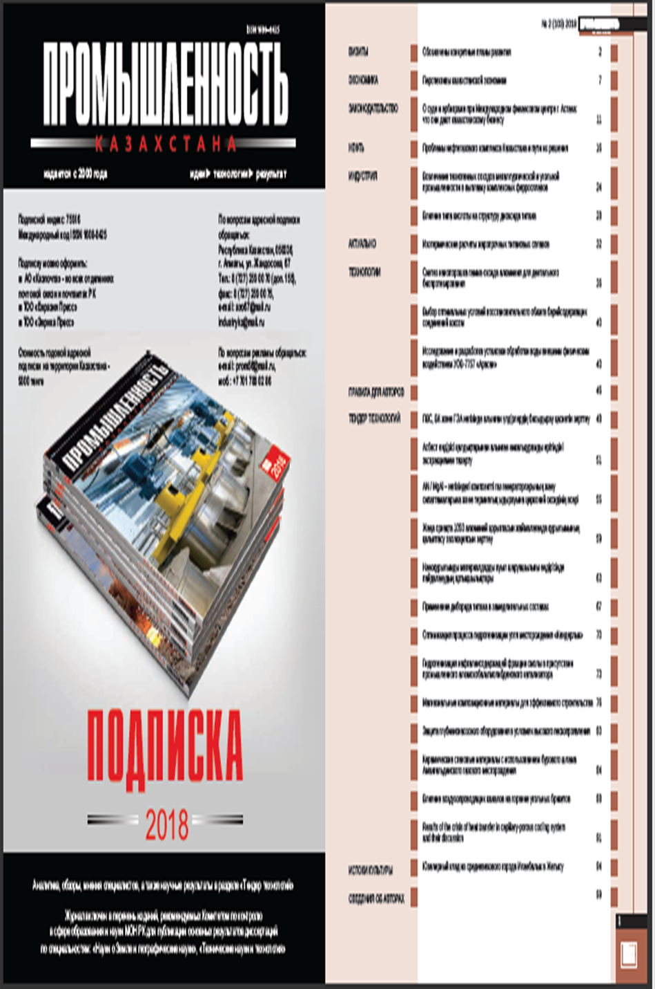
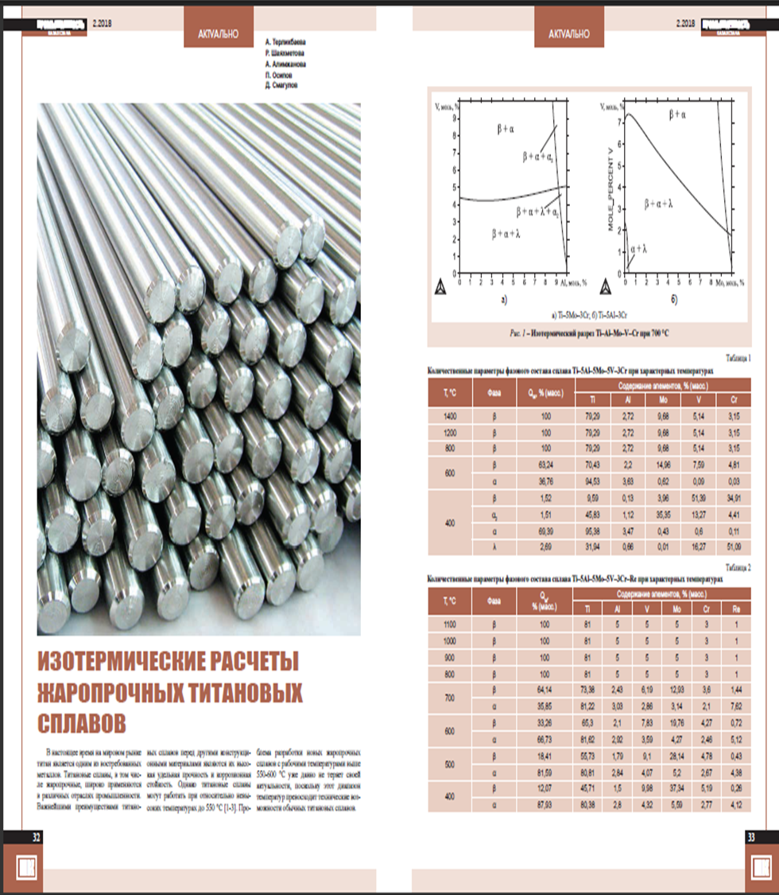
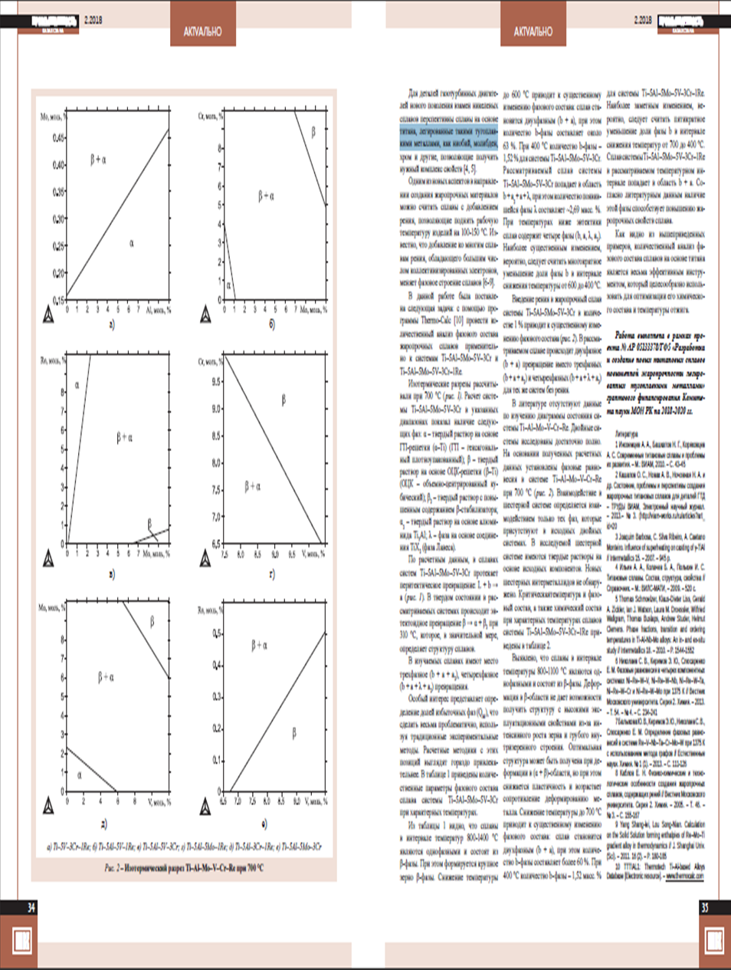
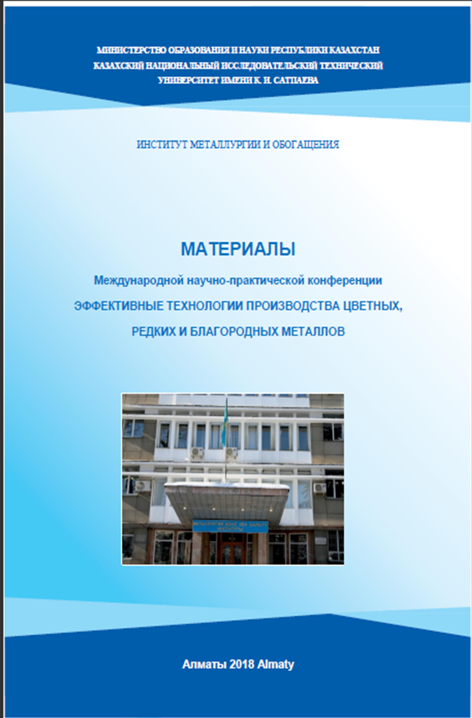
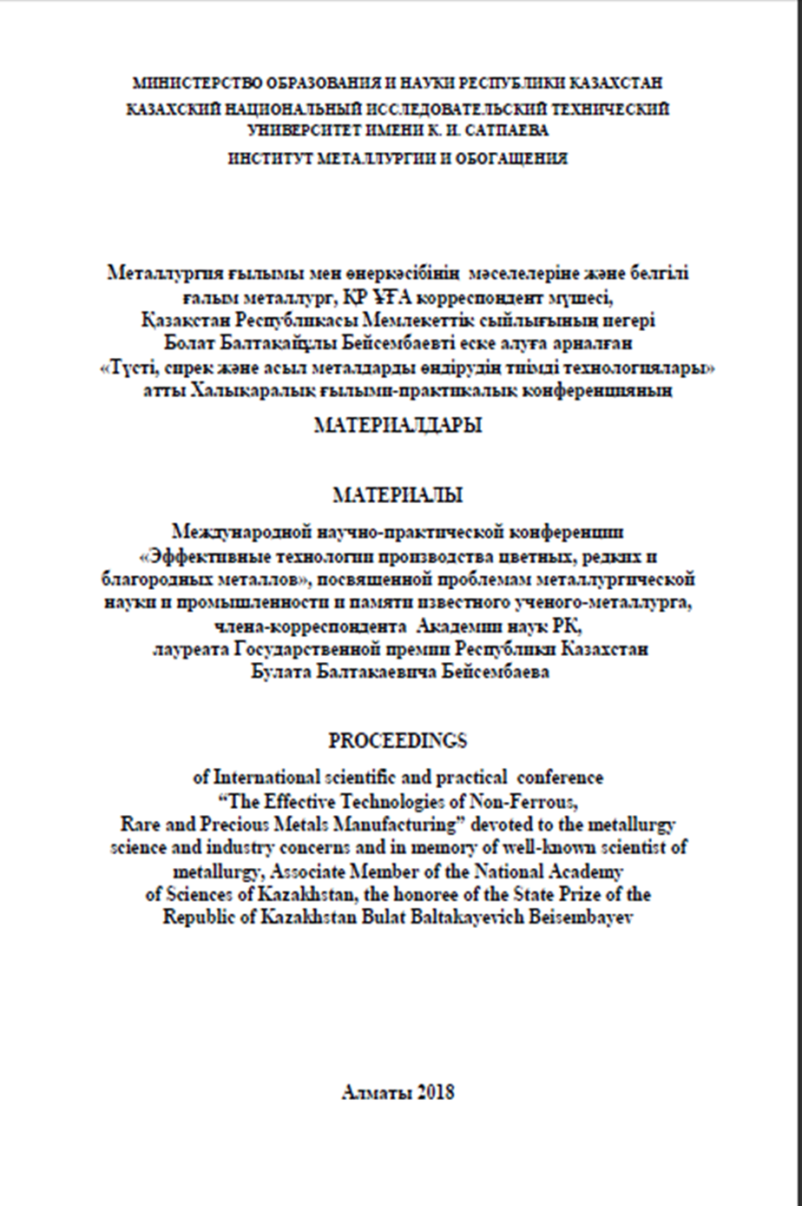

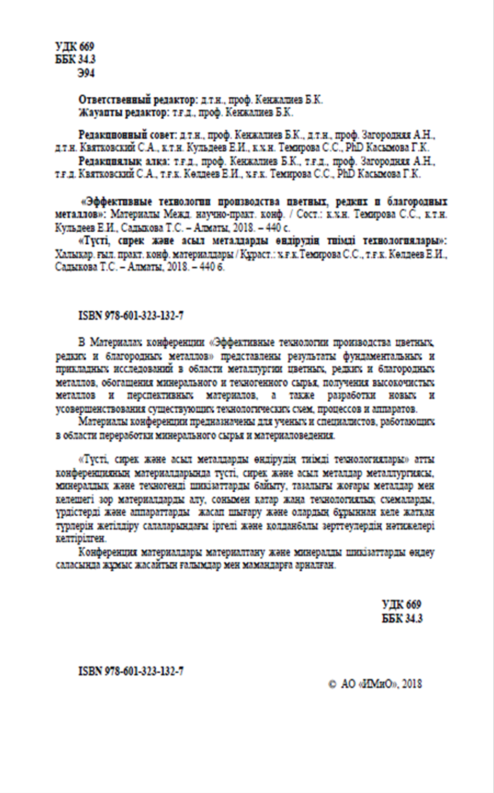
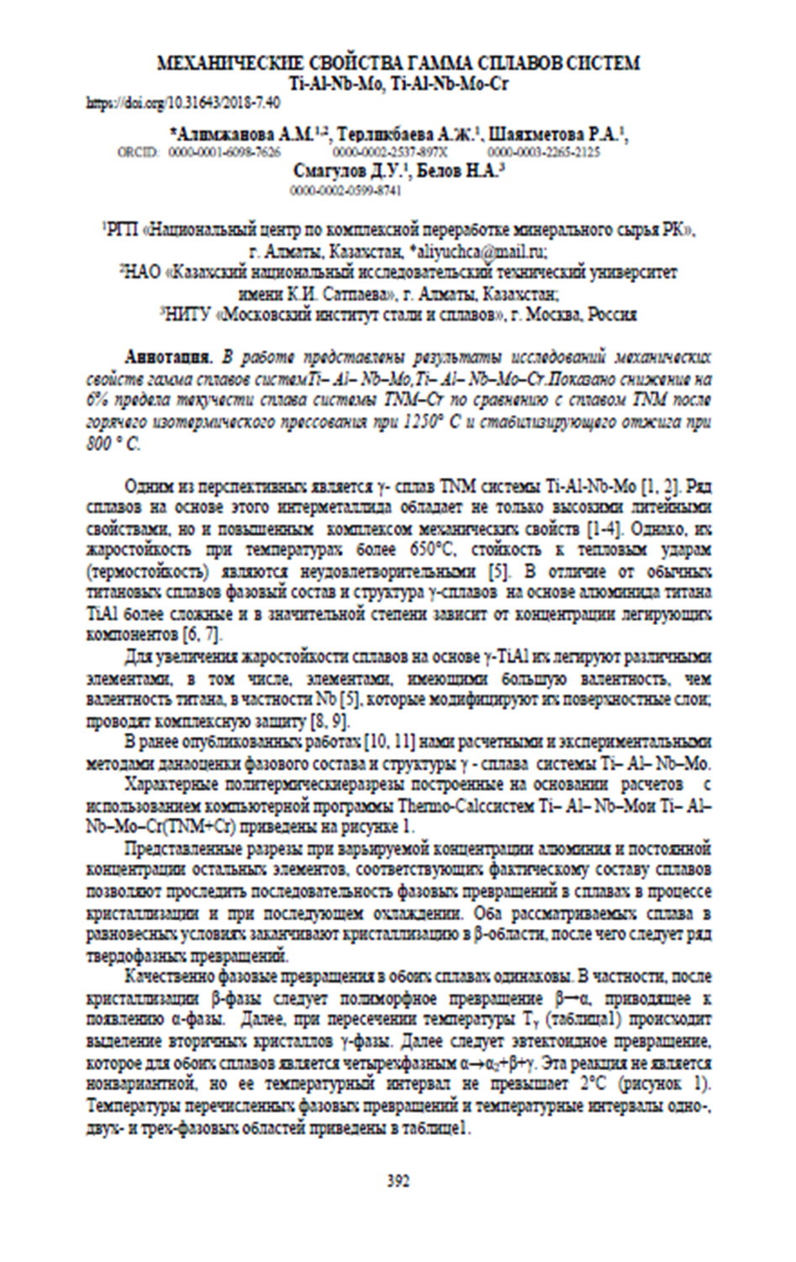
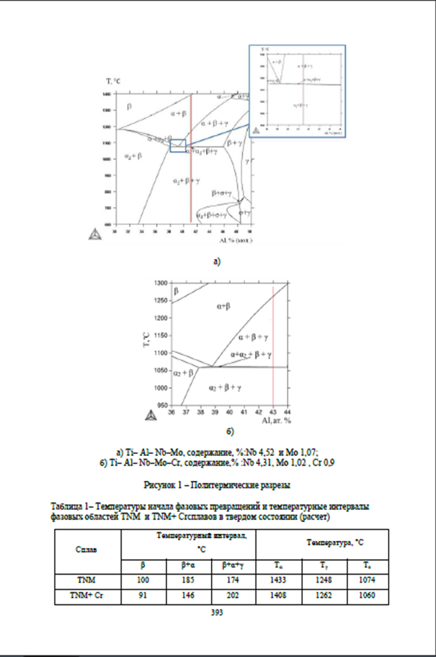

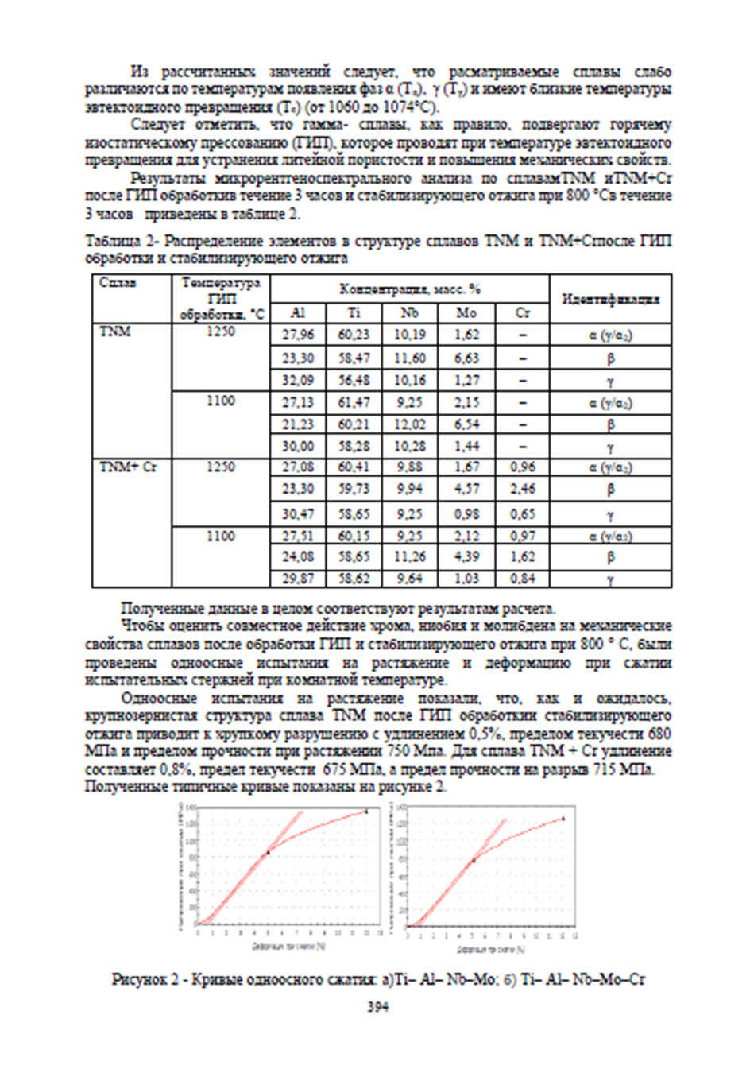

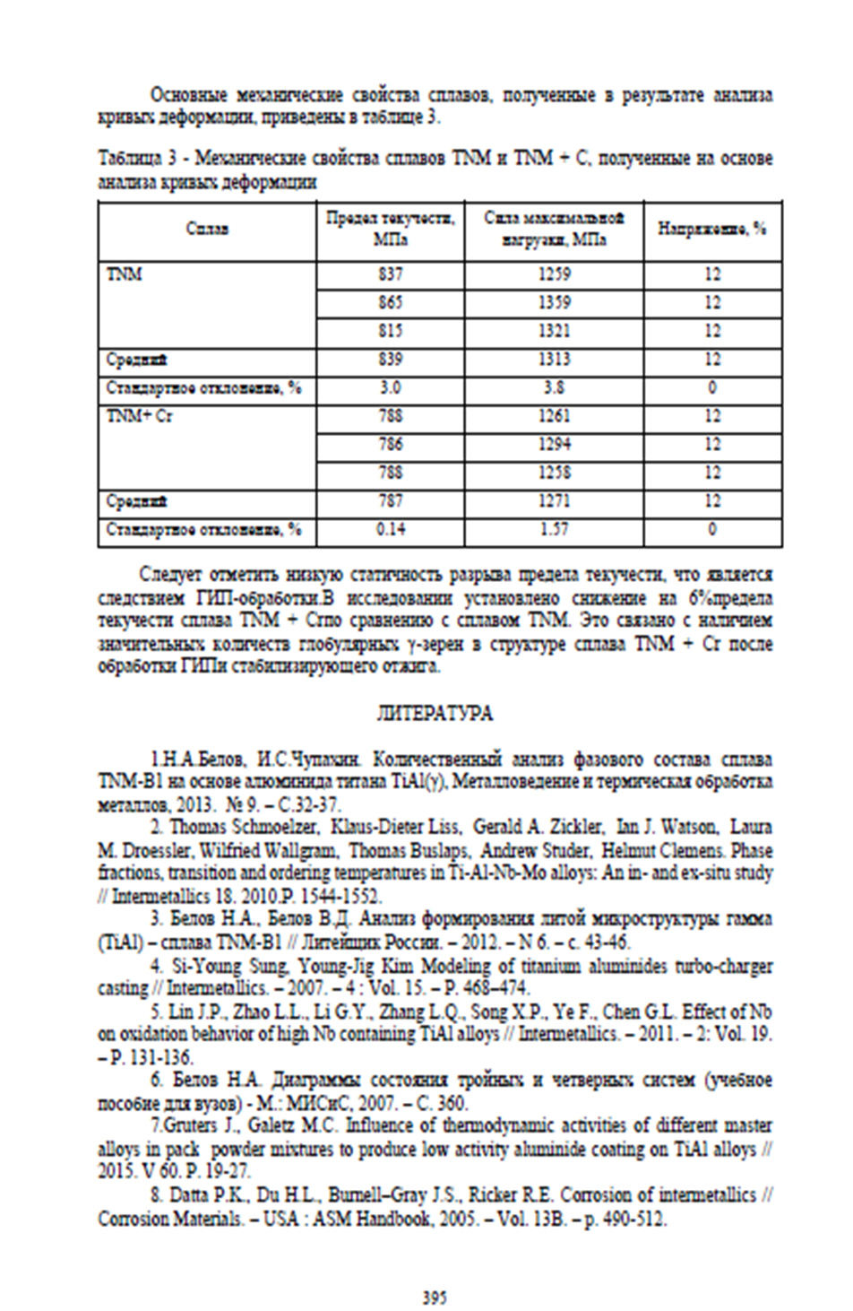

for 2019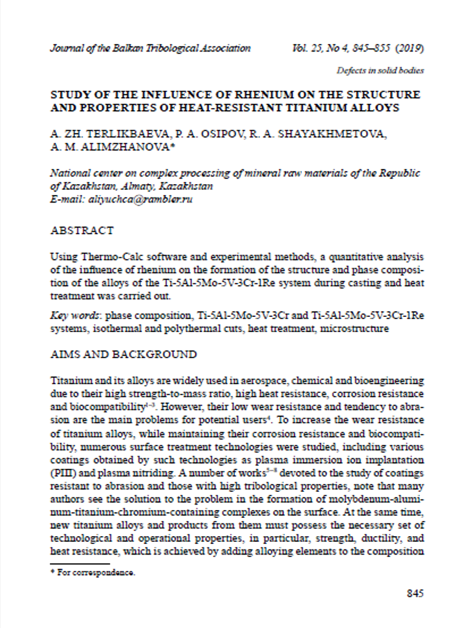

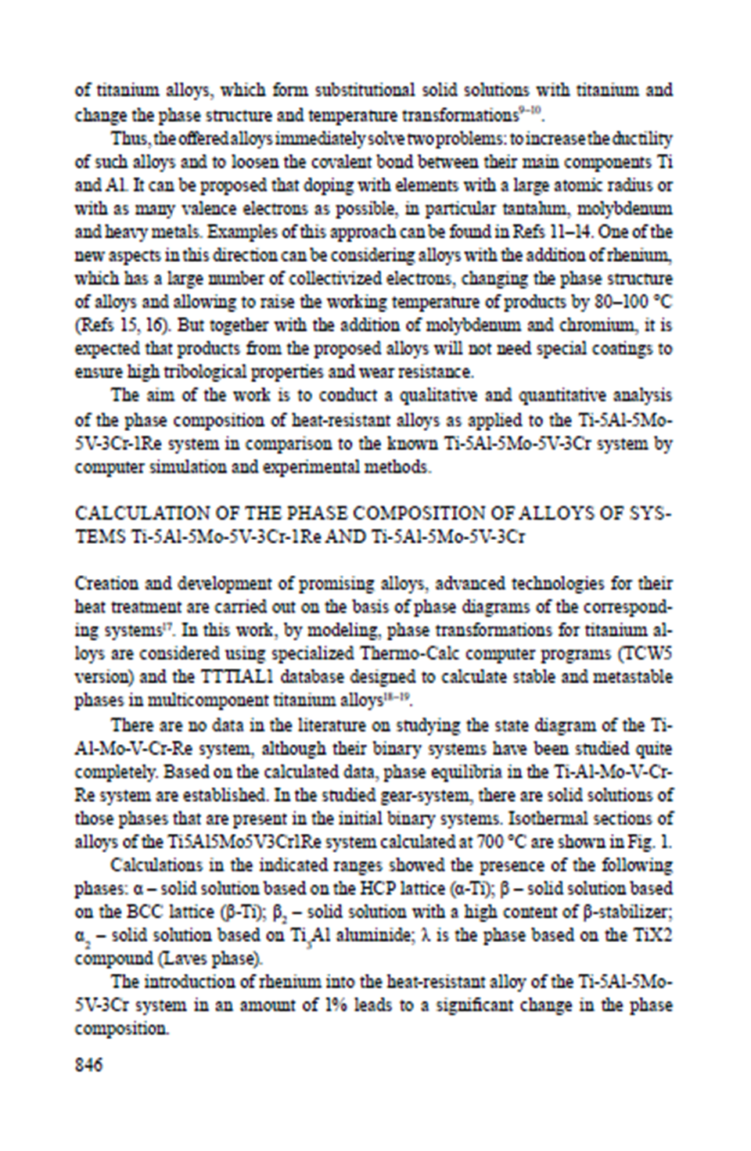

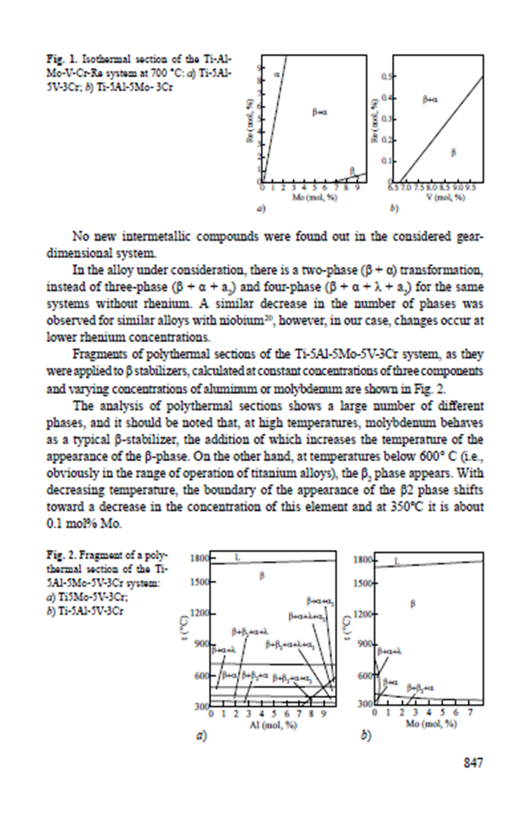

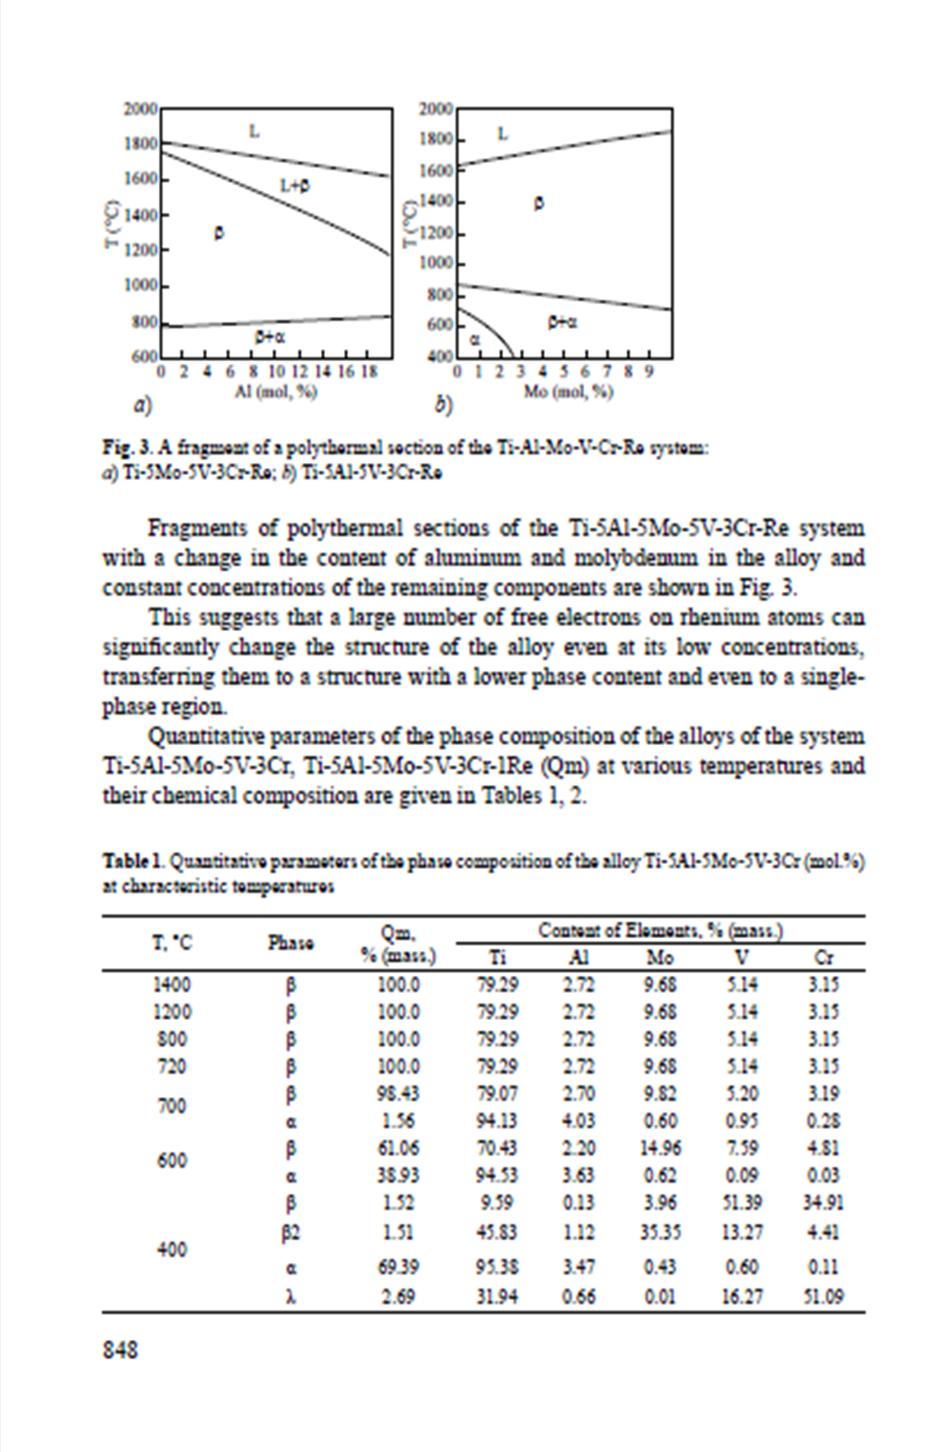
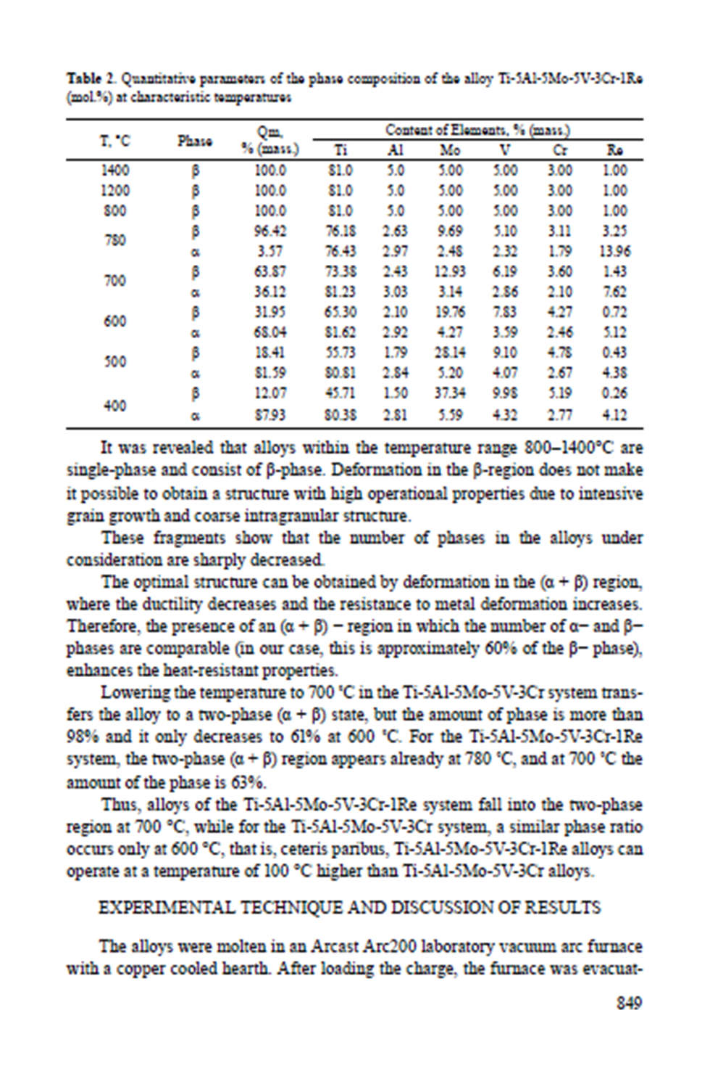
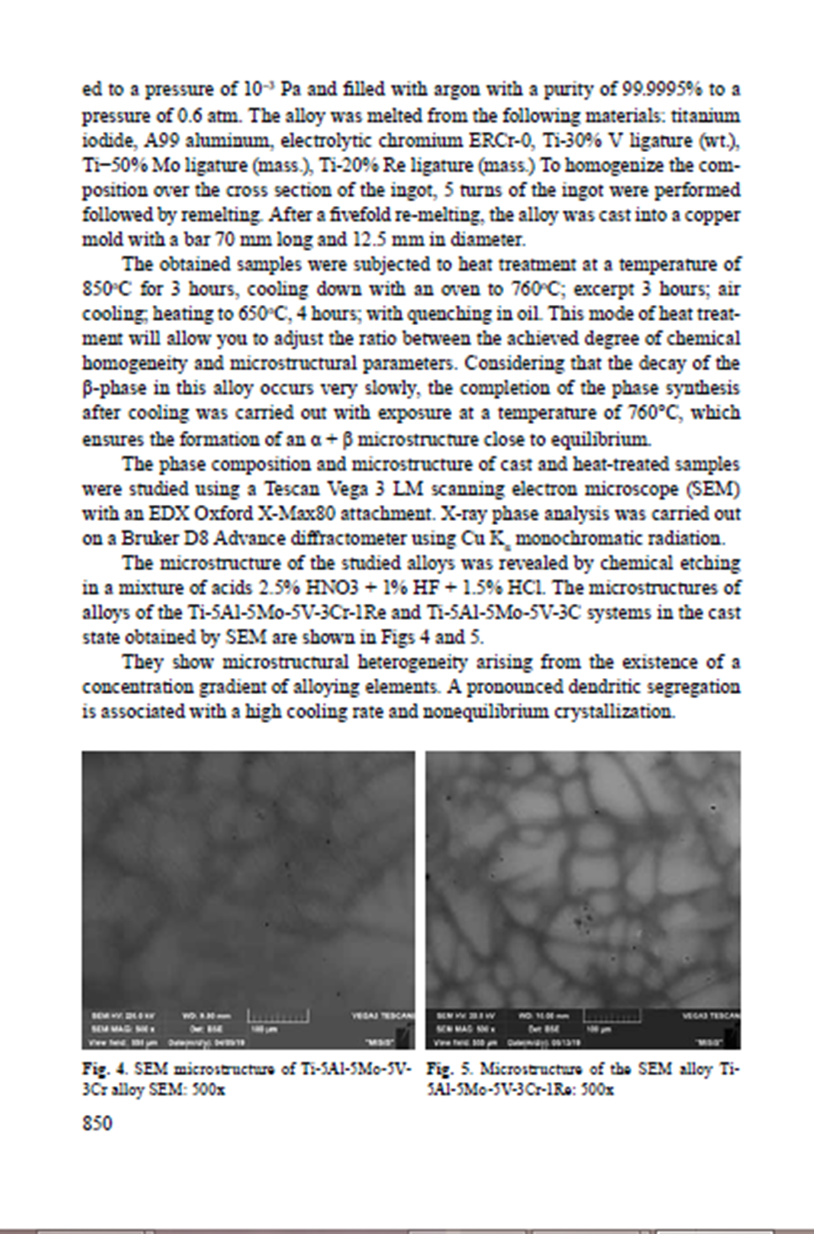

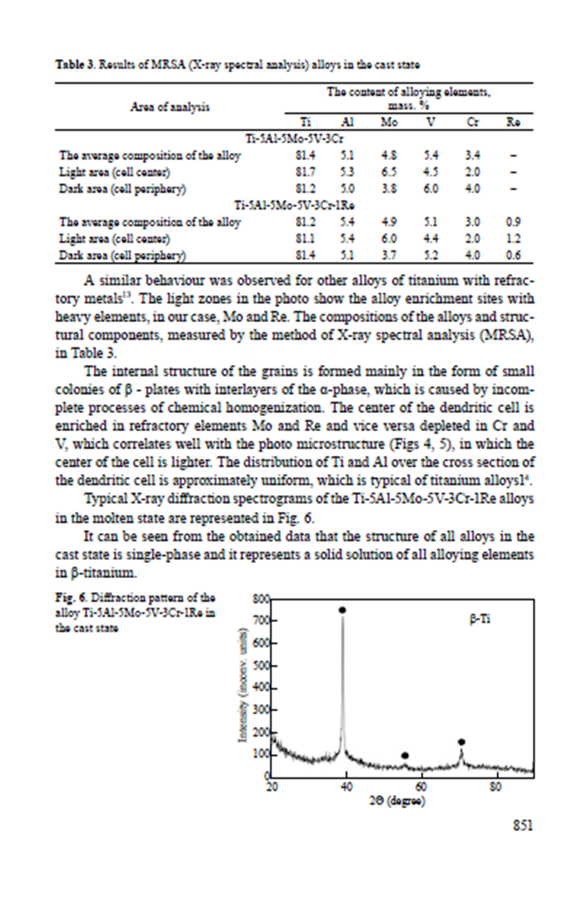
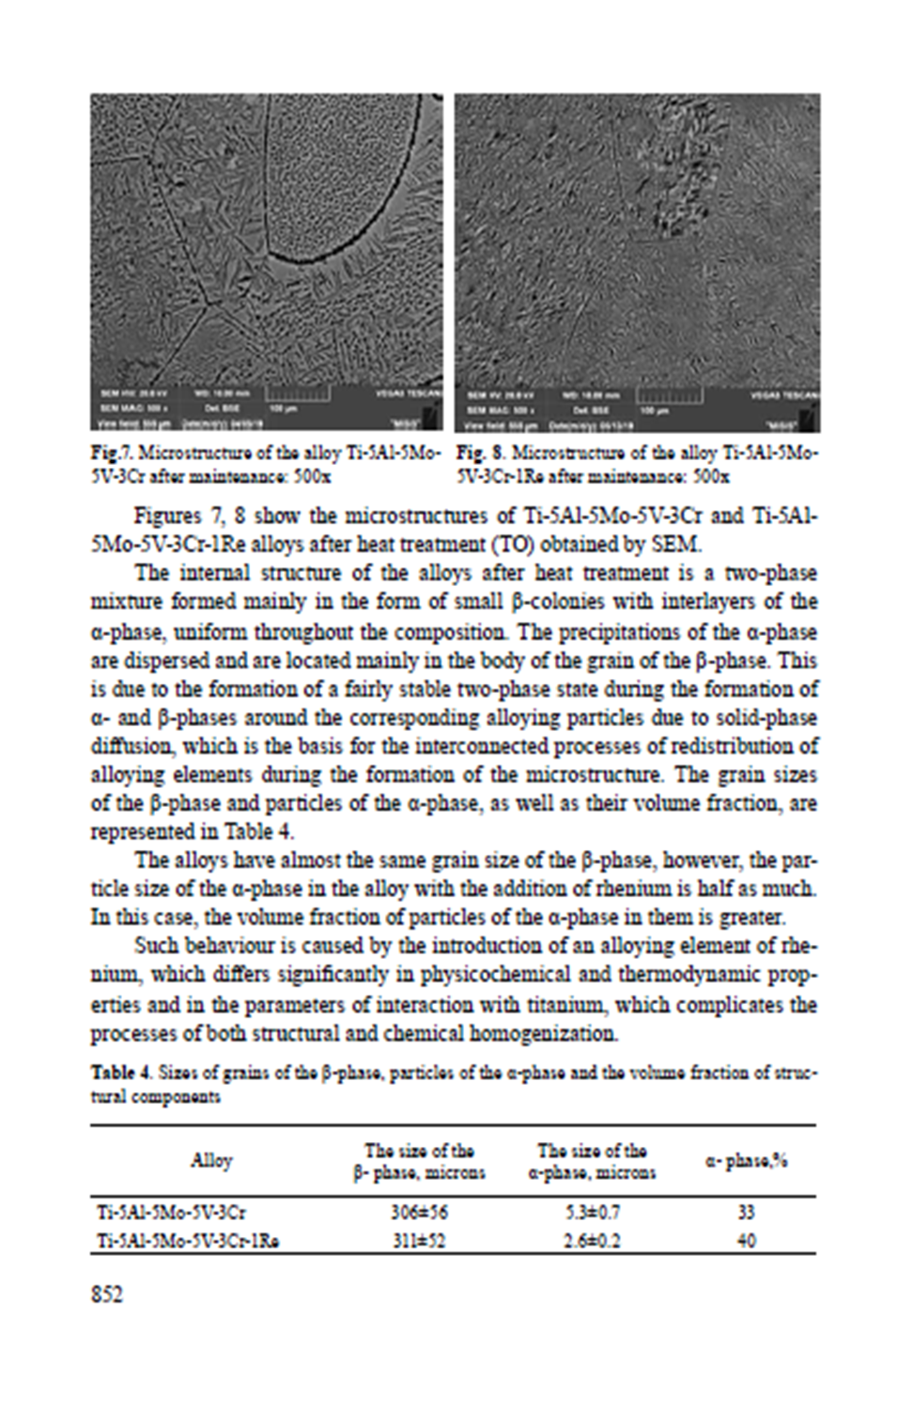
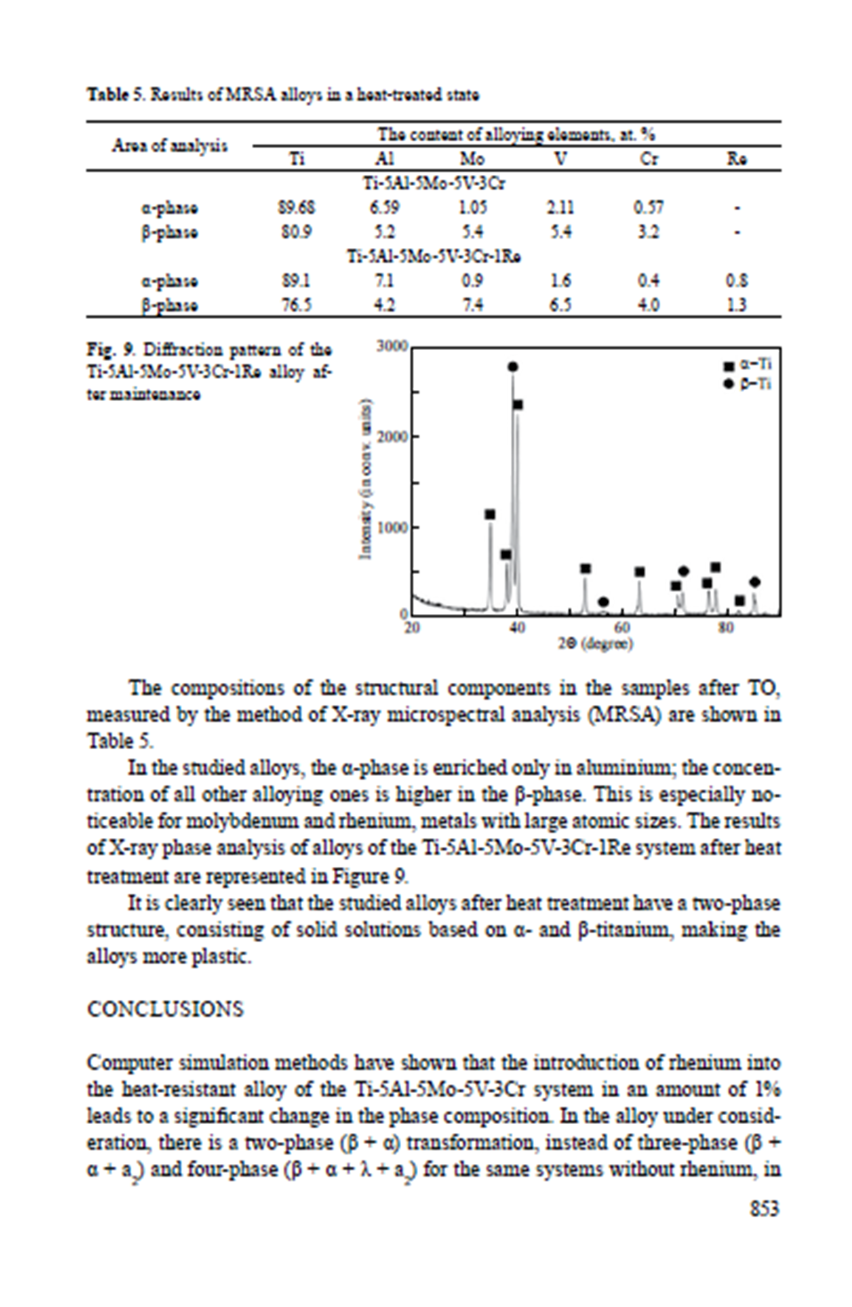

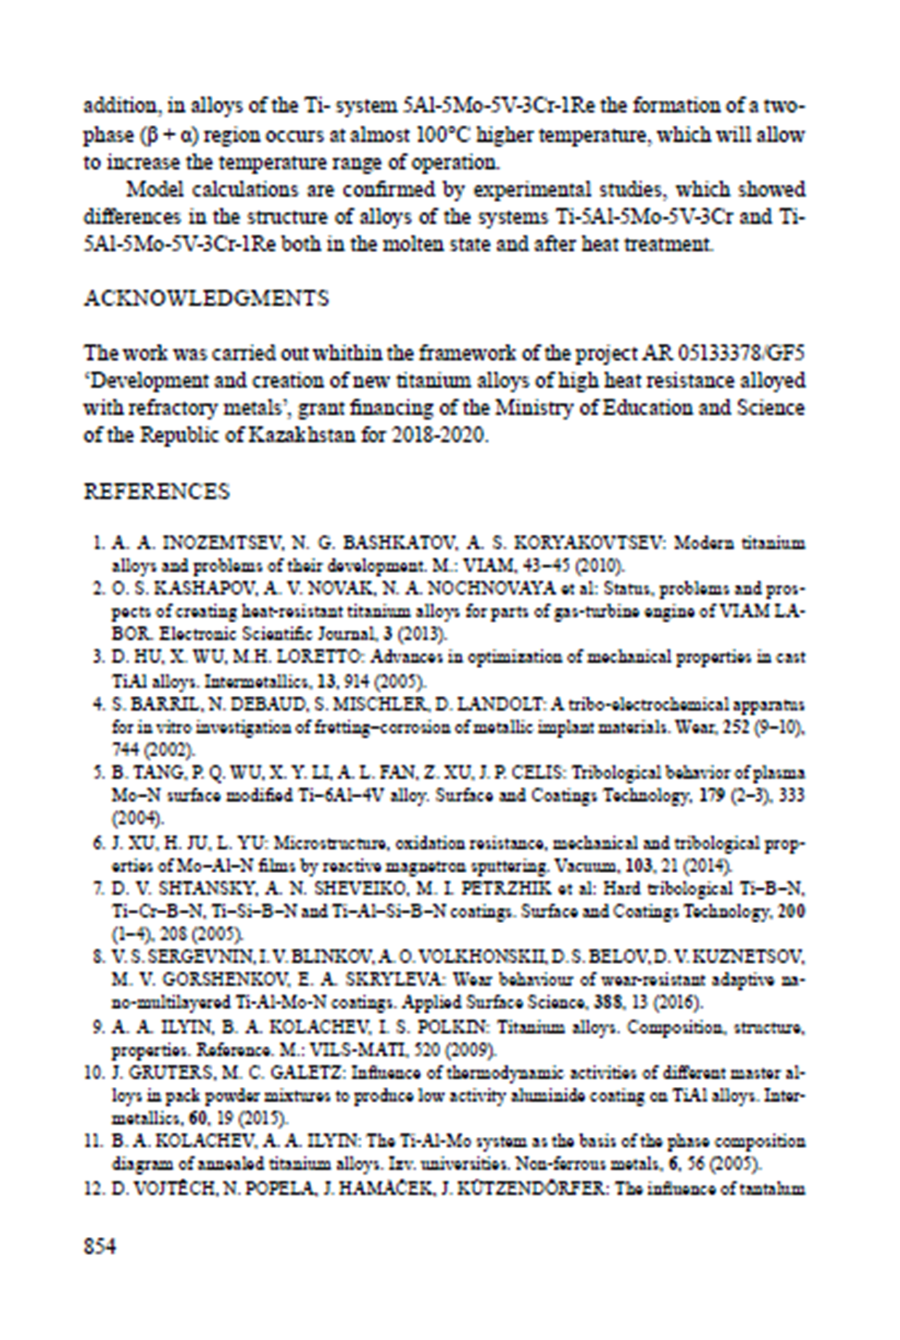

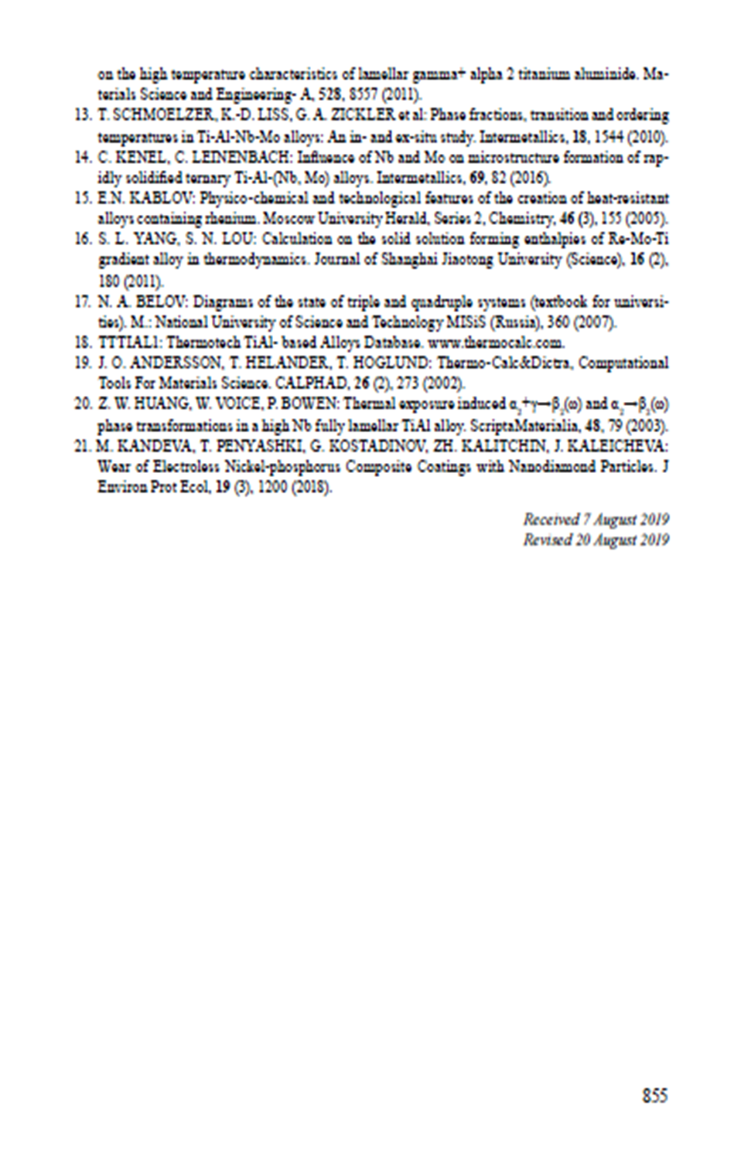
for 2020

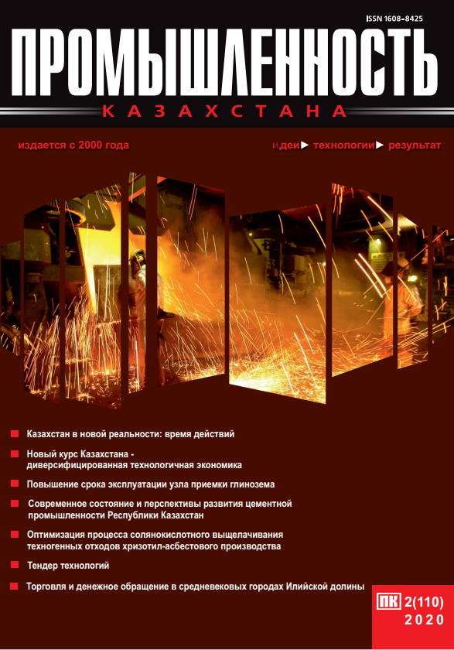







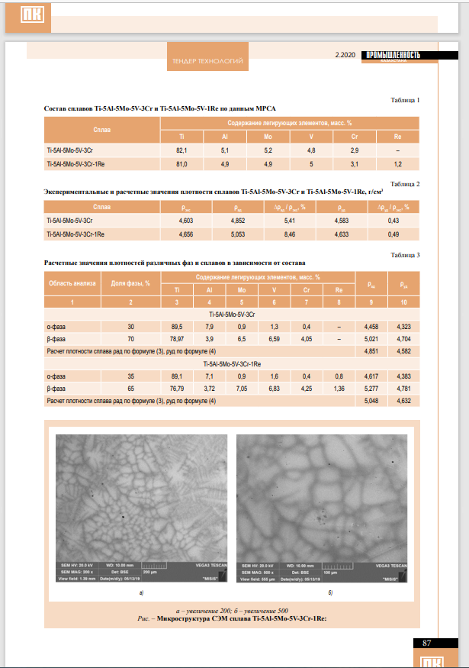

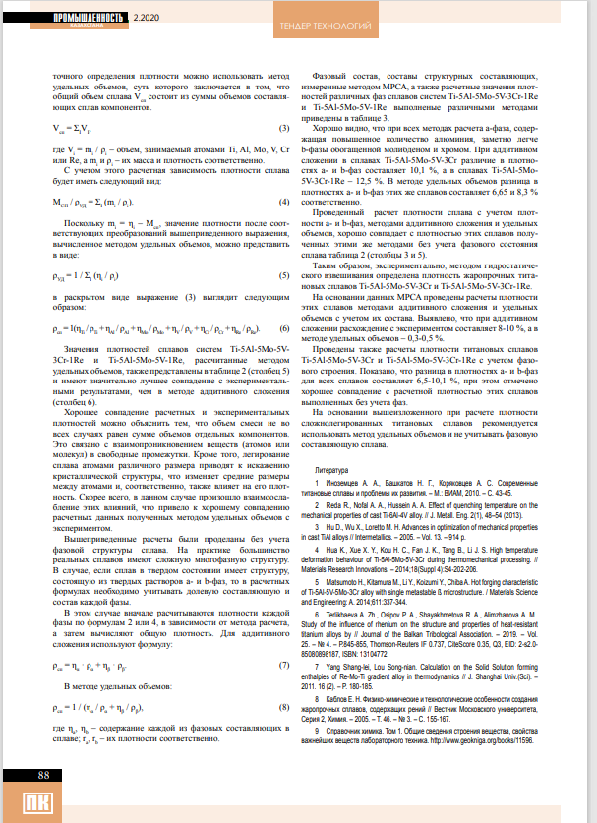

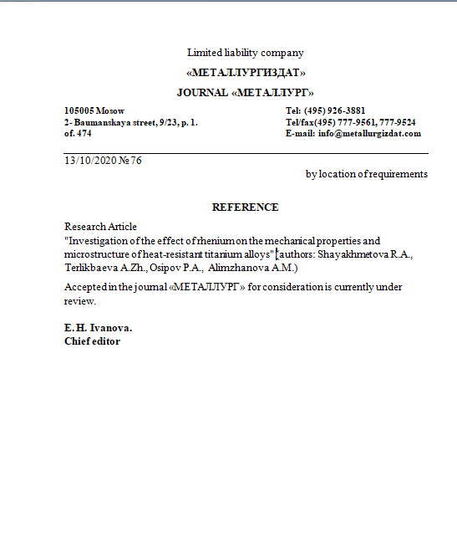

APPENDIX E

List of used foreign information resources
1 http://apps.webofknowledge.com
2 http://link.springer.com
3 http://www1.fips.ru
4 Information on the site www.thermocalc.com.
5 Information on the site www.gfe.com.

