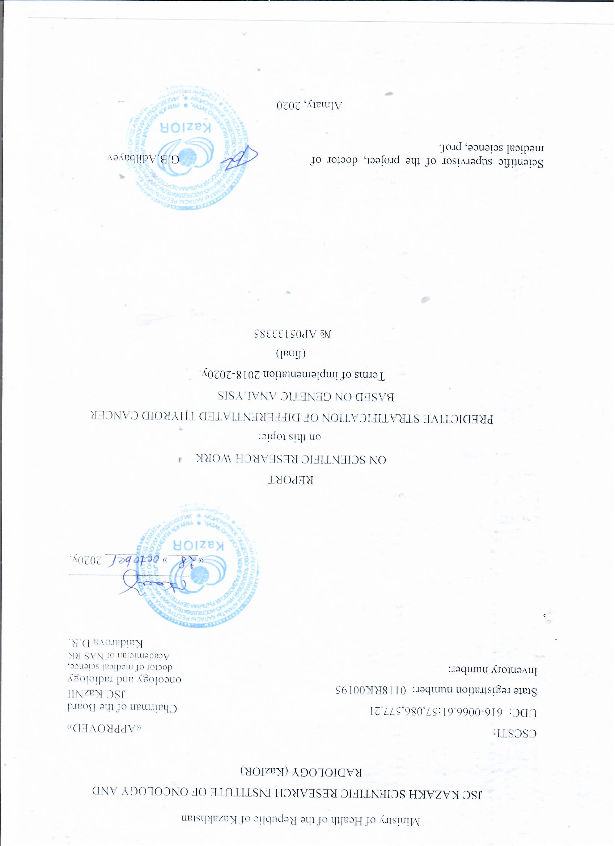

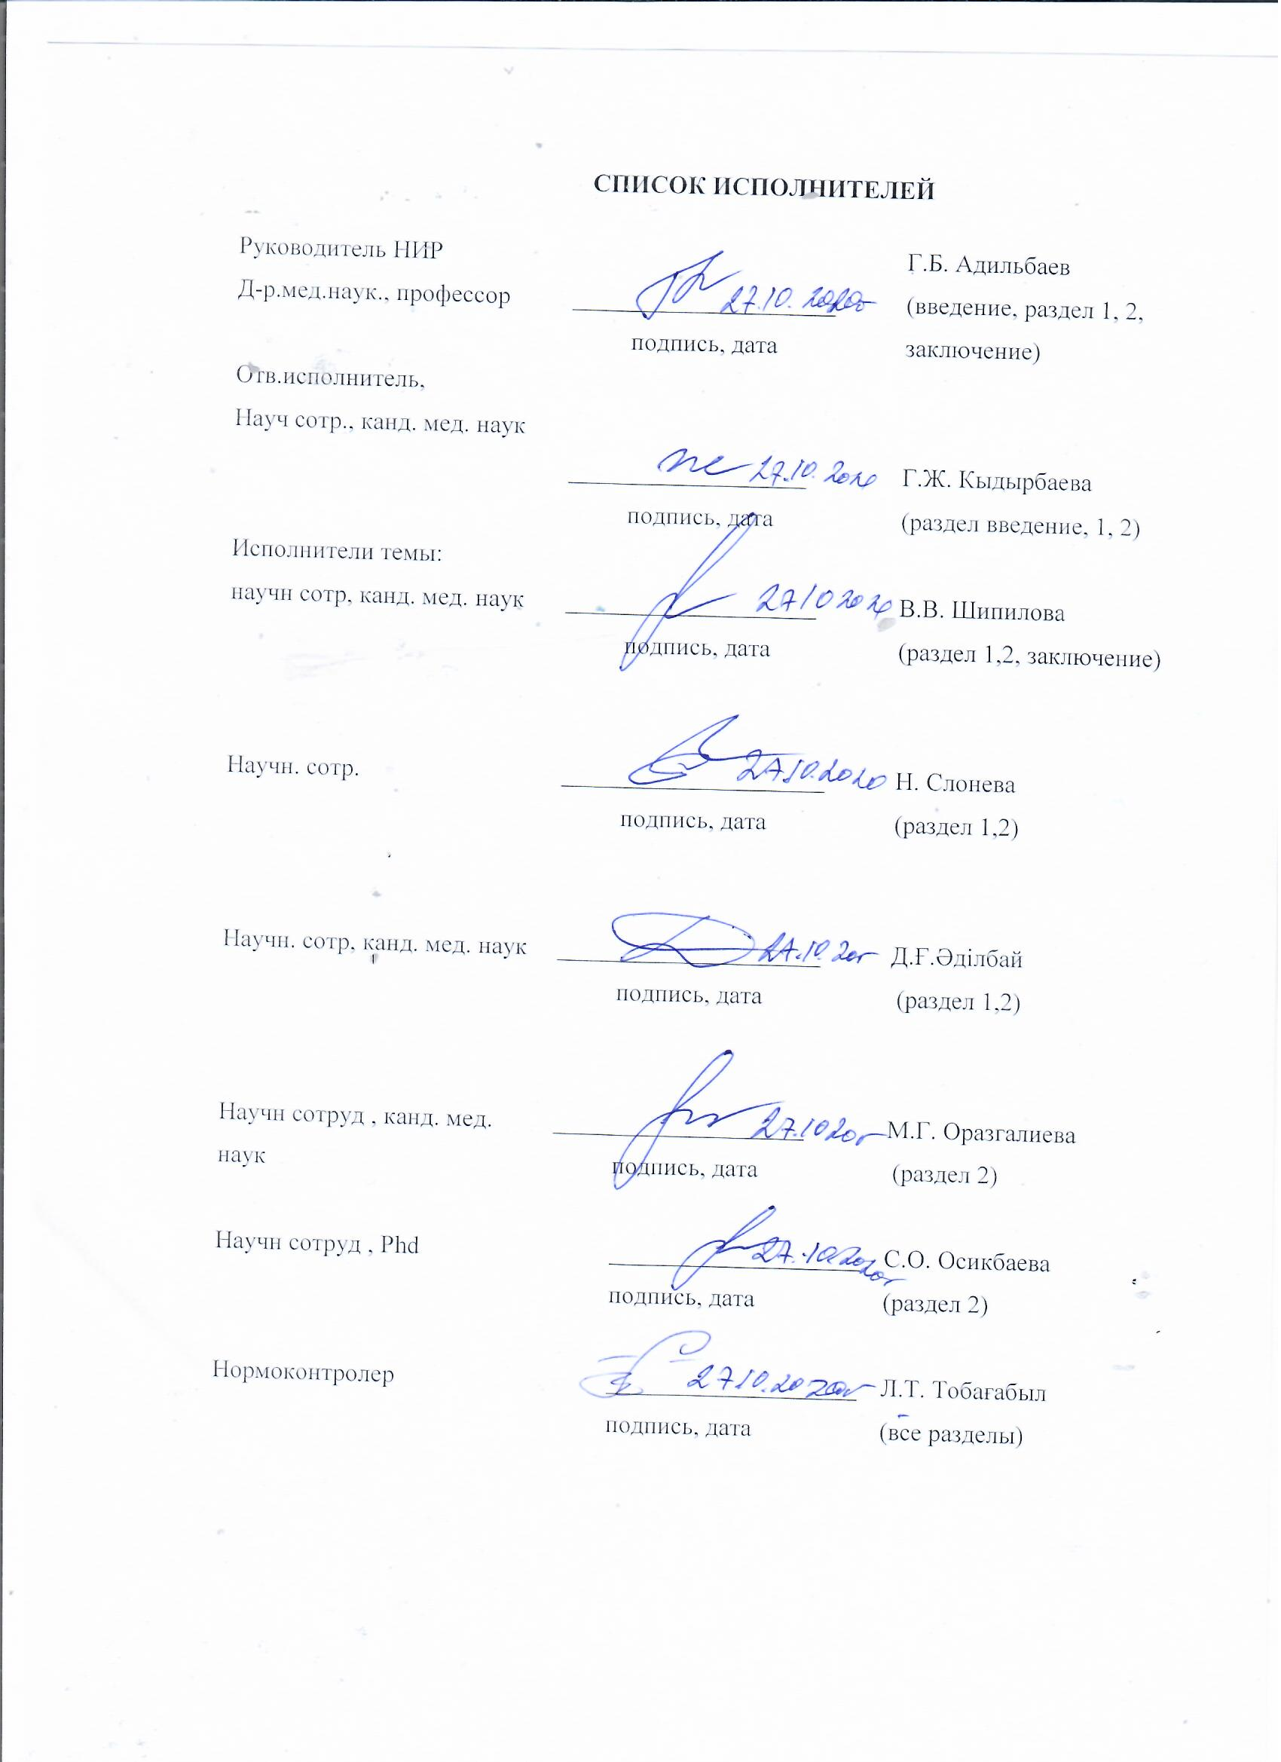

ТҰЖЫРЫМ
Есеп 73 бет, 10 сурет, 5 кесте, 24 дереккөз, 8 қосымша.
ҚАНҚАНША БЕЗІНІҢ ҚАТЕРЛІ ІСІГІ, ГЕНЕТИКАЛЫҚ МУТАЦИЯЛАР, ЖОҒАРЫ ДИФФЕРЕНЦИАЛДАНҒАН ҚАЛҚАНША БЕЗІНІҢ ҚАТЕРЛІ ІСІГІ, СТРАТИФИКАЦИЯ, ГЕНЕТИКАЛЫҚ ТАЛДАУ
Зерттеу нысаны-2012-2015 жылдары папиллярлы және фолликулярлы қалқанша безінің қатерлі ісігі диагнозымен емделген морфологиялық тексерілген 200 науқастың архивтік биопсиялық материалдары қызмет ретінде қолданылды.
Жұмыс мақсаты: Бұл жобаның мақсаты - стратификация жүйесін дамыту мақсатында қалқанша безінің сараланған қатерлі ісігінің болжамды белгілерін анықтау болды.
Зерттеу әдістері: генетикалық талдау, реттілік.
Жұмыс нәтижелері және олардың жаңалығы: Таңдалған гендердің генетикалық анализі мен реттіліктің нәтижесінде, негізінен жоғары дифференциалданған қалқанша безінің қатерлі ісігі науқастарда PTEN и TP53, AKT, BRAF, CTNNB1, EIF1AX, GNAS, HRAS, KRAS, NRAS, PIK3CA, RET, TERT, TSHR гендердің патологиялық зақымдану мутациясы басым болатындығы анықталды. Генетикалық зерттеулердің нәтижелері мен науқастардың клиникалық деректерін өңдеу кезінде AKT1, NRAS, TERT гендеріндегі мутациялар жоғары дифференциалданған қалқанша безінің қатерлі ісігінің қайталану қаупімен айтарлықтай байланысты екендігі анықталды (p <0,05). BRAF, CTNNB1 гендеріндегі мутациялар - аралық тәуекелмен (p <0,05), бұл рецидивтің болжам белгілері болуы мүмкін. Қалқанша безінің қатерлі ісігі диагнозы қойылған науқастардың жалпы бес жылдық өмір сүру деңгейі 90,7%, қайталанбастан жалпы бес жылдық өмір сүру деңгейі 83,6% құрады. Сонымен бірге гендерде мутациялардың болуына байланысты бес жылдық тіршілік етуді талдау NRAS генінде мутация болған жағдайда қайталанудан болатын өлім-жітімнің айтарлықтай жоғары қаупін көрсетті (рецидивсіз өмір сүру ұзақтығы 66,7% (p = 0,04)), AKT1 (рецидивсіз өмір сүру коэффициенті 60,6% (p = 0,033)), TERT (рецидивсіз өмір сүру коэффициенті 33,3% (p = 0,0083)), BRAF (жалпы өмір сүру деңгейі 77,5% (p = 0,039), CTNNB1 (жалпы өмір сүру ұзақтығы 79,3% (0,055)). Жоғарыда айтылғандарды ескере отырып, біз VDTC бар науқастарда AKT1, NRAS, TERT гендерінде мутациялардың болуы жоғары қайталану қаупімен тікелей байланысты деген қорытындыға келдік. BRAF, CTNNB1 гендеріндегі мутацияның болуы пациенттердің осы тобында рецидивтің аралық қаупімен байланысты, бұл оларды рецидив қаупінің болжамды белгілері ретінде қолдануға және оларды стратификация жүйесіне қосуға мүмкіндік береді.
Бұл зерттеудің жаңалығы–Қазақстанда алғаш рет қалқанша безінің жоғары дифференциалданған қатерлі ісігінің қайталануының жоғары және аралық қаупін анықтауға арналған маңызды гендер мен тиімді маркерлердің тізімі анықталғандығында, сонымен қатар қайталану қаупін стратификациялаудың терең жүйесі жасалғандығында.
Негізгі жобалық, технологиялық және техникалық және пайдалану сипаттамалары: жоғары дифференциалданған қатерлі ісігі диагнозымен науқастардағы емдеу тәсілін жекешелендіру.
Іске асыру дәрежесі: Жасалған әдіс Қазақ онкология және радиология ғылыми-зерттеу институтының клиникалық бөлімшелерінің тәжірибесіне және ҚазМҰУ-дың гематология курсы бар Қазақ ұлттық медицина университетінің онкология кафедрасының, онкология кафедрасының оқу процесіне енгізілді.
Зерттеу нәтижелерін енгізу бойынша ұсыныстар немесе енгізу нәтижелері: Қазақстан Республикасында қалқанша безінің жоғары дифференциалданған қатерлі ісігі бар науқастарды диагностикалау мен емдеудің клиникалық хаттамаларын енгізу ұсынылады.
Қолдану саласы: клиникалық онкология, бас және мойын ісіктері, эндокринология.
Жұмыстың маңыздылығы: Біздің жұмысымыздың нәтижесінде стратификацияның неғұрлым терең жүйесі жасалды, соның ішінде AKT1, BRAF, CTNNB1, NRAS, TERT гендеріндегі мутациялардың молекулалық-генетикалық зерттеулері, бұл науқастарды прогрессия қаупі бар топтарға дұрыс бөлуге мүмкіндік береді, науқастарды мүмкіндігінше жеке емдеуге және радионуклидті терапияның агрессивті әдістерін тек оларға шынымен мұқтаж науқастарға қолдану.
Зерттеу объектісін дамыту бойынша болжамдық ұсыныстар: келесі кезең тест жүйесін әзірлеу және тестілеу болады.

ESSAY
Report 73 p. , 5 table., 10 pic, 24 sources, 8 attachment.
Key words: THYROID CANCER, GENETIC MUTATIONS, IN HIGHLY DIFFERENTIATED THYROID CANCER, STRATIFICATION, GENETIC ANALYSIS.
The object of the study was archival biopsy material of 200 patients with morphologically verified papillary and follicular thyroid cancer treated in 2012-2015.
Purpose of the work - The purpose of this project is to identify prognostic markers of differentiated thyroid cancer in order to develop a stratification system with taking into account the characteristics of the Kazakhstan population.
Research methods: genetic analysis, sequencing.
Results of the work and their novelty: As a result of genetic analysis and sequencing of the selected genes, it was revealed that, mainly in patients with thyroid thyroid cancer, pathological damaging mutations in the PTEN and TP53, AKT, BRAF, CTNNB1, EIF1AX, GNAS, HRAS, KRAS, NRAS genes prevailed, PIK3CA, RET, TERT, TSHR. When processing the results of genetic research and clinical data of patients, it was revealed that mutations in the genes AKT1, NRAS, TERT are significantly associated with a high risk of recurrent VDTC (p <0.05). And mutations in genes BRAF, CTNNB1 - with an intermediate risk (p <0.05), which may be markers of the prognosis of relapse. The overall five-year survival rate of VDLC patients was 90.7%, the overall five-year relapse-free survival rate was 83.6%. At the same time, the analysis of five-year survival, depending on the presence of a mutation in the genes, showed a significantly high risk of mortality from recurrence in the presence of a mutation in the NRAS gene (without recurrent survival rate 66.7% (p = 0.04)), AKT1 (without recurrent survival rate 60.6 % (p = 0.033)), TERT (no recurrent survival rate 33.3% (p = 0.0083)), BRAF (overall survival 77.5% (p = 0.039)), CTNNB1 (overall survival 79.3% ( 0.055)). Considering the above, we concluded that the presence of mutations in the AKT1, NRAS, TERT genes in patients with VDTC is directly associated with a high risk of recurrence. And the presence of a mutation in the BRAF and CTNNB1 genes is associated with an intermediate risk of relapse in this group of patients, which makes it possible to use them as prognostic markers of the risk of relapse and include them in the stratification system.
The novelty of this study lies in the fact that for the first time in Kazakhstan, a list of the most important genes and effective markers for determining the high and intermediate risk of recurrence in highly differentiated thyroid cancer has been identified, as well as an in-depth system for stratification of the risk of recurrence has been developed.
Basic design, technological and technical and operational characteristics: personification of the approach to the treatment of patients with highly differentiated thyroid cancer.
Implementation degree: The developed method was introduced into the practice of clinical departments of the Kazakh Research Institute of Oncology and Radiology, and into the educational process of the Department of Oncology of the Kazakh National Medical University, the Department of Oncology with a course of hematology of KazMUCE.
Recommendations for the implementation or the results of the implementation of the results of research: it is recommended to introduce into the Clinical protocols for the diagnosis and treatment of patients with highly differentiated thyroid cancer in the Republic of Kazakhstan.
Applications: clinical oncology, head and neck tumors, endocrinology.
Significance of the work: As a result of our work, a more in-depth system of stratification has been developed, including the most extensive molecular genetic studies of mutations in the genes AKT1, BRAF, CTNNB1, NRAS, TERT, which will allow to correctly distribute patients into groups at risk of progression, which will make it possible to treat patients as personally as possible , and use aggressive methods of radionuclide therapy and suppressive hormone therapy only for those patients who really need them.
Predictive proposals for the development of the research object: the next stage will be the development and testing of the test system.

CONTENT
SYMBOLS AND ABBREVIATIONS | 8
INTRODUCTION | 9
MAIN PART | 14
1 Materials and research methods | 14
1.1 Research material | 14
- Technique for genetic analysis and gene sequencing | 14
1.3 Statistical analysis technique | 16
1.4 Staging technique for thyroid tumors | 18
1.5 Recurrence risk stratification technique | 19
2 RESULTS OF THE WORK PERFORMED | 20
2.1 Patients for genetic research | 20
2.2 Results of genetic analysis and sequencing of selected genes | 20
2.3 Relapse risk stratification results with highly differentiated thyroid cancer | 25
2.4 Analysis of overall and 5-year relapse-free survival | 27
CONCLUSION | 30
LIST OF USED SOURCES | 33
ATTACHMENT А – Technical specification and work schedule | 35
ATTACHMENT B - The list of published works on the topic for 2019 y. | 45
ATTACHMENT C – Grant financing | 57
ATTACHMENT D – extract from the minutes of the meeting of the ethical council of KazNIIOR | 59
ATTACHMENT E - Extract from the minutes of the meeting of the Academic Council of the JSC «Kazakh Research Institute of Oncology and Radiology» | 61
ATTACHMENT F – Final report reviews | 65
ATTACHMENT J – Implementation acts | 69
ATTACHMENT H - Methodical guidance | 71

SYMBOLS AND ABBREVIATIONS

In this research report, the following symbols and abbreviations are used:

TC | - thyroid cancer
HDTC | - highly differentiated thyroid cancer
CTNNB1 | - β-catenin
EGFR | - epidermal growth factor receptor
GTCC | - Gürtle thyroid cell carcinoma
IDH1 | - isocitrate dehydrogenase 1
PDGFR | - platelet growth factor receptor
PDPK1 | - 3 – phosphoinositide-dependent protein kinase 1
VEGFR | - vascular endothelial growth factor receptor
АТА | - American Thyroid Association
AJCC | - American Joint Cancer Committee
UICC | - International Union Against Cancer
EORTC | - European Organization for Research and Treatment of Cancer
KazNIIOiR | - Kazakh Scientific Research Institute of Oncology and Radiology

INTRODUCTION
Assessment of the current state of the problem being solved and its relevance.
Thyroid cancer (TC) is an increasingly common malignant neoplasm with a rapidly growing incidence worldwide [1]. Although the mortality rate from thyroid cancer is not high, in most patients the risk of recurrence reaches 30% [1]. Therefore, it is very important to identify those patients who are prone to relapse and adapt their treatment plan accordingly. [1]. This is the main goal of risk stratification. Recurrence risk is stratified after surgery by staging thyroid cancer based on different systems, including the American Joint Cancer Committee (AJCC) / Union for International Cancer Control (UICC) [1]. This staging system classifies patients according to age and histopathological criteria. The AJCC / UICC staging system is designed to predict mortality from disease; however, it is limited in its ability to take into account other variables that may affect the long-term prognosis [1]. Patients who are considered to be at high risk may not recur, but at the same time are burdened with frequent unnecessary monitoring. Conversely, patients who were initially at low risk may not respond to treatment. Several other risk stratification systems have also been proposed, which include other predictive predictors such as the EORTC, AGES, AMES, MACES and MSK systems [1]. However, none of these methods have proven to be superior. The AJCC / UICC and the systems listed above do not currently adequately assess the risk of recurrence and therefore inaccurately assist the decision-making process regarding the nature and frequency of treatment and monitoring [1].
Basis and initial data for the development of the theme. Recently, the role of inclusion of genetic mutations and molecular markers in risk stratification systems has been studied [1-9]. A number of genetic mutations associated with thyroid cancer are known. It is believed that any tumor can develop in one way or another [10]. The first pathway is activated due to the acquisition of random (somatic) mutations, and the other - due to natural selection of the transformed clone [10]. In thyroid cancer, somatic mutations have been identified in two signaling pathways of tyrosine kinase receptors - MAPK and PI3K. After the occurrence of mutations in these signaling pathways, the processes of enhanced cell growth and tumorigenesis are triggered.
One of the most common mutations in thyroid cancer occurs in the BRAF gene, which leads to the activation of the MAPK pathway. The BRAF mutation is observed in approximately 45% of patients with papillary thyroid cancer [10], which belongs to DTCC. A meta-analysis of 14 studies showed that patients with papillary thyroid cancer who had the BRAF mutation had a 2.66-fold higher risk of death compared with those who did not [1, 11]. Another study showed that recurrence of papillary thyroid cancer was observed on average after 36 months in 20.9% of patients with a positive BRAF mutation compared with 11.6% of patients with a negative BRAF mutation [1, 12]. A 2012 meta-analysis showed that the presence of the BRAF mutation in papillary thyroid cancer was significantly associated with a higher risk of recurrence, as well as tumor spread outside the organ and metastases to lymph nodes [1, 13].
The second most common mutation is the RAS gene mutation. There are three RAS isoforms: HRAS, KRAS, and NRAS. Despite the fact that RAS is a well-recognized dual activator of the MAPK and PI3K pathways, RAS mutations in tumor genesis appear to activate the PI3K-AKT pathway more. In patients with the RAS mutation, the risk of death from thyroid cancer increased by 2.9 times, compared with those who did not have it [1, 11]. The RAS mutation was found in 30-45% of patients with follicular thyroid cancer (a type of HDCC) and in 30-45% of patients with follicular variant of papillary thyroid cancer [10]. Molecular changes in the RET / PTC gene also play an important role in the process of thyroid carcinogenesis. They are often found in patients with papillary and Gürthle cell thyroid cancer. In addition, it was found that the frequency of such changes increases with thyroid tumors that develop after irradiation [10]. Table 1 shows the most common gene mutations identified in studies that play an important role in the tumorigenesis of various types of thyroid cancer [3].
Table 1 - Gene mutations in thyroid cancer
Mutations | Types of thyroid cancer | Prevalence (%) | Signaling pathway involved | Effects on proteins and tumor
BRAF^{V600E} | PTC | 45 | MAPK | Activation; stimulation of tumorigenesis, invasion, metastasis, relapses and mortality
BRAF^{V600E} | FVPTC | 15 | MAPK
BRAF^{V600E} | HDTC | 80-100 | MAPK
BRAF^{K601E} | FVPTC | 5 | MAPK | Probably the same as with the BRAF^{V600E} mutation
HRAS, KRAS, NRAS | FTC | 30-45 | MAPK, PI3K-AKT | Activation; stimulation of tumorigenesis, invasion, metastasis
HRAS, KRAS, NRAS | FVPTC | 30-45 | MAPK, PI3K-AKT
PTEN (mutation) | FTC | 10-15 | PI3K-AKT | Gene inactivation, but PI3K-AKT pathway activation; stimulation of tumorigenesis and invasiveness
PTEN (mutation) | PTC | 1-2 | PI3K-AKT
PTEN (deletion) | FTC | 30 | PI3K-AKT | Gene inactivation, but PI3K-AKT pathway activation; stimulation of tumorigenesis and invasiveness
PIK3CA | FTC | 5-15 | PI3K-AKT | Activation; stimulation of tumorigenesis and invasiveness
PIK3CA | PTC | 1-2 | PI3K-AKT | Activation; stimulation of tumorigenesis and invasiveness
AKT1 | Metastatic cancer | 15 | PI3K-AKT | Dont clear; likely beneficial effect on metastasis
IDH1 | FTC | 5-25 | IDH1- associated signaling pathway | Inactivation; the effect on the tumor is unclear
EGFR | PTC | 5 | MAPK, PI3K-AKT | Activation; the effect on the tumor is unclear
Amplification of oncogenic genes or an increase in the number of copies are additional genetic mechanisms in the tumor genesis of the thyroid gland table «2» [3]. This is especially true for genes encoding receptor tyrosine kinases. Many of the genes that have increased copy numbers are proto-oncogenes. The mechanism of their effect on tumorigenesis is an increase in protein expression and subsequent aberrant activation of the signaling pathways in which they are involved.
Table 2 - Increase in the number of gene copies
Gene | Prevalence in cases FTC (%)
EGFR | 32.2
PDGFRA | 7.7
PDGFRB | 13.6
VEGFR1 | 44.1
VEGFR2 | 3.8
KIT | 9.8
MET | 8.6
PIK3CA | 23.8
PIK3CB | 45.5
PDPK1 (also known as PDK1) | 24.1
AKT1 | 8.2
AKT2 | 22.4

Studies have shown that mutations in the genes BRAF, RAS (especially NRAS), ALK, PIK3CA, PIK3CB, PDPK1, AKT1, AKT2, TERT were associated with a more aggressive course of the disease (spread outside the thyroid gland, more common stages of thyroid cancer, short survival , distant metastases and less response to therapy) [10]. In addition, new somatic changes were identified in oncogenes (MDM2, FLI1), transcription factors and repressors (MITF, FLI1, ZNF331), epigenetic enzymes (KMT2A, NSD1, NCOA1, NCOA2) and protein kinases (JAKK3, CHEK2, AL . A very recent study by GWAS identified single polymorphisms in the NRG gene. In addition, the researchers confirmed three previously reported loci (FOXE1, NKX2-1, and DIRC3) and identified seven new susceptibility loci (VAV3, PCNXL2, INSR, MRSB3, FHIT, SEPT11, and SLC24A6) associated with thyroid cancer [8].
Justification of the need for research. In recent years, the world has made progress in studying the genetic mechanisms of thyroid cancer. In Kazakhstan, this problem has not been studied. It is expected that molecular tests will be able to predict cancer risk much better than cytological testing. It is also expected that the discovery of new gene mutations will influence clinical decisions on patient management, as well as the choice of therapy (surgical or drug therapy).
In order to optimize treatment as new data becomes available, risk assessments need to be constantly revised. It is the dynamic systems of risk stratification that will make it possible to predict clinical outcomes, in contrast to permanent systems [14]. The stratification system for the risk of recurrence and mortality from thyroid cancer can be improved by including the status of mutations of these genes; however, this requires more research. The significance of the BRAF mutation, as well as other mutations and molecular markers that have been shown to be associated with the impact on the clinical course, recurrence and / or prognosis of thyroid cancer, are now being studied and evaluated. Increasingly, nodules with undetermined cytology during fine-needle aspiration biopsy (FNAB) are analyzed for gene mutations to predict the risk of developing malignant neoplasms. As we continue to learn more about the genetic characteristics of thyroid cancer, their role in risk stratification will be of great importance. Until recently, none of the thyroid cancer staging systems included molecular genetic testing. Only the 2015 ATA guidelines proposed to identify TERT +/- BRAF mutations as cancer markers with a less favorable prognosis. But in recent years, the general opinion is that this genetic marker alone is not enough to assess the likelihood of an aggressive course of HDTC and the choice of therapeutic tactics [15].
Information about the planned scientific and technical level of development, about patent research and conclusions from them. All the developed scientific directions of this research work have a practical orientation, and their results can be used in practical health care. Also, the research results were published in Kazakhstan and international journals indexed in the Web of science and Scopus databases. Based on the results of the work, a patent application was filed, and a methodological guide was developed.
Information about the metrological support of research work. Equipment requiring metrological control was not used.
Purpose of the study: The purpose of this project is to identify predictive markers of differentiated thyroid cancer in order to develop a stratification system.
Research objectives:
1) Determine the most important genes for inclusion in the genetic analysis of patients with thyroid malignant tumors based on international experience;
2) Conduct a genetic analysis of retrospective material (2012-2015) to identify markers of thyroid cancer;
3) To analyze the overall survival (OS) and 5-year disease-free survival (DFS) of patients with DTC treated in 2012-2015;
4) Identify markers associated with aggressive forms of DTC and develop a patient stratification system;
5) To develop a methodological guide for the prognostic stratification of patients with DTC.
Scientific novelty of the results obtained:
The scientific novelty of this study lies in the fact that for the first time in Kazakhstan, a list of the most important genes and effective markers will be determined to determine the high risk of recurrence in VDTC, as well as a more in-depth and effective stratification system will be developed, which will allow to correctly distribute patients into risk groups. progression based on genetic analysis, which is an important task and is of high importance, both nationally and internationally.

Interim report 2018 «Predictive Stratification of differentiated thyroid cancer based on genetic analysis» registered with stock number AP05133385-OT-18 at the National Center for Scientific and Technical Expertise.
Interim report 2019 «Predictive Stratification of differentiated thyroid cancer based on genetic analysis» registered with stock number AP05133385-OT-19 at the National Center for Scientific and Technical Expertise.

MAIN PART

Materials and research methods
  - Research material.
The study uses archival biopsy material from patients with morphologically verified papillary and follicular thyroid cancer who were treated in 2012-2015, who will be sequenced with a new generation using the Illumina Trusight cancer kit.
Inclusion criteria:
1) Primary patients diagnosed with thyroid cancer (2012-2015)
2) Papillary cancer
3) Follicular cancer
4) Thyroid surgery
5) Age 18 to 70
6) Availability of status data in EROP
Exclusion criteria:
1) Undifferentiated cancer
2) Medullary cancer
3) Age under 18 and over 70
4) Exceptionally symptomatic treatment
All patients obtained informed consent for the use of biological materials or data that could be identified by the person from whom they were obtained. The ethical principles reflected in the Helsinki Declaration of Patient Safety [16] and in the GCP, GLP protocols conducted with the participation of people are also observed, in accordance with the legislation of the Republic of Kazakhstan.
1.2 Methodology for genetic analysis and gene sequencing
Isolation of DNA from blood samples, surgical material. Genomic DNA was extracted from biological material by the standard phenol-chloroform method or using special reagent kits: GeneJet (Thermo Scientific, USA), or QIAamp DNA MiniKit (Qiagen, USA). Qualitative and quantitative assessment of DNA samples was carried out using the methods of spectrophotometry Quantus ™ Fluorometer (Promega, USA) using the QuantiFluor® dsDNA System reagent kit (QuantiFluor® Dye Systems, Promega, USA). The amount of double-stranded nuclear DNA isolated was at least 50 ng. Massive parallel sequencing on a new generation MiSeq genetic analyzer (Illumina, USA). The set of reagents Custom Cancer Panel (Illumina, San Diego, CA, USA) will be used, which includes 14 genes and 200 polymorphisms. Preparation of libraries for sequencing on the MiSeq platform (Illumina). Libraries are prepared using TruSight Rapid Capture and TruSight Cancer Sequencing Panel (Illumina) reagent kits according to the manufacturer's protocol. A 50 ng 2-stranded DNA sample is enzymatically fragmented and adapter sequences (tag) are attached to the ends of the fragments. For tag-modified DNA fragments, purification from the Nextera transosome is carried out taking into account the individual bar-code for each patient and common adapters required for cluster generation and sequencing. The fragmented DNA is amplified by PCR followed by purification of the amplified fragments. DNA purification of libraries is carried out to remove unwanted amplification products using magnetic particles (Sample purification Beads). 500 ng of each DNA library are combined into one pool, then qualitatively and quantitatively assessed using photometric methods on a Quantus ™ Fluorometer (Promega, USA) using a QuantiFluor® dsDNA System reagent kit (QuantiFluor® Dye Systems, Promega, USA). The DNA libraries are then hybridized twice to attach probes to the specifically labeled regions of the genes of interest. Unhybridized material is removed by washing (Enrichment Wash Solution). Next, a second PCR amplification of the attached fragments of the library is carried out, followed by purification using magnetic particles (Sample purification Beads). Then the complete libraries are quantitatively and qualitatively assessed using photometry methods on a Quantus ™ Fluorometer (Promega, USA), as described above, or using the Agilent DNA High Sensitivity Chip reagent kit on an Agilent Technologies 2100 Bioanalyzer (Agilent Technologies, USA). NGS sequencing on the MiSeq platform (Illumina). DNA libraries with a molarity of 4 mM are subjected to cluster generation in flow cells. 300 cycles of sequencing are carried out in accordance with the paired ends of fragments in different directions using a MiSeq cartridge (MiSeq Reagent Kit v2.) On the MiSeq platform (Illumina).
Analysis of NGS sequencing data and bioinformatics processing. MiSeq is capable of generating 250 nucleotide reads up to 8.5 GB / day. Sequencing data is automatically transferred to BaseSpace. BaseSpace already includes all the necessary tools for analyzing sequences after alignment and combining (www.Illumina.com.). Primary NGS sequencing data was analyzed using MiSeq Reporter v.2.4 software, which resulted in the generation of files in the form of FASTQ, BAM and VCF formats. This program allows the alignment and sequencing of sequenced sequences that are matched to the reference human genome sequence (GRCH37.p5 / hg19) using the Burrows-Wheeler Aligner (BWA) genomic database. Next, a search for variants for specific regions of the genome is carried out; for this, the Genome Analysis Toolkit software (GATK, Broad Institute, Cambridge, USA) was used. Secondary analysis of FASTQ files was carried out using the NextGENe 2.3.4.3 program. (Softgenetics, State College, PA, USA), which uses a specific sequence search algorithm using the Burrows-Wheeler Transform (BWT) database. The resulting report contains only mutation variants of the genome regions of interest to the researcher. Sequencing results, presented as aligned sequences as VCF files, are analyzed using Variant Studio Data Analysis v.2.2 software. (Illumina) or Genetic Assistant (Softgenetics, State College, PA, USA). Specific regions of genes of interest with a coverage of more than 10 nucleotides are used for analysis. Defined single-nucleotide variants (SNVs) and small insertions / deletions are annotated and filtered for exon nonsynonymous variants, splicing and frame-shifting variants. For annotation, genetic databases are used: the NIH database of single nucleotide substitutions [16], the catalog of somatic mutations in cancer [17], and the NIH database of clinical variants [18]. Prediction of the significance of functional pathogenic effects and meaningless variants for protein structure and function is determined in silico using the PolyPhen-2 software [19] and SIFT [20]. For further analysis, options are used that are defined as "pathological" in a particular program. Nonsense mutations that were identified using both programs (PolyPhen-2 and SIFT) as harmless and tolerant are excluded from the analysis, while variants with a frequency of more than 1% in all populations according to the 1000 Genomes project and The "Exome Variant Server" of the NHLBI exome sequencing project, Exome Variant Server (EVS). Variants with altered alleles, depth ≤50 readings and allele variants with a frequency of ≤5% are excluded from the analysis. Further, all variants are verified and visualized with using the Integrative Genomics Viewer [21].
1.3Methodology for conducting statistical analysis
Statistical analysis was performed using the R software (version 3.6.2; R Foundation for Statistical Computing, Vienna, Austria). The analysis of survival and likelihood of recurrence was carried out using the Kaplan-Meier method; the significance of the difference between the groups was assessed by the log-rank test. The observation interval is calculated in months, from the date of surgery to the date of the last observation. A p-value less than 0.05 was established as reliable.
1.4 Staging technique for thyroid tumors
The stage of thyroid cancer shows how common the tumor process is, both in the thyroid gland itself and outside it. The choice of treatment tactics and the prognosis of the disease depend on the stage of the disease, as well as on the morphological form of the tumor. A staging system for thyroid cancer is designed to describe how far the tumor has spread.
Thyroid tumors were staged according to the recommendations of the eighth edition of the AJCC system [22].
Classification of thyroid cancer (according to TNM) (eighth revision).
According to the results of histological examination (pathological stage).
Tx – insufficient data to assess the primary tumor
Т0 – a tumor in the thyroid gland is not detected
Т1 – tumor 2 cm or less in greatest dimension, confined to thyroid tissue:
Т1а - tumor less than 1 cm
Т1в – tumor larger than 1 but less than 2 cm
Т2 – tumor larger than 2 cm but not more than 4 cm in greatest dimension, limited with thyroid tissue
Т3 – a tumor larger than 4 cm in greatest dimension, confined to the thyroid tissue, or a tumor of any size with invasion beyond the thyroid capsule and invading the sterno-thyroid, sternohyoid, or scapular-subclavian muscles
Т3а - tumor more than 4 cm in greatest dimension, limited to thyroid tissue
Т3в – a tumor of any size with invasion of the sterno-thyroid, sternohyoid, or scapular-subclavian muscles
Т4а – moderate invasion: a tumor of any size that extends beyond the thyroid capsule and invades the soft tissue up to the subcutaneous tissue, the larynx, trachea, esophagus, and recurrent laryngeal nerve
Т4в – wide invasion: the tumor grows into the prevertebral capsule. Carotid artery or mediastinal vessels
Index N:
Nх – insufficient data to assess regional lymph nodes
N0 – there are no cancer cells in the regional lymph nodes
N1 – there is a lesion of regional lymph nodes with metastases.
n this case, two subgroups are distinguished, depending on the localization of the affected lymph nodes:
N1а – ymph nodes of group VI are affected (paratracheal, pretracheal, pre-laryngeal (Delfiana)) - that is, directly adjacent to the thyroid gland;
N1b – the lymph nodes of the lateral tissue of the neck are affected on one, two or the contralateral side (levels I, II, III, IV, V),
Index М:
M0 – no distant metastases М1 – distant metastases
According to the AJCC system, indicators of T, N, M are combined into 4 four stages of thyroid cancer, denoted by Roman numerals I - IV. There are four stages of thyroid cancer: I, II, III and IV. Stage 1 and stage 2 cancers are at low risk with a good prognosis for recovery. The third and fourth stages - to the group of medium and high risk with the worst prognosis of recovery.
For patients with differentiated thyroid cancer (papillary and follicular cancer) under the age of 55, there are only two stages - the first and the second. The difference between the first and second stage is only in the presence of distant metastases of thyroid cancer (to the lungs, bones).
For patients over 55 years old, there are third and fourth stages.
Patients under 55:
I stage - a tumor of any value of T and N, no distant metastases - M0.
II stage — tumor of any value of T and N, there are distant metastases - M1.
Patients 55 years and older:
I stage – Т1Т2N0M0
II stage – Т3N0М0, Т1,Т2,Т3 N1М0
III stage —Т4а любая N М0
IV А stage — Т4в any N, М0
IV В stage – Т4в, any stage N, М1
1.5 Recurrence risk stratification technique
Relapse risk stratification was performed using a calculator, which is a tool for determining the stage of differentiated papillary and follicular thyroid cancer, recommended by the American Association for Thyroid Therapy (ATA) for adult patients with thyroid nodules and differentiated thyroid cancer from 2015 [23] «picture 1».

Age at the time of diagnosis (years)
Sex | М F
Primary tumor size (maximum size - cm)
Invasion (any) | Y N
Invasion (Deep) | Y N
Invasion (RLN, larynx, trachea, esophagus) | Y N
Invasion (posterior cervical fascia / vessels) | Y N
Multifocal | Y N
Complete surgical resection | Y N
Nodes (level VI or VII) | Y N
Nodes (Level IV) | Y N
Distant metastases | Y N

Figure 1 - Risk stratification calculator for highly differentiated thyroid cancer

Our risk stratification system was based on the well-known system developed by the American Thyroid Association (ATA), on the basis of which, according to clinical data, 3 groups of patients are identified - with high, intermediate and low risk of recurrent PCT «Table 3».

Table 3 - Stratification of HDTC risk according to ATA recommendations
Low risk | Patients with a single tumor (≤1 cm) without signs of spread outside the thyroid gland N0M0 non-aggressive histological variant
Low risk | Absence of invasion into vessels
Low risk | Stage pN1a - with the presence of micrometastases (less than 0.2 cm), with no more than 5 lymph nodes involved
Low risk | Intrathyroid papillary microcarcinoma, unifocal or multifocal
Low risk | Highly differentiated follicular thyroid cancer with invasion into the capsule
Intermediate  Risk | Tumors <4 cm T1 (> 1 cm) including multifocal or T2, with N0M0
Intermediate  Risk | Aggressive histological variant
Intermediate  Risk | Extrathyroid invasion (T3v)
Intermediate  Risk | if more than 5 lymph nodes are affected, if the size of the nodes is less than 3 cm
Intermediate  Risk | Papillary cancer with vascular invasion
Intermediate  Risk | Intrathyroid papillary carcinoma (less than 4 cm) with BRAF V600E mutation
High risk | Spread tumors outside the thyroid capsule (T4)
High risk | The size of the main tumor is more than 4 cm (T3)
High risk | pN1 with any lymph node greater than 3 cm
High risk | Multi-invasive follicular cancer (more than 4 foci of invasion), the presence of a decrease in differentiation
High risk | The presence of distant metastases M1
High risk | Residual tumor (R1)
High risk | Tumor with mutations (TERT + BRAF)

2 RESULTS OF THE WORK PERFORMED

2.1. Patients for genetic research
The study included postoperative biopsy material (blocks and glass preparations) of 200 patients who underwent surgical treatment at KazNIIOiR for the period from 2012 to 2015 (49 - 2012, 51-2013, 50-2014, 50-2015), selected on the basis of analysis data case histories and databases of ERSP and EROP for the period 2012-2015. «Table 4», which allows to assess the system of stratification of the risk of recurrence and mortality from common forms of differentiated thyroid cancer.
Table 4 - Characteristics of patients with thyroid cancer for 2012-2015 yy
Tumor histology | Amount | Sex |  | Stage
Tumor histology | Amount | М | W | I | II | III | IV
Follicular cancer | 24(12%) | 5(21%) | 19(80%) | 3(13%) | 11(46%) | 3(13%) | 7(30%)
Papillary cancer | 176(88%) | 30(17%) | 146(83%) | 69(40%) | 66(38%) | 24(14%) | 17(10%)
Total | 200 | 35(18%) | 165(83%) | 72(36%) | 77(39%) | 27(14%) | 24(12%)

2.2 Results of genetic analysis and sequencing of selected genes
Genetic analysis and sequencing of the selected genes were carried out on selected material from 200 patients who underwent surgical treatment at KazNIIOiR for the period from 2012 to 2015.
As a result of successful bioinformatic analysis, identification and annotation of polymorphisms, insertions and deletions in the samples were carried out. Abstract and interpretation of the identified genetic variants was carried out using the variant interpreter program. When filtering nucleotide variants, the following parameters were set: Reading depth - <50, variant allele frequency - 5%, quality scale - 100. Statistical analysis. Bioinformatics processing data representing the identified mutations (insertions, deletions, duplications, SNPs) known in the world literature are subjected to statistical analysis of associations taking into account specific clinical manifestations of thyroid cancer.
Bioinformatic analysis of NGS data of 14 genes and 200 polymorphisms associated with thyroid cancer allowed us to determine 452 variants in 200 patients with thyroid cancer, of which 278 were assessed as missense mutations (semantic), 156 as synonymous nucleotide substitutions, 217 - intron variants, stop codon mutations - 21, mutations in the splicing regions - 11, 79 mutations in the 3'-5' UTR regions, frameshift mutations - 2 «Figure 1».
All identified polymorphisms were selected according to the principle of registration in the COSMIC catalog (Catalog of somatic mutations in cancer). Of these, 67.5% of single nucleotide variants (SNVs) were indexed in the dbSNP database, and 20.25% were found in the ClinVar database.
According to the ClinVar database, a total of 37 variants have a pathogenic and probably pathogenic effect. To assess their possible role in cancer development, we evaluated missense variants using the PolyPhen-2 and SIFT bioinformatics tools. Using the PolyPhen-2 database, a total of 132 probably damaging variants were recorded in 14 genes. According to the SIFT database, 133 variants in 14 genes were registered as deleterious mutations.
A detailed bioinformatic analysis of genes associated with thyroid cancer revealed in 23 patients, according to the ClinVar database, 49 variants with an indefinite clinical significance were found, of which 6 are synonymous variants, which is 11.5% of cases. The largest number of variants with indeterminate clinical significance were found in the TP53 genes of 15 variants, RET - 15 variants, and BRAF - 5 variants. In addition to synonymous mutations as a variant of indeterminate value, the study found 79 mutations of the 3'-5' UTR regions, frame shift mutations (frameshift) - 2, 11 - splicing, 278 - missense variants.

Figure 2 - Spectrum of distribution of mutation types in a cohort of thyroid cancer patients by key gene mutations

Figure 3 - Pathogenic variants identified in a cohort of thyroid cancer patients according to the ClinVar database.
«Figure 4» shows the major deleterious mutations of the thyroid cancer patient cohort recorded in the SIFT database. These mutations have been identified as associated with thyroid cancer in other populations.

Figure 4 - Frequency of deleterious mutations in a cohort of thyroid cancer patients (according to the SIFT database)

Thus, from the panel of thyroid-associated key genes, in our cohort, pathological, harmful/potentially damaging mutations in the PTEN and TP53 genes (Figure 3.4) are most often encountered. Pathological, harmful/potentially damaging mutations in the AKT, BRAF, CTNNB1, EIF1AX, GNAS, HRAS, KRAS, NRAS, PIK3CA, RET, TERT, TSHR genes occur in groups or individually; pathological and harmful mutations of these genes also have prognostic value for thyroid cancer.
For the AKT gene in the studied sample, 21 mutations were obtained in 16 variants of mutations. In the SIFT database, deleterious mutations were found 6, in the PolyPhen-2 database, probably damaging was found in 20 cases.
A total of 42 variants of mutations were found in the BRAF gene. Missense mutations 21, 3 splicing region mutations, 3 synonymous mutations, 2 stop codon mutations, 41 intron variants, and 2 frameshift mutations. In the BRAF gene, according to the ClinVar database, the pathogenic mutation c.1405G>A, p. (Gly469Arg) was found, which is a missense mutation in a heterozygous variant. In the SIFT database, deleterious mutations were found 13, in the PolyPhen-2 database, probably damaging were found in 17 cases.
32 types of mutations were found in the CTNNB1 gene, including 21 missense mutations, 9 intron variants, 4 stop codon mutations, 6 synonymous mutations, 1 mutation of the 3'-5 'UTR region. In the CTNNB1 gene, according to the ClinVar database, 3 pathogenic mutations were found c.101G> A p. (Gly34Glu), c.198G> A p. (Trp66Ter), c.1543C> T p. (Arg515Ter). In the SIFT database, deleterious mutations were found 12, in the PolyPhen-2 database, probably damaging was found in 20 cases.
In the EIF1AX gene, only 6 variants of polymorphisms were found, mainly mutations in the 3'-5 'UTR region - 9, as well as 1 missense mutation and 1 synonymous substitution. According to the SIFT and PolyPhen-2 databases, one mutation in the EIF1AX gene - c.44G>A p. (Gly15Asp), is deleterious and probably damaging. In the ETFRF1 gene, only 1 mutation was found in 8 studied samples, a non-pathogenic mutation of the 3'-5 'UTR region.
In the GNAS gene, 32 variants of mutations were found, 15 missense, 28 synonymous, 1 stop codon mutation, 2 splicing region mutations, and 1 intron variant. In the GNAS gene, 9 deleterious mutations were found in the SIFT database, and probably damaging in 8 cases in the PolyPhen-2 database. In addition, 6 variants of mutations were found in the GNAS-AS1 gene, all of them are mutations in the intron region of the gene and are non-pathogenic.
Of the 13 variants of mutations in the HRAS gene, 9 missense, 4 intron variants, 4 synonymous variants, 1 mutation of the splicing region, 4 intron mutations and 1 mutation of the 3'-5 'UTR region. In the HRAS gene, according to the ClinVar database, 2 pathogenic mutations were found: c.37G>A, p. (Gly13Ser) and c.34G>A, p. (Gly12Ser). In the SIFT database, deleterious mutations were found 5, in the PolyPhen-2 database, probably damaging were detected in 8 cases.
In the KRAS gene, 25 mutation variants were found, 13 missense mutations, 4 intronic, 13 synonymous, 1 splicing variant, 16 mutations in the 3'-5' UTR region. According to the SIFT database, there were 9 deleterious mutations in the KRAS gene, and according to the PolyPhen-2 database, probably damaging variants were found in 8 cases.
In the NRAS gene, in turn, 5 variants were identified, 4 missense, 1 intron and 3 mutations of the 3'-5 ' UTR region. Pathogenic according to the ClinVar 3 mutations - c.181C>A p. (Gln61Lys), c.101C> T p. (Pro34Leu), c.35G> A p. (Gly12Asp). All three missense mutations are heterozygous. The SIFT database revealed 4 deleterious mutations, the PolyPhen-2 database revealed 2 probably damaging variants in 19 cases.
In the PIK3CA gene, 62 variants of mutations were found, 44 missense mutations, 64 intron mutations, 5 stop codon mutations, and 9 synonymous mutations. According to the ClinVar database, there are 5 variants of mutations pathogenic - c.3129G> A p. (Met1043Ile), c.311C> T p. (Pro104Leu), c.3140A> G p. (His1047Arg), c.1624G> A p. (Glu542Lys), c.1645G> A p. (Asp549Asn), they are all missense mutations. The SIFT database revealed 18 deleterious mutations, the PolyPhen-2 database revealed 22 probably damaging variants in 10 cases.
In the PTEN gene, 49 variants of mutations were found, the distribution by the types of mutations is as follows: 35 missense mutations, 18 intron ones, 2 mutations of the splicing region, 4 mutations of the stop codon, 2 synonymous, 11 transcript variants, 28 mutations of the 3'-5' UTR region. There are 10 variants of mutations pathogenic according to the ClinVar database, of which 7 are missense mutations, 2 stop codon mutations, 1 splicing region mutation. 24 mutations are deleterious according to the SIFT database, 28 are probably damaging according to the PolyPhen-2 database, in 22 cases.
In the RET gene, 58 variants of mutations were found, the distribution by types of mutations is as follows: 45 missense mutations, 35 intron mutations, 1 downsteam mutation, 40 synonymous, 3 mutations of the 3'-5' UTR region. According to the ClinVar database, pathogenic mutation c.2753T> C p. (Met918Thr). 23 mutations are deleterious according to the SIFT database, 25 are probably damaging according to the PolyPhen-2 database, in 12 cases
In the TERT gene, 21 variants of mutations were found, the distribution by types of mutations is as follows: 9 missense mutations, 2 intron mutations, 1 stop codon mutation, 16 synonymous mutations. 2 mutations are deleterious according to the SIFT database, 3 are probably damaging according to the PolyPhen-2 database, in 19 cases.
In the TP53 gene, 72 variants of mutations were found, the distribution by the types of mutations is as follows: 48 missense mutations, 23 intron mutations, 4 stop codon mutations, 18 synonymous mutations, 2 splice region mutations, 1 mutation of the 3'-5 'UTR region. There are 11 variants of mutations pathogenic according to the ClinVar database, including 7 missense mutations, 3 stop codon mutations, 1 mutation of the splicing region. 24 mutations are deleterious according to the SIFT database, 24 are probably damaging according to the PolyPhen-2 database, in 22 cases.
In the TSHR gene, 17 variants of mutations were found, the distribution by types of mutations is as follows: 4 missense mutations, 21 intron mutations, 11 synonymous mutations, 10 mutations of the 3'-5 'UTR region. 1 missense mutation c.1897G>T p. (Asp633Tyr) is deleterious according to the SIFT database, and 2 missense mutations - c.1897G>T p. (Asp633Tyr) and c.1826G>A p. (Arg609Gln) are likely damaging (probably damaging) on the basis of PolyPhen-2, in 7 cases.
As a result, the data of genes with the presence of mutations of high, medium and low risk «table 5» were obtained.
Table 5 - Risk groups for recurrent thyroid cancer, depending on the detected mutation in patients with HDTC in the Republic of Kazakhstan
Mutation | low risk | high risk | intermediate risk
BRAF | 1 | 2 | 14
NRAS | 1 | 17 | 1
PTEN | 9 | 6 | 7
HRAS | 5 | 3
KRAS | 1 | 7
TSHR | 1 | 6
TP53 | 11 | 8 | 3
GNAS | 1 | 7
CTNNB1 | 1 | 4 | 15
PIK3CA | 2 | 7 | 1
TERT | 1 | 16 | 2
EIF1AX | 3 | 5
RET | 4 | 8
AKT1 | 4 | 15 | 1

As a result of genetic analysis and sequencing of the selected genes, it was revealed that in the study of the Kazakhstan population, from the panel of thyroid-associated key genes, pathological, harmful/potentially damaging mutations in the PTEN and TP53, AKT, BRAF, CTNNB1, EIF1AX genes prevailed in our cohort, GNAS, HRAS, KRAS, NRAS, PIK3CA, RET, TERT, TSHR.

2.3 Results of risk stratification of HDTC recurrence in Kazakhstan population
The technique of stratification of the risk of recurrence is to compare clinical data and the results of genetic studies.
When assessing the stratification of the risk of differentiated papillary and follicular thyroid cancer, we used a calculator recommended by the American Association for Thyroid Therapy (ATA) for adult patients with thyroid nodules and differentiated thyroid cancer from 2015 [19] «see Figure 1».
The following clinical characteristics were taken into account: the nature of tumor growth, the size of the tumor focus, the number of lesions of the thyroid gland, the depth of tumor invasion, spread beyond the capsule of the tumor and the gland itself, spread to neighboring organs, the presence of regional and distant metastases, the volume of surgical intervention.
As stated above, all parameters were entered into the highly differentiated thyroid cancer recurrence risk stratification calculator (ATA).
Based on the data obtained, all patients, depending on the detected mutation, were divided into 3 risk groups: high, low, intermediate «table 5».

As a result, we found that mutations in the genes AKT1, NRAS, TERT in TC patients living in the Republic of Kazakhstan were significantly associated with a high risk of recurrent VDTC (p <0.05). And mutations in genes BRAF, CTNNB1 - with intermediate risk (p <0.05).
At the same time, the level of expression of AKT1, BRAF, CTNNB1, NRAS, TERT correlated with such signs as extrathyroid tumor growth, larger size of the focus, multifocal, metastasis to the lymph nodes of the neck and the presence of distant metastases, as well as the level of recurrent highly differentiated thyroid tumors. This fact confirms that the presence of the above-described mutations can serve as criteria for stratification of the risk of recurrence of highly differentiated thyroid cancer in the Kazakhstan population, which allows them to be used as prognostic markers of the risk of recurrence and to include them in the stratification system.

Based on the above, we have developed a system for stratification of the risk of recurrent HDTC for the patients of Kazakhstan population «Table 6».

Table 6 - Stratification of the risk of HDTC recurrence for RK patients
Low risk | Intermediate risk | High risk
No mutations have been identified. | The presence of a mutation in the BRAF and CTNNB1 gene. | The presence of mutations in genes AKT1, NRAS, TERT, BRAF.
Or a single T1N0M0 tumor (≤1cm) without signs of spread beyond the thyroid gland, a non-aggressive histotype. | Or intrathyroid PTC (less than 4 cm) in the presence of a mutation in the BRAF V600E genes. | Or tumor spread outside the thyroid capsule (T4).
Or the absence of invasion into the vessels. | Or T1 tumors (> 1 <4 cm.) | Or the size of the main tumor is more than 4 cm (T3).
Or stage pN1a, no more than 5 micrometastases in lymph nodes (less than 0.2 cm). | Or T2N0M0. | Or pN1 with any lymph node larger than 3 cm.
Or HDTC is uni- or multi-focal | Or extrathyroid invasion (T3v). | Or multi-invasive thyroid cancer (more than 4 foci of invasion), the presence of a decrease in differentiation.
Or HDTC with invasion into the capsule. | Or metastases in more than 5 lymph nodes, less than 3 cm in size. | Or the presence of distant metastases M1.
 | Or PTC with vascular invasion. | Or residual tumor (R1).
Thus, we have modified the system for stratification of the risk of recurrence of HDTC taking into account the characteristics of the patients identified in the Kazakhstan population, by expanding the sector of genetic research for mutations in the genes AKT1, BRAF, CTNNB1, NRAS, TERT associated with a high and intermediate risk of recurrent HDTC. So, in the presence of a high and intermediate risk, according to the data obtained, patients in these categories are recommended to carry out suppressive hormone therapy and radioiodine therapy. Patients at low risk take hormone replacement therapy as usual and are monitored.
2.4 Analysis of the overall and five-year recurrence-free survival of patients with HDTC in the Republic of Kazakhstan.
We analyzed the overall and non-recurrent five-year survival in 200 patients with thyroid cancer, whose biomaterials participated in the study.
The overall five-year survival rate of patients in all risk groups was 90.7% «Figure 5».
Figure 5 - Overall five-year survival rate of patients with HDTC in the Republic of Kazakhstan.
The five-year non-recurrent survival rate of patients in all risk groups was 83.6% «Figure 6».
Figure 6 - Without recurrent five-year survival of patients with HDTC in the Republic of Kazakhstan
We also analyzed the overall and non-recurrent survival rates depending on the identified mutation.
A significant decrease in the life expectancy of patients with HDTC in the presence of a mutation in the BRAF gene was revealed (p = 0.039).
At the same time, we did not find a significant correlation between the presence of the BRAF mutation and the likelihood of a high risk of recurrence «Figure 7».
Figure 7 - Overall survival depending on the mutation in the BRAF gene

Also, a significant decrease in the life expectancy of patients with HDTC with mutations in the CTNNB1 gene (p = 0.055) was confirmed. At the same time, we also did not find a significant correlation between the presence of the CTNNB1 mutation and the likelihood of a high risk of relapse «Figure 8».

Figure 8 - Overall survival depending on mutation in the CTNNB1 gene
It was revealed that the five-year relapse-free survival rate of patients with the NRAS gene mutation is 66.7%, versus 88.5% without this mutation (p = 0.011) «Figure 9».
Figure 9 - No recurrent survival depending on mutation in the NRAS gene
It was found that the five-year relapse-free survival rate of patients with a mutation in the AKT1 gene is 60.0%, versus 86.7% without this mutation (p = 0.033) «Figure 10».
Figure 10 - No recurrent survival depending on mutation in the AKT1 gene

Thus, the inclusion of mutations in the genes AKT1, BRAF, CTNNB1, NRAS, TERT into the stratification system for molecular genetic research will make it possible to predict a high and intermediate risk of relapse in patients with HDTC and to treat patients as personally as possible, that is, to use aggressive methods of suppressive hormone therapy and radionuclide therapy only those patients who really need them.

CONCLUSION
Brief conclusions based on the research results:
- As a result of genetic analysis and sequencing of the selected genes, it was revealed that in the study of the Kazakhstan population, from the panel of thyroid-associated key genes, pathological, harmful / potentially damaging mutations in the PTEN and TP53, AKT, BRAF, CTNNB1 genes prevailed in our cohort , EIF1AX, GNAS, HRAS, KRAS, NRAS, PIK3CA, RET, TERT, TSHR.
- When processing the results of genetic research and clinical data of patients, it was revealed that mutations in the genes AKT1, NRAS, TERT in patients with HDTC in the RK are significantly associated with a high risk of recurrent HDTC (p <0.05). And mutations in genes BRAF, CTNNB1 - with intermediate risk (p <0.05).
- The overall five-year survival rate of patients was 90.7%, the overall five-year relapse-free survival rate was 83.6%. Analysis of the five-year survival rate depending on the presence of a mutation in the genes showed a significantly high risk of relapse in the presence of a mutation in the NRAS gene (no recurrence survival rate 66.7% (p = 0.04)), AKT1 (no recurrence survival rate 60.6% (p = 0.033)), TERT (non-recurrent survival rate 33.3% (p = 0.0083)), BRAF (overall survival rate 77.5% (p = 0.039)), CTNNB1 (overall survival rate 79.3% (0.055)).
- Based on the data obtained, we have developed a system for stratification of the risk of recurrence in HDTC, taking into account the characteristics of the patients identified in the Kazakhstani population, by expanding the sector of genetic studies of mutations in the AKT1, BRAF, CTNNB1, NRAS, TERT genes associated with a high and intermediate risk of HDTC recurrence.
- Based on the results of the study, a methodological guide «Predictive stratification of thyroid cancer risk using genetic analysis» was developed. A patent application has been filed «Method for predictive stratification of thyroid cancer risk using genetic analysis» registration number 2020 / 0948.2.
- Evaluation of the completeness of solutions to the assigned tasks. All the research tasks have been completed. As a result of genetic analysis and sequencing of the selected genes, it was revealed that, mainly in patients with HDTC living on the territory of the Republic of Kazakhstan, pathological damaging mutations prevailed in the PTEN and TP53, AKT, BRAF, CTNNB1, EIF1AX, GNAS, HRAS, KRAS, NRAS, PIK3CA genes, RET, TERT, TSHR. When comparing the results of genetic research and clinical data of patients, it was reliably established that mutations in the AKT1, NRAS, TERT genes are associated with a high risk, and mutations in the BRAF and CTNNB1 genes are associated with an intermediate risk of developing a recurrence of HDTC (p <0.05), and can be markers for the prognosis of relapse. The overall five-year survival rate of HDTC patients was 90.7%, the overall five-year relapse-free survival rate was 83.6%. At the same time, the analysis of five-year survival, depending on the presence of a mutation in the genes, showed a significantly high risk of recurrence in the presence of a mutation in the NRAS gene (without recurrent survival rate 66.7% (p = 0.04)), AKT1 (without recurrent survival rate 60.6% (p = 0.033)), TERT (no recurrent survival rate 33.3% (p = 0.0083)), ABRAF (overall survival rate 77.5% (p = 0.039)), CTNNB1 (overall survival rate 79.3%(0.055 )).
- Considering the above, we concluded that the presence of mutations in the AKT1, NRAS, TERT genes in patients with HDTC in the RK is directly related to a high risk of relapse. And the presence of mutations in the BRAF and CTNNB1 genes is associated with an intermediate risk of relapse in this group of patients, which allows them to be used as prognostic markers of the risk of relapse and to be included in the stratification system for the Kazakh population of HDTC patients. Based on the results of the study, a methodological guide «Predictive stratification of thyroid cancer risk using genetic analysis» was developed. A patent application has been filed «Method for predictive stratification of thyroid cancer risk using genetic analysis» registration number 2020 / 0948.2.
- The results of evaluating the technical and economic efficiency of the development. This item does not apply to this research work.
- The results of assessing the scientific and technical level of the completed research work in comparison with the best achievements in this area. Previous global studies have shown that mutations in the genes BRAF, RAS (especially NRAS), ALK, PIK3CA, PIK3CB, PDPK1, AKT1, AKT2, TERT were associated with a more aggressive course of the disease (spread outside the thyroid gland, more common stages of thyroid cancer, short survival, distant metastases and less response to therapy) [10]. But at the present time, it is still not known in what cases it is necessary to use more aggressive treatment, the use of radioiodine therapy, or simply intact resection of the lobe of the gland. A more accurate stratification of the risk of recurrence of HDTC is necessary in order to prevent over-active treatment of patients with a favorable prognosis and, conversely, to provide more active treatment for patients with aggressive type of carcinoma. Until recently, none of the thyroid cancer staging systems included molecular genetic testing. Only in the 2015 ATA guidelines was it proposed to identify BRAF mutations as cancer markers with a less favorable prognosis. But in recent years, the general opinion is that this genetic marker alone is not enough to assess the likelihood of an aggressive course of HDTC and the choice of treatment tactics [23].
- As a result of our work, a more in-depth system of stratification has been developed, taking into account the characteristics of the citizens living in the territory of the Republic of Kazakhstan. The stratification system includes the most extensive molecular genetic studies of mutations in the AKT1, BRAF, CTNNB1, NRAS, TERT genes, which allows to correctly distribute patients into groups at risk of progression, and makes it possible to treat patients as personally as possible, and apply aggressive methods of suppressive hormone therapy and radionuclide therapy only to those patients who really need them.

LIST OF USED SOURCES
- Omry-Orbach G. Risk Stratification in Differentiated Thyroid Cancer: An Ongoing Process // Rambam Maimonides Med J.- 2016- 01 28;7(1).- doi: 10.5041/RMMJ.10230. (english)
- Hsiao S.J., Nikiforov Y.E. Molecular approaches to thyroid cancer diagnosis // Endocr Relat Cancer.- 2014.- Oct. 21(5).-T301-13.- doi: 10.1530/ERC-14-0166.- Epub.- 2014-05- 14. (english)
- Xing M. Molecular pathogenesis and mechanisms of thyroid cancer // Nat Rev Cancer.- 2013.- Mar. 13(3).-184-99.- doi: 10.1038/nrc3431. (english)
- Nikiforov Y.E. Molecular analysis of thyroid tumors // Mod Pathol.- 2011-04-24 Suppl 2:S34-43.- doi: 10.1038/modpathol.2010.-Р.167. (english)
- Younis E. Oncogenesis of Thyroid Cancer. Asian // Pac J Cancer Prev.- 2017.- 05-01;18(5):1191-1199. Younis E. Oncogenesis of Thyroid Cancer. Asian (english)
- Schmidbauer B., Menhart K., Hellwig D., Grosse J. Differentiated Thyroid Cancer-Treatment // State of the Art. Int J Mol Sci.- 2017.- Jun 17;18(6).- pii: E1292.- doi: 10.3390/ijms18061292. (english)
- Cancer Genome Atlas Research Network Cell // Integrated genomic characterization of papillary thyroid carcinoma.-2014.- Oct. 23;159(3):676-90.- doi: 10.1016/j.cell.2014.09.050. (english)
- Son H.Y. et al. Genome-wide association and expression quantitative trait loci studies identify multiple susceptibility loci for thyroid cancer // Nat Commun.- 2017- 07- 12;8:15966.- doi: 10.1038/ncomms15966. (english)
- Swierniak M. et al. Somatic mutation profiling of follicular thyroid cancer by next generation sequencing // Mol Cell Endocrinol.- 2016.- Sep. 15;433:130-7.- doi: 10.1016/j.mce.2016.06.007.- Epub 2016- 07- 06. (english)
- Zolotov S. Genetic Testing in Differentiated Thyroid Carcinoma: Indications and Clinical Implications // Rambam Maimonides Med J.- 2016- 01- 28;7(1).- doi: 10.5041/RMMJ.10236. (english)
- Pak K. Prognostic value of genetic mutations in thyroid cancer: a meta-analysis // Thyroid.- 2015.- Jan.-25(1).-Р. 63-70.- doi: 10.1089/thy.2014.0241. (english)
- Xing M. et al. Association between BRAF V600E mutation and recurrence of papillary thyroid cancer // J Clin. Oncol.- 2015.-33.- Р.42–50. (english)
- Tufano R.P., Teixeira G.V., Bishop J., Carson K.A., Xing M. BRAF mutation in papillary thyroid cancer and its value in tailoring initial treatment: a systematic review and meta-analysis // Medicine (Baltimore).- 2012.-91:274–86. (english)
- http://endocrin.net/category/ (russian)
- Khelsinkskaya Deklaratsiya vsemirnoy meditsinskoy assotsiatsii “Eticheskiye printsipy provedeniya meditsinskikh issledovaniy s uchastiyem cheloveka v kachestve subyekta” soglasno redaktsii prinyatoy na 64-oy Generalnoy Assambleye VMA // g. Fortalezayu.- Braziliya- 2013. (russian)
- Single Nucleotide Polymorphism Database (dbSNP) // http://www.ncbi.nlm.nih.gov/ projects/ SNP/. (english)
- Catalogue of Somatic Mutations in Cancer (COSMIC) // http://cancer.sanger.ac.uk/cancergenome/projects/cosmic/.(english)
- ClinVar database // http://www.ncbi.nlm.nih.gov/clinvar/. (english)
- Adzhubei I.A. et al. A method and server for predicting damaging missense mutations // Nat Methods 7.-2010.- Р.- 248-249. (english)
- Kumar P. et al. Predicting the effects of coding non-synonymous variants on protein function using the SIFT algorithm // Nat Protoc 4.-2009.- Р. 1073-1081. (english)
- Thorvaldsdóttir H. et al. Integrative Geno mics Viewer (IGV): high-performance genomics data visuali zation and exploration // Brief Bioinform 14.- 2013.-Р. 178-192. (english)
- Amin M.B., Edge S., Greene F., Byrd D.R., Brookland R.K., Washington M.K., Gershenwald J.E., Compton C.C., Hess K.R., et al. (Eds.). AJCC Cancer Staging Manual (8th edition)//Springer International Publishing: American Joint Commission on Cancer - 2017. (english)
- Thorvaldsdóttir H. et al. Integrative Geno mics Viewer (IGV): high-performance genomics data visualization and exploration // Brief Bioinform . - 2013. - №14. - Р. 178-192. (english)
- Haugen B.R., Alexander E.K., Bible K.C. et al. 2015. American Thyroid Association Management guidelines for adult patients with thyroid nodules and differentiated thyroid cancer: the American Thyroid Association Guidelines task force on thyroid nodules and differentiated thyroid cancer// Thyroid 26(1):1–DOI: 10.1089/thy.2015.00.20. -2016. Р.133. (english)

ATTACHMENT А
Annex 1.5
to the Contract No. ____ dated ___________, 2018
for grant financing

TECHNICAL SPECIFICATION AND
SCHEDULE OF WORKS
under the Contract No. ____ dated ___________, 2018
- NAME OF THE EXECUTOR RSE on REM “Kazakh Research Institute of Oncology and Radiology”
1.1 Priority: 1. Life and health sciences
1.2 Specialized scientific direction: Basic and applied research in Biology.
1.3 On the subject of the project: «AP05133385 Predictive stratification of differentiated thyroid cancer based on genetic analysis»
1.4 Total amount of the project 30 000 000 (Thirty million) tenge, including the breakdown by years, for the execution of works as per clause 3:
– for 2018 – in the amount of 10 000 000 (Ten million) tenge;
– for 2019 – in the amount of 10 000 000 (Ten million) tenge;
– for 2020 – in the amount of 10 000 000 (Ten million) tenge.
2. Characteristics of scientific and technical products by qualification signs and the economic indicators
2.1 Direction of work: Clinical medicine
2.2 Application: Oncology
2.3 Specific outcome for 2018-2020:
In 2018: The most important genes for inclusion in the genetic analysis of patients with thyroid malignancies will be identified based on international experience. Patients will be identified from archival material meeting the selection criteria; retrospective biopsy material of these patients for 2012-2013 will be collected. The sequencing of selected genes from patient retrospective material for 2012 will be carried out.
In 2019: Archival biopsy material for 2014-2015 will be selected for genetic research. Genetic studies of retrospective patient material for 2013-2014 will be carried out. The sequencing of selected genes from patient retrospective material for 2013-2014 will be carried out. Total survival and 5-year relapse-free survival of patients with differentiated thyroid cancer treated in 2012 -2013 will be determined. Two articles will be published in peer-reviewed foreign and domestic journals with a non-zero impact factor.
In 2020: Genetic studies of retrospective patient material for 2015 will be carried out. The sequencing of selected genes from patient retrospective material for 2015 will be carried out. Bioinformatic analysis of the obtained results of the sequencing of patient material for 2012-2015 will be carried out. A list of detected mutations will be formed based on the identified markers associated with aggressive forms of differentiated thyroid cancer. Total survival and 5-year relapse-free survival of patients with differentiated thyroid cancer treated in 2014-2015 will be determined. A patient stratification system will be developed based on the presence of the relationship between markers associated with aggressive forms of differentiated thyroid cancer and risk groups. Two articles will be published in peer-reviewed foreign scientific editions indexed in Web of Science or Scopus with a non-zero impact factor, 1 guideline, and a patent application.

2.4 Patentability: The project is patentable.
2.5 Scientific and technical level (novelty): For the first time in the RK, we will develop a deeper and more efficient system for the correct distribution of patients with differentiated thyroid cancer into progression risk groups based on genetic analysis. This will make provisions for the most personalized treatment of patients and limit the use of aggressive methods of radionuclide therapy only to the patients who really need them.
2.6 The use of scientific and technical products is carried out: Oncological service of the RK
2.7 Type of use of the result of scientific and (or) scientific and technical activities: Prototypes, titles of protection, publications.
3. Name of work, deadlines for their implementation, and results
Task code | Name of work under the Contract and the main stages of its implementation | Terms |  | Expected result
Task code |  | beginning | ending | Expected result
2018
1 | Identification of the most important genes for inclusion in the genetic analysis of patients with thyroid malignancies based on international experience. | January 2018 | June 2018 | The most important genes will be identified to be included in the genetic analysis of patients with thyroid malignancies will be identified based on international experience. Markers associated with aggressive forms of differentiated thyroid cancer will be identified through a literature review; a list of markers for further analysis will be compiled
1.1 | Review of literature for markers associated with aggressive forms of differentiated thyroid cancer (including new markers) | January 2018 | May 2018 | Literature sources will be reviewed for markers associated with aggressive forms of differentiated thyroid cancer (including new markers) will be conducted
1.2 | Compilation of a list of markers for genetic analysis | March 2018 | June 2018 | A list of markers for genetic analysis will be compilated
1.3 | Database (Electronic register of inpatients and Electronic register of cancer patients) analysis to select patient medical histories. Study of archival patient medical histories. | January 2018 | Till November 01, 2018 | Database (Electronic register of inpatients and Electronic register of cancer patients) will be analyzed to select patient medical histories. Archival patient medical histories will be studied. Patients meeting the selection criteria will be identified.
1.4 | Selection of biopsy material in accordance with the obtained data. | June 2018 | Till November 01, 2018 | Biopsy material subject to genetic study will be selected in accordance with the data obtained for 2012-2015
2.0 | Genetic analysis of retrospective material (2012-2015) to identify markers of differentiated thyroid cancer | May 2018 | Till November 01, 2018 | Genetic studies of retrospective material of patients treated in 2012-2015 will be conducted to identify markers of differentiated thyroid cancer. The biopsy material of patients treated in 2012 will be analyzed.
2.1 | Sequencing of selected genes | May 2018 | Till November 01, 2018 | The sequencing of selected genes from patient material for 2012-2015 will be carried out. The biopsy material of patients treated in 2012 will be analyzed.
2019
1.4 | Selection of biopsy material in accordance with the obtained data. | January 2019 | June 2019 | Biopsy material subject to genetic study will be selected in accordance with the data obtained for 2012-2015. Paraffin blocks of the material taken from the selected patients will be sequenced.
2.0 | Genetic analysis of retrospective material (2012-2015) to identify markers of differentiated thyroid cancer | January 2019 | October 2019 | Genetic studies of retrospective material of patients treated in 2012-2015 will be conducted to identify markers of differentiated thyroid cancer. The biopsy material of patients treated in 2013-2014 will be analyzed.
2.1 | Sequencing of selected genes | January 2019 | Till November 01, 2019 | The sequencing of selected genes from patient material for 2012-2015 will be carried out. The biopsy material of patients treated in 2013-2014 will be analyzed.
3.0 | Analyzing total survival and 5-year relapse-free survival of patients with differentiated thyroid cancer treated in 2012-2015. | January 2019 | Till November 01, 2019 | The total survival and 5-year relapse-free survival of patients with differentiated thyroid cancer treated in 2012-2015 will be analyzed. Patient data for 2012-2013 will be analyzed.
5.0 | Scientific publications based on the research results | January 2019 | Till November 01, 2019 | Scientific publications based on the research results will be made: Two articles will be published in peer-reviewed foreign and domestic journals with a non-zero impact factor.
2020
2.0 | Genetic analysis of retrospective material (2012-2015) to identify markers of differentiated thyroid cancer | January 2020 | October 2020 | Genetic studies of retrospective material of patients treated in 2012-2015 will be conducted to identify markers of differentiated thyroid cancer. The biopsy material of patients treated in 2015 will be analyzed.
2.1 | Sequencing of selected genes | January 2020 | May 2020 | The sequencing of selected genes from patient material for 2012-2015 will be carried out.  The biopsy material of patients treated in 2015 will be analyzed.
2.2 | Bioinformatic analysis of the material | January 2020 | October 2020 | Bioinformatic analysis of the obtained results of the sequencing of patient material for 2012-2015 will be carried out.
2.3 | Identification of markers associated with aggressive forms of differentiated thyroid cancer | January 2020 | October 2020 | Markers associated with aggressive forms of differentiated thyroid cancer will be identified; a list of detected mutations will be compiled
3.0 | Analyzing total survival and 5-year relapse-free survival of patients with differentiated thyroid cancer treated in 2012-2015. | January 2020 | Till November 01, 2020 | The total survival and 5-year relapse-free survival of patients with differentiated thyroid cancer treated in 2012-2015 will be analyzed. Patient data for 2014-2015 will be analyzed.
4.0 | Development of a patient stratification system | January 2020 | Till November 01, 2020 | A patient stratification system will be developed based on the presence of the relationship between markers associated with aggressive forms of differentiated thyroid cancer and risk groups.
5.0 | Scientific publications based on the research results | January 2020 | Till November 01, 2020 | Based on the research results, scientific publications will be made: Two articles will be published in peer-reviewed foreign scientific editions indexed in Web of Science or Scopus with a non-zero impact factor, 1 guideline, and a patent application.

From the Consumer:  Chairman of the PA “Committee of Science of the Ministry of Education and Science of the Republic of Kazakhstan”  __________________ B.S. Abdrasilov  Place of seal | From the Contractor:  Director of RSE on REM “Kazakh Research Institute of Oncology and Radiology” of the Ministry of Healthcare of RK  ________________ D.R. Kaidarova  Place of seal  Acquainted:  Research Supervisor of the Project  Prof. G.B. Adilbayev  ______________________

Place of seal

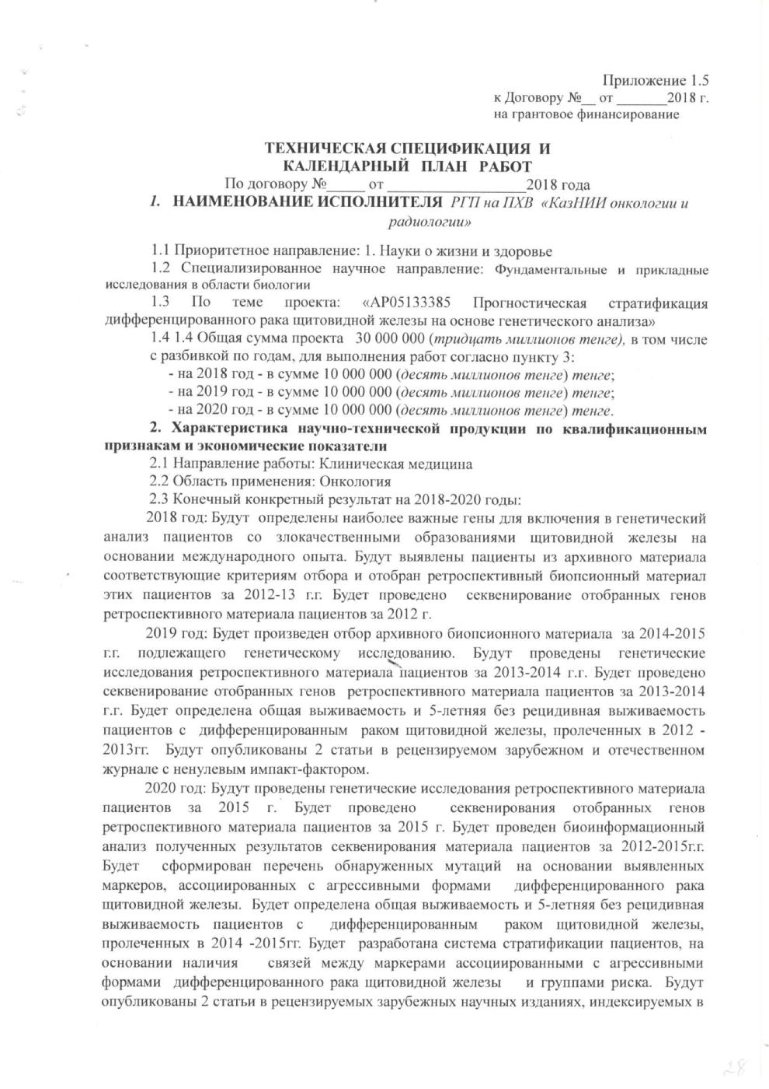

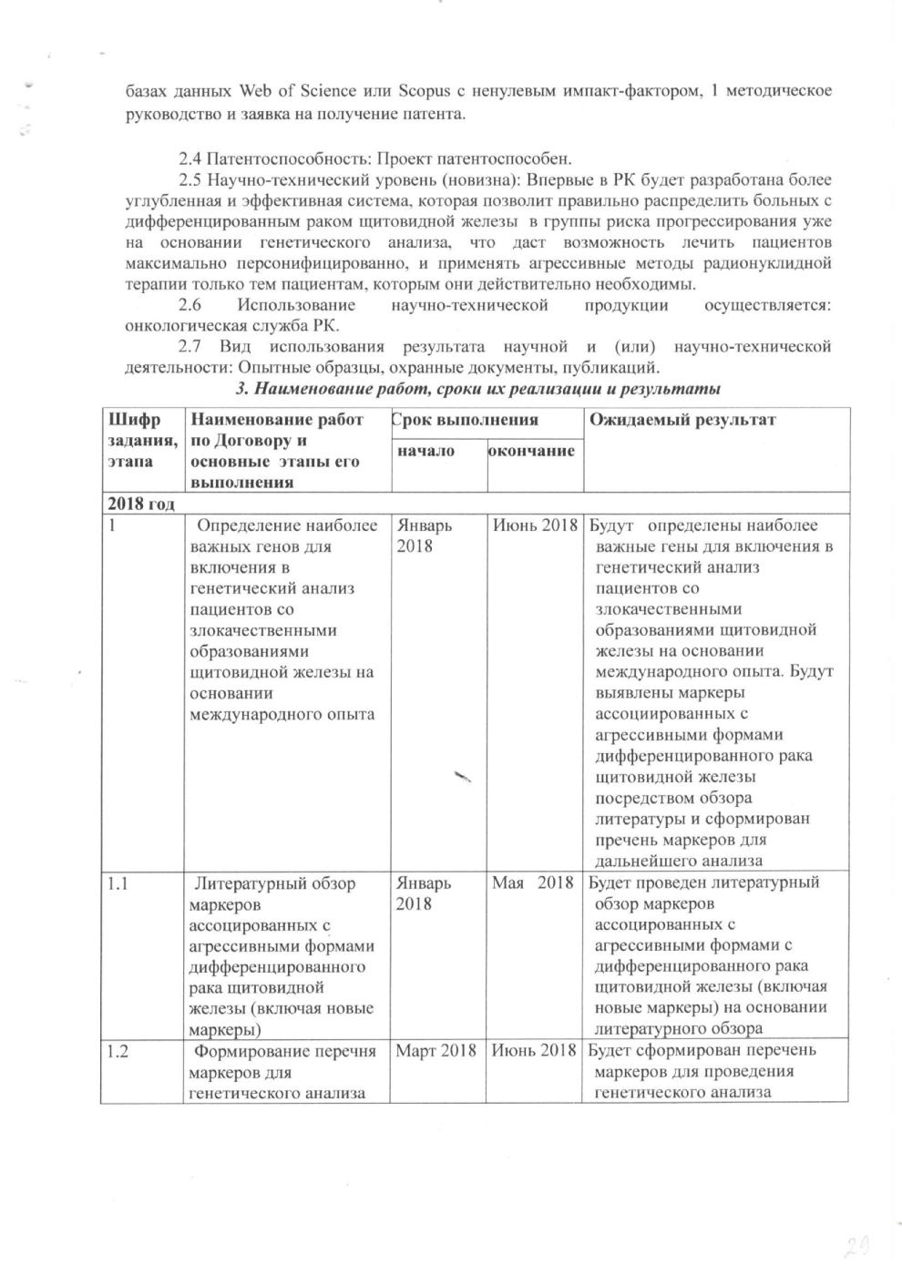

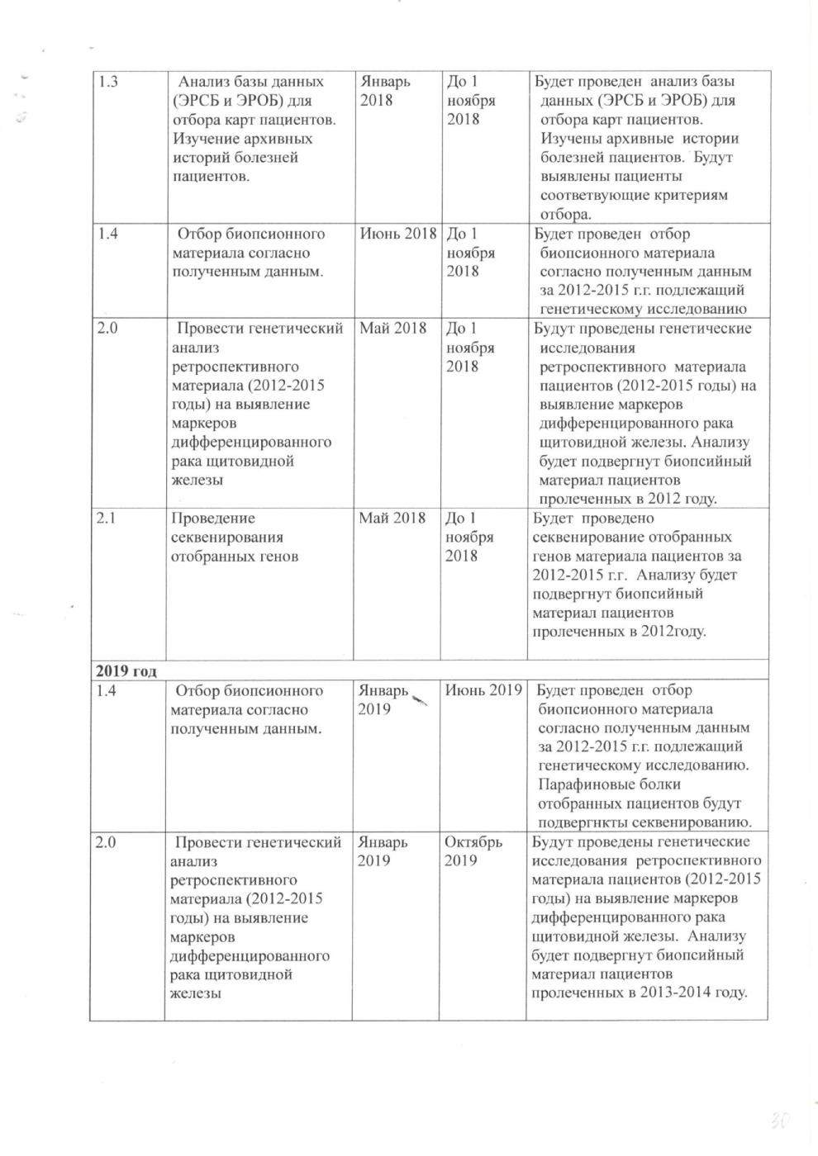

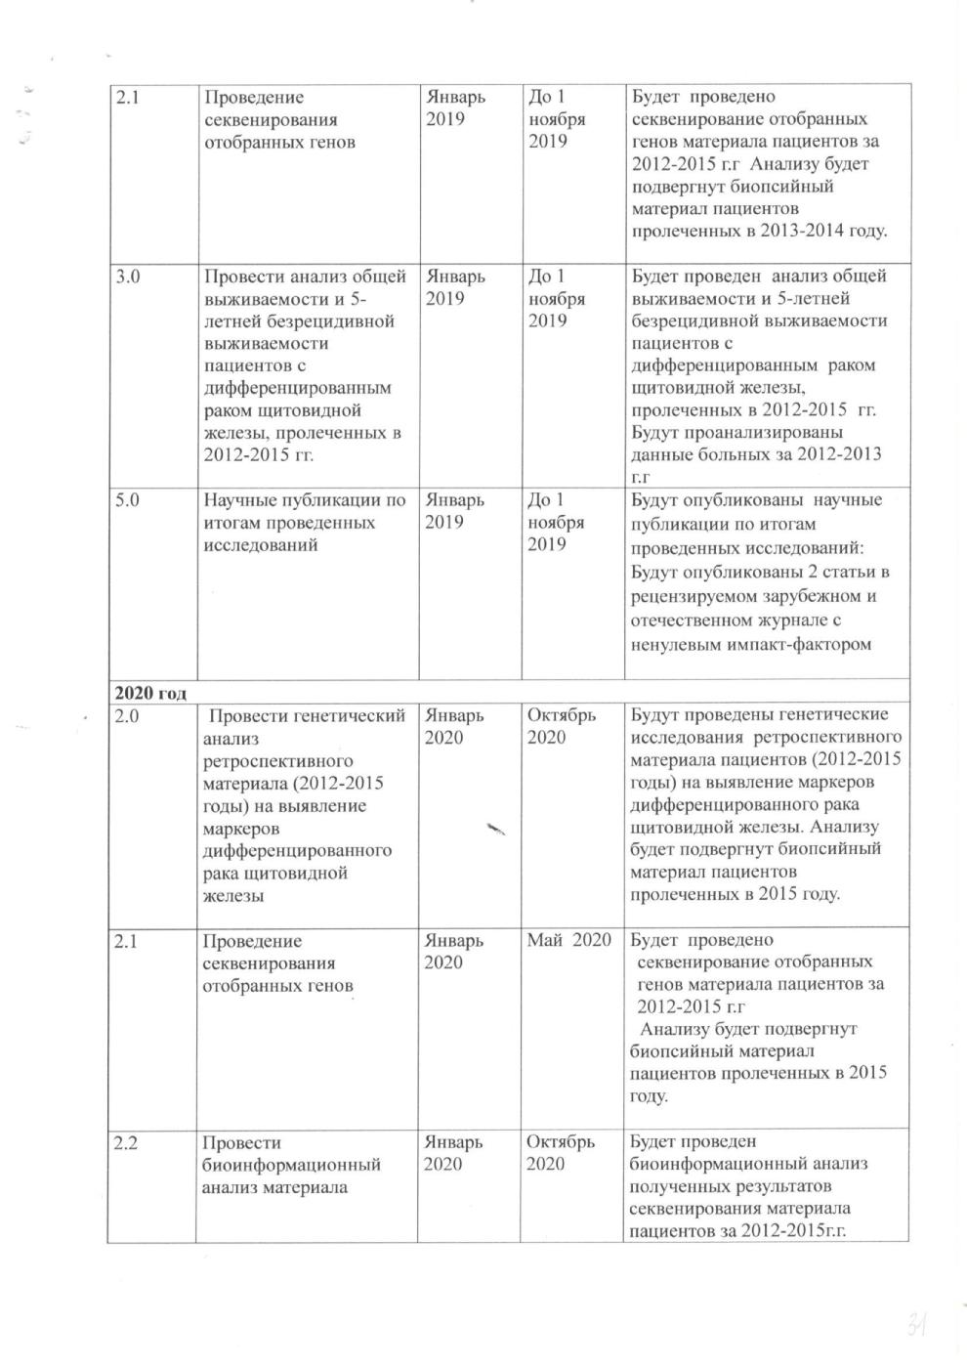

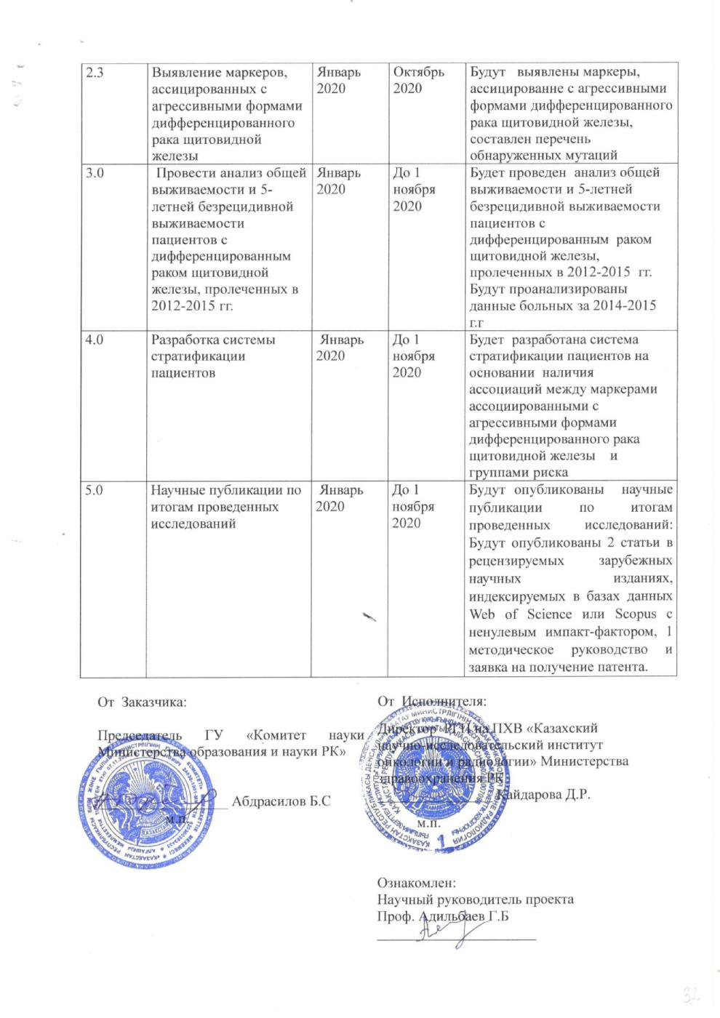

ATTACHMENT B
The list of published works
For 2018:
Foreign publication:

А.S. Tlegenov, Z. Abylaiuly, D.G. Adilbay, Z.B. Eleubayeva, G.B. Adilbayev. Prevalence of mutant brafv600e in the papillary thyroid carcinoma in patients from kazakhstan and its correlation with clinical-morphological tumor characteristic // Медицинский вестник Северного Кавказа.- November 2018.-13(3).- С.468-473. Q3. IF – 0.442 (english)

Domestic publication:

1. А.S. Tlegenov, Z. Abylaiuly, D.G. Adilbay, G.B. Adilbayev, etc Использование молекулярно-генетического тестирования BRAFV600E мутации для тонкоигольной аспирационной цитологии щитовидной железы // Oncology and Radiology of Kazakhstan.-2018.- №3(49). Q1. IF – 0.090 (russian)

For 2020:
Foreign publication:

1. Dauren Adilbay, Galym Adilbayev, Madina Orazgalieva, Viktoria Shipilova, Gulzhan Kidirbayeva, Nina Sloneva, Aizhan Amandosova, Saniya Ossikbayeva. Kazakh Institute of Oncology and Radiology, Almaty, Kazakhstan. CTNNB1, PIK3CA, EIF1AX, and PTEN polymorphisms found in aggressive types of differentiated thyroid cancer.// Journnal of Clinical Oncology 38, no. 15_suppl Published online May 25, 2020. Q1. IF – 18.230 (english)

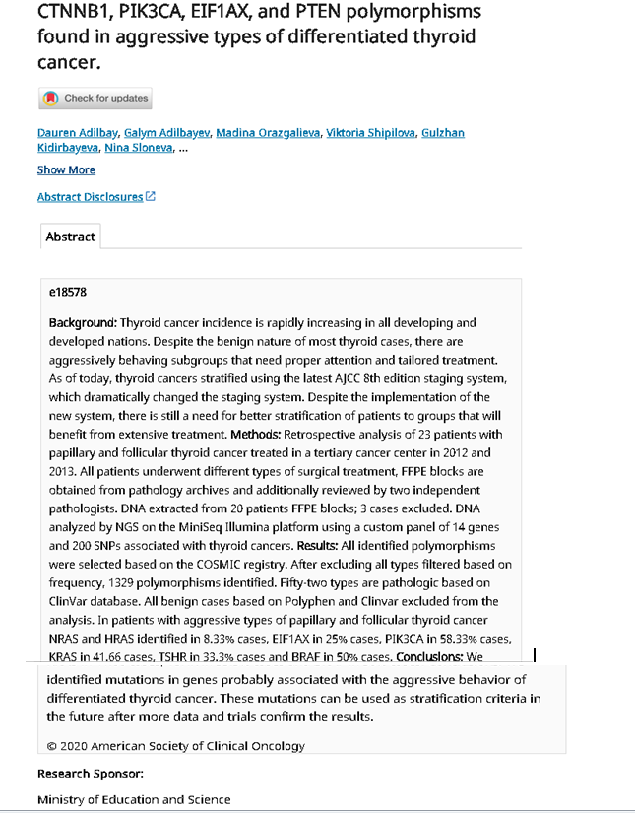

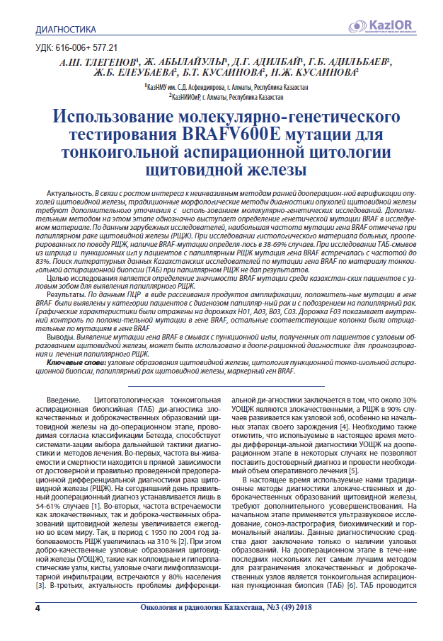

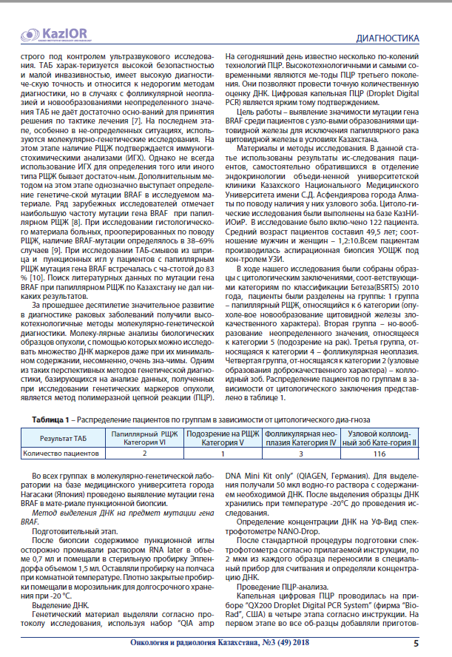
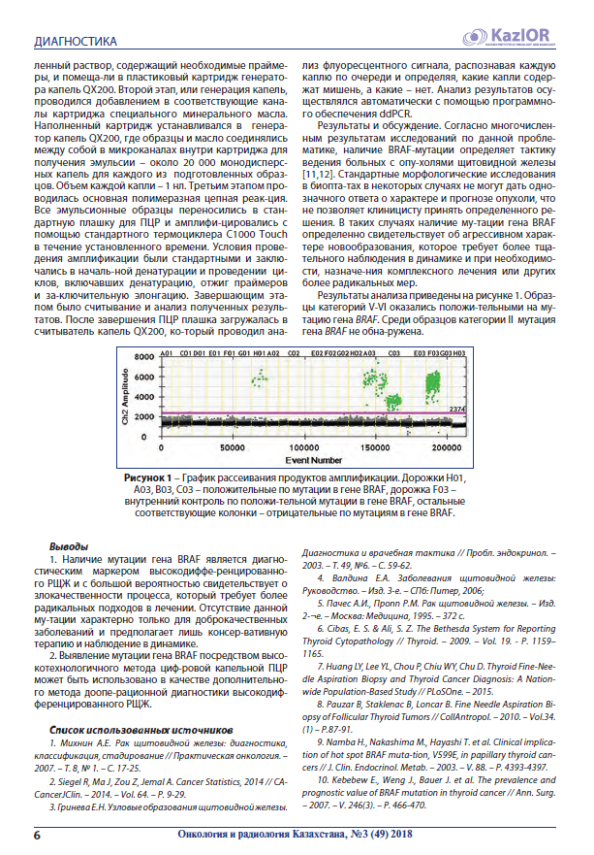
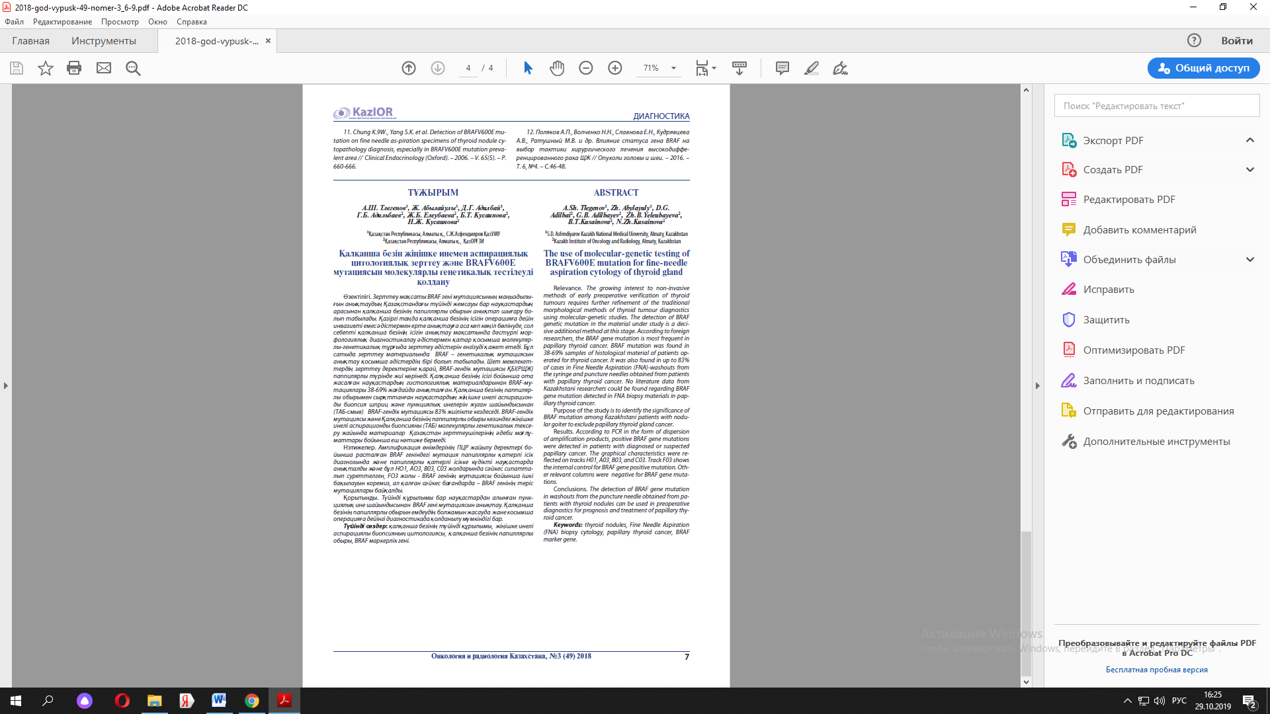
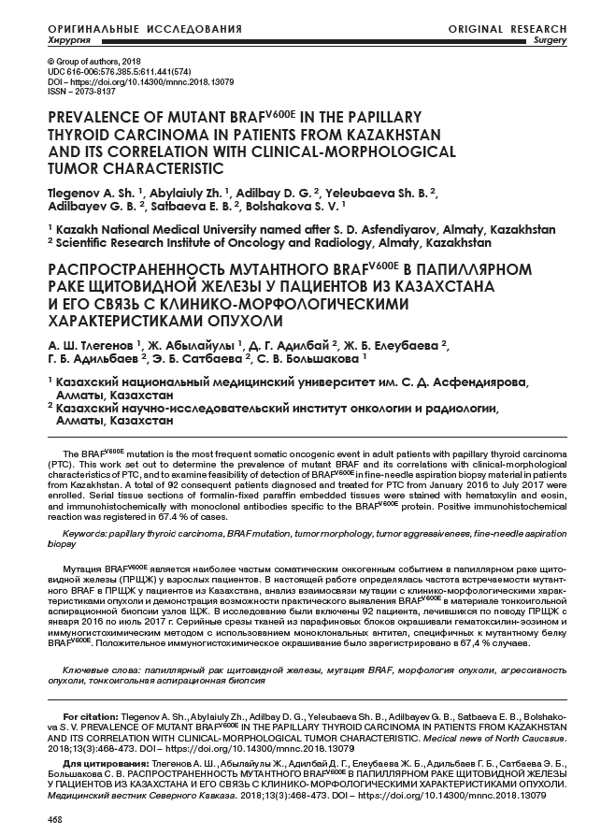
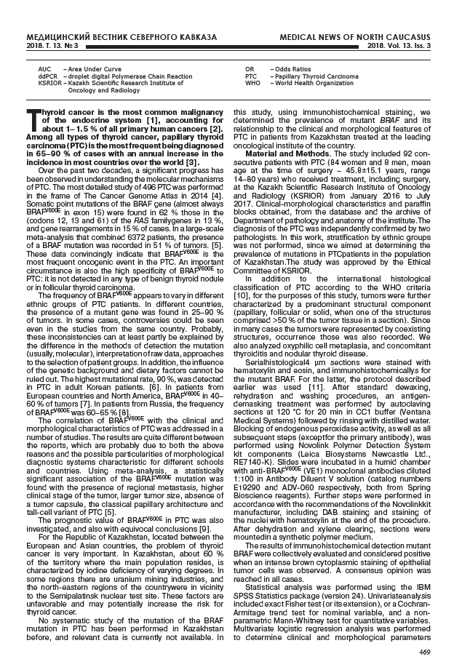
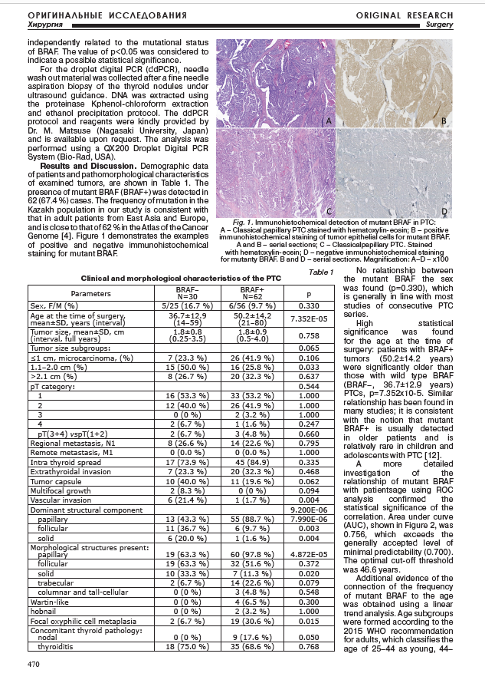
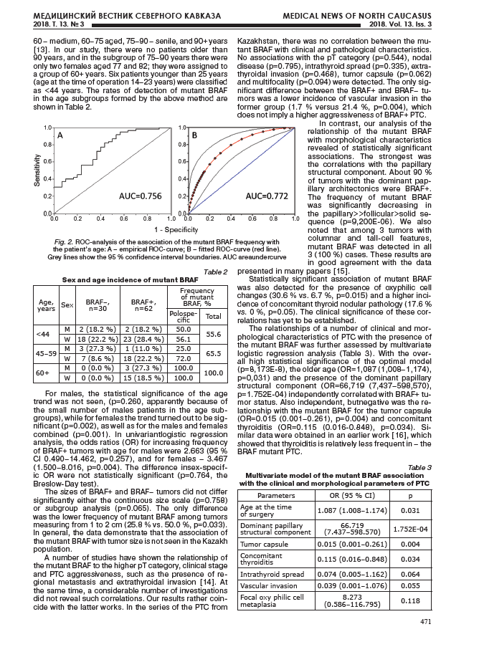
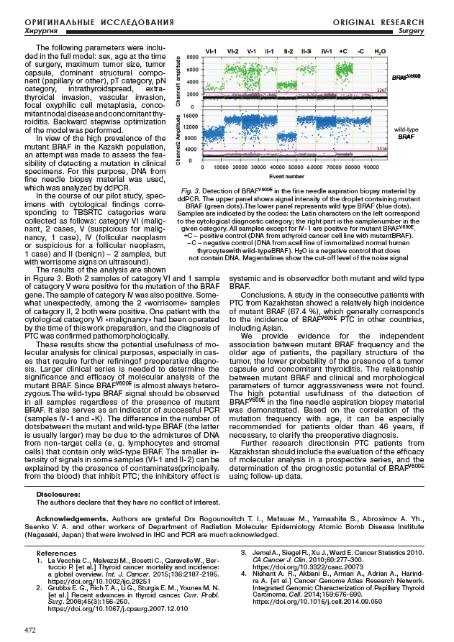
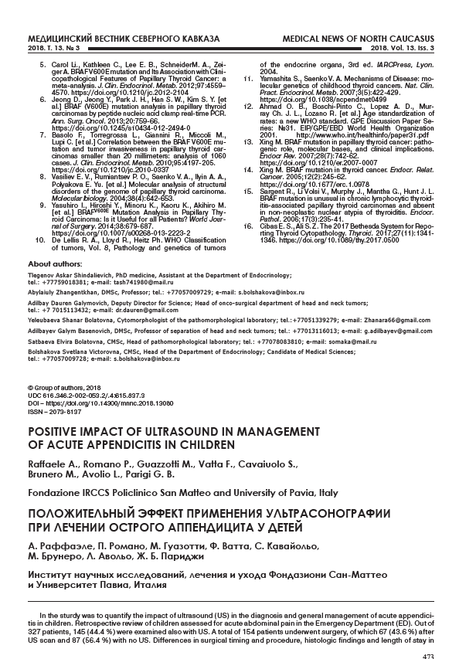
ATTACHMENT C
Grant financing
(results for 2018-2020y)
Full name of the executing organization |  | Grant number |  | Type of research | Name of the project |  | Project start date |  |  | Project completion date
Republican state enterprise on the right of economic management «Kazakh Scientific Research Institute of Oncology and Radiology» of the Ministry of Health and Social Development. |  | № AP05133385 |  | Applied research. | Predictive stratification of differentiated thyroid cancer based on genetic analysis |  | 2018y. |  |  | 2020y.
Type of the result obtained
The object of the study was archival biopsy material of patients with morphologically verified papillary and follicular thyroid cancer treated in 2012-2015.
Purpose of the work: The purpose of this project is to identify prognostic markers of differentiated thyroid cancer in order to develop a stratification system.
As a result, the selection of biopsy material (blocks and glass preparations) of 200 people was completed, carried out on the basis of the previously obtained data from the analysis of case histories and data from the ERSP and EROP databases for the period 2012-2015. As a result of genetic analysis and sequencing of the selected genes, it was revealed that, from a panel of thyroid-associated key genes, in our cohort, pathological damaging mutations in the PTEN and TP53 genes are most often encountered. Pathological damaging mutations in the genes AKT, BRAF, CTNNB1, EIF1AX, GNAS, HRAS, KRAS, NRAS, PIK3CA, RET, TERT, TSHR occur in groups or individually, they also have prognostic value for thyroid cancer. Analysis of the overall and without recurrent five-year survival rate of patients in the study group showed that the overall survival rate is 92%, the five-year non-recurrent survival rate is 89%. Based on the research materials, 2 articles were published.
The novelty of this study lies in the fact that for the first time in Kazakhstan, a list of the most important genes and effective markers will be determined to determine the high risk of recurrence in highly differentiated thyroid cancer, which will allow developing a more in-depth system of stratification.
Implementation degree:implemented.
Patents **
Number of innovative patents or copyright certificates |  | Number of Kazakhstan patents |  | Eurasian patent quantity | Number of OECD international patents | Number of other international patents |  |  | Implementation of the patent
 |  | 1 |  |  |  |  |  |  | (patent sale / conclusion, license agreement, none)
Implementation of results **
Number  2020/ 0948.2. | Implementation name  «Method for predictive stratification of thyroid cancer risk using genetic analysis» registration number |  | Implementation type (technology, standard, recommendation, technique, other) |  | Place of implementation (excluding the executing organization) *
Publications **
The number of published reports and articles based on research results at international conferences with an impact factor |  |  |  |  | Number of reports and research papers published at regional and local conferences
Personnel training**
Number of performers with a scientific degree |  |  |  |  |  |  |  | 5
The number of foreign scientists involved in research
Participation of PhD students, undergraduates in research in the preparation of their dissertations
Attachments (attach the necessary documents confirming the submitted data)
_____________________________ / Signature of the project supervisor / |  |  |  |  |  |  |  | 8(727)239-14-55, +77013116013
Adilbaev Galym Bazenovich Head of the Center for Head and Neck cancer doctor of medical science, prof. |  |  |  |  |  |  |  | E-mail  g.adilbaev@gmail.com
Confirmation: I confirm that the information provided in this report is complete and correct________________ / Authorized Verifier Signature /
Note:
* Specify each value in a separate cell
** it is necessary to attach copies of documents confirming the information

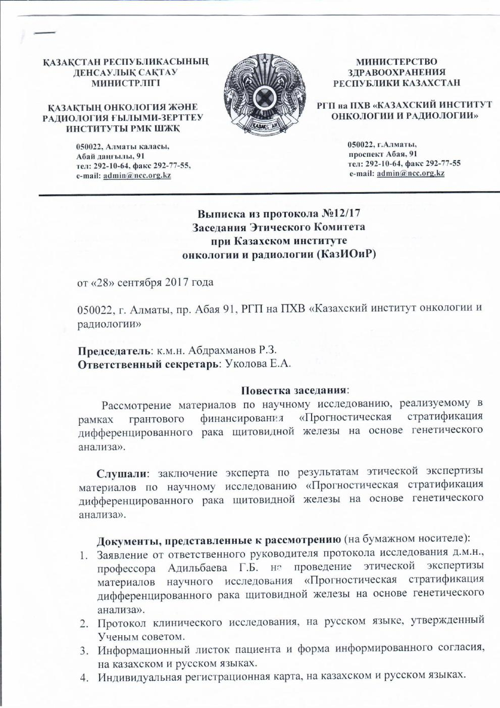
ATTACHMENT D

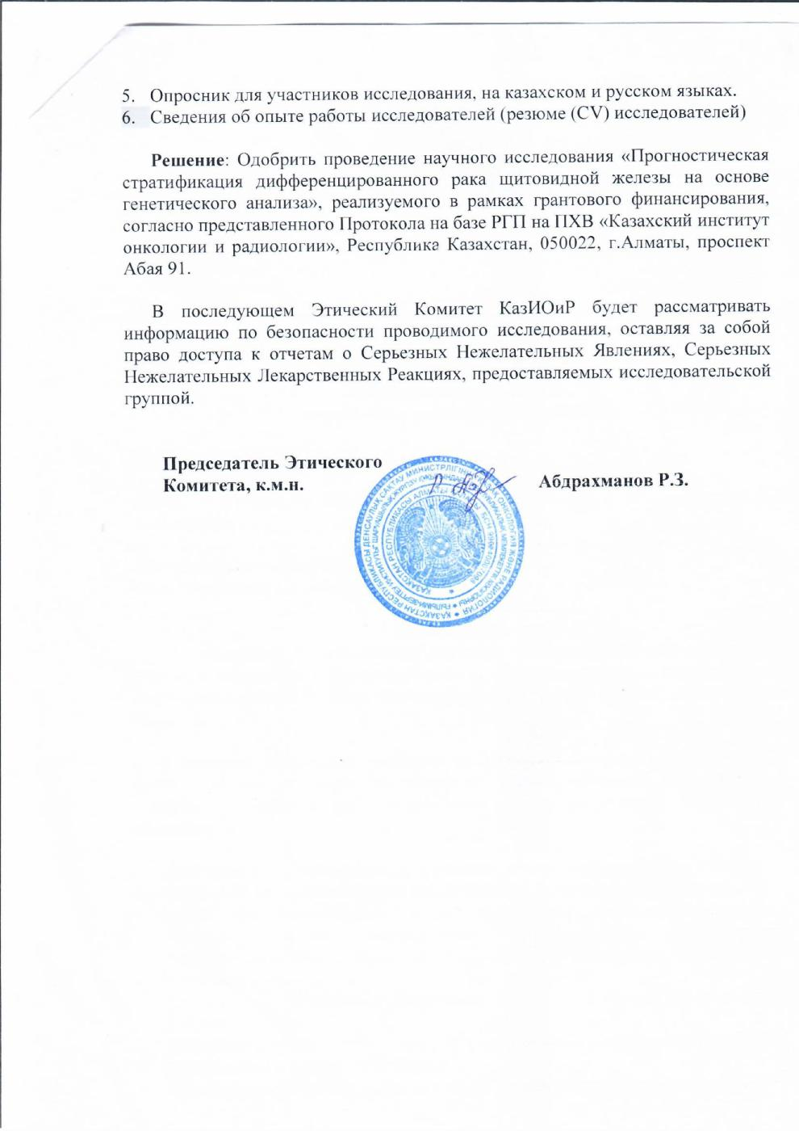

ATTACHMENT E
Extract from the RS protocol

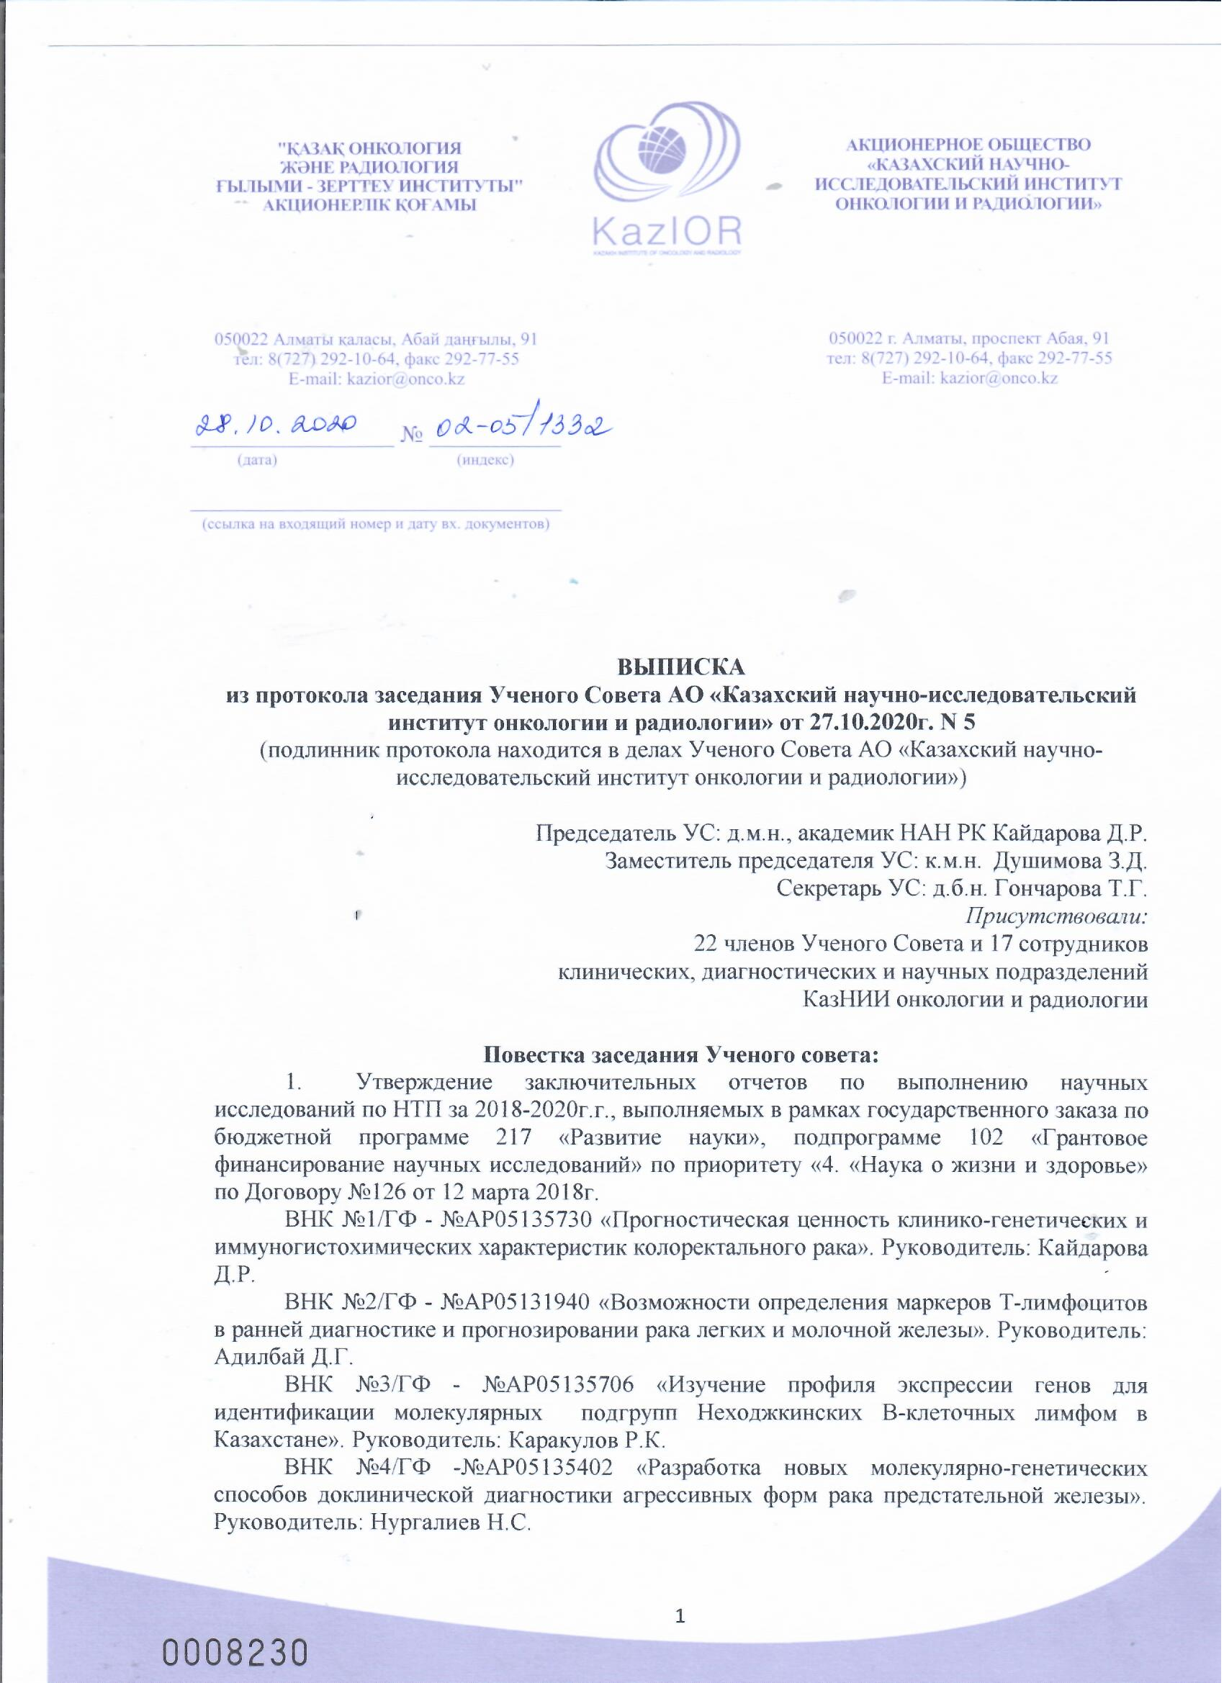

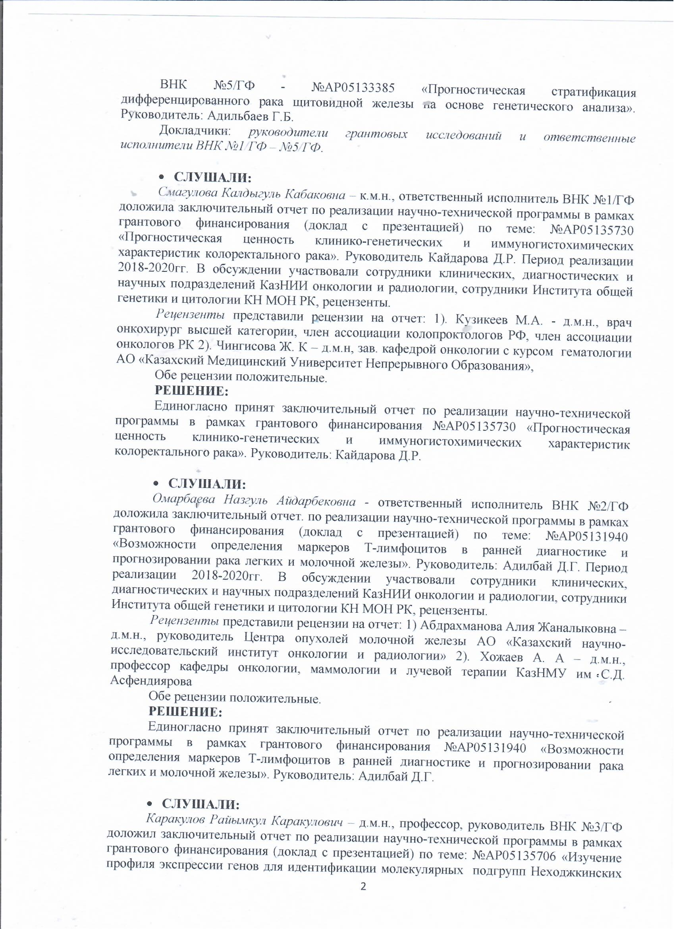
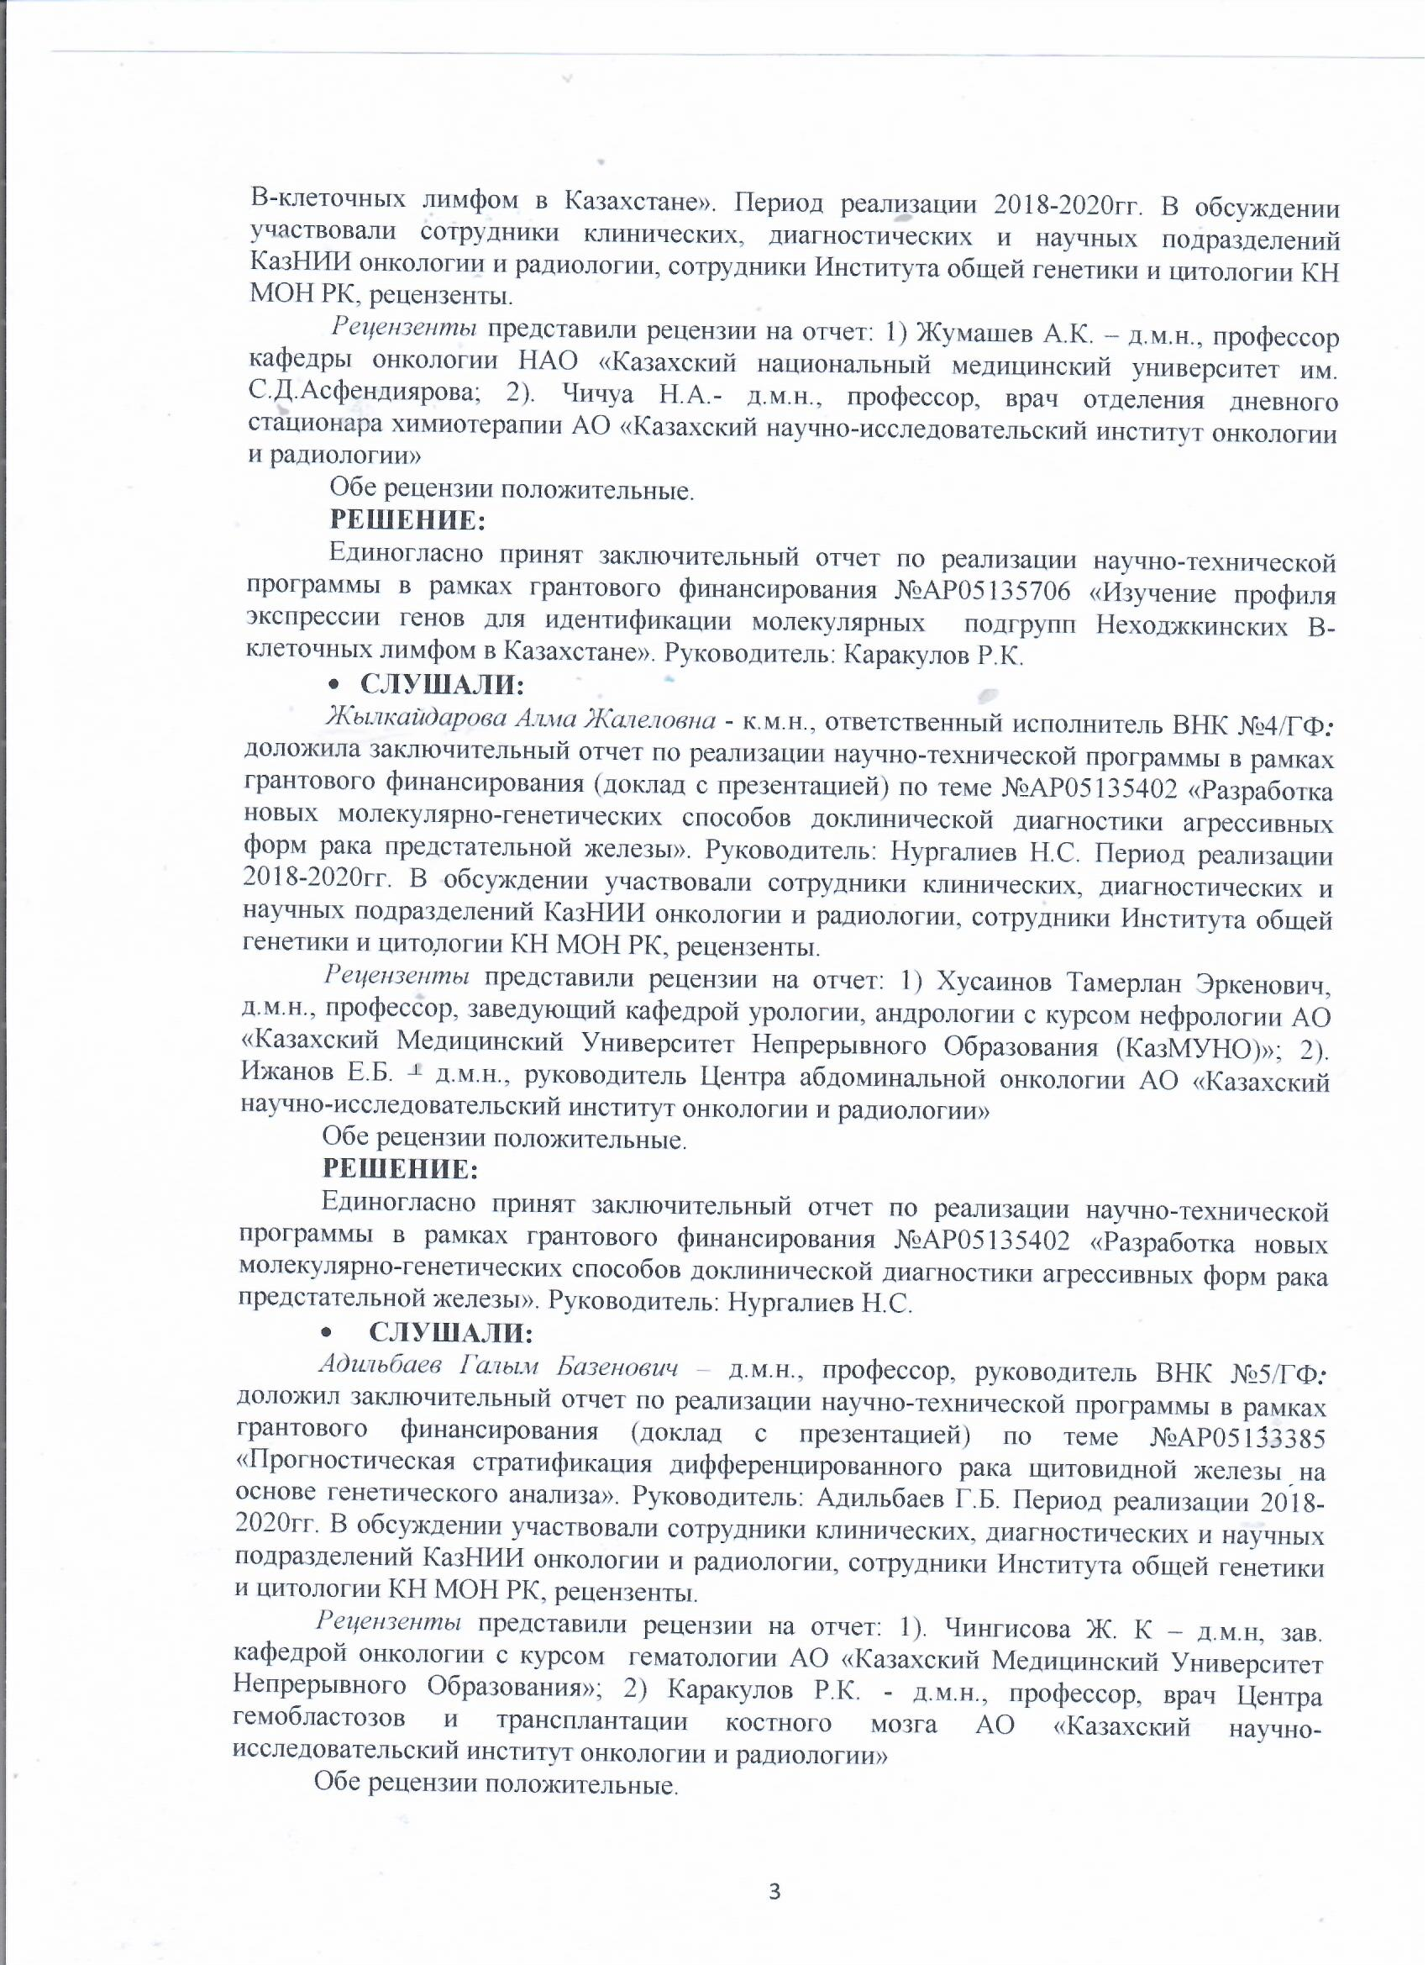

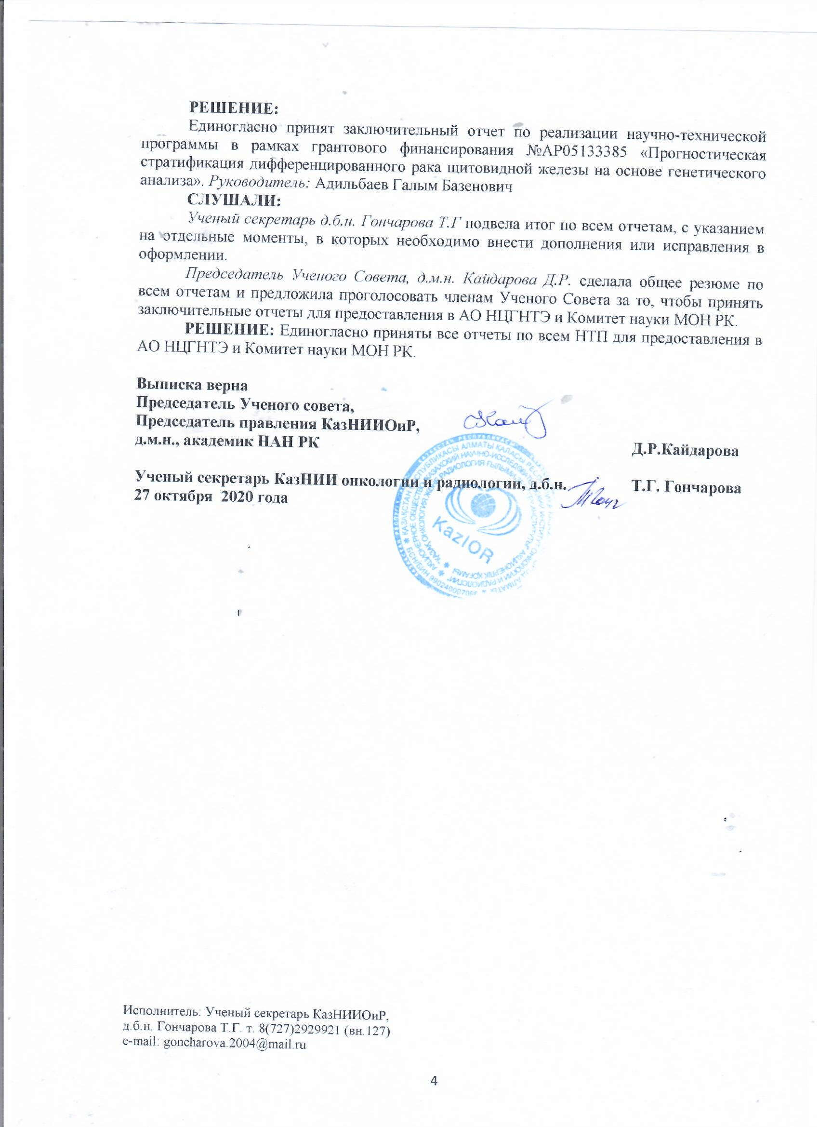

ATTACHMENT F
Reviews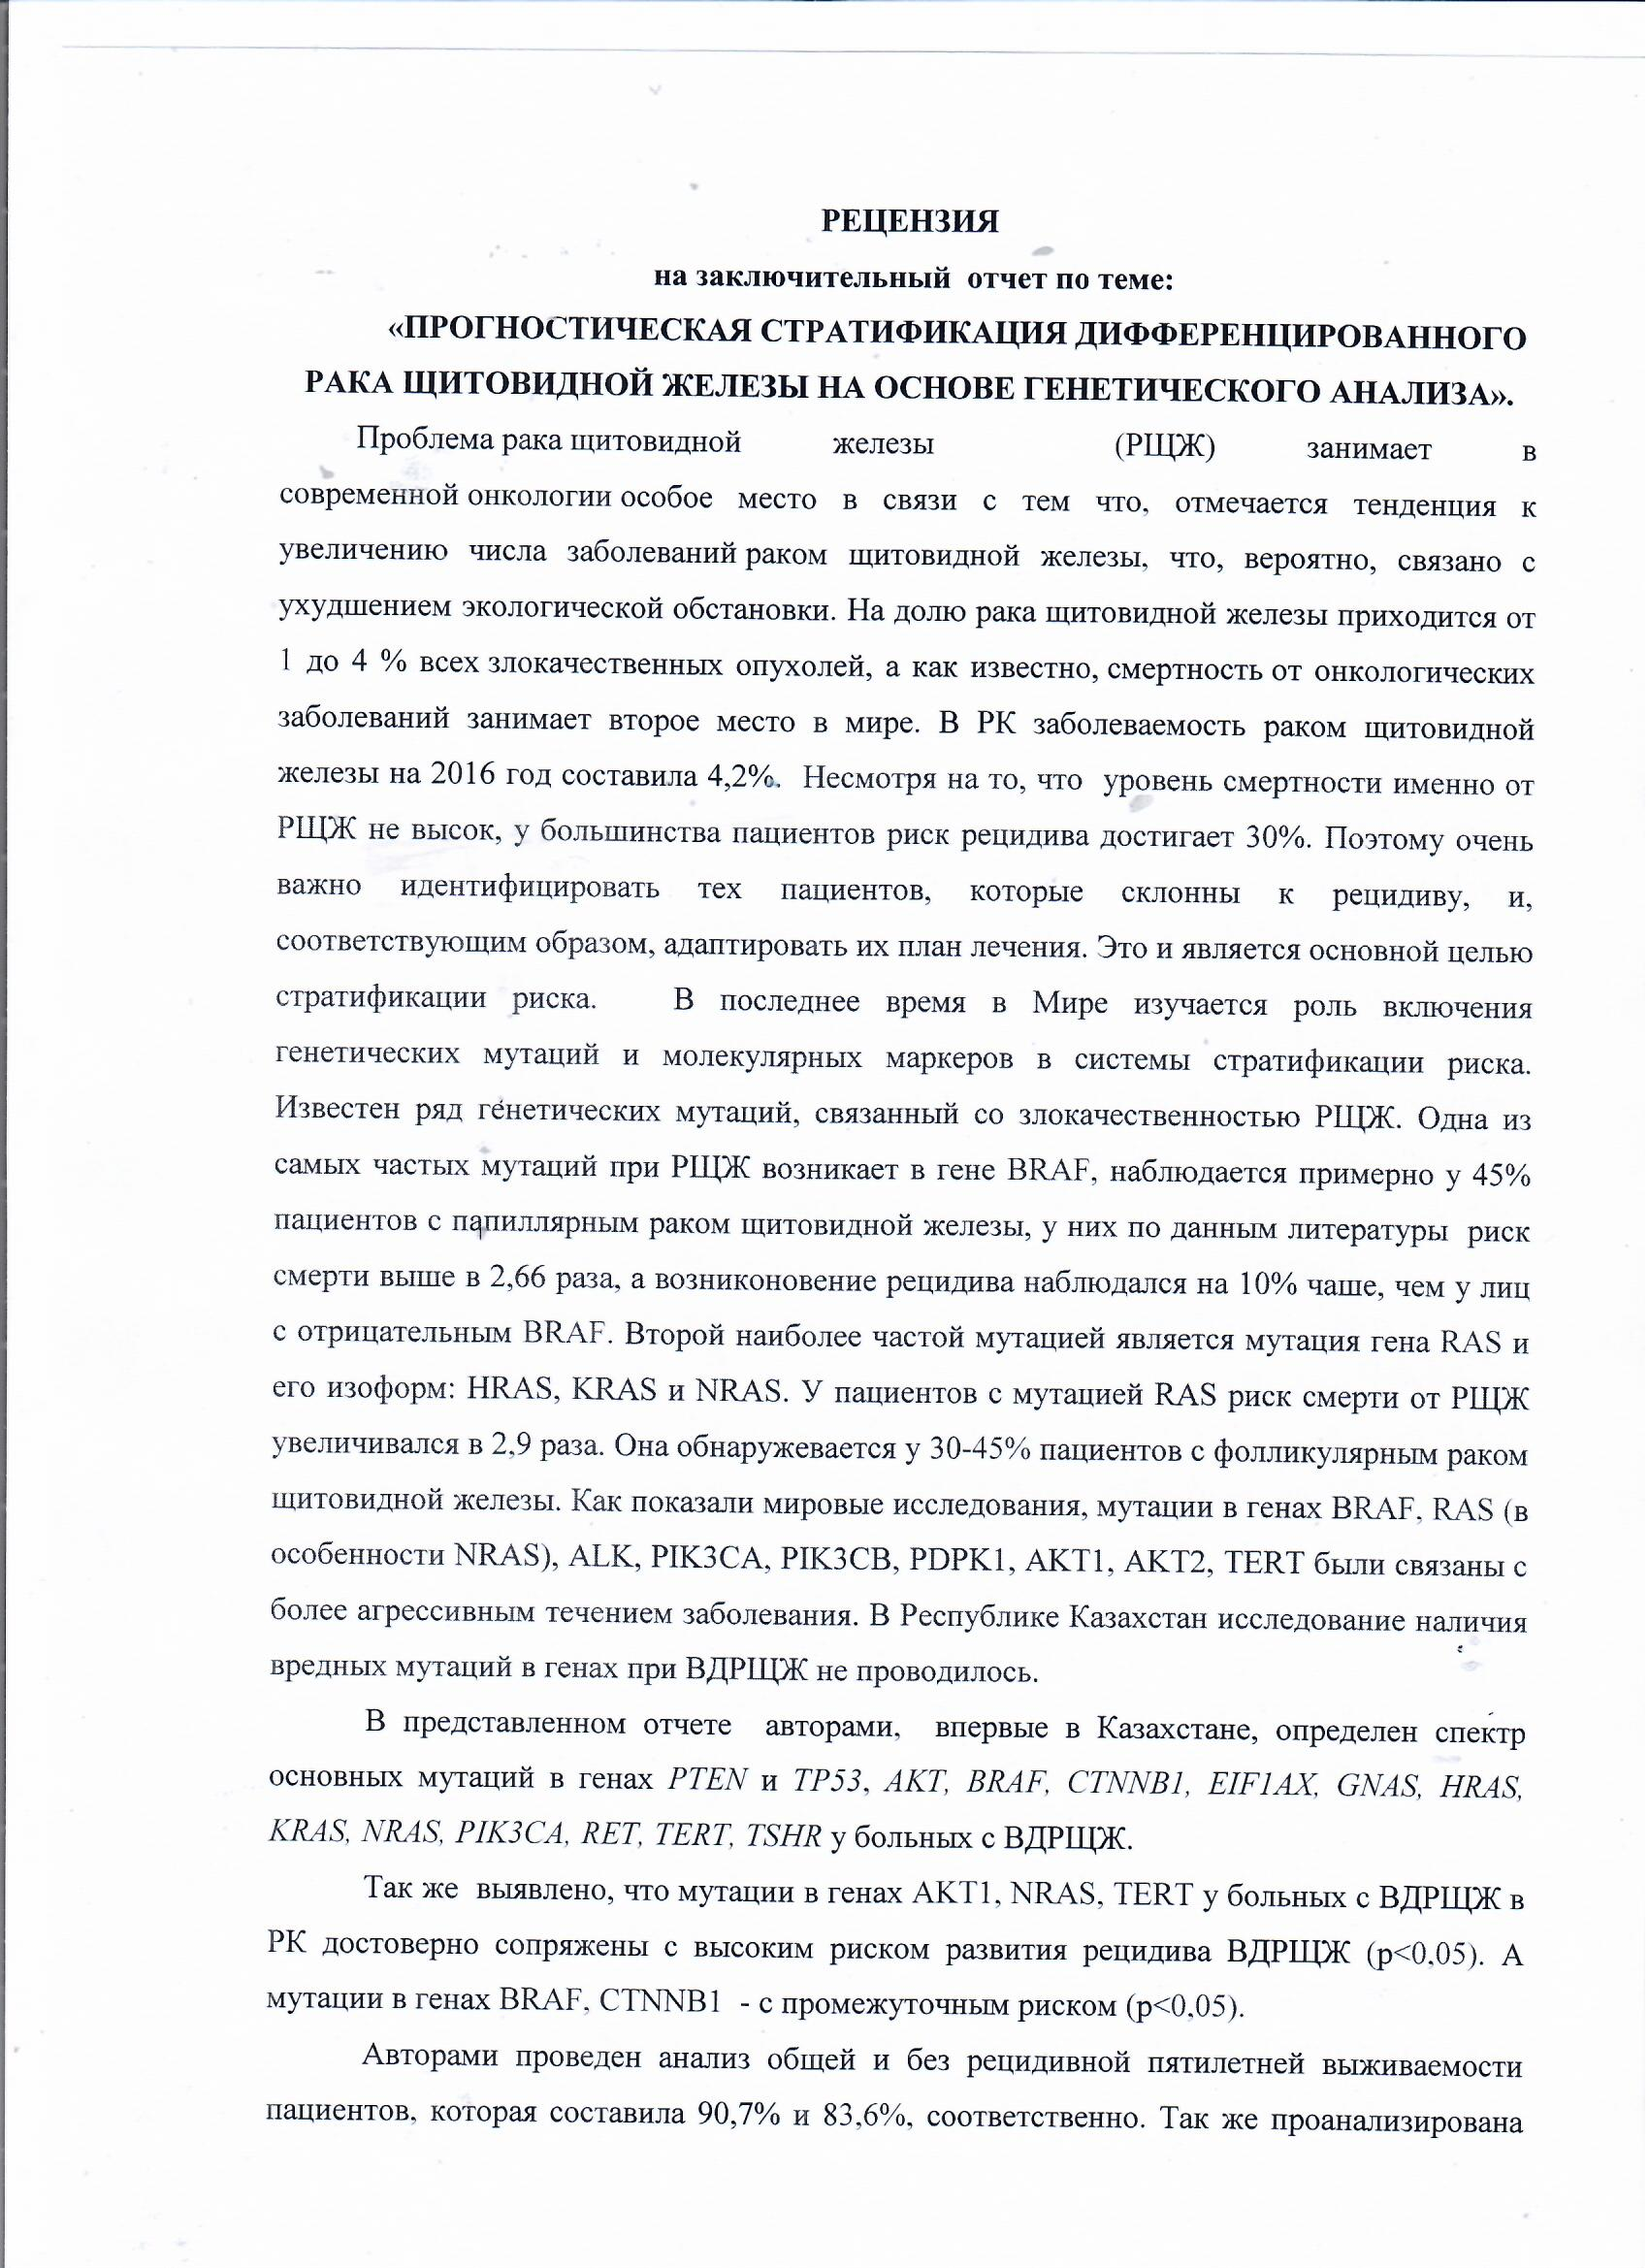

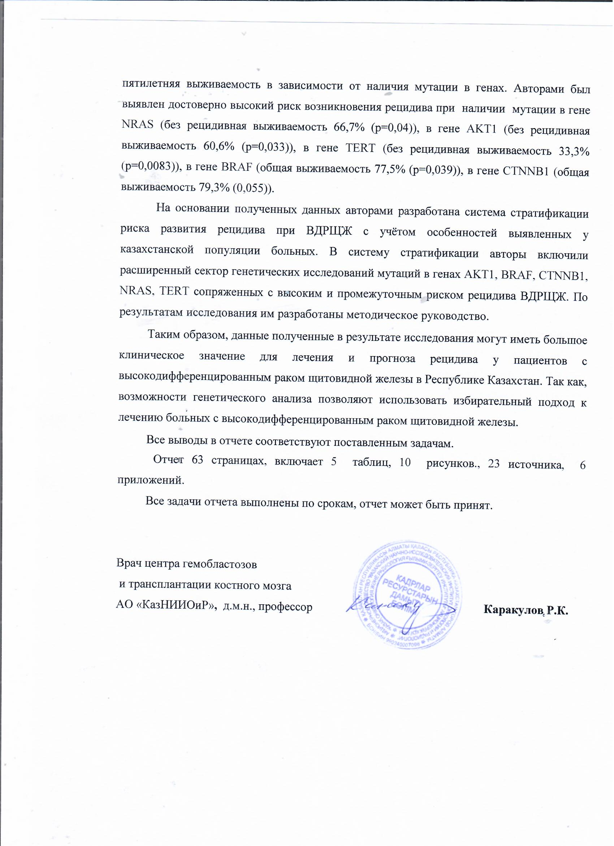

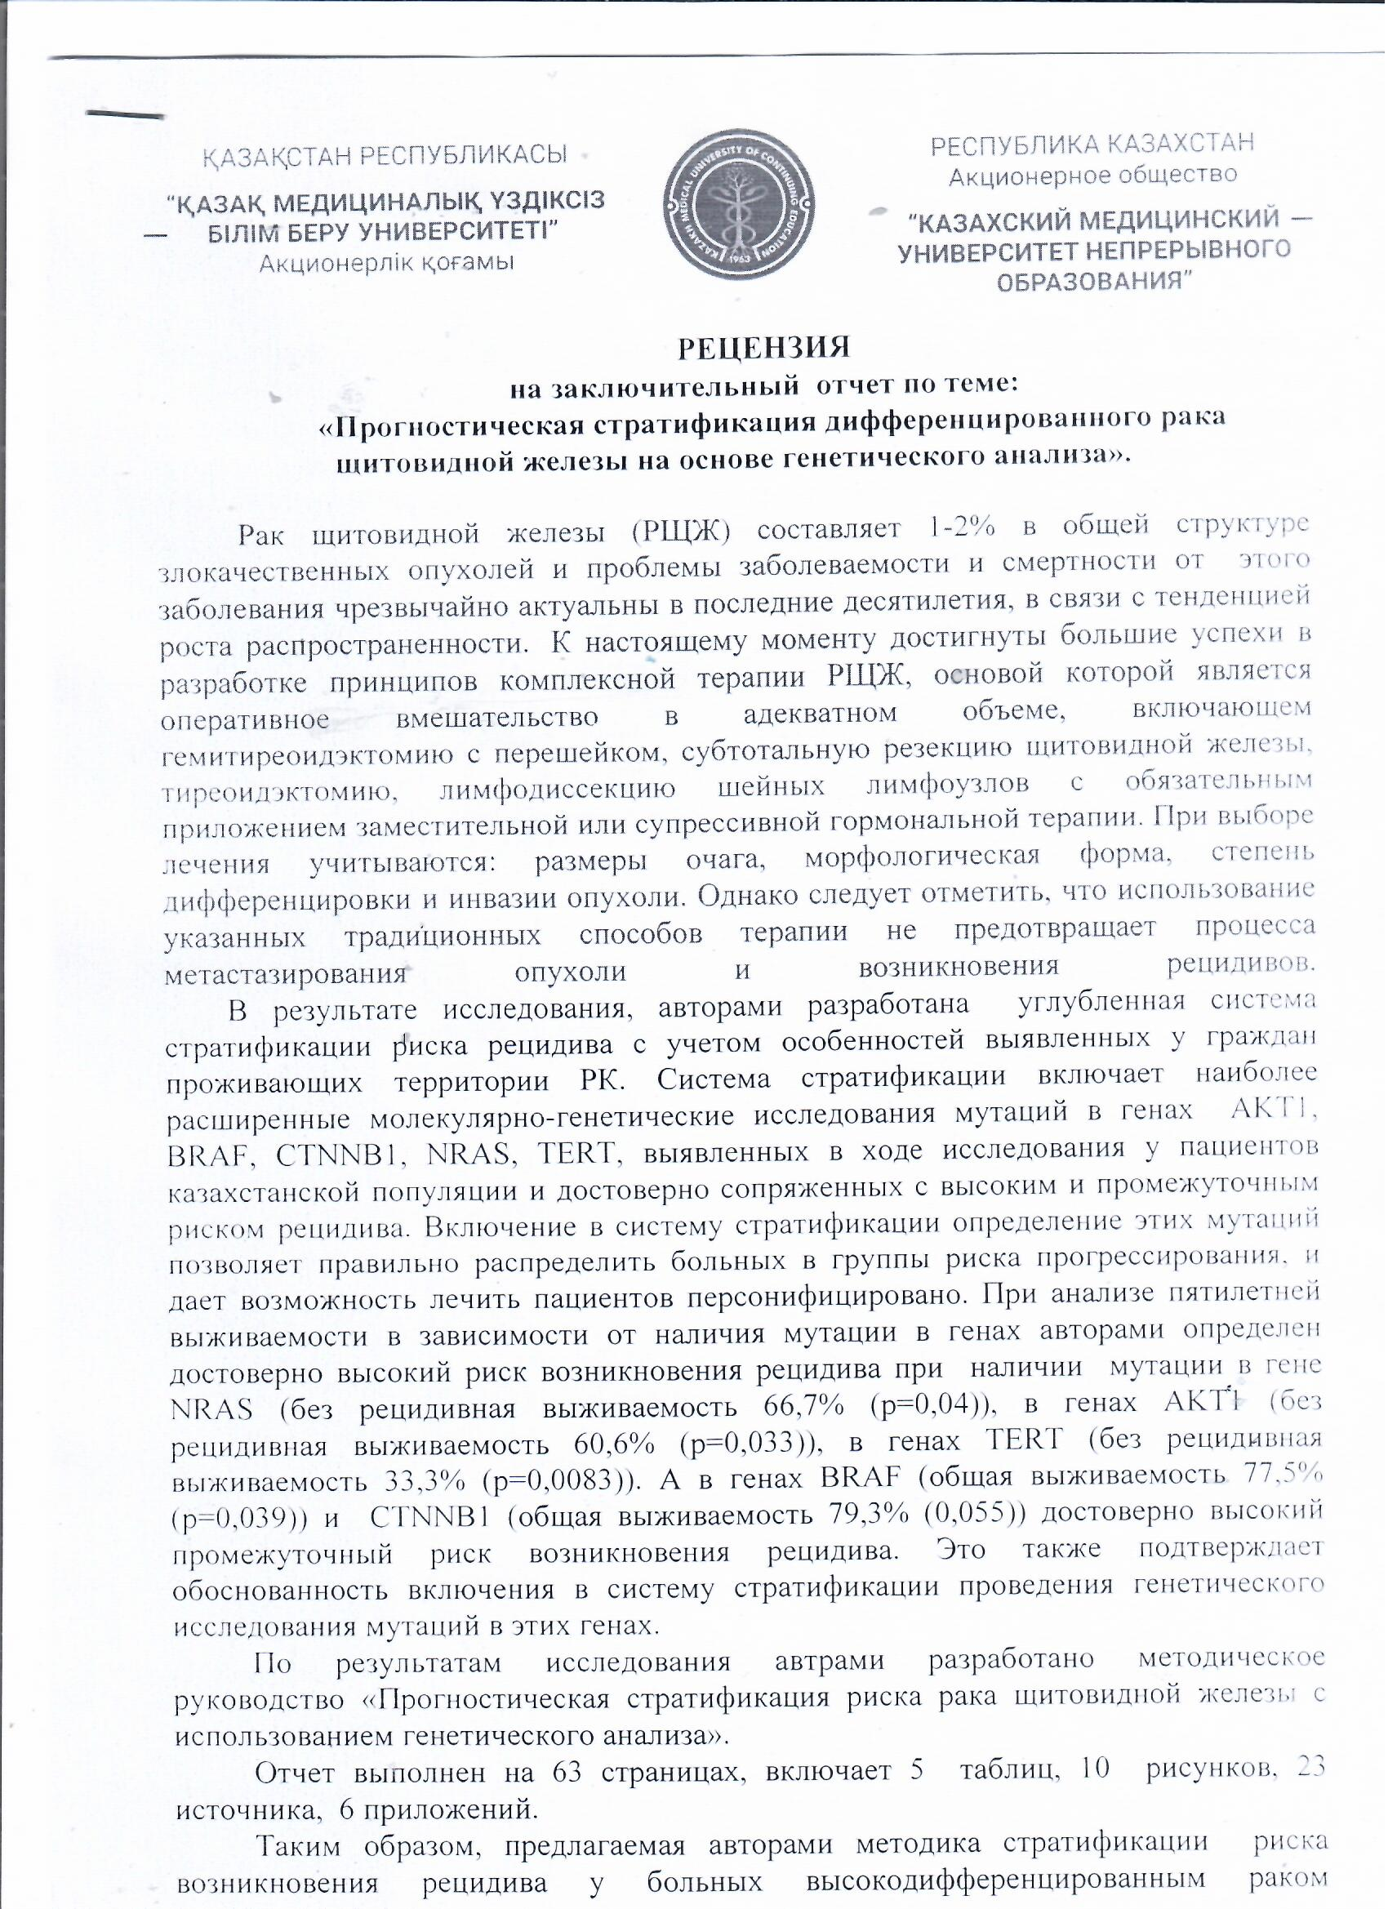

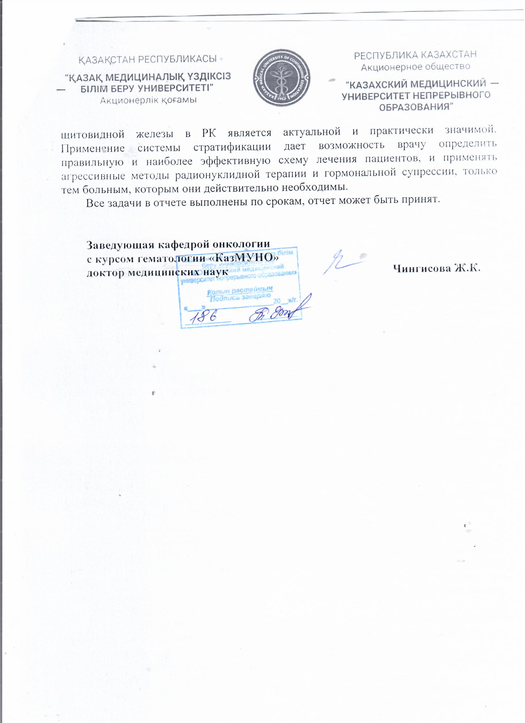

ATTACHMENT J
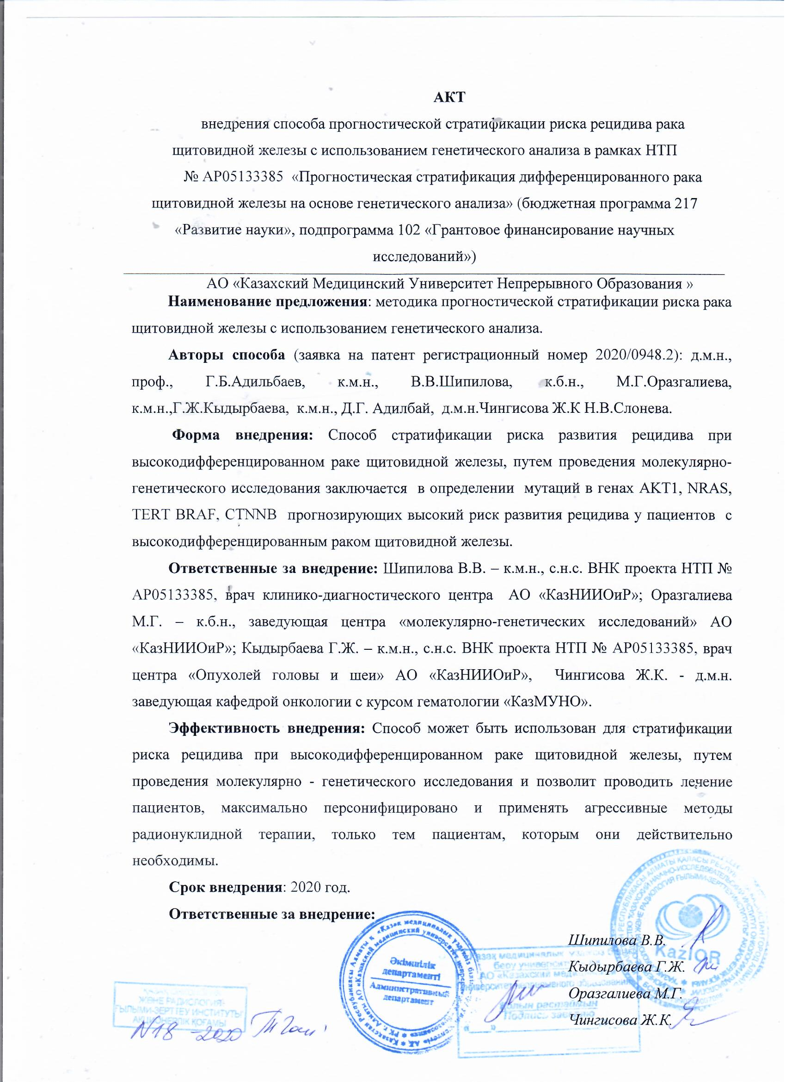

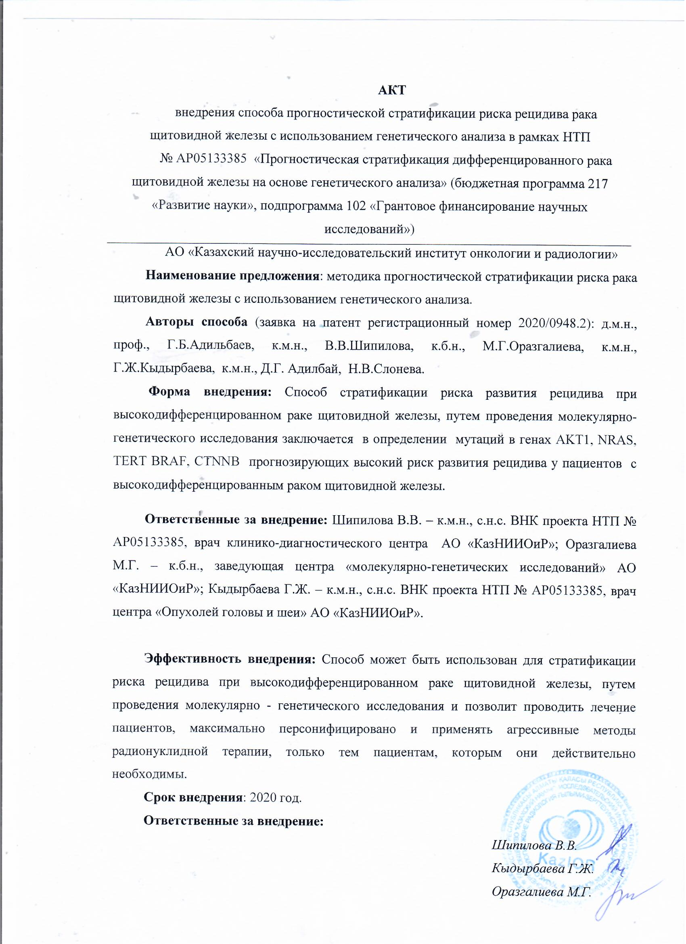

ATTACHMENT H
