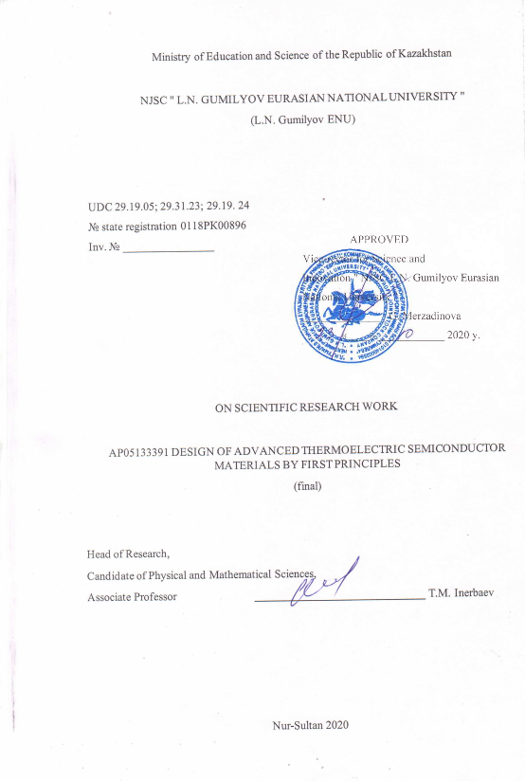

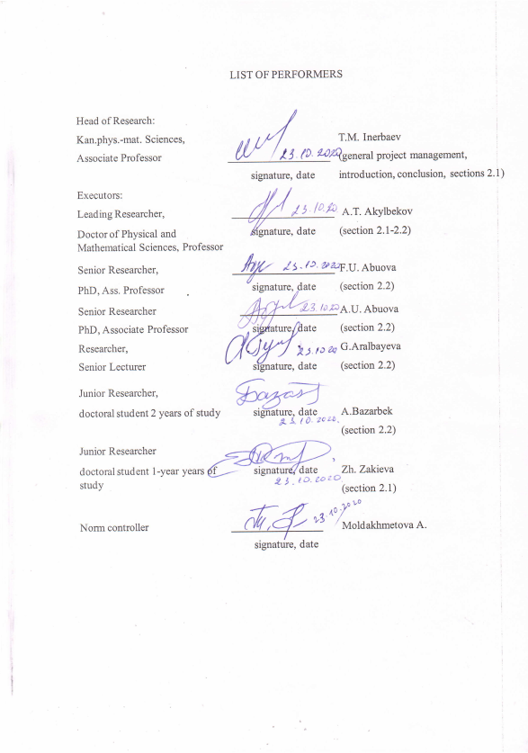
ESSAY

Есеп 49бет, 1 кітап, 20 сурет, 20 дереккөзі, 2 кесте, 2 қосымшадан тұрады.
ЖЫЛУДЫ ЭЛЕКТР ЭНЕРГИЯСЫНА ТІКЕЛЕЙ АЙНАЛДЫРУ, БАЛАМАЛЫ ЭНЕРГЕТИКА, ТЕРМОЭЛЕКТРИКТЕР, ТЫҒЫЗДЫҚТЫҢ ФУНКЦИОНАЛ ТЕОРИЯСЫ, БОЛЬЦМАННЫҢ ТАСЫМАЛДАУ ТЕОРИЯСЫ
Зерттеунысаны - ауырметалдардың, оның ішінде лантан қатарының иондарының қоспа иондары қосылған оксидтер мен фторидтер.
Жұмыстың мақсаты – жылуды электр энергиясына айналдыру үшін термоэлектрлік генераторларда пайдалануға перспективалы жаңа модификацияланған Гейслер қорытпаларын және металл-оксидті қосылыстарды іздеу.
Зерттеу әдістері. Қатты денелердің негізгі күйіндегі қасиеттері, электрондық құрылымы және тордың динамикалық қасиеттері VASP - Vienna ab initio Simulation Package көмегімен ab initio есептеу әдістерін қолдана отырып есептеледі.
Бұл жұмыста ниобиймен, иттриймен және фосформен допингтің кристаллға және электронды құрылымға әсері, сонымен қатар термоэлектрлік қасиеттері зерттелген. Кез-келген элементтермен допинг Bi бос орындары бар таза жүйемен салыстырғанда n-типтегі допингке әкеледі деп есептелген. Nb және P-мен 3-тен концентрациядағы допинг.% Концентрациялары жоғарылаған сайын легирленген элементтер радиусы әсерінен жолақ саңылауының азаюына әкеледі.
Негізгі жобалық-техникалық-экономикалық көрсеткіштер. Тәжірибелік және қолда бар теориялық мәліметтермен салыстыру қолданылған әдістердің дәлдігін көрсетті.
Іске асыру дәрежесі. Ендірулер жоспарланбаған
Тиімділік. Алынған мәліметтер зерттелген материалдардың допингінің олардың термоэлектрлік сипаттамаларын жақсартуға әсерін алдын-ала бағалауға мүмкіндік береді. Сәйкес әсерлер осы жобада кейінірек егжей-тегжейлі зерттелетін болады.
Қолдану саласы: Алынған іргелі ғылыми нәтижелер баламалы энергия және энергия үнемдеу саласында қолдануды табуы керек. Нәтижелер, мысалы, химиктер, материалтанушылар мен инженерлер сияқты әлеуетті пайдаланушыларға практикалық басшылық береді деп күтілуде.

ESSAY

Report 49 pages,1 book, 20 figures, 20 sources, 2 table, 2 ap
DIRECT CONVERSION OF HEAT INTO ELECTRICITY; ALTERNATIVE ENERGY; THERMOELECTRICS; DENSITY FUNCTIONAL METHOD; BOLTZMANN TRANSPORT THEORY
The object of research is oxides and fluorides doped with impurity ions of heavy metals, including ions of the lanthanum series.
The work aims to search for new modified Heusler alloys and metal-oxide compounds promising for use in thermoelectric generators to convert waste heat into electricity.
Research methods. The properties of solids in the ground state, the electronic structure and the dynamic properties of the lattice are calculated using ab initio calculation methods using the VASP - Vienna ab initio Simulation Package.
In this work, the effect of doping with niobium, yttrium, and phosphorus on the crystal and electronic structure, as well as thermoelectric properties, is investigated. It was calculated that doping with any of the elements leads to n-type doping compared to a pure system with incorporated Bi vacancies. Doping with Nb and P at a concentration of 3 at.% Leads to a decrease in the band gap due to the doped elements' radius with a further increase at higher concentrations.
The main design and technical and economic indicators. Comparison with experimental and available theoretical data showed good accuracy of the applied methods.
The degree of implementation. No introduction
Efficiency. The data obtained make it possible to preliminarily evaluate the effect of doping of the investigated materials on the improvement of their thermoelectric characteristics. The corresponding effects will be studied in detail later in this project.
Field of application: the obtained fundamental scientific results should find application in the field of alternative energy and energy saving. The target consumers of the results are scientists, technologists and engineers engaged in the development of energy-saving devices and technologies and the synthesis of new materials for these purposes. The results are expected to provide practical guidance to potential users such as chemists, materials scientists, and engineers.

CONTENT
INTRODUCTION ................................................. ......................................................... | 7
MAIN PART OF THE R&D REPORT............................................................................ | 9
1 Research methods ............................................... ........................................................... | 9
1.1 Carrying out by the molecular dynamics method from the first principles of calculating the trajectories of motion of atoms of oxychalcogenides and heusler alloys at different temperatures…………………………………………………….. | 10
1.1.1 Calculation of non-adiabatic coupling constants. Numerical solution of equations of motion for the reduced density matrix…………………………….. | 10
1.1.2 Calculation of the total figure of merit ZT BiSeCuO by methods of calculation from first principles……………………………………………………………… | 23
CONCLUSION … ………………………………………………………..…………….. | 34
LIST OF USED SOURCES ............................................... .............................................. | 36
APPENDIX A List of published works ………………………………………………… | 38
APPENDIX B Calendar plan 2018-2020yy…………………………………………….. | 40

TERMS AND DEFINITIONS

In this R&D report, the following terms are used with appropriate definitions.

KOHN-SHAM ORBITALS | - in density functional theory, one-electron wave functions are called, obtained as a result of solving the Schrödinger equation with a model effective potential for non-interacting particles, as a result of which the electron density of a system with interaction is reproduced.
DENSITY MATRIX | is one of the ways to describe the state of a quantum mechanical system. In contrast to the wave function, which is suitable only for describing pure states, the density operator can equally define both pure and mixed states. It is used to describe open systems in which energy is exchanged with the environment.
REDUCED DENSITY MATRIX | is the density matrix of the system, in which the averaging over the degrees of freedom of the environment is carried out.
DENSITY FUNCTIONAL THEORY | is a method for calculating the electronic structure of many particle systems in quantum physics and quantum chemistry. It is used to calculate the electronic structure of molecules and condensed matter.
PAW PSEUDOPOTENTIALS | - pseudopotentials used in ab initio PAW (projected augmented waves) calculations by the method, which is a generalization of the pseudopotential method and the method of linearized attached plane waves.

INTRODUCTION

Semiconductor thermoelectrics are used in modern technologies for mobile phones, refrigerators, cars, microwave ovens, and many others. The use of thermoelectric materials can convert their excess waste heat into electricity, which will increase energy efficiency. Thermoelectric materials are materials that use a temperature gradient between a heat source and a radiator to generate current. The phenomenon in which an electrical potential (voltage) is created in a thermoelectric material placed between a heat source and a radiator is known as the Seebeck effect. This effect is measured by the figure of merit of the material, defined as $zT= \frac{σS^{2}T}{κ}$, where S is the Seebeck coefficient, thermal conductivity κ, electrical conductivity σ, and temperature T. To increase the energy conversion efficiency, it is necessary to maximize the parameter zT. Such improvements are often achieved by doping (adding impurities) to various materials (2). If the free charges are positive (p-type material), the positive charge will build up near the heatsink (at the cold end) of the device, which will have a positive potential. Likewise, negative free charges (n-type material) will create a negative potential near the heatsink.
In the 2018 annual report, inventory number 0218RK01099, the following results were obtained: modeling of the properties of promising thermoelectrics of the structure of the Heusler alloy Fe2TiSn and layered oxychalcogenide BiCuSeO was carried out. The simulation of the electronic structure was carried out by “first principles” methods using the density functional method in the basis of plane waves. The calculated properties of the electronic structure are compared with similar calculations in the literature. On the basis of the obtained electronic structure, further studies of the indicated compounds were carried out, in which transport properties were simulated to describe the thermoelectric effects in these substances. The studies were carried out using the numerical solution of the Boltzmann transport equation. As a result, the values ​​of the Seebeck coefficient, electrical conductivity and power factor were obtained. For all these values, a comparison is also made with the available literature data, both theoretical and experimental. In addition, the behavior of these quantities was investigated as a function of the number of charge carriers, which made it possible to approximately predict the effect of doping on the thermoelectric properties of the compounds under study.
In the 2019 annual report, inventory number 0219RK00283, the following results were obtained: the Seebeck coefficients for the Heusler alloys Fe 2 Ti 1 - x V x Sn (x = 0, 0.0625, 0.125 and 0.25) were estimated. The calculations showed that the results for x = 0 are relatively close to the experimental ones. When applied, with the same calculation method for samples with a uniform distribution of vanadium, despite the similarity and confirmation of previous theoretical studies, the results are very different from the experimental ones. The significant difference between theoretical calculations and experimental results can be explained by the fact that the theory does not take into account the imperfection of experimental samples. The calculation with allowance for stacking faults, vacancies, and inhomogeneous distribution of vanadium atoms in the supercell makes it possible to find the thermoelectric voltage values ​​closer to the experimental data.
In addition, a high-precision simulation of the electronic structure of the complete Heusler alloy Fe2SnTi by the quasiparticle GW0. It is shown that the compound under study is a semiconductor with a band gap of 0.34 eV. The behavior of optical conductivity calculated on the basis of the data obtained gives a good description of this quantity in comparison with experiment. The presence of a peak in the Drude-type optical conductivity at low frequencies is well described by taking into account the point defects VFe and TiFe, the presence of which transforms the complete Heusler alloy Fe2SnTi into a p-type conductor. This result resolves the contradiction in the literature, where the calculated band gap varies from 0 to 1 eV, depending on the applied theoretical method.
In 2020, the study of the temperature dependence of the relaxation time of thermally excited electrons in oxychalcogenides was continued and it was shown that, at least at T = 300C and 500C, these times practically coincide. Calculations of the Seebeck coefficients, conductivity and electronic thermal conductivity were carried out at a concentration of conduction electrons corresponding to the concentration introduced by defects in the crystal structure. In addition to the relaxation time of phonon excitations, the characteristic times of recombination of electronic excitations in the defect-free Heusler alloy Fe2SnTi were also calculated. The calculations were carried out at temperatures of 300 and 500 K.

MAIN PART OF THE R&D REPORT

1 Research methods
To describe the thermoelectric properties of the Heusler alloy Fe2SnTi on the basis of the results of calculating the electronic structure by "first principles" methods, the Boltzmann transport equation was solved in the approximation of constant relaxation time, as implemented in the BoltzTrap software package. The efficiency of energy conversion in thermoelectric is characterized by the figure of merit ZT, which is calculated by the formula

$$ZT={S^{2}σT}/κ$$ | (1)

where S is the Seebeck coefficient, σ is the conductivity, κ is the thermal conductivity, and T is the temperature.
Thermal conductivity κ contains two contributions: electronic and phonon, i.e. κ = κ_el + κ_ph. The experiment shows that the thermal conductivity in Fe2TiSn is 7.0 W * m-1 * K-1 from 100 to 400 K, and some part of this thermal conductivity is due to electrons, and some part is due to phonons. At the first stage, modeling is carried out neglecting the phonon contribution to thermal conductivity, which leads to a drastic simplification of calculations and, of course, a decrease in accuracy. The results of calculations of the phonon contribution to thermal conductivity will also be presented. Electronic thermal conductivity, conductivity and Seebeck coefficient are calculated by the BoltzTraP software package, and we will use it when calculating the figure of merit due to electrons in the system, this value already takes into account all processes associated with electrons. In this case, the BoltzTrap software package does not calculate the values ​​of conductivity and electronic thermal conductivity themselves, but the corresponding values, divided by the relaxation time of electrons. Effectively, the effect of defects can be taken into account here by changing the concentration of charge carriers, the value of which is an external parameter for calculating the kinetic coefficients.

1.1 Carrying out by the method of molecular dynamics from the first principles of calculations of the trajectories of motion of atoms of oxychalcogenides and Heusler alloys at different temperatures

1.1.1 Calculation of non-adiabatic coupling constants. Numerical solution of equations of motion for the reduced density matrix

Calculations of the Seebeck coefficients, conductivity and electronic thermal conductivity were carried out at a concentration of conduction electrons corresponding to the concentration introduced by the defects of the crystal structure considered above, which corresponds to approximately 10²¹ cm⁻³. The calculated values ​​of the Seebeck coefficients, conductivity and electronic thermal conductivity are shown in figure 1. It can be seen that the calculated value in the region with respect to temperatures from room temperature to 400 K agrees well with the experimental value. However, it can be seen that at low temperatures (below 250 K) the difference is large, and there is also a large deviation in the temperature range above 400 K, to which the measurements were not brought. The working hypothesis is that the constant relaxation time approximation may not be applicable over the entire temperature range, or, in other words, the dependence of the electron relaxation time on temperature must be taken into account. Hence the need for more detailed calculations, where it is possible to obtain the relaxation times of electronic excitations.
In addition, it becomes necessary to calculate the lattice contribution to thermal conductivity due to the anharmonicity of atomic vibrations. Calculations of this kind were carried out using the ALAMODE software package [1]. The results of calculating the lattice thermal conductivity of the Heusler alloy Fe2SnTi as a function of temperature are shown in Figure 2. The calculated value of the lattice thermal conductivity is 21.9 W * m⁻¹ * K⁻¹, which is approximately three times higher than the experimental value equal to 7.0 W * m⁻¹*K⁻¹ and containing the electronic contribution [3]. The adequacy of theoretical calculations was tested for the well-studied compound LiF, for which our calculations of the lattice thermal conductivity are in good agreement with the previously published data [4], which coincide with the experimental data obtained on single-crystal samples with an accuracy of no worse than 10%. Thus, the discrepancy between the theoretical and experimental results can be explained by the contribution of defects, which greatly reduce the value of thermal conductivity.

(a) | 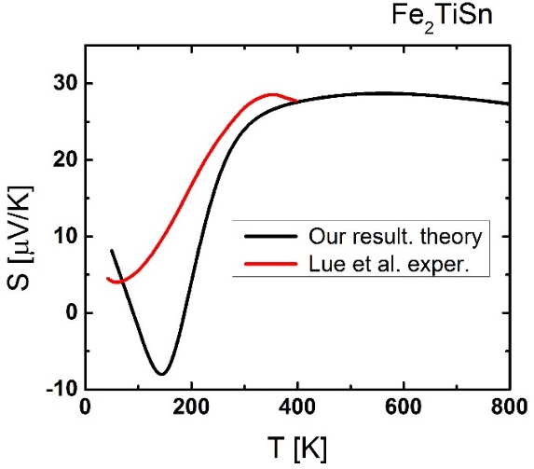
(b) | 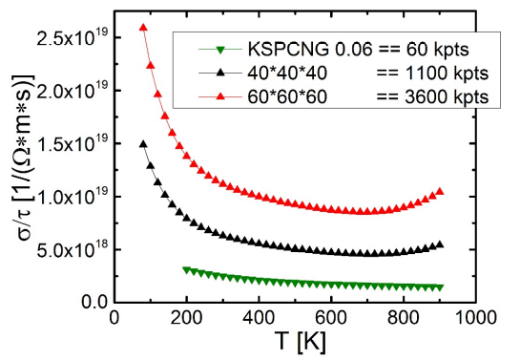
(c) | 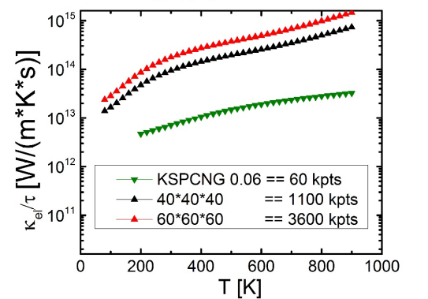
Figure 1 - Dependence of temperature T at various concentrations n (cm-3).

Computer simulation of defective crystals by “first principles” methods is very difficult technically due to the fact that the introduction of point defects lowers the lattice symmetry, which leads to a sharp (by about 2 orders of magnitude) increase in the volume of calculations. In addition, samples of Heusler alloys usually have a granular structure, and the calculation of the contribution of grain boundaries to heat transfer processes is beyond the scope of the modeling methods used here.
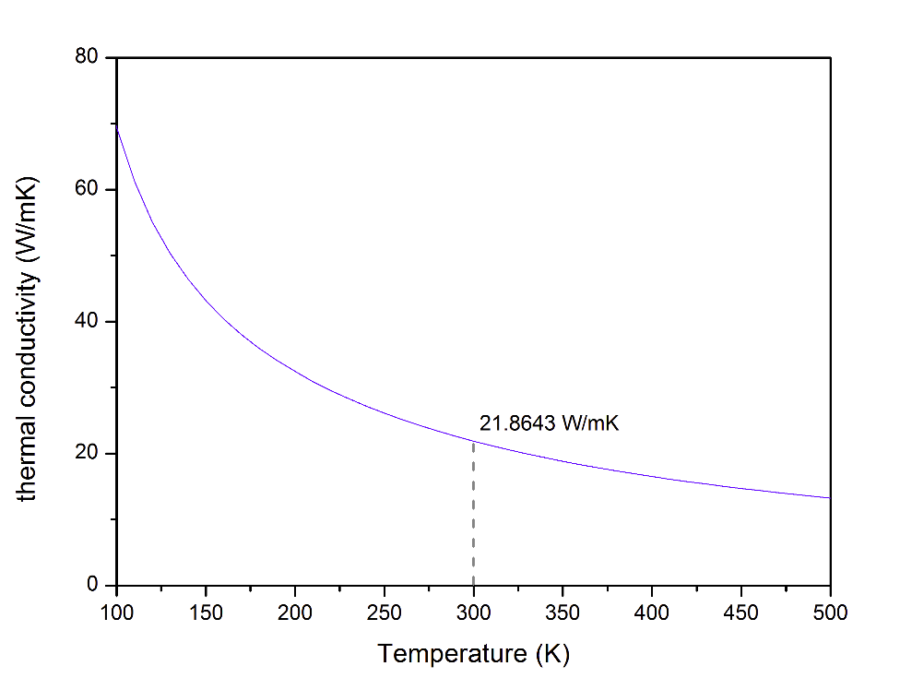
Figure 2 - Dependence of the temperature T of the lattice thermal conductivity of a defect-free crystal of the Heusler alloy Fe₂SnTi

To calculate the energy conversion efficiency, it is necessary to know the relaxation times of electronic and vibrational excitations. Calculation using the ALAMODE program makes it possible to estimate the times and mean free paths of phonons as a function of temperature. The free path times of acoustic phonons for a defect-free crystal of the Heusler alloy Fe2SnTi vary in the range from 0.1 to 1.0 ps. The average phonon mean free paths are shown in figure 3.
The main problem when using the results obtained is that they were obtained neglecting defects in the compound under consideration. It is expected that point defects, dislocations, and grain boundaries will strongly affect phonon lifetimes and mean free paths, since the distance between defects will be less than the phonon mean free path even at high temperatures, where phonon mean free paths are relatively small.
Figure 3 - Average phonon mean free path in a defect-free crystal of the Heusler alloy Fe₂SnTi at different temperatures

In addition to the relaxation time of phonon excitations, the characteristic times of recombination of electronic excitations in the defect-free Heusler alloy Fe2SnTi were also calculated. The calculations were carried out at temperatures of 300 and 500 K.
Charge separation in thermoelectric materials is a multistep process. At the first step, an electron is thermally excited, or an electron is transferred from the valence band to the conduction band, which leads to the formation of an electron-hole pair. At the second step, the electron and hole relax towards the bottom of the conduction band and the top of the valence band, respectively. This step corresponds to the process during which the energy of electronic excitation is partially converted into thermal energy through the electron-lattice interaction. And, finally, at the last stage, the annihilation of the electron-hole pair occurs.
Theoretical modeling of the second step and calculation of the lifetime of an electron-hole pair at the third stage are currently the most difficult for modeling. Our calculations have shown that the lifetimes of electronic excitation at the third stage are much longer than the relaxation times of excitations at the second. Therefore, below we consider only this part of the relaxation process.
To solve this problem, the method of dissipative quantum dynamics is used, based on a combination of the density matrix theory for open systems and modern methods for calculating the electronic structure. This method includes consideration of the interaction of electronic and lattice degrees of freedom.
The description of such propagation in the dissipative mode is based on the application of the density matrix formalism. This formalism is used to calculate the dynamics of electron energy redistribution. This method provides an approach to computing observables when only atomic positions within a model system of the required size are used as initial data. The method also allows one to study systems in a wide time interval from femtoseconds to nanoseconds without additional expensive calculations due to the solution of the equation of motion for the density matrix in the Redfield formulation. [5] The probabilities of transitions between two selected electronic states facilitated by the motion of nuclei are modeled using coefficients describing the nonadiabatic coupling of electronic and ionic degrees of freedom, $V_{ij}=\sum_{I}{\int{\left\langle φ_{i} | \frac{d}{d{\vec{R}}_{I}} | φ_{j}\right\rangle \frac{d{\vec{R}}_{I}}{dt}}}$ describing the overlap of wave functions calculated along the molecular dynamics trajectory of the system in the ground state. The Fourier transform of the autocorrelation function of V_ij results in the average value of the electron-phonon interaction constant for different orbitals in the second order of the perturbation theory, called the Redfield tensor components. To calculate the relaxation rates of electronic excitations, the normalized value of the average energy for each value of the charge as a function of temperature was approximated by an exponential function.
The corresponding nonradiative recombination times between the HOMO and LUMO levels are 15.0 and 8.3 ps, respectively. The use of the obtained data for predicting thermoelectric properties is possible, but comparison of the obtained data with experimental results is difficult for the same reason of the presence of defects in real systems. Point defects should strongly affect the lifetimes of electronic excitations. Moreover, this influence is manifested both in the direction of increasing and in the direction of decreasing the lifetimes. Thus, in our recent studies, it was shown that the presence of a vacancy in the lead position in the MAPbI3 perovskite leads to an increase in the lifetime of electronic excitations, while the presence of a vacancy in the iodine position in the same compound, on the contrary, decreases this time. This difference is explained by the different influence of these defects on the change in the electronic structure of the initial compound. The answer to the question of how defects affect the relaxation rate of electronic excitations is still open.
The ab initio description of the thermoelectric properties of materials, completely independent of the phenomenological parameters, should proceed according to the following scheme. Formula (1) can be rewritten as follows:

$ZT=\frac{S^{2}σ/τ_{el}}{k_{el}/τ_{el}+k_{ph}τ_{ph}/τ_{el}}T$ (2)
where τ_{ph} and τ_{el} are the lifetimes of phonons and electronic excitations, respectively. The S, k_el / τ_{el} and σ / τ_{el} values ​​were calculated above using the BoltzTrap program [6] and are presented in Figures 1 (B) - (C). The lattice thermal conductivity is shown in Figure 2. The calculation results for the relaxation time of electronic excitations τ_el, obtained using the reduced density matrix method at temperatures of 300 K and 500 K, are 15.0 and 8.3 ps, respectively. The lifetimes of phonon states τ_ph can be calculated using the ALAMODE program and vary in the range from 0.1 to 1.0 ps. Thus, all the necessary values ​​were obtained using ab initio calculations using only information on the chemical composition and structure of the crystal lattice of the compound under study. In the specific case of the Heusler alloy Fe2SnTi, for the figure of merit ZT values ​​of 0.05 and 0.03 were obtained at temperatures of 300 K and 500 K, respectively. This is very different from the experimental value of this parameter, equal to 0.2 and 0.25 at the indicated temperatures. [7] Such a large error is due to the fact that an accurate calculation of thermoelectric properties is hindered by the strong influence of defects on material properties, namely, on the times of electronic and phonon relaxation, as well as lattice thermal conductivity. Development of a technique for a completely first-principle description of the properties of thermoelectrics, which requires additional research, which is better to be carried out on another object with a crystal structure, in which, firstly, defect formation is not so easy and, secondly, defects do not have such a strong effect on the electronic structure of the material.

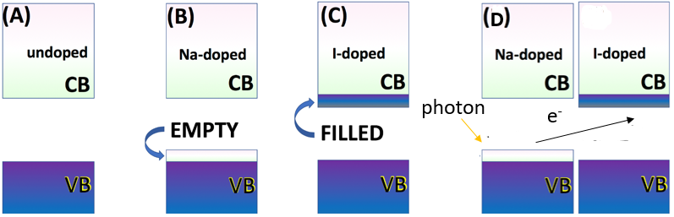

Figure 4 - Electronic structure of various doped and undoped nanowires

For this reason, to refine the methodology, the studies were continued on the classical thermoelectric material PbTe. To simplify the problem, we considered the one-dimensional case, i.e. nanowire PbTe. To study the effect of modification of the electronic structure on the properties of the compound, the compound was doped with Na and I atoms. Figure 4 shows a schematic diagram of doping with sodium and iodine, which are typical realizations of p- and n-doping of lead telluride.
In this study, a periodic lead telluride nanowire doped with sodium and iodine was investigated (figure 5).
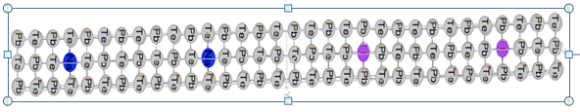
Figure 5 - Rectangular PbTe nanowire doped with iodine (pink) and sodium (blue)
Sodium replaces lead atoms due to the excess of electrons in their valence band. Conversely, iodine replaces telluride due to excess holes in the conduction band. This study investigates whether such a doping configuration improves charge transfer.
The unit cell length is 110 angstroms, it has a cubic structure with 288 atoms. Lead and telluride are present in a 1: 1 ratio with two atoms of iodine and sodium. Lead donates its two extra electrons to telluride so that it can complete its balance shell. This is shown in the following equation.
${Pb}^{2+}+{Te}^{2-}=PbTe$ (3)
To understand this work, one needs to have a minimal understanding of the balancing of the dopant charge during the doping process. Doping is the process of introducing impurities into a semiconductor to change its properties. For example, sodium doping works as follows:
[Na⁽⁰⁾Na⁽¹⁺⁾ + 1e⁻] - [Pb⁽⁰⁾Pb⁽²⁺⁾ + 2e⁻] = Na⁽⁰⁾ – Pb⁽⁰⁾ 1e⁻ - 2e⁻ = -1e (4)
In equation (4), sodium has one extra electron in the valence band. Unlike lead, lead has two extra electrons. When sodium replaces lead during the doping process, one electron moves out of the valence band.
[I⁽⁰⁾I⁽¹⁻⁾ – 1e⁻] - [Te⁽⁰⁾ Te⁽²⁻⁾ – 2e⁻] = I⁽⁰⁾ – Te⁽⁰⁾ -1e⁻ - (-2e⁻) = 1e⁻ (5)
In equation (5), iodine has a hole in the valence shell. As mentioned earlier, there are two holes in the telluride shell. When doped with iodine, iodine replaces telluride. After doping, one hole is removed from the conduction band.
Figure 6 shows the density of states of undoped and co-doped PbTe NWs. Figure 6 (a) shows a rectangular nanowire of undoped lead telluride. The band gap is approximately 1 eV. In the conduction band, the largest number of states will have orbitals with energies from 1.5 to 2 eV. This is confirmed by figure 6 (b) for co-doped nanowires. In the valence band above (-2 to 0), we see that at energies of 0 and -1 there is the largest number of available states. Note that purple indicates that these states are occupied by electrons. Note that there are more states available for the doped model. In addition, the band gap here decreased slightly to 0.9 eV. These two changes indicate a dramatic increase in the ability of the co-doped nanowire to facilitate charge transfer.
The peaks of the unoccupied conduction band B, D in figure 6 (a) correspond to the peaks of the unoccupied conduction band b, d in figure 6 (b). Peaks a, c during joint doping are unique and have no analogues, since they are introduced by iodine. Occupied peaks B ', C', D 'in valence band 3 (a) correspond to occupied peaks b', c ', d' in valence band in Figure 6 (b). The occupied peak a 'in co-doped VB has no analogs, since it is introduced by sodium. Thus, from the DOS analysis, it can be concluded that the boundary orbitals of the joint doped model are introduced by dopants, and it is expected that the least excitation will have a charge transfer character.
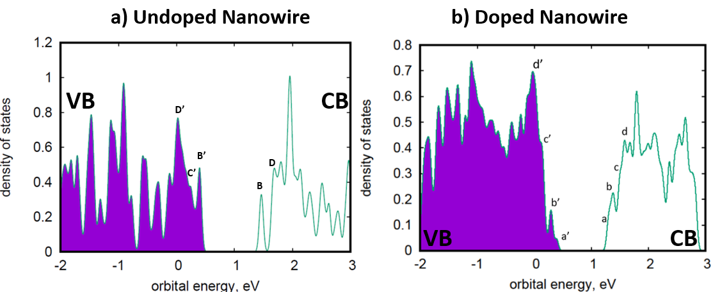

Figure 6 - Density of states

Figure 7 shows the absorption spectra of the undoped and co-doped models. The overall absorption rate is higher for the undoped model than for the co-doped model. In figure 6 (a), it is expected that the transition from B 'to B will be bright due to their delocalization in telluride and lead ions, respectively. Thus, these states will have significant overlap and therefore an increased value of the oscillator strength.

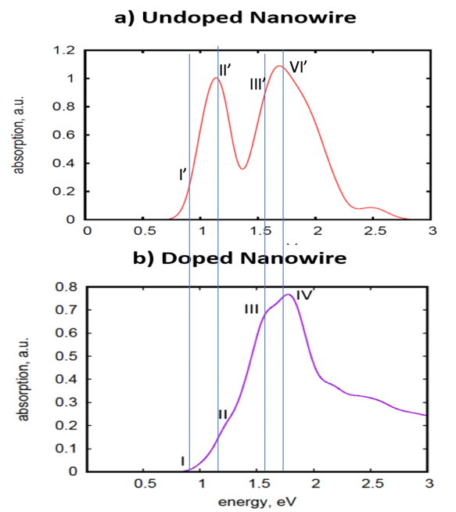
Figure 7 - Absorption spectra of (a) undoped and (b) doped nanowires

In addition, in figure 7 (b), the absorption spectra of the doped nanowire are shown in comparison with the undoped nanowire. Note that the bottom transition (I) from a 'to a in Figure 7 (b) is dark due to excitation of charge transfer. This is consistent with the expected results, since the electron undergoes a transition between orbitals with different spatial localization and slight overlap, which reduces the intensity of the optical transition. Note that a 'and' are localized near sodium and iodine impurities, respectively. In short, (a) and (b) differ due to the new doped states a and c.
Figure 8 shows some of the representative orbitals that were considered in the study. The most important trend to note here is orbital localization. In other words, all occupied orbitals are next to sodium supplements, and unoccupied orbitals are next to iodine supplements. This corresponds to the chemical structure of iodine and sodium. The best example of this is Figure 8 (d), which illustrates HOMO. In this case, it is clearly shown that all occupied orbitals are localized around the sodium orbitals. Likewise, all unoccupied orbitals are next to iodine supplements.


Figure 8 - Localization of Kohn-Sham orbitals

This figure shows all the orbitals that were considered in this study. Note that all HO orbitals are localized near sodium impurities, and vice versa, all LU orbitals are localized around iodine impurities
Figure 9 shows that the rate of transitions between orbitals increases if we put the system in a thermostat with a higher temperature. One interpretation of this is as follows. At higher temperatures, the amplitude of the oscillations increases and the gaps between the orbits / subzones are temporarily closed. This can be one of the main mechanisms for increasing the transfer rate. Another main mechanism is that a large amplitude of nuclear motion leads to a greater violation of orthogonality. Note that the temperature fluctuations shown in the previous figure contribute to an increase in the relaxation rate.
This figure shows the transition speeds of orbital i-HO + 10 and orbital j-HO + 10. The speeds increase significantly at 700 K. Subsequently, the speeds seem to level out along the main diagonal.

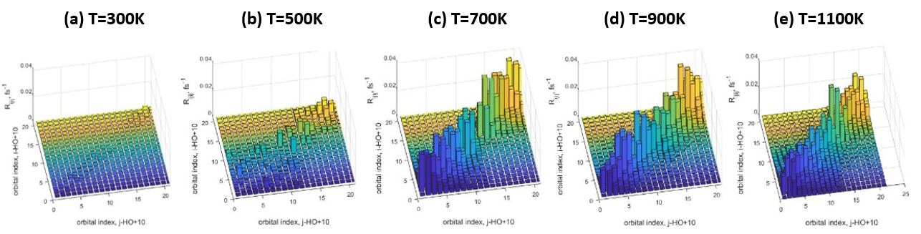

Figure 9 - Redfield tensors at different temperatures

At lower temperatures, the rates of transitions near the band gap are close to zero. Note that Figure 7 shows the positive correlation between temperature and transition rate. This is expected. As the temperature rises, the electrons will have more energy to hop between orbitals. Please note that this is also due to time changes. In addition, as the temperature increases, the gap between the conduction and valence bands decreases. Another interesting feature is that at lower temperatures, most orbitals near HOMO and LUMO have a negligible transition rate. However, with an increase in temperature, the rates of transitions between orbitals are distributed more evenly. The states in the middle contribute to the PbTe→PbTe transitions, the states in the upper right corner are PbTe→I transitions, and the states in the upper left corner are PbTe→Na transitions.
In addition, the orbitals farthest from HOMO and LUMO have very high transition rates, as shown in figure 9. This is consistent with figure 1. At the beginning of the time step, the band gap is about 1 eV. However, with time and with an increase in temperature, the band gap decreases and the transition rates for orbitals adjacent to HOMO and LUMO increase. There are two reasons: an increase in temperature and non-equilibrium dynamics. The second is consistent with the differences in figures 9a and 9e. At 1100K, figure 9e, the orbital transition rates are slightly more consistent than in figure 9a. However, at higher temperatures, these transition rates increase.
After calculating the individual elements of the R-tensor, you can solve the equation of motion for the density matrix under different initial conditions. The initial conditions are set by a pair of orbitals (HO-a, LU + b), which were deflected from the equilibrium configuration. Here we mark the initial excitation with the a orbital that was occupied prior to the excitation event (usually this is the valence band orbital, designated HO-a, and we also mark the b orbital where the electron was propelled as a result of the initial excitation, the second orbital is usually in the conductivity and is denoted as LU + b.Solutions for each initial condition can be used to calculate the distributions observed and their visual interpretation.
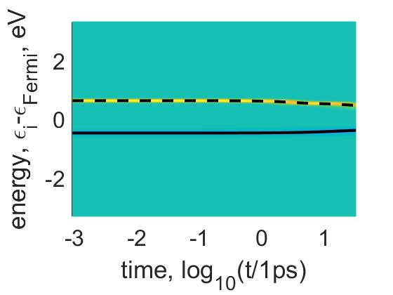
Figure 10 - Typical dynamics of the density distribution as a function of energy for the initial excitation of HO-4→LU + 9

Yellow and blue colors correspond to excess and deficiency of an electron at certain energies at a certain time. Green corresponds to equilibrium distribution. At lower temperatures, the energy change for both the electron and the hole is relatively insignificant compared to higher temperatures. Note that the relaxation rates for the electron and hole can be viewed as time derivatives of these graphs. Dotted line = expected electron energy. Solid line = hole expectation energy.
First, fig. 10 shows the dynamics of the excited state in time, calculated within the framework of the reduced density matrix theory. Yellow and blue colors correspond to an excess n (ε, t)> 0 and a deficit n (ε, t) <0 of an electron at a certain energy at a certain time. The green color corresponds to the equilibrium distribution n (ε, t) = 0. The expected values ​​of the electron and hole energies were represented by the dashed and solid lines, respectively. Note that at lower temperatures the relaxation rates of electrons and holes were practically insignificant. However, at higher temperatures, relaxation occurs earlier. There is one expected trend from this data. With increasing temperature, the difference in the energy of an electron and a hole decreases.
Figure 11 studies the density distribution depending on the position of the electron in space. Two conclusions can be drawn from the qualitative analysis of the graphs. First, all charge transfer is localized near iodine impurities. This finding is consistent with the chemical nature of iodine. Since iodine only needs one valence electron to complete its outer shell, it is logical that an electron from the sodium impurity will move towards the iodine impurity. In addition, the electron appears to be moving towards the most distant iodine impurity.
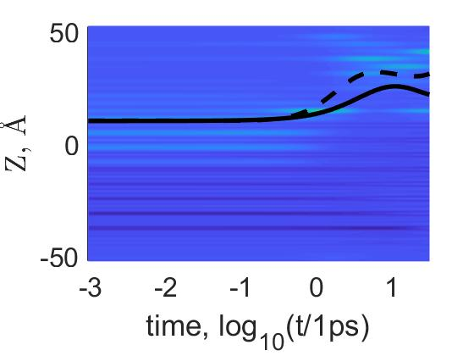

Figure 11 – Charge density distribution dynamics as a function of distance for initial excitation (HO-4; LU + 9)

Solid line = hole energy; Dotted line = electron energy. Yellow = excess electron. Green = too many holes. Blue = balance. Note that all charge transfer is localized around the iodine impurities and that the rate of transition increases with temperature
Figure 11 examines the charge density distribution depending on the position of the electron in space. From a qualitative analysis of the graphs, two conclusions can be drawn. First, all charge transfer is localized near iodine impurities. This finding is consistent with the chemical nature of iodine. Iodine needs only one valence electron to complete its outer shell, it is logical that an electron from the sodium impurity will move towards the iodine impurity. In addition, the electron appears to be moving towards the most distant iodine impurity.
Figure 12 shows the relaxation rates for different initial excitations of the model and at different temperatures. Figure 10 provides a more quantitative study. The relaxation rate is studied as a function of energy. A glance at Figure 10 (a) shows that the band gap law ($K_{e/h}=Ae^{-αΔE}$) appears to apply only to orbital transitions at higher temperatures. In addition, there is a slight change in the relaxation rate with energy at lower temperatures. Perhaps one of the reasons for this is associated with a decrease in the temperature band gap. As the bandgap decreases at higher temperatures (this is confirmed by Figure 8), the "energy" that the electron must emit decreases. As a result, it is easier for the electron to descend along the orbital. Figure 10 (b) shows the limited correlation of the hole with the band gap law.

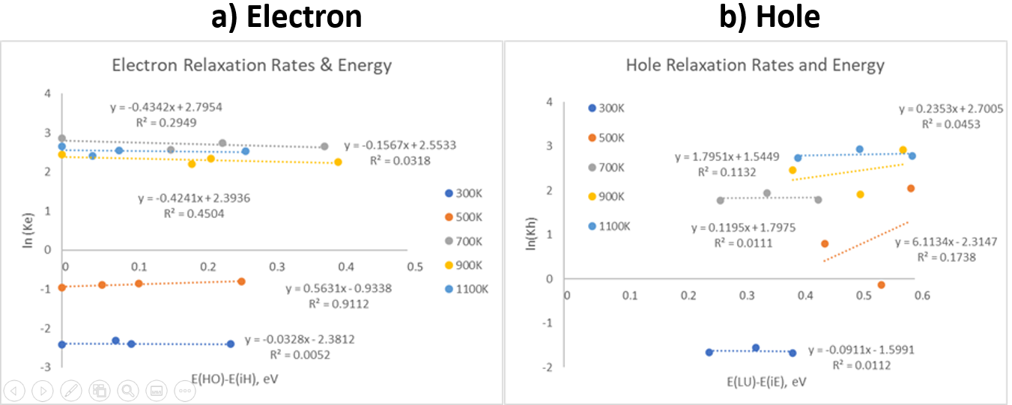
Figure 12 - Relaxation rate as a function of energy

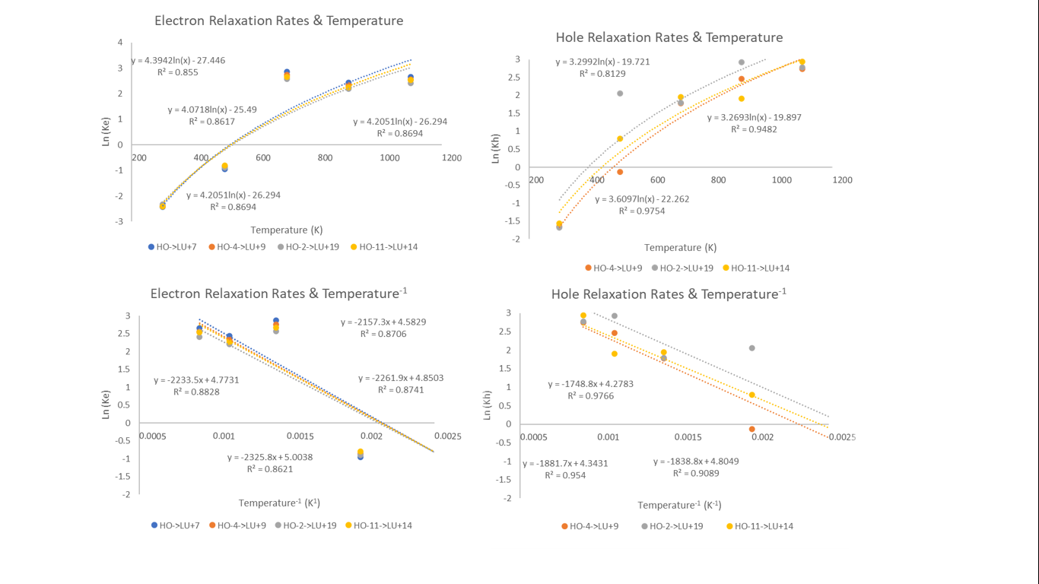
Figure 13 - Relaxation rate as a function of inverse temperature

In addition, figure 11 shows that the temperature dependence of the relaxation rates of electrons and holes does not depend on orbital transitions. Simply put, all orbital transitions return to their original state at the same rate, no matter what temperature is being investigated. A qualitative examination of these figures shows that these figures represent the Boltzmann distributions, where the relaxation rates have an exponential dependence on temperature. In particular, this proves that α = 1 /k_{B}T, where T is the temperature and kB is the Boltzmann constant.

1.1.2 Calculation of the total figure of merit ZT BiSeCuO by methods of calculation from first principles

Thermoelectric materials can directly convert waste heat into electrical energy. Oxyselenide-based materials are considered promising candidates for use in the temperature range from room temperature to 500 ° C, where most of the heat loss is found. In particular, p-type BiCuSeO is considered one of the most promising materials, but the intrinsic properties of the material are insufficient to achieve an efficiency above 30%. To achieve this high efficiency, it is necessary to adjust the crystal structure by replacing elements. The structure of the system consists of sequentially stacked layers of Bi2O2 and Cu2Se2, which are layers of charge generation and conductivity, respectively. It has been proven that doping the charge generation layer is the best strategy for improving the electronic structure and, as a result, thermoelectric characteristics. In this work, the substitutions of yttrium, niobium, and phosphorus for bismuth atoms were studied using the density functional theory. Substitution modeling results showed an improved density of states near the Fermi level for all types of doping. Substitution with phosphorus showed a significant decrease in the band gap at the highest substitution concentration. Doping with niobium led to a change in the nature of conductivity from p-type to n-type. The latter demonstrates a strategy for creating an n-type material based on BiCuSeO.
The effect of phosphorus (P), yttrium (Y) and niobium (Nb) as a substitute element on the electronic structure and lattice structure was studied by modeling using the ab-initio VASP package. The influence led to changes in the zone structure and density of state (DOS), with each change resulting in altered system behavior. The calculation showed a possible improvement in the TE characteristics of BiCuSeO for all substitutions; however, we obtained an unexpected doping effect from the substitution of Nb to the point of transition from the intrinsic nature of the p-type semiconductor to the nature of the n-type at increased Nb concentration.
The crystal structure of BiCuSeO was modeled as a supercell with the following lattice constants a, b, and c equal to 11.86×11.86×18.06 Å, respectively, with all angles of 90 °. The perfect supercell contains 144 atoms, but for the Bi vacancy version, one atom was removed, resulting in 143 atoms. To exclude the contribution of the boundaries on the c axis, a Bi vacancy appears in the middle of the crystal structure. At higher alloying concentrations, scenarios were also considered in which alloying elements could be placed next to each other or separated.
DFT calculations were performed using the plane wave basis and the extended wave method [8] using the Vienna Ab Initio simulation package [9] (VASP). To achieve higher accuracy, + U or the Hubbard parameter were taken into account for each atom. Tests have shown that only the Cu element exhibits the influence of the Hubbard parameter, which was set to + U = 4 according to previously published results [10]. Neither the alloying element nor any other original elements showed the influence of the Hubbard parameter. All predictions were spin-polarized, and spin-orbit coupling was taken into account, the energy limit for the basis set of plane waves was set at 520 eV. The electronic self-consistency contour was reduced to 10-6 eV for all calculations. All structures were relaxed without symmetry constraints using the conjugate gradient algorithm until all forces acting on the atoms were less than 10-2 eV / Å. For a sample of k points during the relaxation of the supercell, a grid of k points (4×4×3) was used, while for a primitive cell the optimal grid was (12×12×6).
The BiCuSeO system was studied in detail by Fan et al [11], where the authors managed to obtain a very accurate electronic structure with a band gap close to the experimental results (0.8 eV). This achievement was made possible by the use of the hybrid functionality HSE06. However, the calculation was performed in a simple crystal structure (monocell) and, due to the computational requirements, can hardly be applied to a supercell, which is a requirement if one wants to study changes in the crystal and electronic structure at low doping concentrations.
The crystal structure of BiCuSeO was modeled as a supercell with the following lattice constants a, b, and c equal to 11.86x11.86x18.06 Å, respectively, with all angles of 90 °. The perfect supercell contains 144 atoms, but for the Bi vacancy version, one atom was removed, resulting in 143 atoms. To exclude the contribution of the boundaries on the c axis, a Bi vacancy appears in the middle of the crystal structure. At higher alloying concentrations, scenarios were also considered in which alloying elements could be placed next to each other or separated.In this work, before the doping, the relaxation of the ideal structure was performed (fig. 14 on the left). The result of relaxation of the ideal structure demonstrates the parameters and electronic structure similar to those described earlier [12]. According to Li et al. [13], the controlled introduction of Bi vacancies leads to improved TE characteristics of the system. This has been implemented and the new structure (Bi.Vc.) has been relaxed as shown in figure 14 - right image. Vacancy Bi is represented by a hollow black circle.
All further calculations of doping were carried out on the basis of the structure with a Bi (Bi.Vc) vacancy. The calculated sizes of the supercell were chosen so that the substitution of one and two Bi atoms was 3% and 6% doping, respectively. Since any Bi atoms can be replaced during doping, it was decided to calculate structures with different arrangements of alloying elements. In Figure 2a, the structure from the point of view of the c axis shows 3 at.% Doping at a position distant from the vacancy, figure 2b shows a doping of 6%, and Figure 2c shows a 6% doping. .% doping with atoms distant from each other and one of the doping atoms close to the vacancy.

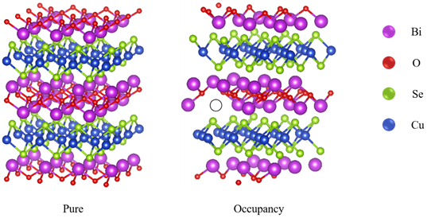
Figure 14 - Structures ideal (left) and with vacancy Bi (right), the latter is rotated in comparison with ideal. The vacancy is represented as a hole in a black circle

All further calculations of doping were carried out on the basis of the structure with a Bi (Bi.Vc) vacancy. The calculated sizes of the supercell were chosen so that the substitution of one and two Bi atoms was 3% and 6% doping, respectively. Since any Bi atoms can be replaced during doping, it was decided to calculate structures with different arrangements of alloying elements. In figure 15a, the structure from the point of view of the c axis shows 3 at.% Doping at a position remote from the vacancy, figure 15b shows a doping of 6%, and Figure 15c shows 6% doping. % doping with atoms distant from each other and one of the doping atoms close to the vacancy.
The calculation of each scenario was performed for each doping. It turned out that for the elements Nb and P at a doping level of 6 at.% The most preferred configuration is figure 15c, while for element Y, the configuration of figure 15b showing lower total energy. The latter indicates that Y-elements are less likely to be doped into a structure close to vacancies, and that they tend to form agglomerates, which can later become a technological problem when the material is in the production stage.
The density of states shown in figure 16 shows the difference between a pure system (left) and a Bi vacancy (right). It seems that vacancies tend to increase the density of states near the Fermi level and exhibit a shift toward the valence band region, i.e. the Fermi level is located deeper in the valence band, which indicates an even more enhanced nature of the p-type. This is due to ... (movement of atoms, change in bond length). The actually high values ​​of the Seebeck coefficient (350 μV / K) can be caused precisely by this change in the density of states and the shift in the Fermi level.The DOS images shown in Figure 4 show the behavior of BiCuSeO systems with different alloying elements (Nb, P and Y) at different concentration levels.
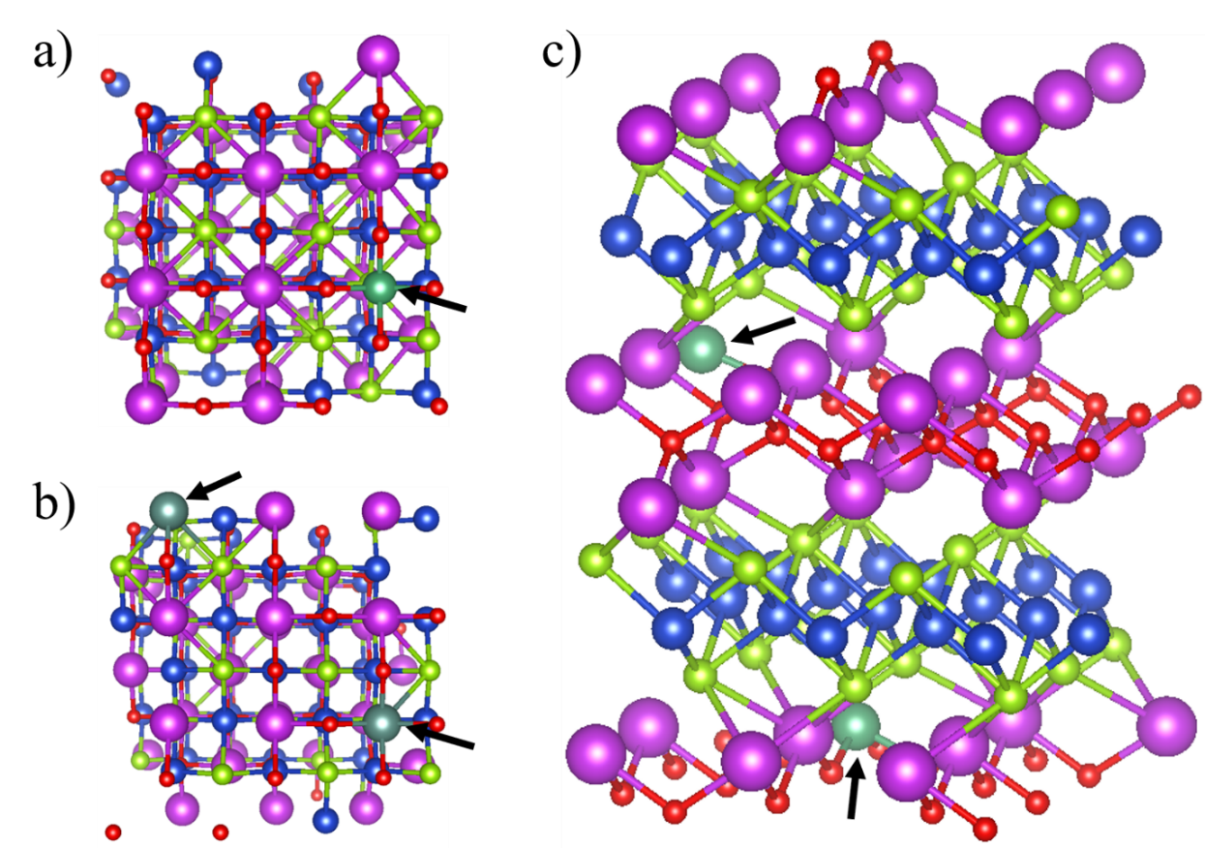

Figure 15 - Types of alloying with elements Nb, P and Y

Figure 15a placing the alloying element far from the vacancy, b) placing two vacancies close to each other and far from the vacancies, and c) placing two alloying elements at a great distance from each other, one of which is located next to the vacancy. Dope positions are marked with black arrows. All design scenarios were performed for each element replacement.
The density of states shown in Figure 16 shows the difference between a pure system (left) and a Bi vacancy (right). It seems that vacancies tend to increase the density of states near the Fermi level and exhibit a shift toward the valence band region, i.e. the Fermi level is located deeper in the valence band, which indicates an even more enhanced p-type nature. This is due to (movement of atoms, change in the length of bonds). The actually high values ​​of the Seebeck coefficient (350 μV / K) can be caused precisely by this change in the density of states and the shift of the Fermi level.
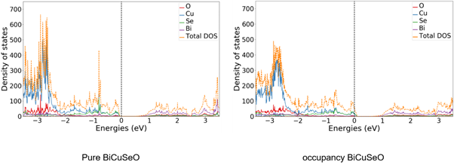
Figure 16 - TES of pure (left) and vacancy (right) BiCuSeO systems

The DOS images shown in Figure 17 show the behavior of BiCuSeO systems with different alloying elements (Nb, P and Y) at different concentration levels.
The introduction of Nb as an alloying element in an amount of 3 at.% Led to n-type doping, since the oxidation state of Nb (+5) is higher than that of Bi [14], i.e., alivalent substitution in this case also introduces Nb into the system two extra electrons. This n-doping is visible from the position of the Fermi level, that is, the Fermi level is raised towards the conduction band, although the system remains a p-type semiconductor. The access of electrons led to an increase in the density of states near the Fermi level, both in the valence region and in the conduction region. An increase in the concentration of electrons leads to higher values ​​of electrical conductivity. Although the Seebeck coefficient and electrical conductivity are mutually exclusive properties for each other (nonlinear dependence) [15], their increase is possible upon doping if the system does not demonstrate a high concentration of charge carriers in the first place, which is the case for a pure BiCuSeO system.
An increase in the doping concentration, which affects the nature of the semiconductor at higher concentrations, can lead to a transition between p-type and n-type [24]. This can be seen if the concentration of electrons is much higher than the concentration of holes in the system, which leads to a change in the contribution to the charge transfer process. However, there are times when even an insignificant concentration leads to the transition of nature. It is this transition that is observed when the concentration of the elements Nb reaches 6 at.%. At this concentration, the BiCuSeO system is n-type, i.e. electrons are the main charge carriers. The Fermi level for this doping concentration is located deep in the conduction band. This significant impact can be dictated by the properties of the Nb atoms, that is, Nb has less weight, therefore it tends to attract electrons to a lesser extent, and they can freely move around the system. Moreover, distortions of the crystal structure are enhanced by both Bi vacancies and a smaller radius of Nb. The distortions resulted in simplified charge transfer in the system. Although the calculation was performed using the PBE + U method and the band gap is greatly underestimated, it should be noted that doping with Nb is a promising method for producing n-type semiconductors. In recent years, research has been mainly carried out on the production of p-type materials, since they are more widespread, however, to successfully use the thermoelectric effect to convert heat into electricity, both types of semiconductors should be used [16]. Doping with niobium opens up the prospect of creating all-oxide thermoelectric generators from one material with high TE characteristics and stability in air.

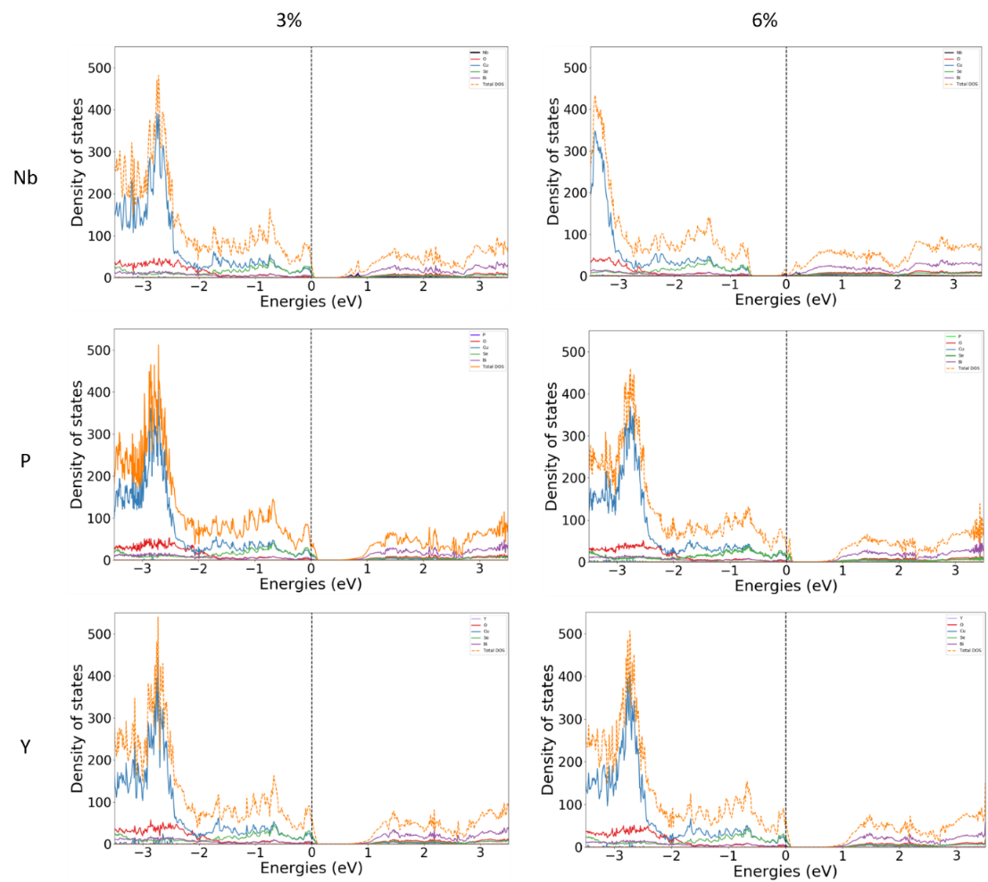
Figure 17 - DOS of alloying elements Nb, P and Y in BiCuSeO systems in rows (from top to bottom, respectively) and concentration (3 and 6 at.%) In columns

The introduction of phosphorus into the BiCuSeO system did not lead to such a drastic change in the electronic structure. This doping is isovalent substitution, since the oxidation states of P and Bi are similar, that is, +3. However, element P has a smaller radius, which results in a large recovery of the lattice constant. As a consequence, one can expect a smaller Coulomb interaction between P and surrounding atoms. The smaller radius P also led to additional distortions of the entire crystal structure. Doping with 3 at.% Led to a slightly elevated position of the Fermi level (closer to the conduction band), which indicates the lower nature of the p-type. The density of state near the Fermi level changed its steepness, which should have affected the mobility of charge transfer. However, an increased concentration of charge carriers, as in the case of doping with Nb, should lead to a higher electrical conductivity.
The increased concentration of P in the system led to a higher density of states near the Fermi level, and it is located slightly deeper in the valence band, which indicates p-doping. This can be explained by a stronger overlap of the bands of bismuth atoms adjacent to phosphorus. DOS has also increased near the Fermi level in the conduction band, which can lead to improved charge transfer and therefore higher electrical conductivity.
An unexpected behavior is observed for doping Y. By its nature, element Y exhibits the same oxidation state, that is, this isovalent substitution, which should lead to an increase in the density of states near the Fermi level, but this behavior is absent. We do observe a shift of the Fermi level towards the conduction band, which indicates n-type doping. The general effect of doping the system with yttrium leads to the restoration of the electronic structure of pure BiCuSeO, albeit with an increased density of states and a shifted Fermi level.

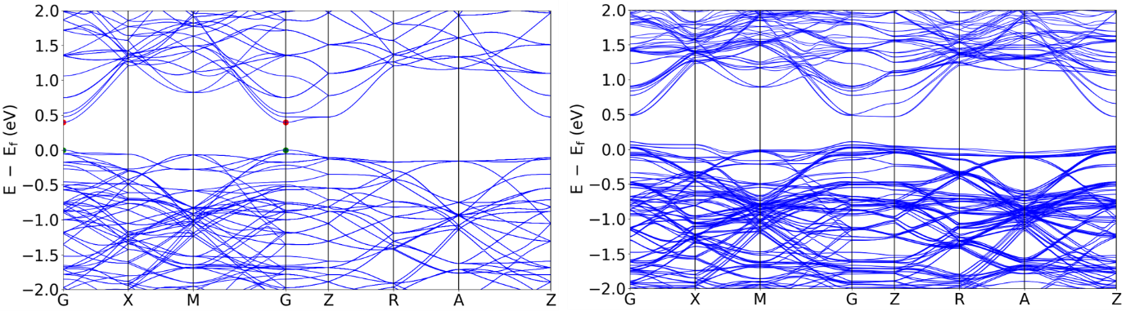

Figure 18 - Zone structure of Pure (left) and Bi.Vc. (right) BiCuSeO systems

The band structures of the systems under study can give a more complete picture of the changes in the electronic structure during the performed iterations. The result of vacancy introduction is shown in Figure 5. The band structure of an ideal BiCuSeO crystal (Figure 5, left) demonstrates a direct band gap, which contradicts the information obtained in the introduction. This is probably because the crystal is perfect. A similar forward band gap, albeit with a higher value (0.81 eV), was achieved by Fan [11], where HSE06 was used. In both works (Fan [11] and current), the spin-orbit coupling approximation was used, which could be the cause of the direct band gap. The introduction of a vacancy (Fig. 5, right) changes the structure of the bands, so that the band gap is not clear and straight. When a vacancy is introduced, the band gap also changes from 0.391 to 0.357 eV, which should lead to an increase in the mobility of charge carriers. For example, the band gap of Bi2Te3 is ~ 0.5 eV, which leads to a higher value of the mobility of charge carriers and, hence, to the Seebeck coefficient [18]. Based on this comparison, it can be assumed that a change in the electronic structure should lead to a similar result, i.e., to an increase in the Seebeck coefficient.
.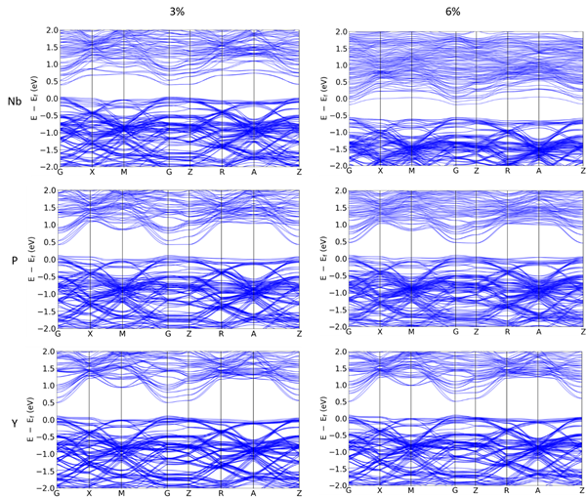
Figure 19 - Band of alloying elements Nb, P and Y in BiCuSeO systems in rows (top to bottom, respectively) and concentration (3 and 6 at.%) In columns

Changes in the band structure upon doping are shown in figure 19. The band gap values ​​for 3 and 6 at.% Nb doping are 0.354 eV and 0.382 eV (Table 1), respectively. The initial decrease in the band gap can be associated with a smaller radius of the alloying element and collapse of bands caused by a change in the distance between atoms, as well as a general distortion of the crystal structure. A further increase in the observed increase in the band gap can be explained by the following discussion: the smaller the size of the atom, the fewer the number of bands it creates and less overlap with other bands. Another reasoning is dictated by the electronic structure of atoms, that is, the bottom of the conduction band is due to the low energy of the 6p orbital of Bi [12], and since the Nb atom has an electronic structure with valence electrons 4d45s1, the influence of the mentioned 6p is less, which leads to a higher position of the band conductivity. Increasing the band density with such a large bandgap change should result in a significant increase in the ZT performance. The band density shows the highest probability in the conduction band when doping with 6 at.%, Which is probably due to a change in the nature of the system from p- to n-type, which is confirmed by the shift in the positions of the bands.

Table 1 - Values of the band gap for systems based on BiCuSeO
System | BiSeCuO | Bi.Vc. | Nb, 3% | Nb, 6% | P, 3% | P, 6% | Y, 3% | Y, 6%
Band gap, Ev | 0.391 | 0.357 | 0.354 | 0.382 | 0.316 | 0.352 | 0.387 | 0.406

The band structure of systems with an increased P-element concentration does not show such a sharp change as in the previous scenario, although there is the same tendency towards an improvement in the band density near the Fermi level and a change in the band gap. The band gaps for 3 and 6 at.% Are 0.316 and 0.352 eV, respectively. The logic of changing the values ​​of the band gap is preserved, that is, smaller atoms create distortions in the crystal structure, making neighboring atoms closer to phosphorus and, as a result, lead to greater overlap of bands. The electronic structure of phosphorus contains valence electrons at 3s23p3. The quality of the change in the band gap differs due to the fact that P has the smallest radius among the considered alloying elements.
As for the yttrium effect, it can be seen that the band structure is similar to the structure of the pure BiCuSeO system before the introduction of the Bi vacancy. With this doping, the system exhibits a straight band gap that follows the same trend as in the two previous scenarios (increased value at higher concentration). However, in the case of Y doping, the band gap at any concentration is higher than that of Bi.Vc. system. The reason for the increase in the gap lies in the electronic structure of yttrium (4d15s2), which means a smaller contribution of low-energy 6p orbitals of Bi and a smaller contribution of electrons from 4d5s of yttrium to the conduction band as compared to Nb. Although increased bandgap values ​​should decrease the carrier mobility, the fact that the gap is straight can somehow reduce the negative impact. As stated earlier, an increased DOS for each Bi.Vc.based system. should lead to improved charge transfer, either by affecting the Seebeck coefficient or electrical conductivity. However, according to the plotted band structures of Y-doped systems, it can be assumed that yttrium mainly contributes to band shape rather than band density.
The effect of doping on the layer charge can be a confirmation of the discussion about transport properties (see table 2). The positions of the substituted elements at different concentrations are shown by black circles. Positive and negative values ​​represent the presence and absence of electrons, respectively. The data presented in Table 2 was obtained for each layer by subtracting the calculated charge densities of all electrons from the values ​​that represent the valence of each atomic sphere.

Table 2 - Charge per layer for each adjustment
Structure | Charge transfer data, eV
BiCuSeO | Pure | Bi.Ve | Ng-doped |  | P-doped |  | Y-doped
BiCuSeO | Pure | Bi.Ve | 3% | 6% | 3% | 6% | 3% | 6%
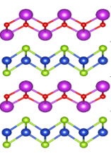 | 8.478 | 8.382 | 8.839 | 8.672 | 8.134 | 8.104 | 8.663 | 8.945
 | -8.473 | -8.136 | -8.136 | -8.381 | -8.252 | -7.925 | -8.118 | -8.080
 | 8.473 | 7.385 | 7.417 | 7.933 | 7.382 | -7.151 | 7.393 | 7.396
 | -8.473 | -7.632 | -7.999 | -8.223 | -7.264 | -7.330 | -7.939 | -8.261

According to the data obtained, the pure crystal structure of BiCuSeO is in an ideal charge balance, whereas after the placement of a vacancy, it can be seen that the charge density decreases for Bi2O2 (HL) layers due to transfer to Cu2Se2 (CL) layers. This indicates that the Bi causes the formation of holes in the HL layers. The latter is consistent with the literature. The most significant change in the charge values ​​is observed for the second HL layer, which is natural, given that this is a layer with a vacancy. All doping scenarios will be compared with the Bi.Vc charge density values.
Further alloying with elements leads to a change in the charge distribution. For the Nb element, the charge of the HL layer becomes higher than that of Bi.Vc., which can be explained by the extra electrons of the doping element, in the end, the Nb-doped system tends to pass from a p-type to an n-type semiconductor, therefore holes as the main charge carriers should be replaced with electrons.
Substitution of phosphorus leads to a decrease in the values ​​of the charge HL, which indicates the further formation of holes, which should positively affect the thermoelectric properties, in particular, the Seebeck coefficient. Since the CL layers exhibit lower values ​​than Bi.Vc., an increase in electrical conductivity can also be expected.
Doping with yttrium leads to an uneven distribution of charges between the layers. The upper HL layer has a higher electron density than the lower HL layer. It can be assumed that this is due to a decrease in the hole concentration in the upper layer. However, this is probably due to the fact that Y-elements tend to form agglomerates. Described in conjunction with the fact that the top layer has become preferable to accommodate all Y-elements, may be an explanation of why such an imbalance is observed. The formation of agglomerates can lead to a change in the conduction mechanism of experimental materials at elevated temperatures. In support of the stated changes associated with doping with Nb, P, and Y, the graphs of the charge difference for a substitution element concentration of 3 at% are shown in Figure 20.
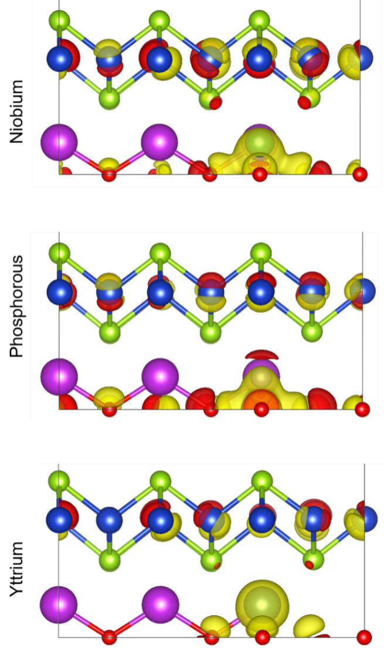
Figure 20 - Difference in charge density for doping with Nb, P and Y at 3 at

CONCLUSION

In conclusion, this first-principles numerical experiment produced some interesting results. One such result is that doping improves the charge transfer capability of the lead telluride nanowire. In particular, replacing two lead atoms and two telluride atoms with sodium and iodine, respectively, allows charge transfer. Comparing the results for the doped and undoped models, it can be found that the co-doped lead telluride has a lower rate of photoenergy absorption in the band gap. Note that it can still be effective above the gap. This, in turn, leads to fast phonon-induced nonradiative transitions between the conduction and valence bands.
The most important aspect of this study is how well the energy relaxation rates correlate with the band gap law. Calculations show two relaxation modes: sequential and parallel. Only the subsequent relaxation path follows the forbidden zone law. The parallel path often violates the law of spacing, as there are more and more parallel paths as the excitation energy increases. This atomistic computational study shows that in the material / nanostructures under study, the band gap applies only to electrons at higher temperatures and shows less correlation with trends in hole relaxation rates. In addition, this study showed that the general trend in the temperature dependence of relaxation rates is independent of the initial choice of excited orbitals / initial conditions.
However, in the future one might be interested in analyzing the transitions, starting with the initial conditions represented by the superposition of orbitals, in order to determine whether the energy gap law is applicable in this situation. This is important because in real-world applications this type of initial photoexcitation is used. Another direction for future research is to compare the results of this numerical experiment with the study of other models, such as doped and undoped, corresponding to nanowires grown in the <111> direction. Relaxation rates, densities of states, absorption spectra, and other observables may need to be calculated for comparison with this study. Note that previous studies have shown that there is no pulse dispersion for <111> nanowires. In addition, the doping of the spiral nanowire is expected to affect its band gap.
Conclusions, observations, and trends obtained in atomistic computational modeling of photoinduced dynamics in certain classes of nanostructures can be applied in industry. First, this work provides numerical evidence for an intuitively anticipated trend that doping promotes charge transfer. Second, for a long time, researchers and manufacturers had to carry out long and laborious studies to calculate the relaxation rate of the material. However, if future research confirms the conclusions of this work and proves that the law of the forbidden zone has at least limited applicability, then the time for research and development in industry can be significantly reduced. In addition, the greater the correlation between the relaxation rates and the band gap law, the more efficient the thermoelectric material.
On the whole, an increase in the transport properties for the systems considered above can be expected, but the thermal conductivity could be improved with the same success. This property consists of two main parameters: electronic heat transfer and lattice heat transfer [19]. It is believed that an increase in the electronic contribution can lead to an increase in the total thermal conductivity; the lattice parameter can somehow reduce this influence or partially compensate for it. Doping with atoms of smaller diameter can lead to a decrease in the contribution of lattice heat transfer to the total thermal conductivity [20]. This may be due to different vibration modes, that is, smaller atoms vibrate at a different frequency. Uneven vibrational modes on these atoms can turn them into heat / electron scattering points.
Based on the foregoing, it can be predicted that the calculated structures with Nb, P, and Y as alloying elements should lead to a common ZT by increasing the numerator parameters and maintaining a constant or insignificant improvement in the denominator parameter k.
In this work, the effect of doping with niobium, yttrium and phosphorus on the crystal and electronic structure, as well as thermoelectric properties, is investigated. It was calculated that doping with any of the elements leads to n-type doping compared to a pure system with incorporated Bi vacancies. Doping with Nb and P at a concentration of 3 at.% Leads to a decrease in the band gap due to the radius of the doped elements with a further increase at higher concentrations. The inclusion of yttrium widens the band gap. The TEC of the systems under study reveals compaction near the Fermi level. When doping with Nb at 6 at.%, A transition of nature from a p-type semiconductor to an n-type semiconductor is observed. This is due to the oxidation state of niobium, i.e., the doping is alivalent with additional electrons.

LIST OF USED SOURCES

- Tadano T., Gohda Y. and Tsuneyuki S. Anharmonic force constants extracted from first-principles molecular dynamics: applications to heat transfer simulations //Journal of Physics: Condensed Matter. -2014. – Vol.26. – P. 225402.
- Fujita Y., Endo K., Terada M., Kimura R. Magnetic properties of heusler type alloys M₂XSn (M = Fe, Co or Ni, X = Ti or V) // J. Phys. Chem. Solids. – 1972. – Vol.33. – P.1443 – 1446.
- Lue C. S., Kuo Y.-K. Thermal and transport properties of the Heusler-type compounds Fe_{2−x}Ti_{1+x}Sn//J. App. Phys. – 2004. – Vol. 96. – P. 2681–2683.
- Liang T., Chen W., HuC.-E., Chen X.-R., Chen Q. Lattice dynamics and thermal conductivity of lithium fluoride via first-principles calculations // Solid State Communications. – 2018. – Vol. 272. – P. 28–32.
- Redfield A.G. On the Theory of Relaxation Processes // Ibm Journal of Research and Development. – 1957. – Vol. 1 – P.19-31.
- Madsen G.K.H., Singh D.J., BoltzTra P. A code for calculating band-structure dependent quantities //Computer Physics Communications. -2006. – Vol. 175. – P. 67-71.
- LueC. S., ChenC. F., LinJ. Y., YuY. T., KuoY. K. Thermoelectric properties of quaternary Heusler alloys Fe₂SnTi.//Phys. Rev. B. – 2007. – Vol. 75. – P. 064204.
- BlöchlP. E. //Phys. Rev. B. –1994. – Vol.50 . – P. 17953.
- KresseG., Furthmüller J. //Phys. Rev. B. - 1996 . – Vol.54. – P. 11169.
- Zhang Y., Yuan X., Sun X., Shih B. C., Zhang P., Zhang W. // Phys. Rev. B - Condens. Matter Mater. Phys.-2011. –Vol.84. –P. 075127.
- Bin X. and Lin Y//J. Phys. D: Appl. Phys.-2008.- Vol. 41.- P. 095404.
- Barreteau C., Bérardan D., Amzallag E., ZhaoL. D., Dragoe N.//Chem. Mater.-2012.-Vol.24.-P. 3168.
- Bin X. and Lin Y. //J. Phys. D: Appl. Phys.-2008.- Vol. 41.- P. 095404.
- PeiY. L., HeJ., LiJ. F., Fuli, LiuQ., PanW., Barreteau C., Berardan D., Dragoe N., ZhaoL. D. //NPG Asia Mater.-2013.-Vol.5.-P.47.
- GeZ. H., Zhao L. D., Wu D., LiuX., Zhang B. P., LiJ. F., HeJ. //Mater. Today.-2016. – Vol.19.-P. 227.
- Zhang Q., Chere E. K., Sun J., Cao F., Dahal K., Chen S., Chen G., Ren Z.//Adv. Energy Mater.-2015.-Vol.5.-DOI 10.1002/aenm.201500360.
- Champier D. //Energy Convers. Manag.-2017. Vol.140 . –P. 167.
- MamurH., BhuiyanM. R. A., KorkmazF., Nill M. //Renew. Sustain. Energy Rev.-2018.-Vol.82.-P. 4159.
- Beretta D., Neophytou N., Hodges J. M., Kanatzidis M. G., Narducci D., Martin- Gonzalez M., Beekman M., Balke B., Cerretti G., Tremel W., Zevalkink A., Hofmann A. I., Müller C., Dörling B., Campoy-Quiles M., Caironi M. //Mater. Sci. Eng. R Reports.-2018, DOI 10.1016/J.MSER.2018.09.001.
- Ren G. K., Le Lan J., Zhao L. D., Liu C., Yuan H., Shi Y., Zhou Z., Lin Y. H. // Mater. Today. -2019. –Vol.29. –P. 68.

APPENDIX A

List of published works
List of published works for 2018
International conferences:
1. Yerzhan Zh. Ashim: Theoretical modeling of thermoelectric properties of Fe2Ti1-xVxSn (x = 0, 0.0625, 0.094, 0.125, 0.25) Heusler Alloys. XVI Interstate conference “Thermoelectrics and their applications-2018”. Sankt-Peterburg, Russia, 8-10 october, 2018
2. Yerzhan Zh. Ashim, T. Inerbaev, A. Taranova, A. Novitskii, S. Taskeev, A. Abuova, V. Khovaylo. Theoretical modeling of thermoelectric properties of Fe2Ti1-xVxSn heusler alloys. INESS-2018, Astana, Kazakhstan, 8-10 august, 2018. P. 56
Publications
1. F.U. Abuova, A.U. Abuova, E.Zh. Ashim. Investigation of the causes of contact failure in tetradimide-based thermoelectric elements. Bulletin. Series Physics, Mathematics, Informatics. –KazGZhPU :, 2018.-№3 (75) .- С.59-66.
2. A.U. Abuova, F.U. Abuova, E.Zh. Ashim The role of diffusion in the destruction of contacts in tetrimite thermoelectric elements. Bulletin. Series Physics, Mathematics, Informatics. –KazGZhPU :, 2018.-№3 (75) .- P.67-72.
3. A.U. Abuova, F.U. Abuova, A.T. Akylbekov, D.A. Dzhunisbekova, D.B. Baktybaev. Electronic contribution of figure of merit ZT for Geiler alloys and unmodified BiCuSeO. Bulletin. Series Physics, Astronomy. - ENU named after L.N. Gumilyov 2018.-№3 (124)
4. S. Taskaev, K. Skokov, V. Khovaylo, D. Karpenkov, M. Ulyanov, D. Bataev, A. Dyakonov and O. Gut et al. Effects of severe plastic deformation on the magnetic properties of terbium. AIP Advances 8, 048103 (2018); doi: 10.1063 / 1.4998292. impact factor - 1.657

List of published works for 2019
International conferences:
1. Inerbaev T.M., Abuova A.U., Abuova F.U., Akilbekov A.T. Native Defects in the Fe2TiSn Full Heusler Alloy: Formation and Influence on the Electronic Structure. The 10th International conference of the Asian Consortium on Computational Materials Science. City university of Hong kong, 22-26 July, 2019, - P.64
Publications
1. Ye. Zh. Ashim, T. M. Inerbaev, A. T. Akilbekov, H. Miki, T. Takagi, and V. V. Khovaylo. Theoretical Modeling of the Thermoelectric Properties of Fe2Ti1 - xVxSn Heusler Alloys. ISSN 1063-7826, Semiconductors.- 2019.- Vol. 53, No.7.- p. 865-868.impact factor –1.18
2. Inerbaev T.M., Abuova F.U., Abuova A.U. Electronic structure and optical conductivity of the complete Heusler alloy Fe2TiSn. KazGosZhenPI Bulletin. Physics series. No. 3.-p. 47-57
3. A.I. Voronin, A.P. Novitskii, Y.Z. Ashim, T.M. Inerbaev, N.Yu. Tabachkova, V.T. Bublik, V.V. Khovaylo. Exploring the origin of contacts destruction in tetradymite-based thermoelectric elements. Journal of Electronic Materials. Vol.48b, No. 4, 2019. DOI: 10.1007 / s11664-019-07029-5 impact factor –1.03

List of published works for 2020
Publications
1. Abuova AU, Inerbaev TM, Abuova FU, Sazanbay A., Nurakanov A. Charge dynamics in a low-dimensional doped thermoelectric. Gumilyov eurasian national university bulletin. Physics series. Astronomy №3 (132), - 2020, - P. 36-43
2. Kevin Gima, Talgat M. Inerbaev, and D. S. Kiline. Excited State Dynamics in a Codoped Lead Telluride Nanowire. J. Molecular Physics. Sent to print
3. A. Kalugina, A. Taranova, A. Novitskii, D. Karpenkov, A. Sedegov, V. Kurichenko, A. Voronin, H. Miki, S. Patnaik, V. Khovaylo. Thermoelectric properties of Fe1.5TiSb1 xSnx and Fe1.5Ti1 xYxSb Heusler alloys. Materials Today: Proceedings accepted for printing. impact factor –0.97

APPENDIX B

Calendar plan 2018-2020

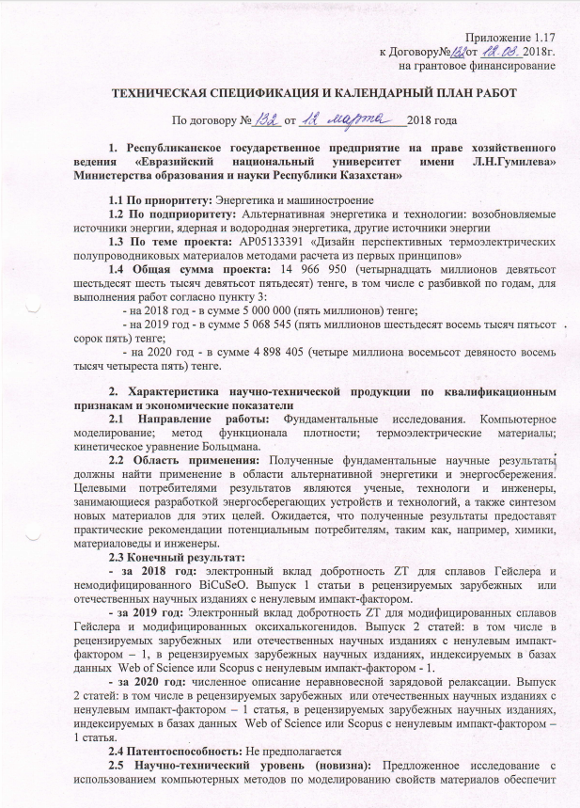
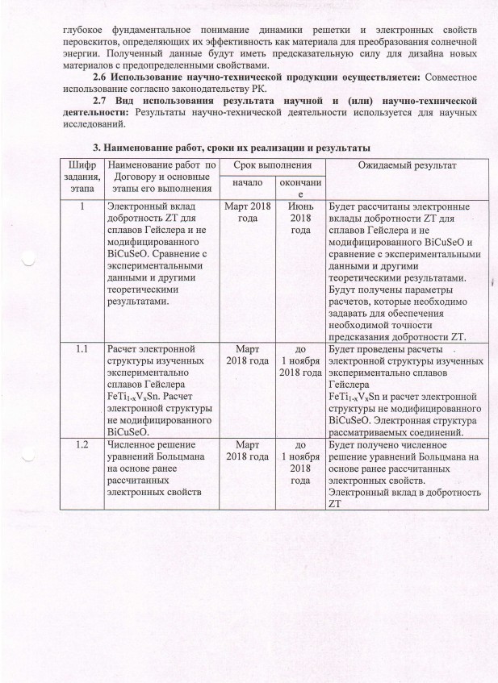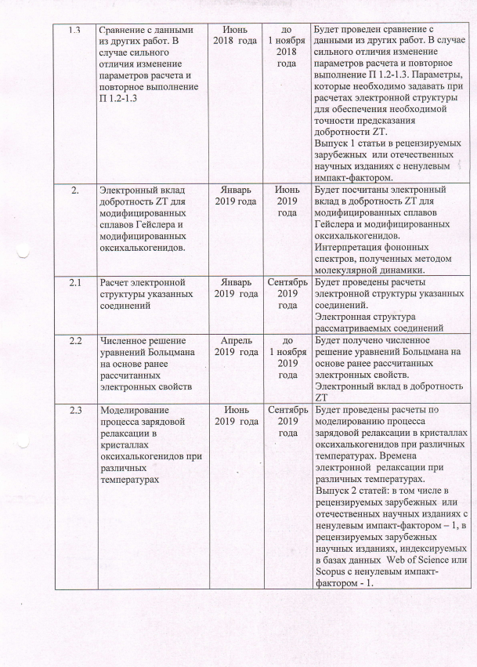
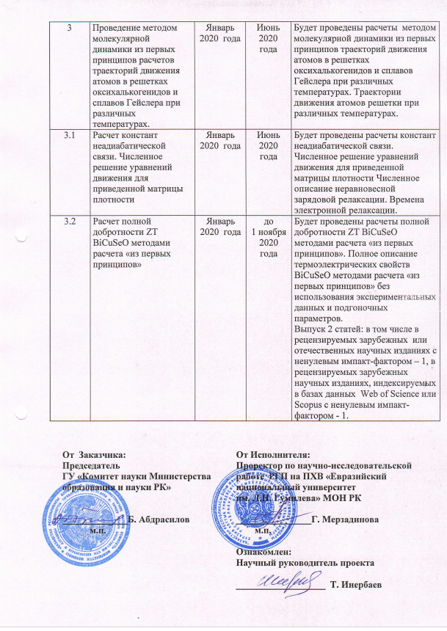

Appendices 1.1-1. __
to the Agreement No.__ dated _______ 2018.
for grant funding

TECHNICAL SPECIFICATIONS AND CALENDAR WORK PLAN

Under contract No. _____ dated __________________2018

1.Republican state enterprise on the right of economic management "Eurasian National University named after L.N. Gumilyov"Ministry of Education and Science of the Republic of Kazakhstan "

1.1 By priority: 2. Energy and mechanical engineering.
1.2 By sub-priority: 2.2 Alternative energy and technologies: renewable energy sources, nuclear and hydrogen energy, other energy sources.
1.3 On the topic of the project: No. AP05133391 "Design of promising thermoelectric semiconductor materials by calculation methods from first principles".
1.4 The total amount of the project is 14,966,950 (fourteen million nine hundred sixty six thousand nine hundred fifty) tenge, including with a breakdown by years, for the performance of work in accordance with clause 3:
- for 2018 - in the amount of 5,000,000 (five million) tenge;
- for 2019 - in the amount of 5,068,545 (five million sixty-eight thousand five hundred forty-five) tenge;
- for 2020 - in the amount of 4,898,405 (four million eight hundred ninety-eight thousand four hundred and five) tenge.

2. Characteristics of scientific and technical products by qualification characteristics and economic indicators
2.1 Direction of work: Computer modeling; density functional method; thermoelectric materials; kinetic Boltzmann equation.
2.2 Field of application: The obtained fundamental scientific results should find application in the field of alternative energy and energy saving. The target consumers of the results are scientists, technologists and engineers engaged in the development of energy-saving devices and technologies, as well as the synthesis of new materials for these purposes. The results are expected to provide practical guidance to potential users such as chemists, materials scientists and engineers, for example.
2.3 End result: (here you need to add where it will be published approximately for each year)
- for 2018: electronic contribution of figure of merit ZT for Heusler alloys and unmodified BiCuSeO. Issue 1 of an article in peer-reviewed foreign or domestic scientific journals with a non-zero impact factor.
- for 2019: Electronic contribution of figure of merit ZT for modified Heusler alloys and modified oxychalcogenides. Issue 2 of articles: including in peer-reviewed foreign or domestic scientific journals with a non-zero impact factor -, in peer-reviewed foreign scientific journals, indexed in the Web of Science or Scopus databases with a non-zero impact factor - 1.
- for 2020: numerical description of nonequilibrium charge relaxation. Issue 2 of articles: including in peer-reviewed foreign or domestic scientific journals with a non-zero impact factor -, in peer-reviewed foreign scientific journals, indexed in the Web of Science or Scopus databases with a non-zero impact factor - 1.
2.4 Patentability: not expected
2.5 Science and Technology (Novelty): The proposed study using computational methods to simulate material properties will provide a deep fundamental understanding of the lattice dynamics and electronic properties of perovskites that determine their effectiveness as a material for converting solar energy. The resulting data will have predictive power for the design of new materials with predefined properties.
2.6 The use of scientific and technical products is carried out: Joint use in accordance with the legislation of the Republic of Kazakhstan.
2.7 Type of use of the result of scientific and (or) scientific and technical activities: The results of scientific and technical activities are used for scientific research.

3. Name of work, terms of their implementation and results

Task code, stage |  | Name of work under the Agreement and the main stages of its implementation * | Period of execution * |  |  | Expected Result *
 |  |  | Start | ending
1. |  | Electronic contribution of figure of merit ZT for Heusler alloys and unmodified BiCuSeO. Comparison with experimental data and other theoretical results. | March 2018 | June 2018 |  | The electronic contributions of the figure of merit ZT for Heusler alloys and unmodified BiCuSeO will be calculated and compared with experimental data and other theoretical results. The calculation parameters will be obtained, which must be set to ensure the required accuracy of prediction of the Q-factor ZT.
1.1. |  | Calculation of the electronic structure of experimentally studied Heusler alloys  FeTi1-xVxSn. Calculation of the electronic structure of unmodified BiCuSeO. | March 2018 | 1 November  2018 y. |  | Calculations of the electronic structure of the experimentally studied Heusler alloys will be carried out  FeTi1-xVxSn and calculation of the electronic structure of unmodified BiCuSeO. Electronic structure of the compounds under consideration.
1.2. |  | Numerical solution of the Boltzmann equations based on previously calculated electronic properties | March 2018 | 1 November  2018 y. |  | A numerical solution of the Boltzmann equations will be obtained based on the previously calculated electronic properties. Electronic contribution to figure of merit ZT
1.3. |  | Comparison with data from other works. In the case of a strong difference, change the calculation parameters and repeat P 1.2-1.3 | June 2018 y | 1 November  2018 y. |  | Comparison with data from other works will be made. In case of a strong difference, change the calculation parameters and repeat P 1.2-1.3. Parameters that must be set when calculating the electronic structure to ensure the required accuracy of prediction of the figure of merit ZT. Issue of 1 article in peer-reviewed foreign or domestic scientific journals with a non-zero impact factor
2. |  | Electronic contribution of figure of merit ZT for modified Heusler alloys and modified oxychalcogenides. | January 2019y | January  2019y |  | The electronic contribution to the figure of merit ZT will be calculated for modified Heusler alloys and modified oxychalcogenides. Interpretation of phonon spectra obtained by the method of molecular dynamics
2.1. |  | Calculation of the electronic structure of these compounds | January 2019y | September  2019 year . |  | Calculations of the electronic structure of these compounds will be carried out.  Electronic structure of the considered compounds
2.2 |  | Numerical solution of the Boltzmann equations based on previously calculated electronic properties | April  2019y | Nov. 1  2019y |  | Будет получено численное решение уравнений Больцмана на основе ранее рассчитанных электронных свойств. Электронный вклад в добротность ZT
2.3 |  | Modeling the process of charge relaxation in oxychalcogenide crystals at different temperatures | June  2019y. | September  2019 year . |  | Calculations will be carried out to simulate the process of charge relaxation in oxychalcogenide crystals at different temperatures. Electronic relaxation times at different temperatures. Issue 2 articles: including in peer-reviewed foreign or domestic scientific journals with a non-zero impact factor 1, in peer-reviewed scientific journals 6 indexed in the Web of Science or Scopus databases with a non-zero impact factor - 1.
3 |  | Carrying out the molecular dynamics method from the first principles of calculating the trajectories of motion of an atom  ov in the lattices of oxychalcogenides and Heusler alloys at different temperatures. | January 2020y | June  2020y. |  | Calculations by the method of molecular dynamics from the first principles of the trajectories of motion of atoms in the lattices of oxychalcogenides and Heusler alloys at different temperatures will be carried out. Trajectories of motion of lattice atoms at different temperatures.
3.1 |  | Calculation of non-adiabatic coupling constants. Numerical solution of equations of motion for the reduced density matrix | January 2020y | June  2020y. |  | Calculations of the non-adiabatic coupling constants will be carried out. Numerical solution of equations of motion for a reduced density matrix. Numerical description of nonequilibrium charge relaxation. Electronic relaxation times.
3.2. |  | Calculation of the total figure of merit ZT BiCuSeO by methods of calculation "from first principles" | January 2020y | 1 September  2020 y. |  | Calculations of the total figure of merit ZT BiCuSeO will be carried out by methods of calculation "from first principles". Complete description of the thermoelectric properties of BiCuSeO by calculation methods “from first principles” without using experimental data and fitting parameters. Issue 2 articles: including in peer-reviewed foreign or domestic scientific journals with a non-zero impact factor 1, in peer-reviewed scientific journals6 indexed in the Web of Science or Scopus databases with a non-zero impact factor -1.
 | From customer:  _________________________________  State Institution "Science Committee of the Ministry of Education and Science of the Republic of Kazakhstan"  ______________ FULL NAME _______________  m. |  |  |  | From the Contractor:  Vice-rector  for research work  ________________ G. Merzadinova  m.  Familiarized with:  Scientific supervisor of the project  ___________________ Inerbaev T.M.  (signature)

