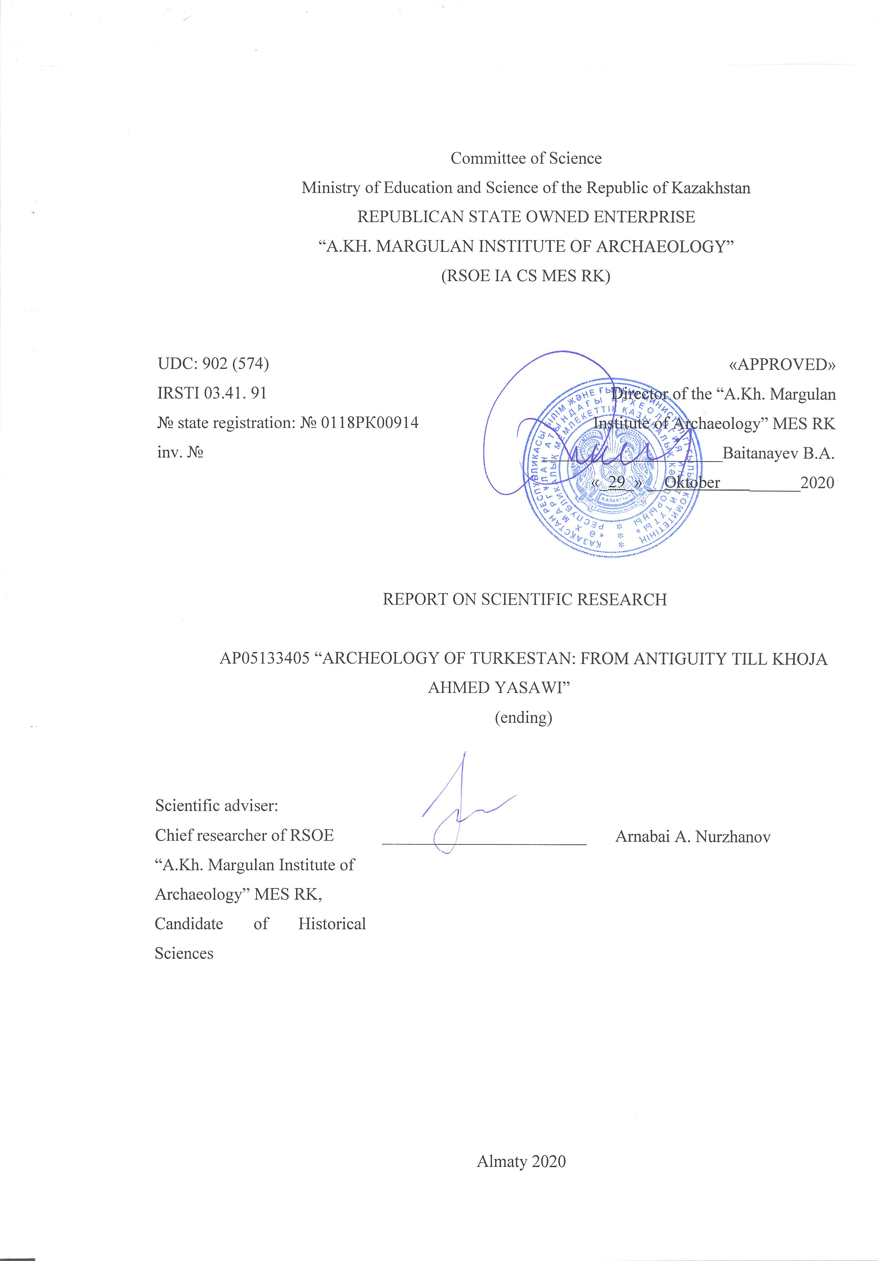

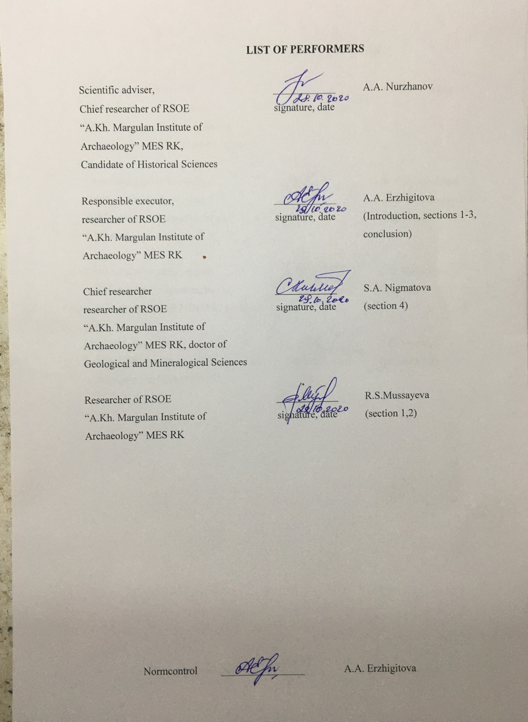

ABSTRACT

The report contains of 60 pages, 1 book, 45 illustrations, 15 sources, 5 appendix.
KARATOBE, SHOYTOBE, KULTOBE, TURKESTAN OASIS, BUILDING HORIZON, CITY, CULTURAL LAYER, CERAMIC COMPLEX, NUMISMATIC COLLECTION.
The object of research is the archaeological sites of the Turkestan oasis: the settlement of Shoy-tobe, the settlement of Karatobe, the settlement of Kultobe.
IRN project: AP05133405.
The main objective of the Project is to identify archaeological remains and study the oldest stages of the emergence of sedentary and urban culture in the Turkestan oasis in the era of the Kangyu state (II century BC - VI century AD).
Research result:
- A comprehensive study of the ancient history of the Turkestan region has been completed;
- Archaeological excavations were carried out at the Shoitobe settlement – a stratigraphic excavation was laid (with an area of 120 square meters).m) on the fortress wall, revealed architectural structures adjacent to the wall, bath-bammam was excavated (900 sq. m. excavation area), removed the topographic plan of the settlement, cameral and laboratory studies were carried out;
- Archaeological research was carried out on the Karatobe settlement: a stratigraphic excavation was laid on the southern facade of the citadel of the settlement (with a total area of up to 120 sq. m.), cameral and laboratory studies were carried out;
- Archaeological excavations were carried out at the Kultobe settlement: studies of the ancient strata of the citadel were carried out; the fortification features of the fortress walls are determined; desk and laboratory tests were performed;
- A series of palynological studies was conducted, which resulted in data on the paleoclimate of the Shoitobe settlement, the Karatobe settlement, and the Kultobe settlement in the middle ages, pollen of agricultural and horticultural crops was detected, a picture of the existence and interaction with the environment of a medieval city is recreated;
- Cultural and chronological attribution of materials obtained during the study of historical objects in the region is carried out.
The research results make it possible to trace the history of the urban culture of Turkestan in the interaction of the sacred and secular, spiritual and material historical and cultural processes that have taken place over 2 millennia. The new materials will be used to illuminate the historical processes that took place in antiquity and the Middle Ages in the south of Kazakhstan, as well as in the development of forecasts of adaptation of the population in modern natural and climatic conditions. Archaeological studies of such reference monuments of the Turkestan territory as the settlement of Shoytobe (Shavgar), the settlement of Karatobe (Ancient Sauran), the settlement of Kultobe (Iasy) within the framework of the Project are the basis for their subsequent inclusion in the actively developing tourism infrastructure in the region.
During the research work, the following methods were used: typological, comparative-historical, methods of field archaeological research, palynological.
This project is not only scientific and educational, but also educational in nature, since the purpose of the planned work is to study the history of the region.
The obtained results of the work can be used:
- in writing scientific papers, textbooks and special courses for secondary schools and universities;
- in the development of promising tourist routes in Turkestan;
- in the preparation of expositions and excursions in the museums of the Republic of Kazakhstan;
- in the popularization and agitation of historical knowledge;
- in writing works on the history of Kazakhstan.
For the introduction of materials into scientific circulation (the results of research of the settlements of Shoytobe, Karatobe, Kultobe), scientific articles recommended by the BULLETIN Abay Kazakh National Pedagogical University; News of the National Academy of Sciences of the Republic of Kazakhstan and peer-reviewed foreign journals with a non-zero impact factor «Nations and religion of Eurasia»; Povolzskaya arheologia; European Journal of Humanities and Social Sciences (Vienna); «Archаology of Uzbekistan» - edition of the Academy of Sciences of the Republic of Uzbekistan; publication of the International Institute for Cenral Studies - Bulletin of IICAS (Samarkand).
The research results were brought to the attention of scientists and scientific institutions in the form of reports at 3 conferences: the international scientific and practical conference «Medieval cities on the Silk Road», held in 2018 in Turkestan; international scientific and practical conference dedicated to the 95th anniversary of K.A. Akishev in Nur-Sultan, 2019; the international scientific conference «In the Heart of Eurasia: Russia and Kazakhstan at Historical Crossroads» in Moscow, May 16-17, 2019 For the general public, the received materials were covered in the media: interviews were given to the republican newspaper «Kazakhstanskaya Pravda»; regional newspaper «South Kazakhstan»; radio Azattyk; TV Otyrar.

CONTENT

 | Introduction …………………………………………………………………. | 6
 | Main part
1 | Results of archaeological research at the Shoytobe settlement in 2018 year …… | 8
2 | The results of archaeological research at the Karatobe settlement in 2019 year …… | 12
3 | Results of archaeological research at the Kultobe settlement in 2020 year ….. | 16
4 | Palynological researches …………………………………………….. | 21
 | Сonclision ………………………………………………………………. | 25
 | List of used sources …………………………………… | 27
 | Appendix A Scientific and popular scientific publications ………… | 29
 | Appendix B Participation in scientific conferences ……………………. | 31
 | Appendix C Appearances in the media ……. | 32
 | Appendix D Calendar plan of work ………………………………. | 34
 | Appendix E Illustrations …………………………………………... | 40

INTRODUCTION

Scientific research theme: «Archeology of Turkestan: from antiquity till Khoja Ahmed Yasawi «, theme leaders: 2018 - 2019 - E.A. Smagulov (c.h.s.), leading researcher at the Institute archeology named after A.Kh. Margulan KN MES RK; 2020 - A.A. Nurzhanov (c.h.s.), leading researcher at the Institute of Archeology named after A.Kh. Margulan KN MES RK; registered at the National Center for Scientific and Technical Information of the Republic of Kazakhstan on 04/27/2018, registration number 0118RK00914, 5. Scientific foundations of «The Eternity Nation» (the formation of the XXI century, fundamental and applied research in the humanities), 5.1. Fundamental and applied research in the field of social, economic and humanitarian sciences. 5.1.3 Actual problems of social and social sciences and humanities and interdisciplinary research. The head organization is the Republican State Treasury Enterprise «Institute Archeology named A.Kh. Margulan» (RSOE IA SK MES RK).
The Turkestan oasis with its sacred center, the city of Turkestan, is increasingly attracting the attention of the tourist business, the flow of both domestic and foreign tourists is increasing.
The scientific novelty of the project is extent large ensured by the fact that, in addition to the settlement of ancient Turkestan, a number of oasis monuments will be involved in the consideration of the problems of studying urbanization processes in the region. They will be considered as an organic whole, the development of which, with the stages of decline and rise, in fact, represents the development of the urban oasis system, to a certain extent ensuring its viability. As the preliminary data show, the historical urban centers (Shavgar, Yasy, Turkestan, Sauran) investigated within the framework of the project developed asynchronously (2018-2020 yy.). That is, in different historical eras, different cities experienced periods of intense growth and decay. The reasons for this phenomenon were mainly historical and political factors, but other circumstances could not help but affect.
For reconstructining the peculiarities of climatic conditions at the time of formation of archaeological object, as well as to trace the stages of landscape development (gardens, parks, fields, etc.) using the palynological method based on the study of pollen and plant spores. Within the framework of the presented project, it is planned to conduct a cycle of palynological studies, which will solve the problems of interaction between the natural environment and the urbanized society in the region for the foreseeable historical time. As a result of comprehensive geo archaeological research, data will be obtained on the paleo climate of the region in the Middle Ages, pollen of agricultural and horticultural crops will be identified, on the basis of which it will be possible to reconstruct in detail the planigraphy of the area, taking into account the location of fields, gardens, etc. a picture of the existence and interaction with the environment of a medieval city.
Research result:
- A comprehensive study of the ancient history of the Turkestan region has been completed;
- Archaeological excavations were carried out at the Shoitobe settlement – a stratigraphic excavation was laid (with an area of 120 square meters).m) on the fortress wall, revealed architectural structures adjacent to the wall, bath-bammam was excavated (900 sq. m. excavation area), removed the topographic plan of the settlement, cameral and laboratory studies were carried out;
- Archaeological research was carried out on the Karatobe settlement: a stratigraphic excavation was laid on the southern facade of the citadel of the settlement (with a total area of up to 120 sq. m.), cameral and laboratory studies were carried out;
- Archaeological excavations were carried out at the Kultobe settlement: studies of the ancient strata of the citadel were carried out; the fortification features of the fortress walls are determined; desk and laboratory tests were performed;
- A series of palynological studies was conducted, which resulted in data on the paleoclimate of the Shoitobe settlement, the Karatobe settlement, and the Kultobe settlement in the middle ages, pollen of agricultural and horticultural crops was detected, a picture of the existence and interaction with the environment of a medieval city is recreated;
- Cultural and chronological attribution of materials obtained during the study of historical objects in the region is carried out.
As part of the research, 13 scientific articles were published; 3 presentations at an international conference. Problems of archaeological sites of the Turkestan oasis are published in the media.
During the implementation of the project, archaeological and survey work was carried out in accordance with the approved work plan, interim scientific reports were submitted based on the results:
2018 year - № 0218РК00627;
2019 year - № 0219РК01148.

MAIN PART

1 Results of archaeological research at the Shoytobe settlement in 2018
One of the largest archaeological monuments of the city of Turkestan is the settlement of Shoytobe (Shavgar) (coordinates: 43014`33.272``; 68017`45.568``). The settlement is located 6 km to the southeast from the mausoleum of Khoja Akhmet Yasawi. Topographically, the monument consists of two parts - two tiered hill "citadel" and a vast once built-up area of ​​the settlement proper. The citadel is a typical "tobe with a platform" of an irregular oval shape in plan area of ​​325x200m, oriented with a long north-east-south-west axis. The most elevated part is in the center of the hill, the surface is flattened. Height above the surrounding area 11-12m. The gentle slope is directed to the southeast side, the northeast slope is steeper. The north-eastern part of the citadel is separated from the main part by a hollow. To the east and southeast of the citadel is a vast territory with traces of building. It has an irregular shape with an area of ​​about 800 x 800 m. This territory is separated from the citadel by a characteristic lowering of the surrounding relief, which is still flooded with spring melt waters, flowing here along an ancient river channel leading to the settlement from the north-east (picture D.1).
The city of Shavgar was named by the early Arab-Persian sources the capital of the vilayat / region, the center of which in a later period will move to the city of Turkestan. Archaeological finds from the excavations of the Shoytobe settlement indicate that a city of the IX-XIV centuries existed on this site of this settlement. A number of signs indicate that the city could well be the main cultural and political center of the region.
Shavgar was located on the trade route connecting the Syrdarya cities with the agricultural oases of Central Asia and Khorezm.
In order to study the fortification of the Shoytobe settlement on the eastern outskirts of Shakhristan, excavation number 4 was dug (picture D.2). The total area of ​​the excavation was 20 × 15 m.In the reporting period, the work was carried out at the level of the upper construction horizon, two tiers 1 and 2.
When clearing apartment, a fortress wall and weakly expressed adobe and mud walls of 6 rooms adjacent to it were fixed. As a result, here we have a building with quite ordinary residential complexes (dwellings) of 2-3 rooms, closely attached to the fortress wall. In the main room of the dwelling there was an extensive sufa, which occupied most of the floor of the room, with a tandoor in it (picture D.3, picture D.4). Inside, at the entrance to the premises, a platform was arranged, often paved with whole or fragments of burnt square bricks. Under the pavement in the center of the site, a tashnau was made - a small well with a mouth covered with bricks for draining dirty water. The tandoor (base diameter 0.60–0.75 m) was arranged so that one of its sides was at the edge of the sufa and either a round hole-blower was made in it, or a small firebox in the form of an arched hole at floor level (picture D. 5). They drowned themselves "in black"; there are no chimneys in the sufs. The walls of the tandoor were up to 0.5-0.6 m high and from the inside they were "decorated" with lines cut in by a comb. The entrance to this central dwelling was through a small hallway, which was used to store firewood and all kinds of household tools. Storage pits and bins were also built here. That is, before us dwellings, the type of which finally took shape in the XIV century and became the main one in the southern part of the Golden Horde. These dwellings existed until modern times and are well known from excavations in Otrar, Turkestan, Sauran, Khorezm [1].
During the clearing of the premises, a small collection of items made of bronze, bone, and ceramics was obtained. The most massive category of finds were fragments of various household ceramic vessels. The Shoitobe ceramic complex includes a large number of vessel shapes, differing in the base material and the technique of ornamentation.
When ordering the Shoitobe ceramic complex, we took as a basis the principles and approaches of systematization of mass ceramic material developed and tested by N.M.Bulatov and G.A. Fedorov-Davydov on materials from the Lower Volga region [2; 3, p. 195] and applied by G.V. Shishkin in the classification of glazed ceramics in Sogd [4, p. 9-12]. All ceramics obtained from VSG Shoytobe belong to the class of loess-clay or red clay according to the composition of the base of the shard.
In shape, glazed vessels are dishes, various types of bowls and plates, jugs, lamps. The most numerous and expressive is the group of ceramics with engraving on white engobe and under glaze painting in shades of brown and green (picture D.6). For this group of vessels, the most characteristic, if not exclusive, concentric composition of the ornament of the inner surface. Most revealing is the large archaeological whole dish (32 cm in diameter, 10 cm high) (picture D.7). It is on a disc-shaped base and from the outside, a white engobe covers one third of the side. On the inner surface in the center there is a small round rosette with a four-rayed Picture, around which there is a "scaly" filling. The four-pointed cross-shaped Picture in the center of the rosette is a very common ornamental motif in the decoration of Shoytobe glazed ceramics. A similar element is very common in the central rosettes of many decorative groups of glazed ceramics of the VSG Shoytobe (XII – XIII centuries) and mainly in engobe ornaments. On glazed ceramics of Sogd, this motive is well known, but in other compositions, and is interpreted by researchers as an image of a fish [5, p. 60].
Non-glazed easel-made ceramics are covered with beige, yellowish, pink engobe (picture D.8). A special form of pitchers is decorated with engobe painting, for this engobe of a more intense color was used - bright brown, red, black in combination with lines drawn on raw clay, usually limiting horizontal belts [5, p. 375, pict. 64]. Painting on hangers in the form of shaded belts and vertical zigzag lines (picture D.9). The unique finds include sazsyrnay made of good quality clay (picture D.10). This is a wind musical instrument. One of the many ceramic vessels is khums (picture D.11). There are two types of pots: molded and made on a potter's wheel. In the collection of pots there is only one complete copy (picture D.12). There are fragments of dastarkhans (picture D.13). Stone products (14 copies) are made of pebble, represented by various types of tools: pestles, terra cotta and some products of unknown purpose (picture D.14). A small collection of small finds is represented by various bronze straps, an earring, a cowrie bead, and a bone product (a pincushion?).
In order to study the medieval bath of the city, an excavation was laid in the eastern part of the citadel. Immediately after cleaning at the level of the day surface of the buried dump in 1997, structures of a medieval building were discovered (picture D.15). The layout is represented by walls made of fired bricks, as well as pakhsa and adobe walls. The brick walls were dismantled and most of the masonry in 1-4 layers of bricks remained from them. The westernmost brick wall has been traced for 5.9 m.
When analyzing the rubble of burnt bricks, and sorting out the multiple layers of ganch coatings, two periods are revealed in this part of the bath. Initially, between the “western wall” and the parallel wall of pakhsa, a water vessel was made of burnt bricks. At the bottom of the northern wall, a water drain was arranged through a ceramic pipeline. A section of this sewer pipeline with a length of almost 12 m was traced. Then it goes to the northwestern edge of the excavation site. Consists of at least 15 pipes. The length of each pipe is 75-90 cm, diameter is 20-25 cm.
At the next stage, another vessel is attached to this vessel from the NW side, but its floor level is 32 cm higher than the floor of the first vessel (picture D.16). Large square ceramic slabs 50x50 cm are used in the floor lining. A ceramic sewer pipeline is also brought out in the NW direction from this level. With a slight bend, it follows in places 40-35 cm higher above the first pipeline. The site between the western brick wall and the one wall with the remains of two reservoirs, we will agree to further call room 1.
To the NE, behind a 75 cm thick groin wall, room 2. It has all groovy walls, carefully smoothed. Preserved in height of 120-130 cm. The dimensions of the room are 2.50x5.00 m. No details of the interior, clear floor, even doorways have been found. In the upper part of the filling of this room, a silver Early Karakhanid coin of the first decades of the 10th century was found. (Picture D.20). The coin belongs to the "Bukharhudat" type, they were issued under the Samanids and Karakhanids as tax money. It can be assumed that such thin, low-grade and already lost Arabic inscriptions behind the portrait of the coin were issued under the Karakhanids at the beginning of the 11th century. The northwestern quarter of the excavation site, through which sewer pipes go under the edge, turned out to be devoid of any building structures. Separate fragments of glazed and unglazed ceramics are found in the debris-drip layer. Abundance of ash and coals.
Thus, the opening of the bathhouse at the foot of the Shoytobe citadel confirmed our previous assumption about the purpose of the building made of baked bricks. But at the same time, the results show that the layout of the baths does not correspond to the standard layouts of baths of the 13th-14th centuries. According to the parameters, it could hardly be a public bath, but rather a small bath complex at a large manor / palace, caravansarai or mosque.
During the reporting period, a numismatic collection was collected. Out of 30 copies, 27 were attributed, i.e. ~ 75% (picture D.17) [6].

2 The results of archaeological research at the Karatobe settlement in 2019 year
In the 2019 field season, the object of archaeological research is the settlement of Karatobe in the Turkestan city of the Turkestan region. The medieval settlement is part of the Sauran archaeological complex and is the remains of the famous historical city of Sauran, but in a more ancient period - from the first centuries A.D. until the XIII centuries. [5]. Preliminary surveys of the settlement showed that life on it ceases in the 13th century, and the time of its emergence can be attributed to the first centuries AD. The city at this place is known in many medieval written sources as a large administrative, political, trade center on the Great Silk Road under the name of Sauran. An important stage in its history, during which the city acquired a special status among the cities of southern Kazakhstan, is associated with the Arab-Muslim conquest of the region in the first half of the 8th century.
The topography of the Karatobe settlement testifies that in its place there was a significant urban center, not inferior in size to such well-known cities as Otrar, Turkestan, Isfidzhab, Taraz, etc. it was abandoned by the inhabitants sometime after the conquest of the region by the Mongols in the 20s of the XIII century.
In 2019, in order to study the fortifications, their structure, and especially, to reveal the chronological and planigraphic correlation of the fortification elements with the adjacent residential buildings, a site was excavated in the southeastern corner of the citadel near the fortress wall (picture D.18).
As a result of the work in 2019, the layout of the premises, combined into separate houses, was revealed within the excavation site. House 1 consisted of four separate sections with passages to one common room (picture D.19). Each section, in turn, united one or two rooms. The first residential section included three rooms (2, 3 and 3a). The walls were built of pakhsa, their width is from 60 to 70 cm, the preserved height is from 60 to 80 cm. The walls were covered with multi-layer plaster of reddish clay mixed with finely chopped straw. The floor of the room is well rammed; small coals are fixed in it.
The second section consisted of two rooms (1, 4). It has two main walls, east and north, 0.7-0.9 m wide. The interior of the room is decorated with a two-level "U-shaped" sufa. In the western sufa there was a tandoor, which was completely preserved. A hole 60 cm deep and 1.2 m in diameter was lowered into the northern sufa. The free floor space was 2.9 x 1.6 m. A 0.7 m wide passageway led into room number 4. Room number 4 rectangular shape measuring 6.2 x 2.4 m. The western wall was the outer main wall of the house, its width was 0.8 m. it was made of pakhsa. The preserved height is from 40 to 60 cm. The room had two passages: one led to room number 1, the second united the fourth room with a corridor and then from the corridor with a common room-hall.
The third residential section consisted of 1 sub-rectangular room № 5 (6.5 x 3.4 m) with an acute south-western corner.
The fourth section united rooms are number 8 and 9. Room № 9 was square in plan 3.5 x 3.5 m, the north-western corner of the room was occupied by a sufa, the length of which along the western wall was 2.8 m, width 1.2 m. It is trapezoidal, 2.3 x 1.5 m in size, and served as a hallway. From it, the passage led to room №10, rectangular in size 7.2 x 5.0 m, was a connecting link of four sections of home ownership. In the western, capital wall, a 1 meter wide passage was cleared, which led to the street.
House № 1 recorded two construction periods. Originally the house consisted of five large rooms - 1, 2, 5, 9, 10. The tenth room served as a mekhmonkhana; it did not have suf. The tandoor was built into a separate cabinet. As the family grew, there was a partial redevelopment of the premises. Room № 1 is divided into two, a sufa with a tandoor is attached to the western wall of the newly formed room, the level of the sufa rises higher and thus a two-level sufa appears. An additional wall is being erected in room № 10, which separates section № 1 and room № 2, through a long corridor communicates with the tenth room.
House 2 is located to the south of the first and consists of № 6, 7, 12 rooms. All rooms have been partially opened within the excavation area, or part of the rooms is located on a hillside and completely lost as a result of the washing away of the upper cultural layer.
To the south of the twelfth room, a rectangular room measuring 3.5x1.5 m was partially cleared. Along the three walls, the sufas survived to a height of 0.3 m. In the center there was a clay altar with a central hole. The altarpiece itself has not survived; only a round spot of the coating of the floor remains.
The layout of the first is fully revealed, the second is partially. Pakhsa (or broken clay) served as the building material for the construction of houses of the upper building horizon and 2SG. The edges of the sufas and partitions were laid out of adobe bricks measuring 40-41x18-20x 8-10 cm. The overlap, apparently, was flat, supported, with a large room, on a central wooden support - a column from which flat stones in the floor that served as a base remain.
The first home ownership united four separate sections with exits to one common large room (№10). Most likely, one large patriarchal family lived in this house. The interiors of the premises were decorated with sufas with built-in tandoors with massive rims in the form of a platform, with oval blowers in the front of the building.
In the southeastern section of the citadel, a cut was made of the wall in order to study its structure and main characteristics, as well as, reaching the mainland, to reveal the period of the emergence of the city that existed on this place. Analysis of the obtained profile of the wall section and observations made during the work on the wall allow us to come to some preliminary conclusions.
To solve this problem, the eastern edge of excavation № 1 (2006-08) in 2019 was expanded eastward to the slope and further down to the bottom of the citadel slope (picture D.21). Excavation 1, as a result of expansion to the east, covered a section of the citadel's hillside about 26 m long to the north of the southeastern corner tower. Analysis of the obtained profile of the wall section and observations made during the work on the wall allow us to come to some preliminary conclusions.
In the western part of the section, from tier 4 from R1, powerful structures of grayish bricks began to be fixed. Along the southern profile, under the levels of the upper building, 2 building horizons and 3, a plastered edge of the wall was exposed, which was traced to a height of about 2.5 m (picture D.22). The surface of the plaster is smoked. This gives grounds to assume that during the early Middle Ages (obviously up to the 10th century) a monumental building made of raw bricks 40-42x22-24x9-10 cm in size was erected here. A yellowish brick, a solution between rows of dark gray masonry 5 -6 cm. The thickness of the walls of different times, revealed by the section, reaches almost ten meters thickness (10 m).
As a result of the work carried out, conclusions can be drawn on the construction of the fortress wall:
- The first stage in construction was the erection of a wall of 1 meter wide pakhsa blocks. It is attached in close proximity to the mud wall of the "castle" revealed at the level of 4-8 tiers. The distance between them is 15 cm. This wall has been opened to a height of 1.5 m. The width of the pakhsa blocks is 44-45 cm. Their height is not yet clear. The eastern outer edge of the wall has one step at the bottom.
In the second period, at a distance of 3.1 m east of the pakhsa wall, another wall of pakhsa blocks 90 cm wide was erected, which, as it were, encloses the first wall in a case. The inner space between the two walls is tightly packed with pieces of pakhsa, fragments of adobe bricks. Thus, the defensive wall, including the castle wall, reaches a thickness of 6 meters.
In the third construction period, at a distance of 1.2 m from the second groin wall, another wall was erected in the same way (2.5 m wide), the external profile of which has a pronounced expansion downward. The space between the second and third walls is filled with loose earth. This filling makes it possible to assume the existence of an in-wall corridor. But this is just an assumption the final conclusions can be drawn after a complete cut of the fortress wall.
At the same time, it was assumed that the excavation would reveal the outer and inner edges of the wall, study its structure, the degree of preservation, etc. behind the wall, walls of some residential buildings were attached to its outer facade. This is the very first and most interesting observation that can probably make significant adjustments to the reconstruction of the city's history. The work on the study of the fortress wall of the Karatobe citadel has just begun, and it is still premature to draw historical conclusions.

3 The results of archaeological research on the ancient settlement of Kultobe in 2020 year

Kultobe settlement is located in Turkestan, 300 m from the mausoleum of Khoja Ahmed Yasawi. As shown by the archaeological research conducted on this monument since 2010., in ancient times, the citadel of the early medieval city of YASA was located here. Stratigraphic observations have clearly shown that this complex of cross-shaped and cross-shaped buildings existed for some time as a separate castle and was the oldest core of the citadel of the fortified settlement that arose here (picture D.23).

At this stage of archaeological research, most of the development of the ancient citadel of the Kultobe settlement has been uncovered. The clearing of the well-preserved base of the citadel castle (the height of the preserved walls is 3.2 - 3.4 m) was completed, the section of the ancient fortress wall extended by 38 m (II-I centuries BC) was revealed, and the construction of the ancient citadel was studied. It is established that the citadel existed for a long time, went through several stages of reconstruction and was abandoned after the defeat and a strong fire. Later, its ruins were sealed up and an early medieval citadel with a castle was built on top. During the excavations, an expressive set of archaeological data was obtained that dates the main stages of reconstruction of architectural structures. The complex of unique finds sheds light on the cult, ritual side of the life of ancient YASA in the II century BC-III century ad [7; 8; 9].
In previous years, work was started on the ancient settlement of Kultobe to identify the fortification system of the ancient city. As a result of the work, the southern and South-Western sections of the wall of the second construction period were excavated. Even on the basis of the already studied sections of the wall, one can judge a powerful defensive system of the city. But these materials do not provide information about the planning structure of the fortification system, to date, we can not say with certainty about the area of the fortress walls, about its tower structures. We can say with confidence that the fortress wall had two construction periods. In 2013-2015 yy., the southern section of the fortress wall was opened (picture D.24). A detailed study of the sequence of adjacent sections of the wall and the construction materials used in it allowed us to identify and pre-describe the sequence of its reconstruction [10, с.519-524]. A stratigraphic section of the wall showed that the original ancient fortress wall probably had the form of a 1.5-1.6 m thick plaster strip, through which rectangular slit-like loopholes were cut at a height of 1.0-1.1 m from the floor (picture D.25, picture D.26). The height of the wall is estimated at 2.5 m. After some time, the fortress wall was severely damaged, in some places destroyed, and its reconstruction was required. This happened during the second construction phase – apparently, the upper part of the earlier wall was cut down exactly, to the level of 1.3 m from the floor, and the surface was leveled with a layer of raw bricks of the standard 50 x 30 x 9-10 cm. Above the layer of brickwork, new masonry is laid (the preserved height of this wall is up to 3.75 m). At the same time, at the bend of the ancient wall, a powerful Bastion was built along the outer contour with an area of 7.7 x 9.3 m in the form of a massive rectangular tower. In its walls at the level of 1,0 - 1,2 m from the floor along the perimeter were arranged slit-like loopholes with a pointed end of the outer mouth. One such loophole, directed along the Eastern segment of the ancient wall, is well preserved in the northern wall of the bastion. The entrance to this corner room on the inner side of the citadel is designed as a low doorway with an arch.
In the reporting season of 2020, in order to continue studying the fortress wall, a dig was made on the South-Eastern section of the fortress wall (picture D.27). Here, on the inner face of the wall, a smooth arc of rotation was revealed, which outlined an angle of about 120°. Work was continued on the site where a stratigraphic pit was carried out in 2012-2013 yy (picture D.28).
When clearing the area adjacent (external) to the wall, an area with garbage layers saturated with coal and ash was found and cleared. Layers of debris rest against a littered layer of clumps of clay and sand, most likely formed as a result of the destruction of the wall (picture D.29). The layers lie on a relatively thick lens, also saturated with coal and ash. The section shows that the ash and coal layers cover the blockage of raw bricks. The ash-coal lens is covered with a layer of rotted organic matter of light green color, saturated with coal and fragments of broken ceramics. The thickness of this layer reaches 70 cm, the lowest power of this layer is in the middle, where it is only 20 cm. Under this layer, a layer of clumps of clay and sand was fixed, which was disappearing closer to the Western wall. The maximum thickness of this layer is 52 cm. Under this layer, a powerful Suite of layers of rotted organic matter was recorded, interspersed with burnt layers. It is important to note that these layers have declines from the fortress wall to the South (picture D.30). The thickness of the cleared area outside the outer limits of the wall was 3.0 m. Thus, the abundance of garbage layers of rotted organic matter, ash and ash may indicate that this site was used as a garbage dump for a long time.
Before the excavation, the wall was 3.7 m high and 2.8 m wide. The original height of the ancient fortress wall could not be determined, because it was partially destroyed during the repair and at the level of 1.4 m it was leveled and in the second construction period it was reinforced with a butt made of plastic tapes and masonry made of mud bricks, and above it was filled with dense clay. This circumstance is observed in the stratigraphic pit (picture D.31).
The fortress wall of the first construction period has been preserved to a height of 1.4 m, built of light brown quality pakhsa with a thickness of 20-24 cm. From the base level, it has a slight slope to the top, i.e. it narrows slightly. As a result of work in the cleared part of the fortress wall with a length of 9.5 m at a height of 0.4 – 0.45 m from the floor, 5 loopholes were opened, located in a row (picture D.32).
The loopholes in the upper part are decorated with triangular recesses; in the archaeological literature they are described as «arrow-shaped». The upper part of the loopholes is decorated with a triangular recess with sides 36x37x40 cm. The inner walls of all the loopholes are smoothly plastered, relatively smooth, reddish in color, and their outer corners are rounded. Loophole 1 is located from the preserved edge of the wall at a distance of 0.80 m, its height is 90 cm, width is 12 cm, the floor is inclined (rises to the inner side of the wall) (picture D.33). The upper part of the loophole clearly shows a triangular depression 35x36x39 cm. Next to the loophole there is a wall 0.9 m long, 0.4 m wide, and a preserved height of 0.68 m (picture D.34). Loophole 2 is located from loophole 1 at a distance of 1.9 m, its height is 90 cm, width is 12 cm, and the lower part is blurred, the triangular recess in the upper part is 35x36x39 cm. It has a hole on one side. Loophole 3 is 1.92 m from loophole 2, its height is 82 cm, width is 9.5 cm. Loophole 4 is located 2.0 m from loophole 3, its height is 86 cm, width is 8 cm, the lower part is clogged with raw bricks 32x18x9 cm. Loophole 5 is located 1.92 m from loophole 4, its height is 82 cm, width in the upper part is 7 cm, in the lower part-11 cm. All of them were filled with loose soil filled with stones and sometimes animal bones (picture D.35).
Small holes of various diameters are fixed between loopholes 3-5 (picture D.36). So, between loopholes 3 and 4, 3 holes were cleared, with a diameter of 7 cm, 10 cm. And between the loopholes 4 and 5 – 6 holes, with a diameter of 5 to 9 cm (picture D.37, picture D.38). All these holes are located at a height of 0.9 m from the current floor.
Questions of fortification are one of the components of the history of cities of the ancient period. During the study of the defensive system of Khorezm of the settlements of Kalaly Gyr and dzhanbas Kala (here they were located in two rows in a staggered order), similar loopholes were cleared [14, c.81, с.89] and dated to the turn of the century, and researchers believe that these loopholes are designed for «mounted combat» - firing at the foot of the wall. Arrow-shaped loopholes of this type are typical for monuments of the ancient period. Similar loopholes were recorded on the towers of the fortresses Kaahka 1 and 2 [15, c.126].
When clearing this area, a small number of fragments of ceramic vessels and two stone terochniki were found (picture D.39, picture D.42). Container dishes are represented by fragments of jugs and hums. Among the fragments found are featureless fragments of the necks, walls and bottoms of pitchers (picture D.39). All of them are made of well-mixed clay, the surfaces are covered with light, brown and red-brown angob. As well as a small number of huma fragments (picture D.40). Which are also made of dough of good otmuchki, the surface is covered with a light, red-brown angob. 4 fragments of hums are represented by a roller-shaped shape, under the Corolla of which there is a trough. As well as small fragments of ceramic vessels (boilers?) from loose dough (picture D.41).
In previous years, when studying the fortress wall of the settlement, we cleared a 25-meter section. It is well preserved, the height of the cleared area is from 2 to 3.8 m. It is established that it is completely built of dense pakhsa. The thickness of the wall is 3.2 m, but in the corner part it expands twice, and inside it there is a Suite of rooms. The length of this curved and expanded part of the wall is about 18 m. It is reliably established that the entrance to these rooms was arranged from the inside of the fortress in the corner in the form of a small hole (90x75 cm) in the inner curved surface of the wall; the preserved height of the walls of these rooms is about 2 m. On the inner side of the fortress wall, slit-shaped rectangular loopholes were cleared. They are located at a height of 1.1-1.15 m from the level of the internal floor and run at the same level for about 20 m North of the corner of the fortress wall, there are 9 of them here, and two loopholes are planned on the southern section of the wall, which here abruptly ends with a late Perekop and the destruction of the wall.
The mouths of all these loopholes are rectangular slit-shaped (with proportions of about 15x30-40 cm). The upper face of the mouth in some cases is not a straight line, but a curved one. In one case (the SP2 loophole in the South tower), a slit-shaped loophole is marked, the shape of the exit mouth of which is given an arrow-shaped shape by two bricks placed at an angle («hut»). The main size of this loophole is quite similar to the «slit» loopholes.
New materials obtained during the 2020 field season showed that the thickness of the ancient wall is 1.2 m, and during the second construction period it is strengthened and now its width reaches 3.2 m, that is, it is amplified from the inner and outer sides by 1.0 m. From the outside, a suite of rooms is attached to it. Thus, we can conclude that the cleared inner cheek of the wall, as it turned out, belongs to the early fortress wall and loopholes in them are also early. And if we combine the materials obtained in 2020, we can say with confidence that from the inside these loopholes had a rectangular shape of 15x30-40 cm (picture D.43), and from the outside their size and shape changes 90x12 cm, decorated in the upper part with triangular recesses (picture D.36).
The obtained materials and a comparative analysis of the complex of buildings in the citadel make it possible to conclude that if the early complex of buildings with a cross-shaped layout ceased to exist at the beginning of the IV century, then the early fortress wall was repaired during this period.
Direct analogies to the cruciform building are the buildings opened in the 1960s by M. S. Merschiev in the settlements of Chol-Tobe and Kyzyl-Kainar-Tobe in the Zhambyl region [11,12]. The cross-shaped building on Kultobe corresponds exactly to both the parameters and the layout. In the burial on Kyzyl-Kainar-Tobe, a belt with overlays "in the form of propellers" was found, which is a chronological reference point for the date of this burial. M. M. Kazansky writes that belts of this type are characteristic of the late Roman army, which all researchers date to the IV century [13, c.242]. Thus, we can assume that in the IV century. the specified cross-shaped building was already a ruin, in which the burial was performed. If we assume that the desolation of castles on Kzylkaynar and Shol-Tobe, Aktobe 2 and Kultobe occurs synchronously, military burials are performed, then it is quite possible that this is a manifestation of a certain chronological milestone in the ethno-cultural history of the region. Then we can say that the complex of buildings on the citadel of Kultobe ceased to function at the beginning of the IV century. Materials from the floor of Kultobe complex, in General, do not contradict this Dating.
Thus, according to the section (2012-2013) and the work carried out in 2020, it can be concluded that the early fortress wall was placed on a leveled area of continental soil and built of gypsum tapes. It is at this level that the first settlement of the city begins. The original height of the ancient wall cannot be identified, but we can only assume that it did not exceed 2.0-2.5 m and the main level of defense was located at the level of a standing warrior who hit the enemy through the lower row of loopholes, which were revealed as a result of the work in 2020. And further, as can be seen from the stratigraphic section, in the second construction horizon, the wall is reinforced from the inside by a 1.2 m wide butt, consisting of dense clay, pakhsa and raw bricks. Thus, the fortress wall of the ancient settlement of Kultobe had a complex and well-developed fortification system.

4 Palynological research
Palynological studies have provided material on the paleoclimate of the studied region. The research area is located between the Karatau mountains and the Syr Darya river on Quaternary accumulative sloping plains at the foot of the Karatau mountains. A special feature of this area is the close relationship of archaeological sites from different eras with the Karatau mountains and the Syr Darya river valley. To the West are the fertile lands of the ancient and modern deltas of the Syr Darya river, which for a long time served as a habitat for people of different eras and cultures, from the Neolithic era to the present day.
It is here, in the zone of ground water wedging or deltas of large valleys, such as the Arys and Syr Darya, that it is possible to form vast oases with a developed agricultural culture, magnificent channels and numerous fields with artificial irrigation. A large number of fields is usually explained by the extensive way they are processed. In the same areas, numerous remains of ancient settlements have been preserved. The geological structure of the territory includes Quaternary alluvial and proluvial deposits along the Karatau mountains (early-middle-late pleistocene) and the river system consisting of the Syr-Darya and Arys river valleys with 2 floodplain terraces (middle-late pleistocene) and I will understand (holocene).
This complex complex near Karatau is deformed and has an inclined occurrence, forming a cuesta relief. Below the zone of interfacing of pre-Paleozoic and Paleozoic rocks with a loose cover, the absolute heights decrease, and the terrain becomes slightly flat. In these areas, proluvial removal cones are observed, overlaying the alluvial deposits of the plains. It is in this part that ground water is wedged out, which is clearly visible on satellite images, and in the relief is expressed in the form of waterlogging zones and the appearance of small lakes and salt marshes. In General, the alluvial plains have a slight slope towards the Syr Darya river valley. The nature of the surface of this part is complicated by the remnants of alluvial deposits, composed of clay sand, gravel-pebble deposits and overlain by a thin cover of loess-like loams or loess. This part of the territory is usually characterized by the presence of river deltas flowing down from the Karatau mountains. Good conditions of these sites are associated with good water content, fairly fertile soils and a mild continental climate.
According to the latest scheme of Botanical and geographical zoning, this area belongs to the Sahara-Gobi desert region, the Iran-Turan subdistrict, the Mountain-Central Asian province, and the Western Tianshan-pamiroalay province.
The predominant zonal vegetation type in this region is ephemeroid-sagebrush foothill deserts and ephemeroid-ephemeroid communities dominated by Poa bulbosa, Carex pachystylis, and C. physodes. Ephemeral-ephemeroid communities are considered as communities of savanna vegetation type. The most characteristic type of foothill deserts of the entire subprovincia are ephemeroid-spreading deserts (Artemisia diffusa, Poa bulbosa, Carex pachystylis). Elevated foothill plains, usually loess, are occupied by low-grass ephemeral-sedge-bluegrass communities, often with the participation of perennial grasses (species of the genera Phlomis, Cousinia, Eremostachys, Ferula).
In 2018, palynological studies were conducted in order to establish ancient vegetation on the territory of the city of Shoitobe. 13 samples were selected for analysis from various sites on the territory of the settlement and the surrounding area (picture D.44).
The question of the existence of a variety of vegetation on the territory of Shoitobe at first glance seems quite problematic, since the modern arid climate (dry and hot) determines the desert vegetation of this territory with the usual set of xerophytic semi-shrub and shrub vegetation for these places. However, evidence of the existence of favorable conditions for living in this area in the past is a large concentration of archaeological sites in a relatively small area.
Based on the results of palynological studies, the following conclusions can be drawn:
- Studies of Holocene deposits of the Syr Darya river floodplain showed climate changes in the direction of some cooling and humidification, which contributed to the cooling of foothill deserts and the increase in river networks and flooding of springs and karizs. The vegetation did not undergo fundamental changes, i.e. in the middle ages the landscape remained deserted.
- Near the territory of Shoi-tobe there were vegetable gardens and fields, as indicated by the presence of pollen in the palinospectra of plants that did not grow in this region in the wild neocultured videv during the entire Holocene, decorative coniferous: pine, yew, juniper; other woody: poplar, sycamore, ash, birch, nuts, oak; shrubs: Privet, hazel; lianas: grapes, bindweed; herbaceous-shrubs: roses, tulips, carnations, daffodils, violets, lilies, daisies, asters, sage, etc. In addition, cotton pollen has been installed. Of these, some of the plants were apparently brought from the Karatau mountains, where they grow naturally, and some were imported from other regions.
According to the results of palynological studies conducted in 2019 at the Karatobe settlement, 9 stages of climate change were identified that led to changes in vegetation, which was reflected in changes in the spore-pollen spectra (picture D.45). Three major stages in the development of these deposits and a number of smaller fluctuations were identified:
Stage I is characterized by almost complete absence of tree pollen. Only at a depth of 1, 1 (sample 1) single pollen grains of willow were recorded. The climate of this stage is much drier and warmer (arid) than the modern one.
Stage II is planned from a depth of 0.6 m to 0.3 m. This stage is characterized by the appearance of a single pollen of woody plants-birch, willow, Loch, spruce, pine. All this suggests that optimization of the climate increasing humidity and reducing temperature.
Stage III-characterizes a sharp increase in the cold climate and its gradual recovery to the current level. Climate change in the direction of "cold-wet" can be judged by indirect signs in the change in the composition of SPS sample 10: a sharp reduction in the number of pollen grains, an absolute reduction in the species composition – only a few pollen grains of haze and spores are found in the spectrum.
In 2020, in order to establish ancient vegetation, 18 samples were taken from the site of the Kultobe settlement from a depth of 110 cm to the surface layer with an interval of about 10 cm. Spore-pollen spectra were isolated from all samples, and the saturation of pollen and spores in all samples is different.
As a result of laboratory research, they can be divided into three major stages:
Stage I (depth from 1.1 m to 0.7 m). This stage is characterized by almost complete absence of tree pollen. There is a relatively high content of haze pollen (from 50 to 70%) with a rather poor species composition of pollen from other plants, which indicates the development of semi-desert and desert vegetation at a considerable distance from the floodplain. Samples taken from a depth of 1.1 m indicate some optimization of the climate in the direction of increasing humidity and decreasing temperature, here there are individual pollen grains of cereals and hedgehogs – coastal water plants.
Stage II is planned from a depth of 0.6 m to 0.3 m. This stage is characterized by the appearance of a single pollen of woody plants-birch, willow, Loch, spruce, pine. Among the herbaceous plants there is a significant variety of grasses, pollen of ephedra (characteristic of open spaces. The species composition changes significantly-pollen of more mesophilic plants appears-cereals, hedgehogs, sedge, buckwheat, lip-flowers, compound flowers (cornflowers), chicory, spores of ferns and mosses appear. All this suggests that optimization of the climate increasing humidity and reducing temperature.
Stage III (from a depth of 0.2 m to the present layer). This stage is characterized by a sharp increase in the cold climate and its gradual recovery to the current level.
Climate change in the direction of "cold-wet" can be judged by indirect signs in the composition change: a sharp reduction in the number of pollen grains, an absolute reduction in the species composition – only a few pollen grains of haze and spores are found in the spectrum.
The palynospectrums studied from all samples are characterized by the dominance of pollen from herbaceous and shrubby plants, which make up the desert vegetation type of the region. In General, this indicates a relatively stable arid climate of the region, which existed throughout the Holocene with some fluctuations in the direction of slightly more humidification.
The results of palynological studies show that the vegetation and landscape of the region underwent some changes depending on climate change. In earlier periods (wet and cool), the desert vegetation settled down, the number of springs increased, rivers and smaller rivers became fuller, and floodplain forests (tugai) expanded. Just as in the Shoitobe settlement, located 7 km from the Kultobe settlement, 9 stages of climate change were identified among the main groups, which resulted in changes in vegetation.
Thus, analyzing the results of palynological studies, we can conclude that in the ancient period of the city's existence, the climate was wetter and cooler than the modern one.

СONCLISION

The beginning of systematic archaeological work on the settlement of Shoitobe was marked by a significant addition of new data on the chronology of the upper construction horizon. Stratigraphic and topographical studies started on the site of the settlement, finally convince that the city that existed on this site, ceased to exist in the first decade of the XIV century. This settlement is the only one in the region that can be associated with the historical city of Shavgar, the medieval capital of the district. This is eloquently evidenced by both the complex of glazed ceramics and the numismatic collection obtained during excavations in shahristan.
Works on the Karatobe hillfort clearly show that a powerful fortification can be located in the southern corner of the Shahristan hillfort. Most likely, the citadel of the city. The results of the research found that during the upper construction horizon (XIII century) and, probably, during the second construction horizon (XII century), the fortress walls of the citadel had already ceased to perform their functions. The layout of this part of the city was a typical dense urban development, consisting of residential areas built close to each other. So far, no such residential area has been completely cleared, but it is quite obvious that it consisted of houses (dwellings) of citizens of various social categories.
It is not yet possible to date the time of successive building of the fortress wall. There is no ceramic material in the thickness of the wall, but it becomes clear that at the beginning of the XI century (?) the wall lost its defensive purpose. Residential buildings are being built on its leveled thickness. Apparently in the second half of the XII century. the question of the defense of the citadel arises and then the third pakhs wall is built 2.5 meters wide. But this wall did not save the city from the Mongol conquest. With the arrival of the Mongols, a ban on fortifications is introduced. Thus, these data and observations when clearing a section of the wall near the South-Eastern corner of the tower did not give a clear answer to the question – did the citadel of Sauran in premongolian time (early XIII century), the powerful fortress fortifications, or the main line of defense of the city took place on other borders (the outer wall of rebadow or Shahristan). Perhaps this question will be answered by the materials of the opening of the corner tower and the study of the outer fortress.
The new materials obtained during the study of the oldest layers of Turkestan – the Kultobe settlement-contribute a lot to the understanding of the processes of urbanization in the region as a whole, and in the ancient history of Turkestan in particular. The discovery of unique architectural structures Dating back at least to the I-III centuries ad and representing the architectural complex of the ancient citadel of YASA. Well-established architectural techniques and forms used in the construction of the oldest buildings of the citadel indicate that the builders had at least a century-old practice of such construction. During this time, the oldest inhabitants and builders of YASA perfectly mastered the technique of erecting high-rise pakhsovo-mud buildings, techniques for removing arches and arches, building ramps and stairs, loopholes and fortress walls.
Our ideas about the time of the city's birth, its first buildings, and the culture of the population have significantly expanded. In the new context, the previous data also become particularly important, which now need to be corrected, and the conclusions drawn from them need to be clarified. Research and museumification of the ancient architecture of Kultobe will expand and diversify the repertoire of monuments displayed by the Azret Sultan Museum-reserve as an original object of ancient culture and will allow you to look into the original layers of the history and culture of the city of Turkestan.
The results obtained on the fortification of ancient monuments of the Turkestan oasis: Shoitobe (Shavgar), Karatobe (ancient Sauran) and Kultobe (Yasi) indicate the importance of this topic in the knowledge of urban culture throughout Central Asia.
Thus, the new archaeological data obtained complement and significantly expand the source base of research on the history and cultural history of Kazakhstan. They irrefutably show that, as in ancient times, and in the middle ages, urban, settled-agricultural culture continued to be an essential factor and component of the development of the steppe culture of the Kazakhs. In the medieval era, the urban culture of Kazakhstan experienced a number of stresses and the most noticeable was not so much the fact of the Tatar-Mongol invasion, but its consequences. The restructuring of the ethno-political world order of the steppe caused a certain restructuring of the cultural component. Many cities around the first half of the XIV century. change their location, changing their external and internal appearance. Nevertheless, the system of caravan trade routes as a whole remains the same, and the «new» cities continue to play the role of hubs in it.

LIST OF USED SOURCES

1 Smagulov E.A. K istorii proiskhozhdeniya i razvitiya zhilishcha "otrarskogo tipa" // Integraciya arheologicheskih i etnograficheskih issledovanij: sb. nauchn. tr. Kazan': In-t istorii im. SH. Mardzhani AN RT. – CH. 1 (gl. red. N.A. Tomilov). – 2010. – S. 174-180.
2 Bulatov N.M. Klassifikaciya polivnoj kashinnoj keramiki zolotoordynskih gorodov (po materialam Carevskogo, Selitrennogo i Madzharskogo gorodishch) // Sovetskaya Arheologiya. – № 4. – 1968. – S. 95-109.
3 Fedorov-Davydov G.A., Bulatov N.M. Keramicheskaya masterskaya Selitrennogo gorodishcha // Sokrovishcha sarmatskih vozhdej i drevnie goroda Povolzh'ya. – M.: Nauka. – 1989. – S. 133-248.
4 SHishkina G.V. Glazurovannaya keramika Sogda. – Tashkent: Fan. – 1979. – 165 s.
5 Smagulov E.A. Drevnij Sauran. – Almaty: AO «ABDI Kompani». – 2011. – 436 s.
6 Smagulov E.A., Petrov P.N., Erzhigitova A.A. Kogda prekratil sushchestvovanie srednevekovyj gorod SHavgar ili novye dannye k hronologii verhnih sloev gorodishcha SHojtobe (Turkestanskij oazis) // Arheologiya Kazahstana. – № 1-2.– 2018. – S.164-189.
7 Smagulov E.A. Iz istorii kangyujskoj arhitektury: zdaniya krestoobraznoj planirovki// Gunnskij forum. Problemy proiskhozhdeniya i identifikacii kul'tury evrazijskih gunnov: sb. nauch. tr. / gl. red.: S. G. Botalov, otv.red.: N. N. Kradin, I. E. Lyubchanskij. – CHelyabinsk: Izdat. centr YUUrGU. – 2013. – S.493-518.
8 Smagulov E.A. Issledovaniya drevnego Turkestana: itogi raskopok 2011-2012 gg//Povolzhskaya arheologiya. – №1 (3). – 2013. - S.197-215.
9 Smagulov E.A. Drevnij Turkestan: shtrihi k istoricheskomu portretu. – Almaty: Institut arheologii im. A.H.Margulana. – 2017. – 342 s. ill.
10 Smagulov E.A., Zakirov S., Erzhigitova A.A. Stroitel'nye materialy i arhitekturnye ob"ekty citadeli drevnego Turkestana // Aktual'nye problemy arheologii Evrazii. Sbornik materialov mezhdunarodnoj nauchno-prakticheskoj konferencii, posvyashchennoj 25-letiyu Nezavisimosti Respubliki Kazahstan i 25-letiyu Instituta arheologii im. A.H. Margulana (18-19 oktyabrya 2016 g). – Almaty: Institut arheologii im. A.H. Margulana. – 2016. – S.507-535.
11 Mershchiev M.S. Poselenie CHol'-tobe v severnyh predgor'yah Kirgizskogo Alatau // Vestnik AN KazSSR. – №12. – 1966. – S. 69-73.
12 Mershchiev M. S. Poselenie Kzyl-Kajnar-tobe I-IV vekov i zahoronenie na nem voina IV-V veka // Po sledam drevnih kul'tur Kazahstana. – Alma-Ata. – 1970. – S.79-92.
13 Kazanskij M.M. Mogily sarmato-alanskih vozhdej IV v. v pontijskih stepyah // MAIET. – Simferopol'. – Vyp. 4. – 1995. – S. 220-242.
14 Tolstov S.P. Drevnij Horezm. Opyt istoriko-arheologicheskogo issledovaniya. –M.: Izd-vo MGU. – 1948. – 440 s.
15 Zelinskij A.N. Drevnie kreposti na Pamire // Strany i narody Vostoka. Geografiya, etnografiya, istoriya. – M.: Nauka. – Vyp.111. – 1964. – S.120-141.

APPENDIX A
Scientific and popular scientific publications

2018
1 Smagulov E.A. Novye dannye k ustanovleniyu vremeni ugasaniya zhizni SHavgara (gorodishche SHojtobe, Turkestanskij oazis) [Elektronnyj resurs]/ Smagulov E.A. // Elektronnyj nauchnyj zhurnal «edu.e-history.kz». - № 4 (16). – 2018. - Rezhim dostupa: http://edu.e-history.kz/ru/publications/view/1002 (in russian).
2 Smagulov E.A., Petrov P.N., Erzhigitova A.A. Kogda prekratil sushchestvovanie srednevekovyj gorod SHavgar ili novye dannye k hronologii verhnih sloev gorodishcha SHojtobe (Turkestanskij oazis) // Arheologiya Kazahstana. – № 1-2. – 2018.– S.164-189. (in russian).

2019
1 Smagulov E.A., Erzhigitova A.A. Novye dannye k istorii kul'tury srednevekovogo SHavgara (Turkestanskij oazis) // Margulanovskie chteniya – 2019. Materialy mezhdunarodnoj nauchno-prakticheskoj konferencii, posv. 95-letiyu K.A.Akisheva. – Nur-Sultan. – 2019. – S.567-584. (in russian).
2 Smagulov E.A. Gorodishche SHojtobe – srednevekovaya stolica Turkestanskogo oazisa // Vestnik Kazahskij nacional'nyj pedagogicheskij universitet im. Abaya. Seriya «Istoricheskie i social'no-politicheskie nauki». – №1. – 2019. – S.398-409. (in russian).
3 Smagulov E.A. O sakral'nom znachenii keramicheskih atributah v zhilishchah Prisyrdar'i // Narody i religii Evrazii. – №2. – 2019. – S.61-74. (in russian).
4 Smagulov E.A. K voprosu o vozraste goroda Turkestan // Povolzhskaya arheologiya. –№2 (28). – 2019. – S.17-31. (in russian).
5 Smaғұlov E.A., Erzhіgіtova A.A. Қazaқstannyң mәdeni tarihyndaғy Tүrkіstan oazisіnің eskertkіshterі // Ұly Dala: tarih pen mәdeniet. III tom. Kөne tүrіler әlemі. Kөrme katalogy (қazaқ, orys, aғylshyn). – Nұr Sұltan. – 2019. – S.117 – 133. (in kazakh).
6 Smaғұlov E.Ә. Tүrkіstan қalasynyң pajda boluy haқynda // Қazaқstan arheologiyasy. – № 2 (4). – 2019. – S.23-38. (in kazakh).

2020
1 Nyrzanov A.A. Archaegikal research of the mediaval sity Yassy-Turkestan // European Journal of Humanities and Social Sciences – № 1. – Vienna. – 2020. – 7-10 рр. (in english)
2 Nurzhanov A.A. Sakral'nye pamyatniki Turkestanskogo oazisa // Vestnik KazNU im.Al' Farabi. Seriya istoricheskaya. – № 1 (96). – Almaty. – 2020. – S.137-143. (in russian).
3 Erzhigitova A.A., YAcenko S.A. Erbulat Smagulov: vklad v arheologiyu // Vestnik MICAI. Bulletin of IICAS. Samarkand: Mezhdunar. in-t central'noaziatskih issled. – № 29. – 2020. – S.164-176. (in russian).
4 YAcenko S.A., Erzhigitova A.A. Tamgi II – serediny IV vv.n.e. iz Kul'tobe Turkestanskogo // Arheologiya Uzbekistana. – № 2 (21). – 2020. – S.49-60. (in russian).
5 Smagulov E.A., Taleev D.Ә. Қaratөbe қalashyғynyң shyғys қabyrғasynda zhүrgіzіlgen zertteu zhұmystarynyң nәtizhesі // Marғұlan oқulary – 2020: «Ұly dala arheologiyalyқ zhәne pәnaralyқ zertteuler ayasynda» atty halyқaralyқ ғylymi-tәzheribelіk konferenciya materialdary (Almaty қ., 17-18 қyrkүjek 2020 zh.). – Almaty: Ә.Marғұlan at. Arheologiya instituty. – 2 tom. – 2020. – 367-376 bb. (in kazakh).

APPENDIX B
Participation in scientific conferences

2018
1 Smagulov E.A., Erzhigitova A.A. Novye dannye k hronologii verhnih sloev gorodishcha SHojtobe (Turkestanskij oazis) // «Ұly zhіbek zholyndaғy ortaғasyrlyқ қalalar» atty halyқaralyқ ғylymi-praktikalyқ konferenciya materialdary. 2018 zhyly 18-20 қazan. – Tүrkіstan: «Әzіret-Sұltan» memlekettіk tarihi-mәdeni қoryқ muzejі. – 2018. – s. 54-62. (in russian).

2019
1 Smagulov E.A., Erzhigitova A.A. Novye dannye k istorii kul'tury srednevekovogo SHavgara (Turkestanskij oazis) // Margulanovskie chteniya – 2019: Materialy Mezhdunarodnoj arheologicheskoj nauchno-prakticheskoj konferencii, posvyashchennoj 95-letiyu so dnya rozhdeniya vydayushchegosya kazahstanskogo arheologa K.A. Akisheva. – Nur-Sultan. – 2019. – s. 567-584. (in russian).
2 Smagulov E.A. Problemy issledovaniya krestovidnyh v plane sooruzhenij v arhitekture Kangyuya (YUzhnyj Kazahstan). Mezhdunarodnaya nauchnaya konferenciya «V serdce Evrazii: Rossiya i Kazahstan na istoricheskih perekrestkah». – Moskva, 16-17 maya 2019 g. (in russian).

APPENDIX С

Appearances in the media

2018

1 Dobrota L. Sohranit' nasledie proshlogo [Elektronnyj resurs]/ Dobrota L. // Kazahstanskaya pravda. 16 avgusta 2018. – Rezhim dostupa: https://www.kazpravda.kz/articles/view/sohranit-nasledie-proshlogo. (in russian).

2 Trocenko P. Kak zastrojka Turkestana mozhet nanesti vred istoricheskim ob"ektam [Elektronnyj resurs]/ Trocenko P. // Radio Azattyk. 20 sentyabrya 2018. – Rezhim dostupa: https://rus.azattyq.org/a/turkestan-genplan-arkheologicheskie-pamyatniki/29499602.html. (in russian).

3 Kanalizaciyu vozrastom v 10 vekov nashli arheologi v Turkestane. [Elektronnyj resurs] / Seldon news. 29.10.2018. – Rezhim dostupa: https://news.myseldon.com/ru/news/index/197745424 (in russian).

4 Drevnyuyu kanalizacionnuyu sistemu nashli arheologi v Turkestanskoj oblasti. [Elektronnyj resurs] / informburo.kz – Rezhim dostupa: https://informburo.kz/novosti/drevnyuyu-kanalizacionnuyu-sistemu-nashli-arheologi-v-turkestanskoy-oblasti.html (in russian).

5 Arheologi obnaruzhili v Turkestane banyu X-XI vekov. [Elektronnyj resurs]/ 365 Info.kz. 31.10.2018. – Rezhim dostupa: https://365info.kz/2018/10/arheologi-obnaruzhili-v-turkestane-banyu-x-xi-vekov (in russian).

6 Specialisty obnaruzhili nahodku v gorodishche SHojtobe v semi kilometrah ot Turkestana. . [Elektronnyj resurs]/InformByuro. 31.10.2018 – Rezhim dostupa: https://informburo.kz/novosti/drevnyuyu-kanalizacionnuyu-sistemu-nashli-arheologi-v-turkestanskoy-oblasti.html (in russian).

7 «Neobychnaya nahodka!»: Drevnyuyu banyu obnaruzhili kazahstanskie arheologi v Turkestane. [Elektronnyj resurs]/ Newtimes. 09.11.2018. – Rezhim dostupa: https://newtimes.kz/obshchestvo/81192-neobychnaya-nakhodka-kazakhstanskie-arkheologi-obnaruzhili-drevnyuyu-banyu-v-turekestane (in russian).

8 Vblizi Turkestana arheologi nashli banyu X veka. [Elektronnyj resurs]/ Kazakh-tv.kz. – Rezhim dostupa: https://kazakh-tv.kz/ru/view/politics/page_199208_tyrkestan-shaarynyn-ailanasynan-x-xi-kylymdarda-salynga (in russian).

9 Isaev A. Pod Turkestanom arheologi nashli banyu X veka. [Elektronnyj resurs]/ Ekspress K. 16.11.2018. – Rezhim dostupa: https://express-k.kz/news/otkrytiya/pod_turkestanom_arkheologi_nashli_banyu_x_veka-132252 (in russian).

10 Pod Turkestanom arheologi nashli banyu X veka. CentrAziya Senrasia. 18.11.2018 – Rezhim dostupa: https://centrasia.org/newsA.php?st=1542558540 (in russian).

2019

1 Dobrota L. Den' rozhdeniya Tajkazana // Kazahstanskaya pravda. 05.03.2019. – Rezhim dostupa: https://kazpravda.kz/articles/view/den-rozhdeniya-taikazana. (in russian).

2 Istoriya beret verh nad legendoj. Interv'yu Smagulova E.A. Gazeta «YUzhnyj Kazahstan». 15.03.2019. https://yujanka.kz/istoriya-beret-verh-nad-legendoj/ (in russian).

3 Privalov V. Sohranit', no ne navredit' // Oblastnaya obshchestvenno-politicheskaya gazeta «YUzhnyj Kazahstan». 18.11.2019. – Rezhim dostupa: https://yujanka.kz/sohranit-no-ne-navredit. (in russian).

APPENDIX D

Calendar plan of work

№ | Objectives for the project’s implementation | Start date | Еnd date | Еxpected results
2018 year
1. | Comprehensive study of ancient history of the Turkestan region in the theme of development architecture of the Kangyu state and the Western Turkic Kaganate. | 2018 february | until november 1 2018 | Comprehensive study of ancient history of the Turkestan region in the theme of development architecture of the Kangyu state and the Western Turkic Kaganate.  The materials significantly expand the research base and along with the new data introduced into science, concretize the history of the urbanization process in the region in the theme of the history of studying the history of the Kangyu state and the West Turkic Kaganate.
1.1 | Collection, systematization and synthesis of written sources, archival materials and results of previous field research. | 2018 february | until november 1 2018 | The collection and systematization of written sources, archival materials and the results of previous archaeological research will be carried out. An appropriate historiography of the archaeological and historical study of the Turkestan region will be studied.
2. | Conducting archaeological research of the ancient settlement Shoy-tobe:  - Intelligence-search operations in order to select objects for research; carrying out a stratigraphic excavation (with an area of 120 sq. m.) on the fortress wall of the site of the ancient settlement, while opening the architectural structures adjacent to the wall; city bath-hammam (excavation area of 900 sq. m.); cameral and laboratory treatment of found material. | 2018 february | until november 1 2018 | Conducting archaeological research of the ancient settlement Shoy-tobe.  - Intelligence-search operations in order to select objects for research; carrying out a stratigraphic excavation (with an area of ​​120 sq. m.) on the fortification wall of the site of ancient settlement, at the same time to open architectural structures adjacent to the wall; city ​​bath-hammam (excavation area of ​​900 sq. m.); removal of the topographic plan of the ancient settlement; cameral and laboratory process of the material which was found.  Clarification of the chronology of the construction of fortifications and the determination of the date of the foundation ancient settlement Shoy-tobe;  - Ensuring the integrity of findings;  -Chronological definition and systematization of archaeological material
3. | Conducting a cycle of palynological studies | 2018  may | until november 1 2018 | Work will begin on a cycle of palynological studies. Will the data on the paleoclimate of the settlement Shoy-tobe in the middle ages, identified the pollen of agricultural and horticultural crops, creates a sense of existence and interaction with the environment of the medieval city.
4 | Conducting cultural and chronological attribution of materials obtained during the study of historical objects of the region. | 2018  may | until november 1 2018 | The ancient architecture of Turkestan was studied in the backdrop of the development architecture of the Kangyu state and the West Turkic Kaganate. The ancient architecture of Turkestan was studied in the backdrop of the development architecture of the Kangyu state and the West Turkic Kaganate.
5 | Approbation of research results in scientific publications and materials of scientific conferences. | 2018  may | until november 1 2018 | Research results will be tested in scientific publications and materials of scientific conferences. The results of research at the Shoytobe settlement are brought to the attention of scientists and scientific institutions in the form of scientific articles and reports at national and international conferences, and are covered in the media for the General public.
2019 year
 | Comprehensive study of ancient history of the Turkestan region in the theme of development architecture of the Kangyu state and the Western Turkic Kaganate. | 2019 january | until november 1 2019 | Comprehensive study of ancient history of the Turkestan region in the theme of development architecture of the Kangyu state and the Western Turkic Kaganate.  The materials significantly expand the research base and along with the new data introduced into science, concretize the history of the urbanization process in the region in the theme of the history of studying the history of the Kangyu state and the West Turkic Kaganate.
3. | Carrying out archaeological excavations at the fortress Karatobe:  - Intelligence-search operations in order to select objects for research.  - Carrying out a stratigraphic excavation of the citadel.  - Determination of the location and excavation of the palace building of the IX - XI centuries.  -Calculating laboratory and laboratory studies | 2019 january | until november 1 2019 | Archaeological excavations of the Karatobe settlement will be carried out:  - Intelligence-search operations in order to select objects for research.  - Carrying out a stratigraphic excavation of the citadel.  - Determination of the location and excavation of the palace building of the IX - XI centuries.  -Calculating laboratory and laboratory studies.  Set the time appearance of the city structure of the ancient settlement.  Ensuring the integrity of findings.  Chronological definition and systematization of archaeological material
4. | Conducting a cycle of palynological studies | 2019 january | until november 1 2019 | Work will begin on a cycle of palynological studies. Will the data on the paleoclimate of the settlement Karatobe in the middle ages, identified the pollen of agricultural and horticultural crops, creates a sense of existence and interaction with the environment of the medieval city.
5. | Conducting cultural and chronological attribution of materials obtained during the study of historical objects of the region. | 2019 january | until november 1 2019 | The ancient architecture of Turkestan was studied in the backdrop of the development architecture of the Kangyu state and the West Turkic Kaganate. The ancient architecture of Turkestan was studied in the backdrop of the development architecture of the Kangyu state and the West Turkic Kaganate.
6. | Approbation of research results in scientific publications and materials of scientific conferences. | 2019 january | until november 1 2019 | Research results will be tested in scientific publications and materials of scientific conferences. The results of research at the Karatobe settlement are brought to the attention of scientists and scientific institutions in the form of scientific articles and reports at national and international conferences, and are covered in the media for the General public, they will also be published in magazines: «Vestnik of KazNPU named after Abay»; «The Peoples and Religions of Eurasia», «The Volga Archeology».
2020 year
1. | Comprehensive study of ancient history of the Turkestan region in the theme of development architecture of the Kangyu state and the Western Turkic Kaganate. | 2020  january | until november 1 2020 | Will be completed study of ancient history of the Turkestan region in the theme of development architecture of the Kangyu state and the Western Turkic Kaganate.  At the site of the settlement of Kultobe planned works will allow to reveal and clarify the features of the fortification system and the architectural construction of the citadel at different historical stages, to reveal and specify the boundaries of the ancient settlement. Reconstruction of the functional purpose of the buildings of the ancient citadel of Yasy against the backdrop of the development of the ancient architecture of Central Asia.
2. | Conducting archaeological excavations at the site of the town of Kultobe:  - Continuation of studies of ancient buildings (II century BC - IV century AD) and citadel (IV - IX centuries AD).  - Identify the boundaries of the early medieval city.  -Conducting cameral and laboratory studies | 2020  january | until november 1 2020 | Archaeological excavations at the Kultobe settlement will be completed:  - Continuation of studies of ancient buildings (II century BC - IV century AD) and citadel (IV - IX centuries AD).  - Identify the boundaries of the early medieval city.  -Conducting cameral and laboratory studies
3. | Conducting a cycle of palynological studies | 2020 january | until november 1 2020 | Work will begin on a cycle of palynological studies. Will the data on the paleoclimate of the settlement Kultobe in the middle ages, identified the pollen of agricultural and horticultural crops, creates a sense of existence and interaction with the environment of the medieval city.
4. | Conducting cultural and chronological attribution of materials obtained during the study of historical objects of the region. | 2020 january | until november 1 2020 | Cultural and chronological attribution of materials obtained during the study of historical objects in the region will be carried out.  The ancient architecture of the Kultobe settlement will be studied against the background of the development of the architecture of the kangyu state and the Western Turkic Khaganate.
5. | Approbation of research results in scientific publications and materials of scientific conferences. | 2020 january | until november 1 2020 | Research results will be tested in scientific publications and materials of scientific conferences. Planned the publication of three scientific articles in peer-reviewed foreign scientific journals of an article with non-zero impact factors: Vienna - The Austrian Journal of Humanities and Social Sciences; «Archeology of Uzbekistan» (edition of the Academy of Sciences of Uzbekistan); IICAS Bulletin of UNESCO (International Institute for Central Asian Studies, Samarkand city).

APPENDIX E

Illustrations

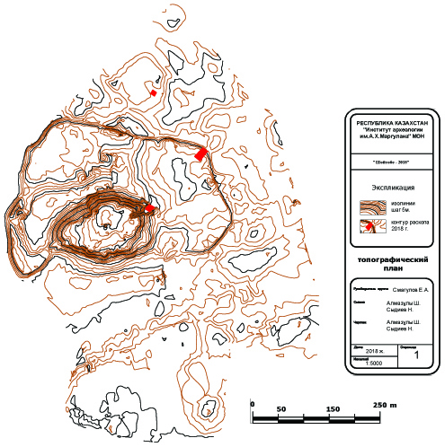
Picture D.1 – Shoytobe settlement. Topographic plan 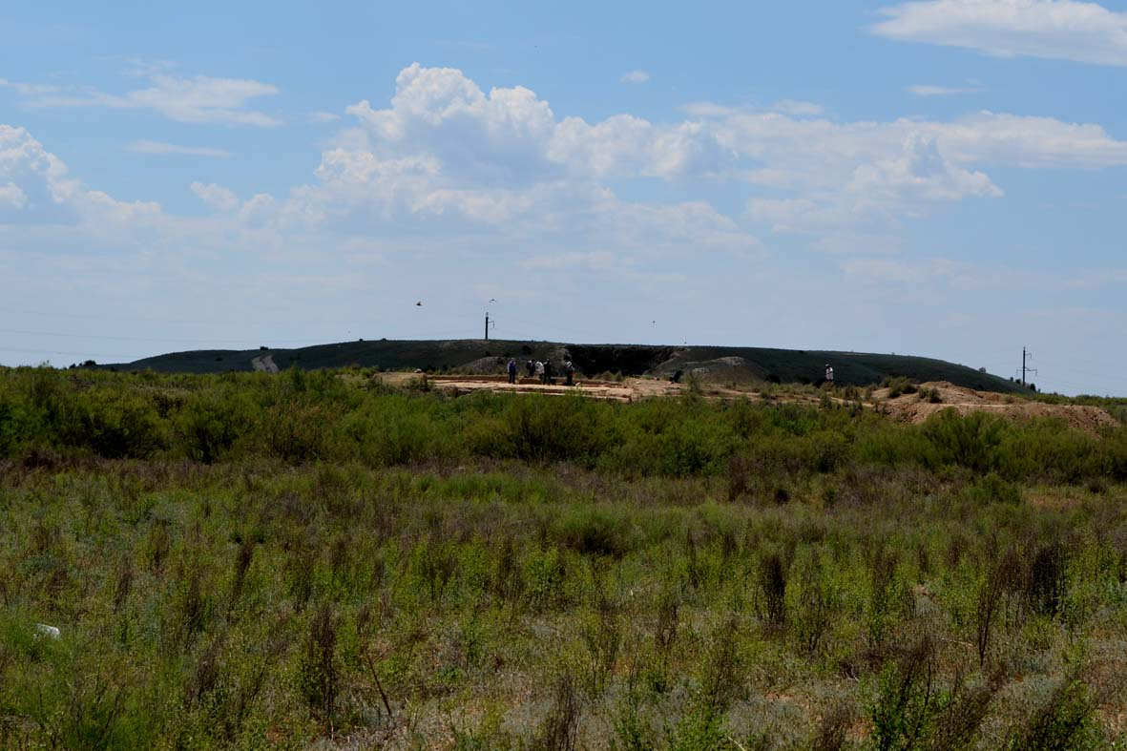
Picture D.2 – Shoytobe settlement. View of excavation N 4 from the east

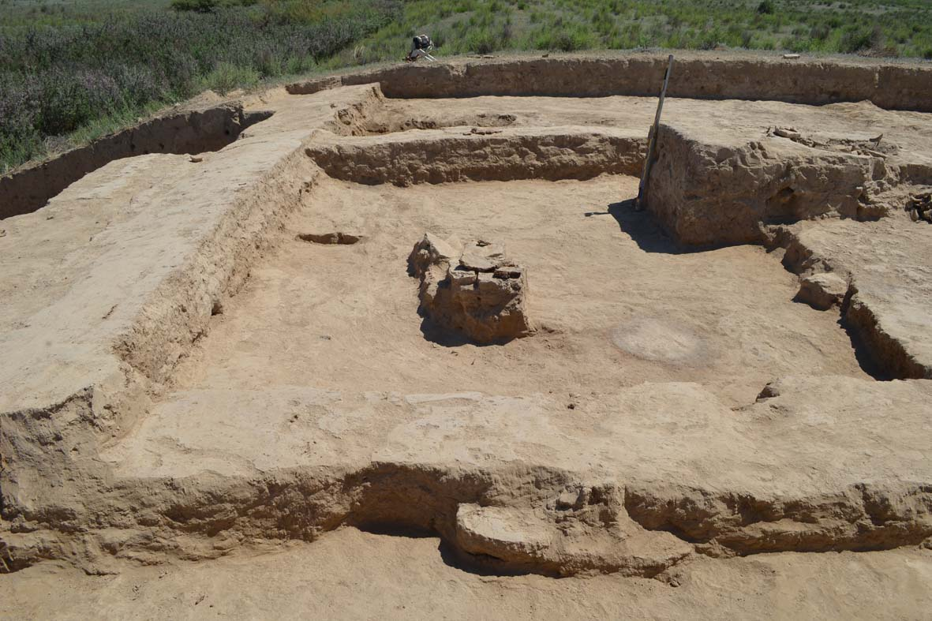
Picture D.3 – Shoytobe settlement. Room 1 on level 1 of the upper construction horizon tier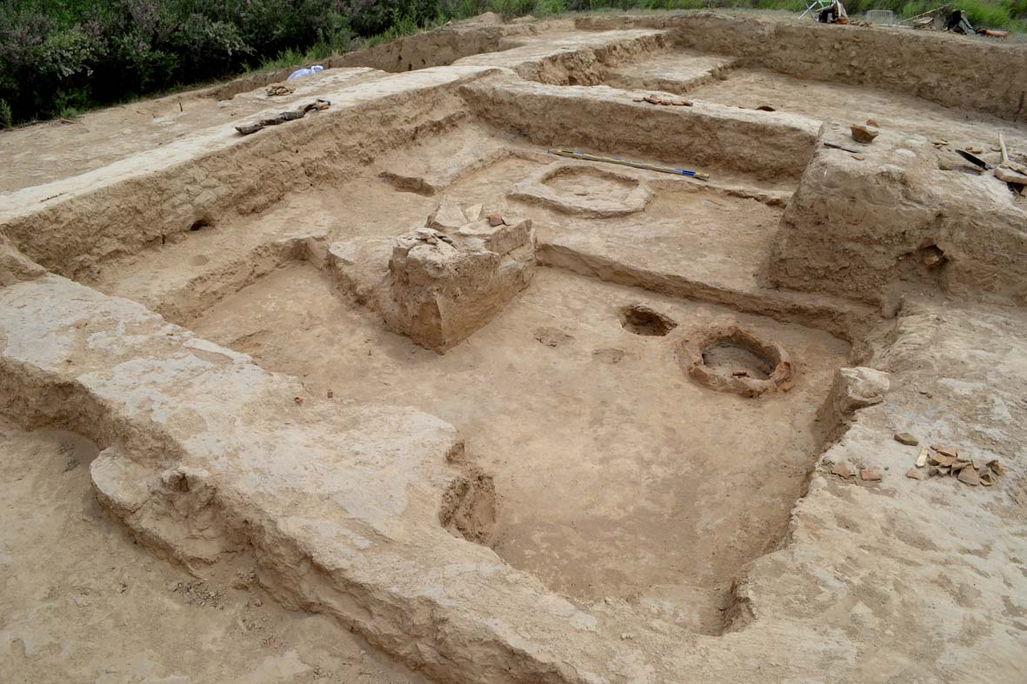
Picture D.4 – Shoytobe settlement. General view of the room 1 on level 2 tiers
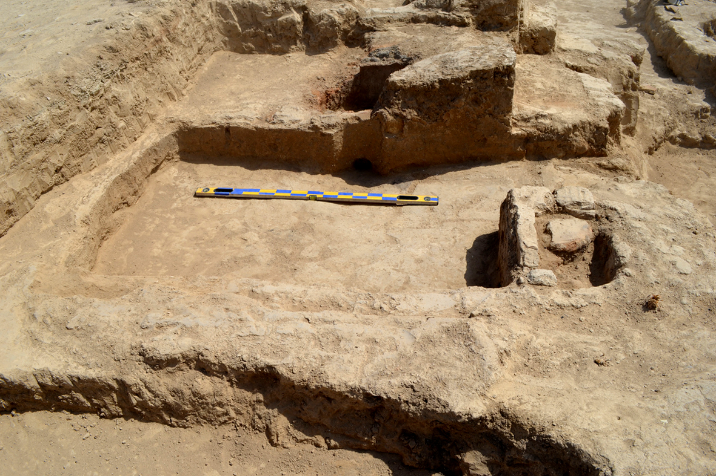
Picture D.5 – Shoytobe settlement. General view of the room 3. View from the West
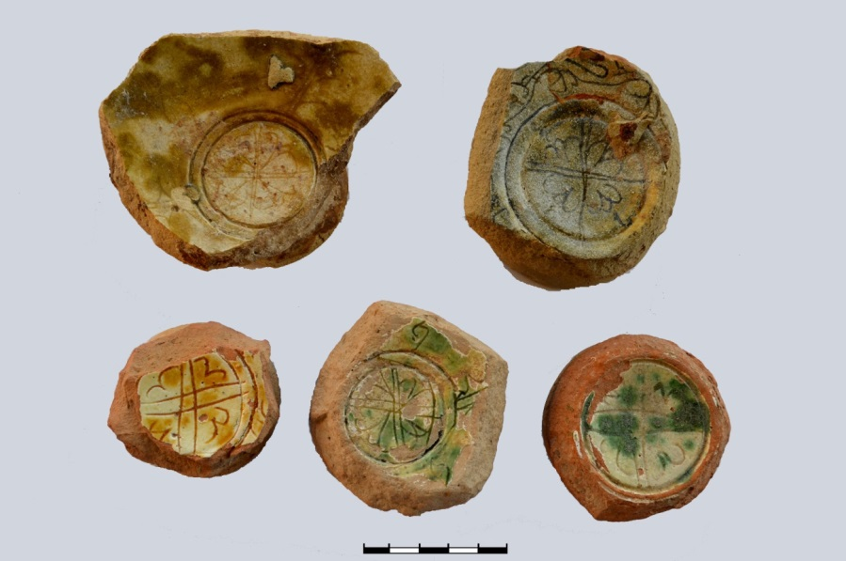
Picture D.6 – Shoytobe settlement. The bottom of the dishes with ornamentation in the center
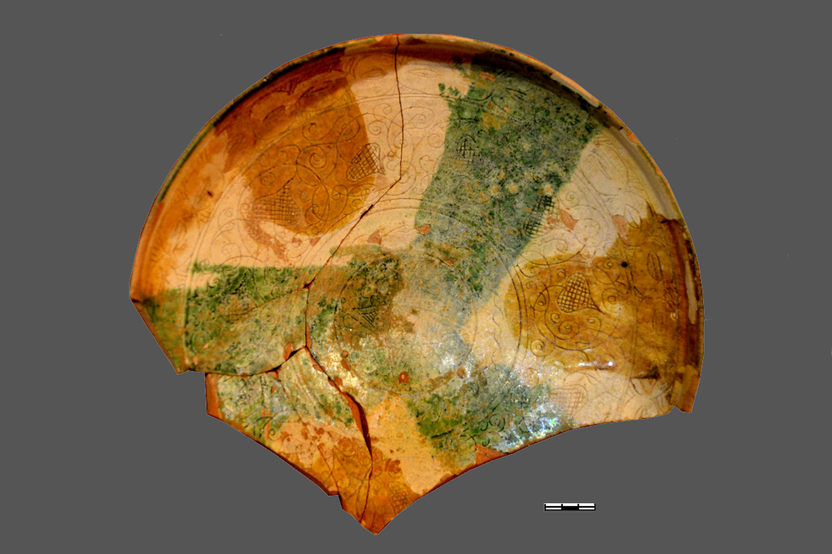
Picture D.7 – Shoytobe settlement. Ceramic dish
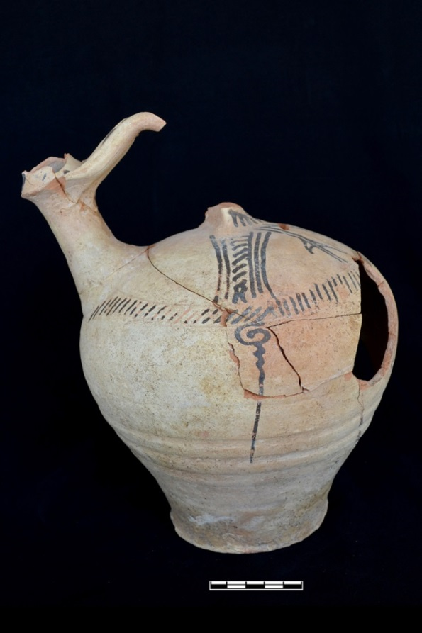
Picture D.8 – Shoytobe settlement. Ceramic jug machine-made
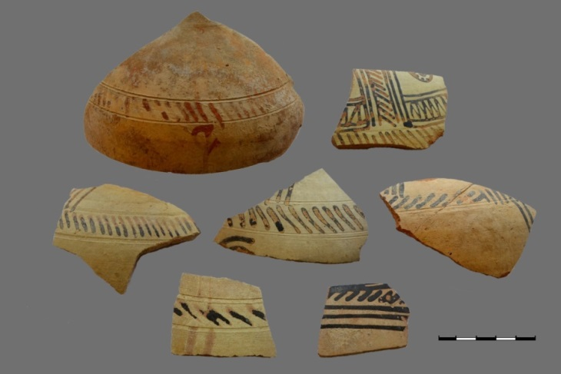
Picture D.9 – Shoytobe settlement. Fragments of the walls of the jars
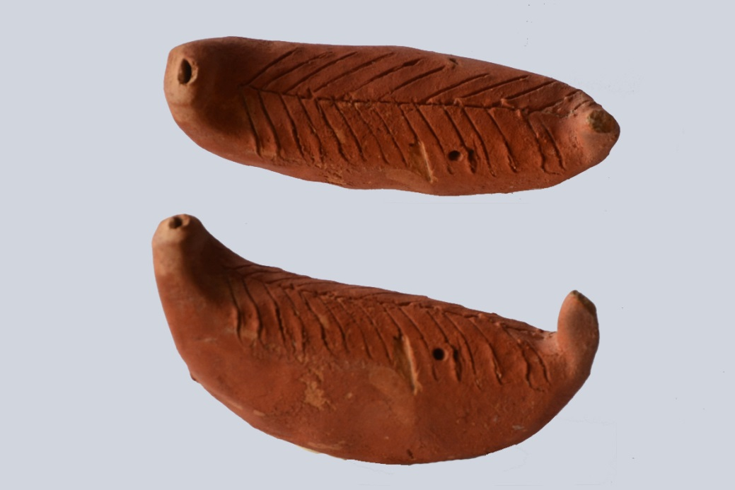
Picture D.10 – Shoytobe settlement. Sazsyrnai-ceramic musical instrument
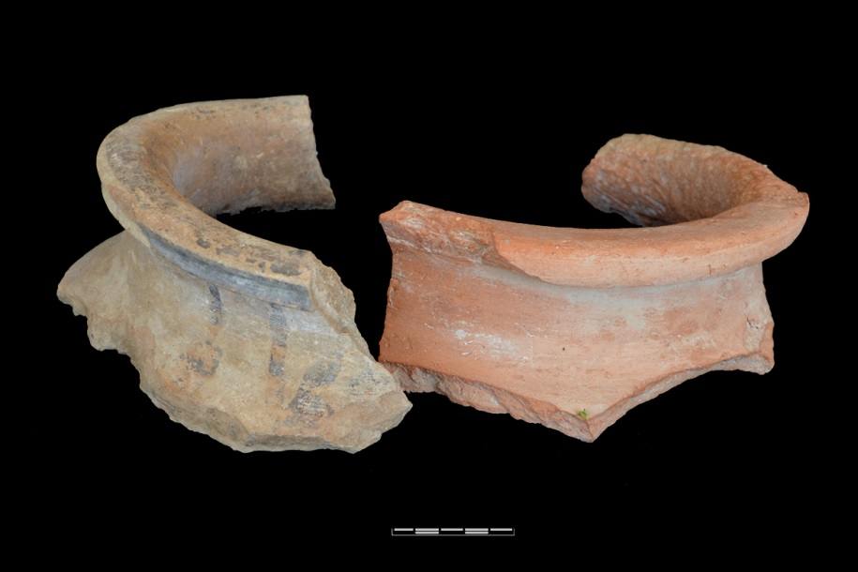
Picture D.11 – Shoytobe settlement. Fragments of the Corolla hums
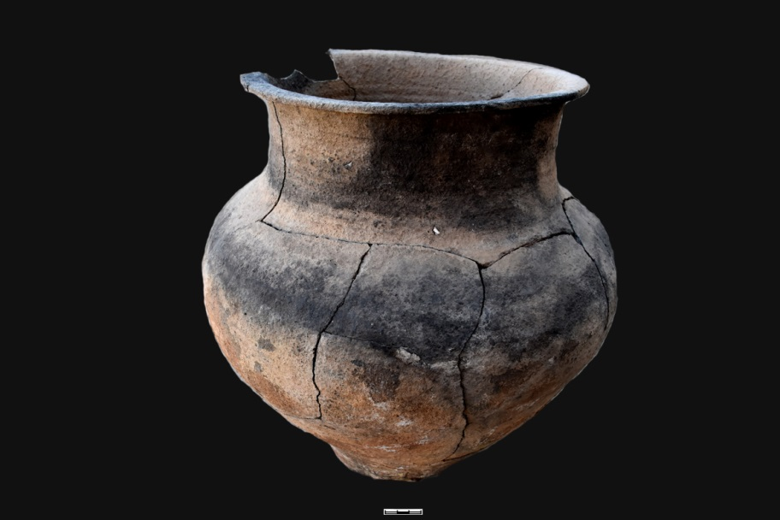
Picture D.12 – Shoytobe settlement. Ceramic pot
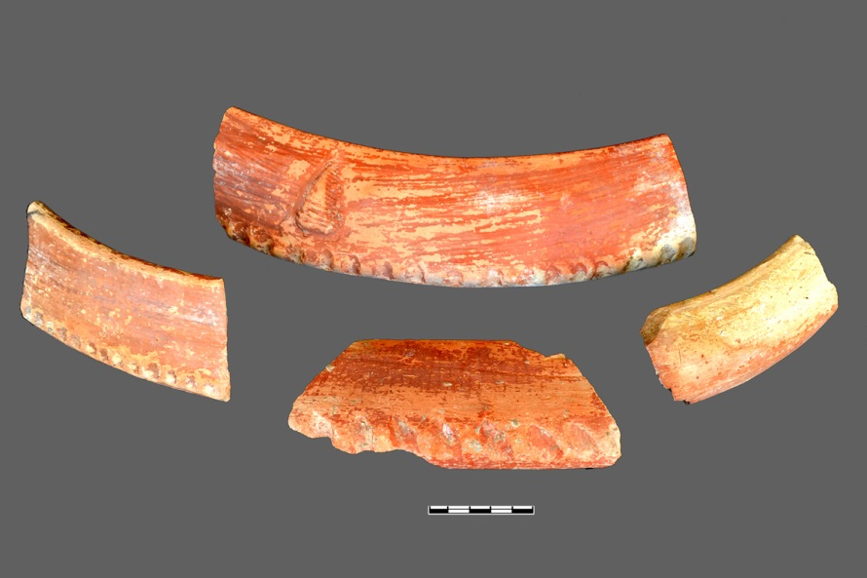
Picture D.13 – Shoytobe settlement. Fragments of the dastarkhan
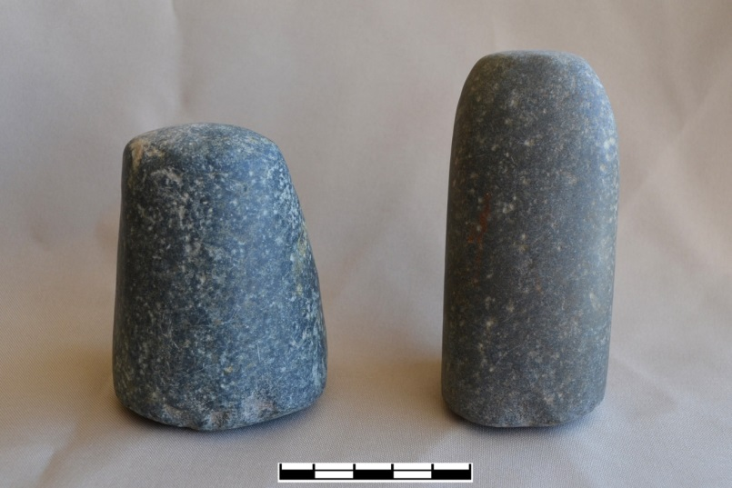
Picture D.14 – Shoytobe settlement. Stone products
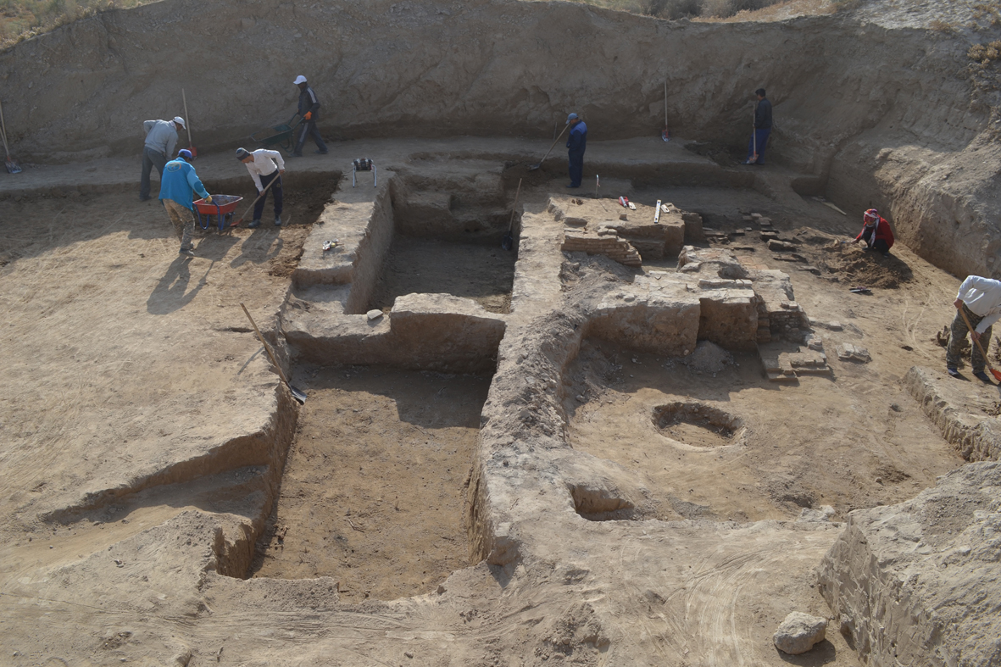
Picture D.15 – Shoytobe settlement. Working time of clearing the bathhouse
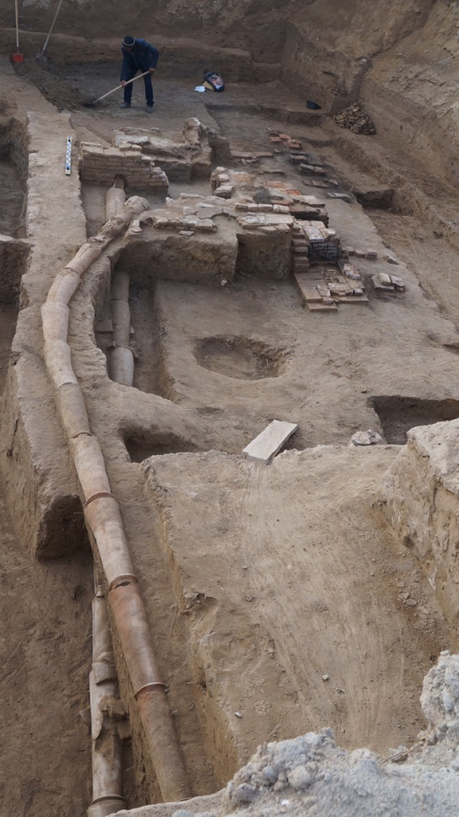
Picture D.16 – Shoytobe settlement. Location of water pipes
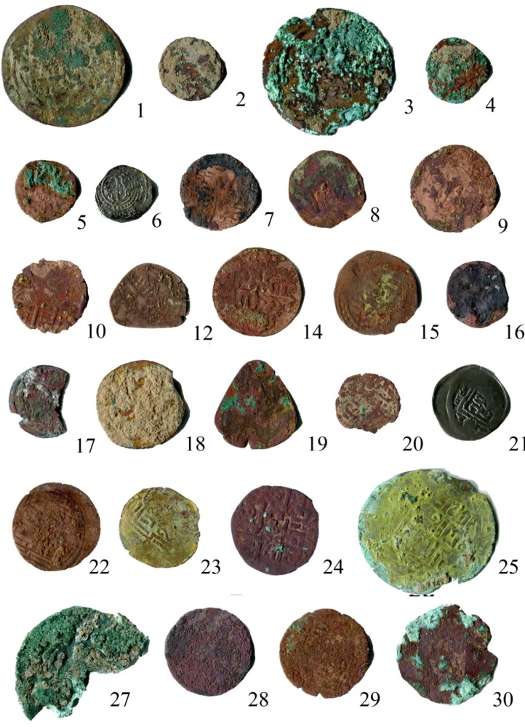
Picture D.17 – Shoytobe settlement. The numismatic collection of the excavation pit 4, the upper construction horizon
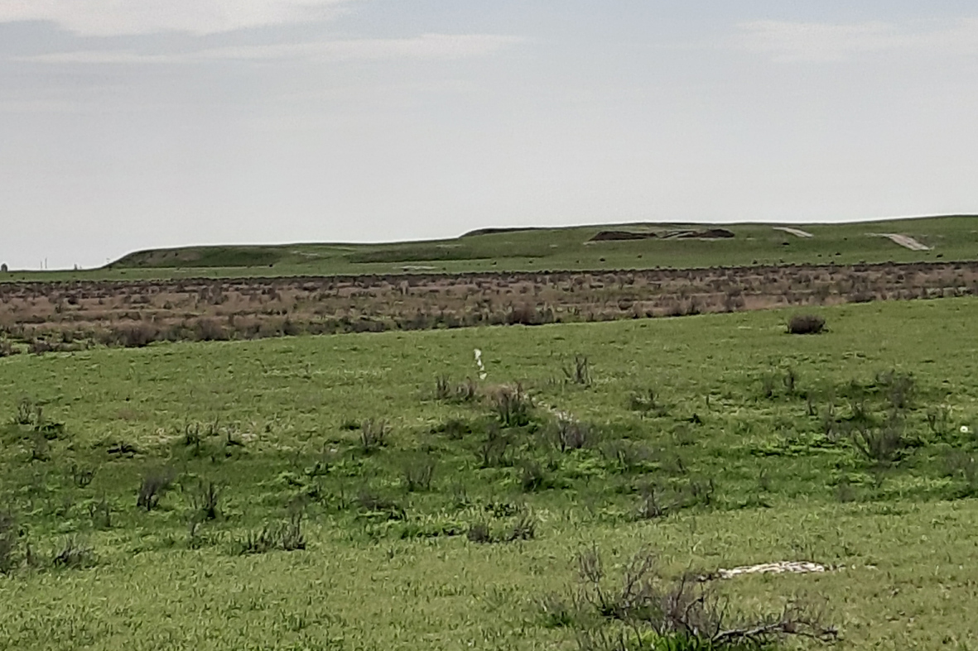
Picture D.18 – Karatobe settlement. View of the south-eastern corner of the monument
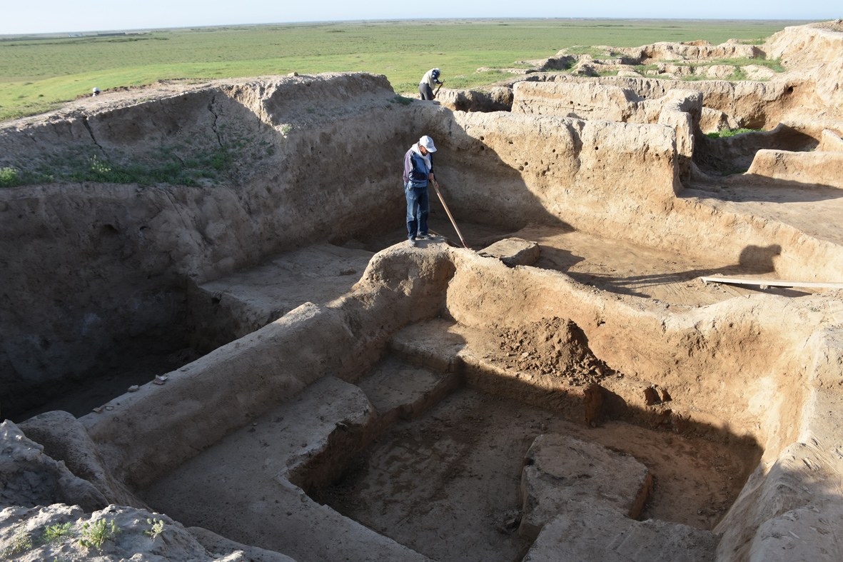
Picture D.19 – Karatobe settlement. Clearing the premises of the house 1
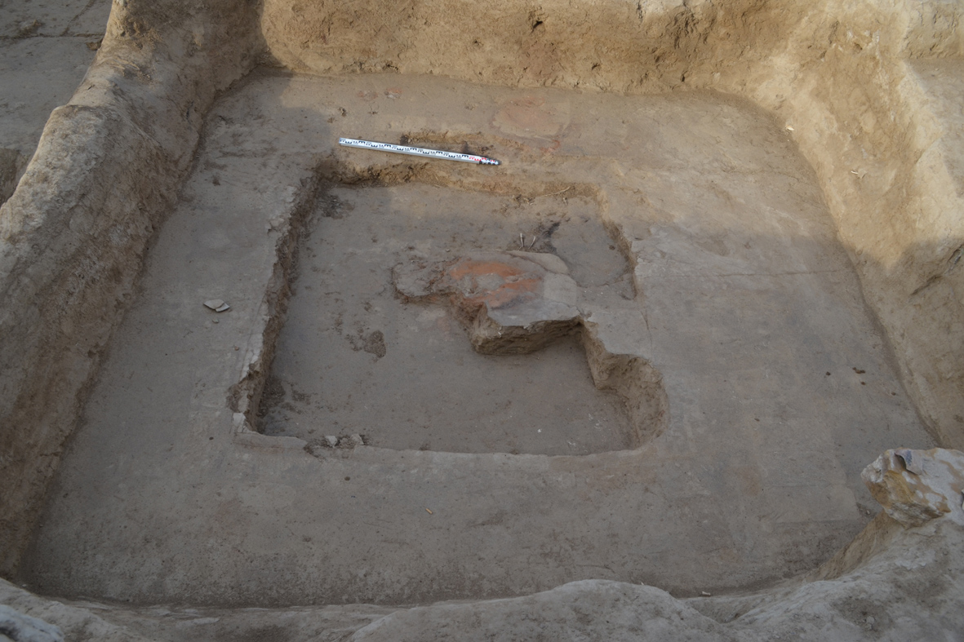
Picture D.20 – Karatobe settlement. Room 9 (section 4)

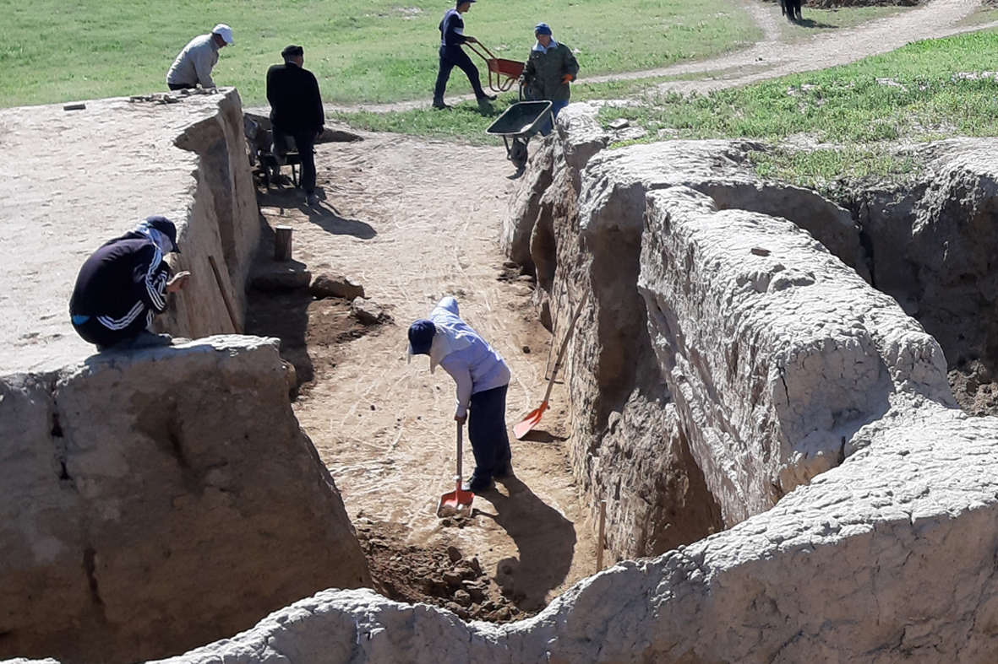
Picture D.21 – Karatobe settlement. Beginning of work on the stratigraphic section
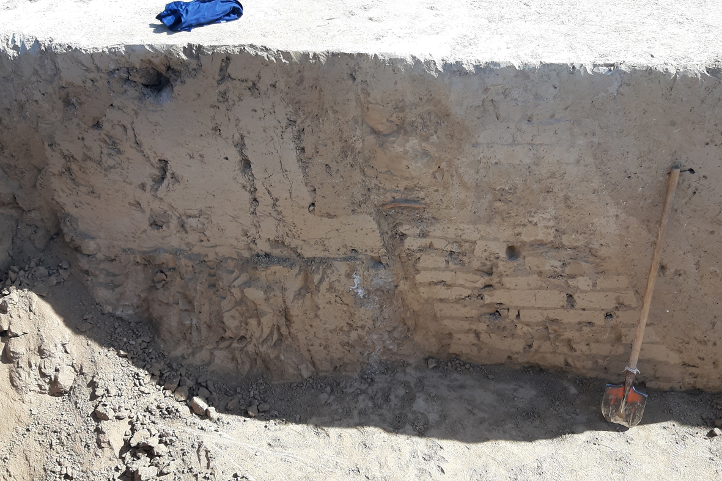
Picture D.22 – Karatobe settlement. Section of the fortress wall in the stratigraphic pit
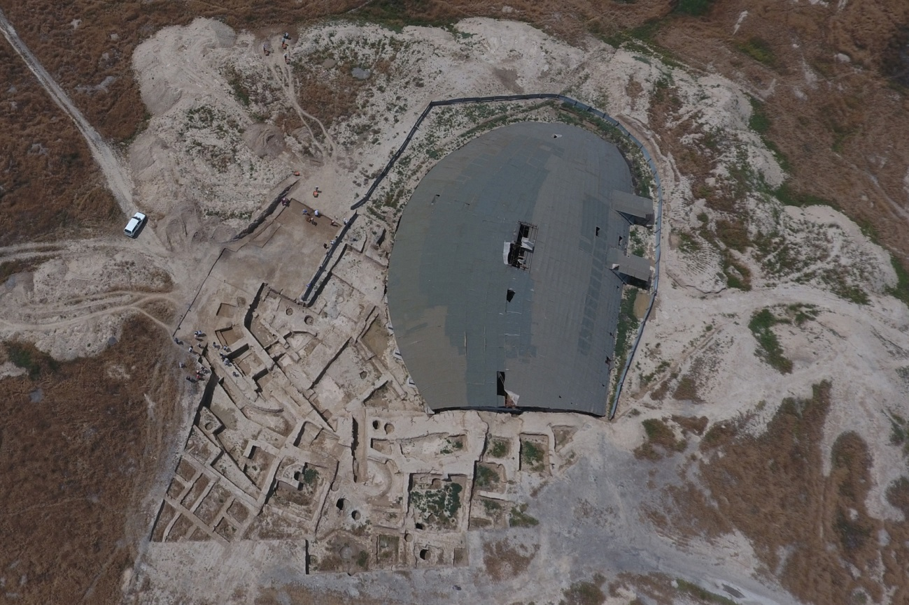
Picture D.23 – Kultobe settlement. A picture from a drone. 2016 year
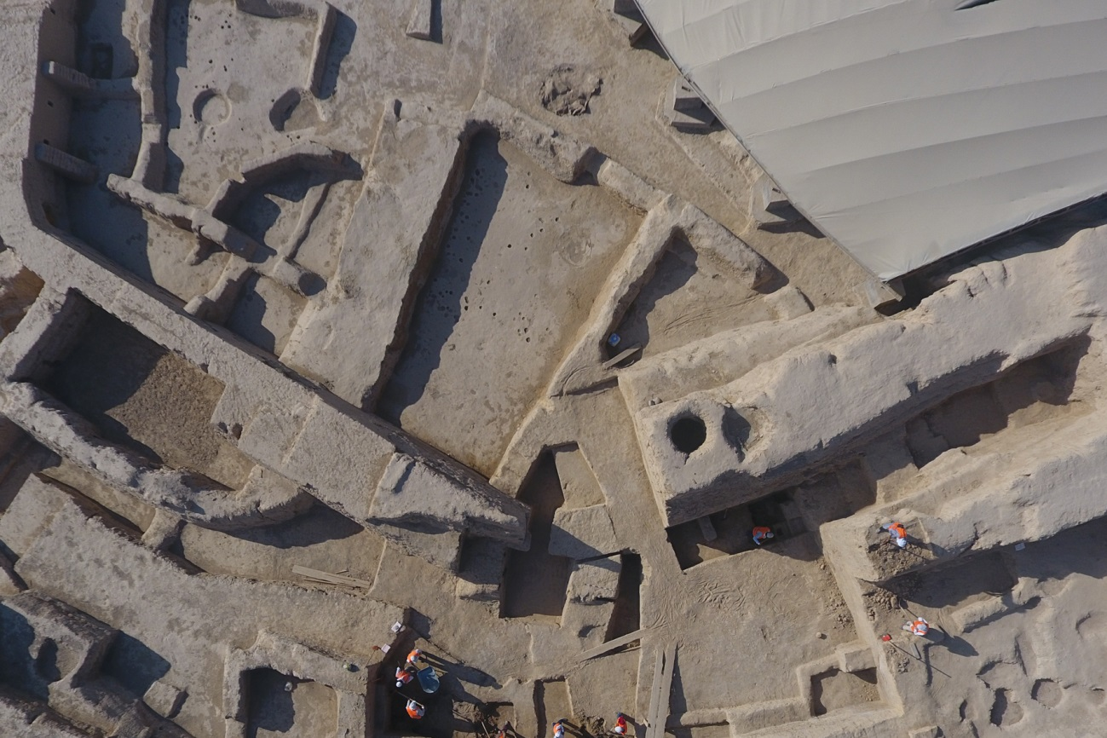
Picture D.24 – Kultobe settlement. Southern section of the fortress wall
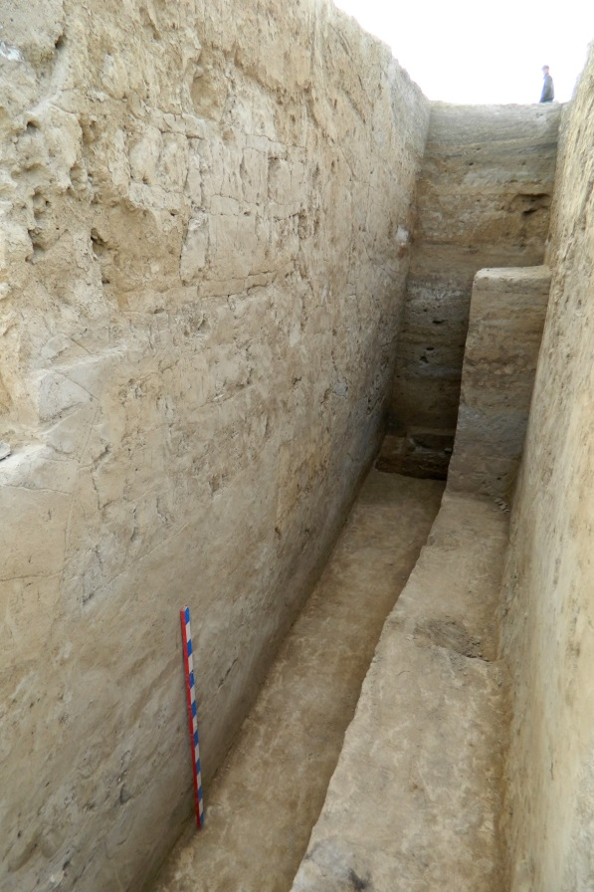
Picture D.27 – Kultobe settlement. Stratigraphic pit 2012-2013 yy.
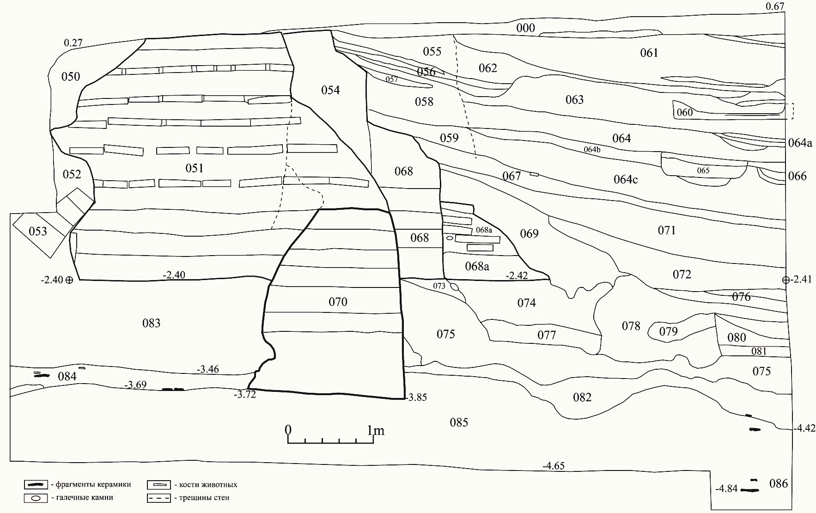
Picture D.28 – Kultobe settlement. Profile of the stratigraphic section of the fortress wall. Two thousand thirteen
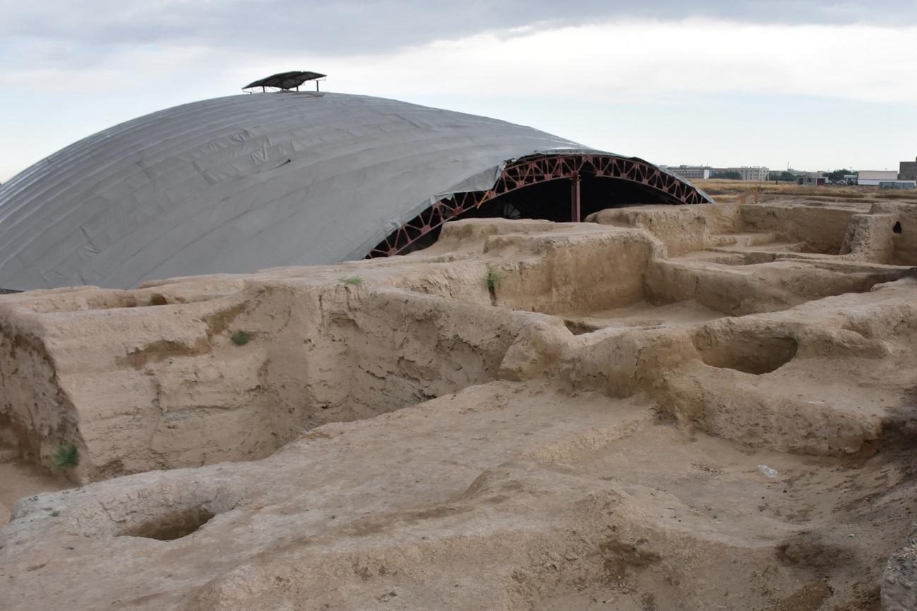

Picture D.29 – Kultobe settlement. Section of wall before work begins
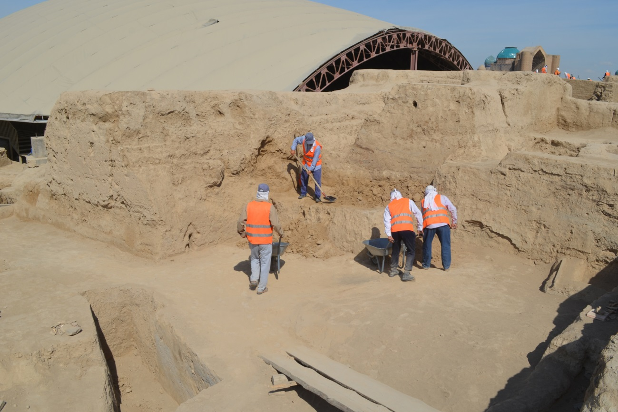
Picture D.30 – Kultobe settlement. Working time of clearing the outer section
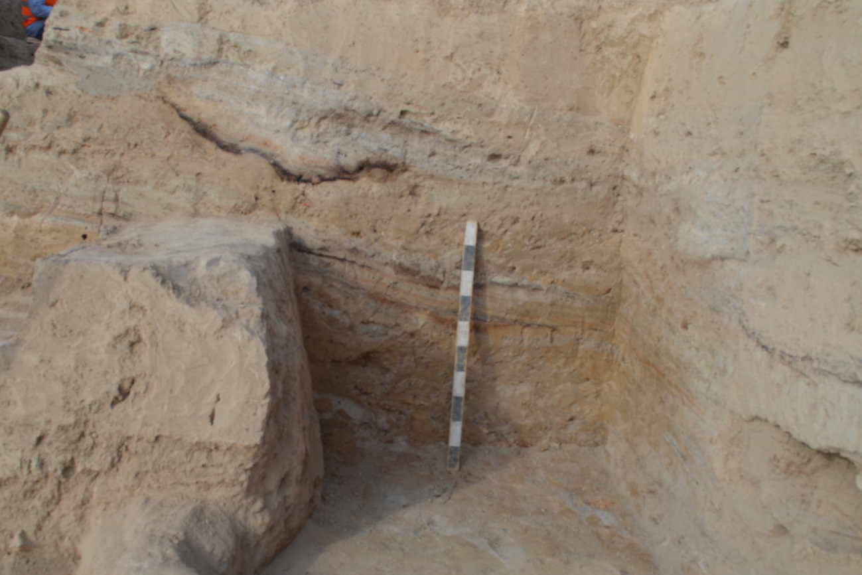
Picture D.31 – Kultobe settlement. Layers lying behind the fortress wall
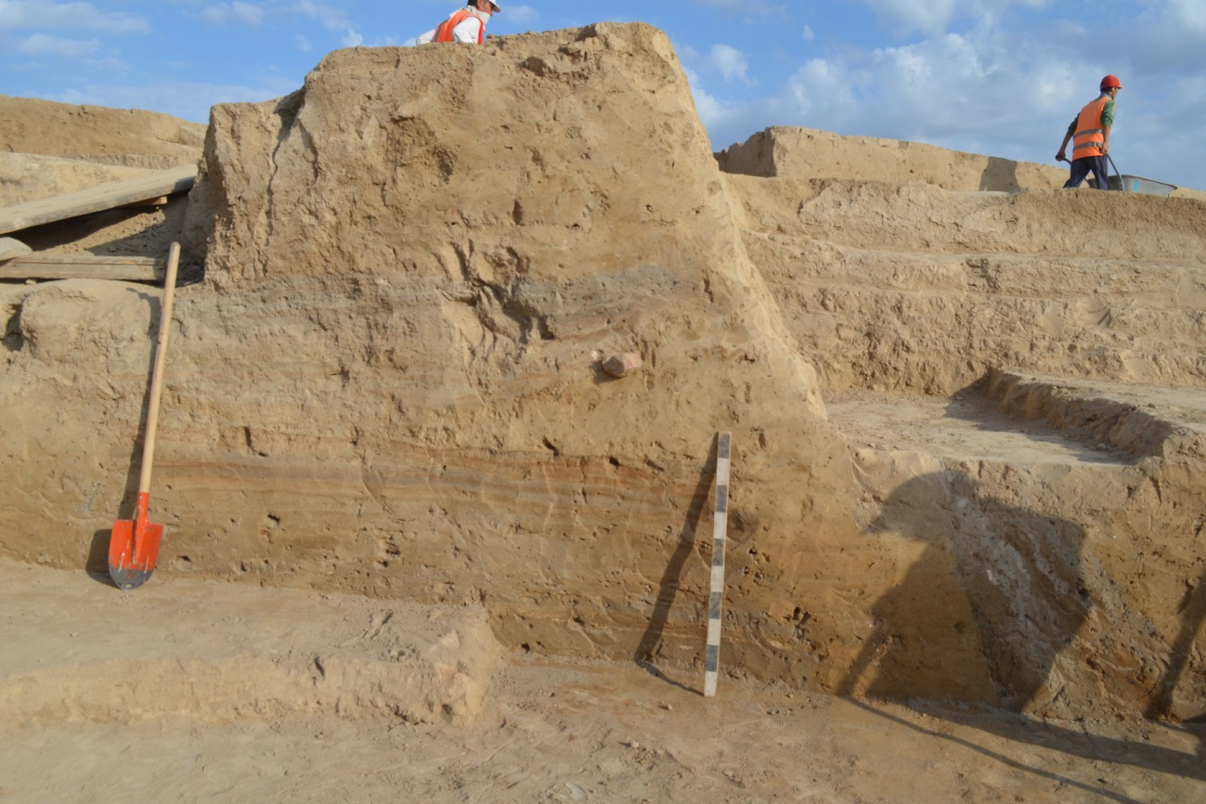
Picture D.32 – Kultobe settlement. The level of occurrence of layers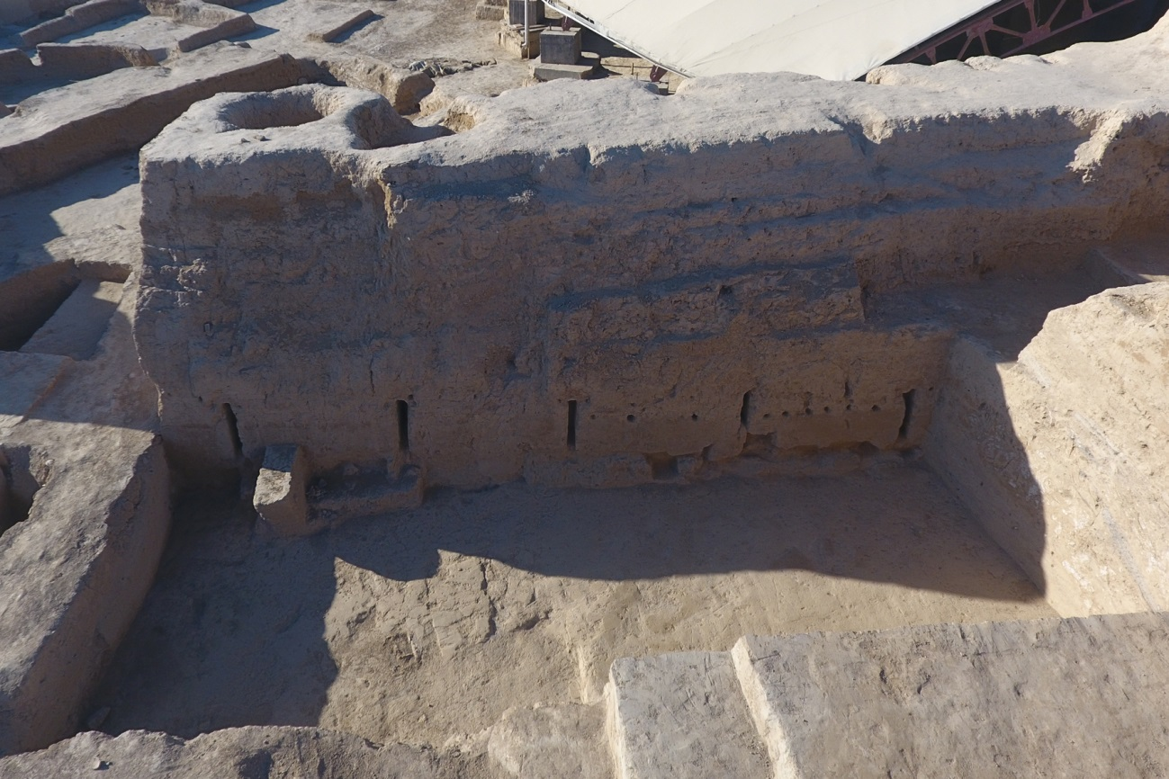
Picture D.33 – Kultobe settlement. Uncovered section of the ancient fortress wall
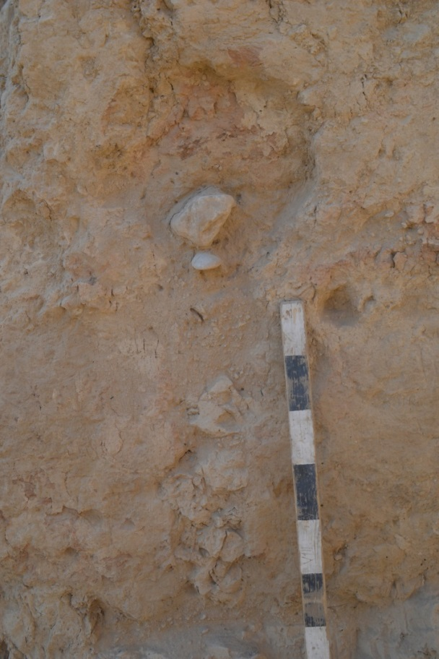
Picture D.34 – Kultobe settlement. Loophole 1 before clearing the internal space
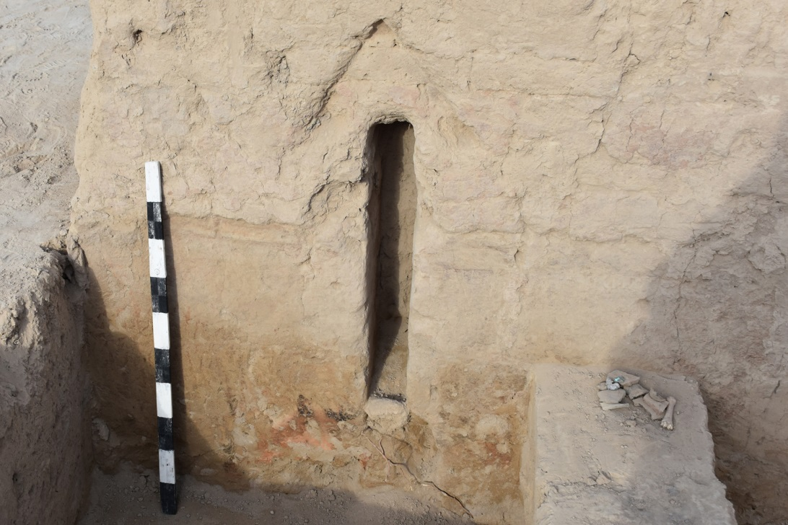
Picture D.35 – Kultobe settlement. Loophole 1 after clearing
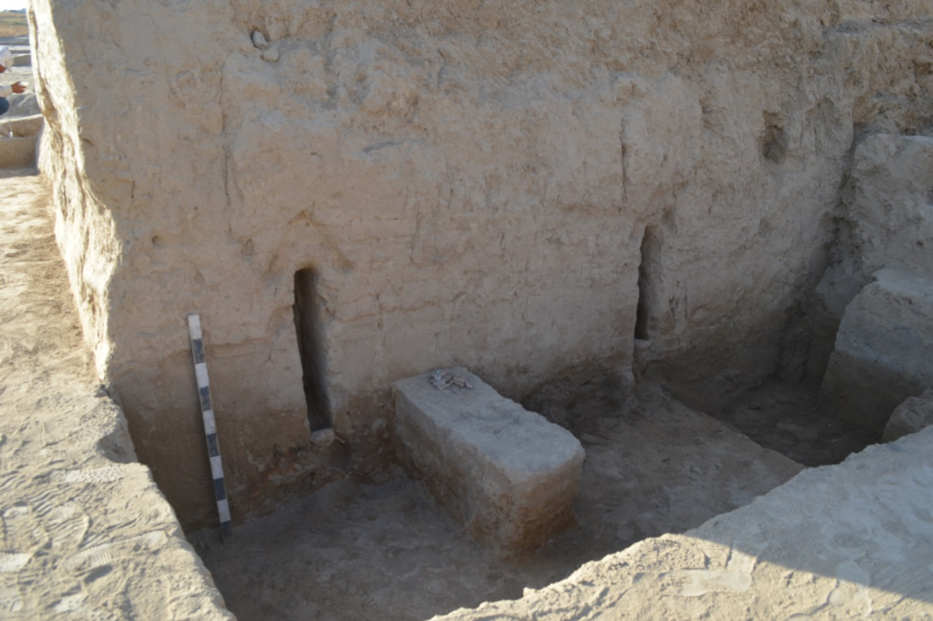
Picture D.36 – Kultobe settlement. View of loopholes 1 and 2 from the south
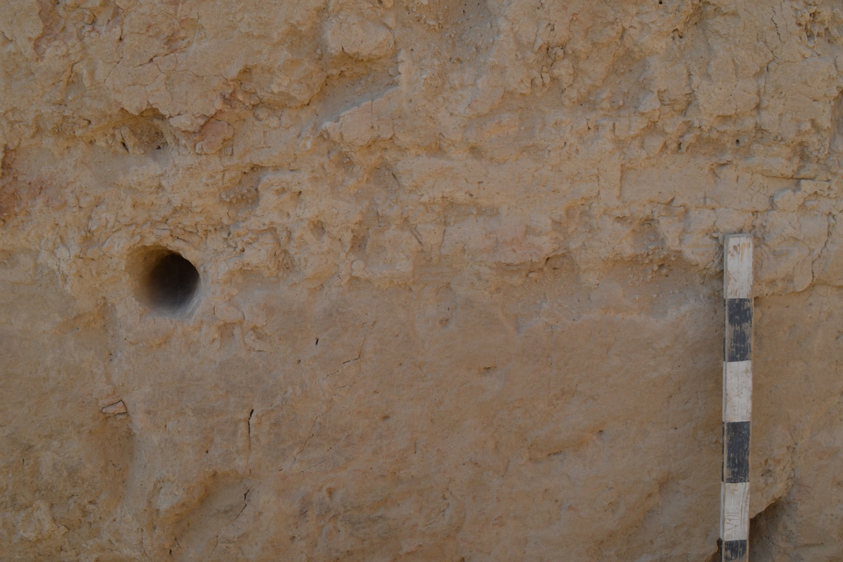
Picture D.37 – Kultobe settlement. Hole in the wall between the loopholes
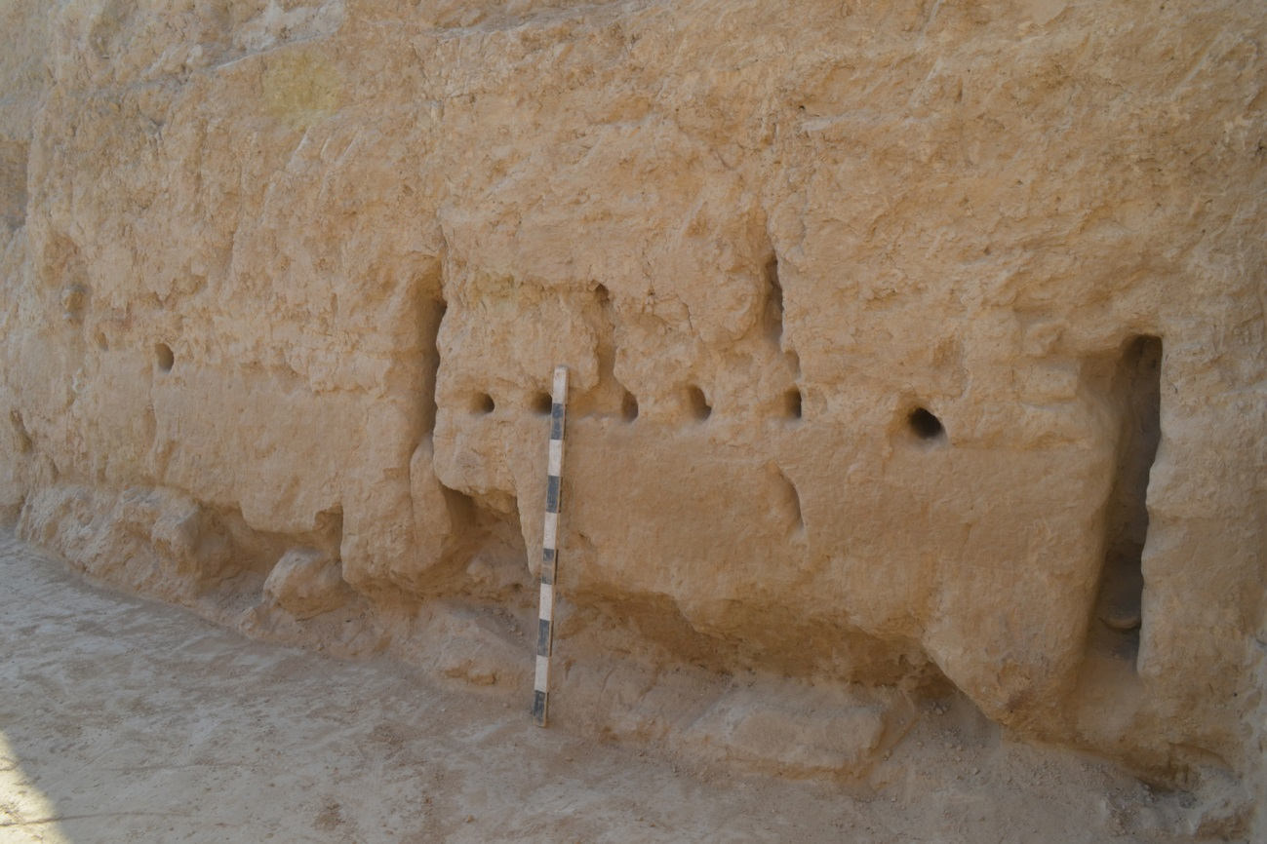
Picture D.38 – Kultobe settlement. Holes between loopholes 4 and 5
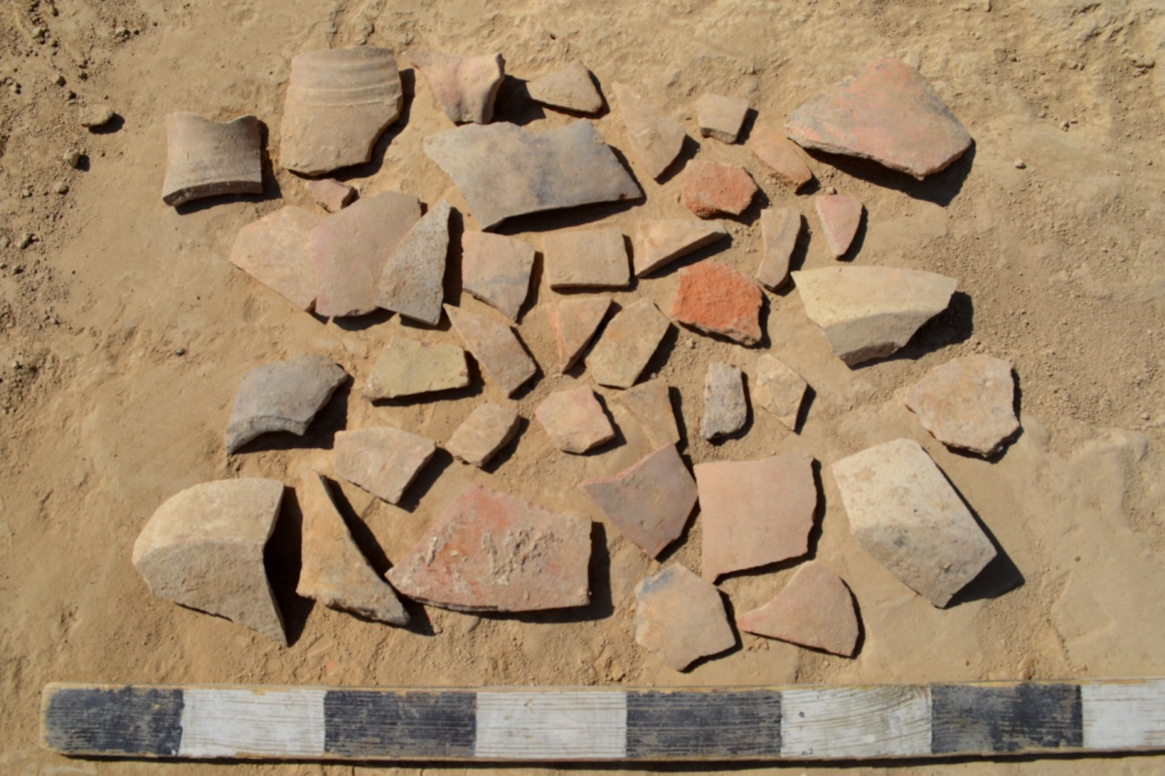
Picture D.39 – Kultobe settlement. Fragments of ceramic jugs
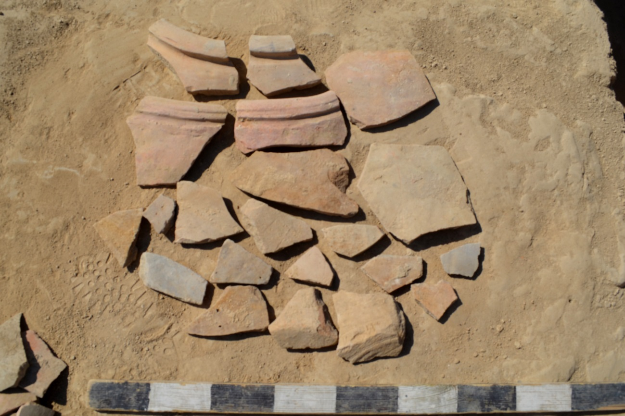
Picture D.40 – Kultobe settlement. Fragments of ceramic hums
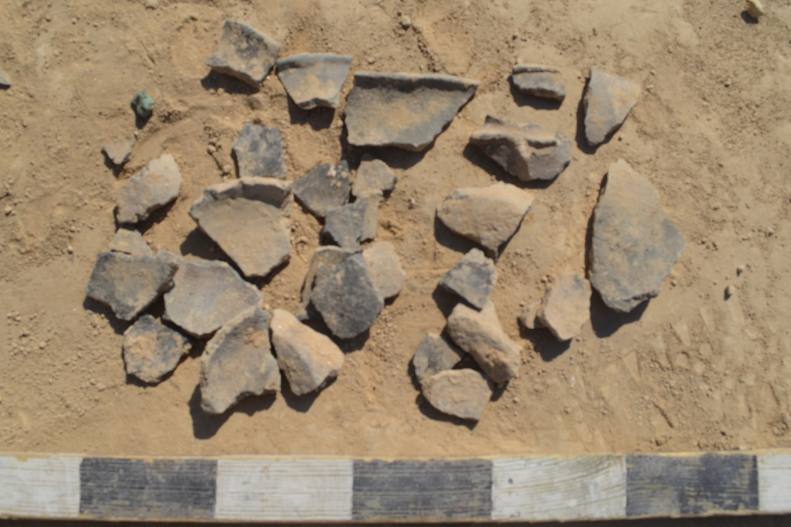
Picture D.41 – Kultobe settlement. Fragments of ceramic vessels made of loose dough

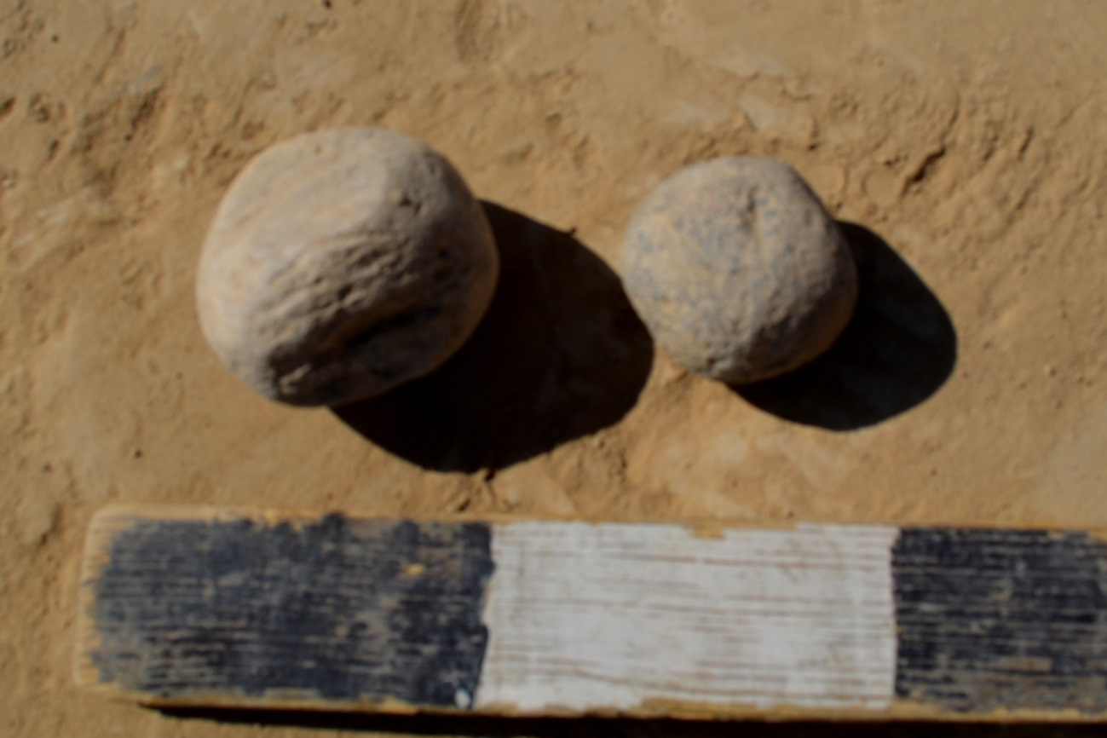
Picture D.42 – Kultobe settlement. Stone products – tarocca
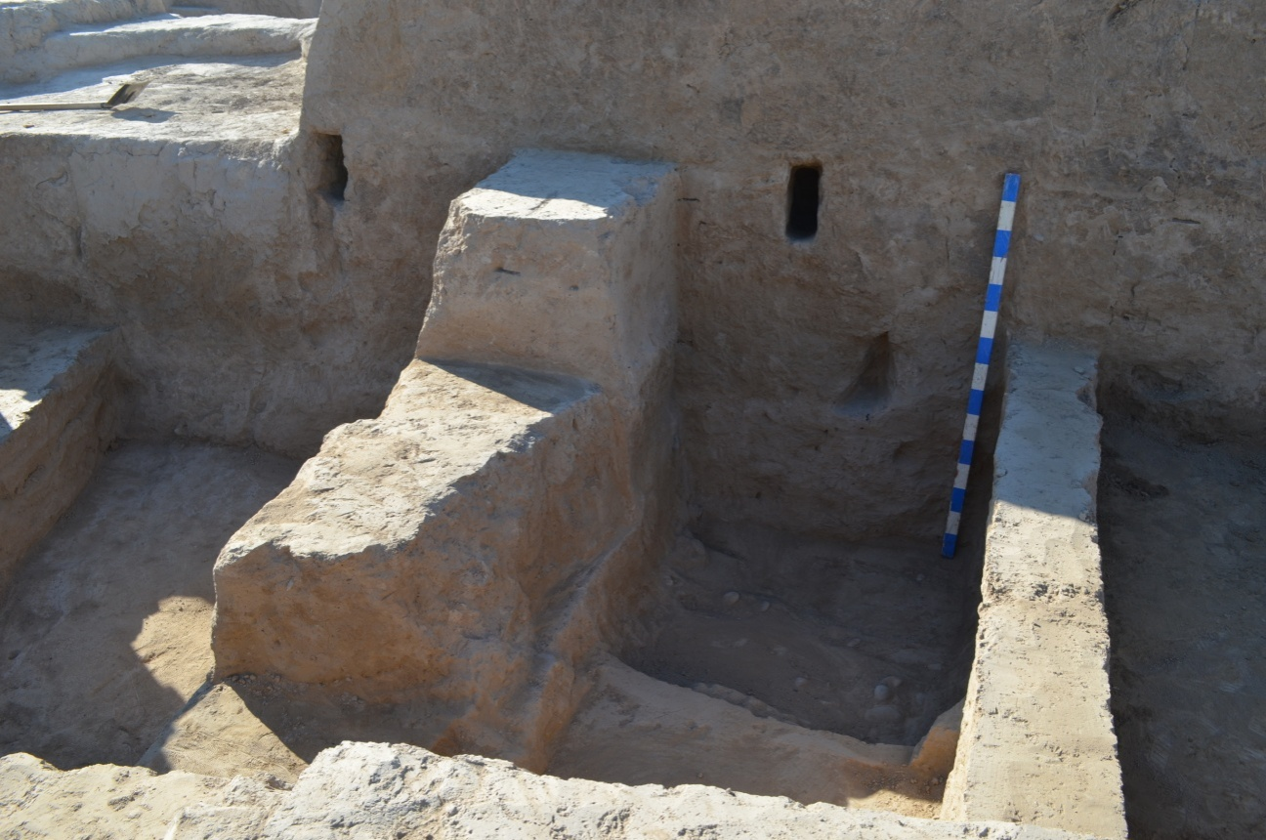
Picture D.43 – Kultobe settlement. Part of the inner section of the ancient wall. 2015 y
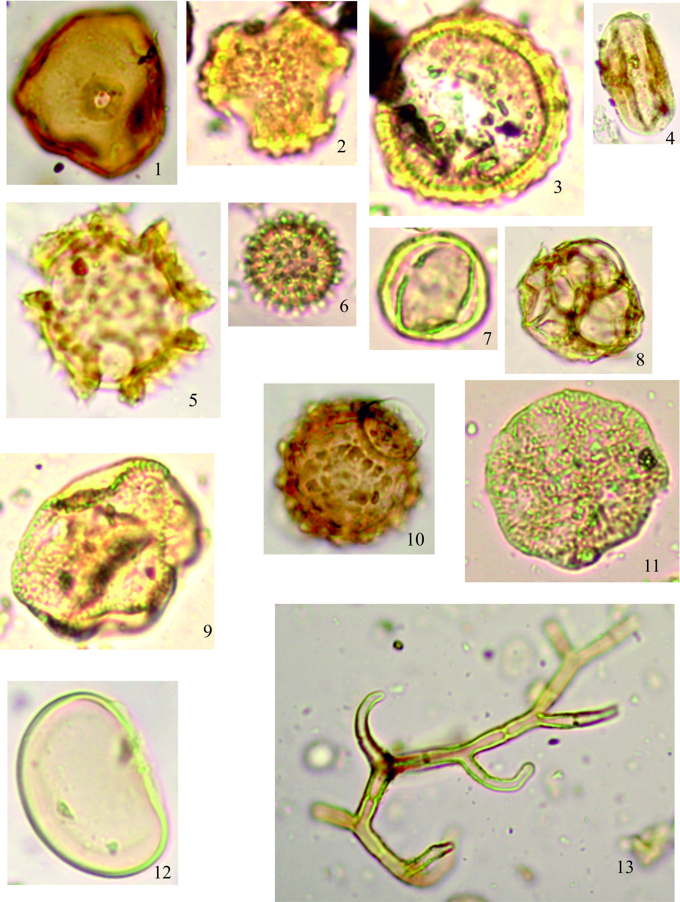
Picture D.44 – Shoytobe settlement. Macro images of selected samples
Picture D.45 – Karatobe settlement. Pollen. Macrophoto

