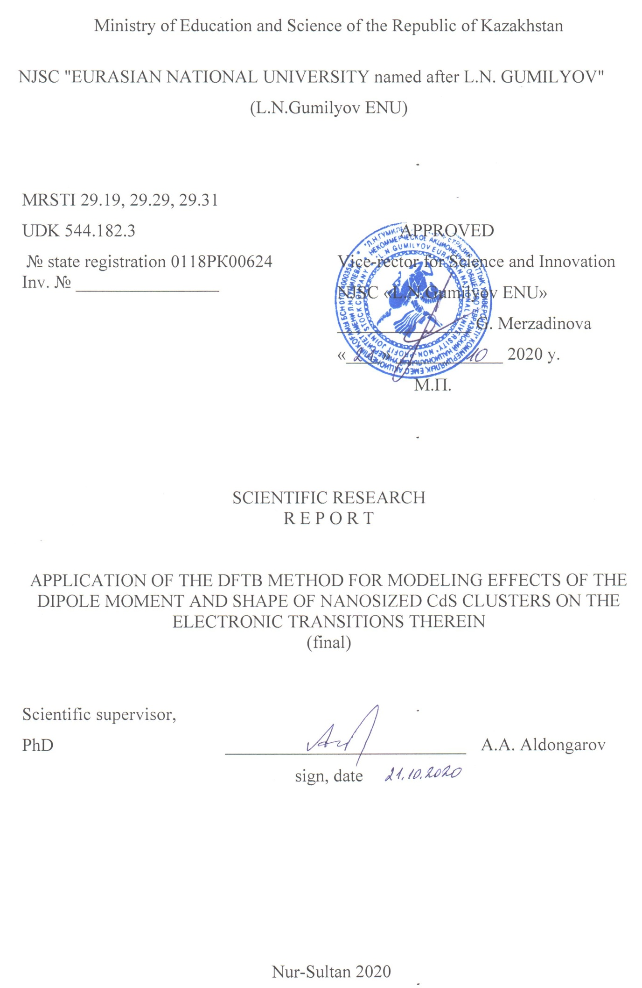
ABSTRACT

Report 39 p., 2 p., 21 fig., 13 tables, 26 references, 3 appendixes. CdS CLUSTERS, LOCALIZED STATES, DENSITY FUNCTIONAL TIGHT‐BINDING THEORY, PASSIVATION, DIPOLE MOMENT
Object of study – cadmium sulfide clusters of wurtzite structure.
Aim of the work – determination of the influence of the electrostatic field on the electronic spectra of CdS clusters; consideration of the self-aggregation effect on the electronic spectra of nanosized cadmium sulfide clusters.
Research methods – the density functional tight binding method was used for the study, in particular, the DFTB method was used to calculate the electronic spectra.
Results obtained and novelty – the optimized structures were calculated and the electronic spectra of cadmium sulfide clusters were calculated by the DFT and DFTB methods. The effect of the electrostatic field on electronic transitions and the position of the boundary molecular orbitals was considered. The external field was applied opposite, in the same direction and perpendicular to the direction of the dipole moment. The effect of self-aggregation along the dipole moment direction on the passivation of cadmium sulfide clusters was also evaluated.
Application area – the results obtained can be used to develop a technique for obtaining semiconductor quantum dots with a relatively high quantum yield of luminescence and in photoelectric converters.
CONTENTS
Page
DEFINITIONS, DESIGNATIONS AND ABBREVIATIONS ……………... | 5
INTRODUCTION …………………………………………………………… | 6
1 Electrostatic field effect …………………………………………………… | 7
2 Effect of self-aggregation ………………………………………………… | 22
CONCLUSION ………………………………………………………………. | 30
REFERENCES ………………………………………………………………. | 31
APPENDIX A – List of published works ……………………………………. | 34
APPENDIX B – Calendar plan for 2020 …………………………………….. | 36
APPENDIX C – Main conclusions based on the results of 2018-2019 ……… | 39

DEFINITIONS, DESIGNATIONS AND ABBREVIATIONS

In this research report the following terms are used with the corresponding definitions, symbols and abbreviations:

DFT – density functional theory
DFTB – density‐functional tight‐binding
МО – molecular orbitals
LUMO – lowest unoccupied molecular orbital
HOMO – highest occupied molecular orbital
QD – quantum dot
μ – dipole moment
f – oscillator strength
Е₁ – energy of first electronic transition
Е – electrostatic field
E_{int} – energy of the lowest in energy intensive transition

INTRODUCTION

Last three deacades show that scientists obtained large progress in synthesis and application of semiconducting quantum dots (QDs). The veriety of application of QDs is great and covers such areas as biomarkers [1-6], photocatalysts [7-9], light sources [10-11], solar light sensytizers [12-13], lasers [14-15].
Main interesting property of QDs, which is responsible for the attraction of large interest of the scientific community, is the quantum size effect. This effect gives the ability to control bang gap value through the size of QDs. In real nanosized semiconducting crystals some states may appear in the bang gap region and this may significantly affect the physical properties of QDs. These states also called as trap states since they provide trapping of charge carriers electron and hole.
For semiconducting QDs surface effects play an important role in their optical and catalytic properties because number of surface atoms is relatively great comparing to a total number of atoms in QDs. Therefore, scientists considered the surface defects, for example, dangling bonds of the surface atoms or impurity atoms as the sources of trap states. The analysis of literature devoted to consideration of reasons of formation of trap states demonstrates controversial conclusions [16-18]. Thus, still there is no clear understanding of how these trap states form and what factors may prevent or stimulate their formation. The ability to control trap states is the key factor for obtaining the materials with superior properties. Particularly, luminescent quantum yield of QDs increases if the number of trap states is decreased because the trap states prevent the recombination of the electron and hole and emission of light [19] or vice versa for photocatalytic generation of hydrogen through water splitting trap states provide better charge separation for effective hydrogen generation [20-21]. Therefore, the engineering of trap states in QDs provide great level of control of their physical properties.
Our previous results [22-23] with application of DFT approximation for small CdS clusters demonstrated that rather the dipole moment of nanosized crystals play important role in formation of trap states than the surface defects by themselves. In this paper we have considered the effect of the dipole moment on the formation of trap states in large CdS QDs applying DFTB method. Some of the results are presented in works published in 2020 (Appendix A).

1 Electrostatic field effect

The significance of the dipole moment value for electronic transitions reasonably leads to an idea that an external effect on dipole moment could lead to changes in the electronic transitions. One of the easiest ways to vary the dipole moment is the application of external electrostatic field. Experimental results demonstrated that application of the electrostatic field may quench the luminescence of quantum dots [24-26]. According to task 5 of the Calendar plan (Appendix B), the effect of the electrostatic field was considered. Therefore, we have used one variation of the [Cd₄S₁(SH)₆]⁰ cluster, which have a dipole moment oriented along one of the Cartesian axes, to test the effect of the electric field on the dipole moment and the ΔE = E_{int} – E₁ value (E_{int} – energy of lowest intensive transition, E₁ – energy of first transition). Figure 1 indicates the orientations of the dipole moment and E. In our model, the standard option of applying an electrostatic field available in the Gaussian 09 program package was used. In our calculations we have used DFT method with functional LC-wPBE and standard basis set LanL2DZ for cadmium, 6-31G(d) for sulfur and 3-21G for hydrogen. The electric field vector (E) of different values was oriented against the dipole moment vector as shown in Figure 1 for [Cd₄S₁(SH)₆]⁰ cluster in order to compensate the large dipole moment value of 17.4406 D and aligned in the same direction to test the effect of the E orientation on the dipole moment vector μ and the electronic transitions. Table 1 shows the calculated values of E₁, E_{int}, μ, and ΔE for different applied values of E for [Cd₄S₁(SH)₆]⁰. Positive values of E correspond to the orientation of the electrostatic field against the μ orientation.

Figure 1 – Structure and orientation of dipole moment vector μ and electrostatic field strength E

As one can clearly see from Table 1 the gradual increase of the applied electrostatic field strength E directed against μ leads to a significant decrease of the μ value. The values of E_{int} and E₁ undergo a red shift (decrease of energy) as E increases, i.e. we may say that there is a correlation between the reduction of μ and the lowering of the energy of the E_{int} and E₁ transitions. Therefore, the decrease of the dipole moment induced by the application of the electric field μ provides the ΔE decreasing. Thus, the application of an external electrostatic field may enhance the passivation effect through decreasing of the dipole moment. We have to note that the application of an electric field allows the decrease of the dipole moment almost down to zero but full passivation (ΔE=0) is not provided. The application of E in codirectional to μ (negative values of E) leads to an obvious increase of the μ value and an increase of the ΔE value, i.e. passivation effect decreases. Another effect provided by the external electrostatic field codirectional to μ is that both values E_{int} and E₁ increase.

Table 1 – Calculated parameters E₁, E_{int} (with their oscillator strengths f), μ and ΔE for different values of electric field strength E for [Cd₄S(SH)₆]⁰
E (a.u.) | E₁ | E_{int} | μ (D) | ΔE (eV)
-70 | 0.6637 eV  f=0.0065 | 4.7274 eV  f=0.3156 | -27.8448 | 4.0637
-50 | 0.4435 eV  f=0.0052 | 4.5721 eV  f=0.2859 | -25.7478 | 4.1286
-30 | 0.2745 eV  f=0.0050 | 4.4370 eV  f=0.1491 | -23.1181 | 4.1625
-10 | 0.1911 eV  f=0.0050 | 4.3538 eV  f=0.2274 | -19.5676 | 4.1627
0 | 0.1676 eV  f=0.0047 | 4.2642 eV  f=0.1661 | -17.4406 | 4.0966
10 | 0.1460 eV  f=0.0040 | 4.2292 eV  f=0.2072 | -15.1501 | 4.0831
30 | 0.0948 eV  f=0.0019 | 3.8602 eV  f=2×0.0736 | -10.2541 | 3.7654
50 | 0.0467 eV  f=0.0005 | 3.7880 eV  f=2×0.0950 | -5.1198 | 3.7413
70 | 0.1057 eV  f=0.0026 | 3.6094 eV  f=2×0.0762 | -0.1619 | 3.5037

For cluster [Cd₄S₁(SH)₆]⁰ we have considered the position of the boundary molecular orbitals (MOs) in presence of the electrostatic field. Figure 2 represents the positions of the boundary MOs.
Analysis of the electronic transitions in the [Cd₄S₁(SH)₆]⁰ cluster shows that the E₁ transition has a major contribution from a HOMO-LUMO transition. From data presented in Figure 2 we may see that the LUMO is significantly separated from the other MOs. Therefore, we may conclude that the LUMO represents a trap state in a band gap region. Application of E in opposite direction of μ slightly decreases the HOMO-LUMO gap and vice versa, the HOMO-LUMO gap increases if E is directed codirectional to μ. In addition, the distance between LUMO-LUMO+1 increases as E increases in the direction opposite to μ, while for E directed codirectional to μ we see a decrease of the LUMO-LUMO+1 gap and an increase of the HOMO-LUMO distance.

Figure 2 – Position of the boundary MOs of [Cd₄S₁(SH)₆]⁰ and the values of the dipole moment in the presence of electrostatic field E

Thus, we may conclude that the trap state positions depend on the relative direction of the applied field E and D. We may also suggest that the application of E in opposite direction to D leads to a transformation of a deep trap state (states located far away from band edges) into so-called shallow trap state (states located close to band edges).
For larger clusters, the DFTB method was used, implemented in the dftb+ program package on a high-performance computing resource at the Technical University of Dresden (ZIH, Zentrum für Informationsdienste und Hochleistungsrechnen). The charge of all clusters was determined by the formula q = 2×(g-j) – k for the cluster [Cd_{g}S_{j}(SH)_{k}]^{q}.
Next, we have considered wurtzite cluster [Cd₁₀S₁(SH)₁₈]⁰. For the optimized structure of the cluster [Cd₁₀S₁(SH)₁₈]⁰ we have applied electrostatic field in direction opposite/colinear to the direction of the dipole moment (Figure 3a) and perpendicular to the dipole moment (Figure 3b). Tables 2 and 3 demonstrate data obtained for calculated excitation spectra with the field applied opposite/colinear to or perpendicular to the dipole moment.
As one can see from Table 2 the application of the field opposite to the dipole moment leads to decrease of an energy of first electronic transition and the decrease of μ. Vice versa, field colinear to μ provides increase of values E₁ and μ. For both directions (opposite/colinear) of the field the increase of f of E₁ was obtained.
Results in Table 3 demonstrate similar changes in values E₁, f and μ for both perpendicular orientations as in case of the opposite orientation of the field. Both perpendicular orientations of the field provide slow decrease of E₁, increase of f and slow increase of μ. Thus, two perpendicular orientation of the external field demonstrate symmetrical change of energies and probabilities of electronic transitions.

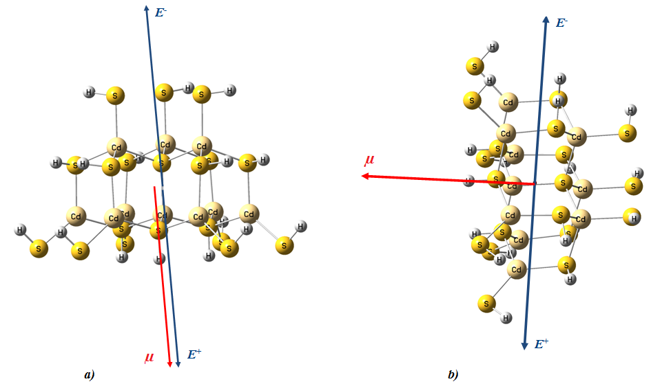
a) – the application of an electric field (blue arrow) along/against the direction of the dipole moment (red arrow); b) – the application of an electric field (blue arrow) perpendicular to the direction of the dipole moment (red arrow)
Figure 3 – Structure of the [Cd₁₀S₁(SH)₁₈]⁰ cluster with the orientation of the dipole moment and an electric field

Table 2 – Data on the effect of the electrostatic field applied along the dipole moment on electronic spectrum and the dipole moment of the structure [Cd₁₀S₁(SH)₁₈]⁰
E, a.u. | E₁, eV | f | µ, Debye
-0.005 | 0.265 | 0.00016412 | 0.272
-0.002 | 0.618 | 0.00006792 | 5.401
-0.001 | 0.742 | 0.00006093 | 7.190
0 | 0.865 | 0.00005869 | 8.963
0.001 | 0.986 | 0.00006259 | 10.723
0.002 | 1.108 | 0.00007245 | 12.470
0.005 | 1.479 | 0.00012311 | 17.645
0.01 | 2.120 | 0.00044145 | 26.085
0.02 | 1.879 | 0.00727436 | 42.462
0.05 | 0.097 | 0.00011876 | 101.556

For the detailed analysis of the effect of external electrostatic field depending on its orientation relative to μ we have constructed MOs diagrams for the cluster [Cd₁₀S₁(SH)₁₈]⁰. Figure 4 demonstrates location of boundary MOs with electrostatic field along the μ.

Table 3 – Data on the effect of an electrostatic field applied perpendicularly on the electronic spectrum and the dipole moment of the structure [Cd₁₀S₁(SH)₁₈]⁰
E, a.u. | E₁, eV | f | µ, Debye
-0.005 | 0.335 | 0.00000827 | 11.956
-0.0025 | 0.650 | 0.00003337 | 9.845
-0.001 | 0.799 | 0.00005591 | 9.136
-0.0005 | 0.840 | 0.00006084 | 9.017
-0.00025 | 0.857 | 0.00006337 | 8.981
-0.0001 | 0.864 | 0.00006524 | 8.968
0 | 0.865 | 0.00005869 | 8.963
0.0001 | 0.858 | 0.00004824 | 8.880
0.00025 | 0.844 | 0.00003893 | 8.762
0.0005 | 0.818 | 0.00003192 | 8.576
0.001 | 0.763 | 0.00002404 | 8.252
0.0025 | 0.579 | 0.00000691 | 7.716
0.005 | 0.226 | 0.00001625 | 8.482

For the detailed analysis of the effect of external electrostatic field depending on its orientation relative to μ we have constructed MOs diagrams for the cluster [Cd₁₀S₁(SH)₁₈]⁰. Figure 4 demonstrates location of boundary MOs with electrostatic field along the μ.

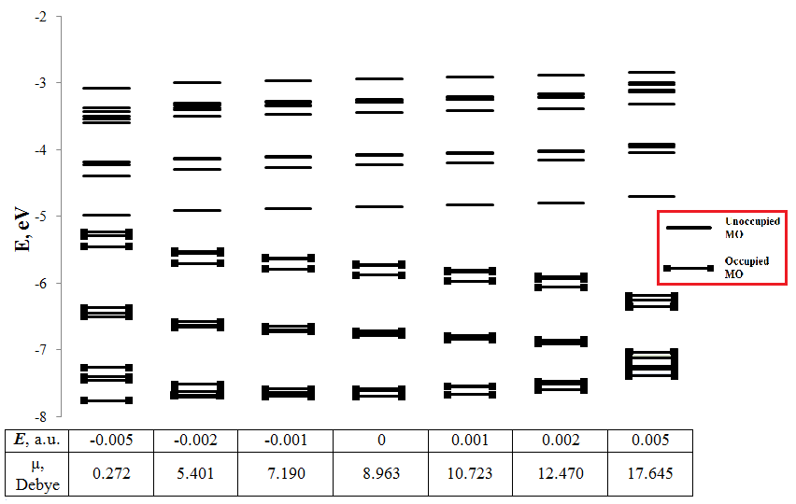

Figure 4 – MO diagram of the [Cd₁₀S₁(SH)₁₈]⁰ cluster

Figure 4 clearly shows that LUMO is approximately equidistant from HOMO and LUMO+1 in the absence of a field. This may indicate that LUMO can be viewed as a trap state within the band gap. Further, when the field is applied against μ, it lowers the dipole moment and greatly reduces the HOMO - LUMO gap, while the LUMO – LUMO+1 distance increases. A field superimposed co-directionally with μ has the opposite effect - increasing μ, increasing the HOMO-LUMO gap and an almost constant LUMO - LUMO+1 gap. It can be assumed that LUMO from a deep-lying trap state gradually becomes a shallow trap state when the field is applied against μ.
Figure 5 shows the location of the boundary MOs of the [Cd₁₀S₁(SH)₁₈]⁰ cluster in a perpendicularly oriented field relative to μ.
Figure 5 shows that the perpendicularly applied field relative to the dipole moment leads to a slight change in the position of the boundary MOs and a small increase in μ. Moreover, both considered opposite directions of the perpendicular orientation of the field relative to μ lead to symmetric changes in the position of the MO. Thus, noticeable changes in the position of the boundary MOs occur only when the field is applied along the direction of the dipole moment vector. Therefore, it can be assumed that for the passivation of nanosized clusters by imposing an external electrostatic field, the magnitude and direction of μ should be taken into account.

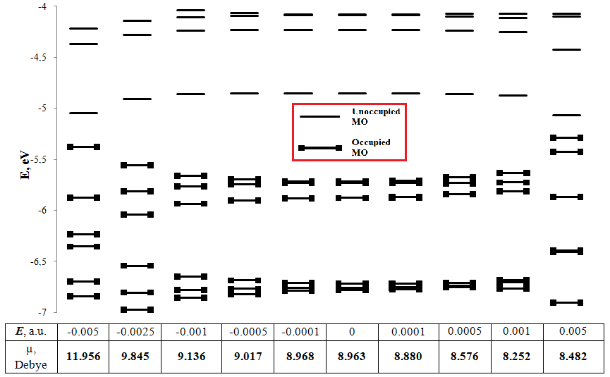

Figure 5 – MO diagram of the [Cd₁₀S₁(SH)₁₈]⁰ cluster with a perpendicular application of an electric field

Further, the cluster [Cd₁₆S₄(SH)₂₄]⁰ of the wurtzite structure was constructed and optimized, for which an electrostatic field of various magnitudes was applied along and against the axis of the direction of the dipole moment vector (Figure 6a), as well as perpendicularly (Figure 6b), and the electronic transitions were calculated and dipole moments. The obtained data on electronic spectra and dipole moments are presented in Tables 4 and 5.

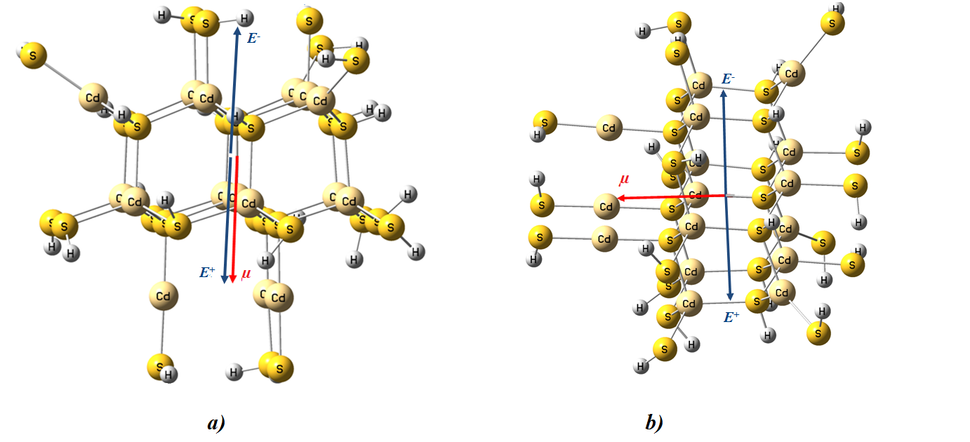
a) – the application of an electric field (blue arrow) along/against the direction of the dipole moment (red arrow); b) – the application of an electric field (blue arrow) perpendicular to the direction of the dipole moment (red arrow)
Figure 6 – Structure of the [Cd₁₆S₄(SH)₂₄]⁰ cluster with the orientation of the dipole moment and an electric field

Table 4 – Data on the effect of an electrostatic field applied along and against the direction of the dipole moment on the electronic spectrum and the dipole moment of the structure [Cd₁₆S₄(SH)₂₄]⁰
E, a.u. | E₁, eV | f | µ, Debye
-0,005 | 0,063 | 0,00010285 | 10,760
-0,002 | 0,603 | 0,00013430 | 1,869
-0,001 | 0,816 | 0,00008208 | 0,923
0 | 0,940 | 0,00006124 | 3,691
0,001 | 0,991 | 0,00006290 | 6,443
0,002 | 1,043 | 0,00006210 | 9,180
0,005 | 1,202 | 0,00005259 | 17,331

Table 5 – Data on the effect of a perpendicular electrostatic field on the electronic spectrum and the dipole moment of the structure [Cd₁₆S₄(SH)₂₄]⁰
E, a.u. | E₁, eV | f | µ, Debye
-0,005 | 0,301 | 0,00319728 | 12,639
-0,0025 | 0,597 | 0,00150524 | 6,996
-0,001 | 0,819 | 0,00109485 | 4,388
-0,0005 | 0,894 | 0,00099130 | 3,878
-0,00025 | 0,932 | 0,00092755 | 3,761
-0,0001 | 0,947 | 0,00003711 | 3,700
0 | 0,940 | 0,00006124 | 3,691
0,0001 | 0,933 | 0,00007034 | 3,698
0,00025 | 0,920 | 0,00008086 | 3,736
0,0005 | 0,896 | 0,00009547 | 3,872
0,001 | 0,836 | 0,00001935 | 4,372
0,0025 | 0,613 | 0,00000469 | 6,925
0,005 | 0,221 | 0,00000163 | 12,289

The data on the superposition of the field along and against the dipole moment show that the field superimposed against μ decreases the values of E₁ and μ, while the oscillator strength increases. And in the case of a co-directional superposition of the field, it leads to an obvious increase in the value of μ and an increase in E₁ at an almost unchanged f. In the case of a perpendicular superposition of the field in both directions, it leads to a small increase in μ and a gradual decrease in E₁.
The position of the boundary MOs was also considered when the field is applied along μ (Figure 7) and perpendicular to μ (Figure 8).

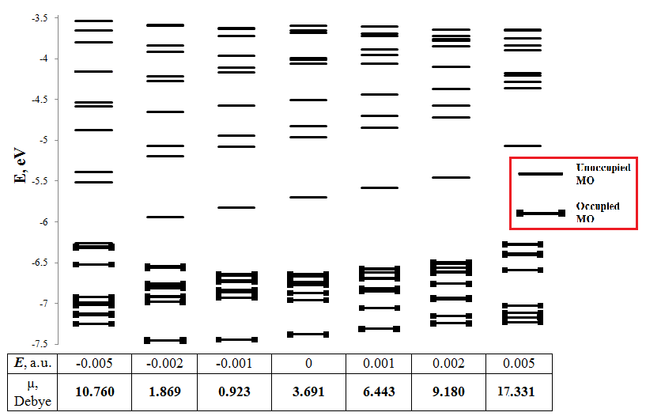

Figure 7 – MO diagram of the [Cd₁₆S₄(SH)₂₄]⁰ cluster with the superposition of an electric field along and against the direction of the dipole moment

Figure 7 shows that the LUMO of the [Cd₁₆S₄(SH)₂₄]⁰ cluster without field superposition is equidistant from HOMO and LUMO+1, that is, it can be considered as a deep trap state. The superposition of the field against the direction of the dipole moment leads to a significant reduction in the gap HOMO - LUMO and an increase in LUMO - LUMO+1. This indicates that LUMO converts from a deep trap state to a shallow trap state, i.e. the passivation level increases. When the field is imposed in the direction of the dipole moment, the HOMO - LUMO gap slightly increased, and the LUMO - LUMO+1 distance does not change. Therefore, LUMO remains a deep trap state.
When the field is applied in the direction perpendicular to the dipole moment, the LUMO position does not change much for both directions. Only at high field values the HOMO - LUMO gap is reduced by increasing the HOMO energy. As can be seen from Figure 8, the position of the orbitals changes symmetrically relative to the case of a zero field when a perpendicular field is imposed in both directions.
Thus, the calculation data for the [Cd₁₆S₄(SH)₂₄]⁰ cluster show that the MO position changes most strongly when a field is applied along or against the dipole moment. This indicates that the best passivation by applying an external electrostatic field can be achieved only when the direction of the dipole moment is taken into account.

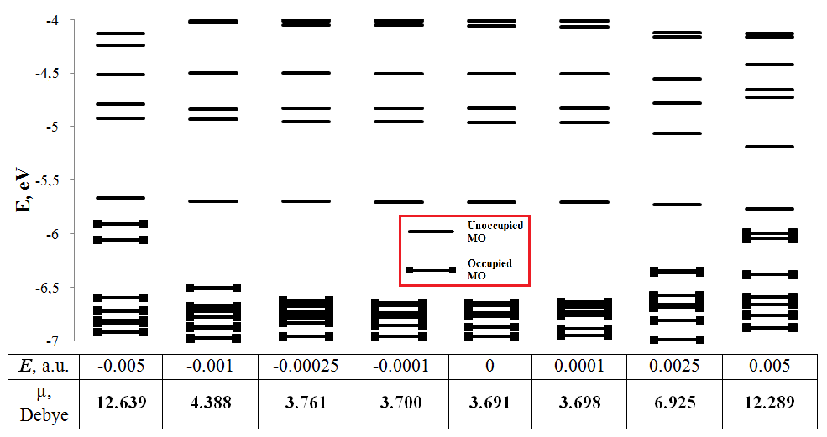

Figure 8 – MO diagram of the [Cd₁₆S₄(SH)₂₄]⁰ cluster with a perpendicular application of an electric field

The next cluster for which the influence of the electrostatic field was considered was the [Cd₂₈S₁₀(SH)₃₈]⁰ cluster, the optimized wurtzite structure of which is shown in Figure 9. For this cluster, an external electrostatic field was imposed along / against the direction of the dipole moment and perpendicular to the direction of the dipole moment, as shown in Figure 9.
The electronic absorption spectrum was calculated for all orientations of the external field. Data on electronic spectra with superposition of an electric field along (against) and perpendicular to the direction of the dipole moment are presented in Tables 6 and 7, respectively.

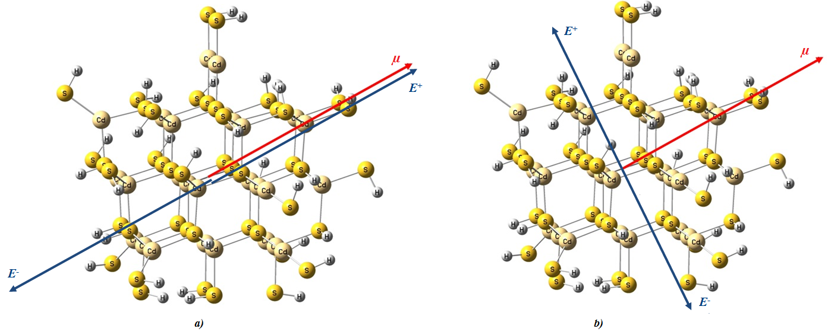
a) – the application of an electric field E along/against the direction μ;
b) – the application of an electric field E perpendicular to the direction μ
Figure 9 – Cluster [Cd₂₈S₁₀(SH)₃₈]⁰ with the application of an electric field E

Table 6 – The calculated values of Е₁, f, and μ upon application of an external field along and against the direction of the dipole moment of the cluster [Cd₂₈S₁₀(SH)₃₈]⁰
E, a.u. | E₁, eV | f | µ, Debye
-0.005 | 0.075 | 0.00092217 | 10.432
-0.0028 | 0.347 | 0.00005833 | 0.261
-0.0025 | 0.414 | 0.00005023 | 1.182
-0.002 | 0.526 | 0.00004195 | 3.334
-0.001 | 0.745 | 0.00003641 | 7.654
-0.0001 | 0.901 | 0.00012534 | 11.542
0 | 0.911 | 0.00012499 | 11.974
0.001 | 1.003 | 0.00009054 | 16.300
0.002 | 0.862 | 0.00000055 | 20.635
0.0025 | 0.787 | 0.00000095 | 22.807
0.004 | 0.549 | 0.00000250 | 29.350
0.005 | 0.381 | 0.00000322 | 33.739

Table 7 – The calculated values of Е₁, f, and μ when an external field is applied perpendicular to the direction of the cluster dipole moment [Cd₂₈S₁₀(SH)₃₈]⁰
E, a.u. | E₁, eV | f | µ, Debye
-0.0028 | 0.416 | 0.00000286 | 17.264
-0.0025 | 0.482 | 0.00000378 | 16.343
-0.001 | 0.786 | 0.00002691 | 12.812
-0.0005 | 0.864 | 0.00006588 | 12.206
-0.00025 | 0.892 | 0.00009671 | 12.041
0 | 0.911 | 0.00012499 | 11.974
0.00025 | 0.921 | 0.00011037 | 12.007
0.0005 | 0.875 | 0.00001580 | 12.139
0.001 | 0.748 | 0.00002443 | 12.686
0.0025 | 0.282 | 0.00002414 | 16.111

The results of Table 6 show that the superposition of the field against the dipole moment leads to a decrease in the energy E₁ and the oscillator strength f. When the field is applied in the direction of the dipole moment, the energy E₁ and the oscillator strength f also decrease. The perpendicularly superimposed field also lowers the E₁ value and slightly increases the dipole moment.
Further, the position of the boundary orbitals was considered when an external field was applied along and perpendicular to the direction of the dipole moment. Figures 10 and 11 show diagrams of the calculated 20 boundary orbitals of the [Cd₂₈S₁₀(SH)₃₈]⁰ cluster with an electric field applied along (against) and perpendicular to the direction of the dipole moment, respectively.
As in the previously considered clusters, the superposition of the field against the dipole moment leads to a decrease in the LUMO energy with a simultaneous increase in HOMO, so that the HOMO - LUMO gap decreases. This explains the decrease in the E₁ value. The LUMO - LUMO+1 distance remains almost unchanged. When the field is imposed against the dipole moment, the HOMO - LUMO distance first increases, but at high values of the field and the dipole moment it begins to decrease. This explains first a small increase in the energy E₁, and then its decrease as the field increases in the direction of the dipole moment.

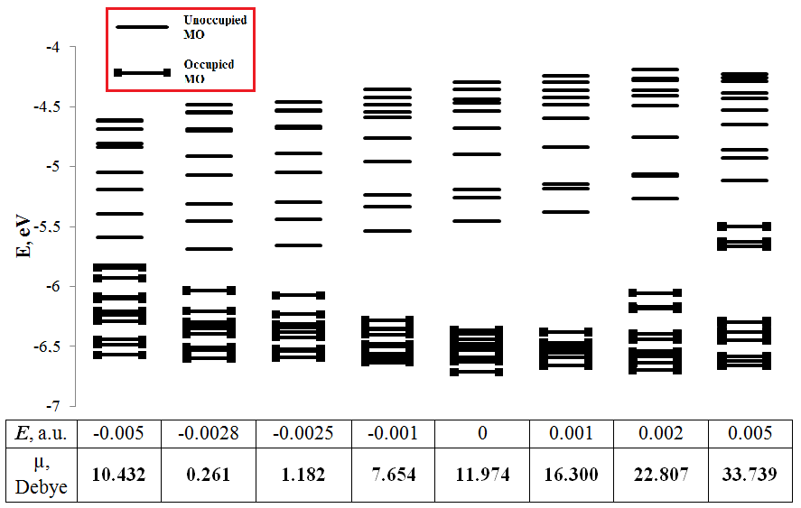

Figure 10 – MO diagram of the [Cd₂₈S₁₀(SH)₃₈]⁰ cluster with the superposition of an electric field along and against the direction of the dipole moment

The superposition of a perpendicularly oriented field in both directions results in the same changes - the HOMO - LUMO gap is gradually reduced with small changes in the dipole moment. This means that the perpendicularly oriented field does not strongly affect electronic transitions. At large values of the superimposed, regardless of its orientation relative to the dipole moment, the HOMO - LUMO gap is reduced.
Thus, the calculated data obtained for the [Cd₂₈S₁₀(SH)₃₈]⁰ cluster demonstrate a significant influence of the electrostatic field on electronic transitions in the direction along the dipole moment and a less pronounced effect in the perpendicular orientation of the field.

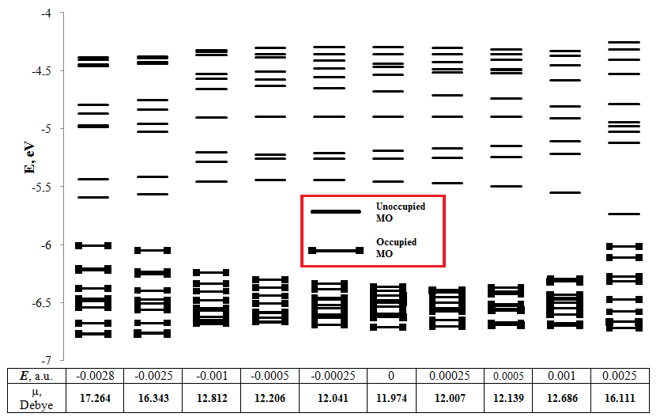

Figure 11 – MO diagram of the [Cd₂₈S₁₀(SH)₃₈]⁰ cluster with a perpendicular application of an electric field

Next, we considered the [Cd₃₇S₁₆(SH)₄₂]⁰ cluster. Its wurtzite structure was optimized and the dipole moment was calculated for it, which are shown in Figure 12. The external field was imposed along / against the direction of the dipole moment (Figure 12a) and perpendicular to it (Figure 12b). Electronic transitions and dipole moments were calculated for these directions of the field. The data obtained are presented in Tables 8 and 9.

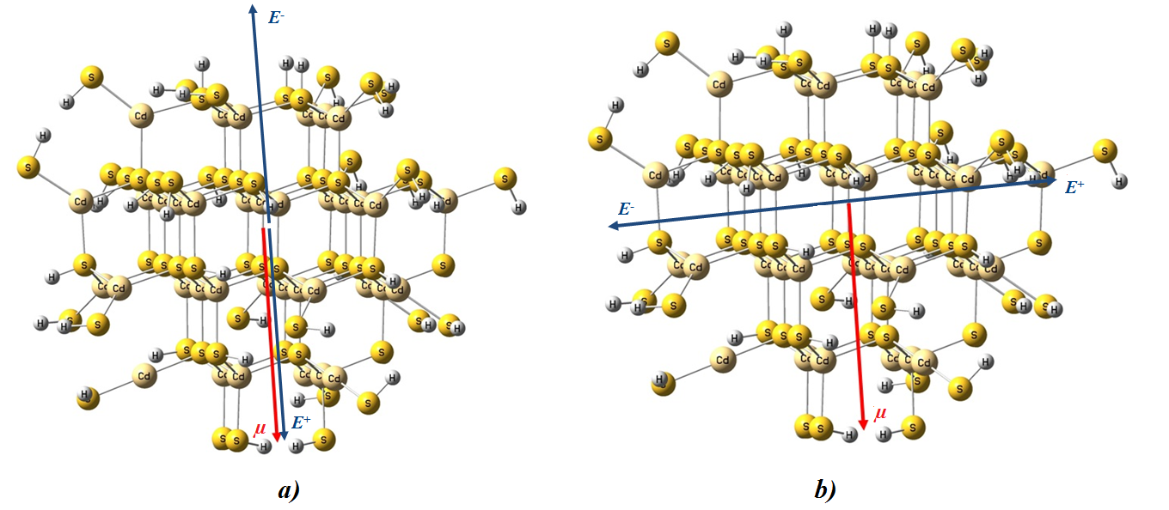
a) – the application of an electric field E along/against the direction of μ;
b) – the application of an electric field E perpendicular to the direction of μ
Figure 12 – Structure of the [Cd₃₇S₁₆(SH)₄₂]⁰ cluster with the superposition of an electric field E

Table 8 – Calculated values of Е₁, f and μ when an external field Е is applied along and against the direction of the cluster dipole moment [Cd₃₇S₁₆(SH)₄₂]⁰
E, a.u. | E₁, eV | f | µ, Debye
-0.002 | 0.009 | 0.00000715 | 2.760
-0.0015 | 0.109 | 0.00000116 | 0.171
-0.001 | 0.211 | 0.00000111 | 2.480
-0.0005 | 0.313 | 0.00000101 | 5.093
0 | 0.413 | 0.00000066 | 7.709
0.0005 | 0.499 | 0.00002629 | 10.329
0.001 | 0.568 | 0.00001956 | 12.953
0.0015 | 0.636 | 0.00001398 | 15.582
0.002 | 0.701 | 0.00000957 | 18.217

Table 9 – Calculated values of E₁, f and μ when an external field E is applied perpendicular to the direction of the cluster dipole moment [Cd₃₇S₁₆(SH)₄₂]⁰
E, a.u. | E₁, eV | f | µ, Debye
-0.0025 | 0.029 | 0.00027324 | 16.774
-0.001 | 0.305 | 0.00000438 | 9.743
-0.0005 | 0.385 | 0.00001556 | 8.280
-0.00025 | 0.411 | 0.00002673 | 7.863
-0.0001 | 0.423 | 0.00003265 | 7.737
0 | 0.413 | 0.00000066 | 7.709
0.0001 | 0.377 | 0.00000087 | 7.725
0.00025 | 0.322 | 0.00000073 | 7.832
0.0005 | 0.228 | 0.00000057 | 8.222
0.001 | 0.037 | 0.00000186 | 9.651

The results of Table 8 show that the superposition of the field against the direction of the dipole moment leads, as in all the cases considered above, to a decrease in E₁. The strength of the oscillator f increases with this. And with a co-directional electrostatic field with respect to the dipole moment, the values of E₁ and μ grow. In this case, the value of f increases strongly at first, and then decreases gradually. With a perpendicularly oriented field in both directions, as before, the value of E₁ falls off little by little, and the strength of the oscillator increases.
Further, the diagrams of boundary MOs were plotted when fields of different orientations were applied. Figure 13 demonstrates the position of the MO with an external field oriented along the dipole moment. Figure 14 demonstrates the position of the MO in an external field oriented perpendicular to the dipole moment.
The position of the orbitals when the field is applied against the dipole moment leads to a reduction in the HOMO - LUMO gap, which explains the gradual decrease in the energy E₁. The distance LUMO - LUMO+1 remains almost unchanged. But there is an increase in the gap HOMO-1 - HOMO-2. There is also a splitting of the HOMO and HOMO-1 levels. When the field is imposed, the HOMO - LUMO gap increases codirectional to the dipole moment, which is the reason for the increase in the energy of the first transition E₁. In this case, there is a noticeable reduction in the gap HOMO-1 - HOMO-2 with a simultaneous increase in the gap HOMO-5 - HOMO-6.

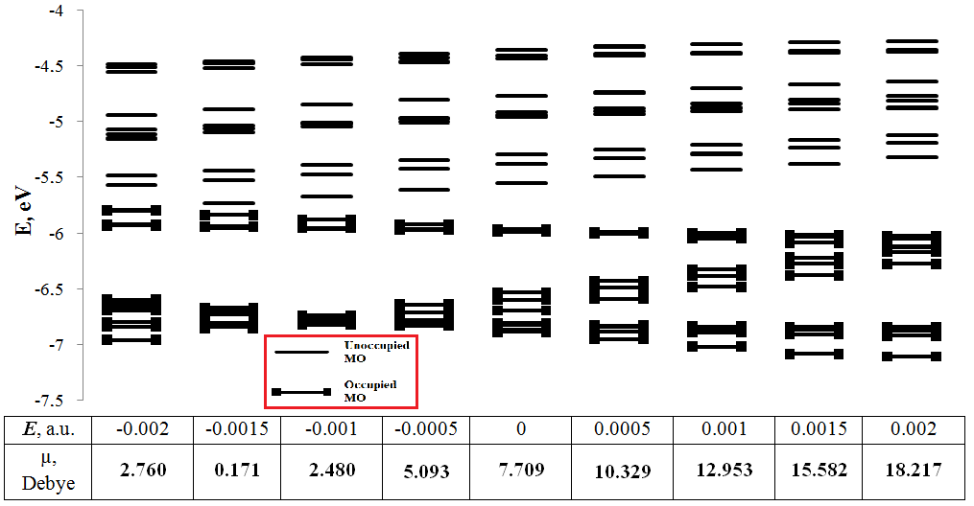

Figure 13 – MO diagram of the [Cd₃₇S₁₆(SH)₄₂]⁰ cluster with the superposition of an electric field along and against the direction of the dipole moment

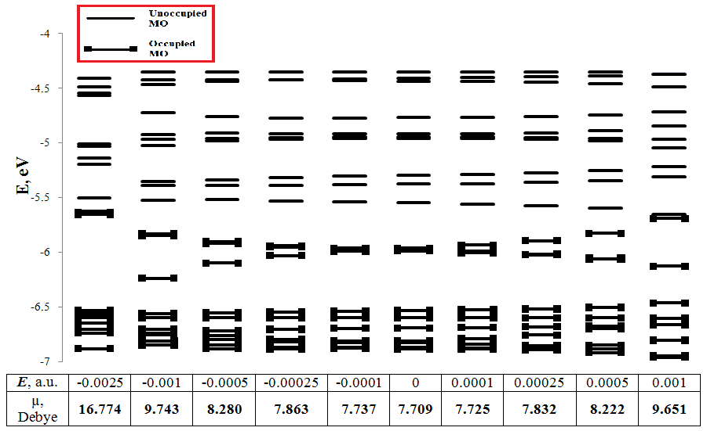

Figure 14 – MO diagram of the [Cd₂₈S₁₀(SH)₃₈]⁰ cluster with a perpendicular application of an electric field

As can be seen from Figure 14, the position of the orbitals changes symmetrically in the case of a perpendicular superposition of the field relative to the dipole moment in two directions. For both perpendicular directions at low values of the field, the position of the MO remains almost unchanged, as does the magnitude of the dipole moment. However, at high field values, the dipole moment increases and the HOMO - LUMO gap decreases. There is also a splitting of the HOMO and HOMO-1 levels.
Thus, for the [Cd₂₈S₁₀(SH)₃₈]⁰ cluster, the most noticeable changes in the MO position and the electronic spectrum occur when an electrostatic field is applied along or against the dipole moment.
For all the considered clusters, when an external field is applied, the mutual orientation of the dipole moment field is of great importance. The most noticeable changes occur when the field is oriented along / against the dipole moment. When the field is applied against the dipole moment, the gap HOMO - LUMO is reduced, and when the field is superimposed in the direction of the dipole moment vector, this gap increases.

2 Effect of self-aggregation

According to task 6 of the Calendar plan (Appendix B), to consider the effect of self-aggregation on electronic transitions in nanosized CdS clusters, the optimized structure and electronic absorption spectrum of the [Cd₄S₁SH₆] cluster were calculated (Figure 15). For the calculations, the tightly coupled density functional theory (DFTB) was used, which is especially well suited for calculating the electronic structures of large systems (up to several thousand atoms) or for simulating dynamics over a large time interval. DFTB calculations were performed in the deMon program package. For each cluster, the Mulliken charge distribution was calculated, on the basis of which the dipole moment was calculated. The cluster charge in all calculations was determined by the following formula q = 2 × (g-j) - k for a cluster with the general formula [Cd_{g}S_{j}(SH)_{k}]^{q}.
After determining the direction and magnitude of the dipole moment, a model of the aggregated dimer of the cluster in the direction of the dipole moment was constructed in order to minimize the dipole moment of the dimer. Thus, two variants of the dimer [Cd₈S₃SH₁₂]²⁻ and [Cd₈S₂SH₁₂] were obtained, the structures of which were optimized (Figure 15). In the first version, an additional sulfur atom was used as a bridge to form a bond along the direction of the dipole moment vector. For both variants of dimers, the energies of the first electronic transitions and dipole moments were calculated. Calculation data for electronic spectra and dipole moments are presented in Table 10.

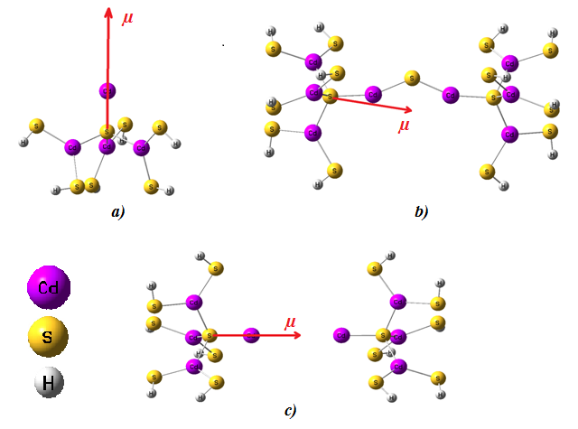
а) – structure [Cd₄S₁SH₆]; b) – structure [Cd₈S₃SH₁₂]²⁻;
c) – structure [Cd₈S₂SH₁₂]
Figure 15 – Optimized structures and their dipole moments

Table 10 – Calculated energies of the first transitions E₁, their oscillator strength f and dipole moments μ for the [Cd₄S₁SH₆], [Cd₈S₃SH₁₂]²⁻, [Cd₈S₂SH₁₂] clusters
Cluster | E₁ (eV) | f | μ (C×m)
[Cd₄S₁SH₆] | 2.827 | 0.0049724 | 8.12×10⁻²⁹
[Cd₈S₃SH₁₂]²⁻ | 4.609 | 0.0303504 | 0.85×10⁻²⁹
[Cd₈S₂SH₁₂] | 2.699 | 0.0018141 | 0.20×10⁻²⁹

As can be seen from Table 10, the aggregation led to a decrease in the dipole moment. During the formation of the [Cd₈S₃SH₁₂]²⁻ dimer through an additional sulfur atom, in addition to a decrease in the dipole moment, the energy of the first transition increased with an increase in its oscillator strength. This indicates that this dimer variant is better passivated than the original [Cd₄S₁SH₆] cluster. On the other hand, the formation of the aggregated dimer [Cd₈S₂SH₁₂] was accompanied by a slight decrease in the energy of the first transition in comparison with the initial monomer [Cd₄S₁SH₆], which indicates a high probability of the formation of localized states in this dimer. However, taking into account the quantum size effect, it can be assumed that when the size of the [Cd₈S₂SH₁₂] dimer is twice as large as compared to the initial [Cd₄S₁SH₆] cluster, their difference in energy E₁ can be considered insignificant. Thus, the formation of a dimer in the direction of decreasing the dipole moment can lead to a significant decrease in the formation of trap states.
To compare the quality of passivation of the dimers and the initial cluster for all structures, we calculated the E₁ × n_{f} value, where n_{f} is the number of intense transitions (high oscillator strength) among the first 10 electronic transitions. Trap states are characterized by a low transition probability in electronic transitions and low energy. Therefore, the larger the E₁ × n_{f} value, the better the passivation and the less likely the formation of localized states. Conversely, the smaller E₁ × n_{f}, the greater the probability of the formation of deep-lying localized states. Figure 16 shows a plot of E₁ × n_{f} versus the dipole moment for [Cd₄S₁(SH)₆]⁰ and its aggregated structures [Cd₈S₃(SH)₁₂]²⁻, [Cd₈S₂(SH)₁₂]⁰.

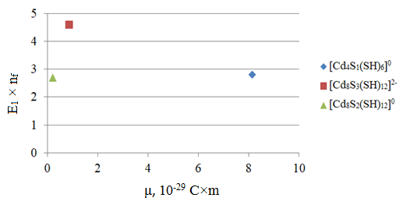

Figure 16 – Dependence of E₁ × n_{f} on the dipole moment in the [Cd₄S₁(SH)₆]⁰ cluster and its aggregated structures [Cd₈S₃(SH)₁₂]²⁻, [Cd₈S₂(SH)₁₂]⁰
As can be seen from Figure 16, the Cd₈S₃(SH)₁₂]²⁻ cluster demonstrates the best degree of passivation at a low value of the dipole moment. Clusters [Cd₄S₁(SH)₆]⁰ and [Cd₈S₂(SH)₁₂]⁰ exhibit approximately the same E₁ × n_{f} value. However, taking into account the quantum size effect and twice the size of the [Cd₈S₂(SH)₁₂]⁰ dimer, it can be argued that this dimer exhibits a higher degree of passivation at a much lower dipole moment compared to the initial [Cd₄S₁(SH)₆]⁰ monomer. Thus, it can be concluded that a decrease in the dipole moment due to the formation of a dimer can be used as a method for passivation of nanosized cadmium sulfide clusters.
Further, to consider the effect of self-aggregation on electronic transitions in nanosized CdS clusters, the optimized structure and electronic absorption spectrum of the cluster [Cd₄S₁(SH)₁₂]⁶⁻.
Having determined the direction and magnitude of the dipole moment of the optimized structure (Figure 17), a model of the aggregated dimer of the cluster was built in the direction of the dipole moment in order to minimize the dipole moment. Thus, one variant of the [Cd₈S₂(SH)₂₄]¹²⁻ dimer was obtained. In this version of the dimer, two identical [Cd₄S₁(SH)₁₂]⁶⁻ clusters were arranged so that the vectors of dipole moments were directed towards each other. Calculation data for electronic spectra and dipole moments are presented in Table 11.

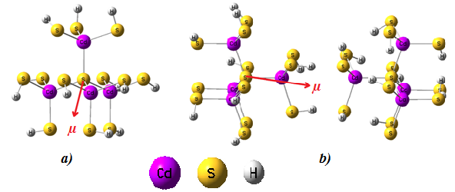

а) – structure [Cd₄S₁(SH)₁₂]⁶⁻; b) – structure [Cd₈S₂(SH)₂₄]¹²⁻
Figure 17 – Optimized structures of [Cd₄S₁(SH)₁₂]⁶⁻, [Cd₈S₂(SH)₂₄]¹²⁻ and their dipole moments

Table 11 – Calculated for [Cd₄S₁(SH)₁₂]⁶⁻ and [Cd₈S₂(SH)₂₄]¹²⁻ clusters energies of the first transitions E₁, their oscillator strength f and dipole moments μ
Cluster | E₁ (eV) | f | μ (C×m)
[Cd₄S₁(SH)₁₂]⁶⁻ | 0.153 | 0.0000179 | 2.645997×10⁻²⁹
[Cd₈S₂(SH)₂₄]¹²⁻ | 5.164 | 0.0963374 | 0.970712×10⁻²⁹

As can be seen from Table 11, aggregation led to a decrease in the dipole moment. During the formation of the [Cd₈S₂(SH)₂₄]¹²⁻ dimer through the opposite direction of the dipole moments of the monomers, in addition to a decrease in the total dipole moment, a significant increase in the energy of the first transition occurred. This indicates that this variant of the dimer is much better passivated than the original [Cd₄S₁(SH)₁₂]⁶⁻ cluster. In addition, taking into account the quantum size effect, it can be assumed that with twice the size of the [Cd₈S₂(SH)₂₄]¹²⁻ dimer in comparison with the initial [Cd₄S₁(SH)₁₂]⁶⁻ cluster, significantly better passivation is achieved, which is indicated only by the difference in E₁, although this difference is also large. It is also seen that, in the case of a dimer, the value of f is also significantly larger than in the case of the initial monomer with a large dipole moment. Thus, the formation of a dimer with a decrease in the dipole moment can lead to a significant decrease in the probability of formation of localized states.
For the cluster [Cd₂₂S₁₀(SH)₂₁]³⁺, the optimized geometry was calculated (Figure 18), the magnitude of the dipole moment and the energy of the first 10 electronic transitions were determined. Along the direction of the dipole moment vector, a second similar complex was constructed in order to lower the dipole moment in the aggregated dimer of the [Cd₂₂S₁₀(SH)₂₁]³⁺ cluster. As a result, the dimer [Cd₄₄S₂₀(SH)₄₂]⁶⁺ was obtained. Another dimer, [Cd₄₅S₂₀(SH)₄₂]⁸⁺, was also obtained, formed through the addition of a bonding cadmium atom along the joining line of two [Cd₂₂S₁₀(SH)₂₁]³⁺ clusters (in the direction of the dipole moment). Optimized structures (Figure 18), dipole moments and energies of electronic transitions were calculated for two variants of the dimer. The data obtained for the energies of the first electronic transitions E₁, their oscillator strength f and dipole moments are presented in Table 12.
The results presented in Table 12 show that in the case of the [Cd₄₄S₂₀(SH)₄₂]⁶⁺ dimer, the E₁ value slightly decreases in comparison with the starting monomer [Cd₂₂S₁₀(SH)₂₁]³⁺, but f increases. Taking into account the quantum size effect, it can be argued that the [Cd₄₄S₂₀(SH)₄₂]⁶⁺ dimer is better passivated than the [Cd₂₂S₁₀(SH)₂₁]³⁺ monomer. For the [Cd₄₅S₂₀(SH)₄₂]⁸⁺ dimer cluster, E₁ and f significantly decrease in comparison with the starting [Cd₂₂S₁₀(SH)₂₁]³⁺ monomer, which indicates poor passivation.
For a more detailed assessment of the quality of passivation, a graph of the dependence of E₁ × n_{f} on the dipole moment for the monomer and two dimers was built, which is shown in Figure 19.

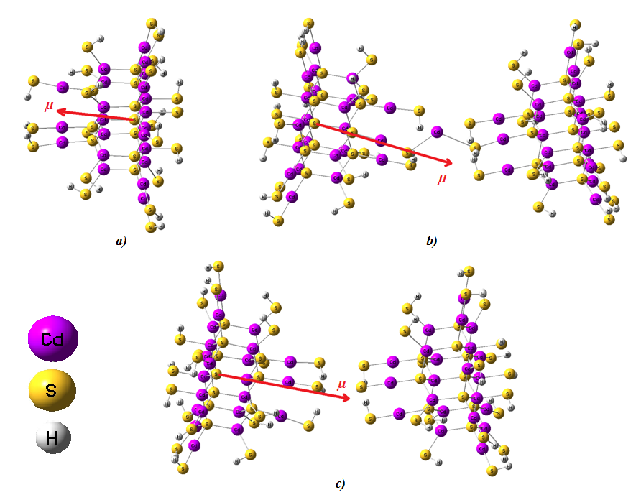

а) – structure [Cd₂₂S₁₀(SH)₂₁]³⁺; b) – structure [Cd₄₅S₂₀(SH)₄₂]⁸⁺;
c) – structure [Cd₄₄S₂₀(SH)₄₂]⁶⁺
Figure 18 – Optimized structures and their dipole moments

Table 12 – Calculated for the [Cd₂₂S₁₀(SH)₂₁]³⁺ and [[Cd₄₅S₂₀(SH)₄₂]⁸⁺, [Cd₄₄S₂₀(SH)₄₂]⁶⁺ clusters energies of the first transitions E₁, their oscillator strength f and dipole moments μ
Cluster | E₁ (eV) | f | μ (C×m)
[Cd₂₂S₁₀(SH)₂₁]³⁺ | 3.803 | 0.0833809 | 5.21×10⁻²⁹
[Cd₄₅S₂₀(SH)₄₂]⁸⁺ | 2.284 | 0.0259480 | 3.44×10⁻²⁹
[Cd₄₄S₂₀(SH)₄₂]⁶⁺ | 3.670 | 0.1014945 | 1.89×10⁻²⁹

The results presented in Table 12 show that in the case of the [Cd₄₄S₂₀(SH)₄₂]⁶⁺ dimer, the E₁ value slightly decreases in comparison with the starting monomer [Cd₂₂S₁₀(SH)₂₁]³⁺, but f increases. Taking into account the quantum size effect, it can be argued that the [Cd₄₄S₂₀(SH)₄₂]⁶⁺ dimer is better passivated than the [Cd₂₂S₁₀(SH)₂₁]³⁺ monomer. For the [Cd₄₅S₂₀(SH)₄₂]⁸⁺ dimer cluster, E₁ and f significantly decrease in comparison with the starting [Cd₂₂S₁₀(SH)₂₁]³⁺ monomer, which indicates poor passivation.
For a more detailed assessment of the quality of passivation, a graph of the dependence of E₁ × n_{f} on the dipole moment for the monomer and two dimers was built, which is shown in Figure 19.

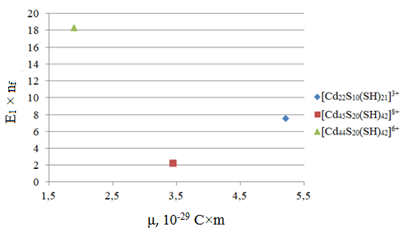

Figure 19 – Dependence of E₁ × n_{f} on the dipole moment in the [Cd₂₂S₁₀(SH)₂₁]³⁺ cluster and its aggregated structures [Cd₄₅S₂₀(SH)₄₂]⁸⁺, [Cd₄₄S₂₀(SH)₄₂]⁶⁺

The data presented in Figure 19 show that the assumption of a much higher passivation level with a significant decrease in the dipole moment in the case of the [Cd₄₄S₂₀(SH)₄₂]⁶⁺ dimer is correct. The low level of passivation for the [Cd₄₅S₂₀(SH)₄₂]⁸⁺ dimer is also confirmed with a slight decrease in the dipole moment. Thus, using the example of the [Cd₂₂S₁₀(SH)₂₁]³⁺ cluster and its aggregated structures [Cd₄₅S₂₀(SH)₄₂]⁸⁺ and [Cd₄₄S₂₀(SH)₄₂]⁶⁺, it has been shown that aggregation in the direction of the dipole moment with the aim of decreasing it can to significantly improve the quality of passivation of nanosized cadmium sulfide clusters.
Further, the cluster [Cd₂₈S₁₃(SH)₃₆]⁶⁻ was considered. For the cluster [Cd₂₈S₁₃(SH)₃₆]⁶⁻, the optimized geometry was calculated (Figure 20), the value of the dipole moment and the energy of the first 10 electronic transitions was determined. Along the direction of the dipole moment vector, a second similar complex was constructed with the addition of a bonding sulfur atom in order to decrease the dipole moment in the aggregated dimer of the [Cd₂₈S₁₃(SH)₃₆]⁶⁻ cluster. As a result, the dimer [Cd₅₆S₂₇(SH)₇₂]¹⁴⁻ was obtained. Two other [Cd₅₆S₂₆(SH)₇₂]¹²⁻ dimers with a distance between monomers of 32 Å and 11.1 Å were also constructed. These two dimers were built along the direction of the dipole moment with the aim of decreasing it. Optimized structures (Figure 20), dipole moments, and electronic transition energies were calculated for the three dimer variants. The data obtained for the energies of the first electronic transitions E₁, their oscillator strength f and dipole moments are presented in Table 13.

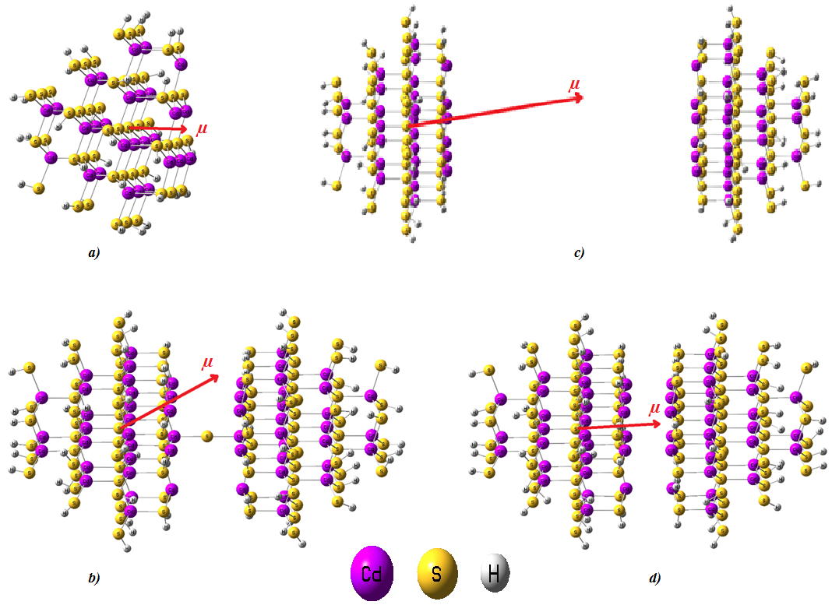

а) – structure [Cd₂₈S₁₃(SH)₃₆]⁶⁻; b) – structure [Cd₅₆S₂₇(SH)₇₂]¹⁴⁻; c) and d) – structures [Cd₅₆S₂₆(SH)₇₂]¹² (distance between monomers 32 Å and 11.1 Å )
Figure 20 – Optimized structures and their dipole moments

Table 13 – Calculated for [Cd₂₈S₁₃(SH)₃₆]⁶⁻, [Cd₅₆S₂₇(SH)₇₂]¹⁴⁻, [Cd₅₆S₂₆(SH)₇₂]¹²⁻ clusters (distance between monomers 32 Å and 11.1 Å) energies of the first transitions E₁, their oscillator strength f and dipole moments μ.
Cluster | E₁ (eV) | f | μ (C×m)
[Cd₂₈S₁₃(SH)₃₆]⁶⁻ | 3.818 | 0.1100189 | 47.07×10⁻²⁹
[Cd₅₆S₂₇(SH)₇₂]¹⁴⁻ | 3.754 | 0.0725840 | 9.80×10⁻²⁹
[Cd₅₆S₂₆(SH)₇₂]¹²⁻  32 Å | 3.755 | 0.0000000 | 2.68×10⁻²⁹
[Cd₅₆S₂₆(SH)₇₂]¹²⁻  11,1 Å | 2.189 | 0.0000043 | 2.61×10⁻²⁹

According to the data in Table 13, for all three dimers, a lower value of the dipole moment was obtained with a decrease in the energy of the first transition together with a decrease in the value of f. At first glance, this may indicate a deterioration in the quality of passivation of clusters in the case of dimers as compared to the initial monomer. However, on the one hand, one must take into account the quantum size effect, and on the other hand, the decrease in the E₁ energy for the [Cd₅₆S₂₇(SH)₇₂]¹⁴⁻ and [Cd₅₆S₂₆(SH)₇₂]¹²⁻ (32 Å) dimers is rather insignificant in comparison with the original monomer.
For a more detailed assessment of the quality of passivation, a graph of the dependence of E₁ × n_{f} on the dipole moment for the monomer and three dimers was plotted, which is shown in Figure 21.

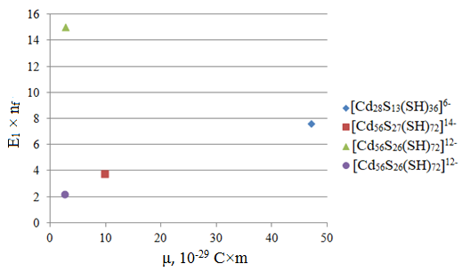

Figure 21 – Dependence of E₁ × n_{f} on the dipole moment in the clusters [Cd₂₈S₁₃(SH)₃₆]⁶⁻, [Cd₅₆S₂₇(SH)₇₂]¹⁴⁻, [Cd₅₆S₂₆(SH)₇₂]¹²⁻ (32 Å and 11.1 Å)

The data presented in Figure 21 indicate that the dimer [Cd₅₆S₂₆(SH)₇₂]¹²⁻ (32 Å) shows the best quality of passivation, even in spite of the zero oscillator strength of the first transition. This is due to the fact that for this dimer there are 4 intense transitions in the first 10 electronic transitions. For all other clusters, there are fewer of them. It should be borne in mind that the data on the comparison of E₁ × n_{f} values presented in Figure 21 do not include the quantum size effect.
Thus, it can be assumed that the aggregation of nanosized clusters in order to lower the dipole moments can lead to a decrease in the probability of the formation of trap states in the band gap. Therefore, we can assume that the formation of trap states in semiconductor clusters is associated with the presence of a significant dipole moment, which contributes to the localization of charge carriers in certain parts of the cluster volume.
CONCLUSION

According to the obtained results, the following conclusions can be drawn.
The superposition of the field along (opposite / colinearly) direction of the dipole moment vector leads to the largest changes in the absorption spectrum and the position of the boundary MOs. In this case, the gap HOMO - LUMO is reduced when the field is imposed against the vector of the dipole moment. Conversely, the HOMO - LUMO gap increases when the field is superimposed co-direction with the dipole moment vector with a simultaneous increase in the dipole moment.
For a perpendicularly oriented field, there are no significant changes in the electronic spectrum and the position of the boundary MOs. And it does not matter in which direction of the possible perpendicular directions to choose for the imposition of the field. Only at high field values the HOMO - LUMO gap shrinks. Thus, the vector of the dipole moment and its direction play an essential role in determining the optical properties of nanoscale clusters in the presence of an external field.
The construction of dimers of cadmium sulfide clusters showed that a higher level of passivation can be achieved in comparison with the initial monomers. In this case, the construction of dimers should occur along the direction of the dipole moment of the monomer in order to minimize it. Therefore, it can be assumed that the dipole moment plays a key role in the formation of trap states in nanosized clusters of cadmium sulfide, and the problem of passivation is reduced to minimizing the dipole moment.
The main research results obtained in 2018-2019 are presented in Appendix C.
The results obtained can be used in practice as recommendations for obtaining QDs with a high luminescence quantum yield. Namely, it is necessary to minimize the dipole moment in order to remove trap states.

REFERENCES

1 Martynenko I. V., Litvin A. P., Purcell-Milton F., Baranov A. V., Fedorov A. V., Gun’ko Y. K. Application of semiconductor quantum dots in bioimaging and biosensing//Journal of Materials Chemistry B. – 2017. – Vol. 5, No. 33. – P. 6701–6727.
2 Rodrigues M., Richards N., Ning B., Lyon C. J., Hu T. Y. Rapid lipid-based approach for normalization of quantum dot-detected biomarker expression on extracellular vesicles in complex biological samples//Nano Letters. – 2019. – Vol. 19, No. 11. – P. 7623–7631.
3 Zhang L.-J., Xia L., Xie H., Zhang Z.-L., Pang D.-W. Quantum dot-based biotracking and biodetection//Analytical Chemistry. – 2018. – Vol. 91, No. 1. – P. 532–547.
4 Pacheco-Linan P. J., Bravo I., Nueda M. L., Albaladejo J., Garzon-Ruiz A. Functionalized CdSe/ZnS Quantum Dots for Intracellular pH Measurements by Fluorescence Lifetime Imaging Microscopy//ACS Sensors. – 2020. – Vol. 5, No. 7. – P. 2106–2117.
5 Mansur A. A. P., Mansur H. S., Carvalho S. M., Lobato Z. I. P., Leite M. de F., Mansur L. L. Fluorescent ZnS Quantum Dots–Phosphoethanolamine Nanoconjugates for Bioimaging Live Cells in Cancer Research//ACS Omega. – 2018. – Vol. 3, No. 11. – P. 15679–15691.
6 Zhang S., Zheng H., Chen Y., Yi H., Dai H., Hong Z., Lin Y. Electrochemiluminescence Resonance Energy Transfer between Ru(bpy)32+ and CdZnSe@ZnSe Quantum Dots for Ovarian Cancer Biomarker Detection//ACS Applied Nano Materials. – 2019. – Vol. 2, No. 11. – P.7061–7066.
7 Wu H., Li X., Tung C., Wu L. Semiconductor Quantum Dots: An Emerging Candidate for CO₂ Photoreduction//Adv. Mater. – 2019. – Vol. 31, No. 36. – P. 1900709.
8 Jiang Y., Weiss E. Colloidal Quantum Dots as Photocatalysts for Triplet Excited State Reactions of Organic Molecules//J. Am. Chem. Soc. – 2020. – Vol. 142, No. 36. – P. 15219–15229.
9 Kirmani A. R., Luther J. M., Abolhasani M., Amassian A. Colloidal Quantum Dot Photovoltaics: Current Progress and Path to GW-Scale Enabled by Smart Manufacturing//ACS Energy Lett. – 2020. – Vol. 5, No. 9. – P. 3069–3100.
10 Zou H., Liu M., Zhou D., Zhang X., Liu Y., Yang B., Zhang H. Employing CdSexTe1-x Alloyed Quantum Dots to Avoid the Temperature-Dependent Emission Shift of Light-Emitting Diodes//J. Phys. Chem. C – 2017. – Vol. 121, No. 9. – P. 5313-5323.
11 Lai C.-F., Tien Y.-C., Tong H.-C., Zhong C.-Z., Lee Y.-C. High-performance quantum dot light-emitting diodes using chip-scale package structures with high reliability and wide color gamut for backlight displays//RSC Adv. – 2018. – 8, No. 63. – P. 35966–35972.
12 Kershaw S. V., Jing L., Huang X., Gao M., Rogach A. L. Materials aspects of semiconductor nanocrystals for optoelectronic applications//Mater. Horiz. – 2017. – Vol. 4, No. 2. – P. 155–205.
13 Beery D., Wheeler J. P., Arcidiacono A., Hanson K. CdSe Quantum Dot Sensitized Molecular Photon Upconversion Solar Cells//ACS Appl. Energy Mater. – 2020. – Vol. 3, No. 1. – P. 29–37.
14 Le Feber B., Prins F., De Leo E., Rabouw F. T., Norris D. J. Colloidal-Quantum-Dot Ring Lasers with Active Color Control//Nano Lett. – 2018. – Vol. 18, No. 2. – P. 1028–1034.
15 Rong K., Sun C., Shi K., Gong Q., Chen J. Room-Temperature Planar Lasers Based on Water-Dripping Microplates of Colloidal Quantum Dots//ACS Photonics. – 2017. – Vol. 4, No. 7. – P. 1776–1784.
16 Giansante C., Infante I. Surface Traps in Colloidal Quantum Dots: A Combined Experimental and Theoretical Perspective//J. Phys. Chem. Lett. – 2017. – Vol. 8, No. 20. – P. 5209–5215.
17 Kilina S., Ivanov S., Tretiak S. Effect of Surface Ligands on Optical and Electronic Spectra of Semiconductor Nanoclusters//J. Am. Chem. Soc. – 2009. – Vol. 131, No. 22. – P. 7717–7726.
18 Kim D., Kim D.-H., Lee J.-H., Grossman J. C. Impact of Stoichiometry on the Electronic Structure of PbS Quantum Dots//Phys. Rev. Lett. – 2013. – Vol. 110. – P. 196802.
19 Liu, F., Zhang, Y., Ding, C., Kobayashi, S., Izuishi, T., et al. Highly Luminescent Phase-Stable CsPbI₃ Perovskite Quantum Dots Achieving Near 100% Absolute Photoluminescence Quantum Yield//ACS Nano. – 2017. – Vol. 11, No. 10. – P. 10373–10383.
20 Commandeur D., Brown G., Hills E., Spencer J., Chen Q. Defect-Rich ZnO Nanorod Arrays for Efficient Solar Water Splitting//ACS Appl. Nano Mater. – 2019. – Vol. 2(3). – P. 1570−1578.
21 Xu H.-Q., Yang S., Ma X., Huang J., Jiang H.-L. Unveiling Charge Separation Dynamics in CdS/MOF Composites for Enhanced Photocatalysis//ACS Catal. – 2018. – Vol. 8, No. 12. – P. 11615–11621.
22 Aldongarov A.A., Assilbekova A.M., Irgibaeva I.S., Barashkov N.N. Modeling electronic excitations/formation of trap states in semiconducting nanocrystals//Chemical Modelling. – 2020. – Vol. 15. – P. 173-188.
23 Aldongarov A., Irgibaeva I., Hermansson H., Agren H. Theoretical study on passivation of small CdS clusters//Molecular Physics. – 2014. – Vol. 112, No. 5-6. – P. 674-682.
24 Ohara Y., Nakabayashi T., Iwasaki K., Torimoto T., Ohtani B., Hiratani T., Konishi K., Ohta N. Electric-Field-Induced Changes in Absorption and Emission Spectra of CdS Nanoparticles Doped in a Polymer Film//J. Phys. Chem. B. – 2006. – Vol. 110. – P. 20927-20936.
25 Mehata M., Majumder M., Mallik B., Ohta N. External Electric Field Effects on Optical Property and Excitation Dynamics of Capped CdS Quantum Dots Embedded in a Polymer Film//J. Phys. Chem. C. – 2010. – Vol. 114. – P. 15594-15601.
26 Ohshima R., Nakabayashi T., Kobayashi Y., Tamai N., Ohta N. External Electric Field Effects on State Energy and Photoexcitation Dynamics of Water-Soluble CdTe Nanoparticles//J. Phys. Chem. C. – 2011. – Vol. 115. – P. 15274-15281.

APPENDIX A

List of published works

for 2018:
1 Aldongarov A.A. Quantum chemical modeling. – Text book. – Astana. – 2018. – 98 p.
2 Aldongarov A.A., Irgibaeva I.S., Assylbekova A.M., Yermekova Zh.K. Determination of the nature of electronic transitions in the complexes of rhodamine dye and clusters CdS// Bulletin of L.N. Gumilyov Eurasian National University. Physics. Astronomy series – 2018. – №1(122). – P. 19-27. (in Russian).
3 Mantel A.I., Yensebayeva A.E., Smatov S.B., Irgibayeva I.S. Decreasing of the concentration quenching of ﬂuorescent dye in a solution by introducing it to nanoparticles of silicon dioxide// Eurasian journal of physics and functional materials. – 2018. – N2, Vol. 2. – P. 110-118.
4 Barashkov N.N., Sakhno T.V. Aldongarov A.A., Mantel A.I., Irgibayeva I.S. N,N-Dimethyl-p-nitrosoaniline and potassium linoleate hydroperoxide as spin traps in process of hydroxyl radicals formation during chloride-free electrolysis of contaminated water// 255th National Meeting and Exposition of the American-Chemical-Society (ACS) – Nexus of Food, Energy, and Water. – New Orleans (USA), March 18-22, 2018.
5 Barashkov N.N., Sakhno T.V. Aldongarov A.A., Mantel A.I., Irgibayeva I.S., Birimzhanova D.A. Absorbance and fluorescence spectra of 5-(benzylidene)pyrimidine-2,4,6-triones// 255th National Meeting and Exposition of the American-Chemical-Society (ACS) – Nexus of Food, Energy, and Water. – New Orleans (USA), March 18-22, 2018.

for 2019:
1 Aldongarov A.A., Irgibaeva I.S., Assylbekova A.M. Application of DFTB method for estimation of correlation between the dipole moment of the ground state of CdS nanosizad clusters and the formation of trap states // 10th International Conference of the Asian Consortium on Computational Materials Science. – Гонконг (КНР), July 21-27, 2019.
2 Aldongarov A., Assilbekova A., Irgibaeva I. Application of DFTB method for analyzing the effect of the dipole moment on the electronic excitations in nanosized crystals of CdS // Book of Abstracts The 20th International Conference on Radiation Effects in Insulators (REI-20) – 19-23 August, 2019, Nur-Sultan (Astana), Kazakhstan – P.182.
3 Bimukhanov A.N., Aldongarov A.A., Schmedake T.A. DFT calculation of optical properties of new neutral hexacoordinated Si(bzimpy)₂ complexes// Eurasian Journal of Physics and Functional Materials. – 2019. – 3(2). – P. 183-190.
4 Barashkov N.N., Sakhno T.V. Aldongarov A.A., Mantel A.I., Irgibayeva I.S. Influence of ultrasonic treatment on hydroxyl radicals formation during chloride-free electrolysis of water contaminated with E.coli // 258th National Meeting and Exposition of the American-Chemical-Society (ACS) - Chemistry and Water. – San Diego (USA), August 25-29, 2019.
5 Lu O., Yensebayeva A., Irgibaeva I., Mantel A. Minimization of the concentration quenching effect of Tris(bipyridine)ruthenium(II) chloride dye// 2nd International Conference on Nanomaterials Science and Mechanical Engineering – Aveiro (Portugal), July 9-12, 2019.

for 2020:
1 Irgibayeva I., Mantel A., Barashkov N., Lu O., Yensebayeva A., Aldongarov A., Mendigaliyeva S., Barashkova I. Study of the effect of the introduction of Tris(bipyridine)ruthenium(II) chloride into silicon dioxide particles by spectrofluorometry methods// Spectrochimica Acta Part A: Molecular and Biomolecular Spectroscopy. – 2020. – Vol. 246. – P. 119007-119016 (IF = 3,29 Web of Science).
2 Aldongarov A. A., Assilbekova A. M., Irgibaeva I. S., Barashkov N. N. Modeling electronic excitations/formation of trap states in semiconducting nanocrystals// Chemical Modelling. – 2020. – Vol. 15. – P. 173-188. (Procentile = 37 in Scopus).
3 Sakhno T. V., Barashkov N. N., Irgibaeva I. S., Mendigaliyeva S., Bostan D. S. Ionic Liquids and Deep Eutectic Solvents and Their Use for Dissolving Animal Hair// Advances in Chemical Engineering and Science. – 2020. – Vol. 10. – P. 40-51. (IF = 1,13 GJIF).
4 Irgibaeva I., Barashkov N., Sakhno T., Mantel A., Mendigaliyeva S., Barashkova I., Sakhno Y. Synthesis of Iron Nanoparticles by Thermal Decomposition of Diironnonacarbonyl in Ionic Liquid and Their Potential Use as Nanotracers for Mixer Studies in Liquids Feeds// Advances in Chemical Engineering and Science. – 2020. – Vol. 10. – P. 201-209. (IF = 1,13 GJIF).
5 Aldongarov A.A., Assilbekova A.M., Irgibaeva I.S. Calculation of electronic transitions in CdS clusters associated with coumarin dye// Bulletin of L.N. Gumilyov Eurasian National University. Physics. Astronomy series – 2019. – №4(129). – P. 15-26. (in Russian)
6 Bimukhanov A.N., Aldongarov A.A. Testing of combinations of Density Functional Theory functionals and basis sets for predicting correct geometrical parameters of neutral hexacoordinated Si(bzimpy)₂ complex// Bulletin of L.N. Gumilyov Eurasian National University. Physics. Astronomy series. – 2020. – №3(132). – P. 59-63.
7 Aldongarov A.A., Assilbekova A.M., Irgibaeva I.S., Mantel A.I. Comparison of calculated by DFTB electronic excitation energies of CdS nanosized clusters with DFT results// Eurasian Journal of Physics and Functional Materials. – 2020. – Vol. 4(3). – P. 255-260.

APPENDIX B

Calendar plan for 2020

Appendix 1.31
to the contract №__ on ______2018
for grant funding

TECHNICAL SPECIFICATION AND WORK SCHEDULE
under contract №___ on ___________________ 2018

1. Republican state enterprise on the right of economic management «Eurasian National University named after L.N. Gumilyov» Ministry of Education and Science of the Republic of Kazakhstan»
1.1 By priority area: Information, telecommunication and space technologies, scientific research in the field of natural sciences.
1.2 By sub-priority area: Scientific research in the field of natural sciences. Mathematical and computer modeling in the field of mathematics, physics and astronomy.
1.3 By title of the project: Application of the DFTB method for modeling effects of the dipole moment and shape of nanosized CdS clusters on the electronic transitions therein
1.4 Total project amount: 21 000 000 (twenty one million) tenge, including with a breakdown by years, to perform work in accordance with paragraph 3:
- for 2018 – 7 000 000 (seven million) tenge
- for 2019 – 7 000 000 (seven million) tenge
- for 2020 – 7 000 000 (seven million) tenge

2. Characteristics of scientific and technical products by qualification features and economic indicators
2.1 Direction of work: Fundamental researches. Quantum-chemical calculations of electronic transitions in semiconductor nanostructures.
2.2 Application area: optical properties of semiconductor quantum dots.
2.3 Final result:
- for 2018: The DFTB method was tested and the effect of structure variation was evaluated. Issue 1 articles in peer-reviewed foreign scientific publications indexed in the Web of Science or Scopus databases with a non-zero impact factor.
- for 2019: The effect of the electrostatic field and self-aggregation on electronic transitions will be tested. Issue 1 articles in peer-reviewed foreign scientific publications indexed in the Web of Science or Scopus databases with a non-zero impact factor.
- for 2020: The effect of the shape anisotropy of nanocrystals on electronic transitions will be estimated. Issue 1 article in peer-reviewed foreign scientific publications indexed in the Web of Science or Scopus databases with a non-zero impact factor, as well as at least 2 (two) publications in peer-reviewed foreign and domestic scientific publications with a non-zero impact factor.
2.4 Patentability: not provided.
2.5 Scientific and technical level (novelty): The obtained results will help clarify some of the observed contradictions in the interpretation of experimental observations, thereby ensuring progress in understanding the processes occurring in nanocrystals. This will make it possible to develop new technologies for obtaining materials with specified properties, which will open the way to new solutions to existing technical problems. New technologies will be more cost-effective than existing ones.
2.6 The use of scientific and technical products is carried out: by the customer
2.7 Type of use of the result of scientific and (or) scientifically technical activities: The expected results will significantly improve the modern technology for obtaining materials with specified properties. Thus, the results of this theoretical project will meet the requirements of the scientific community involved in the preparation of new materials based on semiconductor nanoscale crystals with unique optical properties.

3. Name of the work, terms of their implementation and results

Cipher job, stage | Name of work under the Contract and main stages of its implementation | Term of performance |  | Expected result
Cipher job, stage |  | start | finale | Expected result
1 | Validation of absorption spectra obtained by DFTB | March 2018 | July 2018 | The absorption spectra obtained by the DFTB method will be tested
2 | Testing the effect of structure and shape variations | July 2018 | September 2018 | The effect of varying the structure and shape will be tested
3 | Consideration of the structure-properties relationship in large nanoparticles | September 2018 | Until November 1, 2018 | The structure-properties relationships in large nanoparticles will be considered. The effect of defect permutation on excitations in CdS will be considered.  Issue 1 articles in peer-reviewed foreign scientific publications indexed in the Web of Science or Scopus databases with a non-zero impact factor.
3 | Structure-property relationship in large nanoparticles | January 2019 | June 2019 | The structure-properties relationships in large nanoparticles will be considered. The effect of defect permutation on excitations in CdS will be considered.
4 | Particle-size dependency | June 2019 | Until November 1, 2019 | The dependence of particle properties on their size will be considered. The effect of the nanoparticle size will be evaluated.  Issue 1 articles in peer-reviewed foreign scientific publications indexed in the Web of Science or Scopus databases with a non-zero impact factor.
5 | Electrostatic field effect | January 2020 | August 2020 | The effect of the electrostatic field on electronic excitations will be evaluated
6 | Effect of self-aggregation | August 2020 | Until November 1, 2020 | The effect of self-aggregation on electronic transitions will be considered.  Publishing of 1 article in peer-reviewed foreign scientific publications indexed in the Web of Science or Scopus databases with a non-zero impact factor, as well as at least 2 (two) publications in peer-reviewed foreign and domestic scientific publications with a non-zero impact factor.

From the Customer:  Chairman  State institution "Committee of Science of the Ministry of education and science of the Republic of Kazakhstan»  ______________________ B. Abdrasilov | From the Contractor:  Vice-rector for research work of the RSE on the REM "Eurasian National University named after L.N. Gumilyov "MES RK  ______________________ G. Merzadinova  Familiarized with:  Scientific supervisor of the project  ______________________ A. Aldongarov

APPENDIX C

Basic conclusions based on the results obtained in 2018-2019

The DFTB method allows obtaining data close to those that can be obtained using DFT calculations for cadmium sulfide clusters. A particularly good agreement is obtained when using large clusters with small values of the dipole moment.
The data obtained by the DFTB method indicate that when considering alternative structures obtained by rearranging the atoms of cadmium and SH groups of the surface, the electronic absorption spectra do not change significantly, if there are no significant changes in the dipole moment. In the case of abrupt changes in the dipole moment upon obtaining alternative structures, significant changes occur in the absorption spectrum. Moreover, with an increase in the dipole moment, the energy of the first electronic transition decreases, and vice versa.
For most of the large clusters considered, the creation of surface defects (removal of SH groups) leading to an increase in the dipole moment leads to a decrease in the energy of the first electronic transition, which can lead to the formation of trap states in the band gap. Conversely, the creation of surface defects that reduce the dipole moment leads to an increase in the energy of the first electronic transition.
The DFTB method shows a good reproduction of the quantum size effect; an increase in the cluster size is accompanied by a decrease in the energy of the first electronic transition, for cadmium sulfide clusters ranging in size from a few atoms to a thousand atoms. In this case, the electronic transition energies calculated by the DFTB method are much less sensitive to changes in the dipole moment of clusters than when calculated by the DFT method.
The DFTB approximation does not give a pronounced dependence of the E₁ value on the μ/diameter ratio, while the DFT method for a limited number of clusters shows that E₁ decreases with increasing μ/diameter ratio. Therefore, it can be assumed that the presence of a significant value of the dipole moment leads to the appearance of a local electrostatic field, which promotes the separation of charges (electron and hole) upon excitation and prevents their recombination. In other words, the dipole moment promotes the formation of trap states in the band gap.

