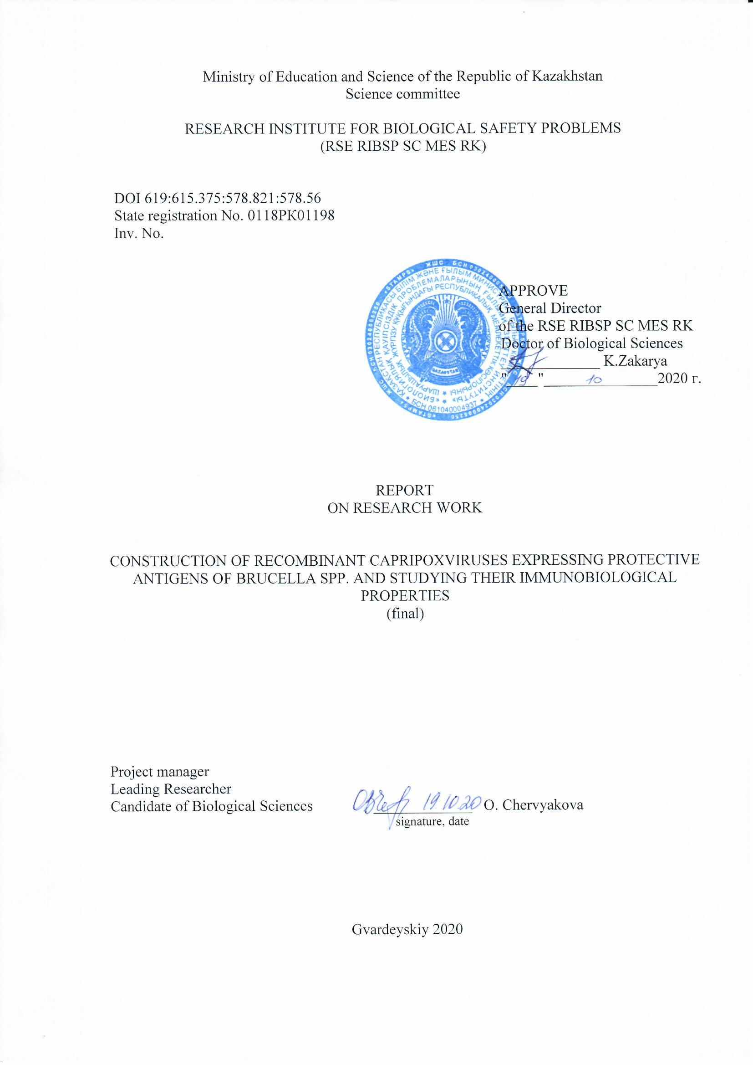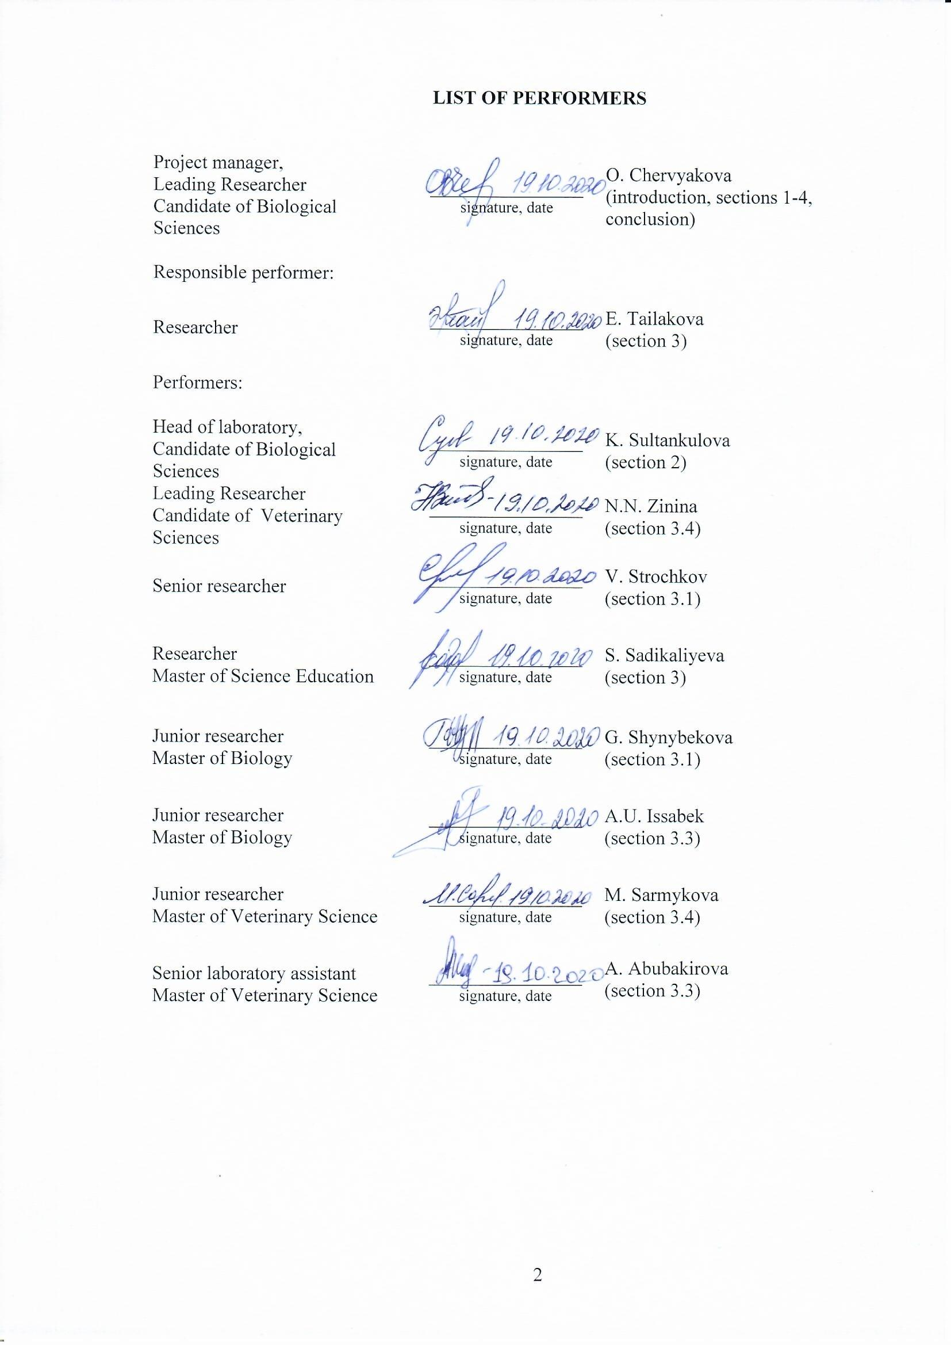
ABSTARCT

Report 138 p., 30 fig., 5 tab., 61 ref., 5 app.
BRUCELLA SPP., PROTECTIVE PROTEINS, VECTOR VACCINES, SHEEP POX VIRUS, ANTIVIRAL IMMUNITY
The research object is sheep pox virus, Capripoxvirus.
The goal of the project is the construction of the recombinant sheep pox virus strains expressing protective Brucella spp. antigens and the study of their immunobiological properties
The method of homologous recombination was used for the recombination of the capripoxvirus genome. The selection of recombinant viruses was carried out under conditions of transient dominant selection.
As a result, seven integration plasmids pIN-TK-omp16, pIN-TK-omp19, pIN-TK-omp25, pIN-TK-SOD, pIN-TK-L7 / L12, pIN-TK-IalB, and pIN-TK- omp19 & SOD were constructed for the insertion of six genes encoding antigenic proteins of Brucella spp. into the sheeppox virus genome. Passports have been drawn up for all structures. Seven recombinant sheep pox viruses rSPPV (TK-)L7/L12, rSPPV(TK-)omp16, rSPPV(TK-)omp19, rSPPV(TK-)omp25, rSPPV(TK-)IalB, rSPPV(TK-)sodC, rSPPV(TK-)omp19/sodC, with inserted genes of Brucella spp., were obtained. All recombinants, excluding rSPPV (TK-) L7 / L12, remained genetically stable during long-term passaging in cell culture and efficiently expressed inserted genes in both permissive and non-permissive cells. Immunization of mice with recombinant viruses induced both humoral and cellular immune responses. The level of antibody production was dependent on the antigen used and was enhanced with the use of heterologous prime-booster immunization. Stimulation of the splenocytes of immunized mice with Brucella antigens led to the synthesis of interferon-gamma. Immunization of mice with recombinant viruses provided a significant decrease in spleen contamination after challenge with virulent strain 544 B. abortus, comparable to the vaccine strain S19 B. abortus.
Field of application – medical/veterinary virology.
The importance of work – recombinant capripoxviruses expressing antigenic proteins of Brucella are promising candidates for the development of a safe vaccine against brucellosis.

РЕФЕРАТ

Есеп 138 б., 30 сур., 5 кес., 61 әдебиет көз., 5 қос.
BRUCELLA SPP., ПРОТЕКТИВТІ БЕЛОКТАР, ВЕКТОРЛЫ ВАКЦИНАЛАР, ҚОЙ ШЕШЕГІ ВИРУСЫ, ВИРУСҚА ҚАРСЫ ИММУНИТЕТ
Зерттеу насаны қой шешегі вирусы Capripoxvirus.
Жұмыстың мақсаты Вrucella spp. протективті антигендерді экспрессиялайтын қой шешегі вирусының рекомбинантты штаммддарын құрастыру және олардың иммунобиологиялық қасиеттерін зерттеу болып табылады.
Каприпоксвирус геномын рекомбинациялау үшін гомологиялық рекомбинация әдісі қолданылды. Рекомбинантты вирустар уақытша доминантты селекция жағдайында таңдалынып алынды.
Зерттеулер нәтижесінде Brucella spp антигенді белоктарын кодтайтын алты генді қой шешегі вирусының геномына ендіру үшін жеті интеграция плазмидалары pIN-TK-omp16, pIN-TK-omp19, pIN-TK-omp25, pIN-TK-SOD, pIN-TK-L7/L12, pIN-TK-IalB, pIN-TK-omp19&SOD конструирленіп алынды. Барлық конструкцияларға төлқұжат жасалынды. Геномдарына Brucella spp. белоктарын кодтайтын гендер ендірілген жеті қой шешегінің рекомбинантты вирустары rSPPV(TK-)omp16 rSPPV(TK-)omp19, rSPPV(TK-)omp25, rSPPV(TK-)SOD, rSPPV(TK-)L7/L12, rSPPV(TK-)IalB, rSPPV(TK-)omp19&SOD алынды. rSPPV(TK-)L7/L12 вирусынан басқа барлық рекомбинанттар жасуша өсіндісінде ұзақ уақыт бойы жасалынған пассаждар нәтижесінде генетикалық тұрғыдан тұрақты болып қала берді. Сонымен қатар олар пермессивті жәнеде пермессивті емес жасушаларда енгізілген гендерді тиімді түрде экспрессиялады. Рекомбинантты вирустармен тышқандарды егу гуморалды және жасушалы иммунды жауапты индуцирлейді. Антиденелердің генерациясының деңгейі қолданылған антигенге байланысты болды, және гетерологиялық прйм-бустер егуді қолдану кезінде ол деңгей жоғарылады. Бруцелла антигендерімен егілген тышқандардың спленоциттерін ынталандыру интерферн-гамманың синтезіне тудырды. Рекомбинантты вирустармен тышқандарды егу оларды B.abortus 544 вирулентті штаммымен бақылаулы түрде егуден кейін олардың көк бауырларының ластануы айтарлықтай B.abortus S19 вакциналық штаммымен тепе-тең келетіндей төменделінгені байқалынды.
Қолдану аймағы – медициналық/веетринарлық биология.
Жұмыстың маңыздылығы – бруцелланын антигенді белоктарын экспрессиялайтын рекомбинантты каприпоксвирустар, бруцеллезге қарсы қауіпсіз екпені жасаудағы перспективалы кандидаттар болып табылады.
CONTENT
INTRODUCTION 9
1 Choice of research directions 12
1.1 Рекомбинация генома поксвирусов 12
1.2 Selection of Brucella antigenic proteins 14
2 Materials and methods 16
2.1 Viruses and bacteria 16
2.2 Amplification of nucleotide sequences 16
2.3 Modification of nucleotide sequences 16
2.4 Transfection of sheep pox virus infected LT cells with plasmid DNA 16
2.5 Selection of recombinant sheep pox viruses 16
2.6 Plaque cloning of recombinant viruses 17
2.7 Cloning of recombinant viruses by limiting dilution method 17
2.8 PCR-analysis of recombinant viruses 17
2.9 Determination of the stability of recombinant viruses 18
2.10 Evaluation of the level of expression of target genes by recombinant viruses in cell culture 18
2.11 SDS-PAGE-electrophoresis and immunoblot 18
2.12 RT-PCR 18
2.13 Obtaining bacterial-expressed proteins and sera to them 19
2.13.1 Bacterial expression of target proteins 19
2.13.2 Purification of recombinant proteins 19
2.13.3 Obtaining specific sera for recombinant proteins 20
2.14 Immunization of mice 20
2.15 Enzyme linked immunosorbent assay (ELISA) 21
2.16 Assessment of the cell-mediated immune response 21
2.16.1 Isolation of mouse splenocytes 21
2.16.2 ELISPOT 22
2.17 Evaluation of the protection (efficiency) of recombinant viruses 22
3 Research results 24
3.1 Construction of the recombinant strains encoding omp19, SodC, omp16, L7/L12 genes, based on the sheep pox virus vaccine strain NISKHI, and determining their expression level 24
3.1.1 Construction of integration plasmids for insertion of Brucella spp. into the genome of sheep pox virus 24
3.1.2 Development of recombinant sheep pox virus strains 26
3.1.2.1 Development of recombinant sheep pox virus rSPPV(TK-)omp19 26
3.1.2.2 Development of recombinant sheep pox virus rSPPV(TK-)omp19/sodC 27
3.1.2.3 Development of recombinant sheep pox virus rSPPV(TK-)SOD 28
3.1.2.4 Development of recombinant sheep pox virus rSPPV(TK-)omp16 29
3.1.2.5 Development of recombinant sheep pox virus rSPPV(TK-)omp25 31
3.1.2.6 Development of recombinant sheep pox virus rSPPV(TK-)IalB 32
3.1.2.7 Development of recombinant sheep pox virus rSPPV(TK-)L7/L12 33
3.1.3 Evaluation of the expression of target genes by recombinant sheep pox viruses 33
3.1.3.1 Obtaining purified bacterial-expressed proteins 33
3.1.3.2 Obtaining specific sera 33
3.1.3.3 Evaluation of the target genes expression by recombinant sheep pox viruses 34
3.2 Evaluation of the stability of the recombinant sheep pox virus strains 39
3.3 Evaluation of the humoral and cellular immunity activation of mice immunized with the recombinant sheep pox virus strains 41
3.4 Study of the obtained strains protection on laboratory animals 42
4 Compilation and evaluation of research results 45
CONCLUSION 48
REFERENCES 49
APPENDIX А 55
APPENDIX B 62
APPENDIX C 120
APPENDIX D 127
APPENDIX E 133

DEFINITIONS, SYMBOLS AND ABBREVIATIONS

The following terms are used in this research report with the corresponding definitions, symbols and abbreviations.
Recombination the process of exchanging genetic material by breaking and combining different molecules
Transfection the process of introducing nucleic acid into eukaryotic cells by a non-viral method
BSA – bovine serum albumin
DNA – deoxyribonucleic acid
IFN-γ – interferon-gamma
CFU – colony forming units
ORF – open reading frame
PCR – polymerase chain reaction
TK – thymidine kinase
LT – lamb testicle
FBS – Fetal Bovine Serum
GFP – green fluorescent protein
gpt – xanthine-guanine-phosphoribosyl transferase gene
PBS – phosphate buffered saline

INTRODUCTION

Brucellosis is a dangerous infectious disease of animals and humans. It is caused by Brucella, a gram-negative, non-spore-forming, facultative, intracellular bacterium of six species: В. melitensis, В. abortus, В. suis, В. neotomae, В. canis, and В. ovis, three of them being pathogenic for humans: the agents causing brucellosis of small cattle (B. melitensis), of cattle (B. abortus) and of swine (B. suis). Sick cloven-hoofed animals are a source of the infectious agent and its natural reservoir [1].
Brucellosis is a serious problem of health care as natural reservoirs exist. Currently live, attenuated vaccines based on strains S19 [2] and RB51 [3] are used to prevent brucellosis among animals. Virulence for humans is the major disadvantage of these vaccines [4, 5]. Although live vaccines are available for livestock, immunization programs must be maintained to limit human infection. The USA program of brucellosis eradication includes vaccination of non-infected animals and slaughter of infected animals [6, 7]. In Kazakhstan, the animals are tested annually for brucellosis and sick animals are slaughtered; vaccines are not used because of their high virulence. However, this approach is impossible for countries that are not able to provide restitution of livestock or where the affected animals cannot be removed due to cultural beliefs.
It should be also noted that the natural reservoir of Brucella spp. expands through wildlife intrusion [8, 9]. Susceptible to B. abortus are American buffaloes (Bison bison) and elks (Cervus elaphus) [10] that are natural reservoirs of the agent in the Greater Yellowstone Area, USA [11, 12]. Control of spread of infection in wildlife is rather limited and the possibility of livestock and human infection persists. The lack of reliable means of treatment and prevention of brucellosis and ease of dissemination of the pathogen in the form of an aerosol is alarming for its illegitimate use [13, 14].
Therefore, development of effective brucellosis vaccines for animals and humans is a task of priority. Developed vaccines should be safe both for target (livestock) animals and for wildlife as well as prevention of infection in humans. Vaccines should induce long-term protection against infection in a high proportion of animals and prevent colonization and seroconversion after exposure to virulent field strains. As the mechanism of immune response formation is not known, it is important for the vaccines in development to induce both cellular and humoral immune responses. A promising direction in the development of a vaccine that meets these requirements is the creation of a recombinant vector vaccine. Poxviruses [15, 16, 17], herpesviruses [18, 19], adenoviruses [20, 21], retroviruses [22, 23] and others are used as vaccine vectors. The development of a vector anti-brucellosis vaccine based on the influenza virus was carried out by the scientists of the RIBSP. As a result, recombinant influenza virus strains expressing SodC, Omp19, Omp16 and L7/L12 proteins [24] were obtained, and the immunogenicity and protection of the developed vector vaccine was evaluated [25, 26]. The genetic instability of the influenza virus dictates the need to search for an alternative vector.
The widespread use of poxviruses as vectors has become possible due to a number of important advantages over other viruses, including the large size of the viral genome (140-300 thousand base pairs) capable of holding up to 25 thousand bases of foreign DNA [27], specific poxvirus promoters and transcriptional enzymes, replication in the cytoplasm of infected cells without integration into the host genome [28], the ability to present foreign antigens on the surface of infected cells, which, in turn, induce cellular and humoral immune responses [29, 30], and exceptional thermal stability.
Research project team has accumulated vast experience in working with poxviruses. As part of the grant funding project GF4/1071 "Capripoxvirus as a universal vector for the development of vaccines against infectious diseases", the research team obtained basic integration plasmids for the genome recombination of the vaccine sheep pox virus strain "NISKHI" at two loci [31] and recombinant virus strains expressing green fluorescent protein in cells of permissive and non-permissive hosts.
Scientific novelty of the project. The sheep pox virus will be first used for the expression of protective proteins of Brucella. Expression cassettes including several genes or epitopes will be used to obtain a unique vaccine against animals and humans brucellosis. This vaccine will provide high immunogenicity and protection (by inducing both a cellular and humoral immune response to protective antigens) as well as completely safe (by deletion of virulence genes of the sheep pox virus).
The significance of the project. Implementation of the project in the long term will allow developing effective safe anti-brucellosis vaccines, which will contribute to epizootic welfare in the country, the successful implementation of targeted livestock development programs aimed at providing quality livestock products to both domestic and foreign markets. In addition, execution will contribute to the formation of highly qualified specialists in the field of biotechnology, virology, veterinary immunology and infectious pathology of animals, the development of modern biotechnology industry.
The main goal of the project is the construction of the recombinant sheep pox virus strains expressing protective Brucella spp. antigens and the study of their immunobiological properties.
Tasks of the project:
1) Construction of the recombinant strains encoding omp19, SodC, omp16, L7/L12 genes, based on the sheep pox virus vaccine strain NISKHI, and determining their expression level;
2) Evaluation of the stability of the recombinant sheep pox virus strains;
3) Evaluation of the humoral and cellular immunity activation of mice immunized with the recombinant sheep pox virus strains;
4) Study of the obtained strains protection on laboratory animals.
Two interim reports with inv. No. 0218RK00509 (for 2018) and 0219RK01056 (for 2019) were prepared based on the research results.

1 Choice of research directions

1.1 Рекомбинация генома поксвирусов
There are a number of methods for producing recombinant poxviruses. Homologous recombination remains the most widely used approach for inserting foreign DNA into the genome of poxviruses. A schematic diagram of homologous recombination of viral and plasmid DNA is described by Falkner & Moss [32]. An integrative vector [33] or viral DNA [34] is transfected into poxvirus-infected cells, resulting in homologous DNA recombination. The first stage is a single crossing over event, which leads to the integration of the full-length vector into the poxvirus genome. Due to the presence of repeats, a second crossing-over event occurs with the formation of either a wild-type virus or a recombinant virus containing foreign DNA sequences (Figure 1).

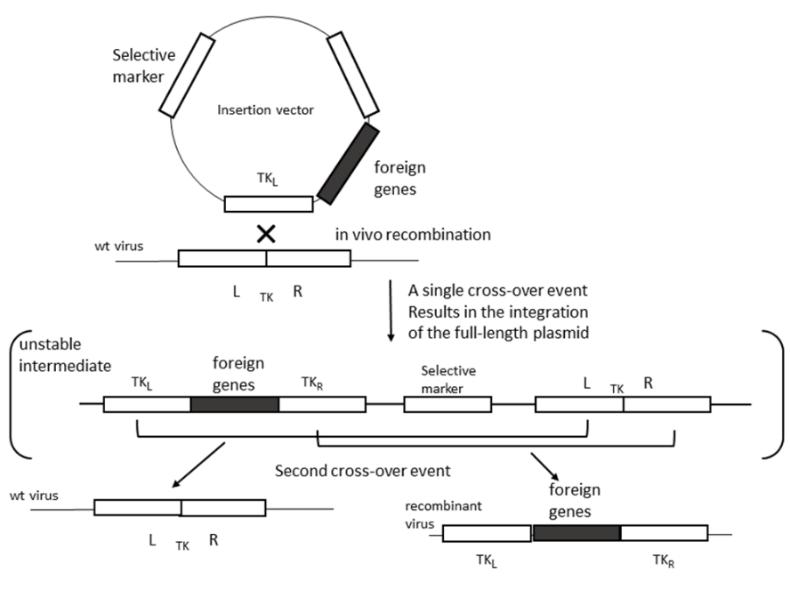
Figure 1 – Scheme of events for homologous recombination (adapted from [32])

When constructing an integrative vector, the following conditions should be observed: the place of insertion should be unimportant for the replication of the virus in the cell, and the insertion itself should not disrupt the work of neighboring genes; the target gene with a promoter must be flanked by DNA sequences (at least 50, but better than 100 bp) homologous to the site of the viral genome where the target gene is planned to be placed [35].
For efficient insertion of DNA fragments up to 25000 bp. in the genome of vaccinia virus, a method of direct in vitro ligation was proposed [27, 36]. Fragments of the viral genome obtained after cleavage with restriction endonucleases at unique sites were ligated with foreign DNA fragments and transfected into cells that were infected with a conditionally lethal helper virus. Without special screening or selection, up to 25% of the plaques contained virus with genomic insertions. When screening was used to select recombinants, all plaques contained virus with genomic insertions.
Despite the advantages (the possibility of inserting large DNA fragments into the viral genome and excluding intermediate unstable recombinants), this method has not found widespread use due to the difficulties associated with manipulating large DNA and the need for helper viruses.
The thymidine kinase gene was one of the first genes used for insertion mutagenesis. Dubbs and Kit [37] described the natural emergence of the vaccinia virus mutants deficient in thymidine kinase (TK) activity, and the method for selection of TK-negative mutants using 5-bromo-2'-deoxyuridine (BUdR). Localization of the TK gene in the viral genome [33] made possible the incorporation of foreign genes into it and biochemical selection of recombinants based on their TK-negative phenotype or by other screening methods [38]. Predominantly TK gene was the site of the foreign gene insertion into the capripoxvirus genome. However, not for all poxviruses the TK gene activity is insignificant. For instance, some representatives of avipoxviruses failed to produce stable TK-negative mutants [39, 40, 41]. Due to that, the search for alternative sites to incorporate the heterologous DNA into poxvirus genome is underway.
To date, the genomes of many poxviruses have been sequenced and annotated, the functions of a number of genes have been determined, genes that determine the virulence of poxviruses have been identified [42, 43]. That has enabled searching for genes suitable for insertion of heterologous sequences, mutations of which result in attenuation of the viral vector [44]. Thus, it was found that along with mutations in the TK gene, mutations in the genes of hemagglutinin (HA) and the small subunit of ribonucleotide reductase (RR) do not affect the replication of vaccinia virus in cell culture and in mice [45]. The TK mutant was characterized by a decrease in the level of replication in mice as compared to the original NYCBH strain; the HA and RR mutants were even more attenuated in this respect. In addition, the RR deletion mutants were not transmitted from primary infected mice to native animals. Using the RR gene as a site for insertion, a recombinant strain of lumpy skin disease virus expressing the rabies virus glycoprotein was obtained [46]. The resulting recombinant virus was stable and elicited a humoral immune response in cattle, which was demonstrated by ELISA and rabies virus neutralization tests.

Poxviruses replicate in the cytoplasm and use their own transcription systems [47]. In this regard, for the expression of foreign genes, the open reading frame should be under the control of the poxvirus promoter and terminator. Poxvirus genes and their promoters are divided into early, intermediate and late depending on the time of their expression during poxvirus infection [48, 49]. Some promoters have both early and late elements, providing continuous gene expression [50]. Among the most commonly used promoters for the expression of foreign genes, the early/late promoter p7.5K and late promoter p11 of the vaccinia virus should be noted. The p7.5 promoter is used as a standard when searching for new promoters or optimizing the existing ones [51, 52]. In addition to the natural promoters of the vaccinia virus, synthetic promoters have been developed for the expression of foreign genes: early/late [53], and late [54].
It has been shown that the poxvirus promoters are genetically conserved and exogenous poxvirus promoters can be used for recombination. For example, the p7.5 promoter of the vaccinia virus was used in the fowl pox virus (FPV) to express a transgene. Transcription in FPV initiated at the early and late element of the promoter and finished at the termination sequence similar to the p7.5 termination sequence in vaccinia virus, resulting in the same transgene [55, 56]. The choice and optimization of the promoter is one of the main stages in the development of vector vaccines and enhancement of their immunogenicity [57]. The promoter determines the time and level of gene expression. For instance, if the protein expression is required prior to the manifestation of the cytopathic effect of viruses in the cell monolayer, early promoters should be used. Strong late promoters provide the highest level of expression [54].
For the screening of recombinant viruses, reporter protein genes are used, which encode proteins that are neutral for cells, easily detectable in cells, or selective antibiotics. The most commonly used reporter genes are β-glucuronidase (GUS), β-galactosidase, and green fluorescent protein (GFP). The presence of the first two enzymes can be determined by in situ histochemical staining of tissues. GFP is capable of fluorescence in the visible (green) region of the spectrum when irradiated with long wavelength UV. This fluorescence is directly due to the protein and does not require substrates or cofactors for its manifestation. The guanine phosphoribosyl transferase (gpt) gene of Escherichia coli is the dominant selectable marker. It was shown, mycophenolic acid (MPA), an inhibitor of purine metabolism, block vaccinia virus replication in normal cell lines. However, recombinant viruses expressing gpt are capable of replicating in a selective medium containing MPA, xanthine, and hypoxanthine [32].
Due to the fact that capripoxviruses have a limited range of hosts and are not pathogenic to humans, they have a high potential for use as both replicable and non-replicable vector vaccines.

1.2 Selection of Brucella antigenic proteins
The choice of antigens is complicated. At present at least 14 Brucella protective proteins have been identified (Table 1). Moreover, the protective protein vaccines may be effective for multiple Brucella species because of the >94% gene homology among Brucella species [58].

Table 1 - Brucella protective antigens verified experimentally
# | Symbol | Locus tag | Protein Description | Location | References (PMIDs)
1 | BLS | CAA86936 | Brucella lumazine synthase | Cytoplasm | 11953389
2 | L7/L12 | BRURPL712X | Ribosomal protein L7/L12 | Cytoplasm | 8873388
3 | P39 | ABM67295 | sugar-binding 39-kDa protein | Periplasm | 11447155
4 | Bfr | BAB2_0675 | Ferritin:Bacterioferritin | Cytoplasm | 11447155
5 | Bp26 | BMEI0536 | Periplasmic immunogenic protein | Periplasm | 17239499
6 | DnaK | BruAb1_2100 | Molecular chaperone DnaK | Cytoplasm | 17686554
7 | IalB | BMEI1584 | Invasion protein B | Cytoplasmic membrane | 17049676
8 | Omp16 | BAB1_1707 | Outer membrane protein MotY | Outer membrane | 18981242
9 | Omp19 | BAB1_1930 | Lipoprotein Omp19 | Outer membrane | 18981242
10 | Omp25 | BMEI1249 | 25 kDa outer-membrane immunogenic protein precursor | Outer membrane | 18981242
11 | Omp31 | BAB1_1639 | OmpA-like transmembrane domain | Outer membrane | 17014873
12 | SodC | BAB2_0535 | Cu/Zn superoxide dismutase | Periplasm | 15039330
13 | SurA | BAB1_0706 | Peptidyl-prolyl cis-trans isomerase | Periplasm | 17686554
14 | Tig | BMEI1069 | Trigger factor | Cytoplasm | 17239499

2 Materials and methods

2.1 Viruses and bacteria
Sheep pox viruses was used in the work: an attenuated vaccine strain NISKhI from the collection of microorganisms of the RIBSP and the recombinant rSPPV(TK-)EGFP expressing a green fluorescent protein, obtained within the framework of the grant project 1071/GF4. The vaccine lumpy skin disease virus Neethling-RIBSP has been considered as an alternative to sheep pox virus. E. coli TOP10 cells were used to construct recombinant plasmids. To obtain recombinant Brucella proteins, we used strains E. coli T7/pET/Omp16, T7/pET/Omp19, T7/pET/L7/L12, T7/pET/SOD, ER2566/pET/Omp25; ER2566/pET/IalB. The vaccine strains S19 B. abortus, Rev1 B. melitensis and virulent strains 544 B. abortus, 16M B. melitensis were used to study the immunogenic efficiency of recombinant viruses.

2.2 Amplification of nucleotide sequences
The amplification of nucleotide sequences of Brucella genes was carried out by PCR in a volume of 50 μL: 5 μL of 10 × buffer, 1 μL of 10 mM dNTP mixture, 1 μL of forward and reverse primers, 2.5 U Taq polymerase, 1 μg of viral DNA, water up to 50 μl. Temperature range: 95 °С – 5 min; 30 cycles 95 °С – 30 s, 50 °С – 1 min, 72 °С – 1 min; 72 °C – 10 min.

2.3 Modification of nucleotide sequences
All manipulations with DNA were performed according to standard methods [59].

2.4 Transfection of sheep pox virus infected LT cells with plasmid DNA
A monolayer of LT cells in a six-well plate was washed twice with a semi-synthetic near-wall medium without serum (SNM-0), then infected with a virus with a multiplicity of infection of 0.1 CPE₅₀ per cell, and incubated for 4 h at 37 °C. After that, the virus suspension was removed from the cell monolayer. The monolayer was washed twice with SNM-0, and the recombinant integration plasmid was transfected using Lipofectamine 2000. Transfection was performed according to the manufacturer's protocol using 1-2 μg of DNA per well of a six-well plate. SNM-0 with the addition of selective chemistry (250 μg/ml xanthine, 15 μg/ml hypoxanthine, and 25 μg/ml mycophenolic acid) was used as a medium.

2.5 Selection of recombinant sheep pox viruses
The selection of recombinant viruses was carried out by 2-3 times sequential passaging of the transfected cell lysate in a LT cell culture in the presence of selective chemistry (250 μg/ml xanthine, 15 μg/ml hypoxanthine, and 25 μg/ml mycophenolic acid).

2.6 Plaque cloning of recombinant viruses
For cloning of recombinant viruses by the plaque, a monolayer of LT cells in 6-well plates was used. The virus-containing cell lysate was treated with trypsin for 10 min at room temperature. To obtain single plaques, virus dilutions from 10⁻⁴ to 10⁻⁶ were used. Monolayer of LT cells was infected with each dilution of the virus (1 ml/well). It was incubated for 60 min at 37 °C, the virus suspension was removed, and 3 ml of a 0.5 % agarose in SNM-2 medium was carefully added into wells. After the agarose solidified, the plates were transferred to a CO₂ incubator. After 5-7 days, the infected cells were stained with a 0.03 % solution of neutral red. Single plaques were transferred to fresh cell culture to accumulate the viral mass. After that, PCR analysis of the resulting clones was performed.

2.7 Cloning of recombinant viruses by limiting dilution method
LT cells culture in 24-well plates was used. Dilutions of the virus were prepared from 10⁻⁵ to 10⁻⁷. 12-24 wells of a 24-well plate were infected with each dilution of the virus (0.5 ml/well). Plates were incubated for 7-10 days in a CO₂ incubator at 37 °C. Then, PCR analysis of the resulting clones was performed.

2.8 PCR-analysis of recombinant viruses
DNA from cell lysates was isolated using PrepMan ™ Ultra Sample Preparation Reagent, Applied Biosystems, according to the manufacturer's instructions. To detect inserted genes in the viral genome, specific primers were used, the sequences of which are shown in Table 2. The structure of the thymidine kinase locus was determined using primers PCR-TK-F 5'-aattataggacctatgttttctggc-3'and PCR-TK-R1 5'-cagcgtctttataacattcc-3'. The size of the PCR product for the parental virus strain is 400 bp, the sizes of the recombinant loci for each variant are shown in Table 2. The DNA amplification reaction was performed as in paragraph 2.2.
Table 2 – Primers used for the detection of inserted genes
Target gene | Primer name | Primer sequence, 5’ – 3’ | PCR product size for target gene, bp | PCR product size for TK locus, bp
L7/L12 | L7/L12-FP | AGTTCAACCTTGGCGCCAGCAGCTT | 117 | 940
L7/L12 | L7/L12-RP | CGGCGGCGCTAACAAGATCAACGTG | 117 | 940
SOD | SOD -F | CGCCATGGTTAAGTCCTTATTTATTGC | 533 | 1045
SOD | SOD -R | CGCTCGAGTTCGATCACGCCGCAGGCAAAA | 533 | 1045
omp25 | Omp25-F | ACCATGGTTGCTGCCGACA | 400 | 1058
omp25 | Omp25-R | CCGAGCACATTGAGAAAGGCA | 400 | 1058
omp16 | Omp16-F | CGCTCGAGCCTTCCGGCCCCGTTGAGAA | 516 | 1045
omp16 | Omp16-R | CGCATATGCGCCGTATCCAGTCGATTGCA | 516 | 1045
omp19 | Omp19-F | CGCATATGGGAATTTCAAAAGCAAGTCT | 542 | 1046
omp19 | Omp19-R | CGCTCGAGGCGCGACAGCGTCACGGCCT' | 542 | 1046
IalB | IalB-F | ACGGTCGACCTTGGTCAATGCCTG | 489 | 998
IalB | IalB-R | TCTAGATCTAGCCTCCCTGCCCGG | 489 | 998
omp19/sodС | PCR-X19-F | CGGCCCTGTCCTGAAGAATAGAG | 558 | 1545
omp19/sodС | PCR-X19-R | TGGCGGAAATCAAGCAGC | 558 | 1545

2.9 Determination of the stability of recombinant viruses
The stability of the recombinant viruses was determined by carrying out five passages in the LT cell culture. The thymidine kinase locus structure and the presence of the target gene in the viral genome were confirmed by PCR analysis.

2.10 Evaluation of the level of expression of target genes by recombinant viruses in cell culture
To assess the transient expression of the target gene, the infected cell culture was transfected with plasmid DNA. The cells were mechanically removed from the surface after 48 h and harvested by centrifugation at 200×g for 10 min. The presence of the target proteins was confirmed by the immunoblot method.
To assess the expression of target genes, monolayer cell culture in a 12-well plate were infected with the recombinant poxviruses (0.2 ml/well) with an activity of 5 lg TCD⁵⁰/ml. Plate were incubated for 1 h at 37 °C in a CO₂ incubator. Then, 0.8 ml of SNM-2 was added to each well and the incubation was continued. Sampling for analysis was carried out in dynamics for 3 days. The cells were mechanically removed and harvested by centrifugation at 200×g for 10 min. The cell pellet was stored at minus 70 °C until analysis.

2.11 SDS-PAGE-electrophoresis and immunoblot
Protein electrophoretic separation was performed in 12 % SDS-PAGE. Proteins were visualized using Coomassie G-250 staining or immunodetection. For immunodetection, proteins were transferred onto a nitrocellulose membrane. After protein transfer, the membrane was blocked for 1 h at room temperature in TBS-T [150 mM NaCl, 20 mM Tris-HCl, pH 7.5, 0.1 % Tween-20] containing 5 % fat free milk. Then they were incubated with primary (specific) antibodies diluted 1:10000 in blocking buffer for 1 h at room temperature, washed with TBS-T buffer and incubated with secondary antibodies labeled with alkaline phosphatase, at a dilution recommended by the manufacturer, under the same conditions. Then developed by adding BCIP/NBT substrate. Polyclonal mouse sera to bacterially expressed target proteins were used as specific antibodies. Purified bacterial-expressed proteins served as a positive control when setting up immunoblots.

2.12 RT-PCR
Cellular RNA was isolated using GenElute ™ Mammalian Total RNA Miniprep Kit, Sigma according to the manufacturer's protocol. QuantiTect SYBR® Green RT-PCR Kit was used for real-time RT-PCR according to the manufacturer's protocol. The reaction conditions were as follows: 50 °C – 30 min, 95 °C – 15 min, 30 cycles: 94 °C – 15 s, 60 °C – 30 s, 72 °C – 40 s, and 72 °C – 7 min. A purified PCR product was used as a standard, the number of copies of which was calculated using a calculator (https://nebiocalculator.neb.com/#!/dsdnaamt)

2.13 Obtaining bacterial-expressed proteins and sera to them

2.13.1 Bacterial expression of target proteins
A glycerol cell stock (5 μl) was added to 30 ml of LB-kan50 medium (LB medium containing 50 μg/ml kanamycin) and incubated overnight at 37 °C on a shaker. The overnight culture was diluted with LB-kan50 medium in a ratio of 1:50, after which the cells were grown at 37 °C to OD600 = 0.6-1 on a shaker (200 rpm). Expression induced by the addition of IPTG to 1 mM was carried out at 37 °C for 4 h. Before and after induction, samples were taken for analysis in SDS-PAGE. The cells were harvested by centrifugation at 4000 rpm for 20 min. Samples for analysis and cell pellets were stored at minus 20 °C until use.

2.13.2 Purification of recombinant proteins
The recombinant proteins L7/L12, omp19, and IalB were purified under native conditions, omp16, omp25, and sodC – under denaturing conditions. For lysis, the cell pellets were thawed and dissolved in buffer 1 [100 mM Tris HCl pH 8.0, 150 mM NaCl, 1 % Triton X-100, 1 % sodium deoxycholate] at the rate of 15 ml of buffer per 1 g of cells. Lysozyme was added to the resulting suspension to a final concentration of 1 mg/ml. Then they were frozen-thawed twice (minus 70 °C, 30 min/37 °C, 30 min) and incubated at 4 °C overnight. It was centrifuged at 4 °C for 15000×g for 15 min (supernatant – fraction of soluble protein, sediment – inclusion bodies). If necessary to obtain inclusions, the precipitate was sequentially washed with buffer 2 [100 mM Tris HCl, pH 8.0, 150 mM NaCl, 1 % Triton X-100], buffer 3 [100 mM Tris HCl, pH 8.0, 150 mM NaCl], buffer 4 [50 mM Tris HCl, pH 7.5]. The pellet was resuspended in buffer 5 [20 mM PBS, pH 7.4, 300 mM NaCl, 8 M urea, 5 mM imidazole, pH 7.4] and incubated at 4 °C overnight for complete dissolution.
Purification of recombinant proteins under native or denaturing conditions was performed using Ni-NTA agarose according to the manufacturer's protocol. Refolding of the purified proteins was performed by dialysis at 4 °C on a magnetic stirrer overnight in buffer [20 mM PBS, 300 mM NaCl, 4 M urea pH 7.4] for proteins purified under denaturing conditions and in buffer [20 mM PBS, 300 mM NaCl, pH 7.4] for proteins purified in native conditions. Protein concentration was determined by the Lowry method.

2.13.3 Obtaining specific sera for recombinant proteins
Experiments with animals were carried out in accordance with current national and international legislation. Application protocol No. 6 was approved by the Bioethics Commission of the RIBSP SC MES RK dated September 25, 2017.
Outbred white mice (females, 6-8 weeks old, weight 18-20 g) were used to obtain specific sera to recombinant proteins. Purified proteins were combined with adjuvant Montanide Gel 01, SEPPIC in a 9:1 (v/v) ratio according to the manufacturer's protocol. Immunization of mice was carried out subcutaneously four times at a dose of 30 μg of protein per mouse with an interval of 14 days. Blood sampling was performed from the tail vein. The activity of the sera was tested in ELISA.

2.14 Immunization of mice
Outbred white mice aged 5-7 weeks were divided into five groups of 9 heads (total 45). Mice were immunized twice with an interval of 14 days using several schemes (Table 3). Recombinant sheep pox viruses with an activity of 6 lgTCD⁵⁰/ml were combined in an equivalent volume and injected in 0.4 ml (105 CPE50 of each virus) intraperitoneally. Recombinant proteins with a concentration of 60 μg/ml each were combined with the adjuvant Montanide Gel 01, SEPPIC in a 9: 1 (v/v) ratio and injected in 100 μl intramuscularly. For comparison, the B. abortus S19 vaccine strain was used, 10⁵ CFU in a volume of 100 μl was injected subcutaneously.

Table 3 – Scheme of immunization of mice
Immunization |  | No. group
Immunization | 1 | 2 | 3 | 4 | 5
Prime | RV | P | RV | - | PBS
Buster | RV | RV | P | Ba | PBS
Notes
RV - a mixture of recombinant viruses;
P - a mixture of proteins
Ba - B. abortus, strain S19,
PBS - phosphate buffered saline
"-" - the drug was not administered

30 days after the last immunization, three mice from each group were used to determine cellular immunity (section 2.16), the remaining six mice were challenged (section 2.17). Mice were bled from the tail vein to determine the humoral immune response by ELISA (section 2.15).

2.15 Enzyme linked immunosorbent assay (ELISA)
96-well plates (TPP, Switzerland) were coated with recombinant proteins; 100 μl of carbonate-bicarbonate buffer containing 2 μg/ml of recombinant protein was added to the wells. The plates were incubated overnight at 4 °C. Then washed three times with TBS-T and blocked with 5 % fat-free milk in TBS-T, (200 μl/well). Two-fold dilutions of the studied sera were added in 100 μL to the wells of the plate, incubated for 1 h at 37 °C. After three times washing with TBS-T buffer, conjugates of anti-mouse IgG with alkaline phosphatase (Sigma, USA) were added at a dilution of 1:5000 and incubated for 1 h at 37 °C. The plates were washed three times with TBS-T buffer and added with 100 μl of substrate for alkaline phosphatase (pNPP) (Sigma, United States), incubated for 30 min. Optical density (OD) was measured using an ImmunoChem-2100 reader at 405/630 nm. The titer was considered the highest dilution of serum, in which the optical density of the specific serum was two or more times higher than that of normal serum.
In the competitive variant, 96-well plates were coated with the recombinant omp25 protein, and 100 μl of carbonate-bicarbonate buffer containing 1 μg/ml of recombinant protein was added to the wells. The plates were incubated at 4 °C overnight. To construct a standard curve, omp25 protein was used at concentrations of 0-250 ng/ml. The working dilution of serum with an activity of 1:6400 was 1:4000. Before the analysis, the protein samples under study were combined with serum in a working dilution in equal volumes and incubated overnight at 4 °C. Standards were prepared in a similar way. Samples prepared for analysis were added in 100 μL to the wells of the plate, incubated at 37 °C for 1 h. The plates were washed four times and conjugates of anti-mouse IgG with alkaline phosphatase (Sigma, USA) were added at a dilution of 1:5000. Plates were incubated at room temperature for 1 h, washed four times, and 100 μl of pNPP substrate, Sigma, USA were added. Plates were incubated for 30 min. OD was measured at 405/630 nm using an ImmunoChem-2100 reader. The protein concentration in the test samples was determined using a standard curve.

2.16 Assessment of the cell-mediated immune response

2.16.1 Isolation of mouse splenocytes
The mouse, removed from the experiment by cervical dislocation, was placed on a dissecting table on its right side. The left side of the mouse was treated with 70 % alcohol. The fur on the left side of the mouse was cut approximately halfway between the front and rear paws. The body cavity was opened, the spleen was removed using forceps. The spleen was placed in a Petri dish. Using a syringe, 5-10 ml of DMEM was passed through the organ. In this case, the cells were washed out into the environment. The procedure was repeated until the white connective tissue of the outer membrane remained. The cell suspension was transferred into a 15 ml tube. Centrifuged at 800×g for 3 min at room temperature. The supernatant was removed and the cells were resuspended in 1 ml of ACK buffer. They were incubated at room temperature for 5 min. The cells were washed twice with culture medium. The pellet was resuspended in 3 ml of complete medium and the cell concentration was determined by counting in a hemacytometer.

2.16.2 ELISPOT
All procedures were performed under aseptic conditions. Anti-IFN-γ-antibodies were diluted in PBS according to the manufacturer's recommendations and added 100 μl to the wells of a 96-well nitrocellulose-coated plate. The plates were placed in a humid chamber and incubated overnight at 4 ° C. Blocked with culture medium RPMI1640 containing 10% FBS for 1 h at 37 °C. Then washed three times with PBS. A suspension of splenocytes with a concentration of 2×10⁶ cells/ml was prepared and 100 μl of cells were added to the wells of the plate. IFN-γ synthesis was stimulated with Brucella antigens. Unstimulated cells were used as a negative control; cells were stimulated with lectin for positive control. Incubated for 48 h at 37 °C. The plates were then washed three times with PBS-T. 100 μl of detecting biotinylated antibodies diluted in PBS-T with 1 % BSA were added. The plates were incubated for 1 h at room temperature. Then washed six times with PBS-T. The wells were filled with 100 μL of a solution of streptavidin labeled with alkaline phosphatase and incubated for 1 h at room temperature. The plates were washed four times with PBS and added 100 μl of NBT/BCIP substrate. The spots were counted using a stereomicroscope.

2.17 Evaluation of the protection (efficiency) of recombinant viruses
Immunogenic efficacy was calculated according to the recommendations of the OIE [60]. Mice immunized with recombinant viruses (section 2.14) were challenged with B. abortus, strain 544 or B. melitensis strain 16M. 30 days after immunization, mice were injected intraperitoneally with 100 μl of a cell suspension containing 2×10⁵ CFU. After 14 days, the contamination of the spleen was determined using the method of determining colony-forming units. The resulting colonies were counted on dilution plates giving less than 300 CFU. The total microbial number (X) was determined by the formula (1):

$Total microbial number \left(\frac{CFU}{organ}\right)=\frac{Total colonies on two plates × dilution}{Total volume of suspension on both plates (ml)}×volume of 10\% suspension (ml)$ (1)

If no colonies were found in 1/10 dilution plates, the spleen was considered contaminated with five bacteria. Then, the relative value of Y was calculated using the formula (2):

$Y=log\frac{X}{logX}$ (2)
where X is the total microbial number (CFU / organ).

Mean and standard deviation, which are the response of each group of six mice, are then calculated. The conditions of the control experiment are satisfactory when: i) the response of unvaccinated mice (mean of Y) is at least of 4.5; ii) the response of mice vaccinated with the reference S19 vaccine is lower than 2.5; and iii) the standard deviation calculated on each lot of six mice is lower than 0.8. The test vaccine (recombinant viruses with proteins) was satisfactory if the immunogenicity value obtained in mice vaccinated with this vaccine is significantly lower than that obtained in the unvaccinated controls and does not differ significantly from that obtained in mice vaccinated with the reference vaccine

3 Research results

3.1 Construction of the recombinant strains encoding omp19, SodC, omp16, L7/L12 genes, based on the sheep pox virus vaccine strain NISKHI, and determining their expression level

3.1.1 Construction of integration plasmids for insertion of Brucella spp. into the genome of sheep pox virus
Integration plasmids for insertion of brucella genes into the sheeppox virus genome were constructed based on the pTKbase plasmid for recombination of the sheep pox virus genome at the thymidine kinase locus, which we obtained earlier within the framework of the grant 1071/GF4. The map of this plasmid is shown in Figure 2.

ori- start of replication of plasmid DNA, APr - ampicillin resistance gene, P (BLA) - promoter, P7.5K - promoter, gpt - xanthine-guanine-phosphoribosyl transferase gene, TK-L - left arm of the thymidine kinase locus of sheep pox virus, TK- R - right arm of the sheep pox virus thymidine kinase locus, pS - synthetic early-late poxvirus promoter

Figure 2 – Map of the basic integration plasmid for recombination of the sheeppox virus genome at the thymidine kinase locus

The DNA sequences encoding the target genes omp16, omp19, omp25, sodC, IalB, and L7/L12 Brucella spp. were amplified from genomic DNA of B. abortus strain 19S and cloned into the basic integration plasmid into the NcoI and NotI (or BglII) sites. As a result, 6 constructs were obtained: pIN-TK-omp16, pIN-TK-omp19, pIN-TK-omp25, pIN-TK-SOD, pIN-TK-IalB and pIN-TK-L7/L12. In addition, a chimeric gene encoding fragments of the omp19 and SOD proteins was obtained by PCR and cloned into the basic integration plasmid (pIN-TK-omp19/SOD). The constructs were validated by sequencing and restriction analysis (Figure 3). The resulting constructs contained DNA fragments of calculated sizes. It should be noted that the treatment with PstI and SphI restriction enzymes of plasmids pIN-TK-omp16 and pIN-TK-omp25 resulted in the formation of additional fragments due to the presence of SphI restriction sites in the omp16 and omp25 gene sequence. Passports have been drawn up for all structures (APPENDIX C).
M - DNA ladder, 1 - basic integration plasmid pIN-TKsppv (108 bp), 2 - pIN-TK-L7/L12 (518 bp),
3 - pIN-TK-IalB (576 bp), 4 - pIN-TK-omp16 (623 bp), 5 - pIN-TK-omp19 (624 bp), 6 - pIN-TK-SOD (623 bp),
7 - pIN-TK-omp19/SOD (1035 bp), 8 - pIN-TK-omp25 (123 + 512 bp)

Figure 3 – Restriction analysis of integration plasmids treated with PstI and SphI

The efficiency of expression cassettes of integration plasmids was assessed by transient gene expression in the poxvirus system (Figure 4). For detection, specific sera to bacterial-expressed target proteins obtained in mice were used.
As can be seen from Figure 4, the transfection of the obtained genetic constructs into a LT cell culture infected with the sheep pox virus provides transient expression of the target genes at the translational level. It should be noted that proteins L7/L12 and IalB accumulate only in cells (Figure 4C, D, line 4), while OMP16 and SOD are detected both in cells and in the culture medium (Figure 4A, B, lines 3, 4). This may be due to the secretion of proteins from the cell or to the destruction of cells due to the toxicity of these proteins. The difference in the molecular weight of the IalB protein expressed in bacterial and poxvirus systems is associated with the presence of additional peptide sequences at the N- and C-terminus of the amino acid sequence in the bacterial expression vector (Figure 4D, lines 1 and 4).

A | B
C | D
E | F
A – OMP16 protein; B – SOD protein; C – protein L7 / L12; D – IalB protein. M is a marker of the molecular weight of proteins. 1, 6 – bacterial-expressed protein (positive control); 2, 7 – lysate of LT cells infected with sheep pox virus (virus control); 3, 8 – the medium of LT cells infected with the sheep pox virus 48 h after transfection with the corresponding integration plasmid; 4, 9 – lysate of cells infected with sheep pox virus 48 h after transfection with the corresponding integration plasmid; 5, 10 – lysate of LT cells (negative control). 1-5 – specific serum for the recombinant protein; 6-10 is normal serum. E – protein OMP19: 1-4 – specific serum; 5-8 – normal serum;
M – marker of the molecular weight of proteins, 1,5 – bacterial-expressed protein (positive control), 2,6 – lysate of LT cells infected with sheep pox virus (virus control), 3,7 – lysate of LT cells (negative control), 4,8 – lysate of cells infected with sheep pox virus 48 h after transfection with the corresponding integration plasmid. F – белок OMP25: 1-4 – специфическая сыворотка; 5-8 – нормальная сыворотка; М – маркер молекулярного веса белков,
1,5 – bacterial-expressed protein (positive control), 2,6 – lysate of LT cells infected with sheep pox virus (virus control), 3,7 – lysate of LT cells (negative control), 4,8 – lysate of cells infected with sheep pox virus 48 h after transfection with the corresponding integration plasmid.

Figure 4 – Immunodetection of target proteins transiently expressed in the poxvirus system

3.1.2 Development of recombinant sheep pox virus strains

3.1.2.1 Development of recombinant sheep pox virus rSPPV(TK-)omp19
The transfection of the cell culture infected with the sheep pox virus of the NISНKI was carried out with the integration plasmid pIN-TK-omp19. To enrich the viral population with recombinants, two selective passages were performed. Then the viruses were cloned by the limiting dilution method. As a result, 46 clones were obtained, three of them had the target gene in the genome (Figure 5A). The structure of the locus corresponded to the parental type of the virus (Figure 5B).
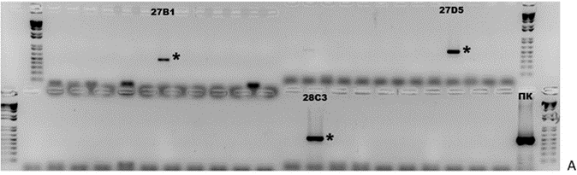 | 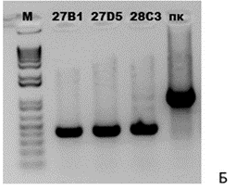
A – analysis for the presence of the target gene omp19, B – analysis of the structure of the TK locus,
PC – positive control, (*) an asterisk indicates the selected clones

Figure 5 – Results of PCR analysis of viral clones obtained by the limiting dilution method

After a single passage and analysis by PCR, clones 27D5 and 28C35 were used for further plaque cloning. Forty-seven plaques were selected and propagated. PCR analysis showed that only one viral clone had the target gene (42C5) (Figure 6A). Analysis of the structure of the locus showed that this clone has a recombinant genotype (Figure 6B).

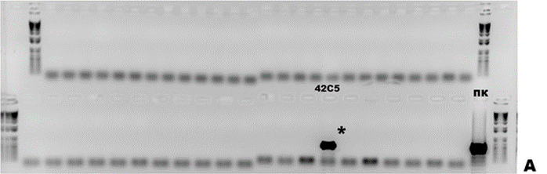 | 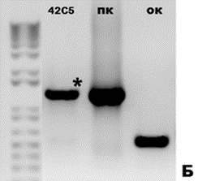
A – analysis for the presence of the target gene omp19, B – analysis of the structure of the TK locus,
PC – positive control, (*) an asterisk indicates the selected clones

Figure 6 – Results of PCR analysis of viral clones obtained
by the method of plaques under agarose coating

Thus, as a result of the studies performed, a recombinant virus rSPPV(TK-)omp19 (clone 42C5) was obtained, the genome of which included the target gene, and the structure of the locus corresponded to the recombinant type. Recombinant virus rSPPV(TK-)omp19 has been deposited in the Collection of microorganisms of the RSE RIBSP SC MES RK (APPENDIX D).

3.1.2.2 Development of recombinant sheep pox virus rSPPV(TK-)omp19/sodC
The transfection of the cell culture infected with the sheeppox virus of the NISKHI was performed with the integration plasmid pIN-TK-omp19/sodC. To enrich the viral population with recombinants, two selective passages were performed. Then the viruses were cloned by the limiting dilution method, which resulted in 46 clones. PCR analysis showed that three clones 35B3, 35B5 and 35C5 had the target gene in the genome (Figure 7A), while one of them 35B5 had a recombinant type of locus structure (Figure 7B).

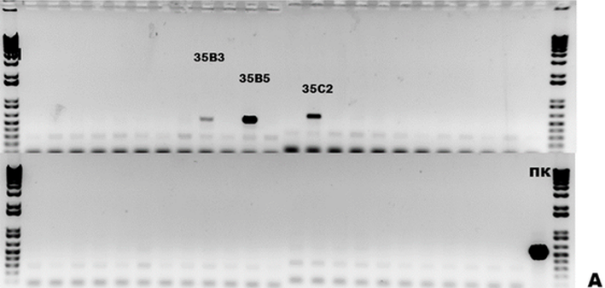 | 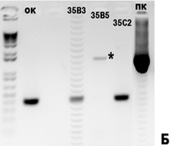
A – analysis for the presence of the target gene omp19/sodC in the viral genome, B – analysis of the structure of the TK locus, PC - positive control, (*) selected clones are marked with an asterisk

Figure 7 – Results of PCR analysis of viral clones obtained by the limiting dilution method

Thus, as a result of the studies carried out, a recombinant virus rSPPV (TK-) omp19/sodC (clone 35B5) was obtained, the genome of which included the target gene, and the structure of the locus corresponded to the recombinant type. The recombinant virus rSPPV(TK-)omp19/sodC was deposited in the Collection of microorganisms of the RSE RIBSP SC MES RK (APPENDIX D).

3.1.2.3 Development of recombinant sheep pox virus rSPPV(TK-)SOD
The transfection of the cell culture infected with the sheep pox virus of the NISKHI was performed with the integration plasmid pIN-TK-sodC. To enrich the viral population with recombinants, two selective passages were performed. As a result of two rounds of cell lysate cloning by the limiting dilution method and one by the plaque method, two virus clones 70F8 and 71D6 were obtained, which were represented by a mixture of recombinant and parent viruses (Figure 8B). The next two rounds of plaque cloning made it possible to isolate genetically homogeneous recombinants (Figure 9). Clones 81B2, 81C2, and 81D4 were selected for further research.

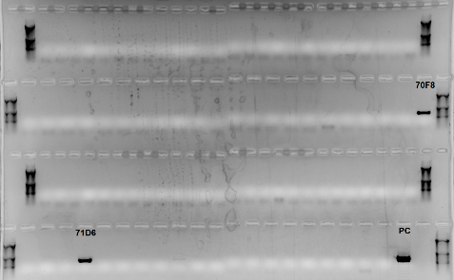A | 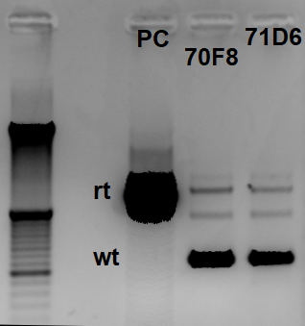B
A – analysis for the presence of the target sodC gene in the viral genome, B – analysis of the structure of the TK locus, PC – positive control, rt – recombinant virus, wt – original virus

Figure 8 – Results of PCR analysis of viral clones obtained by the method of plaques under agarose coating

A – analysis for the presence of the target sodC gene in the viral genome, B – analysis of the structure of the MC locus, PC – positive control, the selected clones are marked with an asterisk (*)

Figure 8 – Results of PCR analysis of viral clones obtained by the method of plaques under agarose coating

Thus, the recombinant viruses rSPPV(TK-)sodC (clones 81B2, 81C2, and 81D4) were obtained, the genome of which included the target gene, and the structure of the locus corresponded to the recombinant type. The recombinant virus rSPPV(TK-)sodC (clone 81B2) was deposited in the Collection of Microorganisms of the RSE RIBSP SC MES RK (APPENDIX D).

3.1.2.4 Development of recombinant sheep pox virus rSPPV(TK-)omp16
Transfection of a cell culture infected with rSPPV(TK-)EGFP was performed with the integration plasmid pIN-TK-omp16. To enrich the viral population with recombinants, two selective passages were performed. As a result of cloning the cell lysate by the plaque method, 14 clones were obtained. In this case, the selection of plaques was carried out using a fluorescent microscope. Fluorescence was recorded in transmitted light (Figure 10). Non-fluorescent plaques were selected. Then PCR analysis of the structure of the locus of the obtained clones was performed (Figure 11A), as well as for the presence of the target gene and the absence of the egfp and gpt genes (Figure 11B). When the rSPPV(TK-)EGFP genome was recombined, the size of the TK locus of the original virus was 1226 bp, and the size of the new recombinant with the inserted omp16 gene was 1046 bp (Figure 11A). Based on the PCR analysis, one clone of the recombinant virus 90A1 was selected, in the genome of which the target gene omp16 was identified (Figure 11B, lane 1). The absence of the egfp (Figure 11B, lane 3) and gpt (Figure 11B, lane 5) genes confirmed the second crossing over event in the viral genome (Figure 1). Two more clones 93D7 and 93G7 were obtained after two rounds of cloning (limiting dilution and plaque).
A - light microscopy of plaques, B - simultaneous luminescent and light microscopy of plaques

Figure 10 – Plaques formed in cell culture by sheep pox virus
A: analysis of the structure of the TK locus, 1-14 – clone numbers; B: analysis for the presence of the target gene omp16 (lanes 1,2), egfp gene (lanes 3,4) and gpt gene (lanes 5,6) in the viral genome, 1,3,5 – clone 90A1,
2,4,6 – clone 92A1; PC – positive control; an asterisk (*) marks the selected clones

Figure 11 – Results of PCR analysis of viral clones obtained by the method of plaques under agarose coating

Thus, we obtained recombinant viruses rSPPV(TK-)omp16 (clones 90A1, 93D7, and 93G7), the genome of which included the target gene, and the structure of the locus corresponded to the recombinant type. The recombinant virus rSPPV(TK-)omp16 (clone 90A1) was deposited in the Collection of Microorganisms of the RSE RIBSP SC MES RK (APPENDIX D).

3.1.2.5 Development of recombinant sheep pox virus rSPPV(TK-)omp25
The transfection of the cell culture infected with rSPPV(TK-)EGFP was performed with the integration plasmid pIN-TK-omp25. To enrich the viral population with recombinants, two selective passages were carried out. As a result of cloning the cell lysate by the plaque method, 23 clones were obtained. Plaque sampling was performed using a fluorescent microscope. Non-fluorescent plaques were selected. Then, PCR analysis of the structure of the locus of the obtained clones (Figure 12A) was performed for the presence of the target gene (Figure 12B) and the absence of the egfp and gpt genes. When the rSPPV(TK-)EGFP genome was recombined, the size of the TK locus of the original virus was 1226 bp, and the size of the new recombinant with the inserted omp25 gene was 1058 bp. (Figure 12A). Based on PCR analysis, three clones of recombinant viruses 88A3, 88B1, and 88B2 were selected, in the genome of which the target gene omp25 was identified (Figure 12B). The absence of the egfp and gpt genes confirmed the second crossing over event in the viral genome.
A – analysis of the structure of the TK locus, B – analysis for the presence of the target gene omp25 in the viral genome, PC – positive control, selected clones are marked with an asterisk (*)

Figure 12 – Results of PCR analysis of viral clones obtained by the method of plaques under agarose coating

Thus, recombinant viruses rSPPV(TK-)omp25 (clones 88A3, 88B1, and 88B2) were obtained, the genome of which included the target gene, and the structure of the locus corresponded to the recombinant type. The recombinant virus rSPPV(TK-)omp25 (clone 88A3) was deposited in the Collection of Microorganisms of the RSE RIBSP SC MES RK (APPENDIX D).

3.1.2.6 Development of recombinant sheep pox virus rSPPV(TK-)IalB
The transfection of the cell culture infected with rSPPV(TK-)EGFP was performed with the integration plasmid pIN-TK-IalB. To enrich the viral population with recombinants, two selective passages were carried out. As a result of two rounds of cloning by the limiting dilution method, clones of viruses 94A10 and 94D4 were obtained, consisting of a mixture of rSPPV(TK-)EGFP and rSPPV(TK-)IalB (Figure 13).
Figure 13 – Results of PCR analysis of the structure of the TK locus of viral clones obtained by the limiting dilution method

The clones selected for further work were combined and cloned by the plaque method. Plaque sampling was performed using a fluorescent microscope. Non-fluorescent plaques were selected. Ten clones were selected and analyzed by PCR (Figure 14). Based on PCR analysis, three clones of recombinant viruses 96A2, 96B2 and 96B4 were selected, in the genome of which the target IalB gene was identified (Figure 14B). The absence of the egfp (Figure 14С) and gpt (Figure 14D) genes confirmed a second crossing over event in the viral genome.
A – analysis of the structure of the TC locus, B – analysis for the presence of the target IalB gene in the viral genome, C – analysis for the presence of the egfp gene, D – analysis for the presence of the gpt gene, NC – negative control, PC – positive control, asterisks (*) marked selected clones

Figure 14 – Results of PCR analysis of viral clones obtained by the method of plaques under agarose coating

Thus, we obtained recombinant viruses rSPPV(TK-)IalB (clones 96A2, 96B2, and 96B4), the genome of which included the target gene, and the structure of the locus corresponded to the recombinant type. The recombinant virus rSPPV(TK-)IalB (clone 96A2) was deposited in the Collection of Microorganisms of the RSE RIBSP SC MES RK (APPENDIX D).

3.1.2.7 Development of recombinant sheep pox virus rSPPV(TK-)L7/L12
To obtain the recombinant virus rSPPV (TK-) L7 / L12, both the NISKHI strain and the recombinant rSPPV(TK-)EGFP were used as the initial virus. The integration plasmid pIN-TK-L7 / L12 was used for transfection. Enrichment of the viral population with recombinants was carried out by carrying out two selective passages. To isolate recombinants, more than twenty rounds of cloning in various combinations were performed (Figure 15). However, it was not possible to isolate a genetically stable recombinant.
A – analysis for the presence of the target gene L7/L12 in the viral genome, B – analysis of the structure of the TK locus, PC – positive control, the selected clones are marked with an asterisk (*)

Figure 15 – Results of PCR analysis of viral clones obtained by the method of limiting dilutions

3.1.3 Evaluation of the expression of target genes by recombinant sheep pox viruses

3.1.3.1 Obtaining purified bacterial-expressed proteins
At the first stage, purified proteins and mouse anti-sera to them were obtained. For this purpose, we used bacterial strains producing recombinant Brucella proteins obtained by us earlier (OMP16, OMP19, SOD, L7 / L12), as well as strains producing OMP25 and IalB proteins obtained within the framework of this project. The purity of the obtained protein preparations was at least 90 %. For the protein preparations received, passports (certificates) were issued indicating the main indicators (APPENDIX E).

3.1.3.2 Obtaining specific sera
Specific sera were produced in mice by immunization with purified proteins combined with adjuvant Montanide Gel01 (150 μg/ml). Immunization was carried out four times with an interval of 2 weeks. The obtained sera were tested by ELISA. The titers of specific sera to proteins OMP16, OMP19, SOD, L7/L12, IalB and OMP25 were 1:40960, 1:320, 1:20480, 1:20480, 1:64000, 1:6400, respectively.

3.1.3.3 Evaluation of the target genes expression by recombinant sheep pox viruses
The expression of target genes by recombinant viruses was assessed at the transcriptional and translational levels. For this purpose, LT (permissive), MDBK and L929 (non-permissive) cells were infected with the recombinant viruses rSPPV(TK-)omp19/sodC, rSPPV(TK-)omp16, rSPPV(TK-)omp25, rSPPV(TK-)IalB. Recombinant viruses effectively replicated in permissive cells, causing a cytopathic effect in the monolayer (Figure 16B), while no cytopathic effect of the virus was detected in the monolayer of non-permissive cells (Figure 16D).
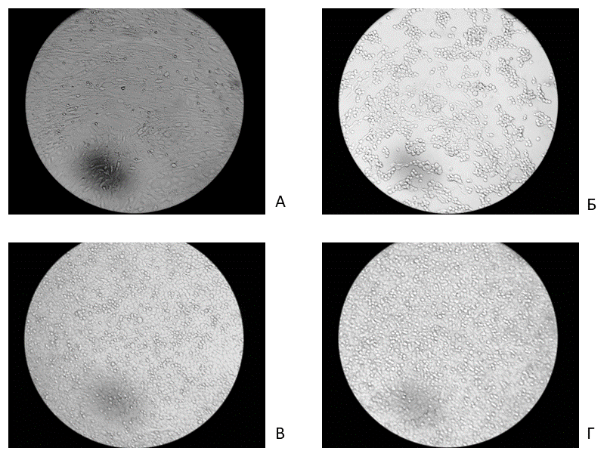
A, B – LT cell line; C, D – L929 cell line; A, C – non-infected cells;
B, D – cells infected with the recombinant virus rSPPV(TK-)omp19/sodC

Figure 16 – Cytopathic changes in the monolayer of cells infected with recombinant sheep pox viruses after 72 h of incubation

Samples of infected cells were collected in dynamics for 72 h. The number of copies of mRNA of the target gene was determined by real-time RT-PCR (see section 2.12).
As seen in Figure 17, target genes are efficiently transcribed from the viral genome. It should be noted that during the reproduction of the virus in permissive cells, the number of mRNA copies increases, reaching a maximum by 72 h (observation period). In non-permissive cells, the infection of the virus is abortive. No new virus virions are formed during the infection. The mRNA copy number reaches its maximum value within 2 h after cell infection and remains at this level for 10-12 h, after which it begins to decrease (Figure 17).
A
B
C
D
A – rSPPV(TK-)omp19/sodC, B – rSPPV(TK-)omp16, C – rSPPV(TK-)omp25, D – rSPPV(TK-)IalB

Figure 17 – The level of mRNA/TCD₅₀ target genes in cells infected with recombinant viruses in dynamics

The cell lysates were tested by Western blotting to identify target proteins (Figures 18-21). As can be seen from Figures 18-21, all proteins are efficiently expressed by recombinant sheep pox viruses. The expression level is consistent with the mRNA copy number. It should also be noted that the omp19/sodC chimeric protein is detected in the Western blot with both omp19 serum (Figure 18A-C, lanes 4-9) and SOD protein serum (Figure 18A-C, lanes 13-18).

A
B
C
A – cell culture MDBK; B – culture of LT cells; C – cell culture L929. M is a marker of the molecular weight of proteins; 1, 10, 19 – bacterial-expressed protein omp19 (positive control); 2, 11, 20 – bacterial-expressed SOD protein (positive control); 3, 12, 21 – lysate of cells infected with the sheep pox virus NISKHI; 4, 13, 22 – lysate of cells infected with recombinant sheep pox virus after 72 h; 5, 14, 23 – lysate of cells infected with recombinant sheep pox virus after 48 h; 6, 15, 24 – lysate of cells infected with recombinant sheep pox virus after 24 h; 7, 16, 25 – lysate of cells infected with recombinant sheep pox virus after 16 h; 8, 17, 26 – lysate of cells infected with recombinant sheep pox virus after 8 h; 9, 18, 17 – lysates of uninfected cells (culture control); 1-9 – specific serum to the recombinant protein omp19; 10-18 – specific serum for recombinant SOD protein; 19-27 – normal serum

Figure 18 – Immunodetection of target proteins omp19 and SOD expressed
by the rSPPV(TK-)omp19/sodC virus

A  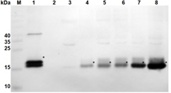 | B | C
A – MDBK cell culture; B – LT cell culture; C – L929 cell culture. M is a marker of the molecular weight of proteins. 1, 9 – bacterial expressed protein (positive control); 2, 10 – lysate of cells infected with the sheep pox virus NISKHI; 3, 11 – lysate of uninfected cells (control of cell culture); 4, 12 – lysate of cells infected with recombinant sheep pox virus after 8 h; 5, 13 – lysate of cells infected with recombinant sheep pox virus after 16 h; 6, 14 – lysate of cells infected with recombinant sheep pox virus after 24 h; 7, 15 – lysate of cells infected with recombinant sheep pox virus after 48 h; 8, 16 – lysate of cells infected with recombinant sheep pox virus after 72 hours; 1-8 – specific serum for recombinant omp16 protein; 9-16 – normal serum

Figure 19 – Immunodetection of the target protein omp16 expressed by the rSPPV(TK-)omp16

A | B | C

A – MDBK cell culture; B – LT cell culture; C – L929 cell culture. M is a marker of the molecular weight of proteins. 1, 9 – bacterial expressed protein (positive control); 2, 10 – lysate of cells infected with the sheep pox virus NISKHI; 3, 11 – lysate of uninfected cells (control of cell culture); 4, 12 – lysate of cells infected with recombinant sheep pox virus after 8 h; 5, 13 – lysate of cells infected with recombinant sheep pox virus after 16 h; 6, 14 – lysate of cells infected with recombinant sheep pox virus after 24 h; 7, 15 – lysate of cells infected with recombinant sheep pox virus after 48 h; 8, 16 – lysate of cells infected with recombinant sheep pox virus after 72 hours; 1-8 – specific serum for recombinant omp25 protein; 9-16 – normal serum

Figure 20 – Immunodetection of the target protein omp25 expressed by the rSPPV(TK-)omp25

A | B  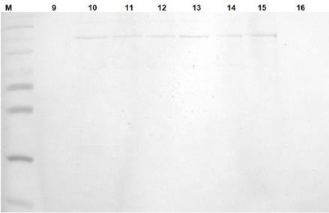 | C

A – MDBK cell culture; B – LT cell culture; C – L929 cell culture. M is a marker of the molecular weight of proteins. 1, 9 – bacterial expressed protein (positive control); 2, 10 – lysate of cells infected with the sheep pox virus NISKHI; 3, 11 – lysate of uninfected cells (control of cell culture); 4, 12 – lysate of cells infected with recombinant sheep pox virus after 8 h; 5, 13 – lysate of cells infected with recombinant sheep pox virus after 16 h; 6, 14 – lysate of cells infected with recombinant sheep pox virus after 24 h; 7, 15 – lysate of cells infected with recombinant sheep pox virus after 48 h; 8, 16 – lysate of cells infected with recombinant sheep pox virus after 72 hours; 1-8 – specific serum for recombinant IalB protein; 9-16 – normal serum

Figure 21 – Immunodetection of the target protein IalB expressed by the rSPPV(TK-)IalB

We also tried to determine the amount of protein that is expressed by a recombinant virus with an activity of 1 TCD₅₀ using rSPPV(TK-)omp25. For this, a monolayer of cells in six well plates was infected with a recombinant virus with an activity of 6.37 lg TCD₅₀/ml (0.5 ml per well). Plates were incubated for 72 h. Cells from each well were harvested mechanically, resuspended in 250 μl PBS, and lysed by freeze-thaw method. The protein content in cell lysates was determined by competitive ELISA. The results are shown in Figure 22.
As can be seen from Figure 22, the maximum accumulation of protein in cells is observed after 24 h in both permissive and non-permissive cells. A low level of protein expression in non-permissive cells is associated with an abortive type of infection. The data obtained will make it possible to make a preliminary calculation of the required amount of virus in a vaccine dose to ensure the expression of the required amount of the target antigen.

Figure 22 – The expression level of the target protein
by the recombinant virus rSPPV(TK-)omp25 in dynamics

3.2 Evaluation of the stability of the recombinant sheep pox virus strains
To determine the stability of the obtained recombinant strains, five consecutive passages were carried out for each recombinant virus. At the first and fifth passage levels, PCR analysis was performed to determine the structure of the locus and the presence of the target gene in the viral genome. The results are shown in Figures 23-28.
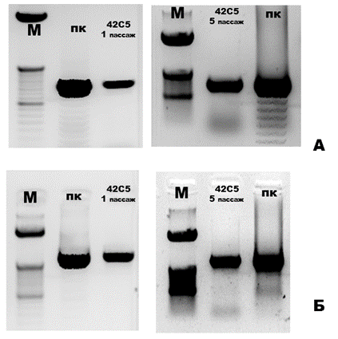
A – analysis for the presence of the target gene omp19 in the viral genome,
B – analysis of the structure of the TK locus, PC - positive control

Figure 23 – Results of PCR analysis determine the stability
of the recombinant virus rSPPV(TK-)omp19 (clone 42C5)

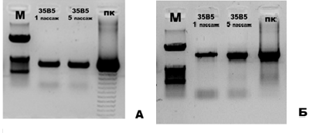
A – analysis for the presence of the target chimeric gene omp19/sodC in the viral genome,
B – analysis of the structure of the TK locus, PC - positive control

Figure 24 – Results of PCR analysis determine the stability
of the recombinant virus rSPPV(TK-)omp19/sodC (35B5)

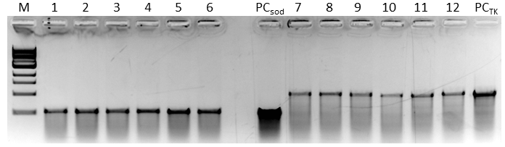
M – DNA length marker; 1,4,7,10 – clone 81B2; 2,5,8,11 – clone 81C2; 3,6,9,12 – clone 81D4; 1,2,3,7,8,9 – first passage; 4,5,6,10,11,12 – fifth passage; PC – positive control (plasmid DNA)

Figure 25 – Results of PCR analysis determine the stability
of the recombinant virus rSPPV(TK-)sodC

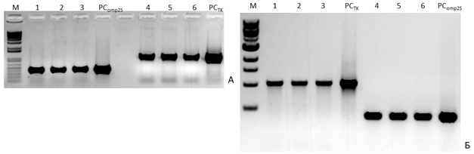
M – DNA length marker; 1,4 – clone 88A3; 2,5 – clone 88B1; 3,6 – clone 88B2; A – first passage;
B – fifth passage; PC – positive control (plasmid DNA)

Figure 26 – Results of PCR analysis determine the stability
of the recombinant virus rSPPV(TK-)omp25

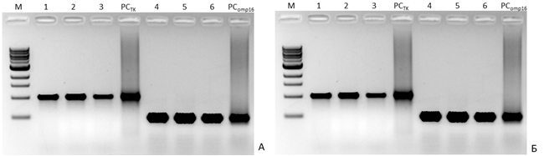
M – DNA length marker; 1,4 – clone 90A1; 2,5 – clone 93D7; 3,6 – clone 93G7; A – first passage;
B – fifth passage; PC – positive control (plasmid DNA)

Figure 27 – Results of PCR analysis determine the stability
of the recombinant virus rSPPV(TK-)omp16
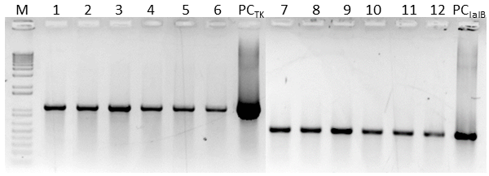
M – DNA length marker; 1,4,7,10 – clone 96A2; 2,5,8,11 – clone 96B2; 3,6,9,12 – clone 96B4; 1,2,3,7,8,9 – first passage; 4,5,6,10,11,12 – fifth passage; PC – positive control (plasmid DNA)

Figure 28 – Results of PCR analysis determine the stability
of the recombinant virus rSPPV(TK-)IalB

As can be seen from Figures 23-28, all the obtained recombinant viruses remain genetically stable for five consecutive passages (observation period) in the TC cell culture.

3.3 Evaluation of the humoral and cellular immunity activation of mice immunized with the recombinant sheep pox virus strains
At the first stage, the level of humoral and cellular immunity was determined in mice immunized twice with the rSPPV(TK-)omp19/sodC virus (clone 35B5) or in combination with a mixture of omp19 and sodC proteins for booster immunization. Then, a mixture of four viruses expressing proteins omp19/sodC, omp16, omp25, IalB and a mixture of the same bacterially expressed proteins was used to immunize mice.
The level of the humoral immune response was assessed by the method of enzyme immunoassay. It was found that a pronounced humoral immune response is formed when using a heterologous scheme of prime-booster immunization (Table 4). In this case, the levels of antibodies to the expressed proteins are determined by both the administered dose and the antigenic properties of the protein. The highest level of antibodies was recorded for Cu-Zn superoxide dismutase.
The activation of the cellular immune response was assessed by the level of interferon-gamma synthesis in ELISPOT. It has been established that recombinant sheep pox viruses, along with a humoral immune response, effectively induce a Th1 immune response. Stimulation of splenocytes with a mixture of recombinant Brucella proteins or heat-killed B. abortus S19 cells significantly increases the number of T-cells producing IFN-γ from mice immunized with recombinant sheep pox viruses (Figure 29).

Table 4 – The level of antibodies in the blood sera of mice immunized with recombinant sheep pox viruses (inverse values of titers in ELISA)
Immunizaion | Protein antibody titer
Immunizaion | Omp16 | Omp19 | Omp25 | L7/L12 | sodC | IalB
Опыт 1
RV(10⁶CPE₅₀)/P (20 µg) | - | 160 | - | - | 2560 | -
RV(10⁶CPE₅₀)/ RV(10⁶CPE₅₀) | - | <40 | - | - | 80 | -
B.melitensis Rev1 (10⁵ CFU) | - | <40 | - | - | 40 | -
Опыт 2
RV(10⁵CPE₅₀)/P (6 µg) | <20 | <20 | <20 | <20 | 80 | <20
P(6 µg)/RV(10⁵CPE₅₀) | 1280 | <20 | 1280 | 640 | 2560 | 1280
PBS | <20 | <20 | <20 | <20 | <20 | <20
B. abortus S19 (10⁵ CFU) | <20 | <20 | <20 | <20 | 40 | <20
Notes
RV – a mixture of recombinant viruses;
P – a mixture of proteins
PBS – phosphate buffered saline
"-" – research was not carried out

X-axis – prime booster immunization: PBS – phosphate buffered saline, V/P – virus mixture (prime)/protein mixture (booster), P/V – protein mixture (prime)/virus mixture (booster), B.a. – B. abortus strain S19;
mitogens: RPMI – nutrient medium RPMI1640 (non-stimulated control), P mix – mixture of recombinant proteins, B.a. – a single brucellosis antigen inactivated by boiling, Lectin – phytohemagglutinin (positive control).
Statistical analysis was performed using two-way ANOVA followed by Tukey's multiple comparisons test.
Data as shown as mean ±SD. ****P< 0,0001, **P< 0,01.

Figure 29 – Level of INFγ synthesis in ELISPOT

3.4 Study of the obtained strains protection on laboratory animals
The protectiveness (immunogenic efficiency) of recombinant sheep pox viruses rSPPV(TK-)omp19/sodC, SPPV(TK-)OMP16, SPPV(TK-)OMP25, SPPV(TK-)IalB was assessed by the degree of contamination of the spleen. The immunogenicity index was calculated as described in section 2.17. It was found that heterologous prime-booster immunization of mice with a mixture of recombinant sheep pox viruses in combination with recombinant proteins provided a high degree of protection of mice from infection with the virulent B. abortus 544 strain, comparable to the commercial live vaccine from the B. abortus S19 strain (Table 5, Figure 30).

Table 5 – Determination of the immunogenic efficacy (protection) of recombinant sheep viruses
Prime/buster immunization | Animal ID | Total microbial count (X) | Immunogenicity index (Y) | µ* | σ**
-/B. abortus (10⁵ CFU) | 1 | 675 | 2,38 | 2,49 | 0,10
-/B. abortus (10⁵ CFU) | 2 | 1000 | 2,52 | 2,49 | 0,10
-/B. abortus (10⁵ CFU) | 3 | 1500 | 2,67 | 2,49 | 0,10
-/B. abortus (10⁵ CFU) | 4 | 750 | 2,42 | 2,49 | 0,10
-/B. abortus (10⁵ CFU) | 5 | 825 | 2,45 | 2,49 | 0,10
-/B. abortus (10⁵ CFU) | 6 | 925 | 2,49 | 2,49 | 0,10
PBS/PBS  (control) | 7 | 262500 | 4,69 | 4,55 | 0,32
PBS/PBS  (control) | 8 | 167500 | 4,51 | 4,55 | 0,32
PBS/PBS  (control) | 9 | 280000 | 4,71 | 4,55 | 0,32
PBS/PBS  (control) | 10 | 302500 | 4,74 | 4,55 | 0,32
PBS/PBS  (control) | 11 | 292500 | 4,73 | 4,55 | 0,32
PBS/PBS  (control) | 12 | 37750 | 3,92 | 4,55 | 0,32
RV(10⁵CPE₅₀)/P (6 µg) | 13 | 5250 | 3,15 | 3,38 | 0,30
RV(10⁵CPE₅₀)/P (6 µg) | 14 | 7250 | 3,27 | 3,38 | 0,30
RV(10⁵CPE₅₀)/P (6 µg) | 15 | 7750 | 3,30 | 3,38 | 0,30
RV(10⁵CPE₅₀)/P (6 µg) | 16 | 8750 | 3,35 | 3,38 | 0,30
RV(10⁵CPE₅₀)/P (6 µg) | 17 | 6275 | 3,22 | 3,38 | 0,30
RV(10⁵CPE₅₀)/P (6 µg) | 18 | 43750 | 3,97 | 3,38 | 0,30
P(6 µg)/RV(10⁵CPE₅₀) | 19 | 6250 | 3,22 | 3,20 | 0,05
P(6 µg)/RV(10⁵CPE₅₀) | 20 | 5250 | 3,15 | 3,20 | 0,05
P(6 µg)/RV(10⁵CPE₅₀) | 21 | 5375 | 3,16 | 3,20 | 0,05
P(6 µg)/RV(10⁵CPE₅₀) | 22 | 6975 | 3,26 | 3,20 | 0,05
Notes
RV - a mixture of recombinant viruses;
P - a mixture of proteins
PBS - phosphate buffered saline
* - arithmetic mean Y
** - standard deviation

prime booster immunization: PBS – phosphate buffered saline, V/P – virus mixture (prime)/protein mixture (booster), P/V – protein mixture (prime)/virus mixture (booster), B.a. – B. abortus strain S19.
**** P <0.0001 compared with negative control groups.
Statistical analysis was performed using one way ANOVA followed by Tukey's multiple comparisons test.

Figure 30 – Determination of immunogenic effectiveness recombinant sheep pox viruses

Thus, recombinant sheep pox viruses expressing immunogenic proteins of Brucella, activate the cellular and humoral immune response in animals and provide protection of animals from infection with the virulent strain of B. abortus 544, comparable to the S19 vaccine.

4 Compilation and evaluation of research results
One of the important advances in recombinant DNA technology is the ability to integrate foreign genes into viral genomes. This allows viruses to be used as vectors for the delivery of antigens. The vaccinia virus was one of the first viruses, on the example of which the possibility of such a replacement was shown without losing the viability of the recombinant virus. Currently, influenza viruses, adenoviruses, etc. are also used as vectors. Potential vectors are many DNA-containing viruses that replicate in the nucleus or cytoplasm. Viruses replicating in the nucleus can integrate into cellular DNA, which can lead to viral persistence and cellular transformation. This fact is a good argument in favor of choosing "cytoplasmic" viruses, such as poxviruses, which are the largest viruses in animals.
Within the framework of this project, recombinant sheep pox viruses were obtained, in the genome of which the genes encoding protective proteins of brucella were integrated. We used an attenuated sheeppox virus, a NISKHI strain, which has been used for a long time to produce a live vaccine, and a recombinant sheeppox virus SPPV(TK-)EGFP expressing a green fluorescent protein. Neethling-RIBSP, an attenuated vaccine lumpy skin disease virus, was also considered as an alternative. The choice of protective proteins of brucella is based on the literature data, as well as on the results of studies obtained by the scientists of the RIBSP.
At the first stage of the project, the integration plasmids pIN-TK-omp16, pIN-TK-omp19, pIN-TK-omp25, pIN-TK-SOD, pIN-TK-L7/L12, pIN-TK-IalB were constructed. These plasmids provided integration into the viral genome of one of the target genes. Increasing the number of foreign genes carried by a single recombinant virus can improve vaccination efficiency, making recombinant vaccines more like traditional vaccines, which usually contain a set of antigens. Therefore, multiple expression of foreign genes in a single vector can provide higher protection. In this regard, the pIN-TK-omp19/SOD construct was obtained, which includes a chimeric gene encoding fragments of omp19 and SOD proteins linked by a G4S2 linker. The correctness of expressing cassettes of integrative vectors was confirmed by both sequencing and transient expression of the target proteins in a virus-infected cell culture 48 h after transfection.
We obtained recombinant viruses rSPPV(TK-)omp19 (clone 42C5), rSPPV(TK-)omp19/sodC (clone 35B5), rSPPV(TK-)omp16 (clones 90A1, 93D7, and 93G7), rSPPV(TK-)omp25 ( clones 88A3, 88B1 and 88B2), rSPPV(TK-)SOD (clones 81B2, 81C2, and 81D4), rSPPV(TK-)IalB (clones 96A2, 96B2 and 96B4) with inserted Brucella genes by the method of homologous recombination of the sheeppox virus genome. Recombinant viruses retained genetic stability for five consecutive passages (observation period) in the LT cell culture. Recombinant viruses were deposited in the Collection of Microorganisms of the RIBSP MES RK (APPENDIX D). An application for an invention has been submitted (APPENDIX B).
When performing the tasks, we optimized the method for producing recombinant viruses. It was found that the use of SPPV(TK-)EGFP as the initial (parental) virus significantly reduces the number of cloning rounds in the selection of recombinants. Plaques formed by the parent virus fluoresce with green light, while the resulting recombinants form non-fluorescent plaques. So, if to obtain recombinants based on the sheeppox virus of the NISKHI it was required from 5 to 10 or more rounds of cloning, when using SPPV(TK-)EGFP, it was possible to isolate genetically homogeneous recombinants in 2-3 rounds of cloning.
The resulting recombinant sheep pox viruses efficiently expressed inserted genes both at the transcriptional and translational levels in vitro. The specificity of the expressed antigens was confirmed by Western blotting. In permissive cells, the level of expression of target proteins was significantly higher. It should be noted that the presence of expression in non-permissive cells makes it possible to use recombinant sheep pox viruses as non-replicative vectors for the development of veterinary vaccines. Using the rSPPV(TK-)omp25 virus as an example, the level of expression of the target protein was quantified. It was found that 1 CPE₅₀ of the recombinant virus ensured the expression of about 120 fg of the target antigen 24 h after infection of the permissive cells. Thus, it can be assumed that in order to ensure the delivery of 10 μg of the target antigen, the administration of 10⁸ CPE₅₀ of the recombinant virus will be required.
The immunogenicity of the obtained recombinants was evaluated in mice. It should be noted that mice are not susceptible to sheeppox virus. And in this case, we evaluated the recombinant viruses as non-replicable vaccine vectors. To enhance their immunogenicity, a revaccination strategy was used. In most clinical trials, the delivery of antigens with a poxvirus vector is used in combination with other delivery modes (another vector, DNA vaccine, or recombinant proteins). It was found that the use of poxvirus as a booster component leads to an increase in the value of antigen-specific T-cell responses; whereas when used as a priming component in combination with a protein plus an adjuvant, it enhances B-cell responses and triggers effective antibody responses to a foreign antigen [61]. The recombinant capripoxviruses obtained during the implementation of the project induced a pronounced humoral immune response using a heterologous scheme of prime-booster immunization. In this case, the levels of antibodies to the expressed proteins are determined by both the administered dose and the antigenic properties of the protein. The highest level of antibodies was noted for Cu-Zn superoxide dismutase. Along with the humoral immune response, the recombinant viruses efficiently induced the Th1 immune response.
Challenging mice immunized with recombinant viruses in combination with the recombinant adjuvanted proteins with the virulent B. abortus strain 544 provide protection against challenge comparable to the S19 vaccine.
The planned studies were carried out in full. Work in this direction should be continued. Research should be aimed at improving the capripoxvirus vector itself aimed at increasing immunogenicity and increasing the number of insertion sites for foreign genes. When developing a vector vaccine against brucellosis, all target proteins should be integrated into one virus. Expression of multiple foreign genes by a single virus will increase vaccination efficiency and provide better protection against infection.

CONCLUSION

Based on the results of the studies carried out, the following conclusions can be drawn:
1. Seven genetic constructs were obtained for integration of Brucella spp. genes into the sheep pox virus genome: pIN-TK-omp16, pIN-TK-omp19, pIN-TK-omp25, pIN-TK-SOD, pIN-TK-L7/L12, pIN-TK-IalB and pIN-TK-omp19&SOD. The correctness of the expression cassettes in the integration plasmids was confirmed by the transient expression in the poxvirus system.
2. Genetically stable recombinant sheeppox viruses rSPPV(TK-)omp19 (clone 42C5), rSPPV(TK-)omp19/sodC (clone 35B5), rSPPV(TK-)omp16 (clones 90A1, 93D7 and 93G7), rSPPV(TK-)omp25 (clones 88A3, 88B1, and 88B2), rSPPV(TK-)SOD (clones 81B2, 81C2, and 81D4), rSPPV(TK-)IalB (clones 96A2, 96B2, and 96B4) were obtained. Viruses have been deposited in the Collection of Microorganisms of the Research Institute for Biological Safety Problems of the Science Committee of the Ministry of Education and Science of the Republic of Kazakhstan.
3. It was found that all recombinant viruses express the integrated target gene in vitro (in cell culture) and in vivo (in mice). Expression of target genes in both permissive and non-permissive cells makes it possible to use the resulting viruses for the development of not only replicative but also non-replicative vector vaccines.
4. Immunization of mice with recombinant viruses activated both humoral and cellular Th1 immune responses. The levels of antibodies to the expressed proteins are determined by both the dose administered and the antigenic properties of the protein. The highest level of antibodies was noted for Cu-Zn superoxide dismutase.
5 Immunization of mice with recombinant sheep pox viruses expressing brucella antigens provided a statistically significant decrease in the level of spleen contamination after challenge, comparable to the B. abortus S19 vaccine strain.
The planned research was carried out in full at a high scientific and technical level. Published 3 articles in journals recommended by the Committee for Control in the Sphere of Education and Science MES RK, 2 articles in peer-reviewed journals of the Scopus database, 1 thesis in the materials of an international conference, 1 patent for an invention was received and 1 application for an invention was filed. Recombinant viruses obtained as a result of the project can serve as a basis for the development of safe and effective means of preventing brucellosis. An optimized method for producing recombinant sheep pox viruses based on the NISKHI strain can be used to develop multivalent vector vaccines for veterinary medicine.

REFERENCES
1 Shuvalova E.P. Infectious diseases. – Moscow: Medicine, 2001.
2 Graves R.R. The story of John M. Buck’s and Matilda’s contribution to the cattle industry // J. Am. Vet. Med. Assoc. – 1943. – Vol. 102. – P. 193-195.
3 Crasta O.R., Folkerts O., Fei Z., Mane S.P., Evans C., Martino-Catt S., Bricker B., Yu G., Du L., Sobral B.W. Genome sequence of Brucella abortus vaccine strain S19 compared to virulent strains yields candidate virulence genes // PLoS ONE. – 2008. – Vol. 3 (5). – P. 2193.
4 Spink W.W., Hall J.W., Finstad J., Mallet E. Immunization with viable Brucella organisms. Results of a safety test in humans // Bull. World Health Organ. – 1962. – Vol. 26. – P. 409-419.
5 Ashford D.A., di Pietra J., Lingappa J., Woods C., Noll H., Neville B., Weyant R., Bragg S.L., Spiegel R.A., Tappero J., Perkins B.A. Adverse events in humans associated with accidental exposure to the livestock brucellosis vaccine RB51 // Vaccine. – 2004. – Vol. – 22 (25-26). – P. 3435-3439.
6 Ebel E.D., Williams M.S., Tomlinson S.M. Estimating herd prevalence of bovine brucellosis in 46 USA states using slaughter surveillance // Prev. Vet. Med. – 2008. – Vol. 85 (3-4). – P. 295-316.
7 Treanor J.J., Johnson J.S., Wallen R.L., Cilles S., Crowley P.H., Cox J.J., Maehr D.S., White P.J., Plumb G.E. Vaccination strategies for managing brucellosis in Yellowstone bison // Vaccine. – 2010. – Vol. 28, Suppl 5. – P. F64-F72.
8 Galindo R.C., Muñoz P.M., de Miguel M.J., Marin C.M., Labairu J., Revilla M., Blasco J.M., Gortazar C., de la Fuente J. Gene expression changes in spleens of the wildlife reservoir species, Eurasian wild boar (Sus scrofa), naturally infected with Brucella suis biovar 2 // J. Genet. Genomics. – 2010. – Vol. 37 (11). – P. 725-736.
9 Olsen S.C., Hennager S.G. Immune responses and protection against experimental Brucella suis biovar 1 challenge in nonvaccinated or B. abortus strain RB51-vaccinated cattle // Clin. Vaccine Immunol. – 2010. Vol. 17 (12). – P. 1891-1895.
10 Scurlock B.M., Edwards W.H. Status of brucellosis in free-ranging elk and bison in Wyoming // J. Wildl. Dis. – 2010. – Vol. 46 (2). – P. 442-449.
11 Thorne E.T. Brucellosis, bison, elk, and cattle in the Greater Yellowstone area: defining the problem, exploring solutions. – Cheyenne: Wyoming Game and Fish Dept. [for] Greater Yellowstone Interagency Brucellosis Committee, 1997. – 219 p.
12 Cheville N.F., Stevens M.G., Jensen A.E., Tatum F.M., Halling S.M. Immune responses and protection against infection and abortion in cattle experimentally vaccinated with mutant strains of Brucella abortus // Am. J. Vet. Res. – 1993. – Vol. 54 (10). – P. 1591-1597.
13 Yagupsky P., Baron E. Laboratory Exposures to Brucellae and Implications for Bioterrorism // Emerging Infectious Diseases. – 2005. – Vol. 11 (8). – P. 1180-1185. doi:10.3201/eid1108.041197.
14 Audic S., Lescot M., Claverie J.M., Scholz H.C. Brucella microti: the genome sequence of an emerging pathogen // BMC Genomics. – 2009. – Vol. 10 (1). – P. 352.
15 Carroll M.W., Overwijk W.W., Surman D.R., Tsung K., Moss B., Restifo N.P. Construction and characterization of a triple-recombinant vaccinia virus encoding B7-1, interleukin 12, and a model tumor antigen // J. Natl. Cancer. Inst. – 1998. – Vol. 90 (24). – P. 1881-1887.
16 Boyle D.B., Anderson M.A., Amos R., Voysey R., Coupar B.E. Construction of recombinant fowlpox viruses carrying multiple vaccine antigens and immunomodulatory molecules // Biotechniques. – 2004. – Vol. 37 (1). – P. 104-106, 108-111.
17 Perrin A., Albina E., Bréard E., Sailleau C., Promé S., Grillet C., Kwiatek O., Russo P., Thiéry R., Zientara S., Cêtre-Sossah C. Recombinant capripoxviruses expressing proteins of bluetongue virus: evaluation of immune responses and protection in small ruminants // Vaccine. – 2007. – Vol. 25 (37-38). – P. 6774-6783.
18 Wang L., Whitbeck J.C., Lawrence W.C., Volgin D.V., Bello L.J. Expression of the genomic form of the bovine viral diarrhea virus E2 ORF in a bovine herpesvirus-1 vector // Virus Genes. – 2003. – Vol. 27 (1). – P. 83-91.
19 Takashima Y., Xuan X., Kimata I., Iseki M., Kodama Y., Nagane N., Nagasawa H., Matsumoto Y., Mikami T., Otsuka H. Recombinant bovine herpesvirus-1 expressing p23 protein of Cryptosporidium parvum induces neutralizing antibodies in rabbits // J. Parasitol. – 2003. – Vol. 89 (2). – P. 276-282.
20 Shiver J.W., Fu T.M., Chen L., Casimiro D.R., Davies M.E., Evans R.K. et al. Replication-incompetent adenoviral vaccine vector elicits effective anti-immunodeficiency-virus immunity // Nature. – 2002. – Vol. 415 (6869). – P. 331-335.
21 Muruve D.A. The innate immune response to adenovirus vectors // Hum Gene Ther. – 2004. – Vol. 15 (12). – P. 1157-1166.
22 Iglesias M.C., Frenkiel M.P., Mollier K., Souque P., Despres P., Charneau P. A single immunization with a minute dose of a lentiviral vector-based vaccine is highly effective at eliciting protective humoral immunity against West Nile virus // J. Gene. Med. – 2006. – Vol. 8 (3). – P. 265-274.
23 Schwantes A., Truyen U., Weikel J., Weiss C., Löchelt M. Application of chimeric feline foamy virus-based retroviral vectors for the induction of antiviral immunity in cats // J. Virol. – 2003. – Vol. 77 (14). – P. 7830-7842.
24 Consortium of recombinant strains Flu-NS1-124-L7 / L12-H5N1, Flu-NS1-124-Omp16-H5N1, Flu-NS1-124-L7 / L12-H1N1 and Flu-NS1-124-Omp16-H1N1 influenza A virus, family Ortomyxoviridae, genus Influenzavirus, expressing brucellosis immunodominant proteins, intended for the production of anti-brucellosis vaccine: p / n No. 28457 RK, IPC C12N 7/00 A61K 39/10 / Sansyzbay A.R., Tabynov K.K., Espembetov B.A. ., Sultankulova K.T., Khairullin B.M., Sandybaev N.T., Egorov A.Yu .; applicant of the RSE on PVC NIIPBB KN MES RK, application No. 2013 / 0790.1 dated 06/14/2013; publ. 05/15/2014 // Industrial property. Official Bulletin. - 2015. - No. 5. (In Russian)
25 Tabynov K., Sansyzbay A., Kydyrbayev Z., Yespembetov B., Ryskeldinova S., Zinina N., Assanzhanova N., Sultankulova K., Sandybayev N., Khairullin B., Kuznetsova I., Ferko B., Egorov A. Influenza viral vectors expressing the Brucella OMP16 or L7/L12 proteins as vaccines against B. abortus infection // Virol. J. – 2014. – Vol. 11. – P. 69. doi:10.1186/1743-422X-11-69.
26 Tabynov K., Kydyrbayev Z., Ryskeldinova S., Yespembetov B., Zinina N., Assanzhanova N., Kozhamkulov Y., Inkarbekov D., Gotskina T., Sansyzbay A. Novel influenza virus vectors expressing Brucella L7/L12 or Omp16 proteins in cattle induced a strong T-cell immune response, as well as high protectiveness against B. abortus infection // Vaccine. – 2014. – Vol. 32 (18). – P. 2034-2041. doi: 10.1016/j.vaccine.2014.02.058.
27 Merchlinsky M., Moss B. Introduction of foreign DNA into the vaccinia virus genome by in vitro ligation: recombination-independent selectable cloning vectors // Virology. – 1992. – Vol. 190 (1). – P. 522-526.
28 Mackett M., Smith G.L., Moss B. Vaccinia virus: A selectable eukaryotic cloning and expression vector // Proceedings of the National Academy of Sciences. – 1982. – Vol. 79. – P. 7415-7419.
29 Coupar B.E., Andrew M.E., Both G.W., Boyle, D.B. Temporal regulation of influenza haemagglutin expression in vaccinia virus recombinants and effects of the immune response. // European Journal of Immunology. – 1986. – Vol. 16. – P. 1479-1487.
30 Andrew M.E., Coupar B.E.H., Boyle D.B. Humoral and cell-mediated immune responses to recombinant vaccinia viruses in mice // Immuology and Cell Biology. – 1989. Vol. 67. – P. 331-337.
31 Chervyakova O.V., Strochkov V.M., Taylakova E.T., Sultankulova K.T., Sandybaev N.T. Construction of Integration Plasmids for Recombination of the Sheeppox Virus Genome // Eurasian Journal of Applied Biotechnology. – 2017. – № 1. – P. 64-67. (In Russian)
32 Falkner F.G., Moss B. Transient dominant selection of recombinant vaccinia viruses // Journal of Virology. – 1990. – Vol. 64. – P. 3108-3111.
33 Weir J.P., Bajszar G., Moss B. Mapping of the vaccinia virus thymidine kinase gene by marker rescue and by cell-free translation of selected mRNA // Proceedings of the National Academy of Sciences. – 1982. – Vol. 79. – P. 1210-1214.
34 Sam C.K., Dumbell K.R. Expression of poxvirus DNA in coinfected cells and marker rescue of thermosensitive mutants by subgenomic fragments of DNA // Annales de Virology. – 1981. – Vol. 132. – P. 135-150.
35 Glick B.R. Molecular biotechnology: principles and applications of recombinant DNA / Bernard R. Glick, Jack J. Pasternak, and Cheryl L. Patten. – 4th ed. ASM Press, 2010.
36 Merchlinsky M., Eckert D., Smith E., Zauderer M. Construction and characterisation of vaccinia virus direct ligation vectors // Virology. – 1997. – Vol. 238. – P. 444-451.
37 Dubbs D.R., Kit S. Isolation and properties of vaccinia mutants deficient in thymidine kinase-inducing activity // Virology. – 1964. – Vol. 22. – P. 214-225.
38 Byrd C.M., Hruby D.E. Construction of recombinant vaccinia virus: cloning into the thymidine kinase locus // Methods Mol Biol. – 2004. – Vol. 269. – P. 31-40.
39 Amano H., Morikawa S., Shimizu H., Shoji I., Kurosawa D., Matsuura Y., Miyamura T., Ueda Y. Identification of the canarypox virus thymidine kinase gene and insertion of foreign genes // Virology. – 1999. – Vol. 256. – P. 280-290.
40 Letellier C. Role of the TK+ phenotype in the stability of pigeonpox virus recombinant // Arch Virol. – 1993. – Vol. 131(3-4). – P. 431-439.
41 Scheiflinger F., Falkner F.G., Dorner F. Role of the fowlpox virus thymidine kinase gene for the growth of FPV recombinants in cell culture // Arch Virol. – 1997. – Vol. 142 (12). – P. 2421-2431.
42 Gubser C., Hué S., Kellam P., Smith G.L. Poxvirus genomes: a phylogenetic analysis // J Gen Virol. – 2004. – Vol. 85 (1). – P.105-117.
43 Upton C., Slack S., Hunter A.L., Ehlers A., Roper R.L. Poxvirus Orthologous Clusters: toward Defining the Minimum Essential Poxvirus Genome // J. Virol. – 2003. – Vol. 77, No. 13. – P. 7590–7600
44 Buller R.M.L., Smith G.L., Cremer K., Notkins A.L., Moss B. Decreased virulence of recombinant vaccinia virus expression vectors is associated with a thymidine kinase negative phenotype // Nature (London). – 1985. – Vol. 317. – P. 813-815.
45 Lee M.S., Roos J.M., McGuigan L.C., Smith K.A., Cormier N., Cohen L.K., Roberts B.E., Payne L.G. Molecular attenuation of vaccinia virus: mutant generation and animal characterization // J Virol. – 1992. – Vol. 66 (5). – P. 2617-2630. PMID:1560521
46 Aspden K., van Dijk A.A., Bingham J., Cox D., Passmore J.A., Williamson A.L. Immunogenicity of a recombinant lumpy skin disease virus (Neethling vaccine strain) expressing the rabies virus glycoprotein in cattle // Vaccine. – 2002. – Vol. 20 (21-22). – P. 2693-2701. PMID: 12034095
47 Miner J.N., Tamin A., Hruby D.E. Anchoring a vaccinia virus promoter in the nucleus prevents its trans-activation by viral infection // Virus Genes. – 1990. – Vol. 3 (4). – P. 355-359.
48 Yang Z., Bruno D.P., Martens C.A., Porcella S.F., Moss B. Simultaneous high-resolution analysis of vaccinia virus and host cell transcriptomes by deep RNA sequencing // Proc Natl Acad Sci USA. – 2010. – Vol. 107 (25). – P. 11513-11518. doi:10.1073/pnas.1006594107.
49 Rubins K.H., Hensley L.E., Bell G.W., Wang C., Lefkowitz E.J., Brown P.O., Relman D.A., Califano A. Comparative analysis of viral gene expression programs during poxvirus infection: a transcriptional map of the vaccinia and monkeypox genomes // PLoS One. – 2008. – Vol. 3 (7). – P. e2628. doi:10.1371/journal.pone.0002628.
50 Broyles S.S. Vaccinia virus transcription // J Gen Virol. – 2003. – Vol. 84 (9). – P. 2293-2303. doi:10.1099/vir.0.18942-0.
51 Orubu T., Alharbi N.K., Lambe T., Gilbert S.C., Cottingham M.G. Expression and cellular immunogenicity of a transgenic antigen driven by endogenous poxviral early promoters at their authentic loci in MVA // PLoS One. – 2012. – Vol. 7 (6). – P. e40167. doi: 10.1371/journal.pone.0040167.
52 Baur K., Brinkmann K., Schweneker M., Patzold J., Meisinger-Henschel C., Hermann J., Steigerwald R., Chaplin P., Suter M., Hausmann J. Immediate-Early Expression of a Recombinant Antigen by Modified Vaccinia Virus Ankara Breaks the Immunodominance of Strong Vector-Specific B8R Antigen in Acute and Memory CD8 T-Cell Responses // J Virol. – 2010. – Vol. 84, No. 17. – P. 8743-8752. doi:10.1128/JVI.00604-10.
53 Chakrabarti S., Sisler J.R., Moss B. Compact, synthetic, vaccinia virus early/late promoter for protein expression // Biotechniques. – 1997. – Vol. 23 (6). – P. 1094-1097.
54 Davison A.J., Moss B. New vaccinia virus recombination plasmids incorporating a synthetic late promoter for high level expression of foreign proteins // Nucleic Acids Res. – 1990. – Vol. 18 (14). – P. 4285-4286.
55 Prideaux C.T., Kumar S., Boyle D.B. Comparative analysis of vaccinia virus promoter activity in fowlpox and vaccinia virus recombinants // Virus Res. – 1990. – Vol. 16 (1). – P. 43-57.
56 Tripathy D.N., Wittek R. Regulation of foreign gene in fowlpox virus by a vaccinia virus promoter // Avian Dis. – 1990. – Vol. 34 (1). – P. 218-220.
57 Alharbi N.K. Poxviral promoters for improving the immunogenicity of MVA delivered vaccines // Human Vaccines & Immunotherapeutics. – 2018. DOI:10.1080/21645515.2018.1513439.
58 Whatmore A.M. Current understanding of the genetic diversity of Brucella, an expanding genus of zoonotic pathogens // Infect Genet Evol. – 2009. Vol. 9 (6). – P. 1168-1184.
59 Maniatis T., Fritsch E., Sambrook J. Methods of genetic engineering. Molecular cloning. – M.: Mir, 1984.
60 Brucellosis (Brucella abortus, B. melitensis and B. suis). In: Manual of Diagnostic Tests and Vaccines for Terrestrial Animals 2019. https://www.oie.int/fileadmin/Home/eng/Health_standards/tahm/3.01.04_BRUCELLOSIS.pdf (Доступно 19 августа 2020)
61 García-Arriaza J., Esteban M. Enhancing poxvirus vectors vaccine immunogenicity // Human Vaccines & Immunotherapeutics. – 2014. – Vol. 10 (8). – P. 2235-2244. DOI: 10.4161/hv.28974

APPENDIX А
Work Schedule

Project title: AP05133746 “Construction of recombinant capripoxviruses expressing protective antigens of Brucella spp. and studying their immunobiological properties”
Job code, stage | The name of the work under the contract and the main stages of its implementation | Period of execution |  | Expected results
Job code, stage |  | start | end | Expected results
3. | Construction of the recombinant strains encoding omp19, SodC, omp16, L7 / L12, bp26, IalB and omp25 genes, based on the sheep pox virus vaccine strain "NISKhI", and determining their expression level. | January 2018 | 1 November 2018 | Work will be begin on the creation of recombinant strains encoding genes of proteins omp19, SodC, omp16, L7 / L12 based on the vaccine strain of the sheep pox virus "NISKhI" and their expression level will be determined.
3.1 | Construction of integration plasmids | January 2018 | June 2018 | Integration plasmids will be designed
3.2 | Development of recombinant sheep pox virus strains | July 2018 | 1 November 2018 | The production of recombinant strains of sheep pox virus will be started.  Publication of 1 article in journals recommended by the СCSES MES RK
3. | Construction of the recombinant strains encoding omp19, SodC, omp16, L7 / L12, bp26, IalB and omp25 genes, based on the sheep pox virus vaccine strain "NISKhI", and determining their expression level. | January 2019 | 1 November 2019 | Work will be continue on the creation of recombinant strains encoding genes of proteins omp19, SodC, omp16, L7 / L12 based on the vaccine strain of the sheep pox virus "NISKhI" and their expression level will be determined.
3.2 | Development of recombinant sheep pox virus strains | January 2019 | 1 November 2019 | The production of recombinant strains of sheep pox virus will be started.  Publication of 1 article in journals recommended by the СCSES MES RK
3.3 | Estimation of expression level of target genes in cell culture | October 2019 | 1 November 2019 | Studies to assess the level of expression of target genes will begin
4 | Evaluation of the stability of the recombinant sheep pox virus strains | October 2019 | 1 November 2019 | Studies to assess the stability of recombinant strains of sheeppox virus will begin
3. | Construction of the recombinant strains encoding omp19, SodC, omp16, L7 / L12, bp26, IalB and omp25 genes, based on the sheep pox virus vaccine strain "NISKhI", and determining their expression level. | January 2020 | 1 November 2020 | Work will be completed on the creation of recombinant strains encoding genes of proteins omp19, SodC, omp16, L7 / L12 based on the vaccine strain of the sheep pox virus "NISKhI" and their expression level will be determined.
3.3 | Estimation of expression level of target genes in cell culture | January 2020 | March 2020 | Studies to assess the level of expression of target genes will be completed
4 | Evaluation of the stability of the recombinant sheep pox virus strains | January 2020 | March 2020 | Studies to assess the stability of recombinant strains of sheep pox virus will be completed
5 | Evaluation of the humoral and cellular immunity activation of mice immunized with the recombinant sheep pox virus strains | January 2020 | June 2020 | The level of activation of the humoral and cellular links of immunity of mice immunized with recombinant strains of sheeppox virus will be assessed
6 | Study of the obtained strains protection on laboratory animals | April 2020 | 1 November 2020 | The protectiveness of the obtained strains on laboratory animals will be studied. Publication of 2 articles in peer-reviewed journals included in Web of Science or Scopus. Application have been filed for recombinant strains of sheep pox virus expressing Brucella proteins.

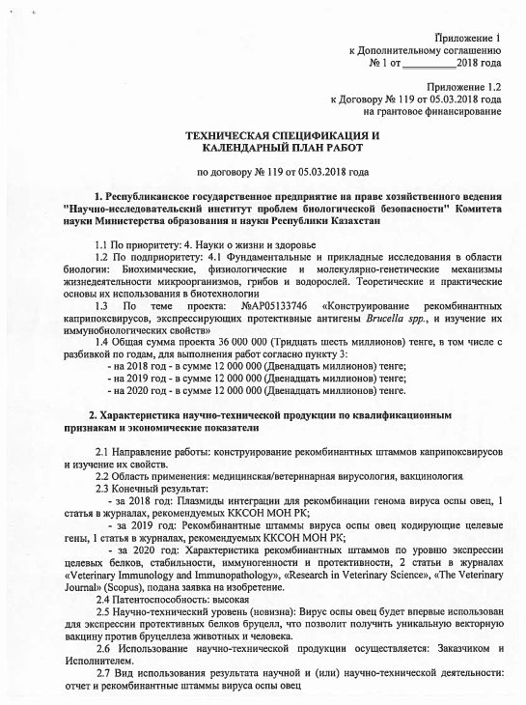
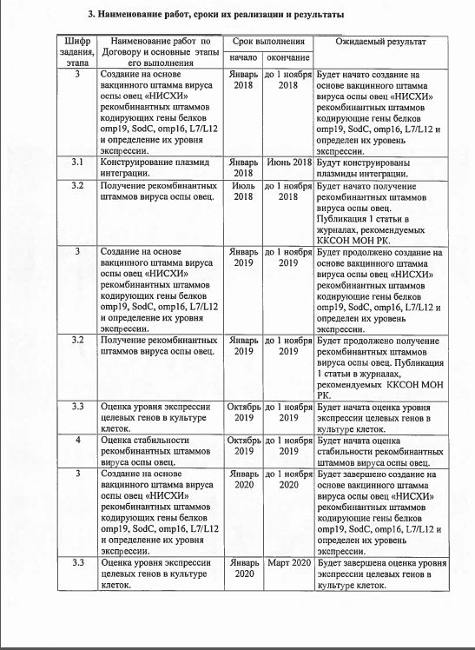
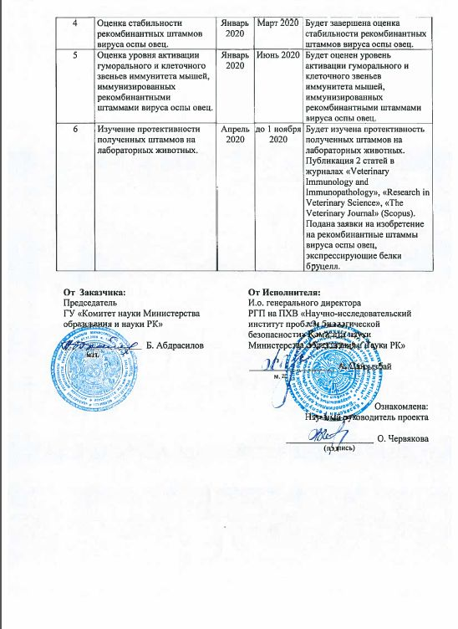
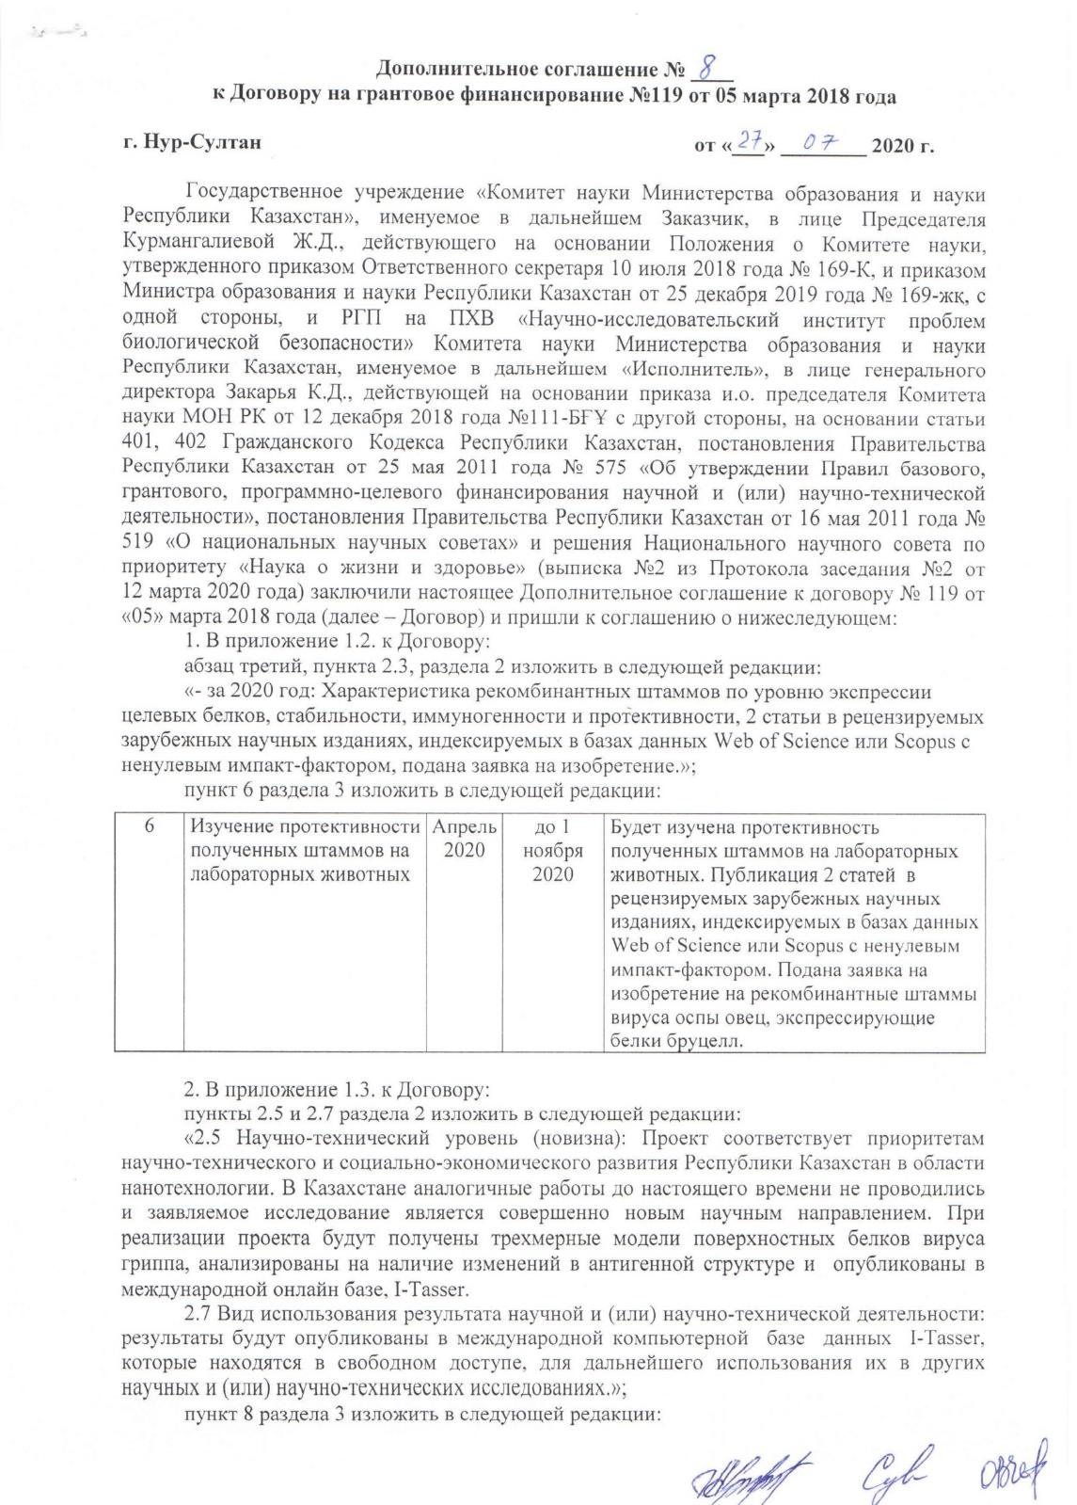
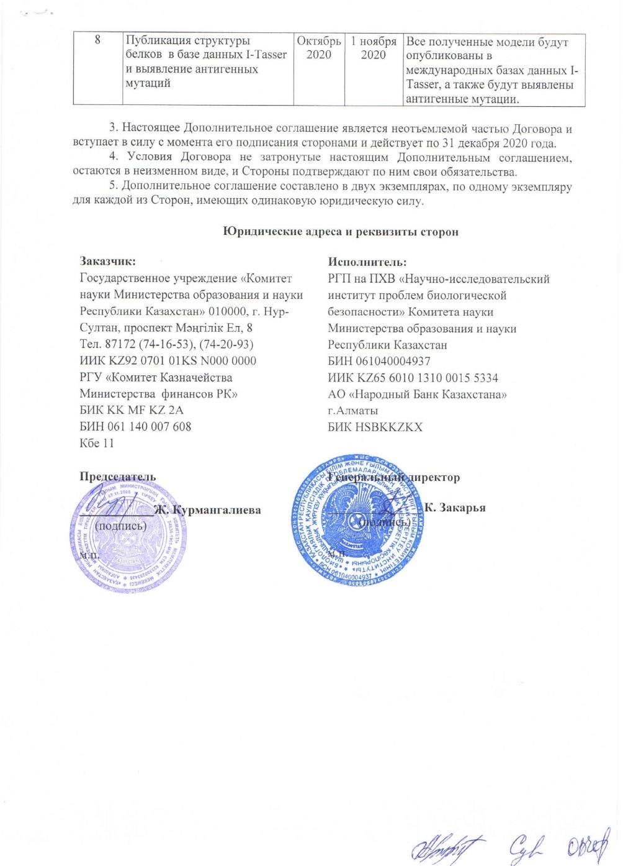

APPENDIX B
List of published works

2018
1 Recombinant plasmid DNA pINT-TKsppv and pINT-RRsppv with the ability to integrate into the genome of the sheep pox virus: p No. 33028 RK, IPC C12N 15/09 (2006.01), C12N 15/11 (2006.01), C12N 15/70 (2006.01), A61K 39/285 / Chervyakova O.V.; Strochkov V.M.; Sultankulova K.T .; Sandybayev N.T .; Sansyzbay A.R .; Applicant for RSE RIBSP SC MES RK, application No. 2017/0255.1 dated 10.04.2017; publ. 08/20/2018 // Industrial property. Official Bulletin. - 2018. - No. 31 (In Russian)
2 Sadikaliyeva S., Chervyakova O., Strochkov V., Sultankulova K., Sandybaeyv N. Sheep Pox Virus NISKhI to Develop a Vector for Veterinary Vaccines. In: XXII International Poxvirus, Asfarvirus and Iridovirus Conference. Academia Sinica, Taipei, Taiwan, May 26-31, 2018. – P8-068.

2019
3 Issabek A.U., Tailakova E.T., Shynybekova G.O., Strochkov V.M., Chervyakova O.V. Expression and purification of IalB protein Brucella spp. // Bulletin of the Karaganda State University. Series “Biology. The medicine. Geography". – 2019. – No. 3 (95). – P. 59-65. ISSN 2518-7101 (In Russian)

2020
4 S.O.Sadikaliyeva, E.T. Taylakova, A.U. Issabek, K.T. Sultankulova, Chervyakova O.V. Construction, expression and purification of the outer membrane protein omp25 Brucella spp. in the bacterial system // Izdenister, nətizheler - Research and results. – 2020. – No. 2 (86). – P. 162-169. ISSN 2304-3334 (In Russian)
5 Tailakova E.T., Sadikaliyeva S.О., Shynybekova G.O., Abubakirova A.K., Sultankulova K.T., Chervyakova O.V. Construction, expression and purification of Brucella spp. recombinant proteins L7/L12 and sodC in E. coli // News of the National Academy of Sciences of The Republic of Kazakhstan. Series of biological and medical. – 2020. - №2(338). – P. 20-30. ISSN 2224-5308. https://doi.org/10.32014/2020.2519-1629.9
6 Sadikaliyeva S.O., Tailakova E.T., Issabek A.U., Shynybekova G.O., Sultankulova K.T., Chervyakova O.V. Development and application of an indirect competitive ELISA method for assessing the expression level of the protein OMP25 Brucella spp. recombinant sheeppox virus // Biosafety and Biotechnology. – 2020. – No. 2. – P.48-52. ISSN 2707-7241. (In Russian)
7 Chervyakova, O., Tailakova, E., Sadikaliyeva, S., Orynbayev, M., & Sultankulova, K. Capripoxvirus vectors for vaccine development. // Gene Reports. – 2020. https://doi.org/10.1016/j.genrep.2020.100890 (Scopus percentile – 7 %, 2019)
8 Orynbayev M.B., Nissanova R.K., Argimbayeva T.U., Zakarya K.D., Myrzakhmetova B.S., Melisbek A.M., Barmak S.M., Issabek A.U., Nakhanov A.K., Shevtsov A., Kozhabergenov N.S., Sultankulova K.T. Genomic Sequence of the New Attenuated Vaccine Strain Neethling-RIBSP of the Lumpy Skin Disease Virus // Microbiology Resource Announcements. – 2020. – Vol. 9 (26): e00318-20; DOI: 10.1128/MRA.00318-20 (Scopus percentile – 45 %, 2019)
9 Recombinant sheep pox viruses SPPV(TK-)OMP16, SPPV(TK-)OMP19, SPPV(TK-)OMP25, SPPV(TK-)SOD, SPPV(TK-)IalB, Poxviridae family, genus Capripoxvirus, expressing immunogenic proteins of brucella for the development of a vector anti-brucellosis vaccine: application for an invention / OV Chervyakova, ET Tailakova, SO Sadikalieyva, G. Shynybekova, KT Sultankulova; Applicant RSE RIBSP SC MES RK, application No. 2020 / 0730.1 dated 21.10.2020 (In Russian)
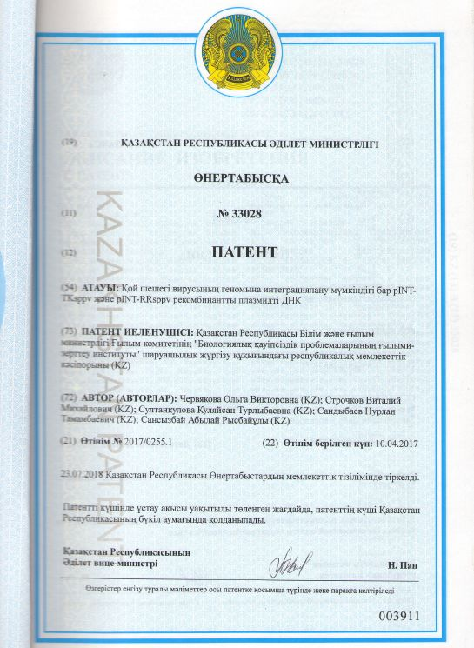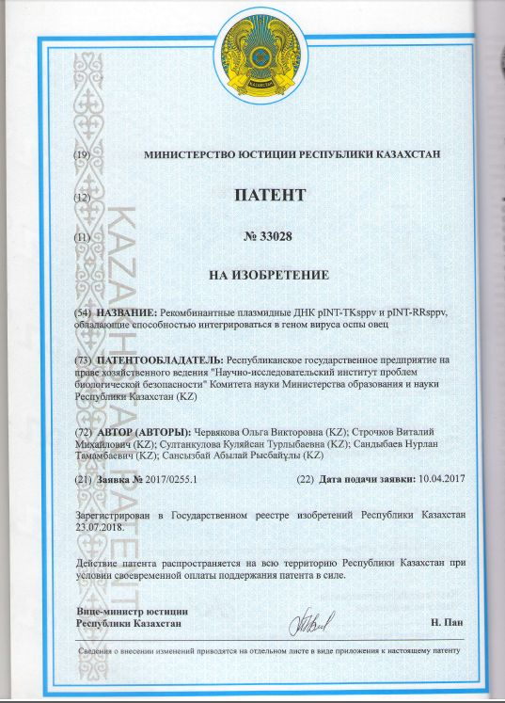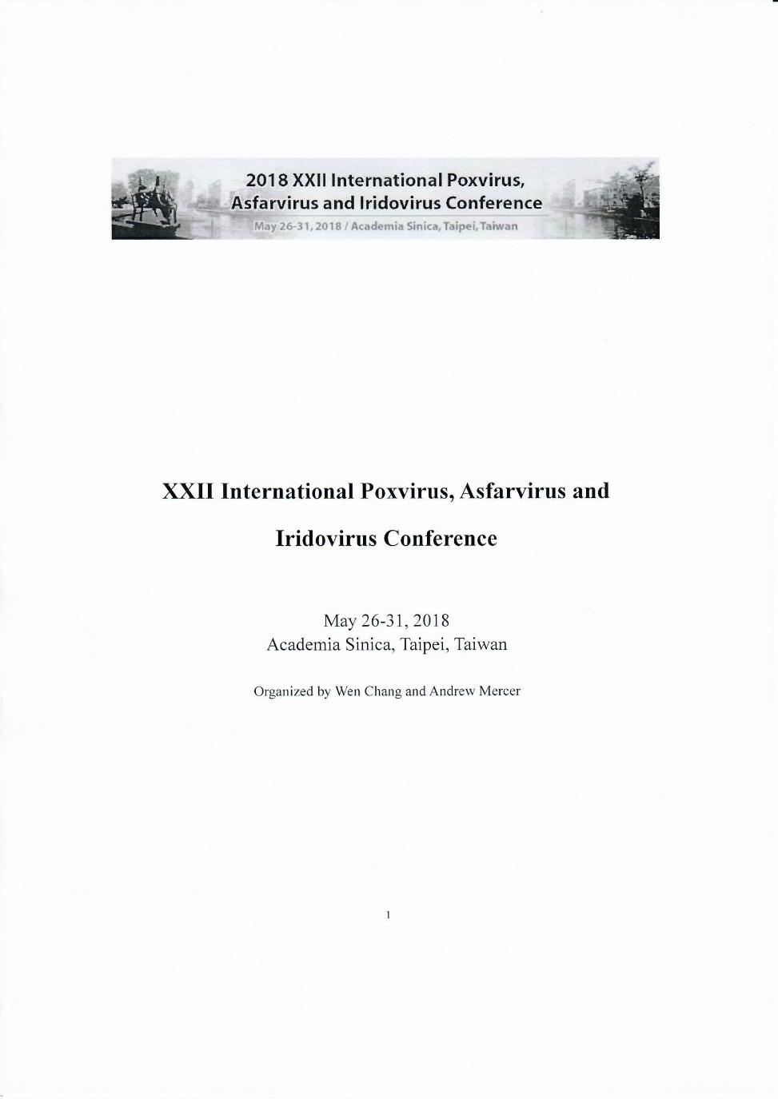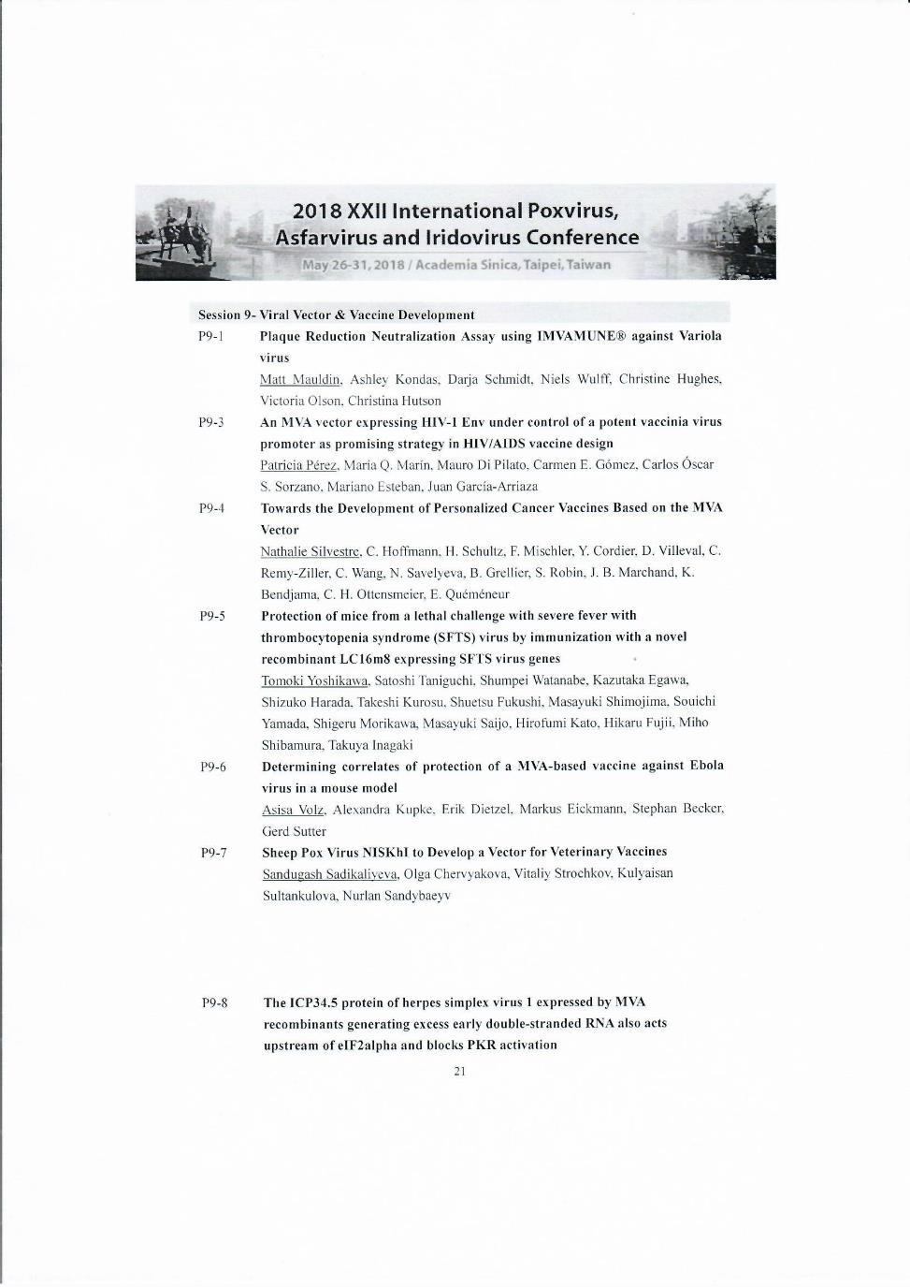

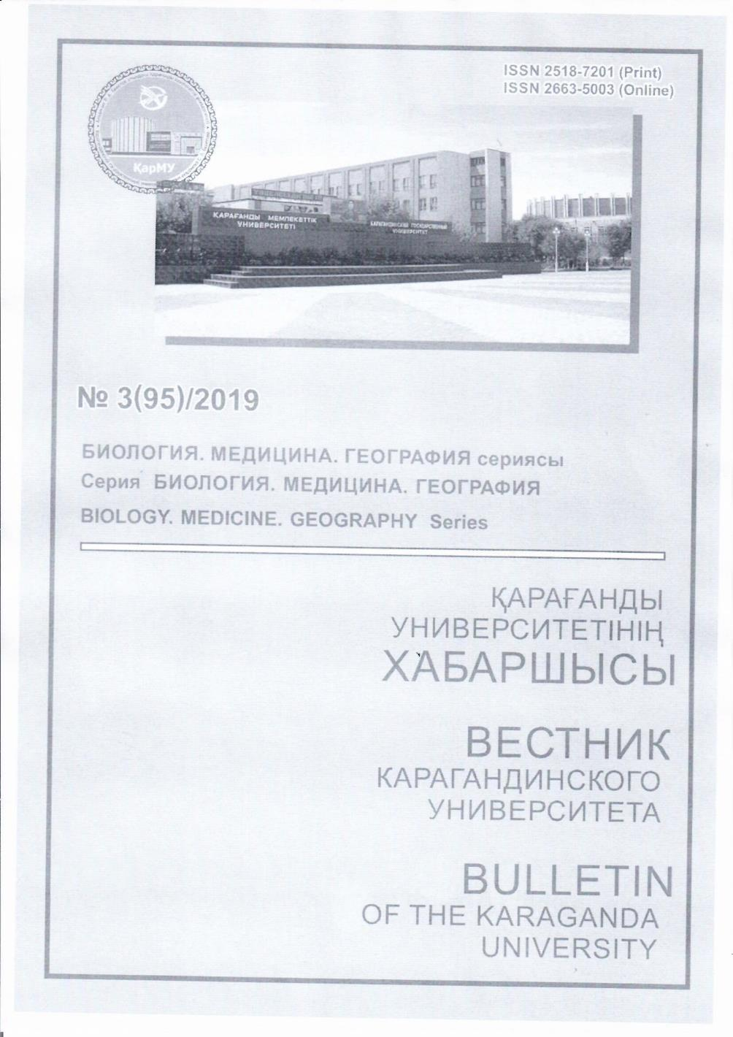

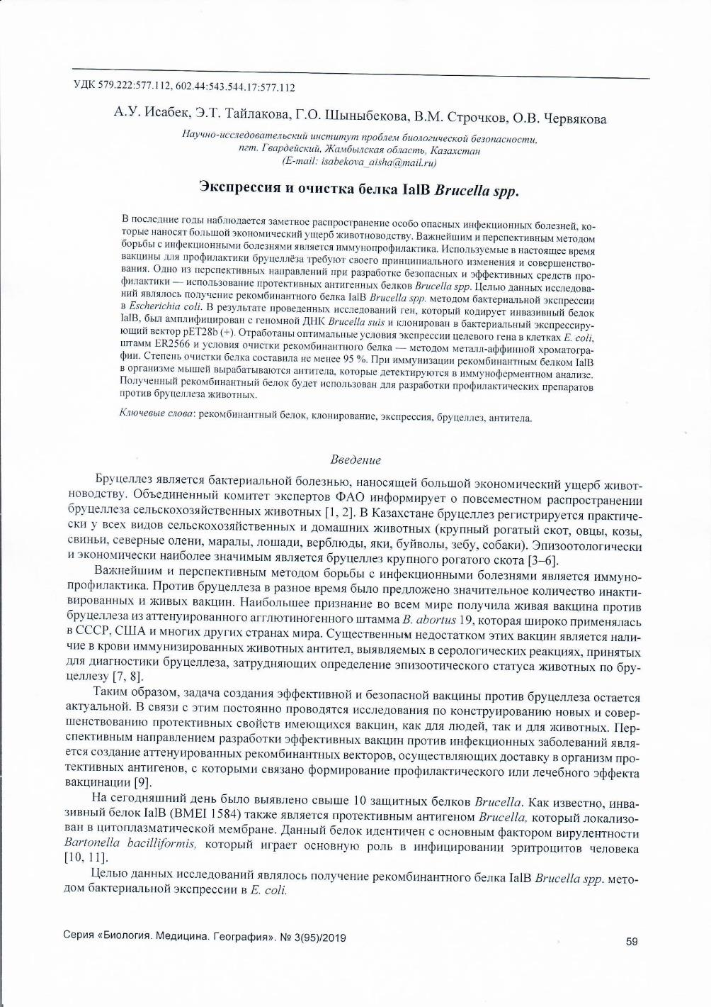
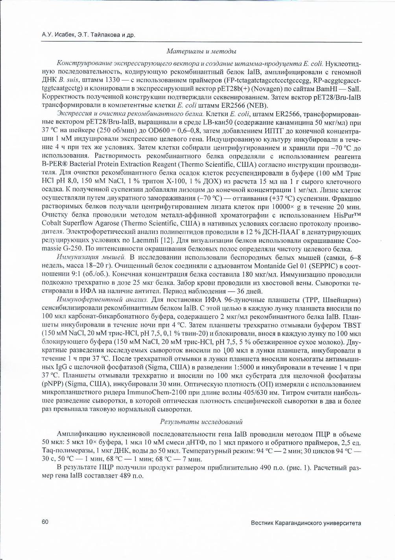
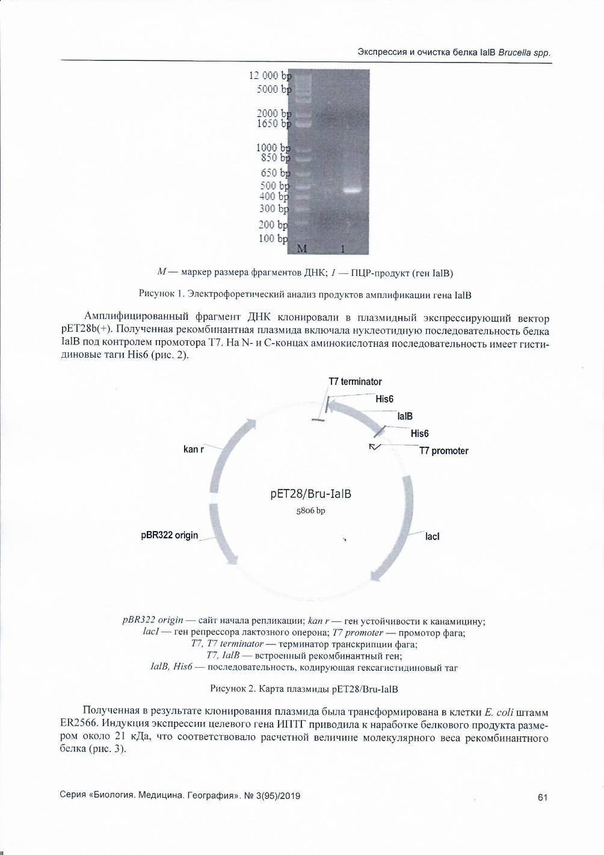
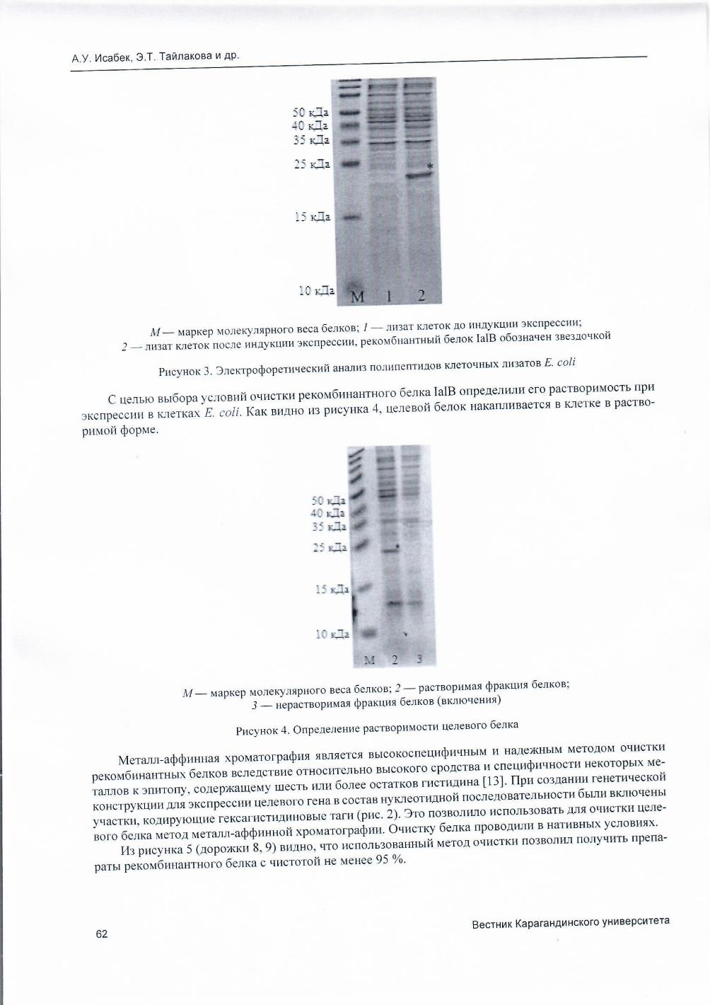
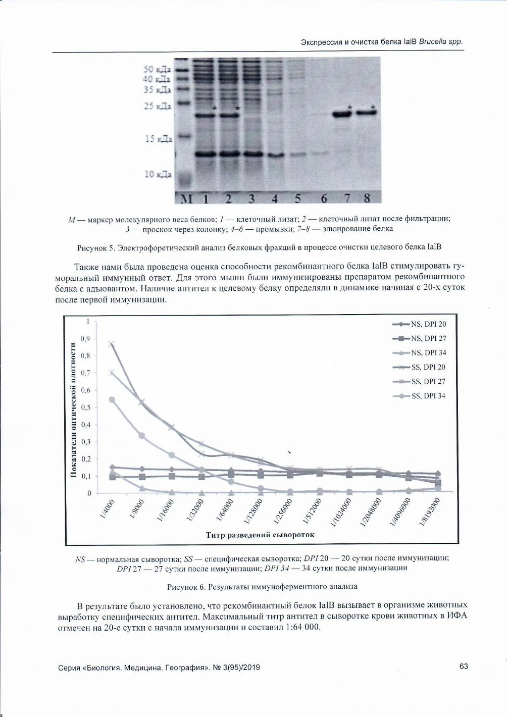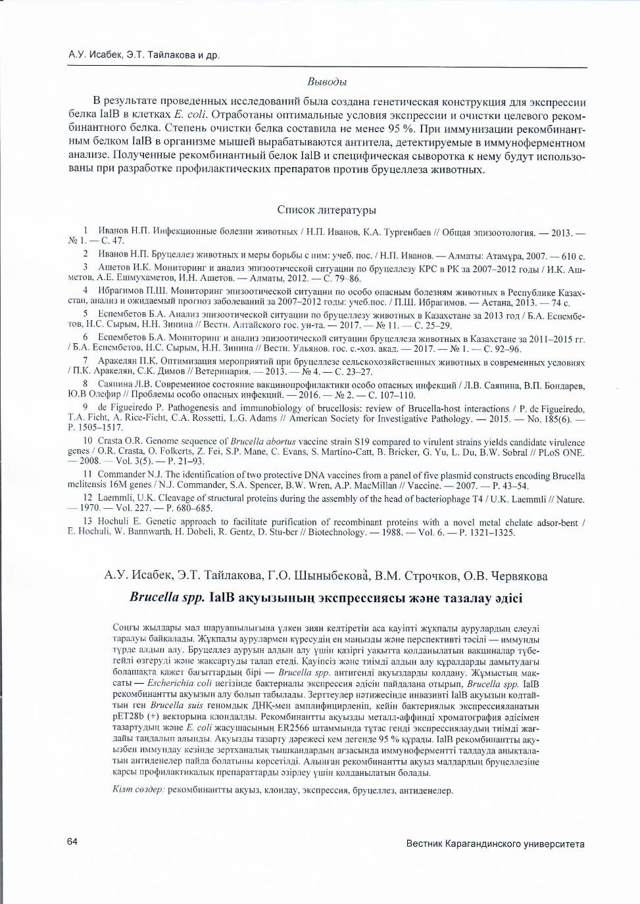
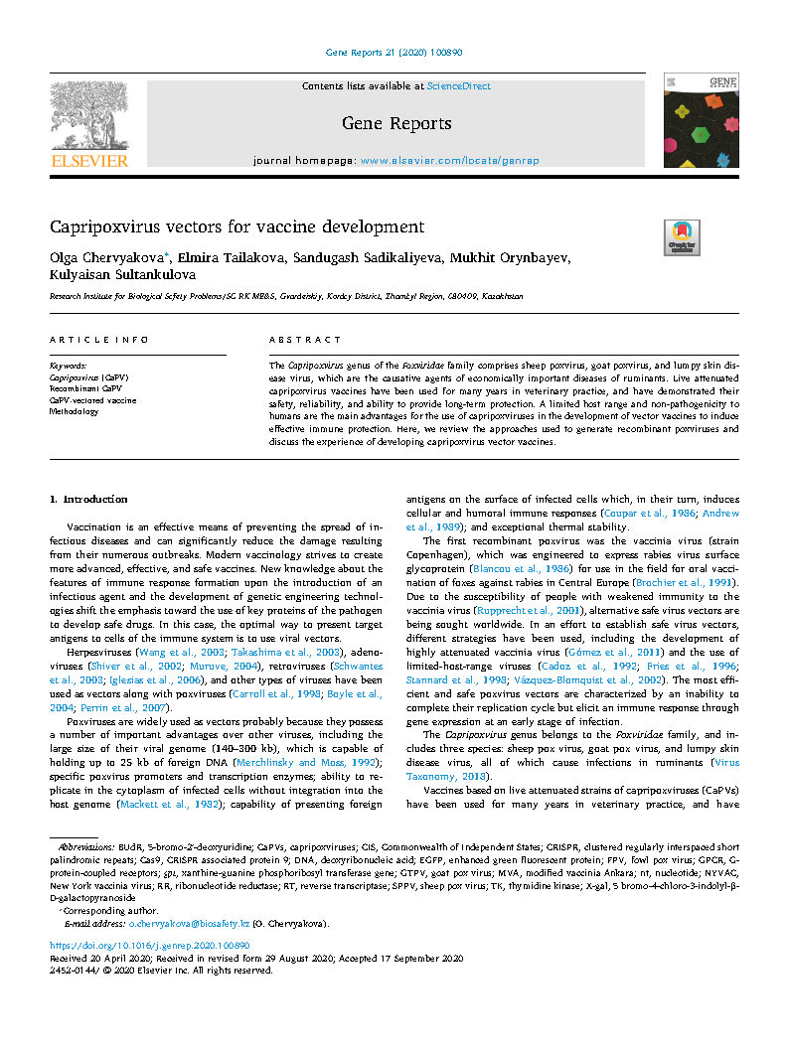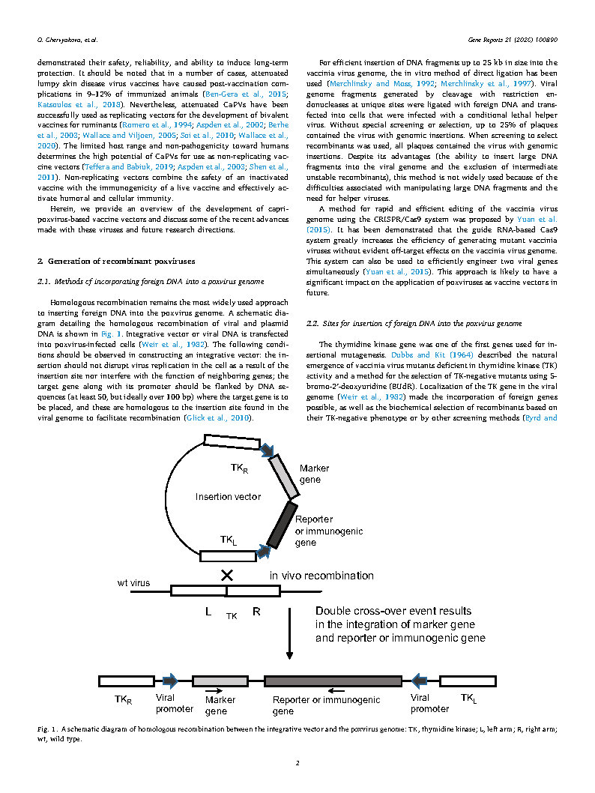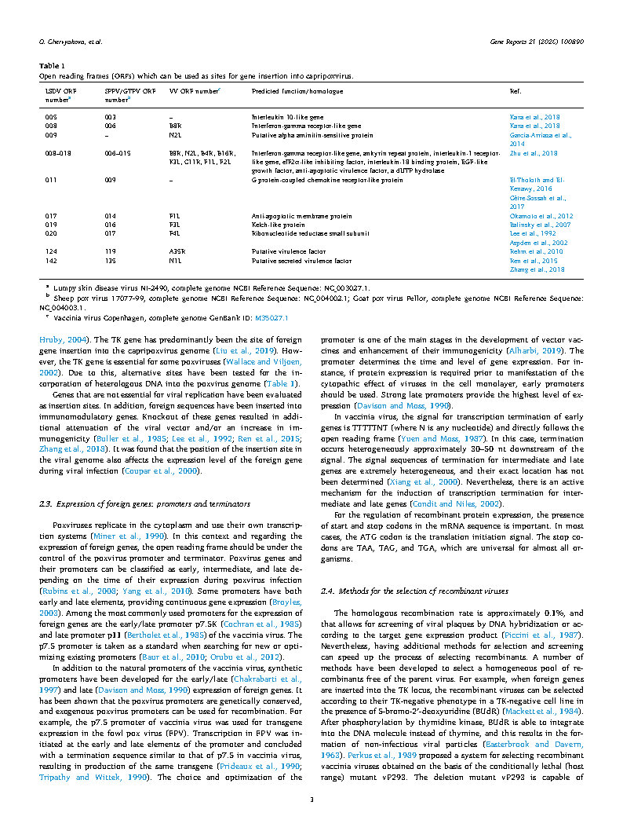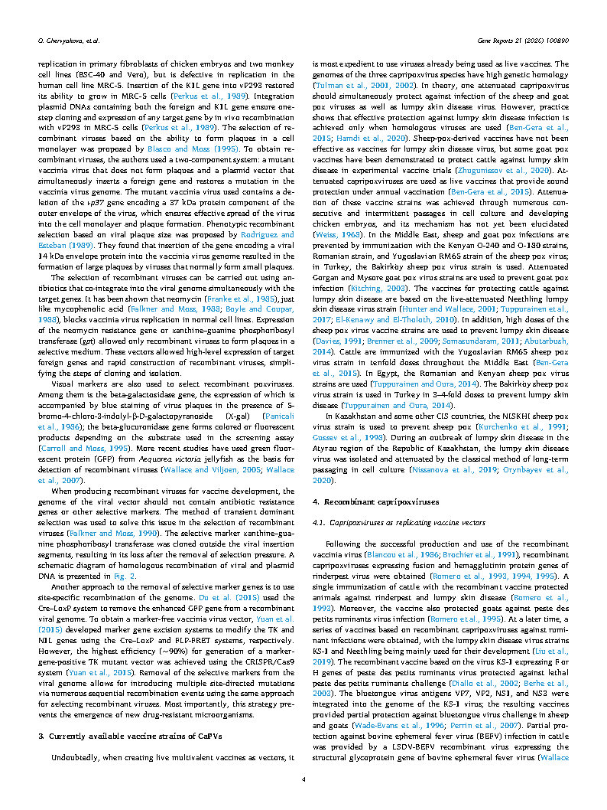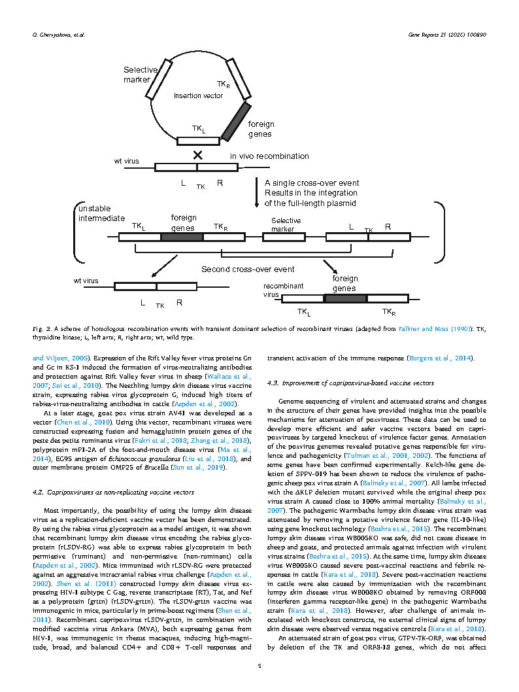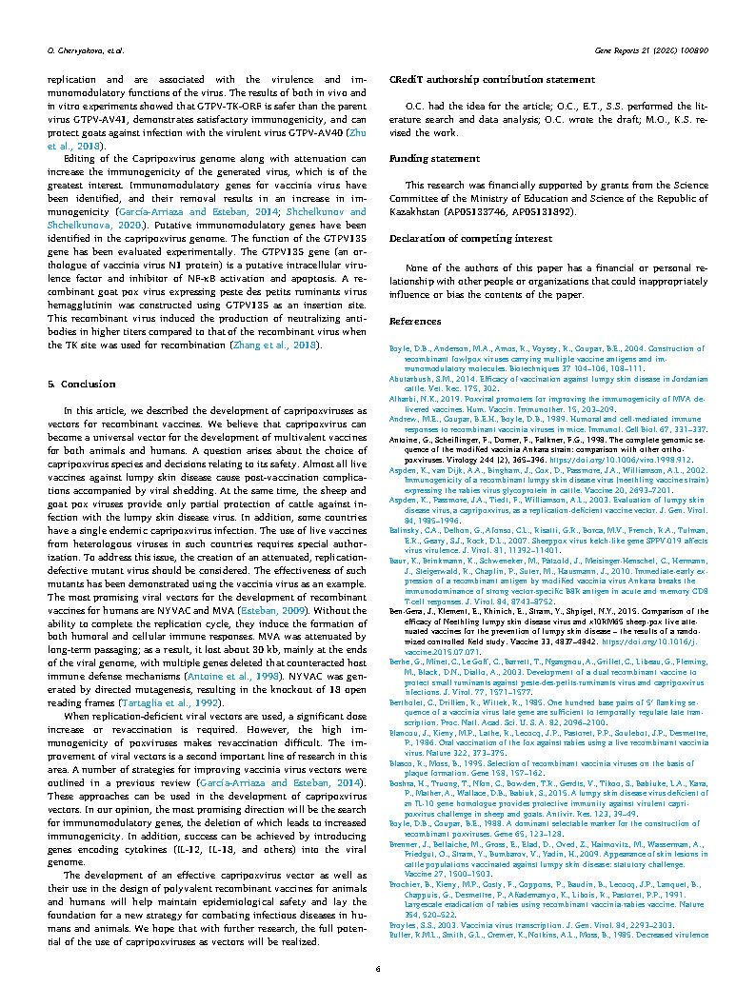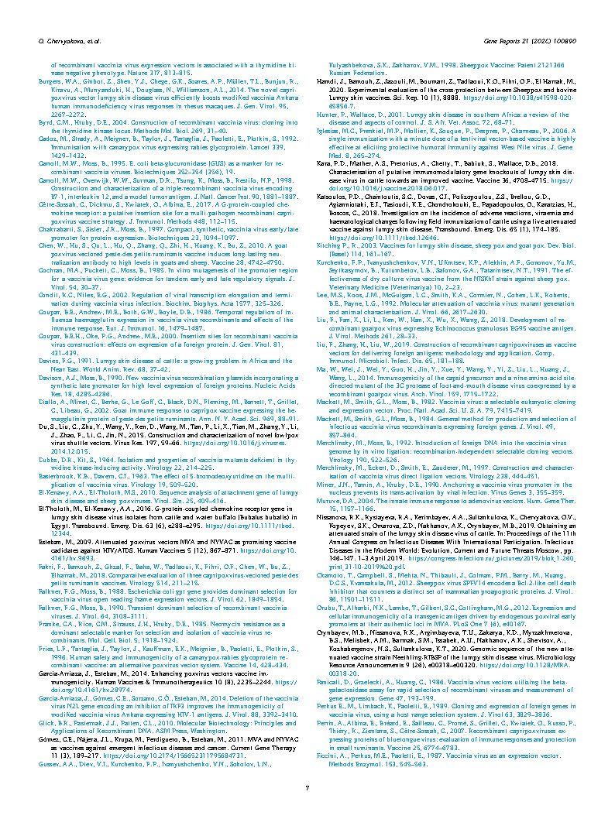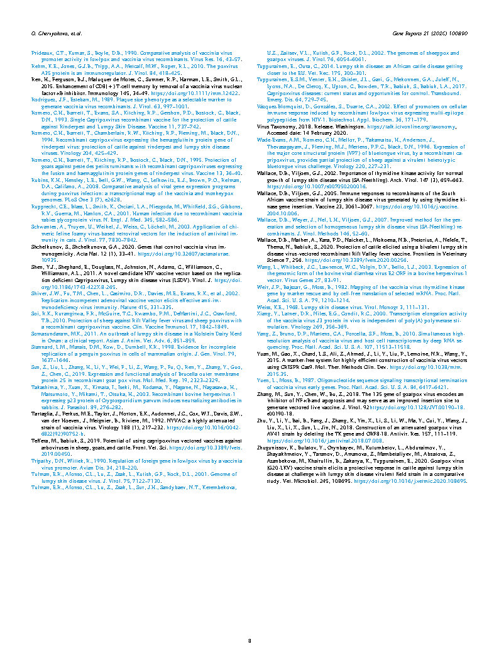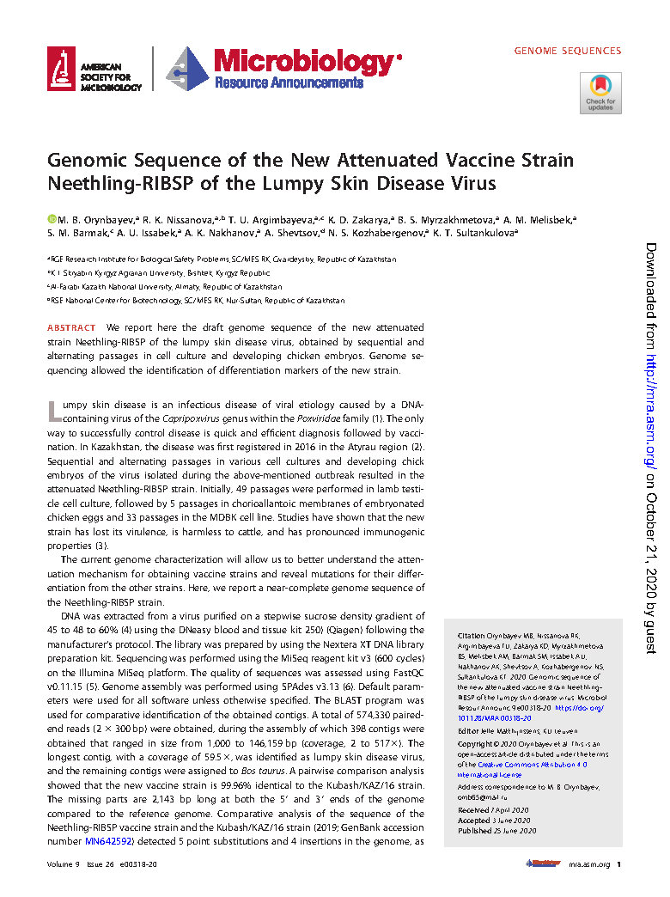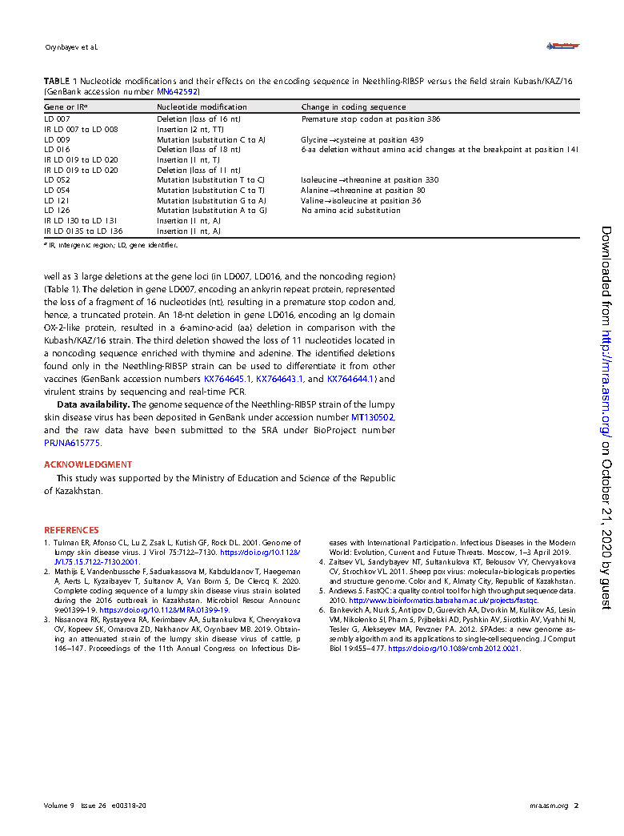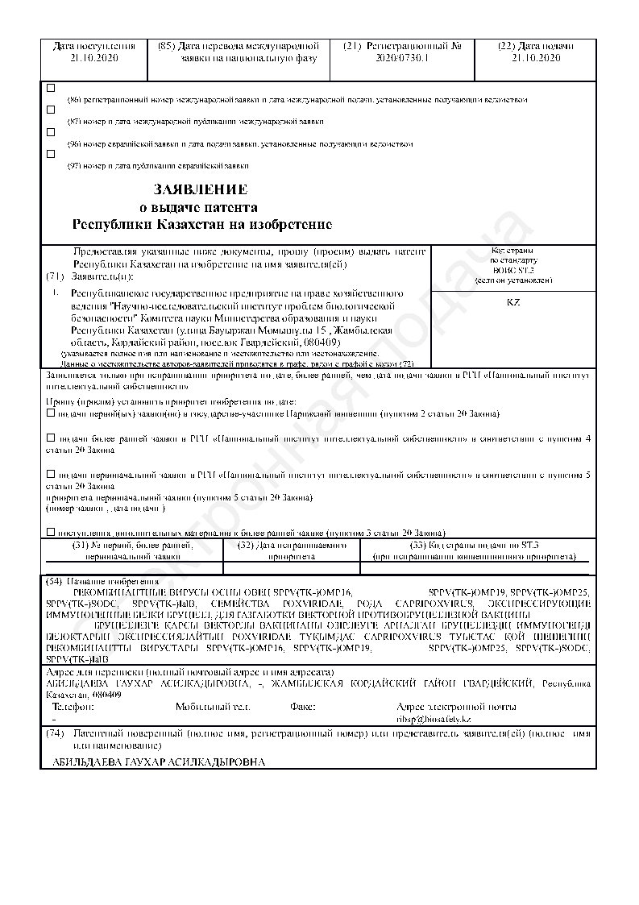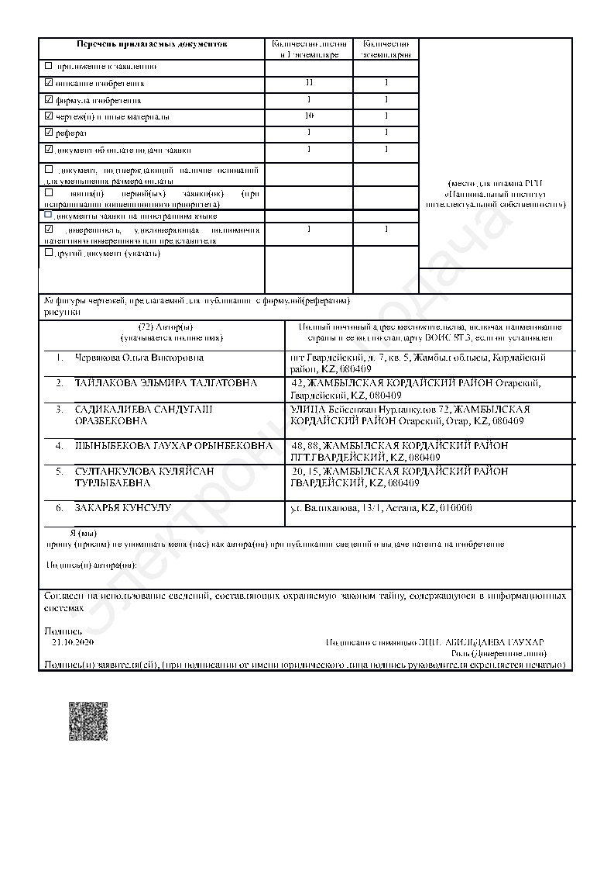

APPENDIX C
Plasmid passports
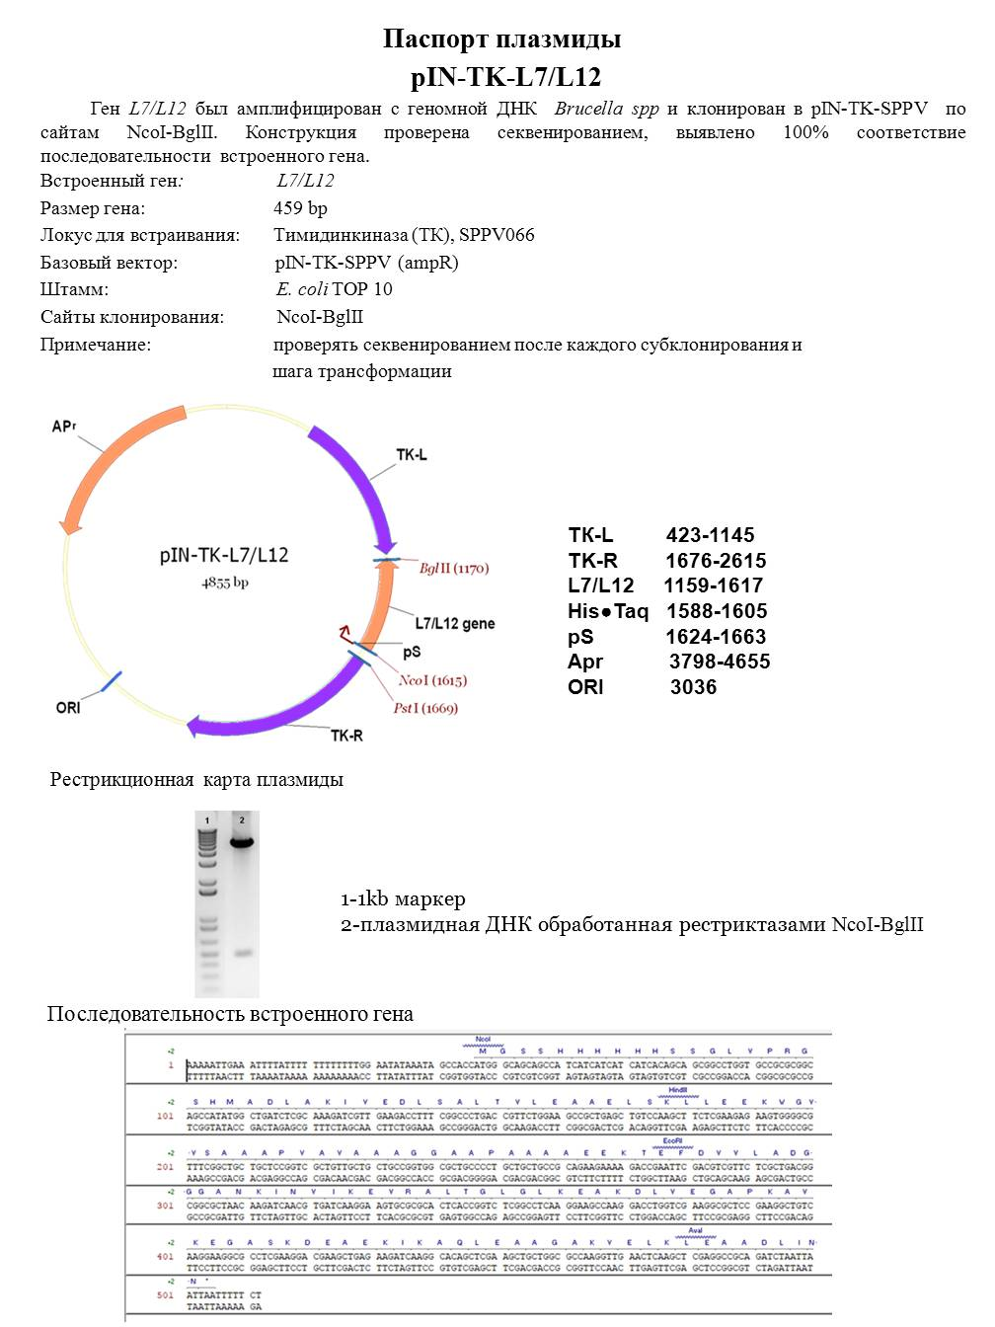
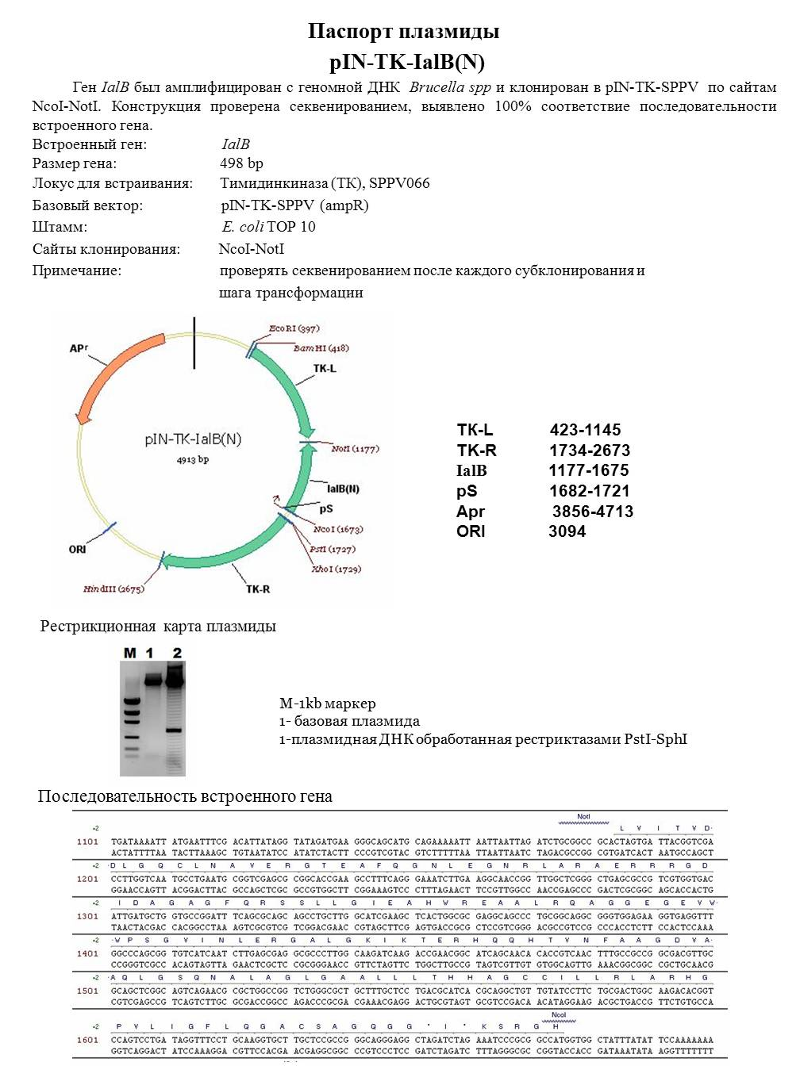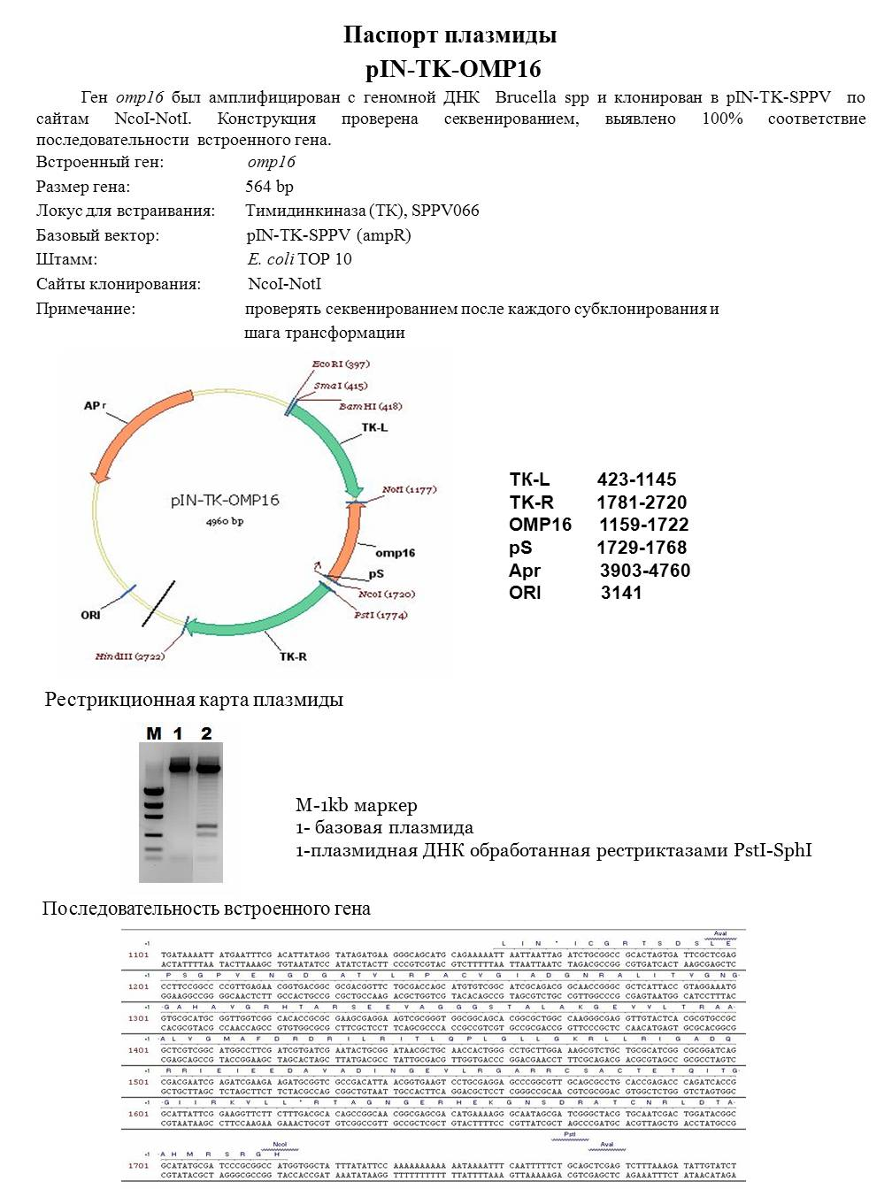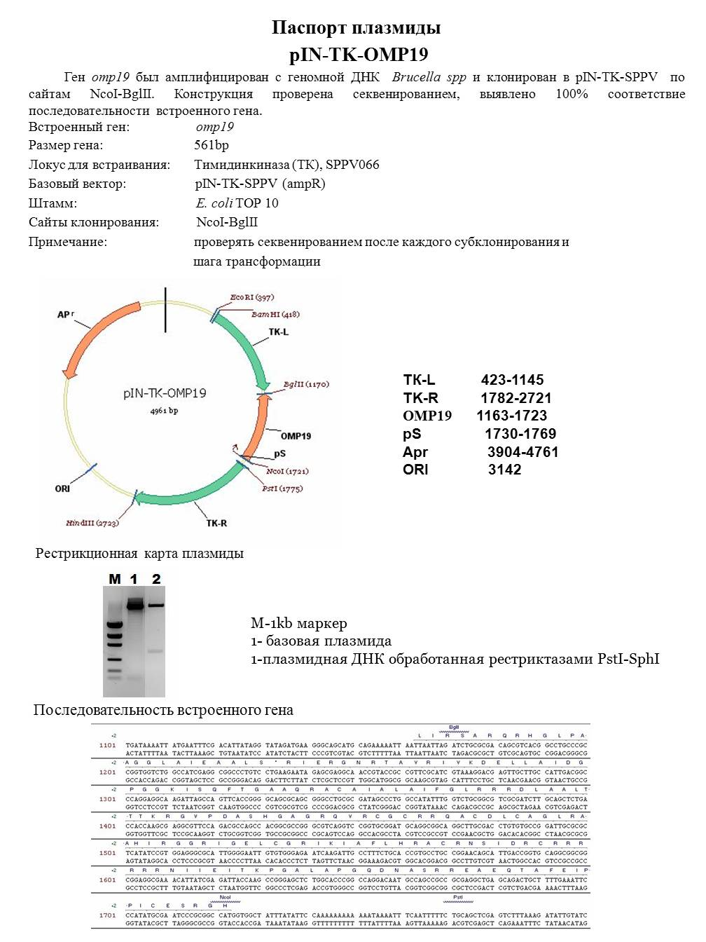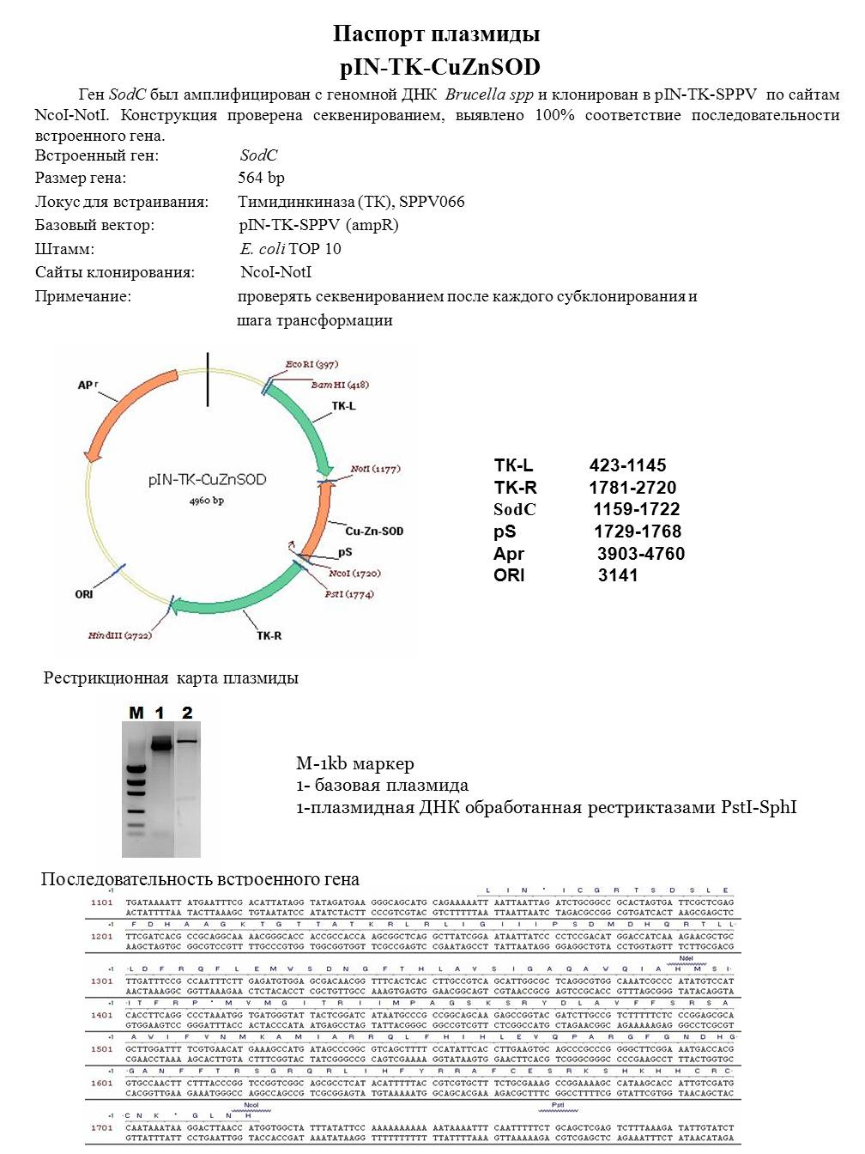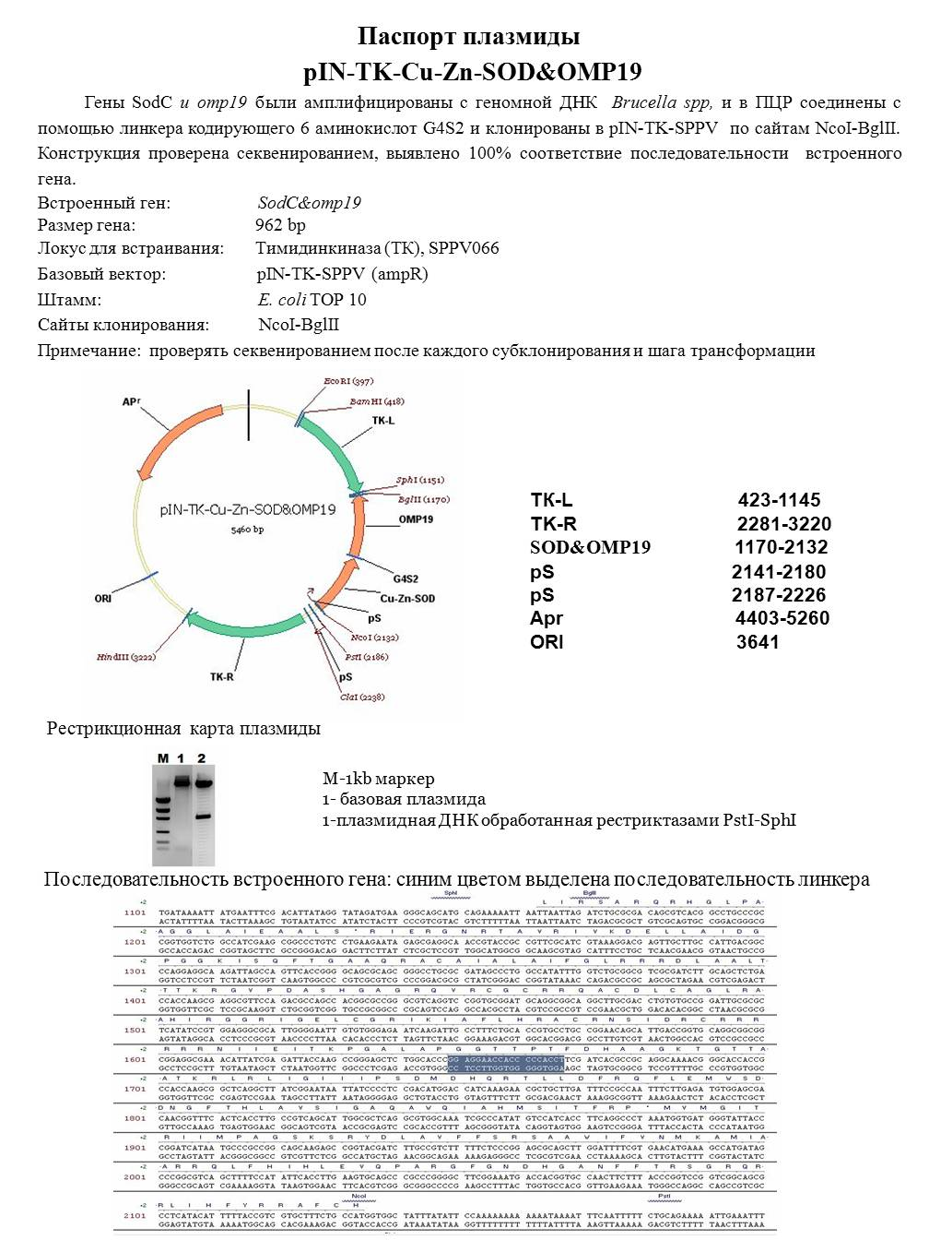

APPENDIX D
Virus Deposit Inquiries
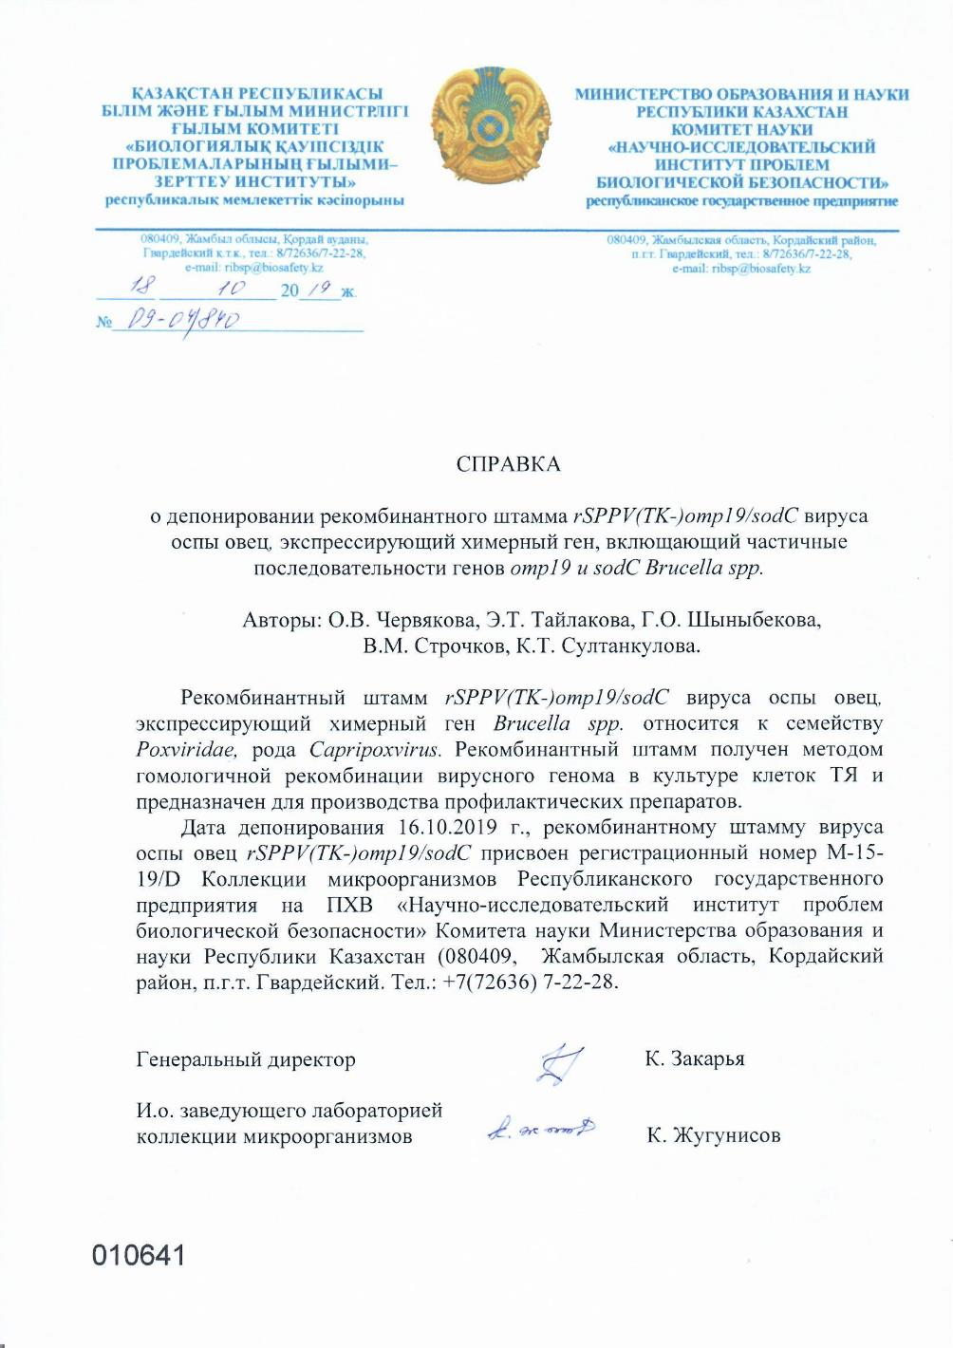
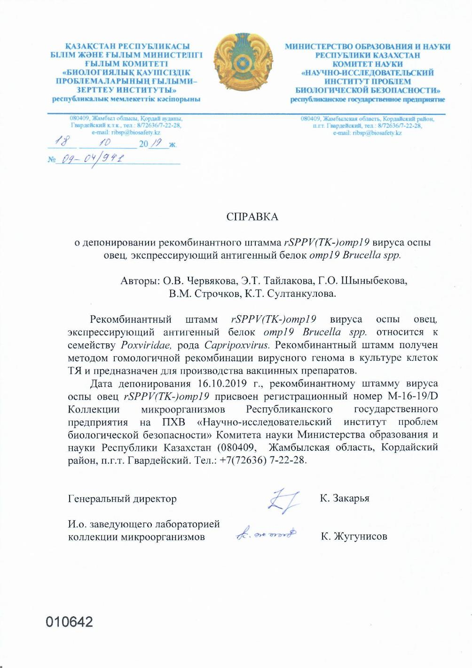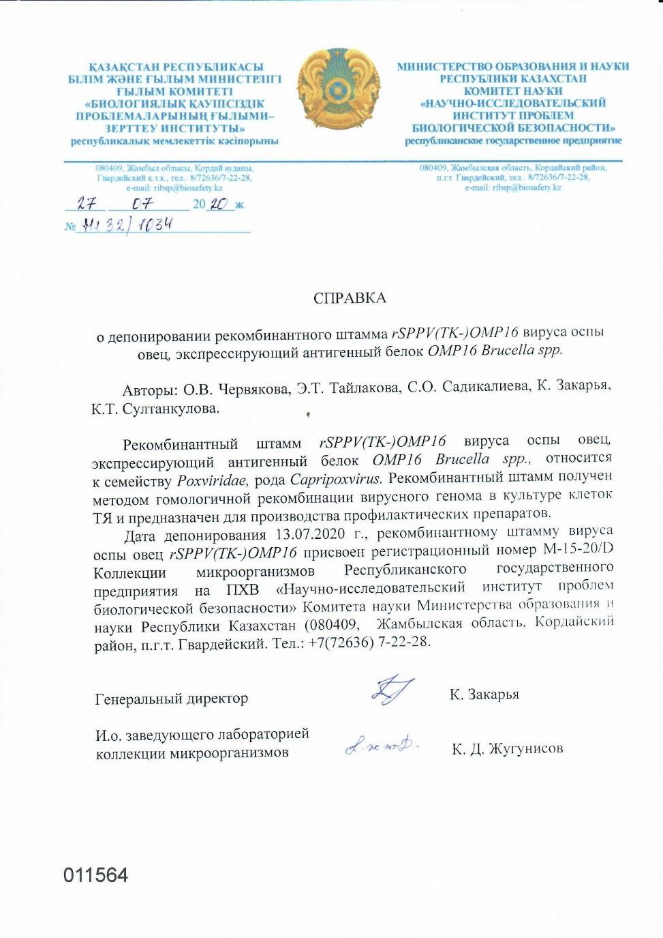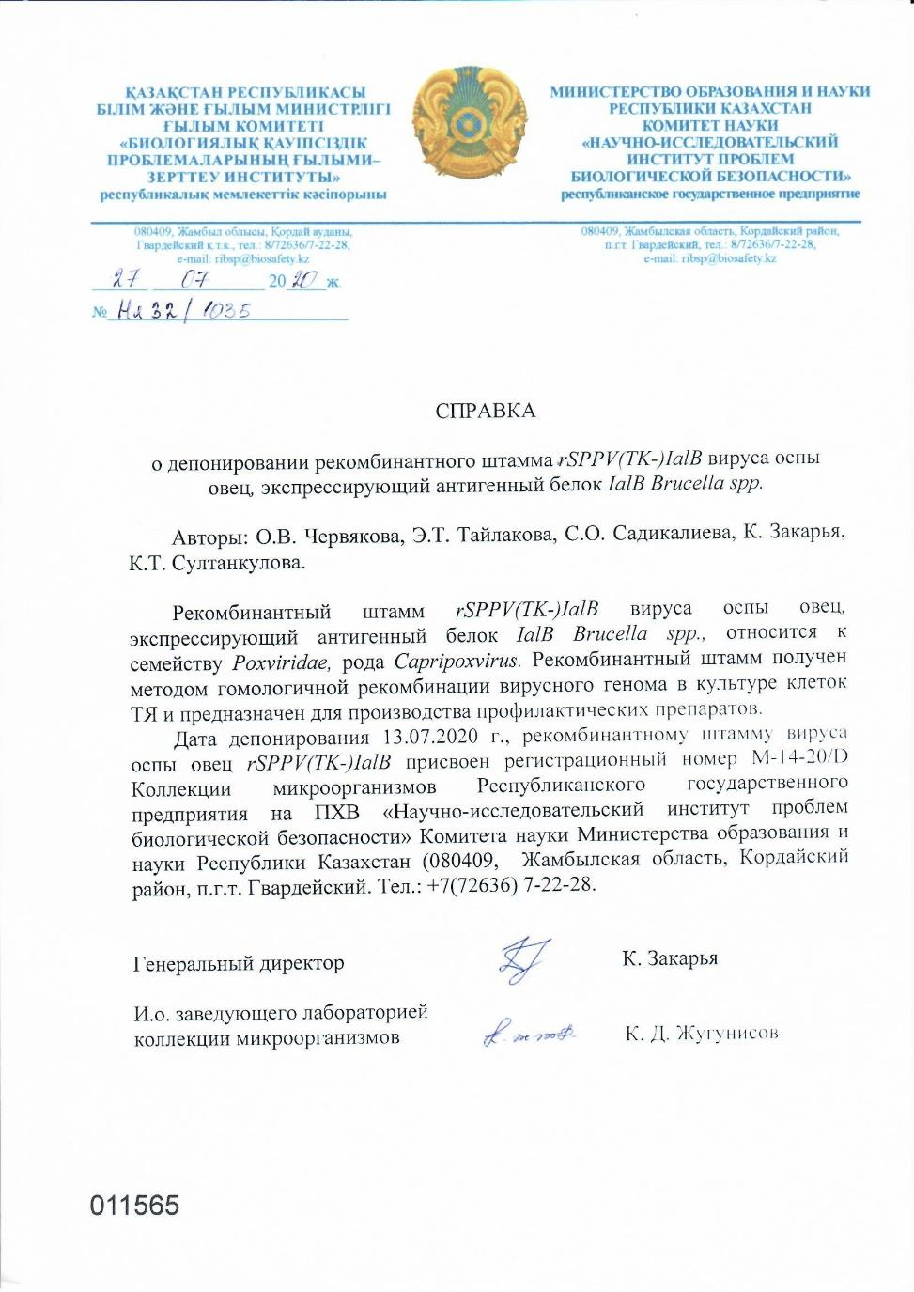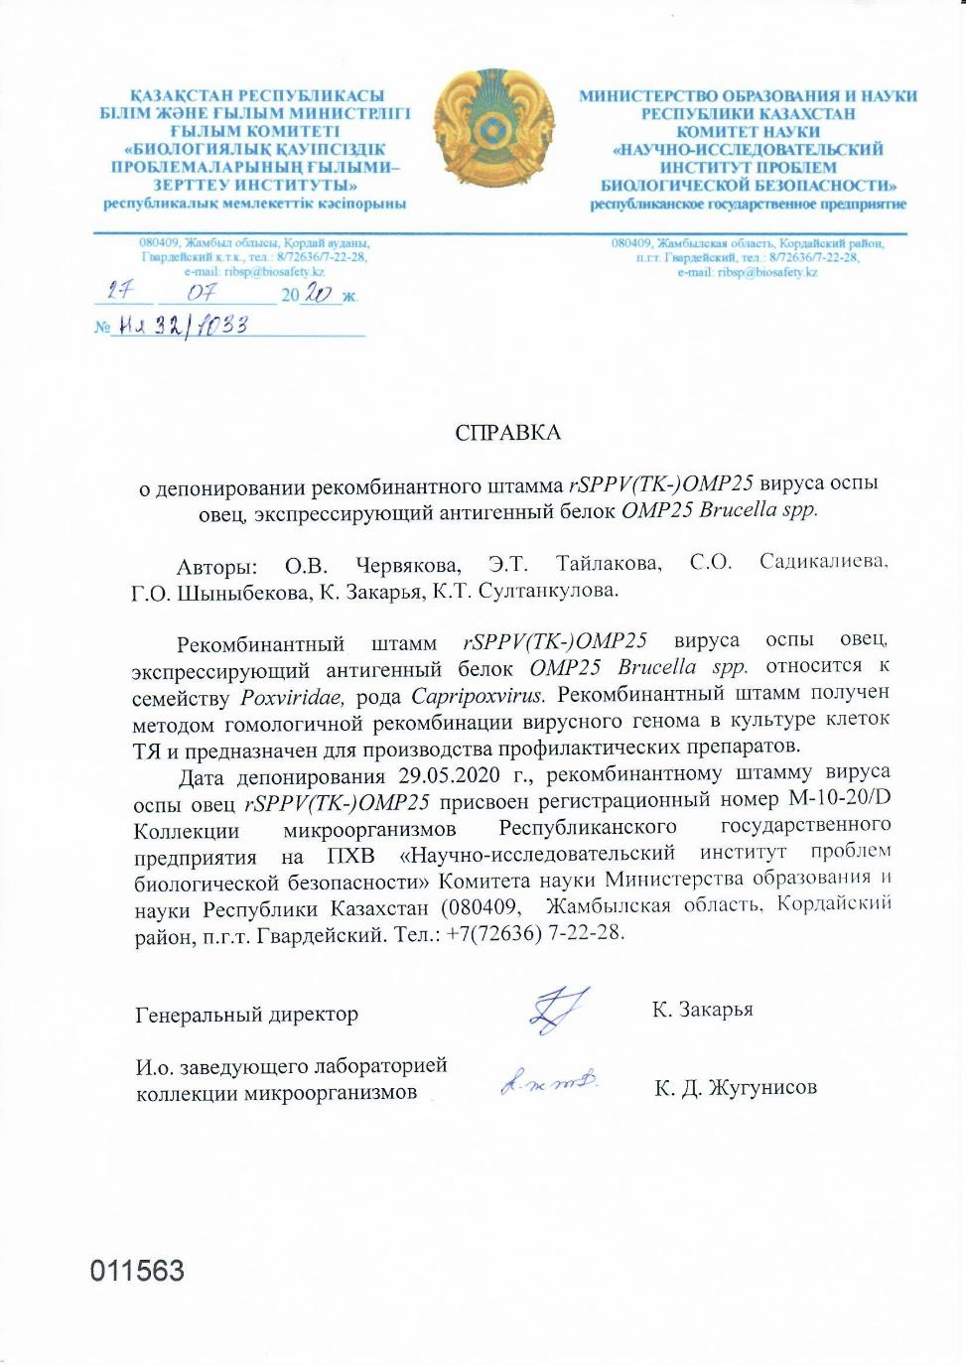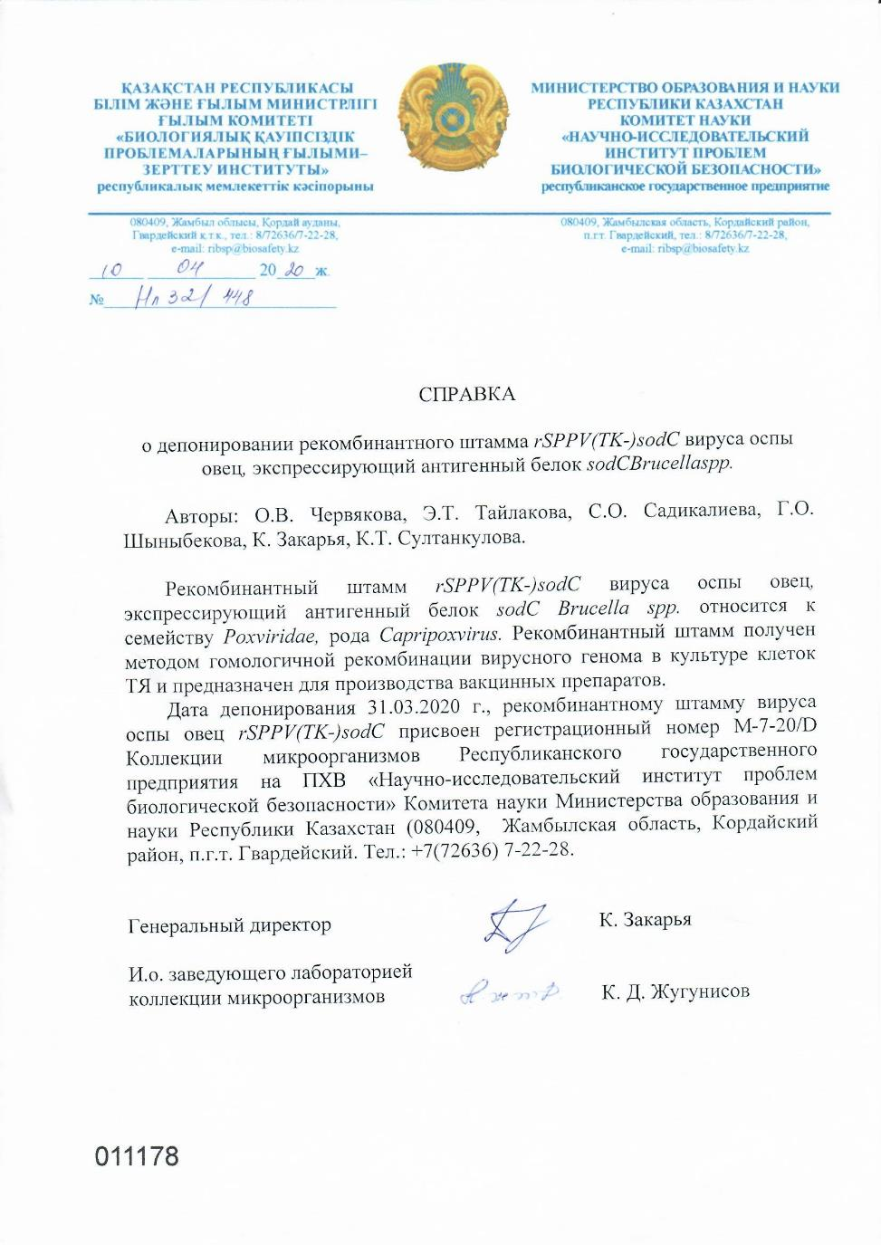

APPENDIX E
Recombinant Protein Passports

_________________________________________________________ЛМБГИ-НИИПББ
ПАСПОРТ
Наименование продукта
Рекомбинантный белок L7/L12 Brucella spp.
Описание продукта
Рекомбинантный белок L7/L12 Brucella spp. бактериально-экспрессированый в клетках E.coli T7, и очищенный методом металл-аффинной хроматографии.

Спецификация продукта
Тест Характеристики
___________________________________________________________________________________________________________
Внешний вид (мутность) прозрачный с легкой опалесценцией
Внешний вид (цвет) бесцветный
Внешний вид (форма) жидкая
Содержание белка 208 мкг/мл
Объем 6,7 мл
Состав буфера 20 мМ натрий-фосфатный буфер,300 мМ хлорид
натрия, рН 7,4

Чистота >90% в ПААГ-электрофорезе, размер белка 15,7 кDa
Стерильность стерилизация через фильтр с диаметром пор 0,22 мкм
Хранение от -20 ° до -70 ° С. Избегать повторяющихся циклов
замораживания-оттаивания.

_________________________________________________________ЛМБГИ-НИИПББ
ПАСПОРТ
Наименование продукта
Рекомбинантный белок SOD Brucella spp.
Описание продукта
Рекомбинантный белок SOD Brucella spp. бактериально-экспрессированый в клетках E.coli T7, и очищенный методом металл-аффинной хроматографии.

Спецификация продукта
Тест Характеристики
__________________________________________________________________________________________________________
Внешний вид (мутность) прозрачный с легкой опалесценцией
Внешний вид (цвет) бесцветный
Внешний вид (форма) жидкая
Содержание белка 362,2 мкг/мл
Объем 27 мл
Состав буфера 20 мМ натрий-фосфатный буфер,300 мМ хлорид
натрия, 4 М мочевина, рН 7,4
Чистота >90% в ПААГ-электрофорезе, размер белка 20 кDa
Стерильность стерилизация через фильтр с диаметром пор 0,22 мкм
Хранение от -20 ° до -70 ° С. Избегать повторяющихся циклов
замораживания-оттаивания

_____________________________________________________ЛМБГИ-НИИПББ
ПАСПОРТ
Наименование продукта
Рекомбинантный белок Omp16 Brucella spp.
Описание продукта
Рекомбинантный белок Omp16 Brucella spp. бактериально-экспрессированый в клетках E.coli T7, и очищенный методом металл-аффинной хроматографии.

Спецификация продукта
Тест Характеристики
__________________________________________________________________________________________________________
Внешний вид (мутность) прозрачный с легкой опалесценцией
Внешний вид (цвет) бесцветный
Внешний вид (форма) жидкая
Содержание белка 311,2 мкг/мл
Объем 11 мл
Состав буфера 20 мМ натрий-фосфатный буфер,300 мМ хлорид
натрия, 4 М мочевина, рН 7,4
Чистота >95% в ПААГ-электрофорезе, размер белка 19 кDa
Стерильность стерилизация через фильтр с диаметром пор 0,22 мкм
Хранение от -20 ° до -70 ° С. Избегать повторяющихся циклов
замораживания-оттаивания

_________________________________________________________ЛМБГИ-НИИПББ
ПАСПОРТ
Наименование продукта
Рекомбинантный белок Omp19 Brucella spp.
Описание продукта
Рекомбинантный белок Omp19 Brucella spp. бактериально-экспрессированый в клетках E.coli T7, и очищенный методом металл-аффинной хроматографии.

Спецификация продукта
Тест Характеристики
__________________________________________________________________________________________________________
Внешний вид (мутность) прозрачный с легкой опалесценцией
Внешний вид (цвет) бесцветный
Внешний вид (форма) жидкая
Содержание белка 335,2 мкг/мл
Объем 23 мл
Состав буфера 20 мМ натрий-фосфатный буфер,300 мМ хлорид
натрия, рН 7,4
Чистота >90% в ПААГ-электрофорезе, размер белка 20 кDa
Стерильность стерилизация через фильтр с диаметром пор 0,22 мкм
Хранение от -20 ° до -70 ° С. Избегать повторяющихся циклов
замораживания-оттаивания

_________________________________________________________ЛМБГИ-НИИПББ
ПАСПОРТ
Наименование продукта
Рекомбинантный белок Omp25 Brucella spp.
Описание продукта
Рекомбинантный белок Omp25 Brucella spp. бактериально-экспрессированый в клетках E.coli ER2566, и очищенный методом металл-аффинной хроматографии.

Спецификация продукта
Тест Характеристики
__________________________________________________________________________________________________________
Внешний вид (мутность) прозрачный с легкой опалесценцией
Внешний вид (цвет) бесцветный
Внешний вид (форма) жидкая
Содержание белка 212,6 мкг/мл
Объем 23 мл
Состав буфера 20 мМ натрий-фосфатный буфер,300 мМ хлорид
натрия, 4 М мочевина, рН 7,4
Чистота >90% в ПААГ-электрофорезе, размер белка 21 кDa
Стерильность стерилизация через фильтр с диаметром пор 0,22 мкм
Хранение от -20 ° до -70 ° С. Избегать повторяющихся циклов
замораживания-оттаивания

_________________________________________________________ЛМБГИ-НИИПББ
ПАСПОРТ
Наименование продукта
Рекомбинантный белок IalB Brucella spp.
Описание продукта
Рекомбинантный белок IalB Brucella spp. бактериально-экспрессированый в клетках E.coli ER2566, и очищенный методом металл-аффинной хроматографии.

Спецификация продукта
Тест Характеристики
__________________________________________________________________________________________________________
Внешний вид (мутность) прозрачный с легкой опалесценцией
Внешний вид (цвет) бесцветный
Внешний вид (форма) жидкая
Содержание белка 300 мкг/мл
Объем 50 мл
Состав буфера 20 мМ натрий-фосфатный буфер,300 мМ хлорид
натрия, 4 М мочевина, рН 7,4
Чистота >90% в ПААГ-электрофорезе, размер белка 23 кDa
Стерильность стерилизация через фильтр с диаметром пор 0,22 мкм
Хранение от -20 ° до -70 ° С. Избегать повторяющихся циклов
замораживания-оттаивания

