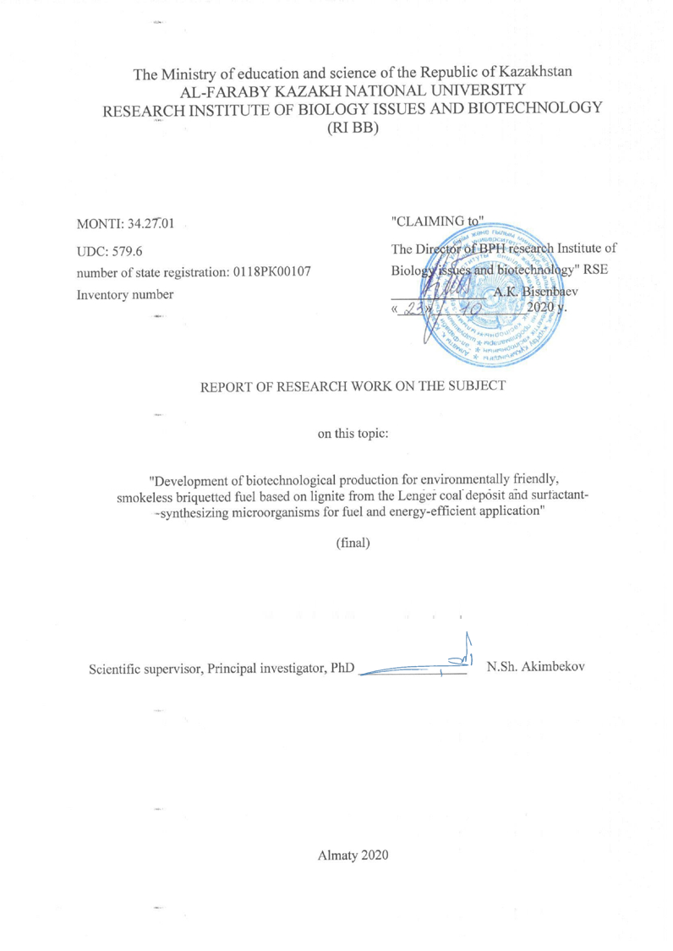
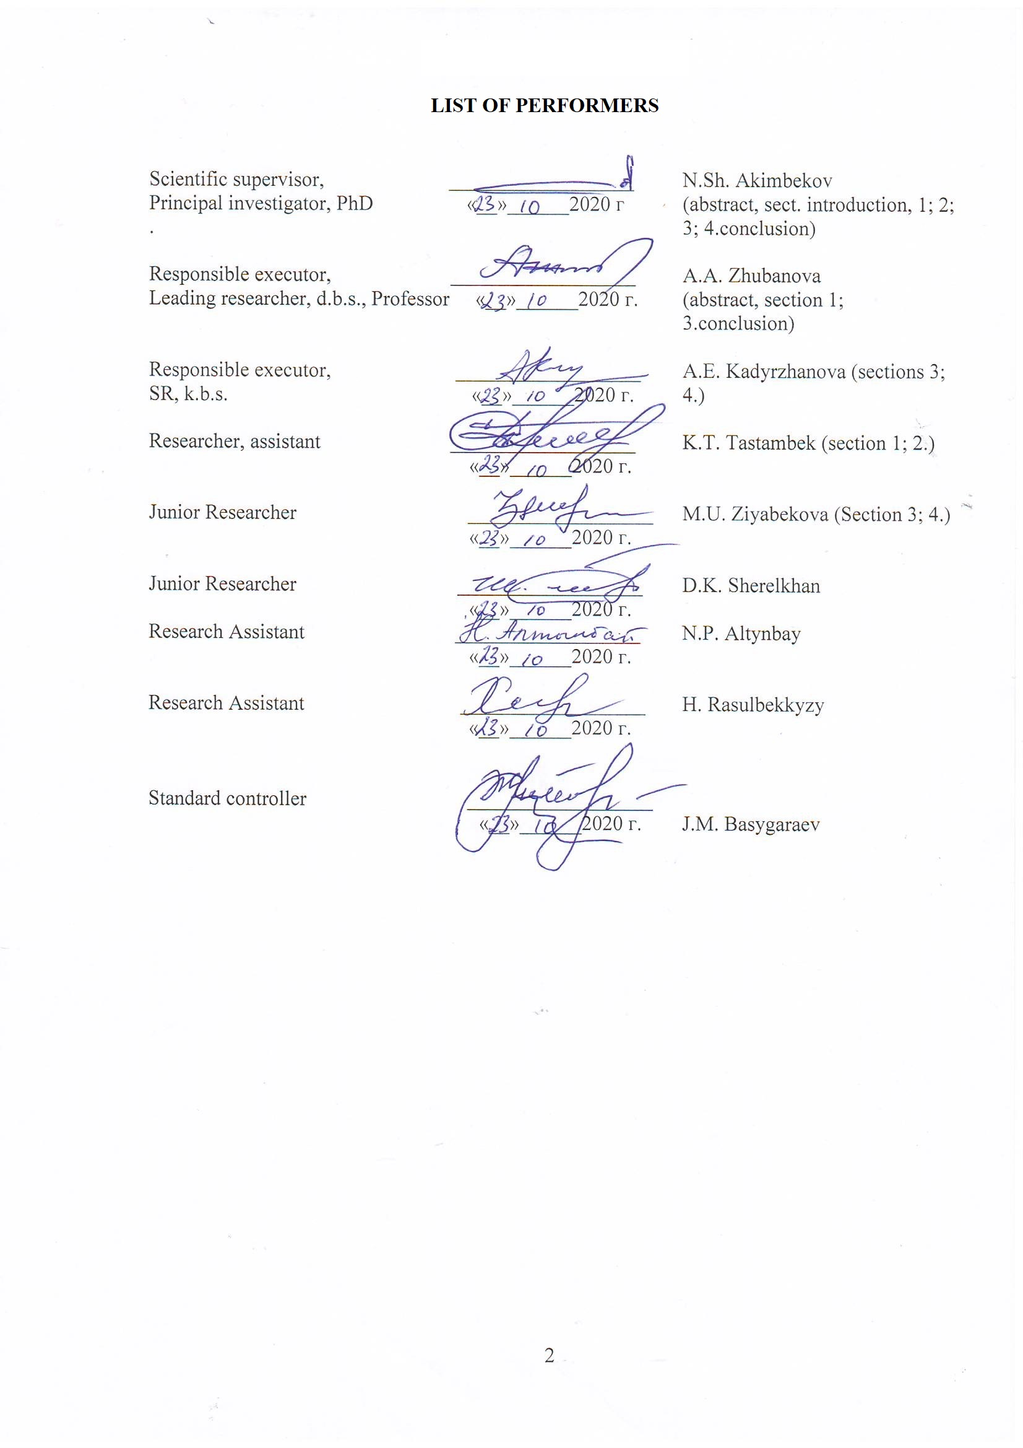

ABSTRACT

The report consists of 54 pages, 41 figures, 18 tables, 45 references, 2 appendices.
BROWN COAL (LIGNITE) OXIDIZED BROWN COAL (LEONARDITE), ELEMENTAL COMPOSITION, PHYSICO-CHEMICAL CHARACTERISTICS, SULFUR CONTENT, MICROORGANISMS, MICROBIOME, METAGENOMICS, BIOSOLUBILIZATION, BIOSURFACTANTS, ORGANIC BINDERS, BRIQUETTING, BRIQUETTES.
Research objects: brown coal and oxidized brown coal of the Lenger (Karatau) coal basin of the Turkestan region and active strains of bacteria.
The aim of the research is to develop a biotechnological method for producing briquetted smokeless fuel from brown coal from the Lenger coal deposit using biosurfactants as binders, synthesized by selected strains of microorganisms.
All experiments were carried out in the laboratory conditions using modern methods of physicochemical, biochemical, genetic, microbiological and biotechnological research.
All objectives of the research have been fully achieved in accordance with the technical specification and work schedule for 2018-2020.
The technical and economic indicators of the research include the results obtained during the planned experiments and assessments of their economic significance.
The results obtained by studying the physicochemical, microbiological and biotechnological properties of brown coal from the Lenger coal deposit can be used for scientific purposes and for the preparation of educational materials on ecology and environmental biotechnology.
Scientific and organizational work: the number of published works - 26, of which scientific articles - 13, abstracts - 10. Participation in conferences - 8, the number of presented reports - 8. Patent - 2, patent application - 1. Monograph - 1.

ТҰЖЫРЫМ

Есеп 54 беттен, 41 суреттен, 18 кестеден, 45 әдебиет көзінен, 2 қосымшадан тұрады.
ҚОҢЫР КӨМІР, ТОТЫҚТЫРЫЛҒАН ҚОҢЫР КӨМІР, ЭЛЕМЕНТТІК ҚҰРАМ, ФИЗИКО-ХИМИКАЛЫҚ СИПАТТАМА, КҮКІРТТІҢ ҚҰРАМЫ, МИКРООРГАНИЗМДЕР, МИКРОБИОМ, МЕТАГЕНОМИКА, БИОСОЛЮБИЛИЗАЦИЯ, БИОСУРФАКТАНТАР, ОРГАНИКАЛЫҚ БАЙЛАНЫСТЫРУШЫЛАР, БРИКЕТТЕУ, БРИКЕТ.
Зерттеу нысандары - жұмыста Түркістан аймағының Ленгер (Қаратау) көмір бассейнінің қоңыр және тотыққан қоңыр көмірлері және бактериялардың белсенді штамдары қолданылды.
Зерттеудің мақсаты – Ленгер көмір кен орны аймағынан қоңыр көмірден брикеттелген түтінсіз отын алудың биотехнологиялық әдісін байланыстырушы ретінде микроорганизмдердің штамдары арқылы синтезделген биосурфактанттарды қолдану.
Барлық тәжірибелер зертханалық жағдайда физика-химиялық, биохимиялық, генетикалық, микробиологиялық және биотехнологиялық зерттеулердің заманауи әдістерін қолдана отырып жүргізілді.
Кезеңнің барлық міндеттері техникалық сипаттамаға және 2018-2020 жылдарға арналған жұмыс кестесіне сәйкес толық көлемде шешілді.
Зерттеудің осы кезеңінің техникалық-экономикалық көрсеткіштеріне жоспарланған тәжірибелер кезінде алынған және олардың экономикалық маңыздылығын бағалайтын нәтижелер кіреді.
Ленгерский көмір кен орнындағы қоңыр көмірдің физико-химиялық, микробиологиялық және биотехнологиялық қасиеттерін зерттеу барысында алынған нәтижелерді ғылыми мақсатта және экология мен экологиялық биотехнология бойынша оқу материалдарын дайындауда пайдалануға болады.
Ғылыми - ұйымдық жұмыс: жарияланған жұмыстың саны – 26, соның ішінде ғылыми мақалалар – 13, тезистер – 10. Конференцияға қатысуы - 8, ұсынылған баяндама саны – 8. Патент – 2, патентке өтінім - 1. Монография – 1.

CONTENT
 | INTRODUCTION………………………………………………………………….. | 7
 | MAIN POINTS……...……………………………………………………………... | 8
1 | Selecting research area………………………….....................……………………. | 8
2 | Materials and methods………………………………………........................…….. | 9
2.1 | Research objects……………………………………………………............……… | 9
2.2 | Materials…………………………………………………………………...……… | 9
2.3 | Research methods…………………………………………………………........…. | 10
3 | Results and discussion………………………………………………………........... | 16
3.1 | Study of the physicochemical and microbiological properties of brown coal from the Lenger coal deposit …………………………………………...........………….. | 17
3.1.1 | Study of the physical, mechanical and chemical properties of brown coal from the Lenger coal deposit ……………………………………………………................... | 17
3.1.2 | Determination of the content of sulfur and sulfur compounds in the samples of brown coal from the Lenger coal deposit…………………………….......………… | 18
3.1.3 | Study of the biodiversity, abundance and physiological-biochemical properties of the microbial community of brown coals …………………………............……….. | 19
3.1.4 | Study of the metabolic activities of the isolated microbial cultures during their growth on media containing various concentrations of brown coal …..................... | 24
3.2 | Study of the main regularities and parameters of biomodification of brown coal … | 25
3.2.1 | Screening of microorganisms capable of removing sulfur (pyrite and organic) from brown coal ……………………………………............................…………… | 25
3.2.2 | Study of the ability of microorganisms to form biosurfactants and determination of their biochemical properties ………………………………………..................... | 27
3.2.3 | Study of the influence of the composition and nature of biosurfactants on brown coal charge …………………………………………………………....................… | 30
3.2.4 | Increasing the plastic properties of briquettes by introducing organic binding agents into the briquetted mixture ……………….........................................……… | 33
3.3 | Development of a basic technological scheme of the process of obtaining briquettes by means of biomodification of brown coal …….................…………… | 36
3.3.1 | Study of the influence of chemical and technological parameters of coal briquetting using bio-binding agents on the functional properties of briquettes ..… | 36
3.3.2 | Study of the influence of the pyrolysis process on the physicochemical properties of the obtained briquettes…………………………………………………………... | 38
3.3.3 | Study of the energy and thermotechnical properties of the obtained briquettes…… | 39
3.3.4 | Carrying out pilot tests to determine the fuel and energy efficiency of the obtained briquettes ………………………………………................................................…... | 40
 | CONCLUSION………………………………………..…………………………… | 42
 | REFERENCES.......................................................................................................... | 44
 | APPENDIX А List of published works on the project.............................................  APPENDIX B Work schedule.................................................................................. | 47  49

DEFINITIONS, DESIGNATIONS AND ABBREVIATIONS

The following terms are used in this research report:
A – Ash-content, %
ACE – Abundance-based Coverage Estimator
BBC – Biotreated Brown Coal
BHS – Biological Humic Substances
CFU – Colony Forming Units
CHS – Chemical Humic Substances
EDX – Energy-dispersive X-ray spectroscopy
EEM – Excitation Emission Matrix
FE-SEM – Field Emission Scanning Electron Microscopy
FTIR – Fourier-Transform Infrared Spectroscopy
HS – Humic Substances
IBC –Initial Brown Coal
LB medium – Luria-Bertani Medium
LC/MS QqQ – Liquid chromatography/Triple quadrupole mass spectrometry
LLE – Lenger Leonardite
LLI – Lenger Lignite
NGS – Next Generation Sequencing
NGS –Next Generation Sequencing
OBBC – Organo-Bioprocessed Brown Coal
OD – Optical Density
OTU – Operational Taxonomic Unit
PCR – Polymerase Chain Reaction
Q – Calorific value, kJ/kg
RKB 10 – strain Providencia sp.
RKB 2 – strain Bacillus sp.
SOB medium – Super Optimal Broth
TMC – Total Microbial Count
UV-vis – Ultraviolet-visible spectroscopy
V – Volatile matter, %
W – Moisture content, %
XDR –X-ray crystal analysis
XRD –X-ray powder diffraction
XRF –X-ray fluorescence analysis

INTRODUCTION

Among fossil solid fuels, brown coal (lignite) has a relatively low energy value, since its combustion leads to environmental pollution with oxides of sulfur, nitrogen, and other substances. In this regard, the challenge of finding alternative ways of utilizing low-quality coals remains urgent.
Biotechnological transformation of the structure of solid fuels is an environmentally friendly and economically profitable way of converting carbon-containing raw materials. The implementation of this coal modification minimizes the use of hazardous chemicals and the release of toxic compounds into the environment. Given the negative impact on the environment arising from the extraction and utilization of low-quality coal, interest in its bioprocessing is growing rapidly. This problem is most acute in countries with high reserves of fossil coal, including Kazakhstan.
The technology for the production of briquette fuels from brown coal has not received industrial application due to the high ash content, low heat of combustion, and the lack of an effective binding agent for briquetting. Taking into account the fact that the majority of the population in the country lives in rural areas, the problem of producing environmentally friendly fuels for domestic and industrial consumption is of very wide importance. Thus, the development of technology for producing briquetted fuel from brown coal in the Lenger coal basin is one of the environmental and economic targets.
In this regard, the utilization of solid waste from the coal industry by the technology of microbial conversion and transformation into solid energy inputs, which makes it possible to reduce the anthropogenic load on the natural environment, is an urgent scientific mission.
The goal of this study is to develop a biotechnological method for producing briquetted smokeless fuel from brown coal in the Lenger coal deposit using as binders – biosurfactants synthesized by active strains of microorganisms.
Research objectives:
1. Study of the physicochemical and microbiological properties of brown coal from the Lenger coal deposit.
2. Study of the main regularities and parameters of biomodification of brown coal.
3. Development of a basic technological scheme of the process of briquetting by means of biomodification of brown coal.
Inventory number 2018 y 0218RK00304, 2019 y 0219RK00440.

MAIN POINTS

1 Selection of research direction
Biotechnological techniques make it possible to efficiently and safely obtain valuable products from various raw materials. Achievements in biotechnology have recently begun to be used to increase the extraction and processing of traditional fuels such as oil, fuel oil, coal, etc. [1].
It is known that fossil solid fuels are natural polymers of heterogeneous structure, which include various mineral, organic and organo-mineral components. Their ratio in each specific fuel is mainly determined by the degree of its metamorphism [2]. Biotechnological conversion of brown coal can be aimed at obtaining various types of products, as well as improving its specific consumer properties. Depending on the method of bioconversion of brown coal and the groups of microorganisms used in this case, two main technological processing methods are distinguished - aerobic and anaerobic. In the first case, due to the supply of oxygen, oxidative processes occur, providing fractional destruction, i.e. solubilizing the structure of brown coal; in the second case (anaerobic system), processes occur that lead to the formation of methane and carbon dioxide in the coal suspension. Surfactants and enzymes produced by microorganisms in the course of their vital activity have a significant effect on the implementation of the process of bioconversion of the organic and mineral parts of solid fuels [3, 4].
To date, the main directions of bioconversion of various coals are the optimization of their environmental characteristics for power production by means of biosolubilization, biodesulfurization (removal of sulfur compounds), biodemineralization, and biogasification [5-7]. When developing biotechnological methods, the different communities of bacteria and fungi are used, and the processes can be implemented both in mesophilic (at ~30°C) and thermophilic (40-65°C) conditions [8]. In a study conducted by El-Midany A.A. et al. [9], using brown coal as an example, direct evidence was obtained for the existence of a huge number of indigenous microorganisms suitable for bioconversion and bioprocessing of coal, which makes it relevant to study the factors of their existence and reproduction in the native environment.
The use of low-quality fuel for disposal and combustion requires its purification from harmful impurities, especially sulfur-containing compounds. Machnikowska H. et al. [10] indicated that during microbiological processing under the influence of microbial cultures, the proportion of carbonyl and aliphatic groups in the biotreated coal increased.
Yuan H. et al. [11] showed that the development of bioconversion processes of brown coals is hampered by insufficient knowledge of the mechanism of microbial effect on coal, studied as agents for coal bioprocessing: their metabolic capabilities are practically unknown. The study [12] described an attempt to use indigenous bacteria isolated in the coal mining areas for biosolubilization of brown coal. Biosolubilization of coals was carried out at 25°C in a culture medium with a coal content of 2%. Under these conditions, the degree of coal solubilization was ~ 30%, with an increase in the process temperature to 100°C, the degree of solubilization increased to ~ 45%. In the coal biosoluilization, the best results were shown by microorganisms Streptomyces sp., Candida sp., and Penicillium sp. The intensity of biosolubilization of brown coal by these microorganisms was up to 90% within 70 days [13]. Other studies [14, 15] demonstrated the results of experiments in which, in addition to the biosolubilization of brown coals, attempts have been made to anaerobic biodegradation of coals to produce methane gas. These works are carried out with the aim of developing biotechnologies using microbial methods to extract methane from coal beds.
The current ecological situation in urbanized regions is tightening the requirements for the quality of combustible municipal solid fuel, at the same time, these fuels must have a low sulfur content, minimal smoke, and the required particle-size distribution. The analysis of the world practice of obtaining smokeless fuel [16] shows that traditional technological methods involve the process of briquetting brown coal with binding agents, i.e. solubilizing agents. A number of technological solutions are based on the method of pressing the coal charge by using the effect of the plastic layer of the coal itself, or the applied organic binder.
A complex of scientific research was aimed at the design of technological parameters for the selection of active microorganisms, the creation of biosurfactants by means of brown coal bioconversion, the study of their biosolubilization, the technological parameters of the preparation of the bio-binders, as well as the study of the possibility of obtaining smokeless fuel.
The introduction of briquetting technology with biosurfactants of microbial origin is usually applied to brown coals, which makes it possible to obtain briquetted fuels of sufficient strength that combust with the formation of a minimum amount of harmful emissions. Various studies [17] have shown the possibility of using brown coals of B2-B3 class with a moisture content of 20-40% for briquetting.
Brown coals of the Lenger coal basin, the commercial reserves of which are estimated at 34,000 thousand tons, are characterized by an average ash content and significant sulfur content. Other reasons determining the feasibility of obtaining energy-efficient solid fuel from Langer brown coal are their average moisture content.
Taking into account the fact that in Kazakhstan a huge part of the population lives in settlements and villages, the problem of producing environmentally friendly and safe briquetted fuel for municipal consumption is of great social and economic importance.
For these objective reasons, the development of more environmentally friendly and efficient technologies for the production of briquetted smokeless fuels is relevant.

2 Materials and research methods
2.1 Research objects
Brown coal (lignite - LLI) class B3 and oxidized brown coal (leonardite - LLE) from the Lenger (Karatau) coal basin (42°10'51.7"N 69°52'58.8"E) of the South Kazakhstan region were used in this research (Table 1). Coal sampling was carried out in accordance with ISO 18283:2006 “Hard coal and coke - Manual sampling and ISO 13909-4:2016 Preview Hard coal and coke - Mechanical sampling - Part 4: Coal - Preparation of test samples” (GOST 10742-71).

Table 1 - Petrological characteristics of the coal samples
 | Characteristics | LLI | LLE
1 | Samples | 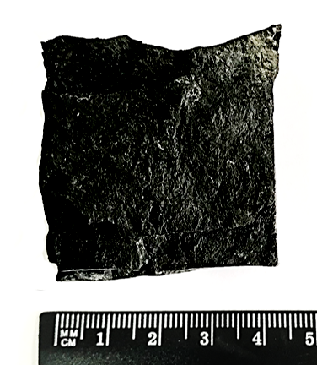 | 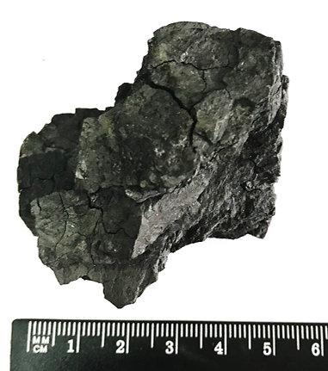
2 | Color | Dark brown | Brownish
3 | Fracture | Splintery | Uneven, angular
4 | Lustre | Glassy | Silky
5 | Texture | Uneven striated | Heterogeneous
6 | Parting/cleavage | Endogenous | Exogenous

2.2 Materials
The following nutrient media were used for the growth of microorganisms:
1. Modified mineral medium (mg/l): NH₄NO₃ – 2.50, KH₂PO₄ – 1.75, K₂HPO₄ – 0.75, MgSO₄ – 0.75, NaCl – 0.25 and (µg/l) ZnSO₄ – 88.0, FeCl₃ – 88.0, CuSO₄ – 16.0, MnCl₂ – 14.0, MoO₃ – 7.0, Co(NO₃)₂ – 5.0. Sterile brown coal was added as the sole source of C and N. 2. LB medium (Luria-Bertani Medium) - to maintain vital activity and obtain bacteria biomass. Composition (g/l): tryptone - 10.0, yeast extract - 5.0, NaCl - 5.0. 3. Meat peptone agar (Nutrient agar) - for the isolation and growth of various bacterial cultures. Composition (g/l): peptone - 5.0, NaCl - 5.0, meat extract - 1.5, yeast extract - 1.5, agar - 15.0. 4. SOB medium of the following composition: peptone - 10 g, K₂HPO₄ - 1.5 g, ammonium iron citrate - 0.75 g, Na₂S₂O₃ × 5H₂O - 1 g per 1000 ml of distilled water. Agar at a concentration of 15 g/l was added to the SOB agar medium. Inoculates were incubated for 24 hours at 30°C. 5. Thiobacillus Broth of the following composition (g/l): (NH₄)₂SO₄ – 0.400, KH₂PO₄ – 4.000, CaCl₂ – 0.250, FeSO₄ – 0.010, MgSO₄ – 0.500, Na₂S₂O₃ – 5.000. Sterilized in an autoclave at 121°C for 15 min. Samples are inoculated in Thiobacillus Broth. After incubation at 25-30°C for 7 days, turbidity or sulfur deposition on the surface of the liquid or on the walls of the flasks indicates bacterial growth. Then the cultures are isolated on Thiobacillus Agar (agar – 12. 500 g/l).

2.3 Research methods
The proximate (technical) analysis of coal is carried out in accordance with [18-22]. Moisture determination (W, %): 1 g of a coal sample was taken into a weighing bottle, then was placed in an oven heated to 105-110°C and dried for 60 min. Then the bottle was removed from the drying cabinet, covered with a lid and cooled for 2-3 min in air, then in a desiccator to room temperature, after which it was weighed. The lowest weight was taken as a result. The mass fraction of water in the analytical sample (W) in percent was calculated according to the formula (1):
$$W=\frac{m_{1}}{m}·100$$ | ((1)
where m₁ is the weight loss during drying of the sample, g; m is the weight of the sample, g.
Ash content determination (A, %): 1 g coal sample was placed in porcelain boats. The sample in boats was placed in a uniform layer, not allowing coal to be poured onto the edges of the container, then was placed in a muffle furnace heated to 300°C. After closing the door, the muffle was gradually heated to a temperature of 800°C, keeping it at this temperature for 1 h. After that, the boats with the ash residue were removed from the muffle, cooled for 5 min in air, and then in a desiccator at room temperature. The ash content of the fuel sample (A, %) was calculated according to the formula (2):
$$A=\frac{G_{1}}{G}·100$$ | ((2)
where G₁ is the mass of the ash residue, g; G is the mass of the coal sample, g.
Determination of the total sulfur content (S_{total}, %). The total sulfur content (S_{total}, %) includes organic sulfur (S_{O}, %), pyrite (S_{P}, %) and sulphate (S_{S}, %). For the analysis, a weighed portion of a coal sample in the amount of 1±0.1 g was examined. The content of total sulfur in an analytical sample of the coal (S_{total}, %) was determined by barium sulphate (BaSO₄) in accordance with the protocol. The value in % was calculated by the formula (3):
$$S_{total}=\frac{{(G}_{1}-G_{2}) ·0,1373}{G}·100$$ | ((3)
where G is a coal sample, g; G₁ is the mass of BaSO₄ obtained by analyzing a coal sample, g; G₂ is the mass of BaSO₄ obtained in the control analysis, g; 0.1373 is the conversion factor of the mass of BaSO₄ to the mass of sulfur.
The sulphate sulfur content (S_{S}, %) was determined by boiling sulphates contained in a coal sample in dilute HCl, followed by precipitation of the sulphate ion in the form of BaSO₄.
The pyrite sulfur content (S_{P}, %) was determined by the oxidation of a coal sample with HNO₃ with subsequent determination of sulfur titrometrically using pyrite iron according to the formula (4):
$$S_{p}=\frac{N \left(v-v_{1}\right) 0,064·100}{m}$$ | ((4)
where, N is the concentration of sodium thiosulphate solution, N; v is the volume of solution consumed for titration, ml; v₁ is the volume of the solution in the control experiment, ml; 0.064 is sulfur content in 1 ml of 1 N. sodium thiosulphate solution, g; m is the weight of brown coal, g.
The content of organic sulfur (S_{O}, %) is found by the formula (5):
$$S_{O}= S_{total}{- (S}_{S}-S_{P})$$ | ((5)
Determination of the yield of volatile substances (V, %). 1 g coal sample was used and placed in a pre-weighed crucible, which with a closed lid was placed in a muffle furnace heated to 850°C. After 7 min, the crucible was removed from the oven, cooled in the air with a lid, and then in a desiccator to room temperature. It was weighed and freed from the non-volatile residue. The volatiles yield in the coal sample (V, %) was calculated using the formula (6):
$$V=\frac{{(m}_{2}-m_{3}) ·100}{{(m}_{2}-m_{1})}-W$$ | ((6)
where m₁ is the mass of an empty crucible with a lid, g; m₂ is the mass of the crucible with the lid and weighed portion before heating, g; m₃ is the mass of the crucible with the lid and the residue after heating, g; W is the mass fraction (%) of moisture in a coal sample.
Determination of the calorific value. The method used is based on the complete combustion of a coal sample in a calorimetric bomb at a constant volume in a compressed oxygen medium. The rise in the temperature of the vessel was measured due to the heat released during the combustion of fuel, auxiliary substances, as well as during the formation of aqueous solutions of HNO₃ and H₂SO₄ under test conditions. A liquid-type combustion calorimeter was used. The specific heat of combustion of a coal sample (Q, kJ/kg) was calculated by the formula (7):
$$Q=\frac{C_{i}·∆t-m_{1}·q_{1}}{m}$$ | ((7)
where С_{i} is the energy equivalent of the calorimetric system, kJ/°С; ∆t is the corrected increase in temperature in the calorimeter vessel; m₁ is the difference in the masses of the ignition wire before and after combustion, kg; q₁ is the specific heat of combustion of the wire; m is the weight of the fuel sample, kg.
Determination of density. As a mechanical characteristic of brown coal, the true strength was determined by the technometric method [GOST 2160-62]. The density of coal on dry weight (g/cm³) was calculated according to the formula (8, 9):
$$l=\frac{m}{m_{1}-(m_{2}-m)}$$ | ((8)
where
$$m=\frac{a (100-W)}{100}$$ | ((9)
m is the dry weight of the sample, g; m₁,m₂ is the mass of the pycnometer, respectively, with a wetting agent solution and a coal sample, g; a is a sample of coal, g; W is the moisture content in the coal sample, %.
Elemental analysis was performed on a standard Vario EL cube device (Germany) for elemental microanalysis, as well as on a JEOL-6380LV scanning electron microscope (Jeol, Japan) equipped with an EDAX GENESIS 2000.
Raman spectrometry. To analyze the structural composition of brown coal, a Solver Spectrum Raman spectrometer (NT-MDT, Russia) was used. The spectra were obtained upon excitation with a solid-state diode laser with a wavelength λ = 473 nm. The laser line was focused on the sample with a 100 x / 0.7 NA Mitutoyo objective, forming a 2 µm diameter spot. The spectral resolution of the diffraction grating was 4 cm⁻¹.
X-ray diffraction analysis of the mineral part of brown coal was carried out on an Empyrean X-ray Diffraction System diffractometer (Holland) by the method of X-ray radiation decomposition.
Fourier-transform infrared spectroscopy (FTIR). FTIR was analyzed using a Nicolet 6700 KBr spectrometer. The IR spectrum of the brown coal sample was recorded in the range from 400 to 4000 cm ⁻¹.
Microstructural analyzes. For the analysis of brown coal samples, a direct optical microscope DM 6000M (Leica) was used. The microscope is equipped with six objectives with a maximum magnification of 150x and a resolution of up to 200 nm. Bright-field (BF) and dark-field (DF) methods were applied.
A Quanta 200i 3D scanning electron microscope (FEI, Holland) at an accelerating voltage of 10–30 kV was used to study the topography of the coal surface and measure micro-objects.
Method for determining the total number of microorganisms (Koch method). Coal samples are taken with a sterile instrument and the test is carried out on the day of sampling. The essence of the Koch method lies in inoculating a test sample of coal on a solid nutrient medium in Petri dishes and then counting the grown of CFU [23]. The procedure is carried out in three stages: preparation of dilutions → inoculation in Petri dishes → counting of grown colonies. Quantitative registration of colonies is carried out according to the formula (10):
$$m=\frac{a ·µ·100}{V}$$ | ((10)
where a is the average number of microorganisms grown on a Petri dish; μ is the degree of dilution; V is the amount of inoculum introduced for inoculation.
Microorganism cultivation methods. To maintain vital activity, the cells of the isolated cultures were grown on nutrient medium at 30°C for 1-2 days, the viability of the cells was maintained by re-inoculating after 1-2 months and kept at a temperature of ~ 7°C. To obtain pure cultures, the method of selective (4-segment) inoculation of bacterial culture was used.
Identification of isolated bacteria. The strains were identified by the method of determining the direct nucleotide sequence of the 16S rRNA gene fragment, followed by the determination of the nucleotide identity with the sequences deposited in the international database Gene Bank, as well as the construction of phylogenetic dendrograms with the nucleotide sequences of the reference strains.
Investigation of the ability of pure cultures to grow on brown coal. The study of the ability to grow on brown coal was carried out in 300 ml Erlenmeyer flasks with 100 ml of sterile mineral medium, to which brown coal was added at a concentration of 5%. The coal sample was sterilized in an autoclave at 1 atm. The culture media were inoculated with a two-day-old bacterial suspension with a bacterial cell concentration of about 10⁸ cells/ml. The process was carried out in a thermal shaker with mechanical stirring (150 rpm) at a temperature of 30°C. The duration of the contact process of coal with the bacterial culture was up to 14 days. The ability of bacteria to grow on medium with brown coal was judged by the intensity of cell multiplication. The experiments were carried out in triplicate.
Use of modern metagenomics methods by means of Illumina sequenced new generation technology. The general approach to preparing libraries for NGS on the Illumina platform includes several stages: 1. Isolation of total DNA from a sample; 2. Determination of sites for sequencing and screening of primers for further amplification using PCR; 3. Double barcoding of the obtained libraries for sequencing; 4. Sequencing; 5. Bioinformatic analysis and visualization of the obtained data. Each stage was performed according to the standard protocols of the manufacturer [24]. Samples were sequenced using a HiSeq instrument from Illumina (USA) at the University of Inner Mongolia (China) according to standard protocols [25]. Illumina platform specifications and key features are available on the official website https://www.illumina.com
Isolation and identification of microorganisms capable of removing sulfur. Bacterial strains have been isolated from various ecological niches, such as stagnant soil with silt, rusty pipes, and brown coal from the Lenger coal deposit. Identification of the isolated bacteria was carried out by determining the direct nucleotide sequence of the 16S rRNA gene fragment with subsequent determination of the nucleotide identity deposited in the international database GeneBank, as well as by constructing phylogenetic trees.
Bio-desulfurization of brown coal. Conditions for treating coal with strains of microorganisms: pH - 3, incubation time - 12 days, pulp density - 5%, particle size - 2 mm, temperature - 30°C. The treatment was carried out in a shaking incubator with a rotation speed of 180 rpm. After optimizing the pH, incubation time, pulp density, particle size, and incubation temperature for microorganisms, the desulfurized brown coal sample was analyzed. By the end of the incubation time, coal samples were separated by centrifugation and then washed with distilled water. Coal samples were dried at 45°С for 12 hours for further analysis [26].
Agar-diffusion method for determining biosolubilization. The bacterial isolate was cultured at 37°C for 48 hours on nutrient agar plates to obtain a lawn. Then sterile particles of lignite were placed (about 3 mm in diameter) on the bacterial lawn and incubation continued for 7 days. Biosolubilization was observed as the appearance of brown halos indicating solubilization of the lignite sample.
Method for biosolubilization of brown coal in a liquid medium. Coal biosolubilization was carried out under aerobic conditions using a liquid culture of bacteria. The active strain was added to LB medium (200 ml) until OD₆₀₀ reached 0.1, then cultured at 30°C for 24 hours in a rotary shaker (3 G-force). Sterilized coal powder at 5% (w/v) was added and incubated for 14 days. During biosolubilization, samples were collected every second day under aseptic conditions, centrifuged at 11,200 G-force for 15 min, filtered through membrane filters (pore size 0.24 μm). The absorption of the filtrate at 450 nm was measured on a UV-2600 spectrophotometer (Shimadzu, Japan) to assess the solubility of lignite [27]. The remaining coal (residue) was subjected to three cycles of water washing, dried at 100°C, and weighed to calculate the percentage of bio-transformed coal. LB medium without inoculum with the addition of coal served as a control. The experiments were carried out in triplicate, and for the data obtained, both mean values ​​and standard deviations were estimated.
Determination of emulsifying activity. To assess the emulsifying activity, the cells were separated from the culture medium by centrifugation for 15 min at 1372 G-force. Then the supernatant was mixed in test tubes with a hydrocarbon substrate in a ratio of 3:2 and vigorously stirred on a shaker at 112 G-force for 20 min to obtain an emulsion. Thereafter, the tubes were left in an upright position at room temperature for 24 hours, then the emulsifying activity was measured. The emulsifying activity was expressed in %, calculated as the ratio of the height of the emulsion layer to the total height of the liquid in the test tube.
The calculation was made according to the formula (11).
E₂₄ (%) = (V_{e}/V_{n}) × 100 (11)
where V_{e} is the emulsion volume, V_{n} is the total volume of the liquid, including the volume of the supernatant phase + the volume of the hydrocarbon phase + the volume of the formed emulsion.
The isolation of humic substances. Humic substances were isolated according to [28]. Air-dried 2 g of coal were suspended in 100 ml of 0.1 M NaOH and stirred at 20°C / 3 G-force for 24 hours, followed by centrifugation at 11 200 3 G-force for 15 minutes. The supernatant was filtered through Whatman # 1 paper and then precipitated by adjusting the pH to 2.0 with 6.0 M HCl and allowed to stand for 12 hours. The precipitate was recovered by centrifugation at 11,200 G-force for 15 min, washed 3 times with distilled water, and dried at 60°C. The resulting product was denoted as Chemical Humic Substances (CHS). The treated coal after biosolubilization was filtered through Whatman # 1 paper and the pH was adjusted to 2.0 using 11.6 M HCl. The precipitate was collected for the extraction of bacterially transformed humic acids (BHS), as described above, to obtain CHS.
Characterization of solubilized products. The isolated humic substances (CHS and BHS) were subjected to the following analysis. FTIR was performed using a Nicolet 6700 FTIR spectrometer (Thermo Scientific, USA) in the transmission range from 4000 to 400 cm⁻¹. The following data acquisition parameters were used: the number of sampled scans – 32, resolution – 4.000, zero-fill – 2, He-Ne laser frequency: 15798.0 cm⁻¹, peak noise position – 8192, apodization function – N-B strong, background scans – 32, Background Gain – 1.0, Optical Fiber 100.00, Sample Gain – 1.0, High Pass Filter 200.0000, Low Pass Filter 20000.0000, Acquisition Method – GC / IR, Final Format – transfer %.
The liquid chromatogram of humic substances was measured using a 6460 QqQ LC / MS system (Agilent, USA). Chromatographic analyzes were performed with a mobile phase in acetonitrile (eluent A) and water (eluent B). The flow rate was 0.25 ml/min⁻¹. The column temperature was maintained at 40°C throughout the process. The injection volume was 5 μL. Mass spectrometric analysis was achieved using electrospray ionization (ESI) in negative mode. Scan monitoring was used at 100-2000 m/z. The mass spectrometer was connected to the UHPLC system via an ESI interface with nitrogen used as drying gas, sheath gas, and collision energy (CE). Parameters: gas temperature 350°C, gas flow rate 8 l/min, nebulizer 45 psi, gas sheath temperature 350°C, gas sheath 12 l/min, capillary voltage 4000 V (negative), nozzle voltage 1500 V (negative). Instrument control and data collection were performed using MassHunter Workstation software (version B.08).
Optical spectroscopy (UV-Vis) of humic substances was carried out on a V-550 spectrophotometer (Jasco, Japan) using a 1 cm quartz cuvette and a phosphate buffer blank. Absorption spectra were recorded in the wavelength range from 200 to 900 nm after 1 hour of sample preparation. Standard spectroscopic indices such as E_{Et/Bz}, E_{2/3}, E_{4/6}, E_{254/410}, E_{265/465}, and ∆logK have been obtained by studying their spectra.
The elemental composition (C and H) of bioprocessing coal products was determined using a Vario EL analyzer of cubic elements (Elementar, Germany).
X-ray data collection was performed using a Bruker AXS D8 Advance X-ray Powder Diffractometer (Germany). X-ray diffraction data were collected with a start angle of 5.00, an end angle of 80.00, and a step angle of 0.02° at a scan rate of 3°/min. The X-ray tube has a voltage of 40 kV and a current of 30 mA. Equipment test conditions: Cu target, bent graphite monochromator, Kα radiation. Slit system: DS (emission slit) - 0.6 mm, SS (anti-scatter slit) - 8 mm.
An electron microscope (FE-SEM, Hitachi S-4800) was used to observe morphological changes in the adhesion of lignite and microorganisms on its surface. The sample without medium was dispersed on a silicon wafer, dried in the air, and placed on the sample stage. SEM conditions were voltage 7-15 kV, working distance 8-12 mm. Samples were scanned from 20 to 80 (2 hours) with a step size of 1 (2 hours) and a counting time of 1 minute. The results were interpreted with the support of the JADE 6.5 software package.
Design of experiments. Figure 1 shows a scheme of experiments to determine the desulfurizing (sulfur removal), emulsifying (release of biosurfactants) and solubilizing (coal liquefaction) activities of active strains of microorganisms.

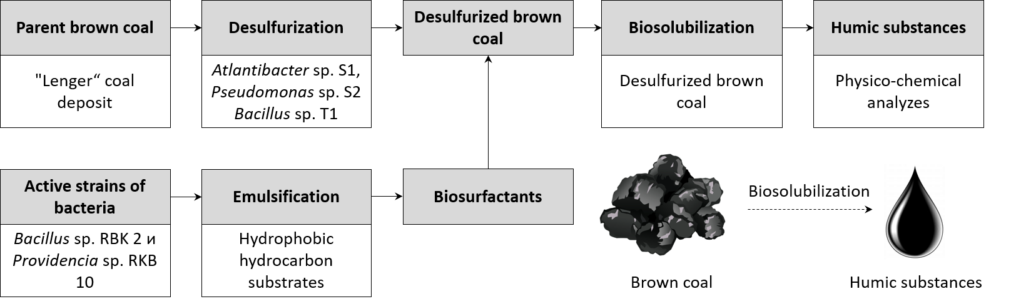
Figure 1 – Design of experiments to determine the emulsifying and solubilizing activities of microbial strains

Method of obtaining bio-binding agents (bio-binders). The biotransformation of Lenger brown coal into a binder was carried out in a bioreactor with mechanical stirring (impeller speed 350 rpm) with aeration at 30°C. Single loading into the bioreactor was calculated according to: substrate – 30% (brown coal – 70%, aspen sawdust – 30%), inoculum – 20%; synthetic medium – 50%. The total volume of a single load was 2 liters. The pre-fermentation period consisted of the following stages: the substrate was prepared (particle size <3 mm, humidity – 32%); the original inoculum of the RKB 2 strain was accumulated; the bioreactor was prepared for fermentation, i.e. disinfected. Fermentation was carried out in the following order: the growth of the inoculum took place in a bioreactor on an organic-coal medium for 60 hours at 30°C under oxygen conditions.
Experiments on briquetting were carried out according to the following scheme: placing the bio-suspension in a drying chamber; the periodic control of the moisture content of the dry coal; unloading of bioproduct and grinding; dry coal briquetting on a hydraulic press; testing of briquettes and determination of physical and chemical properties.
Method for determining technological parameters of briquetting. Initial coal pretreatment included: crushing to a coal size of 10 mm (jaw crusher), grinding to a class of 1 mm (laboratory mill) and subsequent drying with an initial moisture content of up to 16.5% at a temperature of 90°C (oven). Control of the current moisture content of the coal during drying was carried out by periodic sampling.
The bio-binders used in the briquetting experiments were obtained by drying bio-coal suspensions (initial moisture content up to 70%) obtained in the course of coal biomodification to a residual moisture content of 15 wt%. The materials were pressed on a hydraulic press (PO-500М, Antek, Russia), where the specific pressing pressure was 120 MPa. Cylindrical molds with a diameter of 50 mm were used for briquetting: the weight of the sample was 50 g, the height was 20 mm. The resulting products were tested to determine the compressive strength and abrasion strength in accordance with GOST 21189-21191-75.
The method of obtaining briquettes on a stamp press. The pressing of the heated coal mixture was conducted on a semi-industrial stamp press (GCZ26, China) with the following pressing characteristics: 1. the maximum specific pressing pressure – 150 MPa; 2. press productivity (pcs / hour) – 5,000; 3. briquette size (width * length * height): 22 mm. Briquetting modes on a stamp press completely imitated their industrial counterparts.
Abrasion and water absorption strength tests of pyrolyzed briquettes were carried out in accordance with GOST 21289-21291-75. The heat of combustion of the resulting products was determined according to ST COMECON 1463-78; the yield of volatile products in accordance with GOST 6382-80; moisture content according to ST COMECON 751-77; ash content according to GOST 11022-75.
Statistical analysis. Most measurement values represent mean values ± standard deviation (SD). Statistical differences between the microbial communities associated with each sample were determined by two-sided Fisher’s exact test (n=13 per each group).

3 Research results and discussion
3.1 Study of the physicochemical and microbiological properties of brown coal from the Lenger coal deposit
3.1.1 Study of the physical, mechanical, and chemical properties of brown coal from the Lenger coal deposit
The results of studying the technical characteristics, elemental analysis of brown coal samples from the Lenger deposit are presented in Tables 2 and 3. Comparison of these data with respect to the results of studies of the Lenger deposit, carried out earlier [29, 30] revealed their agreement in a number of indicators. However, the data on the sulfur and ash content in the brown coal sample from the Lenger coal deposit, obtained by us and the authors of these works, varied markedly. Thus, the percentage of ash content of the analytical samples we studied was slightly lower, while the sulfur content, on the contrary, was noticeably higher. Apparently, these differences are due to different methods of sample preparation for technical analysis and determination of the elemental composition of the sample. Thus, on the basis of the conducted studies, it can be concluded that the analytical sample of brown coal from the 2018 sample from the main layer of the Lenger deposit belongs to the medium-calorie, medium-sulfur fuel with a noticeable ash content and average moisture content of class B3.

Table 2 – Proximate (technical) characteristics of brown coal samples from Lenger coal deposit
Indicator | Analysis result
Moisture, W, % | 10.8
Ash content, A, % | 21.2
Volatile matter, V, % | 43.3
Calorific value, Q, kJ/kg | 7 300

Table 3 – Ultimate (elemental) analysis of brown coal sample from the Lenger coal deposit, based on ash-free, moisture-free mass, %
Elements | C | H | N | S | O
% | 61.3 ± 0.7 | 3.52 ± 0.1 | 0.85 ± 0.1 | 1.61 ± 0.3 | 32.72 ± 0.6

In order to establish the chemical composition of coal samples, the elemental analysis was carried out using a scanning electron microscope equipped with an EDX GENESIS 2000 detector (Fig. 2).

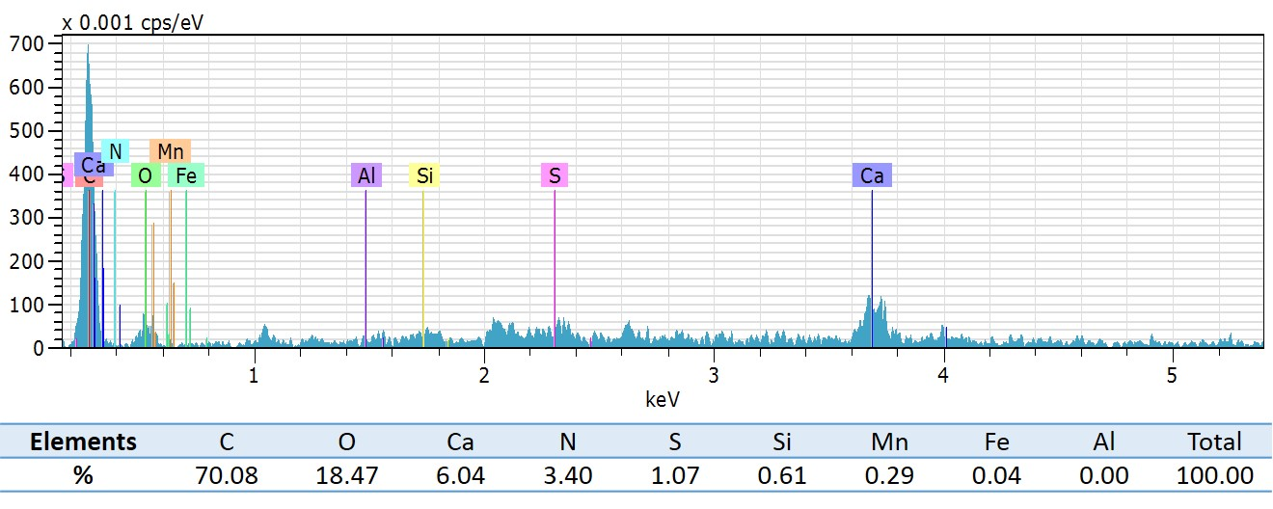
Figure 2 – Elemental analysis of brown coal from the Lenger coal deposit, calculated as Wt%

As can be seen, heavy metals are absent in the composition of the brown coal. The presence in the composition of sulfur, sodium, nitrogen, quartz, manganese, and iron makes it possible for the growth and reproduction of microorganisms in it, which use these elements as a nutrient component.
The true density of brown coal (mass per unit volume of brown coal), excluding pores and cracks, was 1.45 g/cm³.
The molecular structure of the original coal, as well as its individual components, was characterized by the results of spectral analyzes, IR-, UV-, Raman spectroscopy.
Infrared spectroscopy. The results of IR-spectral studies of Langer brown coal are shown in Fig. 3. The following structural fragments (v, cm⁻¹) were identified in the IR spectrum of the parent brown coal: 1. Aromatic cycles (1500-1600 and 700-900); 2. Methyl and methylene groups of alkyl chains (1450-1470 and 800-1100); 3. Double bonds (1320-1270 and 870-520); 4. Carbonyl groups of aliphatic and alkyl-aromatic ketones (1100, 1220-1130 and 1330-1220); 5. Ester groups (1320-1000); 6. Alkoxyl groups (2850, 2830-2815); 7. Hydroxyl groups of phenols and alcohols (1450-1370); 8. Oxygen-, sulfur- (1565, 1030-1015, 870-845 and 800-740) and nitrogen-containing heterocycles (1100-1000, 1210-1190 and 900-670).

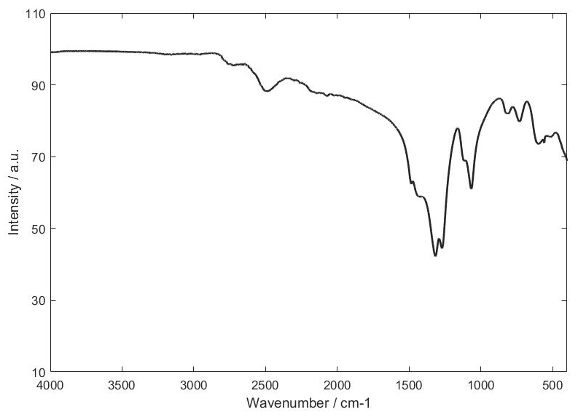 | 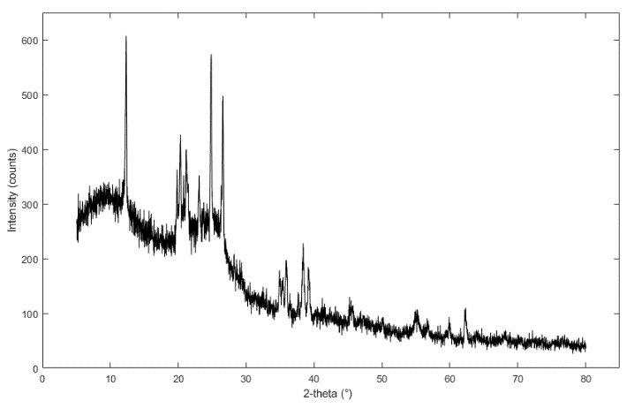
Figure 3 - IR spectrum of the Lenger brown coal | Figure 4 - X-ray structural analysis

X-ray structural analysis. The study of brown coals on an X-ray diffractometer resulted in an X-ray pattern (Fig. 4). The X-ray diffraction pattern had a high background intensity, indicating the presence of disordered materials in the form of amorphous carbon. In particular, the diffraction pattern of the samples turned out to be more extensive in the direction of 10° < 20.
Broad peaks were observed at 20 = 12.2° (kaolinite), 20.8° (quartz), 23.2° (calcite), 24.9° (kaolinite), and 26.7° (quartz), indicating the presence of crystalline carbon (graphite-like) structures.
Raman spectrometry. Raman spectra were measured with excitation with a blue laser with a wavelength of 473 nm. Basically, all spectra are represented by two peaks characteristic of amorphous carbon (Fig. 5). These peaks refer to the so-called D (diamond) and G (graphite) bands.
Against the background of the luminescence band, intense Raman lines are revealed with maxima at ~ 1370 cm-1 (scattering by amorphous carboxylic and methyl groups) and ~ 1600 cm-1 (scattering by aromatic rings and conjugated with them C = O bonds in dicarboxylic acid, and also alkene C = C). The samples have an inhomogeneous structure depending on the region on each individual particle (Fig. 6).

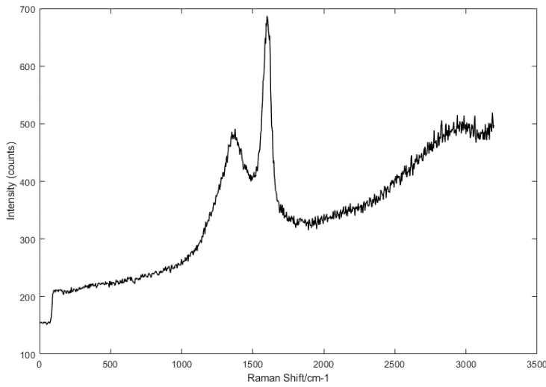 | 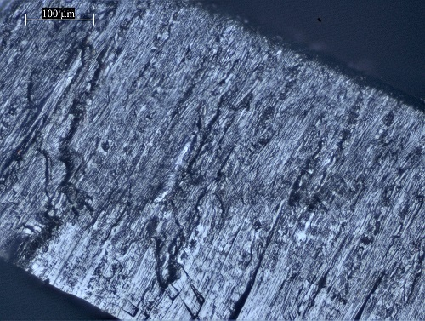
Figure 5 – Raman spectrum of the brown coal sample | Figure 6 – The porous structure of the brown coal
For the initial study of the microstructure, a Leica DM 6000M optical microscope was used. The photographs show the layered architecture of brown coal (Fig. 7). An image was obtained from a relatively flat surface of the structure of a brown coal sample: the surface is unevenly covered with pores, and the directionality of the ordered structure of coal is also present.
For a detailed analysis of the surface structure, the method of scanning electron microscopy was applied. Figure 6 shows micrographs of a sample of the test material.

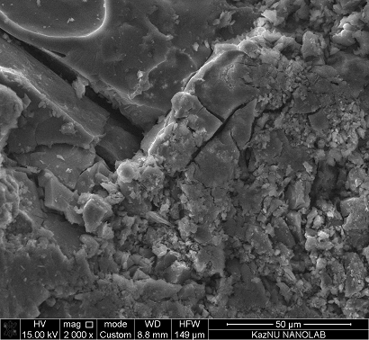 | 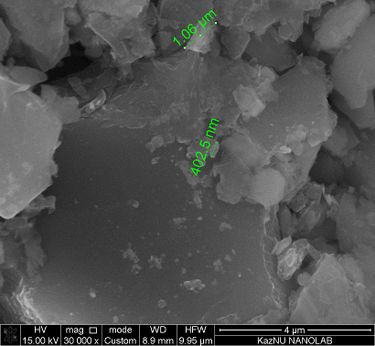
Figure 7 – SEM images of the test sample

The analysis of brown coal by scanning electron microscopy indicates a variety of surface morphology. It is characterized by a heterogeneous structure with local accumulations of isometric forms, which indicates the presence of secondary minerals such as quartz and pyrite in the composition. Globular microstructures, the size of which is 0.1-2 µm, are also found on the surface.
Thus, as a result of the conducted studies of the chemical composition and physicochemical structure of brown coal, the suitability of this raw material for bioconversion was clarified.

3.1.2 Determination of the content of sulfur and sulfur compounds in the samples of brown coal from the Lenger coal deposit
Select-study-paths in the use of solid fuels often depend on their total sulfur content (S_{total}). That is why it is the most important indicator of the coal quality. Sulfur forms (S_{S}, S_{O}, S_{P}) are usually determined only when it is necessary to fully characterize low-quality fuel.
Elemental analysis, which was described above, provides for the determination, along with C, H, O, N, and organic sulfur. Since the S content in coal can significantly affect their technological performance, the analyzes to determine various types of sulfur was conducted.
In solid coal fuel, sulfide sulfur S_{C} and pyrite S_{P}, included in sulfides and bisulfides of metals, are distinguished, organic sulfur S_{O}, which is part of the organic mass of coal, sulphate S_{S}, which is in the form of metal sulphates, and elemental S_{E}, which presents in the fuel in a free state. The sum of these types of sulfur is the total sulfur – S_{total}. One of the indicators characterizing the technical nature of coal – total sulfur (S, %) – indicates the total content of this element in all compounds converted conditionally into elemental sulfur (%) in relation to the analyzed sample.
According to ISO 334-74, a gravimetric method is adopted, based on the absorption of sulfur oxides formed during the combustion of coal fuel by an Eshka mixture with the formation of sulphate salts of Mg and Na. The resulting salts are dissolved in hot water and BaCl₂ is precipitated in a solution acidified with hydrochloric acid. The amount of BaSO₄ is used to calculate the mass fraction of sulfur. According to the international standard ISO 157-75, sulphate sulfur (S_{S}) is determined by the gravimetric method. This method is reduced to the dissolution of solid fuel sulphates in HCl and the precipitation of sulphate ions BaCl₂
The international standard ISO 157-75 provides an oxidation method based on the determination of the iron content associated with sulfur (S_{P}) in the form of FeS₂, based on the fact that the oxidation of pyrite with HNO₃ forms soluble sulphates, by the amount of which the content of pyrite sulfur is determined.
The mass fraction of organic sulfur (S_{O}) is determined by the difference by subtracting from the mass fraction S_{S}, S_{P} and S_{total}. According to the results obtained (Table 4), the sulfur content in the coal of the Lenger coal basin is about 3.14%; it belongs to medium-sulfur coals.

Table 4 - The sum of various types of sulfur in the brown coal sample from the Lenger coal deposit
Sulfur types | Content, %
Total sulfur – S_{total} | 3,14
Sulphate sulfur – S_{S} | <0,01
Pyrite sulfur – S_{P} | 1,61
Organic sulfur – S_{O} | 1,53

There is no definite pattern in the distribution of sulfur over solid fuels of various nature and degree of maturation. Certain types of S in the composition of S_{total}, taken as 100%, are often distributed in coals almost equally between S_{P} and S_{O}, since the amount of S_{S} does not exceed 15% of all sulfur [31].

3.1.3 Study of the biodiversity, abundance, and physiological-biochemical properties of the microbial community of brown coals
Despite the well-established role of microorganisms in the formation of coal, microorganisms of brown coal have been studied extremely insufficiently and superficially. In the available literature [1, 32], there is limited information on bacteria and fungi that live in brown coals.
As part of this work, we processed data on the study of the taxonomic diversity of the 16S rDNA gene with the aim of its more rational use in studies on microbiological monitoring of coal seams. The purpose of this stage of the study is to analyze the results of studying the taxonomic diversity of microbial communities of Lenger brown coal (LLI) obtained using metagenomic technologies. Leonardite (oxidized brown coal - LLE) was used for detailed consideration and comparison.
Since the number of sequences in brown coal samples varied within wide limits, as well as to calculate various indices of diversity (Table 5), the average values ​​of the indicators calculated for random tests of sequences of each sample (analysis "Rarefaction") were used. The results of sequence analysis carried out for these samples showed a multidirectional dynamic of OTU accumulation as the volume of sequences increased (Fig. 8, dilution curve). The slope of the curves on the graph is an additional indicator of biodiversity – the larger the slope, the more diverse the microbiome is. The abundance curve shows the dynamics of the relative intensity of the species composition of microbial communities.

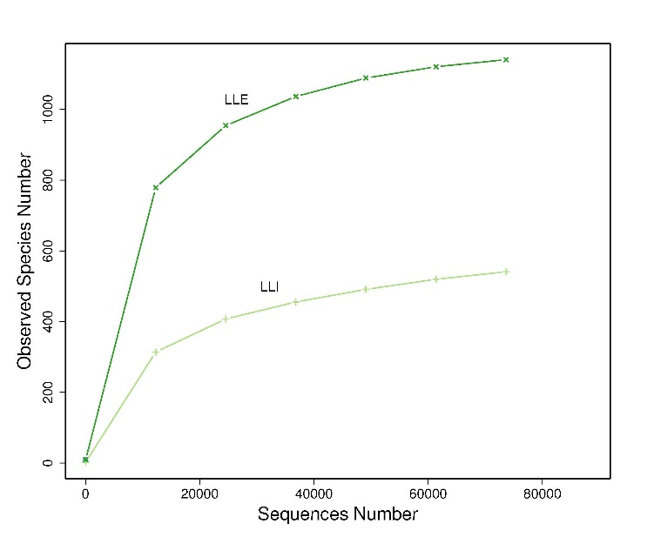 | 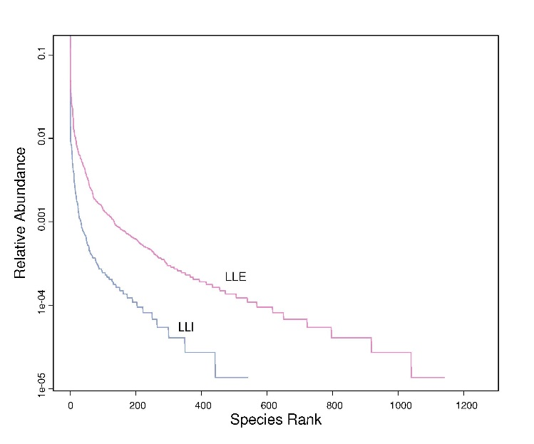
Dilution curve | Number curve
Figure 8 - Results of "Rarefaction" test

Species richness data (number of identified OTUs) and biodiversity indices for samples LLI and LLE are shown in Table 5.

Table 5 - Key indicators of biodiversity for coal samples
Samples | Number of sequences | OTU quantity | Shannon Index | Chao1 Index | ACE Index
LLI | 541 | 628 | 1.800 | 593.161 | 611.707
LLE | 1141 | 1212 | 6.953 | 1183.221 | 1188.680

The level of biodiversity revealed in the communities of microorganisms, in general, reached its high values – about a thousand species. The LLE sample was the richest in species. As the data of the test for the diversity index show, in the case of LLE, an increased level of biodiversity is associated with its high oxidation (aeration) state, which can be a source of chemical energy for various microorganisms.
Interesting is the fact that LLE is characterized by a high Shannon index, comparable to LLI, which also indicates the presence of a climax micro-community in this coal samples (Fig. 9, 10).
When analyzing the taxonomic structure of the microbial community at the domain level, it was found that the absolute majority in the microbiome are bacteria. Thus, in the LLE sample, the proportion of bacteria was 99.0%, while archaea were only 1.0% (Fig. 11). Archaea were not found in the LLI sample (Fig. 12).

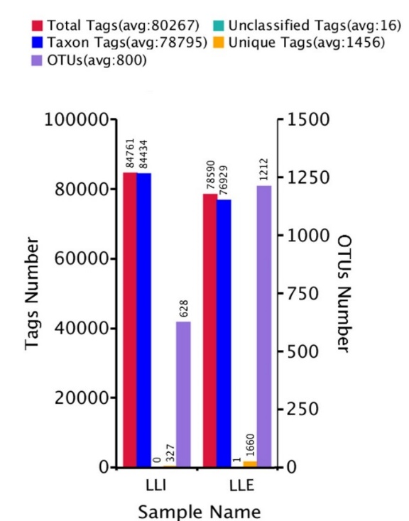 | 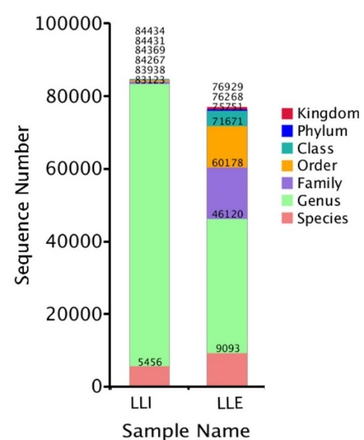
Figure 9 - OUT clustering statistics and annotations | Figure 10 – Sequence statistics of coal samples at different levels of classification

During the taxonomic analysis of nucleotide sequences at the phylum level, representatives of 10 bacterial groups were identified in the samples: Proteobacteria, Tenericutes, Actinobacteria, Firmicutes, Bacteroidetes, Nitrospirae, Chloroflexi, Gemmatimonadetes, Acidobacteria, and Fusobacteria. In addition to the bacteria with the established taxonomy, these samples contained a different amount of sequences unidentifiable at the phylum level, the proportion of which was 0.06% for LLI and 3% for LLE. For archaea, no unidentified sequences were found.

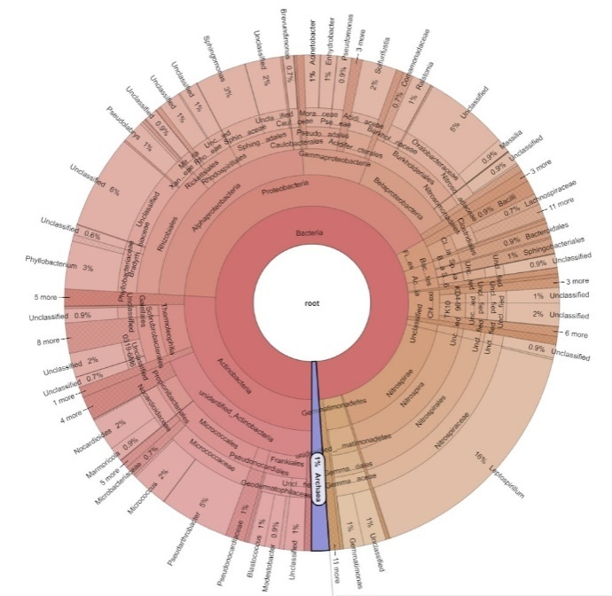 | 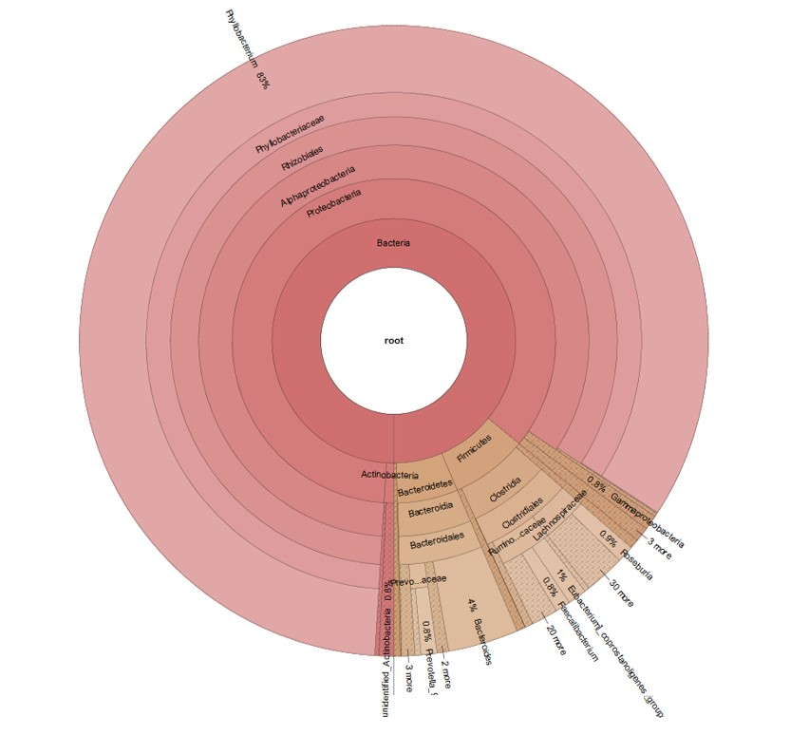
Figure 11 - Taxonomic classification of the bacterial microbiome of the LLE sample visualized using the Krona | Figure 12 - Taxonomic classification of the bacterial microbiome of the LLI sample visualized using the Krona

A large number of undefined sequences have been identified not only at the phylum level but also at the family level. In Fig. 13 and 14, it can be seen that the maximum proportion of these sequences is observed in the LLE sample, which indicates the presence of a rich micro-biodiversity.

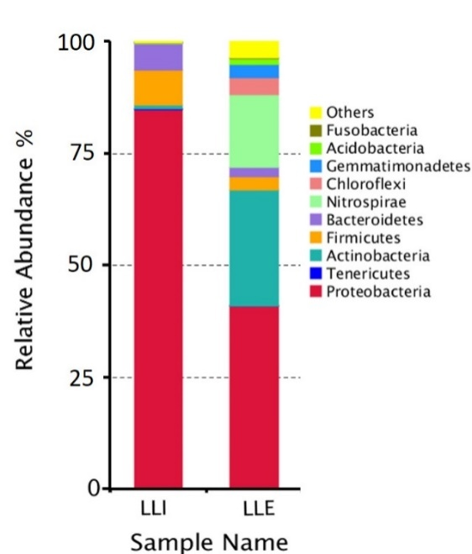 | 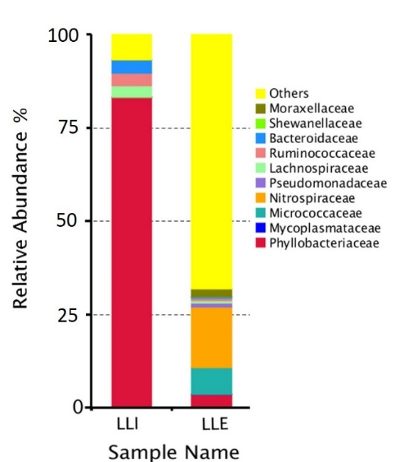
Figure 13 - Taxonomic structure of the community at the phylum level | Figure 14 - Taxonomic diversity of the microbiome at the family level

As the analysis of the taxonomic structure of the community at the family level shows, LLI has a high level of Phyllobacteriaceae diversity. The composition of bacterial families in LLE differs greatly from LLI, for example, in the LLE sample, mainly Nitrospiraceae and Micrococcaceae were found.
Thus, for the first time, based on the analysis of high-throughput sequencing data, the taxonomic structure of the metagenome of the coal seam microbial community is described. For the first time, mathematical modeling methods of the dynamics of brown coal microbiomes of the Lenger coal deposit in the taxonomic space of the 16S rDNA gene was carried out with the calculation of integral parameters describing their structure and dynamics.
Next, a microbiological quantitative characterization of the brown coal sample was carried out. The total microbial number of the samples from the Lenger coal deposit was determined by the CFU index.
Table 6 shows the results of studying the quantitative content of aerobic and anaerobic microorganisms in the brown coal samples.

Table 6 - Total microbial number of LLI and LLE samples
Samples | General numerical index of microbes, CFU/mg
Samples | Aerobes | Anaerobes
LLI | 17,2х10⁴ | 3,8х10³
LLE | 20,8х10⁵ | 0,4х10²

In the course of studying the total number of microorganisms of the LLI and LLE samples, it was revealed that the total number of aerobic microorganisms was 17.2×10⁴ CFU/mg and 20.8×10⁵ CFU/mg, respectively. The number of aerobic microorganisms in LLI is an order of magnitude lower than LLE, while an inverse correlation is observed in the content of anaerobes in samples, so in LLI it is 3.8×10³ CFU/mg, and in LLE the number of anaerobes is much less – 0.4×10² CFU/mg. These results correlate with the localization of brown coal, as the LLI samples were sampled at depth, and the LLE samples were sampled from the surface of a coal waste heap, where the oxidation process was created as a result of prolonged weathering.
To determine the various physiological groups of cultivated bacteria, elective conditions were created, using special nutrient media that provide more favorable conditions for the growth and development of a particular inoculum. As a result of the studies carried out using an elective medium, 4 cultures of microorganisms were isolated from the samples of the Lenger coal deposit. A primary culture-based study of isolated microorganisms was carried out (Table 7).

Table 7 – The primary culture-based study of the bacteria of brown coals
№ | Samples | Culture | Colony characteristics | Morphological characteristics
1 | LLI | RKB 2 | Spherical, whitish, convex surface, curved edges, shiny, diameter ~ 3 mm | Gram-positive, rod-shaped cells, 0.7-4 µm, non-spore
2 | LLE | RKB 3 | Spherical, light green, slimy, rough surface, smooth edges, diameter ~ 4 mm | Large, gram-negative rods, ~ 3 µm, motile
3 | LLE | RKB 4 | Spherical, light red, convex surface, smooth edges, diameter ~ 5 mm | Gram-negative, rod-shaped, size 2.5-4 µm, non-spore
4 | LLE | RKB 10 | Spherical, light green, slimy, rough surface, smooth edges, shiny, diameter ~ 4 mm | Gram-negative, rod-shaped cells, 2-3 µm in size, motile

At the next stage of the study, the phenotypic characteristics of isolated bacteria were determined. An analysis was conducted on morphological characteristics (shape and size of cells, type of cell assemblage, presence of spores and capsules, belonging to Gram stain, motility) using microscopy.
In the work, the classical microbiological methods [23] to study the physiological and biochemical properties of the isolated bacteria were used (Table 8).

Table 8 - Physiological and biochemical properties of isolated bacteria from brown coal samples
Isolated bacteria | Characteristics
Isolated bacteria | Catalase activity | Oxidase activity | Indole test | Nitrate reduction | Motility | Hydrolysis |  |  | Assimilation
 |  |  |  |  |  | Casein | Gelatins | Starch | Glucose | Maltose | Mannitol | Arabinose | Xylose | Lactose | Mannose | Sorbitol
RKB 2 | + | + | - | + | + | + | + | + | + | + | + | + | + | + | + | -
RKB 3 | + | - | ± | + | + | - | - | - | + | + | + | - | - | - | - | -
RKB 4 | + | - | + | + | + | - | - | - | + | + | + | - | - | - | - | -
RKB 10 | + | - | ± | + | + | - | - | - | + | + | + | - | - | - | - | -

During the study of morphological, cultural, physiological and biochemical characteristics, it was revealed that the cultures of RKB 3, RKB 4, and RKB 10 had similar morpho-functional and phenotypic characteristics, which is a reason to attribute these cultures to the same genus Providencia, and RKB 2 to Bacillus. Thus, 2 strains of bacteria RKB 2 and RKB 10 were selected for genetic analysis.
Genotyping of 2 isolates was carried out by the method of identifying the direct nucleotide sequence of the 16S rRNA gene fragment, with the determination of nucleotide identity with the sequences deposited in the international database GeneBank.
The nucleotide sequences of the 16S rRNA gene of the two identified strains were analyzed and combined into a common sequence using SeqScape 2.6.0 software (Applied Biosystems). After that, the terminal fragments were removed, which made it possible to obtain a nucleotide sequence with a length of more than 600 bp, and were identified using the BLAST algorithm.
Additionally, phylogenetic trees with 16S rRNA nucleotide sequences of the gene of reference strains of these species (http://www.bacterio.net) were constructed.
The analysis included the nucleotide sequences of the 16S rRNA gene, phylogenetically the most related microorganisms. The results show (Fig. 15) that the RKB 2 strain is located on the same branch as the nucleotide sequences from the reference Bacillus methylotrophicus strain. As shown in Figure 16, the RKB 10 strain is located in the same clade as Providencia rettgeri.

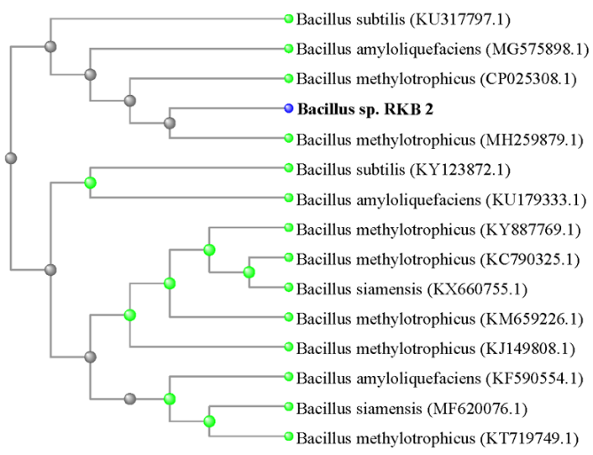 | 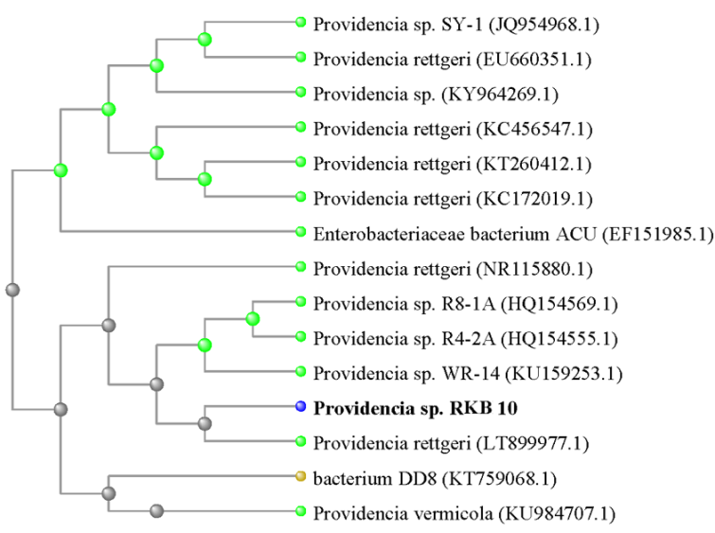
Figure 15 - Phylogenetic tree based on the analysis of the 16S rRNA gene fragment of the Bacillus sp. | Figure 16 - Phylogenetic tree constructed based on the analysis of the 16S rRNA gene fragment of the Providencia sp.
The data obtained from the comparison of morphological-cultural, physiological-biochemical and genetic characteristics made it possible to determine the species belonging of strains RKB 2 and RKB 10 to the genera Bacillus and Providencia, respectively.

3.1.4 Study of the metabolic activities of the isolated microbial cultures during their growth on media containing various concentrations of brown coal
Currently, the study of coal microbiology is mainly focused on the search for microorganisms with pronounced metabolic activity, which is used for the bioconversion of low-quality coals [1, 33] for further use as a basis for creating bio-briquettes.
To investigate the ability of pure cultures of bacteria to grow on Lenger brown coal, the bacterial strains Bacillus sp. RKB 2 and Providencia sp. RKB 10 were tested. For this purpose, a modified mineral medium is used. Sterilized Lenger brown coal was added as the sole source of carbon and nitrogen. The metabolic ability of microorganisms to grow on a mineral medium was determined by the dynamics of changes in the number of bacterial cells in suspension.
Figure 17 shows the results of studying the growth of isolated strains on a mineral medium, where 5% of coal was added as the sole source of carbon. The experiment was conducted for 14 days.
As illustrated, these inoculants multiply on a medium with a high content of brown coal, and the adaptation phase (lag phase) of cell growth does not exceed 24 hours. It should be noted the active reproduction of the cultures – the peak of the largest number of cells in the medium was 13.1×10⁸ cells/ml for RKB 2 on the 6th day, and for the RKB 10 culture - 8.9×10⁸ cells/ml on the 5th day.
The 5% concentration of brown coal in the suspension as the optimal medium was selected taking into account the results of the following experiments. For this, the dynamics of the culture growth in environments with a coal content of 0, 1, 5, and 10% were tested. Coal was used as the sole source of carbon. Figure 18 demonstrates the dynamics of changes in the number of microbial cells in suspension on a mineral medium with different contents of brown coal. The maximum growth of bacteria was observed at a concentration of brown coal in the medium of 5%.
Figure 17 - Growth dynamics of microorganisms-producers of biosurfactants on a medium with brown coal | Figure 18 - Growth of microorganisms on a medium with different concentrations of brown coal

Thus, when studying the growth of isolated cultures of microorganisms, i.e. producers of biosurfactants in the process of biosolubilization, it was shown that both inoculums multiply on a medium with a high content of brown coal, and the adaptation growth phase for all cultures does not exceed 1 day. The maximum number of cells in suspension for Bacillus sp. RKB 2 was observed on the 6th day of incubation, when the TMC was 1.3×10⁹ cells/ml, while the initial value was 1×10⁸ cells/ml.

3.2 Study of the main regularities and parameters of biomodification of brown coal
3.2.1 Screening of microorganisms capable of removing sulfur (pyrite and organic) from brown coal
In order to acquire active strains of desulfurizing bacteria, 3 cultures of bacteria (S1, S2 and T1) were isolated for further identification. The genotyping of the isolates was carried out by determining the direct nucleotide sequence of the 16S rRNA gene fragment, and the construction of phylogenetic trees with the nucleotide sequences of the 16S rRNA gene of the reference strains of these species (Fig. 19-21). S1 is identified as Atlantibacter sp. and this sample was isolated from stagnant soil with silt.

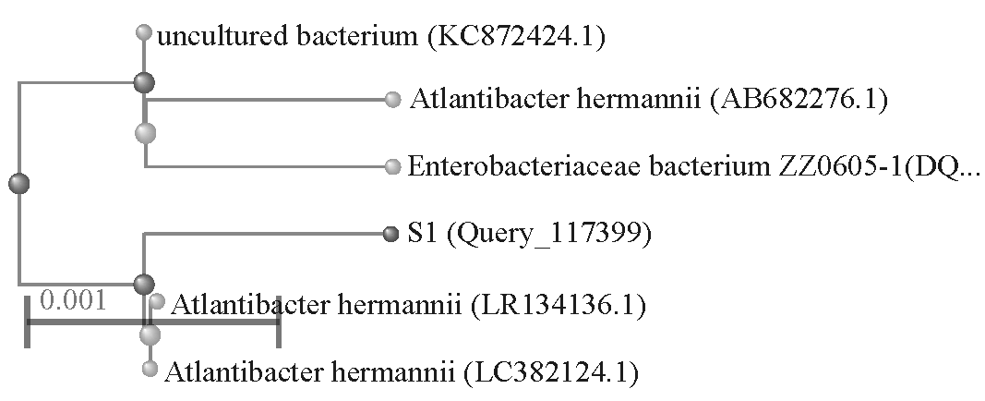 | 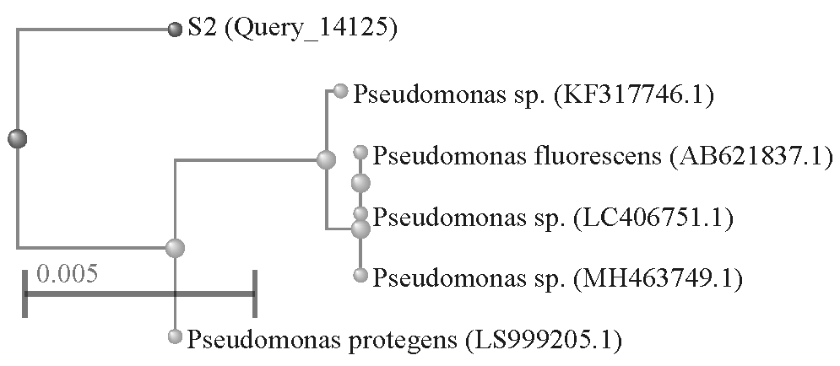
Figure 19 - Phylogenetic tree based on the analysis of the 16S rRNA gene fragment of the Atlantibacter sp. S1. | Figure 20 - Phylogenetic tree based on the analysis of the 16S rRNA gene fragment of the Pseudomonas sp. S2.

S2 is identified as Pseudomonas sp. and this sample was isolated from a rusty pipe. T1 is identified as Bacillus sp. and it was isolated from the coal itself (Lenger deposit).
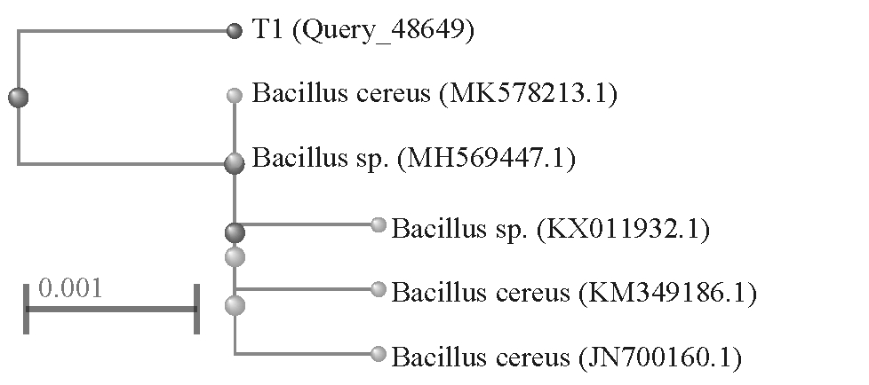
Figure 21 - Phylogenetic tree based on the analysis of the 16S rRNA gene fragment of the Bacillus sp. T1.

The results indicate that the S1 strain is located close to the nucleotide sequences from the reference strain Atlantibacter hermannii, while S2 is located on the same clade with the Pseudomonas sp. As shown in Figure 21, the T1 strain is located in the same clade with Bacillus cereus. The data obtained as a result of the comparison of genetic characteristics made it possible to determine the species belonging of strains S1, S2, and T1 to the genera Atlantibacter, Pseudomonas, and Bacillus, respectively.
At the next stages, the samples of low-grade brown coal collected at the Lenger coal deposit were desulfurized using these bacterial strains.
According to the total sulfur content, coal is divided into low-sulfur (up to 1.5% sulfur), medium-sulfur (1.5-2.5%), sulfur (2.5-4%) and high-sulfur (more than 4%). Sulfur in coals is present in the form of organic sulfur, sulphate sulfur, and pyrite sulfur. Pyrite sulfur is found in coal as a mineral substance, while organic sulfur is present as an integral part of the carbon matrix, covalently bound to its complex structure [34]. One of the indicators characterizing the technical nature of coal is total sulfur (S_{total}) indicates the total content of this element in all compounds, conventionally converted into elemental sulfur (%) in relation to the analyzed sample.
The study of the desulfurization process, and the results of the microbial effect on the total sulfur and different sulfur forms of brown coal were analyzed and demonstrated in Table 9.

Table 9 - Sulfur concentration before and after microbial treatment of a coal sample from the Lenger coal deposit.
Sulfur, in % | Parent coal | Desulfurization of coal by:
Sulfur, in % | Parent coal | Atlantibacter sp. S1 | Pseudomonas sp. S2 | Bacillus sp. T1
Total sulfur, S_{Total} | 3,14 | 2,65 | 1,52 | 1,94
Sulphate sulfur, S_{S} | <0,01 | <0,01 | <0,01 | <0,01
Pyrite sulfur, S_{P} | 1,61 | 1,56 | 1,41 | 1,3
Organic sulfur, S_{O} | 1,53 | 1,09 | 0,11 | 0,64

As can be seen, the total sulfur content in the original coal sample was 3.14%, where 1.53% corresponded to organic sulfur and less than 1.62% inorganic sulfur (1.61% pyrite sulfur and less than 0.01% sulphate sulfur). It was found that 15.6% of the total sulfur was removed from the coal after treatment with Atlantibacter sp. S1 under optimal conditions, organic sulfur was reduced to 1.09% and inorganic sulfur to less than 1.57%, indicating a 29% reduction for S_{O} and 3% for S_{P}.
For Pseudomonas sp. S2 sulfur removal was achieved 52% (for organic sulfur - 93% and for pyrite sulfur - 12%).
When desulfurizing with Bacillus sp. T1, 38% of the total sulfur was removed from the coal, so the sulfur content was reduced to 1.94%. More than half of the S_{O} (58%) was recovered, reaching 0.64%. The content of inorganic sulfur in the form of S_{P} decreased to 1.3%, which was 19% of the parent coal.
Based on these studies, the literature review on individual bacterial strains was conducted. Charanjit Rai and Jon P. Reyniers [35] suggested that the results of preliminary microbial desulfurization of lignite in the states of Illinois and Texas with strains of the genus Pseudomonas show that P. putida was much more effective than P. aeruginosa. P. putida reduced pyrite sulfur content by 76% in 5-7 days. Another study [36] demonstrated a mutant Pseudomonas stutzeri LH42 (Mutant ZW-15). After 15 days of treatment with this strain, 93.25% of organic sulfur and 41% of total sulfur were removed. According to the data presented by A.A. El-Midany [9], B. subtilis can remove more than 70% of sulfur and ash. The final concentrate using B. subtilis contains 0.9% sulfur and 1.95% ash with a yield of 90–92%.
The physical parameters and chemical content of coal can influence microbial diversity and microbial species abundance. High levels of bacterial richness can be observed in low-grade coals. Thus, the sulfur content can be one of the important predictors of the structure of taxonomic groups of microorganisms (Fig. 22).

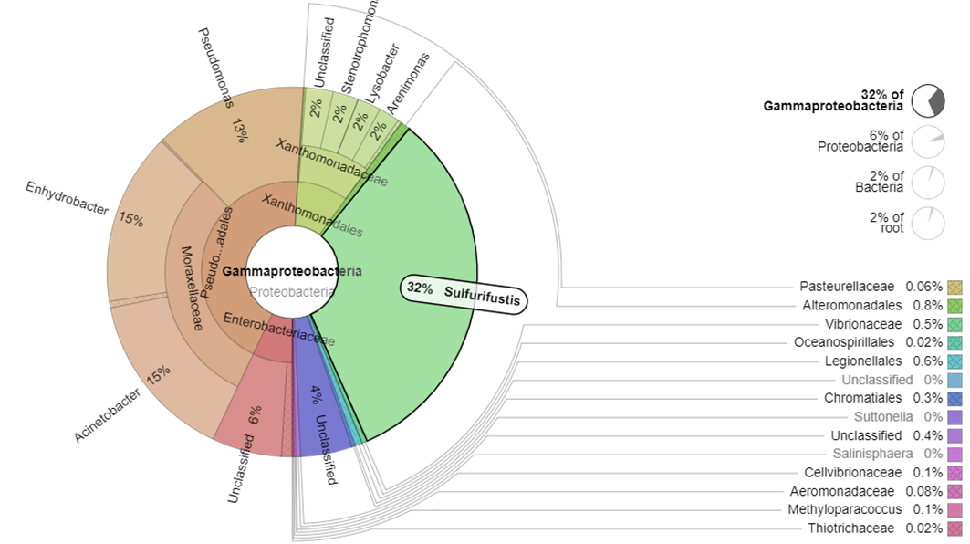
Figure 22 - Visualization of the Krona web taxonomy using the example of Sulfurifustis in the Lenger coal sample

Metagenomic analysis revealed that brown coal contains microbial communities with a chemolithoautotrophic type of metabolism based on the presence of sulfur. The sample contained sulfur-sulphate-reducing genera Desulfovibrio and H16 (family Desulfurellaceae), as well as sulfur-oxidizing bacteria Thiothrix and Sulfurifustis. Considering the fact that brown coal from the Lenger coal deposit contains a high content of total sulfur (3.14%), it can serve as the main source of energy for microorganisms of various physiological groups of biotechnological purposes.

3.2.2 Study of the ability of microorganisms to form biosurfactants and determination of their biochemical properties
It is known that some bacteria synthesize biosurfactants in response to the presence of hydrocarbons in the culture medium. Such microorganisms help to disperse the organic part of the coal, which increases the likelihood of bacterial contact with the coal.
The emulsifying activity of the culture supernatant is a key marker of bacterial strains as producers of biosurfactants [36, 37]. Microorganisms of various physiological groups differ in emulsifying ability, emulsifying capacity, emulsion stability, and secrete biosurfactants of various natures. The ability of microorganisms to form biosurfactants, which disperse the organic mass of coal, maximizing the availability of hydrocarbons for bacteria, was studied by determining the emulsifying activities after 24 hours (E₂₄) in the supernatant. Kerosene, gasoline, diesel fuel, olive oil, chloroform, and hexane were used as hydrophobic substrates of the components when establishing the emulsifying activity.
In the course of the study, the substrate specificity of the biosurfactant-producing strains Bacillus sp. RKB 2 and Providencia sp. RKB 10 was determined. These bacterial strains were isolated in previous studies (Section No. 3.1.3.). Table 10 shows the results of the study of E24 bacterial cultures in relation to substrates.

Table 10 - Emulsifying activity of bacterial strains.
Strains | E₂₄, %
Strains | Gasoline | Diesel | Kerosene | Olive oil | Chloroform | Hexane
RKB 2 | 7,5 | 18,5 | 12 | 18,6 | 33,3 | 8
RKB 10 | 6,7 | 7,4 | 12 | 28 | 60 | 5

As seen, the maximum emulsifying activity with respect to chloroform was found in RKB 10 (60%), and to diesel fuel – in RKB 2 (18.5%).
Thus, as a result of determining the emulsifying activity of microorganism strains in relation to substrates, it was found that E24 in both cultures of microorganisms is higher, i.e. they form cell-bound biosurfactants and their biomass must be used to emulsify coal.
At the next stage of the study, using the isolated bacteria, the supernatants were exposed to a brown coal charge, i.e. a mixture containing bio-desulfurized coals.
Figure 23 demonstrates the degree of dispersion of coal particles by cell-free suspensions of microorganisms containing biosurfactants.
Bacterial transformation (biotransformation) of coal is a complex process due to its solid hydrophobic nature. At the initial stages, organic polymers in coal under the action of microorganisms and their metabolites are destroyed to fragments with a lower molecular weight [5]. These molecules acquire the ability to dissolve in water or be carried in the form of microdroplets and participate in the metabolism of microorganisms, subsequently transforming into final products. Coal biosolubilization takes place under aerobic conditions mediated by the action of biosurfactants containing enzymatic, alkaline, and chelate components [27]. The size of microorganisms is such that they distribute and are fixed on the surface of macro- and microcracks, as well as in the macropores of coal. The hydrophobicity of coal particles is reduced under the influence of extracellular bacterial substances, which leads to the decomposition of coal. As a result, polymers are degraded by extracellular enzymes and alkaline components into smaller structures that can be used by microbial cells.
Biosolubilization of coal by active strains of microorganisms. Determination of the biosolubilizing ability of bacterial cultures was carried out in two techniques using agar-diffuse and submerged culture.
According to the results of the first technique, the culture of Bacillus sp. RKB 2 and Providencia sp. RKB 10 effectively biosolubilize the coal sample with an obvious color change of the agar matrix within 7 days, whereas no solubilization products were observed in the control (without bacterial lawn) (Fig. 24).
The results of coal solubilization in submerged cultures with bacterial strains were comparable to those obtained using the agar diffusion technique. The results demonstrate that Langer brown coal is bioavailable with respect to microbial solubilization.

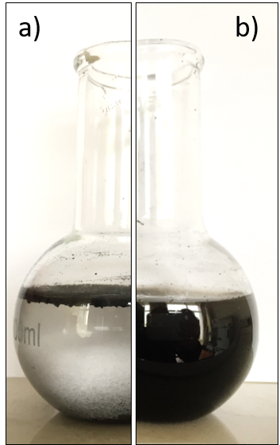 | 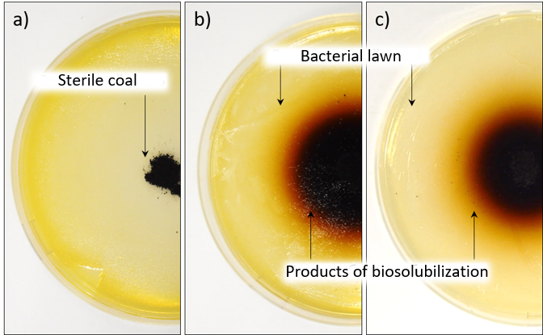
Figure 23 - Emulsifying activity: a - control, b - supernatants. |  | Figure 24 - Biosolubilization of coal: a - control, b - with RKB 2 inoculum, c - RKB 10 inoculum.

The degree of coal biosolubilization by RKB 2 reached 15.6% on the 3rd day, then increased to 24% on the 14th day (Table 11). The degree of coal decomposition in the control samples reached 2.8% over the same time period. Biosolubilization of coal using RKB 10 showed the lowest result – 17.4% after 14 days.

Table 11 - The rate of weight loss in the process of biosolubilization of coal samples
Days | Weight loss, %
Days | RKB 2 | RKB 10 | Control
3 | 15.6 ± 0.6 | 15.7 ± 0.7 | 0.02 ± 0.00
5 | 16.9 ± 0.8 | 16.1 ± 0.5 | 0.07 ± 0.01
10 | 18.1 ± 0.9 | 17.3 ± 0.9 | 0.1 ± 0.02
12 | 21.8 ± 0.1 | 17.3 ± 0.9 | 0.2 ± 0.01
14 | 23.9 ± 0.8 | 17.4 ± 0.1 | 0.2 ± 0.01

The addition of coal lowered the pH of culture media without inoculum (Table 12), probably due to the acidic nature of low-quality coals [27]. So, the initial pH of the medium ~ 7.1 changed to 6.3 during the first 3 days after treating with the coal samples.
The absorbance of the supernatant at 480 nm was measured to study the kinetics of coal biosolubilization. The wavelength was found to be sensitive to the presence of solubilized products. The observed course of the A450 value and the increase in pH correlate, and both indicators reflect a high degree of biosolubilization (Fig. 25).

Table 12 - pH of the culture medium during coal biosolubilization
Days | pH
Days | RKB 2 | RKB 10 | Control
3 | 7.7 ± 0.07 | 7.8 ± 0.03 | 6.3 ± 0.04
5 | 7.9 ± 0.06 | 8.0 ± 0.09 | 5.9 ± 0.09
10 | 8.2 ± 0.01 | 8.1 ± 0.08 | 5.8 ± 0.07
12 | 8.3 ± 0.06 | 8.1 ± 0.06 | 5.8 ± 0.01
14 | 8.2 ± 0.09 | 8.1 ± 0.03 | 5.7 ± 0.06

When the pH of the inoculated medium with coal reached 7.7, the optical density at 450 nm began to gradually increase, indicating the degree of dissolution of the coal. The results confirm that the increase in pH during biosolubilization is due to the biosynthesis of alkaline metabolites [38].

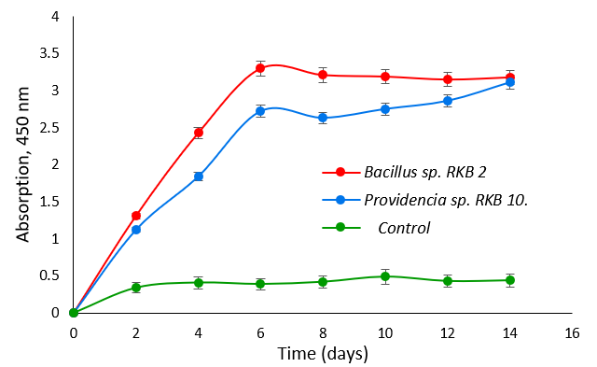
Figure 25 - The degree of solubilization of inoculated and non-inoculated coal samples.

Higher metabolic activity for coal has been shown for Bacillus sp. RKB 2, as the spectral absorption was 3.35 ± 0.4.

3.2.3 Study of the influence of the composition and nature of biosurfactants on brown coal charge
From the point of view of modern chemistry, understanding the structure and nature of humic substances isolated from coal is necessary for an objective assessment of their potential role in increasing the plastic properties of brown coals. At present, the analytical identification of humic substances in various materials is mainly based on the analysis of total organic carbon, applicable to organic molecules that are soluble at a higher pH of the medium. It becomes obvious that all organic substances, soluble at this pH, will be considered as humic compounds, regardless of their true structure [39]. In this context, of great interest is the selection of suitable analytical methods that make it possible to qualitatively characterize humic substances, their composition, and the degree of humification. Among them, for example, the use of spectroscopic analyzes to characterize the products of lignite solubilization, in particular, humic substances present expanded possibilities. At this stage of the research, humic substances as products generated under the influence of biosurfactants on brown coal mixtures were studied by various types of spectroscopic studies.
The IR spectra of brown coal products contain absorption bands characteristic of humic substances of various origins [40]. Figure 26a shows the IR spectrum of CHS. It is characterized by an intense band at 3400 cm⁻¹, which indicates the presence of a significant amount of hydroxyl groups (-OH). The spectra of both humic substances also have an average intensity band in the region of 3192 cm⁻¹, caused by stretching vibrations of alkyl groups (-CH₃ and -CH₂).
The band at 1554 cm⁻¹ indicates the presence of C = C aromatic bonds. The absorption band at about 1400 cm⁻¹ can be attributed to the bending vibrations of the C-H bond in CH₂ groups. Absorption peaks in the 1000-500 cm⁻¹ region may appear due to mineral components.
The IR spectrum of BHS is shown in Figure 26 b, which is different from the CHS spectrum; a band of medium intensity in the region of 1646 cm⁻¹ predominates in the amide group; its presence indicates the existence of protein-like fragments in the composition of humic substances. Several weak intensity bands can be attributed to oxygenated functional groups such as carboxyl groups (1247 cm⁻¹) as well as hydroxyl groups (1038 cm⁻¹). A significant difference between the spectra is the absence of bands at 3192 cm⁻¹ in BHS.

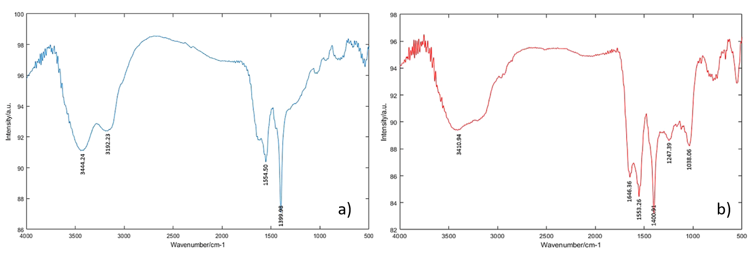
Figure 26 - IR spectra of CHS (a) and BHS (b).

LC/MS QqQ humic substances. The high-performance liquid chromatography method is used to detect polar non-volatile substances, in particular, humic acids. The resolution was evaluated using the mass-to-charge ratio (m/z) of the peak. The full mass range of data in CHS mass spectra extends up to 2000 Da and BHS up to 1000 Da, but peaks are mainly observed in the mass range extending up to 600 Da. Important differences can be noted in the spectra in Figure 27.
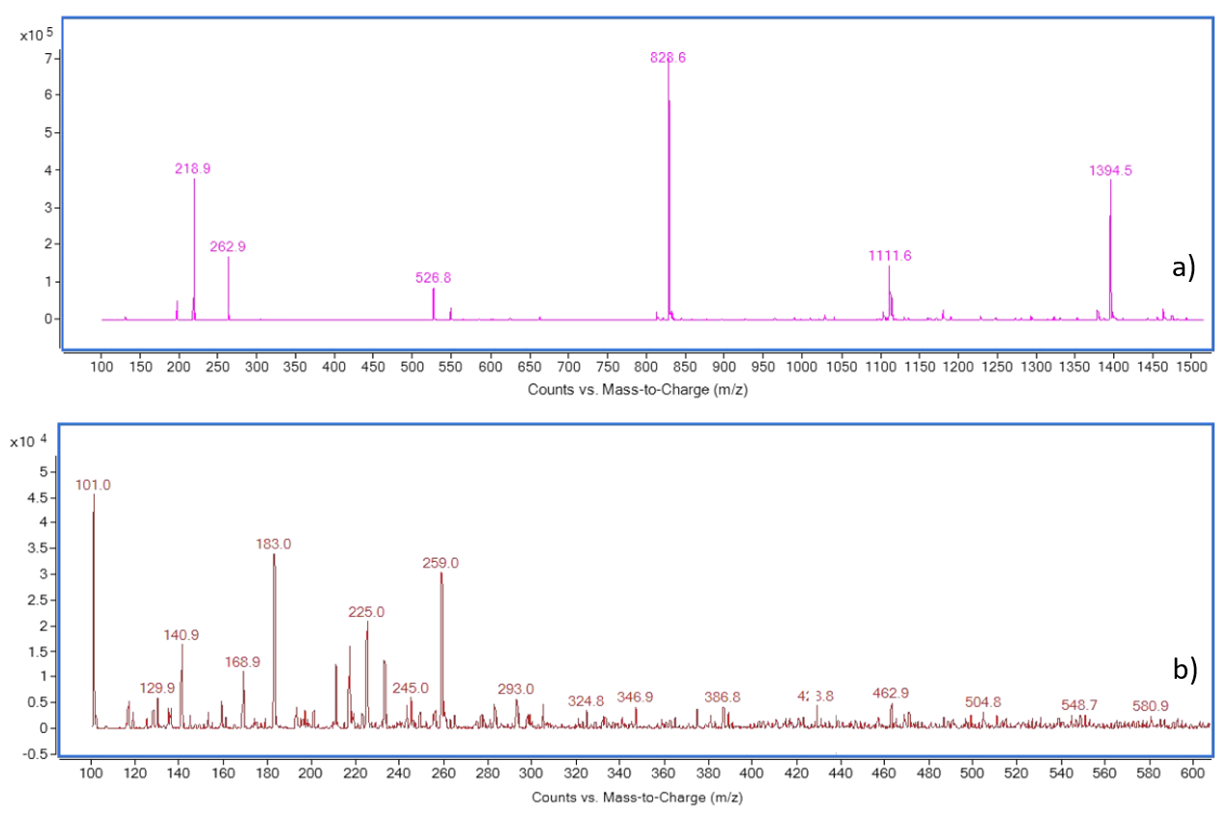
Figure 27 - Mass spectra of CHS (a) and BHS (b)

Humic substances demonstrate clusters in different ranges of mass spectra. Some exist between 200-300 Da, while others range from 500-600 Da, 800-900 Da, as well as around 1100 Da and 1400 Da. BHS indicate a large group of peaks in various mass ranges around 100 Da, 120 Da, 220 Da, 300 Da, etc. The peaks that appear well above the nominal mass are usually high hydrogen substances such as amino acids and fatty acids which have high hydrogen to oxygen ratio. Between the 300-600 Da regions, BHS peaks appear at or below nominal mass, suggesting that molecules present in this region have a very low hydrogen to oxygen ratio. This type of peak can be associated with benzoic acids and condensed aromatics. These compounds have low hydrogen content and often contain significant amounts of oxygen.
Spectral range up to 300 Da at BHS, peaks begin to appear above their nominal masses as H-rich molecules. As the ratio of hydrogen to oxygen increases, due to the high content of aliphatic compounds, the peaks can be associated with medium-length fatty acids. For example, the peak at 183 Da can be attributed to a polyunsaturated fatty acid with 11 carbon atoms (11:2), while the peak at 259 Da represents an unsaturated acid with 16 carbon atoms (16:0), and 293 Da indicates a monounsaturated 19 carbon atoms (19:1).
There is evidence that active bacterial isolates for biosolubilization transform lignite up to 30% [5, 10]. However, it is worth mentioning that the coal samples used in these studies were at significantly lower concentrations, or mainly processed by chemical and biological methods, which significantly improved the solubilization process. In our case, Bacillus sp. RKB-2 is capable of degrading nearly 26% of raw lignite (5% w/v) within 12 days, indicating its potential value for coal bioconversion.
FTIR spectra of BHS show the appearance of different functional groups compared to CHS. The most characteristic changes for BHS are bands between 1300-1000 cm⁻¹ related to the ether and alcohol groups. As a consequence, the distribution of peaks in mass spectra differs markedly between CHS and BHS: most of the intense peaks found for humic substances are below m/z 1000 Da, which indicates that bio-humic substances are small heterogeneous molecules.
Optical spectroscopy indices (UV-Vis). The average values ​​of the indices obtained from the UV-Vis spectra can be used to inform about the presence of functional groups in humic substances and their chemical nature. Table 13 shows the spectroscopic characteristics of the samples under study.

Table 13 - Spectroscopic indicators of humic substances
Indices of UV-Vis | CHS | BHS
E_{Et/Bz} | 1.23 ± 0.01 | 1.37 ± 0.02
E_{2/3} | 0.89 ± 0.09 | 1.04 ± 0.04
E_{4/6} | 3.58 ± 0.07 | 5.29 ± 0.03
E_{254/410} | 1.30 ± 0.04 | 1.57 ± 0.02
E_{265/465} | 1.78 ± 0.05 | 2.49 ± 0.08
∆logK | 3.27 ± 0.03 | 4.31 ± 0.05

To describe the absorption spectra of humic fractions, the E_{ET/Bz} coefficients at a wavelength of λ = 253 nm and the ratio at λ = 203 nm (A_{253/A203}) are widely used [40]. The E_{ET/Bz} value provides information related to the average degree of activation of aromatic rings substituted with hydrophilic groups (hydroxyl, carbonyl, ester and carboxyl). The higher the A₂₅₃/A₂₀₃ ratio, the greater the substitution in aromatic rings [39]. According to the study, the high E_{ET/Bz} observed for BHS indicates the appearance of aromatic rings substituted with oxygen-containing functional groups.
E_{2/3} and E_{4/6} are key values ​​required to specify UV-visible spectra. E_{2/3} is the ratio between absorbance at 250 nm and 365 nm and is often considered an indicator of humification. E_{4/6} is the absorption coefficient at 465 and 665 nm, often referred to as the “humification rate”. However, a comparison of these two indicators suggests that they can characterize various aspects of the structure of humic substances. Based on the physicochemical principles of spectrophotometry, higher E_{2/3} ratios usually reflect lower molecular weight and aromaticity, while the E_{4/6} value demonstrates the presence of functional groups in humic substances. According to the data obtained, the E_{2/3} ratios in BHS are higher than in CHS, indicating that BHS has a lower degree of aromaticity and molecular weight. The highest mean E_{4/6} was observed for BHS, indicating the importance of functional groups. A comparison of the ratios E_{2/3} and E_{4/6} reveals a similar trend, that is, biosolubilized HS are smaller molecules with a higher content of functional groups.
In addition, the ratios E_{254/410}, E_{265/465} and ∆ logK (ratio of absorption at 400 nm and 600 nm) were calculated. These coefficients also demonstrate the degree of aromaticity and molecular size. Based on available literary sources [39], it can be assumed that lower ratios indicate higher aromaticity and molecular weight. As a result, these ratios had a certain degree of visual similarity to E_{2/3} and E_{4/6}.
X-ray pattern (XRD). X-ray structural analysis is the main method for determining the mineralogical characteristics of materials. To assess the effect of biosolubilization on the crystal structure of the coal, samples of intact lignite and residues of biosolubilized lignite were analyzed using this technique. Comparison of the diffraction patterns of the untreated lignite and the corresponding biotreated lignite shows that the positions of the broad peaks do not change during biosolubilization, but the intensity of the diffraction peaks does (Fig. 28). The two predominant diffraction peaks are located at 2θ = 12.2 ° (kaolinite) and 26.7 ° (quartz) in intact coal samples. However, the treated carbon residues are more intense and slightly wider, indicating that bacterial metabolism had little effect on the crystallinity of the sample.

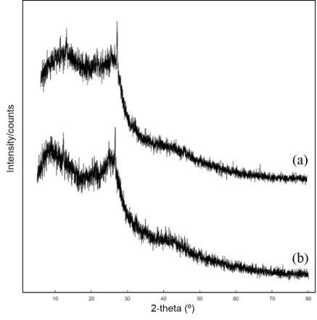 | 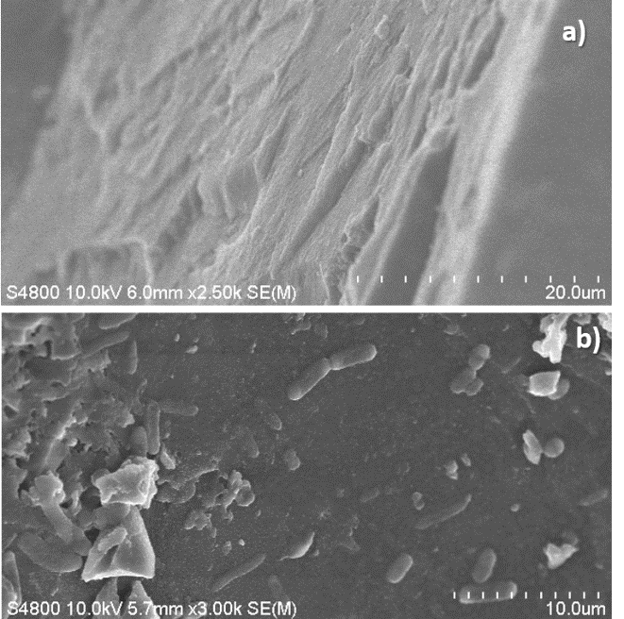
Figure 28 - Diffraction patterns: a - untreated coal, b - biosolubilized coal residue. | Figure 29 - SEM micrographs of coal samples: a - untreated coal, b - bacteria colonizing the surface of the coal.

Scanning Electron Microscopy. SEM is another valuable method for evaluating microbial bio-solubilization of coal. Moreover, the roughness of the surface of the coal makes SEM an ideal tool to provide detailed information on bacterial cell attachment and biofilm formation in cracks and holes in the surface.
According to SEM data, bacterial isolates growing in the presence of coal release polymeric substances that make up the extracellular space of bacterial aggregates and form the architecture of the biofilm matrix. These structures are involved in the adhesion of bacterial cells to the surface of the coal and facilitate the attack of the coal constituents and the absorption of nutrients from their particles. Figure 29 clearly shows the rod-shaped Bacillus cells attached to the surface of the coal.
Bacteria attachment to the surface is mainly manifested in the form of individual cells, however, colonies of cells are also found in more "cave" areas, which facilitates their easy aggregation.

3.2.4 Increasing the plastic properties of briquettes by introducing organic binding agents into the briquetted mixture
At this stage of the study, the effect of organic waste (aspen sawdust) on the generation of biosurfactants during aerobic bioprocessing of brown coal charges was studied. Thus, it is possible to increase/optimize the plastic properties of brown coals for further briquetting.
The presence of binding properties in biotransformed coal is associated with an increase in the content of humic substances in the formed products in comparison with the initial substrate. In this case, a high concentration of polar functional groups is formed, increasing the plastic properties of the coal charge, as well as the generating binding agents.
Experiments on biotransformation of organic-coal raw materials were conducted in a bioreactor under aerobic conditions using a liquid culture of Bacillus sp. RKB 2 adapted to brown coal (Fig. 30, 31).

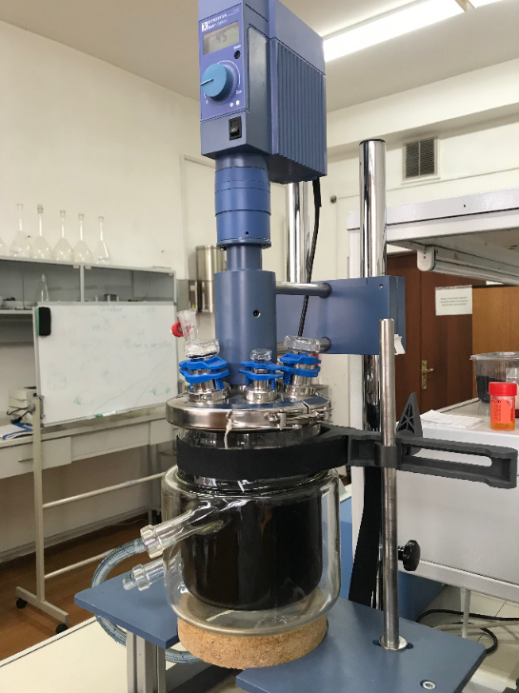 | 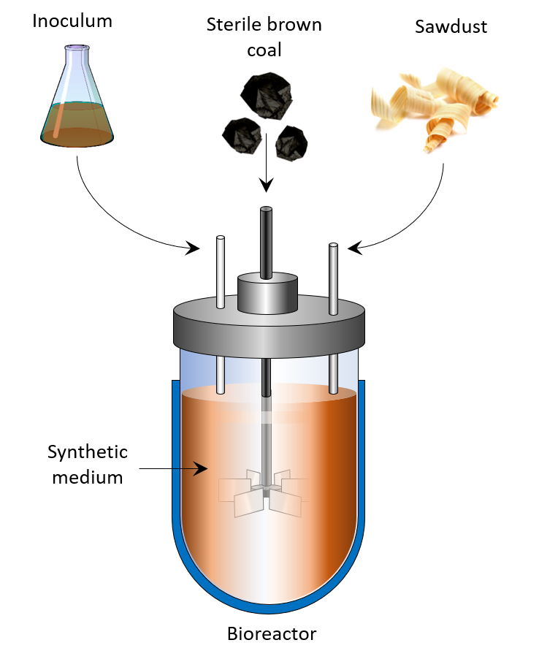
Figure 30 - Bioreactor for experiments on the biotreatment of brown coal | Figure 31 - Experimental setup scheme for the biotreatment of brown coal.

Determination of the quality indicators of products in the initial (IBC) and biotreated brown coals (BBC), as well as the joint biotreatment of brown coal with the addition of sawdust (OBBC) was carried out using elemental analysis and fluorimetry.
Elemental analysis. In the products of bioprocessing of brown coal and a mixture of sawdust, an increase in the H/C ratio was noted in comparison with the original coal. The maximum H/C value was established for OBBC, which may indicate an increase in the proportion of aliphatic fragments in the structure of humic substances (Table 14).
EEM fluorescence spectrometry. The study presents the results of an advanced analysis of fluorescence for analyzing the plastic properties of a briquetted mixture based on organic bio-binding agents.

Table 14 - Indicators of the H/C ratio.
Samples | C, wt. % | Н, wt. % | Н/С ratio
IBC | 74.2 ± 0.1 | 4.75 ± 0.2 | 0.76
BBC | 73.1 ± 0.3 | 5.13 ± 0.4 | 0.84
OBBC | 72.9 ± 0.1 | 5.24 ± 0.4 | 0.86

Fig. 32 (a, b, c) show the EEM spectra of IBC, BBC, and OBBC. Strong fluorophores are mainly observed upon excitation/emission of about 270-275/440-445 nm, which corresponds to humic substances – the main indicator of the plasticity of the briquetted mixture. In the case of IBC, the EEM card demonstrates a different figure with a radiation wavelength of ~ 340 nm, which proves the complete or partial absence of humic substances.
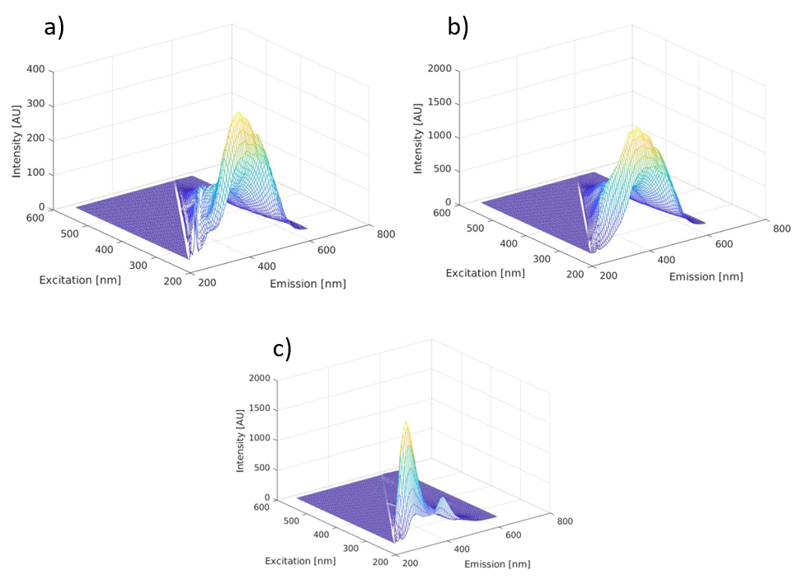
Figure 32 - EEM spectra of samples: a - OBBC, b - BBC, c - IBC.

Specific fluorimetry indices. Three indicators of fluorescence analysis (FI, BIX, and HIX) were chosen to study the nature of the products of biotreated coals (the effect of microorganism metabolites, sources of humic substances, and the maturity degree of humic substances). Their values are shown in Table 15.

Table 15 - Specific indices of fluorescence analysis
Fluorescence indices | IBC | BBC | OBBC
FI (ex.370 nm, em.470/520 nm) | 1.05 ± 0.02 | 1.39 ± 0.01 | 1.85 ± 0.03
BIX (ex.370 nm, em.380/430 nm) | 0.11 ± 0.01 | 0.34 ± 0.02 | 0.98 ± 0.01
HIX (ex.255 nm, em.435-480/300-345 nm) | 13.86 ± 0.13 | 10.77 ± 0.04 | 9.14 ± 0.09

The fluorescence index (FI) is calculated as the ratio of the intensity of emission (em.) at a wavelength of 450-500 nm when excited (ex.) at 370 nm. FI values ​​of ~1.3 or lower correspond to organic matter obtained from fossil sources or soils with higher aromaticity, while values ​​of ~1.9 or higher correspond to microbial sources and lower aromatic carbon content [41]. The FI value of IBC was 1.05 and after biological treatment changed to 1.85.
The Biological Index (BIX) was developed to assess the contribution of autochthonous or biological (microbial) activity to the formation of humic substances. It is assumed that values ​​above 1 correspond to compounds (humic substances) of predominantly biological and microbial origin, while lower values ​​indicate an insignificant autochthonous (local) contribution of the initial substrate [42]. The BIX index is calculated as the intensity ratio em. - 380/430 nm and ex. - 370 nm. In this study, BIX values ​​were in the range of 0.11-0.94, probably due to the predominance of humic-like fluorophores.
The Humification Index (HIX) or Zsolnay Index derived from EEM spectral data is widely used to assess the aromaticity of the resulting humic substance. HIX is calculated as the ratio of intensities em. (integrated area of ​​fluorescence intensity measured between emission wavelengths from 435 to 480 nm, divided by the intensity measured between emission wavelengths from 300 to 345 nm) at wavelength ex. 255 nm. Higher HIX values ​​correspond to the higher aromaticity of the organic matter. Thus, high HIX values ​​(>10) indicate a strongly aromatic compound, mainly of coal origin, while low values ​​(<4) correspond to microbial origin [39]. Thus, IBC has a low degree of aromaticity. This index of fluorescence of humic substances is completely consistent with the absorption indices obtained using UV-Vis spectroscopy spectra.
In general, the results obtained revealed a decrease in the degree of condensation of aromatic structures in the BBC and OBBC, suggesting that the bacterial isolate metabolically changed the initial structure of the IBC, which can be achieved mainly by modifying their polyaromatic ring.

3.3 Development of a basic technological scheme of the process of obtaining briquettes by means of biomodification of brown coal
3.3.1 Study of the influence of chemical and technological parameters of coal briquetting using bio-binding agents on the functional properties of briquettes
The technology of using a binder obtained directly from the coal itself is promising for briquetting solid fuels. Similar technology is the biotechnological transformation of coal.
At this stage of the study, the influence of the technological parameters of the biotransformation process of brown coal on the generation of the binding properties of solid fuel was studied. The main factors characterizing the strength properties of briquettes are the moisture content of the charge and the specific pressing (moulding) pressure. The resulting briquettes based on IBC, BBC, and OBBC were subjected to compressive strength and abrasion tests. During the research, the following technological parameters were used: coal fractions for all variants: <0.7 mm; duration of bioprocessing for BBC and OBBC: 30 hours. Thus, in Fig. 33 shows the dependence of the compressive strength of briquettes (at a pressing pressure of 120 MPa). As follows from the data, bioprocessing (BBC and OBBC) increases the strength of the resulting briquettes.

Figure 33 - Dependence of the strength of briquettes on the type of processing. | Figure 34 - Dependence of the strength of briquettes on moisture at a pressing pressure of 120 MPa.
At the next stage of the study, the influence of the moisture content of the IBC, BBC, and OBBC components on the strength characteristics of briquettes was evaluated (Fig. 34). It was found that, depending on the applied pressed pressure (120 MPa), the optimum moisture for all variants (corresponding to the maximum strength of the briquettes obtained from it) is 15%, while the compressive strength increases.
In the process of coal biotransformation, bio-suspensions are formed with a moisture content of ~ 70%. However, for their further use as a binding agent, it is necessary to obtain a coal moisture content of ~ 15%. In this regard, the influence of the drying temperature of the bio-coal suspension on the binding properties of the dried products was evaluated.

Figure 35 - Dependence of briquettes strength on drying temperature, °С. | Figure 36 - Dependence of the abrasion strength of briquettes on the content of bio-binding agents in the charge for briquetting.

As follows from the data in Fig. 35, the drying point of the bio-suspension affects the compressive strength of the briquettes depending on the temperature from 20 to 80°C (specific pressing pressure of 120 MPa). The maximum strength of the resulting briquettes was provided by the drying point of bio-suspensions at 20°C; with an increase in the drying temperature, the strength of the resulting briquettes decreases.
The purpose of the next stage of the study was to determine the minimum content of the bio-binding agent in the charge during briquetting in order to obtain high-quality briquettes. During the research, the following technological parameters were used: pressing pressure - 120 MPa; the moisture content of the bio-binding agent is 15.0 wt% and the moisture content of the briquetted coal is 16.5 wt% (GOST 7299-84). The size class of coal and bio-binding <0.7 mm were used; the content of the bio-binding agent in the charge was 30, 20, and 10 wt%.
Fig. 36 shows, that to obtain briquettes of the required quality, it is necessary to use the content of the bio-binding agent in the charge no more than 20 wt%. So, at a pressing pressure of 120 MPa and a bio-binder content in the charge of 20 wt%, the resulting briquettes had an abrasion strength of 83.5% for BBC and 86.8% for OBBC, which meets the requirements of GOST 7299-84 (abrasion strength is not less than 77,8%) However, for IBC (original coal without bio-binding agent), this indicator was at 68.2%.
Semi-industrial tests to assess the briquetting of Langer coal based on IBC, BBC, and OBBC were carried out on a briquette stamp press at the “AIMLab” LLP pilot plant in Almaty. The raw materials were crushed in a hammer mill to 1 mm. For the OBBC version, sawdust of the correct particle size distribution was used - 0.5 mm.
After thorough mixing of the charge according to each variant, it was placed in a drying oven, where it was heated before pressing to 40°C. This temperature, along with the indicators of particle size distribution and moisture content, was selected in relation to the standard technology of preparation for briquetting on a stamp press of brown coal B2-3 [43].
Test results for batch briquetting and assessment of consumer indicators of briquettes quality are presented in Table 16.

Table 16 - The composition of the charge and the consumer properties of the briquettes obtained on the stamp press.
Variants | Charge composition, % |  |  | Moisture, % |  | Briquette strength
Variants | Coal | Sawdust | Bio-binder | Coal | Bio-binder | Compression, MPa | Abrasion, %
IBC | 100 | - | - | 16,5 | 15 | 17,5 | 68,2
BBC | 80 | - | 20 | 16,5 | 15 | 23,5 | 83,5
OBBC | 70 | 10 | 20 | 16,5 | 15 | 30,9 | 86,8

According to the data presented in the table, briquettes obtained using bio-binding/bio-plasticizers (IBC and BBC) on a stamp press meet the standardized strength requirements for solid fuels.

3.3.2 Study of the influence of the pyrolysis process on the physicochemical properties of the obtained briquettes
Improving the water-resistance of briquettes is one of the relevant challenges for the sustainable energy industry. The low water-resistance of solid fuels complicates their storage and transportation, reduces the heat of combustion and mechanical strength, which will lead to a decrease in the competitiveness of the product. Water-resistance tests were carried out in accordance with GOST 21291-75. The following parameters were taken as the evaluation criterion: compressive strength at least 15 MPa, abrasion strength at least 65%; water absorption for 2 hours under water – no more than 4%. According to the test results, it was found that for all variants (IBC, BBC, and OBBC), the resulting briquettes have insufficient water resistance.
In this regard, experiments were carried out to study the possibility of imparting satisfactory water resistance to briquettes by initiating pyrolysis. The influence of the temperature of the pyrolysis of briquettes on the physical, mechanical, and thermal properties of the obtained solid fuels was determined. Taking into account the reference [44], for the process of pyrolysis of briquettes, a temperature rise rate of l°C/min was chosen. Analysis of the strength characteristics of pyrolyzed briquettes and their water absorption was carried out according to GOST 21189-21191 - 75 for solid fuels.
To carry out experiments on obtaining briquettes by pyrolysis of coals with a bio-binder, the initial components were used with the characteristics shown in Table 16.
Fig. 37 illustrates the results of the abrasion strength of briquettes pyrolyzed at different temperatures (pressing pressure 120 MPa, the content of the bio-binding agent in the charge is 20 wt%). As follows from the data presented, with an increase in the pyrolysis temperature, a peak in abrasion strength is observed at a temperature of 550°C.
An important indicator characterizing the quality of pyrolysis products is their volumetric (volume) shrinkage. This indicator gives an idea of ​​the total strength of the bonds between the compacted coal particles. If the original briquettes do not have acceptable strength, then it is not possible to obtain a solid product with satisfactory strength. The volumetric shrinkage correlates with the parameter of the bond strength between the briquette particles.
As shown in Fig. 38 data demonstrate that with an increase in the temperature of the pyrolysis process of briquettes, their volumetric shrinkage increases. Moreover, bio-briquettes based on IBC and BBC have a higher volumetric shrinkage in the entire pyrolysis temperature range. The data indicate a significant role of temperature in the formation of strong bonds between coal particles and bio-binders.

Figure 37 - Dependence of the abrasion strength of briquettes on the temperature of their pyrolysis | Figure 38 - Dependence of the volumetric shrinkage of briquettes on the temperature of their pyrolysis

3.3.3 Study of the energy and thermo-technical properties of the obtained briquettes
The resulting briquettes were tested for compliance with consumer requirements, standards, as well as energy and thermo-technical conditions for solid fuel for public living needs.
Table 17 presents data on the chemical and technical properties of pyrolysis products from Langer brown coal obtained using biological agents. As the data show, biomodified (BBC and OBBC) briquettes are required to obtain smokeless briquette fuel with acceptable characteristics, followed by pyrolysis at 550°C.

Table 17 - Characteristics of pyrolysis products obtained from Langer brown coal
Variants | Proximate characteristics |  |  | Ultimate characteristics, %
Variants | A, % | V, % | Q, MJ/kg | C | H | N | S | O
IBC | 18.5 | 39.1 | 12.1 | 75.6 | 3.7 | 0.81 | 0.85 | 19.04
BBC | 9.8 | 27.2 | 21.5 | 78.5 | 3.4 | 0.90 | 0.81 | 16.39
OBBC | 10.1 | 18.5 | 27.1 | 81.5 | 2.2 | 1.02 | 0.84 | 14.44

At a pyrolysis temperature of 550 ° C, the ash content of IBC, BBC and OBBC briquettes is 18.5%, 9.8% and 10.1%, respectively. The content of volatiles in biomodified briquettes OBBC and BBC is significantly reduced compared to IBC and amounts to 18.5%, 27.2%, and 39.1%, respectively. Thus, the resulting bio-briquettes in terms of the content of volatile substances are classified as smokeless fuels.
Experiments on the combustion of pyrolysis products at a temperature of 550°C showed that the combustion of bio-briquettes occurs within ~100 seconds, and soot is not observed during combustion. At the same time, the heat of combustion of pyrolyzed BBC and OBBC increases in comparison with IBC and is 27.1, 21.5, and 12.1 MJ/kg, respectively.
It follows from the ultimate analysis that during pyrolysis there is a significant increase in the carbon content and a decrease in the hydrogen content in bio-briquettes. The carbon content in OBBC rises to 81.5%. The hydrogen content during pyrolysis decreases from 3.7% (IBC) to 3.4% (BBC) and 2.2% (OBBC) for briquettes at 550°C.
During pyrolysis, a significant decrease in the oxygen content of bio-coal fuels is observed. So, if in IBC oxygen content is 19.04%, and in BBC - 16.39%, then in OBBC its content is reduced to 14.44%. It is characteristic that during the pyrolysis of all briquettes, no significant change in the content of nitrogen and sulfur is observed.
Thus, briquettes obtained by pyrolysis of Langer solid fuels and bioagents (BBC and OBBC) have a 0.7-2.0 times higher operating calorific value than an ordinary briquette (IBC), as well as high mechanical strength and water resistance (Fig. 39).

3.3.4 Carrying out pilot tests to determine the fuel and energy efficiency of the obtained briquettes
Evaluation of the consumer properties of bio-coal fuels in the pilot mode included a study of the fuel and energy parameters of bio-briquettes during combustion in a standard heating furnace (Fig. 40).

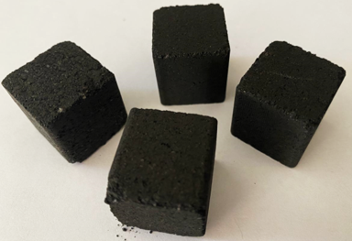 | 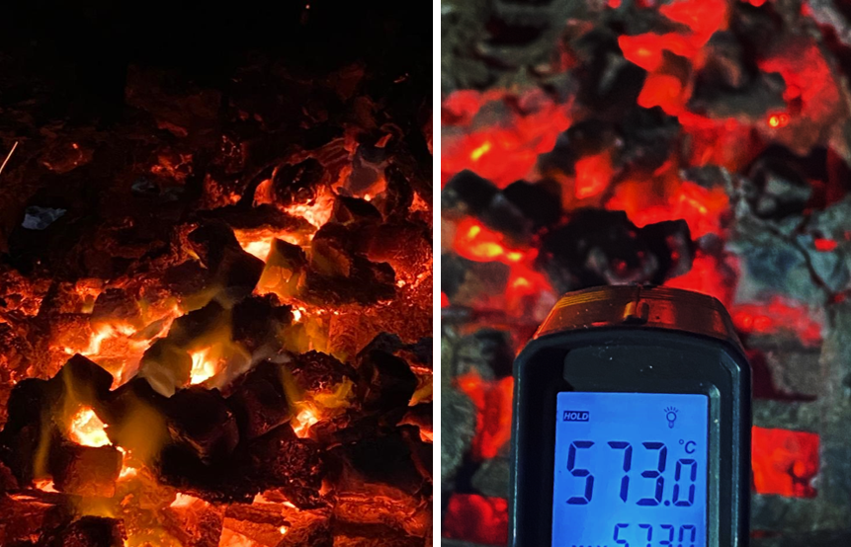
Figure 39 - Fuel briquettes obtained from Lenger coal | Figure 40 - Determination of the fuel and the energy efficiency of briquettes when burning in typical heating and cooking furnace

The study of the consumer properties of bio-briquettes was carried out by burning them at the stand of a household heating and cooking oven. The operating time of this furnace was determined from the point of ignition of the fuel material to the release of CO₂ in the combustion products ~ 3% vol. During the working cycle, the temperature of the gaseous combustion products in the chimney and the content of CO were measured by the volumetric method. The calculation of thermal parameters was carried out in accordance with GOST 9817-82 [45] (Table 18).

Table 18 - Fuel and energy parameters of burning coal briquettes
№ | Combustion indicators | Fuel and energy indicators
№ | Combustion indicators | IBC | BBC | OBBC
1 | Mass of briquettes loaded into the combustion chamber of the furnace, kg | 5,5 | 5,5 | 5,5
2 | Starting (kindling) material weight, kg | 1,6 | 0,9 | 0,5
3 | Furnace operating time, h | 4,0 | 4,1 | 4,5
4 | The average temperature of combustion products at the outlet from the furnace, °C | 174,1 | 176,4 | 175,6
5 | Average room temperature, °C | 25,4 | 25,6 | 25,5
6 | Volume fraction of CO in combustion products, % | - | - | -
7 | Heat loss with exhaust gases, % | 5,6 | 5,8 | 5,1
8 | Working ash content of initial fuel, % | 19,1 | 9,1 | 10,5
9 | The net calorific value of fuel, MJ/kg | 12,8 | 21,6 | 27,5
10 | Efficiency, % | 56,5 | 74,2 | 81,1

The combustion efficiency of BBC and OBBC in domestic ovens, as measured by efficiency, is significantly higher than that of IBC. Thus, the conducted research has established that bio-briquettes are a fast-burning type of household fuel, because a small amount of kindling material is required; the efficiency of a household heating and cooking oven when burning bio-briquettes is much higher.
The results of the study were used to develop a basic technological scheme of an industrial module for the production of solid smokeless fuel from brown coal on the basis of bio-binders/bio-plasticizers. The module includes the following main stages (Fig. 41):

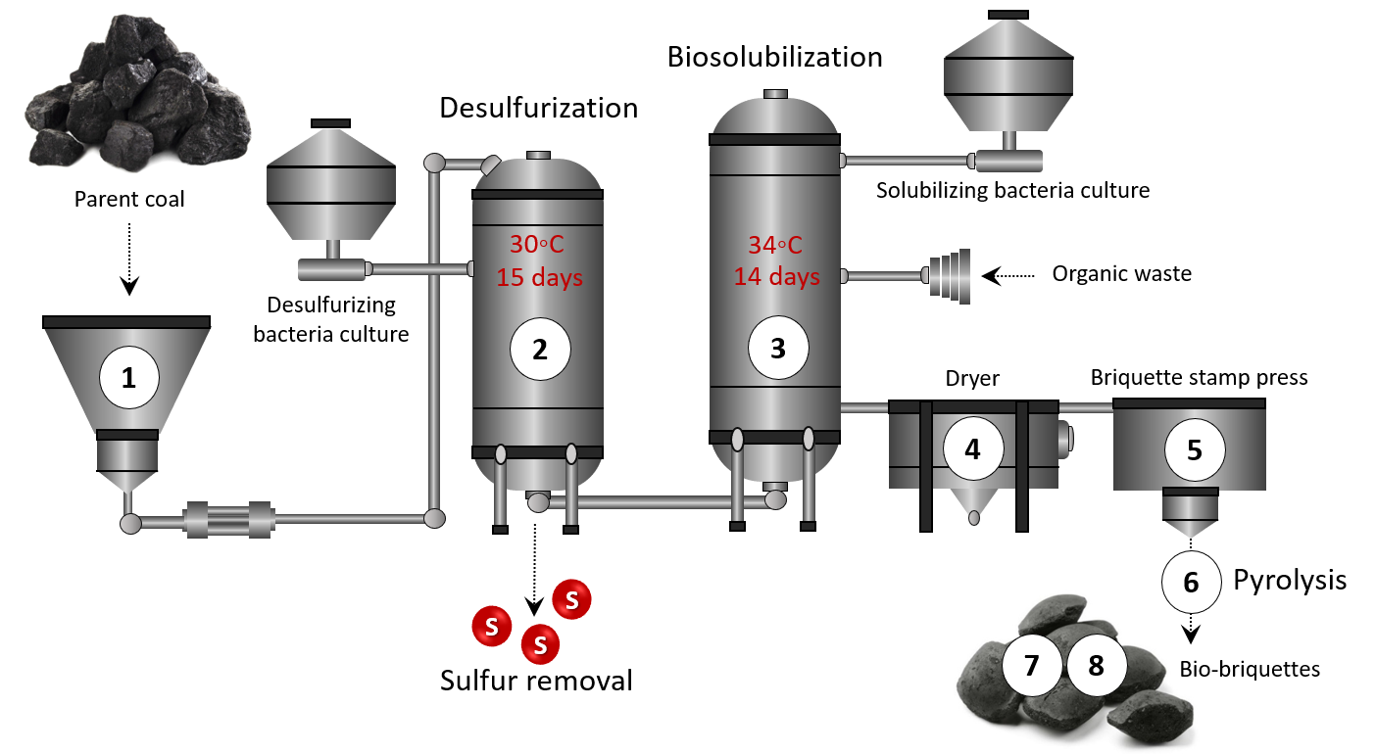
Figure 41 - Process flow diagram of an industrial module for the production of briquetted smokeless fuel from Langer brown coal

1. Stage of coal preparation: preliminary crushing of initial coal of class B2-B3 with size up to 1 mm and moisture content ~ 16%;
2. Desulphurization stage: sulfur removal (up to 58%) from brown coal using active desulfurizing bacteria (Atlantibacter sp. S1, Pseudomonas sp. S2, and Bacillus sp. T1) in a bioreactor (50 m³) for 15 days;
3. Stage of biosolubilization: bioprocessing of the coal charge in a bioreactor (100 m²) with the consumption of coal components and bio-bonders/bio-plasticizers. Bacillus sp. RKB 2 and Providencia sp. RKB 10 are effective culture producing biosurfactants;
4. Drying stage: after the end of the bio-cycle, the bio-coal suspension with a moisture content of ~ 70% is sent for mechanical dehydration to a moisture content of ~ 16%;
5. The stage of obtaining bio-briquettes: includes the mixing of coal and bio-binders/bio-plasticizers in a mixer in a ratio of 70:20:10 wt% and subsequent briquetting in a stamp press at 120 MPa;
6. Stage of pyrolysis: carried out in a pyrolyzer with external heating at a temperature of 550°C;
7. The stage of cooling the obtained bio-briquettes in the amount of 5,000 pieces/hour;
8. The stage of packaging bio-briquettes into packages convenient for individual consumers.
According to the given technological scheme for obtaining a smokeless bio-briquette from brown coal using microbial biomodification of coal as a bio-binder, the results obtained are supposed to be applied to create the production of environmentally friendly and high-quality smokeless solid fuels from Lenger coals.

CONCLUSION

Based on the results of the research, the following conclusions were made:
1 According to the results of physical, mechanical and chemical analyzes of brown coal samples from the Lenger coal deposit, the following quality characteristics of coal have been established: total moisture – 10.8%; ash content - 21.2%; calorific value - 7 300 kJ/kg, volatile matter yield – 43.3%. Elemental analysis of brown coal showed the following contents (% daf.): C – 61.3; H – 3.52; N – 0.85; S – 1.61; O – 32.72. The molecular structure of the analyzed coal, as well as its individual components, were characterized by different spectral (IR-, UV-, Raman-) analyzes and microscopic methods.
It has been established that the sulfur content of Lenger brown coal is 3.14% dw. The content of certain types of sulfur in coal was determined, the main sulfur compounds found in the samples were (%): sulphate sulfur (S_{S}) - <0.01; pyrite sulfur (S_{P}) - 1.61; organic sulfur (S_{O}) - 1.53.
For the first time, the biodiversity and taxonomic structure of the metagenome of the microbial community of brown coal samples are described based on the analysis of Illumina high-throughput sequencing data. Based on the results, 10 taxonomic groups of bacteria were analyzed, belonging to Proteobacteria, Tenericutes, Actinobacteria, Firmicutes, Bacteroidetes, Nitrospirae, Chloroflexi, Gemmatimonadetes, Acidobacteria and Fusobacteria. The bacteria of the genera Bacillus and Providencia have been isolated and identified. Their morphological-cultural and physiological-biochemical features were studied.
It was shown that cultures of Bacillus sp. RKB 2 and Providencia sp. RKB 10 - producers of biosurfactants in the process of biosolubilization actively multiply on media with a high content of brown coal, and the adaptation phase of growth for these microorganisms does not exceed 24 hours. The maximum growth of biomass is observed when the concentration of brown coal in the environment is 5%.
2 As a result of the research, three bacterial strains (Atlantibacter sp. S1, Pseudomonas sp. S2 and Bacillus sp. T1) were selected and identified, which are capable of desulfurizing brown coal, for example, Pseudomonas sp. S1 showed high desulfurizing activity with respect to organic sulfur (93%) and total sulfur (52%), while Bacillus sp. T1 was effective in removing pyrite sulfur (19%) compared to other strains. Additionally, the metagenomic analysis revealed the presence of a group of sulfur-sulphate-reducing and sulfur-oxidizing microorganisms in Langer brown coals, which are indicators of a high sulfur concentration in coals.
It was found that the strains, the producers of biosurfactants Bacillus sp. RKB 2 (diesel - 18.5%) and Providencia sp. RKB 10 (chloroform - 60%) has a high emulsifying activity towards organic substrates. Determination of the biosolubilizing ability of bacterial strains revealed that the Bacillus sp. RKB 2 was characterized by an increased ability to decompose/utilize organic matter of brown coal, which led to its solubilization up to 23.9% within 14 days. An increase in the pH of the medium during biosolubilization (pH 8) is optimal and is due to the synthesis of alkaline metabolites by bacterial strains.
A significant effect of biosurfactants on the formation of humic substances during the processing of Langer brown coal has been established. The results of LC/MS (QqQ) and FTIR analyzes showed that protein-like and fatty acid substances are the main factors catalyzing biosolubilization. The UV-Vis coefficients confirmed the differences in the molecular weight and the degree of aromaticity of humic substances of raw and biotransformed brown coals.
It is shown that biotreatment of brown coal with bacterial cultures and organic waste increases the generation of humic substances with a high intensity of polar groups, which increase the plastic properties of the coal charge. Thus, the values ​​of the fluorescent EEM spectra revealed the microbiological (FI ~ 1.9, BIX ~ 1) nature of biosolubilized humic substances, and the HIX index demonstrated a lower aromaticity of bio-coal products.
3 The analysis was carried out to study the effect of chemical and technological parameters of briquetting on the functional properties of briquettes. It is shown that the optimum drying temperature for bio-coal suspension is 20°C. It was found that to obtain durable solid fuels, the moisture content of the binders should be ~ 15 wt%, and the content of binders in the charge for briquetting BBC and OBBC should be 20 wt%. In this case, a specific pressing pressure of 120 MPa is required.
The influence of the parameters of pyrolysis of coal briquettes obtained by biomodification of coal on the characteristics of the final product has been studied. It has been established that in order to obtain smokeless fuel with increased strength properties, heat treatment must be carried out to a final temperature of at least 550°C. The resulting carbon products have an abrasion strength of 80.5%.
The study of the energy-technical properties of pyrolyzed bio-briquettes based on OBBC showed that the combustion of products at 550°C occurs within ~100 sec. and the calorific value is 27.1 MJ/kg. At the same time, the obtained bio-briquettes in terms of the content of volatile substances (less than 19 wt%) and in the composition of combustion products belong to the class of environmentally friendly smokeless fuel.
As a result of the research, it was determined that the fuel and energy efficiency of combustion of bio-briquettes in household stoves, assessed by the efficiency of the stove, is significantly high (up to 81.1%) compared to the briquettes of the parent coal. A basic technological scheme for the production of smokeless fuel from brown coal using bio-binders/bio-plasticizers, suitable for long-term storage and transportation, is proposed.
The assigned research tasks were fully completed.

REFERENCES

1 Fakoussa R.M., Hofrichter M. Biotechnology and microbiology of coal degradation // Appl Microbial Biotechnol. - 1999. - No. 52. - P. 25-40.
2 Petrova G.I. Theoretical and applied foundations of transformation of brown coals under thermal and electrochemical action. aftoref. ... Ph.D.: 25.00.20. - Yakutsk, 2002. - 17 p.
3 Crawford D.L., Gupta R.K. Influence of cultural parameters on the depolymerization of a soluble lignite coal polymer by Pseudomonas cepacia DLC-07 // Resources, Conservation and Recycling. - 1991. - No. 5 (2). - P. 245-254.
4 Gokcay C.F., Kolankaya N., Dilek F.B. Microbial solubilization of lignites // Fuel. - 2001. - No. 80 (10). - P. 1421-1433.
5 Laborda F., Redondo M.F., Luna N. Characterization of liquefaction / solubilization mechanisms of Spanish coals by newly isolated microorganisms // Coal Science and Technology. - 1995. - No. 24. - P. 1387-1390.
6 Angel A., Olegario M., Jose A. Biodesulphurisation of coal by microorganisms isolated from the coal itself // Fuel Processing Technology. - 2001. - No. 69. - P. 45-57.
7 Nelson V., Liliana G., Manuel P. Production of humic substances through coal-solubilizing bacteria // Brazilian Journal of Microbiology. - 2014. - No. 43. - P. 911-918.
8 Jiang F., Li Z., Lv Z., Gao T., Yang J., Qin Z., Yuan H. The biosolubilization of lignite by Bacillus sp. Y7 and characterization of the soluble products // Fuel. - 2013. - No. 103. - P. 639-645.
9 El-Midany A.A, Abdel-Khalek M.A. Reducing sulfur and ash from coal using Bacillus subtilis and Paenibacilluspolymyxa // Fuel. - 2014. - No. 115. - P. 589-595.
10 Machnikowska H., Pawelec K., Podgórska A. Microbial degradation of low rank coals // Fuel Processing Technology. - 2002. - No. 77. - P. 17-23.
11 Yuan H., Yang J., Chen W. Production of alkaline materials, surfactants and enzymes by Penicillium decumbens strain P6 in association with lignite degradation / solubilization // Fuel. - 2006. - No. 85 (10). - P. 1378-1382.
12 Ackerson M.D., Jonson N.L., Le M., Clausen E.C., Gaddy J.L. Biosolubilization and liquid fuel production from coal // Appl. Biochem. and Biotechnol. - 1990. –№ 24.–P. 913-928.
13 Catcheside D.E., Mallett K.J. Solubilization of Australian lignites by fungi and other microorganisms // Energy and Fuels. - 1991. - No. 1. - P. 141-145.
14 Aravena R., Harrison S. M., Barker J. F., Abercrombie H., Rudolph D. Origin of methane in the Elk valley coalfield, southeastern British Columbia // Canada Chem. Geol. - 2003. - No. 195. - PP. 219-227.
15 Bao Y., Wei C.T., Wang C.Y. Geochemical characteristics and identification significance of coal type gas in various geneses // Earth Sci. J. China Univ. Geosci. - 2013. - No. 38 (5). - PP. 1037-1046.
16 Vorobiev B.M. Coal of the world. The global aspect. - M .: Moscow State University, 2007 .-- 311 p.
17 Ivanov I.I. Obtaining briquetted and smokeless fuel from Kansk-Achinsk coal using bio-binders: author. …to. x. n .: 05.17.07. - M., 1998 .-- 18 p.
18 GOST 10742-71, ISO 1988: 1975. Brown coals, stone coals, anthracite, oil shale and coal briquettes. Sampling methods and sample handling.
19 GOST 11022-90, ISO 1171-81. Solid mineral fuel. Ash content determination method.
20 GOST 11014-81. Brown coals, stone coals, anthracite and combustible shales. Accelerated method for determining moisture.
21 GOST 6382-80. Brown coals, stone coals, anthracite and combustible shales. Method for determining the yield of volatile substances.
22 GOST 8606-72. Solid fuel. Methods for determination of sulfur.
23 Netrusov A.I., Bonch-Osmolovskaya E.A., Gorlenko V.M. Ecology of microorganisms. –M .: Publishing Center "Academy". - 2004 .-- 272 p.
24 Oulas A., Pavloudi C., Polymenakou P., Pavlopoulos G.A., Papanikolaou N., Kotoulas G. Metagenomics: tools and insights for analyzing next-generation sequencing data derived from biodiversity studies // Bioinform Biol Insights. - 2015. - No. 5. - S. 75-88.
25 Delmont T.O., Robe P., Cecillon S., Clark I.M., Constancias F. Accessing the soil metagenome for studies of microbial diversity // Appl. Environ. Microbiol. - 2011. - No. 77.– PP. 1315-1324.
26 Rossi G. The microbial desulfurization of coal // Adv BiochemEngBiotechnol. 2014; 142: 147-67.
27 Romanowska I., Strzelecki B., Bielecki S. Biosolubilization of Polish brown coal by Gordoniaalkanivorans S7 and Bacillus mycoides NS1020 // Fuel Process. Technol. 131 (2015) 430-436.
28 Dong L., Yuan Q., Yuan H. Changes of chemical properties of humic acids from crude and fungal transformed lignite // Fuel. 85 (2006) 2402-2407.
29 Kairbekov J., Ermoldina E. T., Kairbekov A. Zh., Dzheldybaeva I. M. Integrated processing of brown coal in southern Kazakhstan. - Almaty: Kazakh University, - 2018. –454 p.
30 Handbook "Pools and Deposits of Coal and Oil Shale" // Ed. A.A.Abdullina, H.A. Bespaev, E.S.Votsalevsky, S.Zh. Daukeeva, L.A. Miroshnichenko, - Almaty, - 1997 .-- 122 p.
31 Cara J., Carballo M.T., Moran A., Bonilla D., Escolano O., Garcia Frutos F.J. Biodesulphurisation of high Sulfur coal by heap leaching // Fuel. - 2005. - No. 84. - PP. 1905-1910.
32 Pokorny R., Olejnikova P., Balog M., Zifcak P., Holker U., Janssen M., Bend J., Hofer M., Holiencin R., Hudecova D., Varecka L. Characterization of microorganisms isolated from lignite excavated from the Zahorie coal mine (southwestern Slovakia) // Res Microbiol.– 2005. - No. 156 (9). - PP. 932-943.
33 Baylon M.G., David Y., Pamidimarri S.D., Baritugo K.A, Chae C.G., Kim Y.J., Kim T.W., Kim M.S., Na J.G., Park S.J. Bio-solubilization of the untreated low rank coal by alkali-producing bacteria isolated from soil // Korean Journal of Chemical Engineering. - 2017 .-- 34 (1). - PP. 105-109.
34 Olson G.J. Prospects for biodesulfurization of coal: mechanisms and related process designs // Fuel Processing Technology, Vol. 40, Issues 2–3, 1994, P. 103-114.
35 Rai C. and Reyniers J.P. Microbial desulfurization of coal by organisms of the genus Pseudomonas // Biotechnology Progress, 4, 1988, P. 225-230.
36 Eliseev S.A., Kucher R.V. Surfactants and Biotechnology. // Kiev: Naukova Dumka, 2001.-60 p.
37 Palashpriya Das, Soumen Mukherjee, Ramkrishna Sen. Substrate dependent production of extracellular biosurfactant by a marine bacterium // Bioresource Technology. - 2009. - PP. 1015-1019.
38 Strandberg G.W., Lewis S.N. Solubilization of coal by an extracellular product from Streptomyces setonii 75Vi2 // J. Ind. Microbiol. 1 (1987) 371-375.
39 Doskočil L., Burdíková-Szewieczková J., Enev V., Kalina L., Wasserbauer J., Spectral characterization and comparison of humic acids isolated from some European lignites. // Fuel. 213 (2018) 123-132.
40 Manzak A, Kurşun C, Yıldız Y. 2017. Characterization of humic acid extracted from aqueous solutions with polymer inclusion membranes. // Journal of the Taiwan Institute of Chemical Engineers. 81: 14-20.
41 Zsolnay A., Baigar E., Jimenez M., Steinweg B., Saccomandi F. Differentiating with fluorescence spectroscopy the sources of dissolved organic matter in soils subjected to drying. // Chemosphere. 38 (1999) 45-50.
42 Fu P., Kawamura K., Chen J., Qin M., Ren L., Sun Y., Wang Z., Barrie LA, Tachibana E., Ding A., Yamashita Y. Fluorescent water-soluble organic aerosols in the High Arctic atmosphere. // Sci. Rep. 5 (2015) 9845.
43 Ursprung und Entwicklung der thermischen Veredelung der Braunkohle / Schafer Hans-Georg // Chemiker-Zeitung.-1991.-115, No. 1.- P. 19-24.
44 Structure and pyrolysis behavior of different coals and relevant model substances / Van Heek K.H., Hodak W. // Fuel.- 1994.- 73, No. 6.- P. 886-896.
45 Coal in Europe / Chadwick J. // Mining Mag.- 1995.- 172, No. 6.-P. 350-358.

APPENDIX А
List of published works on the project
Articles and abstracts in foreign rating publications

- Qiao S., Berdikulov B.T., Tastambek K.T., Token A., Akimbekov N.Sh., Zhubanova A.A. Biotechnological aspects of studying the process of biomodification of brown coal. 22nd International Pushchino School-Conference of Young Scientists "Biology - Science of the XXI Century" Pushchino, Russia, 23 - 27 April 2018
- Аkimbekov N.Sh., Qiao Xiaohui, Token A., Zhubanova A.A., Tastambek K.T. Investigation of physico-chemical and microbial properties of lignite samples. Вестник КазНУ им. аль-Фараби. Серия экологическая, - 2018. Т. 55, №2 ККСОН
- Аkimbekov N.Sh., Qiao Xiaohui, Tastambek K.Т., Digel L., Abdieva G.Zh., Ualieva P.S., Berdikulov B., Zhubanova A.A. Metagenomic analysis of microbial community in coal samples from Kazakhstan using Illumina NGS Technology. Вестник КазНУ им. аль-Фараби. Серия биологическая, - 2018. Т. 76, №3 ККСОН
- Qiao X., Akimbekov N.Sh., Zhubanova A.A., Tastambek K.T. Screening of lignite depolymerizing bacterial species through illumina miseq high-throughput sequencing technology. Международный симпозиум «Астана Биотех 2018», Астана, 12-13 июня 2018 г. С.46.
- Berdikulov B.T., Tastambek K.T., Token A. Kazakstan Kogyr kumir kumirlerinen biohumus synthesized deuge kabiletti microorganismder bulip alu // V Student men zhas kalymdardyk Farabi arami atty - khaly.
- Tastambek Қ.T., Qiao Xiaohui, Berdіқұlov B.T. Biotechnological aspects of obtaining highly active biohumus based on oxidized brown coal // V Student men zhas Galymdardy Farabi Alemi atty khalygaralyk Gylymi conferences - Almaty - 2018 .-- 168 b.
- Tastambek K.T., Berdilov B.T., Qiao Xiaohui. Kazakstan Kogyr kumirlerinin microbiology zhane physicists Kasietterin zertteu // V Student men zhas kalymdardyk Farabi alemi atty khalygaralyk qylymi conferences - Almaty - 2018 .-- 221 b.Qiao X., Tastambek K.Т. Тhe study of solubilization of brown coal by isolated bacterial strains and its elemental analysis // V Студенттер мен жас ғалымдардың Фараби әлемі атты халықаралық ғылыми конференцияcы – Алматы - 2018. – 174 б.
- Token A., Berdikulov B.T., Tastambek K.T. KAZAKHSTAN KOMIRLERINIS MICROBIOLOGIES // V Student men zhas Kalymdardyk Farabi Alemi atty khalygaralyk Gylymi conferences - Almaty - 2018 .-- 169 b.
- Qiao S., Tastambek K.T., Akimbekov N.Sh., Zhubanova A.A. Enrichment culturing and bacterial community structure analysis of solubilizing-brown coal microflora through illumina miseq high throughput sequencing technology. 22nd International Pushchino School-Conference of Young Scientists "Biology - Science of the XXI Century" Pushchino, Russia, 23 - 27 April 2018
- Zhubanova A.A., Ualieva P.S., Abdieva G.Zh., Kayrmanova K.T., Akimbekov N.Sh., Xiaohui Q., Tastambek K.T. Metagenomic Analysis Reveals Correlation Between Microbiome Structure and Leonardite Characteristics from Kazakhstan Coal Deposits. //Eurasian Chem. Tech. J., 2019, vol. 21, no. 2, pp. 135-141. (Status: Printed. SJR=0.11)
- Akimbekov N.Sh., Zhubanova A.A. Screening of microorganisms with high solubilizing activity against brown coal in Kazakhstan // Modern science: Actual problems of theory and practice. No. 8, 2019. 7-10 pages (RSCI).
- Akimbekov N.Sh., Dzheldybaeva I.M., Kairbekov Zh.K., Ziyabekova M.U., Zhubanova A.A., Digel I.E. The role of the hydrocarbon-oxidizing bacteria Acinetobacter pitti. RKB1, Bacillus sp. RKB2 in lignite biosolubilization processes. Bulletin of KazNU them. al-Farabi. Environmental series, - 2019. - No. 3 (60). 15-23 s. (KXON)
- Can Y., Qiao X., Akimbekov N.Sh., Zhubanova A.A., Jingquan L. The biosolubization of lignite by selective strains of bacteria // Bulletin of KazNU, Environmental series, № (2) 59, 2019, pp. 50-59. (ККСОН)
- Malik A.M., Akimbekov N.Sh., Zhubanova A.A., Abdieva G.Zh., Ualieva P.S. Screening of biosurfactant – producing microorganisms // Bulletin of KazNU, Environmental series, № (2) 59, 2019, pp. 80-89. (ККСОН)
- Samet R.S., Akimbekov N.Sh., Zhaksybayeva A.S., Zhubanova A.A. Interpretation of metagenomics analysis of sulfur bacteria in brown caol samples from Kazakhstan // The Mining Journal of Kazakhstan, pp. 32-35. (ККСОН)
- Xiaohui Qiao., Tastambek K.T., Malik A.M., Yan Can. Investigating enrichment of lignite solubilizing-bacteria species through illumina high throughput sequencing technology. MATERIALS of International Scientific Conference of Students and Young Scientists. Almaty, Kazakhstan, April 9-10, 2019, p. 298.
- Malik A., Abdieva G., Ualieva P., Akimbekov N. Study of the destructive activity of microorganisms isolated from soil contaminated by pesticides. E3S Web Conf. 2019, 122, 05007.
- Akimbekov, N., Digel, I., Abdieva, G., Ualieva, P., Tastambek, K. Lignite biosolubilization and bioconversion by Bacillus sp.: the collation of analytical data. Biofuels. 2020, (in press).
- Akimbekov, N., Digel, I., Qiao, X., Tastambek, K., Zhubanova, A. Lignite Biosolubilization by Bacillus sp. RKB 2 and Characterization of its Products. Geomicrobiol. J. 2020, 37, 255–261.
- Akimbekov N.Sh., Tastambek K.T., Sherelkhan D.K., Berdikulov B.T. The creation of a composite based on Kazakhstan brown coal and microbial community. Горный журнал Казахстана №8’ 2020, 36-41 с.
21 A.A. Zhubanova, K.T. Tastambek, D.K. Sherelkhan, M.U. Ziyabekova. Construction of a mix consortium based on the zoo-microbial community and brown coal. Mining magazine of Kazakhstan No. 9 '2020, 56-61 p.
22 N. Sh. Akimbekov, K.T. Tastambek, D.K. Sherelkhan, N.P. Altynbai. Study of biotechnological transformation of brown coal structure using microorganisms. Mining magazine of Kazakhstan №10 '2020, 22-26 p.
23 Patent "Method of coal processing" No. 2018 / 0682.1 dated 01.10.2018
24 Patent "Method of coal processing" No. 2018 / 0681.1 dated 01.10.2018
25 Patent application “Method for obtaining biologically active products of brown coal solubilization by bacterial strains of Acinetobacter pitti. RKB1 "№2019 / 0504.1 from 15.07.2019

APPENDIX В
Work schedule
# | The name of the objectives, activities for the implementation of the tasks of the project | Duration (in months) | Beginning and completion of research (dd/mm/yy.) | Years of the project implementation, expected results (in terms of objectives and activities)
 |  |  |  | 2018 | 2019 | 2020
1. | Study of the chemical-technological and microbiological properties of lignite from the Lenger coal deposit and monitoring of their quality. | 12 | 03.01.  2018-31.12.  2018 | The chemical-technological and micro-biological properties of the lignite from the Lenger coal deposit and their quality control will be studied.
1.1 | Study of physical, chemical, mechanical and thermal properties of lignite. | 3 | 03.01.  2018-31.03.  2018 | The physical, chemical, mechanical and thermal properties of lignite will be studied.
1.2 | Determination of the quantity and taxonomic composition of the microbial community in lignite samples and the examination of the characteristics of their physiological properties. | 3 | 01.04.  2018-31.06.  2018 | The quantity and taxonomic composition of the microbial community in lignite samples will be determined and the characteristics of their physiological properties will be examined.
1.3 | Determination of sulfur, sulfur compounds and humic acids in coal samples. | 3 | 01.07.  2018-31.09.  2018 | Sulfur, sulfur compounds and humic acids in coal samples will be determined.
1.4 | Investigation of the ability of isolated pure and collection cultures to grow on media containing lignite and analysis of the processes of neutralizing and eliminating foreign compounds. | 3 | 01.10.  2018-31.12.  2018 | The ability of isolated pure and collection cultures to grow on media containing lignite will be investigated and the processes of neutralizing and eliminating foreign compounds will be analyzed.
2. | Study of the main regularities and parameters of biomodification of lignite. | 12 | 03.01.  2019-31.12.  2019 |  | The main regularities and parameters of biomodification of lignite will be studied.
2.1 | Study of the process of removing sulfur (pyrite and organic) from lignite using microbial cultures based on meso- and thermophilic bacteria. | 3 | 01.01.  2019-31.03.  2019 |  | The process of removing sulfur (pyrite and organic) from lignite using microbial cultures based on meso- and thermophilic bacteria will be studied.
2.2 | Study of the ability of microorganisms to form binders. Determination of the composition and properties of bio-binders. | 3 | 01.04.  2019-31.06.  2019 |  | The ability of microorganisms to form binders will be studied. The composition and properties of bio-binders will be determined.
2.3 | Increasing the plastic properties of briquettes by introducing into the briquetted mixture organic binders based on cellulose waste. | 3 | 01.07.  2019-31.09.  2019 |  | The plastic properties of briquettes will be increased by introducing into the briquetted mixture organic binders based on cellulose waste.
2.4 | Study of the influence of composition and nature of binding agents and surfactants on lignite charge. | 3 | 01.10.  2019-31.12.  2019 |  | The influence of composition and nature of binding agents and surfactants on lignite charge will be studied. There will be one article in a journal indexed in the Web of Science or Scopus databases with a non-zero impact factor and one publication in peer-reviewed foreign scientific journals with a non-zero impact factor.
3. | Development of the principle technological scheme for the process of obtaining briquetting by means of biomodification of lignite. | 12 | 03.01.  2020-31.12.  2020 |  |  | The principle technological scheme for the process of obtaining briquetting by means of biomodification of lignite will be developed.
3.1 | Study of the influence of chemical properties and technological parameters of coal briquetting using bio-binders on the functional and consumer properties of briquettes. | 3 | 01.01.  2020-31.03.  2020 |  |  | The influence of chemical properties and technological parameters of coal briquetting using bio-binders on the functional and consumer properties of briquettes will be studied.
3.2 | Investigation the effect of the pyrolysis process on the physicochemical, energy and heat engineering properties of the produced briquettes. | 3 | 01.04.  2020-31.06.  2020 |  |  | The effect of the pyrolysis process on the physicochemical, energy and heat engineering properties of the produced briquettes will be investigated.
3.3 | Optimization the organizational and production parameters for the packing/pressing of lignite based on microbial binders. | 3 | 01.07.  2020-31.09.  2020 |  |  | The organizational and production parameters for the packing/pressing of lignite based on microbial binders will be optimized.
3.4 | Conducting pilot tests to determine the effectiveness of briquettes in the greenhouse complex. | 3 | 01.10.  2020-31.12.  2020 |  |  | The pilot tests to determine the effectiveness of briquettes in the greenhouse complex will be conducted. There will be two articles in journals indexed in the Web of Science or Scopus databases with a non-zero impact factor and one publication in peer-reviewed domestic scientific journals with a non-zero impact factor. A patent application will be filed. A monograph will be published.

