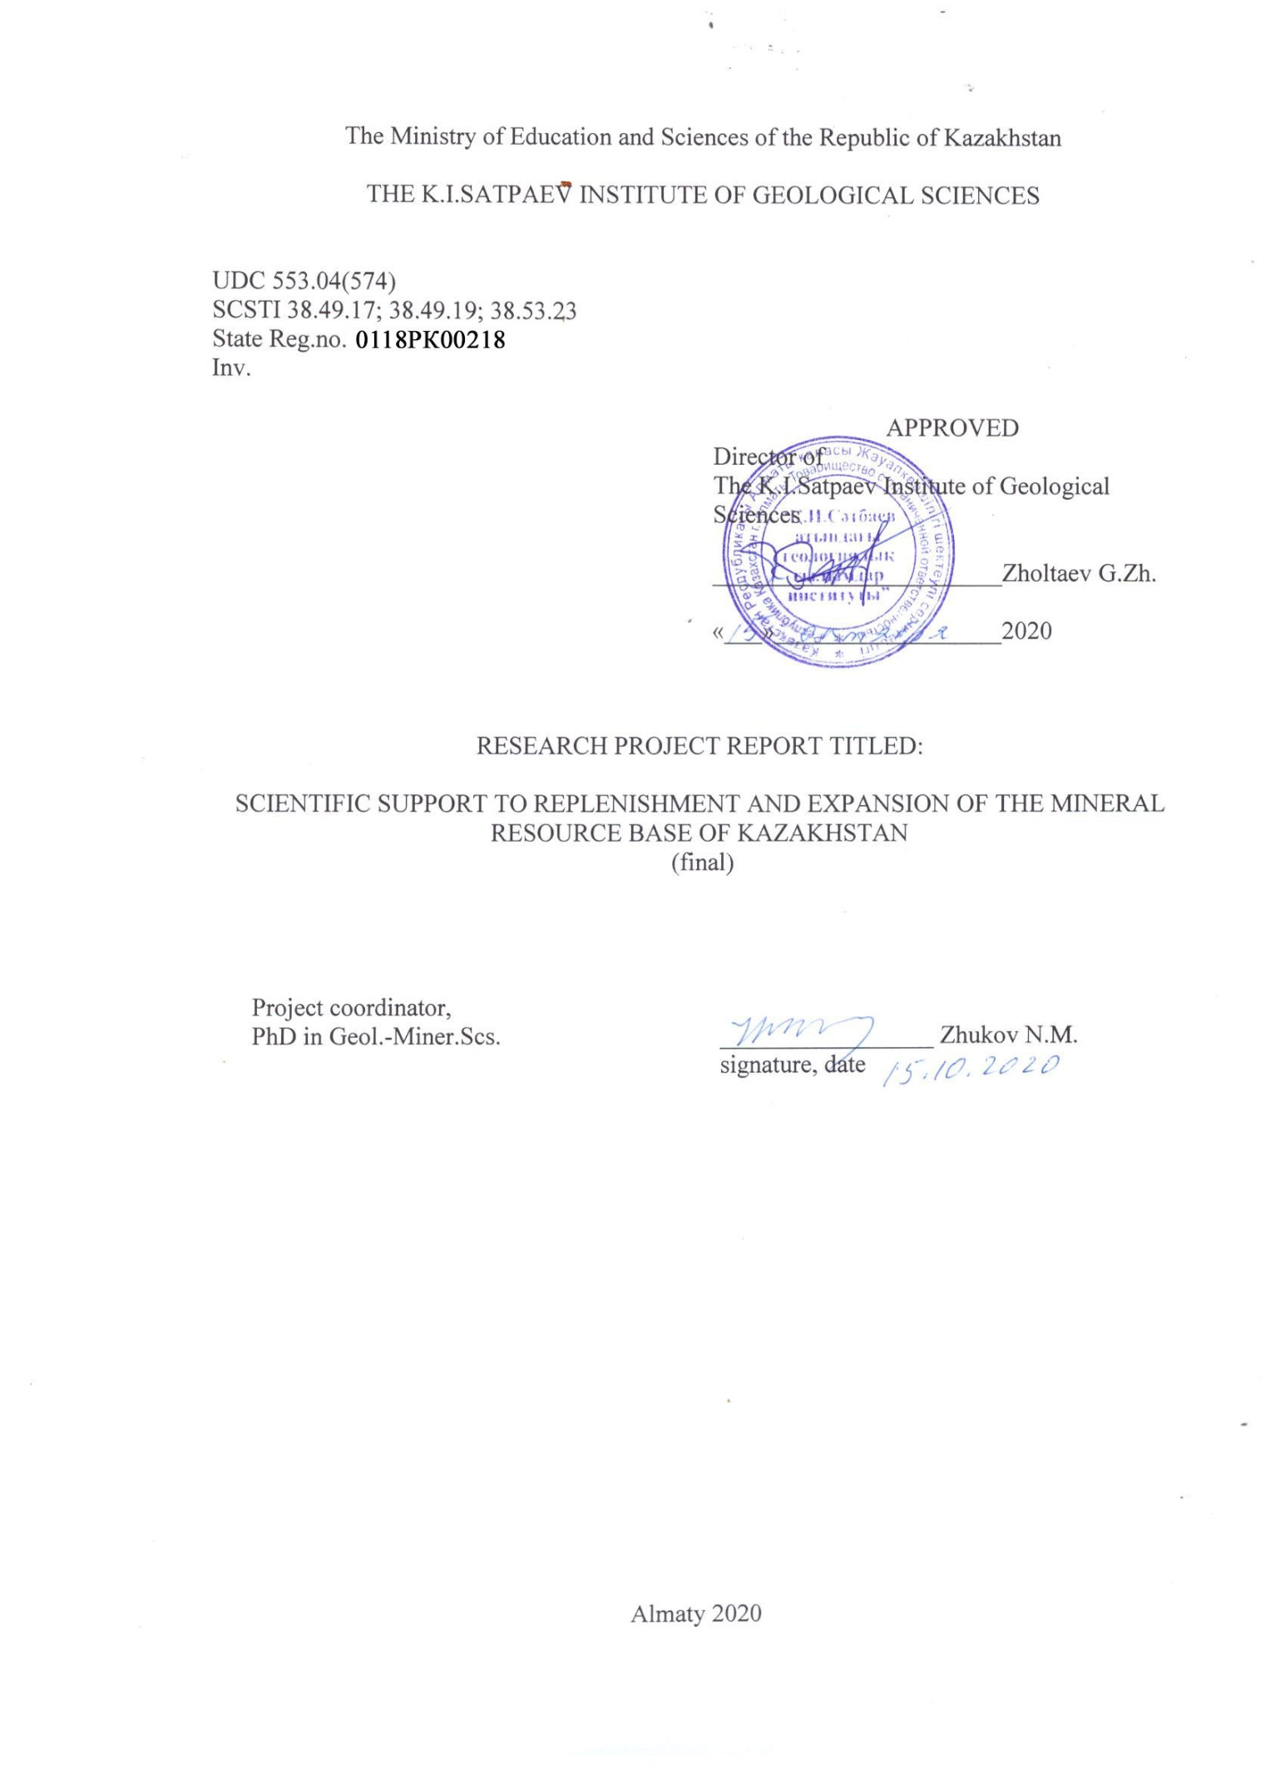

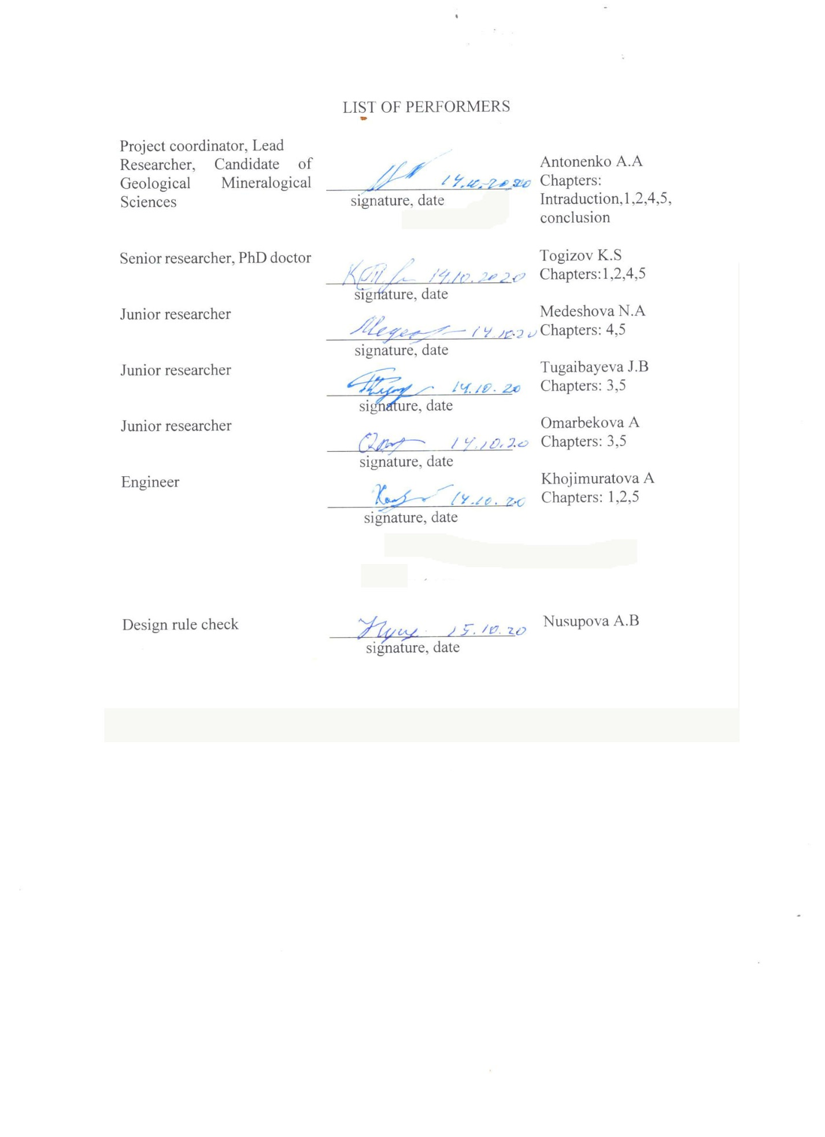

SUMMARY
Report 55 p., 1 book, 2 tables, 15 sources, 3 ADJ.
FIELD, KARST, MINERALS, ASSESSMENT, CRITERIA, PROSPECTS
Object of research: mineral resource base of Kazakhstan
Purpose: assessment of the forecast potential of easily accessible deposits of various types of minerals in the karst.
The final version of the map of karst occurrences on the territory of the Republic on a scale of 1:500000 has been compiled. 8 karst-ore districts were identified
Diagrams are drawn up on a scale of 1:10000 and larger than individual karst fields and sections.
The mineral and element composition of ores and ore-bearing rocks is determined. Analytical work was carried out on the selected samples in 2019.
It is established that Kazakhstan has a great potential for replenishing resources due to karst deposits.
A reference and monographic publication has been prepared for geologists, subsoil users, students, undergraduates and PhD students.
2 articles were prepared and published (in a foreign publishing house).
Scope: Scientific report of practical interest for forecasting the development of the mineral resource base of Kazakhstan.

The CONTENTS

INTRODUCTION ……………………………………………………………………… | 5
1 MAKE A MAP OF THE PLACEMENT OF KARST OCCURRENCES IN THE TERRITORY OF REPUBLIC 1:500000 SCALE………………………………………..  1.1 Final design of the MAP……………......................................................................... | 7  7
2 MAKE THE SCHEME OF THE GEOLOGICAL STRUCTURE OF KARST FIELDS AND SEPARATE ORE-BEARING KARST FORMS RELIEF …………..............  2.1 Final design of the MAP……………………………………………………………. | 9  9
3 DETERMINE MINERAL AND ELEMENT BY ELEMENT COMPOSITION OF THE ORES AND HOST ROCKS OF THE MINERALIZATION (ANALYTICAL WORKS)…………………………………………………………………………………...  3.1 determine the mineral and element composition of ores and rocks containing mineralization (analytical work) 2019…………………………………………………….. | 18  18
3.2 determine the mineral and element composition of ores and rocks containing mineralization (analytical work) in 2020………………………………………………….. | 21
4 EVALUATION OF PREDICTIVE CAPACITY OF KARST FIELDS……………….. | 26
5 PREPARE A REFERENCE AND MONOGRAPHIC PUBLICATION………………. | 29
CONCLUSION……………………………………………………………………………. | 31
LIST OF SOURCES…………………………………..…………………………………... | 32
APPENDIX A Technical specification and work schedule…………………….………… | 33
APPENDIX В Schemes of the geological structure of karst fields …………...………. | 39
Appendix С List of published works for 2018-2020

INTRODUCTION

Traditionally, in Kazakhstan Geology, the main attention has been paid to the search and exploration of deposits in bedrock, usually lying at medium and great depths. However, as the practice of geological research has shown the potential of near-surface mineral resources is far from exhausted.
Until now, the national geological community has not paid due attention to a special type of geological formations - ore-bearing karst (excluding bauxite), which include a wide range of minerals. Currently, karst formation processes are associated with the formation of deposits of lead, zinc, antimony, mercury, uranium, gold, aluminum, Nickel, manganese, iron, barite, celestine, Icelandic spar, malachite, diamonds, phosphorites, oil and gas [1,2,3].
Research conducted in 2012-2014 on the topic "Karst deposits of polymetals and gold – a new promising type of deposits in Kazakhstan" allowed us to obtain the following main results: search criteria for karst deposits of polymetals were developed; promising areas for setting up search operations within the Karatau and Torgay regions were identified. At the same time, the collected material showed the great prospects of this direction and the need for further research. To date, industrial contents have been identified in karst formations: gold (up to 5-7 g/t), rare earths (up to 1.0-1.5%), rare metal mineralization, lead-zinc and manganese ores (with a content of up to 25-40%), titanium-containing ores, abrasive raw materials, in addition, a wide range of non-metallic minerals of industrial and general economic significance (barite ores, mineral dyes, raw materials for the ceramic industry, etc.).
The traditional type of ore-bearing karst on the territory of Kazakhstan is still bauxite deposits, which make up the main mineral resource base of JSC "Aluminum of Kazakhstan".
There is no information in the open Kazakh press, except for fragmentary information on the developed fields. In the foreign media of geological information, the issues of karst formation, especially, ore-bearing karst, are not considered. Only the publication at the level of tourist prospectuses and separate information on the bauxite-ore karsts of Yugoslavia (Karst plateau), published in the COMECON collections of the Warsaw Pact countries in the 70s, are given.
The relevance of research is to fill in shallow (almost from the surface) drying up sources of mineral raw materials (JSC "Aluminum of Kazakhstan", JSC "Yuzhpolimetall", etc.) and to inform existing enterprises and investors located on the territory of the Republic who do not have complete data on the location of easily accessible deposits of valuable raw materials located on the surface and do not require large financial investments for their industrial development.
The scientific novelty of the project is to further improve the theoretical foundations of ore-bearing karst and their practical use for the purposes of forecasting and industrial evaluation of deposits.
Karst ores are the most accessible and easily enriched minerals that occur on the surface of the Earth's crust [2,3,4,5], the resources of which, for a number of metals, can successfully compete with deposits in the bedrock. In addition, the competitiveness of karst ores consists in their natural enrichment, which will significantly reduce the cost of their primary processing. The positive aspects of the project implementation for the national economy are the reduction of the terms of exploration and commissioning of deposits at relatively low financial costs.
Karst science in Kazakhstan, as a branch Of Earth science, is not covered in the special literature, especially concerning aspects of its study and practical use in industry as a potential source of mineral resources, agriculture (as sources of drinking and domestic water supply) and meeting the needs of the rural population in building materials (brick raw materials, natural mineral dyes, etc.). The development of this field (the study of ore-bearing karst) will promote the development of related industries, such as mining development optimization of the surface fields most effective in an open way with the least damage to the ecological environment; technology of primary processing of mineral raw materials – development of new technology and rational extraction of useful components that have industrial value; in metallurgy – development of new technologies of metallurgical mineral raw materials.
All work was carried out according to the schedule (Appendix A).
List of interim reports.
Stage 1, 2018, inventory # 0218RK00799 «Forecast assessment of karst-type mineralization prospects in Kazakhstan for various types of minerals»
Stage 2, 2019, inventory # 0219RK00928 "Forecast assessment of karst-type mineralization prospects in Kazakhstan for various types of minerals»

1 Make a map of karst occurrences on the territory of the republic on a scale of 1:500000
The work was performed.
A map of karst occurrences on the territory of the Republic on a scale of 1:500000 has been compiled
On the basis of GIS technologies, administrative, geological loads and the location of areas with karst type of mineralization are determined. The karst map is based on the karst mineral deposits linked according to the coordinates, in accordance with the available software.

1.1 final registration of the card

The work was performed. First half of the year.
A 1:500000 scale map has been finalized, showing all karst features.
The map shows administrative load (roads, cities, large towns, borders of Kazakhstan, lakes, main rivers), geological load (lithology of rocks, stratigraphic levels of karst manifestations and karst formation of the territory of Kazakhstan). To map made known known ore occurrences in the karst of both modern and paleokarst. Separate areas, districts, and zones have been identified for making larger-scale maps. In total, there are 8 karst ore regions in Kazakhstan: West-Turgay, East-Turgay, Central-Kazakhstan, Kokshetau, Priirtysh, Akzhal-Aksoran, Karatau, Sairam-Ugam, which have prospects for identifying karst deposits.
The Zapadno-Turgay boksitorudny district covers the Eastern TRANS-Urals (Kostanay region) and the Eastern slope of the mugodzhar Mountains (Aktobe region). The main profile karst minerals are bauxite, iron and manganese ores, gold, silver, polymetallic ores, gallium, rare earths. Significant reserves of raw materials for the expanded clay industry and refractory ores have been explored with overburden of karst formations.
The East Torgay karst ore region is located in the North-Western part of the Ulytau mountain range (Kostanay region). The main karst minerals are bauxite, manganese ores, silver, gold, rare earths, raw materials for the expanded clay industry, and refractory clays.
It is located on the North-Eastern side of the Teniz Depression (Akmola region). The main minerals in karst formations are bauxite and related mineral dyes (ochre, mummy).
Kokshetau district is located West of Kokshetau. It differs from other areas in the extremely limited development of karst processes. This is due to the lithological features of the territory, where the main area is made up of metamorphic and Intrusive rocks, karst rocks are developed extremely poorly and occupy small areas. The main mineral is bauxite. Their manifestations are insufficiently studied by individual wells.
Priirtyshsky district covers the Northern part of Pavlodar and the North-Western part of East Kazakhstan regions. There is one known explored Deposit-Gornostaevskoe, affected by karst processes with the formation of deposits of silicate-Nickel ores in karst craters. In addition, a number of karst manifestations of bauxite have been identified. A significant disadvantage is the extremely low degree of their study, the morphology, parameters of ore bodies and the content of useful components remain unclear.
Akzhal-Aksoran district fully corresponds to the area of the Akzhal-Aksoran structural and metallogenic zone. At present, there is only one known Deposit of a thermokarst geological and industrial type and a number of unexplored manifestations, for which there is scant information. During the epochs favorable for the development of karst (Triassic-Jurassic and Cretaceous), this territory had a rather arid climate with a predominance of denudation processes. This adversely affected the development of karst processes.
Karatau district covers the South-Western gentle slopes of the Bolshoy Karatau ridge. There are numerous manifestations of karst processes that occurred in favorable climatic and geomorphological conditions, which led to the formation of numerous deposits and manifestations of karst ores. The main minerals of karst geological and industrial type are lead-zinc, barite and bauxite ores.
Sairam-Ugam district is located in the South-Eastern part of South Kazakhstan region. All bauxite occurrences are confined to the Eastern peripheral part of the Kyzylkum Foundation. The district is bounded on the North by the Karatau range, on the East by the Karzhantau and ugamsky ranges.
The district has one field Kutyrgan and about a dozen manifestations - Artabas, Mensurate, Fogelevka, Knowth, Langer, Ayusay, Kazygurtsky group, Baganaly.
To date, no bauxite deposits of industrial significance have been identified in the area that meet the requirements of the current Groove line. Typical representatives of the bauxite-bearing area are the Kutyrgan Deposit and the Ayusay manifestation.

2 Draw up diagrams of the geological structure of karst fields and individual ore-bearing karst landforms

Work has been performed on drawing up diagrams of the geological structure of karst fields and individual ore-bearing karst landforms for the first half of the year.
Diagrams are drawn up on a scale of 1:10000 and larger than individual karst fields and sections. The compilation was carried out using satellite images, collected geological information and cartographic software. The data obtained as a result of decryption for the selected areas, areas and sections are put on a geological basis and analyzed. When drawing up maps of karst ore sites, the previously selected search criteria and signs of karst mineralization were taken into account. All schemes reflect the geological and structural features of the karst area, the placement of ore mineralization within the area, and the regularities of placement of ore objects and karst landforms in them.

2.1 Final card processing

The work was performed. First half of the year.
The map has been finalized. Diagrams are drawn up on a scale of 1:10000 and larger than individual karst fields and sections. Various geological and geomorphological maps, diagrams, sections, and descriptions of karst landforms and ore objects were used for drawing up the diagrams. Separate areas with the highest karst development and associated mineralization were identified for all the 8 karst-ore regions. Based on this, maps of promising areas were prepared for recommendations for geological exploration.
It is established that the relevance of such maps of karst deposits is to fill in shallow sources of mineral raw materials, which is of great value for the awareness of existing enterprises and investors located on the territory of the Republic, who do not have complete data on the location of easily accessible deposits of valuable raw materials located on the surface and do not require large financial investments for their industrial development.
Work is underway to finalize the cards. Work has been completed on the southern (Karatau) and Northern (Turgay) Kazakhstan, work continues on digitizing Mangistau (Northern Kazakhstan) and in Central Kazakhstan. The geologic load includes rock lithology, rock age, discontinuous tectonics, ore and non-metallic mineral occurrences, as having the primary importance of karst placement in space.
All maps are shown in Appendix B.
In Central Kazakhstan, certain prospects for the discovery of endocarst and exocarst deposits are Akzhal-Aksoran and Akbastau zones (see Appendix B 1).
Akzhal-aksoran Zone
1. within the zone, the main mass of carbonate rocks of the upper Devonian-lower Carboniferous age forms a ridge of the same name, elongated in the sublatitudinal direction. Carbonate rocks are represented by limestones, marl, siliceous, clay, carbonaceous limestones, and other varieties [6,7]. The most favorable for karst formation processes are massive limestones that have a wide area development in the Akzhal-Aksoran ridge.
2. calcite streaks and veins present among the carbonate rock strata indicate hydrothermokarst processes that were active at depth in the past. The great activity of hydrothermal solutions is evidenced by the cavities made by ore material, as well as hydrothermal changes in the host rocks (calcification, baritization, dolomitization, etc.). currently, karst underground waters of sulfate-sodium bicarbonate, sulfate-sodium chloride, calcium bicarbonate and other composition are actively functioning, in the form of sources and intensive water flow to mine workings.
3. the Tectonic structure and position in the regional plan of the Akzhal-Aksoran zone determines the presence of a large number of plicative and disjunctive elements and their combinations, favorable paths for the movement of solutions. This, in turn, contributes to the processes of karst formation, which is confirmed by the observed surface and underground karst [8]. Separate paleokarst of the cavity is made of ore material (Kastigar, Central and Western parts of the Deposit Akzhal).
4. in the Akzhal-Aksoran zone, more than 100 mineralization points are known, among which lead-zinc mineralization is of leading importance. All the main deposits of lead and zinc (Akzhal, Aksoran, Metallometricheskoe, etc.) are confined to the carbonate strata of the ridge of the same name [6]. The largest number of ore bodies of the Akzhal ore field and almost all known ore occurrences in the Eastern and Central part of the ridge are located in massive limestones.
On this basis, there are opportunities for the formation of ectocervix fields. The formation of endocarst deposits could occur due to scattered mineralization in the lower parts of the upper Devonian section (Axoran), which could be re-deposited in the upper section (Akzhal).
5. Climatic, hydrogeological and geomorphological conditions were favorable for active karst-forming processes, as evidenced by the geological and tectonic history of the region.
The use of search criteria allowed us to put forward the Akzhal-Aksoran ridge in the category of promising ones for identifying karst mineralization that is new for this region.
One of the most promising areas is the Kaskaigyr anticline, where the eponymous Deposit is located, represented by columnar ore bodies. On the recommendation of V. V. Kolesnikov, several wells were drilled on this structure, which revealed small blind ore bodies with aggregate ores, with a lead content of up to 11.75% and zinc up to 4.78%.
When conducting further geological exploration, it is necessary to analyze the existing and newly obtained materials from the position of karst mineralization and further work should be carried out purposefully in search of rich karst ores. Such studies should be carried out on promising areas of the Metallometric, Sasykbay, and Akzhal 2 ore occurrences, as well as within the Akzhal ore field and on the area between the Akzhal and Kaskaigyr deposits, which may be linked by separate ore bodies at depth and are a single Deposit. The new objects identified in this way, as well as individual ore bodies of already known deposits, will help solve the problem of shortage of raw materials at the Akzhal GOK.
Akbastau zone
1. in the Akbastau zone, carbonate rocks of the middle-upper Ordovician and upper Devonian - lower Carboniferous are widely distributed and are represented by marbled, quartzized, carbonaceous, clay limestones, marls. The net difference of limestone are secondary distribution. As you can see, carbonate rocks are mainly represented by chemically non-pure varieties (the presence of a certain amount of autigenic material), which reduces the scale of karst formation.
2. numerous veins, veins and bodies of vein minerals (calcite, dolomite, etc.), sometimes with fragments of host rocks, indicate hydrothermal activity of the area and intensive hydrothermokarst processes.
Currently, the zone is widely developed crack-karst waters [7]. sulfate-bicarbonate-sodium, bicarbonate-calcium-sodium and other composition.
3. the Akbastau zone in the regional plan is a section of the earth's crust, intensely divided by faults into separate blocks. A large number of deep faults and a system of cracks associated with them, zones of crushing, fracturing, interformational failures, and delamination zones cause a wide development of karst processes, manifested in the form of surface (craters, depressions, etc.) and underground cavities made of ore and non-metallic material.
4. Akbastau zone is Characterized by lead-zinc and polymetallic mineralization, less often iron and rare metals. There are 117 lead-zinc deposits, ore occurrences, and mineralization points, most of which are located in Ordovician carbonate rocks (32 sites) and upper Devonian - lower Carboniferous rocks (31 sites). The distribution of mineralization in the whole zone is uneven, nodal [6]. The placement of deposits is controlled by the same structural elements as the karst formation processes.
Extensive development of ore mineralization in the Akbastau Zone is a prerequisite for the formation of endocarst and exocarst deposits.
5. the climatic conditions were most likely similar to those of the Akzhal-Aksoran zone. Hydrogeological and geomorphological conditions seem to have been more pronounced, since the tectonic block structure of the zone causes a large number of paths for the movement of solutions and waters, their penetration to great depths, their heating and rising to the surface with elevated temperatures and enriched ore and non-metallic compounds. The block structure also provides a more divided terrain.
The wide development of carbonate rocks with karst forms and crack - karst waters combined with ore mineralization make the Akbastau zone one of the most promising areas for detecting karst mineralization. Located in this structure hidrocarbonetos field Gundy [9]. only confirms the possibility of identifying hydrothermograph rich ores.
First of all, the most promising areas are the areas of distribution and kondinskoe kagohashi Suite of carbonate rocks of the Ordovician, which are characterized by a common infestation of ore mineralization and ore-bearing strata which is for deposits and occurrences Gordinskogo and Abulhairova ore nodes (Gundy, Shiogai 1 and 2, etc.). Guninski node has the largest areal distribution of carbonate rocks kondinskoe Suite, combined with a deep Singlescom fault and his operauser cracks and small intrusions of diorite porphyrite create a favorable environment for the formation of hydrothermograph cavities, which subsequently was postponed ore and non-metallic material. Similar geological conditions are observed in the area of Shozhagai 1 and 2, Abulkhair, and Kyzylzhar (Abulkhair Ore cluster).
A promising area is the Zhilan site, where mineralization is confined mainly to the Ordovician siliceous shales, but small ore accumulations with a lead content of up to 1% are noted in the underlying limestones. Unfortunately, during the geological exploration of the limestone thickness did not pay due attention to the identification of hydrothermocarst mineralization.
A similar situation is developing in the Abulkhair ore Deposit, where in 1989, when drilling wells in the area, one of them, in the range of 25.5 m - 26.5 m, uncovered brecciated limestones cemented with coarse-grained Galena. What he says about the possible existence of ore hydrothermograph breccias at depth.
Carbonate rocks of the upper Devonian - lower Carboniferous are also favorable for the discovery of karst deposits. About having hydrothermograph ores in rocks of this age individual ore bodies in the Deposit Usingall. The Akzhartas Deposit and the surrounding area, as well as the yegendybulak ore cluster, are of particular Interest in the discovery of karst ores.
Of particular interest are the areas covered by the cover of Cenozoic deposits (the Mointy, Shazhogai and Sarybulak river valleys), where carbonate rock strata were opened by mapping wells.
Relative, and sometimes direct (Cartas) distance Galskogo GOK, which is currently experiencing difficulties in respect of shortage of raw materials, raises the question of reassessment of already known objects Akbostanci areas and identifying new ones, which will help significantly extend the work of the GFCS and thereby solve the problem of employment of the population of the village Akzhal.
South Kazakhstan
In southern Kazakhstan, the prospects for the discovery of karst deposits cover large areas: the Karatau ridge, Sairam-Ugam karst-ore regions, according to Appendix B 2.
Karatau
1. Karatau is a region where the overwhelming volume of sedimentary deposits is represented by carbonate rocks. This is especially true for the upper Devonian – lower Carboniferous formations, which are represented exclusively by carbonate rocks (excluding lenses, interlayers, and other sedimentary formations of non-carbonate rocks).
Wide development of relatively homogeneous rocks causes intensive development of karst in the past and present. the most widespread in the rocks of Marche and lower tour.
2. a huge number of veins, veins and bodies of various forms of vein minerals (calcite, dolomite), which sometimes contain ore minerals, indicate intensive hydrothermal processes at a depth that occurred in temporary proximity to ore formation.
Karst formation processes occurred in the Mesozoic (lower Cretaceous). Currently, these processes are taking place on a smaller scale.
Modern underground waters of various compositions that are aggressive to carbonate rocks are widely used in the region. Ore mineralization increases the aggressiveness of water and solutions.
3. a large number of faults, zones of brecciation, karst, fracturing and other disjunctive elements in combination with various forms of folding cause the circulation of solutions in rocks over an area and to a depth.
4. in Karatau, a large number of lead-zinc deposits, ore occurrences and mineralization points are known, most of which are localized in the carbonate rocks of famen and Tournai (Migalimsay, Shalkiya, Smena, Achisay, etc.). geological control of mineralization is carried out by tectonic (plicative and disjunctive dislocations) and lithological (Dolomites and limestones) factors [13,14].
Karatau, as nowhere else in Kazakhstan, clearly shows a close spatial relationship between karst formation and sulfide mineralization, which was a search feature of lead-zinc mineralization.
In addition, in this region there are karst ore occurrences of junoalpine age (Karasu -1, Asan -2, etc.), associated with deposits of Quaternary age in karst cavities.
5. Mesozoic (lower Cretaceous) climatic, hydrogeological and geomorphological conditions were favorable for the widespread development of karst processes. This was also facilitated by the widespread development of karst rocks. The scale of karst formation in the lower Cretaceous is indicated by numerous karst cavities made by younger sediments.
The wide distribution of carbonate rocks with sulfide mineralization in the region, favorable structures combined with karst formation processes (both hydrothermal and cold karst), and the presence of karst deposits make Karatau one of the most promising areas for karst mineralization.
Exocarst mineralization (Shaimerden type) can be expected in areas covered by Mesozoic-Cenozoic sediments that often contain high levels of lead, zinc, barium and other elements (South-Western slopes of Karatau, Prishymkent district). In these areas, special attention should be paid to deposits that perform sinkholes and depressions in the Paleozoic basement, where clay-oxidized rich lead-zinc ores may have formed. Similar ores should be expected in the territories adjacent to deposits with stratified mineralization (mirgalimsay, Shalkiya, etc.).
The areas of lead-zinc deposits: Achisay, Smena, Karasay, Shalkiya, mirgalimsay, Kantagi, and Baijansay have certain prospects for identifying exocarst deposits. Where ore-bearing karsts are recorded. But in the mountainous part, you should not expect a large object, most likely it will be a small ore occurrence with metal reserves of about 15-20 thousand tons.
Sairam-Ugam district.
1. in the Talas Alatau and Ugam Ranges, carbonate rocks of the upper Devonian – lower Carboniferous, as well as in Karatau, are widely distributed. These are mainly limestones and Dolomites. Marls have a subordinate development. Among the limestones there are varieties: limestones, organogenic, siliceous, clay limestones. The most favorable rocks among the carbonate strata for karst development are dolomitized limestones, organogenic limestones and Dolomites.
2. The composition and nature of solutions can be judged by the scale of hydrothermal changes in rocks: dolomitization, calcification, seritization, etc., as well as by breccias of rocks with carbonate cement, which was formed due to material removed from the depths (hydrothermokarst). The presence of volcanic-sedimentary strata causes an increase in the aggressiveness of surface waters in relation to carbonate rocks.
Currently, surface and underground waters have an active impact on carbonate rocks in the region. But Ecocert poorly developed due to intense erosion.
3. Tectonic forecast factors are expressed in a large number of faults, zones of fragmentation, fracturing, which contribute to active processes of karst formation vertically and laterally.
Regional uplift of the region provides circulation of modern groundwater.
4. in the spurs of the Talas Alatau and Ugam ridge, several deposits and many ore occurrences and mineralization points have been registered. Most of them are represented by lead-zinc mineralization, the second place is occupied by barite-fluorite-polymetallic mineralization.
Lead-zinc mineralization is associated with carbonate rocks of famen and lower Carboniferous, which indicates the possible presence of karst deposits in the region similar to Karatau objects.
Note that the substantial ectocervix deposits in the region is unlikely because of the intensive erosion processes. Is it possible to detect small actorstate objects associated with the oxidation zone of sulfide ores (ore karst). Exocarst objects can be identified in the foothill part, where karst cavities served as traps for the material being removed from the ridges.
Great prospects have endocartitis field. First of all, already known, but not fully explored.
5. Climatic, hydrogeological and geomorphological conditions do not contribute to the widespread development of exocarst processes. The area is high-altitude with a highly dissected terrain, which causes intense surface erosion. In the high-altitude part of the region, karst processes are slow due to low temperatures. Steep slopes contribute to the rapid flow of meteor waters into the valley.
In General, the Talas Alatau and Ugam ridge have great prospects for the discovery of hydrothermokarst deposits compared to exocarst mineralization.
The most promising areas in the region are the strip of carbonate rocks, where the Zhusalinsky group of ore occurrences and the Lachinkhana Deposit area are localized. Further work in these areas should first be directed to the re-evaluation of known karst mineralization sites.
Northern Kazakhstan
The prospects of Northern Kazakhstan for identifying karst deposits are associated with the Turgai trough. This promising area, in the first place, to identify ectocervix lead-zinc deposits.
1. in the basement of the Turgay trough, carbonate rocks are located in Devonian - lower Carboniferous overlaid mulds and have a wide development. Sedimentary formations of this age of the Turgai trough are similar to similar deposits of the Karatau ridge, bearing lead-zinc mineralization. They are mainly represented by limestones, dolomitized, clay limestones, Dolomites and marls. Of all these varieties, the most favorable rocks for the development of karst are limestones and dolomitized limestones.
2. Hydrothermal changes in rocks (dolomitization), karst cavities, and weathering crust on Paleozoic rocks indicate the aggressiveness of water and solutions. Currently, the region has a well-developed underground water in Mesozoic-Cenozoic sediments and Paleozoic rocks.
A large number of Intrusive bodies provides increased aggressiveness of water solutions in contact with carbonate rocks, which accelerates the processes of karst formation.
3. a large number of faults caused intensive filtration of water solutions through the rocks, which led to the formation of various karst cavities (craters, polya, etc.) on the Paleozoic basement.
4. lead-zinc mineralization in the Turgay trough is poorly studied, a small number of ore occurrences are known (Arkalyk, Koytas, Alyssk, etc.) and one Shaimerden Deposit. All of them are confined to dolomitized limestones and Dolomites, with a high content of lead and zinc.
Research carried out by a number of geologists (A. R. Niyazov, S. M. Iskuzhin, T. M. Utelbekov, etc.) revealed a wide development of contact-karst weathering crusts with copper and lead mineralization (Sarysu-turgayskaya mulda) /29,30/. Such weathering crusts are confined to the contacts of Fran red flowers with carbonate rocks of famen and are covered by a cover of mozozoic-Cenozoic deposits with a thickness of up to 100 m. Karst weathering crust is made of sandy-clay material, the quartz-kaolinite composition with the hydrous. The source of copper and lead is, according to researchers, the horizons of organogenic Dolomites with a lead content of 0.1% and copper 0.3%, rarely there are nests with a lead content of the first percent. Weathering crusts are wedge-shaped and cloak-shaped. Similar karst weathering crusts are known in Ulutau.
5. extensive development of Paleozoic carbonate rocks and a humid warm climate favorable hydrogeological and geomorphological conditions in the Mesozoic on the territory of the Turgay trough led to the intensive development of karst processes.
Based on the above, it follows that the Turgay trough has great prospects for identifying rich karst ores, and primarily the Valerianovskaya zone, in connection with the Shaimerden Deposit discovered in 1992. To the karst objects should be attributed to ore occurrence Arysskoe, Karasu.
Central Kazakhstan karst ore region.
Within the region, carbonate rocks of the upper Devonian-lower Carboniferous age are widely developed, as shown in Appendix B 3, especially in the North-Western part (Sarysu-Teniz and Atasu District). They are represented by siliceous, clay, carbonaceous limestones, organogenic limestones, Dolomites, etc. Limestones and organogenic limestones are most favorable for the development of karst processes.
The composition of solutions, hydrogeological, geomorphological, climatic and tectonic factors of the region correspond to the Akzhal-Aksoran, Akbastau and Uspensky rifts.
More than 250 lead-zinc deposits and ore occurrences are known in the region [15], most of which are confined to carbonate rocks. Industrial lead-zinc deposits are located in the Zhailminskaya mulda, composed of upper Devonian – lower Carboniferous deposits (Zhairem, Ushkatyn III, Bestube, etc.). In this rift system, as well as in the Akzhal-Aksoran rift structure, there is a clear pattern of deposits being confined to the upper parts of the section (Ushkatyn III) relative to stratified deposits (Zhairem), which are located lower, i.e. the process of re - deposition of scattered mineralization from the bottom to the top is manifested.
The presence of carbonate rocks, aggressive solutions, hydrothermocarst deposits (Ushkatyn III, RIF), and crust-forming processes in the rift system make it a promising structure for detecting karst mineralization.

3 Determine the mineral and element composition of ores and host rocks (analytical work)

The work was performed. First half of the year.
The mineral and element composition of ores and ore-bearing rocks is determined (analytical works). Analytical work was carried out on the selected samples in 2019. The analysis and interpretation of spectral and chemical analyses of karst deposits and ores of lead-zinc and bauxite deposits of the Turgay trough (bauxites, refractory clays) and Bolshoy Karatau (lead, zinc, mineral pigments) were carried out. Based on the data of the spectral and chemical composition of ores and rocks, this work allowed us to Refine previously developed search criteria and prepare recommendations for a comprehensive study of karst deposits and ores in the future.

3.1 Determine the mineral and element composition of ores and rocks containing mineralization (analytical work) 2019

The work was performed. First half of the year.
The mineral and element composition of ores and rocks containing mineralization was determined (analytical works) in 2019. Based on the results of processing samples (spectral and chemical analyses) taken during field work in 2019, the following data were obtained. The content of calcium oxide and titanium for bauxite is close to each other. The content of titanium oxide is from 1.5 to 2.0%. The content of calcium oxide is from 0.38 to 1.23%. High calcium content is associated with secondary changes in bauxites and is the main harmful impurity for the release of abrasive grades, even in high-modulus bauxites. The average alkali content is Na2O - 0.3%, K2O - 0.22%. The content of sulfur is from 0.19 to 0.72%, phosphorus from 0.022 to 0.155%. Of rare elements, gallium, yttrium, and scandium are of interest. The average gallium content in bauxites is 0.0043%. There are increased concentrations of yttrium (12.5-158 g/t) and scandium (50 g/t). For bauxite is characterized by the presence of a significant number of refractory materials in the form of Gibbethon kaolinite clay containing gibbsite to 20-46%, kaolinite up to 50-80%, quartz 10-15%, hydroslide type of monotremata.
We had 17 samples from a depth of 42.7 to 180 m from one of the deepest wells (No. 8830) that intersects the main ore body in its Central part. Each sample was disassembled phase by phase and the entire variety of phases (43 samples) was examined radiometrically and spectrographically.
The main clay components of ores are trioctahedral smectites of magnesium and calcium-magnesium composition and kaolinite. Kaolinite predominates in the upper part of the section (up to a depth of 50-52m). Smectites are mainly distributed below, only sometimes with an admixture of kaolinite. Clays are often accompanied by siderite, quartz, and calcite. Locally, magnesium saponite (111.0 m) appears among the clay components, similar in white to kaolinite. Towards the end of the section marked with vermiculite (155,0 m) from the group of hydromicas.
Zinc minerals are present almost throughout the section, and in significant quantities. The main one is the aqueous zinc silicate hemimorphite = calamine Zn4[Si2O7][OH]2•H2O. Usually three morphological varieties of it coexist: 1) fine-grained dense or earthy aggregates of brownish or creamy color, intensely saturated with clay components; 2) single small crystals more or less evenly dispersed in calamine-smectite mixtures; 3) crystalline crusts, veins, and radially radiant aggregates of calamine completely cleared of clay particles during recrystallization. Calamine crystals are colorless, translucent, and reach a length of 4-5 mm, sometimes 1.3 cm (depth 74.4 m).
Much less frequently, zinc carbonate – smithsonite ZnCO3, and complex oxide – heterolite ZnMn2O4 are fixed from zinc minerals.
Zinc sulfide, sphalerite ZnS, is quite widespread. As a small impurity, it is noted among kaolinite and magnesium smectite in the upper part of the section (52.0 m). Significant accumulations are developed at depths of 95.0 and 122.5 m. Here sphalerite mixed with smectite forms solid fine-grained aggregates of light-brown color. Against their background, relict "oblomkovidno"-mottled forms of almost pure from clay components of solid sphalerite of a darker color are distinguished. Druses of the smallest greenish sphalerite crystals are developed in the leaching voids.
Thus, for well 8830, the upper horizon ores are represented by zinc hydrosilicate calamine and zinc carbonate smithsonite, while the lower horizon ores are represented by zinc sulfide - sphalerite. Although calamine is found as an impurity in clay accumulations at the lower horizons, and sphalerite at the top of the section, silicate and zinc sulfide were not observed together in the ores.Based on the structural and textural features of the ores in the Deposit, the processes of substitution of sphalerite with clay components, leaching and redeposition of ore matter with the transition of fine-grained ore aggregates to fine-grained, and then to larger-crystalline and even drusic ones developed in the leaching voids played a significant role. This is especially clearly observed in the case of sphalerite and calamine.
At the same time, there are no signs of oxidation of primary sulfides such as pyrite, Galena, arsenopyrite, and marcasite scattered in sphalerite.
Table 1 - composition of sphalerite and Galena according to microprobe analyses (wt.%):
Well/ depth, m | Sample characteristics | S | Fe | Zn | Pb | Sum
8830/95м | Crystalline light sphalerite in uniform coalescence with carbonate | 33,15 | 0,47 | 66,38 | - | 100,00
8830/95м | "Fragment" (relic)? dense darker sphalerite in the sphalerite ore | 32,70 | 0,54 | 66,76 | - | 100,00
8830/122,5м | Porous aggregate of sphalerite | 32,92 | 0,77 | 66,31 | - | 100,00
8830/122,5м | "Chip" (a relic) darker sphalerite in its porous aggregate | 32,89 | 1,18 | 65,93 | - | 100,00
8830/95,0м | Grain of Galena on sphalerite framing | 12,79 | - | 1,09 | 86,12 | 100,00
Note: the analyses were performed by V. L. Levin on the JCXA-733 microprobe.

During recrystallization, ore minerals are purified not only from clay components, but also from isomorphic impurities. In particular, this applies to sphalerite. According to spectral analysis, all samples from sphalerite ores contain cadmium (from 500 to 2000 g/t), which is usually a typical isomorphic impurity of sphalerite. However, a microprobe study of sphalerite did not detect cadmium in it (table 2). It can be assumed that the cadmium released during recrystallization of sphalerite was deposited here as its own minerals such as cadmium oxide – monteponite CdO or cadmium carbonate - otavite CdCO3. This is why the admixture of cadmium is determined by spectral analysis not only in sphalerite samples, but also in clay and carbonate components from ore intervals (up to 50 g/t).
The revealed features of ores – their implementation of a narrow deep basin in limestones, relict debris – like structure of ore aggregates, the presence of blocks of mineralized limestones, as well as volcanogenic rocks, the phenomena of leaching, recrystallization of ore matter, the absence of signs of oxidation of pyrite, arsenopyrite and Galena-all this allows us to join the idea that the Deposit is exocarst. Clastic clay-ore material of collapsing mineralized rocks and possibly even ore accumulations was carried into an open cavity in the limestone (karst funnel), which was then compacted and transformed.
Signs of such ore mineralization in the area of the Krasnooktyabrsky bauxite Deposit were encountered before, but they were not given serious significance. To date, it is known that zinc mineralization is widely developed in the underlying bauxite rocks for many kilometers. Only on the area of the Krasnooktyabrsky ore field, five priority sites have been identified that are promising for the search for carbonate-siliceous zinc ores with forecast reserves of 7.1 million tons.t of zinc. In addition, 11 promising sections of the second stage have been identified. The Livanovsky polymetallic district is singled out, within which, in addition to Krasnooktyabrsky, Belinsky and Temir-ayatsky potential ore fields are planned. This means that the entire Valerianovskaya structural-facies zone of the Torgay trough opens up new prospects for the search for rich zinc ores. It is also attractive that these ores (except for sulfide) are easily opened with sulfuric acid to produce rich solutions suitable for electrolytic production of zinc.
A similar formation of essentially zinc ores, represented by zinc sulfides and carbonates, was described by V. B. Fomin and G. N. Korobeynikov on the Gelenskaya square (the Western end of the Hissar ridge). The model of formation of such a Deposit, according to their ideas, is as follows:
1) formation of open cavities and voids in Devonian limestones;
2) weathering of Cretaceous siliceous gravelites containing zinc mineralization and simultaneous transportation of weathering products to karst cavities;
3) karst compaction with partial recrystallization of zinc.
A similar method of formation is most likely for Shaimerden, only the source of ore substance here was mineralized limestone. The reason for the formation of calamine ores was free silica formed during the weathering of aluminosilicate rocks.

3.2 Determine the mineral and element composition of ores and rocks containing mineralization (analytical work) in 2020

The work was performed. First half of the year.
The mineral and element composition of ores and rocks containing mineralization was determined (analytical works) in 2020. Data from the study of mineral and spectral analyses of karst lead-zinc ores are analyzed. Interpretation of the results allowed us to draw conclusions about the practical use of the studied deposits as sources of supply of industrially significant concentrations of lead-zinc ores and mineral non-metallic raw materials to various industries. Thus, it is established that the most promising deposits in terms of mineral and sulfide types of lead-zinc fossils are Achisay, Zhamanktay, XX years of October, Smena and Smena II. The average content of Pb and Zn in productive ores from the named territories corresponds to the generally accepted industrially significant concentrations and values taken into account by the cadastre. It is revealed that the non-metallic mineral raw materials in these deposits can be used fine formations composed of clays (nontronite), silicon oxides (quartz), calcium, magnesium, lead, zinc and iron carbonates, which give the rock (depending on the variation in their number) color, dispersion and resistance to atmospheric fluctuations. These powdery mixtures of substances accompanying ores may be of interest not only as ore raw materials, but also as a pigment material used in paint products and in the manufacture of building facing plates.
The indicator minerals and the features of the supergene ore clusters
It is known that minerals, being a natural product of the processes of geochemical transformations of rocks, are one of the main and most reliable factors determining solutions to many geological problems related to both global and local scales.
The history of the formation of a mountain object or the development of a geological event can be read by the indicator features of rocks, which include the totality of all the properties of the host minerals. The importance of this fact is also clear in the case of studying products of supergenic origin. The latter can explain the mechanism of formation of ore concentrations in karst cavities using examples of individual deposits or their groups.
In the studied deposits, we found types of minerals (from hypogenic lead, zinc, and ferruginous differences in sulfides to complex carbonate-silicate and sulfate systems of secondary generation) that fit well into the classical schemes of mineral formation of the Genesis under consideration. For example, relict sulfate formations of Pb, Zn, and Fe elements are found in most deposits, which serve as a substrate for the development of new phases of supergene origin.
According to the schemes of oxidation of sulfide ores, their transformation must pass through the stage of sulfatization, forming an extensive group of oxidized minerals. However, with regard to iron-containing sulfates, according to analytical definitions, their occurrence in the studied karst deposits (relative to oxide and hydroxide forms of iron) is very rare.
As for lead sulfate minerals, their content in the studied rocks, as well as for ferrous compounds, is insignificant. This is mainly due to the extreme instability of anglesite (the first product of Galena oxidation), as well as the probability of missing it in the diagnosis due to low thermochemical information content.
Thermal analysis does not reveal any obvious manifestations of this group of minerals. An exception is the formation of a mixed composition, where lead and iron cations in the O-SO3-H2O system form the plumbojarosite structure. This mineral was found in some samples. On external signs it is close to the jarosite, and the thermal behavior of these sulfates have little to no qualitative differences. In this regard, the minerals, diagnosed as jarosite, in our case, it can coexist with a lead equivalent. The process of Galena oxidation itself, according to the literature, is short-lived, especially in the initial stage of sulfatization. But under conditions when carbon dioxide appears in solutions, the processes of anglesite formation are immediately superimposed by SO4-CO2 substitution reactions with the formation of lead carbonate. This mode of transformation of the PbSO4 structure into the cerussite crystal structure is typical in many parameters for the cases of mineralization of the studied karst fillings. This can be seen from the factors that determine (during the period of dissolving action of groundwater) the appropriate geochemical environment favorable for the formation of Pbco3. One of these factors is the favorable geological and spatial location of the oxidation zones, such as karsts and its surroundings. Another factor is the pronounced carbonate environment of karst voids. Finally, the very low frequency of PbSO4 occurrence in comparison with cerussite and even in comparison with the (zero) member (PbS) of the paragenetic series of lead-containing minerals is an argument that confirms the transient nature of angletization of lead sulfides in the studied deposits.
Thus, the most preferred ore formation in terms of detecting them in the supergenesis zones of the studied deposits should be the source material itself-lead sulfide, as well as the second member of the smithsonite paragenetic series. In this case, as an indicator of lead mineralization in ore-bearing karsts, which are found in the achisai Ore node, could serve as obohronennye carbonate-clay complexes. On the example of samples from developed supergene formations, the occurrence of Galena and cerussite in rocks is almost directly related to the presence of a hydrotated difference in goethite, which is closely associated with a ferrous member of the smectite series of minerals - nontronite. At the same time, the degree of perfection of the crystal structure of this layered silicate should be low, and the aggregate state of the formation should be coarse. Galena in these deposits tends more to the same associations that are enriched with fine-grained hematite, maghemite, and magnetite
Regarding the formation of secondary minerals in the oxidation zones of zinc-containing sulfide ores, there are geochemically justified and tested in practice schemes for the transformation of these systems. From the point of view of our research, the study of the problem of mineral formation in the conditions of supergenesis of hypogenic sphalerites should be based on determining the ways of formation of new phases in the initial stage of oxidation. At the same time, during the destruction of ZnS, it is necessary to take into account the existence of favorable thermodynamic and geochemical conditions, under which the most preferred directions of mineral formation will be formed for the existing conditions.
To determine the existence of sphalerite sulfatization processes in the initial stage of sulfide oxidation, it is necessary to establish the presence of at least two mineral formations on the considered massifs, which, according to the chronological scale and the level of their development, are located at adjacent stages of the paragenetic series.
One of these mineral phases should be sphalerite itself; the other phase, according to the stage of development of the vacant formation, should include smithsonite. Both minerals (one as a relic, the other as a product of complex transformations) are found in the studied karst cavities. Smithsonite from the deposits under consideration is actually the first mineral product of the oxidation of zinc sulfide ores. It is formed as a result of multi-stage and complex processes of interaction of ZnSO4 and FeSO4 with calcium carbonates and imperfect Dolomites. As a rule, smithsonites with different variations of iron and zinc in them should have precipitated at different microgeochemical barriers, when changing the modes of washing limestone with sulfate solutions. Similar differences in the structures of Fe and Zn carbonates are characterized as the mineral mongeimite [(Zn, Fe)CO3], representing an intermediate member of the siderite-smithsonite series. Such mineral formations were also found in the studied zinc-bearing deposits.
The most preferred way to convert ZnS to Znco3 in the oxidation zones is through the ZnSO4 phase, which itself appears to be the product of direct oxygen action on zinc sulfide. This compound, being in an aqueous solution together with iron sulfate, acts on CaCO3, which results in the formation of smithsonite.
Thus, based on the actual forms of chemical interactions of natural reagents in specific physical and chemical environments, it follows that the process of formation of zinc carbonate in the studied deposits was preceded by the stage of sulfatization of hypogenic ZnS.
The process of replacing carbonate types of zinc-containing minerals with siliceous ones completes the General cycle of stepwise transformation of hypogenic sulfides in supergenesis zones. In the newly formed formations, the zinc atom occupies the main positions in the crystal structure, as does silicon. But in the unit cell of such structures, Zn by mass exceeds Si by 4.7 times. In General, the amount of it in calamine (the most common zinc-containing mineral) reaches 58.13% of the total mass. This arrangement of this element is of interest to the nature of the development and distribution of this formation in the oxidation zones.
The mechanism of introduction of zinc into other structural complexes is closely related to its position among metals in the periodic table. This determines the status of Zn as an exchange cation in most minerals. The structure of the Zn atom is characterized by constants and physical and chemical properties of the element, which ultimately determines the limitations of its entry into the crystal lattice as the main component. To an even lesser extent, this metal is found in this quality in silicate compounds.
According to the literature data, only a few types of siliceous compounds with a significant content of structurally related Zn elements are formed in the oxidation zones: Willenite, Calamine, and a group of aluminosilicates with different coefficients of oxide components. The most common among them according to our research is calamine.
If we consider the stoichiometry of this silicate formation and the source mineral (smithsonite) in the paragenetic series, taking into account the existence of favorable geochemical environmental conditions during the period of zinc mineralization, it follows that the development of calamine should occur even before the formation of Znco3 or in parallel with it. The most preferred system (taking into account the mineral environment of the studied karst deposits) may be the following: H2O – CO2 SiO2 ZnSO4. The composition of the reagents of this chemical arrangement is quite consistent with the mineral and material environment of the oxidation zone, even at the present stage of supergenesis development. Applying the potential distribution rule to the proposed system allows us to identify the direction of the transformation process. The reaction in this case should follow the path of destruction of ZnSO4, by replacing SO3 with carbon monoxide, i.e. in the direction of formation of aqueous Zn carbonate, followed by its crystallization (fallen from solutions of amorphous sediment) in the structure of calamine.
Interpretation of the results of studying the mineral composition of karst deposits, taking into account the data of spectral analysis, made it possible to draw conclusions about the practical use of the studied deposits as sources of supply of industrially significant concentrations of lead-zinc ores and mineral non-metallic raw materials to various industries. Thus, the most promising deposits in terms of mineral and sulfide types of lead-zinc fossils are Achisay, Zhamanktay, XX years of October, Smena and Smena II. The average content of Pb and Zn in productive ores from these territories corresponds to the generally accepted industrially significant concentrations and values taken into account by the cadastre. The total reserve of valuable ore components in a particular Deposit is determined by the thickness of the deposits of the corresponding karst filling. As non-metallic mineral raw materials in these deposits, fine formations composed of clays (nontronite), silicon oxides (quartz), calcium, magnesium, lead, zinc and iron carbonates can be used, which give the rock (depending on the variation in their amount) color, dispersion and resistance to atmospheric fluctuations. These powdery mixtures of substances accompanying ores may be of interest not only as ore raw materials, but also as a pigment material used in paint products and in the manufacture of building facing plates. In this regard, the rocks of the ayusay Deposit are particularly different. They are characterized by a variety of colors and a large range of shades. This raw material is in most cases fine, it does not require labor-intensive processing and is environmentally safe.

4 Assessment of the predicted potential of karst deposits

The work was performed. First half of the year.
The forecast potential of karst deposits in Kazakhstan for various types of minerals is estimated. It is revealed that karst formations can be concentrators of aluminum raw materials (bauxite), contain industrial contents: gold (up to 5-7G/t), rare earths (up to 1.0-1.5%), rare metal mineralization, lead-zinc and manganese ores (with a content of up to 25-40%), titanium-containing ores, abrasive raw materials, in addition, and other wide range of non-metallic minerals. It is established that karst deposits (in particular lead-zinc) occupy one of the leading places in the world in terms of reserves and production of rich ores. In terms of metal content, they are superior to all other industrial-genetic types. The forecast resources of the Karatau region for lead and zinc are determined. In the same report, forecast resources are determined for bauxite (the Shymkent bauxite-bearing region) and adjacent territories along the Bolshoy Karatau ridge (from the South-West). Work is underway to identify resources in Central Kazakhstan (Akzhal-Aksoran karst ore region.
Second half of the year.
It is established that Kazakhstan has a great potential for replenishing resources due to karst deposits. Resources of bauxite, which make up the overwhelming amount of reserves (about 90%) in Kazakhstan are not given. The resources of other minerals (gold, rare and rare earth elements, etc.) in the karst are not defined and require a comprehensive study. On the example of karst lead-zinc deposits, a table is compiled that reflects the average contents and reserves of known karst deposits in Kazakhstan, which clearly shows the importance of their study and industrial development. Thus, the average zinc content in the Sullivan (Canada) and mount ISA (Australia) deposits is 6.3-6.5%, and in the karst objects: Beltana (Australia)-35.5%, Shaimerden (Kazakhstan) – 27%.
In the world practice, karst deposits occupy one of the leading places in terms of reserves and production of rich ores [2,3]. In terms of metal content, they exceed all other industrial-genetic types as shown in table 2 (for example, lead-zinc ores). Based on this, it is safe to say that Kazakhstan has a great potential for replenishing resources through karst deposits. Bauxite resources account for the vast majority in Kazakhstan, and therefore are not given. The resources of other minerals (gold, rare and rare earth elements, etc.) in the karst are not defined and require a comprehensive study.
For Kazakhstan akterstva fields are the new industrial style. Mining of this type of object was carried out earlier, for example, at the Badambay Deposit (Karatau) in 1936, 200 tons of cerussite ores with a lead content of 20-22% were extracted; another example is the lead-rich ores of the Shashtyube Deposit.
World practice is known for the extraction of rich oxidized ores from exocarst in the USA (the Franklin Deposit), in Australia (Beltana, Aruna), in Algeria (Ouarsenis) and other countries.
In the past, hypergene deposits of lead and zinc were major suppliers of metals. In ancient times, primarily oxidized ores were developed (Nerchinsk-Zavodskaya group (Russia), Tintik (USA), Santa Eulalia (Mexico), Kyzyl-espe, Kokzaboy, Achisay (Kazakhstan), etc.). But such deposits were in most cases either small objects or oxidized sulfide ores.
Exocarst deposits of lead and zinc can become one of the industrial sources of metal extraction. Prospects for this type of mineralization in Kazakhstan, where carbonate rocks and stratified lead-zinc mineralization are widely developed, are not defined and require a comprehensive assessment. This is confirmed by the discovery of the Shaimerden Deposit in Torgay, where the revealed hypergene and zinc mineralization is associated with Mesozoic clays underlying bauxite deposits. Similar objects should be expected in Karatau, where the well-known shallow deposits such as Sextube and Visean.
With the discovery of the Beltana, Aruna (Australia), and Shaimerden deposits in Kazakhstan, hypergene deposits of lead and zinc attracted the attention of mine geologists. The change in priorities in the direction of exploration and production operations is influenced by the tendency to exhaust the reserves of hypogenic ores lying in near-surface conditions and, as a result, the increase in the cost of mine products. Therefore, geologists and miners are increasingly turning to hypergenic (exocarst) surface deposits as the most economically profitable objects. These deposits are located at a shallow depth and are characterized by high lead and zinc contents reaching a total of 50-60%.

Table 2 - lead and zinc content and reserves in deposits of various genetic types
Deposit | Containing rocks | Average content, % | Reserves
Exo karst
Shaimerden (Kazakhstan) | Vise limestones | Zn -27, Pb -0,5 | 921,2 thousand tons of zinc
Beltana (Australia) | Limestones of the Cambrian | Zn – 35,3-38,2, Pb – 2,3-2 | 863 thousand tons of ore
Arana (Australia) | Limestones of the Cambrian | Zn – 34,4, Pb – 1,6 | 150 thousand tons of ore
Franklin (USA) | Limestones of the Precambrian | Zn about 15 | 9 thousand tons of ore

Endo karst
Achisay (Kazakhstan) | Dolomites, limestones of famena-Tournai | Sulphide ores:  Zn – 13,Pb – 15  Oxidized ores:  Zn – 12, Pb – 8 | -
Smena (Kazakhstan) | Limestones of Tournai | Zn – 5,6, Pb – 1,4 | 132 thousand tons of ore
Tsumeb (Namibia) | The Dolomites | Pb+Zn+Cu – till 60 | 1,8 million tons of total metals
Tri-state (USA) | lower Carboniferous Limestones | Zn – 2,07, Pb – 0,42 | Zinc – 4,5 million tons  Lead –1 million tons
Paint-Point (Canada) | The Dolomites of the upper Devonian | Zn – 6, Pb – 2,5 | 43,5 million tons of ore

Other genetic types
Shalkiya (Kazakhstan)  hydrothermal-sedimentary | Dolomites, famen limestones | Zn – 3,32, Pb – 0,89 | -
Mount ISA (Australia)  metamorphogenic | Dolomites and calcareous shales | Zn – 6,3, Pb – 6,9 | 56,6 млн.т руды
Sullivan (Canada) hydrothermal  metasomatic | Argillites, siltstones of the Precambrian | Zn – 6,5, Pb – 8,3 | 3454 тыс.т свинца  2743 тыс.т цинка

5 Prepare a reference and monographic edition

The work was performed. Second half of the year.
A reference and monographic publication has been prepared for geologists, subsoil users, students, undergraduates and PhD students. Separate chapters have been published in Russian and foreign publications. The content of the compiled reference and monographic publication is given with a brief explanation of the content of individual chapters, which is due to the limited volume of the report. The total volume of the text and drawings is about 300 pages in A4 format. this monograph – reference book will be updated in preparation for publication. More than 120 karst deposits and manifestations are described, with drawings.
Two articles were published in a peer-reviewed foreign journal indexed in Scopus with non-zero IF.
INTRODUCTION
The relevance of the research topic is highlighted and a brief overview of the state of the problem in the world and in Kazakhstan is given.
1 KARST AND ORE FORMATION
In the Chapter classification of karst, its prevalence in the world, conditions of karst formation, morphological varieties of karst, typical karst deposits, and more.
1.1 Cold and hydrothermal karst
1.1.1 the Prevalence of gidrocarbonata
1.1.2 conditions for the development of cold and hydrothermal karst
1.1.3 hydrogeological zoning of karst
1.1.4 structural and lithological timing of karst Processes
1.1.5 Metasomatosis and karst
1.1.6 morphology of karst cavities
1.1.7 Deposits of the karst
1.1.8 Criteria for the differences between the cold karst from gidrocarbonata
1.2 physical and chemical conditions of cold and hydrothermal karst Formation
1.2.1 Ecocert (cold karst)
1.2.2 Endokarst (hydrothermical)
1.3 Hidrocarbonetos ore formation
1.3.1 allocation Factors and processes of mineralization of gidrocarbonata
1.3.2 the Characteristics of karst mineralization
1.4 Ore karst
2 CLASSIFICATION OF KARST DEPOSITS
The Chapter provides an overview of karst field classifications and a variant of the report authors ' classification.
2.1 an Overview of classifications of karst fields
2.2 genetic classification of karst Deposits by conditions of formation of cavities and their systems
3.KARST DEPOSITS
Brief geological characteristics of karst deposits of the world and Kazakhstan of various minerals are given.
3.1 Karst deposits of the world
3.2 Karst deposits in Kazakhstan
4 MODELS OF KARST DEPOSITS
The Chapter presents models developed by researchers for the formation of karst deposits.
4.1 Model of education endocervix fields
4.2 Model of education ectocervix fields
5 SEARCH CRITERIA FOR KARST MINERALIZATION
Based on the collected information and our own developments, we provide search criteria for karst deposits.
5.1 Regional criteria
5.2 Local criteria
6 KAZAKHSTAN'S PROSPECTS FOR KARST MINERALIZATION
The Chapter explains the prospects for the discovery of karst deposits in Kazakhstan.
CONCLUSIONS
This monograph – reference book will be updated in preparation for publication.

CONCLUSION

The results for 2020 are summarized as follows.
The final version of the map of karst occurrences on the territory of the Republic on a scale of 1:500000 has been compiled. There are 8 karst-ore districts: West-Turgay, East-Turgay, Central-Kazakhstan, Kokshetau, Priirtysh, Akzhal-Aksoran, Karatau, Sairam-Ugam.
Diagrams are drawn up on a scale of 1:10000 and larger than individual karst fields and sections. All schemes reflect the geological and structural features of the karst area, the placement of ore mineralization within the area, and the regularities of placement of ore objects and karst landforms in them.
The mineral and element composition of ores and ore-bearing rocks is determined. Analytical work was carried out on the selected samples in 2019. The analysis and interpretation of spectral and chemical analyses of karst deposits and ores of lead-zinc and bauxite deposits of the Turgay trough (bauxites, refractory clays) and Bolshoy Karatau (lead, zinc, mineral pigments) were carried out. Based on the data of the spectral and chemical composition of ores and rocks, this work allowed us to Refine previously developed search criteria and prepare recommendations for a comprehensive study of karst deposits and ores in the future.
It is established that Kazakhstan has a great potential for replenishing resources due to karst deposits. Resources of bauxite, which make up the overwhelming amount of reserves (about 90%) in Kazakhstan are not given. The resources of other minerals (gold, rare and rare earth elements, etc.) in the karst are not defined and require a comprehensive study. On the example of karst lead-zinc deposits, the importance of studying karst objects for their industrial development is shown.
A reference and monographic publication has been prepared for geologists, subsoil users, students, undergraduates and PhD students.
2 articles were prepared and published (in a foreign publishing house in the Scopus database with a non-zero IF), see Appendix С.

LIST OF SOURCES USED

1 Babutsa A. B. Models of deposits of nonferrous metals. – Almaty, 2012. -448 p.
2 Votsalevsky E. S., Zhukov N. M., Kiselev A. L., Kulinich V. V., Miroshnichenko L. A., tetyukhina E. N., Uzhkenov B. S. Mineralogy of the Mesozoic-Cenozoic of Kazakhstan. – Almaty, 2012. – 403 p.
3 raw material base of lead and zinc, copper, gold in Kazakhstan. – Almaty, 2002. - 104c.
4 Deep structure and mineral resources of Kazakhstan. Metallogeny. – Almaty, 2002. – 272 p.
5 mineragenic map of the Mesozoic-Cenozoic of Kazakhstan, scale 1:1000000. Explanatory note to the mineragenic map of the Mesozoic-Cenozoic of Kazakhstan, scale 1:1000000. - Almaty-Astana, 2012. – 197 p.
6 Kolesnikov V. V. deposits of non-Ferrous metals. - Alma-ATA, 1991. - 192 p.
7 Egembaev K. M., Antonenko A. A. Lead-zinc and polymetallic mineralization of Kazakhstan – state and prospects //Geology of Kazakhstan. – 2002. - No. 1. - P. 4-24.
8 Davydov Yu. V. Epigenesis of carbonate rocks in the ore Deposit system – host rocks in stratiform lead-zinc deposits (Sakha, Yakutia) //Geology and Geophysics. - 2001. - No. 3. P. 427-433.
9 Antonenko A. A. Ore-bearing karsts of Kazakhstan //Geology of Kazakhstan. - 1999. - No. 1. p. 69-72
10 Karst of Kazakhstan, Moscow, 1967, 95 p.
11 Olli E. I. Karst of the Bolshoy Karatau ridge //Bulletin of the Moscow society of nature. Department of Geology. – 1958 - Vol. XXXIII. - Issue 3. pp.
73-88. 12 Antonenko A. A. prospective assessment for hydrothermokarst mineralization of the Akzhal-Aksoran carbonate ridge //Problems of complex development of ore and non-metallic deposits in the East Kazakhstan region. Proceedings of the 1st International scientific and technical conference, Ust-Kamenogorsk, 2001, Pp. 3-4.
13 Geology and metallogeny of Karatau. - Alma-ATA, 1987. - Vol. 2. - 248 p.
14 Geology of the USSR. The South Of Kazakhstan. Mineral resources. – M., 1977. - T. XL. - 403 p.
15 Geology and metallogeny of the Uspenskaya tectonic zone.-Alma-ATA, 1967. -Vol. 3.-261 p.

APPENDIX A
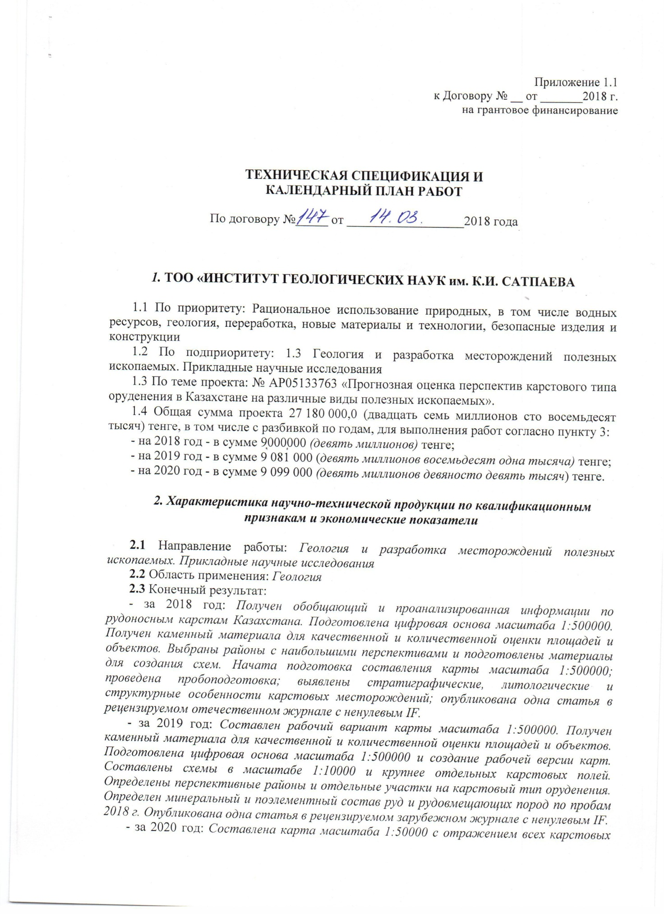
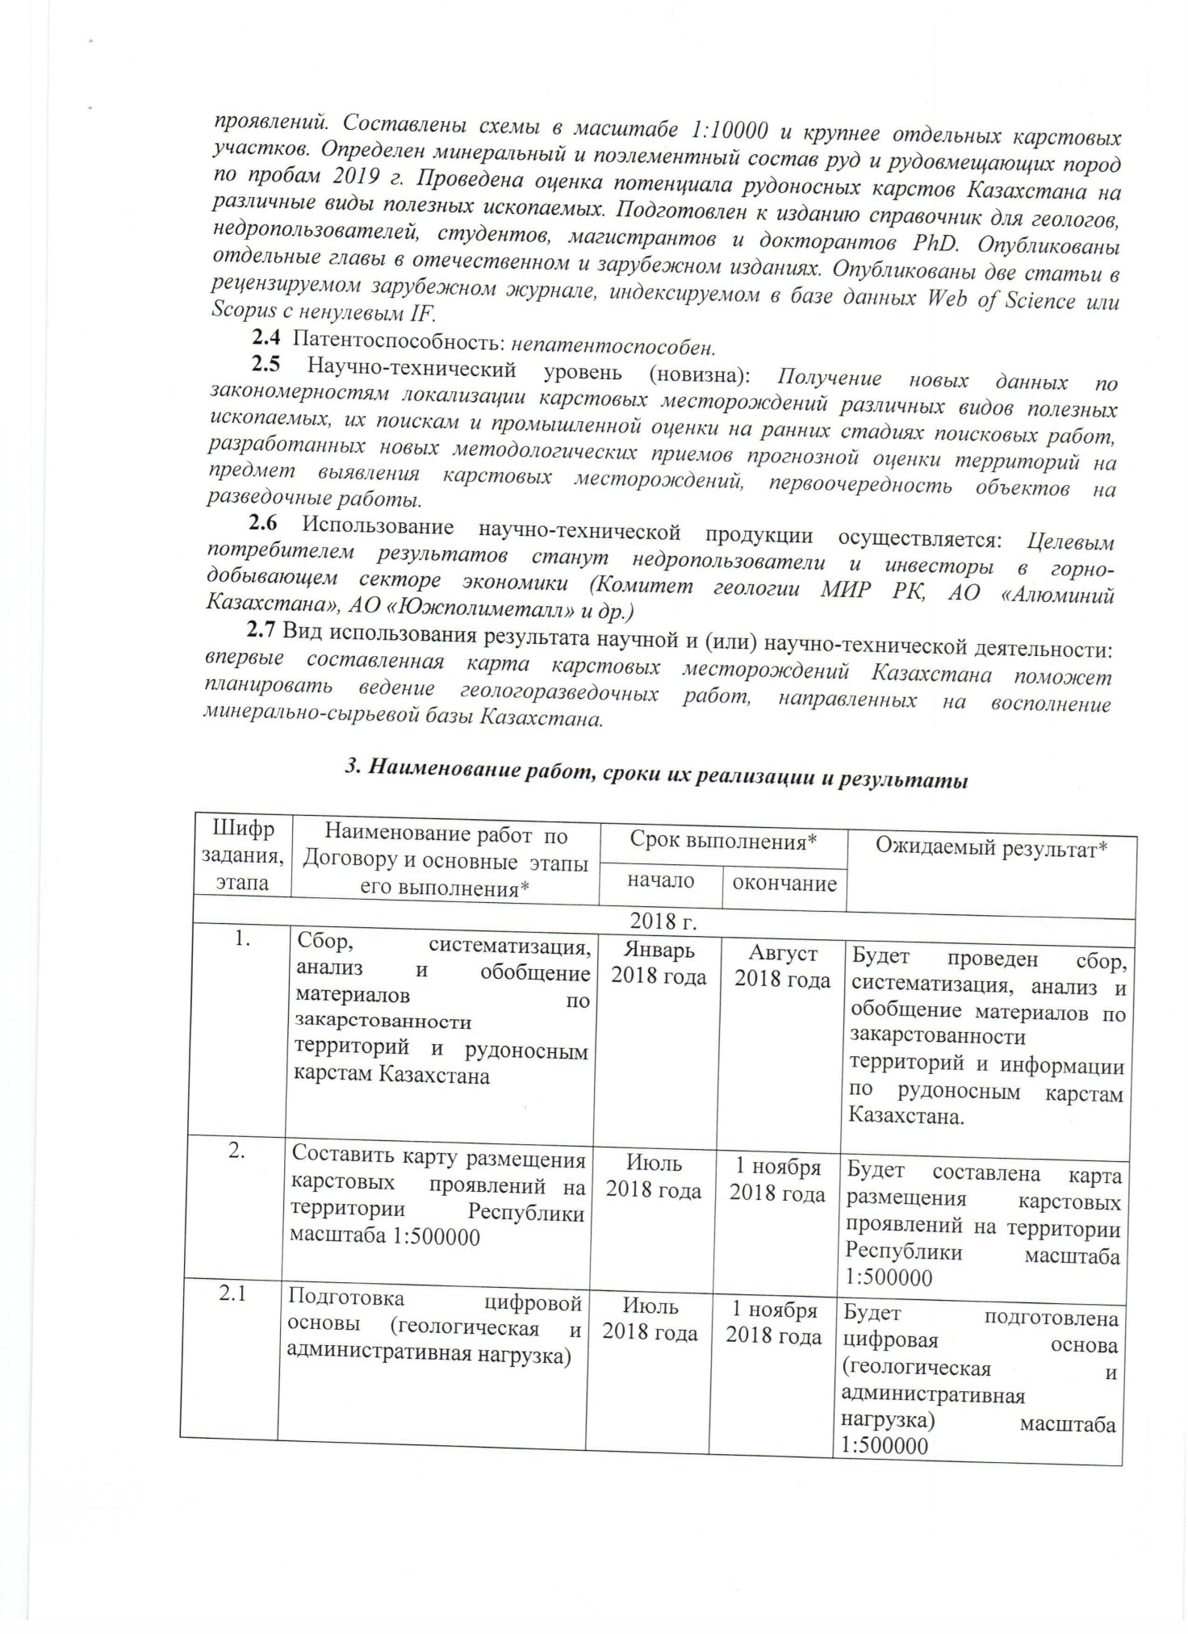
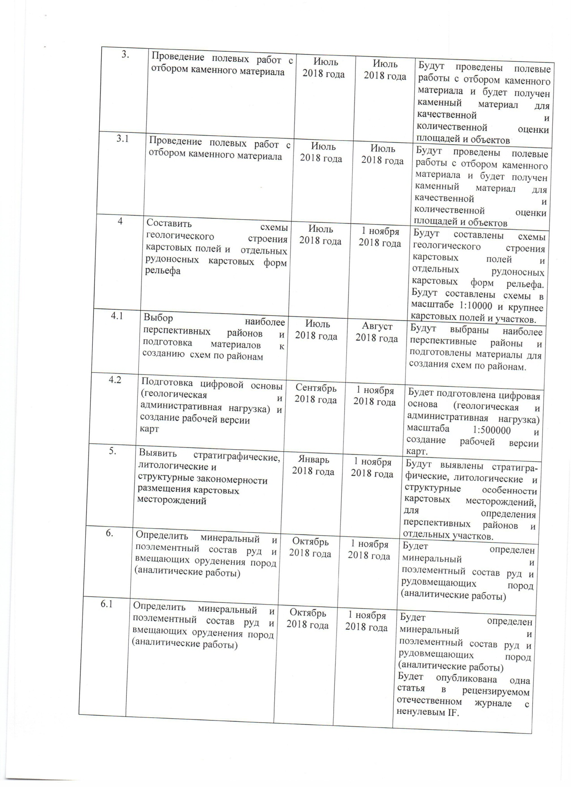
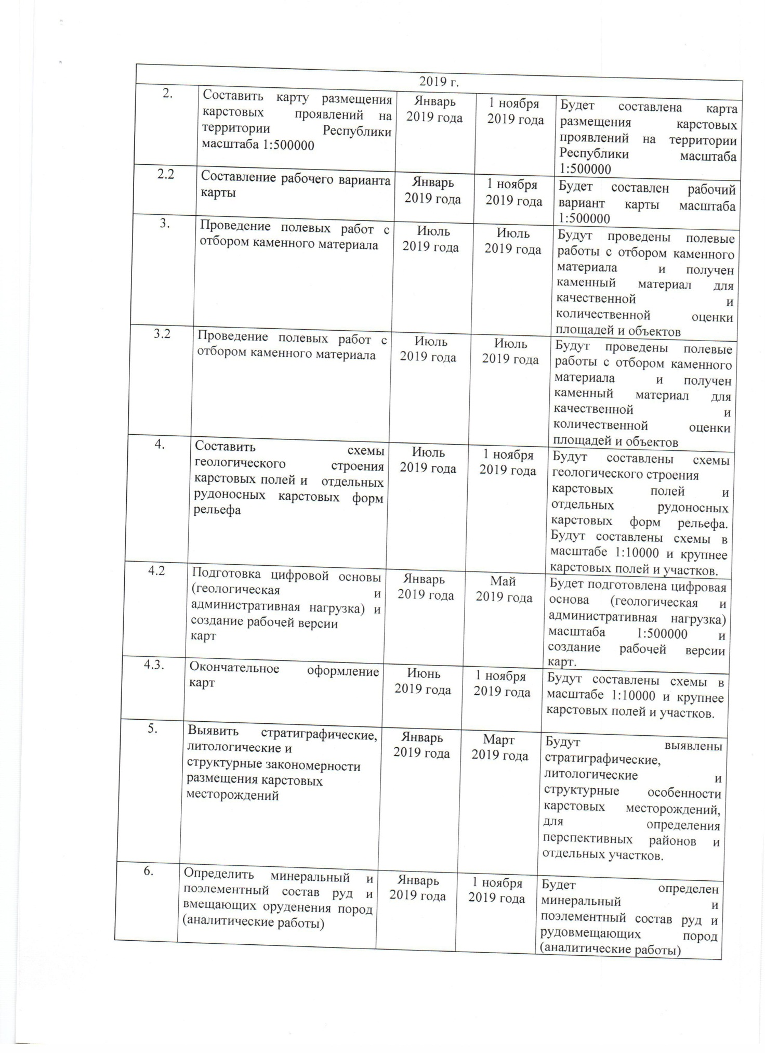
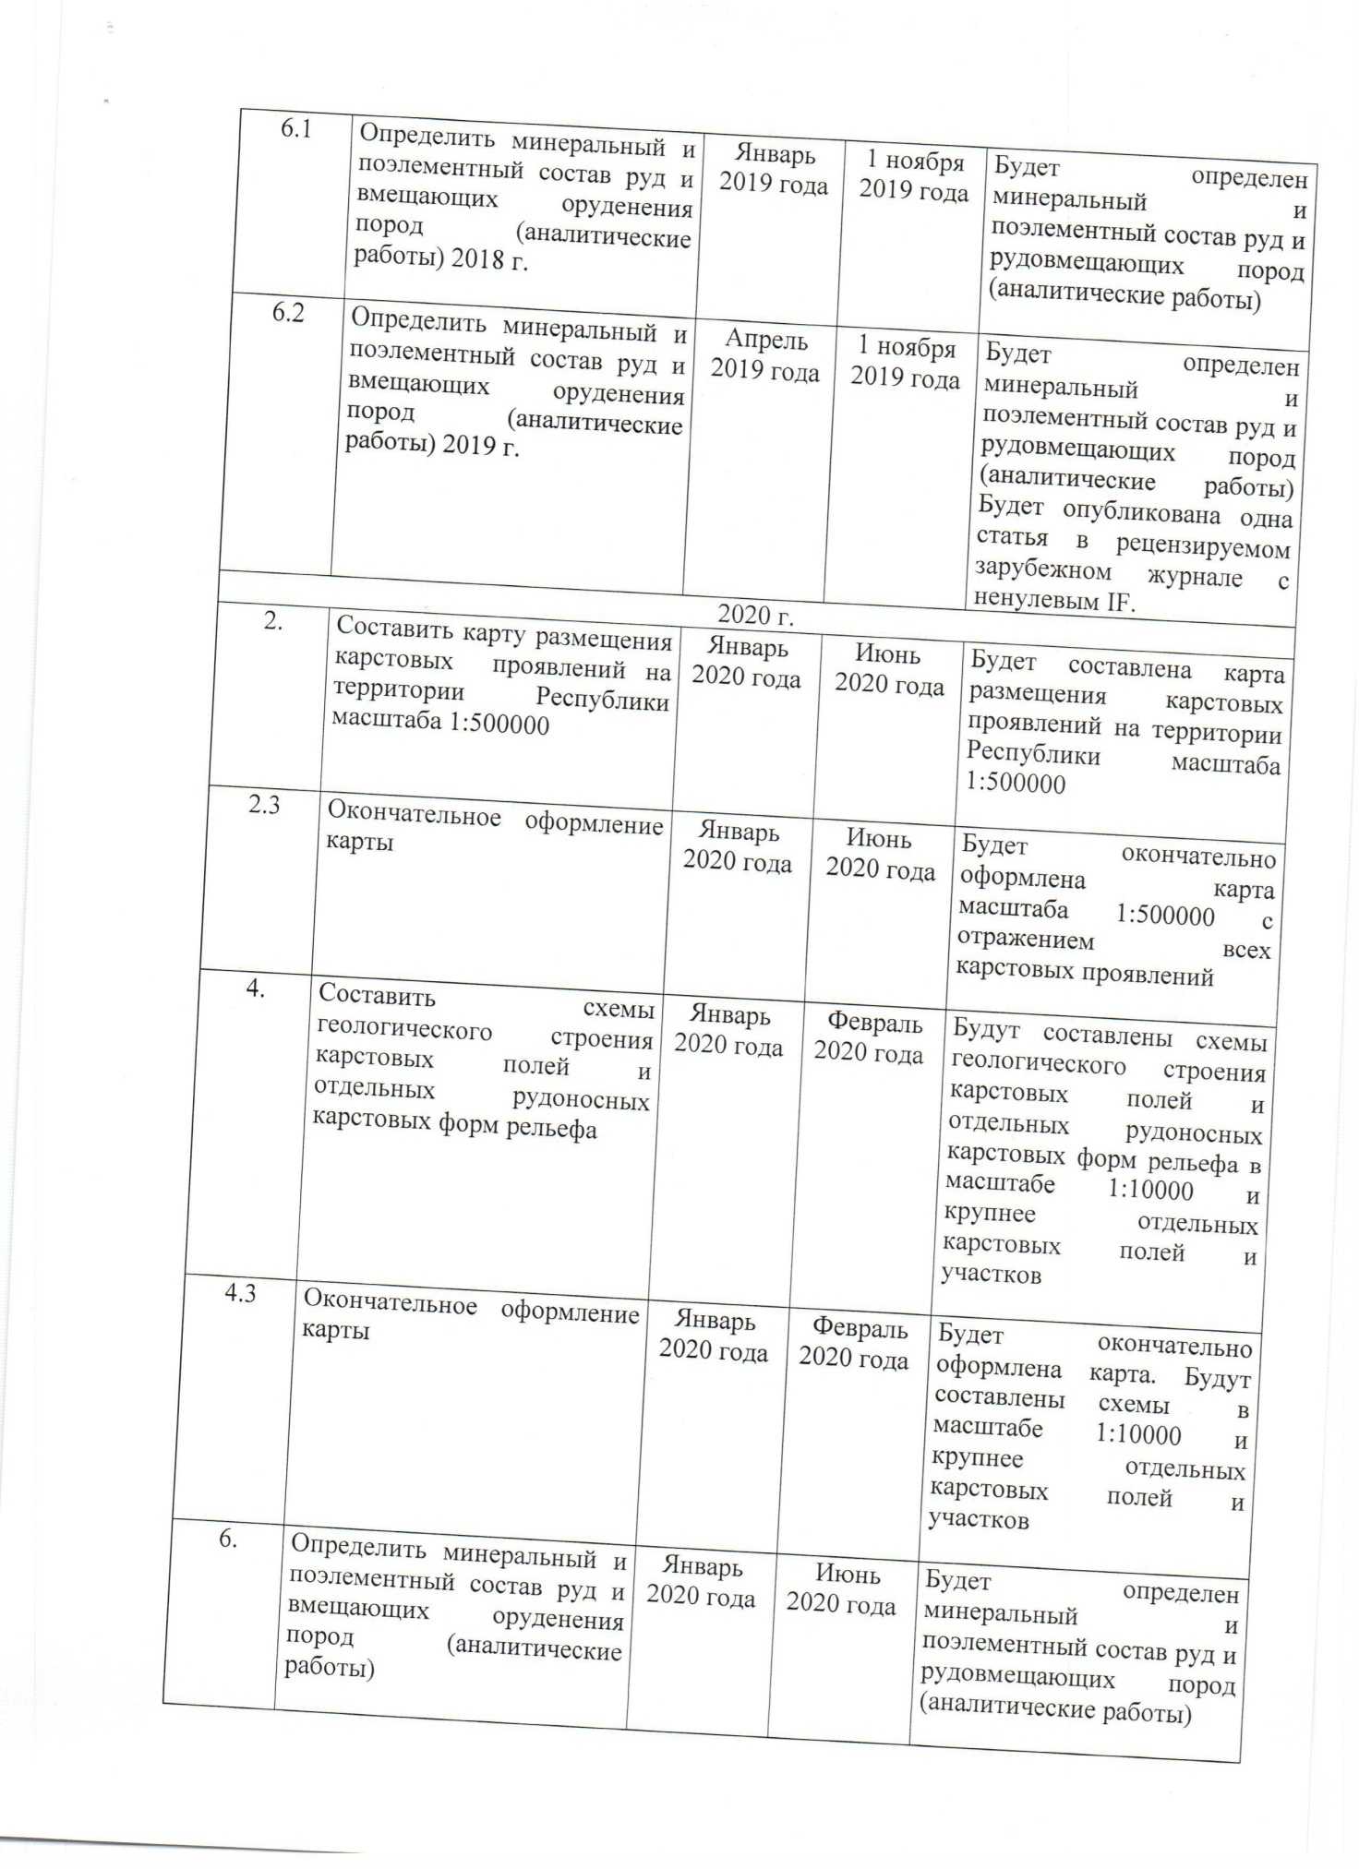
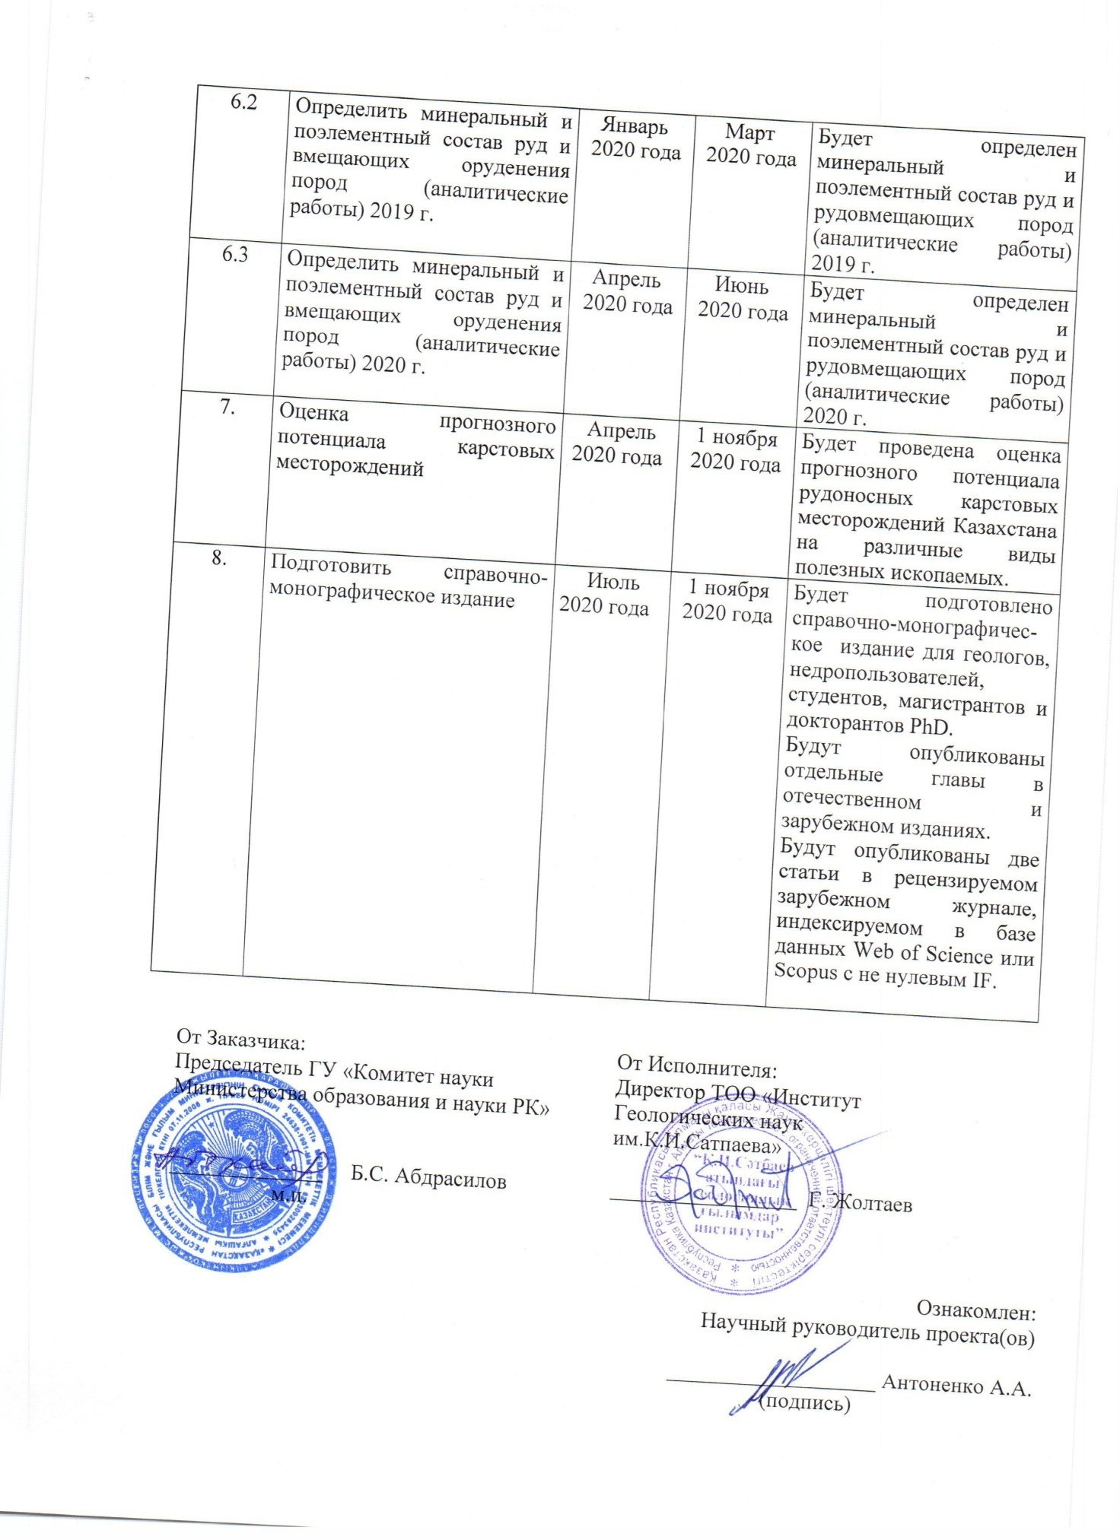

Appendix 1.1
to Agreement No. __ dated _______2018
for grant funding
TECHNICAL SPECIFICATIONS AND
CALENDAR WORK PLAN

Under contract No. _____ dated __________________2018

1. LLP "INSTITUTE OF GEOLOGICAL SCIENCES. K.I. Satpaeva

1.1 By priority: Rational use of natural resources, including water resources, geology, processing, new materials and technologies, safe products and structures
1.2 For sub-priority: 1.3 Geology and development of mineral deposits. Applied research
1.3 On the topic of the project: No. IRN AZ05133763 GF "Forecasting assessment of the prospects of karst type of mineralization in Kazakhstan for various types of minerals".
1.4 The total amount of the project is 27,180,000.0 (twenty seven million one hundred eighty thousand) tenge, including with a breakdown by years, for the performance of work in accordance with clause 3:
- for 2018 - in the amount of 9,000,000 (nine million) tenge;
- for 2019 - in the amount of 9,081,000 (nine million eighty-one thousand) tenge;
- for 2020 - in the amount of 9,099,000 (nine million ninety nine thousand) tenge.

2. Characteristics of scientific and technical products by qualification characteristics and economic indicators

2.1 Direction of work: Geology and development of mineral deposits. Applied research
2.2 Application: Geology
2.3 End result:
- for 2018: Summarizing and analyzed information on ore-bearing karsts in Kazakhstan was received. A digital base at a scale of 1: 500000 has been prepared. Stone material was obtained for the qualitative and quantitative assessment of areas and objects. Areas with the greatest prospects have been selected and materials have been prepared for creating schemes. The preparation of a 1: 500000 scale map is started; sample preparation was carried out; revealed stratigraphic, lithological and structural features of karst deposits, one article was published in Izvestiya NAS RK, a series of geology and technical sciences (Scopus).
- for 2019: A working version of a map with a scale of 1: 500000 was compiled. Stone material was obtained for the qualitative and quantitative assessment of areas and objects. A digital base at a scale of 1: 500000 was prepared and a working version of the maps was created. The schemes were drawn up on a scale of 1: 10000 and larger than individual karst fields. The promising areas and individual areas for the karst type of mineralization have been identified. The mineral and element composition of ores and ore-hosting rocks was determined based on samples of 2018, one article was published in Izvestia of the National Academy of Sciences of the Republic of Kazakhstan, a series of geology and technical sciences (Scopus).
- for 2020: A map was compiled at a scale of 1: 50,000, reflecting all karst occurrences. The schemes were drawn up on a scale of 1: 10000 and larger than individual karst areas. The mineral and element-wise composition of ores and ore-bearing rocks was determined based on the samples of 2019. An assessment of the potential of ore-bearing karsts in Kazakhstan for various types of minerals has been carried out. A reference book for geologists, subsoil users, students, undergraduates and doctoral PhD students has been prepared for publication, two articles have been published in Kazakhstani and foreign peer-reviewed journals.
2.4 Patentability: not patentable.
2.5 Scientific and technical level (novelty): Obtaining new data on the patterns of localization of karst deposits of various types of minerals, their prospecting and industrial assessment at the early stages of prospecting work, developed new methodological methods for predictive assessment of territories in order to identify karst deposits, the priority of objects for exploration work.
2.6 The use of scientific and technical products is carried out: The target consumer of the results will be subsoil users and investors in the mining sector of the economy (Geology Committee of the Ministry of Investment and Development of the Republic of Kazakhstan, Aluminum of Kazakhstan JSC, Yuzhpolymetal JSC, etc.)
2.7 Type of use of the result of scientific and (or) scientific and technical activities: the first compiled map of karst deposits in Kazakhstan will help plan the conduct of geological exploration aimed at replenishing the mineral resource base of Kazakhstan.

3. Name of work, terms of their implementation and results

Job code, stage |  | Name of work under the Agreement and the main stages of its implementation | Period of execution |  | Expected Result
 |  |  | Start | ending
2018
1. |  | Collection, systematization, analysis and generalization of materials on karst territories and ore-bearing karsts in Kazakhstan | January 2018 | August 2018 | Collection, systematization, analysis and generalization of materials on karst territories and ore-bearing karsts in Kazakhstan will be carried out.
2. |  | Make a map of the location of karst occurrences on the territory of the Republic on a scale of 1: 500000 | July  2018 | 1 November  2018 | A map of the location of karst occurrences on the territory of the Republic on a scale of 1: 500000 will be compiled
2.1 |  | Preparation of digital base (geological and administrative load) | July  2018 | 1 November  2018 | The digital base will be prepared (geological and administrative load)
3. |  | Field work with selection of stone material | July  2018 | July  2018 | Field work will be carried out with the selection of stone material and stone material will be obtained for a qualitative and quantitative assessment of areas and objects
3.1 |  | Field work with selection of stone material | July  2018 | July  2018 | Field work will be carried out with the selection of stone material and stone material will be obtained for a qualitative and quantitative assessment of areas and objects
4 |  | Draw up diagrams of the geological structure of karst fields and individual ore-bearing karst landforms | July  2018 | 1 November  2018 | Diagrams of the geological structure of karst fields and individual ore-bearing karst landforms will be drawn up. Diagrams will be drawn up on a scale of 1: 10000 and larger karst fields and sites.
4.1 |  | Selection of the most promising areas and preparation of materials for the creation of schemes for areas | July  2018 | August 2018 | The most promising areas will be selected and materials will be prepared for creating schemes for the areas.
4.2 |  | Preparation of the digital base (geological and administrative load) and creation of a working version kart | September  2018 | 1 November  2018 | A digital base (geological and administrative load) at a scale of 1: 500000 and a working version of the maps will be prepared.
5. |  | Identify stratigraphic, lithological and structural patterns of the location of karst deposits | January 2018 | 1 November  2018 | The stratigraphic, lithological and structural features of karst deposits will be identified in order to identify promising areas and individual areas.
6. |  | Determine the mineral and element composition of ores and host rocks (analytical work) | October  2018 | 1 November  2018 | Mineral and element composition of ores and ore-bearing rocks will be determined (analytical work)
6.1 |  | Determine the mineral and element composition of ores and host rocks (analytical work) | October  2018 | 1 November  2018 | Mineral and element composition of ores and ore-bearing rocks will be determined (analytical work).  One article will be published in a peer-reviewed domestic journal with non-zero IF.
2019
2. |  | Make a map of the location of karst occurrences on the territory of the Republic on a scale of 1: 500000 | January  2019 | 1 November  2019 | A map of the location of karst occurrences on the territory of the Republic on a scale of 1: 500000 will be compiled
2.2 |  | Drawing up a working version of the map | January  2019 | 1 November  2019 | A working version of the map of scale 1: 500000 will be compiled
3. |  | Field work with selection of stone material | July  2019 | July  2019 | Field work will be carried out with the selection of stone material and stone material will be obtained for a qualitative and quantitative assessment of areas and objects
3.2 |  | Field work with selection of stone material | July  2019 | July  2019 | Field work will be carried out with the selection of stone material and stone material will be obtained for a qualitative and quantitative assessment of areas and objects
4. |  | Draw up diagrams of the geological structure of karst fields and individual ore-bearing karst landforms | July  2019 | 1 November  2019 | Diagrams of the geological structure of karst fields and individual ore-bearing karst landforms will be drawn up. Diagrams will be drawn up on a scale of 1: 10000 and larger karst fields and sites.
4.2 |  | Preparation of the digital base (geological and administrative load) and creation of a working version kart | January  2019 | May  2019 | A digital base (geological and administrative load) at a scale of 1: 500000 and a working version of the maps will be prepared.
4.3. |  | Final card design | June  2019 | 1 November  2019 | Diagrams will be drawn up on a scale of 1: 10000 and larger karst fields and sites.
5. |  | Identify stratigraphic, lithological and structural patterns of the location of karst deposits | January  2019 | March  2019 | The stratigraphic, lithological and structural features of karst deposits will be identified in order to identify promising areas and individual areas.
6. |  | Determine the mineral and element composition of ores and host rocks (analytical work) | January  2019 | 1 November  2019 | Mineral and element composition of ores and ore-bearing rocks will be determined (analytical work))
6.1 |  | Determine the mineral and element composition of ores and host rocks (analytical work) 2018 | January  2019 | 1 November  2019 | Mineral and element composition of ores and ore-bearing rocks will be determined (analytical work).
6.2 |  | Determine the mineral and element composition of ores and host rocks (analytical work) 2019 | April  2019 | 1 November  2019 | Mineral and element composition of ores and ore-bearing rocks will be determined (analytical work). One article will be published in a peer-reviewed foreign journal with non-zero IF.
2020 г.
2. |  | Make a map of the location of karst occurrences on the territory of the Republic on a scale of 1: 500000 | January  2020 | June  2020 | A map of the location of karst occurrences on the territory of the Republic on a scale of 1: 500000 will be compiled
2.3 |  | Final card design | January  2020 | June  2020 | A map of scale 1: 500000 with reflection of all karst occurrences will be finalized
4. |  | Draw up diagrams of the geological structure of karst fields and individual ore-bearing karst landforms | January  2020 | February  2020 | Diagrams of the geological structure of karst fields and individual ore-bearing karst landforms will be drawn up on a scale of 1: 10000 and larger than individual karst fields and areas
4.3 |  | Final card design | January  2020 | February  2020 | The card will be finalized. Schemes will be drawn up on a scale of 1: 10,000 and larger than individual karst fields and areas
6. |  | Determine the mineral and element composition of ores and host rocks (analytical work) | January  2020 | June  2020 | Mineral and element composition of ores and ore-bearing rocks will be determined (analytical work)
6.2 |  | Determine the mineral and element composition of ores and host rocks (analytical work) 2019 | January  2020 | March  2020 | Mineral and element composition of ores and ore-bearing rocks will be determined (analytical work) 2019
6.3 |  | Determine the mineral and element composition of ores and host rocks (analytical work) 2020 | April  2020 | June  2020 | Mineral and element composition of ores and ore-bearing rocks will be determined (analytical work). 2020
7. |  | Assessment of the predicted potential of karst deposits | April  2020 | 1 November  2020 | An assessment of the forecast potential of ore-bearing karst deposits in Kazakhstan for various types of minerals will be carried out.
8. |  | Prepare a reference and monographic edition | July  2020 | 1 November  2020 | A reference and monographic publication will be prepared for geologists, subsoil users, students, undergraduates and PhD students.  Separate chapters will be published in domestic and foreign editions.  Two articles will be published in a peer-reviewed foreign journal indexed in the Web of Science or Scopus database with non-zero IF
From customer:  Chairman of the State Institution "Science Committee of the Ministry of Education and Science of the Republic of Kazakhstan"  ______________ B.S. Abdrasilov | From the Contractor:  Director of LLP "Institute  Geological Sciences  named after K.I.Satpayev "  _________________ G. Zholtaev

Familiarized with:
Scientific supervisor of the project (s)

___________________ Antonenko A.A

Appendix B
Schemes of the geological structure of karst fields
Figure В 1. Map of karst manifestations in Kazakhstan
Schemes of the geological structure of karst fields
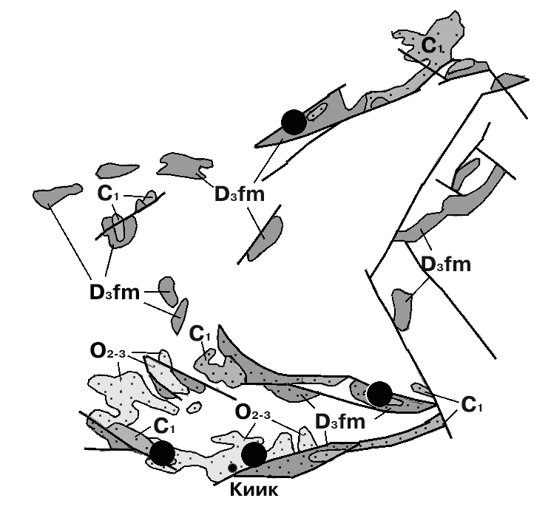
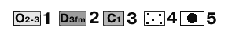
1-3-karst rocks: 1-middle-upper Ordovician age, 2-Famennian age, 3-lower Carboniferous age; 4-strata of non-carbonate rocks containing interlayers, lenses of carbonate formations; 5-lead-zinc deposits

Figure В 2. Distribution of karst rocks of Paleozoic age in continental rift structures (Akzhal-Aksoran and Akbastau continental rifts).

Schemes of the geological structure of karst fields
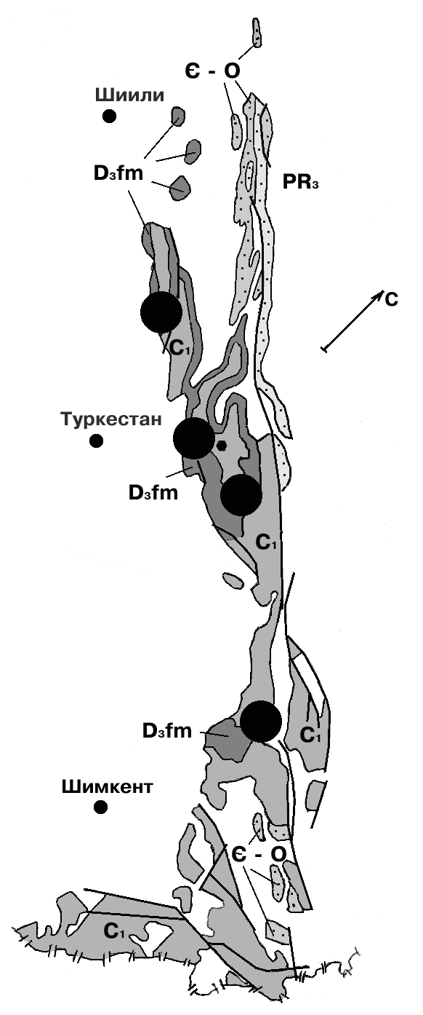
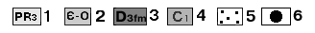
1-4-karst rocks: 1-upper Proterozoic age, 2-cambro-Ordovician age, 3-Famennian age, 4-lower Carboniferous age; 5-strata of non-carbonate rocks containing interlayers, lenses of carbonate formations; 6-lead-zinc deposits
Figure В 3. Distribution of karst rocks in the rift structure of the Karatau and Sairam-Ugam karst ore regions

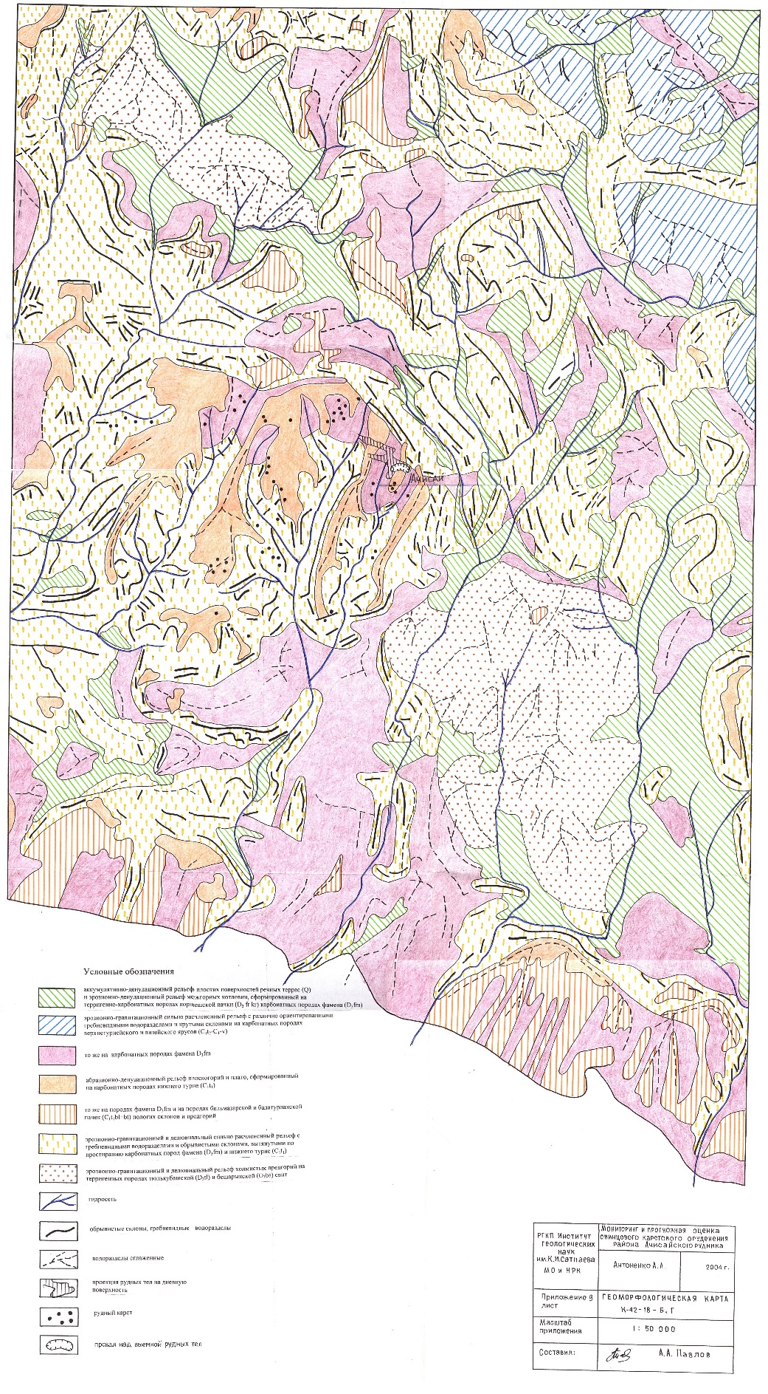
Figure В 4. Geomorphological map of the Achisay field area (Central Karatau), with karst manifestations

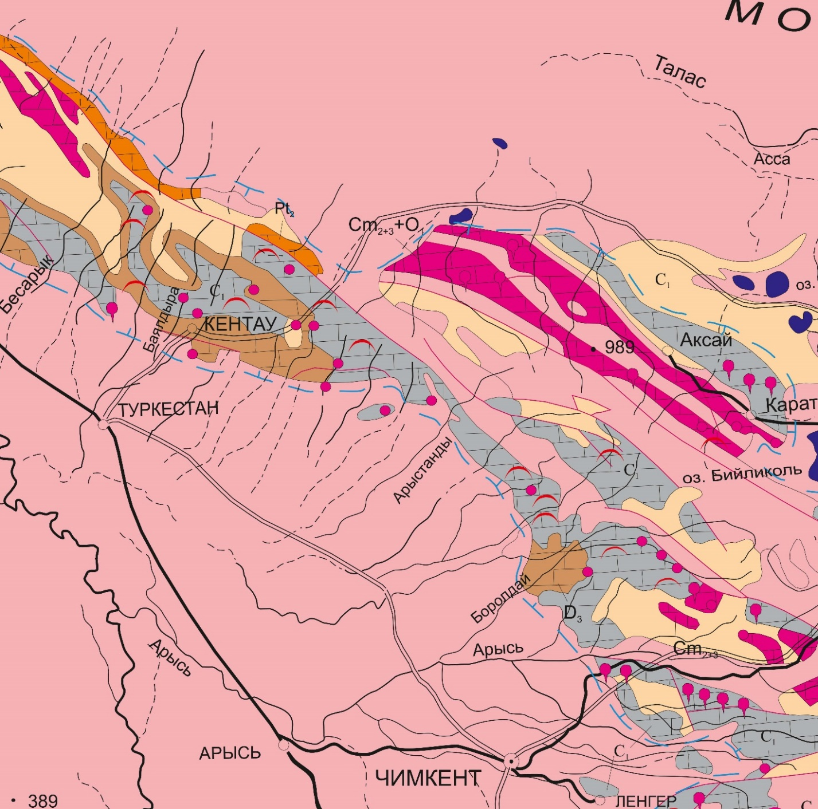

Figure В 5. The location of the karst topography in the Karatau-Ugamsk the area.

Red icons show karst occurrences in carbonate rocks.

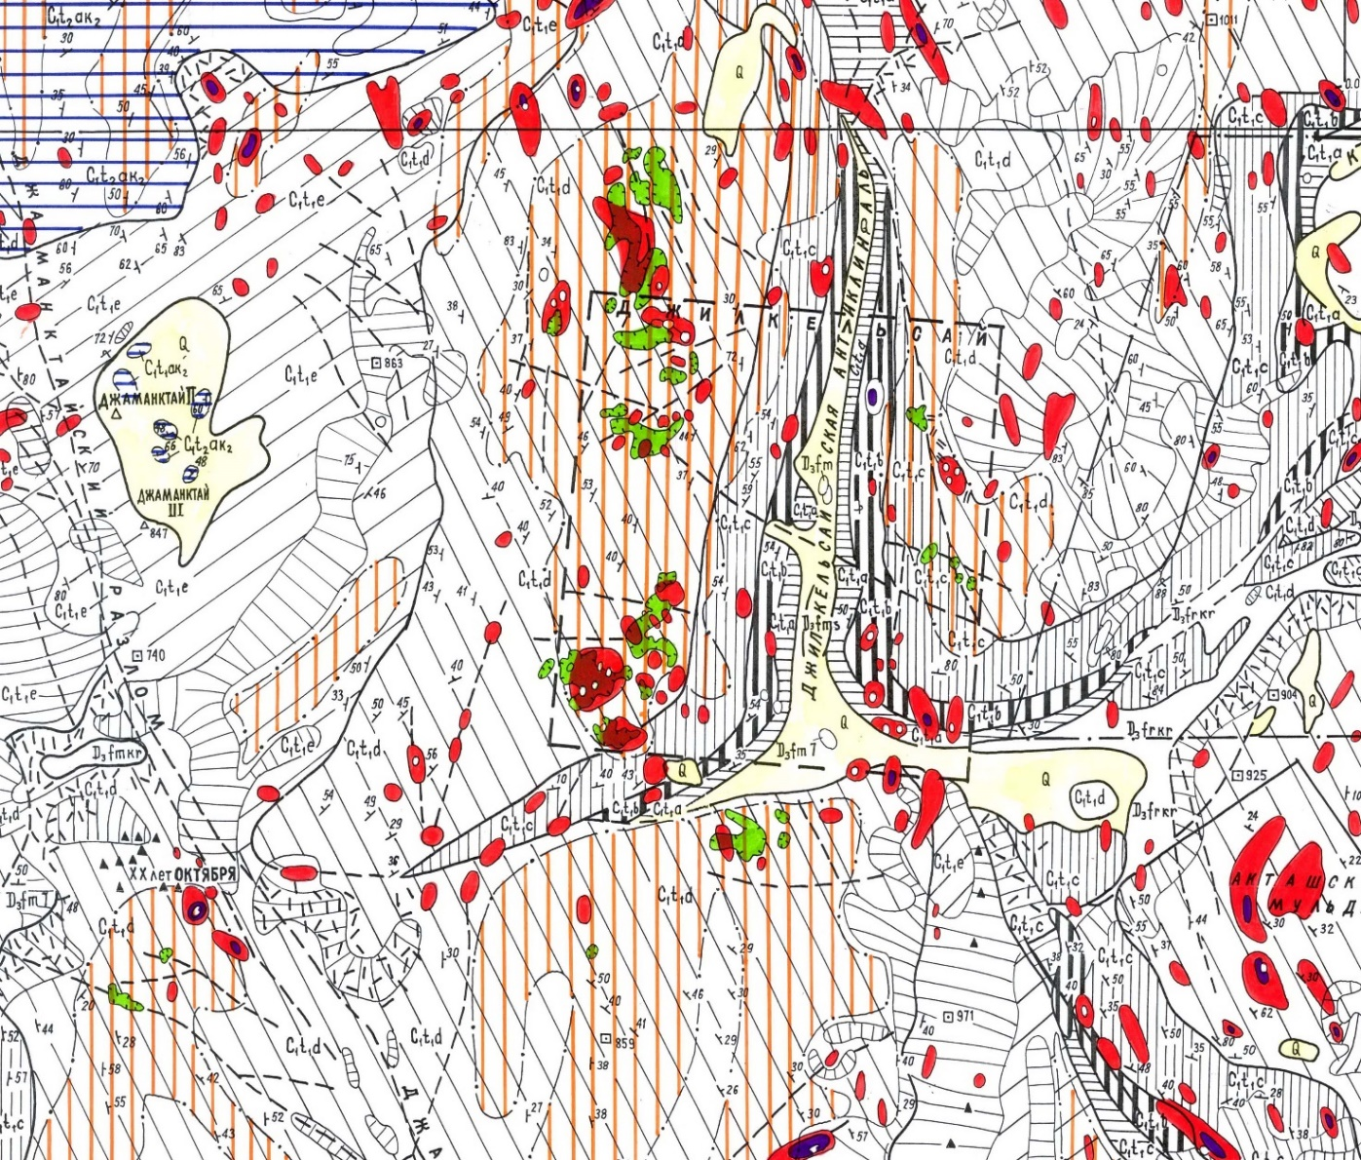

Figure В 6. A fragment of geological-geomorphological maps Zhamanktai karst-ore district (southern Kazakhstan, the Bolshoy Karatau)

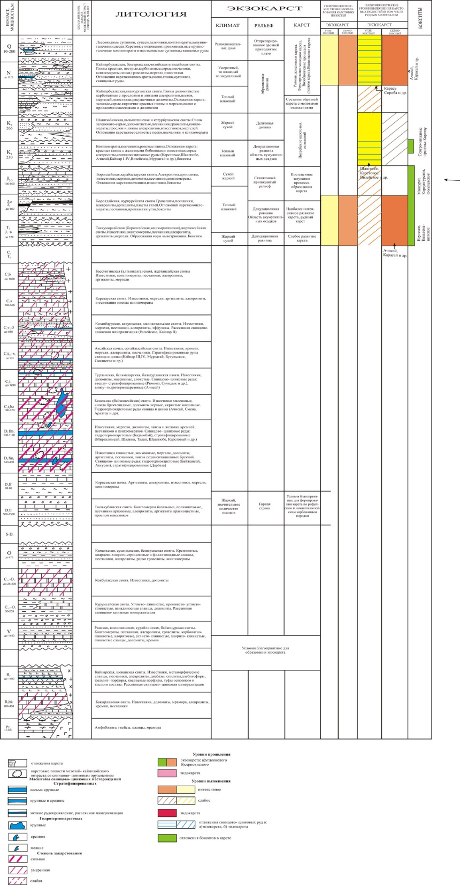
Figure В 7. Geochronological levels of karst formation and mineralization in Bolshoy Karatau

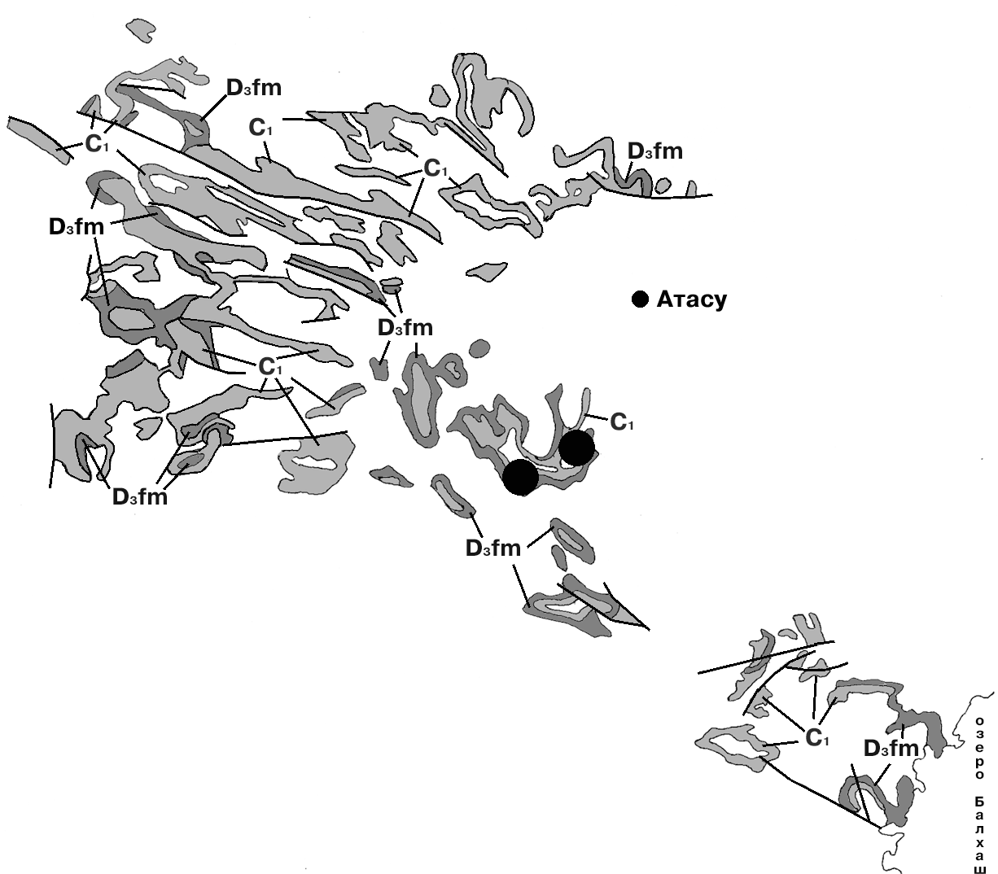
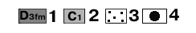
1-2-karst rocks: 1-Famennian age, 2-lower Carboniferous age; 3-strata of non-carbonate rocks containing interlayers, lenses of carbonate formations; 4-lead-zinc deposits

Figure В 8. Distribution of karst rocks of upper Devonian and lower Carboniferous age in the Central Kazakhstan karst-ore region of the rift system.

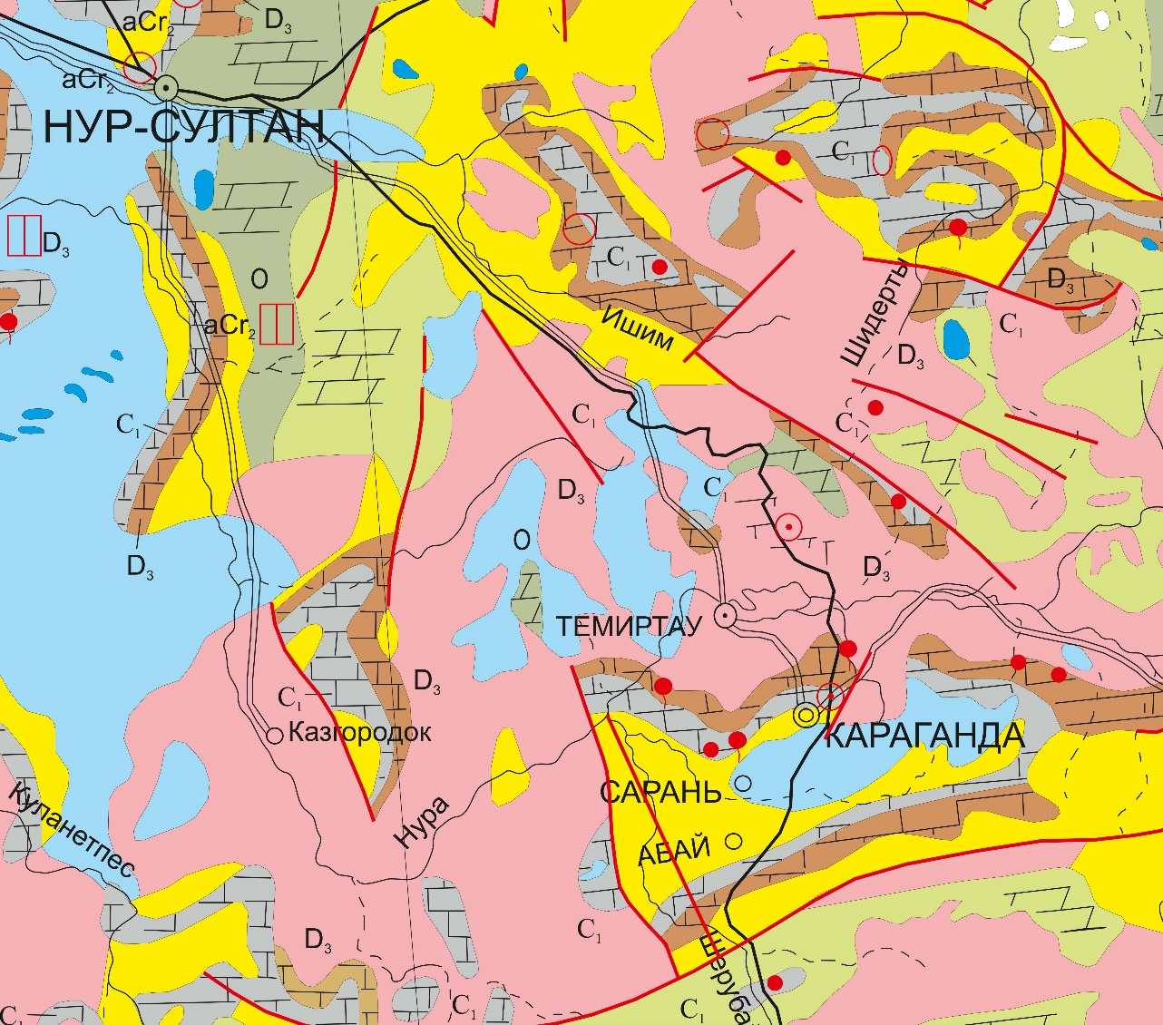
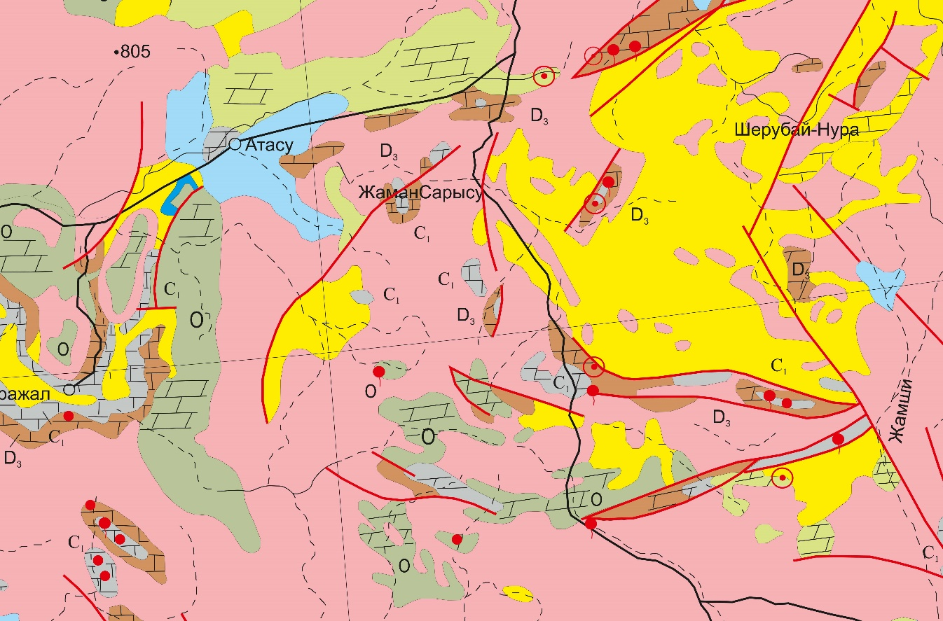
Figure В 9. Manifestations of karst forms in Central Kazakhstan. At the top of the Karaganda area, bottom Atasu district. Red icons show karst occurrences in carbonate rocks.
Appendix С

List of published works for 2018-2020.
2018 year.
A. A. Antonenko, A. T. Khodzhimuratova, D. B. Tugaibayeva, Z. Zh. Nurdauletova, N. A. Medeshova LEAD-ZINC KARSTS OF SHAIMERDEN TYPE. /NEWS OF THE NATIONAL ACADEMY OF SCIENCES OF THE REPUBLIC OF KAZAKHSTAN SERIES OF GEOLOGY AND TECHNICAL SCIENCES. №6. 2018. Р. 190-197.
2019 year.
Oreshkin I.V., Zholtaev G.Zh., Kulumbetova G.E., Oreshkin A.I. Characteristics of carbonate and terrigenous subsalt sediments in the east of the Caspian basin and the formation of hydrocarbon traps in them. / Geology of oil and gas. No. 4. 2019. p. 5-10.
Antonenko A.A., Togizov K.S. Tugaybaeva D. Predicting and prospecting criteria for lead-zinc karst mineralization by the example of the Achisai ore region. / Mining Journal of Kazakhstan. No. 6. 2019. p. 14-17.
Medeshova N.A. Geological features of karst deposits of the Turgai trough. / Problems of geology and subsoil development. Tomsk. 2019. Volume 1. Pages. 166-167.
Antonenko A.A., Khodzhimuratova A., Duisenbek A.E., Karbozova Zh.A. On the exploration of the exokarst of the Big Karatau. / Innovative technologies are the key to successfully solving fundamental and applied problems in the ore and oil and gas sectors of the economy of the Republic of Kazakhstan. Almaty. 2019. Volume 1. Pages. 20-23.
2020 year.
Kuanysh Togizov, Anatoliy Antonenko. THE STRUCTURAL TECTONIC POSITION AND PREDICTIVE SEARCH CRITERIA FOR THE LEAD-ZINC KARST MINERALISATION (SOUTH KAZAKHSTAN). /20th Anniversary INTERNATIONAL MULTIDISCIPLINARY SCIENTIFIC GEOCONFERENCE SGEM 2020 Earth and Planetary Sciences
Anatoliy Antonenko, Kuanysh Togizov, Assem Khodzhimuratova. LOCAL CRITERIA IN SEARCH FOR KARST MINERALISATION IN THE ACHISAI ORE DISTRICT (SOUTH KAZAKHSTAN). /20th Anniversary INTERNATIONAL MULTIDISCIPLINARY SCIENTIFIC GEOCONFERENCE SGEM 2020 Earth and Planetary Sciences

