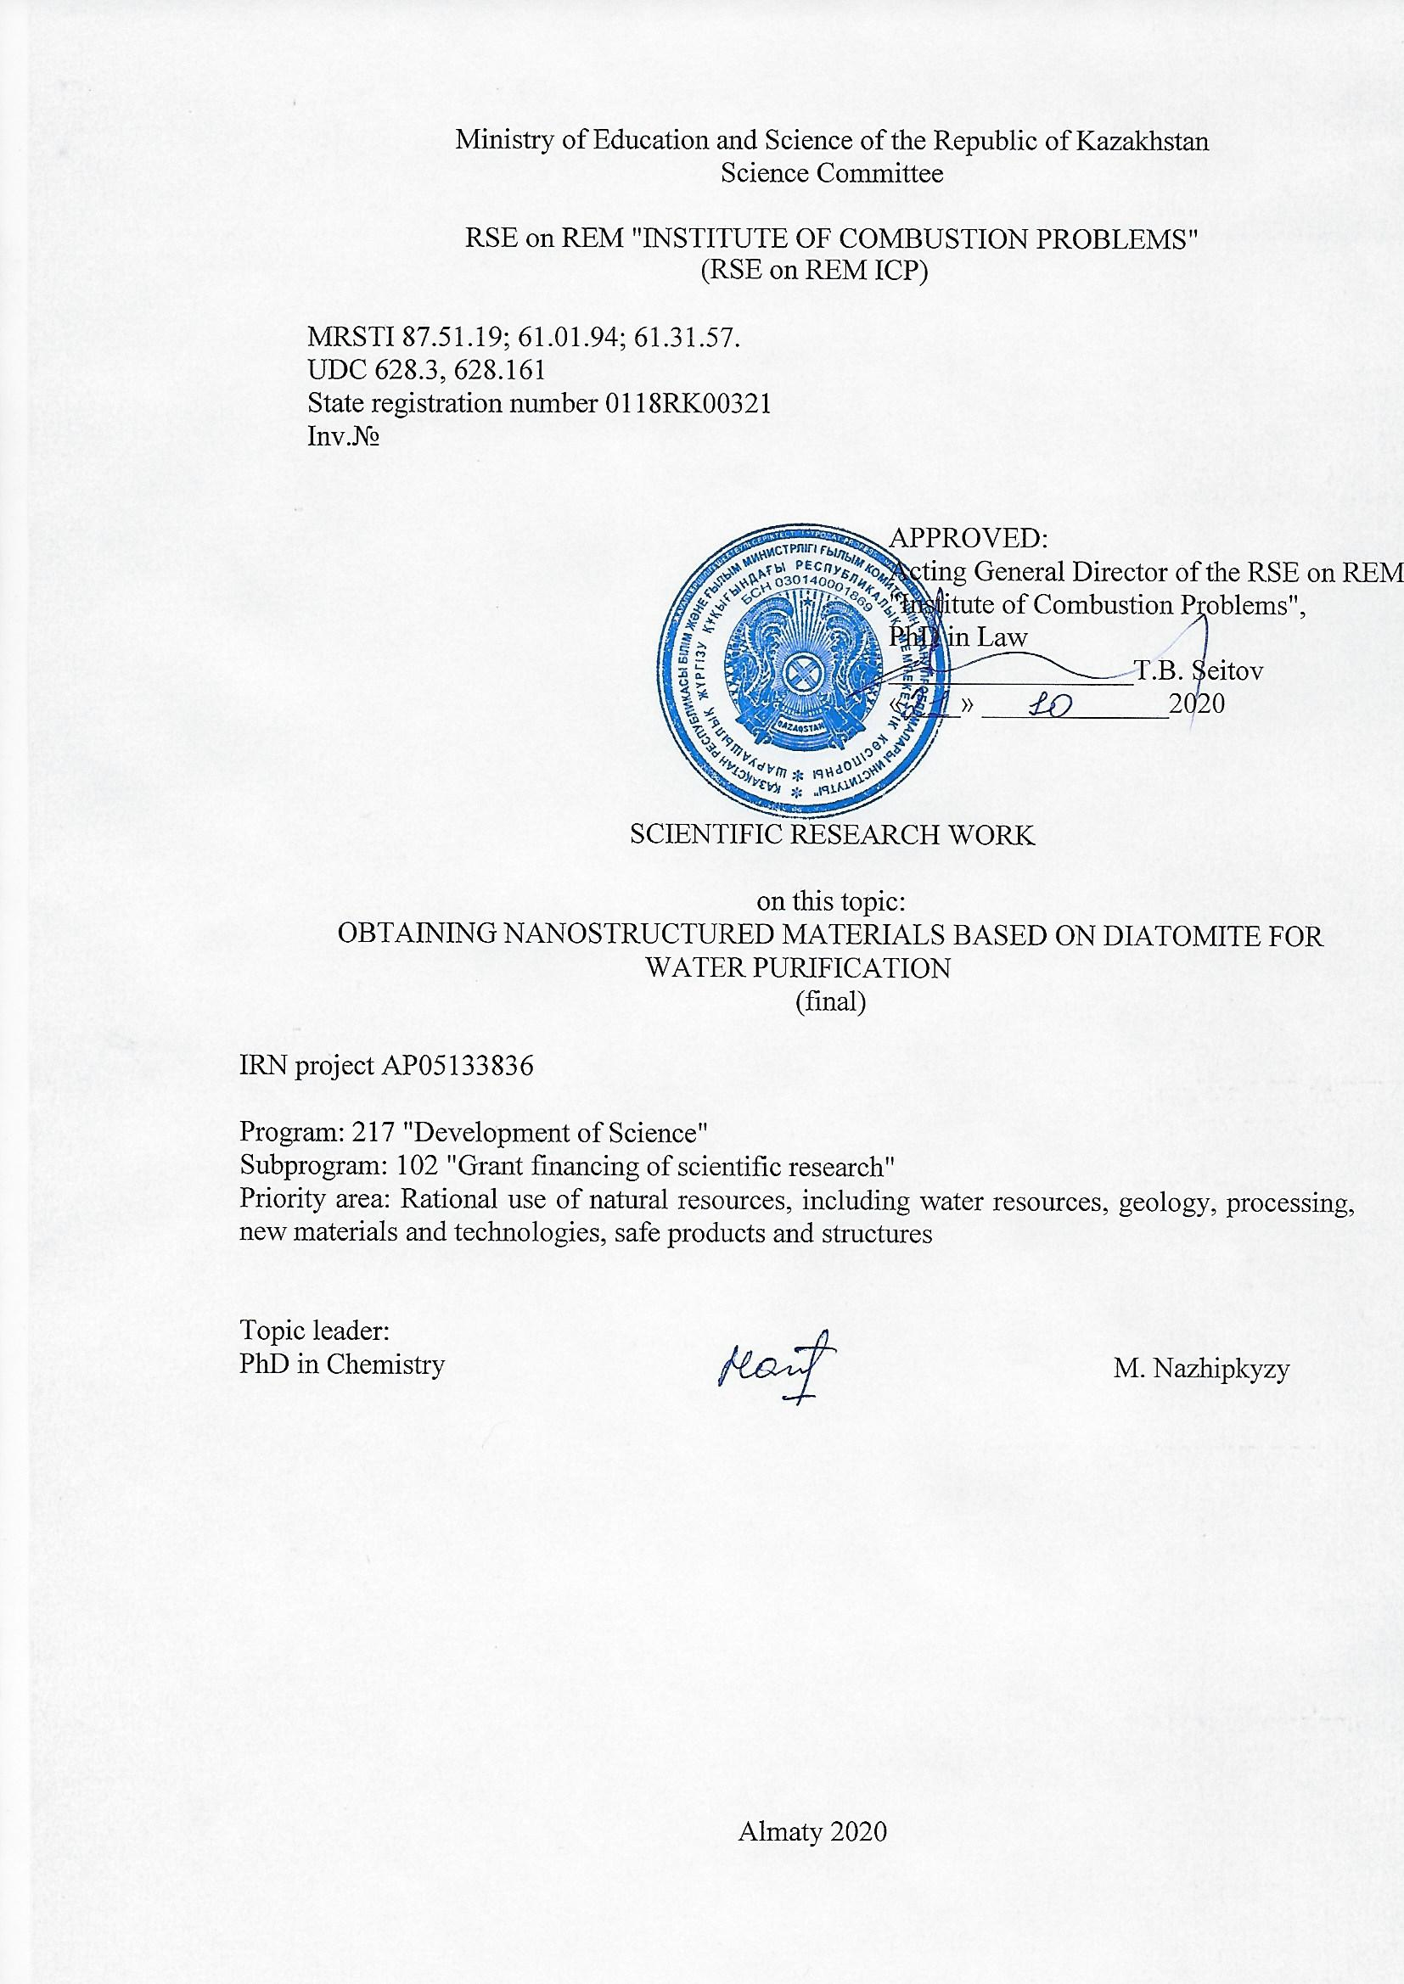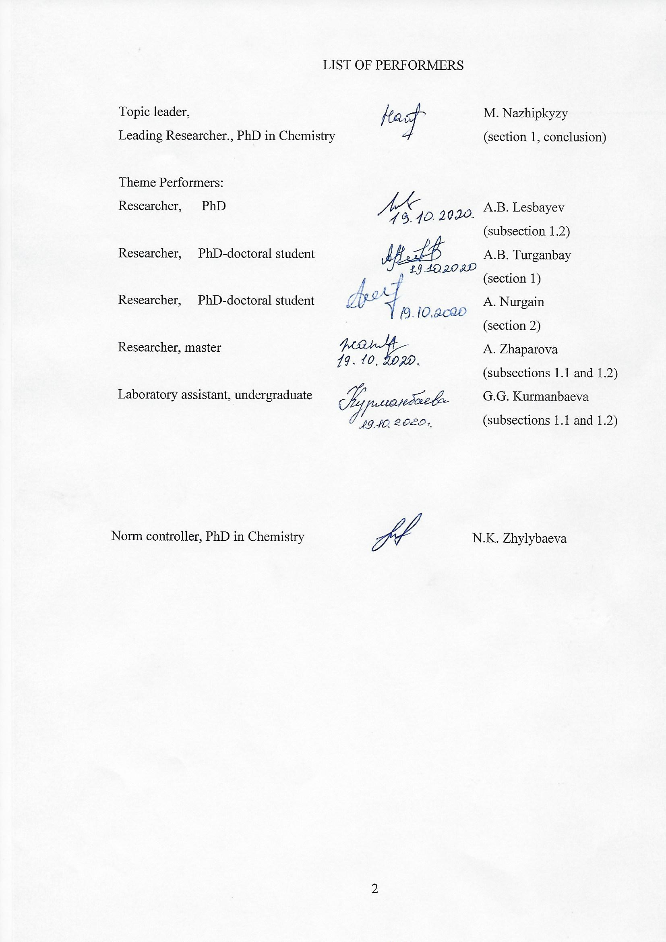

ТҮЙІНДЕМЕ

Есеп 47 беттен, 25 суреттен, 7 кестеден, 15 қолданылған әдебиеттер тізімінен, 3 қосымшадан тұрады.

ДИАТОМИТ, СОРБЕНТ, КОМПОЗИТТІ МАТЕРИАЛДАР, СИНТЕЗ, КӨМІРТЕКТІ НАНОМАТЕРИАЛДАР, АДСОРБЦИЯ

Зерттеу нысаны диатомит негізіндегі сорбенттер болып табылады.
Жұмыстың мақсаты – диатомит негізінде наноқұрылымды материалдарды алу, сонымен бірге пилоттық мембраналы-фильтрационды қондырғыны жасау және жобалау, және оларды қоршаған ортаны қайта қалпына келтіруде қолдану.
Суды тазартуға арналған зертханалық сүзу қондырғысы жобаланып, жасалды. Зертханалық сүзу қондырғысының жұмыс режимдерін іске қосу және жетілдіру үрдісінде оңтайлы жұмыс режимдері болып, 180 мкм дейін ұсақталған диатомит негізінде дайындалған МФАС-СПА мембраналарын пайдалану барысында жүйенің қысымы 15-20 торр кезінде шығыны 3-3,5 мл/мин жылдамдықпен ағып өтетін модель ерітінділері таңдалған. Су ерітінділерін ауыр металдардан тазарту тиімділігіне ортаның рН әсерін (3-тен 10-ға дейін) анықтау бойынша зерттеулер жүргізілді.
Алынған диатомитті мембраналардың үлгілері Инфрақызыл, Раман спектроскопиясы, БЭТ, рентгенфазалық талдау, элементтік талдау әдістерімен, сканирлеуші электрондық микроскоппен, сонымен қатар, оптикалық микроскоппен зерттелінді.

ABSTRACT

The report consists of 47 pages, 25 figures, 7 tables, 15 sources, 3 app.

DIATOMITE, SORBENT, COMPOSITE MATERIALS, SYNTHESIS, CARBON NANOMATERIALS, ADSORPTION

The object of research is diatomite-based sorbents.
The aim of the work is to obtain nanostructured materials based on diatomite, as well as to design and create a pilot membrane filtration unit using diatomite and their use for environmental recovery.
A laboratory filtration unit for water purification was designed and built. During the start-up and refinement of the operating modes of the laboratory filtration unit, it was found that the optimal operating modes were selected when using microfiltration type MFAS-SPA membranes made on the basis of diatomite, crushed to 180 μm at a flow rate of 3-3.5 ml / min of the model solution at pressures in system 15-20 torr. Research has been carried out on the influence of the pH of the medium (from 3 to 10) on the efficiency of cleaning aqueous solutions from heavy metals.
The obtained samples of diatomite membranes were examined by IR, Raman spectroscopy, BET, X-ray phase analysis, EDAX analysis, scanning electron microscope, and optical microscope.

CONTENT

 | SYMBOLS AND ABBREVIATIONS | 6
 | INTRODUCTION | 7
 | 1 Research and development of methods for creating a sorbent based on diatomite (short report for 2018) | 9
 | 2 Development of a method for the synthesis of composite materials using diatomite. Selection of components: reagents, fillers, matrices, in order to obtain nanostructured composite materials (short report for 2019) | 13
 | 3 Creation of a laboratory filtration plant for water purification | 17
 | 3.1 Design and construction of a laboratory filtration plant for water purification | 17
 | 3.2 Launching and finalizing the operating modes of the laboratory filtration unit | 18
 | 3.3 Testing of the created installation for water purification and analysis of water after filtration by physicochemical methods | 22
 | 3.4 Analysis of the results of water treatment, writing a report and articles | 27
 | CONCLUSION  REFERENCES | 31  33
 | APPENDIX A – List of published works for 2018-2020 | 35
 | APPENDIX В – Work schedule for 2018-2020  APPENDIX B.1 – Technical specifications and calendar work plan | 38  42
 | APPENDIX С – Extract from the minutes of the meeting of the Scientific and Technical Council of the Institute of Combustion Problems | 46

SYMBOLS AND ABBREVIATIONS

АС – amorphous carbon;
LQ CNT – low quality carbon nanotube;
HQ CNT – high quality carbon nanotube;
CVD – chemical vapor deposition;
EDAX – energy dispersive x-ray spectroscopy;
CNT – carbon nanotubes;
MWCNT – multi-walled carbon nanotubes;
MCA – mechanochemical activation;
D – diatomite;
BEТ – Brunauer–Emmett–Teller.

INTRODUCTION

One of the most important and valuable components of human life is undoubtedly water. It is necessary in almost all human activities. For a long time, the problem associated with water purification interested and worried people.
Currently, the problem of pollution of water bodies is the most urgent. Intensification of industrial and agricultural production, urbanization of regions, demographic growth leads to increased pollution of the hydrosphere with oil products, inorganic and organic toxic substances that make up the wastewater of industrial enterprises, etc.
Diatomite has a wide range of uses and is a component of hundreds of products, or vital to the manufacturing process of thousands of others. It mainly consists of SiO₂ with low concentrations of impurities, including Fe₂O₃, CaO, MgO, and organic matter [1, 2]. Due to its ordered porous structure, large surface area, good chemical stability, excellent sorption capacity and low price, diatomite is widely used for the adsorption of heavy metals and organic chemicals [3, 4].
The most important use of high quality diatomite is filter media. Naturally occurring diatom fossils have innate filtering properties due to their unique honeycomb structure. Their filtering properties are used in pharmaceutical manufacturing, engine oil refining and pool water filtration.
Currently, an urgent task is the synthesis of sorbents with predetermined properties [5-7]. Natural sorbents are often modified to improve sorption properties, during which various structural and physicochemical changes can occur, which depend on the initial structure and composition of the sorbents, as well as on the conditions of their processing [8].
One of the most important environmental issues to be addressed today is the presence of heavy metals from industrial wastewater. Due to their toxicity and non-degradable nature, heavy metals cause problems for the environment and public health [11, 12]. There are various methods developed for the removal of heavy metals from aqueous solutions. These methods include chemical precipitation, reverse osmosis, ion exchange and adsorption [13].
When treating wastewater from ions of heavy metals, the main practical task is to select local materials that have a low cost, but a sufficient depth of treatment. Natural local sorbents are tens of times cheaper than artificial ones, therefore their use in the process of water purification makes it possible to exclude the stage of adsorbent regeneration [14-16].
Today, it is relevant to obtain sorption-filtering materials (membranes) based on natural minerals and use in the purification of drinking water from iron ions, barium salts and organic compounds to reduce permanganate oxidizability, color, turbidity, to improve the organoleptic indicators of water quality. Membrane water treatment is the main technological approach to solving global problems of water scarcity and environmental pollution. At present, water purification using membranes based on natural minerals has received a lot of attention from researchers [17].
The project aims to obtain nanostructured materials based on diatomite, as well as the construction, design and creation of a membrane filtration unit using diatomite and their use for environmental restoration, namely for water purification.
Based on the results of research for 2018, according to the calendar plan, an interim report with the same name was submitted (inventory number 0218RK00974; registration number 0118RK00321). The work for 2018 was completed in full.
Based on the results of the research for 2019, according to the schedule, an interim report with the same name was submitted (inventory number 00219RK01039; registration number 0118RK00321). The work for 2019 was completed in full.

1 Research and development of methods for creating a sorbent based on diatomite (short report for 2018)

As part of the project, a comprehensive study of the characteristics of the Kazakhstani diatomite of the Mugalzhar region of the Aktobe region was carried out by physical and chemical methods.
A detailed study of diatomite can become a theoretical basis for improving methods of their processing and expanding potential areas of use.
Microscopic studies of diatomite were carried out using optical and scanning electron microscopy (SEM).
Microscopic studies were carried out on a scanning electron microscope "Quanta 200i 3D", FEI Company, USA, in the open-type nanotechnology laboratory at Al-Farabi KazNU.
Figure 1 shows a snapshot of natural diatomite, in which diatom skeletons and broken particles of diatom debris can be clearly seen, also in the sample there are various particles that differ from the skeletons, representing foreign minerals present in diatomite.

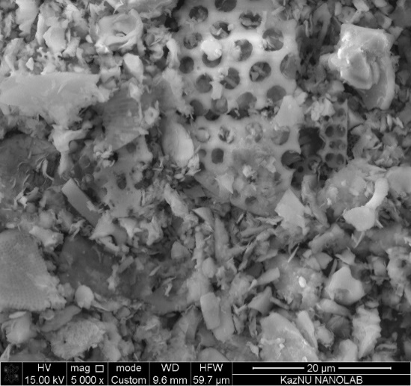

Figure 1 – SEM analysis of pure diatomite
Figure 1 shows a high density of regularly ordered pores with a diameter of 1 to 3 μm. The pores are arranged in parallel sets with uniform pores creating a honeycomb structure. And also one can see macropores in the size of 0.9 microns.
Further, to study changes in the characteristics of diatomite on an optical microscope, three different samples were selected, which are shown in Figures 2 (a-c).

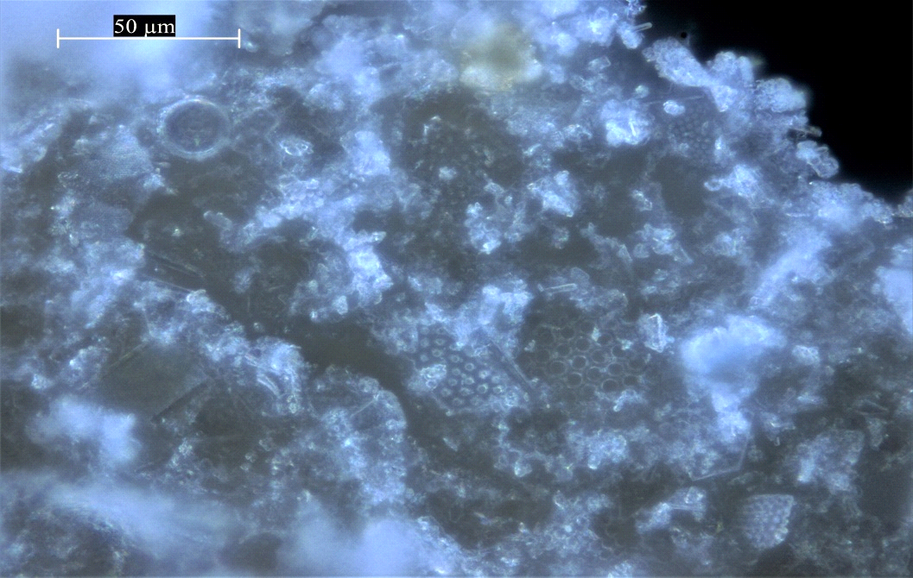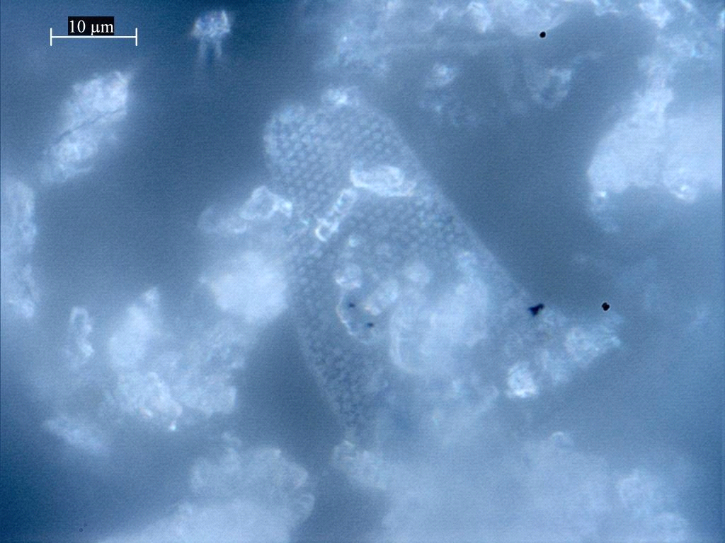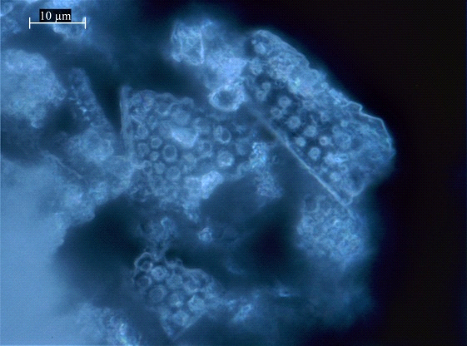
а) b) c)
а - diatomite stone; b - crushed diatomite powder; c - water-washed diatomite

Figure 2 – Optical images of various diatomite samples

From the images of optical microscopy (Figure 2, a), the stone samples show the whole, undamaged structure of the remains of diatom frustals, as well as a remarkable variety of diatom forms, morphologies and porous architectures, in which several of the most common examples of diatom forms are presented. Images of crushed diatomite in powder form (Figure 2, b) show damaged and non-intact structures of the spice diatomaceous rocks compared to Figure 2, c, which shows the still preserved structures and forms of diatomite. Following the images of optical microscopy, it can be assumed that mechanical influences destroy the structure and shape of diatoms.
Figure 3 shows the results of X-ray diffraction analysis of selected diatomite samples.
Figure 3 shows that diatomite contains a lot of quartz. Note that quartz is a polymorphic modification of silicon dioxide. The X-ray diffraction pattern of the initial diatomite shows the most characteristic quartz line with a distance of 3.35 Å, and there are also several lines characteristic of amorphous SiO₂ with interplanar distances of 2.49 and 4.26 Å, and lines with interplanar distances of 3.03; 3.28 and 3.39 Å, indicating the presence of calcite in the sample.
The constituent components of diatomite are also shown: illite-montmorillonite, Al₂(Si₂O₅)(OH)₄ (kaolinite) are present in small amounts. SiO₂ (quartz) is present in a slightly larger amount; in addition, an X-ray amorphous phase is present in a significant amount.

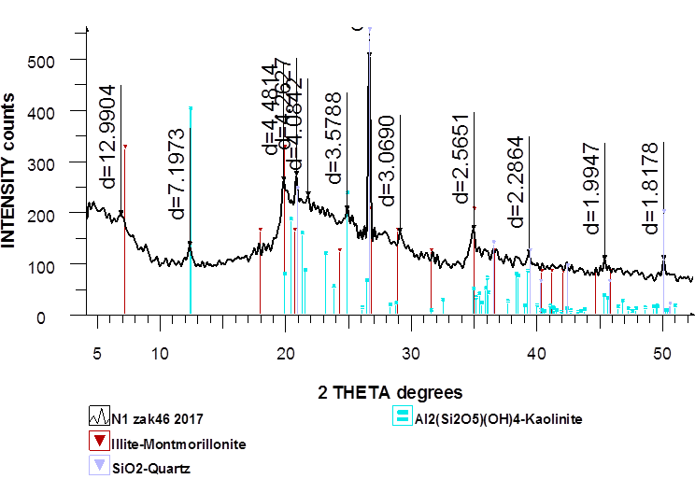
Figure 3 − X-ray diffraction analysis of the main components of natural diatomite

The specific surface area of ​​natural diatomite was determined by the dynamic method of thermal desorption on a Sorbtometer device, where the specific surface area is 39.131 m² / g, the specific pore volume is 0.017 m³ / g, and the average pore size is 1.713 nm.
For detailed analysis, diatomite samples were examined using energy dispersive X-ray spectroscopy, which provides information on the qualitative and quantitative composition of the sample. Also, a sample of diatomite was examined by one of the most effective spectroscopic methods for analyzing surface chemistry, like infrared spectroscopy (IR).
Thus, comprehensive studies of the material composition of Kazakhstan diatomite were carried out to determine the prospects for expanding the scope of their use.
Chemical modification was carried out by acid leaching. The filtered, washed precipitate was dried at 100 ºС for 5 hours. During leaching, a 25 g sample of diatomite was weighed and poured into a 75 ml solution of hydrochloric acid with a certain concentration (0.5; 1; 1.5 M), then the solution was stirred continuously at 200 rpm using a magnetic stirrer for an hour at a temperature 150 °C. The suspension of modified diatomite was filtered and washed several times with distilled water until the pH was neutral.
As a result of the research carried out, sorbents based on natural minerals were obtained, new methods were developed, which include mechanical action, acid treatment and thermal activation.
Table 1 shows the pore size of modified diatomite-based sorbents depending on temperature.
It was found that the porous structure of sorbents obtained with modifications of 0.5 M HCl has a pore size in the range from 0.29 to 2.31 μm, while for sorbents obtained with modifications of 1.0 M HCl, the pore size is in the range of 0.55 - 2.86 microns.
Thus, the optimal conditions for obtaining a sorbent based on domestic diatomite with pore sizes from 1.87 to 2.27 μm, obtained at a temperature of 800 °C at a concentration of 0.5 M HCl, a heat treatment temperature of 150 °C, the contact time of the mineral with the reagent is 60 minutes.

Table 1 − Pore size of modified sorbents
Name | Т, ⁰C | Pore size, μm
Original diatomite | - | 0,37-0,64
Modified sorbents (0.5 M HCl +H₂O) | without heating | 0,17-2,11
Modified sorbents (0.5 M HCl, t=3 h) | 600 | 1,72-1,93
Modified sorbents (0.5 M HCl, t=3 h) | 700 | 1,52-1,65
Modified sorbents (0.5 M HCl, t=3 h) | 800 | 1,87-2,27
Modified sorbents (0.5 M HCl, t=3 h) | 900 | 0,29-2,31
Modified sorbents (1 M HCl, t=3 h) | 600 | 0,86-2,86
Modified sorbents (1 M HCl, t=3 h) | 700 | 0,55-1,32
Modified sorbents (1 M HCl, t=3 h) | 800 | 0,70-0,86
Modified sorbents (1 M HCl, t=3 h) | 900 | 1,93-2,24

From the micrographs obtained with an optical microscope, it can be seen that the modified diatomite shows individual crystallites and non-whole structures of the spice of diatom rocks.
According to the EDAX analysis, it was determined that all samples contain elements such as C, O, Mg, Al, Si, K, Fe.
A qualitative assessment of the presence of functional groups on the surface of the modified sorbents was investigated by FTIR spectroscopy.
Thus, prototypes of sorbents based on diatomite were obtained. The obtained test samples of sorbents were identified using physicochemical methods.

2 Development of a method for the synthesis of composite materials using diatomite. Selection of components: reagents, fillers, matrices, in order to obtain nanostructured composite materials (short report for 2019)

To carry out the work according to the planned schedule, the synthesis of carbon nanotubes was carried out by the method of catalytic decomposition of hydrocarbon vapors (C-CVD) on the surface of the diatomite mineral impregnated with transition metal salts. The use of diatomite as a catalyst carrier is due to its elemental composition. When studying the composition of diatomite from the Mugalzharskoye deposit using modern instrumental techniques, it was found that the diatomite in the groundmass is composed of X-ray amorphous opal and quartz and is characterized by a high degree of homogeneity in chemical and mineralogical composition. Also, diatomite contains metals such as Fe, K, Ca, Mn, Cr, Si, Ti, Zn, which makes it a promising material for use as a catalyst carrier in the synthesis of carbon nanotubes (CNTs) by CVD.
A propane-butane mixture was used as a carbon-containing gas for the production of carbon nanotubes, which is affordable and safe, in contrast to the known methods, which involve the use of a vapor-gas mixture of hydrogen, aromatic compounds, saturated and / or unsaturated hydrocarbons as a carbon-containing gas.
To obtain composite materials based on carbon nanotubes by the CVD method using diatomite, the following salts were used as a catalyst: FeCl₂∙6H₂O, CoCl₂∙6H₂O, Ni(NO₃)₂∙6H₂O, Al(NO₃)₃∙9H₂O, the concentration of solutions was 0.5; 1; 1.5 M.
The process of obtaining a composite material based on carbon nanotubes includes impregnation of diatomite with salt solutions, drying and heating the reactor to a temperature of 650, 700, 750, 800 ℃ in an inert atmosphere. Then the propane-butane gas mixture is passed for 30 min at a speed of 90 cm³ / min. The reactor is cooled to room temperature in argon for 1-1.5 hours. The general scheme of the installation for the synthesis of porous carbon material and CNTs by the catalytic decomposition of hydrocarbon vapors is shown in Figure 4.

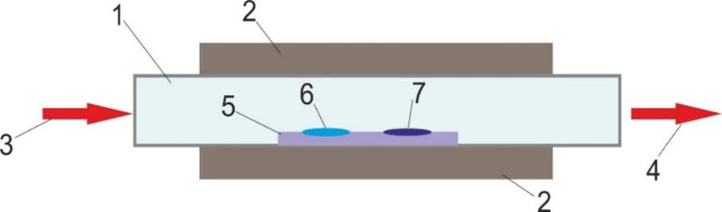

1 - quartz tube, 2 - reactor vessel, 3 - gas inlet, 4 - gas outlet, 5 - quartz boat, 6 - catalyst particles, 7 - carbon nanotube

Figure 4 – Schematic representation of an installation for the synthesis of carbon nanotubes
The reactor vessel is a 1 m long reactor. A removable quartz tube is inserted into the internal cavity of the vessel. A quartz tube 45 cm long and 3.5 cm in diameter is located inside the reactor.
To study the phase composition of the obtained material, all samples were examined by Raman spectroscopy.
It can be seen from the results obtained that the Raman spectra of all the samples under study are represented by two characteristic carbon (graphite) peaks G in the range of 1570-1600 cm-1 and D at ~ 1360 cm⁻¹. The values ​​of 1575-1580 cm-1 are characteristic of vibrations of C-C carbon atoms in the plane, and a narrow and intense peak in this region may indicate the presence of extended graphite carbon structures. In addition, in the spectra of the samples, the appearance of a 2D peak at 2710 cm⁻¹ is noticeable in the samples of carbon nanotubes grown on the surface of diatomite using a cobalt and iron catalyst. This peak indicates long-range order in the sample structure.
According to the results of Raman spectroscopy, the growth of carbon nanotubes is observed when using a catalyst based on Al, Co, Fe, and Ni. The results obtained at CVD temperatures of 650, 700, 750, 800 ℃ correspond to samples containing multi-walled carbon nanotubes. However, when using as a catalyst salts of the metals Al and Fe, at low CVD temperatures (650, 700 ℃) Raman spectra of the samples correspond to amorphous carbon.
It was found that the optimal condition for the CVD process for the growth of a high-quality carbon nanotube (VK-CNT) is the use of a 1 M solution of FeCl₂∙6H₂O as a catalyst at a temperature of 750 ℃; 1.5 M FeCl₂∙6H₂O solution at 800 ℃; 1.5 M CoCl₂∙6H₂O at temperatures of 750, 800 ℃.
Thus, the influence of reagents and synthesis conditions on the properties of synthesized carbon nanotubes was investigated. Also, the degree of defectiveness of the obtained carbon nanotubes was determined from the Raman spectra.
Further work was carried out to extract heavy metal ions, in particular, Pb²⁺ ions from aqueous solutions. As the main material for obtaining the adsorbent was used a natural material - diatomite, the properties and composition of which were previously investigated by various physicochemical methods. Also, a composite material based on diatomite modified with carbon nanomaterials was used as adsorbents for water purification. This modification primarily increases the specific surface area of ​​the natural sorbent and, thus, should contribute to an increase in the sorption characteristics. The adsorption properties of composite materials based on diatomite and carbon nanotubes obtained at 750 ℃ ​​were investigated using FeCl₂∙6H₂O, CoCl₂∙6H₂O, Ni(NO₃)₂∙6H₂O, Al(NO₃)₃∙9H₂O salts as catalysts.
To carry out experimental work on the extraction of Pb²⁺ ions from aqueous solutions, solutions of the Pb²⁺ salt were prepared. from analytically pure lead nitrate (Pb(NO₃)₂) with a concentration of 100 mg / l.
To study the adsorption of Pb²⁺ ions on the surface of the prepared sorbents, 1 g adsorbent samples were mixed with 100 ml Pb(NO₃)₂ solutions. The resulting mixture was then shaken for 5 min, 30 min, 120 min. After the filtration process, the residual concentration of Pb²⁺ ions was determined in the filtrate by atomic adsorption spectrometry.
The composite material obtained with the use of a Ni catalyst showed a high specificity of 188 m² / g than all other samples.
The value of the adsorption capacity A_{max} for pure diatomite (grinded with a mortar) is
9.55 mg / g; diatomite after mechanical activation 8.30 mg / g, which proves the preference of adsorption of Pb²⁺ ions on the surface of pure diatomite (ground with a mortar). Thus, according to the results of studying the adsorption isotherm, the adsorption of Pb²⁺ ions on the surface of pure diatomite (ground with a mortar) proceeds in the best way.
Table 2 shows the results of adsorption of Pb²⁺ ions on natural diatomite.

Table 2 – Results of adsorption of Pb²⁺ ions on natural diatomite and on composite materials based on diatomite and carbon nanotubes
Composite material | Time, min | Recovery rate [α], %
D + CNT (Ni) | 5 | 36
D + CNT (Ni) | 30 | 49
D + CNT (Ni) | 120 | 53
D + CNT (Co) | 5 | 35
D + CNT (Co) | 30 | 53
D + CNT (Co) | 120 | 85
D + CNT (Fe) | 5 | 22
D + CNT (Fe) | 30 | 27
D + CNT (Fe) | 120 | 32
D + CNT (Al) | 5 | 18
D + CNT (Al) | 30 | 13
D + CNT (Al) | 120 | 19
Diatomite (crushed with a mortar) | 5 | 88
Diatomite (crushed with a mortar) | 30 | 98
Diatomite (crushed with a mortar) | 120 | 97
Diatomite after mechanical activation | 5 | 96
Diatomite after mechanical activation | 30 | 93
Diatomite after mechanical activation | 120 | 90

Thus, the maximum degree of removal of Pb²⁺ ions from solutions with a concentration of 100 mg / L in terms of diatomite (ground with a mortar) is 98 and 97%, with a stirring duration of 30 and 120 min, respectively.
Figure 5 shows SEM images of the initial diatomite (a) and diatomite after MCA (b).
Thus, the maximum degree of removal of Pb²⁺ ions from solutions with a concentration of 100 mg / L in terms of diatomite (ground with a mortar) is 98 and 97 %, with a stirring duration of 30 and 120 min, respectively.
Figure 5 shows SEM images of the initial diatomite (a) and diatomite after MCA (b).

а | b

Figure 5 – SEM images of the initial diatomite (a) and diatomite after MCA (b)

The SEM results show that grinding the initial sample negatively affects the efficiency of the process, since the pore size decreased significantly after MCA (Figure 20, b).
As the results of the EDAX analysis show, the samples of modified diatomite contain such metals as Na, Mg, Al, Si, K, Fe and, depending on the catalyst used, Ni, Co. Also, from the results of the EDAX analysis, a high C content is observed, which indicates the modification of natural diatomite with carbon materials by the CVD method.
Thus, it was revealed that the optimal CVD condition for the growth of a high-quality carbon nanotube (HQ-CNT) is the use of a 1 M FeCl₂∙6H₂O solution as a catalyst at a temperature of 750 ℃; 1.5 M FeCl₂∙6H₂O solution at 800 ℃; 1.5 M CoCl₂∙6H₂O at temperatures of 750,
800 ℃.
3 Creation of a laboratory filtration plant for water purification

3.1 Design and construction of a laboratory filtration plant for water purification
A laboratory vacuum filtration plant for water purification has been designed and created, which is shown in Figure 6.

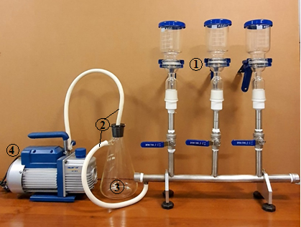

1 - 3-section vacuum filter; 2 - rubber vacuum hose; 3 - collector; 4 - vacuum pump

Figure 6 – Photo of a laboratory filtration plant for water purification

Vacuum filtration is used primarily in microbiological and analytical procedures that involve collecting particles (bacteria, sediment, etc.) from a liquid suspension. The main unit of the filtration unit is a funnel with a filter holder (filter diameter 47-50 mm) with a volume of
100 ml made of stainless steel grade 316L, which provides inertness with respect to the investigated water solution in the temperature range up to 110 °C.
Installation principle:
The tightness of all units of the installation allows you to create a reduced pressure in the system using a vacuum pump to 15-20 Torr. The principle of operation of the installation is as follows: a vacuum of 15-20 Torr is created in the system, a model solution is poured into the funnel, we open the metering valves installed in front of the filter holder, which allow you to adjust the volume of the liquid to be purified from 10 to 30 ml per minute, depending on the type and quantity there are impurities in it. The installation provides for the possibility of parallel operation with three funnels with a filter holder, which provides a threefold increase in productivity. A collector with a volume of 0.5 liters is installed between the filtration system and the vacuum pump, in which water purified from impurities is collected.
Specifications:
- Allows you to filter multiple samples at the same time.
- Acid and alkali resistant 316L stainless steel holder.
- Each holder has an individual control valve, so one vacuum pump can support one or more filters.
- It can be widely used in chemical analysis, pharmaceuticals, sanitation, water quality analysis and other fields of scientific research.
Suitable membrane:
The type of membrane filter must correspond to the different chemical characteristics of the filter medium: mainly PVDF (organic); synthetic fabric colophonic membrane (water); nylon membrane (both aqueous and organic). The aperture is usually: 0.22; 0.45; 0.8 μm. The diameter of the membrane filter is 47 or 50 mm.
Vacuum pump: single stage rotary vacuum pump.
Thus, a laboratory filtration plant for water purification was designed and built.

3.2 Launching and finalizing the operating modes of the laboratory filtration unit
The membranes with which the filter is equipped can differ in structure and pore diameter. The membrane can be:
- microfiltration (pores up to 4 microns);
- ultrafiltration (from 0.2 to 0.02 microns);
- nanofiltration (or track) (from 0.01 to 0.001 microns);
- reverse osmosis (from 0.001 to 0.00001 microns).
Depending on the pore size, the purpose of the filter also changes: it can purify water from colloidal impurities (the largest particles in size), and can stop heavy metal ions.
The membrane water purification system is one of the most popular modern filtration methods. In view of the fact that water use throughout the world has reached such a level at which water sources simply do not have time to recover on their own. The level of pollution of natural and waste waters is constantly growing.
Thus, on the basis of natural diatomite, a membrane was created that does not require much investment. Used a membrane of microfiltration type MFAS-SPA based on cellulose acetate,
d = 47 mm, d pore-1.5-3 μm.
As part of the project, the operating modes of the laboratory filtration unit were refined.
A regulation was drawn up for the launch of the assembled laboratory installation for water purification from heavy metal ions (Figure 7).

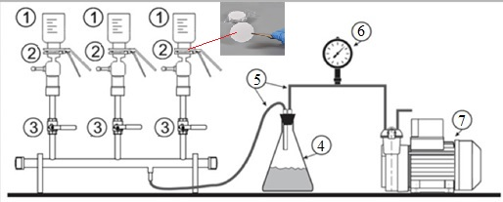

1 - funnel; 2 - filter holder; 3 - metering valve; 4 - collector; 5 - rubber vacuum hose; 6 - manometer; 7 - vacuum pump

Figure 7 – Diagram of a laboratory filtration plant for water purification

The installation contains three parallel funnels (1) with a filter holder (2), which can be used simultaneously or separately by closing the metering valves (3) at the inlet of the vacuum pumping system. To start the installation, a reduced pressure of 15 Torr (4) is created in the system of the collector (4) and branch pipes separated from the funnels with the model liquid by metering valves using a vacuum pump (5). We fix the filters in the filter holder and set the flow rate of model water solutions with dosing taps and the purified water is collected in the collector.
Figure 8 shows the resulting diatomite membranes.

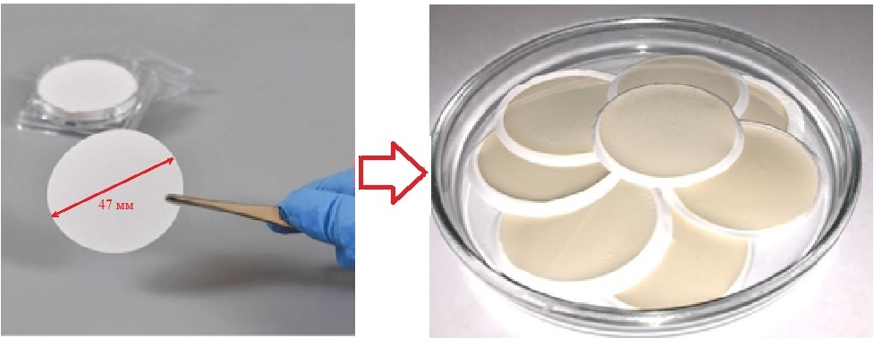

Figure 8 – Diatomite membranes

The working modes of the laboratory filtration unit were refined by carrying out test tests of microfiltration membranes with pore sizes up to 4 μm and for purification from heavy metal ions in model aqueous solutions with a concentration of 10 mg / L zinc chloride ZnCl₂ and copper CuCl₂, as well as lead nitrate Pb (NO₃)₂ with a concentration of 100 mg / l.
After the filtration process, the residual concentration of zinc, copper and lead ions was determined in the filtrate by atomic adsorption spectrometry.
Thus, to obtain diatomite membranes, the natural mineral was crushed into various fractions (180; 354; 707 μm) and deposited on the membranes to determine the sorption capacity (Table 3) and to establish the optimal operating mode of the installation, the obtained samples were used: diatomite membrane - 180, diatomite membrane - 354 and diatomite membrane - 707, respectively.

Table 3 – Sorption capacity of diatom membranes
Membrane type, μm | Heavy metal ions | Solution volume (V), ml | Sorption time (t), s | Solution concentration (A), mg / l | Recovery rate (α),%
Diatomite membrane – 180 | Zn²⁺ | 10 | 70 | 2,89 | 95,29
Diatomite membrane – 180 | Zn²⁺ | 20 | 745 | 5,23 | 86,00
Diatomite membrane – 180 | Zn²⁺ | 30 | 1010 | 7,43 | 81,70
Diatomite membrane – 180 | Cu²⁺ | 10 | 200 | 0,79 | 96,53
Diatomite membrane – 180 | Cu²⁺ | 20 | 1225 | 1,64 | 99,86
Diatomite membrane – 180 | Cu²⁺ | 30 | 2410 | 0,91 | 98,01
Diatomite membrane – 180 | Pb²⁺ | 10 | 27 | 23,55 | 85,85
Diatomite membrane – 180 | Pb²⁺ | 20 | 130 | 47,06 | 85,78
Diatomite membrane – 180 | Pb²⁺ | 30 | 260 | 55,42 | 67,38
Diatomite membrane – 354 | Zn²⁺ | 10 | 35 | 0,15 | 58,40
Diatomite membrane – 354 | Zn²⁺ | 20 | 180 | 0,31 | 59,07
Diatomite membrane – 354 | Zn²⁺ | 30 | 912 | 0,60 | 75,90
Diatomite membrane – 354 | Cu²⁺ | 10 | 43 | 0,22 | 80,29
Diatomite membrane – 354 | Cu²⁺ | 20 | 368 | 0,49 | 88,66
Diatomite membrane – 354 | Cu²⁺ | 30 | 660 | 0,67 | 81,37
Diatomite membrane – 354 | Pb²⁺ | 10 | 52 | 1,92 | 77,17
Diatomite membrane – 354 | Pb²⁺ | 20 | 134 | 3,64 | 72,95
Diatomite membrane – 354 | Pb²⁺ | 30 | 236 | 4,39 | 58,72
Diatomite membrane – 707 | Zn²⁺ | 10 | 80 | 2,47 | 75,98
Diatomite membrane – 707 | Zn²⁺ | 20 | 140 | 4,66 | 71,67
Diatomite membrane – 707 | Zn²⁺ | 30 | 930 | 8,49 | 87,11
Diatomite membrane – 707 | Cu²⁺ | 10 | 130 | 0,73 | 91,72
Diatomite membrane – 707 | Cu²⁺ | 20 | 620 | 1,43 | 89,87
Diatomite membrane – 707 | Cu²⁺ | 30 | 930 | 2,32 | 96,90
Diatomite membrane – 707 | Pb²⁺ | 10 | 50 | 17,06 | 60,45
Diatomite membrane – 707 | Pb²⁺ | 20 | 100 | 29,95 | 53,05
Diatomite membrane – 707 | Pb²⁺ | 30 | 220 | 43,60 | 51,49

Figure 9 shows the dependences of the transmission time on the volume of the prepared model solutions when using membranes made of crushed diatomite up to 180 μm.

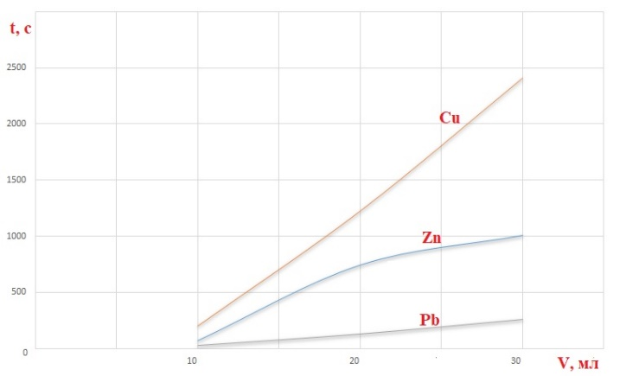

Figure 9 – Transmission time versus the volume of prepared model solutions
The dependences of the adsorption capacities of membranes based on diatomite (crushed to 180, 354, 707 microns) on the volume of prepared model solutions for the extraction of zinc, copper and lead ions are shown in Figures 10-12.

Figure 10 – Dependences of the adsorption capacities of diatomite membranes - 180 on the volumes of model solutions for the extraction of zinc, lead and copper ions

Figure 11 – Dependences of the adsorption capacities of diatomite membranes - 354 on the volume of model solutions for the extraction of zinc, lead and copper ions

Figure 12 – Dependences of the adsorption capacities of diatomite membranes - 707 on the volume of model solutions for the extraction of zinc, lead and copper ions

It was found that the optimal operating mode of the filtration unit is achieved with diatomaceous earth, crushed to 180 microns, at a flow rate of 3-3.5 ml / min of the model solution at a pressure in the system of 15-20 torr. Under these conditions, the diatomite membrane adsorbs up to 2.89 mg / L of zinc ions, 23.55 mg / L of lead ions and 0.79 mg / L of copper ions.
Thus, in the process of launching and finalizing the operating modes of the laboratory filtration unit, it was found that the optimal operating modes were selected when using MFAS-SPA microfiltration membranes made on the basis of diatomite, crushed to 180 microns at a transmission rate of 3-3.5 ml / min of the model solution at pressures in the system 15-20 torr.

3.3 Testing of the created installation for water purification and analysis of water after filtration by physicochemical methods
Further, to test the created installation for water purification and analysis of water after filtration, we prepared model solutions of heavy metals, such as nickel (II) nitrate hexahydrate (Ni(NO₃)₂∙6H₂O) and semi (pentahydrate) cadmium chloride (CdCl₂∙2.5H₂O) and alkali metal solutions such as potassium (KCl) and sodium (NaCl) chlorides.
Table 4 shows the sorption capacity of diatom membranes for the extraction of heavy metals Ni and Cd.

Table 4 – Sorption capacity of diatom membranes for the extraction of heavy metals nickel and cadmium
Membrane type, μm | Heavy metal ions | Solution volume (V), ml | Sorption time (t), s | Solution concentration (A), mg / l | Recovery rate (α),%
Diatomite membrane – 180 | Ni²⁺ | 10 | 70 | 0,10 | 35,72
Diatomite membrane – 180 |  | 20 | 392 | 0,13 | 23,87
Diatomite membrane – 180 |  | 30 | 821 | 0,18 | 22,20
Diatomite membrane – 180 | Cd²⁺ | 10 | 45 | 0,29 | 85,25
Diatomite membrane – 180 | Cd²⁺ | 20 | 594 | 0,59 | 89,98
Diatomite membrane – 180 | Cd²⁺ | 30 | 767 | 0,88 | 89,96
Diatomite membrane – 354 | Ni²⁺ | 10 | 56 | 0,13 | 49,11
Diatomite membrane – 354 | Ni²⁺ | 20 | 323 | 0,14 | 26,48
Diatomite membrane – 354 | Ni²⁺ | 30 | 1094 | 0,24 | 30,00
 | Cd²⁺ | 10 | 41 | 0,32 | 97,16
 | Cd²⁺ | 20 | 457 | 0,65 | 99,21
 | Cd²⁺ | 30 | 874 | 0,97 | 99,12
Diatomite membrane – 707 | Ni²⁺ | 10 | 96 | 0,17 | 61,66
Diatomite membrane – 707 | Ni²⁺ | 20 | 265 | 0,28 | 51,22
Diatomite membrane – 707 | Ni²⁺ | 30 | 945 | 0,43 | 52,67
 | Cd²⁺ | 10 | 38 | 0,29 | 87,35
 | Cd²⁺ | 20 | 327 | 0,61 | 88,01
 | Cd²⁺ | 30 | 912 | 0,85 | 87,43

Figure 13 – Dependence of the adsorption capacity of a diatomite membrane - 180 on the volume of model solutions for the extraction of Cd, Ni

Figure 14 – Dependence of the adsorption capacity of a diatomite membrane - 354 on the volume of model solutions for the extraction of Cd, Ni

Figure 15 – Dependence of the adsorption capacity of a diatomite membrane - 707 on the volume of model solutions for the extraction of Cd, Ni

Table 5 shows the sorption capacity of diatom membranes for the extraction of alkali metals (potassium and sodium chloride).

Table 5 – Sorption capacity of diatom membranes for the extraction of alkali metals
Membrane type, μm | Alkali metal ions | Solution volume (V), ml | Sorption time (t), s | Solution concentration (A), mg / l | Recovery rate (α),%
Diatomite membrane – 180 | К⁺ | 10 | 60 | 0,10 | 30,68
Diatomite membrane – 180 | К⁺ | 20 | 383 | 0,17 | 27,73
Diatomite membrane – 180 | К⁺ | 30 | 1010 | 0,36 | 38,46
Diatomite membrane – 180 | Na⁺ | 10 | 232 | E | E
Diatomite membrane – 180 | Na⁺ | 20 | 325 | E | E
Diatomite membrane – 180 | Na⁺ | 30 | 970 | E | E
Diatomite membrane – 354 | K⁺ | 10 | 116 | 0,15 | 49,16
Diatomite membrane – 354 | K⁺ | 20 | 323 | 0,29 | 46,09
Diatomite membrane – 354 | K⁺ | 30 | 854 | 0,52 | 55,89
Diatomite membrane – 354 | Na⁺ | 10 | 91 | E | E
Diatomite membrane – 354 | Na⁺ | 20 | 357 | E | E
Diatomite membrane – 354 | Na⁺ | 30 | 994 | E | E
Diatomite membrane – 707 | K⁺ | 10 | 81 | 0,11 | 35,52
Diatomite membrane – 707 | K⁺ | 20 | 293 | 0,25 | 40,74
Diatomite membrane – 707 | K⁺ | 30 | 915 | 0,44 | 47,41
Diatomite membrane – 707 | Na⁺ | 10 | 88 | E | E
Diatomite membrane – 707 | Na⁺ | 20 | 306 | E | E
Diatomite membrane – 707 | Na⁺ | 30 | 852 | E | E

From table 6 it can be seen that membranes based on diatomite crushed to 354 microns purify water from KCl to 56%. However, the results on the extraction of NaCl after filtration showed an excess of sodium in all samples.
The dependences of the adsorption capacities of membranes based on diatomite (crushed to 180, 354, 707 microns) on the volume of prepared model solutions for the extraction of KCl are shown in Figure 16.

Figure 16 – Dependence of the membrane adsorption capacity on the volume of model solutions for the extraction of KCl

One of the known physical methods used to analyze water after filtration is the determination of water turbidity. Determination of water turbidity in accordance with GOST (GOST 3351-74 Drinking water. Method for the determination of taste, odor, color and turbidity. GOST) is carried out by a photometric method using a suspension of kaolin and using formazin.
Turbidity is a characteristic of a decrease in transparency due to the influence of internal and external factors. The turbid water contains small solid particles that do not dissolve, but settle to the bottom.
Thus, the turbidity of the water after filtration with diatomaceous membranes was determined and the results obtained before and after filtration are shown in Table 6.

Table 6 – Determination of water turbidity after filtration
Indicator name | Content of components before filtration |  | Content of components after filtration
Indicator name | NTU | 0.58 mg / l kaolin | NTU | 0.58 mg / l kaolin
Turbidity, NTU (where, 1 NTU = 0.58 mg / l kaolin) | 232 | 134,56 | 4,58 | 2,65
Turbidity, NTU (where, 1 NTU = 0.58 mg / l kaolin) | 229 | 132,82 | 4,68 | 2,71
Turbidity, NTU (where, 1 NTU = 0.58 mg / l kaolin) | 231 | 133,98 | 4,59 | 2,66
Average value | 230,6 | 133,78 | 4,61 | 2,67

The average value of the turbidity after filtration was 2.67 mg / l (for kaolin), which is higher than the norm (1.5 mg / l for kaolin).
Table 7 shows the results of the BET analysis of diatom membranes.

Table 7 – Specific surface area of diatomite of various fractions, which were used to create membranes
Diatomite dimension, μm | Specific surface, m² / g | Specific pore volume, cm³ / g | Average pore size, nm
180 | 42,877 | 0,018 | 1,713
354 | 53,731 | 0,023 | 1,713
707 | 49,847 | 0,021 | 1,713

From table 8 it can be seen that crushed diatomite up to 180 microns showed the smallest specific surface area of 42.877 m² / g, compared to samples crushed to 354 and 707 microns.
Further, the influence of the pH of the medium (from 3 to 10) on the efficiency of cleaning aqueous solutions from heavy metals was investigated. Based on the results of the data obtained, the dependence of the adsorption capacity on time was plotted (Figures 17-19).

Figure 17 – Dependence of the adsorption capacity of a diatomite membrane - 180 at different pH

Figure 18 – Dependence of the adsorption capacity of a diatomite membrane - 354 at different pH

Figure 19 – Dependence of the adsorption capacity of a diatomite membrane - 707 at different pH

Thus, the created installation was tested for water purification from heavy and alkali metals. The analysis of water after filtration was also carried out by physicochemical methods, such as the photometric method and the atomic adsorption method. The average post-filtration turbidity was determined to be 4.61. It was found that membranes crushed to 180 microns have the highest sorption capacity. It has been determined that, at pH = 7 and 9, heavy metal ions such as Cu, Cd, Zn and Pb are effectively removed. The maximum adsorption capacity is observed at pH = 7 for Cu was 99.86%.

3.4 Analysis of the results of water treatment, writing a report and articles
In continuation of the work planned in the schedule, mixed model solutions of various heavy metals were prepared for conducting selective analysis of water purification.
Selectivity, selectivity is the ability to determine a substance (ion) in the presence of others.
Figures 20-22 show the dependences of the adsorption capacities of diatomite membranes prepared from diatomite crushed to 180, 354 and 707 microns, respectively.

Figure 20 – Dependence of the adsorption capacity of the diatomite membrane - 180

Figure 21 – Dependence of the adsorption capacity of the diatomite membrane - 354

Figure 22 – Dependence of the adsorption capacity of the diatomite membrane - 707

From the figures, it can be concluded that diatomite membranes crushed to 180 microns show the best results in comparison with the results of diatomite membranes crushed to 354 and 707 microns. The obtained diatomite membranes were studied by various physicochemical methods of analysis.
This section presents the results of electron microscopic studies, elemental analysis, IR spectroscopy, measurements of the specific surface area and pore sizes of crushed diatomite up to 180; 354 and 707 km.
Figure 23 shows the IR spectra of diatomite membranes (black line - diatomite membrane - 180; blue line - diatomite membrane - 354; red line - diatomite membrane - 707).

Figure 23 – IR spectrum of diatomite membranes

Figure 23 shows that the IR spectra of diatomite membranes crushed to 180 µm are the highest compared to diatomite membranes based on ditomite crushed to 354 and 707 µm.
Further, the samples were examined using X-ray fluorescence analysis. Figure 24 shows the results of X-ray fluorescence analysis of diatomite membranes.

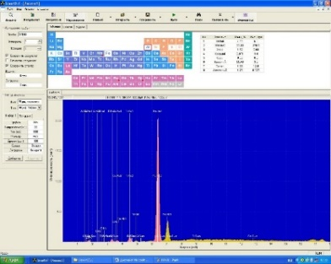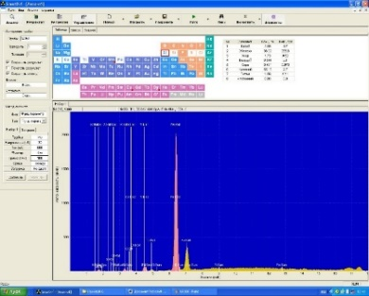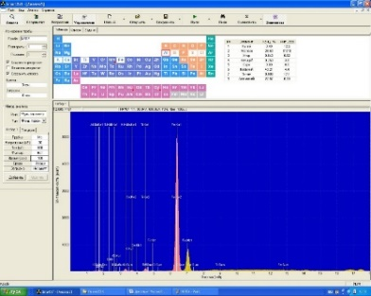
а) b) c)
a - diatomite membrane - 180; b - diatomite membrane - 354; c - diatomite membrane – 707

Figure 24 − Result of X-ray fluorescence analysis of diatomite membranes

The X-ray fluorescence spectra of diatomite membranes are identical to those of natural diatomite. The bulk of the samples contains Si and Fe.
Figure 25 shows electron microscopic images of diatomite membrane samples.

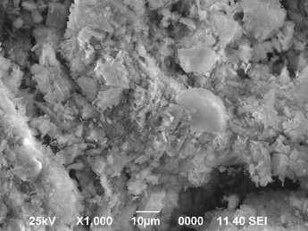
a - diatomite membrane - 180
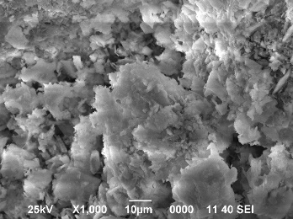
b - diatomite membrane - 354
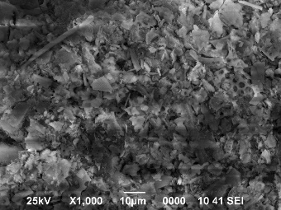
c - diatomite membrane - 707

Figure 25 – SEM images of the obtained diatomite membranes

From the SEM analyzes it can be seen that the crushed samples up to 180, 354 microns have a loose structure compared to the sample crushed to 707 microns. In a sample crushed to 707 microns, similar to the original sample of diatomite, there are fragments of diatomite rocks and porous structures.
Thus, it has been established that diatomite membranes crushed to 180 microns show the best results in comparison with the results of diatomite membranes crushed to 354 and 707 microns. The best results were shown by the extraction of Pb2 + ions α = 40 % when grinding diatomite to 180 μm. The resulting membranes were identified using physicochemical methods of analysis.

CONCLUSION

Based on the results of the studies, the following conclusions were drawn:
- a comprehensive study of the characteristics of Kazakhstani diatomite by physicochemical methods was carried out;
- the effect of treatment with hydrochloric acid and calcination of a sample of diatomite was investigated in order to develop an accurate method for obtaining sorbents with specified properties based on diatomite;
- the obtained sorbent samples were investigated by physicochemical methods of analysis;
- the main technological parameters of the sorbent production process are the type of reagent for surface activation (hydrochloric acid), the concentration of the reagent (0.5, 1, 1.5 M), the temperature of chemical treatment (500-900 °C), as well as the temperature of heat treatment (150 °С), the time of contact of the mineral with the reagent (60 min);
- a method for the synthesis of composite materials (nanotubes) on diatomite obtained on various catalysts has been carried out. According to the results of Raman spectroscopy, the growth of carbon nanotubes is observed on all selected catalysts, such as Al, Co, Fe and Ni. When used as a catalyst salts of metals Al and Fe at low temperatures CVD (650, 700 ℃) Raman spectra of the samples correspond to amorphous carbon;
- the effect of reagents and synthesis conditions on the properties of synthesized nanostructured materials, such as carbon nanotubes, has been studied. Also, the degree of defectiveness of the obtained carbon nanotubes was determined from the Raman spectra;
- it was revealed that the optimal CVD conditions for the growth of high-quality carbon nanotubes (HQ-CNT) are: catalyst at 1.0 M FeCl₂‧6H2O solution at 750 ℃; 1.5 M FeCl₂‧6H₂O solution at 800 ℃; 1.5 M CoCl₂‧6H₂O at temperatures of 750 and 800 ℃;
- an analysis of the results of adsorption of Pb2 + ions on natural diatomite (ground with a mortar), on natural diatomite (after MCA) and on composite materials based on diatomite and carbon nanotubes;
- It was revealed that the maximum degree of removal of Pb2 + ions from solutions with a concentration of 100 mg / L in terms of diatomite (ground with a mortar) is 98 and 97% with a stirring duration of 30 and 120 min, respectively. It was found that pure diatomite has a high adsorption capacity of Pb²⁺ ions.
- a laboratory filtration plant for water purification was designed and built;
- it was found that the optimal operating mode of the filtration unit is achieved with a diatomite membrane, crushed to 180 microns, at a flow rate of 3-3.5 ml / min of the model solution at a pressure in the system of 15-20 torr. Under these conditions, the membrane adsorbs up to 2.89 mg / L of zinc ions, 23.55 mg / L of lead ions and 0.79 mg / L of copper ions;
- the influence of the pH of the medium (from 3 to 10) on the efficiency of purification of aqueous solutions from heavy metals was investigated. The maximum adsorption capacity is observed at pH = 7 for Cu (99.86%).

REFERENCES

1. Wang J., Liu D.H., Wang Y.Y., Hou B.H., Zhang J.P., Wang R.S., Wu X.L. Dual-carbon enhanced silicon-based composite as superior anode material for lithium ion batteries // J.Power Sources. – 2016. – №307. – Р. 738-745.
2. Wang M.S., Fan L.Z., Huang M., Li J., Qu X. Conversion of diatomite to porous Si/C composites as promising anode materials for lithium-ion batteries // J. Power Sources. – 2012.
– №219. – Р. 29-35.
3. Xu L., Gao X., Li Z., Gao C. Removal of fluoride by nature diatomite from high-fluorine water: An appropriate pretreatment for nanofiltration process // Desalination. – №369. – Р. 97-104.
4. Cong P., Chen S., Chen H. Effects of diatomite on the properties of asphalt binder // Constr. Build. Mater. – 2012. – №30. – Р. 495-499.
5. Rezig W., Hadjel M. Preparation and characterization of iron oxide modified system // Der Pharma Chemica. – 2015. – V.7, №2. – P. 5-11.
6. Loganina V.I., Simonov E.E., Jezierski W., Maiaszkiewiecz D. // Construc. Building Mater. – 2014. – V.65. – P. 29-37.
7. Tavares A., Costa A., Velosa A. Absorbent materials in waterfroofing barriers, analysis of the role of diatomaceous earth // Construc. Building Mater. – 2016. – V.102. – P. 125-132.
8. Ye X., Kang S., Wang H., Li H., Zhang Y., Wang G., Zhao H.J. Hazard. Modified natural diatomite and its enhanced immobilization of lead, copper and cadmium in simulated contaminated soils // Mater. – 2015. – V.289. – P. 210-218.
9. Klimov E.S., Buzaeva M.V. Natural sorbents and complexones in wastewater treatment / Ulyanovsk: UlSTU, 2011. – 201 p. (in RUS)
10. Maksatova A.M., Vezentsev A.I., Mikhailyukova M.O., Kalashnikova L.A. Physicochemical basis for the production of an adsorbent based on diatomite. « Bulletin of Contemporary Research ». – 2017. – №7-1(10). – P. 162-170. (in RUS)
11. Xuea Y., Houa H., Zhu S. Competitive adsorption of copper (II), cadmium (II), lead (II) and zinc (II) onto basic oxygen furnace slag // J. Hazard. Mat. – 2009. – №162. – Р. 391-401.
12. Shi W.Y., Shao H.B., Li H., Shao M.A., Du S. Progress in the remediation of hazardous heavy metal-polluted soils by natural zeolite // J. Hazard. Mat. – 2009. – №170. – Р. 1-6.
13. Ijagbemi C.O., Baek M.H., Kim D.S. Montmorillonite surface properties and sorption characteristics for heavy metal removal from aqueous solutions // J. Hazard. Mat. – 2009. – №166. – Р. 538-546.
14. Lin S.H., Juang R.S. Heavy metal removal from water by sorption using surfactant-modified montmorillonite // J. Hazard. Mater. – 2002. – №92. – Р. 315-326.
15. Mohammad A.W., Teow Y., Ang W., Chung Y., Oatley-Radcliffe D., Hilal N. Nanofiltration membranes review: recent advances and future prospects // Desalination. – 2015. – №356. – Р. 226-254.

APPENDIX А

LIST OF PUBLISHED WORKS FOR 2018-2020

1. Smagulova G.T., Nazhipkyzy M., Lesbaev B.T., Bakkara A.E., Prikhod’ko N.G., Mansurov Z.A. Influence of the Type of Catalysts on the Formation of a Superhydrophobic Carbon Nanomaterial in Hydrocarbon Flames // Journal of Engineering Physics and Thermophysics. – 2018. – Vol. 91, № 3. – Р. 774-783. Indexable in Scopus (in ENG)
2. Mitchell G.R., Davis F.J., Mohan S. and Nazhipkyzy M. Highly Anisotropic Polymer Composites Based on Carbon Nanotubes // Carbon Nanotubes - Recent Progress". ISBN:978-1-78923-053-6. Chapter 8, 2018. – P. 127-148. (in ENG)

3. Nazhipkyzy M., Nurgain A., Zhaparova A.A., Seitkazinova A.R., Prikhodko N.G., Nemkayeva R.R. Raman Characteristics of Multiwall Carbon Nanotubes on Diatomite Eurasian Chemico-Technological Journal. – Vol. 20, №4. – 2018. – P. 319-323. Indexable in Scopus (in ENG)
4. Zhalgasbaikyzy A., Nazhipkyzy M., Nurgain A., Mansurov Z.A. Diatomite: a natural occurring bioinspired nanomaterial with complex-shaped and its application in synthesis of MWCNTs as a substrate // White Paper on Nanotechnology. – Almaty, 2018. – V. 2. – P. 223-228. (in ENG)
5. Zhaparova A., Nurgain A., Zhalgasbaikyzy A., Nazhipkyzy M., Lesbayev B.T., Prikhodko N.G., Mansurov Z.A. Diatomite: Origins and Uses. // X International Symposium "Physics and Chemistry of Carbon and Nanoenergy Materials». – Almaty: Combustion Problems Institute, 2018. – P. 69-71. (in ENG)
6. Turganbay A.B., Zhaparova A., Nazhipkyzy M., Lesbayev B.T., Mansurov Z.A. Аpllication of diatomite for energy storage devices // X International Symposium "Physics and Chemistry of Carbon and Nanoenergy Materials». – Almaty: Combustion Problems Institute, 2018. – C. 160-162. (in ENG)
7. Nazhipkyzy M., Zhalgasbaikyzy A., Zhaparova A.A., Nurgain A., Temirgalieva T.S., Prikhodko N.G., Lesbayev B.T., Mansurov Z.A., Tulepov M.I. «Diatomite: an emerging biomaterial with hirarchiral porous structure in nanotechnology and its application in synthesis of multiwalled carbon nanotubes by chemical vapor deposition method». Carbon 2018 Conference, Madrid, Spain, July 1-6. (in ENG)
8. Zhalgasbaikyzy A., Nurgain A., Nazhipkyzy M. A new approch for growth of carbon nanotubes on diatomite: application for removal of lead ions. Proceedings of the III Conference of Students and Young Scientists "Chemical Physics and Nanomaterials" dedicated to the memory of Batyr Zulkhairovich Mansurov - Almaty: Kazakh University, 2018. – P. 84. (in ENG)
9. Saeed D. Mohan, Meruyert Nazhipkyzy, Pedro Carreira, Cyril dos Santos, Fred J. Davis, Artur Mateus and Geoffrey R Mitchell. Direct Digital Manufacturing of Nanocomposites // Direct Digital Manufacturing and Polymers, ISSN: 1662-7482, Vol. 890, pp 92-97, 2019. (in ENG)
10. Meruyert Nazhipkyzy, Araylim Nurgain, Marc Florent, Alfonso Policicchio, Teresa J. Bandosz Magnetic soot: Surface properties and application to remove oil contamination from water // Journal of Environmental Chemical Engineering 7 (2019) 103074. Indexable in Scopus. Impact Factor 2.08 (in ENG)
11. Nazhipkyzy M., Nurgain A., Mansurov Z.A., Prikhodko N.G., Temirgaliyeva T.S., Zhaparova A.A., Lesbayev B.T. A method for producing carbon nanotubes. Utility model patent № 3735; 2018/0753.2; 22.10.2018; 01.03.2019. (in RUS)
12. Nazhipkyzy M., Nurgain A., Temirgaliyeva T.S., Zhaparova A.A., Lesbayev B.T., Prikhodko N.G., Zhalgasbaikyzy A., Mansurov Z.A. Fabrication of composite material based on multiwall carbon nanotubes obtained on diatomite substrate // July 14-19, Carbon 2019, Lexington, KY. (in ENG)
13. Nurgain A., Nazhipkyzy M., Temirgaliyeva T.S., Turganbay A.B., Zhaparova A.A., Akbayeva N.T., Izdik N. Use of pure diatomite for the sorption of heavy metal ions. Program of the X International Bеrеmzhanov Congress on Chemistry and Chemical Technology. – 2019, Almaty. – Р. 14. (in ENG)
14. Nurgain A., Nazhipkyzy M., Temirgaliyeva T.S., Turganbay A.B., Zhaparova A.A., Akbayeva N.T., Izdik N. Use of pure diatomite for the sorption of heavy metal ions // «Combustion and plasma chemistry». – 2019. – №3. – Р. 194-198. (in ENG)
15. Temirgaliyeva T.S., Nazhipkyzy M., Nurgain A., Turganbay A.B., Dinistanova B., Mansurov Z.A. Synthesis of multiwalled carbon nanotubes by CVD and their functionalization // Journal of Engineering Physics and Thermophysics. – 2020. – Vol. 93, №1. – Р. 96-99. DOI: 10.1007/s10891-020-02094-8, Indexable in Scopus. Impact Factor 0.710, Q1. (in ENG)
16. Kuantai N., Nurgain A. Production of carbon nanotubes by CVD method // Proceedings of the International Scientific Conference of Students and Young Scientists "Farabi World" Almaty, Kazakhstan, April 6-9, 2020. (in KAZ)
17. Zhambyl A., Nurgain A., Zhaparova A. Obtaining a hydrophobic sponge on the basis of highly hydrophobic soot // Proceedings of the International Scientific Conference of Students and Young Scientists "Farabi World" Almaty, Kazakhstan, April 6-9, 2020. (in KAZ)
18. Baiboranova A., Seitkazinova A. Production of sorbents based on fruit waste // Proceedings of the International Scientific Conference of Students and Young Scientists "Farabi World" Almaty, Kazakhstan, April 6-9, 2020. – P. 133. (in KAZ)
19. Application for an invention No. 2020/0440.1 dated 05/27/2020. Republic of Kazakhstan. A method of manufacturing membranes based on natural diatomite / Nazhipkyzy M., Nurgain A., Turganbay A.B., Zhaparova A.A., Mansurov Z.A. (in RUS)
20. Nazhipkyzy M., Dalton A. Langmur-Blodgett films based on superhydrophobic soot // News of the National Academy of Sciences of the Republic of Kazakhstan-Series Chemistry and Technology. – 2020. – Vol. 4, №442. – Р. 30-36. (in ENG)
21. Nurgain A., Nazhipkyzy M., Zhaparova A.A., Issanbekova A.T., Alfe M., Musina A.S. Acid Modification of Diatomite-Based Sorbents. Eurasian Chemico-Technological Journal.
– 2020. – Vol. 22. – Р. 157-164. Indexable in Scopus. (in ENG)

APPENDIX B
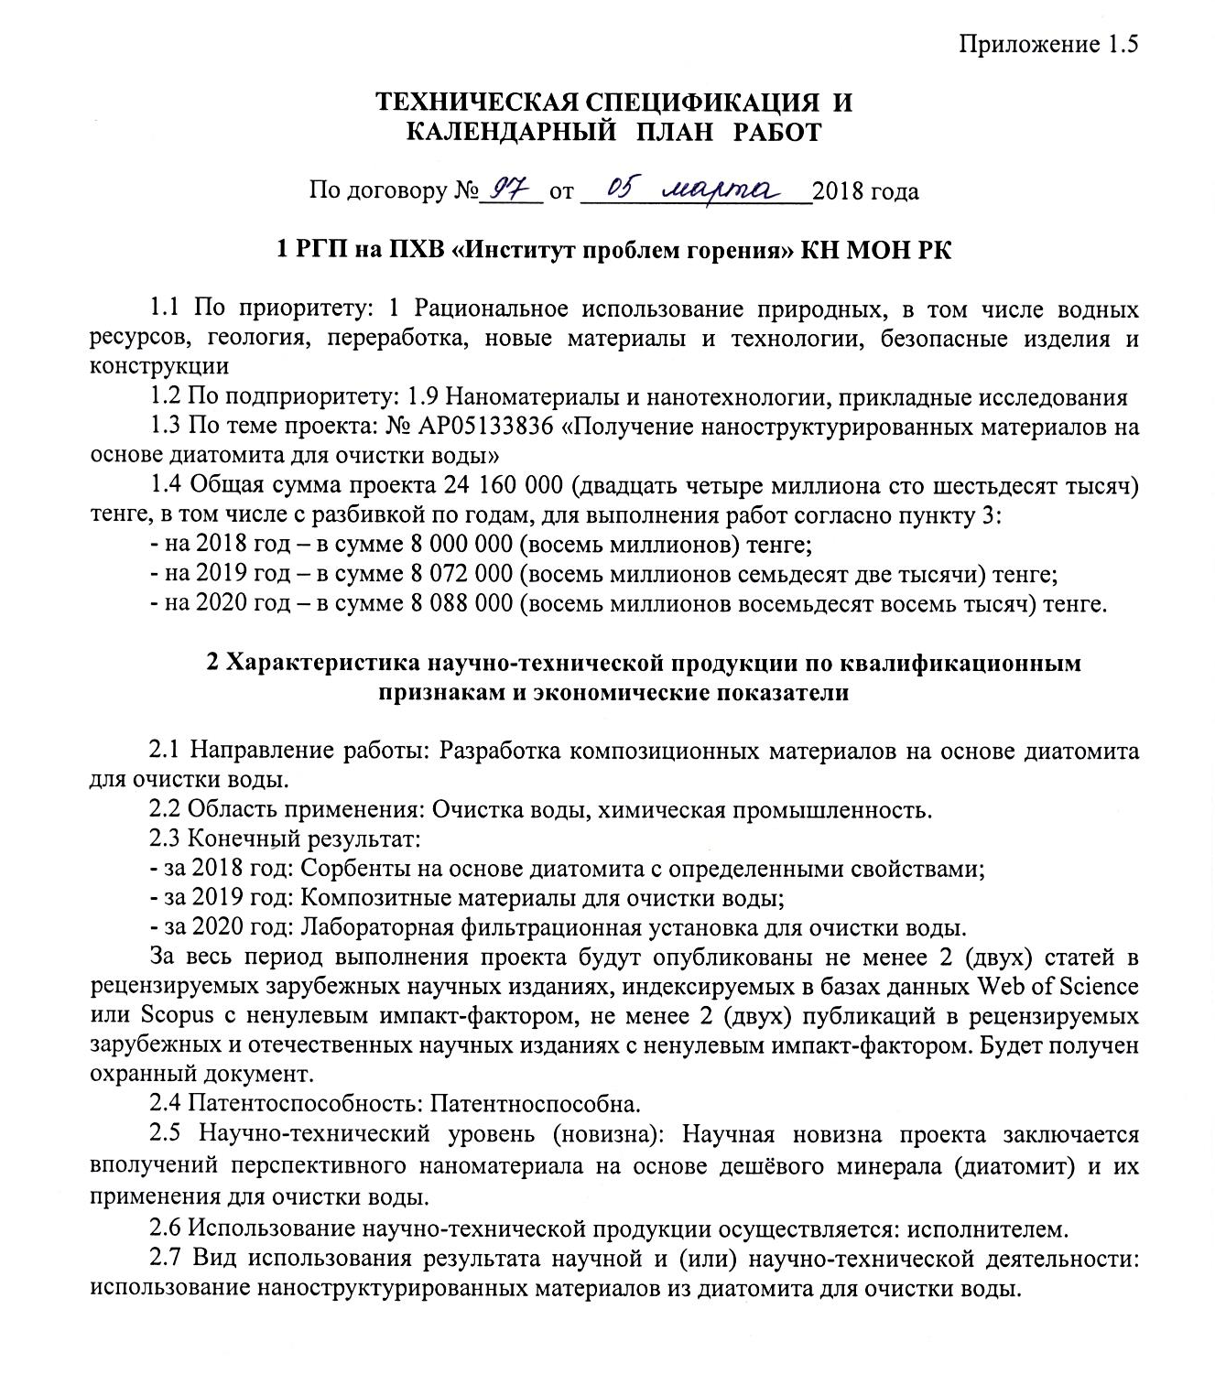
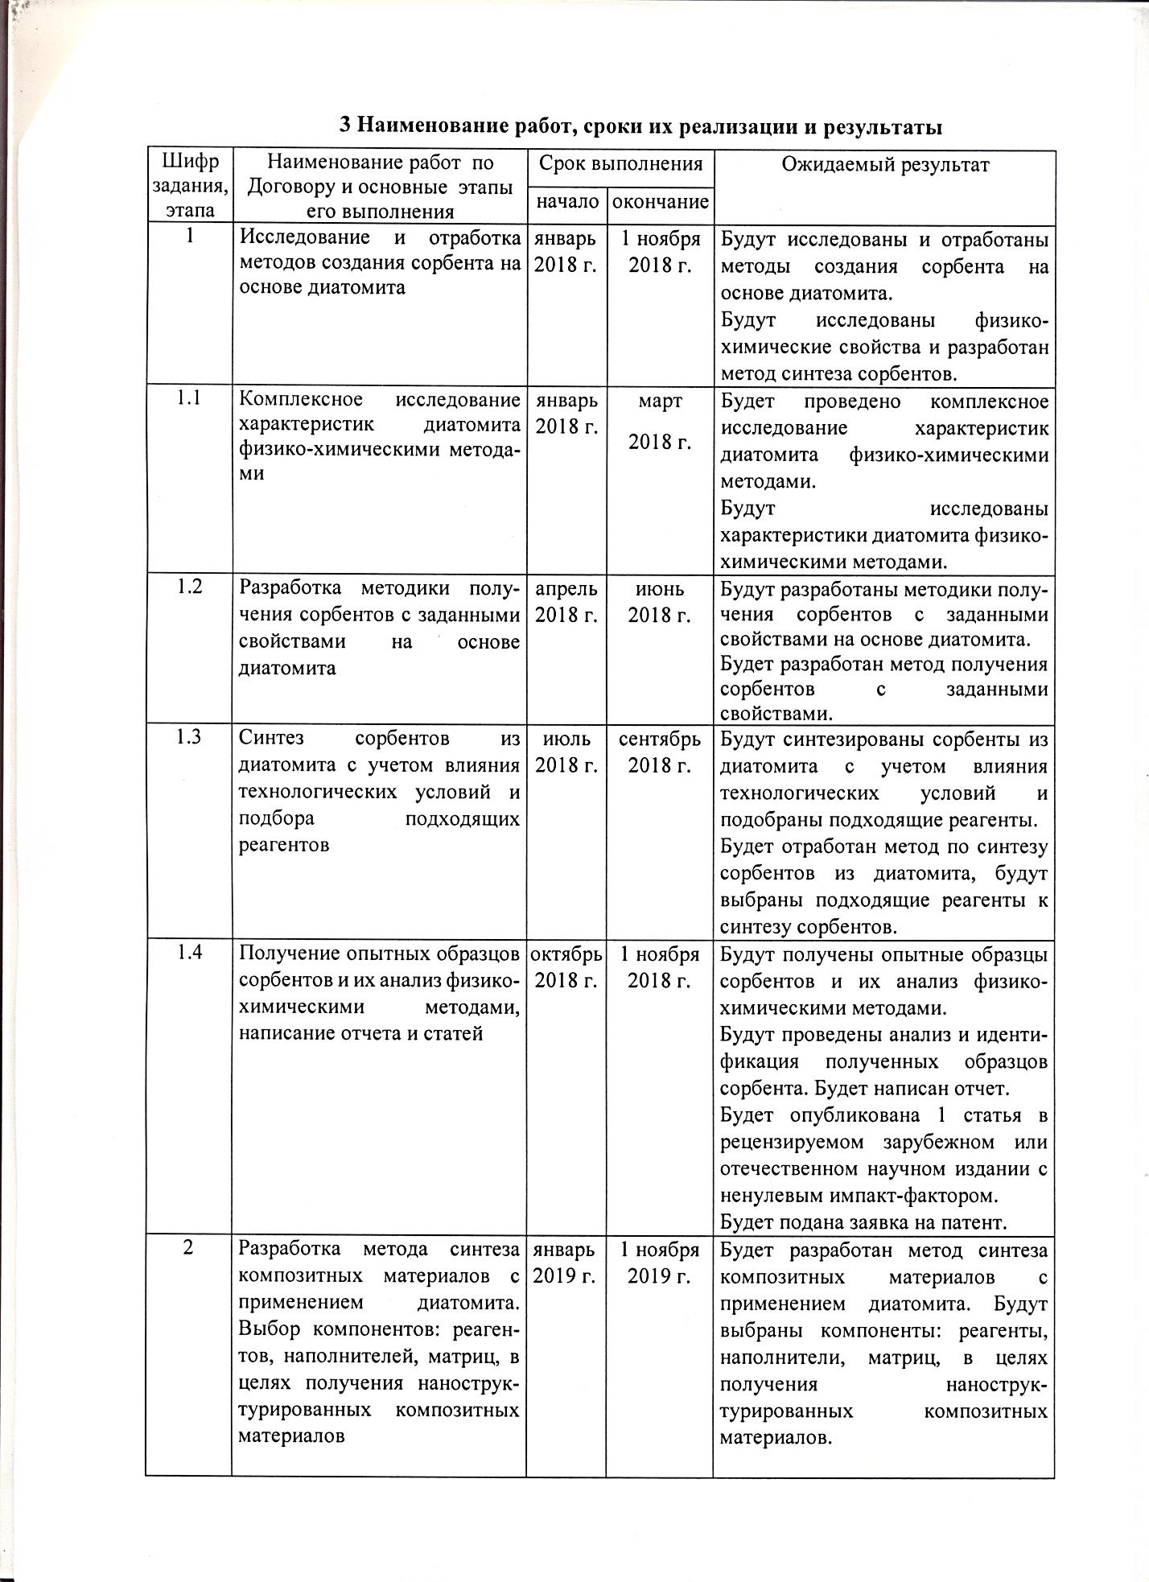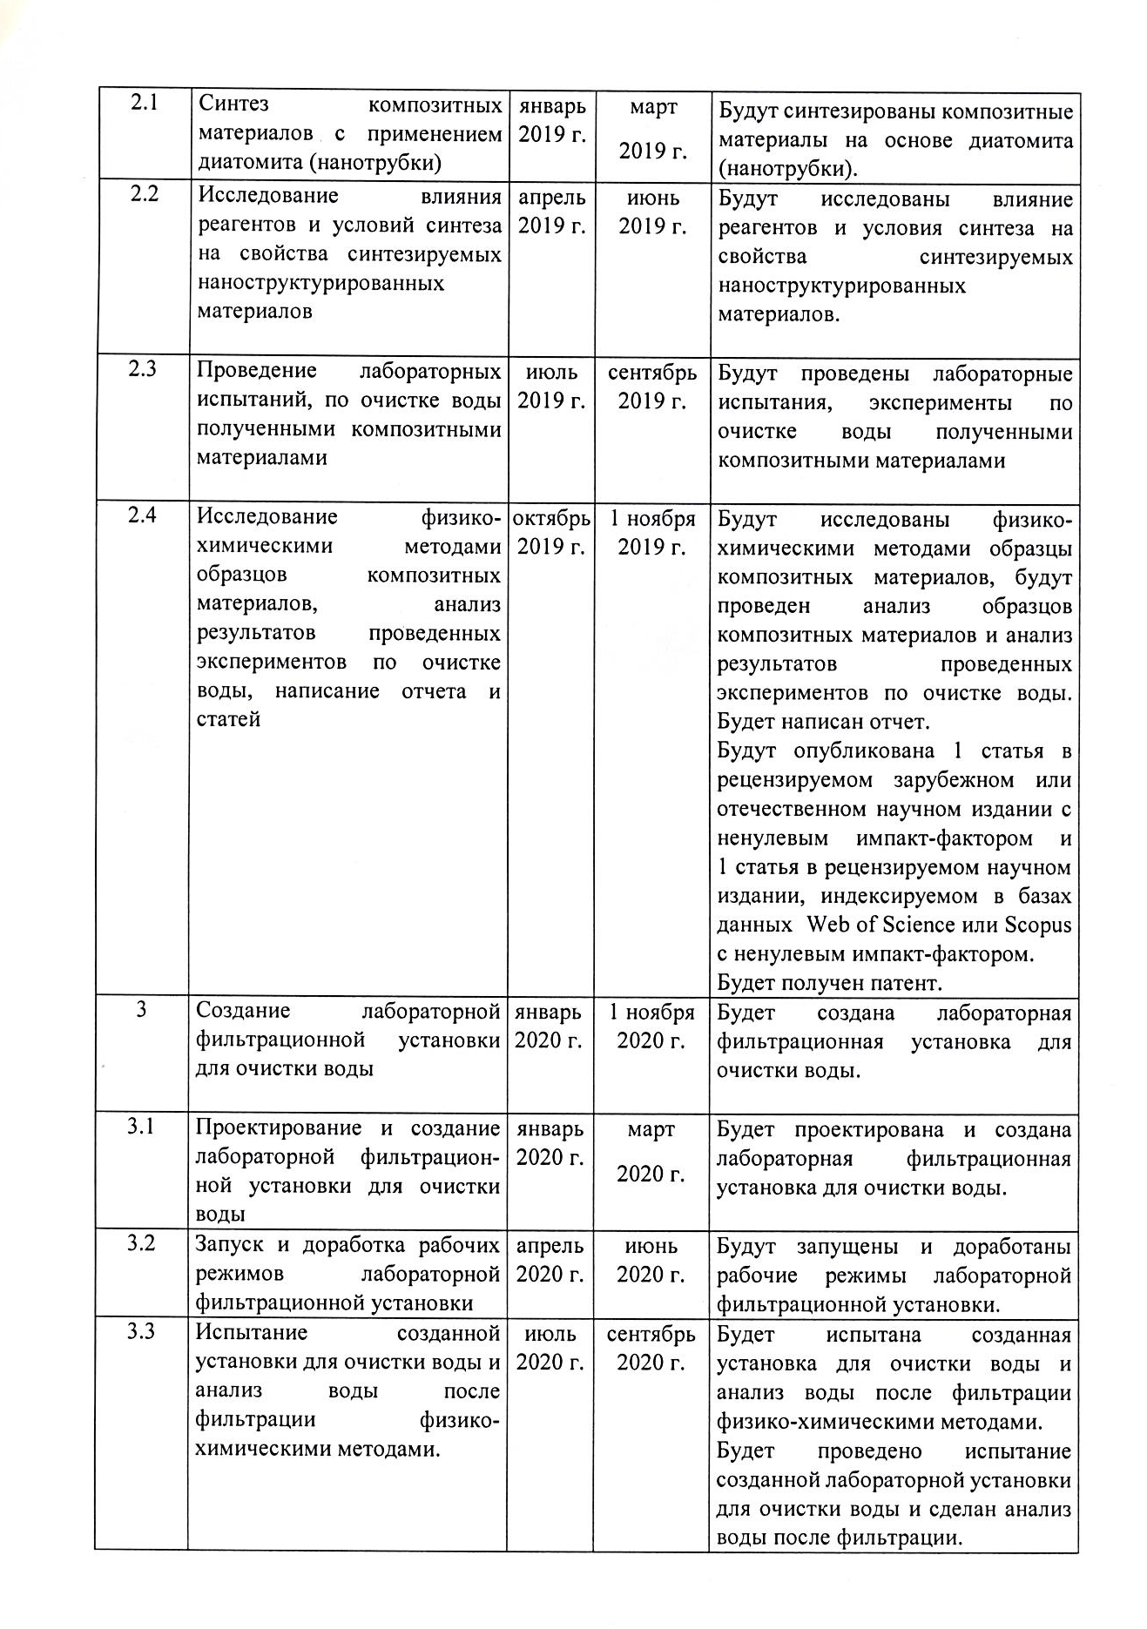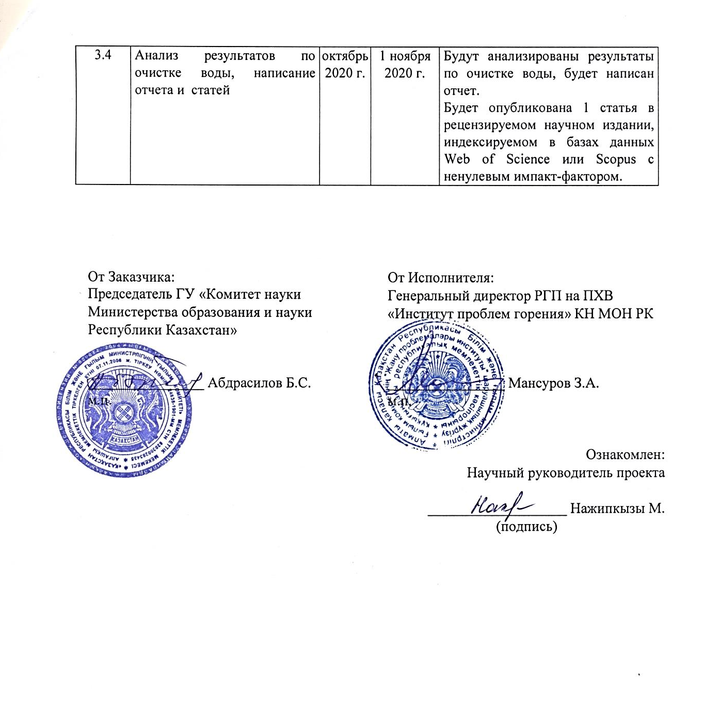

APPENDIX В.1

TECHNICAL SPECIFICATIONS AND CALENDAR WORK PLAN

Under contract No. 97 dated March 05, 2018

1 RSE on REM "Institute of Combustion Problems" SC MES RK

1.1 By priority: 1. Rational use of natural resources, including water resources, geology, processing, new materials and technologies, safe products and structures
1.2 For sub-priority: 1.9 Nanomaterials and nanotechnology, applied research
1.3 On the topic of the project: No. AR05133836 "Obtaining nanostructured materials based on diatomite for water purification"
1.4 The total amount of the project 24 160 000 (twenty-four million one hundred sixty thousand) tenge, including with a breakdown by years, for the performance of work in accordance with paragraph 3:
- for 2018 - in the amount of 8 000 000 (eight million) tenge;
- for 2019 - in the amount of 8 072 000 (eight million seventy-two thousand) tenge;
- for 2020 - in the amount of 8 088 000 (eight million eighty-eight thousand) tenge.

2 Characteristics of scientific and technical products by qualification characteristics and economic indicators

2.1 Field of work: Development of composite materials based on diatomite for water purification.
2.2 Applications: Water treatment, chemical industry.
2.3 Final result:
- 2018: Sorbents based on diatomite with specific properties;
- 2019: Composite materials for water treatment;
- 2020: Laboratory filtration plant for water purification.
Over the entire period of the project, at least 2 (two) articles will be published in peer-reviewed foreign scientific journals indexed in the Web of Science or Scopus databases with a nonzero impact factor, at least 2 (two) publications in peer-reviewed foreign and domestic scientific journals with non-zero impact factor. The title of protection will be received.
2.4 Patentability: Patentable.
2.5 Scientific and technical level (novelty): The scientific novelty of the project lies in the receipt of a promising nanomaterial based on a cheap mineral (diatomite) and their application for water purification.
2.6 The use of scientific and technical products is carried out: by the contractor.
2.7 The type of use of the result of scientific and (or) scientific and technical activities: the use of nanostructured materials from diatomite for water purification.

3 Name of work, terms of their implementation and results

Task code, stage | Name of work under the Agreement and the main stages of its implementation | Period of execution |  | Expected Result
Task code, stage |  | Start | ending | Expected Result
1. | Research and development of methods for creating a sorbent based on diatomite | January 2018 | November 1, 2018 | Methods for creating a sorbent based on diatomite will be studied and tested.  Physicochemical properties will be investigated and a method for the synthesis of sorbents will be developed.
1.1 | Comprehensive study of the characteristics of diatomite by physical and chemical methods | January 2018 | March 2018 | A comprehensive study of the characteristics of diatomite by physical and chemical methods will be carried out.  The characteristics of the diatomite will be investigated by physicochemical methods.
1.2 | Development of a method for obtaining sorbents with desired properties based on diatomite | April 2018 | June 2018 | Techniques for obtaining sorbents with desired properties based on diatomite will be developed. A method for obtaining sorbents with desired properties will be developed.
1.3 | Synthesis of sorbents from diatomite, taking into account the influence of technological conditions and the selection of suitable reagents | July 2018 | September 2018. | Sorbents from diatomite will be synthesized taking into account the influence of technological conditions and suitable reagents will be selected. A method for the synthesis of sorbents from diatomite will be worked out; suitable reagents for the synthesis of sorbents will be selected.
1.4 | Obtaining prototypes of sorbents and their analysis by physicochemical methods, writing a report and articles | October 2018 | November 1, 2018 | Experimental samples of sorbents and their analysis by physicochemical methods will be obtained.  The analysis and identification of the obtained sorbent samples will be carried out. A report will be written. 1 article will be published in a peer-reviewed foreign or domestic scientific publication with a non-zero impact factor. A patent application will be filed.
2. | Development of a method for the synthesis of composite materials using diatomite. Selection of components: reagents, fillers, matrices, in order to obtain nanostructured composite materials | January 2019 | November 1, 2019 | A method for the synthesis of composite materials using diatomite will be developed. Components will be selected: reagents, fillers, matrices, in order to obtain nanostructured composite materials.
2.1 | Synthesis of composite materials using diatomite (nanotube) | January 2019 | March 2019 | Composite materials based on diatomite (nanotubes) will be synthesized.
2.2 | Study of the influence of reagents and synthesis conditions on the properties of synthesized nanostructured materials | April 2019 | June 2019 | The effect of reagents and synthesis conditions on the properties of synthesized nanostructured materials will be investigated.
2.3 | Conducting laboratory tests for water purification by the obtained composite materials | July 2019 | September 2019 | Laboratory tests, experiments on water purification with the obtained composite materials will be carried out
2.4 | Investigation of samples of composite materials by physicochemical methods, analysis of the results of experiments on water purification, writing a report and an article | October 2019 | November 1, 2019 | Samples of composite materials will be examined by physical and chemical methods, samples of composite materials will be analyzed and the results of experiments on water purification will be analyzed. A report will be written.  1 article will be published in a peer-reviewed foreign or domestic scientific journal with a nonzero impact factor and 1 article in a peer-reviewed scientific journal indexed in the Web of Science or Scopus databases with a nonzero impact factor. A patent will be obtained.
3. | Creation of a laboratory filtration plant for water purification | January 2020 | November 1, 2020 | A laboratory filtration plant for water purification will be created.
3.1 | Design and construction of a laboratory filtration plant for water purification | January 2020 | March 2020 | A laboratory filtration plant for water purification will be designed and built.
3.2 | Launching and finalizing the operating modes of the laboratory filtration unit | April 2020 | June 2020 | The operating modes of the laboratory filtration unit will be launched and refined.
3.3 | Testing the created installation for water purification and  analysis of water after filtration by physical and chemical methods. | July 2020 | September 2020 | The created installation for water purification and analysis of water after filtration by physicochemical methods will be tested. A test of the created laboratory installation for water purification will be carried out and an analysis of the water after filtration will be made.
3.4 | Analysis of water treatment results writing reports and articles | October 2020 | November 1, 2020 | The results of water treatment will be analyzed; a report will be written.  1 article will be published in a peer-reviewed scientific journal, indexed in the Web of Science or Scopus databases with a non-zero impact factor.

From customer: From the Contractor:
Chairman of the State Institution General Director of the RSE on REM
"Science Committee Ministry "Institute of Combustion Problems"
of Education and Science of the SK MES RK
Republic of Kazakhstan»

_______________ Abdrasilov B.S. ________________ Mansurov Z.A.

Familiarized with:
Scientific supervisor of the project

______________ Nazhipkyzy М.

APPENDIX C

