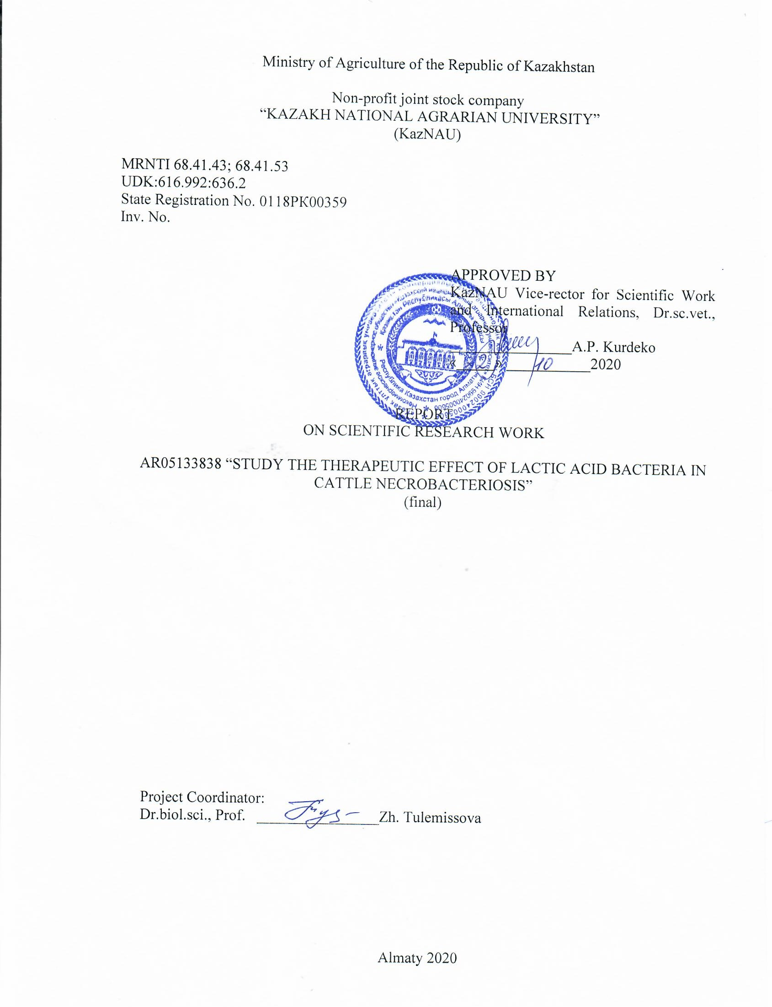
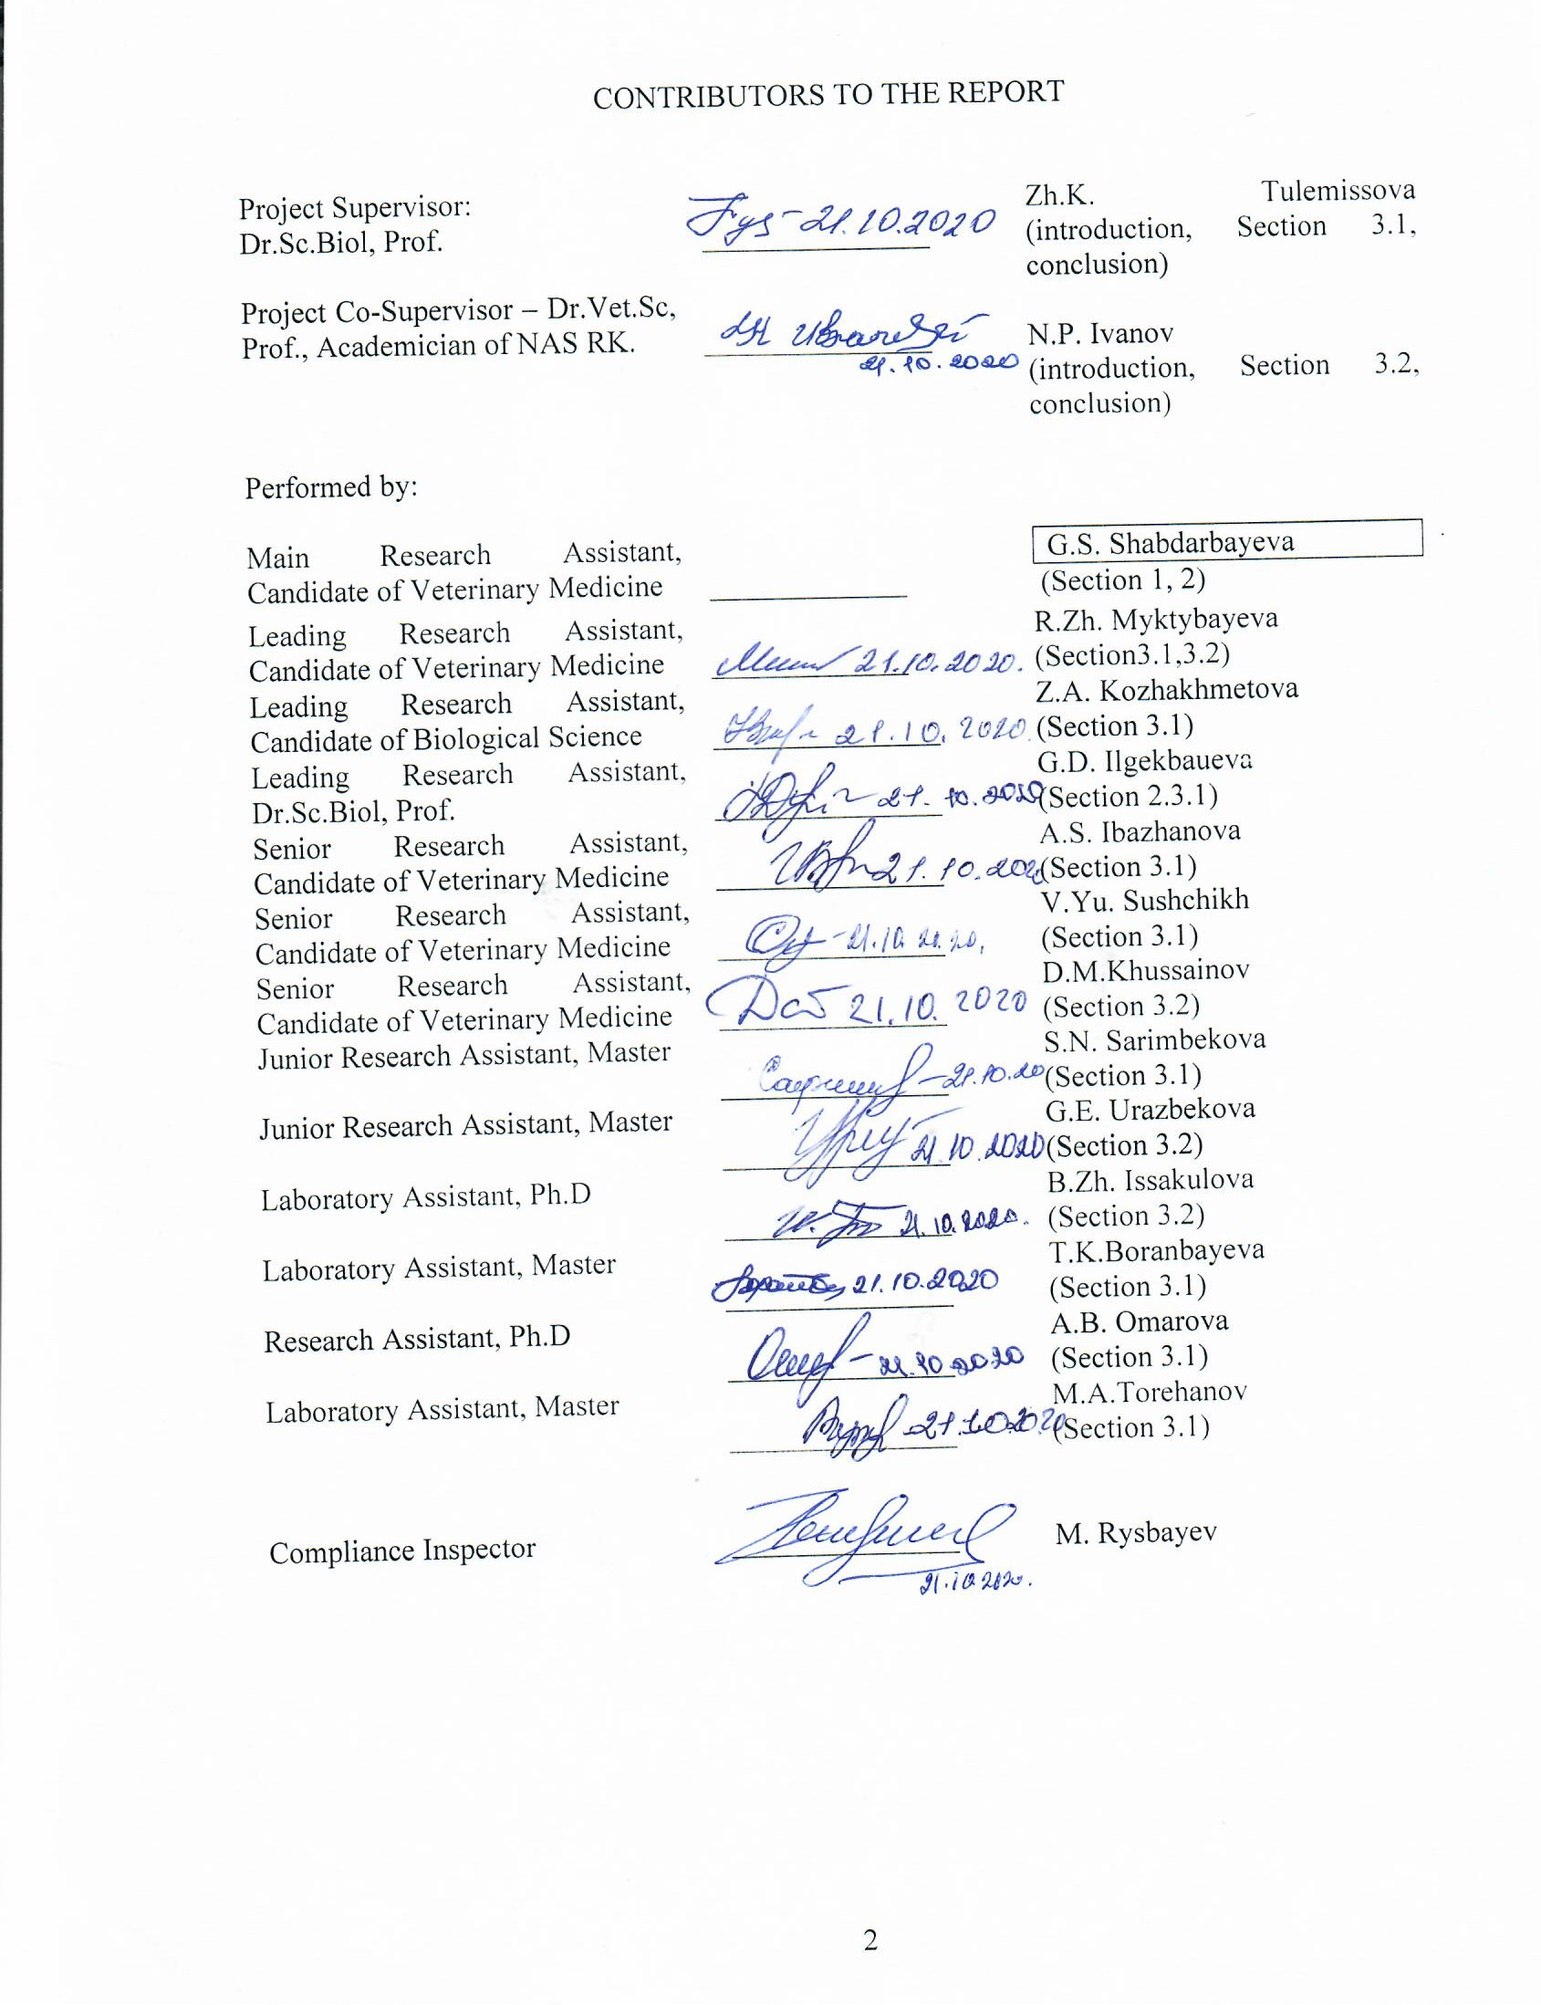
ABSTRACT
Report on 38 pag, figur - 44, tabl - 3, sources - 22, appendixes - 2.
NECROBACTERIOSIS, EPISOOTOLOGY, BACTERIOLOGY, LACTIC ACID BACTERIA, PROBIOTICS, ANTAGONISM, LACTOBACTERIN-TK².
The objects of research are: cattle with clinical signs of hoof lesions, pathological material taken from sick animals, isolated pathogenic microorganisms Fusobacterium necrophоrum, probiotic lactobacilli.
The purpose of this work is to study the therapeutic effect of the drug with lactic acid bacteria in case of necrobacteriosis in cattle.
Methods and methodology of work. Epizootological, clinical, bacteriological studies were performed during the work. When studying the cultural, morphological and biochemical properties of fusobacteria, the following tests were used: smear microscopy; cultivation of cultures in Kitt-Tarozzi medium, SGA, bioassay was carried out on white mice and rabbits. The antagonistic effect of lactic acid bacteria on the pathogenic microflora was carried out using a diffuse method. For the study, isolated strains of F. necrophоrum No. 3, No. 8, museum strains of LAB, bacterial preparation “Lactobacterin-TK²| were used.
For treatment of necrobacteriosis lesions of limbs in cattle, highly active lactic acid bacteria with a stable composition and antimicrobial and regenerative properties were used.
Results of work and their novelty. The epizootic situation of cattle necrobacteriosis in the economic entities of Almaty region was studied. The causative agent of cattle necrobacteriosis was isolated and its indication and type affiliation were determined. The static indicators of the epizootic process were established and analyzed. The effect of Lactobacterin-TK² on the pathogenic microflora isolated from the affected areas of the limbs of cattle was studied in-vitro under laboratory conditions. The therapeutic effect of Lactobacterin-TK² in cattle necrobacteriosis was studied. The pathomorphological, histological and histochemical studies of the skin and internal organs of cattle with necrobacteriosis were studied. The regulatory and technical documentation for the drug was developed.
For the first time for the treatment of necrobacteriosis, the proposed therapeutic drug "Lactobacterin-TK2" antagonistically active to Fusobacterium necrophоrum, which has shown its high efficiency by applying a bandage to the affected limb. Received three patents, two positive decisions and three certificates of authorship.
Scope. Veterinary medicine, veterinary microbiology, veterinary biotechnology, epizootology.
Recommendations for the implementation or the results of the implementation of research results - 1 act of introduction and 8 acts of testing of the veterinary drug lactobacterin TC in necrobacteriosis were received, 4 recommendations were issued on the use of the drug in necrobacteriosis of cattle, normative and technical documentation for the veterinary drug lactobacterin TC was developed
Cost-effectiveness or value of work. There is a great economic damage due to the significant spread of necrobacteriosis in many countries of the world among different species of animals. Therefore, the development of an alternative method for combating animal disease is of great importance not only nationally, but also internationally. This scientific project on combating the necrobacteriosis in animals fundamentally differs from the existing approaches, which are based on the use of antibacterial drugs.
Forecast proposals for development of the research object. The results of scientific researches can be easily implemented by the release of an appropriate biological product in veterinary laboratories, and used in farms for treatment of animals with necrobacteriosis and prevention of cattle disease.

TABLE OF CONTENTS

INTRODUCTION………………………………………………………………………. | 8
MAIN PART OF THE RESEARCH WORK REPORT……………………………….. | 13
1 Choice of Research Area…………………………………………………………….. | 13
2 Process of theoretical and experimental research……………………………………. | 14
3 Research Results and Their Analysis………………………………………………… | 19
3.1 Study of epizootic situation with necrobacteriosis for 2015-2017……………….. | 19
3.2 Study of epizootic situation with necrobacteriosis for 2018……………………… | 20
3.3 Study the effect of the drug with lactic acid bacteria “Lactobacterin-TK²” on the  pathogenic microflora isolated from the affected areas of the limbs of cattle, in-vitro  in laboratory conditions……………………………………………………………… | 21
3.4 Study the therapeutic effect of Lactobacterin-TK² in cattle necrobacteriosis…….  3.5 Pathomorphological, histological and histochemical control of influence of the  lactic acid bacteria in animals with necrobacteriosis on regeneration of the affected  tissues…………………………………………………………………………………  3.6 Develop the regulatory and technical documentation for therapeutic drug  “Lactobacterin-TK²” for treatment of extremities affected by necrobacteriosis……...  3.7 Develop the regulatory and technical documentation for therapeutic drug  “Lactobacterin-TK²” for treatment of extremities affected by necrobacteriosis.……. | 24  28  31  42
CONCLUSION………………………………………………………………………… | 46
REFERENCES | 48
APPENDIX А Work Schedule | 50
APPENDIX B List of published works 2018-2020 (scientific articles, patents, recommendations, acts) | 55

TERMS AND DEFINITIONS
In this Research Report, the following terms are used with appropriate definitions:
ANTAGONISM | - means the suppression of the vital activity of one microbial culture (microbial population) with another due to the release of substances (antibiotics, bacteriocins, organic and fatty acids) preventing growth or retarding reproduction, into the cultivation environment or cohabitation
BIOLOGICAL ASSAY | - bioassay means the assessment of biological activity of various substances (virus, protein, drug, synthetic organic matter, vitamin, hormone, etc.) on organisms, tissues or cells (e.g., cell cultures)
MICROBIOCINOSIS | - means a kind of dynamic microecological system that contributes to creation of more or less uniform conditions for normal life of the autoflora
NECROBACTERIOSIS | - means a chronic infectious disease (causative agent - Fusobacterium Necrophorum), characterized by purulent-necrotic lesions of the skin and subjacent tissues, localized mainly in the distal part of the extremities, less often on the mucous membrane of the mouth, udder, genitals, liver, muscles and other tissues
PANARITIUM | - means a purulent or purulent-necrotic lesion of tissues of the interdigital fissure and the hoof head of animals
PROBIOTICS | - means a class of microorganisms and substances of microbial origin used for therapeutic purposes, and food products and biologically active additives containing live microcultures
STRAIN | - means a culture of microorganisms of the same species with the same morphological and biological properties
EPIZOOTOLOGY | - means a science that studies epizootics, epizootic process, objective laws of occurrence, manifestation, spread and extinction of animal diseases and, on this basis, develops methods for combating them

SYMBOLS AND ABBREVIATIONS
In this Research Report, the following symbols and abbreviations were used
b.c. | - bacteriologically confirmed
y | - year
SGA | - serum glucose agar
cows | - number of cows
farm | - farm
KazNAU | - Kazakh National Agrarian University
KazNIVI | - Kazakh Scientific Research Veterinary Institute
MCM | - micrometer
MM | - millimeter
LAB | - lactic acid bacteria
MES RK | - Ministry of Education and Science of the Republic of Kazakhstan
MA RK | - Ministry of Agriculture of the Republic of Kazakhstan
CDF | - commercial dairy farm
RW | - research work
SF | - stud farm
RK | - Republic of Kazakhstan
cm | - centimeter
APC | - agricultural production cooperative
LLP | - limited liability partnership
LLP | - limited liability partnership
STPC | - Scientific training and production center
C | - clean
st | - strain
Lb | - Lactobacillus
Lc | - Lactococcus
F | - fusobacterium

INTRODUCTION
Evaluation of the state-of-the-art scientific and technical problem to be solved.
In order to solve the food program, radical transformations in economic relations are required, combined with the acceleration of scientific and technical progress with social reorganization of rural areas. The agro-industrial complex of the country should be developed on the basis of different types of management of livestock breeding complexes, farms with their own solution of the main issues related to production and sale of agricultural products.
Basis and source data for the development of the theme. The animal husbandry workers are faced with the task of providing the country’s population with high quality products in publicly available quantities and reducing their imports.
At the same time, the major obstacle is existence of contagious diseases among farm animals, one of them is are necrobacteriosis, which causes large losses due to reduced productivity, premature rejection of animals and high costs associated with antiepizootic measures.
Necrobacteriosis takes one of the central places in the infectious pathology of cattle. Necrobacteriosis is an infectious disease that shows purulent-necrotic lesions of many organs and tissues of the body. This disease causes significant economic damage to livestock breeding [1].
Necrobacteriosis of cattle irrespective of age and breed, is widespread in Kazakhstan, and near and far abroad countries. Geographically, necrobacteriosis is spread on all continents, in all countries, including thyose with highly developed livestock breeding [2].
In addition, in recent years, there has been a tendency towards an exacerbation of the epizootic situation in necrobacteriosis that is associated with becoming more complicated business-and-economic and technological conditions of livestock breeding.
Justification of the need for research. The economic damage caused by this infection is enormous. It is composed of the costs associated with prevention and treatment of patients, premature rejection of animals, loss of productivity and other costs associated with disease elimination activities. Necrobacteriosis affects all kinds of domestic and wild animals, birds, reptiles and humans. Cattle, as well as deer and sheep, pigs and horses are the most susceptible to this infection [3, 4].
The highly productive cows and bull-calves are the most susceptible to necrobacteriosis. In troubled farms, the safety of born calves does not exceed 62-75%, because the offspring is born with primary immunodeficiency due to intrauterine intoxication by products of the necrobacteriosis causative agent [5].
Information about the planned technical level. Despite a significant number of developed and widely used therapeutic and prophylactic methods and drugs used for cattle necrobacteriosis treatment, all of them, for the most part, because of many negative points do not satisfy the practical veterinarians in full. For treatment and prevention of necrobacteriosis with signs of limb lesions the antiseptic drugs and disinfectant baths are used, that is relatively laborious and does not always give the desired result. The antibiotics do not solve this problem in full because of different sensitivity and rapid development of the antibiotic resistance in necrobacteriosis causative agent and germs-associants. In addition, the haphazard use of antibiotics causes immunodepressant effects on organisms [6, 7].
We accumulated the facts showing that one-sided implementation of preventive measures does not provide sufficiently positive results, so they cannot be considered fully perfect. Moreover, under conditions of forming market of veterinary products in the country it is economically profitable to develop and produce domestic therapeutic and prophylactic drugs against the purulent-necrotic lesions of the hooves in cattle that meet all the requirements of veterinary practice. Based on the foregoing, we can safely conclude that the chosen research area is relevant.
Information about patent research. When conducting patent research on the topic "To study the therapeutic effect of lactic acid bacteria in necrobacteriosis in cattle", 9 patents of the Republic of Kazakhstan on necrobacteriosis and its treatment were found, 8 RF, 2 US, 2 WO, 1 EP. In these patents, no information was found about the used strain and methods of treating necrobacteriosis.
Information about the metrological support of research work. All equipment used has passed metrological verification by an accredited body.
Relevance of the topic. To date, in many business entities of the Republic of Kazakhstan, which are engaged in the keeping of cattle, limb disease is registered, especially in the area of coronet and hooves. When making a diagnosis, Fusobacteriumnecrophorum is often revealed, which is the main etiological factor determining the specificity of disease. When combating the necrobacteriosis, various antibacterial agents are used, mainly antibiotics (tetracycline, penicillin, dibiomycin, etc.) and sulfonamide preparations against the background of improving the housing conditions (8, 9).
However, there are reports about the acquisition of antibiotic resistance by pathogenic microflora [8, 9, 10], which leads to search for other alternative methods and drugs that are destructive to pathogenic microflora or enhance their activity. In this aspect, it is worthwhile to study the possible antagonistic effect of lactic acid bacteria on some pathogenic forms of microorganisms, including Fusobacterium necrophorum [11].
There are reports that representatives of lactic acid bacteria have a pronounced antagonistic activity with respect to some opportunistic pathogens. The concept of antagonistic activity is very broad and consists of many components: high breeding speed, a wider set of enzymes, production of various bactericidal and bacteriostatic substances. Among substances produced by lactobacteria, a special place is taken by organic fatty acids, which have high antagonistic activity in relation to pathogens. Lactobacteria are capable of synthesizing bacteriocins (lactobrevine, lactocin, lactolin, lactocidine, plantaricin, heliveticin, bulgaricin, reuterine) - natural antibiotic-like substances. The isolated antibiotic substances inhibit the growth of enterobacteria, clostridium, listeria, sarcina, staphylacoccus, streptococcus, pasteurella, bacillus, fungi of the Candida genus and other bacteria [12].
In recent decades, in veterinary medicine and medicine, in order to effectively combat a variety of pathological processes caused or complicated by minor microflora, probiotic drugs are increasingly being used to form microbiocenoses in ecological niches of the body, which optimally balanced to maintain its homeostasis.
In this regard, the development of a biological method to combat necrobacteriosis in cattle through the use of lactic acid bacteria is almost a new scientific trend and is of great relevance.
Treatment of necrobacteriosis is aimed at creating adverse conditions for development of necrosis bacillus in the tissues of the body, suppressing the vital functions of the pathogen, increasing the resistance of the macroorganism. For animals suffering from necrobacteriosis, a sufficient number of drugs are offered, which, depending on their use method, treatment conditions and severity of the pathological process give more or less satisfactory results [13].
Problem solving methods and their comparative assessment. In recent years, the problem of creating new probiotics containing useful bacteria and studying the mechanism of their action on the human and animal organisms have been of particular interest. The basic action of probiotics is the competitive displacement of opportunistic pathogens from intestinal biocoenosis and containment of pathogenicity factor development therein [16].
The novelty of the topic. Lactobacilli or resident microflora representatives are used as probiotics in public health and veterinary medicine. This is due to such biological properties of lactic acid bacteria as antagonism, adhesiveness, colonizing activity, acid formation, immunostimulation, antitumor and cholesterol utilization properties [17, 18].
The ability of lactobacillus isolated from milk, animal intestines, silage, to produce antibacterial substances - polypeptides (diplococcin, nisin, lactocine, acidophiline, lactofilin, etc.) with a wide range of effect has been established. The most sensitive to producers of lactic acid bacteria are pathogenic species of microorganisms - gram-negative bacteria. Ability to produce antibiotic substances by lactic acid bacteria is of great scientific and practical importance [19, 20].
Lactic acid bacteria have high antagonic activity against a wide range of pathogens and opportunistic pathogens, which allows them to be used as an alternative to antibiotics [21].
The antagonic activity of lactic acid bacteria is composed of the effect of bacteriocins produced by them, acids (lactic acid, acetic acid, ants acid, etc.), alcohols, peroxides and other metabolites accumulated by them during growth and development. The resulting bacteriocins ensure the dominance of needed microflora and suppression of foreign one, which provides disease prevention.
Thus, the study of the sensitivity of the necrobacteriosis causative agent to antagonistic-active probiotic strains of lactobacteria, as well as the use of strains of lactic acid bacteria with these properties against necrobacteriosis, as the basis for development of drugs with therapeutic effects, is a promising area of research.
The purpose of the project is to study the therapeutic effects of a drug containing lactic acid bacteria on cattle necrobacteriosis.
Under this project, according to the calendar plan, the following tasks were set and fulfilled in 2018-2020:
- study the epizootic situation with cattle necrobacteriosis in economic entities of Almaty region, Kazakhstan;
- identify and perform indication and type affiliation of the cattle necrobacteriosis pathogen.
- study the effect of the drug from lactic acid bacteria “Lactobacterin-TK²” on the pathogenic microflora isolated from the affected limbs of cattle in the laboratory conditions;
- study the therapeutic effect of Lactobacterin-TK² on cattle necrobacteriosis.
- in necrobacteriosis of animals, pathomorphological, histological and histochemical control of influence of lactic acid bacteria on regeneration of affected tissues.
- develop normative and technical documentation for therapeutic preparation “Lactobacterin-TK²” for treatment of limbs affected by necrobacteriosis.
Sampling of biomaterial, initial diagnosis and study of the effect of the drug from lactic acid bacteria “Lactobacterin-TK²” on the pathogenic microflora isolated in-vitro from the affected limbs of cattle and therapeutic efficacy were performed in the laboratory of Baiserke-Agro STPC, in the Training and Research Laboratory “Microbiocenoses and Probiotics Design” of KazNAU, in the laboratories of KazNIVI and farms of the Almaty region: Baiserke-Agro LLP, Samsybayev M. Farm, SHP DARNIS LLP, SPK PZ Almaty, K-Anar Farm, Nurzhan Farm, Zhetysu asyl tukym Farm, Sargaldakov Farm, Kasymzhan Farm.
The name and registration number of the report for 2018 “To study the therapeutic effect of lactic acid bacteria in necrobacteriosis of cattle” - state registration number 0118RK00359, inventory number 0218RK00779; for 2019 "To study the therapeutic effect of lactic acid bacteria in necrobacteriosis of cattle" - inventory number 0219RK00998.
MAIN PART OF THE RESEARCH WORK REPORT
1 Choosing a direction of research
Justification of the direction of research. The problem of effectively combating animal diseases, increasing the safety and productivity of livestock, as well as obtaining products that are complete in terms of biological indicators requires deep, both fundamental and applied research in the field of biotherapy using live cultures of microorganisms that are part of the normal biocenosis of the human and animal body.
Problem solving methods and their comparative assessment. Due to the difficult epizootic situation and the difficulty of treatment, the use of biologically safe drugs - probiotics becomes a priority in the treatment of necrobacteriosis and is of great scientific, theoretical and applied importance.
Description of the selected general research methodology. Research methods. In the course of the work, epizootological, clinical and bacteriological studies were carried out. When studying the cultural, morphological and biochemical properties of fusobacteria, the following tests were used: smear microscopy; growing cultures in Kitt-Tarozzi medium, GSA, bioassay on white mice and rabbits. The antagonistic effect of lactic acid bacteria on the pathogenic microflora was carried out by a diffuse method. For the study, isolated strains of Fusobacterium necrophоrum, museum strains of the ICD, bacterial preparation "Lactobacterin-TK2" were used.
For the treatment of necrobacteriosis lesions of the limbs in cattle, highly active lactic acid bacteria with a stable composition and antimicrobial and regenerative properties were used.
Pathohistological examination of organs and tissues was carried out to detect microscopic changes, as well as to study the ratio of internal organs. The material was guided and poured using the methods generally accepted in pathomorphology.
Histological and histochemical micropreparations were studied using an MBI-6 binocular microscope at various magnifications.

2 Process of theoretical and experimental research
The nature and content of theoretical research. The epizootic situation with cattle necrobacteriosis in the economic entities of Almaty region was determined by analyzing data from veterinary laboratories (study of pathological material, bacteriological studies and isolation of an infectious agent), as well as reports of veterinary specialists of farms. In order to determine the intensity of the epizootic process the following statistical indicators were determined: Ill-being indicator - the share of troubled points - the number of troubled economic entities to the number of existing ones. Incidence of disease - the number of diseased animals in one year from the number of available animals in the farm to the number of studied animals (%). Epizooticity index - a percentage ratio of comparison of the number of years during which the disease is recorded to the number of years studied. Nidus index - shows how many sick animals in one epizootic focus. To determine this, the number of sick animals is divided by the number of epizootic foci.
Methods of Researches. For bacteriological studies, the biomaterial was taken in the economic entities of Almaty region, where the hoof disease in cattle was reported by clinical indicators: lameness, ulcers between fingers with gray plaque and characteristic unpleasant smell, fistulas in the hoofed horn with or without a purulent flow. The material was sampled from the affected areas, after removing the dead necrotized tissues on the border between the healthy and affected tissue with size of 2 cm × 1 cm, smears of prints were prepared, Gram stained and microscoped. For inoculation, a piece of necrotic tissue sampled at the border with healthy tissue was used. It was placed on Kitt-Tarozzi medium with 0.5% glucose. The inoculations were grown for 2-3 days at a temperature of 37⁰C. To determine the concomitant aerobic microflora, inoculations were additionally made on MPA and MPB. For its cultivation, Kitt-Tarozzi medium, Martin broth, serum and glucose-blood agar, and semi-liquid agar were used at a temperature of 36⁰-37⁰C, medium pH of 7.4-7.6. The culture media was prepared using the generally accepted methods. Biochemical properties were determined by the following methods;
The hydrogen sulfide content was determind using strips of filter paper soaked in a saturated solution of acetic acid lead. The hemolytic activity was determined by adding sterile ram blood to the daily culture of F.necrophorum. The release of ammonia was determined by the urease activity of isolated Fusobacteriumnecrophorum cultures. Urease activity was assessed using a four-point system. The pathogenicity of the isolated F.necrophorum culture was studied by subcutaneous injection of its suspension to a rabbit at the ear base.
Hyaluronidase activity was established by adding 2 billion bacterial suspension to 1% solution of hyaluronic acid, followed by addition of 20% solution of trichloroacetic acid, after keeping the inoculations in a thermostat for 3-4 hours. The pathogenicity degree was determined according to the method by S.N. Sarimbekova using the intradermal injection of 1-2 billion bacterial suspension of the isolated cultures, followed by determination of the degree of inflammatory reactions. The type affiliation of the isolated pure culture of necrobacteriosis was determined using the Bergey’s manual (1997) [13].
Antagonistic properties were determined using the volume displacement (Well) method. 6-8 wells were placed on one plate. Before the test substrate was put into the wells, the agar surface was irrigated with a suspension of indicator bacteria isolated from the pathogenic material and giving a uniform lawn (growth). In the absence of growth at various distances from the edge of the well with the culture liquid, the availability of antagonistic effect was evaluated.
Invitro Methods. These methods make it possible to quite simply and quickly test a large array of lactic acid bacteria strains and/or test cultures of undesirable microbes.
Diffusion methods (method of perpendicular strokes, method of blocks or wells, method of drops, etc.).
In order to study the therapeutic effect of Lactobacterin-TK² in cattle necrobacteriosis, obtain objective and reliable results, prior to start the production experiments, the repeated additional laboratory tests of experimental lactic acid bacteria were performed to determine their antimicrobial activity, both in mono- and in a combined state with antimicrobial drugs. Three groups were formed, two experimental ones selected with the initial and middle stages of the necrobacteriosis process and one control group. Animals from the first experimental group received complex treatment, which includes the administration of antimicrobial drug in combination with application of lactic acid bacteria to the affected limbs. The second group of experimental animals administered the lactic acid bacteria in the form of local treatments only. The third control group, where the animals will receive conventional treatment in this farm against necrobacteriosis, i.e. antimicrobial drug and additional local treatment.
In all cases, sick animals undergo primary surgical treatment with stopping bleeding, debridement of the wound surface, followed by the use of treatment regimens above.
For fixation and maximum preservation of the drug for a long time, a sterile dressing is fixed on top of the wound surface and a bandage is applied.
During the treatment, a clinical examination is carried out daily and the experimental and control animals are followed-up, noting the timing of the positive dynamics of regeneration processes.
Pathohistological examination of organs and tissues was carried out to detect microscopic changes, as well as to study the ratio of internal organs. The positioning and filling of the material was carried out by the methods generally accepted in pathomorphology.
Material for histological examination was fixed in 10% solution of neutral formalin and Carnoy’s liquid. After that, serial paraffin sections with a thickness of 5 and 6 μm were prepared. Ultrathin sections were made using a HEOTION ERM 3100 semi-automatic microtome and MC-2 microtome.
The celloidin, paraffin and frozen sections were prepared. Sections were stained using conventional and some histological methods: hematoxylin-eosin, according to Van Gieson using processor for staining sections Leica No.S4040/No.000000358.
Histological and histochemical micropreparations were studied with MBI-6 binocular microscope under various magnifications.
Calculation methods. The obtained results were subjected to statistical processing and graphic displays.

3 Research results and their analysis
3.1 Study of epizootic situation with necrobacteriosis for 2015-2017
In order to study the epizootic situation with cattle necrobacteriosis in Talgar, Ili and Enbekshikazakh districts of Almaty region for 2015-2017, the reports of veterinary specialists of economic entities were used. Based on the data analysis, the following results were obtained (Table 1).
In Enbekshikazakh region in 2015, 100 sick cattle were recorded, in 6 cases the causative agent of necrobacteriosis was identified.
In 2016, clinical signs of infection were found in 138 cattle and the causative agent of necrobacteriosis was identified in 7 cases.
In 2017, clinical signs of infection were found in 142 animals and the causative agent of necrobacteriosis was identified in 7 cases.
The next stage of our researches included the analysis of statistical indicators characterizing the epizootic process in necrobacteriosis. The research results are shown in Table 2.
Thus, the statistical indicators of the epizootic process were established and analyzed with regard to cattle necrobacteriosis over the past three years in the economic entities of Talgar, Ili and Enbekshikazakh districts of Almaty region: incidence index, morbidity index, nidus index, visibility indicator.
The epizootic situation with cattle necrobacteriosis in Talgar, Ili and Enbekshikazakh districts of Almaty region for 2015-2017 was studied. The statistical indicators characterizing the epizootic process, morbidity index, visibility indicator and nidus index were determined. During the analyzed period, the visibility indicator was stable (105.8% and 105.5%). The nidus index tended to decrease (in 2015 - 190; in 2016 - 185.3 and in 2017 - 146.6).

Table 1 - Clinical and bacteriological results on cattle necrobacteriosis for 2015-2017 in some business entities of Almaty region
Name of districts, farms | 2015 |  |  | 2016 |  |  | 2017
Name of districts, farms | cows | got sick | b.c. | cows | got sick | b.c. | cows | got sick | b.c.
Talgar district | 1371 | 81 | 8 | 1422 | 73 | 4 | 1526 | 82 | 5
Amiran-Agro Farm | 798 | 51 | 4 | 822 | 50 | 3 | 860 | 47 | 4
Alipov T. Farm | 148 | 8 | 1 | 102 | 5 | 0 | 152 | 9 | 0
Plemzavod of Almaty Farm | 182 | 10 | 1 | 185 | 7 | 1 | 214 | 11 | 1
Dastur Farm | 86 | 3 | 1 | 103 | 0 | 0 | 124 | 6 | 0
Nurbekov Farm | 157 | 9 | 1 | 210 | 11 | 0 | 176 | 9 | 0
Ili district | 6000 | 320 | 20 | 6468 | 368 | 21 | 6858 | 427 | 27
Baiserke-agro Farm | 4535 | 253 | 17 | 4786 | 287 | 15 | 5052 | 326 | 20
Mezhdurechensk-Agro Farm | 1362 | 67 | 3 | 1497 | 76 | 5 | 1548 | 80 | 7
Omarov Tolegen Farm | 103 | 0 | 0 | 185 | 5 | 1 | 258 | 11 | 0
Enbekshikazakh district | 2321 | 100 | 6 | 2617 | 138 | 7 | 2731 | 142 | 7
Adal Farm | 2045 | 91 | 5 | 2235 | 119 | 7 | 2374 | 125 | 6
Alimzhanov T.S. Farm | 137 | 7 | 1 | 184 | 13 | 0 | 165 | 10 | 1
Battal Farm | 65 | 2 | 0 | 103 | 5 | 0 | 90 | 4 | 0
Khasen Farm | 74 | 0 | 0 | 95 | 1 | 0 | 102 | 3 | 0
Total | 9692 | 501 | 34 | 10507 | 579 | 32 | 11115 | 641 | 39
Remarks -
1 cows - number of cows;
2 b.c. - bacteriologically confirmed;
3 Farm - farm

Figure 1 - Statistical indicators of intensity of the epizootic process of cattle necrobacteriosis for 2015-2017 in some business entities of Almaty region

3.2 Study of epizootic situation with necrobacteriosis for 2018
The epizootic situation with cattle necrobacteriosis in 2018 was studied in 4 epizootic units, in particular:
- Zhamantal, located in Aksu district of Almaty region (near Taldykorgan), with 872 cattle of Aberdino-Angus and Hereford breeds;
- Kerbulak, located in Talgar district of the Almaty region (near Almaty), with 2,050 animals of the Kazakh white-headed and Auliyekolskaya breeds;
- Arkabay (Talgar region), with 1980 animals of different breeds, in particular, Aberdino-Angus, Hereford, Kazakh white-headed, Holstein-Friesian and local mongrel group;
- Tsentralny (Talgar district), with 627 heads of the Holstein-Friesian breed.
In Zhamantal, livestock is kept on a year-round pasture, with driving into the base, where there are shelters for animals in the cold time of the day. In Kerbulak, the livestock is mainly in pastures as well, with driving into the territory near the farm, where they are fed in livestock houses. In Arkabay and Tsentralny livestock sites, the cattle are kept in a year-round stall in the cattle house and the territory near the farm.
Taking into account the specified features of keeping cattle, an examination was carried out for the limb diseases. At the same time, it was revealed that no sick animals with signs of necrobacteriosis were found in Zhamantal and Kerbulak, where livestock is kept on the year-round pastures.
On the contrary, when examining the livestock at the commercial dairy farms of Arkabay and Tsentralny sites, we found the limb diseases. The lesion mainly concerned the lower part of the limbs in the form of panaris. Necrotic areas were found in the interdigital fissure and on the coronary band (figures 2 - 3). During of our study, 11 animals with affected limbs were found on the base of CDF of Arkabay site, which is 0.56% of the livestock kept there. 220 dairy cows were examined at the Tsentralny site, and it was found that 17 animals ( 7.7%) suffered from lameness and deformity of the hoof horn.

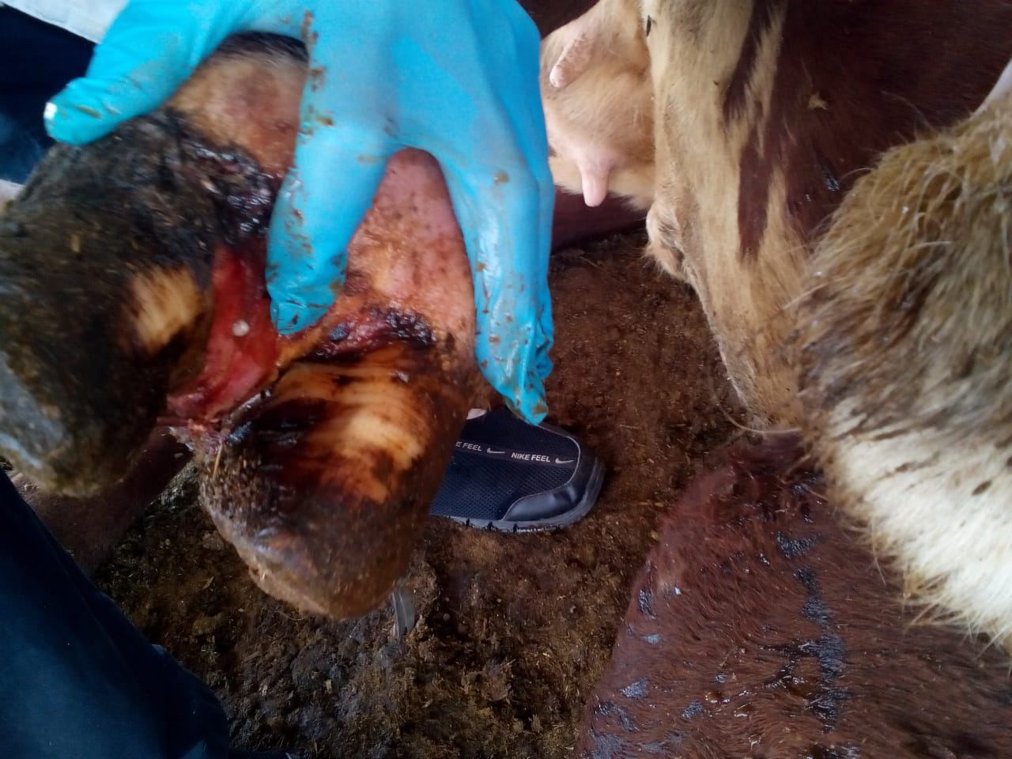 | 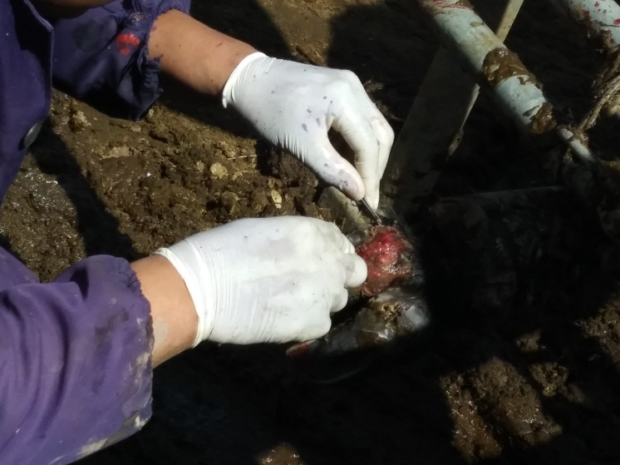
Figure 2 - Lesion of hooves in cattle | Figure 3 – Sampling of biomaterial from a sick cow

3.3 Isolation, indication and determination of type affiliation of necrobacteriosis causative agent in cattle
When studying the epizootic situation with cattle necrobacteriosis in 2018, 18 samples of pathological material were taken in 4 epizootic units. The samples of the pathological material were inoculated onto the Kitt-Tarozzi liquid medium. The inoculated test tubes were kept in a thermostat (ТСО-1/80 SPU mod 1005, 2016) at a temperature of 37°С for a day. When viewing the inoculations in a liquid medium, turbidity and a precipitate with gassing were observed. From 18 inoculated test tubes, culture growth was observed only in 14 ones. Microscopic examination of 14 samples of pathological material found that in 30-40% of cases spherical bacteria, 40-50% of bacteria and bacilli were isolated. In four samples, anaerobic microorganisms were found, culturally and morphologically similar to Fusobacteriumnecrophorum (long gram-negative threads).
Further, smears were prepared from the grown cultures and Gram stained. Microscopy was performed using a biological microscope (Digital binocular microscope DMVA200). The smears were dried in air, fixed by heating and Gram stained, and then examined under a light microscope.
The microflora was counted in 7-10 fields of view along the entire smear length, the average number of bacterial cells (M + t) was counted and deduced. In total, 14 preparations were tested bacterioscopically.
At the same time, the following results were obtained: in preparations Nos. 3, 10, 8, 12, a lot of gram-negative colored thin long filaments, rarely short and coccoid rods, and in preparations Nos. 1, 2, 3, 5, 7, 9, 11, 13, 14, 15 - many gram-negative polymorphic, sometimes long thin rods were observed.
After microscopic examination of stained preparations, the necrobacteriosis causative agent was purified from extraneous microflora by the Weinbrg and Drygalski methods. (figure 4-5).

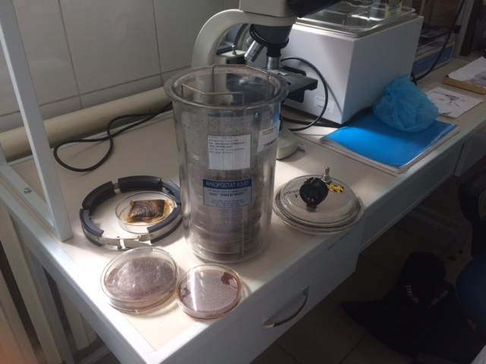 | 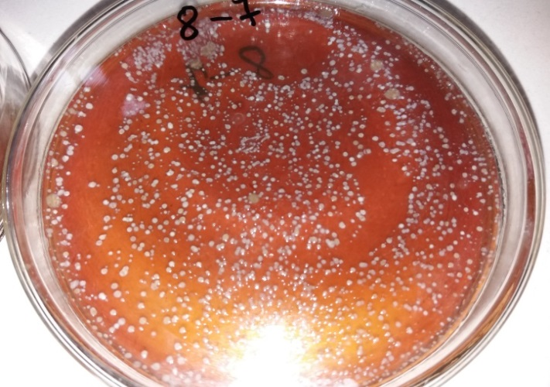
Figure 4 – Grown colonies at dilution | Figure 5 – Grown colonies

The growth of isolated colonies was observed on the second day, which were removed from the test tube by heating it with a burner.
The cultures were taken from the cut agar column with a loop for further study. The resulting colonies were placed in a liquid nutrient medium.
Further, in order to isolate a pure culture of the necrobacteriosis causative agent, white mice were used according to the standard method.
Thus, from cultures isolated from 18 samples of biomaterial, 4 pure cultures were obtained (figures 6, 7, 8, 9).

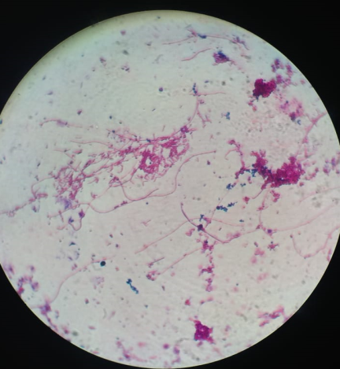 | 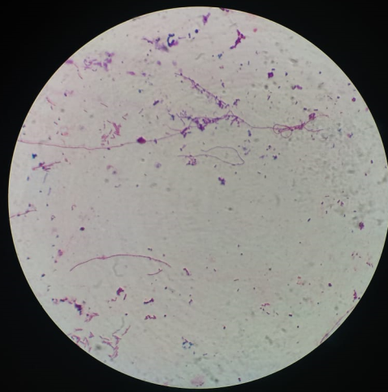
Figure 6 - Morphology of Fusobacteriumnecrophorum | Figure 7 - Morphology of Fusobacterium necrophorum
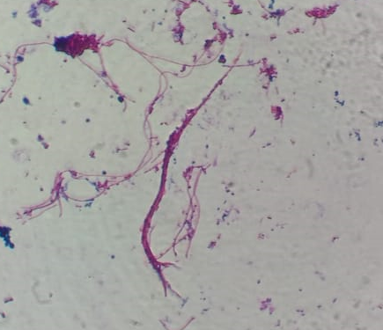 | 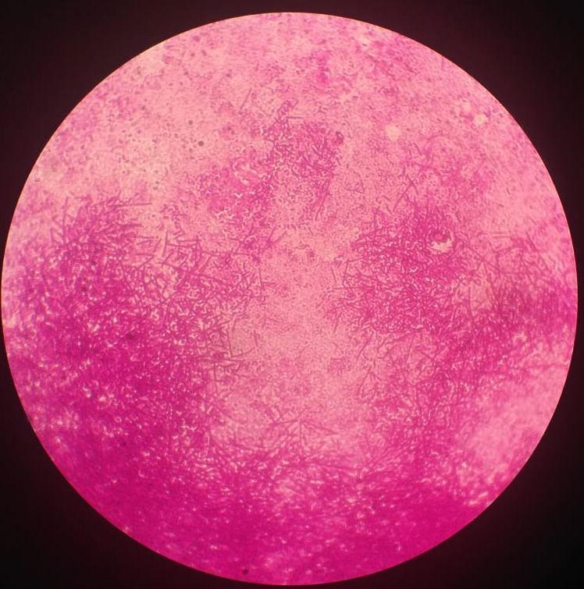
Figure 8 - Morphology of Fusobacterium necrophorum | Figure 9 - Morphology of Fusobacterium necrophorum

We further determined the biochemical properties of the isolated culture of F.necrophorum; by the release of hydrogen sulfide, determination of hemolytic activity, release of ammonia, hyaluronidase activity.
According to the results obtained, out of 14 isolated cultures, 4 strains (No. 3, 8, 10, 12) were classified as Fusobacteriumnecrophorum pathogen by morphological, cultural and physiological and biochemical properties. The affiliation of the isolated pure culture of necrobacteriosis was determined according to the Bergey’s manual (1997) [22].
3.4 Study the effect of the drug with lactic acid bacteria “Lactobacterin-TK²” on the pathogenic microflora isolated from the affected areas of the limbs of cattle, in-vitro in laboratory conditions
We studied the antagonistic activity with regard to 4 isolated cultures of necrobacteriosis pathogens. The antagonistic activity of strains of lactic acid bacteria Lb. acidophilus, 05ch, 15k-1, 022k, Lb. bulgaricus, 08ch-1,018k-3 against Fusobacterium necrophorum. The growth inhibition zone of Fusobacterium necrophorum fluctuated when studying the antagonistic activity and was higher in Lb. acidophilus, 15k-1 (18-20 mm) (figures 10, 11, 12, 13). The results of study for the antagonistic activity of lactic acid bacteria Lactobacillus acidophilus, 15k-1 (table 2).
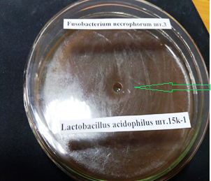 | 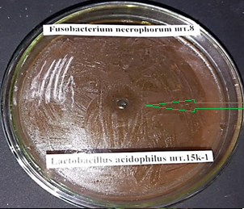
Figure 10 - Lactobacillusacidophilus, 15k-1 against F.necrophorum No.3 (growth inhibition zone 18 mm) | Figure 11 - Lactobacillusacidophilus, 15k-1 against F. necrophorum No.8 (growth inhibition zone 20 mm)
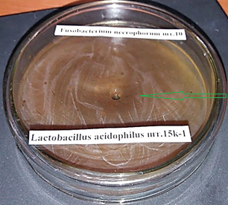 | 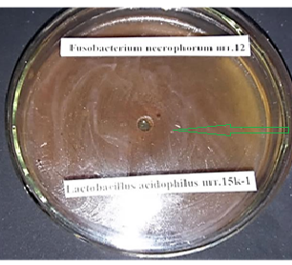
Figure 12 - Lactobacillusacidophilus, 15k-1 against F.necrophorum No.10 (growth inhibition zone 20 mm) | Figure 13 - Lactobacillus acidophilus, 15k-1 against F.necrophorum No.12 (growth inhibition zone 15 mm)

Table 2 - Comparative study of the antagonistic activity of strains of lactic acid bacteria
Lactobacillus strains | Fusobacterium necrophorum
Lactobacillus strains | №3 | №8 | №10 | №12
Lb.acidophilus, 05ch | 5 | 7 | 7 | 5
Lb.acidophilus, 015k-1 | 18 | 20 | 20 | 15
Lb.acidophilus, 022k | 7 | 7 | 7 | 7
Lb.bulgaricus, 08ch-1 | 6 | 8 | 8 | 6
Lb. bulgaricus, 018k-3 | 5 | 5 | 5 | 5
Note: up to 10 mm - low; 10-15 mm - medium; 15 mm and more - high antagonistic activity.

Thus, according to data in the presented Table 3, Lb. acidophilus No.015k-1 has the greatest antagonistic activity against the necrobacteriosis causative agents.

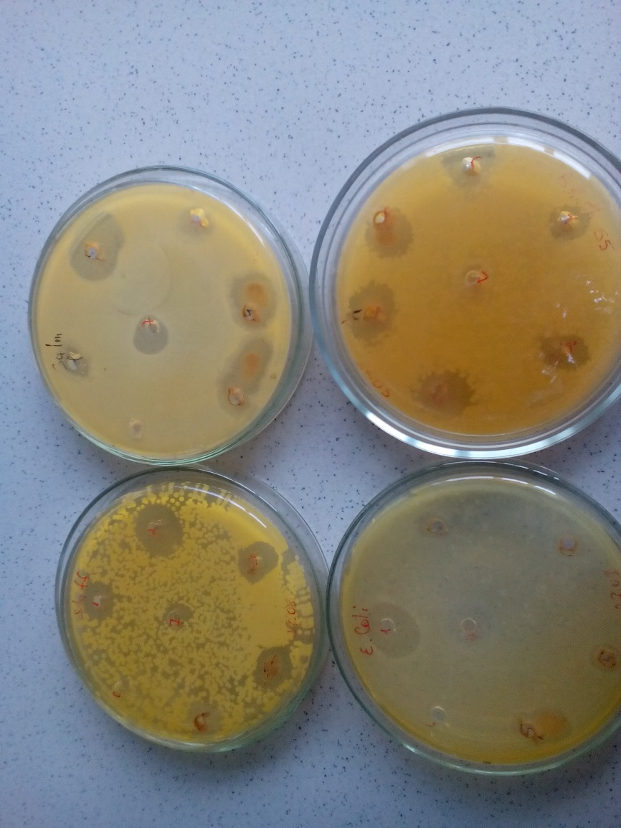
2
4
1
3
Figure 14 - Sensitivity of epizootic cultures Fus. necrophorum, E. coli, Diplococcus and Streptococcus to lactic acid bacteria
Figure 8 shows the result of an experiment to determine the sensitivity of epizootic cultures isolated from sick animals - Fus. necrophorum, E. coli, Diplococcus and Streptococcus to lactic acid bacteria. The figure clearly shows that when using combined options, i.e. lactic acid bacteria with antimicrobial drugs (disc No. 1, No. 3 and No. 4), the microorganism growth inhibition zones are much higher than when they are used alone, as well as when using pure antimicrobial drugs only.
We have determined the antagonistic properties of eight strains of lactic acid bacteria and yeast against new necrobacteriosis causative agents isolated from the affected limbs of cattle (figures 15, 16, 17, 18, 19, 20).

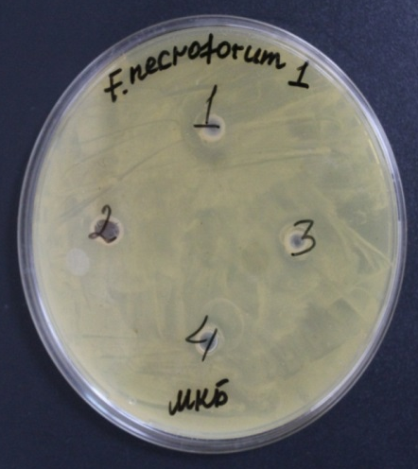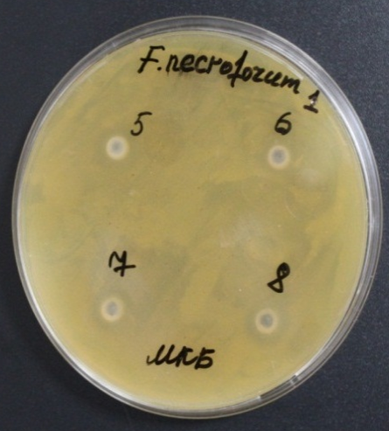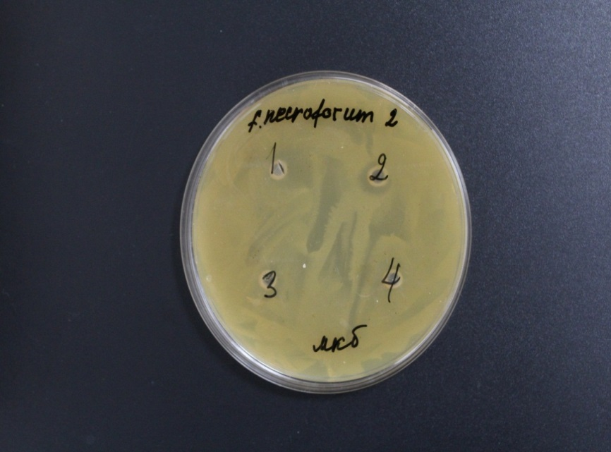
Figure 15 Figure 16 Figure 17
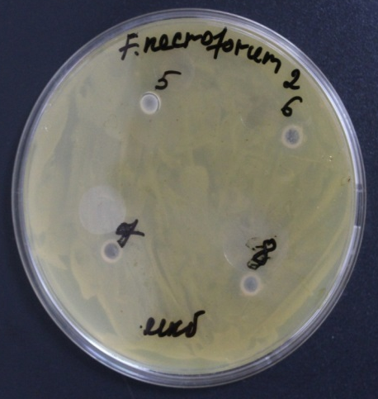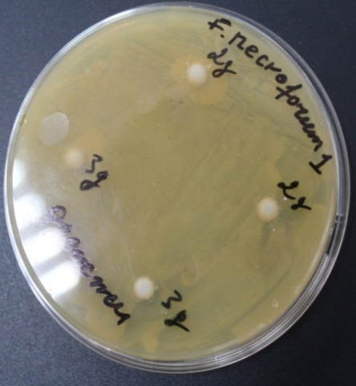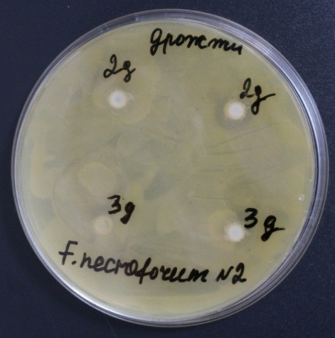
Figure 18 Figure 19 Figure 20
Figure 15-20 - Results of the experiment to determine the sensitivity of the necrobacteriosis causative agent - Fusobacterium necrophorum to various probiotic strains - antagonistic properties.

For the experiment, we used museum cultures - strains Lb.acidophilus 05ch (serial number 1), Lb.casei 012k (No. 2), Lb.acidophilus 015k-1 (No. 3), Lb.bulgaricus 021ch-1 (No. 4), Lb. casei 021ch-3 (No. 5), Lb.bulgaricus 018k-3 (No. 6), Lc.lactis 010k (No. 7), Lc.lactis 026k (No. 8) and two strains of the yeast Torulopsis spherica 13y (No. 2д), Torulopsis spherica 34y (No. 3д) against two necrobacteriosis causative agents - Fusobacterium necroforum, 3 (No. 1), 8 (No. 2).
As can be seen in Figures 15-16 the following strains of lactic acid bacteria had antagonistic activity against Fusobacterium necroforum. 3: Lb.acidophilus 05ch (No. 1), Lb.casei 012k (No. 2), Lb.acidophilus 015k-1 (No. 3), Lb.casei 021ch-3 (No. 5), Lc. lactis 010k (No. 7), Lc.lactis 026k (No. 8), the inhibition zone was within 10-15 mm (Fig. 1, 2), out of yeast Torulopsis spherica 13y (No. 2e), Torulopsis spherica 34y (No. 3e) the inhibition zone was within 10-12 mm (Figure 13).
Antagonistic activity against F.necroforum. 8 (No. 2) had lactic acid bacteria - Lb.casei 012k (No. 2), Lb.casei 021ch-3 (No. 5), Lb.bulgaricus 018k-3 (No. 6), Lc.lactis 010k (No. 7) , Lc.lactis 026k (No. 8), the inhibition zone was within 10-13 mm (Fig. 3, 4), and yeast Torulopsis spherica 13y (No. 2e), Torulopsis spherica 34y (No. 3e) with inhibition zone within 10-12 mm (Figure 14).
It should be noted that Lactobacillus acidophilus 015k-1 included in Lactobacterin-TK² showed the highest antagonistic activity. Therefore, we further tested this drug only.
Most of the drugs used for necrobacteriosis have either antimicrobial or dehydrating effect only.
In addition, in diseases of the limbs, the affected organ is constantly in contact with the soil and other environmental objects and minor damages to the skin integrity leads to inoculation of the wound with various bacterial flora and the additional inflammatory processes occur.
Taking into account the foregoing, we carried out the work to determine the concomitant microflora existing in necrobacteriosis pathology in animals. Studies have shown that during the necrobacteriosis process, in addition to the main pathogen Fusobacterium necrophorum, both aerobic and anaerobic cultures were released.
At the same time, the majority of the samples obtained contained coccal microflora, in particular: Streptococcus (85%) and Staphilococcus (80%), as well as E. coli (35%). Anaerobic cultures were identified as: Clostridium perfingens (65%) and Clostridium septicum (30%). It should be noted that when studying the biological properties of these microorganisms, their high virulence was established in experiments on laboratory animals (white mice) (figure 21).

Figure 21 - Concomitant microorganisms in the necrobacteriosis process in animals
3.5 Study the therapeutic effect of Lactobacterin-TK² in cattle necrobacteriosis
The control of epizootic situation in the winter-spring period showed that this complex keeps sick animals with various pathologies of the limbs, while the largest number of sick animals was found on a dairy farm. In the course of work, 835 animals were repeatedly examined. Treatment of animals with medium necrobacteriosis in hooves was combined with surgical treatment of the affected limbs, in particular, mechanical cleaning of the hoof horn and toilet of the lesion with 3% hydrogen peroxide. The criterion of effectiveness were such indicators as: recovery or culling of animals, as well as the duration of their treatment.
We studied the environmentally friendly lactic acid bacteria in cattle necrobacteriosis.
We studied several epizootic units, where animals with necrobacteriosis were identified to study the therapeutic efficacy of Lactobacterin-TK²: 34 cattle - Baiserke-Agro LLP, Ili district, 10 cattle - Nurzhan Farm, Aksu district, 5 sheep, 4 goats - K-Anar Farm, Talgar district, 2 cattle - SHP DARNIS LLP, 3 cattle - PZ Almaty SPK, Talgar district, 7 cattle - Samsybayev M. Farm, Zhambyl district, 6 cattle - Zhetysu asyl tukym SPK, 4 cattle – Sargaldakov Farm, Eskeldinsky district, 4 cattle – Kasymzhan Farm, Panfilov district, Almaty region.
At CDF of Baiserke-Agro LLP 33 cattle with necrobacteriosis were selected for the experiment.
For the experiment, experimental animals were selected with initial and medium lesion characterized by mild lameness, superficial purulent-inflammatory skin lesions in the area of ​​the interdigital fissure and torus, inflammatory edema or serous secretions on the skin between the finger rudiments and torus.
Three groups, two experimental and one control, were formed. Animals of the first experimental group (12 animals) received complex treatment, which included the use of antimicrobial drug in combination with application of lactic acid bacteria to the affected limbs. The second group of experimental animals (12 cows) administered lactic acid bacteria only in the form of local treatments.
9 cows of the third group were the control of the experiment and received the conventional in this farm treatment against necrobacteriosis, i.e. antimicrobial drag “Nitox 200”, and additional local treatment with Chemisprey.
Taking into account that effective drugs in case of their long-term use gradually decrease their activity, the purulent lesions in all experimental animals, i.e. both with initial and medium form of the disease were treated in several stages. In all cases, the sick animals underwent primary surgical treatment with stopping bleeding, then sanitation of the wound surface, followed by the use of the above treatment regimens (figure 22).
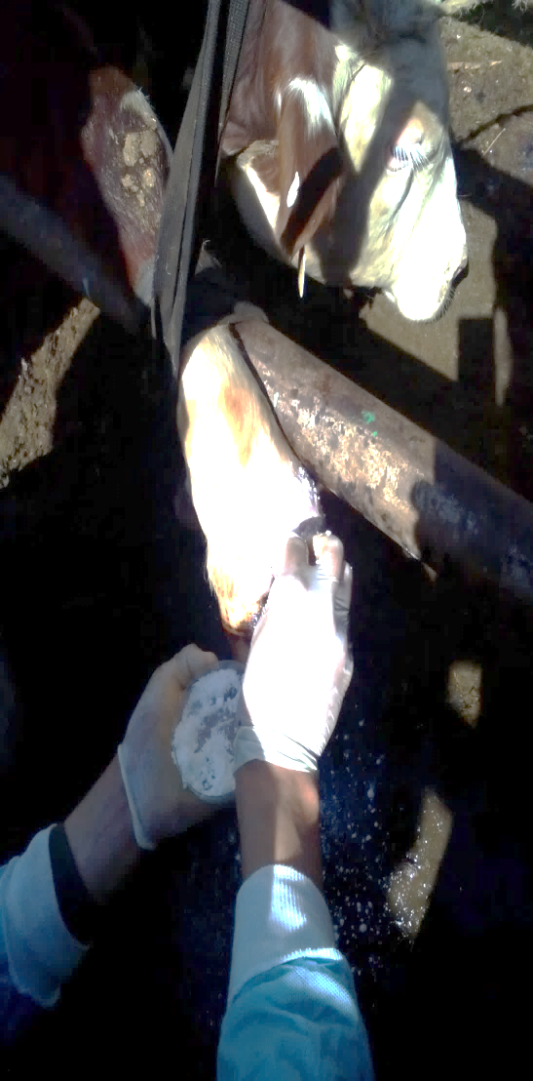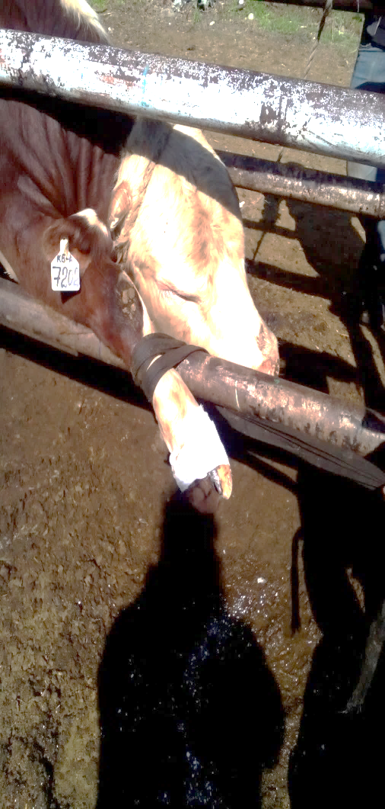
Figure 22 - Application of lactic acid bacteria to the affected limb of the animal and application of a bandage
For fixation and maximum preservation of the drug, the wound top surface was fixed with sterile wrapping and bandage for a long time.
The course of treatment for animals of the first and second experimental groups with the lactic acid bacteria included their application for three days, if necessary, the treatment was repeated. The animals of the control group (9 animals) administered the antimicrobial drug “Nitox 200” only, according to the approved instructions. The use of lactic acid bacteria for the wounds treatment at all stages of complex treatment makes it possible to shorten the period of systemic antimicrobial therapy, avoid the development of side effects, significantly reduce the costs for expensive antibacterial drugs, and avoid the formation of microflora resistance to used systemic antibiotics. Thus, the studies have shown that lactic acid bacteria in the treatment of necrobacteriotic lesions have an anti-edema and anti-inflammatory effect, are an effective agent, and also stimulate regeneration processes, accelerate the growth and maturation of granulation tissue. Clinical examination and observation over the experimental and control animals were carried out on a daily basis, noting the timing of the positive dynamics of regeneration processes.
Studies have shown that in complex treatment of sick animals, including a combination of an antimicrobial drug and the application of a bandage with lactic acid bacteria, on a surgically cleansed wound surface, the appearance of granulation tissue was noted on days 5-6, wound healing on days 7-8, and clinical recovery was observed on days 9-11.
When using lactic acid bacteria only for animals of the second experimental group, a positive dynamics was noted with a longer course of treatment. So, in this group, the granulation process was noted on days 4-5, and the recovery of all 9 animals was recorded after 9 days.
In control animals, on days 15-16, the wound cavity was filled with granulation tissue, the epithelial rim was clearly visible, the edges of the wound are brought together; complete healing occurred on days 20-21 (table 3).
Table 3 - The effectiveness of Lactobacterin TK², antimicrobial drugs and their combined use in necrobacteriosis
Groups of animals | Quantity | Type of drag | Wound healing | Recovery of animals
1-experimental | 12 | Antimicrobial drag “Nitox 200” in combination with application of lactic acid bacteria | day 6 | day 10
2-experimental | 12 | Lactic acid bacteria “Lactobacterin TK²” | day 5 | day 9
Control | 9 | Antimicrobial drag “Nitox 200” | day 16 | day 21
Similar production tests were carried out in other farms in Almaty region as listed above.
Thus, the studies have shown that treatment of necrobacteriosis lesions in animals using lactic acid bacteria included into Lactobacterin TK², when applied locally, promotes rapid wound healing, and in case of medium lesions only, it is advisable to use Lactobacterin TK with the antimicrobial drug “Nitox 200”. During the use of the experimental lactic acid bacteria, no undesirable reactions of the body, toxic and local irritating effects, were observed, and the therapeutic effect in all three groups was 100%.
Similar tests were carried out in other farms listed above( figures 23-24).
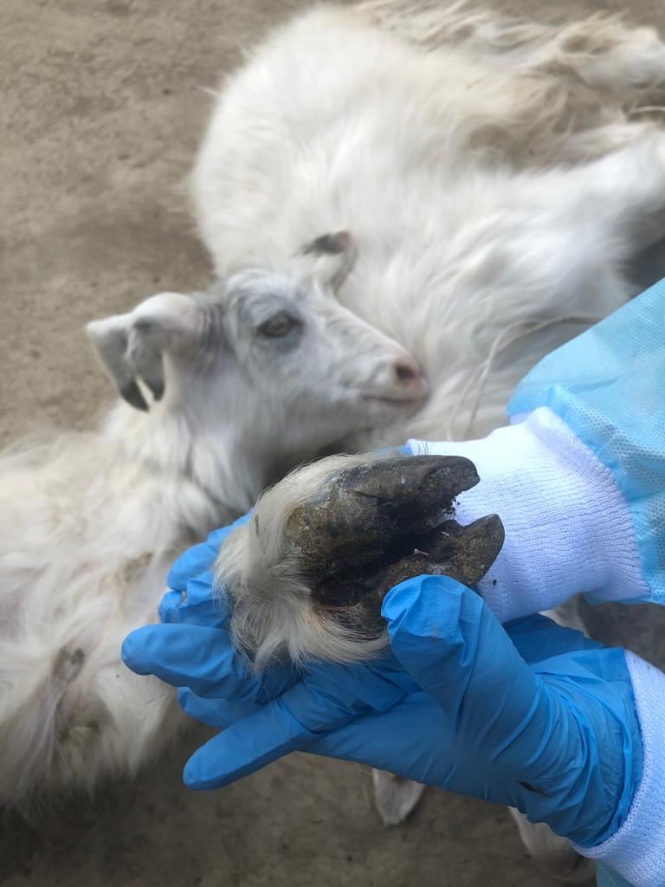 | 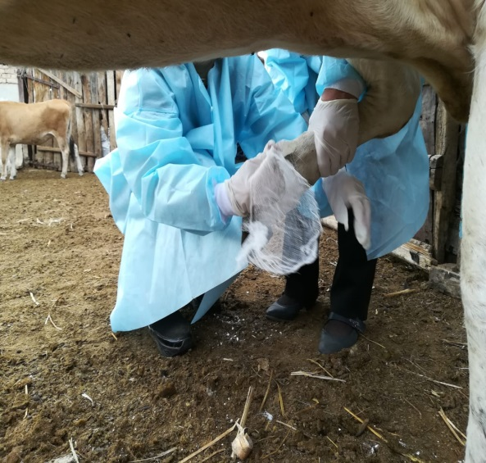
Figure 23 - Signs of necrobacteriosis in goats | Figure 24 - Preparation and applications for necrobacteriosis

3.6 Pathomorphological, histological and histochemical control of influence of the lactic acid bacteria in animals with necrobacteriosis on regeneration of the affected tissues.
The result of pathologic-histological manifestations of the skin of cattle with necrobacteriosis. The pathological morphology of cattle necrobacteriosis is characterized by purulent inflammation of the skin and phlegmon. The marked visible inflammatory processes developed between the joints that resulted in deeply developed holes. A purulent-rotten exudate of gray-green color, mixed with blood, formed from the holes.
The anatomicopathological changes are often isolated at the areas of entry and development of the pathogen. Necrotic ulcers of the extremities are located in the veins, counter-steam folds of the skin, back wall of the hoof or in the sole. Primary necrosis appears in the scalp, often in wide wound sites around the lips and nose. The head is swollen, the hair around the mouth is covered, and the pus is covered with short dry hair. In case of damage to the mucous membrane of the oral cavity, ulcers are determined inward, covered with a purulent film with thickness of the surfaces of the shavings, hard larynx.
Dead foci and bleeding appear on the bones of the fingers, absorption in the bone tissue and signs of exostasis appear (figure 25). In infected cattle, during autopsy, it was noted that dead foci of gray, gray-yellow color, with pronounced borders, with loose deposits were formed in the affected areas of the mucous membrane of the oral cavity, tongue, pharynx.
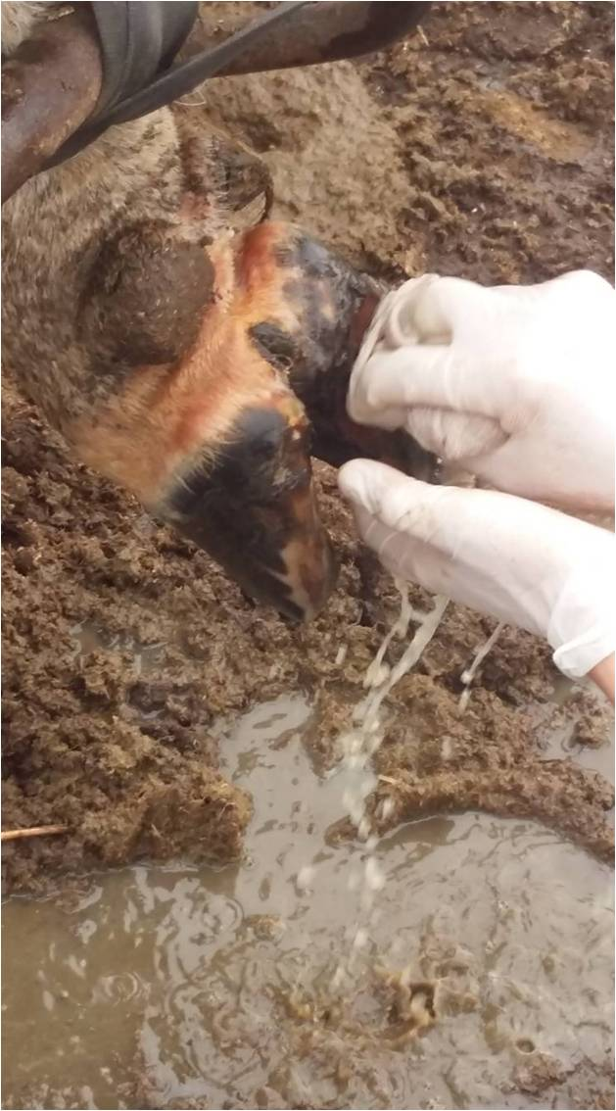 | 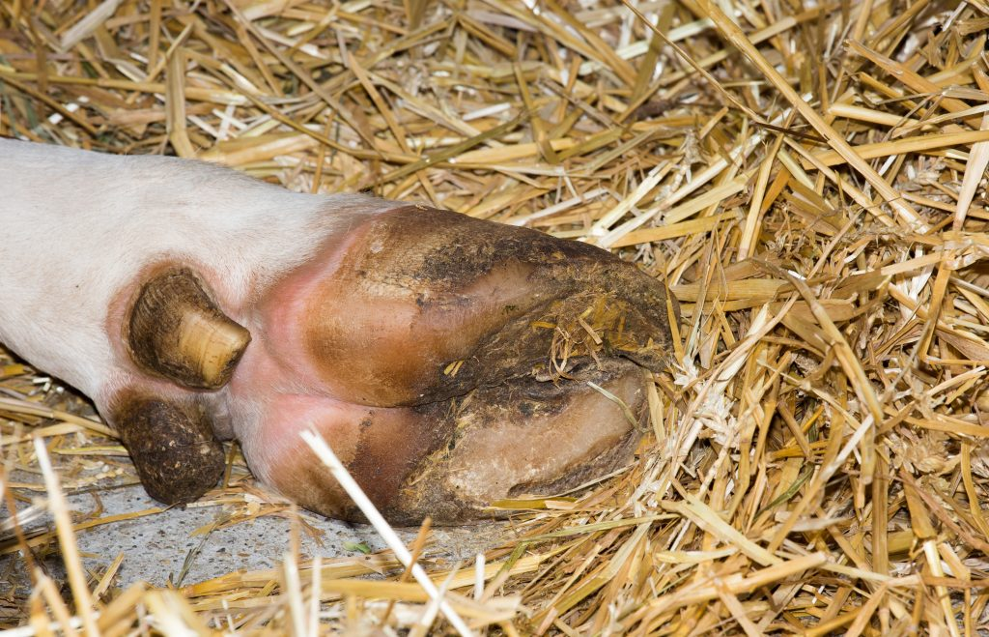
Figure 25 – Symptoms of exostasis in bone tissue

In addition, the pathological anatomical examination revealed the significant symptoms of the disease in the uterus. The uterus was overgrown, the mucous membrane was swollen, covered with gray-green, grayish deposits with unpleasant smell, and there were deposits of fibrin in the moist membrane. Due to the acute and chronic course of the disease in cattle, the pathomorphological nature is chronic, the cows have mild lameness, and then completely unable to move. Looking at the notch between the hooves, the inner soft parts of the hooves, we noticed a dense, hot and very painful bulge that turned red.
The swollen area is moistened with sticky mucus and dried, followed by crusting. Some animals develop purulent blisters and ulcers, and some areas have dried out and become scabs.
Necrotic phenomena moderately spread to neighboring tissues. With repeated damage to necrotic foci of the skin, deeper painful ulcers appeared. Necrosis gradually passed from the skin to deeper tissues, tendons, ligaments and even bones. At the same time, cavities with an acute bulge and purulent fistulas were formed between the hooves.
In acute form, the cows refused to stand up. The purulent necrosis spreads to the skin under the cornea of the hoof, and the hooves fell off. The anatomicopathological examination revealed the development of sepsis and metastasis of the pathogen into the internal organs. Generally, any type of animal can be affected with necrobacteriosis with histological characteristic changes in the skin: the epithelium was removed with covering the damaged skin and mucous membranes; there was a basophilic colored, granular, unstructured mass in place. Focal necrosis is limited to stripes of macrophages, lymphocytes, neutrophils, fibroblasts and blood vessels (figure 26).
When staining the damaged tissue with hematoxylin-eosin using the Romanowsky-Giemsa method, we found the pathogen in the form of pale-colored fibers.
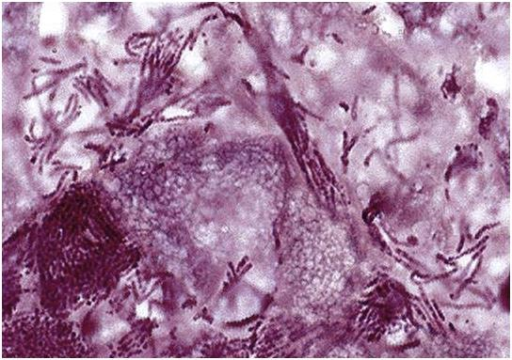
Figure 26 – Identified pathogen Fusobacterium necrophorum and damage to fibrous structure of the skin
During the histopathological examination of internal organs, the following changes were additionally established: hydration and granular degeneration in the liver, karyolysis and plasmolysis of hepatocytes, venous hemorrhages and focal hemorrhages (figure 27).

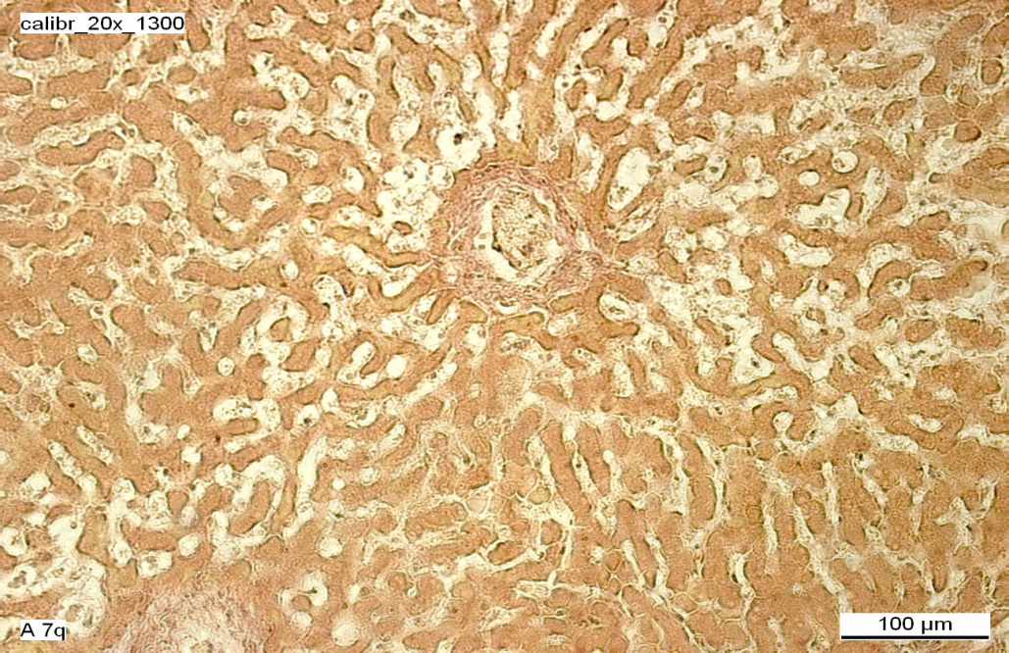
Figure 27 – Hepatic dystrophy and hemorrhage. Van Gieson staining, х100
At the same time, the proliferation of neutrophilic leukocytes was found in large blood vessels under conditions of phagocytosis and karyorrhexis, granular, hydration and fatty degeneration in the kidneys, tubular epithelial necrosis, serous glomerulonephritis and venous hyperemia (figure 28).

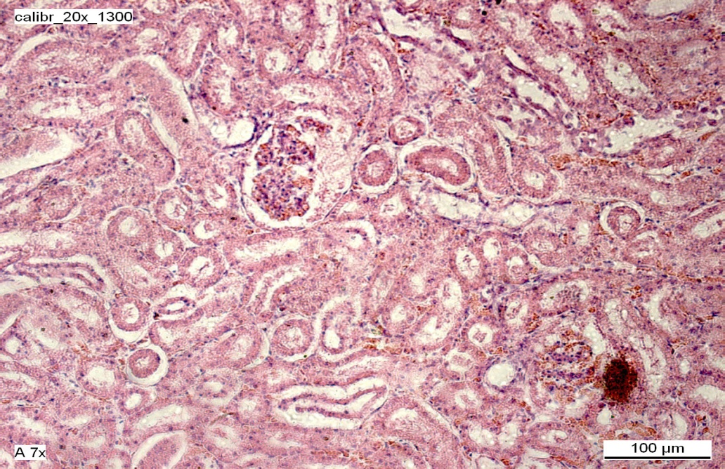
Figure 28 – Granular dystrophy of the kidney
Atrophy of lymphatic follicles in lymph nodes, karyorrhexis and high neutrophilic leukocytes in the form of phagocytosis and necrosis in arteries and veins. Figure 29. Focal necrosis of the spleen, follicular atrophy, venous hyperemia (figures 29, 30).
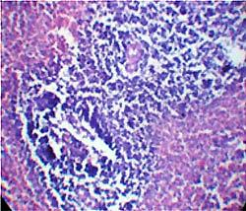 | 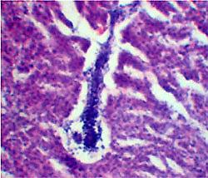
Figure 29 – Bunch of neutrophilic leukocytes in the form of necrosis in the lymph nodes | Figure 30 – Necrosis, atrophy and redness of the spleen

Atrophy of epithelium of the mucous membrane in the rumen, chronic proliferative inflammation of the connective tissue. Purulent-necrotic inflammation of the uterus, proliferation of neutrophilic leukocytes. Interstitial emphysema of the lungs, focal purulent-catarrhal pneumonia, venous hyperemia and edema (Figure 31).
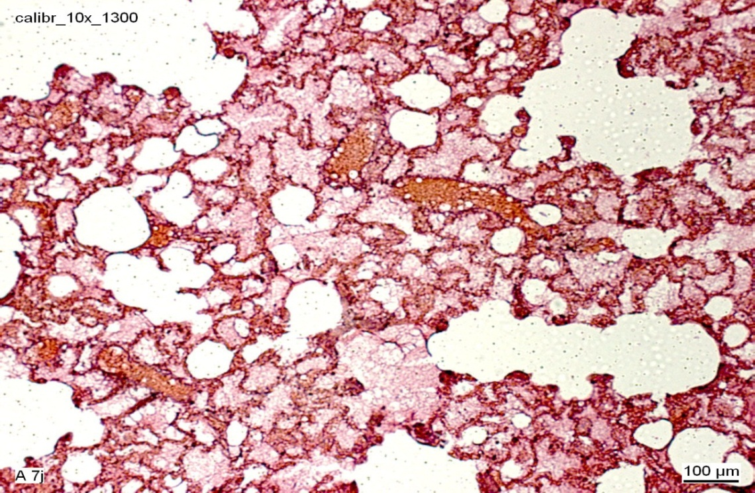
Figure 31 – Emphysema and hyperemia of the lungs
These histopathological changes are characteristic for chronic necrobacteriosis associated with purulent bacterial microflora. The combination of lesions of different organisms may indicate a mixed or associative nature of the infection.
Macroscopic characteristics of cattle skin after treatment of necrobacteriosis with probiotic drug “Lactobacterin-TK²”.
Before taking the therapeutic measures using the probiotic drug “Lactobacterin-TK²”, we studied in detail the skin of the animals and entered the data in the registration log. Before using the drug, the macrocharacteristic of the skin looks like as follows: the skin is naked, there is dried pus on it, edematous (phlegmon). The inflammatory process has penetrated deep into the joint.
A purulent- putrefactive exudate, gray-green in color, mixed with blood, flows out of the gaps that have arisen (figure 32).

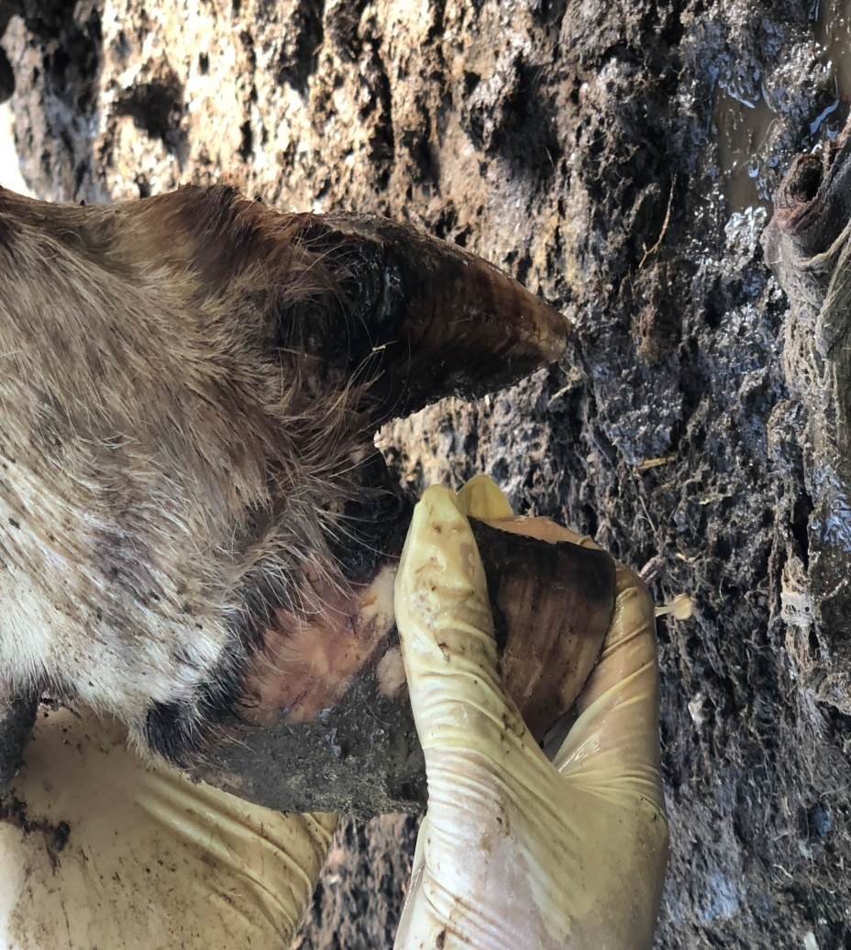
Figure 32 – Release of purulent-putrefactive exudate mixed with blood (first day of research)

Macrocharacteristics of the skin after 3 days of research: Dead foci, hemorrhages appeared on the bones of the fingers, exostoses were observed. The release of purulent exudate completely stopped, edema was observed in the necrotic area only (figure 33).

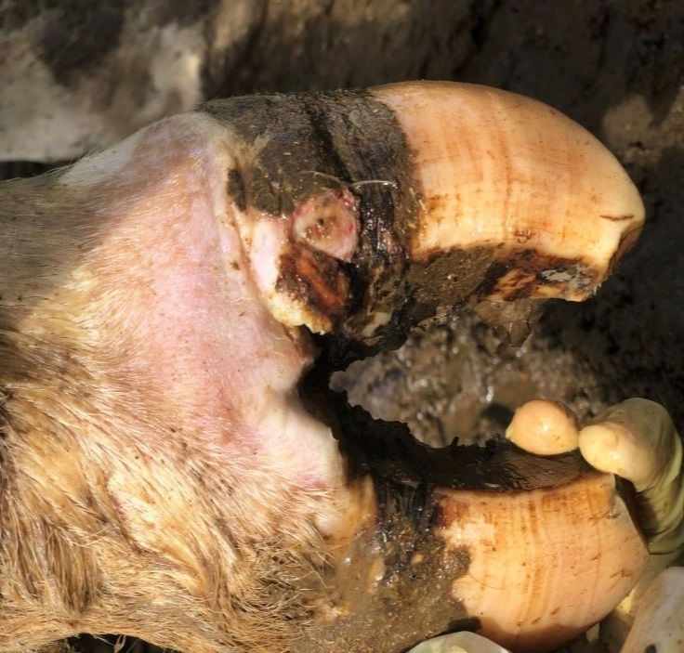 | 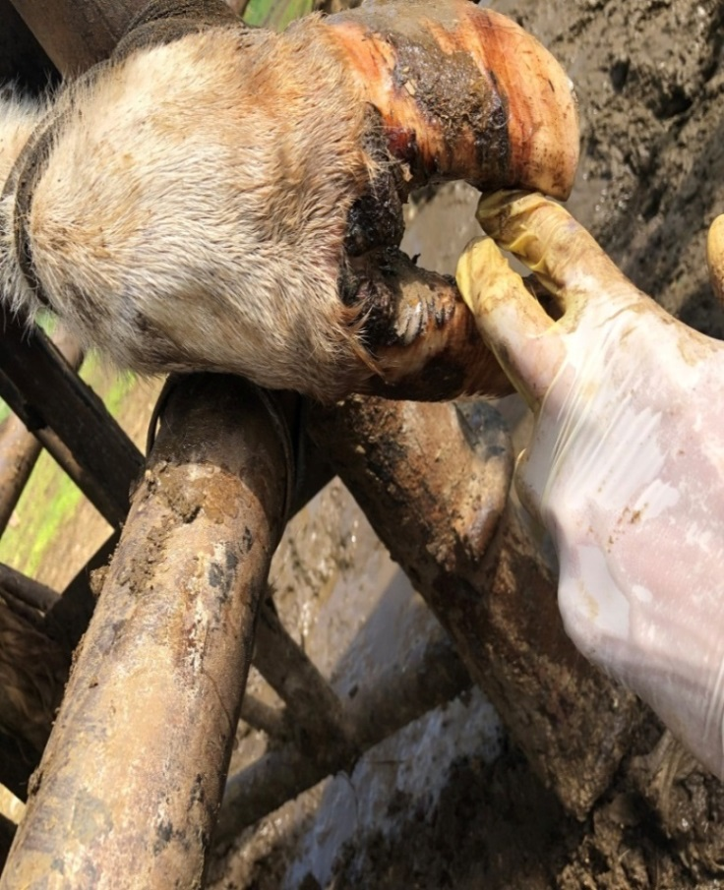
Figure 33 – Edema and necrosis of the skin (3 days after the start of treatment)

Macrocharacteristics of the skin after complete recovery: The necrotic area of the skin turned red, which means the normalization of the mucous membranes, slight edema is observed only in deep tissues, tendons, ligaments and bones damaged by necrotization of the deep area of the skin. The skin is completely cleared of pus and, due to the granulation process, the process of reparative regeneration occurs in the area where necrosis was observed (figures 34, 35).

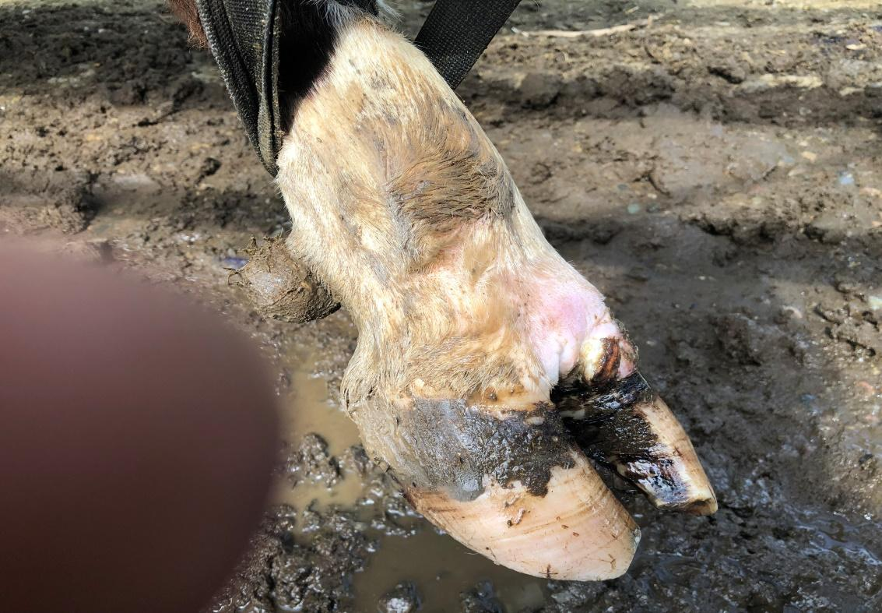
Figure 34 - Emergence of the skin reparative regeneration process

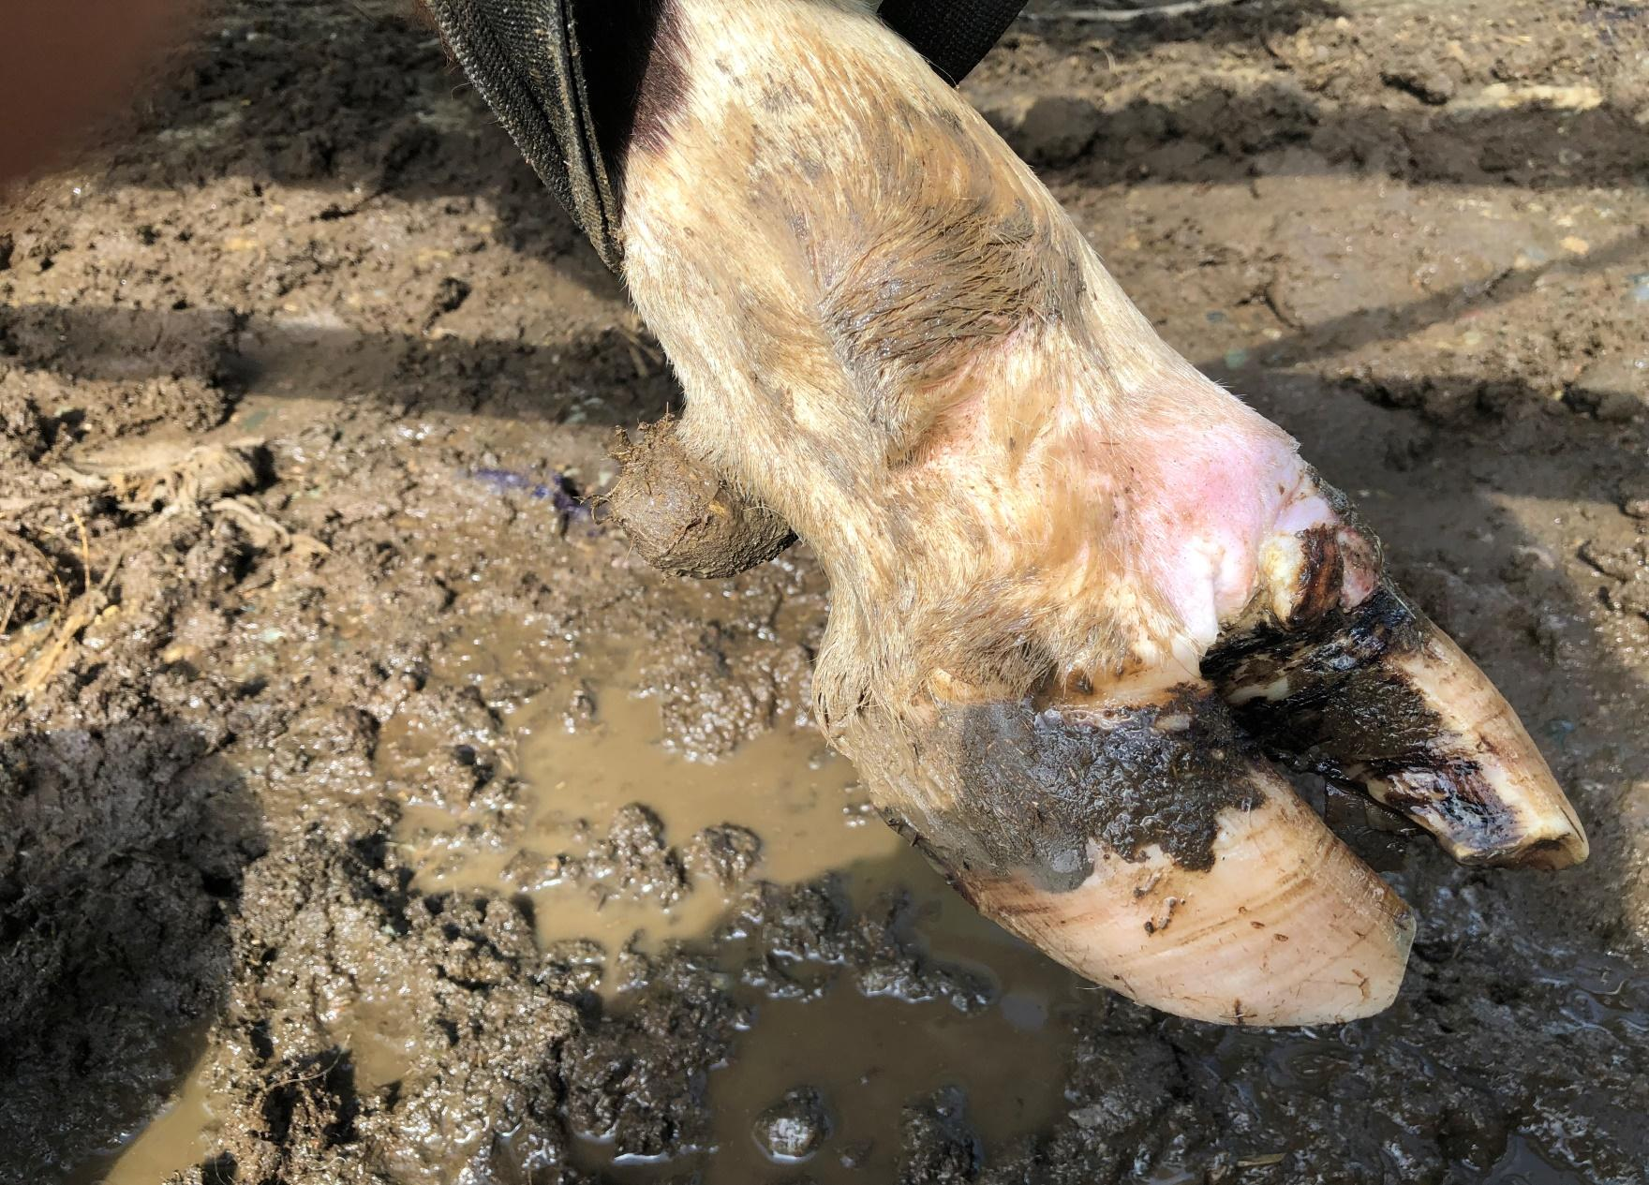
Figure 35 - Manifestation of reversible nature of the skin necrosis process
(Full recovery)
Results of histological and histochemical examination of the skin and muscles after therapeutic procedures
In order to identify the effect of therapeutic measures and histological and histochemical studies, we took the skin and muscles, since the used probiotic drag with local effect, the mechanism of action is mainly observed on the skin and muscles.
Histological character of muscles and skin before treatment: histological examination showed myocytes with smooth, longitudinal and transverse lines of muscle fibers in the tissues. Subcutaneous tissue is represented by connective tissue elements. In the affected focus, there was vascular hyperemia, edema of the perivascular space. Subcutaneous connective tissue was infected with mononuclear phagocytes. The muscle fibers became thick, the existence of histiocytic infiltrates of the intersystem connective tissue was revealed. Signs of edema were observed in the subcutaneous tissue, intermuscular and perivascular spaces. The veins were completely bloody, the walls were stretched, the edges of the lymphocytes stood in the opening of the vessels. The subcutaneous tissue contains a small amount of mononuclear phagocytes and lymphocytes. Microscopic examination of the skin wall showed the blood vessels of the mucous membranes and their endothelium.
The lymphocytic infiltrates were observed in the periarterial zone. The epithelium of the mucous membrane in some places of the mucosa, the papillae were deformed, the macrophages were in the cytoplasm with phagocytosed tissue, and we also saw the causative agent of the disease in the form of weakly colored filaments (figures 36, 37).
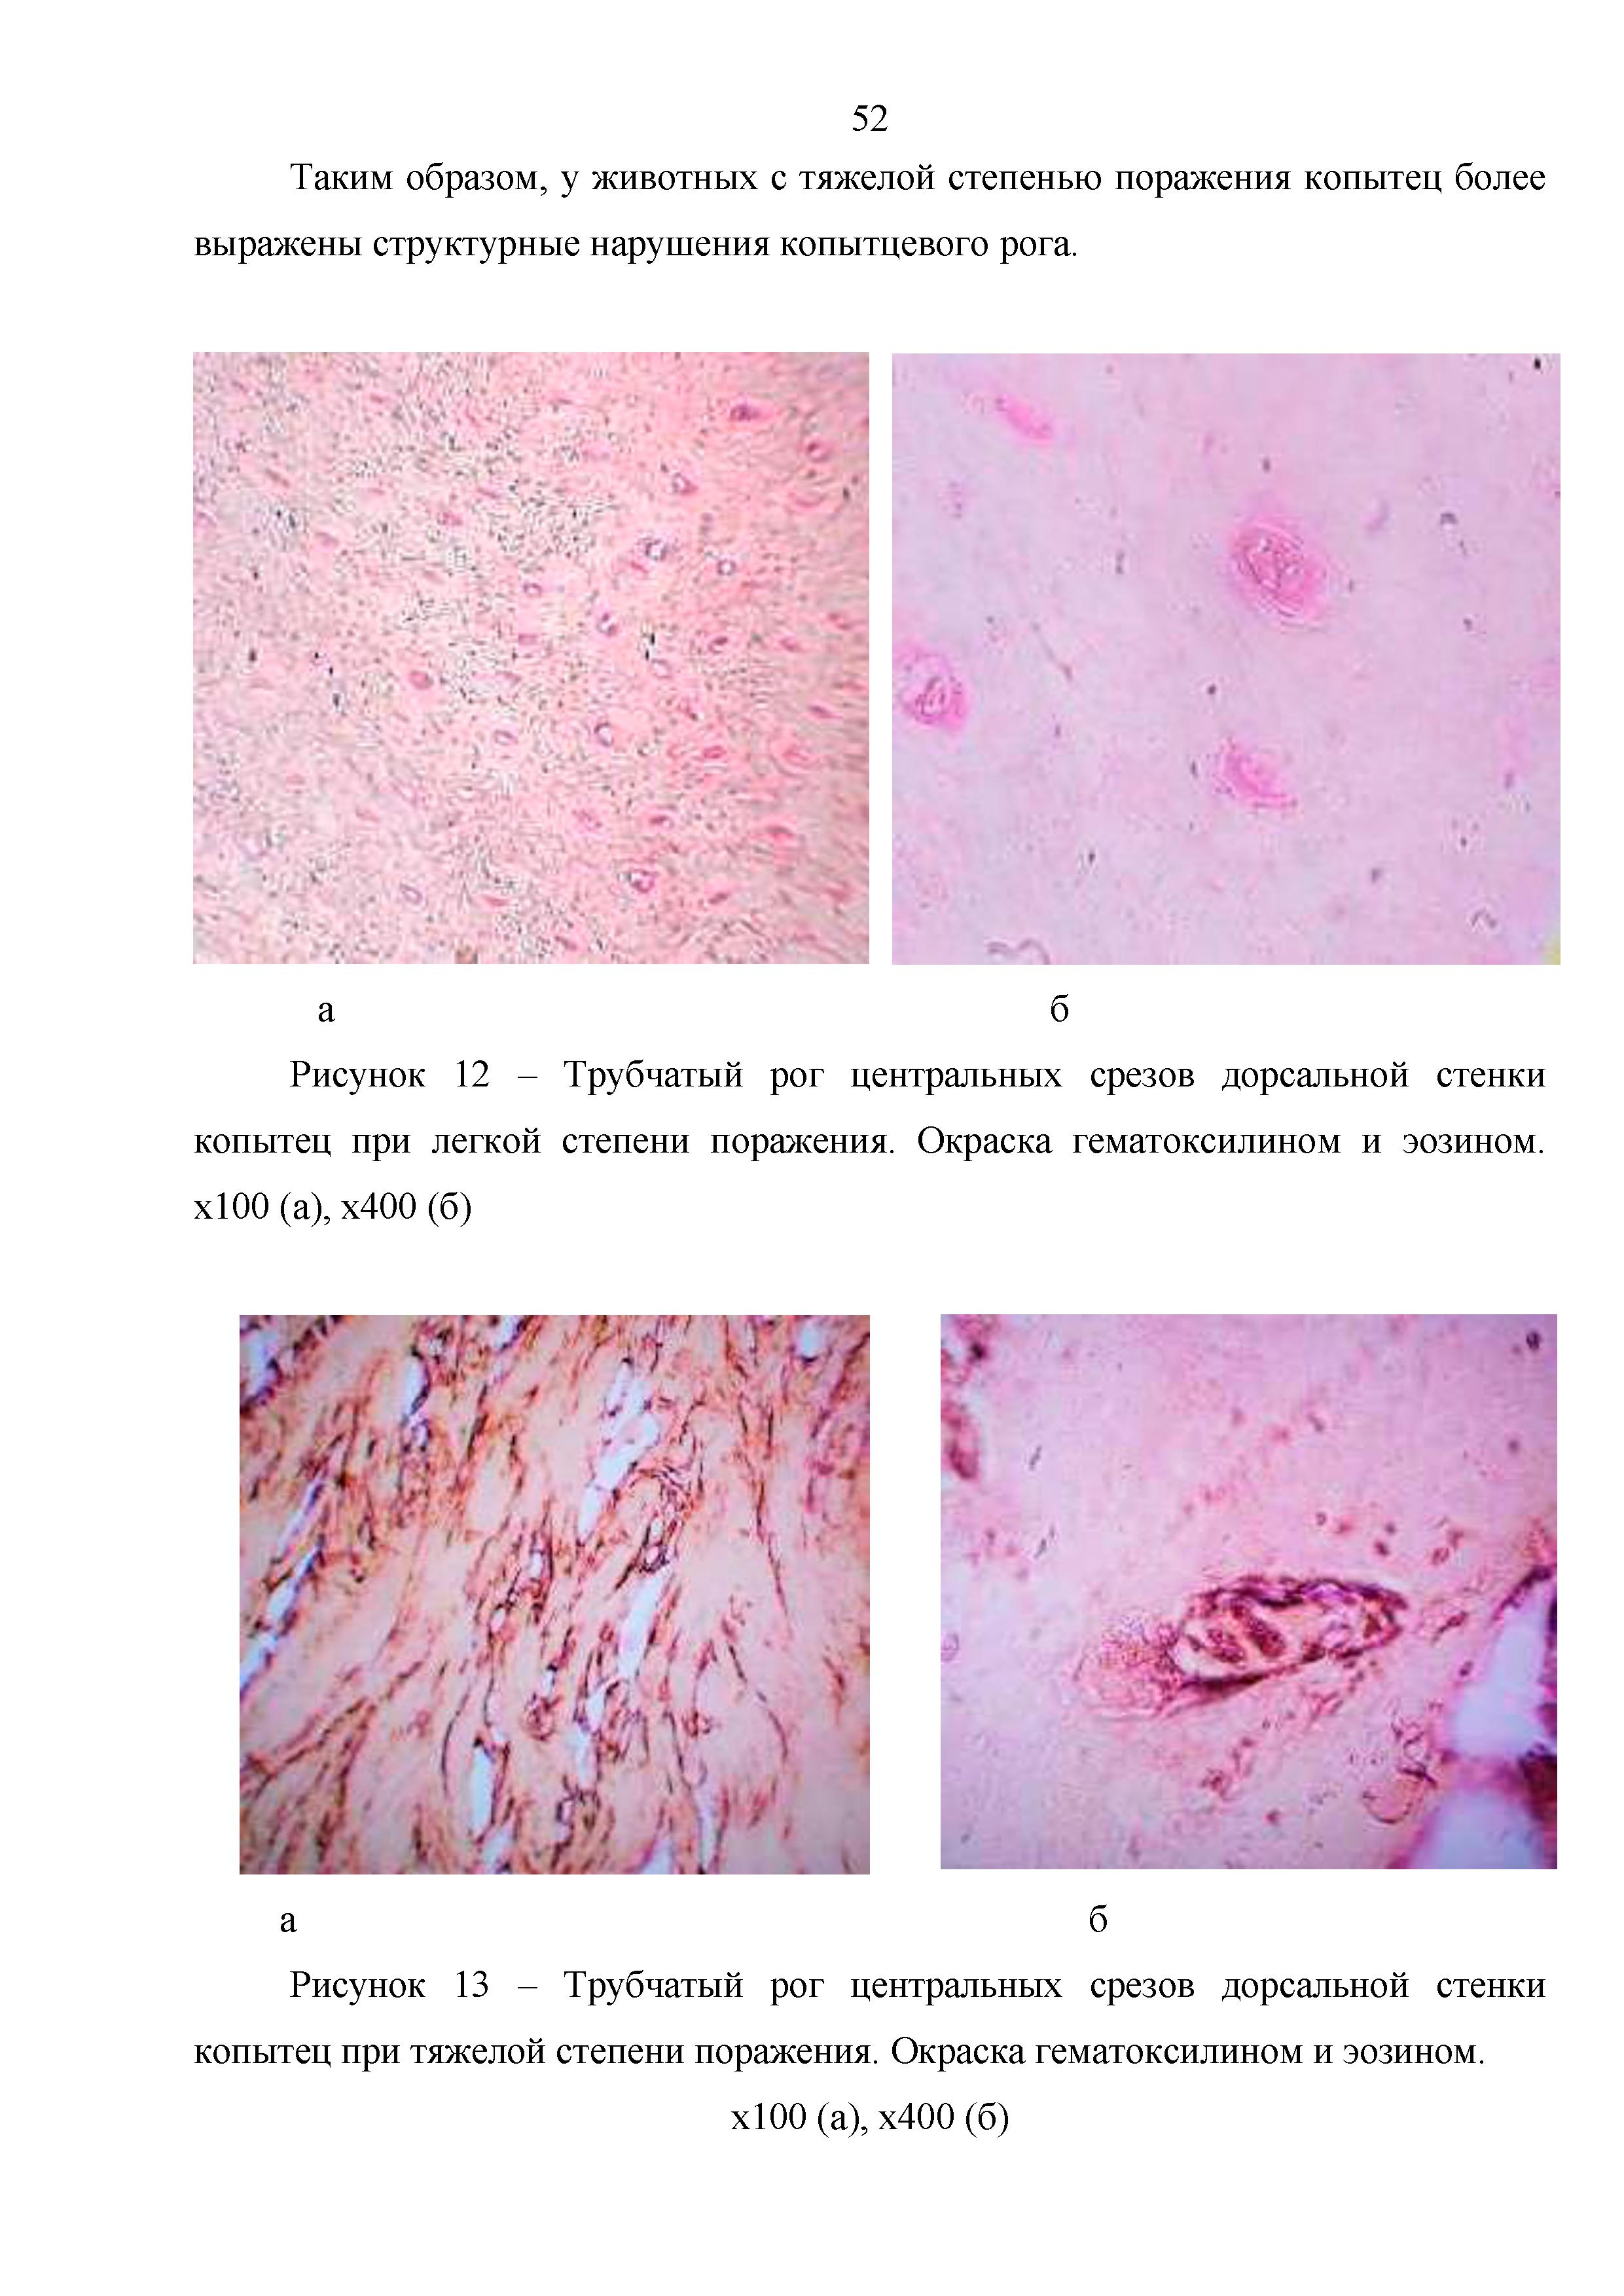 | 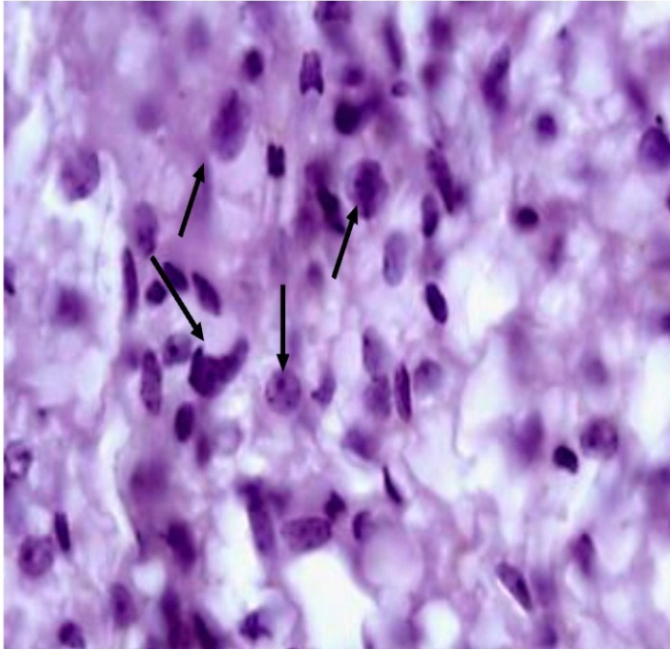
Figure 36 - Skin. Ccausative agent of the disease in the form of tubular horns and filaments in the dorsal membrane | Figure 37 – Muscles. Accumulation of macro facts. (Manifestation before treatment)

The nature of the skin and muscles 3 days after the treatment. We determined the proliferation with histiocytes in the intermuscular space, mixed infiltration, in the subcutaneous connective tissue in small numbers of lymphocytes and histiocytes. The infiltration of histiocytic cells was most often noted. Infiltration was observed mainly with mononuclear phagocytes and individual lymphocytes. Hyperemia, swelling in the intermuscle space occurred. The muscle fibers were folded, the transverse and longitudinal lines of the fibers were preserved. Histological examination of the cicatricial wall of the skin visualized the average blood volume in cows with a mild damage, healthy animals and hooves, a slight infiltration of lymphoid cells was revealed. The epithelium of the mucous membrane was formed in some places. The lesion of the affected skin was found with loosened, filled with neutrophilic granulocytes and lymphocytes. Most of the damaged cells were visualized. Macrophages in the cytoplasm were with phagocytosed tissue (figures 38, 39).
 | 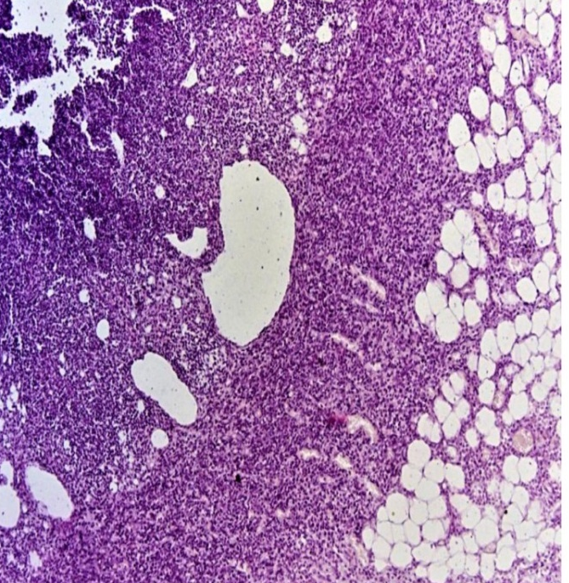
Figure 39 – Skin. Blood circulation in the dorsal membrane (hyperemia) | Figure 40 – Muscles. Foci filled with neutrophilic granulocytes and lymphocytes
The manifestation on the skin and muscles a week later: in the damaged area, infiltrates were often found, represented by histiocytic cells and neutrophilic granulocytes. Infiltrates were mainly represented by mononuclear phagocytes and lymphocytes, and histiocytes were also included into the infiltrates. However, in healing area and affected area, there were mainly neutrophilic granulocytes, which indicated the development of an acute inflammatory reaction, which was associated with the mezynchemical response of the body to the external environment and disease (figures 41, 42).
 | 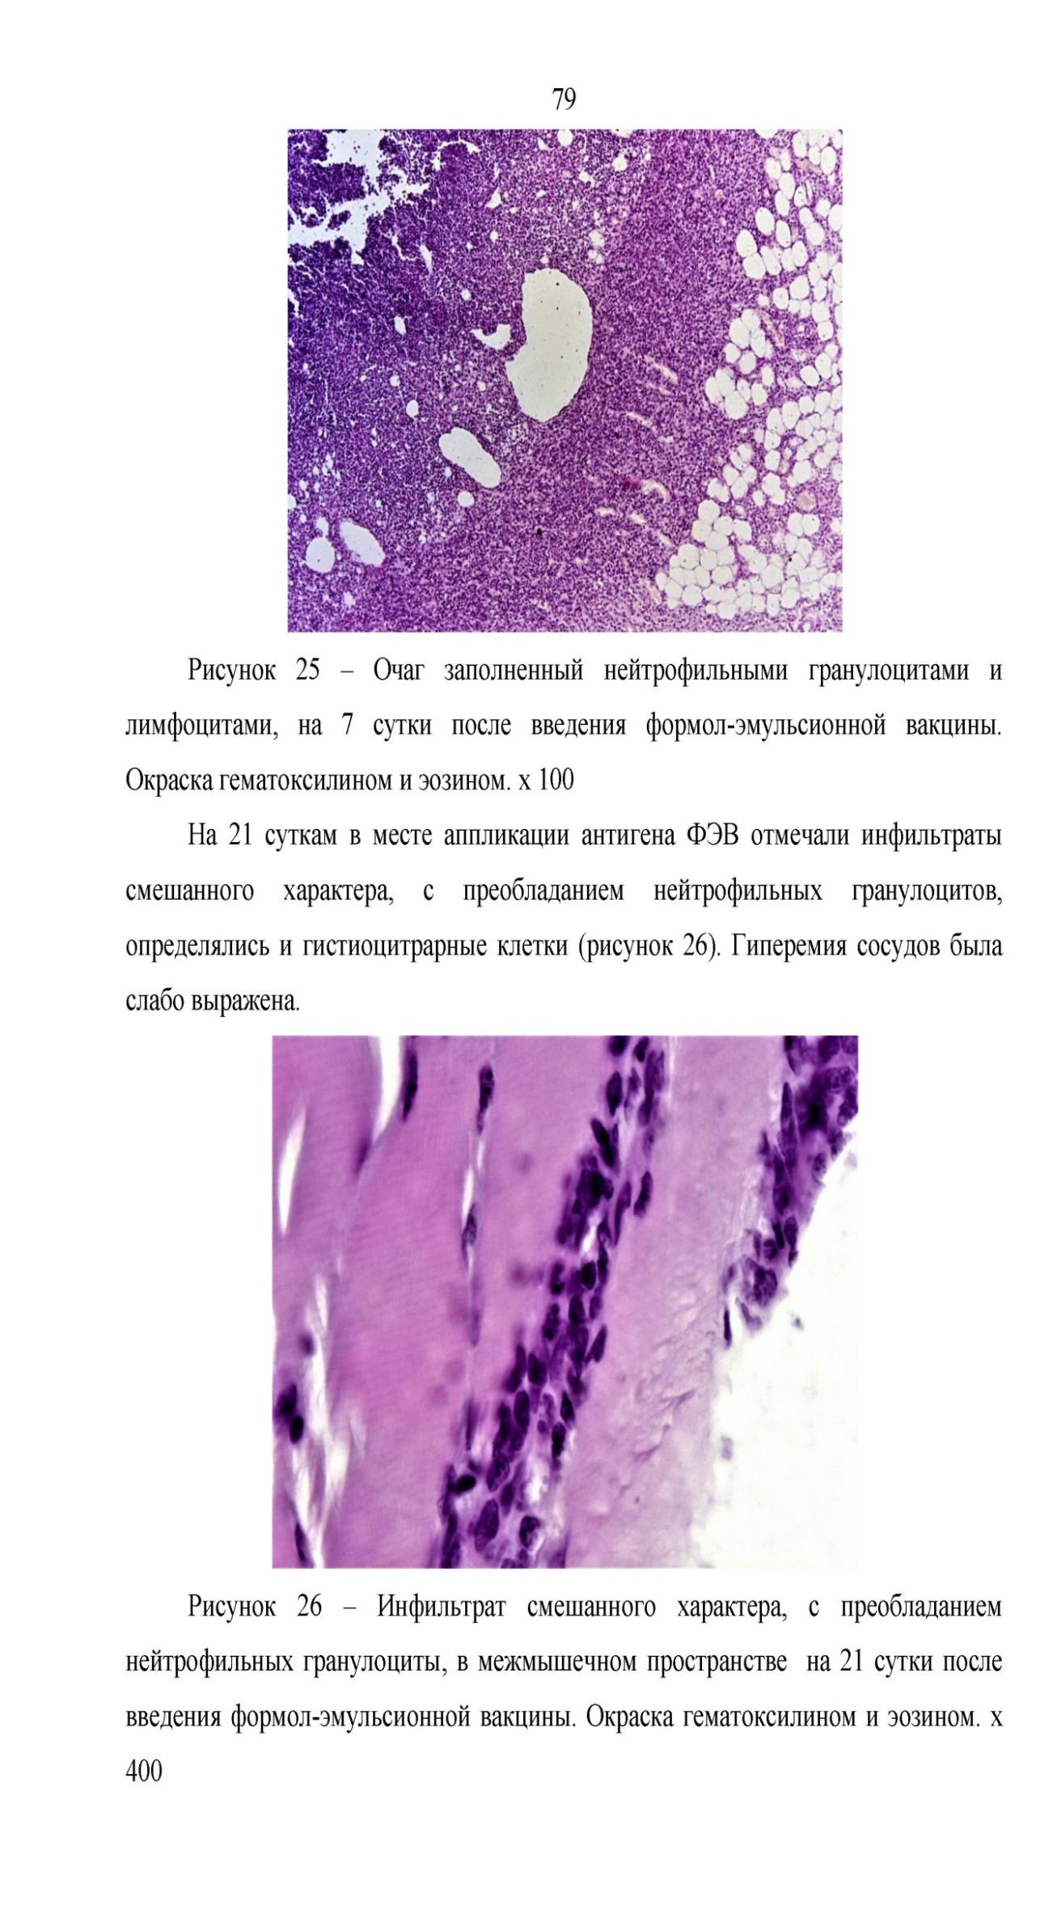
Figure 41 – Skin. Mesenchemical reactions at the inflammation area | Figure 42 – Muscles. Neutrophilic granulocytes
For a comparative histopathological study, after complete recovery, as a result of examination of the skin and muscles in the area were as follows: the skin consists of an uneven thickness with stratified squamous epithelium. All skin layers look like good. The uniform thickness of the epidermis consists of the basal layer, the malpighian layer, the granular layer and the corneal layer. Changes in the epidermal cells are not observed. The basal layer meshes are full and marked. Their long axis is located vertically on the line dividing the epidermis and dermis, and has an emergency basophilic protoplasm and an oval nucleus. The cells of the malpighian layer have a polygonal shape. The corneal layer is thin and uniform in thickness. The border between the epidermis and the dermis is smooth. The dermis is composed of collagen, elastic and reticular fibers. The dermis is evenly dense in places.
The blood vessels in the skin are located in different areas. The blood vessels are filled with medium blood. The vascular wall is not thick and the endothelium has a long, flat shape. The juice gland consists of several parts, each of which is surrounded by a layer of one cubic cell along the periphery. The protoplasm cells of all cells located inside this layer are marked. The structure of the pile follicle is not broken.
The microstructure of the muscles of cattle is a combination of muscle fibers. The connective tissue has a supporting and trophic function. The thickness of the perimysium internum, depending on the various layers, is penetrated into the intramuscular blood vessels, from which thick capillary lines, nerves and lymphatic vessels extend among the muscle fibers. The normal structure of meat fibers was preserved (figures 43, 44).
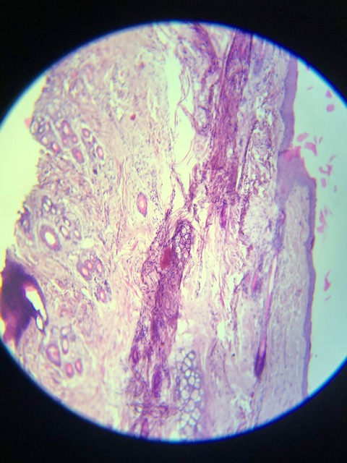 | 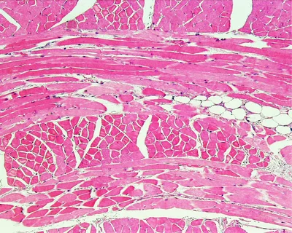
Figure 43 - Skin of cattle after complete treatment | Figure 44 - Muscles of cattle after recovery
In the histochemical study, a large amount of meat fibers, some of them do not have horizontal stripes, a granular mass is collected in the cytoplasm.
The sizes of the nuclei are enlarged, saturated, rounded extreme areas. Between the meat fibers, there are solder edema, sometimes blood foci and infiltrates with round fibers. In the walls of blood vessels, the volumes of edema of the endothelium lattices are increased; in rare cases, focal splitting of meat fibers is observed.
As a result of histochemical studies, a loss of activity of the enzyme acetylcholinesterase in the muscles of all studied cows was recorded (figures 45).

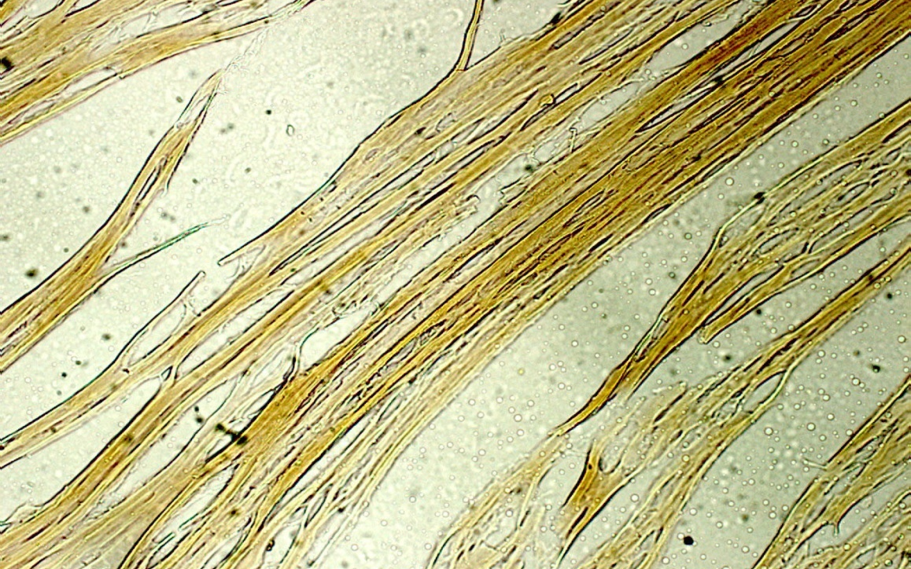
Figure 45 - Decreased muscle acetylcholinesterase enzyme

Thus, studies on pathomorphological, histological and histochemical control have shown the high efficiency of Lactobacterin-TK². The drug prevents the pathogen from penetrating through the damaged skin into the blood vessels and spreading it into the body, after which the purulent exudates have completely stopped, and also reduces the time for wound healing. The skin is completely cleared of pus and, due to the granulation process, the process of reparative regeneration occurs in the area where necrosis was observed.

3.7 Develop the regulatory and technical documentation for therapeutic drug “Lactobacterin-TK²” for treatment of extremities affected by necrobacteriosis
The planned stage of this work was to Develop the regulatory and technical documentation.
The regulatory and technical documentation was developed and approved for the use of Lactobacterin-TK² for treatment of necrobacteriosis in farm animals. The regulatory and technical documentation includes instructions for use of the drug, instructions for manufacturing and control, organization standard for the drug.
The instruction for use of Lactobacterin-TK² for treatment of necrobacteriosis in farm animals includes two sections. The main purpose of the drug is to use it for therapeutic purposes in case of necrobacteriosis in farm animals. First section “General” consists of subsections: trade name, international non-proprietary name, dosage form, indication, description, primary packaging, form of release and completeness, labeling on primary packaging, labeling on secondary packaging, storage conditions, shelf life, disposal. Second section “Procedure for Use” includes subsections: main purpose of the drug, procedure for use, side effects, overdose, interaction with other drugs and other forms of interaction, precautions, personal hygiene rules, and veterinary registration form.
Instructions for manufacturing and control of Lactobacterin-TK² for treatment of necrobacteriosis in farm animals includes 9 chapters. First chapter “General Part” consists of sections: trade name, international non-proprietary name, active ingredient of the drug, indication.
Chapter 2 “Description and Characteristics of Main Active Ingredient of the Veterinary Drug” states that Lactobacterin-TK² is a biological product for treatment of necrobacteriosis in farm animals, obtained on the basis of association of bacteria Lactobacillus acidophilus 05ch, Lactobacillus acidophilus 015k-1 and Lactobacillus bulgaricus 018k-3 grown in a liquid nutrient medium and dried using nonfat milk as a protective medium. The origin of strains, method of creating strains, information about deposition of strains, morphological signs, cultural signs, physiological and biochemical signs are described.
Chapter 3 “Technology for Obtaining and Preparing Auxiliary Materials and Culture Media” consists of sections providing preparation and quality control of dishes, which describe the washing and preparation of dishes and rubber stoppers, detergents, reagents and materials, primary processing of dishes after experiments, secondary washing and preparation of dishes, processing and washing of rubber stoppers, washing and preparation of pipettes, quality control of dishes and stoppers before their using. Section “Nutrient media used for growing lactic acid bacteria Lactobacillus acidophilus 05ch, Lactobacillus acidophilus 015k-1 and Lactobacillusbulgaricus 018k-3” is provided, which describes the preparation of a semi-liquid nutrient medium, MRS-I liquid nutrient medium, MRS-4 dense nutrient medium.
Chapter 4 “Technological Process for Manufacturing of Lactobacterin-TK²” shows a diagram of the technological process for manufacturing of the drug and 7 stages of manufacture: Stage 1 - Preparation of lactic acid bacteria inoculum, Stage 2 - Cultivation of inoculum - Lactobacillusacidophilus 05ch, Lactobacillusacidophilus 015k-1 and Lactobacillusbulgaricus 018k-3, Stage 3 - Cultivation in a fermenter, Stage 4 - Vacuum evaporation and drying, Stage 5 - Preparation of granules, Stage 6 - Packaging and labeling of the finished product, Stage 7 - Control over the biological product.
Chapter 5 “Neutralization and Further Use of Industrial Wastes” includes the requirements for safety, industrial sanitation, sanitary and anti-epidemic regime during manufacturing of the drug.
Chapter 6 briefly describes how to work with a control strain of microorganisms.
Chapter 7 provides “Rules for Safe Handling and Veterinary and Sanitary Regime during Manufacturing the Drug” briefly describes the requirements for the premises where the drug is manufactured, personnel, fire safety. It is noted that before starting work in the box rooms, wet cleaning is carried out and the germicidal lamps are turned on for 30 minutes, and at the end of the working day, the box is wet cleaned with wiping of tables, chairs, floors, walls and other items with a 6% solution of hydrogen peroxide and 0.5% detergent.
Chapter 8 “Accounting for Manufacturing Processes” provides that all manufacturing processes for manufacturing of the drug, preparation of mother culture, inoculation, packaging, control of the drug, etc., are recorded in the logs of the established form on the day when they are made, and numbered and sealed by the biological enterprise, signed by the head of the biological enterprise, head of the safety and quality assurance department and head of the workshop.
Chapter 9 contains “Specification of Equipment and Devices Used”, as well as the specification of the animals used during manufacturing of the veterinary drug.
The organization standard for Lactobacterin-TK² for treatment of necrobacteriosis in farm animals includes 13 sections.
Chapter 1 – “Scope” provides that the organization standard applies to Lactobacterin-TK² for treatment of necrobacteriosis in farm animals (hereinafter - the drug), obtained on the basis of association of the lactic acid bacteria Lactobacillus acidophilus 05ch, Lactobacillus acidophilus 015-k1 и Lactobacillus bulgaricus 018k-3, grown in a liquid nutrient medium and dried using nonfat milk as a protective medium.
Chapter 2 – “Regulatory References” lists regulatory references, including the technical regulation “Requirements for safety of medicinal products and biological products used in veterinary medicine”, “Requirements for labeling of medicinal products for medical use and veterinary medicines”, “Rules for manufacturing of medicinal products” – “Good Manufacturing Practice for Medical Products (GMP)”, as well as ST RK 1088-2003, ST RK 12.0.001-2005, GOST 12.1.004–91, GOST ISO/IEC 17025-2009, GOST 8.579-2002, GOST 12.0.004- 90, GOST 12.1.005-88, GOST 12.1.008-76, GOST 12.2.003-91, GOST 12.3.002-2014, GOST 12.4.011-89, GOST 17.0.0.01-76, etc. used in this standard.
Chapter 3 – “Technical Requirements for Veterinary Drug” lists the physical and chemical properties (appearance and color, mass fraction of moisture, suspension from the powder, disintegration of granules).
Chapter 4 – “Biological Requirements for Veterinary Drug” includes biological requirements (number of viable cells in 1 dose of the drug, typical growth, bacteriological purity, harmlessness in a test dose per 1 mouse, antagonistic activity to test microbes).
The standard contains Chapter 5 “Requirements for raw materials, materials and animals used for control of veterinary drug” and Chapter 6 “Requirements for packaging and labeling (their specifications)” with appropriate description. Chapter 6 contains subsections 6.1 “Pharmaceutical Form”, 6.2 “Label”, 6.3 “Packaging”, 6.4 “Marking”.
Chapter 7 – “Risks Arising from the Use of the Drug” lists the risks when using a veterinary drug, as well as raw materials in the manufacturing process and operation (use) have the risks, and measures to reduce the above risks to a minimum level and their prevention.
Chapter 8 – “Requirements for Safety and Environmental Protection” states that manufacturing of veterinary drugs must comply with the requirements of the “Environmental Code of the Republic of Kazakhstan”, “veterinary (veterinary and sanitary) requirements for organizations engaged in the production, storage and sale of veterinary drugs, feed and feed additives.
Chapter 9 - “Acceptance Rules” states that each batch of a veterinary drug must be accepted (inspected) by the department responsible for quality assurance of the finished product of the manufacturer, describes the requirements for batch of the drug, sampling for control and archiving, the rules for determination of conformity of series (lots) of veterinary drugs.
Chapter 10 – “Methods of Control” describes measuring instruments, reagents, culture media and materials, and sections “Determination of appearance”, “Determination of mass fraction of moisture”, “Determination of disintegration time”, “Determination of the number of viable cells”, “Determination of typicality of the colonies growth”, “Determination of bacterial purity”, “Determination of harmlessness”, “Determination of antagonistic activity of the drug”.
Further, chapters “Transport and Storage”, “Instructions for Use”, “Manufacturer’s guarantees” are described.
All regulatory and technical documentation meets the requirements and purposes of national standards: scientific and technological progress, government orders, introduction of innovations, veterinary drug quality assurance, performance of works and services; improving the life safety and health of animals.
When compiling the Organization Standard, the developers were guided by the requirements of the Ministry of Agriculture of the Republic of Kazakhstan No. 7-1/848 “Veterinary (veterinary and sanitary) requirements for organizations engaged in manufacturing, storage and sale of veterinary drugs, feed and feed additives” dated September 23, 2015.
The organization standard is made in accordance with the requirements of ST RK 1.5-2013 General requirements for construction, presentation, design and content of standards.

CONCLUSION
1 The epizootic situation with cattle necrobacteriosis in Talgar, Ili and Enbekshikazakh districts of Almaty region for 2015-2017 was studied. The statistical indicators characterizing the epizootic process, morbidity index, visibility indicator and nidus index were determined. During the analyzed period, the visibility indicator was stable (105.8% and 105.5%). The nidus index tended to decrease (in 2015 - 190; in 2016 - 185.3 and in 2017 - 146.6).
2 The epizootic situation with cattle necrobacteriosis for 2018 was studied in 4 epizootic units, in particular: Zhamantal located in Aksu district, Almaty region (Taldykorgan region), - Kerbulak, Arkabay, Tsentralny located in Talgar district, Almaty region. No sick animals with signs of necrobacteriosis were found in Zhamantal and Kerbulak sites, where livestock is kept on a year-round pasture. On the commercial dairy farms of Arkabay and Tsentralny sites, the diseases of the lower extremities in the form of a panaritium was revealed, with detection of necrotic areas in the interdigital fissure and on the coronary band. On the base of CDF of Arkabay site, 11 animals with affected limbs were found that is 0.56% of the livestock kept there; at Tsentralny site, the disease was found in 17 animals (7.7%).
3 4 strains were isolated, their indication and type affiliation were identified (Fusobacterium necrophorum) out of 18 samples of pathological material from clinically diagnosed sick cattle. Their morphological, tinctorial, cultural-physiological and biochemical properties of the isolated cultures were studied.
4 When studying the antagonistic properties of eight strains of lactic acid bacteria and two strains of yeast against the necrobacteriosis causative agents isolated from the affected limbs of cattle, it was found that the tested lactic acid bacteria Lb.acidophilus 05ch, - Lb.casei 012k, Lb.acidophilus 015k-1, Lb.bulgaricus 021ch-1, Lb.casei 021ch-3, Lb.bulgaricus 018k-3, Lc.lactis 010k, Lc.lactis 026k and the yeast Torulopsis spherica 13y, Torulopsis spherica, had varying degrees of antagonistic activity against the necrobacteriosis causative agents F.necroforum. At the same time, Lactobacillus acidophilus 015k-1 (15 mm), included in Lactobacterin TK², had the greatest antagonistic activity.
5 The therapeutic efficacy of Lactobacterin-TK² (Patent for utility model No. 5112 dated 03.07.2020) was proved for the first time, when it was found that when applying the bandage with lactic acid bacteria to the surgically cleansed wound surface, the granulation process was noted on days 4-5, and recovery of all 9 animals was recorded after 9 days.
When the lactic acid bacteria were used in combination with the parenteral antimicrobial drug “Nitox”, applied in deep lesions, the positive dynamics was also noted, with appearance of granulation tissue on days 5-6, wound healing on days 7-8, and clinical recovery on days 9-11.
6 The high efficiency of Lactobacterin-TK² was established in the study of pathomorphological, histological and histochemical control. When cattle necrobacteriosis occurs, the pathomorphological picture is observed in the form of suppuration of subcutaneous tissue, characterized by signs of phlegmon. Dead foci and bleeding appear on the bones of the fingers, absorption into the bone tissue and signs of exostasis appear, histological character in the tissues of the affected muscles and skin, in the form of foci of myocytes. Subcutaneous connective tissue is infected with mononuclear phagocytes. Signs of edema were observed in the subcutaneous tissue, intermuscular and perivascular spaces. As a result of histochemical studies, a loss of the activity of the acetylcholinesterase enzyme in the muscles of all cows under study was recorded.
As a result, after treatment of necrobacteriosis with the probiotic drug “Lactobacterin-TK²”, all layers of the skin were clearly marked. Changes in the epidermal cells were not observed. The structure of the pile follicle was not broken. The normal structure of meat fibers was preserved.
7 The regulatory and technical documentation was developed and approved for the use of Lactobacterin-TK² for treatment of necrobacteriosis in farm animals. The regulatory and technical documentation includes instructions for use of the drug, instructions for manufacturing and control, organization standard for the drug.
The regulatory and technical documentation meets the requirements and purposes of national standards: scientific and technological progress, government orders, introduction of innovations, veterinary drug quality assurance, performance of works and services; improving the life safety and health of animals.
8 Based on the project results, 18 articles were published, of which 5 - foreign articles, 3 articles with an impact factor, 2 patents for a utility model, 3 copyright certificates, 5 patent applications, 9 acts, and 4 practical recommendations. (Appendix B).

REFERENCES
1 Baikenov M.T. Diagnostics, prevention and treatment of hoof diseases in cows: diss. ... Ph.D. - Troitsk, 2001 .-- 176 p.
2 Gorelov Yu.M., Sushchikh V.Yu. Recommendations for combating with necrobacteriosis in farm animals. - Almaty, 2011.- 44 p.
3 Agolari D.P. Effectiveness of drugs in diseases of hooves in ruminants (cattle necrobacteriosis and hoofrot in sheep): abstract of the thesis: ...candidate of Veterinary Sciences. - M.: Moscow. State Academics Veterinary Medicine. - 2001.- 18 p.
4 Samolovov A.A. Cattle necrobacteriosis / A.A. Samolovov . - Novosibirsk, 1998.- 140 p.
5 Baradiyev B.N. Wintering and its influence on incidence of necrobacteriosis // Biological bases of increasing productivity in reindeer husbandry in Yakutia. - Novosibirsk, 1990. -P. 87-93.
6 Samolovov A.A., Lopatin C.B. Resistance in cattle necrobacteriosis // Epizootology, prevention and control of infectious diseases. - Novosibirsk, 1993. - P. 91-94.
7 Kakoulin T.E., Ludypov Ts., Atutova S.N. Prevention and treatment of cattle necrobacteriosis in Irkutsk region // Epizootology, diagnostics, prevention and measures for combating with animal diseases. - Novosibirsk, 1997. - P. 120-122.
8 Sidorchuk A.A., Kirillov L.V., Panasyuk S.D. Problems of combating with necrobacteriosis: delusions and reality // Veterinary medicine. -2006. –No.2. - P.5-6.
9 Makayev Kh.N., Khuzin D.A., Potekhina R.M., Mukhammetshin N.A. Preventive efficacy of various means and methods for treatment of necrotic lesions of cattle hooves // Federal State Budgetary Institution “Federal Center for Toxicological and Radiation Safety of Animals”.- Kazan, 2012. - P. 202-206.
10 Kavruk L.S. Effectiveness of new chemical drag “Barrier-1” used for treatment and prevention of necrobacteriosis in cows // RJ. Problems of veterinary sanitation, hygiene and ecology. –2009. - No. 1. - P.53-58.
11 Panin, A.N., Malik, N.I. Probiotics are an essential component of rational animal nutrition. [Text]: / A. N. Panin A // Veterinary medicine. - 2006.- No.7. - P. 3-6.
12 Tolysbayev B.T., Kozhakhmetova Z.A. Antagonistic properties of new strains of lactic acid and acetic acid bacteria // Research, results.- Almaty, 2006. – No.4. - P.293-298.
13 Varyukhin A.V. St. Petersburg scheme for combating with cattle necrobacteriosis/ Varyukhin A.V., Ostrovsky M.V., Sakharova E.D., Spiridonova I.N. // Zooindustry. – 2006. - No. 8 (77). - P. 10 - 11.
14 Veremey E.I. Treatment of cows with purulent-necrotic processes in the area of ​​hooves and fingers / Veremey E.I., Zhurba V.A., Lapina V.A. // "Veterinary Medicine". - 2004.- P.33.
15 Shaburov D.G. Morphological rationale for use of Monclavit-1 for prevention of dry hooves (recommendations). - Perm, 2003. - 18 p.
16 Atela, J.A., Mlambo, V., Mnisi, C.M. A multi-strain probiotic administered via drinking water enhances feed conversion efficiency and meat quality traits in indigenous chickens // Animal nutrition. - Т: 5. - №: 2. - Р. 179-184.
17 Olchowy, TWJ; Soust, M; Alawneh, J. The effect of a commercial probiotic product on the milk quality of dairy cows // Journal of dairy science. - 2019. - Volume: 102. - № 3. - Р: 2188-2195.
18 Maldonado, N.C.; Chiaraviglio, J.; Bru, E.; De Chazal, L; Santos, V.; Nader-Macias, M.E.F. Effect of Milk Fermented with Lactic Acid Bacteria on Diarrheal Incidence, Growth Performance and Microbiological and Blood Profiles of Newborn Dairy Calves // Probiotics and antimicrobial proteins. - 2018. - Т: 10. - №: 4. - Р.668-676.
19. Agolari D.P. Effectiveness of drugs in diseases of hooves in ruminants (cattle necrobacteriosis and hoofrot in sheep): abstract of diss…. candidate of Veterinary Sciences / D.P. Agolari; M.: MGAVMiB, - 2001.-18 p.
20. Alexandrov D.I. Research and development of means for treatment of cattle necrobacteriosis: abstract of dis. … candidate of Veterinary Sciences / D.I. Alexandrov. - Kazan: 2003.- Vseros. NIVI.- 19 p.
21 Tulemissova Zh.K., Kasenova G.T., Muzapbarov B. Antagonistic activity and antibiotic sensitivity of lactic acid bacteria isolated from various dairy products // Biotechnology. Theory and practice.-Stepnogorsk, 2001.- No.3. - P.26.
22 Bergey’s manual. in 2 volumes. - Vol. 1. - Publishing house: "Mir". -1997.

APPENDIX A
Work schedule

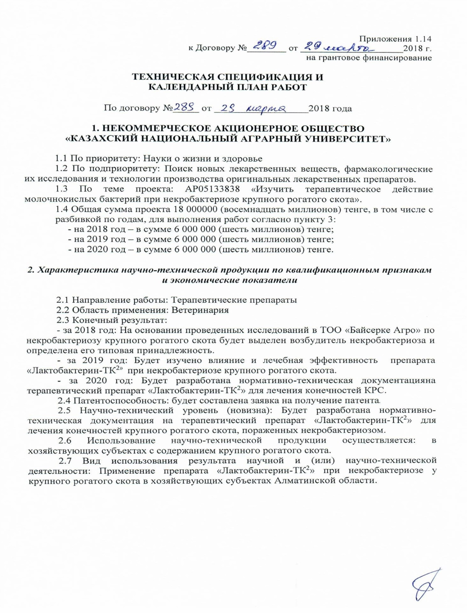

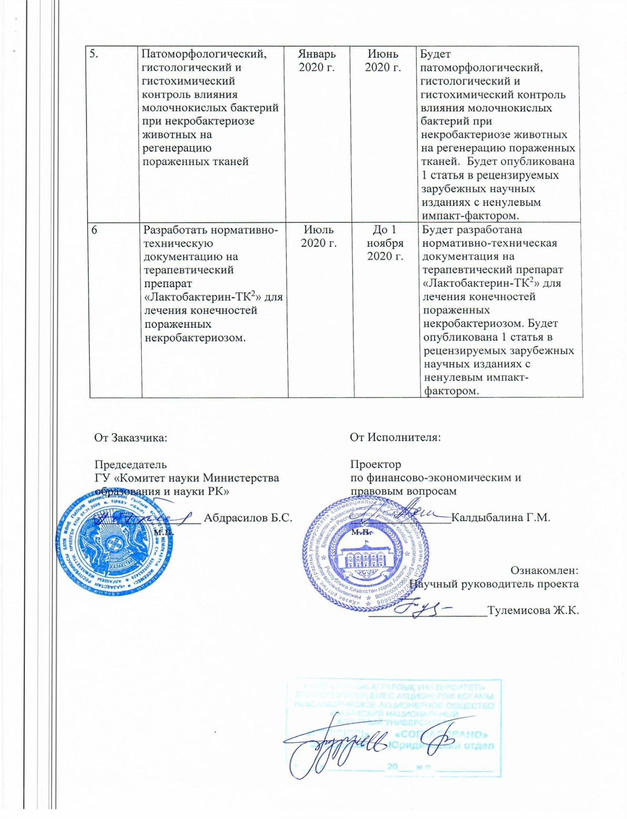

Appendix 1.14
to Agreement № _____from___________2018 years
for grant funding
TECHNICAL SPECIFICATION AND
JOB SCHEDULE
Under contract № ______ from_________________2018 years

1. NON-COMMERCIAL JOINT-STOCK COMPANY
"KAZAKH NATIONAL AGRARIAN UNIVERSITY»
1.1 by priority: life and health Sciences
1.2 by sub-priority: Search for new medicinal substances, their pharmacological research and technologies for the production of original medicinal products.
1.3 project topic: AR05133838 " to Study the therapeutic effect of lactic acid bacteria in cattle necrobacteriosis»
1.4 the total amount of the project is 18,000,000 (eighteen million)tenge, including by year, for the performance of works in accordance with paragraph 3:
- for 2018-in the amount of 6,000,000(six million) tenge;
- for 2019-in the amount of 6,000,000 (six million) tenge;
- for 2020-in the amount of 6,000,000(six million) tenge;

2. Characteristics of scientific and technical products by qualification criteria and economic indicators
2.1 field of work: Therapeutic drugs
2.2 Scope of application: veterinary medicine
2.3 Final result:
- for 2018: Based on the research conducted in Baiserke agro LLP on cattle necrobacteriosis, the pathogen of necrobacteriosis will be isolated and its type affiliation determined.
- for 2019: The influence and therapeutic effectiveness of the drug "Lactobacterin-TK2" in cattle necrobacteriosis will be studied.
- for 2020: Regulatory and technical documentation will be developed for the therapeutic drug "Lactobacterin-TK2" for the treatment of cattle limbs.
2.4 Patentability: a patent application will be drawn up.
2.5 Scientific and technical level (novelty):Regulatory and technical documentation will be developed for the therapeutic drug "Lactobacterin-TK2" for the treatment of cattle limbs affected by necrobacteriosis.
2.6 the use of scientific and technical products is carried out: in economic entities with the content of cattle.
2.7 Type of use of the result of scientific and (or) scientific and technical activities: the use of the drug "Lactobacterin-TK2" in necrobacteriosis in cattle in economic entities of the Almaty region.

3 Name of work, terms of their implementation and results

The cipher of the task stage | Name of work under the Contract and the main stages of their implementation | Period of execution |  | Expected Result
The cipher of the task stage |  | Start | End | Expected Result
1 | To study the epizootic situation of cattle necrobacteriosis in the economic entities of the Almaty region | January  2018 | Until November 1  2019 | The epizootic situation of cattle necrobacteriosis in the economic entities of the Almaty region will be studied.Will be allocated the causative agent of necrobacteriosis cattle.Analyzers and statistical indicators of the epiotic process will also be installed
2 | To highlight and carry out the indication and type of the causative agent of non-crabbacteriosis of cattle | January  2019 | Until November 1  2019 | An indication will be selected and carried out, and the type of the causative agent of cattle necrobacteriosis will be determined.1 article will be published in journals recommended by the KKSON of the Ministry of education and science of the Republic of Kazakhstan.
3 | To study the effect of the lactic acid bacteria preparation "Lactobacterin-TK2" on pathogenic microflora isolated from the affected areas of bovine limbs in vito under laboratory conditions | January  2019 | Until November 1  2019 | The effect of the lactic acid bacteria preparation "Lactobacterin-T2" on pathogenic microflora and on regeneration isolated from affected tissues and affected areas of bovine limbs in vito in laboratory conditions will be studied. Will be published 1 article in a peer-reviewed international scientific journals with nonzero impact factor and 1 article in journals recommended KKSON MES .An application for a patent of the Republic of Kazakhstan will be submitted.
4 | To study the therapeutic effect of the drug "Lactobacterin-T2" in cattle necrobacteriosis | January  2019 | Until November 1  2019 | The therapeutic effect of prepatar and the effect of the therapeutic drug "Lactobacterin-T2" in cattle necrobacteriosis will be studied.
5 | Pathomorphological, histological and histochemical control of the influence of lactic acid bacteria in animal necrobacteriosis on the regeneration of affected tissues | January  2020 | June  2020 | There will be pathomorphological,  histological and histochemical control of the effect of lactic acid bacteria in animal necrobacteriosis on the regeneration of affected tissues. 1 article will be published in peer-reviewed foreign scientific publications with a non-zero impact factor
6 | Develop regulatory and technical documentation for the therapeutic "Lactobacterin-T2" for the treatment of limbs affected by necrobacteriosis | July 2020 | Until November 1, 2020. | Regulatory and technical documentation will be developed for the therapeutic "Lactobacterin-T2" for the treatment of limbs affected by necrobacteriosis.1 article will be published in peer-reviewed foreign scientific publications with a non-zero impact factor

APPENDIX B
List of published works 2018-2020
(scientific articles, patents, recommendations, acts)

Based on the results, 7 foreign articles were published, 4 articles with an impact factor:
According to the research results, it was published:
1 Tulemissova Zh.K., Abeuov Kh.B., Muzapbarov B., Myktybaeva R.Zh., Omarova A.B., Ibazhanova A. Abstract Book, 2018, Vol.4. // 4th International Academic Conference on Agricultural «Prospects for the Use of Probiotics in the Treatment of Cattle Nekrobacteriosis». - Kiev, 2018. (Eng.)
2 Ibazhanova A. S. Tulemisova Zh. K. Pathomorphology of necrobacteriosis IPI // Results of the study. - Almaty, 2018. - No. 3. - Pp. 23-27. (Kaz.)
3 Omarova A.B., Tulemissova Zh.K., Zetbek G.S. Phosphoketolase assay for determination of bifidobacteria // Science news in the agro-industrial complex. Publication based on the materials of the VI International conference “Innovative developments of young scientists - the development of the agro-industrial complex”. – Stavropolя: “AGRUS”, 2018. - Volume 1.- P. 194-197. (Rus.)
4 Omarova A. B., Baigozhaeva B. U., Tulemisova Zh. K., Zetbek G. S. determination of resistance of lactic acid bacteria to natural inhibitors of the digestive system for the production of probiotic products. // Bulletin Of Kaznitu, No. 5 (129). - Almaty, 2018. - P. 193-197. (Kaz.)
5 Tulemissova Zh.K., Abeuov Kh.B., Myktybayeva R.Zh., Omarova A.B. «Prospects for the use of probiotics in the treatment of cattle necrobacteriosis» // International scientific and practical conference “Prospects for development of scientific knowledge”. – Kiev, 2019. - P.45-47. (Eng.)
6 Tulemissova Zh.K., Omarova A.B. Atte Von., Baikhozhaeva B.U., Ikombayev T.D. «Identification of probiotic strains by modern analytical techniques» // News of National of Sciences of the Republic of Kazakhstan, Series of Geology and Technical sciences. - Volume 3, Number 435 (2019). - Р.30-35. - S/0.09 (Eng.)
7 Tulemisova zh. K., Ibazhanova A. S. treatment of bovine necrobacteriosis using the domestic drug "lactobacilli-Tk2" // Collection of materials of the XXIII International scientific-practical conferences of young scientists and students “Scientific youth in agricultural science: achievements and prospects” in the framework of the Year of Youth of the Republic of Kazakhstan. - Almaty. 26-27 April 2019. - P. 97-101. (Kaz.)
8 N.P.Ivanov., V.Y. Suchich., A.M.Namet., N.N. Egorova, B.Kanatov., K.M.Shynybaev. Necrobacteriosis and measures to fight against it in LLP «Bayserke-Agro» // News of the National academy of Sciences of the Republic of Kazakhstan. Seriâ agrarnyh nauk. - 2 (50) march – april 2019. –Р. 86-83. (Eng.)
9 T.K. Boranbayeva, Zh.K.Tulemissova, D.M.Khussainov «Studying the antagonistic properties of lactobacterin-TK² probiotics on pathogenic strains causing gastrointestinal pathology in calves and lamps». News of the National academy of Sciences of the Republic of Kazakhstan, Seriâ agrarnyh nauk. - Volume 3, Number 51(2019) – Р. 12-15. (Eng.)
10 Tulemissova Zh.K., Myktybayeva R.Zh., Kozhakhmetova Z.A. “Effectiveness of lactic acid bacteria in cattle necrobacteriosis” // Bulletin of the Kyrgyz National Agrarian University named after K.I. Skryabin. ISSN 1694-6286. – Bishkek, 2020. - No. 1 (52). - P. 46-51. RINS – 0,025 (Rus.)
11 Boranbayeva Togzhan, Gul Karahan Aynur, Tulemissova Zanara, Myktybayeva Raya, Serkan, Oskaya. «Proptrties ofa New Probiotik Candidate and Lactobacterin-TK² Against Diarrhea in Calves» // Probiotics and Antimicrobial Protiens ISSN DOI 10.1007/s 12602-020-09649-47. - Р. 1867-1306. - Online first. Springer. Q2 (Eng.)
12 Tulemissova Zh.K., Myktybayeva R.Zh., Kozhakhmetova Z.A., Ibraikan Zh.D. Influence of antagonistic activity of lactic acid bacteria strains on the causative agent of cattle necrobacteriosis // Scientific Research journal, results. Kazakh National Agrarian University ISSN 2304-3334. – Almaty, 2020. - No. 1 (85). - P. 132- 137. (Rus.)
13 Ivanov N.P., Sushchikh V.Yu., Myktybayeva R.Zh. “Study of inhibitory activity of lactic acid bacteria and antibacterial drugs against the necrobacteriosis causative agent and associated microflora” // Materials of the International Scientific and Practical Conference / "Modern Challenges for Biotechnology, Veterinary Medicine and Medicine” Gvardeiskiy – Gvardeisky, 2020. (Rus.)
14 Tulemisova Zh.K., Shabdarbaeva G.S., Myktybayeva R.Zh., Kozhakmetova Z.A., Omarova A.B. «Effectiveness of lactis acid bacteria in cattle necrobacteriosis» New York Univercity Abu Dhabi 11-13 february 2020. ( eng.)
15 E. Tomaev, A. K Ikombayev, A. K. Ospanova, Zh. K. Tulemisova, A. B. Omarova efficiency of using the api-test method for identification of bacteria Materials of the International Scientific and Practical Conference “Modern Challenges for Biotechnology, Veterinary Medicine and Medicine” Gvardeiskiy – Gvardeisky - Gvardeisky 2020. P. 171-177. (Kaz.)
16 Baikozhayeva B.U., Omarova A.B., Ikombayev T.D., Tulemissova Zh.K. Development and study of quality and safety of new probiotic drugs is an urgent task of domestic metrological science // Scientific and technical journal Metrology. ISSN 2522-1744 No.1 (72) 2020. P. 65-70. ( Rus.)
17 Zh. K. Tulemissova1, M. A. Torehanov1, R. Zh. Myktybayeva, A. S. Ibazhanova, D. M. Khussainov1, Zh. M. Batanova1, and S. S. Usmangaliyeva1 «Comparison of Probiotic Lactobacillus acidophilus and Oxytetracycline for the Treatment of Early Stage Interdigital Necrobacillosis in Dairy Cows» 2020, Scienceline Publication // World’s Veterinary Journal World Vet J, 25 September 2020. - 10 (3). - P. 375-379. - Q4. (eng.)
18 Torekhanov M., Tulemissova Zh., Ibazhanova A. “Pathomorphological control of cattle skin in necrobacteriosis” // International independent scientific journal ISSN 3547-2340. - No.20. – 2020. - Vol. 1. - P. 61-63.
Recommendations:
1 Tulemisova zh.K., Ibazhanova A. S., Myktybayeva R. zh., Aztan E. M. scientific and methodological recommendation "Pathological anatomical assessment of animal necrobacteriosis". - Almaty "Print": 2019. - P. 14. (Kaz.)
2 Tulemisova zh. K., Ibazhanova A. S., Myktybayeva R. zh., Aztan E. M. scientific and methodological recommendation" pathological morphology of animal necrobacteriosis. - "Almaty" Print ": 2020. - P. 15 (Kaz.)
3. Tulemissova Zh.K., Myktybayeva R.Zh., Kozhakhmetova Z.A., Ibazhanova A.S., Khusainov D.M. “Recommendations for use of Lactobacterin-TK² for cattle necrobacteriosis”. - Almaty “Print”: 2020. - P.31 (Rus.)
4. Tulemisova Zh. K., Myktybayeva R. Zh., kozhakhmetova Z. A., Ibazhanova A. S., Khusainov D. M. "scientific and methodological proposal" Lactobacterin-TK2 application in cattle necrobacteriosis". - Almaty" Print ": 2020. - P. 31 (Kaz.)
Patent applications:
1 Conclusion on the grant of a patent of the Republic of Kazakhstan for useful model “Strain lactobacillus bulgaricus 018k-3 used for manufacturing of a biological product against cattle necrobacteriosis”. Registration number No. 2019/0391.2 Filing date 25.04.2019. (Rus.)
2 Conclusion on the grant of a patent of the Republic of Kazakhstan for useful model “Strain lactobacillus acidophilus 015-k1 used for manufacturing of a biological product against cattle necrobacteriosis”. Registration number No. 2019/0392.2 Filing date 25.04.2019. (Rus.)
Patents:
1. Patent for utility model “Strain lactobacillus acidophilus 05-ch used for manufacturing of a biological product against cattle necrobacteriosis” No. 5482 dated 03.04.2019. (Rus.)
2. Patent for utility model “Composition against ruminants necrobacteriosis” No. 5113 dated 03.07.2020. (Rus.)
3. Patent for utility model “Association of bacterial strains used against cattle necrobacteriosis” No. 5112 dated 03.07.2020. (Rus.)
Author’s Certificate:
1 Khusainov D.M., Tulemissova Zh.K., Ibazhanova A.S., Aztan E.M. Certificate No. 2495 for work of science - object “Epizootic situation with cattle necrobacteriosis in Almaty region” // Included in the State Register of Rights to Objects Protected by Copyright dated 28.03.2019 (Rus.)
2. Ivanov N.P., Sushchikh V.Yu., Ilimbayeva A.K., Sarimbekova S.N. Author’s Ccertificate “Method for detecting the proteolytic (necrotic) properties of Fusobacterium necroforum” // Certificate of entry into the State Register of Rights to Objects Protected by Copyright No. 9054 dated 26.03.2020. (Rus.)
3 Tulemissova Zh.K., Ibazhanova A.S., Khusainov D.M., Myktybayeva R.Zh., Boranbayeva T.K., Torekhanov M.A. Recommendations for use of Lactobacterin-TL² for cattle necrobacteriosis // Certificate of entry into the State Register of Rights to Objects Protected by Copyright No. 12445 dated 8 October 2020 (Rus.)
Regulatory and technical documentation:
1 developed regulatory and technical documentation for the therapeutic drug "Lactobacterin-TK2" for the treatment of limbs affected by necrobacteriosis. (in Russian and Kazakh).
Test Reports:
1. Act of testing the drag with lactic acid bacteria in cattle necrobacteriosis - Samsybayev M. Farm
2. Act of testing the drag with lactic acid bacteria in cattle necrobacteriosis - Agricultural enterprise SHP DARNIS LLP
3. Act of testing the drag with lactic acid bacteria in cattle necrobacteriosis - SPK PZ Almaty
4. Act of testing the drag with lactic acid bacteria in cattle necrobacteriosis - K-Anar Farm
5. Act of testing the drag with lactic acid bacteria in cattle necrobacteriosis – Nurzhan Farm.
6. Act of testing the drag with lactic acid bacteria in cattle necrobacteriosis - Baiserke Agro LLP.
7. Act of testing the drag with lactic acid bacteria in cattle necrobacteriosis - SPK Zhetysu asyl tukym
8. Act of testing the drag with lactic acid bacteria in cattle necrobacteriosis – Sargaldakov Farm
9. Аct of testing the preparation of lactic acid bacteria in cattle necrobacteriosis "kasymzhan farm".
Works on: “Study the therapeutic effect of lactic acid bacteria in cattle necrobacteriosis”, the main stages and expected results provided for in the technical specification and schedule of Agreement No. 289 dated 29 March 2018 have been implemented in full.

1 Tulemissova Zh.K., Abeuov Kh.B., Muzapbarov B., Myktybaeva R.Zh., Omarova A.B., Ibazhanova A. Abstract Book, 2018, Vol.4. // 4th International Academic Conference on Agricultural «Prospects for the Use of Probiotics in the Treatment of Cattle Nekrobacteriosis». - Kiev, 2018. (Eng.)


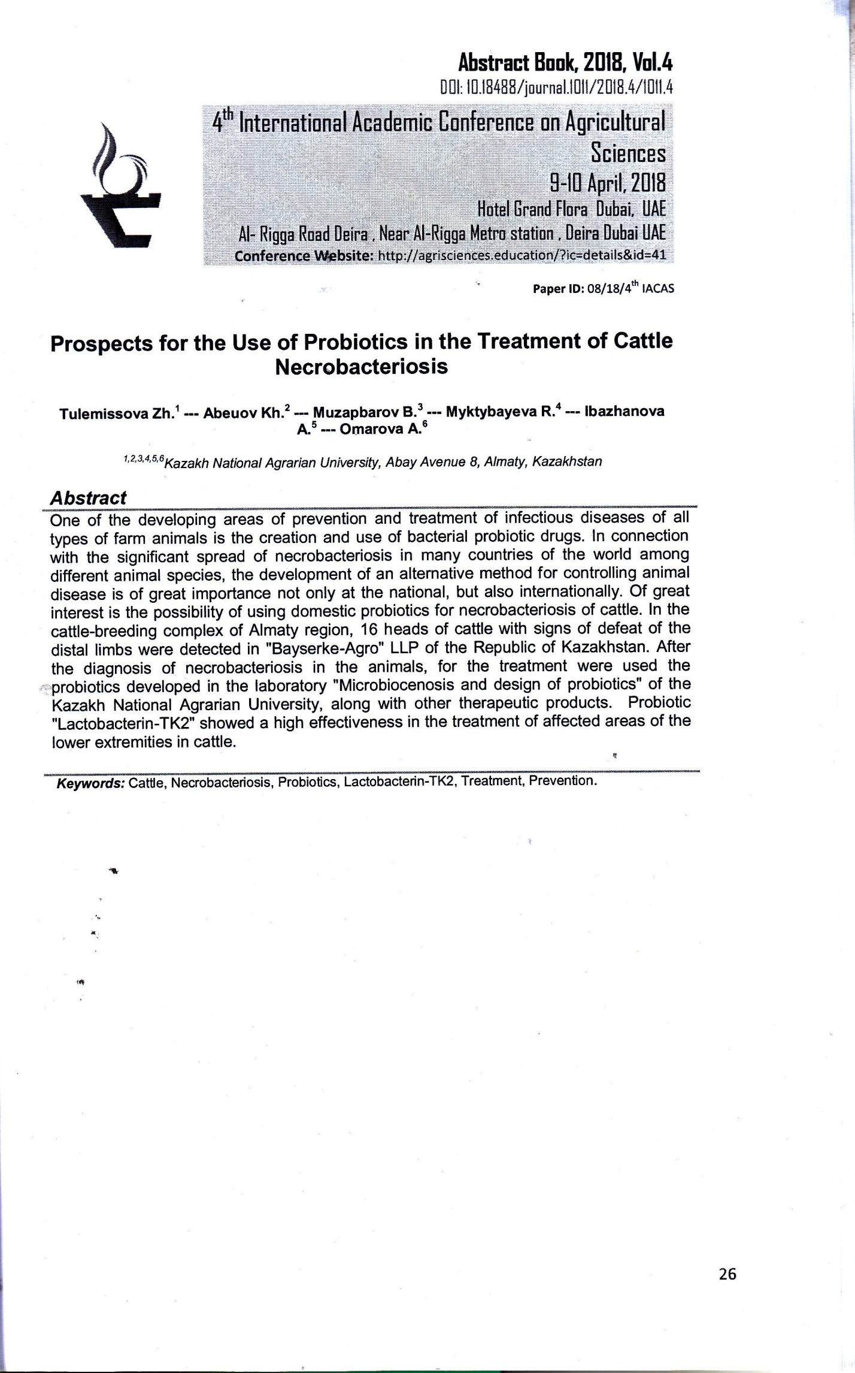
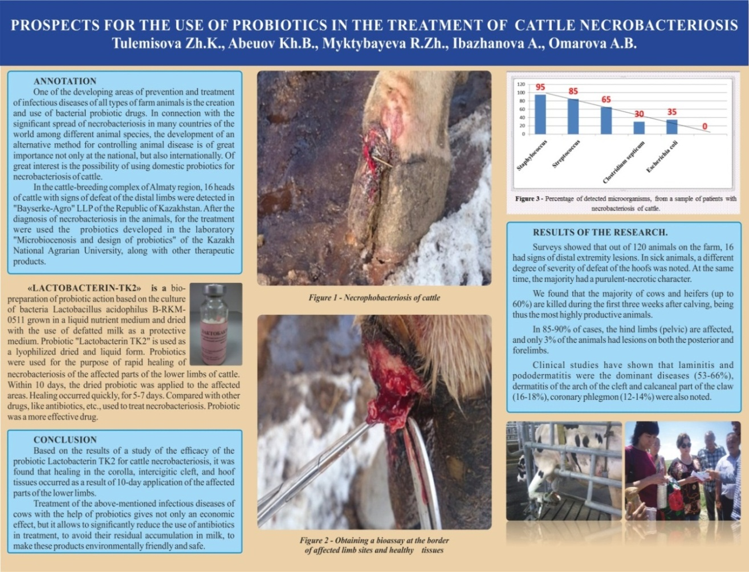
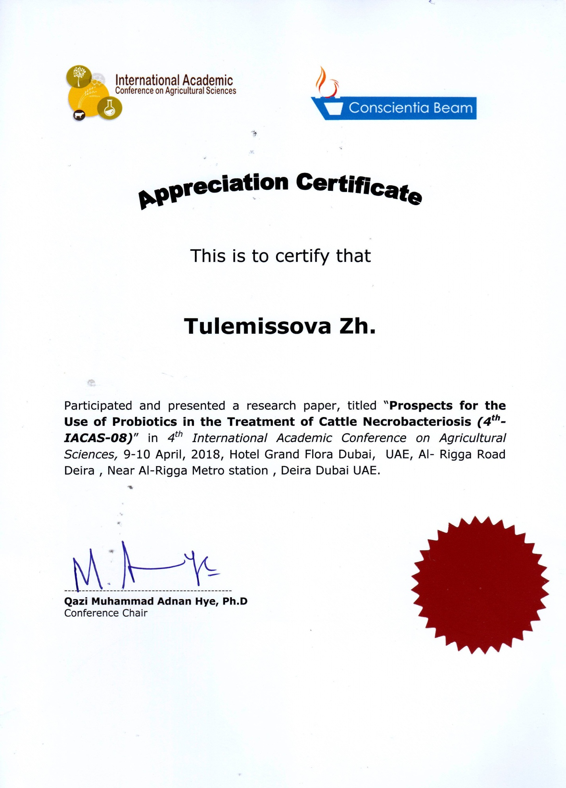

3 Omarova A.B., Tulemissova Zh.K., Zetbek G.S. Phosphoketolase assay for determination of bifidobacteria // Science news in the agro-industrial complex. Publication based on the materials of the VI International conference “Innovative developments of young scientists - the development of the agro-industrial complex”. – Stavropolя: “AGRUS”, 2018. - Volume 1.- P. 194-197. (Rus.)

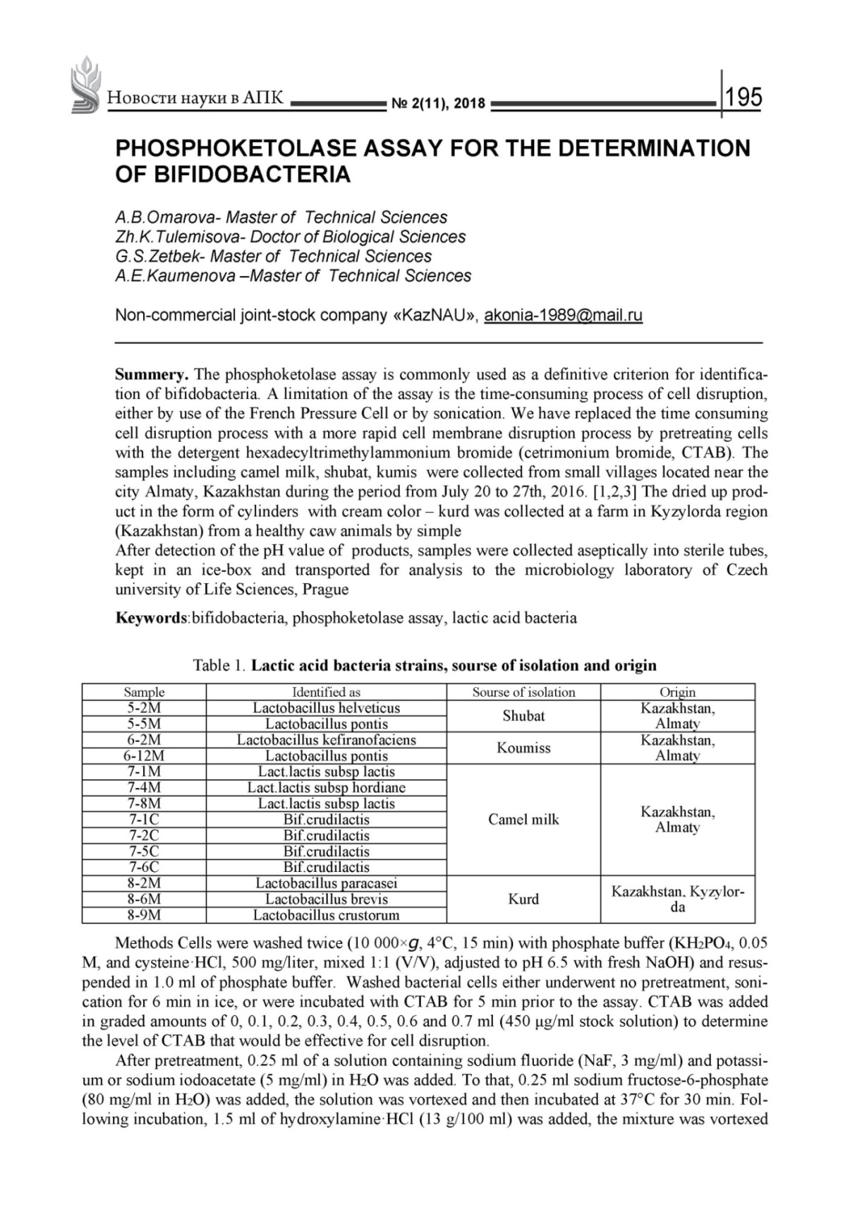

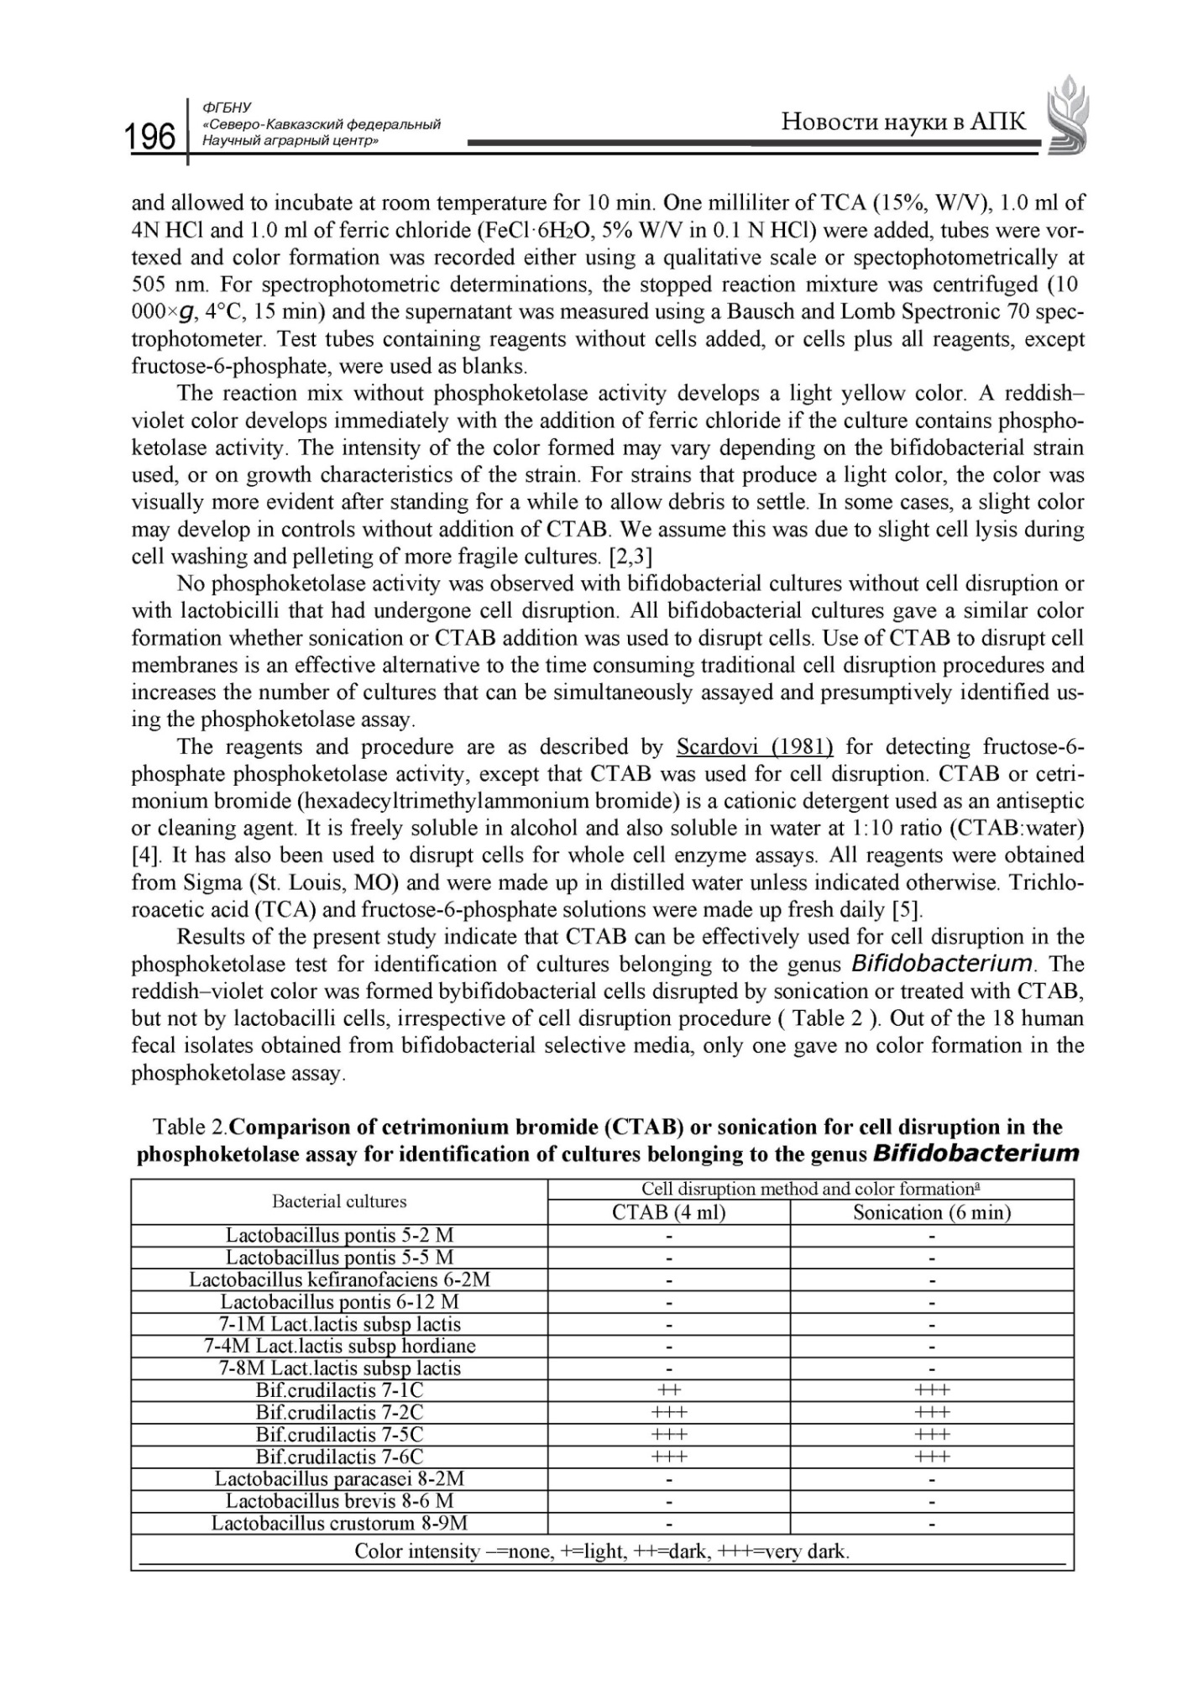

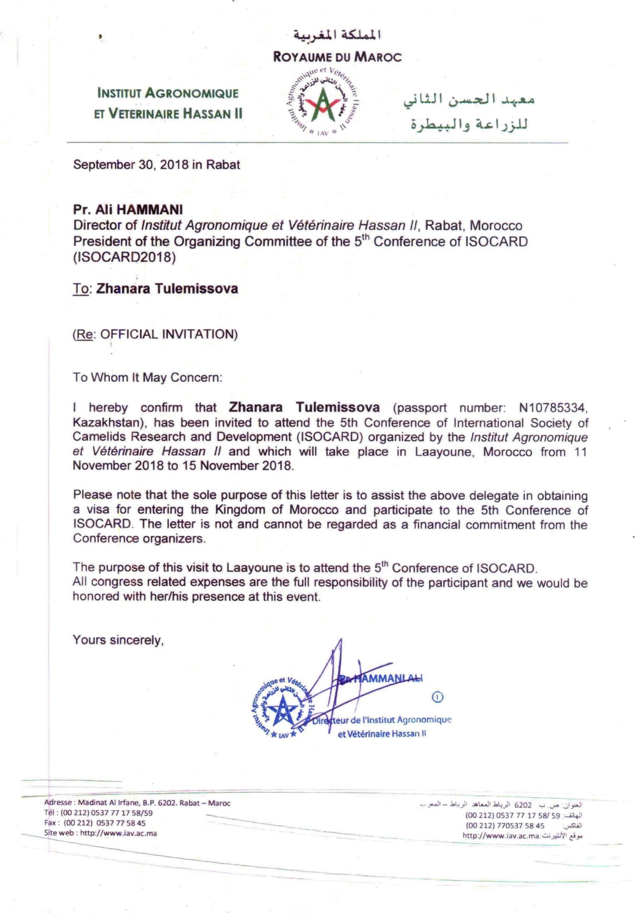

5 Tulemissova Zh.K., Abeuov Kh.B., Myktybayeva R.Zh., Omarova A.B. «Prospects for the use of probiotics in the treatment of cattle necrobacteriosis» // International scientific and practical conference “Prospects for development of scientific knowledge”. – Kiev, 2019. - P.45-47. (Eng.)

6 Tulemissova Zh.K., Omarova A.B. Atte Von., Baikhozhaeva B.U., Ikombayev T.D. «Identification of probiotic strains by modern analytical techniques» // News of National of Sciences of the Republic of Kazakhstan, Series of Geology and Technical sciences. - Volume 3, Number 435 (2019). - Р.30-35. - S/0.09 (Eng.)

8 N.P.Ivanov., V.Y. Suchich., A.M.Namet., N.N. Egorova, B.Kanatov., K.M.Shynybaev. Necrobacteriosis and measures to fight against it in LLP «Bayserke-Agro» // News of the National academy of Sciences of the Republic of Kazakhstan. Seriâ agrarnyh nauk. - 2 (50) march – april 2019. –Р. 86-83. (Eng.)

9. T.K.Boranbayeva, Zh.K.Tulemissova, D.M.Khussainov «Studying the antagonistic properties of lactobacterin-TK² probiotics on pathogenic strains causing gastrointestinal pathology in calves and lamps». News of the National academy of Sciences of the Republic of Kazakhstan, Seriâ agrarnyh nauk volume 3, Number 51(2019) -Р 12-15.
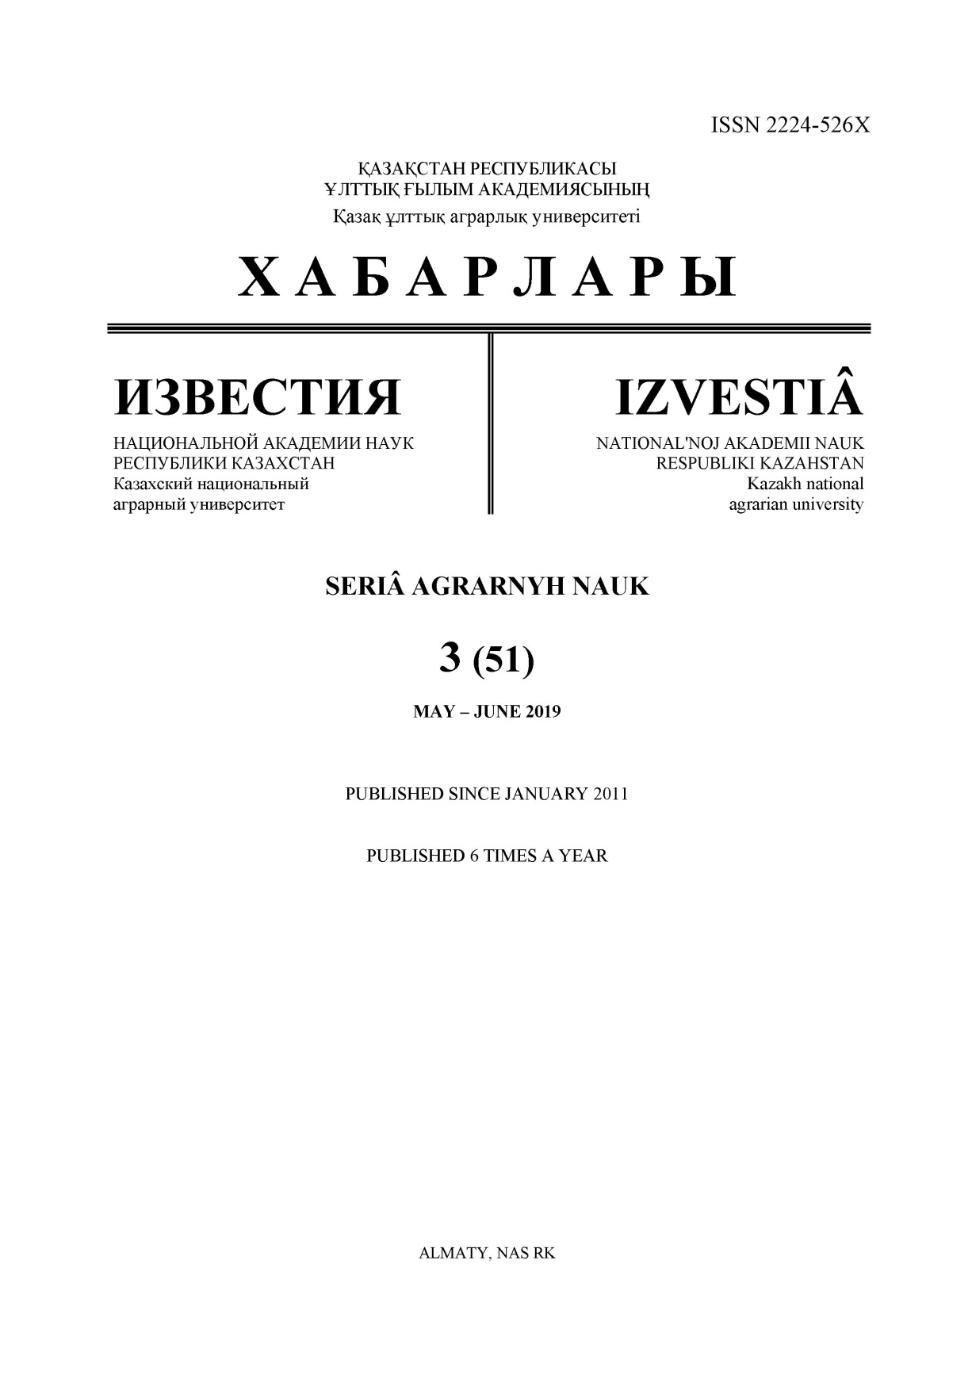

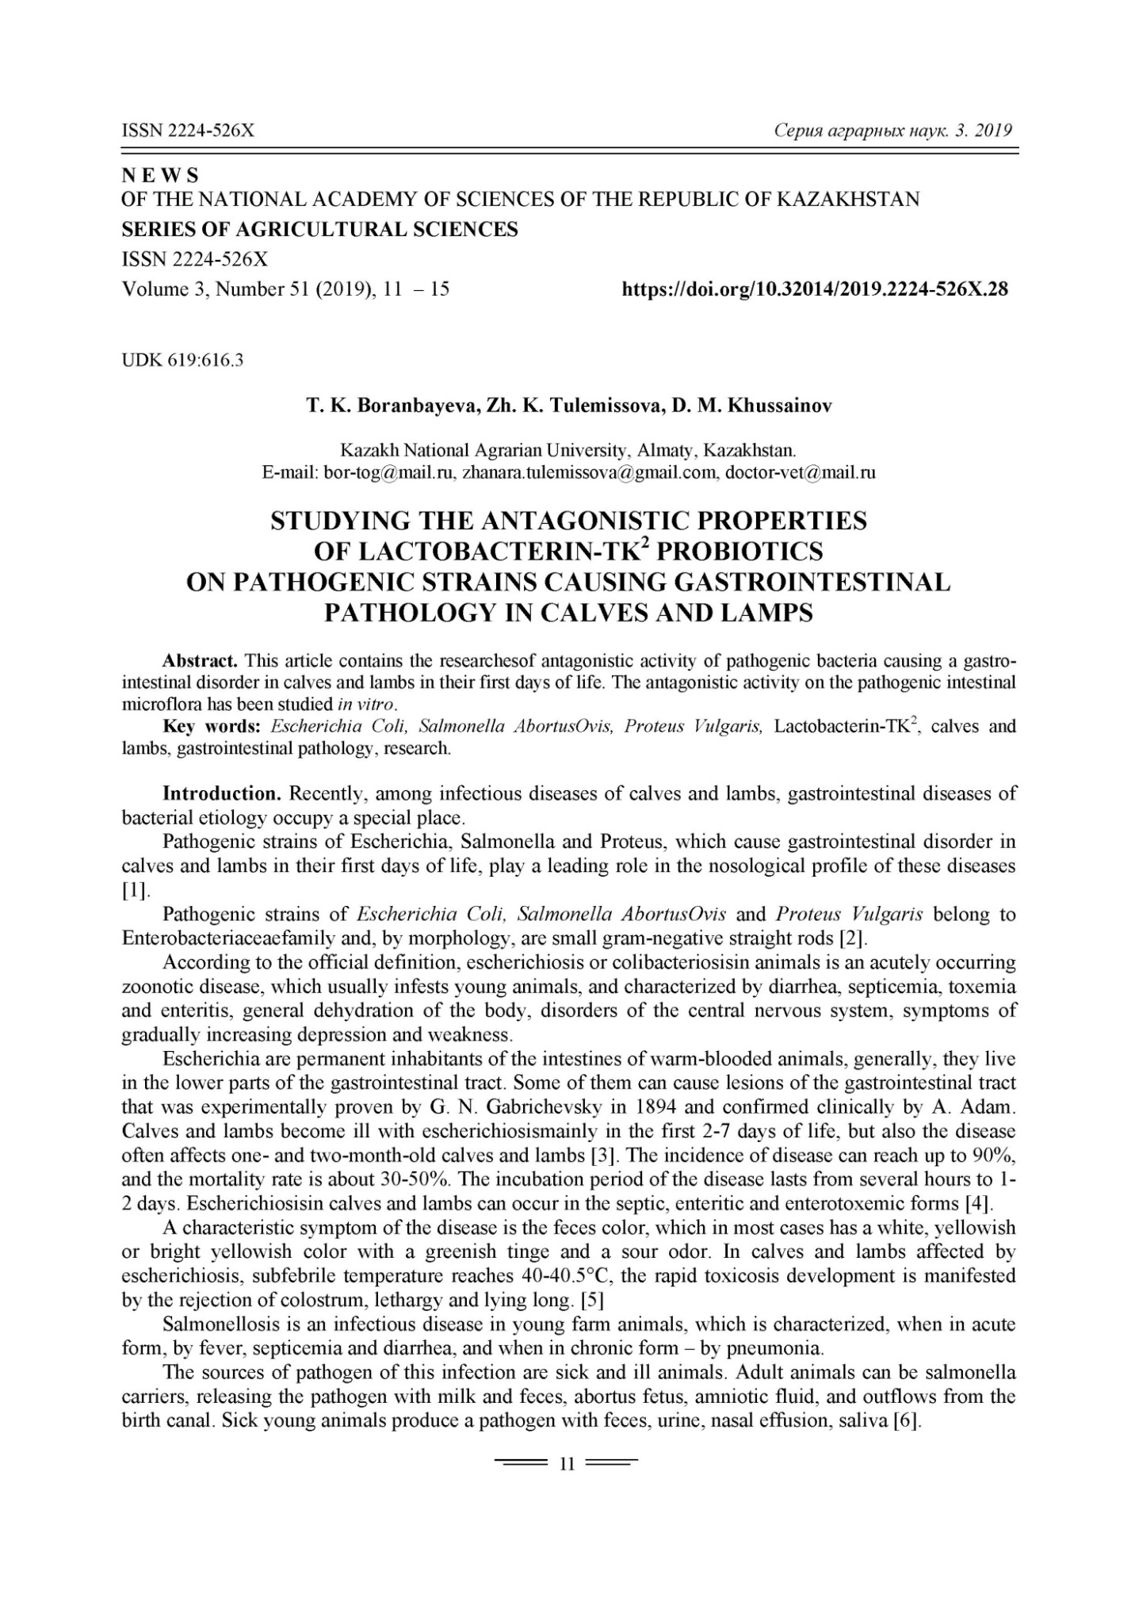

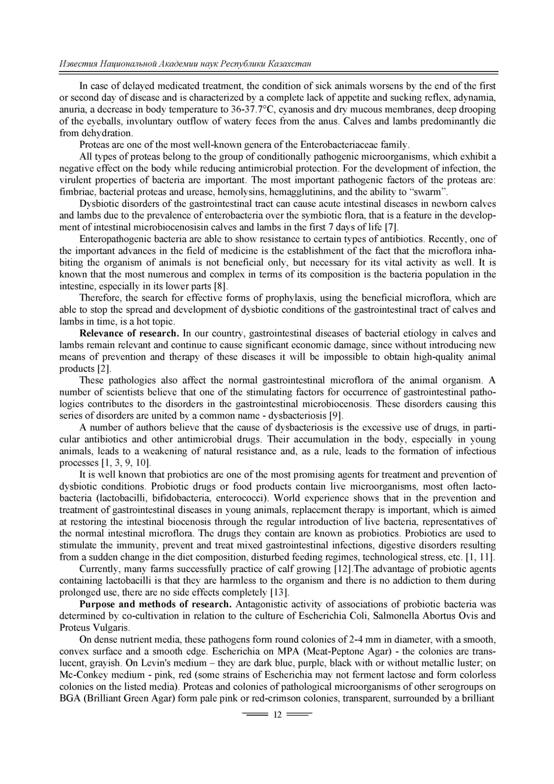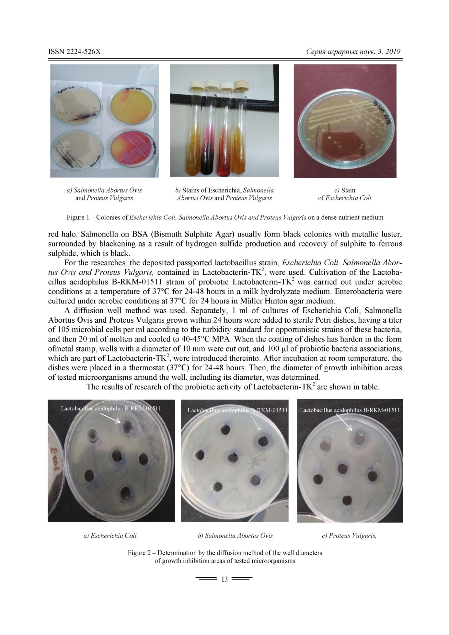

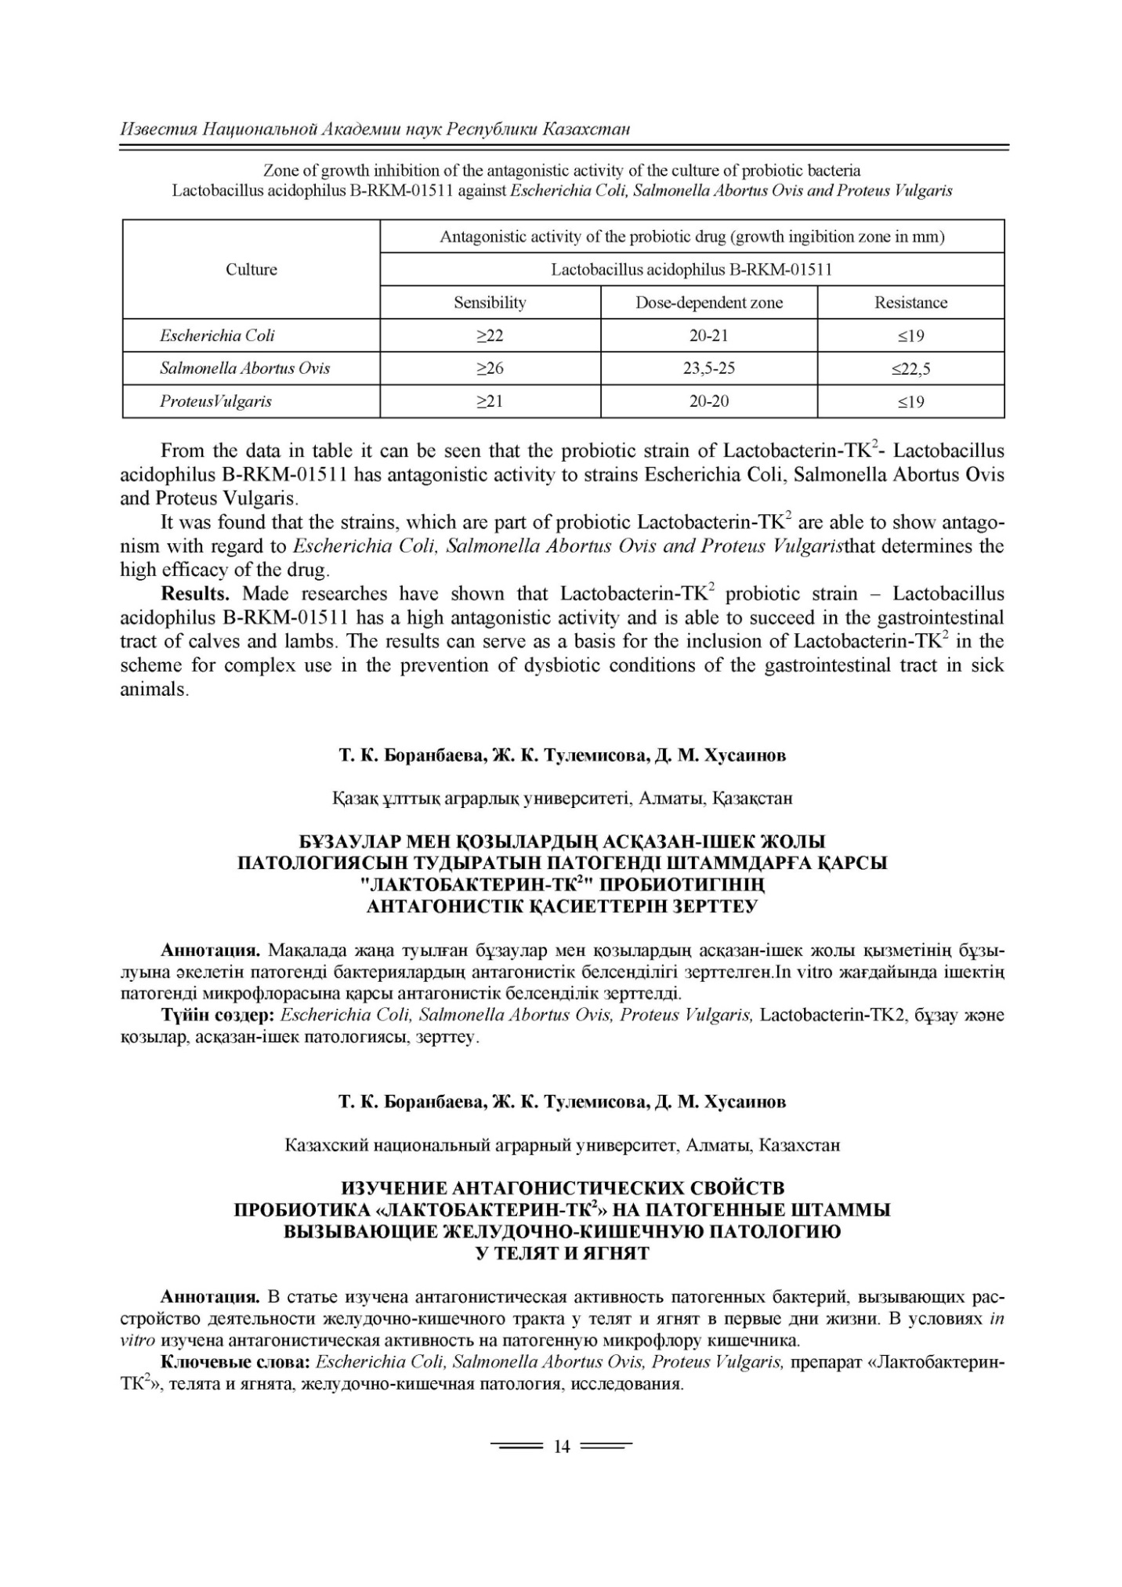

11 Boranbayeva Togzhan, Gul Karahan Aynur, Tulemissova Zanara, Myktybayeva Raya, Serkan, Oskaya. «Proptrties ofa New Probiotik Candidate and Lactobacterin-TK² Against Diarrhea in Calves» // Probiotics and Antimicrobial Protiens ISSN DOI 10.1007/s 12602-020-09649-47. - Р. 1867-1306. - Online first. Springer. Q2 (Eng.)

14 Tulemisova Zh.K., Shabdarbaeva G.S., Myktybayeva R.Zh., Kozhakmetova Z.A., Omarova A.B. «Effectiveness of lactis acid bacteria in cattle necrobacteriosis» New York Univercity Abu Dhabi 11-13 february 2020. ( eng.)

17 Zh. K. Tulemissova1, M. A. Torehanov1, R. Zh. Myktybayeva, A. S. Ibazhanova, D. M. Khussainov1, Zh. M. Batanova1, and S. S. Usmangaliyeva1 «Comparison of Probiotic Lactobacillus acidophilus and Oxytetracycline for the Treatment of Early Stage Interdigital Necrobacillosis in Dairy Cows» 2020, Scienceline Publication // World’s Veterinary Journal World Vet J, 25 September 2020. - 10 (3). - P. 375-379. - Q4. (eng.)

