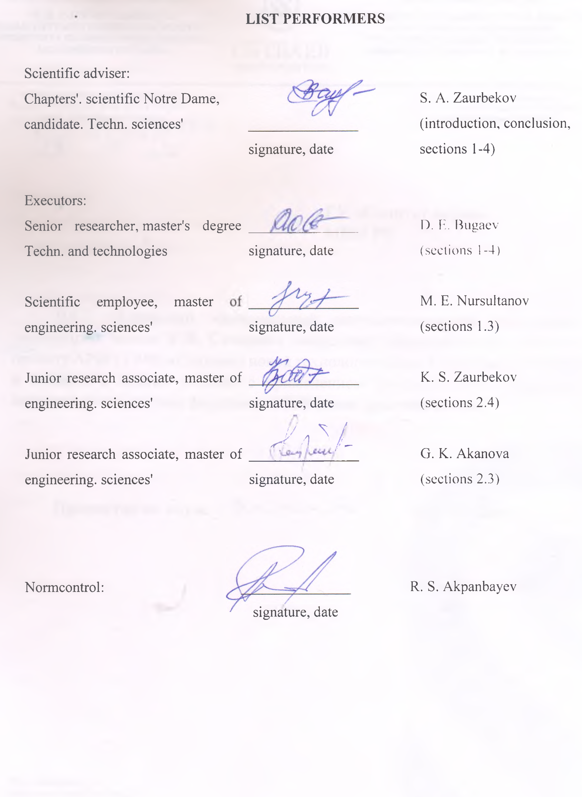

Реферат
Есеп беру 157 бет, 22 сурет, 3 кесте және 87 дереккөзден тұрады.
АНАЛИТИКАЛЫҚ ЗЕРТТЕУЛЕР, ПАРАМЕТРЛЕРДІ ЕСЕПТЕУ, ЗЕРТХАНАЛЫҚ-СТЕНДТІК ҚОНДЫРҒЫ, БУ-ДЫБЫСТЫҚ ҚҰРЫЛҒЫНЫ ЭКСПЕРИМЕНТТІК ЗЕРТТЕУ, ПЛАСТИНА ТҮРІНДЕГІ АҒЫНДЫ ТАРАТУШЫ, ТҰТҚЫРЛЫҚ, ТЕМПЕРАТУРА, СЫЗБАЛАР, ӨНДІРІС, ТЕХНОЛОГИЯ, СЫНАҚТАР, МҰНАЙ ШЛАМДАРЫ.
Зерттеу объектісі - қоймаларда және құю орындарында тұтқырлығы жоғары мұнай мен мұнай шламдарын жинау құрылғылары мен технологиялары болып табылады.
Жұмыстың мақсаты - Материалдық, уақыттық және қаржылық шығындарды азайта отырып, қойма мұнайын жинау тиімділігін арттыруды қамтамасыз ететін ғылыми негізделген техникалық шешім әзірлеу.
Жұмыстарды жүргізудің әдістері мен әдіснамасы – эмпирикалық ғылыми әдістер, қолданбалы ғылыми зерттеулер түрінде, өтіп жатқан процестерді анықтауға, зерттеуге, бақылауға және өлшеуге, газ-гидродинамикалық ағынды таратқыш арқылы өтетін жоғары температуралы будың ультрадыбыстық жылдамдығын қамтамасыз ететін өнімнің нақты жұмыс жағдайларын модельдеуге бағытталған.
Жұмыс нәтижелері және олардың жаңашылдығы – жүргізілген аналитикалық, патенттік зерттеулер негізінде зерттеу бағыты таңдалды, саңылау тәрізді саңылауы бар бу генераторлық құрылғы және пластиналық ағынды таратқыш жасалды, зертханалық – эксперименттік зерттеулердің нәтижелері бойынша снарядтың жұмыс органдарының мұнай шламдарына жоғары температуралы будың ультрадыбыстық ағынының әсерін беретін пластиналы тербелмелі құрылғымен ұтымды қатынасы анықталды және оны қолдану технологиясы ұсынылды. Ұсынылған және іске асырылған техникалық шешімнің ғылыми жаңалығы бар.
Қолдану саласы – Қазақстан өнеркәсібінің мұнай-газ саласы.
Енгізу бойынша ұсынымдар – әзірленген және сынамаланған конструкция және бу-дыбыс құрылғысы және оны қолдану технологиясы енгізуге ұсыным жасауға мүмкіндік береді
Жұмыстың экономикалық тиімділігі немесе маңыздылығы – әзірленген бу-дыбыстық құрылғы және оны тұтқырлықты азайту және қойма мұнай шламын алу үшін қолдану технологиясы ең аз қаржылық және материалдық шығындар мен жоғары тиімділігін көрсетті.
Зерттеу объектісінің дамуы туралы болжамды ұсыныстар - жоғары температуралы бу ағынының ультрадыбыстық жылдамдығын қамтамасыз ететін, пластиналық тербелмелі құрылғы арқылы өтетін өнімді коммерцияландыруға болады

REPORT
Report contains 157 page number., 22 drawings', 3 tables and 87 sources'.
ANALYTICAL RESEARCH, CALCULATING PARAMETERS, LABORATORY AND BENCH ROOM INSTALLATION, EXPERIMENTAL RESEARCHES, STEAM TRANSONIC DEVICE, JET EMITTER PLOSTINATO THE TYPE, VISCOSITY, TEMPERATURE, DRAWINGS, MANUFACTURING, TECHNOLOGY, TESTS, OIL SLUDGE.
Object of research they are devices and technologies collecting high-viscosity materials of oil and oil sludge in barns and filling stations.
Purpose of work – development scientifically based technical support solutions that provide upgrade efficiency collecting granaries oil when decline material, temporary and financial institutions costs.
Methods or methodology carrying out works - empirical data scientific methods, in the form of applications scientific research, directed on the production line, study, observation and measurement leaky ones processes, modeling real-world conditions product operations providing ultrasonic cleaning jet speed high temperature resistance passing pair via gas-hydrodynamic jet emitter.
Results works and their results novelty – based on conducted analytical tools patent applications research direction selected research, developed by steam generator equipment device with slotted nozzle and jet plate type emitter, by results conducted in the laboratory - experimental research installed rational ones relationships working bodies projectile with plate type oscillating the device, providing impact ultrasonic high-temperature jet steam for oil sludge and offered technology its application. Offered and implemented technical support the solution has scientific novelty.
Application – oil and gas industry industry Kazakhstani's.
Recommendations on implementation - developed and tried and tested construction and parooltrazvukogo devices and technology its applications allow make a recommendation ready for implementation.
Economic efficiency or significance works – developed paroultrasonic device and technology its applications for reducing the number of users viscosities and extractions ambarny oil sludge, they showed their own high efficiency at the minimum finansosrvykh and material resources cost.
Forecast data offers about development object of research – developed goods providing ultrasonic cleaning departure speed jets of high-temperature passing pair through the plate oscillatory value device maybe commercialized.
CONTENT

INTRODUCTION……………………………………………………………………………. | 7
MAIN PART OF THE RESEARCH REPORT……………………………………………. | 10
1 Analytical study ……………………………. | 10
1.1 Used technology collection barn oil and oil sludge their dignity and disadvantages......... | 10
1.2 Structures jet mode type for intensification warming up high-viscosity oil companies .. | 12
1.3 Ultrasonic devices gas-hydrodynamic systems emitters jet mode plate type oscillating the device ………………………………………......................................… | 13
1.4 Design steam ultrasound the device with jet-based plate type the emitter ...................... | 15
2 Laboratory and experimental tests research......................................................................... | 17
2.1 Installation for conducting in the laboratory - experimental researches'………………….. | 17
2.2 Results experimental data research..…………………. | 19
3 Development of sketch drawings and production of an experimental design of the device....................................................................................................................................... | 22
3.1 Development of sketch drawings and development of technological manufacturing processes…………………………………………………………………………………… | 22
3.2 Design of technological processes for machining parts of a steam-ultrasonic device…… | 23
4 Technology high-viscosity collection oil with the use of steam transonic devices…… | 35
4.1 Oil companies slurries and their composition ……………………………………… | 35
4.2 Study conditions, places spillage and localization oil sludge.................................... | 37
4.3 Technology collection's high-viscosity oil in the barns and filling stations with the application steam transonic devices……………………………………… | 41
CONCLUSION……………………………………………………………………….. | 44
LIST USED ONES SOURCES......................................... | 45
THE APP A Calendar plan……………………………………………….. | 51
THE APP B Extract from the minutes of the meeting of the department of TM and E……… | 55
THE APP C Extract from the minutes of the meeting of the board of the institute M and PE | 56
THE APP D extract from the minutes of the meeting of the STS university.................................................................................................................................. | 57
THE APP E List of publications on the topic of this research over the 2018 to 2020 ……… | 58
THE APP F Sketch pages drawings of ultrasonic the projectile....................... | 150
THE APP G Technical characteristics of the machine 1k62…………………………………. | 157
The app H The route of the technological process of manufacturing parts………………… | 158
the app I Photos of the manufactured projectile………………………………………….. | 141
the app j Test report………………………………………………………………………. | 145

INTRODUCTION

Rating modern States resolvable scientific and technical problems.
In the modern world the world of oil and gas petroleum products they are priority settings polluting agents environment Wednesday. Spills, leaks, barns with slurries cause damage in the soil cover, in the surface and dirt roads water. According to published data loss oil in the world when it is extracted, recycling and usage exceed 45 million tons per year, which is it makes up about 2% annually production, when this one has 22 of them millions of tons are lost on land.
Mining, transportation and recycling oil in everything the world is connected with contamination environment Wednesday. Periodically occur ruptures of oil pipelines, losses from which reach, by different data, 7-20% of the extracted gas raw materials [1]. Waste oil and gas producing the complex they focus in slime plants barns that are they represent earthen buildings filled barns drilling waste and oil production (a mixture of waste products drilling fluids, rocks. clay, cement, water, oil and oil products; resistant emulsions and waste generated in progress preparation oils, products tank Stripping and so on) [2].
Problems pollution territories oil and gas companies fields current in the all over the world. Oil and petroleum products, getting into the environment environment, deteriorate water regime and physical data soil properties, provide toxic action on plant growth and development living organisms, reduce content mobile devices connections nitrogen and phosphorus and potassium [3]. When this, ambarnaya the oil is useful hydrocarbon-based raw materials, although and suffered serious ones structural features changes, so top layer solidified and it won't budge cure [4,5].
Oil sludge they represent self-sustaining emulsions are not manageable traditional methods of destruction in terms of oil fields and accumulated costs in oil slurries barns. Ambarnaya street oil is undergoing serious ones structural features changes when for a long time open storage as a result interactions with atmosphere and practically completely it loses its lungs fractions. Barn oil, long-term open storage is solidified amorphous mass, for extract, you need cut into part and extract or to thin and pump out.
Justification if necessary carrying out Research on the topic - according to the Committee's data environmental management regulation and monitoring Ministries power engineering Commonwealths Kazakhstan with position with pollutants substances, to be discarded the oil industry in Mangystau region regions in 2015 software only "Uzenmunaygas" annual volume educational institutions oil spills it amounted to 18550 tons (or 21332.5 m³), PU "Kalamkasmunaygas" - 28,478 tons (or 33,503,8 m³). Buterotic photography shows availability of a large quantities barns spilled oil products that are pollute territory oil companies fields and provide negative impact on the environment Wednesday.
Information about the planned event scientific and technical development level about patent applications research and conclusions from them - on the basis analytical, patent research the chosen direction studies installed most meet requirements reduction material time and financial cost parameters values device with inkjet radiator providing supersonic the rate of departure jets of steam. Developed steam transonic device with slotted nozzle and jet plate type emitter, offered technology its application.
Information about metrological services security NER – scientific research provided certified and solicitors metrological services by any means measurements.
Relevance. Impact oil on the ground manifests itself in its geochemical state change. Under the influence of compounds oil happen profound changes morphological, water-physical and agrochemical properties of the soil. Changes acidity environment, increases quantity carbon-containing products connections, increases quantity nitrogen, potassium, iron, manganese, decreases availability for plants phosphorus, nitrogen, of potassium. Oil it also provides inhibiting agents action on nitrification processes and ammonification [6].
The result reduced fertility soils and deteriorating their health hygienic condition broken natural the soil formation process, are formed anthropogenic soil, i.e. the new soil-geochemical body, have combination properties that are not unparalleled in terms of natural ecosystems [7].
Existing technology collection high viscosity oil behind from the modern level of development scientific and technical progress and require a new approach introduction achievements fundamental science and creation new technologies collection high viscosity oil in pits places filling and pollution soils with application ultrasonic devices that today is very relevant.
Novelties'but. Impact by ultrasound steam jets having an annular shape form and passing through via the hydro-gas dynamic method jet emitter, results to structural ones transformations components dispersed phases and provides a high degree of dilution ratio oil sludge, what they allow significantly shorten it financial, material costs and reduce them temporary time period for conducting the cleaning operations barns from oil sludge. Offered and implemented technical support solution of the problem scientific novelty.
Link to this page working with others Research Institute. In present time held numerous research, directed to study effects of ultrasonic impacts for viscosity-temperature tests properties of oils. Results these impacts ambiguous terms and not always explained in links to complexity the object.
Questions security features environmental policy security features environment when conducting the man-made impacts in areas of oil production currently time is given increased attention in the second stage all over the world, so and here in Kazakhstan. In accordance with the set tasks, issues ensure environmental environment do and conduct research a number of institutions, in particular "Kazecoproject", "Central Asian Institute environmental research», «Institute environmental issues research", with whom supported close collaboration and coordinated scientific research.
In implementation framework the project has been prepared two intermediate ones report:
1. Analytical features research and calculation of the main parameters geometric elements and mode settings parameters ultrasonic works devices on the based on analytical data and patent offices research by topic: «Creation new technology collecting high-viscosity materials oil in the barns and filling stations with the application ultrasonic devices". Intermediate № АР05133906. UDC 622.276 (075), 622.243 (075), MRNTI 52.45.19, no. state reg. 0118RK00137, Inv .no. 0218RK00848, Almaty 2018
2. Laboratory-experimental research to clarify ratios working bodies design ultrasonic the device and technology collection high viscosity oils with the use of ultrasonic devices according to indicators oil viscosity and its volume. Intermediate № АР05133906. UDC 622.276 (075), 622.243 (075), MRNTI 52.45.19, no. state reg. 0118RK00137, Inv .no. 0219RK00829, Almaty 2019

MAIN PART OF THE RESEARCH REPORT

1 Analytical study

1.1 Applicable technologies collecting granaries oil and oil sludge their advantages and disadvantages

Granary oil represents self-sanctioned and not sectioned ones oil spills, as shown in figure 1.1, undergoes serious ones structural features changes when for a long time open storage as a result interactions with atmosphere and practically completely it loses its lungs fractions. Barn oil, long-term open storage is solidified amorphous mass, for extract, you need cut into part and extract or to thin and pump out.
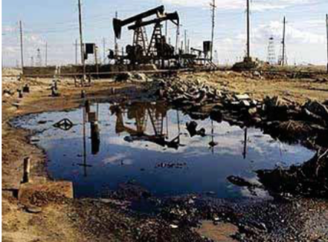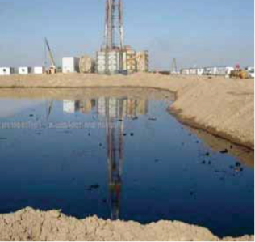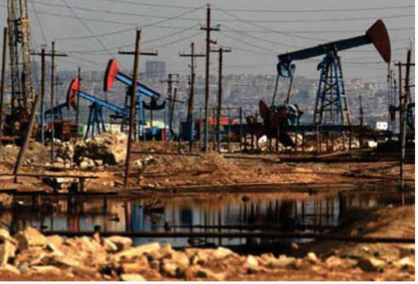
Drawing 1.1 - Oil spill on the fields

Oil sludge they represent self-sustaining emulsions are not manageable traditional methods of destruction in terms of oil fields and accumulated costs in oil slurries barns (see figure 1.2).
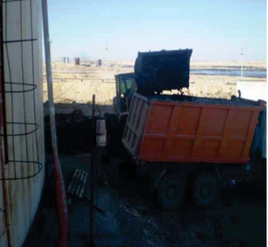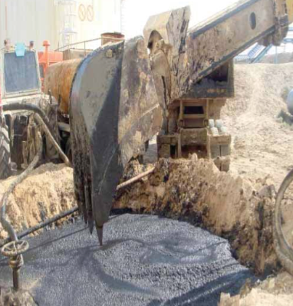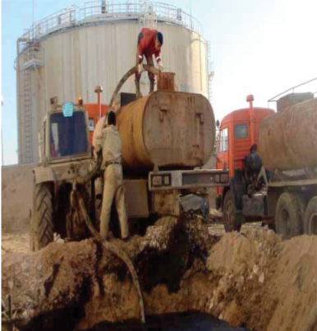
Drawing 1.2 - Various cleaning methods oil barns

Collection method granary oil by cutting and extractions it is not considered necessary technological and in this regard the most widespread application got a method dilution ratio oil and in the future its pumping out [ 8 ].
All known technologies collection and processing granary oil and oil sludge can be divided on the following pages groups [ 9 ]:
  - thermal properties – incineration in the open barns, various furnaces types, getting bituminous plants remaining funds;
  - thermal – heating and processing ferry;
  - mechanical features – mixing and physical division oil sludge;
  - chemical – extraction using solvents, curing process with the application add-ons;
  - physical and chemical properties – application specifically selected ones reagents, modifying ones physical and chemical properties, with follow-up processing on a special site equipment;
  - biological data – microbiological testing decomposition in the soil directly in storage locations, bio thermal decomposition [10].
All these methods actively tested and applied [11], however, none I didn't give any of them long-term investments and positive ones results. Most successful tested and applied combined services methods [12]. However all these methods applicable only for destruction trap doors emulsions and moving parts granary oil sludge, mass content mechanical impurities in the which are not exceeds 10 -16 %.
The largest the effect was given thermal properties methods, and among them they are overwhelming advantage it has an application pair [13], but when this is not all these methods reduce heavy viscosity oil [14].
Promising alternative chemical reagents is the application special features devices, implementers wave physics effects.
On the basis of held analysis to say what low-energy technology (acoustic, vibration, magnetic cavitation etc.), using which can no noticeable external energy cost or using internal reserves substance rebuild its structure, are the most promising in view of their efficiency, efficiency and availability.
At the same time, one from the perspective can be considered cavitation method processing options oil, but this one the method didn't get wide distribution because of the complexity technical support implementations, low reliability and high cost. Therefore, on the view of the most promising, responsible submitted documents requirements is a combination of applications high temperature resistance steam and gas-hydrodynamic jet mode the generator.

1.2 Jet-type devices for intensifying heating of high-viscosity oils

Installations based on principle high speed feeds hot water jets water is widely used for cleaning up reservoirs for storage oil, tanks tankers. When mechanized cleaning method contaminated sites surfaces wash it hot water supplied by under pressure via special offers washing machines – giants.
Mechanized cleaning method significantly reduces time cleaning, reduces tank idle time, reduces volume heavy operations, harmful for human health, and reduces the cost cleaning process the tank.
During the research hydro-mechanical effects parameters jets for efficiency cleaning process it was established that what is the impact force the jet interacting with the with bottoms deposits, has an optimal value, and not located in direct dependence from the diameter nozzle and head washing machine jets liquids. When that's enough high pressure in the hydraulic monitor (2.0 – 2.5) MPa occurs "cutting” jet effect, what reduces your risk efficiency cleaning [15].
In [16, 17] proposed method and equipment for heating oil with a low coefficient of thermal conductivity in train tanks using methods of local contact heating and discrete-pulse energy input.
Known method of exposure on the surface granary oil with a jet of water a pair of feeders from cylindrical nozzles [17]. A drawback this method is the absence of features effective dilution ratio high viscosity oil in the barn or oil sludge. because it is used only heat water jets pair that is missing for quick access liquefaction barn oil.
Also known thermomechanical dilution method granary oil steam engine high speed the umbrella jet type in the complex with mobile installation for collecting granaries oil (see figure 1.3) [18].

Nozzle shape 3
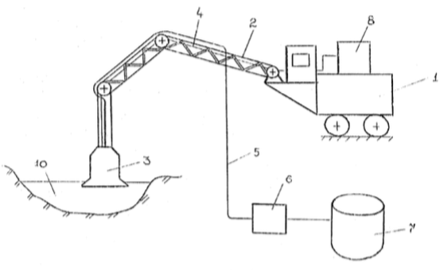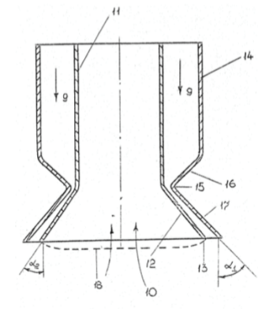
1 - mobile steam generator room installation (PPU); 2-telescopic arrow; 3-nozzle; 4-flexible steam line; 5-flexible oil pipeline; 6-pumping station installation; 7 – capacity.

Drawing 1.3-Thermomechanical dilution method granary oil steam high speed jet [19]

In this design primary nozzle in progress in the form of an annular ring Laval nozzles with the Central one a body with a specific name taper angle and allows you to get an umbrella service steam jet with several redundant parameters on the way out cross section of the nozzle. Dilution thickened granary oil produced ring road supersonic steam jet, generated mobile steam installation PPUA-1600/100, equipped with with an arrow folding and mobile platform, enabling deliver nozzles with supersonic with a jet on the different sections the barn [[18, 19].
Most interesting technical the solution is thermomechanical dilution method granary oil steam engine high speed the umbrella jet type, but all described methods are based on on impact on the surface barn oil, what is a not economical and low-performing [20].

1.3 Ultrasonic devices gas-hydrodynamic systems emitters jet type with plate type oscillating the device

As a basis ultrasonic devices, working in the gas station, liquid and solid Wednesday is supposed to be principle of use elastic oscillatory systems small wave lengths with average 10⁵ – 10⁷ Hz (USH) and high oscillation frequency 10⁷-10⁹Hz (USVCH). Feature devices based on ultrasound is high the intensity waves, which leads to the dilution of the high viscosity environment.
Generators ultrasonic devices they share it into two main categories groups: mechanical and electro-mechanical ones. The basis of the work the generator Hartmann, put the principle is as follows the fact that the supersonic the jet turns to the source sound and video files ultrasonic devices waves [21-24].
Generator ultrasonic devices of fluctuations the mechanical one types that are in turn divided into two parts gas-hydro-jet groups emitters and sirens. Emitters the first group based on how it works the generator Hartmann, applied to get oscillation range 2-50 kHz, at the same time on the path of the jet gas (liquid) outgoing with supersonic speed from nozzle, fits elastic plate, around which alternately arise eddy currents creators periodically upgrade pressure and conducting devices plate b oscillatory value movement [25].
Principle hydrodynamic operation plate type the emitter (GPI) consists of in the next one liquid from nozzles (slot) 1, along the axis of which rigidly attached plate 2 (see figure 1.4).
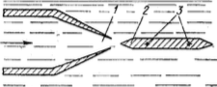
Drawing 1.4-Hydrodynamic plate type emitter
Jet flying with ultrasonic speed hits plate 2, when this one the other side plate frustrated vortices causing periodic pulse pressure at the ends plate range frequency depending on material properties, fluid properties, sizes and attachment method plate. Speed expiration dates liquids from nozzles and distance from the nozzle slice up to the edge of the plate define frequency of the radiated signal sound. Setting up into resonance is being implemented change the fluid flow rate. For frequency above 7 kHz plate fasten in two ways nodal points. for frequencies less than 7 kHz apply console application mounting. Stable SPI operation provided by only when high speeds expiration dates liquids and fine-tuning the system is smooth change the fluid flow rate.
The principle working gas-jet plate emitter is that speed jets emerging of the nozzles shall exceed the speed of sound, the result this arise waves, causing in oscillatory the movement of the plate (membrane) resulting it in resonance oscillation, i.e. works similarly to hydrodynamic plate the emitter [26,27].

1.4 Design steam ultrasound the device with jet-based plate type the emitter

Construction developed by plate type steam-hydrodynamic the emitter for slotted primary the nozzles are presented in figure 1.5.
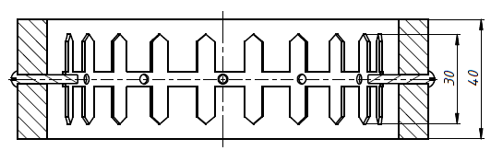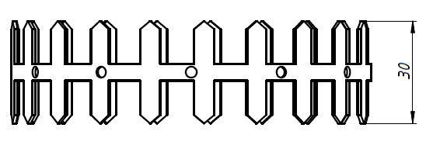

Drawing 1.5-Design plate type steam-hydrodynamic the emitter for slotted nozzles

Emitter represents create a feed cylindrical shapes with a diameter of equal to the diameter slit-like primary nozzle, characterized by the presence the ribbon plates - petals'. Tape with plates-lobes made from hardened have become possessed of elastic flexibility. The feed is fixed inside the case 12 bolts, at the same time with the help of which produced adjustment cross-section tape positions with plates-petals.
Principle plate-type operation the emitter consists of in the next one, high-temperature steam jet crashes from primary nozzles with ultrasonic speed and falls on the records – petals and when gradually increase steam feeds it begins plate vibration callers ultrasonic devices fluctuations, which occur only when expiration rates pair exceeding ultrasound speed.
Developed design steam ultrasound the device with jet-based plate type the emitter submitted by in figure 1.6 and consists of two main ones parts: - device forming agent slotted primary nozzle and ring road plate type emitter, which are connected between themselves into a single device.
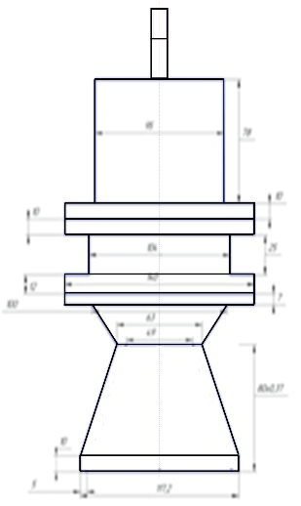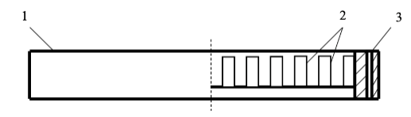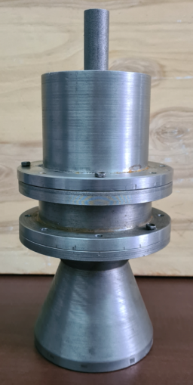

1 - housing jet mode plate type the emitter; 2-records – petals;
3 – connecting cable node
Drawing 1.6 - Design steam ultrasound the device with jet-based plate type the emitter

For calculation of the design slotted steam-supersonic nozzles devices defined by a number of the following parameters:
- relationship pressure after nozzles (P₂) (in the expiration environment) and in front of the nozzle (P₁) (at the nozzle inlet);
- output speed jet departure steam from the nozzle (From₂);
- valid expiration rate (From₂^{d});
- pressure in critical nozzle cross section (P_{kr});
- the enthalpy in critical nozzle cross section (i₁);
- critical speed (S_{kr});
- a valid one critical speed (S_{DCR});
- kinetic energy loss jet energy gas at the expense of friction when expiration date in critical cross-section (Δh_{kr});
- kinetic energy loss jet energy gas at the expense of friction when expiration date in output section (Δh₂);
- minimum value nozzle cross section (F_{min});
- maximum value nozzle cross section (F_{max});
- minimum section size nozzles (D_{min});
- maximum value section size nozzles (D_{max});
- output area cross sections of the experimental ultrasonic testing the projectile;
- area field trip nozzle cross-sections.

2 Results in the laboratory - experimental study
Experiment is dominant among methods of obtaining information about the internal relationships phenomena in the art. It is a starting point and criterion most our knowledge. Experimental data searches are frequent they are conducted in the following areas where theoretically can't be done of any kind foresight. Using experimental data received directly from the subjects studied objects being checked truthfulness theoretical issues background information [28-38].
2.1 Installation for conducting in the laboratory - experimental researches'
Installation for conducting in the laboratory poster sessions research submitted by in figure 2.1 and includes its composition steam generator room install 1, device model 2, connected metal plate 4, capacity of the tube 4 installed at the specified time level for carrying out video shooting using high speed cameras "EVERCAM 1000-8-S" 5 and processing received results on your computer with the application supplied included with a camera software security features [39,40].
Steam generator room the installation was enabled to water supply lines and sewers, generated data rich water vapor submitted to an experimental program device model with pressure 8 bar, at capacity installations 20 kg / h [41].

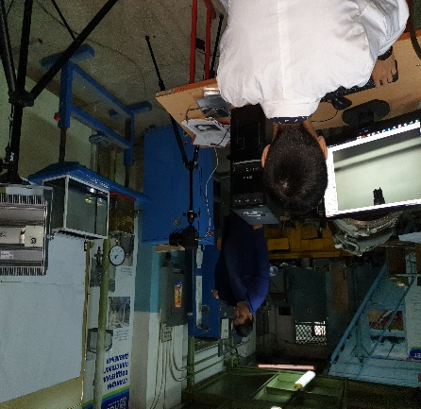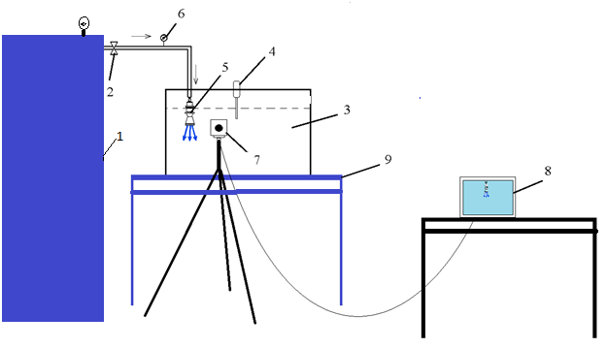

1 – steam generator; 2-ultrasonic projectile; 3-capacity from plexiglass; 4-viscometer; 5-flow meter steam; 6-pressure gauge pair by pair; 7-camera for high speed shooting; 8-computer for processing material shooting; 9-stand
Drawing 2.1-poster Board installation

2.2 Results experimental data research
In as objects research were selected glycerin and oil sludge high viscosity Uzen oil company with the following features:
Table 2.1-Physical devices properties of glycerol
Parameters | Size-ness | Indicators under various conditions temperatures
Parameters | Size-ness | t = 20°C | t = 80°C | t = 140°C | t = 200°C
Density ρ | kg / m³ | 1260 | 1224 | 140 | 200
Dynamic viscosity μ * 10³ | PA * s | 1480 | 35 | 1,8 | 0,22
Table 2.2 - Ffrom <url> properties of oil sludge Uzen oil company
№ | Parameters | Indicators
1 | Density, kg / m³ (20⁰C) | 858,9
2 | Viscosity, x 10⁶ m²/s (50⁰C) | 16,5
3 | Pour, ⁰C | +31
4 | Temperas'. saturation levels paraffin oil, ⁰With | 51
5 | Content, mass %
 | - sulfur | 0,18
 | - Nickel-based resins | 13,30
 | - asphaltenes' | 3,30
 | - paraffins' | 18,60

Choice glycerin and oil sludge Uzen oil company in the quality of objects of research conditioned by because glycerin it is viscous transparent liquid and allows you to produce high speed capturing leaking images processes and install their speed flows [43].
Oil sludge Uzen oil company selected as the research object, due to the fact that that it freezes at the temperature of +30 ° With, what is most important closely matches by viscosity, surface level the resulting layer under the action external factors on the surface barn oil.
Methodology carrying out research included in effect high speed steam jet from the initial stage speed 339 m / s to the object and tracking processes leaky ones in the environment during the specific the time interval time – 0, 5, 10, 20, 30 min. Based on carrying out high speed video shooting defined speed in 5 points separated from each other on a specific site distance from the input point Wednesday's pair – 5, 10, 20, 30, 40 see Measured temperature, selected samples in the specified parameters points and was installed density, kinematic system and dynamic viscosity at set temperature environment, as well as by conducting a high speed video shooting defined jet speed steam, and speed movement of the working group the environment in each from points [44].
Plan carrying out experimental data research there was another one [32.33]:
- Change temperatures in 5 settings points in length after exposure high speed steam jets, by entering the thermometer probe's;
- Measurement dynamic viscosities in 5 installed versions points in length after exposure high speed steam jets, by selecting samples in each point;
- Measurement the speed of the process impacts high speed steam jets on the glycerin in 5 software points results speed measurement based on frame-by-frame information high speed video shooting.
- Build charts in excel.
By results carrying out experimental data research installed main dependencies changes temperatures, density, viscosities glycerin and oil sludge under the influence of ultrasonic jets of high-temperature a couple.

Drawing 2.2-Change temperatures glycerol and oil sludge

Temperatures glycerol in water time at the impact high speed steam jets, from which should be used, what is the temperature glycerol b initial moment (during 5 minutes) increases intense, further growth temperature range it's happening on a more gentle road the curve shows that can I explain it by increasing the number interval time from 5 min up to 10 minutes.
Drawing 2.3-Change densities glycerol and oil sludge
When this, in General for 30 minutes of exposure temperature range glycerin increased by more than 2 times during the in all 3 experiments, how good is that as shown in the graph. Change temperatures oil sludge it's happening planned, without any sudden jumps temperature rise from 20 to 60 °With during one hours, while oil sludge purchases fluidity. Ability leak in oil sludge is one of the main ones’ criteria the problem to solve on dilution and suction oil sludge from the barns.
Change densities glycerin with temperature rise under the influence of high speed steam jets and from the built list the graphic should follow, what is density at the beginning the area between points 1 and 2 it's going down significantly more intense than on the site between points 2-4 and in General density reduced by 4 % with 1270 kg / m³ before 1228 kg / m³. Density oil sludge as the temperature rises with 65 ° with up to 75 ° with under the influence of high speed steam jets, decreased from 920 to 910 kg / m³.
Drawing 2.3-Change dynamic glycerol viscosities and oil sludge
Conducted laboratory and experimental tests research allow do the following conclusions:
- installed, what is 2-fold temperature rise object of research achieved during 30 minutes of processing rich water vapor with ultrasonic speed;
- observed intensive change kinematic function and dynamic viscosities of viscosity object of research with magnification temperatures from 19 to 45 ^{about}With;
- density object of research with magnification temperatures from 19 to 45 ^{about}With changed not essential;
- for 30 minutes of processing provided by conversion object of research – oil sludge into a fluid state.

3 Development took place sketch drawings and manufacturing experienced design
3.1 Development draft drawings and working out technological solutions processes manufacturers
On based on the conducted calculations and analysis of the received data experimental data research installed rational ones geometric elements sizes steam ultrasound the device with jet-based plate type the emitter and developed draft drawings, which are represented by in the app G.
How known, process-creating products it is called production. Production process it is aggregate all actions men and tools labor required on this site enterprise for manufacturing and product repair. Production the process includes individual processes, implemented projects to get from materials and semi-finished products ready-made machines (products).
In production, process includes all processes, providing services possibility manufacturers products starting from the moment of receipt to businesses initial workpieces.
Technological process it is called part of the production process that contains targeted programs software actions change and the definition States products. So in progress mechanical processing options they are changing dimensions, shape, mutual location surfaces and quantity micron values processed data surfaces, and during the build process product changes relative value position details in the collected list node.
Technological process it makes up main part production the process. By to the technological Department process mechanical processing options blanks can be judge about sequences, methods, time processing and others.
Necessary strive to the optimal level to the technological Department process (the best, most appropriate specific terms and conditions issues).
All of them technological approach process mechanical processing options workpieces it gets split up on composite pages parts. The main one part of the technological process the process is technological information operation.
Technological operation it's called finished part of the technological process the process being performed on the same desktop location and coverage all actions the processing lathe details before the transition to the next one.
In dependencies from the worker places of operation they are divided into turning machine, milling machine, sanding machine. During manufacturing small quantities product handling all details on a lathe the machine produces per operation.
When processing details per session operation of it process first with one the parties, then they turn it over and process it the other side. In this case they say that the part is being processed for two installations.
Installation – part technological support operations performed when unchanged pinning processed data workpieces (figure 3.1).
a) processing cylindrical surfaces F40;
b) processing cylindrical surfaces F30
Drawing 3.1-Processing details for two installations

Performed tasks types of processing (pruning end face, external turning, drilling, countersinking, deployment and so on) are called technological solutions click-throughs.
Technological transition it's called finished part of the technological process operations performed the same people by the same means technological equipment equipment at the permanent ones technological solutions modes and installations.

3.2 Design technological solutions processes mechanical processing options details of steam-supersonic the projectile

When making a list technological equipment process mechanical processing options details choose the most economical execution method operations with achievement set point processing accuracy.
Source data with data when design technological equipment the process parameters are working drawing details, gender workpieces, batch sizes and its repeatability.
Technological approach the process can be build software principle differentiations (dismemberment) operations or based on the principle of their concentrations (associations). The choice of one or the other option produce adjusted for size batch and accuracy manufacturers details.
In our case working class part, drawing provides alignment outdoor and indoor internal cylindrical surfaces. DLa increases their accuracy processing should be produced from a single installation. With concentration operations number installations it decreases.
When dismemberment operations each the machine is set up for execution the simplest ones click-throughs. With using stops and other devices, they raise it performance and accuracy processing. Item usually pin it down in specialized areas fast-acting devices, since the number installations increases. At elevated temperatures requirements to accuracy processing options technological approach the process is dissected on the preliminary ones and finishing rooms operations and perform them on hardware different accuracy.
Accuracy and performance turning operations depend on correct one destinations installation instructions bases and selection pinning method details on the machine.
Based on surfaces, or databases are called surfaces, defining features position details. In technology mechanical engineering, distinguish installation instructions, measuring devices, Assembly lines and other databases.
Installation instructions databases they are called such surfaces details to use it is being installed for processing relative machine and cutting equipment the tool. In the quality of installation instructions bases can be applied processed data, so are unprocessed ones the surface. If for the installation fee the application is accepted processed information surface, then it is called finishing base, a raw version – draft. Draft databases use only in the beginning processing.
Installation instructions the databases can be basic or auxiliary functions. Surface, mated during the build process c surface other details and affecting the node operation or machines in in General, they are called the main one installation page the base. Surface (or a set of them surfaces), the one used only for installations details on the machine; they call it auxiliary function installation page the base.
In quality, auxiliary function installation page bases for turning processing frequently apply centerlines holes.
The largest manufacturing accuracy details of the project during processing it is available for one installation. However, this is not always possible. In most cases every detail I have to process on various platforms machines or rearrange them on the same page the same machine tool. If for multiple users installations use various installation instructions bases, then mutual location processed data surfaces completed with errors. These errors you can reduce it, if during execution several apply operations the same one installation page the database.
Selection installation page databases and methods pinnings details on the machine defined by with the specified accuracy processing, sizes and configuration details, as well as type of production, quantity details, etc.
Details relative small length pin it down on lathes machine tools in cartridges. In the quality of installation page databases accept as external, so are internal ones cylindrical the surface.
Four-Cam systems cartridges are used for pinning parts of an asymmetric system forms or when draft installation guide the database. Accuracy centering operations details-0.3-0.4 mm and below. More high accuracy installations requires a lot time and place economically not justified.
When finishing installation the database is used three-Cam systems self-centering cartridges, more often total with the end wall the spiral. Significant a drawback these cartridges is fast loss of accuracy centering operations due to the intense wear of ledges Cams. So, accuracy centering operations details for new cartridges it makes up about 0.1 mm, Ah for worn out ones - 0,15; - 0,4 mm.
When pinning details in the cartridge eases up turning the faceplate surfaces and provided by possibility processing options Central holes.
Drafting technological equipment manufacturing process details begin with careful consideration studying it working drawing and establishment the dimensions of the part. After that, work is being done in the next one sequences:
- Select type of billet, defining its configuration and dimensions. When purpose type of billet we take into account shape and dimensions and the specified one detail accuracy, as well as the view production facilities and the types of content used machine building equipment. In our case for manufacturing used by: blank steel circle diameter F150 mm, steel grade – 40X, turning tool machine of the brand - 1к62
- Making up a list-processing plan (technological process route). All of them process mechanical processing options splitting it into individual operations, installing it their sequence, selecting types equipment, basing methods and anchors machine tool parts and the types of products used devices.
- Define the dimensions of the processed surfaces details. On this stage design features technological equipment operation process splitting it into installations and click-throughs, defining number of passes the tool, assign allowance for processing for each click-through, and also install execution accuracy interoperable sizes.
- Assign cutting tool and cutting modes for each click through.
- Defining time limits for each operation and install it category of work.
- Making out technological information documentation.
View technological support documentation depends on character production facilities and batch size details. From these same factors depends on how much details under development technological approach the process.

3.2.1 Technological features operations and click-throughs
Operating systems description technological equipment process called description of all technological solutions operations in the sequences their implementation with an indication technological solutions click-throughs and processing modes.
When content entries operations and click throughs absolutely must be specified:
- number operations (digit I, II, III,...) and the title this operation (turning machine, milling machine, grinding station etc.);
- installation (letter A, B, C and etc.);
- number transition (digit 1, 2, 3,...) defined by key a word that describes processing method, as a verb in an indefinite form shape (sharpening, drilling, sanding, milling etc.);
- name processed surfaces (cylindrical surface, mort'ovaya street surface, opening, groove, chamfer etc.);
- information by size and their conditional values notation;
- information, the characteristic feature a number at a time processed data surfaces.

3.2.2 Build technological equipment manufacturing process details
Technological process it is the Foundation of the organization production, since it depends on from the content the process is defined the number of things needed equipment and labor force to perform software programs release of parts.
Technological approach the process binds between themselves all links production, therefore accurate compliance technologies it is necessary the condition for correct organizations production.
Technological approach the process is the law of production, which one to break you cannot. Technological approach the process should provide the most economical manufacturing details in the compliance with the specified parameters in the drawing technical issues requirements.
Source data for builds technological equipment process:
- drawing details and technical specifications requirements to its manufacture. In the detail drawing specified all information, required for its production: shape and dimensions surfaces, material of the workpiece, technical features requirements ready for production, form accuracy, dimensional accuracy, accuracy mutual agreement locations surfaces (ANNEX E)
- view and dimensions of the workpiece, from which it should be manufactured by detail;
- data about technological solutions opportunities the machine that is being used planned process workpieces. Under technological solutions understand such features machine tools that are allow build a process most productive (ANNEX Ж).
Build technological equipment the process should submit specific rules.
Rules for single item production facilities:
- processing preforming software features you should perform the following tasks for two installations: first with one parties (processing finishing the base), then on the other side;
- necessary expand operations, i.e. E. combine in a single installation several click-throughs.
The sequence actions that must perform the lathe operator at making a list technological equipment process shown on the diagram (figure 3.2).
Exploring the drawing
Study the others source data
Comparison blanks with drawing

Study the workpiece

Build operations and installations
Selection mounting methods workpieces
Selecting installation bases
Choice of processing methods

Drawing 3.2-Sequence actions for when building it technological solutions processes

Turner during construction technological equipment processing process details of the "cover" in terms of a single item production facilities must adhere to next sequences technological solutions operations:
1) Studying a drawing detail (figure 3.3, a) and technical issues requirements:
- form of the part – cylindrical;
- requirements special requirements for the form requirements to the form in the drawing missing;
- accuracy sizes-all sizes are free;
- accuracy mutual agreement locations surfaces – special requirements to the location surfaces missing;
- roughness surfaces – all surfaces must have roughness 6,3 µm by parameter Ra.
- 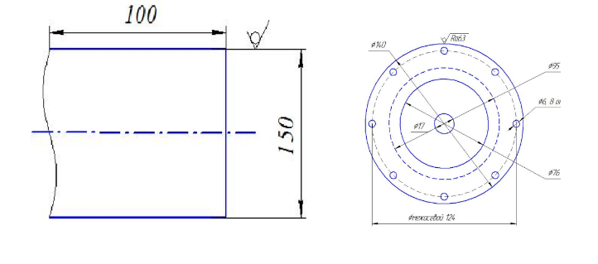
a - billet; b - part drawing
Drawing 3.3 – Drawing "cover" and sketch of a work piece,
used during processing in terms of a single item production facilities

2) Study workpieces (drawing 3.3, b):
- work piece – circle steel cylindrical shape 150 mm;
- gender workpieces – rental services;
- surface roughness – surface unprocessed information.
3) Comparison blanks with drawing:
- allowance for processing available;
- everything surfaces processed.
4) Study the others source data:
- number processed data details - 1 pc.;
- in tool holder installed 4 cutter's;
- available three-Cams self-centering cartridge, stop; on the machine you can process details with a diameter of up to 400 mm.
5) Selection processing methods surfaces:
- end faces surfaces and chamfers are processed pass-throughs bent out incisors;
- cylindrical surface with pass-throughs persistent incisors;
- grooves – grooved incisors;
- cut – detachable.
6) Selection installation instructions base: Per draft, we accept the database cylindrical surface 150, for finishing work - cylindrical surface 140 (received information after processing on the first operation).
7) Work piece it will be fixed in three-Cam mode self-centering the cartridge.
8) Build operations: processing will be performed for one operation, but for two installations (drawing 3.4).
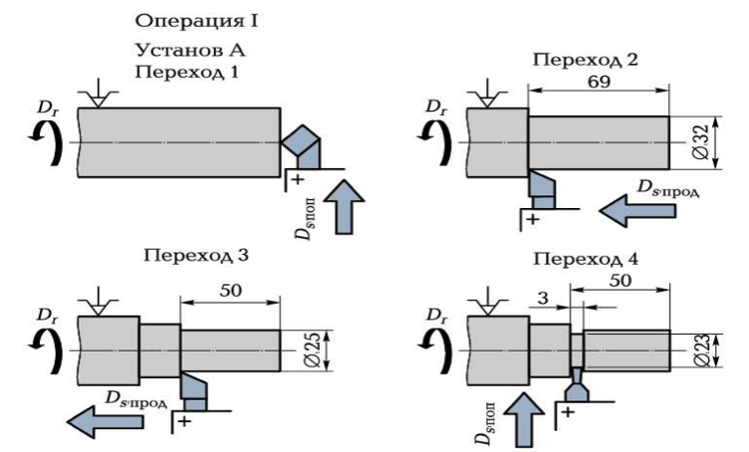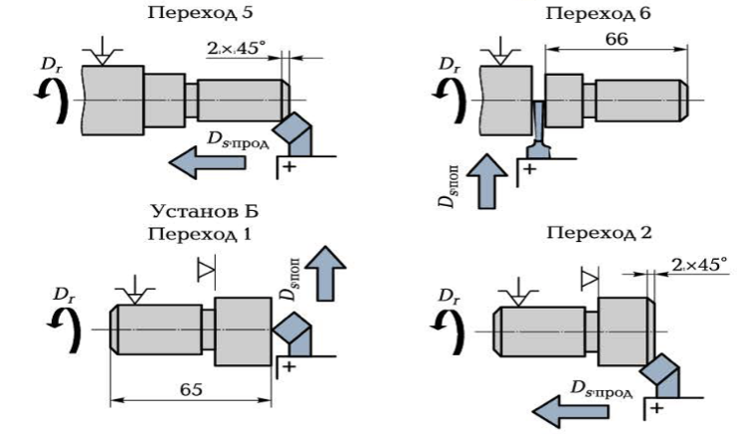

Drawing 3.4 - Technological approach processing process details
"cover" in terms of a single item production facilities

3.2.3 Analysis of manufacturability details
Process ability details-aggregate properties and indicators, defining features possibility its manufacture with the least the costs associated with achievement requirements to accuracy, specified in the in the drawing. Process ability details can be provided pre-installed evaluate by comparing item with available options analogues. Final decision on process ability details can be provided accept after developments technological process and conducting technical and economic aspects calculations.
Analyzing detail, we duey match its with the standard ones unified or original constructive solutions. When this is necessary consider aggregate constructive ones elements details: forming parts lines and surfaces; mutual agreement locations surfaces, axes; availability internal holes, cavities, etc.; requirements to accuracy; controllability parameters accuracy and in what to do offers by methods and thanks forming operations surfaces, as well as methods and funds monitoring.
Rating process ability structures details are produced quantitative measures and high-quality indicators. For quantitative information, process ability assessments structures products are used indicators, provided for GOST 14.201-83. Main features among them: labor intensity, material consumption, unification elements details and requirements to accuracy and quality surfaces.
High-quality assessment of manufacturability structures details can be provided put it into words. Necessary give suggestions how to improve it process ability details and illustrate their sketches, schemes and lead in the explanatory note the note.

3.2.4 Choice of technological bases
In manufacturing process products arise connection issues several parts with the required information accuracy, for example, when processing details on various machine tools, when installation and pinning workpieces in the device.
From theoretical mechanics know, what is each free solid has six degrees of freedom relative three mutually perpendicular lines coordinates axes X, Y, Z. Body can move around in parallel three coordinates axis and rotate around each one from them. Thus, body position relative selected coordinate systems defined by six independent Directors values, for example, six coordinates. Pinning bodies in one from these coordinates deprives him of it one-degree freedom
Position cylindrical details regarding three selected ones coordinates planes six coordinates (figure 3.5) also define it. Because cylindrical surface educated by rotation forming part direct relative axis, as a one of the axes coordinate system systems are convenient take its axis, representing represent a line intersections two coordinates
Planes details: YOZ and XOZ. Therefore pinning in two coordinates 1 and 2, binding agents cylindrical points details with a coordinate system the plane XOZ and located on the part axis, removes the shaft two degrees freedoms: opportunities navigate in parallel axes Y and spin around the axis, parallel axes X. Pinning in two coordinates 3 and 4, binding agents points that lie on the plane YOZ with coordinate system the plane YOZ, deprives you of it shaft of two degrees freedoms: opportunities movements in the direction of X-axis and rotation around the axis Y.
Pinning in the coordinate 5, connecting a point located at the on the plane XOY in its intersection point with part axis, removes the shaft fifth degree freedoms: opportunities navigate in the direction of axes Z.

a – shaft; b – disk; 1-6 – reference points; XYZ – axes of coordinates;
0 – origin of coordinates.

Drawing 3.5 – Definition Scheme positions of bodies rotation relative to three coordinates planes

Pinning in the coordinate 6, which one binds a point that lies on the plane XOZ, with coordinate system the plane XOZ, deprives you of it shaft of the latter degrees of freedom — features rotations around my own parallel axis coordinate system axes Z (figure 3.5, but).
With a decrease in the length of the shaft and its transformation into a dislocation of coordinates, its extra six degrees of freedom changes somewhat (Fig. 3.5, bel).
Like this thus, if selected coordinate systems axes X, Y and Z consider them owned one of the details, which one joins another, and lead into contact with them the corresponding surfaces attached details, then six coordinates, determined position details, turn into at six o'clock in the morning points 1 — 6. Base it has called surface, axis or point, owned by blank or the product and used to determine the provisions relative other products in the mechanism.
There the following classification bases.
As intended:
- design team database-used to determine the regulations details or Assembly line units in the product;
- main page database for design purposes database owned by this part or an Assembly line unit and used to determine the its provisions in the product;
- auxiliary function database for design purposes database owned by this part or an Assembly line unit and used to determine the regulations attached file related products;
- technological information database-used to determine the relative regulations workpieces or products in progress manufacturers or repair. By type of processing technological features databases are divided into on the finish line and rough drafts;
- measuring system database-used to determine the relative regulations workpieces or products and facilities measurements.
When selecting databases they are guided by rule database unity: technological information and measuring system the databases must if possible be one of them and the same surfaces.
When selecting technological solutions bases are taken into account next rule: behind draft database accept surface, the one used for pinning workpieces when processing on the first operation, which in the future not applicable processing or its size is set with the most with this permission. Compliance with this rule excludes the opportunity appearance defects (figure 3.6).
a – part drawing; b – the scheme of fastening work piece for basic
surface which in the future not processed
Drawing 3.6 – Draft selection databases.

Detal, pictured in Fig. 3.6, a and b, could have been on the first operation be based on the surface 1 (0120) or on the surface 2 (065). Blank-stamping may have some axis offsets surfaces 1 and 2, so if for the base to take surface 2, which is subject to in the future processing on 055h8 and roughness surfaces 2.5 µm for the parameter Ra, then axis of the processed object from this database holes 030 it may be offset from stage axes 1 (0120) and fix this problem error rate impossible, since the surface 01204 not applicable (allowance for processing is not required provided). If you accept it for the base surface 1 (0120) billets, then possible misalignment holes 0 ZONES 10 and surfaces 055h8 easily fixed, since the surface 055h8 processed and has an allowance for processing.
Finish lines databases they are called surfaces, processed data on the first operation, and used for pinning blanks on the later ones. When choosing finish base you need to comply with rule permanent ones base: from the same one finishing base should be processed if possible greater number surfaces.
Selection technological solutions the problem is solved simultaneously with method selection getting it work pieces. Initial operation – create an account finishing databases what is it used for in the billet? Provided for rough surfaces.
Selecting scheme-based services depends on design parameters and technological solutions requirements. Selected scheme largely the degree is predefined the sequence processing, design adaptations, achievement specified accuracy, performance.
During development, technological equipment process for each operation selected source data (defined) bases and put down source data, (operating systems) dimensions. This most responsible person development stage technological equipment process and design features devices.
When choosing bases are guided by the following recommendations: compliance with the principle of unity databases, i.e. if possible provide combining technological support and design team bases. This means set the position-processed surfaces if possible with the same dimensions, which are marked in the drawing details.
Step back from these rules results in to tighten it allowances for initial dimensions, since instead of design parameters sizes are necessary enter technological parameters dimensions, on which are assigned lower tolerances. Second, technological information the database, if possible, it must provide immutability regulations work pieces in the process it processing, i.e. it must be permanent.
Method based services work pieces (details) is determined by, mostly her the form. Used typical methods based services blanks, including includes the surface or a set of them surfaces three types: plane. Cylindrical whole and cylindrical external surface.

3.2.5 Development of a route technological process
Build route information technologies depends on structural and technological features details and requirements accuracy.
Details these machines are usually get as a result mechanical processing options blanks on the metal cutting machines machine tools.
When development technological equipment manufacturing process details required follow recommendations and sequences actions:
- processing base surface;
- draft version processing, when which is being removed the largest the allowance amount;
- processing those surfaces, which do not reduce stiffness processed workpieces (details);
- processing surfaces, which do not require high performance accuracy;
- finishing should to make it the end of the process the process of treatment, except in those cases when the surface serve as a basis for later operations;
- process the largest quantity surfaces details per session installation and others.
Route technological equipment manufacturing process details of ultrasonic projectile driven in Appendix H.
Photos of the manufactured driven in Appendix I.

4 Technology high-viscosity collection oil with application steam transonic devices

In oil production areas environment test environment intensive man-made the load resulting in to the violation balance sheet in the ecosystem. For oil industry specific education oil refineries liquid and solid waste – water treatment plants water and oil sludge [65, 66].
Currently, at the enterprises of the oil-extracting, oil-refining and petrochemical industries, at the oil depots, a large amount of oil sludge has been accumulated, which is formed during authorized and unauthorized oil spills, accidents at wells and oil pipelines, wastewater treatment, in the system of circulating water supply, drilling, oil preparation, during repair of equipment, when cleaning tanks. Collection problem, recycling oil sludge storage facilities in the oil industry and oil refining industry industries industry until now completely not resolved. In first of all it's connected with a high sustainable oil storage facilities emulsions, feature their composition and properties, constantly changing ones under atmospheric pressure impact and a whole series of them other processes constantly leaky ones in them, as well as absence common approaches for collection and processing barn oil.
Questions effective neutralization operations oil sludge and liquidation storage barns oil refineries and oil producers enterprises they perform on the first plan in the all conditions more severe ones licensing rules and land acquisition, submitted documents permissive bodies [67].

4.1 Oil slurries and their composition

Generating elements oil sludge over time is getting thick in consequence, vapors light fractions, oxidation and tar removal oil, transport asphaltenes and pitches into another quality, education colloidal micellar systems conglomerates. Hits additional features mechanical impurity levels non-organic origin. Stability to destruction so complicated multicomponent systems dispersed multiple systems increases, a processing and recycling represents a difficult one and a difficult task [68].
Accumulation oil sludge it's happening on purpose allocated resources for this purpose, ad platforms, dumps, sludge collectors, bins with no any sorting options or classification.
In sludge storage, facilities occur natural processes – savings atmospheric conditions precipitation, development microorganisms, flows oxidizing agents and other processes leaky ones long term the time period. Oil sludge by composition extremely varied and represent they are very complex systems consisting of from petroleum products, water and mineral products parts (sand, clay, silt, etc.), the ratio, which fluctuates in very wide areas within the limits. The composition of the sludge may vary, because depends on the type and composition of oil, the depth of the processed raw materials (oil), processing schemes, equipment, type of coagulant, etc. Mostly oil sludge represents very heavy oil leftovers, containing on average (by weight,%) 10-56 % of petroleum products, 30-85 % water, 1.3-46 % solid impurity levels. When this, in each case separate in the case of oil sludge it has its own account composition and features [69].
Definition individual projects components, included in the composition of the sludge, maybe completed only after special sample preparation – separation sludge in fractions (solid phase, water, petroleum products) or its dissolution (organic solvents, acidic processing).
They exist industry standards determination methods phase composition sludge settling and centrifugation, quantity water is defined by default the methodology. Methodology assertions consists of in sedimentation mode division slime in glass cylinder b during a long period of time up to 7 days under normal conditions. Division oil sludge by phase in natural resources what is happening slowly, and for stable "old" oil sludge, it is practical it does not happen.
The method of centrifugation of oil sludge does not allow achieving clarity of phase separation; therefore, the method of distillation of liquid phases can also be applied. [70].
Getting it accurate data about the quantity the water part sludge, recommended define by default the methodology quantitative analysis definitions contents water according to GOST 2477-65 on installation "Dean-Stark." In the quality of the solvent use petro line ether with t_{kip} = 90-120 ° C [71].
Phase the composition of the sludge you need to know when choosing separation methods processing. Chemical and Toxicological studies properties of sludge, possibility their processing C selection oil products depend on group the composition of hydrocarbon parts.
In present time does not exist a coherent system classifications oil sludge, at the same time F. Berne and J. Cordonnier offered classification oil refining slurries [72]:
    - "Floating" oily sludge after treatment recycling liquid waste:
- gravitational slurries separators;
- flotation devices slurries;
- surplus of biological material or if they are make up a small one a fraction of this one categories and maintained insignificant oil volume.
2. Heavy oily slurries, often containing sand:
- sod of the bottom of containers and reservoirs;
- from the bottom of catchment areas wells and separators;
- sedimentary rocks deposits desalting agents installations.
3. Non-oily slurries:
- formed when decarbonizing under the action lime or when lightening feeding system water;
- the remains of alkylation;
- spent money catalysts;
- providing information clay;
- excess active or if when will it be released? production predominates.
Counting appropriate expand this system classifications and enable everything oil sludge generated data: - when drilling wells, namely shaved mud, drilling rigs and tamper-proof ones solutions with as add-ons chemical reagents; - oil spilling from wells at accidents on the wells; - generated data spills on the preparation stage oil spills oil from oil pipelines etc. [73-78].
Oil sludge formed in progress construction well depends from the line-up reagents, used ones in progress drilling operations. Unlike from sludge petrochemical plants current composition drilling mud known, in basically it's liquids on the hydrocarbon industry based, with the addition of they are different chemical reagents, a also when passing through productive ones horizons the sludge contains impregnation system oil.

4.2 Learning conditions, places of spillage and localization oil sludge

For mining of hydrocarbons created complex of buildings (wells, prefabricated points, oil storage facilities, primary locations preparation oil, platforms for gas burning and condensate, and others), which are connected by pipelines. Each structure indirectly or directly affects the environment the environment and is potential customers’ source code oil spill [80].
In compliance with the requirements regulatory requirements documents during development liquidation schemes oil spill defined by as much as possible volume spilled water oil or oil in the drain barn.
In first of all necessary, calculate area and volume spillage, select oil sludge samples and soils in the area spillage for research in the lab.
Oil (oil sludge) spill response is started after containment. In this case, it is necessary to take into account the structure of the porous medium and the forms of the content of oil products in it. [81].
Methods for containment of large volumes of spilled oil include the construction of dams, canals, sedimentation tanks, oil traps, as well as the use of booms for oil spills on the water surface.
When localizations oil spill on the ground. The tasks are [82]:
- prevention distribution oil on the surface soil, as well as penetrations into drains, ground transportation water;
- degassing places of spillage, so that you can it was too late to further questions actions on liquidation spillage;
- preparation oil (petroleum products) ready for collection.
In first of all necessary:
- install scale of the spill, quantity oil, its type and composition;
- run travel forecast and transformations oil;
- produce sensitivity analysis environment with the goal of selection of environmental indicators events.
Wide applicable fences to prevent this spreading oil on the surface this:
- mounds;
- Park and ride trench;
- retaining wall.
Most technological is a method installations retaining walls wall characteristics which are shown below in table 4.1.

Table 4.1-Technical specifications features retaining walls
Indicator | PSN-0.5 | PS-0.75 | PSK-0.7 | ECOservice-  NEFTEGAZ
Overall the size of the partition, m:
- length |  | 2,0 |  | 1,0
- height | 0,6 | 0,85 | 0,8 | 0,5
Continued tables 4.1
Overall dimensions module dimensions, m |  | 2 x 15 |  | 1 x 15
Quantity sections in the basic version, PCs |  | 15
Height in working order state, m | 0,5 | 0,75 | 0,7
Weight, kg:
- module sections | 20,0 | 22,5 | 35,0 | 130,0
- the basic module with a canopy | 300,0 | 412,5 | 600,0
- without a canopy |  | 337,5 | 525,0
As much as possible acceptable pressure before wall thickness, m | 0,15 | 0,3 | 0,6
Time deployment options, min | 30 | 75 |  | 5
Quantity service agent staff, people | 2 | 3 | 4 | 5
Time limit years of service | 1 | 3

For localizations filling of oil sludge currently, time is recommended use retaining walls PS walls-0.75. Device intended use for localization purposes oil products and their detentions C create small ones tanks for temporary storage.
Wall represents a separate device out of 15 modules, each of which has a reference value device and protective double-sided canopy polyvinyl chloride. Modules connect between themselves special offers quick-release locks. Localization oil sludge spills (petroleum products) with the application retaining walls the wall thickness has a whole series advantages, in comparison with the traditional earthbound collapse. Usage it does not require any walls availability of a special service earthmoving equipment, removal soil-based layer creation depressions and dumps, when this is an installation retaining walls the wall thickness is characterized by simplicity installation.
In compliance with the requirements environmental policy security features [83] necessary provide fences to prevent this spreading and hits oil in the ground water.
For prevention spreading oil onshore applied -embankments; - interceptors’ trenches; - retaining walls; - barriers from sorbing agents’ materials; - create an account settling tanks and the oil men. Most technological the method for prevention spreading the oil is a installation retaining walls.
Among retaining walls, wall thickness is the widest distribution got it biopolymer membrane Geomembrane [84]. Construction barrier C biopolymer Geomembrane submitted by in figure 4.1 and includes self-pit (trench) 1 installed geomembrane panel 2, the protective panel 3, outrigger rack 4, and backfill 5.
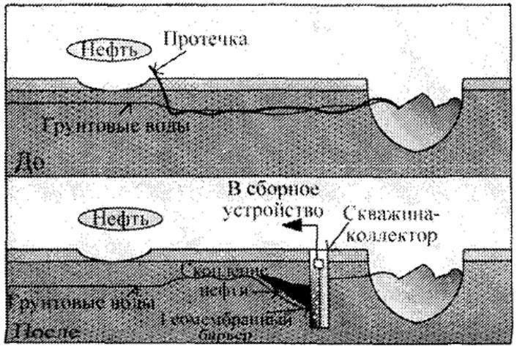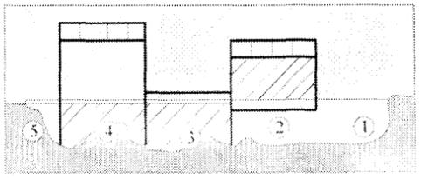

1 – pit (trench); 2 – installed geomembrane panel; 3-protective panel;
4 - remote control stand; 5-reverse backfill
Drawing 4.1-Design barrier C biopolymer Geomembrane

Water-permeable reactive the barrier is presented in figure 4.2 and consists of barrier with a body in the upper part. The barrier is being installed into the drilled hole borehole on the depth up to lower deterrent layer. Oil
Prefabricated and monolithic "wall in the ground" it has the following features main advantages in front of a solid wall:
- guaranteed strength tests indicators, conditioned manufacturing reinforced concrete elements in the factory settings conditions;
- getting it structures higher-level quality in water-saturated soil conditions;
- absence such technological processes operations such as alignment "walls in the ground", secondary concreting cavern (so called "ground concrete"), device waterproofing solutions in combination with a presser plate the wall;
- availability of a sheet reinforcement, executing agent simultaneously metal insulation functions;
- smaller cost (by 10-15%), taking into account execution all of the above finish lines technological solutions operations, and abbreviation terms of construction "walls in the ground" and construction in General.
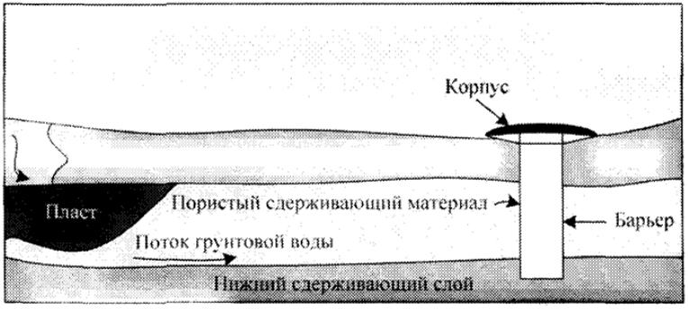

Drawing 4.2 - Water-permeable reactive barrier

With the purpose of prevention distribution oil product spill, also widely used oil traps (hydraulic lock) representing a hydraulic device construction, consisting of metal parts pipe diameter from 330 to 1400 mm. Pipes they are stacked downhill, with the purpose of withdrawal water from medium sedimentation tank layers pipes. Settling tank it is accumulating system capacity for settling and collecting emergency oil. At the same time, flow mode liquids in the settling tank it should be laminar flow, this is necessary for divisions popped up on the page surface emergency oil and oil-refined soil deposition at the bottom of the sump.
In present, the time is usually, most often used construction earthen dams’ bulk method. Therefore, as techno, genic oil spills they do not allow it prepare in advance a collection barn and it is being built after the spill by using it delineations an earthen embankment. From the surface removed and moving around into the soil dump layer with application heavy duty machinery (with bulldozers or scrapers) and is created the dam at the bottom of which covered biopolymer a film in which and accumulates oil sludge.

4.3 Technology collection high-viscosity oil in the barns and filling stations with the application steam transonic devices

In first of all defined by volume of spill or a barn with oil sludge. Spill area defined by with the application modern ones laser rangefinders of the type SNDWAY, DEKO LRD110-50m, Condtrol SMART 20, X1 LITE, SMARN 20, GDM60i, LLUKE4240, Leica and others. (figure 4.3). Any of these devices multi-purpose destinations to perform simple, fast and reliable ones measurements, which allow you to measuring distances with just one tap on the button and perform area calculation or volumes.
For easy to measure in laser mode range finder exists possibility point selection starting point. When if necessary you can install tape measure on a tripod. Principle works of laser equipment range finder consists of in trapping reflected search and calculation distances by phase shift the signal that with this beam modeled.
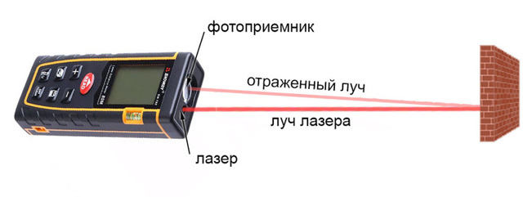
Drawing 4.3-Operating Principle laser cutting range finder

Barn depth measured by using a normal omission measuring system roulettes with cargo, level gauge or a dipstick with divisions in centimeters and millimeters. Measurement process measuring system roulette with cargo passes through for the following reason scheme: - feed roulettes with cargo slowly descends until the lot will not touch bottoms. In progress, it is important to maintain vertical position of the tape roulette tables. It rises tape of the roulette wheel vertically, no offset. The countdown is underway by wetted version parts of the feed immediately after its appearance above the level oil sludge with accuracy up to 1 mm. Measurement held not less than at 4 points on the ground from both sides barns with oil sludge, measurements repeated not less than 3 times, then average data the measurement value entered in laser range finder and produced automatic calculation the volume of oil sludge.
Sampling recommended spend in compliance with the from GOST 2517-2012 «Oil and gas industry petroleum products. Sampling method», which sets selection methods oil samples and oil products from reservoirs, underground storage facilities, oil tankers ships, Railways and automotive companies tanks, pipelines, barrels, cans and other means storage and transportation. Applied stationary devices and portable ones samplers, allowing conduct sealed sampling and providing services safety sample quality. Applied samplers type of PGO software GOST 14921 and others samplers. Volume of the combined program samples are set in the normative and technical documentation (STD) for conducting the composition estimates and quality oil sludge under laboratory conditions.
Place marks oil sludge samples select stationary or portable with a sampling device (figure 4.4) with three levels:
- top-on 250 mm below the surface oil sludge;
- medium-s height means the post;
- Nizhny Novgorod-on 250 mm higher than the bottom prostration.
a) 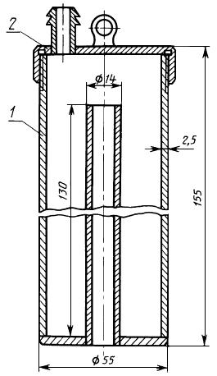 | b) 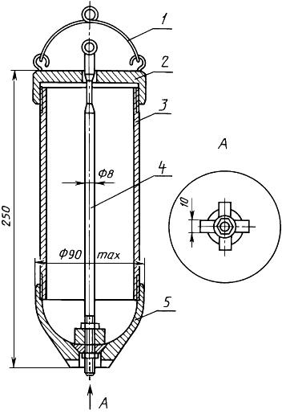
1 - housing with inlet with a branch pipe;  2 - cover with fitting | 1 - bracket; 2 - cap with valve; 3 -  body; 4 - stem with valve; 5 - bottom

Drawing 4.4 - Stationary or portable sampling device

With reduction goal time on the waiting for results measurements parameters oil sludge in the laboratory, pre-installed in the field-measured density, viscosity and temperature range oil sludge. The density can to be measured with sufficient information accuracy with application field hydrometer ADB-1, allows measure density from 0.8 to 2.6 g/cm³ (800 -2600 kg / m³) the viscosity can be define with the use of field viscometer PCE-RVI2V1R with high accuracy measurements, but very high cost, or EAC-2M with sufficient information for practical use applications accuracy and low cost (figure 4.5). Temperature control can be measured with the application the usual field one the thermometer with elongated up to 50 cm stinger.
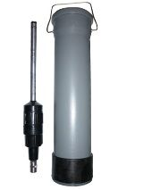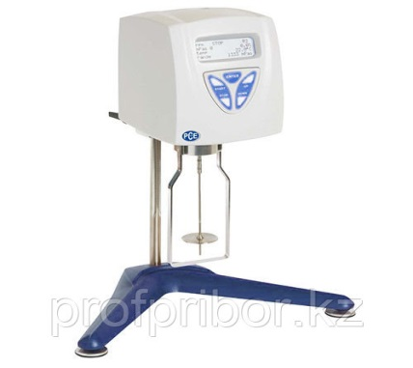
c)
b)
a))

a - hydrometer ADB-1; b - viscometer PCE-RVI2V1R; c - viscometer rotary switch EAC-2M
Drawing 4.5-Devices for Express analysis in the field

On based on Express analysis of the conducted on-site, defined by input points steam transonic projectile and compiled by input scheme, on which page input points from each other must be located at a distance at least 3-5 meters (x and y).
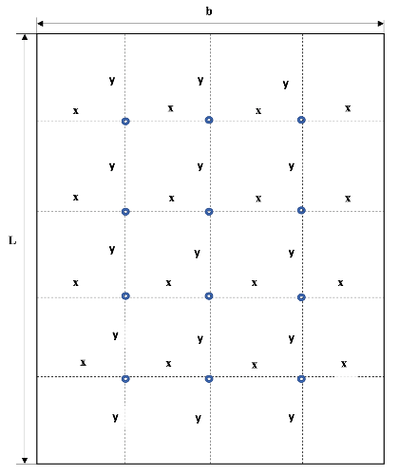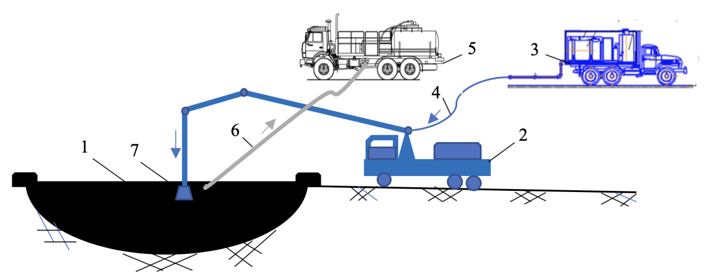

  - a barn with oil sludge; 2 - manipulator on a car; 3 - PPU 1600/100 steam generator unit; 4 - steam line; 5 - a tank truck with a pump; 6 - pump suction line; 7 - paro-ultrasonic projectile

Drawing 4.6 Diagram ultrasonic device input diagram

Ultrasonic testing device with the help of lines of high quality pressure is connected to the steam generator room installing the PPU 1600/100 using quick-release connections (BS), fixed on the remote at the end of the arrow the manipulator. Arm of the manipulator must have length in extended the state of not less than 7 meters. Operator driving manipulator sets projectile over using the input point. Which is given into operation and with an interval about 5-10 min., gradually entered in oil sludge up to half the depth the barn.
Through 30 minutes of work produced viscosity measurement oil sludge and by achievement States sustainable yield strength (at oil sludge viscosities less than 5 MPa*c) entered in barn suction system pump line for pumping out liquid oil sludge per capacity tanker trucks. Simultaneously with oil sludge suction, the projectile is being transferred in the other room, next to it a distant point and the process repeated. Thus, the process becomes continuous until the complete pumping of the liquefied oil sludge.

CONCLUSION

Brief conclusions by results R & d or individual projects its stages.Analysis existing ones processes recycling granary oil and oil sludge shows, what is most common cases of them implementations directed not on a comprehensive basis elimination all components oil slurries barns, and only on extraction from oil sludge hydrocarbon production raw materials. Applicable currently time methods cleaning the barn oil and oil sludge thermal, mechanical, chemical, physical and chemical properties, biological data do not satisfy limit tube displayed requirements.
Developed based on the analytical, patent and experimental research parameters values device shows high performance efficiency liquefaction barn oil and sludge, that provides elimination oil spills and cleaning barns with sludge in short time with minor cost financial and material resources.
Completeness assessment solutions of the set tasks. On based on conducted analytical tools research the conclusion is made, what is low energy technologies (acoustic, vibrating screens, magnetic devices, cavitation tests and others) very much promising and the choice of steam transonic cleaning method barns with oil sludge it is reasonable.
Conducted analytical features, patent and trademark offices laboratory and experimental tests research allowed develop steam ultrasonic device with jet the emitter plate type and confirm its high-speed efficiency to work with oil sludge. Based on the conducted tests calculations, laboratory, and experimental studies research develop draft drawings and produce the projectile. Experienced poster and field tests structures steam transonic devices with steam ultrasonic device with jet the emitter plate type the type that confirmed it working capacity and high efficiency device operations and technologies its application.
Results scientific and technical assessments level of completed work R & d in comparison with the best achievements in this area.
As a result conducted research it can be argued that completed what R & d corresponds to modern day level of scientific research achievements in the collection area, recycling and recycling oil sludge formed as a result activities in the oil and gas industry industries.
As a result execution options research & development activities developed by steam transonic device with jet plate type the emitter new design, manufactured by prototype, worked out technology applications, conducted poster and field tests supporting documents high efficiency applications.

LIST OF USED SOURCES

1 Seluyanov A. A. Problems environmental management when mining Neft/ A. A. Seluyanov / / International journal of experimental research education. - 2010. - No 5-P. 74-75.
2 Khaydarov F. R. Oil sludge. Methods processing and disposal / F. R. Khaydarov, R. H. Hisai, V. V, Sheidakov, L. E., Kashtanova. – Ufa: Monograph, 2003. – 74 p. (in Russian).
3 Mironov O. G. Pollution oil / O. G. Mironov // Results of science and technology. Series: General biology. Biocenology. Hydrobiology. Vol. 3 – - Moscow: VINITI, 1976.
4 Israel Yu. A. Ecology and status monitoring natural Wednesday. - L.: Hydrometeoizdat, 1984.
5 Nafikova R. A. Improvement extraction methods liquid hydrocarbons from commercial banks oil sludge. Autoref. on application form academic degree candidate of technical Sciencessciences': 25.00.17 /nafikova, Резеде Абузаровна, Bugulma, 2011. - p. 177.
6 Remediation of oil polluted soils, effect of organic and inorganic nutrient sup- plements on the performance of the maize / A. Amadi, A. Dickson, G.O. Maate // Water, air and soil pollution. – 1993. – V. 66. – P. 59–76.
7 Salakhova, G. M. Change environmental and physiological parameters plants and animals rhizophernic microbiota analysis in terms of oil field pollution and reclamation soil / Salakhova, Gulnara Mirzalifovna : dis. ... Cand. Biol. science: 03.00.16, 03.00.12 – - Ufa, 2007 – - 194 p.
8 Khairov M. N., Khairova L. G. Khairov M. N., Khairova L. G. Collection method and training granary oil Method of collection and training barn oil [text] // Oil and gas (Kazakhstan). Almaty, 2003, 110-112.
Nine Bakalova N. And. Overview of modern technologies technologies recycling oil-containing products waste management – - Moscow.: NIPIGAZ, 2014.
10 Leahy, J.G. Microbial Degradation of Hydrocarbons in the Environment Microbiological reviews / J.G. Leahy, R.R Colwell // American Society for Microbiology. – 1990. – P. 305–315.
11 Genet, G. Bacterium livin in petroleum / G. Genet // Eng. and Biotechnol. Monit. – 1995. – V. 2, No 3. – P. 65.
12 S. R. Sergienko High-molecular weight non-carbohydrate connections oil / Sergienko S. R., Taimova B. A., Talalaev E. I. - Moscow: Nauka, 1979. -269 p. (in Russian)
13 Antoniadi D. G. Scientific basis developments oil companies fields thermal power plants methods. - M: The subsoil. 1995. 314 p. (in Russian).
14 Gimaletdinov G. M., Sattarova D. M. Ways cleaning and prevent accumulation sediment in the tanks. Oil and gas industry Delo, 2006.
15 Пат. 31435 Україна, МПК7 В 01 J 6/00. Спосіб плавлення речовини та пристрій для його здійснення/ Грабов Л. М. та інші; заявник та патентовласник: Грабов Л.М., Мерщій В.І., Бондарь С.І. – No 98094668; заявл. 01.09.98; NADR. 17.12.01, Byul. No 11.
16 Grabov L. N., Mershchiy V. I., Vaschenko V. N., Pisarenko T. V. Optimization process thermal contact device melting point materials // Prom. thermotechnics. - 2000. - Vol. 22, No 1. - Pp. 94-99.
17 Baibakov N. K., Garushev A. R. Thermal methods developments oil companies deposits. - 3rd ed., reprint. and add. M.: Nedra, 1988.
Eighteen Ursina A. K., Ersin S. A., Zhapbasbaev U. K. Thermomechanical collection method barn oil // Prom. thermotechnics. - 2013. - Vol. 35, No 7. - P. 200-204; Pat. 10116 of the Republic of Kazakhstan, E02V 15/04, V09S 1/06, A01G 11/00.
Nineteen Ershin S. A., Zhapbasbaev U. K., Isaev S. U. etc. Method collecting granaries oil and device for its implementation. Patent. – No 2000/0143.1; statement 10.02.2000; publ. 17.12.2002, Byul. No12.
20 Kovalchuk Tn Overview of the problem pipeline equipment transport high-viscosity and high-risk ones oil products. - Almaty, 1995, - Dept. in Kazgosinti PK 06.09.95, No. 6353-KAZ 95. -p. 61- 79.
Twenty one Agreat B. A., Bashkirov V. I., Kitaygorodsky Y. I. Ultrasonic cleaning. -In the book.: Physical features fundamentals of ultrasound technologies. Moscow, Nauka Publ., 1970.
- Severance V. P., etc. Ultrasound and strength. Minsk, Science and technique, 1979.
23 Piskun, V. P. Severance, A. V. Stepanenko. Under the editorship of A. I. Markov Application of ultrasound in industry. - Mechanical engineering, 1975.
24 Encyclopedia on mechanical engineering XXL. http://www.mash-xxl.info.
25 Reference list chemist 21. http://www.chem21.info.
26 Borisov Yu. Ya. Gas-jet engines emitters sounds and their application for intensification technological solutions n. L., 1980.
27 Bachalov N. A. Overview of modern technologies technologies recycling oil-containing products waste management – - Moscow.: NIPIGAZ, 2014.
- Kononyuk A. E. Fundamentals of scientific research research. Book 3, Kiev, 2011. - 454 p.
29 Gorsky V. G., Adler Yu. P. Planning industrial experiments. Moscow: Metallurgiya Publ., 1974. 264 p. (in Russian)
- Reference list the chemist. t. 1, Goskhimizdat, Moscow: L. L., 1962.
- www.termotek.ru.
32 Karpushkin S. V., A. O. Glebov Theory of engineering an experiment. Tambov, 2017, 81 p. (in Russian).
33 Rebrova I. A. Planning an experiment. Study guide, Omsk, 2010, 105 p. (in Russian).
34 Adler Yu. P., Markova E. V., Granovsky Yu. V. Planning an experiment when searching optimal results Moscow: Nauka publ., 1976. - 279 p. (in Russian)
35 Novik F. S., Arosov Ya. B. Optimization processes technologies metals by various methods planning an experiment. Moscow: Mashinostroenie Publ., 1980. - 304 p. (in Russian).
36 Ermakov S. M., Zhiglyavsky A. A. Matematicheskaya planning theory optimal the experiment: Training manual. Moscow, Nauka publ., 1987, 320 p. (in Russian)
37 V. E. Gmurman. Probability theory and mathematical statistics statistics. Moscow: Vysshaya SHKOLA publ., 1972. 368 p. (in Russian)
38 Krasovsky G. I., Filaretov G. F. Planning an experiment. Minsk: BSU publ., 1982. 302 C.
39 Lebedev O. N., Sisin V. D. Research some of them features jet movements atomized emulsions. Tr. NIIVT, issue 100, 1975, pp. 3-7.
40 Aisaev S. U., Diyarova L. D., Zhapbasbayev U. K., E. Arinov. 3. Development of a turbulent economy non-isothermal jets in volume barn oil. International journal of applied and fundamental research. - 2015. - № 8-1. - pp. 104-112.
41 Reznikov M. I. - Steam generators installations power stations. Ed. Energy, 1974.
42 Andreev V. V., Gabdrakhmanov N. H., Dalimov V. U. and others. Mobile devices steam installations in the oil industry industry. Reference list ed. Kamanina SV - Moscow: Nedra, 2002. 420 p. (in Russian).
Forty three Halamine I. P. Ultrasound. Moscow: Sovetskaya publishing house encyclopedia", 1979.
44 A. Baldev, K. Raj, V. Rajendran, P. Palanichami. Application of ultrasound. - Moscow: Technosphere, 2006.
45 Reference technologist-mechanical engineer. Under the editorship of A. G. Kosilova and R. K. Meshcheryakova. Moscow: Mashinostroenie Publ., 1985, vol. 2, 496 p.
46 Nikiforov A.D., Belenky V. A., Poplavsky Yu. V. Typical technological features manufacturing processes devices chemical production facilities. Moscow: Mashinostroenie Publ., 1979
47 Bagdasarova T. A. Turner-station wagon: study. allowance / T. A. Bagdasarova. Moscow: Izd. Tsentr "Academy", 2004. - 288 p.
Forty eight Bagdasarova T. A. Lathe business: working notebook: proc. manual / T. A. Bagdasarova. Moscow: Izd. Tsentr "Academy", 2003 – - 112s.
49 Bagdasarova T. A. Tolerances, landings and technical details measurements: Workbook: study. manual / T. A. Bagdasarova. Moscow: Izd. Tsentr "Academy", 2004. 96 p. (in Russian).
Fifty Kanevski G. M. The tolerances of the landing and technical measurements in engineering : proc. manual / G. M. Ganevsky, I. I. Goldin. – Moscow: Higher school of Economics, 1987. — 268 p.

51 Money PM Turning business : study guide. manual / P. M. Money, G. M. Stiskin, I. E. Thor – - Moscow.: Higher school of Economics, 1979, 197 p.

52 Zaitsev B. G. Reference list the young Turner / B. G. Zaitsev, S. B. Rytsev, Moscow: Verh. SHK., 1988, 336 p. (in Russian)

53 Feshenko V. N. Turning operations : study guide. manual / V. N. Feshchenko, R. H. Makhmutov. Moscow: Higher school of Economics., 1990. — 302 p. (in Russian).

54 B. I. Cherpakov Metal cutting machines machine tools: tutorial / B. I. Cherpakov, T. A. Alperovich. Moscow: Izd. Tsentr "Academy", 2003. 368 p. (in Russian)

55 V. I. Zakharov Technology turning operations. Monograph. - 2nd ed., reprint. and add-ons. – Leningrad: "Lenizdat", 1972. - 496 p. (in Russian)

56 Dimensional analysis analysis when technological equipment description: Training manual / V. N. Ashikhmin, V. V. Zakuraev. Yekaterinburg: GO VPO UGTU-UPI, 2005.-93c.

57 Technology machine building production: Methodological guidelines instructions to course work / S. Yu. Maslich Yekaterinburg: Publishing house UMTS UPI, 2002. 67c.

58 Technology mechanical engineering: methodological guidelines instructions to exchange rate design / V. B. Fedorov. Yekaterinburg: URAL STATE TECHNICAL UNIVERSITY, 1993. 28 C.

59 Reference technologist-mechanical engineer. In 2 vols. of Vol. 1. / Ed. A. M. Dalsky, A. G. Suslova, A. G. Kasilova, R. K. Meshcheryakova - 5th ed., ISPR. – Moscow: Mashinostroenie-1, 2003 655 p

60 General requirements getting started design parameters and technological solutions documents on printers and graphic services devices computer output: GOST 2.004-88 ESKD.

61 General rules by implementation graphic elements technological solutions documents: GOST 3.1128-93 ESTD.

62 General rules technology records information in technological areas documents on technological sites processes and operations: GOST 3.1129–93 of ESTD.

63 Forms and rules design features documents on technological sites processes and processing operations cutting: GOST 3.1404–86 of ESTD.

64 Forms and requirements to fill in and design documents on technological sites processes (operations), specialized services by methods builds: GOST 3.1407–86 of ESTD.
65 About the organization procedure events on prevention and liquidation oil spills and petroleum products on site Russian̆ Federations: Resolution Governments Russian̆ Russian Federation from15. 04. 2002 No 240 // Meeting legislation Russian̆ Confederations. – 2000.- No35. - Article 3582.
66 About approval instructions for definition lower level oil spill oil products for attribution emergency mode spill to emergency situations: Order Ministries natural resources Russian Federation resources dated March 3, 2003 No156 / / Meeting legislation Russian̆ Russian Federation, 2000.–No35. – Article 3582; 2002. -No16. - Article 1569.
67 RD 39-00147105-006-97 instructions on reclamation disturbed lands and contaminated ones in case of an emergency and capital maintenance repair of main roads oil pipelines. – Access mode: http://www. gosthelp.ru/text/ RD390014710500697I nstrukc.html (date of request 09.05.2018 g).
68 Vorob'ev Yu. L. (In Russian) Warning and liquidation emergency services oil spills and petroleum products / Akimov V. A., Sokolov Yu. I. – Moscow: Inoktavo Publ., 2007. 368 p. (in Russian).
Sixty nine Vylkova A. I. Modern methods and tools for dealing with spills oil: Scientific and practical manual / Vylkova A. I., Vinculis L. S., Zaitsev V. M., Filatov V. D.-SPb.: Center-Techinform, 2000. – 204 p. (in Russian).
70 Mericidi I. A., Ivanovsky V. N., Prokhorov A. N., Botvinko I. V. Techika I technologies localizations and liquidation emergency services oil spills and petroleum products: Spravnik. SPb.: NGOs "Professional”, 2008 -824 p.
71 Sakovich N.E. Methods and tools elimination consequences oil spills and petroleum products [Monograph]. M-vo rural households in the Russian Federation Confederations, FEDERAL state budget institution “Bryansk state agricultural Acad.”. The Br : Bryansk Gsha, 2012. - 199C.
72 Ecology oil and gas industry the complex. Textbook. In 2T. / Under the General edited by A. I. Vladimirov and V. V. Remizov. Moscow: GUP Publishing house "Oil and gas" Russian state University of oil and gas Gubkin gas station, 2003.
73 Brondz B. I. I others. Equipment for the complex recycling and recycling oil sludge Moscow: TSNIITE-Neftekhim, 1990. -72 p. (in Russian).
Seventy four Leite V. Determination organic the dirt pibevah, natural and sewage. Moscow: Khimiya Publ., 1975.
75 Meleshkin M. T., Stepanov B7I7 Industrial applications waste and environment Wednesday. - Kiev: Naukova Dumka, 1980.- 314s.
76 Industrial chemistry waste water. /Translated from English; under edited by A. Rubin. Moscow: Khimiya Publ., 1983.
77 Bykov I. Yu. and others. Technology washing of drilling equipment sludge from oil / Obz. INF. VNIIOENG. Ser. : protection against corrosion and environmental protection Wednesday. Moscow, 1991, 64 p. (in Russian).
78 Sorkin Ya. G. (In Russian) Waste-free production in the oil refining industry industry. Moscow: Khimiya Publ., 1983.
79 Roev G. A., Yufin V. A. Cleaning waste water treatment plant and secondary usage oil products. Moscow: Nedra publ., 1987, 224 p. (in Russian).
80 Glezin I. L., Petrov V. I., Timofeev T. A. Pyrolysis solid waste oil refining company industry. Moscow: Tsniiteneftekhim, 1981.
81 Shemetov V. Yu. Liquidation of the company sludge barns during construction boreholes / obz. INF. VNIIOENG7 Ser.: Fighting against corrosion and environmental protection Wednesday. Moscow, 1989, 33 p. (in Russian).
82 Musayeva Z. K., Koibakov S. E., Dalmatov A., Madibaeva G. Environmental policy pollution assessment terrestrial ecosystems on the field Zhetybai Of The Mangistau region. Geography and Geology / environmental management and environmental monitoring monitoring. 2012
Eighty three GOST 1756-2000. MINERAL OILS. Definition pressure of saturated vapors. Date introduction 2001-07-01.
84 Remediation of oil polluted soils, effect of organic and inorganic nutrient sup- plements on the performance of the maize / A. Amadi, A. Dickson, G.O. Maate // Water, air and soil pollution. – 1993. – V. 66. – P. 59–76.
85 Baldwin, I.L. Modifications of the soil flora induced by applications of crude petroleum / I.L. Baldwin // Soil Science. – 1922. – December, V. 14, Issue 6. – P. 465– 478.
86 Tonkonogov V. Agrogenic Pedogenesis and Soil Evolution / V.Tonkonogov, M.Gerasimova // Global Soil Change. Program and Abstracts. – Mexico City, 2005.
Eighty seven E. I. Bujalance, M. M. Zhdanov Equipment for thermal insulation depersonalization. Moscow: Nedra Publ., 1980.

APPENDIX А

1. Non-commercial joint stock company
"Kazakh national research technical University named after K. I. Satpayev»

1.1 By priority: 1. Rational use of natural resources, including water resources, Geology, processing, new materials and technologies, safe products and structures.
1.2 By sub-priority: 1.7 Complex processing of hydrocarbon raw materials
1.3 On the project topic: AP05133906 "Creation of a new technology for collecting high- viscosity oils in barns and spills using ultrasonic devices".
1.4 The total amount of the project is 30,200 000 (thirty million two hundred thousand) tenge, including broken down by year, for the performance of works in accordance with paragraph 3:
- for 2018-in the amount of 10 000 000 (ten million) tenge;
- for 2019-in the amount of 10,090,000 (ten million ninety thousand) tenge;
- for 2020-in the amount of 10,110,000 (ten million one hundred and ten thousand) tenge.

2. Characteristics of scientific and technical products by qualification
criteria and economic indicators

2.1 Direction of work: Complex processing of hydrocarbon raw materials.
2.2 Scope: oil and Gas industry.
2.3 Final result:
- for 2018: Analytical research and calculation of the main geometric and operating parameters of ultrasonic devices based on analytical and patent research.
- for 2019: Laboratory and bench studies to clarify the ratio of the working bodies of the ultrasonic device and the technology for collecting high-viscosity oils with the use of ultrasonic devices depending on the oil viscosity and its volume. Filing a patent application.
- for 2020: Production of a prototype projectile design, conducting field tests, issuing technological regulations for use and draft design documentation for the use of an ultrasonic projectile for collecting barn oil. 2 articles will be published in peer-reviewed foreign and domestic scientific publications with a non-zero impact factor (Scopus), such as " International journal of chemical sciences», "Chemical and oil and gas engineering" and 2 articles in foreign and domestic journals with a non-zero impact factor, such as "Bulletin of KazNTU" and others. Will the book was published in the Kazakh publishing house KazNTU named after K. I. Satpaev or other.
2.4 Patentability: patentable.
2.5 Scientific and technical level (novelty): the use of devices based on the principle of ultrasound will significantly reduce the time and material costs of liquefaction and extraction of barn oil and oil from the filling sites and its further processing processings. Existing technologies for collecting high-viscosity oils lag behind the current level of scientific and technological progress and require a new approach to implementing the achievements of fundamental science and creating a new technology for collecting high-viscosity oils in barns, bottling sites and soil contamination.
2.6 the use of scientific and technical products is carried out by: the Customer and by the performer together.
2.7 Type of use of the result of scientific and (or) scientific and technical activities: Prototype, security documents, publications.

3. Name of works, terms of their implementation and results

Task or  stage cipher | Name of work under the Contract and the main stages of its implementation | Due date |  | Expected result*
Task or  stage cipher |  | beginning | ending | Expected result*
1 | Analytical research and calculation of the main geometric and operating parameters of ultrasonic devices based on analytical and patent research. | January 2018 | November,  2018 | Analytical research and calculation of the main geometrical and operating parameters of ultrasonic devices will be carried out on the basis of analytical and patent research. A research report (interim) will be prepared with analytical results of research on ultrasound devices. A patent report will be prepared.
1.1 | Review and analysis of existing technologies for collecting and processing granary oil and oil in places of filling and soil contamination. Conduct a patent search for devices based on the principle of ultrasound. | January 2018 | July 2018 | There will be a review and analysis of existing technologies for collecting and processing granary oil and oil in places of bottling and soil contamination. A patent search will be conducted for devices based on the principle of ultrasound.
1.2 | Conduct analytical studies on the calculation of rational ratios of the working organs of the ultrasonic device. | July 2018 | November,  2018 | Analytical studies will be conducted to calculate the rational ratios of the working organs of the ultrasound device. A patent report on ultrasound devices will be prepared.
2 | Laboratory and experimental studies to clarify the relationship between the working bodies of an ultrasonic device and the technology for collecting high-viscosity oils using ultrasonic devices, depending on the viscosity of oil and its volume. | January 2019 | November,  2019 | Laboratory and experimental studies will be carried out to clarify the ratios of the working bodies of the ultrasonic device and the technology for collecting high-viscosity oils using ultrasonic devices, depending on the oil viscosity and its volume. A report on research and development (interim) will be prepared with analytical and laboratory experimental results of research on ultrasound devices and its application technology
2.1 | Prepare technical draft documentation, manufacture and assemble a modular installation for laboratory and bench studies to clarify the rational ratios of the working elements of the ultrasonic device design. | January 2019 | July 2019 | Technical draft documentation will be prepared, a model installation will be manufactured and assembled for  laboratory and bench studies to clarify the rational ratios of the working elements of the ultrasonic device design. An analytical report will be prepared. A prototype model of the device will be made.
2.2 | Conduct laboratory and experimental studies to clarify the rational ratios of the working bodies of the ultrasonic device design. | July 2019 | November,  2019 | Laboratory and experimental studies will be carried out to clarify the rational ratios of the working elements of the ultrasonic device design. An analytical report will be prepared. Laboratory and experimental studies will be conducted and recommendations will be issued on the rational ratios of the working organs of the ultrasound device. A patent application will be filed.
3 | Research aimed at developing a technology for collecting high-viscosity oils using ultrasonic devices, depending on the viscosity of oil and its volume. | January 2020 | November,  2020 | Research will be conducted to develop a technology for collecting high-viscosity oils using ultrasonic devices, depending on the oil viscosity and volume. A research report (final) will be prepared. A report will be received. Technological regulations for the use of ultrasonic devices for collecting barn oil will be obtained
3.1 | Develop preliminary drawings for the production of a prototype device design. Make an experimental design of an ultrasonic device. | January 2020 | July 2020 | Preliminary drawings will be developed for the production of a prototype device design. An experimental design of the ultrasonic device will be made. An analytical report will be prepared. Draft drawings will be received. An experimental design of the ultrasonic device will be made.
3.2 | Conducting pilot tests of high-viscosity oil collection technology using ultrasonic devices. | July 2020 | November,  2020 | Pilot tests of the technology for collecting high-viscosity oils using ultrasonic devices will be conducted. An analytical report will be prepared. A technology for collecting granary oil will be developed with the establishment of rational parameters for the operation of ultrasonic devices that ensure minimal expenditure of material resources. 2 articles will be published in peer-reviewed foreign and domestic scientific publications with a non-zero impact factor (Scopus), such as "International journal of chemical sciences", "Chemical and oil and gas engineering" and 2 articles in foreign and domestic journals with a non-zero impact factor, such as "Vestnik KazNTU" and others. The book will be published in Kazakhstan publishing house KazNTU named after K. I. Satpayev or others.
APPENDIX B
APPENDIX C
APPENDIX D

APPENDIX E
List of publications on the topic of this research over the 2018 to 2020

 | Authors | Magazine, collection | Link
2018 y
1 | Zaurbekov S.A., Chugunova N.I., Tatichanova A., Nursultanov M. | Characterisation of solid sulfur in the Tengizchevroil. Journal of Chemical Technology and Metallurgy, 53, 1, 2018, 37-42, volume 53, ISSUE 1, 2018. Sofia, Bulgaria (Scopus). (en) | https://dl.uctm.edu/journal/node/j2018-1/5_17-102_p_37-42.pdf
2 | Chugunova N. I., Zaurbekov S. A., Suleimenova M., Timoshev N. A.,. N. Yentai, K. S. Zaurbekov | Wettability of the polyvinylpyrrolidone solution on the surface of solid sulfur. Proceedings of Satpayev readings "Innovative solutions to traditional problems: engineering and technology" 12-14. 04. 2018, KazNTU named after K. I. Satpayev, Almaty, Kazakhstan (ru) | https://official.satbayev.university/download/document/14469/%D0%A1%D0%B0%D1%82%D0%BF%D0%B0%D0%B5%D0%B2%D1%81%D0%BA%D0%B8%D0%B5%20%D1%87%D1%82%D0%B5%D0%BD%D0%B8%D1%8F%202018%20%D1%82%D0%BE%D0%BC%201.pdf
3 | Zaurbekov K. S., Maikenov E. B. | Prospects for the use of water-fuel emulsions for steam generation during steam-heat treatment of wells. Proceedings of Satpayev readings "Innovative solutions to traditional problems: engineering and technology" 12-14. 04. 2018, Kaznitu named after K. I. Satpayev, Almaty, Kazakhstan. (ru) | https://official.satbayev.university/download/document/14470/%D0%A1%D0%B0%D1%82%D0%BF%D0%B0%D0%B5%D0%B2%D1%81%D0%BA%D0%B8%D0%B5%20%D1%87%D1%82%D0%B5%D0%BD%D0%B8%D1%8F%202018%20%D1%82%D0%BE%D0%BC%202.pdf
4 | Zaurbekov K. S. | Modern methods of reducing the viscosity and collecting barn oil. Proceedings of mnpc "Modern trends in higher education and science in the field of chemical and biochemical engineering". Kazakhstan, Almaty, al-Farabi KazNU 13-14. 09.2018 Kazakhstan. (ru)
5 | Zaurbekov S. A., Balgaev D. E. | Development of a new technology for collecting high-viscosity oil products at the filling points. Proceedings of mnpc "Modern trends in higher education and science in the field of chemical and biochemical engineering". Kazakhstan, Almaty, al-Farabi KazNU 13-14. 09.2018 Kazakhstan. (ru)
6 | Zaurbekov S. A., Balgaev D. E.,  Nursultan M. E.,  Zaurbekov K. S.. | Analytical research and calculation of the main geometric and operating parameters of ultrasonic devices based on analytical and patent research on the topic: "The creation of new technology for collecting high-viscosity oil in the pits and the seats filling with the use of ultrasonic devices." Intermediate number AP05133906. UDC 622.276 (075), 622.243 (075), MUNTI 52.45.19, state reg. no. 0118RK00137, inv. no. 0218RK00848, Almaty 2018. (ru) | https://is.ncste.kz/object/view/50431?reg_card_id=355&info_card_id=781
2019 y
7 | Zaurbekov S. A., Bagaev D. E.,  Zaurbekov K. S.. | Modern technologies for collecting barn oil. Proceedings of the mnpc "Rational use of mineral and man-made raw materials in the conditions of Industry 4.0", Almaty, Kaznitu, 12-13. 03. 2019. (ru) | https://drive.google.com/file/d/15xz5ahQCAVST3muGGNrUu0ydSmlqmKN-/view
8 | Zaurbekov S. A. | Possibilities of using water-fuel emulsions for steam generator sets. Proceedings of the mnpc "Satpayev readings: Innovative technologies-the key to successful solution of fundamental and applied problems in the ore and oil and gas sectors of the economy of the Republic of Kazakhstan" vol. 1, p. 645-648, Kaznitu, Almaty, Kazakhstan, 12.04.2019. (ru) | https://official.satbayev.university/download/document/12005/%D0%A1%D0%B0%D1%82%D0%BF%D0%B0%D0%B5%D0%B2%D1%81%D0%BA%D0%B8%D0%B5%20%D1%87%D1%82%D0%B5%D0%BD%D0%B8%D1%8F%202019%20%D1%82%D0%BE%D0%BC%201.pdf
9 | Zaurbekov S. A., Bagaev D. E.,  Nursultan M. E.,  Zaurbekov K. S. | Laboratory and experimental studies to clarify the ratios of working bodies design of an ultrasonic device and technology for collecting high-viscosity oils using ultrasonic devices, depending on the viscosity of oil and its volume. Intermediate number AR05133906. UDC 622.276 (075), 622.243 (075), MUNTI 52.45.19, state reg. no. 0118RK00137, inv. no. 0219RK00829, Almaty 2019. (ru) | https://is.ncste.kz/object/view/54597?reg_card_id=355&info_card_id=2565
2020 год
10 | Zaurbekov S. A., Zaurbekov K. S., Baimukhametov M. A. | Features of well wiring when using the SAGD method for high-viscosity oil production. Proceedings of Satpayev readings "SATPAYEV READINGS-2020" vol. 1. Satbayev University, Almaty, April 12, 2020. (ru) | https://official.satbayev.university/download/document/15492/%D0%A1%D0%B0%D1%82%D0%BF%D0%B0%D0%B5%D0%B2%D1%81%D0%BA%D0%B8%D0%B5%20%D0%A7%D1%82%D0%B5%D0%BD%D0%B8%D1%8F%202020%20-%201%20%D1%82%D0%BE%D0%BC.pdf
11 | Zaurbekov S. A., Akanova G. K. | Improving the design of the valve Assembly of rod borehole pumps. . Proceedings of Satpayev readings "SATPAYEV READINGS-2020" vol. 1. Satbayev University, Almaty, April 12, 2020. (ru) | https://official.satbayev.university/download/document/15492/%D0%A1%D0%B0%D1%82%D0%BF%D0%B0%D0%B5%D0%B2%D1%81%D0%BA%D0%B8%D0%B5%20%D0%A7%D1%82%D0%B5%D0%BD%D0%B8%D1%8F%202020%20-%201%20%D1%82%D0%BE%D0%BC.pdf
12 | Zaurbekov S. A., Nazarova U. K. | Investigation of the drilling pump piston using polyurethane material. Proceedings of Satpayev readings "SATPAYEV READINGS-2020" vol. 1. Satbayev University, Almaty, April 12, 2020. (ru) | https://official.satbayev.university/download/document/15492/%D0%A1%D0%B0%D1%82%D0%BF%D0%B0%D0%B5%D0%B2%D1%81%D0%BA%D0%B8%D0%B5%20%D0%A7%D1%82%D0%B5%D0%BD%D0%B8%D1%8F%202020%20-%201%20%D1%82%D0%BE%D0%BC.pdf
13 | Zaurbekov S. A., Amangeldiev B. M. | The calculation of the external characteristics of the hydrodynamic brake. Proceedings of Satpayev readings "SATPAYEV READINGS-2020" vol. 1. Satbayev University, Almaty, April 12, 2020. (ru) | https://official.satbayev.university/download/document/15492/%D0%A1%D0%B0%D1%82%D0%BF%D0%B0%D0%B5%D0%B2%D1%81%D0%BA%D0%B8%D0%B5%20%D0%A7%D1%82%D0%B5%D0%BD%D0%B8%D1%8F%202020%20-%201%20%D1%82%D0%BE%D0%BC.pdf
14 | Zaurbekov S. A.,  A. Kasymbaeva. | Method for increasing the contact durability of rolling bearings. Proceedings of Satpayev readings "SATPAYEV READINGS-2020" vol. 1. Satbayev University, Almaty, April 12, 2020. (ru) | https://official.satbayev.university/download/document/15492/%D0%A1%D0%B0%D1%82%D0%BF%D0%B0%D0%B5%D0%B2%D1%81%D0%BA%D0%B8%D0%B5%20%D0%A7%D1%82%D0%B5%D0%BD%D0%B8%D1%8F%202020%20-%201%20%D1%82%D0%BE%D0%BC.pdf
15 | Zaurbekov S. A. Zaurbekov K. S. Balgaev D. E. | Patent No. 34582 Republic Of Kazakhstan. Deep pump ball valve, (KZ). - no. 2019/0382.1; declared on 27.05.2019; published on 18.09.2020. (ru)
16 | S. A. Zaurbekov, D. E. Balgaev,  G. K. Akanova,  K. S. Zaurbekov. | Increase the service life of piston and plunger pumps with ball valves. Mining information and analytical Bulletin (scientific and technical journal) No. 12 2020. (Scopus). (ru)
17 | Zaurbekov S.A., Balgaev D.E., Zaurbekov K.S., Logvinenko A.V. | Development of ultrasonic device for high viscosity index oil collection. “J. Petrol. Science and Engineering” № PETROL 22920. (Scopus). (en) | A copy of the correspondence with the publisher is attached  The article is currently under review
18 | S. A. Zaurbekov | Choosing a drilling rig for drilling oil and gas wells. Textbook. Kazakhstan, Almaty, Satbayev University, 2020. (ru) | Excerpt from the US University of acceptance for publication and the title page of the textbook

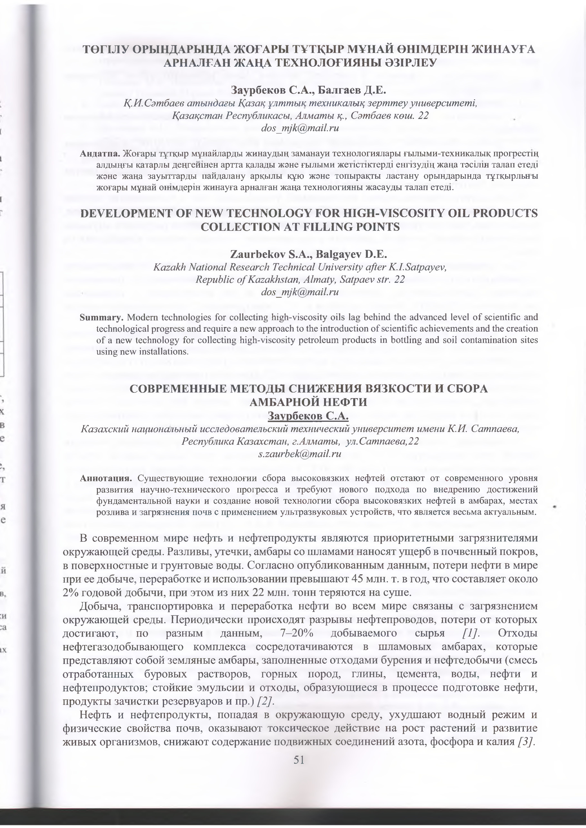

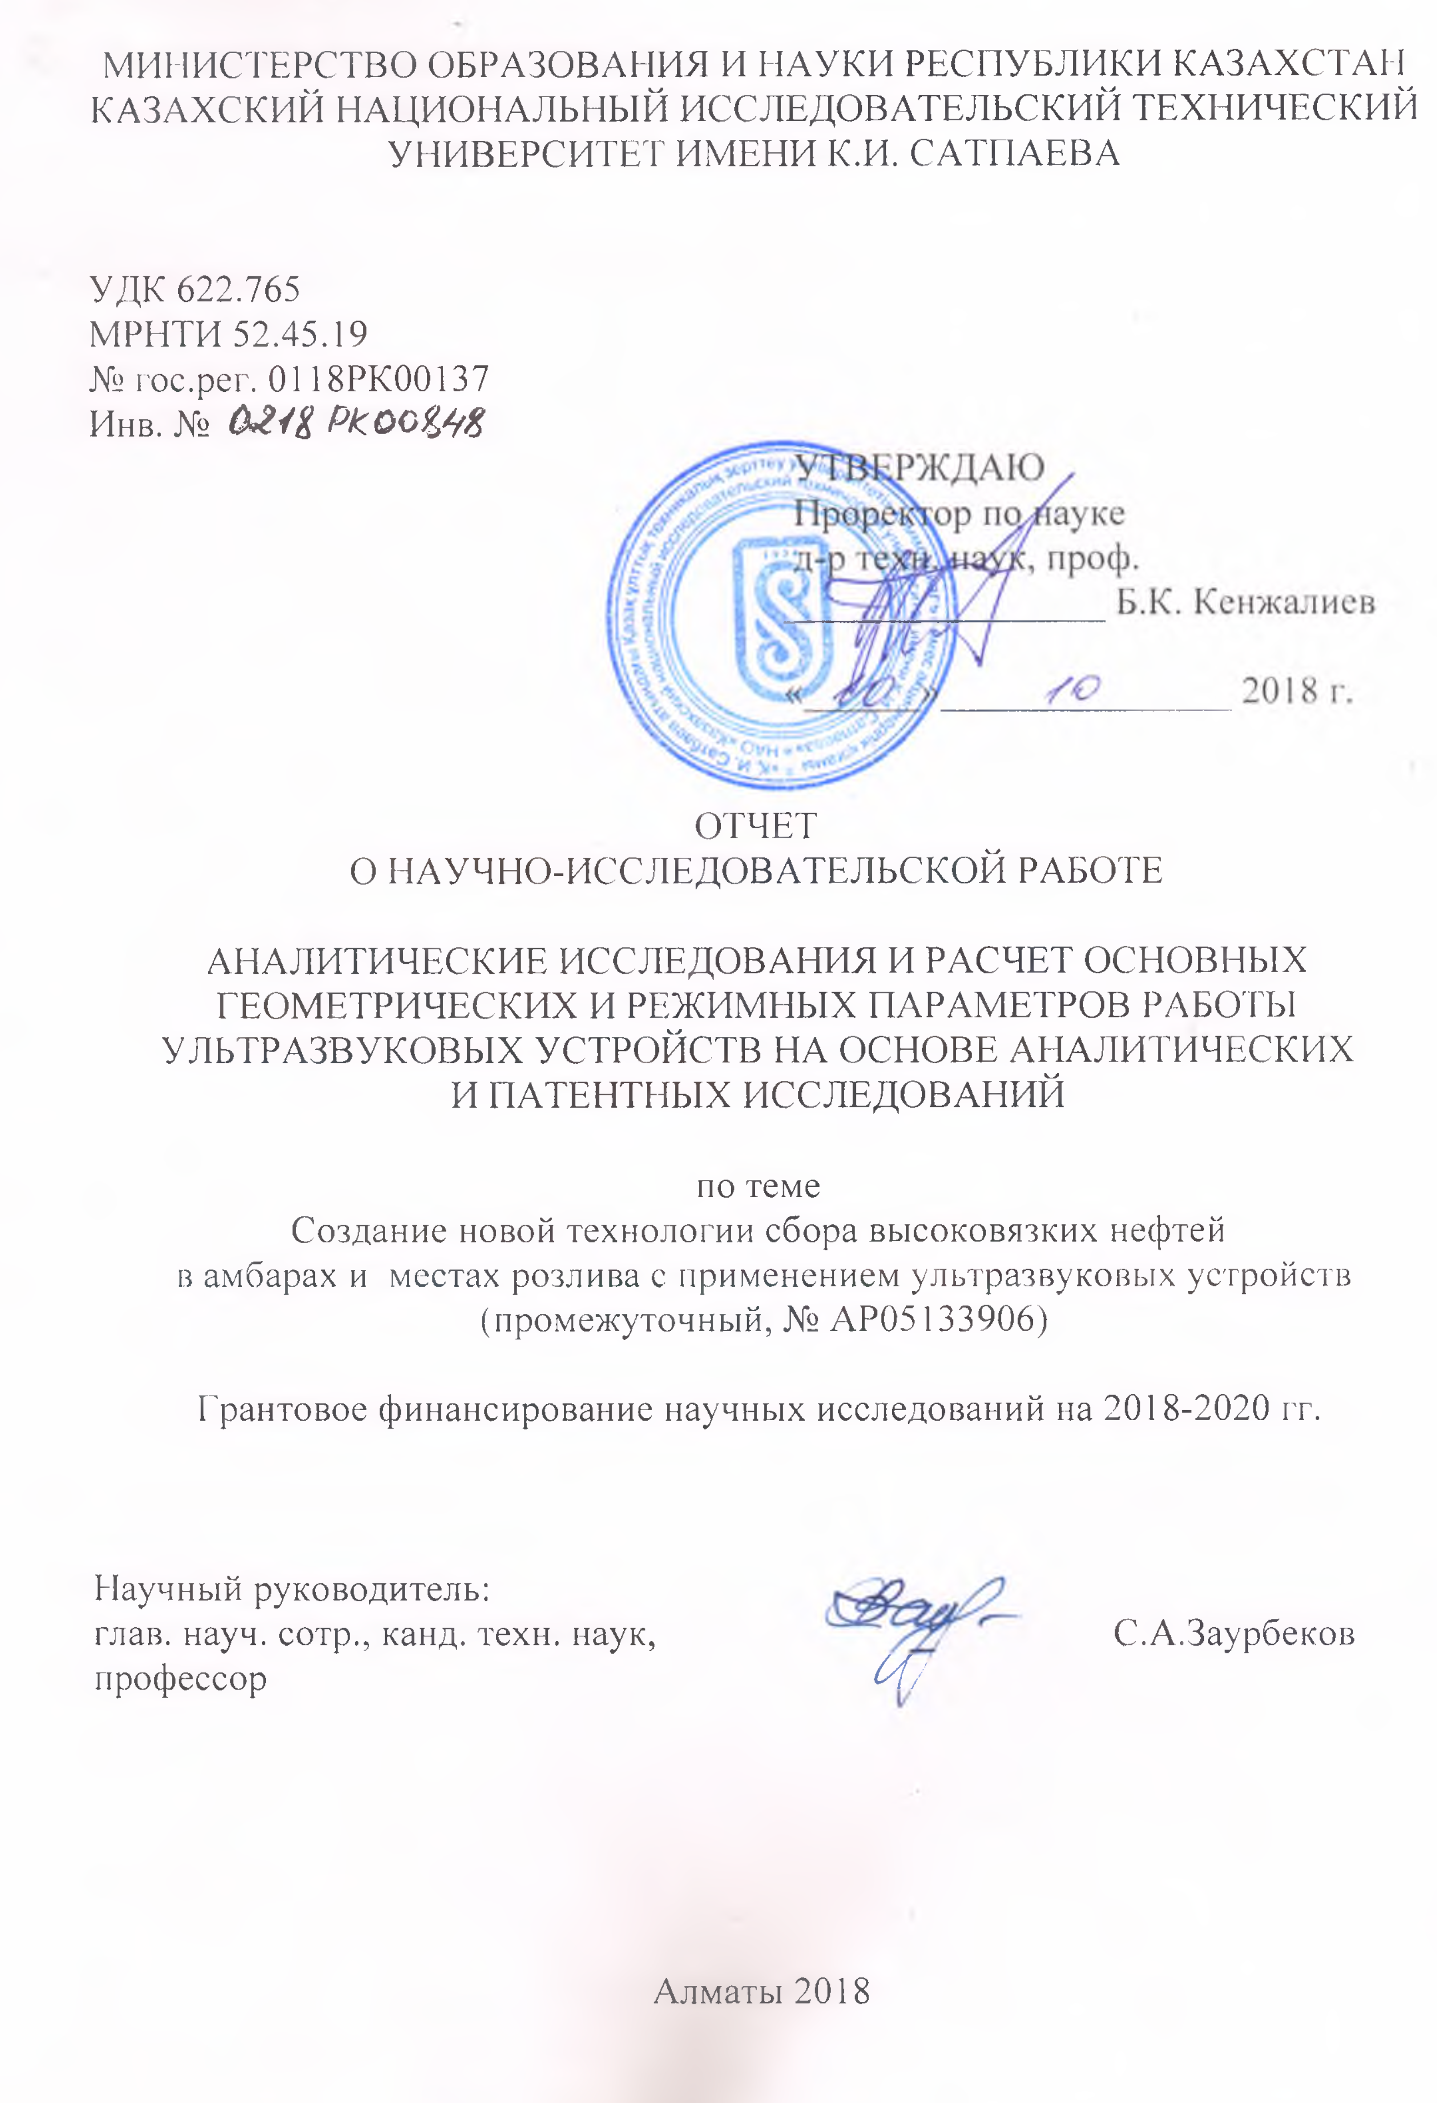
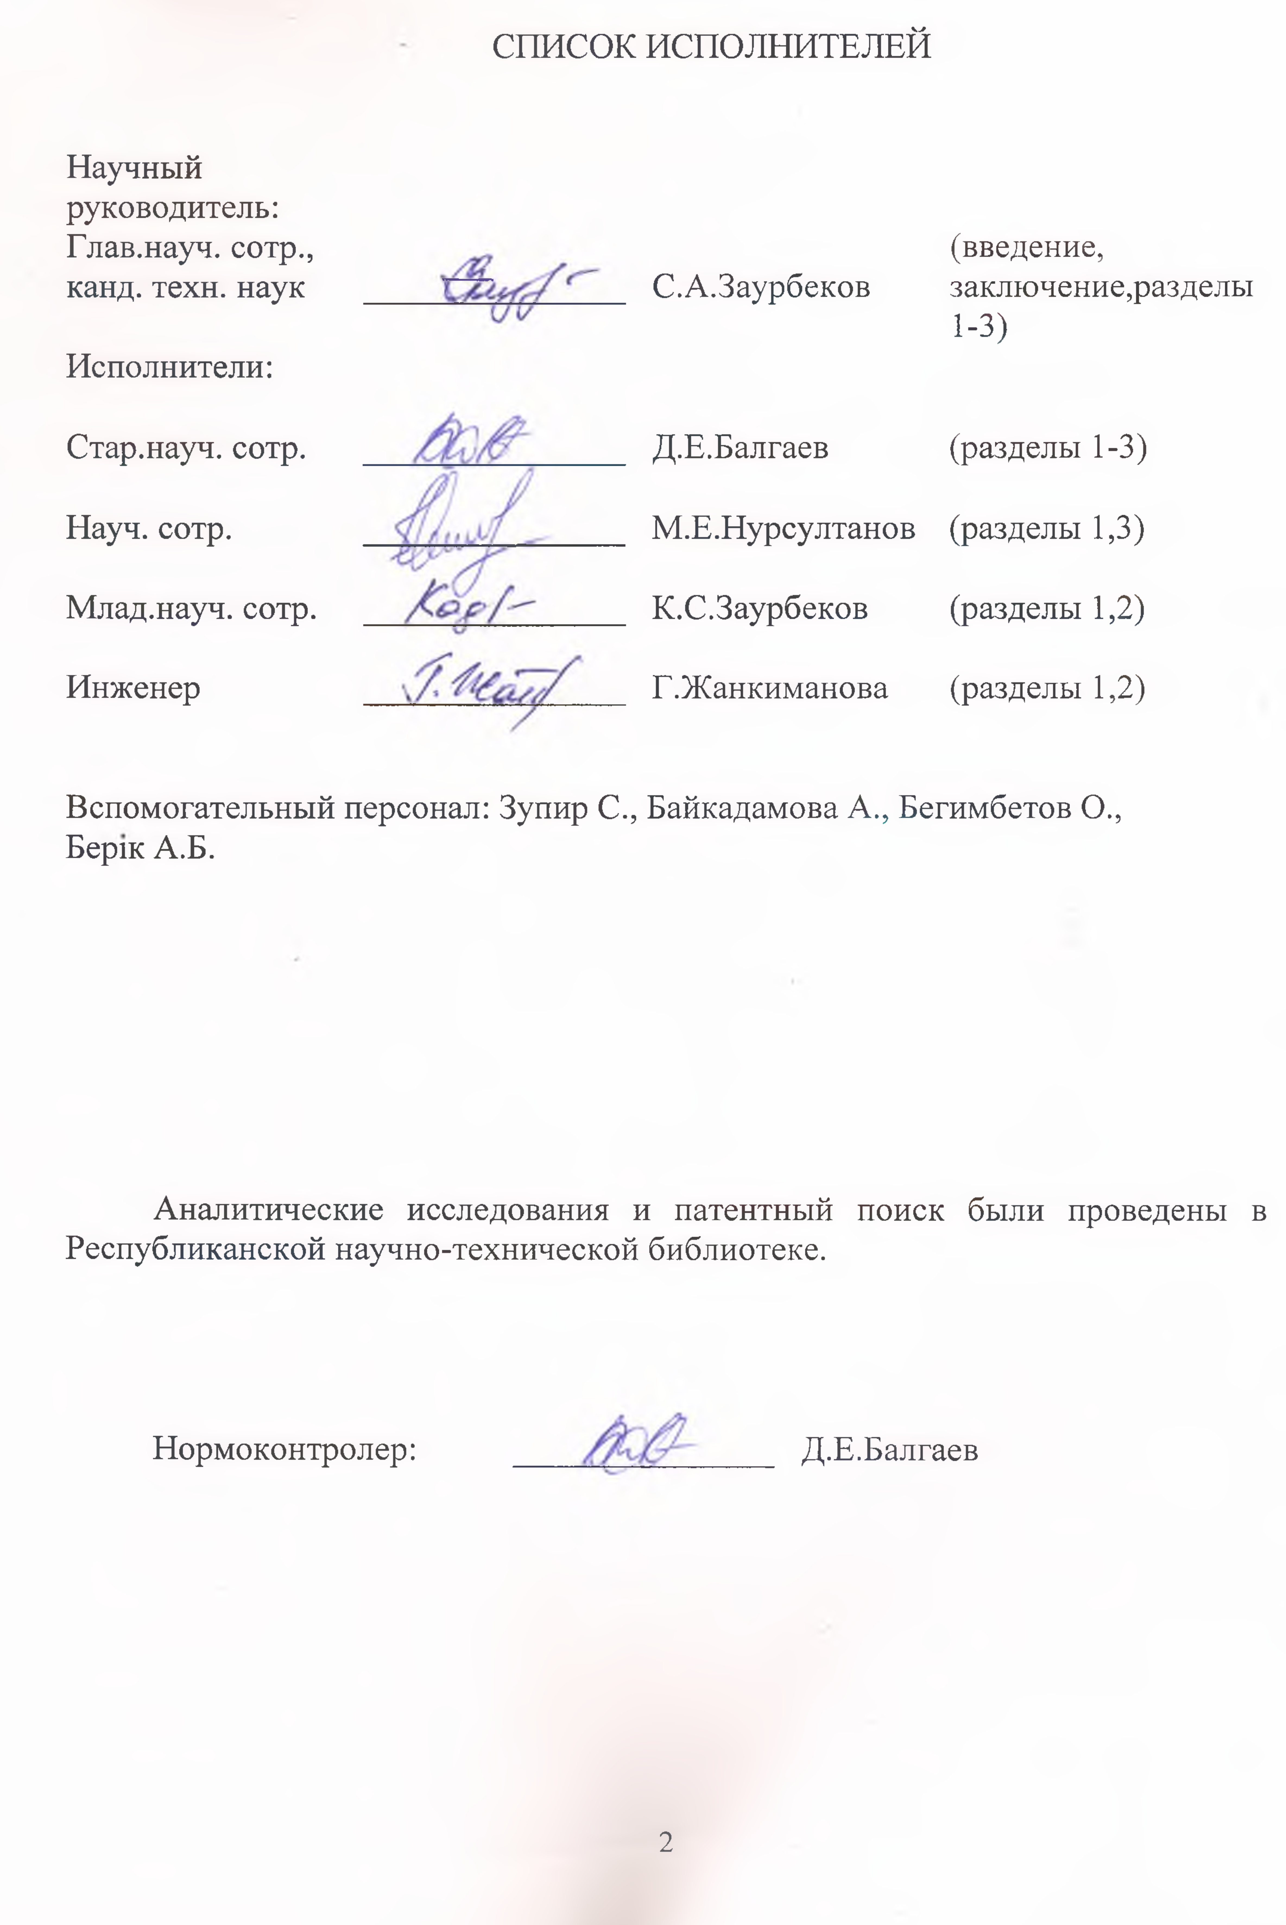

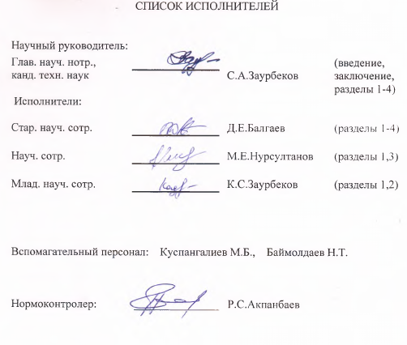

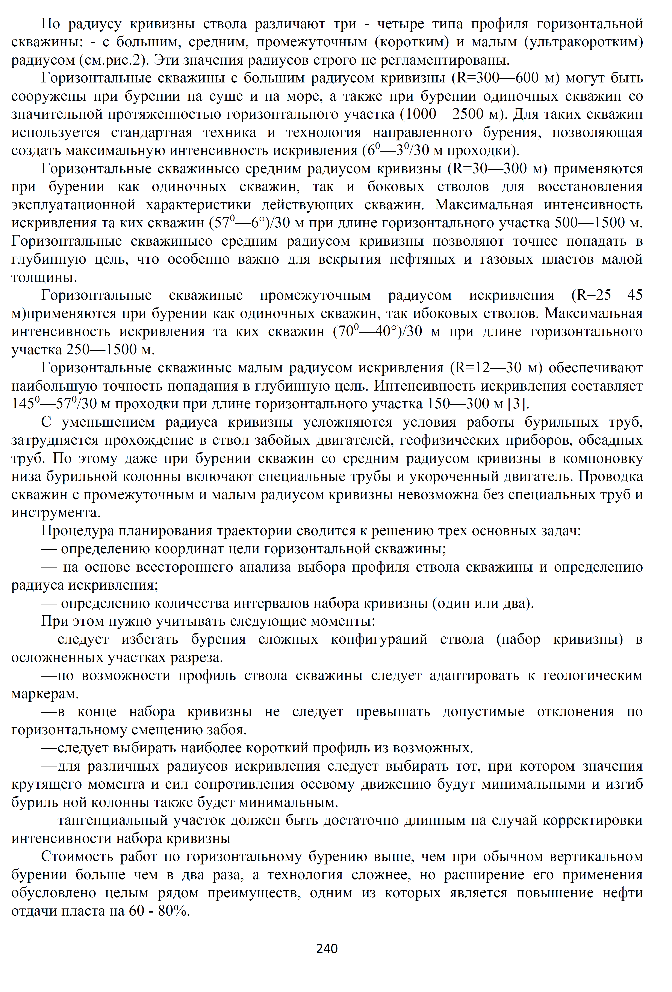

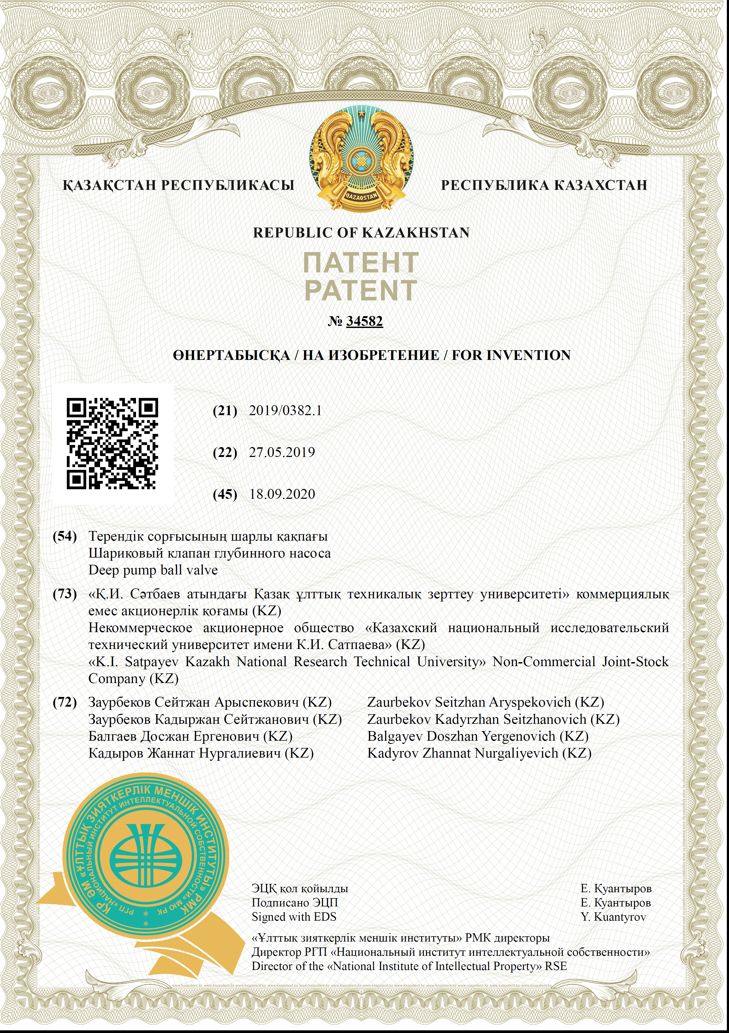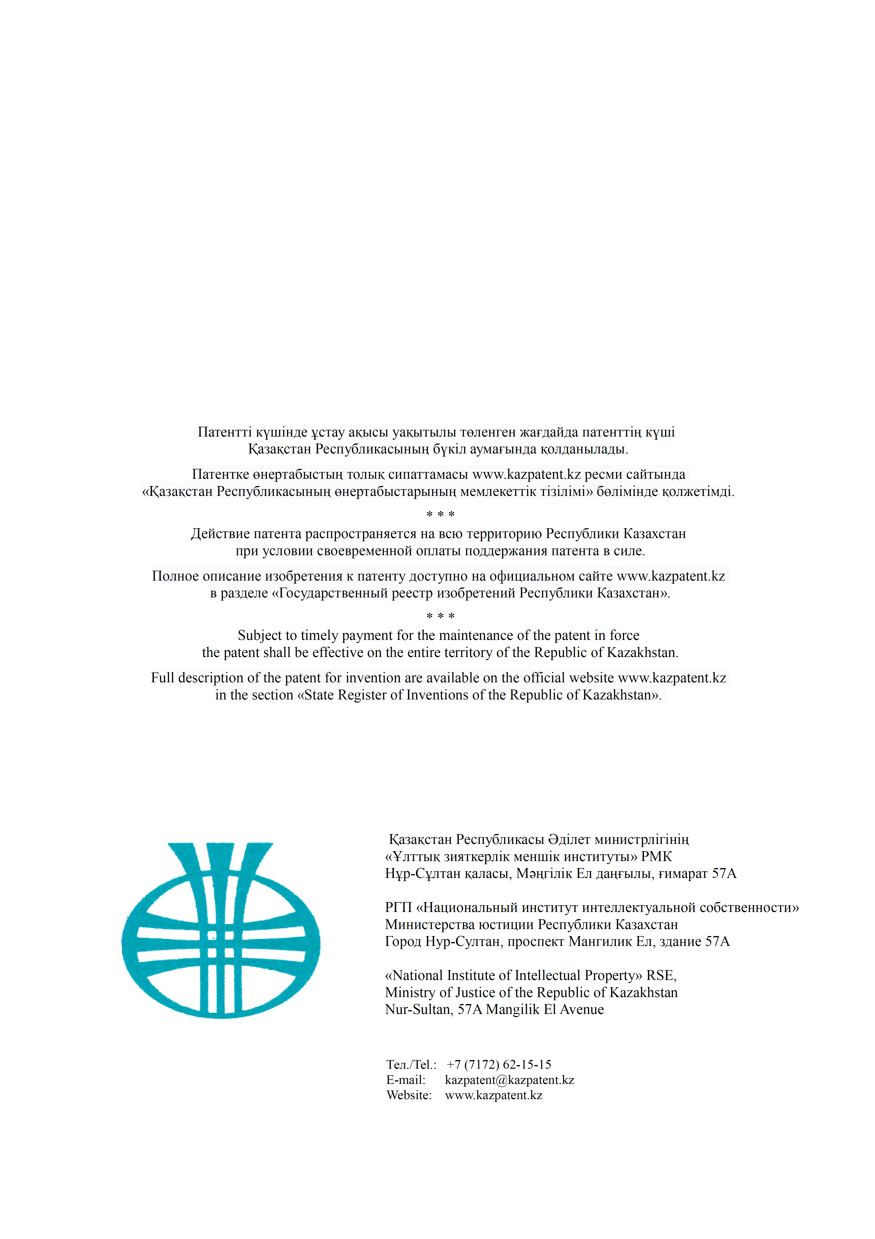

APPENDIX F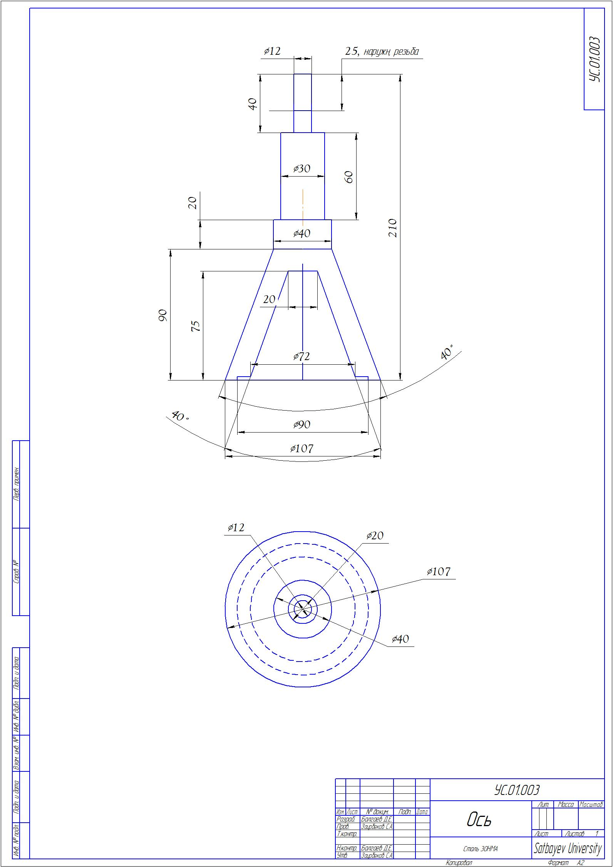 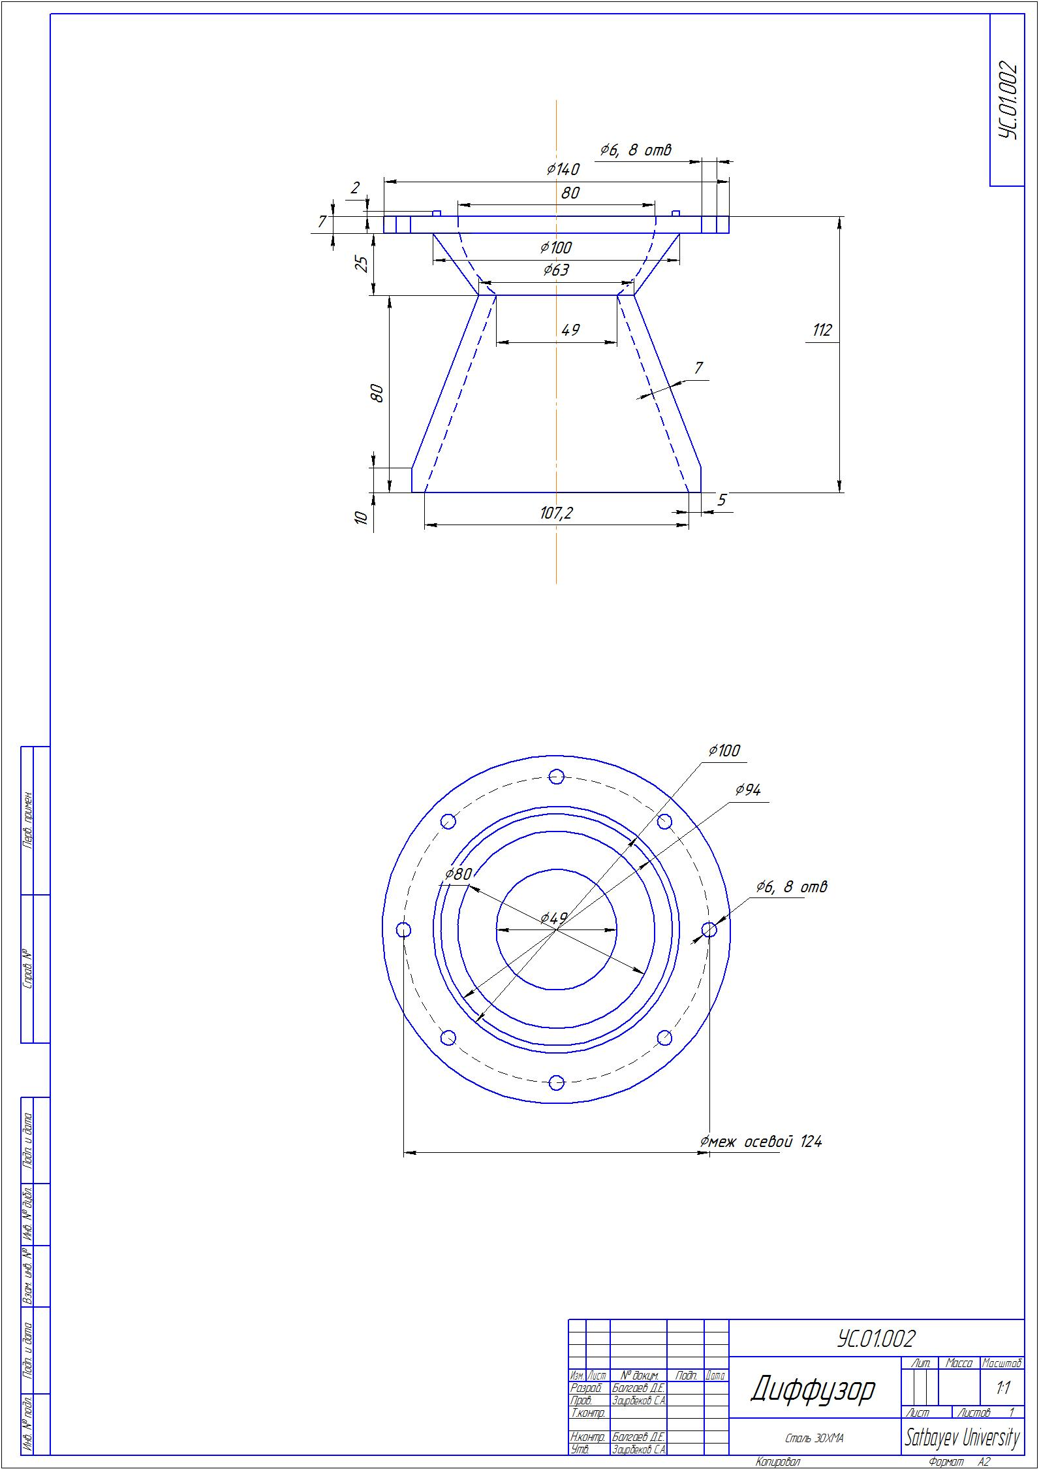
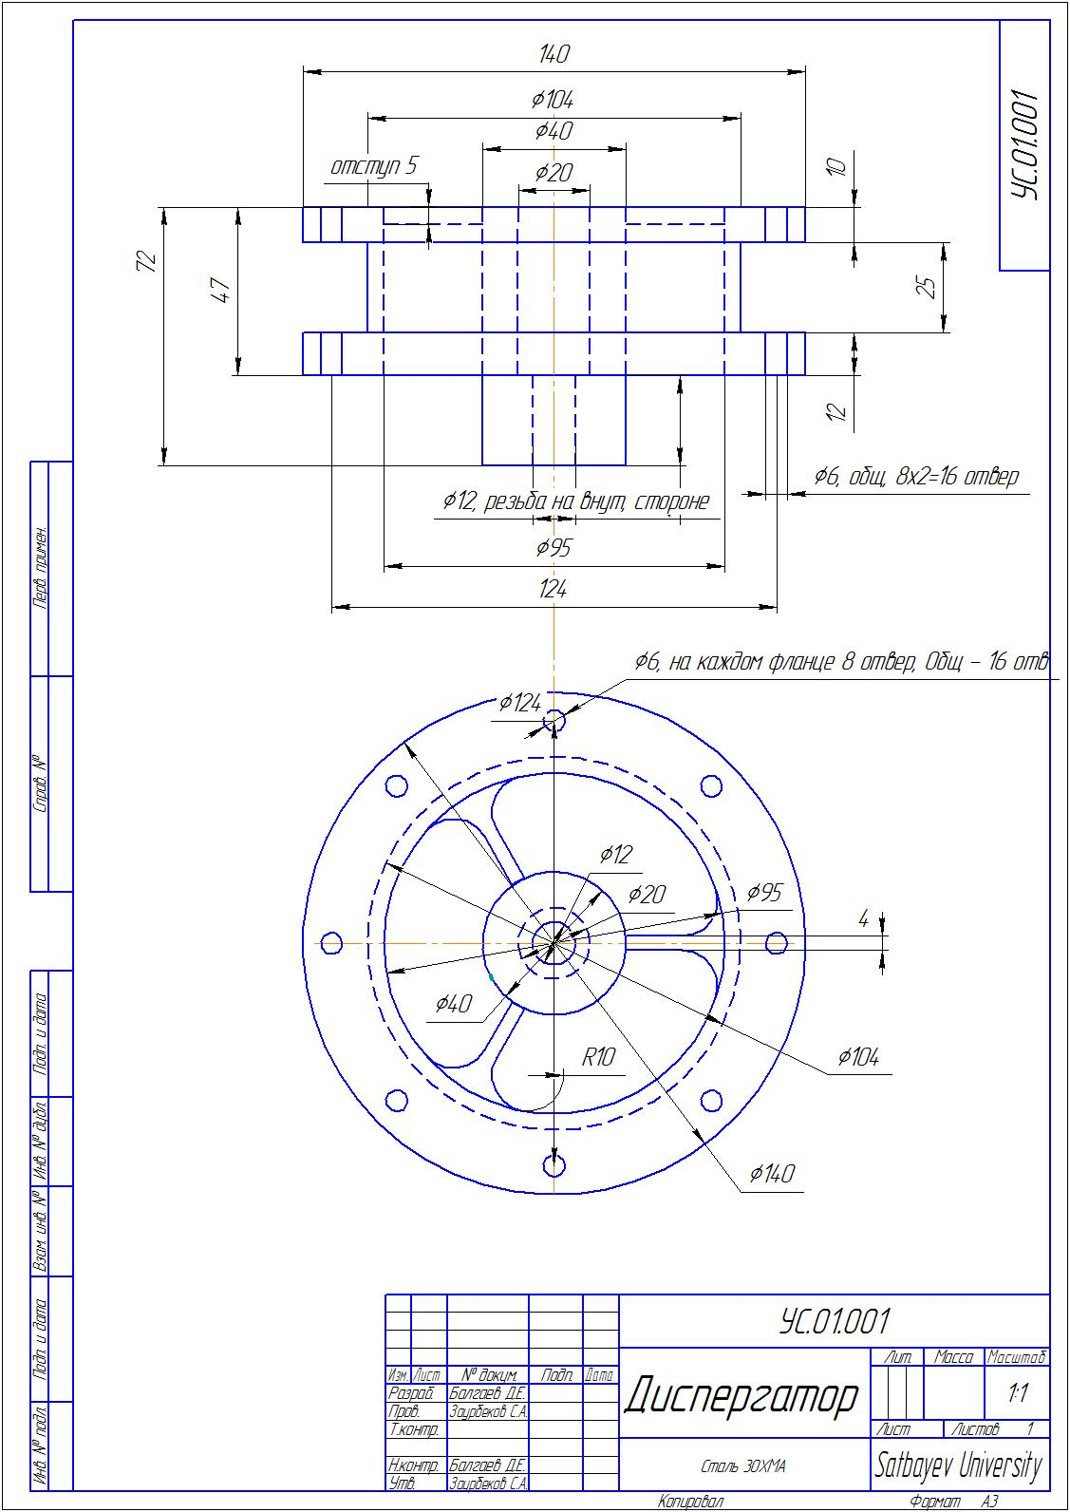
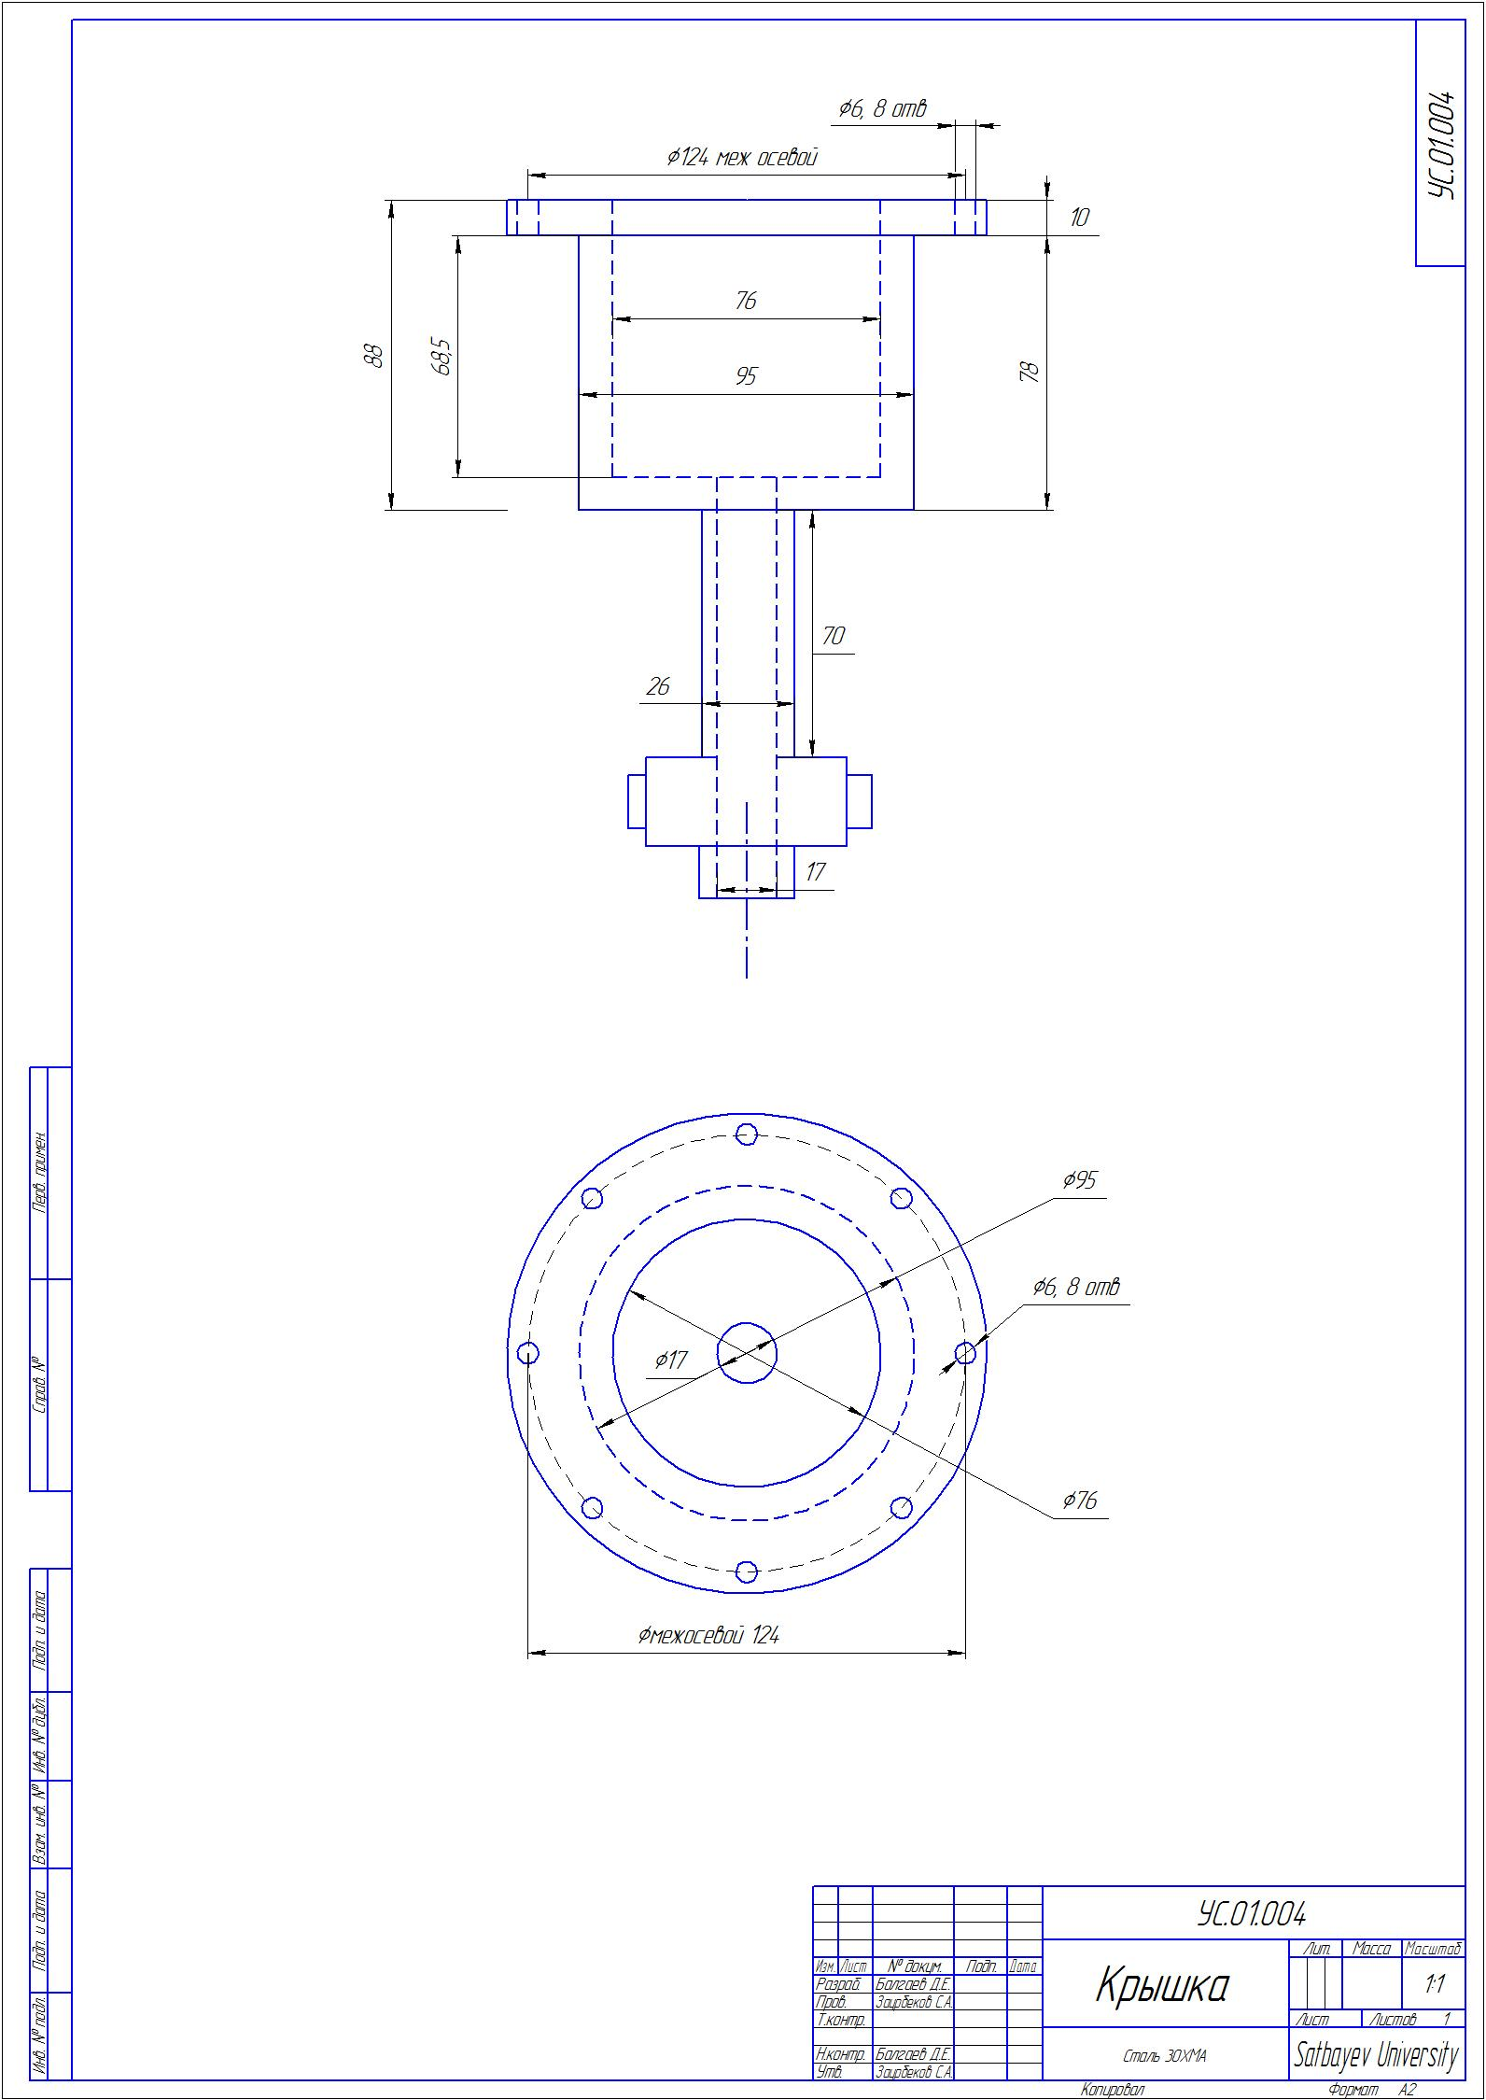

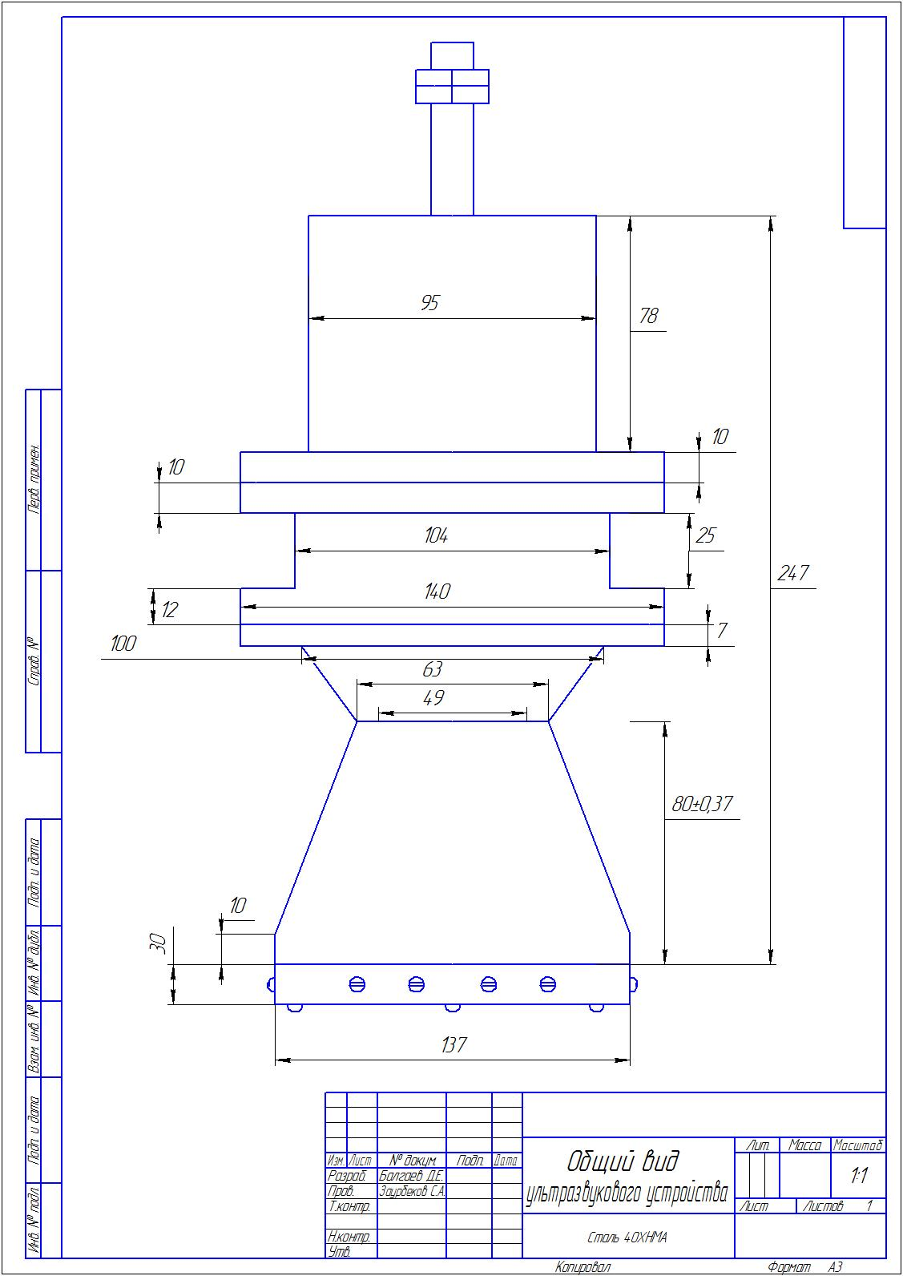

APPENDIX G

APPENDIX H

APPENDIX I
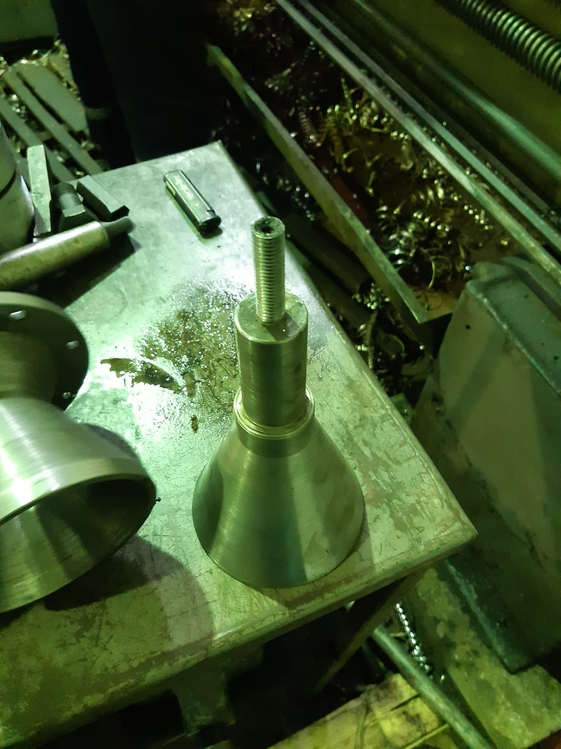
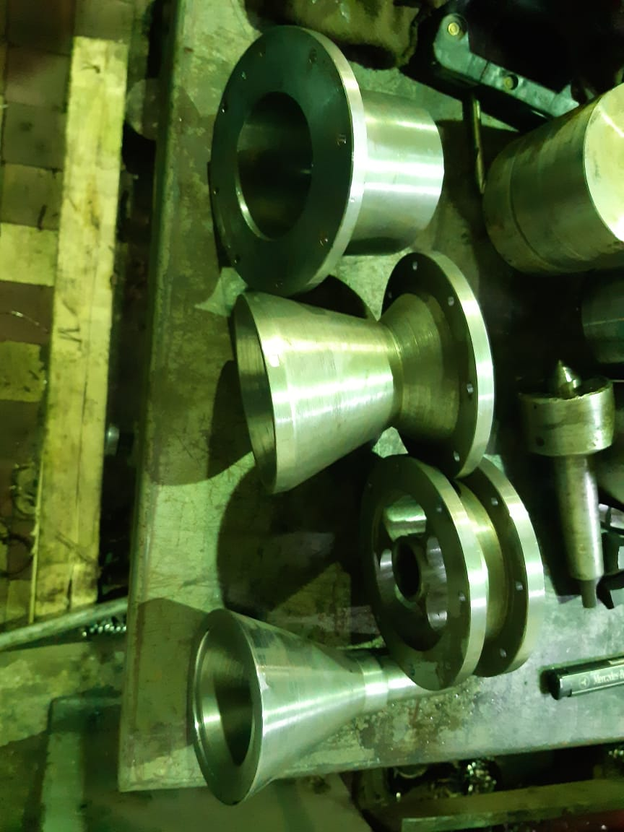
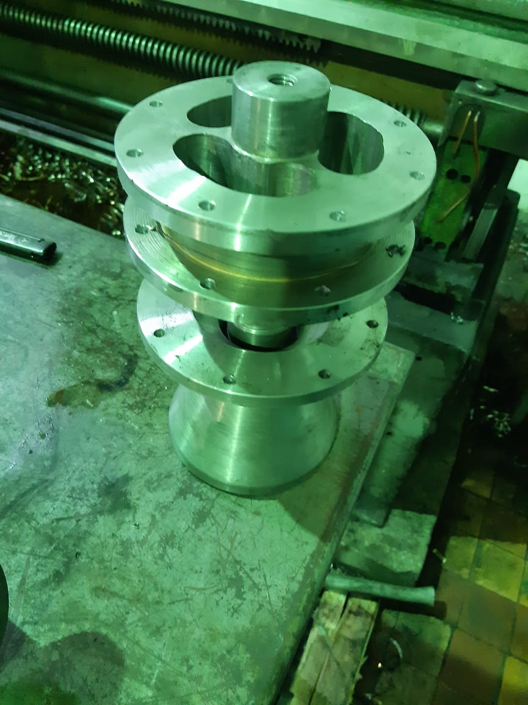
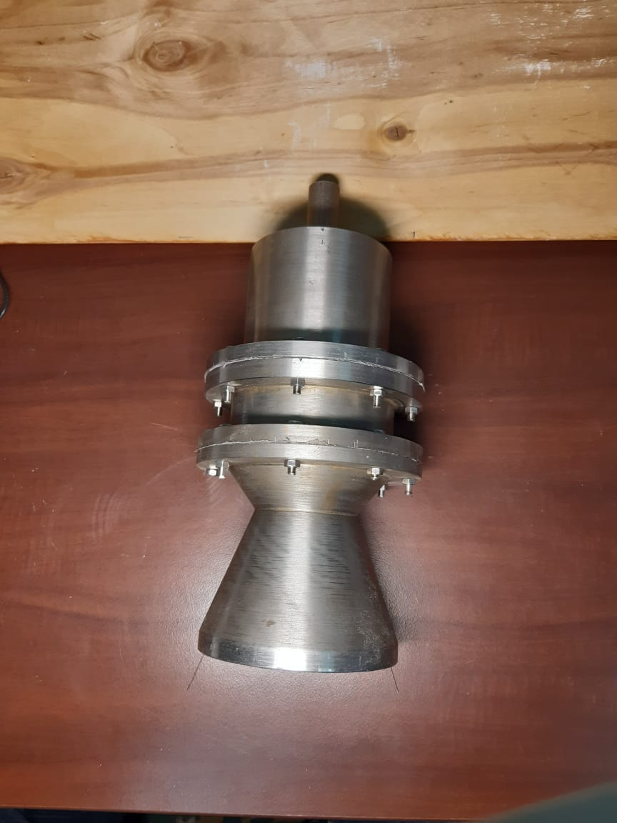

APPENDIX J

