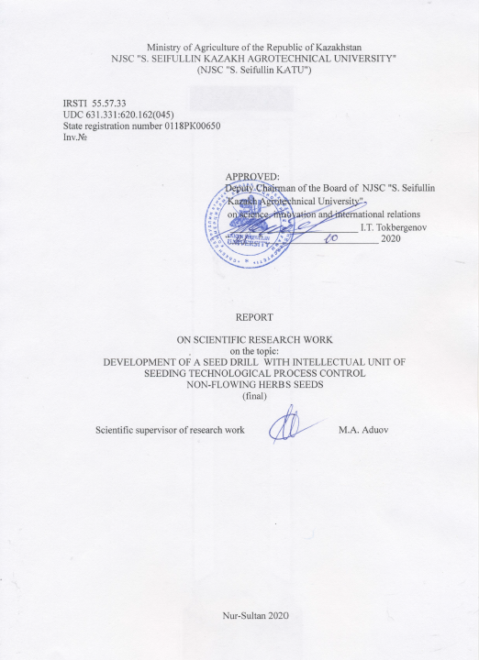

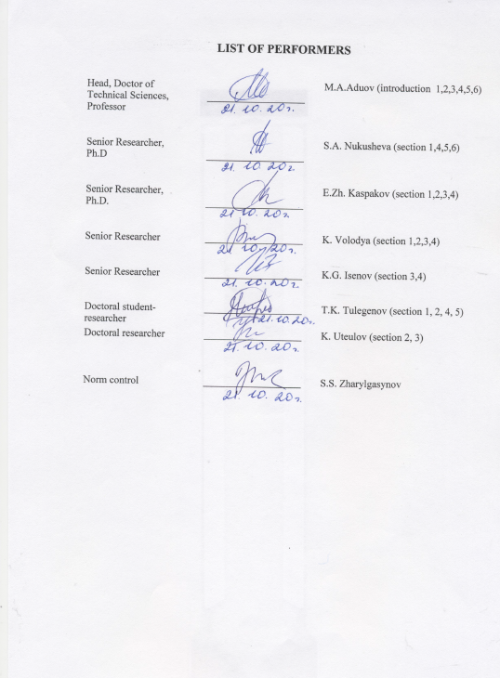

ABSTRACT
Report 118 p., 19 figures, 11 tables, 21 sources, 5 attachments.
SEEDER, CONTROL UNIT, NON-LOOSE SEEDS, DISC COULTERS, TRACTION RESISTANCE, SEEDING, SEEDING MACHINE, YIELD
The object of the research is the sowing process of a seeder with an intellectual control unit for the technological process of sowing non-flowing grass seeds, which has high technical and technological properties.
The goal of the project - Development of a seeder with an intellectual control unit for the technological process of sowing non-loose grass seeds.
Methods of work: During the implementation of the project, modern methods of statistical dynamics, probability theory, laboratory test methods, BST for testing agricultural machinery, dynamometry and other modern methods and technical means were used.
An experimental model of a seeder with an intellectual technological process control unit for sowing non-flowing grass seeds has been developed, which has the following parameters: coverage 3,6 m, row spacing 0,3 m, seeding rate range from 10 to 30 kg / ha, seeding depth 2 -8 cm.
Results: Seed germination of Burabay wheatgrass in the area sown with an experimental seeder is 3,.56% higher than seed germination in the control area, the germination of awnless rump is 2,85% higher in the control; in terms of uniformity of seeding depth, the experimental model of the seeder surpasses the serial seeder for sowing wheatgrass by 4,95% and by 4,89% when sowing awnless rump; the increase in yield on the experimental plot with a seeder for sowing non-flowing grass seeds in comparison with the control is 3,125 c / ha for sowing wheatgrass and is 5,361 c / ha for sowing awnless rump.
Novelty: Regression equations for the dependence of traction resistance and average fuel consumption on the depth of seeding and the speed of movement of the seeder for sowing non-loose grass seeds have been obtained.
The annual economic effect from the use of the developed seeder was calculated, which amounted to 2, 697, 542 tenge.
Implementation degree: partial.
Application area: agriculture and agricultural engineering. The total results for previous years were reflected in the reports under the state registration number 0118RK00650, inventory numbers No 0218RK00380 for 2018 and inventory number 0219RK00469 for 2019.

CONTENT
LIST OF ABBREVIATIONS AND SYMBOLS………………………. …………………. |  |  | 6
INTRODUCTION…………………………………………………………………………. |  |  | 7
MAIN PART ………………………………………………………………………………. |  |  | 9
1 | Development of an experimental model of a high-tech seeder for sowing non-loose grass seeds for moisture and energy saving technologies in forage production………………………. …………………………………………………… |  | 9
2 | Finalization of an experimental prototype of a high-tech seeder with an automated control module for sowing non-loose grass seeds ……………………………………. |  | 13
3 | Carrying out economic tests of an experimental model of a seeder ………………… |  | 15
 | 3.1 | Development of a program and methodology for economic tests of an experimental model of a seeder with an intellectual control unit for the technological process of sowing non-loose grass seeds ……………………… | 15
 | 3.2 | Technique for bench tests of an experimental model of a seeder……………. | 15
 | 3.3 | Methods for determining the characteristics of the sown material …………… | 15
 | 3.4 | Determination of quality indicators of the technological process by seeding machines ……………………………………………………………………… | 15
 | 3.5 | Methods for determining the uneven seeding between the seeding devices (seed tubes) and the instability of the total sowing of seeds …………………. | 15
 | 3.6 | Methods for determining seed damage ………………………………………. | 16
 | 3.7 | Methods for determining the seeding capacity of the seeding machine............................................................................................................... | 16
 | 3.8 | Methodology for conducting economic tests of an experimental model of a seeder with an intellectual control unit for the technological process of sowing non-loose grass seeds ………………………………………………… | 16
 | 3.9 | Method for determining test conditions ………………………………………… | 17
 | 3.10 | Methodology for determining Agrotechnical indicators ……………………….. | 17
 | 3.11 | Methodology for determining energy indicators ……………................................ | 17
 | 3.12 | Estimation of measurement error during research …………………………… | 17
4 | Results of economic tests of an experimental model of a seeder with an intellectual control unit for the technological process of sowing non-loose grass seeds…………. |  | 20
 | 4.1 | Results of economic tests of an experimental model of a seeder with an intelligent control unit for the technological process of sowing non-loose grass seeds according to Agrotechnical assessment …………………………. | 20
 | 4.2 | Energy evaluation of an experimental model of a seeder for sowing the non-flowing grass seeds........................................................................................... | 27
5 | Economic evaluation of an experimental model of a seeder with an intellectual control unit for the technological process of sowing non-loose grass seeds ………... |  | 34
6 | Published articles …………………………………………………………………….. |  | 38
CONCLUSION……………………………………………………………………………. |  |  | 40
LIST OF USED SOURCES……………………………..………………………………… |  |  | 42
ATTACHMENT А Record……………………………………………................................. |  |  | 44
ATTACHMENT B Test results of a seeder for sowing non-flowing grass seeds…………….. |  |  | 64
ATTACHMENT C Article reprints…………………………………………………………. |  |  | 66
ATTACHMENT D Calendar plan……………………………………………….…………. |  |  | 108
ATTACHMENT Е Implementation act …………………………………………………….. |  |  | 118

LIST OF ABBREVIATIONS AND SYMBOLS
In this research report, the following abbreviations and symbols are used:
А | – hole diameter;
B | – clutch opener width;
С | – soil adhesion;
 | – density;
 | – internal friction coefficient;
Q | – loose material consumption
V | – disc coulters speed;
γ | – soil density;
γ_{р} | – the density of the loosened medium;
α | – cutting angle of the clutch opener;
ϕ | – angle of internal friction;
ρ | – external friction angle;
ψ | – shear angle (degrees), for dry soil; coherent soil; solid soil;
ε | – coulters disc angle.
KATU | – Kazakh Agrotechnical University;
INTRODUCTION
The creation of a sustainable forage base that ensures balanced feeding of animals throughout the year is the main condition for the high efficiency of the livestock industry. The current state of the fodder base in the farms of Northern Kazakhstan does not meet the needs of animals, both quantitatively and qualitatively. Therefore, feed production requires no less attention than grain production [1, 2, 3].
One of the main ways to obtain high yields is the method of sowing and the technology for its implementation. The production and breeding of new varieties of high-quality seed material is associated with sowing a wide range of crops with different physical and mechanical properties of seeds. In existing sowing machines, sowing devices are capable of sowing loose and medium-sized seeds of wheat, barley, rye, etc. soil. A characteristic disadvantage when introducing low-flowing (non-flowing) seeds is the presence of a zone of bridging, which should be destroyed.
In order to improve the quality indicators of sowing non-flowing seeds, a technological process and technical means for sowing non-flowing grass seeds for moisture and energy-saving technologies in forage production will be justified and developed [4, 5]. Patent application dated 16.09.2020 [6].
In Northern Kazakhstan, the sowing of grain and grain fodder crops has been carried out and is carried out today by 60-70% by cultivator-seeders SGS-2.1; SGGS-6; SGGS-12. These are seed drills with a row spacing of 22,8 cm. About 30-40% of the area is sown with cultivator seeders from the near (SKP-2.1) and far abroad countries (Flexy-Coil, John Deere, Concord, Amazonia, Horsh, Argentine seeder Crucianelli Pionera, etc.), as well as appropriately converted serially produced seeders, these are: grain seeders SG-3.6 and SGP-3.6; grain grass NWT-3.6 and SGU-3.6; meadow grass SLT-3.6; seeder PM-4; Sapphire 7 (Lemken, Germany) and others [7, 8].
At the same time, the park of domestic seeders is not renewed and the Republic has found itself in complete dependence on foreign suppliers of agricultural machinery, while the purchase of expensive machinery is only possible for large firms, and such equipment is not available for small and medium-sized farmers. In this connection, the transition to new technologies is impossible without appropriate technical support, and in the Republic today, the modernization of existing and the creation of new machines, taking into account domestic and foreign experience, is necessary [9].
A comprehensive analysis of existing designs of seeding devices led to the idea of ​​a project, the creation of an automated seeding system.
The modern grass seeders supplied to Kazakhstan, despite the high technical level of manufacturing, are bulky, metal-intensive and do not fully meet the Agrotechnical requirements. As a rule, they have uneven seeding between devices and a general instability of seeding non-flowing seed materials.
The implementation of new technologies, their introduction into production on large areas, requires the development of appropriate means of mechanization, which would correspond in quality and price to the requirements and capabilities of most agricultural producers in the conditions of Northern Kazakhstan.
The proposed work is aimed at developing effective technical means for the implementation of new technologies [1, 2, 6]. To achieve the goal this year, the following has been done.
An experimental model of a seeder with an intellectual technological process control unit for sowing non-flowing grass seeds has been developed, which has the following indicators: working width 3.6 m, row spacing 0.3 m, seeding rate range from 10 to 30 kg / ha, seeding depth 2- 8cm. The designs of the parallelogram mechanism, the press roller and the distribution arms of the seeding device have been improved. Programs and methods of economic tests of an experimental model of a seeder with an intellectual control unit for the technological process of sowing non-flowing grass seeds have been developed, and economic tests have been carried out on sowing the Burabay wheatgrass and the Akmola emerald rump without awn, during which the Agrotechnical and energy parameters of the seeder were determined. The annual economic effect from the use of the developed seeder was calculated, which amounted to 2 697 542 tenge.
Research work for the period 2018-2020 was carried out according to the approved calendar plan shown in Attachment D.

MAIN PART
1 Development of an experimental prototype of a high-tech seeder for sowing non-loose grass seeds for moisture and energy saving technologies in forage production
Based on the design and technological parameters of the manufactured model of the seeder for sowing non-flowing grass seeds, we designed all the units of the experimental seeder, the strength analysis of the frame and main parts, which makes it possible to test the models without testing the prototypes. Working documentation for manufacturing prepared in Autodesk Inventor environment. The developed experimental model of a seeder for sowing non-flowing grass seeds is shown in Figures 1.1, 1.2, 1.3 and 1.4. The seeder has an intellectual technological process control unit, a frame, a seed box with seeding devices, an attachment, a sowing section, a chassis and a drive for the seeding devices.

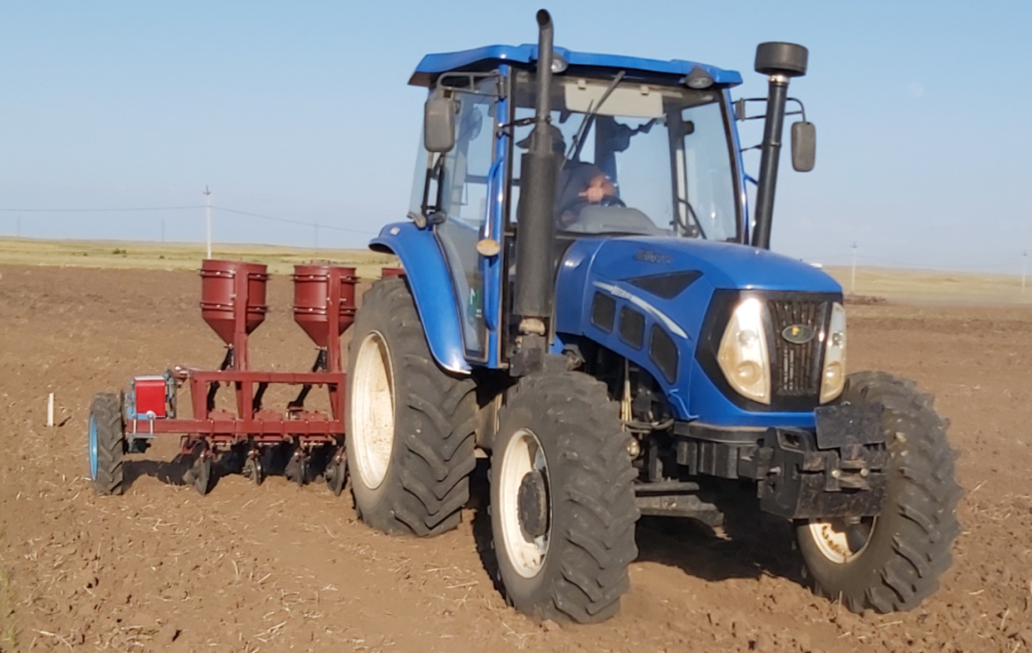
Figure 1.1 - An experimental model of a seeder for sowing non-flowing grass seeds in an experimental field

The seeding width of the seeder is 3.6 m, the row spacing is 0.3 m, the seeding rate range is from 10 to 30 kg / ha, the seeding depth is 2-8 cm. The seeder frame consists of the main and auxiliary beams. The main beam of the frame with automatic coupling is equipped with two pneumatic wheels. Twelve seeding units are hinged to the rear of the frame. The sowing section consists of a double disc coulter and roller. Six seed hoppers are rigidly connected to the metering units, each of which has two distribution arms, which are connected by a seed tube to the seeding section.
The intellectual seeder control unit includes: an electronic control unit (ECU), hopper level sensor, seeding control sensor, path sensor and cabling, Figures 1.2, 1.3 and 1.4. All information from the above sensors is displayed on the monitor (VT) in the tractor cab.

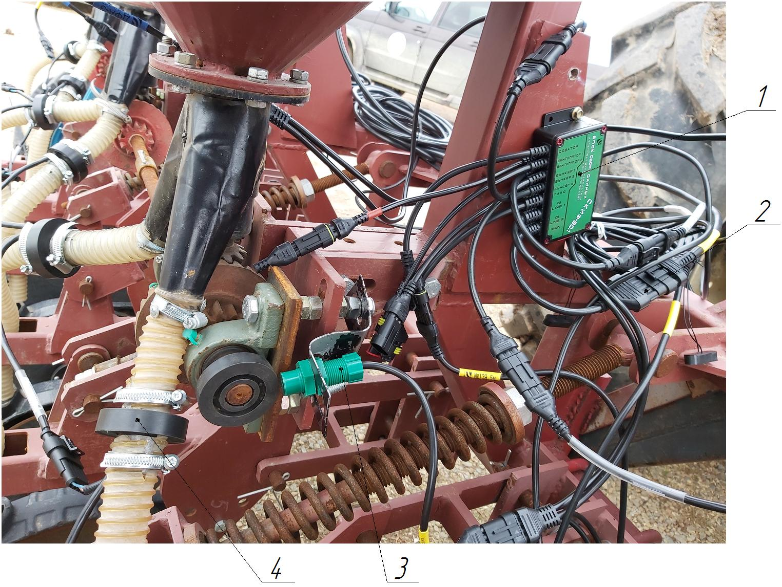
1 - data processing unit; 2 - connecting wires; 3 - sensor of revolutions of the drive of seeding devices; 4 - sensor for control the sowing of the seed
Figure 1.2 - Installation of a seeding control system on a seeder for sowing non-flowing grass seeds
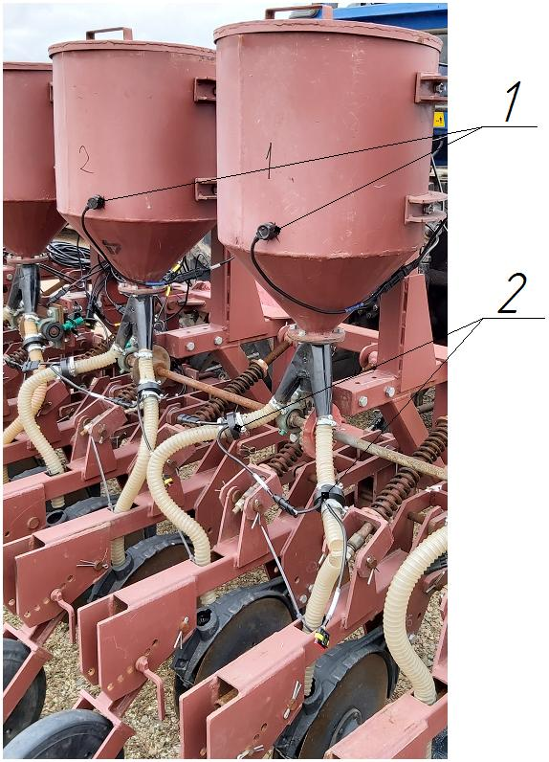

Figure 1.3 - Installation of sensors: 1 - bunker level control sensors; 2 - sensors for control the sowing of the seed
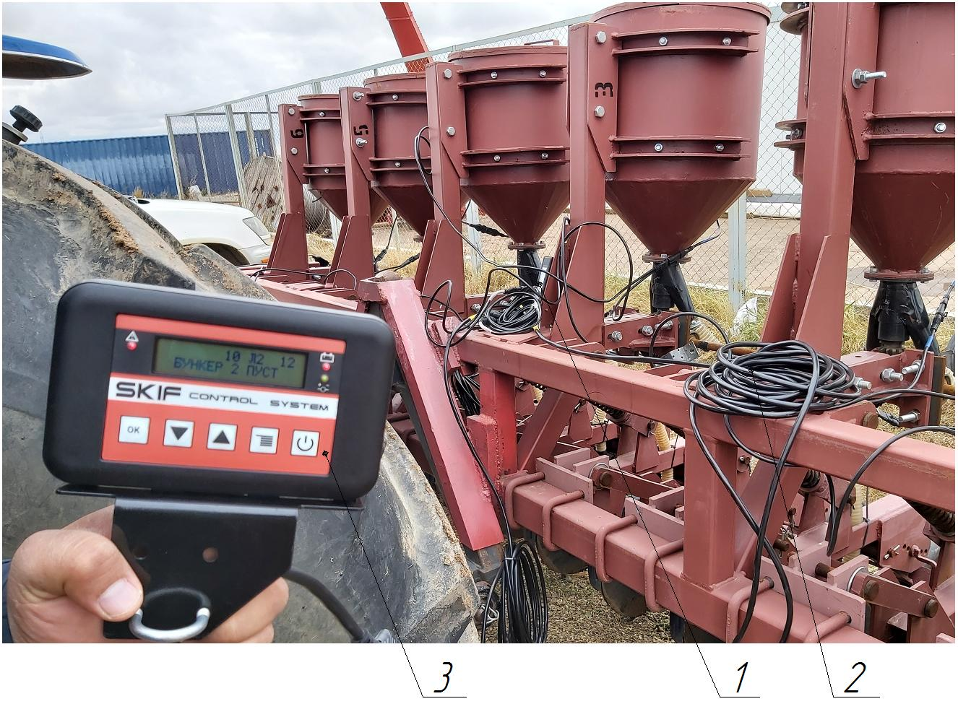
Figure 1.4 - Testing the seeding control system: 1 - data processing unit; 2 - connecting wires; 3 - monitoring and control terminal

2 Refinement of an experimental prototype of a high-tech seeder with an automated control module for sowing non-loose grass seeds
During the laboratory and field experiments with a prototype of a high-tech seeder with an automated control module for sowing non-loose grass seeds, the following disadvantages were revealed:
- when sowing on loose light soils, it is difficult to maintain the minimum amount of seeding;
- the seeds are unloaded in the sleeves of the seeding unit.
To eliminate the depth of the coulters when sowing on loose light soils in order to reduce the pressure on the soil with the press rollers, we changed the design of the mounting bracket for the parallelogram mechanism and moved it vertically by 20 mm and installed a press roller with a diameter of 320 mm and a rim width of 60 mm, Figures 2.1 and 2.2.
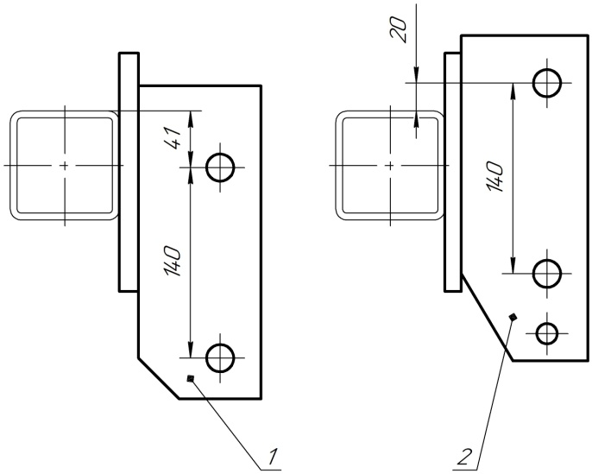

Figure 2.1 - Brackets for attaching the parallelogram mechanism (1-old version, 2-new version)

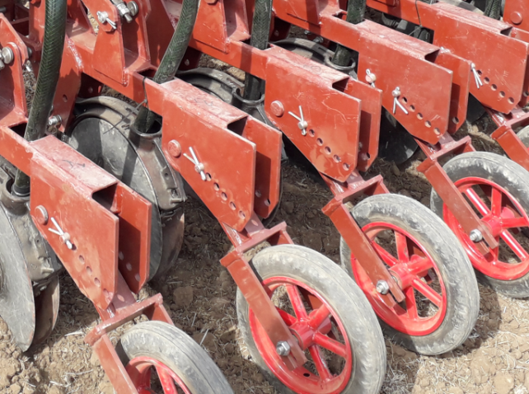 | 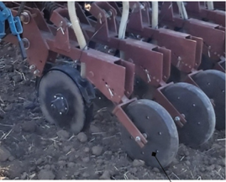
Figure 2.2 - Packer roller initial version and improved version

To eliminate unloading of seeds in the distribution hoses, bends with a smaller angle of inclination were installed, Figure 2.3 [6].
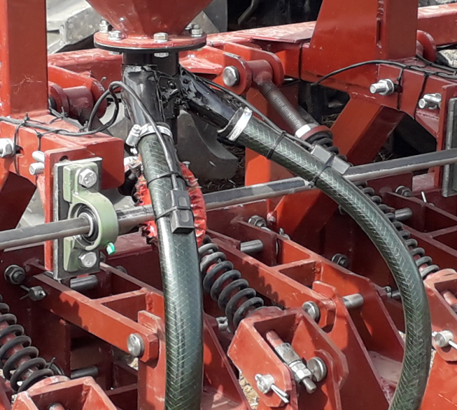 | 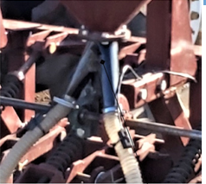
Figure 2.3 - Distribution hoses: initial version and improved version

3 Conducting economic tests of an experimental model of a seeder

3.1 Development of a program and methodology for economic tests of an experimental model of a seeder with an intellectual control unit for the technological process of sowing non-loose grass seeds
The research program of the experimental model of the seeder includes the following:
- bench tests of an experimental model of a seeder;
- laboratory and field tests of an experimental model of a seeder.

3.2 Technique for bench tests of an experimental model of a seeder
Bench tests were carried out in order to check the quality of the technological process by the seeding devices of the seeding machine for sowing those crops that are zoned in the area of ​​application of the seeding machine.

3.3 Methods for determining the characteristics of the sown material
In the sown material, prepared for testing, must be determined [10]: cleanliness, damage - according to SST 12036, SST 12037; germination - according to SST 12038; humidity - according to SST 12041; weight of 1000 seeds - according to SST 12042.
The bulk density of seeds was determined in 3-fold repetition.

3.4 Determination of quality indicators of the technological process by seeding machines
Determination of quality indicators of the technological process by sowing machines is carried out at a frequency of their rotation corresponding to the optimal and increased by 25 ... 30% of the speed of the sowing machine. Tests at different speeds are carried out without changing the adjustments of the seeding devices [11,12, 13, 14].

3.5 Methods for determining the unevenness of seeding between the seeding devices (seed tubes) and the instability of the total seeding of seeds
Unevenness and instability of sowing seeds are determined at the economic seeding rate. For sowing machines with up to 24 devices (seed tubes), the unevenness and instability of seeding are determined by half the working width; for machines with more than 24 devices (seed tubes), the above indicators are determined by at least 12 devices (seed tubes).

3.6 Methods for determining seed damage
The content of damaged seeds must first be determined in the starting material. By the difference between damaged seeds that have passed through the seeding devices (seed tubes) and in the starting material, the crushing of seeds by the seeding devices is determined. The data obtained are compared with TT and SST 26711-89.

3.7 Methods for determining the seeding capacity of the seeding machine
The sowing capacity of the sowing machine is determined by sowing seeds at the maximum and minimum rates in accordance with the TT at one working speed. Samples are taken at least 3 times. The mass of the sown seeds is determined with an error of no more than ± 1 g, the results are recorded in the statement.

3.8 Methodology for conducting economic tests of an experimental model of a seeder with an intellectual control unit for the technological process of sowing non-loose grass seeds
To conduct economic tests of an experimental model of a seeder with an intellectual control unit for the technological process of sowing non-flowing grass seeds, a field with an area of ​​20 hectares on the farm “Guldana” and an experimental plot 150 m long and 14.4 m wide were allocated on the territory of the research and production campus of the Kazakh Agro Technical University named after S. Seifullin.

Table 1 - Plan of experiments for laboratory and field research
Machine name | Crop | Coulter travel depth h_{а} , cm | Seeding rate, kg / ha | Travel speed V, km / h | Evaluation criteria
Experimental seeder | Wheat grass,  Awnless rump | 2,3,4,5 | Minimum, average, maximum | 5,7,9 | Seeding depth, quantity in seeds planted in a layer corresponding to an average depth and two adjacent 1 cm layers, stubble preservation, furrow depth

For the experimental model of the seeder, the following parameters were taken: speed of movement 5, 7, .9 km / h; the seeding depth is 2 and 4 cm. The row spacing is taken as 30 cm. The seeding rate is maximum and minimum for the selected crop.

3.9 Procedure for determining test conditions
When determining the conditions for conducting economic tests, the following were taken into account: soil type; mechanical composition; relief; moisture and soil hardness; weed infestation; the presence and characteristics of plant residues; ridged surface. The test conditions were determined in accordance with SST 20915 [9].
The type of soil and the name are determined by the mechanical composition, the relief is determined from the soil map of the farm and the area where the tests were carried out. To determine the moisture and hardness of the soil, the devices for determining the moisture content of the T-350 Aquaterr (USA) and for determining the density of the soil Wile were used.

3.10 Methodology for determining Agrotechnical indicators
The assessment of Agrotechnical indicators was carried out in accordance with SST 31345 [10]. After the passage of the seeder, the following parameters were determined: the depth of the opener’s stroke ha, the depth of seeding hs, the number of seeds Ks embedded in the horizon corresponding to the average depth and two adjacent 1 cm layers.

3.11 Methodology for determining energy indicators
The determination of the traction resistance of the experimental model of the seeder was carried out in accordance with the requirements of SST R 52777 [23]. For registration and processing of the obtained experimental data, the measuring information system MD 264 with the MS-5 module manufactured by CubRSIIT&M was used [15,16]. The MD-264 measuring information system includes: an electronic unit, a 220V / 12V power supply, a power cable, a PC communication cable, a processing program, a weight-measuring tensor-gage Uralves K-R-20G-10t sensor and a fuel flow meter
The processing of the primary materials of experimental studies was carried out on a personal computer using appropriate programs and methods of mathematical statistics.

3.12 Estimation of measurement error during research
The values ​​of the indicators obtained as a result of the tests will be subjected to statistical processing. The main statistical characteristics of the quantitative variability of the indicator are the arithmetic mean, the variance S2, the standard deviation Sx, the error of the arithmetic mean, the coefficient of variation Vx. We take the arithmetic mean of a series of observation results and its standard deviation Sx for the measurement result of a random physical quantity:

, (3.1)
, (3.2)
where is the arithmetic mean of the measured value;
n is the number of measurements;
- i-the value of the measured value;
Sx - standard deviation of the measured value.
With repeated observation of random physical quantities, the absolute error of the result of evaluating the arithmetic mean is equal to:
, (3.3)
where is the absolute error of the result of evaluating the arithmetic mean of the measured value;
t_{Σ} is the value of the Student's test for the selected significance level for n-1 degrees of freedom;
is the standard deviation of the total error of the measurement result.
The value of the Student's criterion is determined by the expression:

, (3.4)
- error of the arithmetic mean of the measured value;
- table value;
Δ_{a} -absolute error of the measuring instrument (determined by the passport data based on the accuracy class of the device or equal to the scale division price);
Sа - standard deviation of the measurement instrument error.
The standard deviation of the total error of the measurement result is determined from the expression:
. (3.5)
The value of Sa is found by the expression:

. (3.6)
Having determined the S_{ΣХ} e value by formula (5), the total error of the measurement result is calculated:
, (3.7)
Where is the total error of the measurement result.
Relative error in estimating the average value of the measured indicator:
%, (3.8)
Where is the relative error in estimating the average value of the measured indicator.
The assessment of the standard deviation of the error of the measuring instrument is carried out by the expression:
. (3.9)
Further processing of the measurement results and the assessment of the significance of the differences in the obtained data is carried out by methods of analysis of variance.

4 Results of economic tests of an experimental model of a seeder with an intellectual control unit for the technological process of sowing non-loose grass seeds
4.1 Results of economic tests of an experimental model of a seeder with an intellectual control unit for the technological process of sowing non-flowing grass seeds according to agrotechnical assessment
In the first series of experiments of an experimental model of a seeder for sowing non-flowing grass seeds, cereal grasses were sown at the recommended depth of seeding and the rate of sowing of seeds by an agronomist of the farm, and the control sowing was carried out with a serial seeder SG-3,6 (Astra)
In the second series of experiments of an experimental model of a seeder for sowing non-flowing grass seeds, the grasses of awnless rump were sown at the recommended depth of seeding and the rate of sowing of seeds by the agronomist of the farm, and the control sowing with a serial seeder SG-3,6 (Astra)
Economic tests of an experimental model of a seeder with an intellectual control unit for the technological process of sowing non-flowing grass seeds were carried out on a 20 hectare field on the farm Guldana and an experimental plot 150 m long and 14.4 m wide on the territory of the scientific and production campus of S.Seifullin Kazakh Agro Technical University, figure 4.1 and 4.2.
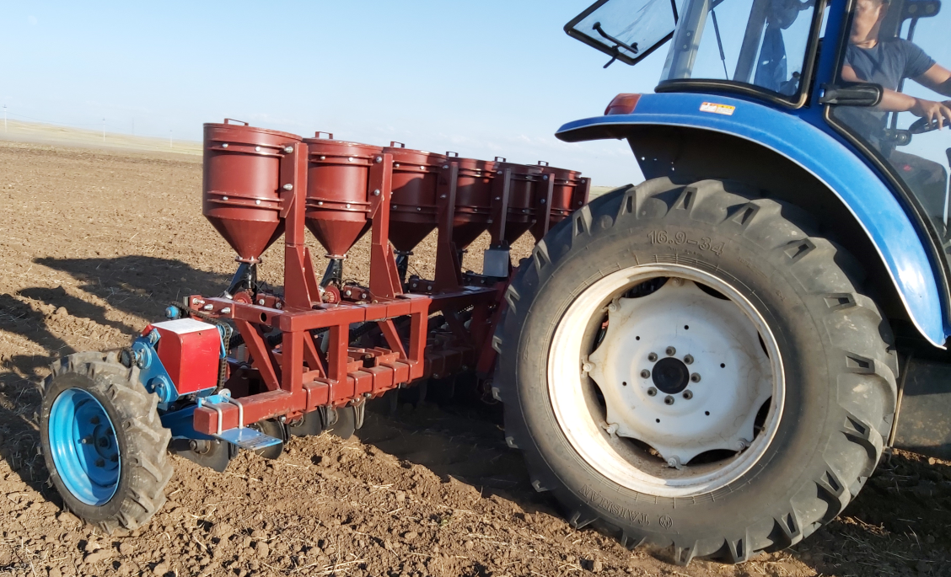
Figure 4.1- Experimental model of a seeder with an intellectual control unit for the technological process of sowing non-flowing grass seeds on an experimental field on the farm "Guldana"

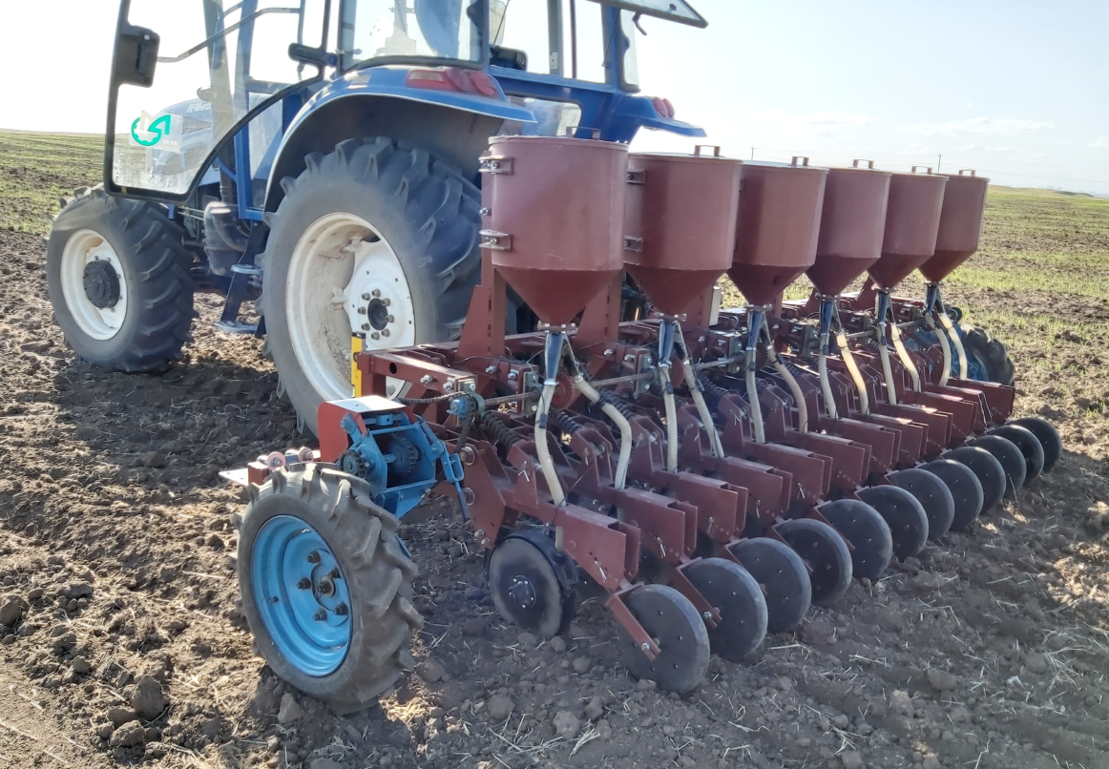

Figure 4.2- An experimental model of a seeder with an intellectual control unit for the technological process of sowing non-flowing grass seeds in economic tests (sowing wheat grass)

Indicators of conditions for carrying out laboratory and field research tests: soil type; mechanical composition; relief; moisture and soil hardness; The surface ridges are determined in accordance with SST 20915 and entered in the observation log and are given in Аttachment A (Form A 1, A 2, A 3, A 4, A 5), Attachment B (Form B 1 and B 2).
Sowing of wheatgrass variety "Burabay" and awnless rump "Akmolinsky emerald" were carried out. The seeding rate and the seeding depth have been established, the dimensions of the experimental plots are 3.6 * 37 m. The collected material on phenological observations of the experimental plots is entered in the observation log. Table 4.1 presents data on the completeness of seedlings and on the field germination of wheatgrass and awnless rump grass seeds.

Table 4.1 - Results of accounting for plant density
Area processed by the unit | Crop | Number of plants, pcs / m² | Field germination,%
Tractor HS1204 + seeder for sowing non-flowing grass seeds | Wheatgrass, variety"Burabay" | 295 | 90
Tractor HS1204 + seeder for sowing non-flowing grass seeds | Awnless rump, variety "Akmolinsky emerald" | 331 | 89
Tractor HS1204 + SG-3.6 (Astra) | Wheat grass variety "Burabay" | 283,3 | 86,44
Tractor HS1204 + SG-3.6 (Astra) | Awnless rump, variety "Akmolinsky emerald" | 320,4 | 86,15

The analysis of table 4.1 shows that the germination rate on the plot sown by the experimental seeder for sowing non-flowing grass seeds of the Burabay wheatgrass was 90%, and on the control plot the germination rate was 86,44%, the difference in germination was 3,56%. The germination rate of grass seedless rump grass in the area sown with a seeder for sowing non-flowing grass seeds was 89%, in the control area the germination rate was 86,15%, the increase in germination was 2,85%. An increase in the germination of grass seeds is achieved due to the high quality of the experimental sowing device and the covering part of the model seed drill. The pilot meter does not injure grass seeds and creates an even seed flow.

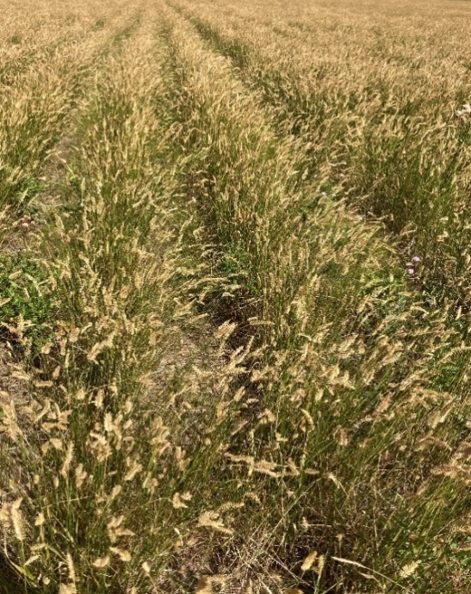 | 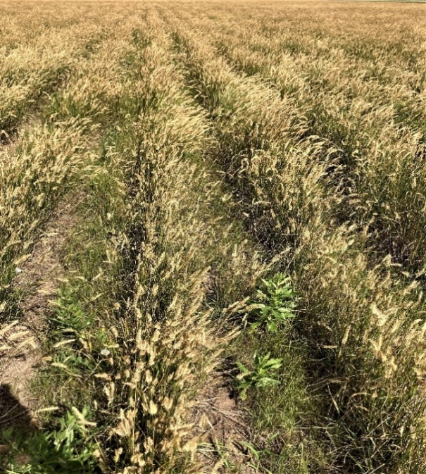
Figure 4.3- Sowing of Burabay grain crops on the experimental plot | Figure 4.4. - Sowings of wheatgrass "Burabay" on the control plot
The results of agrotechnical indicators of crops on the registration plots are shown in Table 4.2 and 4.3 [17].

Table 4.2 - Comparative indicators of the quality of the seeder for sowing non-flowing grass seeds and the SG-3,6 serial seeder (Astra) when sowing the Burabay grain crops
№ | The name of indicators | Experimental seeder | SG-3,6 (Астра)
1 | Date | 28.05. 2019y. | 28.05.2019 y.
2 | Movement speed, km / h | 7,0 | 7
3 | Seeding rate, kg / ha:  a) given  b) actual | 8,4  8,61 | 8,4  8,81
4 | Installation depth of seeding, cm | 4 | 4
5 | Maximum seeding depth, cm | 4,36 | 4,64
6 | Minimum seeding depth, cm | 3,56 | 3,34
7 | Uniformity of embedment depth, general:  a) average, cm  b) rms, ± cm  c) coefficient of variation,%  d) seeds embedded in a layer of average actual depth and two adjacent layers,% | 4,11  0,2  4,81  91 | 4,07  0,39  9,76  86
8 | Number of seeds not embedded in the soil, pieces per m² | not | not
9 | Distribution of plants by feeding area:  a) the average number of plants in  five-centimeter line segment, pieces  b) standard deviation, ± pieces  c) coefficient of variation,% | 4,9  3,04  62,0 | 4,8  3,07  68,6

Analysis of Table 4.2 shows that the uniformity of the seeding depth in the area sown with the experimental model of the seeder makes up 4,81%, and in the control area the uniformity of the seeding depth is 9,76%, that is, the experimental sample of the seeder for sowing non-loose seeds is superior to the serial seeder in uniformity of seeding by 4,95%.
The number of seeds planted in a layer of average actual depth and in two adjacent layers on the experimental plot was 91%, and on the control plot this figure is 86%, the experimental model of the seeder in this indicator exceeds the serial seeder by 5%.

Table 4.3 - Comparative indicators of the quality of work of an experimental model of a seeder for sowing non-flowing grass seeds with a serial seeder SG-3.6 (Astra) when sowing an awnless rump "Akmolinsky emerald"
№ | The name of indicators | Experimental seeder | SG-3,6 (Астра)
1 | Date | 28.05. 2019y. | 28.05. 2019y.
2 | Movement speed, km / h | 7,0 | 7,0
3 | Seeding rate, kg / ha:  a) given  b) actual | 13,4  13,72 | 13,4  14
Сontinuation of the table 4.3
4 | Set depth of seed embedding, cm | 4 | 4
5 | Maximum seeding depth, cm | 4,4 | 4,6
6 | Minimum seeding depth, cm | 3,7 | 3,3
7 | Uniformity of embedment depth, general:  a) average, cm  b) rms, ± cm  c) coefficient of variation,%  d) seeds embedded in a layer of average actual depth and two adjacent layers,% | 4,08  0,25  6,06  90 | 4,04  0,44  10,95  84,3
8 | Number of seeds not embedded in the soil, pieces per m² | not | not
9 | Distribution of plants by feeding area:  a) the average number of plants in five-centimeter line segment, pieces  b) standard deviation, ± pieces  c) coefficient of variation,% | 5,5  3,52  64 | 5,6  3,56  69,2

The analysis of Table 4.3 shows that the uniformity of the seeding depth on the experimental plot sown with the experimental model of the seeder is 6.06%, and on the control plot the uniformity of the seeding depth is 10.95%, which is 4.89% higher than the serial seeder uniformity of the seeding depth.

Table 4.4 - Structure of wheatgrass yield in the experimental plot, experimental model of a seeder for sowing non-loose grass seeds

Variant № | Number of plants,  Pcs/m² | Plant height,  cm | Productivity of green mass, kg / ha
1 | 2 | 3 | 4
1 | 293 | 85 | 52,989
2 | 295 | 81 | 50,840
3 | 315 | 83 | 55,628
4 | 319 | 86 | 58,370
5 | 320 | 79 | 53,787
 | 308,4 | 82,8 | 54,323
 | 176,8 | 8,2 | 8,069
S | 13,297 | 2,864 | 2,841
v | 4,311 | 3,458 | 5,229
 | 6,648 | 1,432 | 1,420
 | 8,410 | 1,811 | 1,797
 | 23,37 | 5,04 | 4,99

Table 4.5 - Structure of grain crops yield in the control plot, seeder SG-3,6 (Astra)
Variant № | Number of plants,  Pcs/m² | Plant height,  cm | Productivity of green mass, kg / ha
1 | 2 | 3 | 4
1 | 280 | 82 | 48,851
2 | 317 | 83 | 55,981
3 | 316 | 77 | 51,770
4 | 295 | 79 | 49,585
5 | 308 | 76 | 49,804
 | 303,2 | 79,4 | 51,198
 | 245,7 | 9,3 | 8,314
S | 15,675 | 3,050 | 2,883
v | 5,170 | 3,841 | 5,632
 | 7,837 | 1,525 | 1,442
 | 9,914 | 1,929 | 1,824
 | 27,56 | 5,362 | 5,07

Analysis of tables 4.4 and 4.5 shows that the number of productive stems in the experimental plots exceeds the number of productive stems in the control plot (308,4; 303,.2), and the plant height in the experimental plot is higher than the height in the control plot (82,8 cm and 79,4 cm). Accordingly, the yield on the experimental plot with a seeder for sowing non-loose grass seeds is 54,323 c / ha, and on the control plot -51,198 c / ha, thus, the yield increase makes up 3,125 c / ha.

Table 4.6 - The structure of the crop of awnless rump on the experimental plot, an experimental model of a seeder for sowing non-loose grass seeds

Variant № | Number of plants,  Pcs/m² | Plant height,  cm | Productivity of green mass, kg / ha
1 | 2 | 3 | 8
1 | 310 | 105 | 70,761
2 | 326 | 102 | 72,287
3 | 290 | 103 | 64,935
4 | 315 | 110 | 75,326
5 | 324 | 108 | 76,070
 | 313,0 | 105,6 | 71,876
 | 208,0 | 11,3 | 19,77
S | 14,422 | 3,362 | 4,446
v | 4,608 | 3,183 | 6,186
 | 7,211 | 1,681 | 2,223
 | 9,121 | 2,126 | 2,812
 | 25,358 | 5,91 | 7,818

Table 4.7 - Structure of awnless rump yield in the control plot, seeder SG-3,6 (Astra)
Variant № | Number of plants,  Pcs/m² | Plant height,  cm | Productivity of green mass, kg / ha
1 | 2 | 3 | 8
1 | 270 | 95 | 55,761
2 | 305 | 102 | 67,630
3 | 279 | 108 | 65,504
4 | 290 | 102 | 64,304
5 | 326 | 112 | 79,374
 | 294,0 | 103,8 | 66,515
 | 490,5 | 42,2 | 72,039
S | 22,147 | 6,496 | 8,488
v | 7,533 | 6,258 | 12,760
 | 11,074 | 3,248 | 4,244
 | 14,007 | 4,109 | 5,368
 | 38,940 | 11,422 | 14,923

Analysis of tables 4.6 and 4.7 shows that the number of productive stems in the experimental plots exceeds the number of productive stems in the control plot (313; 294), and the plant height in the experimental plot is higher than the height in the control plot (105,6 cm and 103, 8 cm). Accordingly, the yield on the experimental plot of the seeder for sowing non-flowing grass seeds is 71,876 c / ha, and on the control plot -66,.515 c / ha, thus, the yield increase is 5,361 c / ha.
4.2 Energy evaluation of an experimental sample seeder for sowing non-flowing grass seeds

The results of the energy evaluation of the work of the experimental model of the seeder for sowing non-flowing grass seeds and the serial SG-3,6 (Astra) are presented in table 4.8.
Based on the results of analytical [18] and laboratory-field studies of an experimental model of a seeder for sowing non-flowing grass seeds and a serial seeder SG-3,6 (Astra), the dependences of the traction resistance on the working speed and depth of soil cultivation were built, Figures 4.6, 4.7, 4.8 and 4.9 .

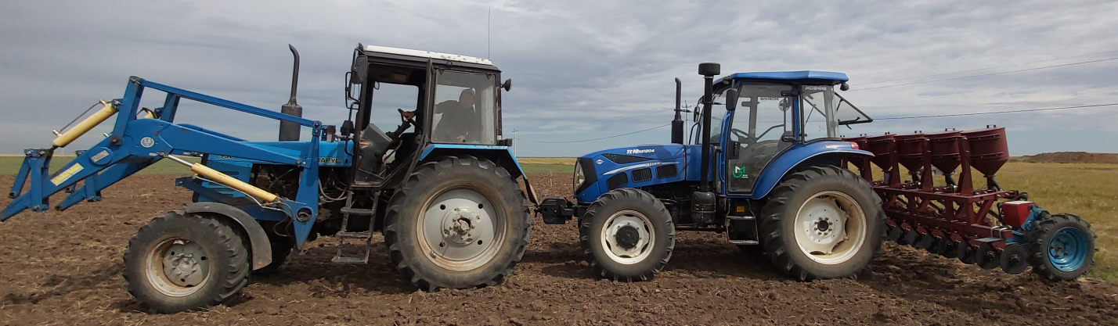

Figure 4.5 - An experimental model of a seeder for sowing non-flowing grass seeds in economic tests for energy assessment

Table 4.8 - The results of experiments on the energy assessment of the experimental installation of the seeder for sowing non-loose grass seeds and serial SG-3,6 (Astra), background- fallow

Experiment № | Experiment date | Unit composition | Embedment depth, cm | Unit speed, km /h | Theoretical traction resistance, kN | Traction resistance, kN | Average fuel consumption, kg / hour | Average slip coefficient,%
1 | 2 | 3 | 4 | 5 | 6 | 7 | 8 | 9
1 | 04.06.20 |  | 2 | 5 | 3,11 | 3,1 | 13,88 | 19,37
2  3  4  5  6  7  8  9  10  11  12 |  | Tractor HS1204 + e. at. seeder | 3  4  5 | 7  9  5  7  9  5  7  9  5  7  9 | 3,13  3,26  3,39  3,4  3,69  3,66  3,68  4,15  4,2  4,3  5,1 | 3,15  3,4  3,5  3,6  4,2  3,7  4  4,6  4,52  4,84  5,89 | 13,75  13,67  13,96  13,94  13,69  14,05  14,04  14,35  14,25  14,27  14,58 | 22,12  24,78  19,96  22,56  25,45  20,54  23,13  25,31  21,67  22,22  26,40
13  14  15  16  17  18  19  20  21  22  23  24 | 04.06.20 | Tractor HS1204 + serial seeder | 2  3  4  5 | 5  7  9  5  7  9  5  7  9  5  7  9 | 3,48  3,49  3,5  3,75  3,77  3,79  4,02  4,04  4,07  4,57  4,59  4,67 | 3,53  3,59  3,87  3,99  4,1  4,78  4,22  4,56  5,24  5,15  5,52  6,71 | 15,4  15,26  15,20  15,53  15,53  15,25  15,66  15,68  16,09  15,96  16,01  16,43 | 21,40  24,47  27,45  22  24,90  28,16  22,61  25,48  27,83  23,76  26,60  28,94

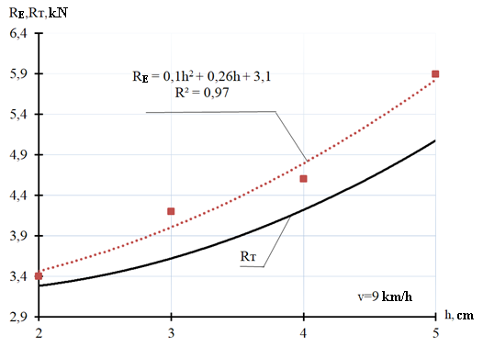
Figure 4.6 - Experimental (R_{E}) and theoretical (R_{T}) dependence of the draft resistance of the experimental model of the seeder on the seeding depth at a working speed V = 9 km / h

As a result of processing the experimental data, a regression equation was obtained, Re = 0.1h2 + 0.26h + 3.1, which describes with reliability R² = 0.97 the dependence of the traction resistance of the experimental model of the seeder on the seeding depth at a working speed of V = 9 km / h, Figure 4.6. Analysis of Figure 4.6 shows that the traction resistance of the experimental model of the seeder increases with an increase in the seeding depth, so at the seeding depth h = 2cm, the traction resistance is 3.4kN, with h = 3cm - 4.2kN, h = 4cm -4.6kN and h = 6cm -5.89kN, respectively. At the same time, the experimental (R_{E}) dependence of the traction resistance of the experimental model of the seeder on the seeding depth at a working speed V = 9 km / h exceeds the values ​​of the theoretical (Rт) dependence of the traction resistance from 4.2% at a depth of 2 cm and up to 13.41% at a depth planting seeds 5cm.

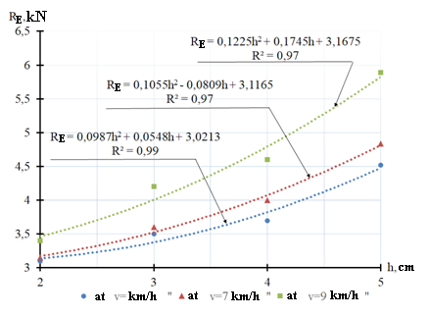
Figure 4.7 - Experimental (R_{E}) dependences of the traction resistance of the experimental model of the seeder on the seeding depth at different speeds of the unit

Figure 4.7 shows the experimental (R_{E}) dependences of the traction resistance of the experimental model of the seeder on the seeding depth at different speeds of the unit with regression equations with high reliability coefficients, where an increase in the traction resistance on the seeding depth is traced at different operating speeds of the seeding unit.
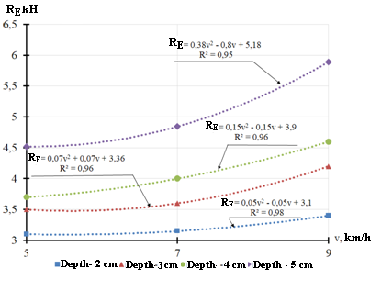
Figure 4.8 - Experimental (R_{E}) dependences of the traction resistance of the experimental model of the seeder on the speed of the unit at different depths of seeding

Figure 4.8 shows the experimental (R_{E}) dependences of the draft resistance of the experimental model of the seeder on the speed of the unit at various depths of seeding. Analysis of these dependencies shows that with an increase in the planting depth, the traction resistance of the experimental model of the seeder increases.
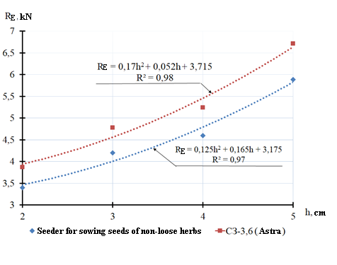
Figure 4.9 - Experimental (R_{E}) dependences of the draft resistance of the experimental model of the seeder and the serial seeder SG-3,6 (Astra) on the seeding depth at a speed of 9 km / h

Figure 4.9 shows the dependence of the traction resistance of the experimental model of the seeder and the serial seeder SG-3.6 (Astra) on the seeding depth at a speed of 9 km / h; for the experimental seeder it is described by the regression equation R_{E} = 0.125h2 + 0.165h + 3.175 at R² = 0.97 and for a serial seeder -R_{E} = 0.17h2 + 0.052h + 3.175 at R² = 0.98. The analysis of these dependencies shows that the draft resistance of the experimental seeder is lower than the draft resistance of the serial seeder by an average of 12.2%.
Figure 4.10 shows the dependences of the draft resistance of the experimental model of the seeder and the serial seeder SG-3,6 (Astra) on the speed of movement of the seeders, for the experimental seeder it is described by the regression equation R_{E} = 0.15v2 + 0.15v + 3.9 at R² = 0. 98 and for a serial seeder -R_{E} = 0.435v2 + 0.963h + 4.974 at R² = 0,96. The analysis of these dependencies shows that the draft resistance of the experimental seeder is lower than the draft resistance of the serial seeder by an average of 12.3%.
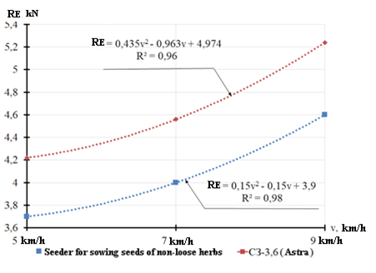
Figure 4.10 - Experimental (Re) dependences of the draft resistance of the experimental model of the seeder and the serial seeder SG-3.6 (Astra) on the speed of the unit at a depth of embedment of 4 cm

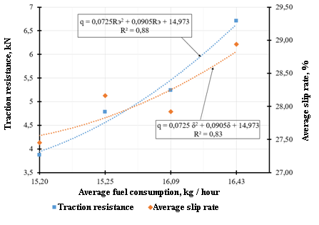
Figure 4.11- Average fuel consumption when sowing an experimental model of a seeder for sowing non-flowing grass seeds from the traction resistance of the seeder and the average slip coefficient of the HS1204 tractor at an operating speed V = 9 km / h

Based on the results of economic tests of an experimental model of a seeder for sowing non-flowing grass seeds, the dependences of the average fuel consumption on the traction resistance of the seeder and the average slip coefficient of the HS1204 tractor were built, Figure 4.11. Regression equations are obtained that describe the dependences of fuel consumption on the traction resistance of an experimental model of a seeder for sowing non-loose grass seeds and the tractor slip coefficient. With an increase in the traction from the traction resistance of the experimental model of the seeder, the fuel consumption increases, the same pattern between the fuel consumption and the tractor slip coefficient.
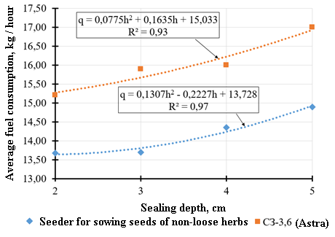
Figure 4.12 - Dependences of the average fuel consumption on the seeding depth of an experimental model of a seeder for sowing non-flowing grass seeds and a serial SG-3.6 seeder (Astra) at an operating speed of V = 9 km / h (tractor HS1204)

Figure 4.12 shows the dependences of the average fuel consumption on the seeding depth of an experimental model of a seeder for sowing non-flowing grass seeds and a serial SG-3,6 seeder (Astra) at an operating speed of V = 9 km / h (HS1204 tractor) with regression equations. Analysis of Figure 4.12 shows that the average fuel consumption increases with an increase in the planting depth, the excess of the average fuel consumption of the SG-3.6 (Astra) serial seeder at an operating speed of V = 9 km / h (HS1204 tractor) over the average fuel consumption of the experimental model of the sowing drill non-flowing grass seeds is 8-10.2%.

5 Economic evaluation of an experimental model of a seeder with an intellectual control unit for the technological process of sowing non-loose grass seeds
The technical characteristics of the developed seeder served as the initial data for determining the estimated economic efficiency of using an experimental model of a seeder with an intellectual control unit for the technological process of sowing non-loose grass seeds. The calculations were guided by works [19, 20, 21]. The economic efficiency of the experimental model of the seeder was evaluated by comparing the reduced costs and increasing the yield and reducing the cost of fuels and lubricants.
Productivity per hour of net working time
, (5.1)

where Vp - working speed - 10 km / h

Bp - working width of the seeder - 3.6 m.

Productivity per hour of shift time
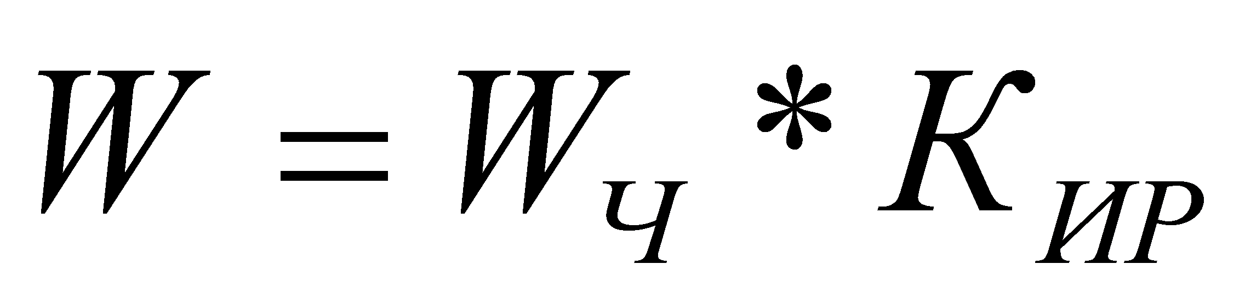 , (5.2)
where Cwt is the coefficient of working time, when sowing Cwt = 0.8
Seeder annual output
 (5.3)
where T is the annual load in hours, for the zone of Northern Kazakhstan T = 140

According to a preliminary calculation, the cost of the developed seeder with an intellectual control unit is 4,526,590 tenge, while the average price of a foreign-made seeder without an intelligent control unit is 4,100,000 tenge.
Direct operating costs

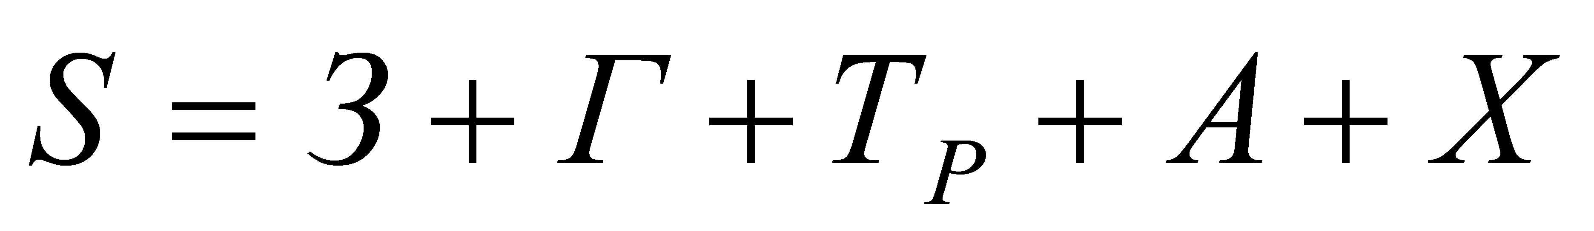, (5.4)

where F is the cost of fuels and lubricants;
Cr- expenses for current repairs and technical maintenance;

 - depreciation charges (for overhaul and renovation);
S- machine storage costs
The salary of the service personnel is the same for the basic and experimental seeders (serviced by one tractor driver for the fifth grade).
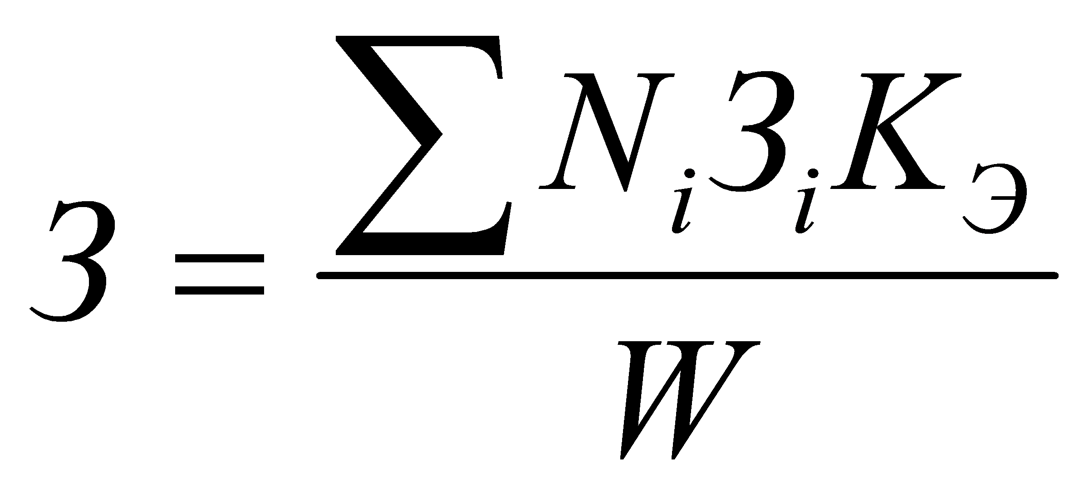, (5.5)

where N 1 - the number of service personnel of each i-th tariff category - 1 machine operator;
З i - hourly tariff rate of the i-th category; tenge (per capita)
C is the coefficient of increase in prices for the implementation of the plan and average charges for mechanized work
According to the experimental data, the average fuel consumption when sowing the developed seeder is 14.07 kg / h, the average fuel consumption of SG-3.6 (Astra) is 15.67 kg / h.
, (5.6)

where 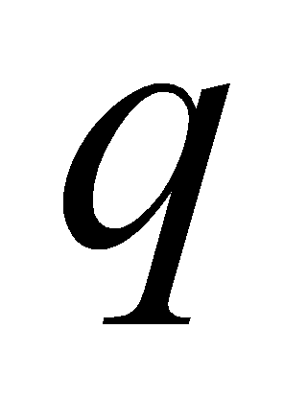is the average fuel consumption, kg / h;

Pf - complex fuel price, we take equal to 190 tenge / kg.

Current repairs and maintenance costs
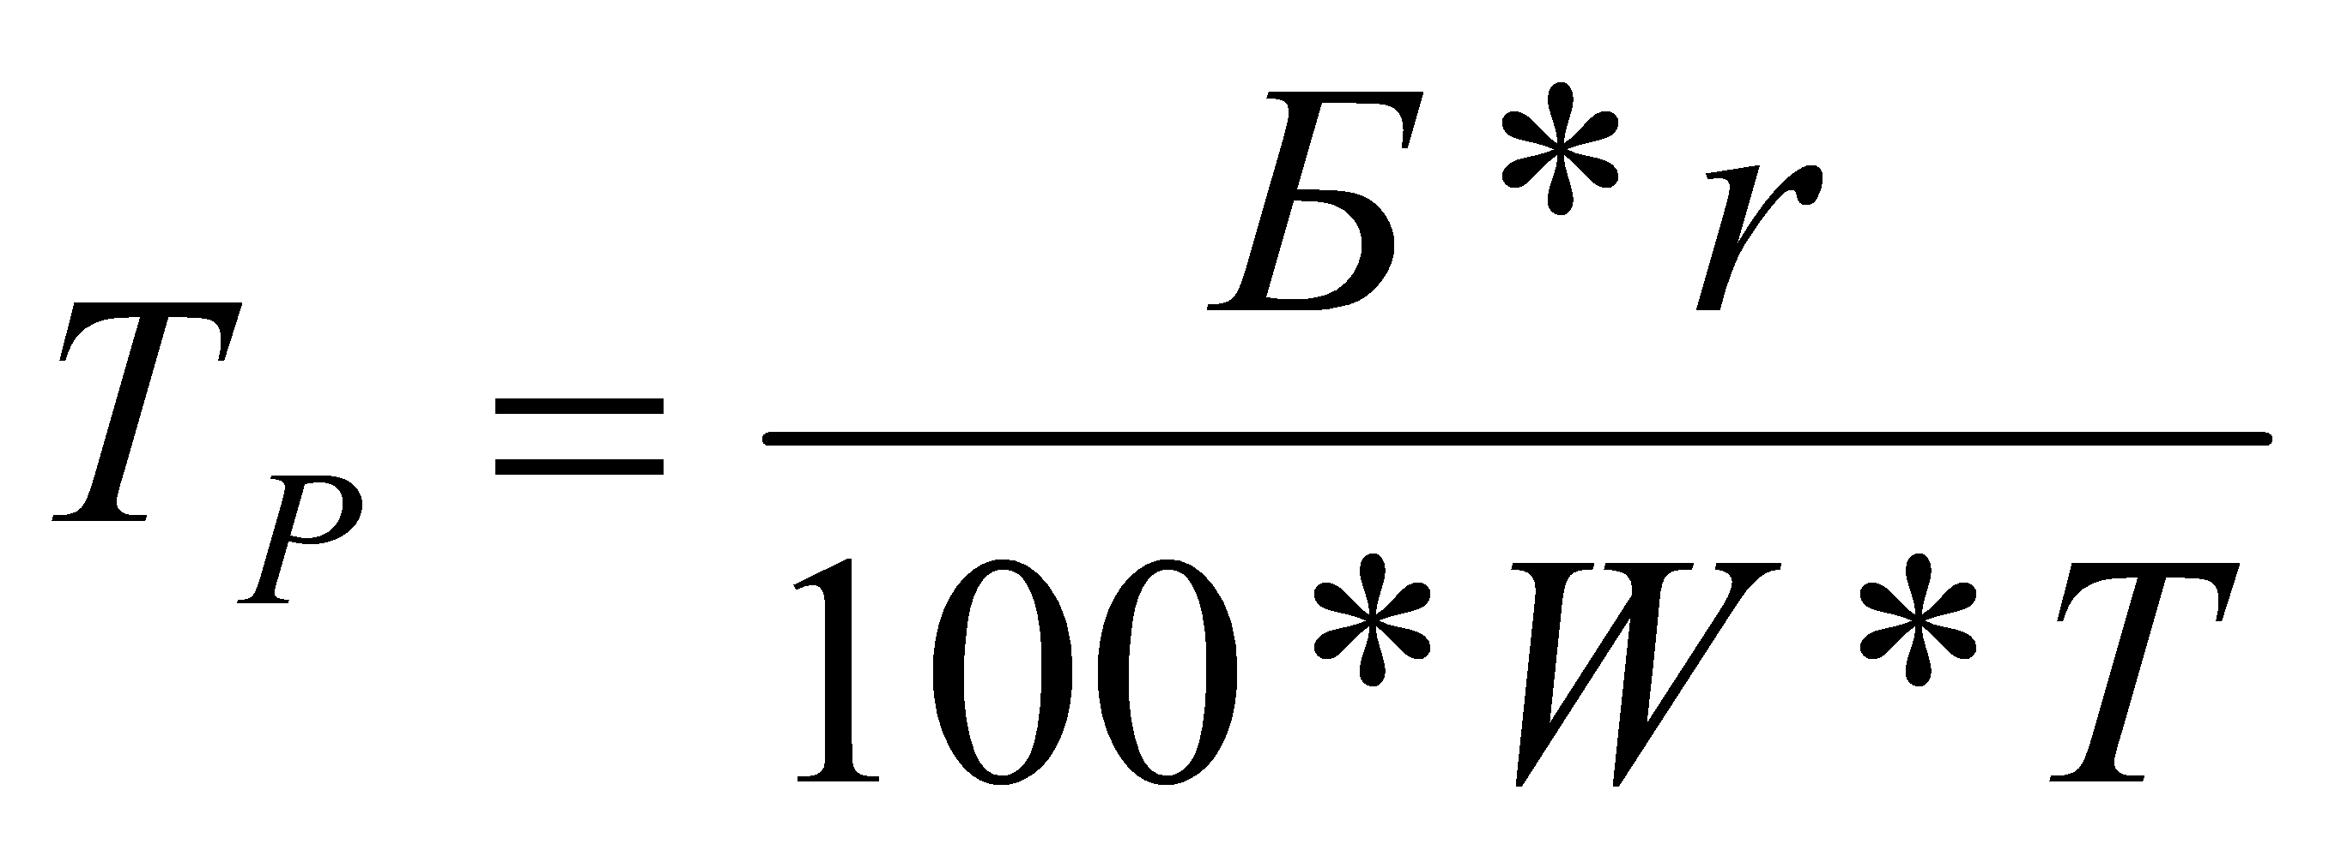, (5.7)

where r is the rate of deductions for current repairs and maintenance, r = 25.
Depreciation deductions

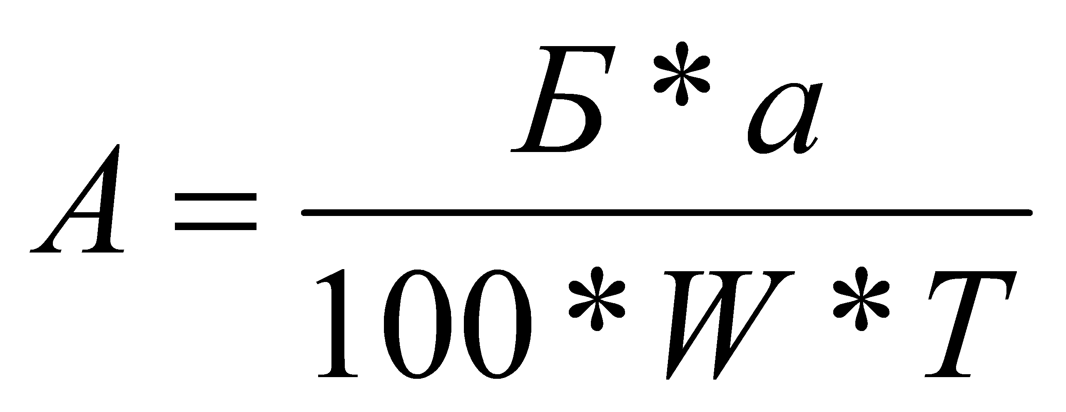, (5.8)

where a is the rate of depreciation, a = 14.2%.
The storage costs are determined by the formula

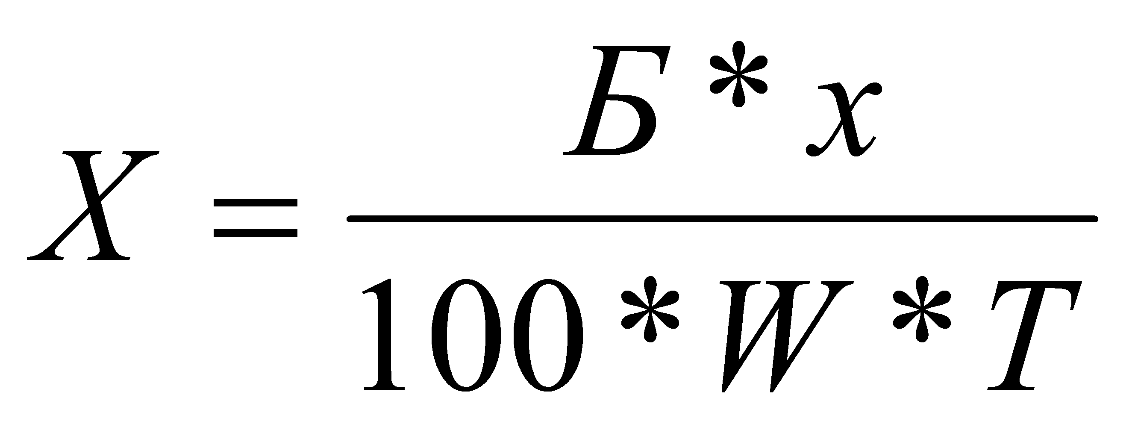, (5.9)

where X is the storage deduction rate for a planter stored in an open area, X = 2.12%.
Specific capital investments are determined by the formula
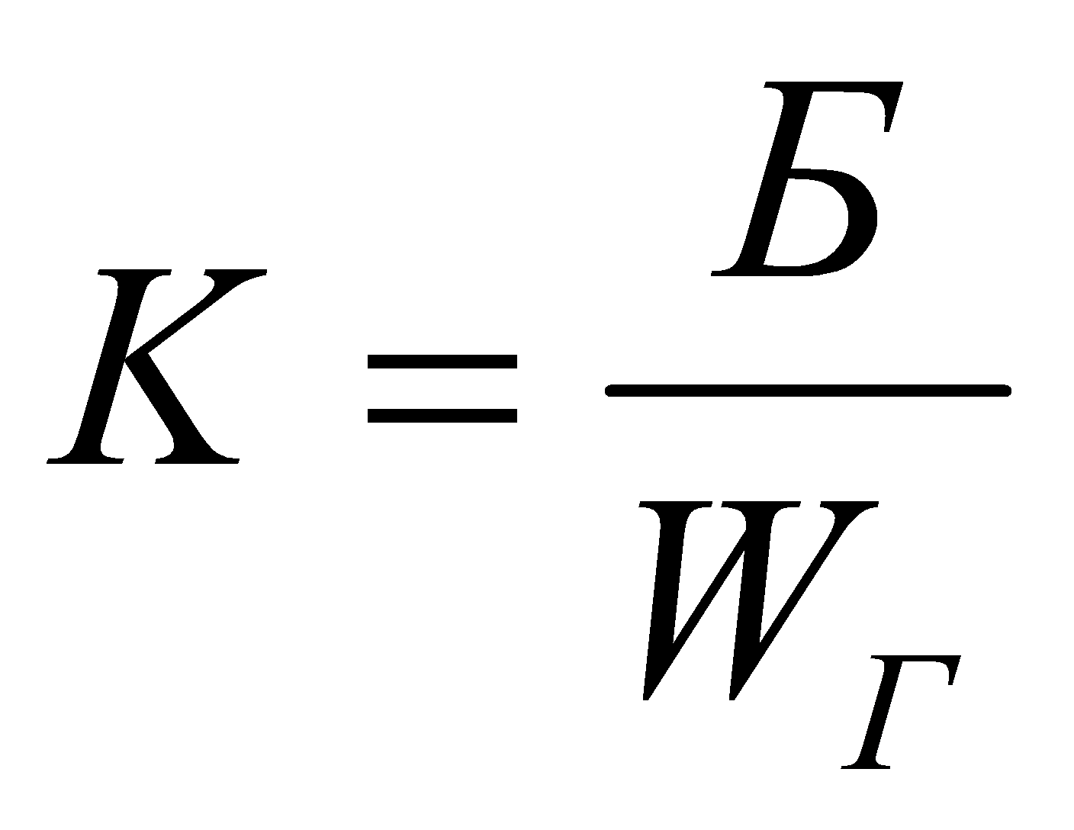 (5.10)

The value of the annual economic effect from the use of the proposed seeder is determined as the difference between the reduced costs for the basic and experimental seeders plus cash proceeds from the sale of additional products.
, (5.11)
where is the standard coefficient of efficiency of capital investments,
for agricultural machinery;
- cash proceeds from the sale of additional products.
The given costs and specific capital investments for the basic and experimental seeders have a small difference and the annual economic effect from the use of a seeder with an experimental seeding device is achieved due to an increase in the yield of the cultivated crop.
, (5.12)
where is the increase in yield, based on the results of experiments for 2019-20 years c;
P tenge/c. - purchase price of 1 centner of grain for hay, P tenge / centner.
The results of calculations to determine the economic efficiency of using an experimental model of a seeder with an intellectual control unit for the technological process of sowing non-loose grass seeds are shown in Tables 5.1 and 5.2.

Table 5.1 - Components of direct operating costs of the developed and serial seeder per 1 hectare of sown area

№п/п | Cost components, tenge / ha | Serial | Developed
1 | Salary | 536.67 | 536.67
2 | Depreciation deductions | 1443.95 | 1594.19
3 | Maintenance, repair and storage costs | 2757.74 | 3044.68
4 | Fuel and lubricant costs | 1033,78 | 928,23
5 | The amount of operating costs | 5772,14 | 6103,77

Table 5.2 - Economic indicators of the efficiency of the developed and serial seeders

№ п/п | Indicators | Serial | Developed
1 | Book value in tenge | 4100000 | 4526590
2 | operating speed of the unit , km / h | 10 | 10
3 | Hourly production rate, ha / h | 2,88 | 2,88
4 | Specific capital investments, tenge / ha | 10168.65 | 11226.66
5 | Annual economic effect at a standard annual load of 140 hours, tenge | - | 2697542

Thus, the estimated annual economic effect from the use of the developed seeder was 2,697,542 tenge. Implementation act has been received, Appendix E.

6 Published articles
Within the framework of the project for 2018-2020, the following articles were published:
- in 2018, 1 patent for a utility model was received and 10 articles were published, of which: 4 in publications of the Republic of Kazakhstan, including 2 CCSON, 4 based on the results of international conferences, 2 articles in the RSCI, a list and scanned versions of articles are presented in the report for 2018 year;
- 10 articles were published in 2019, of which: 2 CCSON, 2 following the results of republican conferences, 1 patent and 1 article in the journal included in the SCOPUS database, 1 article of the RSCI, 3 articles following the results of international conferences, a list and scanned versions of articles are presented in report for 2019.
In 2020, 5 articles were published, of which 1 article in the RSCI, 1 article in CCSON, 2 articles on the results of an international conference, one of them was published in Bulgaria, 1 article in the journal included in the Web Of Science database and 1 application was prepared and submitted for patent
1 M. A. Aduov, S. A. Nukusheva, T. A. Yurina. Investigation of the operational and technological characteristics of direct seeders // Techniques and equipment for the village. - 2020. - No. 1 (104) .P. 10-17
DOI: 10.33267 / 2072-9642-2020-1-10-17
https://www.elibrary.ru/item.asp?id=43957573
2 Aduov M.A., Nukusheva S.A., Kaspakov E.Zh., Volodya K., Isenov K.G .., Tulegenov T.K., Zheksenbaeva. The results of preliminary laboratory and field tests of a prototype seeder for sowing non-flowing grass seeds with an intellectual control unit // Materials of the international scientific and theoretical conference "Seifullin readings -16: Youth science of a new formation - the future of Kazakhstan", - Nur-Sultan, 2020. - P .106-109.
http://kazatu.kz/assets/i/science/sf16-2-2.pdf
3 Aduov М.А., Nukusheva S.А., Uteulov К., Tulegenov Т.К., Zernov A. Technologies and technical means for introducing organic fertilizers //Science Bulletin of Kazakh Agrotechnical University named after S. Seifullin. - 2020. No. 1 (104). -P. 185-190.
http://bulletinofscience.kazatu.kz/assets/i/journals/15/40.pdf.
4 Aduov Mubarak Aduovich., Nukusheva Saule Abaidildinovna, Kaspakov Esen Zhaksalikovich, Tulegenov Talgat Konisbaevich. Assessment of agrotechnical indicators of the seeder for sowing grass seeds // VIII International scientific congress, «Agricultural machinery proceedings». - Varna, Bulgaria, 24 - 27 June 2020. –V. 1/7. - Р. 45-48.
http://agrimachinery.net/sbornik/2020.pdf
5 Aduov Mubarak, Nukusheva Saule, Kaspakov Esenali, Isenov Kazbek, Volodya Kadirbek, Tulegenov Talgat. Seed drills with combined coulters in No-till technology in soil and climate zone conditions of Kazakhstan // Agriculture Scandinavia section B-Soil and plant science. - 2020. - V. 70. - Issue 6. – P. 525-531
DOI: 10.1080/09064710.2020.1784994
https://apps.webofknowledge.com/InboundService.do?product=WOS&Func=Frame&DestFail=https%3A%2F%2Fwww.webofknowledge.com&SrcApp=RRC&locale=en_US&SrcAuth=RRC&SID=F6eyZWlj2uqiqLPjjDQ&customersID=RRC&mode=FullRecord&IsProductCode=Yes&Init=Yes&action=retrieve&UT=WOS%3A000549711500001.
Reprints of articles are placed in Attachment С.

CONCLUSION
1 An experimental model of a seeder with an intellectual technological process control unit for sowing non-flowing grass seeds has been developed, which has the following indicators: working width 3.6 m, row spacing 0.3 m, seeding rate range from 10 to 30 kg / ha, seeding depth 2-8 cm.
2 To eliminate the identified shortcomings, an experimental model of a high-tech seeder with an automated control module for sowing non-flowing grass seeds was modified, which consists in changing the design of the mounting bracket for the parallelogram mechanism and moving it vertically by 20 mm, installing a press roller with a diameter of 320 mm and a rim width of 60 mm, branches with a smaller angle of inclination in the distribution arms of the seeding unit.
3 Programs and methods of economic tests of an experimental model of a seeder with an intellectual control unit for the technological process of sowing non-loose grass seeds have been developed
4 Based on the results of economic tests, it was established:
- seed germination of Burabay wheatgrass in the plot sown with an experimental seeder is higher than the germination rate of seeds in the control plot by 3.56%. The germination of seeds of grasses of awnless rump in the area sown with a seeder for sowing non-flowing seeds is higher than the germination rate in the control area by 2.85%. An increase in the germination of grass seeds is achieved due to the high quality of the experimental sowing device and the covering part of the model seed drill.
- in terms of the uniformity of the depth of seeding, the experimental model of the seeder surpasses the serial seeder by 4.95% for sowing wheatgrass and by 4.89% at sowing awnless rump.
- the increase in yield on the experimental plot with a seeder for sowing non-flowing grass seeds in comparison with the control is 3.125 c / ha for sowing wheatgrass and is 5.361 c / ha for sowing awnless rump.
- the regression equations describing with high reliability the dependence of the draft resistance of the experimental model of the seeder on the depth of seeding and the speed of movement of the seeder were obtained. Their analysis shows that the traction resistance of the experimental model of the seeder increases with an increase in the depth of seeding and the speed of movement.
- the results of comparative tests show that the traction resistance of the experimental seeder is lower than the traction resistance of the serial seeder by an average of 12.3%.
- regression equations for the dependence of the average fuel consumption on the depth of seeding of seeds of an experimental model of a seeder for sowing non-flowing grass seeds and a serial seeder SG-3.6 (Astra) (tractor HS1204) were obtained. The analysis shows that the average fuel consumption of a serial SG-3.6 seeder (Astra) at an operating speed of V = 9 km / h (HS1204 tractor) exceeds the average fuel consumption of an experimental model of a seeder for sowing non-loose grass seeds by 8-10.2 %.
5 The estimated annual economic effect from the use of the developed seeder due to an increase in the yield of grasses and a decrease in fuel costs amounted to 2,697,542 tenge.

LIST OF USED SOURCES
1 Philipova N.I., Pasaev E.I. Recommendation "Perennial grasses for feed and seeds in Northern Kazakhstan". - Shortandy: SPC GF named after A.I. Baraev, .2013. –P.19.
2 Yurchenko V.A., Khamitov M.B. Forage cultivation technology // AgroAlem. - 2017. - P.4.
3 Philipova N.I., Parsaev E.I. Recommendation "Cultivation of perennial grasses in Northern Kazakhstan". - Shortandy, 2015.P. 5.
4 Innov. patent. The Republic of Kazakhstan. Sowing machine / Aduov M .; Matyushkov M.I.; Nukusheva S.A.; Kaspakov E.Zh and others; applicant and patent holder of S. Seifullin KATU. No. 30503; publ. 16.11.2015, Bul. No. 11. - 3 p.
5 Innov. patent The Republic of Kazakhstan. Sowing machine / Aduov M.; Nukusheva S.A.; Volodya K.; applicant and patent holder of S. Seifullin KATU. No. 31106. publ. 16.05.2016, Bul. No. 5. - 3 p.
6 Patent application RK Grass seeder / Aduov M.; Nukusheva S.A.; Kaspakov E. Zh.; Volodya K. and others - №2020 / 0633.1; declared 09/16/2020.
7 Prospects of companies "Аmazone", "John Deere", "Gherardi", "MASCHIO-GASPARDO", "Kuhn", "Köckerling", "Horsch".
8 GRADAR LLC, Tume Nova Combi seeder. St. Petersburg. asp@gradar.spb.ru, Website: www.gradar-rf.com.
9 V.A. Astafiev, G.Z. Gaifulin, A.I. Deripaskin and others. TSELINNIIMESH machines for the implementation of technologies for improving natural and seeded perennial grasses and preparation of roughage (Recommendations). - Astana, 2011, pp. 3-20.
10 SST 20290-74. Agricultural seeds. Determination of the sowing qualities of seeds. Terms and Definitions. - M.: Standartinform, 2011 .-- 17 p.
11 ST RK SST R 15.011-2005. System of product development and launching into production. Patent research. Content and procedure. - Introduction. 2006-07-01. - Astana: Committee on Technical Regulation and Metrology of the Ministry of Industry and Trade of the Republic of Kazakhstan, 2005. - 25 p.
12 SST 20915-2011. Agricultural machinery. Methods for determining test conditions [Text]. - Introduction. 2013-01-01. - M .: FGUP "Standartinform", 2013. - 28 p.
13 SST 31345-2007. Seeders are tractor. Test methods [Text]. - Introduction. 2009-01-01. - M. FSUE "Standartinform", 2008. - 53 p.
14 SST R 52777-2007. Agricultural machinery. Energy assessment methods [Text]. - Introduction. 2007-11-13. - M.: FSUE "Standartinform", 2007. – 7p.
15 Passport Measuring information systems. CubNIITandM. -2015. - P.7.
16 Passport UV 404176.029 PSOOO "Vector-PM". - 2015. -P. 4.
17 Aduov Mubarak Aduovich, Nukusheva Saule Abaidildinovna, Kaspakov Esen Zhaksalikovich, Tulegenov Talgat Konisbaevich. Assessment of agrotechnical indicators of the seeder for sowing grass seeds // VIII International scientific congress, "Agricultural machinery proceedings". - Varna, Bulgaria, 24 - 27 June 2020. –V. 1/7. - P. 45-48.
http://agrimachinery.net/sbornik/2020.pdf
18 Aduov M.A., Nukusheva S.A., Tulegenov T.K. Determination of the dependence of the traction resistance of a seeder for sowing non-flowing grass seeds on its technological and design parameters // Bulletin of Science of Kazakh Agrotechnical University named after S. Seifullin. - 2019. - No. 2 (101). - P. 192-199. http://bulletinofscience.kazatu.kz/assets/i/journals/2(101)2019/4/%D0%90%D0%B4%D1%83%D0%BE%D0%B2%20%D0%9C .% 20% D0% 90.,. Pdf
19 Dakhno I.I. and other Determination of the economic efficiency of inventions and rationalization proposals / I.I. Dakhno, V.N. Lalo, B.S. Sands. - K .: Tekhnika, 1989 .-- 165 p.
20 Standard fuel consumption for mechanized work in plant growing in Northern Kazakhstan for technology from far abroad. Recommended for application by the Order of the Ministry of Agriculture of the Republic of Kazakhstan No. 142 dated February 28, 2007. / DGP "TselinNIIMESH". - Kostanay, 2007 .-- 72 p.
21 Standard fuel consumption for mechanized work in plant growing in Northern Kazakhstan / DGP “TselinNIIMESH”. - Kostanay, 2005 .-- 146 p.
ATTACHMENT A
Record
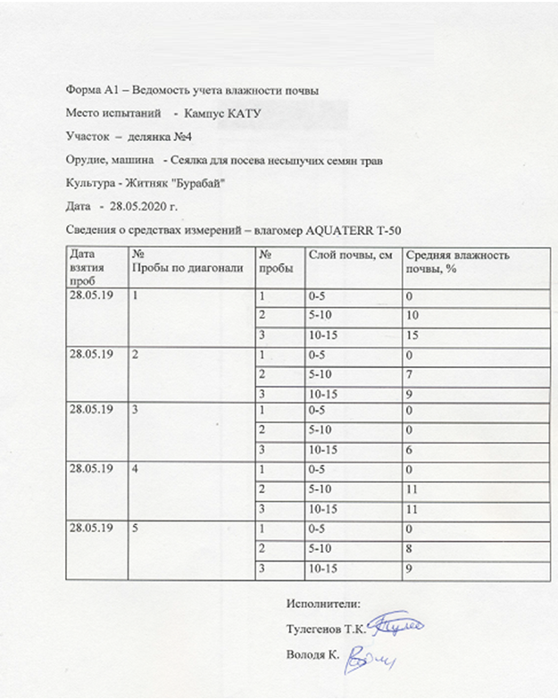

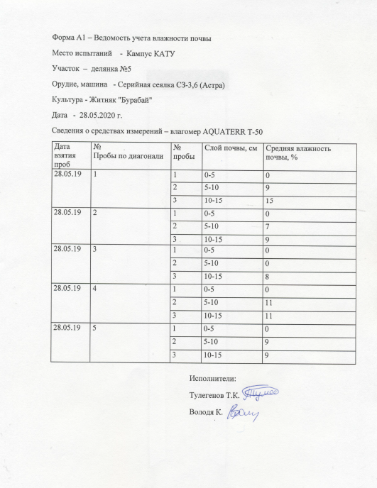

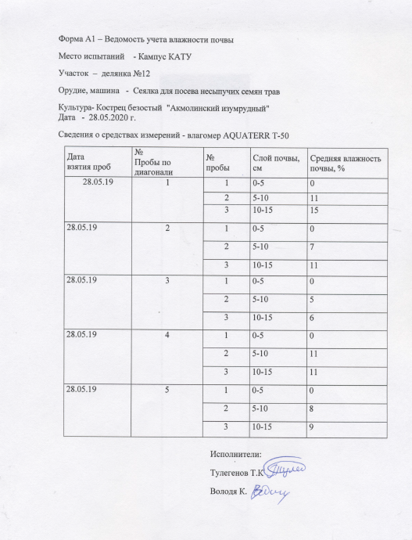

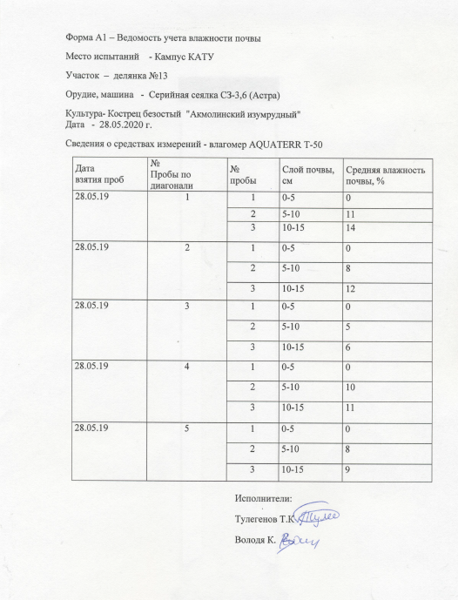

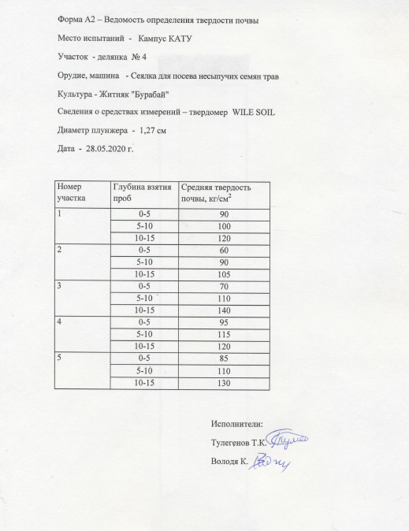

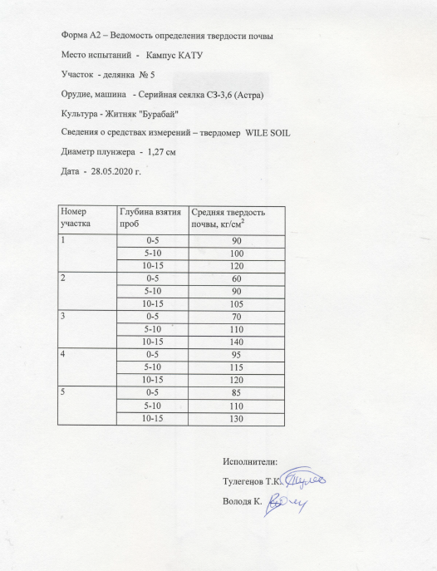
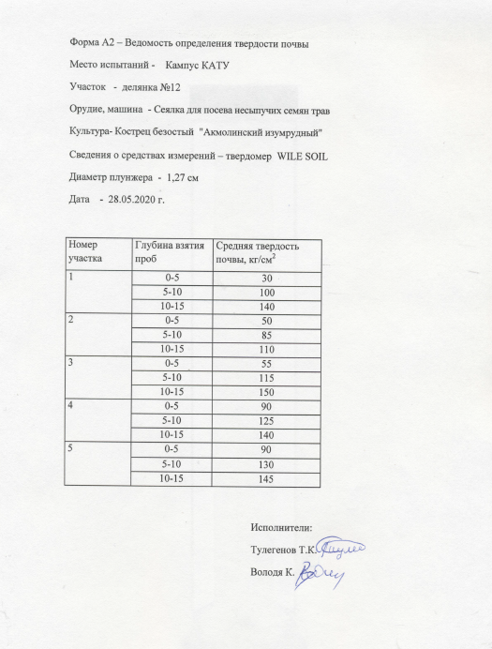

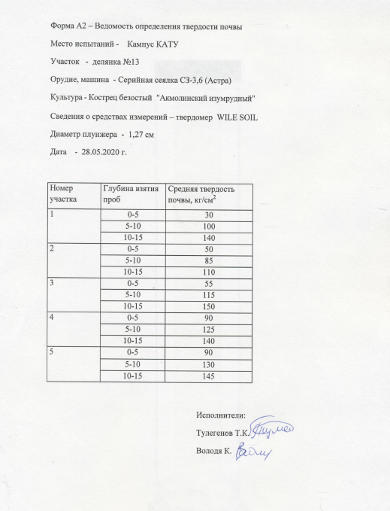.

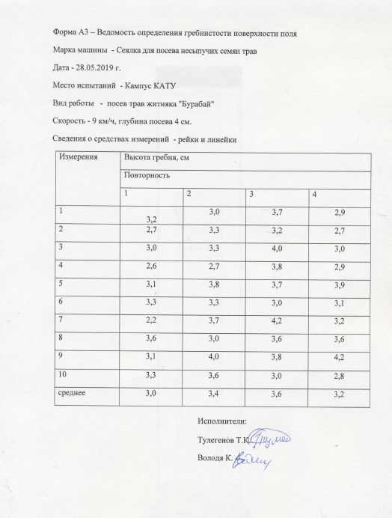

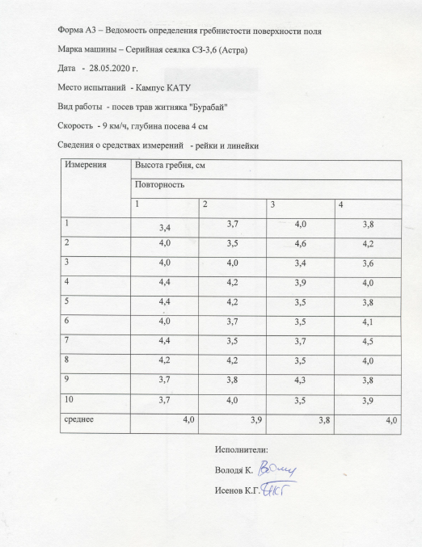

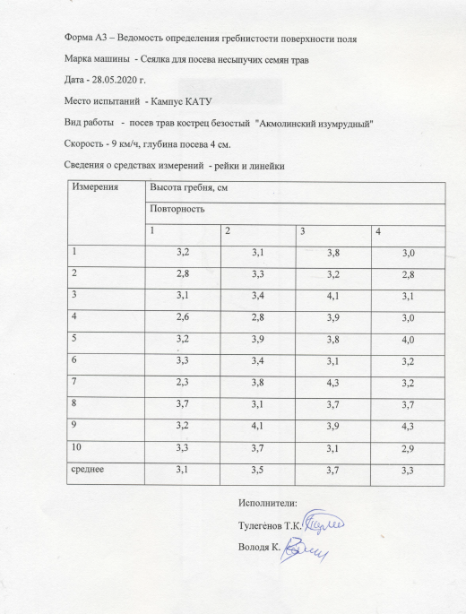

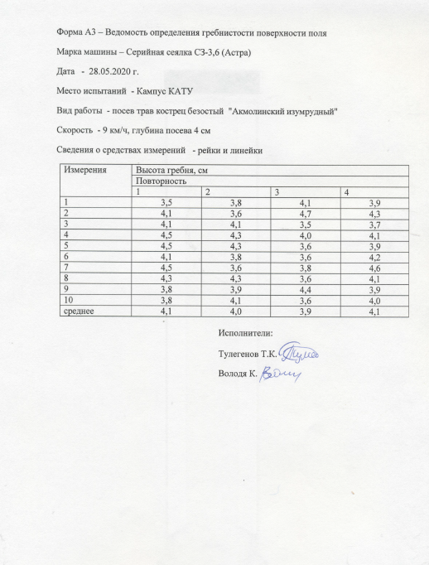

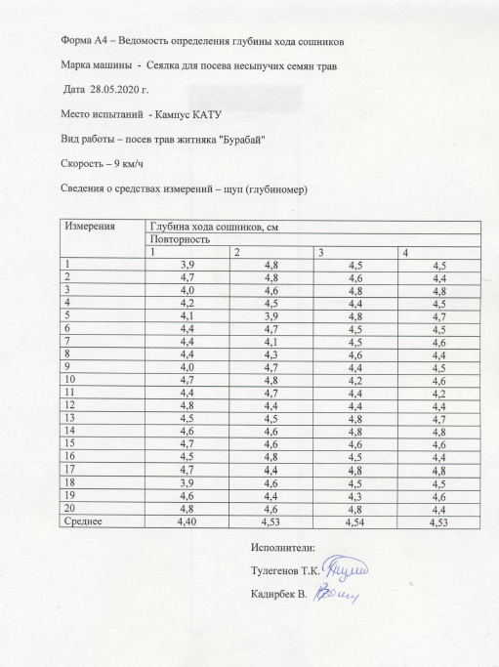

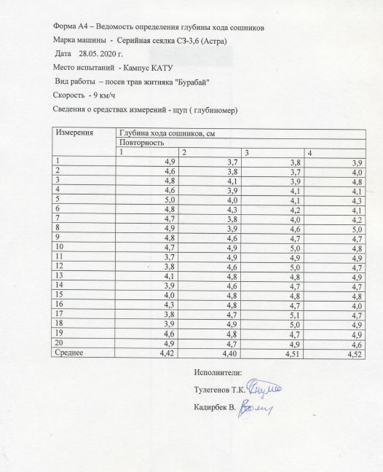

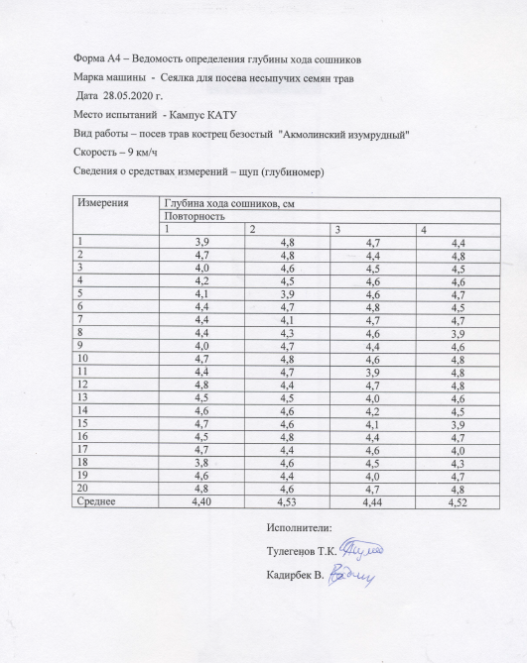

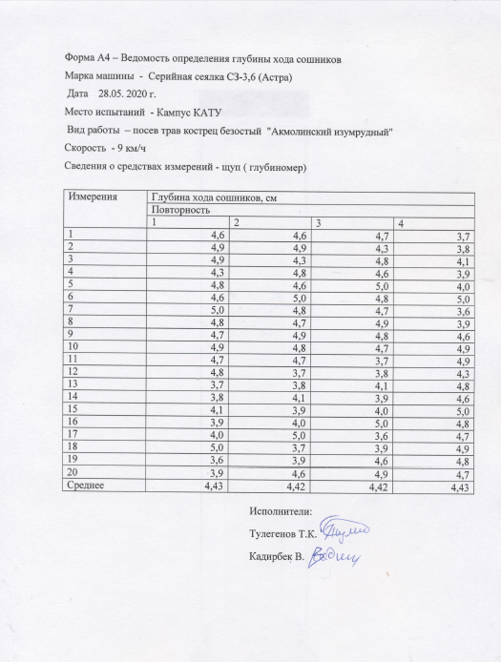

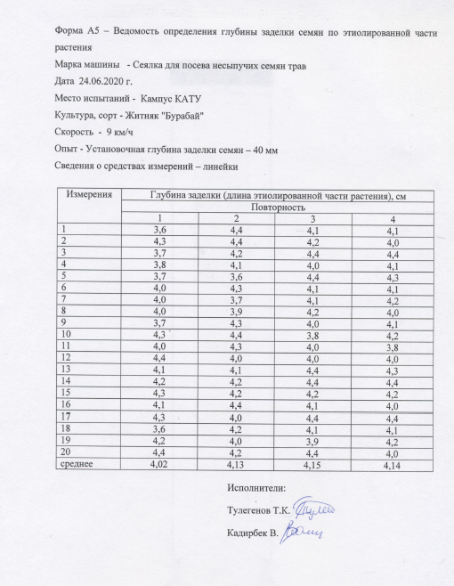

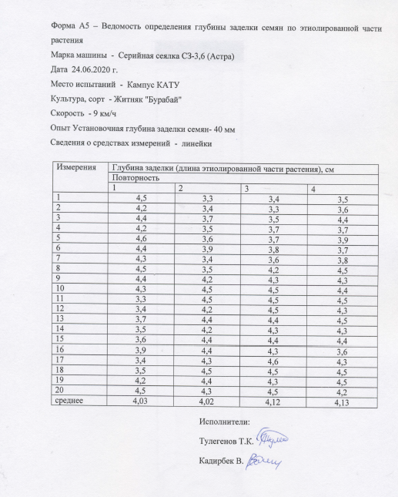

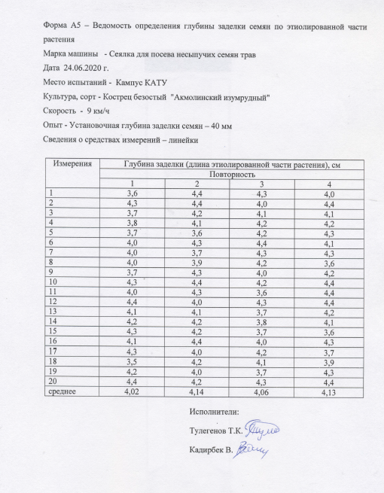

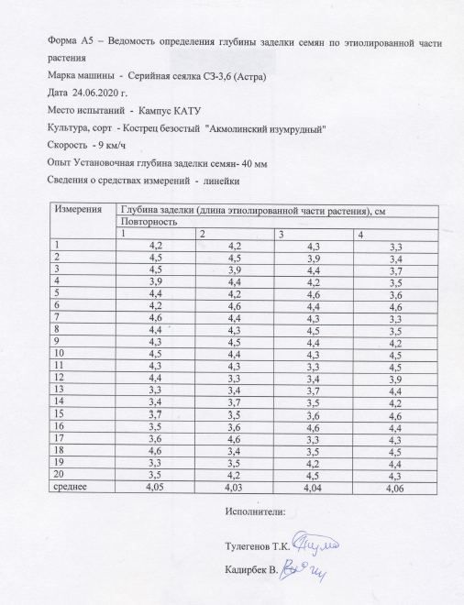

ATTACHMENT В
Test results of a seeder for sowing non-flowing grass seeds
Table B.1 – Comparative performance indicators of the seeder for sowing non-flowing grass seeds with the SZ-3,6 (Astra) serine seeder when sowing the «Burabai» wheat grass crops
№ | Наименование показателей | Сеялка для посева несыпучих семян трав | СЗ-3,6 (Астра)
1 | Дата | 28.05. 2019г. | 28.05.2019 г.
2 | Скорость движения, км/час | 7,0 | 7
3 | Норма высева, кг/га:  а) заданная  б) фактическая | 8,4  8,61 | 8,4  8,81
4 | Установочная глубина заделки семян, см | 4 | 4
5 | Максимальная глубина заделки семян, см | 4,36 | 4,64
6 | Минимальная глубина заделки семян, см | 3,56 | 3,34
7 | Равномерность глубины заделки, общая:  а) средняя, см  б) среднеквадратическое, ± см  в) коэффициент вариации, %  г) семян заделанных в слое средней фак- тической глубины и двух соседних слоях, % | 4,11  0,2  4,81  91 | 4,07  0,39  9,76  86
8 | Количество семян, не заделанных в почву, штук на м² | нет | нет
9 | Распределение растений по площади питания:  а) среднее количество растений в  пятисантиметровом отрезке рядка, штук  б) среднее квадратическое отклонение, ± штук  в) коэффициент вариации, % | 4,9  3,04  62,0 | 4,8  3,07  68,6

Table B.2 – Comparative performance indicators of a seeder for sowing non-flowing grass seeds with a serine seeder SZ-3,6 (Astra) when sowing awnless brome "Akmola emerald"

№ | Наименование показателей | Сеялка для посева несыпучих семян трав | СЗ-3,6 (Астра)
1 | Дата | 28.05. 2019г. | 28.05. 2019г.
2 | Скорость движения, км/час | 7,0 | 7,0
3 | Норма высева, кг/га:  а) заданная  б) фактическая | 13,4  13,72 | 13,4  14
4 | Установочная глубина заделки семян, см | 4 | 4
5 | Максимальная глубина заделки семян, см | 4,4 | 4,6
6 | Минимальная глубина заделки семян, см | 3,7 | 3,3
7 | Равномерность глубины заделки, общая:  а) средняя, см  б) среднеквадратическое, ± см  в) коэффициент вариации, %  г) семян заделанных в слое средней фак- тической глубины и двух соседних слоях, % | 4,08  0,25  6,06  90 | 4,04  0,44  10,95  84,3
8 | Количество семян, не заделанных в почву, штук на м² | нет | нет
9 | Распределение растений по площади питания:  а) среднее количество растений в  пятисантиметровом отрезке рядка, штук  б) среднее квадратическое отклонение, ± штук  в) коэффициент вариации, % | 5,5  3,52  64 | 5,6  3,56  69,2

ATTACHMENT С
Article reprints
1 M. A. Aduov, S. A. Nukusheva, T. A. Yurina. Investigation of the operational and technological characteristics of direct seeders // Techniques and equipment for the village. - 2020. - No. 1 (104) .P. 10-17
DOI: 10.33267 / 2072-9642-2020-1-10-17
https://www.elibrary.ru/item.asp?id=43957573

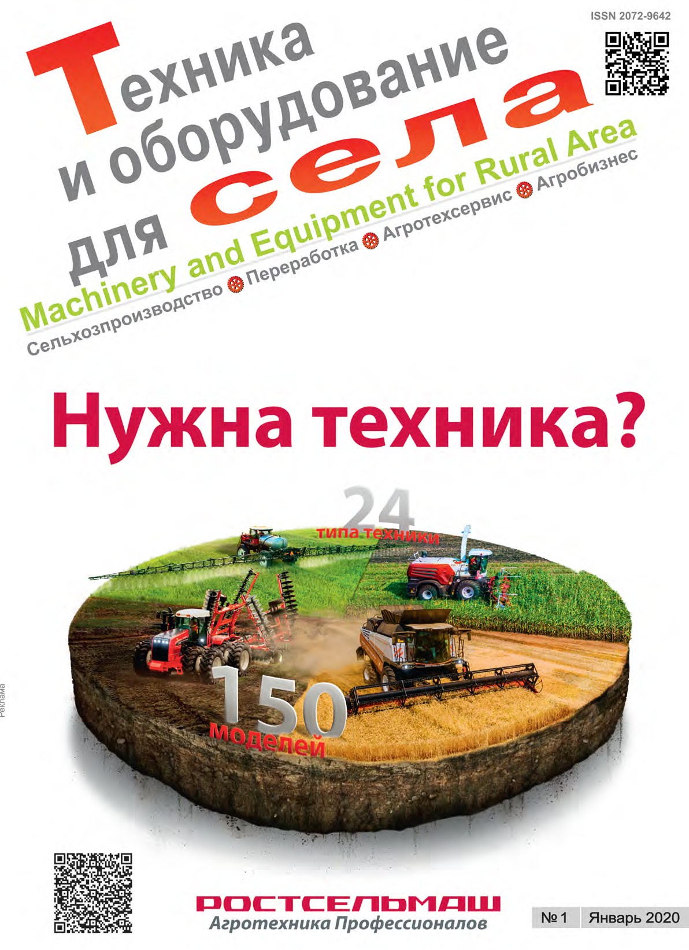

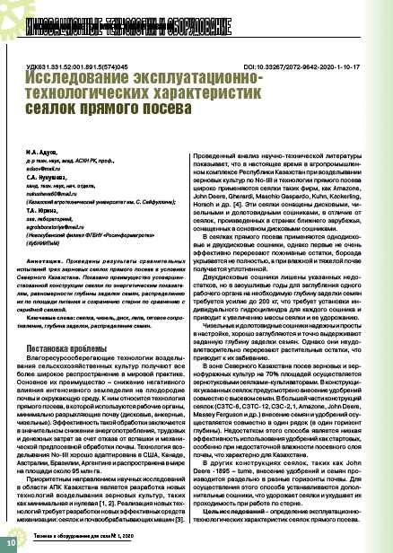

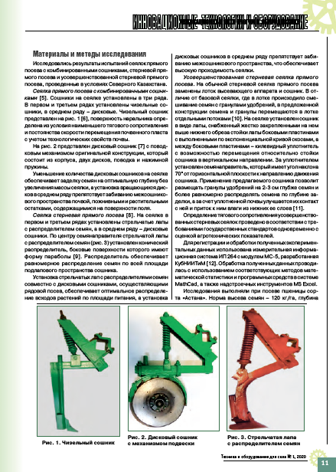

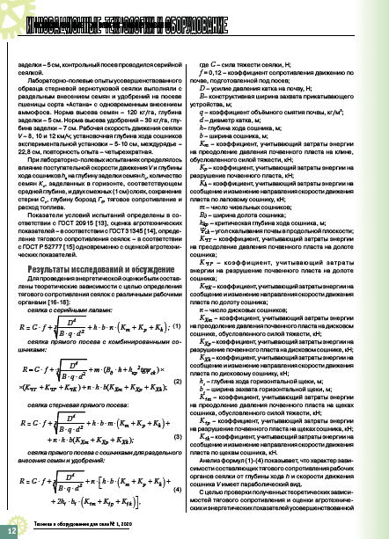

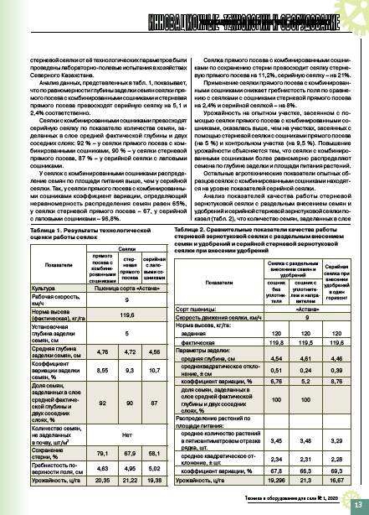

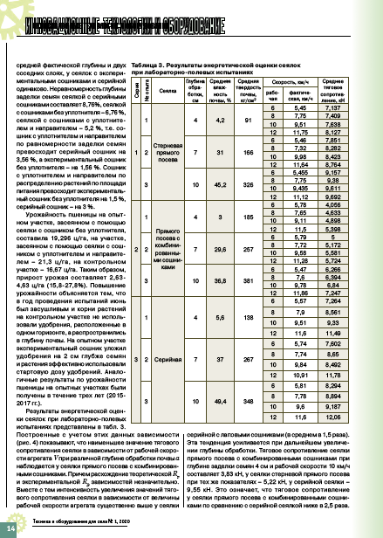

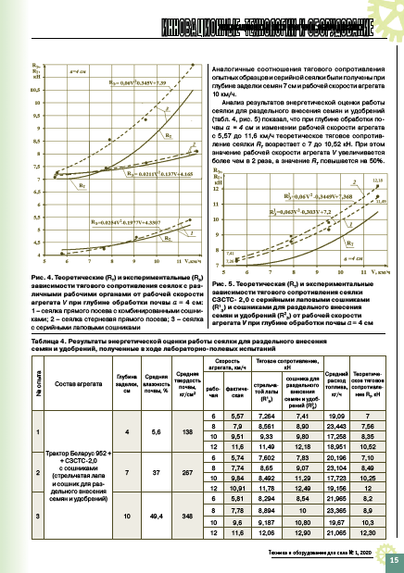

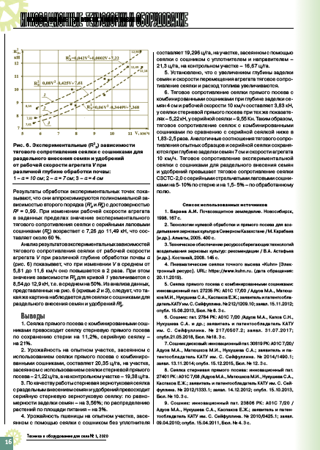

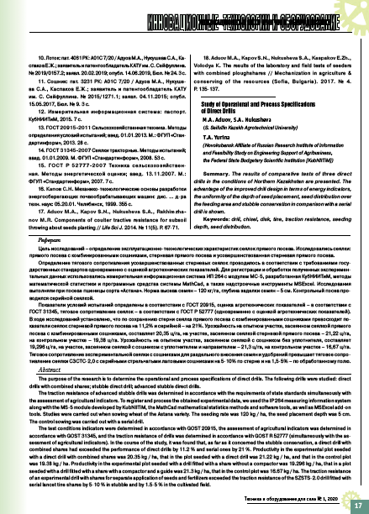

2 Aduov M.A., Nukusheva S.A., Kaspakov E.Zh., Volodya K., Isenov K.G .., Tulegenov T.K., Zheksenbaeva. The results of preliminary laboratory and field tests of a prototype seeder for sowing non-flowing grass seeds with an intellectual control unit // Materials of the international scientific and theoretical conference "Seifullin readings -16: Youth science of a new formation - the future of Kazakhstan", - Nur-Sultan, 2020. - P .106-109.
http://kazatu.kz/assets/i/science/sf16-2-2.pdf

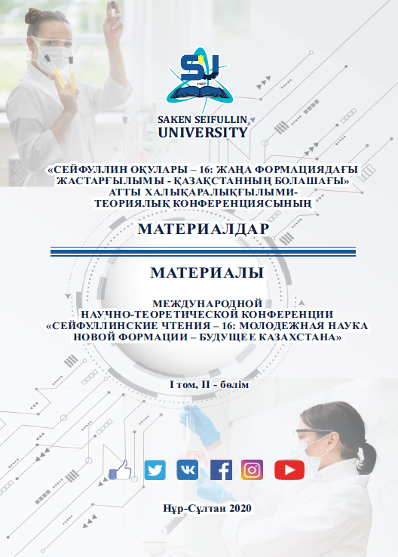

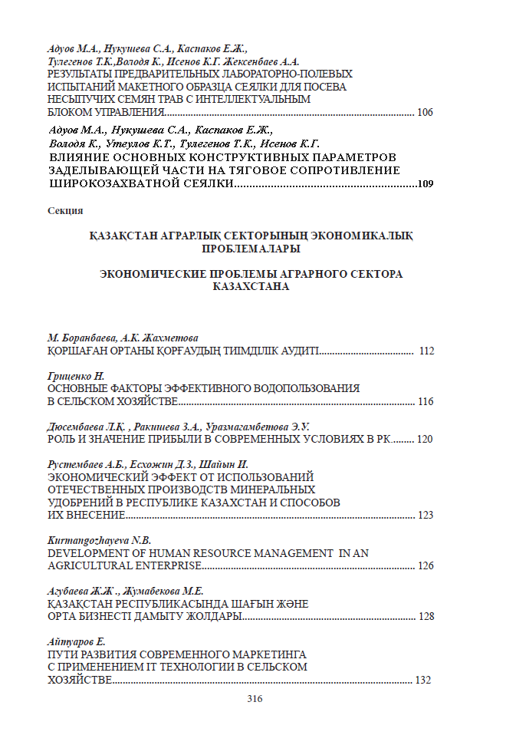

3 Aduov М.А., Nukusheva S.А., Uteulov К., Tulegenov Т.К., Zernov A. Technologies and technical means for introducing organic fertilizers //Science Bulletin of Kazakh Agrotechnical University named after S. Seifullin. - 2020. No. 1 (104). -P. 185-190.
http://bulletinofscience.kazatu.kz/assets/i/journals/15/40.pdf.

4 Aduov Mubarak Aduovich., Nukusheva Saule Abaidildinovna, Kaspakov Esen Zhaksalikovich, Tulegenov Talgat Konisbaevich. Assessment of agrotechnical indicators of the seeder for sowing grass seeds // VIII International scientific congress, «Agricultural machinery proceedings». - Varna, Bulgaria, 24 - 27 June 2020. –V. 1/7. - Р. 45-48.
http://agrimachinery.net/sbornik/2020.pdf

5 Aduov Mubarak, Nukusheva Saule, Kaspakov Esenali, Isenov Kazbek, Volodya Kadirbek, Tulegenov Talgat. Seed drills with combined coulters in No-till technology in soil and climate zone conditions of Kazakhstan // Agriculture Scandinavia section B-Soil and plant science. - 2020. - V. 70. - Issue 6. – P. 525-531
DOI: 10.1080/09064710.2020.1784994
https://apps.webofknowledge.com/InboundService.do?product=WOS&Func=Frame&DestFail=https%3A%2F%2Fwww.webofknowledge.com&SrcApp=RRC&locale=en_US&SrcAuth=RRC&SID=F6eyZWlj2uqiqLPjjDQ&customersID=RRC&mode=FullRecord&IsProductCode=Yes&Init=Yes&action=retrieve&UT=WOS%3A000549711500001

Application for the patent grant of the Republic of Kazakhstan for an invention №2020/0633.1 from 16.09.2020. Grass seeder / Aduov М.А., Nukusheva S.А., Kaspakov Ye.Zh., Volodya К., Tulegenov Т.К., Issenov К.G.




ATTACHMENT D
Calendar plan

Appendices 1.11
to Agreement No.__ dated _______ 2018
for grant funding

TECHNICAL SPECIFICATIONS AND
CALENDAR WORK PLAN

Under contract No. _____ dated __________________2018

1. NAME OF THE CONTRACTOR JSC "Kazakh Agrotechnical University named after S. Seifullin"
1.1 By the priority: 6. Sustainable development of the agro-industrial complex and the safety of agricultural products.
1.2 By the sub-priority: 6. Technical support for the modernization of the agro-industrial complex.
1.3 ICN of the project: AP05134100 "Development of a seeder with an intelligent control unit for the technological process of sowing non-loose grass seeds."
1.4 The total amount of the project is 28,000,000 (twenty eight million) tenge, including with a breakdown by years, for the performance of work in accordance with clause 3:
- for 2018 - in the amount of 10,000,000 (ten million) tenge;
- for 2019 - in the amount of 9,000,000 (nine million) tenge;
- for 2020 - in the amount of 9,000,000 (nine million) tenge.

2. Characteristics of scientific and technical products by qualification characteristics and economic indicators

2.1 Direction of work: Agricultural engineering
2.2 Applications: Agriculture
2.3 Final result: An experimental model of a high-tech seeder for sowing non-flowing grass seeds has been developed, which improves the quality of sowing non-flowing grass seeds for moisture and energy-saving technologies in forage production and reduces operating costs and is competitive in the domestic and world markets;
- for 2018: To develop a draft plan of a seeder with substantiation of the main performance indicators of a grain seeder, subject to automatic control at all stages: the movement of seeds in the hopper, in the seeding device of the device, seed pipe, opener and along the bottom of the opened furrow prepared by the opener
- for 2019: A prototype seeder was made;
- for 2020: An experimental model of a high-tech seeder for sowing non-flowing grass seeds for moisture and energy-saving technologies in forage production has been developed.
In scientific journals indexed in Scopus databases with a non-zero impact factor will be published 2 articles; 2 articles will be published in the RSCI and 2 articles in domestic scientific journals with a nonzero impact factor CCSON; 2 articles on the results of international scientific conferences; a patent application has been filed, and the researchers will report at conferences.
An experimental prototype of a high-tech seeder for sowing non-flowing grass seeds which improves the quality of sowing non-flowing grass seeds for moisture and energy-saving technologies in forage production and reduces operating costs and is competitive in the domestic and world markets will be developed.
2.4 Patentability: Patentable.
2.5 Scientific and technical level (novelty): An experimental prototype of a high-tech seeder for sowing non-flowing grass seeds will be developed, which improves the quality of sowing non-flowing grass seeds for moisture and energy-saving technologies in forage production and reduces operating costs and is competitive in the domestic and world markets.
2.6 The use of scientific and technical products is carried out: by the customer and the contractor.
2.7 Type of use of the result of scientific and (or) scientific and technical activities: Sowing of non-loose grass seeds.
3. Name of work, terms of their implementation and results

 | Code of the task, stage | Name of work under the Agreement and the main stages of its implementation | Implementation Period |  |  | Expected Result
 | Code of the task, stage |  | start |  | completion
 | 1.1 | Analyze the existing technical means and study the design and technological features of existing seeders for sowing non-loose grass seeds. | January  2018y |  | January 31  2018y | An analysis of existing technical means will be carried out and the design and technological features of existing seeders for sowing non-loose grass seeds will be studied.
 | 1.2 | Justify the design and technological scheme, the main parameters and operating modes of the seeder. Justify the technological process of the seeding unit and the experimental coulter. | January  2018 |  | February  2018 | The design and technological scheme, main parameters and operating modes of the seeder will be substantiated. The technological process of sowing the sowing device and the experimental opener has been substantiated.
 | 1.3 | To develop a draft plan of a seeder with substantiation of the main performance indicators of a grain seeder, subject to automatic control at all stages: the movement of seeds in the hopper, in the sowing device of the device, in the seed tube, opener and along the bottom of the open and prepared by the opener furrow. | February  2018 |  | April  2018 | A draft plan of the seeder with substantiation of the main performance indicators of the grain seeder, which are subject to automatic control at all stages will be developed: the movement of seeds in the hopper, in the sowing device of the device, seed tube, opener and along the bottom of the open and prepared furrow by the opener  The article was published and tested by researchers at the republican scientific conference.
 | 1.4 | To develop a device for automatic control of maintaining the sowing rates of non-flowing seeds. | May 2018 |  | July  2018 | A device will be developed for automatic control of maintaining the sowing rate of non-flowing seeds.  An article on the results of participation in an international scientific conference has been published.
 | 1.5 | Develop a device for automatic control of the seed consumption (seed level in the hopper). | August 2018 |  | October  2018 | Develop a device for automatic control of the seed consumption (seed level in the hopper).  An article in CCSON has been published
 | 1.6 | Establishment of threshold values for automatic control of the developed devices using the signal-informative method. | October 2018 |  | Before November 1,2018 | Threshold values for automatic control of the developed devices using the signal-informative method will be set.
 | 2.1 | Make a model of a seeder; develop a program and methodology for laboratory and field research. | January 2019y |  | March  2019y | A prototype seeder will be made; a program and methodology for laboratory and field research has been developed. An article for publication in the journal included in the RSCI database has been published. A patent application has been prepared.
 | 2.2 | Conduct preliminary laboratory and laboratory-field tests of the developed seeder, on sowing forage crops using moisture and energy saving technology | February  2019 |  | June  2019 | Preliminary laboratory and laboratory-field tests of the developed seeder will be carried out on sowing forage crops using moisture and energy saving technology.  The article was published and tested by researchers at the republican scientific conference.  Published an article in the journal included in the CCSON database.
 | 2.3 | Modify the design of the seed drill prototype. | June 2019 |  | July 2019 | The design of the model seeder will be improved.
 | 2.4 | Prepare technical documentation for the developed seeder. | July  2019 |  | Before November 1 2019 | Technical documentation for the developed seeder will be prepared.  An article has been published for publication in indexed Scopus databases with a non-zero impact factor.
 | 3.1 | To develop an experimental model of a high-tech seeder for sowing non-flowing grass seeds for moisture and energy-saving technologies in forage production. | January  2020y |  | January  2020y | An experimental prototype of a high-tech seeder for sowing non-flowing grass seeds for moisture and energy saving technologies in forage production will be developed.
 | 3.2 | Modify an experimental prototype of a high-tech seeder with an automated control module for sowing non-loose grass seeds | February  2020 |  | March  2020 | An experimental prototype of a high-tech seeder with an automated control module for sowing non-loose grass seeds will be finalized.
 | 3.3 | Conduct economic tests of an experimental model of a seeder | April  2020 |  | June  2020 | Economic tests of the experimental model of the seeder will be carried out.  The article was published and tested by researchers at the republican scientific conference.  An article in the journal included in the RSCI database has been published.
 | 3.4 | To analyze the economic tests of the experimental model of the seeder | July  2020 |  | August  2020 | The analysis of economic tests of the experimental model of the seeder will be carried out.  An article for participation in an international scientific conference has been published.  An article in the journal indexed in the Scopus database with a non-zero impact factor has been published.
 | 3.5 | To carry out statistical processing of data, to give an economic assessment of the effectiveness of using the developed model of a seeder. | September  2020 |  | Before November 1 2020 | Statistical data processing will be carried out, and an economic assessment of the effectiveness of using the developed model of a seeder will be given.
From the customer:  The chairman  State Institution "Science Committee of the Ministry of Education and Science of the Republic of Kazakhstan"  ___________________ Abdrasilov B.S.  seal |  |  |  | From the Contractor:  Chairman of the Board  JSC “Kazakh Agrotechnical University  named after S. Seifullin "  _______________ Kurishbaev A.K.  seal  Familiarized with:  Scientific supervisor of the project  ___________________ Aduov M.A.  (signature)

ATTACHMENT E
Implementation act

