ABSTRACT

Report 40 p., 26 figures, 15 tables, 72 sources, 3 app.
Key words: BRACHYPODIUM, BROWN RUST, RESISTANCE, SOFT WHEAT, PHYTOPATOLOGY,
The object of the study is three lines of Brachypodium distachyon (Bd 1-1, Bd 3-1, Bd21) and soft wheat.
Methods of biochemistry, plant physiology, morphometry, statistics were used in the work.
The main goal of 2020: assessment of the physiological and biochemical mechanisms of the nonspecific resistance of the Brachypodium distachyon model object to leaf rust for the creation of immunopreparations.
The tasks set in 2020 have been fully resolved. The results obtained in the course of the study lead to the following conclusions:
- all studied wheat samples are carriers of resistance genes, genes Lr10, Lr22, Lr34 and Lr67 were identified. The Kazakhstanskaya 19 wheat variety is a carrier of the dominant allele of the Lr34 gene, the Samgau wheat variety is the carrier of the recessive allele of the Lr34 gene.
- genes Lr-10, Lr-22, Lr-34 were identified in Brachypodium distachyon. The Lr67 gene in the Brachypodium Bd21, Bd3-1, Bd1-1 inbred lines is not clearly identified. The Lr-10 gene was identified in the inbred lines Bd21, Bd1-1 and in trace amounts in Bd3-1.
- for the induction of callusogenesis, the optimal concentration of 2.4 D in the culture medium of Murashige and Skoog is 2.5 mg / l. During long-term cultivation, the effect of jasmonic acid on the calli of the inbred Brachypodium distachyon lines causes a lethal effect.
Applications: practical breeding and wheat genetics.
Scientific and organizational work: according to the results of the study, 4 articles, 3 theses, 1 methodological recommendation, 1 participation in the conference were published

CONTENT

 | DEFINITIONS, DESIGNATIONS AND ABBREVIATIONS…….... | 6
 | INTRODUCTION………………………………………………………. | 7
 | MAIN PART ON Scientific-research Work.……………………………………………………………...…… | 9
1  1.1 | Choosing a research direction…………………………………………….  Model plant Brachypodium distachyon………….………………………….. | 9  9
1.2 | Features of a biotrophic pathogen Puccinia recondita ……………………. | 10
1.3  1.4  1.5 | Antioxidant system of plants ………...………………………………….  Genes for resistance to leaf rust ………..………………………………..  Elicitors ….……………………………………………………………… | 11  14  15
2 | Research objects and methods ………………………………………….. | 16
2.1 | Research objects ………………………………………………………… | 16
2.2  2.3  2.4  2.4.1  2.5  2.6  2.7  2.8  2.9  2.10  2.11  2.12  2.13  2.14  2.15  2.16 | Estimation of salicylic acid content ……………….……………………..  Estimation of hydrogen peroxide content ……...………………………...  Extraction of protein………….………………………………………….  Measurement of protein concentration …………………………….……  Estimation of catalase activity ………………………………………..…  Estimation of peroxidase activity and its isoforms ………………...……  Estimation of glutathione..…………………………………………….…  Estimation of the content of chlorophylls and carotenoids ………………  Estimation of the content of indole acetic acid………….........................  Estimation of lignin content …………………………………………….  Analysis of the morpho-anatomical features of the flag leaf under infection with the pathogen... ……………………………………………  Estimation of lectin content ……………………………………..……….  Estimation of the content of phytoalexins of phenolic nature ……..…….  Analysis of productivity elements of Brachypodium distachyon and Triticum aestivum plants and protein content in their seeds …………….  Analysis of adult plant resistance genes of Brachypodium and common wheat varieties (genes Lr34, Lr67) upon infection with a pathogen....…..  Evaluation of the effect of exogenous elicitors on Brachypodium callus cultures in vitro ……………………………………………………..….. | 17  17  17  18  18  19  20  21  21  22  22  23  23  24  24  25
3 | Generalization and evaluation of the research results …………………. | 27
3.1 | Analysis of activity of compounds forming an early protective response upon infection with the pathogen Puccinia recondita…………………. | 27
3.1.1 | Estimation of salicylic acid content during infection…..………………… | 27
3.1.2 | Estimation of the content of H₂O₂ upon infection with a pathogen ……... | 28
3.2  3.2.1  3.2.2  3.2.3  3.3  3.3.1  3.3.2  3.4  3.5  3.5.1  3.5.2  3.5.3  3.6  3.7  3.8  3.9 | Estimation of the activity of resistance markers – antioxidant enzymes.  Measurement of protein concentration ….………………………………  Identification of catalase activity upon infection with P. recondita………  Estimation of peroxidase activity and its isoforms upon infection ……….  Estimation of the content of non-enzymatic antioxidants………………..  Estimation of glutathione content upon the pathogen infection………….  Estimation of the content of carotenoids and chlorophylls upon infection Analysis of productivity elements, estimation of protein content in seeds of B. distachyon plants and wheat varieties during infection ………….  Estimation of the activity of compounds that form the mechanisms of innate immunity during the infection with the pathogen P. recondita…  Estimation of indoleacetic acid (IAA) content ………………………….  Estimation of lignin in lines of B. distachyon ………………………….…...  Analysis of morphological and anatomical characteristics of flag leaf of inbred lines of B. distachyon upon infection with a pathogen……………  Estimation of lectin content during infection with a pathogen…………  Estimation of phenolic phytoalexins during infection with a pathogen …  Analysis of gene expression for adult plant resistance in Brachypodium and common wheat varieties upon infection with a pathogen…………...  Evaluation of the effect of exogenous elicitors on Brachypodium callus cultures in vitro…………………………………………………………..  CONCLUSION……………………………………………………….…  REFERENCES LIST…………….......... | 28  28  29  29  30  30  30  32  33  33  34  34  36  37  38  40  41  43

APPENDIX А. Tables, figures, graphs

APPENDIX В. List of publications

APPENDIX С. Calendar plan for 2018-2020 yy.

DEFINITIONS, DESIGNATIONS AND ABBREVIATIONS

B.distachyon – Brachypodium distachyon
Bd 21 – Brachypodium distachyon, inbred line 1-1
Bd 3-1 – Brachypodium distachyon, inbred line 3-1
Bd 1-1 – Brachypodium distachyon, inbred line 21
P.recondita – Puccinia reconditа, brown leaf rust
T.aestivum – Triticum aestivum, soft wheat
rpm (revolutions per minute) – torque range
t _{комн}. – room temperature
t – temperature
ROS – reactive oxygen species
BSA – bovine serum albumine
GA – gallic acid
IAA – indoleacetic acid
Kaz.19 – Kazakhstanskaya19
Kaz.early – Kazakhstanskaya early
КазНИИ ЗиР – Казахский Научно-исследовательский институт земледелия и растениеводства
KazSRI APG - Kazakh Scientific Research Institute of Agriculture and Plant Growing
C – control
SRW – scientific-research work
MES RK – Ministry of education and science
MA – Ministry of agriculture
SRI BSP – Scientific-research institute of biological safety problems
E – experiment
rpm - revolutions per minute
Puccinia recondita – brown leaf rust
RHA – hemagglutination reaction
SA – salicylic acid
SOD – superoxide dismutase
TCA – trichloroacetic acid
PMSF – phenylmethylsulfonyl fluoride
PSB – phosphate-buffered saline
Conv. unit – conventional units
INTRODUCTION

One of the significant issues of the modern world economy is food quality assurance, which is also relevant for Kazakhstan, where the possibility of cultivating soft and durum wheat and the production of grain with high technological quality is one of the strategically important tasks of the country's national security. Environmental stress factors of a biotic and abiotic nature lead to a decrease in the productivity of crops, and the annual loss of world crop yield from diseases, according to the Food and Agriculture Organization of the United Nations, is estimated at more than $ 25 billion, which is equivalent to 35% of the potential harvest harvest [1]. At the same time, the creation of pathogen-resistant varieties of cultivated plants using traditional breeding methods takes a long time, and the evolution of pathogens is ahead of the possibilities of practical breeding, as a result of which the production of pathogen-resistant varieties is late with their introduction into production [2]. In this regard, one of the primary tasks of practical breeding is to identify and develop mobile methods and ways of forming plant resistance to pathogens. The issues of nonspecific plant resistance in terms of increasing the yield of the most important food and fodder cereals are still relevant [3].
Objective of the study: Physiological and biochemical mechanisms of nonspecific resistance of the model object Brachypodium distachyon L. to leaf rust.
Research objectives:
1 Determination of the activity of compounds forming an early protective response upon infection with Puccinia recondita.
2 Determination of the activity of compounds that form the mechanisms of innate immunity when infected with the pathogen Puccinia recondita.
3 Comparative determination of gene expression for age resistance in Brachypodium distachyon and common wheat to the action of leaf rust (Puccinia recondita) and assessment of the effect of exogenous elicitors on Brachypodium callus cultures in vitro.
Research objectives for 2020:
3.1 Determination of expression of genes for age resistance of Brachypodium and varieties of common wheat (genes Lr34, Lr67) upon infection with a pathogen;
3.2 Assessment of the effect of exogenous elicitors on Brachypodium callus cultures in vitro.
In 2018 and 2019. two young employees passed scientific training: the Institute of Biology, Environmental and Rural Sciences of Aberystwyth University, UK and the Institute of Organic Chemistry with the Centre of Phytochemistry, Sofia, Bulgaria.
The implementation of scientific research was facilitated by the purchase of the following equipment in 2018-2020 in the amount of 3 272 515 tenge:
Orbital shaker KS 260 basic package with 2 platforms, Germany;
Drying cabinet E28, Germany;
Mobile irradiator OBNR 2, Russia;
Scales NV 212 RU, OHAUS, USA;
Centrifuge – MiniSpin plus, Eppendorf, Germany;
Shaker – Sunflower Mini Shaker, BioSan, Latvia;
TC thermostat – 1/80 SPU, Russia;
MFP laser HP LaserJet Pro М28w A4-W;
Stereo microscope, ergonomic ISOLAB, Germany;
Distiller ISOLAB, Germany.
The work was carried out on modern equipment that passed the metrological verification in 2018, in 2019.
In 2018, an interim report was prepared for the stage “Analysis of activity of compounds that form an early protective response upon infection with the pathogen Puccinia recondita,” No. 0218RK00859. In 2019, an interim report was prepared for the stage “Analysis of the activity of compounds that form the mechanisms of innate immunity when infected with the pathogen Puccinia recondita,” No. 0219RK00832.
The tasks set for the stages of 2018-2020 have been fully resolved.
Application: practical breeding and wheat genetics
Scientific and organizational work: according to the results of the study, 8 materials were published, including 4 articles and 3 abstracts, methodological recommendations, participation in 3 conferences. Published two articles in the journals indexed in Scopus database with a percentile 0.13 (Q3); 0.10 (Q4).
An application has been filed for a patent “Method for assessing the resistance of a Brachypodium distachyon plant to leaf rust.” Application No. 2020 / 0614.1 is at the stage of substantive examination (Appendix B).

MAIN PART ON SCIENTIFIC-RESEARCH WORK

1 Choosing a research direction

1.1 Model plant Brachypodium distachyon
Brachypodium distachyon – the only annual wild cereal, phylogenetically closest to agriculturally significant cereals - wheat, barley, rice (Figure 1).
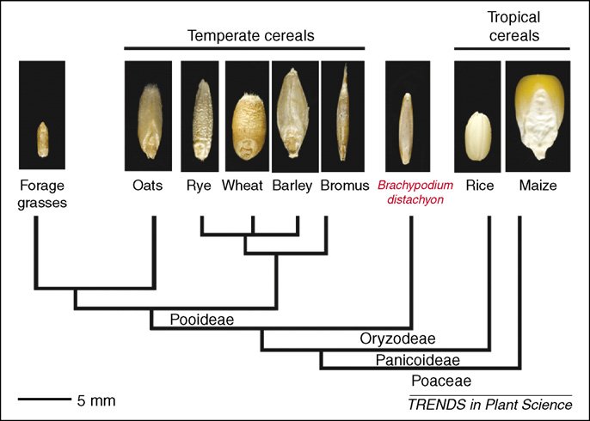

Figure 1 – Phylogenetic relationships of Bd and small-grain cereals [4]

The genome of B.distachyon was sequenced and published in Nature in 2010 [5]. It became the fourth in the list of sequenced genomes, after rice, sorghum and corn, and the first of the Pooideae subfamily 99.6% of his genome has been completely decoded [6].
In 2010, an international consortium of scientists, consisting of more than 100 members of the International Brachypodium Initiative consortium from Europe, America and Asia, for the first time deciphered the plant's genetic code, thereby paving the way for the creation of new crops and contributing to strengthening food and energy (biofuel production) security planets [7].
B. distachyon has a relatively small genome size, which consists of five chromosomes with a capacity of about 300 million base pairs, which makes it a convenient object for molecular genetic analysis and agricultural genetics, including the study of the mechanisms of response to adverse environmental factors.
Other advantages of B. distachyon include a short ontogenetic cycle, the ability to self-pollinate, ease of cultivation in the laboratory, and plant size (15-20 cm in height). This facilitates its application for fundamental and innovative applied research in the fields of cell biology, biochemistry, molecular genetics, and agricultural biotechnology.
The development of its resources and research tools was facilitated by leading scientists from around the world, in particular, the BrachyTAG project, with the aim of identifying key genes for development, reproduction, bioenergy, adaptation to environmental factors, including the resistance of cultivated crops to the most harmful and common diseases. In addition to rust, it becomes infected with fusarium and septoria [8 -10].
The growth of B. distachyon (line 3-1) in the field is shown in Figure 2.

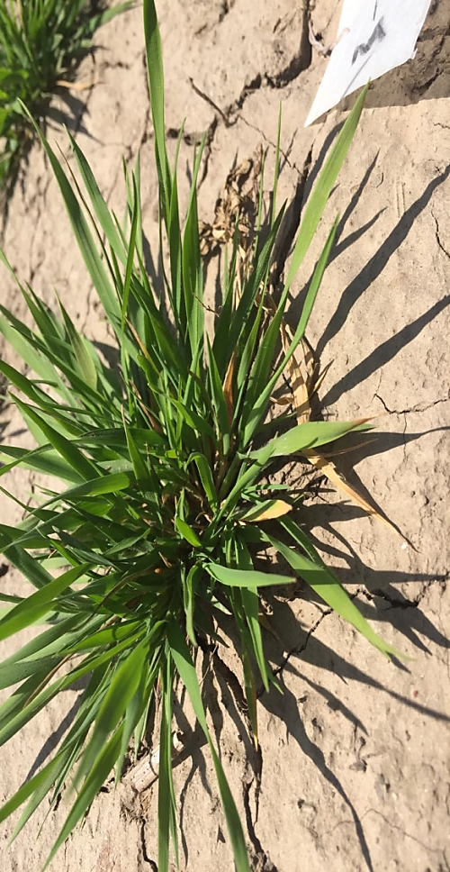

Figure 2 – The growth of B. distachyon (line 3-1) in the field

Fundamental research in the field of plant immunity, especially model plants, contributes to understanding the mechanisms of plant resistance and optimizing the control of damage caused by phytopathogens [11]. The mechanisms of plant defense response to the action of phytopathogens are very complex. These are physical responses when the cell wall is a key element in plant defense; chemicals, including the formation of reactive oxygen species, protective compounds, as secondary metabolites and proteins related to pathogenesis [7, 12].
Wild grain B.distachyon is currently the ideal model object for the action of phytopathogens affecting crops. There are two other Brachypodium species in Kazakhstan, namely Brachypodium pinnatum subsp. pinnatum (L.) Beauv. and Brachypodium sylvaticum (Huds.) Beauv, in particular in the Markakol State Nature Reserve, national parks Altyn-Emel, Katon-Karagai, as well as in the forests of northern Kazakhstan.

1.2 Features of a biotrophic pathogen Puccinia recondita
Mushrooms Puccinia recondita Rob. ex Desm f. sp. tritici or wheat brown leaf rust is an obligate plant parasite, represented by 7000 species from more than 100 genera, the most common of which is the genus Puccinia, which includes the most economically destructive biotrophic fungi. The global crop losses associated with leaf rust are estimated at a corresponding equivalent in the order of US $ 2 billion [13].
Unlike most fungal pathogens, representatives of the genus Puccinia have a complex life cycle, being a two-host parasite with a full life cycle, and have five types of sporulation. It manifests itself mainly on the leaves, less often on leaf sheaths and very rarely on the stems. In the vegetative phase of the life cycle, it exists in the form of dikaryotic mycelium, aeciospores, teliospores and urediniospores. Each specialized form consists of different physiological races that differ from each other in a number of physiological and biochemical characteristics, as well as the ability to infect only certain varieties of the host plant. So, the causative agent of wheat stem rust has more than 200 races, which are distinguished by their aggressiveness, that is, the ability to cause massive damage to susceptible plants and virulence [14].
The harmfulness of brown rust is manifested in a decrease in plant assimilation, increased transpiration, respiration and disruption of other physiological and biochemical processes with a complete disruption of the water balance, which is the cause of premature death of leaves. The disease suppresses the synthesis and deposition of starch and protein in the endosperm, resulting in the formation of a shriveled grain. With severe damage to plants, fewer grains are formed in the ears, they are of low quality, lightweight, which is the main reason for the shortage of harvest. The lack of harvest also depends on the pathogenicity of the pathogen, the resistance of the variety, weather conditions and other parameters. The intensity of damage and the response of the host plant, in particular, are influenced by the stage of plant development, the degree of cultivar resistance and the virulence of the pathogen, the amount of inoculum and environmental factors [2].

1.3 Antioxidant system of plants
The earliest reaction of a plant organism to the introduction of a pathogen is the local generation of reactive oxygen species (ROS; oxidative burst), which trigger a chain of subsequent defense reactions. According to the literature, there are two mechanisms of ROS detoxification in a plant cell [15]:
1. Enzymatic, represented by the work of enzyme systems that detoxify ROS - superoxide dismutase, catalase, peroxidase;
2. Non-enzymatic, including low molecular weight antioxidants such as glutathione, ascorbate, proline, carotenoids, tocopherol, etc.
A significant increase in the content of active forms of O₂ and H₂O₂ has a suppressive effect on the development of phytopathogens. The complex of the presented reactions underlies the formation of not only local resistance, but also systemic acquired immunity, which increases plant resistance to microorganisms, fungi and viruses. Under optimal conditions of intracellular metabolism, ROS are produced in small amounts, mainly in chloroplasts, mitochondria, and peroxisomes [16].
The balance between the formation and detoxification of ROS is of decisive importance in the formation of plant defense reactions and their survival under stresses of various nature; therefore, it is important not only the generation of active substances, but also their degradation and utilization, carried out by catalase and peroxidases [17].
Salicylic acid, being an inhibitor of catalase and peroxidase, leads to the accumulation of hydrogen peroxide in cells. At the same time, SA is an endogenous signal of a systemic induced defense response, and a violation of its synthesis or increased destruction leads to an increase in plant susceptibility to biotrophic pathogens [18].
Salicylic acid or 2-hydroxybenzoic or phenolic acid meets the requirements for systemic signaling molecules: it easily spreads through the phloem vessels, since its physical properties are close to ideal for remote transport through sieve tubes [19]. In plants, it is most often found in the form of derivatives: methyl ester glycoside, performs various physiological functions. With its participation, the delivery of newly formed proteins to the nucleus, chloroplasts, mitochondria and vacuoles occurs. It enhances the synthesis, preservation and restoration of the structure of nucleic acids and proteins important for the existence of plants. It can serve as a regulator of the transport of organic substances along the phloem, gravitropism, and other physiological processes; it also participates in the signal regulation of gene expression during leaf aging of Arabidopsis thaliana [20].
Catalase is an antioxidant enzyme that eliminates excess amounts of H₂O₂ by hydrogen peroxide. This is the enzyme with the highest turnover rate (it can break down 44,000 H₂O₂ molecules per second) [21]. However, at low concentrations of hydrogen peroxide, catalase is capable of catalyzing its reduction only in the presence of additional hydrogen donors, for example, ethanol, formic or ascorbic acids. Therefore, due to the low affinity for the substrate, its action is effective only at high concentrations of H₂O₂. Catalase is predominantly found in peroxisomes, where the enzyme concentration reaches 80% [22].
Under biogenic stress influences, the activity of catalase of a phytopathogen is considered as the degree of manifestation of its aggressiveness, expressed in the suppression of reactive oxygen species of the host plant and a decrease in the protective biocidal effect Н₂О₂ [23].
A decrease in catalase activity in plant cells at the first stage of pathogenesis is a necessary condition for maintaining a high amount of Н₂О₂, which is required to neutralize the phytopathogen in tissues. Inhibition of catalase activity during plant infection is achieved by binding it with salicylic acid, which leads to the accumulation of Н₂О₂, one of the ROS participating in the formation of immunity. At the same time, the activation of catalase in plants is one of the factors that reduce their protective potential.
It was found that with an increase in the activity of catalase, the content of H₂O₂ decreases and does not allow the development of resistance, as a result of which the susceptibility of plants to pathogens increases [24]. Since ROS are toxic not only to the pathogen, but also to the host itself, their amount in plant cells is strictly regulated with the participation of catalase as the main component of the antioxidant system. In addition, catalase limits the lifespan of ROS, protecting the cell from their harmful effects. Therefore, the growth of catalase activity is considered as a protective positive reaction of cells aimed at their preservation under biotic stress at later stages of its action. An increase in antioxidant potential allows plants to resist oxidative stress, which is an integral part of the infectious process [25].
Catalase is not the only antioxidant enzyme that breaks down hydrogen peroxide. Peroxidase is considered as one of the most important catalytic systems among biotic factors of plant protection against phytopathogens. An increase in plant resistance to phytopathogens is achieved due to the activation of lignin formation by peroxidases and an increase in the strength of cell walls in plants .[26].
The non-enzymatic antioxidant link is glutathione, which is a small peptide consisting of three amino acid residues (-Glu, -Cis, -Gly), gamma-glutamylcysteinylglycine. Glutathione protects thiol groups of proteins, inactivates radical particles, destroys peroxide compounds, and reacts with reactive oxygen species. It can stabilize membrane structures by removing acyl peroxides formed during lipid peroxidation. In its reduced form, it can function as an antioxidant in many ways: chemically interact with singlet oxygen, superoxide and hydroxyl radicals, or directly destroy free radicals; to stabilize the membrane structure by the movement of acyl peroxides formed by lipid peroxidation is necessary to maintain the reactions of the ascorbate-glutathione cycle associated with the neutralization of hydrogen peroxide. Reducing the amount of reduced glutathione can lead to severe cellular damage [27].
Another important non-enzymatic antioxidant link in plants is carotenoids. By their chemical nature, Carotenoids belong to the class of tetraterpenoids. Carotenoids, due to the presence of conjugated double bonds, can bind singlet oxygen and inhibit the formation of free radicals, preventing their negative effect on the plant organism. They provide protection against ultraviolet radiation, as they can transform the energy of UV light into visible light, which manifests itself in the phenomenon of fluorescence. They act as antioxidants, protecting sensitive tissues and labile compounds from oxidation.
Carotenoids are effective antioxidants and singlet oxygen quenchers (¹О₂ + β-carotene → О₂ + ³(β-carotene). All carotenoid molecules have a polyene chain with alternating double bonds in their structure, but their end groups may differ. Carotenoids include lycopene, paraxanthines, luteins, and xanthophylls. Currently, more than 600 different carotenoids have been isolated and characterized, among which β-carotene is the most studied and frequently encountered. Carotenoids remove excess energy from excited chlorophyll or singlet oxygen and dissipate it through the process of non-radiative relaxation in the form of heat. Thus, oxidative stress can be prevented [28].
Thus, analysis of the literature data shows that there are many systems in plants that ensure the regulation of the level of reactive oxygen species in a plant cell under changing environmental conditions.

1.4 Genes for resistance to leaf rust
There is enough information in the scientific literature on the genes for wheat resistance to Puccinia recondita. Information on nearly 70 Lr resistance genes is known [29].
Nevertheless, the P. recondita pathogen successfully copes with the resistance genes Lr, which is explained by the emergence of new more aggressive pathogen races. The activity and effectiveness of most genes for resistance to leaf rust is short-lived. The rapid change in generations of P. recondita and the ability to mutate leads to the acceleration of the formation of new races of the pathogen. Genes for resistance to leaf rust are divided into genes for juvenile and age resistance. A number of works have shown that genes Lr12, Lr13, Lr34, Lr35, Lr46, Lr48, and Lr49, which are classified as age resistance genes, determine resistance to some pathogen isolates in juvenile plants. The genes Lr1, Lr10, Lr14a, Lr15, Lr20, Lr23, Lr26, Lr34, Lr36, Lr37 are classified as juvenile resistance genes, however, they show resistance to P. recondita isolates as genes of age resistance. It was noted that the onset of their expression in leaves of different layering depends on the pathogen isolate [30].
Many Lr genes are short-lived. However, genes Lr34, Lr46, Lr68, and Lr67 exhibit long-term, albeit partial, resistance. They promote a delayed type of rust development and are effective against all races of the pathogen [31].
The Lr34 gene is located on the short arm of chromosome 7D, near the Xgwm295 locus. Lr34 is closely related to the leaf necrosis locus (LTN); it is also possible that the LTN phenotype may have the pleiotropic effect of Lr34 itself [32].
The Lr10 gene is isolated from hexaploid wheat and is located on chromosome 1AS. It encodes a CC-NBS-LRR type protein with an N-terminal domain. When expressed in transgenic wheat plants, Lr10 provides increased resistance to leaf rust [33]. The Lr22 gene is localized on chromosome 4D, has two allelic states, of which Lr22a is the most common, and provides age-related resistance to leaf rust [34].
1.5 Elicitors
Elicitors are chemical compounds of exogenous or endogenous, biotic or abiotic origin, complex or with a well-defined molecular structure. Elicitors can interact with special receptor proteins located on the membrane of plant cells, which in turn triggers a whole cascade of defense reactions, and leads to an enhanced synthesis of metabolites that reduce damage and increase resistance to pathogens, pests or abiotic stress, the so-called pattern activated immunity [35]. Acting as signaling molecules at very low concentrations, due to their inductive action, they are a safer alternative to artificial chemicals. The yield increase from the use of biogenic elicitors as immunizers is from 10 to 30%, depending on the conditions of the year, the variety of plants and, especially, the infectious load of pathogens [35]. They can also be used to induce pharmacological compounds useful for humans in cell cultures of various plants [36].
2 Research objects and methods

2.1 Research objects

The objects of the study were inbred lines Brachypodium distachyon: Bd 1-1, Bd 3-1, Bd 21 with varying degrees of resistance to leaf rust and varieties of common wheat of Kazakhstan selection: Kazakhstanskaya 19, Kazakhstanskaya early, Samgau. Seeds of B. distachyon inbred lines were provided by Dr. Matthew Moscou, Sainsbury Laboratory, Norwich, UK.

Bd1-1 – the line is characterized by long ontogenesis, therefore, it requires additional vernalization, has a large biomass and increased bushiness, small seeds, 2n = 10, place of origin - Turkey. Bd3-1 does not require vernalization, seeds are medium size, 2n = 10, origin is Iraq. Bd21 - the line is characterized by a relatively fast flowering, does not require vernalization, is demanding on light conditions, seeds are large, 2n = 10, the place of origin is Iraq.
Since B. distachyon is a model object phylogenetically close to wheat, the main objective of the project is to study the resistance to leaf rust in order to increase wheat productivity. Therefore, local varieties of common wheat were sown: Kazakhstanskaya 19, Kazakhstanskaya early, Samgau.
Kazakhstanskaya 19. The variety is mid-season, drought-resistant. According to the technological indicators, grain is included in the list of strong wheat. Resistant to brown rust damage, up to 15%. Kazakhstanskaya early. Relatively early maturing. According to the technological indicators, grain is included in the list of strong wheat. Early ripe variety. Average yield 25-30 c/ha. It is affected by brown rust, up to 40%. Samgau variety – mid-season soft wheat. Average yield – 40.5 c/ha. High drought resistance. It is affected by brown rust, as well as Septoria disease, dust smut at the standard level. In terms of grain quality, it belongs to especially valuable wheat [34].
Due to the COVID-19 pandemic, the sowing of seeds was carried out later than usual on April 21-22 on the experimental fields of the Kazakh Research Institute of Agriculture and Plant growing of the Ministry of Agriculture of the Republic of Kazakhstan, Karasai district, Almaty region. Sowing was carried out by hand on plots 1 m wide (row spacing 15 cm). B. distachyon seeds were planted 12 pcs in each row, wheat seeds 20 pcs. The seeds of the B. distachyon and wheat were sown on the same calendar date. The plants were grown according to the generally accepted agricultural practices [35]. Experimental B. distachyon and soft wheat plants were infected with uredinium spores of the Kazakhstani population of Puccinia (P.) recondita in the "tillering" growth phase. Control – untreated plants. P.recondita inoculum was provided by the Research Institute for Biological Safety Problems of the Committee of Science of the Ministry of Education and Science of the Republic of Kazakhstan under the contract.
Urediniospores of brown rust were activated for 30 min at 37-40ºC. For germination of fungal hyphae, humidity conditions were created in a desiccator for 4 hours. B. distachyon and wheat plants were sprayed with an aqueous suspension of urediniospores, which contained 0.001% Tween-80. The infectious load of the pathogen spores was 20 mg/m² [36]. Plants were moistened before infection, treatment was carried out in the evening. Plants treated with spores were covered with plastic wrap to create conditions for increased humidity. Untreated plants served as control. Symptoms of the leaf rust infection of plants appeared in the form of brown pustules with a diameter of 0.5-2.0 mm on the upper side of the leaves (rarely on the leaf sheaths). They were registered on days 7-11, depending on weather conditions.

2.2 Estimation of salicylic acid content
To determine the content of salicylic acid, 50 mg of leaves were frozen in liquid nitrogen, grounded to a powder state. Samples were allowed to thaw at room temperature. Samples were extracted in 1 ml of water, centrifuged for 10 min at 10,000 rpm, the Eppendorfs were placed on ice. 100 μl of the supernatant was mixed with 0.1% fresh ferric chloride. The volume of the reaction mixture was adjusted to 3 ml. The resulting violet color of the complex-ions of iron and salicylic acid was analyzed using a spectrophotometer, with the measurement of the absorption coefficient in the visible region at 540 nm [37].

2.3 Estimation of hydrogen peroxide content
500 mg of leaves were ground on ice in 5 ml of 0.1% trichloroacetic acid. The homogenate was centrifuged (Eppendorf 5417 R) with cooling at 4°C for 15 minutes at 12,000 rpm. 0.5 ml of supernatant was mixed with 0.5 ml of 10 mM phosphate buffer (pH 7.0) and 1 ml of 1M KI. The H₂O₂ content was determined by measuring the absorption coefficient at 390 nm using a standard curve [38].

2.4 Extraction of protein
For protein extraction, a sample of B. distachyon leaves and wheat, weighing 150-200 mg, was grounded, homogenized in chilled porcelain mortars with the addition of 400-600 μl of extraction buffer. For the extraction buffer, 20 μl of 100 mM phenyl-methyl-sulfonyl fluoride (PMSF) were dissolved in isopropanol (0.0174 g per 1 ml, or 0.0087 g per 0.5 ml) added to 2 ml of 50 mM K, Na-phosphate buffer, pH = 7.8. The extraction buffer was pre-cooled, all work was performed on ice. Extraction buffer was added, left for 1-2 minutes. The extract was collected in test tubes and centrifuged for 10 minutes at 12,000 rpm. After sedimentation, the supernatant was used to determine protein concentration and enzyme activity.

2.4.1 Measurement of protein concentration
The protein content was determined by the colorimetric method [39]. The method was based on the reaction of Coomassie Brilliant Blue G-250 with arginine and hydrophobic amino acid residues. The bounded form had a blue color with an absorption maximum at 595 nm. The increase in the absorption of the solution at a wavelength of 595 nm was proportional to the amount of protein in the solution.
To prepare the solution, a concentrated Bradford solution was used and diluted with water in a ratio of 1:5. A calibration curve was constructed using bovine serum albumin (BSA). To prepare a BSA stock solution, 10 mg of BSA was dissolved in 10 ml of distilled water. 10 μl BSA and 1 ml Bradford reagent were added to the cuvette. Measurement of the optical density of BSA with different protein content: 10, 5, 2.5, 1.25, 0.625, 0.3125 mg/ml was carried out on a spectrophotometer at a wavelength of 595 nm.
Determination of the optical density of various BSA concentrations is necessary for plotting a curve and further determining the protein concentration in the desired samples. To determine the protein concentration in plant samples, 10 μl of the extract and 1 ml of Bradford's solution were added to the cuvettes, mixed and left at room temperature for the same time interval from 2 to 60 min, after which the optical density was measured on a spectrophotometer at a wavelength of 595 nm.

2.5 Estimation of catalase activity
To determine the activity of catalase (EC 1.11.1.6), the spectrophotometric method proposed by H. Aebi was used [40]. The enzymatic function of catalase is to neutralize H₂O₂ by reduction to H₂O and the formation of molecular oxygen. The method was based on this reaction, in which the rate of decomposition of H₂O₂ by catalase was compared with the activity of catalase.
Reagents: 50 mM K, Na-phosphate buffer, pH 7.8; 50 mM K, Na-phosphate buffer, pH 7.0; extraction buffer, for the preparation of which 20 μl of a 100 mM PMSF solution is added to 2 ml of 50 mM K, Na-phosphate buffer (pH 7.8); 0.6 M hydrogen peroxide, for the preparation of which 3 ml of 3% hydrogen peroxide was brought to 4.5 ml with distilled water.
Working process: 250 mg of B.distachyon leaves and wheat were grind in a chilled mortar, 0.5 ml of extraction buffer added, the homogenate centrifuged (Eppendorf 5417R) with cooling to 4°C for 5 min. at 12000 rpm. The tubes were placed in a refrigerator at 4^{о}С. The reaction mixture contained: 2.95 ml of 50 mM K, Na-phosphate buffer, pH 7.0; 30 μl of extract. The reaction was started by introducing 20 μL of 0.6 M H₂O₂ into the reaction mixture. The control cuvette did not contain hydrogen peroxide. Measurement of the optical density of the catalase activity was carried out every second for 100 seconds at a wavelength of 240 nm.
The enzyme activity per 1 mg protein was determined by the formula (1):

A = (ΔD/T) X/(L•С), (1)

where, C is the protein content in the sample, mg; L - layer thickness, mm; T - the reaction time, sec; X - the final dilution of the extract in the cuvette (the volume of the reaction mixture is divided by the amount of the added extract); ΔD - the change in optical density (subtract the optical density at the end of the reaction from the optical density at the beginning of the reaction); A - Enzyme activity.
Measurement of catalase activity was performed in triplicate. The standard error was calculated in Microsoft Office Excel.

2.6 Estimation of peroxidase activity and its isoforms
The Peroxidase activity was determined by the colorimetric method [41], which was based on the rate of the oxidation reaction of benzidine to the formation of a blue product of its oxidation in the presence of hydrogen peroxide and peroxidase.
Reagents: 0.2 M Na-acetate buffer, pH 5.0, prepared from stock solutions of 0.2 M CH₃COOH (2.4 ml of CH₃COOH was brought to 200 ml with distilled water), 0.2 M CH₃COONa (5.44 g CH₃COONa is made up to 200 ml with distilled water). To prepare 100 ml of a solution, 30 ml of a 0.2 M CH₃COOH solution were mixed with 70 ml of a 0.2 M CH₃COONa solution and the pH of the buffer was checked, the pH, if it did not correspond, was adjusted with CH₃COOH and 5% NaOH. PMSF was added to the acetate buffer at the rate of 20 μl of 100 mM PMSF solution per 2 ml of buffer (34 mg of PMSF was dissolved in 2 ml of isopropyl alcohol); 0.01% solution of benzidine hydrochloric acid (calculation for 10 samples: 5.6 mg of benzidine were dissolved in 1 ml of concentrated acetic acid, brought to 6 ml with distilled water); 0.3% hydrogen peroxide (0.5 ml of 3% peroxide was made up to 5 ml with distilled water).
A portion of the leaves 200-300 mg was ground in a cold porcelain mortar with a pestle with 0.5 ml of acetate buffer (pH 5.0). The resulting homogenate was centrifuged with cooling to 4 ° C at 12,000 rpm for 5 minutes. Samples were placed in a refrigerator at 4°C.
The reaction mixture contained: 0.98 ml of 0.2 M Na-acetate buffer (pH 5.0); 0.5 ml of 0.01% solution of hydrochloric benzidine; 0.02 ml of extract; 0.5 ml 0.3% H₂O₂.
The control cuvette contained: 1.48 ml of 0.2 M Na-acetate buffer (pH 5.0); 0.5 ml of 0.01% hydrochloric benzidine solution; 0.02 ml extract.
Measurement of optical density was carried out at a wavelength of 590 nm every second for 120 seconds. To determine the enzyme activity per mg of protein, the following formula was used (2):
A = (ΔD/T)•X)/(L•С), (2)

where, A - enzyme activity; ΔD - the change in optical density (subtract the optical density at the initial time point from the optical density at the end of the reaction); X - the final dilution of the extract in the cuvette (divide the volume of the reaction mixture by the amount of the added extract); T – the reaction time, s; L – layer thickness, cm; С – protein content in the sample, mg.
Peroxidase activity was measured in triplicate. The standard error was calculated in Microsoft Office Excel.
When studying peroxidase isoforms, it is important to know the nature of the variability of their activity. The determination of peroxidase isoforms was carried out by the Laemli method [42] on a polyacrylamide gel. Concentrating gel 5%, separating 12%, at 4ºC, 20 mA [43]. Peroxidase isoforms were detected after electrophoresis with benzidine reagent in acetate buffer, pH 4.7. Measurements were carried out in triplicate.

2.7 Estimation of glutathione
The content of glutathione was determined by titration of mercury glutathionate with 0.001 N KJO₃ [44]. A portion of the leaves of B. distachyon and wheat, weighing 2 g, was grounded in 2 ml of a 0.3 N solution of mercury acetate and 2 ml of a 30% solution of sodium acetate. The homogenate was transferred into test tubes, left for 10 minutes for complete precipitation, then centrifuged, the supernatant was drained. The precipitate containing glutathione is washed twice with water, 10 ml of 1 N HCl was added, stirred for 5 minutes; 1 ml of 20% KJ solution was added, mixed and centrifuged. The centrifugate was transferred to a 100 ml titration flask. The precipitate was washed with 10 ml of water with stirring. After centrifugation, the solution was attached to the first centrifugate. 0.5 ml of Starch solution was added to the obtained solution and titrated. One ml of 0.001 N KJO₃ solution corresponded to 0.307 mg of glutathione. The glutathione content was calculated by the formula (3):

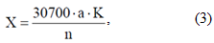
where, X is the glutathione content (in mg per 100 g of the test substance); a - the volume of 0.001 n KJO₃ consumed in the titration of glutathione (in ml); K - the normality of the KJO₃ solution; n is the sample of the test substance (in g); 30700 - normal titer of glutathione (in mg) multiplied by 100 to convert to 100 g of substance.

2.8 Estimation of the content of chlorophylls and carotenoids [45]
The content of chlorophylls a, b and carotenoids was determined on a spectrophotometer according to the Wetstein method. A portion of 50 mg of leaves (flag leaf) of B..distachyon and wheat was grounded in a cold porcelain mortar, and 90% alcohol was added. The resulting homogenate was transferred into microcentrifuge tubes, centrifuged for 5 min (Eppendorf 5417 R) with cooling to 4°C at 5000 rpm. The extract was poured into a test tube and the concentration of photosynthetic pigments was determined on PE-5400VI / UV (Russia) at a wavelength of 665 nm (chlorophyll a), 649 nm (chlorophyll b), and 440.5 nm (Carotenoids).
The Chlorophyll content was calculated using the formulas:

Са (mg/l) = 11,63*D₆₆₅ – 2,39*D₆₄₉ | (4)
Сb (mg/l) = 20,11*D₆₄₉ – 5,18*D₆₆₅ | (5)
Са + Сb (mg/l) = 6,45*D₆₆₅ +17,72*D₆₄₉ | (6)
The total content of Carotenoids was calculated according to formula:

Сcar (ml/l) = 4,695*_{D440.5} – 0,268 (Са + Сb ml/l) | (7)
Determination of the pigment content taking into account the volume of the extract and the mass of the sample according to the formula:
А = С*V/P*1000, (8)
where, C - the concentration of pigments in mg/l; V - the volume of the pigment extract, ml; A - pigment content in plant material in mg/g wet weight; P - weight of plant material, g.

2.9 Estimation of the content of indole acetic acid
To determine the content of indole acetic acid (IAA), plant tissue samples (50 mg) were frozen in liquid nitrogen, homogenized in the cold, placed in test tubes and poured for extraction with cold 80% ethanol at the rate of 10 ml per 1 g of wet weight. The determination of IAA was complicated by the fact that, unlike cytokinins, it is chemically unstable at low pH in the presence of trace amounts of Iron. IAA oxidizes easily in air and light, especially in the presence of yellow pigments. In this regard, an antioxidant (β-mercaptoethanol) was added at the stage of homogenization and extraction. Extraction was carried out at a temperature of 2-4°C for 12 hours with periodic shaking of the tubes on a KS 260 basic orbital shaker (IKA®, Germany) at 50 rpm and 10 minutes at 300 rpm. Homogenization, extraction, and all subsequent procedures were performed under scattered light, protecting the samples from direct exposure to light, which accelerates the degradation of phytohormones. Centrifuged for 10 minutes with refrigeration at 13 thousand rpm. The supernatant was poured into small porcelain dishes, the plant material pellet was washed twice with 5 ml ethanol and centrifuged by combining the supernatants with the first portion. The resulting alcoholic extract was evaporated to an aqueous residue in a flow of cold air. The IAA content was determined at a wavelength of 492 nm [45].

2.10 Estimation of lignin content
Lignin is determined by different methods, so the end result varies. The main requirement for acid hydrolysis methods is complete removal of Polysaccharides with minimal impact on Lignin. The accuracy of the lignin determination results depends on the hydrolysis conditions: the type and concentration of acid, temperature, and processing time. Lignin losses depend on the extraction conditions [46]. One of the most effective methods is the determination of the Lignin content by the acetyl bromide method with modifications [47].
The plant material is mixed with 1.5 ml of acetic acid (990 g/kg), 10 ml of freshly prepared acetyl bromide dissolved in acetic acid (250 g/kg) was added. Samples were heated for 60 minutes at 120°C, cooled on ice and 20 ml of acetic acid were added. After stirring and filtering, 5 ml of the filtrate was added to the test tubes containing 5 ml of acetic acid and 5 ml of 0.3 M NaOH. After stirring, 1 ml of 0.5 M hydroxylamine hydrochloride was added to each tube and the volume was adjusted to 25 ml with acetic acid. After mixing, the samples were left for 45 minutes at room temperature. Measurements were carried out on a spectrophotometer at a wavelength of 280 nm.

2.11 Analysis of the morpho-anatomical features of the flag leaf under infection with the pathogen
The study of the anatomical structure was carried out in accordance with generally accepted methods of botanical research [48]. Anatomical preparations were made using a microtome with a TOS-2 freezing device (Inmedprom, Russia). For a quantitative analysis, the morphometric parameters were measured using an MOV-1-15 eyepiece micrometer (at 100x magnification). Micrographs of anatomical sections were made using an MC 300 microscope (Micros, Austria) with a CAMV400/1.3M video camera (jProbe, Japan, magnification 100x, 400x). Statistical processing of morphometric indicators was carried out using Microsoft Office Excel 2013. The study describes the internal structure of the leaves of the studied lines B.distachyon, gives a comparative characteristic of control and experimental samples.

2.12 Estimation of lectin content
1 ml of acetone, cooled up to 20°C was added to 0.5 ml of the plant extract [49]. The incubation was carried out for 90 minutes at 4°C. Proteins were precipitated by centrifugation at 5000 g for 15 minutes with cooling to 4°C. The supernatant was removed and the precipitate was dissolved in 1 ml of phosphate-buffered saline (PBS) pH 7.4. Human erythrocytes (City Blood Center, Almaty) were precipitated from blood stabilized with anticoagulant sodium citrate and washed three times with PBS followed by centrifugation at 400g for 15 min at 10°C. The precipitated erythrocytes were stored in a refrigerator at a temperature of 4°C for 3 days.
In the wells of immunological U-shaped plates for 96 wells (BD, USA), containing 50 μl of PBS and two-fold dilutions of the test samples, 50 μl of a 2% solution of erythrocytes in PBS was added. Incubation was carried out at room temperature of 20°C for 1.5 hours. The results were determined visually. As a positive control, we used a solution of phytohemagglutinin (PHA) from soybeans (Sigma, USA) at concentrations of 5 and 10 μg/ml.
Lectin activity of 50 protein samples was assessed by the semiquantitative method of erythrocyte agglutination (RGA) [50].

2.13 Estimation of the content of phytoalexins of phenolic nature [51]
The content of polyphenolic compounds in terms of gallic acid was determined spectrophotometrically by reaction with a commercial Folin-Ciocalteu (FCR) reagent (Sigma-Aldrich, Germany). 500 mg of plant material were subjected to extraction in 10 ml of a solvent: ethanol/ water in a ratio of 70:30 (v/v). Extraction was carried out in an Erlenmeyer flask closed with a polished stopper. The flask was kept in an ultrasonic bath for 30 min. at a temperature of 40ºC. The mixture was centrifuged at 5000 rpm for 10 minutes, the resulting extract was decanted from the sediment and dried. The dry residue was dissolved in 10 ml of a solvent, filtered, and brought to a volume of 10 ml with the same solvent. To 1 ml of the analyzed solution diluted in a ratio of 1:10, 1 ml of the FCR reagent diluted in a ratio of 1 part of the reagent and 9 parts of distilled water, 15 ml of distilled water and 2 ml of an aqueous solution of Na₂CO₃ (7.5%) were added. The prepared mixture was shaken for 10 minutes and then kept in a water bath at 40ºC for 20 minutes. The solution was cooled and the optical density of the solution was measured at 760 nm. To construct the calibration curve, from 1 to 5 mg of gallic acid was dissolved in 10 ml of 80% ethanol (Appendix A, Table A. 1 – Ratio of reagents for constructing a calibration curve; Figure 3 – Calibration curve of total polyphenols according to Folin–Ciocâlteu (A = 0.0057conc-0.0107; R2 = 0.9986). The concentration of total polyphenols in the analyzed sample was expressed in mg of gallic acid per 100 mg of the plant product.

2.14 Analysis of productivity elements of Brachypodium distachyon and Triticum aestivum plants and protein content in their seeds
Structural analysis of productivity elements was carried out according to the following indicators: plant height, productive bushiness, length, number and weight of grains of the main spike, weight of 1000 grains. Plants were grown in field conditions (control) and under conditions of artificial infection with P. recondita spores (experiment) [35].
Determination of protein content (% to dry weight) in B.distachyon was carried out on 50 grains, in wheat on 25 grains using a grain analyzer for Protein and moisture GrainAZX-50, Zeltex (USA). Automatic calibration was performed using software. To calibrate the near infrared spectrophotometer, a standard analytical method for Protein determination by Nitrogen content was used.
Figure 4 shows the growth and development of B. distachyon, preparation of P. recondita spores for germination, and infection of plants in the field. (Appendix A, Figure A. 4 - Growth and development of Brachypodium distachyon in vitro, preparation of Puccinia recondita spores for germination, leaf infection).
The results were statistically processed using the Excel program and according to P.F. Rokitsky [53].
Figure 4 shows the growth and development of B. distachyon, preparation of P. recondita spores for germination, and infection of plants in the field of another product (Appendix A, Figure A. 3 – Growth and development of B. distachyon, preparation of P. recondita spores for germination, and infection of plants in the field).

2.15 Analysis of adult plant resistance genes of Brachypodium and common wheat varieties (genes Lr34, Lr67) upon infection with a pathogen
The research materials were 7-day-old seedlings of inbred lines Brachypodium distachyon: Bd1-1, Bd21, Bd3-1, ABR-8, as well as varieties and promising lines of common wheat of Kazakhstani and Russian breeding: Kazakhstanskaya 19, Zhenis, Samgau, Novosibirskaya 29, Iren. DNA isolation was performed using CTAB method [54].
Two to three leaf fragments were placed in 1.5 ml Eppendorf. 400 μl CTAB 2% buffer (consisting of 2% CTAB (10.0 g), 1.4 M NaCl (40.91 g), 20 mM EDTA (20 ml 0.5 M EDTA), 100 mM Tris- HCI pH 8 (50 ml 1M Tris-HCI), adjusted with ddH₂O to a final volume of 500 ml). Homogenization was carried out for 30 sec. 10 μl RNase was added, shaken for 5 sec on a shaker. Incubated for 60-80 min at 65 °C on a water bath, shaking occasionally. 400 ml of cleaning solution (92% chloroform: 8% isoamyl alcohol) was added. Centrifuged for 1 min at 13,000 rpm. The upper phase was transferred into a new tube. Re-purification with centrifugation was carried out. 350 ml of cold isopropanol were added. 10 min at 13,000 rpm. The precipitated DNA was washed in 70% ethanol. 5 min at 13,000 rpm. DNA was dried for 1 hour and dissolved in TE buffer. DNA samples were stored at -20 °C. Quantitative and qualitative assessment of the isolated DNA was performed using a DNA photometer (Biofotometer Plus, Eppendorf, Germany) and electrophoretic analysis.
The identification of Lr genes was carried out using PCR primers that mark individual genes. Primers were selected based on literature data. The nucleotide sequences of the primers are presented in Table 2 (Appendix A, Table A. 2 – PCR primers for the identification of Lr genes). The volume of the PCR reaction mixture was 10 μl and contained 1.0 μl 10 × buffer, 1.0 μl 2.5 mM dNTP, 0.2 μl 10 μM each primer, 0.2 μl 5 U Taq polymerase, 6.4 μl MQ-H₂O, 1 μl 20 ng / μl DNA. The PCR Master mix (Fermentas) was used for PCR. PCR was performed according to the X.M. Chen et al. [55]; protocol (Appendix A, Table A. 3 – Protocol for the PCR reaction).
Amplification was carried out in a Mastercycler (Eppendorf). Amplification products were separated in a 2% agarose gel in TBE buffer (45 mM Tris borate, 1 mM EDTA, pH 8) [56]. Gels were documented by photographing after staining with EtBr (Sigma-Aldrich). DNA Ladder 100 bp Plus (ThermoScientific) was used as a molecular weight marker.
2.16 Evaluation of the effect of exogenous elicitors on Brachypodium callus cultures in vitro
For callus formation, Murashige and Skoog (MS) were selected as the main culture medium with the addition of phytohormone: 2,4-dichlorophenoxyacetic acid (2.4 D) with a concentration of 0.25 ml [57].
Carefully selected seeds of Brachypodium distachyon were soaked for 24 hours. The seeds were sterilized in a soapy solution for 30 min, followed by washing in running water for half an hour, then additional seed treatment was carried out under the conditions of a laminar: 70% ethanol for 1 min, sublimate 0.1% for 9-10 min, followed by three times rinsing in sterile water according to 5 minutes. Isolation of embryos was carried out using a binocular microscope on Petri dishes in a laminar box. Isolated embryos were placed on the surface of the nutrient medium in the position with the shield down. Then the planted embryos were placed in a thermostat: for callusogenesis under dark conditions at a temperature of 24 °C, for regeneration of shoots – 16/8 hour photoperiod, illumination 3000 lux.
The increase in callus mass was analyzed by individually weighing callus aggregates under sterile conditions on a torsion balance at the time of the next passaging. The process of callusogenesis was assessed by two indicators: 1) the frequency of callusogenesis – the proportion of explants that formed callus; 2) the intensity of callus formation – the degree of callus mass accumulation was assessed using a point system: 0 – no callus; 1 – callusogenesis covers up to half of the explant; 2 – up to 2/3 of the explant is covered with callus tissue; 3 – the explant is only partially visible; 4 – the explant is completely covered with callus.
The growth index of callus cultures was determined every 28 days of cultivation and was calculated by the formula:
I = (Wo -Wt) / Wo,

where Wo is the initial mass of the callus, g; Wt - callus mass at the end of the growing cycle, g [58].

3 Generalization and evaluation of the research results

3.1 Analysis of activity of compounds forming an early protective response upon infection with the pathogen Puccinia recondita
Plants have a quite effective innate immune system, which is based on the active detection of plant pathogens and induction of protective reaсtions.

3.1.1 Estimation of salicylic acid content during infection
Endogenous salicylic acid (SA) plays an important role in the induction of protective responses, inducing complex defense mechanisms, resulting in manifestations of systemic and local resistance to a broad range of pathogens. SA is a hydrochloric molecule involved in the mechanism of resistance in plants, which is associated with the induction of ROS generation in the tissues and the stimulation of the synthesis of protective PR-proteins, with activation of phenylpropanoid metabolism, hypersensitivity reactions, and others [61].
The determination of the SA content was carried out spectrophotometrically, with the measurement of the absorption coefficient in the visible region at 540 nm [37]. The results of the content of SA on the 3rd day are presented in Table 4 (Appendix A, Table A. 4 – Salicylic acid content, ug/g fresh weight in leaves B. distachyon and wheat upon infection with P. recondita on 3rd day of infection).
It should be noted that in the control plants of B.distachyon and wheat varieties the presence of SA from the 3rd to the 10th day after infection with the phytopathogen in free form was not detected. An increase in the SA content on the third day was noted in the inbred line Bd 21 - 0.46 ± 0.03 U μg/g fresh weight; at Bd3-1 line, compared with Bd1-1 content SA increased by 45% (0,33 ± 0,18 ug g fresh weight and 0.15 ± 0.06 mg/g fresh weight, respectively). When infected by P.recondita SA content in plants experienced significantly increased with peak on day 7, particularly in Bd21 line; there increase in the content of SA was 3.17 times higher in comparison with the 3rd day of infection.

3.1.2 Estimation of the content of H₂O₂ upon infection with a pathogen
It is known that bio- and abiotic factors of various genesis influence plants and form ROS, of which H₂ O₂ is the most stable. It participates in a number of normal physiological processes and in response to stressful situations [62].
The determination of the content of H₂O₂ was carried out using spectrophotometry, with the measurement of the absorption coefficient in the visible region at 390 nm according to the standard curve [38].
In the infected leaves of B. distachyon, at the first stages of the development of the disease, H₂O₂ did not accumulate. An insignificant accumulation of H₂O₂ in plants of the Bd21 line occurred on the 3rd day, counting 1.75 μmol/g wet weight compared to 1.25 μmol/g wet weight in control. Probably, H₂O₂ accumulation occurs by recovering of highly reactive oxygen species: superoxide and hydroxyl radicals, either as a product of enzymatic reactions (Appendix A, Figure A. 5 – Content of H₂O₂ in leaves of B.distachyon under infection with P.recondita on the 3rd day).
The maximum accumulation of H₂O₂ in the resistant line Bd21 was noted on the 10th day and counted 2.3 μmol/g fresh weight, which is 91% higher than in control (Appendix A, Figure A. 6 - Content of H₂O₂ in leaves B. distachyoт after infection on 10th day).
If the accumulation of H₂O₂ on the 10th day of infection in the relatively stable inbred line Bd3-1 was 2.6 μmol / g fr wt, then in the sensitive line Bd1-1 it was 2.8 μmol/g per dry weight . The content of H₂O₂ on the 10th day from the infection in these lines increased in comparison with the control by 160% and 124%, respectively.
According to the results obtained for Kazakh wheat varieties, the following regularity was revealed: the rate of accumulation of H₂O₂, as in B. distachyon, was characteristic of varieties that are more resistant. This indicates that in these varieties of the wheat level of resistance to leaf rust correlates with a constitutively high concentration of hydrogen peroxide (Appendix A, Figure A. 7 - Content H ₂ O ₂ in wheat leaves upon infection on 3rd and 10th day).

3.2 Estimation of the activity of resistance markers – antioxidant enzymes
One of the main links of protection against ROS is enzymes that remove H₂O₂- catalase and peroxidases. These enzymes catalyze the two-electron reduction of H₂O, catalase usеs H₂O₂ from various organic compounds, peroxidase is used an electron donor [52].

3.2.1 Measurement of protein concentration
To determine the activity of antioxidant enzymes, protein concentration is initially determined in the leaves (Appendix A, Table A. 5 - Estimation of the optical density of various BSA concentrations by the Bradford method).
To determine the protein content in the sample (mg / L), a calibration curve was constructed in the coordinates of protein concentration-optical density of leaves (Appendix A, Table A. 6 – Content and amount of B. distachyon protein during infection).

3.2.2 Identification of catalase activity upon infection with P. recondita
Catalase is involved in the neutralization of hydrogen peroxide, the reduction of H ₂ O ₂ to water, and the formation of molecular oxygen. The rate of decomposition of Н ₂ О ₂ by catalase is compared with the activity of catalase. This reaction is based on the spectrophotometry method proposed by H. Aebi [40].
The optical density of catalase in the leaves of B.distachyon was measured every second for 100 sec at a wavelength of 240 nm (Appendix A, Table A. 7 - The optical density of catalase B..distachyon upon infection with P. recondita). The optical density was used to measure the concentration of the enzyme in the samples at the initial and final moments of the reaction time. Changes in catalase activity at the infection of leaf rust is presented on Figure 8 (Appendix A, Figure A. 8 – Changes in the catalase activity upon infection with P. recondita).
Increased catalase activity in stable line 21 constitutes 5.61 U/mg of protein, and is more than the reference for five times (0.77 conventional units/mg protein). The increased activity of the enzyme is apparently associated with a high concentration of H₂O_{2,} since the molecules of H₂O₂ are formed as a result of dismutation neutralized by the enzymatic activity of catalase.

3.2.3 Estimation of peroxidase activity and its isoforms upon infection
Peroxidase is considered as one of the most important catalytic systems among biotic factors of plant protection against phytopathogens. Increased stability to phytopathogen is due to activation of peroxidases and increased thickness of cell walls in plants [63]. Figure 9 shows oxidase activity, which was determined by a colorimetric method [41], based on the rate of oxidation reaction of benzidine in the presence of hydrogen peroxide and peroxidase 8 (Appendix A, Figure A. 9 – Changes in catalase activity upon infection with P. recondita).
It was found that the specific activity of peroxidase is two times higher than that of catalase. The peroxidase activity of the Bd 21 line in infected leaves was significantly higher than that of Bd 1-1 (up to 3.5 times). Soluble peroxidase in leaves B.distachyon is mainly represented by anionic isoforms (Appendix A, Figure A.10 – Peroxidase isoforms in line Bd21 upon infection with P. recondita).

3.3 Estimation of the content of non-enzymatic antioxidants
When enzymatic oxidative stress protection may be less effective in comparison with protective effect nonenzymatic antioxidants. The level of non-enzymatic antioxidants in plant tissues is determined by the relative activity of enzymatic systems and formation of metabolic transformations.

3.3.1 Estimation of glutathione content upon the pathogen infection
Glutathione is the main source of thiol groups found in all compartments of the cell - the cytoplasm, chloroplasts, endoplasmic reticulum, mitochondria, and vacuoles. It is one of the five most important endogenous antioxidants, which accounts for 90-95% of total thiol compounds in the cell. Decreased levels of glutathione may be the cause of susceptibility to various pathogens [64, 65].
The content of glutathione in leaves of B. distachyon and wheat were determined by titration [44]. Table 6 shows the content of glutathione in the leaves of inbred lines of Brachypodium distachyon and wheat on the third and tenth days after infection by brown rust (Appendix A, Table A. 8 – Content of glutathione in leaves of B. distachyon and wheat plants under infection, mg/100 g fresh weight).

3.3.2 Estimation of the content of carotenoids and chlorophylls upon infection
Carotenoids can be attributed to the "auxiliary" photosynthetic pigments present in all photoautotrophic organisms, which however plays an important role in protecting against ROS. Carotenoids very quickly quench ¹O₂ , and can also absorb excess energy from chlorophyll molecules, which are in an excited state, thus preventing the formation of this form of ROS. All this indicates that carotenoids, localized mainly in chloroplasts, protect the photosynthetic apparatus from the effects of singlet oxygen and other ROS [66, 67].
Determination of photosynthetic pigments performed three-wave photospectroscopical extraction method with pre-photosynthetic pigments in 90% ethanol, at 665, 649 and 440 nm (absorption maxima of chlorophyll respectively a , chlorophyll b, and carotenoids in ethanol).
Concentration of chlorophyll a and b, concentration of carotenoids was calculated according to [45].
It was found that P.recondita affects the pigment content in flag leaves like inbred lines Brachypodium distachyon, as well as in wheat.
The results showed that B. distachyon is more resistant to rust. The following pattern was noted: B. distachyon and Kazakhstanskaya 19 were more resistant to rust than Kazakhstanskaya early. The concentration of chlorophyll-a decreased by 8%, of carotenoids by 66%, while the concentration of chlorophyll b increased by 72% (Appendix A, Table A. 9 – Ratio of photosynthetic pigments in flag leaves of plants of the model object B..distachyon).
When infected with the pathogen Puccinia recondita , the content of C a + b chlorophylls in the flag leaves of plants of the Bd21 line statistically significantly increased by 96%, in the Bd3-1 line by 104%, and in the Bd1-1 line by 121%.
The content of chlorophylls C a / C b after infection by Puccinia recondita changed as follows: in the leaves of plants of the Bd21 line it statistically significantly decreases almost three times, in the Bd3-1 line in the experiment it increases by 17% in comparison with control, and in the Bd1 line -1 by 47%.
The ratio of the concentration of the sum of chlorophylls to carotenoids (C a + b / car) is an indicator of tolerance to abiotic and biotic stresses.
According to this indicator plants Bd21 line seen a nine-fold increase in Bd3-1 line up to 4 times, in line Bd1-1 this ratio increased by more than three times compared to the control (Appendix A, Table A. 9 - relation of photosynthetic pigments in flag leaves of plants model object B.distachyon).
Infection with the pathogen P. recondita of wheat plants showed the following: chlorophyll content C and + b of flags O leaves the resistant variety Kaz.19 wheat plants significantly increased by 21%, at relatively resistant variety Samgau 17% relatively to control, and at Kaz.early the amount of chlorophylls remained practically unchanged (Appendix A, Table A. 10 - The ratio of photosynthetic pigments in flag leaves of wheat).
When infected by pathogen P. recondita, chlorophyll content C and + b of flag leaves of wheat leaves of plants resistant variety Kaz.19 significantly increased by 21%, at relatively resistant variety Samgau 17% relative to control, and at Kaz. early the number of chlorophylls practically did not change.
Analysis of the ratio of the content of chlorophylls C a / C b in the case of P. recondita damage to wheat plants showed that the C a / C b ratio in cultivar Kaz.19 significantly decreased by 57%, in Kaz.early statistically significantly increased by 36%, in the Samgau variety by 10%.
In the variety Kaz.19 ratio of C and b + / Scar statistically significantly increasing a smiling more than 2 times, the variety Kaz early increase of 32%, and grade Samgau 97%.
When calculating tolerance indicators, it was revealed that B. distachyon is more resistant to leaf rust than the cultivar Kaz.19. The ratio of the concentration of a / b chlorophylls statistically significantly decreased almost threefold, and the ratio of the concentration of the sum of chlorophylls to carotenoids, on the contrary, increased by more than 1000%.
The data obtained showed that in the process of adaptation to the pathogen, the following physiological changes occur in the plant organism:
- the ratio of chlorophyll a and b changes;
- the ratio of the sum of chlorophylls to carotenoids changes.
It revealed that inbred line B. distachyon and grade wheat Kaz.19 substantially resistant to infection P.recondita than wheat Kaz early and Samgau.

3.4 Analysis of productivity elements, estimation of protein content in seeds of B. distachyon plants and wheat varieties during infection
One of the main elements of wheat yield is ear productivity. Productivity depends on a number of characteristics: ear length, density, number of grains per ear. Productivity assay was performed for morphological control for plants and to check purposeful influence on the formation of yield structure elements [46].
Comparative analysis of productivity elements presented in Table 11 (Appendix A, Table A. 11 – Effect of the pathogen Puccinia recondita on elements of productivity in B. distachyon and wheat).
Brown rust infection significantly reduced all the elements of productivity. The main features of the main spike change: length, number of grains and weight of grains. For example, the length of the main spike of line Bd1-1 decreases to 46% (1.04 ± 0.45 cm - experiment, 1.91 ± 0.65 cm - control). In Bd3-1 line - statistically significant by 25%, in comparison with control (4.12 ± 0.12 g), the main indicator decreases - the mass of 1000 grains (3.11 ± 0.18 g). In the Bd21 line, the “productive bushiness” trait during infection decreases to 4.3 ± 0.56 units as compared to 5.4 ± 0.55 units in the control; the sign "number of grains" is statistically significantly reduced by 10%.
A statistically significant decrease in all productivity indicators in soft wheat varieties under the influence of leaf rust was established.
The results of the influence of P. recondita on the protein content in the grain of inbred lines of the model plant and soft wheat are shown in Table 12 (Appendix A, Table A. 12 - Influence of P. recondita on the protein content in the grain of inbred lines B. distachyon and common wheat).
Infection of brown rust shows almost no effect on the protein content of kernels of inbred lines as a model plant B. distachyon, and wheat local lollections. Thus, in the Bd 3-1 line, the protein content in grains practically does not change - control 12.00 ± 0.10%, experiment 11.7 ± 0.10%, in the Bd1-1 line the protein content is: 11.53 ± 0 46 % in the control variant and 10.86 ± 0.11% in the experiment, and at the line y Bd21 11.35 ± 0.06 % of the control, 11,03±0.06% in the experimental embodiment.
Figure 11 shows a plot contains the relationships between a protein contained in the grain from the productivity element "mass of grains in the main ear" of inbred line Bd 21, and wheat (Appendix A, Figure 11 A. - Dependence of the protein content in the grain from the productivity element “mass of grains in the main ear” in line Bd 21 and wheat upon infection by P. recondita).

3.5 Estimation of the activity of compounds that form the mechanisms of innate immunity during the infection with the pathogen P. recondita
Plants have a fairly effective innate immunity system, which is based on the active detection of phytopathogens and the rapid induction of protective reactions.

3.5.1 Estimation of indoleacetic acid (IAA) content
To overcome the protection of plant pathogens have developed multilevel molecular mechanisms of hormonal pathways of plants.
An increase in the level of IAA in infected plants coincides, but the time with the maximum rate of accumulation of fungal biomass in them, and the artificial elimination of excess auxin leads to a noticeable decrease in the intensity of the disease, indicating the participation of IAA in creating favorable conditions for the introduction and further development of the parasite in the tissues of the host plant [62]. Determination of the content of IAA in leaves B. distachyon was performed by enzyme immunoassay at a wavelength of 492 nm [41].
Change of IAA is probably due to an increase in the overall activity of the altered processes in cells under the influence of the host plant pathogen, in particular with the action pathogen in the hormonal signaling pathways with a view to its rapid growth and development of IAA level is different in different organs and changes with age seedlings [63].
On the third day, the plants B. distachyon with varying degrees of resistance, an increase in IAA content was observed. In plants of resistant lines, this increase was more significant (fast and early), compared with plants of susceptible line Bd 1-1, and amounted to 154 ng/g fresh weight (Appendix A, Figure A. 12 – IAA content in leaves of inbred lines B. distachyon infected with leaf rust ). It is also important to note that after a slight, not statistically significant, increase in the third day of infection IAA content in infected plants to the 7th day is lower than the control, and throughout the vegetative translational period was at the control level. Transit and multiple storage aux new in the initial period in resistant plants, can be a condition subsequent stabilization of their level and deterrence induced pathogen accumulation of IAA in plants. In tissues susceptible line Bd 1-1 IAA levels increased with a certain delay and on the 7th day was 1.5 times higher than in control.
This probably indicates that the accumulation of auxins is necessary for the development of the fungus in plant tissues of the susceptible line Bd 1-1, is one of the conditions for the development of the disease and correlates with the literature data: auxins can accelerate the rapid degradation of plant cell walls by phytopathogen enzymes, decrease the activity some protective proteins, attraction of nutrients of the affected plant to the place of localization of the fungus and stimulation of its sporulation. It is impossible to confirm with full probability the plant or infectious nature of IAA predominates at the initial and further stages of leaf rust infection, due to the fact that this compound is an integral part of plant metabolism. Start raising the level of IAA apparently due to the non-specific resistance of plants B. distachyon, because the increase in the content of IAA on the third day of infection observed in all lines of B. distachyon .

3.5.2 Estimation of lignin in lines of B. distachyon
It was previously found that plant tissue lignification is a factor of resistance to fungal pathogens. The protective effect can be expressed in a mechanical barrier to the spread of fungal hyphae, as well as in the toxic effect of aromatic metabolites on the pathogen [64].
Morphological changes and changes in the lignin content in the leaves of inbred B. distachyon when infected with the pathogen P. recondita are presented in Figure 13 (Appendix A, Figure A. 13 - Dynamics of lignin accumulation in leaves of inbred B. distachyon lines upon infection with P . recondita ).
Prior infection with the pathogen P. recondita in inbred lines of B. distachyon, no significant differences in lignin content were observed. Active accumulation of lignin was observed in plants of the resistant line Bd21 on day 3 after inoculation, as well as in the relatively resistant line Bd3-1. In the susceptible line Bd1-1 on day 3, the lignin content was 1.5 times less intense and amounted to 68 mg / g dry weight compared to 115 mg / g dry weight in plants of the resistant line Bd21 and 93 mg / g dry weight in Bd3 -1. The activation of lignin formation is associated with an increase in plant resistance to phytopathogens , since the lignification of cell walls creates a mechanical barrier to the penetration of infection.

3.5.3 Analysis of morphological and anatomical characteristics of flag leaf of inbred lines B distachyon upon infection with a pathogen
The peculiarities of the anatomical structure of the vegetative organs of a plant, including the structure of the leaf, well reflect the adaptation of plants to growing conditions.
The study aimed to evaluate the effect of leaf rust infection on quantitative veins indicators on the internal anatomic leaves structure of B. distachyon. The test plants were infected with P. recondita spores during the tillering growth phase. To study the anatomical structure, flag leaves of plants were recorded, which are located directly under the ear, since the tiers of cereal plants have leaves of different quality. With an increase in the layer of a leaf, the degree of its xeromorphism increases, the density of veins increases, the pubescence of the leaves increases, and the cells become smaller [65].
Steel plate - main photosynthesizing portion plate, mostly has a linear shape and nearly
parallel arrangement of the conductive beams. B. distachyon leaves are in a bud usually folded lengthwise. The study of the anatomical structure of the flag leaf blade shows that they are flat, . On the upper side each plate forms a small projection - keel. Thanks to these transverse sections visible ribbing sheet. The outer surface of the cells of the upper and lower epidermis is cutinized due to the presence of a wax plaque. With both of their sides of the leaf blade visible short-celled spinous hairs, rarely meeting are single-celled long spinous outgrowths. Experimental plants have a long, unicellular spine-like outgrowth on the upper side of the epidermis.
In transverse sections from the upper epidermis at the bottom of depressions between the ribs clearly visible bubble-shaped cells - a cell motor, whereas in normal cells cover a larger size and contributing convolution via sheet in dry weather (Appendix A, Figures 14, 15, 16).
The mesophyll is uniform layer throughout the entire thickness of the leaf blade, consists of slightly folded cells. The vascular fibrous vascular bundles are arranged in one row. Over the circumference of fibrovascular bundles under the conductive mechanical roll there is sclerenchyma layer. The bulk of these cells form the lower side of the leaf blade, reinforcing large and medium parts. Tide beams from below in the form of a stand. Between the vascular bundle of the main vein and the upper epidermis, the colorless parenchyma forms wide supportive layer.
Comparison of the morphometric data of the leaves of the control and experimental plants of the line Bd 1-1 showed that a thicker leaf blade and the development of conductive bundles distinguish the experimental plants. Plant leaves line B d 1-1, affected rusty brown leaf cause of the medium in fibrovascular bundles have a sheet thickness roughcast on 29.80% more (583,10 ± 0.02 nm) as compared with lamina control plant (449,20 ± 0.03 nm). It is also noteworthy, that height changes epidermal cells. Thickness of the upper leaf epidermis embodiment experienced line 1-1% reduced by 57.0 (55.70 ± 0.01 nm), compared with control plants s - 97.60 ± 0.04 nm. In Height of the lower epidermal layers of the sheet of cells is increased by 12.4%, possibly due to the formation of more dense waxy coating, Table 1 3 (Appendix A, Table A.1 3 - Effect of P. recondita on morphometric parameters of leaves in line Bd 1-1; Appendix A, figure A. 14 Anatomical structure of the leaf in Brachypodium distachyon, line 1-1).
According to the Table 1 1 , an increase of vascular bundles in diameter at 24.86%, can be explained by the presence of more spaced vessels responsible for the transport of water with dissolved substances from the soil in above-ground part of the plants (experiment - 328.40 ± 0.09 nm, control - 263.0 ± 0.03 nm).
Morphometric analysis of the data line B d 3-1, showed that infected rust spores plant leaves, have indices increased internal structures, compared with those of control plants (Appendix A, Table A.1 4 - Effect of P. recondita on morphometric indicators in leaves of Bd3-1 line; Annex A, Figure 15 A - The anatomical structure of B. distachyon leave, line 3-1).
According to the data in Table 14, the height of the integumentary cells of both the upper and lower epidermis changes in cross section. The thickness of the upper epidermis of experimental plants was equal to 67.20 ± 0.02 nm, which is slightly higher (3.20%) that this parameter in control- 65.10 ± 0.03 nm. There is also a thickened of 7.5% lower epidermis in infected leaves (experiment 64.00 ± 0.01 nm, control - 59.05 ± 0,02nm).
The infected plants are small in sheet plastics - 458.40 ± 0.07 nm, compared with the control 451.00 ± 0.03 nm. Significant change of 43.94% in diameter of conductive tissues in infected, compared with control (control - 197.30 ± 0.01 nm, experiment - 284.00 ± 0.06 nm, corresponding to the data in Table 14).
Histological sections of leaf blades of experimental and control plants of line B d21 showed the following. Plants infected leaf rust, have a thickened lamina, compared to control, are characterized by reduction in thickness of the epidermal cells and the diameter of the conductive beams (Appendix A, Table A.1 5 - Effect of P.recondita on morphometric parameters of leaves in line Bd21; Appendix A, Figure A. 16 - Anatomical structure of the leaf, line Bd 21).
Studies on the anatomical structure of leaves Bd21 determined that the thickness of the sheet at the plant affected by leaf rust is 609.30 ± 0.07 nm and leaf discs 19.94% greater than control - 508.00 ± 0.04 nm. The thickening of the lamina possibly caused by the presence of fungal mycelium plaque.
Morphometric analysis of leaf blades of different lines B. distachyon showed changes in internal structures of infected plants: epidermal thickness, total development of lamina as well as the dimensions of conductive tissues compared with similar indices of control plants. Considerable thickening of leaf plate in sensitive line Bd1-1 (29.80%) and stable line Bd21 (19.94%). The thickness of the upper leaf epidermis in sensitive line Bd1-1 was reduced by 57.0% comparing to control, as is evident from Table 13.

3.6 Estimation of lectin content during infection with a pathogen
Plant lectins have a multifunctional role: they participate in the defense reactions of cells against pathogens and herbivorous insects, and also affect symbiosis with microorganisms, playing a key role in establishing symbiotic relationships with nodule bacteria [66].
We analyzed hemagglutinative activity of the extracts of leaves of inbred lines of B distachyon at 1, 3, and 5 days post infection with P. recondita. To concentrate proteins, the acetone precipitation technique was used [50]. Most proteins have been shown to precipitate, including lectins. The presence of lectin activity of protein samples in the amount of 50 samples was assessed by the semiquantitative method of the hemagglutination reaction (RHA) [51].
Figure 17 contains the results of a tablet with WGA samples for three variants of control lines B. distachyon on the 1st day of infection, samples 1 to 8 (Appendix A, Figure A.1 7 - Haemagglutination reaction with protein concentrates).
As can be seen from Figure 17, erythrocytes in all samples settled to the bottom of the wells. RHA was visible only in cells with PHA. Same results were obtained for all 50 samples. This can be interpreted as the absence of lectin activity in control and the experimental variants of leaves of inbred lines in the first days after infection. On the other hand, the absence of lectin activity may be associated with a small amount of lectins – less than 5 μg/ml by reaction with PHA.
To test this hypothesis, RHA was set for extracts from plants prior to protein concentration, the results of which were shown on Figure 18 (Appendix A, Figure A. 1 8 – Hemagglutination reaction with crude extracts from plants).
The studies carried out show low lectin activity of the studied samples. When diluted by 2 and 4 times, a positive RHA was observed in extracts No. 14 (Bd3-1, 1 day after infection), No. 33 (Bd1-1, 3 days after infection) and in (Bd1-1, 5 days after infection) with a dilution of 8 times. Accumulation of lectins was noted on days 3 and 5 in the sensitive Bd1-1 line and the medium sensitive Bd3-1 line. At the same time, the concentration of proteins with acetone does not lead to an increase in this activity. Probably, plant infection led to an increase in the activity of cell wall lectins and a parallel inhibition of the activity of soluble lectins , which correlates with the literature data [67].

3.7 Estimation of phenolic phytoalexins during infection with a pathogen
Phytoalexins have high biological activity. Their main feature is synthesis during the development of a fungal infection. The spectrum of phytoalexins increases with an increase in their quantitative content. Depending on the composition, the content of phytoalexins correlates with the disease resistance of the variety, and also increases to a level that leads to a significant limitation or complete suppression of the phytopathogen. Thus, during the development of septoria, phytoalexins inhibited spore germination from 6 to 73% and elongation of growth tubes from 7 to 83% [68].
Analysis of the data obtained showed that the content of phenolic compounds in the control variant in the resistant line Bd21 was 38% higher than in the sensitive Bd1-1. On the 3rd day after infection, the content of phenols in Bd21 increased 1.6 times as compared with the 1st day and amounted to 15.69 mg gallic acid equivalent / g dry weight (mg GA equiv./g dry weight), and by 7th day 3.4 times and amounted to 33.56 mg eq. GA/g dry weight. At the same time, Bd1-1 showed a significant decrease in the total content of phenolic compounds on day 3, which is probably associated with the suppression of the accumulation of phenols in susceptible plants by the pathogen. In line Bd3-1, a gradual increase in the content of phenols was noted: on the 1st day, 8.35 mg eq. GA/ g dry weight in the experiment, 6.5 mg eq. GA/ g dry weight in control). On the 7th day 7.8 mg eq. GA/g dry weight in experiment and 26.7 mg eq. Ga/ g dry weight in control (Appendix A, Figure 19 A. - The change of phenolic phytoalexins in inbred lines of B. distachyon upon infection with P. recondita).
In the resistant line Bd21 the content of phenolic compounds in the control variant was 38% higher than in the sensitive Bd1-1. On the 3rd day after infection, the content of phenols in Bd21 increased 1.6 times in comparison with the 1st day and amounted to 15.69 mg equivalent of GA/g dry weight (mg equiv. GA/ g dry weight), and by 7th day by 3.4 times and amounted to 33.56 mg eq. GA/ g dry weight. At the same time, Bd1-1 showed a significant decrease in the total content of phenolic compounds on day 3, which is probably associated with the suppression of the accumulation of phenols in susceptible plants by the pathogen. In the Bd3-1 line, a gradual increase in the content of phenols was noted: day 1 (8.35 – experiment, 6.5 – control mg eq. GA/ g dry weight), 7th day (7.8 – experiment, 26.7 – control mg eq. GA/ g dry weight).
It should be noted that there are few published data on the study of phytoalexins of the model plant Brachypodium distachyon. In particular, it was shown that in the case of fusarium infection, most of the induced genes belonged to the metabolic pathways of the biosynthesis of phenolic compounds (phenylpropane or phenolamide) [68]. Also, 5% of the composition of the protective cuticle wax is normally made up of alkylresorcinols – phenolic lipids, which provide the first line of defense against pathogenic microorganisms [69]. Brachypodium produces basic indole derivatives phytoalexins, associated with wheat and barley, benzoxazalinon, gramin, secologanin, capable of synthesis of phenylpropanoids, tryptamine and serotonin [70].

3.8 Analysis of gene expression for adult plant resistance in Brachypodium and common wheat varieties upon infection with a pathogen
One of the main problems with the short-term efficiency of most Lr-genes is the formation of virulent P. recondita races that are able to overcome resistance; therefore, many of the known Lr-resistance genes become ineffective. Resistance genes - Lr34, Lr68 and Lr67 provide partial but long-term resistance [58].
These genes contribute to the delayed development of rust and are effective against all races of the pathogen.
The aim of this work is to assess the possible expression of genes for resistance to leaf rust, in particular genes Lr34 and Lr67 in a number of common wheat varieties and B. distachyon inbred lines, and to identify Lr genes.
The priority in the study was the study of effective genes of age-related resistance to leaf rust - Lr34, Lr67, Lr22, since they are most characterized by delayed necrosis of lengthy duration, these genes are phenotypically close.
Isolation of genomic DNA from leaves of 7-day-old seedlings of B. distachyon and wheat was performed using the CTAB method [54]. To identify Lr resistance genes, the method of polymerase chain reaction (PCR) with specific primers marking individual genes was used (Appendix A, Table A. 2 - PCR primers for identifying Lr genes). The amplification programs are selected depending on the studied Lr resistance gene (Appendix A, Table A. 3 - Conditions for carrying out the polymerase chain reaction using primers to the corresponding Lr resistance genes).
The csLV34STS marker was used to identify the Lr34 gene. The gene is located on the 7DS chromosome. As a result of PCR, the varieties revealed fragments of different lengths, from 185 to 258 bp. The csLV34 marker of the Lr34 gene makes it possible to assess the allelic state in common wheat samples. The dominant allele indicates the presence of an amplification fragment with a molecular weight of 150 bp in the samples, and a recessive allele with a molecular weight of 229 bp. Figure 20 shows the amplification fragments identifying the presence of the gene for resistance to leaf rust Lr34 in various allelic states in the studied samples. Wheat varieties Novosibirskaya 29, Samgau and Zhenis have a recessive allele of gene Lr34, while varieties Kazakhstanskaya 19 and Iren carry a dominant allele of gene Lr34 and can be used as its sources in the breeding process (Appendix A, Figure A. 20 - DNA amplification products of varieties wheat with gene Lr34).
The Lr67 gene, in complementary interaction with other resistance genes, provides field resistance to Puccinia recondita in the form of the APR gene. To find the gene, the Xcfd23-4D genetic marker was used. The Lr67 gene is located on chromosome 4D. Figure 21 shows the results of electrophoresis of PCR products, reflecting the presence of the Lr67 gene in the samples under study and it was shown that the amplification fragment is present in all samples (Appendix A, Figure A. 21 - Amplification products of the DNA of wheat varieties with the Lr67 gene).
As a result of molecular screening, it was established that all wheat samples are carriers of resistance genes; genes Lr10, Lr22a, Lr34, and Lr67 were identified. Wheat varieties Kazakhstanskaya 19 and Iren are carriers of the Lr10, Lr22a, Lr34 and Lr67 genes, they are also carriers of the dominant allele of the Lr34 gene. The wheat cultivar Samgau, Novosibirskaya 29, Zhenis are carriers of the recessive allele of the Lr34 gene.
Brachypodium distachyon has genes Lr-10, Lr-22, Lr-34. The Lr67 gene in the Brachypodium Bd21, Bd3-1, Bd1-1 inbred lines is not clearly identified (Appendix A, Figures A.22-26). The gene Lr-10, which is frequently found in wheat, has been identified in the inbred lines Bd21, Bd1-1 and in trace amounts in Bd3-1 (Appendix A, Figure A.25).
In general, it is most effective when the plant contains several genes for partial resistance, since none of them alone provide the full effect.

3.9 Evaluation of the effect of exogenous elicitors on Brachypodium callus cultures in vitro
Calli were subcultured to fresh medium after 28 days. For passaging, pieces of callus tissue weighing no more than 4-7 g were taken. To obtain a sufficient amount of callus biomass, 5-7 passages were performed for each line (Appendix A, Figure A. 26 – Brachypodium distachyon callus in vitro). It was found that an increase in the concentration of 2,4-D was accompanied by a decrease in the frequency of formation of morphogenic calli. The process of recognizing an elicitor in plants is carried out with the participation of signaling systems that determine the reaction of cells to various chemical and physical influences [71] In this regard, in order to increase the growth rate and morphogenetic activity (morphogenesis) of calli, we chose jasmonic acid as an elicitor, one of the most well-known mediators of signaling systems [72] of which we looked at two main concentrations of 0.85 and 0.65 μL/L (Appendix A, Figure A. 27 – Growth of Brachypodium distachyon inbred lines callusses under different concentrations of jasmonic acid).

CONCLUSION

The Republic of Kazakhstan is one of the largest producers of commercial wheat grain, where the possibility of cultivating wheat and producing grain with high technological quality is one of the strategically important tasks of the country's national security. However, abiotic and biotic environmental factors, in particular phytopathogens, affect the productivity and grain quality of spike crops.
It is known that plant organisms have different defense regulation systems. Infection with pathogens causes a cascade of defense reactions in resistant plants, which lead not only to the localization of the focus of infection, but also to the emergence of systemic acquired resistance in plants. The formation of resistance is associated with the production of signaling molecules in infected tissues and their translocation to uninfected parts of the plant, where they induce protective reactions and contribute to an increase in resistance. Immunity based on the inability of phytopathogens to infect plants of a particular species is called non-specific.
The tasks set for 2018-2020 have been fully reached. The results obtained in the course of the study lead to the following conclusions:
1 In control plants, the presence of salicylic acid in free form was not detected. It should be noted that the content of salicylic acid in line Bd3-1 is increased as compared to Bd1-1.
In the infected leaves of Brachypodium distachyon, hydrogen peroxide did not accumulate at the first stages of the development of the disease. The maximum accumulation of Н₂О₂ in the Bd21 inbred line was noted on the 10th day.
2 It was found that the specific activity of peroxidase is 2 times higher than that of catalase, and soluble peroxidases are represented mainly by anionic isoforms. The peroxidase activity of the resistant Bd21 line in infected leaves was significantly higher than that of the susceptible Bd1-1 line (up to 3.5 times).
3 It was found that in the process of adaptation to the pathogen there is a change in the ratio of chlorophyll a and b, a change in the ratio of the sum of chlorophylls to carotenoids. It has been shown that carotenoids are less susceptible to the action of leaf rust than chlorophylls.
4 Infection with P. recondita to a large extent affects all elements of productivity of the studied wheat plants, while Brachypodium distachyon exhibits significant resistance to the phytopathogen. It has been established that when infected by P. recondita, the protein content in the grain of B. distachyon lines and common wheat cultivars practically does not change.
5 It was found that in the plants of the resistant line Bd21, the increase in IAA content was rapid in comparison with the plants of the susceptible line Bd1-1 and reached a maximum (154 ng/ g fresh weight) on the 3rd day after infection.
6 Active accumulation of lignin was observed in the resistant line Bd21 on day 3 after inoculation, as well as in the relatively resistant line Bd3-1. In the susceptible line Bd1-1 on day 3, the lignin content was 1.5 times lower and amounted to 68 mg / g dry weight compared to 115 mg/ g dry weight in Bd21 and 93 mg/ g dry weight in Bd3-1.
7 It was found that infection with B. distachyon with leaf rust leads to a change in all quantitative indicators of the internal anatomical structure of the leaf: the thickness of the epidermis, the general development of leaf blades, and the size of the conductive tissues in comparison with the control.
8 Low activity of lectins in all studied B. distachyon inbred lines during P. recondita infection was shown. The accumulation of lectins was noted on the 3rd and 5th days in the sensitive Bd1-1 line and the medium sensitive Bd3-1 line.
9 It was found that the content of phenolic phytoalexins in the control variant in the resistant line Bd21 was 38% higher than in the sensitive line Bd1-1.
10 All wheat samples carry resistance genes; genes Lr10, Lr22, Lr34, and Lr67 have been identified. The Kazakhstanskaya 19 wheat variety carries the dominant allele of the Lr34 gene. Samgau wheat variety carries the recessive allele of the Lr34 gene.
Brachypodium distachyon has genes Lr-10, Lr-22, Lr-34. The Lr67 gene in the Brachypodium Bd21, Bd3-1, Bd1-1 inbred lines is not clearly identified. The Lr-10 gene was identified in the inbred lines Bd21, Bd1-1 and in trace amounts in Bd3-1.
11 For the induction of callusogenesis, the optimal concentration of 2.4 D in the culture medium of Murashige and Skoog is 2.5 mg/l. During long-term cultivation, the effect of jasmonic acid on the calli of the inbred Brachypodium distachyon lines causes lethal effect.

REFERENCE LIST

1 Serge Savary, Andrea Ficke, Jean-Noël Aubertot, Clayton Hollier. Crop losses due to diseases and their implications for global food production losses and food security // Food Security, 2012. – 22 p.
2 Koishybaev M. Integrated protection of grain crops from major diseases in Kazakhstan // Problems of mycology and phytopathology in the XXI century. Materials int. scientific conf. / National Academy of Mycology, BGS, “Dozor” Design Studio. - SPb .: OOO Kopi-R Group, 2013. - P. 163-165.
3 Gill U.S., Lee S., Mysore, K.S. Host versus nonhost resistance: Distinct wars with similar arsenals // Phytopathology. 2015; 105: P. 580-587.
4 Opanowicz M., Vain Ph., Draper J., Parker D., Doonan J.H. Brachypodium distachyon: making hay with a wild grass // Trends in Plant Science. – 2008. – Vol. 13, No. 4. – P.172-177.
5 The International Brachypodium Initiative. Genome sequencing and analysis of the model grass Brachypodium distachyon // Nature. – 2010. – Vol. 463. – P. 763–768.
6 Robert VanBuren, Todd C. Mockler. The Brachypodium distachyon reference genome/ J. Vogel (ed.), Genetics and Genomics of Brachypodium. – Springer International Publishing. – Switzerland. – 2015. – P. 55-70.
7 Boyd L.A., Ridout Ch., O’Sullivan D.M., Leach J.E., Leung H. Plant-pathogen interactions: disease resistance in modern agriculture // Trends in Genetics. – 2013. – Vol. 29, No. 4. – P. 233-240.
8 Glazebrook J. Contrasting mechanisms of defense against biotrophic and necrotrophic pathogens// Annual Review of Phytopathology. – 2005. – Vol. 43. – P. 205-227.
9 Daumi Camejo, Ángel Guzmán-Cedeño, Alexander Moreno. Reactive Oxygen Species, essential molecules, during plant-pathogen interactions // Plant physiology and biochemistry. – 2016. – Vol. 103. – P. 10-23.
10 Carrie Seline, Teresa R. de Kievit, Mark F. Belmonte, W.G. Dilantha Fernando. Elucidating the Role of Effectors in Plant-Fungal Interactions: Progress and Challenges // Frontiers in Microbiology. – 2016. – Vol. 7, No. 600. – 21 p.
11 Wulff BB, Horvath DM, Ward ER. Improving immunity in crops: new tactics in an old game // Curr Opin Plant Biol. – 2011. – Vol. 14, No. 4. – P. 468-476.
12 Andersen E.J., Shaukat A., Byamukama E., Yen Y., Nepal M.P. Review: Disease resistance mechanisms in plants. – Genes. – 2018. – Vol. 9, No. 7. – Р. 339.
13 Bange G.A. World wheat production. Date Views: 2013. http://www.usda.gov/nass.
14 McMullen M., Rasmussen J. Wheat leaf rust / North Dakota State University Extension Service, 2002. – 589 р.
15 Pavlovskaya N.E. Reactive oxygen species and apoptosis in wheat and peas // Agricultural biology, 2010. - No. 1. - P.51-55.
16 B.C. Tripathy, R. Oelmüller. Reactive oxygen species generation and signaling in plants // Plant Signal Behav. – 2012. – Vol. 7, No. 12. – P. 1621–1633.
17 Vlasits J., Jakopitscha C., Schwanningera M., Holubarb P., Obingera C.. Hydrogen peroxide oxidation by catalase-peroxidase follows a non-scrambling mechanism // FEBS Letters. 2007. – Vol. 581, No. 2. – P. 320-324.
18 An C., Mou Z. Salicylic acid and its function in plant immunity // Journal of Integrated Plant Biology. – 2011. – Vol. 53. – P. 412-428.
19 Fragnière C., Serrano M., Abou-Mansour E., Métraux J.P., ’Haridon F. L. Salicylic acid and its location in response to biotic and abiotic stress // FEBS Letters, 2011. – Vol. 585, No. 12. – P. 1847-1852.
20 Bayburina E.V., Fazlutdinova A.I. The influence of salicylic acid on plants (theoretical aspects) // Young scientist. - 2015. - No. 7. - S. 233-235.
21 Bezkorovainy A., Rafelson M. Concise biochemistry. CRC Press, 1996. – P. 147.
22 Sharma I, Ahmad. P. Catalase: a versatile antioxidant in plants: oxidative damage to plants: antioxidant networks and signaling / Academic Press, 2014. – P. 131-148.
23 Pradhan A, Herrero-de-Dios C, Belmonte R, Budge S, Lopez Garcia A. et al. Elevated catalase expression in a fungal pathogen is a double-edged sword of iron. PLOS Pathogens. – 2017.– Vol. 13, No. 5. – P. e1006405.
24 Hackenberg T., Juul T., Auzina A. et al. Catalase and no catalase activity. Promote autophagy-dependent cell death in Arabidopsis // Plant Cell. – 2013. – Vol. 25, No. 11. – P. 4616–4626.
25 Kolupaev Yu.E., Karpets Yu.V., Yastreb T.O. Enzymatic sources of reactive oxygen species in plant cells: regulation of activity and participation in stress reactions // Bulletin of the Kharkov National Agrarian University. Ser. Biology. - Kharkov, 2012. - T. 5, No. 1. - S. 3-5.
26 Liu Q., Luo L., Zheng L. Lignins: biosynthesis and biological functions in plants // Int. J. Mol. Sci. – 2018. – Vol. 19. – Р. 335.
27 Kalinina E.V., Chernov N.N., Novichkova M.D. The role of glutathione, glutathione transferase and glutaredoxin in the regulation of redox-dependent processes // Advances in Biological Chemistry. - T. 54. - 2014. - C. 299-348.
28 Bolhassani A., Khavari A., Bathaie S. Saffron and natural carotenoids: biochemical activities and anti-tumor effects // Biochim Biophys Acta.– 2014. – Vol. 1845, No. 1. – P. 20-30.
29 McIntosh RA, Yamazaki Y, Dubcovsky J, Rogers WJ, Morris C, Appels R, Xia XC (2013) Catalogue of gene symbols for wheat: 12th International Wheat Genetics Symposium, 8–13 September 2013, Yokohama, Japan.
30 Skolotneva E.S., Salina E.A. A variety of resistance mechanisms involved in the multilevel immunity of wheat to rust diseases // Vavilovskiy journal of genetics and breeding. 2019; 23 (5): 542-550. https://doi.org/10.18699/VJ19.523.
31 El-Orabey, W.M., Hamwieh, A. & Ahmed, S.M. Molecular markers and phenotypic characterization of adult plant resistance genes Lr 34, Lr 46, Lr 67 and Lr 68 and their association with partial resistance to leaf rust in wheat. J Genet 98, 82 (2019). https://doi.org/10.1007/s12041-019-1122-1
32 Lagudah ES, McFadden H, Singh RP, Huerta-Espino J, Bariana HS, Spielmeyer W. Molecular genetic characterization of the Lr34/Yr18 slow rusting resistance gene region in wheat. Theor Appl Genet. 2006 Dec;114(1):21-30. doi: 10.1007/s00122-006-0406-z.
33 Feuillet C., Travella S., Stein N., Albar L., Nublat A., Keller B. Map-based isolation of the leaf rust disease resistance gene Lr10 from the hexaploid wheat (Triticum aestivum) genome. Proc. of the National Academy of Sciences of the United States of America. – 2003, – 100(25). – P. 15253–15258.
34 Hiebert C.W., Thomas J.B., Somers D.J., McCallum B.D., Fox S.L. Мicrosatellite mapping of adult-plant leaf rust resistance gene Lr22a in wheat // Theoretical and Applied – 2007. – 115. – P. 877–884.].
35 Sokolov Yu.A. Elicitors and their application. Publishing House “Belarusian Science”. - 2016 .- 204 p .; Bektas Y. Synthetic plant defense elicitors // Plant Physiology. - American Society of Plant Biologists, 2015. - Vol. 5. - P. 804. doi: 10.3389 / fpls.2014.00804.
36 Yablonskaya E.K. The use of exogenous elicitors in agriculture // Scientific journal of KubGAU, 2015, No. 109, pp. 1247-1263.
37 Aituganov K., Kupanova L., Bashirova Z. et al. Collection of varieties and hybrids of agricultural crops used in the Republic of Kazakhstan. - Astana, 2017 .-- 275p.
38 Dospekhov B.A. Field experiment technique. - M .: Agropromizdat, 1985 .-- 351 p.
39 Geshele E.E. Fundamentals of phytopathological assessment in plant breeding. - M .: Kolos, 1973 .-- 206 p.
38 Sergiev I., Alexieva V., Karanov E. Effect of spermine, atrazine and combination between them on some endogenous protective systems and stress markers in plants, Compt. Rend. Acad. Bulg. Sci. – 1997. – Vol. 51. – P. 121-124.
39 Bradford M.M. A rapid and sensitive method for the quantitation of microgram quantities of protein utilizing the principle of protein-dye binding // Anal Biochem. – 1976. – Vol. 72. – P. 248-254.
40 Aebi H. Catalase in vitro // Methods Enzymol. – 1984. – 105. – P. 121-126.
41 Ermakov A.I., Arasimovich V.V., Yarosh N.P., Peruvian Yu.V., Lukovnikova G.A., Ikonnikova M.I. Biochemical research methods of plants // L .: Agropromizdat. 1987. - S. 41-45.
42 Laemmli U.K. Cleavage of structural proteins during assembly of the head of bacteriophage T4 // Nature. – 1970. – Vol. 277, No. 4. – P. 178–189.
43 Methods for determining the redox status of cultivated plant cells: a teaching aid / Sibgatullina G.V., Khaertdinova L.R., Gumerova E.A., Akulov A.N., Kostyukova Yu.A., Nikonorova N.A. , Rumyantseva N.I. - Kazan: Kazan Federal University, 2011. - P. 61
44 Physiological and biochemical methods of plant analysis: Workshop / Kaliningr. state un-t; Auth.-comp. G.N. Chupakhina. - Kaliningrad, 2000.S. 30-32.
45 Shlyk A.A. On spectrophotometric determination of chlorophylls a and b // Biochemistry, 1968. - T. 33, no. 2. - S. 275-285.
46 Veselov S.Yu., Kudoyarova G.R., Usmanov I.Yu. Immunoassay of phytohormones / Method. decree. Ufa: publishing house BashSU, 1992 .-- 27 p.
47 Baeza J., Freer J. Chemical characterization of wood and its components / Hon D.N.S., Shiraishi N. (Eds.) Wood and cellulosic chemistry, 2nd ed. Marcel Dekker, Inc., New York, NY, Р. 275e3842001.
48 Fukushima R.S., Dehority B.A., Loerch S.C. Modification of a colorimetric analysis for lignin and its use in studying the inhibitory effects of lignin on forage digestion by ruminal microorganisms // J Anim Sci. – 1991. – Vol. 69. – P. 295-304.
49 Barykina R.P. and other Handbook of botanical microtechnics. Basics and Methods. - M .: Publishing house of Moscow State University, 2004 .-- 312 p.
50 Medeiros D.S., Medeiros T.L., Ribeiro J.K. et al. A lactose specific lectin from the sponge Cinachyrella apion: purification, characterization, N-terminal sequences alignment and agglutinating activity on Leishmania promastigotes // Comp Biochem Physiol B Biochem Mol Biol. – 2010. – Vol. 155. – P. 211-216.
51 Sano K, Ogawa H. Hemagglutination (inhibition) assay. Methods Mol Biol. 2014;1200:47-52. doi: 10.1007/978-1-4939-1292-6-4.
52 Frum A., Zheorzhesku Ch., Birca A.G., Gligor F.G., Tita O. Study of the qualitative and quantitative composition of phenolic compounds of blueberries (Vaccinium myrtil¬lus l.) As raw materials for food and pharmaceutical industry // Scientific result. Business and service technologies. - T.2, No. 4, 2016. - S. 53-59. doi: 10.18413 / 2408-9346-2016-2-4-53-59.
53 Rokitsky P.F. Biological statistics. - M .: Kolos, 1973 .-- 327 p.
54 Doyle J.J.; Doyle J.L. A rapid DNA isolation procedure for small quantities of fresh leaf tissue. Phytochemical Bulletin, v.19, p.11-15, 1987
55 Chen X.M., Line R.F., Leung H. Genome scanning for resistance gene analogs in rice, barley, and wheat by high resolution electrophoresis // Theoretical and Applied Genetics –– Vol.97. – P. 345-355.
56 Riede R. and Anderson J.A. Linkage of RFLP markers to an aluminum tolerance gene in wheat // Crop Science. – 1996. – Vol. 36. – P. 905-909.
57 Mostafiz S.B., Wagiran A. Efficient callus induction and regeneration in selected Indica rice // Agronomy. – 2018. – 8(77). – doi:10.3390/agronomy8050077
58 Culture of cells, tissues and organs of plants: Method. recommendations for laboratory studies, tasks for independent work and control of students' knowledge / T.I.Ditchenko. - Minsk: BSU, 2007 .-- 46 p.
59 Warrier R.R., Paul M., Vineetha M.V. Estimation of salicylic acid in Eucalyptus leaves using spectrophotometric methods // Genetics and Plant Physiology. – 2013. – Vol. 3, No. 1-2. – P. 90–97.
61 Metraux J.P. Systemic acquired resistance and salicylic acid: current state of knowledge // Eur. J. Plant Pathol. – 2001. – Vol. 107. – P. 13-18.
62Tripathy B.C., Oelmüller R. Reactive oxygen species generation and signaling in plants // Plant Signal Behav. – 2012. – Vol. 7, No. 12. – P. 1621–1633.
63 Liu Q., Luo L., Zheng L. Lignins: biosynthesis and biological functions in plants // Int. J. Mol. Sci. – 2018. – Vol. 19. – Р. 335.
64 Parisy V. Identification of pad2 as a γ-glutamylcysteine synthetase highlights the importance of glutathione in disease resistance of Arabidopsis // Plant J. – 2007. – Vol. 49. – P. 159-172.
65 Zalensky V.R. Materials for the quantitative anatomy of different leaves of the same plants // Izv. Kiev Polytechnic Institute, Kiev. - 1904 .-- T. IV, book. 1. - 112 p.
66 Foyer C.H., Shigeoka S. Understanding oxidative stress and antioxidant functions to enhance photosynthesis // Plant Physiol. – 2011. – Vol. 155. – P. 93-100.
67 Petrou A.L., Petrou P.L., Ntanos T., Liapis A. A possible role for singlet oxygen in the degradation of various antioxidants. a meta-analysis and review of literature data // Antioxidants. – 2018. – Vol. 7, No. 3. – P. 35.
68 Guo Z., Zhao Y., Röder M.S., Reif J.C., Ganal M.W., Chen D., Schnurbusch T. Manipulation and prediction of spike morphology traits for the improvement of grain yield in wheat // Sci Rep. – 2018. – Vol. 8. – P. 14435.
69 Schulze-Lefert P., Panstruga R. A molecular evolutionary concept connecting nonhost resistance, pathogen host range and pathogen speciation // Trends Plant Sci. – 2011. – Vol. 16. – P. 117-125.
70 Dodds P.N., Rathjen J.P. Plant immunity: towards an integrated view of plant-pathogen interactions // Nat Rev Genet. – 2010. – Vol. 11. – P. 539-548.
71 Malik N.A.A., Kumar I.S. and Nadarajah K. Elicitor and receptor molecules: orchestrators of plant defense and immunity // Int. J. Mol. Sci. 2020, 21, 963; doi: 10.3390/ijms21030963/
72 Karpun N.N., Yanushevskaya E.B., Mikhailova E.V. Mechanisms of the formation of nonspecific induced immunity in plants under biogenic stress // S.-kh. biol., Agricultural biology, S-h biol, Sel-hoz biol, Sel'skokhozyaistvennaya biologiya, Agricultural Biology. 2015. No. 5. URL:https://cyberleninka.ru/article/n/mehanizmy-formirovaniya-nespetsificheskogo-indutsirovannogo-immuniteta-u-rasteniy-pri-biogennom-stresse

Appendix А

Table 1 – Calibration curve for reagent ratio

Concentration, mg/L | Gallic acid stock solution volume  for sample preparation, μl | Volume of 80% ethanol for sample preparation, μl
Control, 0 | 0,0 | 250
25 | 12,5 | 237,5
50 | 25 | 225
100 | 50 | 200
150 | 75 | 175
200 | 125 | 125

Figure 3 – Folin–Ciocalteu calibration curve for total polyphenols
(А=0,0057·conc-0,0107; R²=0,9986)

Table 2 – PCR primers for identification of Lr-genes

Lr-genes | Marker name | Marker type | Locali-zation | Sequence | Reference
Lr10 | FI.2245Lr10-6/r2 | STS | 1AS | 5′-GTG TAA TGC ATG CAG GTT CC-3′  5′-AGG TGT GAG TGA GTT ATG TT-3′ | Feuillet C., 2003 [33]
Lr34 | csLv34 | STS | 7DS | 5′-GTT GGT TAA GAC TGG TGA TGG-3′  5′-TGC TTG CTA TTG CTG AAT AGT-3′ | Lagudah E. et al, 2006 [32]
Lr67 | Xcfd23-4D | CFD | 4D | 5′-CAA TAA GTA GGC CGG GAC AA-3′  5′-TGT GCC AGT TGA GTT TGC TC-3′ | Guyomarch et al. 2002
Lr22 | WMS296 | SSR | 2DS | 5′-AAT TCA ACC TAC CAA TCT CTG-3′  5′-GCC TAA TAA ACT GAA AAC GAG-3′ | Roder et al., 1998

Table 3 – Conditions of PCR using primers to the corresponding Lr-resistance genes

Lr-genes | Initial denaturation (°C, min) | The number of cycles | Denaturation  (°С, sec) | Annealing (°С, sec) | Extension  (°С, sec) | Final extension (°С, min)
Lr-10 | 94 (3) | 35 | 94 (45) | 60 (45) | 72 (30) | 72 (3)
Lr-34 | 94 (10) | 30 | 94 (30) | 60 (30) | 72 (30) | 72 (7)
Lr-67 (4D) | 94 (2) | 30 | 95 (60) | 60 (60) | 72 (60) | 73 (5)
Lr-22 (2DS) | 94 (2) | 30 | 94 (60) | 55 (60) | 73 (50) | 73 (5)

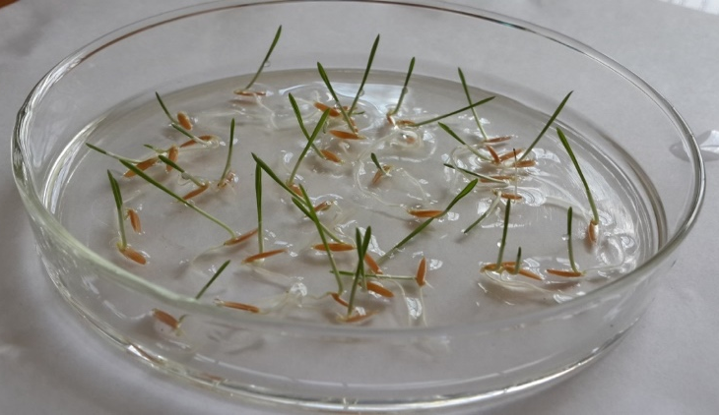 | 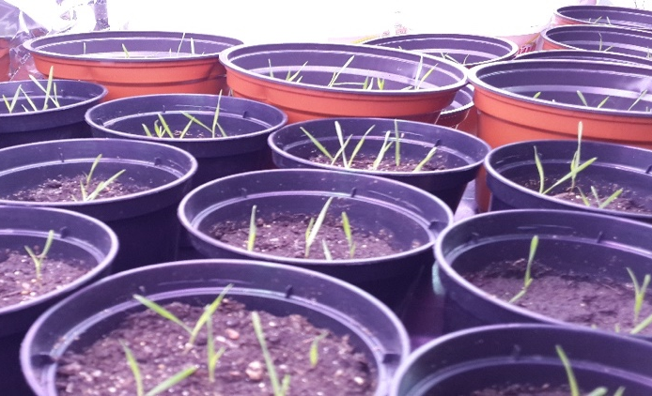
А | В
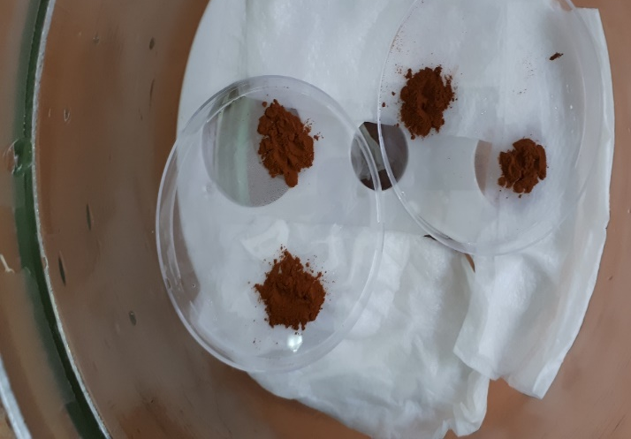 | 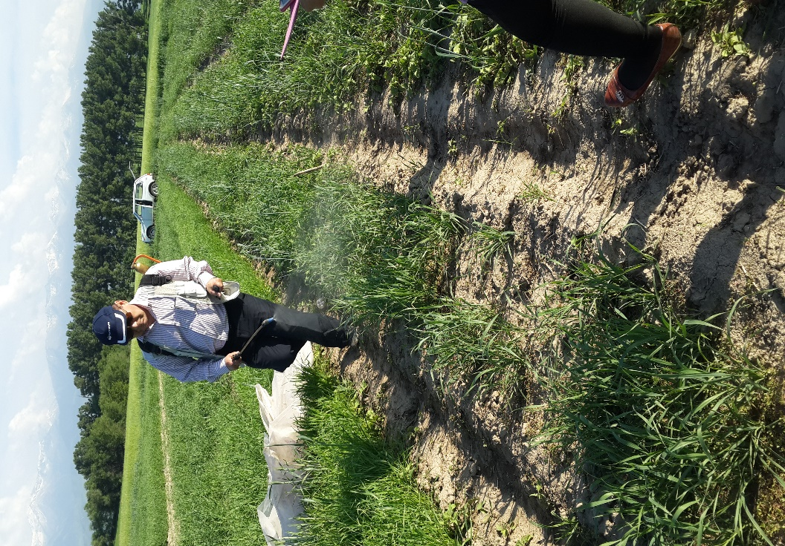
С | Е
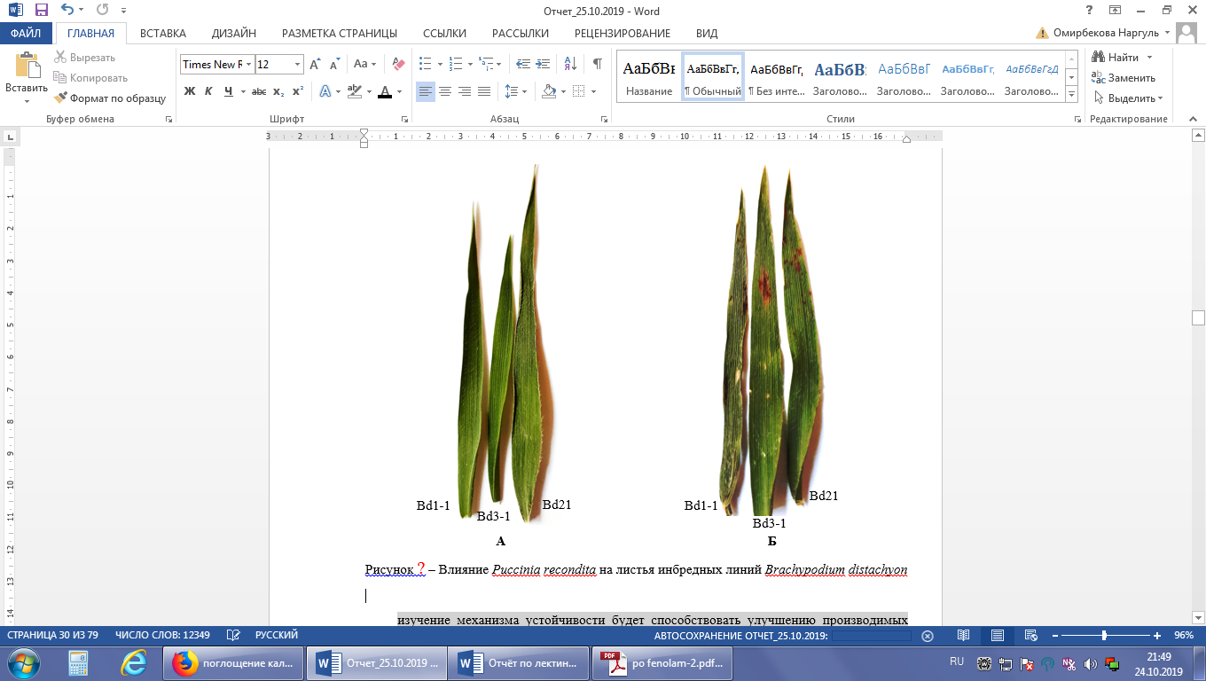
О | Р

Figure 4 – Growth and development of Brachypodium distachyon in laboratory conditions (A, B), preparation of Puccinia recondita spores for germination (C), infection of plants (E), phenotypic traits of leaves (O, P)
Table 4 – The content of salicylic acid, μg/g wet weight in the leaves of B. distachyon and wheat during P. recondita infection on the 3rd day of infection.

Option | Salicylic acid content, μg / g wet weight
Brachypodium distachyon
 | Bd21 | Bd3-1 | Bd1-1
control | n/f* | n/f | n/f
experiment | 0,46±0,03 | 0,33±0,18 | 0,15±0,06
Triticum aestivum
 | Kazakhstanskaya 19 | Kazakhstanskaya early | Samgau
control | n/f | n/f | n/f
experiment | 1,73±0,1 | 1,57±0,01 | 1,69±0,03
* n/f – not found

Table 5 – Determination of optical density of various concentrations of BSA by the Bradford method
BSA concentration, mg/ml | Optical density, 595 nm
5,0 | 1,3670
2,5 | 0,7080
1,25 | 0,4150
0,65 | 0,3790
0,325 | 0,1550
0,1625 | 0,0180

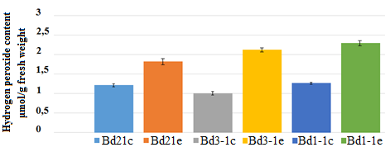

Figure 5 - H₂O₂ content in the leaves of B. distachyon during infection on the 3rd day

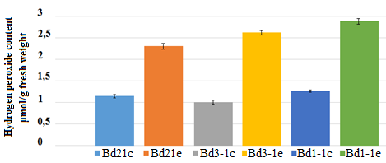
Figure 6 - H₂O₂ content in the leaves of B. distachyon during infection on the 10th day

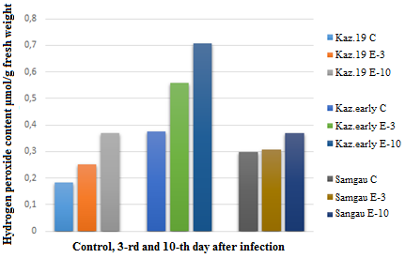

Figure 7 - H₂O₂ content in the leaves of soft wheat during infection on the 3rd and 10th day
Table 6 – Content and amount of B. distachyon protein during infection

Sample | Content, mg/ml | Optical density, 595 nm | Amount, mg
Bd21 control | 3,6343 | 1,0330 | 0,036343
Bd21 experiment | 1,1910 | 0,3385 | 0,047917
Bd3-1 control | 3,7864 | 1,2730 | 0,032629
Bd3-1 experiment | 1,2415 | 0,3973 | 0,058737
Bd1-1 control | 3,9942 | 1,3552 | 0,031914
Bd1-1 experiment | 1,3320 | 0,3785 | 0,064896

Table 7 – Data on the optical density of catalase in B.distachyon during infection with P. recondita
Seconds | Bd21 control | Bd21  experiment | Bd3-1 control | Bd3-1 experiment | Bd1-1 control | Bd1-1 experiment
10 | 0,073 | 0,192 | 0,068 | 0,189 | 0,063 | 0,186
20 | 0,068 | 0,191 | 0,065 | 0,187 | 0,060 | 0,181
30 | 0,065 | 0,185 | 0,062 | 0,181 | 0,057 | 0,176
40 | 0,059 | 0,182 | 0,050 | 0,176 | 0,049 | 0,172
50 | 0,032 | 0,178 | 0,029 | 0,171 | 0,028 | 0,168
60 | 0,016 | 0,171 | 0,014 | 0,168 | 0,012 | 0,164
70 | 0,008 | 0,158 | 0,005 | 0,154 | 0,004 | 0,151
80 | 0,005 | 0,149 | 0,003 | 0,139 | 0,002 | 0,133
90 | 0,003 | 0,144 | 0,001 | 0,124 | 0,001 | 0,119
100 | 0,002 | 0,14 | 0 | 0,12 | 0 | 0,09

According to the optical density data, the concentration of the enzyme in the samples was measured at the initial and final moments of the reaction time.

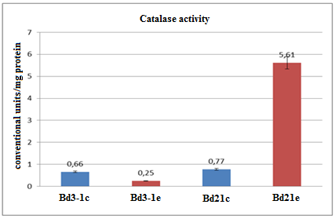
Figure 8 – Changes in catalase activity during P. recondita infection

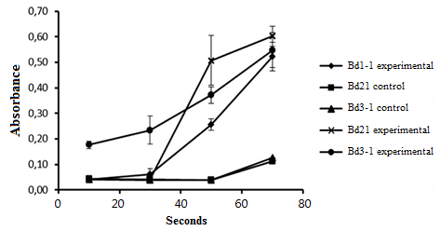
Figure 9 – Change in peroxidase activity upon infection with P. recondite

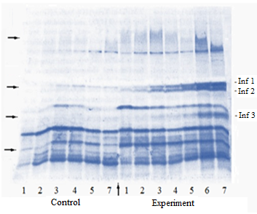
Figure 10 – Isoforms of peroxidase in line Bd21 during infection with P. recondita
Table 8 – The content of glutathione in the leaves of B. distachyon and wheat plants at infection, mg/100 g wet weight

Test option | Brachypodium distachyon |  |  | Triticum aestivum
Test option | Bd21 | Bd3-1 | Bd1-1 | Kazakhstanskaya 19 | Kazakhstanskaya early | Samgau
The third day after infection
Control | 3,75±0,2 | 6,84±0,1 | 8,5±0,2 | 3,75±0,3 | 6,84±0,2 | 8,5±0,1
Experiment | 5,95±0,1*** | 8,03±0,2** | 9,0±0,1* | 5,95±0,1 | 8,03±0,2** | 9,0±0,2*
The tenth day after infection
Control | 3,75±0,2 | 6,84±0,1 | 8,5±0,2 | 4,00±0,2 | 7,8±0,4 | 8,00±0,1
Experiment | 5,95±0,1*** | 8,03±0,1** | 9,0±0,2* | 4,50±0,3 | 20,10±0,2*** | 18,2±0,2***
* at Р < 0,05; ** at Р < 0,01; *** at Р < 0,001 comparing to control

Table 9 – Photosynthetic pigments ratio in flag leaves of plants of inbred lines of B. distachyon
Test options |  | Са+b, mg/g wet weight | Са/Сb | Са+b / Сcar
Brachypodium distachyon, Вd21
Control |  | 2,6±0,1 | 2,3±0,4 | 3,5±0,7
Experiment |  | 5,1±0,3*** | 0,8±0,2* | 36,9±0,8**
Brachypodium distachyon, линия Вd 3-1
Control |  | 2,3±0,1 | 1,39±0,1 | 4,6±0,3
Experiment |  | 4,7±0,2* | 1,64±0,1 | 27,4±0,2**
Brachypodium distachyon, линия Вd 1-1
Control |  | 1,9±0,3 | 1,17±0,1 | 4,8±0,2
Experiment |  | 4,2±0,3* | 1,72±0,2 | 21,6±0,1*
* at Р <0,05; ** at Р <0,01; *** at Р <0,001 comparing to control

Table 10 – The ratio of photosynthetic pigments in flag leaves of wheat

Test options | Са+b, mg/g wet weight сы | Са/Сb | Са+b / Сcar.
Kazakhstanskaya 19
Control | 3,3±0,2 | 2,1±0,1 | 3,6±0,3
Experiment | 4,0±0,1* | 1,2±0,3* | 11,7±0,8**
Kazakhstanskaya early
Control | 2,8±0,1 | 1,9±0,1 | 5,2±0,3
Experiment | 2,9±0,2 | 2,6±0,1* | 6,9±0,2*
Samgau
Control | 3,37±0,2 | 0,98±0,1 | 4,02±0,2
Experiment | 3,96±0,1 | 1,13±0,1 | 7,95±0,3*
* at Р <0,05; ** at Р <0,01 comparing to control

Table 11 – Influence of the pathogen Puccinia recondita on productivity elements in B. distachyon and common wheat

Trait | Plant height, cm | Productive toughness, pcs | Main ear |  |  |  |  |  | Weight of 1000 grains, g
Trait | Plant height, cm | Productive toughness, pcs | Ear length, cm |  |  | Number of grains, pcs | Grain weight, g
Inbred line Bd1-1
C | 15,90±0,90 | 3,2±0,39 | 1,91±0,65 |  | 47,0±0,68 |  |  | 0,18±0,02 | 3,00±0,27
О | 9,93±0,68*** | 2,50±0,33 | 1,04 ±0,45 |  | 40,0±0,47*** |  |  | 0,15±0,01*** | 2,16±0,08***
Inbred line Bd3-1
C | 16,99±0,82 | 4,5 ±0,38 | 1,47±0,64 |  | 56,0±0,23 |  |  | 0,22±0,01 | 4,12±0,12
О | 11,50 ±0,52*** | 3,2±0,01** | 1,40±0,51 |  | 49,0±0,40*** |  |  | 0,18 ±0,01** | 3,11±0,18***
Inbred line Bd21
C | 13,50±0,19 | 5,4±0,55 | 2,65±0,43 | 50,0±0,46 |  |  | 0,28±0,01 |  | 4,34±0,28
О | 10,45±0,74*** | 4,30±0,56 | 1,98 ±0,04 | 45,0±0,16*** |  |  | 0,20 ±0,01*** |  | 2,78±0,17***
Kazakhstanskaya 19
C | 112,3±0,48 | 6,2±0,42 | 10,30±0,48 |  | 37,0±0,48 |  |  | 1,83±0,006 | 38,91±0,41
О | 93,44±0,97*** | 4,70±0,48* | 9,603±0,52 |  | 33, 0±0,52*** |  |  | 1,55±0,01*** | 36,20±0,32***
Kazakhstanskaya early
C | 104,3±0,58 | 6,50±0,53 | 9,9±0,83 |  | 39,8±0,6 |  |  | 1,54±0,005 | 39,09±0,51
О | 102,8±0,48 | 4,35±0,94* | 8,15±0,75 |  | 33,5±0,56*** |  |  | 1,06±0,004*** | 31,89±0,70***
Samgau
C | 112,3± 0,99 | 6,1±0,88 | 10,20±0,66 |  | 41,60±0,84 |  |  | 1,35±0,007 | 34,02±0,31
О | 108,5±0,53** | 4,7±0,82 | 8,70±0,88 |  | 37,80±0,79** |  |  | 0,96±0,006*** | 29,89±0,41**
*at Р < 0,05; ** at Р < 0,01; ***at Р < 0,001 comparing to control

Table 12 – Influence of P. recondita on the protein content in grain of B. distachyon inbred lines and common wheat
Options | Protein content in grain,%
B.distachyon, line Bd 1-1
Control | 11,53±0,46
Experiment | 10,86±0,11
B.distachyon, line Bd 3-1
Control | 12,00±0,1
Experiment | 11,7±0,1
B.distachyon, Bd21
Control | 11,35±0,06
Experiment | 11,03±0,06
Kazakhstanskaya early
Control | 13,20 ±0,03
Experiment | 13,0 ±0,05
Kazakhstanskaya 19
Control | 14,75 ±0,14
Experiment | 14,54 ±0,08
Samgau
Control | 14,26±0,23
Experiment | 13,93±0,11

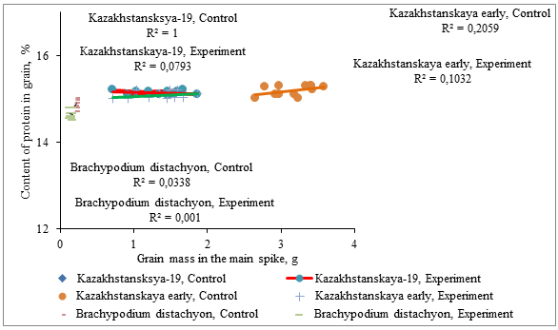

Figure 11 – Dependence of the protein content in grain on the element of productivity
“Grain mass in the main spike, g” in Bd21 and wheat upon infection with P. recondita

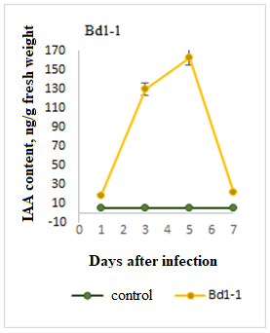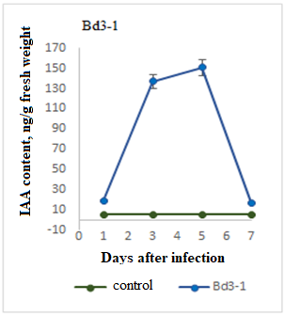
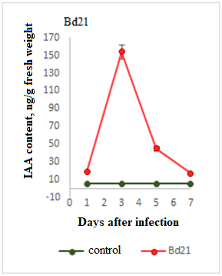

Figure 12 – Indoleacetic acid content in the leaves of
B. distachyon inbred lines infected with leaf rust

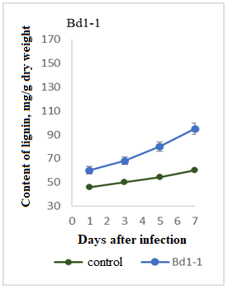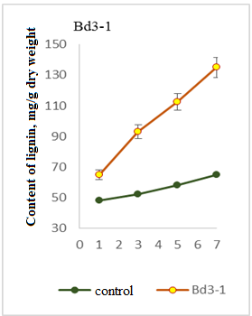

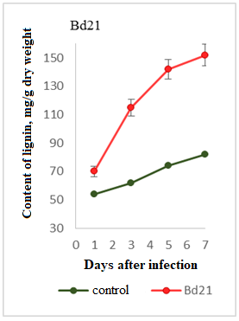

Figure 13 – Dynamics of lignin accumulation in the leaves of
B. distachyon inbred lines upon infection with P. recondita

Table 13 – Influence of P. recondita on the morphometric parameters of the leaves, line Bd1-1

Test options | Epidermis thickness, nm |  | Leaf thickness, nm | Diameter of conducting beams, nm
Test options | Upper | Lower | Leaf thickness, nm | Diameter of conducting beams, nm
Brachypodium distachyon, line 1-1
Control | 97,60±0,04 | 59,6±0,01 | 449,20±0,03 | 263,00 ±0,03
Experiment | 55,70±0,01 | 67,0±0,01 | 583,10±0,02 | 328,40±0,09
Note: in all cases, the difference is statistically significant relative to the control data, р< 0,001

Table 14 – Influence of P. recondita on the morphometric parameters of the leaves, line 3-1

Test options | Epidermis thickness, nm |  | Leaf thickness, nm | Diameter of conducting beams, nm
Test options | Upper | Lower | Leaf thickness, nm | Diameter of conducting beams, nm
Brachypodium distachyon, line 3-1
Control | 65,10±0,03 | 59,05±0,02 | 451,00±0,03 | 197,30±0,01
Experiment | 67,20±0,02 | 64,00±0,01 | 458,40±0,07 | 284,00±0,06
Note: in all cases, the difference is statistically significant relative to the control data, р< 0,001

Table 15 – Effect of P. recondita on the morphometric parameters of the leaves, line Bd21

Test options | Epidermis thickness, nm |  | Leaf thickness, nm | Diameter of conducting beams, nm
Test options | Upper | Lower | Leaf thickness, nm | Diameter of conducting beams, nm
Brachypodium distachyon, line 21
Control | 61,3±0,023 | 71,8±0,039 | 508,00±0,04 | 259,6±0,083
Experiment | 60,0±0,027 | 60,5±0,019 | 609,30±0,07 | 229,1±0,087
Note: in all cases, the difference is statistically significant relative to the control data, р< 0,001

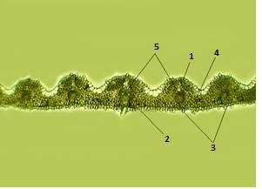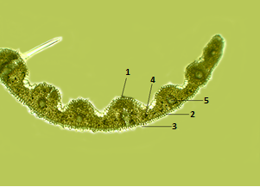
100х
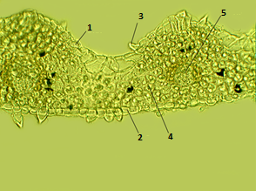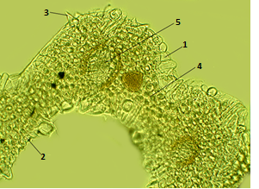
400х
А) Control B) Experiment

Figure 14 – Anatomical structure of the leaf of Brachypodium distachyon, line 1-1, where: 1. upper epidermis, 2. lower epidermis, 3. trichome, 4. mesophyll, 5. vascular bundle, 6. xylem.

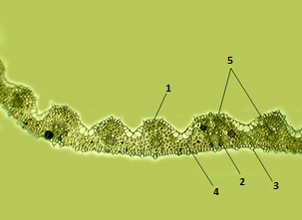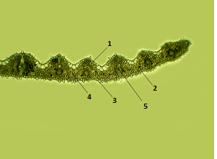
100х
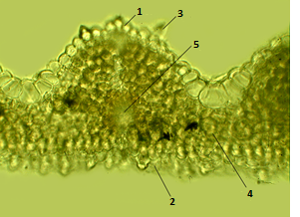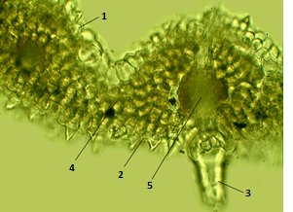
400х
А) Control B) Experiment

Figure 15 – Anatomical structure of the leaf of Brachypodium distachyon, line 3-1, where: 1. upper epidermis, 2. lower epidermis, 3. trichome, 4. mesophyll, 5. vascular bundle, 6. xylem.

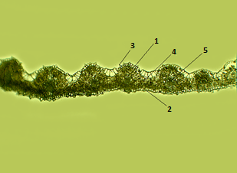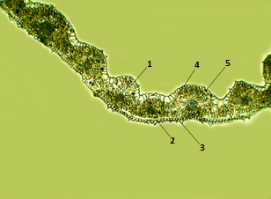
100х
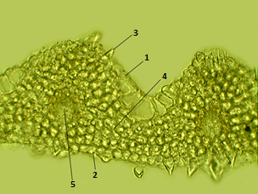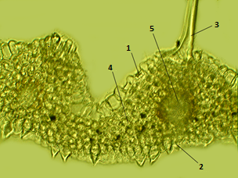
400х
А) Control B) Experiment

Figure 16 – Anatomical structure of the leaf of Brachypodium distachyon, line 21, where: 1. upper epidermis, 2. lower epidermis, 3. trichome, 4. mesophyll, 5. vascular bundle, 6. xylem.

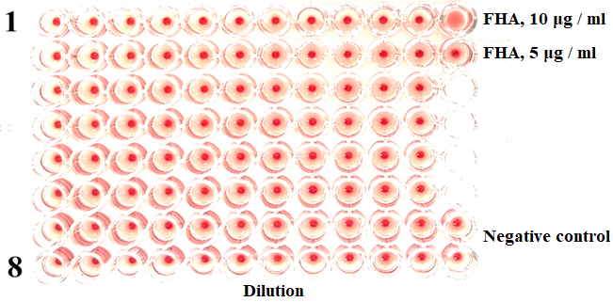

Figure 17 – Hemagglutination reaction with different protein concentrations

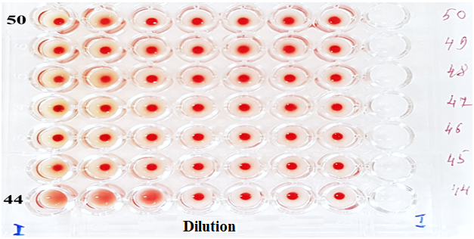

Figure 18 – The reaction of hemagglutination with crude plant extracts

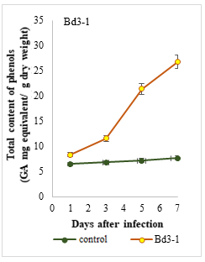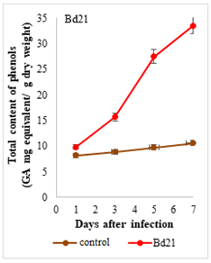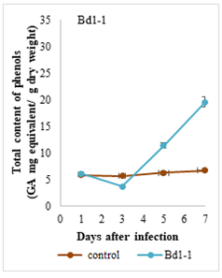

Figure 19 – Change in the content of phenolic phytoalexins
in B. distachyon inbred lines under infection with P. recondita

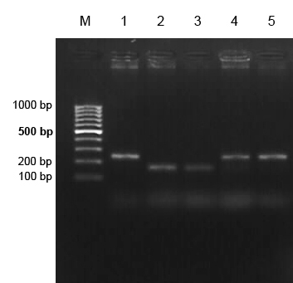

M–molecular marker (GeneRuler 100 bp DNA Ladder, ThermoFisherScientific, USA);
1 – Novosibirskaya 29; 2 – Kazakhstanskaya 19; 3 – Iren; 4 – Samgau; 5 – Zhenis

Figure 20 – Products of DNA amplification in wheat varieties with gene Lr34

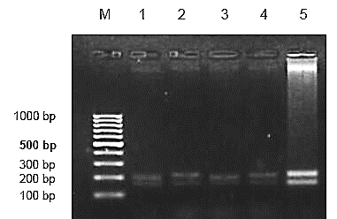

M–molecular marker (GeneRuler 100 bp DNA Ladder, ThermoFisherScientific, USA);
1 – Novosibirskaya 29; 2 – Kazakhstanskaya 19; 3 – Iren; 4 – Samgau; 5 – Zhenis

Figure 21 – Products of DNA amplification in wheat varieties with gene Lr67

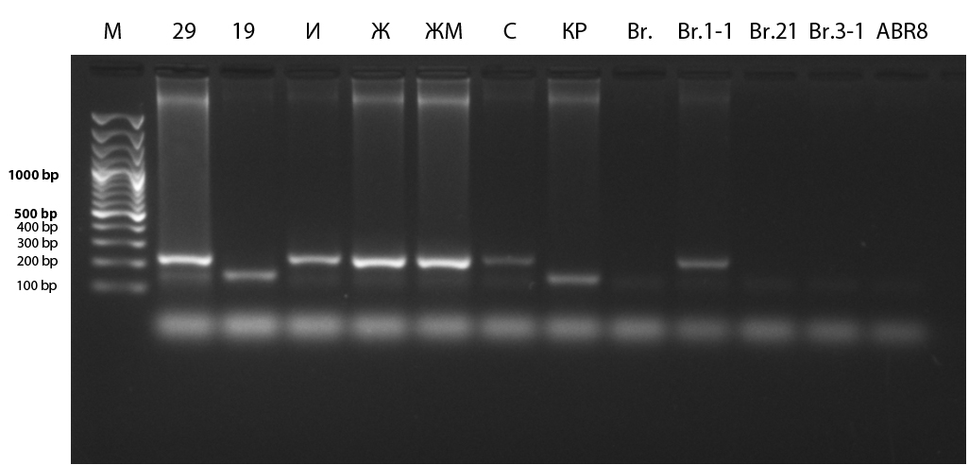

1 – M–molecular marker (GeneRuler 100 bp DNA Ladder, ThermoFisherScientific, USA);
2 – Novosibirskaya 29; 3 – Kazakhstanskaya 19; 4 – Iren; 5 – Zhenis; 6 – Zhenis –mutant line;
7 – Samgau; 8 – Kazakhstanskaya early; 10 – Bd 1-1; 11 – Bd 21; 12 – Bd 3-1; 13 – АВR8

Figure 22 – Amplification products of genomic DNA of wheat and
inbred lines of B. distachyon with gene Lr 34

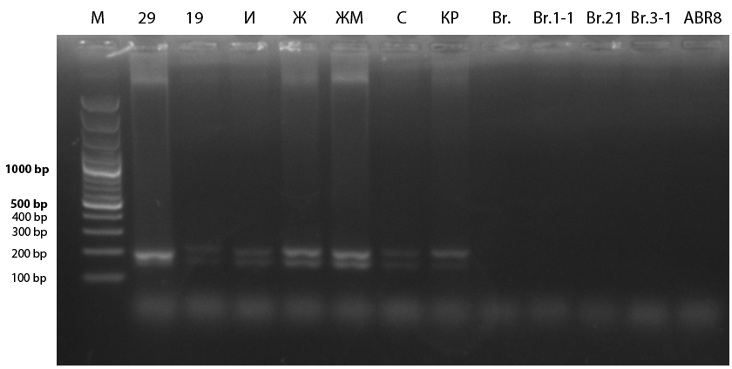

1 – M–molecular marker (GeneRuler 100 bp DNA Ladder, ThermoFisherScientific, USA);
2 – Novosibirskaya 29; 3 – Kazakhstanskaya 19; 4 – Iren; 5 – Zhenis; 6 – Zhenis –mutant line;
7 – Samgau; 8 – Kazakhstanskaya early; 10 – Bd 1-1; 11 – Bd 21; 12 – Bd 3-1; 13 – АВR8

Figure 22 – Amplification products of genomic DNA of wheat and
inbred lines of B. distachyon with gene Lr67
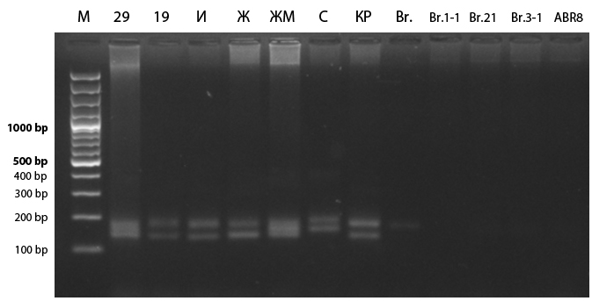

Figure 24 – Products of amplification of genomic DNA of wheat and inbred lines of B.distachyon with gene Lr22

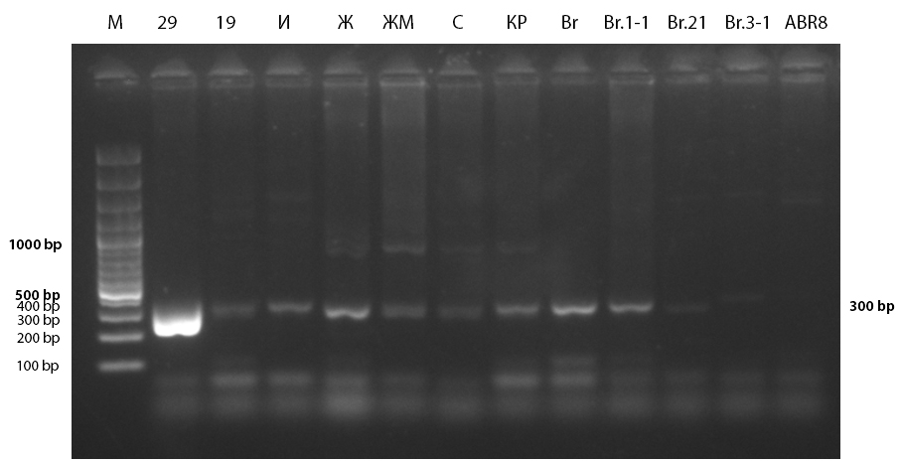

Figure 25 – Products of amplification of genomic DNA of wheat and inbred lines of B.distachyon with gene Lr10

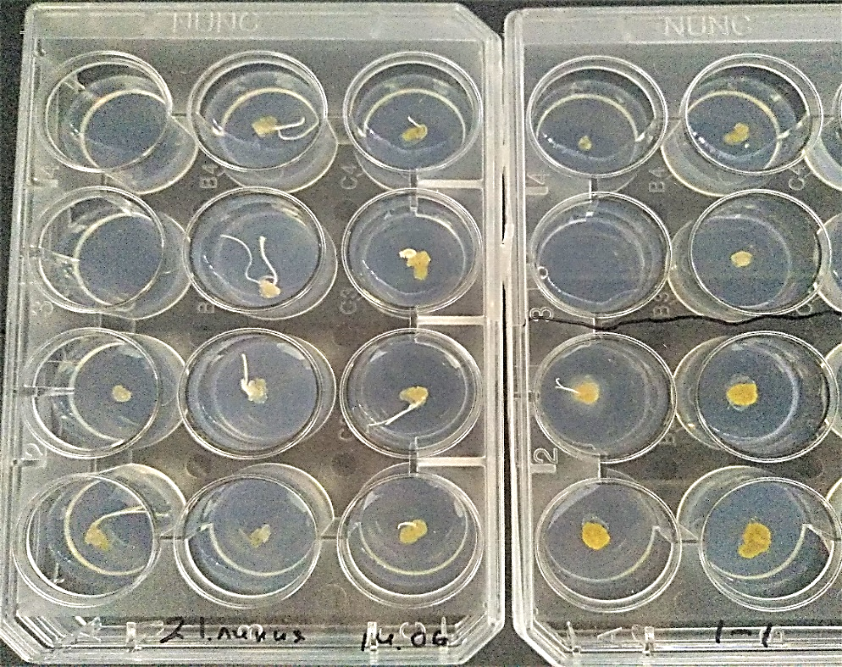

Figure 26 – Calluses of Brachypodium distachyon in vitro

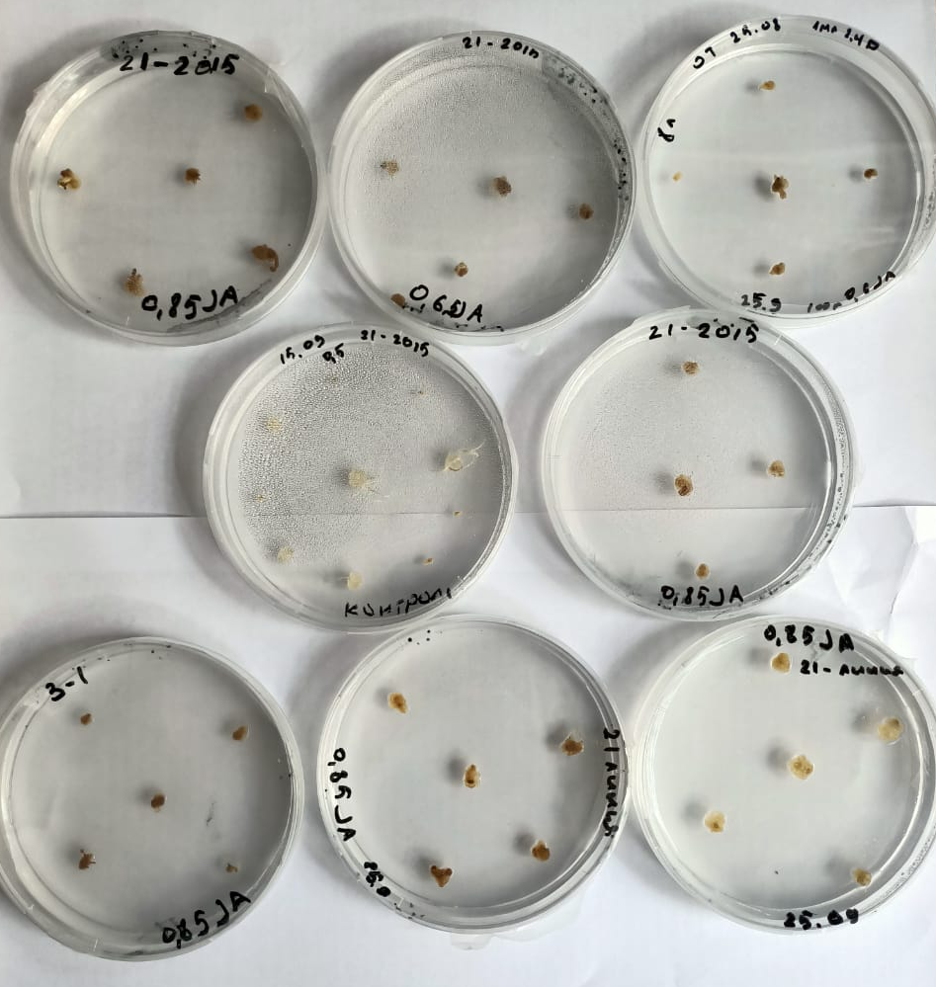

Figure 27 – Growth of calluses of inbred lines of Brachypodium distachyon
at different concentrations of jasmonic acid

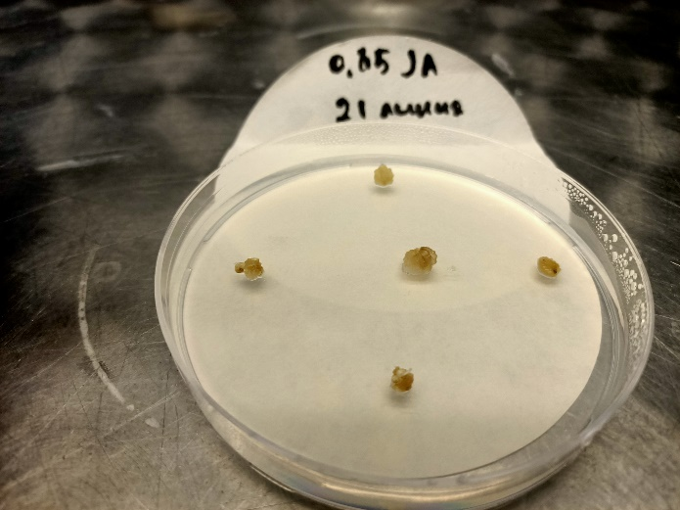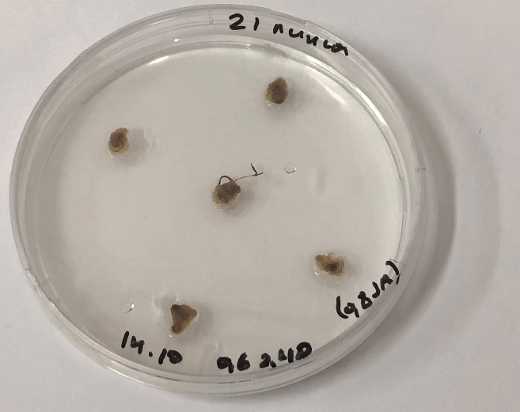

Figure 28 – Effect of jasmonic acid on calluses of inbred lines of Brachypodium distachyon

Appendix В

List of publications within the framework of the project

2018
1 Zhussupova A.I., Zhangissina S., Zhunusbaeva Zh.K., Omirbekova N.Zh. Comparative study of Brachypodium distachyon and Kazakhstani soft wheat varieties resistance to Puccinia recondita // Experimental Biology. – 2018. – 4(77). – P. 30-44. (Recommended by the Committee of Sciences)
2 Zhangissina S. Non-host resistance in Brachypodium distachyon / Materials of international scientific conference of students and young scientists, 2018. P. 152.
3 Omirbekova N.Zh., Zhussupova A.I., Zhunusbayeva Zh.K., Zhangissina S. Studies on Puccinia recondite resistance in Kazakhstan / Collection of the International Scientific-Practical Conference “Modern issues of ecological genetics and current biology.” Almaty, Qazaq University, 2018. P. 54-55.

2019
4 Nargul Omirbekova, Aigul Akhmetova, Zhazira Zhunusbayeva, Aizhan Zhussupova. P11 Comparative analysis of Brachypodium distachyon anatomical feaures with Kazakhstani wheat varieties upon infection with brown leaf rust/ 4th International Brachypodium Conference abstract book. Spain, 2019.P. 78
5 Mynbayeva D.O., Omirbekova N.Zh., Zhunusbayeva Zh.K., Zhusupova A.I., Begmanova M.O., Amirgalieva A.S. Identification resistance genes to brown rust in softwheat varieties // Experimental biology. – 2019. – 2(79). – P. 110-117. (Recommended by the Committee of Sciences)
6 Omirbekova N.Zh., Zhusupova A.I., Zhunusbaeva Zh.K., Ertaeva B.A. Methodical recommendations for studying the mechanisms of nonspecific resistance of the model organism Brachypodium distachyon to the pathogen Puccinia recondita. Part 1. Almaty, Global Print, 2019. 27 p.

2020
7 Omirbekova N.Zh., Zhussupova A.I., Akhmetova A.B., Zhunusbayeva Zh.K. Study of anatomical and physiological changes in model plant Brachypodium distachyon upon infection with the pathogen Puccinia recondita // Jour of Adv Research in Dynamical & Control Systems, 2020, Vol. 12, 08-Special Issue, P. 564-571. (Scopus-indexed)
8 Omirbekova N., Zhussupova A., Zhunusbayeva Zh., Yertaeva B., Demzhanova G., Kenzhebaeva S. Enzymatic changes in different lines of Brachypodium distachyon under rust infection // Solid State Technology, 2020. Vol. 63. Issue: 1s. 6 p. (Scopus-indexed)
9 Nargul Omirbekova, Aizhan Zhussupova, Tlek Mukhanov, Zhazira Zhunusbaeva, Bibinur Yertaeva, Saule Kenzhebaeva. Aspects of model plant purple false brome (Brachypodium distachyon) propagation in vitro // Solid State Technology, 2020, in print (Scopus-indexed).
10 Omirbekova N.Zh., Zhunusbaeva Zh.K., Zhusupova A.I., Ertaeva B.A. Elicitors and culture of Brachypodium distachyon in vitro // Experimental biology. – in print (Recommended by the Committee of Sciences).
11 Omirbekova N.Zh., Zhusupova A.I., Zhunusbaeva Zh.K., Kenzhebaeva S.S., Ertaeva B.A., Omirbekova A.A. Application for invention “Method for assessing the resistance of plants Brachypodium distachyon to leaf rust” No. 2020/0614.1 dated 09/04/2020. Notification of a positive result of a formal examination.

Appendix C

