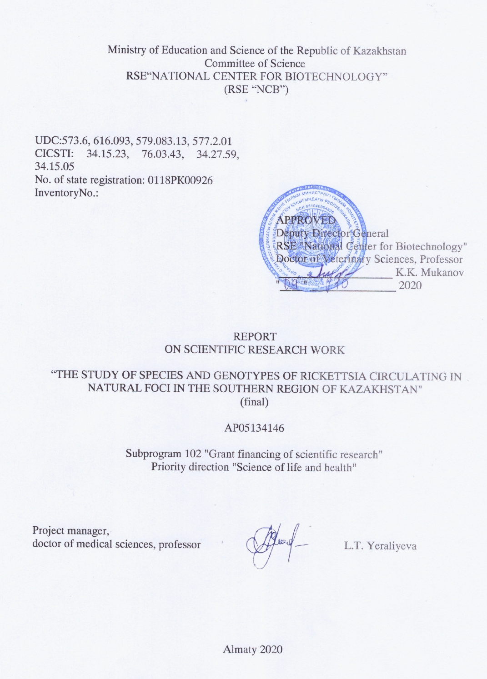
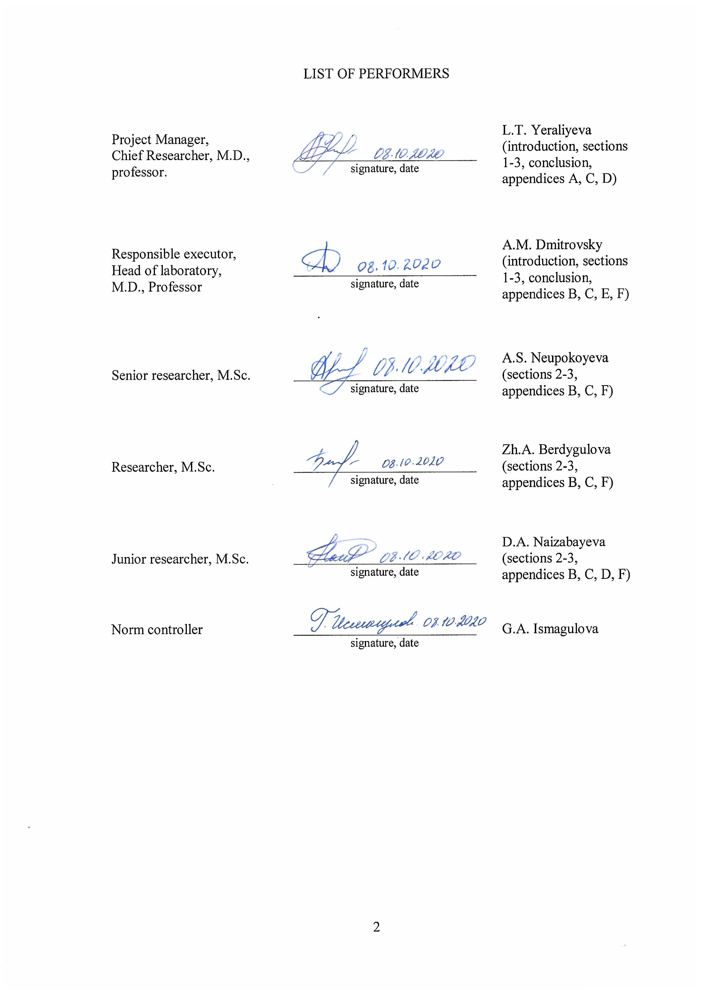
ABSTRACT

Report of 97 pages, 1 book, 8 figures, 11 tables, 37 references, 6 appendices.
RICKETTSIOSIS, SPECIES, GENOTYPE, DIAGNOSTICS, EPIDEMIOLOGY, DISTRIBUTION, TICK.
Research objects: ticks, serum of patients with fevers of unknown origin and healthy residents of the southern region of Kazakhstan.
Aim of the study: to study the distribution of various rickettsia species in ticks in the southern region of Kazakhstan, to conduct genotyping of isolated DNA of rickettsia, identify the circulation of pathogenic rickettsia in humans, as well as improve laboratory and etiological diagnosis of rickettsia and develope a strategy for epidemiological surveillance of rickettsia in the Republic of Kazakhstan.
Research methods: collection of ticks by the "flag" method and from people with tick bites, morphological identification of ticks, homogenization of ticks, extraction of nucleic acids, PCR analysis, electrophoresis of nucleic acids, DNA elution from gel, DNA sequencing, spectrophotometry, ELISA, methods of descriptive and analytical epidemiology.
Results of the study and their novelty: The collection of ticks in the epidemiological seasons of 2018-2020 was conducted in southern region of Kazakhstan. A total of 1,117 ticks were collected, with a geodatabase of collection points. PCR analysis of DNA samples from 428 individual ticks was conducted and demonstrated that the level of infection of ticks with rickettsia of the spotted fevers group was 69.9%. Rickettsia sibirica DNA was found in 7.2% of the samples. Genetic characterization of rickettsia detected in ticks was carried out. Rickettsiae from 24 ticks were sequenced at the locus 190-70 and 190-602 of the OmpA gene. DNA sequencing of rickettsiae identified in 13 ticks was performed at locus 816-843 and 1135-1156 of the GltA gene. DNA sequencing of rickettsia from 7 tick was carried out at locus 3588-3607 and 4406-4387 of the OmpA gene. For the first time in Almaty region, the circulation of the species, pathogenic for humans – Candidatus R. tarasevichiae – was described, and the circulation of pathogenic for human species R. raoultii and R. aeschlimannii was confirmed. Serum samples were collected from 2927 residents and 188 febrile patients in the southern region of Kazakhstan. It was shown that seroprevalence of IgG to R. typhi was 34.4%. IgG to spotted fever rickettsia was found in 22.6% of samples. Areas endemic for rickettsioses have been identified. A standard case definition for endemic typhus and tick-borne rickettsiosis has been developed.
Application area: epidemiology, infectious diseases.
The obtained results will be applied for developing a strategy for the epidemiological surveillance of rickettsiosis in Kazakhstan.
ТҰЖЫРЫМ
Есепте 97 бет, 1 кiтап, 8 сурет, 11 кесте, 37 әдебиет көзі, 6 қосымша.
РИККЕТСИОЗ, ТҮР, ГЕНОТИП, ЭПИДЕМИОЛОГИЯ, ТАРАЛУ, КЕНЕ
Зерттеу нысаны: кене, белгісіз генезді қызбасы бар науқастардың және Қазақстанның оңтүстік өңірінің дені сау тұрғындарының сарысулары.
Зерттеу мақсаты - Қазақстанның оңтүстік аймағында кенелерде әртүрлі риккетсия түрлерінің таралуын зерттеу, риккетсиялардың бөлініп алынған ДНҚ-сына генотиптеу жүргізу, адамдарда патогенді риккетсиялардың айналымын анықтау, сондай-ақ риккетсиоздардың зертханалық-этиологиялық диагностикасын жетілдіру және Қазақстан Республикасында риккетсиоздарды эпидемиологиялық қадағалау стратегиясын әзірлеу.
Зерттеу әдістері: "жалау" әдісімен және кене шаққан адамдардан кенелерді жинау, морфологиялық түрлерін анықтау, кенелерді гомогенизациялау, нуклеин қышқылын алу, ПТР талдау, нуклеин қышқылының электрофорезы, гельден ДНҚ элюциясы, ДНҚ секвенирлеу, спектрофотометрия, ИФТ, сипаттамалық және аналитикалық эпидемиология әдістері.
Жұмыс нәтижелері және олардың жаңалығы: Қазақстанның оңтүстік аймағында 2018-2020жж. эпидемиологиялық маусымында кенелерді жинау жүргізілді. Барлығы 1 117 кене жиналды, жинау орындарының геодеректер базасы құрылды. 428 жеке кенелерден алынған ДНҚ үлгілерінің ПТР талдауы кенелердің шың безгегі қоздырғышы тобына кіретін риккетсияларын жұқтыру деңгейі 69,9% екенін көрсетті. Rickettsia sibirica ДНҚ үлгілердің 7,2% - ында кездеседі. Бөлінген риккетсиялық изоляттардың генетикалық сипаттамасы жасалды. OmpA генінің 190-70 және 190-602 локусы бойынша 24 кенеде анықталған, GltA генінің 816-843 және 1135-1156 локусы бойынша 13 кенеде анықталған, OmpA генінің 3588-3607 және 4406-4387 локусы бойынша 7 кенеде анықталған риккетсиялардың ДНҚ-сына секвенирлеу жүргізілді. Алматы облысында алғаш рет адам үшін патогенді Сandidatus R. tarasevichiae түрлерінің айналымы көрсетілді, адам үшін патогенді R. raoultii және R. aeschlimannii түрлерінің айналымы расталды. Қазақстанның оңтүстік аймағында 2927 тұрғыннан және 188 қызбасы бар науқастардан сарысу үлгілерін жинау жүргізілді. R. typhi-ге IgG серопреваленттілігі 34,4% - ға тең екендігі көрсетілген. Шың безгегі дақты риккетсияларына қарсы IgG үлгілердің 22,6% - ында анықталды. Риккетсиоз бойынша эндемикалық аймақтар анықталды. Эндемиялық іш сүзегі мен кене риккетсиозы жағдайының стандартты жағдайды анықтау жасалды.
Қолдану саласы: эпидемиология, жұқпалы аурулар.
Алынған нәтижелер Қазақстанда риккетсиозды эпидемиологиялық қадағалау стратегиясын әзірлеу үшін пайдаланылатын болады.
CONTENT

INTRODUCTION | 7
MAIN PART OF THE RESEARCH WORK REPORT | 9
1 Choosing a direction of research | 9
2 Materials and methods | 10
2.1 Main research objects | 10
2.2 Research materials and methods | 10
3 Results and discussion | 16
3.1 Analysis of the epidemic situation on rickettsioses among the population of the Republic of Kazakhstan | 16
3.2 Analysis of data on ticks collected in the southern region of Kazakhstan | 17
3.3 Analysis of the distribution of spotted fever group rickettsia in ticks in the southern region of Kazakhstan | 19
3.4 Study of rickettsia species and their genotypes circulating in the southern region of the Republic of Kazakhstan | 22
3.5 Standard operating procedures | 28
3.6 Analysis of the distribution of rickettsioses among the population of the southern region of Kazakhstan | 28
3.6.1 Prevalence of antibodies to R. typhi among the population of the southern region of Kazakhstan, epidemiological characteristics of endemic typhus | 29
3.6.2 Seroprevalence of IgG antibodies to rickettsia of the spotted fever group among the population of the southern region of Kazakhstan, epidemiological characteristics of tick-borne rickettsioses | 33
3.6.3 Seroprevalence of IgM antibodies to rickettsiae of the spotted fever group in patients with fevers of unknown origin/persons bitten by ticks in the southern region of Kazakhstan | 36
3.6.4 Study of the medical history of a patient with suspected tick-borne rickettsiosis | 37
3.7 Development of a standard case definition for rickettsioses based on the study of clinical and epidemiological manifestations of rickettsioses in Kazakhstan | 40
CONCLUSION | 42
REFERENCES | 44
APPENDIX А - Technical specification and work schedule | 48
APPENDIX B - List of published works and scientific and organizational activities for 2018-2020 | 62
APPENDIX C - Scans of published works for 2018-2020 | 66
APPENDIX D - List of used foreign information resources  APPENDIX E - Patent Research Report | 81  82
APPENDIX F - Developed standard operating procedures | 89

LIST OF SYMBOLS AND ABBREVIATIONS
The following symbols and abbreviations are used in this research work report
BSC-2 – class 2 biological safety cabinet
СI – confidence interval
CRL – Central Reference laboratory
DNA – Deoxyribonucleic acid
ELISA – enzyme linked immunosorbent assay
GltA – citrate synthase gen
ICS – internal control sample
IgG – immunoglobulin G
IgM – immunoglobulin M
MIR – minimum infection rate
NA – nucleic acid
OD – optical density
OmpA – outer membrane protein A
OR – odds ratio
PCR – polymerase chain reaction
RNA – ribonucleic acid
RFLP – restriction fragment length polymorphism
SOP – standard operating procedure
SPCSEEM – Scientific and Practical Center of Sanitary and Epidemiological Expertise and
Monitoring
INTRODUCTION
The project was carried out under the budget program: 217 "Development of Science", subprogram 102 "Research grant funding", by priority: 4 "Life and Health sciences", in a specialized direction 4.1. Basic and applied research in biology: Structure and function of biomolecules and supramolecular complexes. Molecular genetic mechanisms of gene expression regulation, cellular signaling systems. Molecular Medicine. Bioenergy. Bioinformatics. Fundamental research.
Rickettsioses are febrile diseases caused by obligate intracellular bacteria belonging to the genus Rickettsia of family Rickettsiaceae. Rickettsiae are closely related to blood-eating arthropods and are divided into two groups: the typhus group and the spotted fever group. Spotted fever rickettsiae are associated with ticks, while typhus rickettsiae are associated with fleas and lice, but can also be transmitted through tick bites [1].
Historically, tick-borne rickettsioses in Kazakhstan have been attributed exclusively to Siberian tick-borne typhus. Siberian (North Asian) tick-borne typhus is caused by R. sibirica, which is transmitted mainly by ticks of the Dermacentor and Haemaphysalis genus [2]. The causative agent of North Asian tick-borne rickettsiosis was first described and isolated in Kazakhstan in 1961 by intra-abdominal infection of guinea pigs with D. marginatus and Hа. punctata tick homogenates [3]. Along with R. sibirica, there are data on other rickettsia species that can be distributed in endemic regions of Kazakhstan. Among them R. conorii caspia [4], R. raoultii [4, 5], R. aeschlimannii [6] and R. slovaca [7], the distribution area and epidemic significance of which require additional study.
Since 1995, for the diagnosis and, therefore, the official registration of cases of tick-borne rickettsiosis in Kazakhstan, only clinical symptoms and laboratory test for the determination of R. sibirica have been used. Annual data are recorded only for four regions of Kazakhstan: North Kazakhstan, Pavlodar, East Kazakhstan and Kyzylorda oblasts. At the same time, in the south of Kazakhstan, in particular in the Almaty oblast, diseases similar to the clinic of tick-borne spotted fevers are recorded, and if the etiological factor in the northern regions of the Republic of Kazakhstan is confirmed as R. sibirica, then in the southern region of the country the etiological factor in these patients is not established, diagnose is proposed clinically. R. typhi, which is the causative agent of endemic typhus, is another possible rickettsial pathogen, the circulation of which we assume in the region.
Given the lack of knowledge of the etiological agents of diseases similar to the groups of rickettsial spotted fevers and typhus fevers in the southern region of Kazakhstan, the availability of data on the isolation of new types of pathogenic rickettsia from ticks in our country, the purpose of this project was to study the distribution of various rickettsiae types in ticks in the southern region of Kazakhstan, genotyping of the isolated rickettsia DNA, identification of the circulation of pathogenic rickettsia in humans, as well as improvement of laboratory and etiological diagnosis of rickettsia and development of a strategy for epidemiological surveillance of rickettsia in the Republic of Kazakhstan.
The study was carried out in accordance with the work schedule to the Contract No. 143 dated 03/14/2018 between the Science Committee of the Ministry of Education and Science of the Republic of Kazakhstan (SC MES RK) and the Republican State Enterprise "National Center for Biotechnology" SC MES RK (Appendix A). During the reporting period, according to the schedule, two articles were published in peer-reviewed foreign editions included in the Web of Science (Thomson Reuters, USA) or Scopus (Elsevier, Netherlands) database, 1 article was accepted for publication in a peer-reviewed foreign edition with a non-zero impact factor, included in the RSCI database (Russia), as well as 2 articles in refereed editions of the Republic of Kazakhstan recommended by the CCSES (Committee for Control in the Sphere of Education and Science) MES RK, and 1 article in a domestic scientific publication with a non-zero impact factor based on the KazBC base (Appendix B). Appendix С contains scanned copies of the publications. Thу information resources presented in Appendix D were used in current study.
A patent information search was carried out to a depth of 5 years in the following electronic databases, information and reference systems on the topic of the research: Eurasian Patent Organization (www.eapo.org); Rospatent (www.fips.ru); Web of Science (www.webofknowledge.com); Elsevier (www.elsevier.com); PubMed (www.pubmed.com); Google Academy (https://scholar.google.ru/?hl=ru) and Kazpatent (www.kazpatents.com). The leading scientific organizations in foreign countries working in the field of rickettsiosis epidemiology have been identified. Patents have been identified having a general orientation with the subject of the project (Appendix E).
Appendix F provides a list of the approved Standard Operating Procedures (SOPs) developed in the limits of this project.
The results of the study were presented in the form of the interim report in 2018. Inv. No. 0218RK00590 and interim report in 2019 Inv. No. 0219RK00857. All planned studies were completed in full and on time.
MAIN PART OF THE RESEARCH WORK REPORT

1 Choice of research direction
Tick-borne rickettsiosis is a typical natural foci transmissible zoonosis. The reservoir of rickettsia in nature could be more than 30 species of various wild rodents: hamsters, chipmunks, ground squirrels, steppe, reed and grey red-backed voles, striped field and pygmy field mouse, house mouse, brown rat. Transmission of infection from rodent to rodent is carried out by ixodid ticks that live in various landscape zones and have a certain territorial range. The transmission of infection to humans is also carried out by ixodid ticks [1].
The clinical picture of tick-borne rickettsioses is polymorphic and depends on the type of pathogen. The most commonly reported symptoms include fever, headache, and myalgia. Basically, the disease in humans begins acutely: with chills, high fever, headache, pain in muscles, joints, sleep disturbances, poor appetite. In some cases, there may be catarrhal symptoms, nausea, vomiting, abdominal pain at the onset of the disease. On examination, the patient's face is often hyperemic, puffy, vascular injection of the sclera and conjunctiva is observed. Hyperemia of the mucous membranes of the soft palate, uvula, palatine arches, tonsils is characteristic. Primary skin affect is detected in 66.2-100% of patients, more often localized on the head, neck, trunk, less often on the limbs. The sizes of the primary affect vary from 2-3 mm to 3 cm in diameter. The primary affect dissolves without a trace after 2-3 weeks. The presence of a rash varies depending on the type of pathogen. Thus, rash is observed in 97% of patients with Mediterranean tick fever caused by R. conorii, and only in 2% of patients with TIBOLA (tick borne lymphoadenopathy) syndrome caused by R. raoultii and R. slovaca. The rash is usually macular or maculopapular. Petechial rash is sometimes observed [8]. Regional lymphadenitis is observed in 36.3-85.8% of patients. From the side of the cardiovascular system, hypotension, bradycardia, muffling of heart sounds are characteristic. An increase in the size of the liver is noted in 50-75% of patients, an increase in the spleen - in 14-40%. In the blood picture, normocytosis or leukopenia, eosinopenia, stab shift, lymphocytosis, accelerated ESR are noted. The disease can also be atypical - without rash, primary affect and lymphadenitis; there can be erased forms. According to the severity of the course, light, medium and severe options are distinguished. [9].
R. typhi is another possible rickettsial pathogen, the circulation of which we assume in the southern region of Kazakhstan. R. typhi belongs to the rickettsia of the typhus group and is the causative agent of endemic typhus (rat typhus, flea fever). Rats of the genus Rattus are considered the main zoonotic reservoir of R. typhi. The Oriental rat flea (Xenopsylla cheopis) and the cat flea (Ctenocephalides felis) are the classic vectors that transmit rat typhus to humans [10]. Rats and fleas do not suffer from R. typhi infection, but the latter remain infected throughout their lives. Human infection can occur through the bites of fleas and ticks parasitizing on rats, alimentarily and aerogenically. The incidence of endemic typhus is sporadic, more common in summer and early autumn, and is usually associated with the presence of rats [11].
As in tick-borne rickettsioses, endothelial cells are the primary target cells for R. typhi, which causes a number of clinical symptoms observed in endemic typhus. So, clinical symptoms of endemic typhus include high fever, persistent headache, skin rash prevailing on the torso, as well as vomiting and myalgia. The rash is usually less severe than with epidemic typhus and may often be absent. In children, clinical symptoms differ. Headache, malaise, anorexia, chills, and rashes occur in half of affected children; abdominal pain, diarrhea and sore throat are common. According to Tsioutis C. et al., who conducted a systematic review of 33 studies available in the Pubmed MEDLINE database since 1980 to 2017 and included 2074 patients with endemic typhus, mortality from endemic typhus composes 0.33%, but complications are observed in 26% of patients [13]. Lesions of the respiratory system, central nervous system, kidney and ophthalmic complications were most commonly reported. Complications are more common in elderly patients and patients with previous transplantation [13].
Since the clinical symptoms of rickettsioses do not have strictly pathognomonic features, these diseases are often not diagnosed. And although rickettsioses are not considered serious diseases, the delay in appropriate antibiotic therapy is the main factor in the unfavorable prognosis in patients, which determines the relevance of identifying areas endemic for rickettsioses and studying the pathogens common in these areas. In this regard, the main direction of this research was to study the distribution of rickettsia in the southern region of Kazakhstan, where in recent years there has been an increase in the incidence of fevers of unspecified genesis.

- Research objects, materials and methods

2.1 Main research objects
Research objects: ticks collected in the southern region of Kazakhstan, nucleic acids samples isolated from ticks, serum of patients with fevers of unknown origin and healthy residents of the southern region of Kazakhstan.
2.2 Research materials and methods
Tick collection
The collection of ticks was carried out by the "flag" method according to the instructions in the developed standard operating procedure (SOP) No. CRL-NCB-SA-SOP-001 "Procedure of tick collection using the “flag” method". First, a flag was prepared for collecting ticks. To do this, a piece of white cloth 1 m long and 60 cm wide was attached with the narrow side to a stick. The unfolded flag was dragged along the side on the site. All ticks found on the “flag” fabric or on the collector's clothes were transferred using thin tweezers into prepared tubes with wet filter paper. Tubes with ticks were labeled with an indication of the place of collection (geodata), date of collection, number of samples, and collector's name. After collection, the test tubes with ticks were wrapped in a wet paper towel and placed in a secondary container to ensure better sample preservation. Then the tubes in the secondary packaging were placed in a plastic container with refrigerants and transported to the laboratory. The collected ticks were stored at -20°C. The coordinates of all collection points were recorded using a GPS-navigator based on the Android platform.
Morphological characteristics of ticks
Morphological identification and differentiation of the collected ticks was carried out according to taxonomic keys [14, 15], as well as by using SOP No. CRL-NCB-SA-SOP-005 “Morphological identification and differentiation of ticks”.
Homogenization of ticks
To grind the ticks, the homogenization method was used according to SOP No. CRL-NCB-SA-SOP-007 “Procedure for homogenizing biological material using a sealed Homogenizer Mixer Mill MM 400/Retsch”. Since ticks are potential vectors of a number of highly dangerous diseases pathogens belonging to the III level of pathogenicity, all work on homogenization and subsequent isolation of NA from the obtained ticks’ homogenates was carried out in biosafety cabinets of the third class by certified employees trained on the basis of the CRL. 600 μL of diluent (1X phosphate buffered saline) was added to a 2 ml tube with a lock cap and three sterile glass beads 5.0 mm in diameter were placed in tubes. Then the individual tick was placed in tubes with forceps. Homogenization of tubes with ticks prepared in BSC-2 was carried out in a bead beater Mixer Mill MM 400/Retsch for 3 minutes at 30 Hz twice. After homogenization, the tubes were centrifuged for 5 min at +4°C at 5000xg. The supernatant in a volume of about 100 μl was taken for further isolation of nucleic acids. The remaining volume was frozen at -20°C.
Extraction of nucleic acids from tick homogenates
DNA and RNA extraction from ticks homogenates was carried out according to the standard technique using the RIBO-prep or RIBO-sorb kits (Amplisens, InterLabService, Russia) according to the manufacturer's instructions, as well as in accordance with SOP No. CRL-NCB-SA-SOP-009 "Nucleic acids isolation using the "Ribo-prep" kit" and SOP No. CRL-NCB-SA-SOP-010 "Isolation of RNA/DNA using the "Ribo-sorb" reagent kit".
NA isolation from tick homogenates using the RIBO-sorb kit was carried out as follows. Labeled tubes containing 450 μL of lysis solution were supplemented with 100 μL of sample (tick homogenates) using tips with aerosol barrier. Tightly closed tubes with the sample and lysis solution were thoroughly mixed on a vortex and centrifuged for 5 s at 5000 rpm in a microcentrifuge to remove drops from the inner surface of the tube lid. The sorbent was carefully resuspended on a vortex. 25 μL of the resuspended sorbent was added with a separate tip to each tube. The mixture was vortexed, and after 1–2 min vortexing was repeated. The tubes were centrifuged for sedimentation of the sorbent at 10 thousand rpm for 30 s on a microcentrifuge. The supernatant was removed using a vacuum aspirator and a separate tip for each sample. Then, by adding 400 μL of washing solution 1 to the test tubes, they were mixed on a vortex until the sorbent was completely resuspended. Centrifugation was carried out for 30 s at 10 000 rpm and the supernatant was removed using a vacuum aspirator and a separate tip for each sample. The previous step using 500 μL of wash solution 3 was repeated twice. After washing with solution 3, 400 µl of washing solution 4 was added to the test tubes. The sorbent was carefully resuspended on a vortex, centrifuged for 30 s at 10 thousand rpm on a microcentrifuge. The supernatant from each tube was ompletely removed with a separate tip using a vacuum aspirator. Then, to dry the sorbent, the tubes were placed in a thermostat at a temperature of 60°C for 10-15 min with open lids. Then, 50 μL of RNA buffer was added to the tubes using an aerosol barrier tips free of RNases. They were vortexed and the tubes were placed in a thermostat at 60°С for 2-3 min. They were again vortexed and the tubes were centrifuged at maximum speed (12-13 thousand rpm) for 1 min. After centrifugation, the supernatant containing purified RNA and DNA was collected for further analysis by PCR.
Determination of the quantity and quality of nucleic acids was carried out by measurement on a NanoDrop 2000 spectrophotometer (ThermoFisher, USA). The DNA concentration was quantified by measuring the absorption of UV light at a wavelength of 260 nm. The purity of the isolated DNA from protein contaminants was determined by measuring the ratio of absorption at 260 nm and 280 nm or subsequent analysis, we used DNA samples for which the A₂₆₀/A₂₈₀ ratio was greater than 1.8.
Nucleic acid electrophoresis was performed by standard protocol [20] in agarose gel (1-1.5% for PCR products) prepared in TAE buffer (PanReac AppliChem) with the addition of ethidium bromide (Thermo Fisher, USA). The bands were visualized in transmitted ultraviolet light on a GelDox XR + gel documenting system (Bio-Rad, USA).
Molecular genetic methods
A screening study of the obtained tick homogenates for the presence of Rickettsia spp., Rickettsia sibirica, and Rickettsia heilongjiangensis DNA in them were carried out using validated kits "RealBest DNA Rickettsia species" and "RealBest DNA Rickettsia sibirica/Rickettsia heilongjiangensis" (Vector-Best, Russia), based on real-time PCR with hybridization-fluorescence detection of products, according to the developed SOP (Appendix F) and the manufacturer's instructions with Rotor-Gene Q amplifier (Qiagen, Germany). The value of the threshold cycle Ct was calculated to interpret the results. In the event that Ct was not determined or exceeded 40, the analyzed sample was considered negative. If Ct was less than or equal to 40, then the sample was considered positive.
Samples that showed a positive result for the presence of rickettsia DNA were then used to carry out genetic characterization of rickettsia at 2 loci of the rOmpA gene and 1 locus of the GltA gene. For this, amplifications of 2 loci rOmpA and 1 locus of the GltA gene of rickettsiae were obtained using the primer pairs Rr-190-70p-FW and Rr-190-602n-Rev, Rr-3588-3607-FW and Rr- 4406-4387-Rev, Rick_gltA-816-843-FW and Rick_gltA-1135-1156-Rev, respectively. All primers were obtained on an oligonucleotide synthesizer and purified by high-performance liquid chromatography in the laboratory of organic synthesis of the Republican State Enterprise "National Center for Biotechnology" SC MES RK (see Table 1).
PCR products were visualized in 1.5% agarose gel with ethidium bromide. Elution of DNA from a 1.5% agarose gel was carried out using a commercial QIAquick Gel Extraction Kit (Qiagen, Germany). The purified fragments were sequenced according to the Sanger method using the BigDye™ Terminator CycleSequensing Kit, v3.1 (Applied Biosystems, USA) according to the developed SOP (Appendix E) and the manufacturer's method. The Sanger reaction was performed in a QuantStudio 5 thermocycler (Thermo FS, USA) by the following temperature mode: stage 1 - 2 min at 96 °C - 1 cycle; stage 2 - 20 sec. at 96 °C, 10 sec. at 50 °C, 4 min. at 60 °C – 30 cycles; stage 3 – 5 min. at 4 °C – 1 cycle. The reaction mixtures were purified from replication terminators using the BigDye® X-terminator Purification Kit (Applied Biosystem, USA) according to the manufacturer's procedure. Capillary electrophoresis of the samples was performed on an ABI 3500XL automatic 24-capillary genetic analyzer (Life Technologies, USA) using 3500 Series Data Collection Software V.3.1 (Life Technologies, USA). Analysis of primary data was performed using the Sequencing Analyzer Software V.6.0 (Life Technologies, USA). The obtained sequences were compared to known sequences from GenBank using BLAST software (https://blast.ncbi.nlm.nih.gov). Then, phylogenetic analysis of the obtained data was carried out using the Mega-X 10.1 program (www.megasoftware.net).
RFLP analysis of the PCR product resulting from the amplification of the OmpA locus of rickettsia using primers Rr 190.70p and Rr 190.602n was carried out using two restriction enzymes: RsaI (in one reaction) and PstI (in another) according to a previously developed method [16].

Table 1 – Primers for the identification of rickettsia and their species differentiation in tick-borne homogenates
Primer | Sequence | Purpose [link]
Rick_gltA-816-843-FW | (5’)GGCTAATGAAGCGGTAATAAATATGCTT | PCR analysis, sequencing [17]
Rick_gltA-1135-1156-Rev | (5’)TTTGCGACGGTATACCCATAGC | PCR analysis, sequencing [17]
Rr-3588-3607-FW | (5´)ААCAGTGAATGTAGGAGCAG | PCR analysis, sequencing [17]
Rr-4406-4387-Rev | (5’)ACTATACCCTCATCGTCATT | PCR analysis, sequencing [17]
Rr190-70p-FW | (5’)ATGGCGAATATTTCTCCAAAA | PCR with analysis of restriction fragment length polymorphism, sequencing [18]
Rr190-602n-Rev | (5’)AGTGCAGCATTCGCTCCCCCT | PCR with analysis of restriction fragment length polymorphism, sequencing [18]
Rick_16S-FW | (5´)TAAGGAGGTAATCCAGCC | PCR analysis, sequencing [18]
Rick_16S-Rev | (5’)CCTGGCTCAGAACGAA | PCR analysis, sequencing [18]

The MUSCLE algorithm was used to align multiple nucleotide sequences. Phylogenetic trees were constructed using the maximum likelihood method based on the Tamura model [19] using the Mega-X 10.1 software (www.megasoftware.net). Reliability values in percent on each internal node were determined according to the analysis of the initial load with 1000 repeats.
Venous blood sampling and preparation of blood for research
Venous blood sampling and blood preparation for serological examination were carried out according to the developed SOP No. NCB-SA-SOP-003 "Procedure of human blood collection" and No. NCB-SA-SOP-011 "Preparation of blood samples for research". The research was conducted in accordance with the ethical provisions of the Helsinki Declaration. Before blood sampling, all donors provided written informed consent for the study. If the donor was underage, written consent was obtained from the parents. Serum samples were stored in two aliquots at -20 °C.
ELISA for the determination of serum antibodies to rickettsia
Before ELISA, all serum samples were inactivated by standard heat treatment, keeping them for 20 min at 56°C.
The analysis of serum for the content of IgG antibodies to rickettsia of the spotted fever group was carried out with a commercial Spotted Fever Rickettsia EIA IgG Antibody Kit (Fuller Laboratories, USA) according to the developed SOP (Appendix F) and the manufacturer's instructions. The kit contains a plate with a lipopolysaccharide layered antigen (rLPS) extracted from R. rickettsii and having serological cross-activity with other rickettsia species of the spotted fever group (R. conorii, R. sibirica, R. australis, R. akari, etc.). Serum of patients and controls was diluted 100 times in solvent, 100 μl/well of diluted samples and controls (positive, negative, Cutoff Calibrator) were added into a plate and incubated for 60 min at room temperature. The wells were washed 4 times to remove unbound antibodies using a Biotec automatic plate washer (BioTek Instruments, USA), and 100 μL of IgG HRP Conjugate was added. Then they were incubated for 30 min at room temperature in the dark, washed 3 times, 100 μl of TMB substrate were added and incubated for 10 min in the dark. The reaction was stopped by adding 100 μl of a stop solution and analyzed at 450 nm on a BioTek ELISA analyzer (BioTek Instruments, USA). Discrimination of positive and negative serum was performed by calculating the ratio of optical density (OD) in the well with the patient's sample relative to the OD of the Cutoff Calibrator. Indicators above 1.1 were considered positive, below 0.9 - negative, from 0.9 to 1.1 - the result is uncertain.
The severity of the rickettsial process in patients with fever of unknown etiology was judged by the content of IgM antibodies to rickettsia of the spotted fever group using the Spotted Fever Rickettsia EIA IgM Antibody Kit (Fuller Laboratories, USA) according to the manufacturer's instructions.
The analysis of serum for the content of IgG antibodies to R. typhi was carried out according to the manufacturer’s instructions and the developed SOP (Appendix F) using a commercial R. typhi IgG ELISA Kit (Fuller Laboratories, USA), which uses the species-specific rOmp B protein isolated from R. typhi, with sensitivity and specificity> 99% and 97%, respectively. The analysis was carried out according to the manufacturer's instructions. The discrimination between positive and negative serum was determined by calculating the ratio of optical density (OD) in a well with a patient sample relative to the OD of the Cutoff Calibrator. Indicators above 1.2 were considered positive, below 0.8 - negative, from 0.8 to 1.2 - the result is doubtful.
Statistical data processing
Biostatistical analysis was performed using EpiInfo 7 (CDC) software. Fisher's exact test was used to assess the statistical significance of the identified associations. Results are presented as mean ± standard deviation. Significance for all analyzes was determined at the level of р˂0,05.

3 Results and discussions
3.1 Analysis of the epidemic situation on rickettsioses among the population of the Republic of Kazakhstan
According to the official statistics of the Scientific and Practical Center for Sanitary and Epidemiological Expertise and Monitoring (SPCSEEM) of the RSE “National Center for Public Health” of the Ministry of Health of the Republic of Kazakhstan for the period from 2009 to 2019, 2272 cases of tick-borne rickettsiosis were officially registered in Kazakhstan (on average 206 cases per year). The incidence of this disease in the Republic increased from 0.89 to 1.12 per 100,000 residents during the indicated period. Wherein, the highest incidence is observed in Kyzylorda (12.68 cases per 100,000 residents in 2019), Pavlodar (9.15 cases per 100,000 residents in 2019) and North Kazakhstan oblasts (3.23 cases per 100,000 residents in 2019), which is several times higher than the republican indicator (1.12 cases per 100,000 residents in 2019). In other regions of Kazakhstan, rickettsioses are not officially registered.
We analyzed the monthly dynamics of appeal of people bitten by ticks for the period of 2013-2016. Archival data obtained from the SPCSEEM, located in Almaty, where people who live both in the city and from the nearest districts of the Almaty region apply were used in this study. The analysis results are presented in Figure 1.

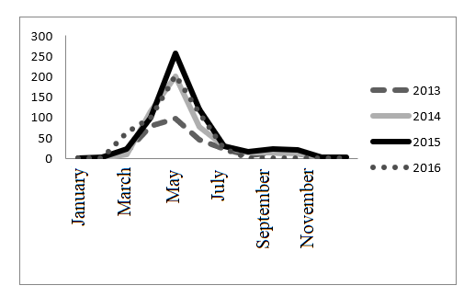
Figure 1 – Monthly dynamics of tick bites appeal/cases in the Almaty region for the period of 2013-2016

The figure shows that over 4 years, the number of complaints about tick bites in the Almaty region has almost doubled (from 294 in 2013 to 595 cases in 2016). The dynamics of the expansion of the tick bites season is observed. So, if earlier all tick bites were registered from March to October, then in recent years the first bites of the year are recorded already in January-February, and the last in November-December, which is apparently associated with the abnormal warming observed recently. As shown in figure 1, the number of bites, generally, increases in March, peaking in May, and sharply declining in July. However, a significant number of tick bites are recorded until October, and a few - in November-December. In September-October, there is a slight increase in the number of complaints with tick bites.
Individuals who applied with tick bites were examined for tick-borne encephalitis. As it is seen from Table 2, there is a significant percentage of people with a history of febrile conditions (an average of 29% of people bitten by ticks). Of those only 12% were diagnosed with tick-borne encephalitis (TBE), which suggests that the rest of the patients had other infections transmitted by tick bites and accompanied by fevers, including tick-borne rickettsioses.

Table 2 – The number of people bitten by ticks in the Almaty region for the period of 2013-2016, with a confirmed diagnosis of tick-borne encephalitis
Year | 2013 | 2014 | 2015 | 2016 | Average
Persons applied with tick bites | 294 | 472 | 595 | 500 | 465
Persons with febrile conditions (%) | 107 (36%) | 152 (32) | 182 (31%) | 84 (17%) | 131  (29%)
Of these, persons with a confirmed diagnosis of TBE | 16 (15%) | 23 (15%) | 12 (7%) | 8  (10%) | 15  (12%)

Thus, the analysis of the rickettsiosis incidence and the analysis of archived data for 2013-2016 indicate an increase in the incidence of tick-borne rickettsioses in the Republic of Kazakhstan, an extension of the season of tick attacks in recent years. As well as an increase in tick attacks and the presence in persons bitten by ticks of other undiagnosed infections, except tick-borne encephalitis, which, in turn, indicates the need to study the distribution of rickettsioses and other diseases transmitted by tick bites among the population of the southern region of Kazakhstan, in particular the Almaty region.
3.2 Analysis of data on ticks collected in the southern region of Kazakhstan
As part of the project, ticks collection in the southern region of Kazakhstan during the epidemic seasons of 2018, 2019 and 2020 and their morphological identification with the definition of the taxonomic group to the species was performed, a geodatabase of tick collection points was created in Excel format to clarify the species diversity in places of distribution.
In the epidemiological season of 2018, within the framework of collaboration, 427 ticks taken from humans were received from the SPCSEEM. Also, in 2018, 179 ticks were collected and identified to a species (collection was carried out in April) in the foothill areas of the Zhambyl region using the “flag” method. Among them, 3 species of ticks belonging to the Ixodidae family were identified: D. niveus, D. reticulatus, Ha. рunctata (data not shown). In the spring-summer 2019 epidemiological season, 25 ticks were collected in the Ili district of the Almaty region during a field trip using the “flag” method. Also, 479 ticks were collected in the Turkestan region using the "flag" method. In the epidemiological season of spring-summer 2020, due to quarantine measures to prevent the spread of SARS-CoV-2 in the Republic of Kazakhstan, tick collection was suspended from March to May. In May 5 ticks were collected in the Zailiyskiy Alatau mountains (Almaty region) using the “flag” method, which belonged to Ixodes persulcatus (n = 4) and Ha. punctata (n = 1) species. Additionally, 2 ticks were obtained from people with tick bites, which belonged to I. persulcatus species and the genus Haemaphysalis. A total of 1,117 ticks were collected during the project..
Below is given an analysis of the ticks species diversity collected from bitten people during the 2018 epidemiological season (see Table 3).

Table 3 – Species and sex/gender of ticks taken from people who applied to hospitals in the southern region of Kazakhstan in the epidemiological season of 2018
Species name | Quantity
Species name | Females | Males | Gender not established | Total quantity (%)
D. marginatus | 33 | 15 | 1 | 49 (11,5%)
D. reticulatus | 1 | 4 | - | 5 (1,2%)
Ha. punctata | 47 | 75 | 2 | 124 (29,0%)
Hyalomma asiaticum | 5 | 7 | 1 | 13 (3,0%)
Rh. turanicus | 45 | 146 | 1 | 192 (45,0%)
I.persulcatus | 37 | 2 | 1 | 40 (9,4%)
Ixodes | 1 | - | - | 1 (0,2%)
Species and genus not established | - | - | 3 | 3 (0,7%)
TOTAL (%): | 169(39,6%) | 249 (58,3%) | 9 (2,1%) | 427 (100%)

As can be seen from Table 3, a total of 6 following ticks species were identified: D.marginatus, D.reticulatus, Ha. punctata, Hy.asiaticum, Rh. turanicus, I.persulcatus. Rh. turanicus (192/427; 45,0%; 95% CI: 40,1-49,8%) and Ha. punctata (124/427; 29,0%; 95% CI: 24,8-33,6%) were the most common types of ticks removed from bitten people. At the same time, 58.3% (249/427; 95% CI: 53.4-63.0%) of the identified ticks were males and 39.6% (169/427; 95% CI: 34.9-44.4% ) - females, for 9 ticks, sex could not be determined. Our data show that residents of Almaty city and Almaty region are most often attacked by Rh. turanicus and Ha. punctata, which depends on the specific landscape zone where the tick attack occurred. Thus, ticks of the genus Haemaphysalis are confined to the meadow-steppe and meadow landscape, to the valleys of mountain rivers, forest-steppe and steppe zones, while ticks of the genus Rhipicephalus prefer Artemisia-cereal steppes and semi-deserts [14, 21].
Information on the age and sex category of people attacked by ticks is shown in table 4. The analysis showed that women and men are attacked by ticks with approximately the same frequency. At the same time, children (0-18 years old) are much more likely to be attacked by ticks (288/427; 67,4%; 95% CI: 62,7-71,9%).

Table 4 – Data on the age and sex category of people attacked by ticks in the southern region of Kazakhstan
Gender | female | 205 (48,1%)
Gender | male | 222 (51,9%)
Age | 0-18 years old | 288 (67,4%)
Age | 19-65 years old | 122 (28,6%)
Age | 66 and older | 17 (4,0%)

3.3 Analysis of the distribution of spotted fever group rickettsia in ticks in the southern region of Kazakhstan
Suspensions from 428 individual ticks were obtained using a hermetic homogenizer Homogenizer Mixer Mill MM 400 (Retsch); used ticks were collected from people bitten by ticks who applied to medical institutions in Almaty and Almaty region in 2018 (n=427) and in 2020 (n=1). Nucleic acids were extracted from the obtained tick homogenates using “RIBO-sorb” and "RIBO-prep" commercial kits, followed by spectrophotometric analysis of the obtained NA samples. The average DNA concentration in the isolated samples composed 84.0 ± 5.7 μg/ml. In order to perform screening of 428 obtained tick homogenates, "RealBest DNA of Rickettsia species" (Vector-Best, Russia) validated kits based on PCR with hybridization-fluorescence detection of products in real time using primers and probes specific to the Rickettsia spp., rickettsia of the spotted fevers group were used. 235 positive for Rickettsia spp. DNA samples were analyzed for the presence of R. sibirica and R. heilongjiangensis DNA using "RealBest DNA Rickettsia sibirica/Rickettsia heilongjiangensis" (Vector-Best, Russia) validated kits. The use of validated kits based on real-time PCR made it possible to detect rickettsia DNA in ticks removed from humans with a higher sensitivity than when using classical PCR. Figure 2 shows representative kinetic curves of Rickettsia spp. DNA amplification for one of a series of 34 samples.

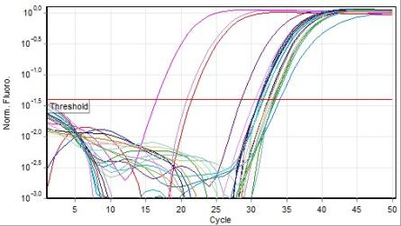

Reporter fluorescence levels (Norm. Fluoro.) from the ROX channel (Orange), on which Rickettsia spp DNA was detected, are plotted against the cycle number (Cycle). The threshold is set at 0.04 as instructed in the manufacturer's instructions. The Ct for the positive control was 21.54. Negative control did not respond positively as expected.

Figure 2 – Chart of Rickettsia spp. DNA detection in ticks by real-time PCR

The cumulative data of the performed real-time PCR analysis are presented in the Table 5.

Table 5 – The results of a PCR study of ticks taken from individuals bitten by ticks in Almaty and Almaty region for the content of Rickettsia spp. DNA.
Species name | Quantity
Species name | Total number of samples analyzed (%) | Rickettsia spp.
Species name | Total number of samples analyzed (%) | posit. (%) | negat. | ambig.
Rh. turanicus | 189 | 130 (68,8%) | 59 | -
D.marginatus | 48 | 40 (83,3%) | 8 | -
D.reticulatus | 5 | 4 (80%) | 1 | -
Ha. punctata | 124 | 80 (64,5%) | 43 | 1
Hy.asiaticum | 13 | 8 (61,5%) | 5 | -
I.persulcatus | 39 | 30 (76,9%) | 9 | -
Ixodes spp. | 1 | 1 (100%) | - | -
Species not determined | 9 | 6 (66,7%) | 3 | -
TOTAL | 428 | 299 (69,9%) | 128 | 1

Table 5 shows that a total of 6 ticks species belonging to 5 genera of ticks of the Ixodidae family were studied. Unfortunately, some of the ticks were severely damaged when removed by the bitten people themselves, and it was possible to determine either only the genus, or it was not possible to identify them morphologically at all. The overall infection rate of the examined ticks removed from bitten people with rickettsia of the spotted fever group composed 69.9% (299/428; 95% CI: 65.5-74.2%). DNA of Rickettsia spp was found in all of the 6 studied tick species, while their level of infection did not differ significantly. The infection rate of females (70.3%) and males (73.2%) also did not differ. In general, our data indicate a high level of infection of the Ixodidae family ticks in the Almaty region with rickettsia of the spotted fever group.
Further study of 235 mite homogenates showed the presence of R. sibirica in 7.2% of DNA samples (17/235; 95% CI: 4.2-11.3%) obtained by homogenization of D. marginatus (8/17) and Ha. punctata ticks (9/17). No R. heilongjiangensis DNA was detected (data not shown).
Rickettsiae have a wide range of pathogenicity and can be divided on this basis into three groups - classic pathogens, new pathogens and symbionts of eukaryotic cells, mainly insects. The classic pathogens include representatives of the typhus group (R. prowazekii, R. typhi), as well as the three most significant representatives of the group of tick-borne spotted fevers: R. rickettsii - the causative agent of Rocky Mountain spotted fever, R. conorii - Mediterranean fever, R. sibirica - the causative agent of tick-borne typhus of North Asia. New pathogens include R. slovaca, R. helvetica, R. honei, R. africaе, R. mongolotimonae, R. felis, R. aeschlimannii, R. canadensis, R. heilongjiangensis, R. parkeri, R. raoultii, R. monacensis and others, the etiological role of which has been established in recent years [21]. Earlier on the territory of Kazakhstan, the circulation of the following 5 types of pathogenic rickettsia was established: R. sibirica, R. conorii subsp. caspia, R. raoultii, R. aeschlimannii и R. slovaca [4-7]. Moreover, in the southern region of Kazakhstan, the circulation of new, not yet described species of rickettsia with unknown pathogenicity is expected. [7]. R. sibirica has been confirmed as an etiological agent of rickettsioses in the northern regions of Kazakhstan, and has not been registered in the southern region of Kazakhstan until now. Our study of individual ticks taken from bitten people in the Almaty region using validated kits showed that the D. marginatus and Ha. punctata ticks were infected with the pathogenic R. sibirica species, and their infection rate composed 22.2% (8/36; 95% CI: 10.1-39.1%) and 8.5% (9/106; 95% CI: 3, 9-15.5%), respectively. We were unable to identify using the real-time PCR method which genotype of R. sibirica sensu stricto, R. sibirica BJ-90, or R. sibirica subsp. mongolitimonae refers to the rickettsia we discovered. Nevertheless, it can be assumed that it belongs to R. sibirica subsp.mongolitimonae, since early studies showed the circulation of this genotype in ticks on the territory of China bordering Kazakhstan [5]. Clinically, the disease is manifested by fever, primary affect at the site of tick attachment, regional lymphadenitis, roseola-papular polymorphic rash, relative benign course. The vessels of the skin are mainly affected, and not the brain, the destruction of vascular endothelial cells is less pronounced [21].
Thus, at this stage of work, using a validated test system, we were able to detect for the first time the circulation of the Siberian tick-borne typhus pathogen in ixodid ticks on the territory of the Almaty region.
3.4 Study of rickettsia species and their genotypes circulating in the southern region of the Republic of Kazakhstan
At the next stage of the work, the Sanger sequencing method and RFLP analysis were used to identify the species of rickettsia found in ticks taken from bitten people using genus-specific real-time PCR. To optimize the sequencing conditions for samples that showed a positive result for rickettsia DNA, a positive control sample (kindly provided by the staff of the M. Aikimbaev National Scientific Center for Especially Dangerous Infections of the Ministry of Health of the Republic of Kazakhstan) was used with 3 pairs of primers specific for 16S, OmpA, GltA loci (see Table 1). The reaction was carried out with 10 samples of ticks homogenates. A representative electrophoretogram of 1.5% agarose gel is shown in figure 3.
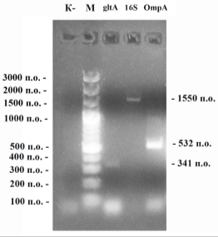

К- – negative control. М – DNA ladder 100 bp GeneRuler (Thermo Fisher Scientific, США). gltA – amplification of the gltA locus using primers Rick_gltA-816-843-FW and Rick_gltA-1135-1156-Rev; 16S – amplification of the 16S locus using primers Rick_16S-FW and Rick_16S-Rev; OmpA – amplification of the OmpA locus using primers Rr-190-70p-FW and Rr-190-602n-Rev.

Figure 3 – Optimization of rickettsia detection in ticks by classical PCR

As can be seen from the electrophoretogram, the most clear and bold bands were obtained using a pair of primers Rr-190-70p-FW/Rr-190-602n-Rev and Rick_gltA-816-843-FW/Rick_gltA-1135-1156- Rev, therefore the subsequent genetic characterization of rickettsia was carried out mainly at the OmpA and GltA loci.
Representative results of the RFLP analysis of PCR products obtained by amplification of the OmpA locus of rickettsia with primers Rr-190-70p-FW and Rr-190-602n-Rev are shown in Figure 4.
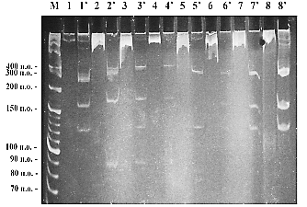
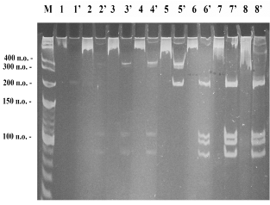
А B

А – Treatment with RsaI; B – Treatment with PstI. 1-8 – samples before restriction;
1’-8’ – samples after treatment with restriction endonucleases. М – DNA ladder (100bp + 10bp, Thermo Fisher).

Figure 4 – Electrophoretic analysis in 8% polyacrylamide gel (1xTBE) of RFLP products of the OmpA locus amplification

To determine the species of rickettsia, amplifications of 2 loci of the OmpA gene and 1 locus of GltA obtained using the primers Rr-190-70p-FW/Rr-190-602n-Rev, Rr-3588-3607-FW/Rr-4406-4387-Rev, Rick_gltA-816-843-FW/Rick_gltA-1135-1156-Rev of 532, 818 and 341 bp, respectively, were eluted from 1.5% agarose gel and sequenced from both ends. The results of phylogenetic analysis of rickettsia DNA samples using Sanger sequencing are presented in Figures 5 and 6. Characteristics of ticks from which rickettsia were isolated are presented in Table 6. All ticks were collected from bitten people in the Almaty region in 2018.
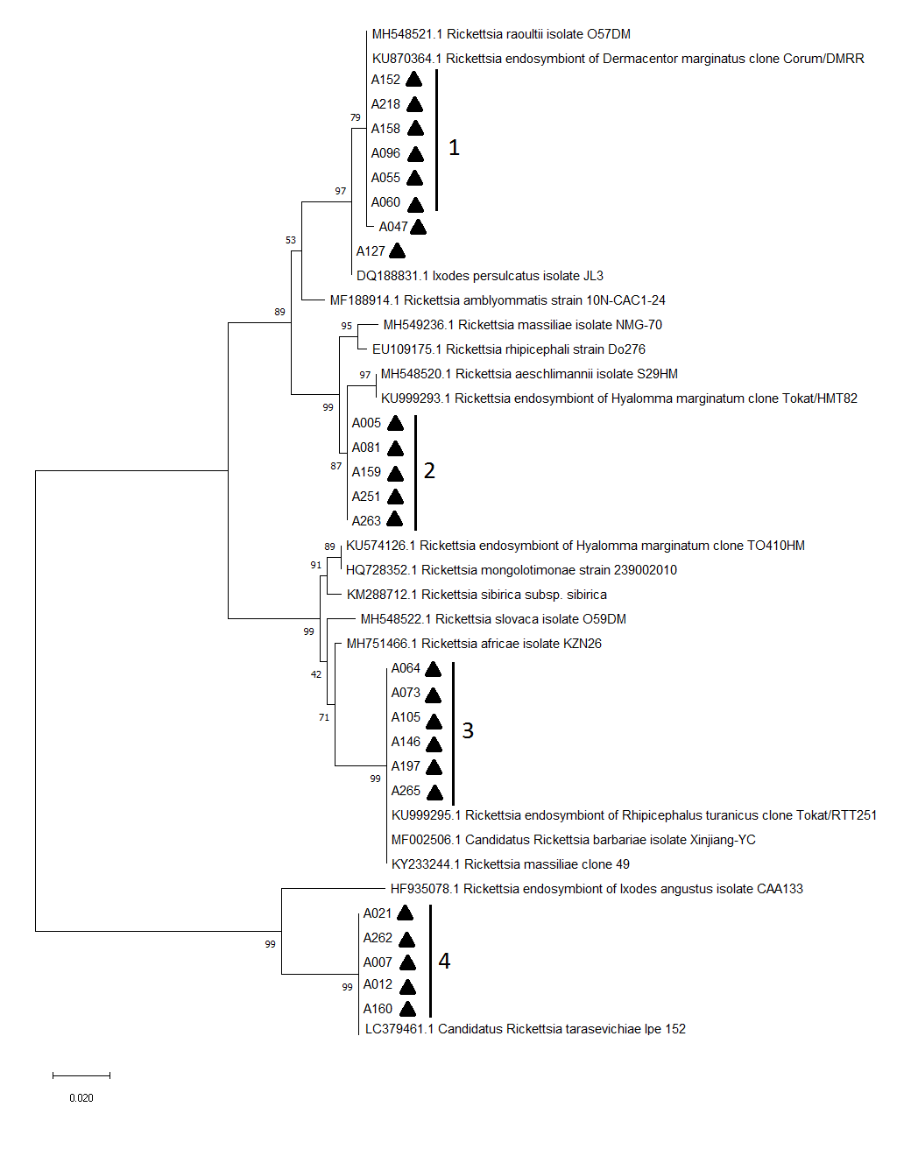

Samples numbered A005-A265, marked with a geometric figure, are samples from this study. The scale unit corresponds to 0.020 nucleotide substitution per one nucleotide position.

Figure 5 - Phylogenetic tree of Rickettsia spp. detected in ticks, constructed on the basis of the locus 190-70 and 190-602 of the OmpA gene, using the MEGA-X software

Phylogenetic analysis of the nucleotide sequences of the locus 190-70 and 190-602 of the OmpA gene showed that most of the analyzed sequences could be grouped into four clades (see Fig. 5). Comparison with the known sequences from GenBank showed that clade 1 (n = 7) was homologous (98-100%) to the corresponding sequences of R. raoultii and R. endosymbiont of D. marginatus. Clade 2 (n = 5) was homologous (98.3-98.9%) to the nucleotide sequences of R. aeschlimannii and R. endosymbiont of H. marginatum. The closest Rickettsia species to clade 3 (n = 6) were Candidatus R. barbariae, R. massiliae, and R. endosymbiont of Rh. turanicus, which had 100% nucleotide sequence similarity. Clade 4 (n = 5) was identical (100%) to Candidatus R. tarasevichiae.

Table 6 - Data on the species and sex of the ticks from which the rickettsial isolates were obtained and sequenced

# | Sample number in the AB NCB database | Sample number in the figure | Species and sex of the tick
1 | KZ01-05052019-A005A1 | А005 | D.marginatus, female
2 | KZ01-05052019-A007A1 | А007 | I.persulcatus, female
3 | KZ01-05052019-A012A1 | А012 | I. persulcatus, female
4 | KZ01-05052019-A021A1 | А021 | D.marginatus, female
5 | KZ01-05052019-A047A1 | А047 | D.marginatus, female
6 | KZ01-05052019-A055A1 | А055 | D.marginatus, female
7 | KZ01-05052019-A060A1 | А060 | D.marginatus, female
8 | KZ01-05052019-A064A1 | А064 | Ha.punctata, male
9 | KZ01-05052019-A073A1 | А073 | Ha.punctata, male
10 | KZ01-05052019-A081A1 | А081 | Ha.punctata, male
11 | KZ01-05052019-A096A1 | А096 | D.niveus, male
12 | KZ01-18072019-A105A1 | А105 | Rh. turanicus, female
13 | KZ01-18072019-A127A1 | А127 | D.reticulatus, female
14 | KZ01-19072019-A146A1 | А146 | Rh. turanicus, male
15 | KZ01-19072019-A152A1 | А152 | D.niveus, male
16 | KZ01-19072019-A158A1 | А158 | D.marginatus, male
17 | KZ01-19072019-A159A1 | А159 | Ha.punctata, female
18 | KZ01-19072019-A160A1 | А160 | I.persulcatus, female
19 | KZ01-19072019-A197A1 | А197 | Ha.punctata, male
20 | KZ01-19072019-A218A1 | А218 | D.marginatus, female
21 | KZ01-19072019-A251A1 | А251 | Ha.punctata, male
22 | KZ01-19072019-A262A0 | А262 | D.marginatus, male
23 | KZ01-19072019-A263A1 | А263 | Rh. turanicus, male
24 | KZ01-19072019-A265A1 | А265 | Rh. turanicus, male

Further refinement and confirmation of the results obtained for isolates from each clade was carried out by sequencing the gltA gene fragments (see Fig. 6).
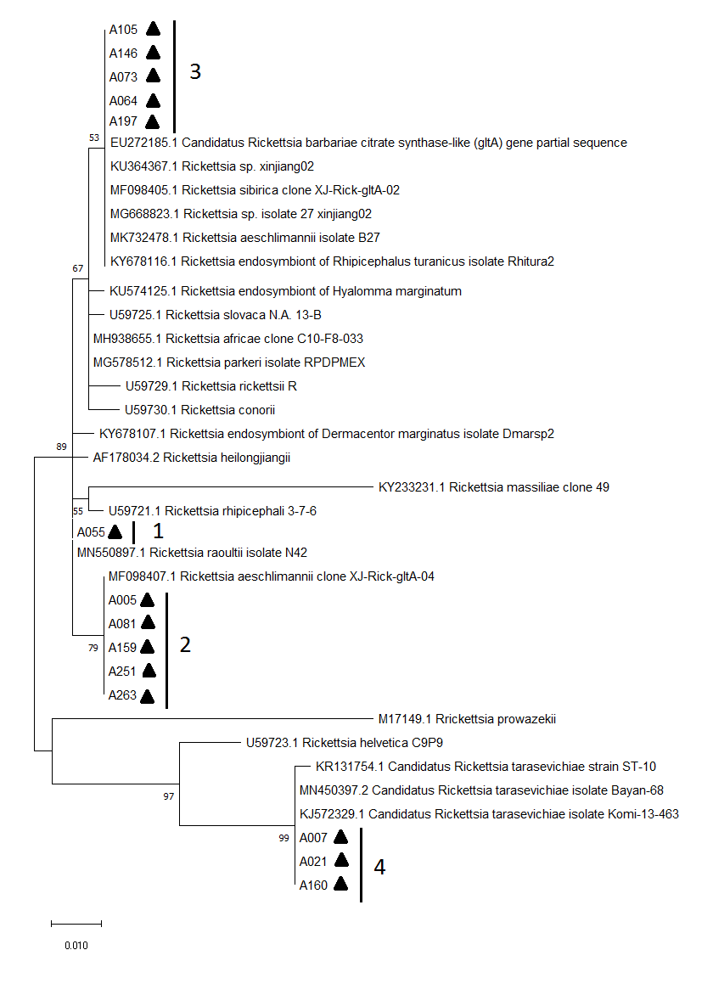

Samples numbered A005-A263, labeled with a geometric figure, are samples from this study. The scale unit corresponds to 0.010 nucleotide substitution per one nucleotide position.

Figure 6 – Phylogenetic tree of Rickettsia spp., detected in ticks, constructed on the basis of locus 816-843 and 1135-1156 of the GltA gene, using the MEGA-X software

As seen from the figure, similar clades were obtained. In particular, it was confirmed that the gltA gene sequences of three rickettsia DNA samples (A007, A021, A160) were identical to Candidatus R. tarasevichiae. The gltA gene fragment sequences of DNA samples from clade 2 were identical to the sequences of R. aeschlimannii isolates. At this stage of the work, we managed to exclude the non-pathogenic species R. endosymbiont of H. marginatum for DNA samples of rickettsia from this clade. Sample A055, isolated from the D. marginatus tick, from clade 1 had 100% identical sequences of the studied gltA gene locus, as well as the 190-70 and 190-602 OmpA locus characteristic of R. raoultii. It is noteworthy that at this stage it was not possible to identify the belonging of the rickettsia DNA samples from clade 3 to the supposed species of Candidatus R. barbariae, R. massiliae and R. endosymbiont of Rh. turanicus.
Sequencing of locus 3588-3607 and 4406-4387 of the OmpA gene of 9 rickettsia DNA samples confirmed the homology of the sample A055 with R. raoultii by 99.7%. The closest Rickettsia species to isolates A005, A081, A159, A251, and A263 was R. aeschlimannii (data not shown).
Thus, in our study, the circulation of 3 pathogenic rickettsia species Candidatus R. tarasevichiae, R. aeschlimannii and R. raoultii in the territory of the Almaty region was shown when sequencing 2 loci of the OmpA genes and 1 locus of the gltA gene. Early studies have shown that 3 types of rickettsia with proven pathogenicity for humans circulate in the Almaty region: R. slovaca, R. raoultii and R. aeschlimannii. R. slovaca DNA was found in D. marginatus, R. raoultii DNA was shown in D. marginatus and D. reticulatus [7]. R. aeschlimannii was found in 6% (2/36) of Ha. punctata collected from vegetation [6]. Our results also suggest that the main reservoirs and vectors of R. raoultii and R. aeschlimannii in the Almaty region are ticks belonging to the genus Dermacentor (mainly D. marginatus) and Haemaphysalis. R. raoultii was first described by serological methods and DNA detection in the blood of patients as an etiological agent of TIBOLA syndrome (Tick-borne lymphadenopathy or Dermacentor-borne necrosis-erythema-lymphadenopathy). Clinical manifestations of the syndrome include the formation of primary cutaneous affect (82% of patients), which may be surrounded by round erythema (21%), enlarged and sometimes painful lymph nodes in the area of the tick bite, fever, fatigue, dizziness, headache, sweating, myalgia, arthralgia and loss of appetite. Without treatment, symptoms may persist for up to 18 months [22]. Disease cases caused by R. aeschlimannii have also been reported in the literature [23, 24].
Candidatus R. tarasevichiae is another species of rickettsia, the circulation of which in the territory of the Almaty region, we demonstrated for the first time. Candidatus R. tarasevichiae is a rickettsia with proven pathogenicity for humans, the main vector of which, according to the literature, are I. persulcatus ticks [25]. The high infection rate of I. persulcatus ticks by this microorganism was determined in a number of regions in neighboring Russia [26]. Later, bacteria were identified as causative agents of the disease characterized by asthenia, anorexia, headache, primary skin affect and lymphadenopathy in 5 patients in the PRC. Moreover, complications in the form of renal dysfunction and respiratory acidosis in one of the patients led to the death of the patient [27]. A fatal outcome has been described for mixed infection with Candidatus R. tarasevichiae and R. sibirica subsp. sibirica in Russia [28]. In our study, Candidatus R. tarasevichiae was detected in 2 species of ticks: I. persulcatus (n = 3) and D. marginatus (n = 2), which suggests the presence of this rickettsia in other tick species, except for I. persulcatus, but their ability to be vectors remains unclear.
Thus, we have confirmed the circulation of rickettsia pathogenic species R. aeschlimannii and R. raoultii and for the first time discovered the circulation of previously unseen pathogenic species R. sibirica and Candidatus R. tarasevichiae in ticks of the Almaty region, which is currently not considered an endemic territory for rickettsioses. The potential severeness of infection with Candidatus R. tarasevichiae and other types of detected rickettsiae indicates an urgent need to develop a system for epidemiological surveillance of rickettsiae in the Almaty region. The data we obtained are of significant interest, since the study used DNA samples from ticks taken from people with tick bites, and, therefore, reflect the immediate risk of infection with rickettsiosis in the study area. Among the limitations of the analysis, it should be noted that we did not have access to information on the health status of people bitten by ticks, from which pathogenic rickettsia was isolated.
3.5 Standard operating procedures
As part of the assignment, a number of internal standard operating procedures (SOPs) for the indication and diagnosis of rickettsioses were developed and approved (Appendix F). The SOP includes the following sections: purpose; scope of application; responsibilities of staff; specific safety, biosafety and biosecurity issues; samples handling; reagents-materials-equipment; quality assurance/control; procedure; interpretation of results; a brief outline of the analysis. All SOPs mentioned in the report have been tested on the basis of the Central Reference Laboratory.
3.6 Analysis of the distribution of rickettsioses among the population of the southern region of Kazakhstan
Serum were collected from residents of the region, as well as from febrile patients who applied to medical institutions in the region in 2018, 2019 and 2020 in order to analyze the distribution of rickettsioses among the population of the southern region of Kazakhstan. In 2018, 46 blood serum samples were collected from 23 patients with fevers of unknown origin (blood was taken twice - at the time of the patient's admission to the infectious diseases hospital and his discharge) and 288 serum samples from people bitten by ticks in Almaty city and Almaty region.
In 2019, 1303 serum samples were collected from a conventionally healthy population of the Turkestan region with the widest possible coverage of the territory (Sholakkorgan, Turkestan, Taukent, Zhetisay, Maktaral, Ordabasy and Otyrar districts) and 11 blood serum samples from febrile patients showing clinical signs, similar to rickettsioses registered in the hospitals of the Turkestan region (Turkestan town, Lenger town, Otyrarsky, Ordabasy and Baidibek districts). Also 154 serum from febrile patients registered in hospitals in the Almaty region were collected in duplicates. The first sample was taken upon admission of the patient, the second sample - after 7-10 days. All information on samples is entered into the database.
In 2020, 6 serum samples were collected from a conventionally healthy population of Almaty and 1330 serum samples from conditionally healthy people of the Turkestan region for screening research. Also, 100 blood serum samples were collected from patients hospitalized in hospitals in Taraz. Serum samples are stored in two aliquots at -20°C. All information on collected samples is entered into the database in Excel format.
3.6.1 Prevalence of antibodies to R. typhi among the population of the southern region of Kazakhstan, epidemiological characteristics of endemic typhus.
Serum samples from 253 people were used for the study. The average age of the studied population was 36.9 years (range 1-71 years), of which 142 were women (56.1%) and 111 were men (43.9%). The collection of serum samples took place in hospitals, clinics, as well as during visits to local residents in cities and administrative centers of the southern region of Kazakhstan (Figure 7).
Of the 253 analyzed samples, 87 (34.4%; 95% CI: 28.5-40.9%) were positive for IgG to R. typhi, of which 15 samples (17.2%) had a very high antibody titer (OD of the sample exceeded the OD value of Cutoff Calibrator more than 4 times), 44 samples (50.6%) had a high antibody titer (OD of the sample exceeded the OD of the Cutoff Calibrator 2-4 times), and 28 samples (32.2%) had low antibody titer (the OD of the sample exceeded the OD of the Cutoff Calibrator less than 2 times). The highest percentage of seropositive samples was found in the Turkestan region and in the village of Zhalandy, Almaty region (Table 7). Residents of the Turkestan region, in comparison with those living in the Almaty region, had the highest risk of infection with R. typhi (OR=128,3, 95% CI=29,7; 553,9; p<0,001). In Almaty region, the risk of infection with R. typhi among residents of the village Zhalandy 8 times (OR = 8.6, 95% CI = 2.7; 27.3; p <0.0001) exceeded that of residents of Almaty (reference value).

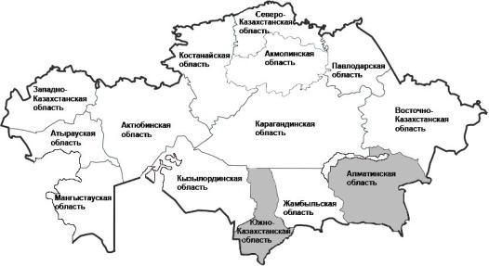

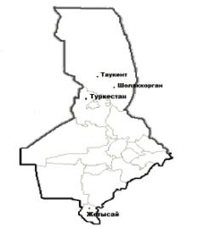
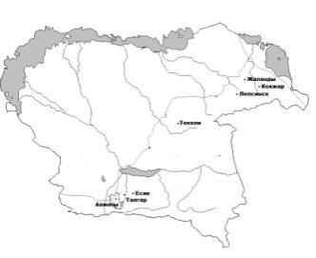

Figure 7 – Blood sampling sites from the population for testing for antibodies
to R. typhi

Table 7 – Prevalence of antibodies to R. typhi among the population of the southern region of Kazakhstan
Oblast of the southern region of Kazakhstan | City/administrative center | Number of examined serum samples | Number of samples positive for R. typhi IgG (%) | Number of samples negative for R. typhi IgG (%) | Number of samples doubtful for R. typhi IgG (%)
Turkestan (previously known as South Kazakhstan) oblast | Sholakkorgan | 15 | 14 (93,3%) | - | 1 (6,7%)
Turkestan (previously known as South Kazakhstan) oblast | Taukent | 15 | 15 (100%) | - | -
Turkestan (previously known as South Kazakhstan) oblast | Zhetisay | 16 | 13 (81,3%) | 2(12,5%) | 1 (6,2%)
Turkestan (previously known as South Kazakhstan) oblast | Turkestan | 15 | 14 (93.3%) | - | 1 (6.7%)
Turkestan (previously known as South Kazakhstan) oblast | Total by oblast | 61 | 56 (91,8%) | 2 (3,3%) | 3 (4,9%)
Almaty oblast | Esik | 11 | 2 (18,2%) | 9 (81,8%) | -
Almaty oblast | Talgar | 2 | 0 | 1 (50%) | 1 (50%)
Almaty oblast | Almaty | 56 | 4 (7,1%) | 50 (89,3%) | 2 (3,6%)
Almaty oblast | Kokzhar | 5 | 0 | 4 (80%) | 1 (20%)
Almaty oblast | Zhalandy | 69 | 22 (31,9%) | 32 (46,4%) | 15 (21,7%)
Almaty oblast | Lepsinsk | 49 | 3 (6,1%) | 46 (93,9%) | -
Almaty oblast | Total by oblast | 192 | 31 (16,1%) | 142 (74,0%) | 19 (9,9%)
Total by region |  | 253 | 87 (34,4%) | 144 (56,9%) | 22 (8,7%)
Seroprevalence was the same in women and men (Table 8). The average age of the seropositive population was 37.3 ± 14.7, while the average age of seronegative donors was 35.9 ± 16.2. The performed logistic regression analysis did not reveal statistically significant reliable differences in the association of seropositivity with age (data not shown). When stratified by age group, seropositivity was also not significantly associated with age, however, positive results were not found in the age group of children under 14 years of age (Table 8). Interestingly, living in rural areas was not associated with seropositivity to R. typhi (Table 8).

Table 8 – Demographic data of persons from the southern region of Kazakhstan, tested for the presence of antibodies to R. typhi
Criterion | Number of examined serum samples (%) | Number of samples positive for R. typhi IgG (%) | Number of samples negative for R. typhi IgG (%) | Number of samples doubtful for R. typhi IgG (%) | OR (95% CI)
1 | 2 | 3 | 4 | 5 | 6
Gender
male | 111 (43,9%) | 32 (28,8%) | 68 | 11 | 1
female | 142 (56,1%) | 55 (38,7%) | 76 | 11 | 1,5 (0,9; 2,6)
Age group
up to 14 years old | 11 (4,3%) | - | 10 | 1 | -
15-24 | 53 (20,9%) | 18 (33,9%) | 32 | 3 | 1
25-34 | 60 (23,7%) | 25 (43,8%) | 32 | 3 | 1,4 (0,6; 3,0)
35-44 | 47 (18,6%) | 18 (42,8%) | 24 | 5 | 1,3 (0,6; 3,1)
45-54 | 36 (14,2%) | 11 (33,3%) | 22 | 3 | 1,1 (0,4; 2,8)
55-64 | 31 (12,3%) | 8 (30,03%) | 18 | 5 | 1,3 (0,5; 3,5)
over 65 | 13 (5,1%) | 6 (50,0%) | 6 | 1 | 1,8 (0,5; 6,3)
data not known | 2 (0,8%) | 1 | - | 1 | -
Residence
City (Zhetisay, Turkestan, Esik, Talgar, Almaty) | 100 (39,5%) | 33 (33,0%) | 62 | 5 | 1
Village (Sholakkorgan, Taukent, Kokzhar, Zhalandy, Lepsinsk) | 153 (60,5%) | 54 (35,3%) | 82 | 17 | 1,2  (0,7; 2,1)
Note – OR – odds ratio, 95% CI - confidence interval

Cases of endemic typhus and seropositivity to R. typhi are registered in neighboring China and Russia [29, 30], however, there is currently no statistics on the incidence of endemic typhus in Kazakhstan. The results of our study suggest that the territory of the southern region of Kazakhstan, in particular the Turkestan and Almaty regions, is the area of active circulation of R. typhi. So, one third of the population sample of the studied southern region of Kazakhstan had IgG antibodies to R. typhi.
Detection of serum IgG antibodies to R. typhi was performed by enzyme linked immunoassay using a commercial test system Rickettsia typhi IgG ELISA Kit (Fuller Laboratories, США). It should be noted that, despite the high specificity (97%) of this test system, manufacturers note the likelihood of cross-reactivity against R. prowazekii in cases of high titers of serum IgG antibodies. Thus, we cannot exclude the possibility that high seropositivity, at least in people over 65, could be associated with a previous epidemic typhus.
The results of the analysis demonstrated that the Turkestan region, where the percentage of seropositive on average reached 91.8% (56/61; 95% CI: 81.9-97.3%), can be considered an endemic territory for R. typhi. A significantly lower percentage of seropositive samples (on average 16.1% in the region) was found in residents of the Almaty region. In the Almaty region, out of 6 studied districts, the highest level of seropositive results was shown in the Zhalandy village. Such differences may be related to the ecosystem in the study area, contributing to the spread of rats and other rodent vectors of the disease, living in adobe houses with crevices made of clay and straw, and the lack of measures to control rodents. In addition, previous studies have shown that the spread of endemic typhus is usually associated with poor sanitary and hygienic living conditions [31].
Since our study did not reveal any significant differences between urban and rural residents, we can assume that both populations are equally susceptible to risk factors. Nevertheless, it should be noted that in such cities as Talgar, Esik, Zhetisay, private farming is significantly developed, which increases the risk of contact with rodents and domestic animals - vectors of endemic typhus. We also showed that both women and men are equally susceptible to risk factors for infection with R. typhi. Results are consistent with previous studies in other countries [32-35]. Age was also not associated with seropositivity, which indicates that over time and the accumulation of exposure, antibodies cannot accumulate at the population level, and, consequently, the instability of immunity to R. typhi. Interestingly, seropositive samples were not detected in the age group of children under 14. Such results may be due to the small sample size of this age group (11 people, 4.3% of the total sample), or indicate that children under 14 years old are not at risk of infection with R. typhi, possibly due to the fact that they do not participate in work, which is a risk factor for infection [33].
The study has several limitations. First, it is not possible to say for certain whether individuals with seropositivity to R. typhi IgG antibodies have had disease in the past. Secondly, since only one serum sample was obtained from each subject, we cannot assess whether they had an increase in antibody titer. In general, performed monitoring showed a very high prevalence of seropositivity (by IgG) to R. typhi in the southern region of Kazakhstan, in particular in the Turkestan region. We do not exclude the possibility that the observed high seropositivity in the region could be associated with the cluster collection of serum samples, in this regard, the data obtained may reflect seroprevalence only in a specific territory, and not in the entire region. Consequently, there is a need for further research in the region with a large coverage of the territory.
3.6.2 Seroprevalence of IgG antibodies to rickettsiae of the spotted fever group among the population of the southern region of Kazakhstan, epidemiological characteristics of tick-borne rickettsioses.
We used 93 blood serum samples obtained from residents of the southern region of Kazakhstan (Table 9). The collection of serum samples took place in hospitals, clinics, as well as during visits to local residents in the cities and administrative centers of the southern region of Kazakhstan. The age range of the studied population was 1–72 years with a median of 36.5 years and a mean of 36.7 years. Of the 93 analyzed samples, 21 (22.6%; 95% CI: 14.5-32.4%) were positive for IgG to rickettsia of the spotted fever group, and 8 samples (8.6%; 95% CI: 3, 8-16.2%) - doubtful (Table 9).
Table 9 – Prevalence of IgG antibodies to rickettsia of the spotted fever group among the population of the southern region of Kazakhstan
Oblast of the southern region of Kazakhstan | City/administrative center | Number of examined serum samples | Number of samples positive for rickettsia of the spotted fever group IgG (%) | Number of samples negative for rickettsia of the spotted fever group IgG (%) | Number of samples doubtful for rickettsia of the spotted fever group IgG (%)
Turkestan oblast | Sholakkorgan | 7 | - | 6 (85,7%) | 1 (14,3%)
Turkestan oblast | Taukent | 7 | - | 6 (85,7%) | 1 (14,3%)
Turkestan oblast | Zhetisay | 7 |  | 7 (100%) | -
Turkestan oblast | Turkestan | 7 | - | 7 (100%)
Turkestan oblast | Total by oblast | 28 | - | 26 (92,9%) | 2 (7,1%)
Almaty oblast | Esik | 8 | - | 8 (100%) | -
Almaty oblast | Talgar | 2 | - | 2 (100%) | -
Almaty oblast | Almaty | 19 | 3 (15,8%) | 16 (84,2%) | -
Almaty oblast | Kokzhar | 5 | 3 (60,0%) | 2 (40,0%) | -
Almaty oblast | Zhalandy | 5 | 1 (20%) | 4 (80%) | -
Almaty oblast | Lepsinsk | 6 | - | 5 (83,3%) | 1 (16,7%)
Almaty oblast | Tekeli | 20 | 14 (70,0%) | 1 (5,0%) | 5 (25,0%)
Almaty oblast | Total by oblast | 65 | 21 (32,3%) | 38 (58,5%) | 6 (9,2%)
Total by region |  | 93 | 21 (22,6%) | 64 (68,8%) | 8 (8,6%)
The highest percentage of seropositive samples was demonstrated in Tekeli, Almaty region, where IgG antibodies were determined in 70% (14/20; 95% CI: 45.7-88.1%) of the tested samples (Table 9). High seroprevalence was also noted in the Kokzhar village, where antibodies to rickettsiae of the spotted fever group were detected in 3 samples out of 5 studied. Interestingly, the positive results for the presence of antibodies against rickettsia of the spotted fever group were not detected in residents of the Turkestan region, but low antibody titers were shown in 2 out of 28 studied samples, which indicates that it is impossible to completely exclude the circulation of rickettsia of the spotted fever group on the territory of this region (Table 9).
Thus, the analysis of the obtained results allowed us to identify several types of natural foci of rickettsioses of the spotted fever group according to the degree of their epidemic activity from less active to more active.:
1) Esik city, Talgar city, no outbreak/foci, positive and questionable results in residents were not identified, additional research of a larger population cohort is required;
2) Lepsinsk village and Turkestan region, foci of weak activity - doubtful results (i.e. low titers of IgG) were detected in 16.7% and 7.1% of the studied samples, respectively;
3) Almaty city, foci of moderate activity - positive results were determined in 15.8% of samples. The city is located at the foothills of the northern slope of the Zailiyskiy Alatau;
4) Alakol district of Almaty oblast, Zhalandy village, foci of medium activity, positive results in 20% of residents. The village is located on hills overgrown with grass, the forest zone is at some distance;
5) Alakol district of Almaty oblast, a small village Kokzhar, a very active foci - a positive results was detected in 60%. The village is located in the Zhalandy rural district in the mountains in the forest zone;
6) Tekeli city, hyperendemic zone - a positive results was determined in 70.0% of the population, doubtful results - in 25%. When choosing data for Almaty as a reference value, residents of Tekeli were significantly more often infected with tick-borne rickettsiosis (OR=74,7, 95% CI=6,9; 802,1; p<0,0001). The city of Tekeli (44°49′48″ N, 78°49′26″ E) is located in the Eskeldy district (44°54′12″ N, 78°29′42″ E) Almaty oblast, which borders the People's Republic of China. The city is located in a valley covered with dense deciduous forest at the confluence of two rivers, there is also a mixed forest on the surrounding mountain slopes. The region is mountainous with an altitude of 1400–2200 m above sea level. Animal husbandry is widely practiced. Average annual rainfall is 250-300 mm.
The obtained results require confirmation conducting additional studies with a large number of samples, which, however, is difficult due to the high cost of specific test systems, as well as the difficulties with their acquisition due to their absence in the state register of the Republic of Kazakhstan. In addition, the Spotted Fever Rickettsia EIA IgG Antibody Kit (Fuller Laboratories, USA) used in current study does not detect group-specific antibodies and, therefore, is unable to differentiate reactivity to various members of the tick-borne spotted fever group. Nevertheless, the data obtained suggest a wider prevalence of rickettsial diseases of the spotted fever group than it was generally considered at the moment. The results of our serological study are consistent with the results of PCR analysis and DNA sequencing of rickettsiae isolated from ticks of the Almaty region, and indicate that the Almaty region can be considered as endemic for tick-borne rickettsioses and, therefore, it is necessary to continue monitoring the group of these diseases on territory of the region.
Next, we conducted an epidemiological analysis of the results obtained in order to identify groups and factors of susceptibility to tick-borne rickettsioses. The stratification of the data obtained by sex and age categories is presented in Table 10.

Table 10 – Demographic data of individuals from the southern region of Kazakhstan tested for the presence of IgG antibodies to rickettsia of the spotted fever group
Criterion | Number of examined serum samples (%) | Number of samples positive for rickettsia of the spotted fever group IgG (%) | Number of samples negative for rickettsia of the spotted fever group IgG (%) | Number of samples doubtful for rickettsia of the spotted fever group IgG (%) | OR (95% CI)
Gender
male | 41 (44,1%) | 5 (12,2%) | 32 | 4 | Ref.
female | 46 (49,5%) | 12 (26,1%) | 30 | 4 | 2,6 (0,8;8,1)
data not specified | 6 (6,4%) | 4 (66,7%) | 2 | 0
Age group
up to 14 years old | 5 | 1 (20,0%) | 4 |  | 2,1 (0,2;29,7)
15-24 | 11 | 0 | 11
25-34 | 19 | 2 (10,5%) | 17 |  | Ref.
35-44 | 16 | 3 (18,8%) | 11 | 2 | 2,3 (0,3;16,2)
45-54 | 14 | 2 (14,3%) | 11 | 1 | 1,5 (0,2;12,6)-
55-64 | 10 | 3 (30%) | 7 |  | 3,6 (0,5;26,7)
over 65 | 1 |  | 1 |  | -
data not specified | 17 | 10 (58,8%) | 2 | 5 | -
Note – OR – odds ratio, 95% CI - confidence interval

The table indicates that seropositivity for antibodies against rickettsia of the spotted fever group was moderately associated with female sex, but this association was not significant (p˃0.05), possibly due to an insufficiently representative samples selection. We did not revealed significant differences in the stratification of seropositivity by age category. Thus, it can be assumed that people of all age categories are equally susceptible to factors of infection with tick-borne rickettsiosis. However, it should be noted that we observed a tendency towards higher seropositivity among elderly people (over 55 years old), which may be associated with a longer duration of exposure. The data are consistent with the results obtained by other research groups, which showed a higher seropositivity to rickettsia of the tick-borne spotted fevers group among people over 45 years old [33, 35].
3.6.3 Seroprevalence of IgM antibodies to rickettsiae of the spotted fever group in patients with fevers of unknown origin/persons bitten by ticks in the southern region of Kazakhstan.
To diagnose acute forms of the disease, 72 patients were examined for the presence of IgM antibodies to rickettsia of the spotted fever group, who applied with a tick bite/acute fever to outpatient hospitals in the southern region of Kazakhstan (Table 11). The average age of the participants was 33 years (interval 1-64 years), while 35 (48.6%) were men, 26 (36.1%) were women, for 11 patients (15.3%) the data are not known, their medical history numbers were redirected to polyclinics to clarify the data.
Table 11 shows that all positive results were found in the Almaty region (4.9%; 3/61; 95% CI: 1.0-13.7%), wherein low antibody titers (doubtful results) were demonstrated in 9.8% (6/61; 95% CI: 3.7-20.1%) samples. Two serum samples that tested positive for antibodies to rickettsiae of the spotted fever group belonged to patients who appplied to hospitals with acute fever. One serum sample that tested positive for antibodies to rickettsiae of the spotted fever group was obtained from a person who reffered with a tick bite. The data obtained once again confirm that the Almaty region can be considered as an endemic territory for tick-borne rickettsioses and suggest their role in the structure of fevers of unknown origin, detected in residents of the southern region of Kazakhstan.

Table 11 – Prevalence of IgM antibodies to rickettsiae of the spotted fever group in patients with fevers of unknown origin who applied to medical institutions in the southern region of Kazakhstan
Oblast of southern region of Kazakhstan | City/administrative center | Number of examined serum samples | Number of samples positive for rickettsia of the spotted fever group IgM (%) | Number of samples negative for rickettsia of the spotted fever group IgM (%) | Number of samples doubtful for rickettsia of the spotted fever group IgM (%)
Turkestan oblast | Baydibek district | 2 | - | 1 | 1
Turkestan oblast | Otyrar district | 1 | - | 1 | -
Turkestan oblast | Lenger | 1 | - | 1 | -
Turkestan oblast | Ordabasy district | 1 | - | 1 | -
Turkestan oblast | Turkestan | 6 | - | 5 | 1
Turkestan oblast | Total by oblast | 11 | - | 9 | 2 (18,2%)
Almaty oblast | Esik | 8 | 1 | 6 | 1
Almaty oblast | Talgar | 2 | - | 2 | -
Almaty oblast | Almaty | 32 | 1 | 28 | 3
Almaty oblast | Tekeli | 19 | 1 | 16 | 2
Almaty oblast | Total by oblast | 61 | 3 (4,9%) | 52 | 6 (9,8%)
Total by region |  | 72 | 3 (4,1%) | 61 | 8 (11,1%)

3.6.4 Study of the medical history of a patient with suspected tick-borne rickettsiosis.
To identify the features of the clinical manifestations of rickettsia in the territory of southern Kazakhstan, at the next stage of work, we studied the case histories of patients with positive results for the presence of IgM antibodies to rickettsia of the spotted fever group, which, in accordance with the standard case definition, is a probable case. As an example, we describe the history of such a case from the city of Tekeli.
Patient Zh. fell ill on June 12, acutely, with the onset of fever (up to 39.4°C), sweating, general malaise, weakness, headache, dizziness, a dry cough appeared. For some time before, there were some complaints about pain in large joints. The intake of antipyretic and non-steroidal anti-inflammatory drugs did not have a lasting effect and the patient was admitted to the infectious diseases department on 15.06 (on the 3rd day of illness). Upon admission to the hospital, the patient had high fever, general malaise, weakness, loss of appetite, dizziness, headaches, sweating, dry cough, joint pain. General condition was of moderate severity due to intoxication, temperature was 39.0°C, skin was pale, moist, without rash, muffled heart sounds. Polyadenopathy, hyperemia of the pharynx, hemorrhagic rash on the mucous membrane of the soft palate were noted. There was an increase in the size of the liver by one cm. The shoulder joint on the right was swollen and painful on palpation, bursitis; pain when moving in the knee and shoulder joints. The patient denied a history of tick bites.
The patient suffered from acute brucellosis several years ago. Was examined for pain in the joints and on 11.06 received positive serological results for brucellosis - the agglutination reaction on glass (Heddelson's reaction) is positive, the volumetric agglutination reaction (Wright's reaction) - 1:200. As a result, a preliminary clinical diagnosis of "secondary chronic brucellosis" was made. The laboratory analysis showed a normal content of erythrocytes (4.0×10¹²/l), and leukocytes (5.3×10¹²/l); at the same time, neutropenia (34.7%), lymphocytosis (58.8%), and a significant increase in ESR (43 mm/h) took place. An increase in the activity of aspartate aminotransferase (AsAt) (112 U/l) and total amylase (95 μkat/l) was also noted.
A complex treatment was prescribed, including antibiotics - gentamicin (2 mg/kg/day intramuscularly for 12 days) and ciprofloxacin (2.5 mg/kg/day intravenously for 9 days); anti-inflammatory drugs - meloxicam (0.19 mg/kg/day intramuscularly, 5 days), paracetamol (18.7 mg/kg/day orally, 4 days and with an increase in temperature); as well as pentoxifylline, pancreatin, vitamins. The treatment had a quick effect on fever and general intoxication. The temperature returned to normal on the 2nd day of treatment, hyperemia of the throat and dry cough disappeared. On the 5th day of treatment (7th day of illness), general malaise and weakness, joint pains disappeared and the liver and lymph nodes reduced to normal size. Muffled heart sounds persisted until the 8th day of treatment (10th day of illness). At the same time, the symptoms of arthritis and bursitis persisted longer until discharge (15 days of treatment or 17 days of illness). Moreover, changes in the general blood test by this time increased even more - neutropenia (21.2%), lymphocytosis (69.4%), an increase in ESR (58 mm/h) and an increase in the activity of AsAt (88 U/l) remained. Positive serological agglutination tests for brucellosis also persisted.
A retrospective serological study at the same time (day 14 of illness) showed the presence in the patient's blood of antibodies of both IgM class to rickettsia of the spotted fever group (OD of the sample 1.72, the excess of OD of Cutoff calibrator equal to 0.9 in 2 times) and IgG class to rickettsia of the spotted fever group (the sample OD 8.81, exceeding OD Cutoff calibrator equal to 0.8, more than 10 times), which allowed us to interpret this case as a confirmed case of rickettsiosis of the spotted fevers group in combination with secondary chronic brucellosis.
The clinical manifestations and dynamics of the disease in this patient were characterized by an acute onset with fever and severe intoxication, damage to the mucous membrane of the oropharynx (including hemorrhage), enlargement of the liver up to the development of signs of moderate hepatitis (persistent preservation of elevated ASAT) and characteristic changes in peripheral blood (with general normocytosis, pronounced absolute neutropenia and lymphocytosis, increased ESR, increasing at discharge). The pathological process of rickettsioses is caused by the multiplication of rickettsia in target cells, mainly in the endothelial cells of small blood vessels, and the vasodilating action of toxins, which causes circulatory disorders characteristic of tick-borne rickettsioses. There was a lesion of the vascular apparatus, mainly precapillaries, capillaries and arterioles [36]. Thus, this patient had hyperemia and hemorrhages in the mucous membrane of the oropharynx, characteristic of tick-borne rickettsioses; hypotension and muffling of heart sounds, and against the background of relative bradycardia, are also often recorded in patients with tick-borne rickettsiosis [21]. An increase in the size of the liver is observed in 50-75% of patients, while an increase in the spleen is much less common in 14-40% of cases. The blood picture shows normocytosis and an increase in ESR, which also corresponds to the clinical manifestations of tick-borne rickettsioses [9]. The presence in the patient's serum of IgG and IgM to rickettsia of the spotted fever group confirms the diagnosis of acute tick-borne rickettsiosis, unspecified in this patient.
The quick effect of the conducted antibacterial therapy, living in the distribution area of ixodid ticks also indirectly confirm the diagnosis of tick-borne rickettsiosis in the patient. The season of the disease is the beginning of June, the period of maximum tick activity in this region, is also consistent with the transmissible tick-borne infection factor. In this case, the patient denies the fact of a tick bite, but often patients may not even be aware of the tick sucking, especially since this bite is painless, bite marks are often difficult to detect or distinguish from bites of other arthropods. Positive results of the reactions of Heddelson and Wright, the presence of symptoms of arthritis and bursitis, slowly responding to antibiotic therapy, can be interpreted as a background concomitant disease with secondary chronic brucellosis. Thus, this patient had an unspecified tick-borne rickettsiosis in combination with chronic brucellosis, while the disease proceeded without rash, and no primary affect was found.
In the treatment of tick-borne rickettsioses, the antibiotic of choice for adults and children is doxycycline. The recommended dosage of doxycycline is 100 mg orally or intravenously twice a day for adults and 2.2 mg per kg orally or intravenously twice a day for children weighing less than 45.4 kg. Despite the fact that the optimal duration of therapy has not been established, it is recommended to apply a course from five to seven days after the temperature has dropped. Chloramphenicol can also be used as an alternative to doxycycline [36]. In the described case, a combination of gentamicin and ciprofloxacin was used as etiotropic therapy, since the initial diagnosis was brucellosis, nevertheless, the effect of treatment in relation to rickettsiosis was very good and came already on the 2-3 day of treatment. Therefore, it can be concluded that other broad-spectrum antibiotics can also be used to treat rickettsial infections. This also confirms the hypothesis that even without establishing an accurate etiological diagnosis of a febrile illness, the use of complex anbiotic therapy, as a rule, has a positive effect.
This study has several limitations. The "golden standard" for the diagnosis of tick-borne rickettsia is a positive result of a PCR test or an increase in the titer of antibodies to rickettsia of the spotted fever group in paired serum [37]. Unfortunately, this study was retrospective, which did not allow us to conduct this analysis. Nevertheless, the simultaneous presence of antibodies of the IgM and IgG classes, the observed clinical picture and living in a mountainous forest area with a wide distribution of ixodid ticks allowed us to interpret this case as tick-borne rickettsiosis. It remains unclear which species of rickettsia caused this disease, since the serological methods used do not make it possible to differentiate between the types of rickettsia that caused the disease. The absence of rash is often seen in TIBOLA syndrome. This disease is supported by the discovery of R. slovaca in the region [7]. In addition, a similar syndrome can be caused by R. raoultii [8], the circulation of which in the territory of the Almaty region was confirmed in this study.
The obtained results demonstrate that in the southern region of Kazakhstan, including the Almaty region, there is an urgent need to improve the awareness of doctors and introduce a comprehensive laboratory and etiological examination of febrile patients for tick-borne rickettsioses.
3.7 Development of a standard case definition for rickettsioses based on the study of clinical and epidemiological manifestations of rickettsioses in Kazakhstan
A standard case definition for endemic typhus (“presumptive”, “probable” and “confirmed” cases) has been developed. The definition of "presumptive case" is a patient with an acute onset, with an increase of body temperature and the appearance of moderate intoxication, and the presence of at least 5 of the following signs/symptoms: 1) chills, 2) pain/body aches, 3) weakness 4) decreased appetite, 5) generalized (including face and soles) roseola-papular rash, 6) enlarged liver.
Definition of "probable case" - corresponds to the presumptive diagnosis and appears within 12 days after exposure to one of the following risk factors:
- direct or indirect contact with fleas;
- eating food or water potentially contaminated by rodents;
- tick bite (gamasid);
OR
- single positive serological test.
The definition of "confirmed case" corresponds to at least one of the following positive results: 1) isolation of the pathogen, 2) a positive result of a PCR test of blood sample and/or material from rash elements, 3) positive immunofluorescence reaction of blood sample and/or material from rash elements , 4) increase in IgG titer in dynamics in paired serum.
Also, based on the study of clinical data on the medical history and epidemiological anamnesis of febrile patients with identified specific antibodies to rickettsia of the spotted fever group, their comparison with the literature data, a standard definition of tick-borne rickettsiosis case was developed ("presumptive", "probable" and "confirmed" cases). A “presumptive case” of tick-borne rickettsiosis is indicated/diagnosed in acute febrile illness, manifested by 5 of the following symptoms: 1) malaise, severe headache, 2) pain in muscles, bones, joints, lower back, 3) generalized maculopapular rash, 4) primary skin affect in the form of a dense moderately painful infiltrate, 5) regional lymphadenitis, moderately painful, 6) hepatomegaly, 7) the phenomenon of serous meningitis.
"Probable case" corresponds to the presumptive, as well as the stay or residence in the endemic area and the presence of one of the following:
- a history of a tick bite / contact with a tick (ixodid),
OR
- single positive serological test
“Confirmed case” is the presence of one of the following positive results: 1) isolation of rickettsiae of the spotted fever group into culture, 2) positive result of PCR analysis, 3) increase in IgG titer in dynamics in paired serum.
The proposed algorithm for the diagnosis of rickettsioses (Figure 7).
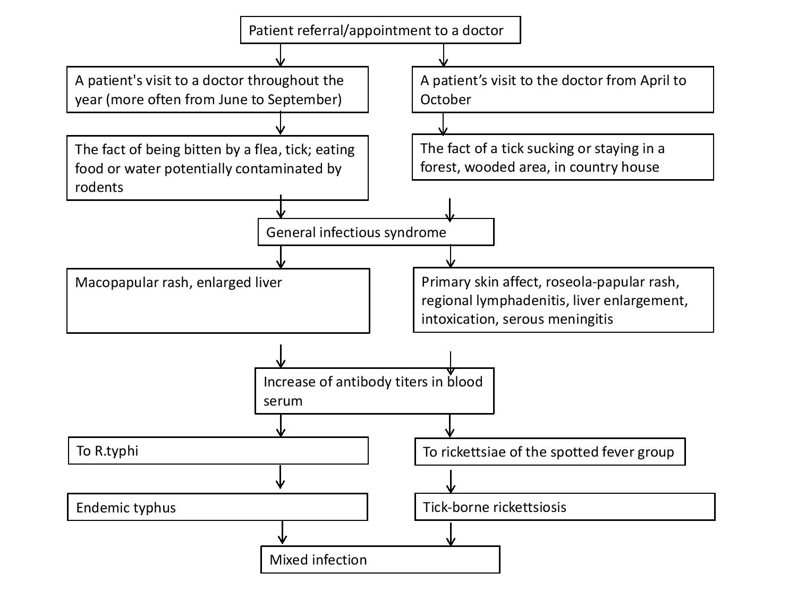

Figure 7 – The proposed algorithm for the diagnosis of rickettsioses
CONCLUSION
The obtained results allow us to draw the following main conclusions:
1) The analysis of ticks collected from bitten people in the Almaty region using molecular genetic methods indicates a high level of their infection with rickettsiae (on average 69.9%). Wherein, the reservoirs of rickettsia are ticks belonging to the following genera: Haemaphysalis, Rhipicephalus, Ixodes, Hyalomma и Dermacentor;
2) In the Almaty region, which was not previously considered endemic for rickettsia, for the first time, the circulation of two species of human pathogenic rickettsia Rickettsia sibirica and Candidatus Rickettsia tarasevichiae was shown, as well as the circulation of the Rickettsia raoultii, Rickettsia aeschlimannii pathogenic for humans rickettsia species was confirmed;
3) Serological studies have established that in the southern region of Kazakhstan there is a significant stratum of the population (22.6%) with antibodies to rickettsia of the spotted fever group, which indicates a natural possibility of infection of people with rickettsia. At the same time, the most epidemically active foci are demonstrated for the Tekeli city and the Kokzhar village of Almaty oblast. Seroprevalence to rickettsia of the spotted fever group was not significantly associated with age or gender;
4) It was revealed that there are some tick-borne rickettsioses cases (presumably 5%) among patients with fevers of unknown etiology registered in hospitals in Almaty region;
5) The territory of the southern region of Kazakhstan is the area of active circulation of the causative agent of endemic typhus Rickettsia typhi. 34.4% of the region's population tested positive for IgG antibodies to Rickettsia typhi. At the same time, the Turkestan region, where the percentage of seropositive samples averaged 91.8%, can be considered as a hyperendemic territory for Rickettsia typhi. All age groups, with the exception of children under 14, have been exposed to infections with Rickettsia typhi, suggesting that work is a risk factor for contracting endemic typhus.
Thus, the data obtained within the framework of the project on the prevalence of types of pathogenic rickettsia and the rickettsioses caused by them in the southern region of Kazakhstan indicate the urgent need to introduce an epidemiological surveillance system for rickettsia in the southern region of Kazakhstan, in particular for tick-borne rickettsioses in Almaty region and endemic typhus in the Turkestan region, the introduction of protocols for diagnosis, treatment and standard case definition of rickettsioses into routine clinical and epidemiological practice in the above-mentioned areas. It is also necessary to raise the level of awareness of these regions’ population about the risks of infection with rickettsioses.
Recommendations for the implementation of the obtained results. The obtained data are recommended to be used to improve the system of epidemiological surveillance of natural foci infections in the Republic of Kazakhstan.
Assessment of the solution completeness for the tasks. All tasks planned as part of the research work were completed on time and in full. The required list of articles has been published (see Appendix B) in accordance with the requirements for tender documentation and the schedule (see Appendix A).
Scientific and technical level of research work (study). The work was carried out at a high scientific and technical level using modern methods of molecular biology and immunology.

REFERENCES

- Merhej V., Angelakis E., Socolovschi C., Raoult D. Genotyping, evolution and epidemiological findings of Rickettsia species//J. Infect. Genet. Evol. – 2014. – Vol.25. – P.122-137.
- Hay J., Yeh K. B., Dasgupta D., Shapieva Z., Omasheva G., Deryabin P., Richards A.L. Biosurveillance in Central Asia: Successes and Challenges of Tick-Borne Disease Research in Kazakhstan and Kyrgyzstan//Frontiers in public health. – 2016. – Vol.4(4). doi:10.3389/fpubh.2016.00004.
- Arkhangelskiy D.S. Experimental study of tick-borne rickettsiosis infectious agent in Alma-Ata oblast/ Proceedings of the Institue of microbiology and virology of the Academy of Science of KazSSR. – Alma-Ata, 1961. – Vol. 4. – p. 176-185 [in Russian: Архангельский Д. С. Экспериментальное изучение возбудителя клещевого риккетсиоза в Алма-Атинской области//Тр. Ин-та микробиологии и вирусологии АН КазССР. – Алма-Ата, 1961. – Т.4. – С.176 -185].
- Rudakov N.V., Shpynov S.N., Samoilenko I.E., Tankibaev M.A. Ecology and epidemiology of spotted fever group rickettsiae and new data from their study in Russia and Kazakhstan//Ann. N. Y. Acad. Sci. – 2003. – Vol.990. – P.12-24.
- Zhao S., Yang M., Jiang M. et al. Rickettsia raoultii and Rickettsia sibirica in ticks from the long-tailed ground squirrel near the China–Kazakhstan border//Exp. Appl. Acarol. – 2019. – Vol.77 (3). – P. 425-433. doi.org/10.1007/s10493-019-00349-5.
- Shpynov S., Fournier P.E., Rudakov N., Tankibaev M., Tarasevich I., Raoult D. Detection of a Rickettsia closely related to Rickettsia aeschlimannii, Rickettsia heilongjiangensis, Rickettsia sp. strain RpA4, and Ehrlichia muris in ticks collected in Russia and Kazakhstan//J. Clin. Microbiol. – 2004. – Vol. 42. – P.2221–2223.
- Turebekov N., Abdiyeva K., Yegemberdiyeva R., Dmitrovsky A., Yeraliyeva L., Shapiyeva Z., Amirbekov A., Oradova A., Kachiyeva Z., Ziyadina L., Hoelscher M., Froeschl G., Dobler G., Zinner J., Frey S., Essbauer S. Prevalence of Rickettsia species in ticks including identification of unknown species in two regions in Kazakhstan//Parasit Vectors. – 2019. – Vol.12(1). – e.197.
- Blanton L.S. The Rickettsioses: A Practical Update//Infect. Dis. Clin. North Am. – 2019. – Vol.33. – P. 213-229. doi:10.1016/j.idc.2018.10.010.
- Loban K.M., Lobzin Y.V., Lukin Y.P. Most important human rickettsioses: manual for the doctors – Leningrad: Medicine, 1980. – p.376 [in Russian: Лобан К.М., Лобзин Ю.В., Лукин Е.П. Важнейшие риккетсиозы человека: руководство для врачей – Л.: Медицина, 1980. – C.376].
- Azad A.F., Radulovic S., Higgins J.A., Noden B.H., Troyer J.M. Flea-borne rickettsioses: ecologic considerations//J. Emerg. Infect. Dis. – 1997. – Vol. 3. – P.319.
- Civen R., Ngo V. Murine typhus: an unrecognized suburban vectorborne disease // J. Clin. Infect. Dis. – 2008. – Vol.46. – P.913-918.
- Tsioutis C., Zafeiri M., Avramopoulos A., Prousali E., Miligkos M., Karageorgos S.A. Clinical and laboratory characteristics, epidemiology, and outcomes of murine typhus: A systematic review//J. Acta. Trop. – 2017. –Vol.166. – P.16-24.
- Tsioutis C., Zafeiri M., Avramopoulos A., Prousali E., Miligkos M., Karageorgos S.A. Clinical and laboratory characteristics, epidemiology, and outcomes of murine typhus: A systematic review//J. Acta. Trop. 2017. – N.166. – P.16-24.
- Pomerantsev B.I. Ixodidae ticks // Fauna of the USSR. Arachnidae. – Leningrad: Publication of the Academy of Sciences of the USSR, 1950. – Vol. 1950. – Vol. 4, Issue 2. – p. 224 [in Russian: Померанцев Б.И. Иксодовые клещи Ixodidae // Фауна СССР. Паукообразные. – Ленинград: Публикация Академии наук СССР, 1950. – Том 4, № 2. – C.224].
- Filippova N.A. Ixodidae ticks // Fauna of the USSR. Arachnidae. – Leningrad: Science, 1977. – Vol. 4, Issue 4. – p. 1-396. [in Russian: Филлипова Н.А. Иксодовые клещи Ixodidae // Фауна СССР. Паукообразные. – Л: Наука, 1977. – Т.4, № 4. – С. 1-396].
- Eremeeva M., Xuejie Y., Raoult D. Differentiation among spotted fever group rickettsiae species by analysis of restriction fragment length polymorphism of PCR-amplified DNA//J.Clin. Microbiol. – 1994. - Vol. 32. - P. 803-810.
- Phan J., Lu C., Bender W., Smoak R., Zhong J. Molecular detection and identification of Rickettsia species in Ixodes pacificus in California//Vector-borne and zoonotic diseases. - 2011. –Vol.11. - Nо.7. – P.957-961.
- Takahiro Uchida, Yansheng Yan, Shigeo Kitaoka. Detection of Rickettsia japonica in Haemaphysalis longicornis Ticks by restriction fragment length polymorphism of PCR product//J. Clin. Microbiol. –1995. – Vol.33. - P. 824–828.
- Tamura K., Nei M. Estimation of the number of nucleotide substitutions in the control region of mitochondrial DNA in humans and chimpanzees//Mol. Biol. Evol. – 1993. – N.10. – P.512-526.
- Sambrook J., Russel D.W. The condensed protocols from molecular cloning: a laboratory Manual - New-York: Cold Spring Harbor Laboratory Press, 2006. – P.800.
- Rudakov N.V., Shpynov S.N., Samoylenko I.E., Yastrebov V.K. et al. Rickettsiae and rickettsioses of tick-borne spotted fever group in the Siberia. – Omsk, 2012. – p. 288. [in Russian: Рудаков Н. В., Шпынов С. Н., Самойленко И. Е., Ястребов В. К. и др. Риккетсии и риккетсиозы группы клещевой пятнистой лихорадки в Сибири. – Омск, 2012. – C. 288].
- Lakos A. Tick‑borne lymphadenopathy (TIBOLA)//Wien. Klin. Wochenschr. -2002. – Vol. 114. – P.648–654.
- Pretorius A. M., Birtles R. J. Rickettsia aeschlimannii: a new pathogenic spotted fever group rickettsia, South Africa//Emerging infectious diseases. – 2002. – Vol. 8(8). – P. 874.
- Mokrani N., Parola P., Tebbal S., Dalichaouche M., Aouati A., Raoult, D. Rickettsia aeschlimannii infection, Algeria//Emerg. Inf. Dis. -2008. – Vol. 14(11). – P.1814–1815.
- Jia N., Zheng Y.-C., Jiang J.-F., Ma L., Cao W.-C. Human infection with Candidatus Rickettsia tarasevichiae//New Engl. J.of Med. – 2013. - Vol.369(12). – P.1178-1180.
- Kartashov Y., Glushkova LI., Mikryukova TP., et al. Detection of Rickettsia helvetica and Candidatus R. tarasevichiae DNA in Ixodes persulcatus ticks collected in Northeastern European Russia (Komi Republic)//Ticks Tick Borne Dis. – 2017. doi:10.1016/j.ttbdis.2017.04.001 8(4):588-592.
- Zhang L., Shan A., Mathew B. Rickettsial seroepidemiology among farm workers, Tianjin, People's Republic of China//J. Emerg. Infect. Dis. – 2008. – Vol. 14 (6). – P. 938–940.
- Rudakov N., Samoylenko I., Shtrek S., Igolkina Y., Rar V., Zhirakovskaya E., Tkachev S., Kostrykina T., Blokhina I., Lentz P., Tikunova N. A fatal case of tick-borne rickettsiosis caused by mixed Rickettsia sibirica subsp. sibirica and «Candidatus Rickettsia tarasevichiae» infection in Russia//Ticks Tick Borne Dis. – 2019. Vol.10(6). - e:101278.
- Zhang L., Shan A., Mathew B. Rickettsial seroepidemiology among farm workers, Tianjin, People's Republic of China//J. Emerg. Infect. Dis. 2008. - Vol. 14(6). - P. 938–940.
- 19. Tarasevich I.V., Mediannikov O.Y. Rickettsial diseases in Russia//Ann. N Y Acad. Sci. – 2006. – Vol. 1078. - P. 48-59.
- Peniche Lara G., Dzul-Rosado K.R., Zavala Velázquez J.E., Zavala-Castro J. Murine Typhus: Clinical and epidemiological aspects//J. Colomb. Med. (Cali). – 2012. – Vol.43 (2). – P.175–180.
- Dill T., Dobler G., Saathoff E. High seroprevalence for typhus group rickettsiae, southwestern Tanzania//J. Emerg. Infect. Dis. – 2013. – Vol.19 (2). – P.317–320.
- Mane A., Kamble S., Singh M.K., Ratnaparakhi M., Nirmalkar A., Gangakhedkar R. Seroprevalence of spotted fever group and typhus group rickettsiae in individuals with acute febrile illness from Gorakhpur, India//Int. J. Infect. Dis. – 2019. – Vol. 79. – P. 195-198.
- Ruiz-Beltrán R., Herrero-Herrero J.I., Martín-Sánchez A.M., Martín-González J.A. Prevalence of antibodies to Rickettsia conorii, Coxiella burnetii and Rickettsia typhi in Salamanca province (Spain): serosurvey in the human population//Eur. J. Epidemiol. – 1990. – Vol.6. – P.293-299.
- Bolaños-Rivero M., Santana-Rodriguez E., Angel-Moreno A., Hernández-Cabrera M., Limiñana-Canal J.M., Carranza-Rodríguez C., Martín-Sánchez A.M., Pérez-Arellano J.L. Seroprevalence of Rickettsia typhi and Rickettsia conorii infections in the Canary Islands (Spain)//Int .J. Infect. Dis. – 2011. – Vol.15 (7). – P.481-485.
- Huntzinger A. Guidelines for the diagnosis and treatment of tick-borne rickettsial diseases//Am. Fam. Physician. – 2007. - Vol. 76(1). – P.137-139.
- Spotted Fever Rickettsiosis (including Rocky Mountain Spotted Fever) (SFR, including RMSF) 2020 Case Definition. https://wwwn.cdc.gov/nndss/conditions/spotted-fever-rickettsiosis/case-definition/2020/.

APPENDIX А
Technical specification and work schedule (In Russian, scanned copies)

APPENDIX А
Work schedule for 2018-2020 years
Appendix 1.15
To the Agreement №___from__________ 2018
for grant funding

TECHNICAL SPECIFICATIONS AND
WORK SCHEDULE
For the Agreement №____ from___________________2018

1.RSE “National center for biotechnology” SC of the MoES RK
1.1 By priority: 4. Life and Health sciences.
1.2 By sub-priority: 4.1 Fundamental and applied research in biology.
1.3 Title of the project: №AP05134146 «Study of Rickettsia species and genotypes circulating in the natural foci of the southern region of kazakhstan».
1.4 Total project amount 21 753 650 (twenty-one million seven hundred fifty-three thousand six hundred fifty) tenge, including with a breakdown by years, for the implementation of work in accordance with paragraph 3:
- for 2018 - in the amount of 8,000,000 (eight million) tenge;
- for 2019 - in the amount of 7,064,661 (seven million sixty-four thousand six hundred sixty-one) tenge;
- for 2020 - in the amount of 6 688 989 (six million six hundred eighty-eight thousand nine hundred eighty-nine) tenge.

2. Characteristics of scientific and technical products by qualification characteristics and economic indicators

2.1 Direction of work: molecular genetics of microorganisms.
2.2 Field of applications: molecular epidemiology and diagnostics of rickettsial diseases.
2.3 Final result:
- for 2018: data on the distribution of rickettsia, their species and genotypes in the southern region of the Republic of Kazakhstan among ticks of the Ixodes genus will be obtained, data on the distribution of rickettsia within population will be obtained using the cases of patients with fevers of unknown origin and bitten by ticks in the southern region of the Republic of Kazakhstan (eastern part of the Almaty region);
- for 2019: data on the distribution of rickettsia, their species and genotypes in the southern region of the Republic of Kazakhstan among ticks of the Dermacenter genus will be obtained, data on the distribution of rickettsia within population will be obtained using the cases of patients with fevers of unknown origin and bitten by ticks in the southern region of the Republic of Kazakhstan (western part of Almaty oblast), development of a standard case definition for rickettsial diseases will be initiated;
- for 2020: data on the distribution of rickettsia, their species and genotypes in the southern region of the Republic of Kazakhstan among ticks of various species will be obtained, data on the distribution of rickettsia within population will be obtained using the cases of patients with fevers of unknown origin and bitten by ticks in the southern region of the Republic of Kazakhstan (Zhambyl oblast), a standard case definition for rickettsial diseases will be developed.
2.4 Patentability: Results are not patentable.
2.5 Scientific and technical level (novelty): the obtained epidemiological and clinical data will make it possible to develop an algorithm for laboratory diagnosis of rickettsioses in Kazakhstan and a standard case definition, as well as will become the basis for improving the epidemiological surveillance of rickettsioses.
2.6 The use of scientific and technical products is carried out by: Client and Executor.
2.7 Type of use of the result of scientific and (or) scientific and technical activities: scientific report, recommendations for the epidemiological surveillance system.

3. Name of works, terms of their implementation and results
Task code, stage | Name of work under the Agreement and the main stages of its implementation | Period of execution |  | Expected result
Task code, stage |  | start | end | Expected result
1 | To study the distribution of rickettsia in the population of ticks of different species in the southern region of Kazakhstan. | January 2018 | Until November 1, 2018 | The distribution of rickettsia in populations of ticks of different species in the southern region of Kazakhstan will be studied. Data will be obtained on the distribution of rickettsia in the southern region of the Republic of Kazakhstan in various species of ticks of the genus Ixodes.
2 | To study which rickettsia species and which genotypes circulate in the oblasts of the southern region of the Republic of Kazakhstan. | July 2018 | Until November 1, 2018 | Which rickettsia species and what genotypes circulate in the oblasts of the southern region of the Republic of Kazakhstan will be studied. Data on the distribution of different species and genotypes of rickettsia in ticks of different Ixodes genus species in the southern region of Kazakhstan will be obtained.
3 | To study the distribution of rickettsioses among the population in the southern region of Kazakhstan. | March 2018 | Until November 1, 2018 | The distribution of rickettsioses among the population in the southern region of Kazakhstan will be studied. Data on the spread of rickettsioses in patients with fevers of unknown origin and those bitten by ticks in the southern region of Kazakhstan (eastern part of Almaty region, Taldykorgan region) will be obtained.
5 | To study the epidemiological characteristics of rickettsioses in the southern region of Kazakhstan. | March 2018 | Until November 1, 2018 | The epidemiological manifestations of rickettsioses in the southern region of Kazakhstan will be studied. The role of Ixodes ticks in the epidemiology of rickettsioses in the southern region of Kazakhstan will be studied.
1 | To study the distribution of rickettsia in the population of ticks of different species in the southern region of Kazakhstan. | January 2019 | Until November 1, 2019 | Будет изучено распространение риккетсий в популяции клещей разных видов в Южном регионе Казахстана. Будут получены данные по распространению риккетсий в Южном регионе РК у различных видов клещей рода Dermacenter.
2 | To study which rickettsia species and which genotypes circulate in the oblasts of the southern region of the Republic of Kazakhstan. | January 2019 | Until November 1, 2019 | Which rickettsia species and what genotypes circulate in the oblasts of the southern region of the Republic of Kazakhstan will be studied. Data on the distribution of different species and genotypes of rickettsia in ticks of different Dermacenter genus species in the southern region of Kazakhstan will be obtained.
3 | To study the distribution of rickettsioses among the population in the southern region of Kazakhstan. | January 2019 | Until November 1, 2019 | The distribution of rickettsioses among the population in the southern region of Kazakhstan will be studied. Data on the spread of rickettsioses in patients with fevers of unknown origin and those bitten by ticks in the western part of Almaty oblast (Almaty region) will be obtained.
4 | Develop protocols for diagnostic techniques/standard operating procedures (SOPs) for the indication and diagnosis of rickettsioses. | January 2019 | Until November 1, 2019 | Protocols of diagnostic techniques/standard operating procedures (SOPs) for the indication and diagnosis of rickettsioses will be developed. Rational tactics of rickettsioses laboratory research of persons bitten by ticks in natural foci will be developed.
5 | To study the epidemiological characteristics of rickettsioses in the southern region of Kazakhstan. | January 2019 | Until November 1, 2019 | The epidemiological manifestations of rickettsioses in the southern region of Kazakhstan will be studied. The role of Dermacenter ticks in the epidemiology of rickettsioses in the southern region of Kazakhstan will be studied.
6 | To develop a standard definition of a case of rickettsioses, based on the study of the clinical and epidemiological manifestations of rickettsioses in the Republic of Kazakhstan. | March 2019 | Until November 1, 2019 | A standard case definition of rickettsioses will be developed, based on the study of the clinical and epidemiological manifestations of rickettsioses in the Republic of Kazakhstan. An algorithm for the diagnosis of rickettsioses will be created, which determines on the basis of what criteria it is necessary to suspect rickettsiosis, which requires the transmission of an emergency notification and laboratory examination for this infection, what criteria confirm the likelihood of a diagnosis and require measures in the outbreak, and which laboratory tests confirm it. An algorithm for the diagnosis of rickettsioses will be created, which will determine on the basis of what criteria it is necessary to conduct a laboratory examination for this infection and what laboratory tests confirm the diagnosis.
7 | Publication of research results in a peer-reviewed foreign journal with a non-zero impact factor and a peer-reviewed journal recommended by CCSES. | January 2019 | Until November 1, 2019 | 2 articles will be published in peer-reviewed foreign and domestic scientific journals with a non-zero impact factor, 1 article in a peer-reviewed journal recommended CCSES.
1 | To study the distribution of rickettsia in the population of ticks of different species in the southern region of Kazakhstan. | January 2020 | Until November 1, 2020 | The distribution of rickettsia in populations of ticks of different species in the southern region of Kazakhstan will be studied. Data will be obtained on the distribution of rickettsia in the southern region of the Republic of Kazakhstan in various types of ticks of other genera.
2 | To study which rickettsia species and which genotypes circulate in the oblasts of the southern region of the Republic of Kazakhstan. | January 2020 | Until November 1, 2020 | Which rickettsia species and what genotypes circulate in the oblasts of the southern region of the Republic of Kazakhstan will be studied. Data on the distribution of different species and genotypes of rickettsia in ticks of different species in the southern region of Kazakhstan will be obtained.
3 | To study the distribution of rickettsioses among the population in the southern region of Kazakhstan. | January 2020 | Until November 1, 2020 | The distribution of rickettsioses among the population in the southern region of Kazakhstan will be studied. Data on the spread of rickettsioses in patients with fevers of unknown origin and those bitten by ticks in the southern region of Kazakhstan (Zhambyl oblast) will be obtained.
4 | Develop protocols for diagnostic techniques/standard operating procedures (SOPs) for the indication and diagnosis of rickettsioses. | January 2020 | Until November 1, 2020 | Protocols of diagnostic techniques/standard operating procedures (SOPs) for the indication and diagnosis of rickettsioses will be developed. Rational tactics of rickettsioses laboratory research of persons bitten by ticks in natural foci will be developed.
5 | To study the epidemiological characteristics of rickettsioses in the southern region of Kazakhstan. | January 2020 | Until November 1, 2020 | The epidemiological manifestations of rickettsioses in the southern region of Kazakhstan will be studied.
6 | To develop a standard definition of a case of rickettsioses, based on the study of the clinical and epidemiological manifestations of rickettsioses in the Republic of Kazakhstan. | January 2020 | Until November 1, 2020 | A standard case definition of rickettsioses will be developed, based on the study of the clinical and epidemiological manifestations of rickettsioses in the Republic of Kazakhstan. An algorithm for the diagnosis of rickettsioses will be created, which determines on the basis of what criteria it is necessary to suspect rickettsiosis, which requires the transmission of an emergency notification and laboratory examination for this infection, what criteria confirm the likelihood of a diagnosis and require measures in the outbreak, and which laboratory tests confirm it. A standard case definition will be developed, consisting of three stages: suspicion or presumptive diagnosis, probable and confirmed diagnosis.
7 | Publication of research results in a peer-reviewed foreign journal with a non-zero impact factor and a peer-reviewed journal recommended by CCSES. | January 2020 | Until November 1, 2020 | 2 articles will be published in peer-reviewed foreign scientific journals, indexed in the Web of Science or Scopus databases with a non-zero impact factor.

From Client:  The Сhairman  State Institution "Science Committee of the Ministry of Education and Science of the Republic of Kazakhstan"  ___________________Abdrasilov B.S.  Stamp and sign | From Executor:  Acting CEO of RSE «Natioanl center for biotechnology» of Science Committee of the Ministry of Education and Science of the Republic of Kazakhstan  ______________________Ramankulov E.M.  Stamp and sign  Acquainted:  Project manager:  ___________________Yeraliyeva L.T.  sign

APPENDIX B
List of published works and scientific and organizational activities for 2018-2020.
1 Staff: 6 people in total, including 3 PhDs; MSc - 3. Young specialists up to 35 years old - 3 (50%).
Financing: for 2018 - 8,000,000 (eight million tenge), in 2019 - 7,064,661.0 (seven million sixty-four thousand six hundred sixty-one tenge), in 2020 - 6,688,989.0 (six million eight hundred eighty thousand nine hundred eighty-nine tenge).
2 Publications.
Articles in peer-reviewed foreign journals with a non-zero impact factor:
а) articles in publications included in the Web of Science (Thomson Reuters, USA) or Scopus (Elsevier, Netherlands):
1 Perfilyeva Y.V., Shapiyeva Z.Zh., Ostapchuk Y.O., Berdygulova Z.A., Bissenbay A.O., Kulemin M.V., Ismagulova G.A., Maltseva E.R., Skiba Y.A., Sayakova Z.Z., Mamadaliyev S.M., Dmitrovskiy A.M. Tick-borne pathogens and their vectors in Kazakhstan – a review // Ticks and Tick-borne diseases. – 2020. – Vol. 11 (5). – 101498. doi:10.1016/j.ttbdis.2020.101498. (WoS Impact Factor – 3.27; Scopus – Q1).
2 Perfilyeva Y.V., Nizkorodova A.S., Berdygulova Zh.A., Ostapchuk Y.O., Naizabayeva D.A., Neupokoyeva A.S., Kuznetsova T.V., Shishkina T.S., Abuova G.N., Yegemberdiyeva R.A., Bissenbay A.O., Maltseva E.R., Mamadaliyev S.M., Dmitrovsky A.M. Detection of IgG against Rickettsia typhi: a population-based study in southern Kazakhstan // Infectoloski Glasnik. – 2019. - Vol. 39 (4). – P. 113-118. doi:10.37797/ig.39.4.2. (Scopus – 6%, Cite Score 0.04, Q4).
б) articles in foreign publications with a non-zero impact factor:
1 Perfilyeva Y.V., Ostapchuk Y.O., Naizabayeva D.A., Neupokoyeva A.S., Turebekov N.A., Yeralieva L.Т., Dmitrovskiy A.M. A clinical case of rickettsial tick-borne fever without rash (In Russian) // Epidemiologiya i infektsionnyye bolezni. Aktual'nyye voprosy. – 2020. – accepted for publication (Impact factor - 0.315, RSCI).
Monographs:
- Yeralieva L.Т., Dmitrovskiy A.M. Meningitis in children (In Russian), Almaty, 2018, 294 pages.
- Dmitrovskiy А. Chapter Tick-Borne Encephalitis in Kazakhstan, - P. 189-195 in the Tick-Borne Encephalitis (TBE) Book, Gerhard Dobler, Wilhelm Erber, Heinz-Josef Schmitt, Global Health Press, 2018.- 304 p.
Articles in refereed scientific publications of the Republic of Kazakhstan:
а) articles in peer-reviewed national scientific journals with a non-zero impact factor;
1 Perfilyeva Y.V., Ostapchuk Y.O., Nizkorodova A.S., Abuova G.N., Bissenbay А.О., Berdygulova Zh.A., Kuatbekova S., Dmitrovskiy А.М. Prevalence of antibodies to Rickettsia typhi among the population of the southern region of Kazakhstan (In Russian) // Vestnik KazNU. Biological series. – 2019. – Т. 81. - №4. – С. 68-75 (Impact-factor - 0,043, KazBC).
б) articles in peer-reviewed domestic scientific journals, recommended by CCSES (Committee for Control in the Sphere of Education and Science) MoES RK:
1 Dmitrovskiy A.M., Yegemberdiyeva R.A., Yeralieva L.Т., Turebekov N.A., Shapiyeva Zh.Z., Neupokoyeva A.S., Berdygulova Zh.A., Naizabayeva D.A. Modern problems of epidemiological surveillance of rickettsioses in Kazakhstan (In Russian)// Vestnik KazNMU. - № 3. – 2019. - 54-58 pp.
2 Berdygulova Z.A, Ramankulov Ye.M. CRISPR-Cas systems in pathogenic bacteria//Eurasian Jourmal of Applied Biotechnology.- No.4 - 2018. - P.3-10 (Published in 2019).
Abstracts:
а) in the proceedings of international conferences from near and far abroad:
1 Turebekov N., Yegemberdieva R., Dmitrovsky A., Yeraliyeva L., Shapieva Z., Abdiyeva K., Amirbekov A., Oradova A., Kachiyeva Z., Ziyadina L., Froeschi G. et al. Prevalence of Rickettsia species in ticks in Kazakhstan // Материалы международной конференции 16th Medical biodefense conference, Германия, 28-31 октября 2018 г. Принят в печать.
б) in the proceedings of international conferences of the Republic of Kazakhstan:
2 Dmitrovskiy A.M., Mamadaliyev S.M., Iskakova F.A., Yeraliyeva L.T., Yegemberdieva R.А., Utepbergenova G.A. Project 53. Biosafety and biosecurity of biological technologies. Learning aspects and perspectives (In Russian) // Materials of the international symposium "Astana Biotech 2018", Astana, 12-13 June 2018.
3 Reports at conferences: (indicating the form of the report)
а) international conferences in near and far abroad:
none
б) international conferences in the Republic of Kazakhstan:
1 “Global Security Threats, Range of Epidemic and Pandemic Risks ”. international Conference in Almaty, 16 April 2018. A.M. Dmitrovsky report “Experience in conducting biosafety training for specialists of different profiles within the framework of program 53”.
2 "Problems of infectious diseases in the southern region of Kazakhstan." International conference in Shymkent, June 29-30, 2018 A.M. Dmitrovsky report "Preparing, planning and conducting trainings on biosafety for specialists in Kazakhstan".
в) trainings:
Conducting 5 trainings:
1 "Safe work with patients with hemorrhagic fevers." Training at the Shymkent Regional Infectious Diseases Hospital, Shymkent, April 23-25, 2018 Trainer - A.M. Dmitrovsky.
2 "Safe work with patients with hemorrhagic fevers." Training at the Zhambyl Regional Children's Infectious Diseases Hospital, Taraz, April 26-28, 2018 Trainer - A.M. Dmitrovsky.
3 "Working with samples potentially infected with highly dangerous pathogens using a film-type biosafety cabinet of class 3 (Flexible Film Isolator - FFI)" on the basis of the Republican Center for Quarantine and Highly Dangerous Infections of the Ministry of Health, within the framework of project 53: "Center of excellence for the reduction of chemical, biological and nuclear risks of the EU" (International Science and Technology Center, ISTC), March 4-7, 2019, Bishkek, Kyrgyz Republic. Trainers - Dmitrovsky A.M., Berdygulova Zh.A.
4 "Safe work with dangerous pathogens" on the basis of Research Institute for biological safety Prolems, Otar, Kazakhstan, April 1-5, 2019, within the framework of project 53: "Center of excellence for the reduction of chemical, biological and nuclear risks of the EU" (International Science and Technology Center, ISTC) Trainers - Dmitrovsky A.M., Berdygulova Zh.A.
5 "Workshop Safety Work with EDP Using ELISA and PCR in BSC" on the basis of the Central Reference Laboratory, Almaty (trainees from Afghanistan). Trainers - Dmitrovsky A.M., Berdygulova Zh.A., Naizabaeva D.A., Neupokoeva A.S.
Participation in trainings:
- Training on data collection and accounting "Field Collection of Ixodes Ticks Traning" (using the CommCare application) April 25-26, 2019 based on Scientific and Practical Center for Sanitary and Epidemiological Expertise and Monitoring (SES), Almaty, Akbulak. Training organizers: CDC Almaty. Trainees: Naizabaeva D.A., Berdygulova Zh.A.
- Training "Standard operating procedures of the safety level 3 laboratory for working with animals" based on the CRL, developed according to the SOP "ABSL-3 SOPs training course". Organizer - CH2M (Jacobs). Trainees: Naizabayeva D.A., Neupokoeva A.S.
- Skills of work in laboratories of the safety level "BSL-3 skills training course" theory / practice 07.22.19-07.2019 on the basis of the CRL. Trainees: Naizabaeva D.A., Berdygulova Zh.A.
- Training "Processing of field data in the R environment: binary logistic regression" April 17, 2019. Trainer: head of the laboratory of biological safety and biological defense ща National Scientific Center for Especially Dangerous Infections, Ph.D. Andrey Kuznetsov. Trainees: Neupokoeva A.S., Naizabaeva D.A., Berdygulova Zh.A.

5 Personnel training: PhD-student, Berdygulova Zhanna Amirovna, master of technical sciences, KazNU named after Al-Farabi, Faculty of Biology and Biotechnology, specialty 6D070100 - Biotechnology, topic: "Research of bacteriophages for the diagnosis, prevention and treatment of listeriosis and rickettsiosis".

APPENDIX C
Scans of published works for 2018-2020
Articles in foreign publications: with a non-zero impact factor:
1. Perfilyeva Y.V., Shapiyeva Z.Zh., Ostapchuk Y.O., Berdygulova Z.A., Bissenbay A.O., Kulemin M.V., Ismagulova G.A., Maltseva E.R., Skiba Y.A., Sayakova Z.Z., Mamadaliyev S.M., Dmitrovskiy A.M. Tick-borne pathogens and their vectors in Kazakhstan – a review // Ticks and Tick-borne diseases. - 2020. – Vol. 11 (5). – 101498. doi:10.1016/j.ttbdis.2020.101498. (Impact Factor-3.005, Scopus; Scopus – Q1).
2. Perfilyeva Y.V., Nizkorodova A.S., Berdygulova Zh.A., Ostapchuk Y.O., Naizabayeva D.A., Neupokoyeva A.S., Kuznetsova T.V., Shishkina T.S., Abuova G.N., Yegemberdiyeva R.A., Bissenbay A.O., Maltseva E.R., Mamadaliyev S.M., Dmitrovsky A.M. Detection of IgG against Rickettsia typhi: a population-based study in southern Kazakhstan // Infectoloski Glasnik. – 2019. - Vol. 39 (4). – P. 113-118. doi:10.37797/ig.39.4.2. (Impact Factor-0.05, 6%, 0.1 Cite Score, Q4 Scopus).
3. Perfilyeva Y.V., Ostapchuk Y.O., Naizabayeva D.A., Neupokoyeva A.S., Turebekov N.A., Yeralieva L.Т., Dmitrovskiy A.M. A clinical case of rickettsial tick-borne fever without rash (In Russian) // Epidemiologiya i infektsionnyye bolezni. Aktual'nyye voprosy. – 2020. – accepted for publication (Impact factor - 0.315, RSCI). Supporting documents of acceptance for publication

Monographs:
- Yeralieva L.Т., Dmitrovskiy A.M. Meningitis in children (In Russian), Almaty, 2018, 294 pages


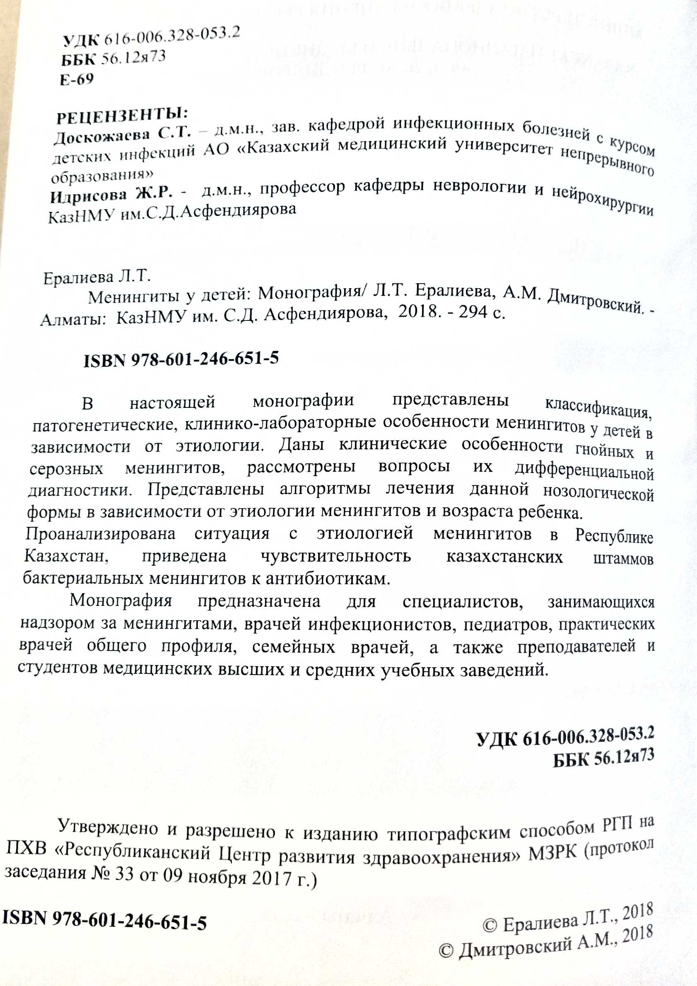

- Dmitrovskiy А. Chapter Tick-Borne Encephalitis in Kazakhstan, - P. 189-195 in the Tick-Borne Encephalitis (TBE) Book, Gerhard Dobler, Wilhelm Erber, Heinz-Josef Schmitt, Global Health Press, 2018. - 304 p.
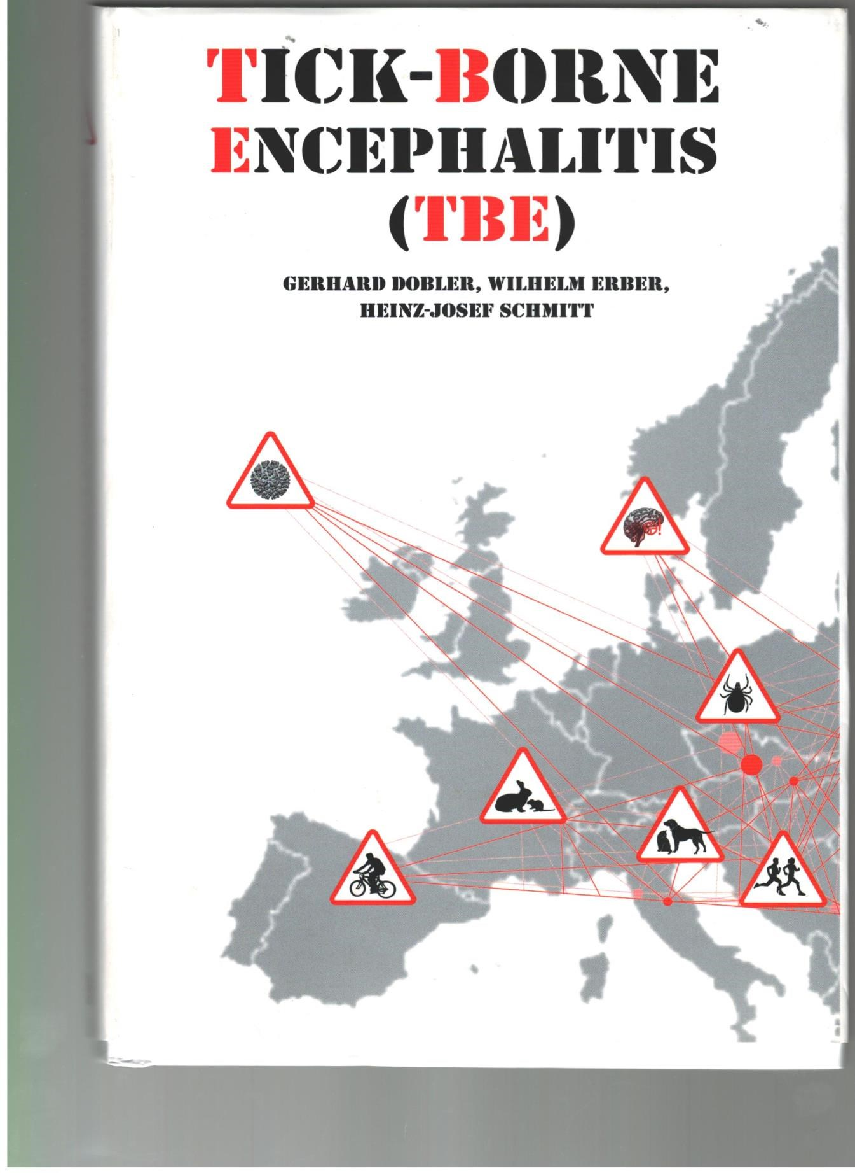



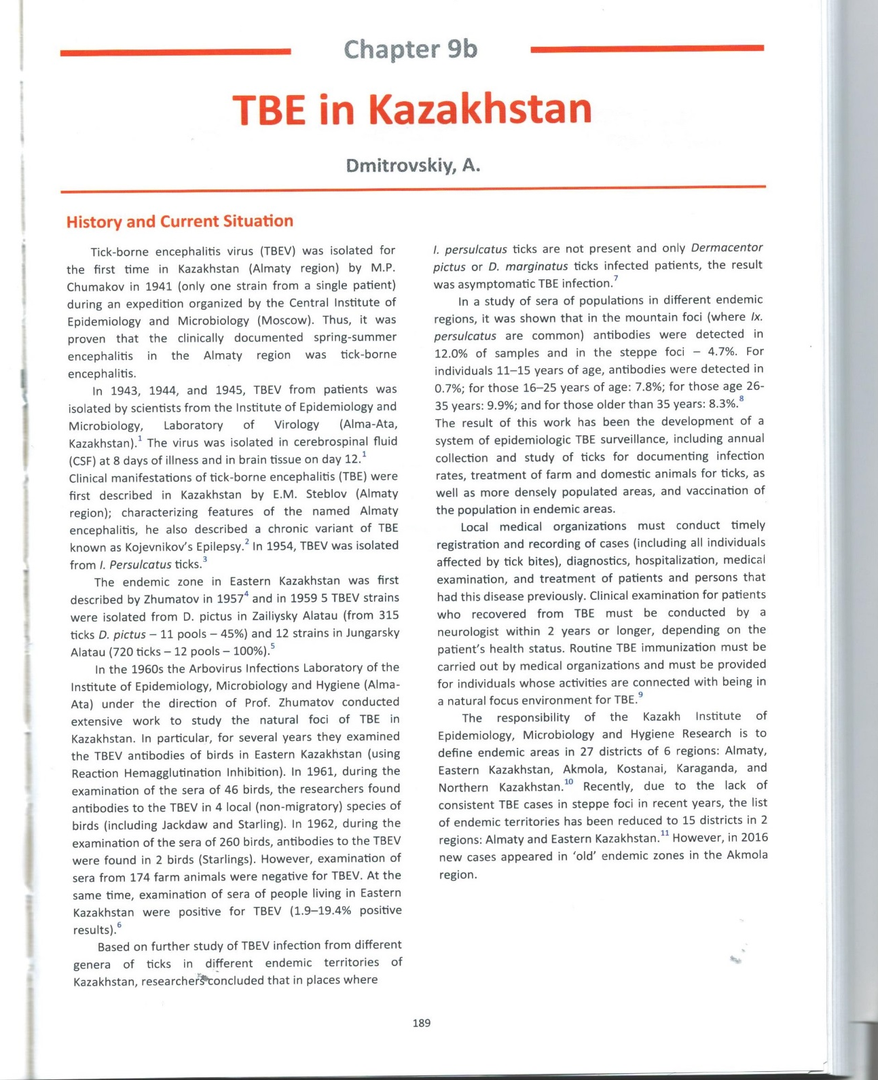

Articles in national peer-reviewed journals:

1 Perfilyeva Y.V., Ostapchuk Y.O., Nizkorodova A.S., Abuova G.N., Bissenbay А.О., Berdygulova Zh.A., Kuatbekova S., Dmitrovskiy А.М. Prevalence of antibodies to Rickettsia typhi among the population of the southern region of Kazakhstan (In Russian) // Vestnik KazNU. Biological series. – 2019. – Т. 81. - №4. – С. 68-75

2 A.M., Yegemberdiyeva R.A., Yeralieva L.Т., Turebekov N.A., Shapiyeva Zh.Z., Neupokoyeva A.S., Berdygulova Zh.A., Naizabayeva D.A. Modern problems of epidemiological surveillance of rickettsioses in Kazakhstan (In Russian)// Vestnik KazNMU. - № 3. – 2019. - 54-58 pp
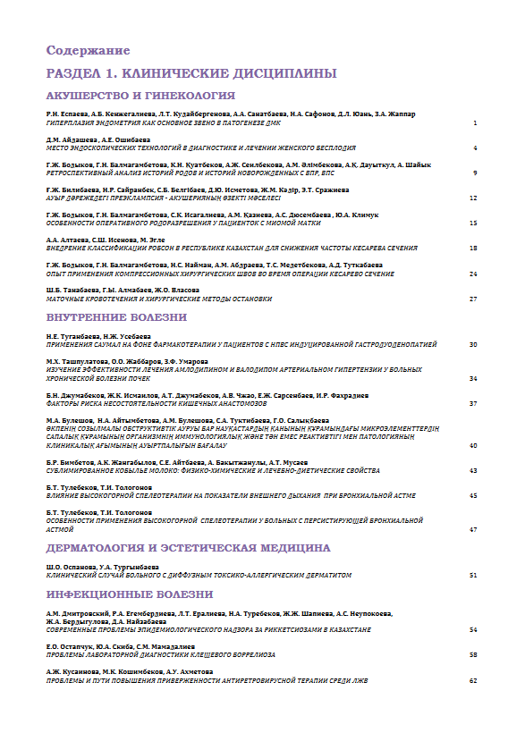
3 Berdygulova Z.A, Ramankulov Ye.M. CRISPR-Cas systems in pathogenic bacteria//Eurasian Jourmal of Applied Biotechnology.- No.4 - 2018. - P.3-10 (опубликована в 2019 г.).

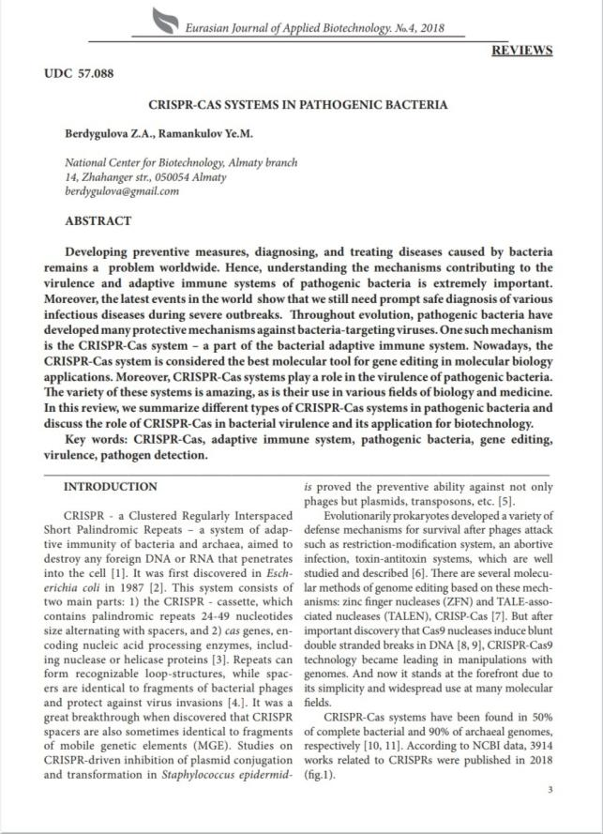
Abstracts in the proceedings of international conferences from near and far abroad:

1 Turebekov N., Yegemberdieva R., Dmitrovsky A., Eraliyeva L., Shapieva Z., Abdiyeva K., Amirbekov A., Oradova A., Kachiyeva Z., Ziyadina L., Froeschi G. et al. Prevalence of Rickettsia species in ticks in Kazakhstan // Материалы международной конференции 16th Medical biodefense conference, Германия, 28-31 октября 2018 г.

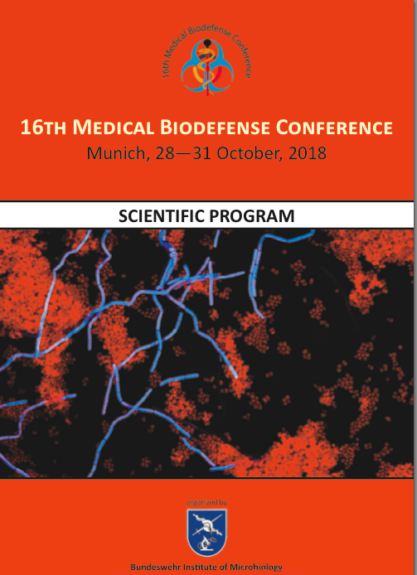

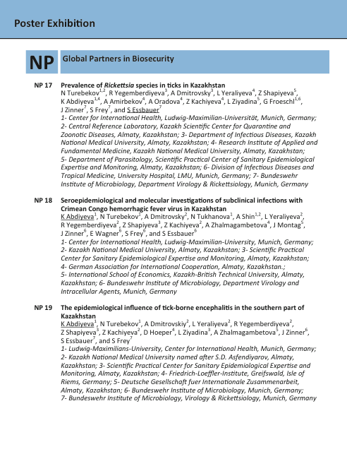

2 Dmitrovskiy A.M., Mamadaliyev S.M., Iskakova F.A., Yeraliyeva L.T., Yegemberdieva R.А., Utepbergenova G.A. Project 53. Biosafety and biosecurity of biological technologies. Learning aspects and perspectives (In Russian) // Materials of the international symposium "Astana Biotech 2018", Astana, 12-13 June 2018

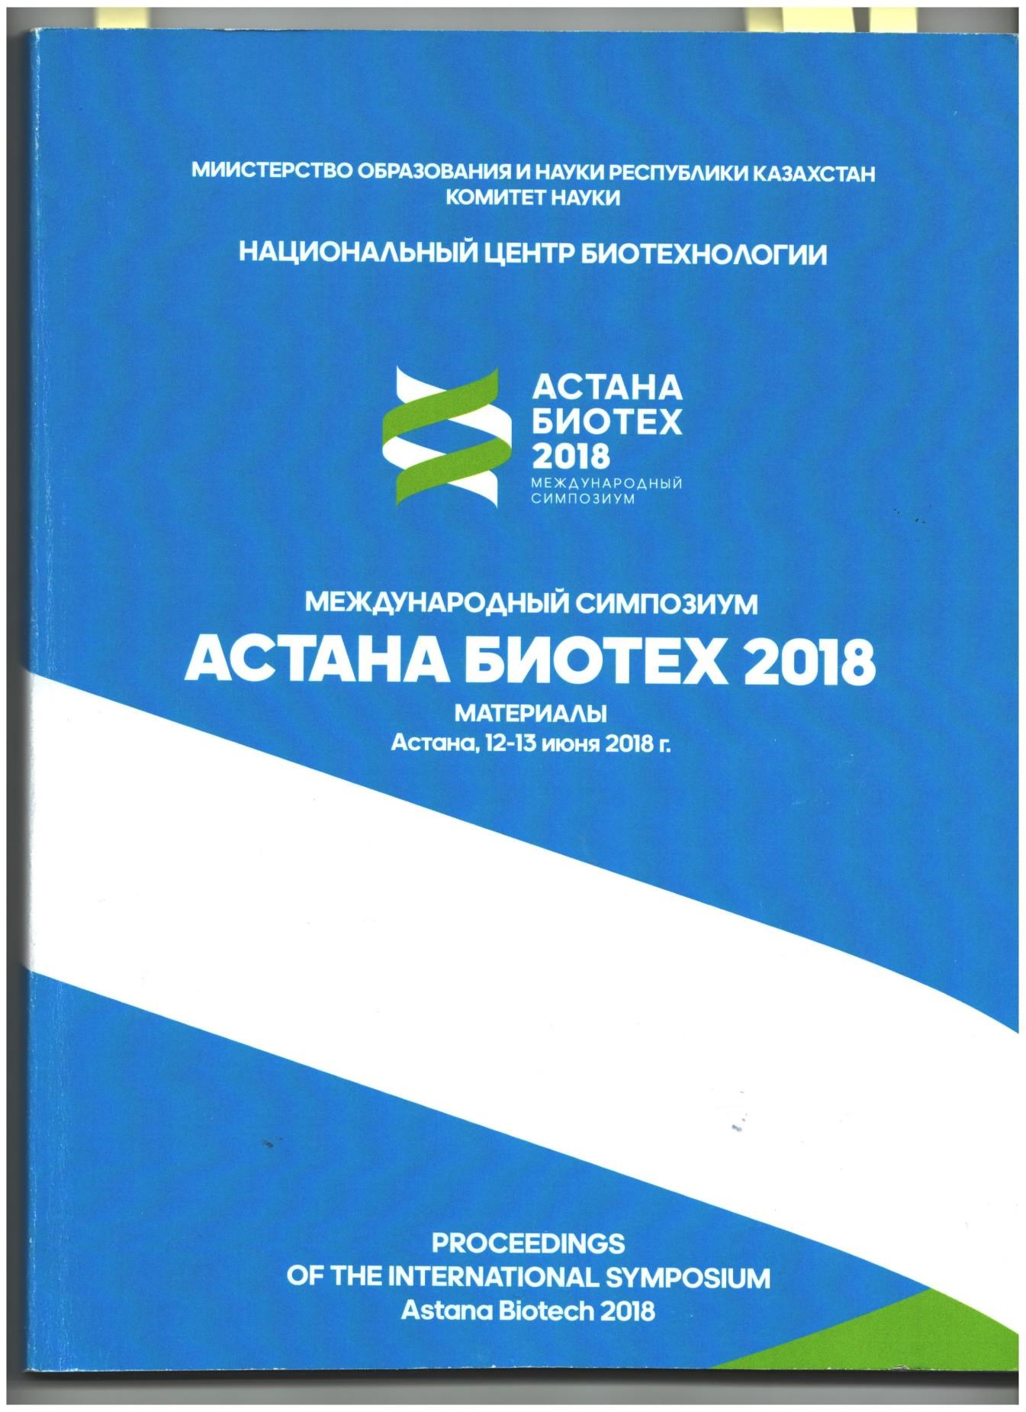

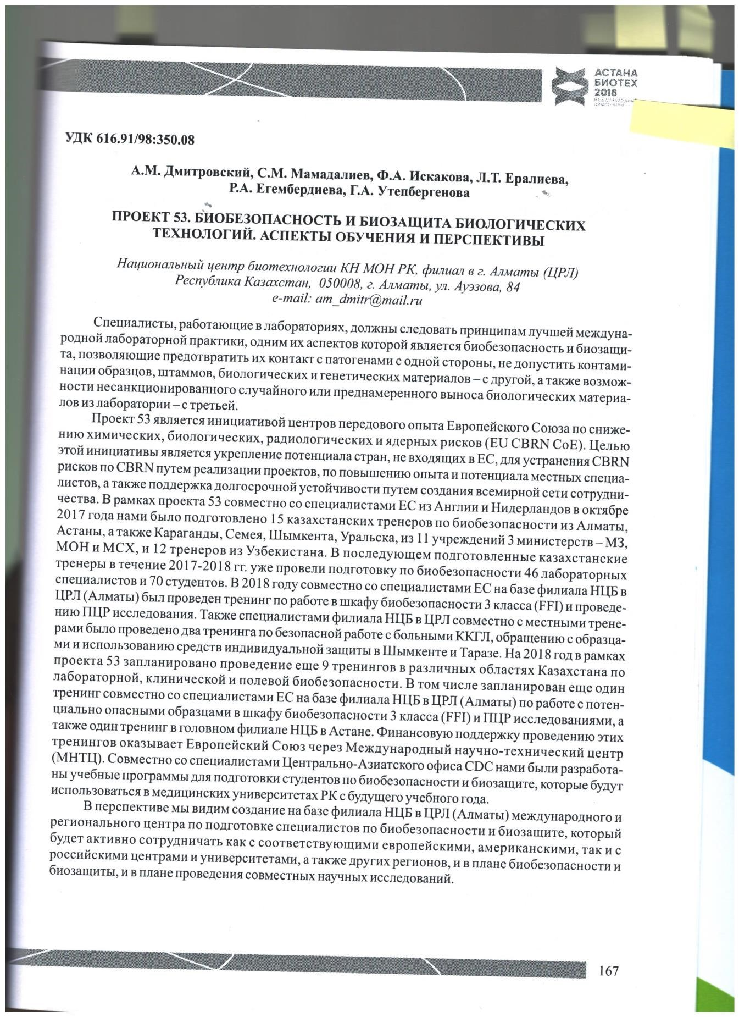

APPENDIX D
List of used foreign information resources

The search was carried out in the following electronic databases, information and reference systems and resources:
Science Direct; Scopus; Web of Knowledge;
Web of Science (www.webofknowledge.com);
Elsevier (www.elsevier.com);
PubMed (www.pubmed.com);
Eurasian Patent Organization (www.eapo.org);
Rospatent (www.fips.ru);
Kazpatent (www.kazpatents.com);
Google Academy (https://scholar.google.ru/?hl=ru).

APPENDIX E
Patent Research Report

REPORT
on patent research on the implementation of the project AP05134146 "Study of the species and genotypes of rickettsia circulating in the natural foci of the southern region of Kazakhstan" in accordance with the budget program: 217 Development of Science", subprogram 102 " Research grant funding", Patent Law of the Republic of Kazakhstan and ST RK GOST R 15.011-2005 «System of product development and launching into production. Patent research. Content and procedure».
Stage of work: interim (2019)
Start of the search: 17.09.2019 End of search: 08.10.2019

В.6 Materials selected for further analysis

Table В 6.1 - Patent documentation
Search subject (research object, its constituent parts) | Country of issue, type and number of the protection document. Classification index | Applicant, country, application number, publication date | Invention title (complete sample model) | Information on the validity of the protection document
Study of the species and genotypes of rickettsia circulating in natural foci of the southern region of Kazakhstan | RU  G01N 33/50, C12Q 1/68,  G01N 33/5091, C12 Q1/6837, C12Q 1/6841, G01N 2035/00158 | Federal budgetary institution of science "Nizhny Novgorod Research Institute of Epidemiology and Microbiology named after Academician I.N. Blokhina " of the Federal Service for Supervision of Consumer Rights Protection and Human Welfare.  RU patent  № 2019114846 14.05.2019 | A method of searching for molecular markers of a pathological process for differential diagnosis, monitoring and targeted therapy.
 | RU  G01N33/58  C12Q1/68 | Federal budgetary institution of science "State Scientific Center of Virology and Biotechnology "Vector”»  RU patent  № 2629604  30.08. 2017 | A set of oligonucleotide primers and probes for the identification of tick-borne encephalitis virus, West Nile virus, borrelia and rickettsia by the method of multiplex PCR in real time.
 | RU  G01N33/50  C12Q1/60 | Федеральное бюджетное учреждение науки Federal budgetary institution of science "State Scientific Center of Virology and Biotechnology "Vector”»  № 2581952  29.03.2016. | A set of oligonucleotide primers and a fluorescent-labeled probe for the identification of the genetic material of rickettsia by real-time PCR.
Table В.6.2 - Scientific and technical, conjunctural, regulatory documentation and materials of state registration (reports on research works)

Search subject | Name of the source of information indicating the source page | Author, company (holder), technical documentation | Year, place and body of publication (approval,  source deposition)
1 | 2 | 3 | 4
Study of the species and genotypes of rickettsia circulating in natural foci of the southern region of Kazakhstan | Internet | Samiye Demir, Sedef Erkunt Alak, Ahmet Efe Köseoğlu, Cemal Ün, Muhammed Nalçacı & Hüseyin Can. | 2020  Molecular investigation of Rickettsia spp. and Francisella tularensis in ticks from three provinces of Turkey.  Experimental and Applied Acarology. – Vol. 81. – P. 239–253.  doi.org/10.1007/s10493-020-00498-y
 | Internet | Galay R.L., Talactac M.R., Ambita-Salem B.V., Chu D.M.M., Costa L.M.O., et al. | 2020  Molecular Detection of Rickettsia spp. and Coxiella burnetii in Cattle, Water Buffalo, and Rhipicephalus (Boophilus) microplus Ticks in Luzon Island of the Philippines.  Trop. Med. Infect. Dis. – Vol. 5(2). – P. 54; https://doi.org/10.3390/tropicalmed5020054
 | Internet | Benson Chuks Iweriebor, Aboi Igwaran, Abiodun Atinuke Adegborioye, Elia John Mmbaga, Anthony Ifeanyi Okoh, Larry Chikwelu Obi. | 2019  Molecular screening of ticks for the presence of Rickettsia species: A public health concern.  Asian Pac. J. Trop. Dis. – Vol.7 (4). – P.199-204.  doi.org/10.12980/apjtd.7.2017D6-411
 | Internet | Khasnatinov M.A., Rychkova L.V., Rodriguez I., Corona B., Danchinova G.A. | 2018  Ixodid ticks and tick-borne infections in the Republic of Cuba – literature review and rationale for risk assessment.  Acta Biomedica Scientifica. -Vol. 3. - No2. – P.35-39.  DOI: 10.29413/ABS.2018-3.2.6
 | Internet | Kartashov M.Y.,  Glushkova L.I.,  Mikryukova T.P.,  Korabelnikov I.V.,  Egorova Y.I., Tupota N.L., Protopopova E.V., Konovalova S.N., Ternovoi V.A., Loktev  V.B. | 2017  Detection of Rickettsia helvetica and Candidatus R. tarasevichiae DNA in Ixodes persulcatus ticks collected in Northeastern European Russia (Komi Republic).  Ticks and Tick - borne Diseases. – Vol.8. – N.4. –  P. 588‒592.
 |  | Noh, Y., Lee, Y.S., Kim, H. et al. Molecular detection of Rickettsia species in ticks collected from the southwestern provinces of the Republic of Korea. 10, 20 (2017). | 2017  Molecular detection of Rickettsia species in ticks collected from the southwestern provinces of the Republic of Korea.  Parasites Vectors. https://doi.org/10.1186/s13071-016-1955-x
 | Internet | Turebekov N.А., Shapiyeva Zh.Z., Yegemberdiyeva R.А., Dmitrovskiy А.М., Yeraliyeva L.Т.,  Abdiyeva К.S., Oradova А., AMirbekov А., Kachiyeva Z., Ziyadina L., Höper D., Zhalmgambetova А., Fröschl G., Zinner J., Frey S.., Essbauer S. | 2016  ALMATY REGION AS AN AREA WITH NEW PATHOGENIC RICKETTSIALES IN KAZAKHSTAN (In Russian).  Nacionalnye prioritety Rossii. - № 4(22). - C.100-102.
The form D 2.2 Assessment of the patentability of newly created technical and art-design solutions, determination of the expediency of their legal protection

Name of technical, art-  design solutions proposed for legal protection | The essence of the solutions proposed  in legal protection | Prototypes of solutions proposed for legal  protection | The achieved technical result and its influence on the characteristics of the object of economic activity | Patentability and qualification of the proposed solutions (the possibility of referring to inventions, utility models, industrial designs) | The expediency of legal protection and the rationale for the choice of countries for patenting or the reason for refusing legal protection and expediency  attribution to know-how
1 | 2 | 3 | 4 | 5 | 6

The form Д.2.2. – not filled in, because there are no technical solutions at this stage of research.

CONCLUSION
on the performance of patent research

The search regulations were carried out to a depth of 5 years from July 2015 to October 2019. Several patents were identified that have a general orientation with the studied topic as a result of the search carried out by the following classes of the IPC A61K, A61K9/08, A61G10/02, A61P25/00, A61P31/04, A61P37/02, C12N, C12Q, C12Q 1/04, G01N, G01N33/68 G01N 33/50. There are scientific articles devoted to the study of knowledge about rickettsiosis, their distribution, significance in human infectious pathology, characteristics of rickettsia, their classification and nomenclature in the light of polyphasic taxonomy, as well as about laboratory diagnosis and treatment of rickettsioses. Express methods such as the method of fluorescent antibodies, IPHA (Indirect passive hemagglutination) with immunoglobulin diagnostics to identify rickettsia of the spotted fever group were previously used for the study of vectors, including those removed/collected from humans. Currently, new diagnostic approaches based on the use of ELISA and PCR technologies have been developed, which contribute to earlier and more effective verification of diagnoses and earlier and targeted treatment of patients with infections transmitted by ixodid ticks. Studies are conducted in Australia, Germany, Israel, Kazakhstan, China, DPRK, Mongolia, Western and Eastern Europe, Russia, France, Czech Republic, Estonia, USA, etc.
Infections transmitted by ixodid ticks make up the majority of all registered cases of natural focal infections. Along with viral tick-borne encephalitis and ixodic tick-borne borreliosis, rickettsioses caused by bacteria of the Rickettsia genus occupy an important place in the structure of infectious pathology of tick-borne infections. Many types of rickettsia are pathogenic for humans and animals, which determines their medical and veterinary importance. In recent years, due to the receipt and gaining of new data, conception about the distribution, taxonomy and ecology of rickettsia have changed significantly. Pathogenic properties have been identified in a number of rickettsia species that have long been considered non-pathogenic. The implementation of modern molecular biological methods is fundamentally important for a faster and more reliable diagnosis of rickettsioses, including those with atypical symptoms. Currently, the most pressing problems of the molecular epidemiology of tick-borne infections are the clarification of the areas of rickettsioses, the genotypes of their pathogens, the identification of rickettsia species pathogenic for humans, the identification of a possible connection between rickettsia infection with the symptomatology of somatic diseases, as well as the species composition and distribution boundaries of their vectors. The data obtained under studies on the incidence and genetic diversity of rickettsiae can be used to further improve test systems which take into account all the species diversity of rickettsiae of the spotted fever group.
Analysis of patent, scientific and technical literature and data from Internet resources (www.pubmed.gob, www.google.com/advanced_patent_search, www.patents.google.com, www.eapo.org, www.findpatent.ru/patent, www. kazpatents.com) indicates the relevance of the project, as well as the need for Kazakhstan to introduce advanced technologies in the fight against rickettsia, expanding scientific knowledge about the genetic structure and population characteristics of rickettsiae found in our country.

Project Manager,
Chief Researcher, MD, professor. ________________________ Yeraliyeva L.Т.

APPENDIX F
Developed SOPs
- 1 CRL-NCB-SA-SOP-001 “Procedure of tick collection”
- 2 CRL-NCB-SA-SOP-003 “Procedure of human blood collection”
- CRL-NCB-SA-SOP-004 "Transportation of biological materials"
- CRL-NCB-SA-SOP-005 "Morphological identification and differentiation of ticks"
- CRL-NCB-SA-SOP-007 "Procedure for homogenizing biological material using a sealed Homogenizer Mixer Mill MM 400/Retsch"
- CRL-NCB-SA-SOP-008 “Operation and Maintenance of the Homogenizer Mixer Mill MM 400”
- CRL-NCB-SA-SOP-010 "Isolation of RNA/DNA using a " Ribo-sorb" reagents kit"
- CRL-NCB-SA-SOP-011 "Preparation of blood samples for research"
- CRL-NCB-SA-SOP-015 "Conducting ELISA for the presence of antibodies to rickettsia using the Spotted fever group IgG ELISA Kit"
- CRL-NCB-SA-SOP-016 "PCR analysis for the differential detection of Rickettsia sibirica and Rickettsia heilongjiangensis DNA using the RealBest DNA Rickettsia sibirica/Rickettsia heilongjiangensis kit (Set 2)"
- CRL-NCB-SA-SOP-018 "PCR analysis for the detection of DNA of Rickettsia species using the RealBest DNA Rickettsia species kit (Set 2)"
- CRL-NCB-SA-SOP-041 "Sanger reaction followed by purification and sequencing on the Applied Biosystems 3500xL genetic analyzer"
- CRL-NCB-SA-SOP-042 “Conducting ELISA for the presence of antibodies to Rickettsia typhi using the Rickettsia typhi IgG ELISA Kit (Fuller Laboratories)”

1 CRL-NCB-SA-SOP-001 “Procedure of tick collection”

2 CRL-NCB-SA-SOP-003 “Procedure of human blood collection”

3 CRL-NCB-SA-SOP-004 "Transportation of biological materials"
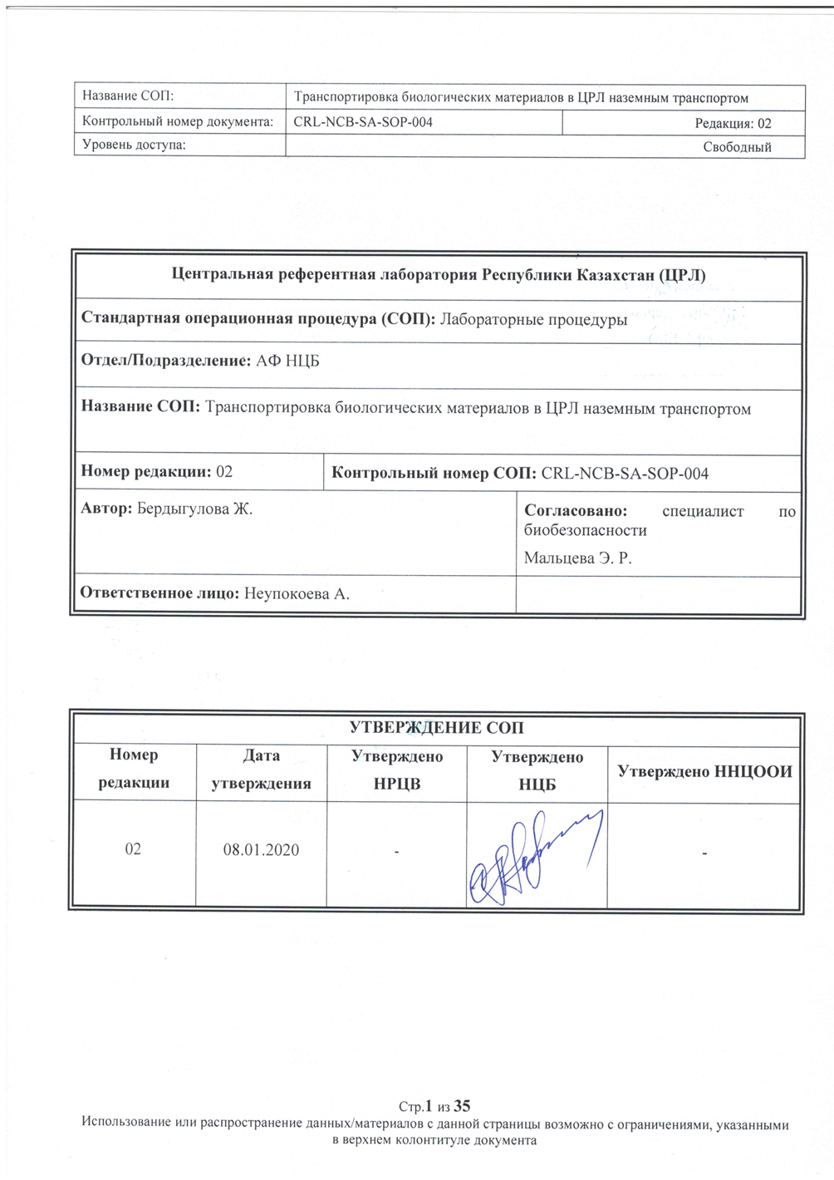

4 CRL-NCB-SA-SOP-005 "Morphological identification and differentiation of ticks"

5 CRL-NCB-SA-SOP-007 "Procedure for homogenizing biological material using a sealed Homogenizer Mixer Mill MM 400/Retsch"

6 CRL-NCB-SA-SOP-008 “Operation and Maintenance of the Homogenizer Mixer Mill MM 400”

7 CRL-NCB-SA-SOP-010 "Isolation of RNA/DNA using a "Ribo-sorb" reagents kit"

APPENDIX F8
8 CRL-NCB-SA-SOP-011 "Preparation of blood samples for research"

9 CRL-NCB-SA-SOP-015 "Conducting ELISA for the presence of antibodies to rickettsia using the Spotted fever group IgG ELISA Kit"
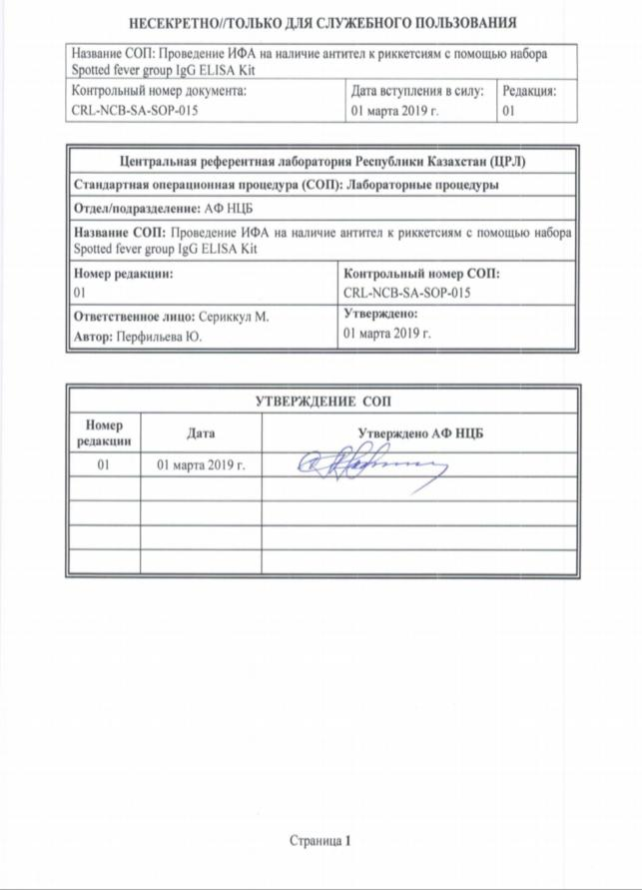
10 CRL-NCB-SA-SOP-016 "PCR analysis for the differential detection of Rickettsia sibirica and Rickettsia heilongjiangensis DNA using the RealBest DNA Rickettsia sibirica/Rickettsia heilongjiangensis kit (Set 2)"
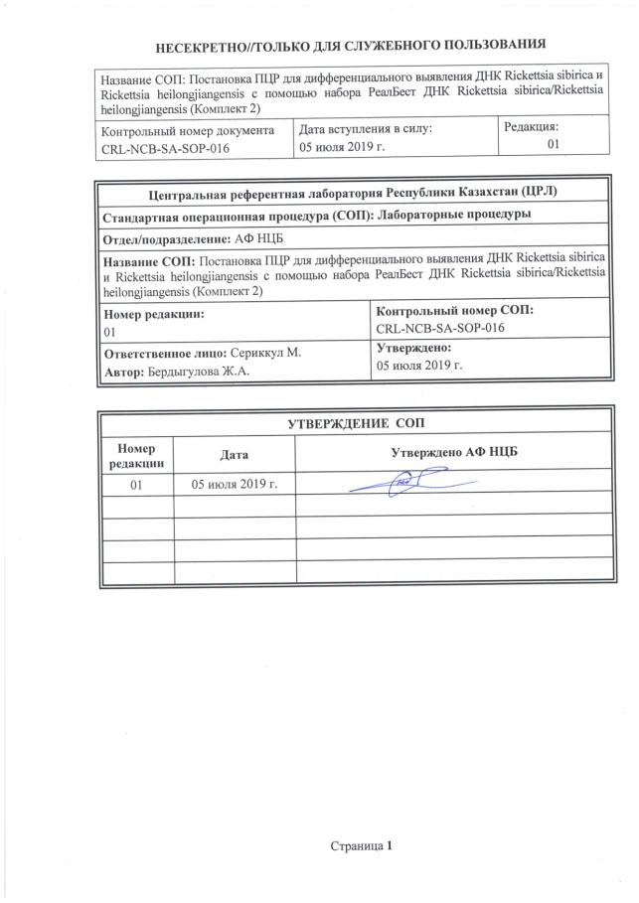
11 CRL-NCB-SA-SOP-018 "PCR analysis for the detection of DNA of Rickettsia species using the RealBest DNA Rickettsia species kit (Set 2)"
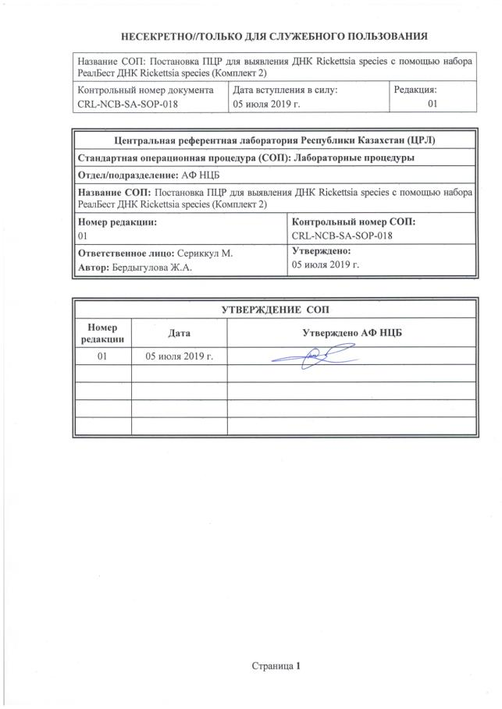
12 CRL-NCB-SA-SOP-041 "Sanger reaction followed by purification and sequencing on the Applied Biosystems 3500xL genetic analyzer"
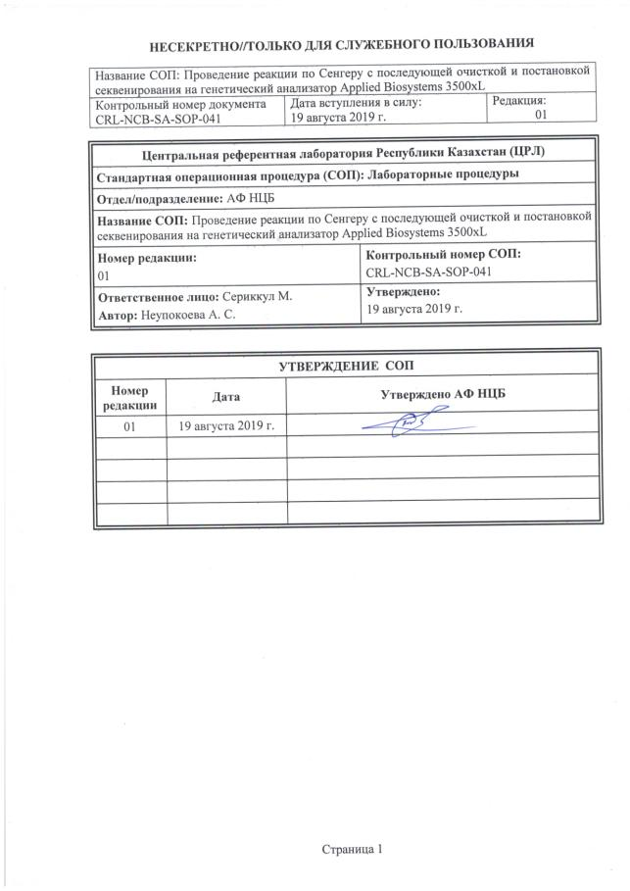
13 CRL-NCB-SA-SOP-042 “Conducting ELISA for the presence of antibodies to Rickettsia typhi using the Rickettsia typhi IgG ELISA Kit (Fuller Laboratories)”
