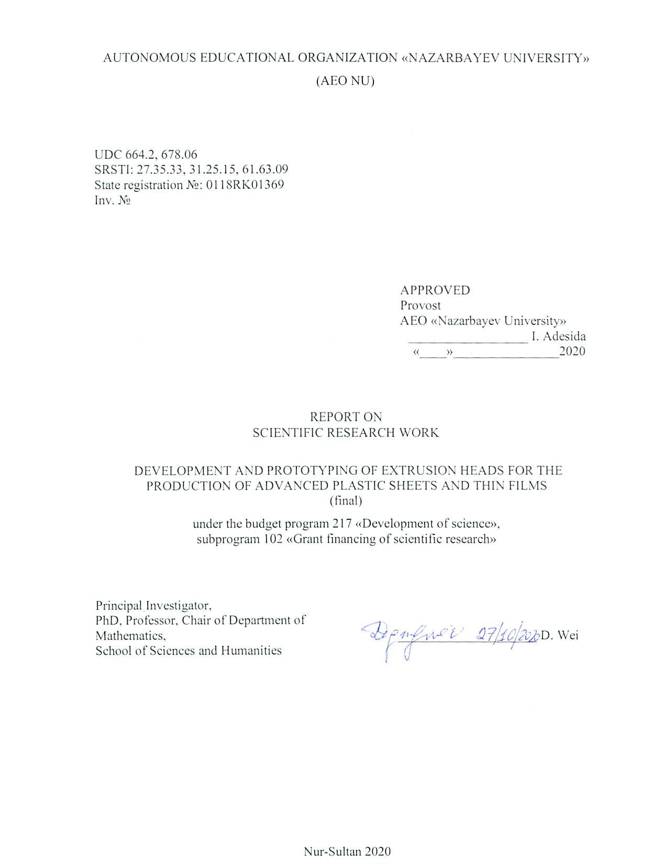
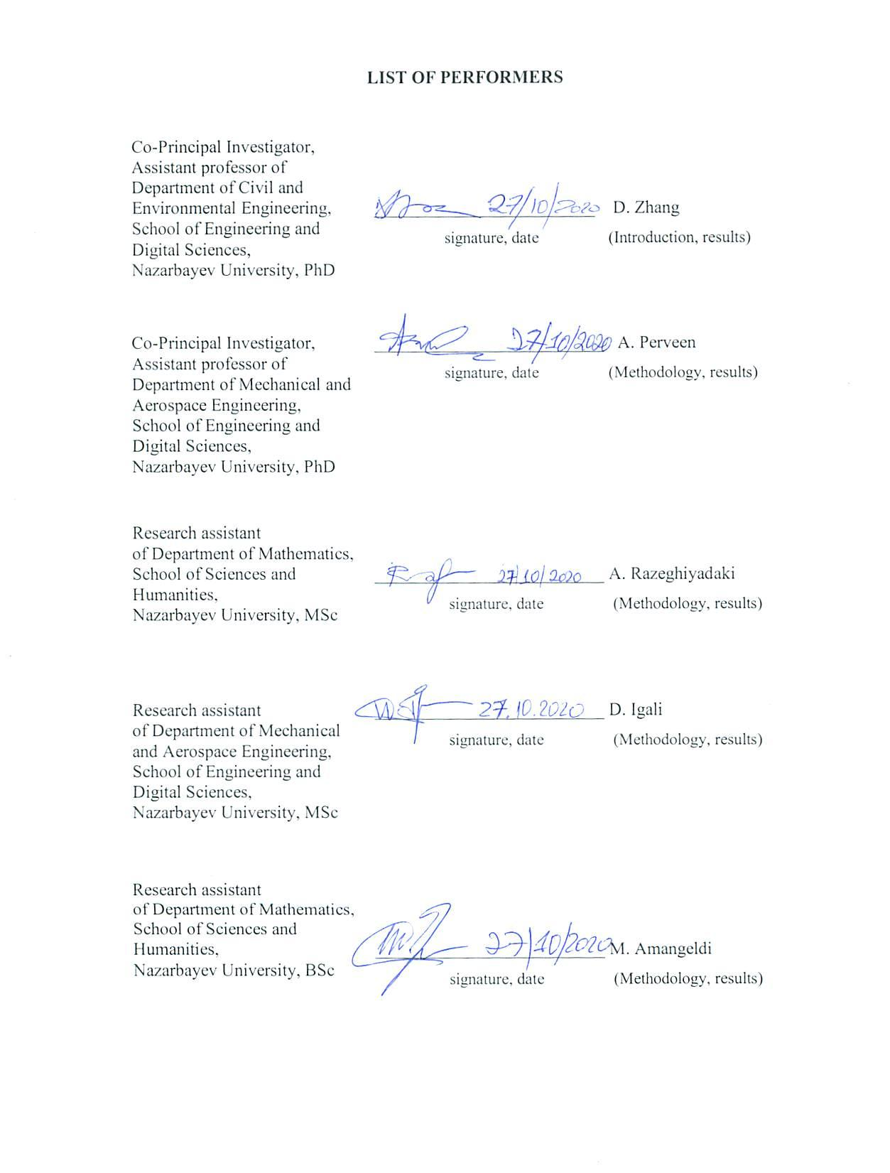
ABSTRACT

Report 25 p., 6 fig., 3 ref., 3 app.
POLYPROPYLENE, EXTRUSION, MODELING, EXTRUSION EHAD, HOMOPOLYMER, COPOLYMER
The object of research are polymers such as homopolymer – polypropylene and its copolymers.
The goal of the project - the goal of our project in 2020 was to perform numerical modeling on various head bodies, manufacture a small-sized prototype of an extrusion head using a milling machine, as well as scientific and organizational work.
Methods of research:
Using a variety of mathematical models to perform numerical calculations using Python, Ansys, MATLAB, and COMSOL programs. Using the Arrhenius law in computational stages to establish the dependence of viscosity on the temperature of the flow of a polymer fluid, as well as describing the viscosity of a fluid flow by other rheological models such as Casson and Carreau-Yasuda.
Results of research:
In 2020, an extensive computational analysis was performed on the flow of polymer fluid in various head bodies. In addition, the Casson and Carreau-Yasuda models were taken into account to describe the fluid viscosity, and the temperature dependence. The results were obtained from the results of numerical simulation of the flow of polymer fluid in different bodies of the extrusion head and taking into account the above conditions of the models. In 2020, 2 articles were published in an internationally recognized scientific journal, with an impact factor of 2.753, 1 article was accepted in the same journal and will be published soon. Also 1 scientific work is being prepared for completion.

CONTENTS
INTRODUCTION.........................................................................................................................5
MAIN PART OF RESEARCH REPORT.....................................................................................6
1 Performing numerical simulations on various head body sizes….............................................6
2 Manufacturing of a small-sized prototype of an extrusion head using a milling machine…..10
3 Scientific and organizational work………………………………………………..….………11
CONCLUSION….…..................................................................................................................12
LIST OF REFERENCES………………………........................................................................13
APPENDIX A – Calendar plan for 2018-2020...........................................................................14
APPENDIX B - List of publications………...............................................................................17
APPENDIX C – Publication prints…………………….............................................................19

INTRODUCTION
Scientific development of the optimal design of certain buildings of production equipment, in general, plays an important role in increasing production efficiency [1]. In this project, the object of scientific research is polymers. As you know, these are materials that are inexpensive, lightweight substitutes for traditional materials such as metals, glass, wood, etc. In particular, to increase the productivity of extrusion equipment, an important factor is the optimal design of the head bodies [2]. Since a number of scientific studies lead to improved shell design, this project focuses on performing numerical simulations and methods for analyzing the flow of polymer fluid in the cavity of various die shells of extrusion equipment.
In 2018, the annual report was completed and the inventory number 0218RK01380 was obtained. We collected a sample of polymers and analyzed them, and also defined the specifications of the extrusion products. In order to optimize the die design, initial computational algorithms were developed. As a result, scientific and organizational work was carried out as a result of which articles for the conference and journals were published.
In 2019, the annual report was completed and the inventory number 0219RK00228 was obtained. We performed rheological checks and obtained characteristics of the physical and chemical properties of the polymer. In order to further optimize the design of the extrusion head, numerical simulations of the design algorithms for the extrusion head were performed. We also carried out scientific and organizational work as a result of which articles for the conference and journals were published.
This year, in order to achieve the necessary results in the direction of computational analysis, first of all, it is necessary to study numerical methods, different laws of viscosity and the Arrhenius law, which will allow introducing the dependence on temperature into the analysis.
As a result, several improved versions of the die body of the extrusion equipment were obtained. In addition, 2 papers were published in a scientific journal and 1 was accepted for publication.

MAIN PART OF RESEARCH REPORT
- Performing numerical simulations on various head body sizes
The extrusion process is one of the important processes used in the processing of polymers. One of the applications of polymer extrusion is the extrusion of a flat polymer sheet. In this process, the head of the body has a significant role, since it is designed to evenly distribute the polymer melt over the cavity, and the uneven thickness and distribution of the shear rate, liquid temperature can lead to low quality of the final product [3]. In order to improve quality and with the development of computing power, numerical methods have become a more common method for analyzing movements within extrusion dies.
In regards to these opportunities, we have carried out a number of methods such as approximating the design of the head with a spline curve and using a more complex rheological model with a temperature dependence. The optimization algorithm was based on the response surface method to ensure a uniform head exit speed. To optimize the geometry of the die cavity of the extrusion equipment, it was necessary to simulate the flow field. For this purpose, the generalized Newtonian model of a viscous incompressible fluid was numerically solved by the finite volume method. This process solves the stationary continuity equation, Navier-Stokes equations and energy equations. Simulations are performed using the commercially available Ansys Fluent 19.1 software package, a computational fluid dynamics package that numerically solves flow equations using a finite volume method.

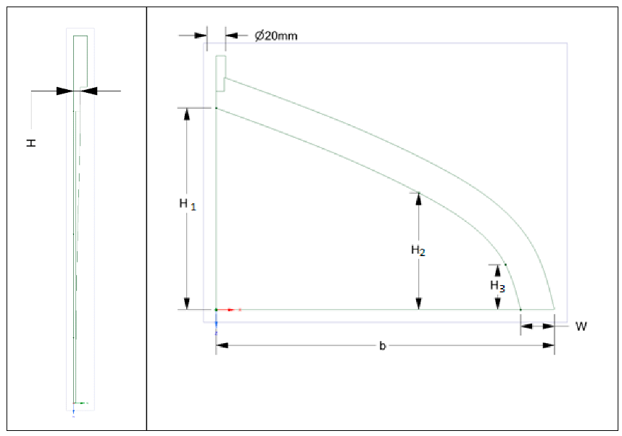
Figure 1 - New scheme of the extrusion head
As shown in Figure 1, this head layout was used for our numerical analysis. As a result of the analysis, the profiles of the velocity and temperature of the flow of the polymer fluid in the head cavity were obtained (Figure 2).
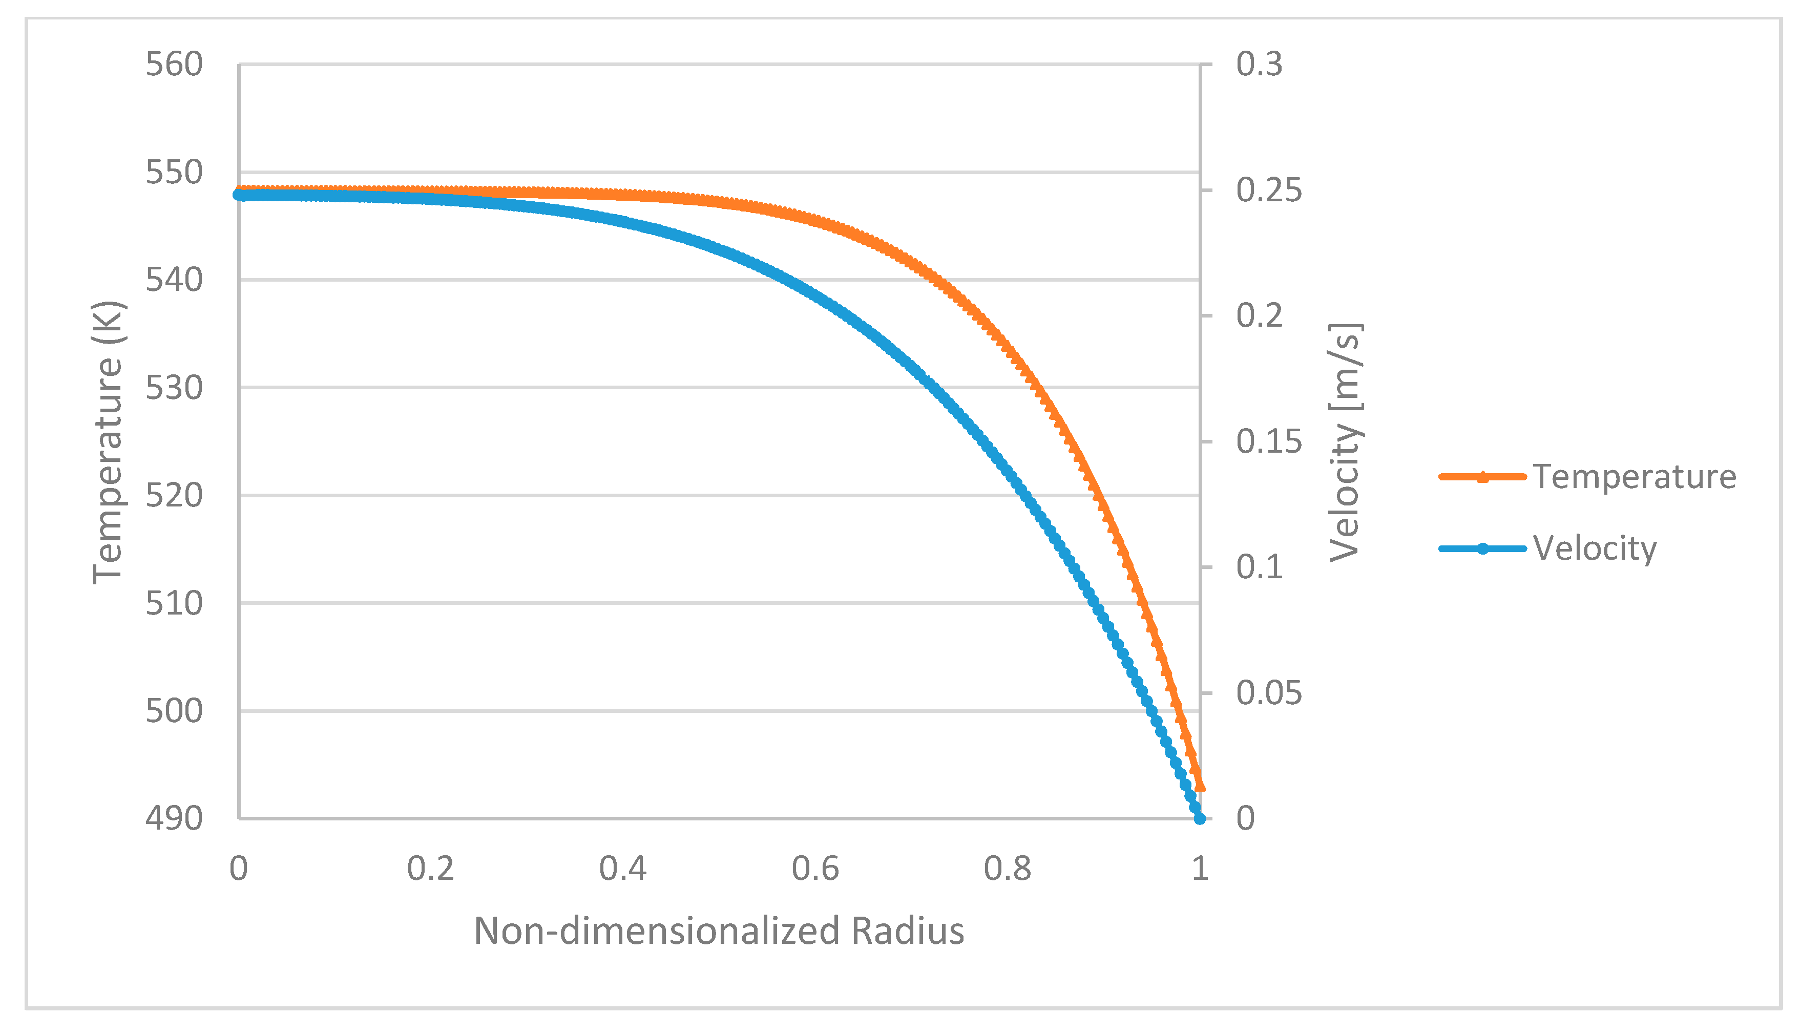
Figure 2 - Velocity and temperature profiles based on the temperature-dependent Carreau-Yasuda equation at the inlet

Since the above curves belong to the results of the solution by the finite volume method, we performed numerical calculations using the response surface method on an improved version of the extrusion head. Figures 3 and 4 show comparisons of temperature and velocity distributions in the cavity of the old and improved hulls.
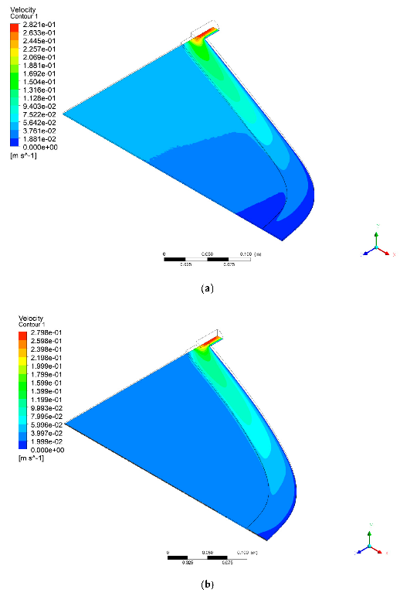
Figure 3 - Velocity distribution in the original (a) and new scheme (b) of the head body
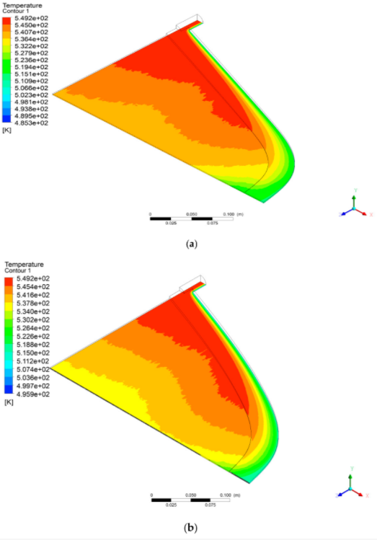
Figure 4 - Temperature distribution in the original (a) and new scheme (b) of the head body

The results (Figures 3 and 4) of the numerical analysis of the fluid flow in the casing according to the scheme in Fig. 1 can be understood to be satisfactory, since the temperature and polymer flow rate are uniform in the improved casing.
The next numerical analysis is the use of the finite element method, which allows solving the temperature distribution of the liquid just as quickly and efficiently. This time, numerical simulations were applied to the fluid flow at the inlet to the die. Figure 5 shows the result of the simulation of the temperature distribution of the liquid in the cavity of a circular pipe.
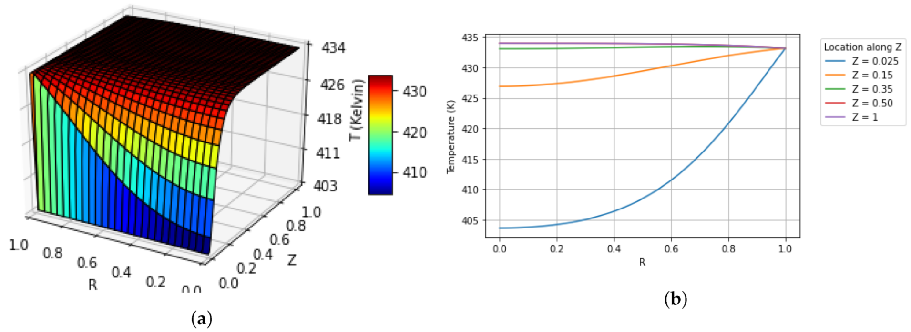
Figure 5 - Solutions of the temperature distribution of a liquid flow (a) inside a circular pipe by the finite element method (b) cross section
In this way, the required pipe length can be calculated, which will ensure a uniform temperature level of the liquid, which will lead to quality production.
In addition, we also performed a structural analysis of the new and improved die body design. A new and improved design (Figure 6) was derived from Winter's design and the corresponding geometry was then evaluated using a numerical fluid-structure interaction. It was determined that it was necessary to identify the required mass flow range.
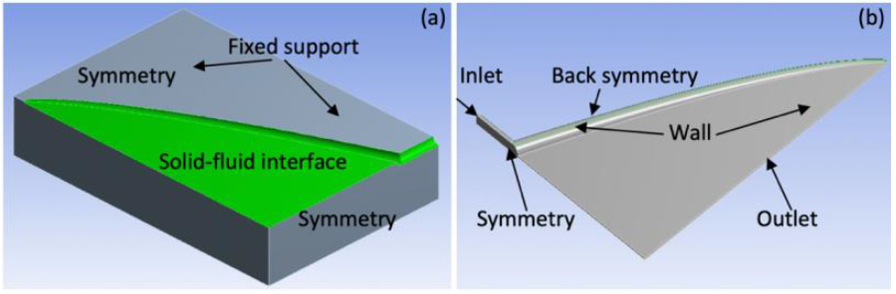
Figure 6 - Improved head body model for structural analysis

- Manufacturing of a small-sized prototype of an extrusion head using a milling machine
Manufacturing a prototype, as is customary, requires a number of stages - preparing the design of the model of the extrusion head, purchasing the necessary material, making a prototype and testing. We carried out the first stage of the field of numerical simulation of the flow of liquids in different buildings. Unfortunately, the rest of the steps are not completed due to the expensive material for the prototype. Of course, other materials with low cost can be used, but during the testing phase, the finished prototype will not be suitable for comparison with scientific calculation results.

- Scientific and organizational work
We have successfully produced scientific articles, published and preparing for submission for publication in the international rating journal "Processes". This scientific journal has a high reputation and an impact factor of 2.753. Below are all of our 2020 scientific results. In particular, the scientific results for 2020 were the optimization of the polymer extrusion head based on the response of the surface method, numerical modeling of temperature flows in the cavity of polymer extrusion channels. And also other scientific work was accepted for publication on modeling the shear rate of flow in the extrusion head using the Casson viscosity model. Another work is being prepared for submission for publication on the approximation of the stationary Carreau-Stokes problem by the finite element method. All of the above published works have successfully passed peer review in the international journal Processes.

CONCLUSION
As a result of 2018, a number of tasks were completed, such as collecting a sample of polymers and analyzing them, and also defining the specifications of extrusion products. In order to optimize the die design, initial computational algorithms were developed. As a result, scientific and organizational work was carried out as a result of which articles for the conference and journals were published.
As a result of 2019, the following tasks were completed, such as performing rheological checks and obtaining characteristics of the physical and chemical properties of the polymer. In order to further optimize the design of the extrusion head, numerical simulations of the design algorithms for the extrusion head were performed. We also carried out scientific and organizational work as a result of which articles for the conference and journals were published.
In final 2020, an extensive computational analysis of the flow of polymer fluid in various die bodies was carried out, in particular, a number of methods were performed, such as approximating the design of the die using finite elements and volumes, and using a more complex rheological model with temperature dependence. As a result, several improved versions of the die body of the extrusion equipment were identified. In addition, 2 papers have been published in a scientific journal, 1 paper has been accepted for publication and 1 is being prepared for completion.

LIST OF REFERENCES
- Market for the production of plastic and rubber products in Kazakhstan // http://rfcaratings.kz/6155 (accessed date: 01.10.2019).
- Wang Y. The flow distribution of molten polymers in slit dies and coathanger dies through three‐dimensional finite element analysis. // Polymer Engineering & Science. – 1991. – Vol. 31. –P. 204-212.
- Hornsby P., W. Michaeli. Extrusion Dies For Plastics And Rubber. - Munich, Bavaria, Germany: Hanser Publishers, 1992. – 362 p.

APPENDIX А
Calendar plan for 2018-2020

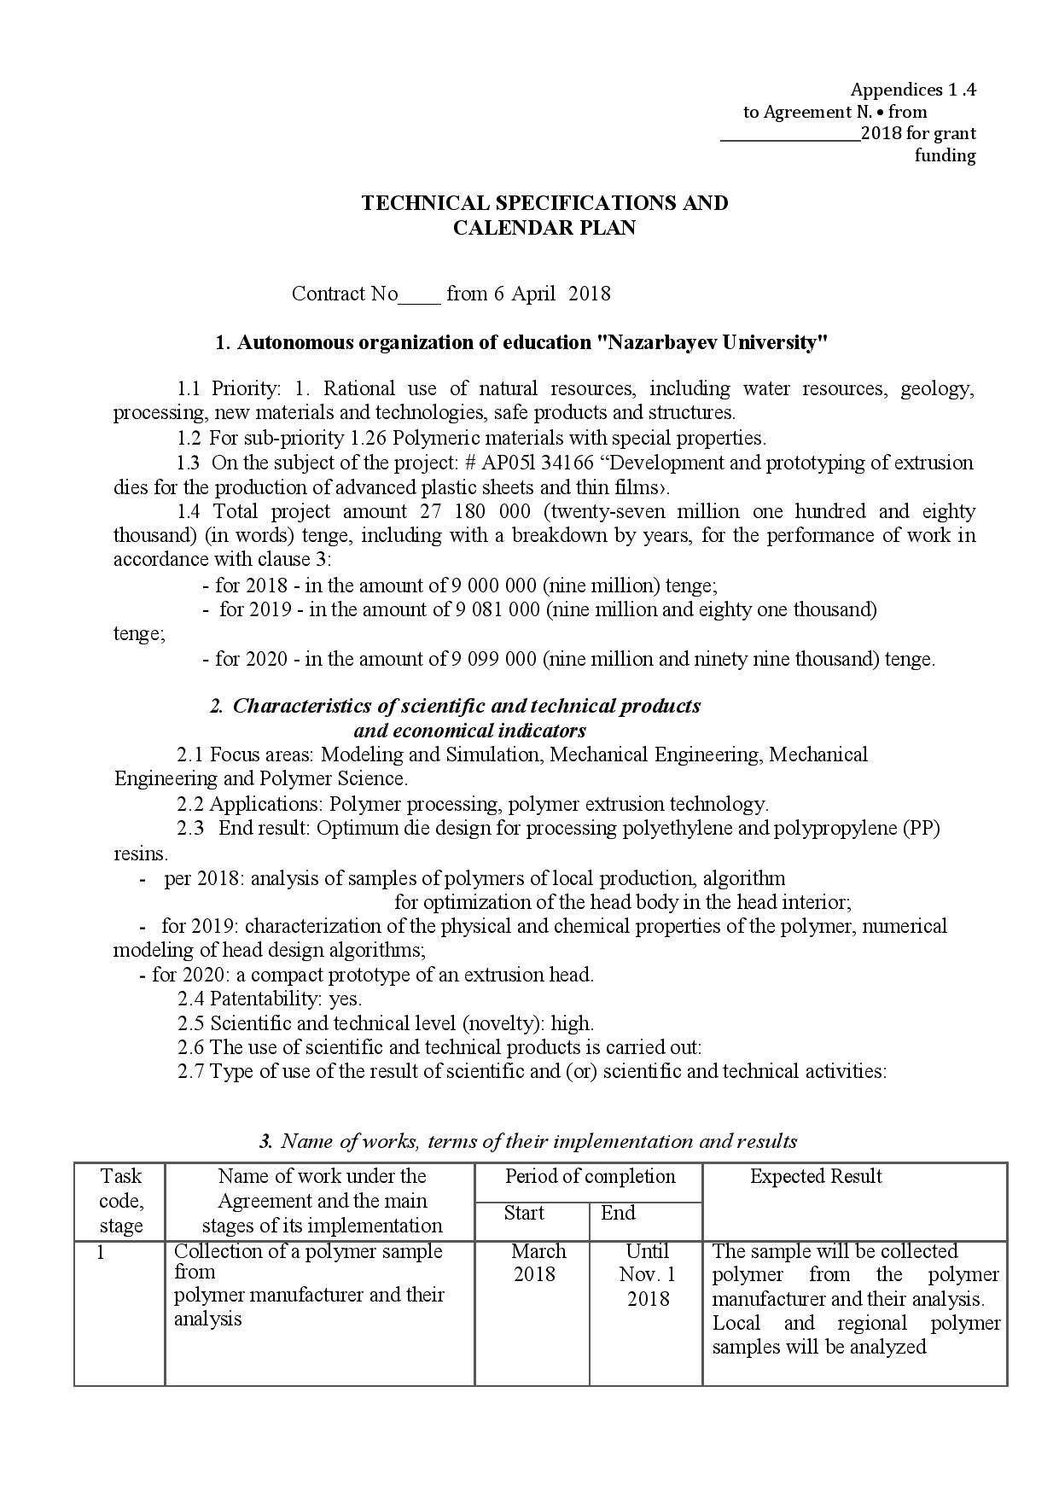
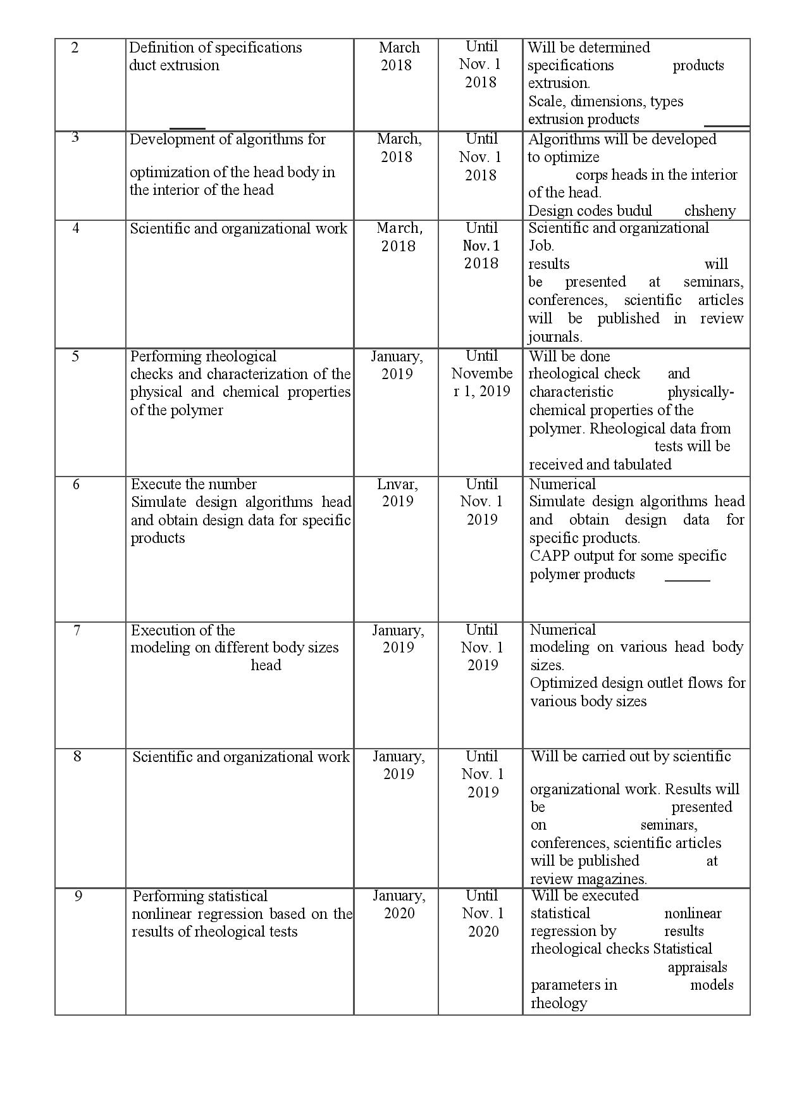
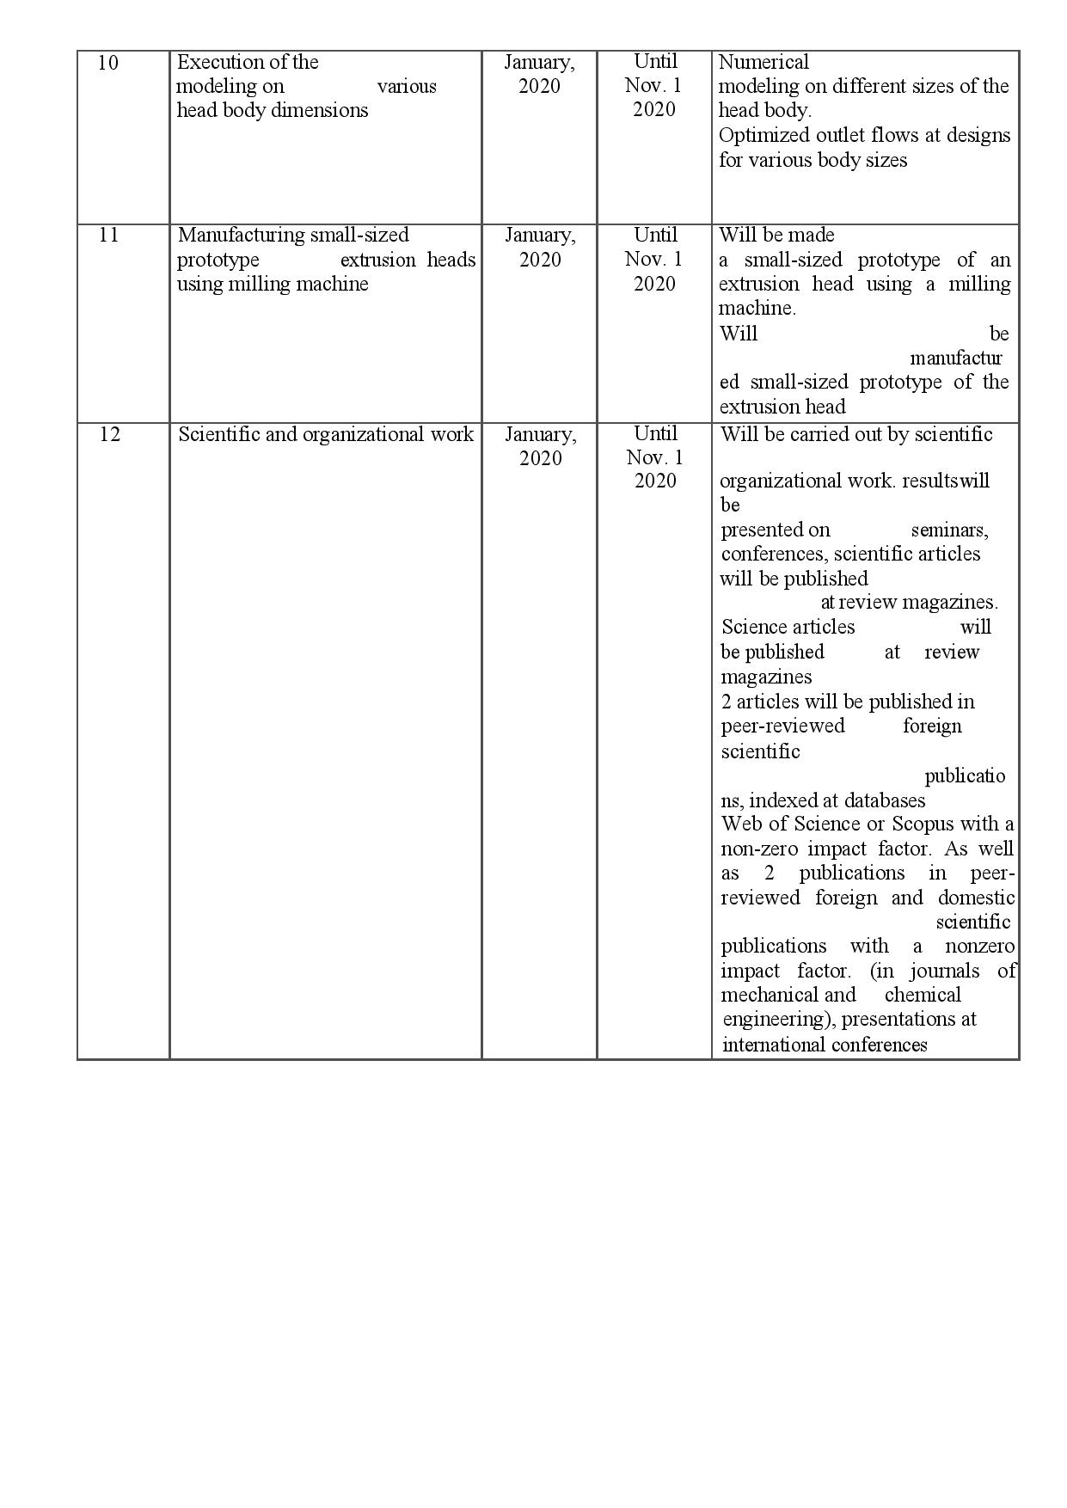

APPENDIX B

List of publications for 2018
- Korzhynbayeva K., Mentbayeva A., Wei D., Zhang D., Perveen A., Development of polymer industry in Kazakhstan // Burning and plasmochemistry. – 2018. – 16, 197-203.
- Korzhynbayeva K., Mukhambetiyar A., Mentbayeva A., Wei D., Zhang D., Perveen A., Rheological behaviour of polymers as the key for developing the extrusion die design // Journal of Chromatography and Separation Techniques – 2018., 8th World Congress on Chromatography and 4th International Conference on Polymer Science and Technology
List of publications for 2019

- Igali D., Perveen A., Wei D., Zhang D., Mentbayeva A., 3D FEM study of the flow uniformity of flat film/sheet extrusion dies // The 4th International Conference On Material Engineering and Application 2019, Kuala-Lumpur, Malaysia
- Saparov T., Belgibay U., Zhang D., Wei D., Mentbayeva A., Perveen A., Design and Optimization of Die body for polymer extrusion // The 4th International Conference On Material Engineering and Application 2019, Kuala-Lumpur, Malaysia

List of publications for 2020

- Razeghiyadaki A., Zhang D., Wei D., Perveen A., Optimization of polymer extrusion die based on response surface method // Processes. – 2020. – Vol. 8, No. 1043.
- Amangeldi M., Wei D., Perveen A., Zhang D., Numerical modeling of thermal flows in entrance channels for polymer extrusion: a parametric study // Processes. – 2020. – Vol. 8, No. 1256.

In print
- Igali D., Perveen A., Zhang D., Wei D., Shear rate coat-hanger die using casson viscosity model // Processes. – 2020. – Vol. 8.
Preparing to submit for publication
- Baiseitova K., Amangeldi M., Wei D., Penalty finite element approximation of the stationary carreau stokes problem

APPENDIX C
Publication prints for 2018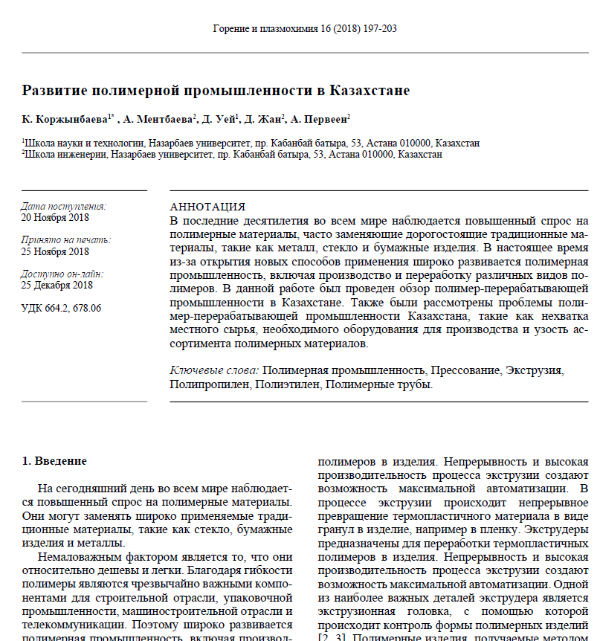


Publication prints for 2019
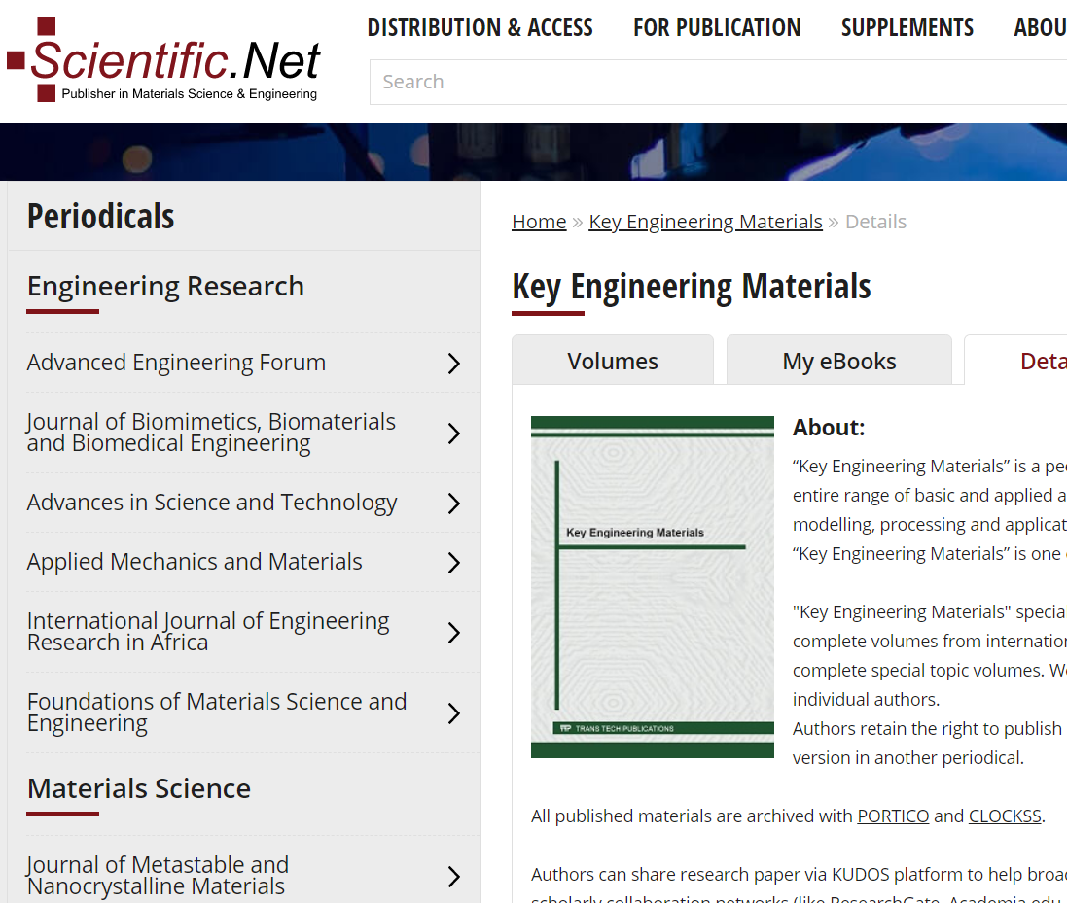

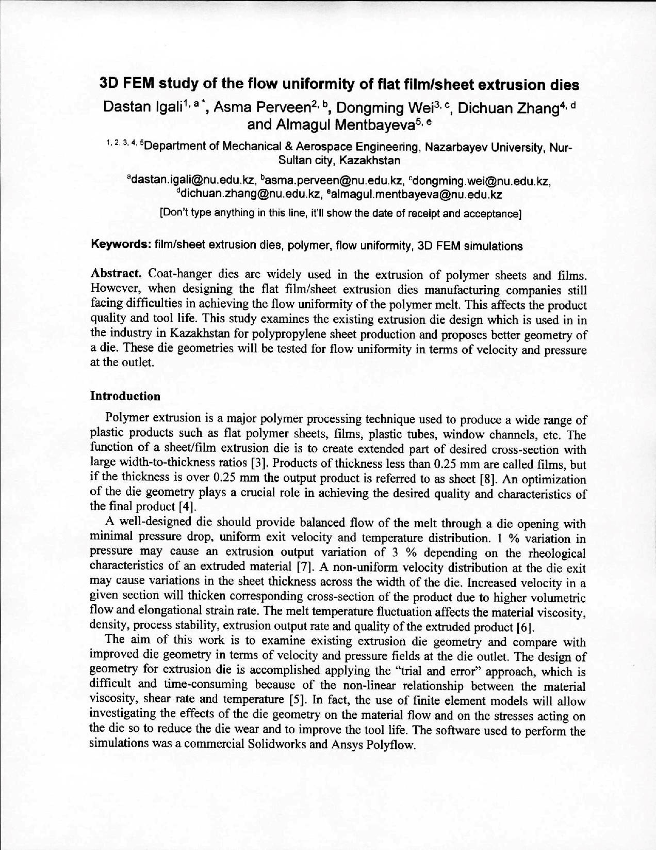

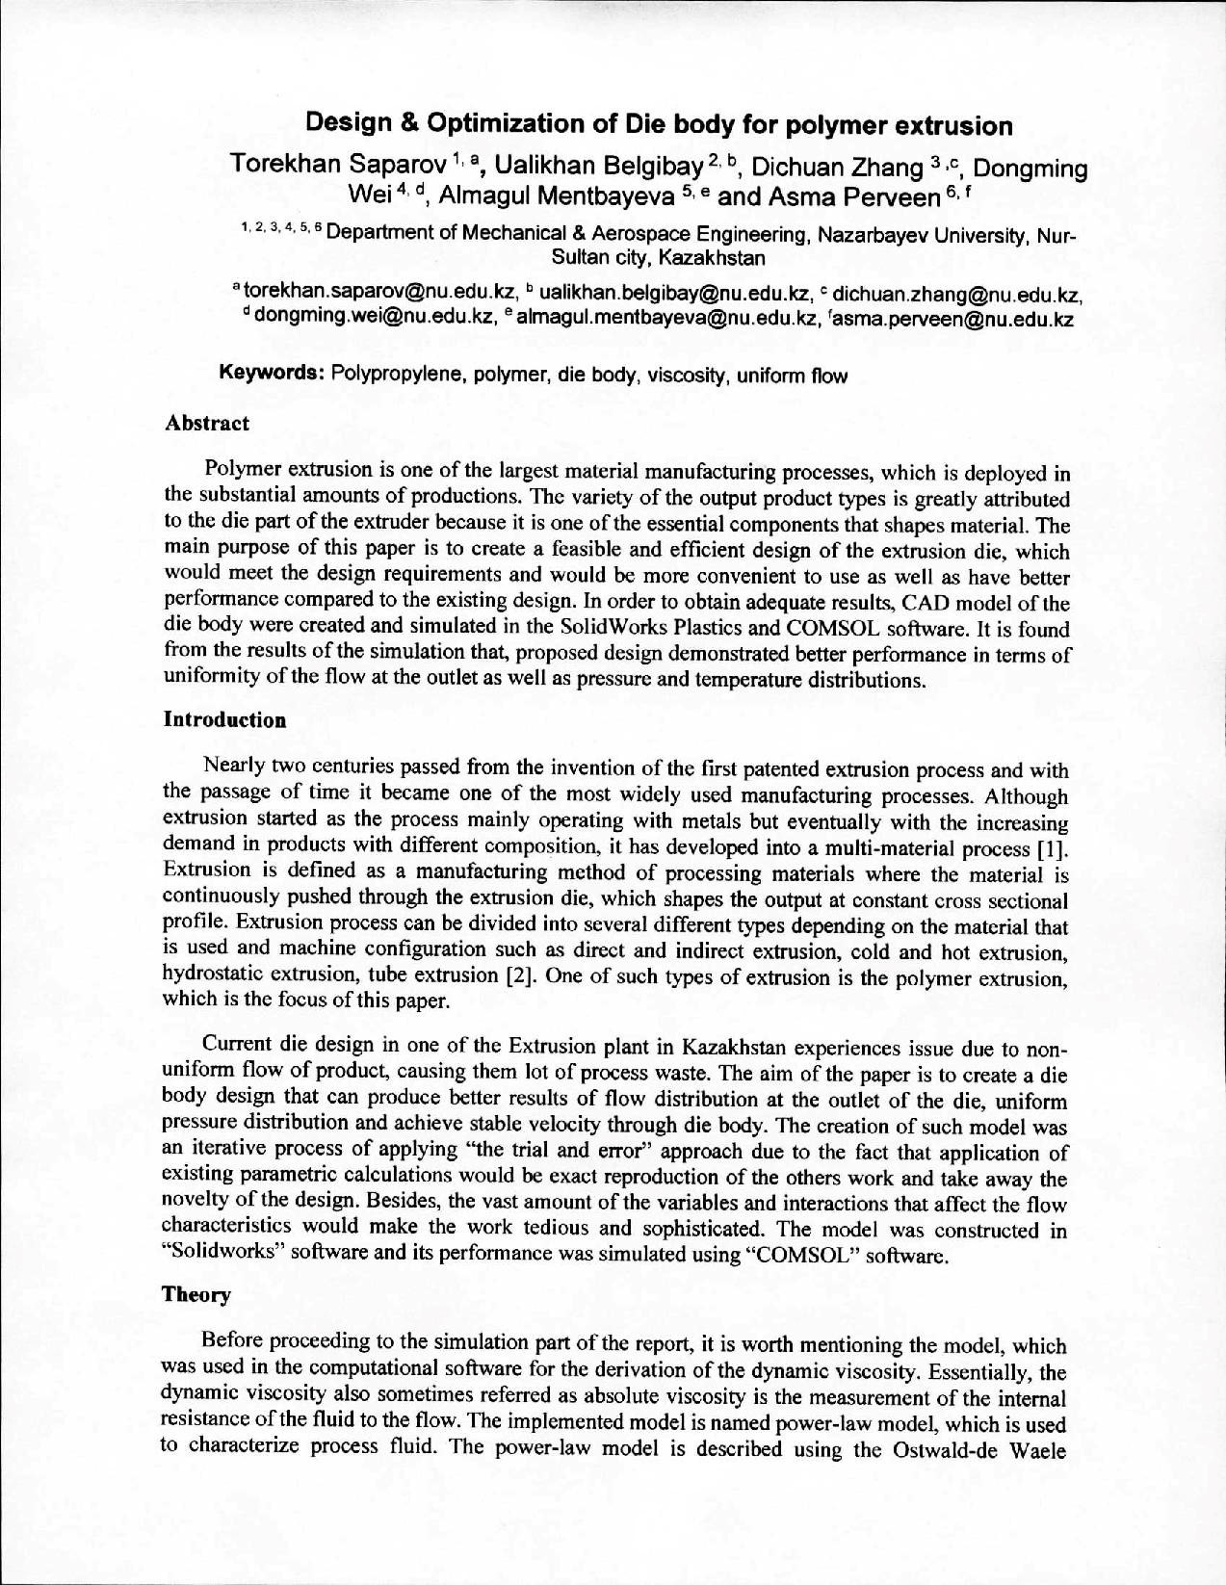

Publication prints for 2020
