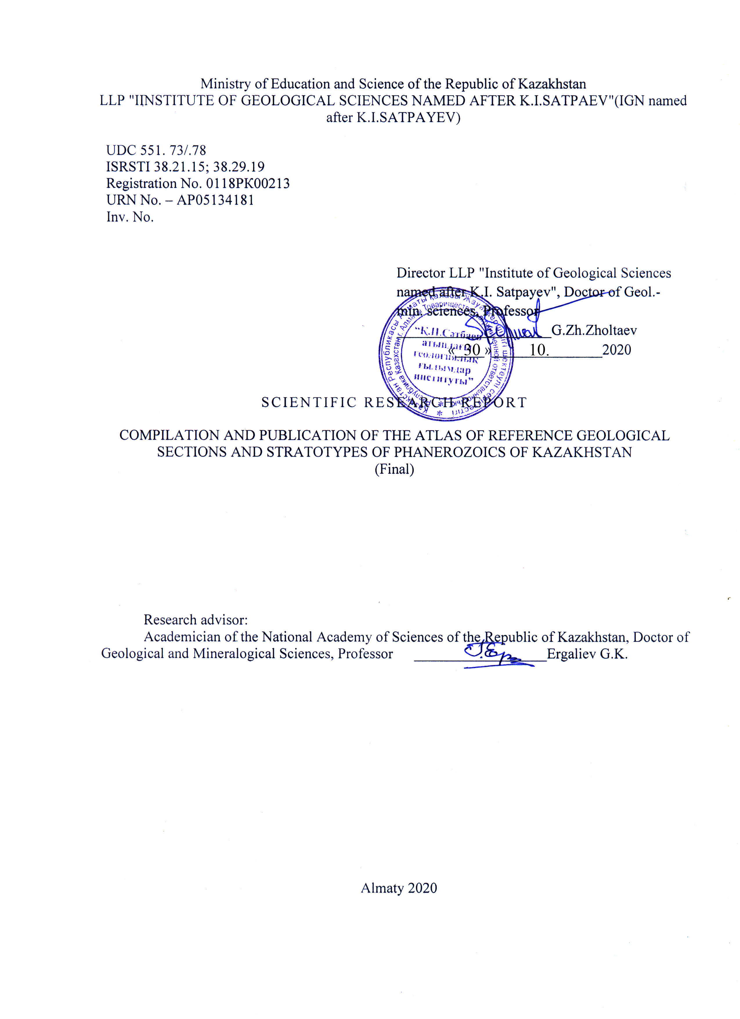

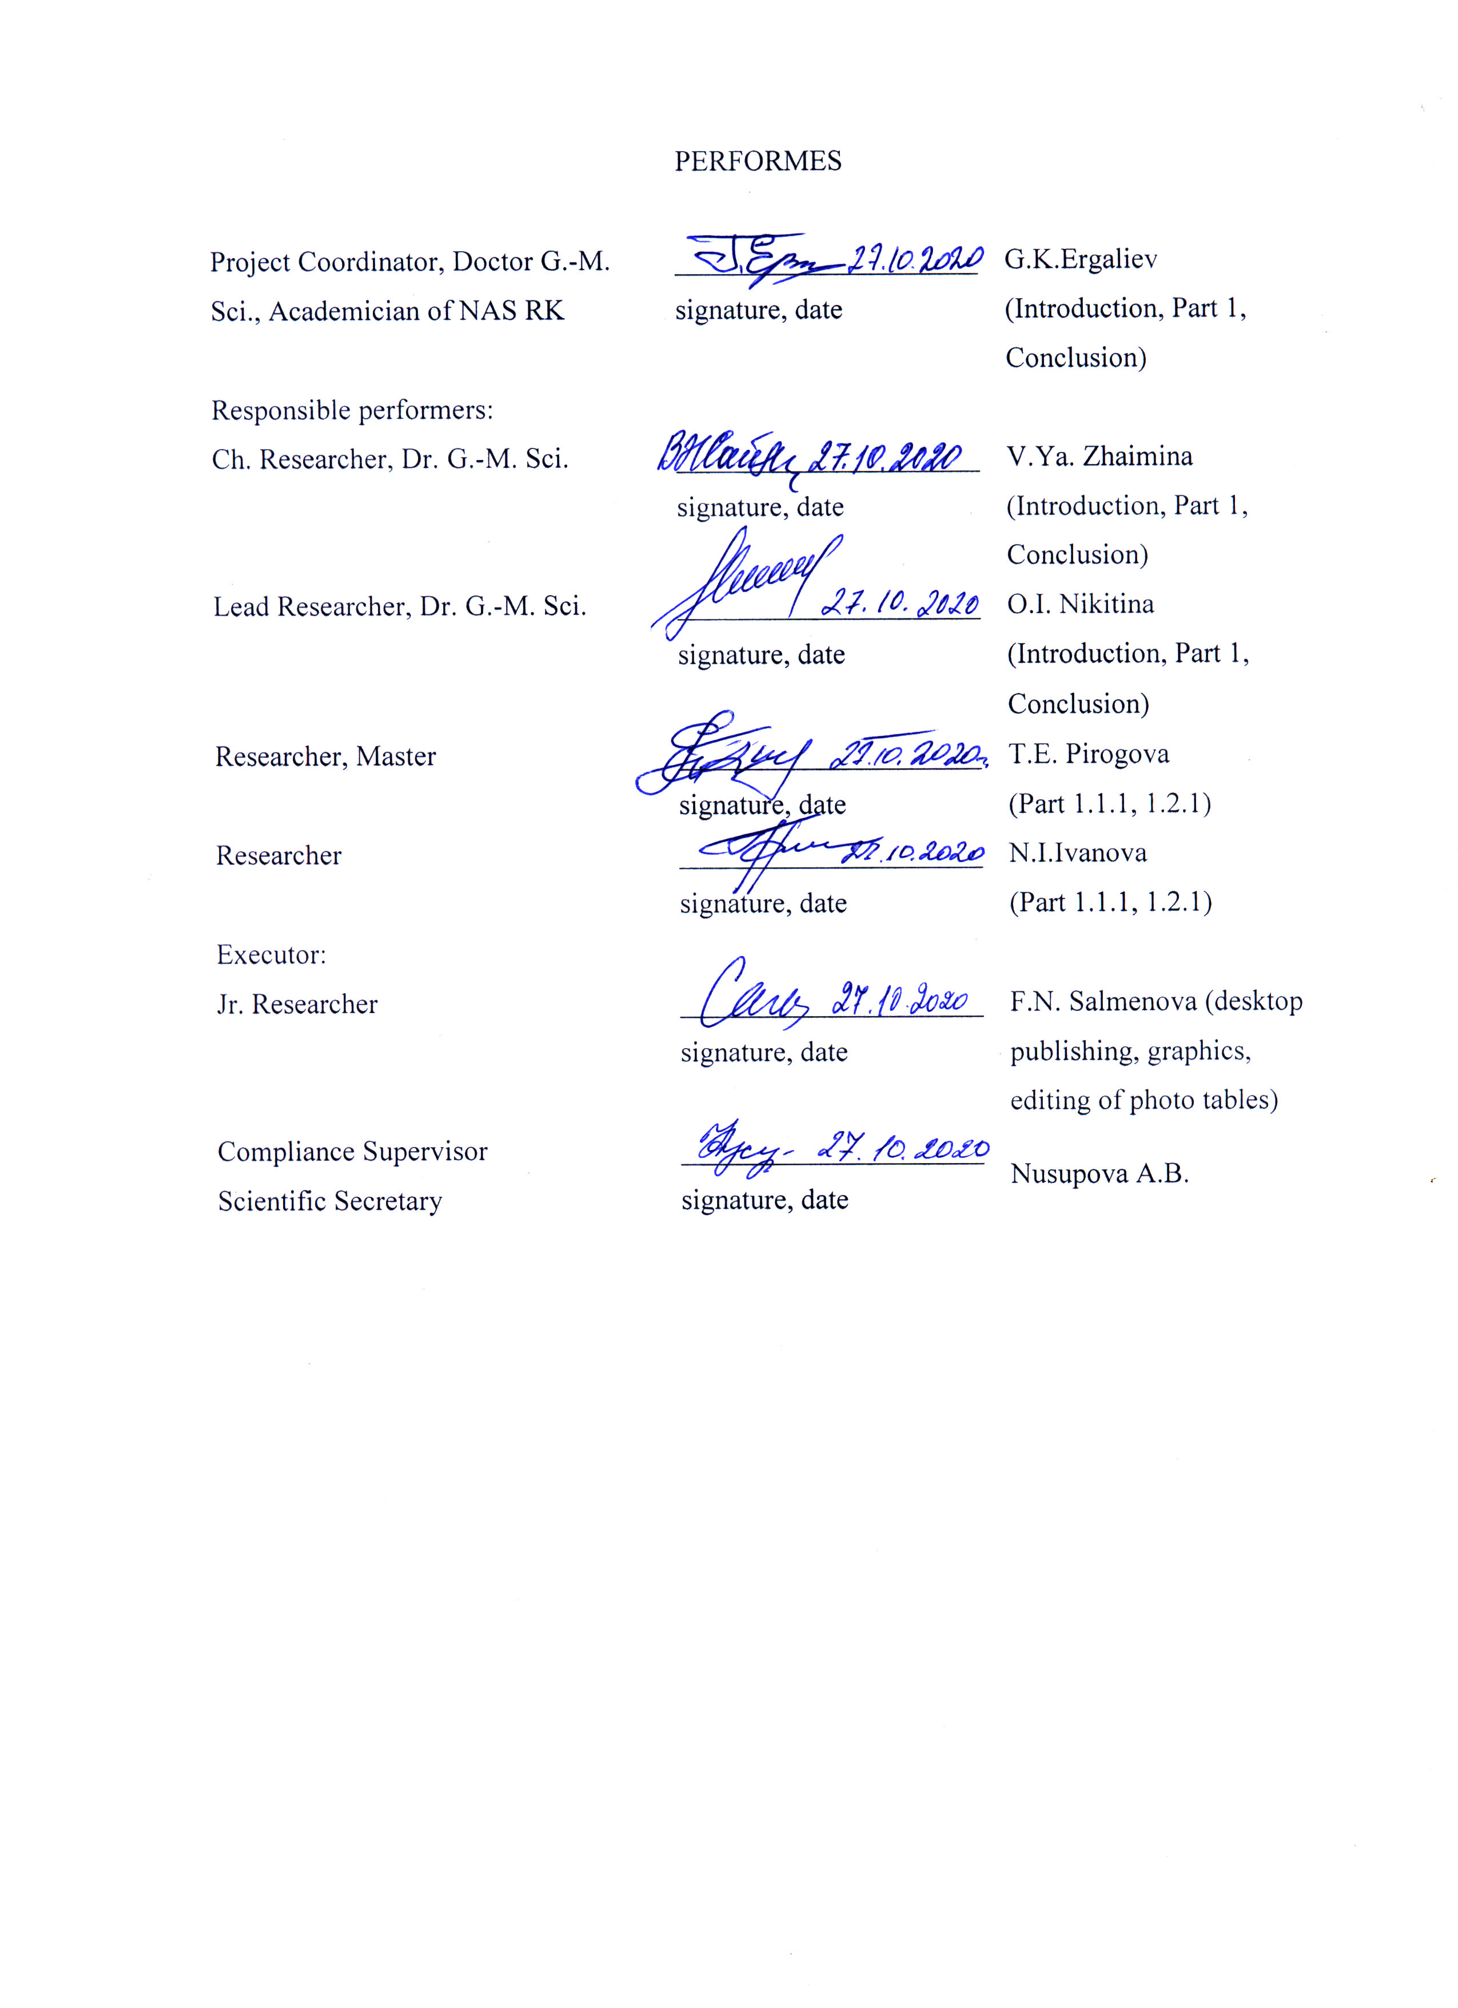
performs

ABSTRACT

Report 97 p., 1 Book, 39 fig., 68 sources, 4 Appendices
ATLAS, KEY SECTIONS, STRATOTYPES, PHANEROSE, CORRELATION, INTERNATIONAL STATISTICAL SCALE.
The object of research is the key geological sections and stratotypes of units and boundaries of the Phanerozoic of Kazakhstan
Purpose of work: digital layout of the layout and publication of the first in Kazakhstan Atlas of geologic key sections and stratotypes of Kazakhstan's Phanerozoic.
Research methods: digital, paleontological-stratigraphic, lithological-facial, laboratory-analytical, determination of the age of organic remains.
Research results of 2020: The revision of guiding complexes composition, detailed dismemberment, age justification, linking of borders and stratolo levels with MSC was completed; description and digital layout of 58 sections with illustrations was completed.
The article by O.I. Nikitina - YOSHITAKA KAKUWA and OLGA I. was published. KAKUWA AND OLGA I. NIKITINA. Petrography of Late Cambrian to Middle Ordovician radiolarian cherts in Kazakhstan with special key to the emergence of benthic animals in the pelagic realm // Sedimentology (2020) 67, doi: 10.1111/sed.1271, P. 2764-2776.
Published article: V.J. Zhaimina - V. JA. ZHAIMINA. Bashkirian - Moscovian Boundary in Zhungar - Balkhash Region (Kazakhstan) // 20th International Multidisciplinary Scientific GeoConferences & EXPO SGEM 2020; 27.06.2020 - 06.07.2020, Sofia, Bulgaria
- The final report compiled.
Novelty of research: The Atlas is the first illustrated summary of the latest stratigraphic and regional-geological information in Kazakhstan, which shows the evolution of the Earth's crust of Kazakhstan.
Degree or results of implementation of the results. Key sections and stratotypes serve as a basis for legends of new generation geological maps, which are necessary to detect and build up mineral resources.
Fields of application: For a wide range of specialists in geological science and practice and in the field of geological education.
Practical significance of the work performed: Publication of the Atlas will promote dissemination of knowledge about the geology of Kazakhstan, development of international cooperation and growth of investment attractiveness of the country.
Forecast assumptions about the development of the research object: the impact on the development of science and technology of published new materials, which will be available to a wide range of specialists in Kazakhstan and abroad.

TABLE OF CONTENT

INTRODUCTION……………………………………………………………………… | 6
1 Digital desktop publishing and publication of the Atlas of key geological sections and stratotypes of the Phanerozoic of Kazakhstan ……………………………………... | 9
1.1 Revision of the guide complexes' composition, breakdown detalization, age substantiation, final correlation of stratigraphic units, boundaries with the ISC, marking strata levels based on the correlation of key sections and stratotypes ……….. | 9
1.1.1 The Cambrian...................................................................................................... | 9
1.1.2 The Ordovician.................................................................................................... | 11
1.1.3 The Silurian......................................................................................................... | 12
1.1.4 The Carboniс...................................................................................................... | 13
1.2 Completion of descriptions of geological sections, introductory and final sections of the report, annotations, graphic and photo illustrations ……………………………... | 18
1.2.1 The Cambrian....................................................................................................... | 18
1.2.2 The Ordovician.................................................................................................... | 22
1.2.3 The Silurian......................................................................................................... | 26
1.2.4 The Carboniс...................................................................................................... | 27
1.3 Layout, PDF formatting, digital page and Atlas layout. Conclusion of an Agreement for printing services for the Atlas publication. Publication of articles. Final report compilation…………………………………………… ……………………….... | 28
CONCLUSION ……………………………………………………………………........ | 31
references ………………………………………………………………………… | 36
APPENDIX А Figures …………………………………………………………………. | 42
APPENDIX B Articles published in the reporting period …………………………….. | 78
APPENDIX C Calendar plan for 2018 - 2020 …………………………………………. | 91
APPENDIX D Atlas of key geological sections and stratotypes of phanerozoic of Kazakhstan……………………………………………………………………………… | 95
INTRODUCTION

The project «Compilation and publication of the Atlas of key geological sections and stratotypes of phanerozoic of Kazakhstan» is preparation and publication of the first illustrated edition in Kazakhstan, which will serve as a source of the latest information on regional geology, stratigraphy, paleontology, sedimentation processes in marine and terrestrial conditions, history of formation of the Earth's crust of Kazakhstan, conditions of dwelling and evolution of its organic world during tens and hundreds of millions of years. Researches in this area are also important for detection, determination of age, genesis, stratigraphic and structural-geological position of productive stratospheric levels of minerals, which are of interest for domestic and foreign specialists and investors in the sphere of development of mineral resource base of the country. The basis for the Atlas creation was the richest factual materials on regional geology, stratigraphy, paleontology, tectonics, geodynamics, paleobasins evolution, mineral formation accumulated over many decades of geological research. Paleontological materials were represented by the richest collections of fossil organic remains accumulated by the authors and their predecessors over many decades, as well as those collected in the course of field work under this program.
Results of research in 2018:
- Working versions of section descriptions and graphical illustrations based on the results of field, laboratory and cameral work were compiled;
- Stock and published materials were collected, analyzed, systematized, and a database on key sections, stratotypes and stratolevels was compiled.
- The article by G.K. Ergaliyev and T.E. Pirogova was edited. "Late Lower-Cambrian and Middle-Cambrian sedimentary sections of the Mayzhon and Ateyskaya suites of the Shyngyz Range (East Kazakhstan)".
- Key sections, stratotypes, productive Cambrian stratospheric levels with paleontological, litho-facial testing, binding, photography of key objects were studied in field conditions. Based on the results of field work:
- paleontological and lithological samples were determined and photographed;
- working variants of section descriptions, graphic illustrations are made.
- The annual report was drawn up.
Research results of 2019:
- Sections descriptions, preparation of graphic illustrations were completed, the concept and structure of the Atlas was developed;
- Databases were compiled on the basis of collections, analysis, systematization of materials, the revision was carried out, linking to the International Stratigraphic Scale (ISS);
- Descriptions with graphic illustrations of the key sections of the Cambrian Atasu-Mointinsky (Zhamshinsky) watershed, Malyii Karatau and Northeast Kazakhstan were made; Ordovician of the Kendyktas, Chu-Iliysky, Western-Pribalkhash, Betpak-Dalinsky segments; Silur of the Western and North-Eastern Pribalkhash region; Carbon of the Zhezkazgan ore district and Zhezkazgan-Chui structural-facial zone (hereinafter referred to as SFZ).
- The concept and structure of the Atlas of key geological sections and stratotypes of Kazakhstan's Phanerozoic.
- An article was published in the peer-reviewed domestic scientific publication "Izvestia NAS RK", Series Geology and Technical Sciences, 2019. N 4 (436), Almaty. C. 42-54. V.Ya. Zhaimin, E.I. Kulagina (Russia) "Features of the boundary sediments of the Devon and carbon of the Karamurun section (Big Karatau, Southern Kazakhstan)".
- The article was published in the peer-reviewed domestic scientific publication "Izvestia NAS", Series Geology and Technical Sciences, 2019. N 5 (437), Almaty. C. 158-168: G.K.Yergaliev, V.G.Zhemchuzhnikov, T.E.Pirogova "Cambrian of North-West Pribalkhashia".
- The article was published in the peer-reviewed scientific publication "Oil and Gas Geology" №5, Moscow, 2019, RINC (IF 0,647): G.Zholtaev, K.O.Iskaziev, A.Abishev, G.E.Kulumbetova. "A New Prospective Direction for Prospecting Oil and Gas Sediments in the East of the Caspian Depression".
- The annual report has been prepared.
In 2020, at the stage of work completion, the following main task was performed in accordance with the calendar plan:
-Digital layout and publication of the Atlas of Key Geological Section and Phanerozoic Stratotypes of Kazakhstan.
In order to accomplish this task, the following types of work were performed:
Revision of the guide complexes’ composition, breakdown detalization, age substantiation, final correlation of stratigraphic units, boundaries with the ISC, marking stratolevels based on the correlation of key sections and stratotypes.
- Completion of descriptions of key sections, annotations, graphic and photo illustrations of the following key sections and stratotypes
- Layout, PDF formatting, digital page and Atlas layout. Conclusion of an Agreement for printing services for the Atlas publication.
- Publication of the results of research in the form of articles in peer-reviewed domestic and foreign scientific journals with a non-zero impact factor (authors V.Ya. Zhaimina, O.I. Nikitina).
The research methodology was based on paleontological-stratigraphic, lithological-facial, laboratory and analytical methods, determination of taxonomic affiliation, age, vertical and lateral distribution, organic residues, separation of zonal species-indexes, as well as on the dissection, correlation of stratigraphic subdivisions with the justification of their borders and linking to the borders of the International Chronostigraphic Scale (ISS) 2018-2020.
Interim reports on the project "Compilation and publication of the Atlas of key geological sections and stratotypes of the Phanerozoic of Kazakhstan" have identical names and a single registration number 0118RK00213, respectively, their inventory numbers: 2018 - 0218RK00477, 2019 - 0219RK00521.

1 Digital desktop publishing and publication of the Atlas of key geological sections and stratotypes of the Phanerozoic of Kazakhstan
The digital layout of the model was completed, the Atlas of geological key sections and stratotypes of the Phanerozoic of Kazakhstan was prepared for publication and submitted to the printing-office.
The digital layout of the Atlas consists of a cover with a title, a fly-leaf, a list of authors, a table of contents, an introduction and sections on Phanerozoic systems, which included 58 of the most representative sections of the Cambrian, Ordovician, Silurian, Marine and Continental Devonian, Famennian-Carboniferous and Carboniferous sediments, shoreline sediments and continental sedimentary and volcanogenic formations of the Upper Paleozoic, subdivisions of the Mesozoic and Cenozoic. All these sections are continuous, have a simple structure, reliable boundaries, and full paleontological basis. They are divided into following main categories: 1 – key stratotype sections of general and regional chronostratigraphic subdivisions and (or) their boundaries in the composition of boundary sediments in Kazakhstan; 2 - key sections of regional subdivisions, which are important for characterizing other structural-facies zones and stratified complexes, corresponding to stratotypical ones by age; 3 - stratotypes and type sections of local charted lithostratigraphic units (series, formations) and their sequences, which are key for certain structural-facies zones and their parts. The illustrations for the descriptions of the sections consist of graphic applications and photographic images of outcrops, rock samples, photographs, reconstructions of fauna and flora. Description of key sections and stratotypes was made in accordance with the requirements of stratigraphic codes (Stratigraphic Code of the Russian Federation 2019, International Stratigraphic Guide 1999, 2000 [1, 2]), taking into account the decisions of the International Commission on Stratigraphy (ISS) and according to the instructions "Tasks and rules for study and description of key stratigraphic sections ”1983 [3].
1.1 Revision of the composition of the governing complexes’, detaling dismemberment, age substantiation, final correlation of stratigraphic units, boundaries with the ISC, marking strata levels based on the correlation of key sections and stratotypes.
At the stage of preparing key sections for digital layout Revision of the guide complexes’ composition, breakdown detalization, age substantiation, final correlation of stratigraphic units, boundaries with the ISC, marking strata levels based on the correlation of key sections and stratotypes was carried out.
1.1.1 The Cambrian
New collection points for trilobites and other fauna have been identified, and the lists of trilobites have been significantly expanded in comparison with the previously known ones, which makes it possible to more accurately date the host rocks in the reference sections, correlate with other regions and with the ISC. Units of the same age in different structural-formational zones, significantly differing in composition, were given new names and their stratotype sections were established [4, 5, 6, 7, 8, 9] (Appendix A, figures 1-7).
Lower Cambrian (from bottom to top): Protohertzina anabarica, Pseudorthotheca costata, Ushbaspis sp. 1, Bercutia cristata, Hebediscus orientalis, Ushbaspis limbata и Redlichia chinensis – Kootenica gimmelfarbi.
Middle Cambrian (from bottom to top): Probowmania asiatica, Peronopsis ultimus, Ptychagnostus intermedius, Ptychagnostus atavus, Glyptagnostus reticulatus – Eugonocare, Innitagnostus inexpectans-Prochuangia, Acutatagnostus acutatus – Erixanium, Pseudagnostus vastulus – Irwingella tropica, Ivshinagnostus ivshini – Irbingella major, Lejopyge armata, Lejopyge laevigata, Kormagnostus simplex и Glyptagnostus stolidotus.
Upper Cambrian (from bottom to top): Glyptagnostus reticulatus – Eugonocare, Innitagnostus, Inexpectans – Prochuongia, Acutatagnostus acutatus, Erixanium, Pseudagnostus vastulus – Irvingella tropica, Ivshinagnostus ivshini – Irvingella major, Pseudagnostus pseudagnostilobus – Acrocephalina, Eurudagnostus kazakhstanicus – Parabolina monstruosa, Eurudagnostus ovaliformis – Pareuloma, Neoagnostus quadratiformis – Taenicephalops kyrshabaktensis, Eolotagnostus scrobicularis – Jegorovaia, Trisulcagnostus trisulcus – Sauniella, Micragnostus mutibilis – Lophosaukia, Pseudagnostus pseudagnostilobus-Acrocephalaspina, Eurudagnostus kazachstanicus-Parabolina monstruosa, Eurudagnostus ovaliformis-«Pareuloma», Neoagnostus quadratiformis – Tacnicephalops kyrshabactensis, Eolotagnostus scrobicularis – Jegorovaia, Pseudagnostus vastulus – Irvingella tropica, Lotagnostus serobicularis, Trisulcagnostus trisulcus - Saukiella, Micragnostus mutabilis –Lophosaukia, Lotagnostus hedini – Diceratopyge mobergiBatyrbaian Stage: trilobite zones Lophosaukia, Harpidoides - Platypeltoides, Lotagnostus hedini and four conodont zones of the same age with them: Hirsutodontus ani, Eoconodontus (E.) notchpeakenis, Eoconodontus (E.) alisonitae, and Civordylodus. Stage 10 Cambrian along the Batyrbai section: Lotagnostus americanus, Cordylodus proavus.
Similar work was carried out on the key sections and stratotypes of the Cambrian regional horizons Bozschakol – Shyngyz – Tarbagatai fold system [10,11,12,13,14,15,16] (Appendix A, figures 8-12). New collection points for the trilobite fauna and other fauna have been identified, the lists of trilobites have been significantly expanded in comparison with the previously known ones, which makes it possible to more accurately date the age of the enclosing rocks within the key sections, correlate with other regions and with the ISC. For stratigraphic units of the same level, located in different structural-formational zones and differing significantly in composition, new names are given and their stratotype sections are designated.
1.1.2 The Ordovician
Orthostratigraphic groups of the Ordovician fauna, according to which the age is substantiated, is divided into biostratigraphic zones necessary for correlating with the ISC - graptolites and conodonts, the guide fauna groups - brachiopods, trilobites, corals, subdividing into regional horizons to substantiate their age and boundaries [ 17, 18, 19, 20] (Appendix A, figures13)
The Natural Monument, the consolidated key section, covers 9 conodont zones from Eoconodontus notchpeakensis of the Upper Cambrian to Paroistodus horridus of the Middle Ordovician in facies. In the Barite section, 10 conodont zones have been identified from Cordylodus angulatus of the Middle Tremadocian to Pygodus serra of the Upper Middle Ordovician (Upper Darriwilian) ISC in siliceous facies. In the Kotnak section, a sequence of conodont zones was established: Cordylodus angulatus of the Upper Tremadoca, Acodus longibasis of the upper part of the Tremadocian - lower part of the Floian Stage, and Oepikodus evae of the Floian Stage in siliceous facies. The Agalatas section contains successive assemblages of graptolites, brachiopods, and trilobites from the Lower to Upper Tremadocian and Lower Dapingian Stage, as well as conodonts of the Zones Paltodus of the Upper Tremadocian and Paroistodus proteus of the uppermost Tremadocian - Lower Floian stages of the ISC in carbonate facies. The Kazakhstan limitotype boundary stratotype of the Cambrian and Ordovician boundary is established near the base of the Cordulodus lindstroemi zone [20, 21] (Appendix A, figures 14-15)
In the key section of the Golubaya Ridge, there are complexes of successively alternating graptolite zones approximatus, fruticosus, protobifidus, maximodivergens, hirundo, as well as conodont zones Oepikodus evae and Periodon flabellum, as well as lingulates, Crustacea in the interval from the base of the Floian to the lower part of the Darriwilian Stage. In the section of the Karakan Ridge, along the conodonts, graptolites and benthos fauna, the stratotype of the Karakan suprahorizon of the Upper Dapingian - Darriwilian ISC is established. The Anderkenyn-Akchoku section includes stratotypes of 6 regional horizons: Kopala (graptolites of the tentaculatus zone, Paroistodus horridus, Ansella jemtlandica conodonts of Lower Darriwilian, brachiopods of Aporthophyla, Martellia-Pomatotrema associations, trilobites); Anrakhay (graptolites of the romanovskyi zone of the Upper Darriwilian, brachiopods of the associations of Tritoechia, Kujanorthis, etc., trilobites), Tselinograd (graptolites of the zones of euglyphus of the Upper Darriwilian, Sandbian gracilis of the ISC); Anderken (trilobite layers, brachiopod associations, Sandbian graptolites of multidens zones and caudatus zones of the Lower Katian Stage of the Upper Ordovician of ISS); Dulankara (brachiopod associations, graptolites of the pumilis Katian zone); Chokpar (graptolites of the inuiti and pacificus zones of the Upper Katian), Durben (graptolites of the extraordinarius, persculptus zones, brachiopods of the Hirnantia sagittifera association, trilobites of the Dalmanitian layers of the Hirnantian Stage of the Terminal Ordovician); Alpeis (graptolites of the ascensus and veniculosus-cyphus zones of the Rhuddanian Stage of the Lower Silurian). Kazakhstani boundary limitotype Silurian boundary is established at the base of the ascensus zone [20, 22-30] (Appendix A, figures 16, 17, 18, 19).
In the descriptions of the typical key sections Koryk, Kyzyltumsyk Abaktigen and Akdombak of the Ordovician and Silurian boundary sediments of the Chingiz-Tarbagatai fold system, the leading fauna complexes of the Abak and Chokpar horizons of the Upper Ordovician Katian stage are presented (layers with corals Agetolites mirabilis, Catenipora libera, with brachiopods Holortechus giganteus); stratotype of the 1st - Alpeis horizon of the Lower Silurian (graptolites of the zones from ascensus-acuminatus Rhuddanian to M. sedgwickii of the Telychian stage of the Lladoveri ISC, brachiopod layers with Eospirifer cinghizicus-Holorhynchus cinghizicus) and the parastratotype of the Donenzhal horizon of Upper Llandoveruan-Wenlock; (graptolites of the zone turriculatus-griestoniensis, brachiopods of layers with Pentamerus longiseptatus) [31-34] (Appendix A, figures 20-24).
1.1.3 The Silurian
The main orthostratigraphic group of the Silurian fauna is represented by graptolites, which are used for zonal subdivision, age substantiation, and correlation with the ISC of strata and their boundaries. The guide groups are corals and brachiopods.
In the stratotype of the 2nd Donenzhal Horizon along the Ayagoz-Tersayryk rivers, graptolites of the Oktavites spiralis Zone of the Upper Llandoverian are present in the lower reaches; above, there are layers with corals Propora obrutschevi and Sapporipora tarbagataica of the Wenlock Division of the Silurian. The typical section of the Arganata of the Balkhash SFZ contains rich complexes of brachiopods of the Wenlock section. In the stratotype of the 3rd Bogut horizon in the Mointy-South-Zhongar SFZ, there are graptolites of the Homer and Sheinwoodian Stages of the Wenlock [32, 33, 35] (Appendix A, figures 25-27).
The stratotype of the 4th Akkan horizon of the Ludlow Division - the Akkerme key section (South-West coast of Lake Balkhash) contains graptolites of the Neodiversograptus nilssoni / Colonograptus colonus zones, and the main volume corresponds to the shallow-water shelf facies of the brachiopodus zones Pentamerus oblongiformis, Brooksina striata, Kirkidium knighti vogulicum. The upper part of the horizon encompasses the Bohemiograptus bohemicus tenuis and Neocucullograptus kozlovskii graptolite zones established in deeper open shelf and slope facies.
The stratotype of the 5th - terminal Tokrau horizon of the Silurian in the Northern Balkhash region covers the upper part of the Ludlow and Pridolian division of the upper half of the Silurian. Graptolite zones are distinguished in the interval from Monograptus formosus - Monograptus spineus of the Upper Ludfordian stage to Monograptus microdon aksajensis (Monograptus transgrediens - Monograptus perneri) Pridolian [36, 37] (Appendix A, figures 28, 29)
1.1.4 The Carbonian
On the base key sections and stratotypes of marine Carbonian sediments, which are widespread in Kazakhstan and are represented by different types of sediments: carbonate, carbonate-terrigenous, terrigene-volcanogenic, etc., the revision of the composition of the guiding complexes was carried out, the details of the dissection, the age was substantiated. According to the latest data, the binding of stratons, boundaries marking stratolevels based on correlation of skey sections and stratotypes was finally specified.
The Atlas describes the key sections of the Carboniferous sediments of Kazakhstan. In Bolshoi Karatau, the boundary sediments of the Upper Famennian-Lower Tournaisian were studied in detail in the shallow-water section Zhertansai-lower (Appendix A, figure 30). The section with reef structures Karamurun (Appendix A, figure 31) [41, 42], the boundaries of the Visean and Serpukhovian stages in the deep-water section Zhanakorgan [55], and also the boundaries of the Lower-Upper Carboniferous in the Zhertansay section, which serve as key lsections for these levels [46, 52]. Also, the boundary sediments of the upper Famennian-Lower Tournaisian in the Zhezkazgan region in the Kyzylzhal mountains were studied (Appendix A, figures 32, 33). Sediments of the Visean stage were studied in detail in the Zhezkazgan, Pri-Ishim and Bolshekaratau regions [47, 53, 56]. The Kungisai section in the Northern Balkhash region serves as a key for the boundary between the Bashkirian and Moscovian stages [44]. Regional horizons of the Carboniferous in Kazakhstan (Rusakovsky, Kassinsky, Ishimsky, Yagovkinsky, Dalny, Beleutinsky) have been identified in Central Kazakhstan, their volumes have been specified, and foraminiferal zones have been identified [53, 54]. In Bolshoi Karatau, the Zhertansai and Bassunga horizons were identified [51], the description and volume of the Zhertansai horizon were refined. In the northern Balkhash region, the Southern Sayak, Northern Sayak and Koldar horizons have been described [43-45].
One of the problems for Kazakhstan is the development of the D / S border, which in the regional scheme is rather conditional at the base of the Kassinian horizon and layers with foraminifers Bisphaera malevkensis-Earlandia minima, although in the new version this border is drawn lower. The key section for Kazakhstan can be the Berchogur section in Mugodzhary, where ammonoids, foraminifers, conodonts, etc. are found. [40, 62]. In Mugodzhary, the Berchogur section was first described by E.A. Balashova and Z.G. Balashov (Balashov Z.G., 1946; Balashova E.A., 1953). Ammonoids of the genus Imitoceras were found on the western wing of the structure. Later, a more detailed description of the sections of the eastern wing of the Berchogur basin was made by Kh.S. Rozman in 1960. Additional research was carried out by employees of the Moscow State University and the Aktobe branch of KazNIGRI (Rozman Kh.S., 1960; Barskov IS, Simakov KV, Alekseev AS et al., 1984; Barskov I.S., Kononova L.I., Alekseev A .S., 1985).
Subsequently, the collection of ammonoids from the "imitocerassic" limestone was carried out by B.I. Bogoslovsky, L.F. Kuzina, S.V. Yatskov. The Berchogur section was also studied by I.S. Barskov, L.I. Kononova, T.V. Byvsheva and A.S. Alekseev [3]. They collected brachiopods, rugoses, foraminifers, ammonoids, ostracods, and conodonts. E.A. Reitlinger identified beds with Quasiendothyra communis and frequent Septatournayella potensa (possibly the upper part of the Q. communis Zone - lower part of the Q. kobeitusana Zone); above are the beds with Q. kobeitusana substricta and Endothyra imminuta. A depleted foraminiferal assemblage with Tournayellina primitiva, T. pseudobeata (Barskov I.S., Simakov K.V., Alekseev A.S. et al., 1984) was found in the "imitocerassic" limestone; later, chernyshinellas were found at this level. In 1987, a monograph was published under the editorship of V.A. Maslova on the fauna and biostratigraphy of the Devonian and Carboniferous boundary sediments of the Berchogur section in Mugodzhary. A more detailed description of the Berchogur section is given in the "Guide of geological excursions..." [58]. From 2018 to 2020, the study of the section continued, comparing the zones of ammonoids, conodonts, and foraminifera.
The international stratotype of the boundary sediments of the Upper Carboniferous and the Lower Permian, the Aidaralashi section (C₂gz₂ – P₁a₁) is located in the Aktobe Cisurals (Appendix A, figure 34) [65] and is the most studied. The C1/P1 boundary in it is drawn between the Fusulinidae zone of the Upper Carboniferous Ultradaixina bosbutauensis - Schwagerina robusta and the lower Permian zone Sphaeroschwagerina vulgaris aktjubensis - S. fusiformis, i.e., it fully corresponds to the GSSP level of the approved C₂/P₁ boundary.
Due to planetary regression and the reduction of paleobasins of the Upper Carboniferous and Lower Permian, marine sediments remained widespread only in the territory of Western Kazakhstan, where they are exposed in the Aktobe Peri-Ural region and are penetrated by numerous wells both in the Peri-Caspian depression and in the Aktobe Peri-Ural. In the rest of Kazakhstan, there were either shallow marginal basins or inland basins with limited water exchange. At that time, continental conditions were established over a larger area of Kazakhstan, therefore the zonal Fusulinidae scale for the boundary sediments of the Upper Carboniferous - Lower Permian was developed only for Western Kazakhstan and was previously included in the Stratigraphic schemes of Russia
The emergence of new materials makes it possible to supplement the stratigraphic scale of Kazakhstan with a detailed description of the boundary Upper Carboniferous - Lower Permian sediments. A detailed description of the Aydarlyasha section is given in the "Guide of geological excursions..." [58].
The sediments of the Visean Stage are best studied in the Big Karatau, where the lower and upper Visean are distinguished [58]. In the Lower Visean substage of the Zhertansai, Zhankurgan, and Akuyuk sections, the Eoendothyranopsis michoti – Eoparastaffella simplex foraminiferal zone is distinguished.
The boundary of the Tournaisian and Visean Stages in the Zhezkazgan region has also been studied (Appendix A, figure 35). The boundary of the upper sub-stage - of the upper stage of the Tournaisian stage of the Kazakh scale is confidently distinguished by the zone Palaeospiroplectammina tchernyshinensis − Latiendothyra latispiralis − Tubiendothyra tuberculata in the Kyzylzhal mountains. The complex of the zone is determined by foraminiferae: Endothyra antiqua Rauser, E. cf. turkestanica, E. off. spinosa, E. aff. belmasarica, E. parakosvensis, E. miniformis, E. aff. inflata, E. aff. recta, E. lidijae, E. cf. paracrassitheca, E. sp., Latiendothyra lalispiralis, L. minima, L. sp., Planoendothyra cf. arta, P. aff. tschikmanica, P. aff. obscura (Brazhnikova), P. ? sp., Palaeospiroplectammina tchernyshinensis, P. ? sp. etc.
The lower substage of the Visean stage characterized by the zone Eoendothyranopsis c Palaeospiroplectammina diversa, Endothyra elegia и Eoendothyranopsis, with foraminerae: Eotuberitina sp., Chernyshinella sp., Endothyra parakosvensis, Endothyra sp., Planoendothyra cf. arta, P. sp. (Eoparastaffella? sp.), Palaeospiroplectammina tchernyshinensis, P. Diversa.
Zone Ammarchaediscus primaevus - Uralodiscus rotundus of upper parts of Lower Visean is represented by a complex of foraminiferae, in which appear Endothyranopsis cf. convexus, E. cf. paraconvexus, Eoendothyranopsis sp., Omphalotis aff. minuta, O. cf. tantilla, O. sp., Globoendothyra cf. parva, G. sp., Mediocris cf. mediocris, Planoendothyra cf. rotai, P. sp., Planoarchaediscus spirillinoides, P. sp., Archaediscus ? sp. Brunsia aff. sygmoidalis, Ammarchaediscus cf. primaevus, Am. cf. ovalis, Am. cf. kumirlensis, Am. sp., Brunsia? sp., Tetrataxis paraminima, T. aff. izhimica, T. eominima, T. conica, T. sp., Palaeospiroplectammina ? sp.
The study of the foraminiferal zones of the lower and upper Vise and other regions of Kazakhstan (Central, Southern, etc.), in addition to those described above, shows that the base of the Visean Stage is fixed by the appearance of Eoendothyranopsis michoti and other species of this genus, as well as Eoparastaffella, which are not found in all sections.
In the Zhezkazgan-Chuiskaya SFZ on the right bank of the Karakingir River, the key section Shatkara II of the Upper Visean, Serpukhovian and boundary Serpukhovian-Bashkirian sediments (Dalny and Beleutinian formations) was studied (Appendix A, figures36, A.37). The boundary Serpukhovian-Bashkirian sediments are composed, mainly of limestones, but they contain terrigenous (clay and sandy) material in greater amounts than in the underlying Serpukhovian sediments, pelecypods are present. Bryozoans, crinoids, and brachiopods of Bashkirian appearance were found in interlayers of organogenic detrital limestones. Limestones predominate, there are layers of siltstones and sandstones. The Bashkirian sediments (Taskuduk su) are mapped by geological routes. The boundary between the Lower and Upper Carboniferous is within the Beleutinian Formation. The Lower Bashkirian is composed of interbedded limestones with siltstones and sandstones; above, sandstones with thin layers of limestones and siltstones prevail. Lumpy limestones, fine detritus, clayey. The color and composition of sandstones vary from bottom to top along the section from light greenish-gray (in the Upper Beleutinian Subformation) to dark gray at the base of the Taskuduk Formation. Sandstones include interlayers of lumpy limestones, sometimes with pelecypods. In the middle part of the Taskuduk Formation, foraminiferae: Earlandia sp., Archaediscus koktjubensis Rauser, Archaediscus sp., Neoarchaed parvus Rauser, Neoarchaediscus cf. gregorii Dain, Planospirodiscus cf. minimus Grozdilova et Lebedeva. In the upper part of the Taskuduk Formation, reddish-brown sandstones and siltstones appear; the section is crowned with quartzites. The Taskuduk Formation is overlapped by red-colored sediments of the Zhezkazgan Formation with conglomerates at the base.
For the first time, the report contains lists of foraminiferae of the Bashkirian Stage of the Upper Carboniferous, the Plectostaffella bogdanovkensis Zone. The collection is picked in the Karakingir River basin, on the southern wing of the structure.
The Zhertansai key section of the boundary Serpukhovian-Bashkirian sediments C₁s-C₂b of the Bolshekaratau SFZ (Maidantal, Baktysai formations) is located in the Big Karatau mountains (Appendix A, figures 38, 39).
As mentioned above, regional horizons of the Carboniferous in Kazakhstan have been identified in Central and Southern Kazakhstan, their volumes have been specified, and foraminiferal zones have been identified [53, 54].
In 1999, Zhaimina V.Ya.carried out a detailed study of foraminiferae from the ARL NW-1 well drilled by the Japanese National Corporation in the east of the Teresken block (North-East Ustyurt). The well penetrated the Upper Paleozoic sediments in the interval 3900-4700 m under the loose Meso-Cenozoic sediments. Numerous and diverse foraminiferae were obtained from samples of clayey limestones and calcareous mudstones and siltstones. As a result of the analysis of the obtained data on microorganic remains, the sediments of the Moscovian Stage in the well are compared with the Kashirian, Podolian and Myachkovian horizons of the Russian platform and contain abundant zonal complexes of foraminiferae [48]
The Upper Carboniferous, the Moscovian Stage is represented by foraminiferal assemblages of the Kashirian, Podolian and Myachkovian horizons. The assemblages of fusulinidae and small foraminiferae are very similar to assemblages of the same age in the Russian Platform [59, 61] and the Urals. There are also forms common in the Moscovian stage of Central and Southeast Asia [60].
As key sections of the foraminiferal zones of the Moscovian Stage Aljutovella priscoidea - Fusulinella subpulchra - Hemifusulina moelleri, Fusulina kamensis - Fusulinella coloniae - Fusulinella vozhgalensis - Hemifusulina truncatula and Fusulinella bocki - Fusulina cylindrica, 3900-4700 m interval is proposed of ARL NW-1 well section
Koldarian horizon, С₂m₂₂ - С₂gz (Kasimovian and Gzhelian stages)
Zone Obsoletes obsoletus - Protriticites Protriticites pseudomontiparus.
The key section of the Obsoletes obsoletus - Protriticites pseudomontiparus zone at the base of the Kasimovian Stage is located in the eastern part of the Aktobe Peri-Urals [58]. It needs additional study.
The base of the Kasimovian Stage was traced in the Peri-Caspian, Aktobe, and Mugodzhary SFZ by the appearance of index types of the Obsoletes obsoletus - Protriticites pseudomontiparus Zone [39, 58, 65] as in the International Correlation Levels, but so far it has not been possible to separate the overlying Montiparus montiparus zone for the region; nevertheless, the complexes of the zones correlate well with the Russian Platform, Donbass, Ural, and Central Asia.
The complex of the zone was found in the eastern part of the Aktobe Peri-Urals in the upper reaches of the Zhaman-Kargaly river, in the Bakai syncline (south of the Or-Ilek Upland) and in the Belogorodsky anticline, as well as in the wells of the Peri-Caspian depression [39, 58].
Montiparus montiparus zone. The key section of the Montiparus montiparus zone is located in the eastern part of the Aktobe Peri-Urals. The complex of the zone is identified above the Protriticites zone in the upper reaches of the Zhaman-Kargaly River. It needs additional study.
The complex of the zone was found in the eastern part of the Aktobe Peri-Urals in the upper reaches of the Zhaman-Kargaly river, in the Bakai syncline (south of the Or-Ilek Upland) and in the Belogorodsky anticline, as well as in the wells of the Peri-Caspian depression [39, 58].
Zonal complex (diagnostic types): The complex is dominated by a variety of Montiparus.
Zone Triticites acutus - Triticites quasiarcticus. The key section of the upper Kasimovian zone is located in the eastern part of the Aktobe Peri-Urals. Additional study is needed
It was identified in the Aktobe Pri-Urals (Aidaralash section), in well G-3 (Eastern Tortkul) and in the wells of the Peri-Caspian depression [39, 58, 65].
Zonal assemblage (diagnostic species): Triticites acutus Dunb. et Condr., Triticites quasiarcticus (Schellwien)
Zone Triticites rossicus - Tr. stuckenbergi. The key section of the zone is located in the Peri-Caspian SFZ [2].
The zone complex was identified in the wells of the Peri-Caspian basin.
Zonal assemblage (diagnostic types): Triticites rossicus (Schellwien), Triticites stuckenbergi Raus.
Jigulites jigulensis Zone. The key section of the zone is located in the Peri-Caspian SFZ.
The Jigulites jigulensis Zone of the Gzhelian Stage is fractionally distinguished only in the Pre-Caspian Basin and is well correlated with the Russian Platform in terms of the index types and associated assemblage. In the Aktobe and Mugodzhar SFZs, other complexes and zones have been identified (Popov et al., 1985, 1987), which are compared with the Donbass, the Urals and Central Asia by index types and with the Peri-Caspian SFZ by associated complexes.
Zonal assemblage (diagnostic types): Jigulites jigulensis (Raus.)
Zone Ultradaixina bosbutauensis - U. robusta. The stratotype of the zone is located in the Aktobe Peri-Urals (Aidaralashian section) and in the wells of the Peri-Caspian depression.
Distributed in the Aktobe Peri-Urals (Aidaralashian section) and in the wells of the Caspian depression [39, 58, 65].
Zonal assemblage (diagnostic species): Ultradaixina bosbutauensis Raus., Ultradaixina robusta Raus.
The zones of the Gzhelian Stage are compared with the International Correlation Levels according to Ultradaixina postgalloway, Daixina sokensis, Jigulites jigulensis, Tritisites rossicus.
Thus, the foraminiferal zoning of Kazakhstan in terms of index types and associated complexes correlates well with the zonations of various regions of the World and with the International Correlation Levels [38, 49, 50, 57, 63, 64, 66, 67, 68].
Similar work was carried out on the key sections and stratotypes of Devonian system of the Middle Paleozoic, Carbon and Permian systems (continental sediments) of the Middle and Upper Paleozoic, the Jurassic, Cretaceous systems of the Mesozoic and Paleogene, Neogene and Quaternary systems of the Cenozoic.

1.2 Completion of descriptions of geological sections, introductory and final sections of the report, annotations, graphic and photo illustrations
1.2.1 The Cambrian
Descriptions with graphical and photographic illustrations of the 2 main key stratotypic sections of the Cambrian of Kazakhstan, located in Malyi Karatau (Southern Kazakhstan) are completed: the section Kyrshabakty of the lower-middle-upper Cambrian and the section Batyrbai terminal Cambrian boundary sediments of the Cambrian and Ordovician. They include stratotypes of Kazakhstan's regional stages of the Cambrian, 4 of which are accepted as common subdivisions - stages of middle and upper Cambrian: Ayusokkan, Saksky, Aksai, Batyrbai. They are complemented by a key stratotypic section of the Big Karatau Formation's Kokbulak. The descriptions of typical key sections of the Cambrian Bozshchakol-Shyngyz-Tarbagatai fold system and Atasu-Zhamshinsky watershed in the North-Western Pribalkhash are also fully completed.
The key section of the Kyrshabakty. The section of the Kyrshabakty River in the Malyi Karatau Mountains contains rich and diverse trilobite fauna, which has been continuously studied for the last 40 years. Data on Lower-Cambrian trilobites are summarized in the work of Yergaliev and Pokrovskaya (1977, 1980), and on Middle and Upper-Cambrian trilobites are given in numerous publications.
The Kyrshabakta section consists of a 600-meter sequence of carbonate sediments, including 100 m of basin lithophanes and about 465 m of carbonate slope sediments. Continuous biostratigraphic sequence of trilobite zones of this section was considered as a standard for biostratigraphic subdivisions of middle and upper Cambrian of the USSR ASPS. The accumulation of carbonate sediments took place in deep water conditions below the storm wave base. Part of the fauna (agnosticides, olenid trilobites, microform linguloform brachiopods) can be considered as an autochthonous component of the original biota, while polymeric trilobites, large obolides and rhinchonillate brachiopods were largely transported through the shelf to the pool by turbidites and debris flows. The sequence of medium and upper Cambrian trilobite biozones was not influenced by migratory biofacial belts associated with sea level fluctuations.
The basis of biostratigraphic analysis was formed by more than 140 agnostic trilobite species. The lower limits of each biofacial zone were determined by the first appearance of the agnostic species-index. The level of the first occurrence of Peronopsis ultimus at the base of the Pseudagnostus pseudagnostilobus bioson - Acrocephalispina - corresponds to the boundary of the middle Cambrian Axai layer. There are also the levels of Drum and Guzhan stages of the MSC, the boundaries of which are determined by FAD (first appearance) of agnostic Ptychagnostus atavus and Glyptagnostus reticulatus, respectively. Besides, the boundary of the 9th Paibian Stage of the Upper Furong Division on FAD Agnostotes orentalis here is accepted by the International Sub-Commission on Cambrian Stratigraphy as an additional stratotype to GSSP (global stratotype) with the status "Silver Nail" [8-16].
The Batyrbai section is located 15km northeast of the city of Zhanatas and consists of two sections, which overlap each other partially and approximately correspond to its lower and upper parts. The lower part was studied by G.K. Ergaliyev, and the upper part was studied by a team led by M.K. Apolonov (Ergaliyev et al., 2013, Apolonov et al., 1992). It covers the stratotypes (from bottom to top) of the Batyrbai stage of the upper Cambrian, the Ungur horizon of the terminal Cambrian (the upper Batyrbai stage) - the lower Ordovician (lower Tremadok) and the Aktau horizon of the upper Tremadok. The border of the Ordovician passes approximately at the level of the first occurrence of Iapetognatus sp. conodonts near the base of Cordylodus linstromi zone. Previously, this boundary was drawn at the bottom of the C. proavus zone, which was taken to be the base of the Tremadok stage; accordingly, the Unguri horizon, which traditionally was divided into two parts, was entirely Ordovician. After the adoption by the International Stratigraphic Commission of a new, higher level border of the Ordovician system according to FAD Iapetognatus fluctivagus, the volume of the Tremadok stage decreased, and the lower part of the Unguri horizon went to the Cambrian and became a part of the Batyrbaisk stage in its new volume (according to the Russian Federation General Staff School 2019). In the future, the Interdepartmental Republican Stratigraphic Council of the RK (IRS RK) is proposed to reduce the volume of the Ungur horizon to its upper half so that it remains within the Ordovician scale only for the convenience of using regional scales.
The key section of the middle-upper Cambrian and lower Ordovician Arpaozen is a stratotype of the Kokbulak Formation at the Big Karatau Ridge, which is described by the Arpaozen River. The Formation consists of an alternation of fine micro- and fine-grained limestones, calcareous siliceous and clay shale, calcareous paxtones and dolarenites with layers of sedimentary breccia and brecciated limestone in the upper part. Contains on 30 levels the fauna of trilobites, mainly agnostic, represented by cosmopolitan zonal taxa. They are used as an orthostratigraphic group of Cambrian fauna for biosonal dissection. Types of Ptychagnostidae family and subfamilies Agnostinae and Glyptagnostinae were used to name the zones of middle and upper Cambrian, and Ceratopygidae family - for lower Ordovician. Precipitation occurred on the seaward edge of the carbonate platform, located in the southwest of the submarine Aisha-Bibi Mountain, on the passive continental edge of the Early Paleozoic microcontinent, far from the equatorial Eastern Gondwana.
In Bozshchakol-Shyngyz-Tarbagatai folded system Cambrian sediments are developed very unevenly. The most widespread is in the central part of the district, where they add up significant areas and where all three departments of the Cambrian faunistically dated. They take part in the structure of Akshatau, Kanshyngyz and Arkalyk SFZ. Substantial formation and lithologic-facial differences in synchronous Cambrian sediments of various SFZs of the Shyngyz-Tarbagatai fold system, including those in the Semipalatinsk polygon (1997-2005), were confirmed as a result of pre-mining and preparation of key sections of the Cambrian.
Key section of the Bulkybeek Formation. The Early Cambrian sediments are best studied and faunalistically justified in the section of the carbonate basalt Balkybeek Formation in the Akshataus SFZ. The suite was first isolated by T.M. Zhautikov and N.K. Ivshin in the sixties of the last century from the Erementau series. The name of the suite comes from the river of the same name, the left tributary of the Bakanas River. Exits of the suite are observed on both banks of the river Balkybek, from where they can be traced to the west and north-west and are found south of the mountains Ushkyzyl, south of the tract Buratigen, as well as in the form of low-power tectonic block in the upper Samsa River. Stratotype of the suite is the basin of Balkybek River, 5 km from the confluence into Bakanas River. Above the Balkybek suite disagree Ordovician Ushkyzyl, which is observed in the mountains Ushkyzyl, right bank of the river Balkybek 6km from the mouth and upper reaches of the river Balkybek. The border is drawn on the appearance in the section of powerful packs of brown-red jasper. The lower and upper borders of the Balkybek suite tectonic.
Volcanites of the lower and middle parts of the section are represented by weakly differentiated basalt thicknesses of spilified almond stone basalts with low-power horizons of andesibasalts (5%), as well as basalt lavobrechia, tufa gravel lithocrystalloclastic and calcareous gravel lithoclastic main composition. The upper part of the section is surrounded by layers and lenses of limestone with fauna of archaeocyates, chiolitic and algae. The ratio of volcanogenic and sedimentary rocks in the section is 95% and 5%, respectively. Power of the suite is 1200-1400 m.
Key section of the Yerean Formation. The Lower Cambrian sediments in the Arkalyk zone are represented by the terrigenous Yedrey Formation, whose outputs are exposed in the Yedrey tract, located on the right bank of the Tundyk River, southeast of Ushkar and northwest of the Yedrey Mountains, where its stratotype is located. The suite is composed of volcanomictic graywacke gravelites, siltstones, volcanomictic medium-pebble conglomerates, gravelites, and medium-coarburized sandstones. In the vicinity of the town of Toxanbai, the outcrops of the Formation are observed among Ordovician sediments; from the east, they tectonically contact with siliceous rocks of the Naymanjal Formation; from the west, they are transgressively covered by the Zhartas Formation of the Upper Ordovician. Definitions of the fauna, represented by trilobites, castles-free brachiopods, and single ostracodes, allow dating the Jewish Formation by the Taon stage of the Lower Cambrian. Power of the suite is 500-530m.
Key section of the MayaJone Formation. Volcanogenic-terrigenous-sedimentary sediments of the upper part of the lower - lower part of the middle Cambrian in the Arkalyk SFZ near Mayazhon were previously attributed by S.S. Kuzmin to the Coksengir Formation. At the International Stratigraphic Meeting (2002) it was proposed to rename it in this zone into the Mayazhon Formation with a stratotype at the southwestern foot of the Mayazhon Mountains. The Formation is composed of alternating siltstones, siltstone sandstones, volcanomictic graywacke sandstones, middle tufa. In the upper part, fine-grained limestones are exposed. In addition to the stratotype, the Mayazhone Formation is marked as separate isolated outlets in the Aktas and Koitas mountains and near Lake Kly. The complex of trilobites and brachiopods indicates that they belong to the tops of the Toyon - the bottoms of the Amgha stages. The suite's borders are not clear. Its power is 860-883m.
Key section of the atheist suite. The Atheist Formation (Middle Cambrian, Amguinsky stage) was introduced into the official stratigraphic scheme at the III Kazakhstan Stratigraphic Meeting (1986). Ateyskaya sediments are observed only in the Kanshyngyz SFZ northwest of Mount Atey, at the southern foot of the mountains Zerbkyzyl (NK Ivshin, 1986). It is assumed that it has a consensual relationship with the Lower Cambrian Karibzhan Formation and the Zerbkyzyl Formation in the Middle Cambrian. The lower reaches of the section of the athean formations are represented by frequently alternating silty-clastic limestone and siltstone, the higher ones are limestone sandstones, large pebble conglomerates, and sandstones. In the sandstones, the fauna of caseless brachiopods and trilobites was found. The above effusive part of the section begins with the thicknesses of diopside basalts with basalt litho-crystalloclastic gravel tuff interlayers. The lower and upper tectonic boundaries.
1.2.2 The Ordovician
Descriptions with graphical and photographic illustrations of 6 key stratotypic sections and typical key sections of Ordovician Buruntau and Chu-Iliysk segments of Erementau-Chu-Iliysk folded region (CO) are completed, Betpak-Dalinsky (Kipchak) and Kendyktassky segments of Steppnyak-North-Tien Shan CO, 2 key sections of boundary sediments of Ordovician and Silur of Shyngyz-Tarabagatai fold system.
Ordovician sediments in Kazakhstan are represented by all three departments, including the lower and upper boundaries, as well as the boundaries of departments and most of the stage divisions. They contain rich and diverse complexes of fossil fauna and algae. In spite of complex, often cover-and-smooth structure and exceptional diversity of facial types of Ordovician sedimentary and volcanic-sedimentary stratified complexes, in many regions there are continuous sequences of sediments, which allow to make detailed layered descriptions of typical sections of all regional scale divisions. These include regional horizons, faunal zones, as well as local mapped lithostratigraphic subdivisions - series, formations, layers, etc.
The key stratotypic sections of the Baritovy and the Natural Monument cover a continuous sequence of conodontic zones in the range from the upper Cambrian to the upper reaches of the middle Ordovician, composed mainly of siliceous pelagic and hemipelagic facies of the Burubaytal Formation. The latter form a vast area in the southwestern Balkhash, in the Buruntau segment of the Erementau-Chu-Iliyskaya CO. They contain mass accumulations of faunistic residues, mainly radiolarians (rock-forming) and conodonts, in association with crustaceans (cariocaridides, pterobranchi), sponges of sponges and graptolite residues. Complementing each other's sections Baritovy and Monument of Nature are key for the deep-water type of sediments of the Upper Cambrian - Middle Ordovician of Kazakhstan. They correlate well with conodontic scales of other regions and the MSC. Conodonts are represented mainly by cosmopolitan species. The incisions are characterized by low capacities (not more than 100 m) with wide age range - up to and beyond the compartments, which is typical for deep-water condensed sediments. Key section The Natural Monument is located near Buryl Baytal station and is composed of ribbon-layered jasper and flint and includes 9 conodontic zones in the upper Cambrian to the middle Ordovician. The Baritovy cut, located to the west of the Shyganak station and opened in the quarry of the Baritovy deposit "Chiganakskoe", contains a continuous sequence of 10 conodontic zones in the interval from the upper Tremadok to the upper Darrivilian stage of the middle Ordovician (Section 1.1.2). It differs from the previous significant volume of terrigenous material in the form of siliceous clastic sandstones, silty and clay interlayers among flints, with a gradual increase upward in the section, up to the olistostrophic horizons - siliceous clastic conglomerate-breccias with a sandy-alteriferous and sandy matrix. At the base of the section, a layer of barites of hydrothermal-sedimentary genesis can be traced at the level of a tremadock. The incisions are also important from the point of view of conodontic ecology, because they often contain natural groups (apparatuses) of conodontic elements, which indicates trophic links with ancient crustaceans and, possibly, other types of conodontics (Appendix A, figure 14) [19, 20, 21].
Key section Agalatas - one of the best sections of the Lower Ordovician in Kazakhstan, located on the southern slopes of the mountains Kendyktas (Southern Kazakhstan), in the right bank of the middle course of the river Agalatas. Here we can observe a continuous regressive sequence, from deep-shelf and slope terrigene-fliche facies of the lower Tremadok, shallow shelf, mainly carbonate facies of the upper Tremadok to avandelta and lagoon terrigenes with a subordinate volume of carbonates of the Florentine stage. These three types of facial complexes correspond to the stratotypes of three consecutive formations - Kendyktas Lower Tremadok, Agalatas Upper Tremadok, Kurdish upper Tremadok-Flo. They contain guiding complexes of trilobites, graptolites, brachiopods and conodonts (Appendix A, Figure 15) [17, 20, 23].
The Kendyktas Formation is represented by a rhythmic alternation of polymite, quartz-polymite sandstone and siltstone mainly dark brown, gray and green color. Trilobites Shumardia sp,. Bicornipyge bicornis Lis., Harpides rugosus costatus Lis., Hysterolenus oblongus Lis. and others. Graptolites of the Staurograptus dichotomous zone, lockless brachiopods. The Agalatasian Formation consists of grey biomycrite and oolithic limestone with interlayers of limestone sandstone at the base and quartz sandstone, siltstones and marl at the top. Trilobites Apatokephalus replicare Lis., Hystricurus antiquus Lis., Leiostegium douglasi Harr., Symphysurus perangustus Lis., etc., brachiopods Syntrophinella typica Ruk, Tetralobula plana Ruk., Clarkella testudo Nikitin et Popov, Clarkella testudo, Nanorthis multicostata Ulrich et Cooper, Cl. transversa Ruk., Tritoechia kendyktasica Ruk., lockless microbrachiopods; conodonts of Drepanoistodus deltifer and Paroistodus proteus zones. The Kurday Formation is composed of reddish-brown and motley quartz-polymite sandstones and siltstones with subordinate layers of clay limestone. Trilobites Kaiseraspis kurdaicus Lis., brachiopods Nanorthis mulcostata Ulrich et Cooper; Tritoechia kendyktasica Ruk., Tritoechia tokmakensis Popov &Vinn & Nikitina (section 1.1.2). Above are the sediments of the upper Ordovician (Appendix A, figure 15) [20, 23].
Representative sections of the Ordovician with a variety of plankton and benthic fauna are described in southern Central Kazakhstan, in the northern part of the Betpak-Dala desert, in the area of uplands named by B.M. Keller "Blue Ridge" and "Karakansky Uval" [17 - 20, 22, 23]. The key stratotypic section of the Blue Ridge covers a continuous sequence of 6 graptolite zones of the lower, middle, and lower reaches of the upper Ordovician and is a key for the stratotypes of the regional Kogashik horizon, the Kusheka Formation, and the Kazakh limitotype of the middle Ordovician boundary (Section 1.1.2). It is composed into the cross of the Blue Ridge hills, formed by a transgressive-regressive series of pelagic, hemipelagic, and marginal-shelf terrigenous facies, with a subordinate number of flints and carbonates (Kusheka Formation: alternating layers of quartz sandstone, coal-siliceous siltstones, argillites, and phthanites). They accumulated in the peripheral paleo-basin, bounded in the northeast (in modern coordinates) by island-arc structures and small sialic blocks of the Chu-Ili island arc, and in the southwest - by the Chu-Sarysu sialic massif. The foundation was accretionary complexes consisting of rocks of the officiolithic association and Cambrian early island-arc basalts of the Jalair-Naiman zone (Appendix A, figures 16-17) [20, 23].
Kushekinskaya suite, according to, with a gradual transition is overlapped by the Karakanskaya suite of the same name horizon of the upper Dapinsko-Darrivilskogo stages of the middle Order. The stratotype of the suites and horizon is described in the key section of the Karakan Uval, located 20 km northwest of the Blue Ridge, and is represented by limestones of organogenic construction, with interlayers of coal shale and quartz sandstone in the lower and upper parts. Rich complexes of trilobites, brachiopods and conodonts were found in the limestones on two roofs of the upper dapin and lower darryville (section 1.1.2) [20, 23].
Composite key section Anderkenin-Akchoku (Annex A, Figure 18) covers 6 of the 12 regional horizons of the Ordovician of Kazakhstan. This is one of the most complete, least disturbed and fairly well studied transects located in the southeast of the Chu-Ili Mountains (Southern Kazakhstan). It characterizes the typical for the Seleta-Syugatinskaya zone of the Erementau-Chu-Iliyskaya CO continuous sequence of precipitation from the lower reaches of the middle Ordovician (Flo) to the upper Ordovician and lower Silurian (Ruddan) inclusive. The section has a cyclic structure and consists of a series of transgressive sequences, each of which begins with a coarsely clastic shallow shelf terrigenous and carbonate facies and ends with a slope facies - a terrigenous flish. They are replaced by regressive series, to extremely shallow motley and red-colored facies. Carbonates are represented mainly by organogenic structures, in small volumes in the middle Ordovician (algae-stromatoporic frameless reefs) and in large volumes in the upper Ordovician, where large algae-stromatoporic and coral-algae-stromatoporic biogerms occur. The whole range contains rich and diverse complexes of fauna. The section is a key for the stratotypes of the Kopala and Anrachaia horizons of Darryville, the Anderkeni horizon (sandy), the Dulankara and Chokpar horizons (kathium) and the Durbeni horizon (hirnant), as well as a number of graptolite zones of the Kazakh Ordovician - tentaculatus, romnanovskyi, euglyphus (darrilyphus), gracilis (sandy), caudatus, pumilis, inuiti, pacificus (katium), extraordinarius, persculptus (hirnant) and the ascensus zones of the ruddan stage of silur. . The Kazakhstan limitotype of the silhouette boundary passes at the base of the ascensus zone coinciding with the roof of the Durbeni horizon, inside the monofacial Zhalaire formation of graptolite black shales, tuffites and clay limestones. In the Ordovician part of the Formation there are trilobites and brachiopods typical for other sections of this level known in the world (see section 1.1.2) [22-30].
Key sections of the boundary sediments of the Ordovician and Silurus are described in the Tokay-Akshatauskaya and Akbastauskaya SFZ of the Genghis-Tarbagatai system, where the stratotypes of the Akdombak suite of the terminal Ordovician and the Alpine horizon (and the suite of the same name) of the lower Llandovarian Silurus department are located. They contain rich and diverse complexes of benthic fauna and graptolites important for the development of local litho-stratigraphic and regional biostratigraphic scales. Shallow shelf terrigenous and terrigenous-carbonate sediments with large carbonate organogenic structures predominate in the composition of the Akdombaq formation. The Alpine Formation is characterized by small volumes of carbonate facies and contrasting sequences of shallow terrigenous, carbonate-terrigenous shelf and deeper hemipelagic flysch sediments, especially typical of the Akbastau SFZ (Appendix A, figures 20, 21, 22, 23).
The Akshataus segment (SFZ silurian) describes a composite key section of the Akdombak formation, with brief data on the Akdombak formation known from many publications [31-35], and a detailed description of the stratotype of the Alpine horizon (the Formation) and the parastatotype of the Donjal horizon (the bottom of the Jumak formation). It consists of sections of Zhanybek and Kazbal and is supplemented by the Ramazan section, which together cover a sequence of layers with brachiopods of the Ruddan, Aeron, and lower Shanwood stages of silur (see Section 1.1.2). Brief data are given with illustrations on the Abak horizon stratotype established in the southeastern extension of the Tokay-Akshataus SFZ, at the Tarbagatai Ridge, along the Bazar River and the Abaktigen brook [20].
For the most complete characterization of boundary Ordovician-Silurian sediments with variable lateral composition of benthic fauna, a typical key section Kyzyltumsyk (Tokai segment) is given. It describes in detail the parastrotype of the Abak horizon of the Ordovician in carbonate-terrigenous facies with a coral reef at the base, the typical section of the Chokpar horizon in terrigenous facies (see Section 1.1.2 for layers with corals and brachiopods), and provides brief data on the alpine silhouette formed by motley and red-colored coastal and marine facies [31]. To characterize the Akbastau type of transects in the Southwestern Predchingyzia (Akbastau segment), the key section Koryk is given with the most detailed description of the carbonate organogenic structure (Akdombak suite), near the roof of which the boundary between Ordovician and Silurian passes. It also provides a detailed description of the parastrotype of the Alpine Formation in the prevailing terrigenous graptolite facies and a small volume of organogenic clayey carbonates with benthic fauna near the base (section 1.1.2) [31, 34].
1.2.3 The Silurian
Silurian sediments with rich and diverse complexes of organic remains (Section 1.1.3) take part in the structure of Seleta-Chu-Iliyskaya, Moiynta-Yuzhno-Zhungarskaya, Shyngyz-Tarbagatayskaya and Zhongaro-Balkhashskaya SFZ in the eastern part of Kazakhstan. The most widespread are carbonate-terrigenous complexes of shallow-shelf type, formed in the residual Paleozoic active basins of the Early Paleozoic margin at the post-collision stage. In the Jongaro-Balkhash deep-water backwater basin, marginal-shelf and hemipelagic facies were accumulated at the collision stage. Volcanogenic island arc and riftogenic complexes, as well as associated biogenic carbonates (carbonate reefs), are developed locally in the Shyngyz-Tarbagatai zone and more widely in the Mynaral-Ketmen subzone of the Moiynty-Yuzhno-Zhungar SFZ (Appendix A, Figures 27-29).
In the Kazakhstan scale of Silurian 5 regional horizons are allocated: the Alpine ruddan and Aeronian stages, the Donenjal upper part of the Aeronian - the lower part of the Sheinwood stages, the Bogut upper part of the Sheinwoodian stages - the Homerian stages, the Akkan ludford and the Tokrau horizon of the ludford upper part - the Prgidolian. The zonal scale is developed based on graptolites and compares well with the MSC. The lower boundary of the system in Kazakhstan, as well as in the MSC, is drawn at the bottom of the acuminatus - ascensus zone, replacing the terminal Ordovician persculptus zone in the sections of boundary sediments of the Ordovician and Silurian of the Chu-Ilian Mountains. The upper boundary coincides with the roof of the Tokrau horizon and the bottom of the Devonian graptolite uniformis zone in the transects of the Northern Balkhash region [32, 33].
The description of the key sections of the Donenzhal Horizon of the Llandoveri-Venlok in the stratotype with coral layers along the Ayagoz near the mouth of the river. Tersayryk (Tarbagatai Ridge) [33, 35] and in the parastratotype with Venlok brachiopods - in the Arganata section of the North-Eastern Balkhash region (Balkhash SFZ, Arganaty mountains).
Brief data on the stratotype of the Bogut horizon of the Venlokian section of the Silurian in the Northern Balkhash region, poorly characterized by graptolites and benthic fauna (Mointy-South Zhungarskaya SFZ) are presented [33]
A detailed description is given of the Akkerme key section of the Akkan horizon of the Ludlovskii division of the Silurian, with the leading complexes of brachiopods and graptolites, with large carbonate organogenic structures - coral reefs in the area of ​​the Akkerme peninsula and bay. The most representative sections of the lower and two upper graptolite zones of the Akkan horizon are located in the Northern Balkhash region, where their stratotypes have been established, as well as the stratotypes of its lower and upper boundaries [22, 32, 33, 36].
The stratotype of the terminal Tokrau Horizon with the leading fauna of the Pridol Division of the Silurian has been comprehensively studied and described in detail in the monograph devoted to it; therefore, the Atlas contains only brief information about it and a stratigraphic column [37].
1.2.4 The Carbonian
Completion of descriptions of geological sections, introductory and final sections of the report, annotations, graphic and photo illustrations.
The description of the key section of the boundary sediments of the Visean and Serpukhovian stages, which is located in the channel of the Zhanakorgan River in Bolshoi Karatau, has been completed (Appendix A, figures36). The Zhanakorgan section is composed of interbedded insite wakestones with granular turbidites. Foraminifera, brachiopods, crinoids, corals, bryozoans, and fragments of algae are found in the turbidite grains at the base of the Serpukhovian Stage. Radiolarians, fragments of sponge spicules, and, rarely, foraminifers are found in Wakistones [55].
The key section of the boundary sediments of the Bashkirian and Moscovian Stages is located in the Sayak SFZ in the Kungisai tract (Appendix A, figure 39). Ammonoids, foraminifers, corals, bryozoans, conodonts, brachiopods are found in the Kungisai and Tastykuduk sections; poorly preserved flora is rare. In the Tastykuduk Formation, at the boundary of the Bashkirian and Moscovian stages, the genozones of the ammonoids Diaboloceras - Axinolobus of the upper Bashkirian stage and Diaboloceras - Winslowoceras of the lower Moscovian stage were established, respectively, the foraminiferal zones Оzawainella pararhomboidalis - Seminovella carbonica, Aljutovella tikhonovitchi – Verella and Aljutovella aljutovica - Profusulinella prisca. Work with graphic and photo illustrations for the section is completed.
1.3 Layout, PDF formatting, digital page and Atlas layout. Conclusion of an Agreement for printing services for the Atlas publication. Publication of articles. Final report compilation
Compiled, formatted in PDF, pages and layout of the Atlas in A4 format (preliminary version), which includes the following sections:
Cambrian system
Key section of the Lower Cambrian middle course of the river Ushbas (Geres deposit); Key section of the Lower Cambrian middle course of the Koksu river (Koksu deposit); Key section of the Lower-Cambrian middle course on the Arpaozen river of Big Karatau; Stage and zone description of the sections; Key section the Cambrian along the Kyrshabakty river of the mountains Malyi Karatau, Southern Kazakhstan; Key section of the Upper Cambrian and Lower Ordovician along the Kyzylata River, Bolshoy Karatau; Key section of the Upper Cambrian and Ordovician on the Sarysai river (Severny ravine), Ulytau; Malokaratau SFZ; Stratotypic key section of the Cambrian and Ordovician boundary sediments along the Batyrbai ravine; Akshatau zone of the. Shyngyz ridge; Key section of the Balkybek suite of the upper part of the Atdaban - lower part of the Botomian stage of the Lower Cambrian; Arkalykaya zone of the ridge Shyngyz; Key section of the Edrei suite of the upper part of the Lower Cambrian: Key section of the mayazhon suite of the upper part of the Lower Cambrian-Lower part of the Middle Cambrian; Shyngyz-Tarbagatai fold area, Kanshengyz zone; Key section of the atey suite of the Amga stage of the Middle Cambrian; Arkalyk zone of the Shyngyz Ridge; Key section of the chingiztau suite of the May stage of Middle Cambrian; Cambrian sediments in the section Sarykum. North-Western Pri-Balkhash.
Ordovician and Silurian systems
Key stratotype sections Barite and Monument of Nature of the sequence of conodont zones of the Upper Cambrian - Middle Ordovician; A typical key section Agalatas of kendyktass, agalatas and kurdai suites of the Lower Ordovician along the Agalatas River. The key stratotype section is the Blue Range of boundary sediments of the Lower and Middle Ordovician; The key stratotype section of the Karakansky ridge of the Karakan overhorizon of the upper Dapingian - Darriwilian stages of the Middle Ordovician; The key stratotype section of the Anderkenyn-Akchoku horizons of the Middle-Upper Ordovician and boundary sediments of the Ordovician and Silurian; Typical key sections of the Koryk and Kyzyltumsyk of the Akdombak suite of the Terminal Ordovician, the Alpeis and Zhumak suite of the Lower Silurian; The key stratotype section Akdombak of the Alpeis Horizon of the Llandoverian Stage and the Zhumak suite of the Upper Llandoverian-Wenlock in the Akdombak Mountain area; The stratotype of the Donenzhalian horizon, the Llandoverian-Wenlock (Tarbagatai segment) and the Arganata typical key section (Balkhash SFZ); The Bogut horizon of the Wenlockian; The key stratotype section of the Akkerme of the Akkan horizon of the Ludlowian section of the Mynaral-Ketmen subzone; Tokrausky horizon of the upper reaches of the Ludlowian-Przhidolian division.
Devonian system
Key sections of stratotype suites and horizons, Zhongaro-Balkhash Province. North-Balkhash SFZ. Key sections of stratotypes of suite and horizons. Lower Devon: Consolidated Key sections Kiykbai-1 and Kikbai-2, Key section “Kotanbulak; Middle Devonian: Key section "East Besoba", Key section "West Besoba".
Zhongar SFZ. Key section Zhuzhurek along the Koilimbai stream.Continental sediments of Kazakhstan. Devonian Volcanic Belt. Devonian sediments of South-Eastern Kazakhstan.
Carboniferous system (marine sediments)
Key sections of the Devonian and Carbonaceous boundary sediments: Berchogur section, Gertansay Lower section, Karamurun section, Kyzylzhal section; Stratotype of carbon and Permian boundary sediments - Aidaralashi section; Key sections of the boundary sediments of the Tournaisian and Visean: Zhanakorgan section, Kyzylzhal section. Key sections of the boundary sediments of the Visean and Serpukhovian stages: Section Zhanakorgan, Section Shatkara; Key section of the boundary sediments of the Serpukhovian and Bashkirian stages: Section Zhertansay; Key section of the boundary sediments of the Bashkirian and Moscowian stages: Section Kungisay; Key sections and stratotypes of horizons and zones.
Carboniferous and Permian systems (continental sediments)
Key sections of continental volcanogenic and volcanic-sedimentary Carbon and Permian sediments of the Zhongaro-Balhash Folded System (ZhFSS). Key sections of the Uspensky SFZ WHBSS: Karatoganbai key section, Sarygulzhan key section, Momyntau key section. Zhantau SFZ ZhBSS. Consolidated typical Key section Aschiozek-Koyketken-Amirkhan-Karabas-Zhantau. East-Tokrau SFZ ZhFSS: Stratotypic Key Section Donabulak; South-Tokrau SFZ ZhFSS: Key section of the south side of the Kokdombak Volcano Tectonic Structure; Kotanemel-Kalmakemel SFZ ZhFSS; Key section of the Kalmakemel Volcano Tectonic Structure; East Bakanas SFZ ZhFSS; Key Section Saryozek; Ili megazon ZhBSS; Key Section of the Arkalyk Mountains.
Jurassic system
Key sections of the Middle Jurassic of Karadiirmen-Sarydiirmen of the Mangistau structural-formational zone (SFZ). Section 1. Karadiirmen. Description of the Key section of the Karadiirmen and Bazarly suites. Section 2. Description of the Key section of the Sarydiirmen suite and the Lower and Middle Callovian.
Cretaceous system
The Key section of the Tulkili Upper Cretaceous sediments (Kyzylkiya, Tulkili, Kankazgan suites); Key section of the Baibishe Upper Cretaceous sediments (Bestobin suite).
Paleogene, Neogene and Quaternary systems
The Key section of the Eocene Kolpakovskaya suite in the outcrops of the Shynzhyly river, the Key section of the fish bed Shynzhyly, the Key sections of Cenozoic stdiments in the Aktau mountains (Kyzyl Murun – Eocene, Umzhota – Oligocene, Kyzylsai – Mioctne, Pliocene). The Key section of the Aktau site, the Key section of the Upper Pliocene sediments at natural landmark Kopaly (Charyn, Aktogay), Key section of continental Paleogene and Neogene sediments; Akespe (Northern Aral region, Butakov Gulf).

A Contract for printing services has been concluded and the publication of the Atlas has been completed.

CONCLUSION

The following main conclusions can be drawn from the research results:
- The works were carried out in accordance with the tasks and deadlines approved in the calendar plan.
In 2018, databases on key sections, stratotypes, stratospheric levels were compiled on the basis of collection, analysis, systematization of stock and published materials; publications were prepared and the annual report was compiled.
Collection and analysis of stock and published materials were carried out on key sections of the Big and Small Karatau Cambrian, Shyngyz-Tarbagatai fold system, Baikonur synclinor and Central Kazakhstan sections.
Working descriptions and diagrams of the Ordovician and Silur have been compiled for the Shyngyz-Tarbagatai FA (Shyngyz, Akbastau SF subzone) and Steppnyak-Betpakdala FA (North Betpak-Dala, Karakansky Uval). A database has been compiled for key sections and stratotypes of subdivisions (regional horizons, biostratigraphic zones, mineragenic stratolevels, series and formations, as well as their boundaries) of the Middle and Upper Ordovician of the Betpak-Dala and North Tienshan segments of the Steppnyak-Betpak-Dala-North Tienshan Folded Area (here in after referred to as FA), Upper Ordovician and Lower Siluria of the Shyngyz and Tarbagatai segments of the Bozschakol-Shyngyz-Tarbagatai FA, Ordovician and Lower Siluria of the Shuili-West Pribalkhash-Syugatinsk segments of the Erementau-Shu-Ilyisk FA, Zhongar segment of the Zhongar-Balkhash FA (Tekeli, Arganatinsk SFZ) and several other geological structures. Among them:
Descriptions, paleontological substantiation, zoning and a graphics was selected for the following key sections of the Ordovician and Silurian boundary sediments: the Akdombak suite of the Chokpar-Durbensky horizons of the Upper Ordovician, the Alpeis and Zhumak suite of the Alpeis-Donezhal Silurian horizons, including stratotypes, parastatotypes of the suites, horizons, and boundary limitotypes.
Collected and analyzed stock and published materials on the key sections of the Carboniferous of the Big Karatau. Selected and analyzed 36 articles and monographs, as well as 3 reports.
The descriptions, paleontological substantiation were analyzed, the graphics were selected, and the determination and photographing were carried out according to the following key sections (including stratotypes, parastratotypes of horizons, limitotypes of boundaries): a) Boundary sediments of the Devonian and Carboniferous (sections Karamurun and Zhertansai-lower); b) Boundary sediments of the Tournaisian and Visean stages - Akyuk section; c) Boundary sediments of the Lower-Upper Carboniferous in the Zhertansay section.
In the field season, in accordance with the calendar plan, revision work was carried out on three sections of the Middle and Upper Cambrian located in the Atasu-Mointy block: Sarykum, Kiik and Chazhagai, geographically located in the Karaganda region. In the cameral period, trilobites from the Aksuran, Shazhagai, and Sarykum sections were preliminarily identified. In the future, an audit of the trilobite fauna collected in different years will be carried out and the list of definitions will be expanded.
Articles on the subject of work have been prepared, which have already been submitted for publication and will be published in peer-reviewed scientific journals with a non-zero impact factor.
In 2019, the following supporting sections were completed, including stratotypes of regional Kazakhstani divisions:
1. Cambrian system. Sections of the Cambrian of the Atasu-Mointinsky (Zhamshinsky) watershed, the Lower Cambrian of the Small Karatau and the North-East of Kazakhstan - Sarykum, Zhaksybulak, Aksuran, Shazhagai;
2. Ordovician system. Sections of the Lower Ordovician of the Kendyktass segment (Agalatas, Karabaur), the Middle Ordovician - Lower Silurian of the Chu-Ili segment (Kopalysai, Kurzhaksai, Anderkenyn-Akchoku, Dulankara, Durben), the Lower and Middle Ordovician of the West-Pribalkhashskiy (Barite, Natural Monument) and Betpak-Dalinsky segments (Blue Ridge).
3. Silurian system. Sections of the Lower and Upper Silurian Mointy-South Nozhungarsky segment, the upper Silurian Mointy-South Zhongarsky segment (Akkerme, Western Balkhash region), Donenzhal horizon of the Silurian North-Eastern Balkhash region (Arganaty);
4. Carboniferous system. Zhezkazgan ore region, Kyzylzhal city (Rusakovskaya, Ishimskaya suites): Kyzylzhal section of boundary sediments of the Upper Devonian - Lower Tournaisian; the Kyzylzhal-II section of the boundary sediments of the Upper Tournaisian - Lower Visean; the Adai section of the Upper-Lower Visean (Yagovka suite, left bank of the Karakingir River); the Shatkara section of the Upper Visean, Serpukhov and the border Serpukhov-Bashkir sediments of the Zhezkazgan-Chuiskaya SFZ (Dalnenskaya and Beleutinskaya suites, right bank of the Karakingir River).
One article was published and the second was accepted for publication in peer-reviewed scientific journals with a non-zero impact factor.
In the IV quarter of 2020, the digital layout of the layout was completed, the Atlas of geological key sections and stratotypes of the Phanerozoic of Kazakhstan was prepared for publication and put into print. It includes 79 stratotype and typical key sections of subdivisions of various ranks, volume and status.
During the year, the revision of the composition of the governing complexes was carried out and was completed, the detailing of the dismemberment, the substantiation of the age, the final linkage with the ISC of the strata, boundaries, marking the stratolevels on the basis of the correlation of the key sections and stratotypes of all the main divisions of the Phanerozoic. The description of sections, introductory and concluding sections, annotations, graphic and photo illustrations, followed by digital layout, has been completed.
Cambrian system. Trilobites, as well as conodonts and graptolites for the Upper Cambrian, are the main orthostratigraphic group of fauna for all sections of the Cambrian. Descriptions with graphic and photo illustrations of 2 main key stratotype sections of the Cambrian of Kazakhstan, located in Malyi Karatau (South Kazakhstan), have been completed: the Kyrshabakty section of the Lower-Middle-Upper Cambrian and the Batyrbay section of the Terminal Cambrian of the boundary deposits of the Cambrian and Ordovician. They include stratotypes of the Kazakhstani regional Cambrian stages, 4 of which are accepted as general subdivisions - the stages of the Middle and Upper Cambrian GSS RF: Ayusokkan, Saka, Aksai, Batyrbay. They are supplemented by the supporting stratotype section of the Kokbulak Formation of the Big Karatau.
The descriptions of typical reference sections of the Cambrian units of the Bozschakol-Shyngyz-Tarbagatai fold system and the Atasu-Zhamshinsky watershed in the North-Western Balkhash region have also been fully completed. A total of 12 key sections and stratotypes of Cambrian units have been described.
Ordovician system. The main orthostratigraphic group of the Silurian fauna is represented by graptolites, which are used for zonal subdivision, age substantiation, and correlation with the ISC. Descriptions with graphic and photo illustrations of 6 the key stratotype sections and typical the key sections of the Ordovician of the Buruntau and Chu-Ili segments of the Erementau-Chu-Ili fold area (FA) have been completed, Betpak-Dalinsky (Kipchak) and Kendyktassky segments of the Stepnyak-North Tien-Shan SS, 2 reference sections of the Ordovician and Silurian boundary sediments of the Shyngyz-Tarabagatai fold system. The reference sections, the Natural Monument and the Barite section, characterize the deep-water siliceous type of sections with zonal complexes of conodonts from the Upper Cambrian to the Middle Ordovician, inclusive. The Agalatas the key section characterizes the shallow-water type of the Lower Ordovician sections. The key sections of the Ordovician and Silurian boundary deposits of the Chingiz-Tarbagatai fold system include stratotypes of the Akdombak Formation of the Upper Ordovician, Alpeis, and lower Donenzhal horizons of the Silurian. A total of 8 reference sections are described, some of which are composite and consist of separate, also reference sections of a number of stratigraphic units.
Silurian system. The stratigraphic scale of the Silurian of Kazakhstan includes 5 regional horizons: the Alpeis Ruddan - Aeronian stages, the Donenzhal Upper Aeronian - Lower Shanwood stages, the Bogut Shanwood-Lower Horstian stages, the Ludford Akkan horizon and the Tokrau horizon of the Upper Ludford - Pzhidolia. The zonal biostratigraphic scale was developed based on graptolites and correlates well with the ISC.
The following the key sections with graphic and photo illustrations are described: the stratotype of the Donenzhal horizon (Ayagoz-Tersayryk) in the Shyngyz-Tarbagatai SFZ, its parastratotype (Arganaty) in the Balkhash subzone of the Zhongaro-Balkhash SFZ, the stratotype of the Akkerme horizon (Akkerme) on the southwestern coast of the Akkerian horizon (Akkerme). Balkhash, in the Mynaral-Ketmenskaya subzone of the Mointy-South Nozhungarskaya SFZ; Brief descriptions and stratigraphic columns of stratotypes of the Bogut and Tokrau horizons in the Northern Balkhash region are presented. A total of 3 reference sections and 2 stratotypes of Silurian subdivisions are described.
Devonian system. The stratigraphic scale of the Devonian of Kazakhstan includes 12 regional horizons. Orthostratigaraphic fauna groups are graptolites and ammonoids. Descriptions of 8 the key sections and stratotypes with graphic and photo illustrations have been completed. 33.
Carboniferous system. Described 21 basic sections of Carboniferous sediments. In Bolshoi Karatau, the boundary sediments of the Upper Famennian-Lower Tournaisian in the shallow-water section Zhertansai-Lower and the section with reef structures Karamurun, the boundaries of the Visean and Serpukhovian stages in the deep-water section of Zhanakorgan and the boundaries of the Lower-Upper Carboniferous in the section Zhertansay levels, which serve as the key sections for these levels, have been studied in detail. The boundary sediments of the Upper Famenian-Lower Tournaisian were also studied in the Zhezkazgan region in the Kyzylzhal mountains. The Visean sediments were studied in detail in the Zhezkazgan, Priishim and Bolshekaratau regions.
The Kungisai section in the Northern Balkhash region serves as the key section for the boundary between the Bashkir and Moscow stages. Regional horizons of the Carboniferous in Kazakhstan (Rusakovsky, Kassinsky, Ishimsky, Yagovkinsky, Dalnyensky, Beleutinsky) have been identified in Central Kazakhstan, their volumes have been specified, and foraminiferal zones have been identified [53, 54]. In Bolshoi Karatau, the Pozhansai and Bassunga horizons were identified [51], and the description and volume of the Pozhansai horizon were refined. In the northern Balkhash region, the southern Sayak, North Sayak and Koldar horizons are described. The foraminiferal zoning of Kazakhstan by species-indexes and associated complexes correlates well with the zonations of various regions of the World and with the International correlation levels.
The foraminiferal zoning of Kazakhstan by species-indexes and associated complexes correlates well with the zonations of various regions of the World and with the International correlation levels.
The description of the key section of the boundary sediments of the Visean and Serpukhovian stages, which is located in the riverbed of the Zhanakorgan River in the Big Karatau, has been completed. The Zhanakorgan section is composed of interbedded in situ wackestones with granular turbidites. Foraminifera, brachiopods, crinoids, corals, bryozoans, and fragments of algae are in turbidite grains at the base of the Serpukhovian Stage. Wackestones contain radiolarians, fragments of sponge spicules and, rarely, foraminifera.
The supporting section of the boundary deposits of the Bashkir and Moscow tiers is located in the Sayak SFZ in the Kungisai tract. Its description is also complete.
- Continental upper Paleozoic. Described 9 typical support sections: Karatoganbai, Sarygulzhan, and Momyntau support sections; Ashchiozek-Koyketken-Amirkhan-Karabas-Janta reference section; Donabulak reference stratotypic section, reference section of the south side of Kokdombak volcanic tectonic structure, Kalmakemel volcanic tectonic structure reference section, Saryozek reference section; Arkalyk reference section.
- Mesozoic group. Descriptions of 8 Jurassic system sections and 2 chalk sections are given. These include the Jurassic support sections of the Mangistau structural formational zone: Karadiirmen, Sarydiirmen; Jurassic deposits of Leontief Graben in the Greater Karatau Mountains - support sections by reeds: Kurkureu, Boroldaiskaya, Kashkaratinskaya, Karabastau, Balabugunskaya.
- Cenozoic group. Descriptions of 8 reference sections of Paleogene, Neogene, and Quaternary systems are given: reference section of the Kolpakovo Eocene Formation in the outcrops of the p. Shyngyly, support section of the Shyngyly, support sections of the Cenozoic sediments in the Aktau mountains (Kyzyl Muryn - Eocene, Umzhot - Oligocene, Kyzylsai - Miocene, Pliocene), support section of the Aktau location, support section of the Upper Upper-Pliocene sediments in the Ur. Kopaly (Charyn, Aktogay), reference section of the continental Paleogene and Neogene sediments of Akespe (Northern Aral region, Butakov Gulf).

References

1 Stratigraphic Code of Russia. (MSK Russia, VSEGEI). Third edition, revised and enlarged. - SPb: VSEGEI Publishing House, 2019. - 96 p.
2 Internftional Stratigraphic Guide. An abridged version / Eds. M.A. Murphy, A. Salvador. Episodes. Vol. 22. No.4. 1999. - P. 255-271. International Stratigraphic Guide. An abridged version. Editor-in-chief of the Russian-language edition Y.B. Gladenkov. Moscow. GEOS. 2002. - P. 1-338.
3 Predtechensky N.N. Tasks and rules for the study and description of key stratigraphic sections - L., 1983. - P.33.
4 Ergaliev G.K. Kyrshabakty section in the Malyi Karatau range (South Kazakhstan) - stratotype of the Middle and Upper Cambrian zones and stages // News of NAS RK. Geol. series – 2006. - No. 4. - 4-10 p.
5 Ergaliev G.K., Ergaliev F.G. Agnostids of the Middle and Upper Cambrian Aksai State Geological Reserve in the South Kazakhstan. - Part I. - Almaty: Gylym, 2008. - P.359.
6 Ergaliev G.K., Zhemchuzhnikov V.G. Stratigraphy of the Cambrian-Lower Ordovician deposits of the South Kazakhstan (Malyi Karatau range) // News of NAS RK. Geol. series – 2011. - No. 6. - P.11-23.
7 Ergaliev G.K., Zhemchuzhnikov V.G., Dubinina S.V., Popov L.E., Alberg P., Pokrovsky B.L. The discovery of Lotagnostus americanus Billings, 1860 makes it possible to establish the boundary of the 10th Cambrian stage in the Karatau range (Kazakhstan) // News of NAS RK. Geol. series – 2013. - No. 6. - P.3-13.
8 Ergaliev G.K., V.(Slava) Zhemchuzhnikov, L.Popov, M.G. Bassett, F. Ergaliev The Auxiliary boundary Stratotype Section and Point (ASSP) of the Jiangshanian Stage (Cambrian: Furongian Series), Kyrshabakty section of South Kazakhstan // Episodes. Journal of Intern. Geoscience. IUGS. – 2014. - V. 37, N1. - Р. 41-47.
9 Field excursion guide. XIV International Field Conference of the Working Group on longline dissection of the Cambrian, Malyi Karatau range, South Kazakhstan / Almaty, (August 24 - September 2, 2009) – Almaty, 2009. - 70 p.
10 Ergaliev G.Kh., Vasyukov Yu.A., Nikitina O.I., Azerbaev N.A., Pirogova T.E. Stratigraphy of the Cambrian of the Arkalyk zone of the Shyngyz-Tarbagatai fold system // State, prospects and problems of stratigraphy in Kazakhstan. Materials of the International Meeting / Almaty, 2002. - P. 47-49.
11 Ergaliev G.K., Pirogova T.E. Late Lower Cambrian and Middle Cambrian sedimentary sections of the Mayazhon and Atey formations of the Shyngyz ridge (East Kazakhstan) // News of NAS RK. Series geol. and technical sciences. - 2018. - No. 6. - P. 180-189.
12 Ergaliev G.K., Zhemchuzhnikov V.G., Pirogova T.E. Cambrian of the northwestern Balkhash region // News of NAS RK. Series Geol. and Technical sciences. - 2019. - No. 5. - P. 158-168.
13 Ergaliev G.K., Zhemchuzhnikov V.G., Pirogova T.E. Stratigraphy of Cambrian deposits in the eastern part of Kazakhstan. State of knowledge and prospects for improvement // Flagman of geological science. - Almaty, 2020. - P. 22-33.
14 Zhautikov T.M., Polyansky N.V., Titov V.I. and others. Geology and metallogeny of the Chingiz-Tarbagatai meganticlinorium. - Alma-Ata: Nauka Kaz. SSR, 1977. – 159 p.
15 Ivshin N.K. Biostratigraphy and trilobites of the Lower Cambrian of Central Kazakhstan. - Alma-Ata, 1978. - 127 p.
16 Lisogor K.A. Middle Cambrian trilobites of the Chingiz range (East Kazakhstan) - Almaty, "Sv-Print", 2004. – 107 p.
17 Nikitin I.F. Ordovician of Kazakhstan. Stratigraphy. - PART I. - Alma-Ata: Science, 1972 - 244 p.
18 Nikitin I.F. Ordovician siliceous and siliceous-basaltic complexes of Kazakhstan // Geology and Geophysics. - 2002. - No. 6(143). - P. 512-527.
19 Nikitina O.I., Tolmacheva T.Yu. Regional Ordovician stratigraphic scale of Kazakhstan: current state and comparison with the General and International stratigraphic scales // General stratigraphic scale of Russia. Condition and prospects of construction. - M., 2013. - P. 129-132.
20 Tolmacheva T.Yu. Biostratigraphy and biogeography of the Ordovician conodonts from the western part of the Central Asian fold belt. - SPb: VSEGEI, 2014. - Vol.356. - P.264.
21 Tolmacheva T.Yu. Ryazantsev A.V., Degtyarev K.E., Nikitina O.I. Hydrothermal Barite Deposits in Upper Cambrian - Lower Ordovician siliceous successions of Southern Kazakhstan // Doklady Akademii Nauk RF. Volume 458. - 2014. - No. 3. - P. 318–322.
22 Chu-Ili ore belt. Geology of the Chu-Ili region. - Alma-Ata: Science. 1980. - P.1-503/
23 Nikitina O.I., Tolmacheva T.Yu., Ryazantsev A.V. Stratigraphy, zoning and main types of Ordovician paleobasins in the Northern Betpak-Dala (Central Kazakhstan) // News of NAS RK, Geological series. – 2008. - No. 6. - P.8-23.
24 Nikitina O.I., Timofeeva L.S. New data on the stratotypes of the Kopaly and Anrakhay horizons of Kazakhstan // Geology and minerals of South Kazakhstan. - Alma-Ata: Gylym, 1991. - P.37-41.
25 Nikitina О.I., Pоpоv L.Е., Neuman R.B., Bassett M.G., Holmer L.E. Mid Ordovician (Darrivilian) Brachiopods of South Kazakhstan // Studies in Palaeozoic palaeontology. National Museum of Wales, Geological Series. - 2006. - № 25. - P. 145-222.
26 Tsai D.T. Ordovician regional zonal scale for graptolites. Abstract of the dissertation for the degree of Doctor of Geological and Mineralogical Sciences. - Novosibirsk, 1988, - P.1-29.
27 Popov L.E., Cocks L.R.M., Nikitin I.F. Upper Ordovician brachiopods from the Anderken Formation, Kazakhstan: their ecology and systematics // Bull. Nat. Hist. Mus. London (Geol.). - 2002. - Vol. 88, N 1. - P. 13-79.
28 Popov L.E., Nikitin I.F., Cocks L.R.M. Late Ordovician Brachiopods from the Otar member of the Chu-Ili Range, South Kazakhstan // Palaeontology. - Vol. 43, N 5. – 2000. - P. 833-870.
29 Popov, Leonid E., & L. Robin M. Cocks. Late Ordovician brachiopods from the Dulankara formation of the Cu-Ili Range, Kazakhstan: their systematics, palaecology and palaeogeography. Palaeontology, Vol. 49, Part 2, 2006. - Р. 247–283.
30 Ordovician-Silurian boundary in Kazakhstan. - Alma-Ata: Science. – 1980. - 299 p.
31 Nikitina O.I. New data on stratigraphy and brachiopod assemblages of the Terminal Ordovician of the Southwestern Peri-Chingiz area // News of NAS RK. Geological series. - 2005. - No. 5. - P.14-30.
32 Bandaletov S.M. Silurian of Kazakhstan. - Alma-Ata, 1969. - 155 p.
33 Tatiana Koren, Leonid E. Popov, Kirill E. Degtjarev, Ovidii P. Kovalevsky, and Tatiana L. Modzalevskaya. Kazakhstan in the Silurian // Silurian Lands and Seas. Paleogeography Outside of Laurentia: New York State Museum. - 2003.Vol. 493. - P. 323-343.
34 Nikitina O.I., Nikitin I.F., Olenicheva M.A., Palets L.M. Lower Silurian Stratigraphy and Brachiopods of the Chingiz range, Eastern Kazakhstan // Stratigraphy and Geological correlation. – 2015. No. 3 (23). – P.30-49.
35 Borisyak M.A., Kovalevsky O.P., Kolobova I.M., Stukalina G.A. Scheme of biostratigraphy of the Upper Ordovician and Lower Silurian of the Chingiz and Tarbagatai ranges (Eastern Kazakhstan). // Pre-Paleozoic and Paleozoic of Kazakhstan. - Volume 1. - Alma-Ata, 1974. - P.228-238.
36 Olenicheva M.A. New data on the paleontological characteristics of the Akkan horizon of the Silurian in Kazakhstan // Izvestia of the Academy of Sciences of the Kazakh SSR. Geological series. – 1981. - No. 2. - P.17-21.
37 Bandaletov S.M., Koren T.N., Paletz L.M., Olenicheva M.A. et al. Tokrau horizon of the Upper Silurian. - Alma-Ata: "Science", 1986. - 235 p.
38 Alekseev A.S. On the content and functions of the "International stratigraphic scale" // Bulletin of MOIP, Dept. of Geol. - 2007. N. 82 (4). – P. 73-79.
39 Akhmetshina L.Z., Gibshman N.B. et al. Atlas of paleontological remains, microfacies and sedimentation environments of the Famennian-Carboniferous deposits of the Caspian Basin (Kazakhstan part). – Almaty, 2007. - 475 p.
40 Barskov I.S., Kononova L.I., Alekseev A.S. On biostratigraphic determination and selection of the type section of the Devonian-Carboniferous boundary // Bull. MOIP. Dept. of Geol. - 1985. - Vol. 60, no. 5. - P.45-58.
41 Zhaimina V.Ya. Foraminiferal zoning of the Carboniferous deposits of the Bolshoy Karatau (South Kazakhstan) as an analogue of the same age oil-bearing carbonate deposits of the North Caspian basin (Western Kazakhstan) // Proceedings of the First International Symposium: Biostratigraphy of oil and gas basins. S.-Pb. - 1995. - P.76-85.
42 Zhaimina V.Ya., Zhemchuzhnikov V.G., Kuk G.E., Buvtyshkin V.M. et al. Biostratigraphic sequence of 4500-meter deposits of the carbonate platform in the Bolshoi Karatau mountains in southern Kazakhstan. // Late Paleozoic foraminifera, their biostratigraphy, evolution and paleoecology, and the mid-Carboniferous boundary. Foraminiferal Studies of the Kushmanian Foundation, Special Publications. – 1997. - P.169-170 (in English).
43 Zhaimina V.Ya. Foraminifers and stratigraphy of marine Middle Carboniferous deposits of the North-Eastern Balkhash and Zhungarsky Alatau. – Almaty, 2000. -.147 p.
44 Zhaimina V.Ya. Foraminifers and the boundary of the Bashkirian and Moscovian stages of the Carboniferous in Kazakhstan (in English) // International conference: Ancient foraminifers. / Turkey. - 2001. - Ankara. - P.41.
45 Zhaimina V.Ya. Foraminifers, facies and paleogeography of the Bashkirian-Early Moscovian Dzgongar-Balkhash marine basin. // Geology of Kazakhstan. – 2002. - No. 1. - P.51-60.
46 Zhaimina V.Ya., Zhemchuzhnikov V.G., Kotova E.V., Cook G.E., Zempolik V.G. About the middle boundary of the Carboniferous of Kazakhstan (on the example of Bolshoi Karatau, South Kazakhstan) // International meeting: State, prospects and tasks of stratigraphy in Kazakhstan / Almaty, 2002. - P.56-57.
47 Zhaimina V.Ya. Features of biostratigraphic subdivision by foraminifers of the Upper Devonian and Carboniferous of the Zhezkazgan region (Central Kazakhstan) // Materials of the XIII All-Russian Micropaleontological Meeting / Moscow, 2005. - P.19-20.
48 Zhaimina V.Ya., Kotova E.V. New data on biostratigraphy of the Upper Paleozoic deposits of the Teresken block (North-Eastern Ustyurt) // News of NAS RK. Geological series. - Almaty. 2004. No. 5. – P. 3-15.
49 Zhaimina V.Ya. The main boundaries of the Carboniferous system in Kazakhstan. State and tasks of stratigraphic research in Kazakhstan. – Karaganda, 2006. - P.57-61.
50 Zhaimina V.Ya. Features of biostratigraphic subdivision by foraminifera of Carboniferous deposits of Kazakhstan // Geology of Kazakhstan. – Almaty, 2008. - P.37-46.
51 Zhaimina V.Ya. About the volume and zonal division of the Zhertansai horizon of the Bashkirian stage. Problems of geology and minerageny in the development of mineral resources // Materials of the international scientific conference "Satpayev readings" / Almaty, 2010. - P.37-42.
52 Zhaimina V.Ya. Foraminiferal assemblages of the upper Serpukhovian-lower Bashkirian stages of the Big Karatau // Materials of the IV International Symposium "Evolution of Life on Earth" / Tomsk, 2010. - P. 237-239.
53 Zhaimina V.Ya., M.M. Stetsyura, L.A. Goganova. Horizons of the Visean stage of Kazakhstan // News of the NAS RK. Geological series. - Almaty, 2012. - No. 4. - P.5-12.
54 Zhaimina V.Ya. The horizons of the Tournaisian stage of Kazakhstan // Materials of the international scientific-practical conference "Satpayev readings" / Almaty, 2012. - P.35-43.
55 Zhaimina V.Ya., Mustapaeva S.N., Baybatsha A.B., Belka Zh. Boundary of the Visean and Serpukhovian stages in the Bolshoi Karatau (South Kazakhstan) // News of the NAS RK. Geology and Engineering Science Series. – Almaty, 2014. - N3. - P.67-81.
56 Zhaimina V.Ya., Mustapaeva S.N. The boundary of the Tournaisian and Visean stages and the volume of the Visean stage in the Bolshoi Karatau (South Kazakhstan) // News of the NAS RK. Series of Geology and Technical Sciences. – Almaty, 2016. - N4. - P.5-17.
57 Zonal stratigraphy of the Phanerozoic of the USSR / A. S. Andreeva-Grigorovich, A. Atabekyan, V. S. Belenkova and others; edited by T. N. Koren. - Moscow: Nedra, 1991. - P. 64-76.
58. Korobkov V.F., Baimagambetov B.K. and others. Guide to geological excursions in the Mugodzhary, Eastern Caspian and Aktobe Pre-Ural. – Aktobe, 2012. - P.358.
59. Rauser-Chernousova D.M., Kireeva G.D., Leontovich G.E., Gryzlova N.D., Safonova G.P., Chernova E.I. Middle Carboniferous fusulinids of the Russian platform and adjacent regions. Reference guide. - M., 1951. - 371 p.
60 Decision of the Central Asian Stratigraphic Meeting (Tashkent, 1989) with regional stratigraphic schemes. - S. -Pb. VSEGEI, 1990. - 140 p.
61 Solovieva M.N. Zonal stratigraphy of the Middle Carboniferous deposits of the USSR according to the Fusulinidae fauna // Issues of micropaleontology. - 1977. - No. 19. - P.43-68.
62 Maslov V.A. Fauna and biostratigraphy of Devonian and carbon Berchogur (Mugodzhary) boundary sediments. - Moscow: Nauka, 1987. - 120 р.
63. Brenckle P.J., Milkina N.V. 2003. Foraminiferae timing of carbonate deposition on the late Devonian (Famennian)−middle Pennsilvanian (Bashkirian) Tengiz platform (Kazakhstan). Rivista Italiana di Paleontologia e stratigrafia. - 2003. - Vol. 109, N.2. - Р. 131-158.
64 Carboniferous guide foraminifera, corals and conodonts in the Franco-Belgian and Campine Basins: their potential for widespread correlation // Сourier Forschungs Institut, Senckenberg. - 1990. - Vol. 130. - P. 15-30.
65 Davydov V.J., Glenister B.F., Spinosa C., Ritter S.M. 1998. Proposal of Aidaralash as GSSP for the Permian system base // Permofiles, Newsletter of SCPS. – 1998. - Vol.26. - P. 1-9.
66 Explanatory note to International Stratigraphic Chart. Jurgen Remane Chairmann of ICS IUCS. Courtesy of the Division of Earth Sciences. - Unesco. - 2000. - P. 1-7.
67 Gradstein F.M., Ogg J.G., Smith A.G., Bleeker W., Lourens L.J. A new Geologic Time Scale with special reference to Precambrian and Neogene // Episodes, 2004. - Vol. 27, N.2. - Р. 83-100.
68 Gradstein F.M., Ogg J.G, Schmitz M.D., Ogg G.M. (Eds.). The Geologic Time Scale 2012 // Elsevier. - 2012. - Vol. 1-2. - xviii+1144 p.

APPENDIX A

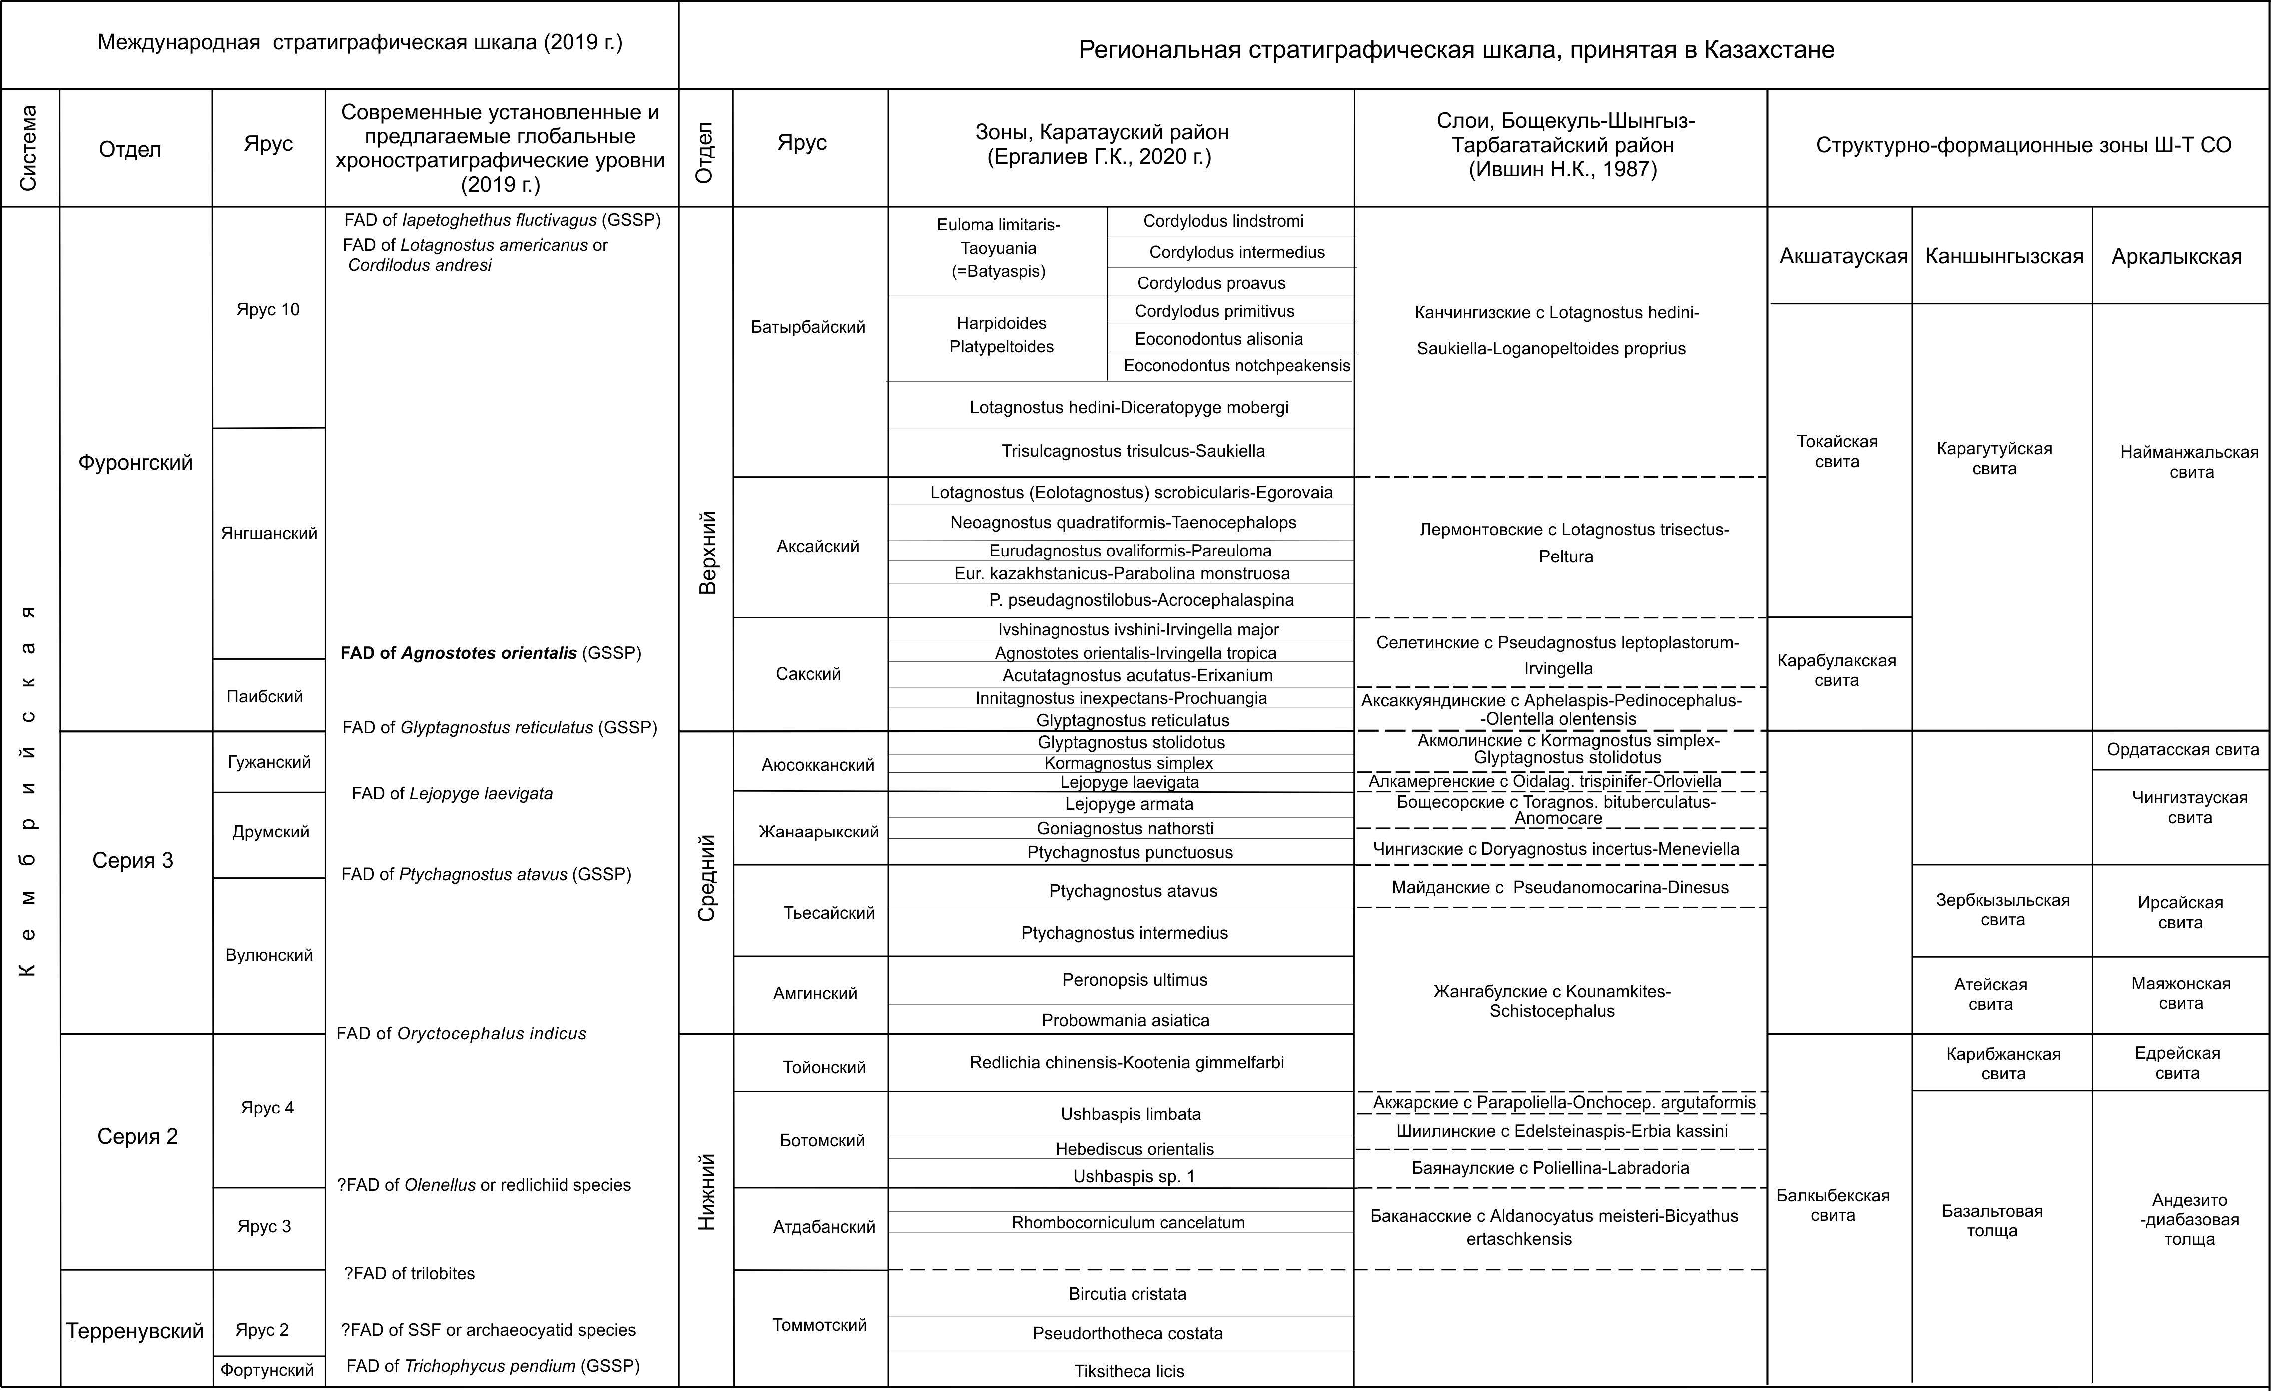
Illustrations

Figure А.1 - Comparison of the modern International Stratigraphic Chart (ISC) of the Cambrian as of 2020 with the regional stratigraphic scale of the Cambrian of Kazakhstan (Karatau and Boschekul-Shyngyz-Tarbagatai regions)
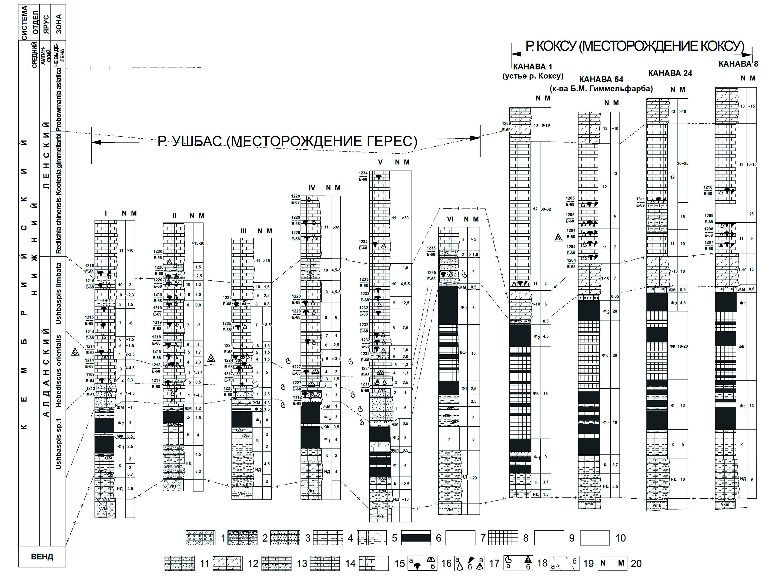
Figure А.2 - Correlation of the sections of the Chulaktau and the lower part of the Shabakty series of ridge Malyi Karatau (South Kazakhstan). List 1

1 - red polymictic FAnglomerates; 2 - FAnglomerates and sandstones with dolomite cement; 3 - red fine-grained sandstones and silty sandstones; 4 - brownish green silty sandstones; 5 - flints; 6 - phosphorites; 7 - phosphorite FAnglomerates; 8 - siliceous, siliceous-phosphate shales; 9 - iron-manganese dolomites with stromatolites and onFAlites; 10 - polymictic FAnglomerates; 11 - brown sandy dolomites; 12 - massive dolomites; 13 - thin-layered sandy limestones; 14 - clayey limestones; 15 - platy limestones; 16 - trilobites: a) polysomitics, b) agnostids; 17 - non-trilobitic fauna: a) inarticulates, b) chiolites, hyolithelminth, etc., c) remains of kutorgins; 18 - FAllections of fauna of other researchers: a) FAllections of K.A. Lisogor, b) FAllections of B.M. Keller, V.G. Korolyova, V.V. Missarzhevsky and others; 19 - stratigraphic boundaries: a) between divisions and stages, b) between zones; 20 - layer number (Н) and thickness (М), НД - lower dolomites, К-unit of cherts, Ф1- lower phosphorites, Ф2 - upper phosphorites, КФ - siliceous-phosphate unit, ЖМ - iron-manganese dolomites, V mk - Malokaroi Formation, Vks - Koksu Formation, Rf3 bk - Bolshekaroi Formation
Figure А.2. List 2

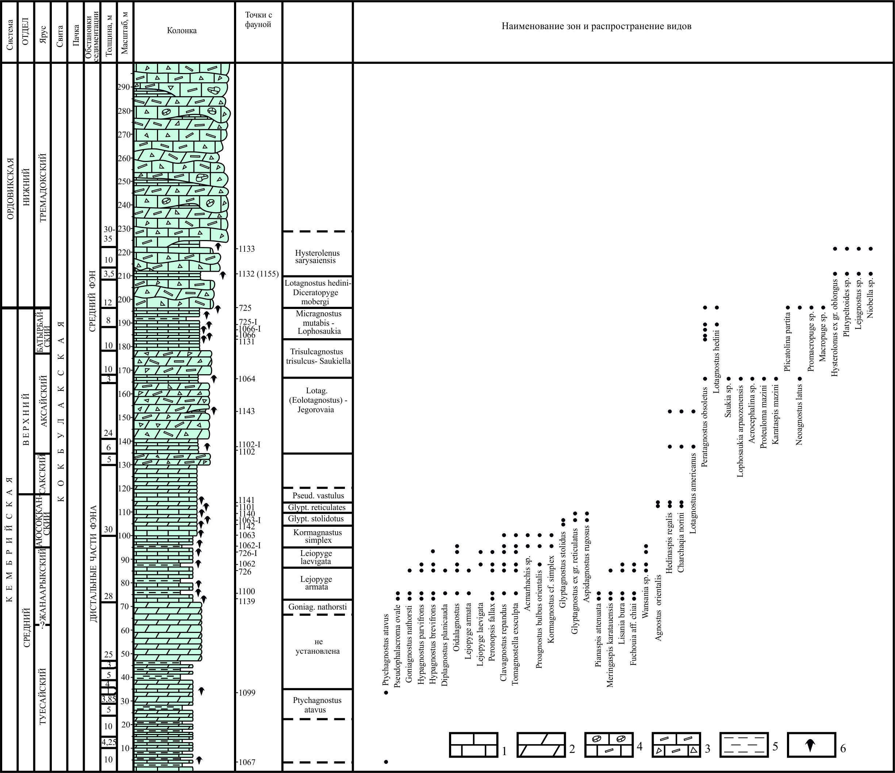
1 - fine-grained limestone; 2 - dolorenites; 3 - sedimentary breccias; 4 - brecciated limestones; 5 - siliceous shale; 6 - collection points of fauna

Figure А.3 - Key section of the Middle-Upper Cambrian and Lower Ordovician along the Arpaozen River in Bolshoi Karatau

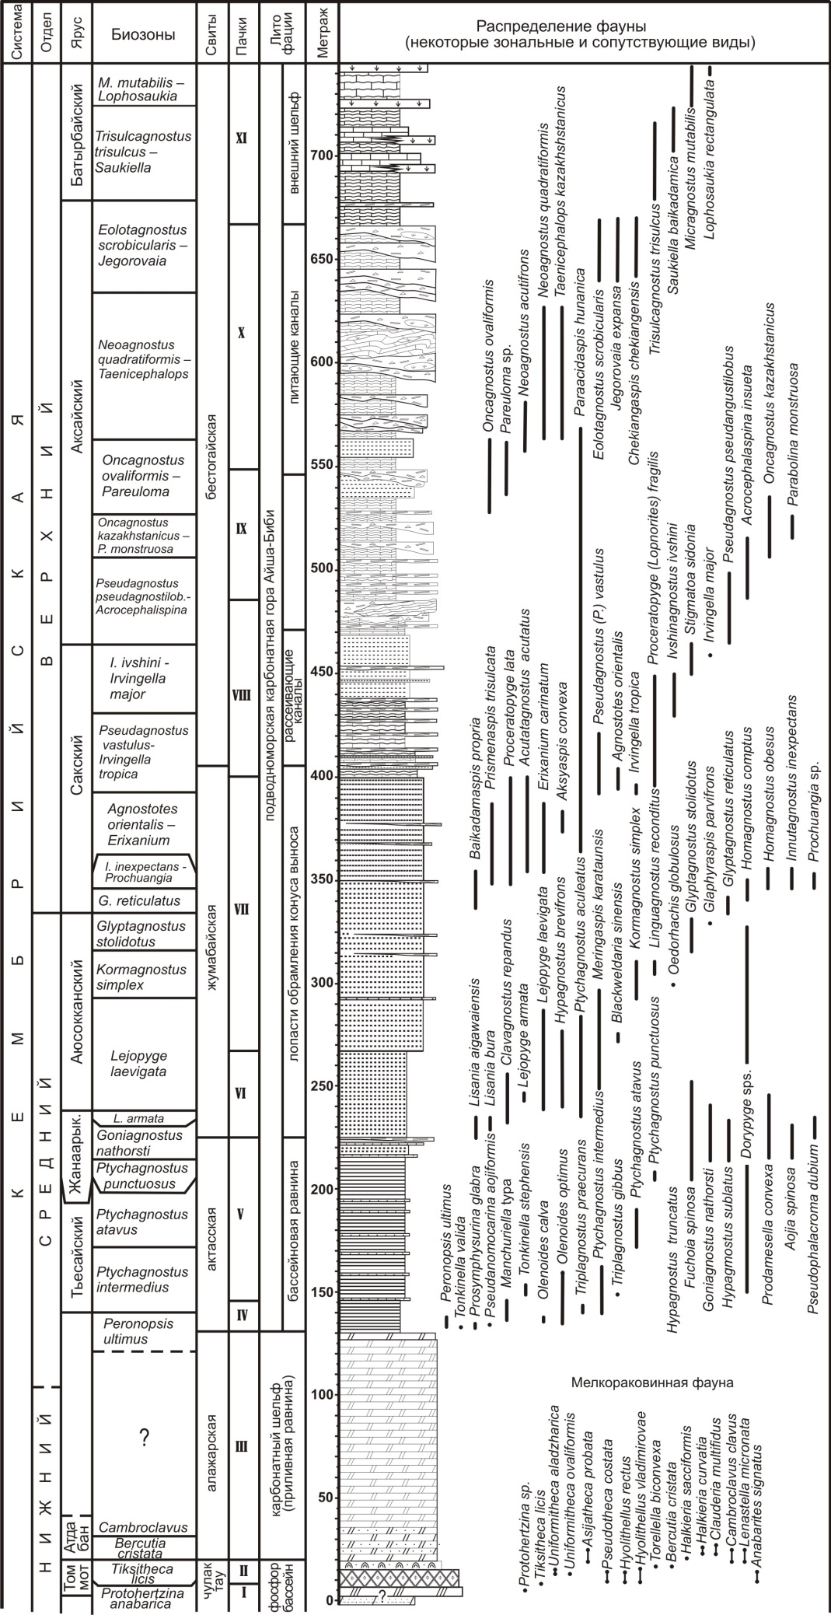
Figure А.4 - Stratigraphic sequence of the Middle and Upper Cambrian sediments of the Kyrshabakty section with the distribution of trilobite taxa

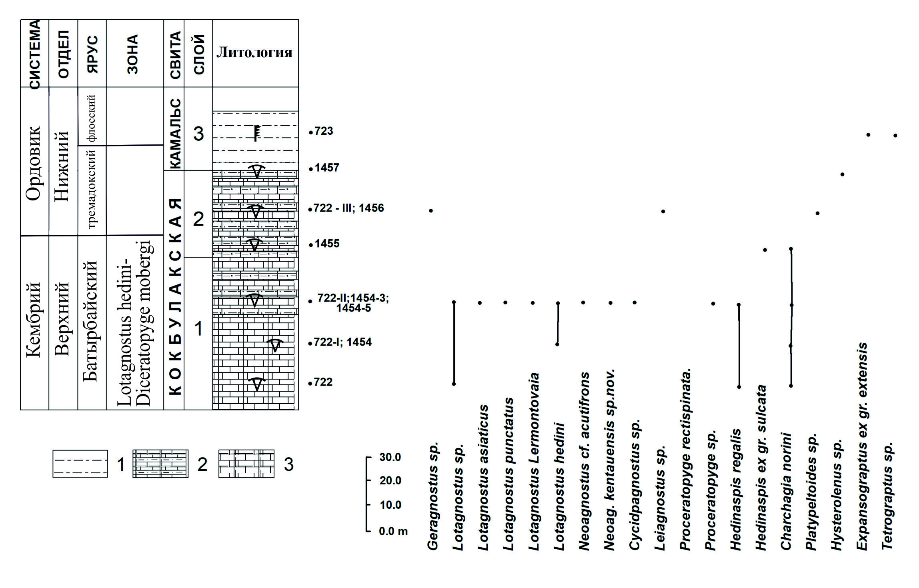
1 - argillaceous and siliceous sheared siltstones and mudstones; 2 - interbedding of clayey and siliceous interstratified siltstones, mudstones and platy micro-granular limestones; 3 - platy micro-grained limestones, rarely dolomites
Figure А.5 - Distribution of trilobites and graptolites in the transitional Rlayers of the Cambrian and Ordovician along the Kyzylata river

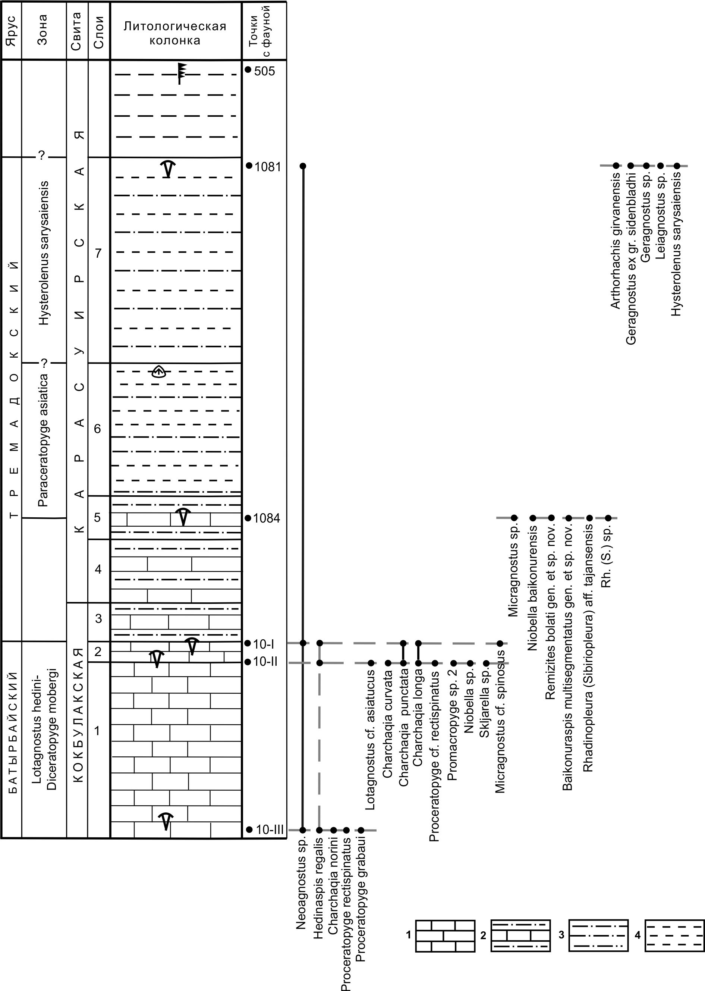

1 - platy limestones, 2 - interbedded limestones and siltstones, 3 - argillites and silty sandstones, 4 - interbedded clay and siliceous siltstones

Figure А.6 - Lithostratigraphic column of the Upper Cambrian and Ordovician key section along the Sarysay River (Severny ravine) in the Ulytau mountains with vertical distribution of trilobites

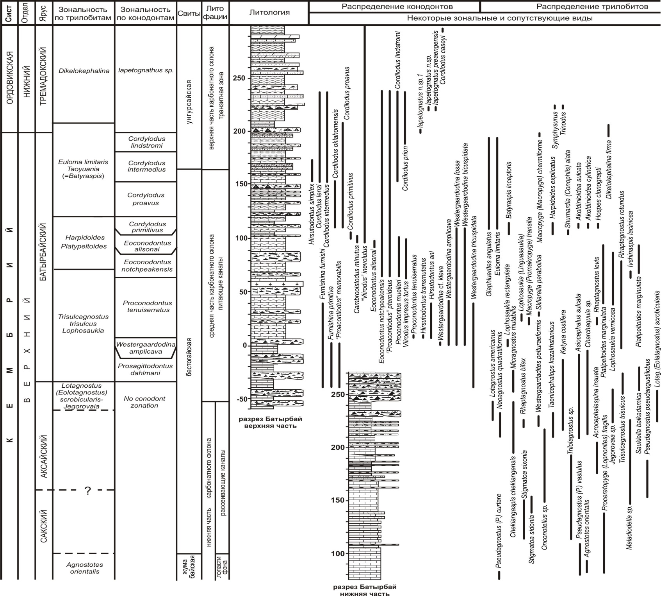
Figure А.7 - Stratigraphic column of the Batyrbay section of the Upper Cambrian - Lower Ordovician
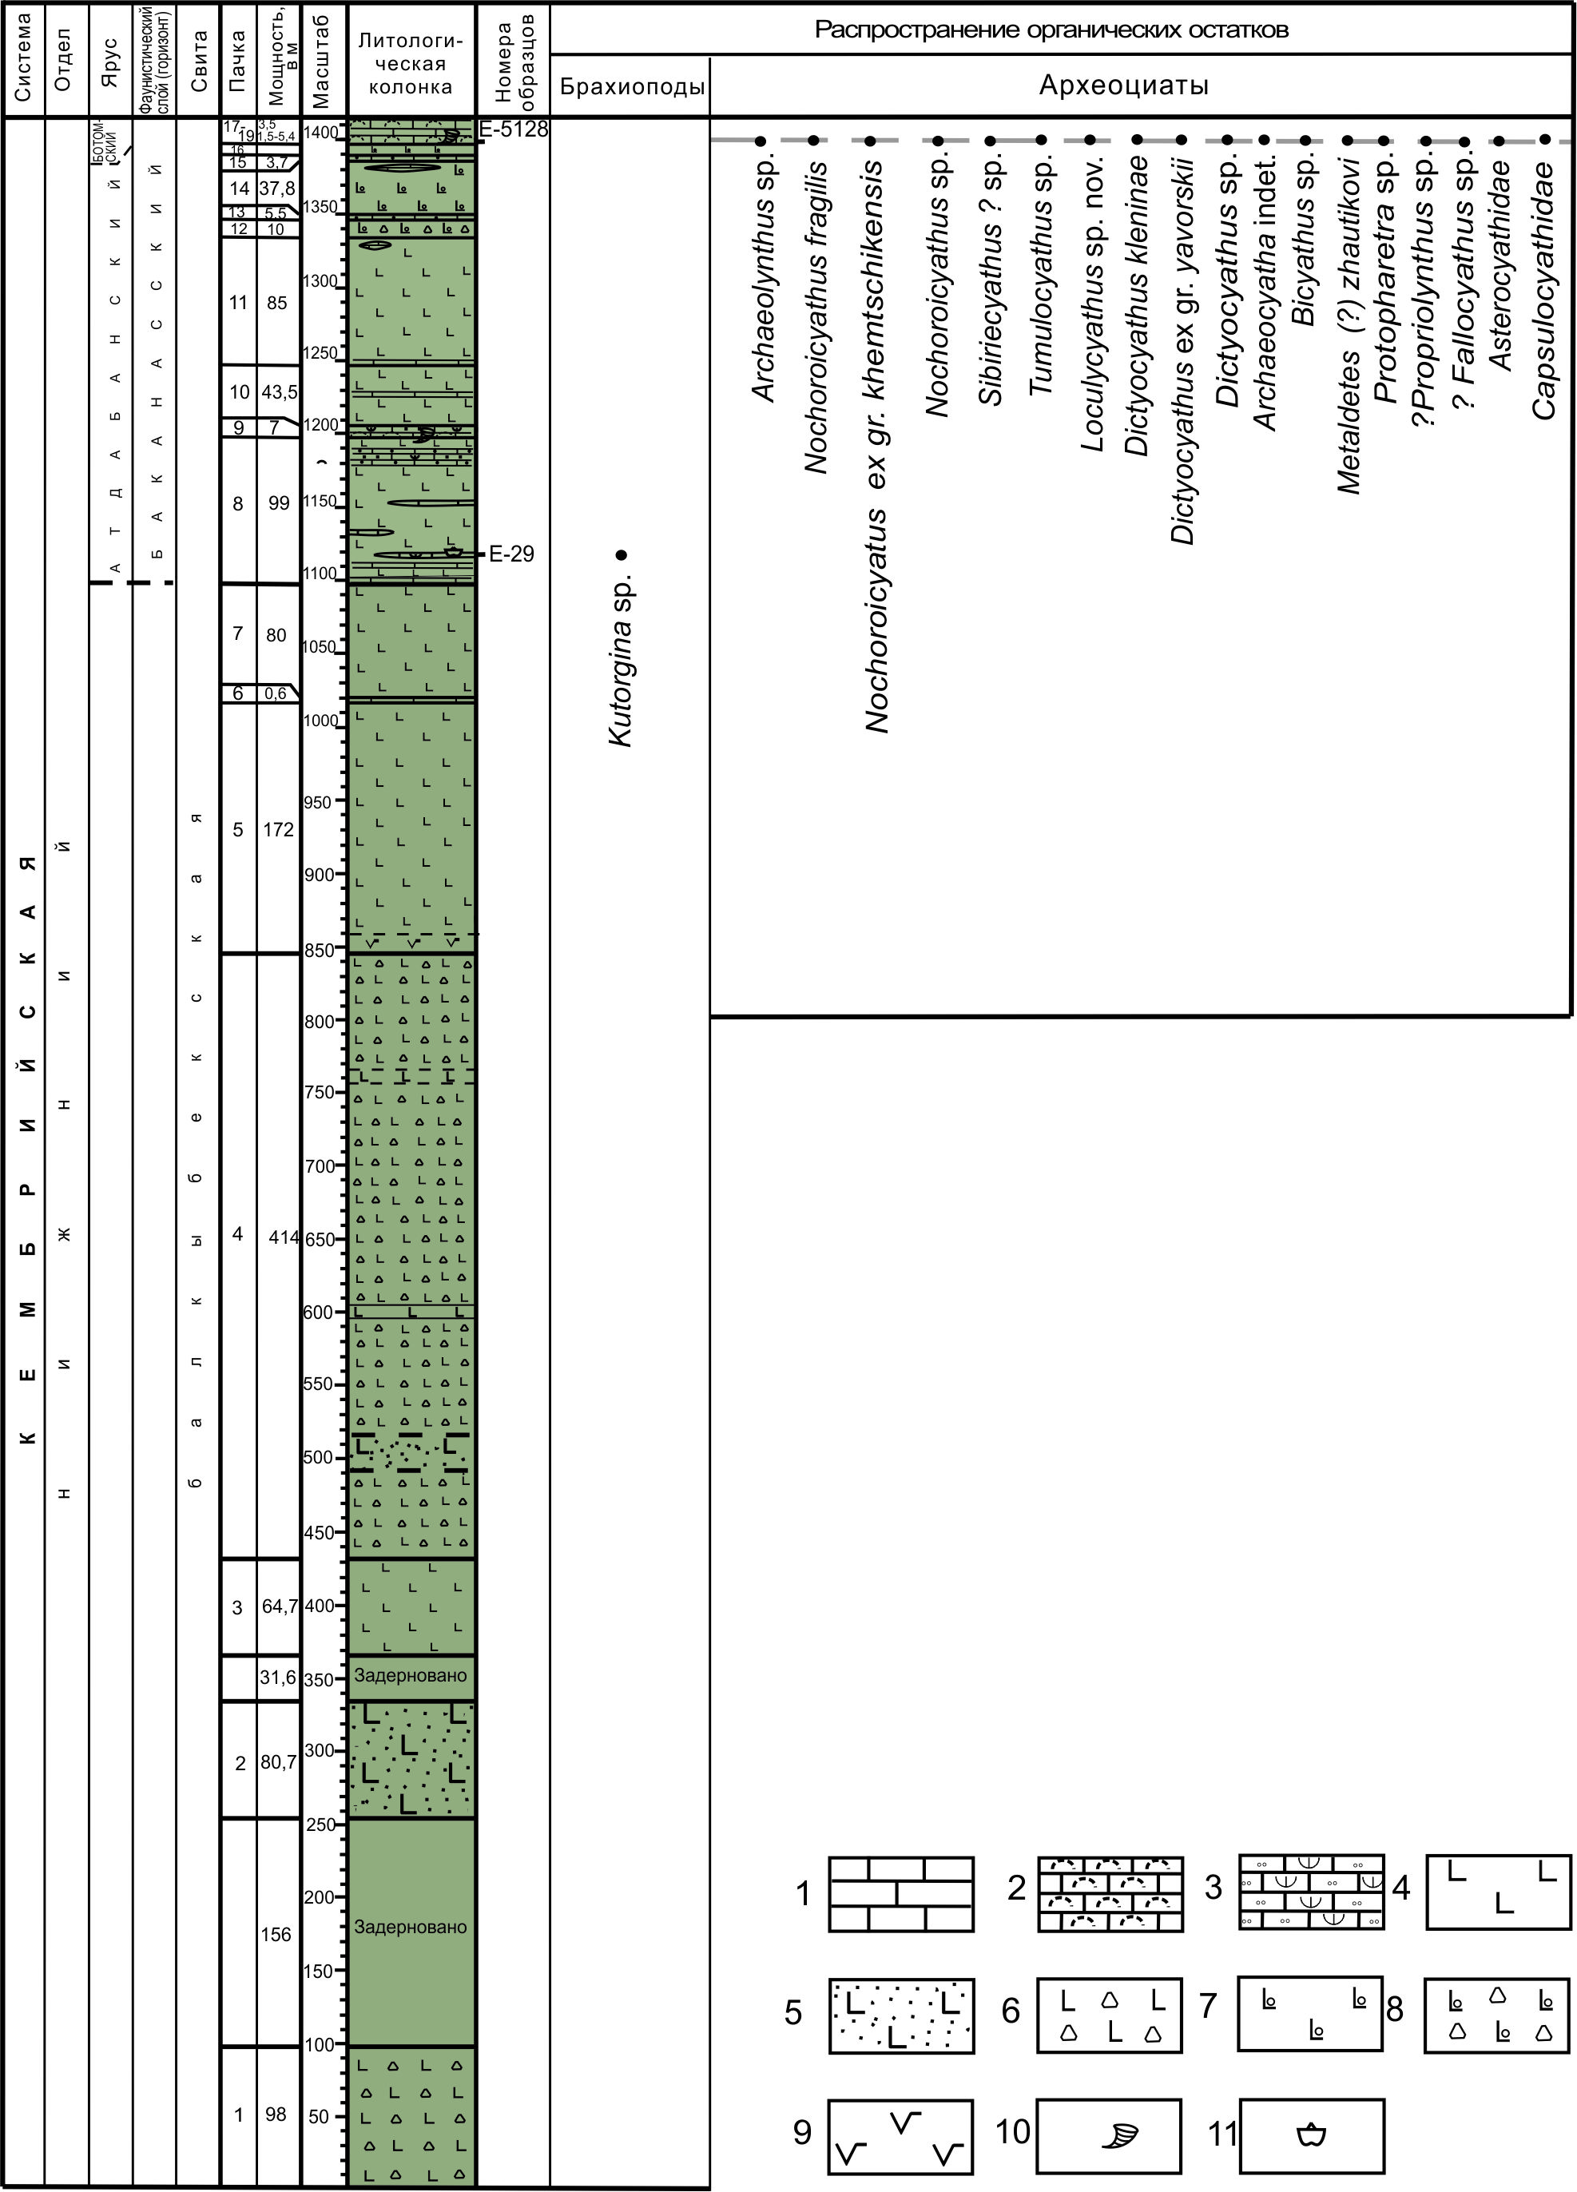
1-limestones, 2-algal limestones, FAmposing frameless reefs (silt hills), 3-tuff limestones, 4-basalts, 5- lithocrystalline-clastic basalt tuffs, 6-basalt lava breccias, 7- almond-stone lavas of basalts, 8-pillow lava, 9- andesibasalt; fauna: 10-archaeocyates, 11- brachiopods

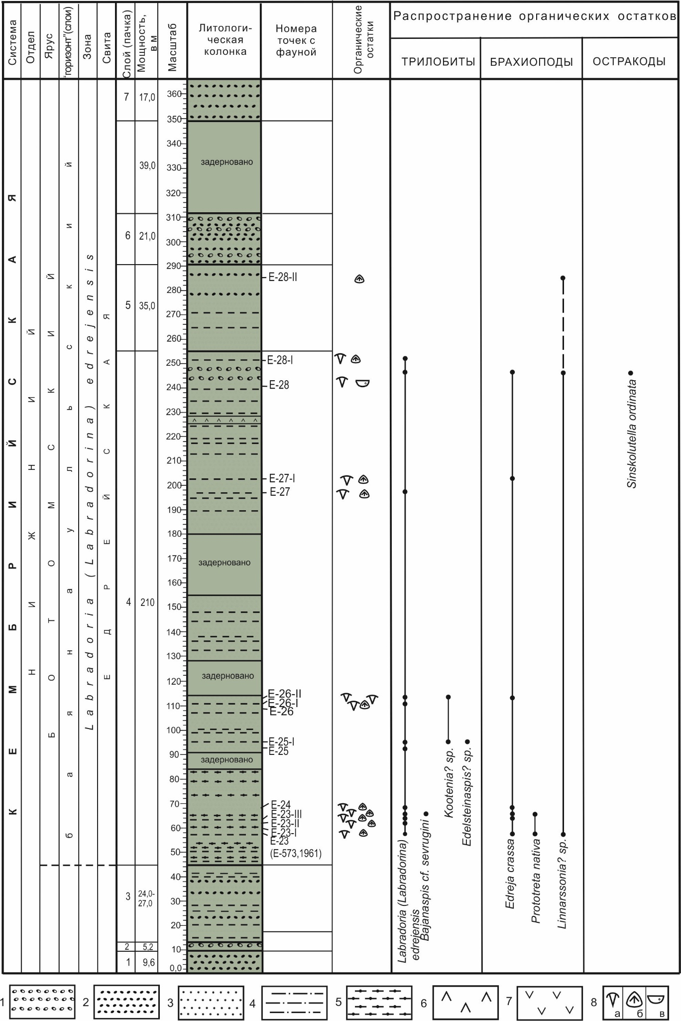
Figure А.8 - Lithological-stratigraphic column of the key section of the Balkybek Formation with vertical distribution of organic remains
1-small and medium-pebble conglomerates, 2-volcanomictic gravelstones, 3-sandstones, 4-siltstones, 5-purple siltstones, 6-andesites, 7-Paleozoic granitoids fauna: 8-fauna: a) trilobites, b) lockless brachiopods, c) ostracods
Figure А.9 - Lithological-stratigraphic column of the key section of the Yedreian Formation of the Lower Cambrian with vertical distribution of fauna
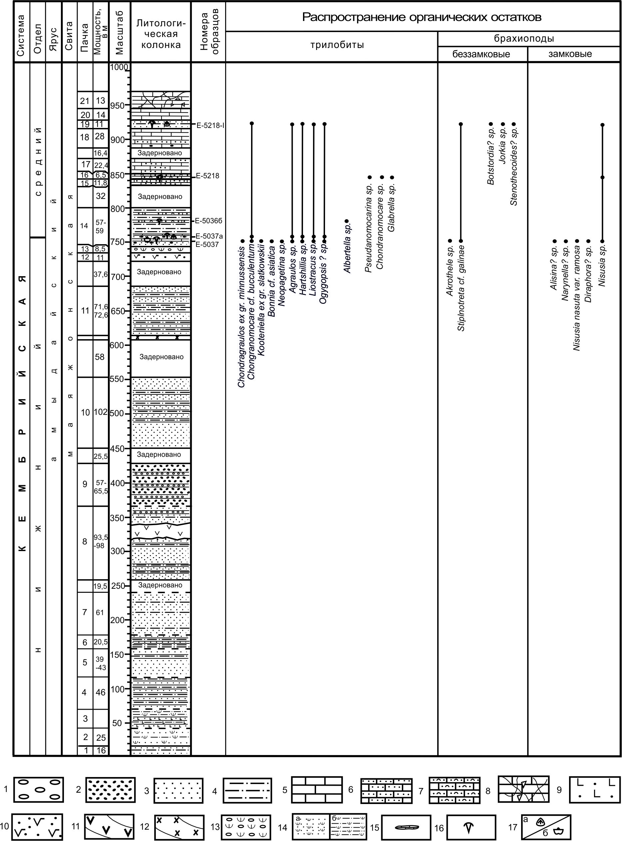
1-conglomerates, 2-volcanomictic gravelstones, 3-grayback sandstones, siltstones, 5-limestones, 6-clastic massive limestones, 7- bioclastic limestones, 8- brecciated limestones, 9-psammitic basalt lithic-crystal tuffs, 10- lithic-crystal tuff, 11 - small intrusion of euporite andesites, 12 - dike of amphibole-augite diorites, 13-pebble tuff conglomerate, 14- a) tuff-sandstone, b) tuff-conglomerate, 15-early diagenetic carbonate concretions; fauna: 16-trilobites, 17-brachiopods: a) inarticulates, b) articulates

Figure A.10 - Lithostratigraphic column of the Mayazhon Formation of the Lower - Middle Cambrian with vertical distribution of organic remains
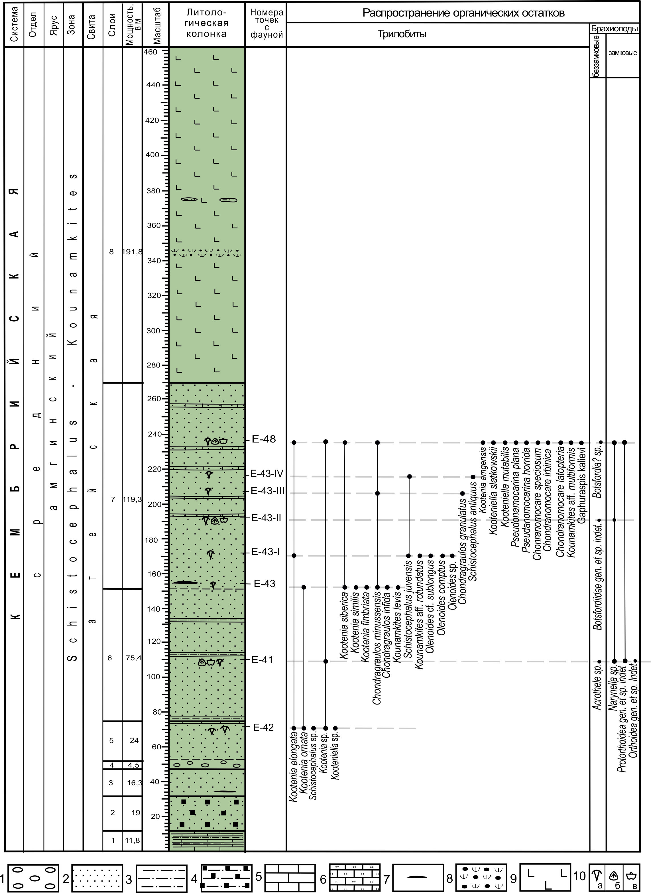
1-large-pebble boulder-terrigenous FAnglomerate, 2 - sandstone, 3 - siltstone, 4 - siltstone with authigenic pyrite, 5 - limestone, 6 - silty fine-grained limestone, 7 - nodular diagenetic formations, 8 - pyroxene basalt, 9 - basaltic lithic-crystal tuff; fauna: 10 - fauna a) trilobites, b) inarticulates, c) articulates

Figure А.11 - Lithostratigraphic column of the key section of the Ateian suite of the Middle Cambrian with vertical distribution of fauna

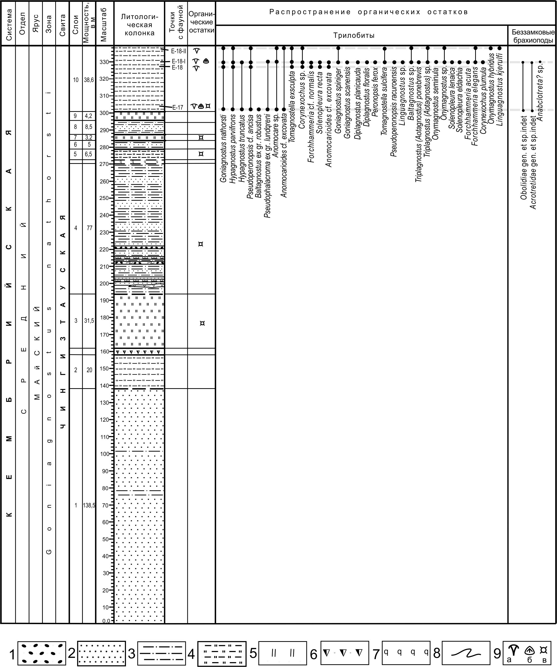

1 - gravelstones, 2 - sandstones, 3 - siltstones, 4 - siliceous mudstones, 5 - siliceous rocks, 6 - sedimentary breccias, 7 - silicification zone, 8 - landslide textures, 9 - fauna: a) trilobites, b) inarticulates, c) radiolarias

Figure А.12 - Lithostratigraphic column of the key section of the Chingiztau Formation of the Middle Cambrian with vertical distribution of fauna

Figure А.13 - Comparison of the Regional Ordovician Scale of Kazakhstan with the International Chronostratigraphic Scale (ISC) as of 2020, the General Stratigraphic Scale (GSS) of the Russian Federation in 2019 and the former GSS ("British Standard") as of 1986 and 2000

1 - barite; 2 - conglomerates and sandstones; 3 - red flints with lumpy bedding surfaces; 4 - gray and green siliceous siltstones; 5 - red siliceous siltstones; 6 - siliceous-clastic sandstones; 7 - red transparent and translucent cherts; 8 - gray, white and yellow transparent and translucent cherts; 9 - red clayey opaque cherts; 10 - interlayering of thin layers of white cherts and carbonaceous black phtanites; 11 - black carbonaceous phtanites; 12 - siliceous sandstones; 13 - stratigraphic break; 14 - places of selection of conodonts; 15 - conodonts scattered in the rock; 16 - conodonts on bedding surfaces; 17 - fecal pellets; 18 - benthic pterobranchs and graptolites; 19 - pelagic arthropods; 20 - sponges; 21 - brachiopods; 22 - ostracods (Tolmacheva, Ryazantsev, Degtyarev, Nikitina, 2014).

Figure А.14 - Comparison of the Burubaital Formation sections and generalized reconstruction of the barite source. Sediments of the lower part of the formation, accumulated during the existence of a barite hydrothermal source (Tolmacheva et al. 2014)
1-Conglomerates, 2-green sandstones, 3-gray sandstones, 4-brown sandstones, 5-siltstones, 6-mudstones, 7-calcareous siltstones, mudstones, 8-brown siltstones, mudstones, 9-beds and lenses of limestones among siltstones, 10 limestones. Fauna: 11-trilobites, 12-graptolites, 13-inarticulates, 14-articulates (AcFArding to I.F. Nikitin, M.K. Apollonov)

Figure А.15 - Correlation of the sections of the Kendyktass, Agalatas and Kurdai formations of the Lower Ordovician on the wings of the Keskintass syncline in the middle reaches of the Agalatas River

1-green quartz-polymictic sandstones and siltstones, 2-whitish quartz sandstones, 3-siltstones, silty sandstones, silicium fragmentals, 4-yellow limonitized sandstones, 5-mudstones, argillaceous-siliceous shales, 6-siliceous argillites, 7-siliceous-argillaceous pelitolites, 8-carbonaceous-siliceous mudstones, 9-carbonaceous-siliceous siltstones, 10-carbonaceous-siliceous pelitolites, 11-phtanites (radiolarites, spongolites), 12-clayey jasper, brown jasper siltstones, 13-brown clay-oolithic shales, 14-oolitic (opal) pelitolites, 15-gravel-breccias, 16-carbonaceous-siliceous nodules, 17-lithocrystalline rhyolite tuffs; 18-21-organic remains: 18-sponge spicules, 19-radiolarians, 20-conodonts, 21-graptolites

Figure A.16 - Detailed geological profile of the Blue Ridge key section with collection points of fauna, lithological sampling, thin sections and samples

1 - Conglomerates, gravelstones, 2 - quartz-feldspar sandstones, 3 - polymictic sandstones, 4 - coal mudstones, siltstones, 5 - the same, in well FAres; 6-9 - limestones: 6 - massive, 7 - platy crinoid, 8 - thick-bedded (biomicrites), 9 - brecciateds; 10 - tuff-terrigenous rocks, 11 - tuffs and tuffaceous rocks of the Savid Formation, 12 - sills (?) of basaltic andesites, 13 - ophiolites. 14-20 - fauna locations: 14 - conodonts, 15 - graptolites, 16 - brachiopods (a - rhynchonellates, b - lingulates), 17 - trilobites, 18 - gastropods, nautiloids, 19 - crinoids, 20 - collection points of fauna in borehole cores and mine workings

Figure А.17 - Stratigraphic column of the key section Karakan Ridge
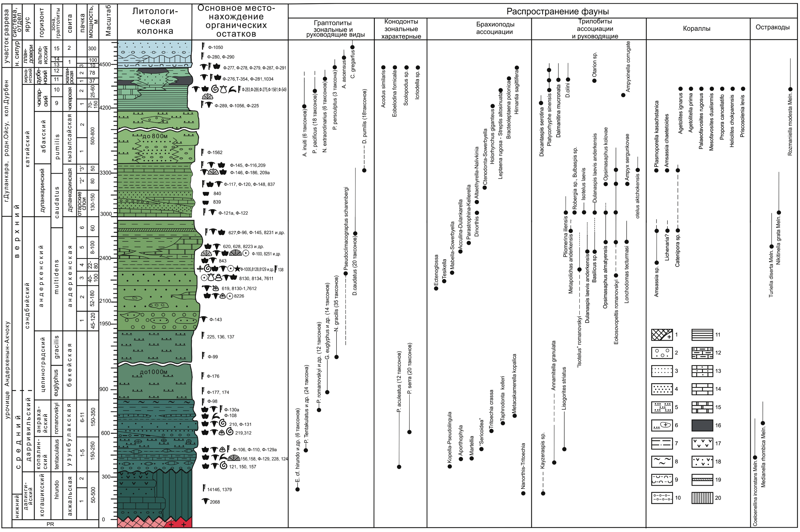
Numerated: Graptolite zones: 9-uniti, 10-pucificus, 11-extraordinarius, 12-persculptus, 13-ascensus-cyphus, 14-gregarius-convolutus, 15-convolutus-centritugus. Beds of the Dulankara Horizon: 2-Degeresian, 3-Akkol, formations: 1-Salamat, 2-Betkainar. Legend: 1-granitoids and Precambrian metamorphites, 2-conglomerates, gravelstones, 3-fine-grained sandstones, 4-medium-grained sandstones, 5-terrigenous turbidites, 6-the same, with lenses of boulder-pebbles, 7-green siltstones, mudstones, 8 - variegated siltstones, 9-tuff siltstones, tuffites, 10-siltstones with FAnglomerate beds, 11-carbonaceous mudstones, siltstones, 12-clayey limestones, 13-sandy limestones, 14-organogenic-clastic limestones, 15-limestone-biohermaceous limestones carbonaceous, 17-andesites, basalts, 18-tuffs, 19-layers of ash tuffs, 20-gaps in sedimentation

Figure A.18 - Stratigraphic column of the Anderkenyn-Akchoku consolidated key section

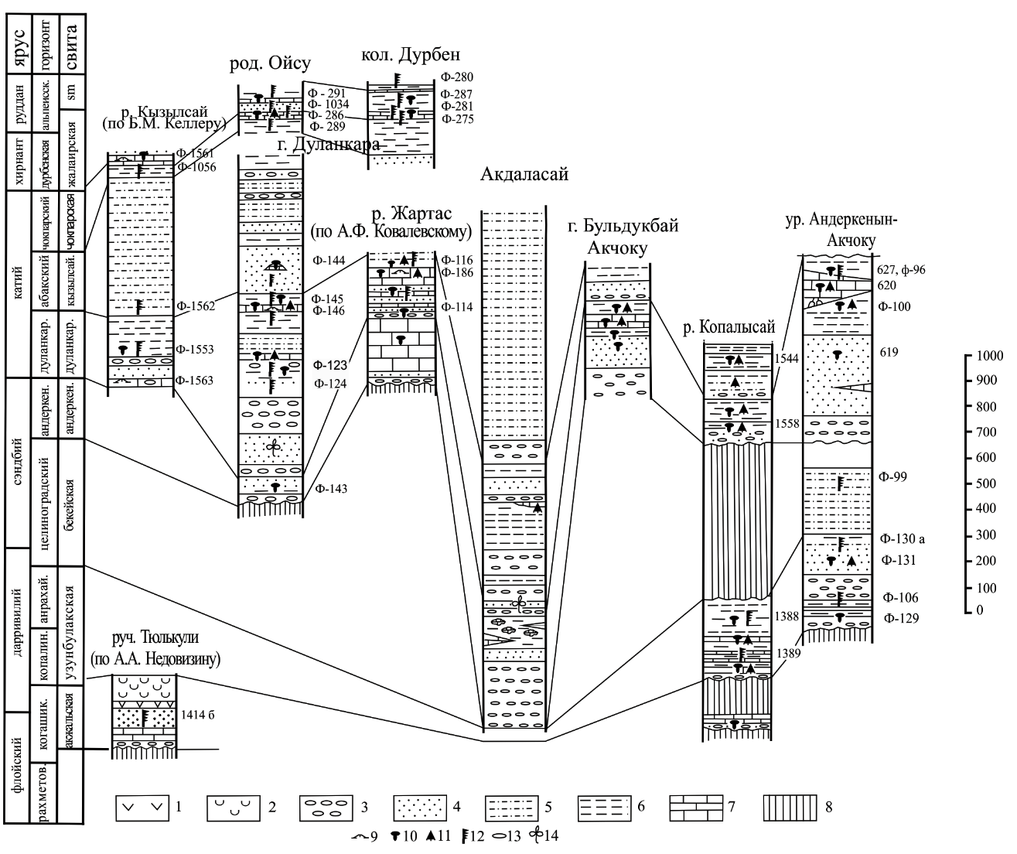
Figure А.19 - Scheme of Comparison of Ordovician sections in the southeastern part of the Chu-Ili Mountains (Nikitin et al., 1980, as amended)
Figure А.20 - Stratigraphic column of the Koryk key section of the Upper Ordovician-Lower Silurian along the Koryk. Southwestern Peri-Chingiz, Akbastau SFZ. Ordovician part

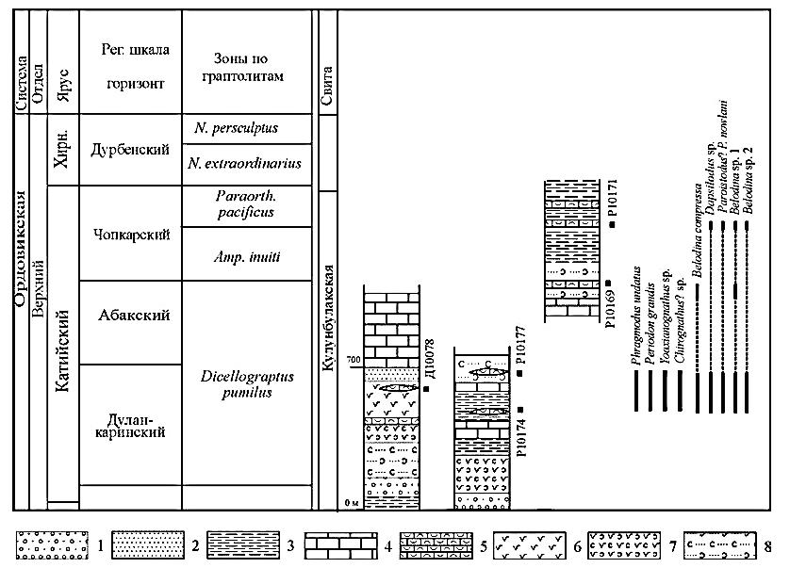
1 - gravels and conglomerates; 2 - sandstones; 3 - siltstones; 4 - massive algal limestones; 5 - bioclastic limestones; 6 - effusive rocks of medium-basic FAmposition; 7 - tuffs of medium-basic composition; 8 - tuff sandstones

Figure А.21 - Stratigraphic column of the Upper Ordovician-Lower Silurian Koryk key section along the Koryk. Southwestern Peri-Chingiz, Akbastau SFZ. Silurian part

Legend: 1-conglomerates and gravelstones of the base of the Alpeis Formation, 2-red conglomerates of the base of the Zhumak Formation, 3-tuff conglomerates, 4-gray-green-colored sandstones, 5-brown sandstones, 6-red sandstones, 7-sandstones with spheroidal jointing, 8- siltstones, 9-variegated mudstones, 10-silty sandstones, 11-organogenic-clastic limestones, 12-platy clayey limestones, 13-lumpy clayey limestones, 14-calcareous siltstones, 15-sandy limestones, 16-crinoid “liliaceous horizon” shell sediments, 18-diabasic sills, 19-andesites, andesi-basalts, 20-tuffs, 21-locality of fauna, 22-rugoses, 23-colonial corals, 24-crinoids, 25-inarticulates, 26-articulates, 27-trilobites, 28-graptolites

Figure A.22 - Distribution of conodonts in the sections of the Kulunbulak Formation, including the stratotype of the Abakian horizon on the right bank of the Bazar River and in the valley of the Abaktigen stream (according to T.Yu. Tolmacheva, 2014, p. 47, fig. 27)

Symbols: 1-conglomerates and gravelites of the base of the Alpine Formation, 2-red colored conglomerates of the base of the Zhumak Formation, 3-tuphoconglomerates, 4-sandstones gray-green-colored, 5-brown sandstones, 6-red colored sandstones, 7-ball sandstones, 8-alevrolites, 9-argillites, 10-alevrolites, 11-vegetable organogenic-clastic, 12-plate clay limestone, 13-composite clay limestone, 14 limestone siltstones, 15 sandy limestones, 16-crinoid shells of the "lily horizon", 17 concretions of limestone, 18-power diabase, 19-andesites, andesi-basalts, 20 tuffs, 21 fauna, 22-rugoses, 23-colonial corals, 24-crinoids, 25-bezzam-free brachiopods, 26-bezzam brachiopods, 27-trilobites, 28-grapptolites

Figure A.23 - Summary stratigraphic column of the Akdombak key section

1 - green siltstones and mudstones; 2 - variegated (brown, cherry, green) mudstones and siltstones; 3 - green sandstones; 4 - calcareous sandstones; 5 - red sandstones; 6 - conglomerates and gravelites; 7 - limestone; 8 - calcareous соncretions, lenses and nodules; 9 - andesites. Organic remains: 10 - brachiopods, corals, trilobites; 11 - lingulates (inarticulates); 12 - graptolites

Figure A.24 - Correlation of the Lower Silurian sections of the Chingiz Ridge

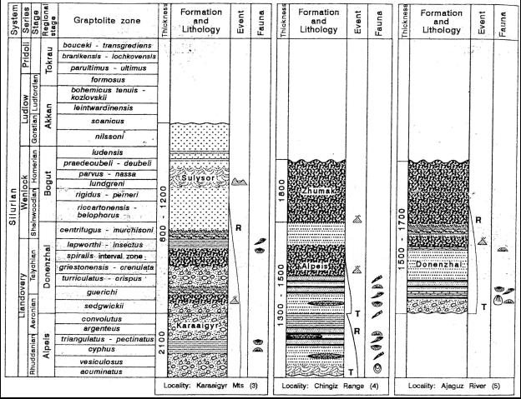

Figure А.25 - Correlation of Silurian sections of the Chingiz-Tarbagatai SFZ (Koren', Popov, et al. 2003. Kazakhstan in the Silurian)

Figure А.26 - Stratigraphic column of the type section of the Donenzhal Horizon at Arganata

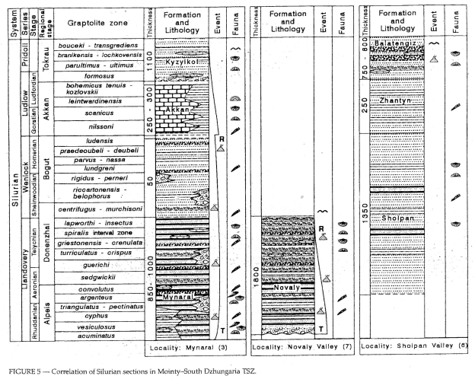
Figure А.27 - Correlation of sections of the Silurian Mointy-South Zhongar SFZ

1-6 - limestones: 1 - dark gray to black, 2 - light, light gray, massive, 3 - pink (a-clastic, b-coarse-clastic), 4 - red, sandy, granular, coarse-bedded, 5 - red crinoid, 6 - dark gray, clayey, layered; 7 - greenish-gray crystalline limestones; 8 - green siltstones; 9 - yellow sandstones, fine-grained, platy, stratified; 10 - red, claret siltstones; 11 - sandstones, greenish-gray, medium-coarse-grained; 12 - yellowish-brown sandstones, quartz-feldspar, medium-coarse-grained; 13 - yellowish-gray sandstones, calcareous, medium-coarse-grained; 14 - calcareous sandstones and siltstones with limestone nodules; 15 - medium-pebble conglomerates with lenses and interlayers of red crinoid limestones; 16 - brown small-pebbled conglomerates; 17 - greenish-gray siltstones; 18 - wax-red siltstones; 19 - thin interbedding of wax-red siltstones and gray sandstones with lenses and limestone boulders; 20 - gray, fine-grained, dense, coarse sandstones; 21 - sandstones pink, calcareous, medium-coarse-grained; 22 - gray conglomerates, medium-large pebble; 23 - dark green, black, reddish, siliceous siltstones; 24 - gray, gray-greenish, medium-grained sandstones; 25 - calcareousness of rocks (a), tectonic ratio of parts of the section (b); 26 - fauna of graptolite (a), shelly (b); 27 - location of the sections. Letter designations (A - E) correspond to the letters in Fig. 4.9

Figure А.28 - Correlation of Silurian sections on the Akkerme Peninsula and the southern coast of the Akkerme Bay

Figure А.29 - Correlation of Silurian sections in the Zhongar-Balkhash fold area (according to T.N. Koren', L.E. Popov, K.E. Degtyarev, O.P. Kovalevsky, T.L. Modzalevskaya, 2003: Tatiana Koren', Leonid E. Popov, Kirill E. Degtjarev, Ovidii P. Kovalevsky, and Tatiana L. Modzalevskaya. Kazakhstan in the Silurian//Silurian Lands and Seas. Paleogeography Outside of Laurentia: New York State Museum Bulletin 493)

1 - Baktysai Formation; 2 - Maidantal Formation; 3 - Kazanbuzar Formation; 4 - Orgaylysay Formation; 5 - Aksai Formation; Devonian sediments: 6 - Shukurganat Formation; 7 - Famennian sediments; 8 - limestone; 9 - crinoid limestones; 10 - limestones with flints; 11 - limestones with bioherms; 12 - limestones with FArals; 13 - limestone breccias; 14 - dolomitized limestones; 15 - dolomites; organic remains: 16 - foraminifera; 17 - conodonts; 18 - Rugosa corals; 19 - brachiopods; 20 - ostracods; 21 - pelecypods; 22 - gastropods

Figure А.30 - Schematic geological map of the key sections Zhertansai-lower boundary sediments of the Upper Devonian-Lower Carboniferous (Shukurganat and Aksai formations D₃-C₁) and Zhertansai boundary sediments of the Lower and Upper Carboniferous (Baktysay formation C₁₋₂). Scale 1: 25000. Compiled by V.Ya. Zhaimina

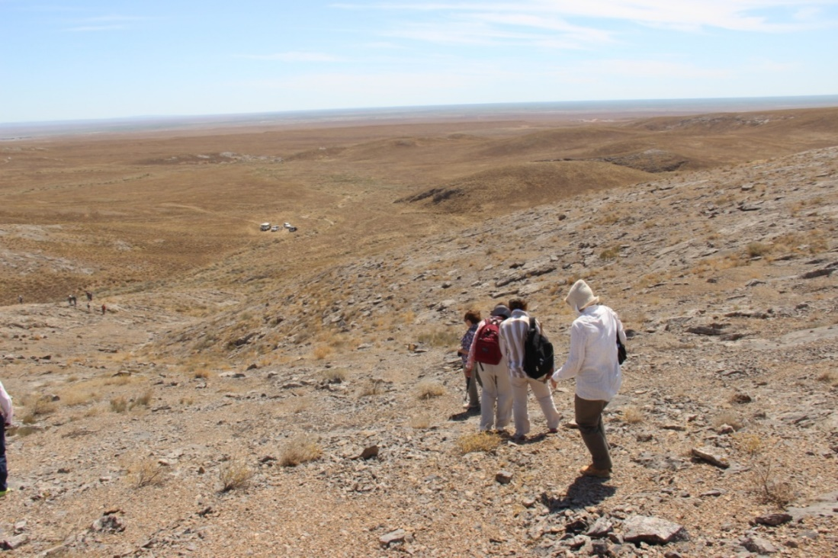

Figure А.31 - General view of the Karamurun section. In the foreground is the Karamurun reef massif, in the center - the outcrops of the rocks of the Lower-Shal Subformation, above them the outcrops of the rocks of the Upper-Shal Subformation

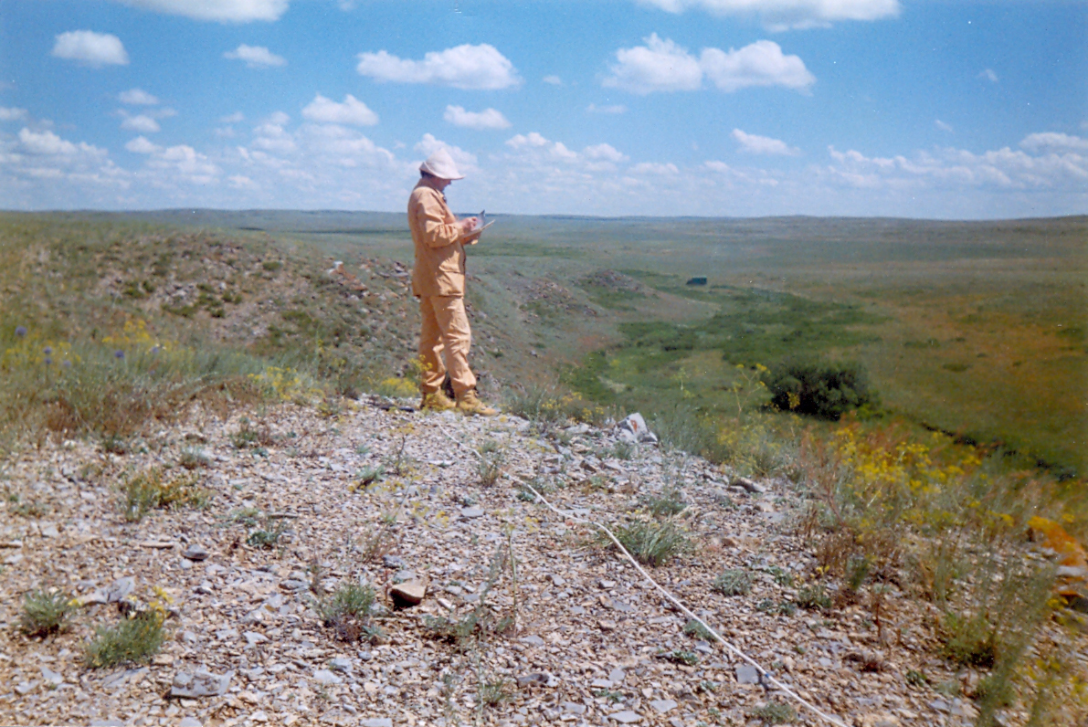

Figure А.32 - Kyzylzhal mountains. Limestones with interlayers of Famennian dolomites

1 - limestones: 2 - with flints, 3 - lumpy, 4 - organogenic-clastic, 5 - clayey, 6 - with agates, 7 - limestone breccias, 8 - manganese, 9 - dolomitized, 10 - silicified, 11 - dolomites; Organic remains: 12 - foraminifera, 13 - bryozoans, 14 - Rugosa corals, 15 - colonial corals, 16 - brachiopods, 17 - conodonts, 18 - sponge spicules, 19 - sponges, 20 - ostracods, 21 - diatoms, 22 - crinoids, 23 - massive tabulata, 24 - flagellate algae.

Figure A.33 - Lithostratigraphic column and foraminiferal distribution in the boundary Famennian-Tournaisian sediments (Kyzylzhal Mountain)

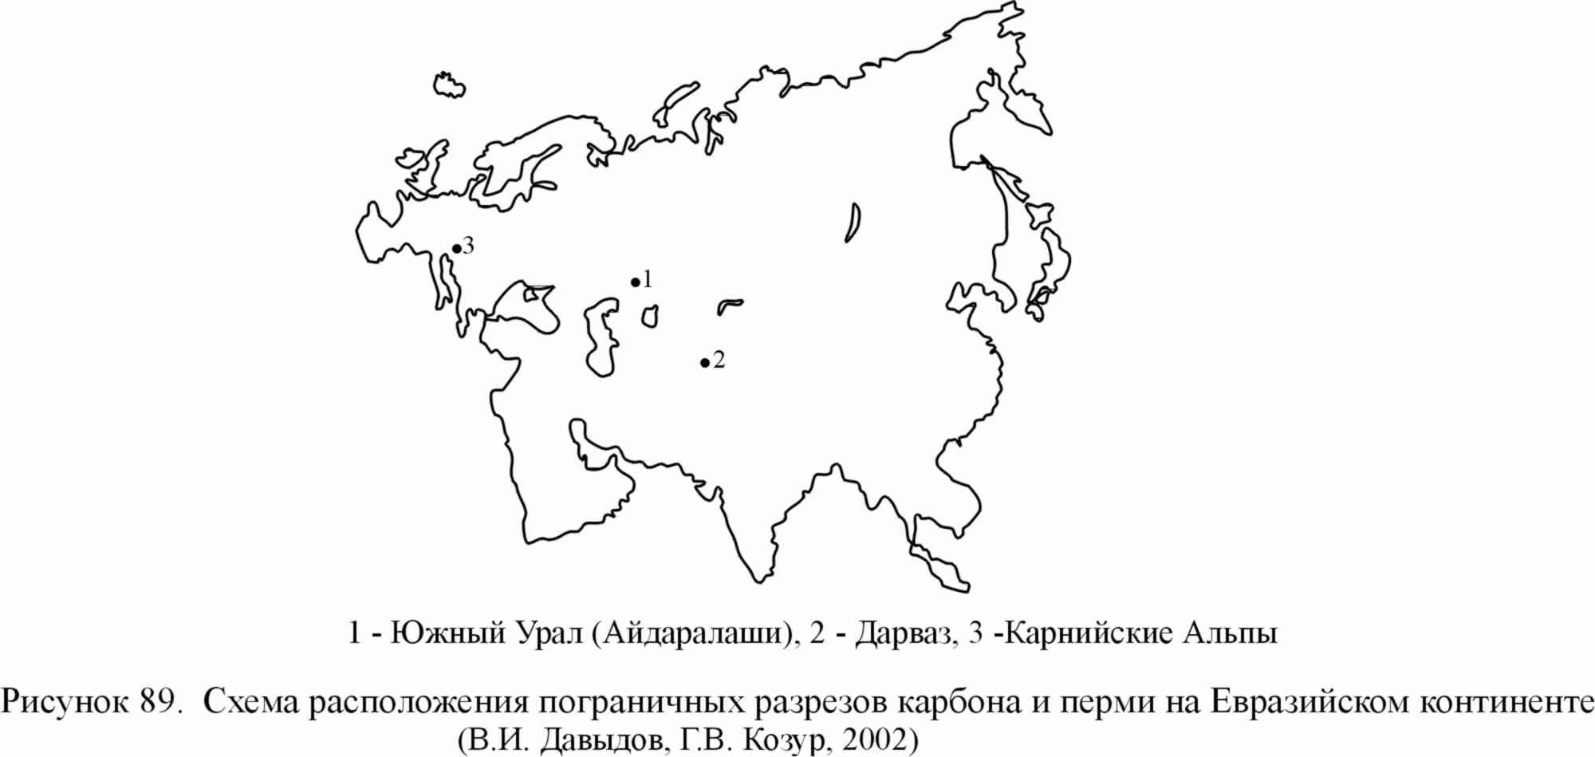
Figure А.34 - Layout of boundary sections of the Carboniferous and Permian on the Eurasian FAntinent (V.I.Davydov, G.V. Kozur, 2002)

Figure А.35 - Lithostratigraphic column and distribution of foraminifera in the boundary sediments of the upper tourne-lower Visean (Kyzylzhal mountain)

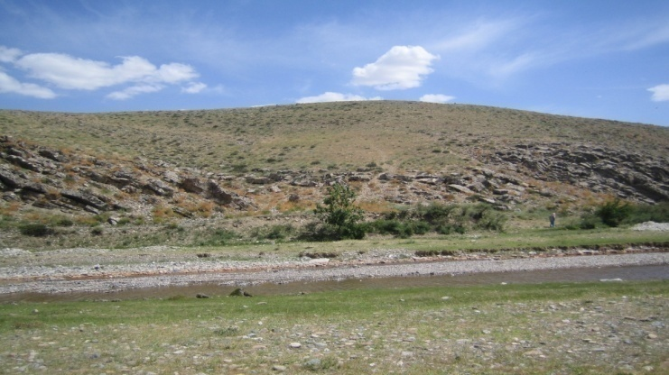
1 - limestones: 2 - foraminiferal, 3 - with corals, 4 - oolitic, 5 - dolomitized, 6 - clayey, 7 - organogenic-clastic, 8 - crinoid, 9 - spongolites, 10 - cavernous, 11 - ferruginous organic remains: 12 - foraminifers, 13 - mesh bryozoans, 14 - Rugosa corals, 15 - colonial corals, 16 - brachiopods, 17 - conodonts, 18 - sponge spicules, 19 - sponges, 20 - ostracods, 21 - gastropods, 22 - branched bryozoans, 23 - algae, 24 - pelitsipods, 25 - crinoids

Figure А.36 - Zhanakorgan section of boundary sediments of the Visean and Serpukhovian stages

Figure А.37 - A schematic geological map to the key sections of the Upper Visean-Bashkirian sediments of the Zhezkazgan-Chu SFZ (Yagovka, Dalny, Beleut, Taskuduk formations), right bank of the Karakengir River, M-42-136-B. Scale 1:50 000. For legend see figure 33
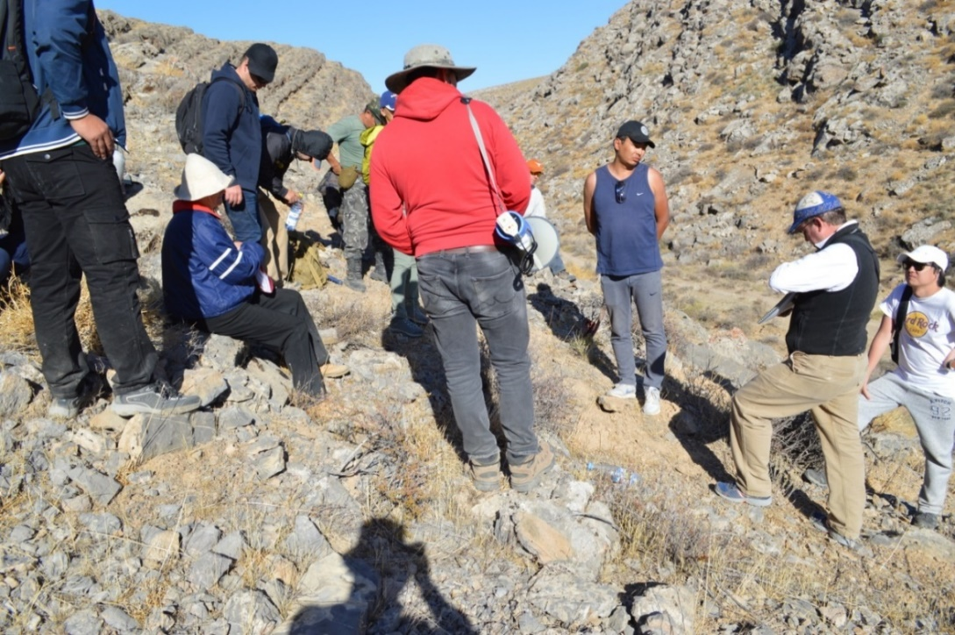
Figure А.38 - Zhertansai section, border of the Serpukhovian and Bashkirian stages

1 - Upper Carboniferous, Moscovian Stage, Kungzhayak Formation; 2 - Upper Carboniferous Bashkirian - lower part of the Moscovian stage, Tastykuduk Formation; 3 - Lower Carboniferous, Burultas Formation; 4 - conglomerates; 5 - gravelstones; 6 - sandstones; 7 - aleurosandstones; 8 - siltstones; 9 - limestone; 10-reef limestones; 11 - tuffaceous sandstones; 12 - acidic tuffs; 13 - bedding elements; 14 - breaking breaches; 15 - places of collection of fossil flora and fauna; 16 - line of layer-by-layer description; 17 - observation points

Figure А.39 - Schematic geological map of the key section of the boundary sediments at the Bashkirian and Moscovian stages of the Sayak SFZ (Tastykuduk Formation) Kungisai site
APPENDIX B

Prints of articles for the period 2018 - 2020
Articles published in the reporting period 2018
1. G.K. Ergaliyev, T.E. Pirogova Late Lower Cambrian and Middle Cambrian sedimentary sections of the May-June and atheist formation of the Shyngyz Ridge (East Kazakhstan) // Izvestia NAS RK. A series of geology and technical sciences. 2018. N 6 (432). Almaty. C. 180-189 (in English)
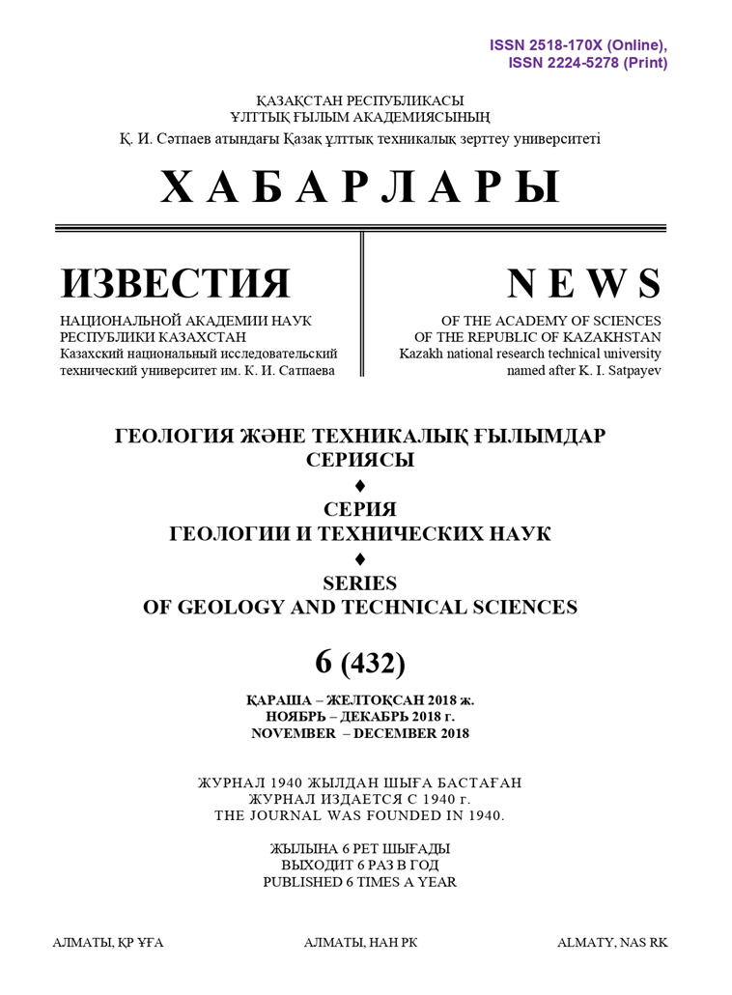
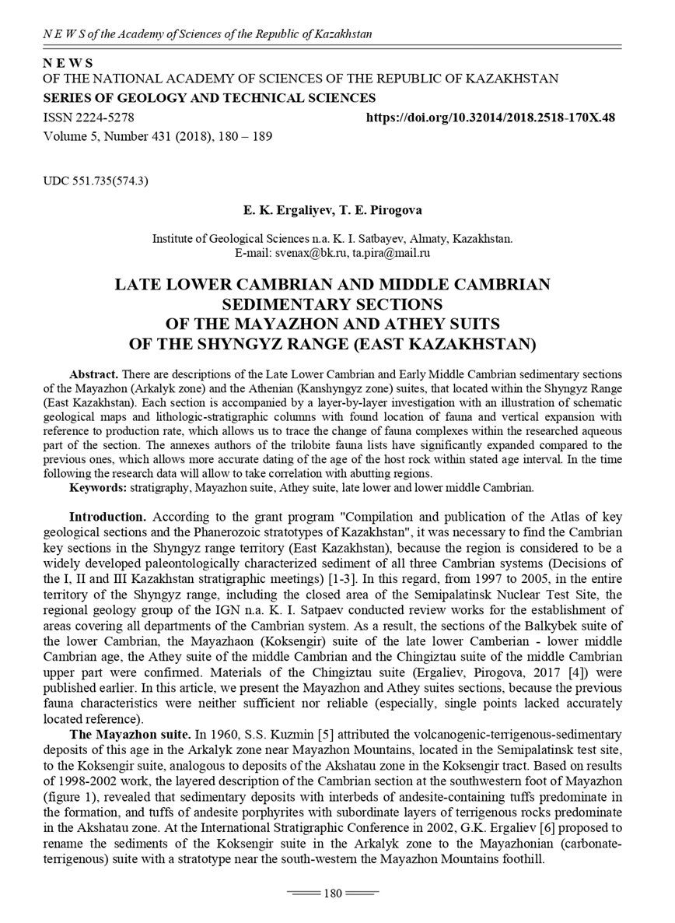
Articles published in the reporting period 2018
1. V.Y. Zhaimin, E.I. Kulagin Peculiarities of the Devonian and Carboniferous Boundary Deposits of the Karamurun Section (Big Karatau, Southern Kazakhstan). // Izvestia NAS RK. A series of geology and technical sciences. 2019. N 4 (436). Almaty.C. 42-54, (in English)
3. G.K.Ergaliyev, V.G.Zhemchuzhnikov, T.E.Pirogova "Cambrian of North-West Pribalkhashia" // Izvestia NAS RK. A series of geology and technical sciences. 2019. N 5 (437). Almaty. C. 158-168 (in English)
3. G.J. Zholtaev, K.O. Iskaziev, A. Abishev, G.E. Kulumbetova. "A New Prospective Direction of Oil and Gas Fields Prospecting in the East of the Caspian Depression". // "Oil and Gas Geology" №5, Moscow, 2019, RINC (IF 0,647), P.27-31

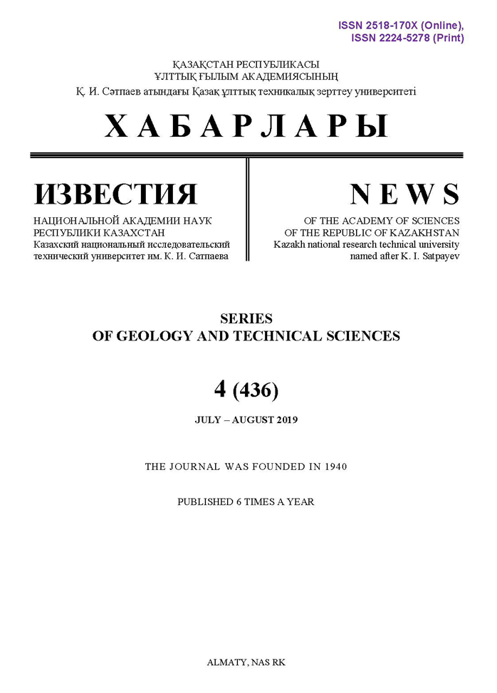
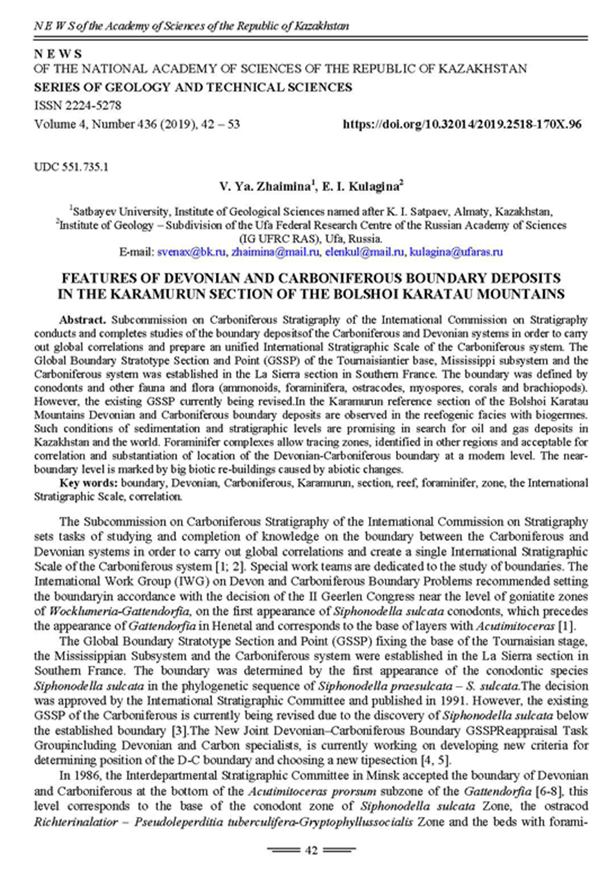
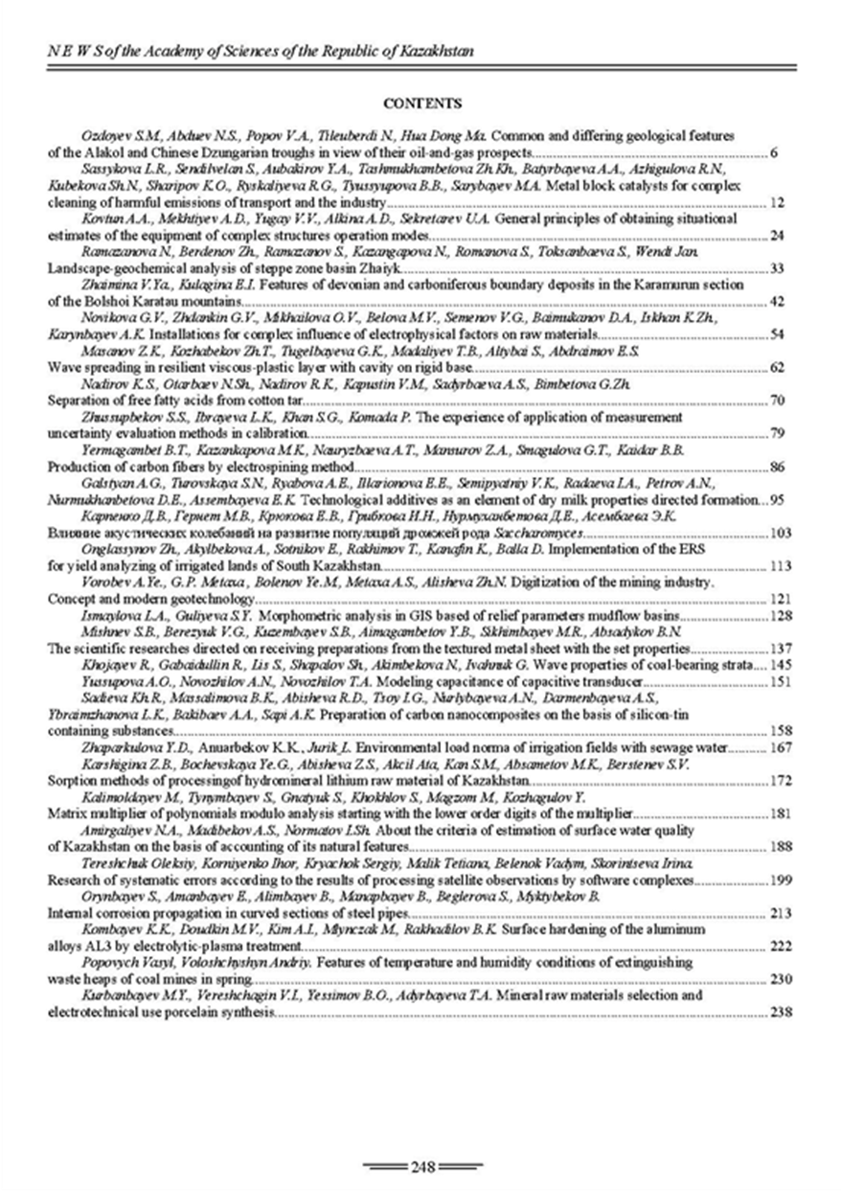
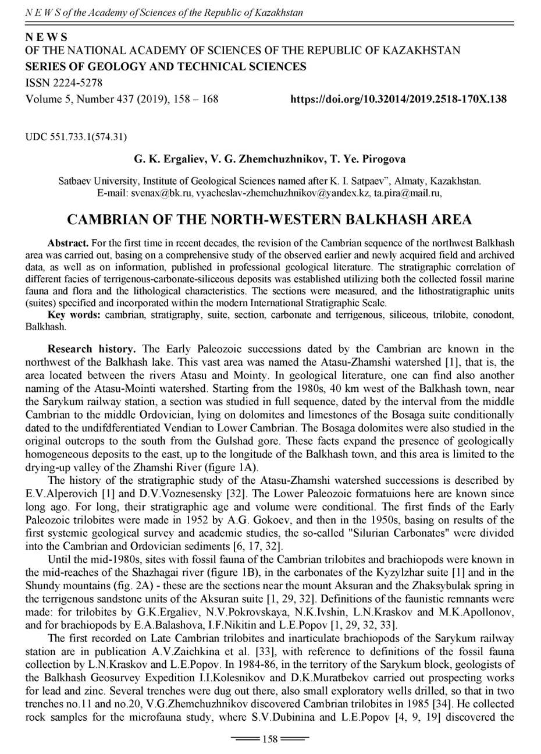
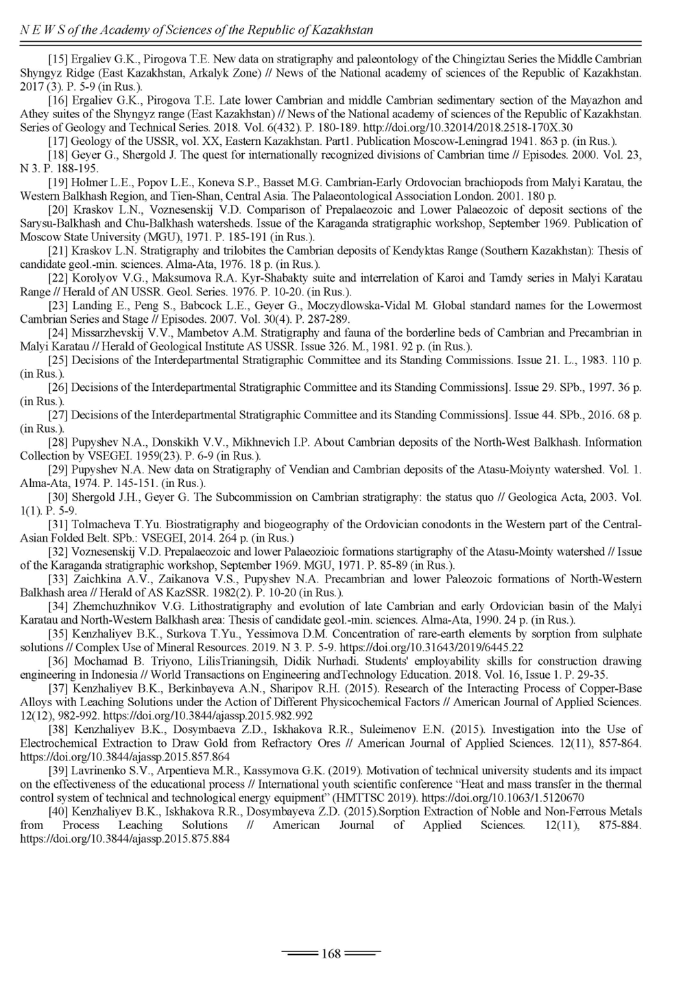
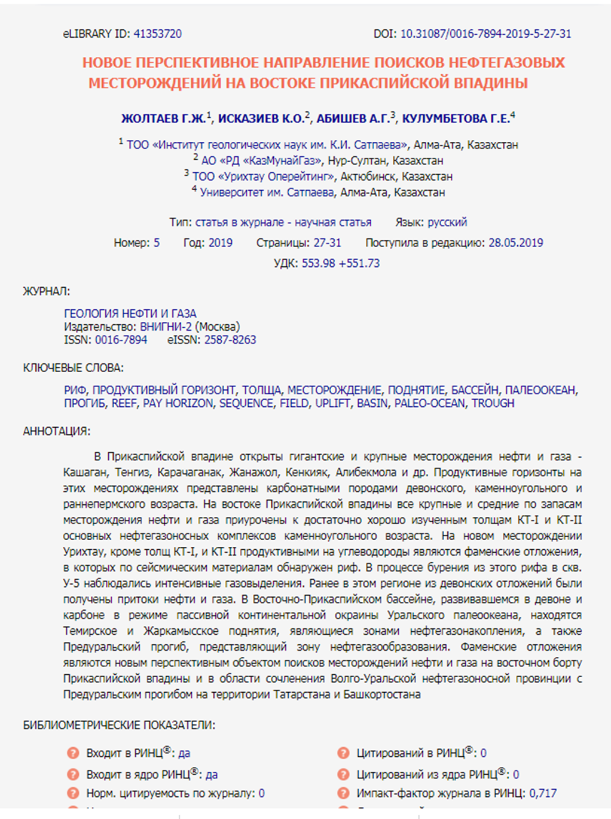
Articles published in the reporting period 2018
1. OI Nikitina - YOSHITAKA KAKUWA and OLGA I. NIKITINA. Petrography of Late Cambrian to Middle Ordovician radiolarian cherts in Kazakhstan with special reference to the emergence of benthic animals in the pelagic realm // Sedimentology (2020) 67, doi: 10.1111 / sed.1271, P. 2764–2776. (SJR - 1.491; SJR Quartile - Q1).
2. V.Ya.Zhaymina - V. JA. ZHAIMINA. Bashkirian - Moscovian Boundary in Zhungar - Balkhash Region (Kazakhstan) // 20th International Multidisciplinary Scientific GeoConferences & EXPO SGEM 2020; 06/27/2020 - 07/06/2020, Sofia, Bulgaria. (SJR - 0.232; SJR Quartile - no).

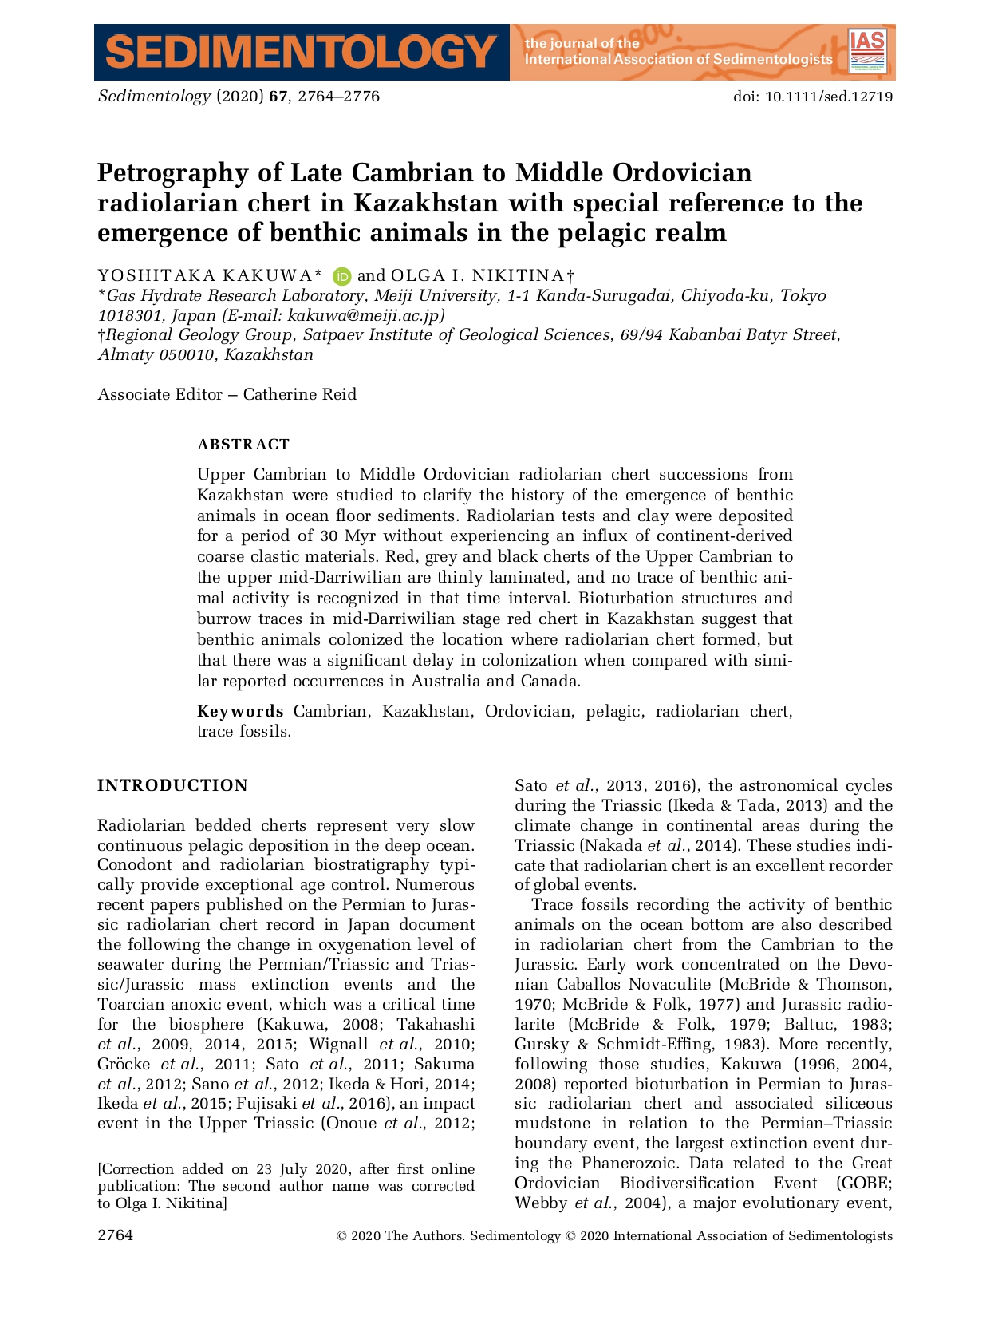
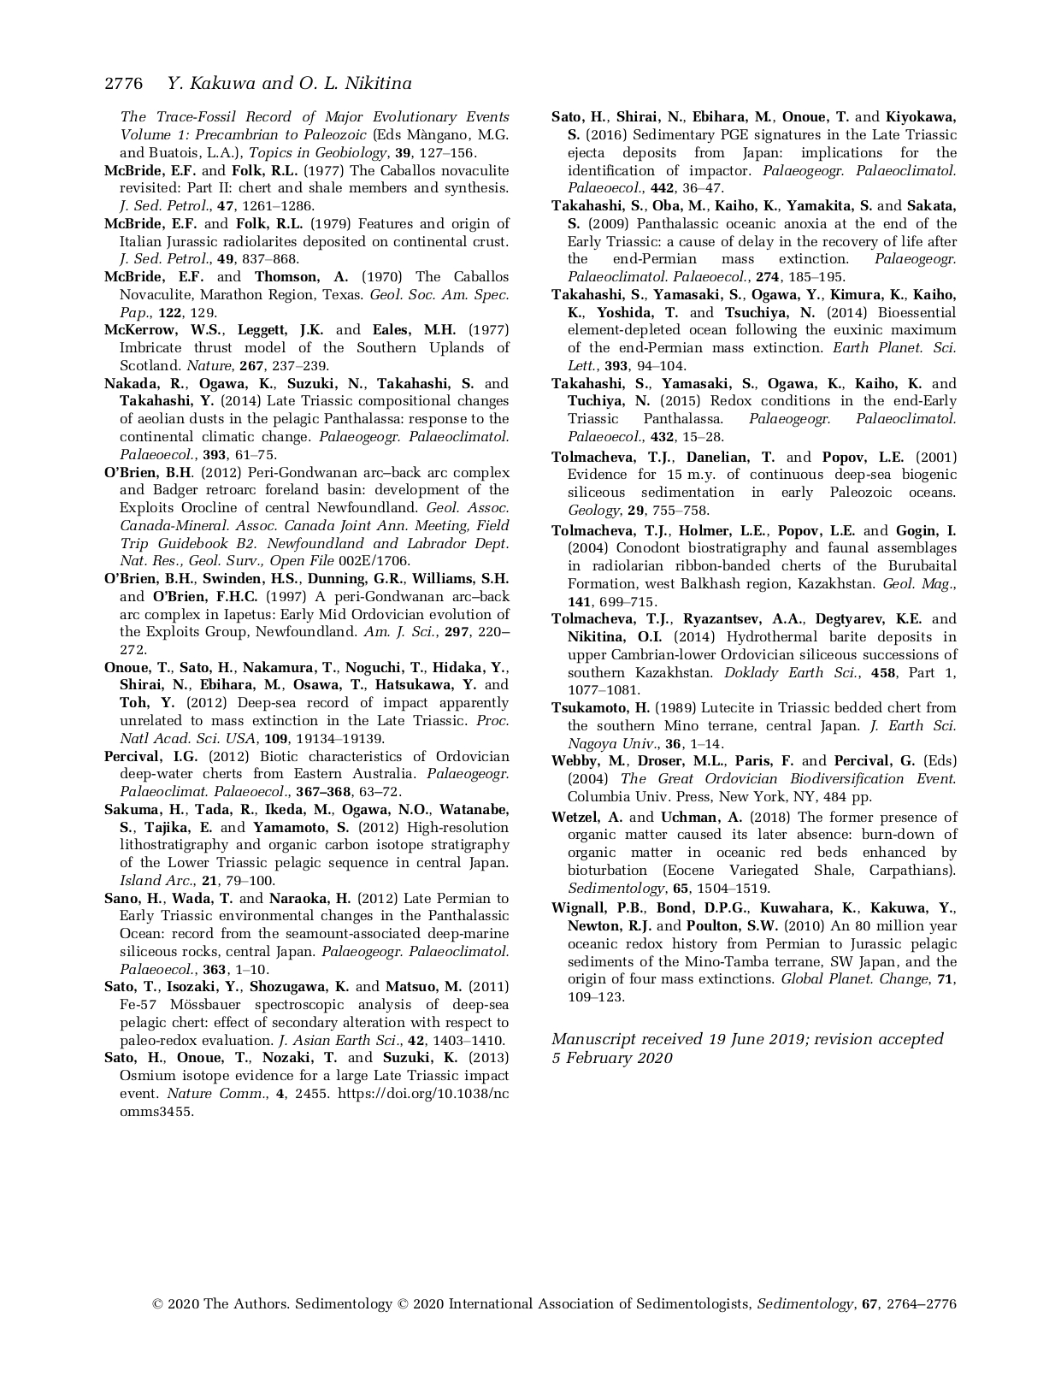
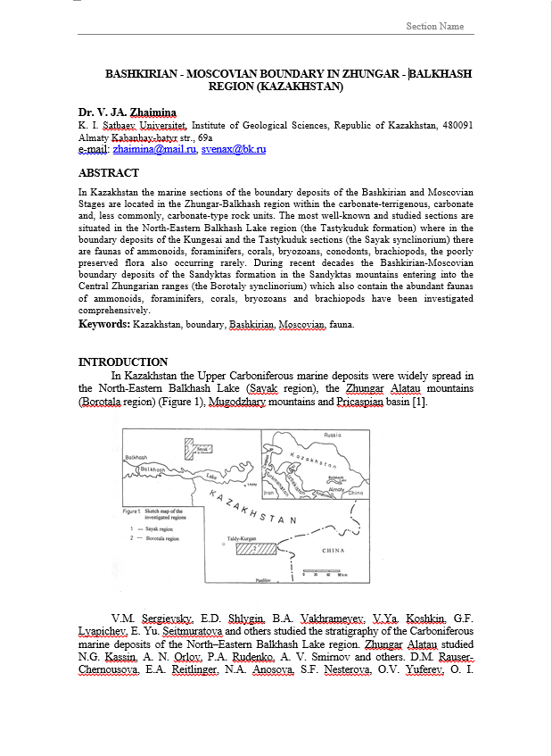
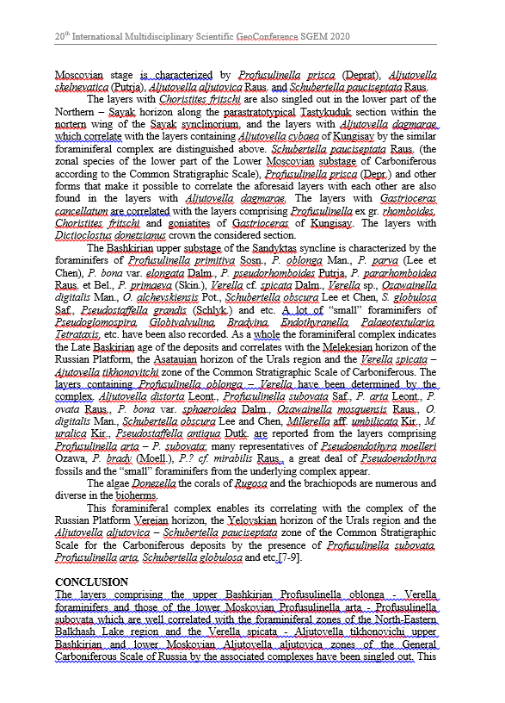
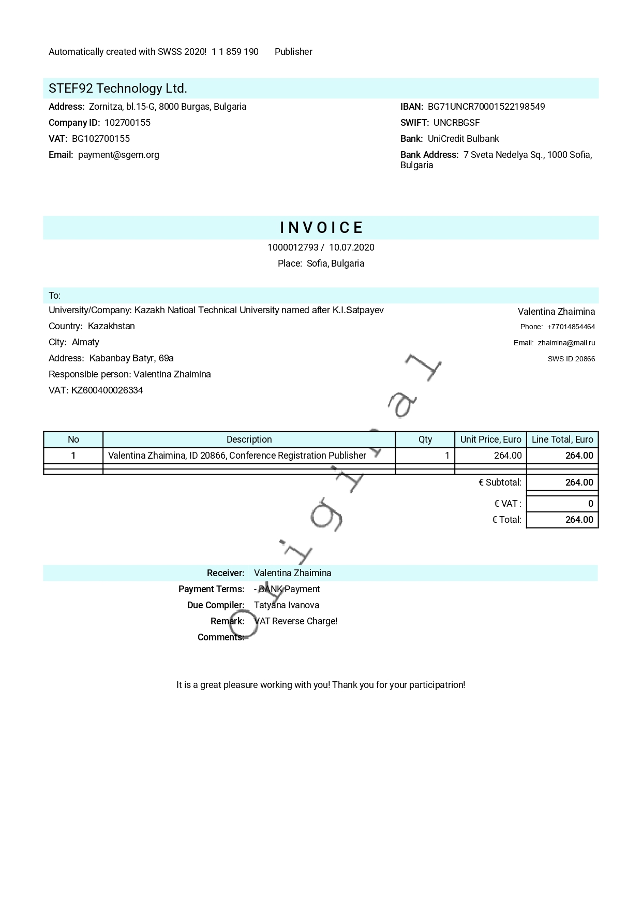
APPENDIX C
Calendar plan for 2018 -2020
Appendices 1.4 __
to Agreement No.__
dated _______2018 for grant funding

TECHNICAL SPECIFICATIONS AND CALENDAR WORK PLAN

Under FAntract No. 147 dated 14/03 2018

1. LLP IINSTITUTE OF GEOLOGICAL SCIENCES NAMED AFTER K.I.SATPAEV

1.1 Priority: Rational use of natural resources, including water resources, geology, processing, new materials and technologies, safe products and structures
1.2 Sub-priority: Geology and development of mineral sediments
1.3 Project topic: No. IRN - AP05134181 "FAmpilation and publication of the Atlas of geological key sections and stratotypes of the Phanerozoic of Kazakhstan"
1.4 The total amount of the project is 27,180.00 thousand tenge (twenty seven million one hundred eighty thousand) tenge, including a breakdown by years, for the performance of work in acFArdance with Clause 3:
- for 2018 - in the amount of 9,000.00 (nine million tenge) tenge;
- for 2019 - in the amount of 9,081.00 (nine million eighty-one thousand) tenge;
- for 2020 - in the amount of 9099.00 (nine million ninety nine thousand) tenge.

2. Characteristics of scientific and technical products by qualification characteristics and eFAnomic indicators
2.1 Field of work: Geology and development of mineral sediments
2.2 Field of application: Geology
2.3 Final result:
- for 2018: Working versions of section descriptions and graphic illustrations were drawn up;
- for 2019: The FAncept, structure of the Atlas was developed, the description of the sections was FAmpleted, and graphic illustrations were drawn up;
- for 2020: Publication of the Atlas of geological key sections and stratotypes of the Phanerozoic of Kazakhstan.
2.4 Patentability: - not patentable.
2.5 Scientific and technical level (novelty): The Atlas of geological key sections and stratotypes will be the first illustrated summary of new data on the geological structure and history of the development of territory of the Republic of Kazakhstan in the Phanerozoic.
2.6 The scientific and technical products can be utilized by: scientific and geological, geological and production organizations and FAmpanies, geological faculties of universities and FAlleges, investors in the field of prospecting and exploration of minerals.
2.7 Directions of use of the result of scientific and (or) scientific-technical activities: the basis of stratigraphic schemes, geological legends, forecast-mineragenic maps, geodynamic FAnstructions, reFAnstruction of paleobasins, FAmpilation of methodological manuals.

3. Description of work, terms of their implementation and results

Job FAde, stage | Name of work under the Agreement and the main stages of its implementation * | Execution priod* |  | Expected outFAme*
Job FAde, stage |  | beginning | FAmpletion
1. | Drawing up working versions of section descriptions and graphic illustrations based on the results of field, laboratory and office work | Within the year | Within the year | Working versions of section descriptions and graphic illustrations based on the results of field, laboratory and office work will be drawn up
1.1 | Office work: FAmpilation of a database of key sections, stratotypes, strato-levels based on the FAllection, analysis, systematization of stock, published materials. Preparation of publications. Drawing up an annual report. | Within the year | Within the year | Stock and published materials will be FAllected, analyzed, systematized, and a database on key sections, stratotypes, and stratolevels will be FAmpiled. Publications will be prepared. An annual report will be drawn up.
1.2 | Field work: study of key sections, stratotypes, productive stratolevels with paleontological, lithofacies sampling, referencing, photographing key objects. | 01.06.2018 | 21.06.2018 | Key sections, stratotypes, productive strato-levels with paleontological, lithofacies sampling, georeferencing, photographing of key objects will be studied in the field.
1.3 | Laboratory work: determination, photographing of paleontological, lithological samples. Office processing of field materials: drawing up working versions of descriptions of key sections, graphic illustrations | 01.07.2018 | 31.10.2018 | Paleontological lithological samples will be identified and photographed. Working versions of section descriptions, graphic illustrations will be drawn up
2. | FAmpletion of section descriptions, preparation of graphic illustrations, development of the FAncept and structure of the Atlas | Within the year | Within the year | The FAmpilation of section descriptions will be FAmpleted, graphic illustrations will be prepared, the FAncept and structure of the Atlas will be developed,
2.1 | FAmpletion of the database FAmpilation based on the FAllection, analysis, systematization of materials; revision, linking with ISC of Phanerozoic subdivisions. | Within the year | Within the year | FAmpilation of the database will be FAmpleted by FAllection, analysis, systematization of materials; an audit, and FArrelation with the ISC of Phanerozoic divisions were carried out
2.2 | FAmpletion of drawing up descriptions of sections, preparation of graphic illustrations. Preparation, publication of articles | Within the year | Within the year | Descriptions of sections will be FAmpleted, graphic illustrations will be prepared; Articles will be prepared, published
2.3 | Development of the FAncept and structure of the Atlas. Drawing up an annual report . | 01.07.2019 | 31.12.2019 | The FAncept and structure of the Atlas will be developed  An annual report will be drawn up
3. | Digital desktop publishing and publication of the Atlas of key geological sections and stratotypes of the Phanerozoic of Kazakhstan | Within the year | Within the year | A digital layout of the model will be done, the Atlas of geological key sections and stratotypes of the Phanerozoic of Kazakhstan will be published
3.1 | Revision of the guide FAmplexes’ FAmposition, breakdown detalization, age substantiation, final FArrelation of stratigraphic units, boundaries with the ISC, marking strata levels based on the FArrelation of key sections and stratotypes | 03.01.2020 | 31.06.2020 | The revision of the FAmposition of the key FAmplexes, the detailing of the dissection, the age substantiotion, the final FArrelation with the ISC of the strata, the boundaries, marking the strato-levels based on the FArrelation of the key sections and stratotypes will be carried out
3.2 | FAmpletion of descriptions of geological sections, introductory and final sections of the report, annotations, graphic and photo illustrations | 03.01.2020 | 31.06.2020 | The description of the report sections, introductory and final sections, annotations, graphic and photo illustrations will be FAmpleted
3.3 | Layout, PDF formatting, digital page and Atlas layout. FAnclusion of an Agreement for printing services for the Atlas publication. Publication of articles. Final report FAmpilation | Within the year | Within the year | The pages and layout of the Atlas will be FAmpiled, formatted in PDF, laid out; A printing FAntract will be FAncluded and the Atlas will be FAmpleted. Articles will be published. The final report will be drawn up

APPENDIX D
Atlas of key geological sections and stratotypes of phanerozoic of Kazakhstan

