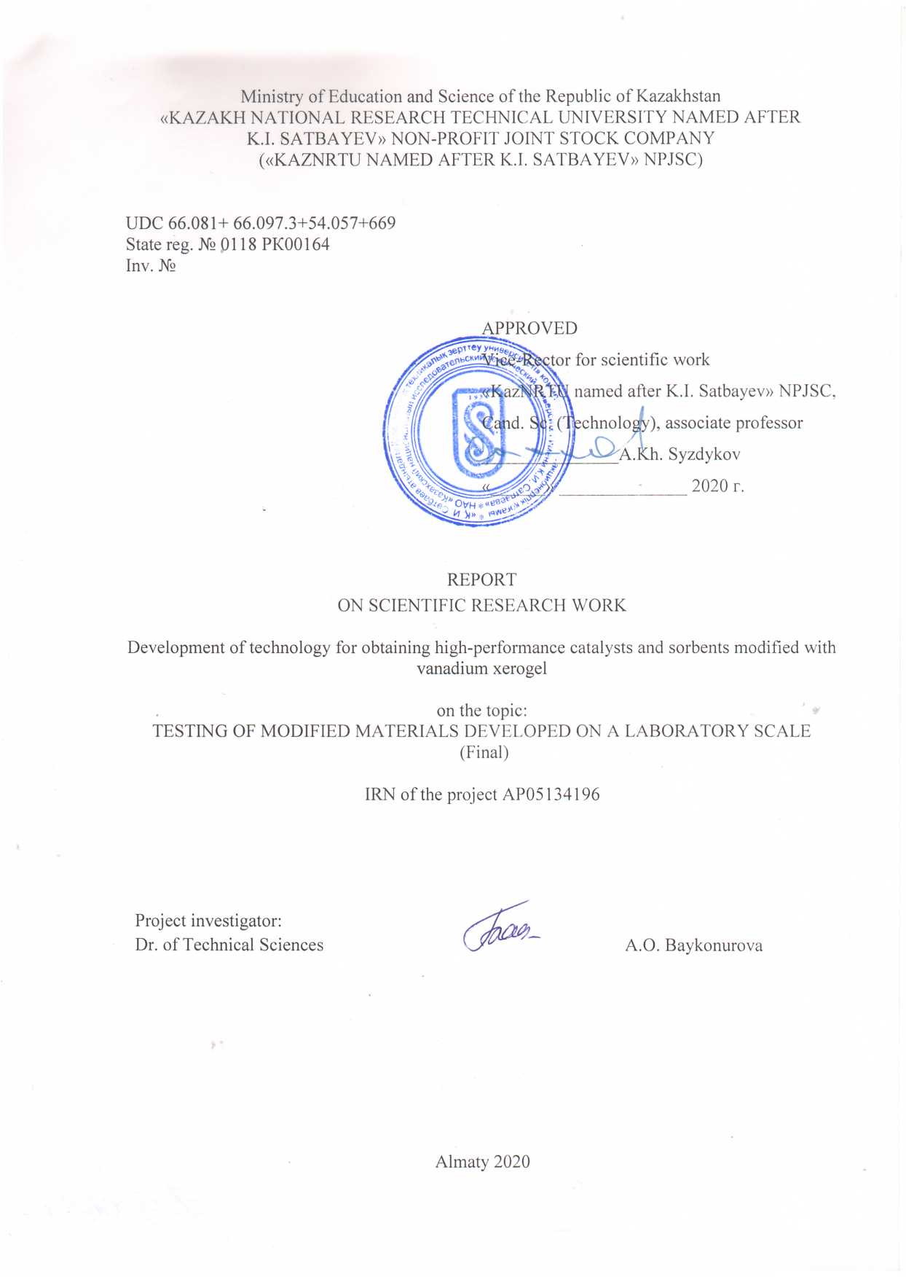

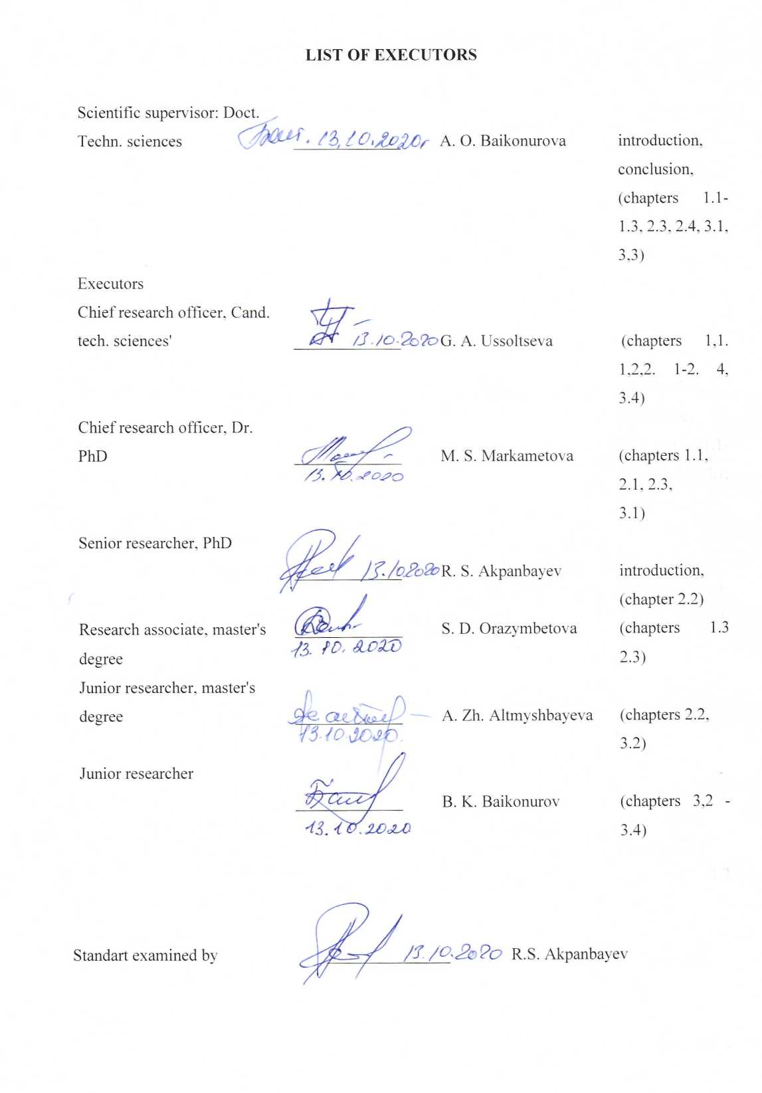

abstract

The report contains 137 pa12ges, 17 figures, 11 tables, 69 sources, and 9 appendices.
NANOMATERIAL, XEROGEL, VANADIUM PENTOXIDE, TEMPLATE, SOL-GEL METHOD, STRUCTURE, SORBENT, CATALYST, MODIFICATION
Objects of research: technology for the synthesis of modified catalysts and sorbents based on zeolites and industrial grade catalysts.
The purpose of this project is scientific and technical justification and development of technology for modifying industrial catalysts and sorbents with synthesized vanadium xerogel, studying their properties and applications.
Methods and methodology of work. The work uses x-ray phase, UV and IR spectroscopic, elemental, photometric analysis, electron microscopy, laser light scattering, etc.
Results and their novelty. Information on the synthesis of xerogel based on vanadium pentoxide is considered; thermodynamic equilibrium States of vanadium ions and compounds capable of spontaneous structure formation are established. Modification of the zeolite mass to obtain sorbents and catalysts was carried out by the "cold impregnation"method. The structure of the obtained modified sorbents and catalysts, their sorption and catalytic properties are studied.
Scientific novelty of the project. A technology has been developed for the production of vanadium xerogel, which can act as a modifying agent for the production of effective catalysts and inorganic sorbents.
Recommendations for implementation or results of implementation of research results. The research results allow us to implement the technology for obtaining sorbents and catalysts modified with vanadium xerogel.
Fields of application: metallurgy, nanotechnology, chemistry of inorganic substances and organic synthesis.
Economic efficiency or significance of the work. Economic calculations of the technology of production of vanadium xerogel from products of processing of carbon shale showed that the net income at the production capacity of 100 kg per year of xerogel will be 1073,422 thousand tenge, profitability-36 %, payback period-5 years.
Predictive assumptions about the development of the research object. The developed catalysts and sorbents based on vanadium xerogel will be tested and used at enterprises that process vanadium-containing raw materials, organic synthesis, and non-ferrous metallurgy.

CONTENT

INTRODUCTION………………………………………………………….................... |  | 8
1 | Justification and study of the process of obtaining vanadium xerogel from black shales of the Greater Karatau ………………………………………………….. | 8
1.1 | Current state of production of xerogel based on vanadium pentoxide …………. | 9
1.2 | Physical and chemical analysis of raw materials and thermodynamic calculations of the possibility of synthesis of vanadium xerogel …………………………… | 11
1.3 | Working out the conditions for the synthesis of vanadium xerogel …………….. | 12
1.4 | Study of the properties of the obtained vanadium xerogel…………………….. | 15
2 | Development of technology for producing high-performance catalysts and inorganic sorbents modified with vanadium xerogel and study of their properties | 15
2.1 | The selection of a natural sorbent and industrial catalyst carriers and substrates … | 15
2.2 | Working out the conditions for modification of selected materials with vanadium xerogel……………………………………………………………………………. | 17
2.3 | Study of properties, composition and structure of modified sorbents …………… | 17
2.4 | The study of properties, composition and structure of the modified catalysts … | 20
3 | Testing of the developed modified materials on a text-based laboratory scale… | 20
3.1 | Approbation of vanadium xerogel synthesis and study of its aging properties …… | 20
3.2 | Working out conditions for modifying sorbents with vanadium xerogel ………… | 27
3.3 | Approbation of conditions for modification of sorbents on a test laboratory scale | 31
3.4 | Testing of modified sorbents on a text-based laboratory scale…………………… | 38
CONCLUSION ………………………………..……………………………. |  | 43
REFERENCES.............................................................................................................. |  | 46
APPENDIX A Calendar plan..……………………….……………………... |  | 52
APPENDIX B List of published works for 2018-2020 ………….…..……… |  | 61
APPENDIX C copies of published scientific papers.............. |  | 63
APPENDIX D Schema for the processing of quartzite Karatau..................... |  | 106
APPENDIX E Optimization of the obtained mathematical models for the synthesis of vanadium xerogel………………………………………………. |  | 108
APPENDIX F Approximate technical and economic calculation of vanadium xerogel synthesis technology indicators.......................................... |  | 112
APPENDIX G Acts of implementation of research results in the educational process.......................................................................................... |  | 118
APPENDIX H Acts of laboratory testing of the technology………………… |  | 121
APPENDIX J Extracts from the report discussion minutes……………….. |  | 125
APPENDIX K forms of grant funding (the results for the 2018-2020 gg).................................................................................................................... |  | 136

INTRODUCTION

Assessment of the current state of the scientific and technical problem being solved. Currently, more and more attention is drawn to nanotechnology, which allows you to create a number of fundamentally new production processes, materials and devices based on them. Of great interest are materials of nanotubular structures based on 3d element oxides, in particular vanadium oxides, which have a unique ability to complex with highly developed layered nanoscale structures [1-4]. Among the known methods for producing vanadium – containing nanomaterials -sol-gel technology is based on the participation of vanadium pentoxide in the presence of a molecular template in the synthesis of a complex compound with a highly developed structure [3-7]. The popularity of the classical version of the Sol-gel method is due to the fact that the resulting products have a high chemical uniformity, which significantly reduces the temperature and duration of heat treatment to obtain functional materials, the ability to control the particle size and pore structure of materials at different stages of synthesis, and change the rheological properties of the dispersed system within a wide range [1, 8, 9].
Basis and source data for theme development. In the practice of vanadium production, pentoxide, which is the raw material base of xerogel, is obtained from ammonium Vanadate by drying and calcining it. A promising source of ammonium Vanadate in Kazakhstan is the uranium-containing carbon-siliceous shale of the Bolshoy Karatau Deposit, whose reserves amount to hundreds of millions of tons. The integrated use of such a unique type of raw material is an essential component of modern environmentally friendly, waste-free and highly efficient technologies that allow us to isolate not only compounds of valuable target components, such as uranium, but also the source material for the production of vanadium xerogel.
Justification of the need for research. This project involves obtaining not only a nanomaterial based on vanadium pentoxide, but also modified sorbents and catalysts that can solve a number of problems in the chemical and metallurgical industries. Thus, modified sorbents can selectively extract harmful compounds from wastewater and waste water from various industries, and modification of catalysts will reduce the conversion time of hydrocarbons, including in the production of liquid and gaseous fuels.
Information about the planned scientific and technical level of development, patent research and conclusions from them. Currently, there is information about the possibility of using vanadium compounds as modifiers for the production of catalysts, but information about the use of vanadium xerogel as modifiers of catalysts and sorbents has not been found. Methods for producing vanadium xerogel are mainly associated with high-temperature processes. the task of this research is to develop a low-temperature method for obtaining this nanomaterial.
Information about metrological support for research. Devices and equipment for physical and chemical research were checked in a timely manner, and the methods used for performing analyses were certified.
The relevance of the research. The development of new methods for obtaining nanomaterials is a modern priority area of science and technology. The formation of nanoobjects occurs, as a rule, within the framework of specific laws that were not previously studied in the classical sections of natural Sciences. One of the main principles of obtaining nanostructured materials is self-organization in complex open systems with hierarchical interactions at various structural levels. Such materials can be successfully used to produce modified sorbents and catalysts used in wastewater treatment and in the production of organic substances.However, despite the intensive development of nanotechnology, information about nanomaterials based on vanadium oxide is not extensive enough. Therefore, the research carried out in this direction is relevant and timely.
The novelty of the topic is to create an innovative technology for producing vanadium xerogel, which, due to its activity and developed structure and morphology, can act as a modifying agent for producing effective catalysts and inorganic sorbents.
Connection of this work with other research works.
Research within the framework of this project was carried out jointly with specialists of JSC "Institute of fuel, catalysis and electrochemistry named After D. V. Sokolsky", Institute of polymer materials and technologies, "PPP" LLP, "Zhersu Power" LLP.
Goals and objectives of research, their place in the implementation of research in General. The purpose of this project is scientific and technical justification and development of technology for modifying industrial catalysts and sorbents synthesized by vanadium xerogel, and their application. The main research objectives were: to study the current state of production of vanadium xerogel; thermodynamic justification of the possibility of synthesis of vanadium xerogel in the low-temperature region; analysis of initial and intermediate materials in the process of obtaining vanadium xerogel; development of conditions for the synthesis of vanadium xerogel and its modification of selected natural sorbents and catalysts; testing of technologies for the synthesis of vanadium xerogel and its modification of sorbents and catalysts on a test laboratory scale.

1 Justification and study of the process of obtaining vanadium xerogel from black shales of the Greater Karatau

  - Current state of production of xerogel based on vanadium pentoxide

Nanomaterials have a large surface area, which increases thethe interaction between them and the environment in which they are placed. Nanomaterials are successfully used in the composition of membranes constructed on the basis of porous matrices and anisotropic nanoparticles inserted into channels-pores. The presence of an unfilled 3d shell in the vanadium atom causes the existence of a number of its oxides that have the ability to complex with the production of spatial partially ordered highly developed nanoscale structures. V2O5 has a range of modifications [1-9]: nanoribbons, filamentous crystals (whiskers), hybrid organo-inorganic materials, and xerogels, which expand the scope of their use. V2O5-based nanotubes (Figure 1) are a typical example of a hybrid nanomaterial.

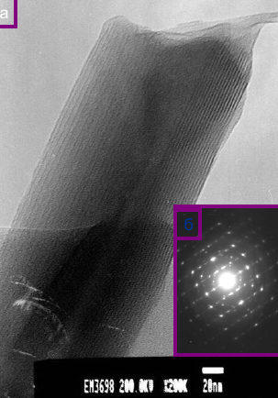 | 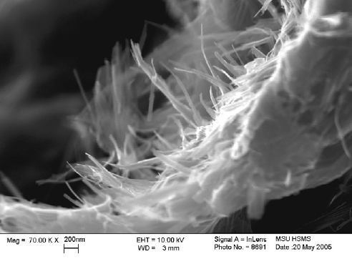
а | б
a - vanadium oxide nanotube; b - nanotube legs of a vanadium oxide centipede
Figure 1 – Nanomaterials based on vanadium pentoxide

Vanadium oxide (VO–H) nanotubes are produced during long-term (up to 10 days) hydrothermal (180 ⁰C) treatment of vanadium-containing compounds such as V₂O₅, VOCl₃, HVO₃ [3]. With the participation of surfactants-templates of different radii, it is possible to regulate the interlayer space of the structure, as a result of which the xerogel will "stretch" or "shrink" according to the accordion principle [1]. Thanks to this structure, the xerogel can intercalate (i.e. "suck in") a variety of ions. The V₂O₅·nH₂O xerogel with a pronounced quasi-one-dimensional structure obtained by the Sol-gel method is the basis for the synthesis of vanadium oxide nanotubes [4-11]. The Sol-gel method is understood as a set of stages, including the preparation of a precursor solution, its sequential conversion first to Sol, and then to gel due to the processes of hydrolysis and condensation, subsequent aging, drying and heat treatment of the product. Vanadium oxide nanotubes are multi-walled, which is due to the peculiarity of their formation process. Twisted V-O layers often remain unclosed. The shape of the cross-sections of such formations is asymmetric, and the distances between adjacent layers can vary quite significantly, usually increasing from the inner to the outer wall. The fine structure of vanadium compounds is quite easy to manage.The process of forming ordered structures can be implemented through the use of templates - "templates" that contribute to the formation of necessary interactions between system elements [5]. The use of ammonia as a template in vanadium-containing systems should contribute to the creation of an ordered complex of nano - or supramolecular structure due to various intermolecular interactions. The phenomena of formation of ordered structures and self-organization usually occur as a response of a complex system to a strong external influence. The ordering of the system during self-Assembly is controlled by the competition of various interaction forces, often of a molecular nature: hydrophilic-hydrophobic interactions, gravitational forces, van der Waals or Coulomb interactions.

1.2 Physical and chemical analysis of raw materials and thermodynamic calculations of the possibility of synthesis of vanadium xerogel

As a starting material, vanadium-containing material is usually used chemically pure vanadium pentoxide. Considering the fact that the use of pure vanadium pentoxide compound for large-scale production of sorbents and catalysts modified with vanadium xerogel will not be economically profitable, we analyzed industrial sources of vanadium pentoxide.
Ammonium metavanadate obtained during processing of the Big Karatau shale was selected as the initial vanadium-containing compound (table G). The composition of ammonium metavanadate was as follows,%: 75,6 –NH₄VO₃, Si – 3,08 , Fe – 2,4 , S – 2,02 , P – 1,08, Al –2,03, Cl – 3,05, As – 0,9. Recrystallization of NH₄VO₃ was performed from a cooled solution (15 ° C) at pH 8.0-8.5 adding 30 % ammonia. Recrystallized NH₄VO₃ was filtered and dried. The structure of the samples was studied using a low-vacuum scanning electron microscope (Figure 2) Jeol JSM-6490 LV.X-ray diffractometer x'pertmpdpro showed that the composition of ammonium metavanadate includes the following components%: 99,6 NH₄VO₃, Si –0,08, Fe – 0,06, S – 0,02, P – 0,02, Al – 0,03, Cl – 0,10.

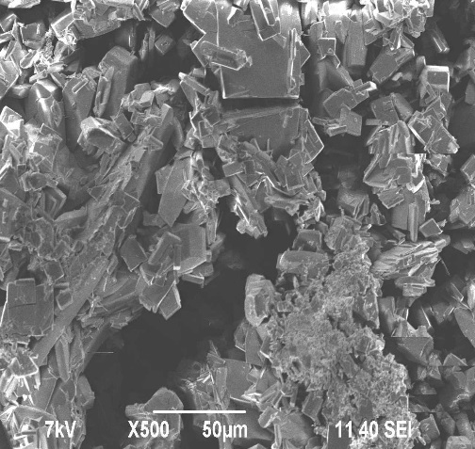 | 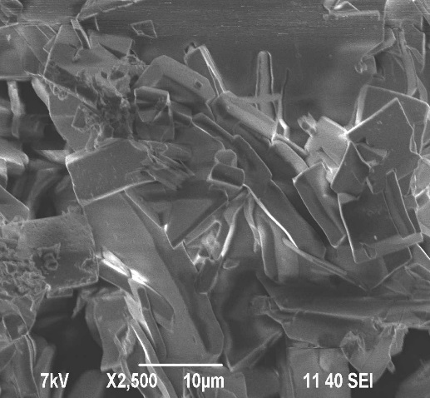
Figure 2 – Micrographs of ammonium metavanadate

Vanadium pentoxide was obtained from technical NH₄VO₃ purified from impurities by recrystallization after filtration, drying and thermal decomposition at a temperature of 550 ° C.
Thermodynamic analysis of vanadium-containing systems has shown that the formation of complex vanadium ions and compounds in the V-N-Н₂О system occurs spontaneously, preferably the formation of decavanadium complexes HV₁₀O₂₈⁵⁻ (Figure 3).
As the pH of the medium increases, the values of the lower and upper limits of their stability potentials decrease. In an ammonia solution, free ammonia molecules begin to replace hydroxyl ions in the decavanadium ion, forming ammonia complexes of the type [(VO₂)_{х}(ОН⁻)_{у}∙nNH₃]^{у-х}, which ensure its high solubility.

Figure 3 – diagram of the Ex-pH of the V-N-Н₂О system (25 ^{о}С)

1.3 Working out the conditions for the synthesis of vanadium xerogel

The initial material for the synthesis of xerogel-vanadium pentoxide was studied by physical and chemical analysis methods. The results of electron microscopic analysis showed that vanadium pentoxide has a crystal structure formed into complex agglomerates (Figure 4).
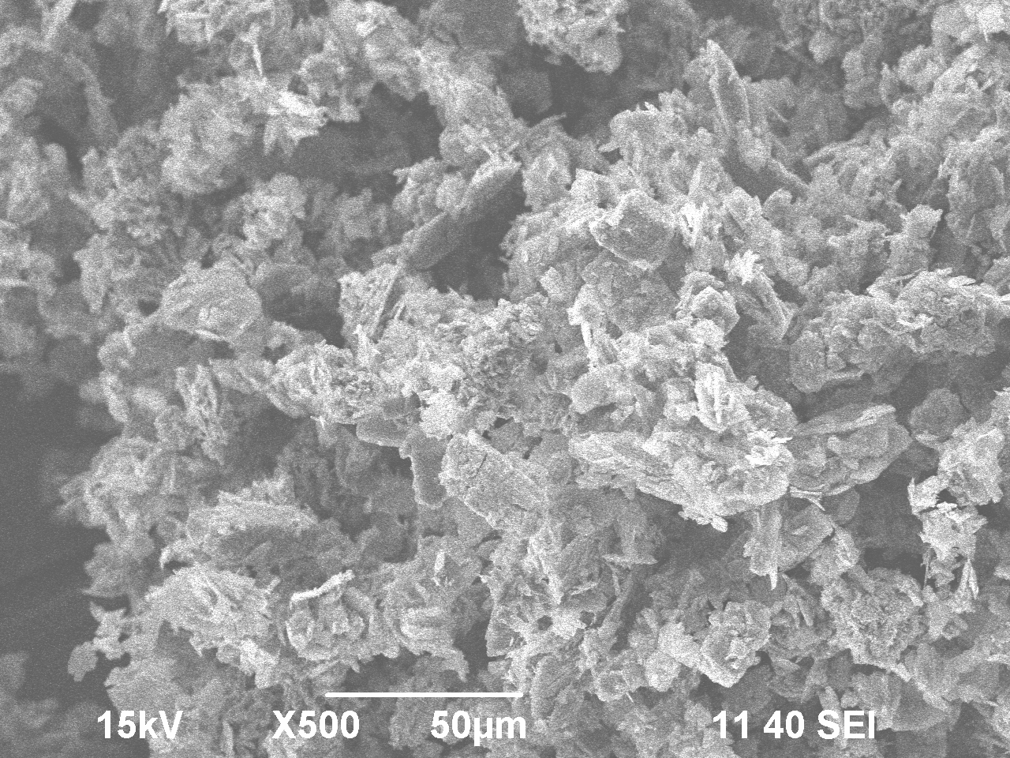

Figure 4 – Micrograph of the initial vanadium pentoxide

A sample of freshly deposited V₂O₅ was melted at a temperature of ~ 600 ° C. Then the Plav was heated to a temperature of 850 ° C for more than half an hour, removed from the oven and introduced into a container with distilled water. The contents were mixed until the precipitate was completely dissolved. In this case, the homogeneous solution turned brown at the pH of the medium 2. the Addition of ammonia to the vanadium solution was carried out with stirring (~ 650 rpm). The main factors affecting the formation of xerogel are the pH of the medium, the duration of the process, the metal concentration in the initial solution, and the system temperature. 30 % ammonia was added to a vanadium-containing solution of 0.2-0.4 ml. The experiment was completed when the consistency of the solution changed (Table 1). When the pH of the medium was 3.4, the solution began to HUS-tify as a result of Sol formation. The process was controlled by visual observation of external signs of a vanadium-containing solution. It was found that at pH ~ 4, the volume of the dispersed phase increases, and coagulation contact between the particles appears, which leads to the beginning of structuring of the monolithic vanadium gel. The final formation of the gel is carried out within 80-120 minutes. The vanadium concentration in the solution was maintained at 5÷25 g /l with a ratio of vanadium solution volumes (С_{V2O5} = 20 g /l) and 30 % ammonia 50÷1.5-2.0.
During the formation of xerogel (Figure 5), you can see a change in the color of samples, the organization of coagulation contact of particles, the formation of agglomerates to produce a xerogel with a shiny dark gray surface.

Table 1 – Results of experiments on the synthesis of vanadium gel
τ, min | VNH_{3,} ml | pН sol.n | Cv₂o₅, g/l
10 | 0,2 | 2,13 | 25,4
20 | 0,2 | 2,42 | 23,1
30 | 0,2 | 2,79 | 21,9
40 | 0,3 | 2,96 | 20,3
50 | 0,3 | 3,08 | 19,99
60 | 0,4 | 3,28 | 19,43
70 | 0,4 | 3,4 | 19,32
80 | 0,4 | 3,92 | 19,29

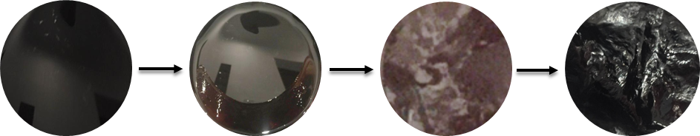

Solution Sol Gel Xerogel

Figure 5 – scheme of xerogel formation in the vanadium-ammonia system

By electron microscopy the mouthit is shown that the composition of the xerogel includes,%: V – 35,32; О – 52,4; H – 10,76; С – 1,52. the X method shows that in the region of 3400 cm⁻¹, absorption bands of valence vibrations of OH groups are manifested; deformation and libration vibrations of water molecules are observed at δHOH-1651 cm⁻¹ and ν_{L}H₂O – 739 cm‾¹[17]. The absorption band at 1013 cm⁻¹ is attributed to the valence vibrations of V – O groups. The absorption band at 510 cm⁻¹ corresponds to the characteristic vibrations of the [V₂O₈]_{2-∞} groups. When subtracting the water spectrum, valence vibrations of the V – O groups were detected at 747 cm⁻¹ and [V₂O₈]_{2-∞} at 503 cm⁻¹.

1.4 Study of the properties of the obtained vanadium xerogel

An amorphous component was detected on the gel diffractogram (Figure 6A); when exposed to air for 120 min, individual reflexes were detected in the small-angle region (6-8°) (Figure 6b). Phase separation is associated with the formation of vanadium hydroxo compounds and the disorientation of nuclei with a non-crystalline structure. Various oxides are crystallized: V₂O₅(H₂O) 31 %, V₂O₅13 %, V₃O₇ 45 %, V₂O₅ 11 %. When water is removed from the gel, a porous layered structure of the vanadium-containing material is formed (Figure 7a). The formation of a layered structure of vanadium xerogel was confirmed by probe microscopy (Figure 7b). The layered structure is formed by ribbon fibers with a length of 100-600 nm and a width of up to 25 nm. The interlayer distance (d) is approximately 150-200 nm.

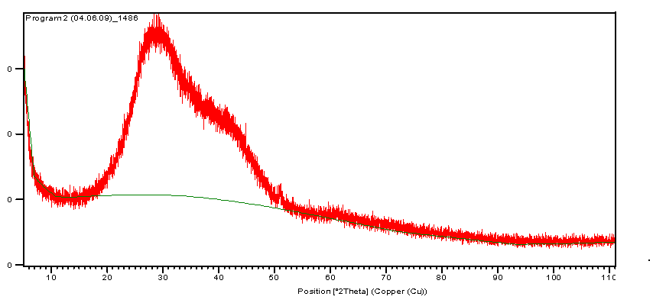 | 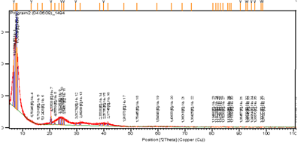

Figure 6 – Diffractograms of vanadium xerogel, freshly extracted (a) and kept in air for 120 minutes (b)

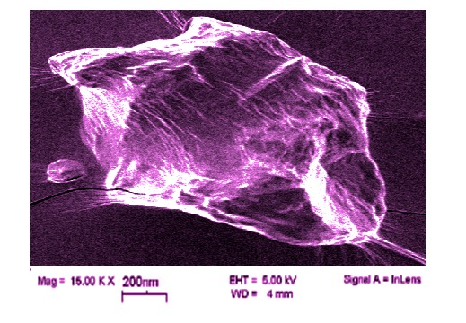  а | 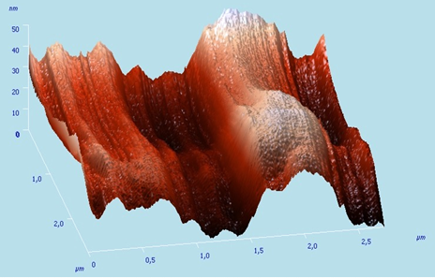б

a-spatial structure; b-3D image of the layered structure
Figure 7 – micrographs of vanadium xerogel

Conclusions for 1 section
– among successfully developing nanotechnologies, the production of nanostructures based on 3d element oxides, in particular vanadium xerogel produced by the Sol-gel method, is of interest. The method is based on the interaction of V₂O₅ and NH₃ used as a template.
– V₂O₅, which serves as the raw material base of the xerogel, can be extracted from the technical NH₄VO obtained from the carbon-siliceous shales of the Bolshoy Karatau Deposit, whose reserves amount to hundreds of millions of tons. Pure vanadium oxide was obtained by recrystallization and thermal decomposition of ammonium metavanadate (550 ° C).
– Thermodynamic analysis shows the formation of HV₁₀O₂₈⁵⁻ (ΔG° = -1934.738 kcal/mol) ions in the V-N-H₂O system, in the presence of NH₃ – [(VO₂)_{х}(ОН⁻)_{у}∙nNH₃]^{у-х}. By selecting the conditions for the formation of vanadium-containing ammonia particles and the occurrence of coagulation contact between the particles, it is possible to cause structuring of the material.
– by methods of physical and chemical analysis, it is shown that during the drying of vanadium xerogel, its layers are released from water, and a quasi-one-dimensional layered structure is formed, which is wrapped in tubes. A porous layered structure of a vanadium-containing material is formed with ribbon fibers from 100-600 nm long and up to 25 nm wide. The interlayer distance reaches 150-200 nm.

2 Development of technology for producing high-performance catalysts and inorganic sorbents modified with vanadium xerogel and study of their properties

2.1 Selection of natural sorbent and industrial catalyst, carriers and substrates

Natural sorbents include zeolites, which are aluminosilicates with a frame structure that allows controlling the parameters of nanoparticles at the stage of their formation. The most widely used catalysts in organic synthesis are zeolites containing vanadium pentoxide and titanium dioxide [14-16]. The low cost of natural aluminosilicates determines the possibility of their use in processes that do not involve zeolite regeneration [13].
As a sorbent, a mixture of Al-containing carriers of the following brands was used: KN-30, IK-17-M, the bidisperse structure of which is represented by the ZSM–5 zeolite base. Composition of zeolite, % wt; Al₂O₃ – 12,9-13,2; SiO₂ – 66,2-78,3; К₂O – 4,0-4,8; Na₂O – 1,8-2,2; CaO – 1,8-2,4; Fe₂O₃ – 0,8-1,2; V – 0,0003; Mn – 0,001; Cu – 0,001; Be – 0,001; Rb – 0,001; As – 0,03; H₂O – 10-12; Synthetic zeolite and titanium dioxide were selected as initial catalysts. Analysis of the granulometric composition of zeolite using a two-angle analyzer of the MalvernZetasizerNanjZS90 brand showed that the main number of particles has a size in the range from 400 to 2000 microns [17]. The analysis of the elemental composition of the samples performed on the INCAENERGY spectrometer allowed us to determine the composition of the zeolite mixture, mass %: O – 47,64, Al-7,42, Si-4,36, S – 0,03, Ca – 0,19, Fe – 0,15, other – 1,21.
A line of hydrated compounds of aluminum and silicon, rhombic sulfur, and silicon oxide was detected on the diffractogram. The results are confirmed by IR spectroscopy. The maxima at 1140, 1050, 990, and 480 cm⁻¹ correspond to fluctuations in Si–O–Si bonds. The band at 710 cm⁻¹ refers to the valence vibrations of the Al–O bond, at 670 cm⁻¹ – to the deformation vibrations of Al–O₄, and at 1610 cm⁻¹ to the deformation vibrations of water molecules. Thermal analysis of the samples showed that at 20-200 ⁰C, there is an inflection in the DTG and DTA curves corresponding to the dehydration reaction. At 200-1000 ⁰C, a decrease in weight was recorded due to the removal of hydroxyl water (~1,5 %) and weakly bound sulfur oxides (~1,5%).

2.2 Working out the conditions for modification of selected materials with vanadium xerogel

Modification of the zeolite mass was carried out by the method of "cold impregnation" by impregnating it with a vanadium-containing gel and drying it at 150 °C for 60 minutes. The amount of vanadium xerogel varied from 0.2 to 5.0 wt. % by vanadium of the initial mass of zeolite. The resulting mixture was calcined at a temperature of 450-500 °C for 5-6h. During the first 15 minutes of impregnation, 97% absorption of vanadium xerogel by zeolite is achieved. Full saturation of the zeolite matrix with vanadium xerogel is achieved at 180 min. The duration of aging of vanadium xerogel has a significant impact on the course of subsequent modification of zeolites. To obtain a modified sorbent, it is optimal to age vanadium xerogel for at least 4 days at room temperature (table 2).

Table 2 – Effect of the aging duration of the initial xerogel on the phase composition of the zeolite matrix products at SiO₂/Al₂O₃ = 9
Duration of xerogel aging, day Phase composition of zeolite matrix products at temperatures | Phase composition of zeolite matrix products at temperatures
 | 25 ^{о}С | 50 ^{о}С
0 | Amorphous phas | Amorphous phas
1 | SiO₂/Al₂O₃ | SiO₂/Al₂O₃
2 | SiO₂/Al₂O₃ | SiO₂/Al₂O₃
3 | SiO₂/Al₂O₃ | SiO₂/Al₂O₃ + V₂O₅
4 | SiO₂/Al₂O₃ + V₂O₅ | SiO₂/Al₂O₃ + V₂O₅
5 | SiO₂/Al₂O₃+ V-OH | SiO₂/Al₂O₃ + V-OH
6 | SiO₂/Al₂O₃ + V-OH | SiO₂/Al₂O₃ + V-OH
10 | SiO₂/Al₂O₃ + V-OH | SiO₂/Al₂O₃ + V-OH
Not: V-OH – oxyvanadium phase

When modifying the catalyst, the resulting mass of the carrier was introduced into the material powder – a mixture of Al-containing materials of the composition AlSi + (θ + α)-Al₂O₃. with the necessary moisture capacity. After drying, the catalyst was formed and sieved. The xerogel vanadium interacts with the zeolite with the formation of alyumosilikatov vanadium. it is established that the process depends on the temperature of the matrix surface, the intensity and flow rate of the deposited substance.

2.3 Study of properties, composition and structure of modified sorbents

Analysis of the granulometric composition of the modified catalysts showed that the resulting material contains more fine particles (less than 100 microns) than the sample of the original zeolite. The structure of the material is dominated by submicron and nanoscale grains with unique oxyvanadium compositions fixed on the zeolite surface.
X-ray phase analysis of the modified zeolite shows that the main existing phases in the zeolite are preserved. In addition, there are the lines corresponding to vanadium oxide. A thermogravimetric analysis of the modified material sample was also performed. The TG curve recorded four stages of weight loss in the intervals of 20-200, 200-325, 325-680, and 680-1000 ⁰C-7,0, 6,5, 15,0, and 0,5%, respectively, due to the removal of water and sulfur from the system, as well as the combustion of organic matter (S) present in the sample.
The ion exchange properties of modified samples of sorbents on lead-containing solutions were tested, since lead is one of the dangerous metals often present in industrial wastewater. Lead sorption was performed under dynamic conditions. A solution with a lead concentration of 24 mg / dm³ and pH 2 was passed through the column at a rate of 100 ml / hour. After saturation, the sorbent was washed with water and desorbed at room temperature with 3 % sulfuric acid solution at a rate of 5 specific volumes per hour. It was found that lead is almost completely (95 %) absorbed from the first 400 specific volumes of the passed solution. The total dynamic lead exchange capacity is 74.9 mg / g. Almost complete desorption of lead is achieved by 5 specific volumes of eluate, which contains 85.6% of lead. It was found that in one cycle of sorption-desorption of lead from solutions with a concentration of 24 mg / dm³, a lead solution with a concentration of up to 2.6 g/dm³ can be obtained. In one cycle of the process, it is possible to concentrate lead 130 times. The parameters of the modified sorbent are high and exceed those for traditionally used active coals when extracting lead from model solutions [18].

2.4 Study of the properties, composition, and structure of modified catalysts

The possibility of using synthesized vanadium xerogel in the production of catalysts was tested. For this purpose, zeolite catalysts impregnated with xerogel were dried for 1 hour at 150 °C, then they were heat-treated for 2 hours at 450 °C in an air atmosphere. The duration of impregnation is 180 min, the mass of the xerogel according to V2O5 from the initial mass of the zeolite catalyst is 2.0 wt.%. changes in the chemical composition of zeolite catalysts during their activation with vanadium xerogel were judged by their content of SiO2, Al2O3, Na2O, K2O and V2O5. As a result of activation, sodium and potassium ions were almost completely removed from the structure of zeolite catalysts, which is due to the isomorphic substitution of sodium and potassium oxides with vanadium oxide forms. The decrease in the aluminum content is associated with the transition of the trioctahedral structure to the dioctahedral structure with isomorphic substitution of silicon and simultaneous stabilization of the oxyvanadium nanoparticles [19, 20]. The activated catalyst keeps the crystal structure unchanged. Based on the literature data and research results, it can be assumed that part of the V=O and V–O groups of vanadium xerogel is fixed on the outer surface of the zeolite, while part migrates to the zeolite channels and is fixed on their surface, replacing hydrogen protons in the brensted and potassium and sodium cations in the Lewis acid centers, which affects the change in the catalytic properties of the catalyst [21, 22].
Determination of the catalytic activity of the resulting zeolite catalyst activated by vanadium xerogel was evaluated during the conversion of methane to ethylene (oxidative condensation of methane) using synthesis gas. The reaction of methane conversion to ethylene corresponds to a homogeneous-heterogeneous mechanism [23, 24]. The zeolite catalyst IK-17 was chosen, since its composition revealed the maximum content of vanadium pentoxide. The maximum yield of ethylene is observed at a temperature of 700-750 ⁰C and the mass of xerogel by V₂O₅ from the initial mass of the zeolite catalyst in an amount of 5 %.
Conclusions for section 2
–as sorbents, a mixture of Al-containing carriers with high metal content, KN-30, IK-17-M, was used to obtain modified catalysts – titanium dioxide and zeolite of the ZSM–5 brand.It was found that the aging of the gel sample affects the properties of the resulting materials. This is due to the fact that various forms of vanadium oxides crystallize in the air. The gel layers are released from water, the anion bond is lost and their transformation occurs, and a quasi-one-dimensional layered structure of the gel is formed;
– the conditions for modifying the initial materials with vanadium xerogel of the composition, mass %: V – 35,32; O – 52,4; H – 10,76; C-1,52 were worked out; introduction of vanadium xerogel into the zeolite structure leads to the grinding of the material particles and the development of its General surface, which is important for sorption processes; the main existing phases in the zeolite composition are preserved, but vanadium oxide appears; during calcination of the modified material, phase transitions are observed associated with the removal of water and sulfur; the study of the sorption properties of the modified sorbent in relation to lead showed that its concentration in one sorption-desorption cycle is 130 times;
– the catalytic activity of the catalyst is significantly affected by its modification with vanadium xerogel, so the decomposition of hydrogen peroxide on modified samples was very active – the volume of oxygen released was 122 ml compared to 14 ml of oxygen released under similar conditions when using pure titanium oxide as a catalyst.

3 Testing of the developed modified materials on a test laboratory scale

3.1 Testing the synthesis of vanadium xerogel and studying its aging properties

The technology of synthesis of vanadium xerogel was tested at The Institute of polymer materials and technologies.
The nanomaterial was synthesized using the Sol-gel method [17, 25-27]. The Sol-gel synthesis method involves obtaining Sol and then converting it into a gel, i.e., into a colloidal system consisting of a liquid dispersion medium enclosed in a spatial grid formed by joined particles of the dispersed phase. Common features of these products are the preservation of nanoscale structural elements at different stages of synthesis:
a) changes in the reaction time;
b) temperature;
C) concentration and chemical composition of reagents.
Vanadium pentoxide was chosen as the raw material base, and ammonia as the template [28, 29].
Vanadium xerogel was prepared on the basis of technical ammonium metavanadate (NH₄VO₃), obtained from black shales of the Greater Karatau, according to the technological scheme shown in the PB drawings, with the production of vanadium pentoxide and uranium-containing desorbate [56]. This vanadium pentoxide was used by us for the synthesis of vanadium xerogel.
Shale leaching consists of the following operations: percolation leaching, collective sorption of vanadium and uranium, separate desorption of uranium and vanadium, crystallization of ammonium metavanadate and its thermal decomposition to vanadium pentoxide.
A sample of 98.5 t quartzite with a bulk weight of 1310 kg / m³ was loaded into 4 columns of 32.2 m³ each for leaching. 1% of the total weight of manganese ore was added to quartzites. As a leaching agent, solutions of sulfuric acid with a concentration of 30 g/dm³. H₂SO₄ and nitric acid – 10 g/dm3 HNO₃ were used. When working in a closed cycle, the ore was irrigated with the initial and masterbatch solution coming from the sorption processing, at a maximum speed of 95.2 dm³/m²/hour. The solution seeped through the ore layer at a rate of 0.3×10-4 m/s.
In total, the tests resulted in 3 leaching cycles, each of which lasted for 30 days. Solutions obtained after leaching containing 3.30 -3.77 g / dm³ V₂O₅ and 0.052-0.261 g/dm³ UO₃ were sent for collective sorption with AM-p anion. Resin saturated with 280 kg/t vanadium and 11 kg/t uranium after washing was desorbed with a solution of 80-90 g / dm³ NH₄NO₃ and 10-20 g / dm³ H₂SO₄. 1,520 m³ of a solution containing 10 g/dm3 of uranium was obtained.
15.66 m³ of desorbate containing 25 g/dm³ of vanadium was produced. Vanadium extraction 99.0 %. The solution after desorption was directed to obtain ammonium metavanadate. This technology has been tested on a pilot scale. Technical and economic calculations allowed the authors to establish that when processing 1,000,000. 00 tons of carbonaceous quartzites in Kazakhstan, the economic effect reaches $ 14 million per year with a payback period of 1.2 years for capital investments
To obtain pure ammonium metavanadate, we performed recrystallization of technical NH₄VO₃. Recrystallized ammonium metavanadate was filtered and dried at room temperature for 48 hours. Next, the resulting powder of freshly deposited vanadium pentoxide was subjected to thermal quenching in a muffle furnace at an initial temperature of 670 ° C, followed by an increase in temperature to 850 ° C for 30 minutes, then V₂O₅ was removed from the furnace and immediately introduced into a glass with distilled water.
The content was stirred to dissolve the solid product, the homogeneous solution and achieve a pH of ~ 2. Then vanadium-containing solution was added the template, which was using 30 %ammonia at a solution temperature of ± 22 °C. When the pH of the medium reached 3.4, the solution began to slowly thicken with the formation of a gel. To form a vanadium xerogel, the resulting product was kept in air for 72 hours.
According to the results of preliminary studies, the main factors affecting the synthesis of vanadium xerogel were selected as the pH of the gel formation medium-X1; the volume ratio of the initial solution of vanadium pentoxide with a concentration of С_{V2O5}= 20 g / l and 30 % ammonia (V_{р-р}: V_{NH3}) – Х₂ and the duration of the process – X₃.
Based on the literature [37, 51, 52] and preliminary experimental data, the temperature of the synthesis process was maintained at 22 ° C. the Criterion for optimizing the synthesis of vanadium xerogel was the size of gel Y nanoparticles, expressed in %. the Boundary conditions for the synthesis of xerogel, selected on the basis of preliminary studies, are shown in table D 2.
After statistical processing of the experiment results, the regression equation was obtained:
Y=₀+b₁X₁+b₂X₂ + b₃X₃ + b₁₂X₁X₂+b₁₃X₁X₃ + b₂₃X₂X₃ +b₁₂₃X₁X₂X₃, (1)

where b –coefficients of the regression equation;
₀ – free term of the regression equation defined by the formula:

Y₀ = = 77,73. (2)

The coefficients of the regression equation were determined by the equation:

b_{j} = . (3)
The b_{j} values were the following values:

b₁= 28,65; b₃ = -8,51; b₁₃=0,98; b₁₂₃= -0,21.
b₂= 2,55; b₁₂= 13,01; b₂₃ = 5,4;

The regression equation (mathematical model) takes the form:

Y = 50,56 + 28,65 X₁ + 2,55 X₂ -8,51 X₃ + 13,01 X₁X₂ +
+ 0,98X₁X₃ +5,4 X₂X₃+ -0,21 X₁X₂X₃. (4)

The dependence of the coefficients of the regression equation can be checked for each coefficient separately by the student's criterion [53].
Excluding an insignificant coefficient from the regression equation will not affect the other coefficients. The variance of the coefficients (Sbj) and reproducibility (Sb_{play}) were calculated using the expressions:
S_{bj} = , (5)
where N is the number of experiments (N= 8).
S_{play}= , (6)

where S_{j}² – variance of a single measurement, determined by the formula:
S_{j}² = ( Y₁ - )² + (Y₁₁ - )². (7)

The calculated variance values are equal to the following values:

S₁² = 1,125; S₄² = 0,180; S₇² = 1,450; S_{воспр}= 1,310;
S₂² = 1,620; S₅² = 0,320; S₈² = 1,280; S_{bj}= 0,463.
S₃² = 0,605; S₆² = 3,920;

The significance of the coefficients was evaluated according to the student's criterion:
t_{j} = (8)

in comparison with the reference table, its ecru value table= 2.31 for the significance level p = 0.05 and the number of degrees of freedom
f = N (m – 1), (9)

where m = 2 is the number of parallel experiments (m = 2 and f = 8 (2 – 1) = 8).
If t_{j} is greater than t_{table}, then this coefficient is significant.

t₁ = 61,85 – significant;  t₂ = 5,5 – significant;  t₃ = -18,37 –not significant; | t₁₂ = 28,08 – significant;  t₁₃= 2,12 – not significant;  t₂₃ = 11,6 – not significant. | t₁₂₃=-0,45 – not significant.

Therefore, you can exclude insignificant terms from the regression equation and it will take the form:
Y = 50,56 + 28,65 X₁ + 2,55 X₂ + 13,01 X₁X₂ +5,4 X₂X₃. (10)

The adequacy of the obtained equation was checked using the Fischer criterion [54]:

F = S_{ост.}²/ S_{play.}² , (11)

where
S_{ост.}² = , (12)

L – number of significant coefficients: L= 6.

(Y₁ - )² = 0,5625;  (Y₂ - )² = 0,81;  (Y₃ - )² = 0,3025;  (Y₄ - )² = 0,9;  S²_{ост.}=5,25/(8 – 6) = 2,625; | (Y₅ - )² =0,16;  (Y₆ - )² = 1,96;  (Y₇ - )² = 0,725;  (Y₈ - )² = 0,64;  F = 2,625/1,31² = 1,53.

Tabulated value of the Fisher criterion for

р = 0,05, f₁ = N – L = 2, f₂ = N(m – 1) = 8: F(f₁, f₂) = 4,5, (13)

where p – is the significance level;
f₁ – number of degrees of freedom of the adequacy variance;
f₂ is the number of degrees of freedom of the reproducibility variance.
The adequacy of the obtained equation was checked using the Fischer criterion. The obtained values of the Fischer criterion for the synthesis of vanadium xerogel were less than the table value of 1.53 < 4.5, therefore, the equation describing the synthesis of vanadium xerogel based on vanadium pentoxide is adequate to the experiment. The resulting regression equation describes the process of xerogel synthesis with sufficient accuracy within the specified measurement limits of three parameters, and, therefore, this model can be used to find the optimal process conditions (Table D). An approximate technical and economic calculation showed the effectiveness of the proposed technology (Table E).
Figure 8 shows an electron microscope image of a dried, freshly prepared gel (gel I), and figure 9 shows a gel II dried and kept in a desiccator for 12 months. The results of the analysis confirm the formation of a porous layered structure of the vanadium-containing complex when water is removed from the resulting gel. Comparison of images of the initial vanadium pentoxide and the dried vanadium-containing gel showed the presence of stratified structural fibers (Figure 9).

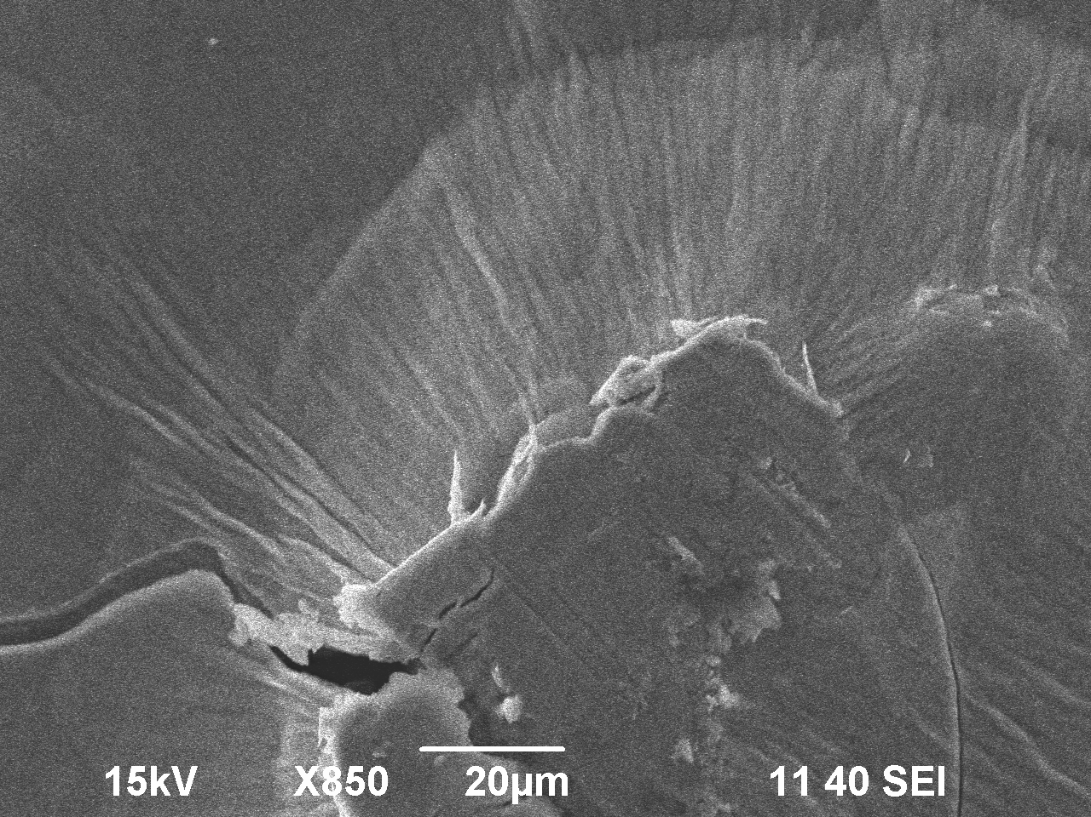
Figure 8 – Micrograph of vanadium-containing gel I

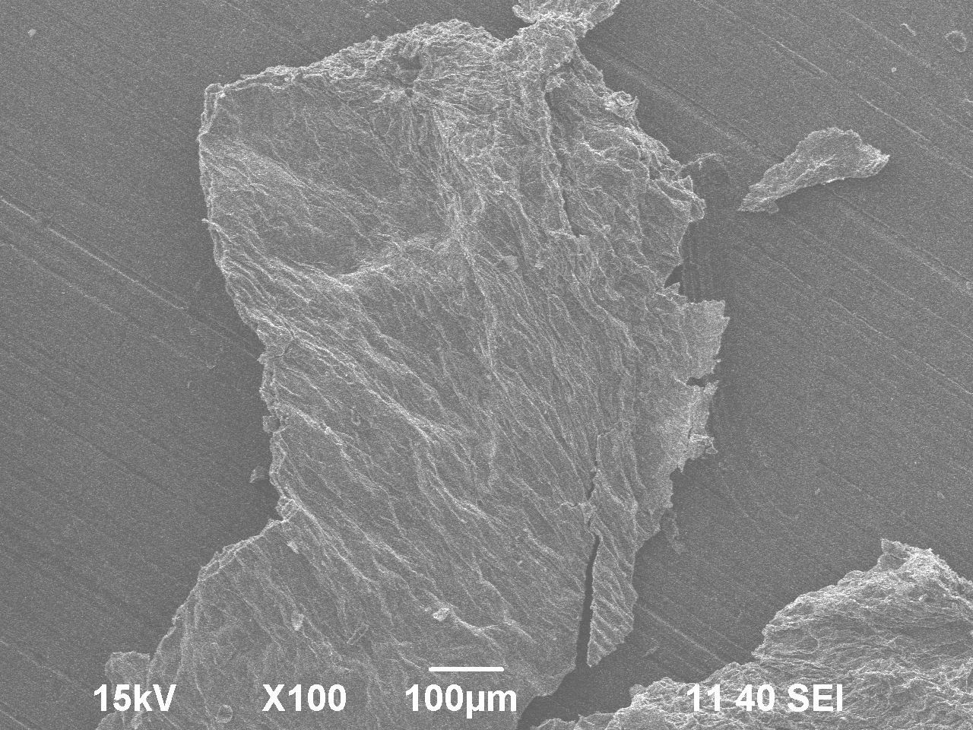
Figure 9 – Micrograph of vanadium-containing gel II

On the surface of the films formed by the randomly entangled threadlike particles are found partially ordered extra long, strongbut anisotropic particles close in size to the" ribbons " of the OK-si gel Yes, of vanadium. The formation of a layered structure of the vanadium complex opens up great opportunities for using the synthesized material in various nanotechnologies, obtaining composite materials, sorbents, catalysts, etc.
In the IR spectrum of gel I, an intense absorption band is observed with a maximum at a wavenumber of 510 cm⁻¹, which is characteristic of vibrations of the [V₂O₈]_{2-∞} radical. After subtracting the water spectrum, the valence vibrations of the V–O groups are detected at 747 cm⁻¹and [V₂O₈]_{2-∞} - at 503 cm⁻¹.In the IR spectrum of gel II (Figure10) absorption bands with maxima at wave numbers 1420, 994, 965, 452 cm⁻¹ and arms at 836, 765 cm⁻¹ are observed, confirming the presence of ammonium polyvanadate as the base of the material, in addition, ammonium hexavanadate – (NH₄)₂V₆O₁₆(absorption maxima at 1420, 994, 983, 723, 553, 407 sm⁻¹) [42-44].

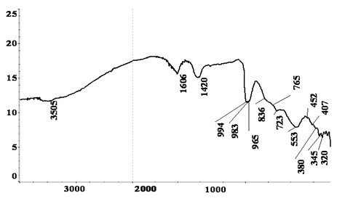
ν, см⁻¹
R, %

Figure 10 – IR spectrum of vanadium-containing gel II

The gel of the vanadium ammonia complex synthesized by the Sol-gel method was also studied by thermogravimetric analysis (Figure 11). The thermogram shows endothermic peaks at 82.3, 140, 277.2, 355.9 and 382.6 ° C. Up to 300 ° C, hygroscopic and partially included in the composition of crystal hydrates water and some oxide compounds are removed. The bond between the layers passes from the crystallized water to the OH groups.

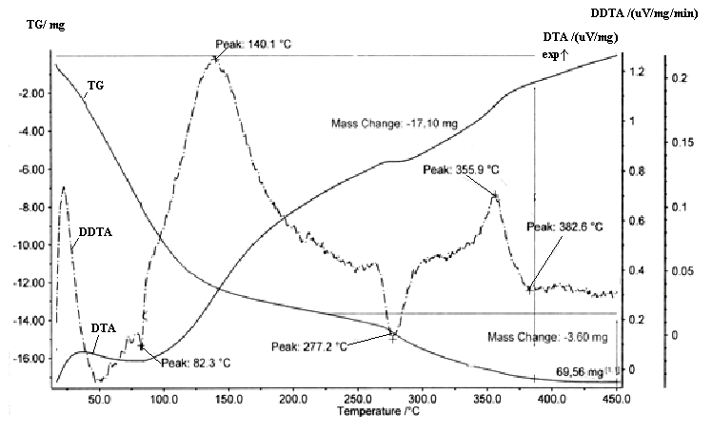
Figure 11 – Thermogram of vanadium-containing gel

A special feature of the hydroxo formation of transition metals is the delamination of the hydroxide structure when moisture is removed to form very thin layers of the material [45]. As a result, the anion bond is lost and the gel is transformed. Mixed-layer hydroxides are formed and wrapped in tubes. Interplanethe distances of the formed phases reach 1.6-0.8 nm.

3.2 Working out conditions for modifying sorbents with vanadium xerogel
The successful development of nanotechnologies that allow synthesizing compounds with a highly developed nanoscale structure opens up broad prospects for creating unique sorbents based on them by modifying natural ion-exchange materials. Effective natural sorbents that can serve as a matrix for modifying nanocompounds include zeolites, the General appearance of which is shown in figure 12. They are aluminosilicates with a frame structure in which there are cavities occupied by large ions and water molecules. Both of them are characterized by significant mobility, which allows for ion exchange and reversible dehydration [46]. The presence of metal cations gives zeolites sorption properties: cations that are part of natural ion-exchange materials can exchange for cations present in solutions of various origins.
A characteristic difference between natural zeolites and other types of sorbents is that they have a highly developed surface framework and the presence of pores of different diameters in it [47, 48]. The crystal structures of zeolites consist, as is known, of silicon-oxygen [SiO₂] and aluminum-oxygen [AlO₄] tetrahedra connected by vertices in openwork channels, in the cavities and channels of which cations and H2O molecules are located.
The General formula of zeolites can be represented as:
Me_{x/n}[Al_{х}Si_{y}О₂(x+y)]zH₂O, where Me is a metal; n is the degree of its oxidation; x is the number of aluminum atoms; y is the number of silicon atoms; z is the number of water molecules.
Sorption properties of zeolites depend on the nature and physicochemical properties (energy, hydration, charge, radius of ion) sorbed ions, concentration of ions in solution, pH, contact time of sorbent with ions, temperature. To obtain strong and water-resistant filter materials from natural zeolites, they are pre-subjected to heat treatment.
Natural zeolite is easily regenerated and can be reused in sorption processes as well as in other industrial areas [49, 50].
A distinctive feature of layered silicates with a zeolite structure is the ability to modify (intercalate) with various compounds, with the expansion of the inter-pack space and subsequent exfoliation into separate layers. This is due to the possibility of significantly improving a number of physical and mechanical properties in comparison with micro-and macro-composites containing the same amount of inorganic filler. This property was used by us in the development of nanocomposites by modifying zeolite matrices with nanoparticles. The process is influenced by the temperature, the duration of synthesis, the nature of the initial reagents, their concentration, the dispersed composition, the presence of organic templates, and a number of other parameters.
As the main sorbent (section 2), a mixture of aluminum-containing carriers (based on zeolite) with high metal content of grades KN-30, KN-4, and IK-17-M was used.
Vanadium xerogel was used as a zeolite modifying agent, which was synthesized according to the methods given in sections 1.3 and 3.1 of this report.
Before modifying the sorbent, samples of the carrier (zeolite) and the active phase were dried at a temperature of 150 °C. Then the zeolite mass was impregnated with a freshly obtained vanadium-containing gel, dried again, and at the last stage the resulting mixture was calcined in a muffle furnace at a temperature of ~ 500 °C for 2 hours. Table 5 shows the dynamics of cycles of impregnation of the initial zeolite with vanadium xerogel, on average, the weight gain of the matrix with vanadium xerogel was 8-10 %.
From the results of the studies shown in table 5, it follows that during the impregnation process, the saturation of the zeolite matrix with nanovanadium occurs already on the 13th cycle (within 10-15 minutes). An increase in the number of impregnations to 17 cycles does not lead to an increase in the degree of coating the matrix surface with ions and, especially, to the growth of agglomerates of the vanadium oxide phase. The degree of saturation of the sorbent with vanadium xerogel reaches 98-99 %.

Table 3 – Results of impregnation of the zeolite matrix with vanadium xerogel
Impregnation cycles | The total duration of soaking, min. | Weight of the zeolite matrix, g |  |  | Changing the mass of the matrix, %
Impregnation cycles | The total duration of soaking, min. | original | after impregnation | after pushing | Changing the mass of the matrix, %
1 | 2 | 3 | 4 | 5 | 6
1 | 15 | 62,35 | 66,71 | 64,67 | 3,72
2 | 30 | 64,67 | 67,13 | 64,99 | 4,24
3 | 45 | 64,99 | 67,78 | 65,34 | 4,80
4 | 60 | 65,34 | 67,93 | 65,72 | 5,41
5 | 70 | 65,72 | 68,18 | 66,30 | 6,33
6 | 80 | 66,30 | 68,61 | 66,65 | 6,90
7 | 90 | 66,65 | 69,03 | 66,97 | 7,41
8 | 105 | 66,97 | 69,38 | 67,30 | 7,93
9 | 120 | 67,30 | 69,82 | 67,60 | 8,42
Table 3 (continue)
1 | 2 | 3 | 4 | 5 | 6
10 | 135 | 67,60 | 70,21 | 67,89 | 8,88
11 | 150 | 67,89 | 70,49 | 68,06 | 9,16
12 | 165 | 68,06 | 70,78 | 68,24 | 9,45
13 | 180 | 68,24 | 70,93 | 68,40 | 9,70
14 | 195 | 68,40 | 71,05 | 68,41 | 9,72
15 | 210 | 68,41 | 71,12 | 68,42 | 9,73
16 | 225 | 68,42 | 71,16 | 68,42 | 9,74
17 | 240 | 68,42 | 71,17 | 68,43 | 9,74

Preliminary experiments have found that the impregnation of zeolite with ammonium Vanadate followed by calcination of the material results in the formation of crystalline vanadium pentoxide on the zeolite matrix. While the samples obtained by modifying zeolites with vanadium xerogel, during their subsequent calcination, contain surface polyvanadates, which should improve the sorption properties of the modified materials.
The formation of a nanoscale modified sorbent synthesized on the basis of natural zeolite and vanadium xerogel using a previously developed method was confirmed by the results of electron microscopy (Figure 13).
Thus, nanomaterials are obtained with a submicron or nanoscale grain, with unique compositions and properties. High thermal and chemical stability of zeolites with introduced nanoparticles allows us to consider them as the most promising sorbents and catalysts.

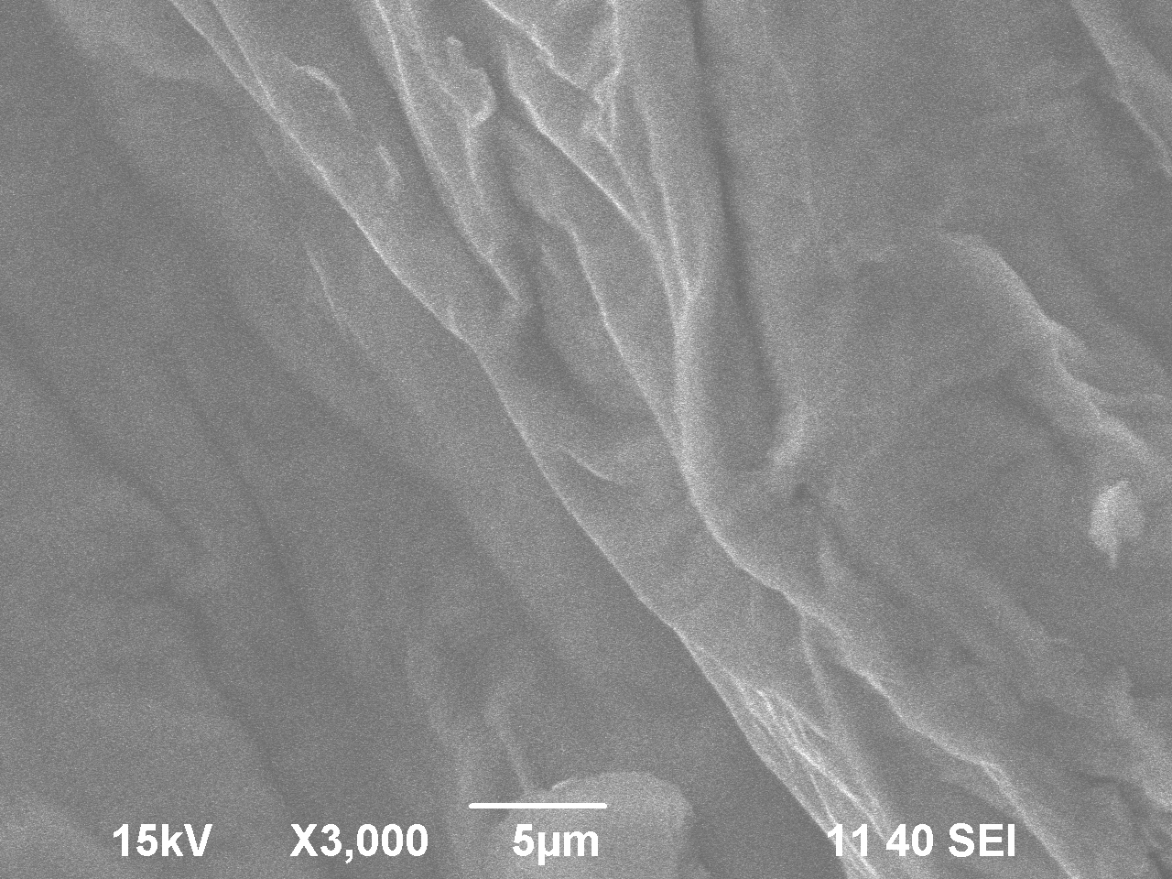
Figure 12 – Micrograph of the modified sorbent

Figure 13 – Influence of the total duration of impregnation on the change in the mass of the zeolite matrix

The trend line plotted on the resulting curve has the equation

y = -0,0002x² + 0,0855x + 1,3362. (14)

The equation shows that the process of saturation of the zeolite matrix corresponds to a parabola with the roots of the equation.
The extremum of the function is found by the first derivative of the obtained equation, taking into account the step in the diagram – 10 minutes:

y/ = -0,0004x + 0,0855. (15)

For y/= 0, we get x = 21.375, which corresponds to a duration of 213 minutes and 45 seconds. Therefore, to fully saturate the zeolite matrix with vanadium xerogel, it is sufficient to maintain the impregnation duration of 213-215 minutes.
The elemental composition of the samples was determined using an INCA ENERGY energy dispersive spectrometer installed on a Superprobe 733 electron probe microanalyzer. Table 6 shows the results of spectral analysis of the modified zeolite. As can be seen, in addition to the main components of oxygen, aluminum, silicon and vanadium, the modified sorbent contains calcium impurities. iron and sulfur.
The spatial structure of the aluminosilicate does not change also because the destruction of the octahedral structure does not occur, which is confirmed by the coincidence of interplanar distances in the initial zeolite and zeolite after activation by vanadium xerogel, despite the detection of the phase of vanadium oxides [19, 57].

Table 4 – Elemental composition of the modified sorbent, %
Spectrum | O | Al | Si | S | Ca | V | Fe
Spectrum 2 | 47,43 | 7,29 | 42,87 | 0,00 | 0,14 | 0,50 | 0,12
Spectrum 3 | 47,57 | 7,31 | 43,28 | 0,02 | 0,13 | 0,63 | 0,11
Spectrum 4 | 47,46 | 7,52 | 43,33 | 0,02 | 0,13 | 0,63 | 0,15
Average | 47,49 | 7,37 | 43,16 | 0,01 | 0,13 | 0,59 | 0,13

Based on the obtained data and literature data, it can be assumed that some vanadium xerogel nanoparticles in the form of V=O and V–O groups are fixed on the outer surface of the zeolite, while some migrate to the zeolite channels and are fixed on their surface [58], which should increase the sorption efficiency of the modified sorbent.
The introduction of vanadium xerogel into the zeolite structure leads to the grinding of material particles and the development of its overall surface, which is important for sorption and catalytic processes.

3.3 Testing the conditions for modification of sorbents on a test laboratory scale

Using the experimental planning method, a mathematical model of the process of modifying the sorbent with vanadium xerogel was constructed, processing the data of which made it possible to obtain optimal conditions for the synthesis of effective sorbents. Optimization of the regression equation allowed us to obtain controlled technological parameters of the process of modifying natural zeolite with vanadium xerogel, which allow us to synthesize effective sorbents that can be used for technological purposes, in particular for wastewater treatment of various industries. The resulting modified sorbents were tested in test tests at the pilot plant of the laboratory of the center "Water technologies and water-chemical modes" of the experimental base of enertek LLP for the treatment of industrial wastewater from metal and ammonium nitrogen impurities and showed positive results (Table I).
Taking into account the fact that the introduction of vanadium xerogel into compounds with a developed porous surface can improve the properties of the starting material, we investigated the possibility of using synthesized vanadium xerogel in the technology of catalyst production.
As you know, catalysts are substances that accelerate chemical processes, but do not experience transformations during the reaction. In catalytic processes, the activation energy of the reaction decreases as a result of the formation of intermediate complexes compared to processes that occur without a catalyst. Many molecules of the starting materials, whose energy was insufficient for active collisions in conventional reactions, become active in the presence of a catalyst. The activity of the catalyst is affected by promoters-substances that, when added in small quantities, increase the effectiveness of the catalyst.
One of the many ways to produce catalysts for organic synthesis is the activation of aluminosilicate materials. Zeolites and catalysts based on them are the most popular for this purpose, since their developed spatial structure allows creating conditions for the introduction of activators at the stage of formation of a new material.
Characteristic important properties of zeolite catalysts are the ability to change the interplane distance depending on the size of the cation (in our case, vanadium). Zeolites are characterized by polyfunctional catalytic properties, which is confirmed by the variety of catalytic processes occurring on them. To enhance the catalytic properties of zeolites, they are activated by metals-cu, Zn, Cd, Al, Ga, In, Sn, V, Cr, Mo, Mn, Co, Ni, Fe, Pt and their compounds. The content of the active component on the carrier, which is often metal oxides (V₂O₅, MoO₃, MgO, Al₂O₃, TiO_{2,} ZnO), is 4-8 mass%.
Research on catalysts using nanomaterials synthesized on the basis of 3d element oxides is attracting increasing attention [2, 11, 61], among which vanadium is of great interest due to its unique ability to complex with the production of spatial partially ordered highly developed layered nanoscale structures under certain conditions. As is known, vanadium solutions in the highest degree of oxidation are prone to spontaneous formation of hydrogels corresponding to the compositions V₂O₅∙1,8H₂O; V₂O₅∙1,6H₂O, as well as systems of colloidal and quasi-colloidal nature. When such colloidal solutions dry, xerogels are formed, from which water is completely or partially removed. Xerogels are an almost x-ray amorphous phase consisting of interwoven polymer chains with a partially ordered layered structure [19, 33, 62].
Nanotechnologies that allow embedding active spatially developed nanoparticles into the existing structure of catalysts are of particular importance in the production of activated catalysts with higher catalytic properties. One of the most promising technologies for the synthesis of active nanostructured particles is the Sol-gel method, which consists of a series of sequential operations: obtaining the initial solution of the active substance (precursor); formation of a colloidal solution (Sol) during hydrolysis and condensation reactions, and then a gel, which is a homogeneous substance with a spatial structure in the form of a mobile three-dimensional grid of metal hydroxide particles containing solvent molecules; aging, drying and heat treatment of the resulting gel-like substance to form a solid nanodisperse material with a particle size of up to 100-150 nanometers [63].
A method for activating zeolite catalysts by impregnating their matrix with vanadium xerogel nanoparticles is proposed. The method is simple to implement, and the resulting activated catalyst can be promising in the processes of catalysis of organic substances.
The preparation of catalysts is carried out by contact with the activator in the stationary and fluidized layers depending on the size of the carrier grains: for the preparation of catalysts in a fixed layer, carriers with a grain size of 3-8 mm are used, and for the preparation of catalysts in a fluidized bed-50-700 microns [2, 11, 61].
When using a porous substrate, the catalysts are prepared by spraying or impregnating the carrier with a suspension of water-soluble vanadium salt and solutions of salts of promoting elements, followed by drying and heat treatment at a temperature of about 500 ° C. The use of promoted vanadium oxide, vanadium-molybdenum and mixed catalysts obtained by impregnation of porous corundum with vanadium oxide melt at 750-780 ⁰C was studied. Vanadium oxides deposited on carriers containing various activating elements (Nb, P, Cs, Tl, Sb, etc.) have a high catalytic efficiency.). Carrying out the process in a stationary layer allows to reach the output of the activated catalyst up to 83,2-84,6 % [33, 35].
Activation of zeolite catalysts with nanoscale active particles will not only increase the active surface of the catalyst, but will also facilitate the transition of a significant proportion of the atoms forming its surface to a low-coordinated state, in which they exhibit maximum catalytic activity.
The possibility of forming nanomaterials with a developed porous surface can form the basis for creating catalysts with high reactivity while reducing the content of the catalytically active phase [59, 60].
The choice of vanadium xerogel as an activating material for industrial catalysts was justified by preliminary studies [27, 63], which showed its high reactivity and the possibility of conducting the nanomaterial synthesis process at low temperatures.
Vanadium xerogel was synthesized by the Sol-gel method by interacting vanadium pentoxide and ammonia, which was used to form a molecular structure-forming reagent (template) that promotes the formation of a developed nanomaterial structure, which served as an ammonia complex with a vanadium-oxygen framework [(VO₂)_{x}(OH)_{y}·nNH₃]^{y-x} [29, 64].
The main factors affecting the formation of vanadium xerogel are the amount of ammonia introduced into the system, the pH of the medium, the mixing rate, the duration of the process, and the metal concentration in the initial solution. In addition, depending on the specific conditions of nanomaterial synthesis, temperature can have a noticeable effect on the process. Section 1 shows the optimal conditions for the synthesis of vanadium xerogel: С_{V2O5} = 25 г/л, t = 25 ^{о}С, V_{р-р}:V_{NH3} = 50:2,рН∼ 4,τ = 30 мин.
X-ray phase studies revealed that the aging of the resulting xerogel in air at room temperature is accompanied by a change in its structure. The newly extracted gel is dominated by the amorphous component, which gradually decreases. As can be seen (Figure 14), as the duration of aging increases, the main maximum and the regions of 6-8° and another one in the region of 23-26°appear and become more intense on the diffractogram. This indicates the formation of a crystal structure corresponding to the vanadium oxide forms V₂O₅ и VO₂ [28, 65]. X-ray phase analysis of vanadium oxide gels was performed using an X'pert MPD PRO diffractometer.

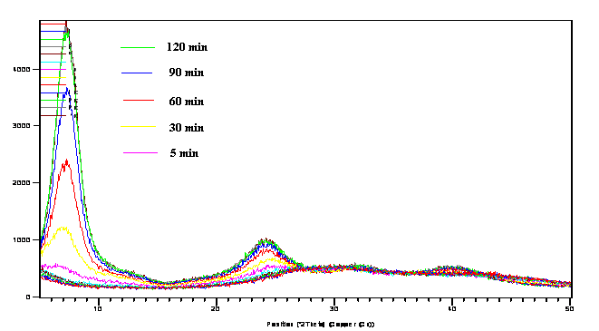
Figure 14 – Diffractograms of vanadium gel samples with different duration of its aging

During aging, the amorphous component of the gel passes into a layered hydroxide material.This structure of the xerogel should enhance the catalytic properties when activating the zeolite matrix, since it will increase the contact between the particles in its entire volume [66].
The properties of industrial grade catalysts modified with vanadium xerogel were compared with catalysts in which zeolite mixtures of grades IK-17, KN-4, and KN-30 produced by the Novosibirsk chemical concentrate plant were used as a carrier. The bidisperse structural form of these zeolites is represented in proton form with an inert carrier γ-Al₂O₃with partial substitution of hydrogen protons for potassium and sodium oxides. These materials were tested by us as the matrix of the sorbents. The carrier layers are a ten-membered ring, and the zeolite itself belongs to the MFI structural type. The pore system of MFI-type zeolites consists of elliptical straight channels with a diameter of 54-56 nm and sinusoidal channels with a diameter of 51-55 nm, which are located perpendicular to each other [67, 68].
The zeolites selected for research are currently used in oil cracking processes[69], but are not used in organic synthesis processes.
Activation of zeolite matrices with vanadium xerogel was performed by the "cold impregnation" method, which is described above in section 2 of the report.
It was found that in the first 15 minutes of impregnation, the zeolite matrix is 63-65% saturated with vanadium xerogel. The duration of impregnation of the zeolite matrix with vanadium xerogel for more than 180 min does not increase the degree of coating of the matrix surface with vanadium ions and is 85-88 %.
Zeolite materials impregnated with vanadium xerogel were first dried for 1 hour at t = 150 °C, then they were heat-treated for 2 hours in a muffle furnace "SNOL" at t = 450 °C in an air atmosphere.
Changes in the chemical composition of zeolite catalysts during their activation with vanadium xerogel were judged by their content of SiO₂, Al₂O₃, Na₂O, K₂O и V₂O₅.
The results of chemical analysis of the composition of the initial and activated zeolite catalysts obtained as a result of their impregnation with vanadium xerogel (impregnation duration 180 min, mass of xerogel according to V₂O₅ from the initial mass of the zeolite catalyst-2.0 wt.%) are shown in table 5.
Analysis of the data obtained shows that as a result of activation, sodium and potassium ions are almost completely removed from the structure of all zeolite catalysts, and nanoparticles of vanadium xerogel are embedded in the structure of zeolite catalysts, and the greatest saturation of vanadium xerogel (85-88 %) was observed when activating the IK-17 zeolite catalyst.
The SiО₂/Al₂О₃ ratio changed: for IR-17 it increased by 40 %, for KN-30 it decreased by 16 %, and for KN-4 it increased by 15 %. The decrease in the aluminum content in zeolite catalysts can be associated with a rearrangement in the octahedral positions, which leads to the transition of the trioctahedral structure to the dioctahedral one with isomorphic substitution of silicon and simultaneous stabilization of the nanoparticles of the oxyvanadium structure [19, 20].
The results of x-ray phase analysis (Figure 15) showed that the activated zeolite catalyst, when introducing vanadium nanoparticles into the aluminosilicate phase, retains the crystal structure unchanged, which is probably due to the isomorphic substitution of sodium and potassium oxides with vanadium oxide forms.

Table 5 – Results of chemical analysis of initial and vanadium xerogel-activated zeolite catalysts
Components | Composition of zeolite catalysts, mass. %
Components | source |  |  | activated
Components | IR-17 | KN-30 | KN-4 | IR-17 | KN-30 | KN-4
SiO₂ | 76,20 | 66,26 | 74,79 | 69,38 | 63,13 | 79,34
Al₂O₃ | 13,20 | 12,88 | 11,10 | 8,54 | 14,54 | 10,26
Na₂O | 1,80 | 3,16 | 4,61 | 0,30 | 0,10 | 0,05
K₂O | 4,27 | 5,52 | 4,80 | 0,21 | - | 0,42
V₂O₅ | - | - | - | 2,20 | 0,87 | 1,10
SiO₂/Al₂O₃ | 5,80 | 5,10 | 6,70 | 8,12 | 4,30 | 7,70

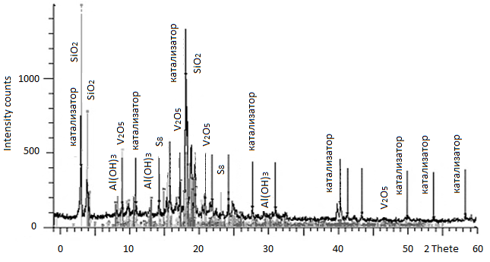
Figure 15 – Diffractogram of activated zeolite catalyst IK-17

The spatial structure of the aluminosilicate does not change also because the destruction of the octahedral structure does not occur, which is confirmed by the coincidence of interplanar distances in the initial zeolite and zeolite after activation by vanadium xerogel, despite the detection of the phase of vanadium oxides [19, 57].
Based on the data of chemical and x-ray phase analysis, it is assumed that a part of vanadium xerogel nanoparticles in the form of V=O and V-O groups is fixed on the outer surface of the zeolite, while a part migrates to the zeolite channels and is fixed on their surface, replacing hydrogen protons in the brensted and potassium and sodium cations in the Lewis acid centers, which may affect changes in the catalytic properties of the zeolite catalyst [21].
The catalytic activity of samples of zeolite catalysts activated by vanadium xerogel was studied at the D. V. Sokolsky Institute of fuel, catalysis and electrochemistry (Table I). The catalytic activity of the resulting zeolite catalyst activated with vanadium xerogel was determined on a laboratory flow-through unit when studying the conversion of methane to ethylene (oxidative condensation of methane) using synthesis gas.
It was found that the reaction of methane conversion to ethylene corresponds to a homogeneous-heterogeneous mechanism [23, 24]. At the first stage of catalysis, methane activation occurs on the surface of the catalyst, during which the hydrogen atom is separated from the methane molecule to form CH₃* radicals, which then undergo recombination and oxidation according to the scheme shown in figure 16[23].

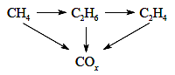
СО_{х}– a generic term for the carbon oxides CO and СО₂
Figure 16 – Scheme of the reaction of oxidative condensation of methane [23]

Catalysts based on vanadium oxides operate in a periodic oxidation-reduction mode and their catalytic activity is based on the processes of reduction of higher vanadium oxides during catalysis and their subsequent regeneration due to oxidation with oxygen contained in the gas phase [23, 24].
The efficiency of the catalyst is estimated by its ability to create active oxygen centers for breaking the C-H bond in the methane molecule, and it is considered that acceptable indicators for oxidative condensation of methane are: selectivity for ethylene-80 % with methane conversion of 25 % [23].
To study the catalytic properties during the conversion of methane to ethylene, the zeolite catalyst IR-17 was chosen, since its composition revealed the maximum content of vanadium pentoxide (Table 8). Factors that influence the process of oxidative condensation of methane include the reaction temperature, the composition of the synthesis gas, and the nature of the catalyst.
The conditions for methane oxidation in the synthesis gas were maintained as follows: temperature-300-750 °C, molar ratio of gases-CH₄:O₂ = 2:1, CH₄:H₂O = 1: 1, volume reaction rate (W) – 8000 h-1. During methane oxidation, ethylene was obtained, the yield of which depended on the temperature of catalysis and the conditions for activating the catalyst with the accepted composition of the synthesis gas (Table 6).

Table 6 – Dependence of ethylene yield during the catalytic oxidation of methane on the mass of vanadium xerogel embedded in the structure of the IK-17 zeolite catalyst
Mass of vanadium xerogel by V₂O₅ from the initial mass of the zeolite catalyst, mass. % | Ethylene yield at t,^{о}С
 | 300 | 500 | 700 | 750
1  3  5  7 | 12,6  21,8  35,6  37,3 | 48,6  59,4  68,8  70,1 | 77,3  90,5  97,0  97,2 | 79,2  90,8  97,2  97,5

The composition of gaseous products of oxidative condensation of methane was analyzed by gas chromatography. As a result of the conducted research, it was found that the maximum yield of ethylene when using a zeolite catalyst activated with vanadium xerogel is observed at the temperature of catalytic oxidation of methane 700-750 ⁰C and the mass of xerogel by V₂O₅ from the initial mass of the zeolite catalyst in the amount of 5 %. The catalytic properties of the synthesized catalyst remained unchanged during the entire test period (56 hours).
Comparison of the properties of the proposed catalyst based on vanadium xerogel with a conventional catalyst prepared by impregnating the carrier with ammonium metavanadate, which is widely used in the production of ethylene, showed that when using an activated catalyst at a temperature of 700 ⁰C, the ethylene yield reached 97 %, while in the presence of an industrial catalyst, the ethylene yield did not exceed ~ 82 %. Thus, the introduction of vanadium nanoparticles into the structure of the zeolite catalyst can significantly increase its catalytic activity in the methane oxidation reaction.

3.4 Testing of modified sorbents on a test laboratory scale

In this work, natural and synthetic zeolites of various compositions and ratios with the addition of vanadium nanopowder were used for wastewater treatment as a contact material on which ions of harmful impurities are sorbed (a certain mass of nanopowder was added to the zeolite powder by mixing).
We conducted test tests of sorption technology for wastewater treatment from heavy metals and ammonium nitrogen with industrial zeolites and their modified vanadium xerogel forms in the laboratory of the center "Water technologies and water-chemical regimes "of the experimental base of «ENERTEK» LLP (table E). In section 2 of the report, the results of wastewater treatment from lead ion impurity were presented. It was found that the degree of purification of industrial wastewater from lead by modified vanadium xerogel zeolites increases to 96,4 % compared to 85,7% when using industrial sorbents.
It was of interest to study the possibilities of wastewater treatment from non-ferrous metal impurities, which are most often present in them, as well as from nitrogen-containing impurities.
A mixture of Al-containingcarriers (based on zeolite) with high metal content of the following grades KN -30 (TU 2177-011), IK -17 – M (TU 2177-008) and their modified forms in the presence of vanadium nanopowder were used as sorbents.
The concentration of the active phase (vanadium xerogels) on the carrier varied from 0,1% to 20%. After drying the samples under the used temperature conditions, the system was tested in the process of wastewater treatment.
Waste water from pnkhz LLP was used for testing the treatment process. The process of zeolite wastewater treatment was started by loading a 508 ml sorption column with a sorbent (218 ml). Parameters of the sorption process are shown in table 9.

Table 7 – Parameters of the sorption process
Working parameters | Unit | Values
1 volume of waste water passed through the column | l | 12,0
2 mass of the sorbent in the column | kg | 0,15
3 the volume of the sorbent in the column | ml | 218
4 Volumetric water flow rate | h⁻¹ | 15,3
5 number of sorption columns | pcs | 1
6 sorption Temperature | °C | 25

The waste water of PPP LLP, which is characterized by a high content of ammonium nitrogen and heavy metals, had the following composition, mg/l: ammonium nitrogen-182.40; nitrates-16.95; nitrites – 4.94; copper – < 0.05; lead – < 0.02; manganese – < 0.24; chromium – < 0.0024; strontium – < 0.50.
The results of purification of waste water from harmful impurities are shown in tables 10, 11.before sorption, 290 ml of water (1 volume of water per 1 volume of sorbent) was poured Into the column to soak and activate the pores of the sorbent. The tests were carried out in the mode of running water discharge with a volume feed rate of 15.3 h-1 through columns with grids on which the sorbent was placed. The volume of wastewater was 200 liters. Next, waste water was supplied from the pressure tank with a flow rate of 3334 ml/h. The mother liquor was fed into a container for collecting the purified solution.

Table 8 – Results of purification of waste water from ammonium nitrogen and metals
Name of types of pollution | Waste water composition, mg / l
Name of types of pollution | source | after the sorption treatment
Name of types of pollution | source | on Al-containing media  (10 l volume) | on a modified vanadium xerogel sorbent under the conditions of
Name of types of pollution | source | on Al-containing media  (10 l volume) | static  (volume 10 l) | dynamic  (volume 20 l )
Ammonia nitrogen | 182,4 | 142, 1 | 2,82 | 4,24
Nitrates | 16,95 | 12,7 | 2,3 | 2,04
Nitrites | 4,94 | 3,2 | 1,6 | 0,94
Copper | <0,05 | 0,04 | 0,02 | 0,01
Lead | <0,02 | 0,016 | 0,011 | н/обн
Manganese | 0,24 | 0,18 | 0,12 | 0,12
Chrome | <0,002 | not detected | not detected | not detected
Strontium | <0,5 | not detected | not detected | not detected

Table 9 – Results of wastewater treatment of "PPP" LLP based on the analysis of the accredited laboratory of "Kazekologiya" LLP.
Poker | Unit. | Values
Poker | Unit. | Sample WTU-II Systems
Poker | Unit. | Normative documents for test methods | Water before cleaning | Water after cleaning
Mineral oils | mg/DM3 | BRD14.1:2:4.128-98 | 0,30 | 0,15
Total hardness | mg-EQ/L | S RK2015-2010 | 4,5 | 0,05
Total alkalinity | mg-EQ/L | S RK2015-2010 | 0,4 | 0,20
Solids | mg/l | S RK2015-2010 | 912,5 | 31,0
Suspended solids | mg/l | S RK2015-2010 | 41 | 0
COD, biochemical oxygen demand permanganate | mango2/L | S RK 1322-2005 | 16,0 | 0,56
Calcium | mg/l | S RKISO 8288-2005 | 44,1 | 1,0
Magnesium | mg/l | S RKISO8288-2005 | 28,0 | н.о.
Sulfates | mg/l | S RK2016-2010 | 303,8 | н.о.
Chlorides | mg/l | S RK2016-2010 | 137,0 | 4,4
Iron | mg/l | КZ.0700.00934-2014 | 0,54 | 0,05
Mineral oils | mg/l | S RKИСО 8288-2005 | 146,2 | 3,3
NH₄ | mg/l | КZ.0700.00935-2014 | 182,4 | 4,0
рН | - | GOST 26449.2-85 п.2 | 6,81 | 5,9

In order to optimize the sorption process under dynamic and static conditions, the transmission rate for solutions with different concentrations of impurities was changed from 1.0 to 2.0 ml / sec. as a result, the flow rate was set to 1.5 ml/sec.

Conclusions for section 3
– testing of the technology for the synthesis of xerogel from vanadium pentoxide when using ammonia as a template was carried out at The Institute of polymer materials and technologies. The initial vanadium pentoxide was prepared on the basis of technical ammonium metavanadate obtained from the black shales of the Greater Karatau.
– methods of physical and chemical analysis confirmed the previously formulated conclusions about the formation of a porous layered structure of a vanadium-containing complex during the interaction of vanadium pentoxide and ammonia. When water is removed from the formed complex, stratified structural fibers are formed, chaotically entangled with filamentous particles;
– a mathematical model of the synthesis process of vanadium xerogel is constructed. Optimization of the regression equation allowed us to obtain controlled technological parameters of the process that allow synthesizing nanomaterials with specified size limits of nanoparticles;
– economic evaluation of the technology of production of xerogel from products of processing of carbon shale showed its effectiveness;
– high sorption properties of natural aluminosilicates, low cost and large reserves in nature served as the basis for their choice as a carrier modified by vanadium xerogel. A mixture of aluminum-containing carriers (based on zeolite) with high metal content, grades KN-30, IK-17-M was used; a method for modifying the carrier with a nanoscale vanadium complex was developed;
– a mathematical model of the process of modifying natural and industrial sorbents was constructed, which allowed determining its optimal conditions;
– sorption treatment of waste water from "PPP" LLP and "Zhersu Power" LLP from metal impurities and ammonium nitrogen is considered. It is established that when using modified ionite KN-30 as a sorbent, a significant increase in the sorption capacity of ionite is observed, in particular for ammonium nitrogen-from 22.09 % (initial KN-30) to 98.45 % (modified KN-30);
– the possibility of using synthesized vanadium xerogel in the production technology of catalysts was investigated; zeolite mixtures used earlier for the production of sorbents were used as a carrier; the method of modifying the zeolite matrix with vanadium xerogel was developed; comparison of the properties of a catalyst modified with vanadium xerogel with a catalyst based on ammonium metavanadate, which is widely used in the production of ethylene, showed that the yield of ethylene on the synthesized catalyst reaches 97 %, while on an industrial catalyst based on NH₄VO₃, the yield of ethylene does not exceed ~ 82 %. Thus, the synthesized catalyst based on vanadium xerogel showed high catalytic characteristics.

CONCLUSION

Summary of research results.
According to the results of the research we can draw the following conclusions:
– analysis of the literature data showed that nanostructures based on oxides of the 3d elements, in particular xerogel vanadium, are promising from the point of view of modification of natural and industrial sorbents and catalysts, increasing the efficiency of their actions by changing their structure; as raw materials of xerogel vanadium pentoxide use it, and as of template – ammonia involved in the formation of the ammonium vanadium complex;
– high-purity vanadium pentoxide is required for the production of vanadium xerogel. We have proposed the production of vanadium pentoxide from technical ammonium metavanadate technology for processing Large Karatau shale, whose reserves amount to hundreds of millions of tons, by recrystallization of NH₄VO₃ and after drying its thermal dissociation;
– conditions for the synthesis of vanadium xerogel by Sol-gel method by interaction of V₂O₅ and 30% NH₃ were established. The results of thermodynamic analysis of vanadium-containing systems have shown that the formation of complex vanadium ions and compounds in the V-N-Н₂Оsystem occurs spontaneously with the formation of [(VO₂)_{х}(ОН⁻)_{у}∙nNH₃]^{у-х} complexes, which ensure its high solubility. By selecting the conditions for the formation of vanadium-containing ammonia particles and the occurrence of coagulation contact between the particles, it is possible to cause structuring of the material; it was found that the main factors affecting the formation of metal xerogel are the pH of the medium, the duration of the process, and the metal concentration in the initial solution;
– the formation of a quasi-one-dimensional layered structure of a xerogel with ribbon fibers 100-600 nm long and up to 25 nm wide with an interlayer distance of 150-200 nm was established by physical and chemical analysis methods;
– vanadium xerogel is recommended as a modifying additive in sorbents and catalysts; mixtures of aluminum-containing carriers, in particular kN-30 and IK-17-M grades, whose properties have been studied by physical and chemical analysis, are selected as matrix materials;
– conditions for modification of sorbents and catalysts with vanadium xerogel have been worked out. Thus, modification of natural zeolite by "cold impregnation" allows to achieve the degree of absorption of vanadium xerogel by zeolite at least 97 %;
– the developed technology of xerogel synthesis was tested at the Institute of polymer materials and technologies. The initial vanadium pentoxide was prepared on the basis of technical ammonium metavanadate obtained from the black shales of the Greater Karatau;
– methods of physical and chemical analysis confirmed the previously formulated conclusions about the formation of a porous layered structure of a nanoscale complex in the process of interaction of vanadium pentoxide and ammonia, which, when water is removed, forms stratified structural fibers chaotically entangled with nitric particles;
– a mathematical model of the synthesis process of vanadium xerogel is constructed. Optimization of the regression equation allowed us to obtain controlled technological parameters of the process that allow synthesizing nanomaterials with specified size limits of nanoparticles;
– an economic assessment of the technology for the production of vanadium xerogel from carbon shale processing products has shown its effectiveness;
– high sorption properties of natural aluminosilicates, low cost and large reserves in nature served as the basis for their choice as a carrier modified with vanadium xerogel;
– a mathematical model of the process of modification of natural and industrial sorbents was constructed, which allowed determining its optimal conditions. The results of calculations were verified on a test laboratory scale;
– sorption treatment of waste water from "PPP" LLP and "Zhersu Power" LLP from metal impurities and ammonium nitrogen is considered. When using modified ionite KN-30 as a sorbent, a significant increase in the sorption capacity of ionite is observed, in particular for ammonium nitrogen-from 22.09 % (initial KN-30) to 98.45 % (modified KN-30), and the concentration of lead ions in one sorption-desorption cycle occurs 130 times;
– comparison of the properties of a catalyst modified with vanadium xerogel with a catalyst based on ammonium metavanadate showed that the yield of ethylene on the synthesized catalyst reaches 97 %, while on an industrial catalyst based on NH₄VO₃, the yield of ethylene does not exceed ~ 82 %.
Assessment of the completeness of the solution of tasks. The tasks set for all stages of the project were completed in full: the analysis of literature data on the creation of vanadium xerogel, its application, and thermodynamic justification of the possibility of xerogel synthesis. The conditions for the synthesis of vanadium xerogel with mathematical processing of the results were studied; its structure was established by physical and chemical studies.
Natural sorbent and industrial catalyst, carriers and substrates were selected; conditions for modification of selected materials with vanadium xerogel were worked out; properties, composition and structure of modified sorbents and catalysts were studied. The obtained results of methods for the synthesis of vanadium xerogel and modification by the vanadium complex of natural and industrial aluminosilicates were tested on a test laboratory scale;
Organizational and logistical support for research. Research was carried out at the Department of "Metallurgical processes, heat engineering and technology of special materials" and in the Laboratory of engineering profile of Kaznit named after K. I. Satpayev. Team of performers – 1 Dr. tech. 1 Cand. Techn. PhD, 2 doctors, 2 masters, 1 Junior researcher with experience in the field of rare and scattered element technology, practical skills in working with sorption systems and catalytic processes,
The project has the necessary research infrastructure: production areas (3 laboratories with a total area of more than 130 m²), research equipment (modern muffle and tube furnaces, technical and analytical scales, centrifuges, derivatograph, photoelectrocolorimeter, spectrophotometer, pH meter and ionomers, automatic titration unit, distiller, necessary office equipment with application programs), access to sources of scientific and technical information. Used equipment of laboratory of engineering profile KazNTU. Specialists of specialized laboratories of the research Institute of the Republic of Kazakhstan were involved in performing physical and chemical analyses. Patent and license security of works was carried out by the relevant service of the organization at all stages of the project.
Assessment of the scientific and technical level of research performed in comparison with the best achievements in this field. The scientific and technical level of the project's research is high, meets the achievements of modern science and technology, and differs from well-known research in that the results obtained allow synthesizing vanadium xerogel without high-temperature heating of the system. Sorbents and catalysts modified with synthesized vanadium xerogel have higher technological performance compared to known analogues.
Assessment of technical and economic efficiency of implementation. The development of a method for obtaining vanadium xerogel and its modification of industrial carriers will allow obtaining new materials with high sorption and catalytic properties. Economic assessment allowed us to state that the profitability of production can reach 36 %, the payback period of the proposed technology is 5 years.
Thus, vanadium xerogel can be successfully used as a modifier of sorbents and catalysts, improving their performance. The materials will not have a high cost, since the raw material base of vanadium xerogel is its pentoxide, which is extracted from the product of processing of black shales of the Republic of Kazakhstan, whose reserves are significant. In addition, aluminosilicates used as a carrier of catalysts and sorbents are natural materials that are rich in the subsoil of Kazakhstan.

REFERENCES

1 Eliseev A. A., Lukashin A.V. Functional nanomaterials / ed. by Yu. D. Tretyakov. – M.: FIZMATLIT, 2010. – 456 p. (Russian)
2 Peryshkov D. V., Grigorieva A.V., Semenenko D. A., etc. Influence of the prehistory of production on the ordering of structural elements of vanadium pentoxide xerogels //DAN, Chemistry. - 2006. – Vol. 406, No. 2. – P. 203-208. (Russian)
3 Zakharov G. S., Volkov V. L., Ivanovskaya V. V., Ivanovsky A. L. Nanotubes and related nanostructures of d-metal oxides: synthesis and modeling // Advances in chemistry, 2005, Vol. 74, No. 7, pp. 651-685. (Russian)
4 Ceccato R. Growth of nanotubes in sol-gel-derived V2O5 powders and films prepared under acidic conditions // J. Mat. Res. – 2009. – Vol. 24, – № 2. – P. 475-481.
5 Xing Chen, Xiaoming Sun, Yadong Li. Self-Assembling vanadium oxide nanotubes by organic molecular templates // Inorg. Chem. – 2002. – №. 47. – P. 4524–4530.
6 Grigorieva A.V., Tarasov A. B. Multi - wall nanotubes based on titanium and vanadium oxides as promising materials for hydrogen energy //IV international Symposium "hydrogen energy of the future and platinum group metals in the CIS countries". – Moscow, 2007. – 6 p. (Russian)
7 Semenenko D. A. Aggregates of ribbon crystals of hydrated vanadium(V) oxide. Optical microscopy in polarized light. Nanotechnologies. ABC for all. – 2008. – No. 9. – P. 365. (Russian)
8 Balakhonov S. V., Churagulov B. R. Hydrothermal synthesis and investigation of physical and chemical properties of ion sieves on the example of MnO2 with todorokite structure. and whiskers based on V2O5 //Zh. Alternative energy and ecology. - 2008. – No. 1. – Pp. 63-68. (Russian)
9 Kharlamov A. I., Kirillova N. V., Kharlamova A. A. and others. Features of the effect of water – based mechanoactivated filtrate products on the state and properties of dispersed vanadium pentoxide //DOP. NAS of Ukraine. – 2003. - No. 4. – P. 95-103. (Russian)
10 Kharlamov A. I., Kirillova N. V., Kharlamova A. A. A new method for producing carbon nanotubes // Theory. and an expert. chemistry. - 2002. – No. 6. – Pp. 347-352 (Russian)
11 Grigorieva A.V., Volkov V. V., Gudilin E. A. et al., Study of the formation of vanadium oxide nanotubulenes during hydrothermal treatment //XII national conference on crystal growth. – M., 2006. – 404 p. (Russian)
12 Nakamoto K. Infrared spectra of inorganic and coordination molecules – Moscow, 1966, 408 p (Russian)
13 Donald W. Breck, Zeolitemolekularsieves. Structure, chemistry, and use, A. Wiley-Interscience publication John Wiley & Sons, New York – London – Sydney – Toronto, 1974.
14 Gallaham H. Phtalic anhydride from petroleum breaks coal tar tradition, Chem. Met. Eng. – 1946. – Vol.53, №8. – С.116-138.
15 Debi N. K. Neftekhimicheskaya tekhnologiya - L.: Gostoptehizdat, 1963. – 123 p. (Russian)
16 Russian patent 2396113. Application of a multilayer catalyst for the production of phthalic anhydride /Guckel K., Dialer H., Estenfelder M.: publ. 12.03.2006, bul. no. 12. – 2 p. (Russian)
17 O. A. baykonurova, Marketov M. S., Usol'tseva G. A. and others. Synthesis of vanadium xerogel by Sol-gel method / "Prospects for the Development of Modern Science" Materials of the IV International Scientific – Practical Conference, March 20-22, 2019. – Gwangju , Korea. – Pp. 107-111. (Russian)
18 Danilovich D. A., Nikolaev Yu. a., Dorofeev A. G. and others. Technology for treatment of return flows of sewage sludge treatment facilities under anoxic conditions //New research in the fields of water supply, sanitation, hydraulics and water resources protection: Fourth academic readings: collection of materials – St. Petersburg: PGUPS, 2009 – pp. 21-23. (Russian)
19 Liu G., Zhao Z.J., Wu T.F., Zeng L., Gong J.L. Nature of the active sites of VOx/Al₂O₃ catalysts for propane dehydrogenation. ACS Catal. 2016. Vol. 6. Р. 5207-5214.
20 Stocker M. Gas phase catalysis by zeolites. Microporous and Mesoporous Materials. 2005. V. 82. Р. 257-292.
21 Lopatkin S. V., Stepanov V. G., Ione K. G. influence of hydrogen on the transformation of a mixture of C6-C8 hydrocarbons in the presence of Fe-containing zeolite HZSM - 5. Petrochemistry. 2002. Vol. 42. No. 3. Pp. 222-227. (Russian)
22 Moisa R. M., Vasilina G. K., Zhubanov K. A. On the formation of acid centers of aromatization catalysts based on modified natural zeolites. Bulletin of KazNU, chemical series. 2009. No. 3(55). Pp. 163-168. (Russian)
23 Anshits A. G., Voskresenskaya E. N. oxidative condensation of methane – a new process of natural gas processing. Sorovsky educational journal,1999, no. 9, pp. 38-43. (Russian)
24 Pinaeva L.G., Noskov A.S., Parmon V.N. Prospects for the direct catalytic conversion of methane into useful chemical products. Catal. Ind. 2017. № 9. Р.283-298.
25 Aegerter M.A. Electrochromism in Materials Prepared by the Sol-Gel Process // Journal of Sol-Gel Science and Technology. – 1997. – Vol. 8. – P. 689-696.
26 Bishop A. Doped transition metal oxides: networks of local distortions correlated by elastic fields // Journal of Physics and Chemistry of Solids. – 2004. – Vol. 65, № 8-9. – P. 1449-1454.
27 Markametova M.S., Mishra B., Baikonurova A.O., Nurzhanova S.B., Ermolaev Y.V. Investigation of the Formation of Layered Nanostructure of Vanadium Xerogel//Journal of Nanomaterials, USA, 2014. – Р. 1-6.
28 Livage J. Vanadium Pentoxide Gels // Chem. Mater. – 1991. – Vol. 3, № 4. – P. 578-593.
29 Wen Chen, Junfeng Peng, Liqiang Mai et al. Synthesis of vanadium oxide nanotubes from V₂O₅ sols //Material Lett. – 2004. – Vol. 58. – P. 2275-2278.
30 Petkov V., Trikalitis P.N., Bozin E.S., Billinge S.J.L., Vogt T., Kanatzidis M.G. Structure of V₂O₅·nH₂O Xerogel Solved by the Atomic Pair Distribution Function Technique // J. Am. Chem. Soc. – 2002. – Vol. 124, №. 34. – P. 10157-10162.
31 Sadrolhosseini A. R., Naseri M., Kamari H. M. Surface plasmon resonance sensor for detecting of arsenic in aqueous solution using polypyrrole-chitosan-cobalt ferrite nanoparticles composite layer // Optics Communications. 2017. –Vol. 383. – P. 132-137.
32D. Wang, J. Zhou, G. Liu, The microstructure and photoluminescence of Cu-doped ZnO nano-crystal thin films prepared by sol–gel method, Journal of Alloys and Compounds, – 487, – 2009, – Р. 545–549.
33 Akpan U.G., Hameed B.H. The advancements in sol-gel method of doped-TiO₂ photocatalysts, Applied Catalysis A: General, – 375, – 2010, – Р. 1-11.
34 Liu Z., Jin Z., Li W., J. Qiu, Preparation of ZnO porous thin films by sol-gel method using PEG template, Materials Letters, 59, 2005, – Р. 3620-3625.
35Aegerter M.A., Electrochromism in Materials Prepared by the Sol-Gel Process, Journal of Sol-Gel Science and Technology,– 8, – 1997, – Р.689-696.
36 Ceccato R. Growth of nanotubes in sol-gel-derived V₂O₅ powders and films prepared under acidic conditions, J. Mat. Res. 24, 2, 2009, 475-481.
37Trinchi A., Li Y.X., Wlodarski W., Kaciulis S., Pandolfi L., Russo S.P., Duplessis J. S. Investigation of sol-gel prepared Ga-Zn oxide thin films for oxygen gas sensing, Sensors and Actuators A, – 108, – 2003,–Р. 263-270.
38. Sahal M, Hartiti B., Ridah A., Mollar M., Mari B. Structural, electrical and optical properties of ZnO thin films deposited by sol-gel method, Journal Microelectronics, – 39, – 2008, Р. 1425-1428.
39 Baikonurova A.O., Ussoltseva G.A., MarkametovaМ.S., Nurzhanova S.B., Akpanbayev R.S. The equilibrium state of compounds of vanadium, capable of spontaneous structure formation, Reports of the national academy of sciences of the republic of Kazakhstan, – 4, – 320, –2018, – Р. 5-11.
40 Kulova T. L., Skundin A.m., Balakhonov S. V., Semenenko D. A., Pomerantseva E. A., Veresov A. G., Gudilin E. A., Churagulov B. R., Tretyakov Yu. D. Investigation of the electrochemical introduction of lithium into the structure of whiskers based on barium-vanadium bronze BaV8O21−δ // Protection of metals. – 2008. – T. 44. – P. 45-48. (Russian)
41 Kopylova E. A., Ni L. P. Infrared spectrophotometry in studies of alumina production processes. – Alma-ATA: Nauka, 1987. – 264 p. (Russian)
42 poray-Koshits M. A., Atovmyan L. O. crystal Chemistry and stoichiometry of vanadium coordination compounds. – Moscow: Nauka, 1974. − 232 p. (Russian)
43 Povarennykh A. S. crystal Chemistry and vibrational spectra of minerals. − Kiev: Naukova Dumka, 1980. -355 p. (Russian)
44 Kazakova E. L., Lugovskaya L. A., Parchment A. L., Stefanovich G. B. Electronic and ionic processes in hydrated vanadium pentoxide // Condensed media and interphase boundaries. 2003. Vol. 5. No. 2. Pp. 187-192. (Russian)
45 Akhmedov K. S., Aripov E. A., Koldaev A. A. and others. Natural sorbents of zeolite structure. – Tashkent, 1974. – 104 p. (Russian)
46 Milanova L. V. wastewater treatment of non-ferrous metallurgy enterprises. – M.: metallurgy, 1971. (Russian)
47 Senderov E. E., Khitarov N. I. Zeolites, their synthesis and conditions of formation in nature. – M.: Chemistry, 1970. (Russian)
48 Klyachkov V. A., Apeltsin I. E. Purification of natural waters. – M.: Stroyizdat, 1971. – 579 p. (Russian)
49 Rubinstein Yu. b., Molodchik G. L. Flotation wastewater treatment. A series of "environmental Protection". – M.: Central research Institute for nonferrous metal of economy and information, 1980. Vol.3. P. 25-27. (Russian)
50 Pletnev R.N. Hydrated oxides of elements of groups IV and V. – Moscow : Nauka, 1986. – 160 p. (Russian)
51 Chandrappa G.T., Steunou N., Cassaignon S. et al. Hydrothermal synthesis of vanadium oxide nanotubes from V2O5 gels // Cat. Today. – 2003. – № 78. P. 85-89.
52 Ermolaev O. Yu. Mathematical statistics for psychologists. – M.: flint, – 2006. P. 26. (Russian)
53 Sidorenko E. V. methods of mathematical processing. – St. Petersburg: Rech, 2007. (Russian)
54 Joaquim K., Plevel. Nanoscience. Invisible revolution, Moscow: Kolibri, 2009. (Russian)
55 Muhr H.J., Krumeich F., Schonholzer U. P. et al. Vanadium Oxide Nanotubes – A New Flexible Vanadate Nanophase // Adv. mater. – 2000. –Vol. 12. P. 231–236.
56 Grazhdanova Ya. V. Development of sorption technology for extracting vanadium and uranium from Karatau quartzites: dis. ... kand.tehn. Sciences. – Almaty: RSE "NC cpmrm RK", 2003. P. 45-87 (Russian)
57 Stoker M. gas-phase catalysis by zeolites. Microporous and Mesoporous materials. 2005. Vol. 82. P. 257-292. (Russian)
58 Lopatkin S. V., Stepanov V. G., ion K. G. influence of hydrogen on the conversion of a mixture of C6–C8 carbohydrates in the presence of Fe-bearing zeolite HZSM-5. Petrochemistry. 2002. Vol. 42, No. 3. P. 222-227.
59 Yergozhin E. E. Organomineral sorbents and multifunctional systems based on natural aluminosilicate and coal-mineral raw materials / Yergozhin E. E., Akimbayeva a.m. Almaty: Print-S LLP. 2007. 359 p. (Russian)
60 Lipin V. A. ways to improve the technology of processing aluminum silicate raw materials for alumina and related products / Lipin V. A., Baimakov A. Yu., Kazakov V. G. Non-ferrous metals. 2014. no. 4. C5. Pp. 62-68. (Russian)
61 Berezina O. Ya., Vasiliev V. A., Vinichenko D. A. synthesis of vanadium dioxide films by modified Sol-gel method. Inorganic material. 2011. Vol. 47, No. 3. Pp. 330-335. (Russian)
62 Mariano R.M. Preparation, structure, and properties of montmorillonite/cellulose II/natural rubber nanocomposites. Journal of Applied Polymer Science. 2011. V. 120. N1. P. 458-465.
63 baikonurova A. O., Markametova M. S., Usoltseva G. A., Konyratbekova S. S. influence of vanadium xerogel synthesis conditions on its structure. Natural and technical Sciences. No. 8. 2019. Pp. 167-173. (Russian)
64 Kharlamov A. I., Ushkalov L. N., Kirillova N. V., Fomenko V. V. A new method for obtaining a new type of vanadium oxide nanotubes. Additional information From the national Academy of Sciences of Ukraine. 2007. No. 4. S. 149-156. (Russian)
65 Pan M., Liu J., Zhong H., Wang S., Li Z., Chen X., Lu W. Raman study of phase transition in V0₂ thin films. Journal of Crystal Growth. 2004. V. 268. Р. 178-183.
66 Fischer R.X., Baur W.H. Microporous and other Framework Materials with Zeolite-Type Structures. Springer. Berlin. 2006.V. 14D.
67 Baerlocher C., Mc Cusker L.B. Atlas of zeolite framework types. Elsevier. 2007. Р. 398.
68 Lei X., Jockusch S, Francesca Ottaviani M., Turro N.J. In situ EPR investigation of the addition of persistent benzyl radicals to acrylates on ZSM-5 zeolites. Direct spectroscopic detection of the initial steps in a supramolecular photopolymerization. Photochem. Photobiol. Sci. 2003. V. 2. Р. 1095-1100.
69 Mikhailov M.N., Kustov L.M., Kazansky V.B. The state and reactivity of Pt6 particles in ZSM-5 zeolite. CatalysisLetters. 2008. V. 120. chapter 1. Р. 113-115.

APPENDIX A

Calendar plan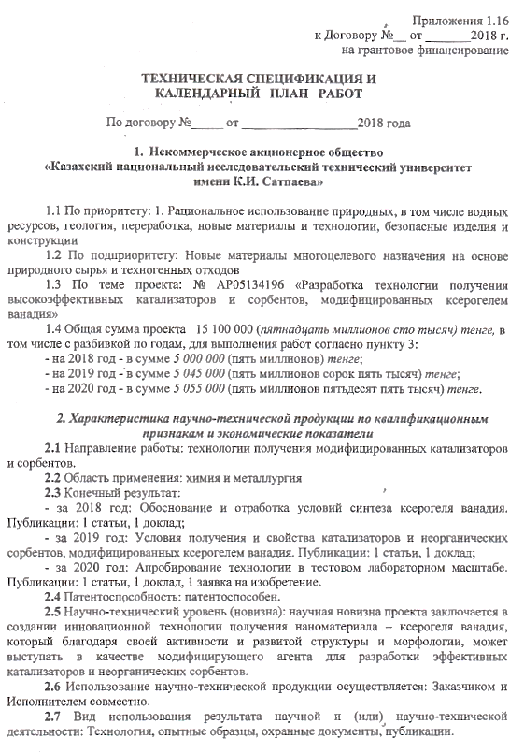

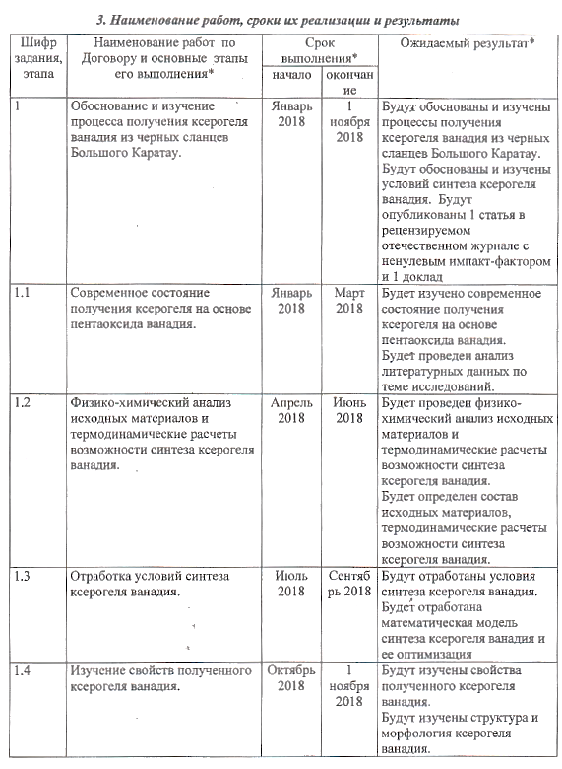

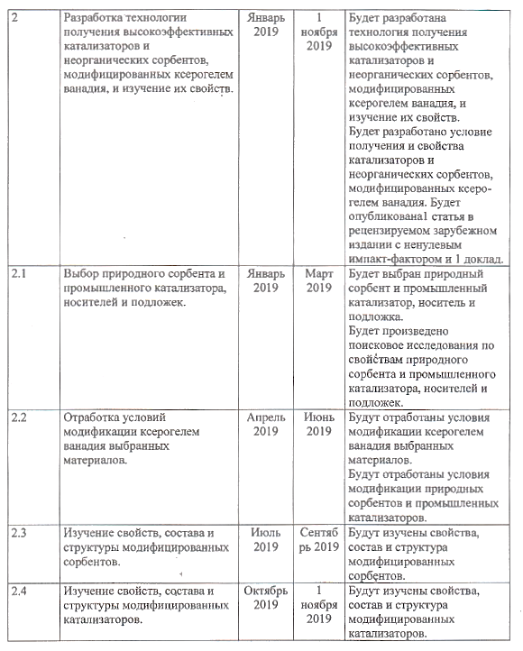

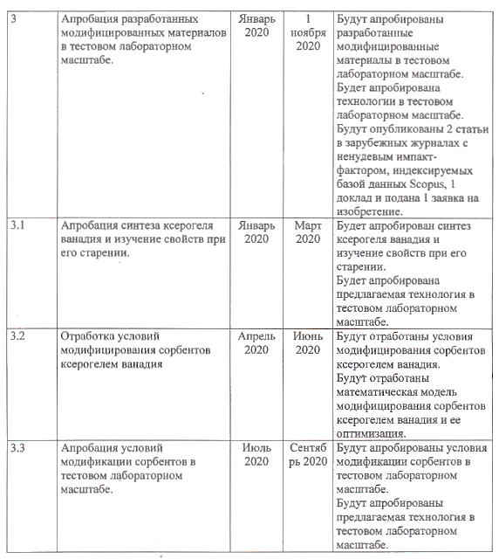

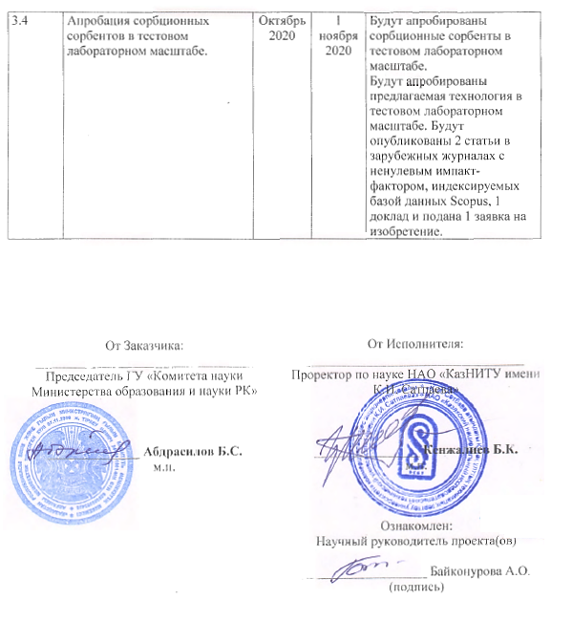

Appendices 1.16
to the agreement № of 2018
for grant funding

TECHNICAL SPECIFICATION AND
JOB SCHEDULE

Under contract no____ of 2018_________________

- Non-commercial joint stock company
“Kazakh national research technical University
named after K. I. Satpayev”

  - By priority: 1. rational use of natural resources, including water resources, Geology, processing, new materials and technologies, safe products and structures
  - By sub-priority: New multi-purpose materials based on natural raw materials and man-made waste
  - Project topic: no. AR05134196 "Development of technology for producing high-Performance catalysts and sorbents modified with vanadium xerogel»
  - The Total amount of the project is 15,100,000 (fifteen million one hundred thousand) tenge, including by year, for the performance of works in accordance with paragraph 3:
- for 2018 - in the amount of 5,000,000 (five million) tenge;
- for 2019 - in the amount of 5,045,000 (five million forty-five thousand) tenge;
- for 2020 - in the amount of 5,055,000 (five million fifty-five thousand) tenge.

2. Characteristics of scientific and technical products according to the educational characteristics and economic indicators
2.1 Direction of work: technologies for producing modified catalysts and sorbents.
2.2 Field of application: chemistry and metallurgy
2.3 Final result:

-for 2018: Justification and development of conditions for the synthesis of vanadium xerogel. Publications: 1 article, 1 report;
- for 2019: Conditions for obtaining and properties of catalysts and inorganic sorbents modified with vanadium xerogel. Publications: 1 article, 1 report;
- for 2020: testing the technology on a test laboratory scale. Publications: 1 article. 1 report, 1 application for an invention.

2.4 Patentability: patentable.
2.5 Scientific and technical level (novelty): the scientific novelty of the project is to create an innovative technology for producing nanomaterial - vanadium xerogl, which, due to its activity and developed structure and morphology, can act as a modifying agent for the development of affective catalysts and inorganic sorbents.
2.6 The use of scientific and technical products is carried out by: the Customer and the Contractor together.
2.7 Type of use of the result of scientific and (or) scientific and technical activities: Technology, prototypes, security documents of the publication.

- The name of the work, terms of their implementation and results

Cipher of task, stage | Name of Work under the contract and the main stages of its implementation* | Due date* |  | Expected result*
Cipher of task, stage |  | Beginning | The end | Expected result*
1 | Justification and study of the process of obtaining vanadium xerogel from black shales of the Greater Karatau. | January 2018 | 1 November  2018 | The processes of obtaining vanadium xerogel from the black shales of the Greater Karatau will be substantiated and studied.  Conditions for the synthesis of vanadium xerogel will be justified and studied. 1 article in a peer-reviewed Russian journal with a non-zero impact factor and 1 report will be published
1.1 | Current state of production of xerogel based on vanadium pentoxide. | January 2018 | Мarch  2018 | The current state of production of xerogel based on vanadium pentoxide will be studied.  Literature data on the research topic will be analyzed.
1.2 | Physical and chemical analysis of raw materials and thermodynamic calculations of the possibility of synthesis of vanadium xerogel | April 2018 | June  2018 | Physical and chemical analysis of raw materials and thermodynamic calculations of the possibility of synthesis of vanadium xerogel will be performed.  The composition of the initial materials and thermodynamic calculations of the possibility of synthesis of vanadium xerogel will be determined.
1.3 | Working out the conditions for the synthesis of vanadium xerogel | July  2018 | September 2018 | Conditions for the synthesis of vanadium xerogel will be worked out. A mathematical model for the synthesis of vanadium xerogel and its optimization will be developed
1.4 | Study of the properties of the obtained vanadium xerogel. | October  2018 | 1November  2018 | The properties of the resulting vanadium xerogel will be studied.  The structure and morphology of vanadium xerogel will be studied.
2 | Development of technology for producing high-performance catalysts and inorganic sorbents modified with vanadium xerogel and study of their properties. | January  2019 | 1  November  2019 | A technology for producing high-performance catalysts and inorganic sorbents modified with vanadium xerogel and studying their properties will be developed.  The conditions for obtaining and properties of catalysts and inorganic sorbents modified with vanadium xerogel will be developed.  1 article will be published in a peer-reviewed foreign publication with a non-zero impact factor and 1 report.
2.1 | Selection of natural sorbent and industrial catalyst, carriers and substrates. | January  2019 | Маrch  2019 | Natural sorbent and industrial catalyst, carrier and substrate will be selected.  Exploratory research will be carried out on the properties of natural sorbent and industrial catalyst, carriers and substrates.
2.2 | Working out the conditions for modification of selected materials with vanadium xerogel | Аpril  2019 | June  2019 | Conditions for modification of selected materials with vanadium xerogel were worked out.  Conditions for modification of natural sorbents and industrial catalysts will be worked out.
2.3 | Study of properties, composition and structure of modified sorbents. | July  2019 | September 2019 | The properties, composition and structure of modified sorbents will be studied.
2.4 | Study of properties, composition, and structure of modified catalysts. | Оctober  2019 | 1  November  2019 | The properties, composition and structure of modified catalysts will be studied.
3 | Testing of new modified materials on a test laboratory scale. | January  2020 | 1  November  2020 | The developed modified materials will be tested on a test laboratory scale.  The technology will be tested on a test laboratory scale.  2 articles will be published in foreign journals with a non - zero impact factor indexed by the Scopus database, 1 report and 1 application for an invention will be submitted
3.1 | Testing of the synthesis of xerogel of vanadium and a study of the properties during its ageing. | January  2020 | Маrch  2020 | The synthesis of vanadium xerogel and the study of its aging properties will be tested.  The proposed technology will be tested on a test laboratory scale.
3.2 | Working out conditions  Modification of sorbents with vanadium xerogel | Аpril  2020 | June  2020 | Conditions for modifying sorbents with vanadium xerogel will be worked out.  A mathematical model for modifying sorbents with vanadium xerogel and its optimization will be developed.
3.3 | Approbation of conditions for modification of sorbents on a test laboratory scale. | July  2020 | September 2020 | Conditions for modification of sorbents will be tested in the test laboratory mass.  The proposed technology will be tested on a test laboratory scale.
3.4 | Testing of sorption sorbents on a test laboratory scale | Оctober 2020 | 1 November  2020 | Sorption sorbents will be tested on a test laboratory scale.  The proposed technology will be tested on a test laboratory scale.  2 articles will be published in foreign journals with a non - zero impact factor indexed by the Scopus database, 1 report and 1 application for an invention will be submitted.

APPENDIX B

List of published works for 2018-2020

Output data of works |  | Link
2018 year
1 | Baikonurova A.O., Usolzheva G.A., Markomedova M.S. Carbonaceous-silicon shales of the Great Karatau field - a potential source of production of vanadium xerogel (Углеродисто-кремнистые сланцы месторождения Большого Каратау – потенциальный источник получения ксерогеля ванадия) // XVIII International scientific conference «The priorities of the world science: experiments and scientific debate» in the section «Engineering»,25-26 July 2018, North Charleston, SC, USA, р. 20-23 | http://otkritieinfo.ru/d/669057/d/sbornik_prioritety_18.pdf
2 | Baikonurova A.O., Ussoltseva G.A., Markametova M.S., Nurzhanova S.B., Akpanbayev R.S. The Equilibrium State of Compounds of Vanadium, Capable of Spontaneous Structure (Синтез ксерогеля ванадия золь-гель методом) // Reports NAS of RK, № 4, November 320 (2018), P. 5-11. | https:///nauka-nanrk.kz/assets/assets/magazine%202018%204/Reports 04_2018.pdf
2019 year
3 | Baikonurova A.O., Markomedova M.S., Usolzheva G.A., Altmicbaeva A.J., Orazimbetova S.J. Synthesis of vanadium ash gel xerogel by the method (Изучение условий синтеза ксерогеля ванадия) / ""Prospectsforthe Development of Modern Science" –MaterialsoftheIVInternationalScientific-PracticalConference, March 20 - 22, 2019. – Gwangju, Korea. – P. 107-111. | https:///drive.google.com/file/d/1gM-BwmbNYkwUF9zBeTEnlsiExhjUc7C/view
4 | Zhekenbay A.K., Altmyshbaeva A.J., Baikonurova A.O., Markomedova M.S. Study of conditions for synthesis of vanadium xerogel (Изучение условий синтеза ксерогеля ванадия) // Innovative technologies - key to successful solution of fundamental and applied problems in the ore and oil and gas sectors of the economy of RK. - 2019. - T.1. - S. 733-736. | https:///official.satbayev.university/ru/y-materialsatpaevskikh-chteniy
5 | Baikonurova A.O., Markomedova M.S., Usolzhev G.A., Konyratbekova S.S. Influence of the conditions of synthesis of the xenogol vanadium on its structure (Влияние условий синтеза ксерогеля ванадия на его структуру) // Natural and technological sciences. - 8. - 2019. - P. 167-173. | https://yadi.sk/i/fKP76duoHJ0vA
6 | Baikonurova A.O., Usolzheva G.A., Nurzhinova S.S., Markomedov M.S. Study of the composition, structure and sorption properties of aluminosilicates modified by vanadium xerogel (Изучение состава, структуры и сорбционных свойств алюмосиликатов, модифицированных ксерогелем ванадия) // «The role of innovation in the transformation of modern society», Zhezkazgan, 2019, P.50-54 | https:///www.zhezu.kz/index.php/ru/20190909-23-1155-05
2020 year
7 | Usolzheva G.A, Baikonurova A.O., Markomedova M.S., Altmyshbayeva A.J., Nurzhnova S.B. Properties of catalysts activated by vanadiya xerogel (Свойства катализаторов, активированных ксерогелем ванадия) / Materials of the XXIV International Scientific and Practical Conference «Innovative development of modern science» IRS-24. 10 June 2020, Russia, Mr. Anapa, S.129-135 | https://innovaova-science.ru/wp-content/upls/2020/06/sbornik-nauchnyh-trudov-10.06.202irs0--24.pdf
8 | Usolzheva G.A., Baikonurova A.O., Markomedova M.S., Nurzhinova S.B. Physico-chemical properties of zeolitic catalysts activated by the xenogol vanadium (Физико-химические свойства цеолитных катализаторов, активированных ксерогелем ванадия) // Non-ferrous metals. Rare metals, semiconductors. - 2020. - 7.- C. 33-40. ISSN 0372-2929 | https:///www.rudmet.ru/catalog/journals/4/1935/
9 | Baikonurova A.O., Usolzheva G.A., Nurzhinova S.S., Markomedov M.S. Method for purifying waste water of metal ions (Способ очистки сточных вод от ионов металлов) / Application for invention at the stage of submission for consideration | Application for the grant of a patent No. 2020/0434.1  (Appendix I)
10 | Baikonurova A.О., Markametova M.S., Nurzhanova S.B., Ussoltseva G.A., Altmyshbayeva A.Z. Development of the conditions modification of zeolites by synthesized Xerogel of vanadium |// | Attached is a certificate of acceptance for publication

APPENDIX C

Copies of published scientific papers

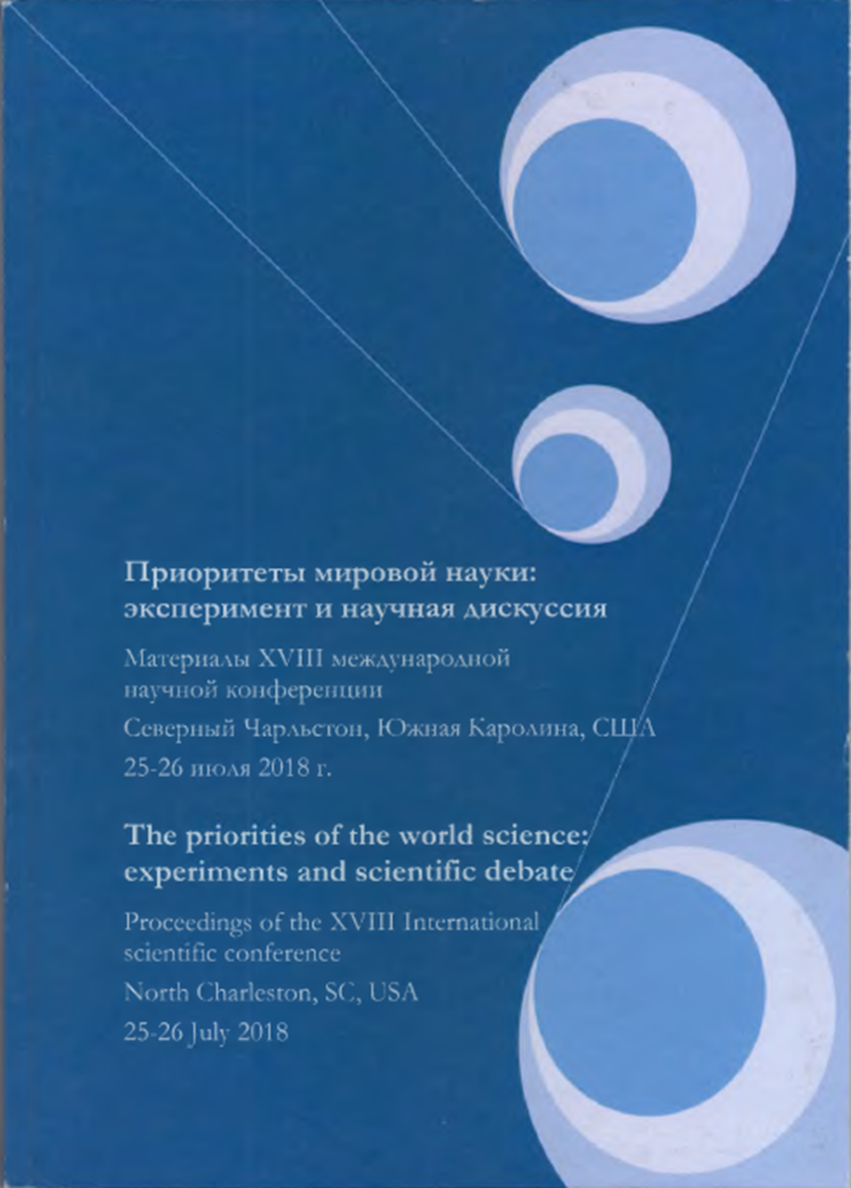

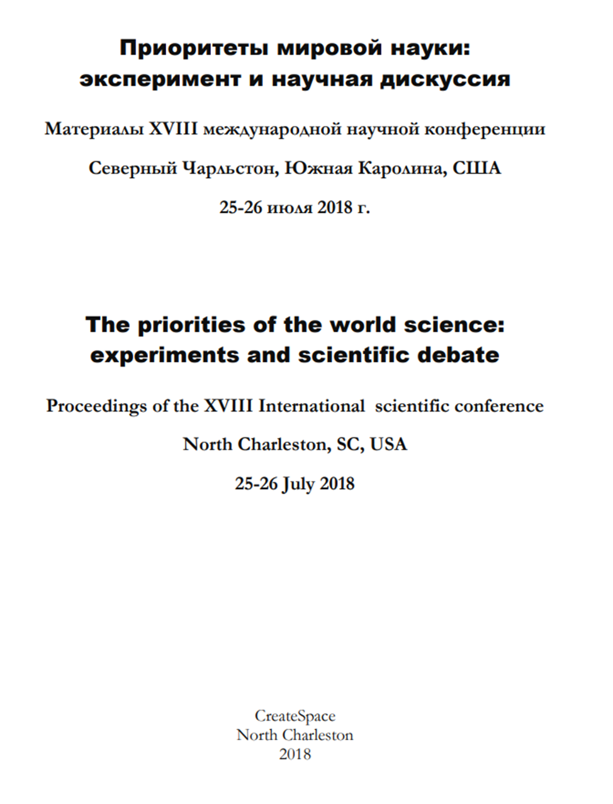

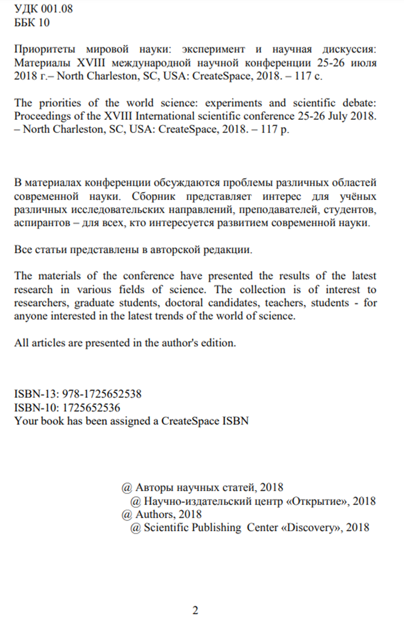

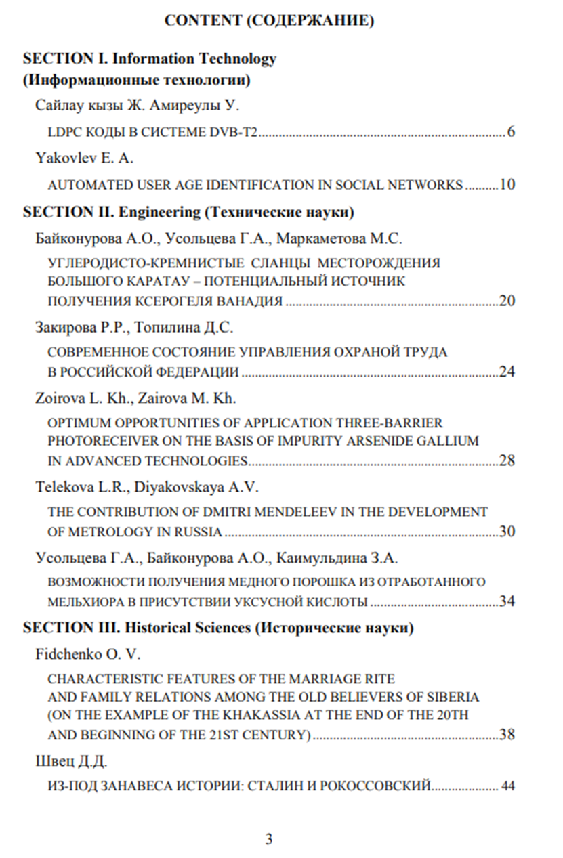

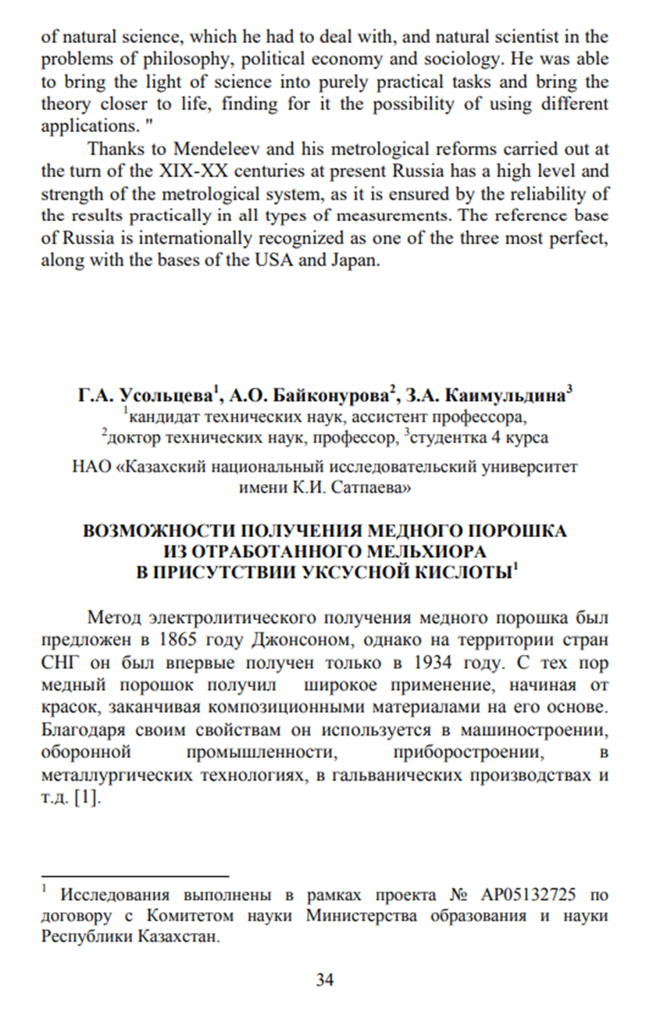

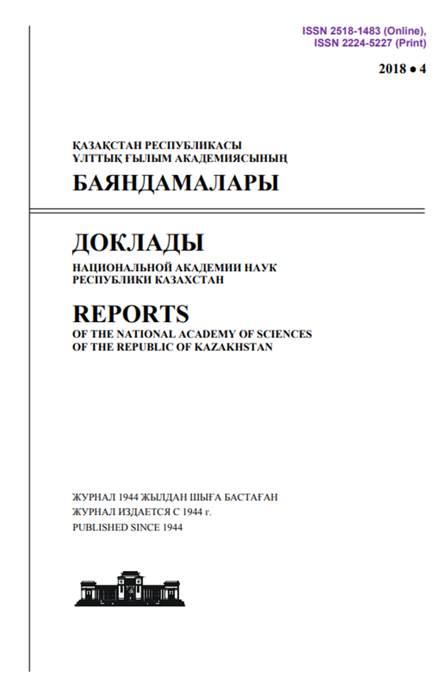

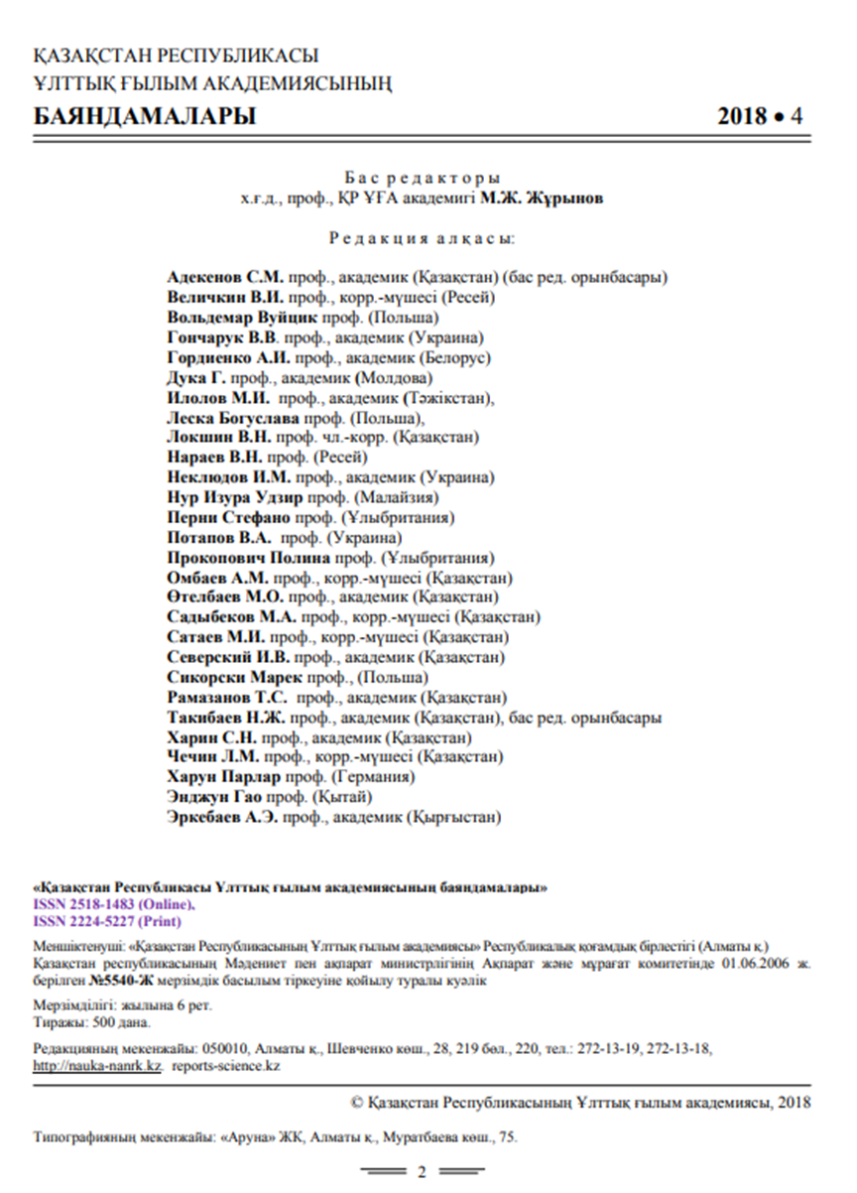

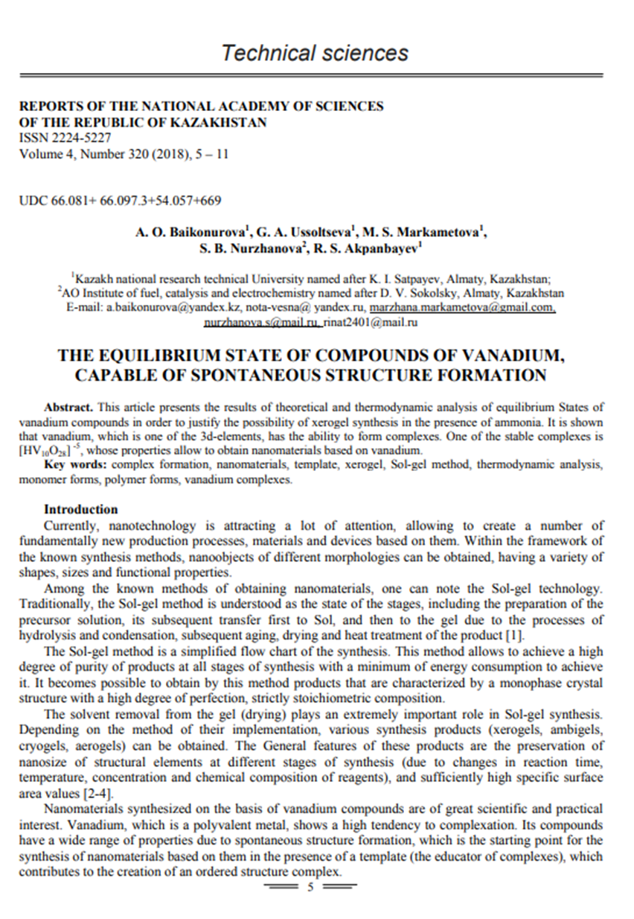

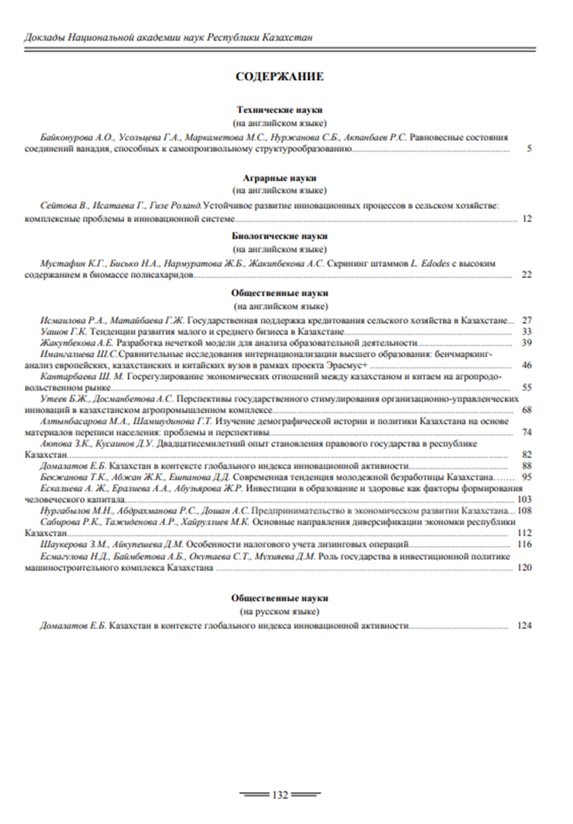



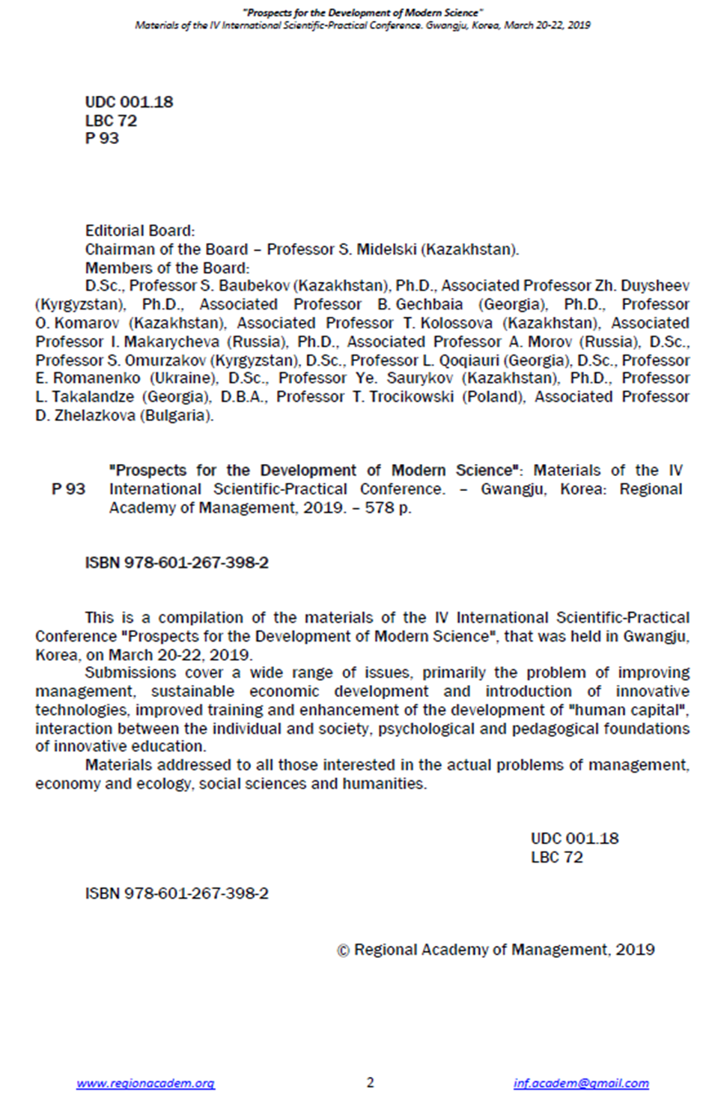
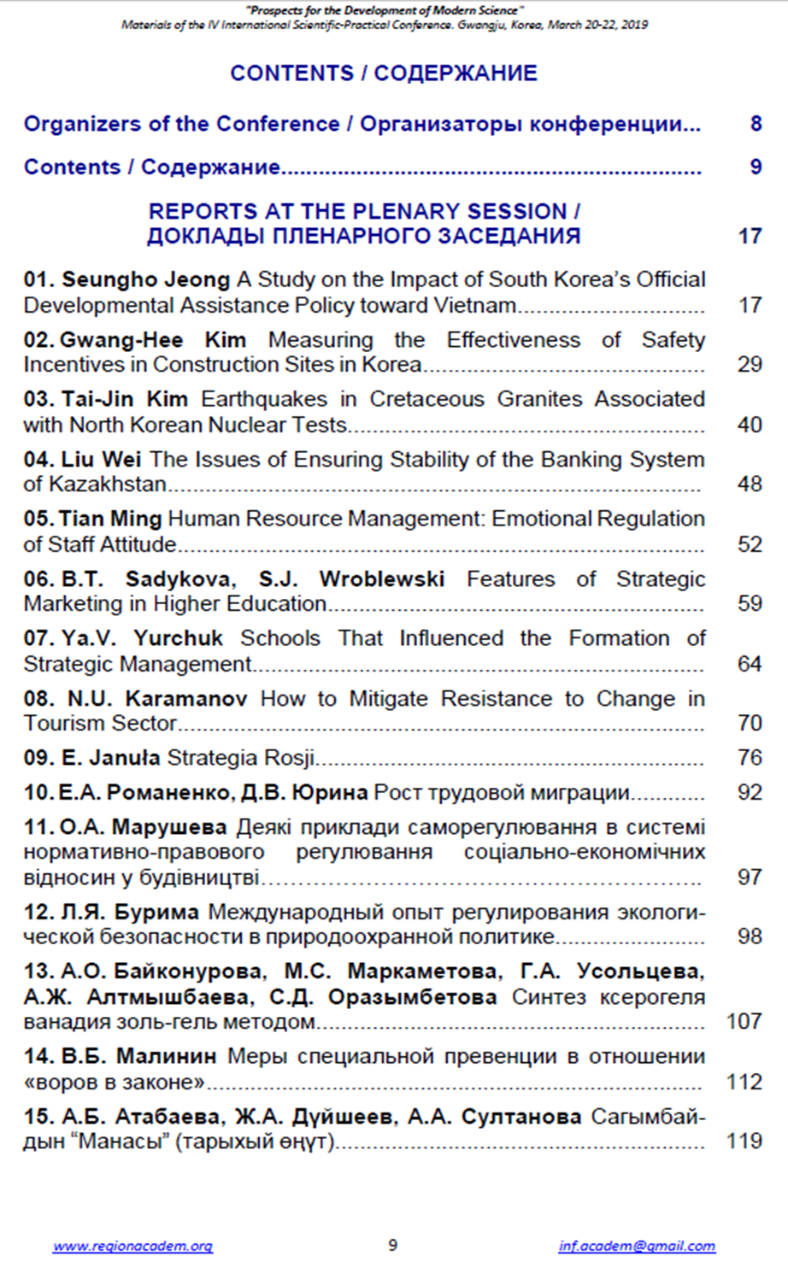

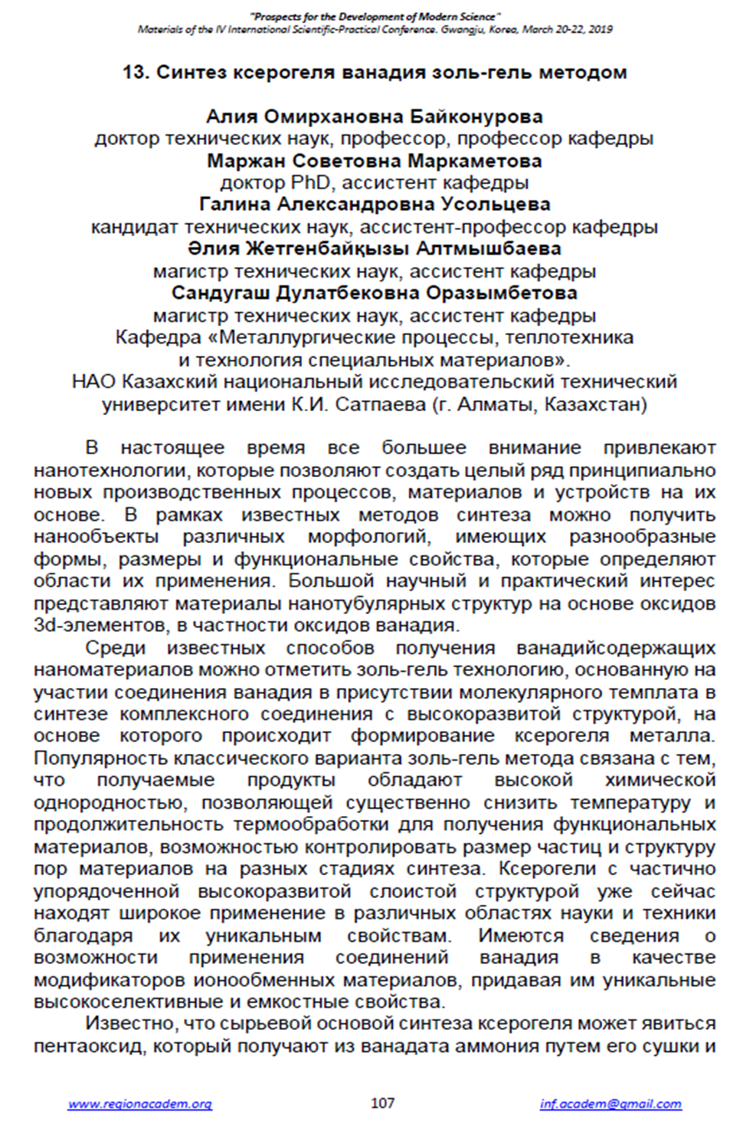

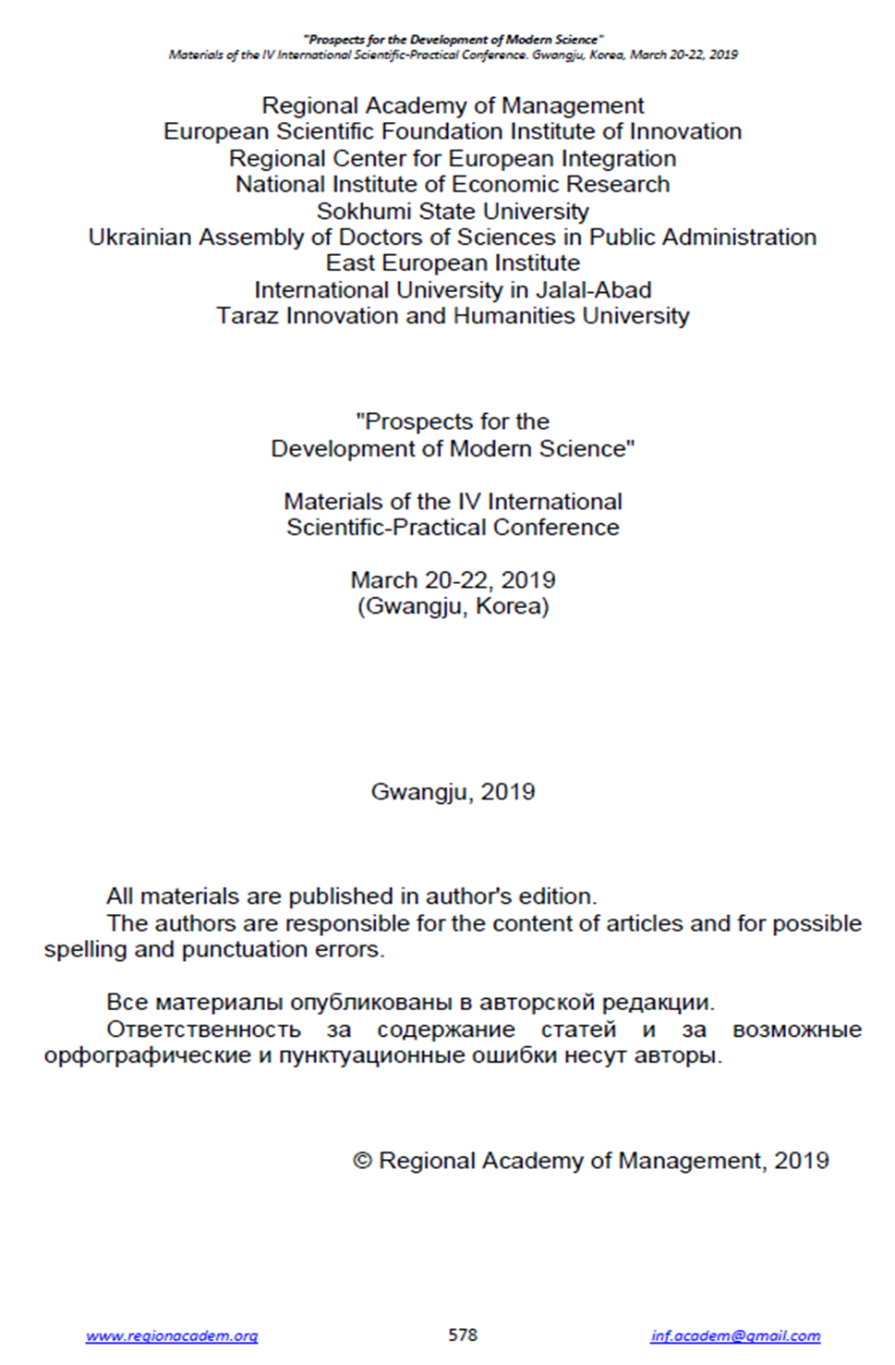

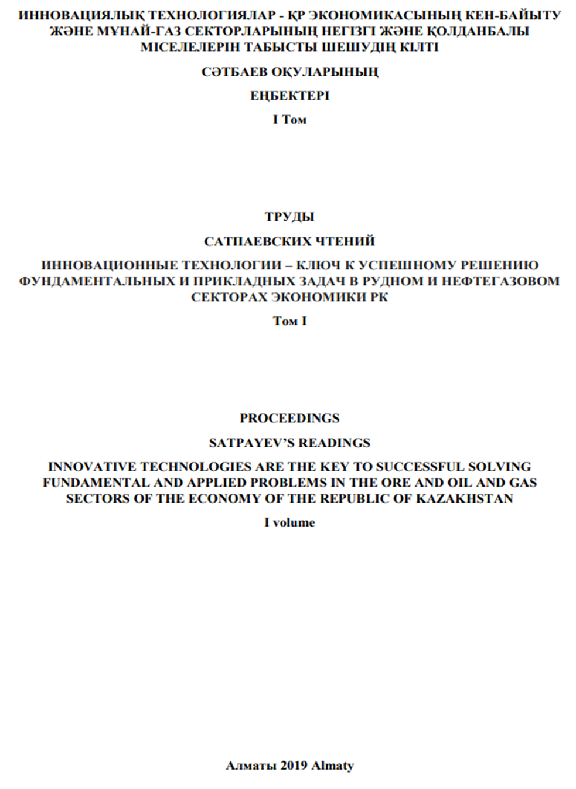

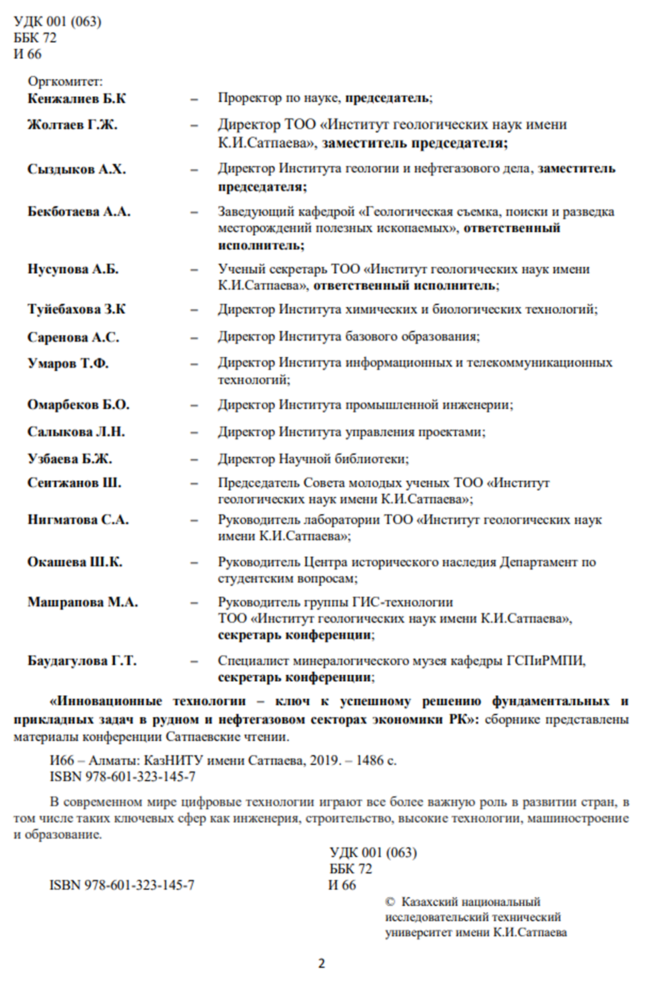

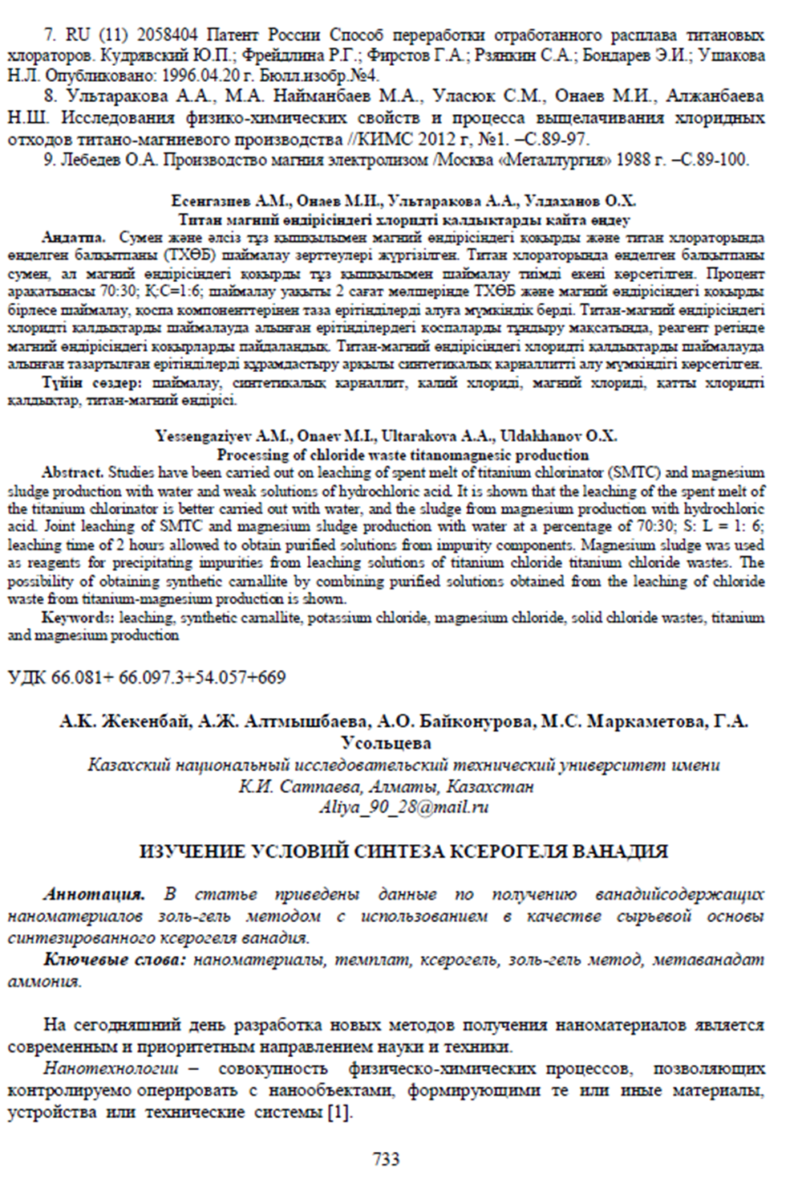

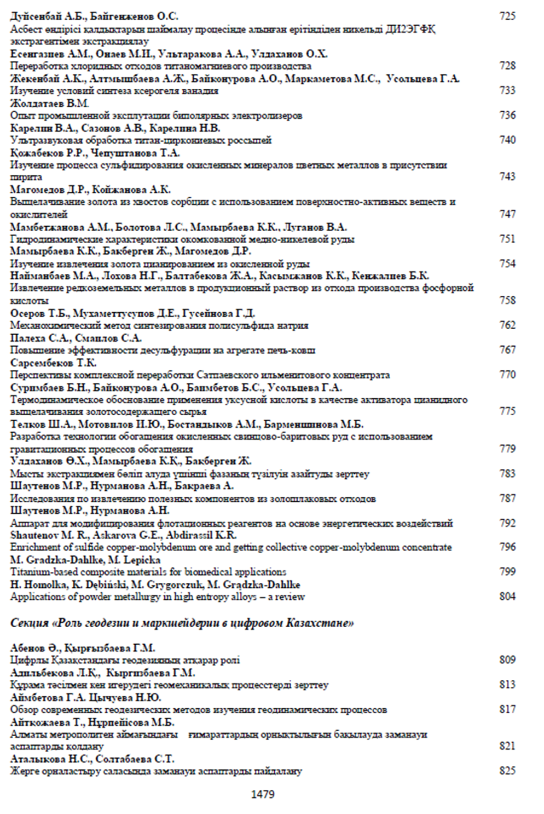
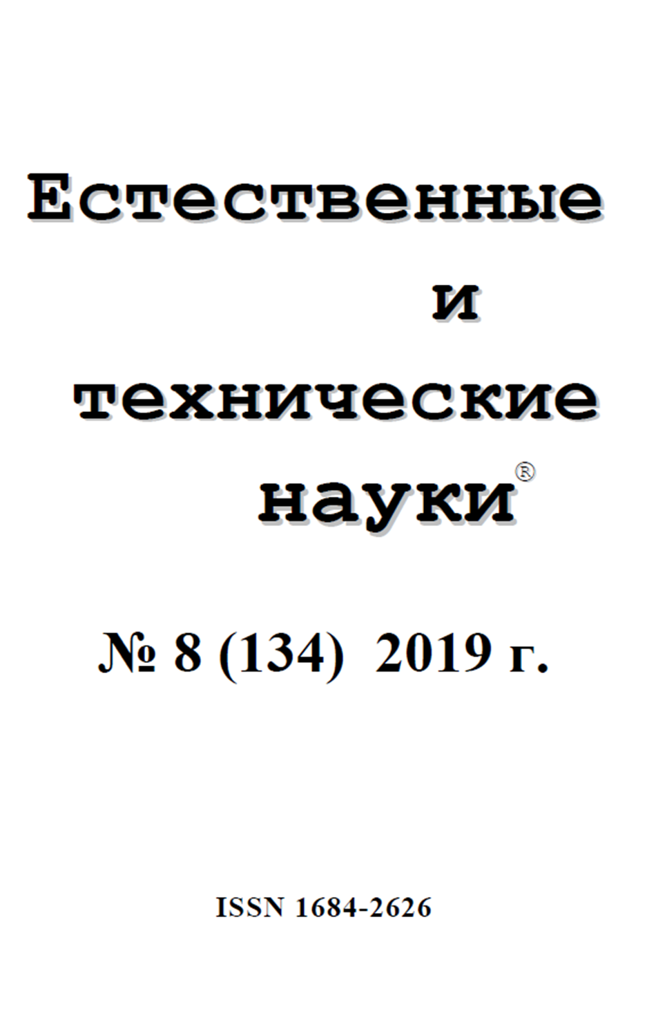

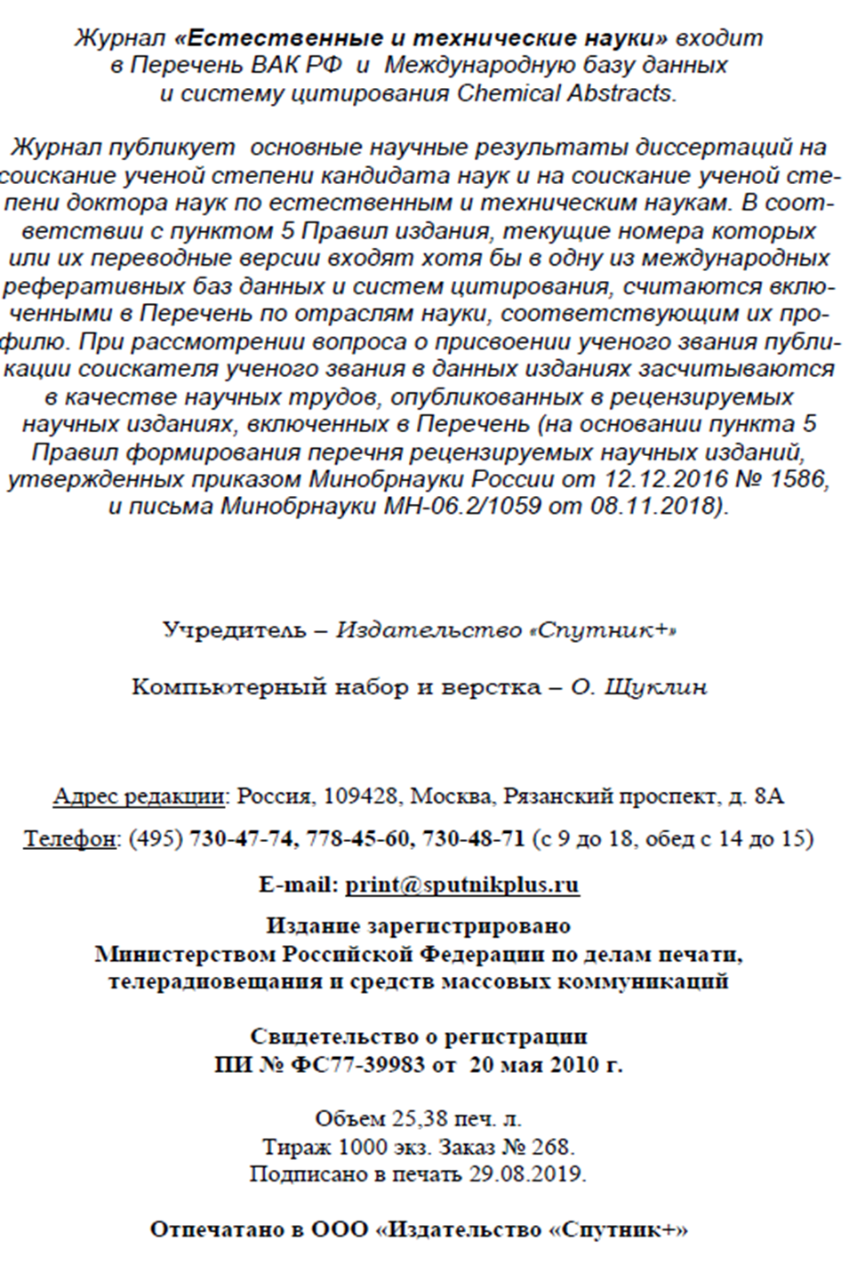

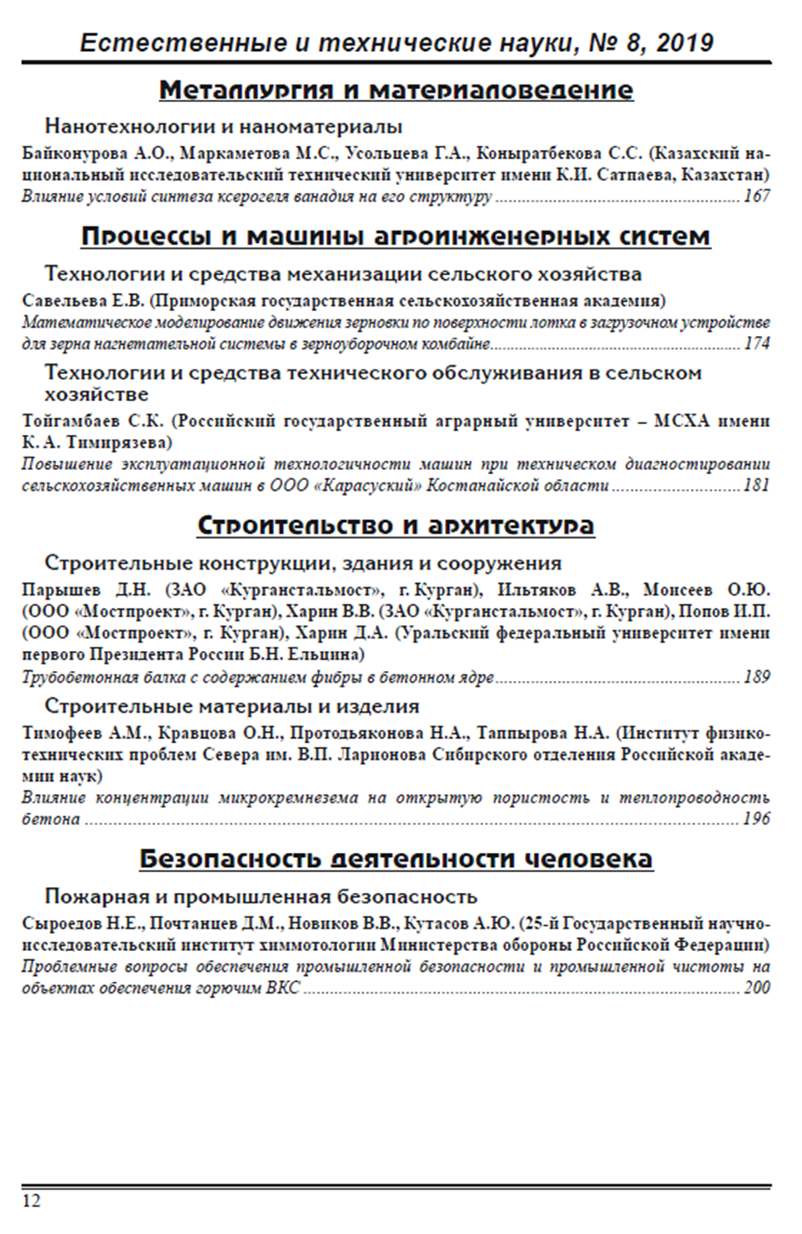

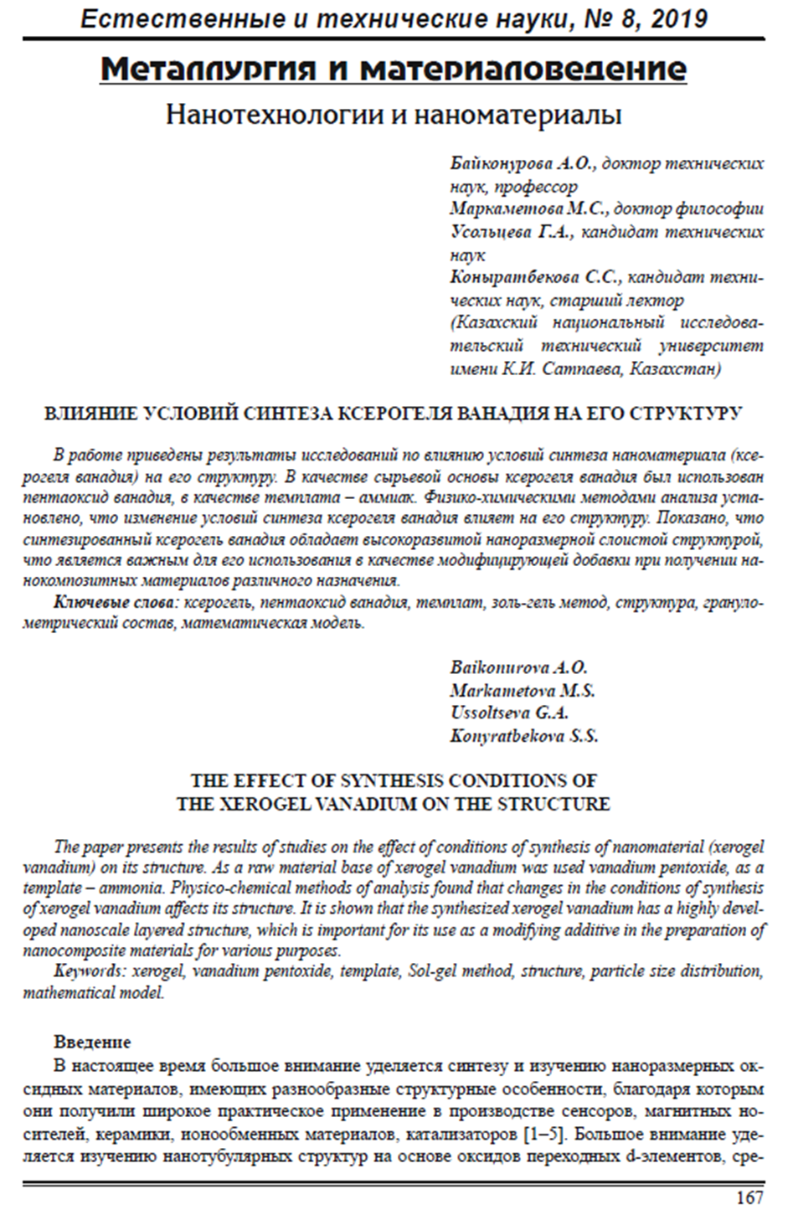

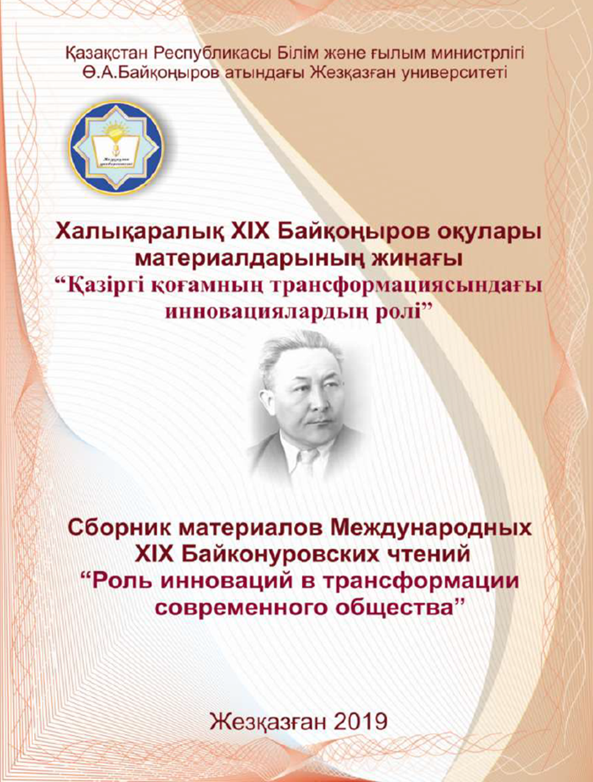

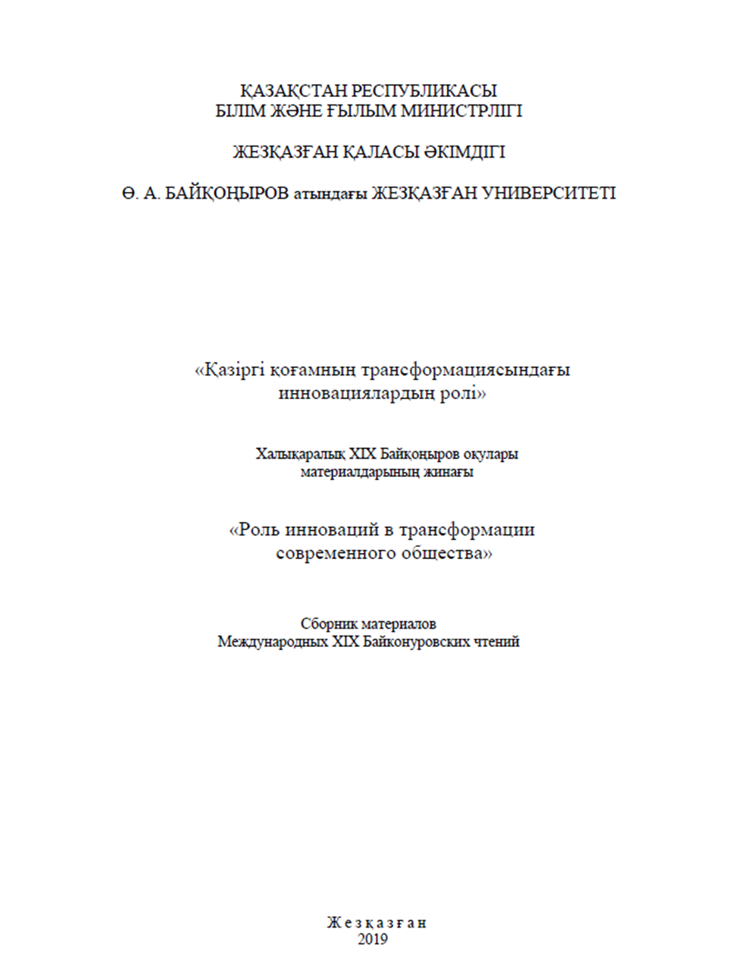

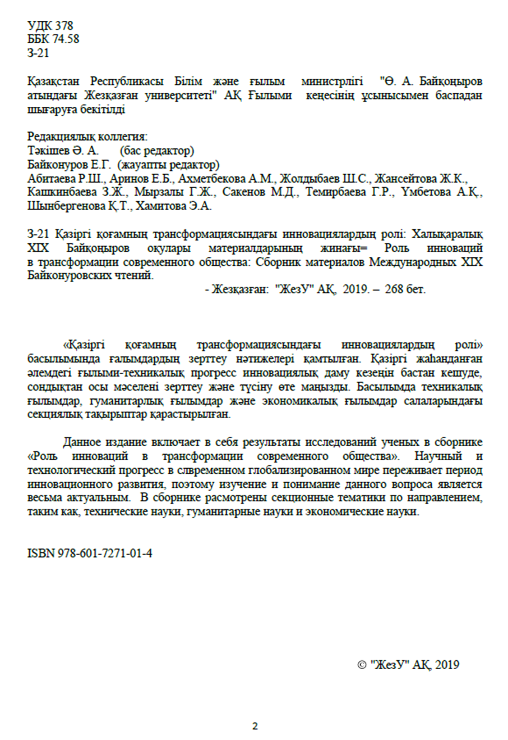

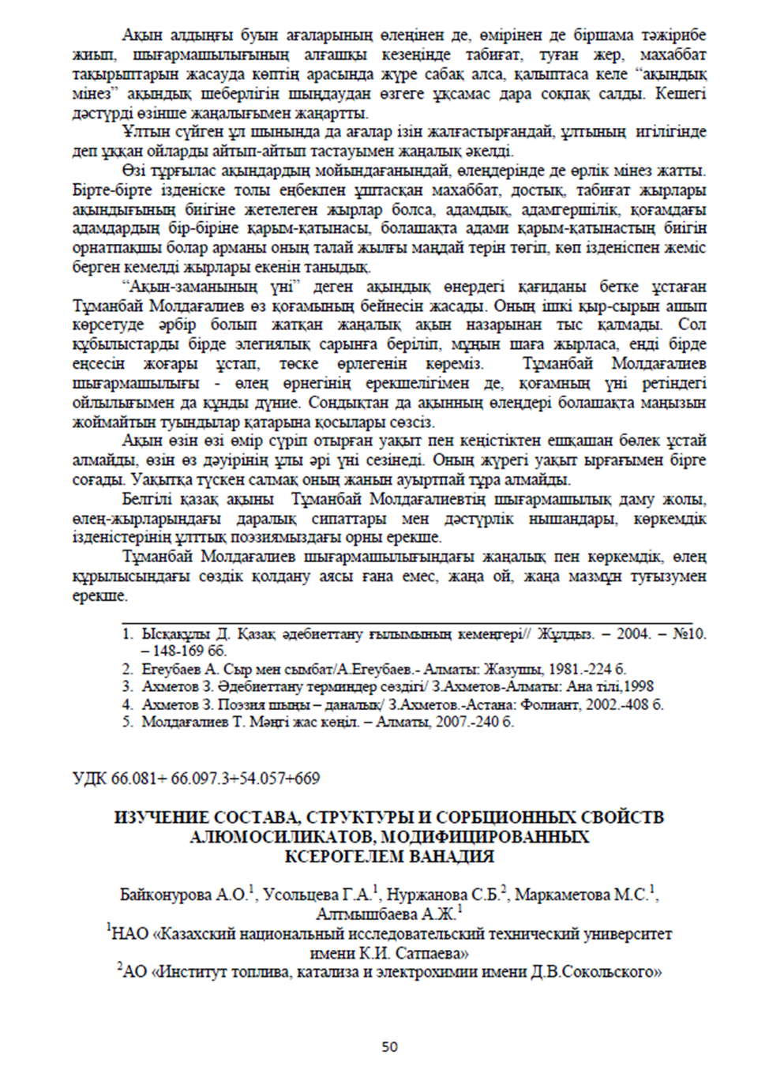

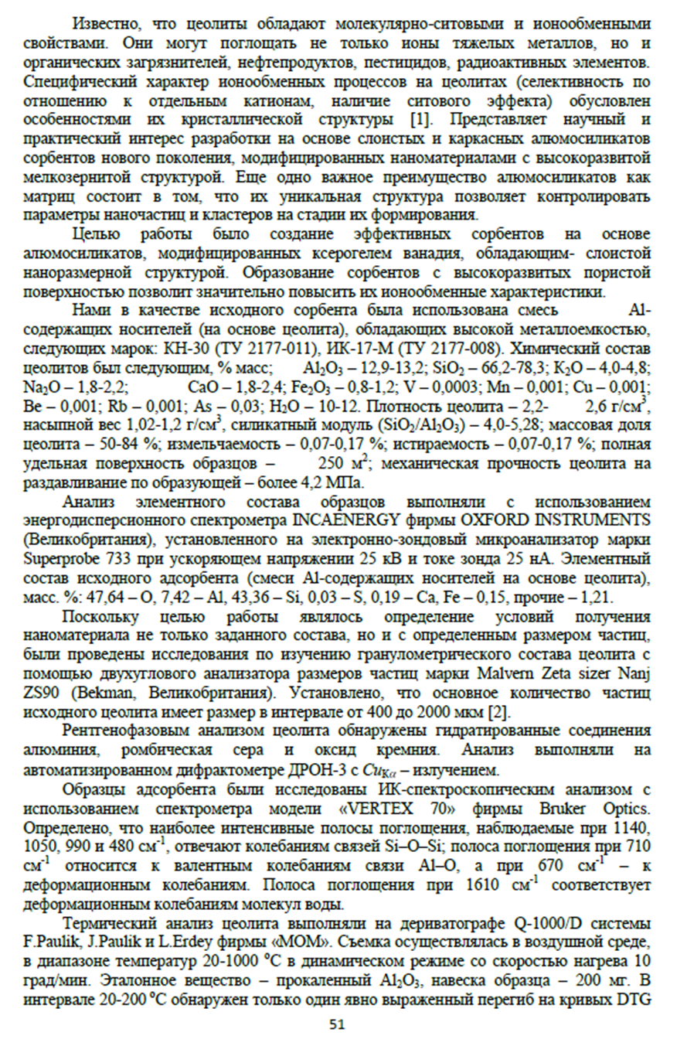

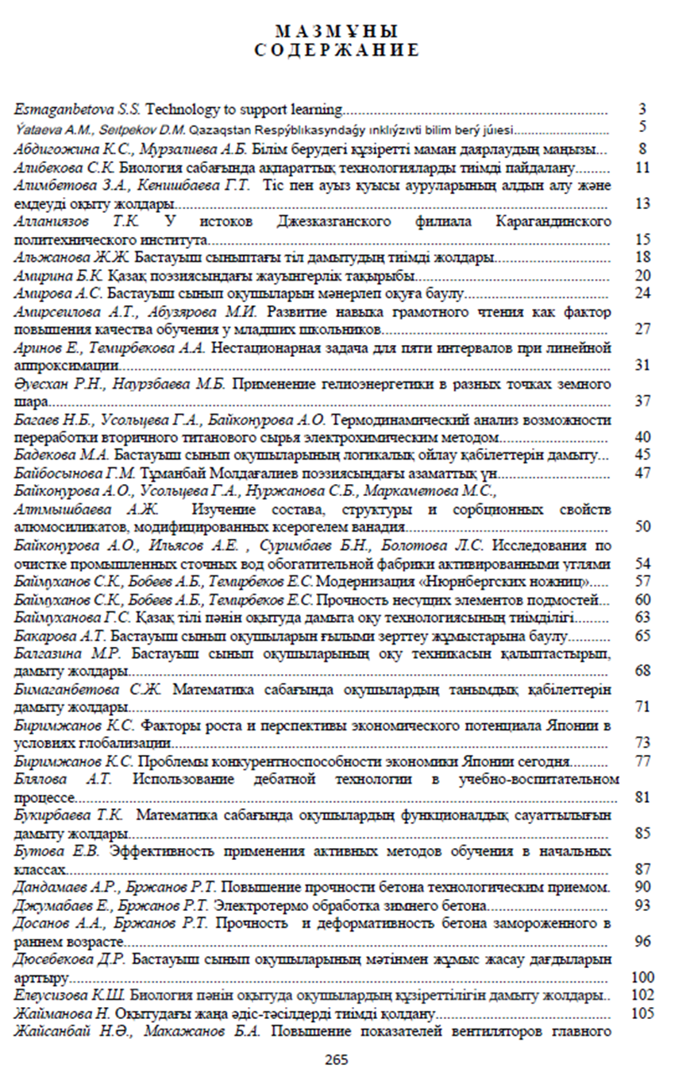
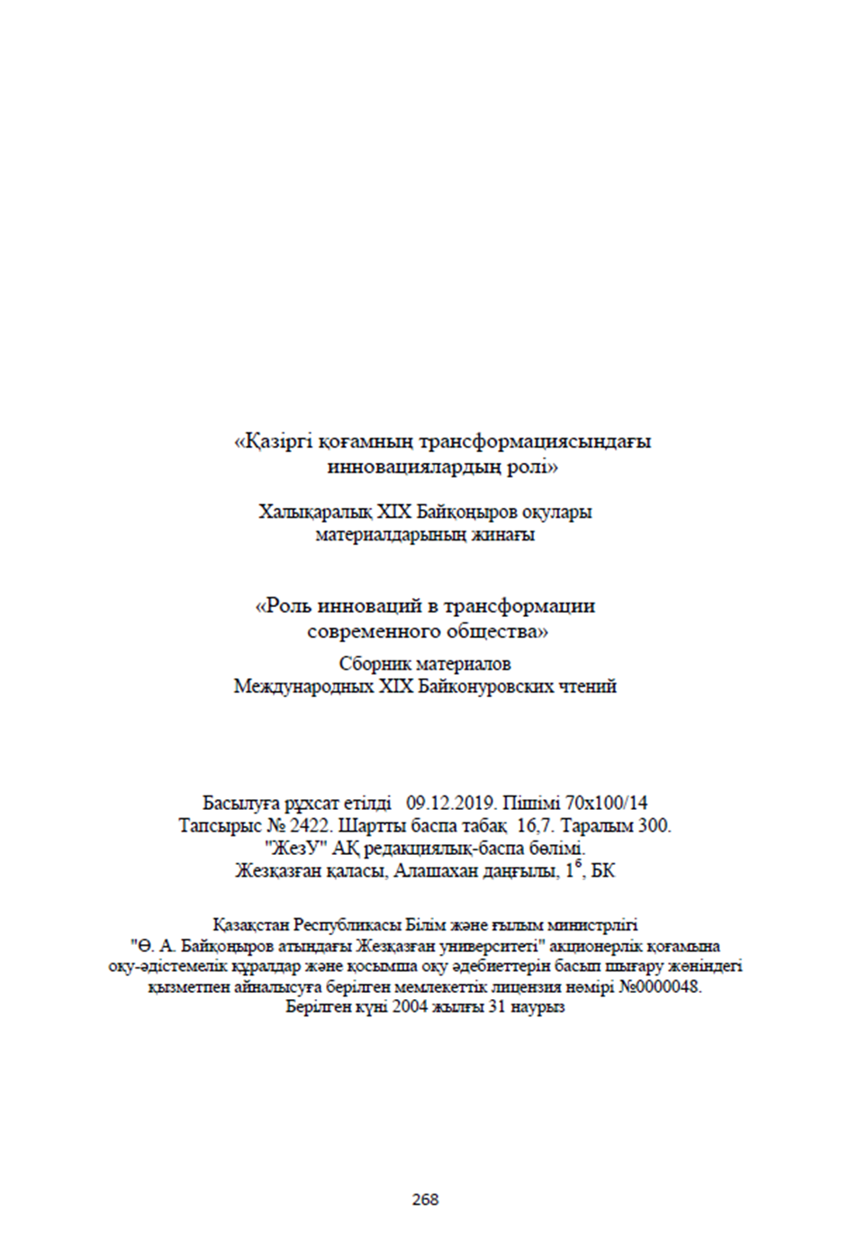

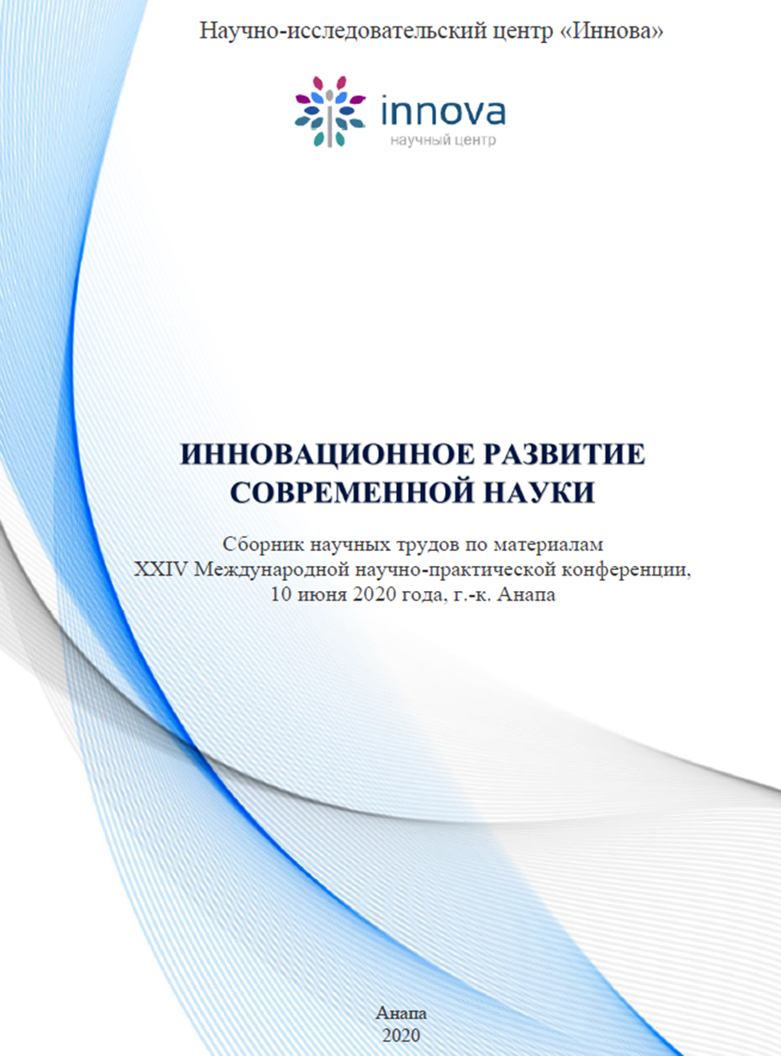

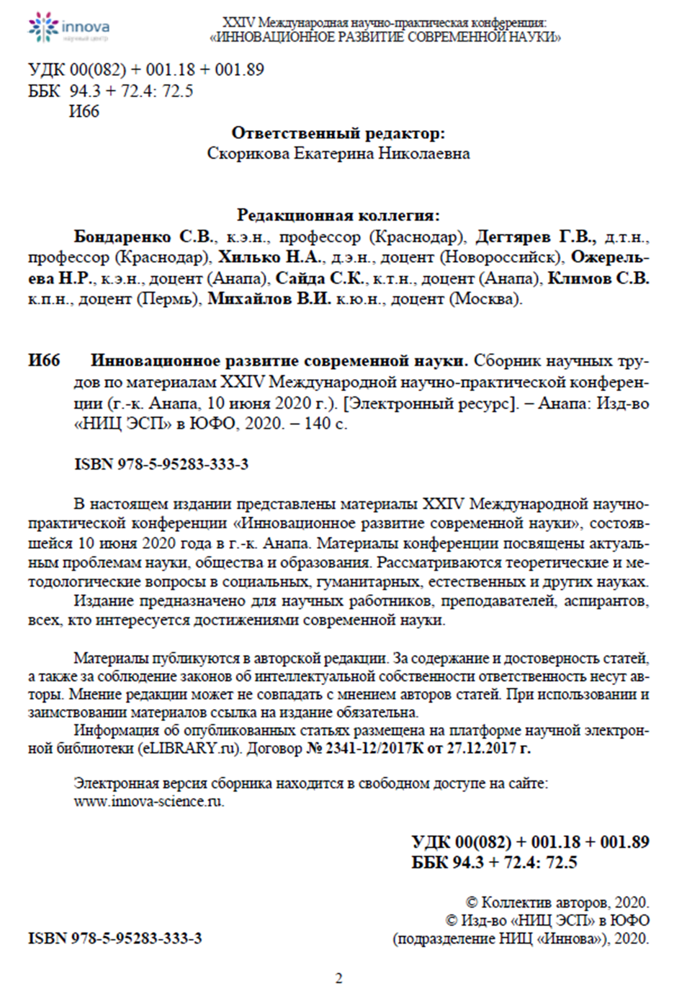

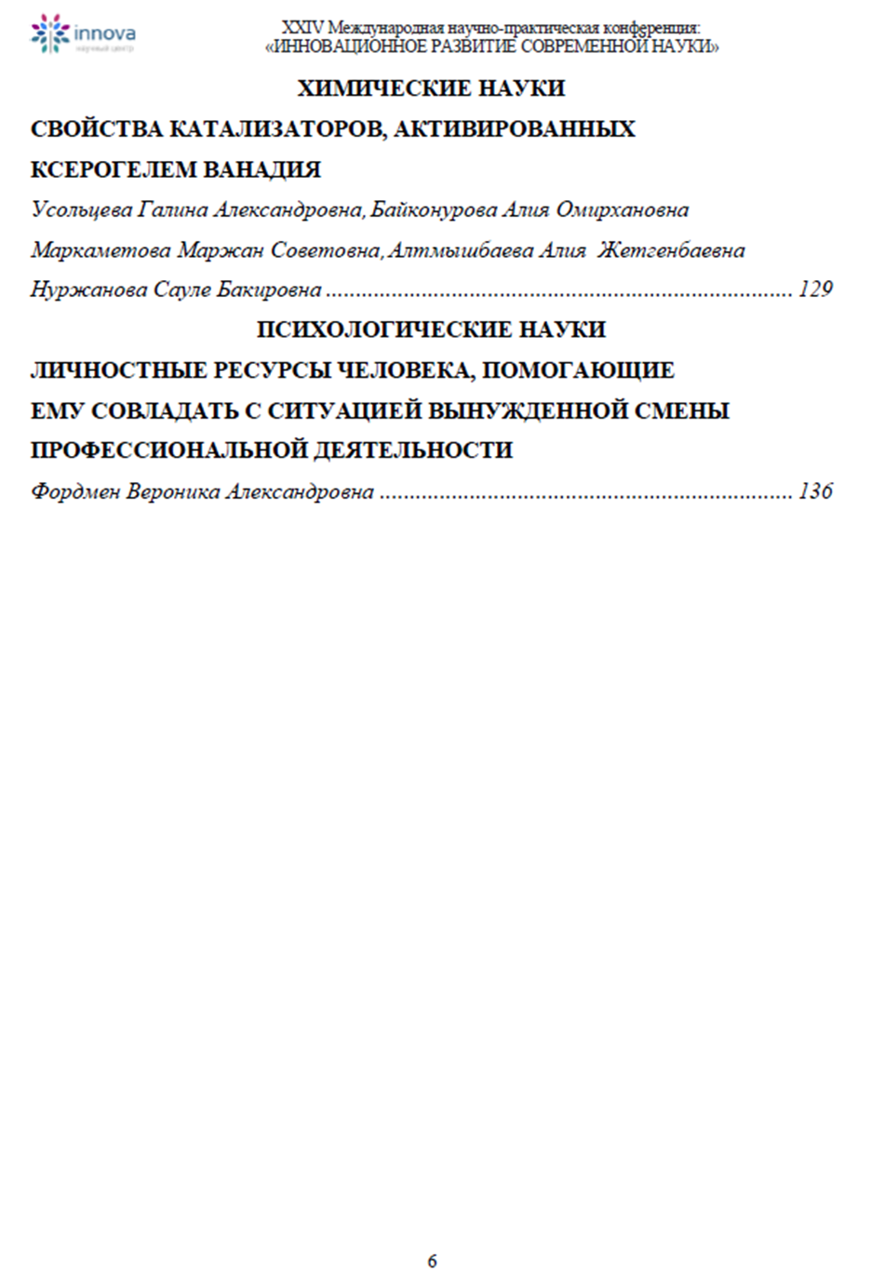

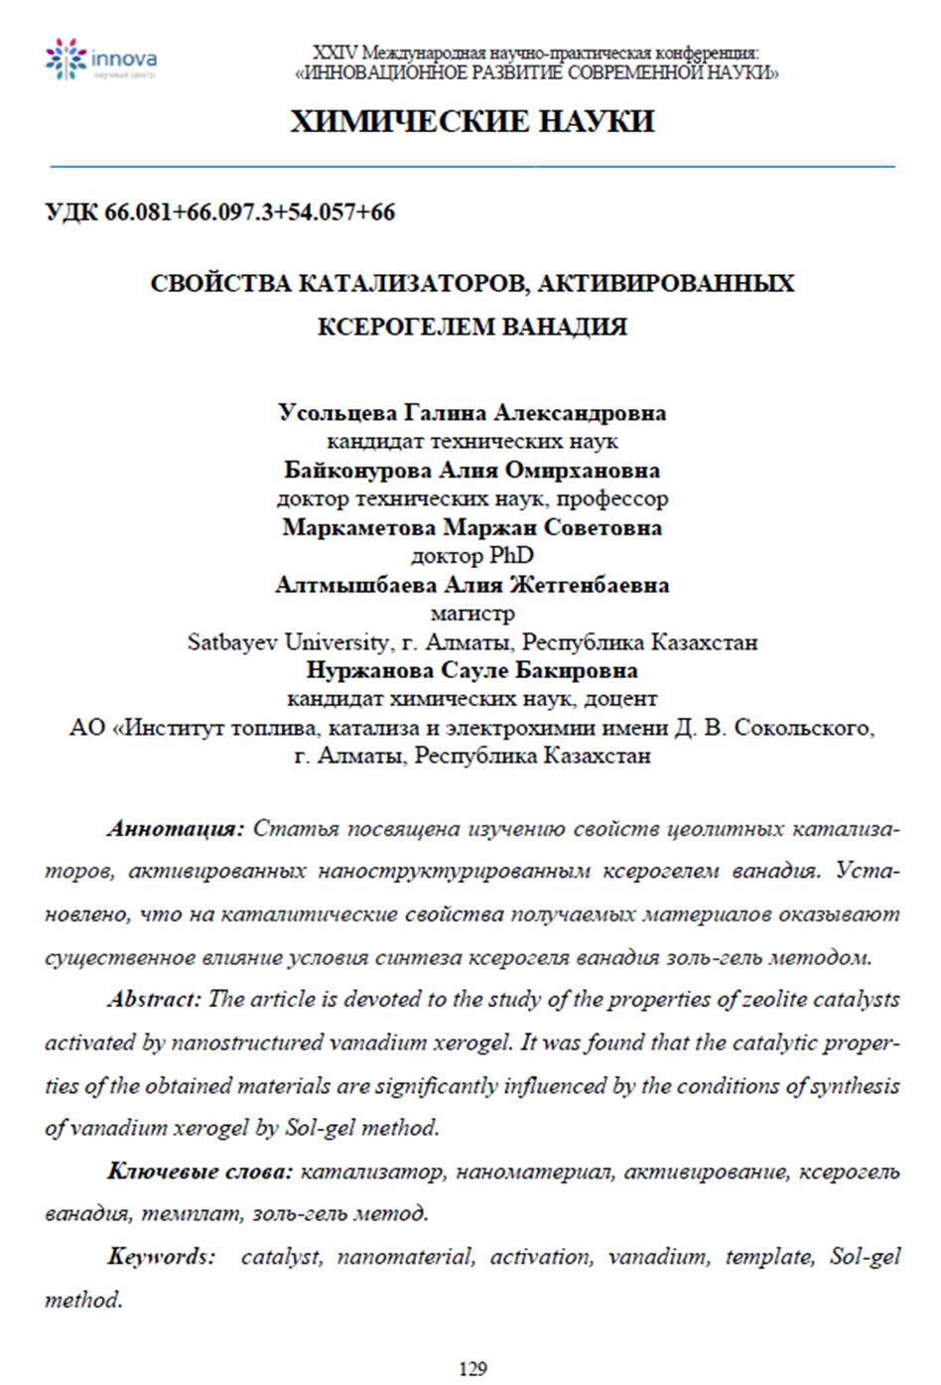

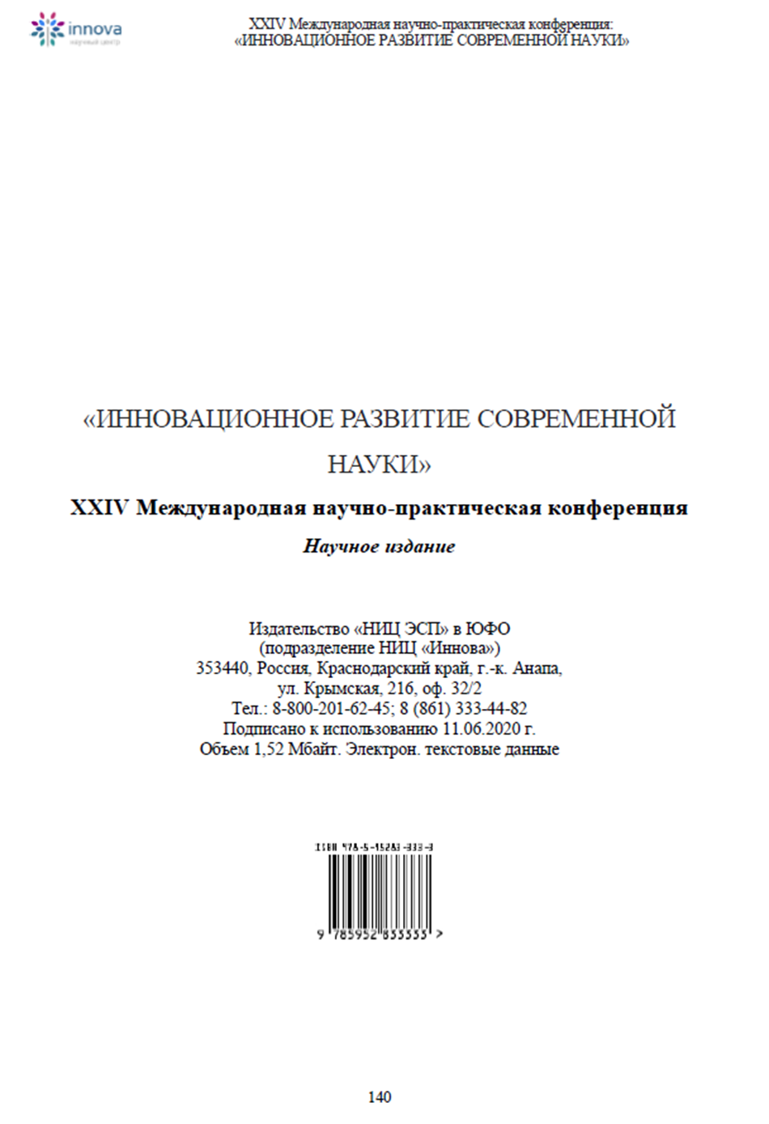

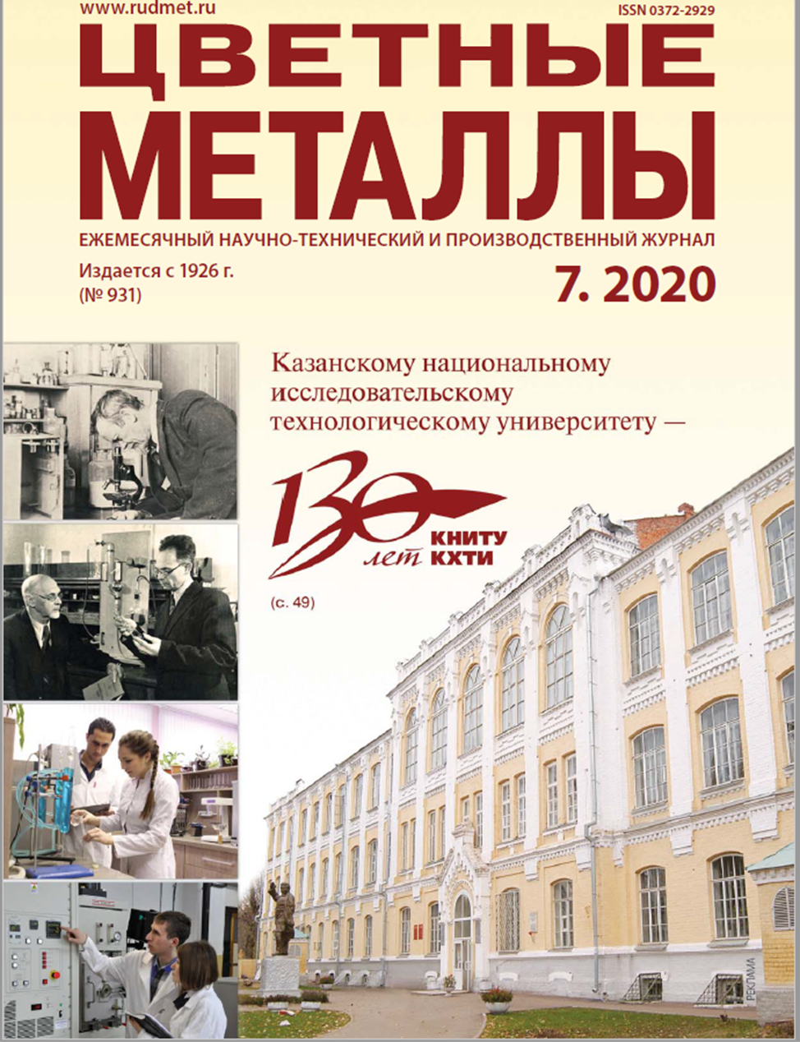

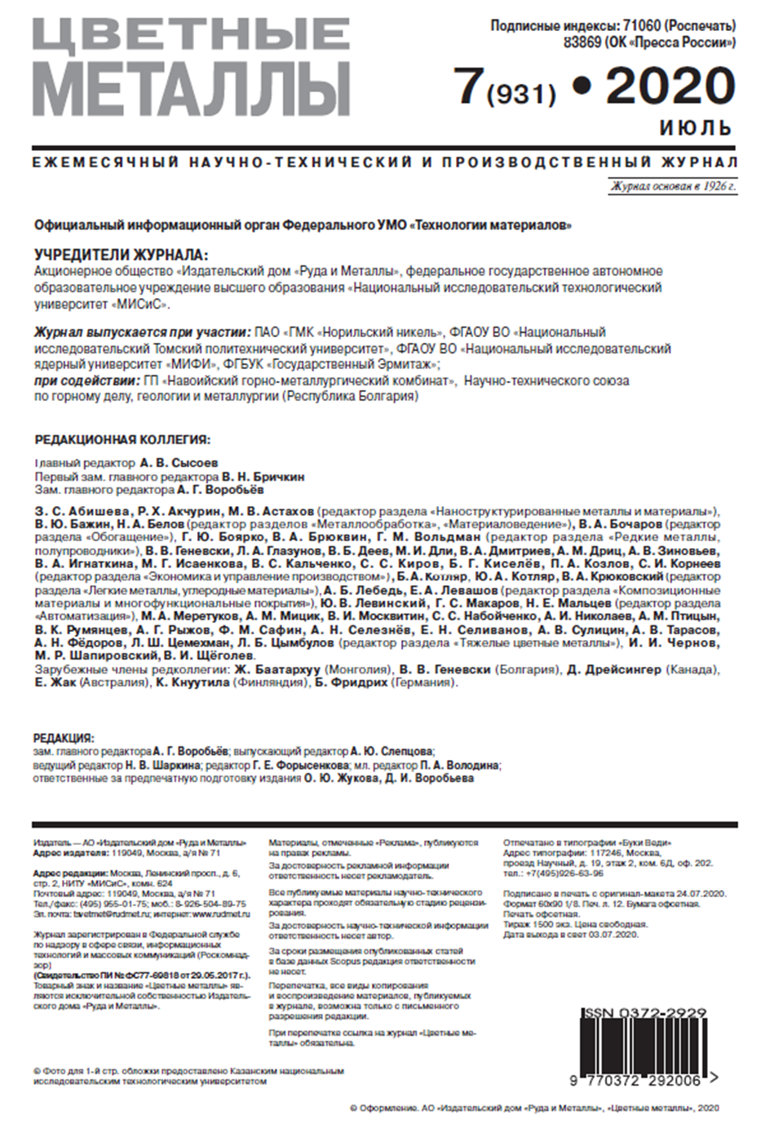

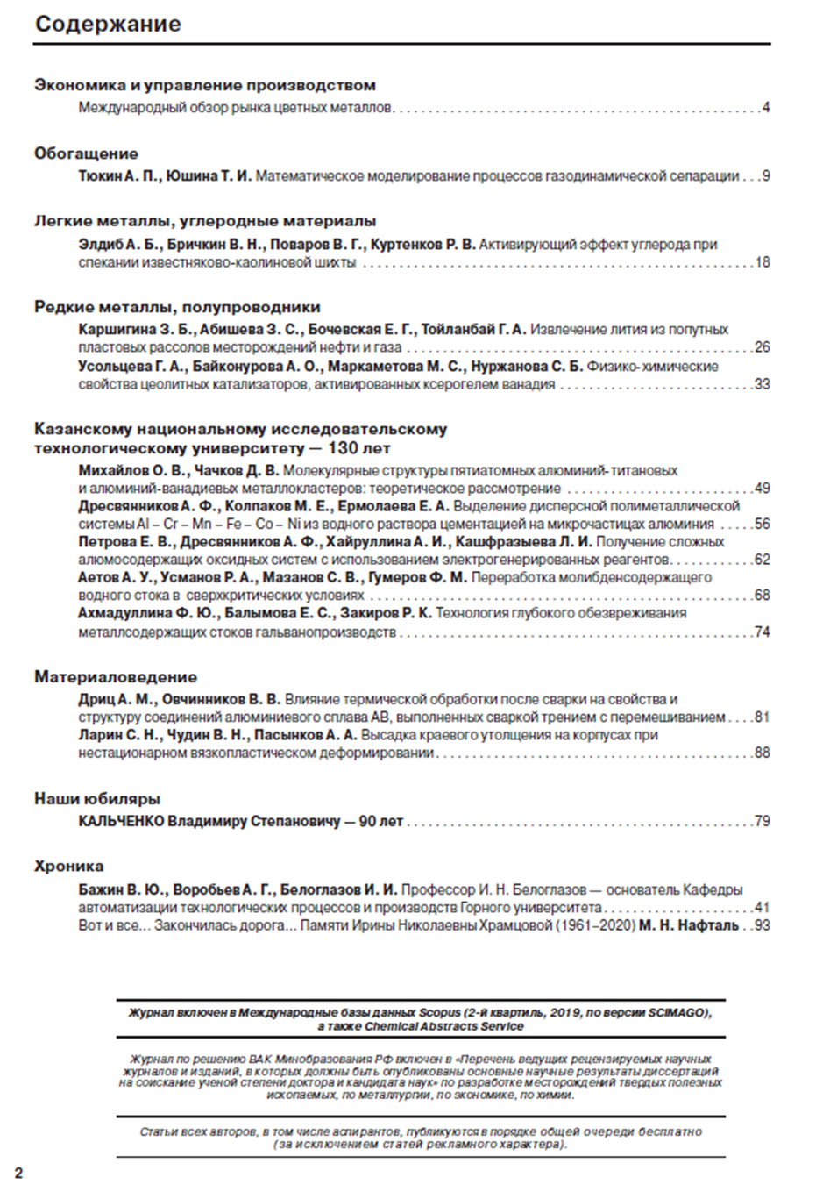

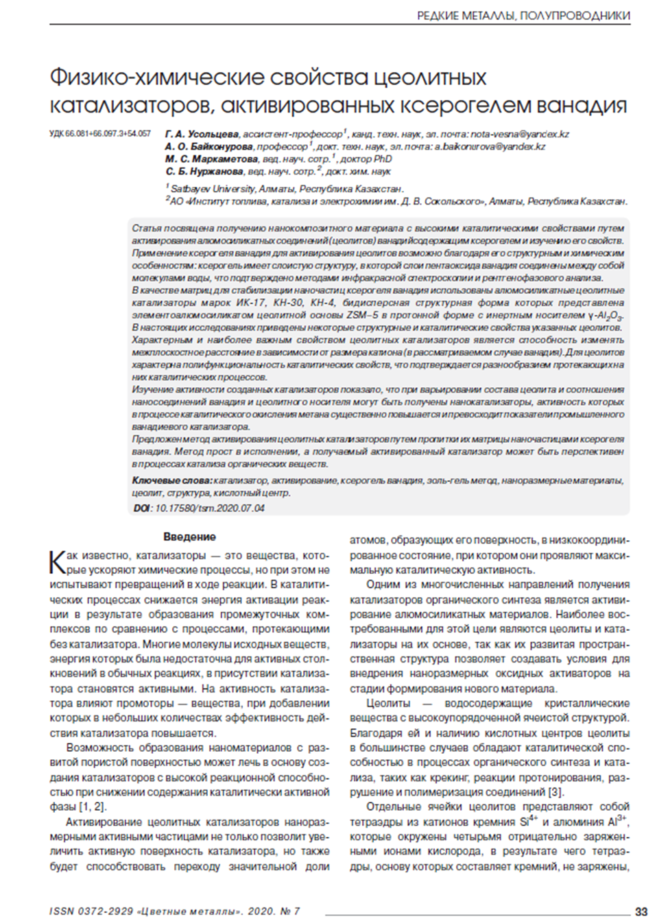

Application for the grant of a patent
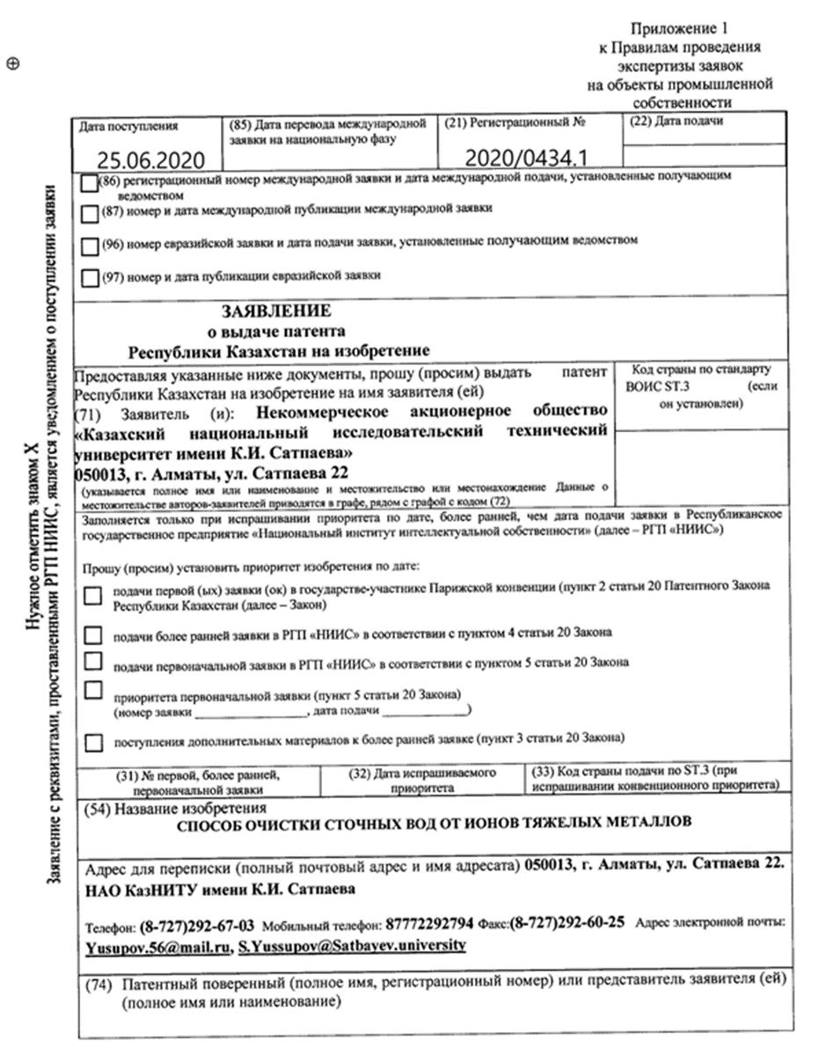

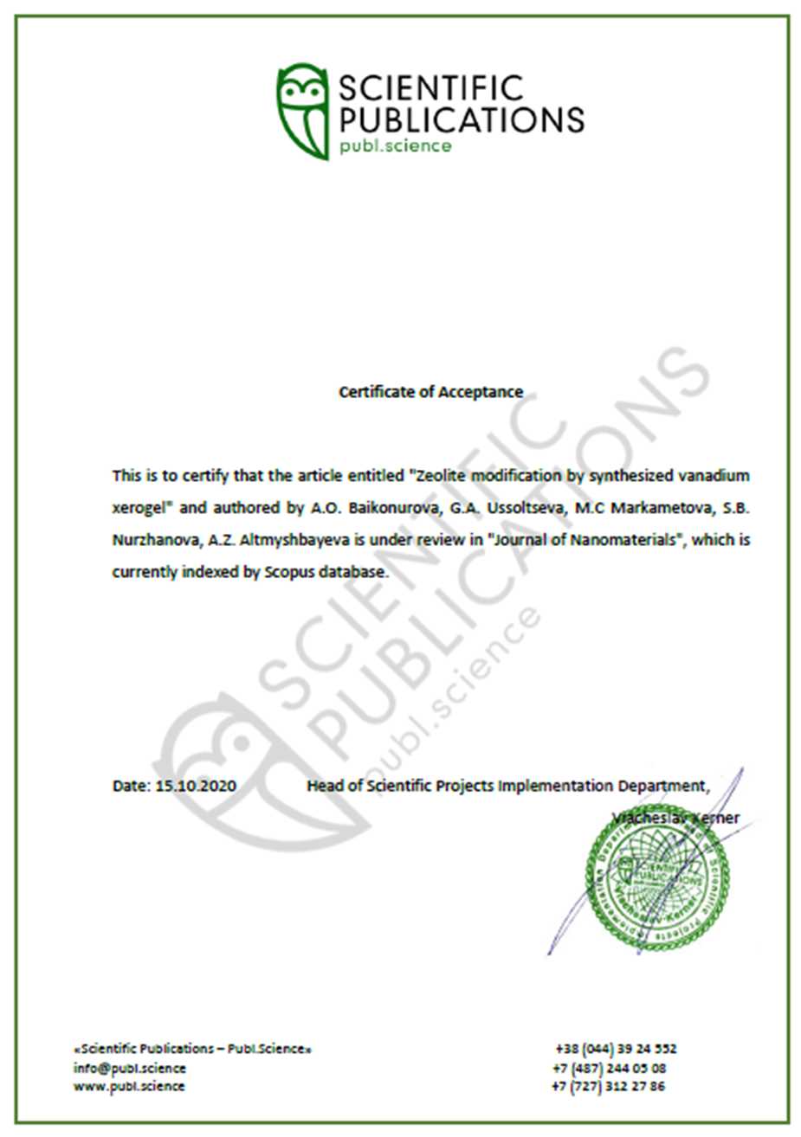

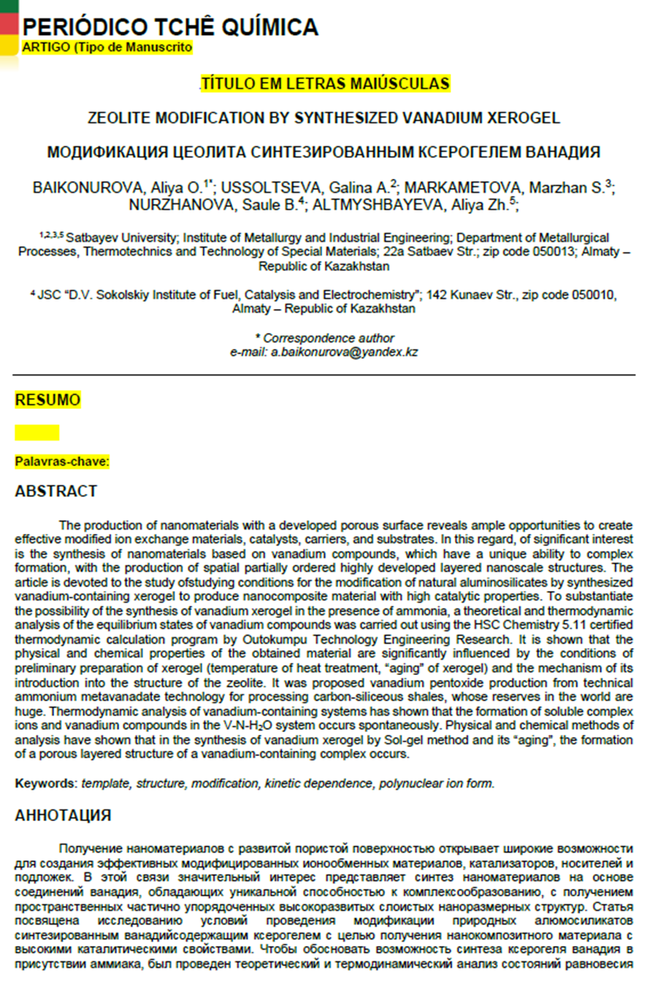

APPENDIX D

Karatau quartzite processing schemes
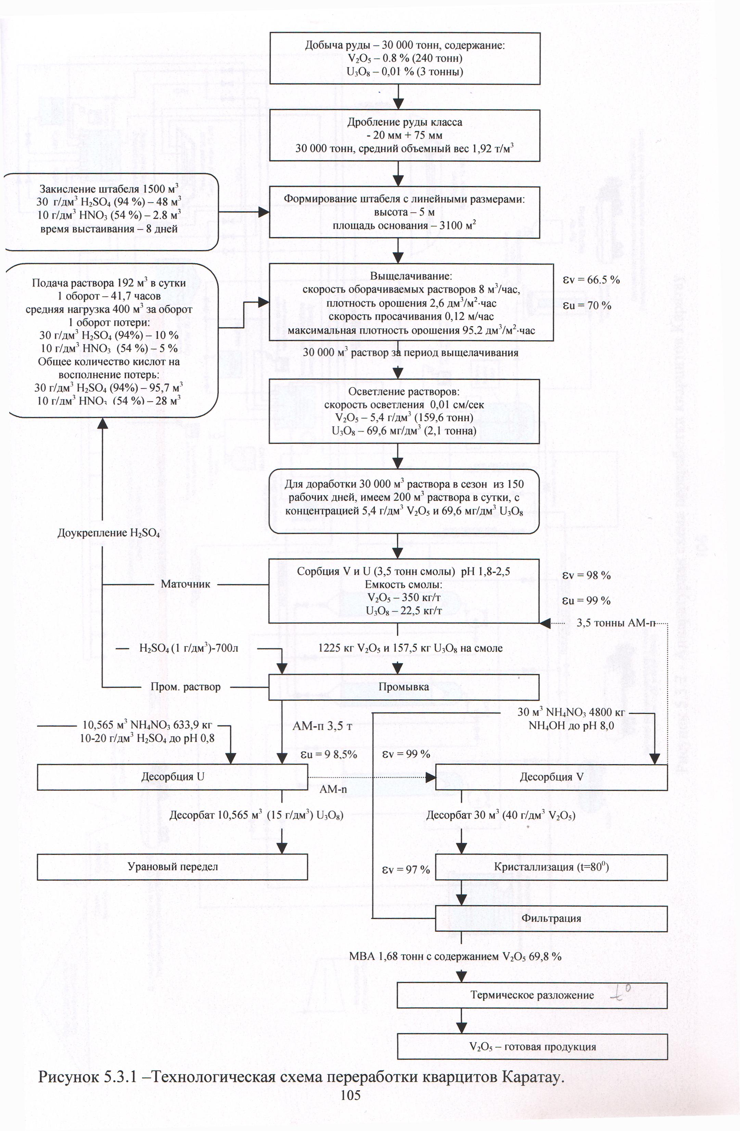

Figure G.1 – Technological scheme for the processing of Karatau quartzite
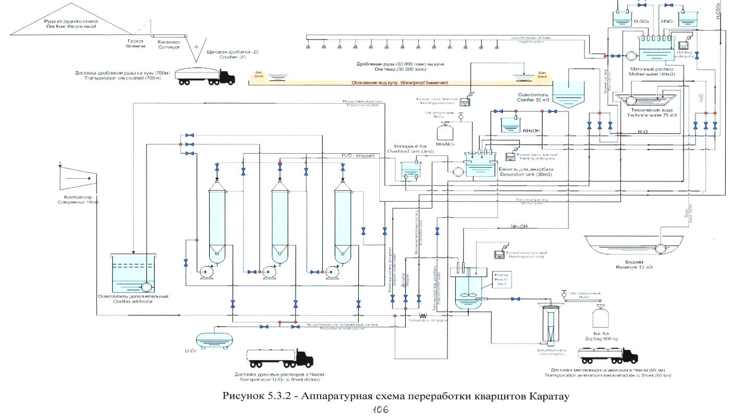

Figure D.2 – Apparatus and technological scheme for the processing of Karatau quartzite

APPENDIX E

Optimization of the obtained mathematical models for the synthesis of vanadium xerogel

Table D. 1 – Boundary conditions for the synthesis of vanadium xerogel
Process conditions | X₁, (рН) | X₂, (V_{р-р} :V_{NH3}) | X₃, (τ)
Lower level | 2,8 | 50:1 | 30
Top level | 4 | 50:2 | 120

Table D. 2–Extended matrix of the full factor experiment
№ | Х₁ | Х₂ | Х₃ | Х₁Х₂ | Х₁Х₃ | Х₂Х₃ | Х₁Х₂Х₃ | Y₁ | Y₂
1 | 2 | 3 | 4 | 5 | 6 | 7 | 8 | 9 | 10 | 11
1 | + | + | + | + | + | + | + | 91,7 | 93,2 | 92,45
2 | - | + | + | - | - | + | - | 6,7 | 8,5 | 7,6
3 | - | - | + | + | - | - | + | 16.7 | 17,8 | 17,25
4 | - | + | - | - | + | - | + | 15 | 15,6 | 15,3
5 | + | + | - | + | - | - | - | 96,7 | 97,5 | 97,1
6 | + | - | - | - | - | + | + | 75 | 77,8 | 76,4
7 | + | - | + | - | + | + | - | 50 | 51,7 | 50,9
8 | - | - | - | + | + | + | - | 46,7 | 48,3 | 47,5
Y₀ = 50,56 %

The optimization of the obtained mathematical models was carried out using computer technologies by a graphical method with setting one of the factors to a constant value.
The response surfaces are obtained in coordinates:
The obtained mathematical models were optimized using computer technologies using a graphical method when one of the factors was set as a constant value.
Response surfaces are obtained in coordinates:
Y = ƒ (X₂; X₃) приX₁=1, X₁ = 0, ₁X₁= -1 (FigureВ.1, В.2);
Y = ƒ (X₁; X₃) приX₂=1, X₂ = 0, ₁X₂= -1 (FigureВ.3, В.4);
if the values of the encoded variable X₃ are constant: X₁, X₂ are mutually influencing factors.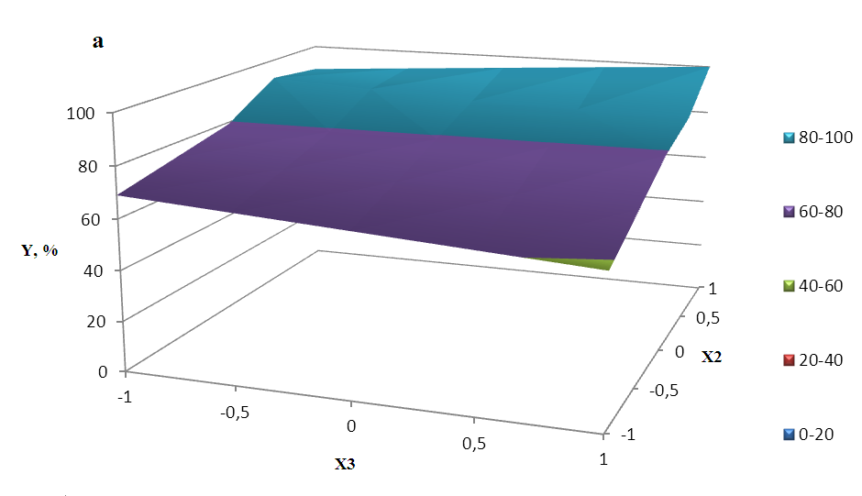
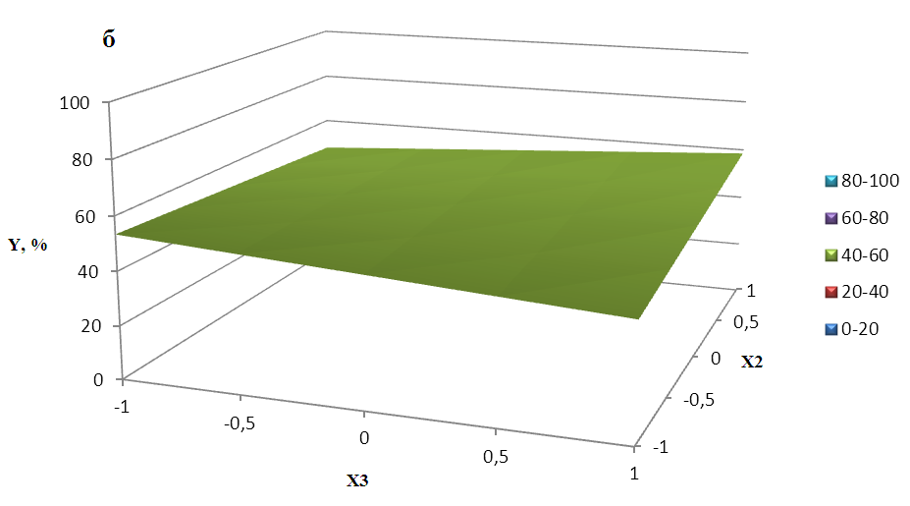
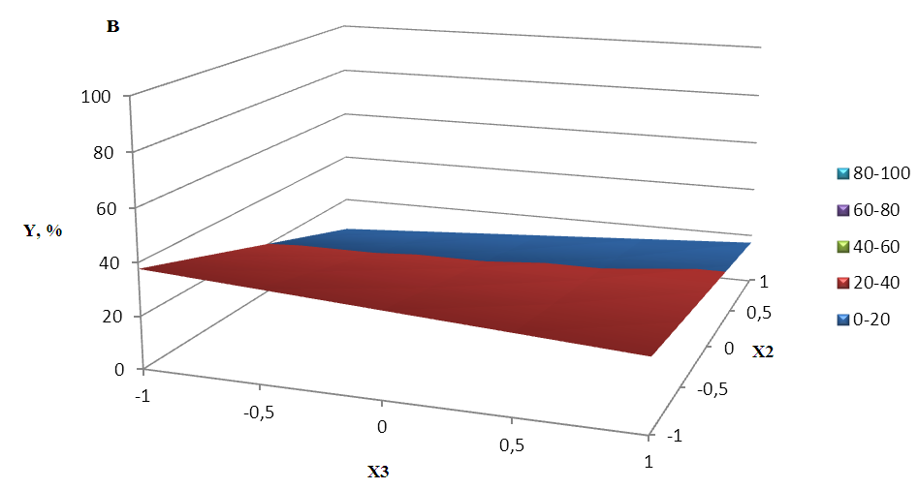

Figure D. 1 – process response Surfaces with constant values of the encoded variable: (а) X₁= 1,(б) X₁= 0, (в) X₁ = -1 X₁
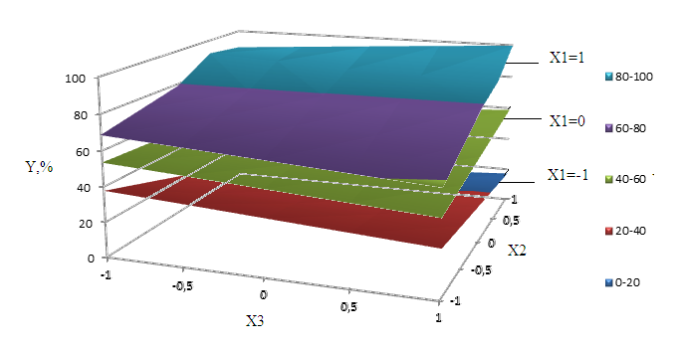
Figure D. 2 – Superimposition of the response surfaces of the vanadium xerogel synthesis process with constant values of the encoded variable X₁

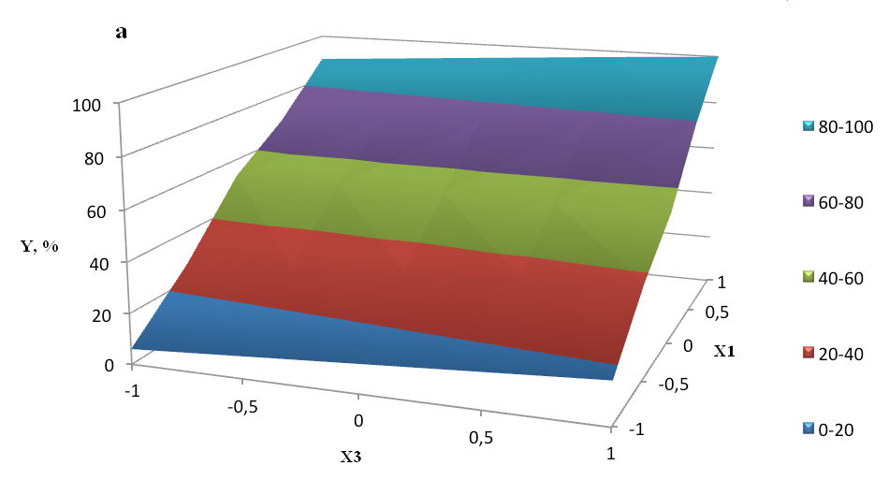

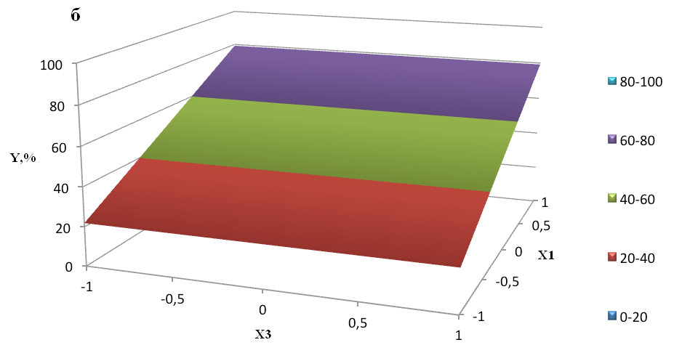

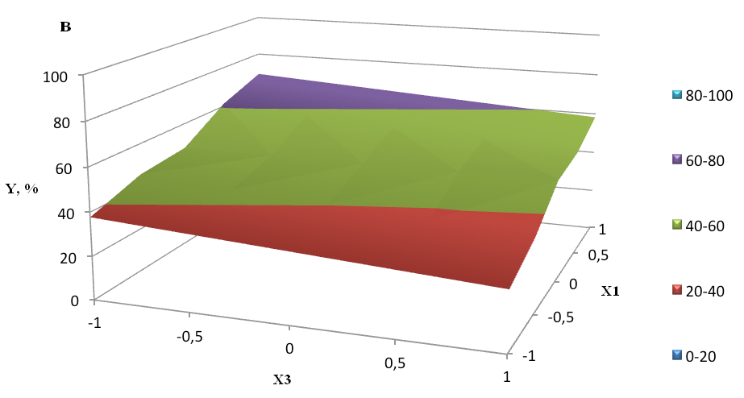

Figure D. 3 – response Surfaces of the xerogel synthesis process with a constant value of the variable X₂: (а) X₂ = 1, (б) X₂ = 0, (в) X₂ = -1

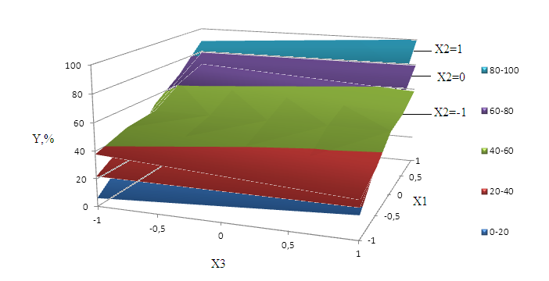
Figure D. 4 – superimposition of response Surfaces of the vanadium xerogel synthesis process with constant values of the encoded variable X₂

Based on the obtained response surfaces, one can clearly see not only the extremum regions, but also the optimal points in the given intervals of variation of the factors X₁,X₂, X₃.
Depending on the further use, it is possible to synthesize nanomaterials of various dimensions (1 ÷ 100 nm). It has been established that to obtain the maximum size of vanadium xerogel nanoparticles, it is necessary to observe the following synthesis modes X₁ = 1; X₂ = 1; X₃ = 1, which corresponds to pH 4, V_{sol}: V_{sol}:V_{NH3} = 50:2, τ = 120 min. To obtain the minimum size of vanadium xerogel nanoparticles, the following synthesis mode must be observed X₁ = -1; X₂ = -1; X₃ = -1, which corresponds to pH 2,8,V_{sol}:V_{NH3} = 50:1, τ = 30 min.
Experimental studies carried out under conditions corresponding to the optimal points of the model made it possible to obtain a vanadium xerogel with the following average particle sizes:
- while maintaining the pH of the medium at 4, V_{sol} :V_{NH3} = 50:2, τ = 120 min, the size of vanadium xerogel nanoparticles was 54 nm;
- while maintaining the pH of the medium at 2.8, V_{sol} :V_{NH3} = 50:1, τ = 30 min, the size of vanadium xerogel nanoparticles was 5.5 nm.
If it is necessary to expand the variation interval, you can use the resulting model, predicting the synthesis conditions.

APPENDIX F

Approximate technical and economic calculation of vanadium xerogel synthesis technology indicators

The economic effect was calculated from the profit of sales of vanadium xerogel. Calculations were performed using the Russian standard Alt. Invest program, which is used in Kazakhstan. It allows in automatic mode, rassmatrivayut calculate the efficiency of the process, considering all types of taxes in accordance with tax legislation of the RK (income tax on legal entities (profit tax), social payments (insurance and pension levy), land tax, property, VAT.
The construction costs of buildings and structures were not taken into account, because the necessary equipment can be placed in the workshops of metallurgical plants for the production of vanadium. Additional investments for the implementation of the technology for obtaining vanadium xerogel were calculated based on material flows and equipment performance. Investment costs included the cost of investment in fixed assets. Investment costs in working capital were formed from own and borrowed funds.
The minimum need for working capital was determined using the following criteria:funds available to create reserves in case of delays in payments. The composition and size of working capital were determined by the needs and requests of the technology. Working capital was defined as the difference between current assets and liabilities. The forecast of the initial working capital requirement for elements was calculated based on the annual increase in net working capital.
Current expenses were determined based on the linear growth of conditionally variable expenses depending on the growth of indicators of production volumes and set values for the main time interval of conditionally fixed expenses. Direct material costs were determined by the cost of purchased raw materials (tables E.1, E.2), as well as the cost of energy resources, maintenance of equipment, transportation costs, and wages of production personnel.Administrative expenses (overheads) included the costs of training staff and the project development period, salaries with accruals of administrative and management personnel, and sales expenses. When forming the cost of production, depreciation charges were determined based on the design useful life of fixed assets.
The main costs of obtaining vanadium xerogel arecosts for raw materials, basic materials, energy, wages, amortization, shop and General plantexpenses. The costs of basic materials and their cost were determined based on the data of consolidated tests and calculations in accordance with current wholesale prices and consumption coefficients. The time interval is 6 years. Electricity and water costs are based on the average technical and economic indicators of industrial enterprises.The main technological equipment is shown in table E. 3.
The number of SPTS and salary expenses of production workers, as well as shop staff, were determined taking into account the experience of operating existing production facilities. The calculation of the number of production personal by category and the annual salary Fund is shown in table G. 4. Accruals for wages and social insurance deductionsyou are in accordance with current regulations. Overhead production costs include the cost of maintaining and operating the main equipment.

Table E. 1 – Consumption of raw materials per 100 kg of vanadium xerogel
Name | 1year | 2-4 year | 5 year | 6 year | Total
The ammonium metavanadate, kg | 10 | 30 | 10 | 10 | 60
Ammonia, l | 5,6 | 10,18 | 5,6 | 5,6 | 30,36
Distilled water, l | 1000 | 3000 | 1000 | 1000 | 6000
Containers for solutions, PCs | 200 | 600 | 200 | 200 | 1200
Alund crucible, PCs | 100 | 300 | 100 | 100 | 600

Table E. 2 – raw material costs, tenge
Name | 1year | 2-4 year | 5 year | 6 year | Total
The ammonium metavanadate | 6000 | 18000 | 6000 | 6000 | 36000
Ammonia | 3578 | 10735,2 | 3578 | 3578 | 21470,4
Distilled water | 10000 | 30000 | 10000 | 10000 | 60000
Containers for solutions | 40000 | 120000 | 40000 | 40000 | 240000
Alund crucible | 7000 | 21000 | 7000 | 7000 | 42000
Total expenses (without VAT) | 66578 | 199735,2 | 66578 | 66578 | 399470,4
VAT to expenses | 13981,38 | 41944,392 | 13981,38 | 13981,38 | 83888,784

Table E.3 – List and cost of equipment used, thousand tenge
Permanent assets | "0" | 1 year | 2-4 year | 5 year | 6 year | Total
Muffle oven 1 PC.
Carrying amount | 120 | 120 | 120 | 120 | 120 | -
Residual value | 120 | 108 | 72 | 60 | 48 | -
Depreciation | 0 | 12 | 36 | 12 | 12 | 72
Electric mixer 2 PCs
Carrying amount | 100 | 100 | 100 | 100 | 100 | -
Residual value |  | 90 | 60 | 50 | 40 | -
Depreciation | 0 | 10 | 30 | 10 | 10 | 60
Nutch filter (S = 1.5 m²), 1 PC.
Carrying amount | 180 | 180 | 180 | 180 | 180 | -
Residual value | 180 | 162 | 108 | 90 | 72 | -
Depreciation | 0 | 18 | 54 | 18 | 18 | 108
Other equipment and deferred expenses
Carrying amount | 150 | 150 | 150 | 150 | 150 | -
Residual value | 150 | 135 | 90 | 75 | 60 | -
Depreciation | 0 | 15 | 45 | 15 | 15 | 90
Total depreciation charges | 0 | 55 | 165 | 55 | 55 | 330

Operating costs for a period of 1-6 years and the amount of capital costs are presented in table E.5.The analysis of the project development efficiency was performed using the following indicators: return on investment; net present income; internal rate of return; payback period of the project.
The main economic indicators of the proposed technology for producing vanadium xerogel are shown in table E. 6.

Table G. 4 – Number and salary of production personnel
Category of personnel |  | Unit | 1 year |  |  | 2-4 year |  |  |  | 5 year |  |  | 6 year |  |  | Total
Main industrial and production personnel
Apparatchik (IV category) |  | people | 2 |  |  | 2 |  |  |  | 2 |  |  | 2 |  |  | -
- monthly salary |  | tenge / month | 60 000 |  |  | 60 000 |  |  |  | 60 000 |  |  | 60 000 |  |  | -
- salary expenses |  | thousand tenge people | 1440 |  |  | 4320 |  |  |  | 1440 |  |  | 1440 |  |  | 8640
Number of main production personnel |  |  | 2 |  |  | 2 |  |  |  | 2 |  |  | 2 |  |  | -
Salary of the main production staff |  | thousand tenge people | 1440 |  |  |  | 4320 |  |  | 1440 |  |  | 1440 |  |  | 8640
Payroll accruals (unified social tax+insurance) |  | thousand tenge people | 302,4 |  |  |  | 907,2 |  |  | 302,4 |  |  | 302,4 |  |  | 1814,4
Auxiliary industrial and production personnel
Locksmith |  | people |  | 1 |  |  |  | 1 |  |  | 1 |  |  | 1 |  |  | -
- monthly salary |  | tenge / month |  | 50000 |  |  |  | 50 000 |  |  | 50 000 |  |  | 50 000 |  |  | -
- the salary costs |  | thousand tenge people |  | 600 |  |  |  | 1800 |  |  | 600 |  |  | 600 |  |  | 3600
Number of support staff |  | people |  | 1 |  |  |  | 1 |  |  | 1 |  |  | 1 |  |  | -
Salary of support staff |  | thousand tenge people |  | 600 |  |  |  | 1800 |  |  | 600 |  |  | 600 |  |  | 3600
Payroll accruals (unified social tax+insurance) |  | thousand tenge people |  | 126 |  |  |  | 378 |  |  | 126 |  |  | 126 |  |  | 756
Administrative and managerial staff
Head of Department |  | people |  | 1 |  |  |  | 1 |  |  | 1 |  |  | 1 |  |  | -
- monthly salary |  | tenge / month |  | 100 000 |  |  |  | 100 000 |  |  | 100 000 |  |  | 100 000 |  |  | -
- salary expenses |  | thousand tenge |  | 1200 |  |  |  | 3600 |  |  | 1200 |  |  | 1200 |  |  | 7200
Sales engineer |  | people |  | 1 |  |  |  | 1 |  |  | 1 |  |  | 1 |  |  | -
- monthly salary |  | thousand tenge |  | 80 000 |  |  |  | 80 000 |  |  | 80 000 |  |  | 80 000 |  |  | -
- salary expenses |  | thousand tenge |  | 960 |  |  |  | 2880 |  |  | 960 |  |  | 960 |  |  | 5760
Number of administrative and management personnel |  | people |  | 2 |  |  |  | 2 |  |  | 2 |  |  | 2 |  |  | -
Salary of administrative and administrative staff |  | thousand tenge |  | 2160 |  |  |  | 6480 |  |  | 2160 |  |  | 2160 |  |  | 12960
 | Payroll accruals (unified social tax+insurance) | thousand tenge |  |  | 453,6 |  |  |  | 1360,8 |  |  | 453,6 |  |  | 453,6 |  |  | 2761,6
 | Total number of employees | people |  |  | 5 |  |  |  | 5 |  |  | 5 |  |  | 5 |  |  | -
 | Total salary expenses | thousand tenge |  |  | 4200 |  |  |  | 12600 |  |  | 4200 |  |  | 4200 |  |  | 25200
 | Total payroll accruals (unified socialtax+insurance) | thousand tenge |  |  | 882 |  |  |  | 2646 |  |  | 882 |  |  | 882 |  |  | 5292

Table E. 5 – Operating expenses, thousand tenge
Current expenditure | 1 year |  | 2-4 year |  | 5 year | 6 year | Total
Raw materials | 66,578 |  | 199,7352 |  | 66,578 | 66,578 | 399,4704
Production staff salary | 2040 |  | 6120 |  | 2040 | 2040 | 12240
Payroll accruals (unified social tax + insurance) | 428,4 |  | 1285,2 |  | 428,4 | 428,4 | 2570,4
Other current expenses, including: | 50 |  | 150 |  | 50 | 50 | 300
- electricity | 100 |  | 300 |  | 100 | 100 | 600
- water | 4 |  | 12 |  | 4 | 4 | 24
- current equipment repairs | 80 |  | 240 |  | 80 | 80 | 480
General expenses
Salary of administrative and administrative staff |  | 2160 |  | 6480 | 2160 | 2160 | 12960
Payroll accruals (unified social tax+insurance) |  | 453,6 |  | 1360,8 | 453,6 | 453,6 | 2721,6
Other General expenses: |  | 35 |  | 105 | 35 | 35 | 210
- electricity for lighting |  | 10 |  | 30 | 10 | 10 | 60
- steam for heating, water for household needs |  | 25 |  | 75 | 25 | 25 | 150
- current repairs of the building and inventory |  | 1,5 |  | 4,5 | 1,5 | 1,5 | 9
- other expenses |  | 2,5 |  | 7,5 | 2,5 | 2,5 | 15
Operating cost |  | 5456,578 |  | 16369,734 | 5456,578 | 5456,578 | 32739,468
Depreciation |  | 15 |  | 45 | 15 | 15 | 90
Total running costs |  | 5471,578 |  | 16414,734 | 5471,578 | 5471,578 | 32829,468
VAT to total current expenses |  | 1149,031 |  | 3447,094 | 1149,031 | 1149,031 | 6894,188

Table G. 6 – Main indicators of the proposed technology, thousand tenge
Indicators | "0" | 1 year | 2-4 year | 5 year | 6 year | Total
Sales proceeds | 0 | 6545 | 19635 | 6545 | 6545 | 39270
Given the costs | 0 | 5471,578 | 16414,734 | 5471,578 | 5471,578 | 32829,468
Net income | 0 | 1073,422 | 3220,266 | 1073,422 | 1073,422 | 6440,532
The same, cumulative total | 0 | 1073,422 | 4293,688 | 5367,11 | 6440,532 | 6440,532

Net income for the year with a production capacity of 100 kg per year of vanadium xerogel will be 1073,422 thousand tenge, the profitability of production is 36 %, the payback period of the proposed technology is 5 years.
Thus, an approximate technical and economic assessment of the proposed technology for producing vanadium xerogel showed its effectiveness.

APPENDIX G

Act of laboratory tests for the preparation and use of catalysts based on vanadium xerogel

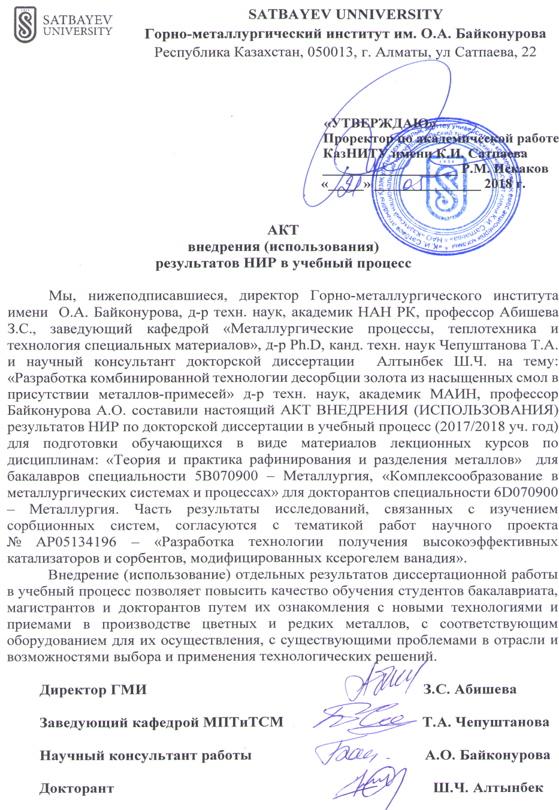

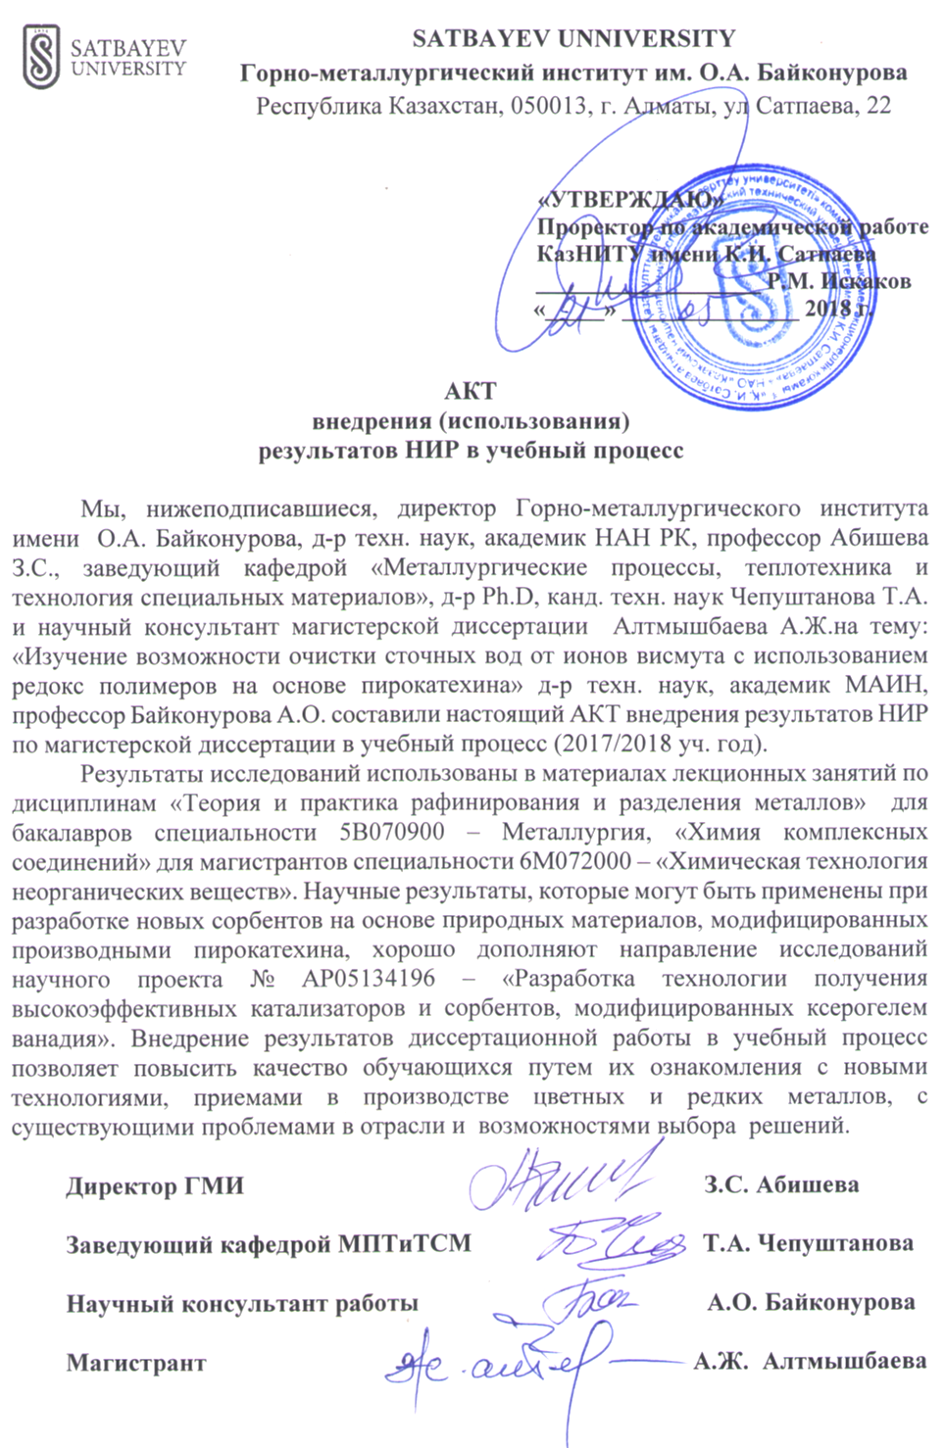
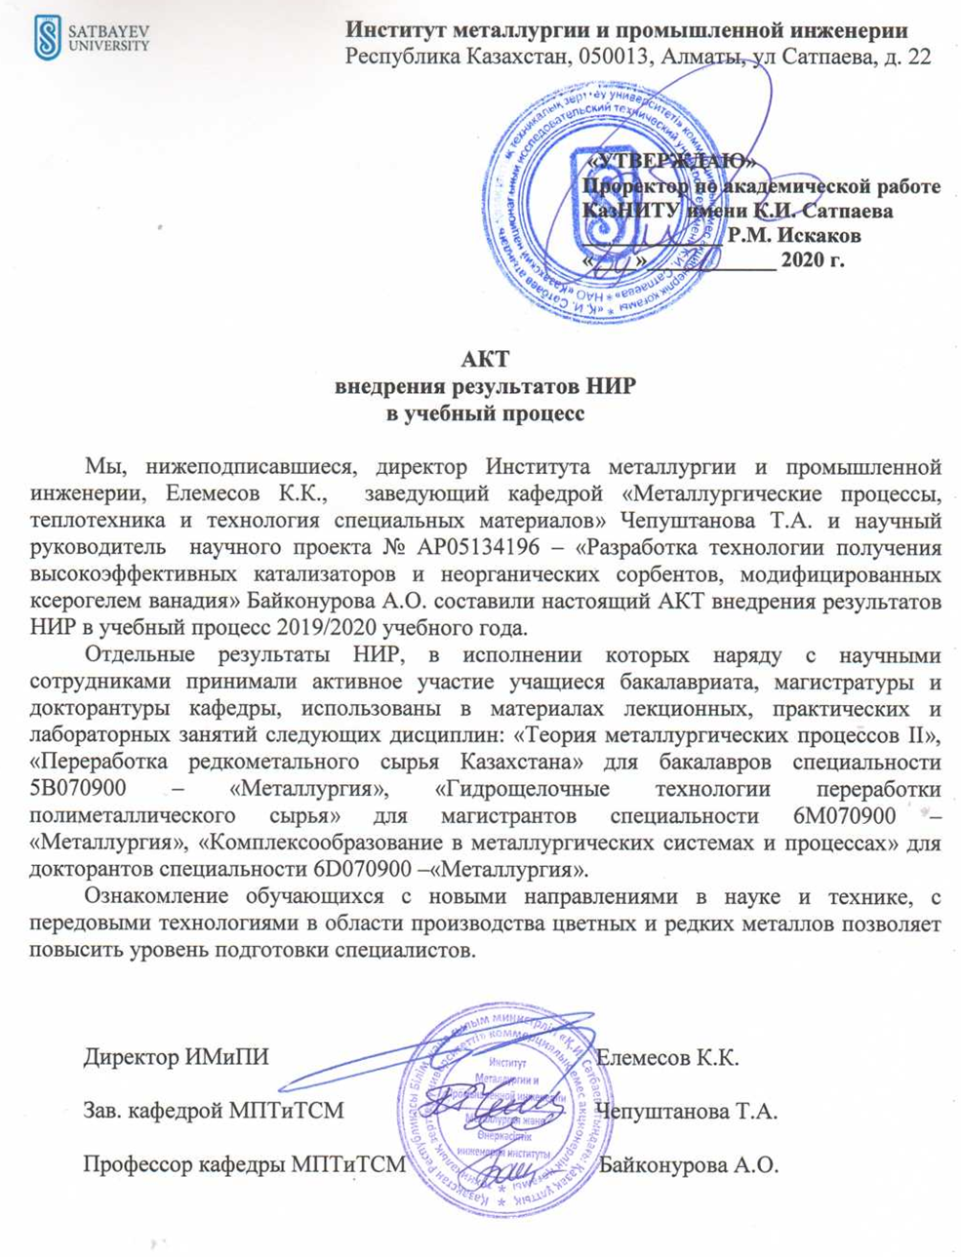

APPENDIX H

Technology laboratory tests

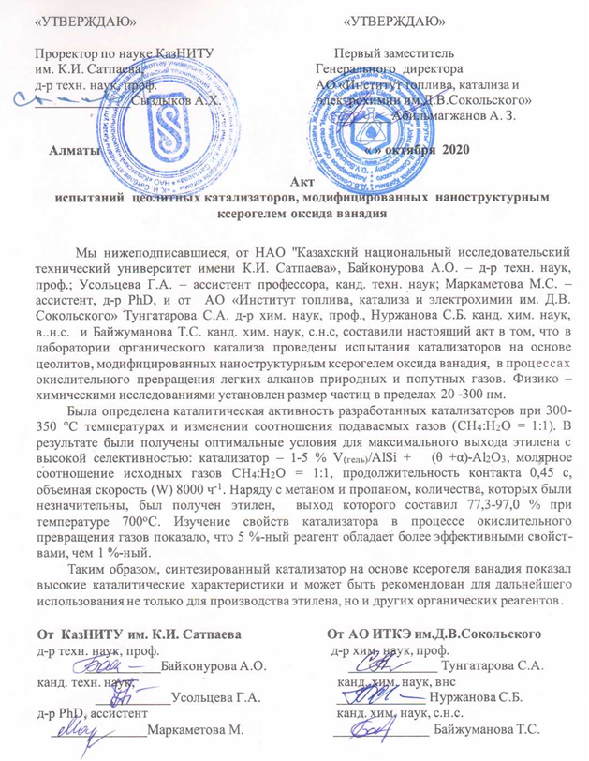

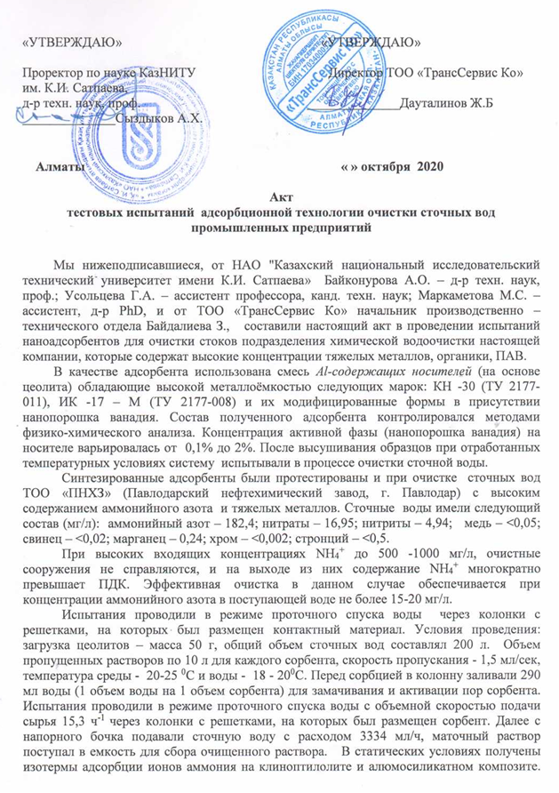

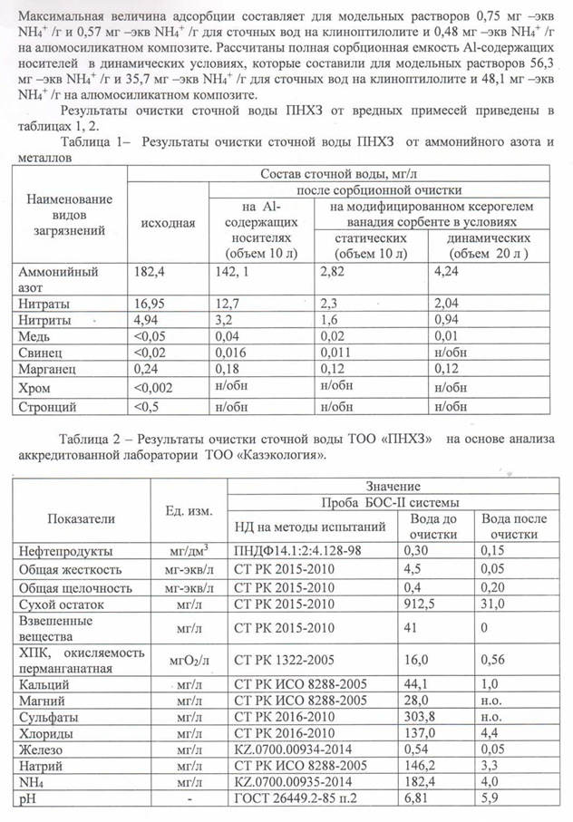

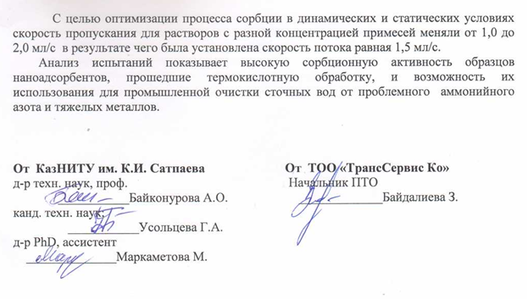

APPENDIX I

Extracts from the minutes of the discussion of the report

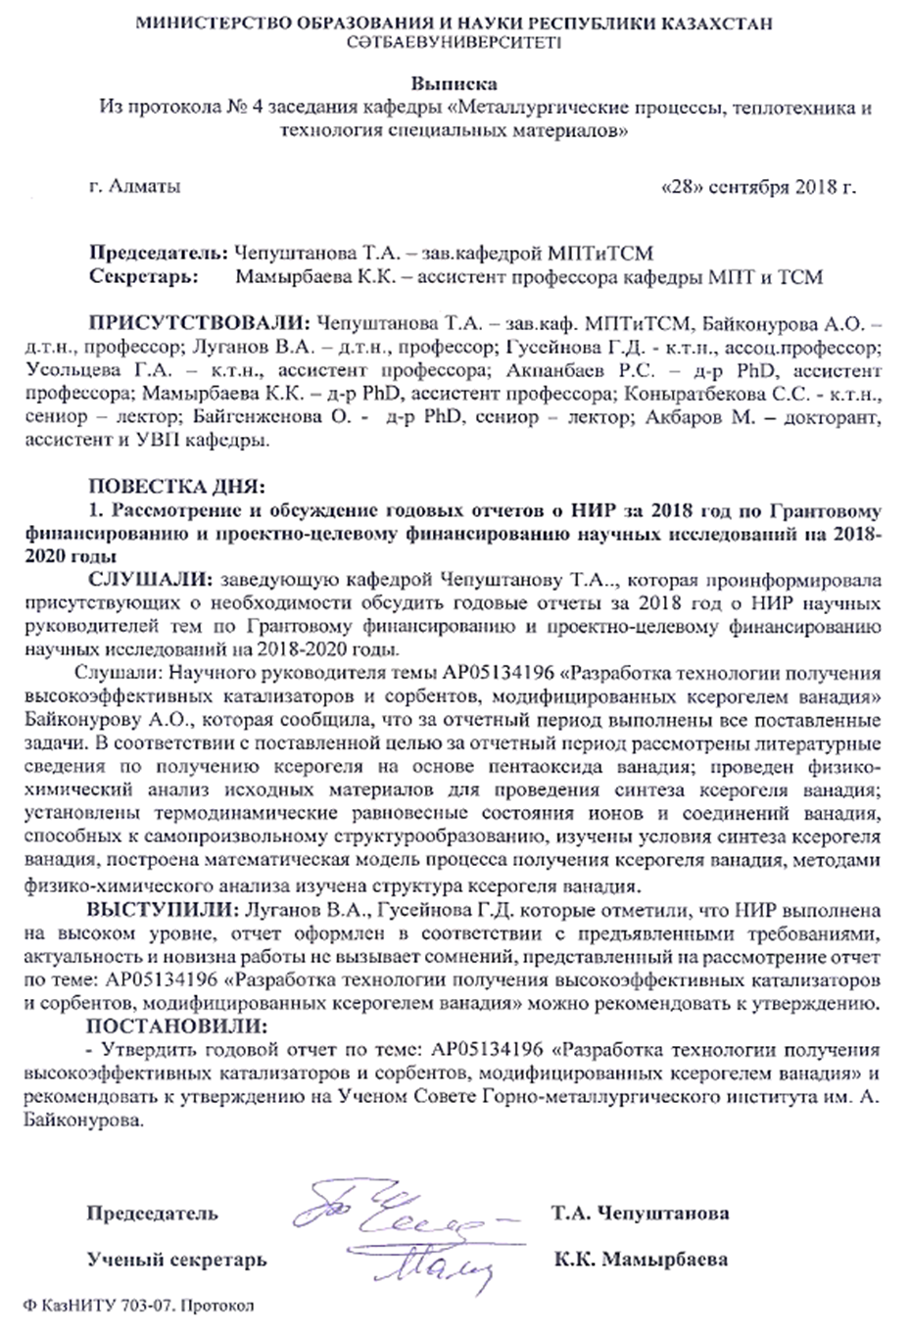

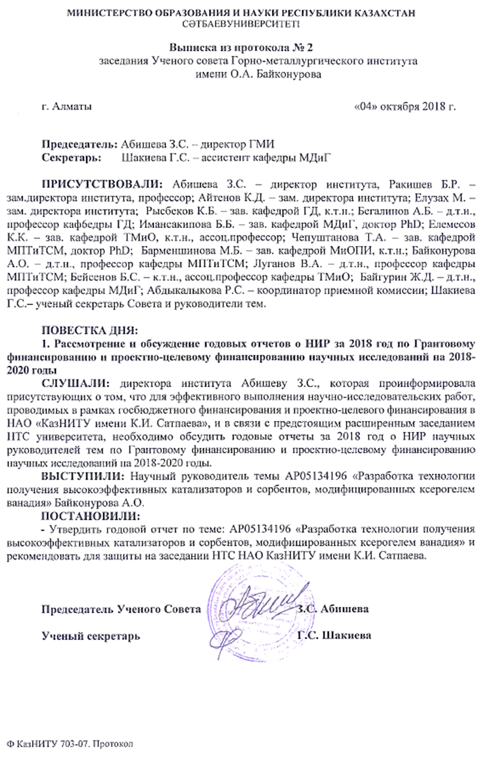
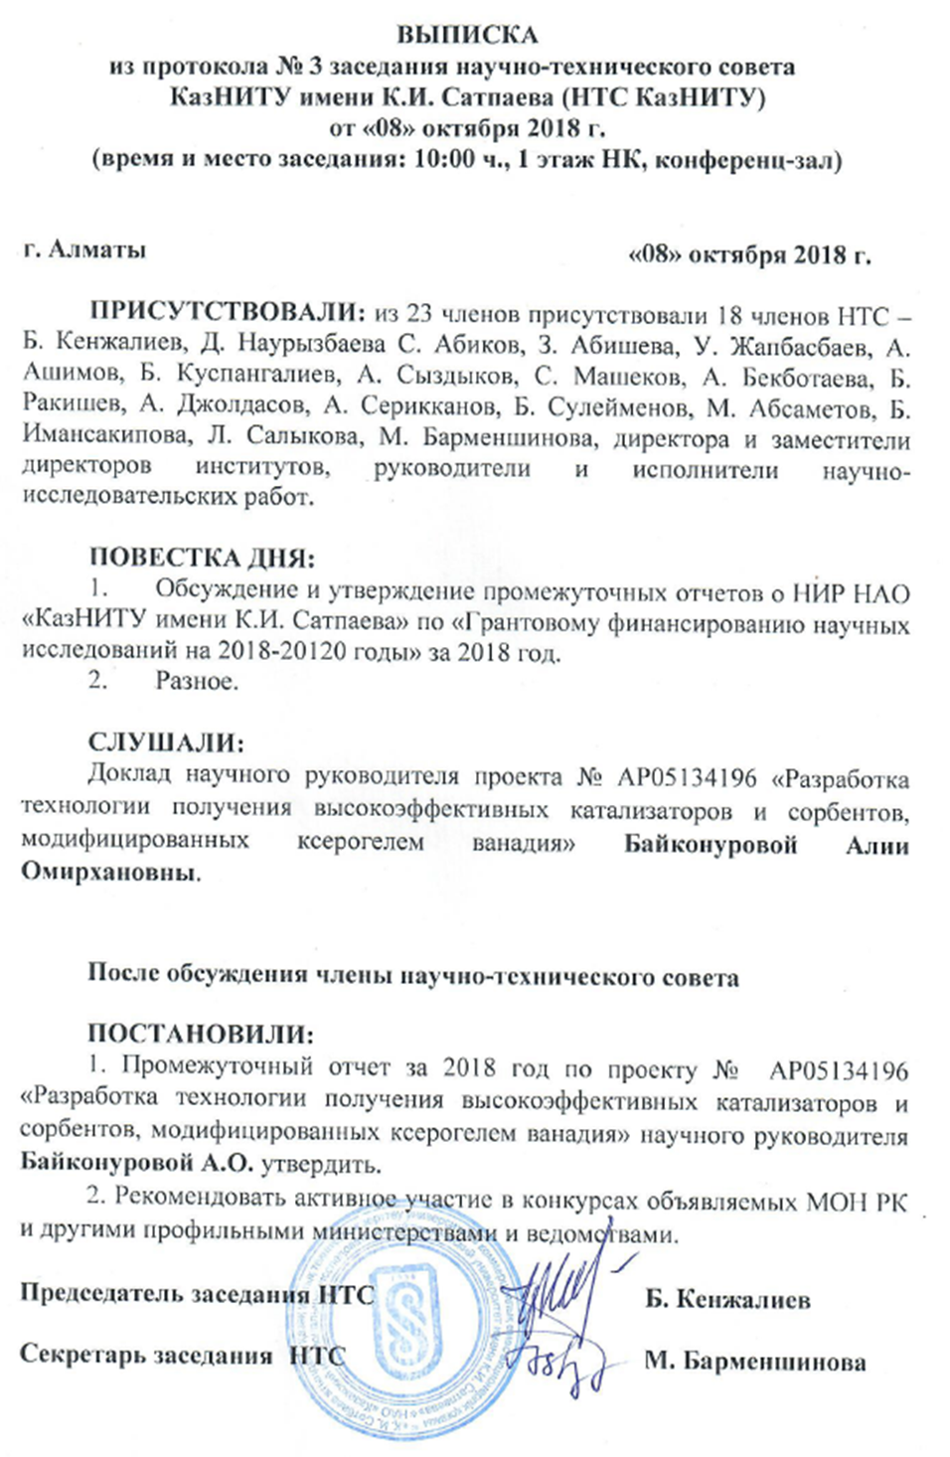

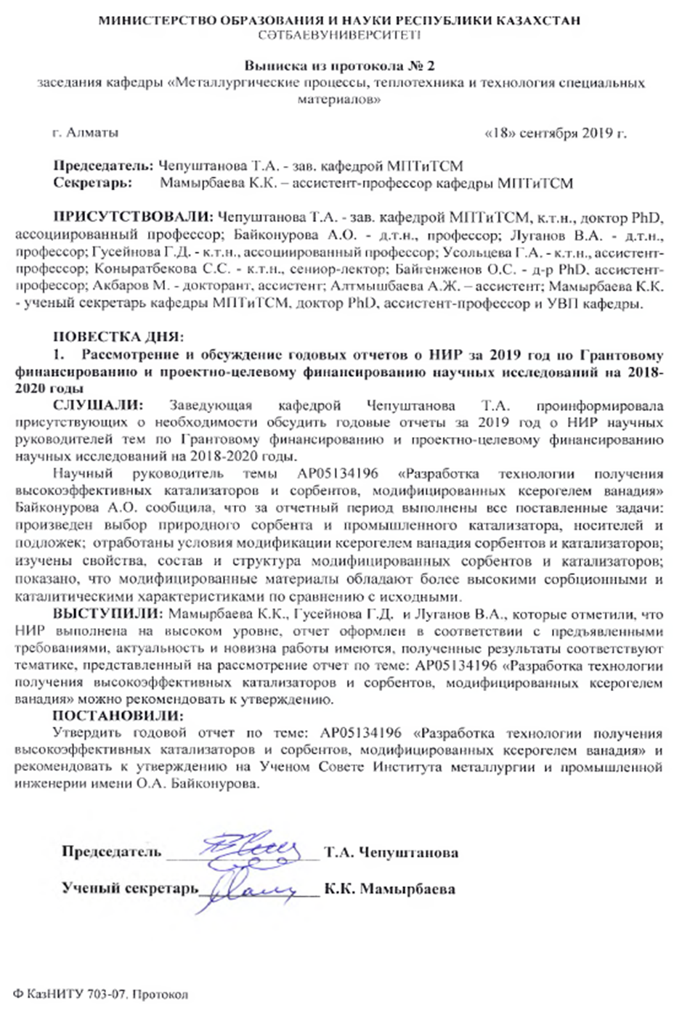

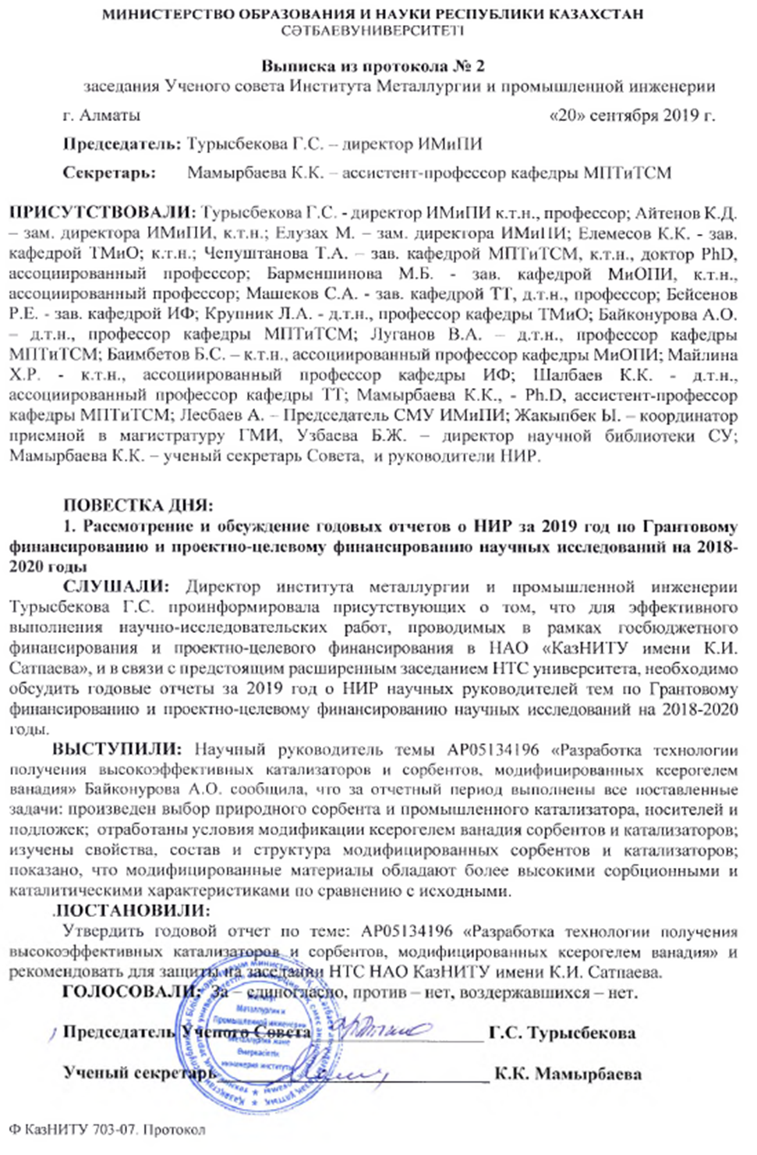
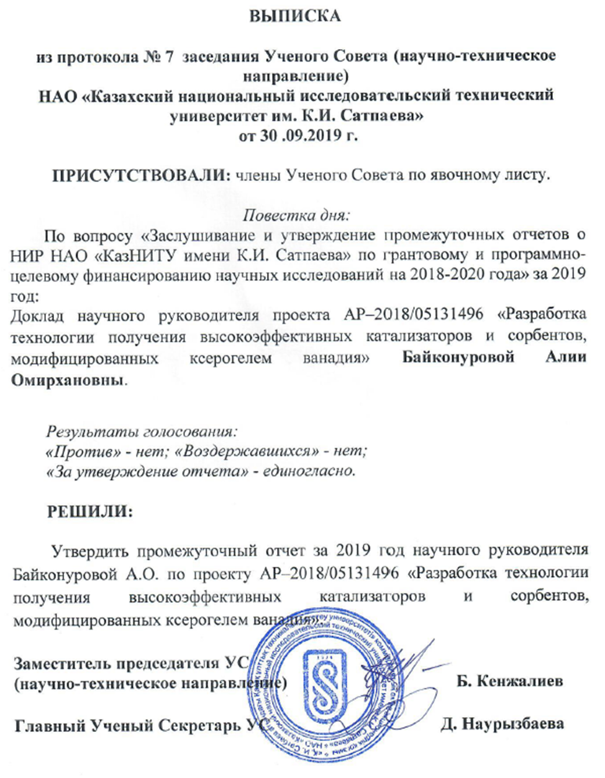

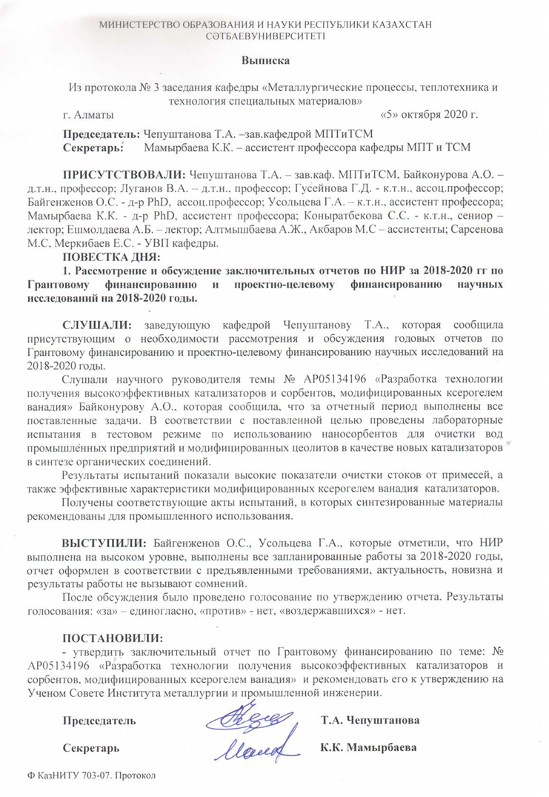

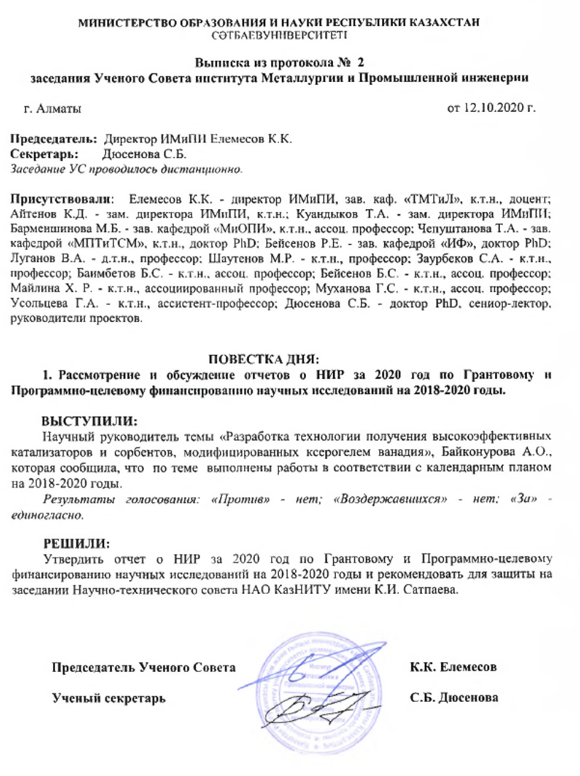

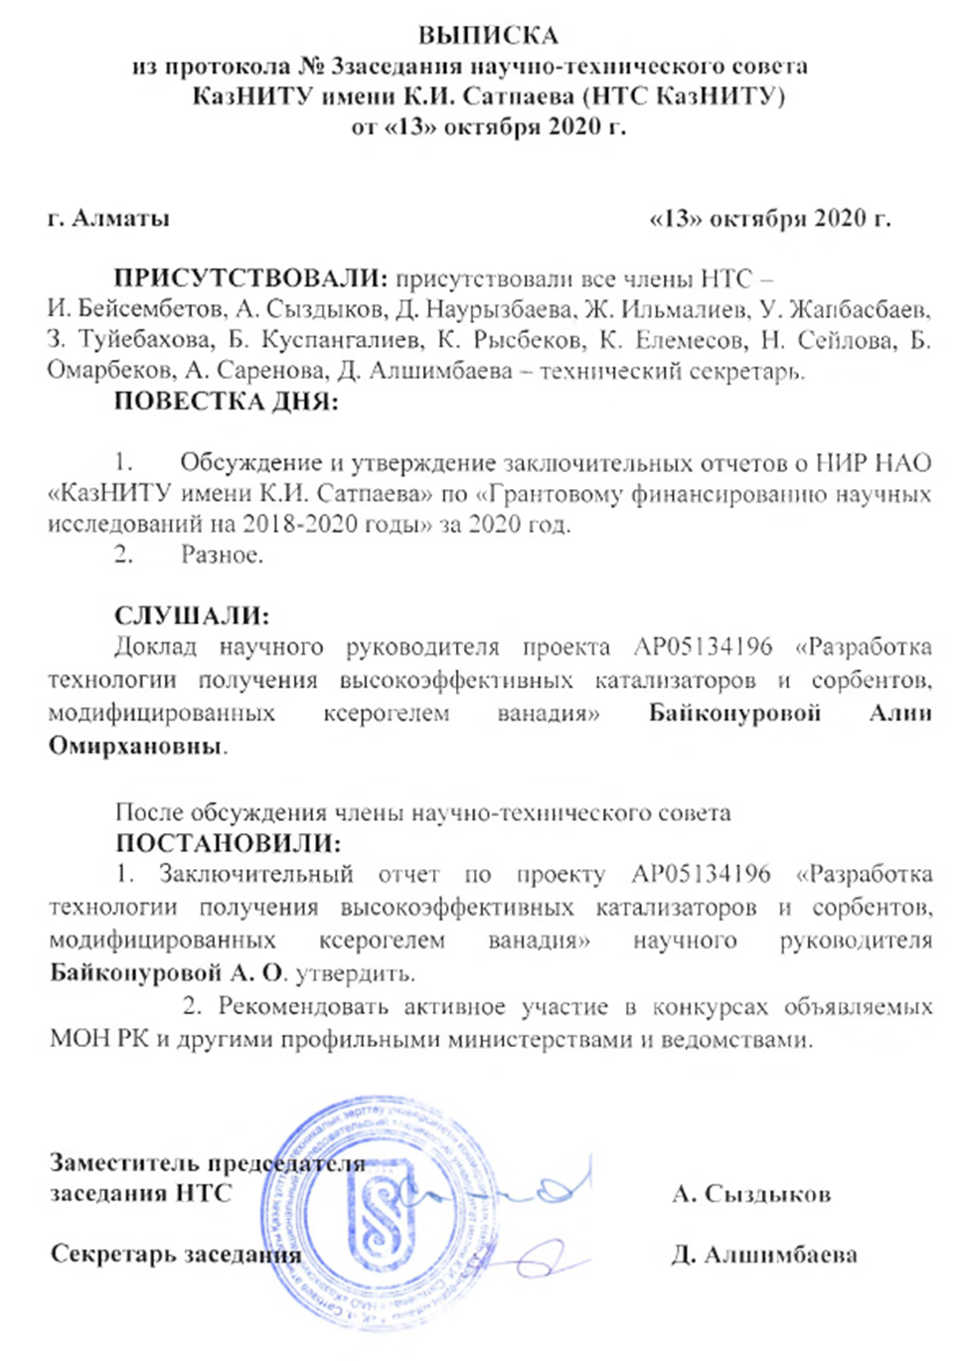

APPENDIX J
Forms for grant financing (results for 2018-2020)

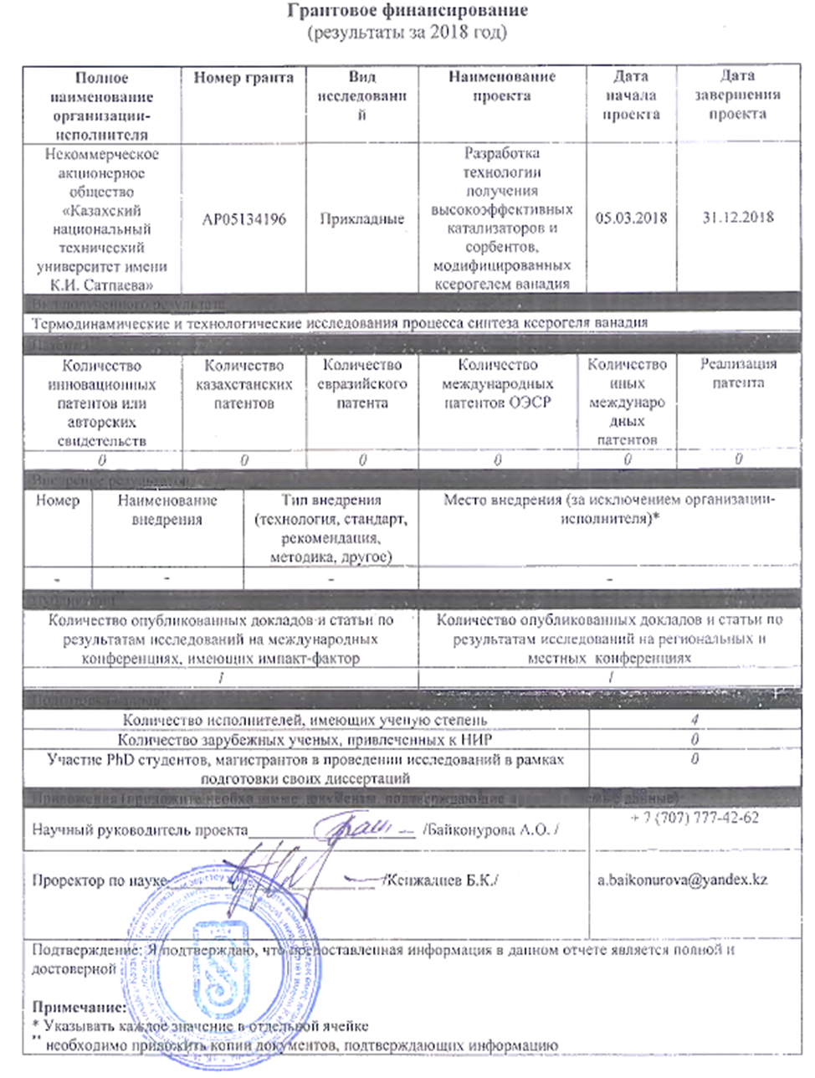

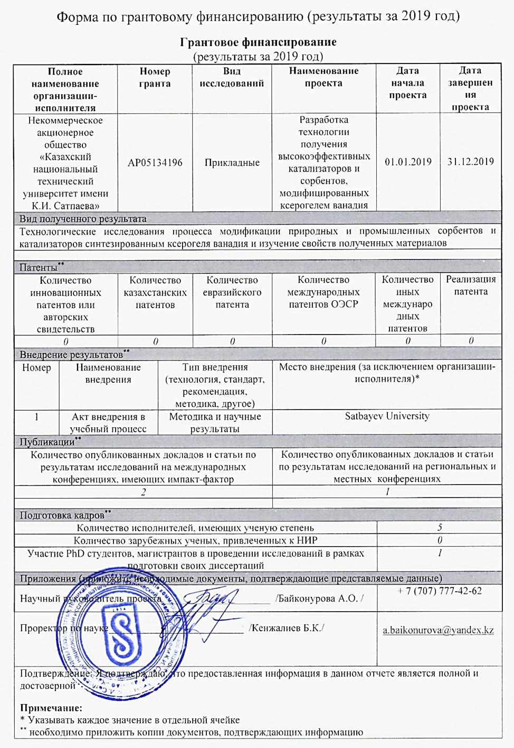

Grant financing
(results for 2020)
Полное наименование организации-исполнителя |  | Номер гранта |  | Вид исследований | Наименование проекта | Дата начала проекта |  | Дата завершения проекта
Некоммерческое акционерное общество «Казахский национальный технический университет имени К.И. Сатпаева» |  | AP05134196 |  | Прикладные | Разработка технологии получения высокоэффективных катализаторов и сорбентов, модифицированных ксерогелем ванадия | 05.03.2018 |  | 01.11.2020
Вид полученного результата
Апробация разработанных модифицированных материалов в тестовом лабораторном масштабе
Патенты**
Количество инновационных патентов или авторских свидетельств |  | Количество казахстанских патентов |  | Количество евразийского патента | Количество международных патентов ОЭСР |  | Количество иных международных патентов | Реализация патента
0 |  | 1 заявка на патент |  | 0 | 0 |  | 0 | 0
Внедрение результатов**
Номер | Наименование внедрения |  | Тип внедрения (технология, стандарт, рекомендация, методика, другое) |  | Место внедрения (за исключением организации-исполнителя)*
1 | Акт испытаний модифицированных катализаторов |  | Лабораторные в тестовом масштабе |  | Г. Алматы, АО «Институт топлива, катализа и электрохимии им. Д.И. Сокольского»
2 | Акт испытаний модифицированных сорбентов |  | Лабораторные в тестовом масштабе |  | Г. Алматы, ТОО «ТрансСервис Ко»
Публикации**
Количество опубликованных докладов и статьи по результатам исследований на международных конференциях, имеющих импакт-фактор |  |  |  |  | Количество опубликованных докладов и статьи по результатам исследований на региональных и местных конференциях
2 |  |  |  |  | 1
Подготовка кадров**
Количество исполнителей, имеющих ученую степень |  |  |  |  |  | 4
Количество зарубежных ученых, привлеченных к НИР |  |  |  |  |  | 0
Участие PhD студентов, магистрантов в проведении исследований в рамках подготовки своих диссертаций |  |  |  |  |  | 1
Приложения (приложите необходимые документы, подтверждающие представляемые данные)
Научный руководитель проекта__________________ /Байконурова А.О. / |  |  |  |  |  | + 7 (707) 777-42-62 a.baikonurova@yandex.kz
Проректор по науке____________________________ /А.Х. Сыздыков/ |  |  |  |  |  | A.Syzdykov@satbayev.university
Подтверждение: Я подтверждаю, что предоставленная информация в данном отчете является полной и достоверной
Примечание:
* Указывать каждое значение в отдельной ячейке
** необходимо приложить копии документов, подтверждающих информацию

