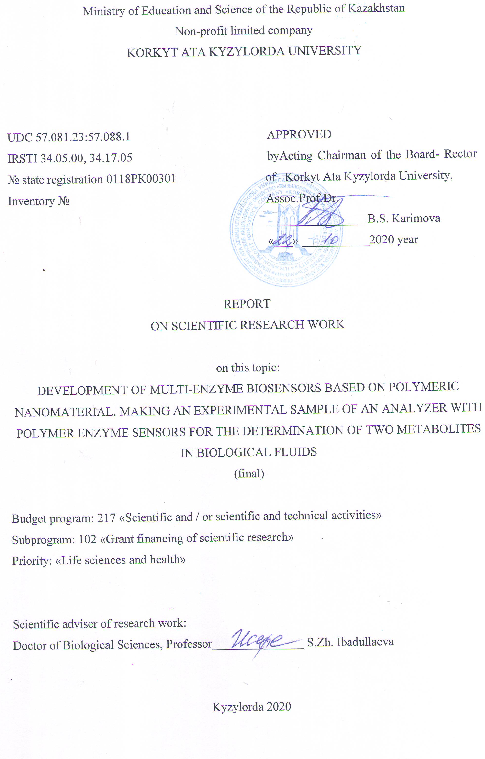
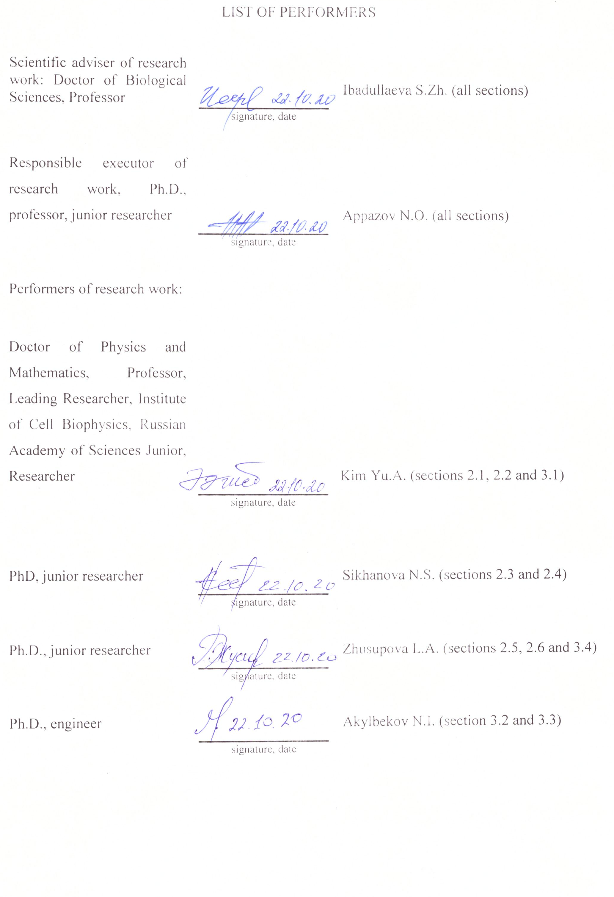
РЕФЕРАТ

Есеп 140 беттен, 19 суреттен, 159 сілтемеден, 3 қосымшадан тұрады.

МУЛЬТИФЕРМЕНТТІК БИОСЕНСОРЛАР, ПОЛИМЕРЛІК НАНОМАТЕРИАЛ, КАПСУЛАЛАНҒАН ФЕРМЕНТТЕР, МИКРОКАПСУЛАЛАР, МИКРОҰЯЛЫ ПОЛИЭЛЕКТРОЛИТТІ ЖАБЫН, МИКРОРЕАКТОРЛАР
Зерттеудің нысаны: бір ферментті микрокапсулалар, екі ферментті микрокапсулалар, полимерлі қабаттар мен ферментті микрокапсулалардың комбинациясынан тұратын, жаңа полимерлі ферментті және мультиферментті жабынды құрайтын биосенсорлық датчиктер.
Жобаның осы кезеңінің мақсаты: биологиялық сұйықтықтардың метаболиттерін анықтау үшін полиэлектролиттер қабаттарының арасында орналасқан ферментті микрокапсулалар негізінде дайындалған мультиферментті жүйені дайындау технологиясын әзірлеу.
Әдістер: кальций карбонатты құрамды қабықты бөлшектер алу; ферментті полиэлектролитті микрокапсулаларды алу.
Жұмыс нәтижелері және жаңашылдығы:
Жобаны орындаудың осы кезеңінде полиэлектролитті капсулаларға және уреаз ферменттері мен желкек пероксидазына енгізілген тиісті субстраттарды анықтау қабілетін зерттеу бойынша бірінші кезеңде орындалған зерттеулер жалғастырылды. Амперометриялық әдіспен глюкозооксидаза ферментін зерттеу жүргізілді. Әлемдік тәжірибеде алғаш рет бір микрокапсулада глюкозооксидаз және желкек пероксидазы ферменттерінің булары бірге инкапсурленген зерттеулер жүргізілді. Глюкоза оксидазасы - желкек пероксидазасының жұбын қамтамасыз ететін конъюгацияланған каталитикалық реакцияны қолдану арқылы глюкозаны спектрофотометриялық әдіспен өлшеудің негізгі мүмкіндігі көрсетілген.
Жоба нәтижелерінің мақсаты және қолданылу саласы
Жүргізілген зерттеулер қолданбалы мәнге ие, себебі болашақта ферментті микрокапсулаларды иммобилизациялау бойынша әзірленетін технологияның негізгі мақсаты сұйықтықтағы әртүрлі заттардың биосенсорлық анализатор-құрылғыларын басқаруда арзан, портативті, жеңіл кең спектр үшін ферментті сенсорлық датчиктерді құру болып табылады. Биосенсорларға қажеттілік әлемде жыл сайын денсаулық сақтау, экологиялық қауіпсіздік, тамақ өнеркәсібі, ауыл шаруашылығы сияқты салаларда өсуде.

ESSAY

The report contains 140 pages, 19 figures, 159 references, 3 applications.

MULTI-ENZYME BIOSENSORS, POLYMER NANOMATERIAL, ENZYMES INCLUDED, MICROCAPSULES, MICROWAY POLYELECTROLYTE COATING, MICROREACTORS

The object of the study was: microcapsules with one enzyme, microcapsules with two enzymes, biosensor sensors, which are a combination of polymer layers and microcapsules with enzymes and form a new polymeric enzyme and multienzyme coating.
The aim of this work was to study the catalytic activity of the multienzyme system glucose oxidase - horseradish peroxidase for the determination of glucose using microreactors based on encapsulated enzymes.
Methods: obtaining composite calcium carbonate crustal particles; obtaining polyelectrolyte microcapsules with enzymes; production of enzyme-containing polymer coatings.
Results of work and their novelty:
At this stage of the project, the studies carried out at the first stage to study the ability to detect the corresponding substrates included in polyelectrolyte capsules and polymer microcellular coating of the enzymes urease and horseradish peroxidase were continued. The amperometric method was used to study the enzyme glucose oxidase. The fundamental possibility of measuring glucose by the spectrophotometric method using a coupled catalytic reaction providing a pair of glucose oxidase - horseradish peroxidase is shown.
Purpose and scope of project results
The studies carried out are of practical importance, since, in the long term, the main goal of the developed technology for immobilizing microcapsules with enzymes is to create enzyme sensor sensors for a wide range of cheap, portable, easy-to-use biosensor devices-analyzers of various substances in liquids. The need for biosensors is steadily growing in the world every year in such areas as health care, environmental safety, food industry, agriculture.

CONTENT
INTRODUCTION …..……………………………………………………………………... |  | 7
MAIN PART OF THE RESEARCH REPORT |  | 8
1 | Multi-enzyme complexes and polymers in electrochemical biosensors …………… | 8
1.1 | Multienzyme complexes in biosensors …………………………….……………… | 13
1.1.1 | Biosensors with two enzymes ………………………….………………………….. | 14
1.1.2 | Biosensors with three or more enzymes….................................................................... | 15
1.1.3 | Acetylcholine biosensors………................................................................................... | 18
1.1.4 | Amperometric biosensors for the determination of acetylcholines and cholines….... | 19
1.1.5 | Cholinesterase multienzyme biosensors………….………………………………… | 20
1.1.6 | Application of multienzyme biosensors…………........................................................ | 26
1.2 | Enzyme electrodes with polymer matrix…………...................................................... | 27
2 | Materials and methods of research................................................................................. | 34
2.1 | Reagents and equipment…............................................................................................. | 34
2.2 | Obtaining enzyme-containing calcium carbonate crustal particles………….............. | 34
2.3 | Preparation of enzyme-loaded polyelectrolyte microcapsules………………............ | 35
2.4 | Method of obtaining ultra-thin microcellular polymer coating…………………....... | 36
2.5 | Determination of hydrogen peroxide concentration by spectrophotometric method............................................................................................................................. | 36
2.6 | Statistical processing of results…………...................................................................... | 37
3 | Results of studies and discussion of results………………………........……............. | 38
3.1 | The ratio of the activity of enzymes that make up the cascade reaction...................... | 38
3.2 | Assessment of the stability of encapsulated enzymes over time………...................... | 39
3.3 | Comparison of free and encapsulated glucose oxidase activity…………………...... | 40
3.4 | Comparison of the activity of free and immobilized glucose oxidase on a biosensitive coating…………….................................................................................... | 41
CONCLUSION..…………………………………………………………………………… |  | 43
LIST OF USED SOURCES………………………....……………………………………... |  | 44
APPLICATION A – Calendar plan of work……......................................................................... |  | 57
APPLICATION B – List and reprints of published works based on research results………................................................................................................................................... |  | 68
APPLICATION C – Technical task ………………………………….……………………… |  | 130

LIST OF ABBREVIATIONS AND SYMBOLS
In this research report, the following abbreviations and symbols are used

CNT | - | carbon nanotubes - карбоновые нанотрубки
CS | - | chitosan - хитозан
GA | - | галактозооксидаза
GCE | - | стеклоуглеродный электрод
GDH | - | глицеролдегидрогеназа
GPTMS | - | γ-glycidoxypropyltrimethoxysiloxane
Ig | - | ИГ - иммуноглобулин
L | - | лактаза
LbL | - | layer by layer technique – послойная электростатическая самосборка
PANIG | - | glutaraldehyde modified polyaniline - глутаральдегид модицифированный полианилин
PPy | - | polypyrrole – полипиррол
PQQ | - | пирролохинолинхинон
SWNT | - | одностенные углеродные нанотрубки

INTRODUCTION

Based on the results of the research work, two interim reports were prepared:
1. Development of multi-enzyme biosensors based on polymeric nanomaterial. Making an experimental sample of an analyzer with polymer enzyme sensors for the determination of two metabolites in biological fluids. Inventory number - 0218РК00897.
2. Development of multi-enzyme biosensors based on polymeric nanomaterial. Making an experimental sample of an analyzer with polymer enzyme sensors for the determination of two metabolites in biological fluids. Inventory number - 0219РК00745.
Currently, biosensors have been developed using one, two, or even several enzymes immobilized on the electrode surface, but at the moment there are relatively few such works, even less work is known on the use of cascade reactions catalyzed by immobilized multienzyme systems due to the complexity of manufacturing multienzyme sensors: each enzyme needs to be worked individually. For example, in chemical immobilization, each enzyme must be modified and attached to a substrate; in physical immobilization, the response time can be quite long. Consequently, fabricating a multienzyme sensor is a challenging task, the solution of which, in turn, will open up a new spectrum of clinical and pharmaceutical applications.
The aim of this work was to study the catalytic activity of the multienzyme system glucose oxidase - horseradish peroxidase for the determination of glucose using microreactors based on encapsulated enzymes.
To achieve this goal, the following tasks were set:
To manufacture polyenzyme biosensor systems based on polyelectrolyte microcapsules, which can provide the passage of conjugated catalytic reactions (cascade reactions) by the example of glucose oxidase and horseradish peroxidase.
To study the possibilities of determining the physiological concentrations of substrates using the multienzyme system glucose oxidase-horseradish peroxidase.
Analyze the stability of the performance of glucose oxidase enclosed in polyelectrolyte microcapsules.

MAIN PART OF THE RESEARCH REPORT

1 Multienzyme complexes and polymers in electrochemical biosensors

Biosensors are classified as types of chemical sensors in which the recognition system has a biochemical nature and uses the reactions of individual biomolecules (enzyme or group of enzymes), or biological supramolecular structures in direct spatial contact with the transducer [1]. According to IUPAC (International Union of Pure and Applied Chemistry), a biosensor is an independent integrated bioreceptor / transducer device designed to obtain selective quantitative or semi-quantitative analytical information using a biorecognition element [2]. The use of biosensors has gained immense importance in the fields of drug development, biomedicine, food safety standards, defense, safety and environmental quality monitoring.
When creating biosensors, detectors are used that allow converting the [transducer] recognition signal into physical or chemical processes that can be recorded by specialized detectors designed to convert the registered changes into electric current (figure 1). From the converter, the signal enters the electronic unit (potentiostat) for its amplification and transmission to the electronic device for reading and processing the analysis data (computer).
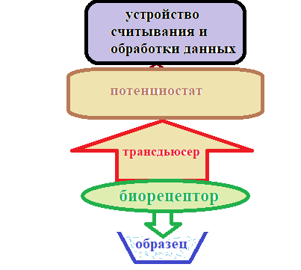
Figure 1 - Block diagram of the principle of operation of biosensors

The overwhelming majority of works devoted to the creation of biosensors are devoted to electrochemical methods of signal registration, in particular, these are potentiometry and amperometry. They are simple in design, have the ability to miniaturize, are reliable in measurement, are characterized by low detection limits and small operational volumes, which is especially important in the analysis of biological samples [3, 4]. In addition, much attention is paid to the development of enzyme biosensors, since they are convenient for use in sensors, as specific and sensitive bioreceptors in determining the concentration of a wide range of substrates.
Since the demonstration of the first enzymatic biosensor - the biosensor for glucose determination [5], this area has expanded significantly and great efforts have been directed to research to increase their efficiency and widespread use for diagnostic purposes. Glucose biosensors dominate the current market for these devices, and are the main diagnostic criteria for diabetes [6], as this disease is the most common in the world. Diabetes mellitus has become a progressive disease in recent years, which has determined the widespread use of glucose sensors in practice. A brief history of biosensors, basic principles of operation, requirements for analytical characteristics and the current status of glucose biosensors, as well as an assessment of their testing reliability in clinical practice, are discussed in the article [7].
The key element of any biosensor is a surface with a bioelement (bioreceptor (Figure 1)) that interacts with something - this is the part of the sensor that detects a certain analyte. In this capacity are, in particular, antibodies, aptamers, molecular imprinted polymers (MIP), enzymes.
Antibodies (immunoglobulins, Ig, Ig) are protein compounds of blood plasma formed in response to the introduction of bacteria, viruses, protein toxins and other antigens into the human body or warm-blooded animals. Antibodies are widely used in biosensors and other immunoassays due to the presence of antibodies against a wide range of targets. Two heavy chains are inside the molecule, two light chains are outside. They are all stitched together by disulfide bridges (S-S). Antibody isotypes - dimers (IgA) and pentamers (IgM) (Figure 2).
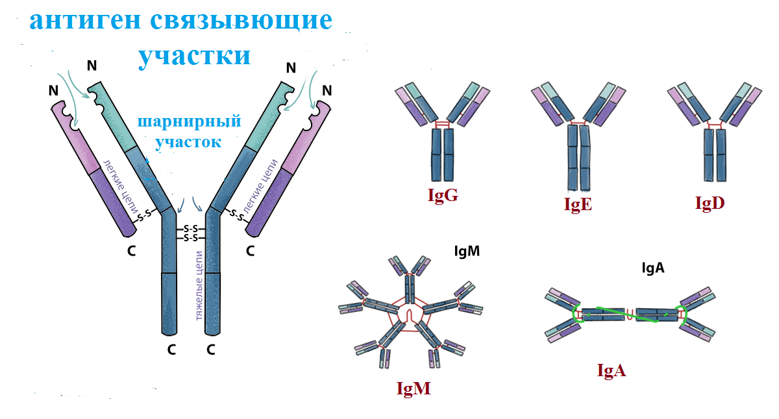
Figure 2 - Scheme of the structure of the antibody

The methods that researchers used to develop highly specific and sensitive biosensors based on recombinant antibodies for detecting antigens in simple or complex biological samples are described in a review [8].
Aptamer - oligonucleotide or peptide molecules that specifically bind to certain target molecules (Figure 3).
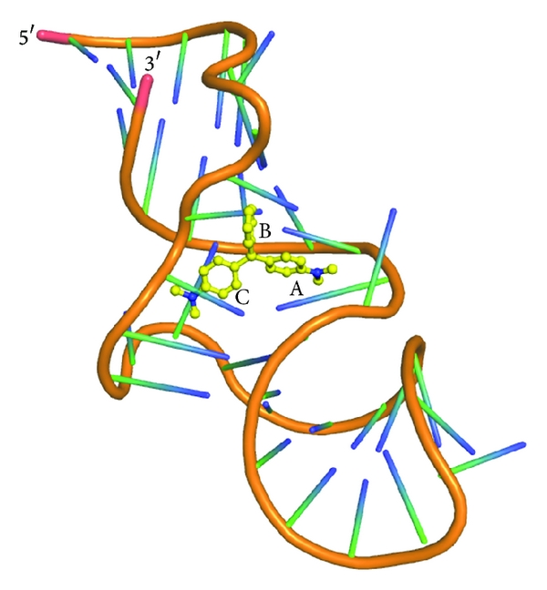
Figure 3 - Aptamers of nucleic acids: research tools in the diagnosis of diseases

Recently developed aptasensors for the detection of antibiotics such as β-lactams, aminoglycosides, anthracyclines, chloramphenicol, (fluorine) quinolones, lincosamide, tetracyclines, and sulfonamides have been reviewed [9].
Molecularly imprinted polymers (MIP) are a bioelement that is synthesized by polymerization of monomers around the target and can be separated, leaving an imprint, capturing the target with high specificity. They mimic antibody binding sites, replacing the amino acid scaffolds of proteins with synthetic polymers (Figure 4).
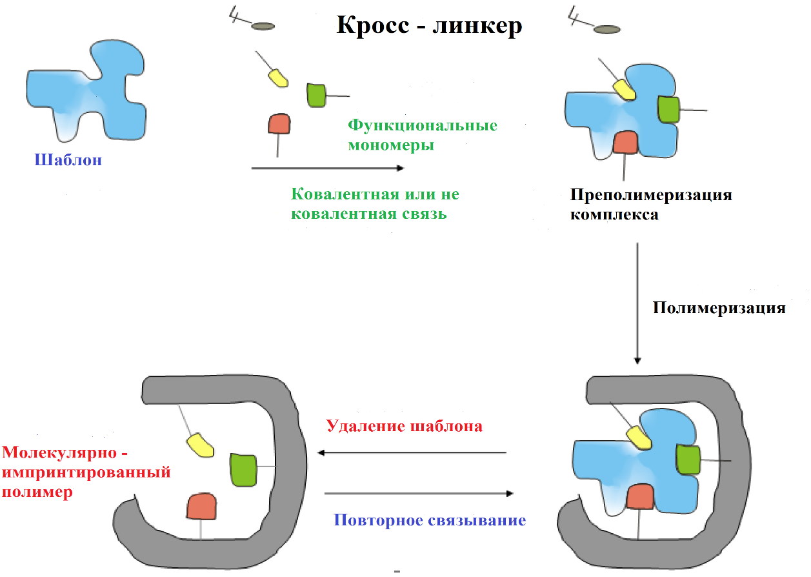
Figure 4 - Simplified workflow for the production of molecularly printed polymers (MIP)

The concept of a fully synthetic so-called molecularly imprinted polymer was implemented by Wolfe and Mosbach [10, 11]. The review [12] presents the latest results, main trends and prospects of electrosynthesized protein MIPs for chemical probing. Compared to antibodies and aptamers, MIPs have only been developed for a limited range of proteins, and nearly half of the published work still uses hemoglobin, serum albumin, and avidin as model templates.
The first molecularly imprinted polymers for the recognition of the diagnostically significant enzyme butyrylcholinesterase (BuChE) are presented in [13]. MIP was prepared using electropolymerization of a functional o-phenylenediamine monomer and applied as a thin film onto a glassy carbon electrode by oxidative potentiodynamic polymerization.
Enzymes are protein molecules synthesized by living cells and are biological catalysts for chemical reactions (Figure 5). The high specificity of the enzyme for its target makes it very attractive for biosensor applications. The combination of enzymes with electrochemical sensors makes it easy to detect metabolites, drugs, antigens and antibodies.
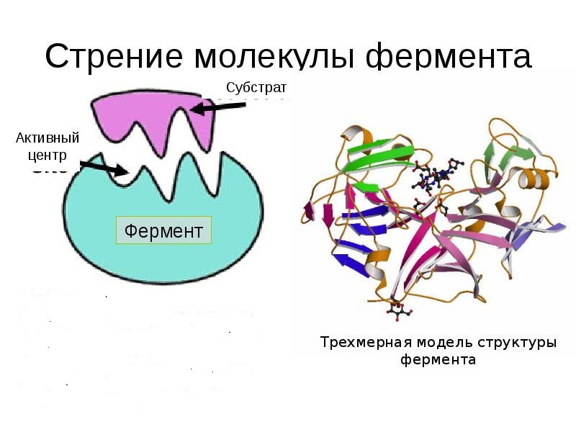
Figure 5 - The structure of the enzyme

A review of recent advances in the development of biosensors using inhibition of cholinesterases, photosynthetic system II, alkaline phosphatase, cytochrome P450A1, peroxidase, tyrosinase, laccase, urease, and aldehyde dehydrogenase is presented in article [14].
Stable attachment of the enzyme to the surface of the transducer is the most important step in the development of a biosensor, and this has led to the solution of several problems, such as enzyme loss, preservation of enzyme stability, and the shelf life of the biosensor. Enzyme immobilization can provide shorter enzymatic response times and provide disposable devices that can be easily used in stationary or flow systems. Each immobilization method has its own advantages and disadvantages, and the choice of the applicable method depends on the nature of the enzyme, sensor and detection mode [15]. The most commonly used immobilization methods include adsorption, physical trapping, microencapsulation, covalent binding, and crosslinking (Figure 6).
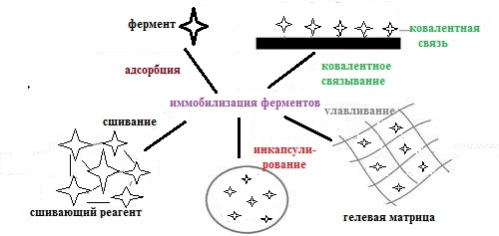
Figure 6 - Methods for enzyme immobilization

1.1 Multienzyme complexes in biosensors

Research aimed at increasing the efficiency of biosensors is closely related to the tasks of increasing the sensitivity, selectivity and expanding the range of analytes that can be determined. One of these tasks is the introduction of a cascade multienzyme reaction into biosensors. In biology, cascades of enzymatic reactions are widespread, which consist of several enzymatic stages of the same type, and the substrate at each stage is a protein, which is converted into an active enzyme as a result of the reaction. This enzyme, in turn, uses another protein as a substrate, converting it into an active enzyme [16], and so several times, which accelerates the course of reactions. The use of two or more enzymes in a biosensor increases the sensitivity and accuracy of the measurement and, in addition, expands the range of application, which is a typical limitation for biosensors based on one enzyme. In some cases, biosensors based on a single enzyme cannot be used for analyte detection. For example, triglycerides in a serum sample can be determined electrochemically based only on a three-enzyme cascade reaction [17] because there is no enzyme that could directly oxidize analytes and produce electroactive substances.
The problem of creating multienzyme systems and bioreactors is the most difficult topic for researchers in biosensor technologies. The use of enzymatic cascade reactions in biosensors is discussed in detail in reviews [18, 19], and the possibility of introducing cascade multienzyme modified electrodes that sequentially bind the bioelectrocatalytic activity of various enzymes is considered in [20].
Electrochemical and optical biosensors are the main technological components in the development of high-quality biosensors. In most developments of multienzyme biosensors using cascade chemical reactions, electrochemical methods of signal measurement are used [21, 22].
The basic principle of operation of multienzyme electrochemical biosensors is based on cascade multienzyme reactions containing redox and non-redox enzymes that are capable of converting analytes into a specific form, which can be oxidized by the following redox enzyme reaction [21]. Any possible enzyme such as kinase, transferase, invertase and hydrolase can be used as a non-oxidizing enzyme for the analyte conversion reaction. Below are examples of some biosensor designs using 2 or more enzymes.

1.1.1 Biosensors with two enzymes
The first artificial bienzymatic system, including immobilized enzymes covalently bound to a polymer carrier, hexokinase and glucose-6-phosphate dehydrogenase, was created in 1970 by K. Mosbach [23]. The polymers used as matrices were Sepharose 4B and acrylamide-acrylic acid copolymer. Enzymes were sutured to matrices using cyanogen bromide and water-soluble carbodiimide, respectively. The enzymatic activity of the matrix-bound two-enzyme system was determined in a coupled assay after adding glucose, ATP and NADP. It has been demonstrated that the use of a two-enzyme system hexokinase-glucose-6-phosphate dehydrogenase, covalently bound to a polymer matrix, increases the efficiency of such a spatially concentrated enzyme system compared to the corresponding system with enzymes in solution in free form.
Using benzyme oxidase / peroxidase systems, amperometric biosensors for glucose, ethanol, and biogenic amines (putrescine) were constructed [24]. All developed biosensors were based on redox hydrogels formed by oxidases (glucose oxidase, alcoholic oxidase or amine oxidase), as well as purified sweet potato hepatic acid (SPP), cross-linked with a redox polymer with horseradish peroxidase (HRP). SPP electrodes showed higher sensitivity and better detection limit for putrescine than those using horseradish peroxidase (HRP) and also showed that they retain their activity in the organic phase much better than those based on HRP.
Two different configurations of biosensors: one based on glycerol dehydrogenase / diaphorase (GDH / DAP) and the other using glycerol kinase / glycerol-3-phosphate oxidase / peroxidase (GK / GPOx / HRP) for glycerol determination, is presented in [25]. Both enzyme systems were immobilized together with the mediator tetrathiafulvaline (TTF) on 3-mercaptopropionic acid (MPA) with a self-assembled monolayer modified with a gold electrode using a dialysis membrane. The electrochemical oxidation of TTF at +150 mV (versus Ag / AgCl) and the decrease in TTF (+) at 0 mV were used to monitor enzymatic reactions for the bienzyme and trienzyme configurations, respectively. For each configuration, experimental variables have been optimized regarding both the composition of the biosensors and the operating conditions. In both cases, good repeatability of measurements was obtained without the need for cleaning the biosensors. Biosensors have shown great sensitivity in the analysis of wines and have been used to determine glycerol in 12 different wines.
The horseradish peroxidase (HRP) and glucose oxidase (GOD) biosensor was constructed [26] by in situ formation of an organic-inorganic biocomposite film based on one-stage electrodeposition and a covalently bonded sol-gel process. Electrodeposition was carried out in a solution containing a functional inorganic precursor with epoxy groups, γ-glycidoxypropyltrimethoxysiloxane (GPTMS), chitosan biopolymer (CS), HRP, and GOD. The covalently bonded sol-gel process was formed by self-hydrolysis and self-condensation of GPTMS followed by in-situ covalent crosslinking of CS, HRP, and GOD through a reaction between amino groups and epoxy groups. The developed bienzymatic biosensor was highly stable in acidic solution due to covalently bound organic-inorganic hybridization. Compared to the non-hybrid HRP-GOD / CS / Au electrode, the HRP-GOD / GPTMS / CS / Au bienzyme biosensor showed improved sensitivity and a wider linear range for glucose determination. The linear response of the developed HRP-GOD / GPTMS / CS / Au biosensor for glucose determination varied from 1 to 351 μmol / L with a detection limit of 0.3 μmol / L.
To detect phosphorous and fluoride ions, we used a multienzyme biosensor system [27] in which the effect of the concentration and rate constant of the reaction of an inhibitor with two enzymes in a dynamic mode was studied. Stationary performance indicators of a system of multienzyme inhibitors that hydrolyze glucose-6-phosphates under various conditions have been studied. The influence of parameters of internal mass transfer and kinetic parameters of the inhibitor is discussed.

1.1.2 Biosensors with three or more enzymes
The three-enzyme system in biosensors was first proposed by the authors of [28], which was supposed to allow observing the effect of cumulative efficiency. The investigated system looked as follows: beta-galactosidase - hexokinase - glucose-6-phosphate dehydrogenase with reagents. Borrowed with changes from [28] (Figure 7).
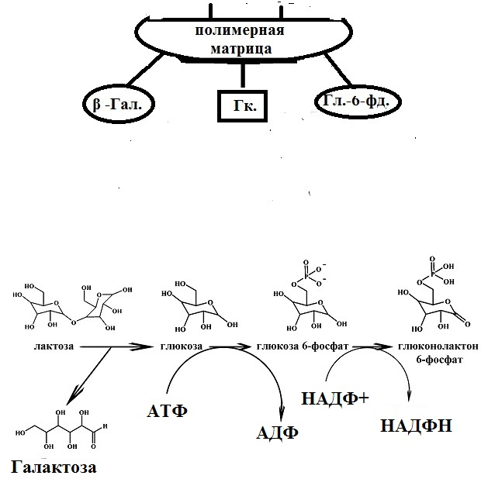

Figure 7 - Schematic representation of a matrix-bound three-enzyme system

The enzyme beta-galactosidase was chosen because it catalyzes a reaction immediately preceding that already studied using the two-enzyme sequence by Mosbach [23]. Three enzymes were surface bound to a fortified cross-linked matrix, the conjugation procedure of which is described in article [29]. It was shown that the kinetic behavior of the matrix-bound trienzyme system compared to a similar system consisting of three unbound and in solution enzymes β-galactosidase, hexokinase and glucose-6-phosphate dehydrogenase was higher before reaching a steady state.
Higher potency than the corresponding soluble system was also found when only two enzymes were involved. But in the triple enzyme system, associated with the matrix, the increase in efficiency was even more pronounced, indicating a cumulative effect. Currently, several dozen immobilized polyenzyme systems are known, consisting of two, three, four or more enzymes. The efficiency of such complexes is much higher than that of free enzymes, due to the local concentration of the substrate around the second and all subsequent enzymes included in the system.
Recently, a three-enzyme system consisting of choline kinase / choline oxidase / HRP has been proposed for the rapid and specific detection of group 2-IIA secretory phospholipase, a biomarker of bacterial sepsis infection [30]. The surface of the amperometric sensor was modified with a composite based on choline kinase / choline oxidase / HRP-linked acrylic bead / gold nanoparticles attached to a carbon electrode. The linear detection range and detection limit of the sensor were 0.01–100 ng / ml and 5 × 10–3 ng / ml, respectively.
The possibility of joint encapsulation of enzymes, for example, lactate oxidase, peroxidase, and glucose oxidase, with sensitive dyes to micron-sized sensory capsules was demonstrated by the authors of [31]. The enzymes were located in the inner part of the capsule, while the fluorescent dyes were incorporated into the shells of the polyelectrolyte microcapsules by electrostatic and hydrophobic interactions with the polyelectrolyte multilayer shells. Chemical and biosensors have been manufactured for the detection of oxygen, glucose and lactate using a single capsule as a sensitive object. Calibration of the sensor capsules has shown that millimolar glucose and lactate concentrations are easily controlled using fluorescence. Thus, the joint encapsulation of an enzyme and a fluorescent dye, which allows optical monitoring of biologically important metabolites in one microcapsule, is a unique system for studying the biological microenvironment and serves as a real-time reporter of concentration changes.
A three-electrode amperometric biosensor for the detection of two different saccharides (lactose and glucose) in aqueous solutions is described in [32]. Glucose oxidase and β-galactosidase (β-Gal) were co-immobilized into a graphite working electrode through covalent bonds. The reaction of the biosensor was studied depending on the relative concentration of two immobilized enzymes and the best working conditions were determined by measuring the sensitivity and the linear range of the reaction. In particular, the lactose biosensor showed a linear range up to 0.010 mM and a limit of detection (LOD) and sensitivity of 0.001 mM and 850 ± 81 μA / mM, respectively. For glucose, the values ​​of the above parameters are 0.015 mM for linear range, 0.001 mM for LOD, and 505 ± 55 μA / mM for sensitivity. The performance parameters of the biosensors were significant compared to other biosensors designed to measure the concentration of the two saccharides studied in the work. In particular, low (LOD) and high sensitivities are obtained for lactose and glucose. The biosensor was tested on real samples - fruit juices, skim milk, and whey.
Another amperometric biosensor based on three enzymes for the determination of lysine as an indicator of the nutritional quality of pharmaceutical compositions and food samples was presented by Bock et al. [33]. In their study, enzymes, including lysine decarboxylase from Bacterium cadaveris, diamine oxidase from Pisum sativum and HRP, were co-immobilized on the surface of a graphite electrode with an osmium redox polymer. The lysine sensor provided a linear detection range of 0.005 to 0.500 mM and showed selective detection of lysine in pharmaceutical and food products.
Four enzymes (lactase (L), glucose oxidase (G), mutarotase (M) and galactose oxidase (Ga)) were appropriately combined to form un- (Ga), di- (LG, LGa), tri- (LMG, LGGa) ) and tetra- (LMGGa) enzyme systems [34]. Six different lactose electrodes were formed based on combinations of four enzymes, and lactose was determined amperometrically by monitoring the formation of hydrogen peroxide. Among the six electrodes, the trienzyme electrode, LMG, was dominant in terms of response to lactose, with a linear range of 3 × 10-6-2 × 10-3 M, although the trienzyme LGGa electrode and the tetraenzyme LMGGa electrode showed a twofold increase in sensitivity compared to LMG. It should be noted that the biosensor based on MG electrodes showed good storage stability for eight months at 4 ° C, given that increasing the long-term stability and activity of the membranes of immobilized enzymes is important for all practical purposes of enzyme-based biosensors.
The values ​​and advantages of multienzymatic biosensors based on cascade enzymatic reactions are clear, and expanding the range of such devices is very important and can be achieved by integrating more enzymes into the sensitive layer [35, 36]. However, with an increase in the number of enzymes involved in the cascade enzymatic reaction, the sensor becomes very sensitive to interference and disturbances caused by various factors that affect each of the enzymes. In recent years, a large number of biosensors have been developed that are capable of meeting the requirements for sensitivity and selectivity associated with practical applications, but this is still insufficient for industrial production and commercialization. Complex sensor assembly processes, expensive materials, possible unwanted properties and lack of storage stability are some of the limiting factors that prevent their mass production.
Understanding the mechanisms of enzymatic reactions is an important factor in the development of effective biosensors, and the selection of suitable enzyme pairs is the starting point for the study of biosensors based on multienzyme reactions.
The technologies used in the development of biosensors based on the use of redox enzymes are one of the most rapidly developing areas of analytical chemistry due to their high selectivity, sensitivity, rapidity and reliability of measurements, compactness, and relatively low price [37]. A brief review [38] presents works on research and development of multienzyme biosensors for the determination of cholesterol, creatinine, triglycerides, methyl salicylates, and other important metabolites over the past 10 years. Below are some papers on research, development and operating principles of acetylcholine multienzyme biosensors.

1.1.3 Acetylcholine biosensors
Cholinesterases (ChE) are a family of enzymes that catalyze the hydrolysis of choline-based esters, some of which serve as neurotransmitters and belong to the esterase / lipase family in the α / β-hydrolase superfamily [39, 40] and are critical in such areas such as neurobiology, pharmacology and toxicology [41]. Acetylcholine (ACh) and choline (Ch) are important neuroactive molecules, but the in vivo detection of these compounds presents significant analytical challenges. The electrochemical determination of esters of cholinesterase and thiocholine [42] gave impetus to the appearance of electrochemical sensors for cholinesterase. The first biosensor based on cholinesterase inhibition was for the determination of organophosphorus compounds [43] and since then a large number of them based on ChE have been developed for the determination of various substances, including nerve agents and pesticides. A common disadvantage of ChE biosensors is the irreversible inhibition caused by toxic agents during the analysis.
Electrochemical analysis is one of the most widely used detection methods in biosensor systems, including cholinesterase biosensors, which can be divided into two groups: (1) monoenzyme, using only ChE as a biorecognition element, and (2) bienzyme, in which ChE is associated with choline oxidase (ChOx) [44]. Electrochemical biosensors based on immobilized ChEs use the potentiometric principle, when the ChE activity is expressed as a change in the pH of the medium by the addition of a natural substrate acetylcholine (butyrylcholine), which leads to the release of acetic (butyric) acid [45]. In [46], the activity of ChE was expressed as the rate of pH change as a result of the release of acetic acid, a product of the hydrolysis of acetylcholine (Ach). A simple electrochemical method for determining the ChE activity in human plasma, erythrocytes, and whole blood [47] has also been applied to detect carbamate-induced inhibition of ChE.

1.1.4 Amperometric biosensors for the determination of acetylcholines and cholines
Amperometric biosensors are an alternative to potentiometric ones and are quite simple compared to potentiometric devices. They provide a linear output signal that depends on the concentration of the analyte, and there are two modes for assessing cholinesterase activity - monoenzyme based on immobilized AChE (butylcholinesterase) (BChE)) and replacement of ACh (butyrylcholine (BCh)) with an alternative substrate acetylthiocholine (ATCh) butyrylthiocholine. The produced thiocholine (TCh) is oxidized to dithiol under the action of the built-in voltage (approximately +450 mV), and the anodic oxidation current TCh is inversely proportional to the inhibitor concentration in the sample [48; 49]. The mechanism of this reaction is shown in Figure 8.

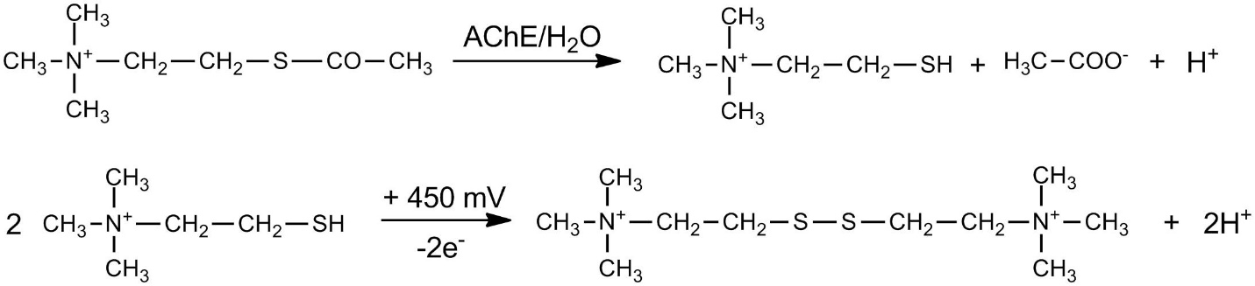
Figure 8 - Mechanism of amperometric assessment of AChE using ATCh as substrate

To detect organophosphorus and carbamate pesticides, the enzyme was electrically immobilized in an AChE biosensor into a thick conductive polypyrrole layer, which reduced the oxidative potential of thiocholine to +100 mV and increased the amperometric signal [50]. The design of a biosensor based on genetically engineered AChE, which was immobilized in a polyvinyl alcohol / Fe-Ni alloy nanocomposite [51], made it possible to reduce the applied potential to +30 mV compared to Ag / AgCl. The developed biosensor was used to detect phosmet in olive oil.
The second mode (called bienzymatic) is based on the participation of ChE, usually with choline oxidase and an amperometric oxygen or hydrogen peroxide converter, in which ACh is hydrolyzed by AChE to choline (Ch) and acetic acid. The second enzyme, choline oxidase, is involved in the development of this biosensor, which oxidizes choline to betaine and hydrogen peroxide, which is detected amperometrically [52]. The reaction mechanism is shown in Figure 9.

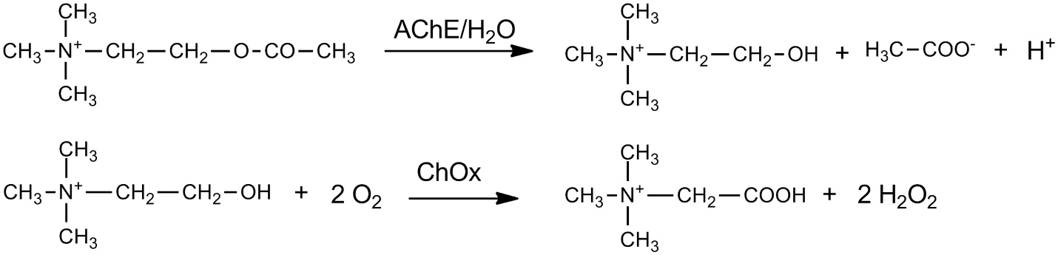

Figure 9 - Mechanism of amperometric estimation of AChE using ACh as substrate

Enzymatic activity can be determined by measuring the decrease in oxygen using a Clark electrode [53] or increase in hydrogen peroxide [54], which can be measured amperometrically using a platinum electrode. Amperometric biosensors can be used to diagnose intoxication with organophosphorus compounds by observing the activity of blood cholinesterases [49]. There are several analytes that can be analyzed using the amperometric biosensor cholinesterase: pesticides (paraoxon, dichlorvos, sulfotep), nerve agents (sarin, soman), aflatoxin, and new anticholinergic drugs [55–60]. An amperometric biosensor with immobilized BChE was used to detect nerve agents in air [61].

1.1.5 Cholinesterase multienzyme biosensors
Amperometric biosensors are the most commonly used cholinesterase biosensors, while monoenzymatic biosensors are more common due to their simpler design. Cholinesterase-based biosensors have a major drawback - they cannot selectively measure various pesticides (like ChE inhibitors), since they provide an overall parameter for ChE inhibition, and there is no qualitative or quantitative information about individual compounds. This problem was solved by using multisensor systems [62] in which two converters were connected: a potentiometric one with a pH-sensitive transistor and a conductometric one with thin-film interdigitated electrodes. Were used three enzymes (urease, AChE and BChE), which allow the simultaneous identification of several heavy metals and pesticides. The result of hydrolysis is the consumption of urea (with urease) or the production of a proton (with AChE or BChE), which causes an increase in pH and changes in conductivity on the membranes with the subsequent possibility of potentiometric or conductometric detection [63].
Multisensory systems are usually combined with artificial neural network data processing. In addition, genetically engineered ChEs with specific and high inhibition constants for target analytes are required for the detection of compound-specific multi-analytes [62]. Usually, only one enzyme is used, but in some cases it is necessary to combine several enzymes to obtain multienzyme systems, while all the enzymes used are included in the same reaction layer [64, 65]. An amperometric acetylcholine biosensor [66] was constructed by covalently co-immobilizing a mixture of acetylcholinesterase (AChE) and choline oxidase (ChO) onto a nanocomposite of chitosan nanoparticles (CHIT) / gold-coated iron (IV) oxide. The biosensor was based on the electrochemical measurement of H2O2 formed during the oxidation of choline by immobilized ChO, which, in turn, is obtained during the hydrolysis of acetylcholine by immobilized AChE. The biosensor showed an optimal response within 3 s at + 0.2 V, pH 7.0 and 30 ° C. The electrode had a linear operating range of 0.005-400 μM with a detection limit of 0.005 μM for acetylcholine. The biosensor measured the plasma acetylcholine content in apparently healthy people and people with Alzheimer's disease, was not exposed to a number of serum substances, but lost 50% of its initial activity after 100 uses within 3 months when stored at 4 ° C.
Recently, cholinesterase-based biosensors have been widely used for the analysis of anticholinergic compounds. Primarily, biosensors based on enzyme inhibition are useful analytical tools for the rapid screening of inhibitors such as organophosphates and carbamates. The review [67] summarizes the most important facts about cholinesterase-based biosensors, types of physicochemical transduction, immobilization strategies, and practical applications. Cholinesterase biosensors can be used to detect pesticides and nerve agents, which are the most common compounds. Enzymatic detection of pesticides is primarily based on ChE inhibition. Pesticides are among the most important environmental pollutants due to their increasing use in agriculture. When exporting and importing food materials, portable biosensors with fast response are convenient for their rapid detection [68]. Cholinesterase-based biosensors have been used to determine pesticides in food [69–74], water [75, 73, 76], and soil [77].
Cholinesterase biosensors are also used in the diagnosis and treatment of certain diseases [68]; in particular, Lenigk et al. Used an amperometric biosensor based on the immobilization of AChE and ChOx using a gel trap to study Alzheimer's disease [78]. The developed amperometric biosensor determined in vitro inhibition of acetylcholinesterase, which was co-immobilized with choline oxidase on the surface of the working electrode of the three-electrode system using gel capture. The sensor was used to determine the IC50 values ​​of two known and one newly developed drug for Alzheimer's disease. Simultaneous measurement by standard photometric method has shown the applicability of the method for rapid drug screening.
Ozturk et al described a method of photophysical characterization of fluorescent oxazol-5-one derivatives in PVC, which were used to detect the AChE inhibitor donepezil [79]. In an amperometric biosensor for the detection of neostigmine and donepezil in samples of enriched tap water, AChE and ChOx were immobilized on a copolymer-coated graphite electrode by covalent bonding with carbodiimide [80]. Biosensors are also used for the early detection of chemical warfare agents, especially nerve gases such as sarin, soman, herd, and VX [81]. A liquid chromatography (LC) detector based on a fast and sensitive bienzymatic amperometric biosensor for acetylcholine (ACh) and choline (Ch) is described in [82]. The detector fabrication consisted of cross-linking glutaraldehyde acetylcholinesterase and choline oxidase with bovine serum albumin on a Pt working electrode of a conventional thin-layer electrochemical flow cell. The influence of some experimental parameters (eg enzyme loading, biensim layer thickness, flow rate) on detector performance was studied to optimize analyte response while minimizing band broadening and distortion. It was found that the mobile phase, consisting of a phosphate buffer (I, 0.1 M; pH 6.5) containing 5 mM sodium hexanesulfonate and 10 mM tetramethylammonium phosphate, gives a very satisfactory resolution and peak shape in a reversed ion pair LC. phase. Linear responses were observed for at least four decades, and the absolute detection limits (at a signal-to-noise ratio of 3) were 12 and 27 fmol for Ch and ACh, respectively. After one month of intensive use in the LC system, the detector retained about 70% of its initial sensitivity. The potential of the described approach is demonstrated by the simultaneous determination of Ch and ACh in rat brain tissue homogenates.
The work [83] presents new multienzyme amperometric biosensors with the measurement of physiologically significant levels of ACh and Ch in vivo. Poly (m- (1,3) -phenylenediamine) (pmPD) electropolymerized on a platinum-iridium wire (Pt) served as a matrix for enzyme immobilization. A multi-enzyme layer containing choline oxidase (ChOx) and ascorbic acid oxidase (AAO) for the Ch or ChOx sensor, acetylcholinesterase (AChE) and AAO for the ACh / Ch sensor was immobilized with bovine serum albumin by cross-linking with glutaraldehyde. The pmPD enzyme sensors demonstrated increased sensitivity, stability and selectivity compared to the same multienzyme systems immobilized on Nafion solvent cast and modified with cellulose acetate Pt. The sensor sensitivity was linear up to 100 μM Ah or h. The detection limits were 0.66 ± 0.46 μM Ah and 0.33 ± 0.09 μM h, and the reaction time was <1 s. Selectivity for Ch and ACh has been demonstrated with respect to potential interventions and pharmacological agents commonly used in the study of cholinergic physiology. The dependence on temperature and pH was determined, as well as the effect of storage conditions on the sensitivity and selectivity of the sensor. Exogenous and endogenous Ch and ACh were measured in rat brain in vivo.
The cited work [84] describes the design of an optical biosensor based on the simultaneous immobilization of the enzymes acetylcholinesterase and choline oxidase to detect pesticide residues. Various types of new hybrid SiO2 membranes have been synthesized for use as optical biosensors using sol-gel technologies. The bioactive component of the sensor consisted of a multienzyme system, including acetylcholinesterase and choline oxidase, covalently immobilized on new hybrid membranes. The sensor showed a linear response to acetylcholine over a concentration range of 2.5-30 mM. The inhibition plots obtained when testing carbamate (carbofuran) pesticides showed concentration-dependent behavior and showed linear profiles in concentration ranges between 5 × 10 -8 - 5 × 10 -7 M for carbofuran. The factors influencing the constructed optical biosensors were investigated.
A new acetylcholinesterase (AChE) / choline oxidase (ChOx) bienzymatic amperometric acetylcholine biosensor based on gold nanoparticles (AuNP) and multi-walled carbon nanotubes (MWCNT) has been successfully developed by self-assembly in combination with a sol-gel technique [85]. Importantly, this study showed a simple and effective platform for immobilization of the multiferme for efficient immobilization on the electrode surface. Electrochemical biosensors based on the enzymes poly (o-phenylenediamine) (PoPD) and acetylcholinesterase (AChE) and choline oxidase (ChO) were fabricated [86] on a carbon fiber (CF) substrate. Electropolymerized PoPD has been used to reduce interfering substances. The assembly of the electrodes was completed by the deposition of functionalized carbon nanotubes (FCNTs) and Nafion (Naf). The amperometric detection of acetylcholine (ACh) and choline (Ch) was performed at an applied potential of +750 mV against Ag / AgCl (saturated with KCl). At pH 7.4, the final assembly of Naf-FCNTs / AChE-ChO ((10: 1)) / PoPD / CF (Elip) was observed to have a high sensitivity to Ch (6.3 ± 0.3 μA mM (-1) ) and ACh (5.8 ± 0.3 μA mM (-1)), linear range for Ch (K (M) = 0.52 ± 0.03 mM) and ACh (K (M) = 0.59 ± 0.07 mM).
Many substances with anticholinergic effect have found use in agriculture, medicine, industry and other industries. Moreover, these substances (especially organophosphorus compounds) can be used for military purposes, because of their toxicity they are potentially dangerous to living organisms. For this reason, the importance of their early detection and analysis is growing, and cholinesterase-based biosensors are given an important role. These analytical tools have been applied in many areas of biological research, diagnostics, environment, food control and military defense industries. The review [67] presents various types of physicochemical transduction, immobilization methods, and practical application of cholinesterase-based biosensors.
Acetylcholinesterase (AChE) monitoring at the point of care is essential for pesticide poisoning and disease diagnosis. The authors of [87] developed a colorimetric strategy for the rapid and accurate detection of AChE based on joint catalysis with a multienzyme system consisting of nanoflags of cobalt oxyhydroxide (NOO CoOOH) and choline oxidase (CHO). In this sensor, AChE catalytically hydrolyzes acetylcholine (ACh) to form choline, which is further efficiently oxidized by CHO to form H2O2. Under optimal conditions, the developed sensor had a sensitive response to AChE with a detection limit of 33 μU / ml. In addition, the proposed platform has been applied to fabricate a paper sensor for fast AChE recognition by direct observation with the naked eye. In conjunction with a smartphone and ImageJ software, an additional image processing algorithm has been developed to quantify AChE with very promising results, which has been confirmed in field applications in clinical diagnosis and pesticide poisoning.
The modern biosensor ACh usually contains two enzymes, namely acetylcholinesterase (AChE) and choline oxidase (ChOx), which functions through sequential biochemical reactions [88, 89]. The use of AChE converts acetylcholine to choline (Ch) and acetate, while ChOx converts choline to betaine and H2O2. Hydrogen peroxide is an electrochemically active product that can be detected using electrodes constructed from carbon fiber, which provides biocompatibility and availability in micrometric measurements (7-30 µm). Biosensors based on carbon fibers, platinum / iridium, glassy carbon, mesoporous silica membranes, cadmium sulfide nanocrystals, multilayer carbon nanotubes, and many other transducer surfaces have been used to detect acetylcholine [90–92], most of which were developed and tested in standard acetylcholine solutions.
A new generation of analytical tools for studying the neurochemistry of animal brains in real time are implantable biosensors integrated into miniature telemetry systems, with high sensitivity and specific to each neurochemical species. A review article [93] summarizes the available technologies for in vivo electrochemical monitoring of neurotransmitters (dopamine, norepinephrine, serotonin, acetylcholine, and glutamate), bioenergetic substrates (glucose, lactate and oxygen), neuromodulators (ascorbic acid and nitric oxide), and exogenous molecules such as ethanol. Among all acetylcholinesterase-based biosensors, the amperometric acetylcholinesterase / choline oxidase (ChOx) biosensor is especially effective due to its potentially high sensitivity, reproducibility, and selectivity for the simultaneous in vivo detection of neurotransmitters.
These devices can be used to detect choline and acetylcholine in situ and have been implanted in the rat brain [83]. The enzymes acetylcholinesterase and choline oxidase were immobilized on the surface of a solid electrode such as platinum-iridium (Pt / Ir) [83, 94] (Figure 10) or carbon fibers [95]. The acetylenecholinesterase / choline oxidase layer is captured on the electrode surface by cross-linking the amino groups of enzymes with glutaraldehyde [83]. In addition, the enzyme layer also includes bovine serum albumin (BSA), which stabilizes the enzyme activity in the immobilized state.
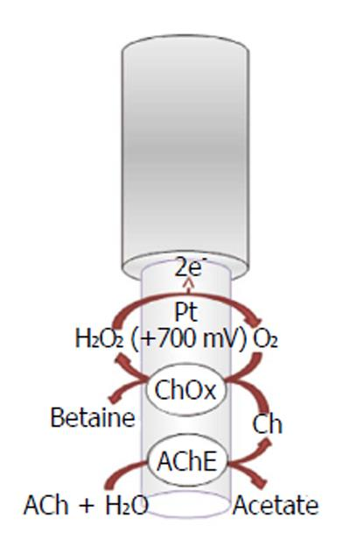

Figure 10 - Schematic representation of a platinum-based biosensor used to detect acetylcholine in animal brains (ACh) acetylcholine; (Ch) choline; (ChOx) choline oxidase; (AChE) acetylcholinesterase

From the large volume of literature on the development of electrode configurations for the detection of neurotransmitters, there is still little work on in vivo measurements with electrodes inserted into tissues as diagnostic probes or for monitoring the state of the disease in the whole body. There is still a problem of improvement in processing methods to extract the maximum possible information from these sensors, in improving the selectivity and sensitivity of these probes in vivo. Eliminating interference and overlapping signals from many electroactive molecules in the physiological environment is another challenge that requires better interface design and the development of new approaches and materials. Likewise, changes in oxygen level, temperature, or pH can lead to false signals. Moreover, sensors can also lose their sensitivity when working in a biological system, which is associated with contamination of the electrodes or mechanical damage to the active area.
Reviews [96, 97] are specifically devoted to studies on the discovery of neurotransmitters.
Recently, the authors of [98] described the pathway for the synthesis of acetylcholine in unicellular eukaryotes Acanthamoeba sp., And previously identified a homologue of muscarinic receptors (mAChR1) in Acanthamoeba castellanii [99]. It is possible that these unicellular eukaryotes can become a source of acetylcholine-binding domains for the development of new biosensors for acetylcholine [100].

1.1.6 Application of multienzyme biosensors
A number of multienzyme biosensors have been developed for monitoring food quality and the state of the environment [101]. Glucan, L-lactate [102], polyphenol [103] and sulfites [104] are typical target analytes for multienzyme biosensors in food analysis. In particular, for the detection of phenolic compounds, a biosensor construct has been reported [105], in which glucose oxidase and peroxidase are coimmobilized by incorporating graphite-Teflon tablets into the mass. This design made it possible to generate "in situ" H2O2, which is necessary for the reaction of the enzyme with phenolic compounds. It was also reported about the creation of trienzyme biosensors, in which GOD, HRP and tyrosinase were coimmobilized in a graphite-Teflon matrix. The practical applicability of composite multienzyme amperometric biosensors was assessed by assessing the content of phenolic compounds in the wastewater of a refinery, and the results were compared with the results obtained using colorimetric official method based on the reaction with 4-aminoantipyrine.
Environmental monitoring has been one of the priorities on a European and global scale because of the close relationship between environmental pollution and human health / socio-economic development. In this field, biosensors are widely used as cost-effective, fast, in-situ and real-time analytical methods. The need for portable, fast and intelligent biosensor devices explains the recent development of biosensors with new transduction materials derived from nanotechnology and for the detection of multiplexed pollutants, in which interdisciplinary experts are involved. This review article [106] provides an update on the latest advances in biosensors for real-world monitoring of air, water and soil pollutants such as pesticides, potentially toxic elements and small organic molecules, including toxins and endocrine disrupting chemicals. Also presented are the prospects for the future in the field of environmental monitoring using biosensors.
The main limitation of biosensors for the environment is their lack of use in real samples, since most were applied to tap water samples or synthetic samples. There are still few commercial biosensors for environmental monitoring. The biosensors described in this review article [106] were applied in real water samples (lakes, river, sea water, soil and waste water samples) or in shellfish samples.
In conclusion of this part of the review, we note that although the introduction of a large amount of enzymes into the sensitive layer of a biosensor improves many of its characteristics [35, 36], there are limitations associated with an increase in sensitivity to interference and disturbances affecting each of the enzymes in the multienzyme complex. Nevertheless, studies of the mechanisms of enzymatic reactions, as well as the selection of suitable enzyme pairs, are important in the development of new effective multienzyme biosensors.
Clinical and biochemical analyzes (general blood and urine tests, studying the composition of a number of other biological body fluids) are among the most common methods used to diagnose human diseases. Enzymological methods using free enzymes are widely used today [107-110]. However, along with obvious advantages, these methods also have a number of disadvantages, including their one-time use and the ambiguity of analysis in the presence of other high molecular weight compounds aggressive towards enzymes, in particular, proteases and intracellular components. As an alternative, eliminating many of them, immobilized enzymes are used on the biosensor electrode covered with a polyelectrolyte layer, which increases their stability [111].

1.2 Enzyme electrodes with polymer matrix

In enzymatic biosensors, the analyte diffuses through a semipermeable membrane into a thin layer of the biocatalyst, where the enzymatic reaction takes place. Since the product of the enzymatic reaction in this case is determined using an electrode with an enzyme on the surface, such a device is often called an enzyme electrode, which is an electrode with a surface layer (some natural polymer) applied containing one or more immobilized enzymes. Depending on the type of electrode taken as a basis, they are divided into potentiometric and amperometric. The classical potentiometric enzyme electrode is a combination of ion-selective electrodes with an immobilized (insoluble) enzyme, which provides high selectivity and sensitivity for the determination of a specific substrate. Immobilization prevents the destruction of enzymes, increases their duration, and turns them into a heterogeneous catalyst. The most frequently used enzymes for creating biosensors are: β-glycochidase, asparaginase, cholesterol oxidase, chymotrypsin, glucose oxidase, catalase, lipase, penicillinase, trypsin, amylase, invertase, urease, uricase.
The enzyme binds to the electrode surface by a number of processes: covalent crosslinking, capture by a gel layer on the electrode surface, encapsulation using or absorption on graphite. For example, to create an electrochemical biosensor, microcapsules containing catalase crystals were deposited on the electrode, on which a shell of multilayers consisting of PAA / PSS polyelectrolyte pairs was formed [112]. Polyelectrolyte layers controlled the membrane permeability and prevented the release of enzymes from the electrode, which also increased the stability of the biosensor. The stability of the biosensor, the main element of which was glucose oxidase, was increased by applying a complex of the enzyme with polyelectrolytes to the electrode surface [113]. This also increased the thermal stability of the enzyme.
Polyelectrolyte microcapsules were first obtained in 1998 by a group of researchers at the Max Planck Institute by the method of layer-by-layer electrostatic self-assembly of oppositely charged polyelectrolyte molecules on colloidal particles of micron and submicron sizes [114, 115].
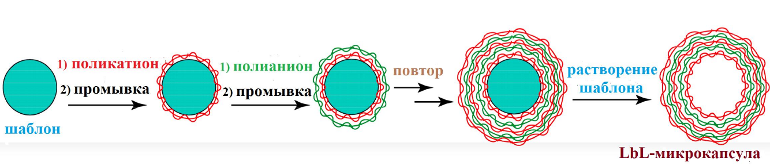
Figure 11 - Preparation of layered (LbL) microcapsules

The technology makes it possible to obtain microcapsules of a certain shape and size, depending on the matrix cores used, and the shell of the microcapsules provides the required catalytic or affinity properties, stability, permeability, compatibility and regulation of the release of the inner material of the capsule. The polyionic assembly method for applying polyelectrolyte layers to colloidal particles can be carried out in two ways: either the amount of polyelectrolyte required to saturate adsorption is added at each stage, or the polyelectrolyte is added in excess. In the second case, the remaining polymer molecules must be removed before applying the next layer to avoid complex formation in solution. They can be separated by centrifugation or filtration. It was shown in [116] that the second method is more efficient, since the first leads to the formation of a larger number of aggregates.
The thickness of the polyelectrolyte shell of polyallylamine (PAA) and polystyrene sulfonate (PSS) depends on the type of core on which it is formed. On the surface of latex particles, according to small-angle neutron scattering data [117], it is 1.6 nm, practically does not depend on the surface curvature, and weakly depends on the number of layers. In the case of calcium carbonate cores, the thickness of one layer obtained from the data of atomic force microscopy is 8 nm [118].
Various materials including synthetic polyelectrolytes, natural polymers such as polysaccharides, polypeptides, polynucleotides, and lipids can be used to form the shell. The nucleus can be dissolved, leaving a hollow capsule. The condition for the formation of a stable capsule is the insolubility of the complex formed by polyelectrolytes. The size of the obtained microcapsules is determined by the size of the nuclei and can be in the range from several tens of nanometers [119] to tens of micrometers [120, 121]. A charged surface can be responsible for the functionality of microcapsules, which is obtained by sequential adsorption of oppositely charged polyelectrolytes (layer-by layer technique, LbL), leading to the formation of polyelectrolyte complexes (PEC) [122].
The use of polyelectrolyte capsules (PEC) as a new diagnostic tool for determining the glucose content in a medium was proposed in [123]. Microcapsules containing urease were used as a microreactor in a potentiometric biosensor for the determination of urea in milk and blood [124, 125]. Of the four polyelectrolytes used to create microcapsules: polystyrene sulfonate (PSS) and dextran sulfate, which carry a negative charge, and polyallylamine hydrochloride (PAA), and polydiallyldimethylammonium chloride (PDADMA) with positive charges, PAA was a strong inhibitor of urease [126]. Inhibition of PAA urease was reversible and was not accompanied by noticeable structural changes in the enzyme molecule [127]. In solutions of monovalent anions (chlorides), the activity of urease-PAA complexes monotonically increases with increasing salt concentration, obeying the square root equation of ionic strength.
The study of the properties of PECs containing encapsulated urease and used as a microdiagnosticum capable of recognizing and quantifying low-molecular-weight substances both in native biological fluids and in wastewater is discussed in [128]. Microdiagnosticum showed the lower limit of detection for the analyte of no more than 5 mM urea, and the upper limit of no less than 100 mM. In this case, the measurement error did not exceed 10%. One of the advantages of the developed microdiagnosticum is the possibility of reusing polyelectrolyte microcapsules containing urease for the analysis of urea in various liquids. Thus, the proposed sensor system had a number of advantages such as multiple use, protection of the sensor enzyme from the aggressive action of proteolytic enzymes, and increased stability during storage in solution.
The first polyelectrolyte capsules were made using melamine-formaldehyde latex particles as a template [129, 114]. However, in subsequent studies it was shown that complete dissolution of such nuclei does not occur - a certain amount of oligomer, a decomposition product of melamine-formaldehyde molecules, remains inside the capsules [130]. For polystyrene cores, this problem was solved by choosing tetrahydrofuran as a solvent [131]; however, for applied purposes the use of organic solvents is undesirable. When CaCO3 is used as nuclei, dissolution is carried out using a solution of EDTA salt [118] - calcium is removed from the capsule due to the formation of a complex of this metal with EDTA, that is, in the case of inorganic colloidal particles, organic solvents are not required for decomposition and there is no need to fear toxic action of decay products. After removing the template, a stable hollow microcapsule remains, the permeability of which can be varied both at the stage of preparation (material and wall thickness, nature of the template) and after the formation of the capsule (changing the pH or salt composition of the subphase, adding organic solvents, heating).
The advantages of polyelectrolyte capsules over other similar systems are their monodispersity with a wide range of specified sizes; ease of regulation of their permeability; ease of change and the possibility of a wide choice of wall material. The mild conditions for the formation of microcapsules (within the physiological temperature and pH range) and the ability to choose the environmental conditions, and the composition of the polyelectrolyte shell with a minimum effect on proteins allows the inclusion of various biomolecules with the maximum preservation of their biological activity [132, 133, 127, 134]. Therefore, this method [135] is widely used for the immobilization of enzymes in polyelectrolyte microcapsules, the shells of which can be modified, including various types of ions, functional molecules, and nanoparticles.
For the use of polyelectrolyte capsules as medical probes, luminescent dyes that are highly sensitive to changes in the environment were encapsulated. As luminescent dyes, the pyridinium salt of 3,3'-di- (γ-sulfopropyl) -4,4 ', 5,5'-dibenzo-9-ethylthiacarbocyanine betaine described in [136] and the dye 3,3'-diethylthiacarbocyanine iodide.
The main requirements for sensor structures using enzyme molecules on the surface of an electrochemical converter as a sensitive layer are the preservation of the biocatalytic activity of fixed enzyme molecules and a high density of deposition of molecules on the surface of the electrochemical converter. Compliance with these requirements provides an increase in analyte sensitivity. It was shown [137] that packing the enzyme into polyelectrolyte containers (capsules) allows the maximum preservation of the native state of the enzyme molecules. Polyelectrolyte microcapsules are a new type of objects that can find application in many fields, in particular, in biosensorics [138]. The layer-by-layer adsorption method makes it possible to embed nanoparticles, marker molecules and other nano-objects into their shells, which makes it possible to control the sensitivity of microcapsules to the medium, their permeability and adsorption properties.
In one of the recent works [139], the authors described a urea biosensor made using polymer technologies and representing a combination of polyelectrolyte layers and microcapsules with an enzyme inside, and a shell of the same polyelectrolytes. As shown by experimental data, the biosensor was quite suitable for determining the concentration of urea in blood and urine. One of the significant results of this work, according to the authors, is the optimization of the conditions for obtaining a functionally active enzyme immobilized in a polyelectrolyte coating and the fact that a polymer coating with an enzyme makes it possible to work not only as an enzyme electrode, but also as an enzyme microreactor, while not decreasing the rate of signal registration after passing the catalytic urease - urea reaction. This is due to the fact that the polyelectrolyte layers separating the enzyme from the external analyzed solution are nanometer thick and are easily permeable to urea and the decay products of the catalytic urease - urea reaction. Figure 12 is a schematic representation of a urease electrode.

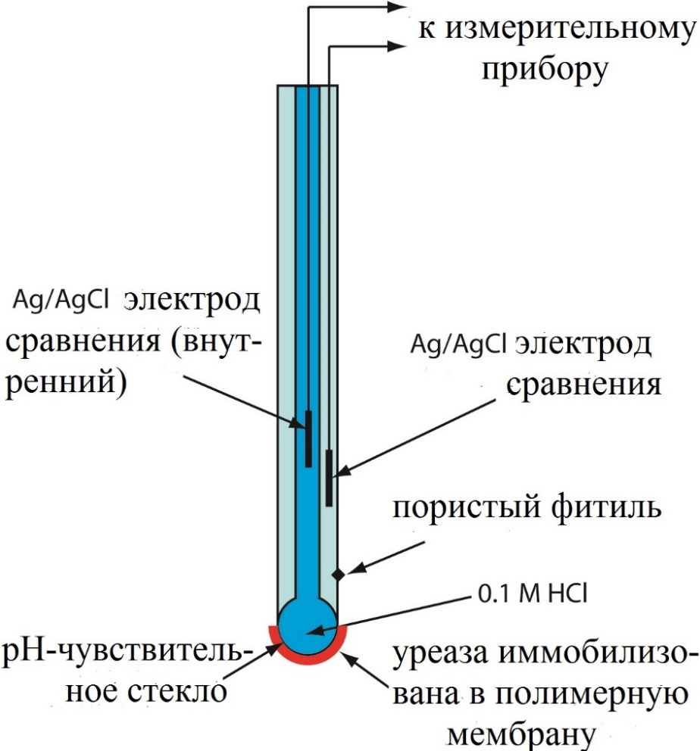

Figure 12 - Diagram of the urease electrode device

The electrodes themselves play an important role in the operation of electrochemical biosensors. The electrode material, its surface modification or its dimensions affect the detection capability of the electrochemical biosensor. There are three types of electrodes in an electrochemical cell: a working electrode; reference electrode; auxiliary (counter electrode).
Reference electrode: other electrodes in the cell refer to this electrode. Types of reference electrodes: hydrogen, calomel and glass. There are two commonly used and commercially available types of reference electrodes:
Ag / AgCl electrode: Ag wire that is coated with AgCl and immersed in NaCl solution.
AgCl+e⁻ Ag + Cl (E⁰ = +0,22V))
Saturated calomel electrode: Calomel is another name for mercuric chloride (Hg₂Cl²).
Hg₂Cl²+2e⁻ 2Hg + 2Cl² (E⁰ = +0,24V)
The calomel electrode consists of mercury, paste (a mixture of powder of mercury (I) chloride and potassium chloride) and a saturated solution of potassium chloride.
Auxiliary (counter) electrode: In a two-electrode system, when a known current or potential is applied between the working and auxiliary electrodes, other variables can be measured. The auxiliary electrode functions as a cathode whenever the working electrode functions as an anode, and vice versa. Made from electrochemically inert materials such as gold, platinum or carbon.
A working electrode is an electrode on which a reaction takes place in an electrochemical system [140–142]. In an electrochemical system with three electrodes, the working electrode can be called either cathodic or anodic, depending on the reaction at the working electrode, reduction or oxidation. There are many types of working electrodes. Glass carbon electrode, screen printed electrode, Pt electrode, gold electrode, silver electrode, indium tin oxide coated glass electrode, carbon paste electrode, carbon nanotube paste electrode, etc. Screen printed electrodes are prepared with the ink on the electrode substrate (glass, plastic) or ceramics) in the form of thin films. Different inks can be used to produce different sizes and shapes of biosensors. Screen-printed electrochemical cells are widely used for the development of amperometric biosensors because these biosensors are cheap and can be produced on a large scale and potentially used as a disposable sensor.
The separation of the sensitive sensor from the recording electrode offers many possibilities for instrument designers - urea analyzers based on an ultra-thin polymer coating. Polyelectrolytes can be used to prevent direct contact between the enzyme and the electrode surface, thus maintaining its activity. Thus, a biosensor for the determination of cholesterol was created, containing an enzyme immobilized on an electrode, the working surface of which was previously modified with a polyelectrolyte [143].
Conductive polymers such as polypyrrole and polyaniline are very often used to immobilize enzymes and make enzyme electrodes. Among various conductive polymers, polypyrrole (PPy) plays an important role in electrochemical biosensors in order to increase electrochemical activity and sensitivity due to its good biocompatibility, conductivity, stability and efficient polymerization at neutral pH, as well as easy synthesis. The material has unique properties of preventing some undesirable electrochemical interactions and facilitating the transfer of electrons from some redox enzymes [144]. Enzymatic electrodes with polypyrrole are manufactured by electropolymerization, and enzymes are captured in the polymer as a dopant during polymerization [145–151].
Layer-by-layer assembly technology is also used in PPy-based biosensors. An example is that multilayer films PPy and CNT (carbon nanotubes), assembled per layer, were fabricated on a Pt-coated polyvinylidene fluoride membrane, where the PPy film was obtained by electrochemical polymerization, and the CNT layers were vacuum-filtered [152]. This multilayer structure provided an excellent matrix for enzyme immobilization, which had the beneficial properties of both PPy and CNT. For immobilization of glucose oxidase (GOD), a crosslink was chosen, and such a biosensor showed an increased linear range, response time, and sensitivity [153].
Polyaniline is another widely used polymer for enzyme immobilization. Improved selectivity and stability of the glucose biosensor was obtained on the basis of in situ electropolymerized polyanilino-polyacrylonitrile composite film [154]. A new method was developed by Wilner's group to create an integrated electrically coupled glucose dehydrogenase electrode by surface reduction of the apoenzyme on polyaniline modified with pyrroloquinoline quinone (PQQ) [155]. The same group has developed an enzymatic electrode in which glucose oxidase is in direct electrical contact with the electrode using poly (aniline-aniline-boric acid) wires generated on ds-DNA matrices [156].
The technology developed for the manufacture of enzyme electrodes has spurred progress in the application of biosensors. However, there are problems that hinder further progress in technology, of which the most significant are long-term stability of enzyme electrodes, efficient transfer of electrons between enzymes and electrode surfaces, and improved biocatalytic activity of enzymes.

2 Materials and research methods

2.1 Reagents and equipment

We used lyophilized horseradish peroxidase (Diaem), glucose oxidase (Sigma Aldrich), buffer, Na-acetate. Salts CaCl2, Na2CO3 were of chemically pure grade or analytical grade. and EDTA (Sigma Aldrich). Substrates: D-glucose, 30% hydrogen peroxide solution, benzidine (Sigma Aldrich). Polyelectrolytes: polyethyleneimine (PEI), polyallylamine hydrochloride (PAGE) and polystyrene sulfonate (PSS) (all - "Aldrich") mol. weighing 60,000 - 70,000 were used in the form of solutions in 0.33 M NaCl. All salt solutions were prepared using deionized water obtained by purifying distilled water using an Arium 611-UF (Sartorius). The water conductivity was 1 μS.
The following instruments were used in the work: a CARY 100 spectrophotometer (Varian, USA), a Nikon eclipse E200 microscope, a Beckman F 690 pH / Temp / mV / ISE Meter (USA), a U-1 thermostat (Germany), Vortex (a for shaking and stirring), ultrasonic bath, magnetic stirrer, benchtop centrifuge, semi-automatic micropipettes for 2-20 μl, 20-200 μl and 200-1000 μl.

2.2 Obtaining enzyme-containing calcium carbonate crustal particles

Composite microspherolites CaCO3, a protein (or two proteins), which, in comparison with other possible crustal particles, are capable of chemically degrading under mild conditions (room temperature, neutral pH) in the presence of EDTA, with slight acidification of the medium, were used as crustal microparticles to obtain polyelectrolyte capsules.
CaCO3 microspherolites were obtained by the reaction of ion exchange by mixing solutions of calcium chloride and carbonate in the presence of a protein (enzyme) - by the method of biomineralization. The procedure for obtaining microspherolites was as follows: enzymes were added to a 0.33M (or 0.5M) aqueous solution of CaCl2, intensively stirred on a magnetic stirrer, stirred for 1 minute, and then an equal volume of 0.33M (or 0.5M) aqueous solution of Na2CO3 was quickly added ... Stirring was continued for 30 seconds, after which the resulting suspension was kept for 15 minutes at room temperature until the supernatant was completely cleared.
After the completion of the formation of composite microspherolites enzymes - CaCO3, the precipitate was thoroughly washed from Na + and Cl- ions with distilled water and dried in air. Thorough washing is of fundamental importance, since it was found that the "state of spherulites" is not thermodynamically stable, and in the wet state they gradually transform into classical rhombohedral polycrystals, and the process is noticeably accelerated in the presence of NaCl. In a dry state, microspherolites enzymes - CaCO3 can be stored indefinitely.
The process conditions (varying the concentration of reagents, temperature, hydrodynamic characteristics) largely determine the size and morphology of the resulting microparticles.

2.3 Preparation of enzyme-loaded polyelectrolyte microcapsules

Polyelectrolyte microcapsules were obtained by alternate adsorption of oppositely charged polyelectrolytes [5] on calcium carbonate microparticles containing the corresponding enzyme. At this stage of the study, polyelectrolytes: polystyrene sulfonate (PSS) and polyallylamine hydrochloride.
To 100 mg of CaCO3-protein nuclei, 2 ml of a PAAG solution (concentration 1 mg / ml) in 0.5 M NaCl was added. The suspension was stirred for 10 min on a shaker, then the unbound polymer was removed by centrifugation at 700 rpm for several seconds, and the particles were washed three times with deionized water to remove the polyelectrolyte residues with centrifugation. Then the same procedure was carried out using a PSS solution.
Alternate layering of oppositely charged polyelectrolyte macromolecules onto colloidal particles was carried out three to five times, obtaining a three to five-layer shell with the architecture of PAGE / (PSS / PAGE) n., Where n = 1.2. The procedure for the formation of microcapsules was carried out at room temperature (15-25 ° C). The work investigated three-five-layer enzyme-containing positively and negatively charged polyelectrolyte microcapsules: PAGE / (PSS / PAGE) n and PSS / (PAGE / PSS) n, n = 1.2. The microcapsule diameter is 3.6 ± 0.2 µm (Figure 13).
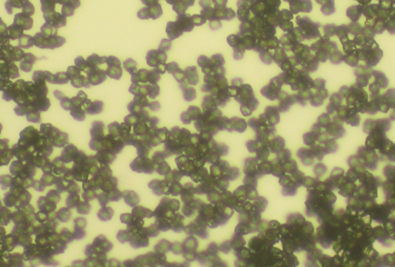
Figure 13 - Photograph from a light microscope of polyelectrolyte capsules loaded with enzymes

The microcapsule size and the sphericity of the calcium carbonate particles were controlled using a Nikon eclipse E200 light microscope. Removal of calcium carbonate particles from microcapsules was carried out by keeping the solution with microcapsules in dialysis bags for 3 hours to 12-15 hours in 2-25 mM EGTA or EDTA at a temperature of 4 ° C or 20 ° C with alkalization of the medium (pH 7.2) ... The number of capsules in the solution was counted using a Goryaev camera.
When forming a polyelectrolyte shell, PSS or PAGE polyelectrolytes were used as the first polyelectrolyte.
Capsules loaded with two enzymes, in our case glucose oxidase and horseradish peroxidase, were made on the basis of core particles containing two enzymes at the same time.

2.4 Method of obtaining an ultra-thin microcellular polymer coating

The method we used for obtaining an ultrathin polymer material was developed and patented at the Institute of Theoretical and Experimental Biophysics of the Russian Academy of Sciences [2].
Immobilization of microcapsules was carried out on a plastic plate. At this stage, additionally, as the first layer, we used polyelectrolyte polyethyleneimine (PEI), mm. 600,000 (Aldrich), which according to the literature is the optimal precursor for the creation of nanoscale layers by the polyion assembly method [6]. The concentration of polyelectrolyte solutions (PEI, PSS, PAGE) was 2 mg / ml.
The plate was covered with 1mg / ml PEI solution (0.33M NaCl), kept for 20 min, stirring not intensively at intervals of several minutes (3-5), and then washed twice with 0.1M NaCl solution. Next, a suspension of microcapsules was applied over the PEI layer so that the microcapsules completely covered the surface to be modified in an even layer, dried at room temperature, and then washed from excess microcapsules with 0.1 M NaCl solution. At this stage, microcapsules not purified from CaCO3 particles were used. Next, layers of PAGE-PSS were applied as described above. The surface (outer) layer was negatively charged. After immobilization, the microcapsules were purified from the CaCO3 component of the bark: the cuvette was immersed in a 0.025 M EDTA solution for 12-14 hours. After removal of calcium carbonate, the EDTA solution was replaced with distilled water, and the cuvette was placed in a refrigerator.

2.5 Determination of hydrogen peroxide concentration by spectrophotometric method

The kinetics of the peroxidase reaction at two stages with the addition of horseradish peroxidase and glucose oxidase was recorded by the change in optical absorption at a wavelength of 590 nm, corresponding to benzidine oxidation on a CARY 100 spectrophotometer (Varian, USA) (Figure 14). The initial stationary reaction rates were determined by the slope of the linear part of the product accumulation curve over time within 30 seconds (in some cases 10 seconds) from the start of the reaction registration: V = D590 / 30 sec.
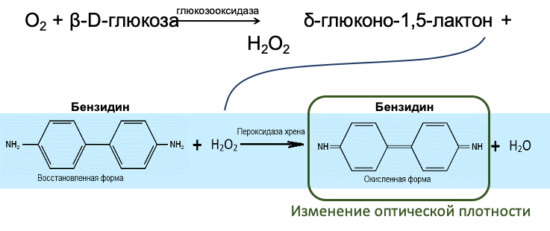
Figure 14 - Scheme of the cascade reaction involving horseradish peroxidase and glucose oxidase

In this work, the dependence of the initial rate of the peroxidase reaction on the concentration of the substrate was determined for various methods of encapsulation and immobilization. The kinetic parameters - the maximum velocity Vmax and the Michaelis constant Km - were found from the Lineweaver-Burk plots (double reciprocal coordinates). The pH values were controlled on a Beckman F 690 pH / Temp / mV / ISE Meter pH meter (USA), with an accuracy of 0.002 units.

2.6 Statistical processing of the result в

Each experimental point had 3-5 replicates (N). The results are presented in the figures as mean values ± standard deviation. Statistical processing of the results was carried out using the Mann-Whitney U-test for paired comparisons and the Kruskal-Wallis test for comparing three groups.

3 Results of studies and discussion of results

3.1 The ratio of the activity of enzymes that make up the cascade reaction

The development of a method for obtaining an ultrathin microcellular polymer coating as a biosensor of sensors has led to the creation of multienzyme systems - microreactors, which make it possible to relatively easily immobilize two or more enzymes in a measuring cell. For the possibility of creating a multienzyme system using encapsulated enzymes, various options for setting up experiments with the use of free enzymes, enzymes enclosed in capsules, as well as capsules enclosed in polyelectrolyte layers and deposited on a plate were considered.
At the first stage of the work (Figure 15), studies were carried out to study the ratio of the activity of two types of enzymes enclosed in capsules at two stages of a cascade reaction. In the medium there are four-layer microcapsules with PAGE / PSS / PAGE / PSS architecture, containing the enzymes glucose oxidase-horseradish peroxidase (~ 30 μg / ml). For each group of measurements n = 5, the values are mean ± SD; p <0.05
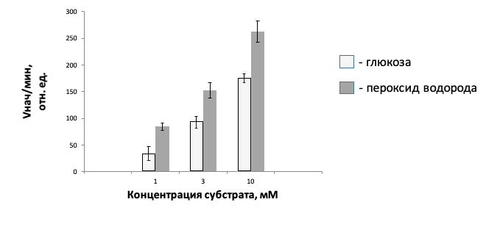
Figure 15 - Dependence of the initial rate of the peroxidase reaction on the addition of the substrate to the study medium (sodium acetate buffer, pH 5.3)

We were able to obtain results on the initial rates of the peroxidase reaction initiated directly by the addition of hydrogen peroxide, and then these data were compared with the results obtained by reproducing the complete cascade reaction with the addition of glucose. The parameters with the addition of glucose turned out to be lower than those with the addition of hydrogen peroxide, which can be associated with the multistage process and the probable transition of a part of D-glucose into L-glucose during storage.

3.2 Assessment of the stability of encapsulated enzymes over time

The study of the stability of enzymes enclosed in polyelectrolyte capsules makes it possible to assess the longevity of the system (Figure 16). In the medium (sodium acetate buffer, pH 5.3) four-layer microcapsules with the architecture of PAGE / PSS / PAGE / PSS, containing the enzymes glucose oxidase-horseradish peroxidase (~ 30 μg / ml). For each group of measurements n = 5, the values are mean ± SD; p <0.05. According to the data, a biosensor based on immobilized urease retains 40-50% of its initial activity and is capable of detecting substrates for up to two months [41].
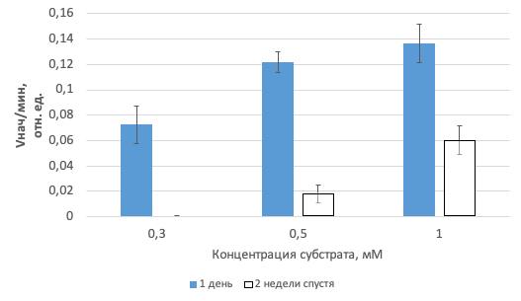
Figure 16 - Change in the activity of the encapsulated enzyme glucose oxidase during storage

The durability of the sensor may also depend on the stability of the polyelectrolyte shells themselves, which protect the enzymes from aggressive environmental influences. We were able to evaluate the stability of encapsulated glucose oxidase in the presence of horseradish peroxidase for a period of two weeks. Compared to the first day of measurements, glucose oxidase after two weeks retained up to 40% of its initial activity. In addition, it is possible that with further study of durability over a longer period of time, the activity of the system after the first weeks may decrease slightly, which will allow the sensor to be used for a longer period of time than expected.

3.3 Comparison of free and encapsulated glucose oxidase activity

The next stage of research included a comparison of the activity of free and encapsulated glucose oxidase. Data were presented at a substrate concentration of 3 and 10 mM, taken from the working range from 1 to 10 mM. In the medium (sodium acetate buffer, pH 5.3), four-layer microcapsules with the architecture of PAGE / PSS / PAGE / PSS containing the enzymes glucose oxidase-horseradish peroxidase (~ 30 μg / ml). For each group of measurements n = 5, the values ​​are mean ± SD; p <0.05 (Figure 17). In the medium (sodium acetate buffer, pH 5.3) four-layer microcapsules with the architecture of PAGE / PSS / PAGE / PSS, containing the enzymes glucose oxidase-horseradish peroxidase (~ 30 μg / ml). For each group of measurements n = 5, the values ​​are mean ± SD; p <0.05 (Figure 18). It was found that the activity of the encapsulated glucose oxidase is about 27% of the activity of the free enzyme (22% at 3 mM and 33% at 10 mM).
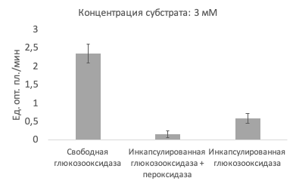
Figure 17 - Comparison of the activity of the free enzyme glucose oxidase and encapsulated together with peroxidase and separately according to the initial rate of the peroxidase reaction from the addition of the substrate to the study medium at a glucose concentration of 3 mM

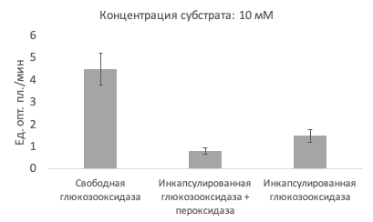
Figure 18 - Comparison of the activity of free enzyme glucose oxidase and encapsulated in capsules together with peroxidase and separately according to the initial rate of peroxidase reaction from the addition of the substrate to the study medium at a glucose concentration of 10 mM

It is possible that peroxidase affects the activity of glucose oxidase when localized together in the same cell; therefore, the variant of the system when different types of enzymes are placed in separate capsules is more preferable. Nevertheless, according to the literature data, studies show a 6-7-fold decrease in the activity of encapsulated enzymes, while the system remains operational and allows the detection of substrates [101].

3.4 Comparison of the activity of free and immobilized glucose oxidase on a biosensitive coating

Experiments using a biosensitive coating included the assembly of a structure of polyelectrolyte layers and polyelectrolyte capsules filled with glucose oxidase molecules, and the peroxidase required to initiate the reaction was present in the solution in free form. This method of enzyme immobilization allows the same enzyme molecules placed in polymer coating microcapsules to be used repeatedly and for a long time for measurement. Concentration measurements are due to a number of properties of the biosensitive coating: good permeability of polyelectrolyte layers for glucose and products of its degradation by glucose oxidase, impermeability of these layers for the enzyme and preservation of high activity by the enzyme in the coating cells. For each group of measurements n = 5, the values ​​are mean ± SD; p <0.05 (Figure 19).

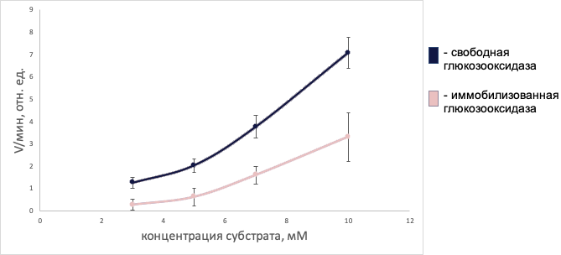
Figure 19 - Comparison of the activity of the free enzyme glucose oxidase and the immobilized enzyme glucose oxidase applied to a plastic plate, according to the initial reaction rate from the addition of glucose to the study medium in the presence of free horseradish peroxidase

In the variant of the experiment with a biosensitive coating, a two-fold decrease in the activity of immobilized glucose oxidase was observed in comparison with the free one, which is a higher indicator in relation to the encapsulated glucose oxidase.
The presence of a larger number of polyelectrolyte layers does not reduce the activity of the system, but, on the contrary, protects it from the influence of foreign molecules and microorganisms, while allowing the capsules to be fixed on the surface for optimal detection by the spectrophotometric method.

CONCLUSION

Enzymes are widely used in the diagnosis of various diseases due to their biocatalytic properties. Enzyme biosensors can also be used as an analytical tool for diagnosing common diseases. Some biosensors are already spreading for individual use in home first-aid kits (most often for determining blood sugar) and interest in biosensors is constantly growing. Future direction and development in the field of biosensor will likely focus on non-invasive methods of monitoring the health of patients, implantable biosensors and sensors [102–104]. At the same time, polymers are priority materials in this area and, in particular, biosensors based on them have great potential. The immobilization of enzymes with polymers and nanomaterials is key to improving the sensitivity and detection threshold of biosensors.
The development of biosensors is primarily aimed at providing sensitivity, specificity, absence of toxicity, the ability to detect small molecules and economic efficiency. These characteristics will ultimately make it possible to achieve the required critical parameters and eliminate the main limitations of biosensor technology.
The need for early diagnosis of cardiovascular, infectious and other socially significant diseases, including diabetes, requires the development and implementation of new mobile highly efficient analysis tools. The literature of recent decades shows that, according to the existing approaches to the development and application of biosensors, these devices today successfully compete with traditional methods that are standardly used in clinical diagnostics. However, despite the clinical need, commercialization of biosensors from research laboratories to the clinical diagnostics industry is still lacking, with a few exceptions such as glucose, lactate and cholesterol biosensors. One of the most important areas of modern clinical diagnostics is the analysis of key metabolic components that does not involve blood sampling, and in this area biosensors with their high sensitivity and selectivity are called upon to play a key role.
Conclusions:
1. A polyenzyme biosensor system of horseradish peroxidase and glucose oxidase on the basis of polyelectrolyte microcapsules has been made, which ensures the passage of a cascade reaction.
2. Using the system of glucose oxidase-horseradish peroxidase, it is possible to measure the physiological concentrations of the substrate from 1 to 10 mM.
3. The activity of immobilized glucose oxidase is 27% of the activity of a free, freshly prepared enzyme.
4. After two weeks, the encapsulated glucose oxidase retains up to 40% of its activity compared to the first day of measurements.

LIST OF USED SOURCES

1 Turner, A. P. F., Karube, I. and Wilson, G. S. Biosensors: Fundamentals and Applications. – Oxford: Oxford University Press, 1987. – 614 c.
2 Thevenot D. R., Tóth K., Durst R. A., Wilson G. S. Electrochemical Biosensors: Recommended Definitions and Classification // Pure and Applied Chemistry – 1999. - Vol. 71. – No. 12. – P. 2333-2348.
3 Tian K., Prestgard M., Tiwari А. A review of recent advances in nonenzymatic glucose sensors // Мaterials science and engineering: C – 2014. – Vol. 41. – P. 100-118.
4 Uddin Ahmed M., Mosharraf Hossain M., Tamiya E. Electrochemical biosensors for medical and food applications // Electroanalysis – 2008. - Vol. 20. – No. 6. – P. 616-626.
5 Clark L. C., Lyons C. Electrode systems for continuous monitoring cardiovascular surgery // Annals of the New York Academy of Sciences - 1962. - Vol. 102. – P. 29–45.
6 American Diabetes Association // Diagnosis and Classification of Diabetes Mellitus. Diabetes Care – 2010. - Vol. 33. – P. 62-69.
7 Yoo E. H., Lee S. Y. Glucose biosensors: an overview of use in clinical practice // Sensors. – 2010. – Vol. 10. – No. 5. – P. 4558-4576.
8 Zeng, X., Shen, Z., Mernaugh, R. Recombinant antibodies and their use in biosensors // Analytical and bioanalytical chemistry – 2012. – Vol. 402. – No. 10. – P. 3027–3038.
9 Mehlhorn A., Rahimi P., Joseph Y. Aptamer-based biosensors for antibiotic detection: a review // Biosensors – 2018. – Vol. 8. – No. 54. – P. 1–62.
10 Arshady R., Mosbach K. Synthesis of substrate‐selective polymers by host‐guest polymerization // Die Makromolekulare Chemie – 1981. – Vol. 182. – No. 2. – P. 687–692.
11 Wulff G., Sarhan A. Über die Anwendung von enzymanalog gebauten polymeren zur racemattrennung // Angewandte Chemie -1972. – Vol. 84. – No. 8. – P. 364.
12 Erdőssy J., Horváth V., Yarman A. et al. TrAC Trends in Analytical Chemistry // Electrosynthesized molecularly imprinted polymers for protein recognition – 2016. – Vol. 79. – P. 179–190.
13 Ozcelikay G., Kurbanoglu S., Zhang X.,et al. Electrochemical MIP sensor for butyrylcholinesterase // Polymers – 2019. – Vol. 11. – P. 1970-0.
14 Bucur B., Munteanu F.-D., Marty J.-L., et al. Advances in enzyme-based biosensors for pesticide detection // Biosensors – 2018. – Vol. 8. – No. 28. – P. 291-298.
15 Sassolas A., Blum L. J., Leca-Bouvier B. D. Immobilization strategies to develop enzymatic biosensors // Biotechnology advances – 2012. – Vol. 30. – No. 3. – P. 489–511.
16 Марри Р., Греннер Д., Мейес П., Родуэлл В. Биохимия человека. – Москва: Мир, – 1993, - 266 c.
17 Minakshi, Pundir C.S. Construction of an amperometric enzymic sensor for triglyceride determination // Sensors and Actuators B: Chemical – 2008. – Vol. 133. – No. 1. – P. 251–255.
18 Muschiol J. et al. Cascade catalysis–strategies and challenges en route to preparative synthetic biology // Chemical Communications. – 2015. – Vol. 51. – No. 27. – P. 5798-5811.
19 Nguyen H.H. et al. Immobilized enzymes in biosensor applications // Materials. – 2019. – Vol. 12. – No. 1. – P. 121.
20 Wollenberger U., Schubert F., Pfeiffer D., Scheller F. Enhancing biosensor performance using multienzyme systems // Trends in Biotechnology – 1993. – Vol. 11. – No. 6. – P. 255-262.
21 Han Y.D., Jang Y.H., Yoon H.C. Cascadic Multienzyme Reaction-Based Electrochemical Biosensors // Biosensors Based on Aptamers and Enzymes. – Springer, Berlin, Heidelberg, – 2013. – P. 221-251.
22 Baronas R., Ivanauskas F., Kulys J. Mathematical modeling of biosensors: an introduction for chemists and mathematicians. – Springer Science & Business Media, – 2009. – Vol. 9.
23 Mosbach K., Mattiasson B. Matrix-bound enzymes. Part II: Studies on a matrix-bound two-enzyme-system // Acta chemica Scandinavica – 1970. – Vol. 24. – P. 2093–2100.
24 Castillo J., Gáspár S., Sakharov I., Csöregiet E. Bienzyme biosensors for glucose, ethanol and putrescine built on oxidase and sweet potato peroxidase // Biosensors and Bioelectronics – 2003. – Vol. 18. – No. 5-6. – P. 705–714.
25 Gamella, M., Campuzano, S., Reviejo, A. J., Pingarrón, J. M. Integrated multienzyme electrochemical biosensors for the determination of glycerol in wines // Analytica Chimica Acta – 2008. – Vol. 609. – No. 2. – P. 201–209.
26 Li F., Wang Z., Feng Y. Construction of bienzyme biosensors based on combination of the one-step electrodeposition and covalent-coupled sol-gel process // Science in China Series B: Chemistry. – 2009. – Vol. 52. – No. 12. – P. 2269-2274.
27 Rangelova V., Pandelova A., Stoiyanov N. Inhibitor multienzyme biosensor system in dynamic mode-phosphate measurement // Annals of the Faculty of Engineering Hunedoara – 2011. – Vol. 9. – No. 2. – P. 83-86.
28 Mattiasson B., Mosbach K. Biochimica et Biophysica Acta (BBA) – Enzymology // Studies on a matrix-bound three-enzyme system – 1971. – Vol. 235. – No. 1. – P. 253–257.
29 Axén R., Porath J., Ernback S. Chemical Coupling of Peptides and Proteins to Polysaccharides by Means of Cyanogen Halides // Nature – 1967. – Vol. 214. – P. 1302–1304.
30 Nik Mansor N.N. et al. An amperometric biosensor for the determination of bacterial sepsis biomarker, secretory phospholipase group 2-IIA using a tri-enzyme system // Sensors. – 2018. – Vol. 18. – N. 3. – P. 686.
31 Kazakova L.I., Shabarchina L.I., Anastasova S., et al. Chemosensors and biosensors based on polyelectrolyte microcapsules containing fluorescent dyes and enzymes // Analytical and bioanalytical chemistry – 2013. – Vol. 405. – P. 1559–1568.
32 Portaccio M., Lepore M. Determination of different saccharides concentration by means of a multienzymes amperometric biosensor // Journal of Sensors – 2017. – Vol. 2. – P. 1–8.
33 Bóka B, Korózs M, Nánási M, Adányi N. Novel amperometric tri‐enzyme biosensor for lysine determination in pharmaceutical products and food samples // Electroanalysis – 2015. –Vol. 27. – No. 3. – P. 817–24.
34 Abdul Hamid J., Moody G. J., Thomas J. D. R. Flow-through multi-enzyme electrodes for the determination of lactose : Int. Symp. Electroanal. Biochem., Environ. and Ind. Sci., Loughborough // The Analyst – 1989. – Vol. 114. – No. 12. – P. 1587-1592.
35 Wollenberger U., Schubert F., Scheller F. W. Biosensor for sensitive phosphate detection // Sensors and Actuators B: Chemical – 1992. –Vol. 7. – No. 1-3. – P. 412–415.
36 Scheller F.W., Renneberg R., Schubert F.. Coupled enzyme reactions in enzyme electrodes using sequence, amplification, competition, and antiinterference principles. In: Immobilized Enzymes and Cells Part D (Ed.) // Elsevier – 1988. – P. 29-43.
37 Monteiro T., Gabriela Almeida M. Electrochemical enzyme biosensors revisited: old solutions for new problems // Critical reviews in analytical chemistry – 2019. – Vol. 49. – P. 44–66.
38 Ibadullaeva S. Zh, Appazov N. O., Tarahovsky Y. S., et al. Amperometric multi-enzyme biosensors: Development and application, a short review // Biophysics – 2019. – Vol. 64. – No. 5. – P. 696–707.
39 Lenfant N., Hotelier T., Bourne Y., et al. Proteins with an alpha/beta hydrolase fold: Relationships between subfamilies in an ever-growing superfamily // Chemico-biological interactions – 2013. – Vol. 203. – P. 266–268.
40 Ollis D. L., E. Cheah E., Cygler M., et al. The α/ β hydrolase fold // Protein engineering – 1992. – Vol. 5. – No. 3. – P. 197–211.
41 Miao Y., He N., Zhu J.J. History and new developments of assays for cholinesterase activity and inhibition // Chemical reviews – 2010. – Vol. 110. – P. 5216–5234.
42 Kramer D.N., Cannon P.L., Guilbault G.G. Electrochemical determination of cholinesterase and thiocholine esters // Analytical Chemistry – 1962. –Vol. 34. – No. 7. – P. 842–845.
43 Guilbault G.G., Kramer D.N., Cannon P.L. Electrical determination of organophosphorous compounds // Analytical Chemistry – 1962. – Vol. 34. – No. 11. – P. 1437–1439.
44 Arduini F., Amine A., Moscone D., et al. Biosensors based on cholinesterase inhibition for insecticides, nerve agents and aflatoxin B1 detection // Microchimica Acta – 2010. – Vol. 170. – No. 3-4. – P. 193–214.
45 Bidmanová Š., Pohanka M., Cabal J., et al. Biosenzory k včasné detekci otravných látek // Chemické listy – 2010. – Vol. 104. – No. 5. – P. 302–308.
46 Michel H.O. An electrometric method for the determination of red blood cell and plasma cholinesterase activity // Journal of laboratory and clinical medicine – 1949. – Vol. 34. – P. 1564–1568.
47 Mohammad F.K., Alias A.S., Ahmed O.A.H. Electrometric measurement of plasma, erythrocyte, and whole blood cholinesterase activities in healthy human volunteers // Journal of medical toxicology: official journal of the American College of Medical Toxicology – 2007. –Vol. 3. – P. 25–30.
48 Pohanka M. Cholinesterase based amperometric biosensors for assay of anticholinergic compounds // Interdisciplinary toxicology – 2009. – Vol. 2. – P. 52–54.
49 Pohanka M., Hrabinova M., Kuca K. Diagnosis of intoxication by the organophosphate vx: comparison between an electrochemical sensor and ellman´s photometric method // Sensors – 2008. – Vol. 8. – P. 5229–5237.
50 Rani Dutta R., Puzari P. Amperometric biosensing of organophosphate and organocarbamate pesticides utilizing polypyrrole entrapped acetylcholinesterase electrode // Biosensors & bioelectronics – 2014. – Vol. 52. – P. 166–172.
51 El-Moghazy A.Y., Soliman E.A., Ibrahim H.Z., et al. Ultra-sensitive biosensor based on genetically engineered acetylcholinesterase immobilized in poly (vinyl alcohol)/Fe–Ni alloy nanocomposite for phosmet detection in olive oil // Food chemistry, Elsevier – 2016. – Vol. 203. – P. 73–78.
52 Campanella L., Lelo D., Martini E., et al. Organophosphorus and carbamate pesticide analysis using an inhibition tyrosinase organic phase enzyme sensor; comparison by butyrylcholinesterase + choline oxidase opee and application to natural waters // Analytica chimica acta – 2007. – Vol. 587. – P. 22–32.
53 Kok F.N., Bozoglu F., Hasirci V., Construction of an acetylcholinesterase-choline oxidase biosensor for aldicarb determination // Biosensors and Bioelectronics – 2002. – Vol. 17. – No. 6-7. – P. 531–539.
54 Marty J.L., Sode K., Karube I. Biosensor for detection of organophosphate and carbamate insecticides // Electroanalysis – 1992. – Vol. 4. – No. 2. – P. 249–252.
55 Dou J., Ding A., Cheng L., et al. A screen-printed, amperometric biosensor for the determination of organophosphorus pesticides in water samples // Journal of Environmental Sciences – 2012. – Vol. 24. – No. 5. – P. 956–962.
56 Pohanka M., Dobes P., Drtinova L., Kuca K. Nerve agents assay using cholinesterase based biosensor // Electroanalysis – 2009. – Vol. 21. – No. 10. – P. 1177–1182.
57 Pohanka M., Jun D., Kuca K. Amperometric biosensor for real time assay of organophosphates // Sensors – 2008. – Vol. 8. – P. 5303–5312.
58 Pohanka M., Kuca K., Jun D. Aflatoxin assay using an amperometric sensor strip and acetylcholinesterase as recognition element // Sensor Letters – 2008. – Vol. 6, – No. 3. – P. 450–453.
59 Pohanka M., Kuca K., Kassa J. New performance of biosensor technology for Alzheimer’s disease drugs: in vitro comparison of tacrine and 7-methoxytacrine // Neuro endocrinology letters – 2008. – Vol. 29. – P. 755–758.
60 Valdés-Ramírez G., Fournier D., Teresa Ramírez-Silva M., et al. Sensitive amperometric biosensor for dichlorovos quantification: Application to detection of residues on apple skin // Talanta – 2008. – Vol. 74. – P. 741–746.
61 Arduini F., Amine A., Moscone D., et al. Fast, sensitive and cost-effective detection of nerve agents in the gas phase using a portable instrument and an electrochemical biosensor // Analytical and bioanalytical chemistry – 2007. – Vol. 388. – P. 1049–1057.
62 Schulze H., Vorlová S., Villatte F., et al. Design of acetylcholinesterases for biosensor applications // Biosensors and Bioelectronics – 2003. – Vol. 18. – No. 2-3. – P. 201–209.
63 Arkhypova V. Multibiosensor based on enzyme inhibition analysis for determination of different toxic substances // Talanta – 2001. – Vol. 55. – No. 5. – P. 919–927.
64 Crew A., Lonsdale D., Byrd N., et al. A screen-printed, amperometric biosensor array incorporated into a novel automated system for the simultaneous determination of organophosphate pesticides // Biosensors & bioelectronics – 2011. – Vol. 26. – P. 2847–2851.
65 Meng X., Wei J., Ren X., et al. A simple and sensitive fluorescence biosensor for detection of organophosphorus pesticides using H2O2-sensitive quantum dots/bi-enzyme // Biosensors & bioelectronics – 2013. – Vol. 47. – P. 402–407.
66 Chauhan N., Pundir C.S. Amperometric determination of acetylcholine – A neurotransmitter, by chitosan/gold-coated ferric oxide nanoparticles modified gold electrode // Biosensors & bioelectronics – 2014. – Vol. 61. – P. 1-8.
67 Štěpánková Š., Vorčáková K. Cholinesterase-based biosensors // Journal of enzyme inhibition and medicinal chemistry – 2016. – Vol. 31. – P. 180–193.
68 Ju H., Kandimalla V.B., Biosensors for pesticides // Electrochemical Sensors, Biosensors and Their Biomedical Applications. Elsevier, San Diego – 2008. – P. 32–50.
69 Suprun E., Evtugyn G., Budnikov H., et al. Acetylcholinesterase sensor based on screen-printed carbon electrode modified with prussian blue // Analytical and bioanalytical chemistry – 2005. – Vol. 383. – P. 597–604.
70 Caetano J., Machado S.A.S. Determination of carbaryl in tomato “in natura” using an amperometric biosensor based on the inhibition of acetylcholinesterase activity // Sensors and Actuators B: Chemical – 2008. – Vol. 129. – No. 1. – P. 40–46.
71 Mishra R.K., Dominguez R.B., Bhand S., et al. A novel automated flow-based biosensor for the determination of organophosphate pesticides in milk // Biosensors & bioelectronics – 2012. – Vol. 32. – P. 56–61.
72 Hildebrandt A., Bragós R., Lacorte S., et al. Performance of a portable biosensor for the analysis of organophosphorus and carbamate insecticides in water and food // Sensors and Actuators B: Chemical – 2008. – Vol. 133. – No. 1. – P. 195–201.
73 Raghu P., Madhusudana Reddy T., Kumara Swamy B.E., et al. Development of AChE biosensor for the determination of methyl parathion and monocrotophos in water and fruit samples: A cyclic voltammetric study // Journal of Electroanalytical Chemistry – 2012. – Vol. 665. – P. 76–82.
74 Raghu P., Madhusudana Reddy T., Reddaiah K., et al. Acetylcholinesterase based biosensor for monitoring of malathion and acephate in food samples: a voltammetric study // Food chemistry – 2014. – Vol. 142. – P. 188–196.
75 Arduini F., Ricci F., Tuta C.S., et al. Detection of carbamic and organophosphorous pesticides in water samples using a cholinesterase biosensor based on Prussian Blue-modified screen-printed electrode // Analytica chimica acta – 2006. – Vol. 580. – P. 155–162.
76 Hildebrandt A., Ribas J., Bragós R., et al. Development of a portable biosensor for screening neurotoxic agents in water samples // Talanta – 2008. – Vol. 75. – P. 1208–1213.
77 Chauhan N., Shekhar Pundir C. An amperometric acetylcholinesterase sensor based on Fe3O4 nanoparticle/multi-walled carbon nanotube-modified ITO-coated glass plate for the detection of pesticides // Electrochimica Acta – 2012. – Vol. 67. – P. 79–86.
78 Lenigk R, Lam E, Lai A., et al. Enzyme biosensor for studying therapeutics of Alzheimer’s disease // Biosensors and Bioelectronics – 2000. – Vol. 15. – No. 9-10. – P. 541–547.
79 Ozturk G., Alp S., Timur S. Photophysical characterisation of fluorescent oxazol-5-one derivatives in PVC and their application as biosensors for detection of Ach and AChE inhibitor: donepezil // Dyes and Pigments –2008. –Vol. 76. – No. 3. – P. 792–798.
80 Turan J., Kesik M., Soylemez S., et al. Development of an Amperometric Biosensor Based On A Novel Conducting Copolymer for Detection of Anti-Dementia Drugs // Journal of Electroanalytical Chemistry – 2014. – Vol. 735. – P. 43–50.
81 Upadhyay S., Rama Rao G., Sharma M.K., et al. Immobilization of acetylcholineesterase–choline oxidase on a gold–platinum bimetallic nanoparticles modified glassy carbon electrode for the sensitive detection of organophosphate pesticides, carbamates and nerve agents // Biosensors & bioelectronics – 2009. – Vol. 25. – P. 832–838.
82 Guerrieri A., Palmisano F. An acetylcholinesterase/choline oxidase-based amperometric biosensor as a liquid chromatography detector for acetylcholine and choline determination in brain tissue homogenates // Analytical Chemistry – 2001. – Vol. 73. – P. 2875–2882.
83 Mitchell K. M. Acetylcholine and choline amperometric enzyme sensors characterized in vitro and in vivo // Analytical Chemistry – 2004. – Vol. 76. – P. 1098–1106.
84 Yotova L., Medhat N. Optical biosensor with multienzyme system immobilized onto hybrid membrane for pesticides determination // Int. J. Bioautomation – 2011. – Vol. 15. – No. 4. – P. 267-276.
85 Hou S., Ou Z., Chen Q., et al. Amperometric acetylcholine biosensor based on self-assembly of gold nanoparticles and acetylcholinesterase on the solgel/multi-walled carbon nanotubes/choline oxidase composite-modified platinum electrode // Biosensors & bioelectronics – 2012. – Vol. 33. – P. 44–49.
86 Khan A., Ab Ghani S. Multienzyme microbiosensor based on electropolymerized o-phenylenediamine for simultaneous in vitro determination of acetylcholine and choline // Biosensors & bioelectronics – 2012. – Vol. 31. – P. 433–438.
87 Jin R. et al. Sensitive colorimetric sensor for point-of-care detection of acetylcholinesterase using cobalt oxyhydroxide nanoflakes // Journal of Materials Chemistry B. – 2019. – Vol. 7. – No. 8. – P. 1230-1237.
88 Tamiya E. et al. Ultramicro acetylcholine sensor based on an enzyme-modified carbon fibre electrode //Analytica chimica acta. – 1991. – Vol. 251. – No. 1-2. – P. 129-134.
89 Yao T, Suzuki S, Nishino H, Nakahara T. On-line amperometric assay of glucose, L-glutamate, and acetylcholine using microdialysis probes and immobilized enzyme reactors // Electroanalysis – 1995. – Vol. – No. 12. – P. 1114–1117.
90 Lee S.R. et al. Development of a highly-sensitive acetylcholine sensor using a charge-transfer technique on a smart biochip // TrAC Trends in Analytical Chemistry. – 2009. – Vol. 28. – No. 2. – P. 196-203.
91 Shimomura T., Itoh T., Sumiya T., et al. Amperometric biosensor based on enzymes immobilized in hybrid mesoporous membranes for the determination of acetylcholine // Enzyme and microbial technology – 2009. –Vol. 45. – No. 6-7. – P. 443–448.
92 Wang C.-I., Chen W.-T., Chang H.-T. Enzyme Mimics of Au/Ag Nanoparticles for Fluorescent Detection of Acetylcholine // Analytical Chemistry – 2012. – Vol. 84. – P. 9706–9712.
93 Farina D., Alvau M. D., Puggioni G., et al. Implantable (Bio)sensors as new tools for wireless monitoring of brain neurochemistry in real time // World Journal of Pharmacology – 2014. – Vol. 3. – No. 1. – P. 1–17.
94 Wu B.-Y., Hou S.-H., Yin F., et al. Amperometric glucose biosensor based on multilayer films via layer-by-layer self-assembly of multi-wall carbon nanotubes, gold nanoparticles and glucose oxidase on the Pt electrode // Biosensors and Bioelectronics – 2007. – Vol. 22. – P. 2854–2860.
95 Garguilo M.G., Michael A.C. Amperometric microsensors for monitoring choline in the extracellular fluid of brain // Journal of Neuroscience Methods – 1996. – Vol. 70. – No. 1. – P. 73–82.
96 Chandra S., Siraj S, Wong D.K.Y. Recent advances in biosensing for neurotransmitters and disease biomarkers using microelectrodes // ChemElectroChem – 2017. – Vol. 4. – No. 4. – P. 822–833.
97 Isoaho N., Peltola E., Sainio S., et al. Carbon Nanostructure Based Platform for Enzymatic Glutamate Biosensors // The Journal of Physical Chemistry C – 2017. – Vol. 121. – No. 8. – P. 4618–4626.
98 Mannan Baig A., Rana Z., Tariq S., et al. Traced on the timeline: discovery of acetylcholine and the components of the human cholinergic system in a primitive unicellular eukaryote Acanthamoeba spp // ACS chemical neuroscience – 2018. – Vol. 9. – P. 494–504.
99 Mannan Baig A., Ahmad H.R. Evidence of a M1-muscarinic GPCR homolog in unicellular eukaryotes: featuring Acanthamoeba spp bioinformatics 3D-modelling and experimentations // Journal of receptor and signal transduction research – 2017. – Vol. 37. – P. 267–275.
100 Leopold A.V., Shcherbakova D.M., Verkhusha V.V. Fluorescent Biosensors for Neurotransmission and Neuromodulation: Engineering and Applications // Frontiers in cellular neuroscience – 2019. – Vol. 13. – P. 474-493.
101 Prodromidis M.I., Karayannis M.I. Enzyme based amperometric biosensors for food analysis // Electroanalysis – 2002. – Vol. 14. – No. 4. – P. 241–261.
102 Bagal-Kestwal D., Mohan Kestwal R., Hsieh B.-C., et al. Electrochemical β (1→ 3)-d-glucan biosensors fabricated by immobilization of enzymes with gold nanoparticles on platinum electrode // Biosensors & bioelectronics – 2010. – Vol. 26. – P. 118–125.
103 Diaconu M., Litescu S. C., Radu G. L. Bienzymatic sensor based on the use of redox enzymes and chitosan–MWCNT nanocomposite. Evaluation of total phenolic content in plant extracts // Microchimica Acta. – 2011. – Vol. 172. – No. 1-2. – P. 177-184.
104 Spricigo R., Dronov R., Lisdat F., et al. Electrocatalytic sulfite biosensor with human sulfite oxidase co-immobilized with cytochrome c in a polyelectrolyte-containing multilayer // Analytical and bioanalytical chemistry. – 2009. – Vol. 393. – No. 1. – P. 225-233.
105 Serra B., Reviejo A. J., Pingarrón J. M. Composite multienzyme amperometric biosensors for an improved detection of phenolic compounds // Electroanalysis: An International Journal Devoted to Fundamental and Practical Aspects of Electroanalysis. – 2003. – Vol. 15. – No. 22. – P. 1737-1744.
106 Justino C.I.L., Duarte A.C., Rocha-Santos T.A.P. Recent progress in biosensors for environmental monitoring: A review // Sensors. – 2017. – Vol. 17. – No. 12. – P. 2918.
107 Меньшиков В.В., Анкирская А., Бехало В.А., et al. Методики клинических лабораторных исследований. – М.: Лабора, 2009. – 880 с.
108 Долгов В.В., Селиванова А.В. Биохимические исследования в клинико-диагностических лабораториях ЛПУ первичного звена здравоохранения. – СПб.: Изд. Витал Диагностикс, – 2006. – 231 c.
109 Taylor A.J., Vadgama P. Analytical reviews in clinical biochemistry: the estimation of urea // Annals of clinical biochemistry. – 1992. – Vol. 29, – No. 3. – P. 245-264.
110 Naslund B. et al. Luminometric single step urea assay using ATP-hydrolyzing urease // Clinical chemistry. – 1998. – Vol. 44, No. 9. – P. 1964-1973.
111 Chaniotakis N.A., Alifragis Y., Konstantinidis G., et al. Gallium nitride-based potentiometric anion sensor // Analytical chemistry. – 2004. – Vol 76, No. 18. – P. 5552-5556.
112 Yu A., Caruso F. Thin films of polyelectrolyte-encapsulated catalase microcrystals for biosensing // Analytical chemistry. – 2003. – Vol. 75, No. 13. – P. 3031-3037.
113 Gibson T.D. et al. Improvements in the stability characteristics of biosensors using protein-polyelectrolyte complexes // Sensors and Actuators B: Chemical. – 1996. – Vol 33, No. 1-3. – P. 13-18.
114 Sukhorukov G.B. et al. Stepwise polyelectrolyte assembly on particle surfaces: a novel approach to colloid design // Polymers for Advanced Technologies. – 1998. – Vol. 9, No. 10‐11. – P. 759-767.
115 Caruso F. Hollow capsule processing through colloidal templating and self‐assembly // Chemistry–a European journal. – 2000. – Vol. 6, No. 3. – P. 413-419.
116 Sukhorukov G.B. et al. Layer-by-layer self assembly of polyelectrolytes on colloidal particles // Colloids and Surfaces A: physicochemical and engineering aspects. – 1998. – Vol. 137. – No. 1-3. – P. 253-266.
117 Estrela-Lopis I. et al. SANS studies of polyelectrolyte multilayers on colloidal templates // Langmuir. – 2002. – Vol. 18. – No. 21. – P. 7861-7866.
118 Volodkin D.V. et al. Matrix polyelectrolyte microcapsules: new system for macromolecule encapsulation //Langmuir. – 2004. – Vol. 20. – No. 8. – P. 3398-3406.
119 Mayya K.S., Schoeler B., Caruso F. Preparation and organization of nanoscale polyelectrolyte‐coated gold nanoparticles // Advanced Functional Materials. – 2003. – Vol. 13. – No. 3. – P. 183-188.
120 Qiu X. et al. Studies on the drug release properties of polysaccharide multilayers encapsulated ibuprofen microparticles // Langmuir. – 2001. – Vol. 17. – No. 17. – P. 5375-5380.
121 Shenoy D.B. et al. Layer-by-layer engineering of biocompatible, decomposable core− shell structures //Biomacromolecules. – 2003. – Vol. 4. – No. 2. – P. 265-272.
122 Wang D., Rogach A.L., Caruso F. Semiconductor quantum dot-labeled microsphere bioconjugates prepared by stepwise self-assembly // Nano Letters. – 2002. – Vol. 2. – No. 8. – P. 857-861.
123 De Geest B.G. et al. Glucose-responsive polyelectrolyte capsules // Langmuir. – 2006. – Vol. 22. – No. 11. – P. 5070-5074.
124 Решетилов А.Н. и др. Полиэлектролитные микрокапсулы с уреазой и парамагнитными частицами как основа потенциометрического биосенсора для определения мочевины // Журнал аналитической химии. – 2015. – Т. 70. – №. 11. – С. 1186-1186.
125 Reshetilov A.N. et al. Detection of urea using urease and paramagnetic Fe3O4 particles incorporated into polyelectrolyte microcapsules // Process Biochemistry. – 2016. – Vol. 51. – No. 2. – P. 277-281.
126 Сухоруков Б. И. и др. Инкапсулирование белков в полиэлектролитные нано-и микрокапсулы и проблемы разработки ферментного микродиагностикума // Биофизика. – 2007. – Т. 52. – №. 6. – С. 1041-1048.
127 Saburova E. A. et al. Changes in the activity and structure of urease in the interaction with polyelectrolytes // Russian Journal of Physical Chemistry A, Focus on Chemistry. – 2008. – Vol. 82. – No. 3. – P. 468-474.
128 Дубровский А. В., Шабарчина Л. И., Тихоненко С. А. Полиэлектролитный ферментный микродиагностикум с седиментационной системой регистрации для определения мочевины в растворе // Прикладная биохимия и микробиология. – 2017. – Т. 53. – №. 4. – С. 427-432.
129 Donath E. et al. Novel hollow polymer shells by colloid‐templated assembly of polyelectrolytes //Angewandte Chemie International Edition. – 1998. – Vol. 37. – No. 16. – P. 2201-2205.
130 Sukhorukov G.B. et al. Comparative analysis of hollow and filled polyelectrolyte microcapsules templated on melamine formaldehyde and carbonate cores // Macromolecular Chemistry and Physics. – 2004. – Vol. 205. – No. 4. – С. 530-535.
131 Déjugnat C., Sukhorukov G.B. pH-responsive properties of hollow polyelectrolyte microcapsules templated on various cores // Langmuir. – 2004. – Vol. 20. – No. 17. – P. 7265-7269.
132 Kokufuta E. Polyelectrolyte-coated microcapsules and their potential applications to biotechnology // Bioseparation. – 1998. – Vol. 7. – No. 4-5. – P. 241-252.
133 Sukhorukov B.I. et al. Protein-filled polyelectrolyte microcapsules in the design of enzymic microdiagnostics // Biophysics. – 2007. – Vol. 52. – No. 6. – P. 575-581.
134 Tikhonenko S.A. et al. A technique for incorporating enzymes into polyelectrolyte microcapsules // Glass Physics and Chemistry. – 2007. – Vol. 33. – No. 3. – P. 287-293.
135 McShane M.J. Enzyme immobilization in polyelectrolyte microcapsules // Enzyme Stabilization and Immobilization. – Humana Press, Totowa, NJ, 2011. – P. 147-154.
136 Алфимов М.В., Штыкова А.А., Разумов В.Ф. Фото-и термоинициированное образование J-и Н-агрегатов в аморфных дисперсиях карбоцианинового красителя // Химия высоких энергий. – 2006. – Т. 40. – №. 1. – С. 21-24.
137 Монтрель М.М. и др. Патент на изобретение № 2333231. – 2008.
138 Zhang M.J. et al. Microfluidic fabrication of monodisperse microcapsules for glucose-response at physiological temperature // Soft Matter. – 2013. – Vol. 9. – No. 16. – P. 4150-4159.
139 Фомкина М.Г., Ибадуллаева С.Ж. Разработка биодатчика мочевины с применением полимерных технологий для анализов крови и мочи // Научное приборостроение. – 2018. – Т. 28. – №. 3.
140 Kissinger P., Heineman W.R. (ed.). Laboratory Techniques in Electroanalytical Chemistry, revised and expanded. – CRC press, 2018.
141 Bard A.J. et al. Fundamentals and applications: electrochemical methods. – 2001.
142 Zoski C.G. (ed.). Handbook of electrochemistry. – Elsevier, 2006.
143 Ram M. K. et al. Cholesterol biosensors prepared by layer-by-layer technique // Biosensors and Bioelectronics. – 2001. – Т. 16. – №. 9-12. – С. 849-856.
144 Ramanavičius A., Ramanavičienė A., Malinauskas A. Electrochemical sensors based on conducting polymer—polypyrrole // Electrochimica acta. – 2006. – Vol. 51. – No. 27. – P. 6025-6037.
145 Zhu Z. et al. Directed evolution of glucose oxidase from Aspergillus niger for ferrocenemethanol‐mediated electron transfer // Biotechnology Journal: Healthcare Nutrition Technology. – 2007. – Vol. 2. – No. 2. – P. 241-248.
146 Sung W. J., Bae Y. H. A glucose oxidase electrode based on electropolymerized conducting polymer with polyanion− enzyme conjugated dopant // Analytical chemistry. – 2000. – Vol. 72. – No. 9. – P. 2177-2181.
147 Cosnier S., Gondran C., Watelet J.C. A polypyrrole‐bienzyme electrode (salicylate hydroxylase‐polyphenol oxidase) for the interference‐free determination of salicylate // Electroanalysis: An International Journal Devoted to Fundamental and Practical Aspects of Electroanalysis. – 2001. – Vol. 13. – No. 11. – P. 906-910.
148 Yasuzawa M. et al. Properties of glucose sensors based on the immobilization of glucose oxidase in N-substituted polypyrrole film // Sensors and Actuators B: Chemical. – 2000. – Vol. 66. – No. 1-3. – P. 77-79.
149 Cosnier S., Gondran C. Fabrication of biosensors by attachment of biological macromolecules to electropolymerized conducting films // Analusis. – 1999. – Vol. 27. – No. 7. – P. 558-563.
150 Trojanowicz M., Matuszewski W., Podsiadła M. Enzyme entrapped polypyrrole modified electrode for flow-injection determination of glucose // Biosensors and Bioelectronics. – 1990. – Vol. 5. – No. 2. – P. 149-156.
151 Cosnier S. et al. A glucose biosensor based on enzyme entrapment within polypyrrole films electrodeposited on mesoporous titanium dioxide // Journal of Electroanalytical Chemistry. – 1999. – Vol. 469. – No. 2. – P. 176-181.
152 Shirsat A.N., Bharadwaj S.R., Das D. Thermochemistry of decomposition of RE2O2CO3 (RE= Sm, Eu) // Thermochimica acta. – 2008. – Vol. 477. – No. 1-2. – P. 38-41.
153 Gade V.K. et al. Immobilization of GOD on electrochemically synthesized Ppy–PVS composite film by cross-linking via glutaraldehyde for determination of glucose // Reactive and functional polymers. – 2006. – Vol. 66. – No. 12. – P. 1420-1426.
154 Xue H., Shen Z., Li C. Improved selectivity and stability of glucose biosensor based on in situ electropolymerized polyaniline–polyacrylonitrile composite film // Biosensors and Bioelectronics. – 2005. – Vol. 20. – No. 11. – P. 2330-2334.
155 Raitman O.A. et al. Electrical contacting of glucose dehydrogenase by the reconstitution of a pyrroloquinoline quinone-functionalized polyaniline film associated with an Au-electrode: an in situ electrochemical SPR study // Chemical communications. – 2002. – No. 17. – P. 1936-1937.
156 Shi L., Xiao Y., Willner I. Electrical contacting of glucose oxidase by DNA-templated polyaniline wires on surfaces // Electrochemistry communications. – 2004. – Vol. 6. – no. 10. – P. 1057-1060.
157 Turner A.P.F. Biosensors: sense and sensibility // Chemical Society Reviews. – 2013. – Vol. 42. – No. 8. – P. 3184-3196.
158 Turner A. Biosensors: then and now // Trends in biotechnology. – 2013. – Vol. 31. – No. 3. – P. 119-120.
159 Affatato L., Carfagna C. Smart Textiles: a strategic perspective of textile industry // Advances in Science and Technology. – Trans Tech Publications Ltd, 2013. – Vol. 80. – P. 1-6.

APPLICATION A – Calendar plan of work
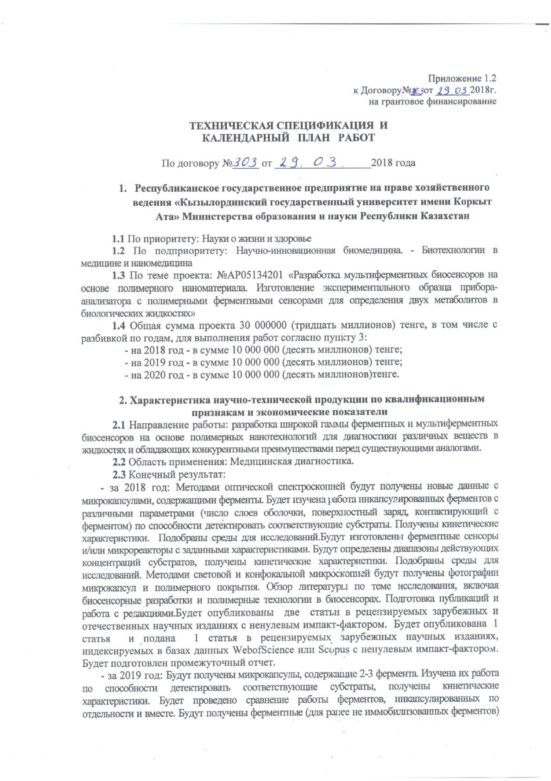

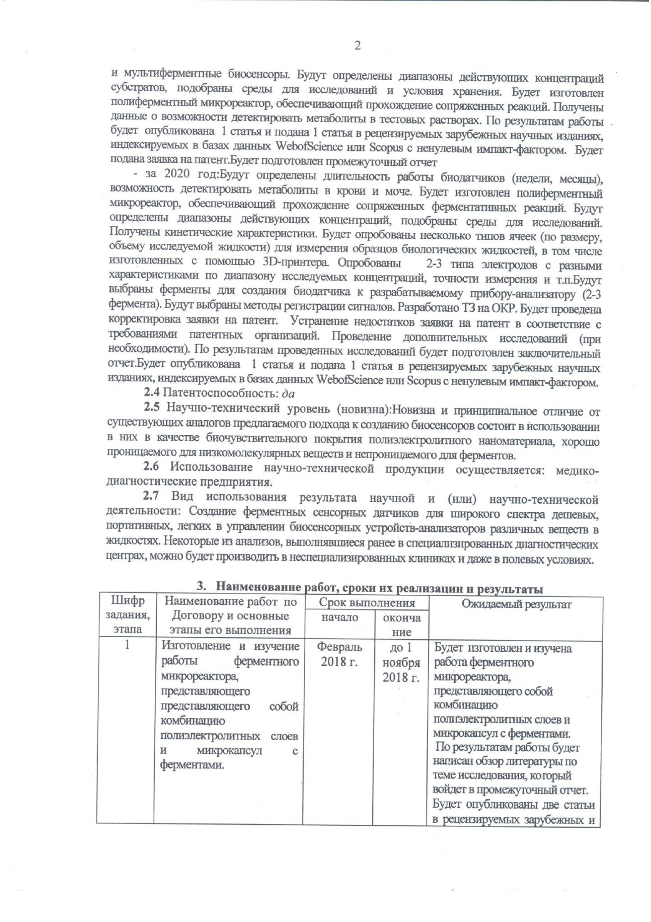

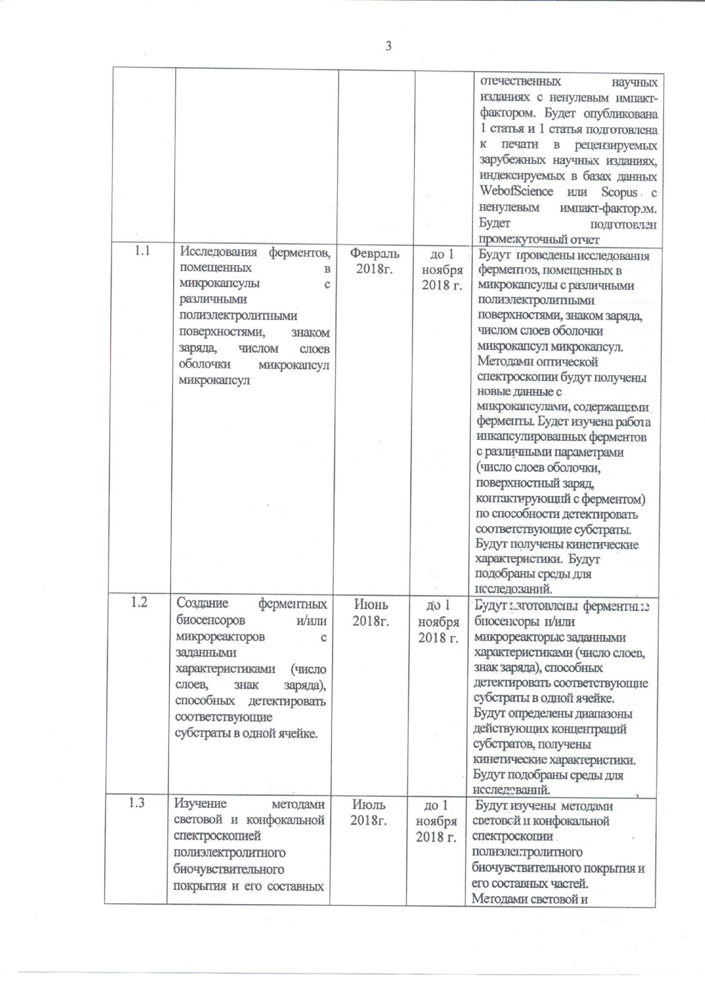

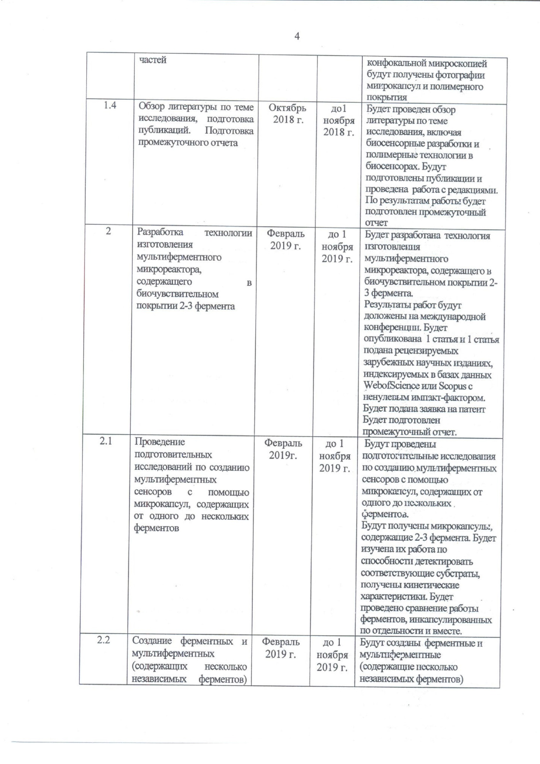

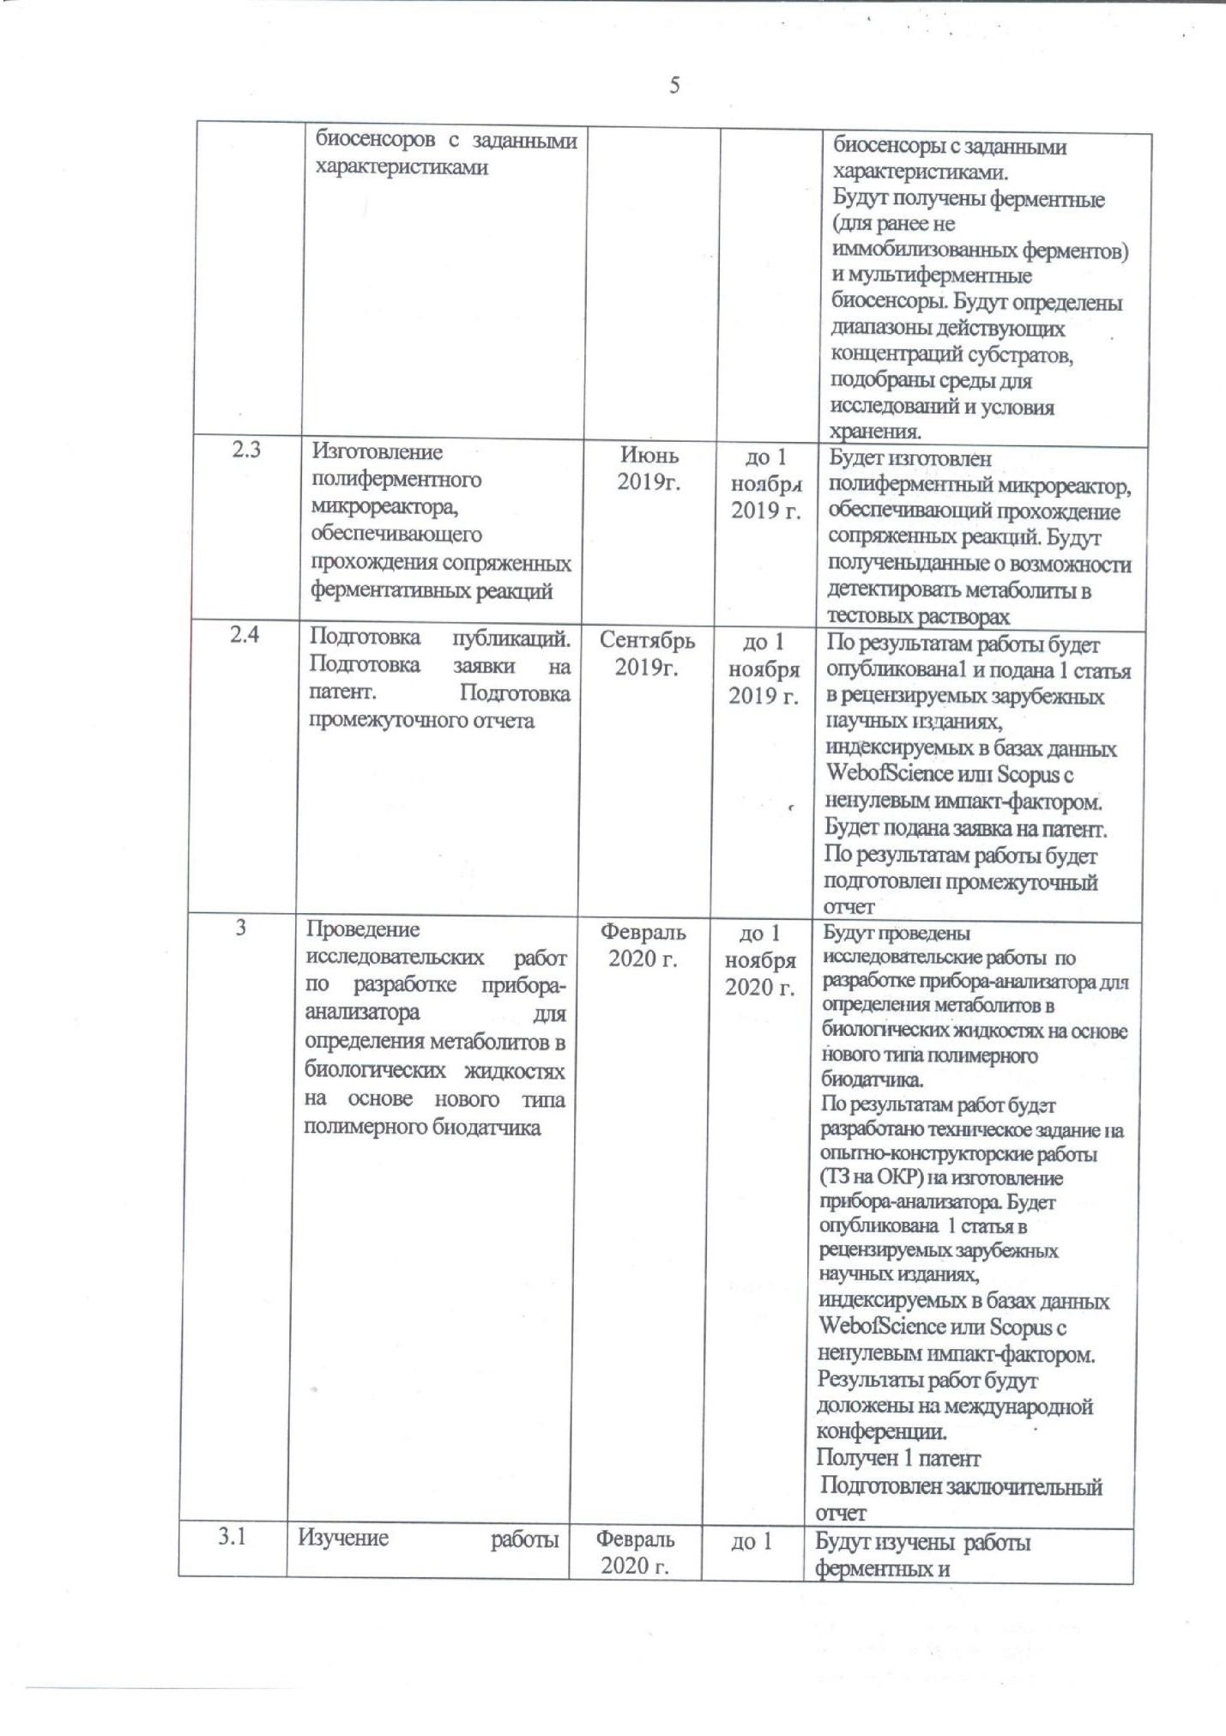

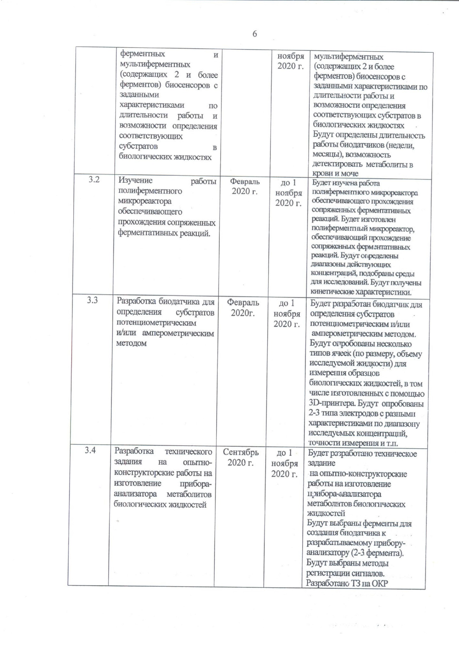

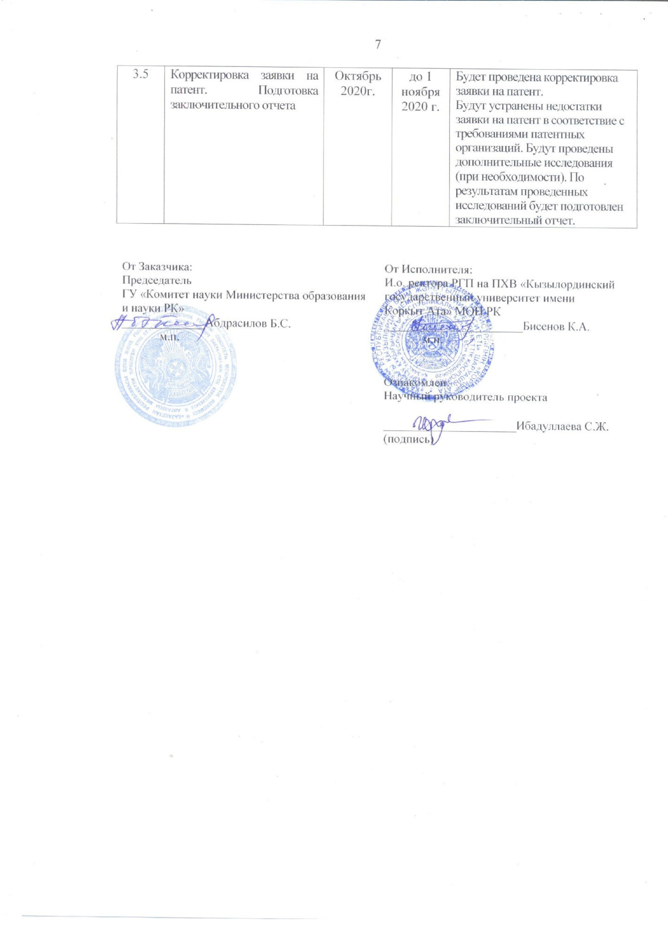

3. Name of work, terms of their implementation and results

Job code, stage | Name of work under the Agreement and the main stages of its implementation | Period of execution |  | Expected Result
Job code, stage |  | Start | ending | Expected Result
1 | Manufacturing and studying the operation of an enzyme microreactor, which is a combination of polyelectrolyte layers and microcapsules with enzymes | February 2018 | Until November 1, 2018 | The operation of an enzymatic microreactor, which is a combination of polyelectrolyte layers and microcapsules with enzymes, will be manufactured and studied. Based on the results, a literature review on the research topic will be written, which will be included in the interim report. Two articles will be published in peer-reviewed foreign and domestic scientific journals with a non-zero impact factor. 1 article will be published and 1 article will be prepared for publication in peer-reviewed foreign scientific journals, indexed in the Web of Science or Scopus databases with a non-zero impact factor.  Interim report will be prepared
1.1 | Studies of enzymes placed in microcapsules with different polyelectrolyte surfaces, charge sign, number of shell layers of microcapsules of microcapsules | February 2018 | Until November 1, 2018 | Studies of enzymes placed in microcapsules with different polyelectrolyte surfaces, sign of charge, and the number of layers of the microcapsule shell will be carried out. Using optical spectroscopy, new data will be obtained with microcapsules containing enzymes. The work of encapsulated enzymes with different parameters (number of shell layers, surface charge in contact with the enzyme) will be studied in terms of their ability to detect the corresponding substrates. Kinetic characteristics will be obtained. Research environments will be selected
1.2 | Creation of enzymatic biosensors and / or microreactors with specified characteristics (number of layers, charge sign) capable of detecting the corresponding substrates in one cell. | June 2018 | Until November 1, 2018 | Enzyme sensors and / or microreactors with specified characteristics (number of layers, sign of charge), capable of detecting corresponding substrates in one cell, will be manufactured. The ranges of effective concentrations of substrates will be determined, kinetic characteristics will be obtained. Research environments will be selected
1.3 | Study of polyelectrolyte biosensitive coating and its constituents by methods of light and confocal spectroscopy | July 2018 | Until November 1, 2018 | They will be studied by light and confocal spectroscopy of a polyelectrolyte biosensitive coating and its components. Photographs of microcapsules and polymer coating will be obtained using light and confocal spectroscopy.
1.4 | Review of literature on the research topic, preparation of publications. Preparation of interim report | October 2018 | Until November 1, 2018 | A review of the literature on the research topic, including biosensor development and polymer technologies in biosensors, will be carried out. Publications will be prepared and work with editors will be carried out. Based on the results of the work, an interim report will be prepared
2 | Development of a technology for the manufacture of a multienzyme microreactor containing 2-3 enzymes in a biosensitive coating | February 2019 | Until November 1, 2019 | Technologies for manufacturing a multienzyme microreactor containing 2-3 enzymes in a biosensitive coating will be developed. The results of the work will be reported at an international conference. 1 article will be published and 1 article submitted to peer-reviewed foreign scientific journals, indexed in databases. Web of Science or Scopus with a non-zero impact factor. A patent application will be filed. An interim report will be prepared.
2.1 | Carrying out preparatory studies for the creation of multi-enzyme sensors using microcapsules containing from one to several enzymes | February 2019 | Until November 1, 2019 | Preparatory studies will be carried out to create multienzyme sensors using microcapsules containing from one to several enzymes. Microcapsules containing 2-3 enzymes will be obtained. Their work on the ability to detect the corresponding substrates will be studied, and kinetic characteristics will be obtained. A comparison will be made of the work of enzymes encapsulated separately and together
2.2 | Creation of enzyme and multienzyme (containing several independent enzymes) biosensors with specified characteristics | February 2019 | Until November 1, 2019 | Enzyme and multienzyme (containing several independent enzymes) biosensors with specified characteristics will be created. Enzymatic (for previously not immobilized enzymes) and multienzyme biosensors will be obtained. Ranges of effective substrate concentrations will be determined, research media and storage conditions will be selected
2.3 | Manufacturing of a polyenzymatic microreactor that ensures the passage of conjugated enzymatic reactions | June 2019 | Until November 1, 2019 | A polyenzyme microreactor will be manufactured to ensure the passage of coupled reactions. Data on the possibility of detecting metabolites in test solutions will be obtained
2.4 | Preparation of publications. Preparation of a patent application. Preparation of interim report | September 2019 | Until November 1, 2019 | Based on the results of the work, 1 article and 1 article of peer-reviewed foreign scientific journals will be published, indexed in the Web of Science or Scopus databases with a non-zero impact factor.  A patent application will be filed. Based on the results of the work, an interim report will be prepared
3 | Carrying out research work on the development of an analyzer device for determining metabolites in biological fluids based on a new type of polymer biosensor | February 2020 | Until November 1, 2020. | Research work will be carried out on the development of an analyzer instrument for determining metabolites in biological fluids based on a new type of polymer biosensor. Based on the results of the work, a technical assignment for development work (TOR for R&D) will be developed for the manufacture of an analyzer device. 1 article will be published in peer-reviewed foreign scientific journals, indexed in the Web of Science or Scopus databases with a nonzero impact factor. The results of the work will be reported at an international conference.  1 patent received  Final report prepared
3.1 | Study of the work of enzyme and multienzyme (containing 2 or more enzymes) biosensors with specified characteristics for the duration of work and the possibility of determining the corresponding substrates in biological fluids | February 2020 | Until November 1, 2020 | The work of enzyme and multienzyme (containing 2 or more enzymes) biosensors with specified characteristics in terms of the duration of operation and the possibility of determining the corresponding substrates in biological fluids will be studied. The duration of the biosensor operation (weeks, months), the ability to detect metabolites in blood and urine will be determined
3.2 | Study of the operation of a polyenzymatic microreactor providing the passage of conjugated enzymatic reactions. | February 2020 | until November 1, 2020 | The work of a polyenzymatic microreactor providing the passage of conjugated enzymatic reactions will be studied. A polyenzymatic microreactor will be manufactured to ensure the passage of conjugated enzymatic reactions. Ranges of effective concentrations will be determined, and research media will be selected. Kinetic characteristics will be obtained
3.3 | Development of a biosensor for determination of substrates by potentiometric and / or amperometric method | February 2020 | Until November 1, 2020 | A biosensor will be developed for the determination of substrates by potentiometric and / or amperometric methods. Several types of cells (in terms of size, volume of the investigated fluid) will be tested to measure samples of biological fluids, including those made using a 3D printer. 2-3 types of electrodes with different characteristics in the range of investigated concentrations, measurement accuracy, etc. will be tested.
3.4 | Development of technical specifications for experimental design work for the manufacture of a device-analyzer for metabolites of biological fluids | September 2020 | Until November 1, 2020 | Terms of reference will be developed for experimental design work for the manufacture of a device-analyzer for metabolites of biological fluids. Enzymes will be selected to create a biosensor for the developed instrument-analyzer (2-3 enzymes). Signal acquisition methods will be selected. TK developed for R&D
3.5 | Correction of the patent application. Preparation of the final report | October 2020 | Until November 1, 2020 | The patent application will be revised. The shortcomings of the patent application will be eliminated in accordance with the requirements of patent organizations. Additional research will be conducted (if necessary). Based on the results of the research carried out, a final report will be prepared.

APPLICATION B

List of published works based on research results for 2018:

Articles in magazines:
- Fomkina M.G., Ibadullaeva S.Zh. Development of a biosensor for urea using polymer technologies for blood and urine analyzes // Scientific Instrument Engineering. - 2018. - Vol. 28. - No. 3. - P. 36-43. (russian).
- Ibadullaeva S.Zh., Fomkina M.G., Appazov N.O., Zhusupova L.A. Development of a urea biosensor using polymer technologies for blood and urine analyzes // Izvestiya NAN RK. Biological and medical series. - 2018. - No. 6. (russian).
- Kim Yu.A., Gaidin S.G., Tarahovsky Yu.S. The influence of simple phenols on collagen type I fibrillogenesis in vitro // Biophysics. – 2018. –Vol. 63. – №2. P.162-168. DOI: 10.1134/S0006350918020148. Scopus. Impact factor: 0.56. (english).
- Fomkina M.G., Minkabirova G.M., Montrel A.M., S.Zh. Ibadullaeva. Search for ways to increase the catalytic activity of encapsulated horseradish peroxidase // Biophysics. - 2019. - Vol. 64. No. 1. – P. 39-47. DOI: 10.1134 / S0006302919010058. (russian).

List of published works based on research results for 2019:

Articles in magazines:
1 Fomkina M.G., Minkabirova G.M., Montrel A.M., Ibadullaeva S. The search for ways to improve the catalytic activity of encapsulated horseradish peroxidase // Biophysics. 2019. Т. 64. № 1. С. 31-37. DOI: 10.1134/S0006350919010068. Scopus. Impact factor: 0.56. (english).
2 Ibadullaeva S.Zh., Appazov N.O., Tarakhovsky Yu.S., Zamyatina E.A., Fomkina M.G., Kim Yu.A. Amperometric multienzyme biosensors: development and application (brief review) // Biophysics. 2019.Vol. 64. No. 5.P. 869-882.) DOI: 10.1134 / S0006302919050065. (russian).
Articles in conference proceedings:
3 Yagolnik E.A., Fomkina M.G., Zamyatina E.A., Appazov N.O., Ibadullaeva S.Zh., Kim Yu.A. Polyelectrolyte microcapsules with encapsulated urease: measuring the pH of the medium with a hydrophobic fluorescent probe // Bulletin of the Tula State University. Natural Sciences. – 2019. – Vol. 2. – P. 3-14. (russian).
4 Ibadullaeva S.Zh., Fomkina M.G., Zamyatina E.A., Appazov N.O., Kim Yu.A. Multienzyme biosensors (brief overview) // In the collection: Receptors and intracellular signaling. Edited by V.P. Zinchenko, A.V. Berezhnova. Pushchino, – 2019. – P. 155-160. (russian).
5 Yagolnik E.A., Fomkina M.G., Zamyatina E.A., Appazov N.O., Ibadullaeva S.Zh., Kim Yu.A. Determination of the pH of the medium by the fluorescence of the molecules of the hydrophobic probe included in the polyelectrolyte microcapsules // In the book: Proceedings of the XIX International Conference on Science and Technology Russia-Korea-CIS, Moscow, – 2019. – P. 89-94. (russian).

List and reprints of published works based on research resultsfor 2020:

Articles in magazines:
1. S. Zh. Ibadullaeva N. O. Appazov Yu. S. Tarahovsky E. A. Zamyatina M. G. Fomkina Yu. A. Kim. Amperometric Multi-Enzyme Biosensors Development and Application a Short Review // Biophysics. – 2019. – Vol. 64. – No. 5. – P. 869-882. DOI: 10.1134/S0006350919050063. Scopus. Impact factor: 0.56. (english).
2. V. A. Anikina Yu. A. Kim A. F. Korystova M. Kh. Levitman V. V. Shaposhnikova Yu. N. Korystov. Effects of Catechin on Activity of Angiotensin-Converting Enzyme and Generation of Reactive Oxygen Species in Rat Aorta // Bulletin of Experimental Biology and Medicine. – 2020. – Vol. 168. – No. 1. P. 627-630. DOI: 10.1007/s10517-020-04766-0. Web of Science, Scopus. Impact factor: 0.775. (english).
3. Smolobochkin A. Gazizov A. Sazykina M. Akylbekov N. Chugunova E. Sazykin I. Gildebrant A. Voronina J. Burilov A. Karchava S. Klimova M. Voloshina A. Sapunova A. Klimanova E. Sashenkova T. Allayarova U. Balakina A. Mishchenko D. Synthesis of Novel 2- Het arylpyrrolidine Derivatives and Evaluation of Their Anticancer and Anti-Biofilm Activity // Molecules. – 2019. – Vol. 24. – No. 17. – P. 3086-3112. DOI: 10.3390/molecules24173086. Web of Science, Scopus. Impact factor: 3.267. (english).
Patents:
1 Ibadullaeva S.Zh., Appazov N.O., Fomkina M.G., Kim Yu.A., Montrel A.M., Zhandavletova N.B., Zhusupova L.A., Arystanova A.T. A method for increasing the catalytic activity of encapsulated and immobilized enzymes // Patent for a useful model of the Republic of Kazakhstan No. 4173 dated 16.07.2019. (russian).
Articles in conference proceedings:
1. Appazov N.O., Ibadullaeva S.Zh., Zhapparbergenov R.U., Kim Yu.A. Bienzyme amperometric glucose biosensors mini review // Materials of the international scientific and practical conference "Science and education in the XXI century" 07/31/2020. Bulletin of scientific conferences. – 2020. – Vol. 7-1. – No. 59. – P.20-25. (russian).

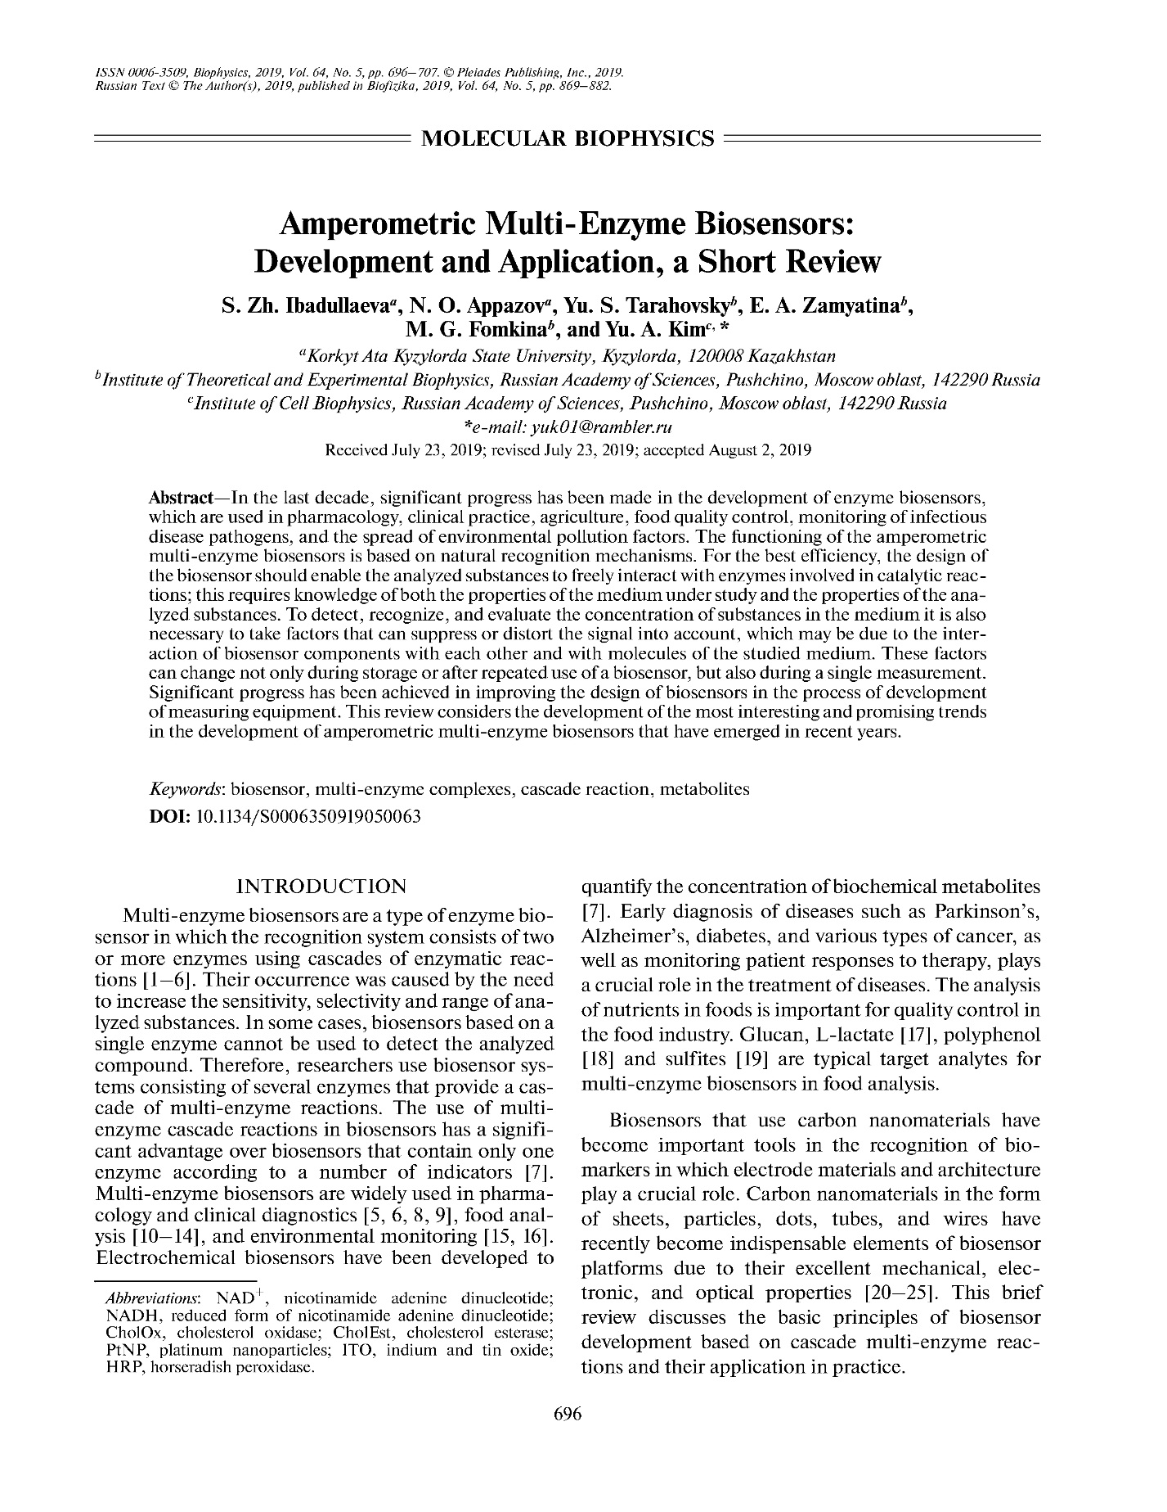

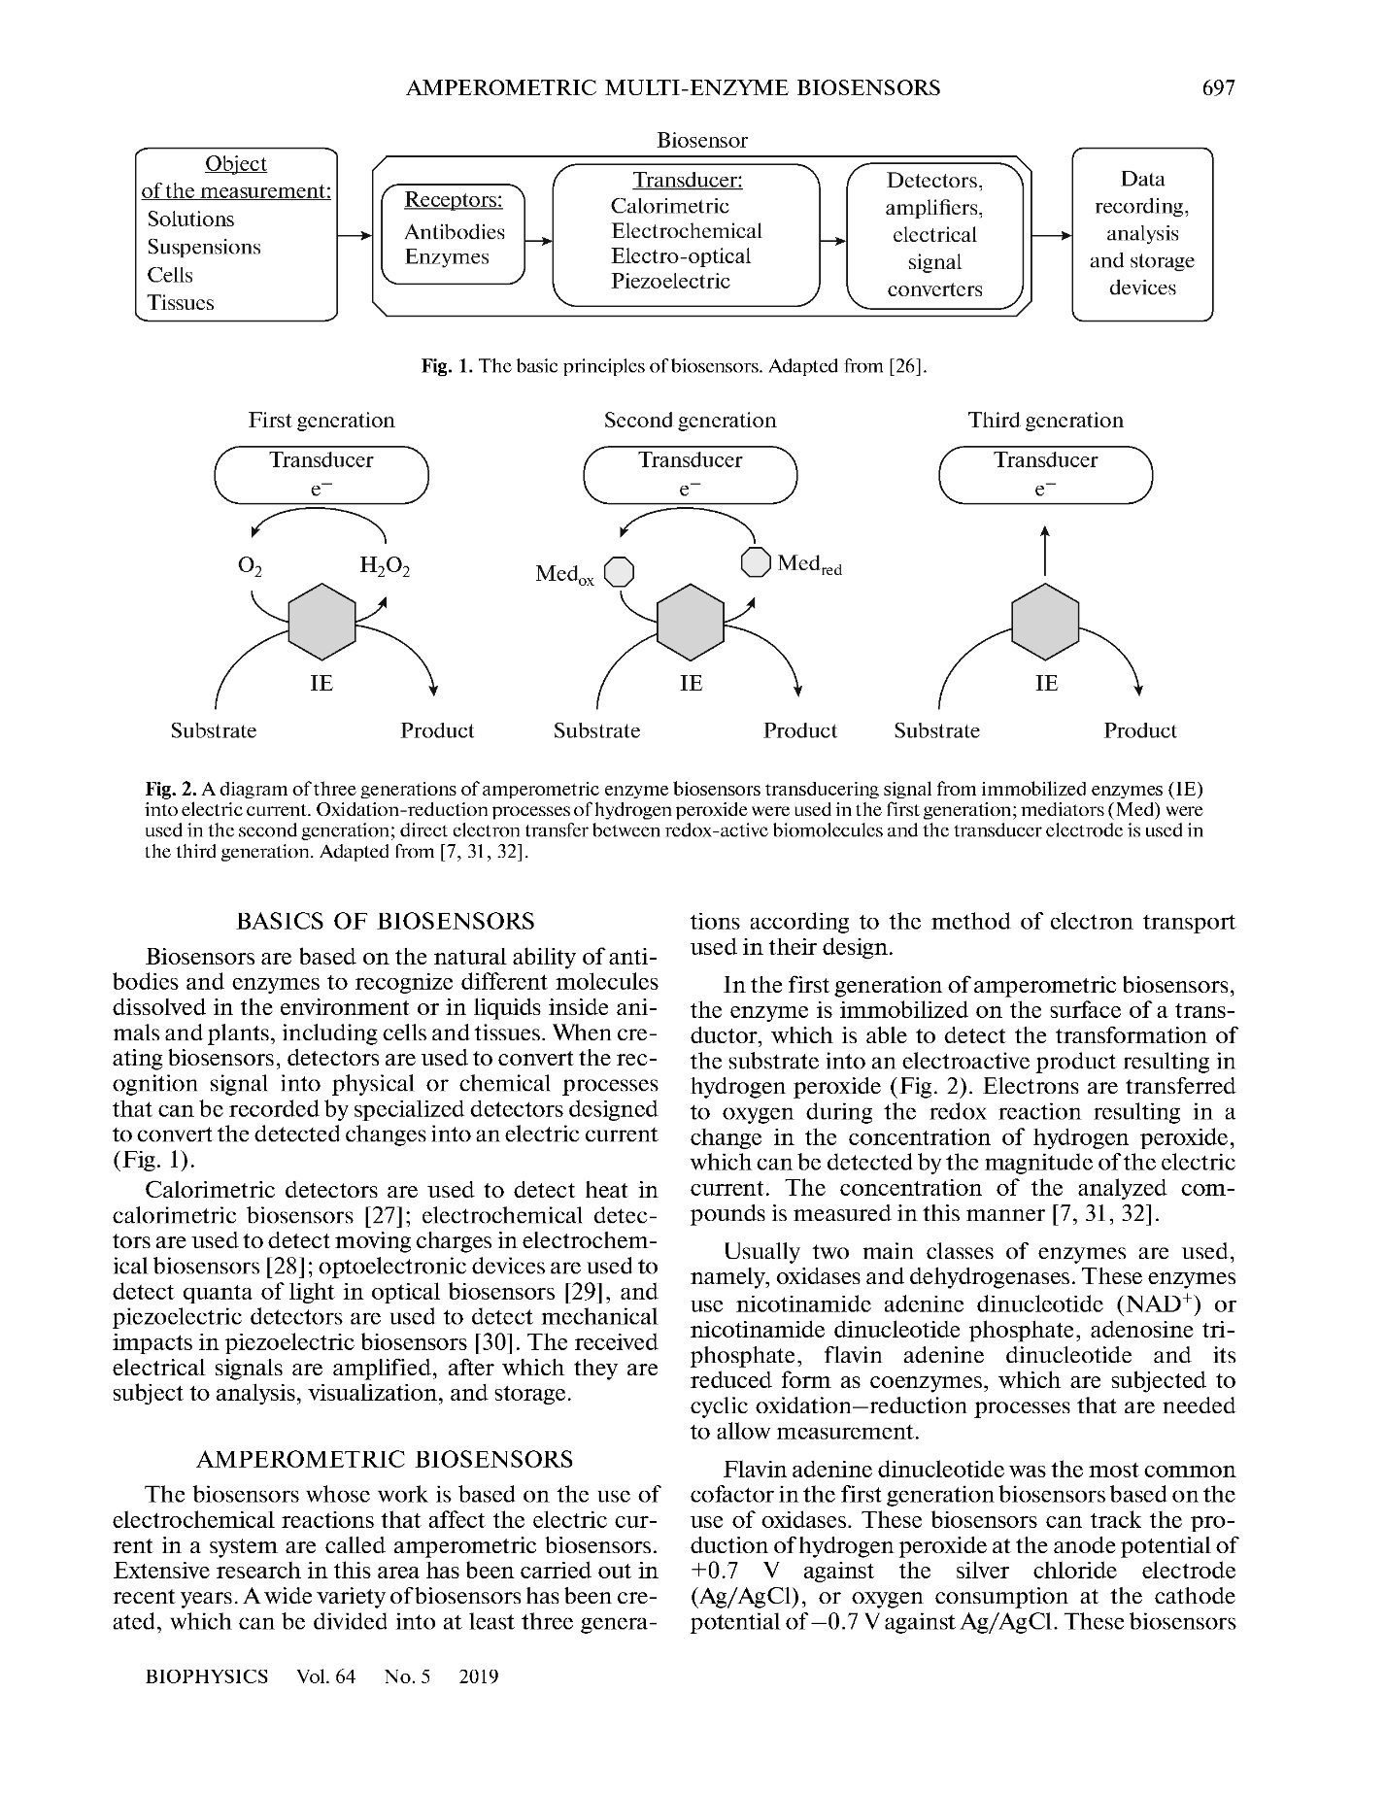

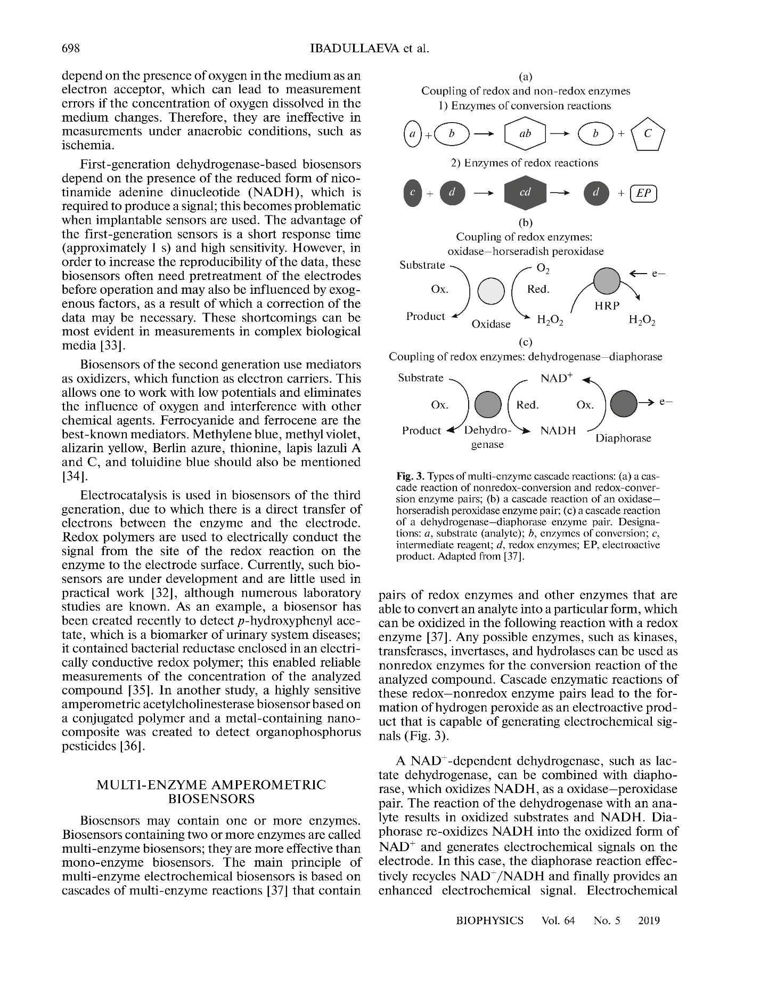

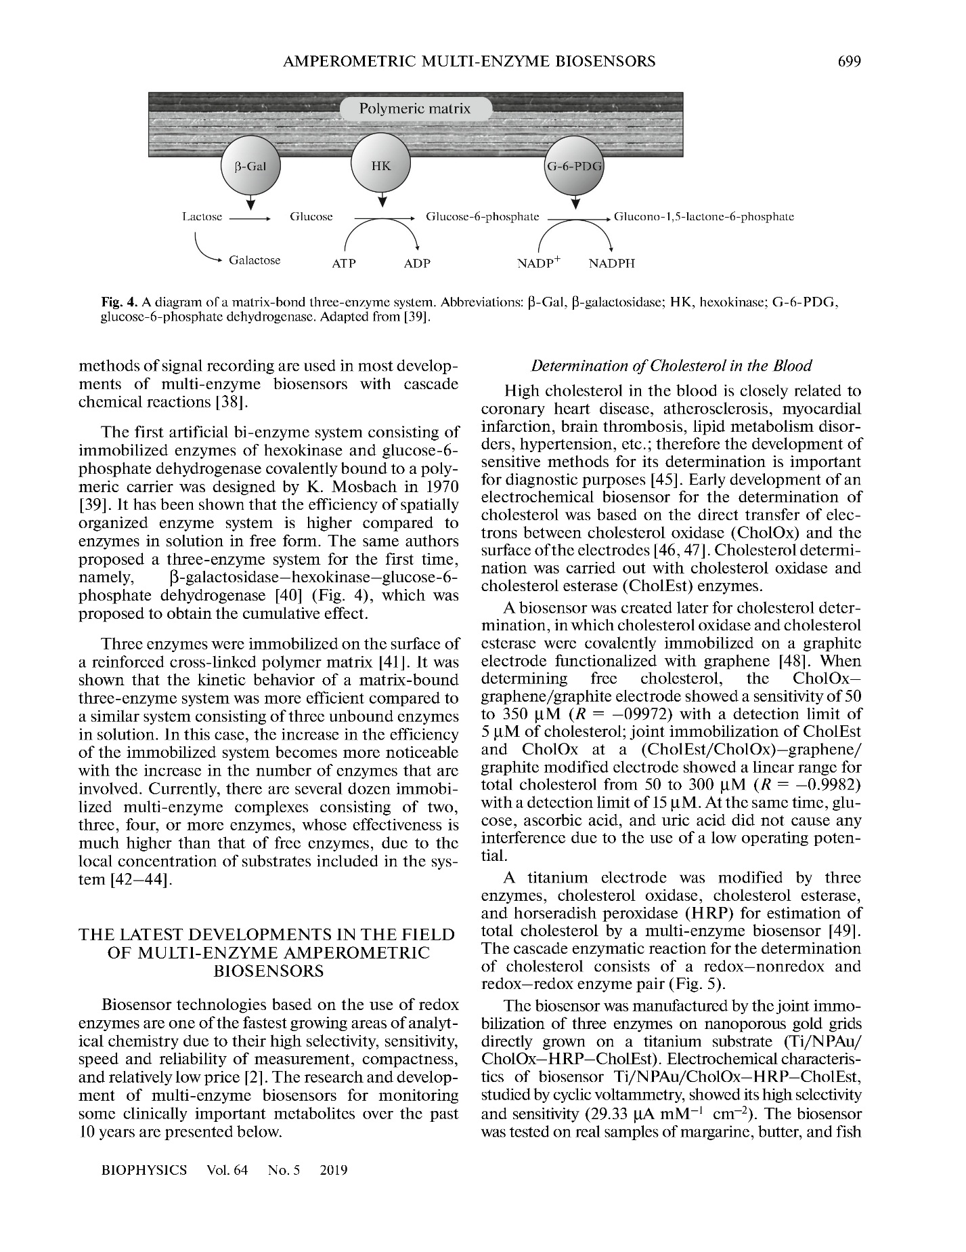

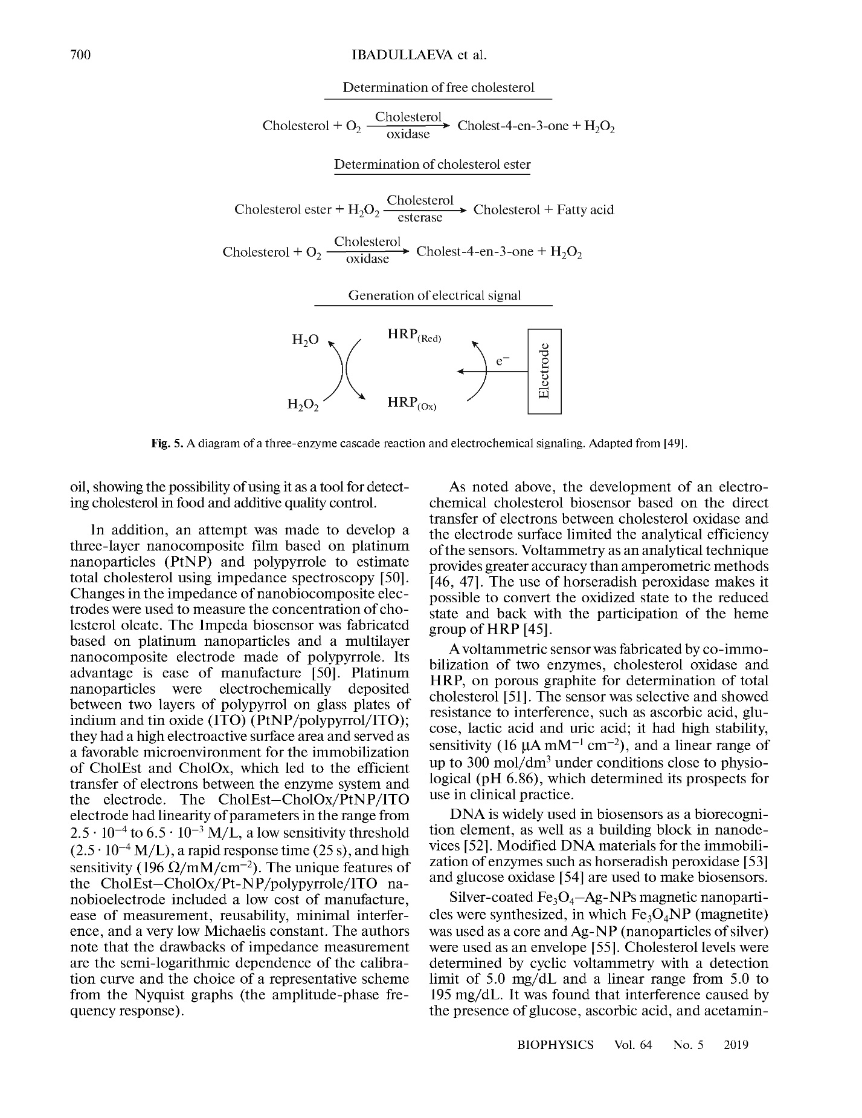

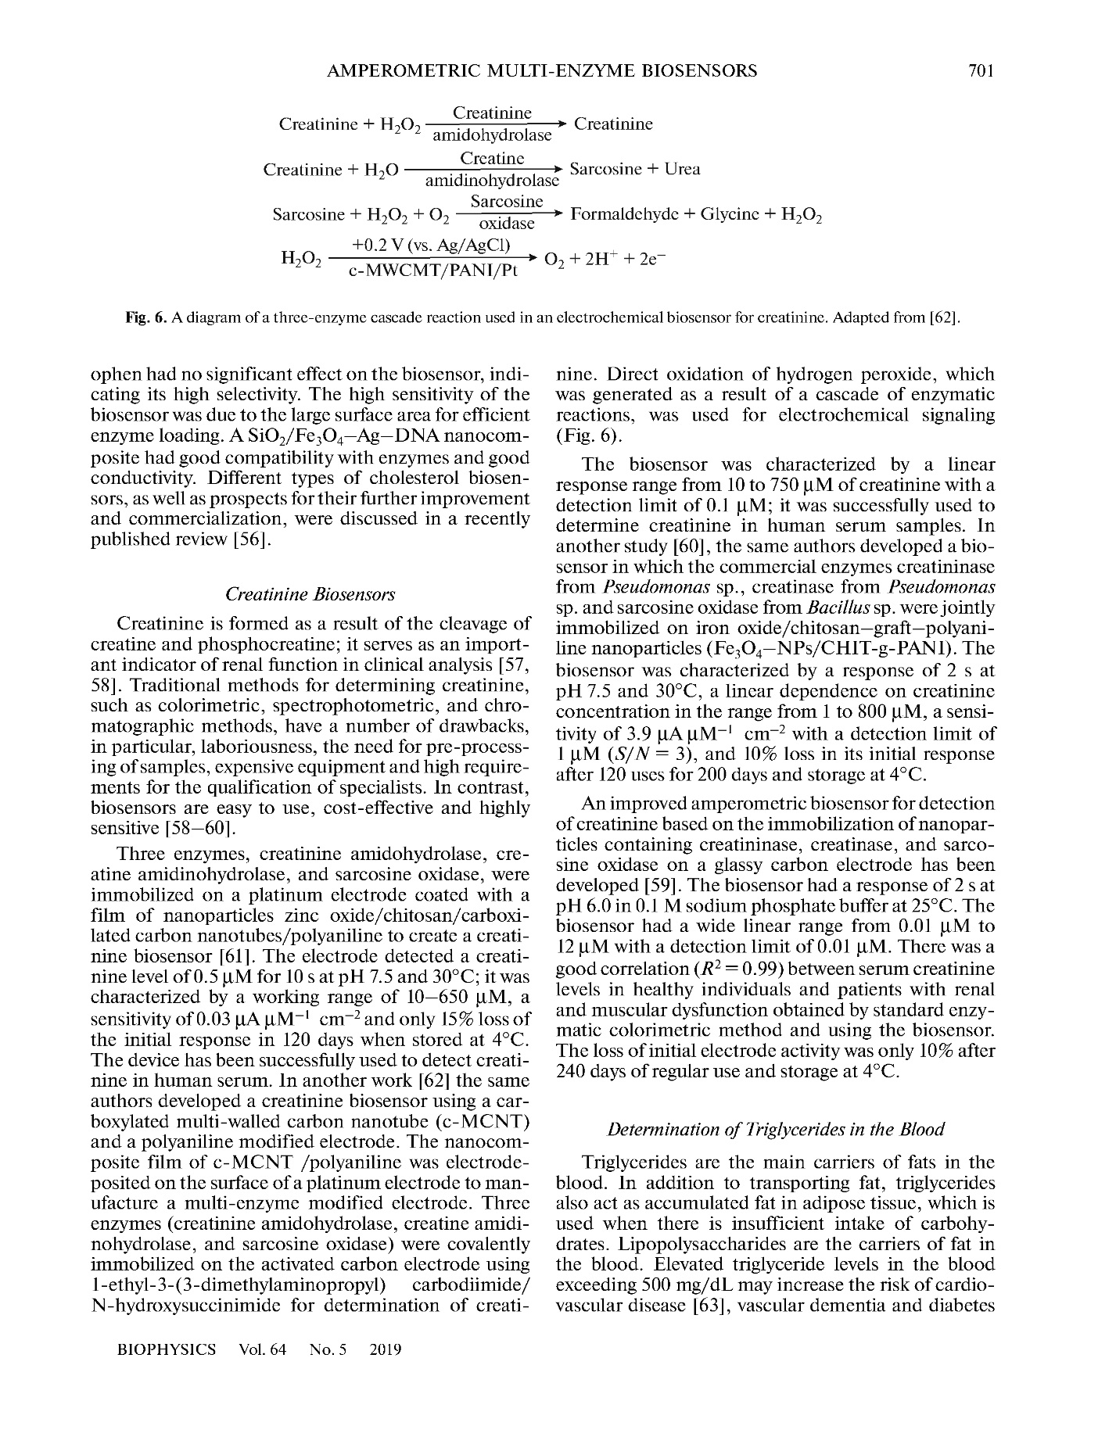

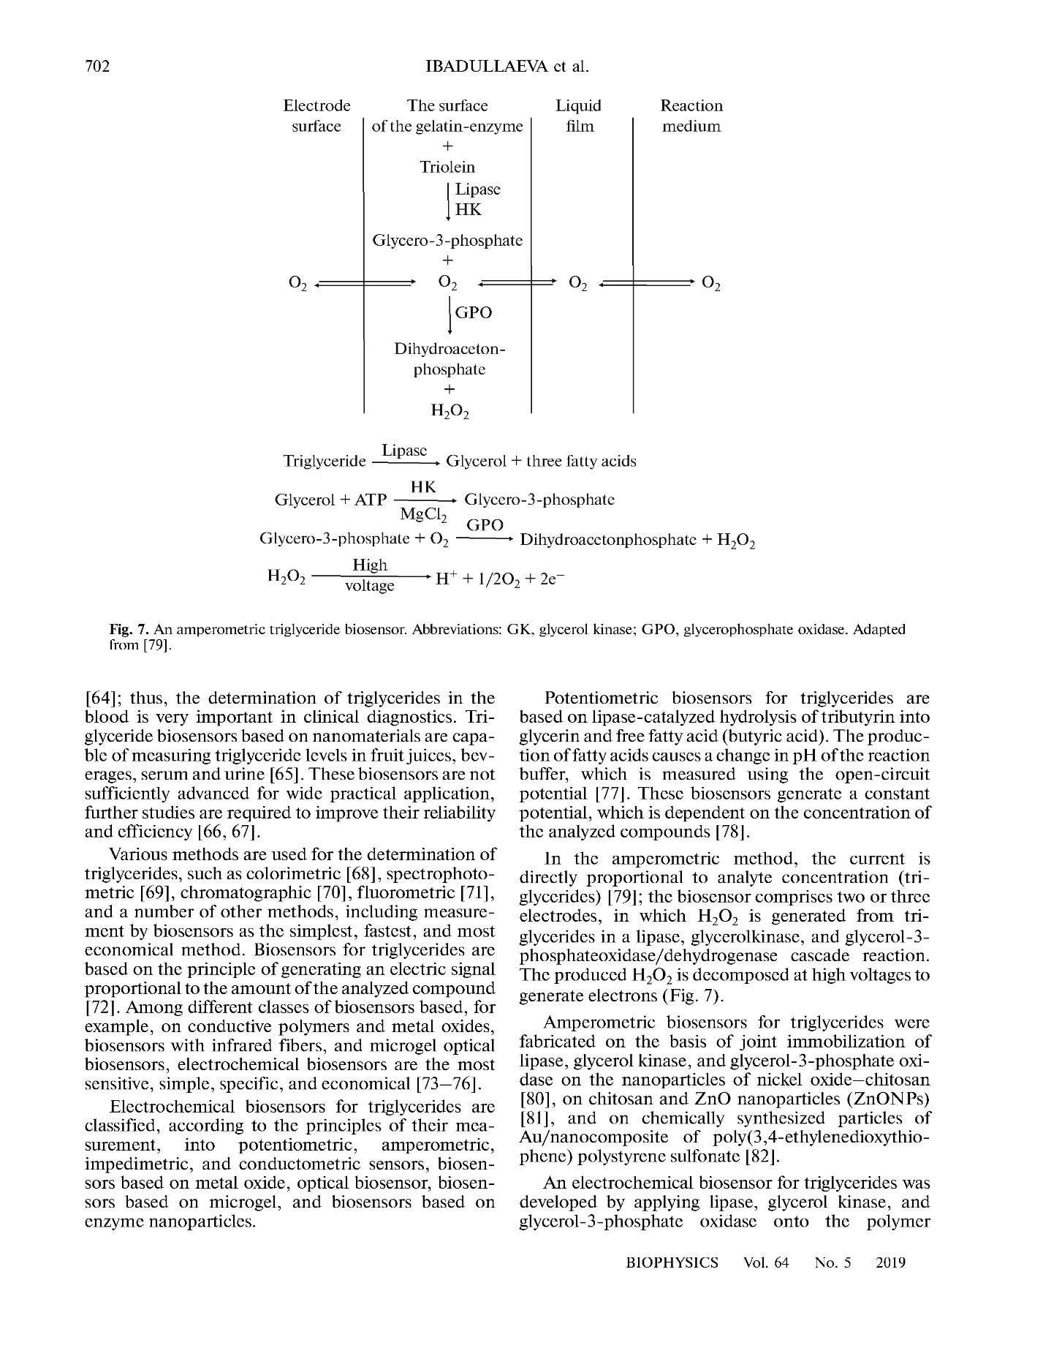

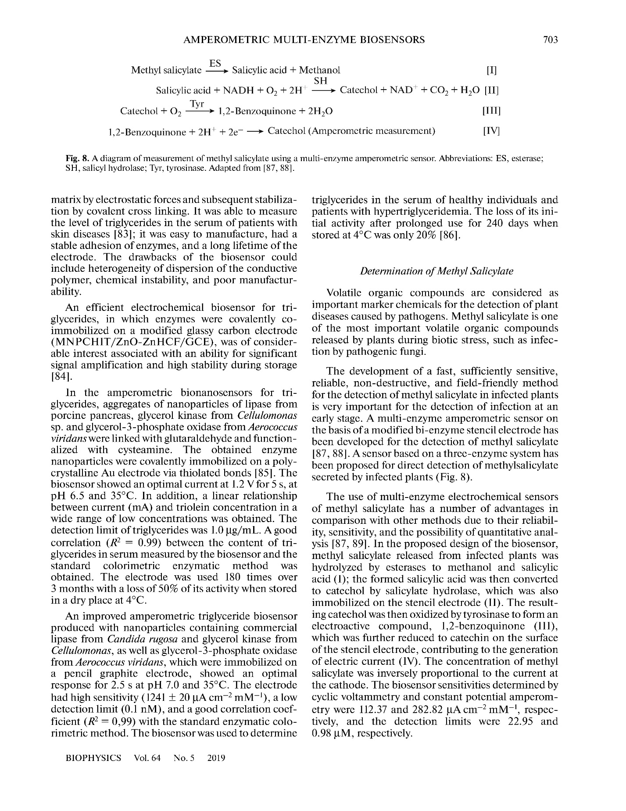

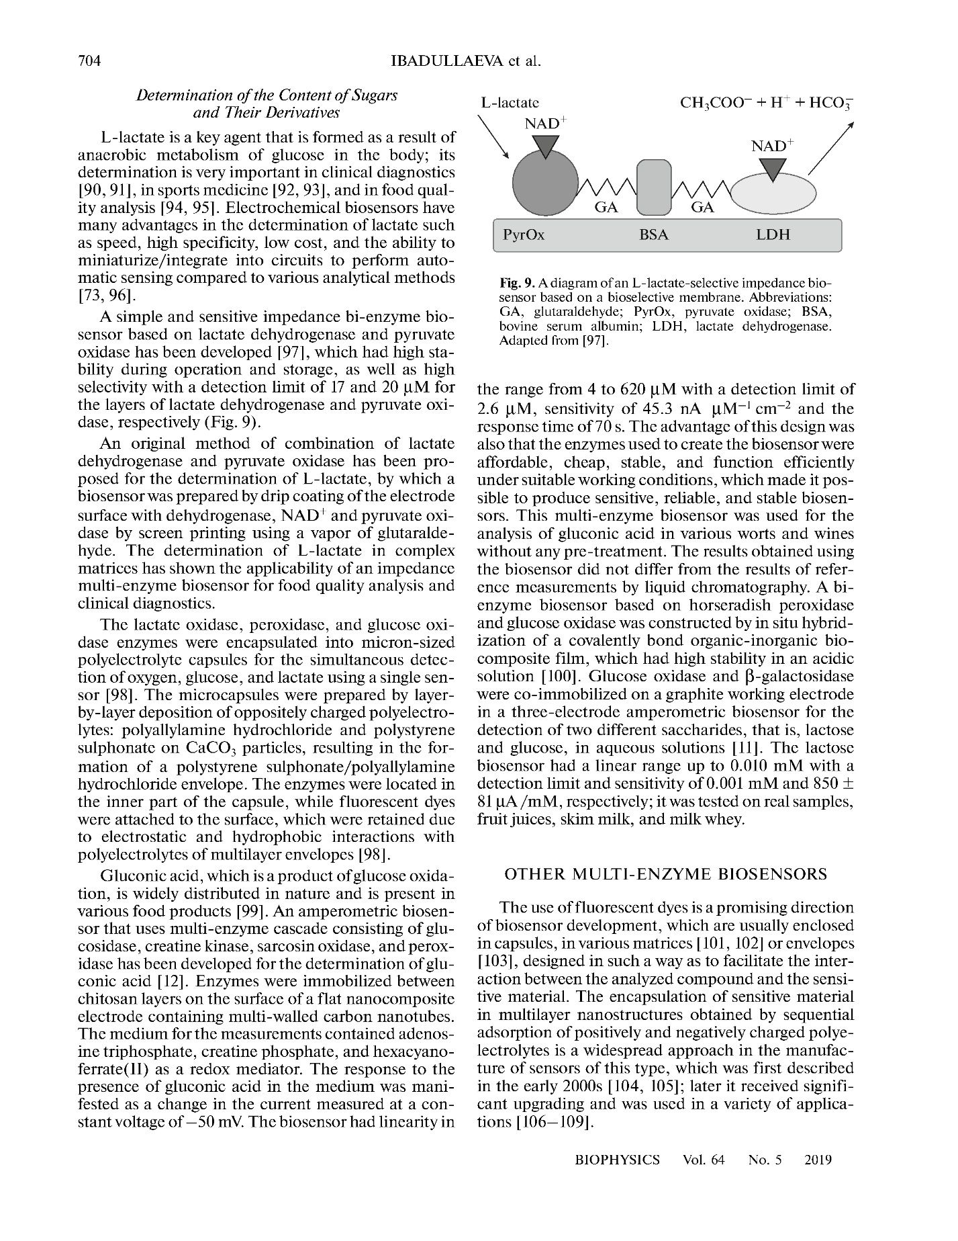

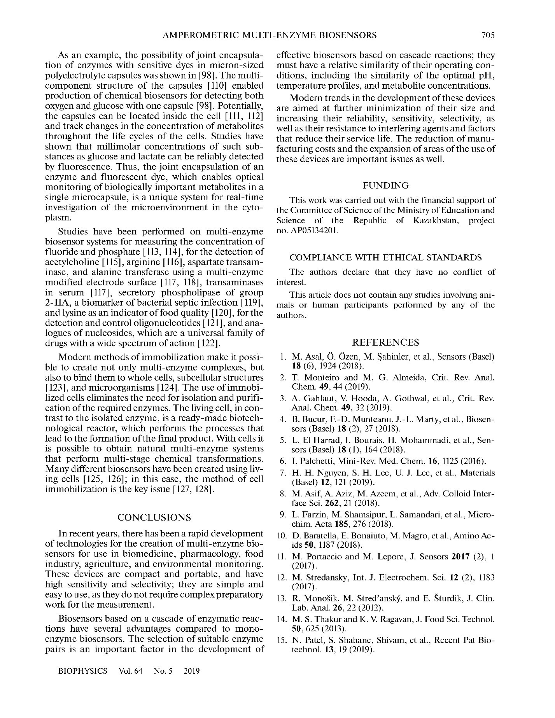

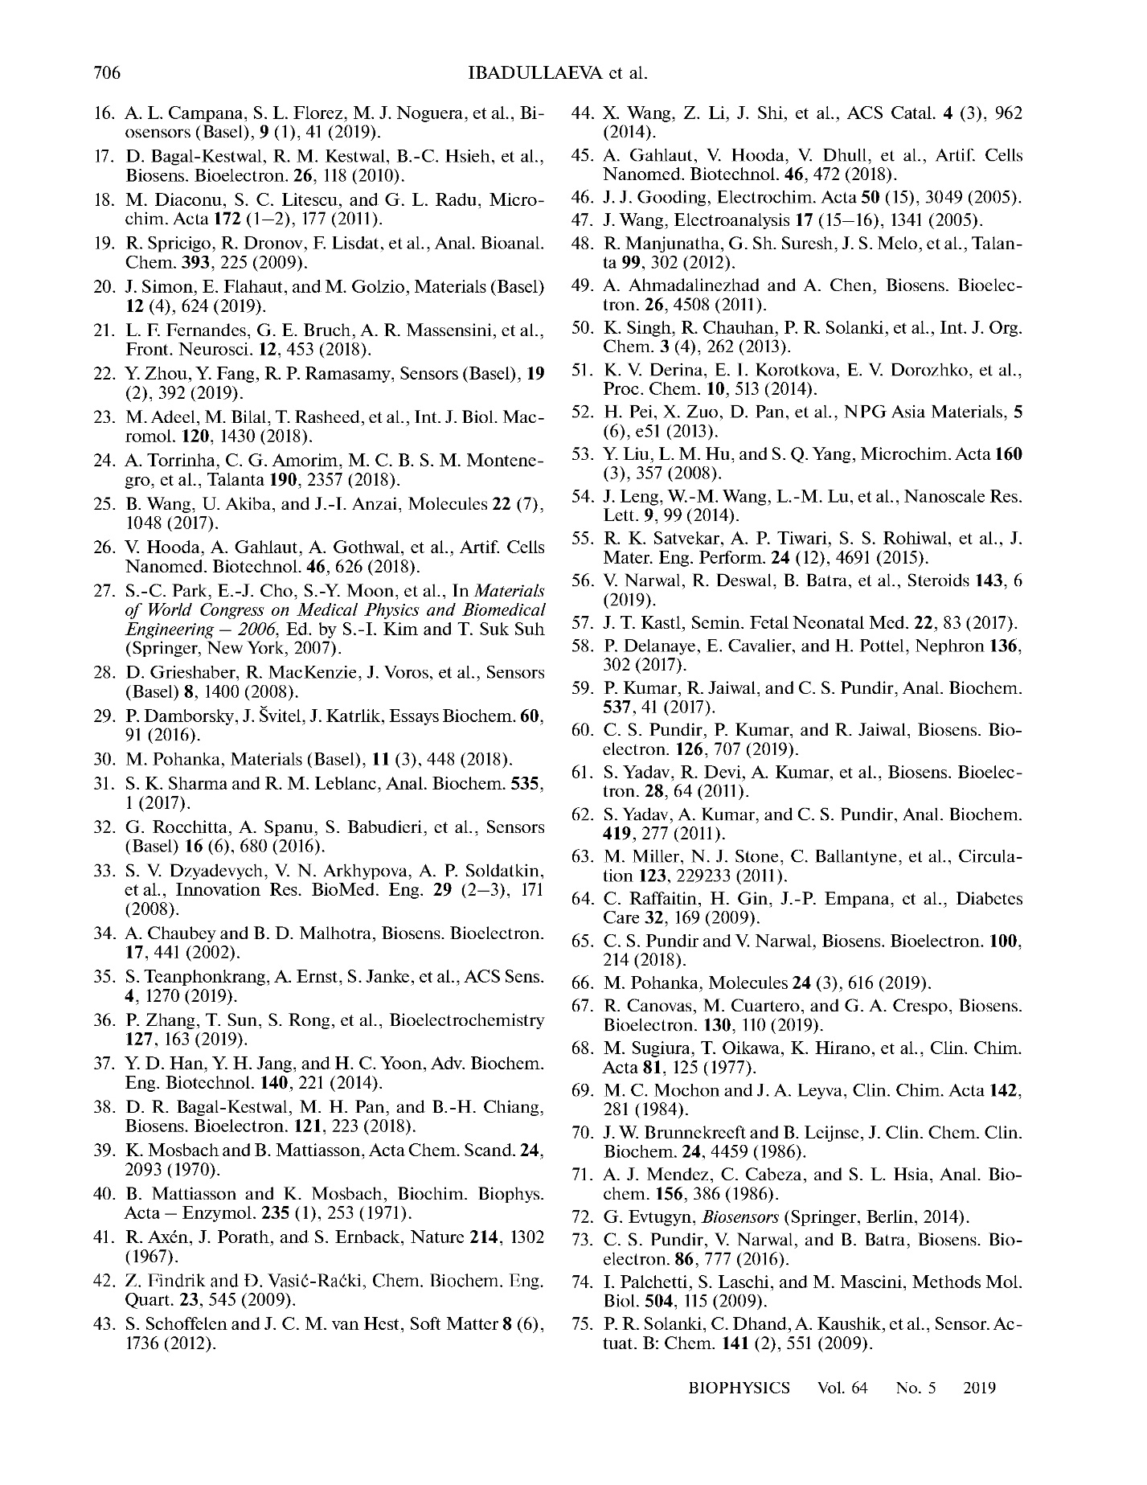

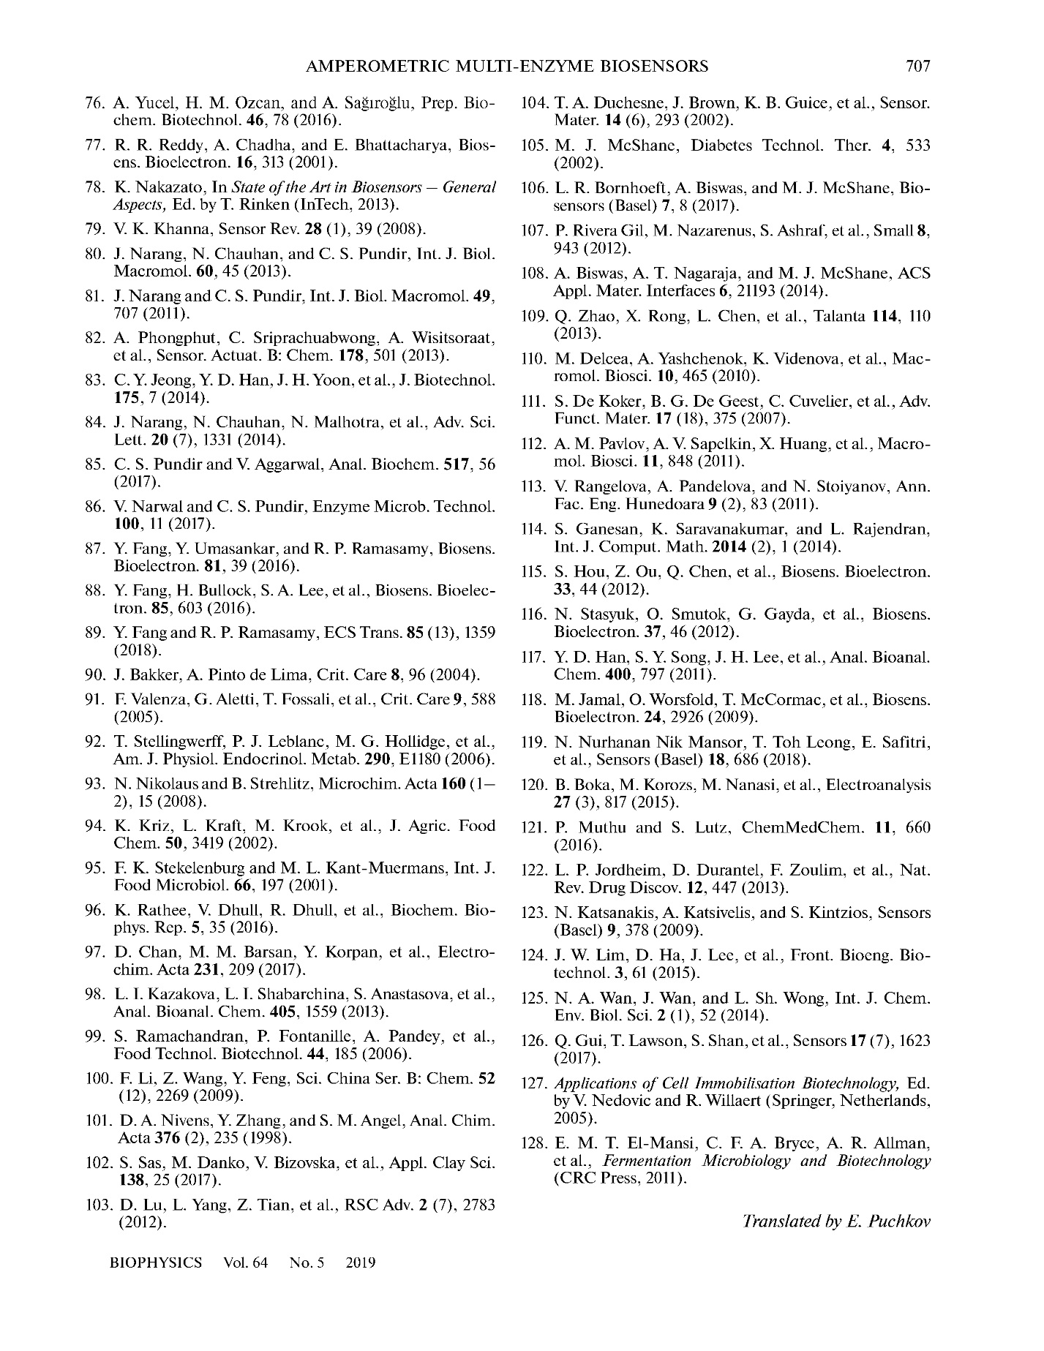

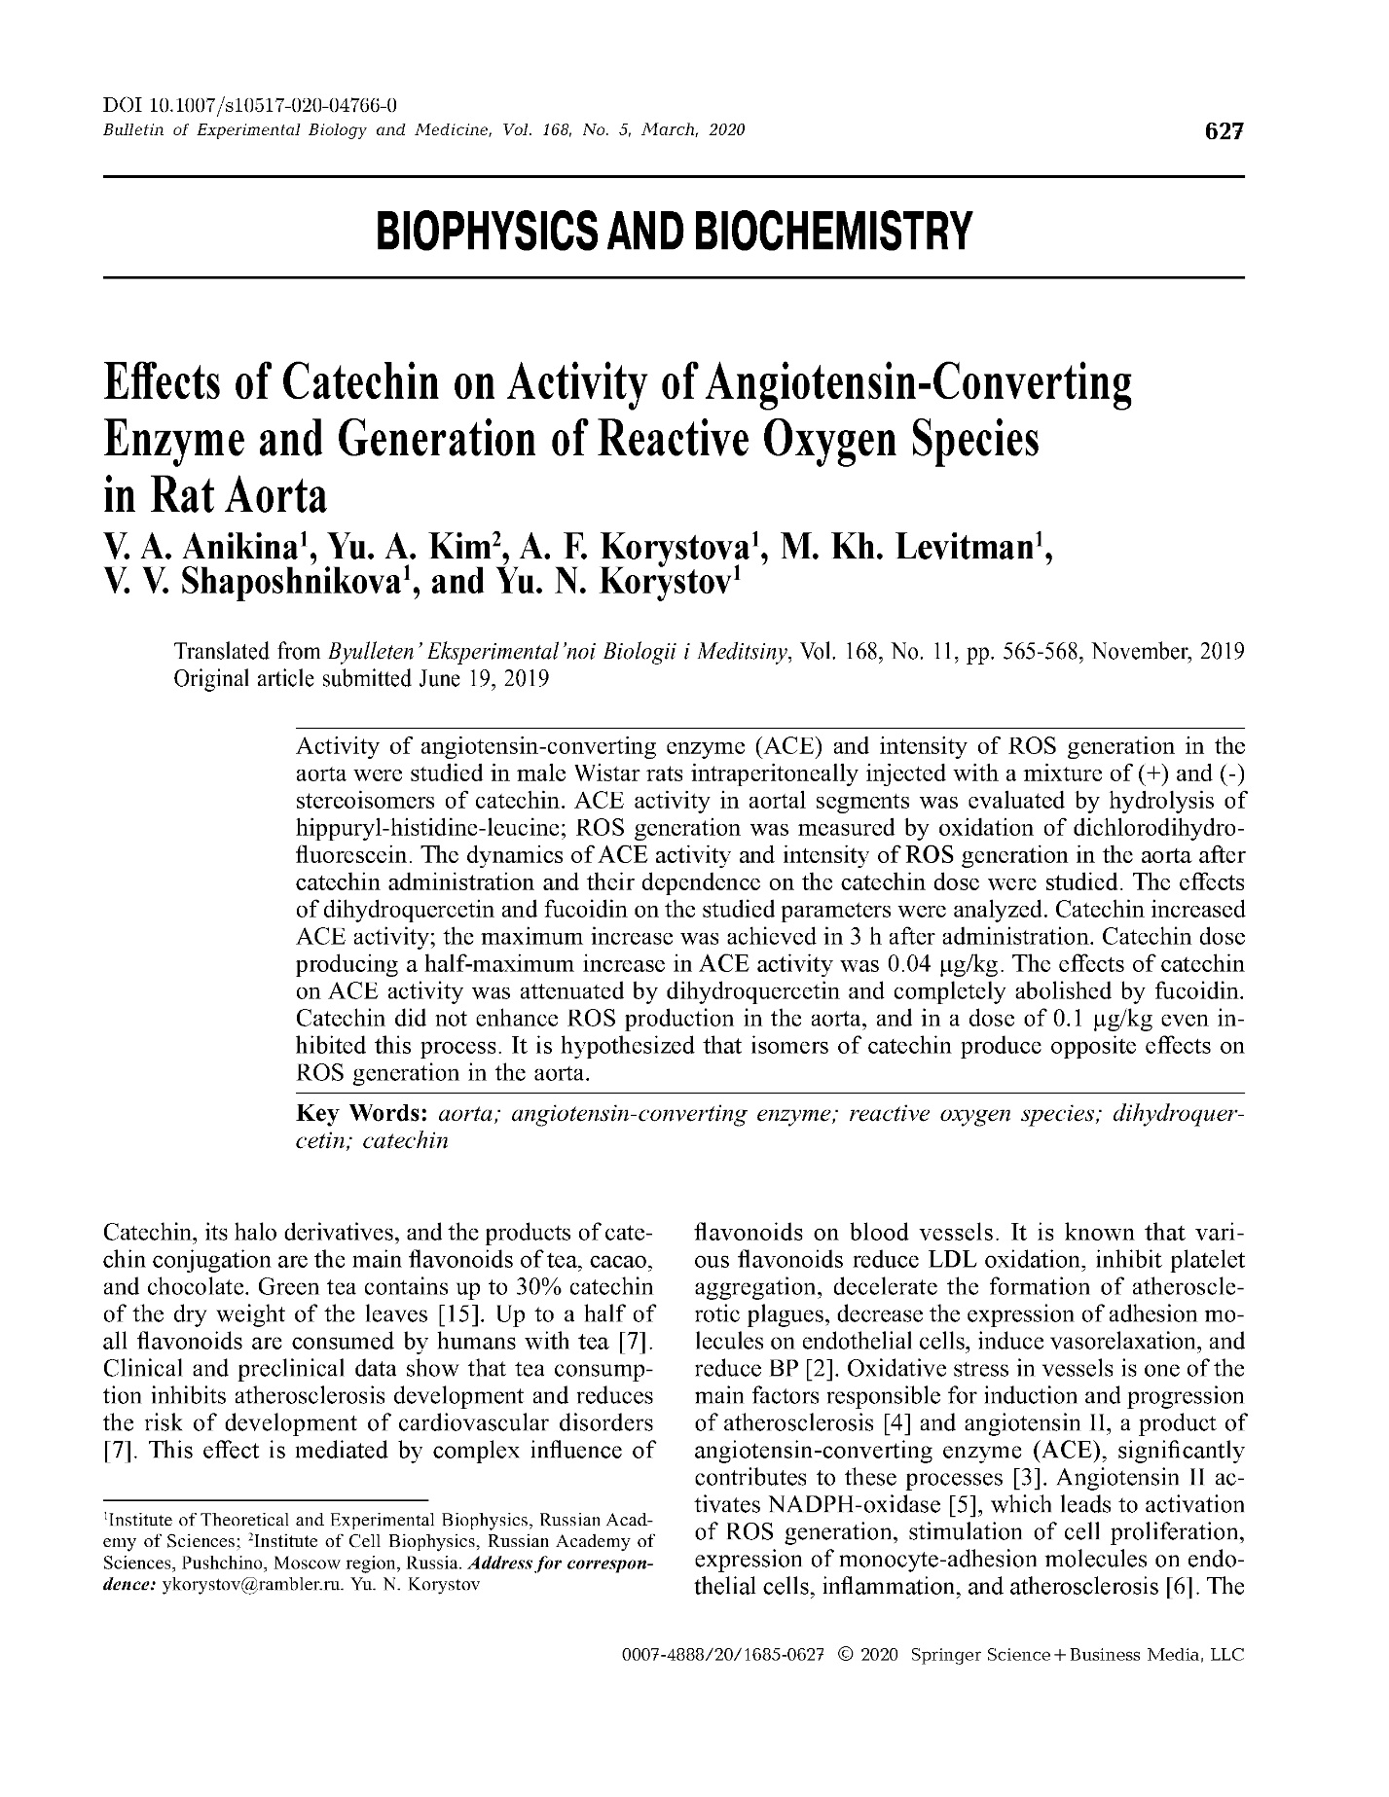

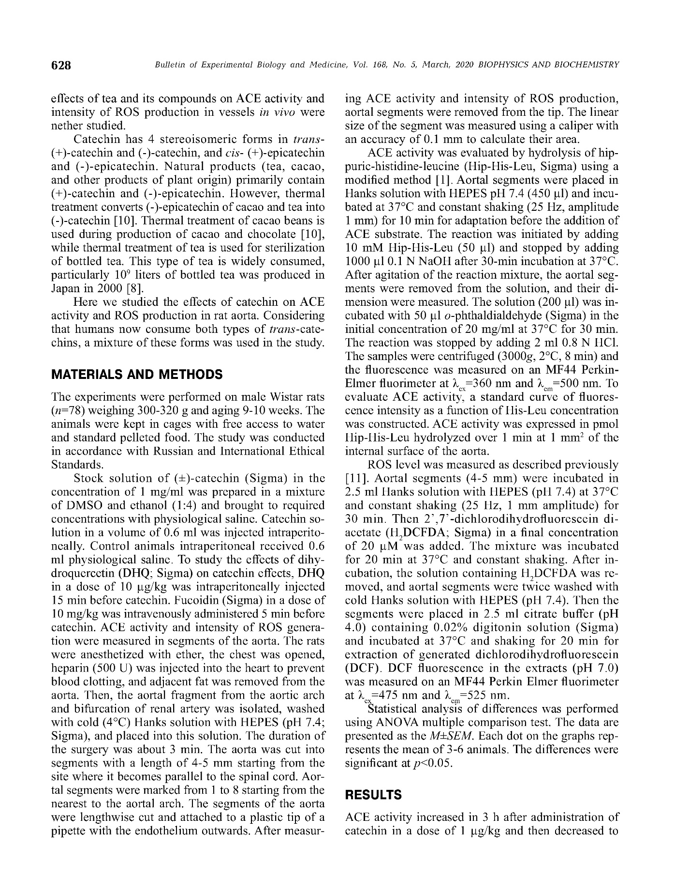

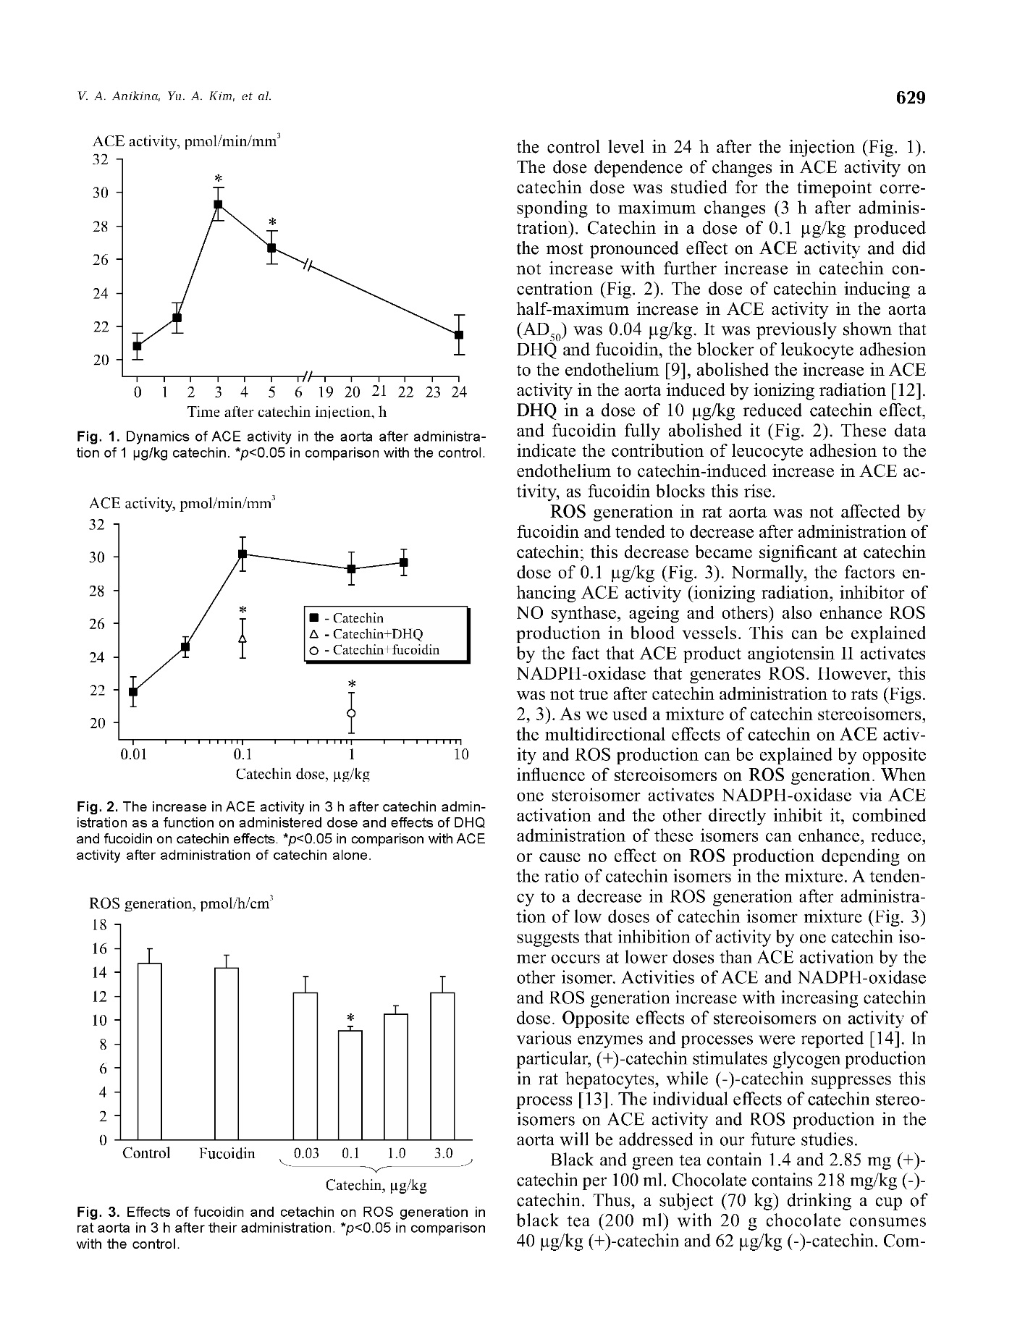

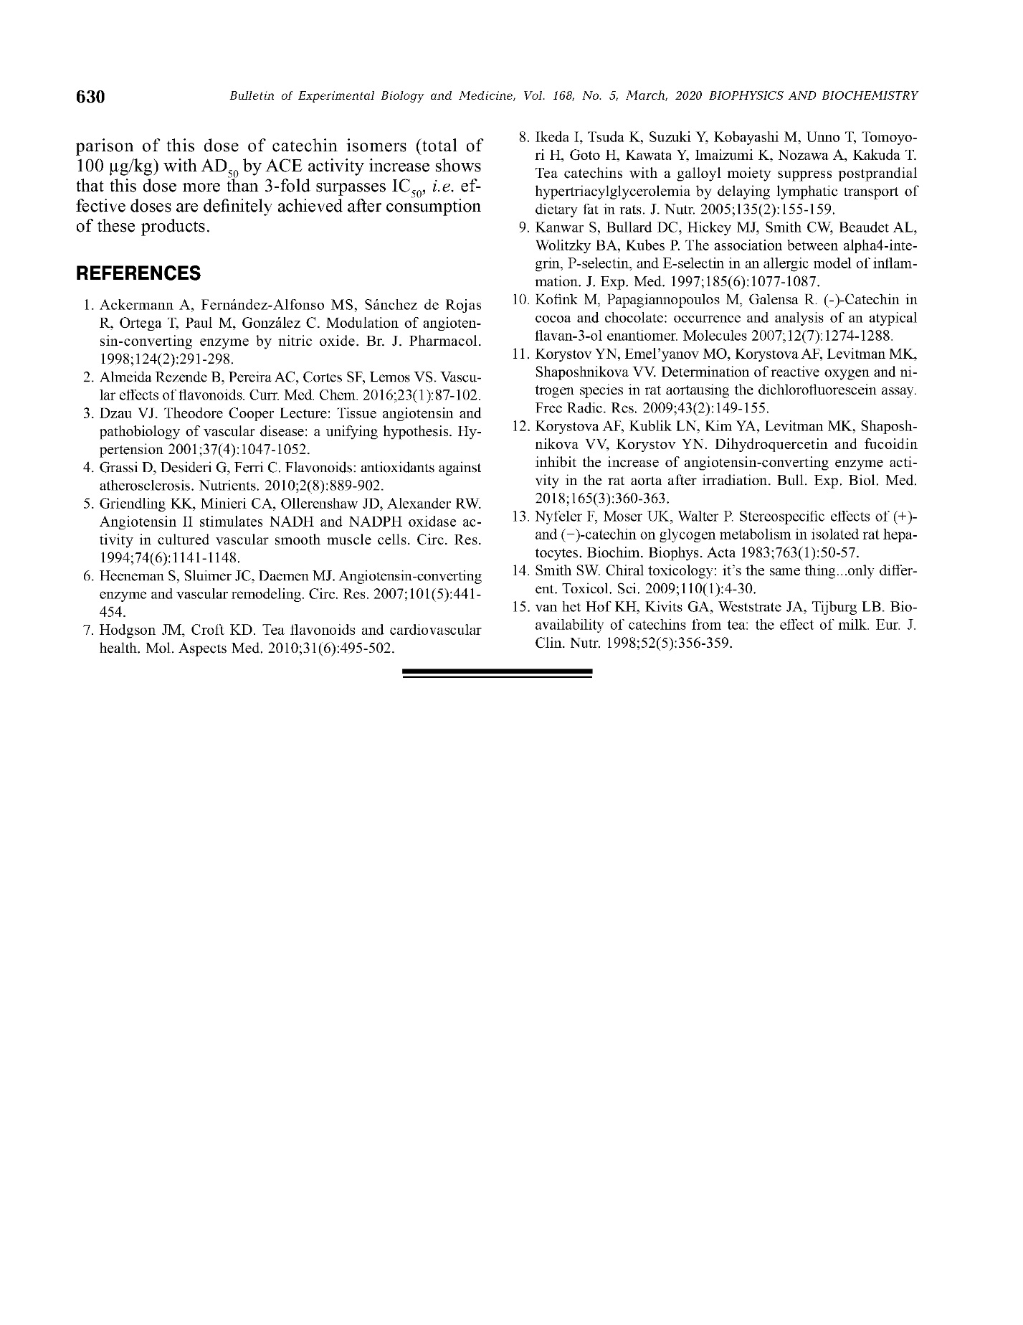

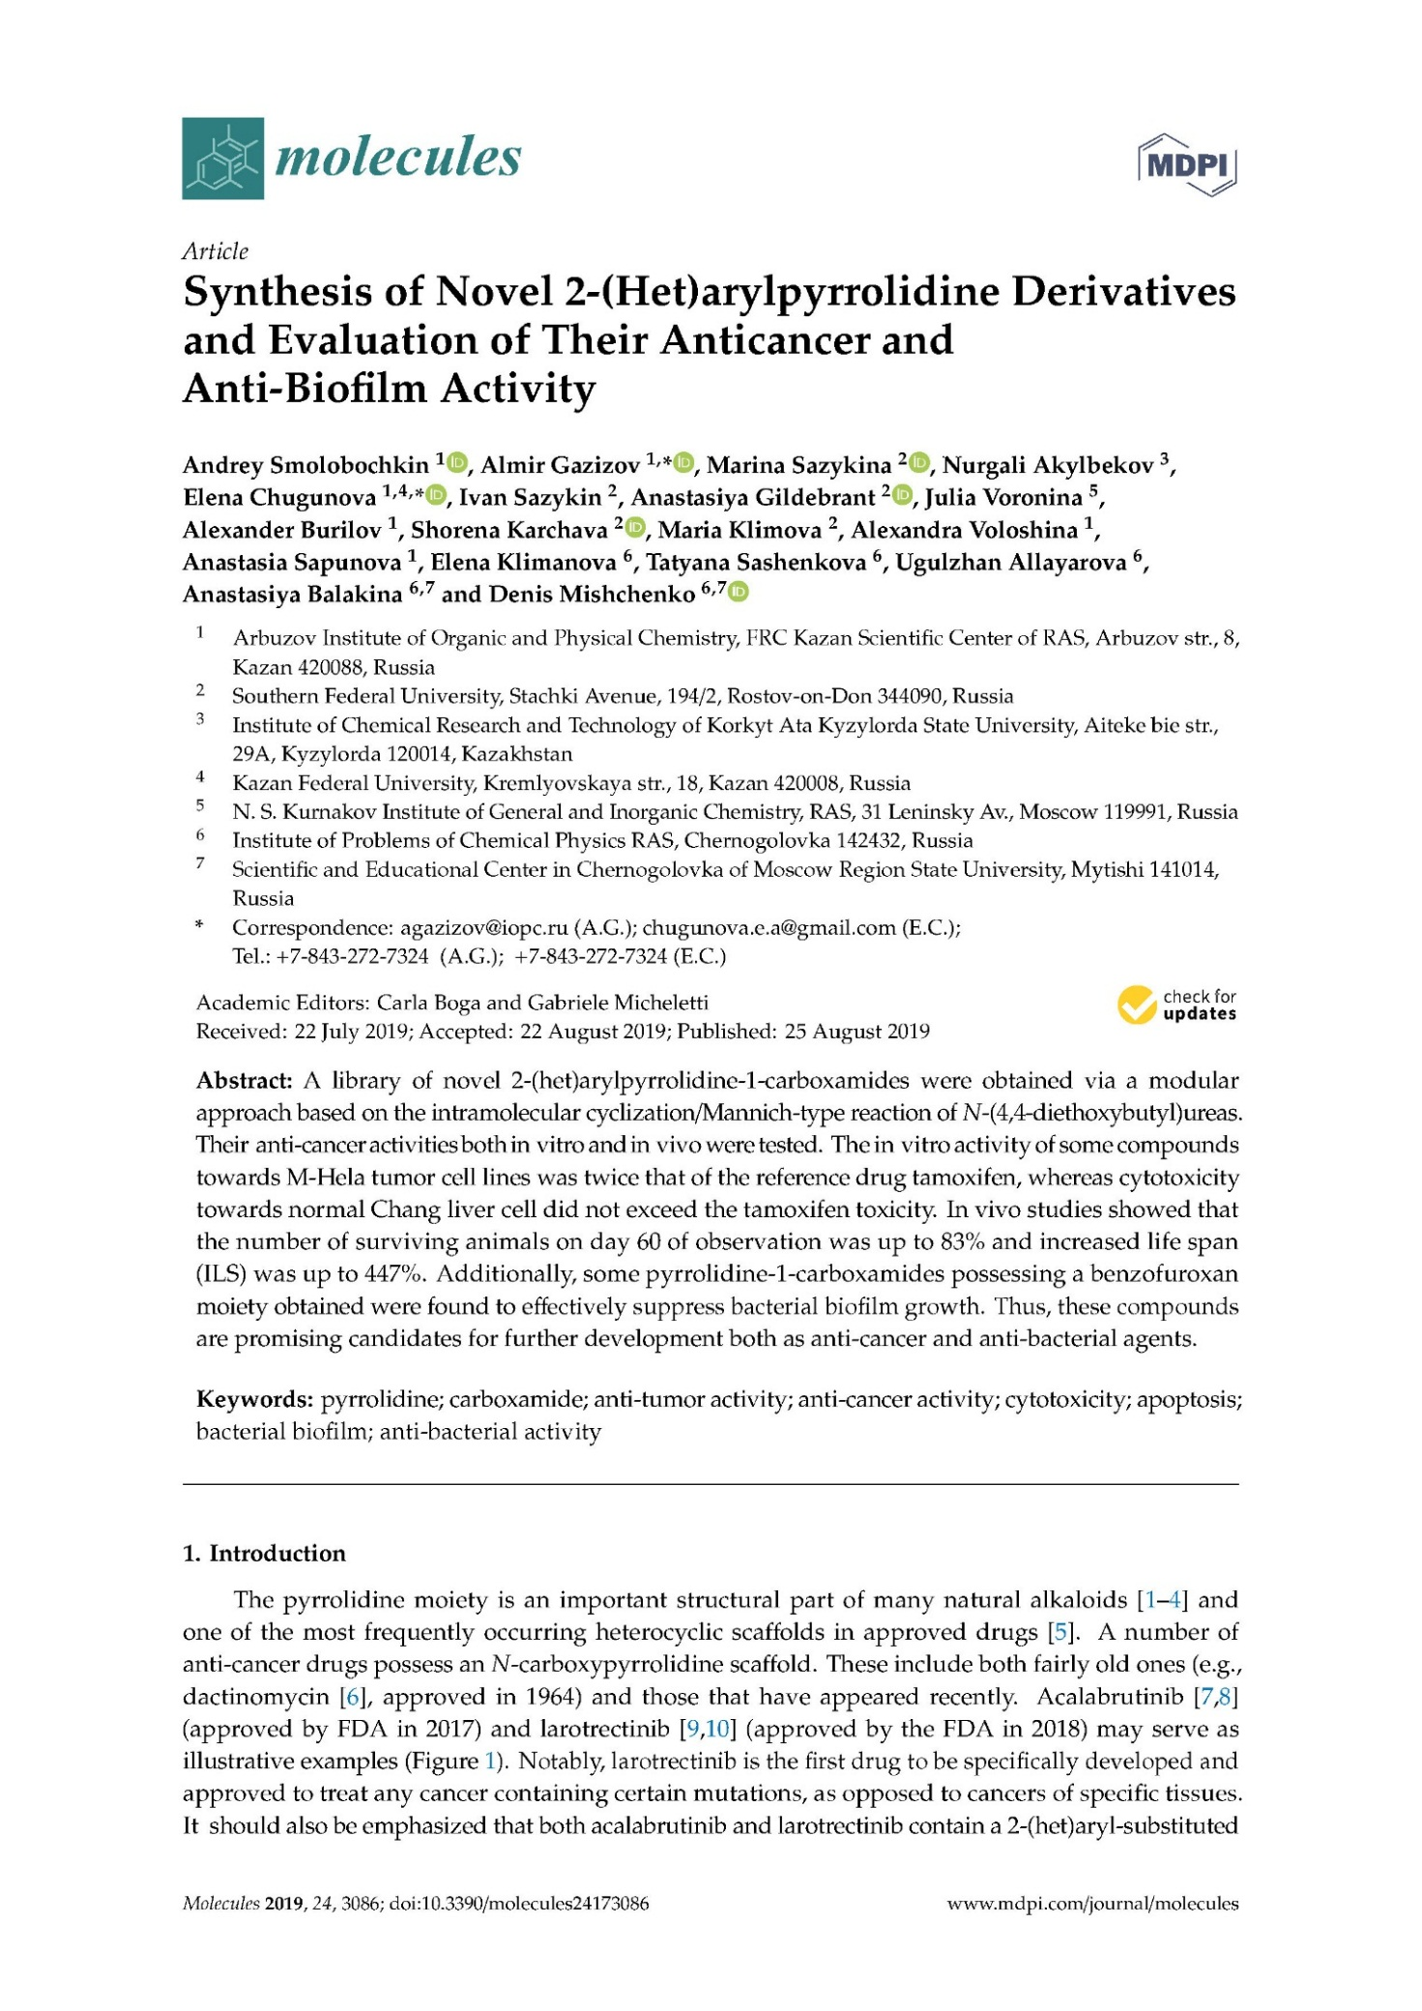
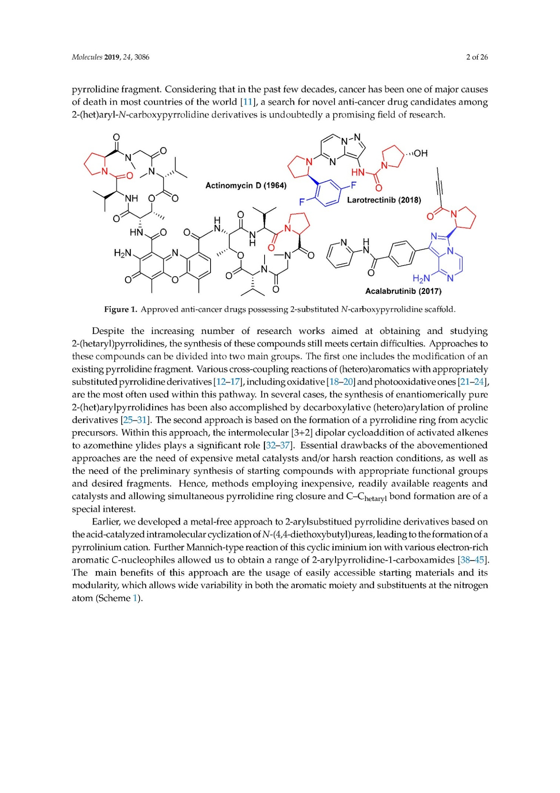
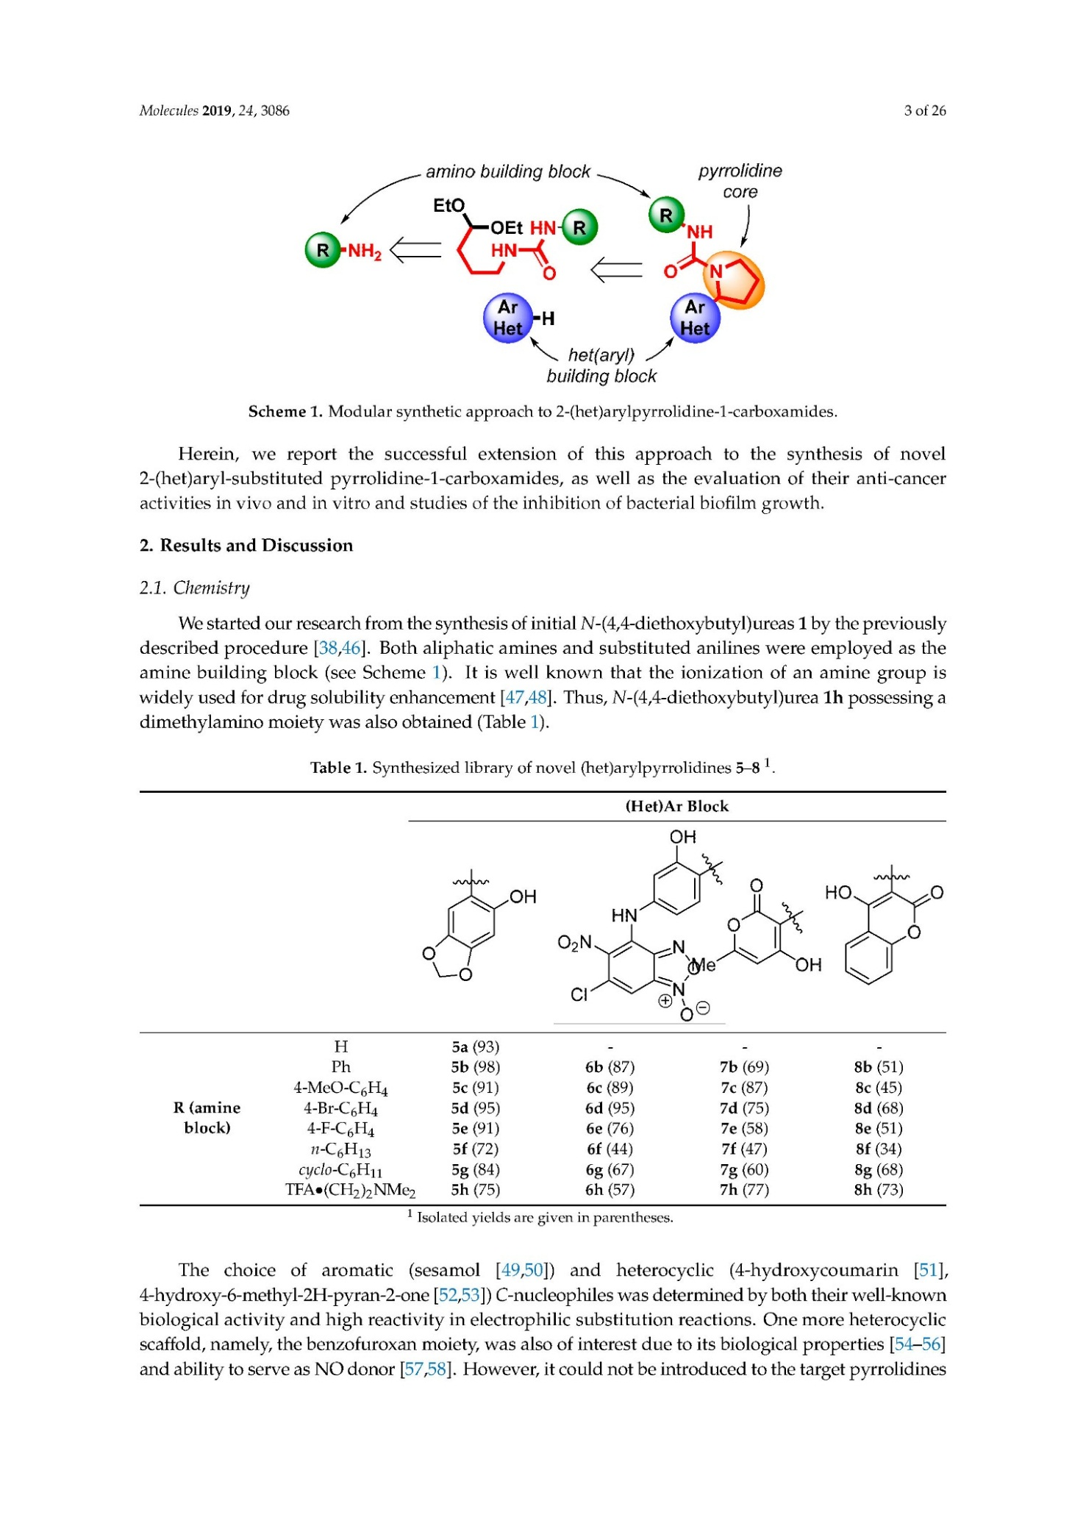
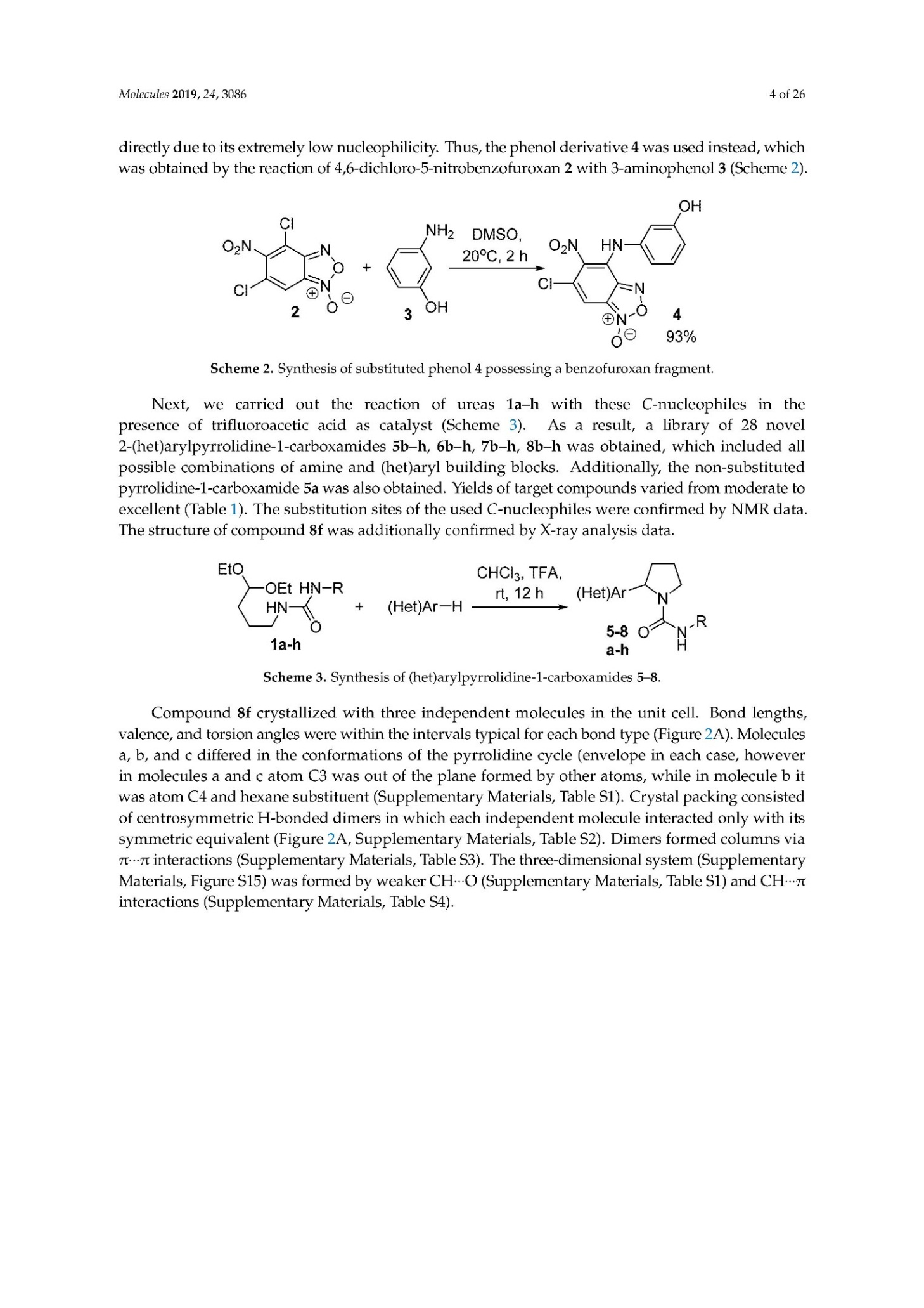
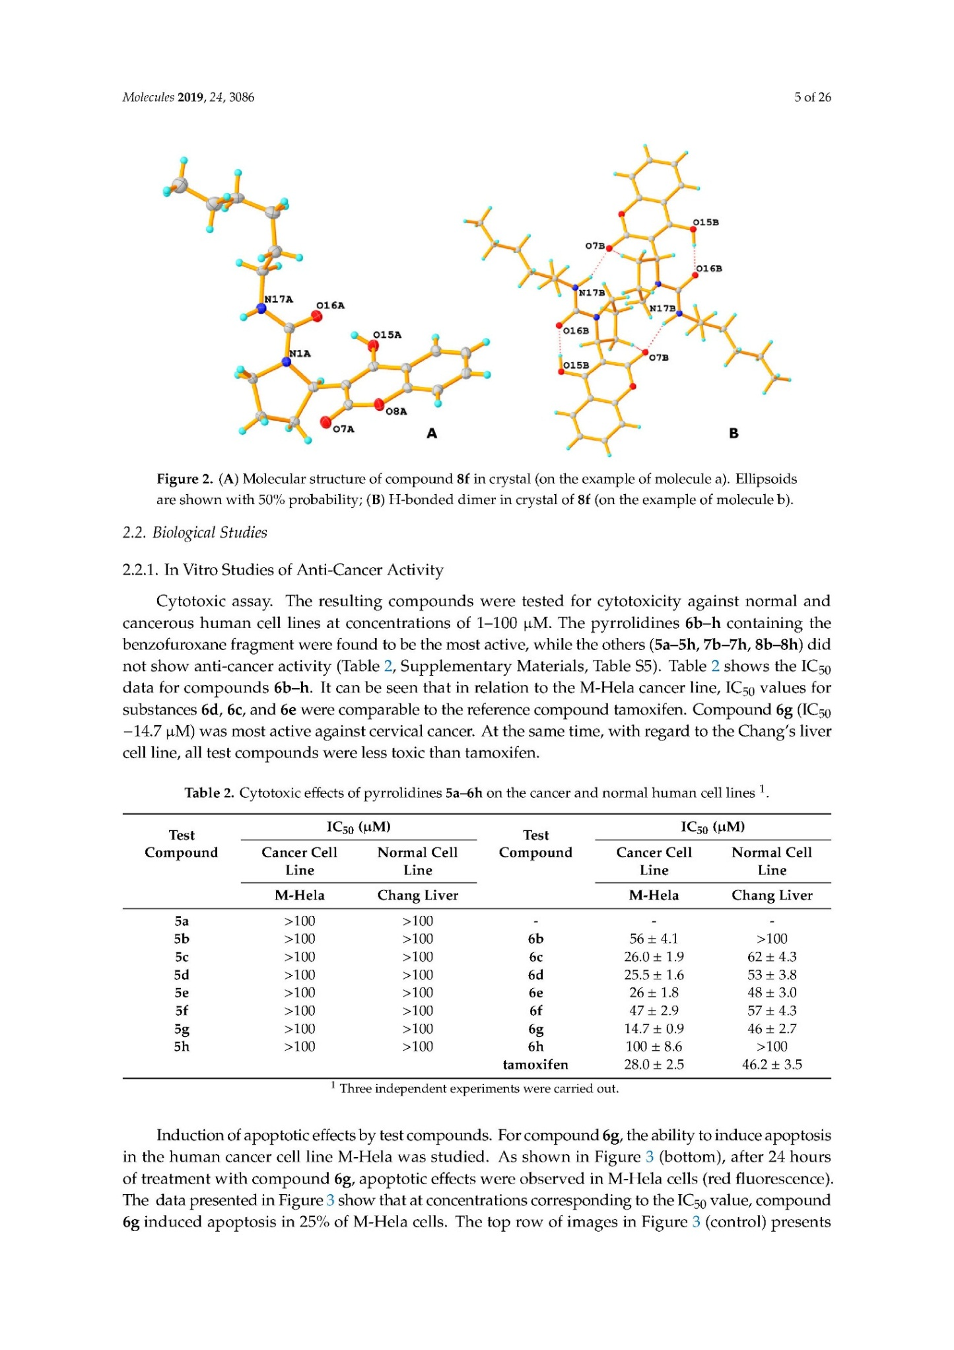
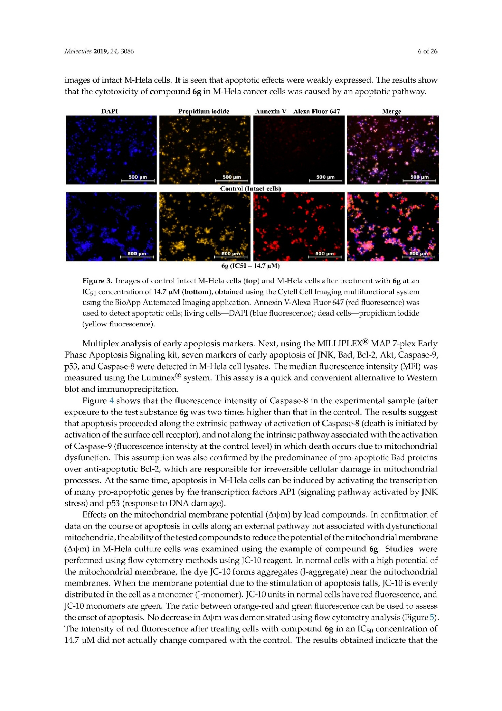
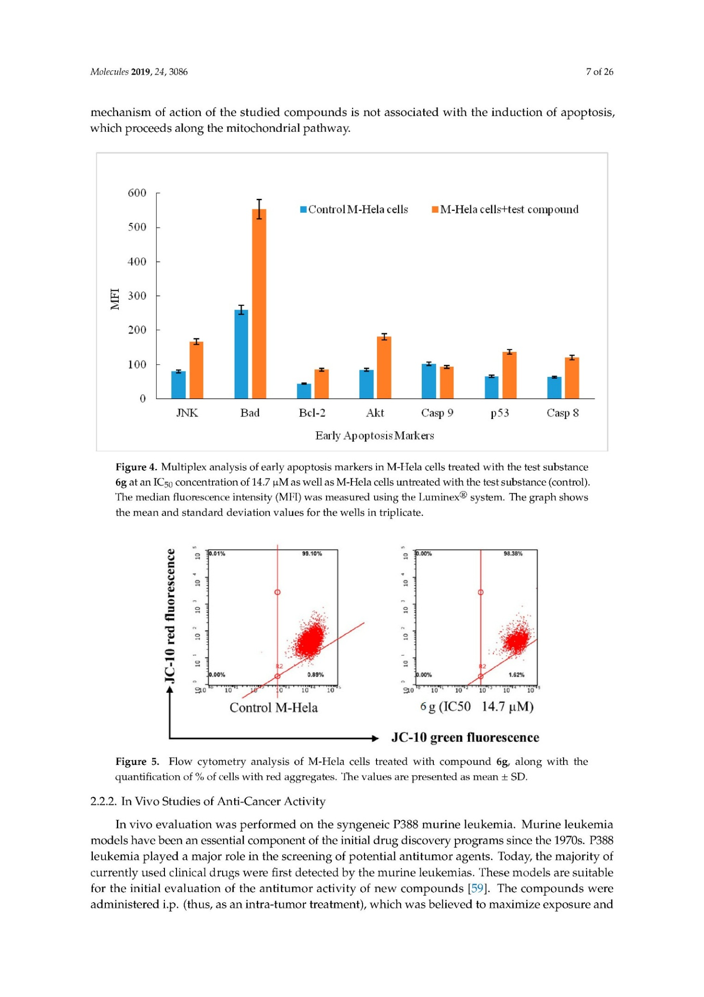
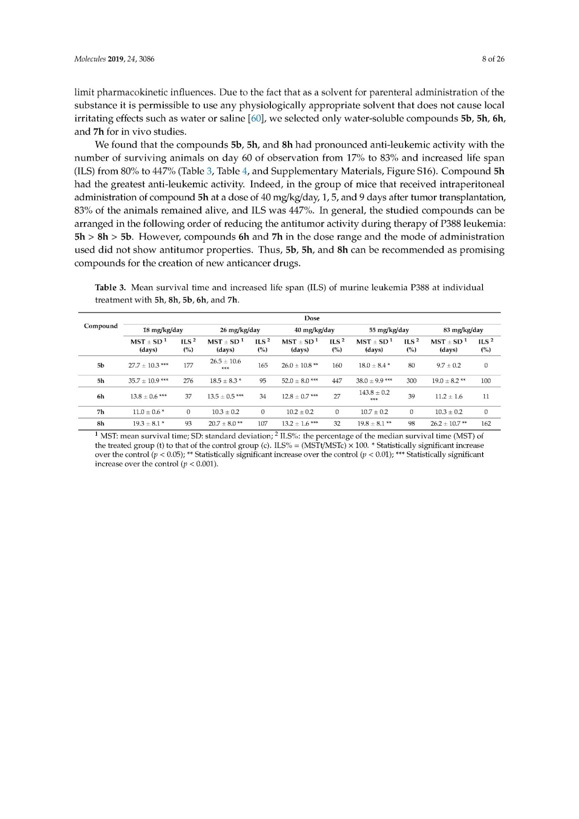
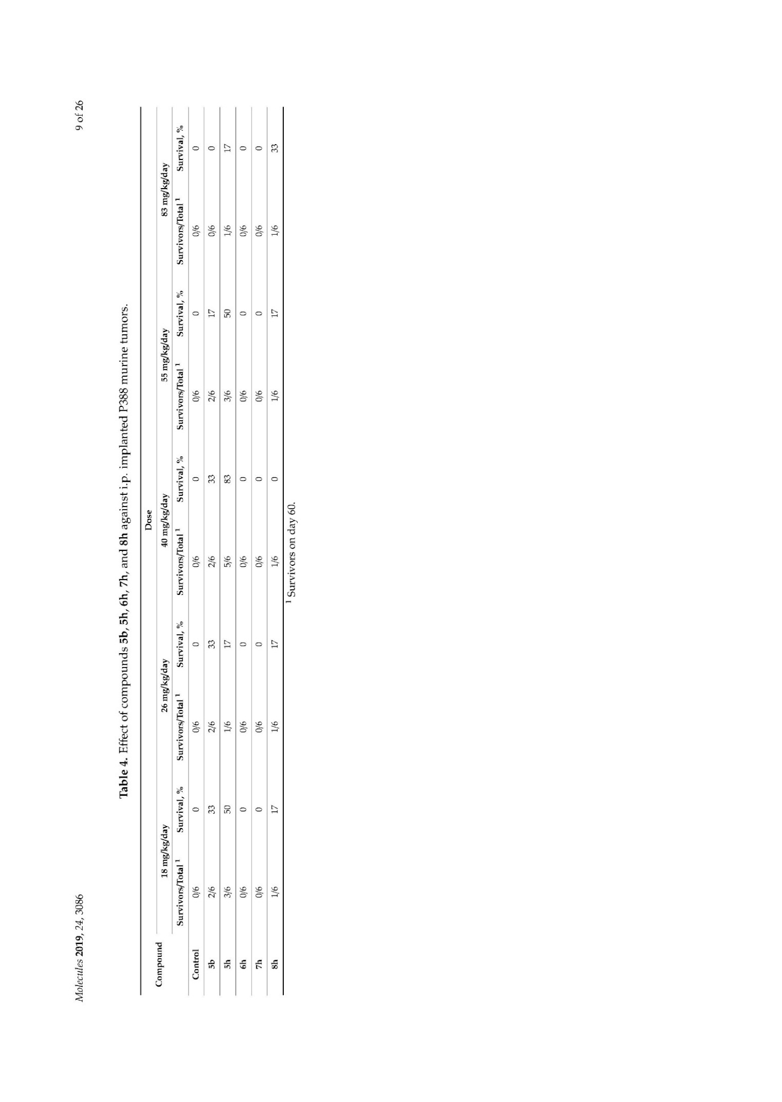
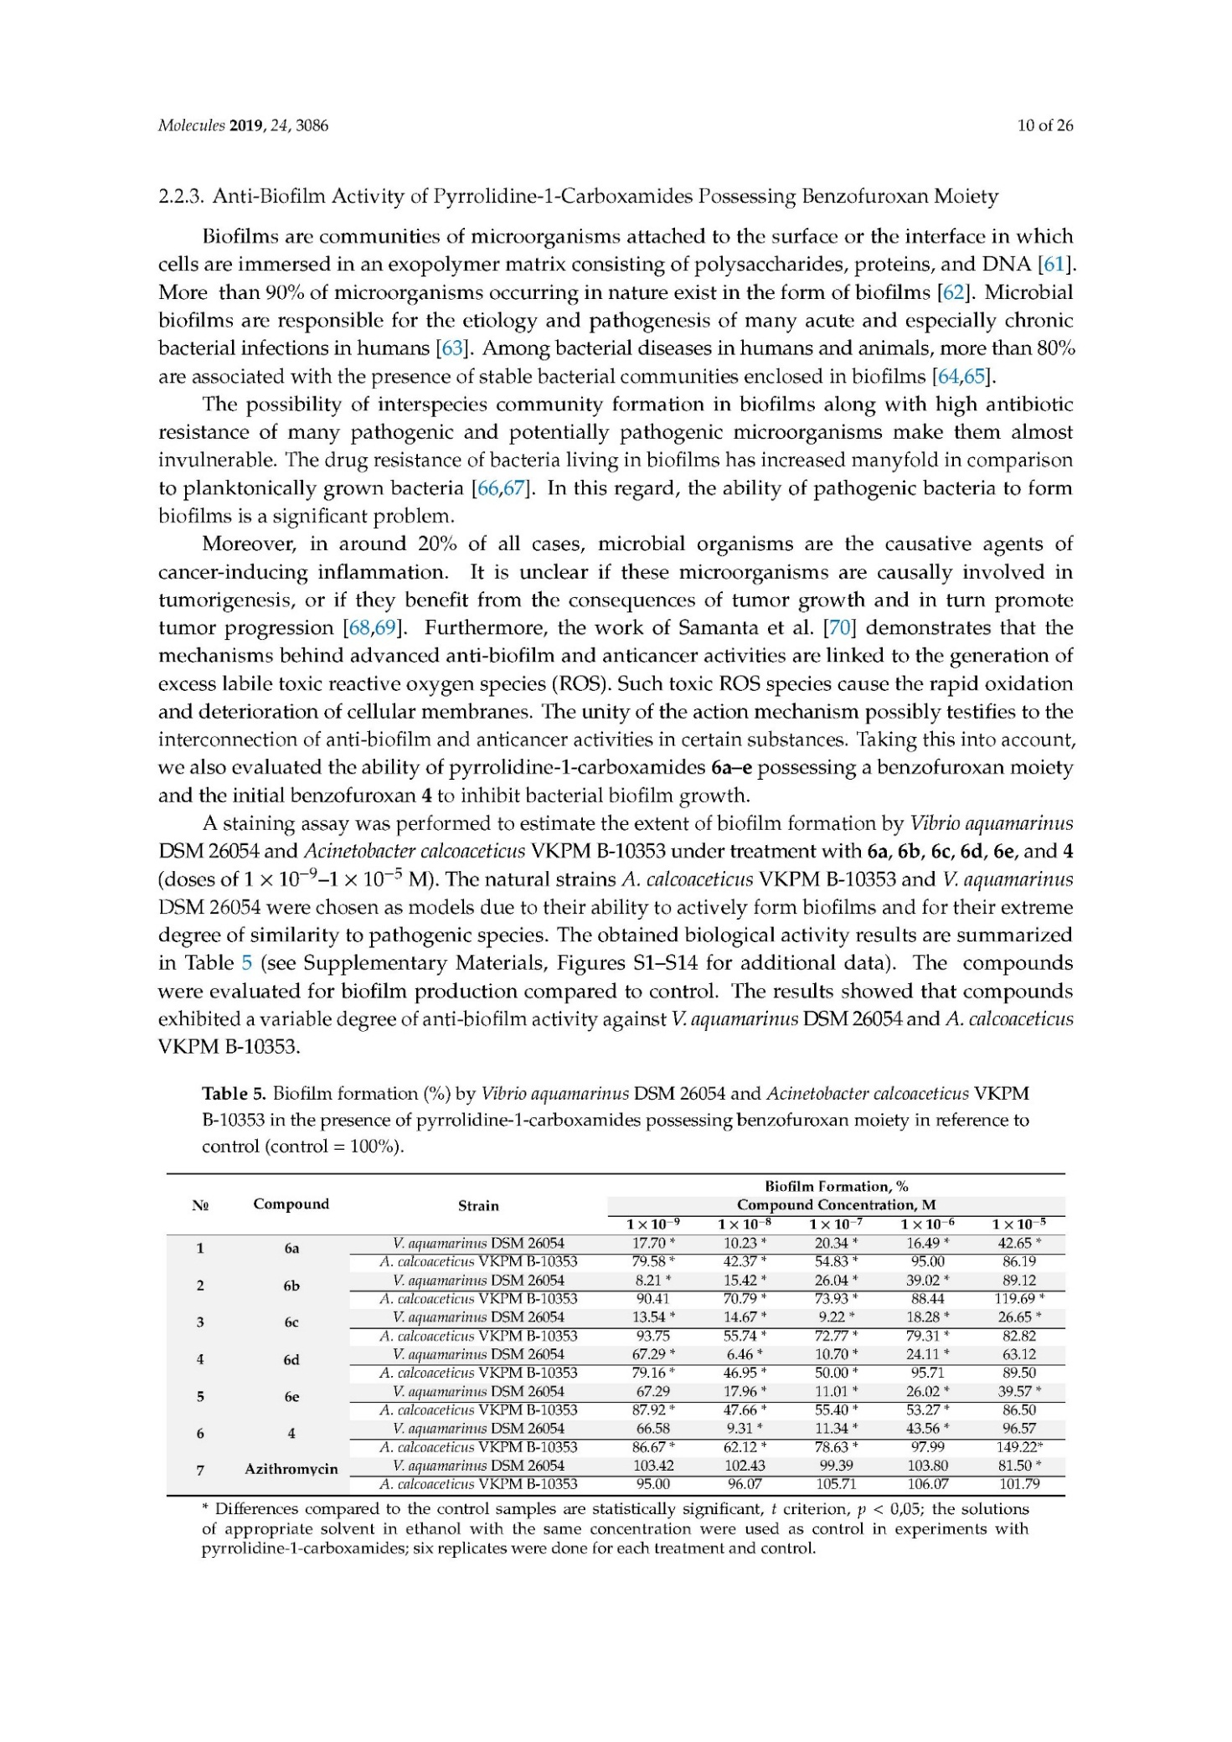
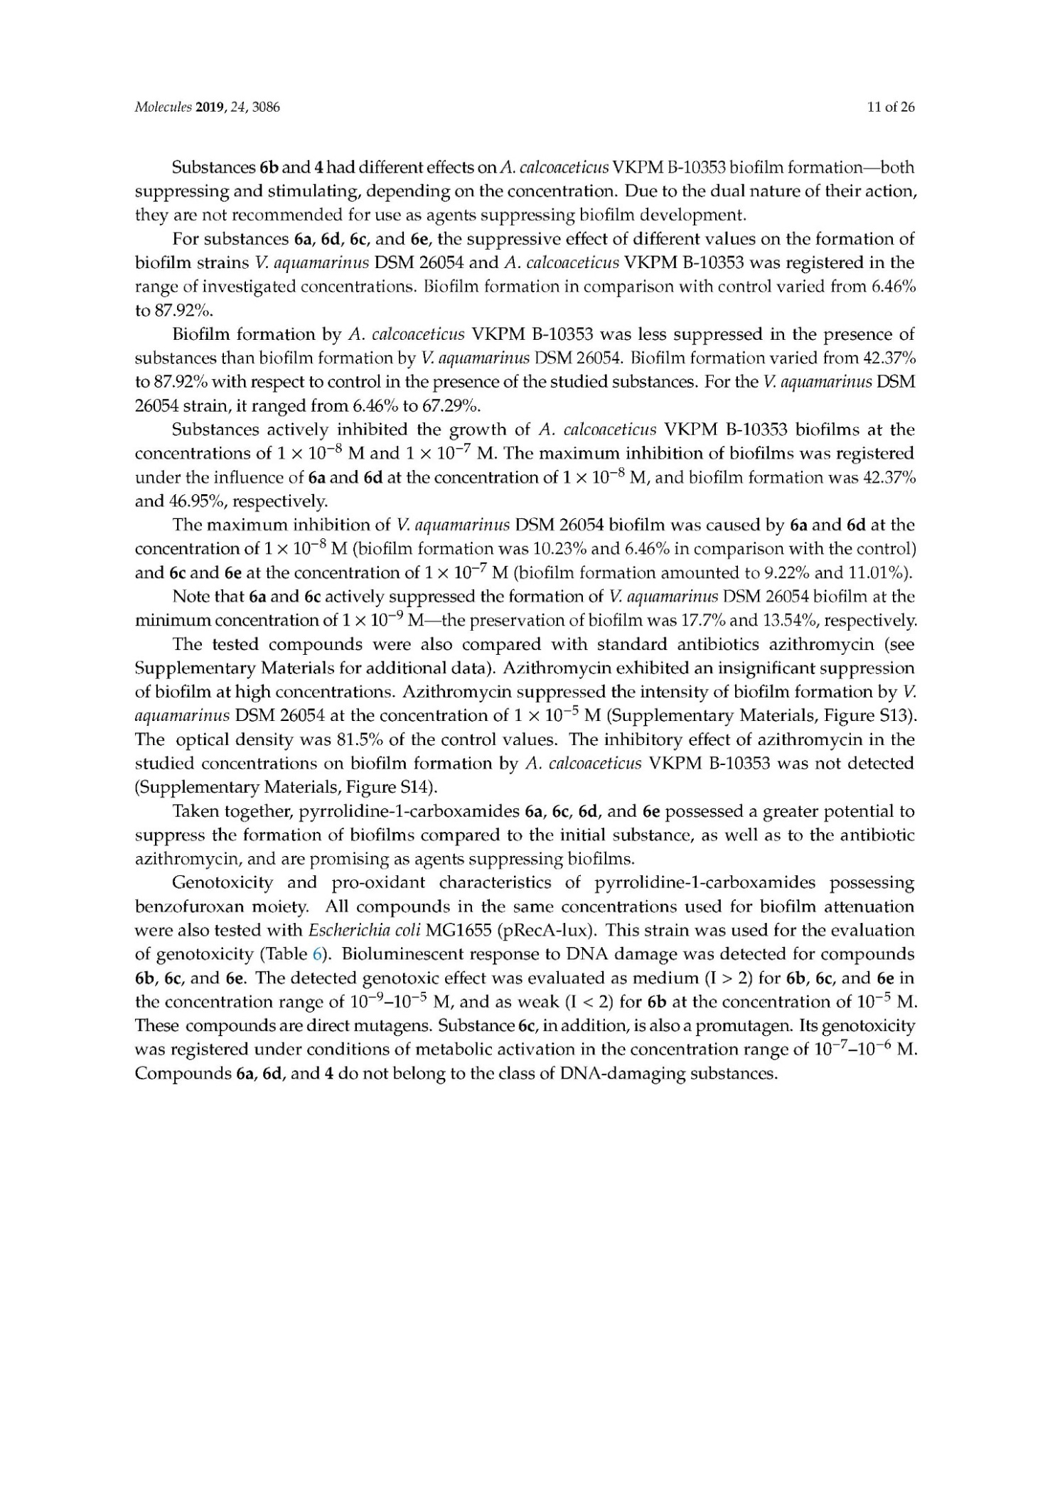
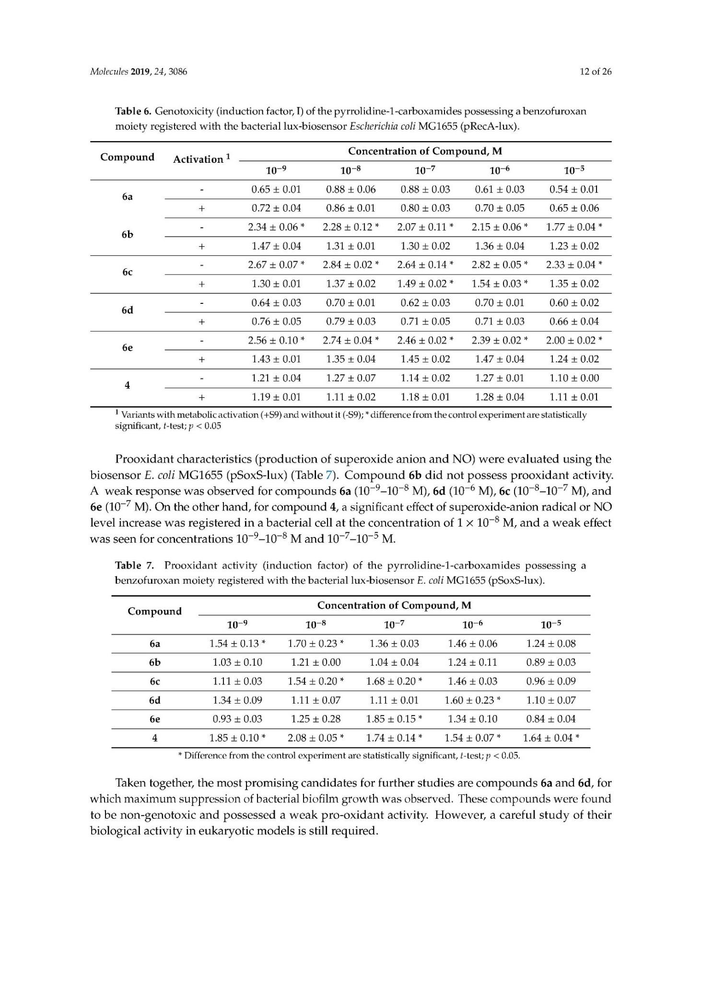
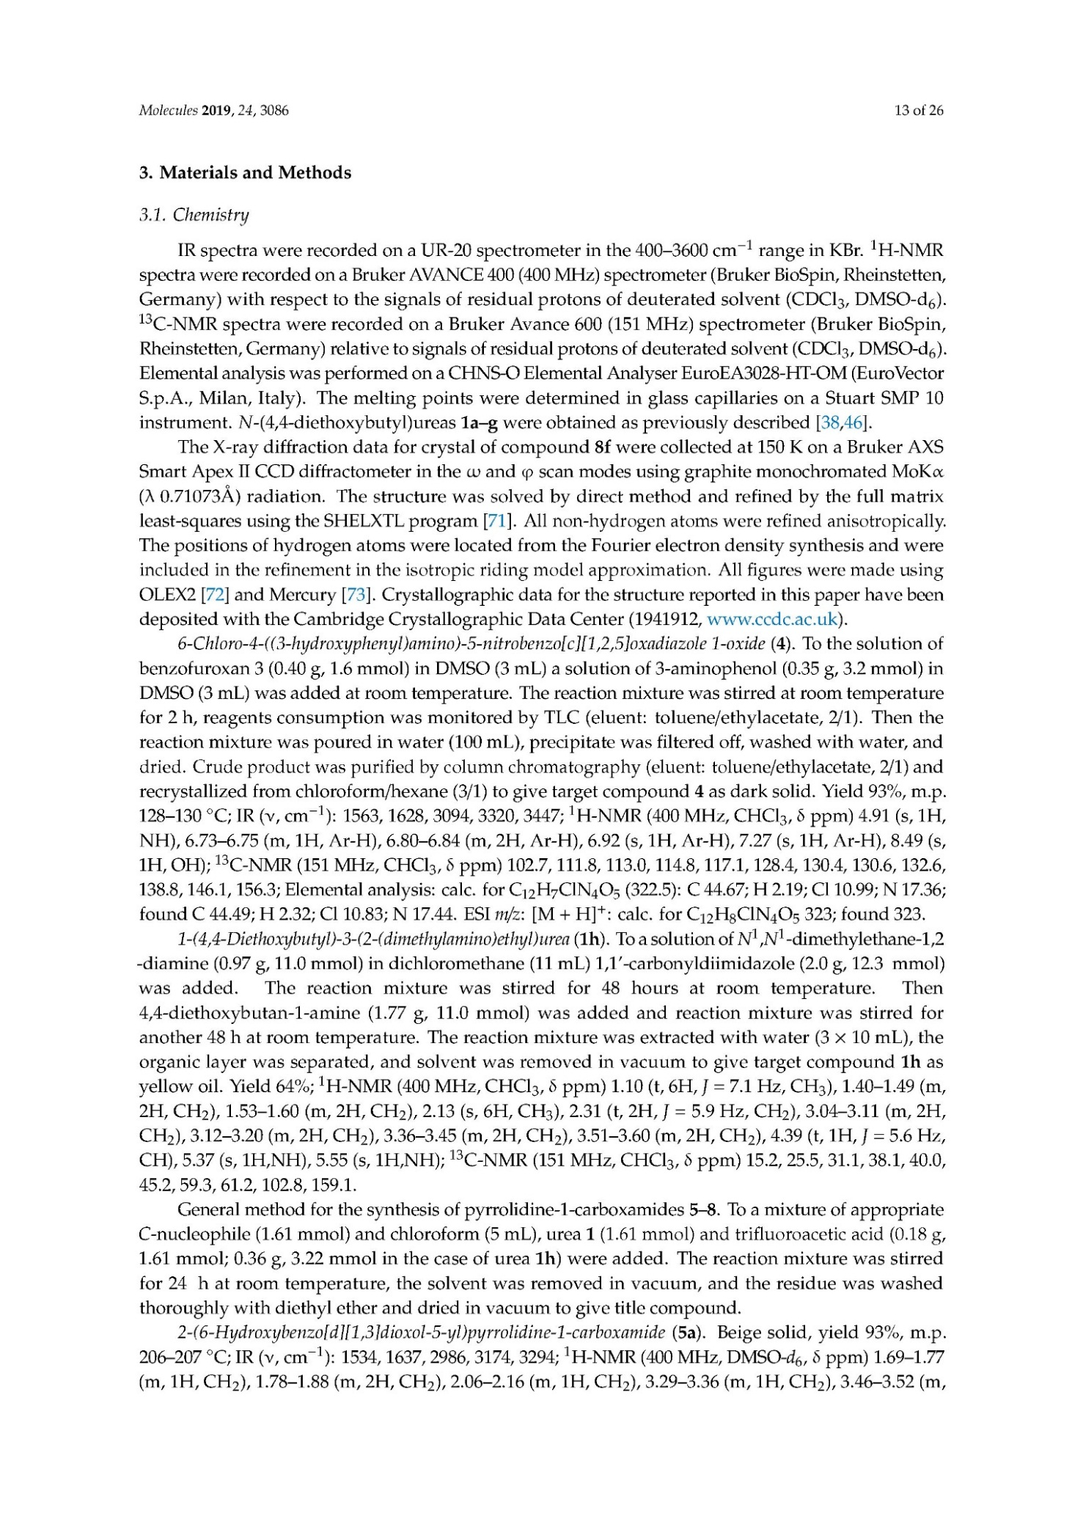
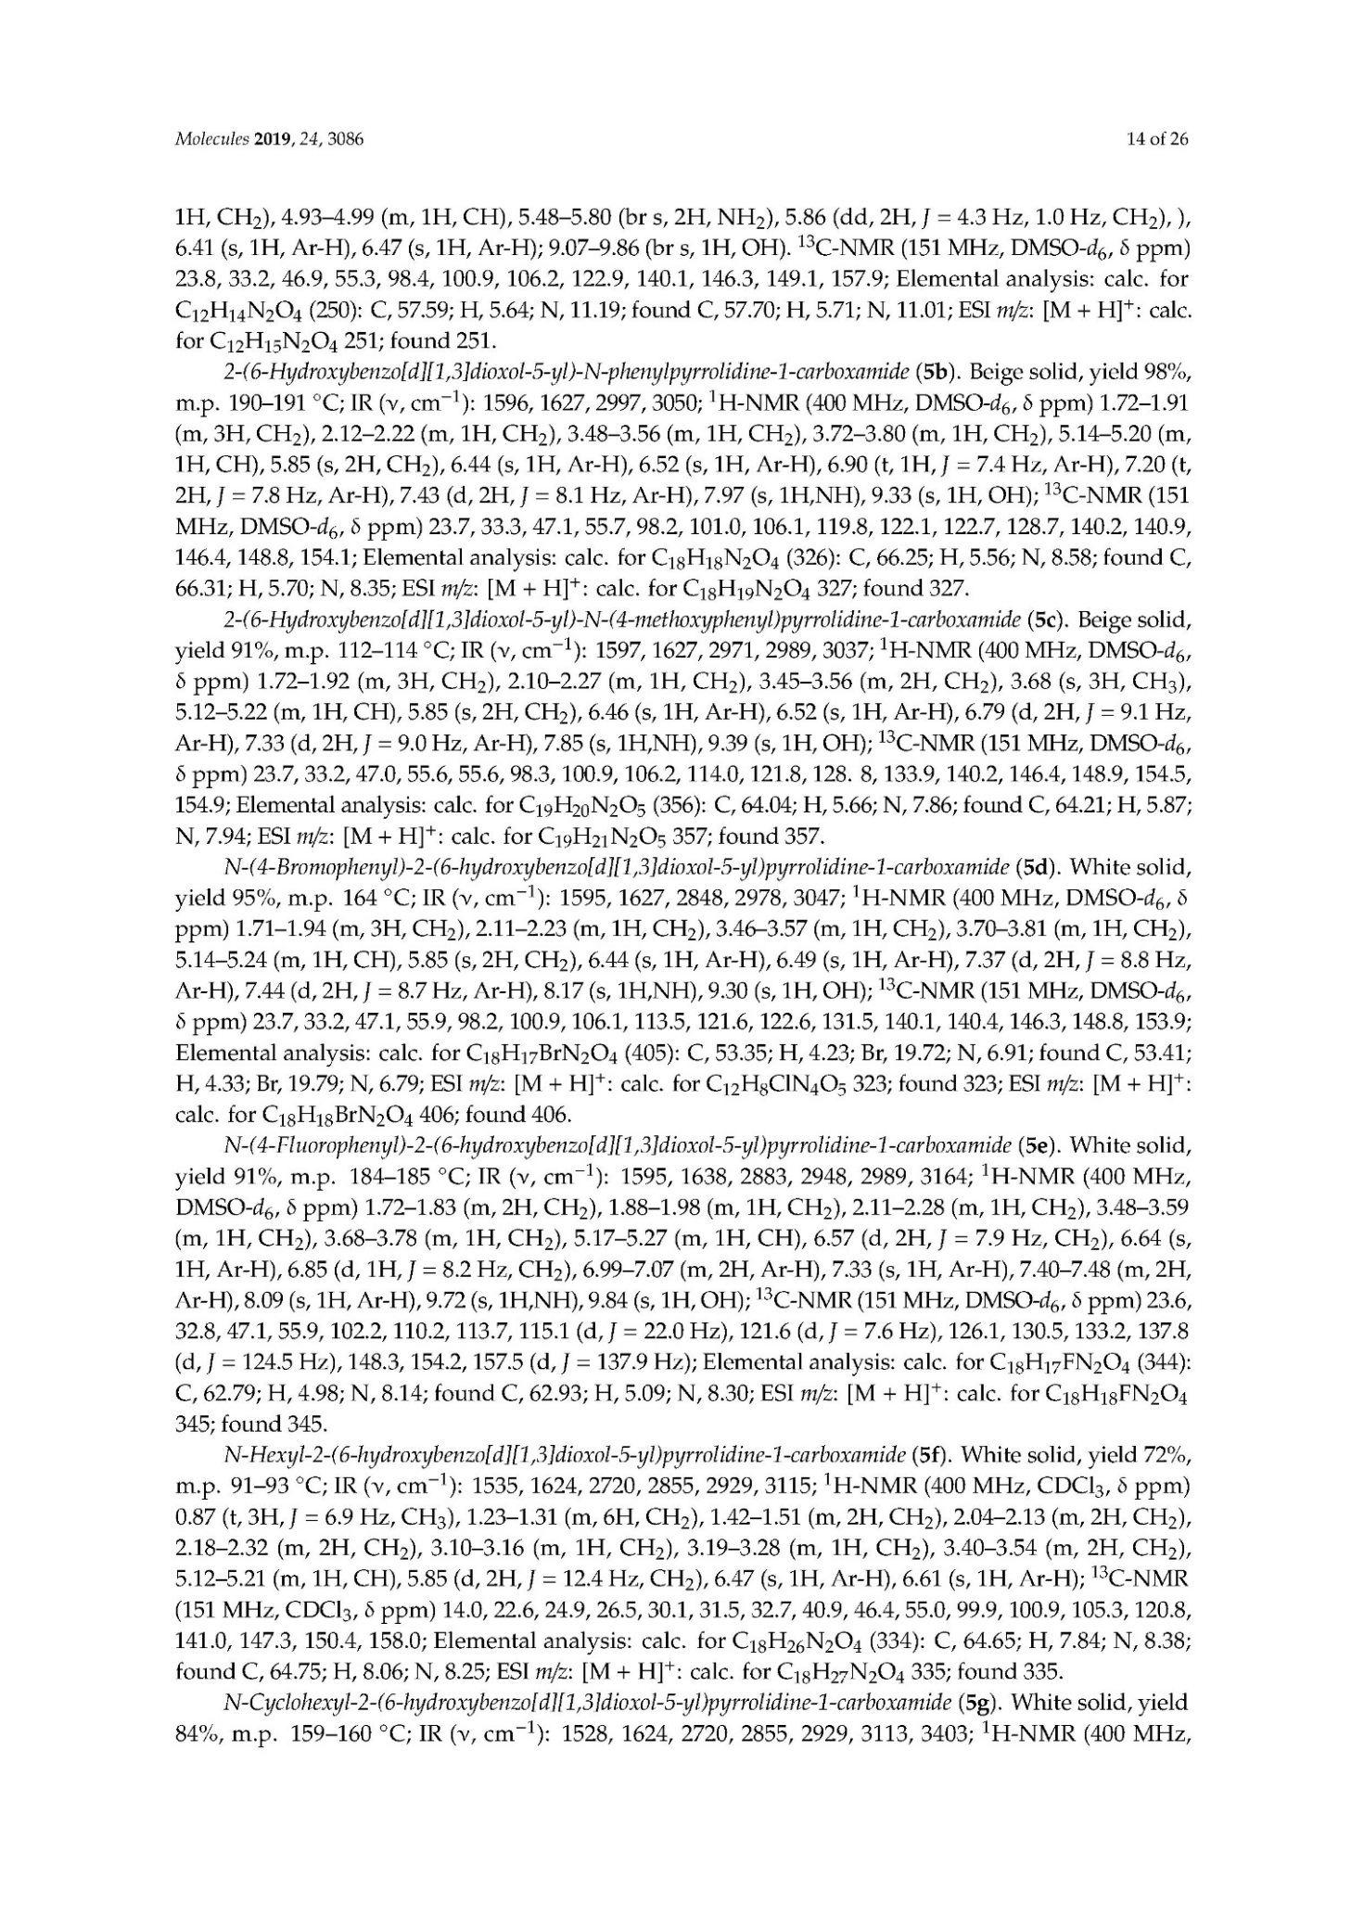
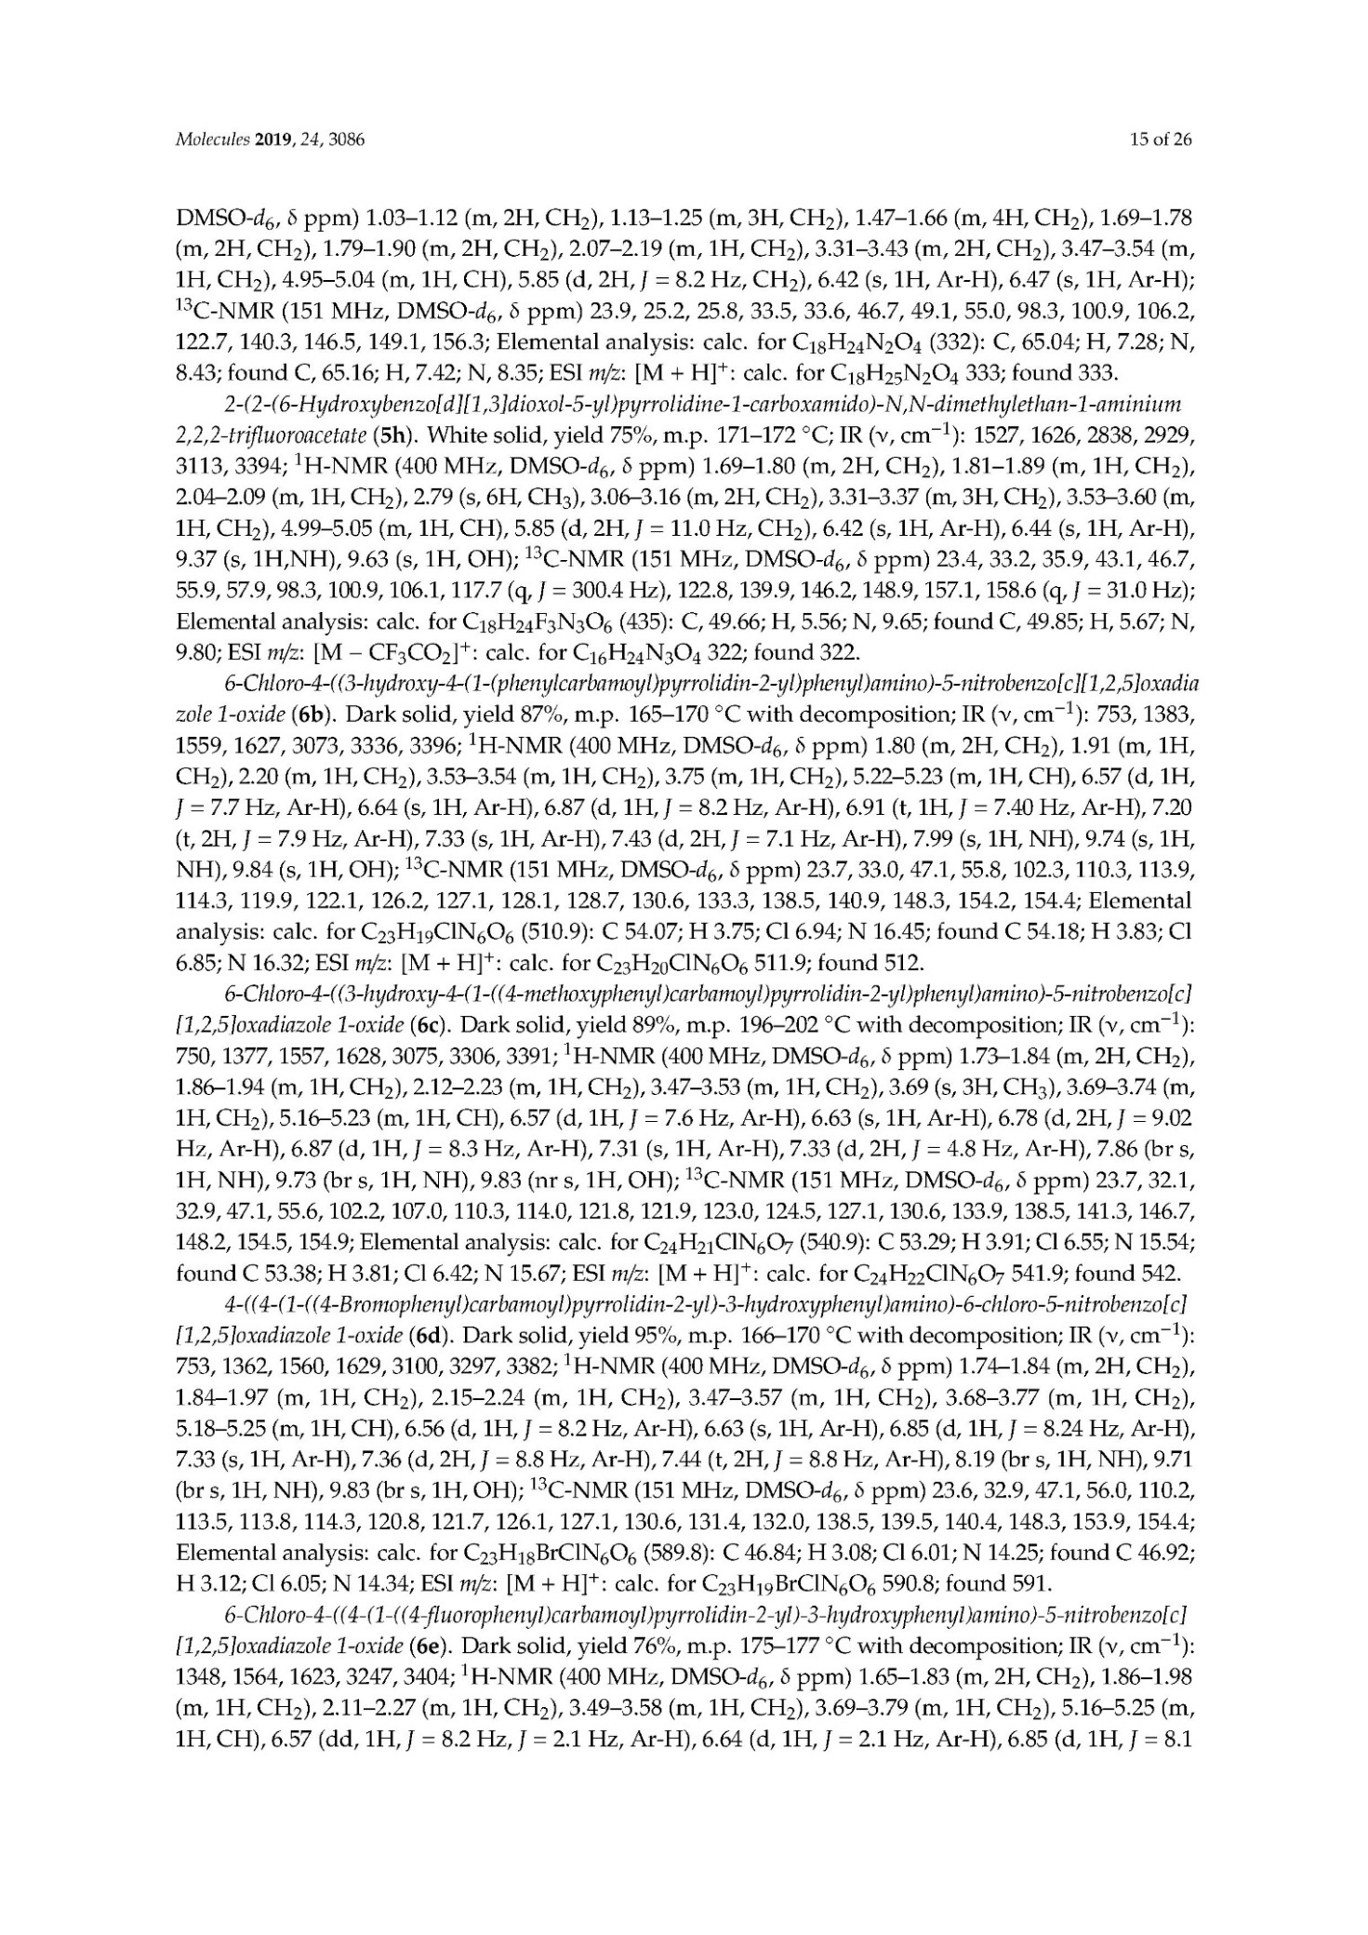
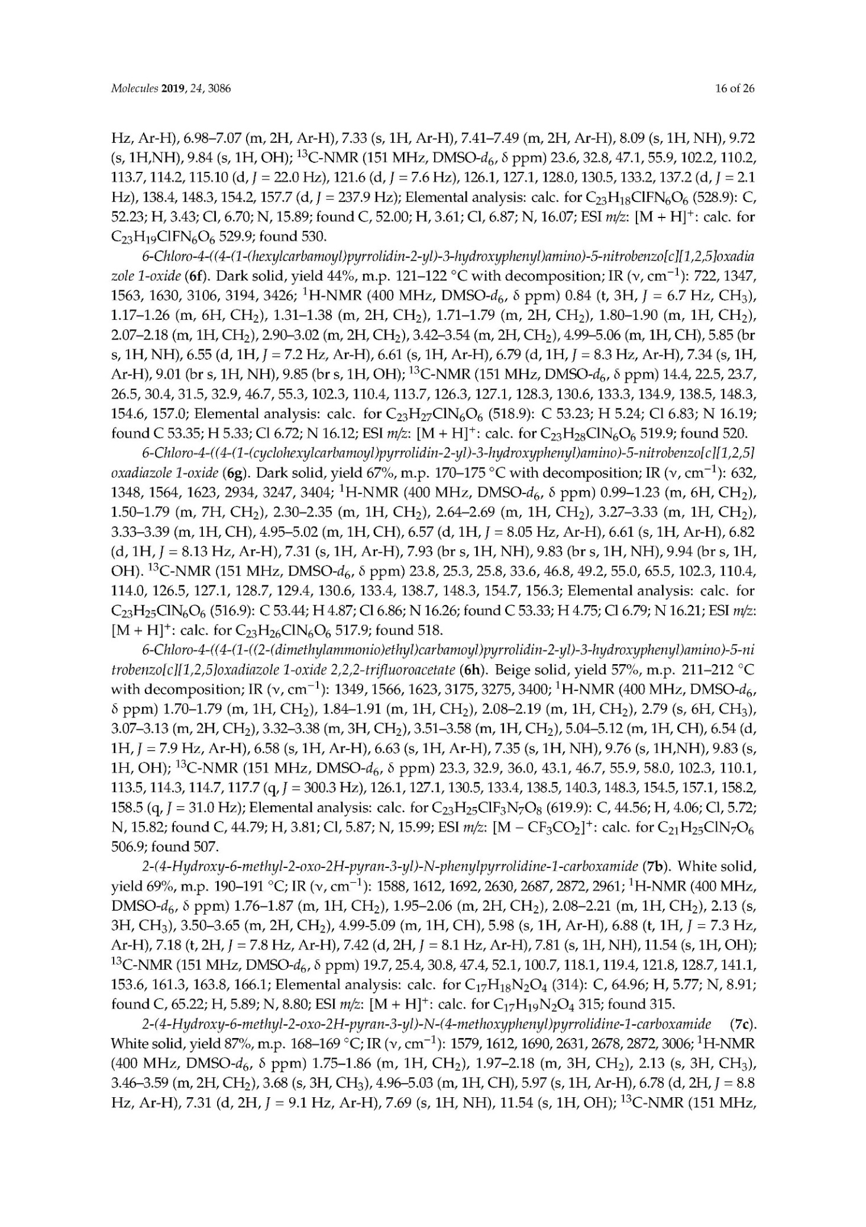
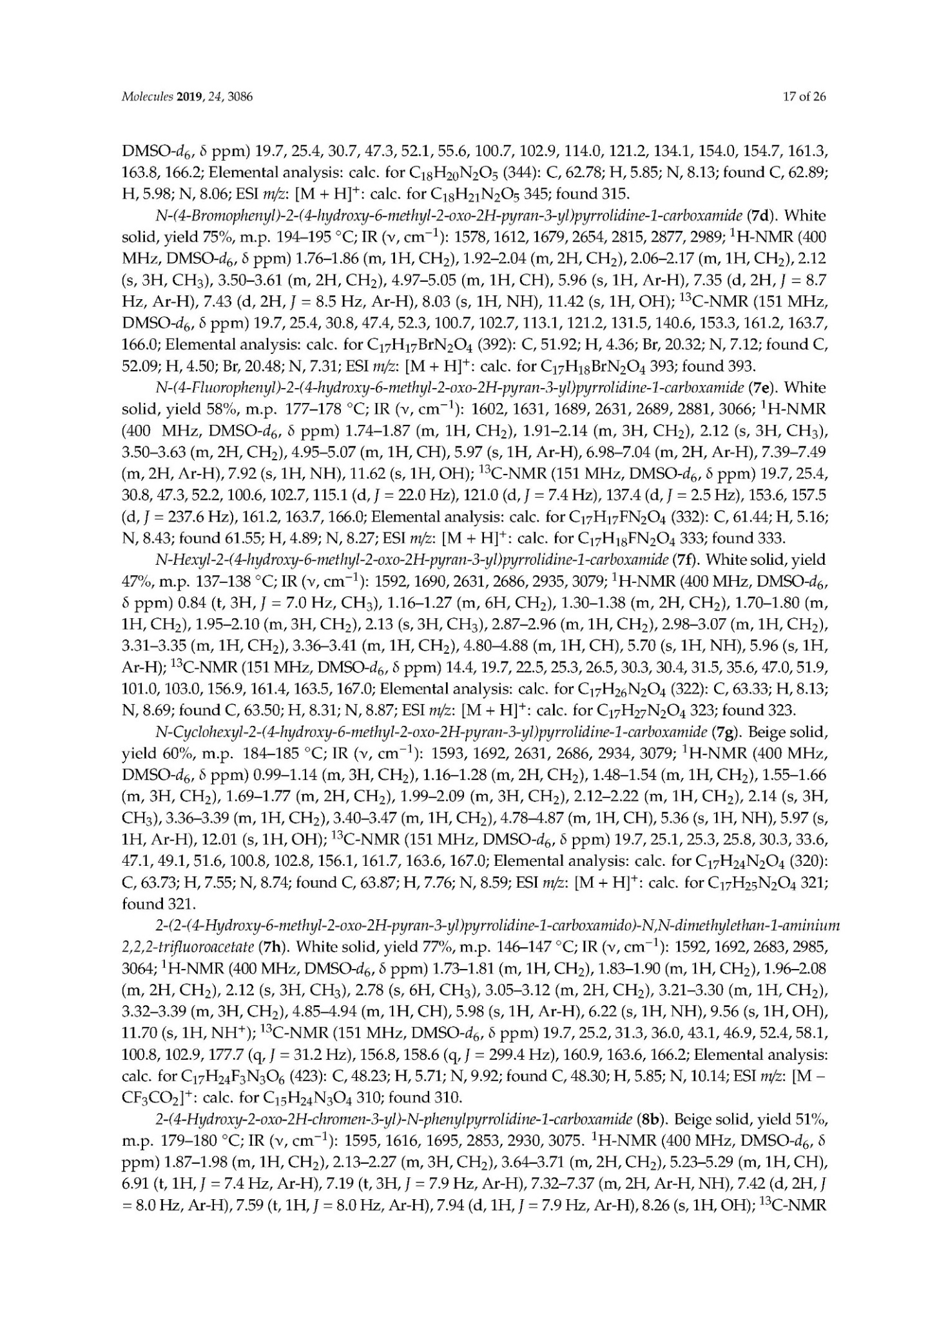
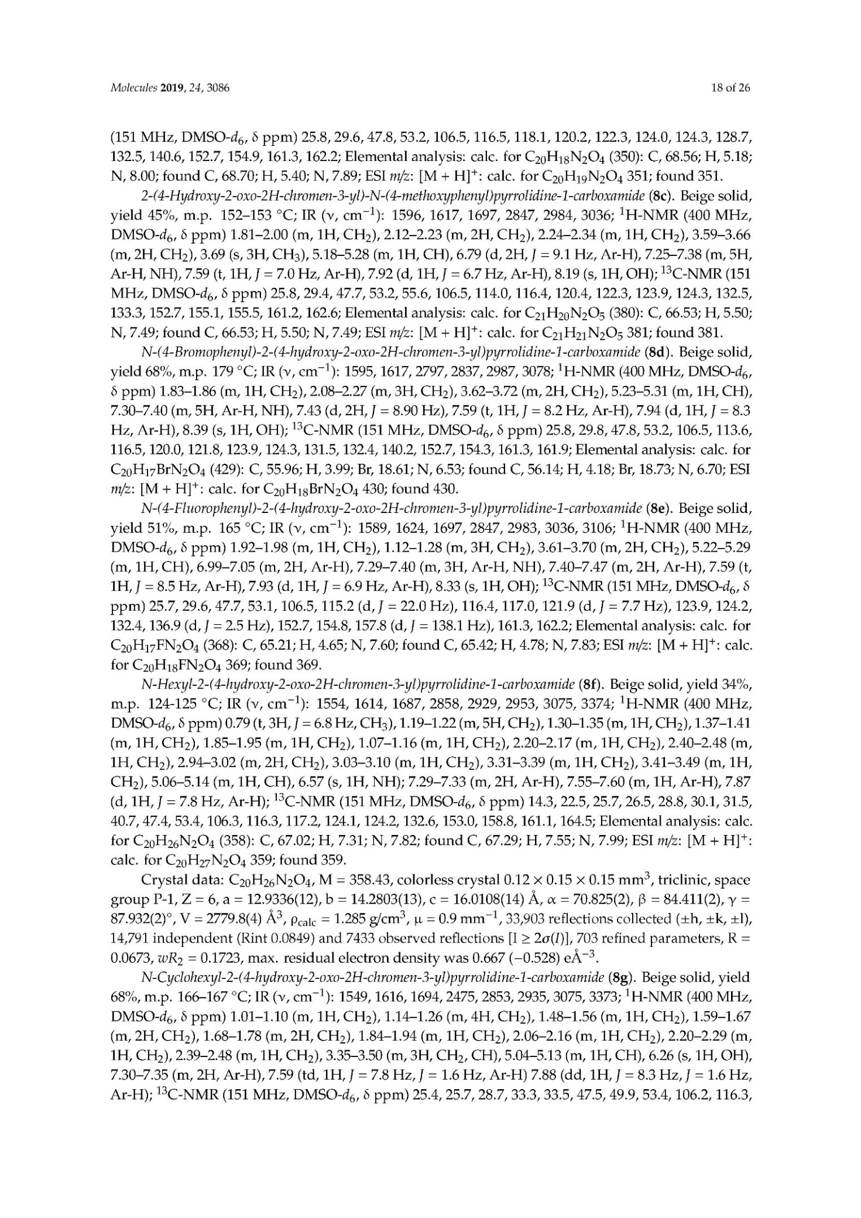
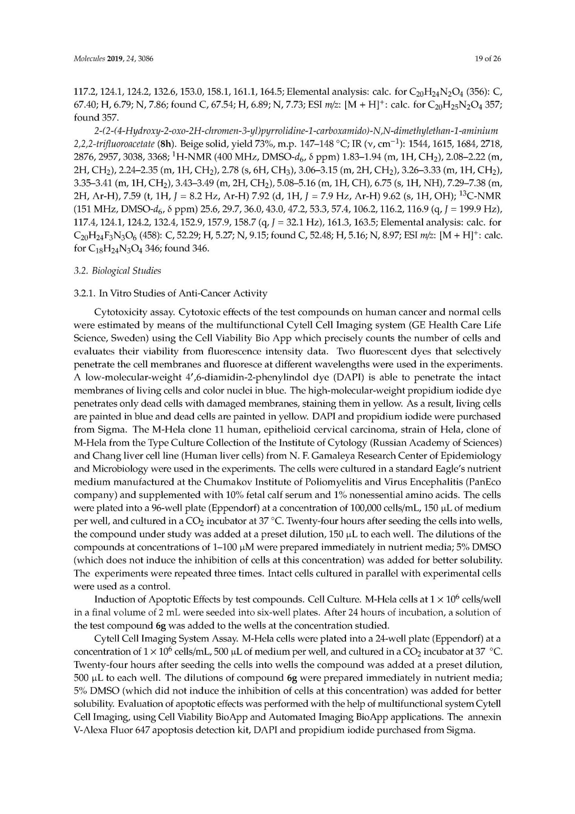
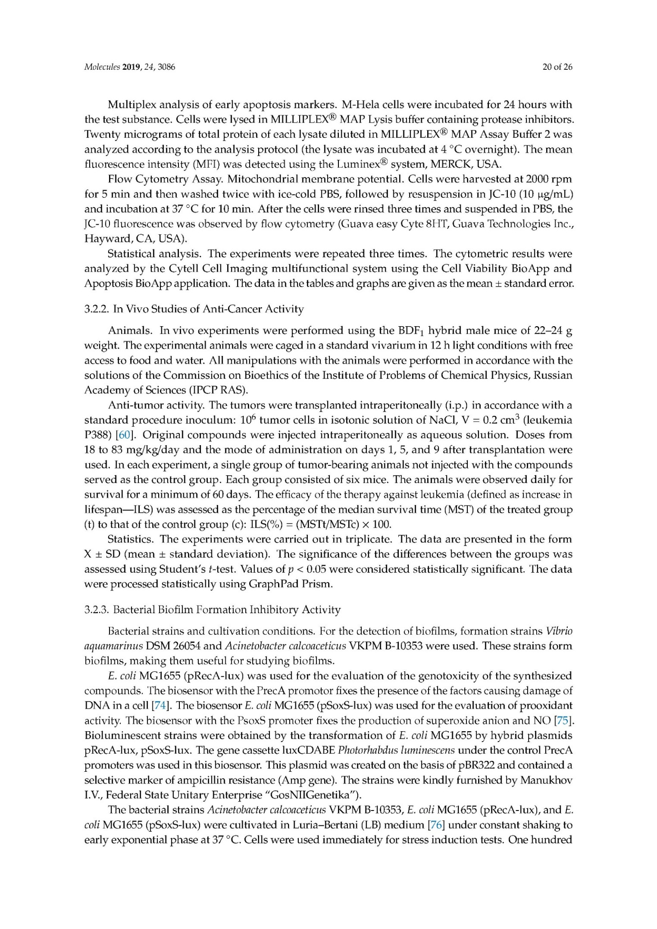
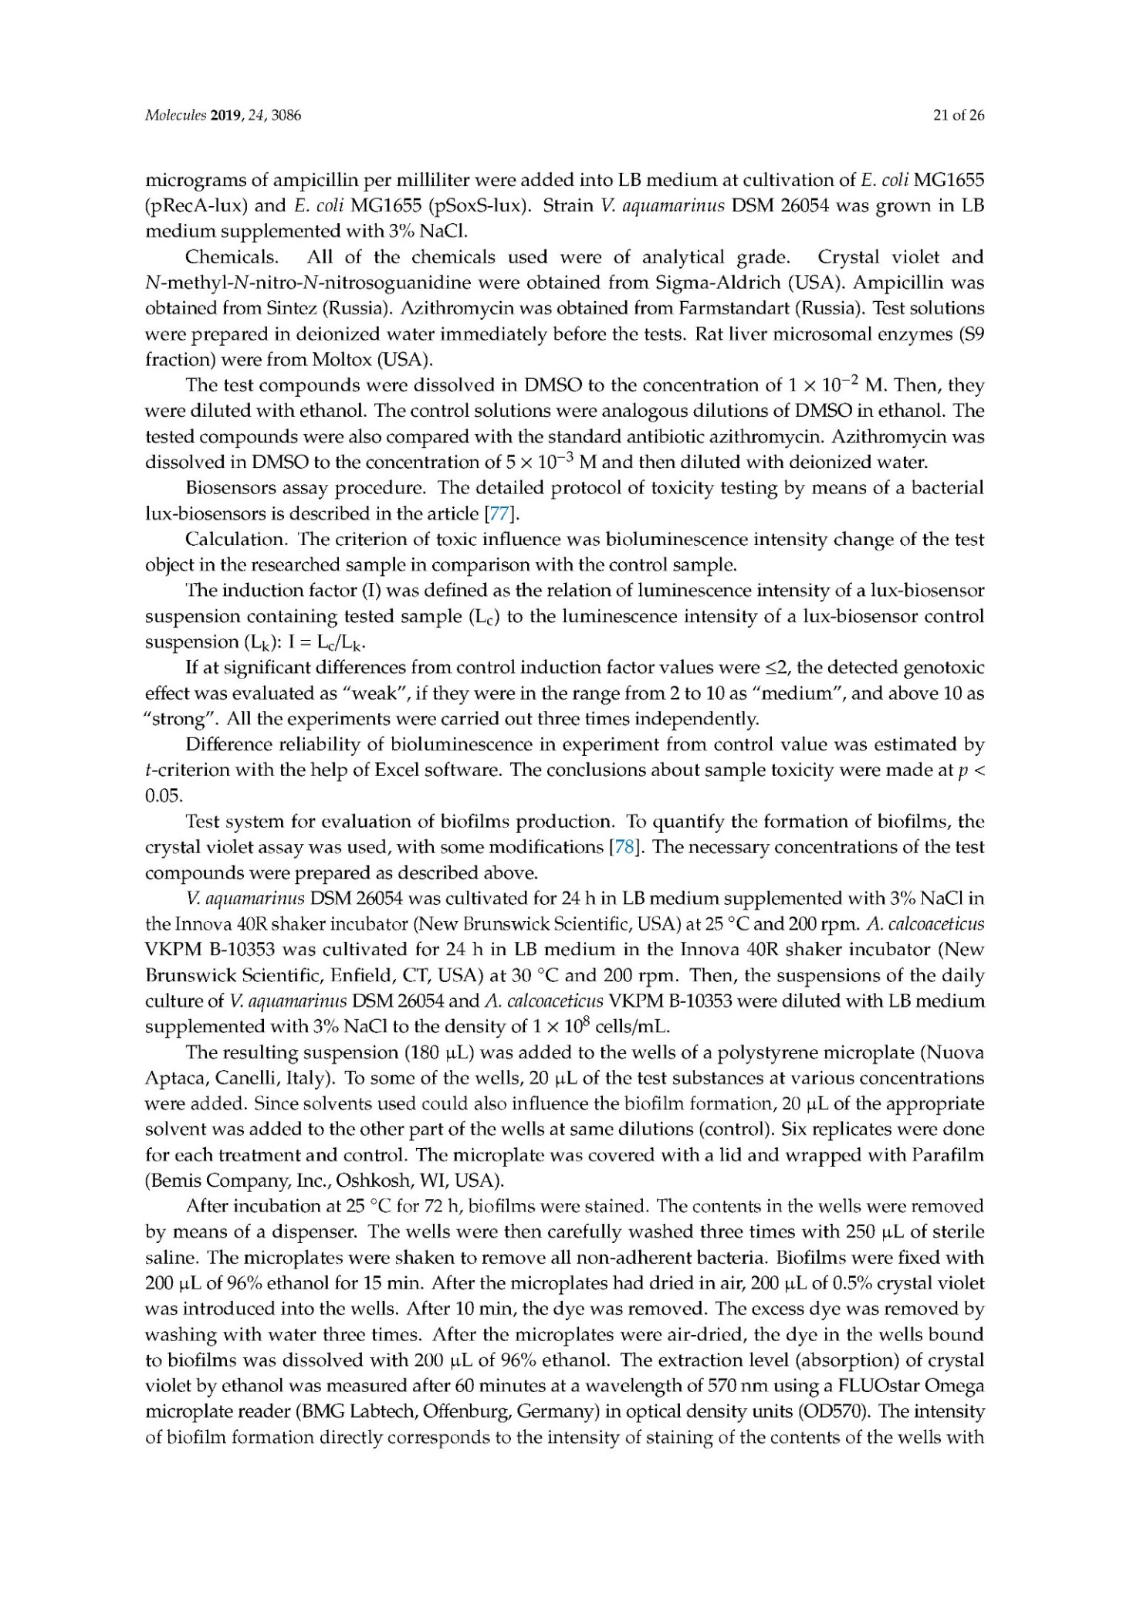
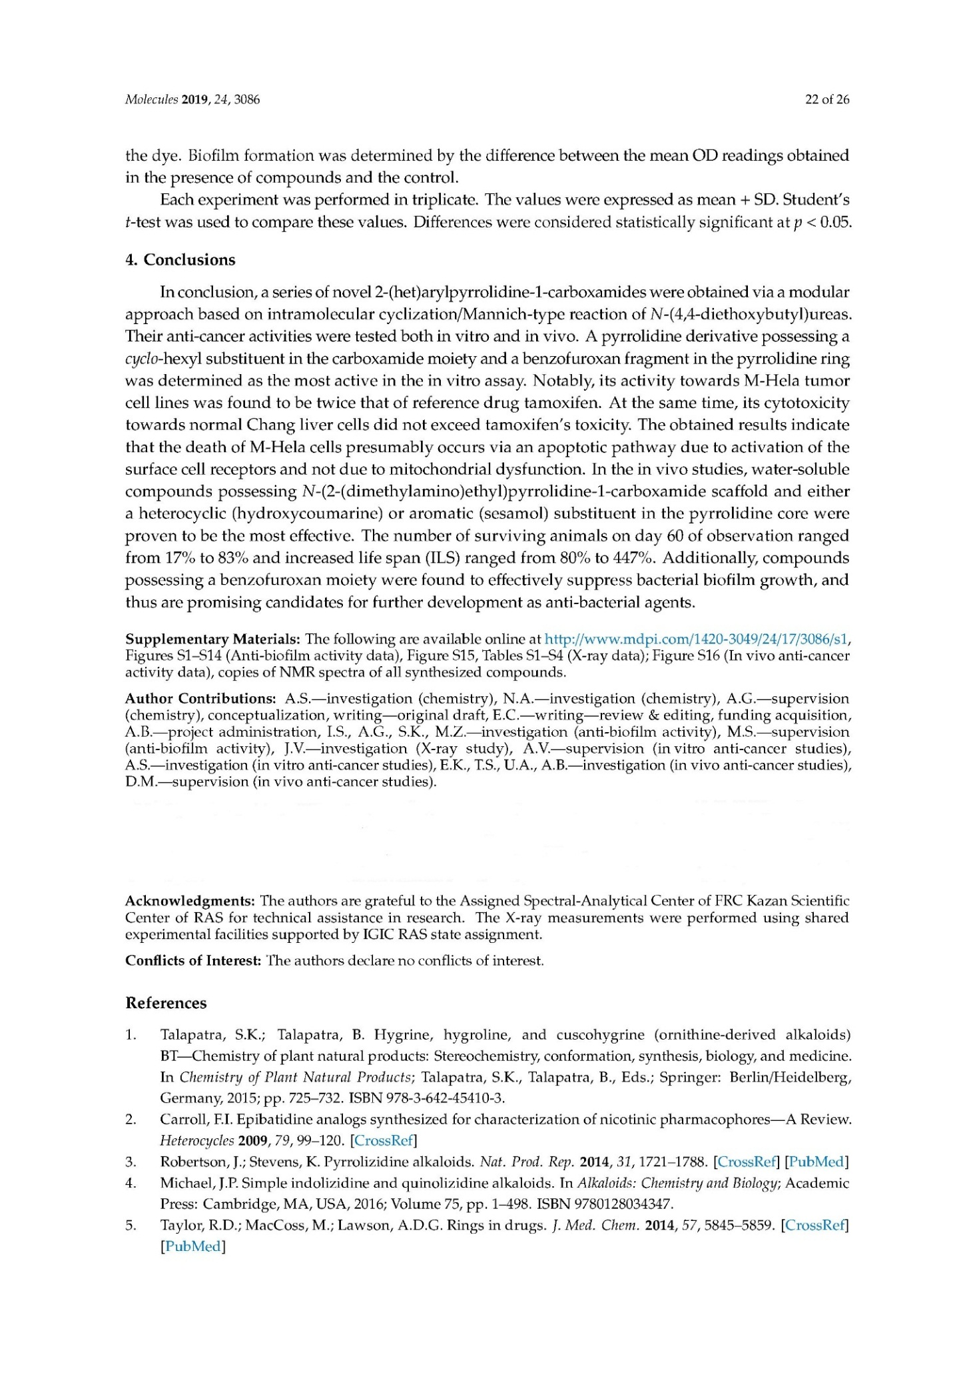
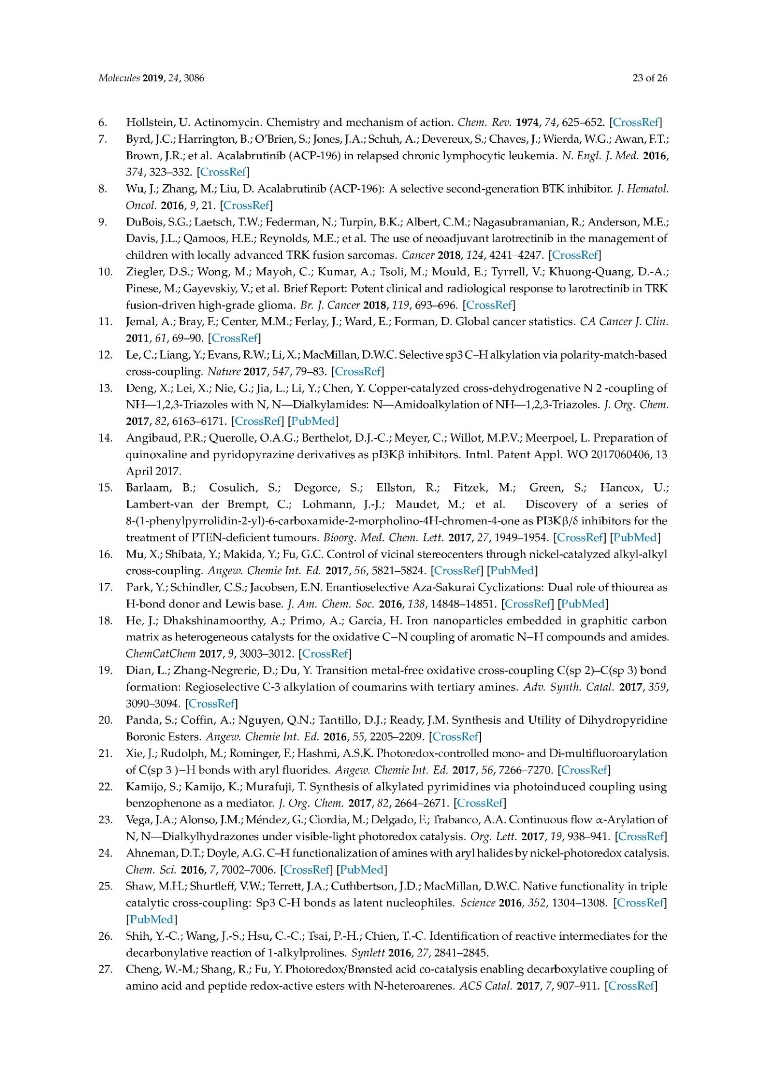
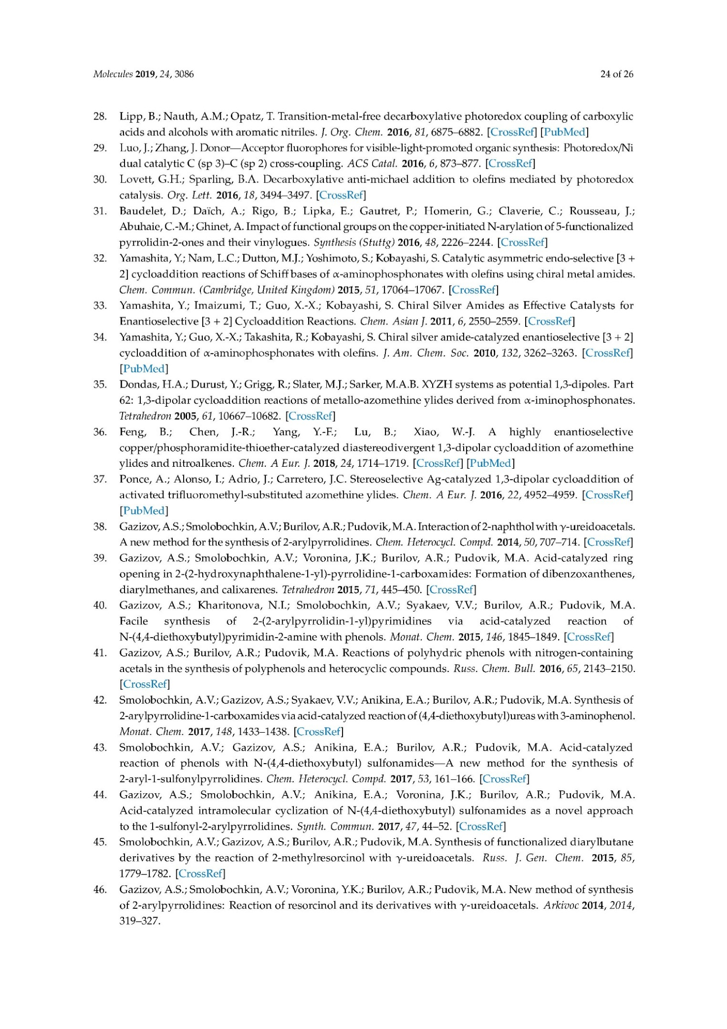
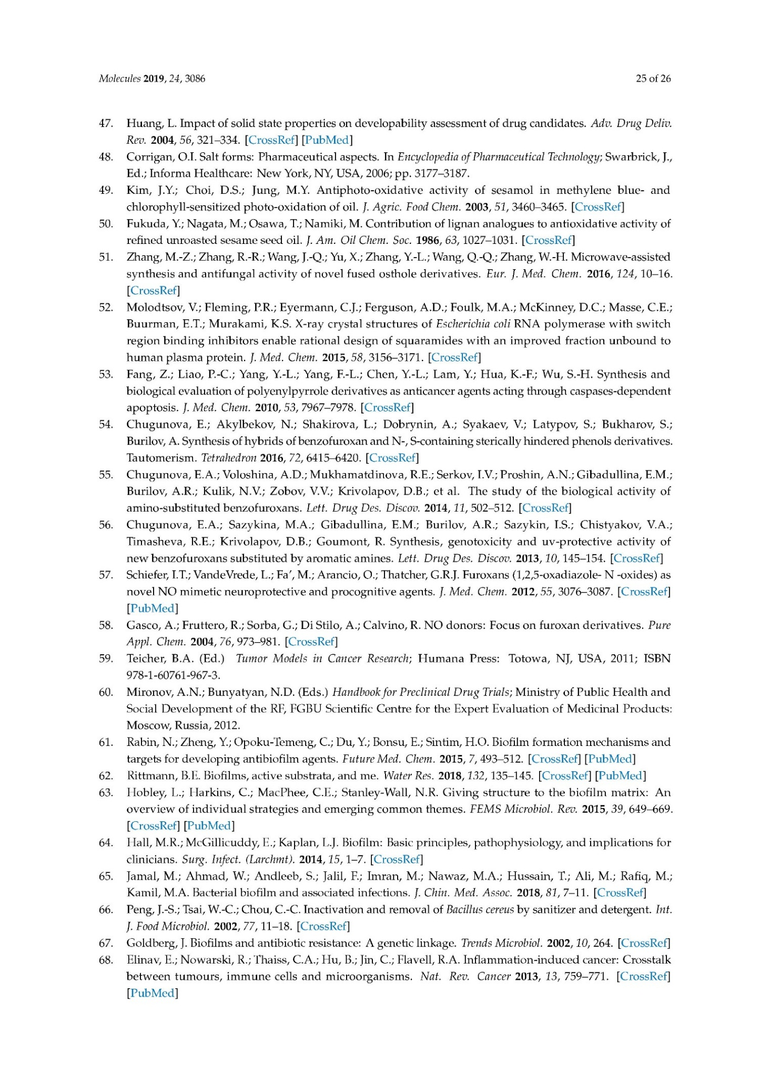
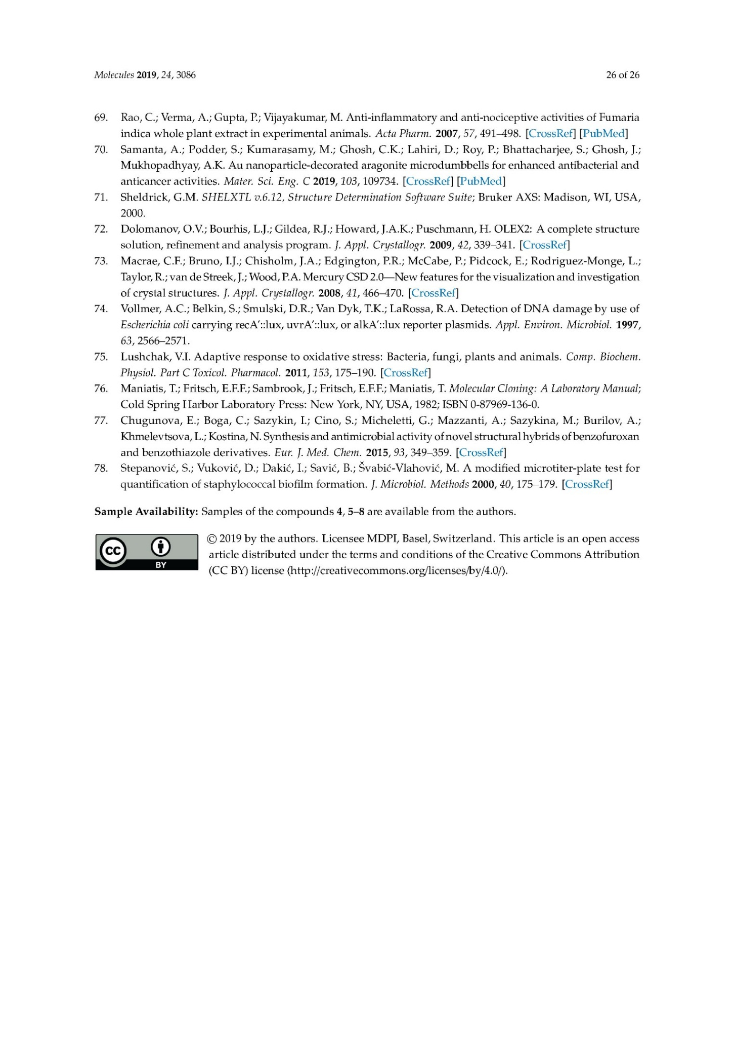

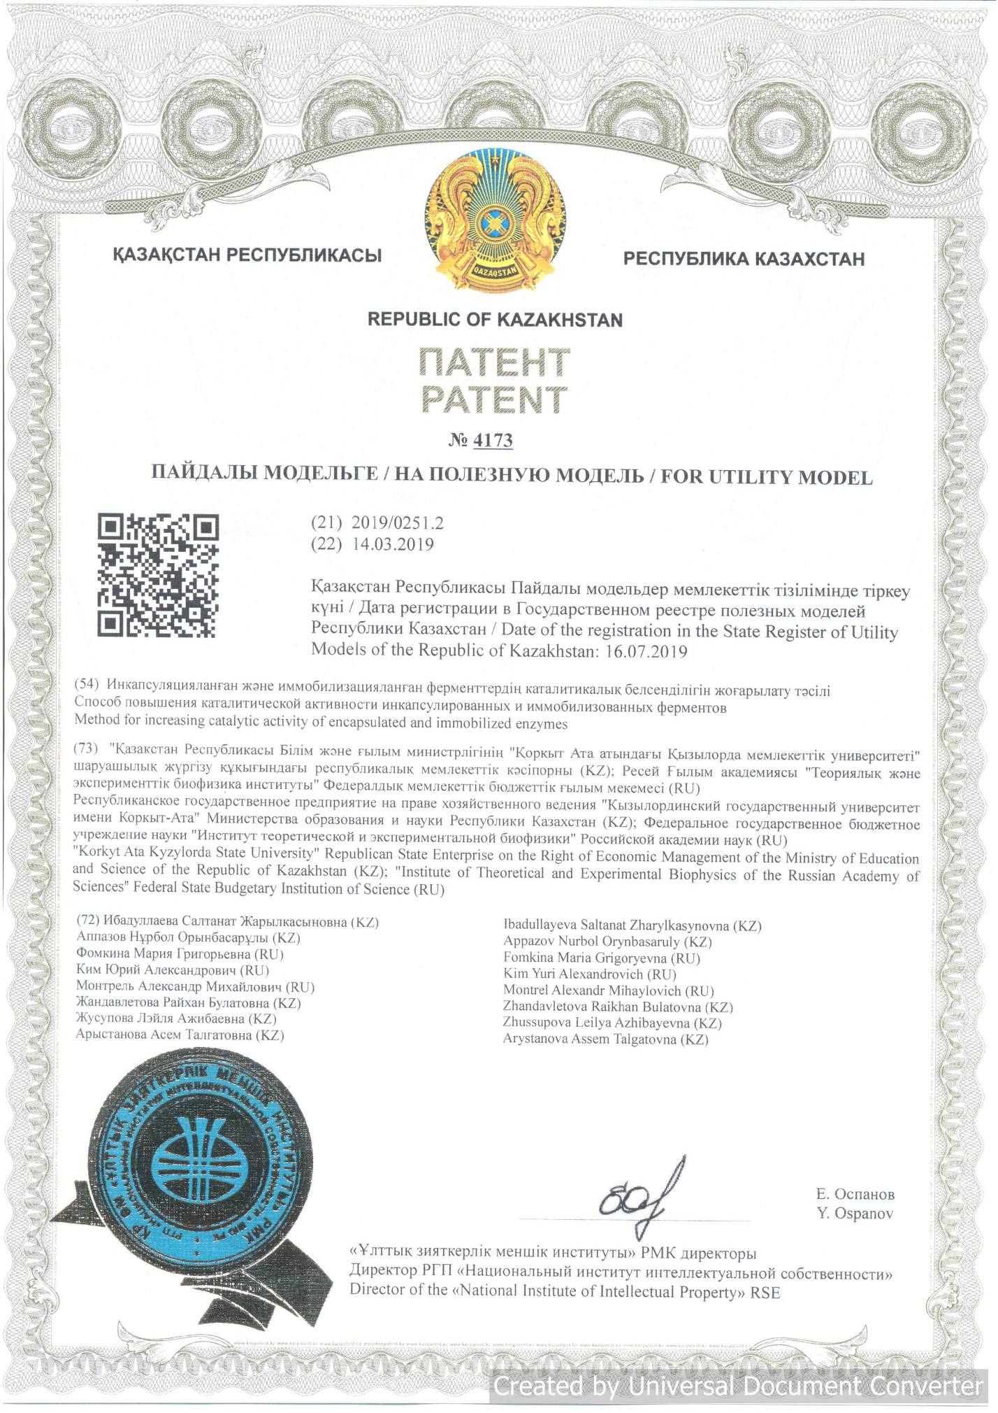

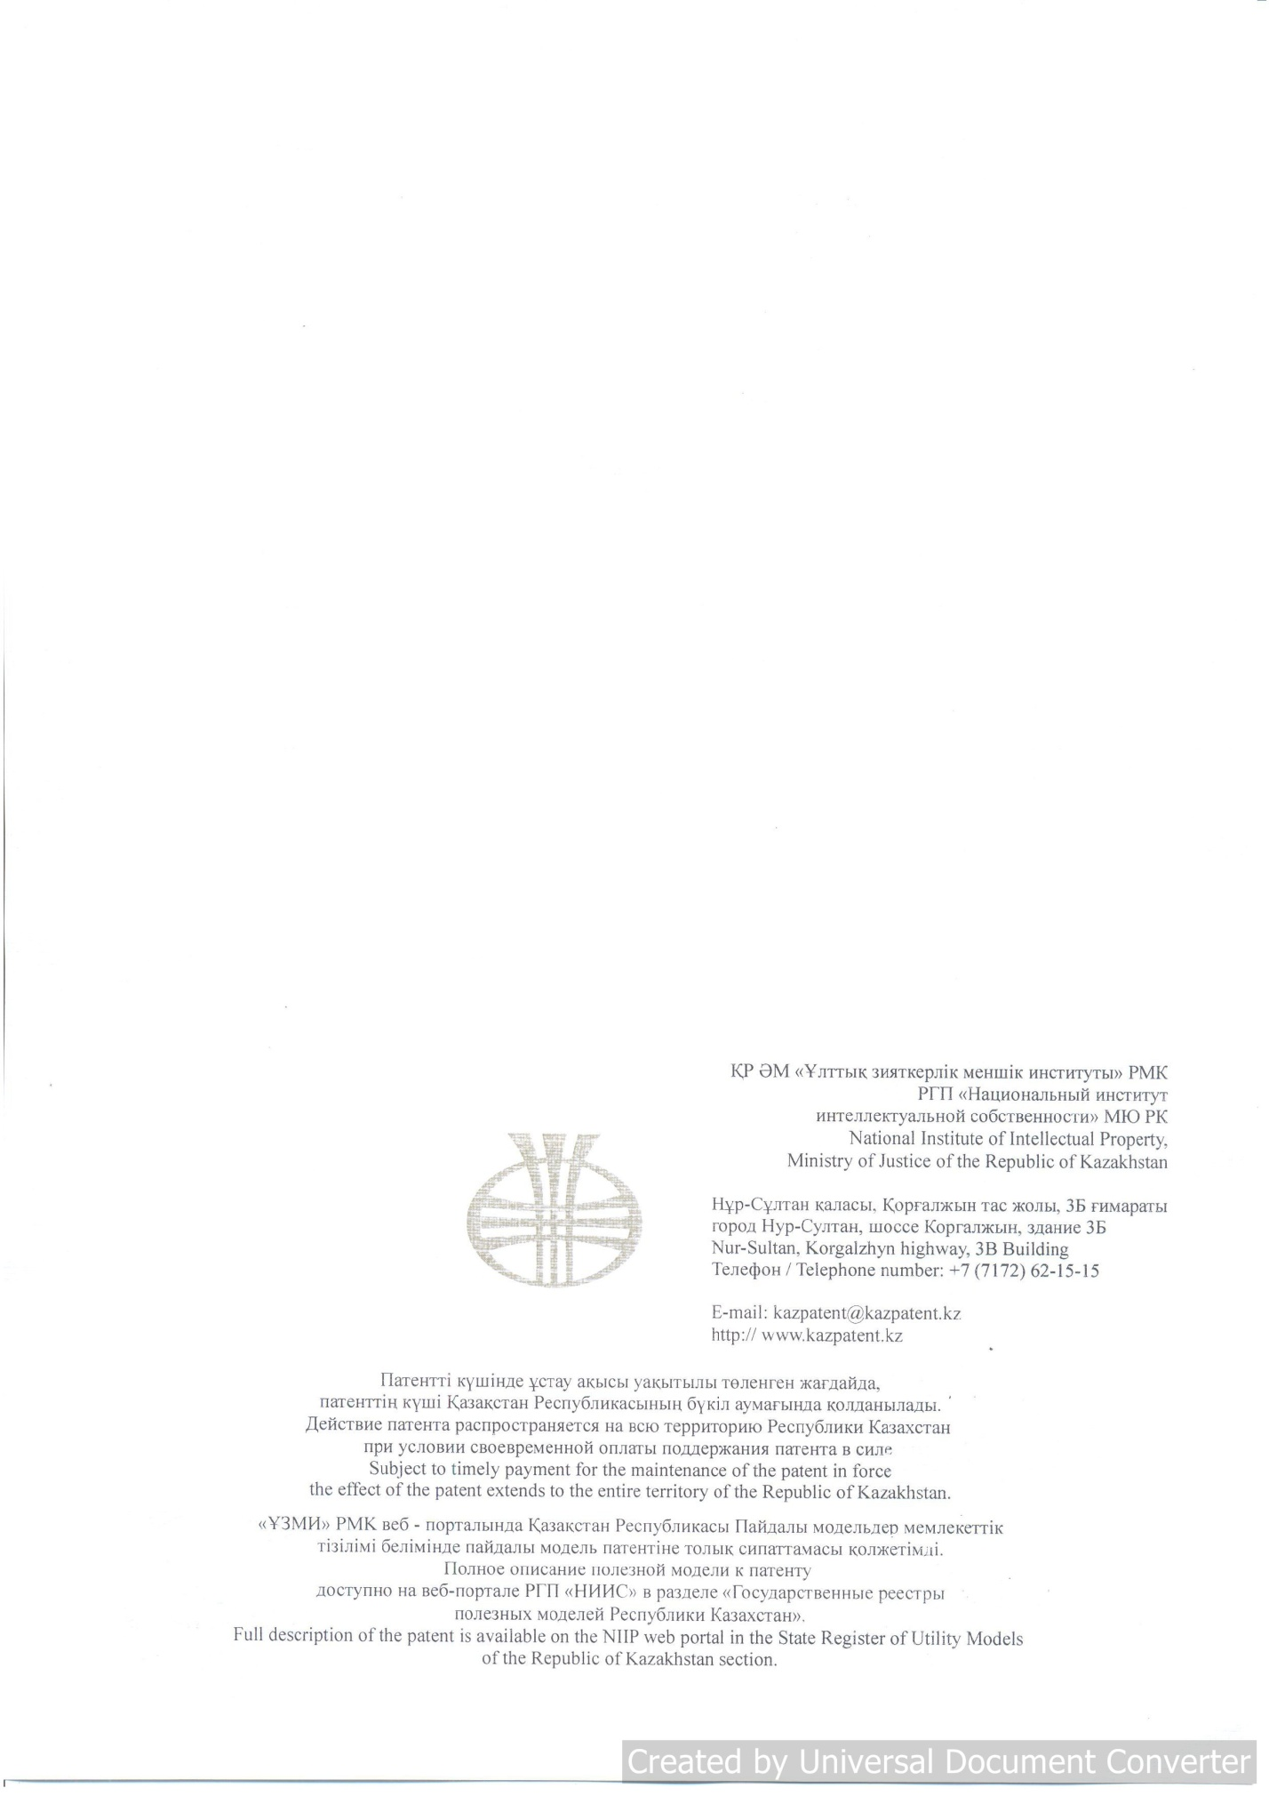

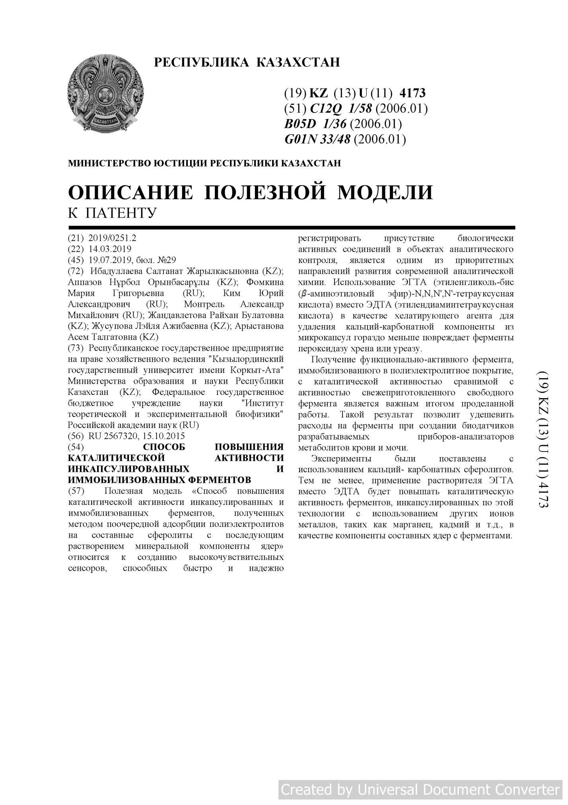

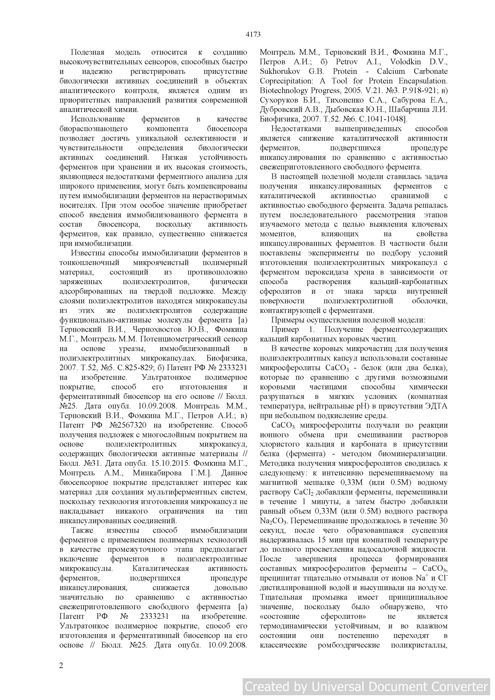

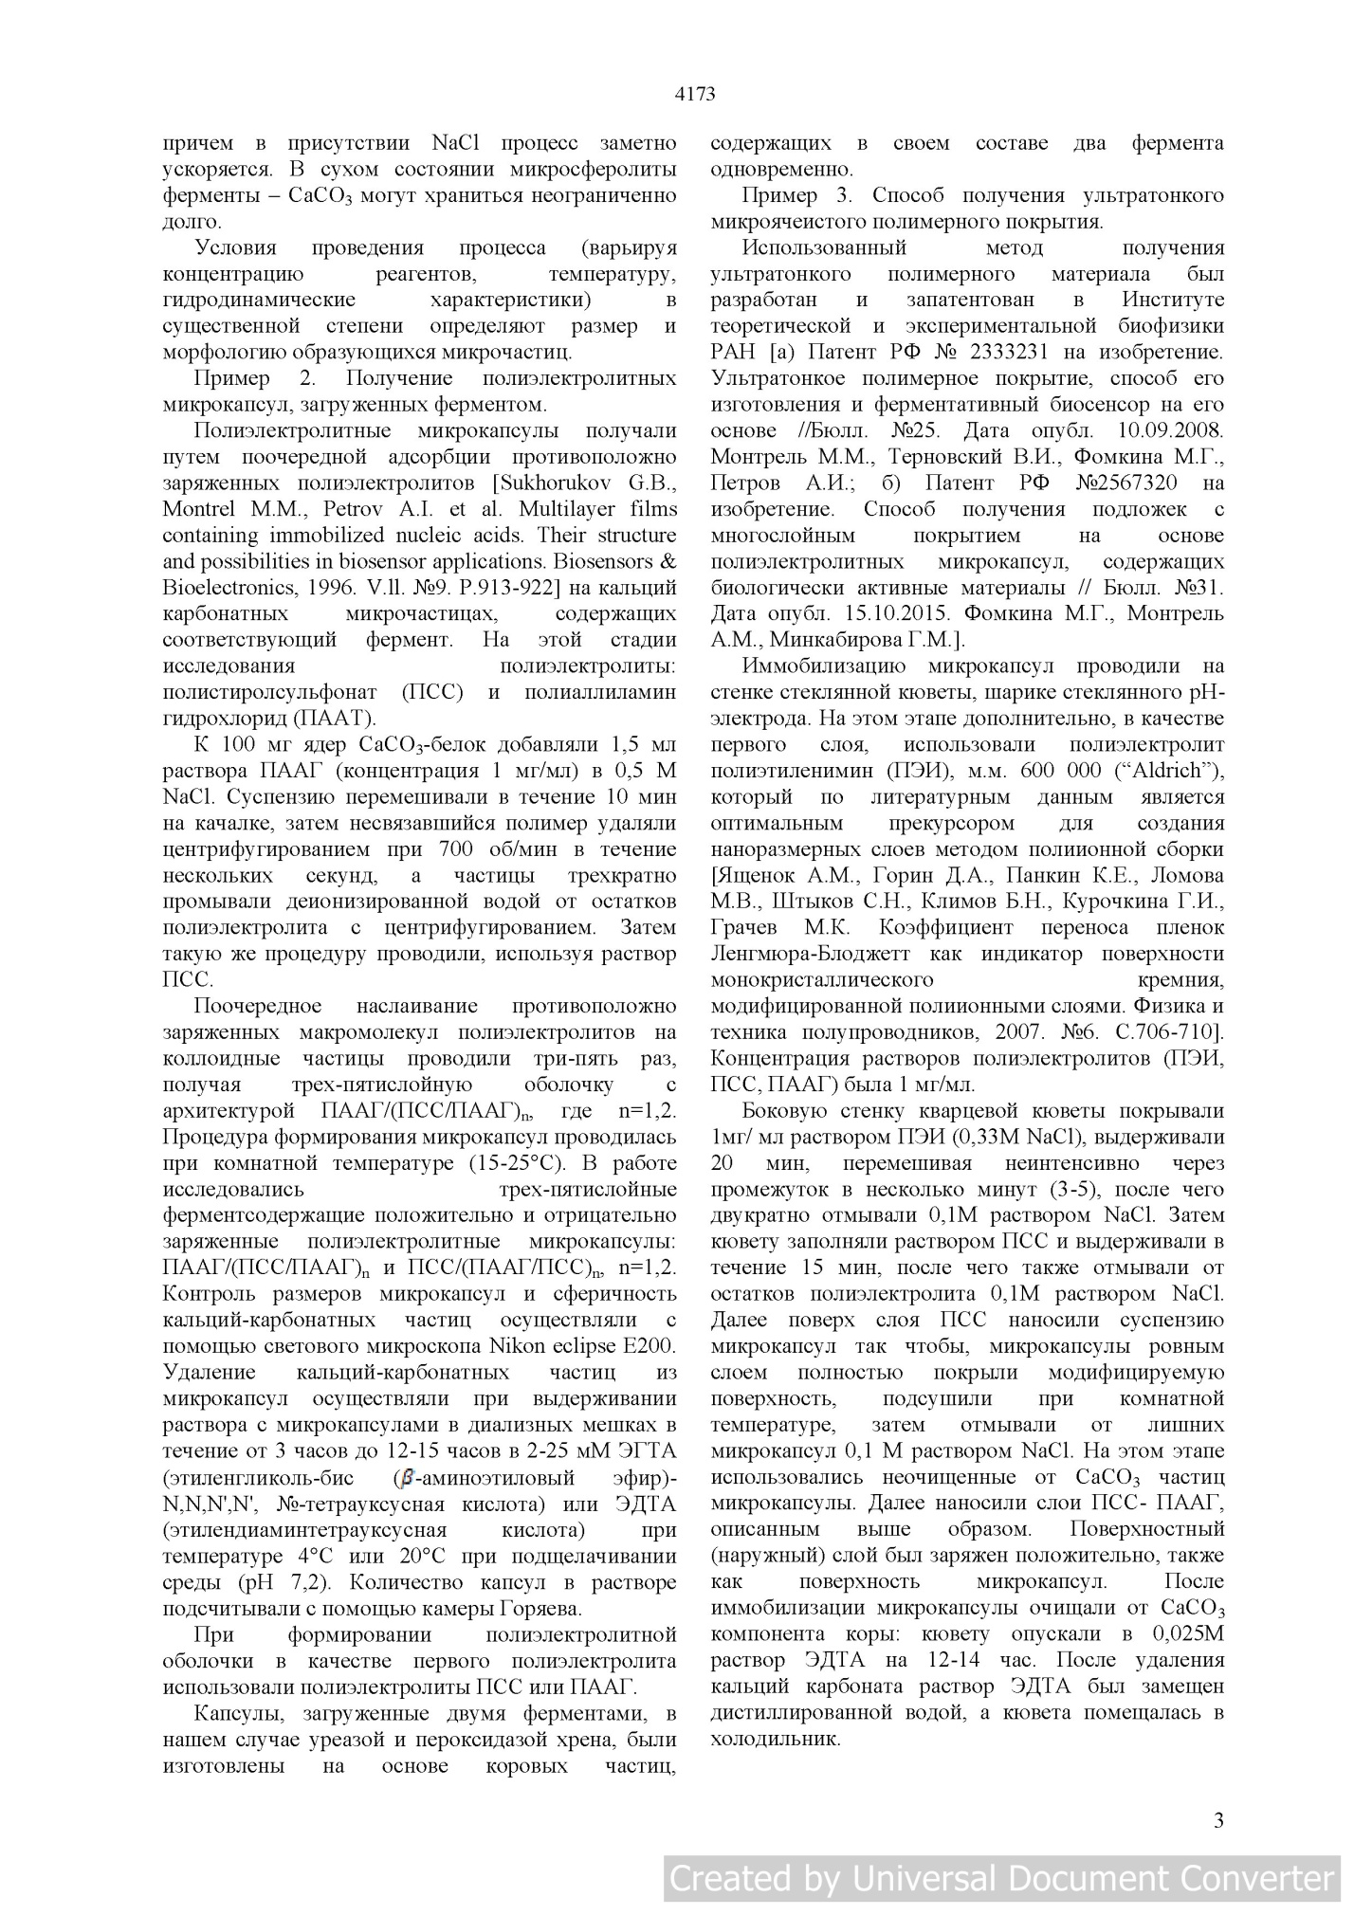

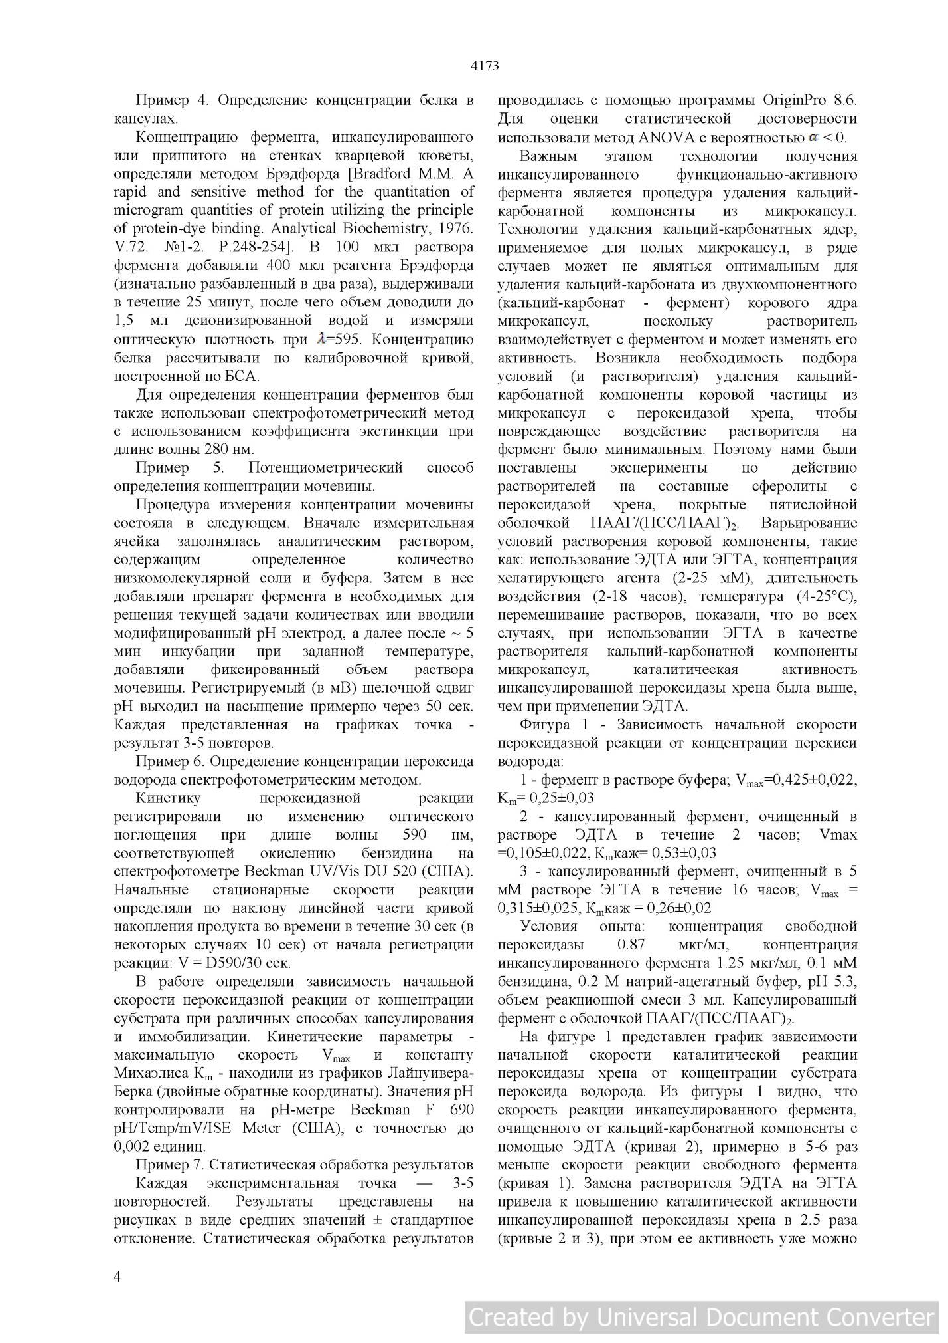

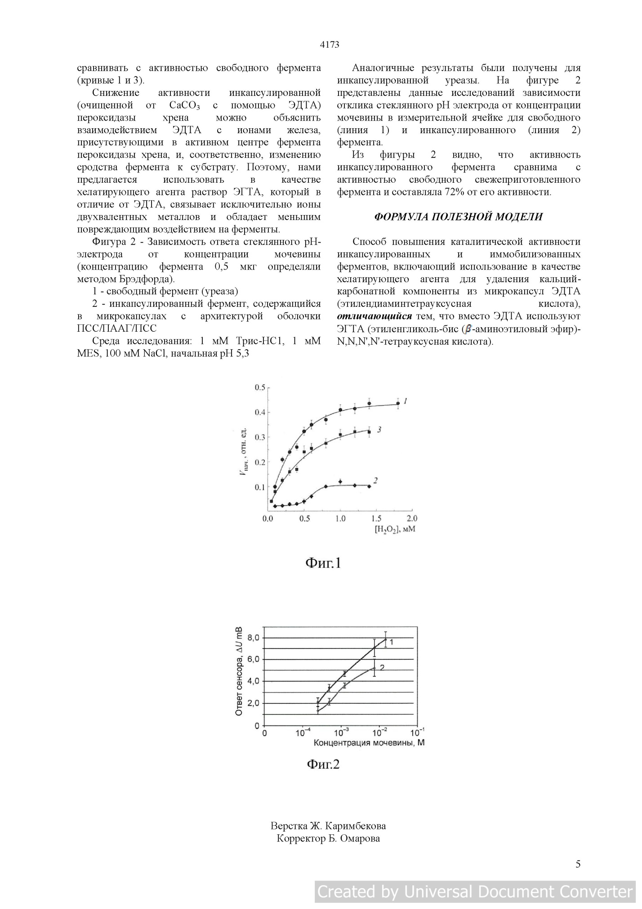

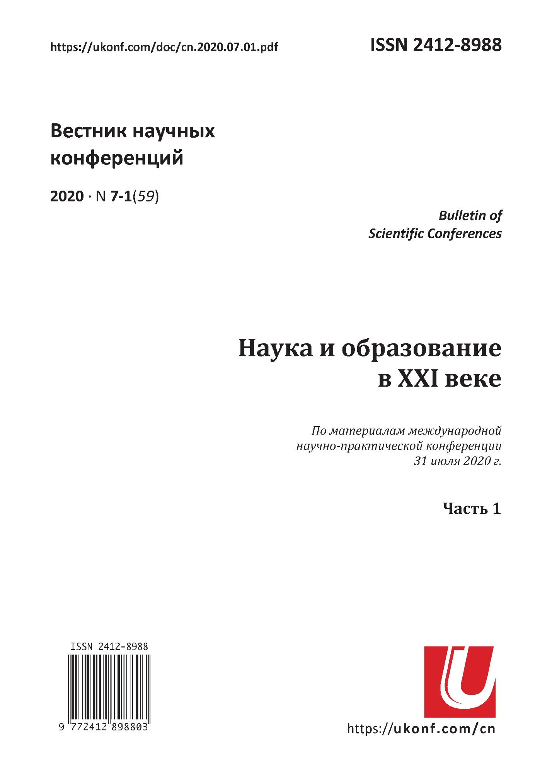

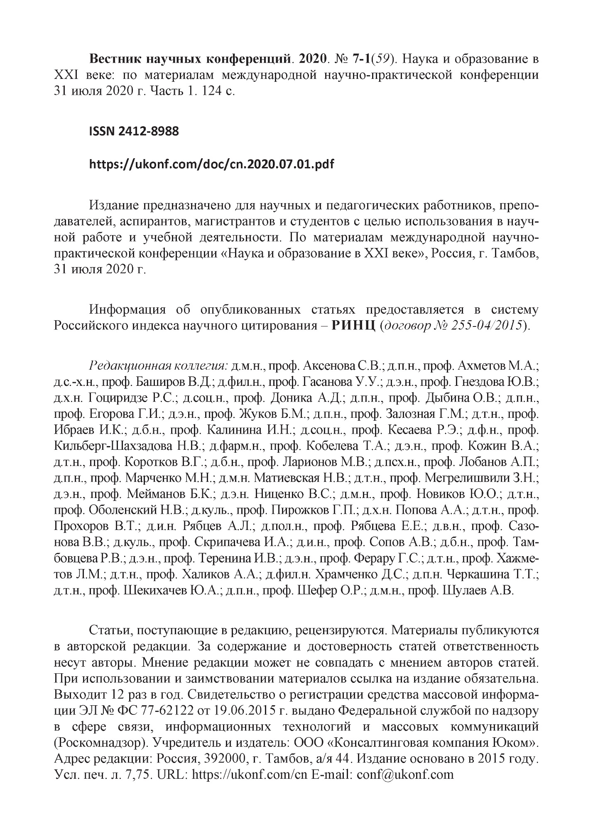

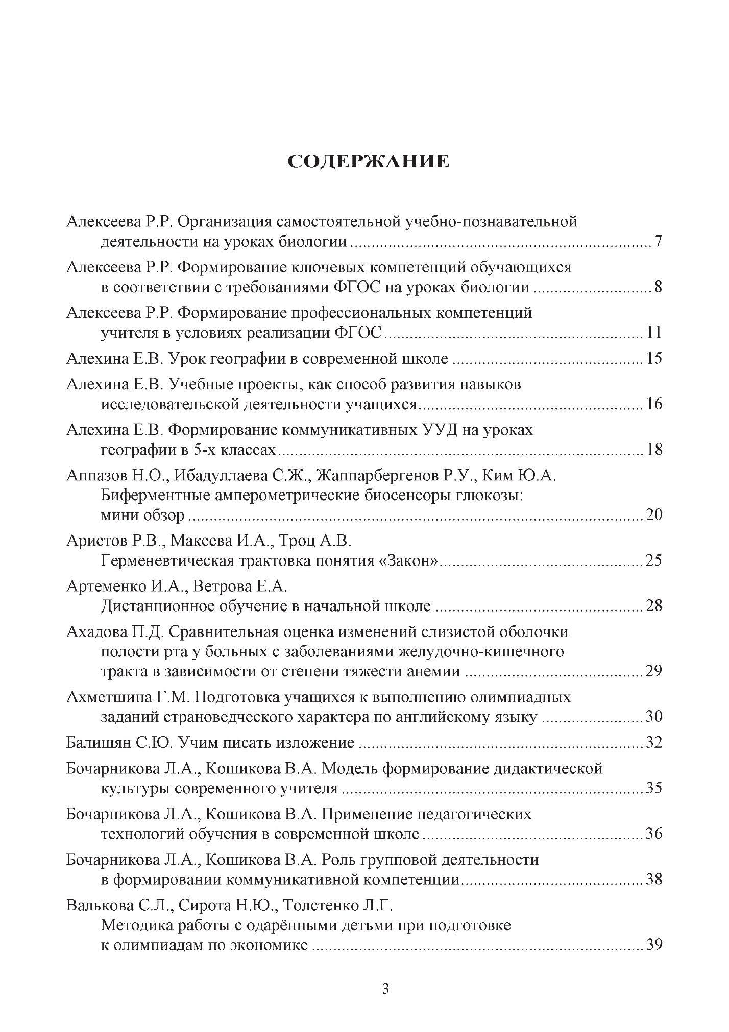

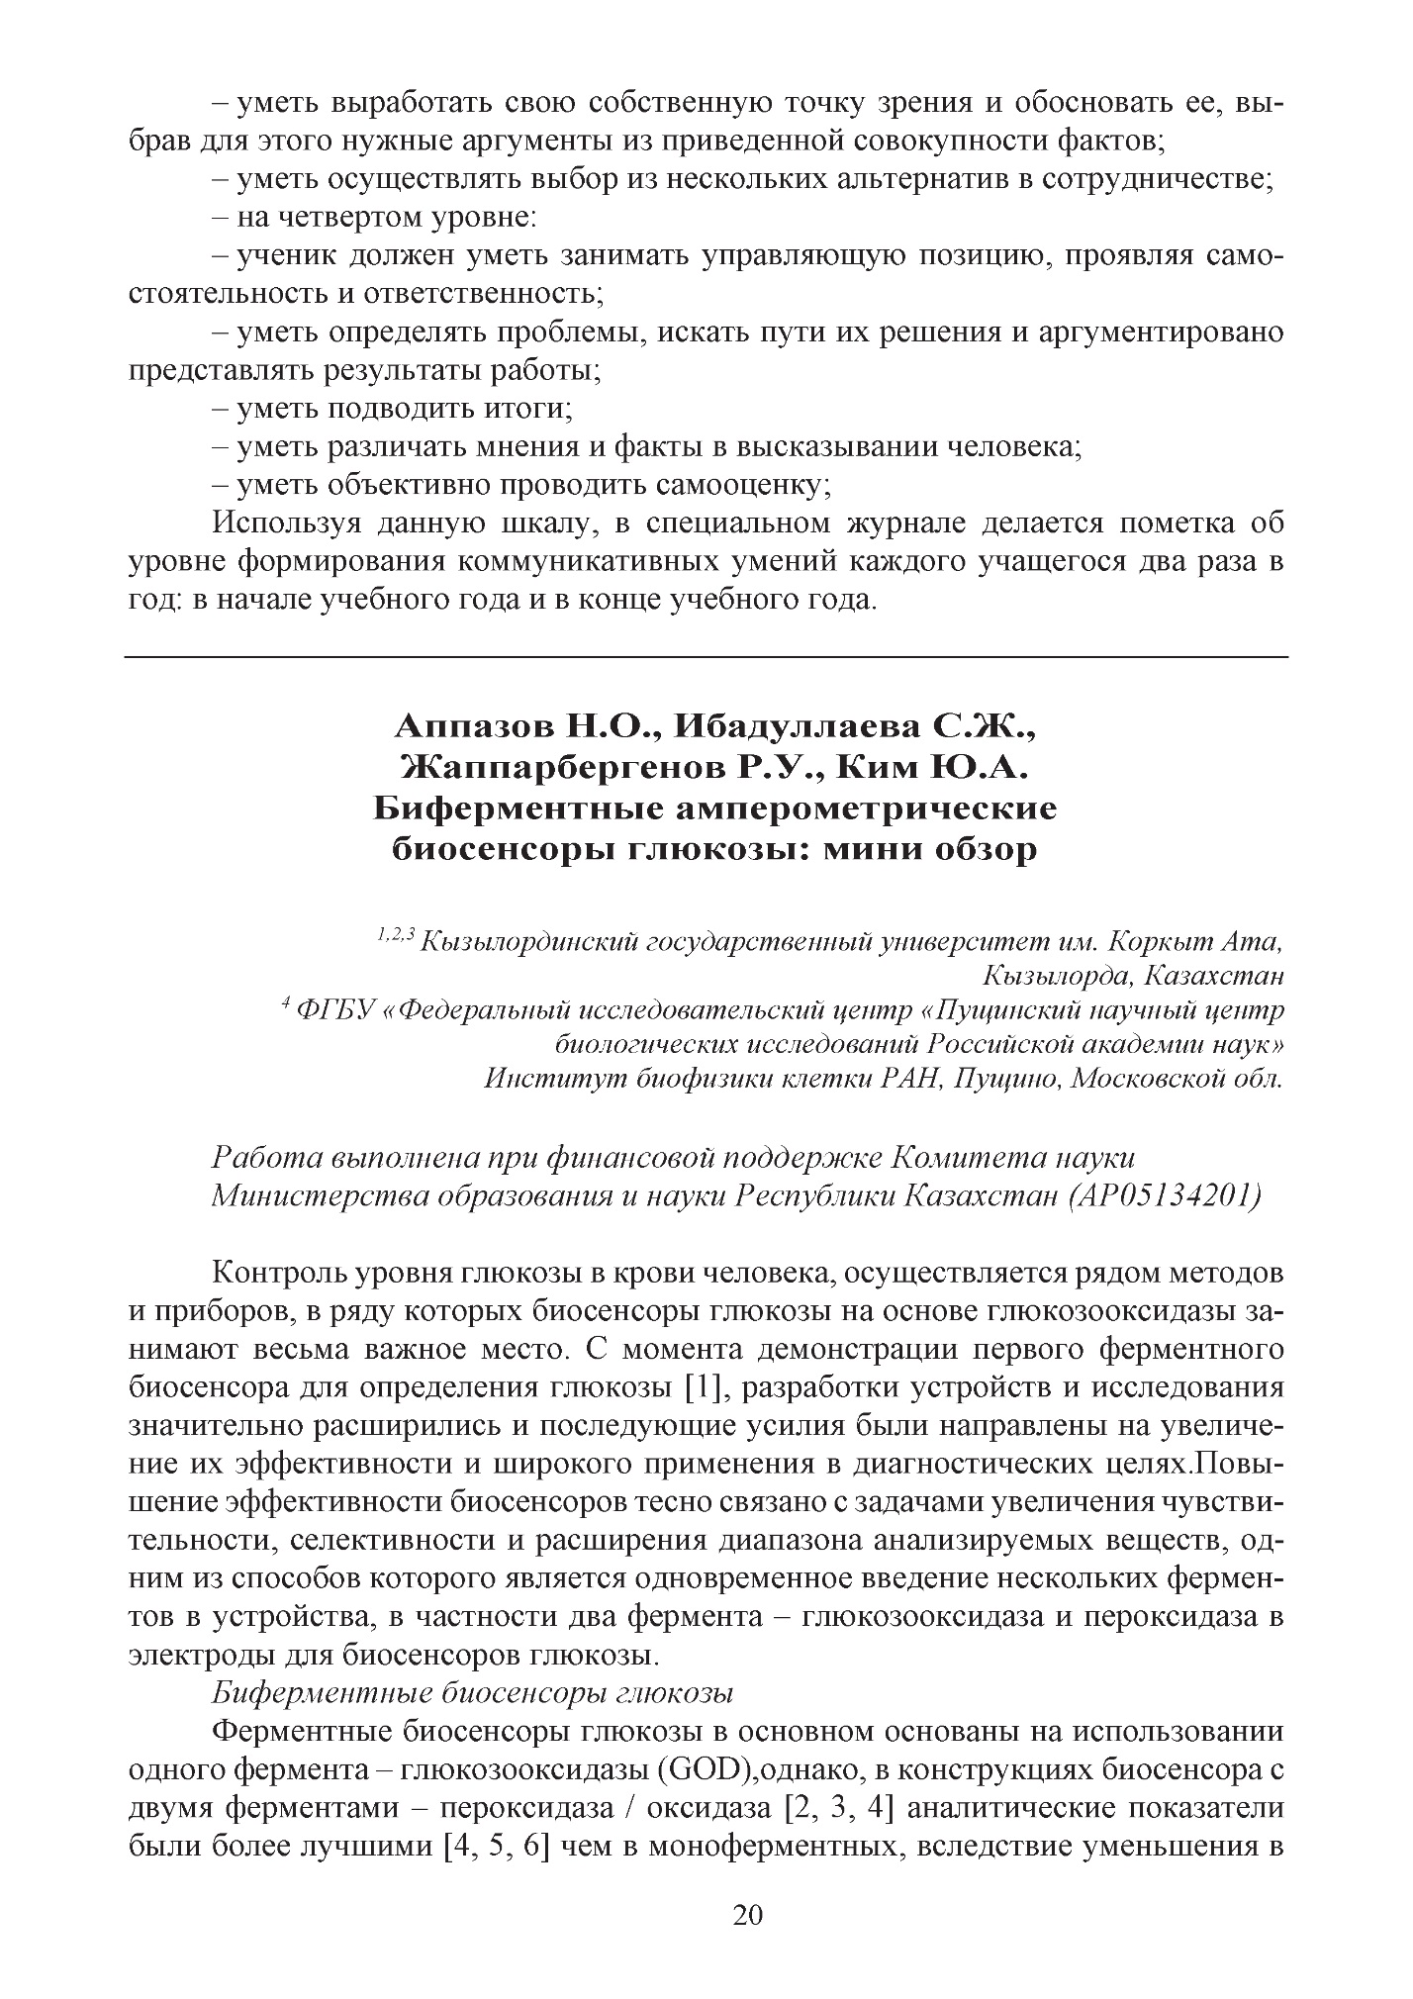

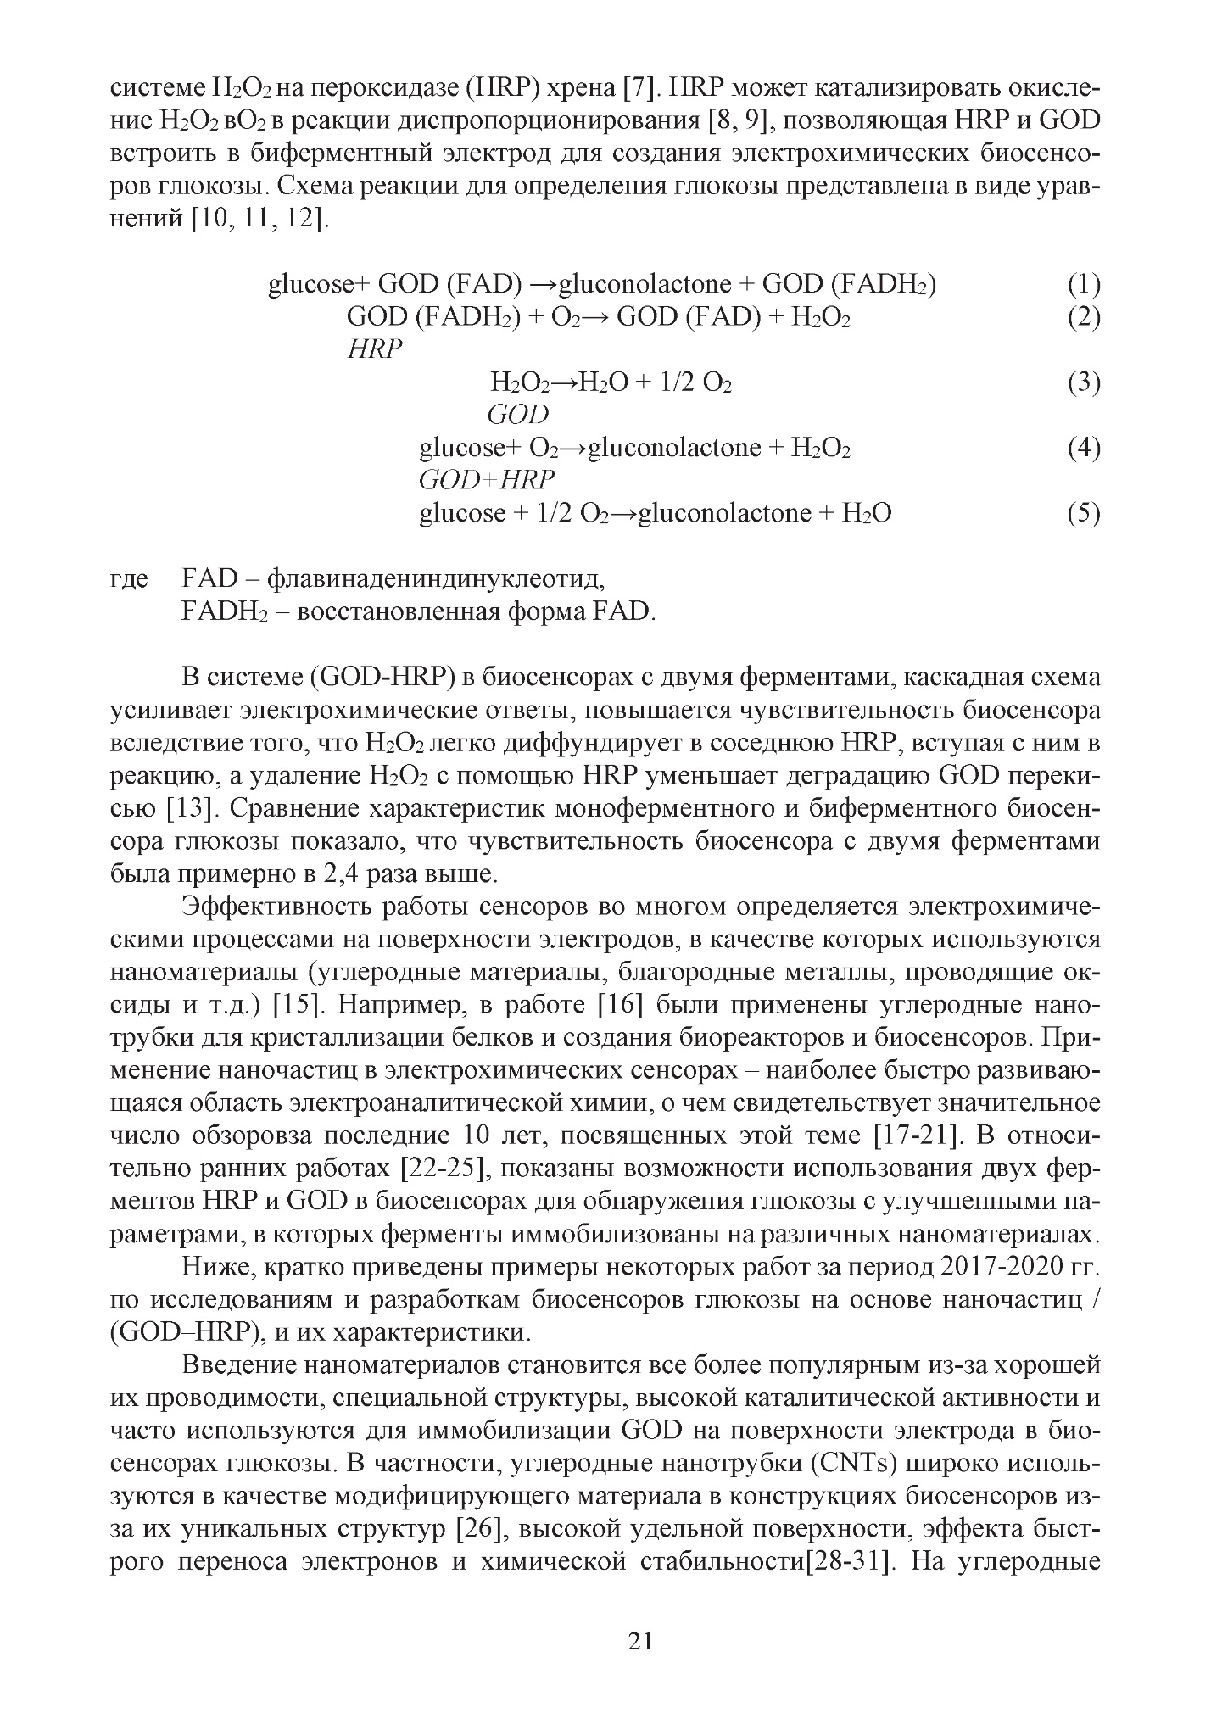

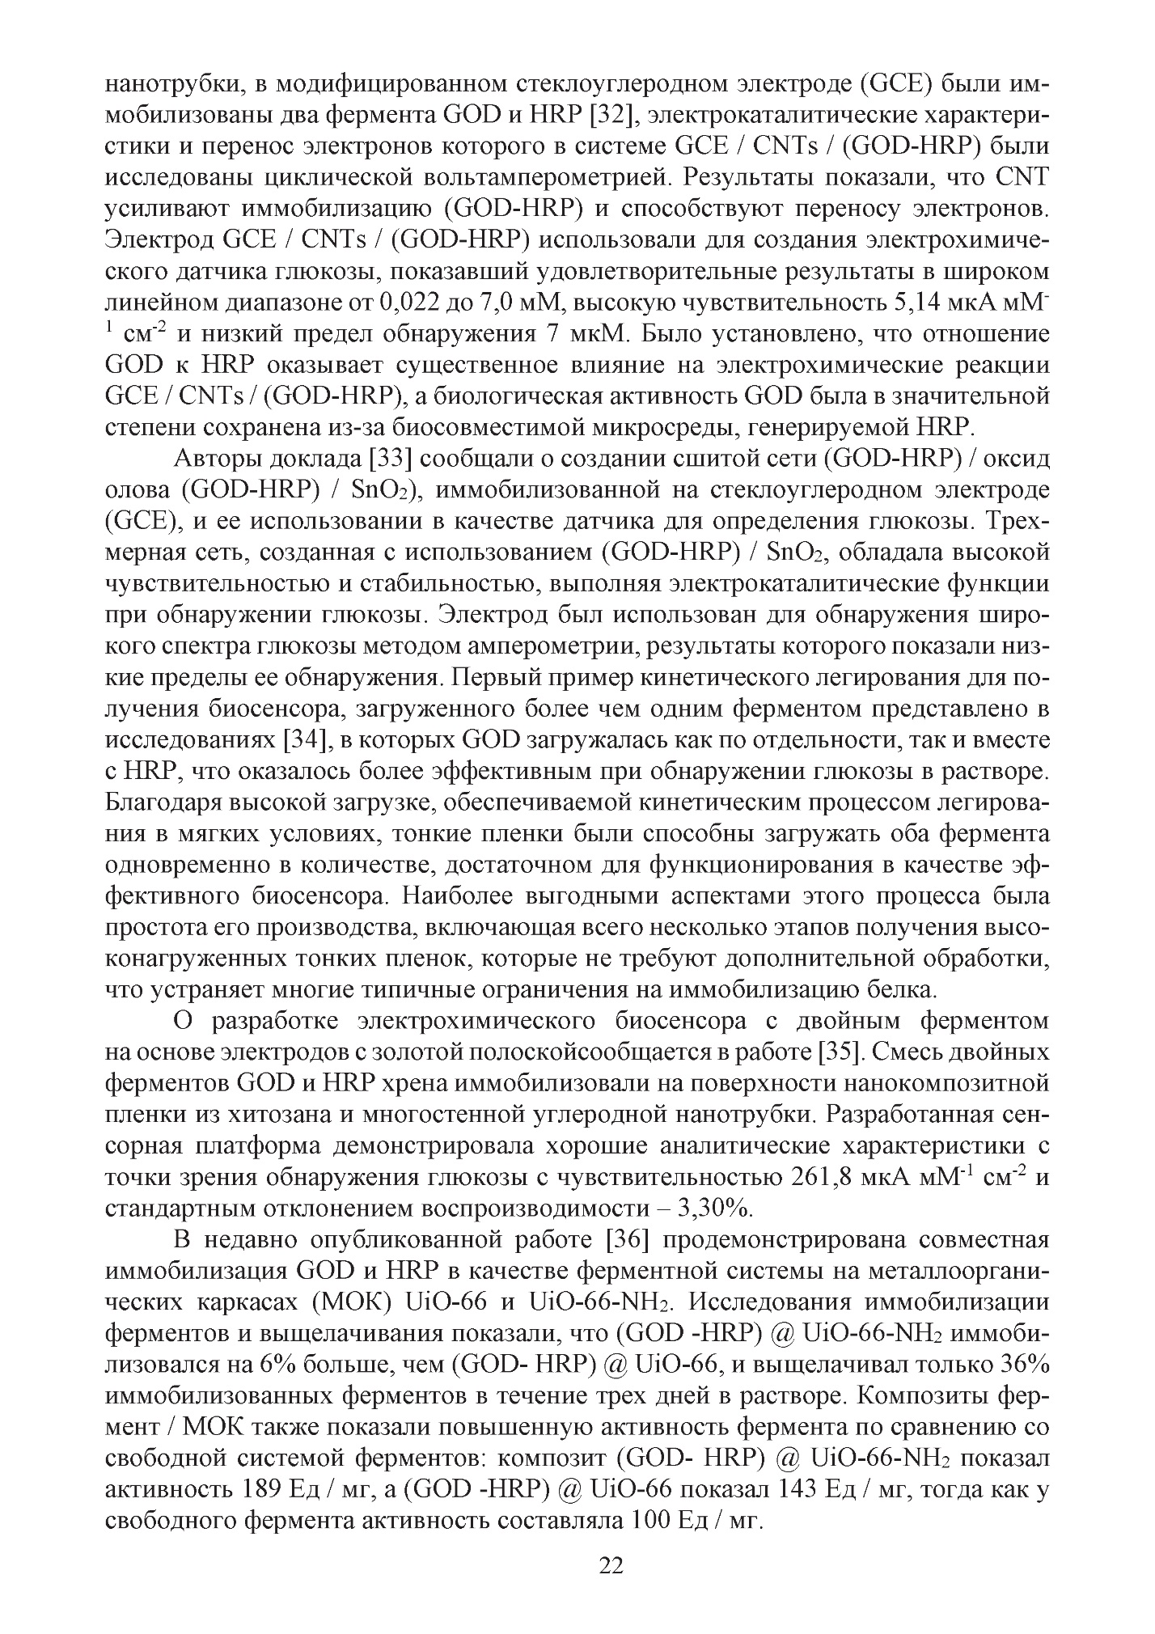

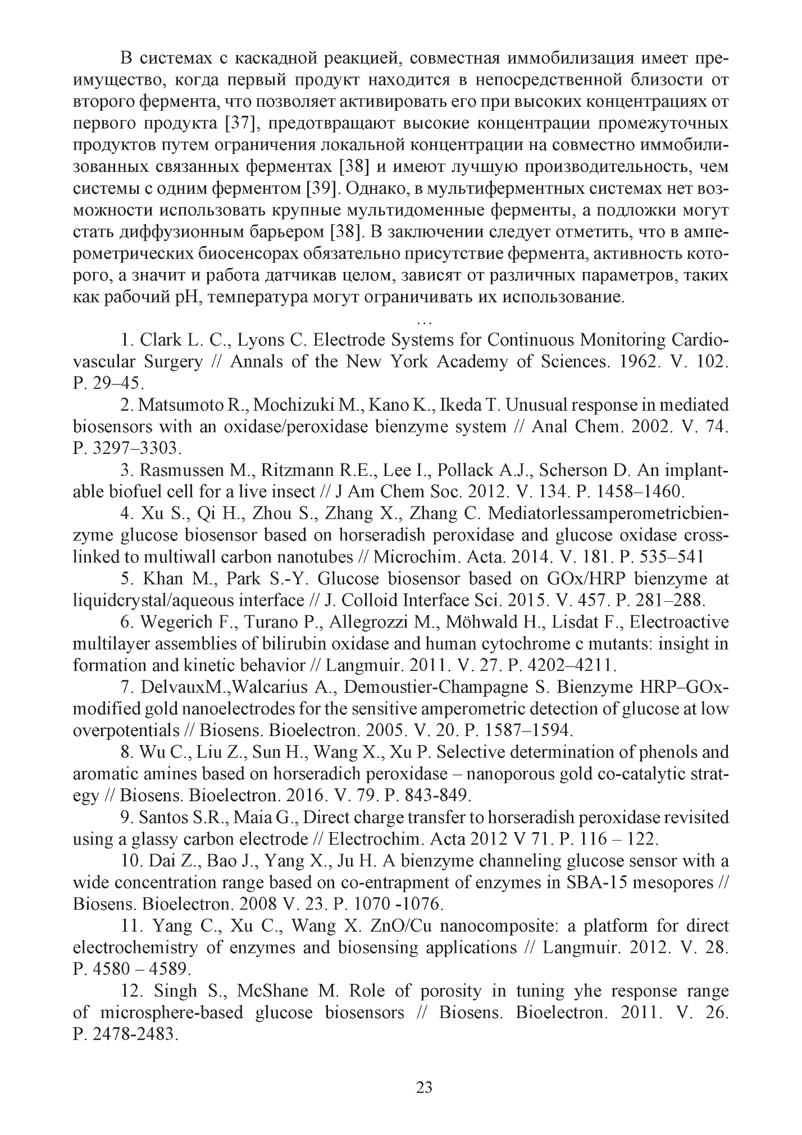

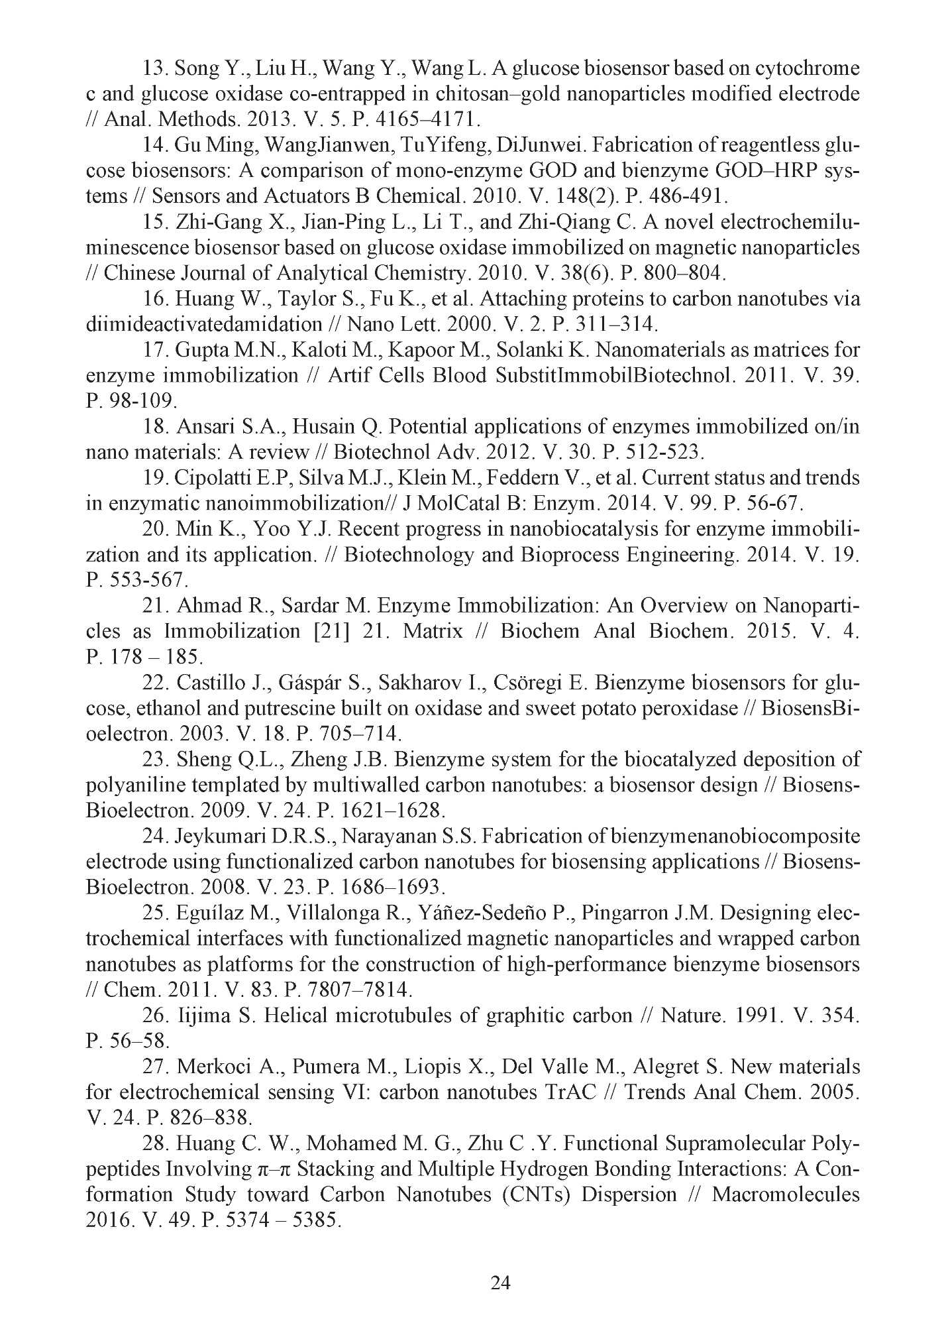

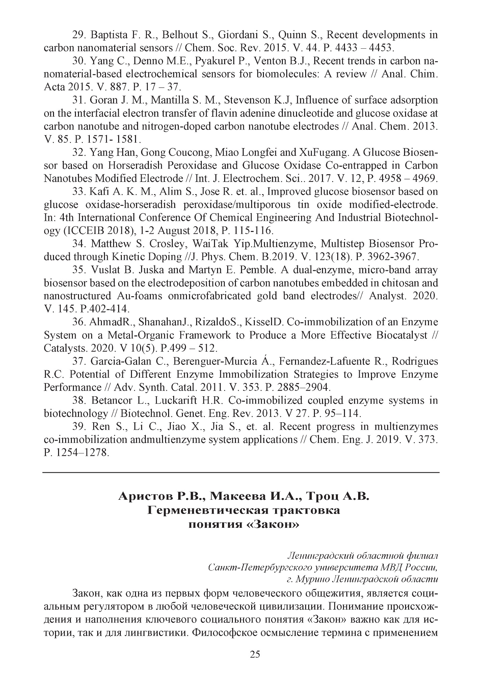
APPLICATION C – Technical task 