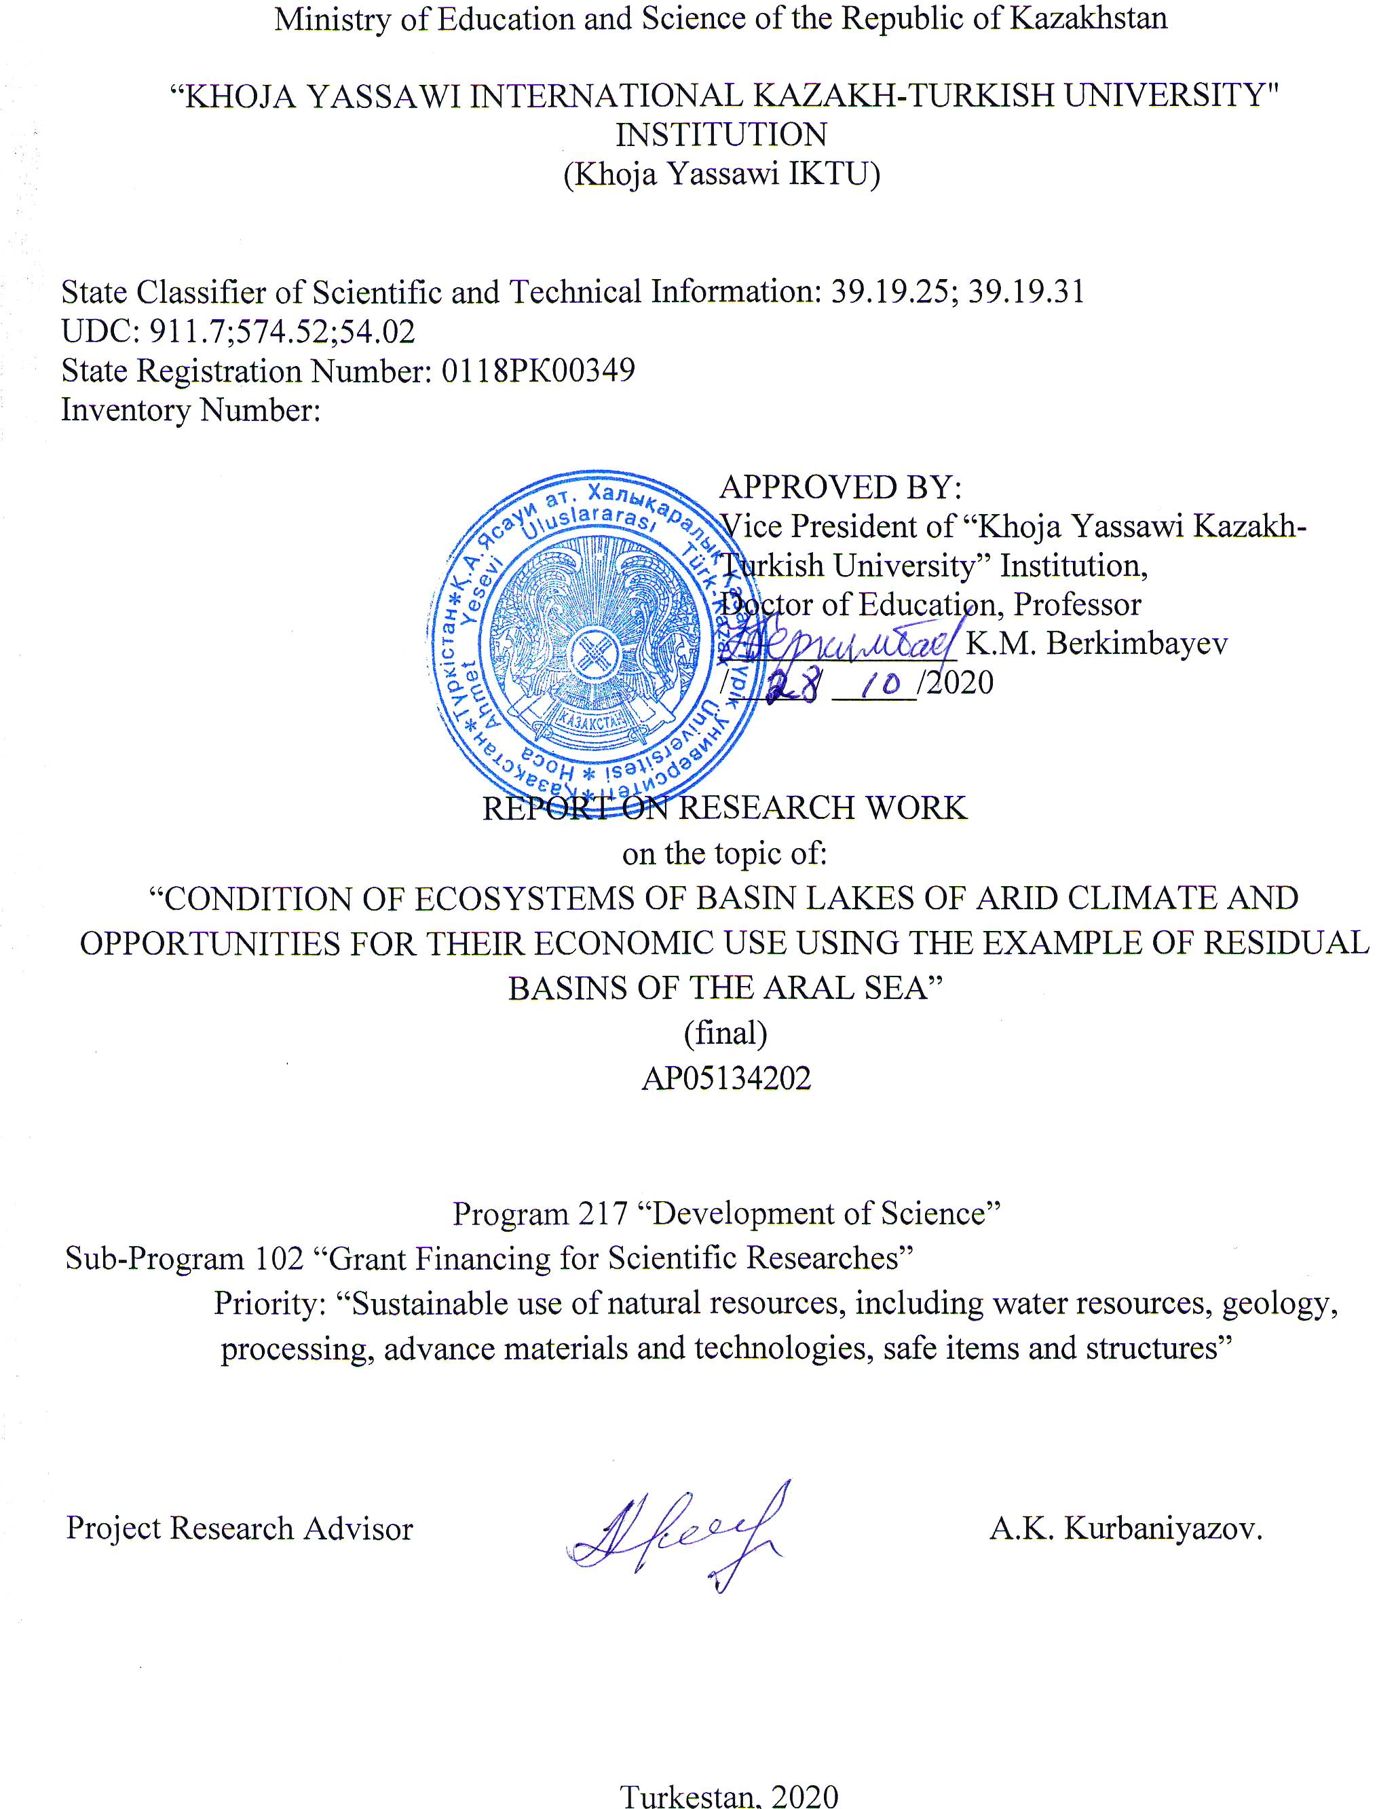

CONTRIBUTORS TO THE REPORT

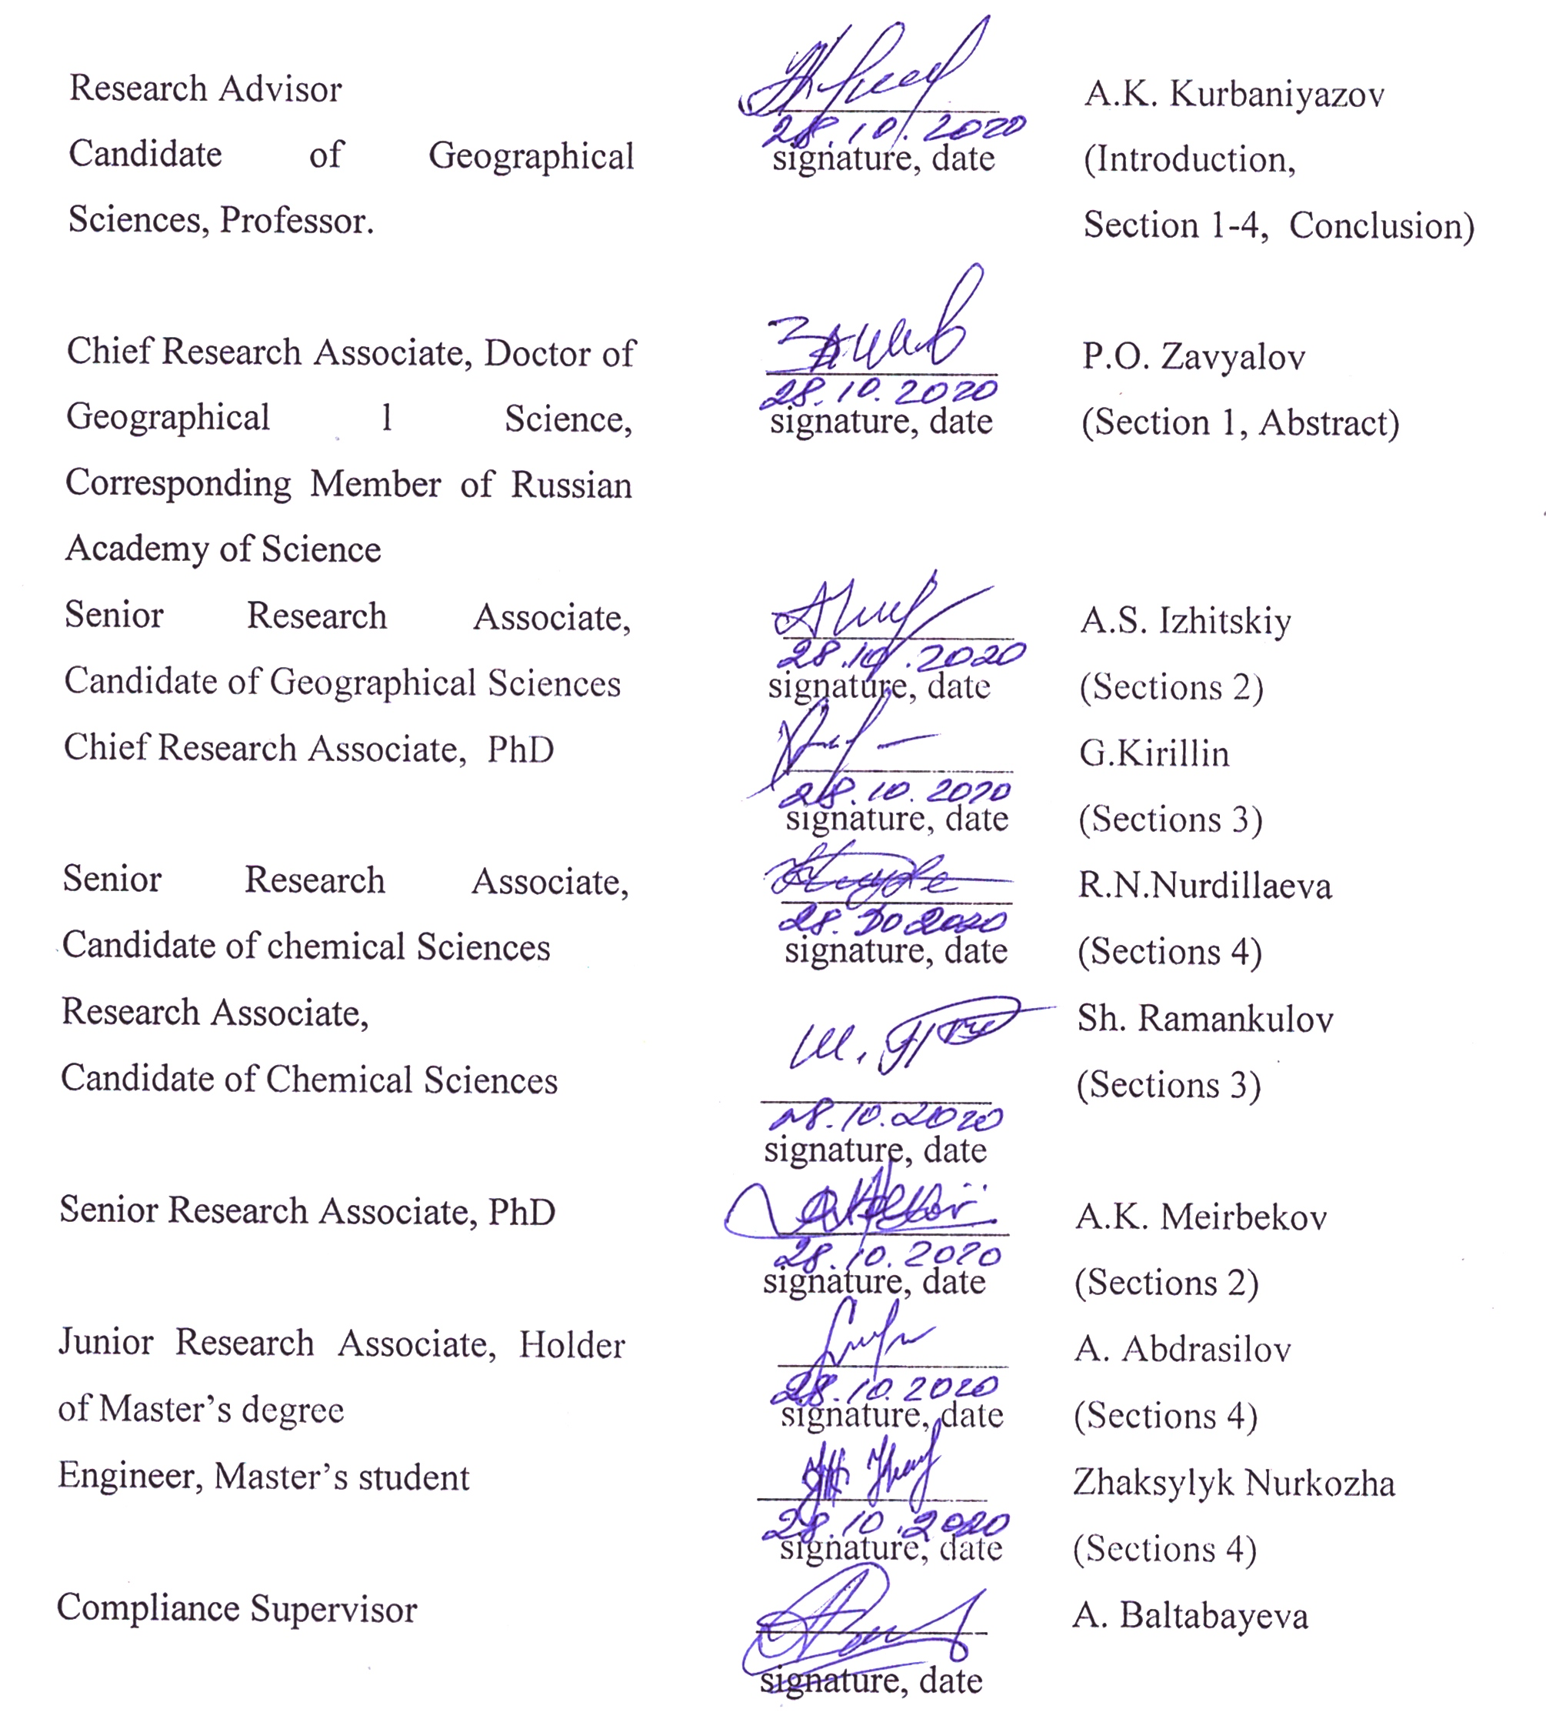

ABSTRACT

The report includes 110 pages, 16 figures, 31 reference sources, and 6 appendixes.
GEOMORPHOLOGY, GEOGRAPHY, ARAL SEA, HYDROLOGY, ION-SALT COMPOSITION, BIODIVERSITY, THERMOHALINE STRUCTURE
The subject of the research is ecosystems of basin lakes of arid climate – residual basins of the Aral Sea.
Purpose of the scientific research: Identification of patterns and response mechanisms of the system of residual lakes of the Aral Sea as a unique large aqueous system of the world which was exposed to the strongest anthropogenic stress in memory of the humankind to anthropogenic and climatic effects.
The methodology of the research is based on experimental and theoretical methods of research and is of applied nature. Innovative methods and advanced equipment for field observations, as well as remote sounding technique were applied.
Findings and novelty of the research. Being based on the finding of the research, it is certain that a double layer vertical stratification of water was observed in autumn season in the western basin of the Aral Sea in 2018-2020. According to the findings, in the bottom layer maximum salinity can be still observed, which may prevent complete mixing of the basin in the incoming winter season. Seasonal pattern of current filling rate of Aral basins and its dependence on climatic factors were established. Using the developed hydrologic model forecast estimations (till 2099) of variability of freshwater inflow into the Smaller Aral Sea were performed using three climate scenarios (RCP 2.6, RCP 6.0, RCP 8.5). Large-scale analysis of the hydrological regime in arid regions of Central Asia indicates changed trend of water level in terminal lakes from long-term reduction to its growth, which suggests fundamental changes in atmospheric circulation and regional water balance.
Scope of application – ecology, hydrology, oceanology, agricultural sector, educational field. The finding may be used in a number of economic sectors, for instance, in commercial purchase and sale of artemia cysts and in fishing industry, as well as in development of tourism and balneological enterprises in Aral Sea region.
Predictive assumptions on development of the research subject. Findings of the research may be used to assess risks in economic activity in the research region, as well as in development of measures for mitigation of the environmental crisis. Gradual change of the hydrophysical conditions in the residual basins will evidently affect the structure of bio-communities either.

CONTENTS

DEFINITIONS, REFERENCES AND ABBREVIATIONS |  | 5
INTRODUCTION |  | 6
1 Unit “Field observations” |  | 9
 | 1.1 Field measurements and simulation of hydrophysical parameters |  | 9
 | 1.2 Study of the dynamics of the bio-diversity under conditions of rapidly changing physical-chemical and hydrologic environment. Identification of mechanisms for adaptation of biological system to extreme living conditions in different residual basins (Greater, Smaller Aral, Tshchebas, eastern ephemeral Aral) |  | 15
2 Unit “Data analysis” |  |  | 20
 | 2.1 Assessment of the impact of artificial control of water exchange in Smaller Aral on vertical mixing |  | 20
3 Unit “Numerical simulation” |  |  | 24
 | 3.1 Model diagnostic and forecasting estimations of possible changes in the level and condition of the sea for next 20-30 years depending on water content of rivers |  | 24
 | 3.2 Simulation of water balance of the basin |  | 27
4 Unit “Satellite monitoring” |  |  | 31
 | 4.1 Assessment of inter-annual variability of basin area, ice regime |  | 31
 | 4.2 Assessment of long-term trends in change of water balance of large Central Asian lakes |  | 34
CONCLUSION |  | 40
BIBLIOGRAPHY |  | 44
APPENDIX А – Work schedule for 2018-2020 |  | 47
APPENDIX B – List of published works on the topic for 2018-2020 |  | 55
APPENDIX C – Minutes Of the scientific Committee of the University on the discussion and approval of the final report of research |  | 58
APPENDIX D – Satellite images of the Aral sea for 2020 |  | 59
APPENDIX E – Results of chemical analysis of water in the coastal zone of the Aral sea |  | 70
APPENDIX F – Prints of published works obtained as a result of research |  | 73

DEFINITIONS, REFERENCES AND ABBREVIATIONS

The following terms were used in this Report on Scientific Research

Microphytobentos | – | a set of alga and photosynthetic bacteria developed on/in different bottom soils
GIS | – | geo-information system (geographic information system) is a system for collection, storage, analysis and graphic representation of spatial (geographic) data and related information on objects required
MODIS (Aqua-Terra) | – | Moderate Resolution Imaging Spectroradiometer scanning the entire surface of the Earth each 1-2 and collecting data in 36 spectral bands or wavelength groups
VIIRS (SNPP) | – | Visible Infrared Imaging Radiometer Suite
CTD | – | conductivity, temperature, depth
AVHRR (NOAA-METOP) | – | an improved radiometer of very high resolution
NASA | – | National Aeronautics and Space Administration is an agency of the Federal Government of the USA
the USA | – | the United States of America
TS | – | temperature/salinity
POM | – | Princeton Ocean Model
IO RAS | – | Institute of Oceanology of the Russian Academy of Sciences
ТР | – | Tibetan Plateau
CA | – | Central Asia
ERS | – | Earth Remote Sensing

INTRODUCTION

Assessment of the current status of the issue to solve and its relevancy. Study of the dynamics of the water balance of inland waters and development of water-balance models for basins insufficiently supported by data of directs observations is one of pressing problems of the modern hydrology. This scientific problem has special important in arid zones which reacts most sharply to climatic changes and anthropogenic impact. A recent publication [1] on Climate Scenario RCP 6.0 predicted changes in regimes circulation of lakes across the globe, in particular, trends to intensification of vertical stratification of water and increase in temperature of surface layer water have been identified. The work [2] underlines dominant influence of anthropogenic impact on reduction of the value of water resources in the Aral region in last decades. Authors of the work [3] analyze causes of the modern crisis of water resources in Central Asia and identify intensification of glacial melting and reduction of snow cover, incongruity in spatial distribution of water and land resources, as well as intense human activity as major factors. Examples of recent researches presented only demonstrate significance of tasks set in the Project at the global level.
Basis and source data for elaboration of the topic.
Findings of the Project in many instance supplement and deepen understanding of the of the above issues and divert focus from the global scale to certain issues of water resources of the basin of the Smaller Aral Sea. Obtained scenarios of projected changes in freshwater inflow into the Smaller Aral Sea in 21st century in combination with the developed water-balance model will be used in further researches of this understudies but critical region, for instance, for assessment of impact of climate change on physical and biological characteristics of the Smaller Aral Sea or for elaboration of practical measures on mitigation of environmental and social consequences of projected changes in the regional hydrology.
Rationale for scientific research on the topic.
The Larger Aral Sea in its current state is a natural mega-laboratory which demonstrates resilience of the ecosystem under conditions of a steady growth in salinity, changed balance of salts in different water layers, as well as geological metamorphization of the bottom and coastline. Shallow waters where living environment changes to particularly greater extent within relatively short interval of change in depth are of a special interest from environmental prospective.
Over of a period between 2016 and 2019, we have studied communities of bottom microorganisms of residual basins of the Greater Aral Sea such as western basin of water area of the Greater Sea, Tshchebas lake, gradually betrunking Chernyshov bay, as well as alongside courses of streams flowing on salt crust in shore zone, and immediately in sources where such streams originate. Based on the observations conclusions on the role of Tshchebas lake, as well as sources and streams along the banks of the Greater Sea in the process of changing of diversity of communities of bottom microorganisms of the Western basin of Aral and former Chernyshov bay on the back of non-periodical fall in salinity conditioned upon short-term but extensional discharge of water from the Smaller Sea, as well as intake of large quantity of atmospheric precipitation were drawn. Potential impact of communities of bottom microorganisms of Tshchebas lake and streams on shore band on the stability and recovering capacity of the bottom communities of the Western basin and Chernyshov bay was demonstrated. In 2020 field studies were obstructed due to border closure against the background of restrictions introduced in view of Covid-19 pandemic.
Conduction of the scientific research is needed due to the fact that physical, chemical and biological regime of the Aral Sea remaining a large inland water reservoir marine type which has lost within last half a century about 90% of its volume due to joint effect of anthropogenic load and global climate changes, is in the process of unprecedentedly rapid (by general geological standards) and drastic transformation taking place before our eyes. These processes are understudied. It appears that it would be unjustifiable to leave these changes without due scientific “accompaniment”, recording and study.
Details of metrological support for the Scientific Research.
Field works were conducted using advanced measurement technology presenting brand new level of obtaining full-scale data. Measurements buoy stations were performed using RBR temperature gauges (Canada) which ensure stable recording of temperature to the accuracy of 0.002°C and Zebra-Tech D-Opto optode oxygen sensors (New Zeeland) characterized by stability of measurements and resistance to biofouling and influence of hydrogen sulfide. For integrated recording of hydrologic parameters RINKO-CTD multimetric probe (Japan) was used, equipped with the most accurate up to date RINKO-Optode fast response oxygen concentration sensors was used. Home stations for the expedition were Aralsk city and Bozoy settlement. For transportation of the expedition team to immediate work sites two UAZ all-terrain vehicles were used. Direct measurements were performed from two inflatable rubber boats “Rotan” and “San-Marin”.
Different methods to determine salinity of water according to data of conductivity and water temperature measurements following СTD-probing. In addition, two direct methods to measure water mineralization (salinity) were used: by weight (by weight of dry solid after evaporation of samples) and according to sum of ions (through determination of full or main ion composition of water), and related method of determination according to water density.
Scientific novelty of findings.
Scientific novelty of findings is supported by publications in leading scientific journals on hydrology and geography. A list of papers published between 2018 and 2020 is presented in Appendix B. The project is aimed at comprehensive study of the current condition of physical, chemical and biological systems of the modern Aral Sea, the report was reviewed by the Scientific Council of the University (Appendix С). The researches proposed were characterized by comprehensive approach combining expeditionary field observations, extensive use of data of remote satellite sounding (satellite images of the Aral sea for 2020 are presented in Appendix D), numerical simulation, as well as laboratory analyses (Appendix E) and experiments. Such integrated inter-discipline study of the modern Aral Sea within a single project has been conducted for the first time, which defined the relevance and novelty of the topic. Reprints of published works for 2018-2020 are presented in Appendix F.
Findings of the research may be used for assessment of risks in economic activity in the study area, as well as in development of measures for mitigation of the environmental crisis. The findings suppose further transformation of hydrophysical and hydrochemical conditions in every residual basins.

1 Unit “Field observations”
1.1. Field measurements and simulation of hydrophysical parameters

During field measurements in expeditions to residual basins of the Greater Aral Sea over the period between 2016 and 2020, vertical CTD-sounding of water column using YSICastAway and Rinko-Profiler oceanographic probes was performed at all stations. A series of measurements of vertical profiles of dissolved oxygen, turbidity and fluorescence of chlorophyll was also performed to assess phytoplankton biomass using Rinko multiparameter probe.
Water transparency at stations was measured using Secchi disk. Water sampling for further laboratory analyses of ion-salt composition, density, total salinity and oxygen isotope fractionation 18O and deuterium 2H was conducted at stations С5 (horizons 0 m, 4 m, 6 m and bottom), С12 (horizon 0 m), Т5 (horizons 0 m and bottom) and М1 (horizons 0 m and bottom). Water samples were also taken in Syr Darya river (Amanotkel settlement), Kamystybas lake and in Akbasty aul (groundwater). Water sampling for study of material composition of suspended material of different genesis in water layer was conducted at stations С5, T5 and М1 from surface and bottom horizons. In the shore zone of three residual basins in the area of water’s edge, samples of sedimentary deposits were taken for analysis of their litho-mineralogic peculiarities and determination of the specificity and dynamics of sedimentary and biogeochemical processes occurring in these basins.
During expeditions anchored stations were installed. The first station was installed in Chernyshov bay in the western basin of the Greater Aral Sea. Installation coordinates: 45˚57,706’ middle latitude, 59˚13,621’ east longitude, installation depth 12m. The station was equipped with 11 TR-1060 autonomous temperature recorders (manufacturer: RBRLimited, Canada), 2 D-Opto autonomous dissolved oxygen recorders (manufacturer: Zebra-Tech, New Zeeland), as well as with BARO-DIVER water level sensor (manufacturer: &Water, Netherlands) (manufacturer: LowellElectronics, the USA). Temperature sensors were arranged with vertical resolution of 1m. Oxygen recorders were arranged in surface layer in maximum production layer at the depth of 4.5m.
In late June 2016 over the period of sampling, salinity of water in the surface layer (0-1m) in Tshchebas lake, measured by vaporization of 1,500ml of water with further weighing of derived dry sediment of salts on precision balance, made up 70-73ppt. In turn, in Cherhyshov bay, not too significantly separated from the rest water area of the Western basin yet at that time, salinity mad 83-87ppt in layer 0-1.2m –effect of water freshening against the background of seasonal discharge from the Smaller Aral was observed. For reference, in October 2015, in the same region of coastline over the period of sampling, total concentration of salts in the same water layer made up 132.14-134ppt. In a tortuous stream flowing on salt crust of the shore zone nearest to water, concentration of salts was a little over 150ppt.
In late October and early November 2017, salinity of surface water in the Western basin near Kiim-Chiyak cape made up 132.6ppt.
In October 2018 in the period of sampling, concentration of salts in surface water of Tshchebas lake made up 47ppt, while in the area of sampling in Chernyshov заливе it made up 72ppt (Reykhardetal., 2019); regular and local regarding time (discharge) autumn freshening was observed here.
In late May 2019, near Kiim-Chiyak cape at the western coast of the Western basin of the Greater Aral Sea, microphytobentos samples were taken in three streams flowing on salt bent of shore. Vaporization of 150-200ml of water demonstrated that salinity in three sources on the coast of the Western basin made up in that period 44-49ppt, while closer to outflow at the distance of half a meter from influx to the sea, it made up – 68-72ppt. Samples of salt sand from the sea bottom were also taken: in bays between capes exposing from water upon recession of the sea at the depth of 0.03-0.05m, and alongside water’s edge at the open side of the coast to the north from the cape; samples of biofilms from the surface of muddy clayish soil at the depth of 0.05-0.3m were also taken here. Salinity of water was measured using the same method and made 135-136ppt here.
Following three-year studies, it is certain that in 2017-2019, in the western basin of the Greater Aral in autumn season, two-layer vertical stratification of water was observed. Data on vertical distribution of water salinity is provided below. According to this data, maximum salinity can be still observed in the bottom layer, which may prevent complete mixing of the basin in the forthcoming winter season. However, a long-term trend to reduction of bottom maximum of salinity is observable. In comparison with the similar historic data, namely from the research of IO RAS of 2014, maximum salinity in the bottom layer is poorly expressed, which may be indicative of gradual transition of the basin from meromictic to monomictic type.
For calculation of exchange between the eastern and western basins of the Greater Aral, quasi-synoptic data from the both basins, is required, besides for the western trench, hydrological data from its deepest part located in Uzbekistan is required. In recent years, we cannot have such data for obvious technical reasons. However, we obtained such data [4] in early 2002-2004. This is the very data we used for analysis specified in this section.
This section presents a simple TS-analysis for specification of mechanisms of formation of thermohaline structure of the modern Aral Sea. As it is known, this approach is widely applied in classical oceanography for tracking of types of waters of different origin (for instance, Pickard and Emery, 1990), however, is has not been applied to the modern Aral Sea yet.
Data of measurements in the autumn 2002, aligned in TS coordinates, is provided in Figure 1. Grey squares show main types of water, and straight lines show regression lines for respective parts of the diagram. Dashed line connects end points of the diagram.
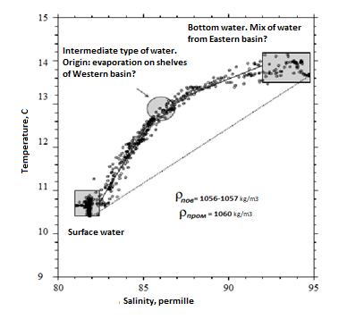
Figure 1 – Temperature-salinity diagram of waters of the western basin of the Aral Sea, November 2002

Density values for different types of water are also presented. It can be shown, that in case of mixing of two different types of water (i.e. points on plain TS), a point representing type of water must lay on the right line connecting source types at the distance therefrom, which are characterized by relative content of two types in the mix. Therefore, TS diagram inflection points represent “main” types of water, while segments of curve, which may be approximated with straight lines, describe mixing between the types.
When three main types are involved, any result of mixing between them creates a point laying inside a triangle known as mixing triangle. The form of diagram in Figure 1 suggests presence of 3 different types of water (surface, bottom and intermediary) which are illustrated schematically in the figure. The lower pycnocline represents, in its essence, mix of bottom and intermediary types of water.
Salinity in the lower layer is much higher than in the intermediary layer, and it is unlikely that such higher salinity could only be a result of evaporation in the western basin without advection of more saline waters in the eastern basin. Features of the surface water type are mainly defined by interaction of the sea and atmosphere. As for the intermediary type, it origins hypothetically from local evaporation in the western basin, especially, on its shallow northern shelf, where summer evaporation is particularly intensive. Besides, the bottom water type contains water impurities originating from the eastern basin. Actually, the lower layer is warmer than the intermediary layer, which assumes that, at the very least, a portion of water constituting it gained its features in the summer or in the early autumn, when sea surface temperature in the shallow eastern basin is higher than in the western basin.
TS diagrams for October 2003 are shown in Figure 2. Three main types of water forming “mixing triangle” can also be identified again. Thermohaline features of a new warm invasion are close to those observed in 2002. According to wind records, invasion of 2003 most likely took place in June. Origin of type of cold water is disputable and may be associated either with earlier winter invasion from the eastern basin or supposedly with winter convection or incursion down of very cold winter water from shallow southern part of the western basin. Two competing mechanisms which may be responsible for invasion of waters from eastern basin to the western trench are outlined in Figure 2. Three main types of water are defined (large grey circles). EBW means eastern basin waters

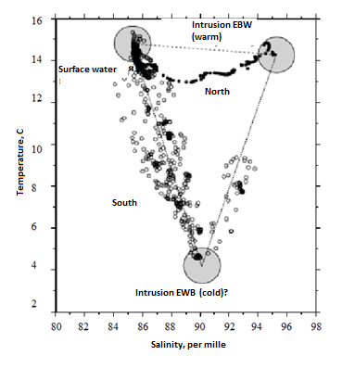
Figure 2 – Diagram of temperature-salinity for the southern part (circles) and northern part (dashes) of the western basin in October 2003

When gat connecting two basins is sufficiently large, then wind friction stress directed to the east must create surface slope of the lake which results in “pushing” of dense water of the eastern basin barothropically via a channel to the western basin, where it goes down to the lower layer. In opposite conditions of western wind, vertical picture of density in the channel and near it will be convectively unstable. On the other hand, to the extent when gut is insignificant and two basins “do not feel each other”, invasion of eastern waters must be caused by eastern winds (the lower part of Figure 3). As the final result, in the course of decrease of the sea level, the system must transit from “larger gut” to “smaller gut”.
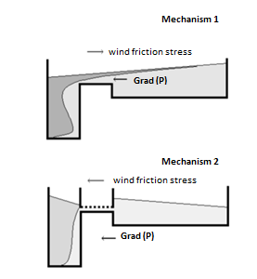
Figure 3 – Conceptual schematic drawing illustrating two potential mechanisms of intrusion of water from the eastern basin to the western

Figure 4 – Surface velocity profile obtained in barothropic and baroclinic regimes of experiment with POM

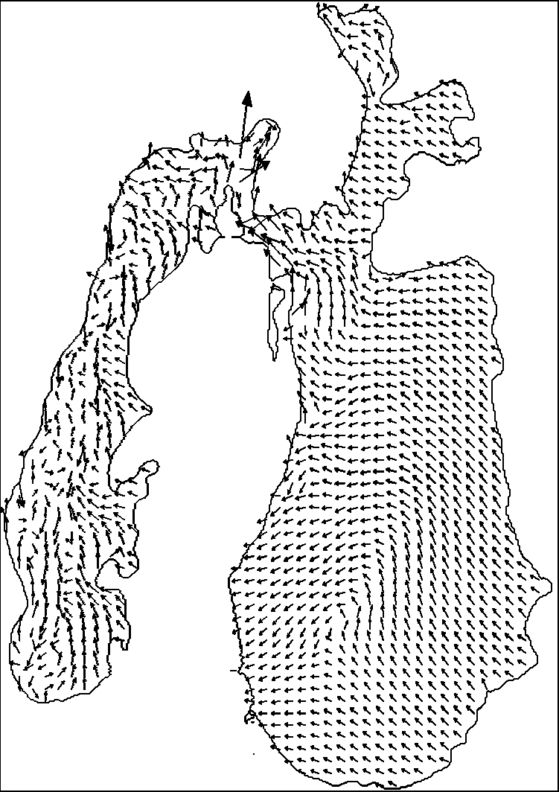

Figure 5 – Bottom velocity profile obtained in barothropic and baroclinic regimes of experiment with POM
Side view – the left vessel stands for the western basin filled with relatively fresh water (dark grey), the right one is shallow eastern basin with more saline water (light grey) (Mechanism 1). Gut is sufficiently large to establish surface slope across the basin as a whole (Mechanism 2). Gut is small so that surface slope is established individually in each basin, while two basins act as separate vessels, though they are interconnected via conceptual thin “pipeline”.
Figures 4 and 5 show velocity profiles obtained in our experiments with well-known Princeton Ocean Model (POM). These two profiles correspond to surface and bottom currents which were obtained under conditions of western wind. Note western current in the bottom part of the connecting channel.
In Figure 4, the model used “real” stratification and forcing in the form of constant in time and space of western winds within 96 hours of integration. Note current in the eastern direction in the surface space of the connecting gat. Thus, after analysis of Figures 4-5, while western winds “drag” surface water to the east through the connecting channel, they also promote transition of the opposite sign in the lower part of the gat. Thus, the model could simulate the mechanism of “larger gat” as mentioned above.

1.2 Study of the dynamics of the bio-diversity under conditions of rapidly changing physical-chemical and hydrologic environment. Identification of mechanisms for adaptation of biological system to extreme living conditions in different residual basins (Greater, Smaller Aral, Tushebas, eastern ephemeral Aral)

Collections of microphytobentos performed by authors in complex international expeditions to the residual basins of the Greater Aral Sea over the period between 2016 and 2019 also served as natural material for this study. Samples of biofilms were taken from the bottom of the Western basin of the Greater Aral Sea, from streams along its banks, and from bay/lake Tshchebas (Tushibas, Tushybas, Tshe-Bas). Depths where samples in shallow water are were taken ranged from 0(+0.05) m to 1-1.2m. In streams, samples were taken from their sources and close to inflow. In consideration of the fact that lengths of such streams flowing on salt crust of shore zone of the Western basin do not exceed 10-15m, distance between sampling points was small. However, in the course of movement of water from the source to the inflow along watercourse in salt crust it’s salinization took place.
As our studies conducted following expeditions over the period between 2002 and 2019 show, this is the very place, namely coastal shallow waters, starting from water’s edge but, in fact, from humid crystal crust on the shore to depths of about 0.5m, where the maximum diversity of organisms inhabiting ultra-haline Greater Aral [4-6] is concentrated. Mostly they are microorganisms: Stramenopiles: Diatoms [7-8], Cyanoprokariotes [9-10], heterotrophic flagellates and infusoria (Euglenozoa: Kinetoplastids; Alveolates: Dinoflagellates, Ciliates), sun animalcules (Harcobia: Centroheliozoa) and ameba (Amoebozoa: Amoebae; Cercozoa: Granofilosea) [11-14]. Already this list, save for heterotrophic bacteria, shows that diversity of microorganisms inhabiting this habit zone, extremely heterogeneous according to their forms abiota and mostly extreme, remains quite significant, despite major stressing factor in the form of total salinity above 130ppt.
However, observations show that from time to time in the Greater Aral, namely in the Western Basin, level of total salinity has been reduced. It is due to short-term by significant in terms of inflow of less saline waters after discharge of water from the Smaller Aral, abundant and longstanding rainfalls and spring water. At the same time, reduced salinity affects to a greater extent on communities again in shallow waters down to depths of about 1-1.5m [5-6]. At the background of mineralization, significant transformations in the composition and structure of coenosis, firstly, of those forming thin but sustainable biofilm on the surface of bottom, take place. Diversity of microorganisms increases, and their species composition is enriched. Of course, there a number of questions: how and where species integrated into these communities for the period of freshening come from? Here we will present some answers obtained based on our observations in 2015, 2016, 2017, 2018 and 2019.
Let us analyze composition and structure of coenosis of microorganisms in the examined basins in line with the general chronology of studies.
October 2015. A stream on saline shore in Chernyshov bay. In many locations where samples from a stream with high-salinity water which crossed morphologically different sections of salt crusts (from loose white sand to crystalline lenses) were taken, development of one microphyte coenosis in its variants different in terms of its composition and structure was noted. This was a community of wider euryhaline type of Nitzschia communis. Where the stream flew on crystalline lenses, biofilms were only formed by this specie developing almost as a monoculture. Where the stream dipped into loose sand, in the composition of bubbling biofilms of rufous-brown color co-emerging from the bottom, this specie was accompanied by another 4-5, in the status of frequent and rare: Halamphora normannii, Amphora sp.1, Navicula cryptotenella, Halamphora cymbifera and Navicula phyllepta. Respectively, when the stream egressed to more crystallized substrata, diversity of coenosis reduced.
A separate community was formed in shallow plashes extending behind low sandy-saline marsh encasing the coast a little above the wash band. Depth of these plashes reached 5-7cm, there was no biofilm on the bottom, however patches of light brown-green color characterized by small flake-like surface have encountered. In the structure of these patches 9 types of microphytes were noted: cyanobacterium Planktolyngbya minor which formed a net of extremely thin trichomes, and 8 types of diatoms with domination of Nitzschia communis, Halamphora normannii, Navicula cryptotenella and Navicula radiosafallax were encountered in large; Halamphora holsaticoides was also encountered in large, while Halamphora pseudoholsatica, Amphora pusio and Nitzschia incognita lived in the status of rare ones. Among epipsammonic forms which colonized the surface of saline sand (Halamphora spp.) Halamphora normannii which is a widely euryhaline specie of conditionally fresh-water origin dominated distinctively.
Coenosis on the surface of the sandy bottom of shallow waters of the bay was structured differently. Cyanobacteria living here included Geitlerinema attenuatum, Planktolyngbya limnetica, Planktolyngbya minor, Leibleinia inconspicua and Spirulina subsalsa. The first three species formed a net of trichomes in the form of reinforcing skeleton for biofilm; Leibleinia inconspicua inhabited on sand particles, while spiral trichomes Spirulina subsalsa moved freely across substratum particles. 6 species of diatoms also inhabited here: Nitzschia communis dominated, Navicula cryptotenella and N. radiosafallax presented in large, Halamphora normannii often encountered on sand particles, and it accompanied by Halamphora holsaticoides, and H. pseudoholsatica, which were noted significantly rarely.
June 2016. At the background significant reduction in salinity caused by discharge from the Smaller Aral of large volumes of light-slated water conditions similar in terms of salinity to those in the autumn 2003 were formed in coastal shallow waters of Chernyshov bay [4]. In this biotope bunches of red alga Bangya aff. Atropurpurea characterized here by emerald-green color of its thallomes extended in large with relatively small presence of green macrophytes Cladophora spp. On the surface of Bangya microepiphytical complex which was also noted by us on thallomes Cladophora fracta in the autumn 2002-2003 also developed here: Tabularia fasciculata (radial bundles of cells) and Nitzschia fruticosa in the form treelike-dendritic colonies. In this epiphytical community trichome cyanobacterium Heteroleibleinia epiphytica developed in large, besides dinoflagellates Oxyrrhis marina, which is a universal planktonic predator, was noted in free-swimming form in ultrahaline Greater Aral for the first time.
Under short-term conditions of relatively low salinity (83-87ppt) several types of thread cyanobacteria included in biofilms on the surface of bottom have developed: Planktolyngbya limnetica, P. minor, Jaaginema quadripunctulatum, J. thermale, J. unigranulatum, J. geminatum, J. gracile, Leibleinia inconspicua, L. porphyrosiphonis, Leptolyngbya valderiana, Geitlerinema attenuatum, Geitlerinema sp.1 and Tapinothrix janthina. Coccoid cyanobacteria Synechocystis salina presented in small amounts. From among the above only three species presented in the stream (46 ppt) flowing amongst loose sand on shore band: Jaaginema thermale, Planktolyngbya limnetica and P. minor; other species of cyanobacteria encountered there (Oscillatoria putrida, Oscillatoria sp.1, Limnothrix guttulata and Jaaginema pseudogeminatum) have not been noted in the sea.
At the depths down to 0.35m development of two variants of interspecies associations was noted: Stauronella decipiens + Navicula radiosafallax + Halamphora cymbifera – on fragile soil, and Jaaginema spp. + Nitzschia acicularis + Planktolyngbya limnetica on mineral soil. Futher, on sands from the depth of ≈1m (at salinity of > 90ppt) Halamphora spp. + Stauronella aff. marina + S. decipiens + N. cryptotenella + N. radiosafallax association developed.
October 2017. By the autumn 2017, in the central part of the Western basin (at 132.6ppt in the surface layer) near Kiim-Chiyak cape, shallow bottom microphyte coenosis of three types were formed. The first one with 3 index species Synechocystis (with dominance of S. salina) + Halamphora normanii + Nitzschia communis + Navicula sp.. + Phormidium chlorinum + Spirulina subsalsa developed on the surface of stones, rocks and shells laying on the bottom at the depths down to 20 cm. The second one with domination of N. communis + (small form H. normanii + Fragilaria aff. subsalina) inhabited on the salt crust which covered argillaceous bottom of shallow waters. In the structure of the third association of F. aff. subsalina + H. normanii played the leading role. All these bottom communities inhabited here at the background of transition of the sea to predominantly cyanoprocariotic mechanism of production in pelagic zone: phytoplankton is mainly represented by Synechocystis salina, and the role of other types of this specie was insignificant.
October 2018. On the sandy bottom of Chernyshov bay, under conditions of critical reduction in salinity (down to 72ppt) at the background of massive discharge of water from the Smaller Aral at the depths down to 35cm a community with domination of Navicula cincta with massive development of Tryblionella apiculata and Navicula phyllepta, frequent Halamphora subholsatica, H. pseudoholsatica, Amphora pusio, Stauronella decipiens and rare Nitzschia pellucida, Entomoneis sp. and Euglena cf. mutabilis. Development of cyanoprocaryotic component has not been noted. Nevertheless, in this coenosis sun animalcules Choanocystis cf. perpusilla were noted for the first time.
The same sun animalcules were also found in Tshchebas lake, where at the same time under salinity of 47ppt, in bottom plankton diatom Cyclotella meneghiniana, and in bottom habit areas - Navicula cincta, Mastogloia pusilla and Proschkinia complanata, with frequent Mastogloia pumila and Tryblionella apiculata, and rare Pleurosigma sp. developed largely. Cyanobacteria were represented by one trichomid specie – Phormidium chlorinum.
May 2019. In communities of coastal shallow waters of the Western basin, in gulfs near Kiim-Chiyak cape and to the north therefrom, in open areas of the coast sustainable associations of dominant diatoms inhabited, which has been quite a stable for these biotopes over the period since the summer 2011: Nitzschia communis + Halamphora normannii (Fig. 1). They were accompanies by Planktolyngbya minor. However, in the structure of this community development of new species inhabiting here in the status of frequent (Navicula cincta, Synechococcus subsalsus, Aphanothece cf. salina), as well as colonial cyanobacteria Aphanocapsa cf. salina and Aphanothece cf. stagnina was also noted. Separate trichomes Spirulina subsalsa and few cells Synechocystis septentrionalis inhabited in these habitat area before were encountered. Neither in plankton, where now dominates S. subsalsus, nor in benthos Synechocystis salina was not noted.
In streams originating from sources on salt crust of the lowest terraces of shore, a different picture was noted. At source at 44-49ppt, the dominant diatom was Navicula phylleptosoma (Fig. 2), as for cyanobacteria the dominant was Geitlerinema attenuatum, Phormidium ambiguum, Ph. cf. irriguum f. minor. Navicula phyllepta, Nitzschia pellucida, Navicula cincta, Stauronella cf. marina, as well as Jaaginema cf. geminatum, Oscillatoria limosa and Limnothrix obliqueacuminata encountered more rarely. In the same coenosis Choanocystis cf. perpusilla and heterotrophic flagellates Rhynchomonas nasuta were noted singly.
Study of Tshchebas lake and streams flowing on saline shore showed that in these basins more species inhabit than in the Western basin at salinity of greatly above 90ppt. Some of them succeeded in colonization of bottom habit areas of shallow waters of the Greater sea in period of its freshening. They have already lived in the sea in the periods of lesser salinity (Navicula phylleptosoma, N. phyllepta, Nitzschia pellucida, Tryblionella acuminata, Halamphora holsaticoides, H. subholsatica, Amphora pusio, Stauronella cf. marina), and they had a set of necessary adaptations for this purpose. Essentially, cyanobacteria Geitlerinema attenuatum and Leptolyngbya cf. valderiana and Phormidiumirriguum f. minor, that lived in streams in May 2019, already had chances to return to Aral shall its salinity drop below 90ppt due to freshening discharge of a greater volume.
At the same time, a part of species which previously hadn’t lived in the sea but adapted to live in Tshchebas lake and streams gradually also move to biotopes with higher salinity: in recent years these are Navicula cincta which entered communities of the Greater sea; in 2004 – Merismopedia cf. glauca, which settled from a source on the shore band to the nearest areas of salt crusts humidified by rainfalls. In turn, cyanobacteria Synechocystis salina, which largely filled pelagic zones and some bottom biotopes of the Greater Sea in 2017-2018, passed adaptation to high salinity not only on the bottom of the Greater sea, being for many years a minor of coenosis. This specie also habited shallow lagoon to the north-east of Vozrozhdeniya peninsula, where we noted it in 2005 in the status of dominant with great strength at salinity of 164ppt. The has already dried up in 2006, but the specie succeeded to obtain necessary adaptations to significant growth in salinity. When by 2017 salt-tolerance of Oocystis submarina, which dominated for many years in pelagic phytocoenosis of the Greater sea reached it limit, S. salina rapidly filled its niche.
Another source of species colonizing the sea is salt crusts on coasts. Rains which became more frequent in warm seasons in recent years wet these habit areas and make them suitable for colonial cyanobacteria living on the surface of plastered soil of Ustyurt plain. In such a way, having suffered halinic adaptation, Aphanothece cf. salina, A. cf. stagnina and Aphanocapsa cf. salina entered the Western basin. So far, it is too early to talk about income sources of most species of cyanobacteria from genus of Jaaginema, which formed communities in shallow waters of Chernyshov bay at strong freshening in 2016, to the Greater sea.
In general terms, it makes sense to consider basins with lesser salinity betrunked from the main water area of the sea (for instance, Tshchebas lake/bay), sources and streams flowing on salt crusts on coasts, as well as crust itself when it is wetted due to frequent rains, as reservoirs for gradual halinic adaptation of species of organisms to inhabitance under conditions of high salinity of the Greater sea.
2 Unit “Data analysis”
2.1 Assessment of the impact of artificial control of water exchange in Smaller Aral on vertical mixing

Following the three-year studies, it is certain that in 2017-2020, two-layer vertical stratification of water was noticeable in the autumn season in the western basin of the Greater Aral. Data on vertical distribution of water salinity is presented below. According to this data, maximum salinity which may prevent complete mixing of the basin in the forthcoming winter season is still noticeable in the bottom layer. However, a long-term trend to reduction of the bottom maximum of salinity can be traceable. In comparison with the similar historic data, namely from studies of IO RAS in 2014, maximum salinity in the bottom layer is poorly expressed, which may be indicative of a gradual transition of the basin from meromictic to monomictic type.
Figure 6 represents vertical temperature profiles obtained at the ground according to data of CTD-sounding. In the course of measurements, upper mixed layer achieved depths of 22-28m and it was marked by temperature values of about 13˚С. Drop of water temperature was observed in thermocline; the values in the bottom layer achieved 5˚С. Marked difference in the depths of position of thermocline between areas of eastern and western coasts of the basin (station а4 and station а2) should be noted, which might be caused by the slope of isopycnic line due to the activity of internal waves.

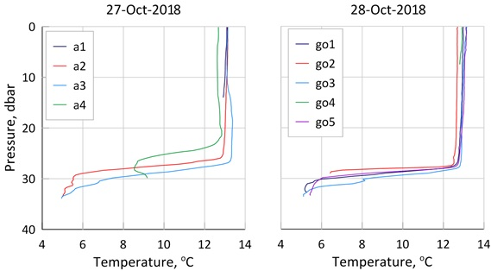
Figure 6 – Water temperature at the surface of Chernyshov bay according to satellite sounding, October 27-28, 2018

These measurements recorded an interesting picture of variability of values of temperature and current velocities. In the initial period of recording, expressed wave-like variations of temperature values within thermocline (depths from 27.5m and above) were observed; lower water layers were not affected by such variations. The similar nature is also traceable in variability of values of current velocity. It should be noted that maximum velocities of bottom currents (under thermocline) in that period reached 4cm/s. Later, movement of water in the bottom layer ceased almost completely. It seems that under influence of intense winds inside thermocline, internal seiche oscillations were developed, which ceased rapidly enough upon the end of storm due to the presence of high vertical density gradients in the basin. Inclined position of the thermocline specific during observation of internal seiche was also recorded according to data of CTD-profiling.
Dissolved oxygen concentration in the bottom layer of the basin remained almost constant, which is another confirmation of isolation of the bottom layer from the rest part of water column and anaerobic environment which has been formed here due to decomposition of organic matters under conditions of density vertical stratification. Sour smell in samples of water from the bottom horizon, as well as in samples of bottom taken by a bottom sampler should also be noted.
Thus, despite intense influence of vertical density stratification, particular water exchange in the bottom layer may occur by the effect of mechanisms of wave-like variations in the thermocline. Besides, according to the findings, bottom currents also react to wind action apparently due to action of the barothropic mechanism.
Following sounding of the water layer of residual basins of the Aral Sea, data on vertical hydrophysical structure of waters for each of them has been obtained. Figure 7 below shows profiles of temperature, conductivity, turbidity, and concentration of dissolved oxygen and chlorophyll “a”.
Three-layer structure of water was observed in Chernyshov bay, which has been observed since 2014. The upper mixed layer was spread to horizon of 2m. Temperature of the upper mixed layer was a little over 16˚С. Layer of temperature inversion and peak of maximum temperature values (about 33˚С) were situated below at the depth of 4m. Further, towards the bottom temperature values gradually decreased and reached 16˚С in the bottom layer. Temperature peak in the intermediate layer was accompanied by maximum values of dissolved oxygen. At the same time, maximum values of chlorophyll fluorescence and turbidity were observed in the layer below temperature peak and dissolved oxygen at the depth of 6.5m. Minimum values of conductivity were observed in upper layer of 0-2m.

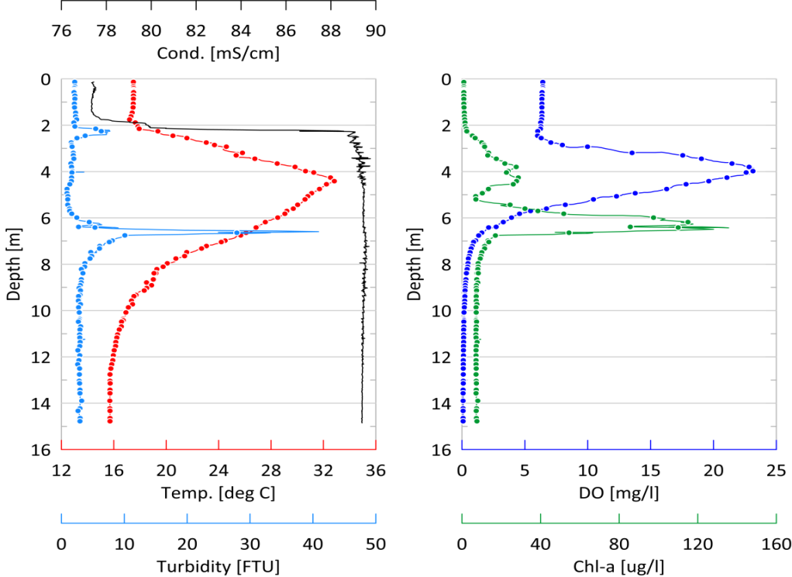
Figure 7 – Vertical hydrophysical structure of water in Chernyshov bay

Figure 7 shows vertical profiles of temperature (red), conductivity (black), turbidity (blue), dissolved oxygen concentration (dark) and chlorophyll “a” (green) in the central part of Chernyshov bay (stationС5) obtained on September 21, 2019 [15]. Figure 8 presents vertical profiles of parameters measure in Tshchebas bay. In period of works in the upper layer of bay waters (0-2m) maximum temperature values were observed, which, apparently, is conditional upon day radiative forcing.
Below this layer, water layer had homogenous pattern in terms of temperature and conductivity. In the upper layer, maximum dissolved oxygen values and minimum chlorophyll fluorescence value were also observed.

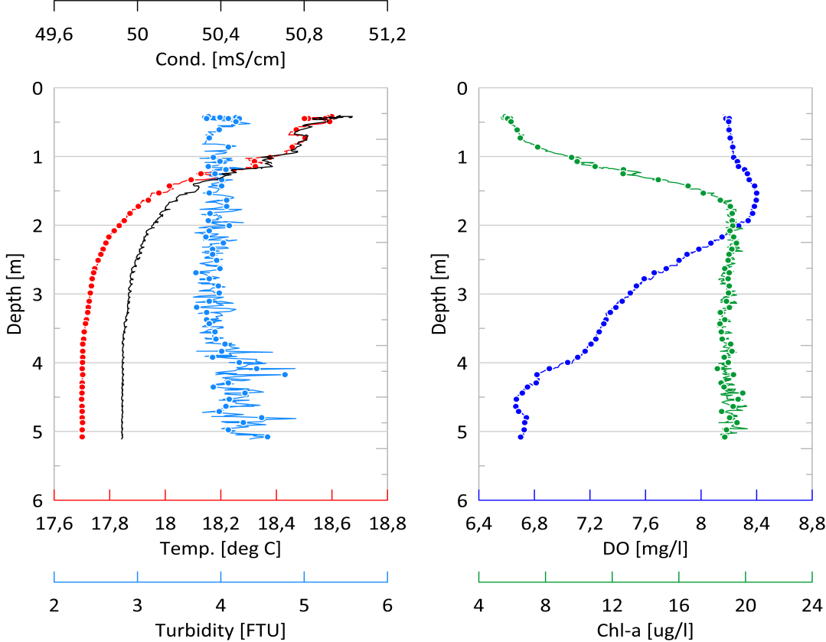
Figure 8 – Vertical hydrophysical structure of water in Tshchebas bay

Despite relatively short-term total period of recording of devices installed at the station (approximately 1 day), measurements recorded an interesting pattern of variability of values of temperature and current velocities. Over the period between beginning of record and up until 9 p.m. 28/10 expressed wave-like variations of temperature values within thermocline (depths from 27.5m. and above) were observed; lower water layers have not been affected by these variations. Similar nature is also traceable in variation of current velocity values. We should note that maximum velocities of bottom currents (under thermocline) in that period reached 4cm/s. After 9 p.m. 28/10, water movement in the bottom layer has almost ceased, and variations of temperature values were only traceable at horizon of 25.5m. Apparently, under influence of intense winds on October 25-26, inside the thermocline internal seiche oscillations have developed, which ceased quite soon upon end of the storm due to high vertical density gradients in the basin. Inclined position of the thermocline revealing in observation of internal seiche was also recorded according to data of CTD-profiling.
As a brief conclusion for this section, we can state that TS-analysis points to vital importance of exchange of water and salts between these two basins. Currently, the processes of inter-basin water exchange, in particular its volume and spatial distribution, are the main factor defining vertical and spatial structure of water in different parts of Aral Sea. In turn, this determines hydrophysical and hydrochemical parameters of waters which defines the overall condition of ecosystem of each residual basins.
Works performed within the project allowed to develop and successfully test a set of hydrologic physically justified model capable of forecasting volume of inter-basin water exchange in residual basins of Aral Sea.

3 Unit “Numerical simulation”
3.1 Model diagnostic and forecasting estimations of possible changes in the level and condition of the sea for next 20-30 years depending on water content of rivers

In the course of solving of tasked scheduled within the Project the following results were obtained:
Calculation of freshwater inflow to Smaller Aral Sea based on modern data on discharge of Syr Darya rive, data of meteorological and hydrological re-analyses and hybrid hydrological model of water collection developed within the Project which combines a set of physically justified models and methods of machine learning. Thus, with monthly resolution, freshwater inflow to Smaller Aral Sea over the period с 1994 and 2016 was obtained. The outcome is the first open scientifically justified model estimation of freshwater inflow over the recent period (Figure 9). Findings of analysis of sensitivity of the hybrid model developed showed that freshwater inflow to Smaller Aral Sea is mainly formed in highland zone of catch basin of Syr Darya river, while the rest of the basin (from Fergana Valley and downstream) defined temporal dynamics of its reformation.

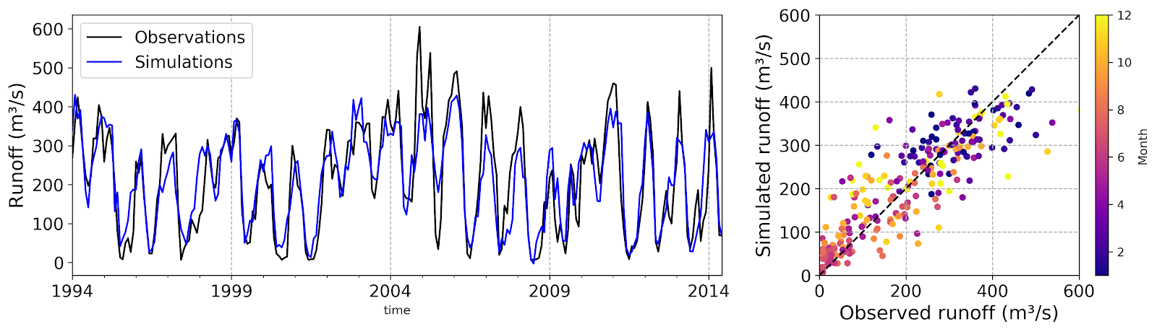
Figure 9 – Results of adjusting and validation of the model of freshwater inflow to Smaller Aral Sea over the recent period (1994-2014)

Variability of monthly average consumption of Syr Darya river at Kazalinsk station according to data of observations (black line) and according to data of model (blue line) is presented in Figure 9 on the right. On the left: Diagram of dispersion of observation data and simulation results, distribution of data by months is marked with color.
Calculation of gain in water volume in Smaller Aral Sea based on yje water-balance model developed within the Project was performed. Following model simulation experiments, monthly data on variability of water volume in Smaller Aral Sea in the recent period (2006-2017) were obtained (Figure 10). Introduction of upper threshold for water volume preconditioned by the height of Kokaral dam into the model allowed to receive at the output monthly data on volume of discharge from the dam (Figure 10, blue line) which later enters Tshchebas bay and the northern part of the western basin of Greater Aral (Chernyshov bay). The model also included a block for calculation of water salinity расчета which allowed to obtain data on monthly changes of marine average mineralization over the period between 2006 and 2017 which properly confirm with available data of direct observation.

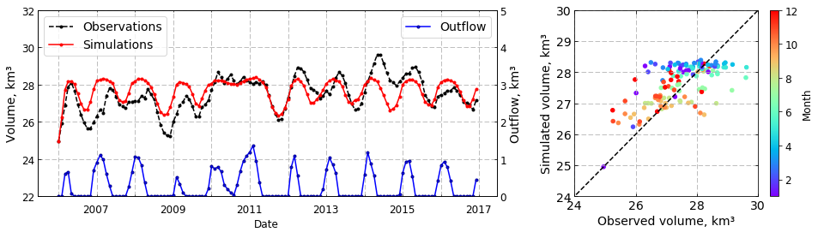
Figure 10 – Simulation of variability of water volume of Smaller Aral Sea

Graph of variability of water volume of Smaller Aral according to data of simulation (red line) following recalculation of data of satellite altimetry (black dashed line), graph of variability of volume of water discharged from Kokaral dam (blue line) is presented in Figure 10 on the right. On the left: Diagram of dispersion of data of recalculation of satellite observations and simulation results, distribution by months is marked with color
Based on the hybrid model developed forecast estimations of variability of freshwater inflow to Smaller Aral Sea (Figure 11) were performed using the three climate scenario (RCP 2.6, RCP 6.0, RCP 8.5) of expected changes in meteorological values (air temperature, precipitation and total evaporation) calculated by four models of total atmospheric and oceanic circulation (GFDL-ESM2M, HadGEM2-ES, IPSL-CM5A-LR, MIROC5). For analysis of changes in freshwater inflow, forecast period (2007-2099) was broken down into four sub-periods, namely sub-period of modern changes (P0; 2007–2016) and three forecast sub-periods: P1 (2017–2044), P2 (2045–2072), and P3 (2073–2099).
Preliminary findings of the analysis points to the fact that model MIROC5 with forcing of climate scenario RCP 2.6 most adequately reproduces modern changes in freshwater inflow to Smaller Aral Sea. Thus, by assuming scenario of freshwater inflow based on data of MIROC5 and RCP 2.6 as the most the most probable (with preservation of modern trends of climate change), in the forecast period small increase in inflow (up to 10%) for each calendar month is expected.
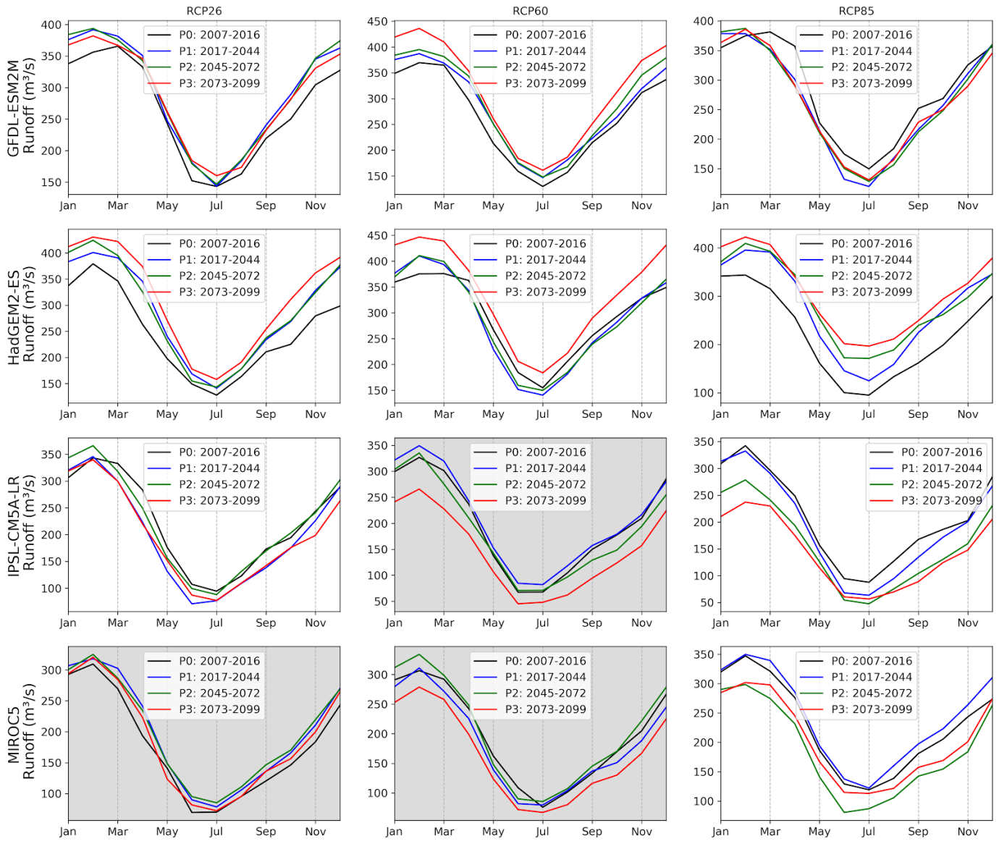

Figure 11 – Simulated changes in climatic annual hydrograph of Syr Darya river at Kazalinsk station based on forecast changes in metrological values

In Figure 11 grey color marks scenarios which reproduce most reliably changes in discharge in historical period P0 (2007 - 2016).
As a result, taking this scenario of freshwater inflow to Smaller Aral Sea as a basis, we can expect both increase in total volume of freshwater inflow and further reduction in salinity of sea down to values below those in pre-industrial period (about 10g/kg for the late 1950s). In addition, excess of fresh water may be redirected to other residual basins of Aral Sea via Kokaral dam. However, it worth noting that such excess of freshwater is negligibly small to launch the process of restoration of residual basins.
Unfortunately, in case of more aggressive scenarios of growth in green house emission (RCP 6.0, RCP 8.5) results of simulation of freshwater inflow is indicative of rather negative influence on the hydrology of Smaller Aral Sea, as well as on the economy and the environment of the region. Thus, reduction in predicted inflow of freshwater to Small Aral Sea by 7-15% in comparison with historical period would cause significant changes in the scheme of control over water resources at the regional scale which, in turn, would also reflect other sectors of the national economy.
Works performed on the study of the dynamics of the water balance of Smaller Aral Sea may be divided into two large blocks: (1) simulation of water balance of the water-collecting part of the basin, and (2) simulation of the water balance of the marine part of the basin. Methodological description for each of them is presented below.

3.2 Simulation of water balance of the basin

Simulation of the water balance of water collecting part of the basin.
To assess freshwater inflow to Smaller Aral Sea, a hybrid model of formation and transformation of water flow to its basin (Figure 12) was created. The hybrid model consists of two successively interacting blocks: ensembles of physically justified models of the zone of formation of river flows (upper block) and ensembles of statistical models of machine learning of the zone of transformation of river stock (lower block).
Assessment of freshwater inflow to Smaller Aral Sea over the period till 2099 was performed based on application of previously developed hybrid model combining a set of physically justified hydrological models and models of machine learning. Results of simulation of possible climate changes (air temperature, precipitation and total evaporation) calculated based on four models of total atmospheric and oceanic circulation (GFDL-ESM2M, HadGEM2-ES, IPSL-CM5A-LR, MIROC5) according to three potential scenarios of greenhouse emission (RCP 2.6, RCP 6.0, RCP 8.5) were used as input data for the hybrid model.
As we can see in Figure 12, in the course of creation of a model for freshwater inflow, the basin of Smaller Aral Sea is divided into Inflow Formation Zone (FZ) and three Inflow Transformation Zones (TZ1, TZ2, TZ3). Triangles mark stations for observation of water consumption.

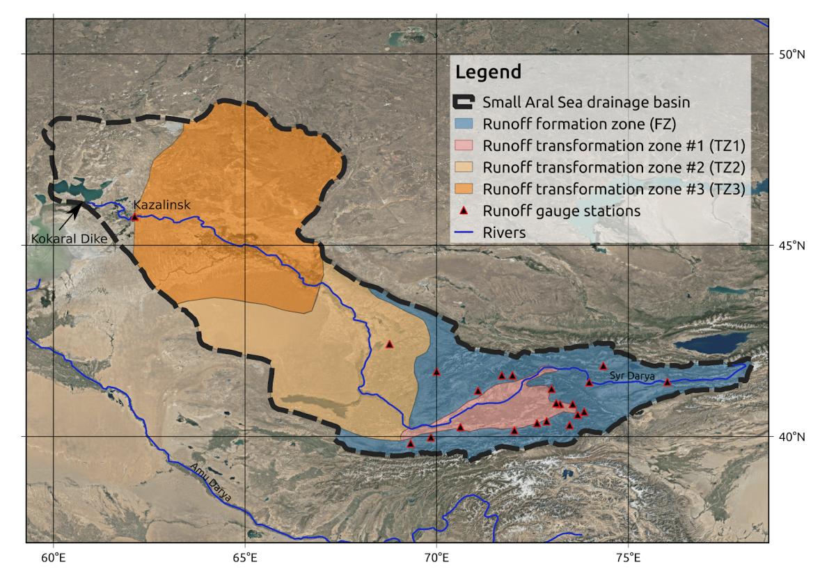
Figure 12 – Study area

Scenarios of potential climate change were adjusted (bias-correction) based on the use of WFDEI re-analysis for consistency of estimations of freshwater inflow over historical and forecast periods. In total, for forecast period (2007-2099) 12 scenarios (4 models, 3 scenarios) for freshwater inflow to Smaller Aral Sea were obtained. More detailed description of methods of forecast calculations for freshwater inflow to Smaller Aral Sea is presented in [16-18].
Simulation of the water balance of the marine sea of the basin
For landlocked Small Aral Sea which is subjected to significant changes in its area and volume, it is the most conveniently and significantly to perform calculations of the water balance in linear units, which in our case in volumetric gain. Equity of the water balance is in the following form:
R+PS+G-ES-D=V,
where R – incoming river flow, P – precipitation, E - evaporation, G – underground component, D – inter-basin water exchange, V – volumetric gain.
Income portion of the water balance. Monthly values of river flow incoming to the sea (main part of income part of the water balance) were calculated using a hybrid model of formation and transformation of water inflow in the basin of Smaller Aral (for details see above and [16-19]) created within the Project.
Average values over the water area of Smaller Aral obtained according to data of node net of EWEMBI re-analysis and prepared for the entire basin of Smaller Aral Sea within the project were taken as monthly values of atmospheric precipitation.
Unfortunately, for Aral Sea there are no reliable data not only on inter-annual, but even on average long-term value of the underground component of the water balance. However, many researchers agree that this component is insignificant and it has almost no influence on sea level variations [20], and as such the underground component has not been taken into account in calculation of the water balance.
Consumption part of the water balance. Obtaining reliable estimations of evaporation which is the main negative component of the water balance is a complex task in arid zones poorly supported by observation data. The use of classical Penman formula [21] was hampered by the lack of the required wider set of regular data of weather observation. It was attempted to use simplified parametrization of evaporation through air temperature [19] taken from re-analysis. However, validation of water-balance model showed the most satisfactory results with the use of evaporation values directly taken from EWEMBI re-analysis, especially as these values had been previously correlate in a single data base with values across water collection of Smaller Aral Sea and used in the model of inflow formation.
Inter-basin exchange established between this part of the sea and Greater Aral after they have separated holds a valuable place amongst consumption components of the water balance of Smaller Aral. Volumes of flow through Berg gut was sufficiently, which led to reduction of the level of Smaller Aral in 1990s and early 2000s. The model developed considers period after 2005 when the final version of Kokaral dam was launched in Berg gut, which resulted in filling and relative stabilization of the level of Smaller Aral approximately the point of 42.5 m.abs. Correspondingly, the model used threshold value of sea water volume (28km³) upon achievement whereof discharge of water over the dam started which linearly grew depending on further growth in water volume. Upon achievement of water volume value of 30km³, discharge of water fixed at the value of 1.5km³/month (maximum possible consumption through water discharge).
Validation of model. Data of satellite measurements of level of the surface of Smaller Aral were used to obtain real values of sea water volume within the researched period. Water-balance model of the marine part of the basin for each calculation step (Figure 10 – Observation data) was validated using a digital model of bottom configuration created based on a detailed bathymetric map which linked values of the level of basin surface obtained according to data of satellite altimetry with values of water volumes and surface area calculated according to the model (Figure 13).
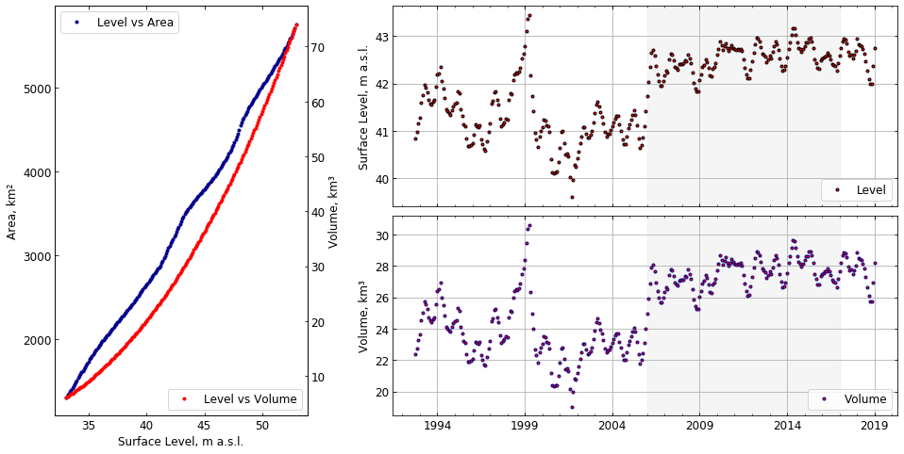
Figure 13 – Hypsographic relation (on the left) obtained for Smaller Aral Sea and linking water volume and surface area with variations in its level (interval 0.1m)
In Figure 13, graphs of variation of the surface level (according to data of satellite sounding) and respective values of water volume calculated to each value of surface are presented on the right. Grey color marks time period of operation of the water-balance model.

4 Unit “Satellite monitoring”
4.1 Assessment of inter-annual variability of basin area, ice regime

Negative events taken place in 2020, related to introduction of quarantine measures due to a coronavirus infection that covered the whole world, raised a question of relevance of application of data of space sounding for continuous monitoring of environmental situation in the basin of Aral Sea again. Under conditions of almost complete cessation of any field works and expedition measurements, satellite methods actually remained the only sources of immediate and reliable information on the condition of Aral Sea region and morphological changes occurring therein. During 2020 collection and processing of data of monthly satellite observations on Aral Sea of visible and infrared bands from the global portals for storage of satellite information developed by NASA (the USA) and the European Space Agency have been continued within the research work. Almost daily satellite data on Aral Sea of MODIS (Aqua-Terra) and VIIRS (SNPP) radiometers were collected depending on the weather conditions. In addition, for more detailed analysis of the condition of the water area and adjacent area several dozens of satellite images of high and ultra-high resolution from Landsat-8 and Sentinel-2 satellites were ordered and processed.
Data of MODIS and VIIRS sensors (aboard Terra, Aqua and SNPP satellites) provides an opportunity to trace changes in the coastal line and identify interesting phenomena in water, the atmosphere and drained areas of Aral Sea. Figures in Appendix G presents a series of 8 monthly images of MODIS sensor from Terra satellite between February and September this year, selected by optimal weather criteria in the middle of each month. All images have been taken according to composite technique to obtain images in natural colors. Such composition allows to identify irregularities immediately on water, underlining “bathymetrical” and “shallow” areas, as well as area with excessive soil salinization, besides, this technique allows clear separation of snow-covered to ice-covered areas. The images are consequently combined in Figures 1 and 2, Appendix D.
When analyzing the series of images, we can note that the scenario of redistribution of water masses in the researched basins of Aral Sea in whole repeats the situation that had been observe last year. The level of snow cover of the section under consideration has been again small and it was mainly concentrated in the northern part of the region and it has almost disappeared by the early February. An image from Terra satellite on one of rare cloudless days in the middle of winter presented in Figure 3, Appendix G, confirms this fact.
In common with the last year, the last winter has been in whole soft and has not led to formation of ice cover on all basins observed; stable ice cover was only noted on sweetened basins of Northern Aral, while Greater Aral, and its western and eastern parts almost has not been covered with ice. Representative distribution of ice cover in the basin of Smaller Aral by the early spring is presented in an image of high resolution from Sentinel-2A satellite (Figure 4, Appendix D),
Overall image of high resolution of the entire northern Aral Sea region from Landsat-8 satellite demonstrating absence of stable ice cover beyond Smaller Aral by the early spring is presented in Figure 5, Appendix D.
Further events in Aral basin also repeated the last year scenario. Melt water and water discharge from Kokaral dam through an intermediate basin only filled a small northern part of the Eastern basin, which can be seen in spring images in Figure 3, and as early as by the late spring after rapid drying, no water surface was noted there. Adding of water from Amu Darya also was extremely insignificant; the same Figure 3 only shows small filling of separate basins to the south of dried Eastern basin, where waters from Amu Darya opposed to some recent years has not reached at all. Upon termination of active water discharge from Smaller Sea and drying of the intermediate basin by the early summer, Tshchebas bay separated from it and formed a separate basin without connection with other basins which is regularly repeated all recent years. By comparing satellite data over these recent years, we note that the most drastic changes 2020 have taken place in the northern part of the Western basin in Chernyshov bay, which in the lack of any significant events in other parts were beyond our careful attention. As it was predicted before the launch of this project, accelerated drying across Aral region under conditions of dry winters and small amount of precipitation for over 2-3 years led to actual separation of Chernyshov bay the rest part of the western basin, at the same time, the bay itself is divided into two unequal parts, and the western one smaller in its volume and depth may also get dry soon. When assessing detailed satellite images of key sections of the area under consideration, we may note that in the first instance progressive drying was caused by small inflow of water to the bay through gat between the East and West. As it was mentioned above, the spring images in Figure 5, Appendix G, only poor filling of the Eastern basin and respective flowing over of water therefrom through the gat to the Western basin is observed.
Findings of images 6-7, Appendix D, allow to state that the process reached its maximum by the late March. In the middle of March, no water run in Figure 6 is noted, while in Figure 7 ten days later, the process of water exchange is observed alongside the entire gat. More detailed condition of the gat and its outflow zone in the point of entry to Chernyshov bay at the height of water flow is presented in MSI image of high resolution on 30 (Figure 8, Appendix D).
However, due to insufficient water inflow to the Eastern basin mentioned before, the process of water flow through the gat has almost ceased in April. We can expressly note that in images of high resolution of MSI scanner with two-week interval after the above image on March 30, presented in Figure 9, Appendix D.
The situation described ultimately led to the fact that Chernyshov bay started to divide into two parts for the first time over the long-term period of observations. The most demonstrative is comparison of detailed synchronous images of the entire bay with annual difference in time. By the early summer last and this year, the situation was as it is shown in shown in Figure 10, Appendix D.
Besides comparison of the condition of water’s edges in this two images, comparison of vegetative regions on dry land sections around the bay is of special interest. With absolutely synchronous processing and structuring of compositional maps according to three-channel technique for MSI sensor with equal time to take pictures in early summer each year, significant amount of vegetation in the image for 2019 is apparent in comparison with the current year, which may indicate significant reduction in water balance and drier period before date of filming in 2020, which, in turn, also influenced progressive drying and separation of the bay. In fact, this take place in the middle of June, 2020, which is apparent in comparison of images presented to June and July from MSI scanner in Figure 11, Appendix D. Highlighted fragment in the image for July 13 shows the shallower bond near the outflow of East-West gat, alongside whereof Chernyshov bay was divided into two basins. The specific character of drying of the bond is deviation of color spectrum to blue region, while with this technique of image processing blueness corresponds to sections of surface background at least marginally covered with water, which is not expressly observed near joining of two basins formed in the basin. According to the same principle and using images of maximum resolution and refining, we can monitor the condition of a gat connecting Chernyshov bay with the rest part of Western basin existing for several years, which was formed in location of relatively bathymetrical channel from the bay. Occurrence of separate high light in this gat may indicate potentially “problematic” zones, which ultimately will result in complete separation of Chernyshov bay from all other Aral basins and, apparently, its further drying in the absence of source of water inflow.
As it was mentioned before, quite a small amount of precipitation was observed over the region under consideration last summer, which led to described situation with division of Chernyshov bay into two basins. However, after a strong rain front, water exchange between these basins restored though for a short time. This situation is reflected in satellite images for the middle July presented in Figure 12, Appendix D, however, the bond was closed soon (Figure 13, Appendix D).
Inter alia, this may be indicative of the fact that longstanding autumn rain showers most likely will restore the water exchange and will connect two parts of the bay at least until next summer. So far, as of the date of preparation of the report, the situation is quite pessimistic, especially when analyzing the condition of the smaller western part of the separated bay. In the image 13 taken on the basis of composition of water-sensitive channels of MSI scanner translucent bottom of the basin and quite a small relatively bathymetrical section can be seen can be seen. In whole, in classical overall Modis’ image (Figure 14-15, Appendix D) it can be seen that the process of drying of basins beyond Smaller sea is uninterrupted and total area of the water surface of basins is reduced from year to year.

4.2 Assessment of long-term trends in change of water balance of large Central Asian lakes

To assess long-term trends of change in water balance of large Central Asian lakes, including Aral, we мы have analyzed inter-decade variations of level of three largest blind drainage basins in Eurasia based on satellite altimetry and data on precipitation and air temperature as the major factor defining evaporation from the surface of lakes and their water collections. In addition to Central Asian region, which included Aral, the comparative analysis also included neighboring inland regions: Tibetan plateau and West-Mongolian plateau (Figure 14). Rectangles represent spatial sphere of general closed drainage areas in A) Central Asia, B) West-Mongolian plateau and С) Tibetan plateau. Central Asia lakes include: 1) Southern Aral Sea, 2) Northern Aral Sea, 3) Sarykamyshskoye, 4) Balkhash, 5) Issyk Kul, 6) Zaisan.
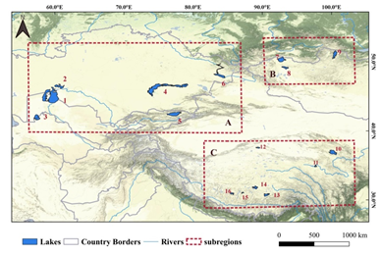
Figure 14 – Distribution of Central Asian lakes

Data sources
1) Data set on water level of a lake based on data of satellite altimetry.
Water level in the researched lakes was obtained from three global data sets: Hydroweb [22], G-REALM [23] and DAHITI [24].
2) Metrological data set.
Climatic influence on the change of lake level was assessed based on regional precipitation and temperature data from GPC, UDEL and CRU products [25,26].
3) Data integration
To integrate data on precipitation from different sources into a uniform data set, weight approach based on minimization of mean squared discrepancy between values was applied. Relative weight of each data source to weighted average was defined according to the level of their margin. Error dispersion of each data set was calculated using their average value as true value, whereupon relative weight was calculated as:
$${w_{i}=\frac{1}{σ_{j}^{2 }}}/{\sum_{j=1}^{n}{\frac{1}{σ_{j}^{2 }}}}$$
where, w_{i} – weight of i data set, σ_{j}² – its product margin, n – total number of data sets to be consolidated.
4) Trend analysis.
We applied non-parametric Mann-Kendall test (MK) to identify significance of trend in time sequences of water level in the lake and climatic variable. Due to its non-parametric nature, MK-test does not require a priory condition for standard distribution of random time sequences. To eliminate influence of auto-correlation of hydrological and meteorological sequences on calculation of trend, “trend-free pre-whitening” based on works [26] was applied prior to MK-test. This combination demonstrated its efficiency in assessment of trend in hydrological and metrological researches. Trend value was assessed by Sen method. In our research, α = 0.01 and α = 0.05 significance levels were accepted.
5) Identification of culmination points (trend change).
Trend change point determined based on statistical performance is considered as a potential initial point of drift of hydrological regime. To identify culmination in trends of metrological variable two methods were applied – Pettite test and Bayesian selective change test. Pettite test is a non-parametric test of trend for evaluation of origin of break point widely used to identify sharp variations in hydrological and climatic series. Bayesian test of break point is included in identification of variations in unknown time point and slip height in time sequence assuming that such variation has taken place. This test allows identification of average value, trend and/or deviation using minimum length of a segment between two slips. Change point was only acknowledged in case of identification of the same point using both methods, whereupon average value before and after slip of hydrological regime was calculated.

Regional climatic effect on level of lakes.
Level of lakes showed recent break of trend from drop to growth both in Central Asia and on Tibetan plateau. At the same time, change in the precipitation regime which took place approximately in 1998 and 2005 respectively acts as the major factor causing break. Trends to growth in water level differs between two regions: in 2005 break took place in the level of lakes in the northern part of Tibetan plateau with further significant trend to increase in the level. In Central Asia, the level of lakes constantly increased in 1998-2005, manifesting variations around mild trend afterwards.
To identify causes of such large-scale heterogeneity in change of the level of lake, we have studied interrelation between climatic factors – precipitation and air temperature – and change in the level. Cumulative analysis (Figure 15) has identified general regularities variations of air temperature on Tibetan plateau (TP) and in Central Asia (CA). Over the period between 1990 and 1997, trends to drop in air temperature was observed in both regions. In the western part of TP, trends to increase in air temperature in three lake basins were observed before 2007, which were followed significant variations with express drop in temperature in 2012. Opposed to air temperature, precipitation regime manifested noticeable spatial differences between СА and ТР. At the same time, dynamics of the level of lakes followed the dynamics of cumulative abnormal precipitation in lake basins, which demonstrate that cumulative influence of precipitation at regional scales plays a pivotal role in variation of the level of lakes both in CA and on TP.

Regime of slip of precipitation and temperature
As it was demonstrated above, variation in level of lakes demonstrate their direct relation to precipitation and air temperature over lake basins (Figure 16). To assess whether the change of climatic conditions would lead to the change in the general trend in variation of the level of lake, analysis of climate change was conducted at the scale of the basin. As we can see in Figure 16, significant variation of annual time sequence of precipitation (blue line) and temperature (orange line) on the scale of basin of lakes in Central Asia. Vertical lines represent years of regime change. Horizontal lines represent average value of each regime.
To assess break points of annual time sequences of precipitation and air temperature, two methods have been applied, findings whereof are presented in Figure 16. In Central Asia, two slips were recorded in precipitation. By reference thereto, the entire period between 1990 and 2016 was divided into three periods: 1990-1997, 1998-2008 and 2008-2016. Step-like increase was identified in three periods: in Balkhash lake, Issyk Kul lake and Zaisan lake, which supported the growth in the level of the lake in 1997, which was associated with the changed regime in air temperature in 1997. On the Tibetan plateau, change in precipitation regime differed between North and South parts. Slip in 2005 was identified in the northern part, while in the southern part years of slip were identified both in 1997 and 2008. Change in temperature occurred in 1997, alike in CA; change in the regime was associated with a defining moment in the change of the lake level.

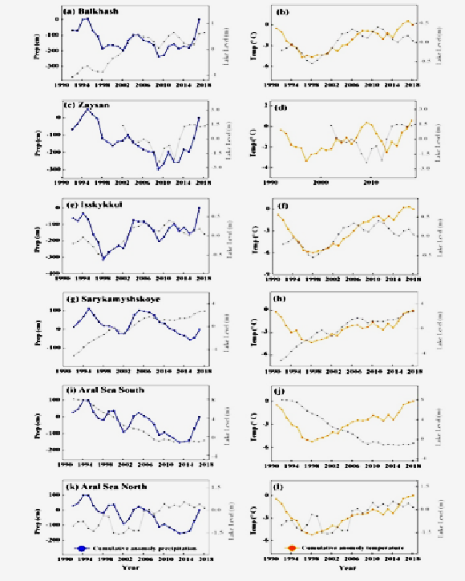

Figure 15 – Cumulative abnormal precipitation in basins of Eurasian lakes

The left panel: cumulative precipitation abnormality (blue line); the left panel: cumulative abnormality of temperature (yellow line) at the scale of the basin between 1990 and 2018 in comparison with the lake level (grey line) in Central Asia showed on the axis on the right – x.
Thus, all Central Asian lakes pass through sharp increase in water level starting from 1997. Such constant increase in water level in all lakes of the largest regions without drainage is the most important finding of the research. Previous researches indicated to constant reduction in level of lakes in the region from the middle and till late 20th century. Growing demand in water use in that century was named as the reason of reduction in the level of lakes Issyk Kul, Zaisan and Sarykamysh [16, 27-29]. Based on this data, it was assumed that these lakes could share the fate of Aral Sea which has dried down to 10% of its volume only within 40 years between 1960 and 2000 [4].
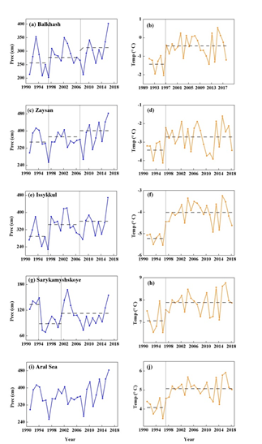

Figure 16 – Changes in the regime of precipitation and temperature in basins of Eurasian lakes

Almost simultaneous consistent switch to increase in water level of all these lakes may be considered as a sign of a large-scale change in hydrological regime in Central Asia. Our findings confirm with recent conclusions [27] of the research on change in lake area in СА based om images of Landsat between 1975 and 2007, which revealed that the major part of lake surface tends to increase since 1997. Scientists [30,31] has also discovered that the water level in Balkhash lake had been increased since 1993. Less noticeable increase in the water level of Sarykamysh lake is apparently associated with its artificial origin and, as a consequence, greater dependence on water drained due to irrigation, than on changes in the regional hydrological regime.
Findings of this large scale analysis explain important trends in dynamics of two largest remaining basins of Aral Sea: southern Aral (also called Greater Aral Sea) and northern Aral (also called Smaller Aral Sea). The latter is mainly filled from feeder of Syr Darya river, and its level since 2005 is adjusted by Kokaral dam which separates Smaller Aral from the remaining part of the former basin of Aral Sea. As a result, water level in Smaller Aral has rapidly grown up to maximum value allowed for construction of a dam, and remained almost constant after 2006, while gates of the dam remained open for most of the year. Concurrently, the water level in Greater Aral stabilized near constant value after decades of permanent reduction. Amu Darya, the major inflowing stream of Greater Aral is heavily regulated and intensively used for irrigation and, as a rule, does not reach the lake and partially run into Sarykamysh lake. Consequently, stabilization of the water level in Greater Aral may be interpreted as a flow of water from Smaller Aral preconditioned by incapacity of Kokaral dam to constrain growing flow form Syr Darya which, in turn, is cause by increase in precipitation at its water collection. Thus, dynamics of residual basins of Aral Sea is coherent with increased water level in other terminal lakes in Central Asia being a consequence of the same large-scale processes.
Remote monitoring performed under conditions of quarantine measures due to a coronavirus infection has showed high efficiency of algorithms and technology for comprehensive assessment of the condition of the ecosystem of Aral region and entire adjacent area on the basis of a wide range of gauges installed on earth satellite vehicles and data obtained therefrom in real-time mode of medium and high resolution in different band of the spectrum developed within our scientific research. It allowed to evaluate dynamics of changes in coastline as well as anthropogenic and climatic factors efficiently and with higher reliability. Under conditions of impossibility to perform field expedition works, satellite observations almost remained the only source to obtain immediate and reliable information on environmental condition of Aral Sea region and preparation of forecast evaluations for further development of the region.
CONCLUSION

Seasonal nature of the current filling of Aral basins and its dependence on climatic factors was established. With stable level of the basin of Smaller sea and regular discharge of water through Kokaral dam, uninterrupted drop in the level in Western basin of Greater Aral, as well as almost complete drying in the summer period of Eastern basin were notice. During the entire period of observations, ice cover was only observed in sweetened basin of Smaller sea and partially in Tshebas bas, while in other basins, ice cover had not been formed in full. Two last summers were with little snow and dry, which resulted in constant drop in the sea level; primarily this is the case of Western basin, since Eastern basin has been already dried by the middle of summer. Exactly for Western basin based on multi-year archive data we have performed annual assessment of the area of its water surface starting from 2008, and it has been demonstrated that since then till present it was reduced almost by 2 times and continues to decline progressively. Using data of optical sensors, we have noticed that in 2018, an intense phytoplankton bloom in Eastern basin was observed due to intense Mat overheating of sweetened melt water, which has not been observed in onwards since the basin was almost dried by summers. Due to short water inflow in the recent year water exchange between Eastern and Western basins has almost ceased, which resulted in actual separation of Chernyshov bay from the remaining Western basin, as well as in its division into two unequal parts, the smaller whereof as of the date of preparation of the report has almost dried.
Within our research work within three-year period of observations, depending on the weather conditions almost daily satellite data on Aral Sea of visible and infrared bands of AVHRR (NOAA-METOP) and MODIS (Aqua-Terra) radiometers obtained in real-time mode from Satellite Information Receiving Station of Marine Hydrophysical Institute of RAS were collected. In addition, for more detailed analysis of the condition of water area and adjacent areas more than a hundred of satellite images of high and ultra-high resolution from Landsat-8 and Sentinel-2 satellites were ordered and processed. Regular analysis of multi-year archive of data since 2002 has also been conducted to assess changes in progress.
All data of remote monitoring we have obtained were processed and stored on magnetic media and it was partially published in the Internet on specialized web-sites, as for the most specific images and descriptions thereof were presented in annual reports on the project established following monitoring in 2018-2020. Following the work, it should be noted that satellite observations have been a critical component of the project for comprehensive assessment of the condition of the ecosystem of Aral Sea region and entire adjacent area, especially under conditions of quarantine measures due to coronavirus infections affecting the whole globe, when remote observations remain almost the only source to obtain immediate and reliable information on the environmental condition of Aral Sea region and preparation of forecast estimations of further development of the region, and they shall be certainly continued within further projects on monitoring of Aral Sea.
Over the period of implementation of the Project, a number of the most important findings on the study of the modern dynamics of the water balance of Smaller Aral Sea was obtained. First, based on the current data on stream flow of Syr Darya river, specific data of meteorological and hydrological re-analyses, and hydrological model developed, freshwater inflow to Smaller Aral Sea over the period between 1994 and 2016 was calculated. Findings are the first open scientifically justified model estimation of freshwater inflow over the current period. Second, based on data on freshwater inflow and using a model of water balance of the marine part of the basin developed calculations of monthly gain in water volume of Smaller Aral Sea over the modern period between 2006 and 2017 were obtained. Block of assessment of inter-basin water exchange used in the water-balance model allowed to calculate with a monthly resolution, the volume of water discharged from Kokaral dam, the major component of income part of water balance of other residual basins of Aral Sea. Third, based on hybrid hydrological model developed forecast estimations (until 2099) of variability of freshwater inflow to Smaller Aral Sea using three climate scenario (RCP 2.6, RCP 6.0, RCP 8.5) were performed.
Satellite monitoring performed within the project has been an important source of immediate areal information on condition of the ecosystem of Aral Sea and entire adjacent area, dynamics of change in coastline, and influence of anthropogenic and climatic factors. Spatial resolution of data of satellite sounding allowed to control formation of ice cover, to assess flooding or drying of separate sections, identify different natural phenomena and predict potential changes.
Major characteristics of the satellite monitoring of Aral basin are:
- efficiency, which is achieved through processing of data on time scale close to that real with specific deadline to present findings of measurements within 2-3 hours after satellite observation;
- diversification, which is achieved through using of a wide range of sensors, visible-to-near infared radioneters;
- multi-dimension, which is defined by application of a set of means for earth remote sensing (ERS) with wide-span equipment (survey swath: 2500km, resolution: 250m) and field-specific equipment for close mapping of monitoring sites (survey swath: 10-185km, resolution: between 0.3m/pixel and 15-30m/pixel);
- high framing rate, which is achieved using different orbit groups of space modules, which ensure optical framing with frequency up to 4-6 times a day in visible and IR band;
- economical efficiency, which is achieved by combination of data of satellite monitoring from free resources with commercial license data from different suppliers, as well as with data from global archives and data bases of remote sounding being in free access.
The core of the above analysis is included in assessment of the capacity of terminal lakes as dot displays of influence of a large scale climate change on large inland basins. Thus, variations in the water level in terminal lakes may provide insight both into regional hydrological regime and changes in global circulation. Regularities identified in the research regions are indicative of the changed trend in the water level in terminal lakes from long-term drop to its growth, which supposes dramatic shifts in atmospheric circulation and regional water balance. Spatial structure of the level of lakes is directly associated with climatic factors, such as precipitation and air temperature. Increased amount of precipitation and air temperature on basins of lakes in Central Asia has been identified since 1997 being an indicator of changed climate from warm and dry to warm and wet.
Current filed studies in all parts of Aral Sea have sporadic nature; most sensitive monitoring hydrometeorolohical stations ceased to exist in the first half of 1990s, therefore this work used data base of indirect observation of the water level, freely distributed by DAHITI project, as well as data base of ERA-Interim climate re-analysis. The main purpose of this work is to study opportunities to simulation dynamics of water volume of the basin subjected to arid conditions using data of indirect measurements from open sources.
Works performed within the project allowed to develop and successfully test a set of hydrological, physically justified models capable to forecast the volume of inter-basin water exchange in residual basins of Aral Sea.
Our findings conform to recent conclusions [15,16,27-32], which studied change in the area of area of lakes in CA based on images of Landsat between 1975 and 2007, and discovered that the most part of lake surface has a trend to increase since 1997. Lesser expressed increase in the water level in Sarykamysh lake is apparently associated with its artificial origin and, as a consequence, greater dependence on water drained due to irrigation, than on the change of regional hydrological regime.
The findings of this wide-scale analysis explain important trends in the dynamics of the two largest remaining bodies of water in the Aral Sea: the southern Aral (also called the Great Aral Sea) and the northern Aral (also called the Small Aral Sea). The results obtained in the course of this Project, in many ways, complement and deepen the understanding of the above issues, shifting the focus from a global scale to specific problems of water resources in the Small Aral Sea basin. The resulting scenarios of predicted changes in the inflow of fresh water into the Small Aral Sea in the XXI century, together with the developed water balance model, will be used in further studies of this insufficiently studied, but extremely important region, for example, to assess the impact of climate change on physical and biological characteristics. Of the Small Aral Sea or to develop practical measures to mitigate the environmental and social consequences of projected changes in regional hydrology.

BIBLIOGRAPHY

- Woolway R. I., Merchant C.J. Intralake Heterogeneity of Thermal Responses to Climate Change: A Study of Large Northern Hemisphere Lakes // JGR: Atmospheres. - 2018. - №123 (6). - Pages 3087-3098. https://doi.org/10.1002/2017JD027661
- Xue L., Yang F., Yang C. et all. Identification of potential impacts of climate change and anthropogenic activities on streamflow alterations in the Tarim River Basin, China // Scientific Reports. - 2017. - №7. https://doi.org/10.1038/s41598-017-09215-z
- Zhu B., Xue L., Wei G., Zhang L., Chen X. CMIP5 projected changes in temperature and precipitation in arid and humid basins // Theoretical And Applied Climatology. - 2019. - №136 (3-4). - Pages 1133-1144. https://doi.org/10.1007/s00704-018-2542-1
- Zavyalov P.O. The Big Aral Sea at the beginning of the XXI century: physics, biology, chemistry / P.O. Zavyalov, E.G. Arashkevich, I. Bastida, A. I. Ginzburg, S.N. Dikarev, J.S. Zhitina, A.C. Izitsky, D.P. Ishniyazov, A.G. Kostyanoy, V.I. Kravtsova, T.V. Kudyshkin, A.K. Kurbaniyazov, A.A. Nee, A.B. Nikishina, M.A. Petrov, A.F. Sazhin, F.V. Sapozhnikov, D.M. Soloviev, V.M. Han, H.A. Sheremet. M .: Science. - 2012 -- 228 p. (in Russian).
- Sapozhnikov F.V., Kalinina O.Y., Nikitin M.A. Cyanoprokaryotes of the Big Aral Sea at the stage of ultrahalinization of waters // Issues of modern algology. - 2017 - No. 1 (13). – P.11-45. (in Russian).
- Sapozhnikov F.V., Kalinina O.Y. The main results of observations of changes in the bottom biota and ichthyofauna of the Big Aral Sea in the period 2002–2017 // Ecology of the hydrosphere - hydrosphere-ecology.ru. - 2018 - No. 1 (2). – P. 56-62. (in Russian).
- Hofmann G., Werum M., Lange-Bertalot H. Diatomeen im Süßwasser—Benthos von Mitteleuropa. Bestimmungsflora Kieselalgen für die ökologische Praxis. - Königstein: Koeltz Scientific Books. - 2013. - 908 р.
- Izhitskiy A.S., Zavialov P.O., Sapozhnikov P.V., Kirillin G.B., Grossart H.P., Kalinina O.Y., Zalota A.K., Goncharenko I.V., Kurbaniyazov A.K. Present state of the Aral Sea: Diverging physical and biological characteristics of the residual basins // Scientific Reports. - 2016. - 6. - 23906.
- Komárek J., Anagnostidis K. Cyanoprokaryota. I. Chroococcales. Cyanoprokaryota. Heidelberg & Berlin: Spektrum, Akademischer Verlag, 1999. – 548 p.
- Komárek J., Anagnostidis K. Süsswasserflora von Mitteleuropa. Cyanoprokaryota. München: Elsevier Spektrum Akademischer Verlag, 2005. – 759 p.
- Levkov Z. Amphora sensu lato // Diatoms of Europe: Diatoms of the European Inland Waters and Comparable Habitats. Ruggell: A.R.G. Gantner Verlag K.G. - 2009. - Vol. 5. - P. 5-916.
- Reykhard L., Sapozhnikov P., Izhitskiy A. et al. Halogenesis and biomineralization in the residual basins of the Aral sea // Book of Abstract. 32nd European Crystallographic Meeting (ECM32). - Vienna, Austria, 2019. - P. 186-186.
- Sapozhnikov F.V., Ivanishcheva P.S., Simakova U.V. Modern assemblage changes of benthic algae as a result of hypersalinization of the Aral Sea // Journal of Marine Systems. - 2009. - V. 76 (3). - P. 343-358.
- Sapozhnikov F.V., Arashkevich E.G., Ivanishcheva P.S. Biodiversity In The Handbook of Environmental Chemistry: The Aral Sea Environment . – Germany: Springer, 2010. - P. 235-282.
- Kurbaniyazov A. K. state of ecosystems of drainless lakes of arid climate and possibilities of their economic use on the example of residual reservoirs of the Aral sea // Research report (interim). - 2019. - 40 p. (in Russian).
- Ayzel G., Izhitskiy A. Climate Change Impact Assessment on Freshwater Inflow into the Small Aral Sea // Water, 2019. - № 11(11). - 2377.
- Ayzel G., Izhitskiy A. Coupling physically based and data-driven models for assessing freshwater inflow into the Small Aral Sea // Proceedings of the International Association of Hydrological Sciences, 2018. - № 379. - Р.151-158.
- Lange S. EartH2Observe, WFDEI and ERA-Interim data Merged and Bias-corrected for ISIMIP (EWEMBI) // GFZ Data Services. - 2019. - №.1.1. http://doi.org/10.5880/pik.2019.004
- Linacre E. T. A simple formula for estimating evaporation rates in various climates, using temperature data alone // Agricultural meteorology. - 1977. - №18(6). - Р. 409-424.
- Bortnik V.I., Chistyaeva S.P. Aral Sea. Hydrometeorology and hydrochemistry of the seas of the USSR // L .: Gidrometeoizdat. - 1990. (in Russian).
- Penman H.L. Natural evaporation from open water, bare soil and grass // Proc. Roy. Soc. London A, 1948. - №194. - Р. 120-145.
- http://hydroweb.theia-land.fr/
- https://ipad.fas.usda.gov/cropexplorer/global_reservoir
- https://dahiti.dgfi.tum.de/
- http://climate.geog.udel.edu/
- Wang H., Xue G., Li Z. Ozone-peroxide TCF bleaching of low-kappa number wheat straw pulp, Chung-kuo Tsao Chih // China Pulp and Paper. - 2003. - №22 (6). - Р. 5-8.
- Woolway R. I., Merchant C. J. Worldwide alteration of lake mixing regimes in response to climate change // Nature Geoscience. - 2019. - №12(4). - Р. 271.
- Deng H., Chen Y. Influences of recent climate change and human activities on water storage variations in Central Asia // Journal of Hydrology. - 2017. - №544. - Р. 46-57.
- Chen Y., Li Z., Fang G., Li W. Large hydrological processes changes in the transboundary rivers of Central Asia // Journal of Geophysical Research: Atmospheres. - 2018. - №123(10). - Р. 5059-5069.
- Propastin Pavel. Multisensor Monitoring System for Assessment of Locust Hazard Risk in the Lake Balkhash Drainage Basin // Environmental Management. - 2012. - №50 (6). – P. 1234-1246. https://doi.org/10.1007/s00267-012-9950-2
- Imentai A., Thevs N., Schmidt S., Nurtazin S., Salmurzauli R. Vegetation, fauna, and biodiversity of the Ile Delta and southern Lake Balkhash - A review // Journal Of Great Lakes Research. - 2015. - №41 (3). - P. 688-696. https://doi.org/10.1016/j.jglr.2015.04.002

APPENDIX А
Work schedule for 2018-2020
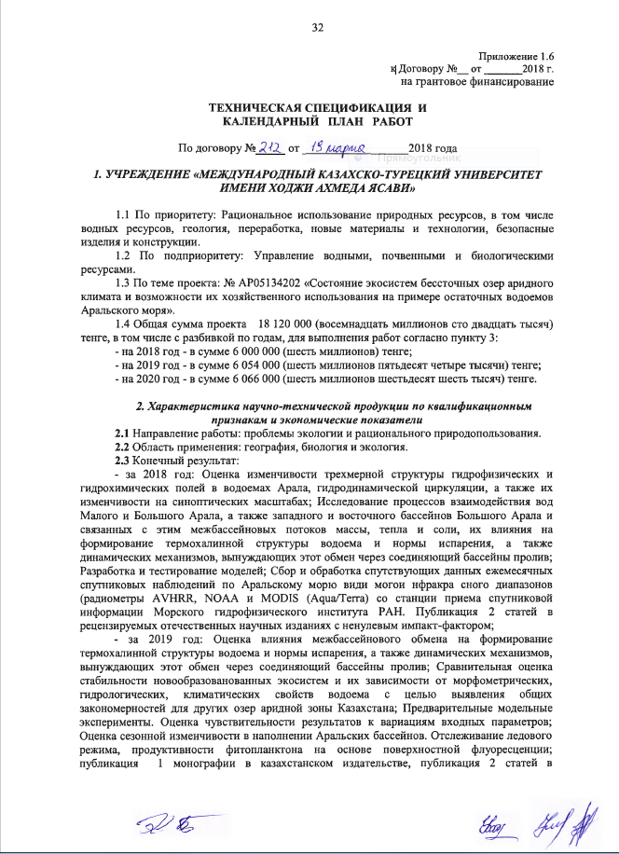
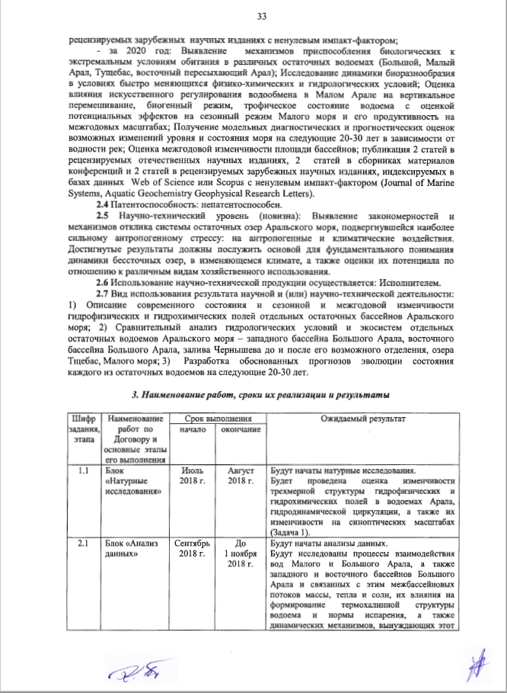
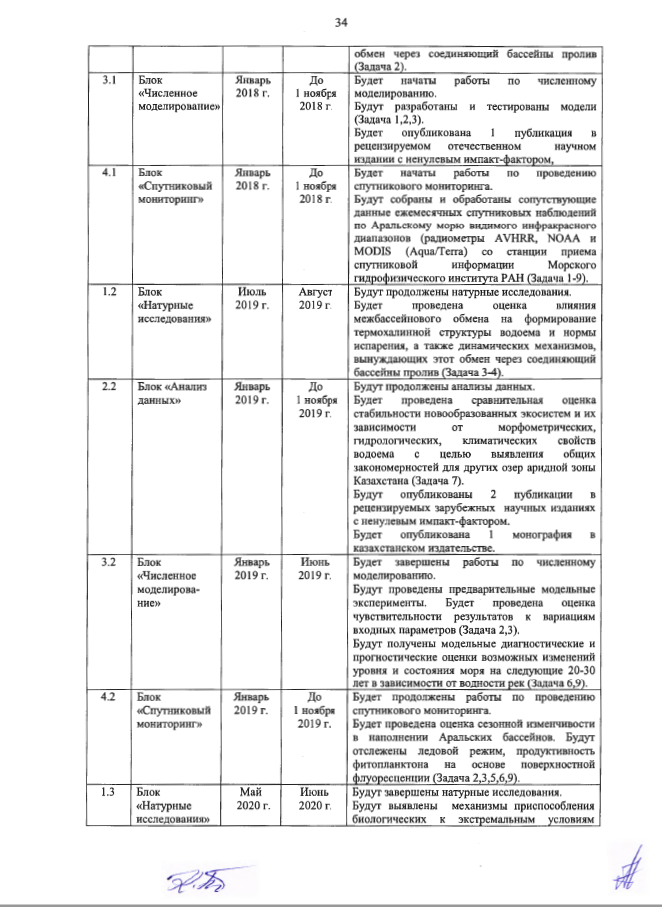
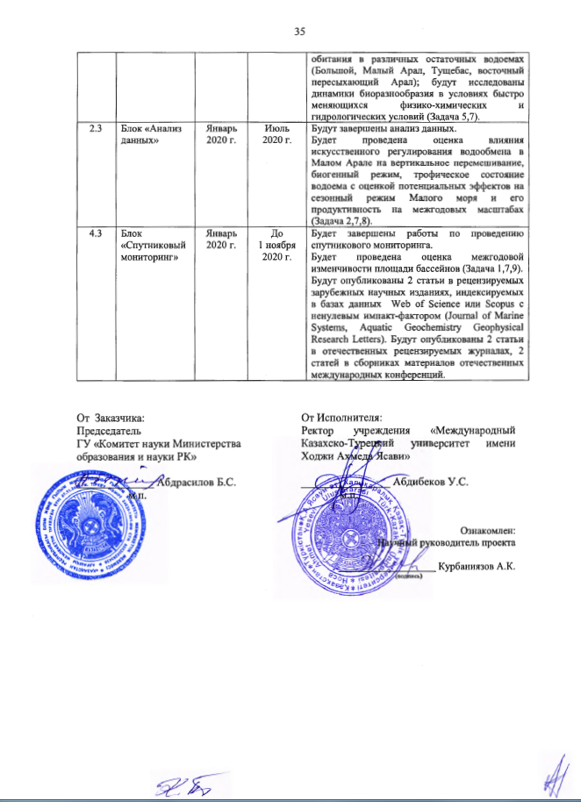
Appendix 1.6
to Agreement No. __ dated ____/____/2018
for grant financing

TECHNICAL SPECIFICATION AND
WORK SCHEDULE

under Agreement No. _____ dated _____ / _____/2018

1. “KHOJA AKHMED YASSAWI INTERNATIONAL KAZAKH-TURKISH UNIVERSITY” INSTITUTION

1.1 Priority: Sustainable use of natural resources, including water resources, geology, processing, advance materials and technologies, safe items and structures.
1.2 Sub-priority: Management of water, soil and biological resources.
1.3 Project topic: No. AP05134202 “Condition of ecosystems of basin lakes of arid climate and opportunities for their economic use using the example of residual basins of Aral Sea”.
1.4 Total project amount: 18,120,000 (eighteen million one hundred and twenty thousand) KZT, including with a breakdown by years, for performance of works according to Paragraph 3:
- 2018 – totaling to: 6,000,000 (six million) KZT;
- 2019 – totaling to: 6,054,000 (six million fifty-four thousand) KZT;
- 2020 – totaling to: 6,066,000 (six million sixty-six thousand) KZT.

2. Characteristics of scientific research product according to qualification features and economic indicators
2.1 Area of work: issues of ecology and sustainable use of natural resources.
2.2 Scope of application: geography, biology and ecology.
2.3 Final outcome:
- in 2018: Assessment of variability of a three-dimension structure of hydrophysical and hydrochemical fields in the basins of Aral, hydrodynamic circulation, as well as their variability at synoptic scale; Study of the processes of interaction of waters of Smaller and Greater Aral, as well as the western and eastern basins of Greater Aral and related inter-basin flow of mass, heat and salt, and influence thereof on formation of thermohaline structure of the basin and evaporation rates, as well dynamical mechanisms causing the exchange via a gat connecting basins; Development and testing of models; Collection and processing of accompanying data of monthly satellite observations across Aral See of visible and infrared band radiometers (AVHRR, NOAA and MODIS (Aqua/Terra) from the station for reception of satellite information of Marine Hydrophysical Institute or RAS. Publication of 2 articles in national peer-review scientific editions with non-zero impact factor;
- in 2019: Assessment of influence of inter-basin exchange on formation of thermohaline structure of the basin and evaporation rates, as well as dynamic mechanisms causing this exchange via a gat connecting basins; Comparative assessment of stability of newly established ecosystems and dependence thereof on morphometric, hydrologic and climatic features of the basin in order to identify general regularities for other lakes in the arid zone of Kazakhstan; Preliminary model experiments. Assessment of sensibility of findings to variations of input parameters; Assessment of seasonal variation in filling of Aral basins. Tracking of ice regime, efficiency of phytoplankton based on surface fluorescence; publication of 1 monography in a Kazakhstani edition, publication of 2 articles in international peer-review scientific editions with nonzero impact factor;
- in 2020: Identification of mechanisms for adaptation of biological organisms to extreme living environments in different residual basins (Greater Aral, Smaller Aral, Tushebas, eastern ephemeral Aral); Study of dynamics of bio-diversity under conditions of rapidly changing physical-chemical and hydrological conditions; Assessment of artificial control of water exchange in Smaller Aral on vertical mixing, biogenic regime, trophic conditions of the basin with assessment of potential effects on seasonal behavior of Smaller sea and its efficiency at inter-annual scale; Obtainment of diagnostic and forecast evaluations of changes in the level and condition of the sea for next 20-30 years depending on the water content of rivers; Assessment of inter-annual variability of the basin area; publication of 2 articles in national peer-review editions, 2 articles in conference information packages and 2 articles in international peer-review scientific editions indexed in Web of Science or Scopus data bases with non-zero impact factor (Journal of Marine Systems, Aquatic Geochemistry Geophysical Research Letters).
2.4 Patentability: Non-patentable.
2.5 Scientific and technical level (novelty): Identification of regularities and mechanisms of the response of the system of residual lakes of Aral Sea which have been affected by the strongest anthropogenic stress: to anthropogenic and climatic effects. Results achieved shall serve as a basis for fundamental understanding of the dynamics of terminal lakes in the changing climate, as well as assessment of their capacity in relation to different types of economic use.
2.6 Scientific and technical product will be used by: Contractor.
2.7 Use of the result of scientific and (or) scientific and technical activity: 1) Description of the current state, and seasonal and inter-annual variability of hydrophysical and hydrochemical fields of separate residual basins of Aral Sea; 2) Comparative analysis of hydrological conditions and ecosystems of separate residual basins of Aral Sea – western basin of Greater Aral, eastern basin of Greater Aral, Chernyshov bay before and after its potential separation, Tshchebas lake, Smaller Sea; 3) Development of reasoned forecast for evolution of the condition of each of residual basins for the next 20-30 years.

3. Name of works, terms for implementation and results

The cipher of the task stage | Name of work under the Contract and the main stages of its implementation | Terms |  | Expected result
The cipher of the task stage |  | Beginning | Completion | Expected result
1.1 | Unit “Field researches” | July 2018 | August 2018 | Assessment of the variability of the three-dimensional structure of hydrophysical and hydrochemical fields in the Aral waters, hydrodynamic circulation, and their variability on synoptic scales (Task 1).
2.1 | Unit “Data analysis” | September 2018 | Before November 1, 2018 | Investigation of the processes of interaction between the waters of the Small and Great Aral, as well as of the western and eastern basins of the Great Aral and the associated inter-basin flows of mass, heat and salt, their influence on the formation of the thermohaline structure of the reservoir and the evaporation rate, and the dynamic mechanisms that force this exchange through the connecting Strait pools (Task 2).
3.1 | Unit “Numerical simulation” | January 2018 | Before November1, 2018 | Development and testing of models (Tasks 1, 2, 3).  1 publication in a national peer-review scientific editions with non-zero impact factor
4.1 | Unit “Satellite monitoring” | January 2018 | Before November 1, 2018 | Works on collection and processing of satellite data of monthly satellite observations on the Aral Sea of the visible and infrared ranges (radiometers AVHRRNOAA and MODISAqua / Terra) from the satellite receiving station of the Marine Hydrophysical Institute of the Russian Academy of Sciences (Tasks 1-9) will be started.
1.2 | Unit “Field researches” | July 2019 | August 2019 | Assessment of the influence of inter-basin exchange on the formation of the thermohaline structure of the reservoir and the rate of evaporation, as well as the dynamic mechanisms that cause this exchange through the connecting straits (Tasks 3-4)
2.2 | Unit “Data analysis” | January 2019 | Before November 1, 2019 | Comparative assessment of the stability of newly formed ecosystems and their dependence on the morphometric, hydrological, climatic properties of the reservoir in order to identify common patterns for other lakes in the arid zone of Kazakhstan (Task 7).  2 publications in international peer-review scientific editions with non-zero factor.  1 monography in a Kazakhstan edition.
3.2 | Unit “Numerical simulation” | January 2019 | June 2019 | Preliminary model experiments. Estimation of the sensitivity of the results to variations in the input parameters (Tasks 2, 3)  Obtaining model diagnostic and prognostic assessments of possible sea level and sea level changes for the next 20-30 years, depending on river water content (Tasks 6, 9).
4.2 | Unit “Satellite monitoring” | January 2019 | Before November 1, 2019 | Estimation of seasonal variability in the filling of the Aral basins. Tracking the ice regime, the productivity of phytoplankton based on surface fluorescence (Tasks 2, 3, 5, 6, 9).
1.3 | Unit “Field researches” | May 2020 | June 2020 | Identification of the mechanisms of adaptation of biological to extreme habitats in various residual water bodies (Bolshoy, Small Aral, Tushchebas, eastern drying Aral); Study of the dynamics of biodiversity in the rapidly changing physical, chemical and hydrological conditions. (Tasks 5, 7)
2.3 | Unit “Numerical simulation” | January 2020 | July 2020 | Evaluation of the influence of artificial regulation of water exchange in the Small Aral on vertical mixing, biogenic regime, trophic state of the reservoir with an assessment of potential effects on the seasonal regime of the Small Sea and its productivity on interannual scales (Tasks 2, 7, 8).
4.3 | Unit “Satellite monitoring” | January 2020 | Before November 1, 2020 | Assessment of interannual variability of basin area (Tasks 1, 7, 9).  2 articles in international peer-review scientific editions indexed at Web of Science or Scopus data bases with non-zero impact factor (Journal of Marine Systems, Aquatic Geochemistry Geophysical Research Letters). 2 articles in national peer-review journals, 2 articles in national and international conference information packages.

For and on behalf of Customer:  Chairman  “Committee of Science of the Ministry of Education and Science of the Republic of Kazakhstan” SE  ______________ B.S. Abdrasilov  Seal | For and on behalf of Contractor:  President of “Khoja Akhmed Yassawi International Kazakh-Turkish University” Institution  ________________ U.S. Abdibekov  Seal  Read and understood:  Research Advisor  ___________________ A.K. Kurbaniyazov  (signature)

APPENDIX B
List of published works on the topic for 2018-2020

List of published works for 2018
Publications in domestic journals recommended by CCSES MES RK
1 Kurbaniyazov A.K., Sambayev N.S., Atabayev Zh.F., Sagyndykova E.U. The current hydroecological state of the lower reaches of the Syrdarya river and the use of its runoff resources // Bulletin of Yasavi University. – 2018. - No. 1 (107). - pp. 160-170. (In Russian).
2 Kurbaniyazov A.K., Zavyalov P.O., Sambayev N.S., Atabayev Zh.F., Nurgalieva G.Zh., Abdrassilov A.A. Ways to increase the productivity of ichthiofauna in the lakes of the Aral-Syr Darya basin system // Bulletin of the National Academy of Sciences of the Republic of Kazakhstan. - 2018. - №2. - P.256-262.
3 Kurbaniyazov A.K., Makkaveev P.N., Zavialov P.O., Yusupov B. Investigation of chemical composition of the Aral sea water in autumn seasons of 2012 and 2013 // Bulletin of the National Academy of Sciences of the Republic of Kazakhstan. Series of Geology and Engineering Sciences. - 2018. - №3(429). - P.75-83.
Papers published at International conferences
1 Kurbaniyazov A.K., Zavyalov P.O., Zloto A.K., Izhitskiy A.S., Kirilin G., Sapozhnikov F.V., Kalinina O.Yu., // Current state of the residual reservoirs of the Aral Sea // Materials of International scientific and practical conference "Problems and prospects of complex geographic research in the Aral region and adjacent territories". - Nukus: Nukus state pedagogical Institute named after Ajiniyaz, 2018. - Pp. 13-17. (In Russian).
2 Kirillin G., Alymkulov S., Kurbaniyazov A., Zavialov P. Seasonal mixing regime of Eurasian lakes: how resistant is it to the climate variability // International Conference «Freshwater Ecosystems - Key Problems». - Irkutsk: LLC «Megaprint», 2018. - P. 56-57.

List of published works within the project for 2019
Scientific articles in journals included in the Web of Science and Scopus databases
1 Izhitskaya E.S., Izhitskiy A.S., Zavialov P.O.et all. Dissolved methane in the residual basins of the Aral Sea // Environmental Researcn Letters. - 2019. - №14. (065005). https://doi.org/10.1088/1748-9326/ab0391, Web of Science, IF за 2018 г. – 6.096. (In Russian).
2 Andpulionis N.Yu.., Zavialov P.O.. Laboratory Studies of Main Component Composition of Hyperhaline Lakes // Experimental And Expeditionary Studies. Physical Oceanography, 2019, 26(1), pp. 13-31. https://doi.org/10.22449/1573-160X-2019-1-13-31
Collective monograph published in the international Springer database
1 Remote Sensing of the Asian Seas / Cretaux J.F., Kоstianoy A., Berge-Nguyen M, Kouraev A. Под ред. Barale V., Gade M. - 1 изд. - Hamburg: Springer, 2019. - 523-539 p. https://doi.org/10.1007/978-3-319-94067-0
Publications in domestic journals recommended by CCSES MES RK
1 Mambetulayeva S.M., Kuchkarova S.A., Kurbaniyazov A.K. Features of successional processes and restorative potential of phytocenoses on the dried bottom of the Aral Sea // Problems of Geography and Geoecology. . - 2019. - № 2. - P.81-87. (In Russian).
2 Mambetullaeva S.M., Kurbaniyazov A.K., Nurgaliyeva G.Zh. Research of transforvdtion of biogenoustltments in water ecosystems of the southern Aral sia area // News Of The National Academy Of Sciences Of The Republic Of Kazakhstan. Series of agricultural sciences. - 2019. - №3 (51). - P. 33-36.
Monograph in Kazakhstan publishing house
1. Kurbaniyazov A. K. Natural complexes of the Aral sea: monograph. - Shymkent: «Alem» printing House, 2019. - 115 p. (In Russian).

List of published works within the project for 2020
Publications in domestic journals recommended by CCSES MES RK
1 Izhitsky A. S., Zavyalov P. O., Kurbaniyazov A. K., Sapozhnikov F. V., Yakushev E. V. Comprehensive study of the hydroecological state of residual reservoirs of the Aral sea // Questions of geography and Geoecology. - 2020. - No. 2. - Pp. 30-39. (In Russian).
2 Ayzel G.V., Izhitskiy A.C., Kurbaniyazov A.K. Forecasting of tһe state of tһe small Aral sea based on open data sources // Reports of the National Academy of sciences of the Republic оf Kazakhstan. - 2020. - №4 (332). - P. 57-64. https://doi.org/10.32014/2020.2518-1483.89
Scientific articles in journals included in the Web of Science and Scopus databases
1 Zavialov P.O., Izhitskiy A.S., Kirillin G.B., Rezvov V.Yu., Alymkulov S.A., Zhumaliev K.M., Kurbaniyazov A.K. Features of Thermohaline Structure and Circulation in Lake Issyk-Kul // Oceanology. - 2020. - №60 (3). - P. 297-307. https://doi.org/10.1134/S0001437020020137
2 Ayzel G., Izhitskiy A. Climate change impact assessment on freshwater inflow into the small Аral sea // Water. - 2019. - №11 (11). - P. 2377. http://dx.doi.org/10.3390/w11112377 Web of Science, IF 2019 . – 2,544.
3.A.K.Kurbaniyazov, S.K.Berdibayeva, K.Mamutov, P.R.Reimov, K.A.Kosnazarov, E.U.Sagindykova, Some questions study of deflation processes and sand transport in the drained bottom of the Aral sea // News of the National Academy of Sciences of the Republic of Kazakhstan. Series of geology and technology sciences. – 2020. - № 6 (444). – С. 40-50.
Reports published at International conferences
1 Kurbaniyazov A. K., Nabiollin D. E. Conducted Research of the Northern part of the Aral sea // Collection of materials of the Republican scientific and theoretical conference "Topical issues of geography and teaching". - - Nukus: Nukus state pedagogical Institute named after Ajiniyaz, 2020. - Pp. 172-174. (In Russian).
2 Sapozhnikov F. V., Kalinina O. Yu., Kurbaniyazov A. K., Abdrasilov A. Studies of microphytobenthos in reservoirs of the small Aral sea system // Collection of materials of the international scientific and theoretical conference "Topical issues of Natural Sciences". - Nukus: Nukus state pedagogical Institute named after Ajiniyaz, 2020. - Pp. 229-231. (In Russian).
3 Shatwell T., Kirillin G. Effect of climate warming on the mixed layer depth in lakes // In EGU General Assembly Conference Abstracts. – 2020. - Р. 22261.
4 Kochkarova S. A., Sapozhnikov F. V., Zavyalov P. O. Current state of vegetation cover on the dried-up bottom of the Western Aral sea.//Materials of the International scientific and practical conference "Protection and rational use of natural resources of the southern Aral sea region" - Nukus: Karakalpak state University named after Berdakh, 2020. – P. 46-54. (In Russian).

APPENDIX C
Minutes Of the scientific Committee of the University on the discussion and approval of the final report of research

APPENDIX D
Satellite images of the Aral sea for 2020
\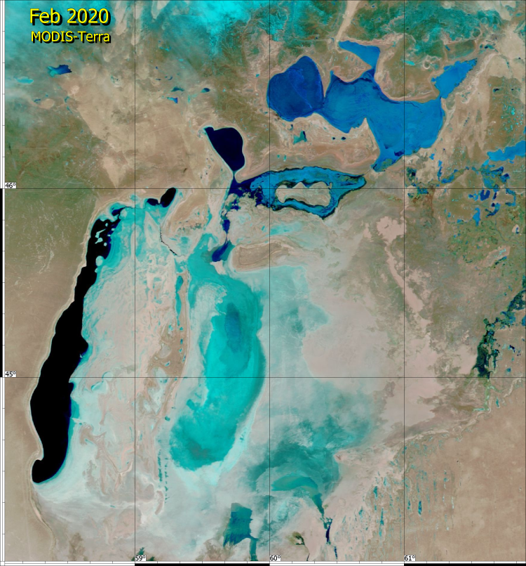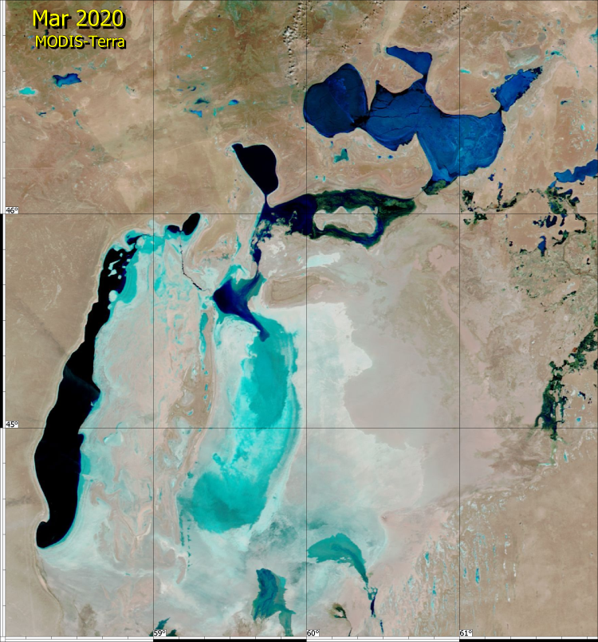
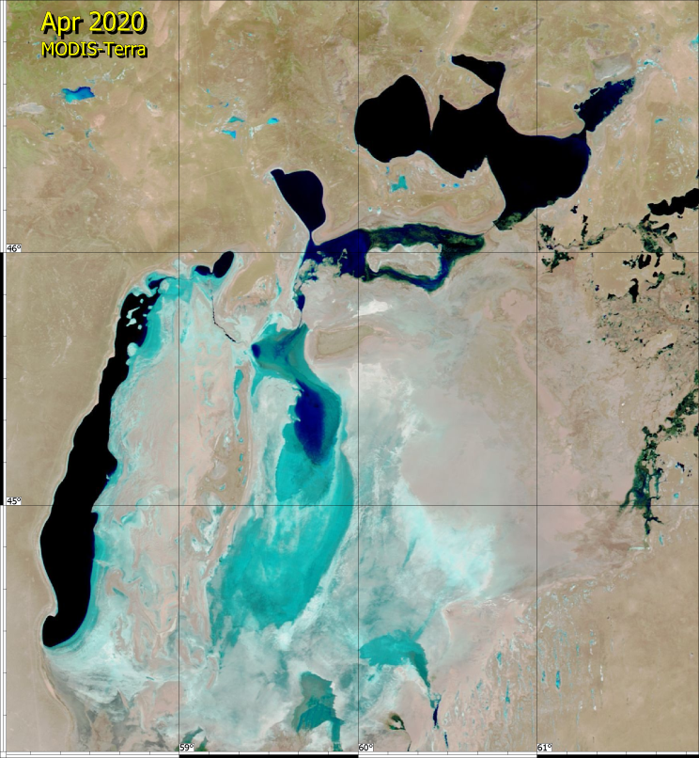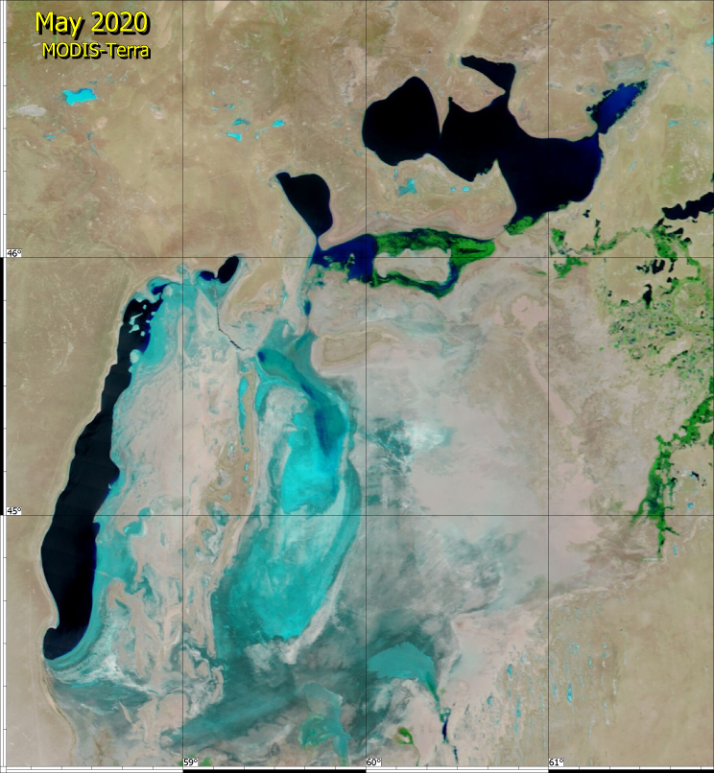

Figure 1-Overview maps of the Aral sea region from February to may 2020

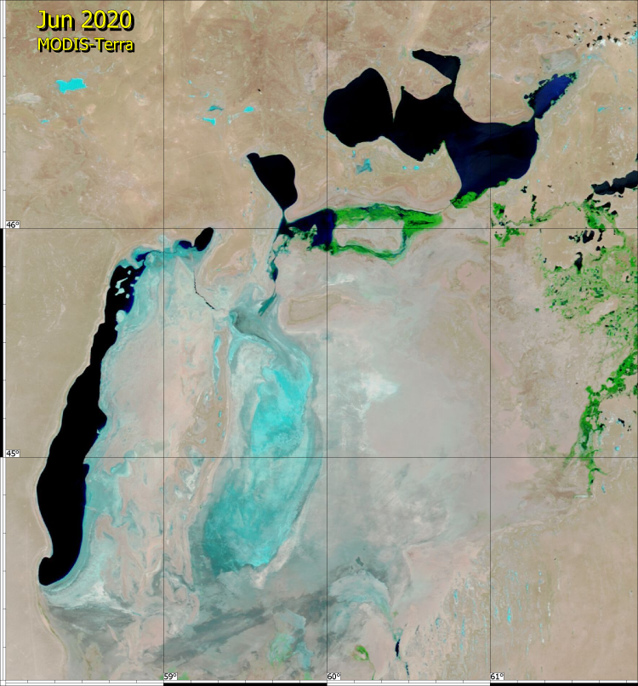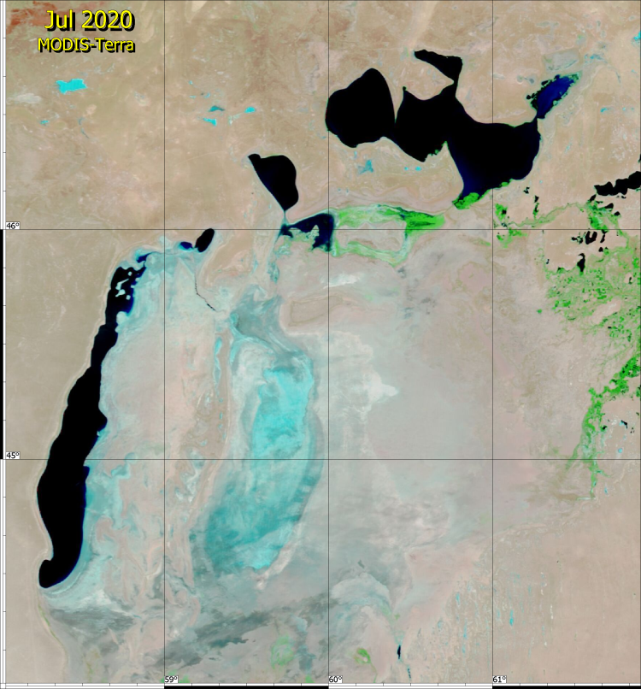
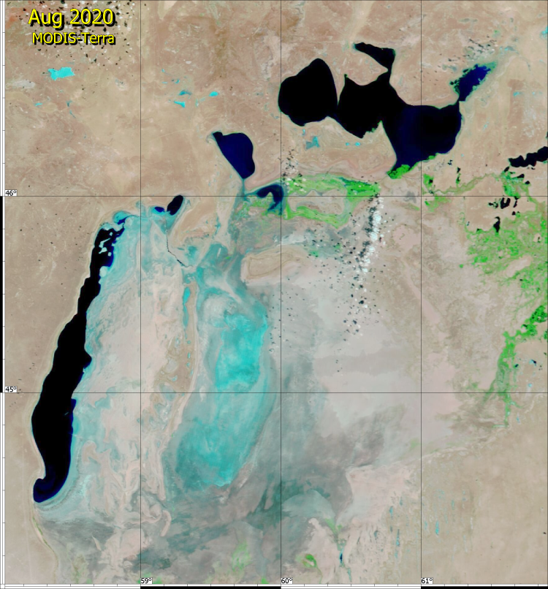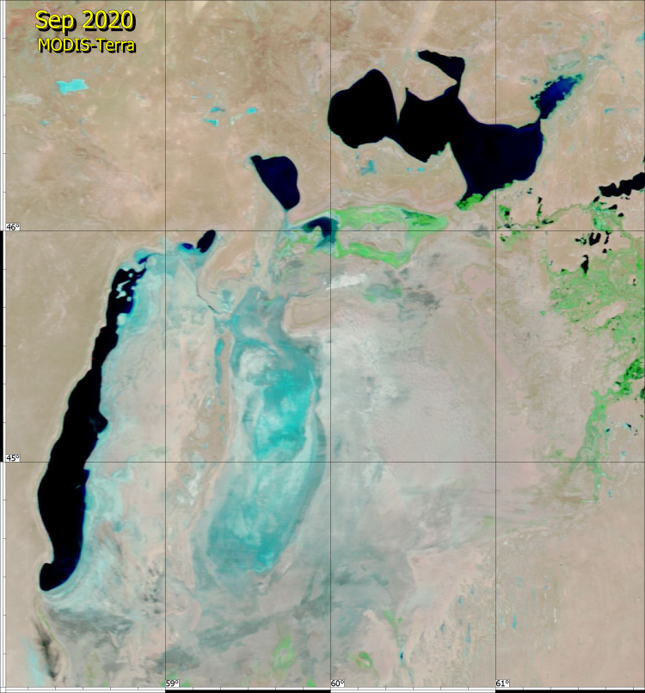

Figure 2-Overview maps of the Aral sea region from June to September 2020
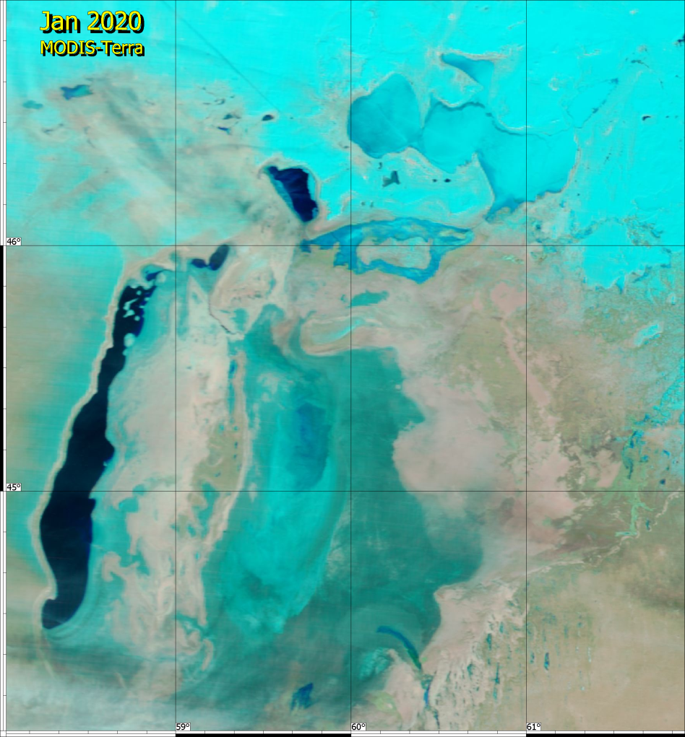
Figure 3-Overview map of the Aral sea region for January 2020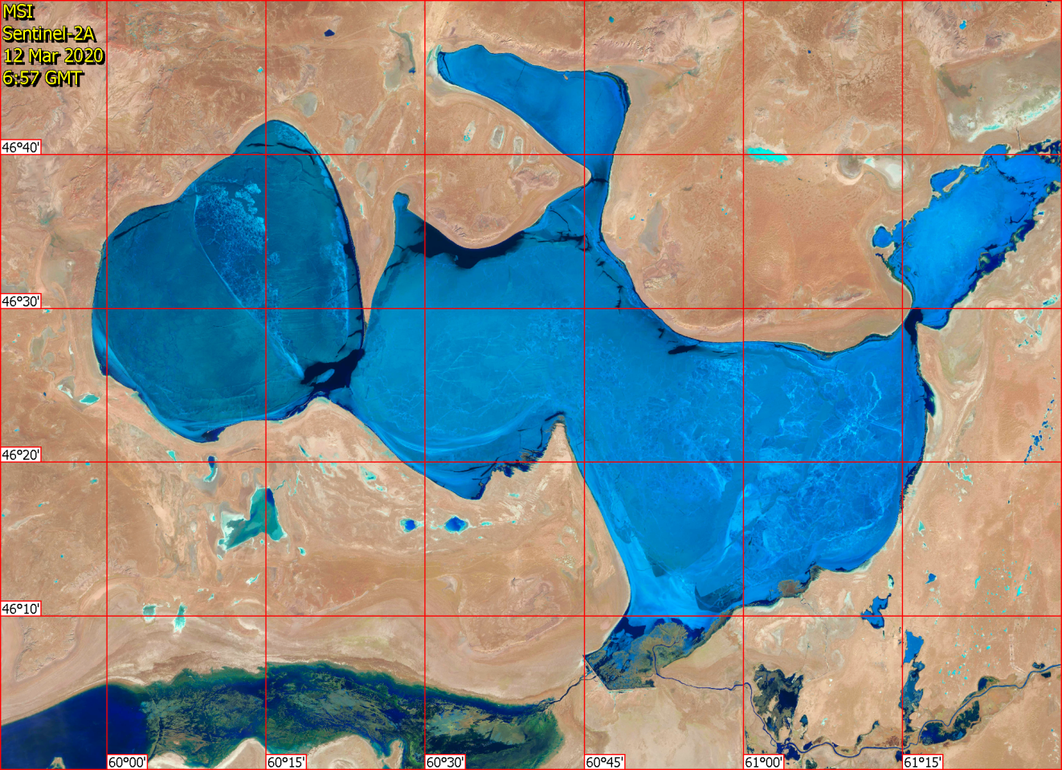
Figure 4-Distribution of ice cover in the Small Aral sea in March 2020
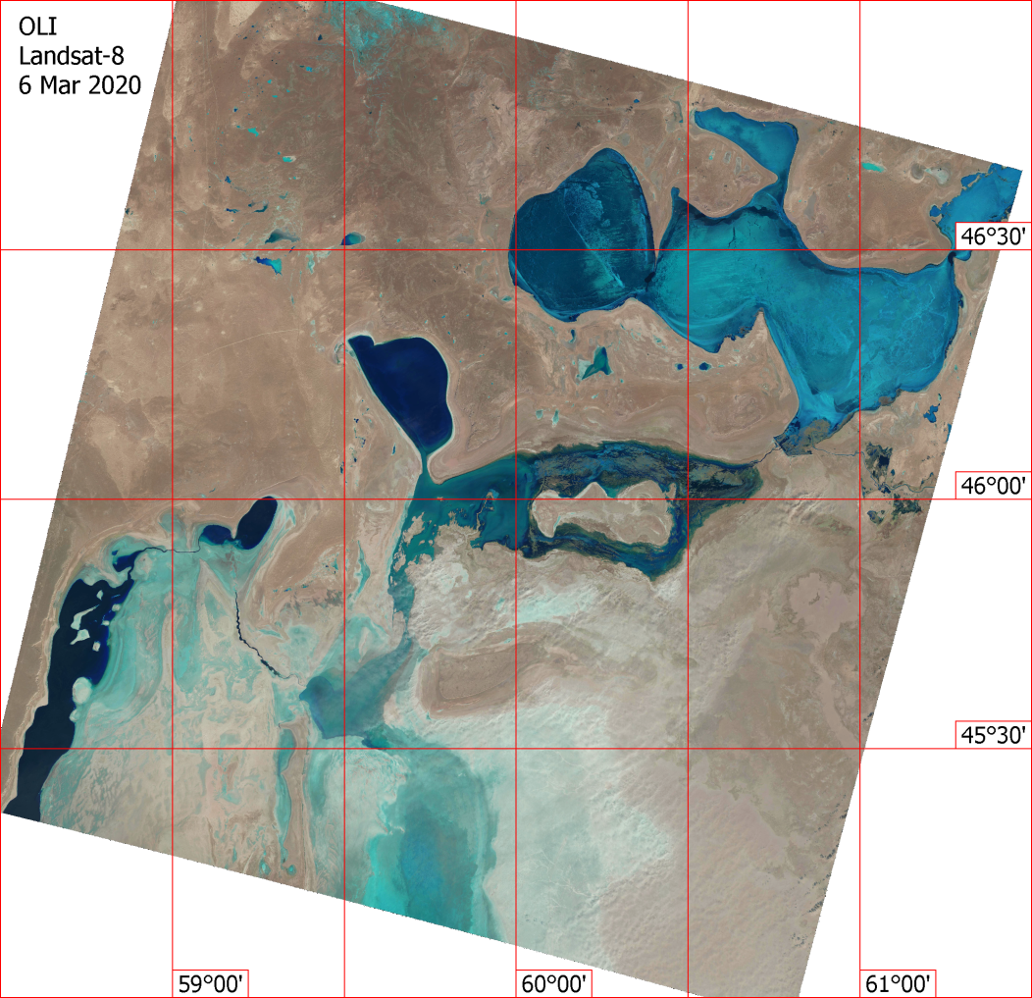
Figure 5-Distribution of ice cover in the Greater and Lesser Aral sea in March 2020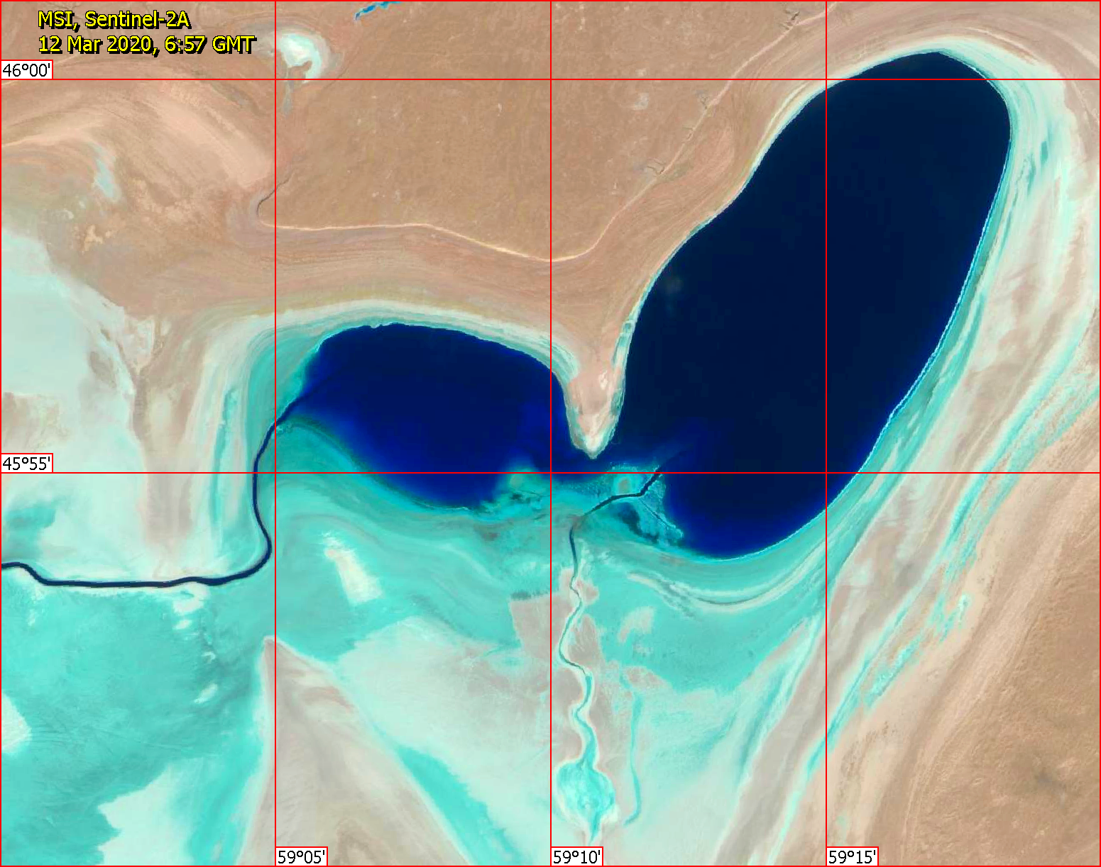
Figure 6.-10-meter resolution Image from the Sentinel-2A satellite for 12.03.2020.
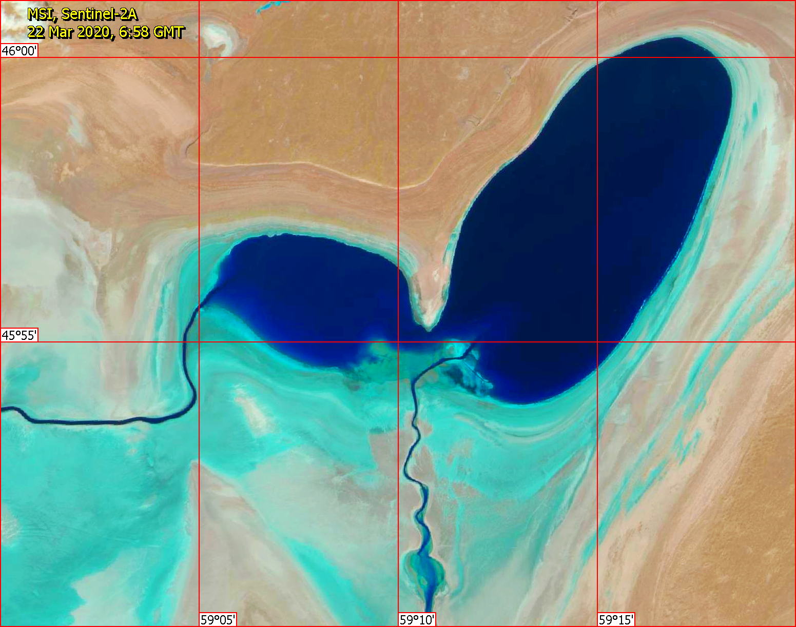
Figure 7-10-meter resolution Image from the Sentinel-2A satellite for 22.03.2020.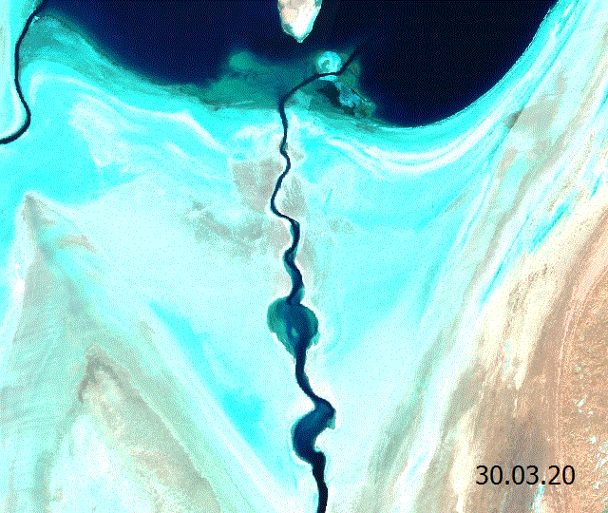
Figure 8-Maximum water filling of the East-West Strait 30.03.2020
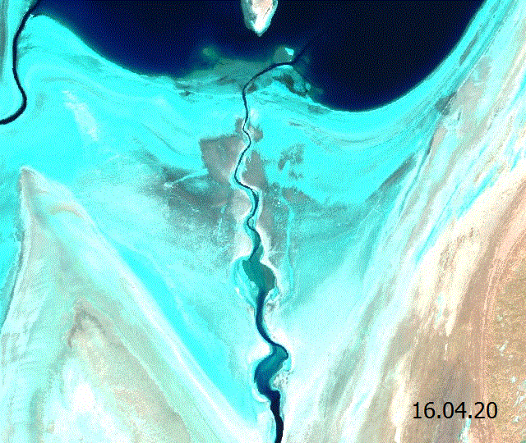
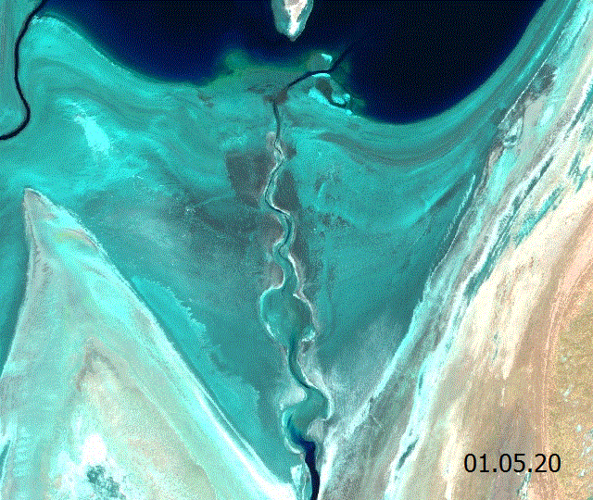
Figure 9-Drying up of the East-West Strait during April 2020
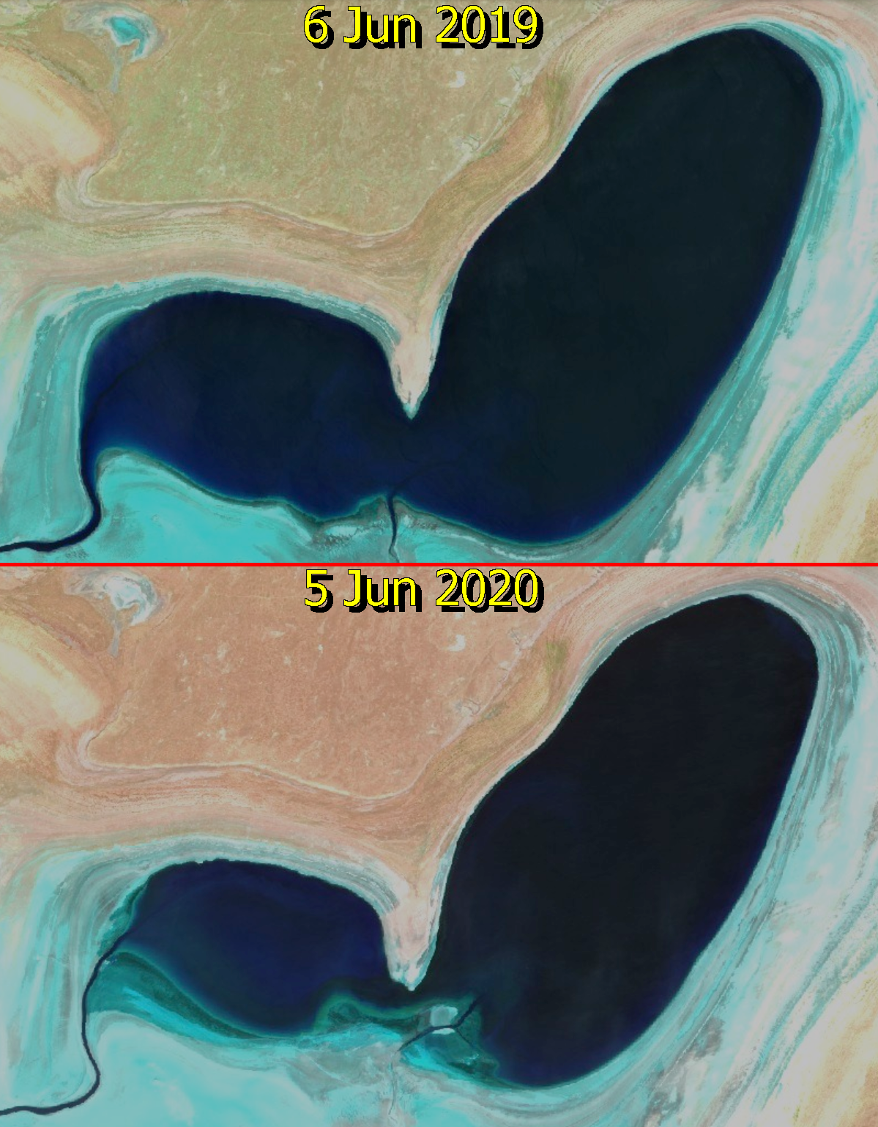
Figure 10-water Filling of Chernyshov Bay by the beginning of summer 2019 and 2020
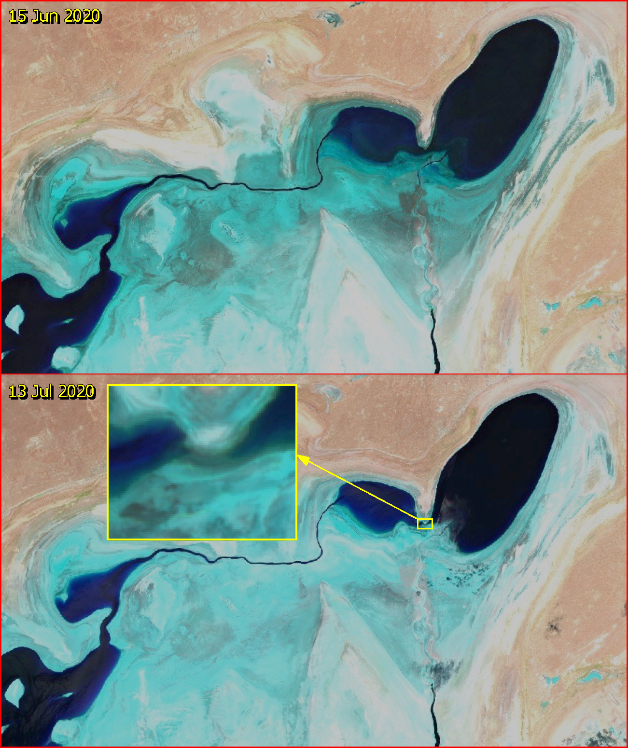

Figure 11-Primary division of Chernyshov Bay into two basins in July 2020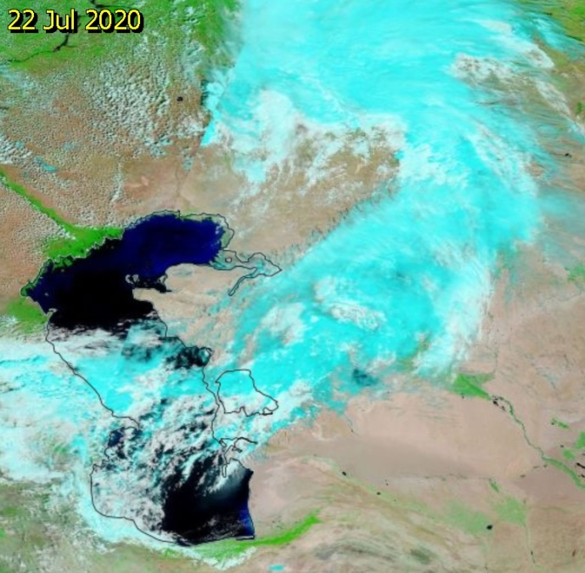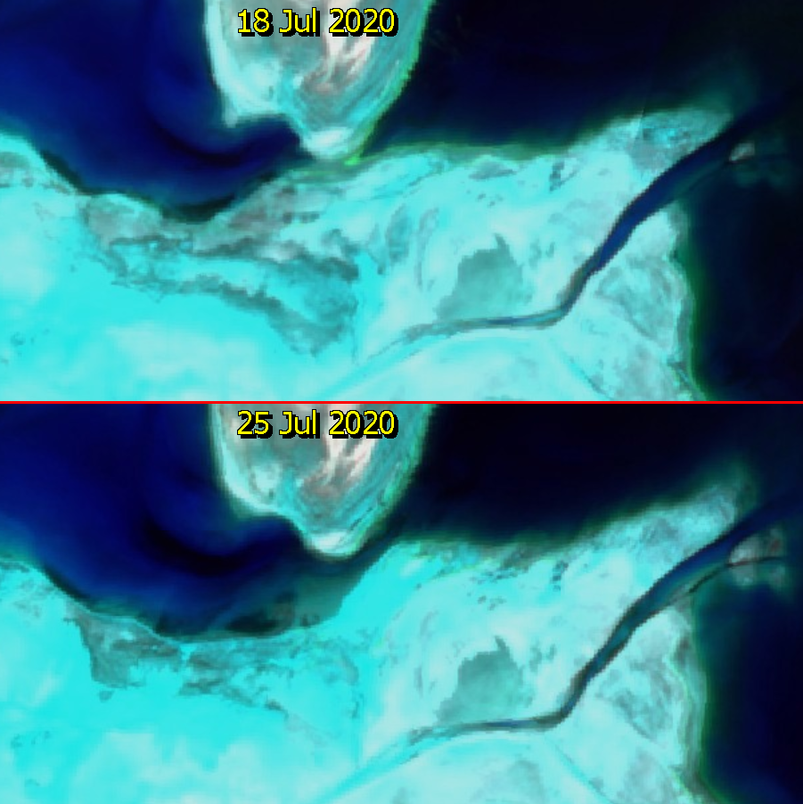
Figure 12-Temporary restoration of water exchange between parts of Chernyshov Bay after the passage of the rain front in July 2020
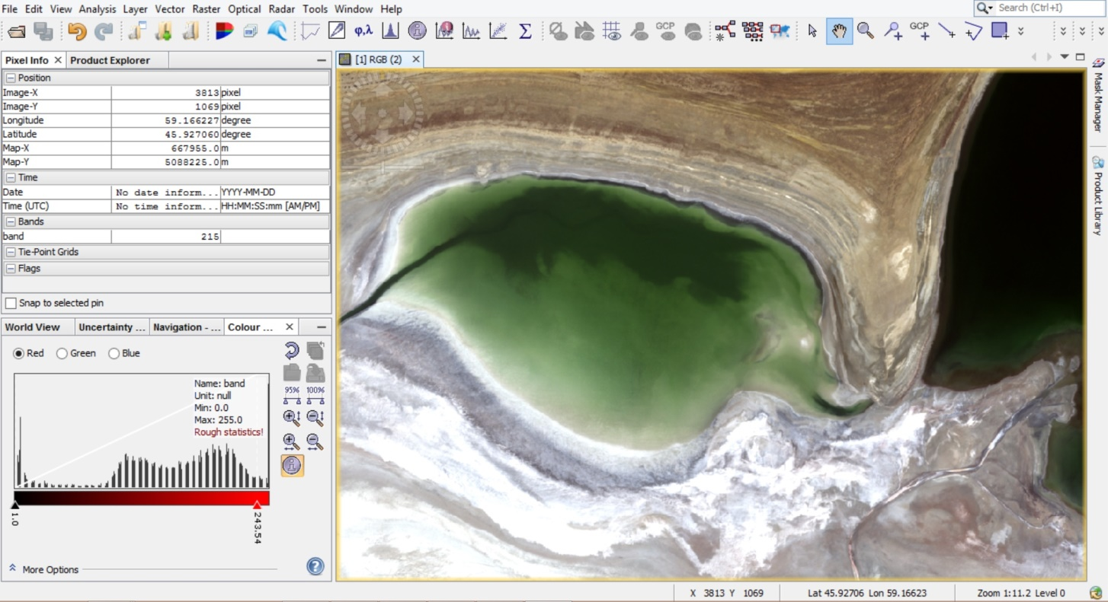
Figure 13-Western separated part of Chernyshov Bay in August 2020
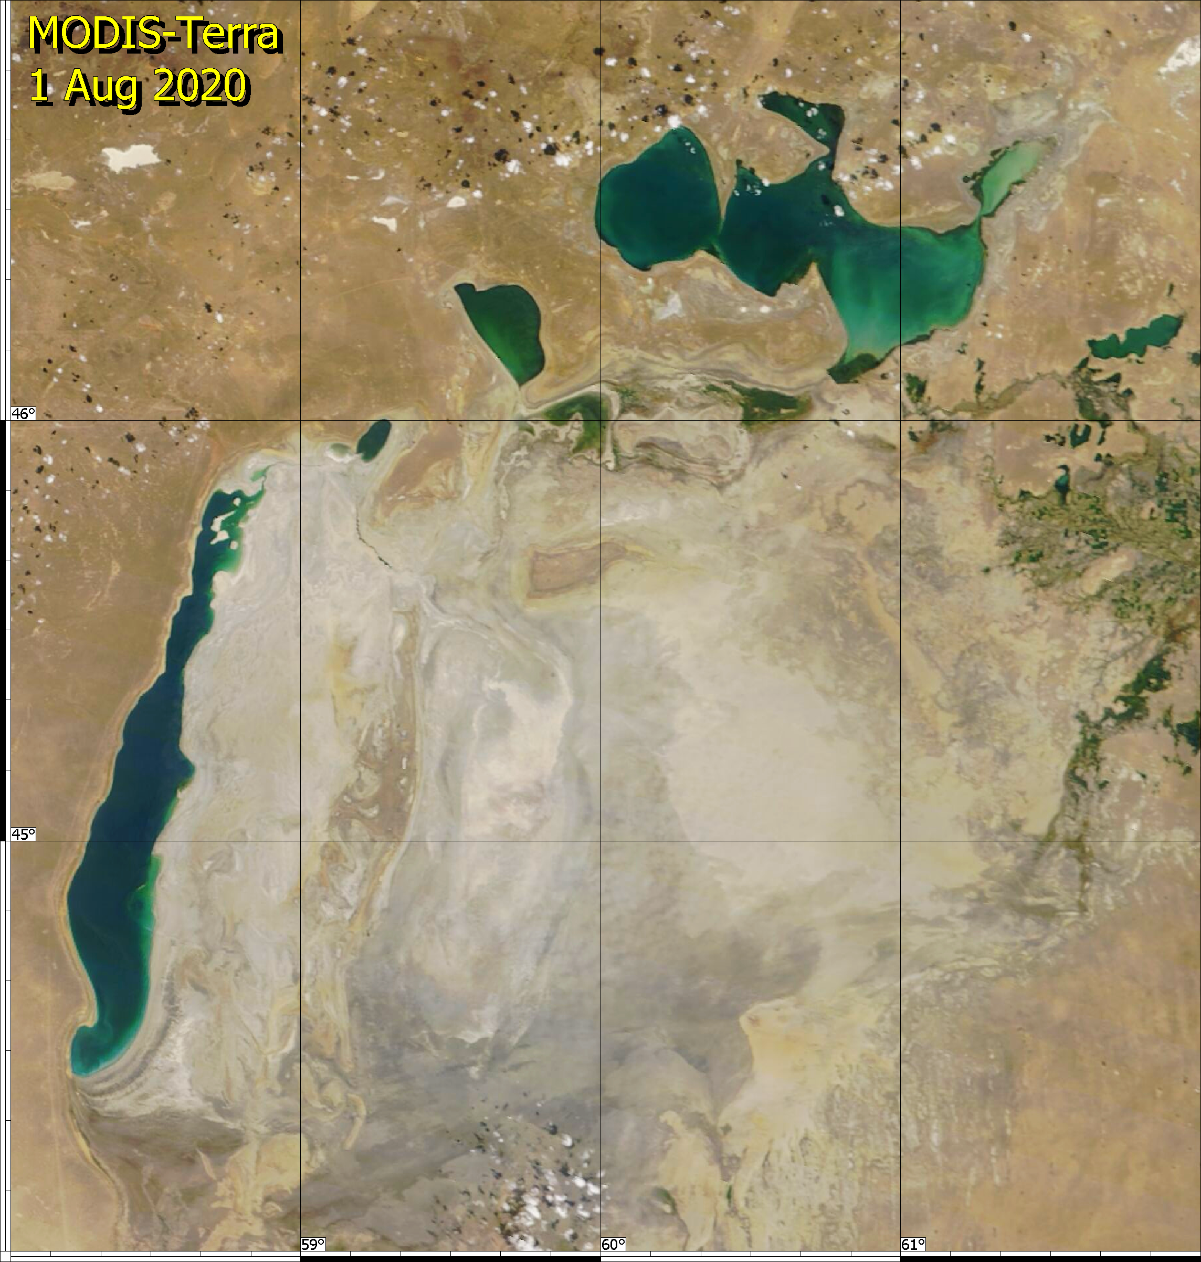
Figure 14-Overview image of the Aral sea region from the Terra satellite for August 2020

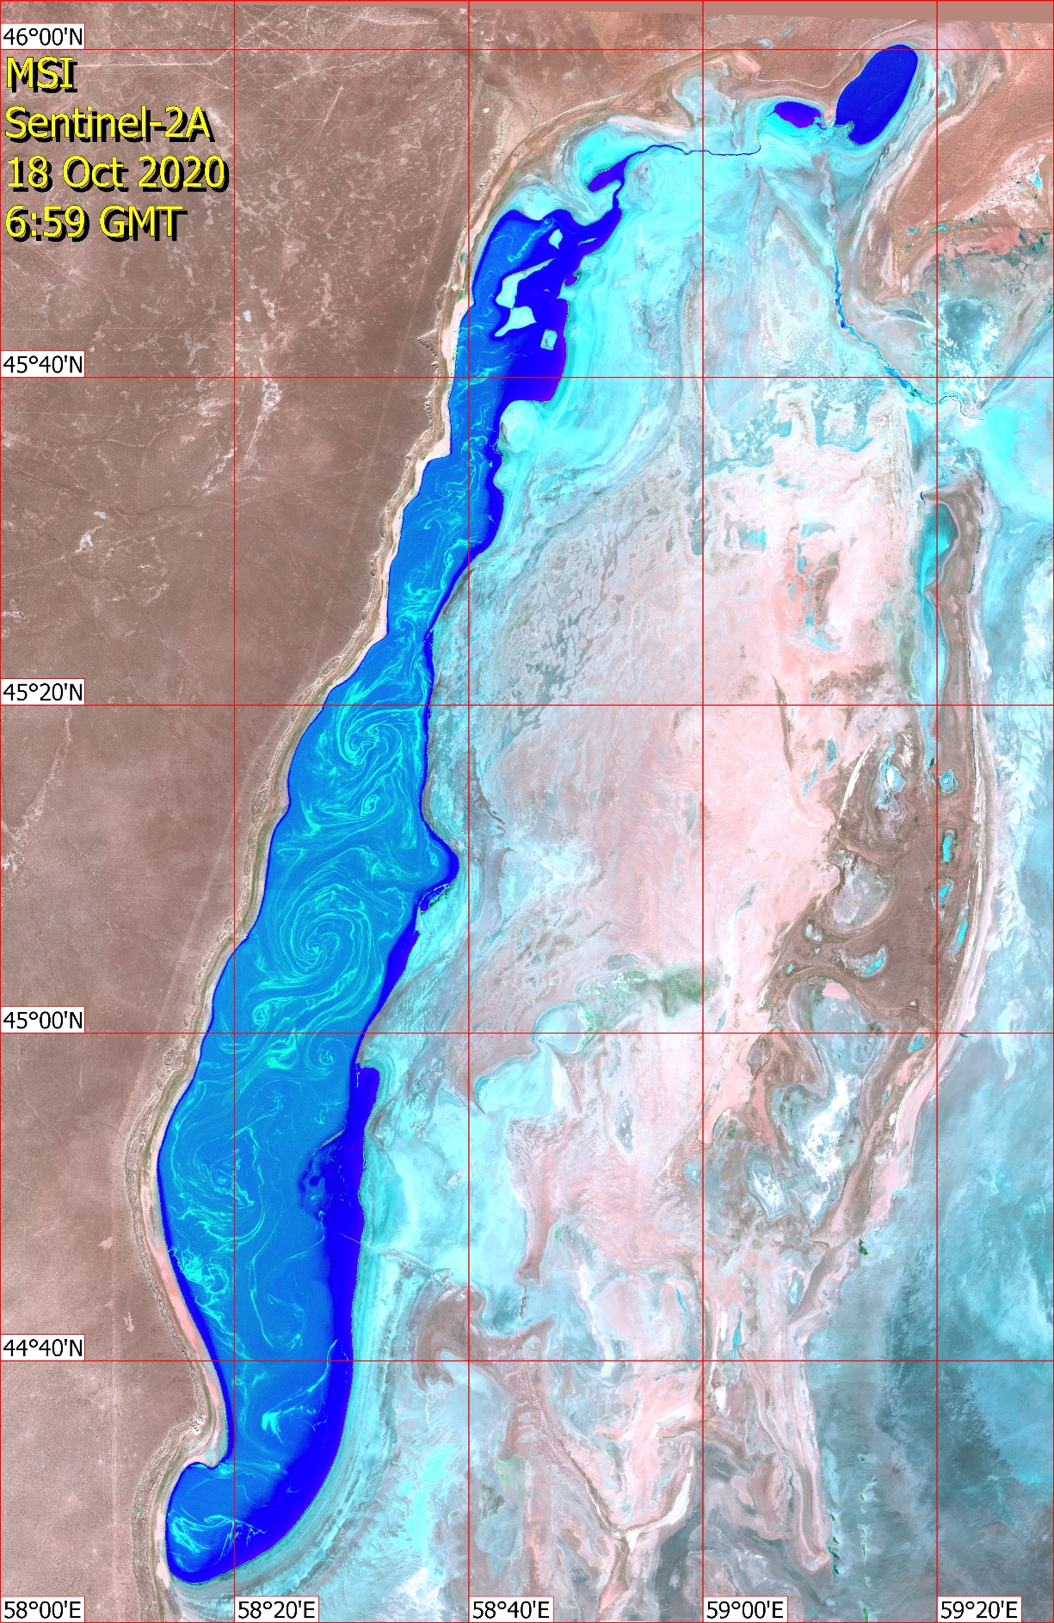
Figure 15 - Sea current and bright hyperhaline blooming of the Western basin of the Aral sea, captured by the European Sentinel satellite

APPENDIX E
Results of chemical analysis of water in the coastal zone of the Aral sea

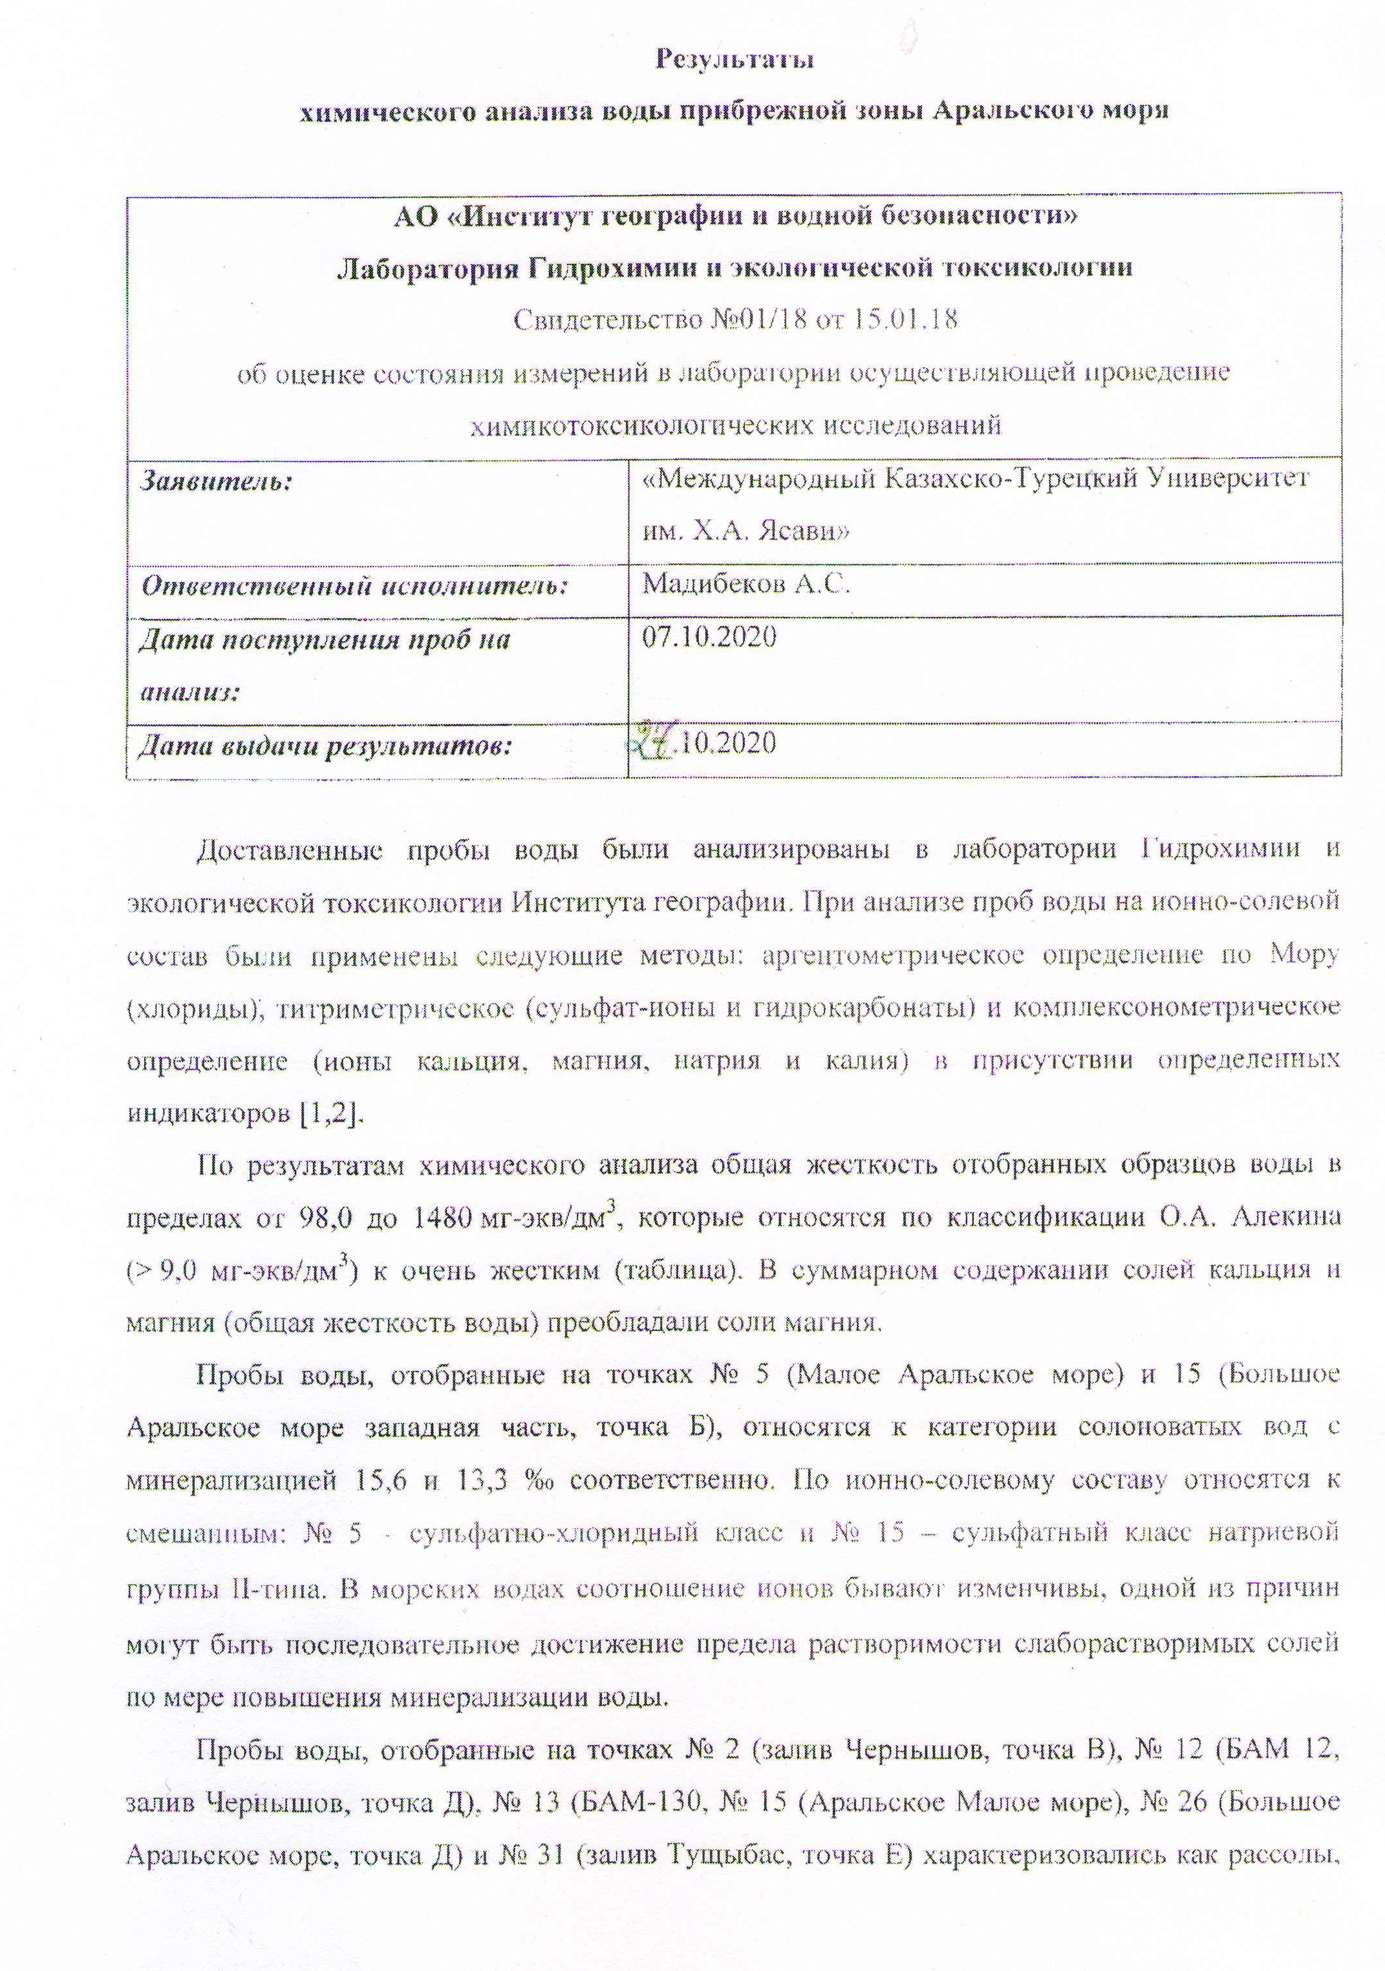
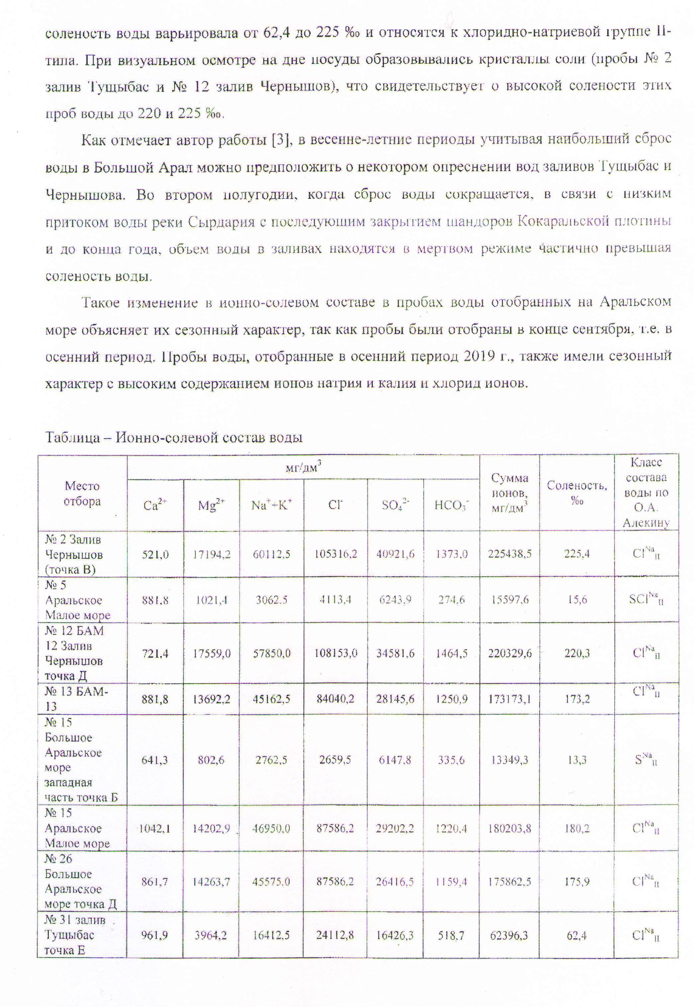

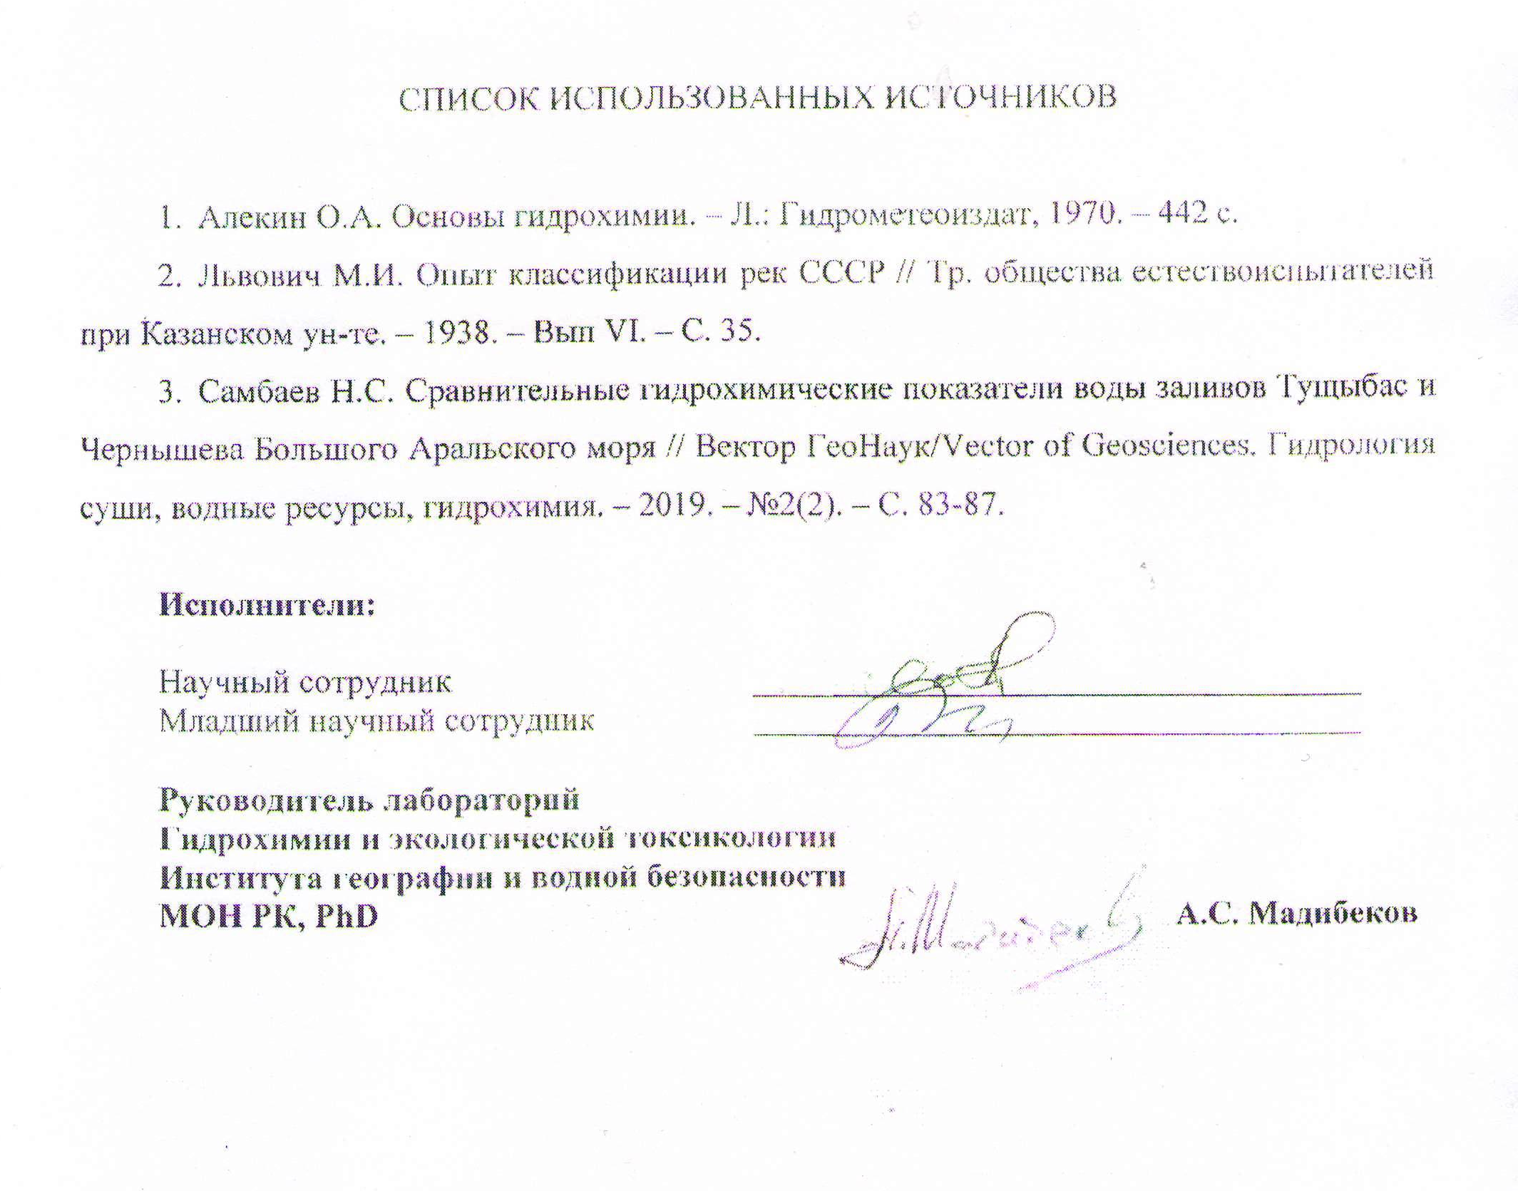
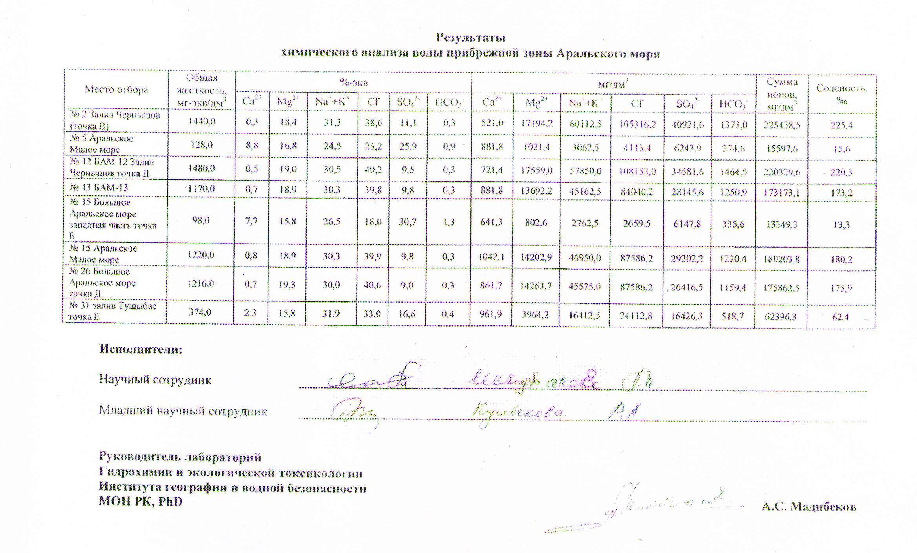

APPENDIX F
Prints of published works obtained as a result of research
