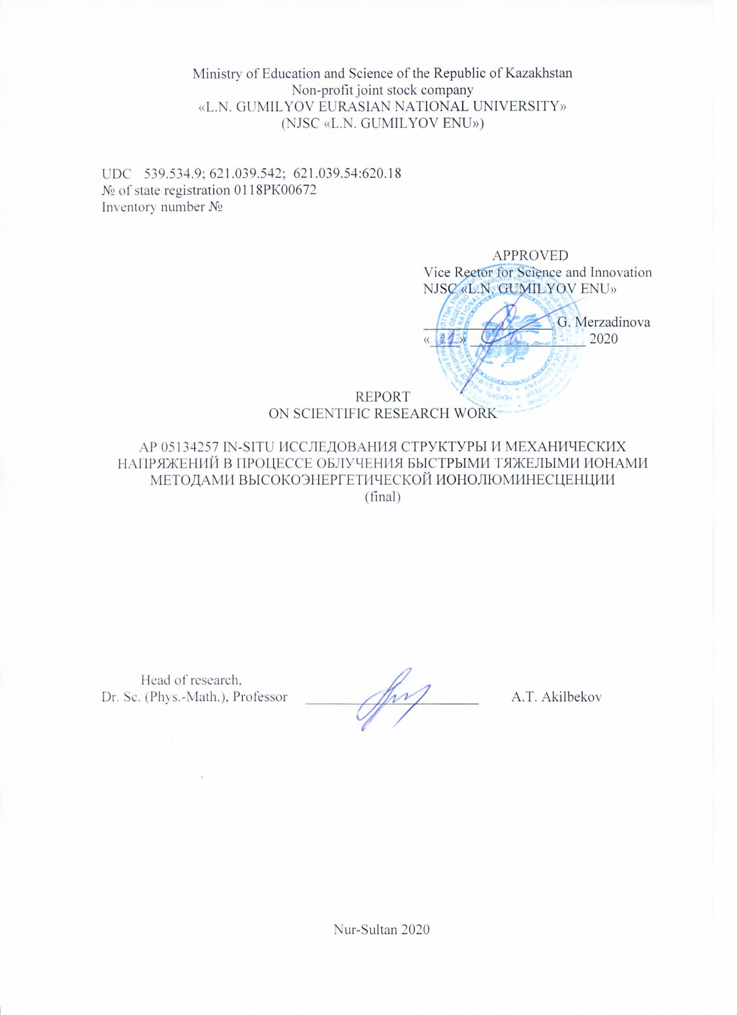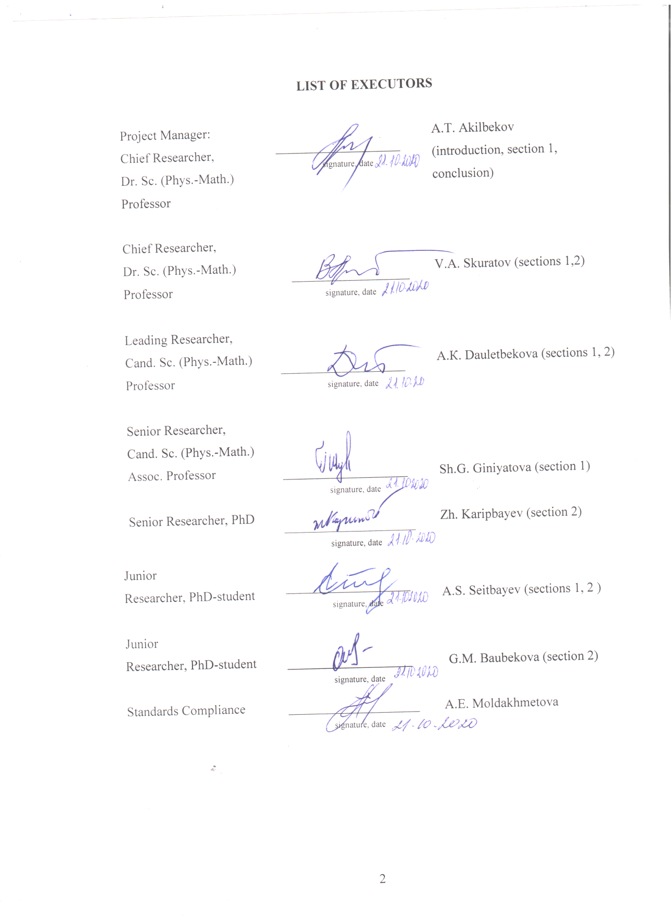

ABSTRACT

Report 41 p., 19 figures, 1 tab., 20 sources, 3 app.
IONOLUMINESCENCE, SWIFT HEAVY IONS, cross-section CLEAVAGE, NANOHARDNESS, PHOTOLUMINESCENCE
The objects of research are crystalsof MgO.
Research methods :in-situ ionoluminescence (IL), AFM, TEM, PL, CL.
Purpose of the study: creation and improvement of a complex for measuring IL at the DC-60 accelerator. Measurement of IL depending on irradiation conditions, and structural damage caused by irradiation. The main results obtained at the stage of 2020 are presented, and for previous years have been reflected in the conclusion:
- A complex for in-situ measurement of high-energy ionoluminescence at the DC-60 accelerator has been created. In 2020, work was carried out to increase the temporary resolution of the facility. For the first time, the new technique used the emission of electrons directly from the surface of the irradiated sample to generate a stop signal. This made it possible to obtain a time resolution of ∆τ=250 ps.
- The IL kinetics of Al₂O₃ and MgO were measured using a new technique. Over a wider time range. For Al₂O₃, it was recorded for the first time that, in addition to the "fast" stage, they exhibit the components τ₂=1,8±0,1 ns and τ₃=54÷70 ns. Radiation with a lifetime τ₂ is associated with F⁺ -centers. Our data obtained in different spectral ranges indicate that radiation with a decay time constant τ₃ is detected in the range of 300–400 nm and can be associated with the recombination of self-trapped excitons near the defect. The PL decay curves of MgO exhibit components with a duration that depends on the level of electronic braking. So, for xenon ions, they are ~0.2 μs and ~100 μs.
- The RIOA spectra were investigated in the range 1.4–7.5 eV for a single crystal of MgO irradiated with 230 MeV ¹³²Хе ions. Absorption bands have been identified.
- The cathodoluminescence spectra of irradiated MgO crystals were measured and analyzed.
- The depth profile nanohardness in irradiated MgO crystals is measured and analyzed
- TEM studies of MgO single crystals irradiated with 167 MeV¹³²Xe and 470 MeV¹³²Xe ions show the absence of defects associated with the formation of tracks. The reason for this behavior is the recrystallization of the track region.
Applications: nuclear power, nuclear materials science.

CONTENT

INTRODUCTION ……………………………………………………………………………. | 6
1 Measurement of ionoluminescence on the cyclotron DC-60…...…………………………… | 7
1.1 Installation for measuring ionoluminescence…….……………………………………… | 7
1.2 Modification of the complex for IL measuring.………………………………………….. | 10
2 AFM and TEM research. Photoluminescence and cathodoluminescence………................... | 15
2.1 AFM studies of nanohardness along the ion path. Tem research…………………...…… | 15
2.2 Analysis of point defects…………………………………………………………............. | 17
2.3 Analysis of photo- and cathodoluminescence spectra.…………………………………... | 20
CONCLUSION ………………………….……………………………………………………. | 24
REFERENCES………………………………………………………………………………….….………………………………………... | 26
APPENDIX A – Calendar work plan.......................................................................................... | 28
APPENDIX B – List of published works…………................................................................ | 32
APPENDIX C – Act on implementation.................................................................................... | 35

SYMBOLS AND ABBREVIATIONS

FHI | – Fastheavyions
IL | –Ionoluminescence
CL | –Cathodoluminescence
PL  PMT | – Photoluminescence  – Photomultipliertube
LCM  LCSM | – Laser confocal luminescence  – Laser confocal scanning luminescence
PCL | –Pulsedcathodoluminescence
SEM | – Scanningelectronmicroscope
AFM | – Atomicforcemicroscope
TEM  RIOA | – Transmission electron microscopy  – Radiation-induced optical absorption
OD | – Optical density
INTRODUCTION

The relevance and novelty of research work is since research related to the study of radiation damage arising from irradiation of SHI under various experimental conditions in candidate materials (matrices) of nuclear fuel. The use of the SHI makes it possible to simulate the situation of irradiation by fission fragments.
The absence of microscopic mechanisms for the formation of structural defects makes it almost impossible to theoretically estimate the stress field, therefore, experimental studies in this direction are very much in demand and relevant.
From a practical point of view, such works are of greatest interest for predicting the long-term radiation stability of ceramic and oxide materials used in nuclear power plants in relation to the effect of fission fragments.
The main task of the project was to create a complex for studying «in-situ» ionoluminescence at the DC-60 accelerator and its modification during operation. Research methods: measurement of IL on the complex for «in-situ» study of ionoluminescence at the accelerator DC-60, created within the framework of the project, absorption spectroscopy, luminescence, cathodoluminescence, atomic force microscopy, transmission electron microscopy.
Direction of work: applied research.
The main objectives of the study at the stage of 2020:
- Modification of the complex for studying «in-situ» ionoluminescence.
- Measurementof IL kinetics.
- Investigation using AFM, TEM of the surface of samples irradiated with SHI.
- Measurement of luminescence, cathodoluminescence, absorption spectra.
- Approbation of the results. Preparation of publications.
Materials of research at this stage were MgO, Al₂O₃
The scientific and technical level (novelty) lies in the fact that the IL was measured and investigated for the first time on a set of equipment for in-situ measurement of high-energy IL on the DC-60 cyclotron created in the framework of the project.
The reliability of the results obtained is confirmed by:
- using a complex of modern research methods;
- correct formulation of the problems being solved and their physical validity, and the use of well-tested methods of physicalexperiment.
- wide approbation of the obtained data and conclusions of the study at scientific conferences, as well as in publications.
The results can be used in nuclear power engineering and nuclear materials science.

- Measurement of ionoluminescence on the cyclotron DC-60

  - Installation for measuring ionoluminescence
Various installations were used to measure IL. The complex for measuring IL, assembled at the accelerator at the Leagnaro National Laboratories in Italy, is shown in Figure 1 [1].

Figure1 – Model of the complex for measuring ionoluminescence in Leagnaro Laboratories, Italy [1].

IL is excited by a 2 MeV proton beam. Shutter response time for 70 μs emission registration. The installation has been improved to allow light to be collected in the angle range of 2π. The scan area is currently 0,5 х0,5 mm², and the scan time, for the map 512x512 pixels, is about 18 seconds. It takes a few minutes to get a good distribution, depending on the emissivity of the target. The wavelength distribution can also be performed by interference filters instead of a monochromator.
Figure 2 shows a complex for measuring IL, created by the Laboratory for IonBeam Interactions at the RuđerBošković Institute, Zagreb, Croatia [2].

Figure2 – Optical scheme for measuring IL [2]
Irradiation was carried out with protons with an energy of 2 MeV and beam currents in the range of 50-300 pA. The IL spectrum was measured with an Ocean Optics HR4000 spectrometer with an entrance slit of 100 nm, a resolution of 3.5 nm, and a spectral range of 200–1100 nm. To achieve maximum sensitivity, the collecting lens was positioned as close as possible to the beam focus. The optical system (Thorlabs UV Fused Silica) is positioned at an angle of 150⁰ to the beam direction, as shown in Figure 2.
Figure 3 shows a schematic diagram of the IL-spectroscopy complex combined with the in air micro-PIXE system. An optical fiber with a diameter of 800 μm was installed on the microbeam system. This complex was created by the Advanced Radiation Technologies Department, Japan Atomic Energy Agency [3].

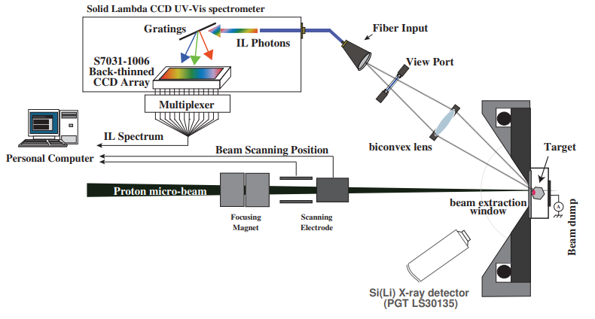

Figure3 – Diagram of optics and detectors for the IL-spectroscopy system [3]

A biconvex lens is placed in a vacuum chamber at 75 mm from the target at an angle of 40° to the beam axis. The input end of the fiber is located at the opposite focus of the collecting lens. The opposite end of the optical fiber was connected to a spectrometer or PMT for spectroscopy and 2D visualization of the IL. The IL spectra and images were obtained by irradiating the target with a 3 MeV proton beam. The fiber output was connected to two different photodetectors for 2D imaging and IL spectroscopy.
In our project, a set of equipment for “in-situ” measurements of high-energy at the DC-60 accelerator (Nur-Sultan, Kazakhstan) has been created and is used.
Figure 4 showst he accelerator with the location of the IL complex.

The complex contains:
- 4-position monitor (4pMon) .
- Single ion detector based on a microchannel plate (MCP) for generating "starting" pulses when measuring the lifetime of excited states.
- Minicryostat with quartz windows, allowing measurements in the temperature range 80-300 K and in the wavelength range 300-800 nm.
- A photomultiplier-based detector for the registration of single photons from irradiated samples, generating a STOP signal for performing time measurements.
- A device for measuring the lifetime of excited states based on a TimeHarp 260 time-to-amplitude converter with a constant fraction discriminator (CFD), with the ability to measure in the range from tens of picoseconds to three milliseconds with the appropriate software package;
- Program for monitoring the parameters of measuring equipment (gains of preamplifiers, voltage on the MCP and PMT).

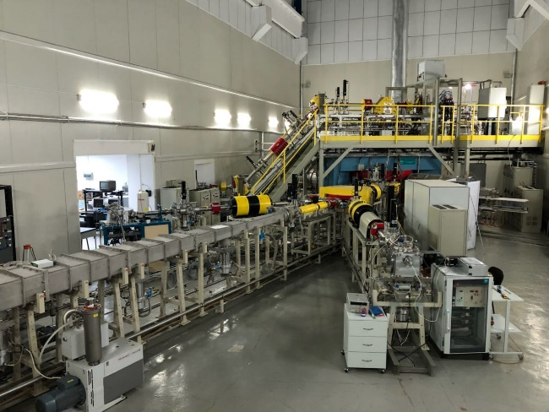 | 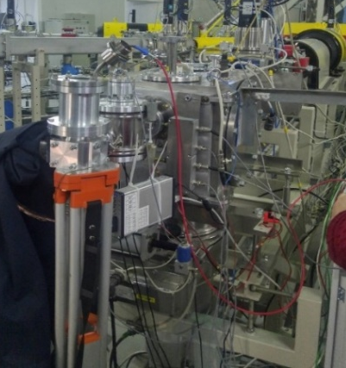
Figure 4 – General view of the complex for measuring IL

This complex is designed to measure IL and luminescence kinetics upon irradiation with high-energy ions.

  - Modification of the complex for IL measuring
During the reporting period (2020), work was carried out to increase the time resolution of the installation and experiments to measure the kinetics of ionoluminescence in the process of irradiation of Al₂O₃ and MgO single crystals with high-energy heavy ions. In the previously used standard technique, the starting signal was formed by an MCP-based detector because of registration of electron emission from a thin metal foil arising from the passage of ions through it (Fig. 5a). The energy dispersion due to scattering on the foil, in addition to that already present in the initial beam, was the main source of errors in the measurements of the time intervals between the Start and Stop signals and, hence, in the measurements of the lifetime of excited states. For the first time, the new technique used the emission of electrons directly from the surface of the irradiated sample to generate a stop signal (Fig. 5b). This made it possible to obtain a time resolution of ∆τ=250 ps.

Alfoil
Ionbeam
e⁻

𝛄
MCP
Sample

Diaphragm
PMT

Stop
Start
a)

Start

MCP
e⁻
Ionbeam

𝛄

Diaphragm
Sample
PMT

Stop
b)

a) first version of the complex; b) block diagram of a modified complex

Figure 5 – Block diagram of various techniques for generating start signals
Figure 6 shows the results of measuring the luminescence kinetics of alumina single crystals under the action of single Xe ions with different time resolution and Ar ions (∆τ=250 ps).

Figure 6 – Luminescence decay curves for α-Al₂O₃ irradiated with ¹³²Xe and Ar ions with an energy of 1.2 MeV/nucleon

As follows from the figure, the data obtained for argon and xenon ions demonstrate the stage of «fast» luminescence, which was difficult to isolate at a resolution of 600 ps. The parameters of this stage are determined by the level of specific ionization energy losses. The most probable process responsible for this stage is the recombination of charge carriers directly in the region of the trajectory of Swift heavy ions [4].

Figure 7 – Kinetics of α-Al₂O₃luminescence upon irradiation with ¹²C (1.6 MeV/nucleon), ¹³²Xe, and Ar (1.2 MeV/nucleon) ions
Luminescence decay curves in a wider time interval are given in Fig. 7. As can be seen, apart from the «fast» stage, they exhibit the components τ₂ =1,8±0,1 ns and τ₃ ₌ 54÷70 ns, which we first recorded in experiments on ionoluminescence. Radiation with a lifetime τ₂ is associated with F⁺ - centers [5]. Literature data on the third component are presented only in one work, in which the cathodoluminescence of unactivatedAl₂O₃ was studied [6].It was suggested that the so-called E luminescence with τ= from 280 ns to 28 ns in the temperature range from 80K to 300K, recorded in the band with a maximum of 3,8 eV, may be associated with the recombination of self-trapped excitons near the defect. Our data obtained in different spectral ranges also indicate that radiation with a decay time constant τ3 is detected in the range of 300-400 nm (Fig. 8).

Figure 8 – Kinetics of α-Al₂O₃ luminescence in different spectral regions. Irradiation with ¹³²Xe ions (1.2 MeV/nucleon)

The experiments carried out on single crystals of MgO showed that the luminescence decay curves contain components with a duration that depends on the level of electronic stopping. So, for xenon ions they are ~0,2 μs and ~100 μs (Fig. 9-11), at present, work is under way to establish the nature of these components and the dependence on the irradiation conditions, in particular, in a wider range of specific ionization losses energy. It was found that these components are absent in the pre-irradiated crystal, as can be seen from Fig. 9, which indicates that they are not associated with radiation damage but are due to impurities.

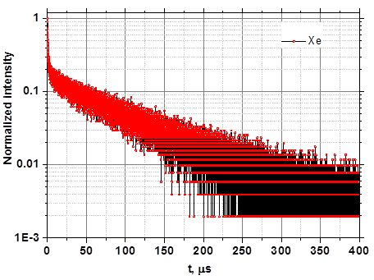

Figure 9 – The decay curve of the luminescence of MgO generated by ¹³²Xe ions (1,2 MeV/nucleon), which indicates that they are not associated with radiation damage but are due to impurities

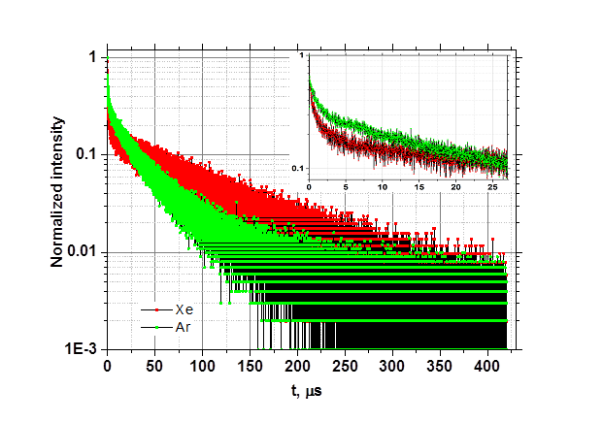

Figure 10 – Kinetics of MgO luminescence generated
by ¹³²Xe and ⁴⁰Ar ions (1,2 MeV/nucleon)

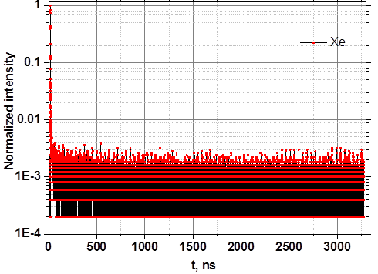

Figure 11 – Luminescence kinetics of MgO irradiated with ¹³²Xe (1,2
MeV/nucleon) to a fluence of 2,28×10¹³cm⁻². Irradiation with xenon ions (1,2 MeV/nucleon)

2 AFM and TEM research. Photoluminescence and cathodoluminescence

2.1 AFM studies of nanohardness along the ion path. TEM research
Hardness profiles versus the depth of ion penetration were studied on a cross-section along the ion path. The measurements were carried out at a constant indentation depth (150 nm). Figure 12 illustrates the variation of hardness and SRIM-calculated energy loss along the Xe-ion path in MgO irradiated with different fluence. The ion-induced hardening becomes detectable at Ф> 10¹¹ Xe/cm² corresponding to a stage of track overlapping. The hardness increases with fluence and at Ф =10¹⁴ Xe/cm² turns to saturation at about 15.6 GPa (hardening effect ΔH/H₀ ~50%). [7].

Figure12 – Change in hardness along the path of ¹³²Xe ions with an energy of 230 MeV with different fluences in MgO

The hardness variation in the initial part of range correlates with the depth behaviour of electronic energy loss. It should be taken into account that in the incoming part of Xe ion range (up to 5 m) the electronic stopping power exceeds the 22 keV/nm threshold for the formation of latent tracks and creates ultimate excitation [8], but as our TEM studies showed, the tracks did not are ceated (Fig. 13 and 14).
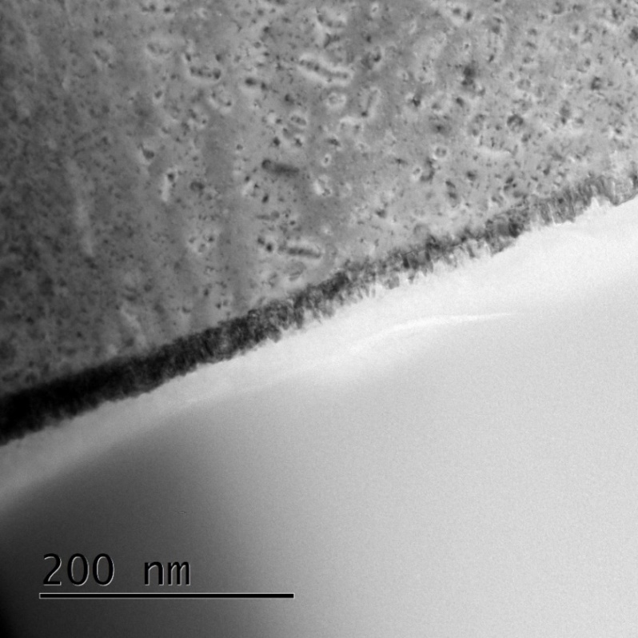

Figure 13 – TEM studies of MgO crystals irradiated with 470 MeV Xe ions to a fluence of 2х10¹⁰ ions/cm²

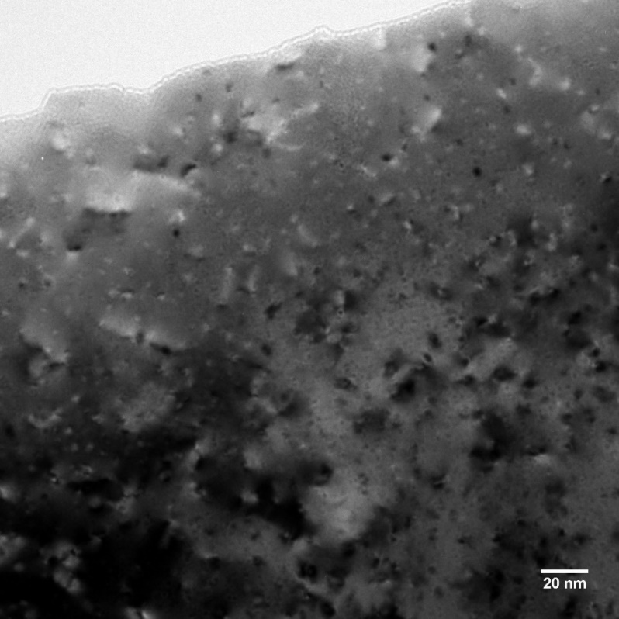

Figure 14 – TEM studies of MgO crystals irradiated with 167 MeV Xe ions to a fluence of 2х10¹⁰ ions/cm²

The electron loss for ¹³²Xe 167 MeV is 21 keV/nm, and for ¹³²Xe 470 MeV it is 24keV/nm, but there are no defects associated with the formation of tracks. The reason for this behavior is the recrystallization of the track region [9]. This process also contributes to hardening.
At the end of the ion path, the hardness at high fluence reaches a maximum. In this region, the electron energy losses of ions decrease to small values, while nuclear energy losses reach their maximum and dominate in the creation of radiation defects. Ion-induced complex defects, including dislocations and complex defects, are considered as the main reason for hardening [10]. At a fluence of Ф<10¹²Xe/cm², no contribution of elastic retardation to crystal hardening is observed.
The results allow us to conclude that both electronic and nuclear losses of ¹³²Xe ions contribute not only to the creation of color centers, but also to the formation of aggregates of defects and more complex defects.

2.2 Analysis of point defects
Absorption spectra in different spectral ranges were measured on two devices: a Jasco 660 double-beam spectrophotometer in the range from 1.4 to 6.5 eV and a VMR-2 vacuum monochromator from 5 to 7.5 eV. Figure 15 shows a set of RIOA spectra measured for MgO single crystals irradiated with ¹³²Xe ions with a fluence varying by almost three orders of magnitude.

Figure15 – RIOA spectra of MgO single crystals irradiated with 230 MeV ¹³²X ions to various fluences
The spectra consist of several well-pronounced broad bands with maxima of 5,0, 3,48, and 2,16 eV, which were previously analyzed in the literature in additively colored or highly irradiated MgO crystals (see [11-17]). The non-elementary band at ~5 eV is a superposition of two bands with maxima at 5.03 and 4.92 eV, attributed to the so-called F and F⁺ centers (two or one electron captured by an oxygen vacancy, respectively), the simplest aggregate F₂ centers (two spatially close F centers) are responsible for the band, the peak of which is 3.48 eV, while the complex band, the peak of which is ~2.1 eV, belongs to structural defects of still unclear origin.The bands associated with the iron impurity have values at the maxima of 4.26 and 5.74 eV. In the case of a high fluence, the upper part of the complex UV band was reconstructed along the known contour of the absorption band at the measured fluence.
To analyze the dependence of the concentration of F-type radiation defects on the irradiation fluence (nine different values), the RIOA spectra of MgO crystals were approximated by decomposition into Gaussian components. An example is shown in Figure 16.

Figure 16 – Decomposition of the spectrum of radiation-induced optical absorption кристаллаMgO (Ф = 1×10¹⁴Хе/cm²) into Gaussian components

Figure 17 – Dependence of the number of F-type centers (according to the Gaussian maximum RIOA) on the fluence

The concentration of F-type defects in MgO crystals irradiated with heavy ions can be estimated using the Smakula-Dexter formula [18]. When irradiated with heavy ions, the average ion range R is significantly less than the sample thickness; in this case, the surface density of defects is equal to:

(1)

where I_{max} is the radiation-induced OD at the maximum of the absorption band, the coefficient k takes into account the oscillator strength f and the half-width (W_{1/2}) of the absorption band of the F-type center, as well as the refractive index (n = 1.74) for MgO.Taking f = 0.8 for both centers, F and F⁺ and based on our decomposition results W_{1/2} (F) = 0,77 eV, W_{1/2} (F⁺) = 0,62 eV, we get the values k = 5,76 and k = 4,64 for the F- and F⁺ -centers, respectively. The average volumetric concentration of defects N [cm⁻³] can be estimated by the formula:

(2)

According to Fig. 15, xenon ions create a very small number of F₂ centers (see the OD values on the right ordinate) and, in addition, even a decrease in the number of F₂ centers (as well as the F₂/F ratio) is observed at Ф ≥10¹³Xe/cm². Parameters of color centers in MgO crystals irradiated with ¹³²Xe ions with an energy of 230 MeV in the fluence range Φ=5×10¹¹– 3,3×10¹⁴ Xe/cm² (Tab.1).

Table 1 – Parameters of color centers in MgO crystals
Ion | E,  GeV | R,  μm | Fluence,  Xe/cm² | I_{max} | N [cm⁻³] ∙10¹⁹
 |  |  |  | F⁺ | F | N | N
Xe | 0,23 | 14 | 5×10¹¹ | 0,32077 | 0,21397 | 0,24 | 0,2
Xe | 0,23 | 14 | 1×10¹² | 0,61341 | 0,24399 | 0,5 | 0,3
Xe | 0,23 | 14 | 3,3×10¹² | 0,94701 | 0,57586 | 0,7 | 0,5
Xe | 0,23 | 14 | 6,7×10¹² | 1,54813 | 1,01653 | 1,2 | 1
Xe | 0,23 | 14 | 1×10¹³ | 1,7122 | 1,12941 | 1,3 | 1,1
Xe | 0,23 | 14 | 3,3×10¹³ | 2,63649 | 1,76907 | 2 | 1,7
Xe | 0,23 | 14 | 6,7×10¹³ | 3,18196 | 2,13508 | 2,4 | 2,1
Xe | 0,23 | 14 | 1×10¹⁴ | 3,57158 | 2,4401 | 2,7 | 2,3
Xe | 0,23 | 14 | 3,3×10¹⁴ | 4,39414 | 3,13552 | 3,35 | 3,1

The dose dependence of the concentration of radiation defects contains an approximately linear region above Ф= 3,3×10¹⁴ Xe/cm² (more obvious in the case of a linear abscissa scale), while a much higher rate of defect accumulation is characteristic of the region of low irradiation fluences. It is generally accepted that the rapidly growing nonlinear component of the dose dependence below Ф= 3,3×10¹³ Xe/cm² can be explained by the partial formation of F-type centers due to oxygen vacancies already existing in the crystal before irradiation.At the same time, the second nonlinear stage of accumulation (stage of saturation) of defects, which appears presumably due to the aggregation of single F-type centers (for example, the formation of F₂ or more complex defects) is not observed even at the maximum fluence Ф= 3,3×10¹⁴ Xe/cm² within the framework of this experiment. This fact is also confirmed by the dependence of the concentration of F₂ centers on the irradiation fluence.

2.3 Analysis of photo- and cathodoluminescence spectra
Cathodoluminescence spectra were measured upon excitation of the sample with an electron beam with an energy of 10 keV and a current of 0.1 μA in the laboratory of the Institute of Physics of the University of Tartu. According to the CASINO simulation data [19], the penetration depth of such electrons is about 0.5 m. The installation was equipped with a closed-cycle helium cryostat (5–400 K) and two monochromators covering a wide spectral range of 1.5-10 eV: an ARC SpectraPro 2300i monochromator and a homemade double vacuum monochromator. To avoid surface charge of the crystals during the excitation of the electron beam, 3 nm Pt films were deposited on all samples.
Figure 19 shows the cathodoluminescence spectra for unirradiated and irradiated with ¹³²Хе ions to different fluences of MgO crystals, measured at 5 K, luminescence is excited by 10 keV electrons. Pre-irradiation with Xe ions leads to drastic changes in the spectra.

Figure 18 – Cathodoluminescence of unirradiated (curve 1) and after irradiation (curve 2-4) MgO crystals excited by 10-keV electrons at 6 K. 2 - Φ = 5×10¹¹Xe/cm²; 3 - Φ = 1×10¹²Xe/cm²; and 4 - Φ = 1×10¹³Xe/cm². The inset shows the expansion of the ~ 3.1 eV band (symbols - experimental curve) in Gaussian components for MgO irradiated to Φ = 1×10¹³Xe/cm²

The sharp decay of exciton-type luminescence with fluence is associated with the appearance of radiation-induced structural defects, where effective nonradiative decay of mobile excitons occurs, and the suppression of cathodoluminescence at ~5.3 eV can be explained by the reabsorption of this radiation by the F and F⁺ centers created by ion irradiation. On the other hand, the transformation of visible cathodoluminescence and a significant increase in luminescence with a maximum at ~3.1 eV are also associated with radiation-induced structural defects.
Decomposition of the complex CL band at 2-4 eV in the irradiated sample gives three Gaussians associated with the emissions of the F- and F⁺ -centers (peaks at 2,4 and 3,2 eV with half-width W_{1/2} = 0,6 eV for both components), and the component at ~ 2,8 eV is presumably attributed to divacancies created by lattice deformation during FHI irradiation. As can be seen from Figure 4.4, the emission intensity of the F⁺ centers (3.2 eV) are significantly higher than the emission of the F centers (2.4 eV).
For these luminescence bands, we measured the excitation spectra in an MgO crystal irradiated with ¹³²Xе ions with a fluence of 10¹² ions/cm². As can be seen from Fig. 19, a clear band with a maximum at about 4.8 eV (curve 1) is seen in the excitation spectrum for a 3.15 eV emission (curve 1), and for a 2.4 eV emission, a less pronounced band with a maximum at 4.7 eV (curve 2). It is obvious that the recorded excitation bands should belong to F⁺ and F-centers, respectively. For comparison, the figure also shows the absorption spectrum of the same crystal at room temperature (curve 3). Recall that the absorption bands of F⁺ - and F-centers are not allowed due to strong overlap.

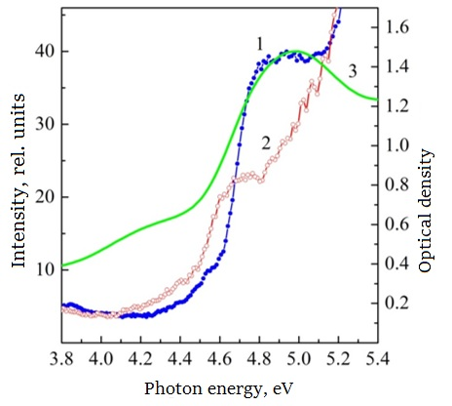

Figure 19 – Excitation spectra for the luminescence of the F⁺ and F centers of a MgO crystal irradiated with ¹³²Xe ions with a fluence of 10¹² ions/cm²: curve 1 is the luminescence excitation spectrum at 3.15 eV, curve 2 is the luminescence excitation spectrum at 2.4 eV, and curve 3 is the optical absorption spectrum. The excitation spectra were measured at 79 K, the optical absorption spectrum was measured at room temperature

In the CL spectra, there is a clear increase in the emission of F + and F centers with xenon fluence (up to not very high values). At the same time, a sharp weakening/suppression of cathodoluminescence in other spectral regions occurs due to partial reabsorption of luminescence by radiation-induced structural defects (including F⁺- and F-centers), as well as in connection with a possible increase in the efficiency of nonradiative processes in irradiated Xe -ions crystals.
In Xe-irradiated MgO, the emission intensity of the F⁺ centers is much higher than that of the F centers, and the bulk concentration of F⁺ and F centers, determined from the absorption spectra, is approximately the same.
Upon excitation of pre-irradiated SHI MgO crystals with an electron beam, radiation-induced F⁺ and F centers enter into secondary reactions with e-h pairs formed upon excitation by 10-keV electrons, which can distort the actual ratio of the number of F/F⁺ centers. The ratio of the intensity of the luminescence of the F⁺ - and ⁺ -centers depends on the type of external action (irradiation with fast neutrons or SHI, thermochemical reduction) on the MgO crystals.[20] This difference, in particular, testifies to the irreducibility of the mechanisms of the formation of F-type centers upon irradiation with fast heavy ions to only the impact mechanism, which fully describes the processes of defect formation under the influence of fast neutrons [20].

CONCLUSION

The tasks set for 2020 have been fully implemented. In conclusion, the main results from previous years are also presented.
The work was carried out within the framework of the grant funding program for 2018-2020, in cooperation with Doctor of Physical and Mathematical Sciences, Skuratov V.A., G.N. Flerov FLNR, JINR (Dubna), in accordance with the schedule.
Mainresults:
- A complex for in-situ measurement of high-energy ionoluminescence at the DC-60 accelerator was created. We have received the certificate of implementation of the complex for measuring of IL.
- In 2020, work was carried out to increase the temporary resolution of the facility. For the first time, the new technique used the emission of electrons directly from the surface of the irradiated sample to generate a stop signal. This made it possible to obtain a time resolution of ∆τ=250 ps.
- The IL kinetics of Al₂O₃ and MgO were measured using a new technique. Over a wider time, range. For aluminum oxide, it was recorded for the first time that, in addition to the "fast" stage, they exhibit the components τ₂ =1,8±0,1 ns and τ₃ ₌ 54÷70 ns. Radiation with a lifetime τ₂ is associated with F⁺ - centers. Our data obtained in different spectral ranges indicate that radiation with a decay time constant τ₃ is detected in the range of 300–400 nm and can be associated with the recombination of self-trapped excitons near the defect. The IL decay curves of magnesium oxide exhibit components with a duration that depends on the level of electronic braking. So, for xenon ions, they are ~0.2 μs and ~100 μs.
- The RIOA spectra were investigated in the range 1.4 - 7.5 eV for a single crystal of MgO irradiated with 230 MeV ¹³²Хе ions. Several complex bands were recorded in the spectra with maxima at ~ 5 eV, ~ 5,6-5,8 and 2.16 eV. The analysis showed that the bands with maxima at 5.03 and 4.92 eV are associated with the F and F⁺ centers, the simplest aggregate centers F₂ are responsible for the 3.48 eV band, the ~ 2.1 eV band belongs to structural defects of still unclear origin. Bands associated with an iron impurity at 4.26 and 5.74 eV.
- Measurement and analysis of the cathodoluminescence spectra of irradiated MgO crystals showed a sharp decay of the luminescence of free and bound excitons. The decay of the exciton luminescence with increasing fluence is associated with the appearance of radiation-induced structural defects, on which the effective nonradiative decay of mobile excitons occurs. At low fluences, an increase in the intensity of intra-center luminescence created by radiation of F⁺- and F-centers is recorded, which makes it possible to monitor the accumulation of radiation defects using the cathodoluminescence signal.
- An analysis of the depth profile of nanohardness in MgO crystals showed that it correlates with the energy losses of Xe ions. Thus, the joint contribution of impact and ionization mechanisms to the formation of complex structural defects has been confirmed.
- TEM studies of MgO single crystals irradiated with ¹³²Xe 167 MeV and ¹³²Xe 470 MeV ions show the absence of defects associated with the formation of tracks. The reason for this behavior is the recrystallization of the track region. Thisprocessalsocontributestohardening.
8.The contribution of «track effects» was found in the IL of Al₂O₃ crystals, measured during irradiation with C, Ar, Kr and Xe ions with energies of 1.67 MeV/nucleon, when the contribution of fast luminescence increases with increasing excitation density. The most probable nature of which is the recombination of charge carriers in the region of the latent track.
A study of the PL on a transverse cleavage of an Al₂O₃ crystal showed that the profiles of the PL exit (flash) of F₂⁺ centers correlate with the spatial distribution of defects formed in elastic collisions. Thus, the formation of vacancy-type point defects and their complexes in Al₂O₃ is not associated with latent tracks formed along the channel of ionization energy losses.
On the surface of the Al₂O₃ crystal, during SHI irradiation, hillocks are formed. TEM studies show the crystal structure for aluminum oxide. The surface layer is amorphous.
9. The IL spectra of LiF crystals, depending on the fluence, show a decrease in the intensity of the exciton IL with a fluence of 2 10¹¹ ions/cm², a decrease in the IL intensity of F₂ centers begins with a fluence of 8.4 10¹¹ ions/ cm², and the IL F₃⁺ center reaches saturation, and an increase in the IL of F₂⁺ centers begins. A study of the PL on a cross-section of an LiF crystal showed that the profiles of the PL exit (flash) of the F₂ and $F_{3}^{+}$ centers correlate with the spatial distribution of defects formed in elastic collisions. This gives grounds to assert that the formation of vacancy-type point defects and their complexes in LiF is not associated with latent tracks formed by the channel of ionization energy losses. A decay of the luminescence intensity of the F₂ and $F_{3}^{+}$ aggregate color centers was observed at the end of the track. The effect is associated with the formation of non-luminescent agglomerates by the segregation of aggregate color centers on ion-induced dislocations as traps for radiation defects. The activating role of the local stress field with extended defects in such transformations is assumed.
10. We received an act of introducing into the educational process the training manual "Ionoluminescence of dielectrics" created within the project.Three Q2 articles were published in 2020.
The obtained results show that in-situ IL can predict the behavior of inert matrixes of nuclear composite fuel under the influence of fission fragments.
REFERENCES

- Barberio M., Barone P., Bonanno A., Camarca M. Thermo- and iono-luminescence on MWCNT bundles // Radiation Physics and Chemistry. – 2007. – Vol. 76. –P. 492–494.
- Jardin C., Canut B., Ramos S.M.M. The luminescence of sapphire subjected to the irradiation of energetic hydrogen and helium ions // J. Phys. D: Appl. Phys. – 1996. – Vol. 29. –P. 2066–2070.
- Wataru K., Akihito Y., Masashi K., Takahiro S., Tomihiro K. High-resolution ion luminescence analysis with external proton microbeam probe // International Journal of PIXE – 2013. –Vol. 23. – P. 47–53.
- Kimura S., Sharma A.I., Popov A. Novel ultra-fast luminescence from incipient ion tracks of insulator crystals: electron–hole plasma formation in the track core // Radiation Measurements. –2001. –Vol. 34. – P. 99–103.
- Toshima R., Miyumaru H., Asahara J., Murasawa T. Ion Induced Luminescence of Alumina with Time-resolved Spectroscopy // J. Nucl. Sci. Techn. –2001. –Vol. 39. –№1. – P.15-18.
- Kulis P.A., Rachko Z.A., Springis M.E., Tale I.A., Yansons J.L. Recombination luminescence of non-activated alumina. Electronic Processes and Defects in Ionic Crystals // Collection of Scientific Papers. –1985. – P. 86-124.
- Baubekova G., Akilbekov A., Feldbach E., Grants R., Lushchik A., Manika I., Zdorovets M., Vasil’chenko E. Radiation defects and modification properties in MgO crystals irradiated with swift ¹³²Xe ions // Abstracts book the 20th International Conference on Radiation Effects in Insulators. –2019. – P. 111.
- Beranger M., ThevenardP., BrenierR., Balanzat E. Defect creation by electronic processes in MgO bombarded with GeV heavy ions // Mat. Res. Soc. Symp. Proc. –1996. – Vol. 396. – P. 365-370.
- Rymzhanov R.A., Medvedev N., O’Connell J.H., Janse van Vuuren A., Skuratov V. A., Volkov A. Recrystallization as the governingmechanism of ion track formation // Sci. Rep. –2019.– Vol. 9. – P. 3837.
- Sibley W.A., Chen Y. Radiation damage in MgO // Phys. Rev. –1997. – Vol. 160.– P. 712-716.
- Chen Y., Williams R.T., Sibley W.A. Defect cluster centers in MgO // Phys. Rev. – 1969. – Vol. 182. – P. 960-964.
- Kappers L.A., Kroes R.I., Hensley E.B. F⁺ and F’ centers in magnesium oxide // Phys. Rev. B. –1970. – Vol.1. – P. 4151-4157.
- Evans B.D., Comas J., Malmberg P.R. Coloration induced in MgO by Ne⁺ bombardment // Phys. Rev. B. –1972. – Vol. 6. – P. 2453-2462.
- Evans B. Spectral study of Ne⁺-bombarded crystalline MgO // Phys. Rev. B. –1974. – Vol. 9. – P. 5222-5235.
- Henderson B. Anion vacancy centers in alkaline earth oxides // CRC Crit. Rev. Solids State Mater. Sci. –1980. – Vol. 9. – P. 1-60.
- Gonzalez R., Chen Y., Sebek R., Williams G., Williams R., Gellermann W. Properties of the 800-nm luminescence band in neutron-irradiated magnesium oxide crystals // Phys. Rev. B. –1991. – Vol.43. – P. 5228-5233.
- Gonzalez R., Chen Y., Sebek R.M., Williams G.P., Williams R.T., Gellermann W. Properties of the 800-nm luminescence band in neutron-irradiated magnesium oxide crystals // Phys. Rev. B. –1991. – Vol. 43. – P. 5228-5233.
- Schwartz K.,Volkov A.E., Sorokin M.V., Trautmann C., Voss K.-O., Neumann R., Lang M. Effect of electronic energy loss and irradiation temperature on color-center creation in LiF and NaCl crystals irradiated with swift heavy ions // Phys. Rev. B. – 2008. – Vol.78. – P. 024120.1-10.
- Lushchik Ch. B., Lushchik Ch. A. Decay of Electronic Excitations with Defect Formation in Solids. – Moscow: Nauka, 1989. – P. 12.
- Lushchik A., Dolgov S., Feldbach E., Pareja R., Popov A.I., Shablonin E., Seeman V. Creation and thermal annealing of structural defects in neutron-irradiated MgAl₂O₄ single crystals // Nucl. Instr. Meth. B. – 2018. – V. 435. – P. 31–37.

APPENDIX A
Applications 1.1-1. __
to the Treaty №132 from 12.03. 2018.
for grant funding

TECHNICAL SPECIFICATIONS AND
CALENDAR WORK PLAN

Under contract № 132 from «12» march 2018

1.Republican state enterprise on the right of economic management «L.N.Gumilyov Eurasian National University» Ministry of Education and Science of the Republic of Kazakhstan
1.1 Bypriority: Energy and mechanical engineering..
1.2 By sub-priority: Alternative energy and technologies: renewable energy sources, nuclear and hydrogen energy, other energy sources.
1.3 By project topic: № AP05134257«In-situ research of structure and mechanical stresses in the process of irradiation with fast heavy ions by the methods of high-energy ionoluminescence»
1.4 The total amount of the project 23947120 (twenty three million nine hundred forty seven thousand one hundred twenty) tenge, including with a breakdown by years, to perform work in accordance with paragraph 3:
- for 2018 year -in the amount of8000000(eight million) tenge;
- for 2019 year -intheamountof8109672(eight million one hundred nine thousand six hundred seventy two)tenge;
- for 2020 year -intheamountof7837448(seven million eight hundred thirty seven thousand four hundred forty eight)tenge.

2. Characteristics of scientific and technical products by qualification characteristics and economic indicators
2.1 Direction of work: Applied scientific research
2.2 Application area: radiation materials science
2.3 End result:
- for 2018 year: creation of a set of equipment for measuring IL at the DC-60 cyclotron. Spectra of IL, AFM, SEM and TEM images, spectra of confocal luminescence and PCL of the studied samples depending on the irradiation regimes, prepared thesisof conferences, articles
- for 2019 year: IL spectra, AFM, SEM and TEM images, confocal luminescence and PCL spectra of MgAl₂O₄ and Al₂O_{3,} samples, depending on the irradiation regimes. Prepared conference thesis, articles
- for 2020 year: IL spectra, AFM, SEM and TEM images, confocal luminescence and PCL spectra of MgO, samples, depending on the irradiation regimes. Prepared conference thesis, articles. Final analysis of the results obtained. Report. Tutorial «Ionoluminescence of dielectrics»
2.4 Patentability: not provided
2.5 Scientific and technical level (novelty): for the first time at the DC-60 cyclotron, a set of equipment will be created for measuring ionoluminescence during irradiation, to study the appearance of mechanical stresses that can significantly affect the radiation resistance and long-term stability of dielectrics, candidate materials for inert nuclear fuel matrices

2.6 The use of scientific and technical products is carried out: sharing according to the legislation of the Republic of Kazakhstan
2.7 Type of use of the result of scientific and (or) scientific and technical activities: for the selection of candidate materials for composite nuclear fuel

3. Name of work, terms of their implementation and results
Job code, stage |  | Name of work under the Agreement and the main stages of its implementation* | Period of execution* |  |  | Expectedresult*
 |  |  | start |  | ending
1 |  | Creation of a set of equipment for measuring IL at the DC-60 cyclotron | 03.01.2018 |  | 30.06.2018 | A set of equipment for in-situ measurements of ionoluminescence (IL) will be created at the DC-60 cyclotron
1.1 |  | Installation of the system on the DC-60 cyclotron channel | 03.01.2018 |  | 28.02.2018 | The system will be installed on the DC-60 cyclotron channel.
1.2 |  | Calibration of the measuring device | 01.03.2018 |  | 31.03.2018 | The measuring channel will be calibrated and the measurement errors will be estimated
1.3 |  | Development of modes for measuring and decoding IL spectra on model crystals | 02.04.2018 |  | 30.06.2018 | The modes of measuring and decoding the IL spectra on model crystals will be developed. Ionoluminescencespectrawillbeobtained
2 |  | In-situ studies of the structure and mechanical stresses during FHI irradiation by the ionoluminescence methods of LiF, MgAl₂O_{4,} Al₂O_{3,} MgO crystals. Irradiation of the FHI with the energies of fission fragments | 02.07.2018 |  | 30.06.2020 | In-situ studies of the structure and mechanical stresses during FHI irradiation by ionoluminescence methods of LiF, MgAl₂O_{4,} Al₂O_{3,} MgO crystals will be carried out. Irradiation of the FHI with the energies of fission fragments. The IL spectra of the studied samples were obtained depending on the irradiation modes.
2.1 |  | Measurement of IL spectra for LiF crystals depending on the irradiation regimes | 02.07.2018 |  | 01.11.2018 | The IL spectra will be measured for LiF crystals depending on the irradiation regimes. The IL spectra of LiF were obtained depending on the irradiation modes.
2.2 |  | Measurement of IL spectra for MgAl₂O₄ crystals depending on the irradiation regimes | 01.01.2019 |  | 29.06.2019 | The IL spectra will be measured for MgAl₂O₄ crystals depending on the irradiation regimes. The IL spectra of MgAl₂O₄ were obtained depending on the irradiation modes.
2.3 |  | Measurement of IL spectra of Al₂O₃, depending on the irradiation modes | 01.07.2019 |  | 01.11.2019 | The IL spectra of Al₂O₃ will be measured, depending on the irradiation regimes The IL, Al₂O₃ spectra will be obtained, depending on the irradiation regimes
2.4 |  | Measurement of IL spectra of MgO depending on the irradiation regimes. Analysis of results | 03.01.2020 |  | 30.06.2020 | The IL spectra of MgO will be measured depending on the irradiation regimes and the analysis of the results will be carried out.The spectra of IL, MgO will be obtained depending on the irradiation regimes and the analysis of the results1
3 |  | SEM, AFM, TEM investigation of the surface and transverse cleavage of samples of irradiated FHI. | 02.07.2018 |  | 30.06.2020 | They will be investigated using SEM, AFM, TEM of the surface and transverse cleavage of samples of irradiated FHI. AFM, SEM, TEM images of the samples were obtained depending on the irradiation modes
4 |  | Study of confocal luminescence of samples along the ion path. Pulsedcathodoluminescence (PCL) measurement. | 02.07.2018 |  | 31.11.2020 | The confocal luminescence of the samples along the ion path will be studied and pulsed cathodoluminescence (PCL) will be measured. The spectra of confocal luminescence and PCL were obtained depending on the irradiation modes
5 |  | Approbation of the results. Preparation of publications | 02.07.2018 |  | 01.11.2020 | The results will be tested. and publications prepared. Preparedconference thesis, articles
6 |  | Completeanalysisofresults | 3.08.2020 |  | 31.10.2020 | A full analysis of the results will be done. The result is a final analysis of the results. ReportTutorial «IonoluminescenceofDielectrics»
 | From customer:  _________________________________  SI «Science committee of the Ministry of Education and Science of the Republic of Kazakhstan»  ______________ B. Abdrasilov |  |  | From the Contractor:  Vice-rector  for research work  ________________G. Merzadinova  Familiarized with:  Scientific supervisor of the project  ____________А.T. Akilbekov
APPENDIX B

List of published works for 2018 - 2020

List of published works for 2018
Articles with an impact factor
- Dauletbekova A.K., SkuratovV.A., KirilkinN.S., I. Manika, J. Maniks, R.Zabels, Akilbekov A., VolkovA., BaizhumanovM., ZdorovetsM. et. al. Depth profiles of aggregate centers and nanodefects in LiF crystals irradiated with 34 MeV ⁸⁴Kr, 56 MeV ⁴⁰Ar and 12 MeV ¹²C ions // Surf. & Coat. Tech., –2018. –Vol. 355. –P.16-21. IF- 3.78, Q1 https://doi.org/10.1016/j.surfcoat.2018.03.096
- O’Connel J., Aralbayeva G., Skuratova V., Saifulin M., Akilbekov A., Zdorovets M. Temperature dependence of swift heavy ion irradiation induced hillocks in TiO₂ // Mater. Res. Exp. – 2018. – Vol. 5. – P.055015. IF- 1.929, Q3 https://doi.org/1088/2053-1591/aac0ce
Article recommended by CCSES MES RK
- Dauletbekova A.K., SkuratovV.A., Manika I., Maniks J., Zabels R., Kirilkin N., Akilbekov A., Giniyatova Sh., Baizhumanov M., Seitbayev A. Dislocation mechanism of fading of luminescence intensity // Bulletin of ENU, Physics Series. Astronomy. –2018. – №1(122). –P. 91-100. (rus)
Theses and reports of international conferences
- Dauletbekova A.K., KirilkinN.S., Akilbekov A.T., SeitbayevA., SkuratovV.A. et al. Iono and photoluminescence characterization ofradiation damage in oxide crystals induced by swift heavy ions irradiation // Abstracts book the European Materials Research Society. Spring meeting. –2018. –PI.26.
- Akilbekov A.T., Skuratov V.A., Kirilkin N.S., Dauletbekova A.K.,Giniyatova Sh et al. Iono - and photoluminescence of oxyde single crystals induced by swift heavy ions irradiation // Abstracts book the International Congress on Energy Fluxes and Radiation Effects. –2018. –P. 469.
- GiniyatovaSh., SkuratovV.A., KirilkinN.S., Dauletbekova A.K.,AkilbekovA. etal. Iono - and photoluminescence characterization of radiation damage in dielectric crystals induced by swift heavy ion irradiation // Abstracts book the 10th European Conference on Luminescent Detectors and Transformers of Ionizing Radiation LUMDETR. – 2018. –P. 111.
- Dauletbekova A.,Kirilkin N.S., Manika I., Manks J. Zabels R., Akilbekov A., SeitbayevA. et al. Depth profile aggregate centers and nanodefects in LiF crystals irradiated with swift heavy ions // Abstracts book the First Annual Meeting of Kazakh Physics Society KPS. –2018. –P.45.

List of published works for 2019
Articles with an impact factor
- Rymzhanov R., Medvedev N., Skuratov, V. A. O’Connel J. Recrystallization as the governing mechanism of ion track formation // Scientific reports. – 2019. – Vol. 9. – P.3837. F-3.4998. Q1. https://doi.org/10.1038/s41598-019-40239-9
Article recommended by CCSES MES RK
- Akilbekov A., Dauletbekova A.K., SkuratovV.A., Giniyatova Sh., Seitbayev A. Creation of facility for in-situ measurement of high-energy ionoluminescence DС-60 // Bulletin of ENU, Physics Series. Astronomy – 2019. –№3(128). – P.25-33. (rus)
Theses and reports of international conferences
- Seitbayev A., Dauletbekova A. Installation for "In-situ" studies of high-energy luminescence at the DC-60 accelerator // Proceedings of the XV International Scientific Conference of Students and Young Scientists "Science and Education”. -2019. -P.416-418. (rus)
- O’Connell J., Aralbayeva G., Skuratov V., Saifullin M., Akilbekov A., Zdorovets M., Seitbayev A., Dauletbekova A. Surface nanoscale defects induced by single swift heavy ions in crystalline oxid // Abstracts book the European Materials Research Society, Spring meeting 2019, International Conference on Advanced Materials. Simposium J. Nuclear Materials. –2019. – P1.7.
- Akilbekov A., Seitbayev A., Teterev Yu., Krylov A., Zdorovets M., Dauletbekova A. High Energy ionoluminescence of Al₂O₃ and LiF: Time Resolved Studies // Abstracts book the 21th International Conference on Surface Modification of Materials by Ion Beams.–2019. – P. 68.
- Seitbayev A., Skuratov V., Dauletbekova A., Teterev Yu., Krylov A., Zdorovets M. Time-resolved high energy ionoluminescence of Al₂O₃ ana CsI(TI) // Proceedings of the 20th International Conference on Radiation Effects in Insulators.–2019. – P. 86.
- Zdorovets M., Skuratov V., Dauletbekova A., Seitbayev A., Teterev Yu., Krylov A. Experimental set-up for high energy ionoluminescence characterization of radiation damage in materials at DC-60 cyclotron // Proceedings of the 20th International Conference on Radiation Effects in Insulators.–2019.. – P. 145.

List of published works for 2020
Articles with an impact factor
- Baubekova G., Akilbekov A., Popov A.I., Shablonin E., Vasil’chenko E., Zdorovets M., Lushchik A. About complexity of the 2.16 eV absorption band in MgO crystals irradiated with swift Xe ions // Radiation Measurements.–2020. –Vol.135. –P.106379 IF-1.435. Q2.https://doi.org/10.1016/j.radmeas.2020.106379
- Baubekova G., Akilbekov A., Kotomin E.A., Kuzovkov V.N., Popov A.I., Shablonin E., Vasil’chenko E., Zdorovets M., Lushchik A. Thermal annealing of radiation damage by swift ¹³²Xe ions in MgO single crystals // Nucl. Instr. Meth. B.–2020. –Vol.462. –P.163-168. IF-1.27. Q2 https://doi.org/10.1016/j.nimb.2019.11.021
- Baubekova G., Akilbekov A., Feldbach E., Popov A.I., Schwartz K., Vasil’chenko E., Zdorovets M., Lushchik A. Accumulation of radiation defects and modification of micromechahnical properties under MgO crystal irradiation with swift ¹³²Xe ions // Nucl. Instr. Meth. B.–2020. –Vol.463. –P.50-54. IF-1.27. Q2 https://doi.org/10.1016/j.nimb.2019.11.021
Article recommended by CCSES MES RK
- Baubekova G., Asylbaev R., Giniyatova Sh. Radiation damage caused by swift heavy ions in MgO crystals // Bulletin of ENU, Physics Series. Astronomy.. – 2020.–№ 2(131). – P.69-77. (rus)
- Seitbayev A., SkuratovV.A., Akilbekov A., Dauletbekova A.K., Zdorovets М.V., Kinetic of LiF crystals ion luminescence // Bulletin of ENU, Physics Series. Astronomy – 2020. –№ 2(131). – P.99-109. (rus)
- Baubekova G., Asylbaev R., Giniyatova Sh. Creation and annealing of structural defects MgO, crystals irradiated with ¹³²Xe ions // Bulletin of КаzNSТU. – 2020. – Vol. 1, № 133. – P.657-663. (rus)
Theses and reports of international conferences
- Baubekova G., Akilbekov A., Feldbach E. Lusnchik A. Accumulation and thermal annealing of radiation defects in MgO single crystals irradiation with swift ¹³²Xe ions // Abstracts book the 7th International Congress on Energy Flues Effects.–2020.–P.463.
- Akilbekov A., Seitbayev A., Skuratov V., Zdorovets M., Dauletbekova A. High energy ionoluminescence of lithium fluoride and aluminum oxide single crystals// Abstracts book the 7th International Congress on Energy Flues Effects. –2020. –P.397.
Tutorial
- Akilbekov A., Dauletbekova A., Giniyatova Sh.G., Seitbayev A. Ionoluminescence of
dielectrics. –Nur-Sultan: ЕNU, 2020. –p. 93. ISBN 978-601-337-300-3
APPENDIX С

«APPROVE»
Director of Astana branch of
Nuclear physics Institute of the
Ministry of energy of Kazakhstan
______________ Zdorovets M. V.
"____" ____________ 2020

Act
on implementation of research results

This act is drawn up on the introduction of a set of equipment for measuring in-situ high-energy ionoluminescence at the DC-60 heavy ion accelerator, developed as part of the project on the topic AP05134257«In-situ research of structure and mechanical stresses in the process of irradiation with fast heavy ions by the methods of high-energy ionoluminescence».
The complex is successfully used to study the structure and mechanical stresses in materials in real time during irradiation with heavy ion beams.The complex belongs to the advanced modern methods of materials research and extends the scope of the DC-60 accelerator.On the territory of the countries of independent States, this installation is unique, and today, it has attracted the attention of a large number of scientific groups to conduct joint research in this area.

The description of the implementation object on 3 (three) sheets is attached and is an integral part of the Act.

Head of the cyclotron DC-60 | I. Ivanov
Head of the cyclotron DC-60 control  service | D. A. Mustafin
Project manager | A. T. Akilbekov

DESCRIPTION OF THE IMPLEMENTATION OBJECT

1.1 Development of a method for in-situ measurements of ionoluminescence in the interaction of high-energy ions with radiation-resistant materials
Among experimental methods for studying radiation defects in dielectrics, optical spectroscopy methods, such as measurement of absorption and luminescence spectra play a significant role.As it is known, the processes of energy dissipation of charged particles in dielectric materials are accompanied by the generation of electromagnetic radiation in the ultraviolet and visible regions of the optical spectrum caused by the radiative decay of electronic excitations, luminescence of color centers, centers associated with impurity atoms, as well as other structural defects and their complexes. Therefore, «in-situ» studies of the luminescence spectra excited by heavy ions depending on the dose, irradiation temperature, and other factors are of interest from the point of view of obtaining information about the evolution of the defective structure of irradiated materials. High-energy ionoluminescence is one of the few non-destructive methods for obtaining «structural» information when studying the properties of solids during BTI irradiation. Сonsiderable interest is the use of this method for studying radiation damage in dielectrics, in particular, in single crystals of refractory oxides and alkaline halide crystals. One of the interesting practical applications of high-energy ionoluminescence can be the assessment of the level of mechanical stresses during ion irradiation. This makes it possible to monitor the accumulation of mechanical stresses in irradiated materials and establish a relationship between the stress level and the parameters of the defective structure at different stages of its evolution. Figure 1 shows a schematic diagram of «in-situ»: studies of high-energy ionoluminescence.

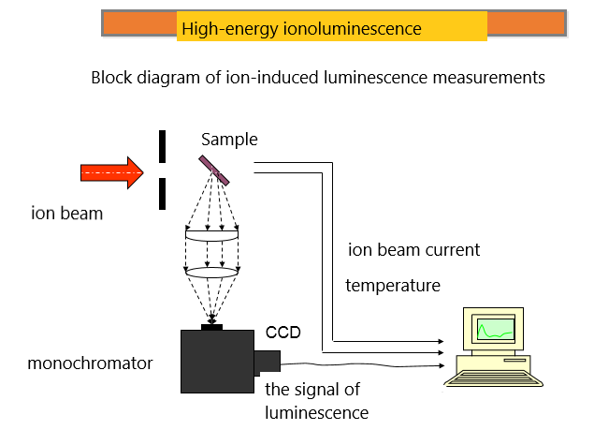

Figure 1 – «In-situ» schematic diagram of the study of high-energy ionoluminescence

As you can see, the main components are an ion accelerator, a monochromator, and a registration system.
As part of the project, a complex for in-situ study of ionoluminescence on the DC-60 cyclotron was developed and installed.
A set of equipment for «in-situ» measurements of high-energy ionoluminescence (IL) at the DC-60 accelerator was created.
Figure 2 shows a block diagram of an experimental setup for measuring ionoluminescence during irradiation, that is, in the «in-situ» mode:

 | 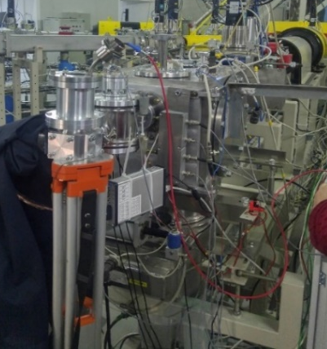
а | б
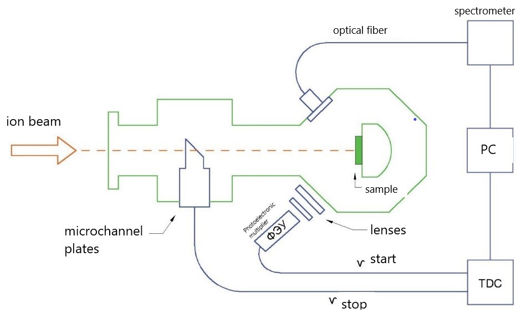
в
Figure 2– a) schematic representation of the DC-60 accelerator, the arrow indicates the location of the ionoluminescence complex; b) General view of the complex for measuring ionoluminescence, C) block diagram of the experimental installation for measuring ionoluminescence on the DC-60 cyclotron

Thecomplexcontains:
- 4-position monitor (4pMon) of the ion flux density at low intensities (104 ions / cm2) and control of the ion beam distribution over the surface of the irradiated sample with a visualization program for operators of the DS-60 cyclotron necessary to maintain the specified experimental conditions;
- A single ion Detector based on a microchannel plate (MCP) for generating "starting" pulses when measuring the lifetime of excited States;
- Minicryostat with quartz windows that allows making measurements in the temperature range of 80-300 K and the wavelength range of 300-800 nm.Installation of optical filters is provided for time measurements in a given spectral range;
- Detector for recording single photons from irradiated samples based on a Photoelectron multiplier that generates a STOP signal for time measurements;
- A device for measuring the lifetime of excited States based on the Time-amplitude Converter Time Harp 260 with a tracking level discriminator CFD (constantfractiondiscriminator), with the ability to measure in the range from tens of picoseconds to three milliseconds with the appropriate software package;
- Program for monitoring the parameters of measuring equipment (preamp gain, voltage to microchannel plates and Photoelectronic multiplier).
The appearance of the complex and the measuring part is shown in figure 3.

1.2 Calibration of the measuring device
The measuring path was calibrated directly on the DC-60 accelerator channel and the time measurement errors were estimated.Using a DRS4 digitizer (DRS4 Evaliation Board), we digitized pulses with microchannel plates and a photomultiplier tube with an accuracy of 200 picoseconds to adjust and optimize the parameters of fast preamplifiers, and determined the rise and fall times of the pulses. The conditions for the optimal signal-to-noise ratio are established. It is shown that the curves of the decay of excited states in the course of irradiation with high-energy heavy ions can be determined with an accuracy of no worse than 500 picoseconds.

1.3 Development of modes for measuring and decoding IL spectra on model crystals
Modes of measuring and decoding the IL spectra on a number of model crystals were developed. Sample ionoluminescence spectra of LiF crystals in various structural States were obtained. Irradiation was performed with Xe ions 220 MeV, fluence up to 105 ions / cm2 at room temperature and at the temperature of liquid nitrogen (80K). The sample spectra and decay curves of excited States were measured on the following materials: Al₂O₃, LiF (initial, free of structural disturbances), LiF pre-irradiated with Kr ions with energies of 245 MeV, and ZrO₂. The ion-luminescence kinetics was measured in various spectral regions selected using appropriate filters. It is shown that the decay curves of excited States, in addition to the components associated with radiative decay of color centers and luminescence centers associated with impurities, contain a fast component (lifetime less than 1 nanosecond), the nature of which is currently unknown. Recombination of charge carriers directly in the track region around the trajectory of fast heavy ions is considered as the most possible process responsible for the origin of "fast luminescence".
A unique complex of in-situ measurements of ionoluminescence under high-energy ion irradiation has been created.The main advantage of this complex is the ability to perform insitu measurements of the kinetics of radiation damage and structural changes in the material in real time when the radiation dose is set. Another advantage of ionoluminescence is the ability to vary the ion energy, mass, and penetration profile to determine and change the excitation mechanisms, including the ability to separate the effects of nuclear and electronic losses on changes in the properties of materials.
The creation and successful operation of this unique complex of in-situ ionoluminescence measurements allowed us to significantly expand the capabilities of the DC-60 heavy ion accelerator in the direction of studying the kinetics of radiation damage and their evolution.

Head of the cyclotron I. Ivanov

Project managers | A.T. Akilbekov  V. Skuratov

«APPROVE»
Vice-rector of academic Affairs
L.N. Gumilyov Eurasian National University
_______________ E. A. Ongarbaev
«___» _____________ 2020

The act of implementing
the results of research work in the educational process

We, the undersigned, Director of the Department of Academic affairs Kashkhynbai B.B., Dean of the Faculty of Physics and Technology Nurmoldin E.E., Head of the Department of Technical Physics Salikhodja Zh.M. and the scientific project manager Akilbekov A.T, drew up this act stating that the results of research work on the topic АР 05134257 «In-situ research of structure and mechanical stresses in the processes of irradiation with fast heavy ions by the methods of high-energy ionoluminescence» (Grant funding for research in 2018-2020) and tutorial «Ionoluminescence of dieletrics» of Akilbekova A., Dauletbekova A., Giniyatova Sh, Seitbayev A. published within the framework of the project, have theoretical and practical significance for the educational process.
The results of scientific research and the textbook are implemented in the educational process of the Universityin 1 semester forthe first-year doctoral students of the specialty 8D05323 «Technical physics» in the discipline Ion-beam modification of materials) in 2019-2020, 2020-2021 academic years.

Director of the Department of Academic Affairs |  | Kashkhynbai B.B.
Dean of the Faculty of Physics and technology |  | Nurmoldin E.E.
Head of the Department of Technical physics |  | SalikhodjaZh.M.
Scientific project manager |  | Akilbekov A.T.

