Abstract
Report 47p., 1 book, 9 fig., 33 sources, 3 appendix.
THIN FILMS, HYDROGEN INDEX, STRUCTURE, RESISTANCE, TIN OXIDE, SnO₂, SOL-GEL
Object of research: thin films of tin oxide SnO₂.
Objective of the work: to study the effect of solution parameters on the structure and thermal stability of properties of SnO₂ thin films.
Methods of work: experimental-sol-gel method, computational-computer modeling of nanofilm formation patterns.
The results of the work and its novelty:
1) A decrease in the sensitivity of SnO₂ films to ethanol vapors was found with an increase in the concentration of ammonium hydroxide NH₄OH in the film-forming solution.
2) The stability of the response time under thermal action of films with additives of 1.0 ml, 1.5 ml and 2.0 ml NH₄OH is shown.
3) The stability of the resistance of films with additives of 1.5 ml and 2 ml was found during annealing of 250°C for 6 and 9 hours. The sample, with an addition of 2.0 ml, demonstrates stability of sensitivity to ethanol vapors, from the annealing duration at 250ºC.
4) A mathematical model of changes in the structure and properties of films obtained from solutions with different chemical parameters from thermal effects has been developed.
The scope of the results: creation of touch screens, gas analysis equipment, solar cells.
Recommendations for implementation: the results of research on the creation of SnO₂ films for various purposes based on a low-cost method can be used to create sensors for monitoring leaks of toxic and flammable gases, to create anti-reflective coatings for solar photo-converters, to create de-icing coatings and touch screens, etc.
Economic efficiency and significance of the work: the obtained film samples have thermally stable gas-sensitive properties, and also reduce the cost of the final product.
Assumptions about the development of the research object: the next stage of the project development is the submission of research results for commercialization.
CONTENT
Introduction……………………………………………………………………………………. | 6
1 Key results for 2018-2019…………………………………………………………………… | 10
1.1 Key results for 2018 ……………………………………………………………………. | 10
1.2 Key results for 2019 ……………………………………………………………………. | 11
2 Study of the characteristics (optical, electrical, gas-sensitive,etc.) of the resulting films…………………………………………………………………………..………………… | 13
3 Study of the stability of functional properties of films under thermal influence………..…… | 15
4 Study of the stability of functional properties of films depending on the duration of thermal exposure ……………………………………………..………………………………………… | 18
5 Drafting mathematical model of changes in the structure and properties of films obtained from solutions with different chemical parameters from thermal effects…………………….. | 21
Conclusion……………………………………………………………………………….…….. | 26
References……………………………………………………………………………………... | 30
Appendix A List of published works ……………………………………….………………… | 33
Appendix B Work schedule for 2018-2020…………………………………………………… | 36
Appendix C Supplementary agreement………………………………………..………………. | 44

LIST OF ABBREVIATIONS, DESIGNATIONS, AND DEFINITIONS

Alloying | – | Controlled introduction of additional components into the film-forming solution
Coagulation | – | Combining particles of the dispersed phase into aggregates due to the adhesion of particles when they collide as a result of Brownian motion
Dispersed phase | – | a collection of small homogeneous solid particles, liquid droplets or gas bubbles, evenly distributed in the environment
Sol-geltechnology | – | A method based on the synthesis of colloidal particles based on various materials, followed by their polycondensation and formation of gels (spatial structures), and further removal of the solvent.
Sensor | – | A primary device that selectively responds to changes in certain properties of the environment and allows recording this response as a corresponding signal
QCD | – | Quantum chromodynamics
QED | – | Quantum electrodynamics
C₂H₅OH  С  D  k  k_{p}  NH₄OH  рН | –  –  –  –  –  –  – | Ethanol  Concentration of solution  Fractal dimension  Boltzmann constant  Void ratio  Ammonium Hydroxide  Potential of hydrogen
Sn(OH)₄  SnO₂  SnCl₄  T | –  –  –  – | Tinhydroxide  Tin dioxide  Tin(IV) chloride  Absolute temperature

INTRODUCTION

Assessment of the current state of the scientific and technical problem being solved
The study of the influence of colloidal parameters of solutions in the sol-gel process on the structure and thermal stability of the properties of SnO₂ thin films is an urgent task for many experimental groups [1-2].
The scope of application of the results obtained in the project is extensive. The results obtained in the project will be the greatest importance for the rapidly developing solar power industry [3-4] and in gas analysis equipment [5]. The ability of the lattice oxygen to enter into a chemical reaction and, at the end, be renewed by the oxygen of the gas phase, allows the use of SnO₂ as a catalyst for oxidative processes. Tantalum-doped SnO₂ serves as capacitor electrodes in a new generation of dynamic random access memory (DRAM) devices [6-15].
The properties of tin oxide films depend on surface uniformity, stoichiometry, adhesion to the substrate surface, and other parameters. The dominant mechanism for the formation of spatial structures is self-organization, a significant contribution to which is made by alloying additives [16-18].
In CIS countries the leading position in this field is a research group of the Department of semiconductor electronics of the Tomsk state University, which engaged in the development of gas analysis equipment, as well as the faculty of material Sciences of Moscow state University who study films obtained by the Sol-gel method, for the needs of solar energy [19-20].
The basis and initial data for development of themes
Our research group doped tin oxide films with fluorine ions, adding crystalline NH₄F to the film-forming solution. A change in the acidity of the solution was observed after the fluorinating agent was dissolved. To detect the effects of NH₄⁺ ions and changes in the acidity of the solution, three groups of samples were made and studied. 1 – from SnCl₄ solutions in ethanol without additives, 2 – with the addition of NH₄F, 3 – with the addition of NH₄OH, but with the same pH as in the solution with the addition of NH₄F. The same increase in sensitivity to ethanol vapors and similar changes in the optical properties and structure of group 2 and 3 films were found. This was the main idea of this project-to study the effect of the properties of solutions on the structure and properties of films.
In the project special attention is paid to the chemical parameters of film-forming solutions. In particular, alcoholic solutions of tin tetrachloride may contain both alkoxy compounds (reaction 1) and tin acid (reaction 2), depending on the pH.

SnCl₄ + 4C₂H₅OH →Sn(C₂H₅O)₄ + 4HCl (1)

SnCl₄ + 4H₂O →Sn(OH)₄ + 4HCl (2)
Tin hydroxide (tin acid), at the time of formation, has a gel-like structure. Long-term storage of the solution leads to the destruction of this structure with the formation of individual sol particles. Solutions are applied to the surface of the substrate and dried. Unstable tin acid decomposes to form water and the desired tin oxide (reaction 3)

Sn(OH)₄ → SnO₂ + 2H₂O (3)

The features of the formation of crystal structures can be considered depending on the technological conditions of competition between these two processes.
Justification for the need of research
Research results on the creation of porous SnO₂ nanofilms based on Sol-gel method will significantly reduce the cost of the final product in the production of sensors for monitoring leaks of toxic and combustible gases, in the creation of anti-reflective coatings for solar photo-converters and touch screens, etc.
Information about the scientific and technical level of development, patent research and conclusions from them
A patent search was conducted using the Web of Science and the Derwent Innovations Index patent database (from 1963 to the present). Serving as a combination of unique patent information with additions provided by more than 50 patent authorities and indexed in Derwent World Patent Index (from 1963 to the present), with citations of patents indexed in Derwent Patents Citation Index (from 1973 to the present).
The "SnO₂ thin films" request with the "tin oxide" specification corresponds to 202 entries. Figure 1 shows the analysis of search results.
28 of them are dedicated to gas analysis equipment. The following patents are closest to the developed topic: "Battery driven thin film gas sensor, for use with gas leakage alarm, has intermediate tin-platinum alloy layer formed between platinum sensing membrane electrodes and tin oxide gas sensing film". Patent number: JP2007057254-A; JP4788238-B2. Inventors: KUNIHARA K, SUZUKI T, OKAMURA M, KOBAYASHI M. Names and codes of patent holders: FUJI DENKI KIKI SEIGYO KK (FJIE-C), FUJIELECTRICCOLTD (FJIE-C). Main IPCG01N-027/12. The primary identification number Derwent: 2007-668206. «High sensitivity gas sensor–has at least one of tungsten, molybdenum or vanadium added to tin di:oxide thin film». Patent number: JP6003310-A;JP3185947-B2. Inventors: NAKAHARAT, AMAMOTOT. Names and codes of patent holders: FIGARO GIKEN KK (FIGA-C). Main IPCG01N-027/12. The primary identification number Derwent: 1994-046021. Patent languages – Japanese.


Figure 1 – Patent search analysis

However, the effect of additives on the stability of the functional properties of films was not considered.
As a result of the project, samples of films with improved properties and a utility model patent No. 3375 was obtained.
Relevance and novelty of the topic
Changes in the properties and composition of the initial solutions lead to changes in the structure and physical characteristics of the resulting tin oxide films. Many currently known studies indicate the chemical parameters of solutions, but do not pay enough attention to their influence on the structure and properties of the resulting films. Films during operation are exposed to various influences, in particular, prolonged heating (in gas sensors, de-icing coatings). Research into the influence of thermal effects on films with modified properties, which are currently unsystematic, is of great practical importance. This project is aimed at studying the structure and properties of films obtained from solutions with different chemical parameters. Special attention is paid to one of the main chemical parameters of solutions – the hydrogen pH index. The effect of long-term thermal exposure on the resulting structures was studied.
Relation of this work with other research papers
The scientific results obtained under this project allowed the Institute's team to form new tasks. The scientific results planned under the new projects are aimed at solving important applied and fundamental tasks for creating sensors for monitoring leaks of toxic and combustible gases, for creating anti-reflective coatings for solar photo-converters, for creating de-icing coatings, also touch screens, etc.
List of names of all prepared interim reports by stages and their registration numbers:
1. Influence of colloidal parameters of sol-gel solutions on the structure and thermal stability of properties of SnO₂ AR05134263-OT-18 thin films. The inventory number of the interim report for the 2018 is 0218RК00432.
2. Influence of colloidal parameters of sol-gel solutions on the structure and thermal stability of properties of SnO₂ AR05134263-OT-19 thin films. Inventory number of the interim report for 2019 is 0219RK00487.
1 KEY RESULTS FOR 2018-2019
1.1 Key results for 2018
- The colloidal properties of solutions with changes in concentration and chemical composition are studied. A decrease in the value of the hydrogen index was found with an increase in the concentration of tin tetrachloride in the solution. As the concentration of tin ions in the solution increases, the density, viscosity, and surface tension increase. Adding ammonium hydroxide to solutions increases the hydrogen index, density, viscosity, and surface tension.
- The influence of chemical parameters of film-forming solutions on the structure and properties of the resulting films was studied. The parameters of solutions at which the obtained films have stable adhesion to the substrate are determined. It was found that an increase in pH leads to the appearance of structural formations. Moreover, with increasing pH, the size of structural formations increases, and the shape changes. It was found that films obtained from solutions with a tin ion concentration of less than 0.2 mol/l have stable adhesion to the glass substrate. Films obtained from a solution of tin tetrachloride with a concentration of 0.36 mol / l are prone to peeling from the substrate.
- Mathematical computer methods for analyzing the regularities of nanofilm formation have been developed. The results of modeling the features of maturation of solutions and the formation of structures in thin films of tin dioxide SnO₂ obtained by the sol-gel method are presented. It is found that the nonlinear evolution of sol-gel random processes leads to a fractal structure of film clusters. The parameters of cluster formation and the morphology of the thin film are presented, depending on the control parameters related to the concentration of tin in the solution and the amount of catalyst.
- The characteristics of the resulting films were studied. The following parameters were determined: transparency of films, band gap, refractive index, etc. It was found that the transparency of the films decreases with an increase in the amount of ammonium hydroxide added to the solution. The spectra were determined by: refractive index-1.733; film thickness-316 nm; absorption coefficient-11 * 10⁻³ cm⁻¹. The band gap is 3.6 eV.
5 The stability of the functional properties of films under thermal influence was studied. The regularity of changes in the structure and transparency of films from the annealing temperature is studied. It was found that with an increase in the annealing temperature, no significant changes in the structure (at this increase) are observed. The transparency of films increases with increasing annealing temperature.

1.2 Key results for 2019
- The influence of chemical parameters of film-forming solutions on the structure and properties of the resulting films is studied. By increasing the pH of the film-forming system in the range from 1.4 to 1.49, optical microscopy revealed the growth of surface structures, the connection between which is stable. The transmittance of such films is reduced to a minimum at pH=1.49. With an increase in pH in the range from 1.51 to 1.53, the growth of structural formations continues, but already in the volume of the film. At the same time, voids appear, which indicates a decrease in the adhesion of the films to the glass substrate.
- The influence of chemical parameters of film-forming solutions on the surface resistance of samples was studied. The change in resistance when the sample is heated is determined. It was found that the films obtained from the SnCl₄/EtOHc film-forming system with pH=1.40 were 47.0±4.5 MOhm at room temperature. An increase in the pH of the film-forming system leads to an increase in the film resistance, at room temperature, more than 200 MOhm. When the films are heated, the resistance decreases. A direct dependency was found between the pH of the film-forming system and the film resistance. At 270ºC, the film resistance varies from 6.7±0.7 MOhm to 36.6±3.7 MOhm depending on the pH of the film-forming system.
- The dependence of the functional properties of films on the duration of thermal exposure is studied. A decrease in the transmittance from 93% to 88% was found with an increase in the annealing time for films obtained from a film-forming system with a pH of 1.40. The transmittance of films obtained from a film-forming system with a pH of 1.49 to 1.53 varies within 2%. An increase in the number of structural elements with an increase in the duration of annealing was found in films obtained from film-forming systems with pH=1.49 and 1.53.
- The regularity of changes in the surface resistance from the annealing temperature is studied. A decrease in the film resistance was found with an increase in the annealing temperature. Annealing at 200 ºC (15 minutes) does not change the resistance. An increase in the annealing temperature to 400 °C leads to a decrease in resistance by 1.5-2 times.
- Correlation studies of the thermal effect on the structure of the obtained films were carried out. It is found that at annealing temperatures below 250 °C, the spectrum of the crystallographic structure of the film is a narrow peak of high intensity at angles 2θ= 31.65±0.26 (twice the scattering angle of diffracted x-rays on the crystal lattice of the sample). At annealing temperatures above 400 °C 4 characteristic peaks of tin dioxide SnO₂ are distinguished in the spectrum of the crystallographic structure of the film at angles 2θ=26.7±1.9, 33.9±2.2, 38.1±1.1 and 52.2±3.3 degrees. These signals correspond to the crystallographic planes of tin dioxide SnO₂ (110), SnO₂(101), SnO₂(200), and SnO₂(211), respectively. A model of the influence of thermal action on the properties of films based on the formation of cluster structures depending on the "competition" of the processes of formation of tin acid Sn(OH)₄ and its decomposition into water and tin dioxide is developed.
6 The evolution of a thin film is modeled according to the solution of a differential diffusion equation with a nonlinear internal source for the formation and destruction of structures in a chemical reaction with diffusion. A change in the dynamics of the concentration of intermediate products of a chemical reaction depending on the parameters of the initial concentrations was found.
2 STUDY OF THE CHARACTERISTICS (OPTICAL, ELECTRICAL, gas-SENSITIVE, etc.) OF THE RESULTING FILMS
The implementation of this section is scheduled for the period from July 2018 to March 2020. In accordance with the calendar plan, a study of adsorption sensitivity to ethanol vapors was planned for 2020.
The sensitivity to ethanol vapors was studied on an experimental assembly that allows heating the substrate up to 270ºC. The sample was mounted on a heating element, and the film resistance was measured using a UT70B multimeter. At the same time, the measurement data was displayed on the laptop in online mode.
As an example, figure 2 shows experimental data on the sensitivity of SnO₂ films to ethanol vapors without additives.

Figure 2 – Change in the resistance of SnO₂ films when ethanol vapors are applied

As can be seen from figure 2, when ethanol vapors are applied, the film resistance decreases. The system for determining gas sensitivity was close to the operating conditions of commercially available sensors. The sensor element is not isolated after the gas mixture is released, but remains in contact with the ambient air. After interacting with the film, the ethanol vapors into the environment. The resistance of the films increases when ethanol vapors. After reaching the initial resistance value, the next portion of the detected gas is released.
The sensitivity to ethanol vapors was studied on an experimental setup that allows heating the substrate up to 270 ºC. The sample was installed on a heating element, the resistance of the films was measured with a UT70B multimeter, and the data was output to a laptop.
The sensitivity of tin dioxide films was determined as the ratio:
, (4)
where R₀– is the resistance of the gas-sensitive layer in clean air; R_{g}– is the resistance of the gas-sensitive layer in the presence of ethanol vapors of a certain concentration.
Figure 3 shows the dependence of the sensitivity of films to ethanol vapors of different concentrations. As can be seen from this figure, the sensitivity to ethanol vapor decreases with increasing concentration of ammonium hydroxide in the film-forming system.
5
4
3
2
1
1-film without additives, 2-with 0.5 ml NH₄OH, 3-with 1.0 ml NH₄OH, 4-with 1.5 ml NH₄OH, 5-with 2.0 ml NH₄OH

Figure 3 - dependence of film sensitivity on ethanol vapor concentration

3 STUDY OF THE STABILITY OF FUNCTIONAL PROPERTIES OF FILMS UNDER THERMAL INFLUENCE
The implementation of this section is scheduled for the period from September 2018 to August 31, 2020. In 2020, in accordance with the calendar plan, it was planned to study the regularity of changes in the adsorption sensitivity to ethanol vapor from the annealing temperature.
Figure 4 shows the results of measurements of the adsorption sensitivity to ethanol vapor from the annealing temperature.
The samples were divided into 4 parts: the first is not subjected to a heat treatment, the second was annealed for 1 hour at 200 ºC, and the third for 1 hour at 300 ºC, the fourth – for 1 hour at 400 ºC.
As can be seen from figure 4a, annealing at 200 ºC reduces the sensitivity of films without additives to ethanol vapor. 300 ºC-increases the sensitivity, and annealing at 400 ºC for an hour affects the sensitivity to ethanol vapor within the measurement accuracy.
Annealing at 200 ºC and 300 ºC films, with the addition of 0.5 ml of an aqueous solution of ammonia, leads to an increase in sensitivity to ethanol vapors. Hourly annealing at 400 ° C leads to a decrease in sensitivity at concentrations above 1.5 MPC (figure 4b). Figure 4c shows that annealing 200 ºC and 300 ºC films, with the addition of 1.0 ml of an aqueous solution of ammonia, leads to the same increase in sensitivity to ethanol vapors. Annealing these films at 400 ° C for an hour leads to a smaller increase in sensitivity.
Films obtained from the SnCl₄/EtOHс film-forming system with the addition of 1.5 ml of 32% ammonia solution increase the sensitivity to ethanol vapor after annealing. However, the annealing temperature does not affect the increase in sensitivity (figure 4d).
Important technical characteristics of gas sensors are response time and recovery time.
The response time is taken as the time during which the resistance of the films, when the gas mixture is injected, reaches the minimum value. Recovery time – the time it takes for the resistance to reach the initial values from the minimum value.
Table 1 shows the response time depending on the annealing temperature of the films. Table 1 shows that the response time of films obtained from the film-forming system without additives decreases by about 1.8 times after annealing 200 ºC 1h. Annealing of the original films at 300 °C for 1 hour leads to a similar reduction in response time. Films with additives of 1.0 ml, 1.5 ml, and 2.0 ml NH₄OH have a more stable response time under thermal influence. The response time of these films varies within the measurement accuracy.

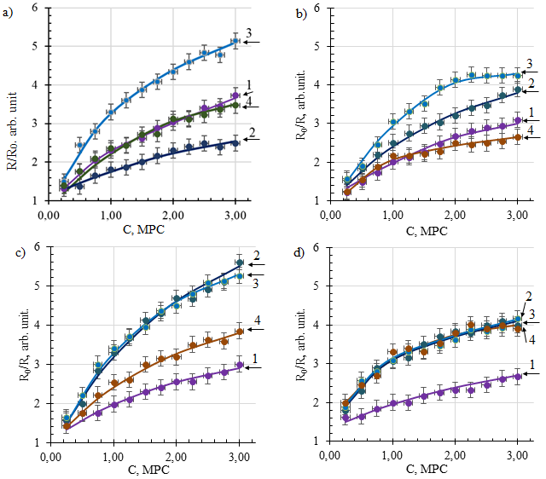

a) film without additives, b) with the addition of 0.5 ml NH4OH, C) 1.0 ml, d) 1.5 ml.
1-after receiving, 2 - 200 ºC 1 hour, 3 - 300 ºC 1 hour, 4 - 400 ºC 1 hour.

Figure 4 - dependence of the sensitivity of films on the concentration of ethanol vapors after thermal exposure

Table 1- Response time depending on the annealing temperature of films
 | After receiving | After annealing 200 ^{о}С, 1hour. | After annealing 300 ^{о}С, 1hour. | After annealing 400 ^{о}С, 1hour.
Without additives | 7,0±0,1s. | 3,9±0,2s. | 4,0±0,1s. | 5,4±0,7s.
+0,5 ml NH₄OH | 7,0±0,7s. | 4,2±0,5s. | 4,8±0,4s. | 4,8±0,5s.
+1,0 ml NH₄OH | 5,3±0,6s. | 4,8±0,9s. | 5,3±0,6s. | 5,8±0,4s.
+1,5 ml NH₄OH | 5,8±0,5s. | 6,2±0,7s. | 6,5±0,9s. | 6,6±0,6s.
+2,0 ml NH₄OH | 6,5±0,8s. | 6,7±0,7s. | 6,9±0,3s. | 6,3±0,7s.

The recovery time of the initial resistance value depends on the concentration of ethanol vapors (figure 2). Table 2 shows the values of the recovery time when ethanol vapors are injected at a concentration of 1MPC (1 mg / l).

Table 2-recovery Time depending on the annealing temperature of films (per 1PDC)
 | After receiving | After annealing 200 ^{о}С, 1hour. | After annealing 300 ^{о}С, 1hour. | After annealing 400 ^{о}С, 1hour.
Without additives | 99±2s. | 101±3s. | 104±5s. | 53±4s.
+0,5 ml NH₄OH | 70±3s. | 83±5s. | 94±4s. | 67±5s.
+1,0 ml NH₄OH | 60±2s. | 106±5s. | 128±3s. | 63±3s.
+1,5 ml NH₄OH | 63±5s. | 96±9s. | 108±7s. | 68±9s.
+2,0 ml NH₄OH | 56±6s. | 91±8s. | 109±9s. | 57±7s.

As can be seen from table 2, the recovery time increases with an increase in the annealing temperature of 200 ºC and 300 ºC films, regardless of the concentration of ammonium hydroxide in the film-forming solution. When annealing 400 ºC one hour, the recovery time values differ from the values after obtaining within the measurement accuracy.

- STUDY OF THE STABILITY OF FUNCTIONAL PROPERTIES OF FILMS DEPENDING ON THE DURATION OF THERMAL EXPOSURE
To achieve maximum sensitivity to ethanol vapors, the films were heated to 250 ºC. At this stage of the study, the influence of the duration of thermal exposure at the operating temperature of the sensor element (250 ºC) was studied. The resistance of the films was determined by 10 measurements on different parts of the samples. The Student’s coefficient for 10 measurements with a reliability of 0.95=2.262. The error was calculated by the formula:

$∆\overline{A}=t_{γ,n-1}\frac{\sqrt{\frac{\sum_{i=1}^{n}{{(А_{i}-\overline{A})}^{2}}}{n-1}}}{\sqrt{n}}$ (5)

where ∆$\overline{A}$ - the absolute measurement error, t_{(γ, n-1)} - the student’s coefficient, A_{i} - the value of the i-th measurement, ̅A – the arithmetic mean, and n is the number of measurements.
Table 3 shows the values of the active resistance measured at a distance of 1 mm between the probes.

Table 3 - Film resistance from the duration of thermal exposure
Образец | After receiving,  kОм | After annealing 250 ^{о}С 3 hours, kОм. | After annealing 250 ^{о}С 6 hours, kОм. | After annealing 250 ^{о}С 9 hours, kОм.
Without additives | 79,4±7,8 | 138,5±14,1 | 155,6±14,9 | 827,4±76,8
+0,5 ml NH₄OH | 45,0±4,3 | 24,2±2,5 | 28,2±3,0 | 50,7±4,8
+1,0 ml NH₄OH | 20,8±3,1 | 13,8±1,4 | 50,3±4,9 | 139±12,6
+1,5 ml NH₄OH | 15,8±1,7 | 8,84±0,96 | 33,8±3,2 | 35,6±3,4
+2,0 ml NH₄OH | 43,2±4,9 | 29,6±3,1 | 394,7±29,1 | 404,2±43,8

As can be seen from table 3, the resistance of films without additives increases with increasing annealing time. The resistance of the remaining samples decreases during annealing of 250 °C for 3 hours. Increasing the annealing time to 6 and 9 hours leads to an increase in the resistance of films with 0.5 ml and 1.0 ml additives. The resistance of films with additives of 1.5 ml and 2 ml during annealing of 250 °C for 6 and 9 hours varies within the measurement accuracy.
Figure 5 shows the results of measurements of the adsorption sensitivity to ethanol vapors from the duration of thermal annealing.

a) film without additives, b) with the addition of 0.5 ml NH₄OH, C) 1.0 ml, d) 1.5 ml) 2.0 ml. 1-after receiving, 2-3 hours, 3-6 hours, 4-9 hours.

Figure 5 - Dependence of the film sensitivity on the concentration of ethanol vapor after annealing at 250 °C for 3, 6 and 9 hours
Figure 5a shows that films obtained without additives, after annealing at 250 °C for three hours, increase the sensitivity to ethanol vapor concentrations above 1 MPC. Further annealing at 250 ºC reduces the sensitivity to ethanol vapors.
Figure 5a), b), c) shows that three-hour annealing increases the sensitivity to ethanol vapor of films without additives and with the addition of 0.5 ml and 1.0 ml. However, with the increase in the number of additives, the increase in sensitivity to ethanol vapors varies. Further annealing leads to a decrease in the sensitivity of these films.
The sensitivity to ethanol vapor of the film obtained from the SnCl₄/EtOHс film-forming system with the addition of 1.5 ml of 32% aqueous ammonia solution decreases with increasing annealing time (figure 5c).
Of particular interest is the film obtained from the SnCl₄/EtOHс film-forming system with the addition of 2.0 ml of 32% aqueous ammonia solution. Annealing 250 ºC for 3 hours increases the sensitivity to ethanol vapor both at low and high concentrations. A further increase in the annealing time to 6 and 9 hours does not lead to significant changes in the sensitivity to ethanol vapors. Thus, this sample demonstrates stability of sensitivity to ethanol vapor after annealing at 250 ºC.

- DRAfting A MATHEMATICAL MODEL OF CHANGES IN THE STRUCTURE AND PROPERTIES OF FILMS OBTAINED FROM SOLUTIONS WITH DIFFERENT CHEMICAL PARAMETERS FROM THERMAL EFFECTS
Currently, there are unsolved fundamental problems of the lack of a theory of the origin of structures in both QED and QCD. This also applies to non-equilibrium thermodynamics and non-perturbativechromodynamics. In nonlinear thermodynamics, such effects as self-organization in non-equilibrium processes occur. Collective phenomena, such as self-organization of structures, cannot be described by approximate methods for solving the Schrodinger equation for many bodies. In such cases, it is effective to use methods of the nonlinear theory of dynamical systems, when differential equations are replaced by discrete Poincare maps. Nonlinear theory operates with such fundamental concepts as bifurcation and fractal structure. Correlated interaction of a large number of ensemble elements can lead to the phenomenon of self-organization.
The theory and technology of thin films is becoming relevant at the present stage of development of approaches to condensed matter. Changes in the electrical conductivity of thin layers of tin dioxide SnO2 during gas adsorption became the basis for their use in semiconductor sorption sensors along with other applications [21]. For gas-sensitive sensors, films with a controlled porous structure are of particular interest. Currently, several methods for producing a thin film of tin dioxide based on Sol-gel technology have been developed [22-24].
A significant achievement of our time is the experimental confirmation of the appearance of fractal structures of colloidal particles of the dispersed phase. Models of fractal structure formation differ by clustering mechanisms: models of diffusion-restricted aggregation [25] and models of cluster-cluster aggregation [26]. The low probability of particles/clusters sticking together leads to deep penetration of clusters into each other and the formation of small fractal clusters [27-30].
The sol-gel process takes place against the background of thermal diffusion, the influence of which becomes more significant as the temperature increases. In diffusion processes, the mass flow is caused by the motion of particles involved in Brownian thermal chaotic motion with energy kT proportional to temperature (T is the absolute temperature, k is the Boltzmann constant). Mathematical models of diffusion processes are based on the fundamental laws of conservation of matter in the integral or differential form of the Ostrogradsky-Gauss equations.For small differences in the concentration of the substance u (r, t), the law for the diffusion flow is applicable: [d * grad u(r, t)]. In the case of significant changes in concentration over time, the law of diffusion applies: ${\dot{u}}_{t}=d∙{\ddot{u}}_{rr}$
The concentration of reagents, depending on the scheme and mechanism of the dynamic process, simultaneously decreases in proportion to the concentration and increases in parallel competing, sequential or reversible chemical reactions. Given that the diffusion process from the concentration of matter u(x,y,t) in the approximation of deterministic dynamic chaos is described by the diffusion equation with dynamically determined chaos. Thus, the differential equation of the diffusion process in a chemically active medium with a dynamically determined randomness associated with the quadratic nonlinearity u² can be represented as [31]:

$k_{p}∙{\dot{u}}_{t}=d∙∆u+f\left(u,t\right),$ (6)

with the porosity coefficient k_{p} [8] or
$k_{p}∙\frac{∂u(x,y,t)}{∂t}=d∙\left(\frac{∂^{2}}{∂x^{2}}+\frac{∂^{2}}{∂y^{2}}\right)u(x,y,t)+f(u,t)$ (7)

This differential equation of a chemical process on the background of diffusion includes a nonlinear function
$f(u,t)=μ(t)∙A∙(α∙u-β∙u^{2})$ (8)

with the normalization condition A and the evolution parameter µ. the Nonlinear function f(u) is the density of the internal source of structures in the evolutionary competition of generation and recombination of matter elements (molecules, ions, clusters) of a dynamical system with the coefficients of birth α and absorption β. For certain values of the parameter μ, the function f(u) leads to the so-called deterministic dynamic chaos.
We use an explicit Euler difference scheme with a uniform time step and spatial coordinate. For the difference scheme, we introduce a time step Δt=τ and a step along the coordinate Δr=L. The derivatives in the differential equation are replaced by their difference analogs and approximate lattice points are obtained:

$k_{p}∙\frac{u_{i,j+1}-u_{i,j}}{τ}=d∙\frac{u_{i-1,j}-2u_{i,j}+u_{i+1,j}}{L^{2}}+μ∙u_{i,j}\left(1-u_{i,j}\right),$ (9)

Next, we program the system of chemical reaction equations with diffusion and perform numerical calculations of the difference scheme of the differential equation. Thus, a nonlinear differential equation of chemical reactions with diffusion in Sol-gel during the formation of a thin SnO₂ film is modeled and numerically solved.
The results of numerical computer calculations of the differential equation for the evolution of the thin film surface with increasing temperature in the sol-gel process are shown in figures 6 and 7.

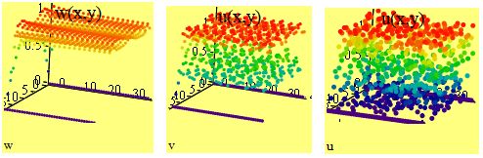

Figure 6 – Evolution of the thin film structure with increasing process temperature

The formation of structures depends on the temperature of the process and the time of evolution, which in our model is determined by the parameter k.
The results are shown in figure 7.

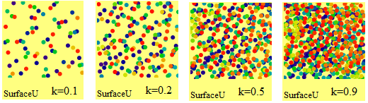

Figure 7 – Stages of formation of SnO2 thin film surface structures for the parameter k=0.1; k=0.2; k=0.5; k=0.9

The expected characteristics of a thin tin dioxide film are determined mainly by the fractal dimension of clusters and are determined by the evolution parameter of a deterministic chaotic dynamical system. Mandelbrot defined a fractal as an object with a Hausdorff-bezikovich dimension (fractal dimension) that exceeds its topological dimension. To determine the fractal dimension an increment of the mathematical expectation is constructed [32].

$S_{m}=E\left[\left|X_{k+m}-X_{k}\right|\right]=\frac{1}{K-m}∙\sum_{k=1}^{K-m}{\left|X_{k+m}-X_{k}\right|}$ (10)

A study of the solution of a nonlinear differential equation depending on various initial conditions is carried out. There is a direct proportionality between the maturation temperature of thin films and the evolution time in modeling the sol-gel system. More specifically, it is the number of steps in the numerical solution of a differential equation. The model is constructed by analogy with the so-called Prigogine brusselator [33] for solving a system of equations for an autocatalytic chemical reaction with diffusion. The modelling is performed according to the following algorithm. Several pairs of initial conditions are set for the concentration of reagents. A combined matrix is formed from separate matrices of solutions to the differential equation for different initial conditions. Calculations of the evolution of the dynamic system of a chemical reaction with Sol-gel diffusion for the formation of thin films are shown in figures 8 and 9. the constructed trajectories on the phase plane reflect the dynamics of the concentration of intermediate products of the chemical reaction. The model parameters are the initial concentrations.

Figure 8 - Graph of the time dependence of the solution of the differential equation

Figure 9 - Comparison of two different methods results of calculating the phase portrait of the Sol-gel process evolution at different initial concentrations of chemical reagent

Figure 9 shows that all trajectories from the solution of a system of differential equations that come from different initial points converge to the so-called attractor with coordinates (1,1) from the theory of nonlinear dynamical systems. In this case, this attractor is a "node". The counteraction of various direct and reverse chemical reactions along with coagulation and peptization in a dispersed medium in Sol-gel processes with a stochastic diffusion component leads to the establishment of a certain stationary state with an equilibrium concentration. This will allow you to get the optimal parameters.
The presence of fractal structures in the experimental results on thin films means the presence of nonlinear collective phenomena associated with the stochasticity of the process. Fractal dimension is an important parameter for understanding the properties of film roughness. Algorithms for evolutionary programs have been developed and numerical computer calculations have been performed to model the formation of nanostructured clusters of thin films.
Thus, we propose a mechanism for the formation of structures within the introduced nonlinear equation for competing processes of decay and fusion on the background of weak diffusion. This is a new approach to the mechanism of structure formation. The results of computer modeling indicate the presence of collective effects of self-organization of stable structures. The nonlinear evolution of multiparticle systems of sol-gel dynamics with counteracting chemical reactions leads to the formation of fractal clusters, which corresponds to the available experimental data on the fractal structure in thin films. A software product has been created for analyzing the patterns of nanofilm formation. A general method for studying non-equilibrium processes for nanostructure technology is developed.

CONCLUSION

Brief conclusions on the results of research and individual stages (conclusion for 2018 and 2019 through).
The following results were obtained during the entire project implementation period:
- A decrease in the value of the hydrogen index was found with an increase in the concentration of tin tetrachloride in the solution. As the concentration of tin ions in the solution increases, the density, viscosity, and surface tension increase. Adding ammonium hydroxide to solutions increases the hydrogen index, density, viscosity, and surface tension.
− It was found that an increase in pH leads to the appearance of structural formations. Moreover, with increasing pH, the size of structural formations increases, and the shape changes. It was found that films obtained from solutions with a tin ion concentration of less than 0.2 mol/l have stable adhesion to the glass substrate. Films obtained from a tin tetrachloride solution with a concentration of 0.36 mol/l are prone to peeling from the substrate.
− It is shown that when the pH of the film-forming system is increased in the range from 1.4 to 1.49, the growth of surface structures is detected by optical microscopy, the connection between which is stable. The transmittance of such films is reduced to a minimum at pH=1.49. With an increase in pH in the range from 1.51 to 1.53, the growth of structural formations continues, but already in the volume of the film. At the same time, voids appear, which indicates a decrease in the adhesion of the films to the glass substrate.
- Mathematical computer methods for analyzing the patterns of nanofilm formation have been developed. The results of modeling the features of solution maturation and structure formation in thin films of tin dioxide SnO₂ obtained by the sol-gel method are presented. The formation of cluster structures is considered depending on the "competition" of two processes: the process of hydrolysis of tin tetrachloride SnCl₄, which leads to the formation of tin acid Sn(OH)₄, and the process of decomposition of gel-like tin acid into water and tin dioxide. It is found that the nonlinear evolution of sol-gel random processes leads to a fractal structure of film clusters. The parameters of cluster formation and the morphology of the thin film are presented, depending on the control parameters related to the concentration of tin in the solution and the amount of catalyst.
− It was found that with an increase in the amount of ammonium hydroxide added to the solution, the transparency of the films decreases. The spectra were determined by: refractive index-1.733; film thickness-316nm; absorption coefficient-11 * 10⁻³ cm⁻¹. The band gap is 3.6 eV.
− It was found that with an increase in the annealing temperature, no significant changes in the structure (at this increase) are observed. The transparency of films increases with increasing annealing temperature.
- It was found that the films obtained from the SnCl₄/EtOH film-forming system with pH=1.40 at room temperature is 47.0±4.5 MOhm. An increase in the pH of the film-forming system leads to an increase in the film resistance, at room temperature, more than 200 MOhm.. A direct relationship was found between the pH of the film-forming system and the film resistance. At 270 ºC, the film resistance varies from 6.7=0.7 MOhm to 36.6=3.7 MOhm depending on the pH of the film-forming system.
− A decrease in the transmittance from 93% to 88% was found with an increase in the annealing time for films obtained from a film-forming system with a pH of 1.40. the transmittance Of films obtained from a film-forming system with a pH of 1.49 to 1.53 varies within 2%. An increase in the number of structural elements with an increase in the duration of annealing was found in films obtained from film-forming systems with pH=1.49 and 1.53.
- A decrease in the resistance of films with an increase in the annealing temperature is shown. Annealing at 200 ºC (15 minutes) does not change the resistance. An increase in the annealing temperature to 400 ° C leads to a decrease in resistance by 1.5-2 times.
- Correlation studies of the thermal effect on the structure of the obtained films were carried out. It is found that at annealing temperatures below 250 °C, the spectrum of the crystallographic structure of the film is a narrow peak of high intensity at angles 2θ = 31.65±0.26 (twice the scattering angle of diffracted x-rays on the crystal lattice of the sample).At annealing temperatures above 400 °C 4 characteristic peaks of tin dioxide SnO₂ are distinguished in the spectrum of the crystallographic structure of the film at angles 2θ=26.7±1.9, 33.9±2.2, 38.1±1.1 and 52.2±3.3 degrees. These signals correspond to the crystallographic planes of tin dioxide SnO₂ (110), SnO₂(101), SnO₂(200), and SnO₂(211), respectively. A model of the influence of thermal action on the properties of films based on the formation of cluster structures depending on the "competition" of the processes of formation of tin acid Sn(OH)₄ and its decomposition into water and tin dioxide is developed.
- Modeling of the evolution of a thin film according to the solution of a differential diffusion equation with a nonlinear internal source for the formation and destruction of structures in a chemical reaction with diffusion is carried out. Changes in the dynamics of the concentration of intermediate products of the chemical reaction depending on the parameters of the initial concentrations were found.
- A decrease in the sensitivity of SnO₂ films to ethanol vapors was found with an increase in the concentration of ammonium hydroxide in the film-forming solution.
- The stability of the response time under the thermal action of films with additives of 1.0 ml, 1.5 ml and 2.0 ml NH₄OH is shown.
- The stability of the resistance of films with additives of 1.5 ml and 2 ml was found during annealing of 250 °C for 6 and 9 hours. The sample, with an addition of 2.0 ml, demonstrates stability of sensitivity to ethanol vapors, from the annealing duration at 250 ºC.
- A mathematical model of changes in the structure and properties of films obtained from solutions with different chemical parameters from thermal effects has been developed.
Evaluations of completeness of targets solutions
Due to the reduction of funding by 7 (seven) times compared to the requested amount, the calendar plan (Appendix B) was amended in accordance with the supplementary agreement (Appendix С, paragraph 2.4, no. AR05134263, Appendix 1.6). "State in a new version: "research Results will be published in foreign scientific journals indexed by the Web of Science or Scopus database (at least two articles), in Kazakh journals with a non-zero impact factor (at least two articles). A patent will be obtained in the Kazakhstan patent office."
Subject to the changes, in accordance with the supplementary agreement, the tasks were completed in full. As a result of the project, patent No. 3375 was obtained, and articles were published in foreign scientific journals indexed by the Web of Science or Scopus database (3 articles), as well as in Kazakhstan journals with a non-zero impact factor(2 articles). For a complete list of published works, see Appendix A.
Development of recommendations and initial data on specific use of research results
To create antireflective coatings for solar photo-converters, to create de-icing coatings, to create touch screens and other devices in which tin oxide films act as a transparent coating, it is recommended to use film-forming systems with a concentration of tin ions up to 0.2 mol/l in order to avoid peeling the film from the glass substrate. A multi-layer coating is recommended to obtain the necessary film conductivity. When using SnO₂ films as a sensitive element of sensors for monitoring the concentration of ethanol vapors in the working area, it is recommended to use film-forming systems with a concentration of tin ions of 0.11 mol/l with the addition of 2.0 ml of 32% aqueous ammonia solution per 100 ml of solution. After receiving the film, it is necessary to anneal the sensor element at the operating temperature for 1 hour. Following these recommendations will increase the sensor's service life.
Results of evaluation of technical and economic efficiency of implementation
The results obtained the great importance for the development of methods for controlling the structure of thin films to create materials with improved functional properties.
Results of evaluating the scientific and technical level of research performed in comparison with the best achievements in this field
The scientific and technical level of research is at a high level and corresponds to the best achievements of modern world science in this field of physics.
REFERENCES

- Badr A.M.etal.Characteristics of DC electrical conductivity and optoelectronic features of tin dioxide nanocrystals synthesized by sol-gel chemistry //Semiconductors -2020. -Vol.54(3), P.297-310.
- Haouanoh D. et al.Effects of thermal treatment and layers' number on SnO₂ thin films properties prepared by sol-gel technique //Materials research express - 2019. –Vol.6(8),ID.086422.
- Diliegros-GodinesC.J. et al. High quality semiconductor Cd₂SnO₄films for solar cell applications // Semiconductor science and technology - 2020. –Vol.35(10),ID.105015.
- IsmailW.et al.Impact of substrate type on the surface and properties of electrodeposited Cu₂O nanostructure films as an absorber layer for solar cell applications //Materials science in semiconductor processing - 2020.–Vol.120, ID.105335.
- Sokovykh E.V. et al. Influence of conditions of Pd/SnO₂ nanomaterial formation on properties of hydrogen sensors //Nanoscale Research Letters - 2017. -Vol.12, ID.383. P.1-8.
- KuznecovaS. A. Properties of ZnO films: Al, ZnO:Al-SiO2 obtained by Sol-gel method from film-forming solutions // News of higher educational institutions. Physics. - 2020. -V.63(4). -P.55-61.(Rus)
- UvarovV.I. etal.Nanoporous high-temperature filters based on Ti-Al ceramic SHS materials //Ceramicsinternational - 2020. –Vol.46(14)‏, P.23180-23185.
- DmitriyevaE.A.et al.Doping of fluorine of tin dioxide films synthesized by sol-gel method //News of The National Academy of Sciences of The Republic of Kazakhstan-Series of Geology and Technical Sciences - 2019. –Vol.1(433), P.73-79. -doi: 10.32014/2019.2518-170X.9.
- GrushevskayaE.A. et al.Sensitivity to ethanol vapour of thin films SnO₂ doped with fluorine // Eurasian Chemico-Technological Journal - 2019.-Vol.21(1), P.13-17.- doi: 10.18321/ectj781.
- Guo H.F. et al. A significant increase in efficiency along limitation toxicity of solar cell based on Sb₂Se₃ with SnO₂ as buffer layer // Journal of Materials Chemistry C - 2019. –Vol.7(45), P.14350-14356. - doi: 10.1039/c9tc04169a.
- Wang D. et al. Poly(vinylpyrrolidone)-doped SnO₂ as an electron transport layer for perovskite solar cells with improved performance // Journal of Materials Chemistry C - 2019. -Vol.7(39), P.12204-12210. - doi: 10.1039/c9tc04269e.
- BatzillM. et al. The surface and materials science of tin oxide // Progress in Surface Science - 2005. – Vol.79(2-4), P.47-154. - doi:10.1016/j.progsurf.2005.09.002.
- ZhangR.Y. et al. Function promotion of SO₄²⁻/Al₂O₃–SnO₂ catalyst for biodiesel production from sewage sludge // Renewable energy - 2020. –Vol. 147, P.275-283. - doi: 10.1016/j.renene.2019.08.141.
- Chen Z. et al. Wavy SnO₂ catalyzed simultaneous reinforcement of carbon dioxide adsorption and activation towards electrochemical conversion of CO₂ to HCOOH // Applied Catalysis B-Environmental -2020. -Vol.261, UNSP 118243. -doi:10.1016/j.apcatb.2019.118243.
- ZhangB.H. et al. Well-dispersed SnO₂nanocrystals on N-doped carbon nanowires as efficient electrocatalysts for carbon dioxide reduction // Journal of Energy Chemistry -2020. –Vol. 41, P.7-14. - doi: 10.1016/j.jechem.2019.04.022.
- Cho C.J. et al. Ta-Doped SnO₂ as a reduction–resistant oxide electrode for DRAM capacitors // Journal of Materials Chemistry C - 2017.–Vol. 5(36), P.9405-9411. -doi: 10.1039/c7tc03467a.
- Fedosimova A.I. et al. Modeling the process of formation of fractal structures in thin films // Journal of Physics: Conf. Series - 2018.- Vol.1141, ID.012004. - doi:10.1088/1742-6596/1141/1/012004.
- MukhamedshinaD.M. etal.Influence of plasma treatment on physical properties of thin SnO₂ films obtained from SnCl₄ solutions with additions of NH₄F and NH₄OH // Eurasian Chemico-Technological Journal - 2019. -Vol.21(1), P.57-61. - doi: 10.18321/ectj791.
- Dmitriyeva E. A. Effect of isothermal annealing on the optical and electrical properties of fluorine doped SnO2 thin films // KazNU Bulletin. A physicalseries. - 2018. -N2(65). – P.68-75. (rus)
- O’Sullivan M. etal.Contributions of biogenic material to the atmospheric ice-nucleating particle population in North Western Europe // Scientific Reports - 2018. –Vol. 8(1), ID.13821. - doi: 10.1038/s41598-018-31981-7
- Dmitrieva E.A. et al. The effect of NH₄F and NH₄OH on the structure and physical properties of thin SnO₂ films synthesized by the sol-gel method //Glass Physics and Chemistry - 2014. - Vol. 40, P.31-36. – doi: 10.1134/S1087659614010076.
- MukashevB.N. etal.Influence of structure changes of oxide films on their physical properties // Materials Science and EngineeringB - 2005. -Vol. 118, P.164-169.
- MukhamedshinaD.M. etal.Influence of plasma treatments on the properties of SnO(x) thin films //High Temperature Material Processes -2006. - Vol. 10(4), P.603-615.
- WittenJr T. A. etal.Diffusion-limited aggregation, a kinetic critical phenomenon //Phys. Rev. Lett. - 1981. -Vol. 47, P.1400. - doi: 10.1103/PhysRevLett.47.1400.
- Brinker C.J. etal.Sol → gel → glass: I. Gelation and gel structure // Non-Cryst. Solids - 1985. -Vol. 70 (3), P.301-322. - doi:10.1016/0022-3093(85)90103-6.
- Moshnikov V.A. et al. New nanomaterial. Synthesis. Diagnostics.Modeling. -SPb.: Publishing house Etu "LETI", 2015.
- PanT. et al. Gradual crossover from subdiffusion to normal diffusion: a many-body effect in protein surface water // Phys. Rev. Lett. - 2018. -Vol.120, ID.248101.
- ThaiM.H. et al. Experimental test of the differential fluctuation theorem and a generalized Jarzynski equality for arbitrary initial states// Phys. Rev. Lett. -2018. -Vol.120. -ID.080602. -doi:10.1103/PhysRevLett.120.080602.
- ZhangW. etal.Unexpected stable stoichiometries of sodium chlorides // J. Science - 2013. -Vol. 342, P.1502-1505. - doi: 10.1126/science.1244989.
- Martinson L.K. and MalovYu.I.Differential equations of mathematical physics. -M.:MSTU, 2002.
- KorolenkoP.V. et al. Innovative methods of analysis of stochastic processes and structures in optics. Fractal and multifractal methods.-M.:Moscow state University, SINP, 2004.
- PrigozhinI. Self-organization in non-equilibrium systems. - М.:World,1979. (rus)
- TemiralievA. et al. Birth and fusion in a sol-gel process with low diffusion // Eurasian Physical Technical Journal -2020. - Vol.17, No.1(33). –doi: 10.31489/2020No1/132-13

APPENDIX A
List of published works for 2018-2020
Monograph
DmitriyevaE. A. Thin films of tin oxide obtained by Sol-gel method. Collected papers. - G.: LAPLambertAcademicPublishingRU, 2018. - ISBN:978-613-9-91169-1. – 87p.(rus)
Articles indexed by WebofScience and/or Scopus:
- FedosimovaA.I., DmitrievaE.A., LebedevI.A., TemiralievA.T., TemiralievT., AbishevM.E., BaitimbetovaB.A.,RyabikinYu.A.,Serikkanov A.S. Modeling the process of formation of fractal structures in thin films // Journal of Physics: Conf. Series. - 2018. - Vol.1141,No.012004. -doi: 10.1088/1742-6596/1141/1/012004.(IF=0.69, percentile 17%, citations -3)
- TemiralievA.,Tompakova N., Fedosimova A., Dmitriyeva E., Lebedev I., Grushevskaya E., Mukashev B., Serikkanov A. Birth and fusion in a sol-gel process with low diffusion // Eurasian Physical Technical Journal. - 2020. - Vol.17, No.1.(33). P.132-137. – doi: 10.31489/2020No1/132-137. (IF=0.2, percentile 16%)
3 GrushevskayaE.A.,IbraimovaS.A., DmitriyevaE.A., LebedevI.A., Mit’ K.A., MukhamedshinaD.M., FedosimovaA.I., SerikkanovA.S., TemiralievA.T.Sensitivity to ethanol vapour of thin films SnO₂ doped with fluorine // Eurasian Chemico-Technological Journal. - 2019. - Vol.21, P.13–17. - doi: 10.18321/ectj781 (IF=0.52, percentile 26%, citations -1)
Articles recommended by CCSON::
- DmitriyevaE. A., MukhamedshinaD. M., MitK. A., LebedevI. A., GrushevskayaE. A.Effect of isothermal annealing on the optical and electrical properties of fluorine doped SnO2 thin films // Bulletin of KazNU, physical series (RecentContributionstoPhysic). - 2018. – N2(65). – С.68-75.(rus)
- DmitriyevaE. A., GrushevskayaE. A,MukhamedshinaD. M., MitK. A.,LebedevI. A., Effect of the acidity of film-forming solutions on the structure and properties of SnO2 thin films // Bulletin of KazNU, physical series (RecentContributionstoPhysic). - 2020. - V.72. - N.1. - С.81-88. – doi:10.26577/RCPh.2020.v72.i1.10. (rus)
Other articles
Mit K, A.,Dmitriyeva E.A., Mukhamedshina D.M., Lebedev I.A., Grushevskaya E. A, Fedosimova A.I. Investigation of the stability of optical properties of SnO2 thin films // White paper on nanotechnology.– 2018.–V. 2.–P.265-267. (rus)

Patents
DmitriyevaE. A., MukhamedshinaD. M., LebedevI. A., MitK. A.,GrushevskayaE. A, Fedosimova A. I., Girina I. I. Method for producing thin films of tin dioxide // Patent № 3375 for utility model. - 2018. (rus)
Conference proceedings
- Dmitriyeva E. A., Mukhamedshina D. M., Lebedev I. A., Mit K. A.,Grushevskaya E. A, Effect of isothermal annealing on the optical and electrical properties of fluorine doped SnO2 thin films // Materials of the international conference.«Abdildin readings »Almaty, Kazakhstan - 2018.-P.183-188.(rus)
- Dmitriyeva E. A., Lebedev I. A., Fedosimova A. I., Grushevskaya E. A, Mukhamedshina D. M.,Mit K. A. Surface structure of SnO2 thin films synthesized by Sol-gel method // Proceedings of the V Intern. Conf. "Modern problems of condensed matter physics, nanotechnology and nanomaterials.Sarsembinova reading»/Almaty, Kazakhstan, (17-18 may 2018 ).-2018. -P.79-83.(rus)
- Dmitriyeva E.A., Ibraimova S.A., Grushevskaya E.A., Lebedev I.A., Mit K.A., Mukhamedshina D.M., Fedosimova A.I., Serikkanov A.S. Sensitivity to vapors of ethanol of thin films of SnO₂ alloyed by fluorine after isothermal annealing // Abstract book of The 6th International Conference on Nanomaterials and Advanced Energy Storage Systems / Astana,Kazakhstan, (8-10 August 2018.).- 2018. -P.43.
- Dmitriyeva E. A., Mukhamedshina D. M.,Lebedev I. A., Mit K. A.,Grushevskaya E. A., Fedosimova A. I. Investigation of optical and electrical properties of fluorine doped SnO₂ thin films // Book of Abstracts of 5th Int.Conf. Sol-gel 2018 / Saint-Petersburg, (27-31 august 2018.). - 2018. - P.62-63. (rus)
- Fedosimova A. I.,DmitriyevaE. A., LebedevI. A., Temiraliyev A. T., Ryabikin Yu., A.Modeling of the regularities of formation of nanofilms// Collection of abstracts of the international scientific conference of students and young scientists «Pharabialemi» / Almaty, (8-11 april 2019). - 2019. - p.182.(rus)
- Grushevskaya E. A., Dmitriyeva E. A., Lebedev I. A.,Tompakova N. M., Serikkanov A. S. Investigation of the influence of chemical parameters of film-forming solutions on the structure of the resulting films // Collection of abstracts of the international scientific conference of students and young scientists «Pharabialemi» / Almaty, (8-11 april 2019). - 2019. - p.182.(rus)
- Tompakova N., Dmitriyeva E., Lebedev I., Serikkanov A., Grushevskaya E., Baitimbetova B. Influence of acid filming solution on SnO₂ thin films // INESS The 7thInternation Conference on Nanomaterials and Advanced Energy Storage Systems / Almaty, (7-9 august 2019.). - 2019. - P.71.
- Dmitriyeva E. A., Grushevskaya E. A., Mukhamedshina D. M., Mit K. A., Lebedev I.А. Effect of the acidity of film-forming solutions on the structure and properties of SnO2 thin films // Collection of abstracts of the II international scientific forum " Nuclear science and technology”/ Almaty, (june 24-27 2019). - 2019. - p.76.(rus)
- Tompakova N., Fedosimova A., Dmitriyeva E., Lebedev I., Mukashev B., Serikkanov A., Temiraliev A. Modeling the formation of pattern fractal structures in thin films of a chemical reaction with diffusion. // Chaos and structures in nonlinear systems. Theory and experiment. Materials of the 11th international scientific conference / Karaganda, (22-23 november 2019.). - 2019. - Р.187-191.
- Dmitriyeva E. A., Lebedev I.А., GrushevskayaE. A., Murzalinov D. O., FedosimovaA. I.,Zhantuarov S. R.Effect of acidity of initial solutions on the surface structure of SnO2 thin films // Materials of the international scientific conference of students and young scientists "PharabiAlemi»/ Almaty, Kazakhstan, (6-9 april 2020). – 2020. - p.198. (rus)
- DmitriyevaE. A., LebedevI.А., GrushevskayaE. A., MurzalinovD. O., FedosimovaA. I.,Zhantuarov S. R.Effect of the application method on the properties of SnO2 films \\Materials of the international scientific conference of students and young scientists "PharabiAlemi»/ Almaty, Kazakhstan, (6-9 april 2020). – 2020. –P.199. (rus)
- FedosimovaA. I.,BaitimbetovaB., DmitriyevaE. A., Ibraimova S. A., Kudryashov V., Lebedev I. A., Ryabikin Yu. AStructure of SnO2 films with embedded nitrogen atoms \\Materials of the international scientific conference of students and young scientists "PharabiAlemi»/ Almaty, Kazakhstan, (6-9 april 2020). – 2020. - P. 225. (rus)
APPENDIX B

Calendar plan for 2018-2020
TECHNICAL SPECIFICATION AND
Calendar’s of work
Under the contract No 243 from 27 March, 2018

- "Institute of physics and technology" LLP
1.1 Priority: "Rational use of natural resources, including water resources, geology, processing, new materials and technologies, safe products and structures»
1.2 1.2 By sub-priority, Nanomaterials and nanotechnologies.
1.3 By project topic: No АR05134263/ТF «Effect of colloidal parameters of sol-gel solutions on the structure and thermal stability of SnO₂ thin films»
1.4 The total amount of the project 140 21 000 (twenty one million one hundred forty thousand) tenge including total project 140 21 000 (twenty one million one hundred forty thousand) tenge, with break down by year, to perform work paragraph 3:
- for 2018-in the amount of 7,000,000 (seven million) tenge;
- for 2019 - in the amount of 7,063,000 (seven sixty-three thousand) tenge;
- for 2020-in the amount of 7,077,000 (seven million seventy-seven thousand) tenge.

- Characteristics of scientific and technical products by qualification criteria and economic indicators
2.1 Direction of work: Development of a new effective technology for forming SnO₂ thin films for various purposes based on the sol-gel method. Obtaining samples of films with thermally stable improved optical and gas-sensitive properties.
2.2 Field of application: creating sensors for monitoring leaks of toxic and flammable gases, for creating anti-reflective coatings of solar phototransformers, for creating anti-corrosion and de-icing coatings, etc.
2.3 Outcome:
- for 2018: colloid solutions will be investigated. The parameters of solutions at which the obtained films have stable adhesion to the substrate will be determined. Will be developed a mathematical model of the maturation of solutions. The following parameters will be defined: transparency of films, band gap, refractive index, etc.The regularity of changes in the structure and transparency of films from the annealing temperature will be studied.
- for 2019: The structure of films with stable adhesion to the substrate will be studied. A mathematical model of film formation will be developed. The surface resistance and the change in resistance when the sample is heated will be measured. The regularity of changes in surface resistance from the annealing temperature will be studied. A mathematical model of the effect of thermal effects on the properties of films will be developed. The effect of the duration of thermal exposure on the structure and optical properties of films will be investigated. The research results will be published in Kazakhstani publications. An application for a patent of the Republic of Kazakhstan will be submitted.
- for 2020: The adsorption sensitivity to ethanol vapors will be investigated. The regularity of changes in the adsorption sensitivity to ethanol vapor from the annealing temperature will be studied. The effect of the duration of thermal exposure on the electrophysical characteristics of films will be investigated. A generalizing mathematical analysis will be conducted for all the conducted studies.
The research results will be published in foreign scientific journals indexed by the Web of Science database: Journal of sol-gel science and technology (IF-1. 575. USA), Advances in physics (IF-9.571, England), Journal of applied physics (IF-2.171, USA), Materials science & Engineering R-Reports (IF-14.440, Netherlands), in Russian journals indexed by the SCOPUS database: Advances in chemistry (IF-3.356), Colloid journal (if-0.622), Physics and chemistry of glass (if-0.433). Obtaining a patent in the Kazakhstan patent office.
2 2.4 Patentability: patentable
2.5 Scientific and technical level (novelty): development of a new effective technology for producing SnO nanofilms with a different low-cost Sol-gel approach
2.6 The use of scientific and technical products is carried out by: the Contractor
2.7 Type of use of the result of scientific and (or) scientific and technical activities:
The results obtained during the implementation will be published in scientific journals and presented at international conferences

- Name of works, terms of their implementation and results
No | Name of work under the сontract and the main stages of its implementation* | Target date |  | Expected results
No |  | starts | ends | Expected results
1 | Investigation of colloidal properties of solutions with changes in concentration and chemical composition. | January  2018 | November 1st 2018 | Colloidal properties of solutions with changes in concentration and chemical composition will be investigated.
2 | Investigation of the influence of chemical parameters of film-forming solutions on the structure and properties of the resulting films. | April  2018 | November 1st 2018 | The influence of chemical parameters of film-forming solutions on the structure and properties of the resulting films will be studied. The parameters of solutions at which the obtained films have stable adhesion to the substrate will be determined.
3 | Development of mathematical and computer methods for analyzing the patterns of nanofilm formation. | January  2018 | November 1st  2018 | Mathematical and computer methods for analyzing the patterns of nanofilm formation will be developed. A mathematical model of solution maturation will be developed
4 | Investigation of the characteristics (optical, electrical, gas-sensitive, etc.) of the resulting films. | July  2018 | November 1st 2018 | The characteristics (optical, electrical, gas-sensitive, etc.) of the resulting films will be studied. The following parameters will be determined: transparency of films, band gap, refractive index, etc.
5 | Study of the stability of functional properties of films under thermal influence. | September  2018 | November 1st 2018 | The stability of the functional properties of films under thermal influence will be studied. The regularity of changes in the structure and transparency of films from the annealing temperature will be studied
2.1 | Investigation of the influence of chemical parameters of film-forming solutions on the structure and properties of the resulting films. | January 2019 | November 1st 2019 | The influence of chemical parameters of film-forming solutions on the structure and properties of the resulting films will be studied. The structure of films with stable adhesion to the substrate will be studied.
3.1 | Development of mathematical and computer methods for analyzing the patterns of nanofilm formation. | January2019 | March 2019 | Will be developed mathematical and computer methods for analyzing the patterns of nanofilm formation. A mathematical model of film formation will be developed.
4.1 | Investigation of the characteristics (optical, electric gas-sensitive, etc.) of the resulting films. | January 2019 | November 1st 2019 | The characteristics (optical, electrical, gas-sensitive, etc.) of the resulting films will be studied. The surface resistance and the change in resistance when the sample is heated will be measured.
5.1 | Study of the stability of functional properties of films under thermal influence. | January 2019 | November 1st 2019 | The stability of the functional properties of films under thermal influence will be studied. The regularity of changes in surface resistance from the annealing temperature will be studied.
6 | Correlation studies of the thermal effect on the structure of the obtained films. | January 2019 | November 1st 2019 | Correlation studies of the thermal effect on the structure of the obtained films will be carried out.  A mathematical model of the effect of thermal effects on the properties of films will be developed.  The research results will be published in Kazakhstan publications with a non-zero impact factor. An application for a patent of the Republic of Kazakhstan will be submitted.
7 | Study of the stability of functional properties of films depending on the duration of thermal exposure. | January 2019. | November 1st  2019 | The stability of the functional properties of films depending on the duration of thermal exposure will be studied. The effect of the duration of thermal exposure on the structure and optical properties of films will be investigated.
4.2 | Investigation of the characteristics (optical, electrical, gas-sensitive, etc.) of the resulting films. | January2020 | March  2020 | Research will be conducted. characteristics (optical, electrical, gas-sensitive, etc.) of the resulting films. The adsorption sensitivity to ethanol vapors will be investigated.
5.2 | Study of the stability of functional properties of films under thermal influence. | January 2020 | August  2020 | The stability of the functional properties of films under thermal influence will be studied. The regularity of changes in the adsorption sensitivity of ethanol vapors from the annealing temperature will be studied.
7.1 | Study of the stability of functional properties of films depending on the duration of thermal exposure. | January2020 | November 1st 2020 | Stability issues will be studied. functional properties of films depend on the duration of thermal exposure.
8 | Drawing up a mathematical model of changes in the structure and properties of films obtained from solutions with different chemical parameters from thermal exposure. | January2020 | November 1st  2020 | Mathematical models of changes in the structure and properties of films obtained from solutions with different chemical parameters from thermal effects will be compiled.  The research results will be published in foreign scientific journals indexed by the Web of Science database (at least two articles): Journal of sol-gel science and technology (IF-1.575, USA), Advances in physics (if-9.571, England), Journal of applied physics (IF-2.171, USA), Materials science & Engineering R - Reports (IF-14. 400. Netherlands), in Russian journals indexed by the SCOPUS database (at least two articles): Advances in chemistry (IF-3,356) Colloidal journal (IF-0.622), Physics and chemistry of glass (IF-0.433). Obtaining a patent in the Kazakhstan patent office.
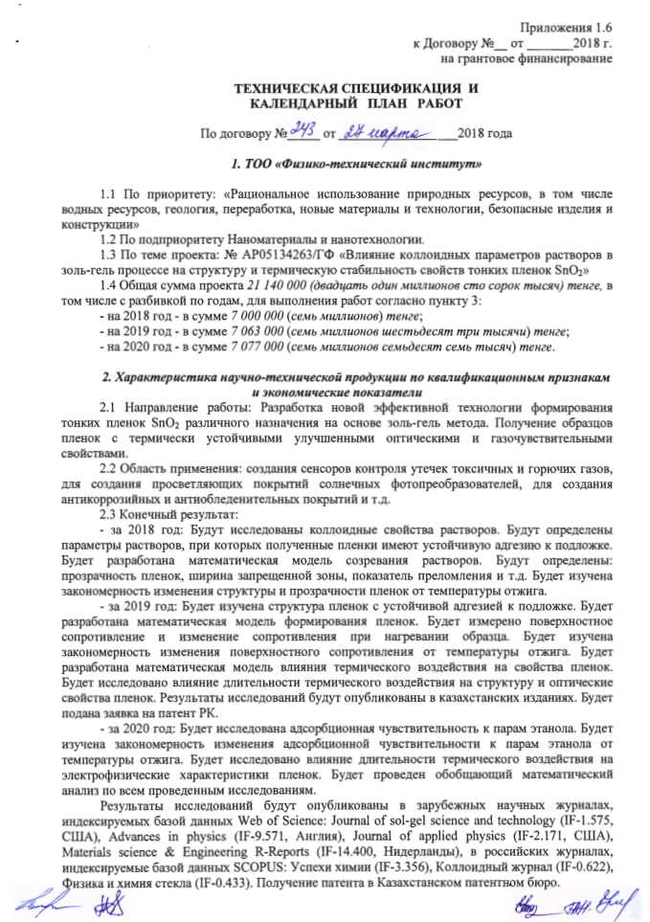

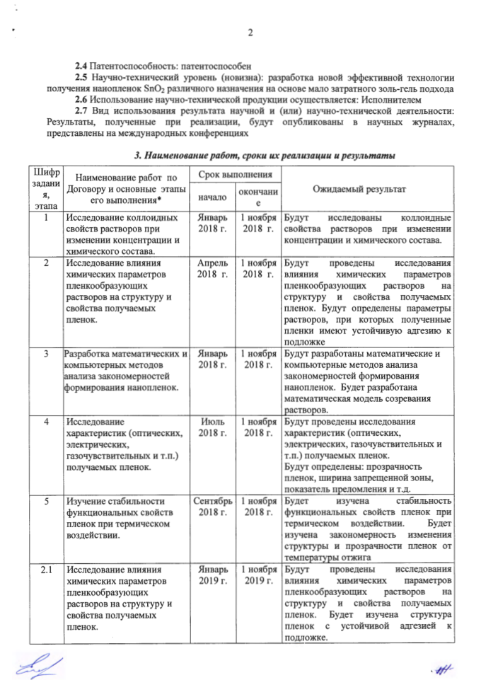
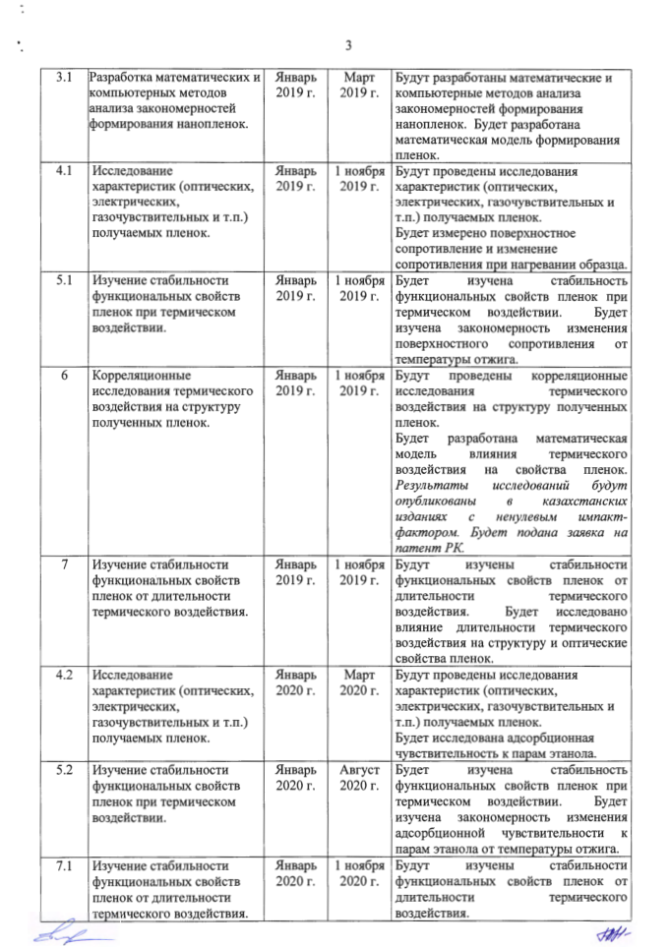

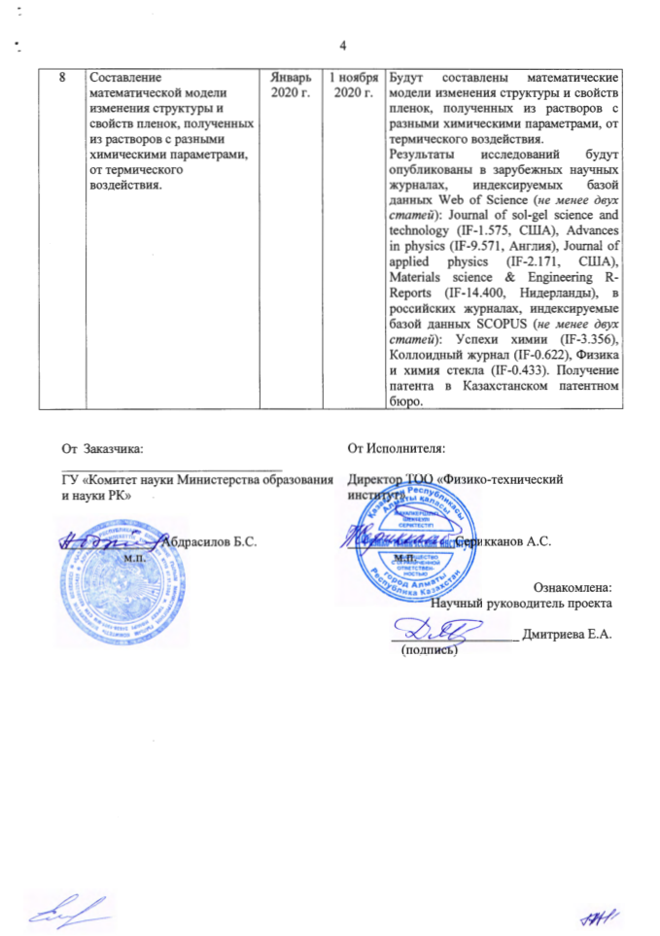

APPENDIX C

Supplementary agreement No. 2 to the grant financing Agreement No. 243 dated March 27, 2018.

  - No AR05134263, Annex 1.6:
Section 2, paragraph 2.3. Final result, 4 paragraph under the agreement: "research results will be published in foreign scientific journals indexed by the Web of Science database (at least two articles): Journal of sol-gel science and technology (IF-1.575, USA), Advances in physics (IF-9.571, England), Journal of applied physics (IF-2.171, USA), Materials science & Engineering R-Reports (IF-14.400, Netherlands), in Russian journals indexed by the Scopus database (at least two Articles): Advances in chemistry (IF-3.356), Colloid journal (IF-0.622), Physics and chemistry of glass (IF-0.433). Obtaining a patent in the Kazakhstan patent office".
State in a new edition: "the research Results will be published in foreign scientific journals indexed by the Web of Science or Scopus database (at least two articles), in Kazakh journals with a non-zero impact factor (at least two articles). A patent will be obtained in the Kazakhstan patent office."
Section 3, paragraph 8 for the year 2020. Expected results under the agreement: "mathematical models of changes in the structure and properties of films obtained from solutions with different chemical parameters from thermal effects will be compiled. The research results will be published in foreign scientific journals indexed by the Web of Science database (at least two articles): Journal of sol-gel science and technology (IF-1.575, USA), Advances in physics (IF-9.571, England), Journal of applied physics (IF-2.171, USA), Materials science & Engineering R-Reports (IF-14.400, Netherlands), in Russian journals indexed by the Scopus database (at least two articles): Advances in chemistry (IF-3.356), Colloid journal (IF-0.622), Physics and chemistry of glass (IF-0.433). Obtaining a patent in the Kazakhstan patent office.
Set out in a new version: "Mathematical models of changes in the structure and properties of films obtained from solutions with different chemical parameters from thermal effects will be compiled. The research results will be published in foreign scientific journals indexed by the Web of Science or Scopus database (at least two articles), in Kazakh journals with a non-zero impact factor (at least two articles). A patent will be obtained in the Kazakhstan patent office."

