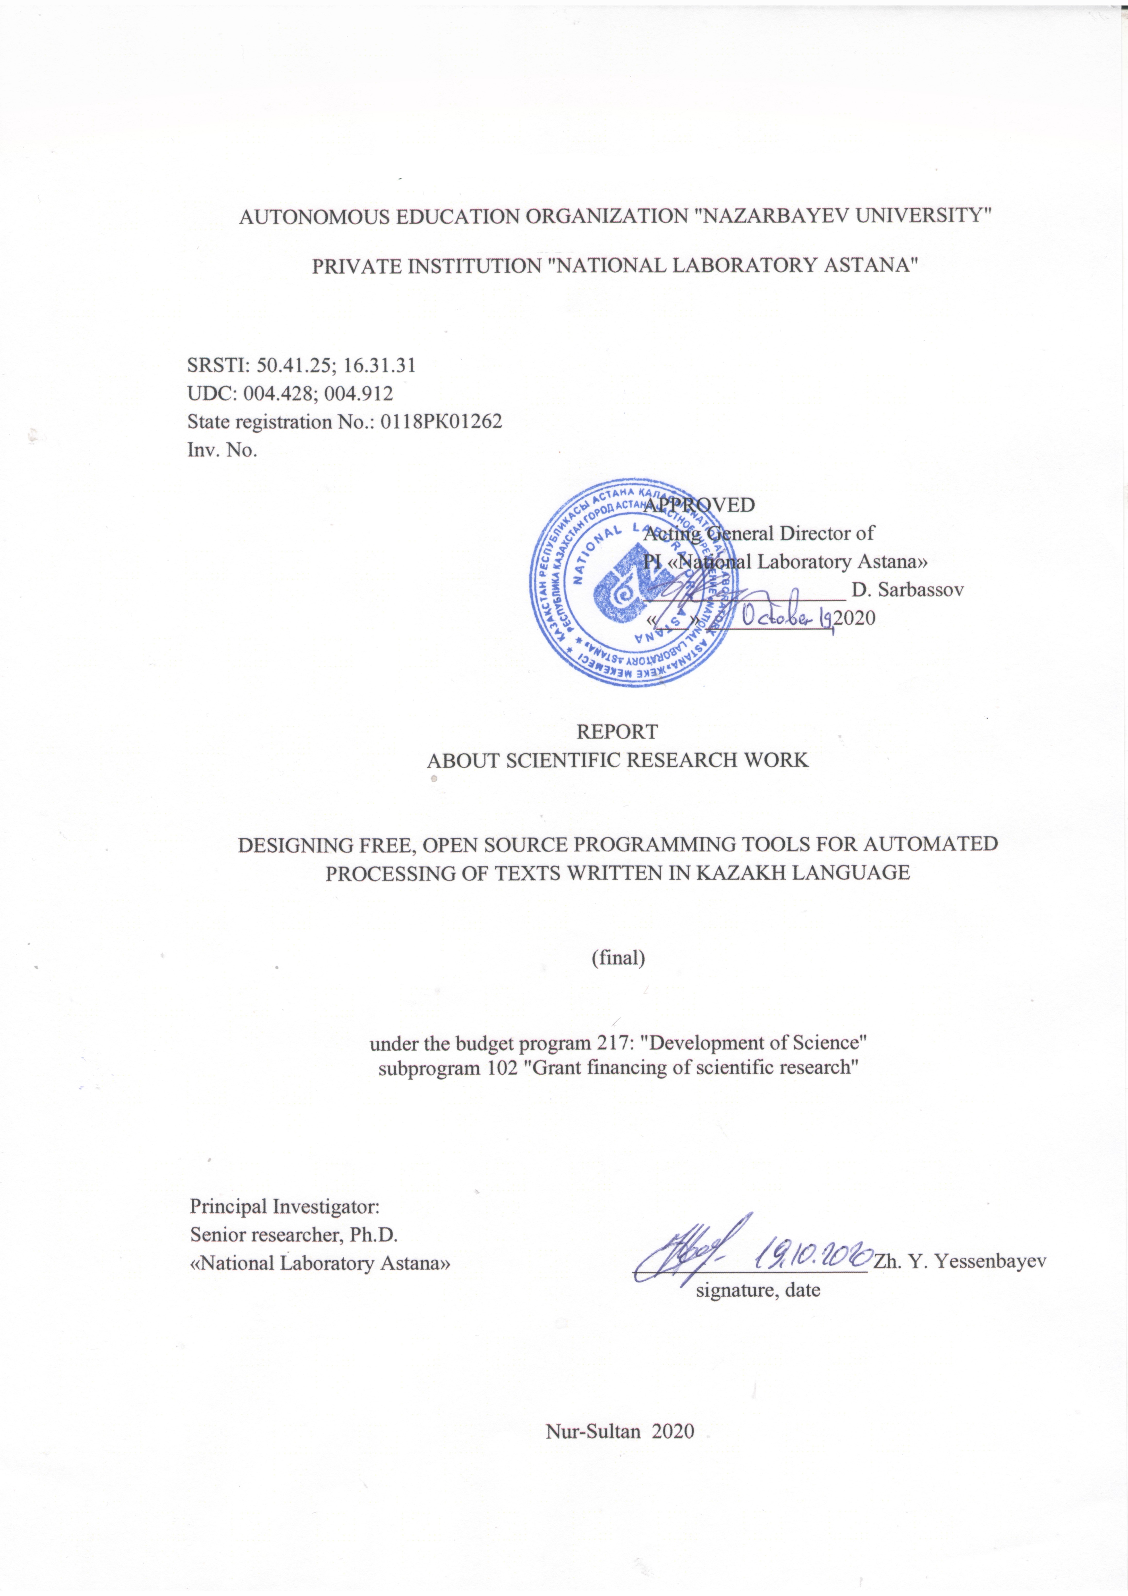
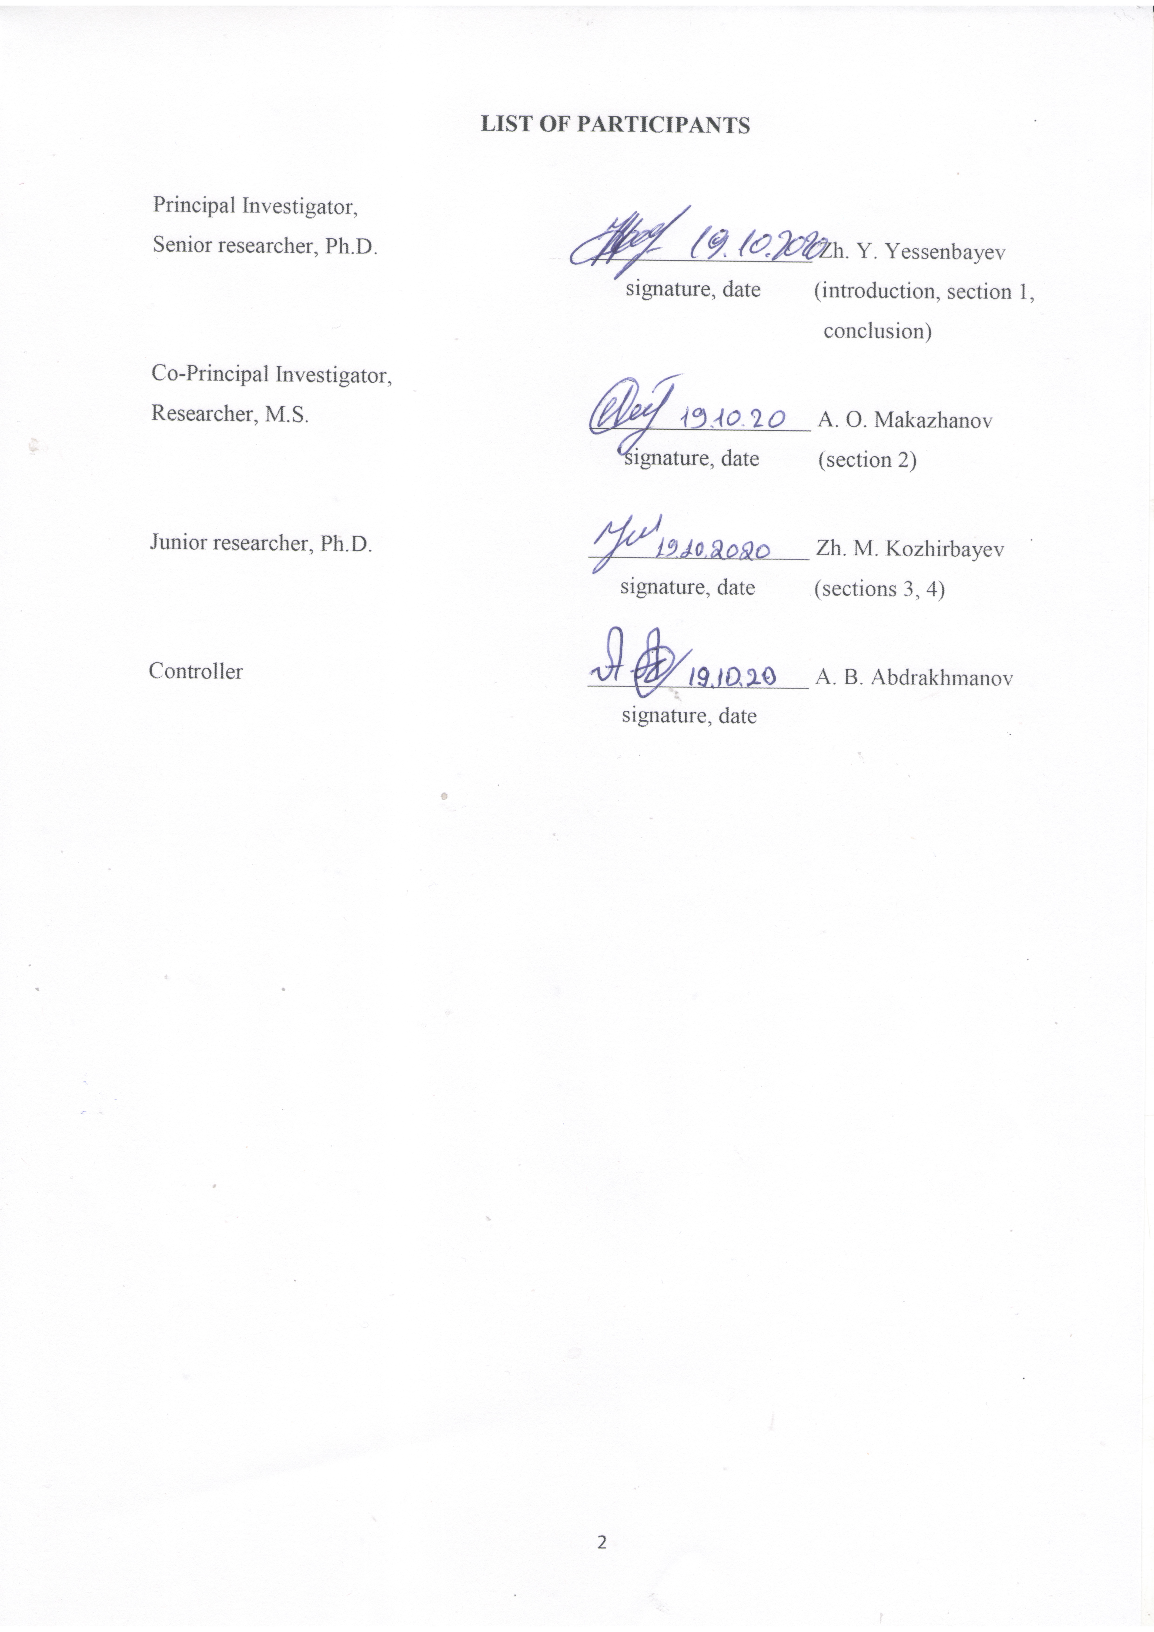
ABSTRACT
Report 99 pages, 13 tables, 4 figures, 94 references, 3 appendices
NATURAL LANGUAGE PROCESSING, ARTIFICIAL NEURAL NETWORKS, MACHINE LEARNING, SYNTAX ANALYSIS, GRAMMAR CORRECTION, NAMED ENTITY RECOGNITION, TEXT NORMALIZATION
The objects of research of this project are text documents in the Kazakh language, as well as modern methods and algorithms for their processing and analysis. The purpose of the project is to create free open source software tools for automatic processing of texts in the Kazakh language. This work uses methods of machine learning, artificial neural networks and statistical processing of textual data, such as naive Bayesian classifiers, hidden Markov models, recurrent neural networks and finite state transducers. The methodology for processing and analyzing data is consistent with the generally accepted practice of conducting research using machine learning approaches.
In this work, text processing studies were carried out in four directions - a syntactic analyzer, grammar correction, named entities recognition and secondary nominalization of texts in the Kazakh language. A syntactic parser was developed based on artificial neural networks, which showed the parsing quality at 88.62% according to the UAS metric. A grammar correction tool was developed. Two approaches were implemented: a basic one based on phonetic rules and an advanced one based on training an ensemble of decision trees. Accuracy was achieved in the range of 75% - 99% (basic) and 87% - 100% (advanced). A tool for named entities recognition based on artificial neural networks LSTM and CRF was developed. The quality of the model in the F1-score was 88%, which is currently comparable to the best performance for this task. A tool for secondary text normalization based on artificial neural networks was developed, which translates real comments of Internet users into grammatically correct text in Kazakh. The translation quality according to the BLEU metric was 29.74.
All software modules developed within the framework of this project are available on the Internet and are provided in the form of codes and demo web services. The developed modules can be applied in any area where automatic processing of texts in the Kazakh language is in demand, for example, for searching and extracting information from text, classifying documents and unstructured web data. The significance of the work lies in the creation and provision of tools for automatic processing of textual data in the Kazakh language to domestic users, as well as in the development of the field of natural language processing.
TABLE OF CONTENT

INTRODUCTION 7
1 Development of the syntactic parser based on artificial neural networks 10
1.1 Task 10
1.2 Existing solutions 11
1.2.1 Graph-based mothods 11
1.2.2 Transition-based methods 11
1.2.3 Neural network-based methods 11
1.3 Methodology 11
1.4 Experiments and results 13
1.4.1 Dataset 13
1.4.2 Metrics 14
1.4.3 Experiments 14
1.5 Short conclusion 15
2 Development of the grammar correction module 16
2.1 Task 16
2.2 Existing solutions 17
2.3 Methodology 18
2.3.1 The basic approach 19
2.3.2 The improved approach 20
2.4 Experiments and results 20
2.4.1 Data collection and preprocessing 20
2.4.2 Experiments 21
2.4.3 Results 21
2.5 Short conclusion 22
3 Development of the named entity recognition module based on artificial neural networks 24
3.1 Task 24
3.2 Existing solutions 24
3.3 Methodology 25
3.3.1 Conditional random fields 25
1.3.2 Long short-term memory neural networks 25
1.3.3 Hybrid LSTM-CRF model 25
3.4 Dataset 26
3.5 Experiments and results 27
3.6 Short conclusion 28
4 Development of the secondary normalization module based on artificial neural networks 29
4.1 Task 29
4.2 Existing solutions 29
4.3 Data collection and annotation 31
4.4 Methodology 33
4.5 Experiments and results 33
4.6 Short conclusion 34
CONCLUSION 36
REFERENCES 38
APPENDIX A Calendar plan for 2018-2020 46
APPENDIX B List of publications in 2018-2020 57
APPENDIX C Copies of the published papers in 2020 59

LIST OF NOTATIONS AND ABBREVIATIONS
In this research report, the following abbreviations and symbols are used.
ATP – Automatic Text Processing
BLEU – A Bilingual Evaluation Understudy
CL – Computational Linguistics
CRF – Conditional Random Field
FST – Finite State Transducer
HMM – Hidden Markov Model
IN – Initial Normalization
IOB – Inside Outside Beginning (labeling)
KL – Kazakh Language
LID – Language Identification
LR – Language Resource
LSTM – Long Short-Term Memory
NB – Naïve Bayes
NLP – Natural Language Processing
NN – Neural Network
NUGT – Noisy User-generated Text
OOV – Out of Vocabulary (words)
POS – Part of Speech
RNN – Recurrent Neural Network
TSS – Token Sentence Segmentation
TTR – Type Token Ratio
UD – Universl Dependencies
UGC – User-generated Content
WNUT – Workshop on Noisy User-generated Text
WSJ – Wall Street Journal

INTRODUCTION
Automatic text processing (ATP) is a discipline engaged in the automation (computer processing) of the analysis and synthesis of text in a natural language (i.e., the language peculiar to humans, and not, for example, animals or computers). Let's clarify the terminology right away. In the Russian-language literature, there are two more terms that are very often used interchangeably with ATP, but they have a slightly different specificity. The first, NLP (natural language processing), is a generalization, since the corresponding discipline deals with the analysis and synthesis of not only text, but also other forms of language, such as speech and sign language. The second term, CL (computational linguistics) is an imprecision, since CL deals with the study of the nature of language by computational methods. In this document, we use the terms ATP and NLP interchangeably, and the term CL defines a subsection of linguistics that uses the methods of statistics, mathematics, and, in fact, the methods of ATP.
The range of tasks that relate to ATP can be briefly described as “text automation”. This includes machine translation, automatic spell checker, and more, including basic skills such as writing, reading, and finally reading comprehension. Despite the huge (theoretically infinite) set of ATP tasks, all of them can be conditionally divided into the following three groups:
- pre-processing - this includes tasks for cleaning and formatting text, for example, initial normalization (cleaning from special characters, encoding errors and other "noise") and graphematic analysis (segmentation of text into sentences, words and other units) ;
- core linguistics processing is the task of analyzing the linguistic properties of the text, for example, automatic lexical, morphological and syntactic analysis;
- application level is the largest group, including both self-sufficient tasks (machine translation, spell checking, etc.) and intermediate tasks (named entity, removing anaphora, etc.).
Today ATP is one of the most actively developing disciplines of computer science (informatics). Some of the leading research groups in these areas are the laboratories of Stanford and Cornell Universities, as well as other universities in the USA, Canada and Great Britain. For many languages ​​(primarily English and Western European languages), both commercial and free software are available in abundance to solve a large number of ATP tasks belonging to all of the above groups. Unfortunately, the situation is different with the Kazakh language (KL).
From the point of view of CL and ATP, KL is of scientific interest as an agglutinative language of the Türkic group with a complex morphology and a relatively free word order. However, ATP tools for this language and, as a consequence, studies of it with modern CL methods are few. This is not surprising, since in order to solve almost any problems of ATP for languages ​​with complex morphology, basic tools are needed, such as a morphological analyzer and a tagger (software that removes morphological ambiguity). For KL, such tools exist, but they are limited either by access [1], or by the complexity of use [2, 3], or by the degree of readiness (“raw”, experimental systems) [4]. In addition, existing systems are poorly documented. The same is the case with other ATP tasks, for example, with parsing, sentiment analysis, etc. Thus, the main motivating factor for the implementation of the project is the urgent need for affordable, easy-to-use, cross-platform and well-documented software tools for ATP on the KL.
As far as we know, on the territory of the Republic of Kazakhstan, systematic research in the areas of CL and ATP for KL is carried out mainly by laboratories of the Eurasian National University (ENU) and Kazakh National Universities (KazNU), the Institute of Information and Computing Technologies, as well as our laboratory at National Laboratory Astana. There are also research groups that occasionally deal with this issue in China [5,6], USA [2], RF [7] and Turkey [1,8]. Both domestic and foreign studies are focused mainly on morphological analysis [1–10] and tagging [1, 3, 4, 11, 12], as well as on the creation of language resources for these tasks (electronic text corpora labeled for morphological features) [5, 6, 13]. There are also systematic studies of the problems of machine translation for KL [12, 14–18]. These studies fall into two groups: (1) using a rule-based approach) [14-16], and (2) using a statistical approach (based on training data) [12, 17, 18]. The former actively use the Apertium platform [19] and the graphematic and morphological analyzers for KL developed within its framework [2], and the latter use the Moses platform [20] and a graphematic analyzer trained on KL data [21]. Of the listed works, only two [2, 3] provide full access to the developed tools and their source code. In this case, the morphological tagger [3] uses the result of the work of the morphological analyzer [2], which adheres to a complex scheme of marking the grammatical properties of the KL, for example, such linguistic concepts as zero-derivation, verb-copula, and indivisible phrases are taken into account. In our opinion, the complexity of the linguistic component is the main reason that this morphological analyzer [2] and a tagger based on it [3] have not received widespread use, especially, in industry.
If we consider the world experience of research in the fields of CL and ATP, then first of all it should be noted the English language, for which the first ATP tools began to appear in the early 90s of the last century. So in 1992, the first automatic tagger (by parts of speech) [22] and a parser [23] appeared for the English language. By the mid-2000s, all the tools that we plan to develop for the KL within the framework of this project, for the English language had already been created [24]. Now they are being actively modernized and used to create more complex intelligent systems. Some of the leading research groups in these areas are the laboratories of Stanford and Cornell Universities, as well as other universities in the USA, Canada and Great Britain. A similar path, but much faster (taking into account the experience of the English language), was passed for the languages ​​of Western Europe, Chinese and (partially) Russian [25] and Turkish [26] languages. We sincerely believe that research in the areas of CL and ATP for KL can and should move in the same direction, and one of the first steps towards this goal will be the implementation of this project.
The goal of the project is to create free open source software tools for automatic text processing in the Kazakh language. The project planned to develop the following tools:
- initial normalization module;
- tokenization module;
- language identification module;
- morphological analyzer;
- morphological tagger;
- syntactic parser;
- spelling and grammar correction module;
- named entity recognition module;
- secondary normalization module.
For the current reporting period, according to the calendar plan for 2020 (see Appendix A), the following software tools were developed:
- a syntactic parser based on artificial neural networks;
- grammar correction module;
- named entity recognition module based on artificial neural networks;
- secondary normalization module based on artificial neural networks.
All of the listed software tools have been fully developed, and the source codes and documentation are available on the Internet under the terms of the Creative Commons Attribution 4.0 license [27], which allows you to use the product for any purpose, including commercial.
The interested reader can find the results of work for previous years in our previous reports. For 2018, a research report was submitted with inventory number 0218RK00199, and for 2019, a research report was submitted with inventory number 0219RK00217.

1 Development of the syntactic parser based on artificial neural networks

1.1 Task
Syntactic arsing is the task of recognizing a sentence and determining its syntactic structure. The word "syntax" comes from the Greek syntaxis, which means "set together or arrangement" and means the way words are related to each other. In practice, these relationships between words are expressed in the form of syntax parse trees, which contain independent linguistic units (words or phrases) and direct dependencies between them, similar to the "ancestor-descendant" analogy. There are two main classes of parse tree construction approaches in the literature. The first approach is based on formalizing the grammar of the language by developing syntactic rules, and the second approach is based on identifying grammatical relationships directly between words. Figure 1.1 shows an example of parsing a sentence in two different ways. In this work, we use the second approach, since it is better suited for languages ​​with free word order in a sentence, and also because formalization and development of syntactic rules for the Kazakh language is not possible within the time frame and resources of this project.

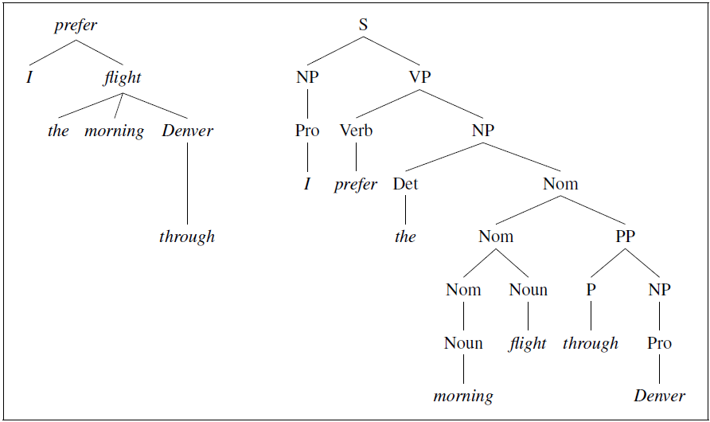
Figure 1.1 – An example of parsing a sentence in English in two different ways

Parse (dependency) trees are directly used in applications such as grammar checking in word processing systems: a sentence that cannot be parsed may have a grammatical error (or at least be hard to read). However, as a rule, parsing trees serve as an important intermediate stage in the presentation of data for semantic analysis and, thus, play an important role in applications such as dialog systems and information extraction systems. For example, to answer the question “Which books were written by British women writers before 1800?” We need to know what the subject of the sentence is “which books” and that the add-on is “British writers” to help us figure out what the user wants a list of books rather than a list of authors [28].
The main difficulty in parsing a sentence is structural ambiguity. Two common types of structural ambiguity are affiliation ambiguity, where a linguistic unit can be related to different “ancestors,” and coordination ambiguity, where different groups of linguistic units can be combined through alliances. Although a person in most cases is able to eliminate these ambiguities without much difficulty, with automatic processing by computers this task may be beyond their power.
Next, we describe the results of work on the development of a syntactic parser (analyzer) based on artificial neural networks.

1.2 Existing solutions

1.2.1 Graph-based mothods
The dependency tree is a task of searching in directed graphs, in particular, finding the best spanning tree. The most common algorithms for finding a dependency tree are algorithms using factorization of arcs and related to parameterization of edge weights. The main disadvantage of these methods is that, for non-projective trees, the worst-case scenario for most methods is O (n³) complexity [29]. However, for non-projective parsing, the Chu-Liu-Edmond algorithm has complexity O (n²). The most common tool that implements this algorithm is the MST parser [30].

1.2.2 Transition-based methods
Transition-based parsing creates a dependency structure, parameterized for the transitions, is used to create a dependency tree. This is closely related to shift-reduction algorithms in rule-based methods. Because of the notion of transition selection in an abstract machine, such algorithms are generally greedy. The advantage of this is that the algorithms have linear time complexity. However, due to greedy algorithms, longer arcs can cause propagation of parsing errors along each hop [31]. The standard tool for branch-based algorithms is the Malt parser [32], which has proven itself to be one of the most efficient systems.

1.2.3 Neural network-based methods
Deep neural networks have performed well in many areas such as POS tagging, named entity recognition, or machine translation. A wave of neural network parsers was recently pioneered by Chen and Manning [33], who introduced a fast and accurate branch-based parser. Many other parser models followed, using various methods such as LSTM networks [34], BiLSTM-based approaches with biaffin classifiers [35], global normalization [36] or recurrent neural network grammars [37].

1.3 Methodology
In our work, we use a BiLSTM-based artificial neural network model with biaffin classifiers proposed in [35]. The system using this model [38] showed the highest performance among other systems in the CoNLL 2018 UD Shared Task competition, in which it was necessary to develop a syntactic parser for more than 50 languages. It is worth noting here that in reality this model can be attributed to neuro-graph methods, which, in fact, are based on graph methods, but use neural networks to estimate the weights of edges or other classification.
As you know, graph-based methods, for a given sentence, search in space for possible parse trees that maximize some estimate. These methods encode the search space as directed graphs. More formally, given a sentence S, we are looking for the best parse tree (dependencies) T* in G_{S}, the space of all possible trees for this sentence is a complete graph that maximizes some estimate:

$T^{*}=\underset{T∈G_{S}}{argmax}{\{score(T,S)\}},$ (1.1)

where the total tree estimate is calculated as the sum of the weights of its edges:

$score\left(T,S\right)=\sum_{e∈T}{weight\left(e\right).}$ (1.2)

Based on the above, the task of parsing is reduced to solving the following subtasks:
- assigning weights to trees in G_{S};
- search for the maximum spanning tree.
In this approach, the proposed model based on artificial neural networks performs the task of assigning weights to edges and estimating the total weight of each parse tree. In more detail, this neural network can be represented as shown in Figure 1.2.
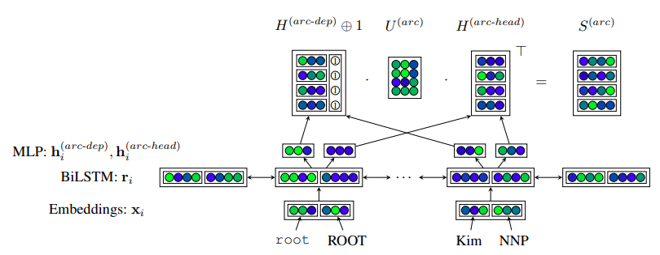
Figure 1.2 – Architecture of the neural network
Here, word embeddings are used as the network input, i.e. each word is represented as a numerical vector of fixed dimension x_{i}. In turn, this vector is converted into a new vector r_{i} using the BiLSTM bidirectional recurrent network. Then the vector r_{i} undergoes a series of transformations:

$h_{i}^{arc-dep}={MLP}^{arc-dep}(r_{i})$ (1.3)

$h_{j}^{arc-head}={MLP}^{arc-head}(r_{j})$ (1.4)

$s_{i}^{arc}=H^{arc-dep}U^{(1)}h_{i}^{arc-dep}+H^{arc-head}u^{(2)}h_{j}^{arc-head}$ (1.5)

As with other graph-based models, a predicted tree during training is a tree in which each word depends on its highest-scored head. During testing, it is checked that the parsing is a well-formed tree using the MST algorithm [29, 30].

1.4 Experiments and results

1.4.1 Dataset
To create automatic text processing systems, special text databases or corpuses are used, which can contain various types of linguistic information and metadata designed to solve a particular problem. Since we are solving the problem of developing a syntactic parser, then we used and expanded the corpus in [39, 40], which contains the necessary morphological and syntactic information and is part of the international project Universal Dependency. The statistics of the datasets are shown in Table 1.1. Note also that to create mathematical models, all data were randomly divided into training and test sets in a ratio of 80:20.
Table 1.1 – Statistics of the datasets
Metric | Extended | Basic
Number of sentence | 61111 | 1078
Number of syntactic links | 47 | 47
Number of words | 934731 | 10536
Number of POS tags | 17 | 17
Number of pairs Category=value | 31 | 31

Data in the UD_Kazakh-KTB corpus corresponds to the CoNLL-U format and is encoded as UTF-8 text files. Sentences consist of one or more lines of words, and lines of words contain the following fields:
ID: word index, an integer starting with 1 for each new sentence;
FORM: word form or punctuation character;
LEMMA: lemma or word stem;
UPOS: part of speech, according to the universal system.
XPOS: part of speech specific to a particular language;
FEATS: List of morphological features from a universal feature list or from a specific language extension;
HEAD: The ancestor of the current word, which is either an ID value or zero (0).
DEPREL: generic dependency relation to HEAD (root if HEAD = 0) or a specific subtype for a specific language.
DEPS: improved dependency graph as a list of HEAD-DEPREL pairs.
MISC: any other annotation.
An example of one sentence and its annotations contained in the UD_Kazakh-KTB corpus:
# text = ІТ-саласындағы ілгерілеу жолдары талқыланды
1 ІТ-саласындағы іт-саласындағы ADJ ADJ _ 2 amod _ _
2 ілгерілеу ілгеріле VERB VERB vbType=Ger 3 acl-poss _ _
3 жолдары жол NOUN NOUN Number=Pl|Poss=3 4 nsubj _ _
4 талқыланды талқыла VERB VERB Person=3|vbTense=Pst|vbVcPass=True 0 root _ _
Additionally, for word embeddings needed to train the neural network, we used Facebook's corpus of pretrained word vectors for 157 languages, trained in Common Crawl and Wikipedia using fastText [41]. These models were trained using CBOW with positional weights in dimension 300, symbolic n-grams of length 5, window size 5, and 10 negatives.

1.4.2 Metrics
As a metric for assessing the quality of algorithms for automatic construction of parse trees, two standard metrics are used - labeled attachment score (LAS) and unlabeled attachment score (UAS) [42]. UAS examines the structure of the dependency tree and evaluates the correctness of the output of the link / arc "ancestor" and "child". In addition to UAS, LAS also measures the accuracy of the dependency labels on each arc. A third but less common metric is used to assess the percentage of sentences that are absolutely correct in terms of their LAS score. This metric is best used to evaluate how the dependency parser will affect other NLP tools that use the output of the dependency parser [43]. In our work, we will use the UAS metric, since we only focus on the syntactic structure of sentences.

1.4.3 Experiments
We have developed a system for automatic syntax analysis of Kazakh texts based on the above-described neural network model using the Stanza package [44]. Next, we conducted preliminary experiments in which we compared our previously developed statistical graph-based parser, the standard UDPipe 2.0 parser [45], and also compared various models based on the Stanza package, including the base and retrained systems of [38], and our system. The difference between the two systems of [38] is that the base system uses fastText as word embedding, and the retrained system uses Facebook. The results of the work of these parsers are shown in Table 1.2 (in brackets you can see which features were taken into account in the model).
As you can see from Table 1.2, the highest accuracy was obtained using our data and Facebook vectors. This is a fairly logical result for models based on neural networks, which show better accuracy with a large amount of data. Also, our system has surpassed the result of the popular UDPipe package, which is also very remarkable.
Table 1.2 – Results of the experiments
Systems | UAS
Statistical graph-based parser (POS tags  + morphological features of a child  + distance between head and child) | 61.08
UDPipe 2.0 | 87.90
Baseline system [38] (basic UD_Kazakh-KTB+fastText) | 44.33
Retrained system [38] (basic UD_Kazakh-KTB + Facebook) | 70.70
Our system (extended UD_Kazakh-KTB + Facebook) | 88.62

1.5 Short conclusion
In this work, we have trained a syntactic parser based on artificial neural networks, implemented in the Stanza package. To train the model, we used our own corpus with syntactic markup. In addition, we used Facebook's text corpus to create a vector representation of words. As a result of training, a high quality model was obtained, exceeding the quality of the popular UDPipe tool, as well as the original base system in Stanza.

2 Development of the grammar correction module

2.1 Task
The task of grammar correction is to find words or phrases that meet the spelling norms, but violate various aspects of the grammar of the language. For example, the sentence “Гости разошёлся” (Rus. “Guests has dispersed”) lacks subject-verb agreement and violates the syntax of the Russian language, although each word taken by itself does not contain spelling errors. Also, lexical (incorrect use of words, for example, " тарелка лежит на столе" – Rus. the plate is “lying on the table” – should be “standing” in Russian) and phonetic (violation of sound combinations, for example, “келдің ба?" – Kaz. “have you come?” – should be “келдің бе?”) norms may be violated.
The problem of grammatical error correction is most relevant for languages with a large number of non-native speakers. Thus, some of the first works to check the correctness of the use of articles and prepositions in English have appeared since the mid-90s of the last century [46–48] and were motivated by the need to post-edit documents written by non-native speakers or obtained by machine translation. These and other early works tended to distinguish between various aspects of grammatical errors, for example, detecting errors in choice of articles and in choice of prepositions were treated separately as sub-problems. This approach did not require a large amount of data to build models, since it relied mainly on either checking the violation of a limited set of rules, or on training statistical models with a small number of parameters. Later, the annotation of errors [49-51] in large collections of written works of non-native speakers studying English made it possible to apply the noisy channel [52-54] and encoding-decoding [55, 56] models used in statistical and neural machine translation. respectively. A distinctive feature of these models is their versatility, since it suffices to train a single model to correct all types of errors up in the training set.
For the Kazakh language, the problem of correcting written works by non-native speakers is much more modest than for English, due to the small number of people learning the language outside the school course. Therefore, as an independent task, collecting and marking up a fairly large corpus of "natural" errors of non-native speakers does not make much sense. This, in turn, limits the use of advanced, machine translation-based approaches to the task that require such corpora. On the other hand, the problem of editing translations (both machine- and human-produced) is relevant for the Kazakh language. It is no secret that a large number of documents and news releases in the Kazakh language are translations from Russian. It is not uncommon for such translations to be made according to templates, when in similar documents only certain parts are changed, and the rest are copied. This often leads to errors, for example, if, given a sentence like “Жиналысқа фирма жетекшісінің орынбасары да қатысты” (“The meeting was also attended by the deputy head of the company”), we replaced “deputy head of the company” with “head of the company”, without changing the rest of the text, we would get the following sentence “Жиналысқа фирма жетекшісі да қатысты", in which the grammatical particle "да" now violates the phonetic rules of the language. In the modified sentence, the word before the particle "да" ends in a front vowel "i", which requires the use of the corresponding soft form of the particle, i.e. "де". In total, there are 20 such phonetically dependent particles and conjunctions in the Kazakh language and they are grouped as follows: question particles «ба, бе, ма, ме, па, пе»; conjunctions «бен(ен), мен(ен), пен(ен)»; conjunction particles «да, де, та, те»; particles «ғана, қана»; particles «ғой, қой».
Errors associated with these function words turned out to be fairly common. Thus, in the process of preparing experimental data on a sample of 96200 news articles collected from 15 websites, we found 1838 such errors (about one error per 52 articles). Detailed statistics on collected errors are given in Table 2.1.
Table 2.1 - Statistics on the detected grammatical errors
Conjunction/particle | Errors count | % of the total | Example error
бен(ен), мен(ен), пен(ен) | 1280 | 69.6 | «қоры пен»
ба, бе, ма, ме, па, пе | 200 | 10.9 | «кедей ма»
да, де, та, те | 185 | 10.0 | «өзге да»
ғана, қана | 172 | 9.4 | «спорт ғана»
ғой, қой | 1 | 0.1 | «керек ғой»
Total | 1838 | – | –

The grammar correction module developed by us automatically finds cases of incorrect use of phonetically dependent conjunctions and particles and suggests a possible replacement. We use two approaches. The basic approach is based on the application of the phonetic rules of the Kazakh language, compactly formulated in the form of regular expressions. The improved approach is based on training an ensemble of decision trees (Random Forrest [57]) using the result of applying the above rules as one of the features.

2.2 Existing solutions
Early approaches to solving the problem of grammar correction were based on the application of machine learning algorithms to correct specific types of errors, for example, incorrectly used articles and / or prepositions. The success of such methods largely depended on a set of features designed for the task. Thus, Knight and Chander [46] used a binary vector to encode up to 30,000 lexical features (for example, such as “the word triple is in front of the article”), automatically extracted from more than 400 000 noun phrases. The decision tree algorithm trained on this data achieved 81% accuracy in determining the article. For the same problem, Han and Leacock [47] used a maximum entropy classifier (multi-nominal logistic regression). The authors use various combinations of word forms and parts of speech of the noun phrase as features, obtaining 83% accuracy for the best combination of features. In a similar work, Felice and Pulman [48], using the same machine learning algorithm, but with a broader set of features, achieved 92% accuracy in article correction and 70% accuracy in preposition correction.
With the advent of large corpora marked for grammatical errors [49–51], an approach based on machine translation has been actively applied to the problem of grammar correction. The essence of this approach is that the model learns to "translate" sentences with errors into sentences without errors. This eliminates the need to select features and train different models for different types of errors, as is done in the above-described classification-based approaches. The first works in this direction were carried out in the paradigm of statistical machine translation [58] using a translation model, a language model and a decoder as components of the system. At the same time, improving the performance of one or more components potentially improves the performance of the entire system. Dahlmeier and Ng [52] improved the decoder, equipping it with additional learning weights for the most common types of errors: articles and prepositions. This allowed to raise the F-metric of this model by 14% relative to the standard model. In another work, the authors of the AMU grammar correction system [53] improved all system components by providing the translation model and the language model with additional data, and making the process of adjusting weights more suitable for the problem of grammar correction than for translation. As a result, the absolute increase in the F-metric in relation to the standard model was almost 10% (from 25.4% to 35%).

2.3 Methodology
The choice of a suitable phonetically dependent particle/conjunction in the Kazakh language depends on the phonetic properties of the last syllable. Let us analyze this dependence on the example of a pair of interrogative particles "ма, ме". If the last syllable of the previous word ends with a vowel from the set {аоұыэяу}, then "ма" is used. The same particle is used if the last syllable contains a vowel from the same set, but ends in a consonant from the set {йлрую}. The particle "ме" is used in the same way, but with a vowel from the set {йлрую}. Thus, the vowel in a particle is determined by the vowel of the last syllable of the previous word, and the consonant by the consonant found in the last syllable. Such rules can be written in the form of regular expressions, which then can be used to match in the previous word. For example, in Python the regexp for "ма" can be constructed as:
«[аоұыэя][ую]*$|[аоұыэяу][^аоұыэяуәөүіеёию]*[йлрую]$|^[^аоұыэяуәөүіеёию]*[йлрую]$».
When such an expression is applied to the words "бұқа", "бай" and "ҚР", it will match the substrings "а", "ай", "ҚР", respectively. This means that "ма" can be used after these words. However, in the word "кеме", this expression does not match any substring, i.e. “ма” cannot be used after this word.
Table 2.2 lists the phonetic rules we use and the corresponding regular expressions; here, for the sake of compactness, some sets of sounds are designated as follows: C1 = {йлмнңр}, C2 = {бвгғдкқпстфхцчшщ}, V0 = {аоұыэяәөүіеёи}, V1 = {аоұыэяу}, V2 = {әөүіеёию}.
Table 2.2 – The rules governing usage of the phonetically dependent particles/conjunctions
Part./conj. | Vowel | Consonant | Regular expression
бен(ен) | {жз} | V0 | [V0][^V0ую]*[жз]$|^[^V0]*[жз]$
мен(ен) | C1 | V0 | [V0][ую]*$|[V0][^V0ую]*[C1ую]$|^[^V0ую]*[C1ую]$
пен(ен) | C2 | V0 | [V0][^V0ую]*[C2]$|^[^V0]*[C2]$
ба | {жзмнң} | V1 | [V1][^V0ую]*[жзмнң]$|^[^V0ую]*[жзмнң]$
бе | {жзмнң} | V2 | [V2][^V0ую]*[жзмнң]$|^[^V0ую]*[жзмнң]$
ма | {йлрую} | V1 | [V1][ую]*$|[V1][^V0ую]*[йлрую]$|^[^V0ую]*[йлрую]$
ме | {йлрую} | V2 | [V2][ую]*$|[V2][^V0ую]*[йлрую]$|^[^V0ую]*[йлрую]$
па | C2 | V1 | [V1][^V0ую]*[C2]$|^[^V0ую]*[C2]$
пе | C2 | V2 | [V2][^V0ую]*[C2]$|^[^V0ую]*[C2]$
да | {C1жзую} | V1 | [V1][ую]*$|[V1][^V0ую]*[C1жзую]$|^[^V0ую]*[C1жзую]$
де | {C1жзую} | V2 | [V2][ую]*$|[V2][^V0ую]*[C1жзую]$|^[^V0ую]*[C1жзую]$
та | C2 | V1 | [V1][^V0ую]*[C2]$|^[^V0ую]*[C2]$
те | C2 | V2 | [V2][^V0ую]*[C2]$|^[^V0ую]*[C2]$
ғана | {C1жзую} | V0 | [V0][ую]*$|[V0][^V0ую]*[C1жзую]$|^[^V0ую]*[C1жзую]$
қана | C2 | V0 | [V0][^V0ую]*[C2]$|^[^V0ую]*[C2]$

2.3.1 The basic approach
In the basic approach, we rely solely on regular expressions. The algorithm here is extremely simple: if the current token (a word-numeric string or a single character that is neither a letter nor a number) of the input is one of the particles/conjunctions, the corresponding regular expression is applied to the previous word-numeric string (punctuation and other characters are skipped). The particle/conjunction is considered to be used correctly, if there is a match and incorrectly otherwise.
The disadvantage of this approach is the impossibility of handling exceptions. For example, in the case of proper names such as “Тур де Франс” (Tour de France) or “Хусейн бен Талал” (Hussein bin Talal), this method will count as an error. Since in the above examples the words "де" and "бен" are not particles/conjunctions of the Kazakh language, but only coincide with them in form, they should be ignored. Numbers are another exception, for example, in the sentence “17 ғана қалды” (“there are only 17 left”) the particle “ғана” is used correctly, but the basic approach will consider such usage wrong.

2.3.2 The improved approach
To eliminate the shortcomings of the basic approach, we use the Random Forrest machine learning algorithm [57], implemented in the scikit-learn library [59] for the Python language. For classification, we use the following five features:
- which symbol out of the following does the previous word ends with: soft/hard sign, dot (abbreviation) or the Latin (English) alphabet letter;
- case of the previous word: all caps, capitalized (first letter), lower case;
- does the corresponding regular expression match the previous word;
- are there any non-alphanumeric characters between the previous word and the particle/conjunction;
- case of the previous word: all caps, capitalized (first letter), lower case, no case (if non-alphanumeric character).
Additionally, if the previous word is a number in a character notation, we “write it down in words” before extracting the features, i.e. in the example "17 ғана қалды" the signs are extracted from the word "жеті" (seven), since it will be preceding "ғана".

2.4 Experiments and results

2.4.1 Data collection and preprocessing
We used a sample of 96,200 news articles collected from 15 websites as our data source. Each occurrence of any of the particle/conjunction (together with five words/symbols/numbers on the left and right) was saved in the dataset of the corresponding group of particles/conjunctions, for example, the occurrence of the particle "ба" was saved into the set "ба, бе, ма, ме, па, пе". After that, repetitions were removed and with the basic approach (rule-based method) each particle/conjunction was checked for phonetic consistency as described in the previous subsection. All cases marked as an error were rechecked by us and marked as correct if the method was inaccurate. For example, “де” in “Тур де Франс” was recognized as a phonetically inconsistent particle, and since “de” in this context is not a Kazakh word at all, the example was relabeled by us as correct. In this way negative and positive teaching examples were reliably identified for each group of particles/ conjunctions. Since there were much more positive (when everything was consistent) training examples in each dataset, we reduced their number by randomly selecting and removing as many positive training examples as was required for the negative examples to account for one fourth of the data set. Detailed statistics for the resulting datasets are shown in table 2.3.
Table 2.3 – Datasets
Particle/conjunction | Training examples
Particle/conjunction | Positive | Negative | Total
бен(ен), мен(ен), пен(ен) | 3279 | 1093 | 4372
ба, бе, ма, ме, па, пе | 584 | 196 | 780
да, де, та, те | 486 | 162 | 648
ғана, қана | 438 | 146 | 584

2.4.2 Experiments
We apply both of our approaches to each set of particles/ conjunctions data separately. In other words, four experiments are performed for each approach. For the improved approach, a 10-fold cross validation is performed where a dataset is randomly divided into ten parts, nine of which are used for training and one for evaluation. The evaluation is carried out for each of the ten parts with averaging of the final result. We use the following metrics as estimates: error precision (P) - the percentage of examples correctly identified as an error; error recall (R) - percentage of correctly identified errors; F-metric of error (error F-score) - harmonic mean of P and R; overall accuracy is the percentage of correctly recognized examples (both positive and negative).

2.4.3 Results
Table 2.4 contains the results of evaluating the basic approach. As can be seen from the table, this method achieves the best results with values of 98-99% across all metrics when working with the “ба, бе, ма, ме, па, пе” particles. Also, a fairly high accuracy of 96.7% is achieved when correcting the "ғана, қана" particles, but at the same time the sensitivity to errors is lower and amounts to 89.4%, that is, approximately in one case out of ten this method erroneously evaluates the correctly used particle wrong. This indicator turns out to be even lower for the "бен(ен), мен(ен), пен(ен)" conjunctions and the "да, де, та, те" particles - and 49.9% and 49.4%, respectively. This is for a reason, which has already been mentioned several times, when parts of proper names such as "Tour de France" and "Hussein bin Talal" are mistaken for an incorrectly used conjunction/particle.
Table 2.4 – The basic approach results
Particle/conjunction | Error precision, % | Error recall, % | Error F1, % | Accuracy, %
бен(ен), мен(ен), пен(ен) | 49.9 | 100.0 | 66.6 | 74.9
ба, бе, ма, ме, па, пе | 98.0 | 99.0 | 98.5 | 99.2
да, де, та, те | 49.4 | 100.0 | 66.1 | 74.4
ғана, қана | 89.4 | 98.6 | 93.8 | 96.7

It is for the recognition of such cases in the training model of our improved approach that we included the signs encoding the case of letters of the previous and subsequent words. The results of the improved approach are shown in table 2.5.
Table 2.5 – The improved approach results
Particle/conjunction | Error precision, % | Error recall, % | Error F1, % | Accuracy, %
бен(ен), мен(ен), пен(ен) | 89.9 | 97.5 | 92.6 | 90.6
ба, бе, ма, ме, па, пе | 99.5 | 100.0 | 99.8 | 99.9
да, де, та, те | 92.0 | 54.4 | 67.9 | 87.2
ғана, қана | 100.0 | 100.0 | 100.0 | 100.0

To begin with, we note that looking at the results, we can say that this approach lived up to its name and improved the basic approach, improving the latter's performance for all metrics in all particle/conjunction categories, with the exception of error coverage in the “бен(ен), мен(ен), пен(ен)" and "да, де, та, те". Nevertheless, even the excellent results of the basic approach for the particles "ба, бе, ма, ме, па, пе" were improved on average by 1%, and for the particles "ғана, қана" an ideal result was achieved in all metrics. However, the most interesting are the results achieved when working with "hard" particles/conjunctions.
Indeed, when correcting the conjunctions " бен(ен), мен(ен), пен(ен)" and particles " да, де, та, те ", with which the basic method had great difficulties, the improved method achieves acceptable sensitivity indicators (89.9% and 92.0%, respectively), and also provides an increase in overall accuracy by 15.5% and 12.8% (in absolute terms). Nevertheless, the situation with the error coverage for particles “да, де, та, те” is worse, since only a little more than half (54.4%) of cases of incorrect use of these particles are recognized by this method as errors. This fact may indicate that the feature that checks the observance of phonetic rules is the strongest predictor of the erroneous use of particles, and the additional contextual features we added to the improved model, such as the case of letters of adjacent words, are deterring factors that provide high sensitivity. Unfortunately, in many machine learning tasks, low coverage is usually the price to pay for high sensitivity. Note also that a trivial way to provide 100% coverage for any value of the dependent variable is to assign this value to all examples in the control sample. In other words, if we wanted to provide perfect error coverage, we could not resort to any machine learning methods or rule checking, but simply consider all the particles/conjunctions.

2.5 Short conclusion
We have developed a module for correcting the grammar of the Kazakh language. The task of grammar correction was set as a check of language constructions, for compliance with phonetic rules. In particular, we have considered four groups of phonetically dependent conjunctions of particles: interrogative particles "ба, бе, ма, ме, па, пе"; conjunctions "бен(ен), мен(ен), пен(ен)"; particle-conjunctions “да, де, та, те”; particles "ғана, қана".
To solve the problem, two approaches were implemented. The basic approach is based on the application of the phonetic rules of the Kazakh language, compactly formulated in the form of regular expressions. The improved approach is based on training an ensemble of decision trees using the result of the basic approach as one of the features. Experimental results have shown that these approaches complement each other. Although the basic approach finds 98% to 100% errors (high coverage), it also considers more than half of all correct cases to be wrong. The improved approach, on the contrary, can miss up to 45% of errors, but produces no more than 10% of false negatives. In terms of overall accuracy (the proportion of correctly identified cases, both erroneous and correct), the approaches achieve results in the range of 75% - 99% (basic) and 87% - 100% (improved).

3 Development of the named entity recognition module based on artificial neural networks

3.1 Task
Over the past decade, tremendous progress has been made in natural language processing with the advent of machine learning approaches and the availability of computational resources to store and process huge amounts of data. If most of the unstructured textual data available not only from traditional media, but also from social networks can be structured, this would make it possible to gain rich knowledge from the collected data. The named entity recognition is a major challenge for providing important information from semi-structured and unstructured text sources.
This work will present one of the well-known solutions to the problem of recognition of named objects for the Kazakh language using conditional random fields (CRF). We also used a hybrid approach combining the bidirectional LSTM model and the CRF model. The hybrid approach was applied to the vector representation of words.
For experiments, a corpus was built with tags such as location, organization, names and others. This task is due to the objectives of the project to develop tools for processing text in the Kazakh language, of which this work is a part. There is no doubt that there is no novelty in the approach, but that was not the goal. The goal is to experiment with methods based on statistical and neural network approaches and test how they deal with agglutinative Kazakh language.

3.2 Existing solutions
The history of the NER task begins with the Sixth Conference on Message Understanding (MUC-6) in 1996 [60], where tasks were focused on information extraction. In the process of setting goals, it looked like a separate task when extracting objects from documents. To define an entity, the term named entity was coined and the task was named as named entity recognition. Previous research on the extraction of information from unstructured texts was conducted to determine the significance of "pieces of information" such as the names of people, organizations, locations, and numeric expressions such as time, date, money, and percentages.
There are several research done on NER for many other languages. For a thorough overview of the work on NER, the reader is encouraged to refer to the recent review by [61].
This section is limited to a brief overview of research on NER for the Kazakh language [62, 63]. In a previous paper, the authors argue that their CRF-based model and features derived from the results of the morphological analysis approach significantly improve system performance from 69.91% to 89.81% in F1. They built a dataset for NER that consists of 18054 sentences. In a later work, the authors applied neural network methods on their corpus.

3.3 Methodology
This section provides a brief overview of the methods that were applied to the corpus in this task. CRF and LSTM were chosen as the primary approach for defining the named entities represented in the proposal.

3.3.1 Conditional random fields
Conditional random fields (CRF), a discriminatory probabilistic model, are most often used to solve the tagging and segmentation problems of sequences [64]. Since CRF is a supervised machine learning algorithm, it requires a training sample of sufficient size to train it. CRF can be context sensitive; for example, a linear chained CRF can predict label sequences for input data sequences, while a discrete classifier predicts labels for only one sample. The formula below is for CRF where y is the output variable and X is the input sequence:

$p\left(y | X, λ\right)= \frac{1}{Z\left(X\right)}exp\sum_{i=1}^{n}{\sum_{j}{λ_{j}}}f_{i}(X, i, y_{i-1},y_{i})$ (3.1)

The sequence of output samples is modeled as the normalized product of the function.

1.3.2 Long short-term memory neural networks
Another important strategy for building a high-performance deep learning method is to understand what type of neural network is best for solving the NER problem, given that text is a sequential data format. However, not every type of LSTM can handle this task, since using a standard LSTM will only take into account the "past" information in the text sequence. We need to use bidirectional LSTMs for NER as the context covers sequential and future labels in sequence. A bidirectional LSTM is a combination of two LSTMs, one moving forward "from right to left" and the other backward "from left to right" [65].

1.3.3 Hybrid LSTM-CRF model
Given an input sequence $x$= ($x_{1}, … , x_{m}$), that is, the words of the sentence and the sequence of output states $s$= ($s, … , s_{m}$), that is, tags of the named object. In conditional random fields, we have modeled the conditional probability that the output sequence of states gives the input sequence:

$p\left(s_{1}, . . ., s_{m}\right|x_{1}, . . .,x_{m})$ (3.2)

We did this by defining a feature map that covers the entire input sequence $x$ paired with the complete sequence of states $s$ into some $d-$dimensional feature vector:

$Φ\left(x_{1},…,x_{m},s_{1},…,s_{m}\right)∈$ $R^{d}$ (3.3)
Then we can model the probability as a log-linear model with a vector of parameters $w∈$ $R^{d}$ as:

$p\left(s | x;w\right)= \frac{exp(w* Φ(x, s))}{\sum_{s^{'}}{exp(w* Φ(x, s^{'}))}}$ , (3.4)

where, $s^{'}$ covers all possible output sequences. The expression $w* Φ(x, s)$ = ${score }_{crf}(x, s)$ can be considered as an estimate of how well a sequence of states matches a given input sequence. The idea is to replace the linear scoring function with a nonlinear neural network. We define $score$ as:

${score }_{lstm-crf}\left(x, s\right)= \sum_{i=0}^{n}{W_{{s_{i-1, }s}_{i }}*{LSTM\left(x\right)}_{i}+b_{{s_{i-1, }s}_{i }}}$, (3.5)

where $W_{{s_{i-1, }s}_{i }}$ and $b$ are the weight vector and displacement corresponding to the transition from $s_{i-1 }$ to $s_{i}$, respectively. After constructing this scoring function, we can optimize the conditional probability $p\left(s | x;W,b\right)$, as in a normal CRF, and propagate it back [66].

3.4 Dataset
The dataset is collected from the kazdet corpus: NLA-NU Kazakh Bank of Dependency Trees [67], which is annotated for lemma, part of speech, morphology and dependency relations in accordance with Universal Dependency 2 and is stored in the UD-native CoNLL-U format. As of December 2018, the bank contains ~ 61 thousand sentences and ~ 934.7 thousand tokens. It is a fairly large corpus with many annotations. However, there are no annotations for the task of recognizing named entities. 29629 sentences were extracted from the kazdet corpus, which contain at least one proper noun containing only part of speech tags. After that, a corpus (kazNER) was created for the NER problem.
Since IOB tags have become the standard way of representing chunk structures in files, the kazNER corpus is in this format. The IOB tag format contains tags of the form: B - {TAG_TYPE} - for a word in the initial segment; I - {TAG_TYPE} - for words inside a segment; O - outside any segment.
IOB tags are further classified into the following classes: LOC = Location of the object; ORG = Organization; PER = Person's name; OTH = any other named entity such as pet name, book title, etc. Figure 3.1 shows the distribution of words by tags with the O tag (outside of any fragment) and without it.

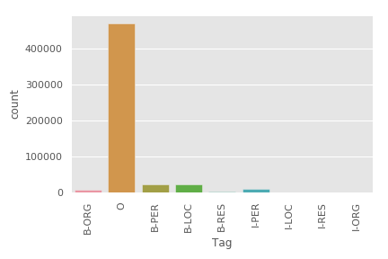 | 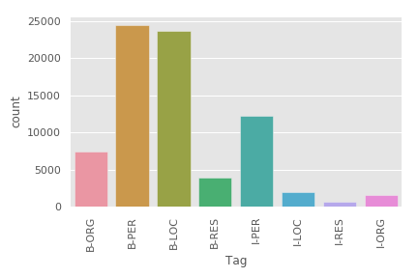
Figure 3.1 – Distribution of words by tags with (left) and without (right) tag O

3.5 Experiments and results
In order to use the techniques mentioned in the Methodology section, one must provide a set of features for correct tag recognition. The CRF method takes into account the context, an approximate set of features such as uppercase letters, word type (title, line, number), word length, alphabet characters will be presented to build these models. Sklearn-crfsuite [59] allows extracting features of a word as a dictionary ready for use with the model: current words, previous words, next words, current POS tags, previous and next POS tags
The Stanford NLP team applied these features when using CRF for the NER problem [68]. Signs such as uppercase letter, lower letter, digit have been extracted for the current, previous and next word. In addition to the recommended ones, features such as istitle, iscamelcase, isabbv, has_hyphen have been added to the set. The CRF model uses the LGBFS (Gradient Descent Using L-BFGS) algorithm with an ordered elastic net (C1 + C2). The elastic regularization grid values ​can be tuned ​to test their impact on performance. Initially, initial values ​​were chosen as C1 = 0.1 and C2 = 0.1 for the CRF model (CRF1). Then the parameters were adjusted as C1 = 10 and C2 = 0.1 (CRF2). The third experiment (CRF3) used Randomized CV Search, which is an exhaustive grid search of all parameter combinations.
In a hybrid approach that combines the bidirectional LSTM model and the CRF model, we match sentences to a sequence of numbers and then augment the sequence. Note that we have increased the word index by one to use zero as the padding value. This is because we want to use the mask_zero parameter of the embedding layer to ignore inputs with a value of zero. The model is trained using a backpropagation algorithm. Parameter optimization is done with rmsprop. The hyperparameters are selected based on the performance of the development dataset.
The f1 metric will be used to evaluate the performance of the model, as precision is not a good metric for an unbalanced kazNER dataset.
Table 3.1 shows that the CRF classifier performs excellently. After optimization, it can be seen that lower elastic network regularization values (C1 + C2) lead to the best model performance - especially for C1. The cross-validated randomized search model shows a decent f1 with 0.95 overall without the "O" tag.
Table 3.1 – F1-score on the test set of models for the NER problem
Model | B-PER | I-PER | B-LOC | I-LOC | B-ORG | I-ORG | B-OTH | I-OTH | Overall  With «O» | Overall  Without «O»
CRF1 | 0.97 | 0.97 | 0.96 | 0.90 | 0.80 | 0.69 | 0.70 | 0.60 | 0.99 | 0.92
CRF2 | 0.90 | 0.92 | 0.89 | 0.85 | 0.72 | 0.59 | 0.47 | 0.34 | 0.98 | 0.85
CRF3 | 0.98 | 0.98 | 0.98 | 0.92 | 0.87 | 0.81 | 0.82 | 0.76 | 0.99 | 0.95

Table 3.2 shows the results of the experiment on the hybrid model LSTM-CRF. The results look pretty good and it doesn't require any design specifics compared to the CRF model. The advantage of CRF is not very noticeable here, but if we had a dataset with more complex named objects, it would certainly be a good result.
Table 3.2 – Performance on a test set of hybrid LSTM-CRF models
Tags | Precision | Recall | F1-score
ORG | 0.73 | 0.73 | 0.73
PER | 0.90 | 0.93 | 0.91
LOC | 0.92 | 0.94 | 0.93
RES | 0.58 | 0.69 | 0.63
Average | 0.86 | 0.89 | 0.88

3.6 Short conclusion
Since NER relies on a large corpus, neural networks are very efficient at finding named objects in the data to provide a superior NER model. Using modern techniques such as combining LSTM and CRF neural networks is simple and often gives good results, there are some potential drawbacks [69]. If we did not see the word during the precomputation, we have to encode it as unknown and infer its meaning from the words surrounding it. Often the word postfix or prefix contains a lot of information about the meaning of the word. Using this information is very important if we are dealing with texts that contain many rare words and expect many unknown words during output. To encode information at the character level, we will use character embedding and LSTM to encode each word into a vector. We can use pretty much anything that creates a single vector for a sequence of characters representing a word.

4 Development of the secondary normalization module based on artificial neural networks

4.1 Task
With the rise of social media, custom text data has reached unprecedented sizes. As part of the project, we strive to provide tools for processing real-world data, including user generated content (UGC), that is, tweets, comments, dialogues on Internet forums, etc. This type of text is considered difficult to process due to the high level of noise, i.e. it is far from the standards of the literary language. Known examples of such noise include non-traditional spellings such as duplication (керемееет) or abbreviated (крмт) letters; merging ([не] [деген] [керемет]) or segmentation of words (к-е-р-е-м-е-т), the use of emoji (, ) and their symbolic counterparts [:), : (] not speaking already about “spontaneous” transliteration, when Kazakh words are written in alternative alphabets without observing certain standards, for example, the word «біз» can be written as «быз», «биз» or «biz».
The secondary normalization tool is designed to edit such texts to match the standard language. All these properties of UGC significantly reduce the accuracy of NLP tools, so in practice UGC is often normalized, that is, brought to literary language standards. Consequently, non-canonical text normalization is considered the main preprocessing stage of almost all NLP tasks.
Currently, we can automatically normalize noisy texts using neural networks and a machine translation approach, so as not to depend on external linguistic resources and manually defined rules.

4.2 Existing solutions
With the rapid growth of content on social media, text normalization has gained increasing attention in the past decade, with a focus on converting noisy non-standard tokens in informal text into standard vocabulary words. Spell checking plays an important role in this process as it can be seen as an initial attempt at text normalization. [70–72], it was proposed to use a framework with noisy channels to generate a list of corrections for any misspelled word, ranked according to the corresponding posterior probabilities.
The work of [73] refined this structure by computing the likelihood function as a noisy token and its associated tag would be generated by a specific word. However, spell-checking algorithms are in most cases ineffective for this type of data because they do not account for phenomena in informal text. For example, some previous work [74] has instead focused on sporadic typographical errors using edit distance [75] in conjunction with modeling pronunciation.
A noisy channel model based on spell editing distance using the web to generate a large set of auto-generated (noisy) pairs that will be used for training and for spelling suggestions [76]. Even though they use the Web for gathering, they do not focus on informal text, but rather unintentional misspellings. [77] combined the noisy channel model with a rule-based final transformer and obtained acceptable results for French SMS. [78] used weighted finite state machines (FSM) and rewrite rules to normalize French SMS; [79] focused on tweets generated with mobile phones and developed a CRF tagger for deletion-based reduction.
Recent work has also focused on normalizing Twitter messages, which is generally considered a more challenging task. Han et al. [80] developed classifiers to detect malformed words and generated corrections based on morphophonic similarities. Liu et al. [81] proposed to normalize non-standard tokens without explicitly categorizing them. In [82], it was shown that different populations exhibit different styles of shortening.
The above approaches rely almost heavily on external linguistic resources and manually defined rules. A wide range of NLP tasks shows promising results using neural networks. The encoder-decoder architectures [83, 84] exceeded expectations in machine translation [85], dialogue generation [86], summarization [87], question answering [88]. Hence, it makes sense to wonder if the Seq2Seq models are suitable for the normalization task.
Work of [89] applied the encoder-decoder architecture that uses Recurrent Neural Network (RNN) based on Gated Recurrent Unit (GRU) for Japanese text normalization. They improved the performance of Japanese text normalization by performing a stable training of the encoder-decoder model with a new method for data augmentation. [90] applied a normalization method based on word-character attention-based encoder-decoder model on noisy text in social media. They state that the presented character-based component, which is trained on synthetic adversarial examples, shows a significant result. [91] normalized Swiss German WhatsApp messages using the encoder-decoder model. They argue that the flexibility of the encoder-decoder model provides for using same training data in different ways. Particularly, the modification was made in the part of decoding by introducing different levels of granularity in the language of the target side: characters and words. [92] explored the possibilities of using machine translation techniques to normalize noisy Turkish texts. They trained character-based translation model with synthetic parallel data. The experiments were conducted both on statistical and neural machine translation methods to compare the obtained results.
Our work is closely related to [92]. In this task, we use machine translation techniques to normalize Kazakh texts on social media. To build machine translation systems, we need a large parallel corpus with collection of aligned sentences in canonical and non-canonical forms. Although it is currently popular to create unsupervised (unsupervised) machine translation systems without a parallel corpus, nevertheless, their performance is still lower for use in real applications. In this work, we also used both statistical and neural machine translation approaches for the normalization problem.

4.3 Data collection and annotation
We used a machine translation approach to develop a secondary normalization tool. In our previous work, we had experience in building a parallel corpus, as well as building machine translation systems. For the normalization task, our parallel corpus will be the original raw comments and the revised comments by annotators. More precisely, the source side will be the unprocessed comments, and the target side will be the revised comments. To create a corpus for this task, at the beginning we collected comments from news web pages: nur.kz, tengrinews.kz and zakon.kz. The comments were divided into language groups: Kazakh, Russian and mixed.
We then removed the perfect comments, which are free of errors, since it does not make sense to have correct comments on our machine translation approach. In addition, it takes time for annotators. To sort the ideal comments, we used texts from the official news web pages, in which we believe there are no errors. We compare them, if all the words of our comments are in this text, then this comment is considered ideal.
Some comments may contain multiple sentences, so we split longer comments into multiple sentences. Finally, we split these comments equally into two groups for our two annotators. The statistics are shown in Table 4.1.
Table 4.1 – Data set statistics from news portals
Total |  | Stripped of perfect comments |  | After splitting long comments |  | Ideal comments |  | Annotator 1 |  | Annotator 2
doc | tok | doc | tok | doc | tok | doc | tok | doc | tok | doc | tok
17181 | 237092 | 12896 | 192853 | 19799 | 192853 | 4285 | 44239 | 7287 | 96192 | 10072 | 96189

Beside comments from news portals, additional comments were collected from social networks. The Kazakh-speaking audience of commentators is most active on social networks like Facebook and Instagram. The analysis shows the main share of comments in the Kazakh language falls on such Facebook groups as OnlineQazaqstan (367,920 members at the time of analysis), newspaper "Қала мен Дала" (97,685 members at the time of analysis). Based on the above, the Kazakh-speaking segment of the social network Facebook was selected for the source of collecting text data.
The Facebook platform itself offers an HTTP-based Graph API tool for uploading and downloading data. The API Graph name emphasizes the relationship of this API to the "social graph" - the presentation system on Facebook.
The Graph API consists of the following elements: nodes, context boundaries, fields. You can use nodes to retrieve data about a specific object, context boundaries allow you to collect collections of objects associated with an individual object, and fields help you get information about an individual object or each object in a collection.
The Graph API is based on the HTTP protocol and works with any language that has an HTTP library (e.g. URL, urllib). In other words, the Graph API can be used right in the browser.
Despite the fact that the Facebook platform offers its own api for accessing data, there have been some serious restrictions over the past few years. In order to unload posts and comments from groups or open pages, you must have administrator rights or request special permission, which consists of some complex procedures.
Therefore, to solve problems, one has to resort to methods of analysis using parsers. For this case, Beautiful Soup was chosen, a parser for parsing HTML / XML files written in the Python programming language.
Using BeautifulSoup, they were compiled in the following format:
Post: -id - identifier; -text - the main text of the post.
Comment: -id - identifier; -parentId– parent element identifier (it can be a post or comment); -text - the main text of the comment.
Based on the results of processing the received data, a total of 10,014 comments were received. The statistics of the dataset from social media is presented in Table 4.2.
Table 4.2 – Social media dataset statistics
Source | Number of posts | Number of comments
Online Qazaqstan | 17 | 3287
Газета «Dala men Qala» | 18 | 1490
Kaspi.kz | 8 | 1897
Stan.kz | 29 | 3340
Итого | 72 | 10 014

After the annotation process, the datasets were further processed. Some very long comments are split into several parts, mostly by sentence. Comments in Russian were removed. After these preprocessing, 27005 comments remained. We used 90% of these comments for training and the rest for testing. Statistics are shown in Table 4.3.
Table 4.3 – Final data statistics
Parallel comments | Train set | Test set
27005 | 24305‬ | 2700

4.4 Methodology
In this project, we explored the potential of using machine translation methods to normalize non-canonical texts in Kazakh. Therefore, we conducted both statistical (see previous report for 2019) and neural based normalization approaches in order to compare the results.
The SMT method was chosen as a baseline experiment. A pretty standard set of tools was used in this pipeline. The plan was to build scalable NLP tools in Python, so we built phrase-based statistical machine translation systems, since among the various methods, phrase-based methods have shown high performance. We used n-gram language models, in particular 3-gram models. The decoding process was implemented using the beam search stack decoding algorithm.
Inspired by advances in neural machine translation (NMT), we applied end-to-end neural network models, in particular sequence-sequence (Seq2Seq) models to the secondary normalization task. Seq2Seq models have ability to convert sequences from one domain (e.g. sentences in non-canonical form) to sequences in another domain (e.g. the same sentences in canonical form). Its feature to capture any useful contextual information in a sentence can be used in text normalization task. This eliminates the need for language-specific tools except the sufficient training data.
We built our Seq2Seq model using the Keras library [93]. Firstly, the combination of the train and test datasets was used to define the maximum length and vocabulary of the problem. We map words to integers, as needed for modeling. Separate tokenizer was used for the source sequences and the target sequences. Each input and output sequence must be encoded to integers and padded to the maximum phrase length, since a word embedding was used for input sequences and one-hot encoding for output sequences.
We use an encoder-decoder LSTM model on this problem. In this architecture with 2-layer LSTM encoders and decoders, the input sequence is encoded by a front-end model called the encoder then decoded word by word by a backend model called the decoder. The model is trained using the efficient Adam approach to stochastic gradient descent and minimizes the categorical loss function because we have framed the prediction problem as multi-class classification. The architecture of the model can be seen in Figure 4.1.

4.5 Experiments and results
To assess the quality of translation, we used a widely used measurement - BLEU (A Bilingual EvaluationUnderstudy) [94]. The main idea behind this metric is to determine the n-gram match between the translated candidate and the link. After translation, we compared our translated test set with an original test set. This result can be viewed in Table 4.4.

Table 4.4 – Final results
Model | BLEU score
SMT | 21.67
NMT | 29.74

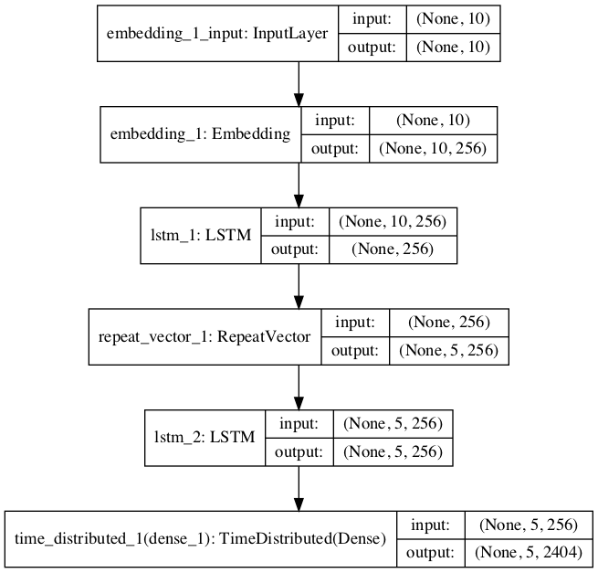
Figure 4.1 – Plot of Model Graph for NMT

4.6 Short conclusion
In this work, we used a machine translation approach to normalize comments. To create machine translation systems, we first collected comments from news portals and social networks. We then corrected these comments with annotators. A total of 27005 comments were collected and corrected. The original raw comments are treated as the sourceside, and the revised comments are treated as the targetside in our parallel corpus. Using these comments, we have created the phrase-based statistical machine translation system as a baseline system. Furthermore, we applied word-based sequence-sequence models to the secondary normalization task in order to compare statistical and neural network approaches. The statistical method shows 21.67 BLEUs on the test set, whereas sequence-sequence model obtained approximately 30 BLEU score. The later technique improves the performance of the normalization task significantly. In average, the both results can be viewed as an average performance. The reason for this phenomenon may be related to sparse datasets. To solve this problem, in the future we are going to add more comments to our parallel dataset. Moreover, we will conduct experiments with sequence to sequence models with attention mechanism as well as character-based models.

CONCLUSION
In this work, research on text processing was carried out in four areas - a syntactic analyzer, grammar correction, named entities recognition and secondary normalization of texts in the Kazakh language.
In this work, we have created a parser based on artificial neural networks implemented in the Stanza package. To train the model, we used our own corpus with syntactic labeling. In addition, we used Facebook's text corpus to create a vector representation of words. As a result of training, a high quality model was obtained - 88.62%, exceeding the quality of the popular UDPipe tool (87.90%), and also significantly superior to the original basic system in Stanza (44.33%). Note that the decisive factor for such a high result was the volume and quality of data, which is a prerequisite for the success of the application of approaches using artificial neural networks.
A module for correcting the grammar of the Kazakh language was also developed. The task of grammar correction was set to check the language constructions, for compliance with phonetic rules. In particular, we have considered four groups of phonetically dependent conjunctions of particles: interrogative particles "ба, бе, ма, ме, па, пе"; unions "бен, мен, пен"; particle-conjunctions "да, де, та, те"; particles "қана, ғана". To solve the problem, two approaches were implemented. The basic approach is based on the application of the phonetic rules of the Kazakh language, compactly formulated in the form of regular expressions. The improved approach is based on training an ensemble of decision trees using the result of the basic approach as one of the features. In terms of overall accuracy (the proportion of correctly identified cases, both erroneous and correct), the approaches achieve results in the range of 75% - 99% (basic) and 87% - 100% (advanced).
Next, a hybrid model was presented for the named entity recognition (NER) problem based on the LSTM and CRF neural networks for the Kazakh language. The results look pretty good and it doesn't require any design specifics compared to the CRF model. The average quality of the model according to the F1 metric was 88%, which is comparable to the existing models for the NER problem. Using modern techniques such as combining LSTM and CRF neural networks is simple and often gives good results, although there are some potential disadvantages. The main disadvantage is the lack of a large amount of labeled data, which requires large resources to create it. Of course, we see collecting and labeling data as future work to improve the quality of the developed model.
Finally, in the task of secondary text normalization, we used a machine translation approach. To create machine translation system, we first collected comments from news portals and social networks. We then corrected these comments with annotators. A total of 27005 comments were collected and corrected. These datasets are our parallel corpus: in the machine translation approach, the original raw comments are treated as the source and the revised comments are treated as the target. Using these comments, we created a phrase-based statistical machine translation system as a base system. In addition, we applied word-based sequence-to-sequence models to the secondary normalization problem to compare the statistical and neural network approaches. The statistical method shows 21.67 BLEUs on the test set, while the sequence-to-sequence model gives 29.74 BLEUs. The neural network method significantly improves the performance of the normalization task. On average, both results can be viewed as averages. The reason for this phenomenon may be related to sparse datasets. To address this issue, we are going to add more comments to our parallel dataset in the future. In addition, we will be experimenting with sequence-to-sequence models with attention mechanisms as well as symbol-based models.
The results have been published in international peer-reviewed journals and conferences within the project. In particular, 2 articles were published in journals with a non-zero impact factor, indexed in the Scopus database; 2 articles were published in the local journals with a non-zero impact factor; 10 articles have been published in various international conferences. A complete list of published articles during the project is given in Appendix B. In Appendix C screenshots of the papers published in 2020 are given.
All developed modules are posted online on the demo site http://opendev.kz/kaznlp/, and the source code of the modules is available at https://github.com/nlacslab/kaznlp.

REFERENCES
- Kessikbayeva G., Cicekli I. Rule Based Morphological Analyzer Of Kazakh Language. // In Proc.: The 2014 Joint Meeting of SIGMORPHON and SIGFSM. —2014. — P. 46–54.
- Washington J., Salimzyanov I., Tyers F. Finite-State Morphological Transducers For Three Kypchak Languages // In Proc.: The Ninth International Conference on Language Resources and Evaluation (LREC’14). — 2014. — P. 3378–3385.
- Assylbekov Z., Washington J., Tyers F. A free/open-source hybrid morphological disambiguation tool for Kazakh // In Proc.: The TurCLing 2016. — 2016. — P. 18–26.
- Makhambetov O., Makazhanov A., Sabyrgaliyev I., Yessenbayev Z. Data-Driven Morphological Analysis and Disambiguation for Kazakh // In Proc.: The 2015 Computational Linguistics and Intelligent Text Processing, Part I. — 2015. — P. 151–163.
- Altenbek G., Abilhayer D., Niyazbek M., Xiao-Jie L. A Study of Word Tagging Corpus for the Modern Kazakh Language // Journal of Xinjiang University. — 2009. — Vol. 4, No. 26. — P. 394–401.
- Altenbek G., Xiao-long W. Kazakh Segmentation System of Inflectional Affixes // In Proc.: The Joint Conference on Chinese Language Processing. — 2010. — P. 183–190.
- Suleymanov D., Gatiatullin A., Almenova A., Bashirov A. A Multifunctional Computer Based Linguistic Model as a Database for Linguistic Processors // Philology and Culture. — 2016. — Vol. 2, No. 44. — P. 143–151.
- Zafer H. R., Tilki B., Kurt A., Kara M. Two-Level Description of Kazakh Morphology // In Proc.: The 1st International Conference on Foreign Language Teaching and Applied Linguistics (FLTAL’11). — 2011. — P. 11–19.
- Kairakbay B. M., Zaurbekov D. L. Finite State Approach to the Kazakh Nominal Paradigm // In Proc.: The 11th International Conference on Finite State Methods and Natural Language Processing. — 2013. — P. 108–112.
- Sharipbayev A., Bekmanova G., Ergesh B. Intellectual Morphological Analyzer Based On Semantic Networks // In Proc.: The OSTIS-2012. — 2012. — P. 397–400.
- Makazhanov A., Yessenbayev Z., Sabyrgaliyev I. On Certain Aspects of Kazakh Part-Of-Speech Tagging // In Proc.: The 8th International Conference on Application of Information and Communication Technologies (AICT’14). — 2014. — P. 1–4.
- Myrzakhmetov B., Sultangazina A., Makazhanov A. Identification of the Parallel Documents from Multilingual News Websites // In Proc.: The 10th International Conference on Application of Information and Communication Technologies (AICT’16). — 2016. — P. 197–201.
- Makhambetov O., Makazhanov A., Yessenbayev Z. Assembling the Kazakh Language Corpus // In Proc.: The conference on Empirical Methods in Natural Language Processing (EMNLP’13). — 2013. — P. 1022–1031.
- Assem S., Aida S. Machine Translation of Different Systemic Languages Using a Apertium Platform (with an Example of English and Kazakh Languages) // In Proc.: The International Conference on Computer Applications Technology (ICCAT). — 2013. — P. 1–4.
- Rakhimova D. The Development of Semantics Model in Machine Translation of the Kazakh Language // International Journal of Mathematicsand Physics Quarterly Journal of al-Farabi Kazakh National University. — 2012. — Vol. 3, No. 2. — P. 56–64.
- Salimzyanov I., Washington N., Tyers F. A free/open-source Kazakh-Tatar machine translation system // In Proc.: The XIV Machine Translation Summit. — 2013. — P. 175–182.
- Assylbekov Z., Myrzakhmetov B., Makazhanov A. Experiments with Russian to Kazakh Sentence Alignment // Izvestija KGTU im.I.Razzakova. — 2016. — Vol. 38, No. 2. — P. 12–16.
- Myrzakhmetov B., Makazhanov A. Initial Experiments on Russian to Kazakh SMT // Research in Computing Science. — 2017. — Vol. 117. — P. 153–160.
- Forcada M. L., Ginestı-Rosell M., Nordfalk J. Apertium: a free/open-source platform for rule-based machine translation // Machine translation. — 2011. — Vol. 25, No. 2. — P. 127–144.
- Koehn P., Hoang H., Birch A. Moses: Open source toolkit for statistical machine translation // In Proc.: The 45th Annual Meeting of the Association for Computational Linguistics (ACL’07): Interactive poster and demonstration sessions. — 2007. — P. 177–180.
- Kiss T., Strunk J. Unsupervised multilingual sentence boundary detection // Computational Linguistics. — 2006. — Vol. 32, No. 4. — P. 485–525.
- Brill E. A simple rule-based part of speech tagger // In Proc.: The workshop on Speech and Natural Language. — 1992. — P. 112–116.
- Jelinek F., Lafferty J. D., Mercer R. L. Basic methods of probabilistic context free grammars // In Proc.: The Speech Recognition and Understanding. — 1992. — P. 345–360.
- Manning C. D., Surdeanu M., Bauer J. The Stanford CoreNLP Natural Language Processing Toolkit // In Proc.: The 52nd Annual Meeting of the Association for Computational Linguistics: System Demonstrations. — 2014. — P. 55–60.
- Mikhail K. Morphological Analyzer and Generator for Russian and Ukrainian Languages // In Proc.: The 4th International Conference on Analysis of Images, Social Networks and Texts. — 2015. — P. 320–332.
- Eryigit G. ITU Turkish NLP web service // In Proc.: The Demonstrations at the 14th Conference of the European Chapter of the Association for Computational Linguistics. — 2014. — P. 1–4.
- Лицензия Creative Commons 4.0. — Режим доступа: https://creativecommons.org/licenses/by/4.0/. свободный. (дата обращения: 10.10.2020).
- Jurafsky D., Martin J. H. Speech and language processing: An introduction to natural language processing, computational linguistics, and speech recognition. — 2nd edition. — Prentice Hall, 2009. — 1024 P.
- Eisner J. M. Three New Probabilistic Models for Dependency Parsing: An Exploration // In Proc.: The 16th Conference on Computational Linguistics - Volume 1. — COLING ’96. — 1996. — P. 340–345.
- McDonald R., Pereira F., Ribarov K., Hajic J. Non-projective dependency parsing using spanning tree algorithms // In Proc.: The conference on Human Language Technology and Empirical Methods in Natural Language Processing. — 2005. — P. 523–530.
- Kubler S., McDonald R., Nivre J.. Dependency Parsing. Synthesis lectures on human language technologies. — Morgan & Claypool, 2009. — 127 P.
- Nivre J., Hall J., Nilsson J. MaltParser: A language-independent system for data-driven dependency parsing // Natural Language Engineering. — 2007. — Vol. 13, No. 2. — P. 95–135.
- Chen D., Manning C. A fast and accurate dependency parser using neural networks // In Proc.: The 2014 conference on empirical methods in natural language processing (EMNLP). — 2014. — P. 740–750.
- Dyer C., Ballesteros M., Ling W. Transition-based dependency parsing with stack long short-term memory // CoRR. — 2015. — Vol. 1505.08075. — URL: http://arxiv.org/abs/1505.08075 (дата обращения: 10.10.2020).
- Dozat T., Manning C. D. Deep biaffine attention for neural dependency parsing // CoRR. — 2016. — Vol. 1611.01734. — URL: http://arxiv.org/abs/1611.01734 (дата обращения: 10.10.2020).
- Andor D., Alberti C., Weiss D. Globally normalized transition-based neural networks // CoRR. — 2016. — Vol. 1603.06042. — URL: http://arxiv.org/abs/1603.06042 (дата обращения: 10.10.2020).
- Kuncoro A., Ballesteros M., Kong L. What do recurrent neural network grammars learn about syntax? // CoRR. — 2016. — Vol. 1611.05774. — URL: http://arxiv.org/abs/1611.05774 (дата обращения: 10.10.2020).
- Qi P., Dozat T., Zhang Y., Manning C. D. Universal Dependency Parsing from Scratch // In Proc.: The CoNLL 2018 Shared Task: Multilingual Parsing from Raw Text to Universal Dependencies. — 2018. — P. 160–170.
- Tyers F. M., Washington J. Towards a free/open-source universal-dependency treebank for Kazakh // In Proc.: The 3rd International Conference on Turkic Languages Processing, (TurkLang 2015). — 2015. — P. 276–289.
- Makazhanov A., Sultangazina A., Makhambetov O., Yessenbayev Z. Syntactic annotation of kazakh: Following the universal dependencies guidelines. a report // In Proc.: The 3rd International Conference on Turkic Languages Processing (TurkLang 2015). — 2015. — P. 338–350.
- Grave E., Bojanowski P., Gupta P. Learning Word Vectors for 157 Languages // CoRR. — 2018. — Vol. 1802.06893. — URL: http://arxiv.org/abs/1802.06893 (дата обращения: 11.10.2020).
- Green N. D. Dependency Parsing // In Proc.: The WDS’11 Contributed Papers, Part I. — 2011. — P. 137–142.
- Buchholz S., Marsi E. CoNLL-X shared task on multilingual dependency parsing // In Proc.: The tenth conference on computational natural language learning / Association for Computational Linguistics. — 2006. — P. 149–164.
- Qi P., Zhang Y., Zhang Y.. Stanza: A Python Natural Language Processing Toolkit for Many Human Languages // In Proc.: The 58th Annual Meeting of the Association for Computational Linguistics: System Demonstrations. — 2020. — P. 101–108.
- Straka M., Strakova J. Tokenizing, pos tagging, lemmatizing and parsing ud 2.0 with udpipe // In Proc.: The CoNLL 2017 Shared Task: Multilingual Parsing from Raw Text to Universal Dependencies. — 2017. — P. 88–99.
- Knight K., Chander I. Automated Postediting of Documents // In Proc.: The Twelfth National Conference on Artificial Intelligence. — 1994. — P. 779–784.
- Han N.-R., Chodorow M., Leacock C. Detecting Errors in English Article Usage by Non-Native Speakers // Natural Language Engineering — 2006. — Vol. 12, No. 2. — P. 115–129.
- De Felice R., Pulman S. G. A Classifier-Based Approach to Preposition and Determiner Error Correction in L2 English // In Proc.: The 22nd International Conference on Computational Linguistics (Coling 2008). — 2008. — P. 169–176.
- Dahlmeier D., Ng H. T., Wu S. M. Building a Large Annotated Corpus of Learner English: The NUS Corpus of Learner English // In Proc.: The Eighth Workshop on Innovative Use of NLP for Building Educational Applications. — 2013. — P. 22–31.
- Rozovskaya A., Roth D. Annotating ESL Errors: Challenges and Rewards // In Proc.: The NAACL HLT 2010 Fifth Workshop on Innovative Use of NLP for Building Educational Applications. — 2010. — P. 28–36.
- Tajiri T., Komachi M., Matsumoto Y. Tense and Aspect Error Correction for ESL Learners Using Global Context // In Proc.: The 50th Annual Meeting of the Association for Computational Linguistics (Volume 2: Short Papers). — 2012. — P. 198–202.
- Dahlmeier D., Ng H. T. A Beam-Search Decoder for Grammatical Error Correction // In Proc.: The 2012 Joint Conference on Empirical Methods in Natural Language Processing and Computational Natural Language Learning. — 2012. — P. 568–578.
- Felice M., Yuan Z., Andersen Ø. E. Grammatical error correction using hybrid systems and type filtering // In Proc.: The Eighteenth Conference on Computational Natural Language Learning: Shared Task. — 2014. — P. 15–24.
- Junczys-Dowmunt M., Grundkiewicz R. The AMU System in the CoNLL-2014 Shared Task: Grammatical Error Correction by Data-Intensive and Feature-Rich Statistical Machine Translation // In Proc.: The Eighteenth Conference on Computational Natural Language Learning: Shared Task. — 2014. — P. 25–33.
- Zhao W., Wang L., Shen K. Improving Grammatical Error Correction via Pre-Training a CopyAugmented Architecture with Unlabeled Data // In Proc.: The 2019 Conference of the North American Chapter of the Association for Computational Linguistics: Human Language Technologies, Volume 1 (Long and Short Papers). — 2019. — P. 156–165.
- Kaneko M., Mita M., Kiyono S. Encoder-Decoder Models Can Benefit from Pre-trained Masked Language Models in Grammatical Error Correction // In Proc.: The 58th Annual Meeting of the Association for Computational Linguistics. — 2020. — P. 4248–4254.
- Breiman L. Random Forests // Machine Learning. — 2001. — Vol. 45, No. 1. — P. 5–32.
- Koehn P. Statistical machine translation. — Cambridge University Press, 2010. — 365 P.
- sklearn-crfsuite-2015. — Режим доступа: http://https://sklearncrfsuite.readthedocs.io. свободный. (дата обращения: 10.10.2020).
- Vilain M., Burger J., Aberdeen J. A model-theoretic coreference scoring scheme // In Proc.: The 6th conference on Message understanding. — 1995. — P. 45–52.
- Yadav V., Bethard S. A survey on recent advances in named entity recognition from deep learning models // In Proc.: The 27th International Conference on Computational Linguistics. — 2018. — P. 2145–2158.
- Gulmira T., Alymzhan T., Orken M., Rustam M. Named Entity Recognition for Kazakh Using Conditional Random Fields // In Proc.: The CICLing 2019. — 2019. — P. 101–116.
- Gulmira T., Alymzhan T., Zheng X. Neural Named Entity Recognition for Kazakh // In Proc.: The 4-th International Conference on Computer Processing of Turkic Languages. — 2016. — P. 45–56.
- Lample G., Ballesteros M., Subramanian S. Neural architectures for named entity recognition // CoRR. — 2016. — Vol. 1603.01360. — URL: http://arxiv.org/abs/1603.01360 (дата обращения: 11.10.2020).
- Hochreiter S., Schmidhuber J. Long short-term memory // Neural computation. — 1997. — Vol. 9, No. 8. — P. 1735–1780.
- Huang Z., Xu W., Yu K. Bidirectional LSTM-CRF models for sequence tagging // CoRR. — 2015. — Vol. 1508.01991. — URL: http://arxiv.org/abs/1508.01991 (дата обращения: 11.10.2020).
- Makazhanov A., Sultangazina A., Makhambetov O., Yessenbayev Z. Syntactic annotation of kazakh: Following the universal dependencies guidelines. a report // In Proc.: The 3rd International Conference on Turkic Languages Processing (TurkLang 2015). — 2015. — P. 338–350.
- Manning C., Surdeanu M., Bauer J. The Stanford CoreNLP natural language processing toolkit // In Proc.: The 52nd annual meeting of the association for computational linguistics: system demonstrations. — 2014. — P. 55–60.
- Dong C., Zhang J., Zong C. Character-based LSTM-CRF with radical-level features for Chinese named entity recognition // In Proc.: Natural Language Understanding and Intelligent Applications. — 2016. — P. 239–250.
- Church K. W., Gale W. A. Probability scoring for spelling correction // Statistics and Computing. — 1991. — Vol. 1, No. 2. — P. 93–103.
- Mays E., Damerau F. J., Mercer R. L. Context based spelling correction // Information Processing and Management. — 1991. — Vol. 27, No. 5. — P. 517–522.
- Brill E., Moore R. C. An improved error model for noisy channel spelling correction // In Proc.: The 38th Annual Meeting on Association for Computational Linguistics. — 2000. — P. 286–293.
- Sproat R., Black A. W., Chen S. Normalization of non-standard words // Computer speech and language. — 2001. — Vol. 15, No. 3. — P. 287–333.
- Kukich K. Techniques for automatically correcting words in text // ACM Computing Surveys (CSUR). — 1992. — Vol. 24, No. 4. — P. 377–439.
- Toutanova K., Moore R. C. Pronunciation modeling for improved spelling correction // In Proc.: The 40th Annual Meeting of the Association for Computational Linguistics. — 2002. — P. 144–151.
- Whitelaw C., Hutchinson B., Chung G. Y., Ellis G. Using the web for language independent spellchecking and autocorrection // In Proc.: The 2009 Conference on Empirical Methods in Natural Language Processing. — 2009. — P. 890–899.
- Beaufor R. t, Roekhaut S., Cougnon L.-A., Fairon C. A hybrid rule/model-based finite-state framework for normalizing SMS messages // In Proc.: The 48th Annual Meeting of the Association for Computational Linguistics. — 2010. — P. 770–779.
- Choudhury M., Saraf R., Jain V. Investigation and modeling of the structure of texting language // International Journal of Document Analysis and Recognition. — 2007. — Vol. 10, No. 3-4. — P. 157–174.
- Pennell D. L., Liu Y. Normalization of text messages for text-to-speech // In Proc.: The 2010 IEEE International Conference on Acoustics, Speech and Signal Processing. — 2010. — P. 4842–4845.
- Han B., Baldwin T. Lexical normalisation of short text messages: Makn sens a# twitter // In Proc.: The 49th Annual Meeting of the Association for Computational Linguistics: Human Language Technologies / Association for Computational Linguistics. — 2011. — P. 368–378.
- Liu F., Weng F., Wang B., Liu Y. Insertion, deletion, or substitution?: normalizing text messages without precategorization nor supervision // In Proc.: The 49th Annual Meeting of the Association for Computational Linguistics: Human Language Technologies. — 2011. — P. 71–76.
- Gouws S., Metzler D., Cai C., Hovy E. Contextual bearing on linguistic variation in social media // In Proc.: The Workshop on Languages in Social Media. — 2011. — P. 20–29.
- Sutskever I., Vinyals O., Le Q. V. Sequence to sequence learning with neural networks // In Proc.: Advances in neural information processing systems. — 2014. — P. 3104–3112.
- Cho K., Van Merrienboer B., Gulcehre C. Learning phrase representations using RNN encoder-decoder for statistical machine translation // CoRR. — 2014. — Vol. 1406.1078. — URL: http://arxiv.org/abs/1406.1078 (дата обращения: 11.10.2020).
- Wu Y., Schuster M., Chen Z. Google’s neural machine translation system: Bridging the gap between human and machine translation // CoRR. — 2016. — Vol. 1609.08144. — URL: http://arxiv.org/abs/1609.08144 (дата обращения: 11.10.2020).
- Vinyals O., Le Q. A neural conversational model // CoRR. — 2015. — Vol. 1506.05869. — URL: http://arxiv.org/abs/1506.05869 (дата обращения: 11.10.2020).
- Nallapati R., Zhou B., Gulcehre C. Abstractive text summarization using sequence-to-sequence rnns and beyond // CoRR. — 2016. — Vol. 1602.06023. — URL: http://arxiv.org/abs/1602.06023 (дата обращения: 11.10.2020).
- Yin J., Jiang X., Lu Z. Neural generative question answering // CoRR. — 2015. — Vol. 1512.01337. — URL: http://arxiv.org/abs/1512.01337 (дата обращения: 11.10.2020).
- Ikeda T., Shindo H., Matsumoto Y. Japanese text normalization with encoder-decoder model // In Proc.: The 2nd Workshop on Noisy User-generated Text (WNUT). — 2016. — P. 129–137.
- Lourentzou I., Manghnani K., Zhai C. Adapting sequence to sequence models for text normalization in social media // In Proc.: The International AAAI Conference on Web and Social Media. — Vol. 13. — 2019. — P. 335–345.
- Lusetti M., Ruzsics T., Gohring A. Encoder-decoder methods for text normalization // In Proc.: The Fifth Workshop on NLP for Similar Languages, Varieties and Dialects. — 2018. — P. 18–28.
- Colakoglu T., Sulubacak U., Tantug A. C. Normalizing Non-canonical Turkish Texts Using Machine Translation Approaches // In Proc.: The 57th Annual Meeting of the Association for Computational Linguistics: Student Research Workshop. — 2019. — P. 267–272.
- Chollet F. Deep Learning mit Python und Keras: Das Praxis-Handbuch vom Entwickler der Keras-Bibliothek. — MITP-Verlags GmbH & Co. KG, 2018. — 384 P.
- Papineni K., Roukos S., Ward T., Zhu W.-J. BLEU: a method for automatic evaluation of machine translation // In Proc.: The 40th annual meeting on association for computational linguistics. — 2002. — P. 311–318.

APPENDIX A
Calendar plan for 2018-2020

TECHNICAL SPECIFICATIONS AND
CALENDAR PLAN
Under contract No. _______ dated __________________2018

Private institution "National Laboratory Astana"

1.1 By priority: Information, telecommunications and space technologies, scientific research in the field of natural sciences
1.2 By sub-priority: Intelligent information technologies - Speech technologies and computational linguistics
1.3 On the topic of the project: №AP05134272 "Development of free open source software tools for automatic processing of texts in the Kazakh language"
1.4 The total amount of the project is 45,000,000 (forty-five million) tenge, including with a breakdown by years, for the performance of work in accordance with paragraph 3:
- for 2018 - in the amount of 15,000,000 (fifteen million) tenge;
- for 2019 - in the amount of 15,000,000 (fifteen million) tenge;
- for 2020 - in the amount of 15,000,000 (fifteen million) tenge.

2. Characteristics of scientific and technical products by qualification characteristics and economic indicators
2.1 Direction of work: speech technology and computational linguistics.
2.2 Scope: for research and development of applied software in the field of automatic word processing.
2.3 End result:
- for 2018:
The following tools (modules) will be developed:
1) module of primary text normalization;
2) a graphematic analyzer module;
3) language definition module;
4) a morphological analyzer module based on final converters;
5) a morphological tagger module based on a statistical approach.
- for 2019:
The following tools (modules) will be developed:
1) a morphological analyzer module based on a statistical approach or artificial neural networks;
2) module of morphological tagger based on artificial neural networks;
3) a parser module based on a statistical approach;
4) spelling correction module;
5) a module for extracting nominal entities based on a statistical approach;
6) a module for secondary text normalization based on a statistical approach.
- for 2020:
The following tools (modules) will be developed:
1) a syntactic analyzer module based on artificial neural networks;
2) grammar correction module;
3) a module for extracting nominal entities based on artificial neural networks;
4) a module for secondary text normalization based on artificial neural networks.
2.4 Patentability: None.
2.5 Scientific and technical level (novelty): Application of a deep learning approach using artificial neural networks for the analysis of text in the Kazakh language.
2.6 The use of scientific and technical products is carried out: by the Contractor.
2.7 Type of use of the result of scientific and (or) scientific and technical activities: in the form of software modules.

3. Name of work, terms of their implementation and results
Code of the task |  | Name of work under the Agreement and the main stages of its implementation | Duration |  | Expected results
 |  |  | Start | End
1 |  | Developing the initial normalization module | January 2018 | November 1, 2018 | The initial normalization module will be developed
2 |  | Developing the sentence-word tokenizer | January 2018 | November 1, 2018 | The sentence-word tokenizer will be developed
3 |  | Developing the  language identification module | January 2018 | November 1, 2018 | The  language identification module will be developed
4 |  | Developing the  morphological analyzer | January 2018 | November 1, 2018 | The  morphological analyzer will be developed
4.1 |  | Developing the  morphological analyzer based on Finite State Transducers | January 2018 | November 1, 2018 | The  morphological analyzer based on Finite State Transducers will be developed
5 |  | Developing the  morphological tagger | January 2018 | November 1, 2018 | The  morphological tagger will be developed
5.1 |  | Developing the  morphological tagger based on statistical approach | January 2018 | November 1, 2018 | The  morphological tagger based on statistical approach will be developed
4 |  | Developing the  morphological analyzer | January 2019 | November 1, 2019 | The  morphological analyzer will be developed
4.2 |  | Developing the  morphological analyzer based on artificial neural networks | January 2019 | November 1, 2019 | The  morphological analyzer based on artificial neural networks will be developed
5 |  | Developing the  morphological tagger | January 2019 | November 1, 2019 | The  morphological tagger will be developed
5.2 |  | Developing the  morphological tagger based on artificial neural networks | January 2019 | November 1, 2019 | The  morphological tagger based on artificial neural networks will be developed
6 |  | Developing the  syntactic parser | January 2019 | November 1, 2019 | The  syntactic parser will be developed
6.1 |  | Developing the  syntactic parser based on statistical approach | January 2019 | November 1, 2019 | The  syntactic parser based on statistical approach will be developed
7 |  | Developing the spelling checking and correction module | January 2019 | November 1, 2019 | The spelling checking and correction module will be developed
7.1 |  | Developing the spelling checking and correction module (orthography) | January 2019 | November 1, 2019 | The spelling checking and correction module (orthography) will be developed
8 |  | Developing the  named entity recognition module | January 2019 | November 1, 2019 | The  named entity recognition module will be developed
8.1 |  | Developing the  named entity recognition module based on statistical approach | January 2019 | November 1, 2019 | The  named entity recognition module based on statistical approach will be developed
9 |  | Developing the  secondary normalization module | January 2019 | November 1, 2019 | The  secondary normalization module will be developed
9.1 |  | Developing the  secondary normalization module based on statistical approach | January 2019 | November 1, 2019 | The  secondary normalization module based on statistical approach will be developed
10 |  | Publication of the results of the projects | September 2019 | November 1, 2019 | At least 1 (one) article will be published in peer-reviewed foreign scientific journals indexed in Web of Science or Scopus databases with a non-zero impact factor, at least 1 (one) publications in peer-reviewed foreign and domestic scientific journals with a non-zero impact factor
6 |  | Development of the  syntactic parser | January 2020 | November 1, 2020 | The  syntactic parser will be developed
6.2 |  | Development of the  syntactic parser based on artificial neural networks | January 2020 | November 1, 2020 | The  syntactic parser based on artificial neural networks will be developed
7 |  | Developing the spelling checking and correction module | January 2020 | November 1, 2020 | The spelling checking and correction module will be developed
7.2 |  | Development of the grammar correction module | January 2020 | November 1, 2020 | The grammar correction module will be developed
8 |  | Development of the  named entity recognition module | January 2020 | November 1, 2020 | The  named entity recognition module will be developed
8.2 |  | Development of the  named entity recognition module based on artificial neural networks | January 2020 | November 1, 2020 | The  named entity recognition module based on artificial neural networks will be developed
9 |  | Developing the  secondary normalization module | January 2020 | November 1, 2020 | The  secondary normalization module will be developed
9.2 |  | Developing the  secondary normalization module based on artificial neural networks | January 2020 | November 1, 2020 | The  secondary normalization module based on artificial neural networks will be developed
10 |  | Publication of the results of the projects | September 2020 | November 1, 2020 | At least 1 (one) article will be published in peer-reviewed foreign scientific journals indexed in Web of Science or Scopus databases with a non-zero impact factor, at least 1 (one) publications in peer-reviewed foreign and domestic scientific journals with a non-zero impact factor

APPENDIX B
List of publications in 2018-2020

For 2020
Foreign (language of publication – English):
1. Yessenbayev Zh., Kozhirbayev Zh., Makazhanov A. KazNLP: a pipeline for automated processing of texts written in Kazakh language // Lecture Notes in Computer Science. — 2020. —Vol. 12335. — P. 657-666. (indexed in Scopus, IMPACT FACTOR=0.43, Q2)
2. Abilkassov Sh., Nurlybayev A., Soltan S., Kim A., Shpieva E., Yesmagambet N., Yessenbayev Zh., Shintemirov A., Facilitating Autonomous Vehicle Research and Development Using Robot Simulators on the Example of a KAMAZ NEO Truck // In Proc.: The 2020 IEEE Intelligent Transportation Systems Conference (ITSC). —2020. — P. 1869-1876. (indexed in Scopus)
3. Kozhirbayev Zh., Yessenbayev Zh. Kazakh text normalization using machine translation approaches // In Proc.: The VIII International Conference on Computer Processing of Turkic Languages (TurkLang 2020). — 2020. (in print)
Local (language of publication – Russian):
4. Kozhirbayev Zh., Yessenbayev Zh. Named Entity Recognition for the Kazakh language // Journal of Mathematics, Mechanics and Computer Science. — 2020. — Vol. 3(107). — P. 57-66. (indexed in KazBC, IMPACT FACTOR=0.068)

For 2019
Foreign (language of publication – English):
1. Zulkhazhav A., Kozhirbayev Zh., Yessenbayev Zh., Sharipbay A. Kazakh text summarization using Fuzzy logic // Computación y Sistemas. — 2019. — Vol. 23 (3). — P. 851-859. (indexed in Scopus, IMPACT FACTOR=0.19, Q3)
2. Kozhirbayev Zh., Yessenbayev Zh., Myrzakhmetov B. VITA Search - An Intelligent Multimodal Search and Archive System for Online Media Resources // In Proc.: The 2019 IEEE 13th International Conference on Application of Information and Communication Technologies (AICT). — 2019. (indexed in Scopus)
3. Kozhirbayev Zh. CRF-based Named Entity Recognition for the Kazakh Language // In Proc.: The VII International Conference on Computer Processing of Turkic Languages (TurkLang 2019). — 2019. (in print)
4. Myrzakhmetov B., Assylbekov Zh., Takhanov R. Initial explorations on chaotic behaviors of Recurrent Neural Networks // Lecture Notes in Computer Science. — 2019. (in print)
Local (language of publication – Russian):
5. Kozhirbayev Zh., Yessenbayev Zh., Sharipbay A. Language identification in the spoken term detection system for the Kazakh language in a multilingual environment // Journal of Mathematics, Mechanics and Computer Science. — 2019. — Vol. 96(4). — P. 88-98. (indexed in KazBC, IMPACT FACTOR=0.068)

For 2018
Foreign (language of publication – English):
- Makazhanov A., Myrzakhmetov B., Assylbekov Zh. Manual vs Automatic Bitext Extraction // In Proc.: The Eleventh International Conference on Language Resources and Evaluation, (LREC). — 2018. — P. 1-6. (indexed in Scopus)
- Kozhirbayev Zh., Erol B. A., Sharipbay A., Jamshidi M. Speaker Recognition for Robotic Control via an IoT Device // In Proc.: The 2018 World Automation Congress (WAC). — 2018. — P. 1-5. (indexed in Scopus)
- Myrzakhmetov B., Yessenbayev Zh., Makazhanov A. Initial Normalization of User Generated Content: Case Study in a Multilingual Setting // In Proc.: The 2018 IEEE 12th International Conference on Application of Information and Communication Technologies (AICT). — 2018. — P. 6-10. (indexed in Scopus)
- Z. Kozhirbayev, Z. Yessenbayev and A. Makazhanov, “Document and Word-level Language Identification for Noisy User Generated Text // In Proc.: The 2018 IEEE 12th International Conference on Application of Information and Communication Technologies (AICT). — 2018. — P. 11-15. (indexed in Scopus)
- Myrzakhmetov B., Kozhirbayev Zh. Extended Language Modeling experiments for Kazakh // In Proc.: The TEL-2018. — 2018. — P. 1-5. (indexed in Scopus)
- Yessenbayev Zh. A Preliminary Work on Sentence Tokenization using ReinforcementLearning and Linguistic Resources // In Proc.: The VI-th International Conference on Computer Processing of Turkic Languages (TurkLang 2018). — 2018. — P. 288-292.

APPENDIX C
Copies of the published papers in 2020

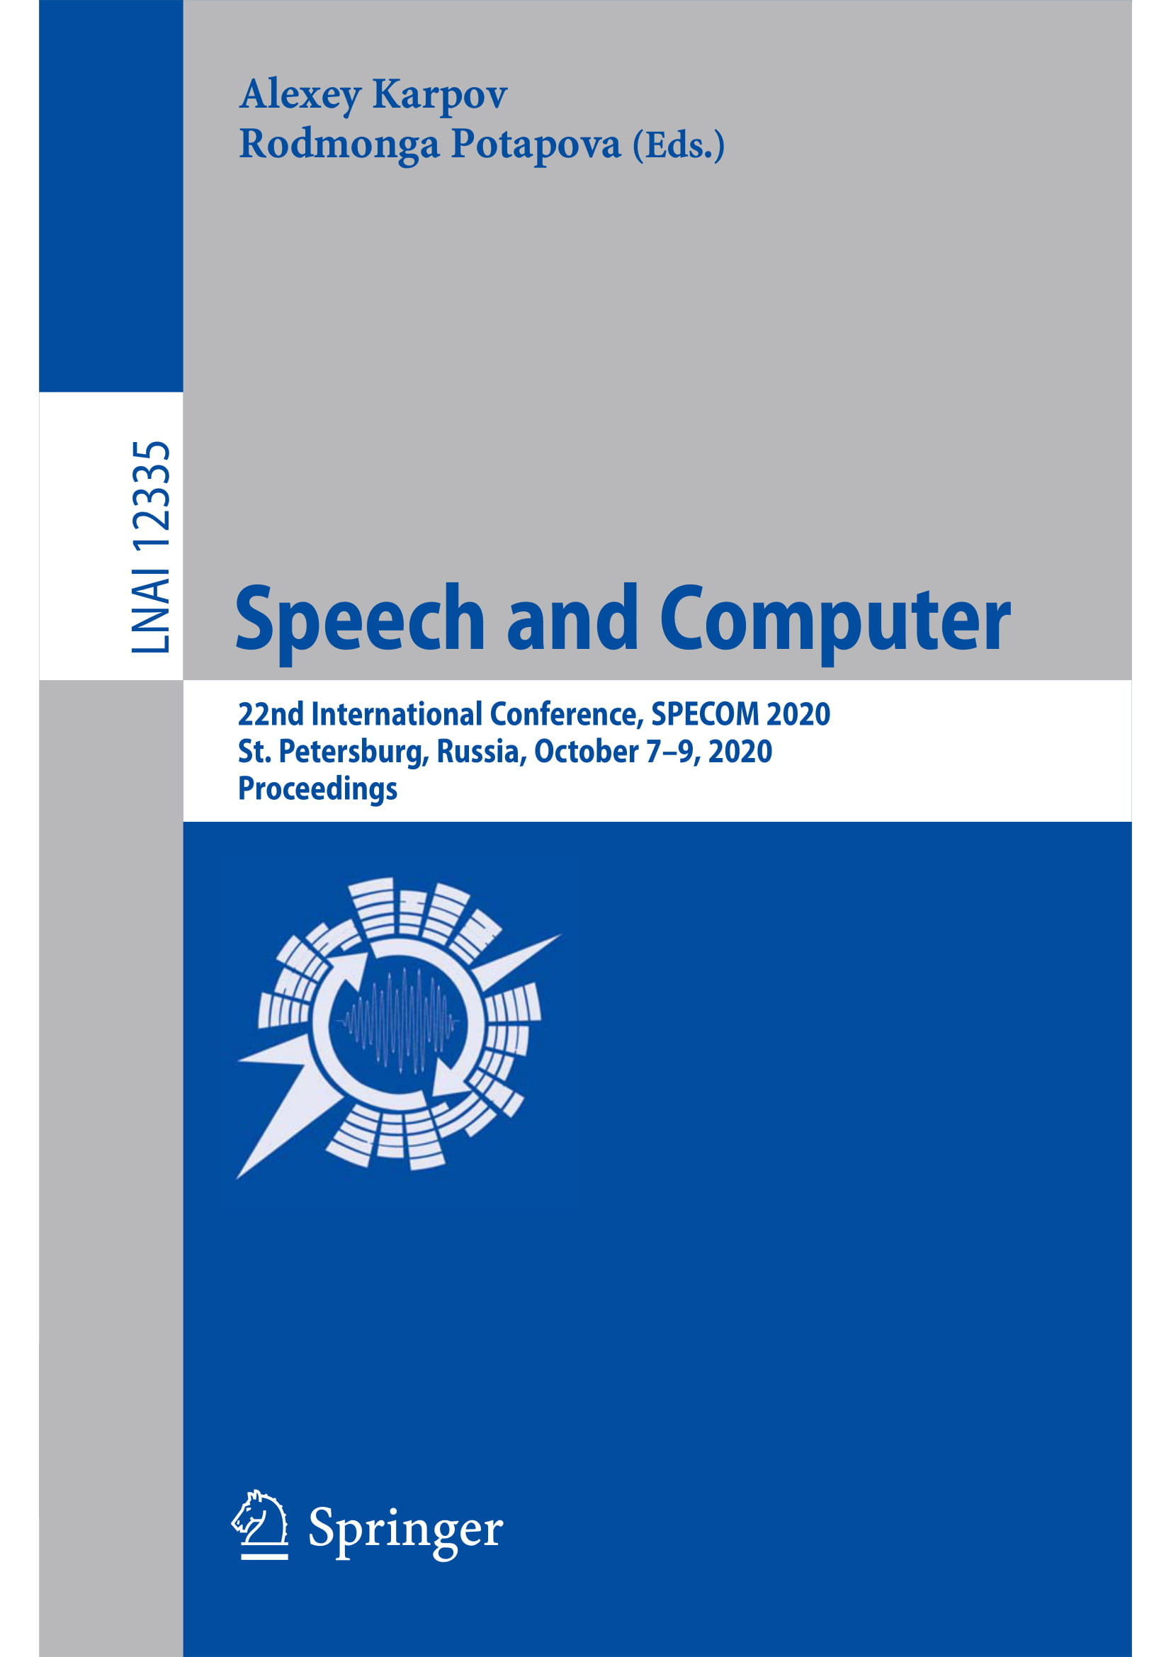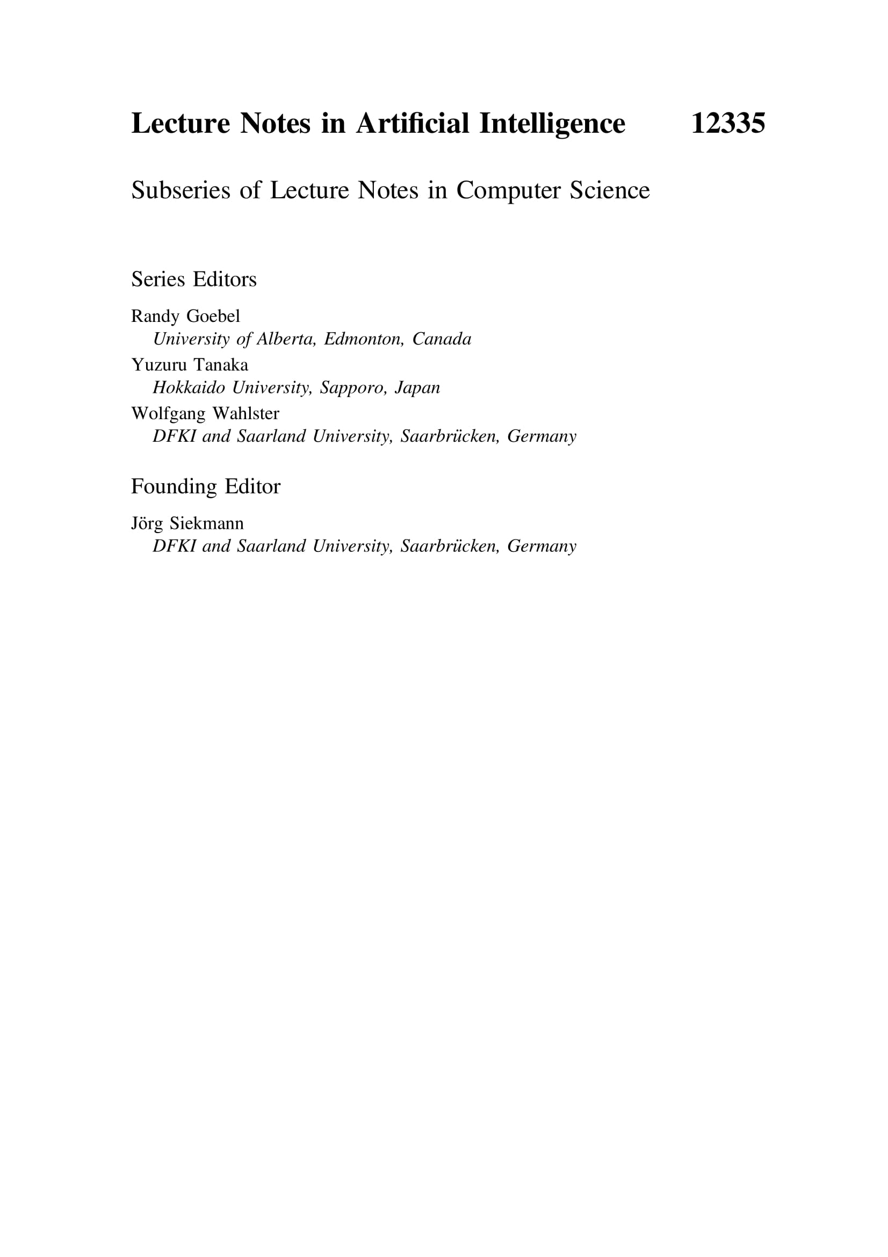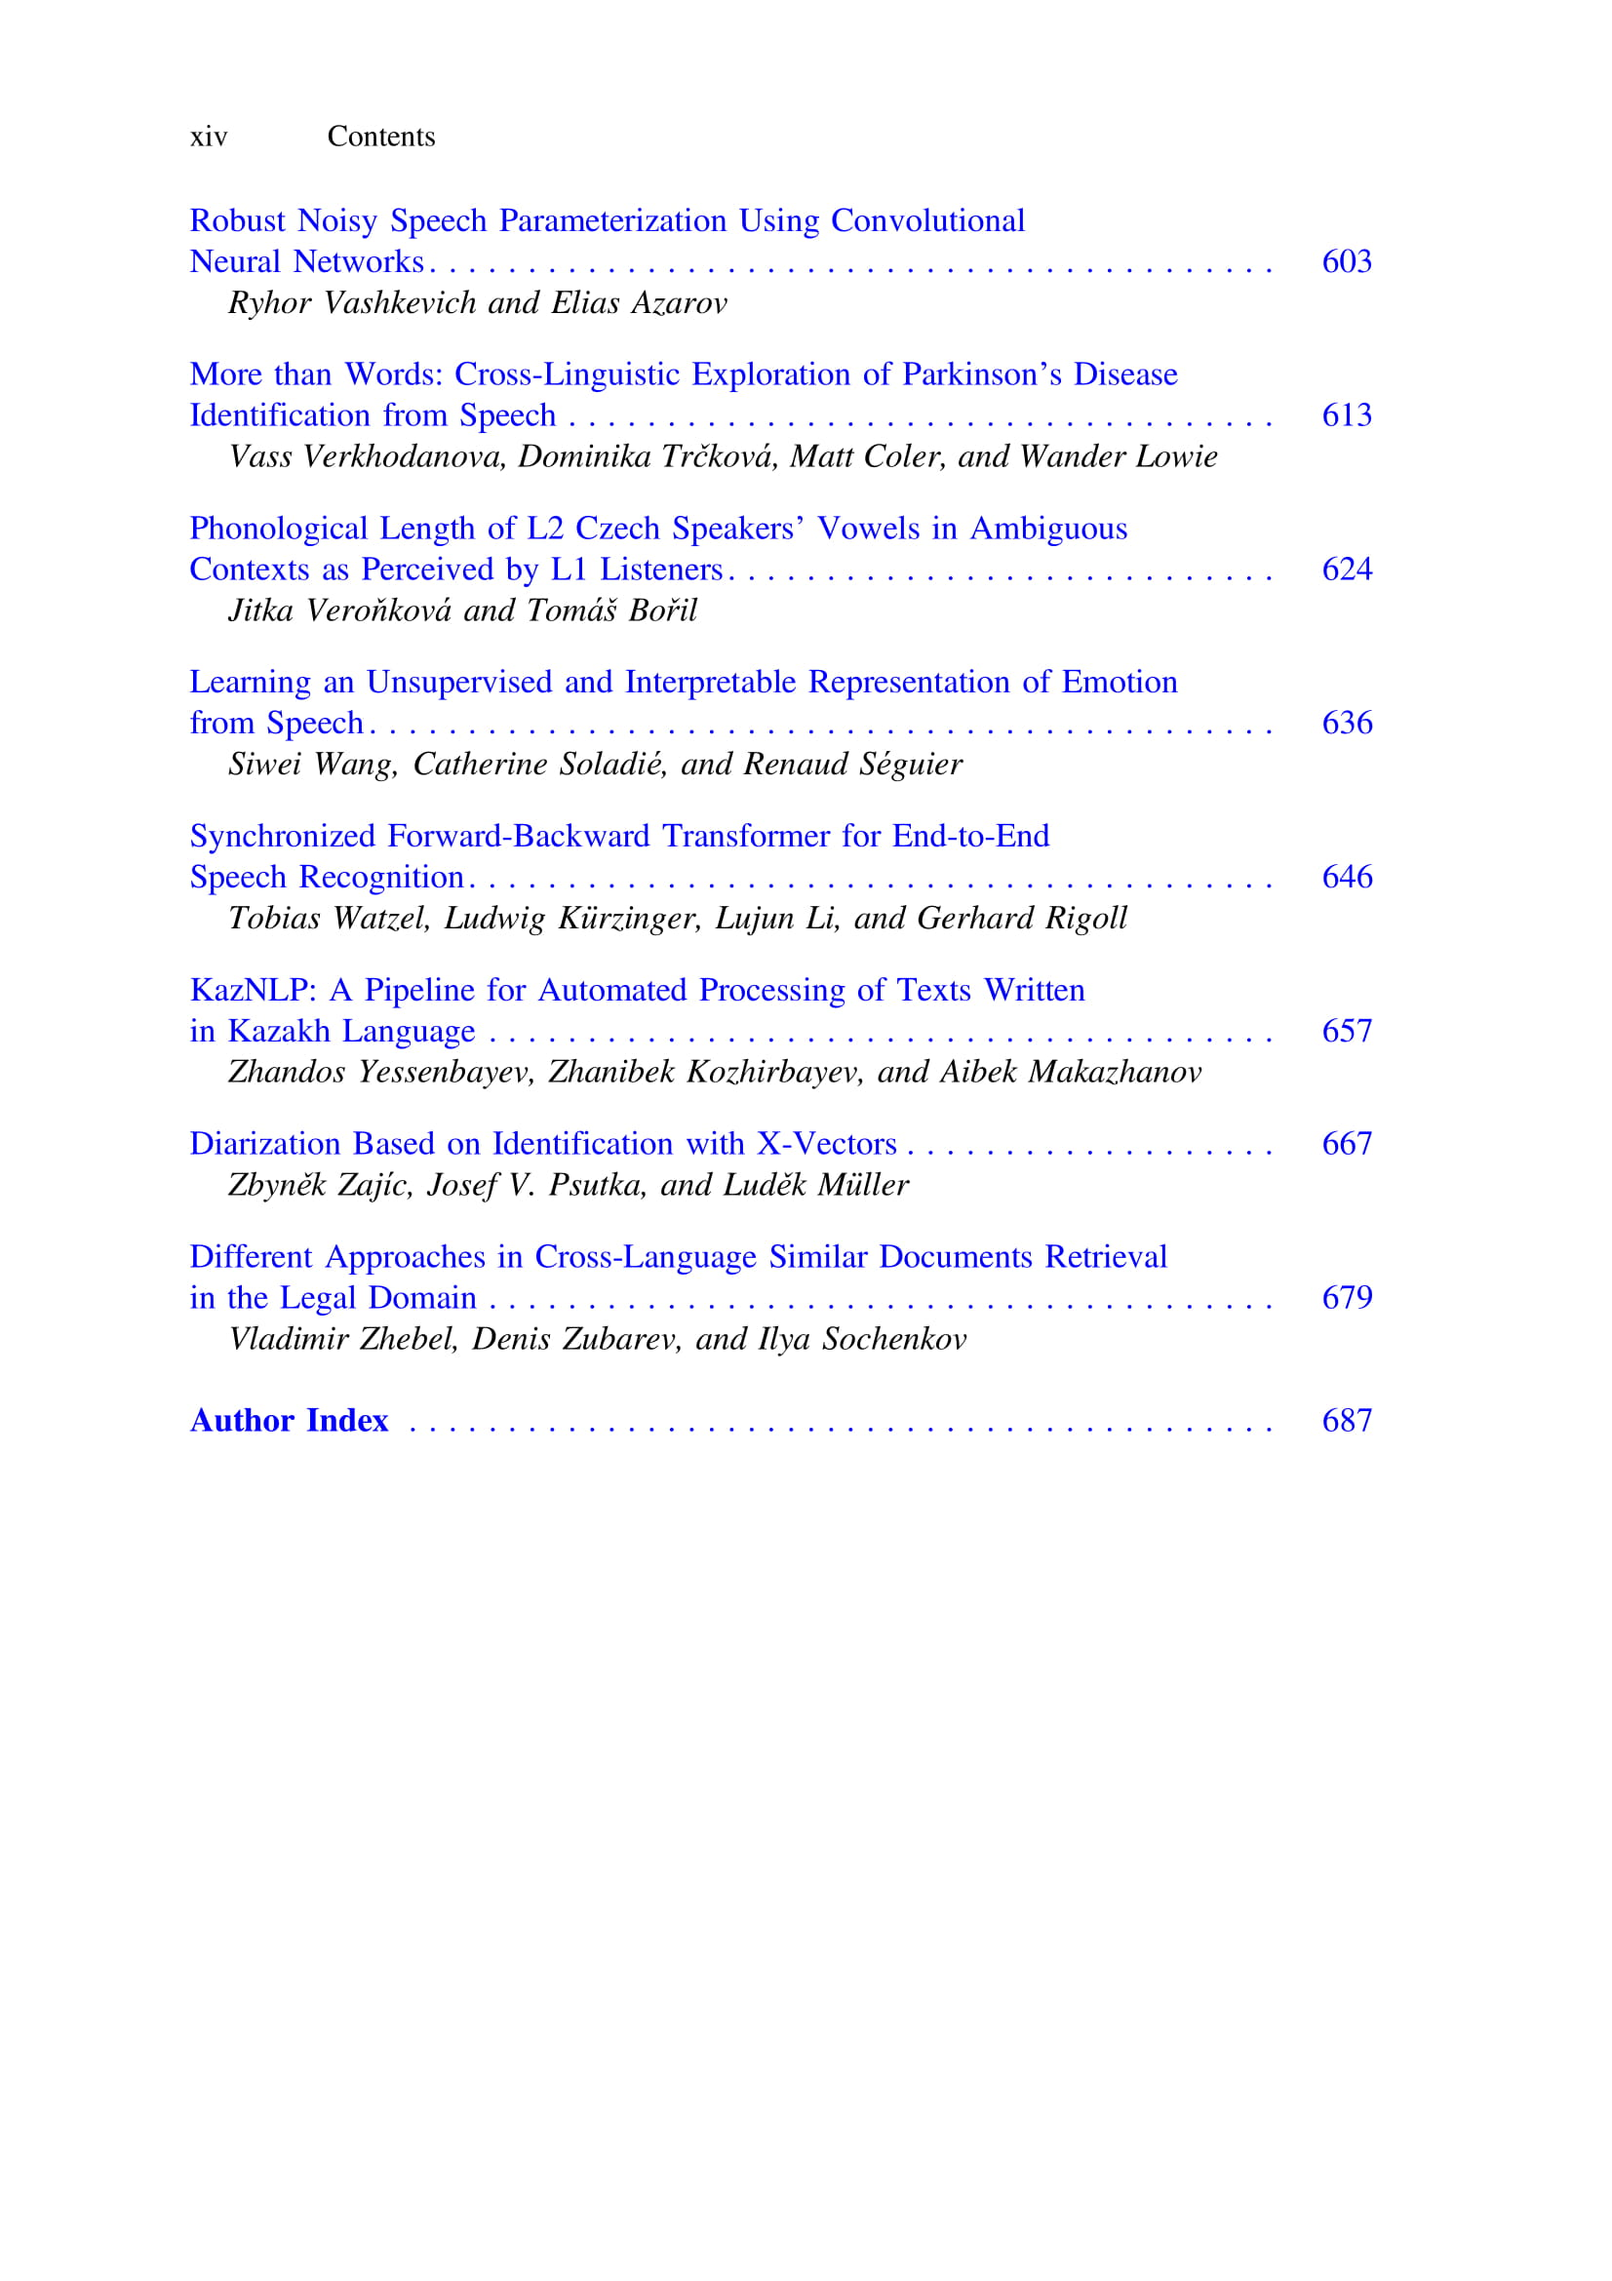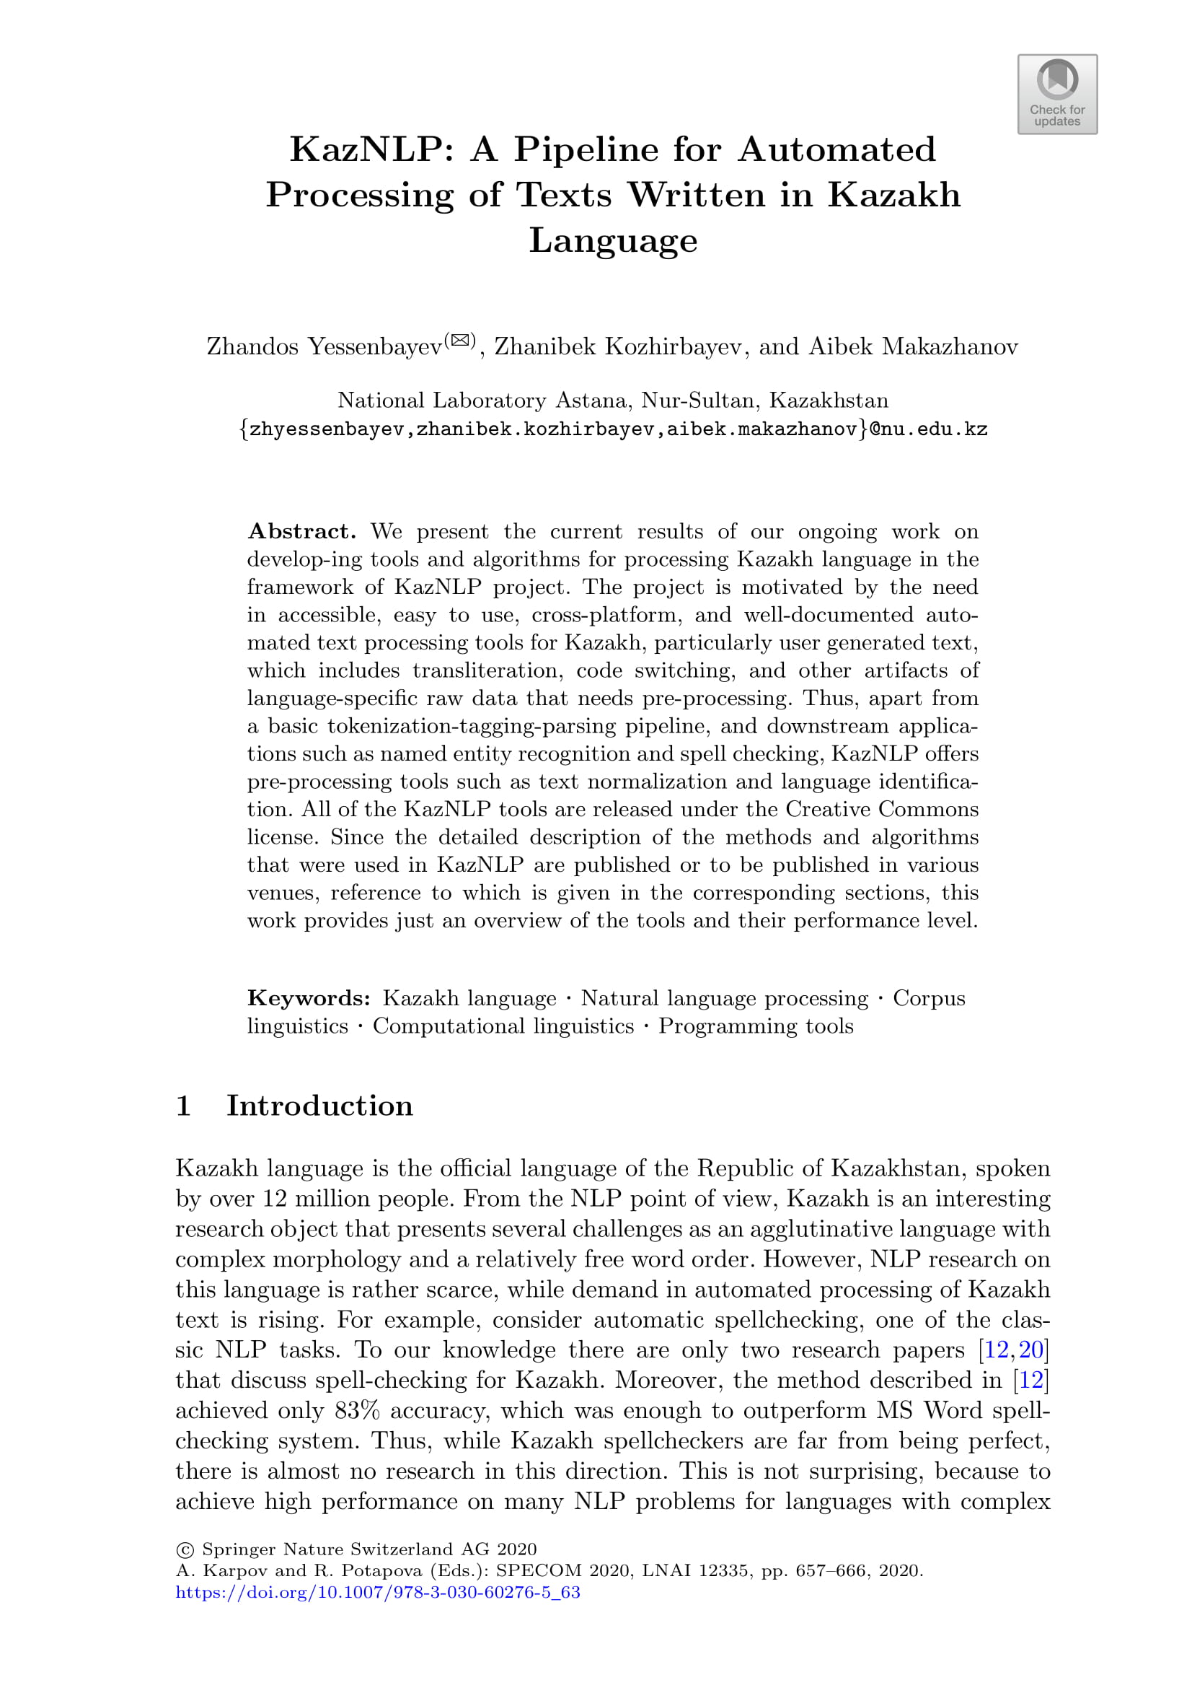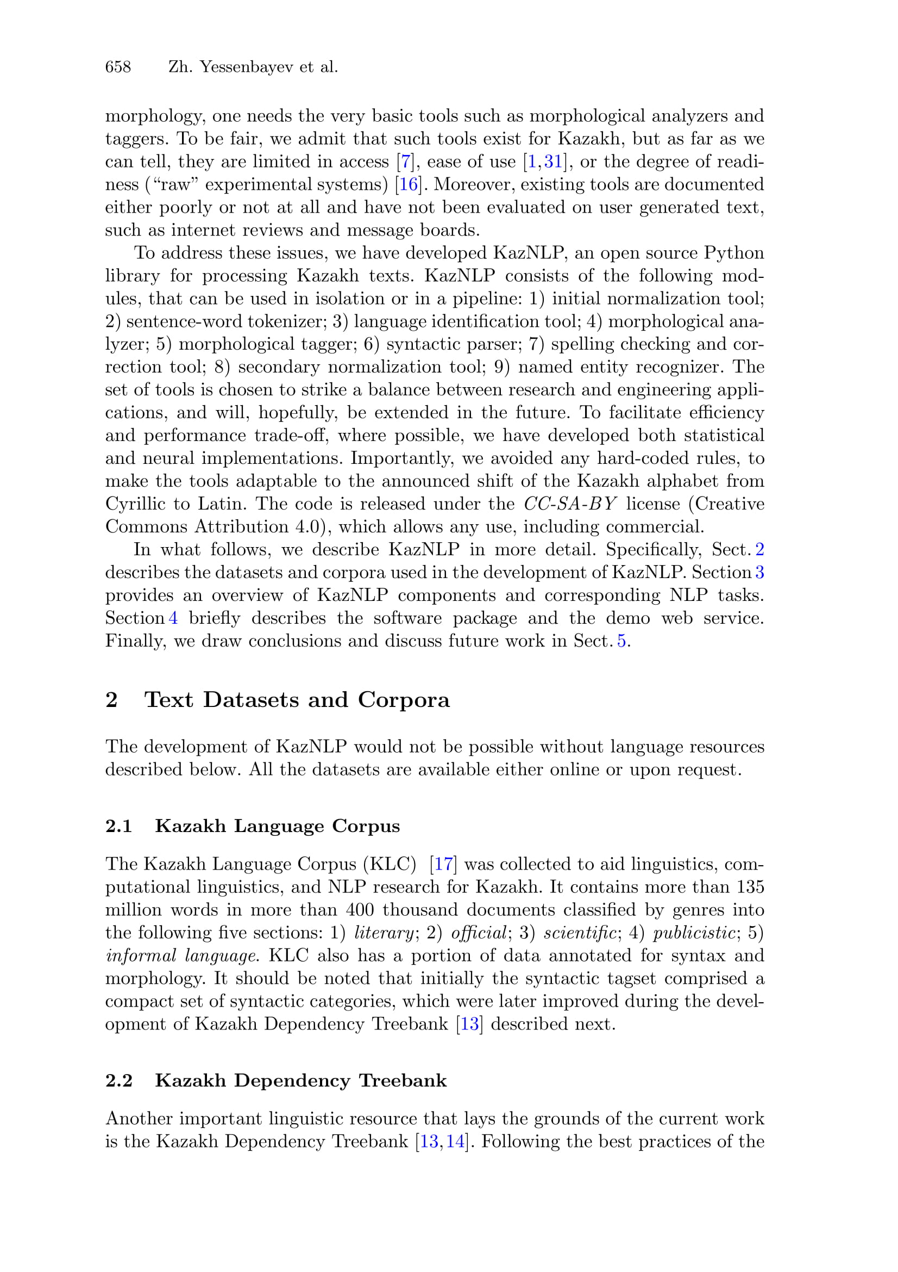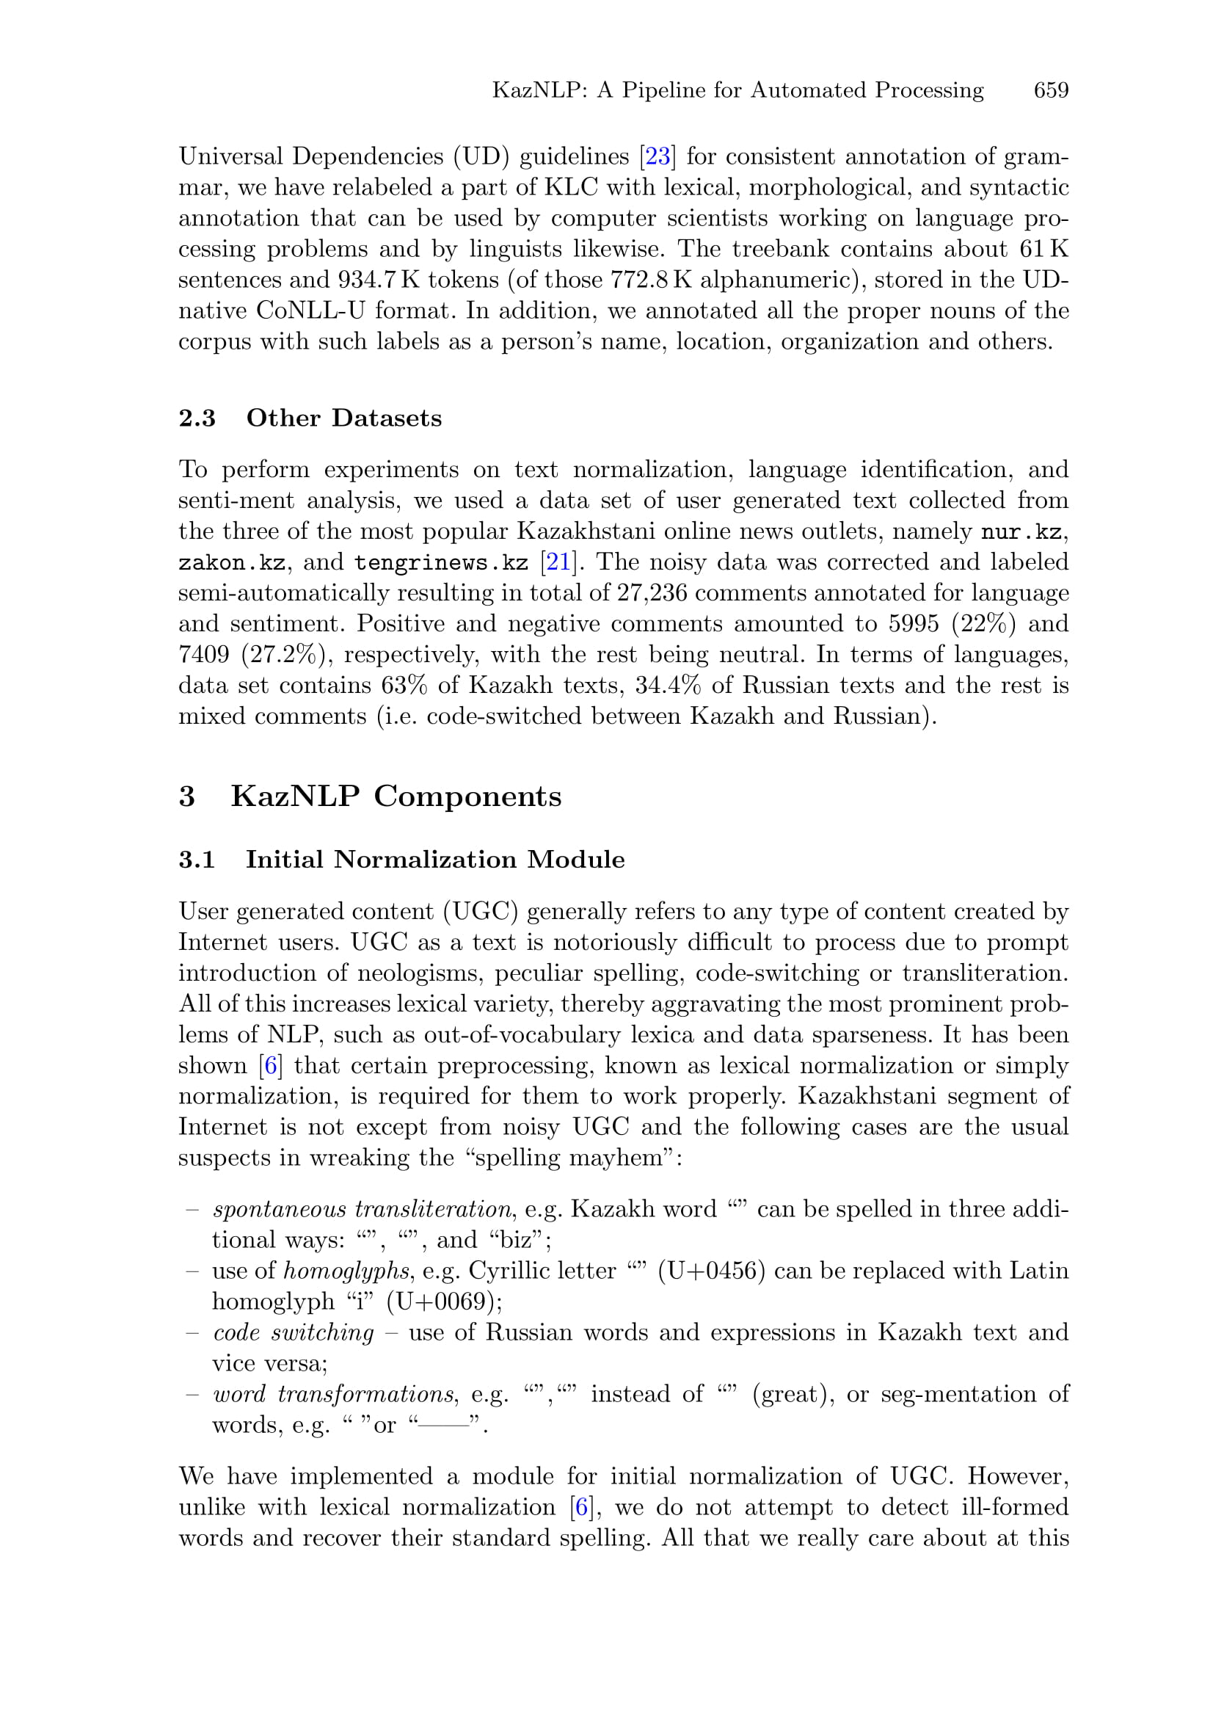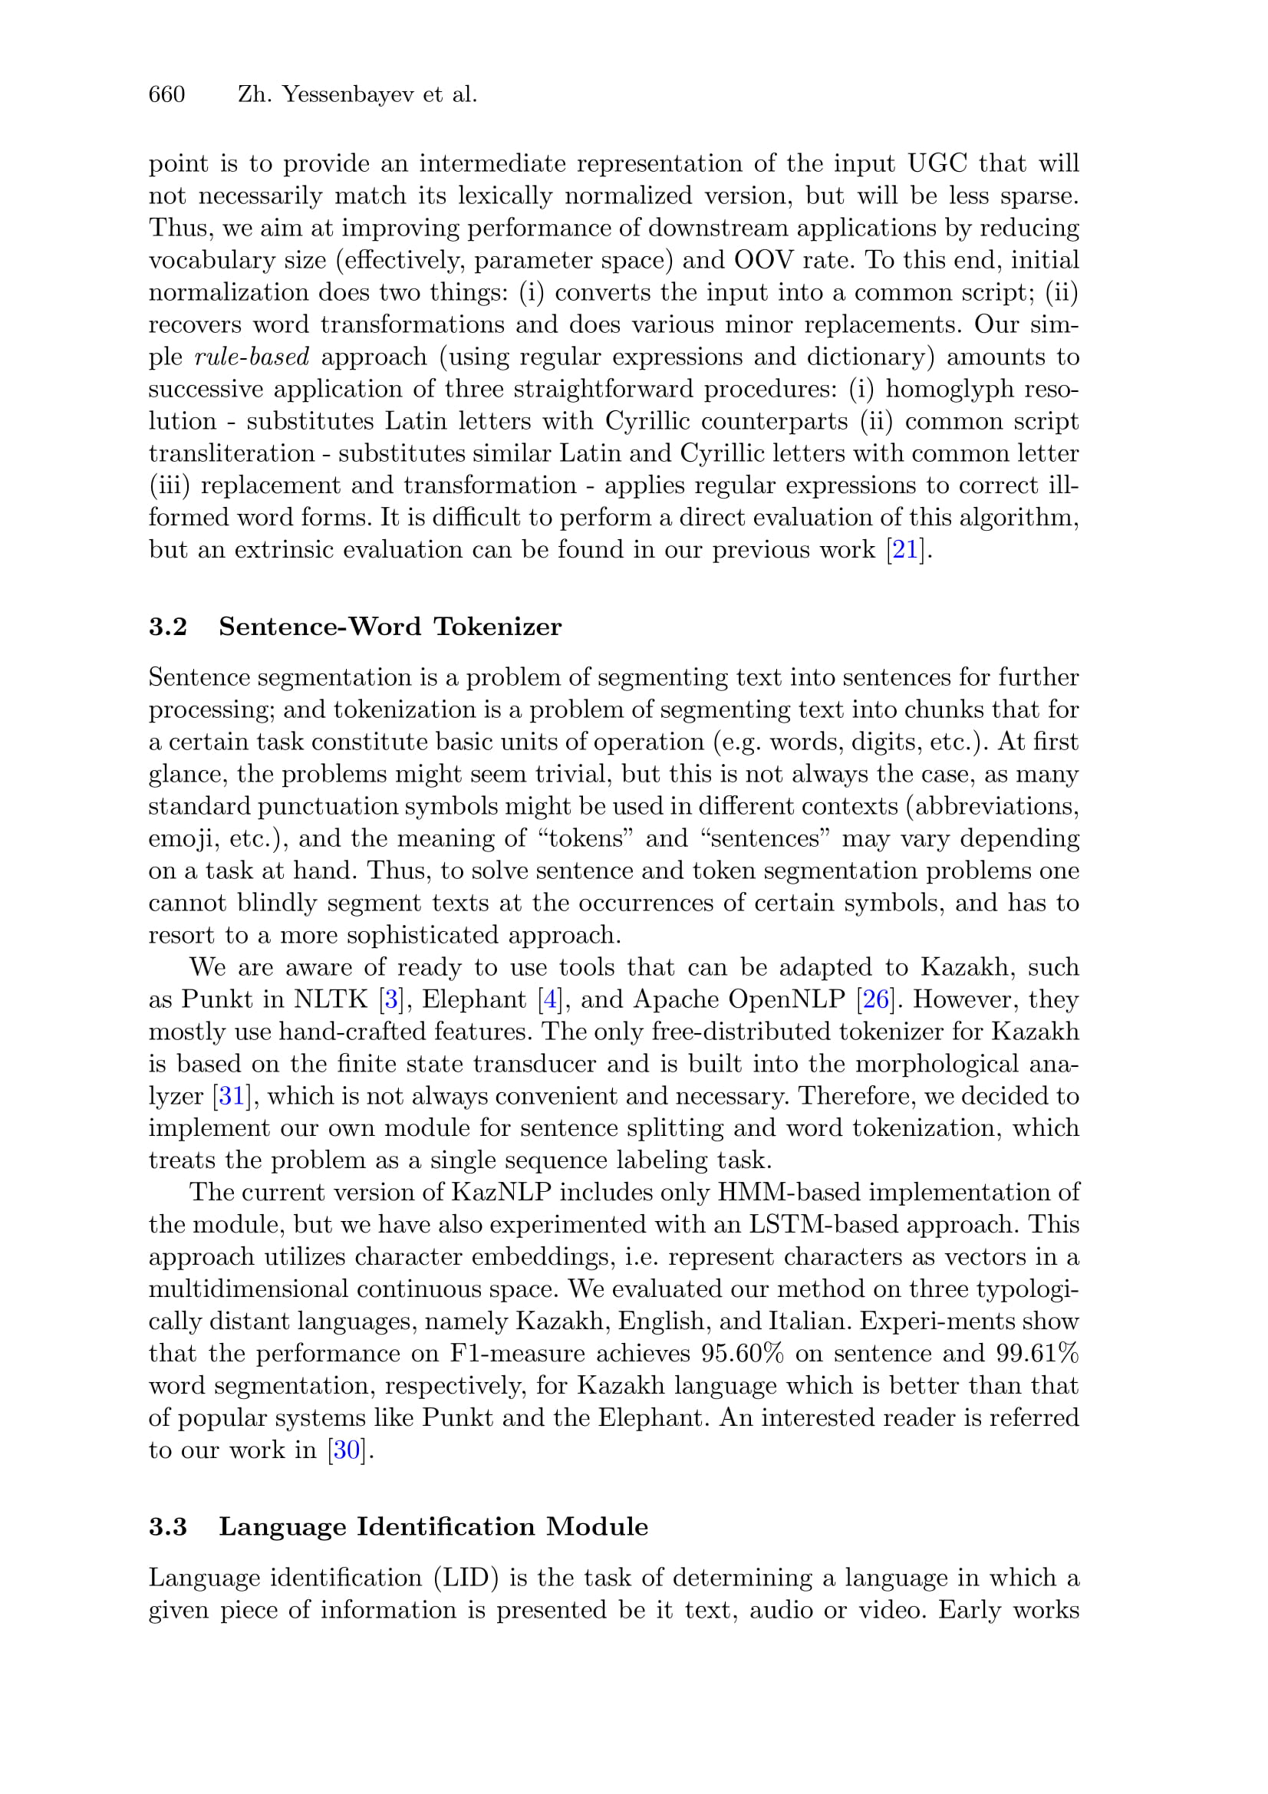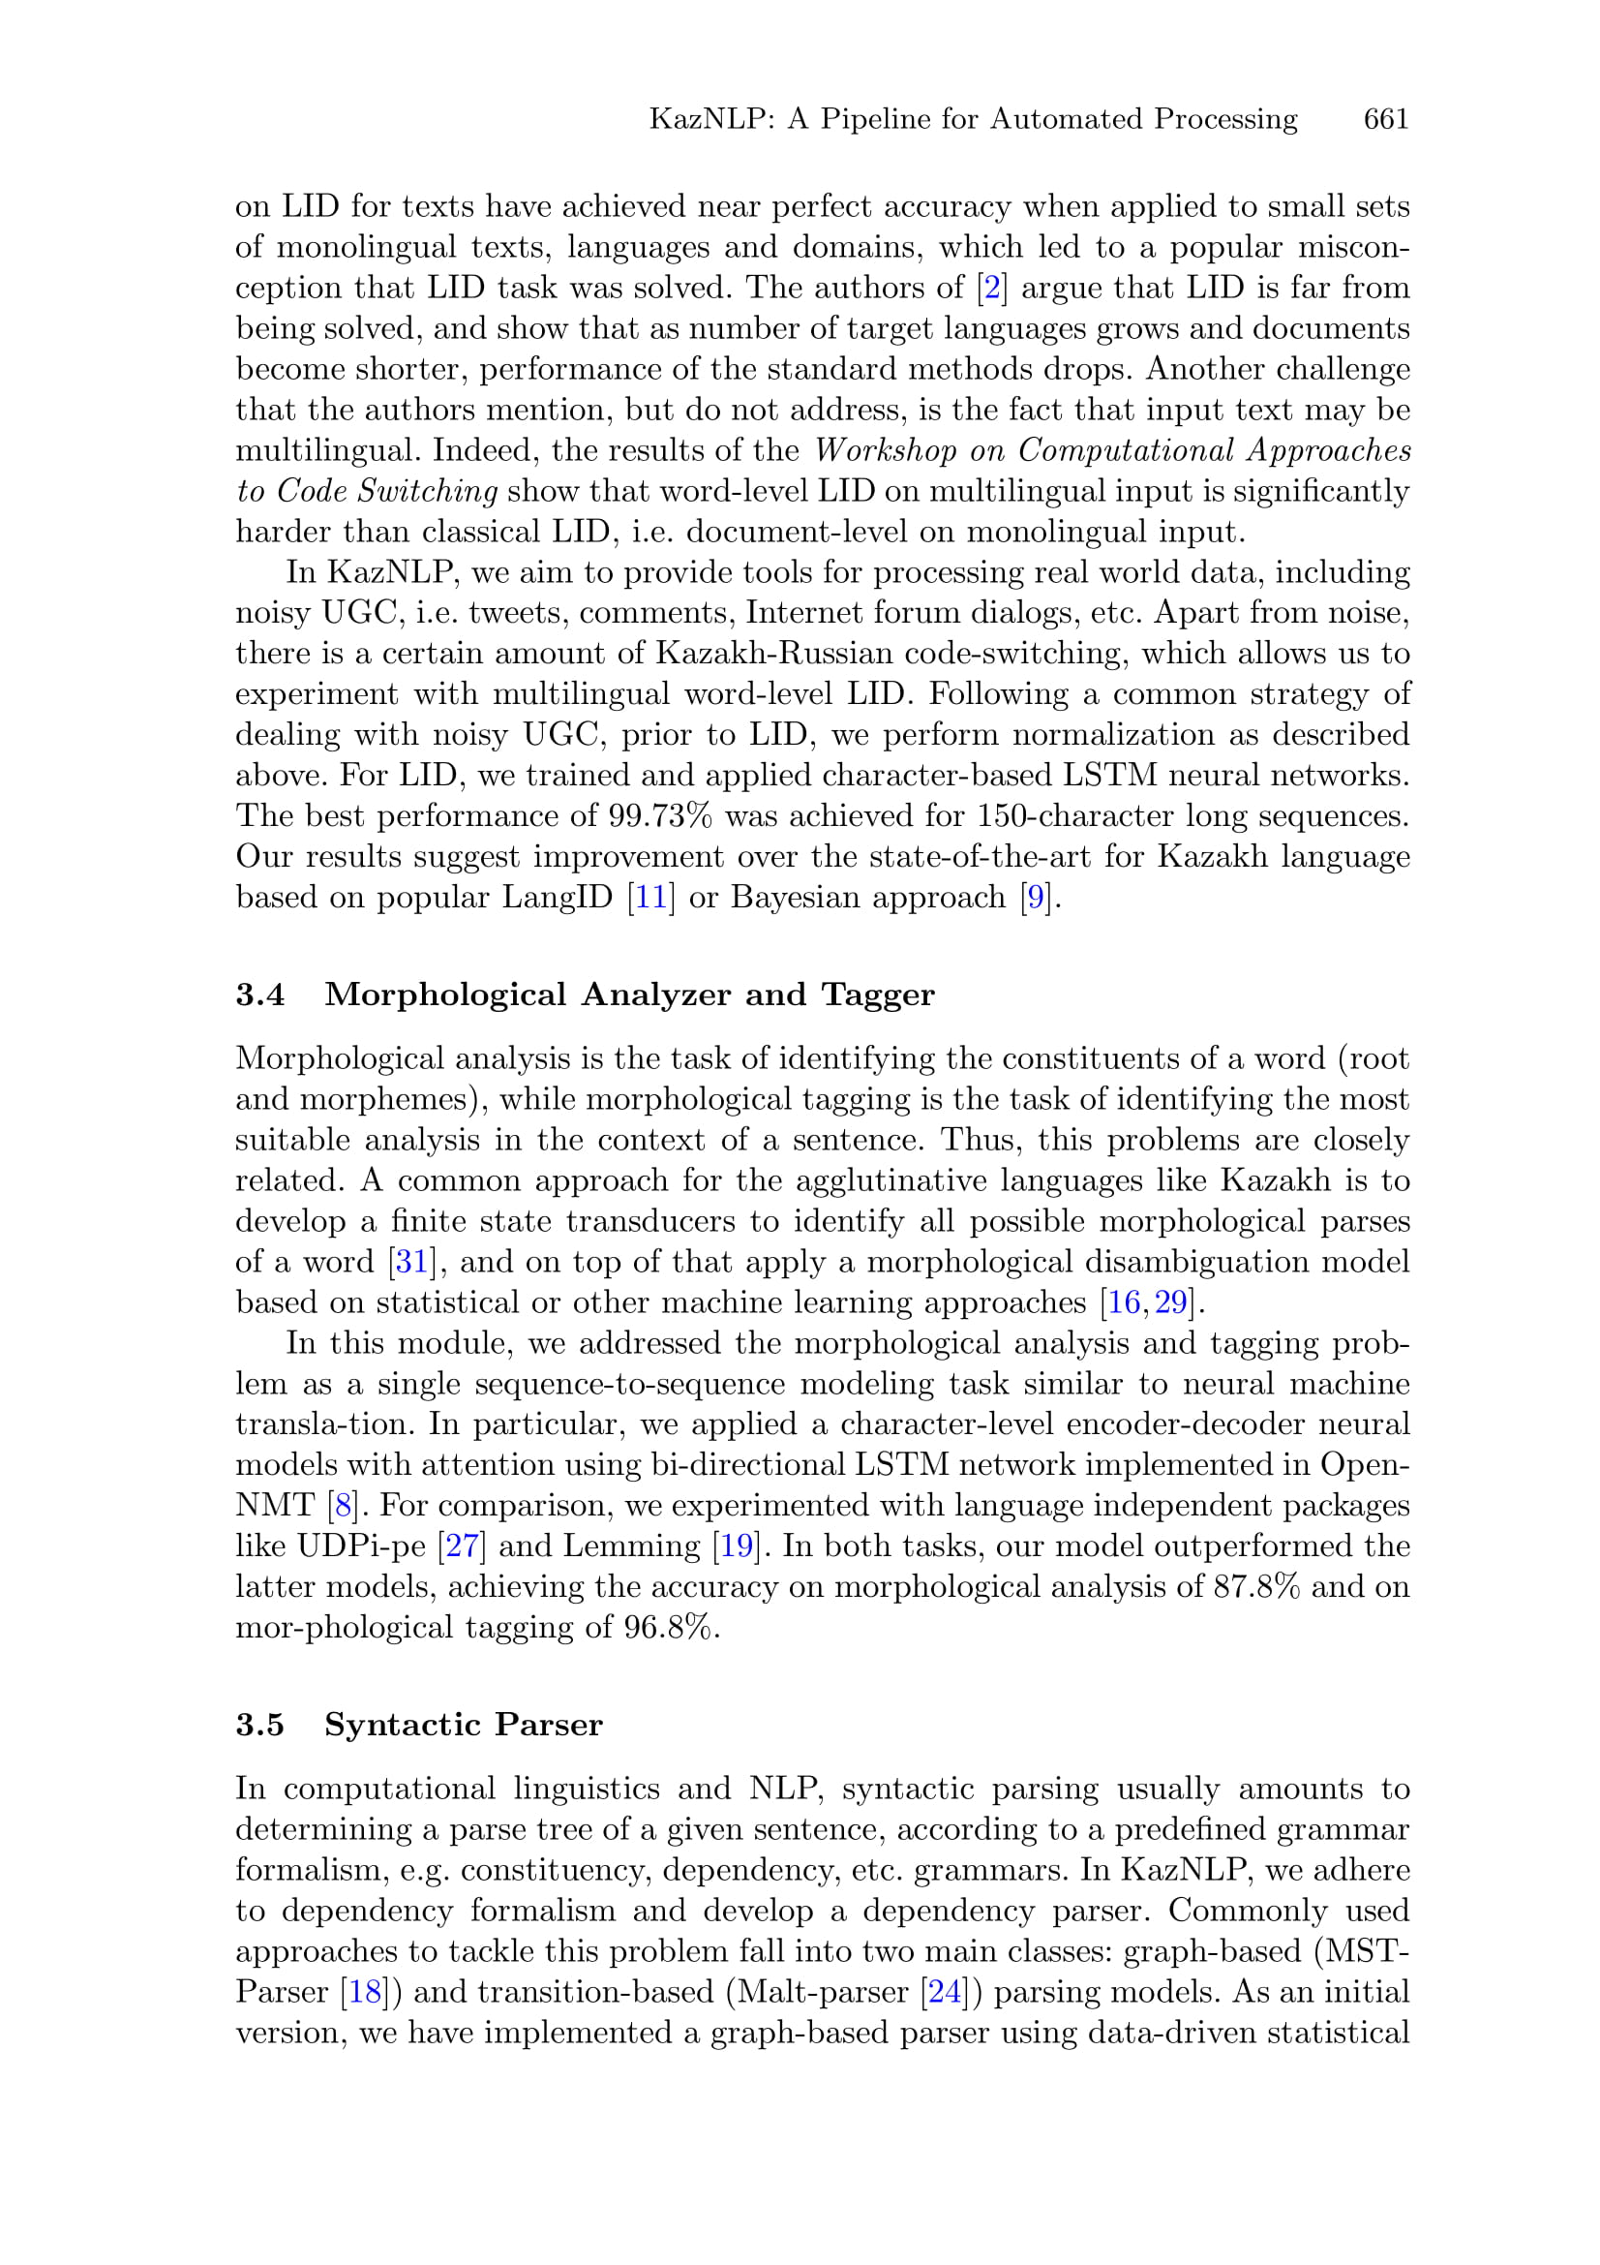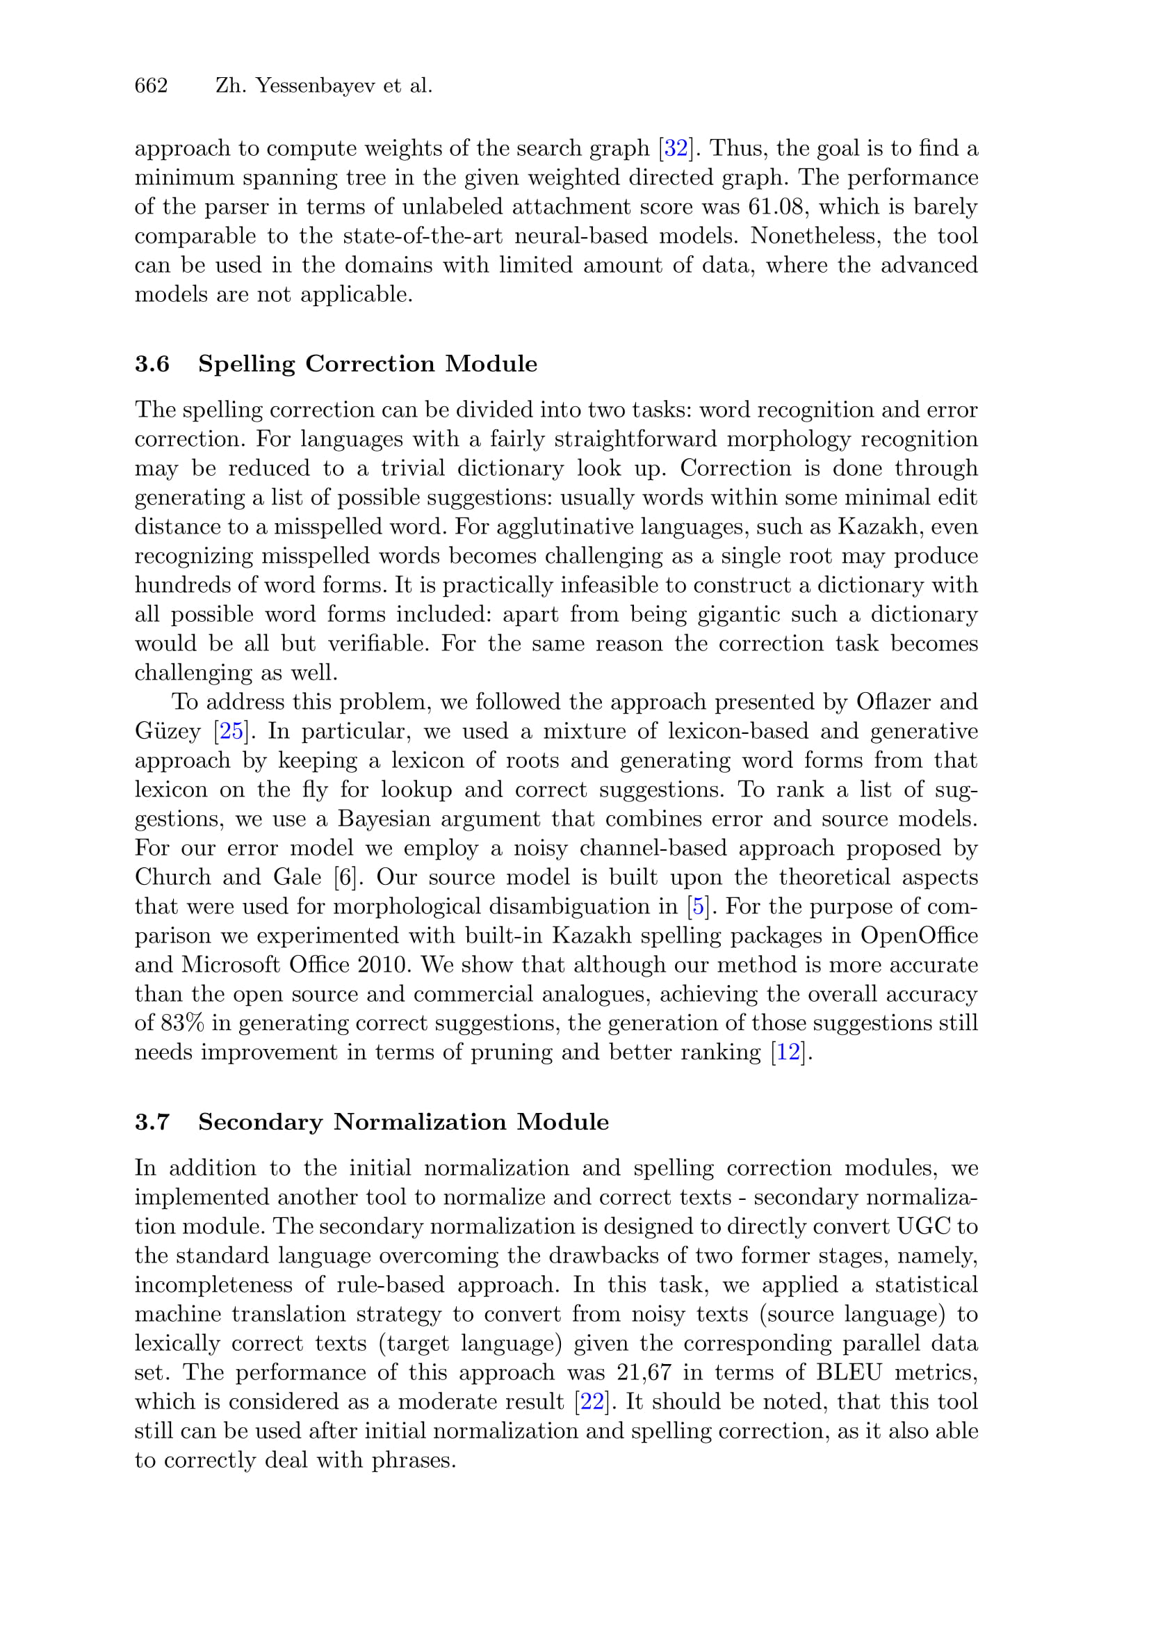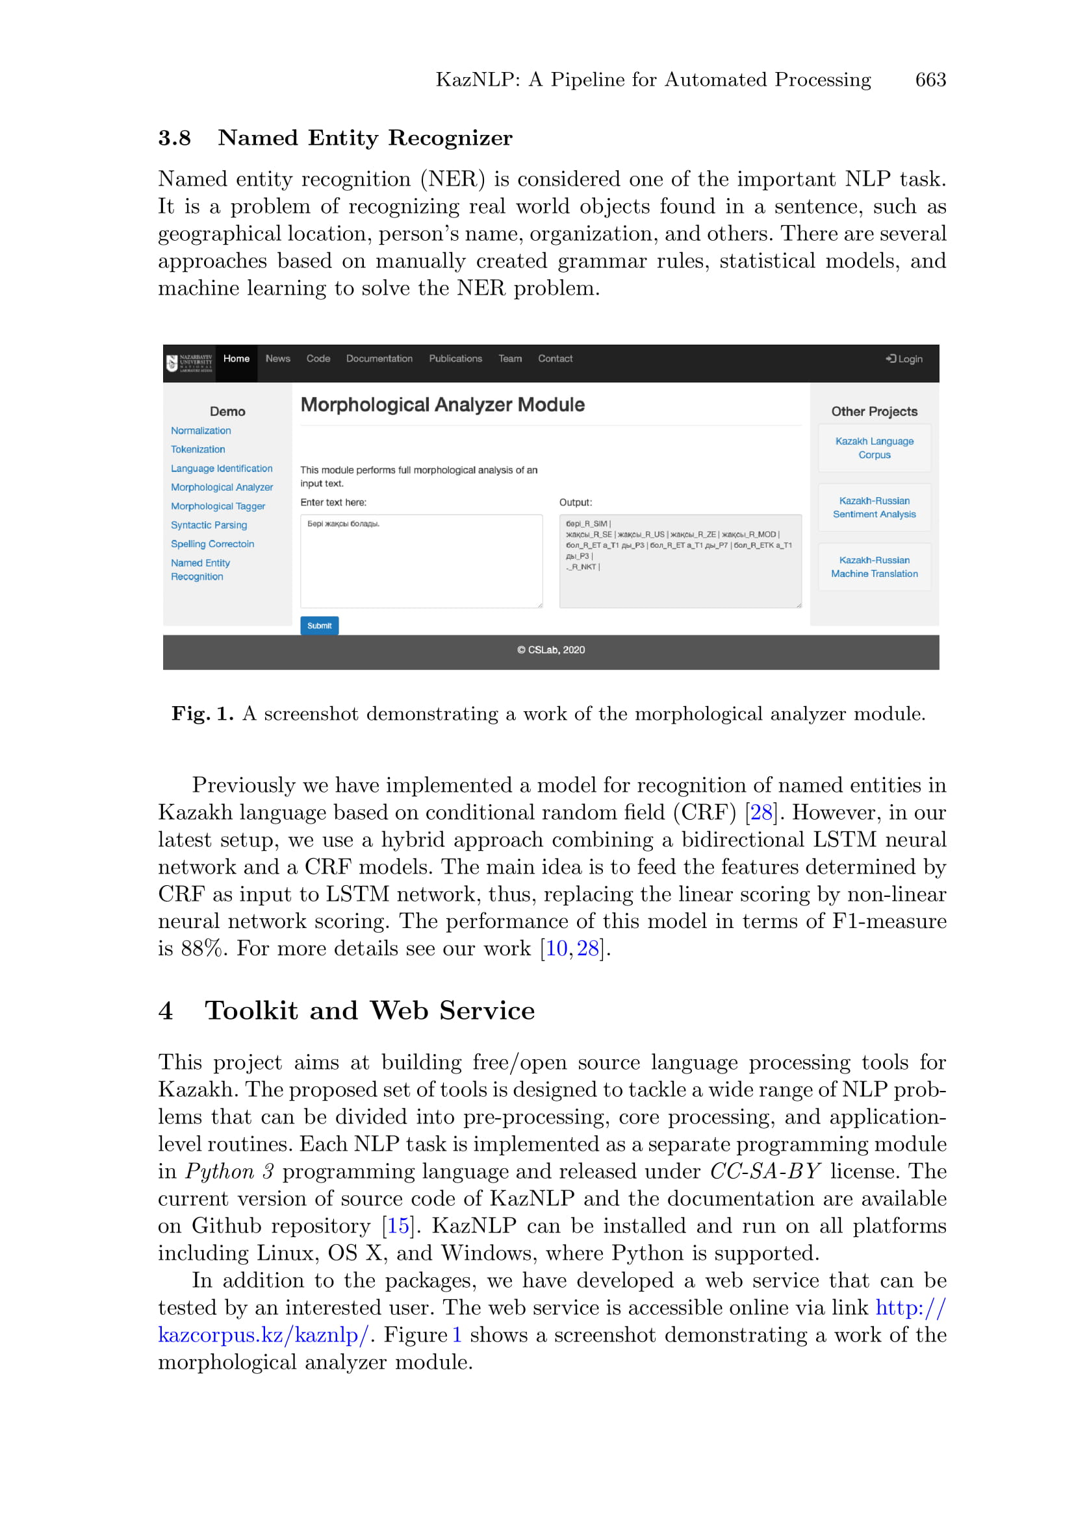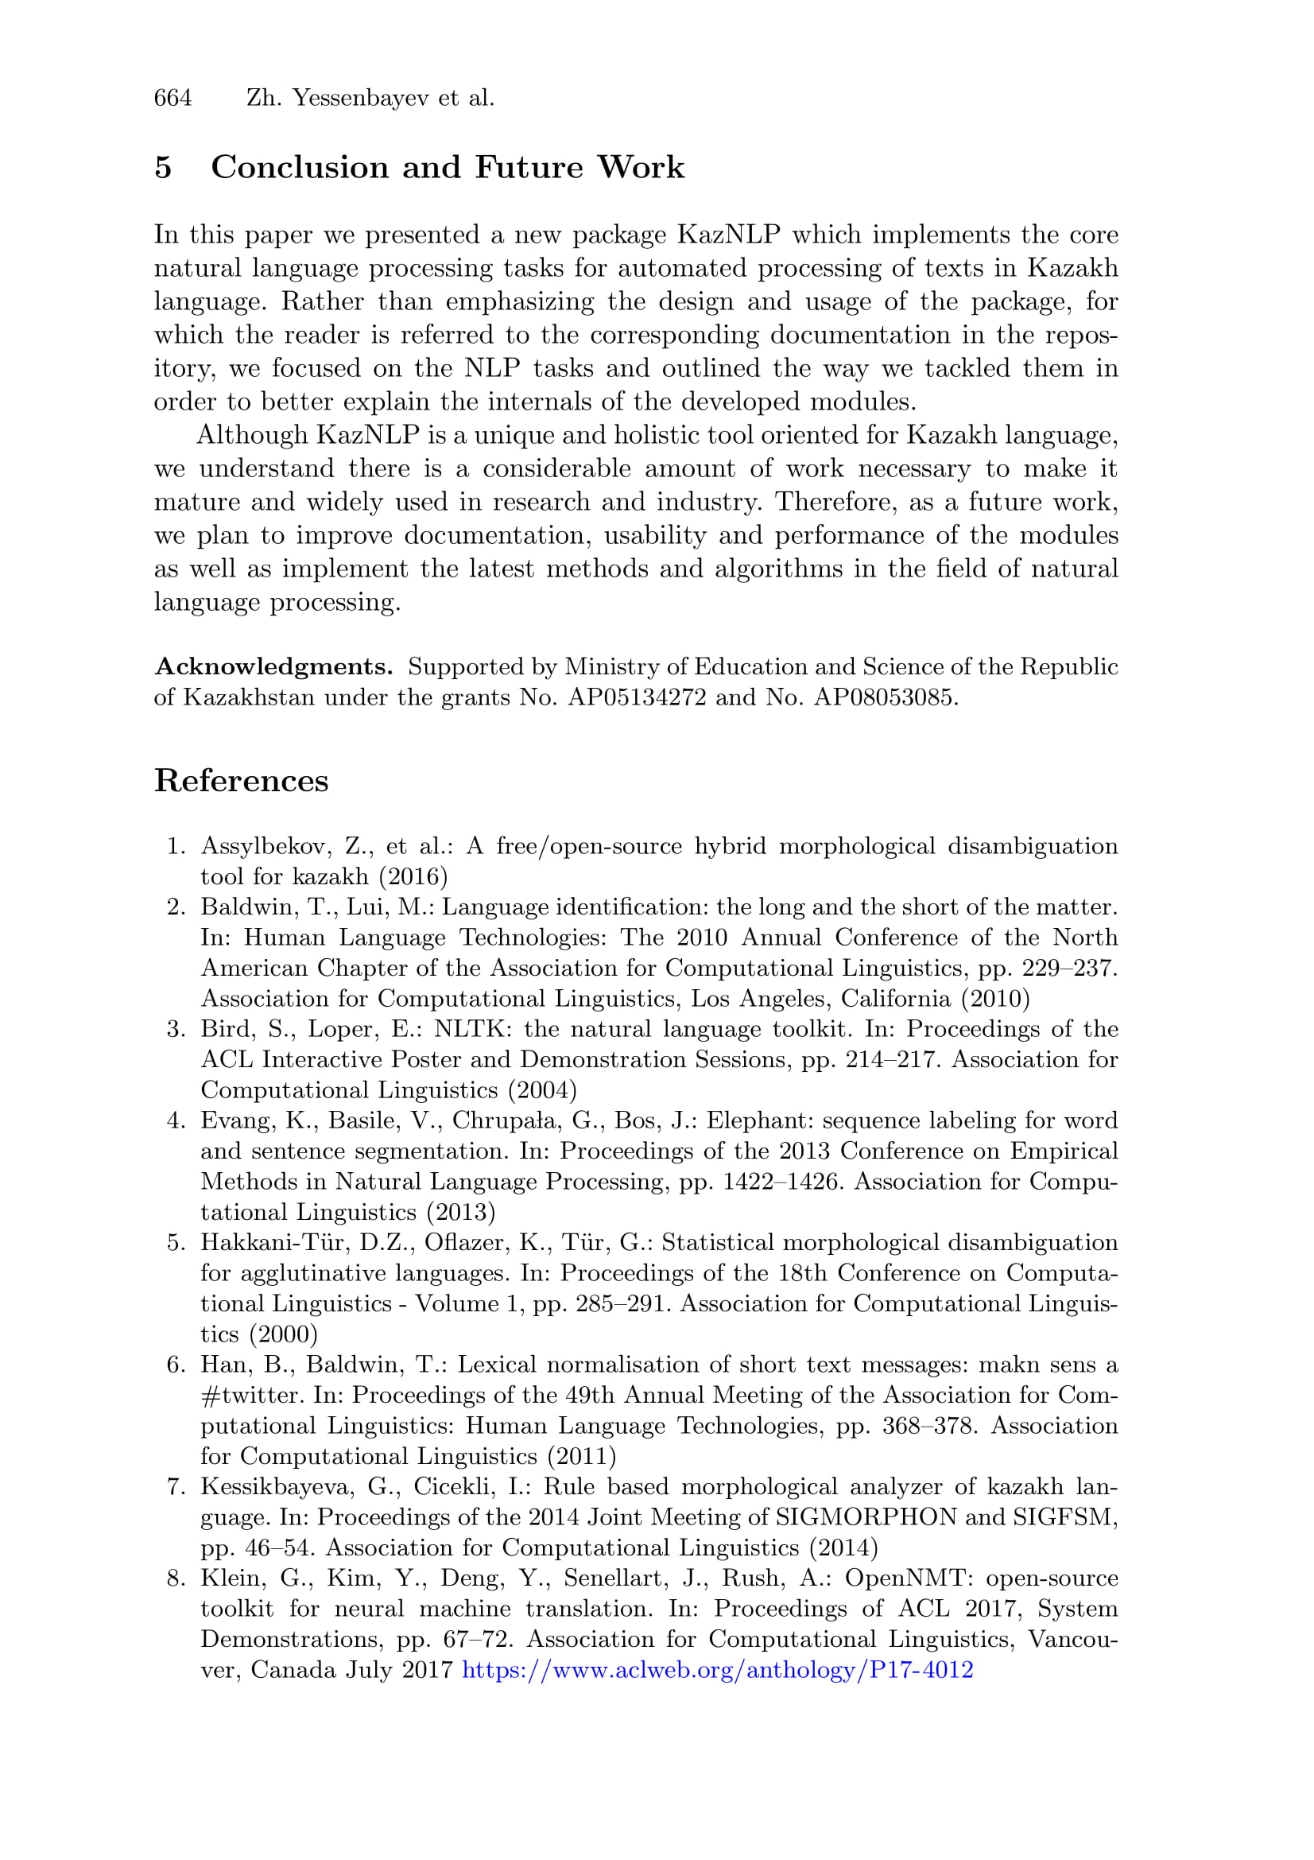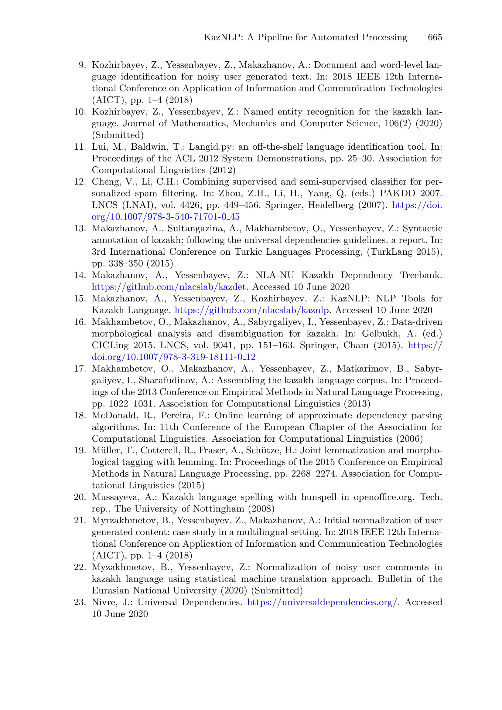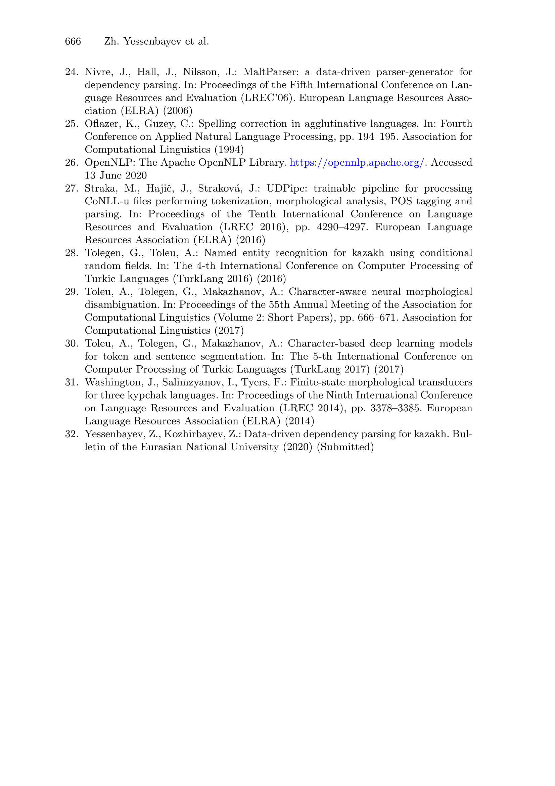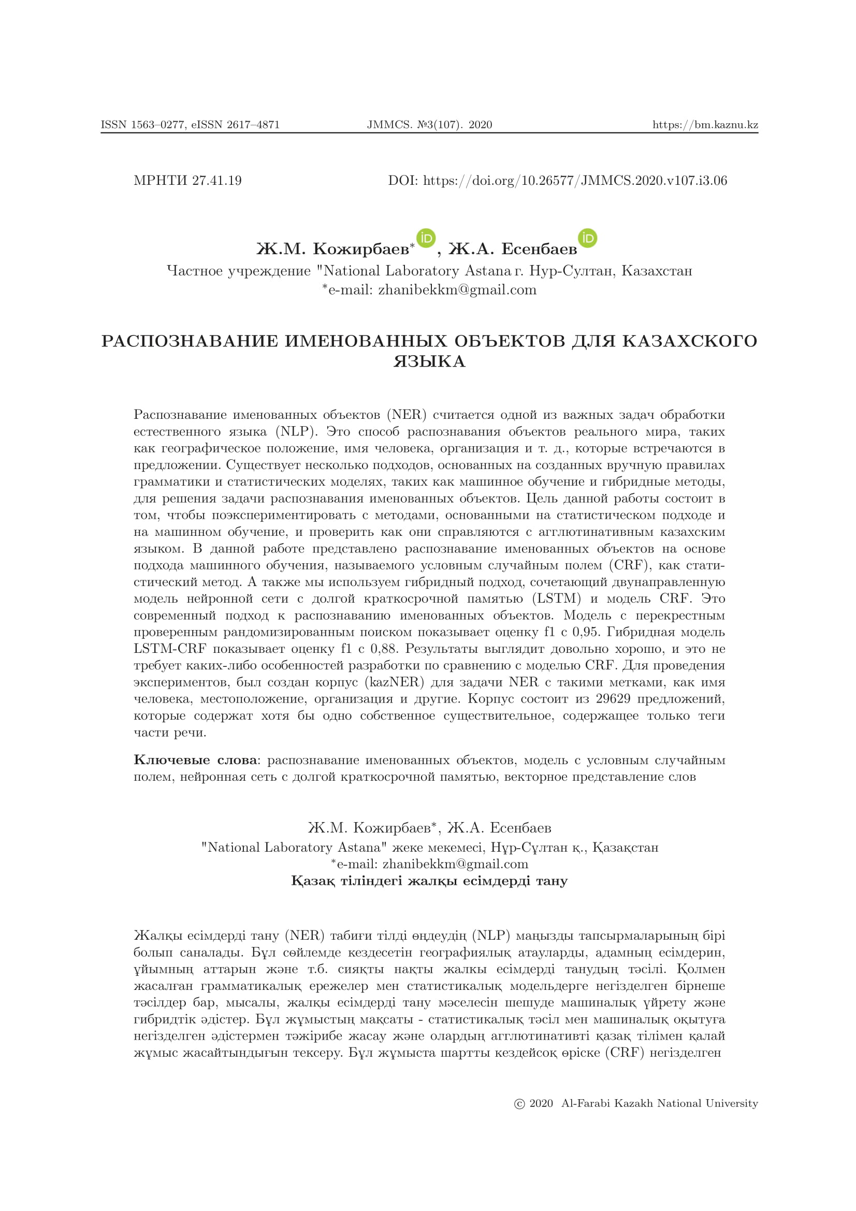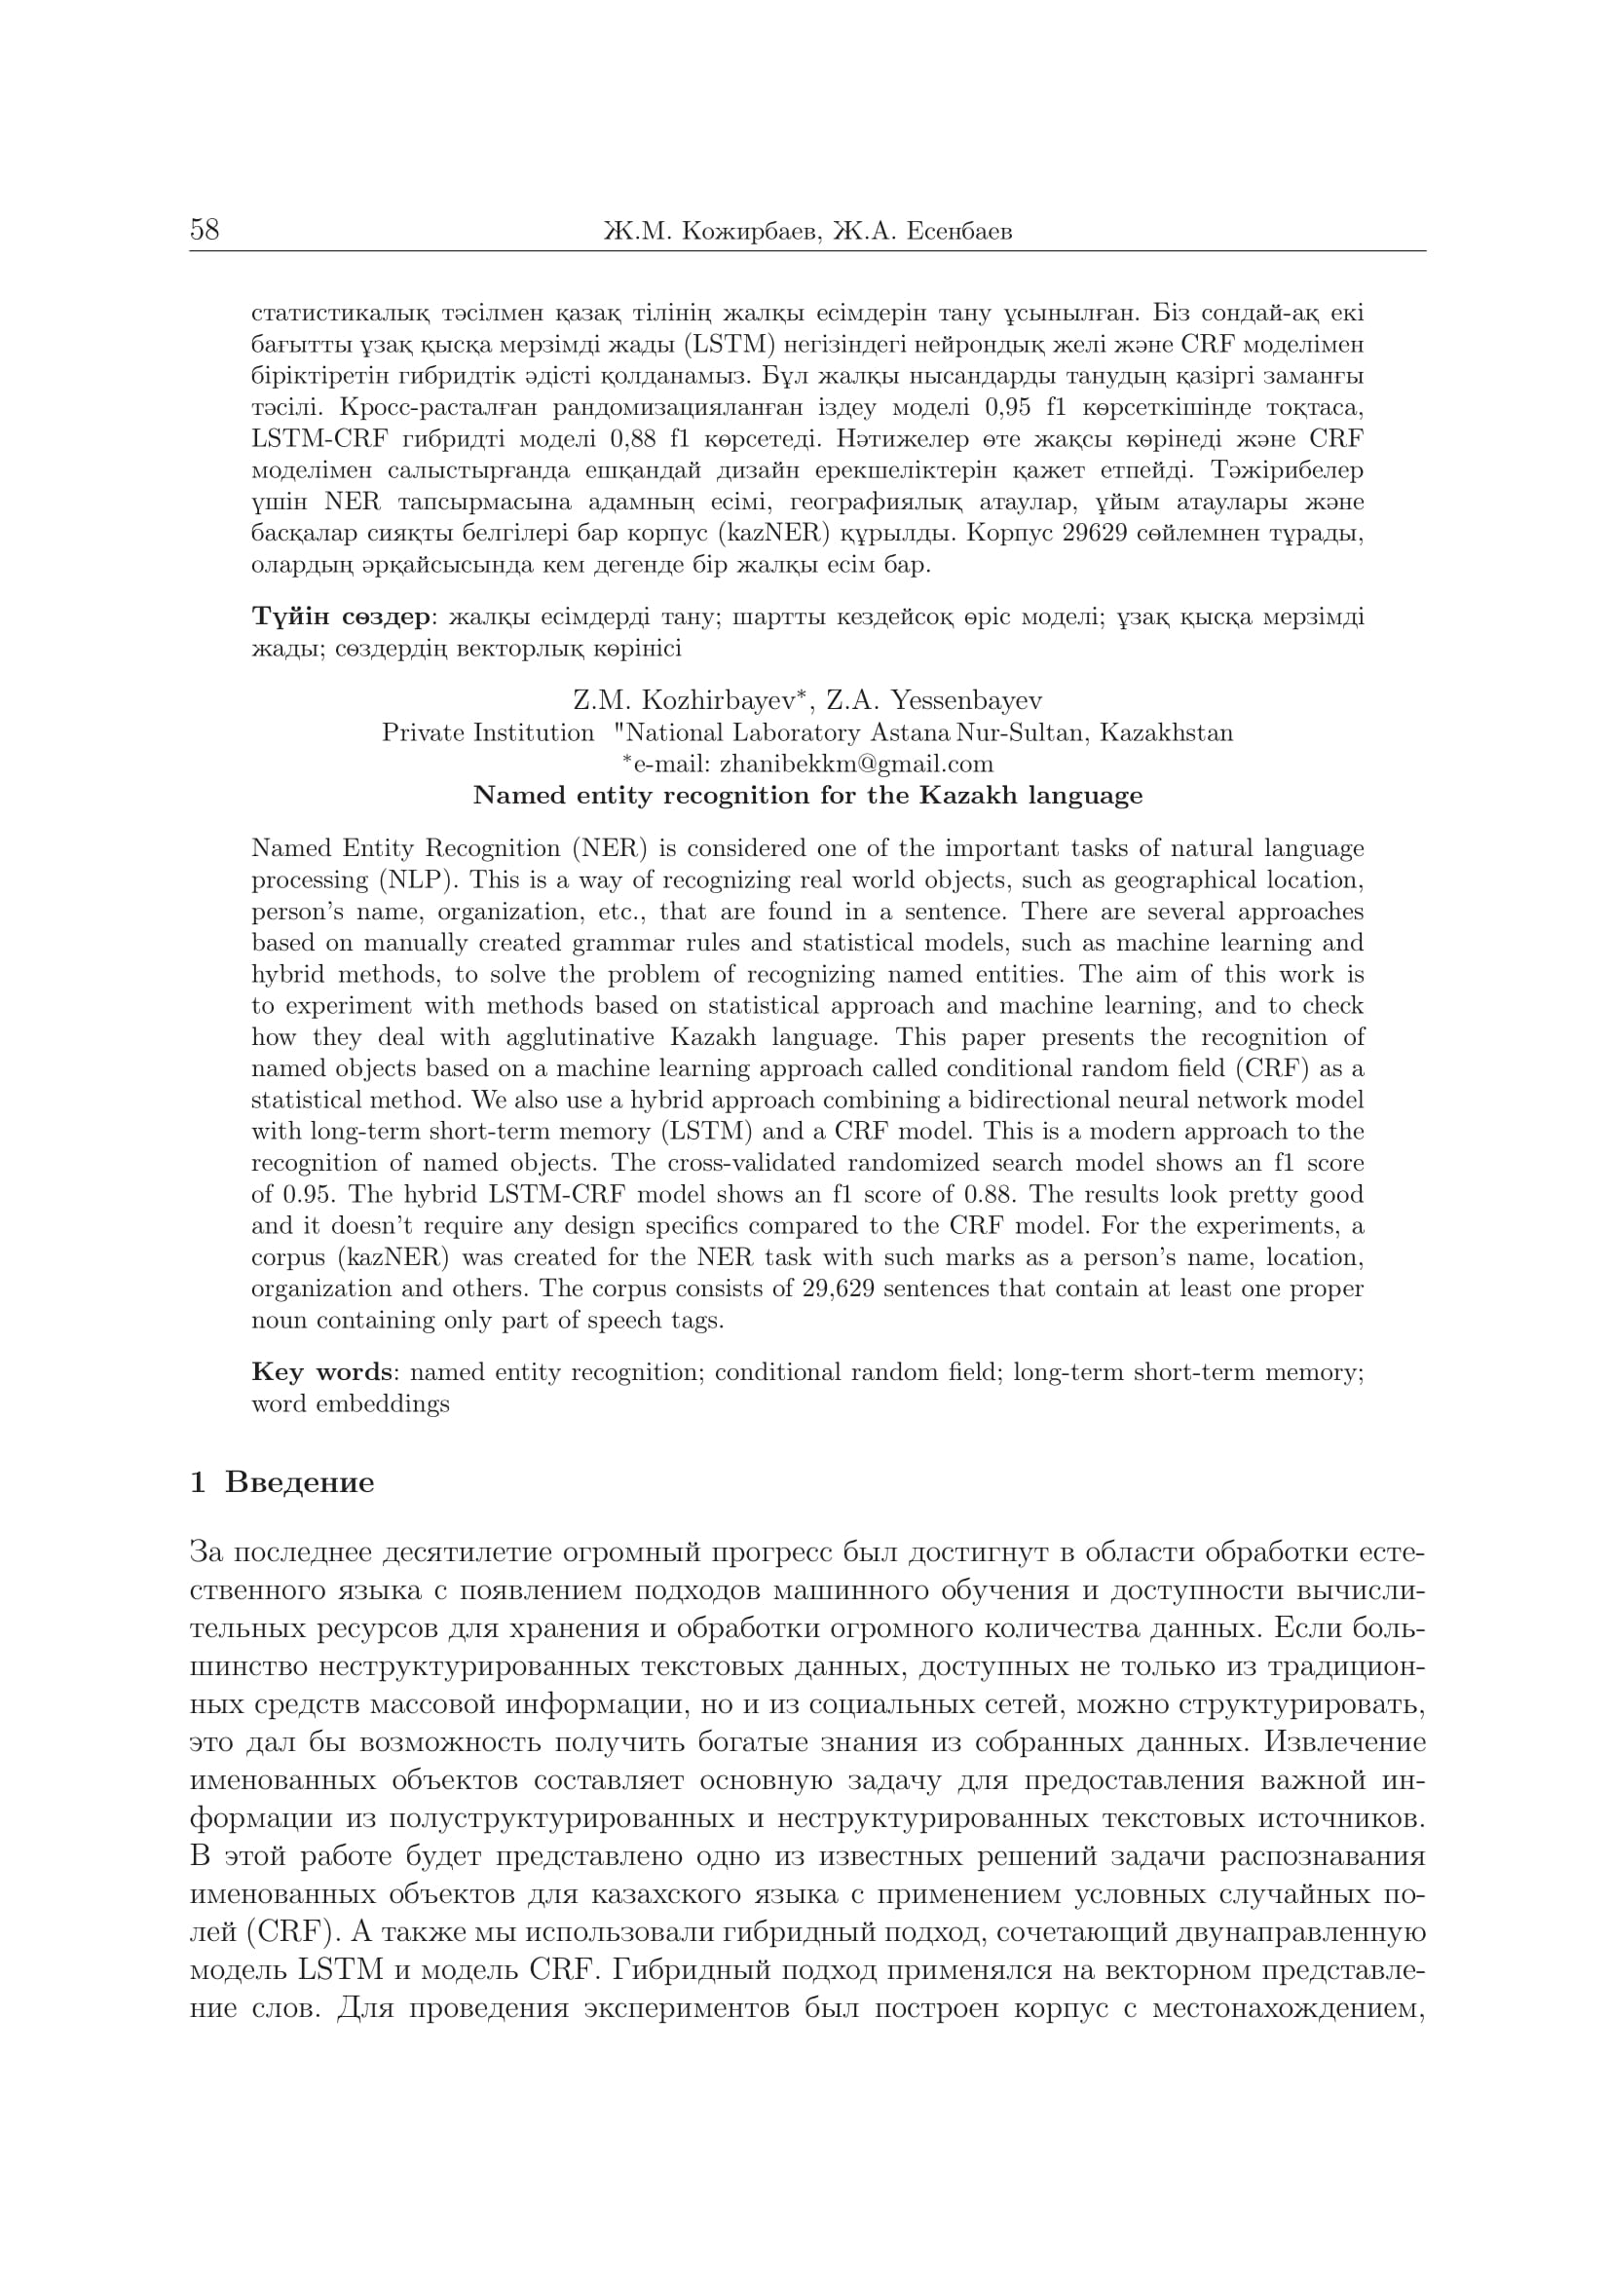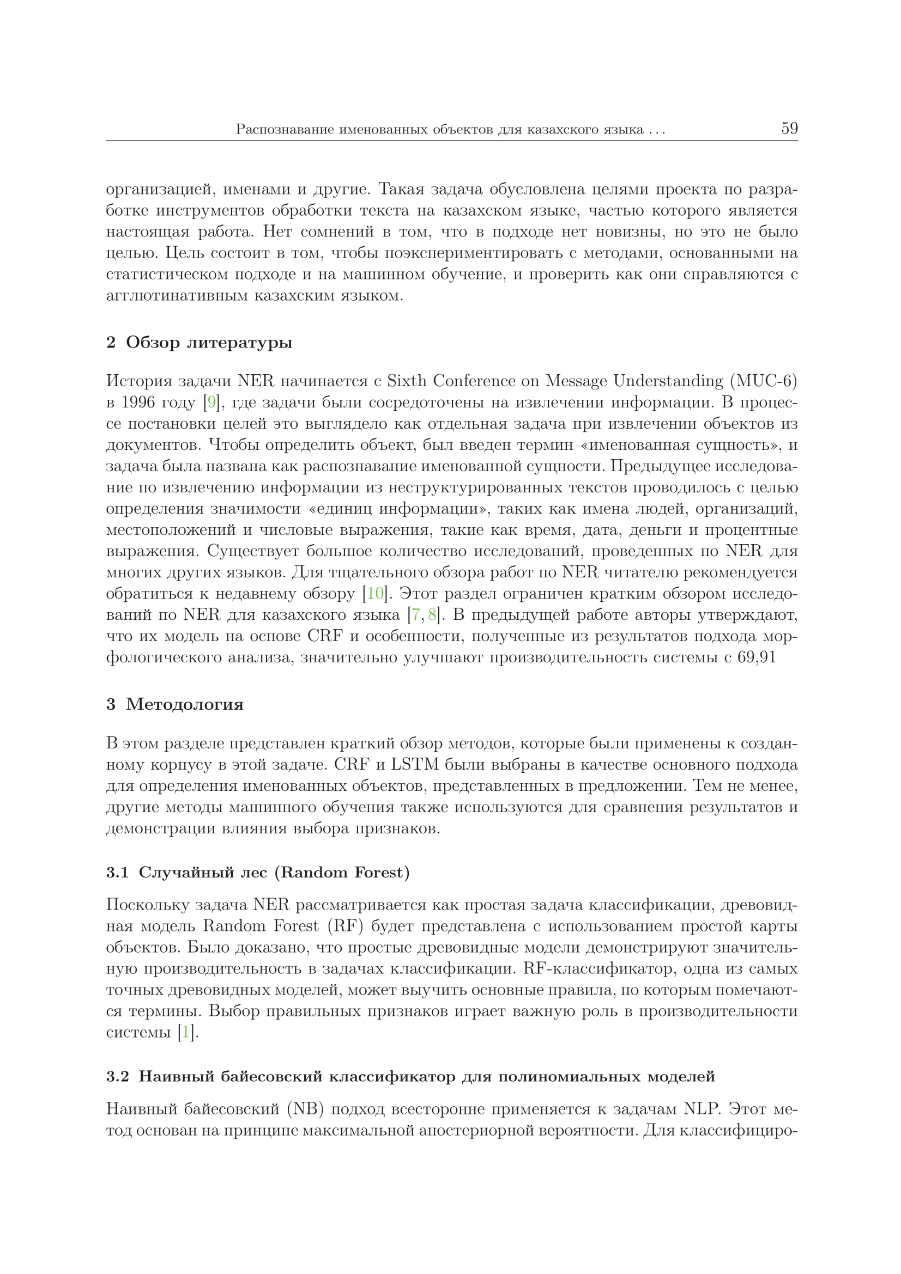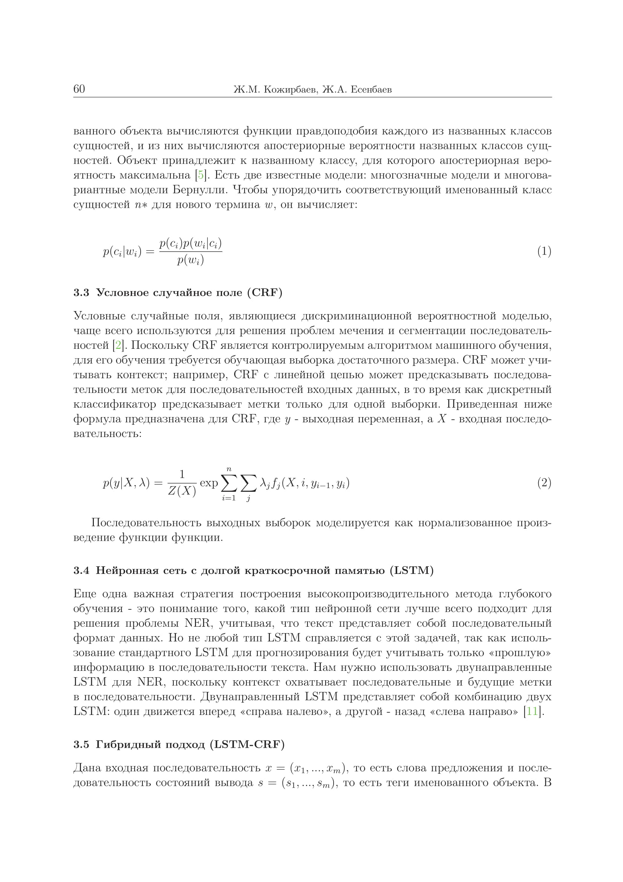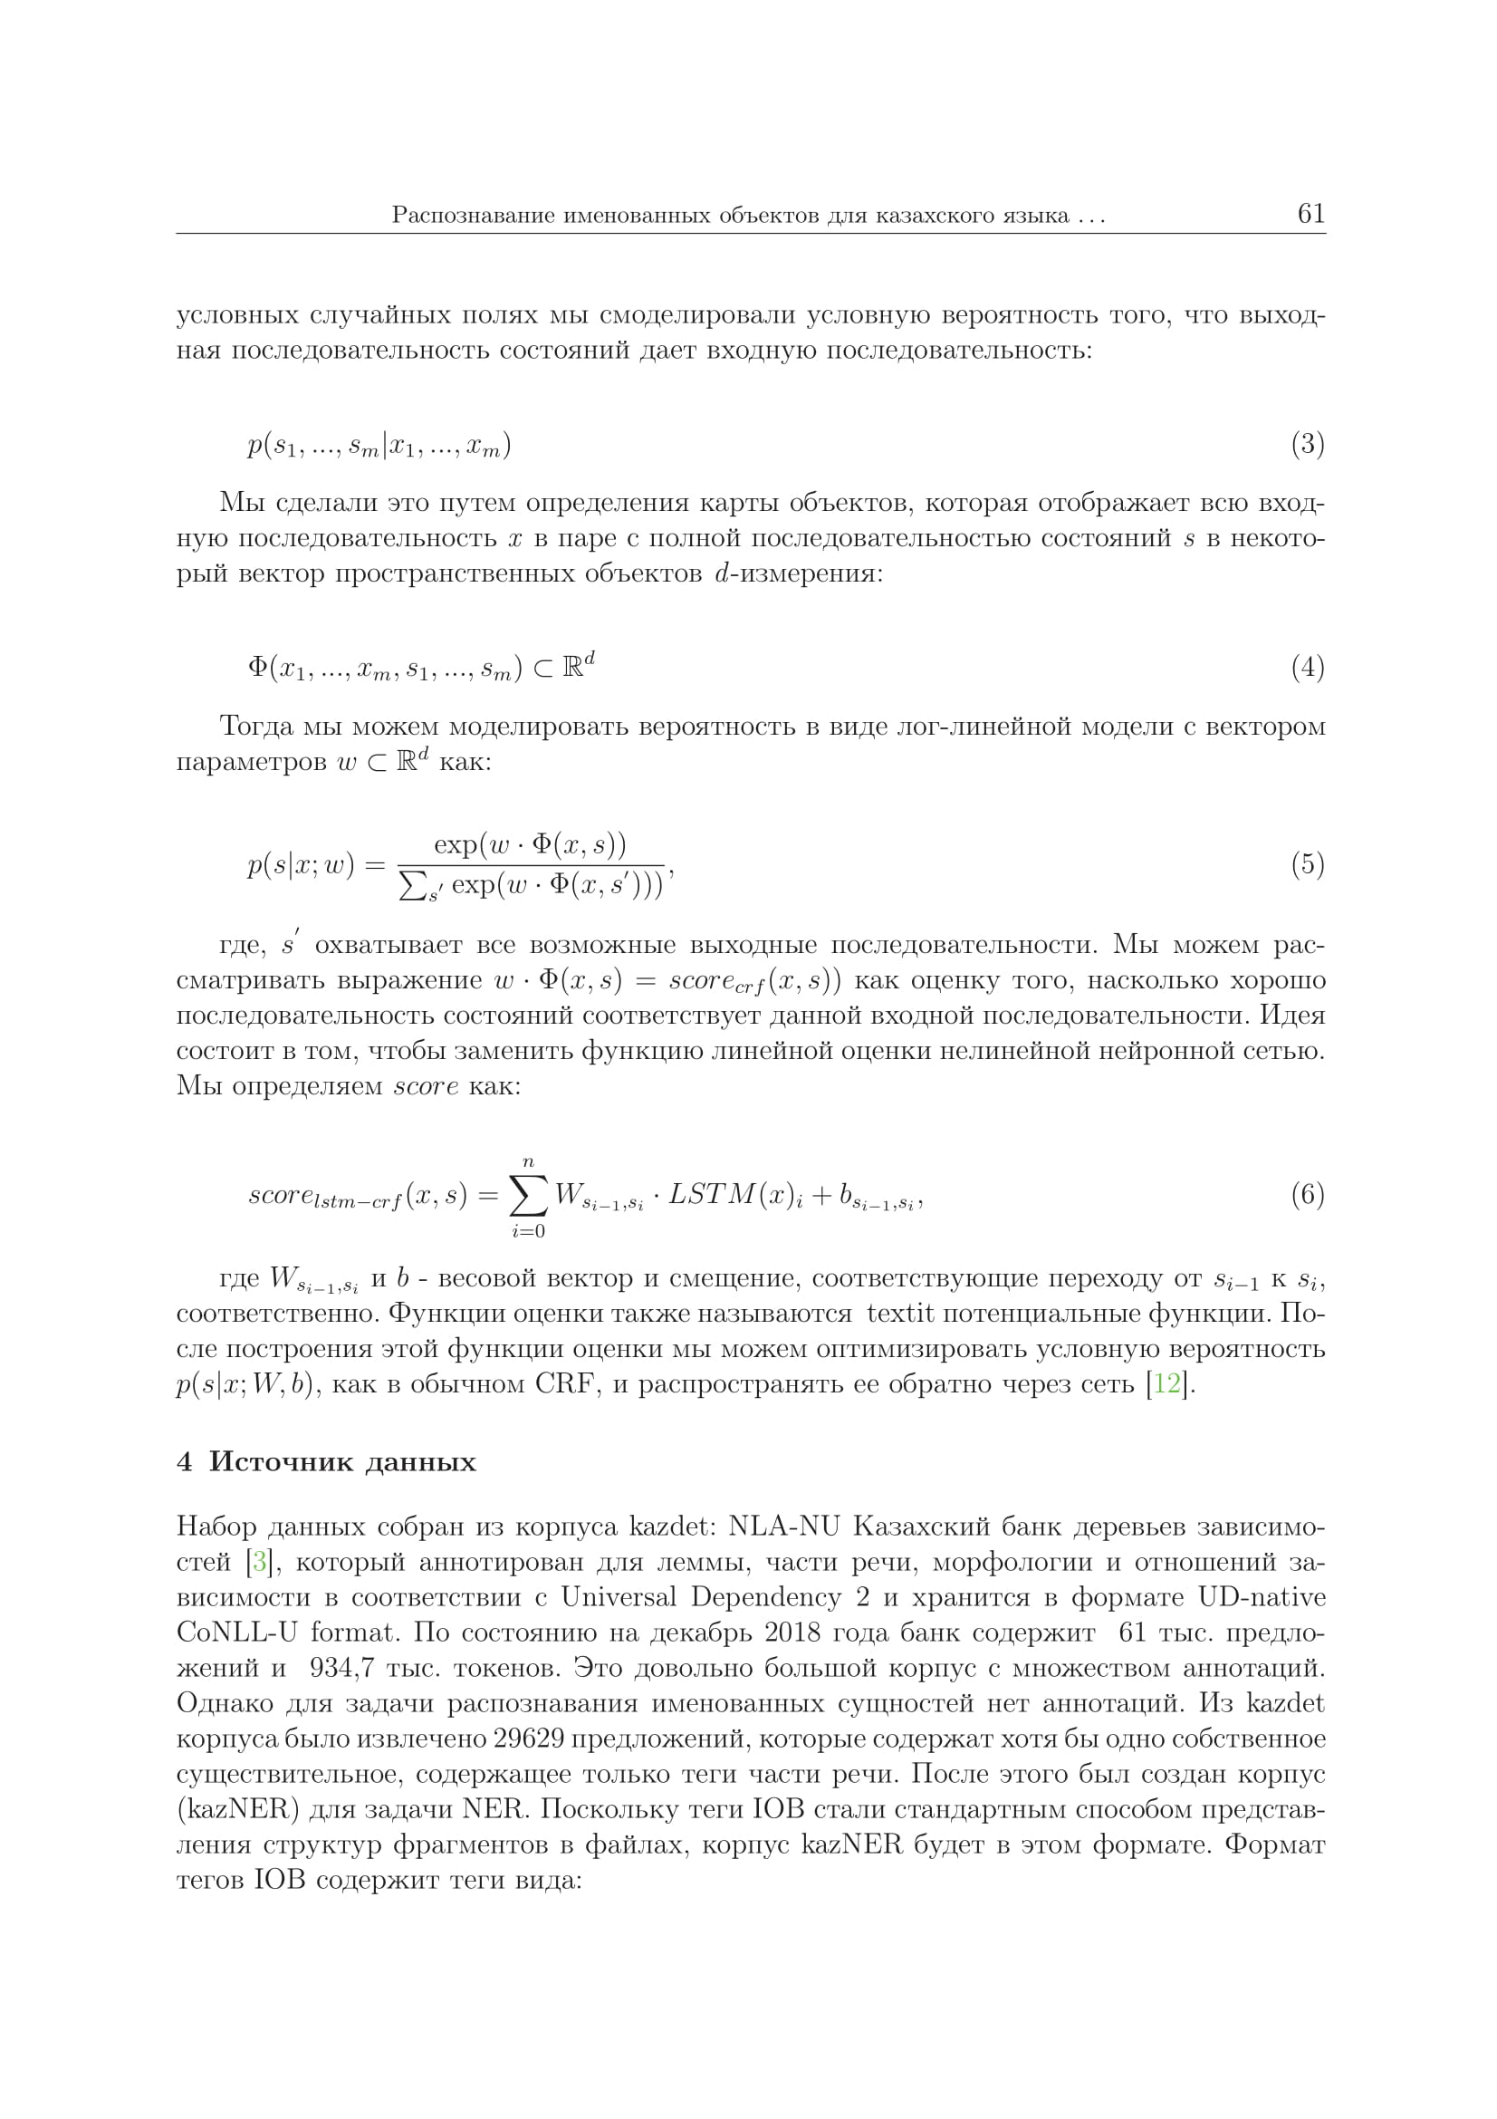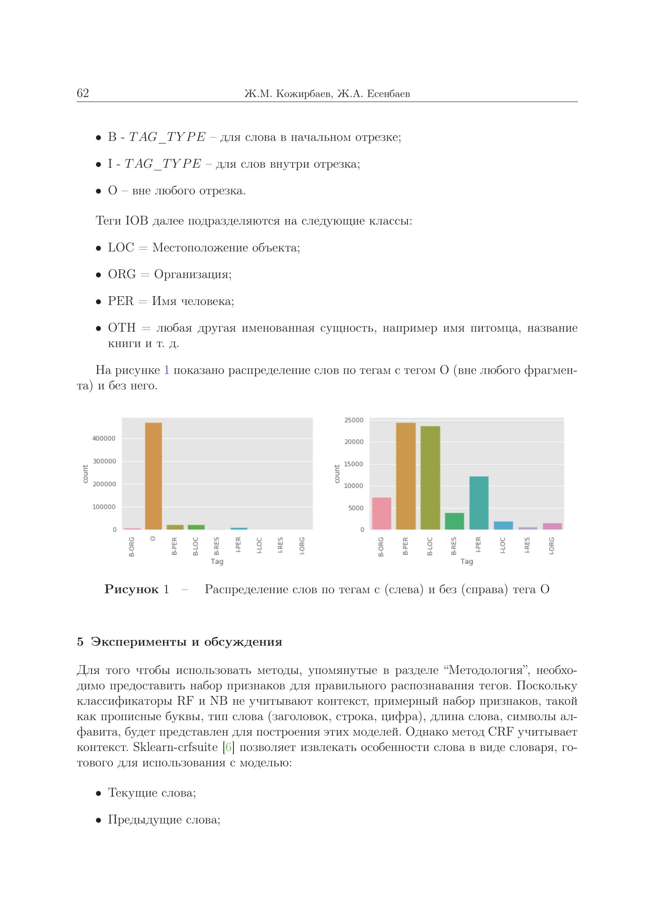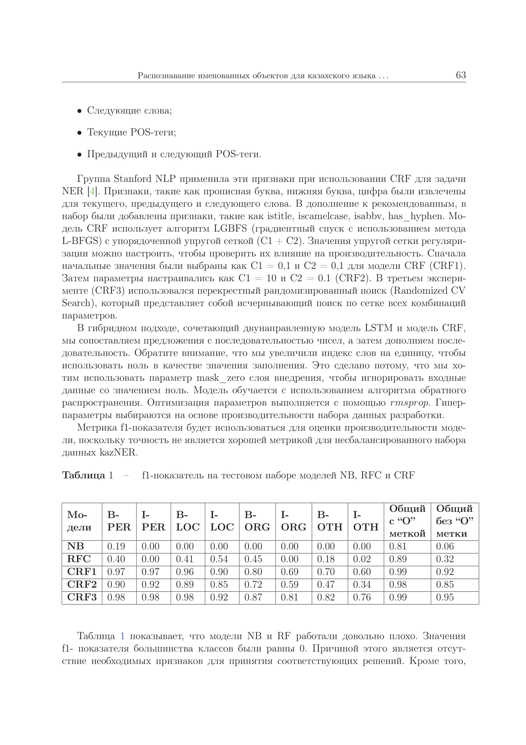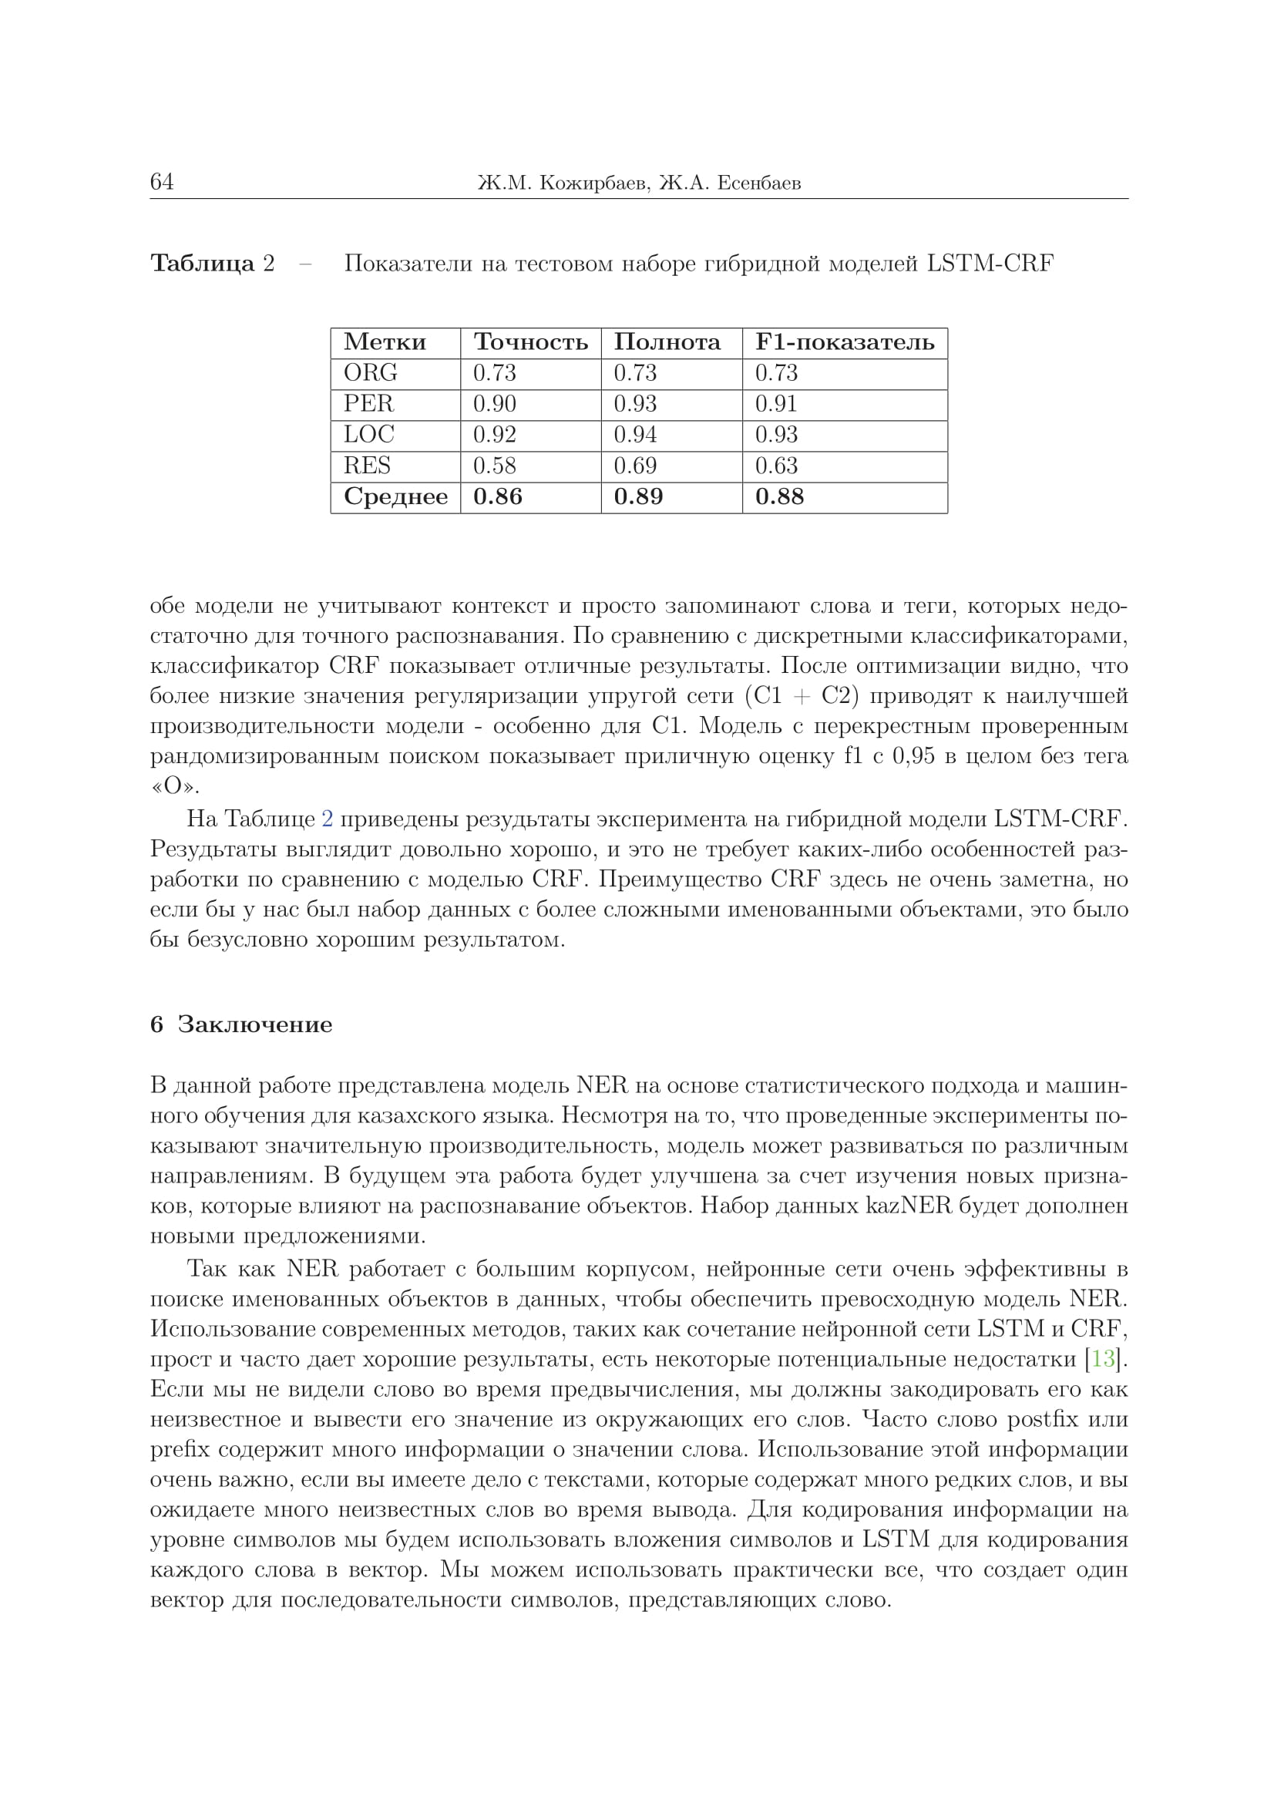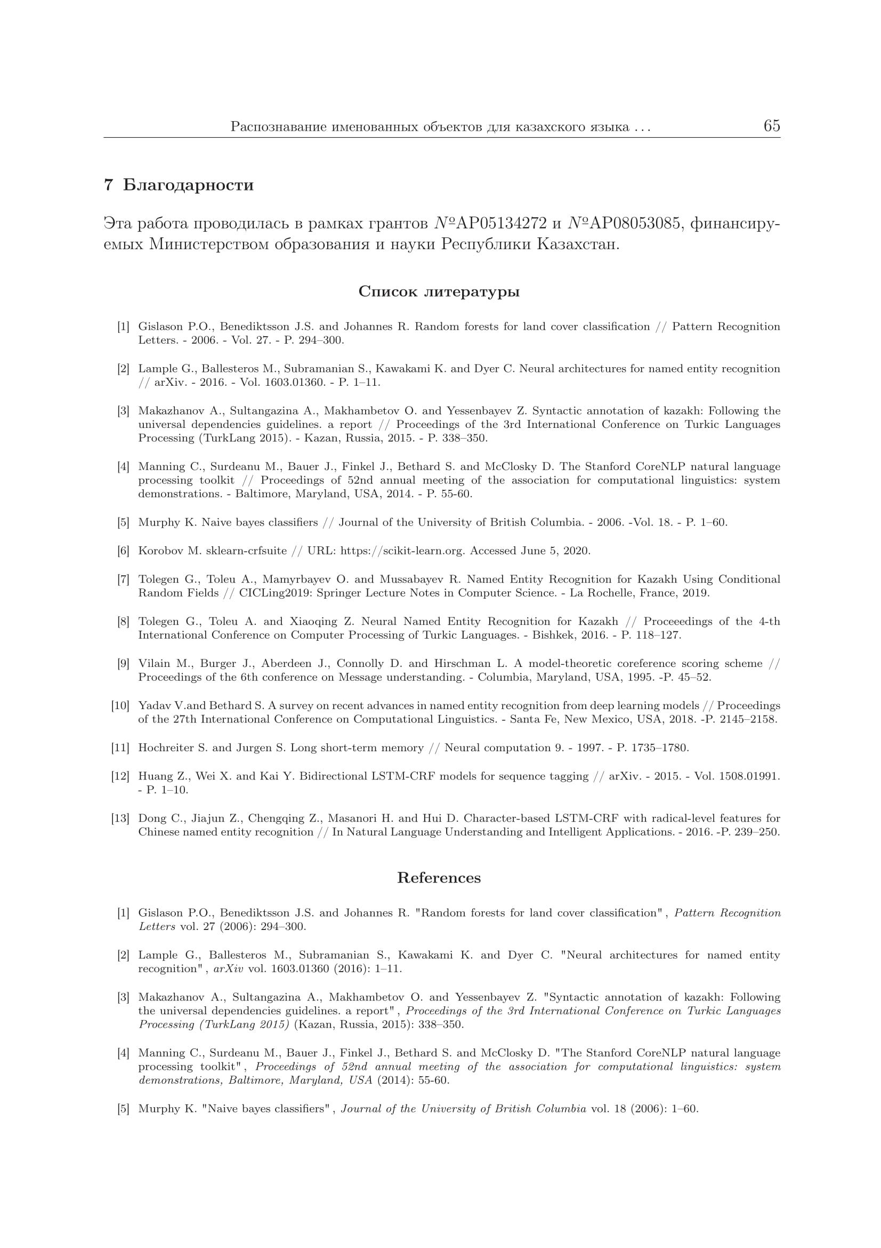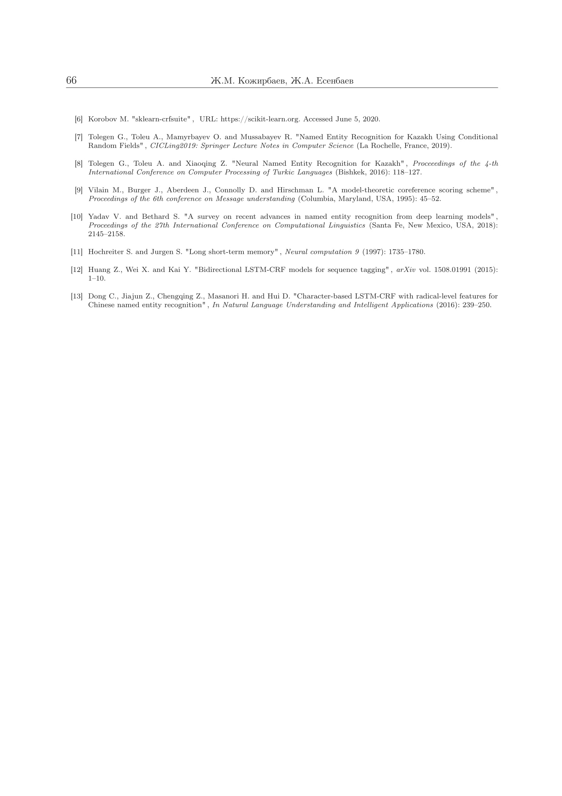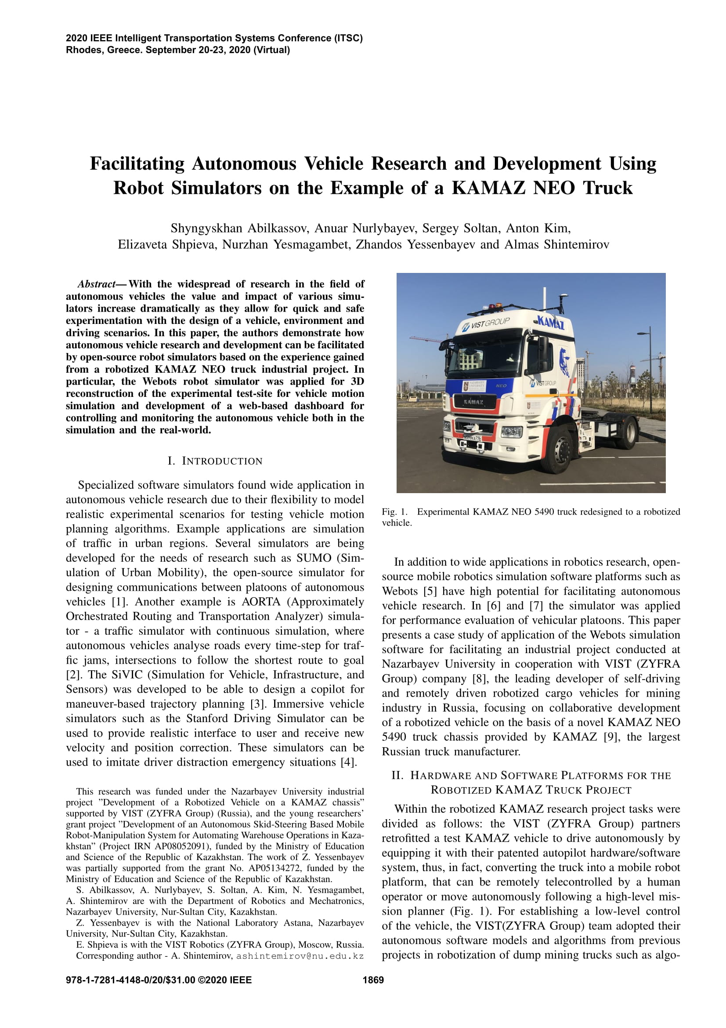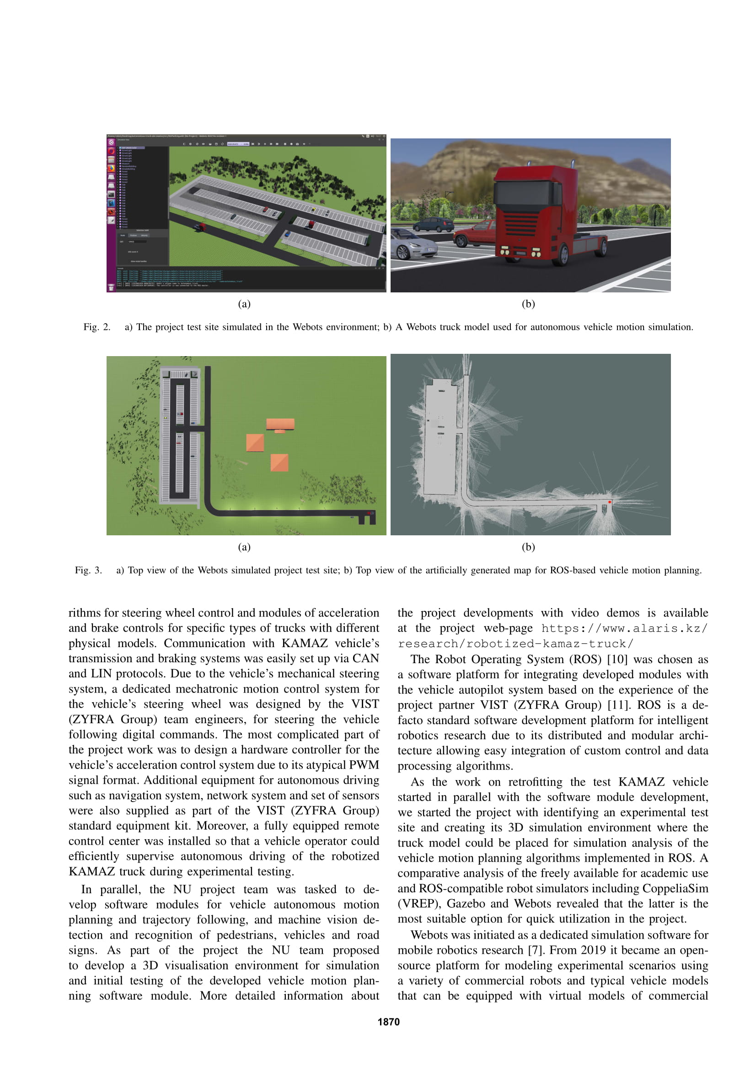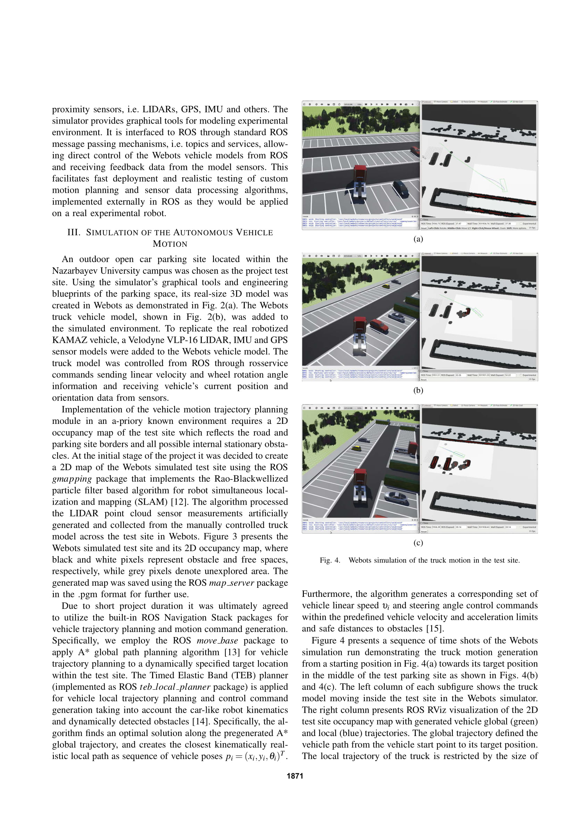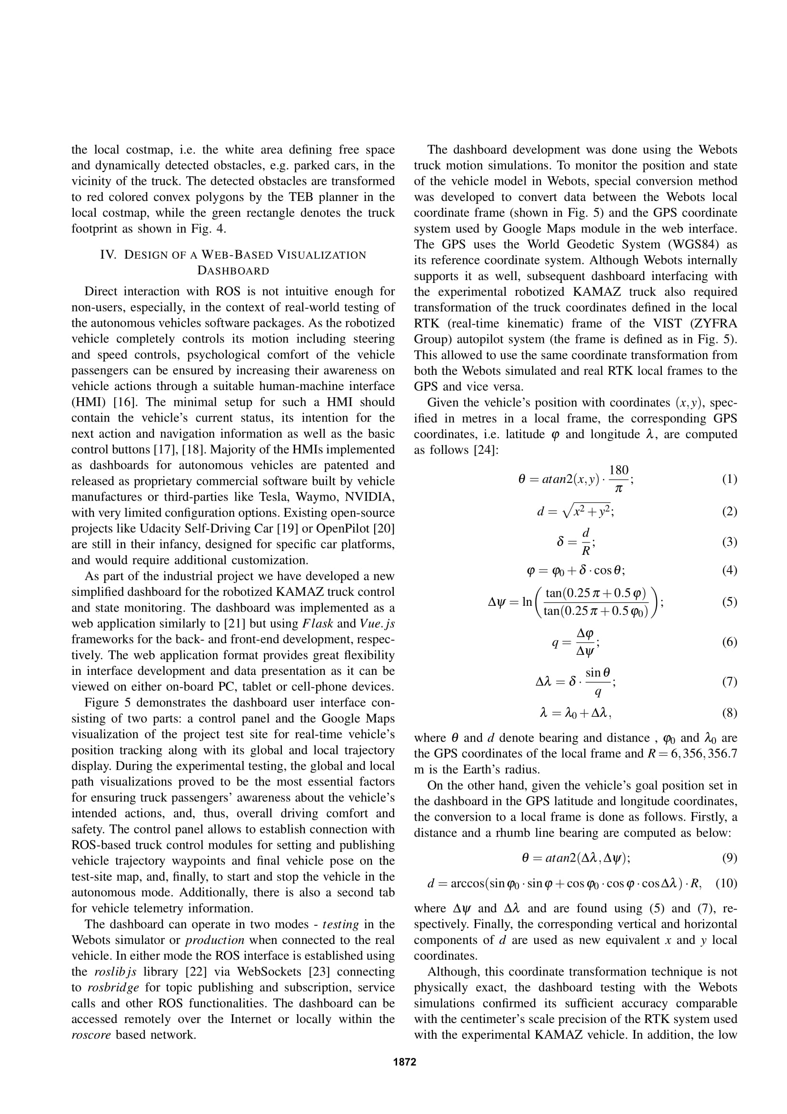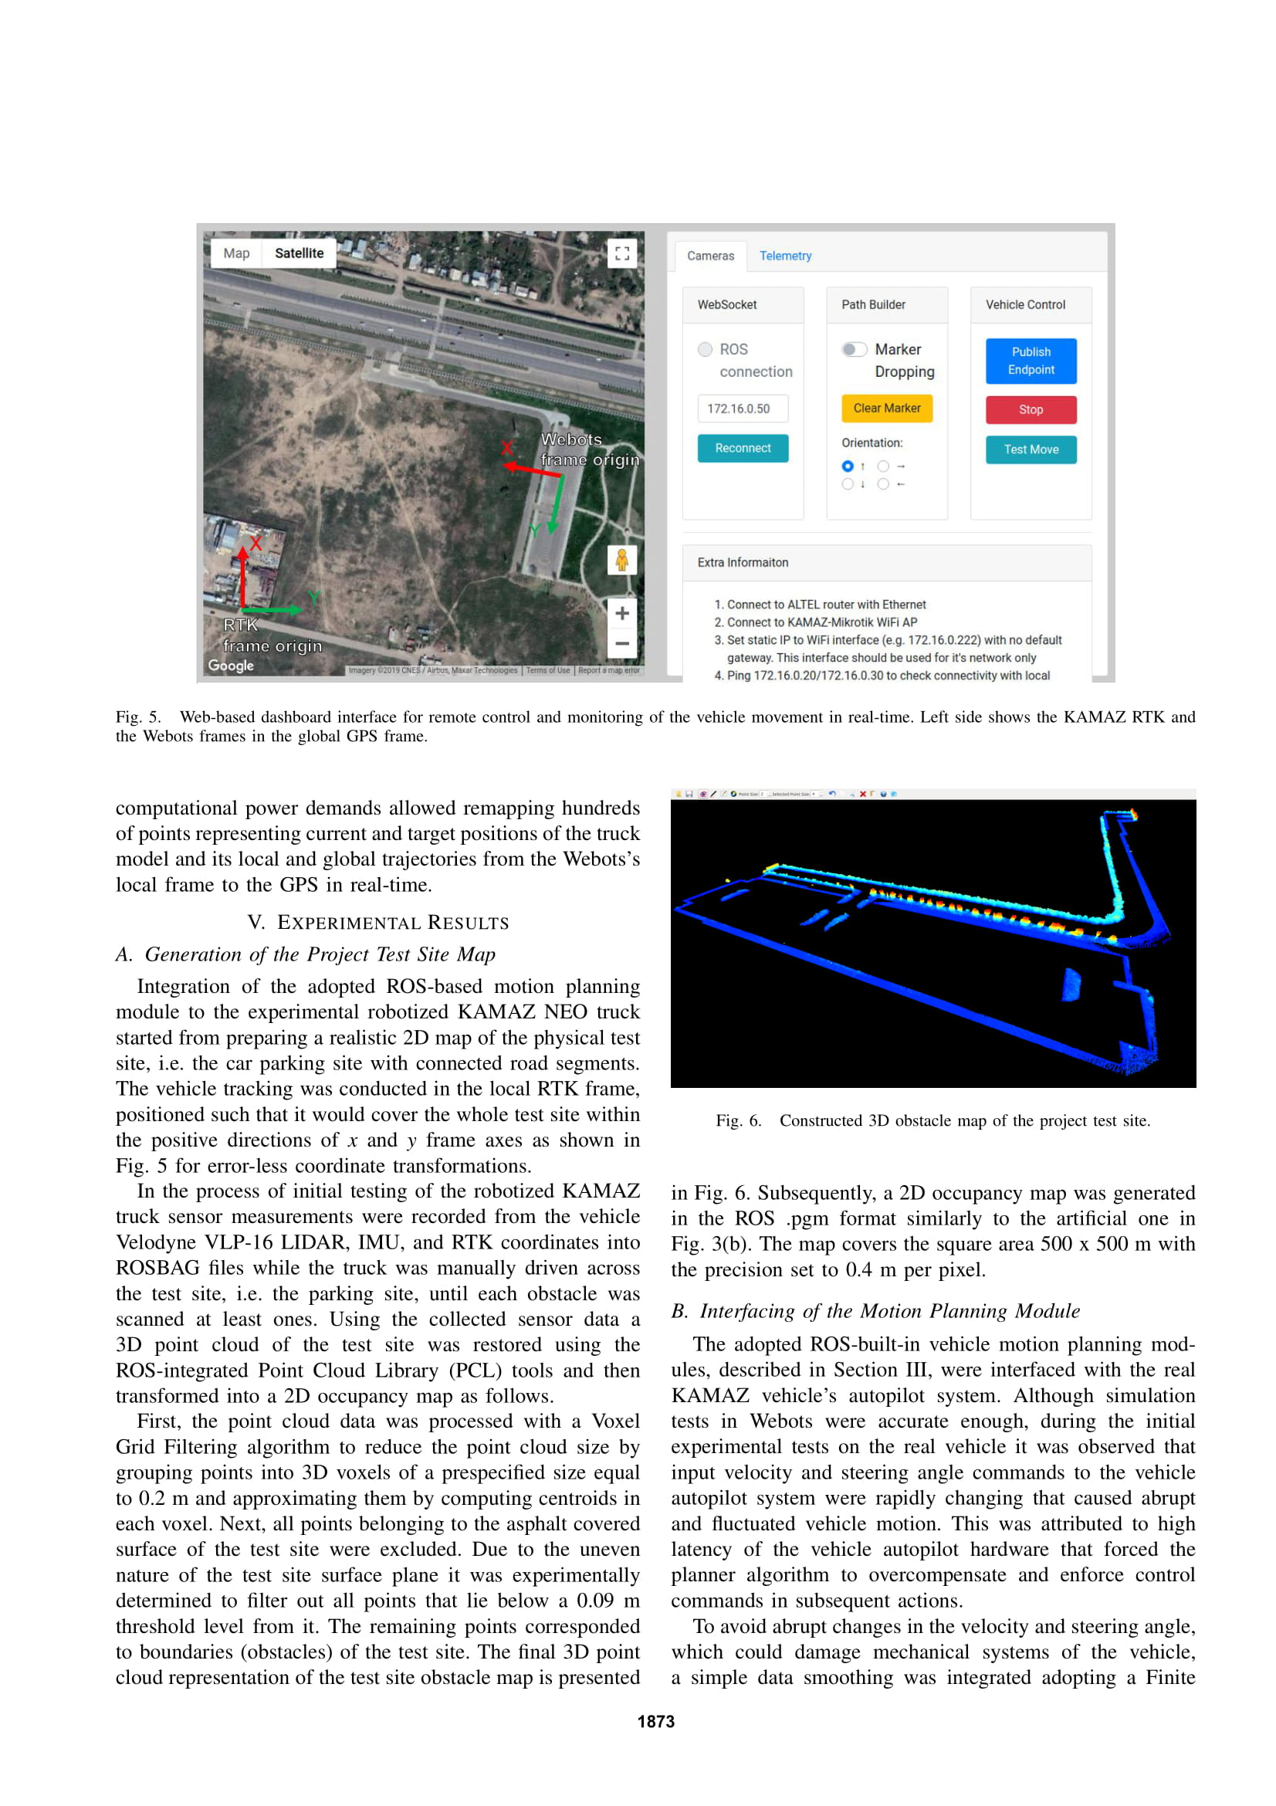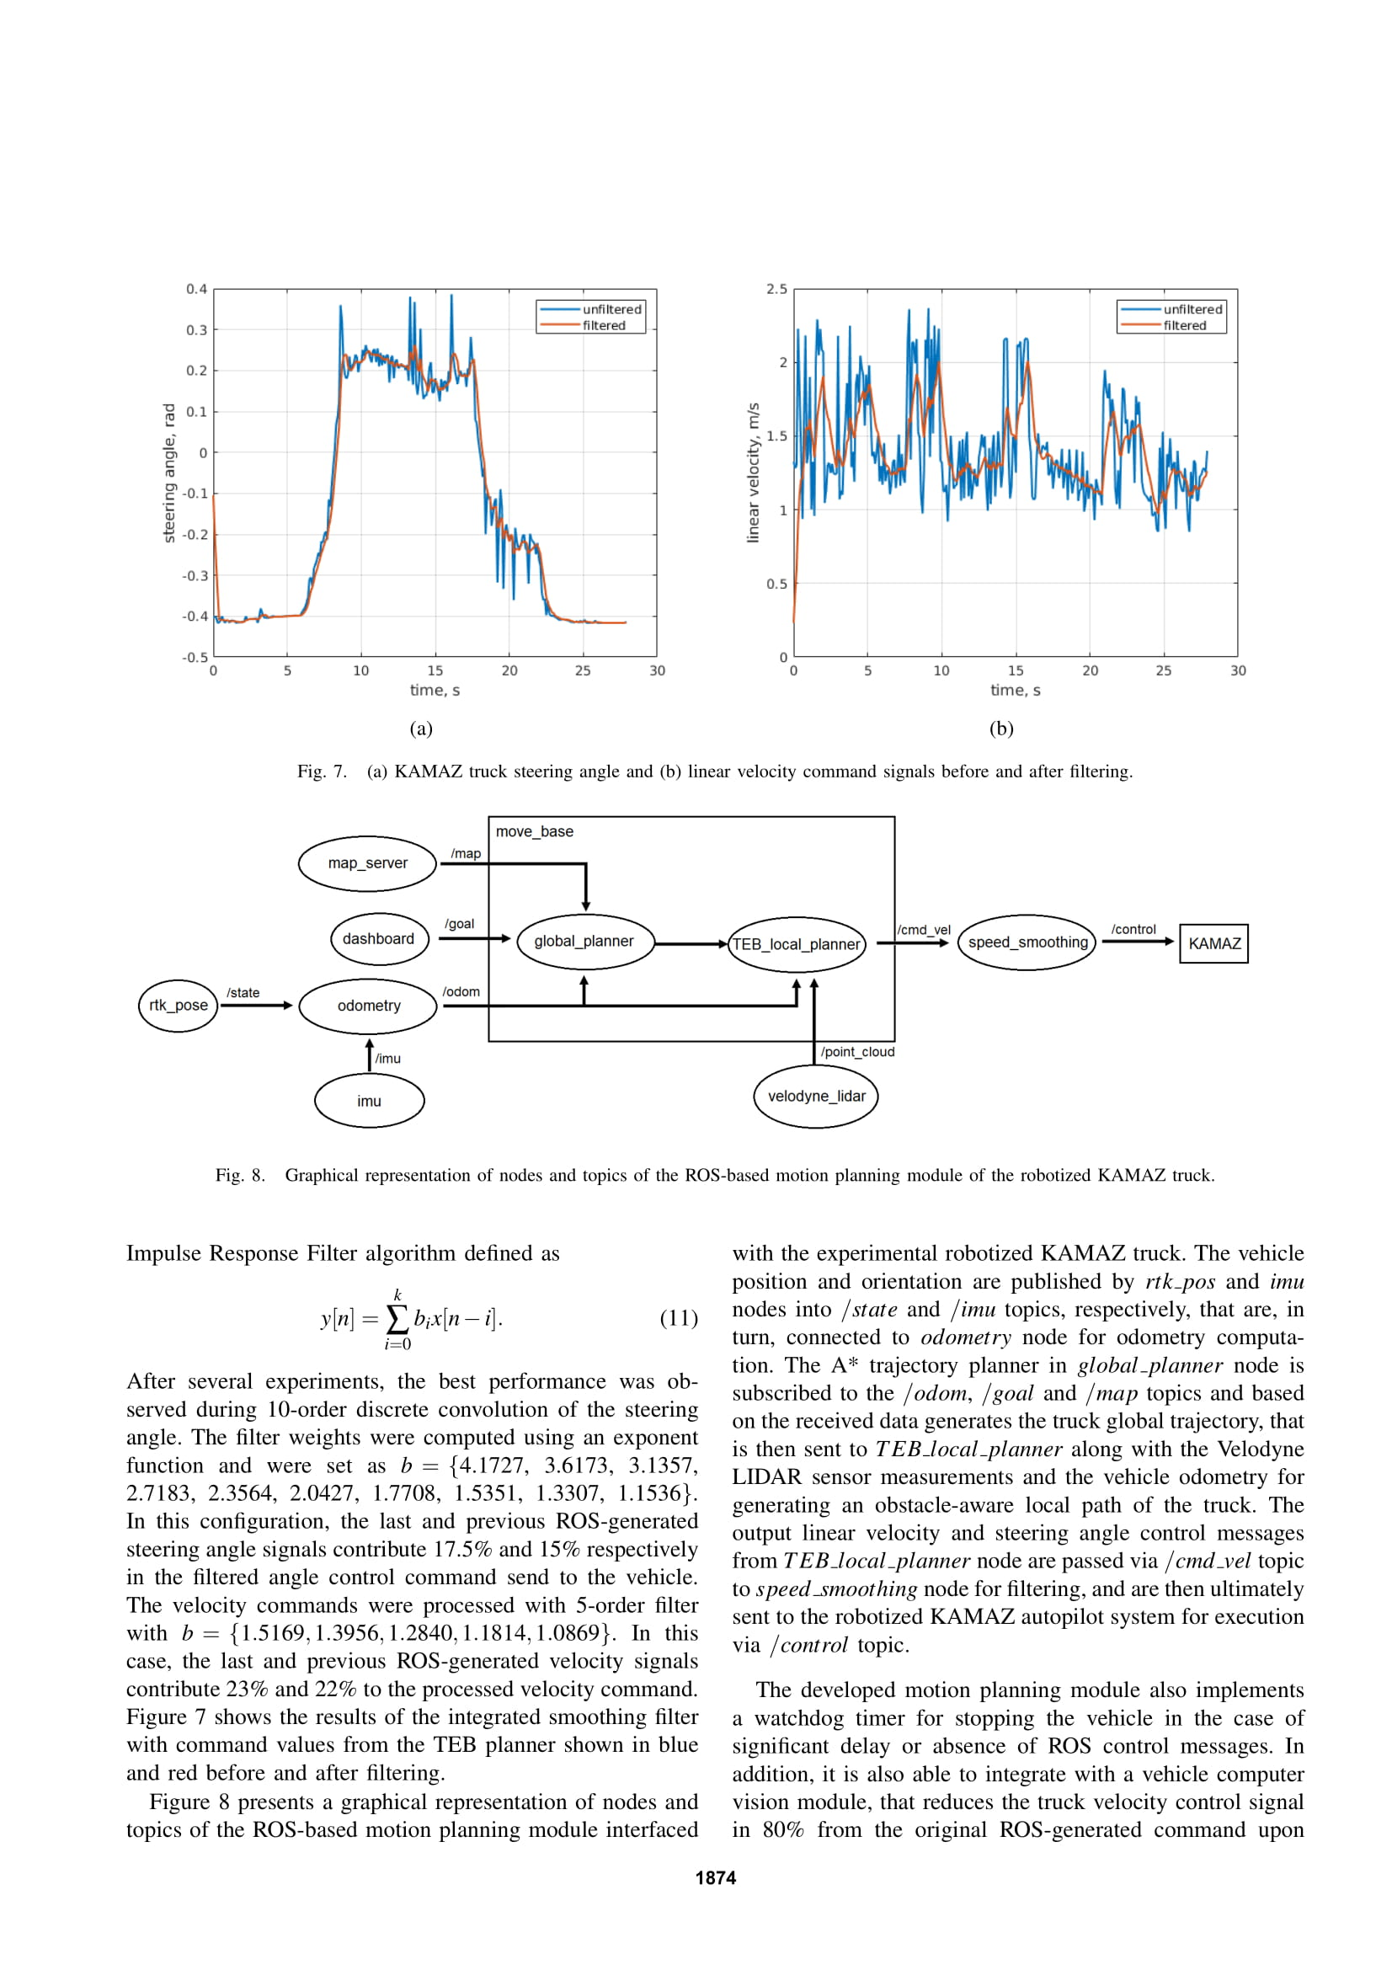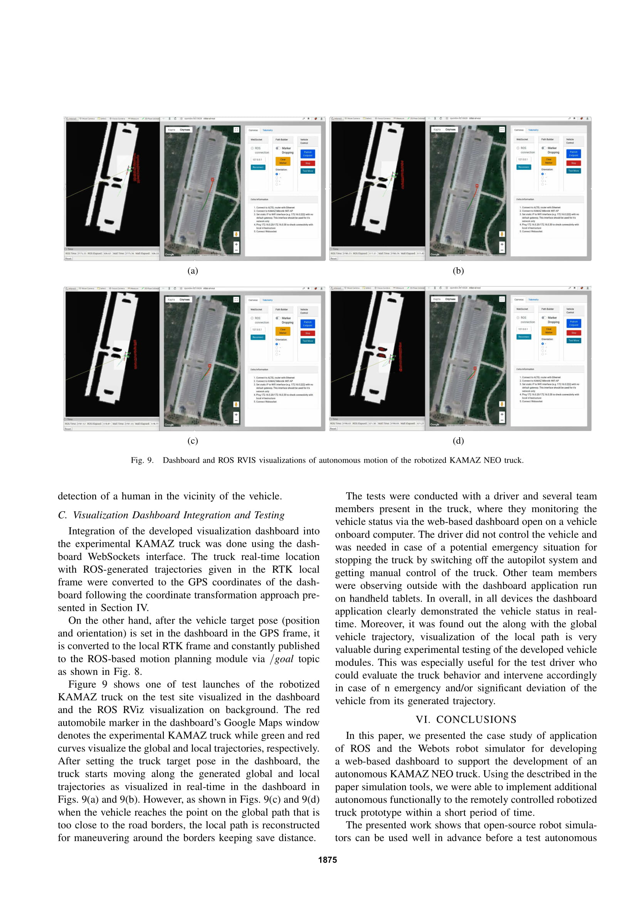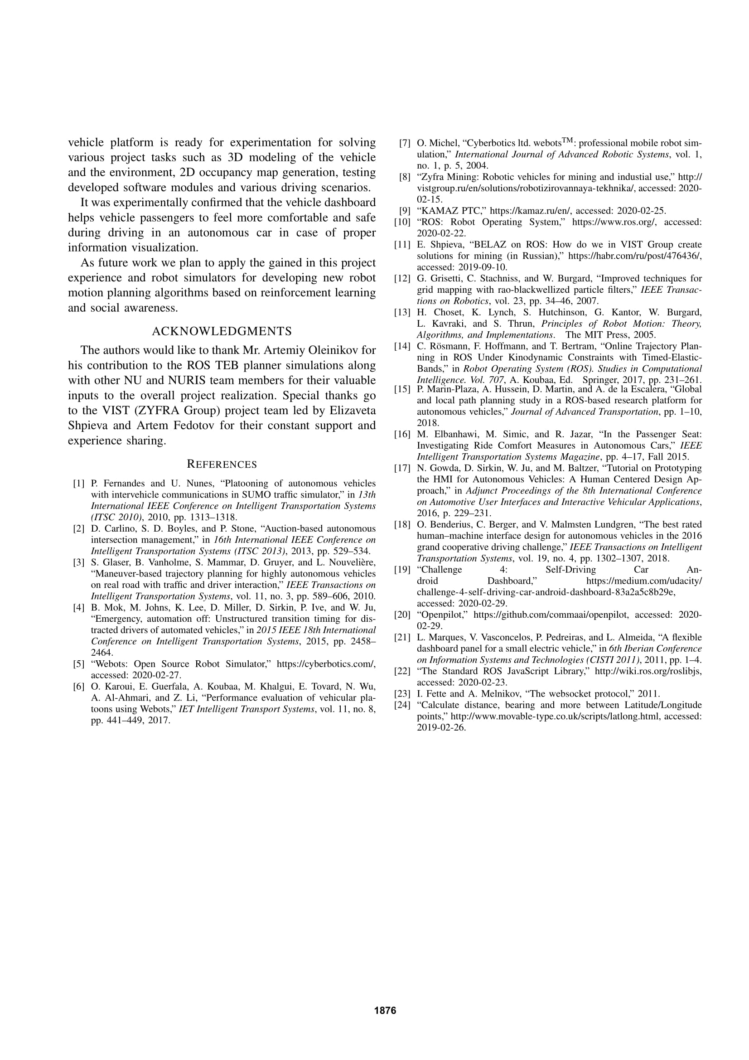

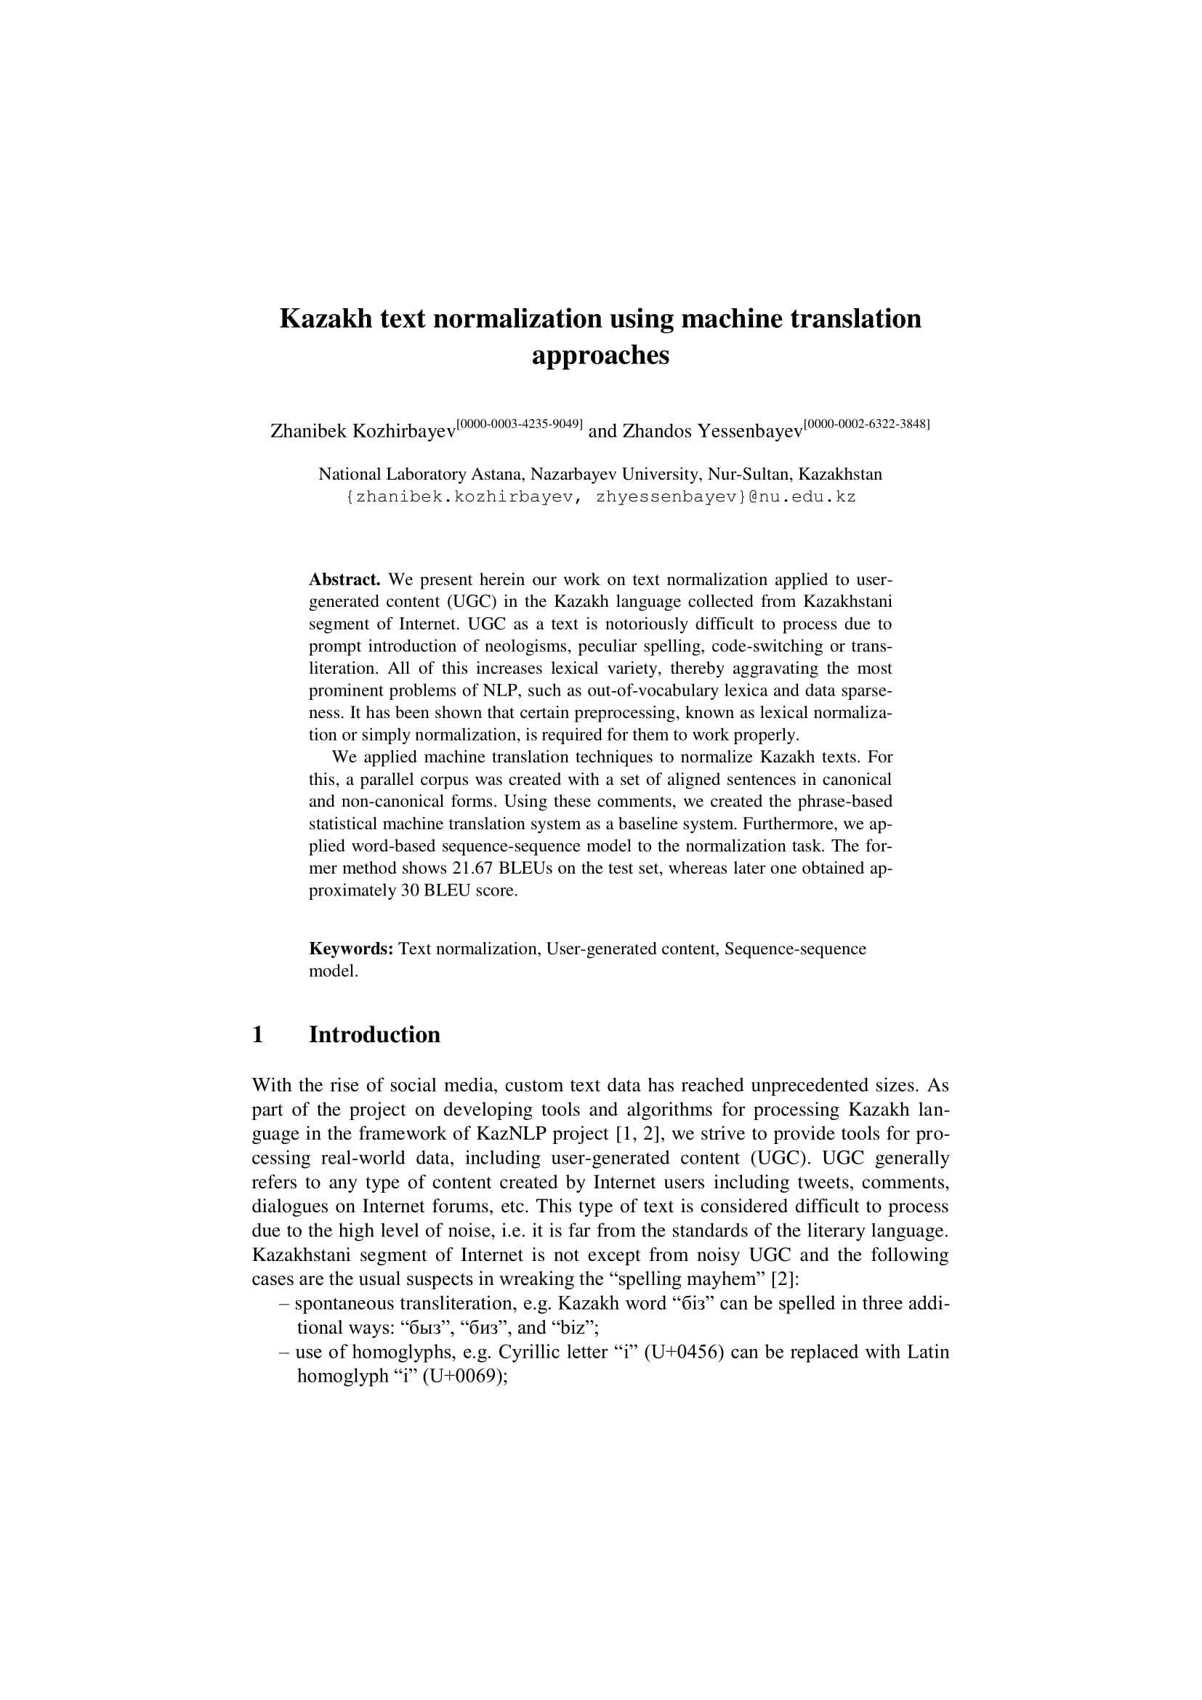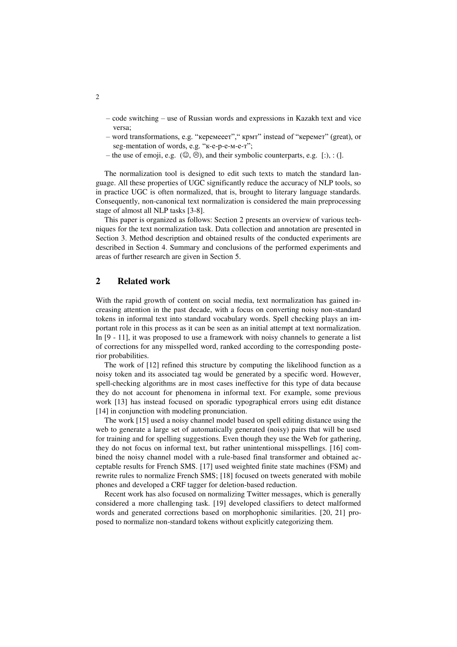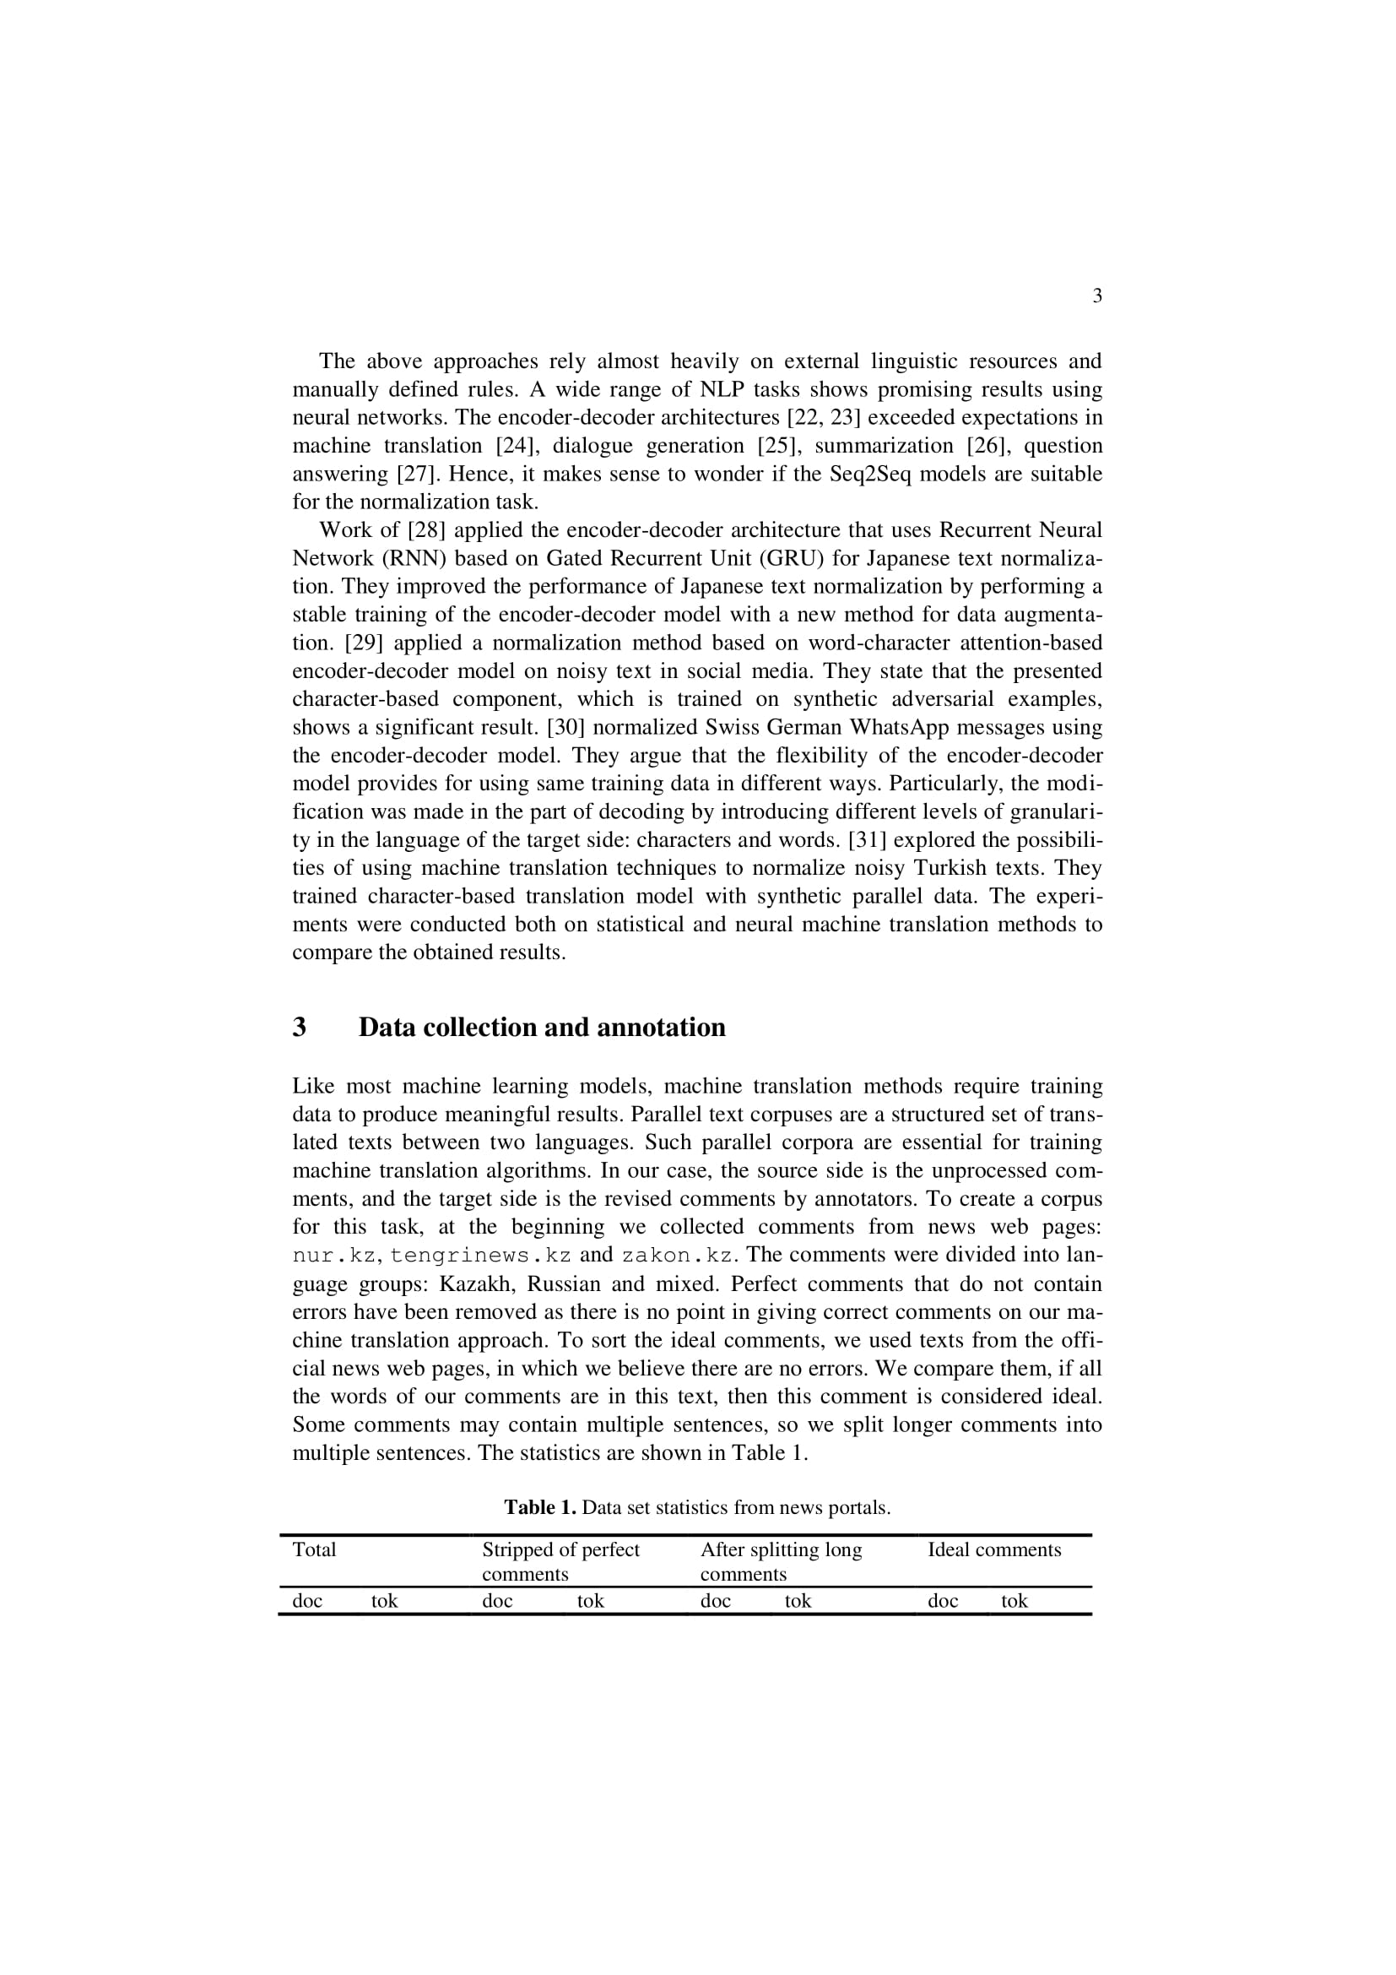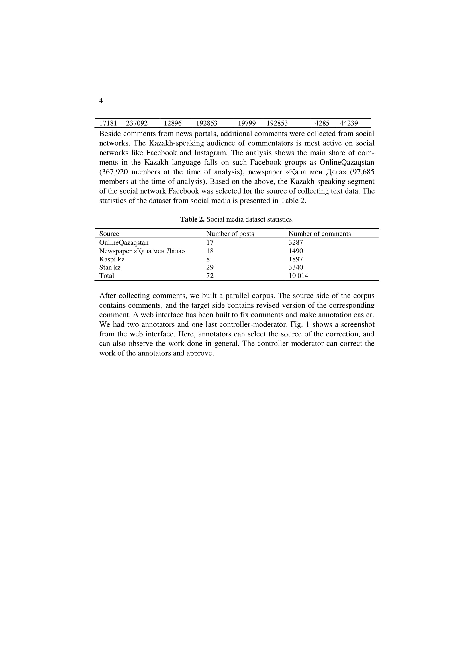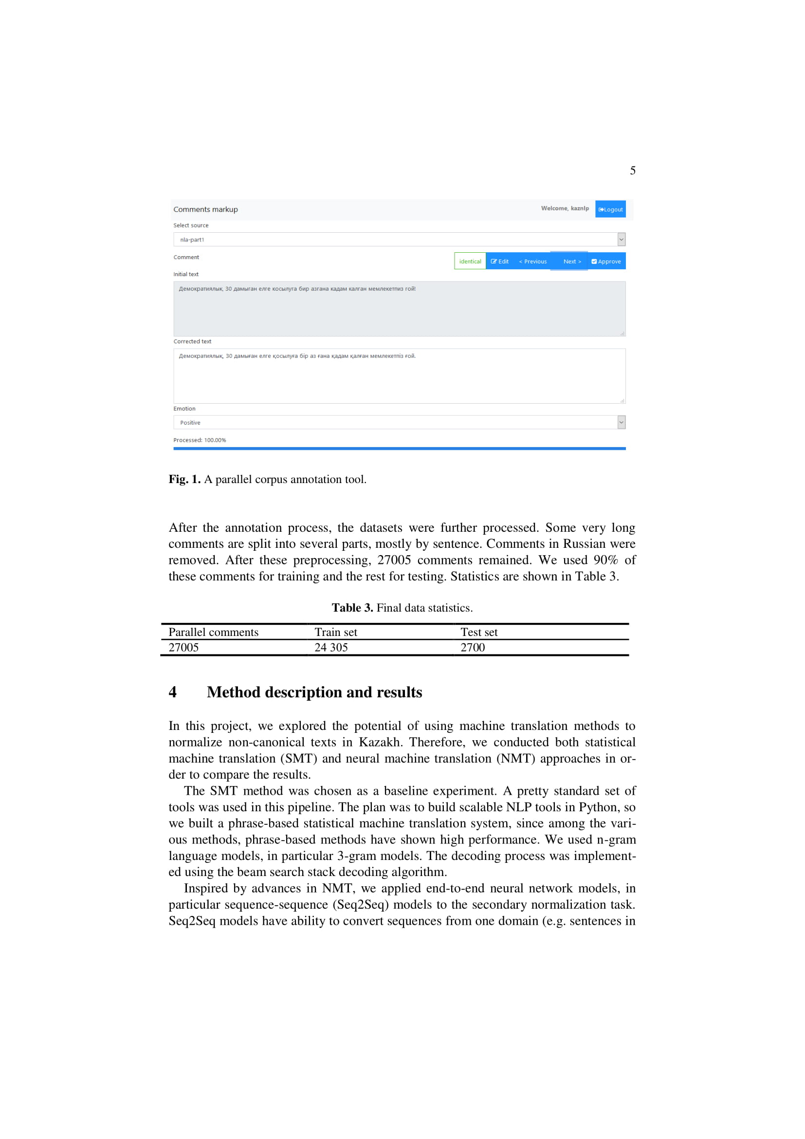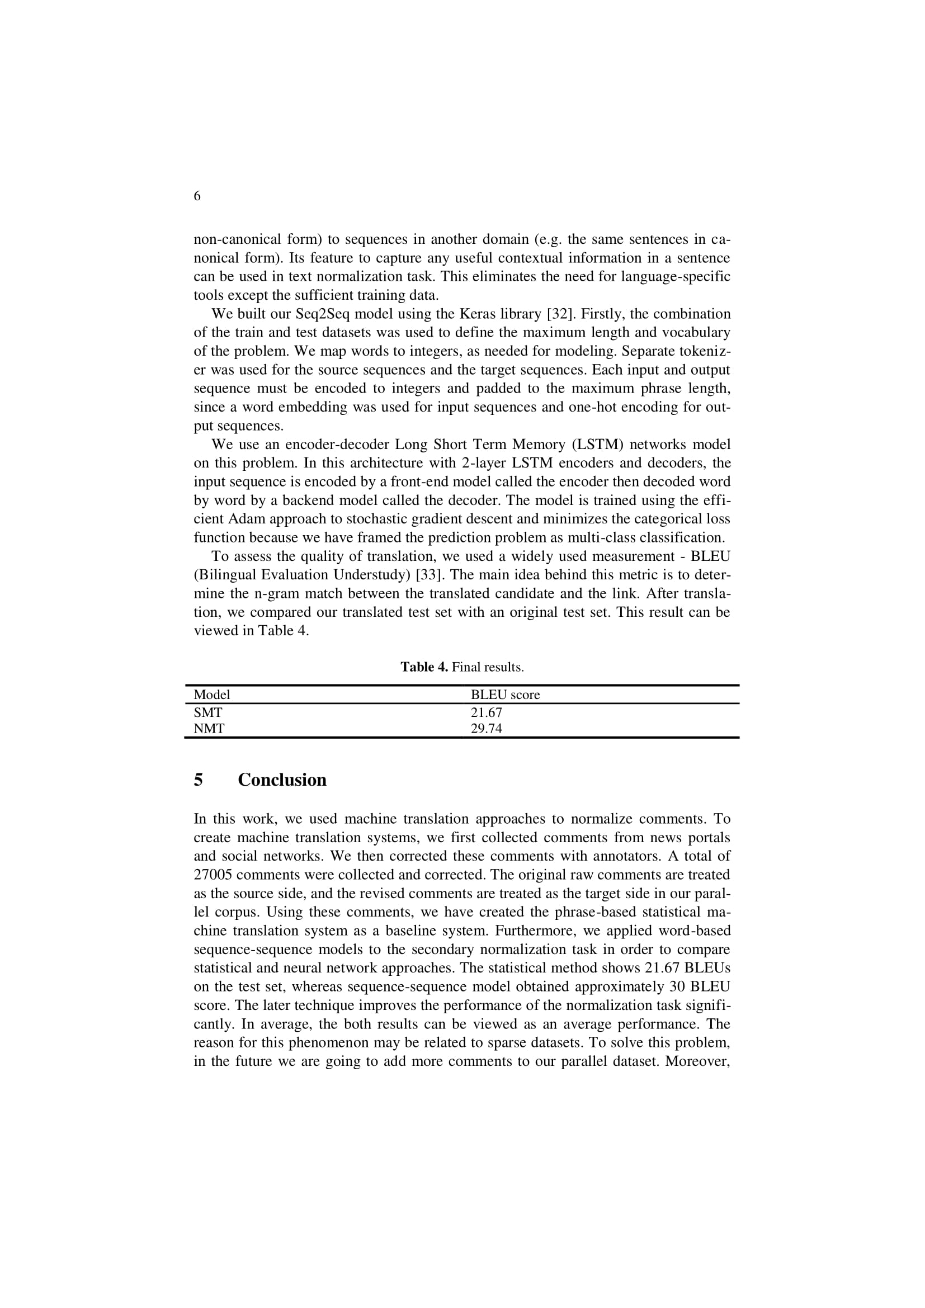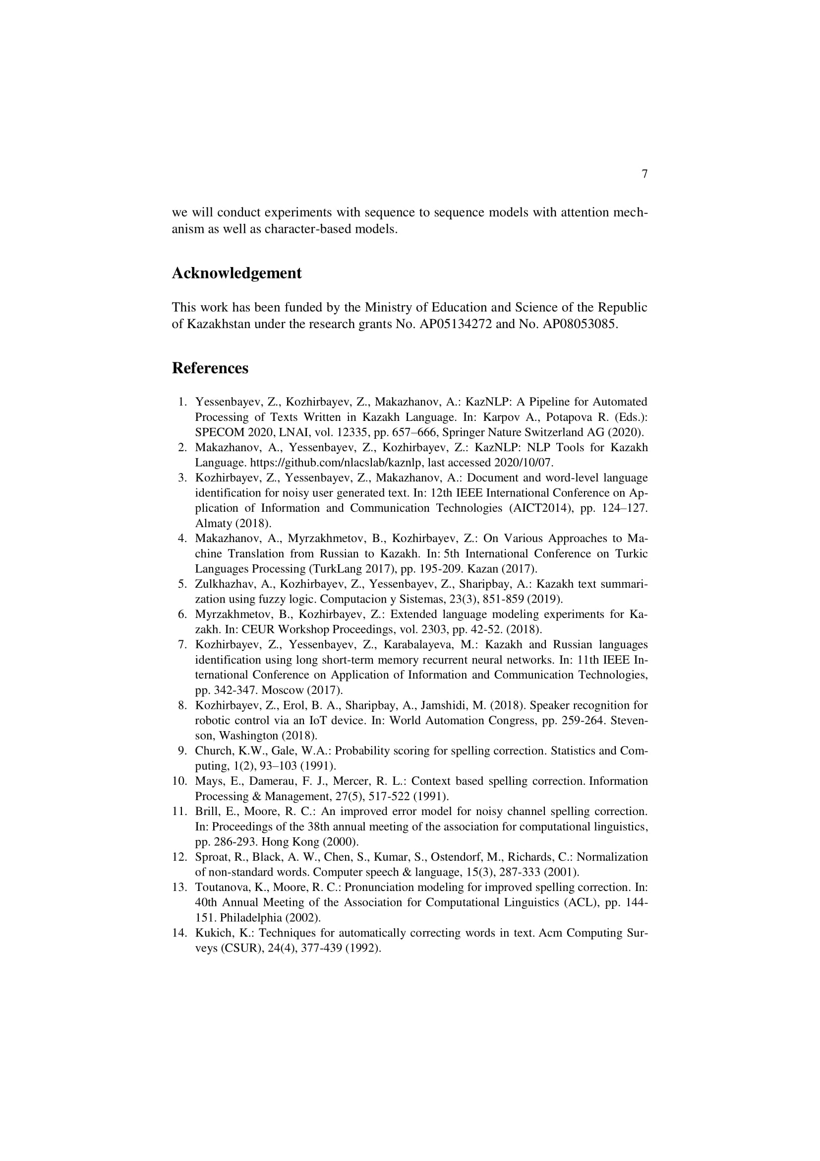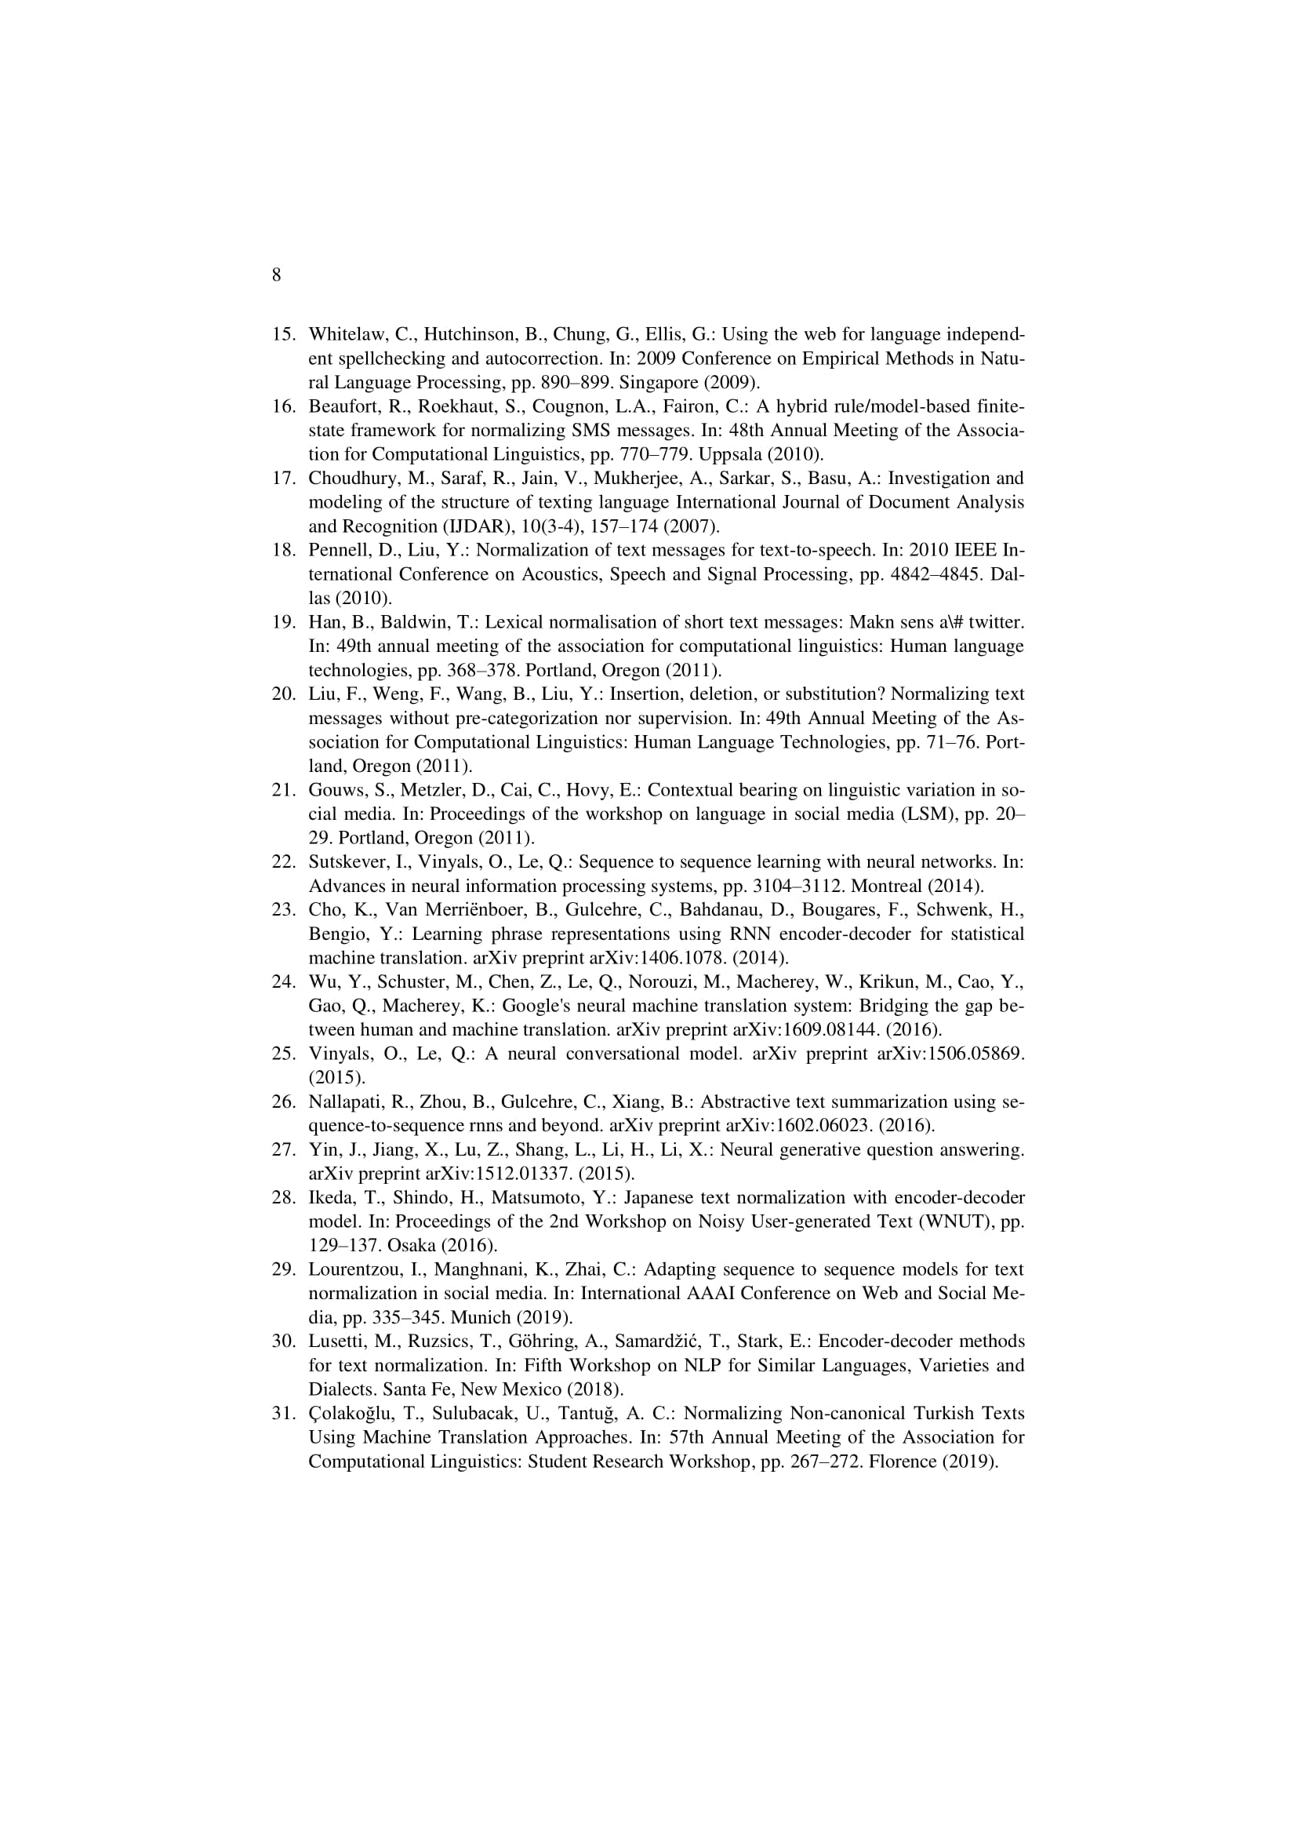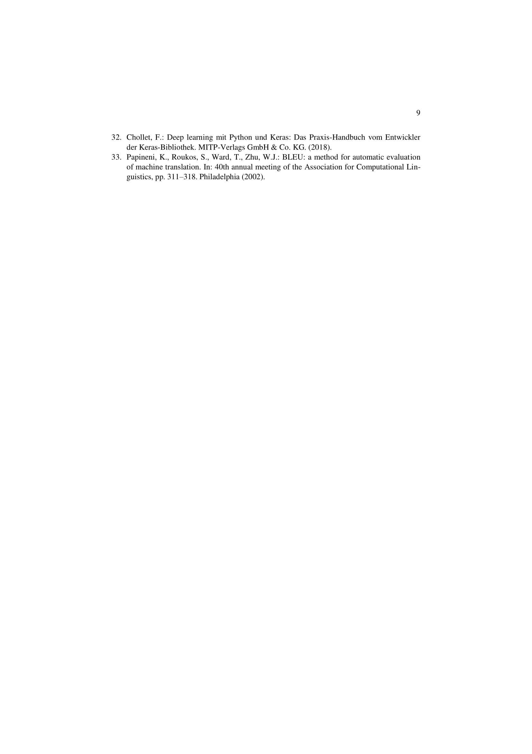

For example, word-for-word translations, violating the Kazakh syntax, typically made by Russian speakers, such as "кімдікі кітап?" (instead of "кімнің кітабы?" - "whose book is this?"), "екі кітаптар" (instead of "екі кітап" - "two books"), etc.
As can be seen from Table 2.1, there was only one error associated with “ғой, қой” particles, which is extremely small, both for evaluating and for training our model. Therefore, these particles are not further considered by us.

