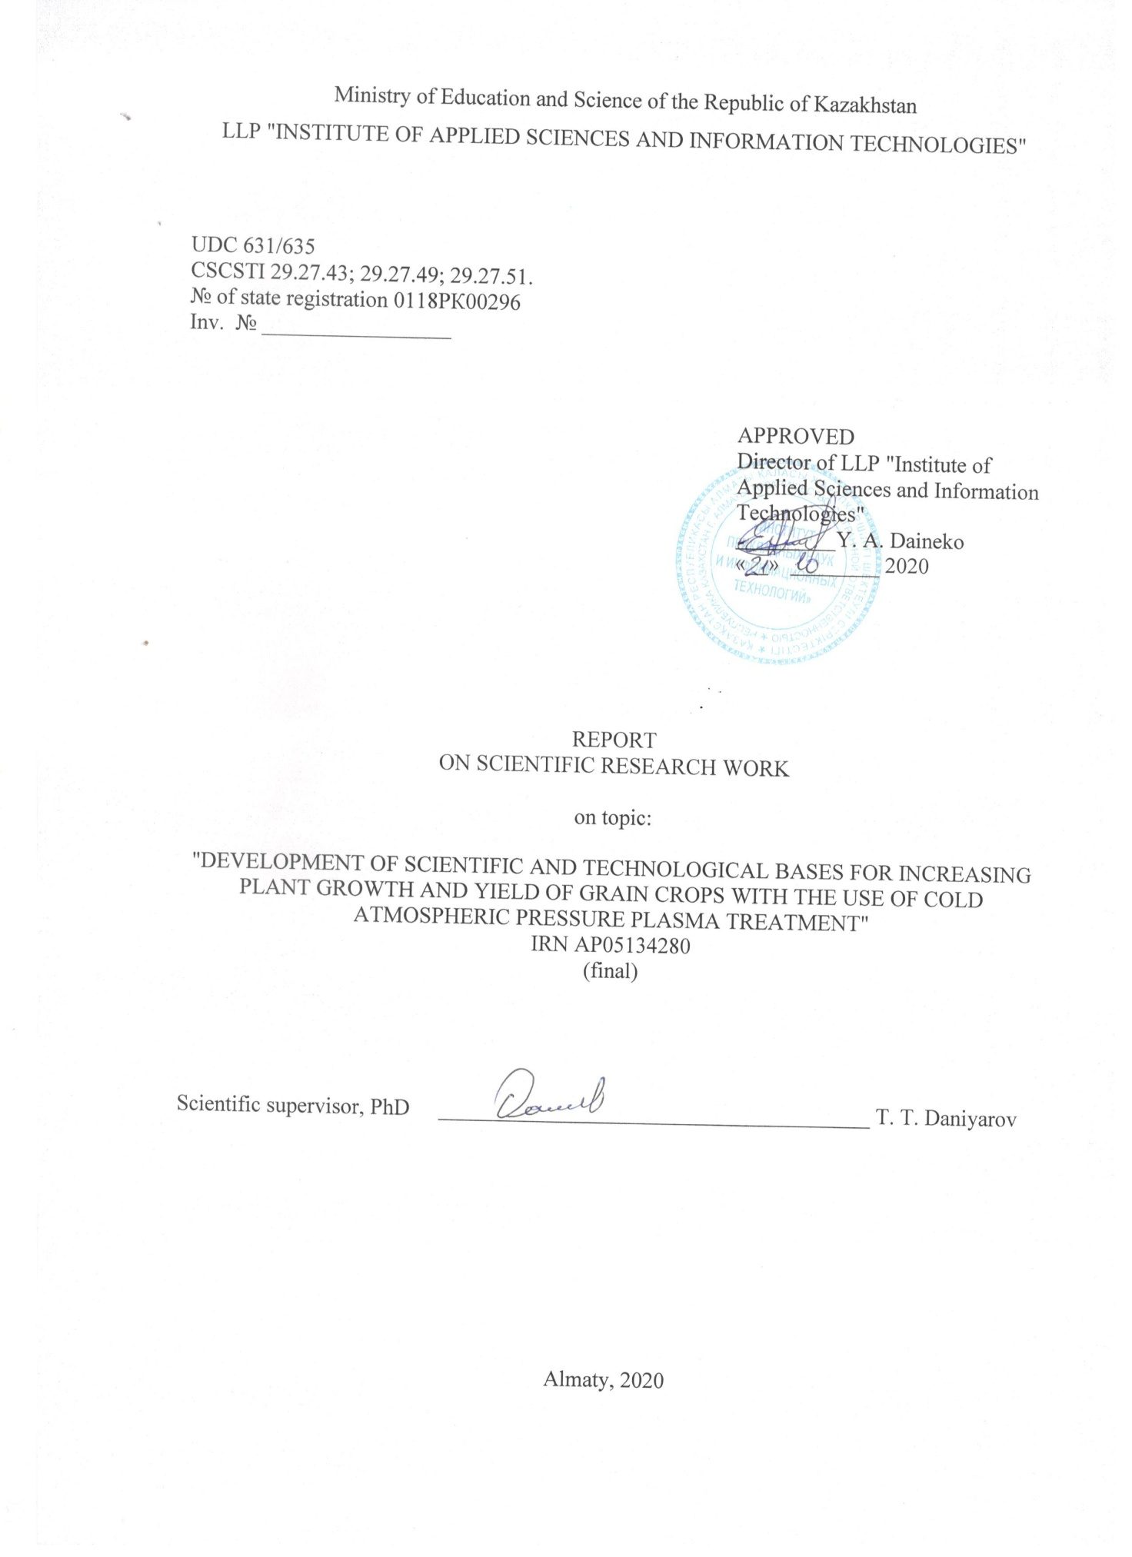
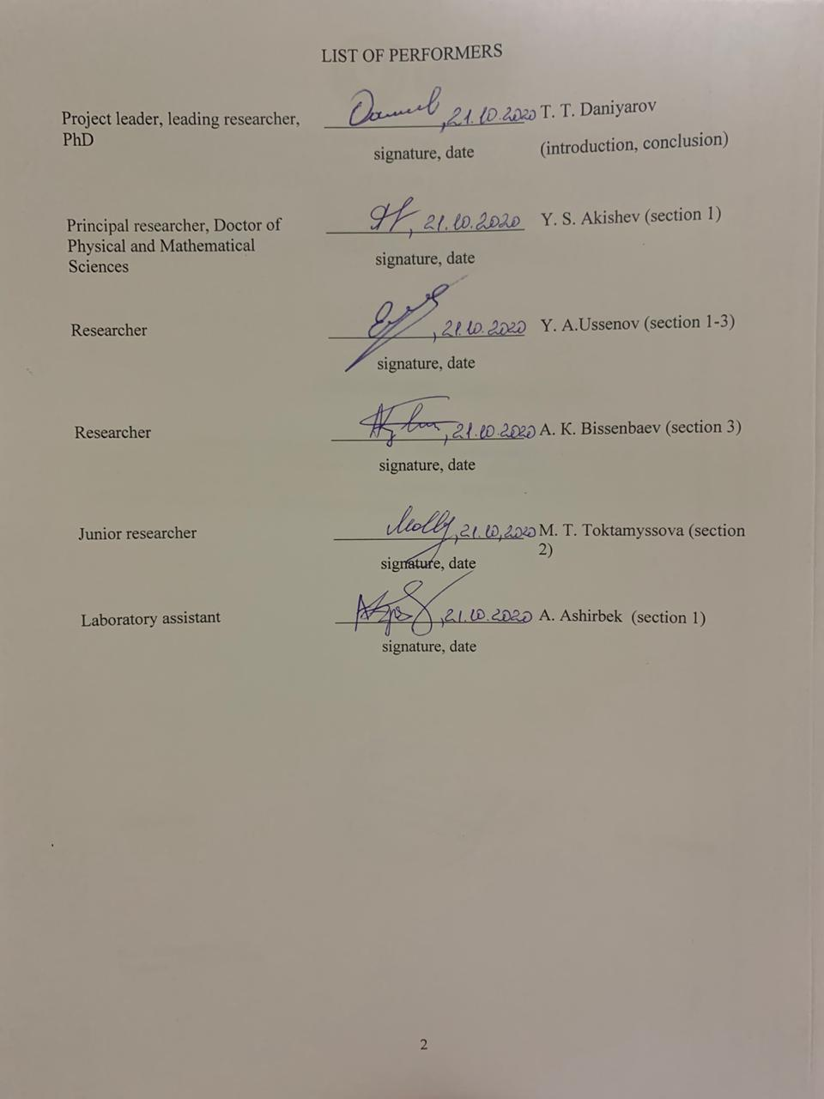
ESSAY

The report consists of 51 pages, 6 parts, 18 figures, 7 tables, 62 sources, 2 appendices.
PLASMA AGRICULTURAL INDUSTRY, ATMOSPHERIC PRESSURE PLASMA, DIELECTRIC BARRIER DISCHARGE, DIFFUSE COPLANAR SURFACE BARRIER DISCHARGE, INCREASING AGRICULTURAL PRODUCTIVITY.
The object of research is a diffuse coplanar surface barrier discharge.
The purpose of the work - research and development of ways to improve sowing qualities and ways to increase the yield and germination of grain crops by using cold plasma treatment methods at atmospheric pressure, increasing the energy of seeds and plants and ensuring their preparation for sowing, industrial cultivation and storage.
Research methods: methods of optical diagnostics of plasma, including optical emission spectroscopy, methods for diagnosing electrical characteristics of a discharge, methods for diagnosing the surface characteristics of agricultural samples, including electron microscopy, measuring the wettability of samples by measuring the contact angle; methods for measuring the percentage of germination, growth parameters, including the method for measuring constant mass by using an analytical balance; methods of analysis of biochemical properties of samples of agricultural crops.
The end result: obtaining new properties of cold plasma of atmospheric pressure and methods of plasma treatment of agricultural seeds in order to increase yields based on the results obtained.
The novelty of the project: study of the mechanisms of action of atmospheric pressure plasma (APP) on biological objects, including the biochemical composition of grain crops.
Implementation of the results obtained: the results of studying the effect of atmospheric pressure plasma on agricultural crops can be useful for processing, cleaning and modifying the surface of biological materials, processing and improving the properties of crops, etc.
Scope: agro-industry.
Research work was carried out on the basis of the National Nanotechnological Laboratory of Open Type at Al-Farabi KazNU.

CONTENT
INTODUCTION |  | 5
1 | Modernization of the installation based on surface dielectric barrier discharge and selection of seed | 6
2 | Treatment of wheat seeds with plasma of a surface dielectric barrier discharge | 13
3 | Investigation of the biological response of wheat grains to the effect of atmospheric pressure plasma | 17
4 | Microbiological examination of seed samples for contamination with bacteria and microscopic fungi | 26
5 | Repeating experiments with different parameters and their optimization | 31
6 | Development of technological foundations of methods for treating seeds of grain crops with APP | 35
CONCLUSION |  | 39
LIST OF USED LITERATURE |  | 40
APPENDIX A - List of works published for the reporting period |  | 44
APPENDIX B - Work schedule |  | 50

INTRODUCTION

Low-temperature atmospheric pressure plasma is now widely studied for the purpose of application in medicine, chemical and agricultural industries, biotechnology and nanotechnology. Atmospheric pressure plasma can also be used for cleaning, modifying and activating the surface of biological materials, as well as for treating crops in order to improve their properties and increase yields. Plasma treatment of seed and planting material under normal (room) conditions can be considered in the technology of industrial cultivation of agricultural crops as an alternative to the traditional chemical and biological methods of their presowing treatment. The main type of discharge that allows one to obtain low-temperature plasma without the use of a discharged gas is a dielectric barrier discharge (DBD). DBD has traditionally been used as an efficient ozone generator and as a radiation generator in high-power gas lasers and excimer lamps. Further study of the properties of this discharge made it possible to expand the scope of application in such different industries as agriculture, medicine, and nanotechnology. Despite active research carried out in this area, DBD and atmospheric pressure plasma are still not fully understood and do not lose interest from the world scientific community.
This paper summarizes the main results on the modernization of the installation based on the dielectric barrier discharge (DBD) and the selection of seed for further plasma treatment, treatment of wheat seeds with plasma of a surface dielectric barrier discharge, study of the biological response of wheat grains to the effect of atmospheric pressure plasma, and the results of microbiological studies of seed samples for infection with bacteria and microscopic fungi, analyzes of the effect of atmospheric pressure plasma on wheat seed yield, development of technological foundations of methods for treating wheat seeds with atmospheric plasma are presented.

1 Modernization of the unit based on surface dielectric barrier discharge and selection of seeding material

Dielectric barrier discharge (DBD) is a discharge that is ignited in a narrow gas gap between flat or coaxial electrodes, one or both of which are coated with a dielectric. A feature of this type of discharge is that it is generated at atmospheric pressure and in room conditions, without the need for bulky vacuum equipment. The absence of bulky and expensive vacuum equipment for obtaining atmospheric pressure plasma makes it promising to use DBD in technological processes, in production lines for processing very large surfaces and materials. Another advantage of the dielectric barrier discharge is the production of low-temperature, so-called "cold" atmospheric pressure plasma. Atmospheric pressure plasma (APP) obtained on the basis of DBD has been widely developed over the past decade and is already actively used in the field of plasma medicine [1], to destroy cancer cells [2], agriculture [3], to disinfect water and residual gases [4] , for surface treatment of various materials and in nanotechnology [5].
The main type of discharge that makes it possible to obtain low-temperature plasma under room conditions without the use of a discharged gas is a dielectric barrier discharge. In the early 90s of the last century, a new type of DBD was developed, called atmospheric pressure plasma jet (APPJ). Currently, APPJ sources based on a barrier discharge have been created and studied, in which the working gas is He, Ar, N₂, air, and mixtures of inert gases with additions of nitrogen or oxygen [6-8]. Also used are installations based on a surface dielectric barrier discharge, in which metal electrodes are located on the surface of the dielectric in the form of a series of parallel stripes. The main advantage of using this type of discharge is that the plasma can be generated directly in air (no need for working gases) and cover very large volumes. Low-temperature atmospheric pressure plasma is of great interest because it does not require special bulky vacuum equipment and is easy to obtain.
The experiments were carried out on a dielectric coplanar surface barrier discharge (DCSBD) Roplass model RPS400. The RPS400 is a fully featured atmospheric pressure plasma generator providing a plasma area of approximately 8 x 20 cm. The RPS400 uses a diffuse coplanar surface barrier discharge to generate atmospheric pressure plasma. It is suitable for processing textiles, plastics, metals, wood, glass, etc. Figure 1 shows a general view of the RPS400 experimental setup.
The DCSBD electrode system is designed as follows: two systems of parallel strip electrodes (width 1.8 mm, thickness 0.1 mm, length 230 mm) made of silver were embedded in 96% aluminum oxide. The thickness of the ceramic layer between the plasma and the electrodes was 0.4 mm [9]. The discharge was triggered by a sinusoidal high voltage (17 kHz, approximately 3 kV peak to peak) supplied with an HV plasma power supply.
The electrical parameters of the discharge were measured using a Rogowski coil with a 47-ohm resistance connected and a Tektronix P6015 high-voltage probe (1: 1000). The signals were recorded with a Le Croy digital oscilloscope.
In order to preliminary study the chemical composition and kinetic reactions of the discharge, the optical properties of the dielectric coplanar surface barrier discharge were studied. For this, an optical emission spectrometer from Solar Systems was used. The spectrometer consists of an optical system assembled into a single unit for signal registration, an optical fiber for radiation transmission and the spectrometer itself. Then the received signal is processed through a personal computer. The exposure time was varied between 500-1500 μs, to reduce noise, the measured spectrum of the surrounding background was excluded through the spectrometer software. A schematic representation of the DCSBD measuring system is shown in Figure 2.

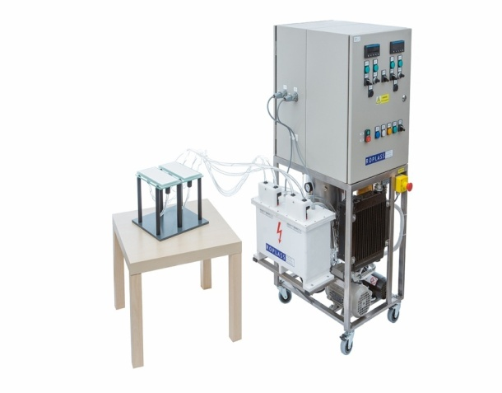 | 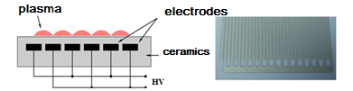
а) | b)
Figure 1 - General view of the experimental setup (RPS400) for plasma generation (a) and a schematic representation of the DCSBD electrode system (b)
The electrodes are equally spaced from each other on the surface under the dielectric layer. When high-voltage pulses are applied from a power source, a discharge is ignited on the surface. The high voltage pulses have a pulse repetition rate of 16.5 kHz and are sinusoidal with a maximum peak voltage of 3 kV (Fig. 3). As can be seen from Figure 3, the current voltage characteristics show a capacitive character with a 90 ° current phase shift. It can also be seen from the current oscillogram that there are discharge current peaks on top of the displacement current, which arise from single streamers.

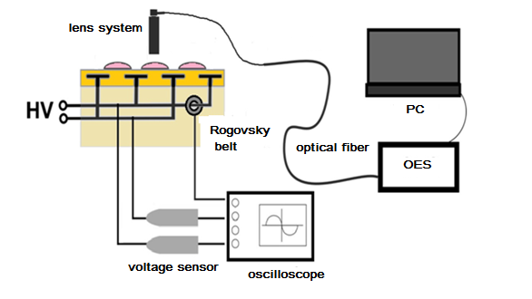

Figure 2 - Schematic representation of the DCSBD measuring system

The experiments were carried out at different powers from 81 W to 300 W with a step of 20 W. The experimental results showed that with increasing power, the number of micro-discharges increases, gradually filling the surface. Complete filling of the surface occurs at a power of 220 W.
The total power averages about 9 W. Below, in Figure 4, the dependence of the power calculated from the measured values of the current I (t) and voltage U (t) of the discharge on the supplied power is shown. As can be seen from the graph, the dependence is linear, while the total power is an order of magnitude less than the supplied power. High currents and voltages create a load on the power supply circuit and ultimately significantly increase the power loss in the electrical circuit and on dielectrics [10].

а)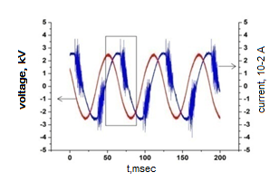
b)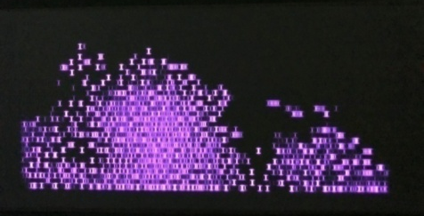 с)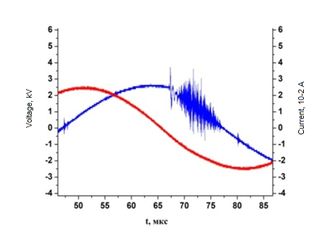
Figure 3 - a) volt-ampere characteristics of the DCSBD for the pulse repetition rate f = 16.5 kHz and voltage U = 3 kV; b) a photograph of the DCSBD surface at an applied power of 81 W and a pulse repetition rate f = 16.5 kHz; c) discharge current peaks on top of the displacement current

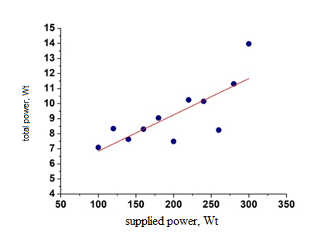
Figure 4 - Dependence of the total power calculated from the values of the current I (t) and voltage U (t) of the discharge on the supplied power

The chemical composition of the plasma was determined using optical emission spectroscopy. Molecular bands of nitrogen were observed in the emission spectrum of DCSBD, namely, the second positive (N₂ (C-B)) and the first negative (N₂ + (B-X)) systems. In Figure 5, the observed peaks from 300 nm to 470 nm are composed of OH (308 nm), N₂ (337 nm and 357 nm), N₂ + (380 nm, 390 nm, 427 nm and 470 nm) radicals. Due to the abundance of nitrogen molecules in the atmosphere, nitrogen bands are naturally dominant. OH radicals are also visible due to the presence of water vapor in the air [11]. The emission rates of other radicals such as NO, which are expected under the conditions given in a humid atmosphere, were negligible due to the low density and effective collisional quenching of the corresponding excited states.
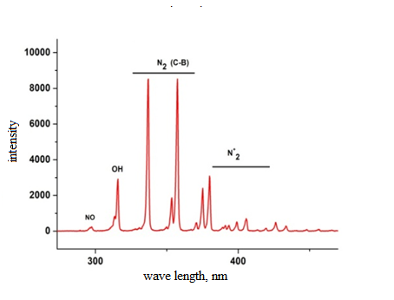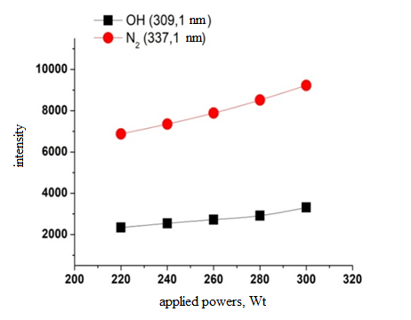
Figure 5 - Emission spectrum of a dielectric coplanar surface barrier discharge in the wavelength range of 300-470 nm (left) and intensities of OH and N₂ lines at applied powers of 200-320 W

A number of experiments were also carried out to measure the surface temperature of the experimental setup. These measurements were carried out in order to determine the temperature at different supplied powers, as well as to exclude the thermal effects of the dielectric coplanar surface barrier discharge in further research on the processing of crops and polymer materials. The surface temperature was measured using a UNIT UT 303C pyrometer. The experiments were carried out at various powers from 200 W to 260 W, with a step of 20 W. The measurement results showed that with an increase in power the temperature increases, at a power of 200 W the surface temperature was equal to 580 ⁰C, and at a maximum power of 260 W the temperature reached 630 ⁰C (Table 1). In this case, it can be assumed that in further research on the processing of polymers and agricultural crops, thermal effects at this power range can be excluded.

Table 1 - Temperature values measured at different powers
Р, W | 200 | 220 | 240 | 260
<T>, ⁰С | 58 | 60 | 62 | 63

For the purpose of uniform treatment of grain crops with the plasma of a surface dielectric barrier discharge, the installation based on the DCSBD was modernized, namely, the oscillating motion of the DCSBD surface was reported. For this, a crank mechanism was assembled, consisting of an engine that rotates the crank shaft (1), a connecting rod (2) and a slider (3), on which the surface of the experimental setup (4) is located. A schematic of the retrofitted installation is shown below, in Figure 6.

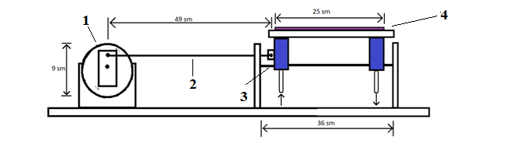
а)

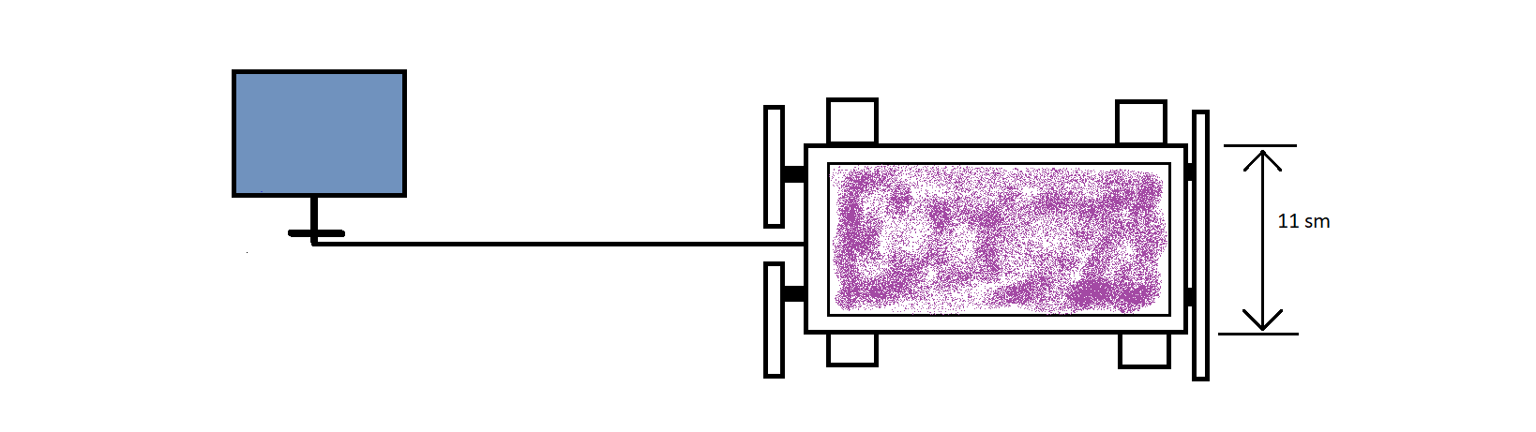
b)

а) Side view , b) view from above.
Figure 6 - Schematic representation of the oscillating mechanism of the surface of the experimental setup DCSBD

The motor driving the crank shaft consists of a power supply, an autotransformer, a diode bridge and a capacitor. The electronic circuit of the engine is shown in Figure 7.

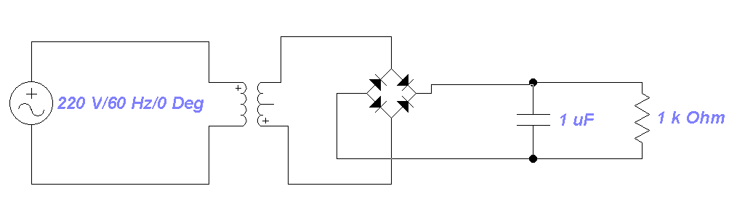

Figure 7 - Engine electronics

Wheat is one of the staple food crops in the world, providing 20% ​​of the energy in the human diet. Moreover, wheat is the main source of protein in developing countries. Demand for wheat is increasing due to rapid population growth in developing countries and demand is expected to increase by 60% by 2050. In the past 20 years, the average growth in gross grain harvest of wheat in the world has been about 1% per year. At the same time, the total sown area under wheat in the world did not change significantly and remained at the level of 215 million hectares [1]. Thus, the main factor determining the growth of wheat grain production in the world was an increase in yields, not in acreage. Among the measures aimed at improving the technology of cultivation of wheat and contributing to the increase in yields was an increase in the use of mineral fertilizers and chemical plant protection products. However, the use of fertilizers and chemical plant protection products, the mechanization of production upsets the balance of agroecosystems and destroys the natural environment, which cannot but have a negative impact on soil fertility and the quality of the products obtained. Further intensification of the cultivation of agricultural crops becomes more and more costly and less efficient, provides less and less yield increases and leads to environmental pollution [2]. Problems arising from the use of fertilizers and chemical plant protection products force the search for other, more environmentally friendly methods of influencing seeds to increase seed germination and crop yields.
In recent decades, there has been an active search for physiological, biochemical and biophysical techniques and technologies aimed at realizing the genetic potential, increasing resistance to abiotic and biotic stresses, enhancing the adaptive potential of plants in order to increase the yield of agricultural crops. Numerous methods of pre-sowing treatment of seeds have been developed using sound, shock-wave and heat treatment, exposure in electric and magnetic fields, laser, UV and IR irradiation, etc. Some studies have shown the positive effect of low doses of ionizing radiation on seed germination and crop yield [3].
In the next chapter, we investigated the effect of plasma treatment of seeds on germination and the main biometric indicators of seedlings of grain of spring soft wheat variety Saratovskaya 29, harvest of 2016.
2 Treatment of wheat seeds with surface dielectric barrier discharge plasma

The set of physical methods of action on seeds is diverse: electromagnetic fields of various ranges, irradiation with alpha and beta particles, ions of various elements, gravitational action, etc. Each of the physical factors of influence is provided with its own specialized equipment, and some radiation is dangerous to human life. The most promising of the physical methods at the moment is the use of low-temperature plasma at atmospheric pressure.
The relevance of studies on the application of the method of plasma processing at atmospheric pressure is due to both the high biological activity of atmospheric pressure plasma and the specific properties of nonequilibrium "cold" plasma with a gas-kinetic temperature of about 300 K, as well as their efficiency and environmental safety, i.e. plasma treatment of seed and planting material under normal (room) conditions can be considered in the technology of industrial cultivation of agricultural crops as an alternative to the traditional chemical and biological methods of their pre-sowing treatment.
The various uses of low-temperature plasma are determined by the simplicity of its creation. Gas-discharge low-temperature plasma is used in gas lasers and light sources, in plasma-chemical processes and gas purification processes, for surface treatment, in various technologies and metallurgical processes [12].
Of particular interest is the use of low-temperature atmospheric pressure plasma in the agricultural industry, since increasing the yield of agricultural crops and the safety of manufactured products has been and remains one of the primary tasks of the country's agricultural sector. Low-temperature plasma can interact with seeds and change their surface characteristics by etching, introducing functional groups, and imparting hydrophilic properties to the processed samples. New evidence suggests that plasma seed treatment can enhance germination and growth of seedlings in crops by removing microbial layers, altering water uptake and other changes [13,14,15].
Grains of spring soft wheat variety Saratovskaya 29 were used in the work. Wheat grains were obtained from the Kazakh Research Institute of Agriculture and Plant Production of the Ministry of Agriculture of the Republic of Kazakhstan. Wheat grains were visually checked and grains free of visible defects were selected for plasma treatment. Wheat grains (Triticumaestivum) were sterilized in a 1% sodium hypochlorite solution for 10 min. Then they were washed several times in sterilized water. Several batches of seeds were prepared, each batch containing 25 seeds, then they were placed in Petri dishes containing 3 - 4 layers of paper (Whatman No. 1) moistened with distilled water. One lot was exposed to plasma for 5, 10 and 15 seconds, and seeds from another lot were used as a control. The grains to be treated with plasma were evenly distributed over the Petri dish, while the individual grains did not touch each other. Seed germination was carried out for four days at 250 °C under conditions of long daylight hours at 22 °C. Seed germination was determined by the following formula: Germination (%) = (Number of germinated seeds in 1 day / total number of seeds) x 100%. The weight of seedlings, parameters of the length of the aerial part and root were determined on the 4th day after the start of germination at a temperature of + 22 °C in comparison with the control variant without treatment. The reliability of the results was assessed using the Student's t-test.
One of the promising areas of fundamental and applied research is the study of the regulation of plant growth and development using physical methods. At the same time, it is obvious that the main attention should be paid to the first stages of plant ontogenesis, starting with seed germination and seedling growth, when the most noticeable, significant and fundamental changes in plants take place.
The effect of plasma on wheat seed germination varied depending on the duration of treatment (Figure 8). Grain germination when exposed to wheat grains for 5, 10 and 15 seconds was 100, 96 and 98%, respectively. A significant difference was observed between the treated and control options (7-12%) (p <0.05). However, no significant differences were observed between the results obtained with plasma treatment for 5, 10 and 15 seconds. Treatment of wheat grain for 30 seconds or more resulted in a complete cessation of plant growth (data not shown).

Figure 8 - Effect of plasma on the germination of wheat grain

The results of biometric analysis of structural elements of plants are presented in Table 1. As can be seen from the data presented, seedlings of spring wheat, seeds of which were treated with plasma, had a mass approximately 15–18% higher than that of untreated plants. At the same time, the increase in the aboveground biomass of spring soft wheat plants ranged from 22% to 44%, while the mass of the root system increased from 60% to 80% per plant. It should be noted that in the presented experiment, the options for processing plants within 15 seconds had an advantage. To elucidate the effect of plasma on the growth of seedlings, the length of the root system and the first true leaf (shoot) at the age of 4 days was determined in the following experiments. Table 2 presents data characterizing the growth of wheat seedlings after plasma treatment of seeds. Table 3 shows the biometric parameters of wheat seedlings after plasma treatment.

Table 2 - Efficiency of plasma treatment of soft spring wheat seeds
 | Number of plants | Seedling mass  (g / plant) | Above ground weight  (g / plant) | Root mass  (g / plant)
The control | 33 | 1.47±0.012 | 0.75±0,023 | 0.3±0.015
5 seconds | 50 | 1.7±0.015* | 0.92±0,009 | 0.48±0.023*
10 seconds | 42 | 1.68±0.018* | 1.0±0,011* | 0.43±0.018*
15 seconds | 48 | 1.74±0,02* | 1.08±0,005* | 0.54±0.021*
* p <0.005 compared to control

The greatest length of shoots and roots of wheat when treated with plasma was manifested when treated for 15 seconds (13 cm). When treating seeds for 5 and 10 seconds, the length of shoots and roots was 10.6 and 10.29 cm, respectively. The type of germinated wheat seeds is shown in Figure 9.
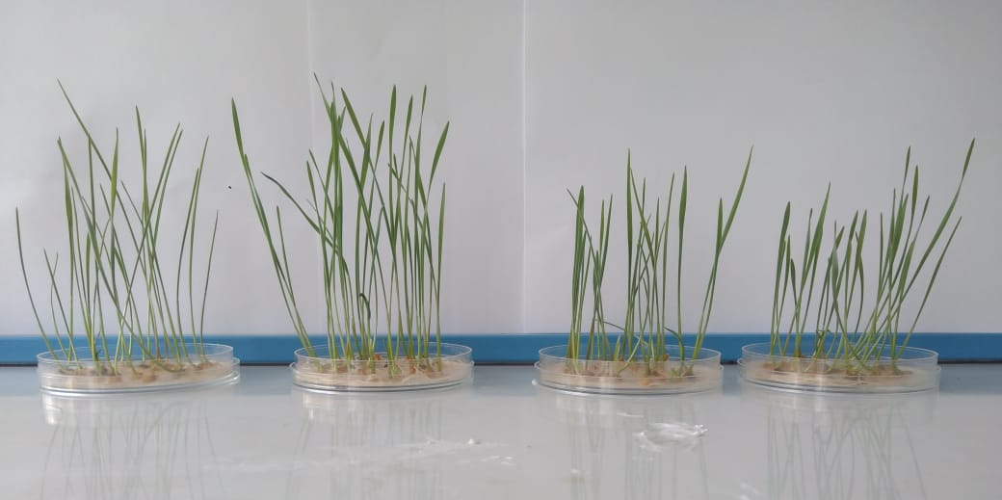

From left to right: 1) control sample, 2) 15 seconds of plasma treatment, 3) 10 seconds of plasma treatment, 4) 5 seconds of plasma treatment.
Figure 9 - View of germinated wheat seeds

Table 3 - Biometric indicators of wheat seedlings after plasma treatment
 | Root length, mm | Seedling length, mm
The control | 4,63±0,212 | 10,02±0,296
5 seconds | 5,6±0,165* | 10,6±0,212
10 seconds | 5,23±0,205* | 10,29±0,270
15 seconds | 5,03±0,249* | 13±0,200*
* p <0.005 compared to control

The germination and germination rate of plant seeds depend on many factors, such as water, oxygen, temperature, and light [16]. In addition, it has been shown that physical factors such as laser irradiation [13], magnetic field [14,15], low pressure [17], plasma treatment [18-25], gamma rays, and UV radiation have a significant effect on grain germination efficiency. However, the obtained data are contradictory and the mechanism of the stimulating effect of physical factors on the efficiency of germination of wheat seeds has not been fully investigated.
The present study has shown that plasma has a positive effect on wheat germination. Grain germination and biometrics were significantly higher when treated with plasma. In this case, the effectiveness depended on the duration of the plasma action. Grain treatment for 15 seconds caused the greatest stimulating effect on germination and biometric indicators of wheat seedlings. The plasma treatment process possibly absorbs water and activates enzymatic and other biological reactions in the plant cell, which leads to faster and more uniform germination.

3 Study of the biological response of grain to the influence of atmospheric pressure plasma

According to the studies of a number of scientists, the plasma of a dielectric coplanar surface barrier discharge can affect the germination of seeds of agricultural crops in the following way: disinfection of seeds by deactivating harmful microorganisms and bacteria, which can significantly improve the quality of sowing [26,27], making changes in the structure of the surface of seeds, message of hydrophilicity, thereby promoting the absorption of water by the seed [28], changing the chemical composition of the treated samples by introducing radicals [29,30], stimulating seed growth through the production of enzymatic antioxidants necessary for resistance under various stress conditions. Plant organisms produce special substances called enzymes, or enzymes. These substances have the ability to induce and accelerate chemical reactions that occur in living organisms. Scientists are investigating one of the types of catalase enzymes, since it breaks down peroxides to form molecular oxygen, that is, it breaks down peroxides harmful to the body, thereby protecting the body from external disorders [30]. There are also several types of enzymes that catalyze hydrolysis reactions, otherwise hydrolases. These include the enzyme alpha-amylase, which hydrolyzes starch with the formation of dextrins and maltose, which affects the further growth of plants. The germination and germination rate of plant seeds depend on many factors, such as water, oxygen, temperature, and light [31]. In addition, it has been shown that physical factors such as laser irradiation [11], magnetic field [1,2], low pressure [18], plasma treatment [32,33], gamma rays, and UV radiation have a significant effect on efficiency. germination of grain.
We used grains of soft spring wheat varieties "Saratovskaya 29". Wheat grains were obtained from the Kazakh Research Institute of Agriculture and Crop Production of the Ministry of Agriculture of the Republic of Kazakhstan. Wheat grains were visually checked and grains without visible defects were selected for plasma treatment [34].
Wheat grains (Triticum aestivum) were sterilized in a 1% sodium hypochlorite solution for 10 minutes. Then they were washed several times in sterilized water. Several batches of seeds were prepared, each batch containing 25 seeds, then they were placed in Petri dishes containing 3 - 4 layers of paper (Whatman No. 1) moistened with distilled water. One lot was exposed to plasma for 5, 10 and 15 seconds, and seeds from another lot were used as a control. The grains to be treated with plasma were evenly distributed over the Petri dish, while the individual grains did not touch each other. Seed germination was carried out for four days under long daylight conditions at 22 ° C.
The weight of seedlings, parameters of the length of the aerial part and the root were determined on the 4th day after the start of germination at a temperature of +22 ºС in comparison with the control variant without treatment. The reliability of the results was assessed using the Student's t-test.
Surface morphology of wheat seeds before and after plasma treatment with DCSBD was studied using scanning electron microscopy (SEM). An electron microscope was used in order to obtain an enlarged image of the surface by the use of high-energy electron beams.
The studies were carried out on a Quanta 3D 200i scanning electron microscope with an attachment for X-ray spectral analysis from EDAX.
Also, to study the morphological properties of wheat seeds before / after plasma treatment with DCSBD, the method of measuring the contact angle was used, since the contact angle of wetting is a quantitative characteristic of the wetting process, its value determines the intermolecular interaction of particles on the surface of solids with liquids. To determine the wetting angle of a drop of water on the surface of wheat seeds at different times of treatment with 1 μL, a drop of ordinary water was applied to the surface of the grain using a micropipette under room conditions. Further, immediately after applying the drop, the camera was used to fix the image at a position strictly perpendicular to the cross-section surface.
The α-amylase activity was determined using soluble starch as a substrate and by measuring the amount of reducing sugars by the DNS (3,5-dinitrosalicylic acid) method using D-glucose as a standard. For the analysis, 0.5 ml of plant homogenate as a source of the enzyme was mixed with an equal volume of 0.15% starch in 0.1 M sodium acetate buffer (pH6) and for 30 min at 60 °C. After incubation, the reaction was stopped by adding 3 ml of DNS reagent and boiling for 15 minutes. The unit of activity was taken as the amount of enzyme that forms 1 μM of reducing sugars in 1 min per 1 mg of total protein under the given reaction conditions.
Also, an electrophoretic analysis of alpha amylase was additionally performed. Preliminarily, the grain intended for the electrophoretic analysis of alpha amylase was disinfected with a KMnO4 solution heated to 750 °C for 30 seconds, washed with distilled water and set to germinate on filters moistened with water in a dark place at a temperature of 200 °C for 4 - 5 days. During germination, the length of the seedling reached an average of 40 mm.
To extract the enzyme, after removing the seedling and roots, the caryopsis was placed in a test tube, after which 0.2 % bicarbonate of soda (NaHCO3) containing 20 % sucrose and 0.03 % bromophenol blue was poured. After carefully grinding each caryopsis in separate tubes using a stainless steel rod, centrifugation was carried out at 5000 rpm. within 10 minutes. Then, the closed tubes with supernatane were overheated at a temperature of 80 °C for 20-25 minutes. The prepared supernatant liquid was applied to the starting cells, 2-3 μL each.
Electrophoresis was carried out on plates of 7.5% polyacrylamide gel 190x105x1 mm in size on devices manufactured at the Genetic Breeding Institute of the Ukrainian Academy of Agrarian Sciences (Odessa). Electrophoretic separation was carried out in a triglycine system; pH 8.46 movement of enzymes from cathode to anode at 300 V. Stainless steel electrodes. The duration of electrophoresis corresponded to the transit time of 2.5 bromophenol blue labels through the gel, about 2.5 hours. 1 liter of electrode buffer contains 1.2 g of tris and 5 g of glycine.
After electrophoresis, the incubation of alpha amylase was carried out for 30 minutes at room temperature in 1% solution of hydrolyzed starch prepared in 0.1 M acetate buffer. For a more uniform penetration of starch, the gel must be turned over.
The acetate buffer contains 2.7 g of sodium acetate: 50.3 ml of 0.2 M acetic acid and diluted with water to 300 ml. 5 g was added to this solution. hydrolyzed potato starch. With constant stirring, this suspension was brought to a boil.
After incubation, the gel plates were washed with running water and stained with a solution of iodine in potassium iodide.
The coloring composition included:
1) Potassium iodine - 2.5 g;
2) Crystalline iodine - 1.3 g;
3) Trichloroacetic acid (TCA) - 25.2 g (or 42 ml of 60% TCA);
4) Water - up to 500 ml.
The gel plates acquired a dark violet color under the action of the dye mixture. Localization sites of amylases are not stained. The effect of plasma on wheat seed germination varied depending on the duration of treatment. Grain germination when exposed to wheat grains for 5, 10 and 15 seconds was 100, 96 and 98%, respectively. A significant significant difference was observed between the treated and control options (7 - 12%) (p <0.05). However, no significant differences were observed between the results obtained with plasma treatment for 5, 10 and 15 seconds. The present study has shown that plasma has a positive effect on wheat germination. Grain germination and biometrics were significantly higher when treated with plasma. In this case, the effectiveness depended on the duration of the plasma action. Grain treatment for 15 seconds caused the greatest stimulating effect on germination and biometric indicators of wheat seedlings. Plasma treatment possibly provides water absorption and activates enzymatic and other biological reactions in the plant cell, which leads to faster and more uniform germination [34].
A number of experiments were carried out to study the morphological properties of wheat seeds treated with DCSBD plasma, namely, wettability. The samples were processed for 5, 10, 15, 30 seconds, 1 and 3 minutes, the power was 220 W. The results of measuring the contact wettability angle of the samples were as follows: the contact wettability angle of the control sample was 70 °, at 5 s irradiation the wettability angle decreased to 68 °, at 10 s irradiation to 43 °, at 15 s irradiation to 54 °, at 30 s irradiation to 48 °, with 1 min of irradiation up to 30 °, with 3 min of irradiation up to 0 °. As can be seen from these results, after treatment with DCSBD plasma, the samples became hydrophilic, that is, the wettability of these samples became higher, which contributes to further seed germination. The results obtained are in good agreement with the results of other studies. Below, in Figure 5, photographs are shown of measuring the contact angle of wettability of a water drop on the surface of wheat seeds treated with DCSBD plasma. Table 4 shows the numerical values of the measured contact angles depending on the time of plasma treatment at a plasma source power of 220 W.

Table 4 - Results of measuring the contact angle of wettability of samples
Irradiation time | Control | 5 с | 10 с | 15 с | 30 с | 1 min | 3 min
Contact angle, ° | 70° | 68° | 43° | 54° | 48° | 30° | 0°

The surface morphology of wheat seeds after DCSBD plasma treatment was also studied using scanning electron microscopy (SEM). Wheat seeds were treated with DCSBD plasma for 15 seconds, and treated seeds were compared to untreated samples. The results show that no particularly noticeable structural damage is observed.
The surface elemental composition of wheat seeds before and after treatment with low-temperature atmospheric pressure plasma was studied using X-ray spectral microanalysis. Below, in Figure 12, the results of the analysis are shown.

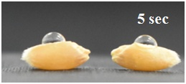 | 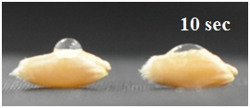
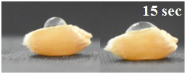 | 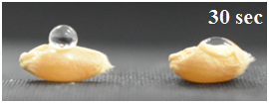
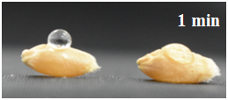 | 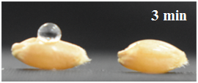

Left - control, right - processed samples.
Figure 10 - Photographs of measuring the contact angle of wettability of wheat seeds treated with plasma DCSBD

a) | b) 15 sec
 | 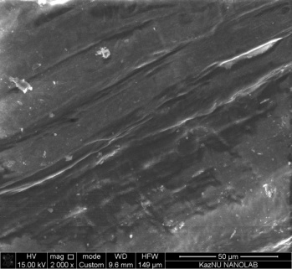
c) 30 sec | d) 1 min

- Utreated (control) and b), c), d) plasma treated.
Figure 11 - Surface morphology of wheat seed samples

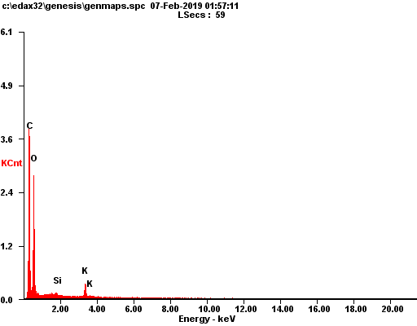
  Element | Wt% | At%
  CK | 56.79 | 64.70
  OK | 39.85 | 34.08
  SiK | 0.29 | 0.14
  KK | 3.07 | 1.08
  Matrix | Correction | ZAF
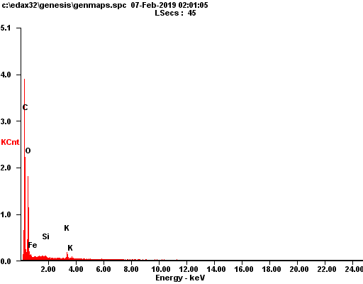
  Element | Wt% | At%
  CK | 58.45 | 67.80
  OK | 34.77 | 30.28
  FeL | 4.96 | 1.24
  SiK | 0.25 | 0.13
  KK | 1.57 | 0.56
  Matrix | Correction | ZAF
Figure 12 - Elemental analysis of the seed surface before and after treatment (15 s) with atmospheric pressure plasma

The results of elemental analysis show that there are no noticeable changes in the elemental composition of grains after treatment. One can see the presence of peaks of carbon and oxygen, which are the main indicators of the organic nature of substances. Peaks of silicon (Si) and potassium (K) are also observed. Longer dielectric barrier discharge treatment up to 3 min at a generator power of 220 W also did not reveal significant changes in the elemental composition.
It is known that seed germination is one of the important stages in the life of a plant. At the earliest stages of life, until the reserves of the caryopsis are exhausted, heterotrophic nutrition prevails in plants. With the formation of tissues and new organs, the plant gradually passes from heterotrophic to autotrophic nutrition, which is accompanied by a restructuring of enzyme systems and metabolic mechanisms. Disruptions in molecular signaling during grain germination can cause not only reduced seedling productivity, but also significant yield losses in the pre-harvest period. Conversely, prolonged dormancy leads to the inability of the grain to germinate at the optimum season for it and, accordingly, to the difficulty of successful fixation of the seedling on the substrate.
Alpha-amylase enzyme activity and effects of plasma treatment were measured using the DNS method. Today this method is the most optimal, which is associated with more accurate results and ease of use. The results of measurements of the alpha-amylase activity are shown below in Table 5.

Table 5 - Method for checking alpha-amylase activity by DNS method
μmol of glucose per minute for total protein in mg
 | control | 5 sec | 10 sec | 15 sec
1 day | 4,74 | 5,08 | 4,84 | 4,8
2 day | 5,53 | 5,46 | 5,77 | 5,79
3 day | 5,62 | 5,57 | 5,57 | 6

The method of checking the activity of the alpha-amylase enzyme by the DNS method showed that the highest alpha-amylase activity on the first day is achieved with plasma treatment for 5 s, and on the second and third days with plasma treatment for 15 seconds. As mentioned above, the activity of alpha-amylase is a key factor in the growth of the embryo and further germination of the plant, therefore, the highest activity of alpha-amylase contributes to the best germination of seeds, and treatment with atmospheric pressure plasma of the seeds gives a better result compared to the control sample. The graph of the distribution of the values ​​of the activity of the enzyme alpha amylase by days after the start of germination at different times of treatment is shown below in Figure 13.

A - the activity of α-amylase was determined quantitatively using dinitrosalicylate detection of reducing sugars; B - staining acrivity of α-amylases. The crude extract from 1 to 3 day old wheat seedlings was subjected to a native page and stained for α-amylase activity. Lane 1 - three-day-old seedlings of untreated wheat seeds; lane 2 - three-day-old seedlings of 5 sec plasma-treated wheat seeds; lane 3 - three-day-old seedlings of 10 sec plasma-treated wheat seeds; lane 4 - three-day-old seedlings of 15 sec plasma-treated wheat seeds. One unit of α-amylase activity was defined as the amount of enzyme required to obtain a reducing sugar equivalent to 1 μmol of glucose per minute from soluble starch at 30 ° C and pH 6 in 1 ml of enzyme.
Figure 13 - Time course of β-amylase activity in plasma-treated wheat seeds compared to controls

As can be seen from the graph, on the first day of seed germination, the highest alpha amylase activity is observed for samples treated with plasma for 5 seconds. The lowest activity is in the control sample and it is equal to about 4.7 μM / mg. On the second day of observation, the alpha amylase activity showed peak values for plasma treatment times of 10 and 15 seconds. The values in this case vary from 5.7 μM / mg to 6 μM / mg. On the third, the alpha amylase activity increases for the samples treated at 15 seconds and reaches 6 µM / mg, while the control samples and the treated samples at 5 and 10 seconds lag significantly behind in the alpha - amylase activity.
The alpha amylase activity measured by electrophoresis also showed maximum values for samples treated with plasma at 10 and 15 seconds.
In conclusion, we can say that the process of treating wheat seeds with low-temperature atmospheric pressure plasma stimulates germination, probably by increasing the activity of hydrolysis enzymes, including the key enzyme alpha amylase. The activity of these enzymes, in turn, will lead to an increase in germination at an early stage of germination.
4 Microbiological studies of seed samples for infection with bacteria and microscopic fungi

Interest in the use of atmospheric pressure plasma in medicine and surgery is increasing day by day. Plasma sterilization and the interaction of plasma with microorganisms are two of the most interesting and ongoing areas of cold plasma research. Several conventional sterilization methods are already well known such as autoclaving, ethylene oxide, UV sterilization, irradiation. New plasma sterilization technology can also be added to this list. Plasma can kill almost all types of bacteria, since different types of ions and reactive substances such as oxygen and ozone atoms can be generated during gas treatment. Since low-temperature atmospheric pressure plasma is suitable for surface treatment of samples up to 70 °C, that is, it is possible to treat plant seeds as well without destructive effect.
To determine the effectiveness of the cold plasma disinfection mode, microbiological analysis of grain was carried out in accordance with GOST [35,36] and literature data [37,38]:
-total number of mesophilic aerobic and facultative anaerobic microorganisms (MAFAnM);
- potato stick bacteria;
- the number of molds.
The method for determining the total number of mesophilic aerobic and facultative anaerobic microorganisms was based on:
-sowing of dilutions of a certain amount of the product in a vagarized nutrient medium;
- cultivation of crops under aerobic conditions at a temperature (30 ° C for 72 hours;
- counting all mesophilic aerobic and facultative anaerobic microorganisms and recalculating their number per 1 g of product. Meat-peptone agar, wort agar, and Czapek and Saburo's nutrient medium were used as a nutrient medium [38].
Identification of bacteria. The identification of bacteria is studied by morphological and physiological and biochemical characteristics. The morphology of bacteria is studied using a BM-EX20 microscope with a magnification resolution of 100-200. Gram stain and bacterial motility are studied according to the methods described in [37]. Physiological and biochemical properties are determined by the ability of bacteria to use different sources of carbon: alcohols, organic acids, amino acids (as an electron donor and a carbon source). Organic acids and alcohols are added in concentrations of 3.5 g / l, amino acids - 2 g / l, into Postgate "C" medium without yeast extract. As electron acceptors, sulfate, sulfite, thiosulfate, and elemental sulfur are introduced into the Postgate “B” medium at a concentration of 4.5 g / l. The ability of microorganisms to sporulate is checked by heating cell suspensions in sealed ampoules in a water bath at 80 ºС for 10, 20.30 min [37].
It is known that about 80 mold fungi form mycotoxins, of which 8 species are fungi of the genus Fusarium, 17 species of Aspergillus and four species of Penicillium. The main toxins produced by molds - six types of aflatoxins, patulin, ochratoxins and rubratoxins - are dangerous to humans and animals [38].
Infection of grain with fungi of the genus Fusarium causes a significant decrease in yield and deteriorates the quality of products. This disease of cereals is called grain fusarium. Fusarium grain appears as a result of infection with fungi F.graminearum, F.culmorum, F.avenaceum, F.sporotrichioides, F. poae, etc., there are samples with typical signs of infection and carrying an internal infection, as well as without visible symptoms of damage [ 39]. Bacteria of the genus Bacillus sp. the causative agents of potato bread disease are known as opportunistic bacteria that cause foodborne infections (Figure 14). These bacteria are found in the mycoflora of soils from where they then enter the grain, and, therefore, subsequently infect flour and, when eating bread, cause serious human diseases (meningitis, endocarditis, arthritis, endophthalmitis, septicemia, osteomyelitis, etc.). In this regard, the search and use of less energy-intensive and environmentally friendly methods for disinfecting grains, flour and extending the shelf life of bakery products is a very urgent problem that requires a solution.
As can be seen from Figure 14, control samples of wheat grains were initially infected with filamentous fungi of the genus Penicilliumspp. With the minimum value of the time of exposure to plasma - 15 seconds, at all values of the specific power in the studied range, an increase in the infection of grain with fungi of the genera Penicillium spp. and Aspergillus spp. was found. The minimum time of exposure to plasma on the grain, activates the vital activity of the mycelium of fungi of the genus Aspergillus spp., causing their rapid growth, which is clearly undesirable during the production and storage of wheat grain.
The identification of filamentous fungi by microbiological methods is based mainly on the structure and methods of development of reproductive structures as the most taxonomically significant. On the basis of a complex of macroscopic and microscopic features, the studied fungi cultures were assigned to the genera Aspergillus spp. and Penicillium spp.

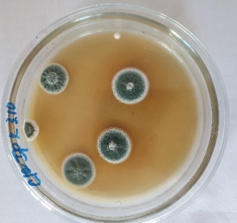
А)
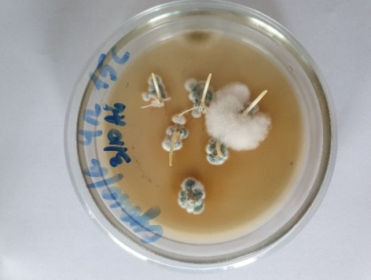 | 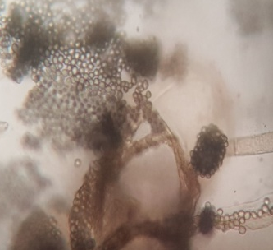
B)
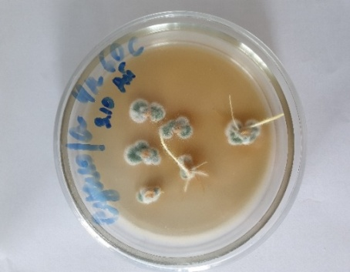 | 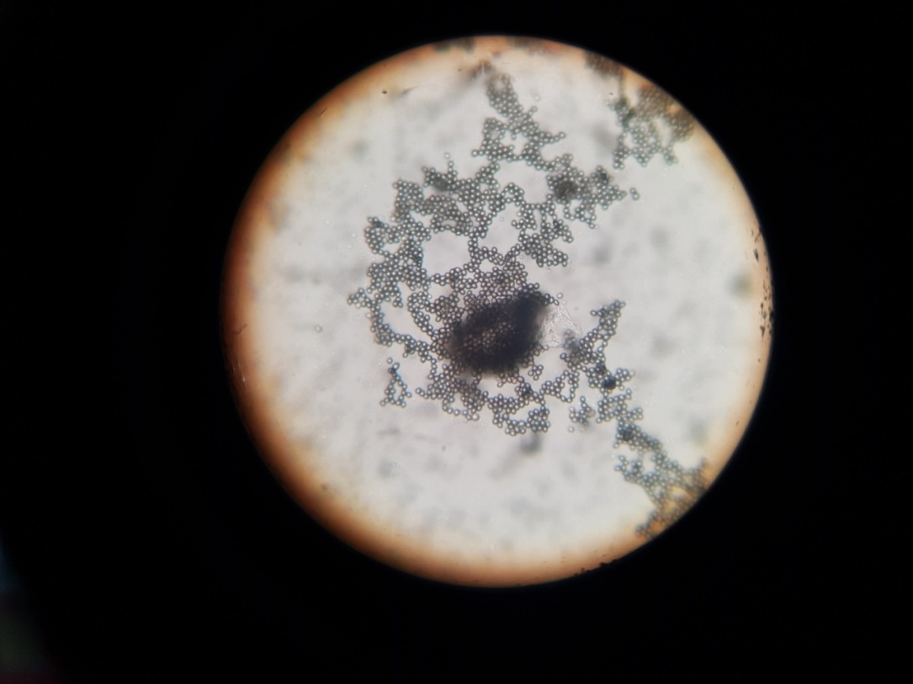
C)
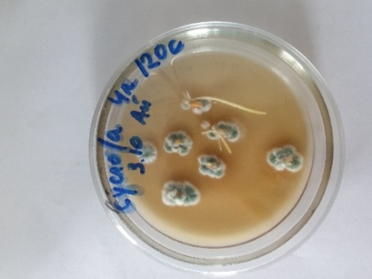 | 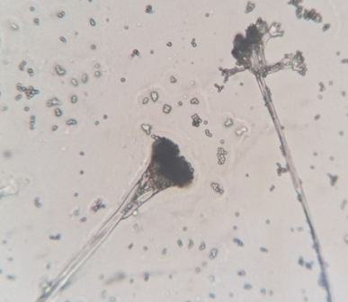
D)

A) control, B) After 15 seconds of plasma treatment and micrograph of Aspergillus spp. C) After 60 seconds of plasma treatment and micrograph of Penicillium spp. D) After 120 seconds of plasma treatment and micrograph of Penicillium spp.
Figure 14 - Mycological identification of filamentous fungi isolated from wheat grains using a BM-EX20 microscope (magnification 100x)

Aspergillus spp. on Czapek's nutrient medium form flat, rarely zoned, wide-spread colonies. On the 10th day of cultivation, the diameter of the colony reached 5.5-6 cm. The mycelium had a white-gray color, when the conidia matured it acquired an olive-gray tint. The conidial heads are radial, the conidiophores extend from the hyphae of the substrate and aerial mycelium, the apical expansion is spherical. Sterigmata are loose, bunk. Conidia are spherical.
Strains of Penicillium spp. when growing on Czapek's nutrient medium, they formed limited-growing, relatively thick colonies. Sterile hyphae are abundant and white. Conidiogenic zone of gray-green color. Conidiophores are connected in bundles, moving away from the substrate and aerial mycelium. Three-tiered brushes, asymmetrical. Conidiophores, twigs and broomsticks are rough. Metuli are collected in whorls, sterigmas - in bunches. Conidia are elliptical, smooth.
At 60 and 120 seconds of exposure to plasma, the growth of fungi of the genus Aspergillus spp. not observed, however, the growth of fungi of the genus Penicillium spp. is not suppressed. Obviously, to suppress the development of filamentous fungi of the genus Penicillium spp. With plasma, a longer treatment regime is required.
Thus, the short-term plasma sterilization mode for 15 seconds is not recommended for processing grain, due to the fact that the vital activity of filamentous fungi of the genus Aspergillus spp. is activated.
Control samples of wheat grains had a contamination level of up to 570 CFU / gram. As can be seen from Figure 15, plasma treatment for 15 seconds does not significantly affect the infection of wheat grains with bacteria of potato bacillus. With an increase in the exposure period of 60 seconds, all bacteria were also in an active state. Only after plasma treatment for 120 seconds, there is a slight decrease in the growth of bacteria of the genus Bacillusspp., Up to 390 CFU / g, however, germinated spores of bacteria make it possible to regenerate into vegetative forms in the shortest possible time. Apparently for the suppression of the development of spore rods of bacteria of the genus Bacillusspp. longer plasma processing time is required.
The mode of processing wheat grain with plasma for 15 seconds, not only does not have a fungicidal effect, but also stimulates the vital activity of filamentous fungi of the genus Aspergillusspp. To suppress the development of filamentous fungi of the genus Penicilliumspp. And spore rods of bacteria of the genus Bacillussp. a longer plasma processing time is required than 120 seconds.
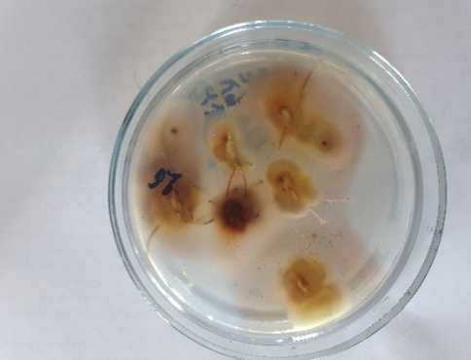  a) | 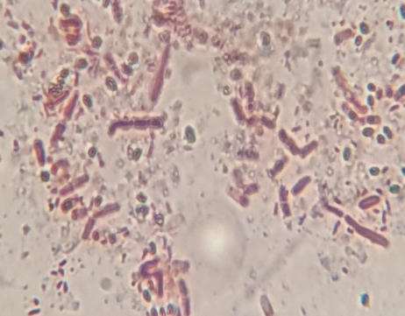
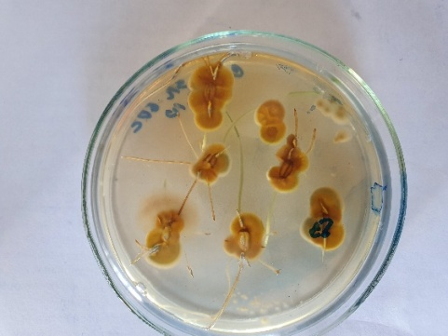 | 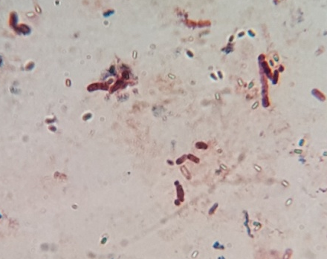
b)
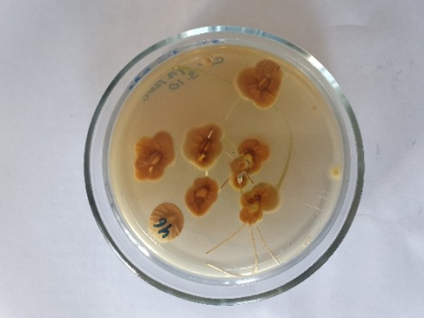 | 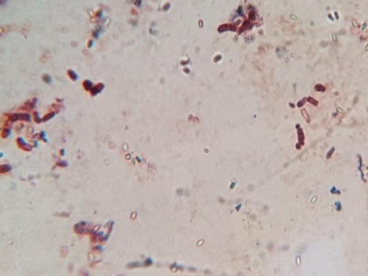
c)
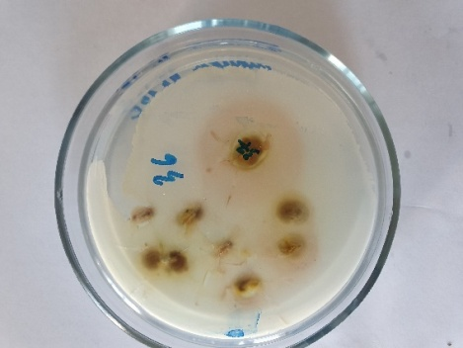 | 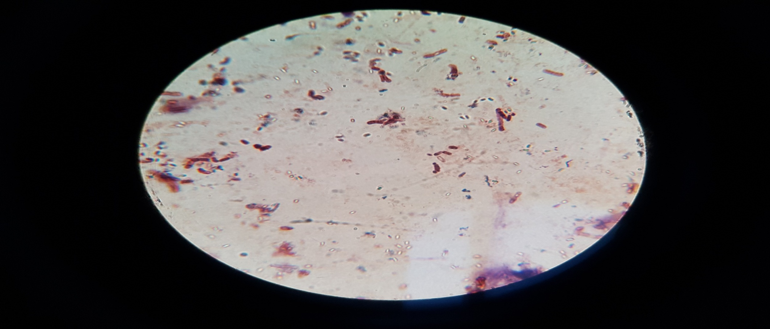
d)
a) Control, b) wheat grains after 15 s plasma treatment, c) wheat grains after
60 s with plasma treatment, d) wheat grains after 120 s with plasma treatment.
Figure 15 - Cultural and morphological identification of bacteria isolated from wheat grains on a BM-EX20 microscope (magnification 200x) and corresponding micrographs of Bacillus spp.

5 Repeating experiments with different parameters and their optimization

The experiments were repeated with different parameters and their optimization. Experiments on treating wheat seeds with plasma of a dielectric coplanar surface barrier discharge at atmospheric pressure were carried out with the following parameters: discharge power 260 W, treatment time 5 seconds, 1 min, and 3 min. The best germination results were achieved with 5 seconds of treatment with low-temperature atmospheric pressure plasma. Optical microscopy was also performed using a Leica microscope. The results showed that plasma treatment of seeds did not cause visible damage to the surface morphology of the samples (Fig. 16).

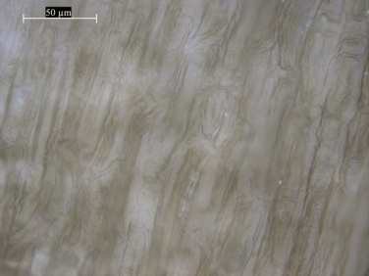 | 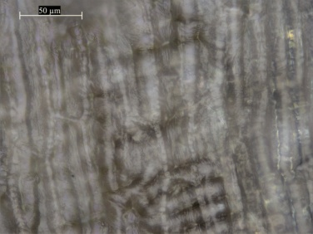 | 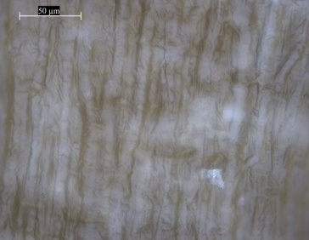 | 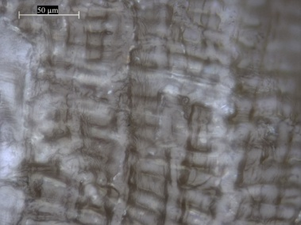
а) | b) | c) | d)
a) Control sample; b) processing time 5 seconds; c) processing time 1 min; d) processing time 3 min.
Figure 16 - Optical Microscopy Results

A number of experiments were also carried out to re-examine the morphological properties of samples treated with low-temperature plasma. The processing times were 10 sec, 30 sec, 1 min and 3 min. The results showed an increase in the hydrophilic properties of the treated samples in comparison with the control sample, but no noticeable changes in the chemical composition of the surface of the samples were observed (Fig. 17).

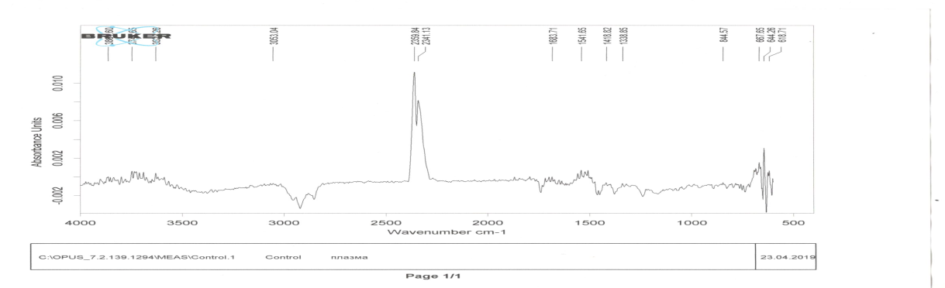 | а)
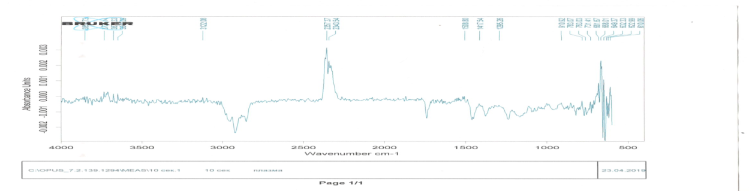 | b)
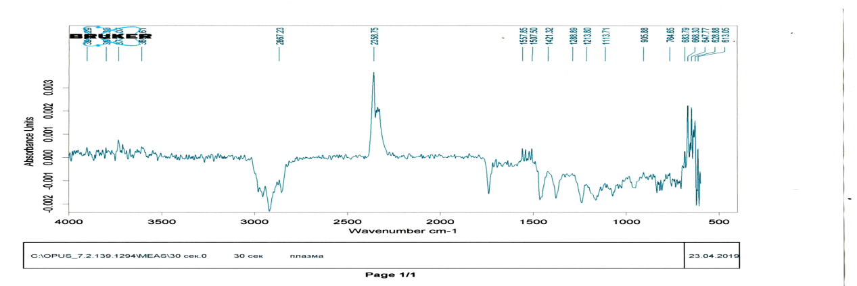 | c)
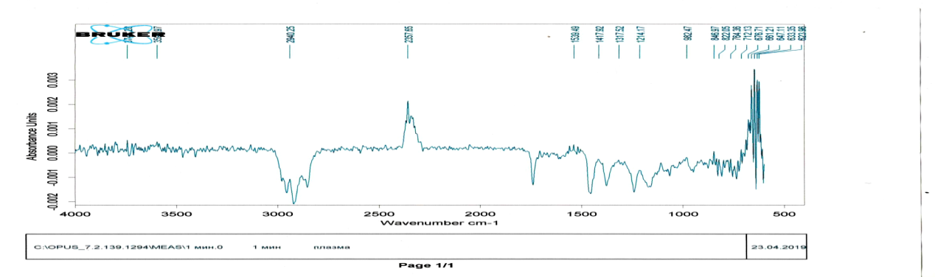 | d)
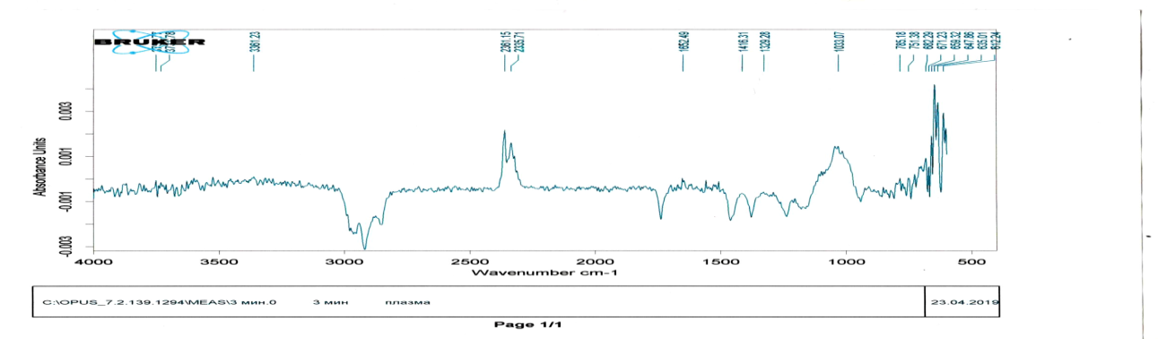 | e)
a) Control sample, b) treatment time 10 s, c) treatment time 30 s, d) treatment time 1 min, e) treatment time 3 min.
Figure 17 - FTIR Analysis Results

Productivity is a complex quantitative trait that is the result of the results of plant development. For wheat, the main components of the yield structure are: the number of ears per unit area, the number of grains per ear and the mass of 1 grain. The number of ears per unit area is the number of plants per unit of area harvested, the number of grains per spike corresponds to the number of spikelets in an ear and grains in it.
In the experiments carried out, wheat yield traits were determined for ten randomly selected plants by calculating the average values ​​of the main yield traits. Wheat yield was determined by harvesting the crop grown on a plot of one square meter. Only spikelets filled with grains were counted. The total number of grains in each spikelet was also counted. Wheat grains were weighed after threshing and drying crops. The grain yield was estimated as kg / m2. The time of plasma treatment of wheat grains was equal to 10, 15 and 30 seconds.
The results of experiments on the treatment of wheat grains with atmospheric pressure DCSBD plasma, such as yield and yield-promoting traits: ear length, number of spikelets / ears, grains / spikelet, 1000 seeds weight, were collected and shown in Table 6 and Fig. 18, respectively.

Table 6 - The effect of treating wheat grains with plasma DKPBR on grain yield
Processing time, sec | Ear length (cm) | Number of spikelets / ears | Amount of grain / spikelet
Control | 11,30 | 2,58 | 37,21
10 | 10,60 | 2,95 | 39,85
15 | 11,50 | 2,59 | 42,69
30 | 10,48 | 2,57 | 37,70

As can be seen from this table, the best results of the yield of wheat grains in comparison with the control sample were achieved when treated with plasma DCSBD atmospheric pressure for 15 seconds.

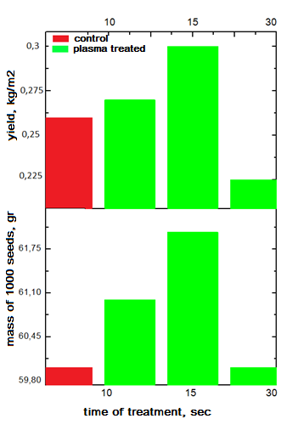
Figure 18 - Influence on yield and weight of 1000 wheat grains of plasma treatment with DCSBD

Treatment of wheat grains with atmospheric pressure DCSBD plasma showed a significant difference in the grain / head ratio. Plants grown from plasma-treated seeds gave the highest number of kernels / ears (44.69) compared to control (37.21), where the best treatment time was 15 seconds. The mass of 1000 grains increased significantly and reached 62.00 g, as shown in Fig. 10. The best yield result in comparison with the control sample was achieved with plasma treatment for 15 sec. The results obtained are in good agreement with the results of the work of foreign scientists on the treatment of wheat seeds with atmospheric pressure plasma [40].

6 Development of technological bases of processing methods of grain crops APP

As a result of studies of the effect of plasma treatment with a dielectric coplanar surface barrier discharge of wheat seeds, the optimal processing conditions were determined, such as the time of plasma treatment with DCSBD, discharge power, surface temperature of DCSBD.
A study of the effect of atmospheric pressure plasma on wheat seeds showed a positive result on the germination of wheat grains. Grain germination and biometric parameters, such as the number of plants, the weight of seedlings, aerial parts, roots, root and seedling length, when treated with plasma DCSBD were much higher than the control sample. Improvement of germination, length of roots and seedlings, water absorption of wheat seeds after treatment with nonequilibrium low-temperature plasma of atmospheric pressure have been reported in a number of previous works [41-43]. Since the parameters of the discharge power source (power, frequency), the geometry of the electrodes and the type of gas used vary, the most optimal processing time and, accordingly, the radiation dose for different authors correspond to different values. In our experiments, the optimal time for improving seed germination is 5 seconds, at which the samples show almost 100% germination with about 88% germination for control samples. It is also worth noting that at processing times of 10 and 15 seconds, a high germination rate of about 96 and 98% is also observed. Starting from the 30th time of treatment, the germination of seeds sharply decreases and after 1 min of treatment, plant growth completely stops. The highest biometrics were obtained for samples with a processing time of 15 seconds. In particular, wheat seedlings had a weight approximately 15-18% higher than untreated plants. The increase in the aboveground biomass of spring soft wheat plants was 44%, while the mass of the root system increased from 60% to 80% per plant. Velichko et.al [41] reported that when treated with a plasma jet of atmospheric pressure of wheat seeds, the highest germination and growth parameters are achieved at 15-60 seconds, depending on the distance between the end of the tube and the substrate, and when processing with a volume barrier discharge, the optimal processing time is 2 -10 Seconds. A further increase in the processing time in both cases leads to a decrease in germination. In the work of Loset. al. [44] the optimal time is indicated 30 - 60 s after the treatment of seeds with a high-voltage dielectric barrier discharge. Indirect plasma exposure at 60 s led to an increase in germination and by 14.7% and to an improvement in the quality of seedlings in comparison with the control samples. A significant decrease in germination was observed with a treatment time of 180 seconds or more. Zahoranovaet. al. reported that germination rate, dry weight and vigourindex increased significantly with plasma treatment from 20 s to 50 s, with the highest positive responses within the 30 s treatment time. The germination rate was increased to 21%, while a longer treatment time of 70 - 80 s suppresses almost all growth parameters. The optimal processing time depends not only on the plasma parameters and discharge generation methods, but also on the variety and type of wheat seeds, grain sizes and germination conditions. The most optimal plasma processing time can range from several seconds to several minutes [43, 45].
Low-temperature plasma treatment leads to a change in the properties of various surfaces from hydrophobic to hydrophilic, thereby increasing wettability. The results of measuring the surface wettability show that after 15 seconds of plasma treatment of wheat seeds at a power of 260 W, the contact angle between a water drop decreases to 430, while for control (not treated) samples it is 800. However, a complete decrease in the contact angle to 00 is achieved after 180 seconds of continuous plasma treatment (Figure 6). A change in the surface wettability can lead to an increase in water absorption of the seed shell [46, 47] (or to water absorption by the seeds themselves), which subsequently has a positive effect on germination during germination [48]. The seed surface can become hydrophilic due to the formation of functional groups (-COOH, -COH, -COO, -NH2, -OH, -NO, etc.) on the surface of the outer shell of the seeds, or due to the formation of cracks or damage (erosion) [49 ,50]. In our case, SEM analysis and micrographs of the surface of seeds treated with plasma of a surface barrier discharge show the absence of any changes on the surface of the grains even after 60 seconds of plasma exposure (the maximum optimal growth time is 15 seconds). The results of some authors on the study using microscopy of the surface of grains of various types after plasma treatment confirm that plasma does not significantly affect the morphology [44], while other authors indicate the formation of microscopic cracks and chips [30, 49] or a change in shape covering surface and to smoothing the roughness [51]. The formation of microcracks and erosion during plasma treatment depends on the type of seeds and the properties of their shell, on the time of irradiation and on plasma parameters such as the energy of active particles and ions, and the geometry of the discharge and the location of the substrate with grains. In many cases, the presence of cracks and chips on the surface of the seeds is confirmed by treatment with low-pressure plasma (for example, in a capacitive HF discharge) where, due to the low collision frequency and the large layer thickness (plasmasheath), the ion energy and the intensity of the surface bombardment are high [30, 52], or when the seeds are located directly in the interelectrode region of the discharge (volumetric DBD) [51]. In the case of treatment with a surface barrier discharge of the coplanar type, the surface of the seed coat remains unchanged [53, 54].
It is known that starch is the main component of the endosperm of cereals and serves as the main source of energy for germination and plant growth. The conversion of starch into soluble sugars is a complex process involving many enzymes, with α-amylase being a key enzyme [55]. Our study showed that plasma treatment significantly increased α-amylase activity in wheat seedlings (Figure 9), and these results are consistent with those of Guoet. al. [56] and Jiet. al. [18], [19]. In the work of Guoet. al. [56] shows that after 4 min. After plasma treatment in bulk DBR, cracks are observed in the seed shells, and the amount of soluble proteins and the activity of α-amylase in 4-day-old seedlings also increase. In a series of works by Jiet. al. [57, 58] investigated the activity of α-amylase and the content of the hormone gibberellin (GA) directly in spinach seeds after plasma treatment with a pulsed nanosecond discharge. It was shown that after 24 hours of germination, a significant increase in GA content and α-amylase activity is observed.
During grain germination, the synthesis of hydrolytic enzymes, including α-amylase, is strictly regulated by hormones. GA stimulates the synthesis of α-amylase and promotes grain germination, while abscisic acid (ABA) blocks the action of GA and slows down germination [59]. GA synthesis is known to be enhanced by increasing seed water uptake. Therefore, an increase in the hydrophilicity of the seed surface and the subsequent increase in water absorption as a result of plasma treatment can ultimately lead to an intense synthesis of GA, which in turn increases α-amylase.
In addition to these stimuli, α-amylase synthesis is also regulated by oxygen radicals, which are known to be signaling molecules that activate cellular processes in plants. It has been shown that in barley grains the generation of H₂O₂ through the superoxide radical produced by NADPH oxidases enhances GA biosynthesis in embryos, which in turn induces the synthesis of α-amylase in aleurone cells of barley grain [60]. Therefore, it is quite possible that oxygen radicals generated after plasma treatment are involved in the regulation of the synthesis of the phytohormone gibberellin and the synthesis of α-amylase in wheat grains and, as a consequence, controls the germination and growth of seedlings. The recommended time of plasma treatment with atmospheric pressure plasma of wheat seeds to obtain the highest activity of the enzyme alpha-amylase is 15 seconds at a power of 220 W. The activity of alpha-amylase is a key factor in the growth of the embryo and further germination of the plant, therefore, the highest activity of alpha-amylase contributes to the best germination of seeds, and treatment with atmospheric pressure plasma of the seeds at these parameters gives a better result compared to the control sample.
Presumably, one of the most dominant mechanisms for increasing germination and growth parameters during plasma treatment is surface disinfection of seeds from various pathogens, which favorably affects the germination process as a whole. It is known that non-equilibrium atmospheric pressure plasma is a powerful tool for effective sterilization and disinfection of various surfaces, including highly heat-sensitive materials and biological and living tissues. In work Zahoranovaet. al. [61], using a setup similar to our experiments, the effect of atmospheric discharge plasma on the number of bacteria and microscopic fungi such as Fusariumnivale, F. culmorum, Trichotheciumroseum, Aspergillusflavus, and A. clavatus on the surface of wheat seeds was studied in detail. The authors report that the number of bacteria and fungi on the surface of plasma-treated seeds is reduced several times compared to the control sample. For different types of mushrooms, the critical processing time for disinfection is different (for example, for Fusariumnivale - 30 seconds, for Aspergilusflavus - 90 seconds). However, the most significant results are achieved with treatment times starting from 60 seconds with a discharge power of 400 W, but at the same time the best germination rates (germinationrate, vigorindex) are achieved with 30 seconds of treatment. As described above, the bacteria Bacillusspp were studied in our experiments. Aspergillusspp. at a discharge power of 260 W. The results of microbiological analysis show that a decrease in the number of pathogenic organisms begins to affect at a treatment time of more than 120 seconds, while germination and other growth parameters show a maximum value at 15 seconds of plasma treatment. The positive effect of inactivation of pathogenic microorganisms is observed only after treatment with plasma for 180 s. at a power of 400 W, and at 300 s, the seed surface is completely sterilized. The results of many other authors also confirm that significant disinfection of the seed surface requires more treatment time than the optimal germination time after exposure to plasma [62].
The best yield result according to the results of treatment of wheat seeds with plasma of a dielectric coplanar surface barrier discharge at atmospheric pressure compared to the control sample was achieved with plasma treatment for 6 minutes. Plants grown from plasma treated seeds produced the highest number of kernels / ears compared to the control, where the best treatment time was also 6 minutes.

Table 7 - Optimal parameters of wheat seed treatment with plasma DCSBD as a recommendation for the development of methods and principles for constructing installations based on atmospheric pressure plasma
 | Germination | Disinfection | Alpha amylase | Yield
Power | 260 W | 400 W | 220 W | 260 W
Voltage | 121 mV | 128 mV | 121 mV | 121 mV
Current | 64,36 мА | 70,16 мА | 64,36 мА | 64,36 мА
Irradiation time | 15 sec | 180 sec | 15 sec | 6 min
Specific power | 8,24 W | 14,98 W | 10,25 W | 8,24 W
Humidity | 35 | 35 | 35 | 35
Temperature | 63°С | 63°С | 63°С | 63°С

CONCLUSION

To study the effect of the plasma of a surface dielectric barrier discharge on agricultural crops, in particular, wheat seeds, an installation based on a surface DBD was modernized, and a seed was selected and prepared for further processing with plasma. Seed material was treated with plasma, structural properties, percentage of seed germination and yield were investigated. The results showed that plasma has a positive effect on wheat germination. Grain germination and biometrics were significantly higher when treated with plasma. Also, the biological response of grain to the effect of atmospheric pressure plasma was investigated, an analysis of the activity and changes in the expression of the key enzyme of grain germination, alpha-amylase, was carried out. The wettability of the grain surface was studied, the results showed a decrease in the contact angle of wettability of the grain at 15 s of treatment from 70 ° to 54 °. The study of the activity of the enzyme alpha-amylase by the DNS method showed that the greatest activity of alpha-amylase on the first day is achieved with plasma treatment for 5 s, and on the second and third days with plasma treatment for 15 seconds. Microbiological studies of seed samples for infection with bacteria and microscopic fungi were carried out and the optimal radiation doses were identified. An analysis of the effect of atmospheric pressure plasma on the yield of grain crops was carried out; the best result was achieved with plasma treatment for 6 minutes. The development of technological foundations of methods for treating seeds of grain crops with atmospheric pressure plasma was carried out, an analysis of the results was carried out and recommendations were prepared for the development of methods and principles for constructing installations for the agro-industry.
The planned amount of research and development work in accordance with the schedule has been completed in full. As a result of the implementation of this project, 21 papers were published, including 2 articles in a domestic edition recommended by Committee for Control in the Sphere of Education and Science of the Ministry of Education and Science of the Republic of Kazakhstan and 2 articles in foreign journals included in the Scopus and Clarivate Analytics database (Thomson Reuters). Research results have been tested at 7 international conferences abroad, such as: IEEE, ESCAMPIG, SPPT, 15th Dusty Plasma Workshop, ICPIG, ISPC, "Farabi Alemi". As a result of the project, 2 patents were filed. Scientists from TRINITY, Moscow, Russia, the Institute of Physics of the Belarusian Academy of Sciences took part in this project. One master's and two doctoral theses are being carried out directly on the topic of the project.
LITERATURE

- Mounir Laroussi, From Killing Bacteria to Destroying Cancer Cells: 20 Years of Plasma Medicine // Plasma Process. Polym. – 2014. Vol. 11, No. 1138. P. 345.
- Michael Keidar, Plasma for cancer treatment // Plasma Sources Sci. Technol. – 2015. Vol.24, No. 033001. P. 138.
- Lakshman K. Randeniya, Gerard J. J. B. de Groot, Non-Thermal Plasma Treatment of Agricultural Seeds for Stimulation of Germination, Removal of Surface Contamination and Other Benefits: A Review // Plasma Process. Polym. – 2015. Vol. 12, No. 608. P. 136.
- Christopher J., Whitehead Plasma–catalysis: the known knowns, the known unknowns and the unknown unknowns // J. Phys. D: Appl. Phys. – 2016. Vol. 49, No. 243001. P. 120.
- Kortshagen U., Nonthermal Plasma Synthesis of Nanocrystals: Fundamentals, Applications, and Future Research Needs // Plasma Chem Plasma Process. – 2016. Vol.36, No.73. P. 105.
- Nizharadze TS, Theoretical substantiation of the application of ecological methods of pre-sowing seed treatment // Bulletin of RUDN, series Ecology and life safety. - 2015. No. 2. 41-46 p. (in Russian)
- Yin M. Q., Huang M. J., Ma, B. Z. & Ma, T. C., Stimulating effects of seed treatment bymagnetized plasma on tomato growth and yield // Plasma Sci. Techno. 2005. Vol. 7. P. 3143–3147.
- Baskin C. C. and Baskin J. M., Seeds. Ecology, Biogeography, and Evolution of Dormancy and Germination. San Diego // CA: Academic. 1998. Vol. 2. P.153.
- http://www.roplass.cz/products/product/rps400-roplass-plasma-system-400-w/
- Cech J., Zemánek M., Stahel P., Dvoráková H., Cernák M., Influence of substrate thickness on diffuse Coplanar surface barrier discharge properties // Acta Polytechnica. 2014. Vol. 54, No. 6. P. 383–388.
- Offerhaus B., Lackmann J., Kogelheide F., Spatially resolved measurements of the physical plasma parameters and the chemical modifications in a twin surface dielectric barrier discharge for gas flow purification // Plasma Process Polym. 2017. Р. 1-14.
- Phillips S. and Norton R., Global Wheat Production and Fertilizer Use // Better Crops. – 2012. Vol. 96, No. 3. P.4-6.
- Muszynski S. and Gladyszewska B. M., Representation of He-Ne laser irradiation effect on radish seeds with selected germination indices // Int. Agroph. 2008. Vol. 22. No. 2. P. 151–157.
- Kalinin L. G., Boshkova I. L., Panchenko G. I., and Kolomiichuk S. G., The influence of a low- and high-frequency electromagnetic fields on seeds // Biofizika. 2005. Vol. 50, No. 2. P.361–366.
- Barzali M., Lohwasser U., Niedzielski M., and Borner A., Effects of different temperatures and atmospheres on seed and seedling traits in a long-term storage experiment on rye // Seed Sci. Technol. 2005. Vol. 33, No. 3. P. 713–721.
- Baskin C. C. and Baskin J. M., Seeds. Ecology, Biogeography, and Evolution of Dormancy and Germination. San Diego // CA: Academic. 1998. Vol. 2. P.153.
- Cholakov D., Uzunow N., and Meranzova R. M., The influence of pre-sowing laser and gamma irradiation upon the yield and quality of cucumber seeds // Proc. 1st Balkan Symp. Vegetables Potatoes, ActaHorticulturae. 1997. Vol. 1. P. 783–786.
- Ebrahim M. K., Stress/tolerance responses of two cotton cultivars exposed to ultraviolet-A (366 nm): Photosynthetic performance and some chemical constituents // Agrochimica. 2004. Vol. 48, No. 5/6. P. 177–191.
- Akildinova A. K., Ussenov E. A., Pazyl A. S., Gabdullin M. T., Dosbolaev M. K., Ramazanov T. S., Daniyarov T. T., Electrical and optical properties of a dielectric coplanar surface barrier discharge // Bulletin. Physical series. 2018. No. 2 (65). 58-65 p. (in Russian)
- Ussenov Y.A., Pazyl A.S., Dosbolayev M.K., Gabdullin M.T., Ramazanov T.S., Thin film deposition by combined plasma jet and spark discharge source at atmospheric pressure // Book of abstracts ESCAMPIG XXIV. Glasgow, Scotland, 2018. P. 148.
- Akildinova A. K., Ussenov E. A., Pazyl A. S., Gabdullin M. T., Dosbolaev M. K., Ramazanov T. S. Investigation of the electrical and optical properties of a dielectric coplanar surface barrier discharge // Collection of theses. International Scientific Conference of Students and Young Scientists, "FARABI ALEMI". 2018, p. 243. (in Russian)
- Pazyl A., Үssenov E. A. Obtaining thin copper films using a combined discharge at atmospheric pressure // Collection of theses. International Scientific Conference of Students and Young Scientists, "FARABI ALEMI".- 2018.- p. 267. (in Russian)
- Ashirbek A. Influence of air flow on the dynamics of microdischarges of a dielectric barrier discharge // Collection of theses. International Scientific Conference of Students and Young Scientists, "FARABI ALEMI". -2018.- P. 249. (in Russian)
- Ussenov Y. A., Pazyl A. S., Dosbolayev M. K., Gabdullin M. T., Daniyarov T. T., Muratov M. M., Ramazanov T. S., Synthesis of dust particles by combined discharge at atmospheric pressure // Book of abstracts, 15th Dusty Plasma Workshop. Baltimore, Maryland, USA, 2018. P. 91.
- Akildinova A. K., Ussenov Y. A., Pazyl A. S., Gabdullin M. T., Dosbolayev M. K., Ramazanov T. S. and Kersten H., Electrical and Optical properties of a dielectric coplanar surface barrier discharge // Book of abstracts: Symposium on Plasma Physics and Technology. Prague, Czech Republic, 2018. P. 78.
- M. Shiratani, M. Hori, Current status and future prospects of agricultural applications using atmospheric-pressure plasma technologies // Plasma Process Polym. 2017; doi: 10.1002/ppap.20170007.
- S.Mošovskáa, A.Zahoranová. Cold atmospheric pressure ambient air plasma inhibition of pathogenic bacteria on the surface of black pepper // Food Research International –2018 – Vol. 869 – P. 106862 - 106870.
- Li Ling, Li Jiangang, Shen Minchong, Zhang Chunlei and Dong Yuanhua. Cold plasma treatment enhances oilseed rape seed germination under drought stress // Scientific Reports | 5:13033 | DOI: 10.1038/srep13033.
- R. Zhou, R. Zhou, X. Zhang, J. Zhuang, S. Yang, K. Bazaka& K. (Ken) Ostrikov. Effects of Atmospheric-Pressure N2, He, Air, and O2 Microplasmas on Mung Bean Seed Germination and Seedling Growth // Scientific Reports | 6:32603 | DOI: 10.1038/srep32603.
- S. I. Hosseini, S. Mohsenimehr, J.Hadian, Physico-chemical induced modification of seed germination and early development in artichoke (Cynarascolymus L.) using low energy plasma technology // Phys. Plasmas – 2018 – Vol.25, – P. 013525.
- Černák M., Kováčik D., Ráheľ J., Sťaheľ P., Zahoranová A., Kubincová J., Tóth A., Černáková Ľ.: Generation of a high-density highly non.equilibrium air plasma for high-speed large-area flat surface processing, Plasma Phys. Control. Fusion – 2011.– Vol. 53 – P.8.
- Stanislav Kyzek, Ľudmila Holubovа, Veronika Medveck, Juliаna Tomekovа, Eliška Gаlovа, Anna Zahoranovа Cold Atmospheric Pressure Plasma Can Induce Adaptive Response in Pea Seeds // Plasma Chemistry and Plasma Processing – 2018. – https://doi.org/10.1007/s11090-018-9951-x.
- Daniela Dobrin, Monica Magureanu, Nicolae Bogdan Mandache, Maria-Daniela Ionita. The effect of non-thermal plasma treatment on wheat germination and early growth // Innovative Food Science and Emerging Technologies – 2015. – Vol.29. P. 255-260.
- Development of scientific and technological foundations for increasing plant growth and yield of grain crops using cold plasma treatment at atmospheric pressure (IRN AR05134280): research report (intermediate) / LLP "Institute of Applied Sciences and Information Technologies": advisor Daniyarov T.T .; executor А. Usenov E.A. - Almaty, 2018 .- p. 34. - No. 0118RK00296 - Inv. No. 0218RK00797. (in Russian)
- GOST 12044-93 Agricultural seeds. Methods for determining the incidence of diseases. Instead of GOST 12044-81; entered 1993-10-21. - M.: Publishing house of standards. 1995.- 87 p; - 21 cm. (in Russian)
- GOST 15113.6-77 Food concentrates. Methods for the determination of sucrose. Instead of GOST 15113.5-69; entered 1979-01-01. - M.: Publishing house of standards. 1987 - 16 p.; - 21 cm. (in Russian)
- Fomina O. N, Levin A. M., Narseev A. V. Grain. Quality and safety control according to international standards. - M .: Vice-rector, 2001 .-- 368 p. (in Russian)
- Sheraliev A. Sh., Bukharov K. V. Species composition of fungi of the genus Fusarium, affecting cultivated and weed plants of Uzbekistan // Mikol. ifitopatol. - 2001 . -T. 35, no. 2. - P. 44 - 47. (in Russian)
- 39. Gagkaeva T. Yu., Gavrilova O. P., Levitin M. M., Novozhilov K. V. "Plant protection and quarantine" "Fusarium of grain crops" - 2011. - No. 5 - 120 p. (in Russian)
- Roy N.C., Hasan M.M., Kabir A.H., Atmospheric pressure gliding arc discharge plasma treatments for improving germination, growth and yield of wheat // Plasma Sci. Technol. – 2018. – Vol. 20, no. 115501.
- Velichko I, Gordeev I, Shelemin A, et al Plasma Jet and Dielectric Barrier Discharge Treatment of Wheat Seeds//Plasma Chem Plasma Process. -2019.- Vol. 39. P. 913–928. https://doi.org/10.1007/s11090-019-09991-8
- Lotfy K, Al-Harbi NA, Abd El-Raheem H Cold Atmospheric Pressure Nitrogen Plasma Jet for Enhancement Germination of Wheat Seeds//Plasma Chem Plasma Process – 2019. – Vol. 39. P. 897–912. https://doi.org/10.1007/s11090-019-09969-6
- Scholtz V, Šerá B, Khun J, et al Effects of Nonthermal Plasma on Wheat Grains and Products// J. Food Qual. - 2019
- Los A, Ziuzina D, Boehm D, et al Investigation of mechanisms involved in germination enhancement of wheat ( Triticum aestivum ) by cold plasma: Effects on seed surface chemistry and characteristics//Plasma Process Polym.–Vol. 16. P.1800148. https://doi.org/10.1002/ppap.201800148
- Ito M, Oh JS, Ohta T, et al Current status and future prospects of agricultural applications using atmospheric-pressure plasma technologies//Plasma Process Polym. – 2018. – Vol. 15:. https://doi.org/10.1002/ppap.201700073
- Bormashenko E, Grynyov R, Bormashenko Y, Drori E Cold radiofrequency plasma treatment modifies wettability and germination speed of plant seeds//Sci Rep.-2012.-Vol. 2. P.3–10. https://doi.org/10.1038/srep00741
- Dobrin D, Magureanu M, Mandache NB, Ionita MD The effect of non-thermal plasma treatment on wheat germination and early growth//Innov Food Sci Emerg Technol. – 2015.-Vol. 29. P.255–260. https://doi.org/10.1016/j.ifset.2015.02.006
- Junior CA, De Oliveira Vitoriano J, Da Silva DLS, et al Water uptake mechanism and germination of Erythrina velutina seeds treated with atmospheric plasma//Sci Rep.-Vol. 6. https://doi.org/10.1038/srep33722
- Li Y, Wang T, Meng Y, et al Air Atmospheric Dielectric Barrier Discharge Plasma Induced Germination and Growth Enhancement of Wheat Seed//Plasma Chem Plasma Process.-2017.-Vol. 37.P.1621–1634. https://doi.org/10.1007/s11090-017-9835-5.
- Park Y, Oh KS, Oh J, et al. The biological effects of surface dielectric barrier discharge on seed germination and plant growth with barley//Plasma Process Polym.-2018.-Vol. 15. P.1–8. https://doi.org/10.1002/ppap.201600056
- Meng Y, Qu G, Wang T, et al Enhancement of Germination and Seedling Growth of Wheat Seed Using Dielectric Barrier Discharge Plasma with Various Gas Sources//Plasma Chem Plasma Process.-2017.-Vol. 37.P.1105–1119. https://doi.org/10.1007/s11090-017-9799-5
- Filatova I, Azharonok V, Lushkevich V, et al Plasma seeds treatment as a promising technique for seed germination improvement//31st ICPIG 4–2013.-7.
- Štěpánová V, Slavíček P, Kelar J, et al. Atmospheric pressure plasma treatment of agricultural seeds of cucumber (Cucumis sativus L.) and pepper (Capsicum annuum L.) with effect on reduction of diseases and germination improvement//Plasma Process Polym.-2018.-Vol. 15.P.1–9. https://doi.org/10.1002/ppap.201700076
- Mošovská S, Medvecká V, Halászová N, et al Cold atmospheric pressure ambient air plasma inhibition of pathogenic bacteria on the surface of black pepper//Food Res Int. – 2018.-Vol.106.P.862–869. https://doi.org/10.1016/j.foodres.2018.01.066
- Bak-Jensen KS, Laugesen S, Østergaard O, et al Spatio-temporal profiling and degradation of α-amylase isozymes during barley seed germination//FEBS J.-2007. https://doi.org/10.1111/j.1742-4658.2007.05790.x
- Guo Q, Meng Y, Qu G, et al Improvement of wheat seed vitality by dielectric barrier discharge plasma treatment//Bioelectromagnetics.-2018.-Vol.39.P.120–131. https://doi.org/10.1002/bem.22088
- Ji SH, Choi KH, Pengkit A, et al Effects of high voltage nanosecond pulsed plasma and micro DBD plasma on seed germination, growth development and physiological activities in spinach//Arch Biochem Biophys.-2016.-Vol.605.P.117–128. https://doi.org/10.1016/j.abb.2016.02.028
- Ji SH, Ki SH, Kang MH, et al Characterization of physical and biochemical changes in plasma treated spinach seed during germination//J Phys D Appl Phys.-2018.-Vol. 51. https://doi.org/10.1088/1361-6463/aab2a2
- Kaneko M, Itoh H, Ueguchi-Tanaka M, et al The α-amylase induction in endosperm during rice seed germination is caused by gibberellin synthesized in epithelium//Plant Physiol.-2002. https://doi.org/10.1104/pp.010785
- Ishibashi Y, Aoki N, Kasa S, et al The interrelationship between abscisic acid and reactive oxygen species plays a key role in barley seed dormancy and germination//Front Plant Sci.-2017. https://doi.org/10.3389/fpls.2017.00275
- Zahoranová A, Henselová M, Hudecová D, et al Effect of Cold Atmospheric Pressure Plasma on the Wheat Seedlings Vigor and on the Inactivation of Microorganisms on the Seeds Surface//Plasma Chem Plasma Process.-2016.-Vol. 36.P.397–414. https://doi.org/10.1007/s11090-015-9684-z
- Fursov OV, Khaydarova GS, Darkanbayev TB Purification, Separation and some Properties of α-Amylase Components of Germinating Wheat Grains//Biochem und Physiol der Pflanz.-1986. https://doi.org/10.1016/s0015-3796(86)80048-8

APPENDIX A

LIST OF WORKS PUBLISHED FOR THE REPORTING PERIOD:
- Akildinova A.K., Ussenov E.A., Pazyl A.S., Gabdullin M.T., Dosbolaev M.K., Ramazanov T.S., Daniyarov T.T., Electrical and optical properties of a dielectric coplanar surface barrier discharge // Bulletin. Physical series. 2018. No. 2 (65). 58-65 p. (in Russian)
- Ussenov Y.A., Pazyl A.S., Dosbolayev M.K., Gabdullin M.T., Ramazanov T.S., Thin film deposition by combined plasma jet and spark discharge source at atmospheric pressure, Book of abstracts ESCAMPIG XXIV. Glasgow, Scotland, 2018. P. 148.
- Akildinova A.K., Ussenov E.A., Pazyl A.S., Gabdullin M.T., Dosbolaev M.K., Ramazanov T. S. Investigation of the electrical and optical properties of a dielectric coplanar surface barrier discharge // Book of abstracts. International Scientific Conference of Students and Young Scientists, "FARABI ALEMI". Almaty, 2018. P.243. (in Russian)
- Pazyl A., Үssenov E.A. Obtaining thin copper films using a combined discharge at atmospheric pressure // Collection of theses. International Scientific Conference of Students and Young Scientists, "FARABI ALEMI". Almaty, 2018. P. 267. (in Russian)
- Ashirbek A. Influence of air flow on the dynamics of microdischarges of a dielectric barrier discharge // Collection of theses. International Scientific Conference of Students and Young Scientists, "FARABI ALEMI". Almaty, 2018. P. 249. (in Russian)
- Ussenov Y. A., Pazyl A. S., Dosbolayev M. K., Gabdullin M. T., Daniyarov T. T., Muratov M.M., Ramazanov T.S., Synthesis of dust particles by combined discharge at atmospheric pressure // Book of abstracts, 15th Dusty Plasma Workshop. Baltimore, Maryland, USA, 2018. P. 91.
- Akildinova A. K., Ussenov Y. A., Pazyl A. S., Gabdullin M. T., Dosbolayev M. K., Ramazanov T. S. and Kersten H., Electrical and Optical properties of a dielectric coplanar surface barrier discharge // Book of abstracts: Symposium on Plasma Physics and Technology. Prague, Czech Republic, 2018. P. 78.
- Akildinova A.K., senov E.A., Bisenbaev A.K., Gabdullin M.T., Dosbolaev M.Y., Effect of plasma treatment with DCSBD on wheat seed germination and α-amylase enzyme activity // Journal of Problems of Evolution open systems. - 2019. - T.1 - PP. 73-81 (in Russian)
- Ussenov Y. A., Pazyl A. S., Dosbolayev M. K., Gabdullin M. T., Daniyarov T. T., Muratov M. M., and Ramazanov T. S., Dust Particle Synthesis by the Combined Plasma Source at Atmospheric Pressure, IEEE Transactions on plasma science. – 2019. – V 47. – P. 4159- 4164.
- Аkildinova А., Ussenov Y.,. Bissenbaev A. K, Gabdullin М. Т., Dosbolayev M. K., Daniyarov Т. Т., Ramazanov Т. S. Investigation of treatment of wheat seed by plasma of dielectric coplanar surface barrier discharge // 24th International Symposium on Plasma Chemistry, Naples 2019. - P.1-3
- А. Аkildinova А., Y. Ussenov, Bissenbaev A. K., Yerlanuly Ye., Gabdullin М. Т., Dosbolayev M. K., Daniyarov Т. Т., Ramazanov Т. S., The effect of DCSBD plasma treatment on wheat seed germination and α-amylase enzyme activity // 24 th International Conference on Phenomena in Ionized Gases, Sapporo 2019. - P. 19 - 20.
- Y. Ussenov, Toktamyssova M.T., Gabdullin М.Т., Dosbolayev M.K., Daniyarov Т.Т., Ramazanov Т.S., Deposition of CuO thin films by coupling APP jet and spark discharge. // 24 th International Conference on Phenomena in Ionized Gases, Sapporo 2019. - P. 16 - 17.
- Akildinova A., Usenov E. Investigation of treatment of wheat seeds with DCSBD plasma // Collection of abstracts. International Scientific Conference of Students and Young Scientists, "FARABI ALEMI". Almaty, 2019. - P. 362. (in Russian)
- M. T. Toktamyssova, E. A. Usenov, Obtaining thin CuO films by combining a dielectric barrier discharge with a spark discharge at atmospheric pressure // Collection of theses. International Scientific Conference of Students and Young Scientists, "FARABI ALEMI". Almaty, 2019. - P. 393. (in Russian)
- Ashirbek A. Influence of air flow on the power of a dielectric barrier discharge // Collection of theses. International Scientific Conference of Students and Young Scientists, "FARABI ALEMI". Almaty, 2019.- P. 363.
- Ussenov E. A., Akishev Y. S., Petryakov A. V., Ramazanov T. S., Gabdullin M. T., Ashirbek A., Akildinova A. K., The Memory Effect of Microdischarges in the Barrier Discharge in Airflow // Plasma Physics Reports. – Vol. 46. – 2020. – p. 459-464.
- Ussenov E. A., Akishev Yu. S., Petryakov A. V., Ramazanov T. S., Gabdullin M. T., Ashirbek A., Akildinova A. K. Effect of "memory" of barrier discharge microdischarges in air flow // Applied Physics. - 2019. - p. 12-19. (in Russian)
- Ussenov Y.A., Ashirbek A., Akishev Yu.S., Gabdullin M.T., Dosbolayev M.K., Ramazanov T.S., Microdischarge dynamics of dielectric barrier discharge plasmas in airflow at atmospheric pressure, Book of abstracts ESCAMPIG XXV. Paris, France, 2020.
- Toktamysova M.T. Obtaining thin films using a low-temperature plasma of atmospheric pressure // Collection of theses. International Scientific Conference of Students and Young Scientists, "FARABI ALEMI". Almaty, 2020. P. 366. (In Russian)
- Ashirbek A., Dynamics of microdischarges of a dielectric barrier discharge in a stream of air // Collection of theses. International Scientific Conference of Students and Young Scientists, "FARABI ALEMI". Almaty, 2020. P. 346. (In Russian)
- Akildinova A.K., Study of a dielectric barrier discharge in an air stream // Collection of abstracts. International Scientific Conference of Students and Young Scientists, "FARABI ALEMI". Almaty, 2020. P. 361. (In Russian)
- The method of direct deposition of thin films on the surface of materials using a combined discharge plasma at atmospheric pressure and a device for its implementation are registered in the State Register of Utility Models of the Republic of Kazakhstan. Protection document No 5403. (in Russian)
- Application for a useful model "device for low-temperature plasma treatment of running water at atmospheric pressure". Barcode number 2270229. Reg. application number 2020 / 0734.2, from 08/11/2020 (in Russian)
- Y. A. Ussenov, M. T. Toktamyssova, M. K. Dosbolayev, M. T. Gabdullin, T. T. Daniyarov, T. S. Ramazanov, Thin film deposition by combining plasma jet with spark discharge source at atmospheric pressure // Contrib. Plasma Phys. - 2021. Vol. 61, No. 10. – P. 105.

APPENDIX B
Work schedule
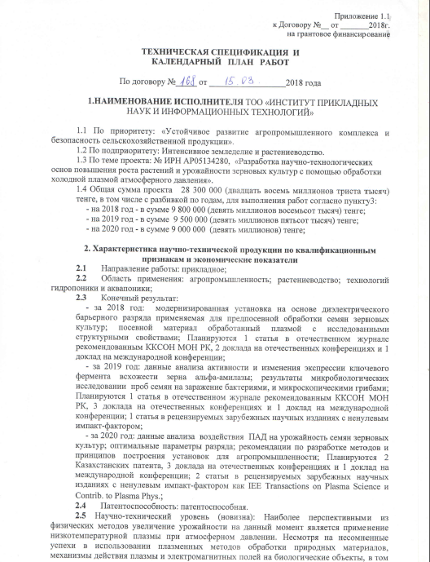
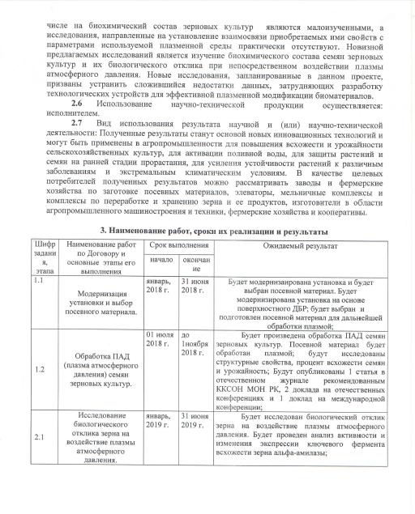
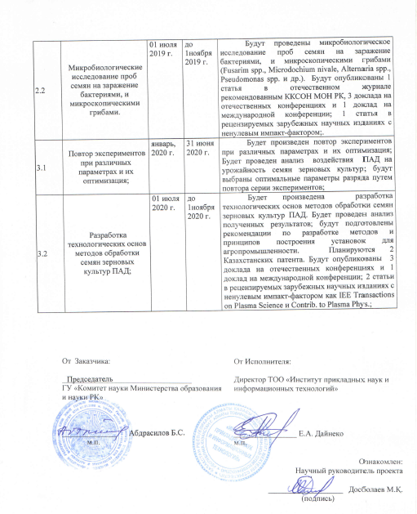
3. Name of work, terms of their implementation and results
Task code, stage |  | Name of work under the Agreement and the main stages of its implementation | Period of execution |  |  | Expected Result
 |  |  | start | ending
1.1 |  | Modernization of the plant and selection of seed. | January 2018 | June 31, 2018 |  | The plant will be upgraded and the seed will be selected. The facility will be upgraded based on surface DBD; seed will be selected and prepared for further plasma processing;
1.2 |  | Atmospheric pressure plasma (APP) treatment of grain crops seeds | July 01, 2018 | November 01, 2018 |  | Treatment of grain crops with atmospheric pressure plasma will be carried out. The seed will be treated with plasma; structural properties, percentage of seed germination and yield will be investigated; There will be published 1 article in a national journal recommended by the Committee for Control in the Sphere of Education and Science of the Ministry of Education and Science of the Republic of Kazakhstan, 2 reports at domestic conferences and 1 report at an international conference;
2.1 |  | Study of the biological response of grain to the effect of atmospheric pressure plasma. | January 2019 | June 31, 2019 |  | The biological response of grain to atmospheric pressure plasma will be investigated. An analysis of the activity and changes in the expression of the key enzyme of grain germination, alpha-amylase, will be carried out;
2.2 |  | Microbiological examination of seed samples for contamination with bacteria and microscopic fungi. | July 01, 2019 | November 01, 2019 |  | Microbiological examination of seed samples for infection with bacteria and microscopic fungi (Fusarim spp., Microdochium nivale, Alternaria spp., Pseudomonas spp., Etc.) will be carried out. 1 article will be published in a national journal recommended by the the Committee for Control in the Sphere of Education and Science of the Ministry of Education and Science of the Republic of Kazakhstan, 3 reports at domestic conferences and 1 report at an international conference; 1 article in peer-reviewed foreign scientific journals with a non-zero impact factor;.
3.1 |  | Repetition of experiments with different parameters and their optimization; | January 2020 | June 31, 2020 |  | The experiments will be repeated with different parameters and their optimization; An analysis of the impact of APP on the yield of grain crops will be carried out; the optimal discharge parameters will be selected by repeating a series of experiments;
3.2 |  | Development of technological foundations of methods for treating grain seeds with atmospheric pressure plasma; | July 01, 2020 | November 1, 2020 |  | The development of technological foundations of methods for treating grain seeds with APP will be carried out. An analysis of the results will be carried out; recommendations will be prepared on the development of methods and principles for constructing installations for the agro-industry. 2 Kazakhstan patents are planned. 3 reports will be published at domestic conferences and 1 report at an international conference; 2 articles in peer-reviewed foreign scientific journals with non-zero impact factor as IEE Transactions on Plasma Science and Contrib. to Plasma Phys .;
 | From customer:  The chairman of SA "Science Committee of the Ministry of Education and Science of the Republic of Kazakhstan"  ______________ B. S. Abdrasilov  signature |  |  |  | From the executor:  Director of LLP "Institute of Applied Sciences and Information Technologies"  ________________ Y.А. Daineko  signature  Familiarized with:  Scientific supervisor of the project  ___________________ T. Т. Daniyarov  (signature)

