


ABSTRACT
Report 58 pages, 8 figures, 2 appendices, 36 sources.
INTELLIGENT SYSTEM, INFORMATION AND COMMUNICATION TRAFFIC, NEURAL NETWORK, PROBABILISTIC-TEMPORAL CHARACTERISTICS, MULTISERVICE NETWORK, THE PROBABILITY DISTRIBUTION
Object of research – the object of research and development of this work is an intelligent system for analyzing and predicting the probabilistic and time characteristics of infocommunication traffic, which will provide normalized indicators of the quality of infocommunication services provided on the telecommunications networks of the Republic of Kazakhstan, increase the efficiency of the modernization process and reduce the cost of developing the telecommunications infrastructure of Telecom operators for the successful implementation of the state program «Digital Kazakhstan».
The purpose of the research - research and theoretical study of the basic aspects of building an intelligent system for analyzing and predicting the probabilistic and time characteristics of info-communication traffic.
Research methods: the general principles of approaches to project development and the use of scientific methods consist in a clear division of common tasks into interrelated components, well-structured in the general distribution of functions and methods. The effectiveness of solving these problems allows to create layouts of individual nodes of the developed system, work out algorithms for their functioning, check the correctness of the selected solutions, integrate the resulting solutions into a single complex and make sure that it is functional and efficient.
As part of the research, it was found that since the uncertainty arising in traffic analysis due to the information observed and received from expert subsystems is not of the nature of «ignorance», but is determined by the degree of probability, it is advisable to use statistical probabilistic methods of information processing in these systems. To ensure the formation of effective solutions in the process of traffic analysis, when developing the structure of the traffic analysis system, it is advisable to use such artificial intelligence subsystems as expert systems and neural networks. Also, it should be noted that expert systems used in traffic analysis systems usually have a significant branching and a small depth of the state space, which allows you to effectively use the search strategy based on the path price criterion.

TABLE OF CONTENTS
INTRODUCTION………………………………………………………………………..…….....5
MAIN PART OF THE RESEARCH REPORT………………..……..………………..…......…..6
1 Research of the possibility of using artificial intelligence systems in information and communication traffic analysis systems. Development of basic technical requirements for the layout of an intelligent infocommunication traffic analysis system………………..……..............6
1.1 Research of decision-making issues in conditions of uncertainty, in relation to the problems of traffic analysis and formation. Research on the choice of search strategy for artificial intelligence systems, in terms of the tasks of analyzing infocommunication traffic……………...………..……………..……………..……………..……………..…………6
1.2 Research on the construction of information and communication traffic analysis systems based on elements of artificial intelligence systems………..…..……....……………..………..22
1.3 Creating a list of technical requirements for an intelligent system for analyzing infocommunication traffic…..……………..……………..……………..………………….......33
CONCLUSION ………………………………………………………………………………….39
LIST OF SOURCES USED……………………………………………………………….….…42
APPENDIX A – List of published works on the project………………………………..……….47
APPENDIX B - Work planned schedule for 2020………………………………………………50

INTRODUCTION
Artificial intelligence is one of the breakthrough directions in the development of digitalization, both in Kazakhstan and Russia, as well as in the entire international community.
According to reports, in the next few years, the telecommunications industry will invest several tens of billions of dollars in artificial intelligence (AI) technologies, software, equipment and services using them. According to experts, in the period from 2016 to 2025, telecommunications service providers will spend about $ 36.7 billion on various AI solutions.
Solutions using artificial intelligence will find their application in forecasting and Analytics systems, network infrastructure management, based on intelligent analysis of traffic flows, and cybersecurity. It is believed that more than 60% of investments will go to these areas.
Other areas of application of artificial intelligence include: implementation of virtual assistants in customer service and marketing departments, creation of intelligent systems for managing customer relationships, predictive maintenance, etc.
Taking into account the above forecasts, the issues of implementing smart search and decision-making strategies, as well as the use of artificial intelligence solutions in traffic analysis and formation systems, as well as their main characteristics, are of great importance in this report.
The entire life cycle of modern and promising multiservice networks, including resource planning, development of technical means, implementation of technical operation measures, and formation of tasks for modernization, is largely based on the results of research on infocommunication traffic. It is obvious that in modern economic conditions it is impossible to conduct the necessary research for decades. For this reason, it is appropriate to solve emerging problems by creating an intelligent system for analyzing and predicting the probabilistic and time characteristics of infocommunication traffic. The proposed approach not only reduces the time of research, but also allows you to use new methodological techniques, as well as promising information technologies, which complements the arguments for the relevance of the chosen field of work.
Research reports - for 2018, inventory number №0219РК00339 and for 2019, inventory number №0218РК01053.
MAIN PART OF THE RESEARCH REPORT
1 Research of the possibility of using artificial intelligence systems in information and communication traffic analysis systems. Development of basic technical requirements for the layout of an intelligent infocommunication traffic analysis system

  - Research of decision-making issues in conditions of uncertainty, in relation to the problems of traffic analysis and formation. Research on the choice of search strategy for artificial intelligence systems, in terms of the tasks of analyzing infocommunication traffic
The functioning of any systems whose ultimate goal is the implementation of tasks related to the analysis and formation of traffic, ultimately, is reduced to a constant decision-making process, based on the available and received information and the accepted rules for processing this information [1-2].
To select the most effective decision-making mechanism that is appropriate to use in these systems, we will consider some provisions of the decision-making theory.
Since the infocommunication system as a whole and all its components related to the formation, a large number of random factors affects transmission and reception of traffic, and the identified patterns are usually statistical in nature, the theory of statistical solutions will be of the greatest interest [32-33].
The decision is the result of the process of processing the received information, according to the established rules. The solution may consist of:
- choosing one of the available alternatives;
- in establishing the fact of existence - there is an object or not (detection);
- rating – selecting a specific value from the possible values;
- In determining whether an object belongs to one of the classes (recognition).
The solution is thus a very general concept. Any problem that arises involves making some decision.

Here are some properties of the decisions made:
- the decision made leads to certain consequences, which can be used to evaluate the quality of the decision. It should be noted that the main task is to choose a solution that would lead to the most favorable consequences;
- the solution is chosen from a set of possible solutions, finite or infinite. Without reducing generality, we can assume that the set of solutions is definite, since new, non-standard solutions can be included in the set of existing ones;
- a decision is made based on the information available at the time of its adoption, which consists of two fundamentally different parts. The first part of it summarizes all past experience, i.e. a priori. The second part – the set of observation data (a posteriori part) - is obtained directly in the decision-making process. The ratio of the volumes of these two parts can vary widely. In particular, one of them may be completely missing;
- the choice of a solution is not always unambiguously determined by the available information - then we are talking about choosing a solution in conditions of uncertainty. Under these conditions, the choice of a solution should be based on an estimate of the probabilities of random events [29]. These are so-called randomized solutions.
Thus, solutions are chosen from a set of options U = {u}. The solution is chosen using data (observations, measurements, samples) Z, all possible values of which make up the set Z = {z}. In this case, there are hidden, unobservable parameters that describe the real situation and take values from the set of all possible situations Y = {y}.
The set of variants of U can be very different, three cases can be highlighted.
a) the solution space U = {u₁, u₂,...} is at most countable. For example, in object detection and recognition tasks.
b) the solution space is continuous (bounded or infinite). For example, in the parameter estimation problem.
C) the space U = {U₁, U₂,..., U_{k}} is discrete-continuous, where all or some of the UIS are continuous. For example, the task of detecting objects and evaluating their parameters.
Decision rules can be non-randomized or randomized.
Non-randomized rules define a well-defined solution for each observation Z. Such rules have the form u = u (z), i.e. they are functions, transformations of z => u. The aggregate of various transformations u (z) forms the set U (z) of all non-randomized decision rules, from which the optimal rule should be chosen.
Randomized rules are determined by setting a conditional probability measure f (u | z) on U, i.e. with the existing observation z0, the solution u is chosen randomly with the probability distribution f (u|z0). The non-randomized rule u (z) is a special, degenerate case of the randomized one, when the measure f (u | z) is entirely concentrated at the point u(z).
The consequences of decision-making should be assessed according to their degree of compliance with the goal. This correspondence, in principle, can be determined using a quantitative measure that determines the losses from the decision made. This measure is called the loss function, which plays the role of an objective function that should be minimized. Minimization of the objective function leads to the choice of the most effective solution.
Losses may depend not only on the decision u made, but also on the actual situation described by the parameters y. It is possible that the losses also depend on observations of z. In general, the loss function has the form g = g (u, y, z).
If the value of y was known, i.e. the real situation is completely determined, then when obtaining the observation z = z0, the optimal solution would be the minimum point u0 of the function g (u) = g (u, y0, z0), i.e. the optimal decision rule would simply be to minimize the known function by u for the given values of its parameter and z. The solution obtained in this way is the best.
In reality, Y are unknown parameters that lead to the uncertainty of the position, i.e. the actual situation can, at best, be known only approximately. In this case, it is no longer possible to find the best solution every time – mistakes due to erroneous estimates are inevitable.
In such a situation, it is advisable to find a decisive rule in which the average losses are minimal, i.e. the average value of the loss function, called risk.
To find the average value of the loss function g = g (u, y, z), you need to set the probability distribution on the space of its arguments U, Y, Z. the Law of probability distribution of possible situations is described by the probability distribution density W(y) on Y.
The observations of z must be related to y in some way, otherwise there is no need for them. The conditional probability distribution density on the observation space Z, which is called the likelihood function, can describe this relationship.
Decisions u are made depending on z, this is the decisive rule. In the most General case, this rule is randomized and determined by a conditional probability measure given by the conditional probability distribution density f (u|z).
Depending on the degree of averaging, different types of risks are considered.
Average risk. If the distribution y and z are known (given the probability distribution densities W(y) and P (z|y)), then for any decision rule f = f(u|z), you can find an unconditional mathematical expectation of the loss function that depends only on this rule and is called the average risk:
Г(ф) = M[g(u,y,z)] = ʃ ʃ ʃg(u,y,z)Ф(u|z)P(z|y)W(y)dudzdy (1)
Optimization of decision-making consists in choosing a rule in which the average risk (1) is minimal.
For non-randomized rules u = u(z), the distribution of f (u|z) is centered at the point u(z), i.e.
Ф(u|z) = δ(u-u(z)) (2)
where-δ () is the Dirac function, and (1) takes the form
Г(u(z)) = ʃ ʃg (u(z),y,z) P(z|y)W(y)dzdy (3)
Expression (3) defines the average risk for any rule u = u (z), and optimization of decision-making consists in choosing a rule in which the risk (3) is minimal.
A priori risk is the value of
G(u) = ʃ ʃg(u,y,z)P(z|y)W(y)dzdy (4)
where u is independent of z. If, in addition, g(u, y, z) = g(u, y), then
G(u) = ʃ ʃg(u,y) P(z|y)W(y)dzdy = ʃg(u,y)W(y)dy (5)
Expressions (4) and (5) define a priori estimate of the losses associated with a decision u made in the absence of observations or when they are ignored. Such a decision can be planned in advance, even before the moment when the decision needs to be made. In this setting, the optimal solution is one that minimizes (4) or (5).
A posteriori risk is the conditional mathematical expectation of the loss function for a given solution and for a given value of z. To do this, we use the Bayes formula to find the posterior conditional distribution y for a given value of z:
W₀(y) = W(y|z) = P(z|y)W(y)/ ʃ P(z|y)W(y)dy (6)
A posteriori risk is determined by averaging the loss function over density (6):
Г(u,z) = ʃg(u,y,z)
W(y|z)dy = ʃg(u,y,z) P(z|y)W(y)dy/ ʃ P(z|y)W(y)dy (7)
Average and posteriori risks are related by the ratio
Г(Ф) = ʃʃГ(u,z)Ф(u|z)P(z)dudz (8)
where
P(z) = ʃ P(z|y)W(y)dy (9)
the absolute density of the probability distribution of observations z in the case of non-randomized rules, the relation (8) takes the form
Г(u(z) = ʃГ(u(z),z)P(z)dz (10)
Conditional risk is the average loss that occurs when using the f =f(u|z) rule for a given y value:
г(Ф,y) = ʃʃ g(u,y,z) Ф(u|z)P(z)dudz (11)
and in the case of a non-randomized rule u=u(z):
г(u(z),y) = ʃg(u(z),y,z) P(z)dz (12)
This risk determines the average loss over all possible observations for a specific decision rule u=u(z) and a specific situation y.
In this section, it was shown that the concept of probability underlies statistical decision - making under uncertainty. Uncertainty arises both because of limited opportunities to obtain reliable information, and because of the lack of certain knowledge. Uncertainty cannot be avoided in complex and dynamic systems.
The use of probability as a model for the uncertainty is already very long ago became the dominant method. The first results of this were promising, but these systems themselves could not be deployed on a large scale due to the exponential number of probabilities that were required in a complete joint distribution (effective algorithms for Bayesian networks were not yet known) [26].
It should be noted that artificial intelligence has considered many alternative approaches that do not involve the use of probabilities [3-4].
Early decision-making systems ignored uncertainty and used strictly logical reasoning, but it soon became apparent that this approach was practically not applicable to most real-world problem areas.
As a result, a number of alternative approaches have been tested.
  - One of the widely held views is that probability theory is essentially numerical, whereas human reasoning, in which one's estimates are expressed, is more of a qualitative nature. Of course, people do not consciously perform numerical calculations with degrees of confidence, but they seem to have the ability to form logical reasoning of a certain type, and it may turn out that numerical estimates of degrees of confidence are encoded directly in the form of the intensities of connections and activation parameters of neurons in the human brain [5-6]. If this is the case, then it is not surprising that it is so difficult for a person to consciously evaluate these intensities. One of the most well-researched approaches is the formation of default reasoning, in which logical conclusions are considered as «being the subject of confidence in their truth until a more significant reason is found for something else to become the subject of confidence in their truth».
  - Another approach relates to the question of ignorance, which should be distinguished from uncertainty. One of the limitations of probabilistic approaches to uncertainty is that they use a single quantitative measure, which can be very difficult to calculate. An alternative approach, called the Dempster-Schafer theory of justification, considers a set of assumptions and assigns to each of them a probability interval of confidence (likelihood), which should belong to the degree of confidence in each assumption. The confidence measure is denoted by bel and changes from zero, which indicates that there is no evidence in favor of a set of assumptions, to one, which means certainty.
Suppose that there are two competing hypotheses, in the absence of information supporting these hypotheses, the confidence and likelihood measure of each of them belongs to the segment [0; 1]. As information accumulates, these intervals will decrease, and confidence in hypotheses will increase. According to the Bayesian approach (in the absence of evidence), a priori probabilities are distributed equally between the two hypotheses. The Dempster-Schafer approach also implies this. Thus, the Dempster-Schafer approach can be very useful when you need to make a decision based on accumulated data.
So the Dempster-Schafer approach solves the problem of measuring confidence by making a fundamental distinction between lack of confidence and ignorance. In probability theory, we are forced to express the degree of our knowledge of the hypothesis h by the singular number P (h). The problem with this approach, according to Dempster-Schafer, is that we simply cannot always know the values of probabilities, and therefore not every choice of P(h) can be justified.
The Dempster-Schafer confidence function satisfies axioms that are weaker than the axioms of probability theory, and reduces to probability theory if all probabilities are known. Trust functions allow you to use existing knowledge to limit the probabilities of events in the absence of accurate probability values.
Consider the coin toss problem. If we know that the coin is genuine, we can reasonably assume that the probability of an eagle is 0.5. If it is known that the coin is fake, but it is not known whether it has two heads or two tails, then the only reasonable solution is to accept the hypothesis of probability 0.5. Obviously, both of these cases are not the same, but probability theory does not seem to allow a distinction to be made between them.
Approaches based on fuzzy logic and fuzzy sets use the concept of ignorance — ignorance of the extent to which an event is true. The subject of fuzzy logic is the learn of reasoning in conditions of fuzziness, blurring, similar to reasoning in the usual sense, and their application in computing systems.
In fuzzy logic, in contrast to classical logic, instead of the values true and false, the value "degree of truth" is used, which takes any values from an infinite set from 0 to 1 inclusive. Therefore, logical operations can no longer be represented in tables. In fuzzy logic, they are defined by functions.
To measure uncertainty, fuzzy logic offers a theory of possibilities, while probability theory allows you to define a measure of randomness.
The theory of fuzzy sets proposed by Zadeh gives a quantitative expression of inaccuracy. To do this, we introduce a set membership function that can take real values in the range between 0 and 1. The concept of a fuzzy set can be described as follows: let S be a set, and s be an element of this set. A fuzzy subset F of a set S is defined by the membership function mF(s), which defines the degree of membership of s to F.
Thus, based on the fact that in systems for generating and analyzing multiservice traffic, the resulting uncertainty caused by the information observed and received from expert subsystems is not of the nature of ignorance, but is determined by the degree of probability, it is advisable to use probabilistic methods in these systems as part of statistical information processing [9, 16, 27].
The main tasks related to the analysis of infocommunication network traffic, such as classification, are essentially the search for the necessary solution among alternative options.
Within the framework of artificial intelligence systems, the state-space search theory justifies methods and strategies for solving problems, and allows you to answer questions such as: is there a guarantee of finding a solution, is the search process finite, is the found solution optimal, and does the search process depend on the execution time [36].
The state-space search theory provides answers to these questions. By presenting the problem as a graph of the state space, you can use graph theory to analyze the structure and complexity of the problem itself, as well as the procedure for finding its solution.
A graph consists of a set of vertices and arcs connecting pairs of vertices. In the model of the state space of the problem to be solved, the graph vertices represent discrete States of the solution process. Graph arcs describe transitions between States. These transitions correspond to logical conclusions or valid moves. So, in expert systems describe the state of knowledge about the problem at a certain stage of the study. Expert opinions in the form of "if ..., then" rules allow you to get new information. In this case, each case of applying the rule is represented as an arc between States.
Let's define some concepts. The state from which the solution of the problem begins is called the initial state.
The set of all States that can be reached from the initial state using all possible sequences of actions is called the state space.
A sequence of vertices leading from the initial state to another in a given state space is called a path.
The length of a path is the number of vertexes on that path.
The process of finding a target state is called a goal search strategy, or goal search.
Success ratings that characterize the effectiveness of the search can be very different. We assume that the success score is a positive number or zero, and the higher the number, the more successful it is.
Then the most obvious assessment is the possibility of achieving the goal at all.
Another estimate may be the cost of the path. The third estimate can be the search price, which is characterized by the amount of time required for the search.
Finally, another measure of success can be the total cost, which is some function of the path cost and the search cost.
The search price depends on many circumstances. For example, the search price may be proportional to the time spent on the search.
The total price may depend on the distance traveled and the time spent searching. Calculating the total price is not an easy task, since the choice of path and, consequently, the distance traveled can be determined by the time spent on the search.
Search strategies differ in the sequence or order of viewing States or sets of States in the space of all States.
State-space search strategies are usually compared based on a number of criteria. The main criteria are as follows.
Completeness: a strategy is complete, if it always provides a solution, if it exists at all in a given state space.
Time complexity: the time required. to find a solution.
Optimality: a strategy is called optimal if it provides a solution that may not be the best, but it is known that it belongs to a certain class or subset. All elements of the strategy have a certain General property, according to which they are referred to as optimal solutions.
Minimality: a strategy is minimal if it is a strategy for finding the best solution. Minimality is thus a special and stronger case of optimality.
Search strategies are divided into two large groups: «blind» search and «directed» search.
Let's take a closer look at the types of strategies that belong to the group «Blind search».

1.1.1 The strategy of blind search
Breadth-first search strategy. One of the most obvious search strategies is called breadth-first search. The search starts from the root vertex, determines all the followers of the root vertex, then all the followers of each of the followers of the root vertex, then all the followers of each of the followers found in the previous step, and so on until all the vertices corresponding to the target States are found. According to this strategy, vertices of depth k are searched after all vertices of depth k – 1 are found.
Figure 1 shows the sequence of finding vertices when searching in width and with the number of followers of each vertex equal to 2. When searching in width, all paths with a length of 1are considered first, then with a length of 2, and so on. It is obvious that a breadth-first search satisfies the criterion of completeness and minimality, since this search considers all paths leading from the initial vertex (state) to all the others.

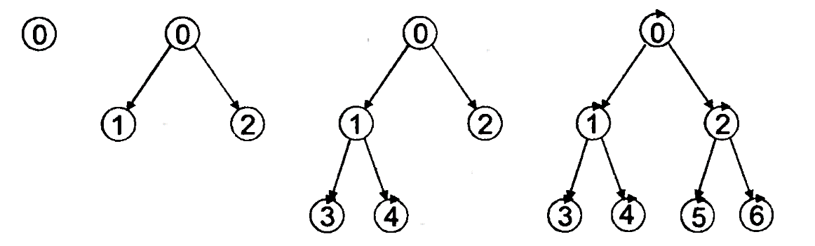
Figure 1 – Breadth-first search strategy
Let's estimate the time and memory spent in the breadth search process. We assume that the number of followers of each vertex is l. Then, at the beginning of the breadth search, we have one initial vertex, then l followers, then l2 followers, and so on.
In general, if the depth of the search tree is k, the number of vertexes studied during the search is equal to 1 + l + l²+ l³+ ...+ l^{k}.
For specific values of l and k, this formula can be used to calculate the maximum number of vertices of the search tree that can be obtained during the search in width.
Naturally, the solution may be found before all the followers are found. However, this value can be reached for some tasks. Usually, instead of this formula, its notation is used in the form of 0(l^{k}), which is called an exponential complexity estimate. If we assume that getting each sequence requires one unit of time, then 0(l^{k}) is a time complexity estimate.
In a breadth-first search, each vertex in the tree must be preserved until the desired solution is obtained. If we assume that this storage requires a unit of memory, then the same formula is also an estimate of the complexity from memory.
The exponential nature of the obtained estimates leads to the following conclusion: the breadth-first search strategy should not be used for solving large-dimensional problems, for example, problems with l > 10.
A strategy for monotonous breadth-first search. A breadth-first search finds the target state that is at the minimum depth of the search tree. However, the minimum price of the path is not guaranteed. Monotone search width is a certain modification of breadth-first search, which consists in the fact that in the process of breadth-first search every time code is determined by the next top of the follower, at the same time the system calculates the price path leading to this vertex. This path price is used to evaluate whether it is appropriate to search for vertices that continue this path by comparing them with other path prices that have already been obtained. If the price of a given path is less than the prices of all these paths, then the search for vertices on this path continues. Otherwise, the search for vertexes on this path is postponed, and the search for vertexes on paths whose price is less than this one continues. When a target vertex is reached on any path, the search for paths whose price is higher than the price of this path stops altogether. all paths that have the same minimum price of paths leading to the target vertex are the solution to the problem.
Search strategy in-depth. When searching in depth, starting from the root vertex (the root vertex is at level 1), all incident vertices of level 2 are considered, starting from left to right. If you can find them among all the target vertex, the search stops if they cannot find all the target vertices, and the maximum tree depth has not been reached, the left-most vertex of level 2 and considers all the vertices incident to her level 3 from left to right. If all the target vertices are still not found after this, then the leftmost vertex from level 3 is taken. Then again, she considers all incident vertices of level 3 from left to right and so as long as either are found, all of target node, or maximum depth of the tree on which in accordance with the procedure viewed all vertices incident to the leftmost vertex of the previous level, and all target is still not found. In the latter case, the tree is climbed one level up, the leftmost vertex is selected at this level, the incident vertices of the next level have not yet been considered, and the search is performed further among the target vertices according to the same principle. And so on until all the vertices of the tree are considered. Figure 2 shows the depth-first search sequence for a tree with three levels and a branching degree of 2. The vertexes in this drawing are numbered according to their viewing sequence.
The memory requirements for depth-first search are significantly lower than for width-first search. As can be seen from figure 2, all vertices that are incident to vertices on the path from the root vertex to any other vertex whose neighboring vertices are considered must be stored in memory. Obviously, for branching degree 1 and tree depth k, the memory complexity estimate for depth-first search is O (/k). The time complexity estimate for depth-first search remains the same as for breadth-first search, namely O(l^{k}).
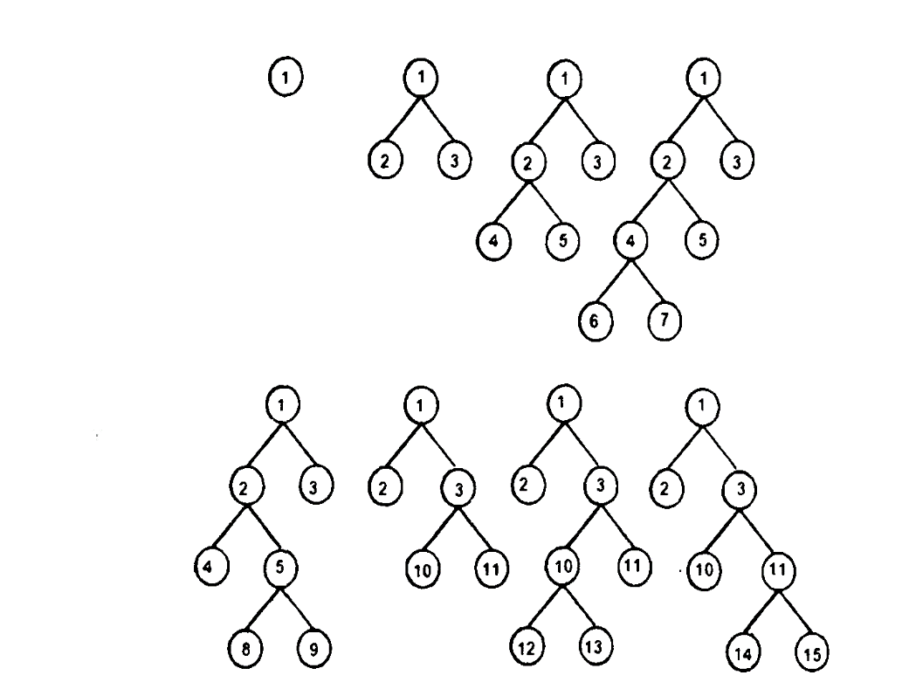
Figure 2 – Depth search strategy
For problems where the search tree is finite and the number of goals is relatively small, depth-first search may be effective, since it has a chance to find this small number of goals without looking at all the vertices. for problems with a large or even infinite depth of the tree, depth-first search may be extremely inefficient, since it will always go deep, while the goal may be close to the root of the tree, but on a path that has not yet been viewed. The search goes down all the time and in the case of an infinite depth of the tree, it may never go back to viewing the vertices among which the target ones are located. As a result, you should avoid using depth-first search to solve problems with large or infinite tree depth. Depth-first search, therefore, is neither complete nor optimal.
Limited depth search strategy. Restricted depth-first search is a special case of depth-first search. This search uses a limit on the search depth.
With a limited depth search, as soon as the level that matches the specified number is reached, a return occurs, just as it is done with a normal depth search. Restricted depth - first search is complete if the search depth limit is selected so that all tree vertexes can be viewed.
The time and memory complexity estimates for a limited depth-first search are the same as for a normal depth-first search.
Iterative depth-first search strategy. For a limited depth-first search, the complexity of the search depends on the choice of restriction. For example, when searching, you can use the maximum number of vertexes that can occur at each stage. This number is called the search radius.
Knowing the search radius leads to a more efficient limited depth-first search. However, in most problems, the search radius is not known until the problem is solved. Iterative depth-first search uses a strategy based on iteratively applying a restricted depth-first search for a search radius of O, then 2, then 3, and so on.
Figure 3 illustrates four iterations of such a search for a binary tree.
Iterative search in zx6 may seem very inefficient, since some vertexes are viewed multiple times, but for many tasks, the vast majority of vertexes are at a low level.
Recall that the time complexity estimate for a limited depth-first search is calculated using the formula:
О(l^{k}) == 1 + l + l² +.... + l^{k-2} + l^{k-1} + l^{k}.
For example, for l= = 10, k = = 5 we will have O (lk) = = 111111. When iteratively searching for depth k, the vertices of depth k are viewed once, depth k -1 twice, depth k-2 three times, and so on. The root vertex is viewed k + 1 times. Thus, the time complexity estimate for iterative depth-first search is calculated using the formula:
O (l^{k}) = (k + 1) l⁰ + (k) l¹ + (k -1) l²+ ,... + 3 l^{k-2} + 2 l^{k-1} + 1 l^{k}
For l== 10, k = 5 we will have O (l^{k}) = 123456.
Compared to the time complexity estimate for limited depth-first search, the time complexity for iterative depth-first search increased by only 11%. The formula above shows that the higher the degree of branching, the lower the proportion of complexity obtained by repeated vertex viewing. But even for the case where l = 2, the time complexity of iterative depth-first search is only twice as high as the time complexity of simple depth-first search. This means that the complexity estimate for the iterative depth-first search time is still О(l^{k}), and the memory complexity is O(lk). Iterative depth-first search has proven itself quite well for tasks with a large search space and unknown depth.
Bidirectional search strategy. The idea of bidirectional search is based on using two strategies at once: direct search from the root vertex and reverse search from the target vertex. The search process stops when both of these processes meet in the middle of the depth. If we assume that the degree of branching in direct and reverse search is the same, then the time complexity estimate for bidirectional search will be О (l^{k/2}). This estimate is significantly better than the same one for the search strategies considered.
However, this is true, provided that the goal is only one, the degree of branching and the complexity of finding followers and predecessors is the same. When solving practical problems, this condition may be violated. In addition, there may be other problems. For example, determining whether the same vertex appears in both halves of the search may require a significant amount of effort and complexity. If all these problems can be solved in a constant time that does not depend on the number of vertices, then the complexity estimate for the bidirectional search time will remain equal to О(l^{k/2}).
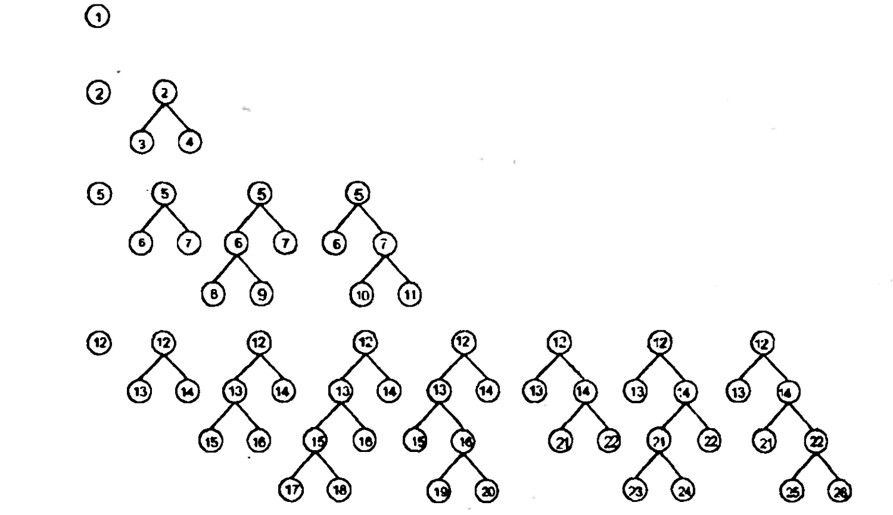
Figure 3 – Iterative depth-first search
Comparison of search strategies. The characteristics of the strategies considered, where l is the degree of branching, k is the search depth, d is the maximum depth of the search tree, and d is the limit on the search depth, are shown in figure 4.
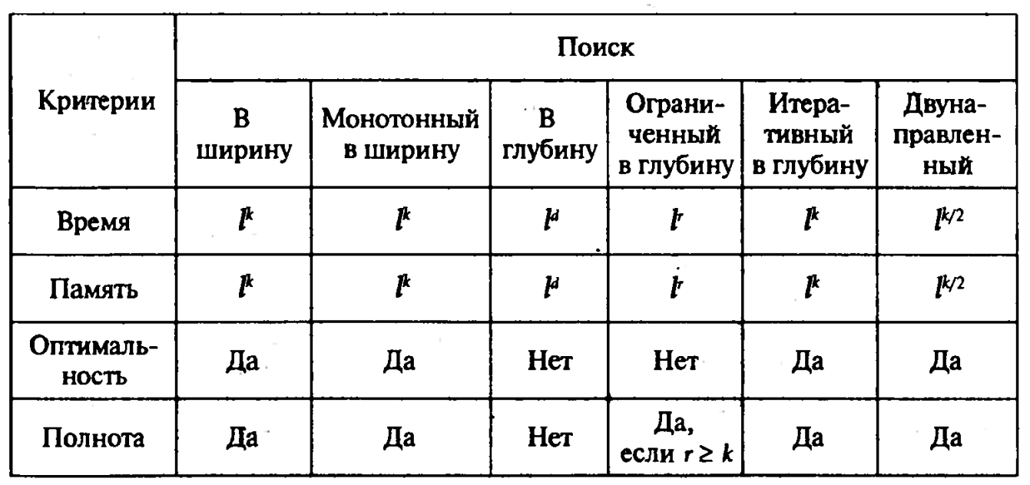
Figure 4 – Comparison table
Now let's look at the strategies related to the «Directed search» group.

1.1.2 Directed search strategies
All blind search strategies have exponential complexity estimates for search time, and some for memory, and, as a result, are suitable for solving relatively small tasks. In blind search strategies, the knowledge used when selecting the next vertex determines only the General selection order and does not take into account the quality of the selection, for example, the complexity of searching for the target vertex.
In directed search strategies, the knowledge used to select the next vertex is deeper and uses special functions called criteria. If a criterion can be calculated for each vertex participating in the search, and the set of all vertices is ordered by this criterion, then the next vertex is selected according to the value of this criterion. The better the value of the criterion, the better the choice.
In other words, from the set of alternative vertexes, the one for which the criterion has the best value is selected. This is why these types of selection strategies are called best-case selection strategies. Criteria are usually chosen in such a way as to optimize the complexity of the search, find the optimal solution, or achieve both. Let's look at some strategies for directed search that use additional knowledge to reduce the complexity of the search.
Search strategy based on proximity to the goal. The criterion for proximity to the target is usually a numerical function h(b) ≥ 0, calculated for vertex b and characterizing the proximity of this vertex to the target. When using the criterion of proximity to the goal, starting from the root vertex, all neighboring vertices are viewed, the one for which h(b) is minimal is selected, and everything is repeated again for the selected vertex.
And so on until the target vertex is reached, i.e. the vertex that is closest to the goal is selected.
A search based on the criterion of proximity to the goal is a depth-first search, but with the choice of a single vertex at each step, from which the next step begins. The disadvantages of this strategy are the same as for blind depth-first search, namely, it is suboptimal and incomplete, since it may happen that the search will go on an infinite path and never come back.
The time complexity estimate for this search strategy is O(ld), where d is the maximum depth of the search space. When searching for the criterion of proximity. the goal has to store all the vertexes that are considered during the search. Therefore, the memory complexity score for this strategy is the same as the time complexity score. If the criterion of proximity to the goal is chosen well enough, the complexity of the search can be significantly reduced.
Search strategy based on the path price criterion (A * - search). Let's denote g (b) the criterion for the price of the path from the root vertex to vertex b, and h(b) the criterion for proximity to the goal already considered. Let both criteria have the same dimension. The function f(b) = g(b) + h(b) can be considered a criterion for the price of the path from the root vertex to the target vertex. Using this criterion, you can find paths with the lowest price. Let's consider a search strategy based on this criterion and show that it will be complete and optimal if we introduce small restrictions on the h(b) criterion. The idea of this restriction is to select the h(b) criterion in such a way that it does not overestimate the proximity to the goal, the h(b) Criterion selected in this way is called acceptable. A search strategy that uses the f(b) criterion and the valid h(b) criterion is known as A *– search.
The meaning of this criterion is that it takes into account not only the distance from one vertex to another, but also the degree of complexity of the transition, for example, not only the distance between points, but also the quality of the road between them.
Keep in mind that on any path from the root vertex, the value of the f(b) criterion does not decrease anywhere when moving to the next vertex. This is not an accident and is true for almost all acceptable criteria of h(b) proximity to the goal. Criteria f(b) for which this property holds are called monotone. If the monotony is broken, this violation can be eliminated by minor correction.
The solution obtained using A * search is optimal, since there is a vertex with the maximum value of f(b), and, consequently, the maximum g(b), since h(b) = 0.
the Strategy of optimizing iterative search. In many problems, the search for the target state in the state space is set as the task of finding the state that is, in a certain sense, the best. However, the cost of finding a goal doesn't really matter, as long as it can be achieved in a reasonable amount of time and memory.
The idea of optimizing iterative search becomes clear if we assume that States are points on the surface of a mountain landscape. The higher a point is above sea level, the better the state it represents. The points corresponding to the peaks are the optimal points. The task of optimizing iterative search is such an order of viewing points, or otherwise such a movement on the surface of the landscape, in which the optimal points are eventually reached.
There is a wide variety of procedures for optimizing iterative search. One of these procedures is gradient search. The idea of gradient search is extremely simple - to move in the upward direction, starting from some initial state. The search tree is not stored, but only the last found state b and its quality score L(b) are stored. If there are several States with the same quality rating, one of them is usually selected.
Gradient search in its pure form has three known disadvantages.
- if there are several vertexes, then after climbing one of them, the search process will stop, assuming that the goal has been achieved, although the reached vertex is only a local optimum and is far from the best.
- if the landscape has a plateau, the search process becomes random.
- if the landscape has ridges (ridges) with a slight slope, then easily reaching the ridge, the search process can take a very long time to go along the ridge until it reaches the optimal top.
After stopping the gradient search process, the next iteration begins with a different initial state, and the optimal state Is found until the best state is found.
This iterative search process is performed a finite number of times or until a suitable solution is found.
It is clear that if we conduct a sufficient number of such iterations, the optimal solution will eventually be found. The success of gradient search strongly depends on the type of state space. If the number of local minima is small, the optimal solution will be found relatively quickly.
Of course, the choice of the most effective search strategy depends on the specific task to be solved, the requirements of the available resources and capabilities.
However, since such components of artificial intelligence systems as neural networks and expert systems are widely used in traffic analysis tasks, some conclusions can be drawn a priori.
A significant part of the algorithms used in training neural networks is occupied by various algorithms based on the strategy of optimizing iterative search, the so-called «gradient descent algorithms». This fact makes it possible to highlight this strategy for information and communication traffic analysis systems.
In addition, expert systems used in traffic analysis systems usually have a significant branching and a small depth of the state space, which allows you to effectively use the search strategy based on the path price criterion.

1.2 Research on the construction of information and communication traffic analysis systems based on elements of artificial intelligence systems
Artificial intelligence provides tools for solving problems that are difficult or irrational to solve using other methods.
In the field of artificial intelligence, the development of intelligent systems is carried out, the purpose of which is complex tasks, where logical information processing prevails over computing. These tasks, in particular, are characterized by the fact that decisions sometimes have to be made in a limited time.
The infocommunication traffic analysis system may include at least two subsystems that are actually subsections of artificial intelligence.
This is an expert subsystem based on the traffic knowledge base that allows you to form decisions using logical search and structured knowledge extraction methods, and a subsystem for rapid decision-making based on neural network technologies.
Let's look at them in more detail. With the development of computer technology, information structures for data representation were developed. We can say that data are facts that characterize objects, processes, and phenomena in the subject area, as well as their properties. There are different ways to describe data, lists, and hierarchical structures.
The next step was the introduction of databases. Large amounts of information can be stored in the database at the same time, and special tools - the DBMS database management system, allow you to efficiently extract them from the database or write them to the database in the desired order, search for data, etc.
As intelligent systems developed, the concept of knowledge emerged. Knowledge is related to data and is based on it, but, unlike data, it represents the result of intellectual activity and summarizes existing experience.
We can say that knowledge is the identified patterns of the subject area (principles, relationships, laws). The knowledge base is a necessary component of artificial intelligence systems.
Any knowledge base contains a database as a component, but it is not reduced to it at all. The main difference between a knowledge base and a database is that only the actual information that is embedded in it can be extracted from the database, whereas new facts can be derived from the knowledge base that were not directly embedded in it. Knowledge bases are represented by special languages based on symbolic representation of data. Currently, the most popular languages are Lisp and Prolog, whose rules are one of the ways to represent knowledge.

1.2.1 Knowledge representation
Knowledge representation is a set of syntax and semantics conventions that describe objects. A good rule of thumb when designing a knowledge representation is to organize knowledge in a form that allows easy access using simple and natural mechanisms.
There are various models of knowledge representation, mainly they can be subdivided as follows:
Semantic networks are a directed graph with vertices representing concepts and arcs representing relationships between them. Concepts are usually objects, and relationships are relationships of the type: «this», «has a part», «belongs», and so on.
A characteristic feature of semantic networks is the mandatory presence of three types of relationships:
- class-class element;
- property-value;
- an example of an element class.
The problem of finding a solution in a knowledge base such as a semantic network is reduced to finding paths on the graph that allow you to get from the vertices with the original data to the vertices with the desired values. This search can be automated.
The output (production) of new knowledge in the semantic network can be carried out in two directions: from known data to the goal, or, conversely, from the goal to known data. The first method is called direct search, and the second is called reverse search.
The main drawback of this model is the complexity of the output search procedure on the semantic network.
A frame is a unit of knowledge representation filled in in the past, the details of which are changed and refined as necessary in relation to the situation.
From the user's point of view, there are three levels of frame generality:
1) a skeletal, empty frame (template) that turns into a general or specific concept after it is filled in;
2) a general concept frame is a template filled with variables rather than specific values;
3) a specific concept frame (instance) is a prototype filled with specific values.
The frame description consists of a series of descriptions called slots. Each slot is designed to be filled with a specific data structure. The slot value can be: numbers, mathematical relations, natural language texts, programs, output rules, links to other slots of this frame or other frames.
When a frame is specified, it and its slots are assigned specific names and the slots are filled with their values. The transition from the original prototype frame to the instance frame can be multi-step, carried out by gradually refining the slot values.
Frame models can be considered as a semantic network with a block structure.
The main advantage of frames as a model of knowledge representation is the ability to reflect the conceptual basis of the organization of concepts.
Formal logical models - models of this type are based on a formal system defined by a set of four sets of the form: M = <T, R, A, B>.
Here, the set T is a set of basic elements of different nature (for example, words from a limited dictionary). It is important that for a set T, there is some way to determine whether an arbitrary element belongs to this set or not. The procedure for such a check can be any, but in a finite number of steps it must give a positive or negative answer to the question: is x an element of the set T? Let's denote this procedure as P(T).
The set P is a set of syntactic rules. They are used to form syntactically correct aggregates from the T elements. for example, syntactically correct phrases are constructed from words in a limited dictionary. It also declares the existence of a procedure P(R), which in a finite number of steps can be used to get the answer to the question: is the set X syntactically correct?
In the set of syntactically correct aggregates, a subset A is distinguished, the elements of which are called axioms. As for other components of a formal system, there must also be a procedure P(A), by which for any syntactically correct set you can get an answer to the question of whether it belongs to the set A.
The set B is a set of inference rules, applying them to the elements of A, you can get new syntactically correct aggregates, to which you can apply the rules from B again, and so on. This is how the set of aggregates derived in this formal system is formed. If there is a procedure P (B) that can be used to determine for any syntactically correct set whether it is deducible, then the corresponding formal system is called solvable. This shows that the inference rule is the most complex component of the formal system.
For knowledge included in the knowledge base, we can assume that the set A is formed by all information units that are entered into the knowledge base from outside, and new derived knowledge is derived from them using inference rules. In other words, a formal system is a generator for generating new knowledge that forms the set of knowledge deduced in this system. This property of logical models makes them attractive for use in knowledge bases. it allows you to store only the knowledge that forms the set A in the database, and get all other knowledge from them according to the rules of inference.
Product models - allows you to present knowledge in the form of sentences like: "If a condition, then an action." Here, a condition is defined as a certain sample sentence that is used for searching in the knowledge base, and an action is defined as actions performed when the search is successful (they can be intermediate, also acting as conditions, or target, which terminates the system).
When using a product model, the knowledge base consists of a set of rules. The program that controls the iteration of these rules is called an output machine. Most often, the output is direct (from the data — to the goal search) or reverse (from the goal, to confirm it, to the data).
The output machine performs two functions:
- view existing facts (from working memory) and rules (from the knowledge base) and add new facts to working memory;
- define the order in which rules are viewed and applied.
The action of the inference machine is based on applying the following rule: if it is known that statement A is true, and there is a rule of the form "if A, then B", then statement B is also true.
The rules are triggered if facts are found that satisfy their left side: if the premise is true, then the conclusion must also be true.
The control component of the output machine determines the order in which rules are applied and performs the following four functions:
- comparison-the sample rule is compared with the existing facts;
- selection – If multiple rules can be applied, only one of them is selected based on some criteria;
- triggered – if a sample rule matches a fact, this rule is triggered;
- actions – the conclusions of the triggered rule are added to the working memory.
These actions are repeated cyclically until we get a terminal rule or there are no more matches.
The output machine operation cycle is shown in figure 5.
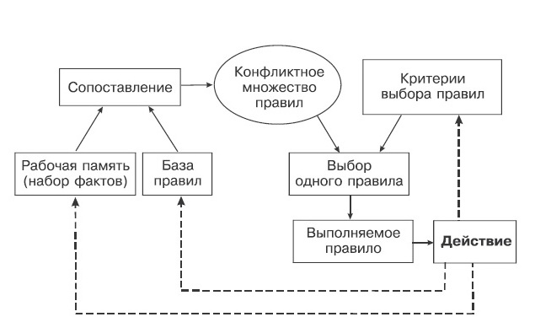
Figure 5 – The operating cycle of the machine output

The production model is most often used in industrial expert systems. It is characterized by clarity, high modularity, ease of making additions and changes, and simplicity of the logical inference mechanism [10-11].

1.2.2 Expert system

Expert systems is an area of research in the field of artificial intelligence to create systems that can make decisions similar to those of experts in a given subject area [20-23].
Expert systems are a software subsystem that models the reasoning of a human expert in a certain area and uses a knowledge base containing facts and rules known in this area and a special logical inference procedure.
As a rule, expert systems are created to solve practical problems in some highly specialized areas, where the knowledge of «experienced» specialists plays an important role.
Expert systems have one big difference from other artificial intelligence systems: they are not designed to solve any universal problems, such as neural networks or genetic algorithms. Expert systems are designed to solve problems in a specific area, in rare cases – areas.
The foundation of any type of expert system is the knowledge base, which is compiled on the basis of expert knowledge of specialists, so the value of the entire expert system as a finished product is 90% determined by the quality of the created knowledge base.
Expert systems can be used to solve a wide range of tasks, but usually in those subject areas that are characterized by the most clear decision-making strategies.
A typical expert system consists of at least the following main elements:
- solver;
- data base;
- knowledge base;
- subsystem of knowledge acquisition.
The database is intended for storing source and intermediate data of the currently solved problem.
The knowledge base is the main, Central part of the expert system. It contains long-term data and rules that describe relationships, methods, and knowledge to ensure appropriate data transformation, i.e., to solve problems from the field of application of the expert system.
The solver, using the source data from the database and knowledge from the knowledge base, forms a sequence of rules that, when applied to the source data, lead to the solution of the problem.
The knowledge acquisition subsystem provides an interface for implementing the process of filling the expert system with knowledge.
Expert systems can be classified according to a number of different criteria.
- for the problem being solved. The most common tasks are interpretation, diagnostics, monitoring, forecasting (making forecasts with probabilistic estimates), planning, and training. It is also possible to combine these tasks;
- relation to real time. Static expert systems are used in areas where the knowledge base and interpreted data are stable and do not change over time. Quasi-dynamic expert systems are designed for a situation that changes with a certain fixed time interval. Dynamic expert systems work in real time and constantly interpret incoming data;
- by the degree of integration with other programs and systems. They are divided into Autonomous expert systems that work directly in the user consultation mode and hybrid expert systems that are built-in complexes that interact with other subsystems and standard application software packages.
Thus, the use of an expert system in traffic analysis systems makes it possible to make effective decisions on traffic classification and recognition based on the received (observed) information about traffic and the rules and strategies of its processing embedded in the knowledge base. It should also be noted that the development of expert systems involves a number of difficulties related to the fact that:
- transferring "deep" domain knowledge to expert systems is a big challenge. As a rule, this is a consequence of the complexity of formalizing the heuristic knowledge of experts.
- expert systems are unable to provide meaningful explanations for their reasoning, as a person does. As a rule, expert systems only describe the sequence of steps taken in the process of finding a solution.
- Debugging and testing any computer program is quite time-consuming, but checking expert systems is especially difficult.
- In order to keep expert systems up-to-date, continuous intervention in the knowledge base of knowledge engineers is necessary.
In conclusion, it is worth noting that despite these limitations, expert systems have already proven their value and relevance in many important applications, including teletraffic analysis [19, 34-35].

1.2.3 Neuronet technology
Another basic direction in the development of artificial intelligence is based on an attempt to create a neural model of the brain, which is based on a mathematical interpretation of the activity of the nervous system (primarily the human brain).
This is their difference from expert systems, which were based on modeling the human decision-making process by using the laws of formal logic, set theory, graphs, semantic networks, and other scientific achievements in the field of discrete computing [28].
Artificial neural networks are induced by biology, since they consist of elements whose functionality is similar to most of the elementary functions of a biological neuron. These elements are then organized in a way that can match the brain's anatomy [3].
Despite these superficial similarities, artificial neural networks exhibit a surprising number of brain-specific properties, such as learning from experience, generalizing previous cases to new cases, and extracting essential properties from incoming information.
Training. Artificial neural networks can change their behavior depending on the external environment. After the input signals are provided (along with the required outputs), they self-tune to provide the required response. There are many training algorithms, each of which has its own advantages and disadvantages.
Generalization. Networks after training may show a lack of response to small changes in input signals. This is, in fact, the internal ability to recognize an image through noise and distortion. It is important that an artificial neural network provides generalizations due to its structure, and not using specially written programs.
Applicability. Artificial neural networks are not a panacea. They are of little use for many tasks that are strictly computational in nature. However, they will be preferred in a large class of image recognition tasks that are poorly handled by conventional computers.
For the practical use of neural networks, the actual modeling of the brain has faded into the background. There was not much progress here, even the most powerful Neurocomputers are incomparable to the ant's nervous system. Thus, the identification of artificial intelligence with human thinking can only be very conditional [30-31].
Perhaps their greatest similarity is their ability to make mistakes. Human self-knowledge is slower than the development of artificial intelligence technologies, which have become an independent scientific field (although the scientific terminology itself retains the «humanoid» style — «fuzzy logic», «genetic algorithms», etc.).
In recent years, there has been an explosive interest in neural networks, which are successfully used in various fields, in particular, in the field of telecommunications. Neural networks have become common practice wherever you need to solve forecasting, classification, or management problems. it should be noted that these aspects are inextricably linked to traffic analysis [24-25].
There are several reasons for this.
- Broad opportunities. Neural networks are an extremely powerful modeling method that allows you to reproduce extremely complex dependencies.
- Easy to use. Neural networks are trained using examples. Representative data is selected, and then runs a learning algorithm that automatically perceives the data structure. At the same time, the user, of course, needs some set of heuristic knowledge about how to select and prepare data, choose the necessary network architecture and interpret the results, but the level of knowledge required for successful application of neural networks is much more modest than, for example, when using traditional statistical methods. Neural networks are also attractive from an intuitive point of view, because they are based on a primitive biological model of nervous systems. In the future, the development of such neurobiological models may actually lead to the creation of thinking computers. Neural networks have emerged from research in the field of artificial intelligence, namely from attempts to reproduce the ability of biological nervous systems to learn and correct errors by modeling the low-level structure of the brain.
The human brain consists of a very large number (approximately 10,000,000,000) of neurons connected by numerous connections (on average, several thousand connections per neuron, but this value can vary greatly).
A neuron is a special cell that can transmit electrochemical signals. When activated, the neuron sends an electrochemical signal along its axon, and through synapses this signal reaches other neurons, which can, in turn, be activated. A neuron is activated when the total level of signals coming to its core from dendrites exceeds a certain level (activation threshold).
Thus, being constructed from a very large number of very simple elements (each of which actually calculates a weighted sum of input signals and if the total input exceeds a certain level, then transmits a binary signal further), the brain is able to solve extremely complex problems.
Artificial neural networks are an ordered community of artificial neurons. Each artificial neuron is a simplified model of a biological neuron [7]. An artificial neuron consists of an input adder, a nonlinear Converter, and a branch point at the output (figure 6).
The functioning of an artificial neuron can be described as follows.
- it receives input signals (input data or output signals from other neurons in the neural network) through several input channels;
- each input signal passes through a connection that has a certain intensity (weight) corresponding to the synaptic activity of a biological neuron;
- each neuron has a specific threshold value associated with it. The weighted sum of the input signal values is calculated, the threshold value is subtracted from it, and the neuron activation value is calculated;
- the activation signal is converted by the activation function to the output signal of the neuron.

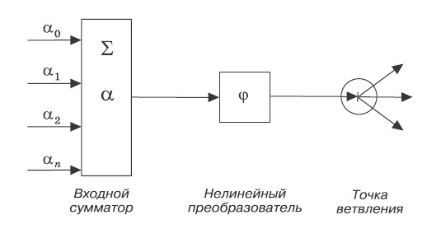
Figure 6 – Artificial neuron
As already mentioned, a neural network is an ordered connection of individual neurons. Orderliness consists in the fact that neurons are combined into layers. The outputs of some neurons are connected to the inputs of others, and the inputs of neurons are assigned certain weights, in accordance with the model of an artificial neuron. Signals that determine the input data of the problem to be solved are sent to the inputs of neurons in the first layer. These signals are summed, taking into account the weights assigned to the neuron inputs, that is, taking into account the significance of each input, and transmitted to the inputs of the next layer of neurons. The signals generated by the neurons of the last (output) layer are interpreted as a solution to the problem.
By architecture, neural networks are divided into single-layer and multi-layer [8].
In single-layer neural networks, signals from the input layer are immediately fed to the output layer. It performs the necessary calculations, the results of which are immediately fed to the outputs. It should be noted that single-layer networks have limited functionality, in contrast to the widely used multi-layer networks.
In multi-layer networks, neurons are grouped into layers. In addition to the input and output layers, there are internal layers that are called hidden. The number of hidden layers is unlimited. if there are more than 1 hidden layers, the neural network is considered deep.
Multi-layer networks with direct signal propagation effectively solve problems in which the input vector completely defines the task, and the solution does not depend on the background. Although such networks are a universal tool, however, the main purpose of these networks is to solve classification problems.
Feedback networks (recurrent networks) – allow you to process information in which not only the content is important, but also the order of its receipt. The main direction of using such networks is clustering tasks.
Convolutional neural networks-got their name because of the "convolution" operation they implement. The main purpose of convolutional neural networks is pattern recognition.
To get reliable results, before using it, it is necessary to conduct a training procedure for the neural network, during which the weights of the inputs of neurons are adjusted so that the correct response is formed to the incoming input data.
There are two main methods of training neural networks – «with a teacher» and «without a teacher».
The method of learning with a teacher assumes that during training there are many pairs of vectors {(X, Y)}, where x_{i} is one of the vectors that define the problem condition, and y_{i} is a known solution for the vector x_{i}. During training, the network changes its weights to form the desired x →y mapping. Note that the size of the set {(X, Y)} must be large enough.
The unsupervised learning method is used when only the input vectors are known. When these vectors are presented, the network self-organizes, adjusting its weights so as to generate the same results for sufficiently close input values. In fact, the neural network searches for patterns in the training data and groups similar input vectors by implicit features.
These methods are implemented in a very large number of different specific algorithms, each of which uses its own search strategies.
Different algorithms are based on the following basic rules:
Error correction-refers to the method of learning with a teacher. Using the appropriate optimization procedures, a pre-set objective function is minimized that characterizes the correct operation of the network.
Boltzmann training-this rule is based on a stochastic algorithm that follows the principles of theoretical thermodynamics. The goal of Boltzmann training is to adjust the weights so that the States of the neurons satisfy the desired probability distribution determined based on the Boltzmann probability function:
Рk=1 / (1 + ехр (- Е_{k} / t))
where t – the analog of the thermal noise level, and Ek is the sum of the weights of the connections of the k-th neuron with all currently active neurons [12-14].
Habb training is based on the neurophysiological postulate that if neurons on both sides of the synapse are in an excited state, the weight of the connection between them increases, but if neighboring neurons are in different States, the weight of the connection between them decreases.
Competitive learning-a feature of this rule is the process of firing output layer neurons in accordance with the «winner takes all» principle. This means that when any input vector is fed, only one neuron of the output layer is always excited.
Based on the results of the analysis of neural network models, and taking into account that the main predicted task in the research is classification, we can conclude that it is advisable to use multi – layer neural networks with direct signal propagation in traffic analysis tasks.
Taking into account the above statement, a neural network was developed to determine the closest type of distribution of probability characteristics of the analyzed traffic.
The following neural network architecture was chosen: the input layer, in accordance with the dimension of the input signal, contained 51 neurons, two hidden layers with 20 and 10 neurons, respectively, and the output layer with five neurons, according to the number of recognized types of distributions.
The neurons in the layers were connected to each other on the principle of «each with each». All connections of two neurons were assigned a certain weight coefficient, which was then adjusted by the network during training. The hidden layers used the sigmoid activation function, and the output layer used the softmax activation function. This function generates the values of the output vector in the range from 0 to 1, which makes it possible to interpret the values of the output vector as the probability of the input signal belonging to one of the assumed distributions, which, after appropriate analysis, were chosen as the Poisson distribution, normal distribution, Weibull distribution, Pareto distribution and hyperexponential distribution. For training, we used pre-formed training and test samples containing 30 thousand input vectors of each of the specified distributions.
When the input of the neural network vectors obtained in accordance with the available statistical data, a signal is generated at the output corresponding to the Pareto distribution, which is consistent with the theoretical assumptions. The remaining outputs of the neural network, respectively, form zero values.
To verify the result of the neural network operation, the least squares method was used to evaluate how closely the Pareto distribution approximates the traffic characteristic under study compared to other distributions under learn [17-18].
The results obtained showed a satisfactory quality of the work developed and trained in the framework of the conducted research of the neural network.

1.3 Creating a list of technical requirements for an intelligent system for analyzing infocommunication traffic
The conducted research has shown the possibility and feasibility of creating an intelligent system for analyzing infocommunication traffic and allowed us to formulate the main technical requirements for it.
The infocommunication traffic analysis system should provide analysis of passing traffic by the following characteristics:
- flow rate;
- by the ratio of transport protocols used;
- by the ratio of high-level protocols;
- by IP addresses and port numbers;
- by the ratio of encrypted and unencrypted streams;
- by distributions of the main probabilistic characteristics of traffic, such as the intervals between packets, the duration of TCP sessions, and the amount of information transferred in the session;
- for traffic-generating applications;
- by traffic profiles stored in the system.
The infocommunication traffic analysis system generates profiles of typical traffic, stores them, and provides comparison of passing traffic with stored profiles and their combinations.
The infocommunication traffic analysis system should provide statistical processing of the received data, their systematization and visualization.
The infocommunication traffic analysis system must store the results of the analysis for a specified time and transmit them to authorized operators upon request.
The infocommunication traffic analysis system should generate short-term and long-term forecasts of the expected traffic behavior based on the accumulated data.
The infocommunication traffic analysis system must ensure the protection and confidentiality of stored information.
The infocommunication traffic analysis system must implement end-to-end skipping of the analyzed traffic or its mirroring according to the specified parameters.
The infocommunication traffic analysis system should provide the possibility of parallel connection to the analyzed network section.
The infocommunication traffic analysis system should be able to synchronize the built-in time scale with the national UTC (SU) time scale.
The infocommunication traffic analysis system should provide round-the-clock operation.
The implementation of the infocommunication traffic analysis system must meet the current state of the art and guarantee stable and reliable operation.
The infocommunication traffic analysis system should include elements of artificial intelligence systems, such as expert systems and neural networks.
Based on the technical requirements for an intelligent infocommunication traffic analysis system, a simulator layout was developed for learnying the traffic properties of multiservice networks desktop network simulator «Traffic».
Figure 7 shows the composition and structure, as well as a description of the work of a desktop network simulator for learning the properties of traffic in multiservice networks of the desktop network simulator «Traffic».
The «Traffic» desktop network simulator is designed to learn the properties of traffic circulating within multiservice communication networks [15]. The desktop network simulator «Traffic» can be used both on real communication networks and on network models formed in accordance with the specified structure and parameters, for which it includes a network model generator. The desktop network simulator «Traffic» is able to form a model of an arbitrary topology with specified characteristics that may change during testing, which is important for learning the impact of potential changes in the reliability and survivability indicators of the technical means used on traffic parameters.
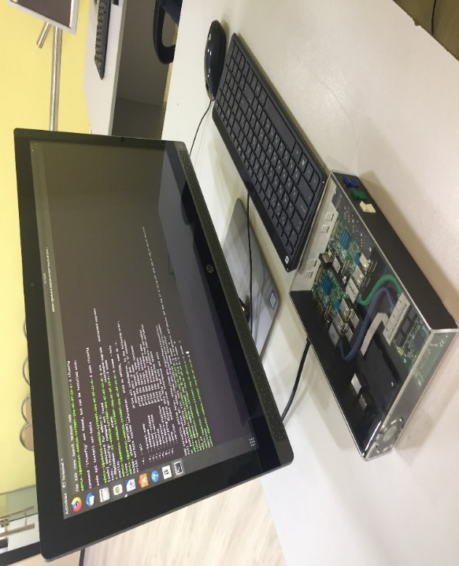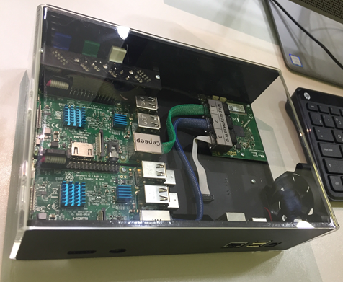
Figure 7 – Simulator layout for learning the traffic properties of multiservice networks of the desktop network simulator «Traffic»
In addition to the network model generator, the desktop network simulator «Traffic» includes two more main elements: a traffic generator and a traffic analyzer. In addition, the desktop network simulator «Traffic» can include a mirroring block that is installed on the border of the network under study and provides reception and selection of the control packet flow, including its own time stamp in the technological label and redirecting this packet flow to the traffic analyzer of the desktop network simulator «Traffic». This methodology makes it possible to effectively assess the impact of the parameters of the network under learn on the traffic circulating in it.
The traffic generator of the desktop network simulator «Traffic» allows you to generate request flows with different probability distribution laws. The task of the generator is to simulate the traffic flow based on the specified parameters of a random process and send it to the specified address and port. The UDP transport Protocol is used for data transmission. The payload header of the packet includes a process label that includes the sequence number of the packet in the stream and the timestamp for sending the packet.
The peculiarity of the traffic generator implementation is that to ensure the necessary speed, the pseudo-random sequence of intervals between packets is generated not online, but immediately before the generation itself and is stored in memory, and then (if necessary) repeated cyclically. Thus, the values of the intervals between packets are generated first, and only then, in accordance with these intervals, the packets themselves are physically generated.
The second feature of the implementation of the desktop network simulator «Traffic» is that the reception function is non-blocking. This means that the presence of a mirroring block or even the fact of receiving or not receiving packets at the input of the traffic analyzer receiver does not affect the operation of the system as a whole.
The third feature is that the generator program and the mirror on the server side create a small load on the computing resources of both the client and the server. This allows you to carry out such work as studies of the distortion of the statistical profile of calibrated traffic and losses against the background of a heavy load on the channel or a heavy load on the CPU.
The fourth feature. The program provides the user with the ability to change the parameters of theoretical curves of distribution functions and visualize them online. This allows, for example, to visually evaluate the parameters of the received traffic directly «by eye», by fitting the parameters of the theoretical distribution curve. The variety of statistical distribution functions is exhaustive within the known models of teletraffic theory [8, 19].
The traffic analyzer is designed for receiving and redirecting the packet stream from the mirroring block, analyzing it, and comparing the parameters of received and transmitted packets.
The traffic analyzer receiver continuously listens on the port where a series of packets was sent. When the receiver receives a packet, it checks its technological label and information about the packet's route. This information includes: timestamps for sending, mirroring, and receiving, as well as the sequence number of the packet.
Based on this data, statistical characteristics of packet delays on both sections of the route (from the client to the server and back) are determined, and the level of losses is estimated in real time.
The desktop network simulator «Traffic» software implements a user-friendly interface and provides extensive capabilities for managing the generation of packet streams, visualization and evaluation of results.
Figure 8 shows the main screen of the desktop network simulator «Traffic» user interface.
The Distribution low field is located in the upper-left part of the screen. When you click on this field, a drop-down list appears that allows you to select the desired distribution law of intervals between packets.
The drop-down list contains the following options:
- Constant – a uniform (constant) distribution that forms a single value equal to the minimum delay value;
- Normal – normal distribution;
- Flat – pseudo-uniform distribution;
- Weibull – Weibull distribution;
- Beta – Beta distribution;
- Poisson – Poisson distribution.
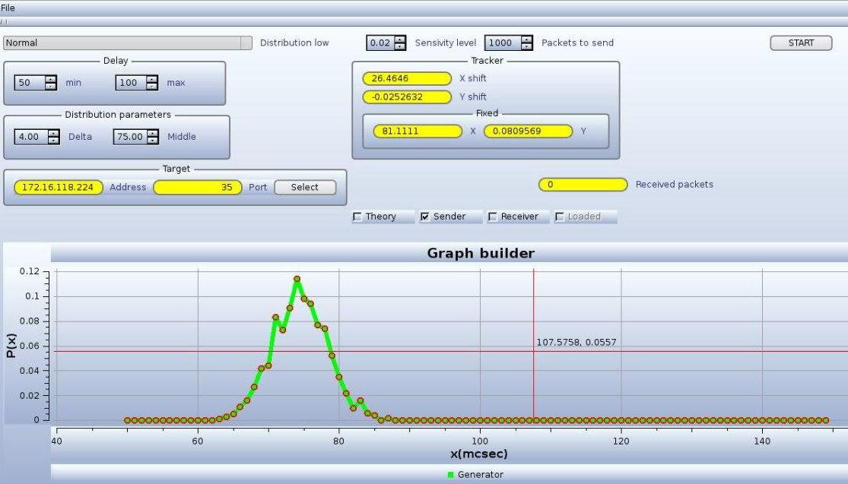
Figure 8 – Main screen of the desktop network simulator «Traffic» user interface
The Delay field located below the Distribution low field allows you to set the range of possible delays (intervals between packets) by setting the minimum and maximum values.
Even lower is the Distribution parameters field, which allows you to set parameters that correspond to the selected distribution law. Since the Normal distribution is selected in the case shown in this figure, the following parameters are displayed: Delta (standard deviation) and Middle (expectation). For each distribution law, its inherent parameters are indicated.
The next field located on the left side of the screen – the Target field allows you to set the destination IP address for the generated packet stream and the port number. The Select key confirms the selected values.
In the central part of the screen, at the top, there are the Sensitivity level fields, which sets the sensitivity level of the traffic analyzer receiver, and Packets to send, which sets the number of packets in the sent stream.
The Start key is located in the upper-right part of the screen, which initiates sending a stream of packets with the specified parameters.
At the bottom of the screen is the Graph Builder, which displays the following curves:
- the theoretical density curve of a given distribution (Theory);
- the actual generated distribution curve of the transmitted stream (Sender);
- the distribution curve of the received stream (Receiver);
- the distribution curve of the loaded distribution profile.
There is a set of radio buttons above the plotter window that allows you to select one or more options for displaying curves, depending on the selected check boxes. The view of the displayed curve is displayed below the graph builder window.
The Tracker field block allows you to make estimated measurements of intervals on the displayed chart.
When you left-click on a certain point on the graph, a crosshair appears and the coordinates (values) of this point are displayed in the x and y Windows of the Fixed field. If you then hold this crosshair with the mouse and move it, the X shift and Y shift Windows display the offset values relative to the originally selected point.
In this way, you can measure parameters on the displayed graphs.
CONCLUSION
Methods for analyzing the probabilistic and temporal characteristics of information and communication traffic were developed. An analytical review of modern scientific and technical literature concerning the problem under study was conducted. Was performed the systematization of the most significant parameters characterizing information and communication traffic. Statistical characteristics of infocommunication traffic are analyzed, traffic forecasting models based on observations of its statistical characteristics Will be developed, as well as methods for analyzing traffic uniformity in terms of distributions of its probabilistic characteristics. The main results:
- research has been conducted on methods for generating and analyzing test infocommunication traffic, which allows to take into account all the advantages and disadvantages of existing methods and develop innovative approaches to the problems being solved;
- methodology for testing network structures has been developed – a set of knowledge that allows to make effective decisions aimed at building both the hardware and software parts of the system for analyzing and predicting the probabilistic and time characteristics of infocommunication traffic;
- mathematical models of test traffic have been studied, which allows creating a flexible device for generating adequate input effects for specific network structures.
The growth of the third derivative of the function that characterizes the increase in traffic intensity seems to be a logical criterion for detecting congestion in individual components of telecommunications networks.
The proposed approach, based on the calculation of third-order finite differences, can be used in combination with other methods for estimating traffic intensity growth and algorithms for managing telecommunication networks. In particular, its joint application with hysteresis control algorithms is promising.
Thus, it can be argued that the development of the approach will solve a number of important practical problems that relate to the design of telecommunication networks and their technical operation.
During testing of the developed neural network, it was shown that the neural network of the above architecture, after appropriate training, confidently classifies input vectors for compliance with a certain probability distribution.
Based on the results of using the developed neural network, it can be concluded that such a characteristic of the dormitory traffic as the duration of TCP sessions has a distribution close to the Pareto distribution.
Experimentally, it was found that increasing the number of intermediate layers and the number of neurons in each of them is advisable to a certain threshold. Further increase in these parameters leads to the phenomenon of "retraining" of the neural network – the network ceases to be flexible and makes incorrect decisions. It should also be borne in mind that an increase in the number of network elements leads to an increase in the number of connections between them, and networks with an excessive number of connections model more complex functions that adapt to training examples and the network loses its ability to generalize.
Increasing the number of sequences for training reduces the error of recognition by the neural network of distributions fed to its input. When a certain number of noisy sequences are reached for training, the neural network must detect and remember the dependencies between the input signals and the required responses. Perhaps an increase in training sequences will reduce the number of neurons and hidden layers in the network, since the network will have a sufficient number of training examples to generalize their properties with a small number of connections. However, it is worth considering that if you increase the sample of training, significantly increases the learning time.
Testing has shown that the neural network consistently classifies the normal distribution, Pareto distribution, and hyper exponential distribution, at all stages. At the outputs corresponding to each of the classes of distributions studied, a probability of more than 0.8 was observed.
The study showed the feasibility of using neural networks in the analysis of infocommunication traffic.
As part of the research, it was found that since the uncertainty arising in traffic analysis due to the information observed and received from expert subsystems is not of the nature of "ignorance", but is determined by the degree of probability, it is advisable to use statistical probabilistic methods of information processing in these systems.
A significant part of the algorithms used in training neural networks is occupied by "gradient descent algorithms", so it is advisable to use this strategy in infocommunication traffic analysis systems containing neural networks.
Also, it should be noted that expert systems used in traffic analysis systems usually have a significant branching and a small depth of the state space, which allows you to effectively use the search strategy based on the path price criterion.
To ensure the formation of effective solutions in the process of traffic analysis, when developing the structure of the traffic analysis system, it is advisable to use such artificial intelligence subsystems as expert systems and neural networks.

LIST OF SOURCES USED
- Komashinsky V. I. Neural networks and their application in control and communication systems / V. I. Komashinsky, D. A. Smirnov. - M: Hotline-Telecom, 2003. - 94 p. [Комашинский В.И. Нейронные сети и их применение в системах управления и связи / В.И. Комашинский, Д.А.Смирнов. – М: Горячая линия-Телеком, 2003. – 94 с.] (in Russian).
- Potemkin V. G. Neural networks. Matlab 6 / V. G. Potemkin, V. S. Medvedev. - Moscow: Dialog-MEPhI, 2002. - 496 p. [Потемкин В.Г. Нейронные сети. Matlab 6 / В.Г. Потемкин, В.С. Медведев. – М.: Диалог-МИФИ, 2002. – 496 с.] (in Russian).
- Bostrom N. Artificial intelligence. Stages. Menaces. Strategies / Nick Bostrom; translated from English by S. Filin. - M.: Mann, Ivanov and Ferber, 2016 [Бостром Н. Искусственный интеллект. Этапы. Угрозы. Стратегии / Ник Бостром; пер. с англ. С. Филина. — М.: Манн, Иванов и Фербер, 2016] (in Russian).
- Kononyuk A. E. Fundamentals of the fundamental theory of artificial intelligence. Books 1,2,3. Kiev: «Education of Ukraine», 2017. - 730 p. [Кононюк А.Е. Основы фундаментальной теории искусственного интеллекта. Кн. 1,2,3. Киев: «Освіта України», 2017. – 730 с.] (in Russian).
- Bishop Christopher M. Neural Networks for Pattern Recognition / Christopher M. Bishop – Clarendon press Oxford, 1995. – 498 с.
- Hinton G. Deep Neural Networks for Acoustic Modeling in Speech Recognition / Hinton G., Deng L., Yu D., Dahl G., Mohamed A., Jaitly N., Senior A., Vanhoucke V., Nguyen P., Sainath T., Kingsbury B. – IEEE Signal Processing Magazine. – 2012. – Vol. 29. – No. 6. – PP. 82 – 97.
- Haikin S. Neural networks: a complete course, 2nd edition / S. Haikin. - M.: publishing house "Williams", 2008. - 1104 p. [Хайкин С. Нейронные сети: полный курс, 2-е издание / С. Хайкин. – М.: Издательский дом «Вильямс», 2008. – 1104 с.] (in Russian).
- Stepanov S. N. Fundamentals of teletraffic of multiservice networks / S. N. Stepanov-M.: Eco-Trends, 2010. - 392 p. [Степанов С.Н. Основы телетрафика мультисервисных сетей / С.Н. Степанов. — М.: Эко-Трендз, 2010. – 392 с.] (in Russian).
- Ageev D. V., Ishatenko A. A., Kopylev A. N. Metodika otechestveniya parameterov potokov na raznykh sections multiservice telecommunications network with the self-similarity effect taken into account / D. V. Ageev, A. A. Ipatenko, A. N. Kopylev / Problems of telecommunications. – 2011. – № 3 (5). – P. 18-37. [Агеев Д.В. Методика определения параметров потоков на разных участках мультисервисной телекоммуникационной сети с учетом эффекта самоподобия / Д.В. Агеев, А.А. Игнатенко, А.Н. Копылев / Проблеми телекомунікацій. – 2011. – № 3 (5). – С. 18 – 37.] (in Russian).
- Goldshtein B. S. Communication Networks / B. S. Goldshtein, N. A. Sokolov, G.G. Yanovsky. – Saint Petersburg: BHV-Petersburg, 2010. - 400 p. [Гольдштейн Б. С. Сети связи / Б. С. Гольдштейн, Н. А. Соколов, Г.Г. Яновский. – СПб: БХВ – Петербург, 2010. – 400 с.] (in Russian).
- Lozhkovsky A. G. traffic Model in multiservice networks with packet switching / A. G. Lozhkovsky. – Naukovi Pratsi ONAZ im. O. S. Popova. – 2010. [Ложковский А. Г. Модель трафика в мультисервисных сетях с коммутацией пакетов / А. Г. Ложковский. – Наукові праці ОНАЗ ім. О. С. Попова. – 2010] (in Russian).
- Galushkin A. I. Theory of neural networks / A. I. Galushkin. - M.: Hotline-Telecom, 2010. - 496 p. [Галушкин А.И. Теория нейронных сетей / А.И. Галушкин. – М.: Горячая линия-Телеком, 2010. – 496 с.] (in Russian).
- Wasserman F. Neurocomputer technology: theory and practice Wasserman. – M.: Mir, 1992 — p. 67 [Уоссермен Ф. Нейрокомпьютерная техника: теория и практика / Ф. Уоссермен. – М.: Мир, 1992 — 67 с.] (in Russian).
- Callan R. Basic concepts of neural networks Callan. - M.: publishing house «Williams», 2001. – 287 p. [Каллан Р. Основные концепции нейронных сетей /Р. Каллан. –М.: Издательский дом «Вильямс», 2001. – 287 с.] (in Russian).
- Lozhkovsky A. G. Theory of mass service in telecommunications: textbook / A. G. Lozhkovsky. - Odessa: ONAS named after A. S. Popov, 2012. – 112 p. [Ложковский А. Г. Теория массового обслуживания в телекоммуникациях: учебник / А. Г. Ложковский. – Одесса: ОНАС им. А. С. Попова, 2012. – 112 с.] (in Russian).
- Pozdnyak I. S. Research of network traffic on the degree of self-similarity / I. S. Pozdnyak, M. A. Buranova. - Samara: IUNL PGUTI, 2013. - 8 p. [Поздняк И. С. Исследование сетевого трафика на степень самоподобия / И. С. Поздняк, М. А. Буранова. – Самара: ИУНЛ ПГУТИ, 2013. – 8 с.] (in Russian).
- Samoilov M. S. Analysis of probabilistic and time characteristics of nodes for processing non-Poisson multimedia traffic of multiservice communication networks: dissertation / M. S. Samoilov. - Volga state University of telecommunications and Informatics. – Samara, 2015. – 147 p. [Самойлов М. С. Анализ вероятностно-временных характеристик узлов обработки непуассоновского мультимедийного трафика мультисервисных сетей связи: диссертация / М. С. Самойлов. – Поволжский государственный университет телекоммуникаций и информатики. – Самара, 2015. – 147 с.] (in Russian).
- Bakhareva N. F. Analysis and calculation of non-Poisson traffic models in computer networks / N. F. Bakhareva, I. V. Kartashevsky, V. N. Tarasov. // Infocommunication technologies, 2009, Vol. 7, No. 4, Pp. 61-66. [Бахарева Н. Ф. Анализ и расчет непуассоновских моделей трафика в сетях ЭВМ / Н. Ф. Бахарева, И. В. Карташевский, В. Н. Тарасов. // Инфокоммуникационные технологии. – 2009. – Том 7. – № 4, – С. 61-66.] (in Russian).
- Kireeva N. V. A special case of studying network traffic parameters to determine the laws of packet transmission time distribution / N. V. Kireeva, L. R. Chupakhina. – Samara: Volga state University Telecom. – 2015. [Киреева Н.В. Частный случай исследования параметров трафика сети для определения законов распределения времени передачи пакетов / Н.В. Киреева, Л.Р. Чупахина. – Самара: Поволжский государственный университет телеком. – 2015.] (in Russian).
- Goikhman V. Yu. Building a neural network architecture to identify the type of distribution of random variables /V. Yu. Goikhman, A. I. Lapiy / / Technologies and communication tools. - 2016. - No. 3. – P.36-40. [Гойхман В.Ю. Построение архитектуры нейронной сети для выявления вида распределения случайных величин /В.Ю. Гойхман, А.И. Лапий // Технологии и средства связи. – 2016. – № 3. – С. 36–40.] (in Russian).
- Goikhman V. Yu. Research of probabilistic characteristics of traffic using the neural network apparatus/ V. Yu. Goikhman, A. I. Lapiy / / Elektrosvyaz. – 2018. – No. 4. – PP. 64-67. [Гойхман В.Ю. Исследование вероятностных характеристик трафика при помощи аппарата нейронных сетей/ В.Ю. Гойхман, А.И. Лапий // Электросвязь. – 2018. – № 4. – С.64–67.] (in Russian).
- Avramenko M. V., Goikhman V. Yu. Choice of the discipline of data transmission of the sensor node. – M.: First mile, No. 2, 2017. – P. 34-39. [Авраменко М.В., Гойхман В.Ю. Выбор дисциплины передачи данных сенсорного узла. – М.: Первая миля № 2, 2017. – С.34-39.] (in Russian).
- Goikhman V. Yu. Solution of the problem of traffic classification using a neural network / V. Yu. Goikhman, A. I. Lapiy / / Proceedings of educational institutions of communications. - 2016. – Volume 2, No. 1. - PP. 43-47. [Гойхман В.Ю. Решение задачи классификации трафика с использованием нейронной сети / В.Ю. Гойхман, А.И. Лапий // Труды учебных заведений связи. – 2016. – Т. 2, № 1. – С. 43–47.] (in Russian).
- Goikhman V. Yu., Lushnikova T. Yu. Characteristic features of campus traffic. – M: Elektrosvyaz. – 2017. – No. 4. – P.40-44. [Гойхман В.Ю., Лушникова Т.Ю. Характерные черты кампусного трафика. – М: Электросвязь. – 2017. – № 4. – С. 40–44.] (in Russian).
- Goikhman V. Yu., Lushnikova T. Yu., Zinenko Yu.A. Traffic analysis of student dormitories. Bulletin of Cybernetics. – 2016. – № 1 (21). [Гойхманн В.Ю., Лушникова Т.Ю., Зиненко Ю.А. Анализ трафика студенческого общежития. Вестник кибернетики. – 2016. – № 1 (21).] (in Russian).
- Warzinski R. N. The reference probability distributions / R.N. Wardzinski. - SPb: Nauka, 2001. - 295 p. [Вардзинский Р.Н. Справочник по вероятностным распределениям / Р.Н. Вардзинский. – СПб: Наука, 2001. – 295 с.] (in Russian).
- Shelukhin O. I. Self-similarity and fractals: telecommunication applications / O. I. Shelukhin, A.V. Osin, S. M. Smolsky. - M.: Fizmatlit, 2008-368 p. [Шелухин О.И. Самоподобие и фракталы: телекоммуникационные приложения / О.И. Шелухин, А.В. Осин, С.М. Смольский. – М.: Физматлит, 2008. – 368 c.] (in Russian).
- Shelukhin O.And Modeling of information systems / O. I. Shelukhin, a.m. Tenyakshev, A.V. Osin. - M.: Radio engineering, 2005. – 368 p. [Шелухин О.И Моделирование информационных систем / О.И. Шелухин, А.М. Тенякшев, А.В. Осин. – М.: Радиотехника, 2005. – 368 с.] (in Russian).
- Wentzel E. S. Probability theory / E. S. Wentzel. -4th ed., stereotype. - M: Nauka, Fizmatgiz, 1969. - 576 p. [Вентцель Е. С. Теория вероятностей / Е.С. Вентцель. – 4-е изд., стереотип. – М.: Наука, Физматгиз, 1969. – 576 с.] (in Russian).
- Olifer V. G. Computer networks. Principles of technology protocols / V. G. Olifer, N.A. Olifer. – St. Petersburg: Peter, 2010. – 916 p. [Олифер В.Г. Компьютерные сети. Принципы технологии протоколы / В.Г. Олифер, Н.А. Олифер. – СПб: Питер, 2010. – 916 с.] (in Russian).
- Tanenbaum E. Computer networks / E. Tanenbaum. – St. Petersburg: Peter, 2003. – 992 p. [Таненбаум Э. Компьютерные сети / Э. Таненбаум. – СПб: Питер, 2003. – 992 с.] (in Russian).
- Kendall M. Statistical conclusions and connections / M. Kendall, A. Stewart. - M.: Science. Fizmatlit, Volume 2, 1973. – 899 p. [Кендалл М. Статистические выводы и связи / М. Кендалл, А. Стюарт. – М.: Наука. Физматлит, Т. 2, 1973. – 899 с.] (in Russian).
- Pustylnik E. I. Statistical methods of analysis and processing of observations / E. I. Pustylnik. – M.: Nauka, 1968. - 288 p. [Пустыльник Е.И. Статистические методы анализа и обработки наблюдений / Е.И. Пустыльник. — М.: Наука, 1968. – 288 с.] (in Russian).
- Schneps-Schnappe M. A. Numerical methods of the theory of teletraphy / M. A. Schneps-Schnappe. – M.: Svyaz, 1974. – 232 p. [Шнепс-Шнеппе М.А. Численные методы теории телетрафика / М.А. Шнепс-Шнеппе. – М.: Связь, 1974. – 232 с.] (in Russian).
- Basharin G. p. Lectures on the mathematical theory of teletraphy / G. P. Basharin. – M.: RUDN, 2004. – 193 p. [Башарин Г.П. Лекции по математической теории телетрафика / Г.П. Башарин. – М.: РУДН, 2004. – 193 с.] (in Russian).
- Basharin G. P. Quality management and probabilistic models of functioning of communication networks of the next generation / G.P. Basharin, Yu.V. Gaidamaka, K. E. Samuylov, N. V. Yarkina. - M.: RUDN, 2008. - 157 p. [Башарин Г.П. Управление качеством и вероятностные модели функционирования сетей связи следующего поколения / Г.П. Башарин, Ю.В. Гайдамака, К.Е. Самуйлов, Н.В. Яркина. – М.: РУДН, 2008. – 157 с.] (in Russian).

APPENDIX A
List of published works on the project
2018
- Kassenova M. N., Korganbayeva L. N. Research issues reliable and current characteristics of information and communication traffic. XIII International Scientific Conference of students and oung Scientists «Science and education – 2018», L. N. Gumilyov Eurasian National University, Astana. – 2018. – PP. 219-222. ISBN 978-9965-31-997-6 [Касенова М.Н., Корганбаева Л.Н. Проблемы исследования вероятностно-временных характеристик информационно-коммуникационного трафика. XIII Международная научная конференция студентов и молодых ученых «Наука и образование - 2018», Евразийский национальный университет имени Л.Н.Гумилева, Астана, – 2018. – С. 219-222. ISBN 978-9965-31-997-6] (in Russian).
- Seilov Sh. Zh., Korganbayeva L. N., Kassenova M. N., Goikhman V. Yu., Marshak M. M. Review of the model of an intelligent infocommunication traffic system, Astana, a Professional journal on telecommunications: Information and telecommunications networks. – 2018. – №4 (139-140). – PP. 24-26 [Сеилов Ш.Ж., Корганбаева Л.Н., Касенова М.Н., Гойхман В.Ю., Маршак М.М. Обзор модели интеллектуальной системы инфокоммуникационного трафика. Астана, Профессиональный журнал о телекоммуникациях:Информационные телекоммуникационные сети, – 2018. – №4 (139-140). – С. 24-26] (in Russian).
- Seilov Sh. Zh., Korganbayeva L. N., Kassenova M. N., Goikhman V. Yu., Marshak M. M. Systematization of parameters characterizing information and communication traffic. Astana, Professional journal on telecommunications: Information and telecommunications networks. – 2018. – №5 (141-142). –PP. 43-48 [Сеилов Ш.Ж., Корганбаева Л.Н., Касенова М.Н., Гойхман В.Ю., Маршак М.М. Систематизация параметров, характеризующих информационно-коммуникационный трафик. Астана, Профессиональный журнал о телекоммуникациях:Информационные телекоммуникационные сети, – 2018. – №5 (141-142). – С. 43-48] (in Russian).
2019
- Kassenova M. N., Shoganova I. A. Development of a software and hardware complex for learning infocommunication traffic. XIV international scientific conference of students and young scientists «ǴYLYM JÁNE BILIM – 2019», L. N. Gumilyov Eurasian National University, Nur-Sultan, – 2019. – P. 143-146. ISBN 978-601-337-170 [Касенова М.Н., Шоганова И.А. Разработка программно-аппаратного комплекса для изучения свойств инфокоммуникационного трафика. ХIV Международная научная конференция студентов и молодых ученых «ǴYLYM JÁNE BILIM – 2019», Евразийский национальный университет имени Л.Н.Гумилева, Нур-Султан, – 2019. – С. 143-146. ISBN 978-601-337-170-2] (in Russian).
- Goykhman V., Korganbaeva L., Ermakov A., Nikolaeva M. Research of Typical Information Objects Traffic. Advances in Science and Technology Research Journal, Volume 13, Issue 2, June 2019. – P.51–55.
- Goikhman V., Seilov Sh., Sokolov N., Korganbayeva L. Evaluating the packet traffic parameter measurements. Telecommunications and Radio Engineering, №78 (6), 2019. – P. 489-499.
- Seilov Sh. Zh., Boranbayev S. N., Kassenova M. N., Seilov A. A., Shingisov D. S. Intellectual analysis of information and communication traffic. Bulletin of the L. N. Gumilyov Eurasian National University. Series Technical Sciences and technologies. No. 3 (128), 2019. – PP. 76-86 [Сеилов Ш.Ж., Боранбаев С.Н., Касенова М.Н., Сейлов А.А., Шингисов Д.С. Интеллектуальный анализ информационно-коммуникационного трафика. Вестник Евразийского национального университета имени Л.Н. Гумилева. Серия Технические науки и технологии. №3(128), 2019. – С.76-86] (in Russian).
- Seilov Sh., Goykhman V., Kassenova M., Seilov A., Shingissov D. Development of neural network models for the analysis of infocommunication traﬃc. Bulletin of the Karaganda University. Mathematics series. №2019-96-4. – PP.118-126.
2020
- Kassenova M. N., Shingissov D. S., Seilov A. A. Investigation of neural network models used for analyzing statistical characteristics of traffic. XV international scientific conference of students and young scientists «ǴYLYM JÁNE BILIM-2020». – Nur-Sultan: L. N. Gumilyov Eurasian national University. – P. 424-428. ISBN 978-601-337-318-8 [Касенова М.Н., Шингисов Д.С., Сейлов А.А. Исследование моделей нейронных сетей, используемых для анализа статистических характеристик трафика. ХV Международная научная конференция студентов и молодых ученых «ǴYLYM JÁNE BILIM-2020. – Нур-Султан: Евразийский национальный университет имени Л.Н.Гумилева. – 2020. – С. 424-428. ISBN 978-601-337-318-8] (in Russian).
- Arzykulov S., Nauryzbayev G., Hashmi M. S., Eltawil A. M., Rabie K. M., Seilov S. Hardware- and Interference-Limited Cognitive IoT Relaying NOMA Networks With Imperfect SIC Over Generalized Non-Homogeneous Fading Channels. IEEE Access, Volume 8. – PP. 72942-72956, 2020. DOI: 10.1109/ACCESS.2020.2987873.
- Seilov Sh. Zh., Zhursinbek E. Sh., Kassenova M. N., Kuzbayev A. T., Nurzhaubayev A. A., Seilov A. A., Shingissov D. S. Certificate of entering information into the state register of rights to objects protected by copyright, No. 12600 from 15.10.2020. Computer program «Electronic textbook» Modern problems and problems of designing multiservice communication networks» [Сеилов Ш.Ж., Жүрсінбек Е.Ш., Касенова М.Н., Кузбаев А.Т., Нуржаубаев А.А., Сейлов А.А., Шингисов Д.С. Свидетельство о внесении сведений в государственный реестр прав на объекты, охраняемые авторским правом № 12600 от 15.10.2020 г. Программа для ЭВМ «Электронное учебное пособие «Современные проблемы и задачи проектирования мультисервисных сетей связи»] (in Russian).
- Seilov Sh. Zh., Zhursinbek E. Sh., Kuzbayev A. T., Nurzhaubayev A. A., Seilov A. A., Shingissov D. S. Certificate on including information in state register of rights to objects protected by copyright No. 12599 from 15.10.2020. Computer program «Desktop network simulator «IT-alem Traffic» [Сеилов Ш.Ж., Жүрсінбек Е.Ш., Кузбаев А.Т., Нуржаубаев А.А., Сейлов А.А., Шингисов Д.С. Свидетельство о внесении сведений в государственный реестр прав на объекты, охраняемые авторским правом № 12599 от 15.10.2020 г. Программа для ЭВМ «Настольный сетевой тренажер «IT-alem Traffic»] (in Russian).
- Seilov Sh. Zh. Research of characteristics of multiservice networks: analysis of probabilistic and time characteristics of information and communication traffic: tutorial / Sh. Zh. Seilov, V.Yu Goikhman, M. N. Kassenova, T. A. Kuzbayev, A. A. Seilov, N.A. Sokolov, D. S. Shingissov. – Nur-Sultan: Halyk-Media LLP, 2020. – 105 p. [Сеилов Ш.Ж. Исследование характеристик трафика мультисервисных сетей: Анализ вероятностно-временных характеристик информационнокоммуникационного трафика: учебное пособие / Ш.Ж. Сеилов, В.Ю.Гойхман, М.Н. Касенова, А.Т. Кузбаев, А.А. Сейлов, Н.А.Соколов, Д.С. Шингисов. – НурСултан: ТОО “Халык-Медиа“, 2020. –105 с]. (in Russian).

APPENDIX B

Work planned schedule for 2020










Task cipher, stage | Name of work under the contract and the main stages of its implementation | Due date |  | Expected result
Task cipher, stage |  | beginning | ending
1. | Research and development of methods for analyzing the probability-time characteristics of information and communication traffic. | March  2018 | until November 1, 2018 | Methods for analyzing the probabilistic and temporal characteristics of information and communication traffic will be developed
1.1 | Analytical review of modern scientific and technical literature concerning the problem under study; | March  2018 | May  2018 | An analytical review of modern scientific and technical literature on the problem under study will be conducted; methods for analyzing the probabilistic and temporal characteristics of information and communication traffic will be developed.
1.2 | Systematization of the most significant parameters that characterize information and communication traffic. The analysis of statistical characteristics of information and communication traffic. | March  2018 | August 2018 | Systematization of the most significant parameters that characterize information and communication traffic will be performed. Statistical characteristics of infocommunication traffic will be analyzed And methods for analyzing the probabilistic and temporal characteristics of information and communication traffic will be developed
1.3 | Development of methods for analyzing traffic homogeneity in terms of distributions of its probabilistic characteristics;  Development of traffic forecasting models based on observations of its statistical characteristics; | August 2018 | until November 1, 2018 | We will develop methods for analyzing the probabilistic and temporal characteristics of information and communication traffic, as well as methods for analyzing the uniformity of traffic in terms of distributions of its probabilistic characteristics;  Traffic forecasting models will be developed based on observations of its statistical characteristics;
2. | Research and development of neural network models used for analyzing traffic statistics. | January 2019 | until November 1, 2019 | Models of neural networks used to analyze the statistical characteristics of the traffic will be investigated and developed. Based on the results of scientific research, it is planned to publish one article in peer-reviewed foreign scientific publications indexed in Scopus databases with a non-zero impact factor.
2.1 | Research of neural network models that are most suitable for traffic analysis; | January 2019 | June 2019 | Will be investigated and developed models of neural networks used to analyze the statistical characteristics of the traffic.
2.2 | Research of methods for forming training samples used in the process of training neural networks intended for traffic analysis; | July 2019 | until November 1, 2019 | Models of neural networks used to analyze the statistical characteristics of the traffic will be investigated and developed. Based on the results of scientific research, it is planned to publish one publication in peer-reviewed domestic scientific publications with a non-zero impact factor;
3. | Research of the possibility of using artificial intelligence systems in information and communication traffic analysis systems.  Development of basic technical requirements for the layout of an intelligent infocommunication traffic analysis system. | January 2020 | until November 1, 2020 | The possibilities of using artificial intelligence systems in information and communication traffic analysis systems will be investigated. Based on the results of scientific research, it is planned to publish one article in peer-reviewed foreign scientific publications indexed in Web of Science databases with a non-zero impact factor. The main technical requirements for the layout of an intelligent infocommunication traffic analysis system will be developed.
3. | Research of decision-making issues in conditions of uncertainty, in relation to the problems of traffic analysis and formation.  Research on the choice of search strategy for artificial intelligence systems, in terms of the tasks of analyzing infocommunication traffic | January 2020 | March 2020 | The possibilities of using artificial intelligence systems in information and communication traffic analysis systems will be investigated.  Will be reviewed and investigated decision-making under uncertainty, with application to problems of analysis and traffic shaping and the choice of search strategies for artificial intelligence systems, in terms of task analysis information and communication traffic
3.2 | Research on the construction of information and communication traffic analysis systems based on elements of artificial intelligence systems. | April 2020 | June 2020 | The possibilities of using artificial intelligence systems in information and communication traffic analysis systems and issues of building information and communication traffic analysis systems based on elements of artificial intelligence systems will be investigated.
3.3 | Creating a list of technical requirements for an intelligent system for analyzing infocommunication traffic | July 2020 | until November 1, 2020 | The main technical requirements for the layout of an intelligent infocommunication traffic analysis system will be formed.  Preparation of the tutorial «Analysis of probabilistic and time characteristics of information and communication traffic». Based on the results of scientific research, it is planned to publish one publication in peer-reviewed foreign scientific publications with a non-zero impact factor


