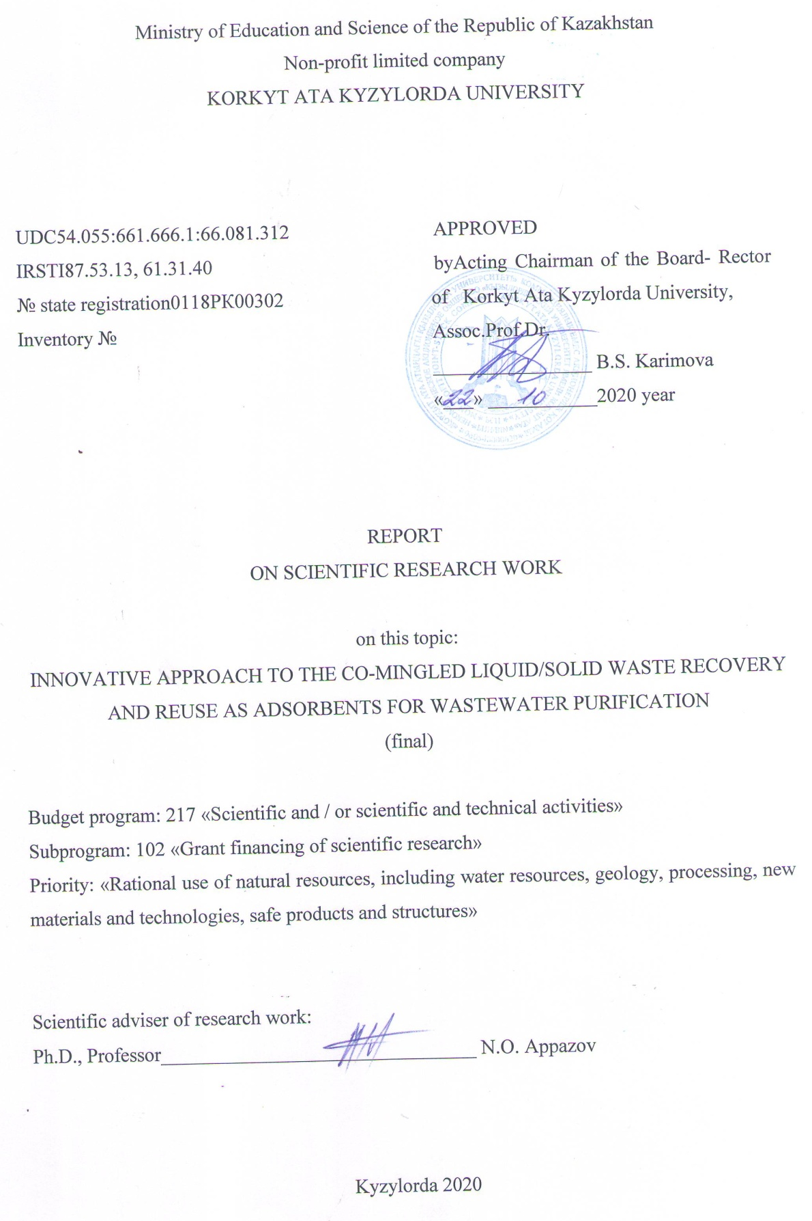
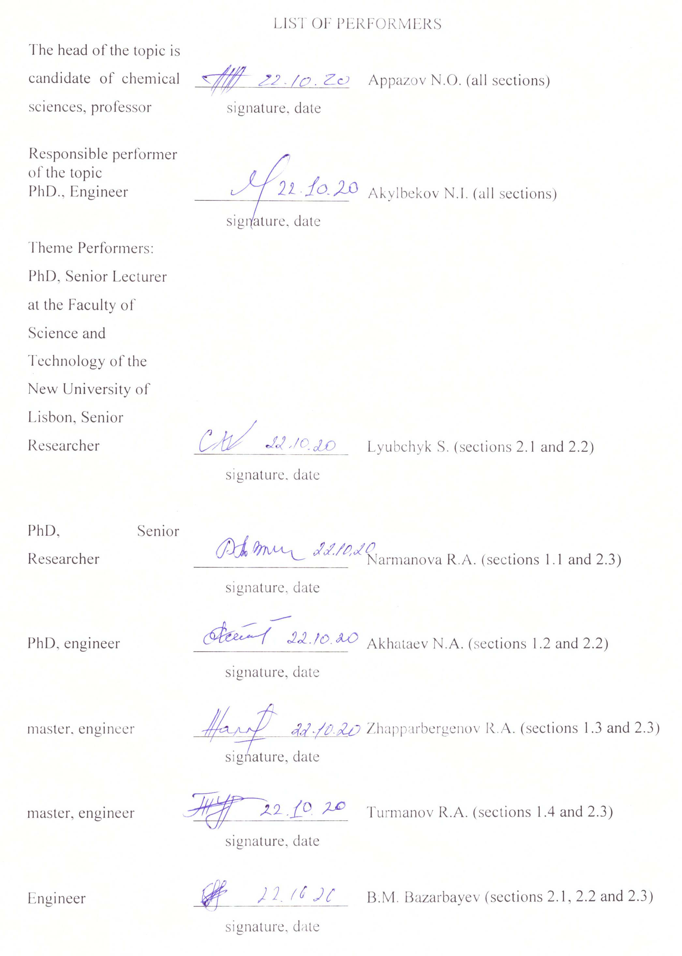

РЕФЕРАТ

Есеп 102 беттен,6 кестеден, 7 суреттен, 63 сілтемеден, 3 қосымшадан тұрады.

АДСОРБЕНТ, БЕЛСЕНДІРІЛГЕН КӨМІР, АҒЫНДЫ СУЛАР, МҰНАЙ ҚАЛДЫҚТАРЫ, КҮРІШ ҚАУЫЗЫ МЕН САБАНЫ
Зерттеу нысаны күріш қалдықтары (сабан, қауыз), мұнай шламдары болып табылады.
Жұмыс мақсаты – өндірістік ағынды суларды тазалауға арналған экологиялық қауіпсіз және пайдалы екіншілік өнім – адсорбенттер алудың жоғары бәсекелі өңдеу технологиясын жасау.
Жұмыс барысында зерттеу тақырыбы бойынша әдеби мәліметтер қаралып зерттеу бағыты бойынша жақын технологиялар табылды. Қатты және сұйық қалдықтарды өңдеудің және екіншілік өнімдерді қайта пайдаланудың инновациялық технологиясы жасалды. Екіншілік экологиялық таза өнімдер – аралас қалдықтардан алынған жаңа адсорбенттер өндірістік ағынды суларды ауыр металдар мен органикалық заттардан тазалауға сыналды.
Төменгі сортты ауылшаруашылығының қатты қалдықтары мен сұйық мұнай қалдықтарынан алынатын кеуекті көміртекті материалдар алу үшін физика-химиялық шарттар кешені жасалды. Адсорбенттің морфологиясының, құрылымы мен қасиеттерінің, температура мен бірге өңдеуге тәуелділігі бағаланды. Со-термолизді қолданып, қалдықтарды біріктіре өңдеуде микро- және наноқұрылым түзетін көміртекті қаңқаның құрылымдық-химиялық трансформациясының тәжірибелік моделі жасалды. Модельдер қазақстандық шикізат көздері – Қызылорда облысының төменгі сортты қатты және сұйық қалдықтары (күріш сабаны, қауызы және техногенді мұнай қалдықтары ) қоспасынан жасалды.
Ағынды суларды тиімді рециркуляциялауға бағытталған, қатты және сұйық қалдықтардың қоспасынан алынатын жаңа адсорбенттермен өндірістік ағынды суларды ауыр металдар мен органикалық заттардан тазалау бойынша зерттеу жұмыстары жүргізілді.

ESSAY

The report contains 102 pages, 6 tables, 7 figures, 63 sources, 3 appendices.

ADSORBENT, ACTIVATED COAL, WASTE WATER, OIL WASTE, RICE HULL AND STRAW
The objects of research are rice waste (straw and husk), oil sludge.
The aim of the work is to develop a highly competitive technology for processing solid and liquid waste into environmentally safe and useful secondary products - adsorbents for industrial wastewater treatment.
A literary search was carried out and the closest technologies in the direction of research were identified. An innovative technology has been developed for the recovery of liquid and solid waste and the reuse of secondary products. Secondary environmentally friendly products - new adsorbents from mixed waste have been studied for the purification of industrial wastewater from heavy metals and organic substances.
A complex of physicochemical approaches has been developed for the production of porous carbon materials from mixed low-grade agricultural solid waste and liquid oil waste. The dependence of the morphology, structure, and properties of the adsorbent on the temperature and time of joint treatment was estimated.
Experimental models of the structural and chemical transformation of the carbon frame with the formation of micro- and nanostructures during the joint processing of waste using co-thermolysis have been developed. Models have been developed for mixtures of low-grade solid and liquid waste (rice straw and husk, and man-made oil waste) from Kazakhstani sources in the Kyzylorda region.
Research work has been carried out to purify industrial wastewater from heavy metals and organic pollution with new adsorbents from mixed solid and liquid waste, aimed at efficient wastewater recycling.

CONTENT
 |  | Page
INTRODUCTION...................................................................................................................... |  | 6
MAIN PART OF THE R&D REPORT................................................................................... |  | 8
1 | The current state of the processing of agricultural waste……………………….. | 8
1.1 | Raw materials, production and characteristics of activated carbon......................... | 8
1.2 | Carrying out the process of co-thermolysis............................................................... | 11
1.3 | The use of activated carbon as an adsorbent.............................................................. | 14
1.4 | Perspectives andapplications….................................................................................. | 19
2 | Co-processing of rice waste and oil sludge into adsorbents …………………….. | 20
2.1 | Co-thermolysis of rice husks and straw with oil sludge........................................... | 20
2.2 | Study of the adsorption properties of the obtained sorbents.................................... | 22
2.3 | Application of the obtained adsorbents for the treatment of sewage...................... | 28
CONCLUSION.......................................................................................................................... |  | 31
LIST OF USED SOURCES...................................................................................................... |  | 32
APPLICATION A –Calendar plan of work........................................................................... |  | 38
APPLICATION B – List and reprints of published works based on research results…... |  | 48
APPLICATION C–Technical task ……………...…………………………………….... |  | 95

INTRODUCTION

Based on the results of the research work, two interim reports were prepared:
1. An innovative approach to the joint processing of solid and liquid waste into adsorbents for wastewater treatment. Inventory number –0218RK00485.
2 An innovative approach to the co-processing of solid and liquid waste into adsorbents for wastewater treatment. Inventory number –0219RK01141.
Activated carbon is used in many processes in chemical technology. Waste gas and waste water treatment is mainly based on adsorption by activated carbon. Only activated carbon can meet the ever-increasing requirements for the purity of our drinking water. The successful development of modern adsorption technology is largely facilitated by the constant improvement in the quality of this product, due to the improvement of its production methods. In a number of processes, the industrial use of activated carbon became possible only after the development of appropriate reactivation methods.
Development of a highly competitive technology for processing technogenic raw materials - solid and liquid wastes into environmentally friendly and useful secondary products - adsorbents for cleaning industrial effluents from heavy metals and organic pollutants in order to implement the tasks of waste management and sustainable development of the Republic of Kazakhstan.
To develop an innovative technology for waste processing, it is assumed that the processes of restructuring the carbon framework with the formation of carbon micro- and nanostructures occur due to joint heat treatment of mixtures of solid and liquid organic waste. Currently, this area is the most promising from the point of view of processing natural raw materials and commercialization of secondary products. However, successful implementation for the disposal of various types of waste requires innovative technical developments for the joint processing of waste mixtures to ensure efficient recovery and creation of useful secondary products for their reuse.
Based on the approaches of cluster nanophysics and structural-chemical transformation of the carbon framework, which is associated with the formation of micro- and nanostructures; the process of joint thermolysis of technogenic carbon-containing solid and liquid wastes (such as oil waste and low-value raw materials from rice straw with the addition of high-value raw materials - rice husks with a high content of heteroatoms), will allow us to develop an innovative technology for the recovery of mixed waste, as well as to create promising porous secondary products, unparalleled synthesis by other methods of waste treatment.
The literature comprehensively considered and presented in detail the currently existing methods of thermal processing of carbon-containing raw materials, which include pyrolysis, gasification, combustion [1-3]. The most promising method from the currently existing ones - co-thermolysis, when multicomponent mixtures or composites of different in nature organic materials are used for the thermolysis process in order to obtain synergism of thermolysis of components and, accordingly, to improve the yield and selectivity of secondary liquid or solid foods. It has been shown that the practical application of co-thermolysis is one of the most promising directions in the processing of natural and technogenic raw materials. Specific examples of the processes of co-pyrolysis, co-gasification and co-liquefaction are given in order to obtain valuable solid, gaseous or liquid secondary products: in metallurgy when producing anisotropic coke, in the fuel and energy complex for producing energy and fuel gases, in the chemical industry when obtaining liquid hydrocarbons and additives to liquid fuel [4-10].
In addition, despite some progress in the field of understanding the structure of a carbon sorbent (individual works [11–15], including reviews [16, 17] devoted to this topic, are found in the literature), at the present stage of development of science there is an acute this area. The limited number of such studies is associated with the complexity and uniqueness of the equipment that allows such studies.
One of the areas of research aimed at developing the processes of co-carbonization and the formation of micro- and nanostructures (carbon sorbents) is based on the use of composites as starting materials - mixtures of solid and liquid organic materials, including waste, as well as the use of raw materials with binders, catalyst additives, etc. pre-chemically modified raw materials. At the moment, this direction seems to be the most promising from the point of view of the processing of natural raw materials, waste disposal and the involvement of environmentally friendly secondary products in the economic circulation, however, for its successful implementation, it is necessary to solve a number of problems associated with identifying the structure of the obtained sorbents and managing the process of forming micro- and nanostructures during structural and chemical transformations of the carbon frame.

MAIN PART OF THE R&D REPORT

1 The current state of the processing of agricultural waste

  - Raw materials, production and characteristics of activated carbon

Activated carbon is a carbon-rich solid with unique characteristics, including favorable porous structure, high surface functionality and the ability to exchange more cations [18]. These properties are mainly associated with the type of raw material and the method of production [19]. Commonly used raw materials for activated carbons are agricultural and wood waste, sewage sludge, plastic waste, microalgae, coal, waste tires and manure [20]. The first type is the most widely used raw material for the production of activated carbon due to its ecologically clean nature, renewability and availability as a result of agricultural activities and forest environment [4]. It is the most important source of lignocellulosic biomass, which mainly consists of cellulose, hemicellulose, and lignin [21].
Many technologies have been used to produce activated carbon, such as gasification, hydrothermal carbonization, and thermolysis [22]. During thermolysis, raw materials are thermally decomposed into chemical components in an environment with a limited oxygen content [23]. Depending on the heating rate, thermolysis processes are divided into slow and fast. The slow process is effectively used for the production of activated carbon [24]. However, the yield and characteristics of activated carbon obtained under certain thermolysis variables usually depend on the properties of the feedstock [25]. For example, activated carbon obtained from manure contains more ash, high pH, ​​low carbon content, and a lower calorific value than those obtained from agricultural waste. Meanwhile, plant-based activated carbons have a relatively higher porosity and a lower ability to exchange cations [26]. Thus, to overcome the disadvantages of activated carbons made from different single raw materials, a new thermolysis technology has been developed in terms of co-thermolysis.
Co-thermolysis is a process in which two or more raw materials are processed in one operating system of conventional thermolysis [27]. Thus, it can effectively combine the favorable properties of the feedstock and improve the characteristics of activated carbon [28]. In this context, co-pyrolysis of plant waste after adding pinecone shows activated carbon with high yield and high quality in terms of low ash content, high carbon content, high porosity characteristics compared to plant waste [29]. The improved quality of the mixed raw material of activated carbon is also associated with a high adsorption capacity in relation to various pollutants in comparison with the individual activated carbon of the raw material [30,31]. According to published studies, the most studied pollutants are synthetic dyes and heavy metals, followed by phenols, pharmaceuticals, pesticides and other substances [32].
In addition to the main advantage of co-thermolysis, which is the conversion of solid waste and by-products into valuable products [33], this process plays an important role in reducing the amount of waste, since various mixed wastes are used as raw materials [25]. It can also solve the problems associated with the fact that solid waste is usually in the form of mixtures that are not easily separated into their components [34]. Normal thermolysis of individual waste into activated carbon is discussed in detail in many reviews [4,19,20,21]. Co-thermolysis of mixed waste was also considered [20,35,36]. However, these reviews of co-thermolysis mainly focused on bio-oil. Thus, this review includes the co-thermolysis of various mixed starting materials into activated carbon. The influence of co-thermolysis variables on the yield and physicochemical characteristics of activated carbon is discussed. In addition, the use of activated carbon as an adsorbent for the treatment of organic and inorganic pollutants has also been included.
Assessment of the physicochemical characteristics of activated carbon is of great importance for determining their potential use in industry and the environment [23]. For example, activated carbon with a large amount of ash and lower carbon content is not applicable as an energy source, and activated carbon with low porosity and weak adsorption capacity is not suitable for improving soil and attracting pollutants [24]. In comparison with the standard characteristics of raw materials, in the specific case of activated carbon, the characteristics of the surface and pores, as well as the electrical and chemical properties, acquire key properties [25].
The pore properties of activated carbon in terms of surface area, along with the total volume and average pore size, have a significant effect on the characteristics of activated carbons as adsorbents or catalysts [26]. An adsorbent with a large surface area usually has excellent characteristics due to the abundance of active sites for adsorption processes [37]. However, a large surface area with very small pores can impede the passage of large molecules. In this case, important factors to be determined, in addition to surface area, are total pore volume and average pore size [38]. Pores 50 nm, 2-50 nm, and 2 nm are defined as macropores, mesopores and micropores, respectively [39]. The properties of pores can be estimated from the adsorption of N2 using the Brunauer-Emmett-Teller (BET) theory [40]. The final or elemental composition of activated carbon mainly includes carbon, hydrogen, oxygen, nitrogen and sulfur [41]. The molar ratios of these elements in terms of (O - N) / C or O / C and H / C determine the polarity and aromaticity of activated carbon, respectively [42]. Low H / C content indicates high aromaticity or high carbonation. The low O / C ratio reflects high hydrophobicity and low polarity. Hydrophobic activated carbon is highly attractive to insoluble contaminants [6]. The low O / C and H / C ratio also confirms the more stable activated carbon. The O / C ratio of 0.2 indicates a high stability of activated carbon with a half-life of 1000 years [30]. The final analysis is carried out using an elemental analyzer [43].
The approximate composition of activated carbon includes ash, associated carbon, volatiles, and moisture [44]. Ash content is the amount of solid residue left after complete combustion of the sample [45]. A large amount of ash is usually unfavorable due to the presence of more minerals, which can block the pores of the activated carbon and reduce the number of active sites [31]. The carbon that exists in activated carbon after the release of volatiles is identified as bonded carbon. A high content of fixed carbon indicates a high degree of carbonation and a low content of volatiles [28]. Most preliminary analyzes are performed on a dry basis due to the complete removal of moisture during pyrolysis.
There are two calorific values, namely the lower calorific value (LHV) and the higher calorific value (HHV) [32]. HHV activated carbon is usually detected with a bomb calorimeter [26]. The pH of activated carbon is a key property that significantly affects the quality of activated carbon [33]. A high pH value indicates a high degree of carbonation [28]. The pH of activated carbon obtained from various raw materials usually exceeds 7, which indicates the basic nature of activated carbon [34]. Cation exchange capacity (CEC) is a measure of the ability to exchange cations with organic or inorganic substances.Activated carbons with high CEC values ​​exhibit significant cation exchange [25]. The CEC value can be determined by the number of naturally occurring cations (for example, Ca, Na, K, Mg) associated with negative surface charges [28]. Electrical conductivity (EC) gives an idea of ​​the content of soluble salt in the structure of activated carbon [35]. The calorific value is the amount of energy produced when the sample is completely burned. Activated carbon with a high C / H ratio and low ash content has a high heating value [36].There are two calorific values, namely the lower calorific value (LHV) and the higher calorific value (HHV) [32]. HHV activated carbon is usually determined with a bomb calorimeter [26]. Morphological analysis using a scanning electron microscope (SEM) is another characteristic of the structure of activated carbon. SEM 2 M.J. Ahmed, B.H. Hameed / JournalofCleanerProduction 265 images show activated charcoal surfaces and clarify pore development [31]. In addition, functional groups on the surface of activated carbon can be identified using Fourier transform infrared spectroscopy (FTIR) [23]. Surface functional groups mainly include oxygen, nitrogen, hydrogen, halogen, etc., among which oxygen and nitrogen groups have a significant effect on the adsorption properties of activated carbon [27].
The mass content or yield of activated carbon is the mass ratio of the activated carbon product to the feedstock [37]. Raw materials with high moisture give a product with a low yield, therefore they are unfavorable raw materials for activated carbon. Meanwhile, raw materials with a large amount of ash give a large yield [38]. Lignocellulose feedstock with a high lignin content demonstrates a high yield of activated carbon and low volatiles [24]. The yield and physical and chemical properties of activated carbon mainly depend on the type of raw material and the production method.

1.2 Carrying out the process of co-thermolysis

The term pyrolysis is mainly defined as a thermochemical process in which raw materials are thermally decomposed in an inert atmosphere or in an atmosphere with a low oxygen content to form activated carbon, bio oil and non-condensable gases [46]. Pyrolysis can be classified as slow or fast. The fast process mainly produces bio-oil with biochar as a by-product at a high heating rate above 300 C / s and a short residence time of less than 10 s. Meanwhile, the slow process yields activated carbon as the main product with low bio-oil yield at a low heating rate and relatively long residence time [47].Thus, slow pyrolysis is the most useful process for producing activated carbons with high yields. However, in the ordinary pyrolysis of individual raw materials, activated carbon exhibits weakness in some properties [48]. To overcome these disadvantages and produce activated carbon with improved properties, co-thermolysis has been adopted. The co-thermolysis process processes binary or multicomponent mixtures of raw materials. The operating system is almost the same as that of regular pyrolysis. The process mainly takes place in a closed reactor at moderate temperatures and a limited amount of oxygen [11].Compared to conventional pyrolysis, co-pyrolysis is recognized as an efficiently developed process for producing improved activated carbon [49]. The high efficiency of co-thermolysis is primarily associated with the synergistic effect that occurs as a result of the interaction between the feedstock. The synergistic effect is classified as positive or negative [17].A positive synergistic effect exists when the interaction between two or more raw materials gives an overall value that exceeds the sum of the values ​​calculated for the individual raw materials. This leads either to an increase in the yield and quality of activated carbon, or to deterioration of any properties of the mixed raw material or a derivative of activated carbon [22]. The synergistic effect of co-pyrolysis mainly depends on the type of feedstock, the mixture ratio, pyrolysis temperature and residence time. Compared to conventional pyrolysis, co-thermolysis has a specific and important variable in terms of the mixing ratio. Table 2 summarizes the yield and physicochemical properties of activated carbons obtained by co-pyrolysis of various mixed starting materials.According to this table, the co-thermolysis process can improve the yield and quality of activated carbons. For example, the yield, surface area, calorific value and ash content of activated carbons obtained by co-thermolysis are 1.38, 43.36, 1.16 and 0.49 times higher than those of activated carbons obtained by a conventional pyrolysis process.
Huang et al. [45] tested the co-pyrolysis of sawdust (SD) / rice straw (RS) and sewage sludge (SS) on activated carbon. Co-pyrolysis conditions: mass ratio SS: SD / RS 1: 1 by mass, 500 ° C, 60 min, 20 ° C / min and N2 flow rate 0.2 L / min. The yields of activated carbons SS, SS-RS and SS-SD were 65%, 54% and 53% at 500 ° C and 73%, 69% and 62% at 400 ° C, respectively. The use of RS / SD clearly reduces the yield of activated carbon, which may be due to the low ash content in the RS / SD feed [50]. Compared to RS, the addition of SD showed a relatively high reduction in SS char yield due to the lower SD ash content (0.1%) compared to 14.5% for RS (Table 1).

Table 1 – Yields and physicochemical characteristics of activated carbon obtained by joint thermolysis of various mixed starting materials
Feedstock | Co-pyrolysisconditions | Yield % | Porecharacteristics |  |  | Proximateanalysis | Ultimateanalysis(%) | Othersproperties
Feedstock | Co-pyrolysisconditions | Yield % | SBET  m2  /g | Vt  cm3  /g | dp  nm | Proximateanalysis | Ultimateanalysis(%) | Othersproperties
1 | 2 | 3 | 4 | 5 | 6 | 7 | 8 | 9
Cottonstalks-Sewage  sludge | 9:1 w/w, 2 h, 650 C, 0.5 L/  min N2 | 32,5 | 33,0 | 0,071 |  | A 30.99, VM 53.07,  FC 15.94 | C 54.88, H 2.20, N 1.12 | pH 9.0, CEC  22.5 cmol/kg
Ricestraw-Sewage  sludge | 1:1 w/w, 1 h, 500 C, 0.2 L/  min N2 | 53,3 | 6,60 | 0,057 | 17,8 | A 55.70, VM 41.70,  FC 2.60 | C 29.6, H 1.50,  N 2.70 | pH 7.0, EC 45.0 mS/cm
Sawdust-Sewagesludge | 1:1 w/w, 1 h, 500 C, 0.2 L/  min N2 | 55,0 | 3,90 | 0,033 | 14,1 | A 35.50, VM 60.10,  FC 4.40 | C 45.6, H 2.50, N 2.60 | pH 7.4, EC 65.0 mS/cm
Ricestraw-polypropylene | 4:6 w/w, 4 h, 550 C, 1 L/min N2 |  | 27,5 |  |  |  | C 57.9, H 2.10, O 7.43, N  0.54 | pH 11.1, CEC 321  meq/100 g
Ricestraw | 0:1 w/w, 4 h, 550 C, 1 L/min N2 |  | 16,4 |  |  |  | C 55.8, H 2.88, O 13.1, N  2.02 | pH 9.12, CEC 77.5  meq/100 g
Pinecones-Vegetablewastes | 1:1 w/w, 2 h, 500 C, 7 C/  min | 33,8 | 50,3 | 0,322 | 54,6 | A 18.06, VM 10.33,  FC 70.53 | C 67.8, H 2.19, O 7.87, N  3.00 | pH 10.39, EC  0.045 dS/m
Vegetablewastes | 0:1 w/w, 2 h, 500 C, 7 C/  min | 29,2 | 1,16 | 0,242 | 22,8 | A 36.67, VM 12.43,  FC 50.17 | C 48.21, H 1.99, O  10.85, N 3.49 | pH 11.23, EC  0.121 dS/m
Sewagesludge-Willow | 6:4 w/w, 3 h, 700 C,  10 C/min | 36,2 | 104,1 | 0,115 | 4,94 | A 50.9 | C 46.2, H 0.62, O 0.21, N  2.09 | pH 12.5, EC 8.5 mS/  cm

Continuation of table 1
1 | 2 | 3 | 4 | 5 | 6 | 7 | 8 | 9
Sewagesludge | 1:0 w/w, 3 h, 700 C,  10 C/min | 44,4 | 89,2 | 0,138 | 6,19 | A 71.4 | C 24.5, H 0.29, O 1.71, N  2.10 | pH 12.4, EC 9.0 mS/  cm
Woodenwaste-Sewagesludge | 1:3 w/w, 0.25 h, 800 C,0.2 L/min | 35,8 | 119,5 |  | 3,58 | A 73.9, VM 0.60, FC  25.4 | C 25.7, H 0.12, O 0.15, S  0.02
Sewagesludge | 0:1 w/w, 0.25 h, 800 C,0.2 L/min | 61,0 | 41,3 |  | 10,9 | A 88.84, VM 0.51, FC  10.65 | C 10.83, H 0.20, O 0.08,  S 0.04
BamboosawdustSewagesludge | 1:1 w/w, 1 h, 600 C, 1 L/  min N2 | 41,0 | 8,49 |  |  | A 61.9 | C 30.2, H 1.16, N 1.76, S  0.51 | рН 11,6
Sewagesludge | 0:1 w/w, 1 h, 600 C, 1 L/min N2 | 53,1 | 5,99 |  |  | A 74.0 | C 19.9, H 0.71, N 2.04, S  0.87 | рН 11,7
Ricehusk-Polyethylene | 2:8 w/w, 0.58 h, 390 C |  | 5,10 | 0,009 | 7,47 | A 47.3 | C 57.6, H 2.6,  O 4.6, S 0.04
Pinewood-  Polypropylene | 7:3 w/w, 600 C, 0.83 h,  0.05 L/min | 16,5 |  |  |  | M 1.27, VM 5.31, A  1.60 | C 91.57, H 2.44, O 3.16,  S 0.13 | HHV 34.12 Mj/kg
Rubbertires-plastic  wastes | 1:1 w/w, 0.25 h, 420 C,  5 C/min | 18,0 | 23,7 | 0,246 | 24,6 | M 1.03, VM 38.5, FC  52.7 | C 82.0, H 5.7,  O 1.77, S 1.35
Pine cones-Pine needles- Pinebark | 1:1 w/w, 4 h, 600 C | 22,9 | 202,2 | 0,188 |  |  | C 81.60, H 2.84, O  12.47, N 3.0 | pH 8.71
Pineneedles | 1:0 w/w, 4 h, 600 C | 19,1 | 189,6 | 0,141 |  |  | C 84.25, H 3.28, O 9.50,  N 2.91 | pH 9.84
Pinesawdust-Sewagesludge | 1:1 w/w, 0.25 h, 800 C,  40 C/min |  | 168,3 | 0,157 | 3,73 | A 46.0, VM 5.64, FC  48.36 | C 35.87, H 1.66, O  13.89, N 2.06
Bituminouscoal-Cornstover | 1:1 w/w, 1 h, 600 C,  10 C/min |  | 40,3 | 0,036 |  | A 13.5, VM 18.4, FC  68.1
Bituminouscoal-Wheatstraw | 1:3 w/w, 0.5 h, 950 C,  10 C/min |  | 43,2 | 0,081 | 12,6
Bituminouscoal | 1:0 w/w, 0.5 h, 950 C,  10 C/min |  | 12,9 | 0,026 | 15,6
Microalgae-Polyethylene | 1:3 w/w, 0.5 h, 600 C,  0.15 L/min | 4,0 |  |  |  | VM 19.43, FC 41.83,  A 38.75 | C 50.45, H 1.32, O 3.38,  N 5.91 | LHV 18.11 Mj/kg

Continuation of table 1
1 | 2 | 3 | 4 | 5 | 6 | 7 | 8 | 9
Microalgae | 1:0 w/w, 0.5 h, 600 C,  0.15 l/min | 19,5 |  |  |  | VM 13.44, FC 55.10,  A 31.47 | C 54.41, H 1.73, O 5.77,  N 6.53 | LHV 19.51Mj/kg
Seaweed-Rice husk-Pine  sawdust | 7:3 w/w, 1 h, 500 C,  0.05 L/min N2 | 28,0 | 4,02 | 0,005 | 4,94 | A 40.0 | C 44.43, H 2.15, O 50.6,  S 1.66 | pH 10.33, HHV 18.51 Mj/kg
Seaweed | 1:0 w/w, 1 h, 500 C,  0.05 L/min N2 | 31,0 | 1,05 | 0,004 | 16,3 | А 46,6 | C 37.89, H 1.88, O 57.0,  S 2.03 | pH 10.36, HHV 15.91Mj/kg
Rapestraw-Phosphaterock | 1:2 w/w, 2 h, 500 C,  10 C/min |  | 31,6 |  | 16,2 | А 61,0 | C 51.8, H 1.36, O 22.2, N  0.30 | pH 10.8
Rapestraw | 1:0 w/w, 2 h, 500 C,  10 C/min |  | 13,5 |  | 14,1 | А 32,1 | C 47.7, H 2.60, O 20.9, N  0.60 | pH 10.3

The pore characteristics of the activated carbons SS, SS-RS and SS-SD were 7.1, 6.6 and 3.9 m2 / g; 0.0639, 0.0566 and 0.0333 cm3 / g; and 20.0, 17.8 and 14.1 nm, respectively. The use of the RS mixture slightly reduced the pore properties of activated carbon in comparison with the SD mixture. This may be due to the highly volatile (99.2%) SD compared to 84.2% for RS. The average pore size is from 2.0 to 50 nm, which confirms the presence of mesoporous activated carbons [51]. The final analysis showed a high carbon content in the SS-SD or SS-RS biochar, which indicates a high degree of co-thermolysis [52]. The closest analysis showed that the amount of ash apparently decreased due to the use of RS / SD, which improved the quality of the activated carbon. The use of RS / SD had little effect on the EC and pH values ​​of the activated carbon.

1.3 The use of activated carbon as an adsorbent

Synthetic dyes, metals, phenols, drugs, pesticides and others have contaminated water systems to a large extent. These contaminants can adversely affect animal and human health [53]. Adsorption is widely used to treat these pollutants because of its high efficiency, simplicity, low cost, and environmental friendliness. Co-thermolysis activated carbon is effectively used for the adsorption of various contaminants due to its favorable characteristics, such as relatively more developed pores, high cation exchange capacity and enriched surface functional groups. The maximum adsorption capacity of activated carbons obtained from mixed raw materials in relation to various organic and inorganic contaminants under the best adsorption conditions are shown in Table 2.

Table 2 – The maximum adsorption capacity of the feedstock allows mixing the derived activated carbon with various organic and inorganic pollutants
Raw materials | Adsorption conditions | Adsorbate | qmax (мг / г) | Isotherm | Kinetic
1 | 2 | 3 | 4 | 5 | 6
Spentmushroom-S. Japonica | 1 g/L, 24 h, 30 C, pH 6, 150 rpm, 50e4000 mg/L | Crystalviolet | 610.1 | Freundlich  R2 = 0,946 | PFO  R2 1⁄4 0.981  SSE 1⁄4 8.12
Spentmushroom | 1 g/L, 24 h, 30 C, pH 6, 150 rpm, 50e4000 mg/L | Crystalviolet | 282.9 | Langmuir  R2 1⁄4 0.759 | PSO  R2 1⁄4 0.932  SSE 1⁄4 4.65
Teawaste-Sewagesludge | 10 g/L, 24 h, 45 C, pH 7, 50e150 mg/L | Methyleneblue | 19.38 | Langmuir  R2 1⁄4 0.993 | PSO  R2 1⁄4 0.997
Ricehusk-Sewagesludge | 0.1 g, 24 h, 25 C, pH 6e7,  150 rpm, 50e300 mg/L | Direct red Acid orange React blue  Methyleneblue | 59.71  42.12  38.46  22.59 | Freundlich  R2 1⁄4 0.975  Langmuir  R2 1⁄4 0.994  Freundlich  R2 1⁄4 0.986  Langmuir  R2 1⁄4 0.943  Freundlich  R2 1⁄4 0.979 | PSO  R2 1⁄4 0.998
Pinesawdust-Sewagesludge | 1 g/L, 4 h, 30 C, 190 rpm,  20e50 mg/L | Methyleneblue | 14.24 | Langmuir  R2 1⁄4 0.943  Freundlich  R2 1⁄4 0.979 | PSO  R2 1⁄4 0.999
Ricehusk-Polyethylene | 1 g/L, 24 h, 25 C, pH 5, 150 rpm, 10e250 mg/L | Chromium | 2.52 | Sips  R2 1⁄4 0.956 | PSO  R2 1⁄4 0.959

Continuation of table 2
Teawaste-Sewagesludge | 4 g/L, 24 h, 45 C, pH 6, 180 rpm, 10e80 mg/L | Cadmium | 20.0 | Langmuir  R2 1⁄4 0.958 | PSO  R2 1⁄4 0.999
Rapestraw-Phosphaterock | 5 g/L, 24 h, 25 C, pH 5, 220 rpm, 0e5 mmol/L | Lead | 51.03 | Freundlich  R2 1⁄4 0.943
Rapestraw | 5 g/L, 24 h, 25 C, pH 5, 220 rpm, 0e5 mmol/L | Lead | 46.93 | Langmuir  R2 1⁄4 0.938
Hazelnutshell-Sewagesludge | 1.25 g/L, 24 h, 25 C, 110 rpm, 0e100 mg/L | Copper | 43.54 | Langmuir  R2 1⁄4 0.999 | PSO  R2 1⁄4 0.999
Ricestraw-Polypropylene | 5e2500 g/L, 12 h, 25 C, pH 5e5.5, 100e200 mg/L | Lead | 84.4 | Langmuir
Ricestraw | 5e2500 g/L, 12 h, 25 C, pH 5e5.5, 100e200 mg/L | Lead | 62.1 | Langmuir
Cornstraw-Sawdust | 0.25 g/L, 24 h, 25 C, 15e55 mg/L | Atrazine | 17.51 | Freundlich  R2 1⁄4 0.996 | PFO  R2 1⁄4 0.961
Wheathusk-Papersludge | 4 g/L, 2 h, 60 C, pH 2 | 2,4-Dichlorophenol | 37.51 | Langmuir  R2 1⁄4 0.990  Freundlich  R2 1⁄4 0.998 | PSO  R2 1⁄4 0.996
Fishwaste-Sewagesludge | 5 g/L, 5 h, 30 C, 100 rpm,  1e100 mg/L | Carbamazepine | 37.2 | Sips  R2 1⁄4 0.999  SSE 1⁄4 1.380
Sewagesludge | 5 g/L, 5 h, 30 C, 100 rpm,  1e100 mg/L | Carbamazepine | 18.1 | Sips  R2 1⁄4 0.996  SSE 1⁄4 0.974

Wastewater from the textile, paint and varnish, paper and cosmetics industries is a major source of synthetic dye contamination. Dyes can adversely affect the aquatic environment due to their carcinogenic and mutagenic nature. Synthetic dyes are mainly soluble in water and are little dispersive or non-ionic. Water-soluble dyes are classified into anionic or acidic dyes and cationic or basic dyes. Crystal violet and methylene blue are examples of cationic dyes. Meanwhile, methyl orange and Congo red are anionic dyes.Meanwhile, methyl orange and Congo red are anionic dyes. The most studied dye is methylene blue. Several studies have shown effective removal of various dyes by adsorption on a mixed feedstock with activated carbon [54] tested the adsorption properties of a cationic crystal violet (CV) dye on SKBC activated carbon obtained from the combined thermolysis of seaweed KE (marine biomass) and the used mushroom substrate SMS ( land biomass). Freundlich's model analyzed well the CV adsorption on SKBC with an R2 value of 0.946 compared to Langmuir's model with an R2 value of 0.812. The Freundlich parameter, KF, was 124.5 (mg / g) (L / mg) 1 / n, and the 1 / n value was 0.181. This indicates multiple adsorption on the non-uniform SKBC surface.According to the Langmuir model results, the maximum monolayer adsorption qL was 610.1 mg / g for SKBC compared to 282.9 mg / g for SMSBC (activated carbon from waste mushroom substrate). SKBC's performance was 2.2 times that of SMSBC. The RL values ​​were in the range of 0e1, which confirmed favorable sorption. According to kinetic data, CV adsorption reached equilibrium after 720 min for all activated carbons except KBC. The pseudo first order (PFO) model showed better kinetic data analysis of CV with an R2 of 0.981 and an SSE of 8.118% versus an R2 of 0.969 and an SSE of 16.49% for a pseudo second order (PSO) model. Thus, the kinetics of PPO plays a dominant role, which may indicate physical adsorption (Godinho et al., 2017) [55].The results within the partial kinetic model confirmed the existence of another stage of rate control, such as film diffusion, in addition to porosity diffusion. An increase in pH from 2 to 8 increased qe from 50 mg / g to a maximum value of 750 mg / g, then decreased to 625 mg / g at pH 11.74. This result was due to the competition between H ions and cationic CV molecules for the adsorption sites of activated carbons at lower pH [56]. The decrease in qe at pH 11.74 was probably due to the aggregation of the dye with the formation of large molecules, which prevented their passage through the pores of the activated carbons.
The isotherm data for the adsorption of methylene blue (MB) dye on activated carbons obtained as a result of the combined thermolysis of tea waste (TW) and sewage sludge (SS) (Fan et al., 2016) [57] were well described by Langmuir (R2 = 0.991-0 ). .996) and Freundlich (R2 = 0.813-0.975) compared to Temkin and DR. Thus, the adsorption of MBs on a mixture of SS and TW activated carbons was mainly performed as a monolayer coating. According to the Langmuir model, the qL values ​​were 12.58, 13.74, and 19.38 mg / g at 25, 35, and 45 ° C, reflecting the endothermic nature [58]. The 1 / n (0.075e0.173) values ​​were 0.5, confirming favorable adsorption. Equilibrium was reached after 24 hours with an adsorbed amount of 8.5 mg / g for the MB sample with an initial concentration of 100 mg / L at 25 ° C.These kinetics were well described by the PSO model with an R2 of 0.99. The PSO kinetic model describes surface adsorption together with film and pore diffusion. According to the PSO model, the qe, cal values ​​were 5.04, 8.94 and 9.88 mg / g, and the k2 values ​​were 0.031, 0.003 and 0.002 g / mg.min for the MB input amounts of 50, 100 and 150 mg / L. ... The Elovich model (R2 0.800e0.995) also showed good agreement with the observed results. Thus, the adsorption of MB was identified by the processes of diffusion and adsorption. An increase in pH from 3 to 12 increased the adsorbed amount from 7.75 to 10 mg / g for the MB sample with an initial concentration of 100 mg / L at 25 ° C. This indicated that the alkaline environment enhanced the MB treatment and showed that electrostatic attraction occurred between SS þ TW activated carbons and MB at high pH.The initial concentration of the dye and the dosage of activated carbon had a significant effect on the adsorption capacity and removal rate, depending on the adsorption temperature and pH of the solution. The mechanism between MB and SS þ TW activated carbons includes electrostatic interaction, ion exchange, surface complex formation, physical adsorption, and others. It has also been reported that the Freundlich and Langmuir models were successfully applied to analyze the adsorption of methylene blue (MB), reactive blue 19 (RB), acid orange II (AO), and direct red 4BS (DR) on activated carbons from rice hulls [16]. The adsorption data for all dyes were in good agreement with the Langmuir model with R2 0.99 and the Freundlich model with R2 ˃ 0.96 relative to the D-R and Temkin models.This could indicate that single layer adsorption was not the only control step. The qL values calculated by the Langmuir equation for DR, AO, RB and MB on SRHB were 59.77, 42.12, 38.46 and 22.59 mg / g, respectively. The RL values for the four dyes ranged from 0 to 1, which indicates favorable adsorption [13]. The adsorption kinetics of all dyes is well analyzed using the PSO model, with an R2 of 0.997 and very low deviation between qe, cal and qe, exp compared to the PFO and Elovich models.
This confirmed that chemisorption of dyes on SRHB can be a rate control step [12]. The intraparticle model plot of all dyes shows several regions, showing that the adsorption rate can be limited by film diffusion and surface adsorption. Moreover, a relatively good analysis of the Elovich model with 0.868 ˂ R2 ˂ 0.957 indicated the existence of a heterogeneous diffusion step [58]. Kinetic data for all dyes showed that adsorption increased sharply during the first 240 minutes and then gradually became stable until equilibrium was reached after 24 hours.The order of the effect of the variables on the capacity of the colorants was as follows: concentration at the inlet ˃ pH ˃ temperature. The results confirmed that electrostatic mechanisms dominate mainly in the adsorption of MB, AO and DR on SRHB. However, intermolecular force or physical adsorption controlled the RB adsorption. The mechanisms of adsorption of dyes on SRHB were complex, including surface involvement, electrostatic attraction, and functional group interactions.

1.4 Perspectives and applications

Co-thermolysis of blended feedstocks to activated carbons has been included in several studies because of the importance of this process in improving the quality of activated carbon, reducing waste and preventing environmental problems associated with waste. The importance of this area is also explained by the use of activated carbons as adsorbents for the purification of organic and inorganic pollutants. However, other work is still required by testing the effect of other co-thermolysis variables, such as feed particle size, heating rate and nitrogen gas flow rate, on the yield and quality of activated carbon, conducting additional studies on activated carbons obtained from co-thermolysis. -thermolysis of more than two raw materials, comparison of the quality of activated carbons obtained by joint thermolysis of mixed raw materials with the quality of activated carbon obtained by mixing separate activated carbons under the same conditions, study of the adsorption purification of real waste water on activated carbons, the use of activated carbon in as a catalyst or soil improvement, and studying the regenerative capacity of activated carbons.

- Co-processing of rice waste and oil sludge into adsorbents

2.1Co-thermolysis of rice husks and straw with oil sludge

Rice husks and straw were crushed to a powder in a laboratory mill.
Co-thermolysis of rice husk and oil sludge in ratios of 9: 1, 8: 2, 7: 3, 6: 4, 5: 5 was carried out in a tubular furnace made of stainless steel 250 mm high and 25 mm in inner diameter at a temperature of 500 ° C and activation carbonizate with water vapor at a temperature of 800 ° C.
Co-thermolysis of a mixture of rice straw and oil sludge was carried out in a tubular furnace made of stainless steel with a height of 250 mm and an inner diameter of 25 mm. A mixture of 9 g of rice straw and 1 g of oil sludge is placed in the furnace, carbonization was carried out at temperatures of 350-500 ° C. Then a vessel is connected from the bottom of the tube furnace to supply water steam at a temperature of 750-900 ° C.
The properties of the obtained activated carbons (adsorption activity with respect to iodine, total pore volume with respect to water, mass fraction of moisture, bulk density) were determined according to a well-known method [60–63].
Joint processing of rice husk of oil sludge was carried out according to the general method: a mixture of rice husks and oil sludge in various ratios (Table 3) is placed in a tubular furnace, sealed and carbonization is carried out at a rate of temperature rise of 10 ° C per minute to 500 ° C and kept at this temperature for 100 minutes. Then, from the bottom of the tubular furnace, a vessel is connected for supplying water steam at a rate of 2: 1 per carbonizate mass. The activation is carried out at a temperature of 800 ° C. The physical and chemical parameters of the obtained activated carbon are shown in Table 3.

Table 3 - Joint processing of rice husks and oil sludge
Indicator name | Results of experimental studies
Mass ratio of rice husk and oil sludge | 9:1 | 8:2 | 7:3 | 6:4 | 5:5
Carbonizate yield, wt% | 42,7 | 40,6 | 36,8 | 33,7 | 33,0
Activated carbon output, wt% | 35 | 32,4 | 29,4 | 26,6 | 26,2
Iodineadsorptionactivity,% | 46,99 | 43,18 | 38,10 | 31,75 | 26,67
Total pore volume by water, cm³ / g | 1,41 | 1,38 | 1,31 | 1,28 | 1,20
Moisturecontent, % | 4,1 | 4,5 | 4,9 | 5,1 | 5,3
Bulkdensity, g / dm³ | 201,4 | 207,9 | 211,3 | 213,2 | 220,8

Co-thermolysis of a mixture of rice straw and oil sludge was carried out at a temperature rise rate of 10 ° C per minute to the required temperature (350-500 ° C) and kept at these temperatures for 50-150 min. The yield of carbonizate during co-thermolysis under various conditions is 27.9-32.5%. The activation of the carbonizate was carried out with water vapor with a water flow rate per carbonizate mass of 1-4: 1 at temperatures of 750-900 ° C. The output of activated carbon is 20.0-29.0% of the mass of the taken mixture of straw and oil sludge.
The optimal condition for obtaining activated carbon by co-thermolysis of rice straw and oil sludge is a carbonization temperature of 500 ° C with a duration of 100 minutes, activation of a carbonizate at a temperature of 850 ° C and with a water: carbonizate ratio of 2: 1. The adsorption activity for iodine of the activated carbon obtained in this way is 94.03% (Table 4).

Table 4 – Co-thermolysis of rice straw and oil sludge
Indicator name | Results of experimental studies
Carbonization temperature, ºС | 500 | 350 | 400 | 450 | 500 | 500 | 500 | 500 | 500 | 500 | 500
Duration of carbonation, min | 100 | 100 | 100 | 100 | 100 | 100 | 50 | 150 | 100 | 100 | 100
Carbonizate yield, wt% | 31,1 | 32,5 | 31,6 | 30,8 | 31,1 | 31,1 | 31,6 | 27,9 | 31,1 | 31,1 | 31,1
Activation temperature of carbonizate, ºС | 850 | 800 | 800 | 800 | 750 | 900 | 850 | 850 | 850 | 850 | 850
Water: carbonizedratio | 2:1 | 2:1 | 2:1 | 2:1 | 2:1 | 2:1 | 2:1 | 2:1 | 3:1 | 4:1 | 1:1
Activated carbon output, wt% | 22,1 | 25,2 | 24,6 | 27,3 | 28,3 | 24,0 | 22,4 | 20,0 | 25,3 | 25,0 | 29,0
Iodineadsorptionactivity,% | 94,03 | 60,97 | 51,84 | 49,29 | 73,34 | 92,71 | 45,58 | 42,24 | 31,75 | 35,56 | 30,47
Total pore volume by water, cm³/g | 2,12 | 1,43 | 1,99 | 0,98 | 1,93 | 1,35 | 0,94 | 1,51 | 1,09 | 1,13 | 2,20
Moisturecontent, % | 0,06 | 0,52 | 0,85 | 0,41 | 0,58 | 1,26 | 7,20 | 0,32 | 1,68 | 1,09 | 2,33
Bulkdensity, g/dm³ | 144,7 | 154,0 | 142,4 | 141,9 | 143,2 | 168,0 | 167,3 | 149,9 | 117,7 | 124,3 | 114,9
According to the results of experimental studies, the product obtained during the joint processing of rice husks and oil sludge in a ratio of 9: 1 corresponds to activated carbon of the DAK brand (GOST 6217-74. Crushed active charcoal).
The resulting product from the combined processing of rice straw and oil sludge in a ratio of 9: 1, at a carbonization temperature of 500 ° C for a duration of 100 minutes, at an activation temperature of 850 ° C in a ratio of water: carbonizate = 2: 1 (the most optimal), corresponds to activated carbons of the BAU-MF brand, BAU-A and BAU-Az (GOST 6217-74. Crushed active wood coal).

2.2 Study of the adsorption properties of the obtained sorbents

The adsorption process was studied in periodic experiments for individual metals. For the study, we used activated carbon obtained with a straw: oil sludge ratio of 9: 1 (the most optimal). The process was carried out at room temperature (25 ± 1 ° C), with a fixed loading of activated carbon of 4 g / L and a change in the metal concentration in the range (Figure 1):
- 50-1000 mg / l Cr^{3 +;}
- from 50 to 1000 mg / l Co² ⁺.
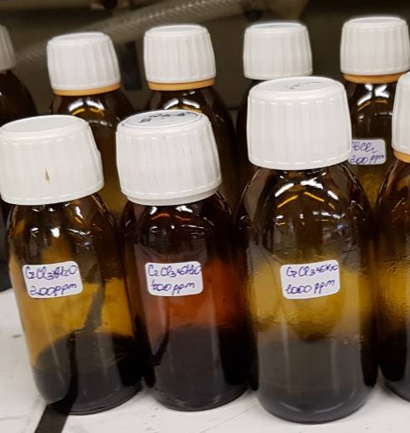
Figure 1 - A set (50-1000 ppm) of aqueous model solutions (10 ml) of CrCl3 with an adsorbent (0.4 g / l)

Metal salts that are mainly used in various industrial processes such as CrCl3 • 6H2O and Co (CH3COO) 2 • 4H2O.
When the adsorption process was completed, the solutions were filtered through 0.6 µm membrane filters to avoid the influence of small particles of the adsorbent during optical measurements (Figure 2); the equilibrium concentrations of metals were measured by ultraviolet spectrophotometry using a UV-VIS 1800 device from Shimadzu (Japan).
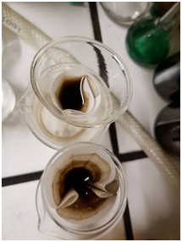
Figure 2 - The process of filtration of solutions through membranes 0.6 μm

The adsorption capacity of the sorbent (qeql) can be expressed in terms of the amount of Men + adsorbed per unit mass of the sorbent, i.e. absorption (mg / g) is given as follows:
(1)
whereС_{init}- initial concentration, С_{eql} is the equilibrium concentration of Me^{n+} in the solution (mg / l) and m is the sorbent dose (g / l).
The adsorption efficiency of the system (Rem%), indicated by the percentage of Me^{n+} removed relative to the initial amount, i.e. Rem in%, is determined
(2)
The selection of experimental data on adsorption was carried out by several known isothermal models.
Isothermal adsorption models used for analysis.
Langmuir isotherm. The model assumes a monolayer coating and constant binding energy between the surface and the adsorbate:
(3)
whereq_{max} is the maximum adsorption capacity (monolayer coating), i.e. mmol of adsorbate per (g) of adsorbent; K_{L} is the Langmuir isotherm constant if the enthalpy of adsorption does not depend on the coating.
To calculate the basic parameters of the Langmuir isotherm model, a linear form is required. It is assumed that linearizing the Langmuir model (equation 1 / q_{eql}vs 1 / C_{eql}) will give a straight line with an intercept of 1 / q_{max}:
(4)
Freundlich isotherm:
For the particular case of heterogeneous surface energies, in which the energy term (KF) changes depending on the surface coverage, the Freundlich model is used:
(5)
where K_{F} is the equilibrium constant of the Freundlich equation associated with the adsorption capacity 1 / nF, is a parameter associated with the strength of the adsorbent-adsorbate interaction, which is associated with the efficiency of adsorption.
Similarly, for the Langmuir model, the linear form of the Freundlich isotherm is used to calculate the main parameters.
However, when only a portion of the adsorption data is correlated for subsequent use in a specific adsorption application, without the need to extrapolate to other adsorbates or to a significantly different temperature range, it is more appropriate to obtain a less general but more accurate representation of adsorption equilibria. For this purpose, the Sips and Thoth isothermal models are used.
As a model of adsorption, we used the nonlinear model of the Sips isotherm (Freundlich-Langmuir) to obtain a more accurate representation of the parameters of adsorption equilibria:
(6)
whereq_{s} is the adsorption capacity of the adsorbent, Ks is the equilibrium constant, and n is the heterogeneity. The parameter n characterizes the interaction of the adsorbate and the adsorbent, and its value increases with the heterogeneity of the system. It should be noted that for n = 1, Eq. (3) becomes a Langmuir-type equation. Alternatively, for Ceql or Ks approaching 0, this isotherm is reduced to the famous Freundlich isotherm.
The Thoth isotherm is an empirical model that has been developed to provide improved fit over traditional Langmuir isotherm modeling. This is often useful for describing heterogeneous systems. Thoth's isotherm model approaches the Henry region at infinite dilution:
(7)
The adsorption measurements of Men + on the produced activated carbon were carried out at a fixed load (4 g / L) of the adsorbent, aimed at determining the equilibrium conditions of the adsorption process (Figures 3-4).
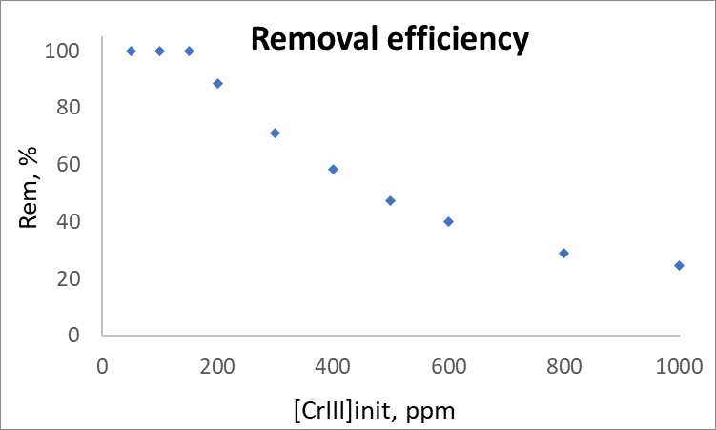
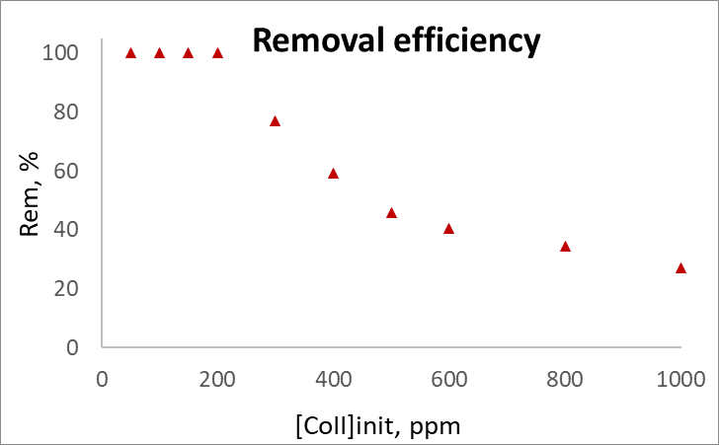
Figure 3 - The efficiency of adsorption (Rem%) of Cr3 + (left) and Co2 + (right) on the obtained adsorbent with a fixed loading of the adsorbent (~ 4 g / l) after 1 week

As can be seen (Figure 6), the adsorption efficiency (Rem%) decreases with increasing concentration at a constant load of activated carbon, which is consistent with theory (equation 2).
The experimental isotherms shown in Figure 7 are type I adsorption isotherms. Moreover, all systems were in equilibrium after 7 days of adsorption.
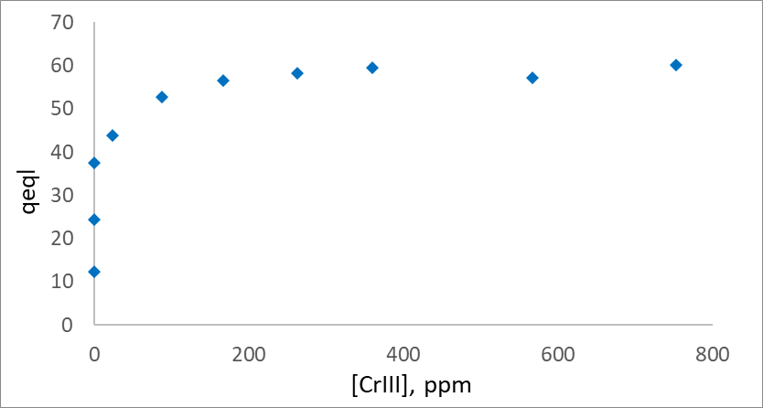
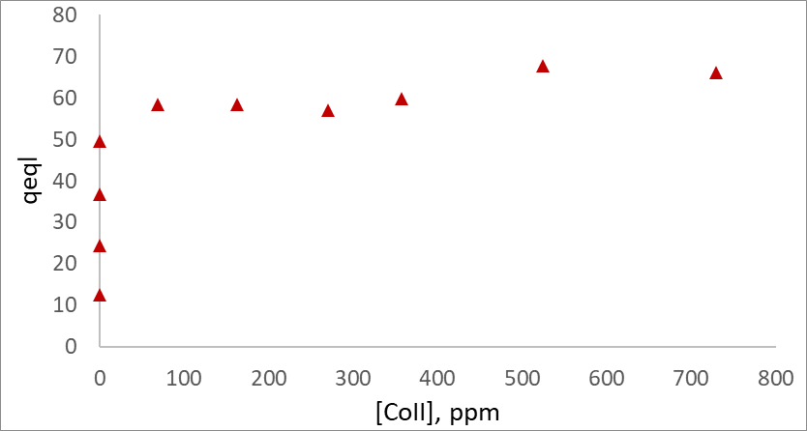
Figure 4 - Experimental adsorption isotherms of Cr3 + and Co2 + on the obtained activated carbon with a fixed loading of the adsorbent (~ 4 g / L) after 1 week of equilibration

Adsorption isotherms were analyzed by fitting experimental data using Langmuir, Freundlich, Sips and Thoth isotherm models. The residual sum of squares algorithm was used to fit the experimental isotherm in a non-linear approach using the AMPL programming language. This method does not transform the datasets and therefore no distortions are generated in the original error distribution. The fitting results are shown in Figure 5 and Table 5.
Figure 5 - Graphs of experimental adsorption isotherms on activated carbon with a fixed loading of adsorbent (~ 4 g / l) after 1 week of equilibration; solid lines correspond to fittings with different isothermal models.

As seen from the Freundlich model, the model poorly described the resulting adsorption curves due to its complex behavior in the studied concentration range.
However, the two-parameter linear / nonlinear Langmuir and three-parameter models of the Sips and Thoth isotherms are in adequate agreement with the experimental results. The maximum adsorption capacities obtained using the nonlinear form of the Langmuir and Sips models are the same for all metals, and the values ​​obtained by the Thoth model differ from these values ​​(Table 5).

Table 5 - Isotherm constant of two and three-parameter models for the adsorption of Men + on activated carbon
Isothermmodel | Constant | Cr³⁺ | Co²⁺
Langmuir | q_{s}(mg / g) | 59,7 | 64,1
Langmuir | b(L / g) | 0,12 | 0,1
Langmuir | ΔG (кДж/моль) | -5,4 | -5,7
Sips | q_{s}(mg /g) | 59,5 | 70
Sips | K_{s}(L/g) | 0,12 | 0,05
Sips | n_{s} | 1 | 1
Sips | ΔG (кДж/моль) | -5,4 | -7,5
Tot | q_{s}(mg /g) | 61,2 | 66,8
Tot | K_{T}(L/g) | 0,24 | 0,26
Tot | n_{T} | 0,74 | 0,74
Freundlich | K_{F}(L/g) | 0,12 | 0,12
Freundlich | n_{F} | 1 | 1

Thus, for the next discussion, the description results obtained using the Langmuir and Sips models were selected. In addition, it should be noted that the calculated parameter n in the Sips model is 1, therefore, the Sips transformation into a simpler Langmuir equation. The parameter b and KS, which are equilibrium constants, do not vary significantly between models for all metals (Table 9).
To better understand the equilibrium of the systems under study, the Gibbs free energy was chosen for the Men + adsorption isotherms. For this purpose, the calculations used the equilibrium constants (Ks band) obtained by the Langmuir and Sips method. The change in the standard Gibbs free energy ΔG was calculated using the Wanta-Hoff equation:
where K is the apparent equilibrium constant, T is the temperature in Kelvin, and R is the gas constant (8.314 J / mol • K).
As can be seen (Table 9), all ΔG values are negative, which indicates spontaneous adsorption in nature. There was also a slight change in the ΔG values (from -5.7 to -7.5 kJ / mol for the Langmuir and Sips models for Co), whereas for Cr, both models showed a ΔG of -5.4 kJ / mol), which are appropriately correspond to the calculated qs values, so the lowest energy value corresponds to the highest qs value.
We can also conclude that 7 days is enough for the onset of adsorption equilibrium.

  - Application of the obtained adsorbents for wastewater treatment

The resulting adsorbent was used for cleaning the sewage runoff in Kyzylorda. For the study, we used activated carbon obtained with a straw: oil sludge ratio of 9: 1 (the most optimal). Samples of sewage water were taken at the biological treatment plant after the entire treatment stage (filtration from coarse particles, biological treatment). Photos of the biological treatment plant in Kyzylorda are shown in Figure 6.
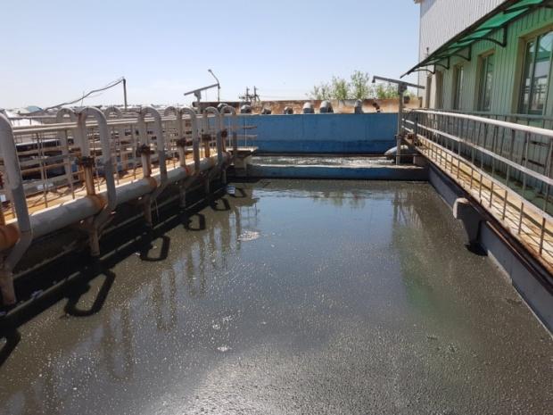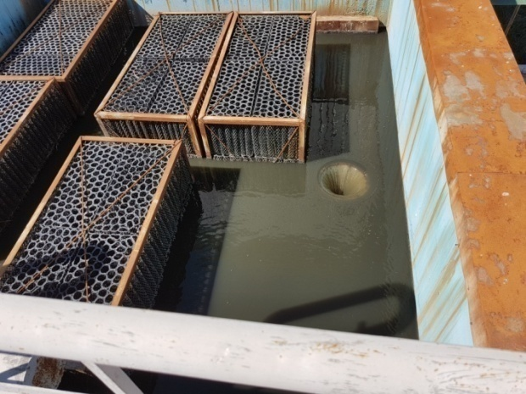

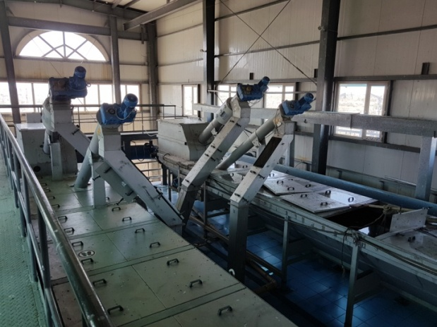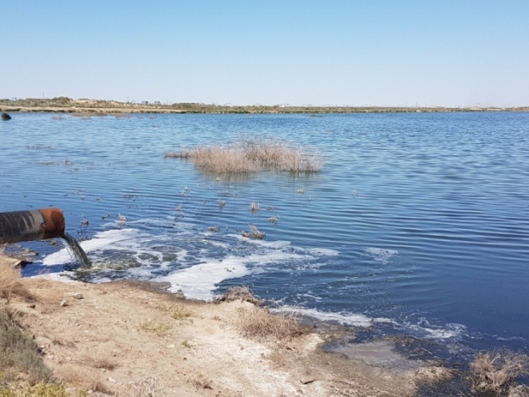
Figure 6 - Biological treatment plant in Kyzylorda
Waste sewage water was purified using the obtained adsorbent, Figure 7 shows photographs of sewage water before and after purification with the obtained activated carbon (Figure 7). Sewage water was analyzed for 8 types of indicators, after cleaning with the obtained adsorbent, these indicators were examined. The data are shown in Table 6.

Table 6 - Physicochemical parameters of sewage water before activated carbon treatment
Thenameofindicators | ND designation  testmethods | Normon ND | The actual  values before cleaning | The actual  values after clearing
Color, degrees, nomore | GOST 3351 | 20 | 520,2 | 430,4
Hydrogen exponent (pH) | Measured with a pH meter | 7,2 | 8,6 | 8,6
Aluminum, mg / dm³ | GOST18165 | 0,5 | 26,903 | 4,7
Nitrite, mg / dm³ | GOST 18826 | 3 | 0,4 | 0,3
Polyphosphates, mg / dm³ | GOST 18309 | 3,5 | 0,5 | 0,3
Orthophosphates | GOST 18309 | 3,5 | 0,6 | 0,4
Manganese, mg / dm³ | GOST 4974 | 0,05 | 0,03 | absent
Total mineralization, mg / dm³ | GOST 18164 | 1000,0 | 2 | 1

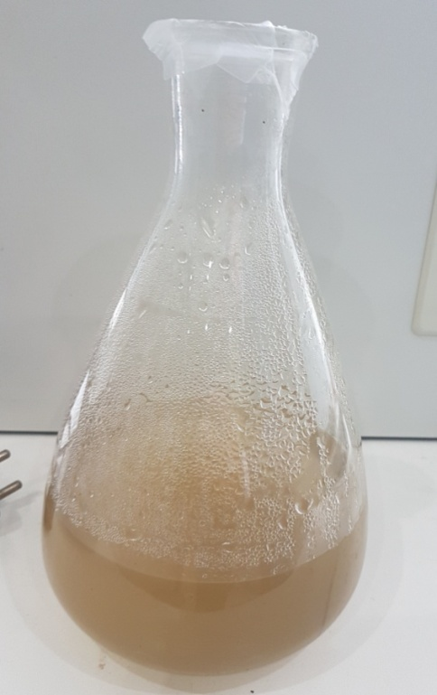 | 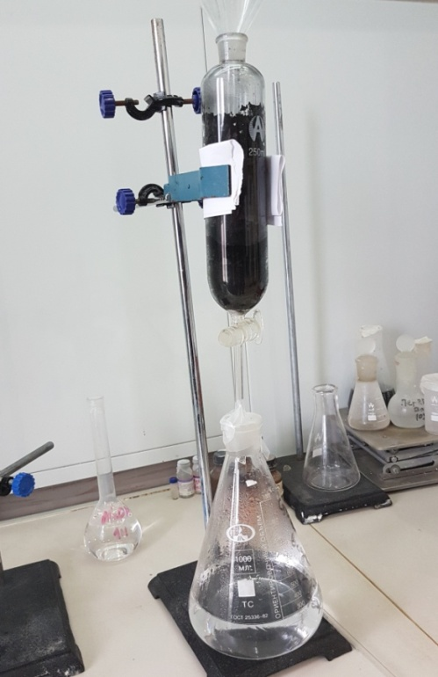
A – before cleaning | B – after cleaning
Figure 7 – Sewage waste water

From table 6 it can be seen that after cleaning, such physical indicators as color and dry residue are improved, there is a decrease in such chemical indicators as ions of calcium, aluminum, manganese, nitrites, polyphosphates, orthophosphates. For the rest of the indicators, no changes were observed.
CONCLUSION

Based on the results of the research, the following conclusions were made:
1. The scientific and technical literature on the research topic has been analyzed, which made it possible to establish the strengths and weaknesses of the currently existing methods of producing activated carbon. Despite some progress in the field of ideas about the structure of a carbon sorbent, at the present stage of development of science there is an acute shortage of knowledge in the field of joint processing of liquid and solid organic waste into adsorbents; 2. Thermolysis of rice husks and straw was carried out in order to obtain a carbon sorbent. The properties of the products obtained have been studied, and according to their results, it can be judged that the activated carbon obtained from agricultural waste is in no way inferior in quality to charcoal;
3. Co-thermolysis of rice husk and straw with oil sludge was carried out, optimal conditions and composition were found. According to the results of the studies, it was found that the adsorbent obtained by co-thermolysis of rice straw and oil sludge in a ratio of 9: 1 corresponds to the best sorption and other indicators for activated carbons;
4. Activated carbon obtained under optimal conditions was tested for adsorption capacity. The first evaluative tests of the obtained sample of activated carbon for the adsorption of heavy metals (Cr3 + and Co2 +) have been carried out, according to the test results, it can be judged that the obtained activated carbon has high adsorption characteristics;
5. Also, the obtained activated carbon was tested for the treatment of sewage waste water after the biological treatment plant in Kyzylorda. It was found that after cleaning, such physical indicators as color and dry residue improve, there is a decrease in such chemical indicators as ions of calcium, aluminum, manganese, nitrites, polyphosphates, orthophosphates.

LIST OF USED SOURCES

- Bespamjatnov G.P, Botushevskaja K.K., Zelensky L.A. Thermal methods of neutralisation of a waste. – Moscow: Chemistry, 1975. – 342 p.
- Maksimov I. E. Condition and use prospects ecosafety systems in the decision of problems of a waste. Analytical Review//In: Municipal and Industrial Wastes: Neutralization and Utilization Processes. Ser. Ecology. – Novosibirsk, 1995. –P.52–76.
- Ravich B.M., Okladnikov V.P, Lygach V.N, etc. Complex use of raw materials and a waste. – Мoscow: Chemistry, 1988 – 226 p.
- Luo M., Curtis C. W. Thermal and catalytic co-processing of Illinois No. 6. coal with model and commingled waste plastics// Fuel Processing Technology. 1996. – Vol. 49. – №1-3. – P.91–117.
- Sharypov V.I., Beregovtsova N.G., Kuznetsov B.N., Baryshnikov S.V., Cebolla V.L., Weber J.V., Collura S., Finqueneisel G., Zimny T. Co-pyrolysis of wood biomass and synthetic polymers mixtures: Part IV: Catalytic pyrolysis of pine wood and polyolefin polymers mixtures in hydrogen atmosphere//Journal of Analytical and Applied Pyrolysis. –2006. – Vol. 76. – № 1-2. –P.265–270.
- Nikkhah K., Bakhshi N.N., MacDonald D.G. Co-pyrolysis of various biomass materials and coals in a quartz semi-batch reactor//In: Klass D.L., Editor, Energy from biomass and waste XVI, Institute of Gas Technology. – Chicago, 1993. P.857–902.
- Zhu W., Song W., Lin W. Catalytic gasification of char from co-pyrolysis of coal and biomass// Fuel Processing Technology. – 2008. – Vol. 89. – № 9. – P.890–896.
- Lapuerta M., Hernández J.J., Pazo A., López J. Gasification and co-gasification of biomass wastes: Effect of the biomass origin and the gasifier operating conditions//Fuel Processing Technology. –2008. –Vol. 89. – № 9. – P.828–837.
- Zhu W., Song W., Lin W. Catalytic gasification of char from co-pyrolysis of coal and biomass// Fuel Processing Technology.– 2008. –Vol. 89. – № 9. – P.890–896.
- Wang L., Chen P. Development of first-stage co-liquefaction of Chinese coal with waste plastics//Chemical Engineering and Processing. –2004. – Vol. 43. – №2. – P.145–148.
- Hawelek L., Brodka A., Dore J.C., Honkimäki V., Burian A. Fullerene-like structure of activated carbons // Diamond and Related Materials. – 2008. – Vol. 17. – №7-10. P.1633-1638.
- V.M. Gun’ko, O.P. Kozynchenko, V.V. Turov, S.R. Tennison, V.I. Zarko, Y.M. Nychiporuk, T.V. Kulik, B.B. Palyanytsya, V.D. Osovskii, Y.G. Ptushinskii, A.V. Turov. Structural and adsorption studies of activated carbons derived from porous phenolic resins // Colloids and Surfaces A: Physicochem. Eng. Aspects. – 2008. – Vol. 317. – №1-3. –P.377–387
- T. Petersen, I. Jarovsky, I. Snook, D.G. McCulloch, G. Opletal.Structural analysis of carbonaceous solids using an adapted reverse Monte Carlo algorithm // Carbon. – 2003. – Vol.41. - №12. – P.2403-2411.
- T. Petersen, I. Jarovsky, I. Snook, D.G. McCulloch, G. Opletal. Microstructure of an industrial char by diffraction techniques and Reverse Monte Carlo modelling // Carbon. – 2004. – Vol.42. - №12-13. – P.2457-2469.
- Harry Marsh, Francisco Rodríguez-Reinosо. SEM and TEM Images of Structures in Activated Carbons // Activated Carbon. – 2006. – P. 366-382.
- P.J.F. Harris, Structure of non-graphitizing carbons //International Materials Reviews. –1997. –Vol. 42. – №5. – P.206-218.
- Suzdalev I.P. Nanotechnology: physico-chemistry of nanoclusters, nanostructures and nanomaterials. Moscow: Series "Synergetics: from the past to the future", 2006. - 589 p.Meng J., Tao M., Wang L., Liu X., Xu, J. Changes in heavy metal bioavailability and speciation from a Pb-Zn mining soil amended with biochars from co-pyrolysis of rice straw and swine manure // Sci. Total Environ. Vol.633. - 2018а. - P.300-307.
- Xu D., Cao J., Li Y., Howard A., Yu K. Effect of pyrolysis temperature on characteristics of biochars derived from different feedstocks: a case study on ammonium adsorption capacity // Waste Manag. Vol.87. - 2019a. - P.652 - 660. Yuan P., Wang J., Pan Y., Shen B., Wu C. Review of biochar for the management of contaminated soil: preparation, application and prospect // Sci. TotalEnviron. Vol.659. - 2019. – P.473-490.
- Tripathi M., Sahu J.N., Ganesan P. Effect of process parameters on productionofbiochar from biomass waste through pyrolysis (a review) // Renew. Sustain.Energy Rev. Vol.55. - 2016. – P.467-481.
- Yaashikaa P.R., Senthil Kumara P., Varjanic S.J., Saravanand A. Advances inproduction and application of biochar from lignocellulosicfeedstocksforremediation of environmental pollutants // Bioresour. Technol. Vol.292. - 2019. – P.122030.
- Masebinu S.O., Akinlabi E.T., Muzenda E., Aboyade A.O., A review of biocharproperties and their roles in mitigating challenges with anaerobic digestion // Renew. Sustain. Energy Rev. Vol.103. -2019. – P.291- 307.
- Zhang Z., Zhu Z., Shen B., Liu L., Insights into biochar and hydrocharproduction and applications: (a review) // Energy. Vol.171.- 2019a.– P.581-598
- YangX.,NgW.,WongB.S.E.,BaegG.H.,WangC.-H.,OkY.S.Characterization and ecotoxicological investigation of biochar produced via slow pyrolysis: effect of feedstock composition and pyrolysis conditions // J. HazardMater. Vol.365. - 2019a.- P.178-185.
- GaoY., Jiang Z., Li J., XieW., Jiang Q., Bi M., Zhang Y. A comparisonofthecharacteristicsandatrazineadsorptioncapacityofco-pyrolysedandmixedbiochars generated from corn straw and sawdust // Environ. Res. Vol.172. - 2019a. – P.561-568.
- Meng J., Liang S., Tao M., Liu X., Brookes P.C., Xu J. Chemical speciationand risk assessment of Cu and Zn in biochars derived from co-pyrolysis of pigmanure with rice straw // Chemosphere. Vol.200. - 2018b. – P.344-350.
- HassanH.,LimJ.K.,HameedB.H.Recentprogressonbiomassco-pyrolysisconversion into high-quality bio-oil // Bioresour. Technol. Vol.221. -2016. – P.645-655.
- Fan S., Li H., Wang Y., Wang Z., Tang J., Tang J., Li X., Cadmium removalfrom aqueous solution by biochar obtained by co-pyrolysis of sewage sludgewithteawaste //Res.Chem.Intermed. Vol.44. - 2018. – P.135-154.
- Sewu D.D., Boakye P., Jung H., Woo S.H. Synergistic dye adsorption bybiochar from co-pyrolysis of spent mushroom substrate and Saccharinajaponica // Bioresour. Technol. Vol.244. - 2017. – P.1142-1149.
- GaoR.,FuQ.,HuH.,WangQ.,LiuY., ZhuJ.Highly-effectiveremovalofPbby co-pyrolysis biochar derived from rape straw and orthophosphate // J.HazardMater. Vol.371. - 2019b. – P.191-197.
- SiyalA.A.,ShamsuddinM.R.,KhanM.I.,RabatN.E.,ZulﬁqarM.,ManZ.,SiameJ.,Azizli K.A. A review on geopolymers as emerging materials for theadsorptionofheavymetalsanddyes //J.Environ.Manag. Vol.224. – 2018. – P.327-339.
- Chen S., Qin C., Wang T., Chen F., Li X., Hou H., Zhou M. Study on theadsorption of dyestuffs with different properties by sludge-rice husk biochar:adsorption capacity, isotherm, kinetic, thermodynamics and mechanism // J. Mol.Liq. Vol.285. - 2019a. – P.62-74.
- AbnisaF., Wan Daud W.M.A. A review on co-pyrolysis of biomass: anoptionaltechniquetoobtainahigh-gradepyrolysisoil //EnergyConvers.Manag. Vol.87. - 2014. – P.71-85.
- Chen W., Chen M., Zhou X. Characterization of biochar obtained by co-pyrolysis of waste newspaper with high-density polyethylene // Bio Resources. Vol.10. - 2015. – P.8253-8267.
- Jafri N., Wong W.Y., Doshi V., Yoon L.W., Cheah K.H. A review on production and characterization of biochars for application in direct carbon fuel cells // Process Saf. Environ. Vol.118. - 2018. – P.152-166.
- Yaashikaa P.R., Senthil Kumara P., Varjanic S.J., Saravanand A. Advances inproduction and application of biochar from lignocellulosicfeedstocksforremediation of environmental pollutants // Bioresour. Technol. Vol.292. -2019. – P.22030.
- Zhang Z., Zhu Z., Shen B., Liu L. Insights into biochar and hydrocharproduction and applications: (a review)// Energy. Vol.171. - 2019a. – P.581-598.
- Uzoejinwa B.B., He X., Wang S., Abomohra A.E., Hu Y., Wang Q. Co-pyrolysis of biomass and waste plastics as a thermo chemical conversion tech-nologyforhigh-gradebiofuelproduction:recentprogressandfuturedirectionselsewhere worldwide // Energy Convers. Manag.Vol.163. 2018. – P.468-492.
- YuK.L.,LauB.F.,ShowP.L.,OngH.C.,LingT.C.,ChenW.-H.,NgE.P.,Chang,J.-S.Recentdevelopmentsonalgalbiocharproductionandcharacterization // Bioresour. Technol. Vol.246. - 2017. – P.2-11.
- Kambo H.S., Dutta A. A comparative review of biochar and hydrocharinterms of production, physico-chemical properties and applications // Renew.Sustain. Energy Rev. Vol.45. - 2015. – P.359-378.
- Luz,F.C.,Cordiner,S.,Manni,A.,Mulone,V.,Rocco,V.,Biocharcharacteristicsandearlyapplicationsinanaerobicdigestion-areview //J.Environ.Chem.Eng. Vol.6. - 2018. – P.2892-2909.
- Qian K., Kumar A., Zhang H., Bellmer D., Huhnke R. Recent advances inutilization of biochar // Renew. Sustain. Energy Rev. Vol.42, 2015. – P. 1055-1064.
- Zhang X., Gao B., Creamer A.E., Cao C., Li Y. Adsorption of VOCs ontoengineered carbon materials: (a review) // J. Hazard Mater. Vol.338. - 2017. – P.102-123.
- Kathrin Weber, Peter Quicker Properties of biochar // Fuel Vol.217. – 2018. – P.240-261.
- Cha J.S., Park S.H., Jung S.-C., Ryu C., Jeon J.-K., Shin M.-C., Park Y.-K. Production and utilization of biochar: (a review) // J. Ind. Eng. Chem. Vol.40. - 2016. – P.1-15.
- Li S., Harris S., Anandhi A., Chen G. Predicting biochar properties andfunctions based on feedstock and pyrolysis temperature: a review and datasyntheses // J. Clean. Prod. Vol.215. - 2019. – P.890-902.
- Li D.-C., Jiang H., The thermochemical conversion of non-lignocellulosicbiomass to form biochar: a review on characterizations and mechanism elucidation // Bioresour. Technol. Vol.246. - 2017. - 57-68.
- CaiJ.,HeY.,YuX.,BanksS.W.,YangY.,ZhangX.,Yu Y.,LiuR.,BridgwaterA.V.Review of physicochemical properties and analytical characterization oflignocellulosicbiomass // Renew.Sustain.EnergyRev. Vol.76. - 2017. – P.309-322.
- Oliveira F.R., Patel A.K., JaisiD.P., Adhikari S., Lu H., Khanal S.K. Environ-mental application of biochar: current status and perspectives //Bioresour.Technol. Vol.246. - 2017. – P.110-122.
- Tan Z., Lin C.S.K., Ji X., Rainey T.J. Returning biochar to ﬁelds: (a review) // Appl.Soil Ecol. Vol.116. - 2017. – P.1-11.
- AdhikariS.,Gasco´G.,Me´ndezA.,SurapaneniA.,Jegatheesan V., ShahK.,Paz-Ferreiro J. Inﬂuence of pyrolysis parameters on phosphorus fractions ofbiosolidsderivedbiochar //Sci.TotalEnviron. Vol.695. - 2019.-P.133846.
- WangX.,MaD.,Jin Q., DengS.,StanˇcinH.,TanH.,Mikulˇci´cH.Synergisticeffects of biomass and polyurethane co-pyrolysis on the yield, reactivity, andheating value of biochar at high temperatures // Fuel Process. Technol. Vol.194. - 2019a. – P.106127.
- Ahmed M.J., Hameed B.H. Adsorption behavior of salicylic acid on biocharasderived from the thermal pyrolysis of barley straws // J. Clean. Prod. Vol.195. - 2018. - P.1162-1169.
- Li D.-C., Jiang H. The thermochemical conversion of non-lignocellulosic biomass to form biochar: a review on characterizations and mechanism elucidation // Bioresour. Technol. Vol.246. – 2017. – P.57-68.
- Yin Q., Liu M., Ren H. Biochar produced from the co-pyrolysis of sewagesludge and walnut shell for ammonium and phosphate adsorption fromwater // J. Environ. Manag. Vol.249. - 2019. – P.109410.
- Chen W.M., Chen M.Z., Zhou X.Y. Characterization of biochar obtained by co-pyrolysis of waste newspaper with high-density polyethylene // Bio Resources. Vol.10. – 2015. - P.8253-8267.
- Cheng G., Sun L., Jiao L., Peng L., Lei Z., Wang Y., Lin J. Adsorption ofmethylene blue by residue biochar from co-pyrolysis ofdewateredsewagesludgeandpinesawdust //Desalin.WaterTreat. Vol.51. - 2013. – P. 7081-7087.
- Leng L.J., Yuan X.Z., Huang H.J., Wang H., Wu Z.B., Fu L.H., Peng X., Chen X.H.,Zeng G.M. Characterization and application of biochars from liquefaction of microalgae, lignocellulosic biomass and sewage sludge // Fuel Process.Technol. Vol.129. - 2015. – P.8-14.
- GüzelF.,Sayg˘ılıH.,Sayg˘ılıG.A.,KoyuncuF.Decolorisationofaqueouscrystal violet solution by a new nanoporous carbon: equilibrium and kineticapproach // J. Ind. Eng. Chem. Vol.20. - 2014. – P.3375-3386.
59 GOST 6217. Crushed active wood coal. Technical conditions. - M .: IPK Standards Publishing House, 2003.
60 GOST 17219. Active coals. Method for determining the total pore volume by water. - M .: Publishing house of standards, 1988.
61 GOST 12597. Sorbents. Method for determining the mass fraction of water in activated carbons and catalysts based on them. - M .: Publishing house of standards, 1989.
62 GOST 16190. Sorbents. Bulk density determination method. - M .: Publishing house of standards, 1970.

APPLICATION A – Calendar plan of work

3. Name of work, terms of their implementation and results
Task code, stage | Name of work under the Agreement and the main stages of its implementation | Period of execution |  | ExpectedResult
Task code, stage |  | start | end | ExpectedResult
1 | Development of innovative technology for the processing of mixtures of solid and liquid waste from national repositories for recovery and reuse | February  2018 y. | Until November 1, 2018 y. | An innovative technology will be developed to recycle mixtures of solid and liquid waste from national repositories for recovery and reuse
1.1 | Creation of a plan for the implementation of the development of a highly competitive technology for processing national natural and technogenic raw materials. Collection and provision of information on the current state of the art in the field of raw materials processing technologies based on the best approaches / developments, including those approved and tested within the EU environmental programs. | February  2018 y. | March  2018 y | A plan for the implementation of the development of a highly competitive technology for processing national natural and man-made raw materials will be created. Information on the current state of the art in the field of raw material processing technologies will be collected and provided on the basis of the best development approaches, including those approved and tested within the EU environmental programs.
1.2 | Preparation and provision of information on the national resources of natural and man-made raw materials, on the sources of liquid oil waste and waste of solid biomass of the rice stalk in the Kyzylorda region, in terms of sources of nature, availability / need for disposal / processing. | April 2018 y. | May  2018 y. | Information will be prepared and provided on national resources of natural and man-made raw materials, on the sources of liquid oil waste and waste of solid biomass of rice stem in the Kyzylorda region, in terms of sources / nature, availability / need for disposal / processing.
1.3 | Co-thermolysis of organic waste mixtures to obtain solid, porous, valuable secondary products in three different modes: direct activation by high-temperature steam (850 ° C); activation through a stage of low-temperature (350 ° C) or high-temperature carbonization (700 ° C), with additions of rice husk with a high mineral content and a Si / C ratio. | May  2018 y. | November 1, 2018y. | Co-thermolysis of organic waste mixtures will be carried out to obtain solid, porous, valuable secondary products in three different modes: direct activation by high-temperature steam (850 ° C); activation through a stage of low-temperature (350 ° C) or high-temperature carbonization (700 ° C), with additions of rice husk with a high mineral content and a Si / C ratio. 2 articles will be published in peer-reviewed Russian scientific journals with a non-zero impact factor. An application will be filed for a patent of the RK for a utility model.
1 | Development of innovative technology for the processing of mixtures of solid and liquid waste from national repositories for recovery and reuse. | January 2019 y. | August 2019 y. | An innovative technology will be developed to recycle mixtures of solid and liquid waste from national repositories for recovery and reuse. The conditions for carrying out carbonation and activation processes will be optimized.
1.4 | Development of design parameters for waste disposal, implementation of valorization, re-polymerization, re-association and polycondensation reactions between components in a composite system. | January 2019 y. | May  2019 y. | Design parameters for waste disposal will be developed, valorization of re-polymerization, re-association and polycondensation reactions between components in the composite system will be carried out.
1.5 | Joint processing of a mixture of wastes, study of the synergistic effects of reference structural fragments of components of a mixture of solid and liquid carbon-containing waste, occurring during co-thermolysis. | June  2019 y. | August  2019 y. | Joint processing of a mixture of waste will be carried out, synergistic effects of reference structural fragments of components of a mixture of solid and liquid carbon-containing waste, occurring during co-thermolysis, will be investigated.
2 | Вторичные продукты – разработка и характеристика новых адсорбентов из смесей отходов с использованием физико- химических методов анализа | September 2019 y. | Until November 1, 2019 y. | New adsorbents from waste mixtures will be developed and characterized using physicochemical methods of analysis
2.1 | Investigation of the formation of micro- and nanoclusters during the transformation of carbon matrices of raw organic materials using an integrated approach to the analysis of solid porous substances using various diagnostic methods, such as time-of-flight mass spectrometry with laser ionization, scanning electron microscope, photoelectron and Auger spectroscopy, and solid state NMR spectroscopy. | September 2019 y. | Until November 1, 2019 y. | The formation of micro- and nanoclusters during the transformation of carbon matrices of raw organic materials will be investigated using an integrated approach to the analysis of solid porous substances using various diagnostic methods, such as time-of-flight mass spectrometry with laser ionization, scanning electron microscope, photoelectron and Auger spectroscopy. as well as solid state NMR spectroscopy. 2 articles will be published in peer-reviewed foreign scientific journals, indexed in the Web of Science or Scopus databases with a non-zero impact factor and a patent of the Republic of Kazakhstan will be obtained
2 | Secondary products - development and characterization of new adsorbents from waste mixtures using physicochemical methods of analysis | January 2020 y. | June  2020 y. | New adsorbents from waste mixtures using physicochemical methods of analysis will be developed and characterized. The sorption properties of the obtained sorbents will be investigated in various models. Two articles will be published in peer-reviewed foreign and domestic scientific journals with a non-zero impact factor.
2.2 | Development of a new approach to changing the activity of adsorbents. The use of a component of additional mixtures (rice stalk) to create the necessary morphology of nanoparticles, mesoporous structures and control their surface texture, the nature of sorption centers, their strength, surface charge to ensure the ability to bind pollutants not only physically, but also chemically. | January 2020 y. | March  2020 y. | New approaches will be developed to change the activity of adsorbents. Components of additional mixtures (rice stalk) will be used to create the necessary morphology of nanoparticles, mesoporous structures and control their surface texture, the nature of sorption centers, their strength, surface charge to ensure the ability to bind pollutants not only physically, but also chemically.
2.3 | Creation of adsorbents that can have both a wider spectrum of activity and high selectivity in relation to specific pollutants. | April 2020 y. | June  2020 y. | Adsorbents will be created that can have both a wider spectrum of activity and high selectivity in relation to specific pollutants.
3 | Preparation of a technical recommendation on the joint processing of oil waste and rice stalk with new nanocomposite adsorbents. Obtaining a patent of the Republic of Kazakhstan for the developed technology. | May  2020 y. | July  2020 y. | A technical recommendation will be prepared on the joint processing of oil waste and rice stalk with new nanocomposite adsorbents.
4 | Study of the kinetics and thermodynamics of the adsorption of heavy metals and organic compounds from the liquid phase on the surface of porous nanomaterials in model solutions | June  2020 y. | August  2020 y. | The kinetics and thermodynamics of adsorption of heavy metals and organic compounds from the liquid phase on the surface of porous nanomaterials in model solutions will be studied.  Data will be examined to optimize process conditions
5 | Obtaining data on the development of a technical recommendation for a new product (new adsorbent from a mixture of solid and liquid waste) for industrial wastewater treatment | September 2020 y. | November 1, 2020 y. | Based on the data obtained, technical recommendations will be developed for a new product (a new adsorbent made from a mixture of solid and liquid waste) for industrial wastewater treatment.  1 article will be published in peer-reviewed foreign scientific journals, indexed in the Web of Science or Scopus databases with a non-zero impact factor and a patent of the RK will be obtained.

APPLICATION B

List of published works based on research results for 2018:

Articlesinmagazines:
- Omarov Ye., Zhapparbergenov R.U., Turmanov R.A., Syzdykbayev M.I., Saduakaskyzy K., Appazov N.O. Obtaining palladium nanoparticles and their application as catalyst in hydrogenation of vegetable oil // Химический журнал Казахстана. – 2018. – №1(61). – С.128-132.(english).
- Bainazarova S.R., Diyarova B.M., Lygina O., Shuragaziyeva A.T., Tapalova A.S., Zhusupova L.A., Appazov N.O. Processing of rice wastes into activated carbon // Химический журнал Казахстана. – 2018. – №4(64).(english).
- АппазовН.О., ЖусупбекУ.А., ТурмановР.А., ЛюбчикС.Б., ЛюбчикА.И., ЛюбчикС.И., ЛыгинаО.С., БайназароваС.Р., БазарбаевБ.М. Способполученияактивированногоугляизрисовойсоломыишелухи. Заявление о выдаче патента РК на полезную модель №2018/0404.2 от 07.06.2018 г. (russian).

List of published works based on research results for2019:

Articlesinmagazines:
- Байназарова С.Р., Любчик А.И., Жусупбек У.А., Шурагазиева А.Т., Аппазов Н.О. Получение активированного угля из рисовой шелухи и соломы // Вестник НИА РК. 2019. -№1. С.76-80.(russian).
- Аппазов Н.О., Базарбаев Б.М., Диярова Б.М., Лыгина О.С., Шурагазиева А.Т., Акылбеков Н.И. Получение активированного угля со-термолизом рисовой соломы и нефтешлама // Химический журнал Казахстана. – 2019. – №4(68). – С.46-51.(russian).
- Аппазов Н.О., Турманов Р.А., Жаппарбергенов Р.У., Диярова Б.М., Лыгина О.С., Шурагазиева А.Т., Акылбеков Н.И. Получение активированного угля со-термолизом рисовой шелухи и нефтешлама // Химический журнал Казахстана. – 2019. – №4(68). – С.77-83.(russian).
- Smolobochkin A.V., Rizbayeva T.S., Gazizov A.S., Voronina J.K., Chugunova E.A., Akylbekov N.I., AppazovN.O.,Burilov A.R., Pudovik M.A. Synthesis of 2-(pyrrolidin-1-yl)pyrimidines by reactions of N-(4,4-diethoxybutyl)pyrimidin-2-amine with (hetero)aromatic C-nucleophiles // Chemistry of heterociclyc compounds. – 2019. – V. 55, № 6. – P. 523-528.WebofScience, Scopus. Impact factor:1.519.(english).
- Smolobochkin A., Gazizov A., Sazykina M., Akylbekov N., Chugunova E., Sazykin I., Gildebrant A., Voronina J., Burilov A., Karchava S., Klimova M., Voloshina A., Sapunova A., Klimanova E., Sashenkova T., Allayarova U., Balakina A., Mishchenko D. Synthesis of Novel 2-(Het)arylpyrrolidine Derivatives and Evaluation of Their Anticancer and Anti-Biofilm Activity // Molecules. – 2019. – Vol. 24, N. 17. – P. 3086-3112.Web of Science, Scopus. Impact factor: 3.267.(english).
Patents:
- АппазовН.О., ТурмановР.А., БайназароваС.Р., ДияроваБ.М., ШурагазиеваА.Т., ДжиембаевБ.Ж., ЛыгинаО.С., ЛюбчикА.И., КурманбаевР.Х. Патентнаполезнуюмодель №3821. Способ получения активированного угля из рисовой шелухи и нефтешлама. Промышл. собственность. Офиц. бюлл. –2019. – №14.(russian).
- Аппазов Н.О., Жусупбек У.А., Турманов Р.А., Любчик С.Б., Любчик А.И., Любчик С.И., Лыгина О.С., Байназарова С.Р., БазарбаевБ.М.Патент на полезную модель №3892. Способ получения активированного угля из рисовой соломы и шелухи. Промышл. собственность. Офиц. бюлл. –2019. -№16.(russian).

Articles in conference proceedings:
- Appazov N., Diyarova B., Lygina O., Tapalova A, Saduakaskyzy K., Shuragaziyeva A., Dzhiembaev B. Processing of rice husk and straw into active coal. Book of Abstracts Eight International conference “Modern trends in science” FMNS-2019. 26-30.06.2019, Blagoevgrad, Bulgaria. P.36. (english).
- Аппазов Н.О., Турманов Р.А., Базарбаев Б.М., Жаппарбергенов Р.У., Шурагазиева А.Т., Акылбеков Н.И. Получение активированного угля со-термолизом рисовой шелухи и нефтешлама. Сборник материалов международной научно-практической конференции «Фундаментальные исследования: инновации в химической науке и образовании». Усть-Каменогорск.12.09.2019. – С. 40-42.(russian).
- Аппазов Н.О., Базарбаев Б.М., Жаппарбергенов Р.У., Диярова Б.М., Шурагазиева А.Т., Акылбеков Н.И. Получение активированного угля из рисовой соломы и нефтешлама. Труды Х международного Беремжановского съезда по химии и химической технологии. Алматы. 24-25 октября 2019 г. – С. 99-100.(russian).

List and reprints of published works based on research resultsfor 2020:

Articles in magazines:
1 Lyubchyk S., Shapovalova O., Lygina O., Oliveira M.C., Appazov N., Lyubchyk A., Charmier A.J., Lyubchik S., PombeiroA.J.L.Integrated Green Chemical Approach to the Medicinal Plant Carpobrotusedulis Processing // Scientific reports. – 2019. 9:18171. DOI: 10.1038/s41598-019-53817-8. Web of Science, Scopus. Impact factor: 3.998.(english).
2 SmolobochkinA.V., TurmanovR.A., AbdullaevaD.S., GazizovA.S., VoroninaJ.K., AppazovN.O., BuzyurovaD.N., BurilovA.R., PudovikM.A. 2-(Het)aryl-N-phosphorylpyrrolidinesviaCyclizationofPhosphorusAcidAmides: ARegioselectiveApproach // ChemistrySelect. – 2020. – Vol. 5. – P. 12045-12050.DOI: 10.1002/slct.202003353. WebofScience, Scopus. Impactfactor: 1.811. (english).
3 АппазовН.О.,БазарбаевБ.М., АкылбековН.И., ЖаппарбергеновР.У., КанжарС.А., ДияроваБ.М. Получениекачественногосорбентаизотходоврисаинефтешлама // Нефтьигаз. – 2020. – №3-4 (117-118). – С.169-179. (russian).
Patents:
4 АппазовН.О., АйсауытоваЗ.Ж., СыздыкбаевМ.И., АхатаевН.А. Патентнаполезнуюмодель №5305. Способполучениясиликатногоадсорбента // Промышл. собственность. Офиц. бюлл. – 2020. – №33.(russian).
Articles in conference proceedings:
5 Акылбеков Н.И., Аппазов Н.О., Базарбаев Б.М., Диярова Б.М., Шурагазиева А.Т., Канжар С.А., Жаппарбергенов Р.У. Комплексная переработка рисовых отходов с нефтешламом // Материалы Всероссийской научно-практической конференции, посвященной 90-летию Чувашского государственного педагогического университета им. И.Я.Яковлева «Теоретические и прикладные аспекты естественнонаучного образования», Чебоксары, 2020. – С. 3-11. (russian).

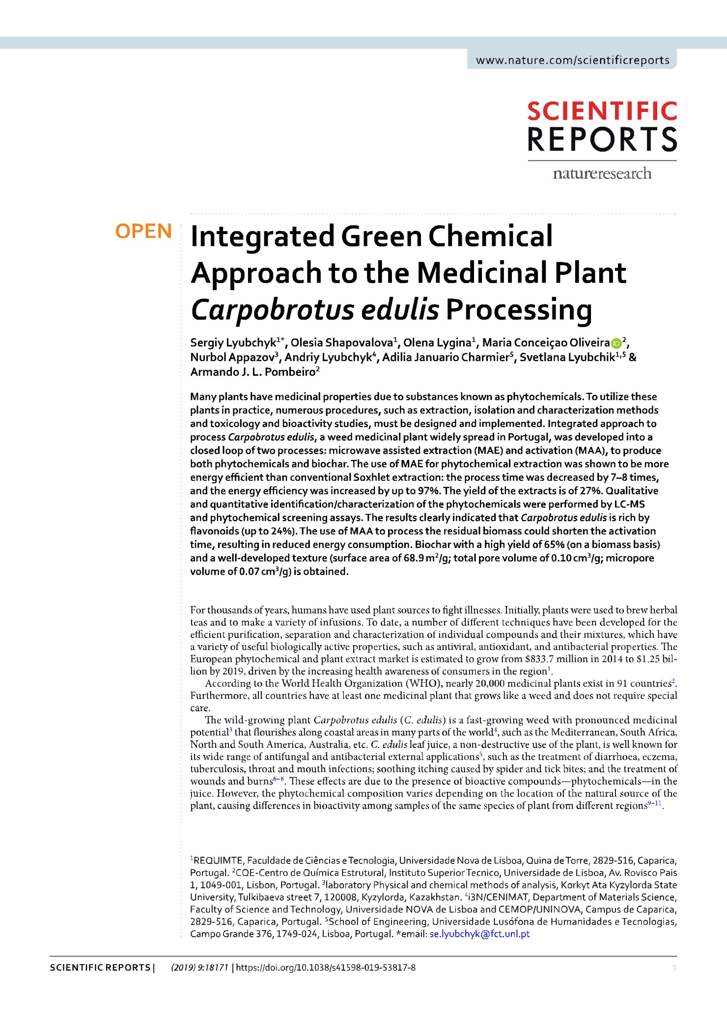
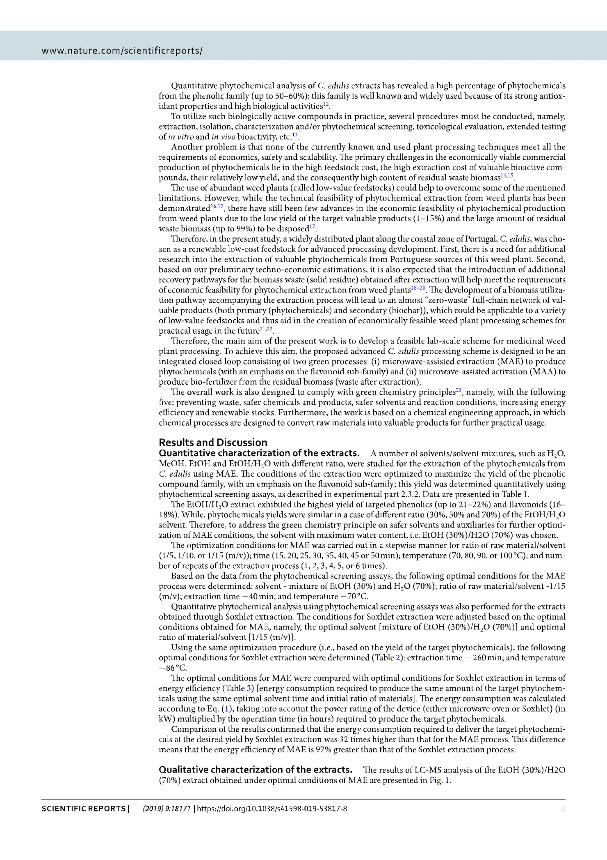
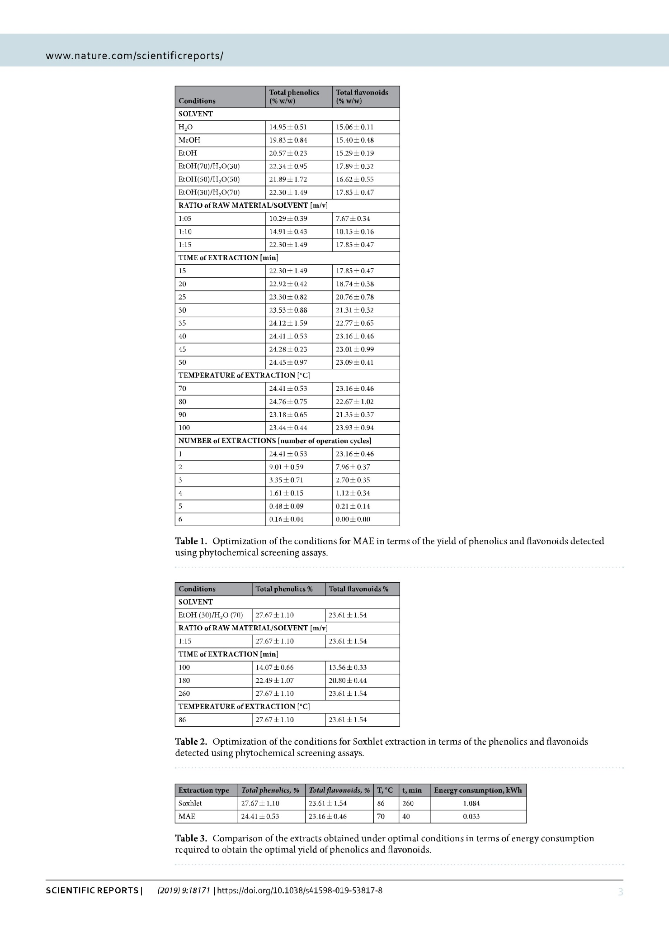
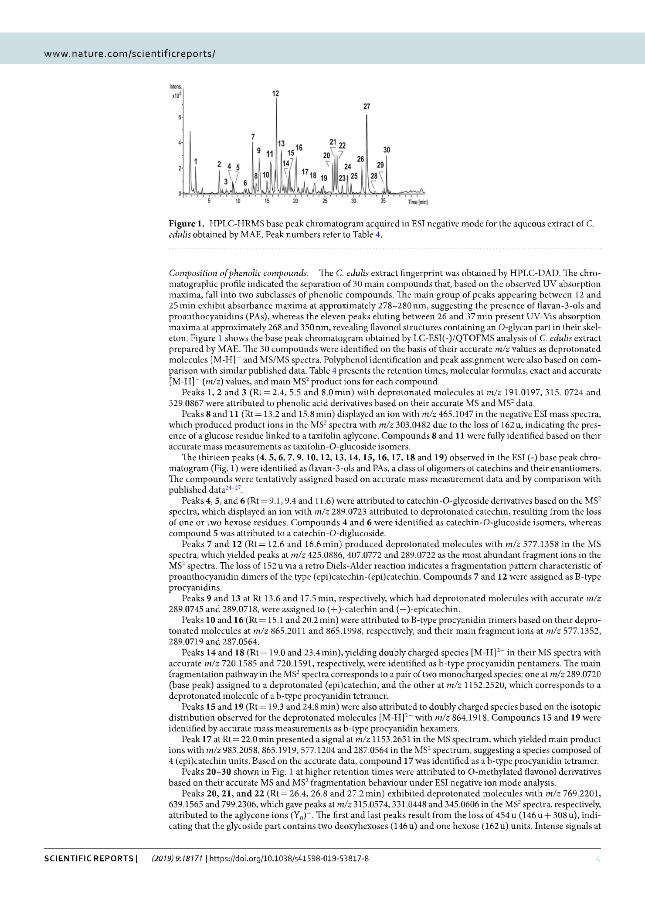
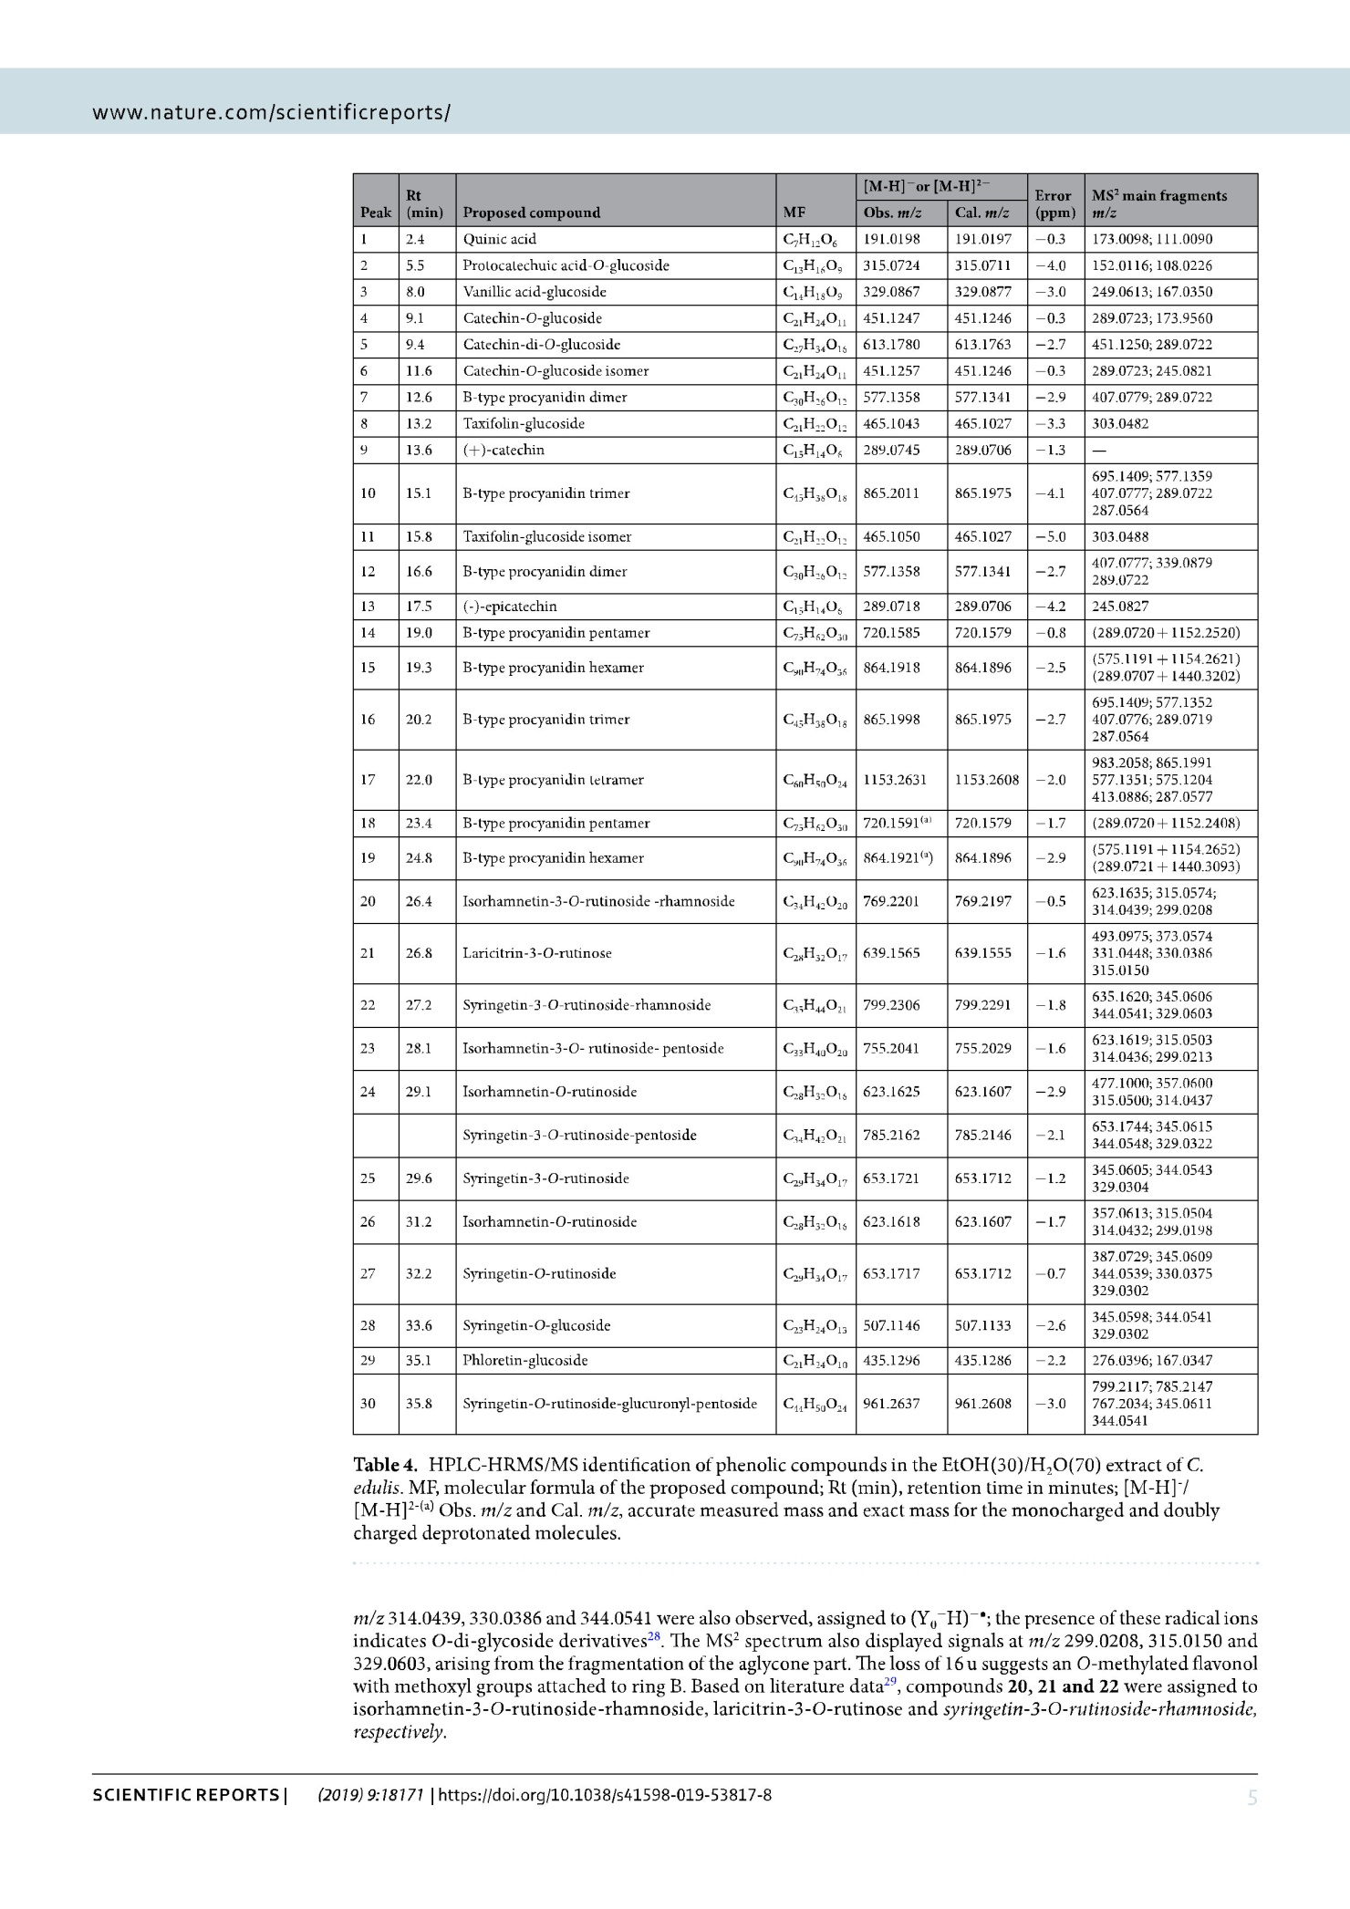
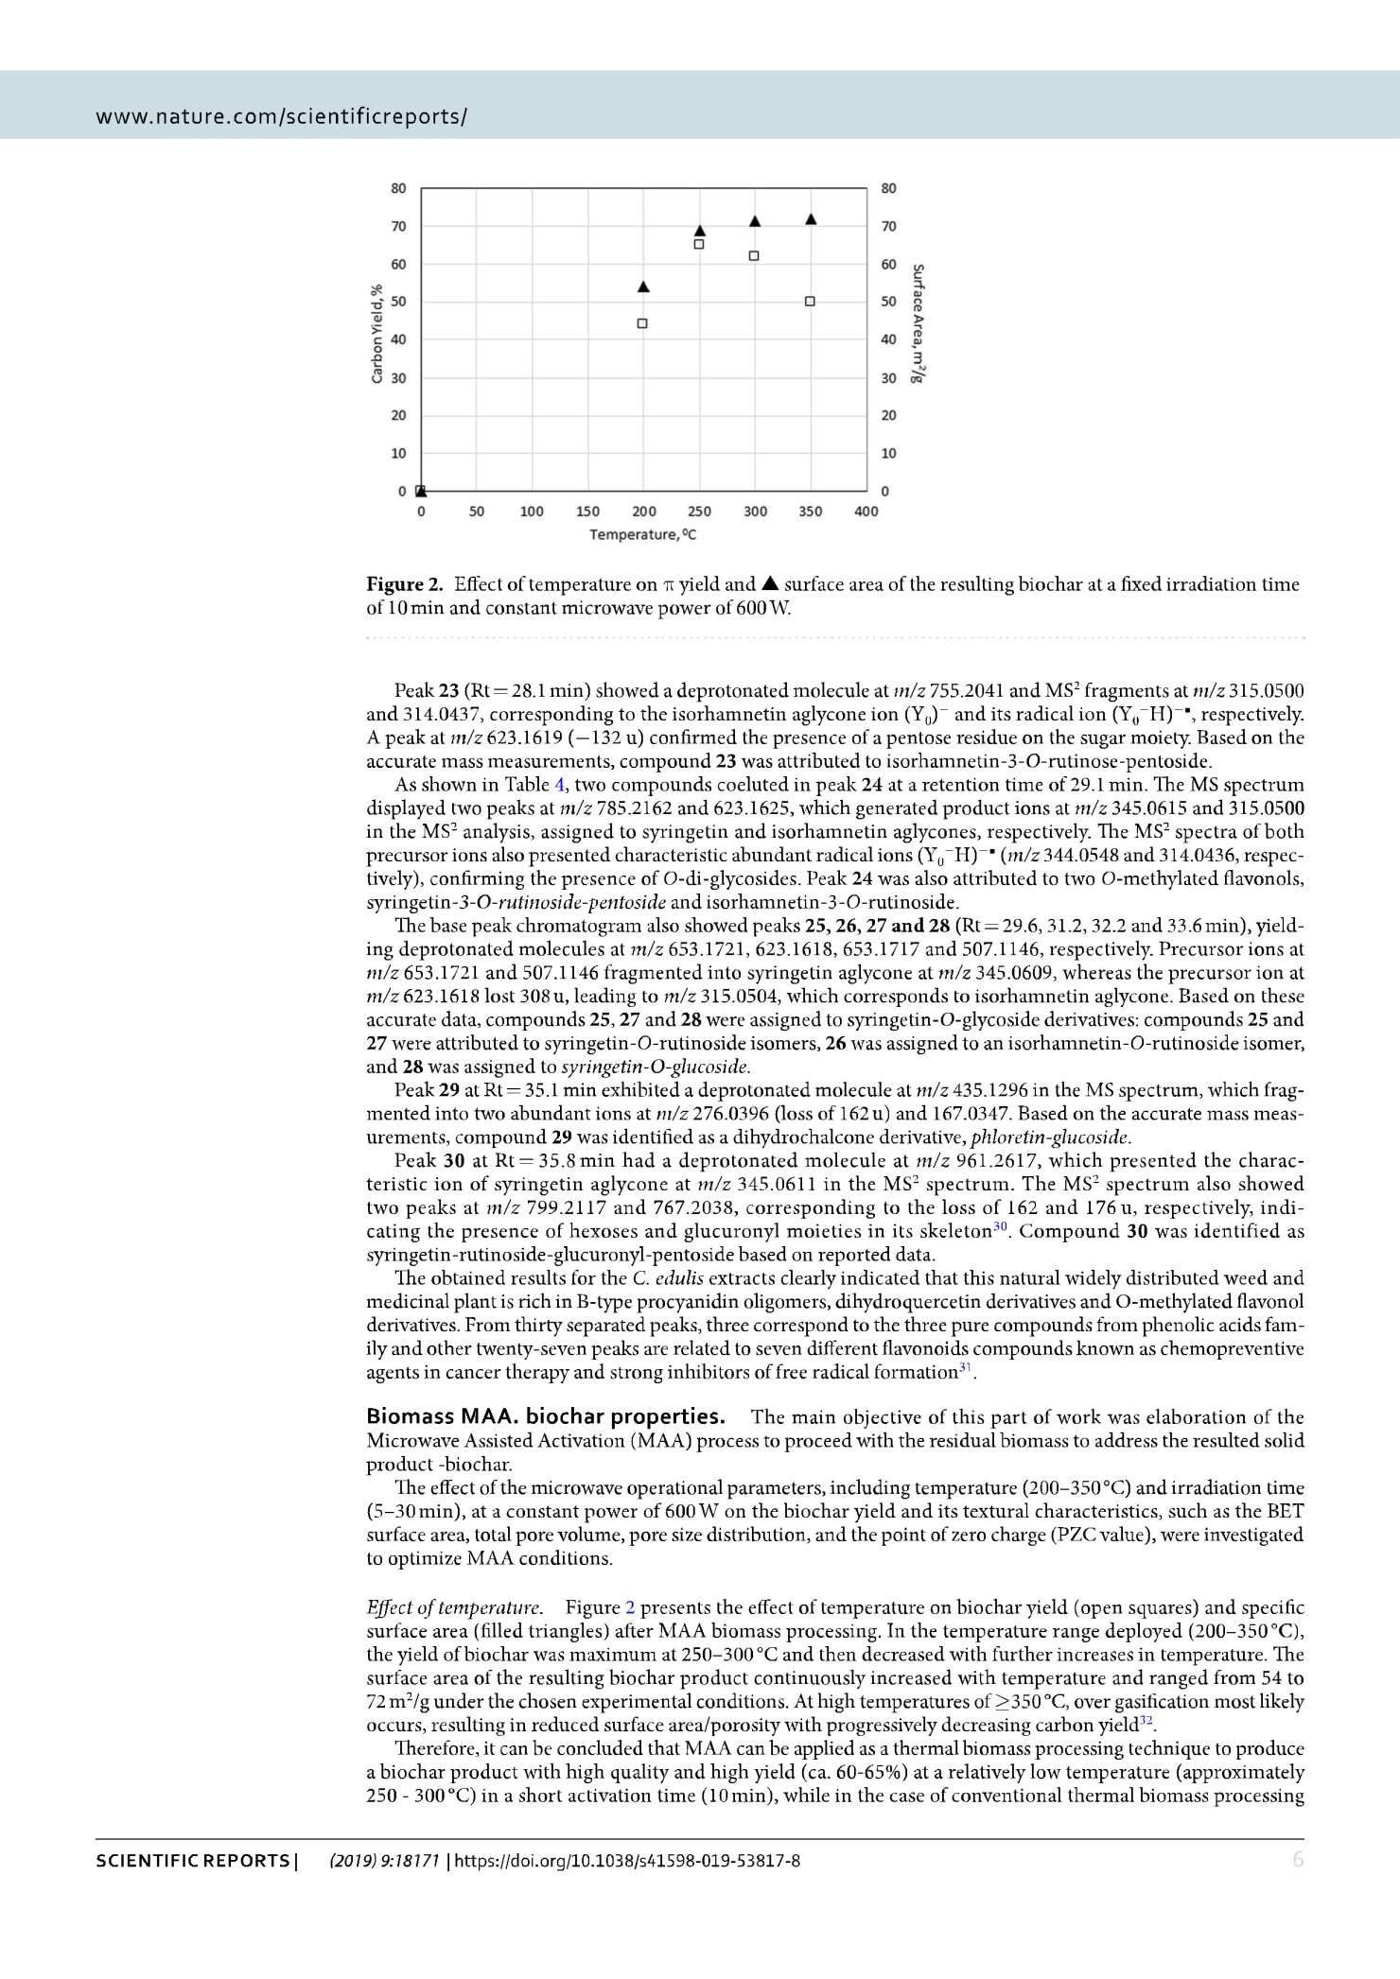
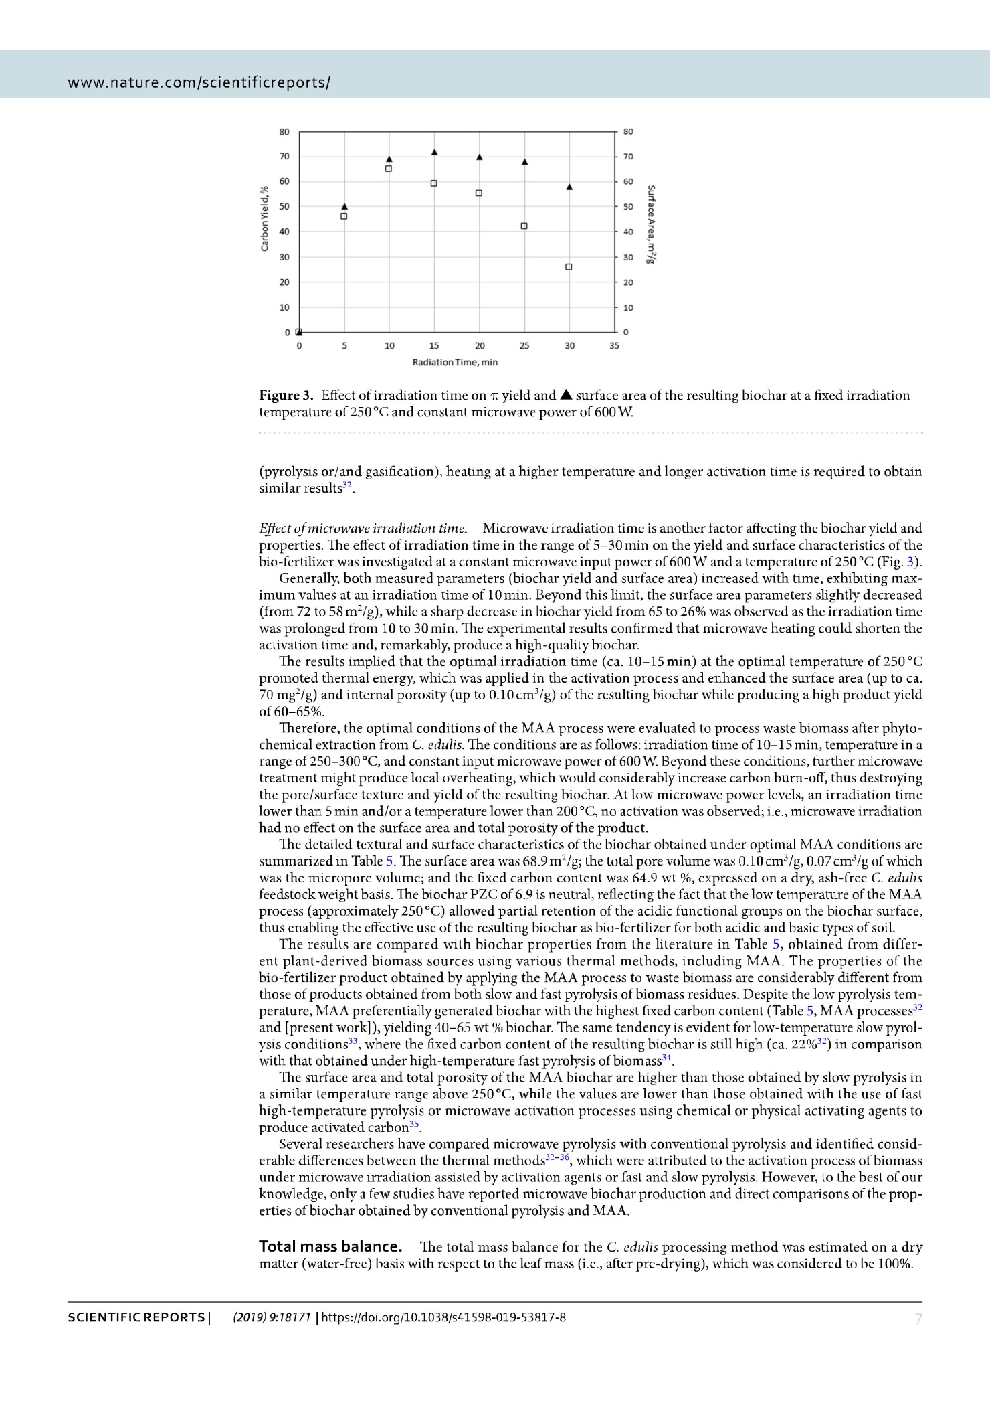
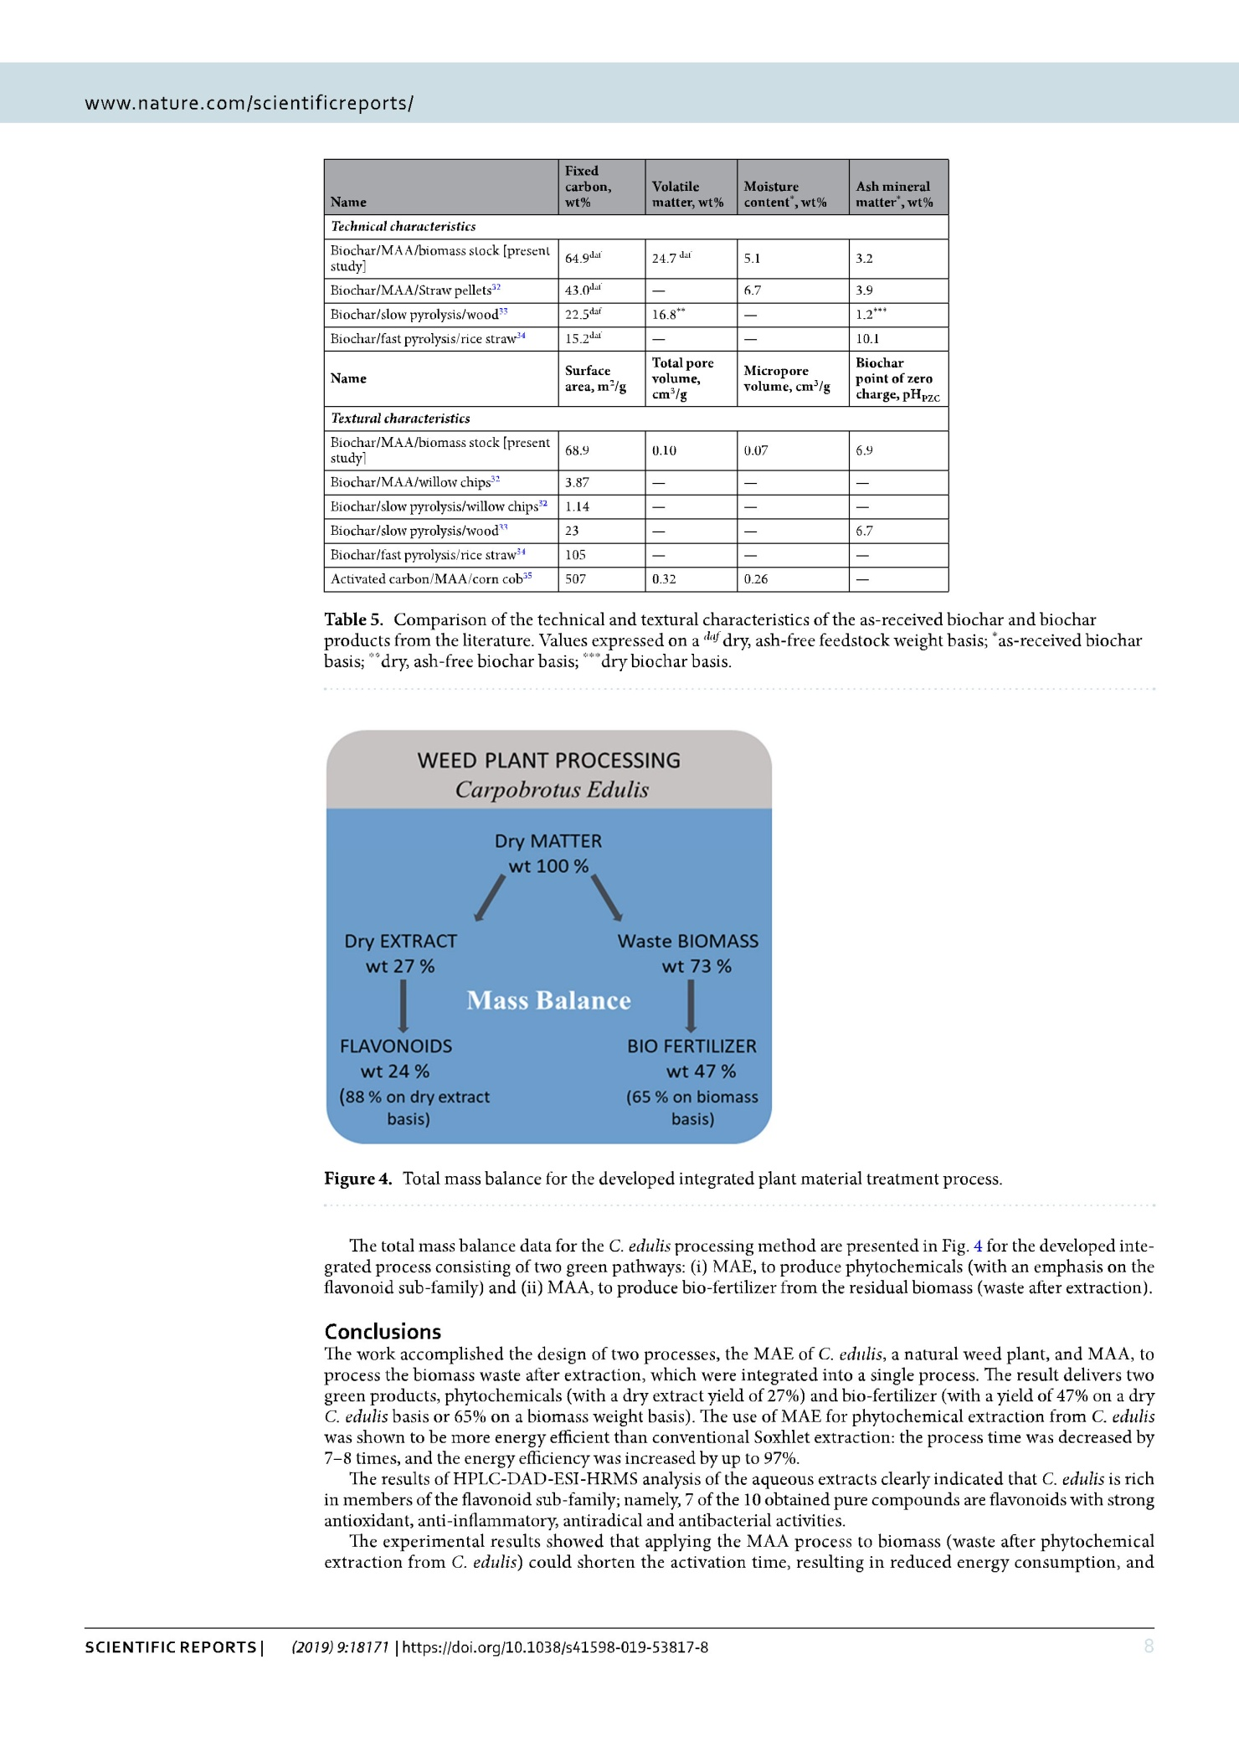
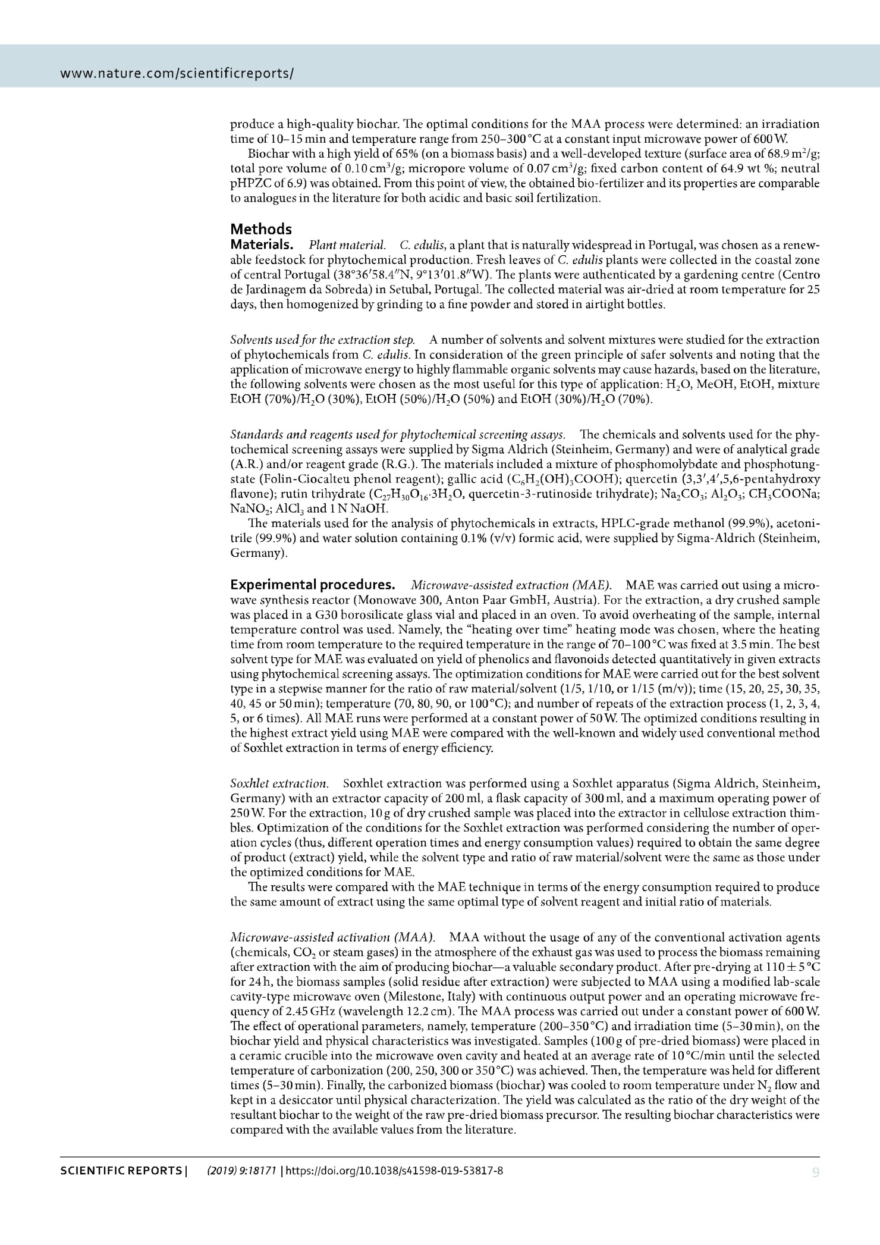
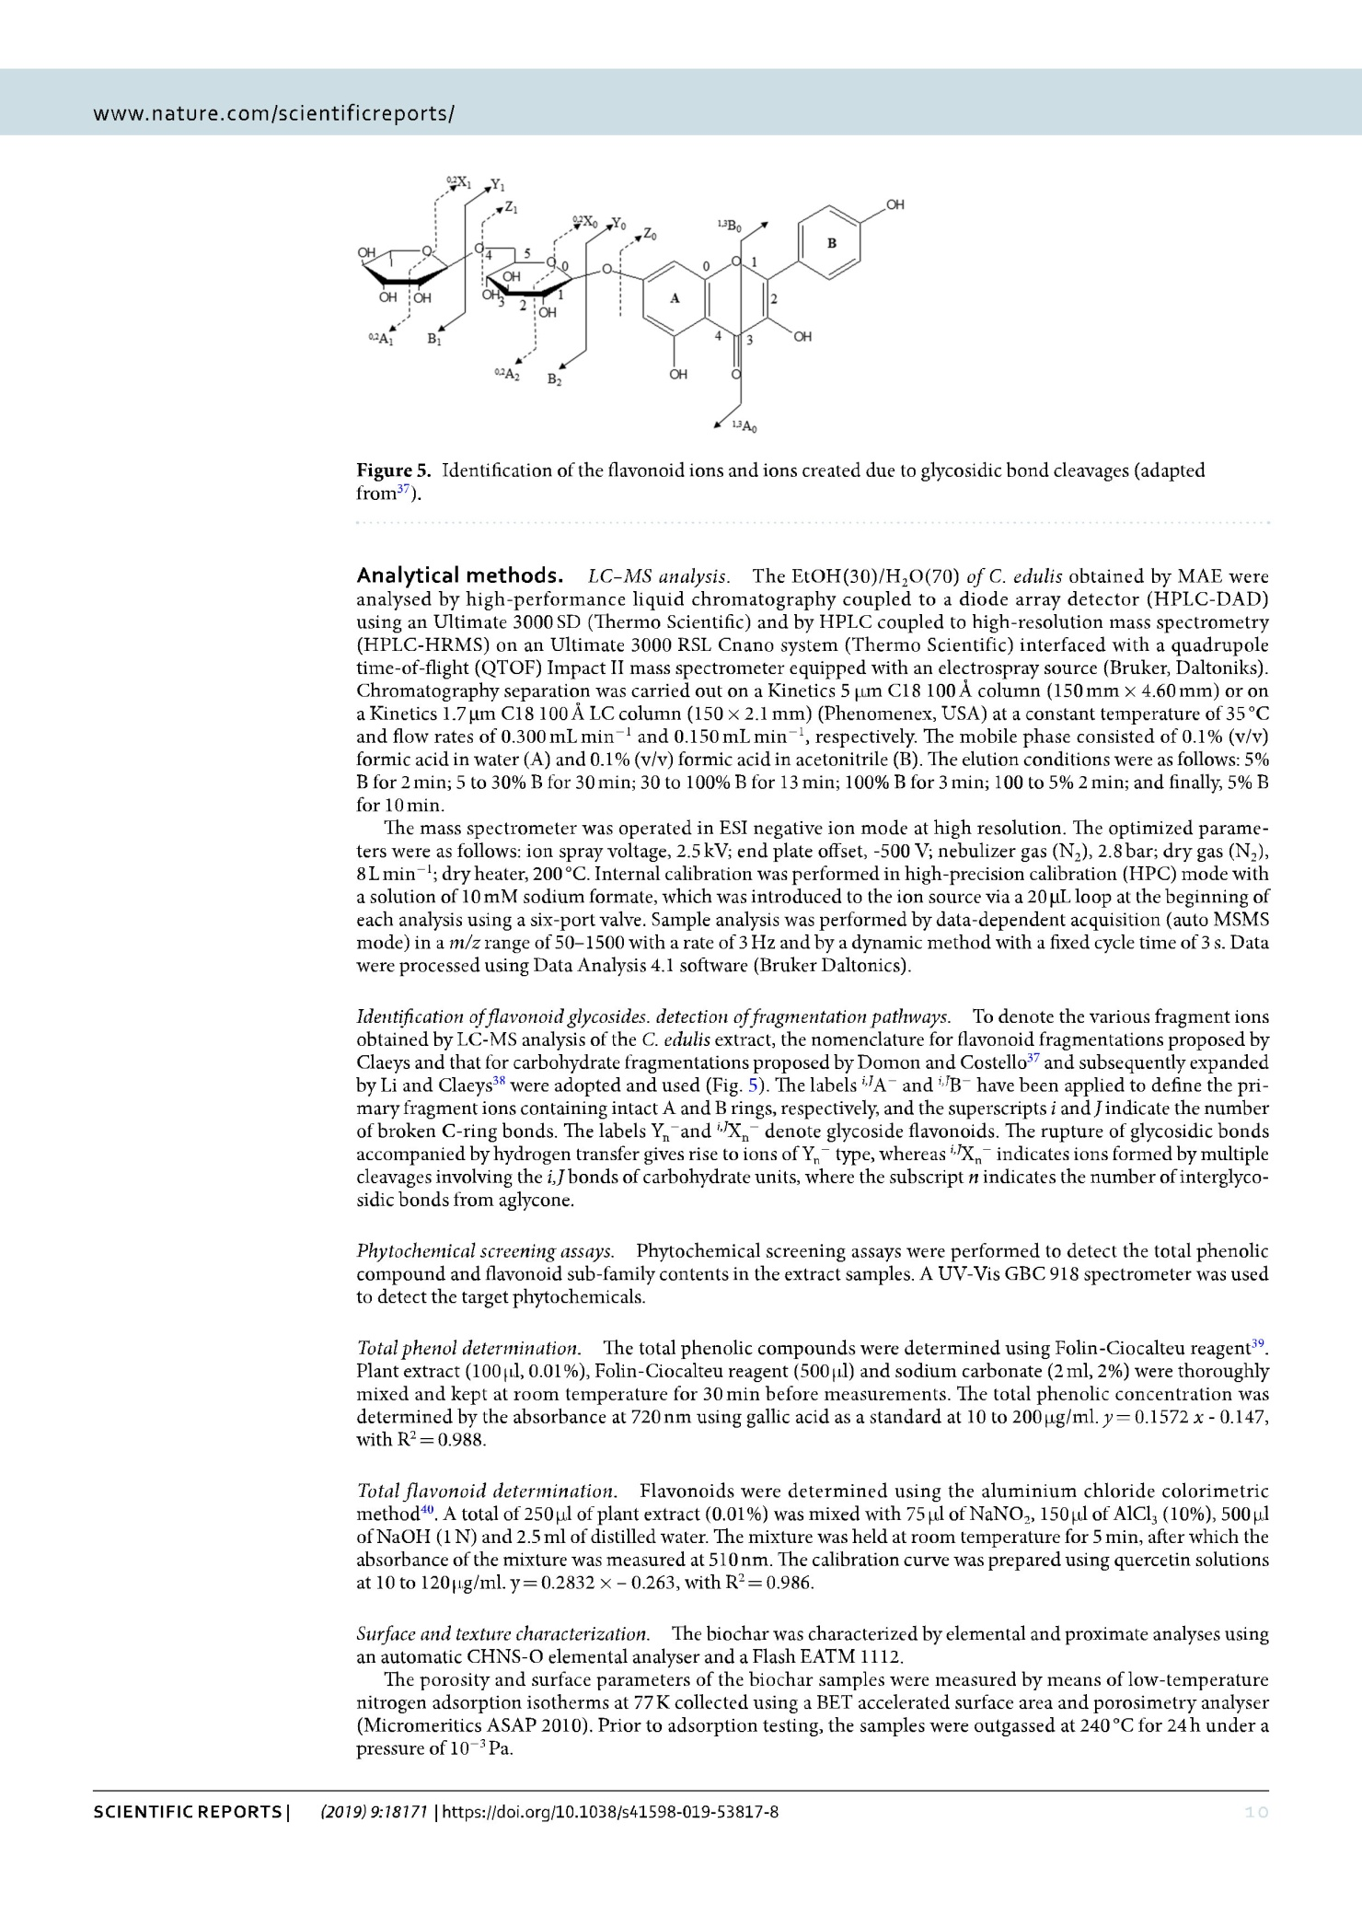
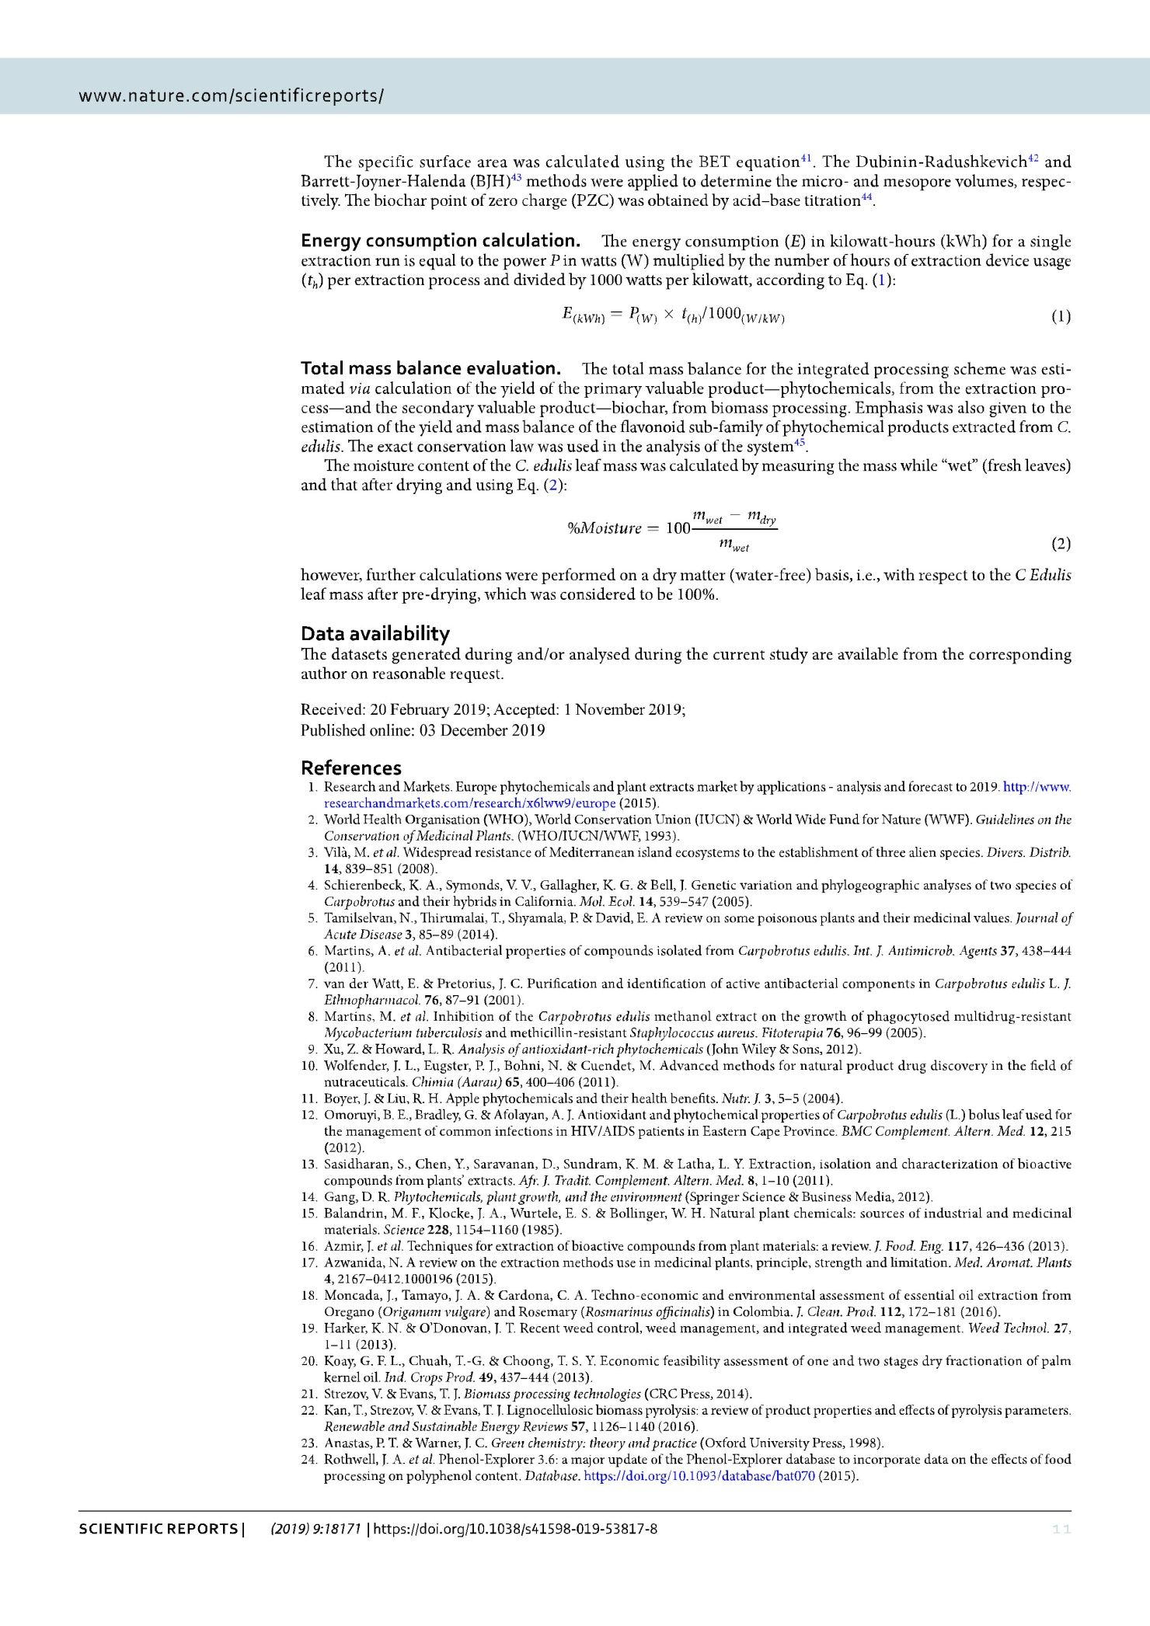
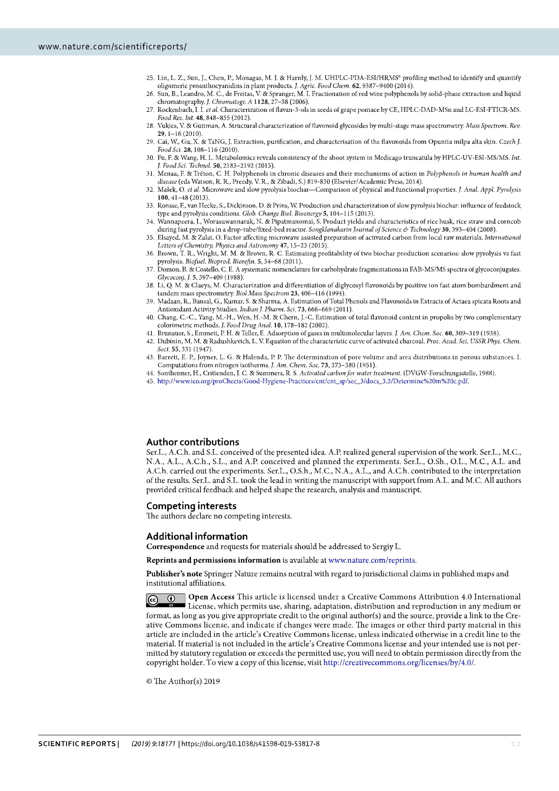
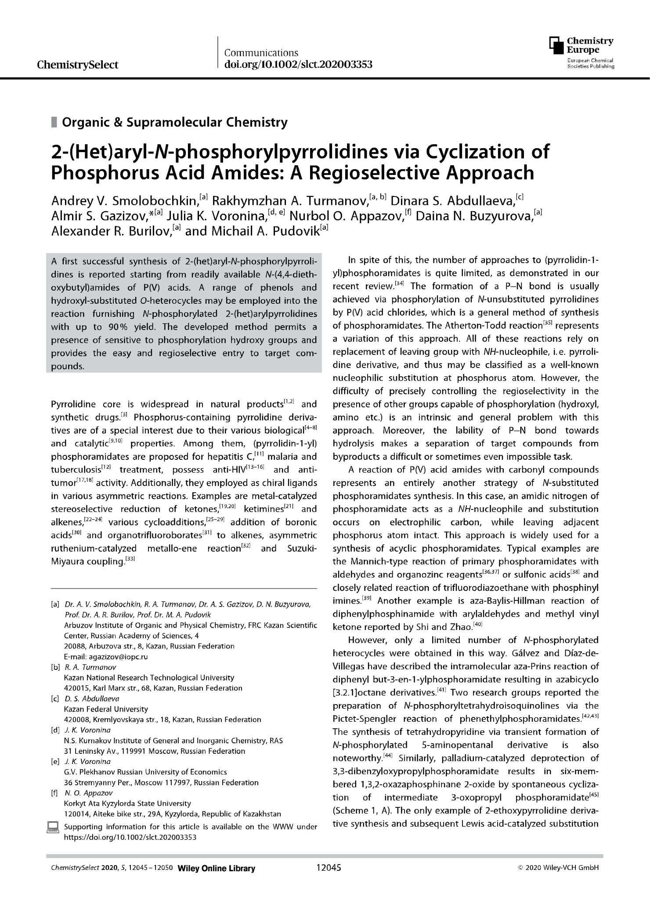
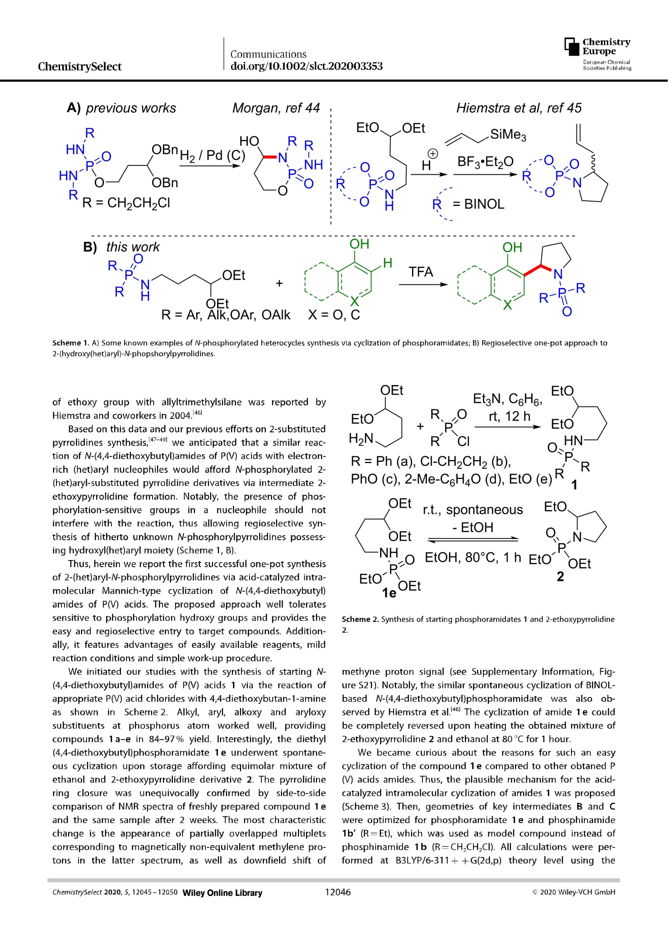
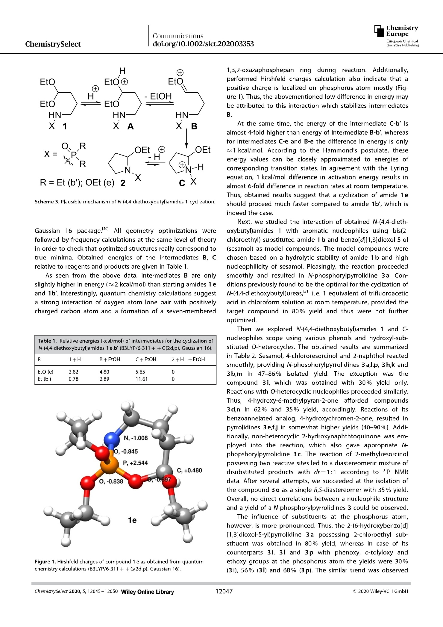
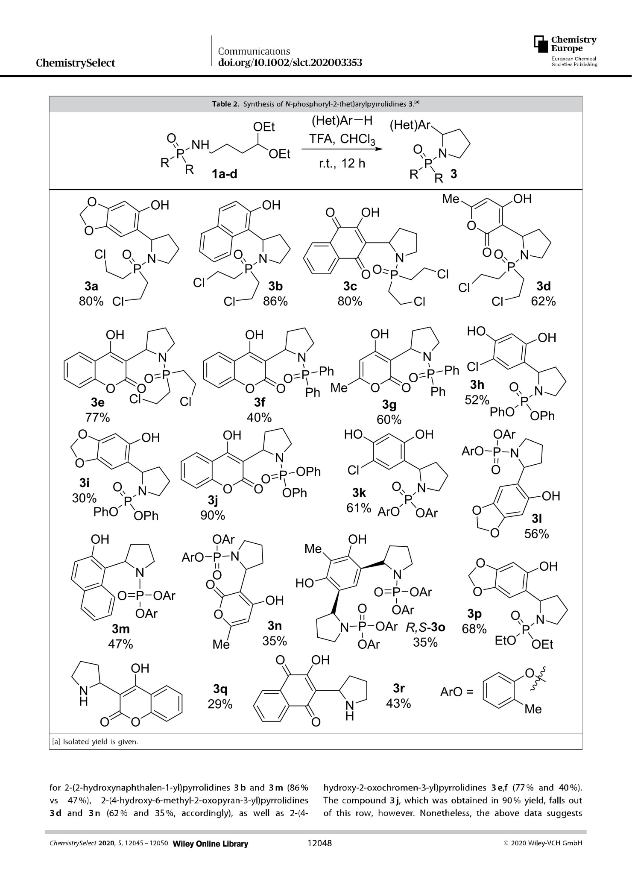
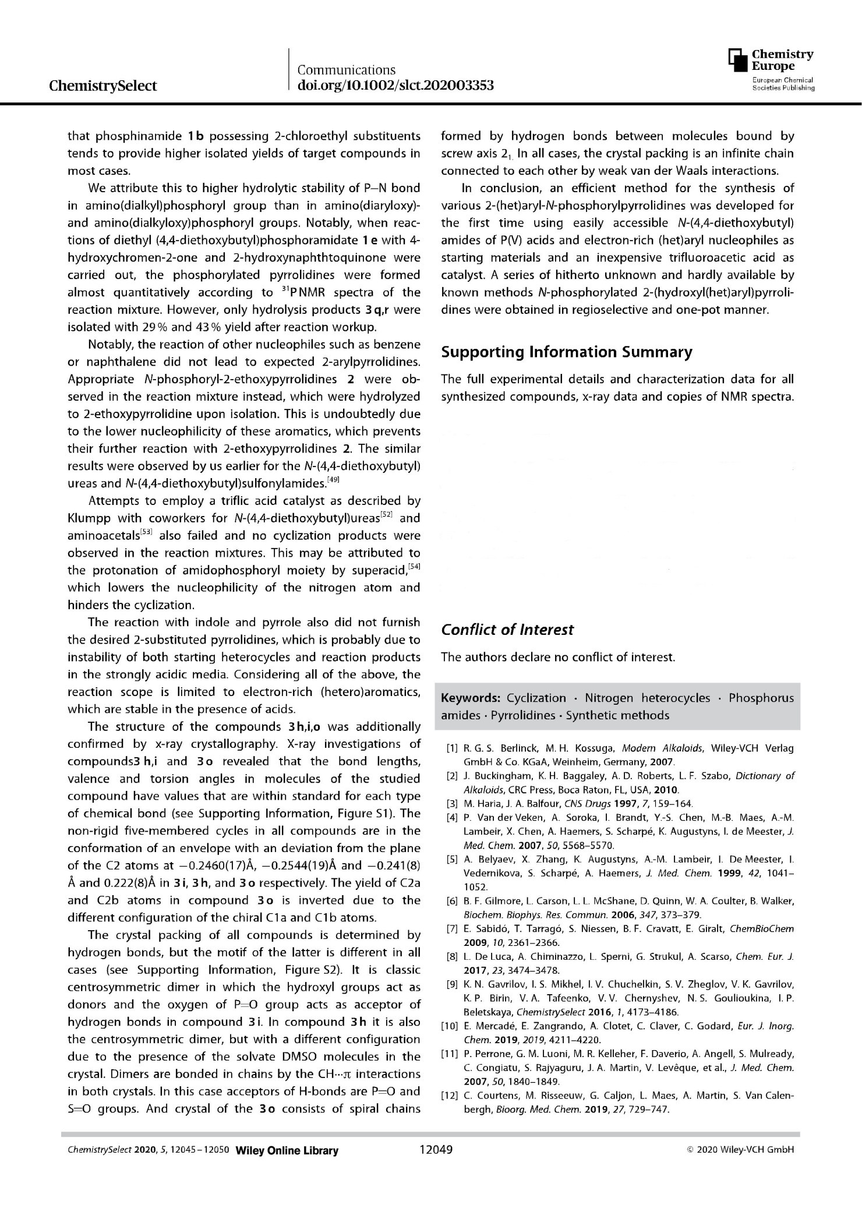
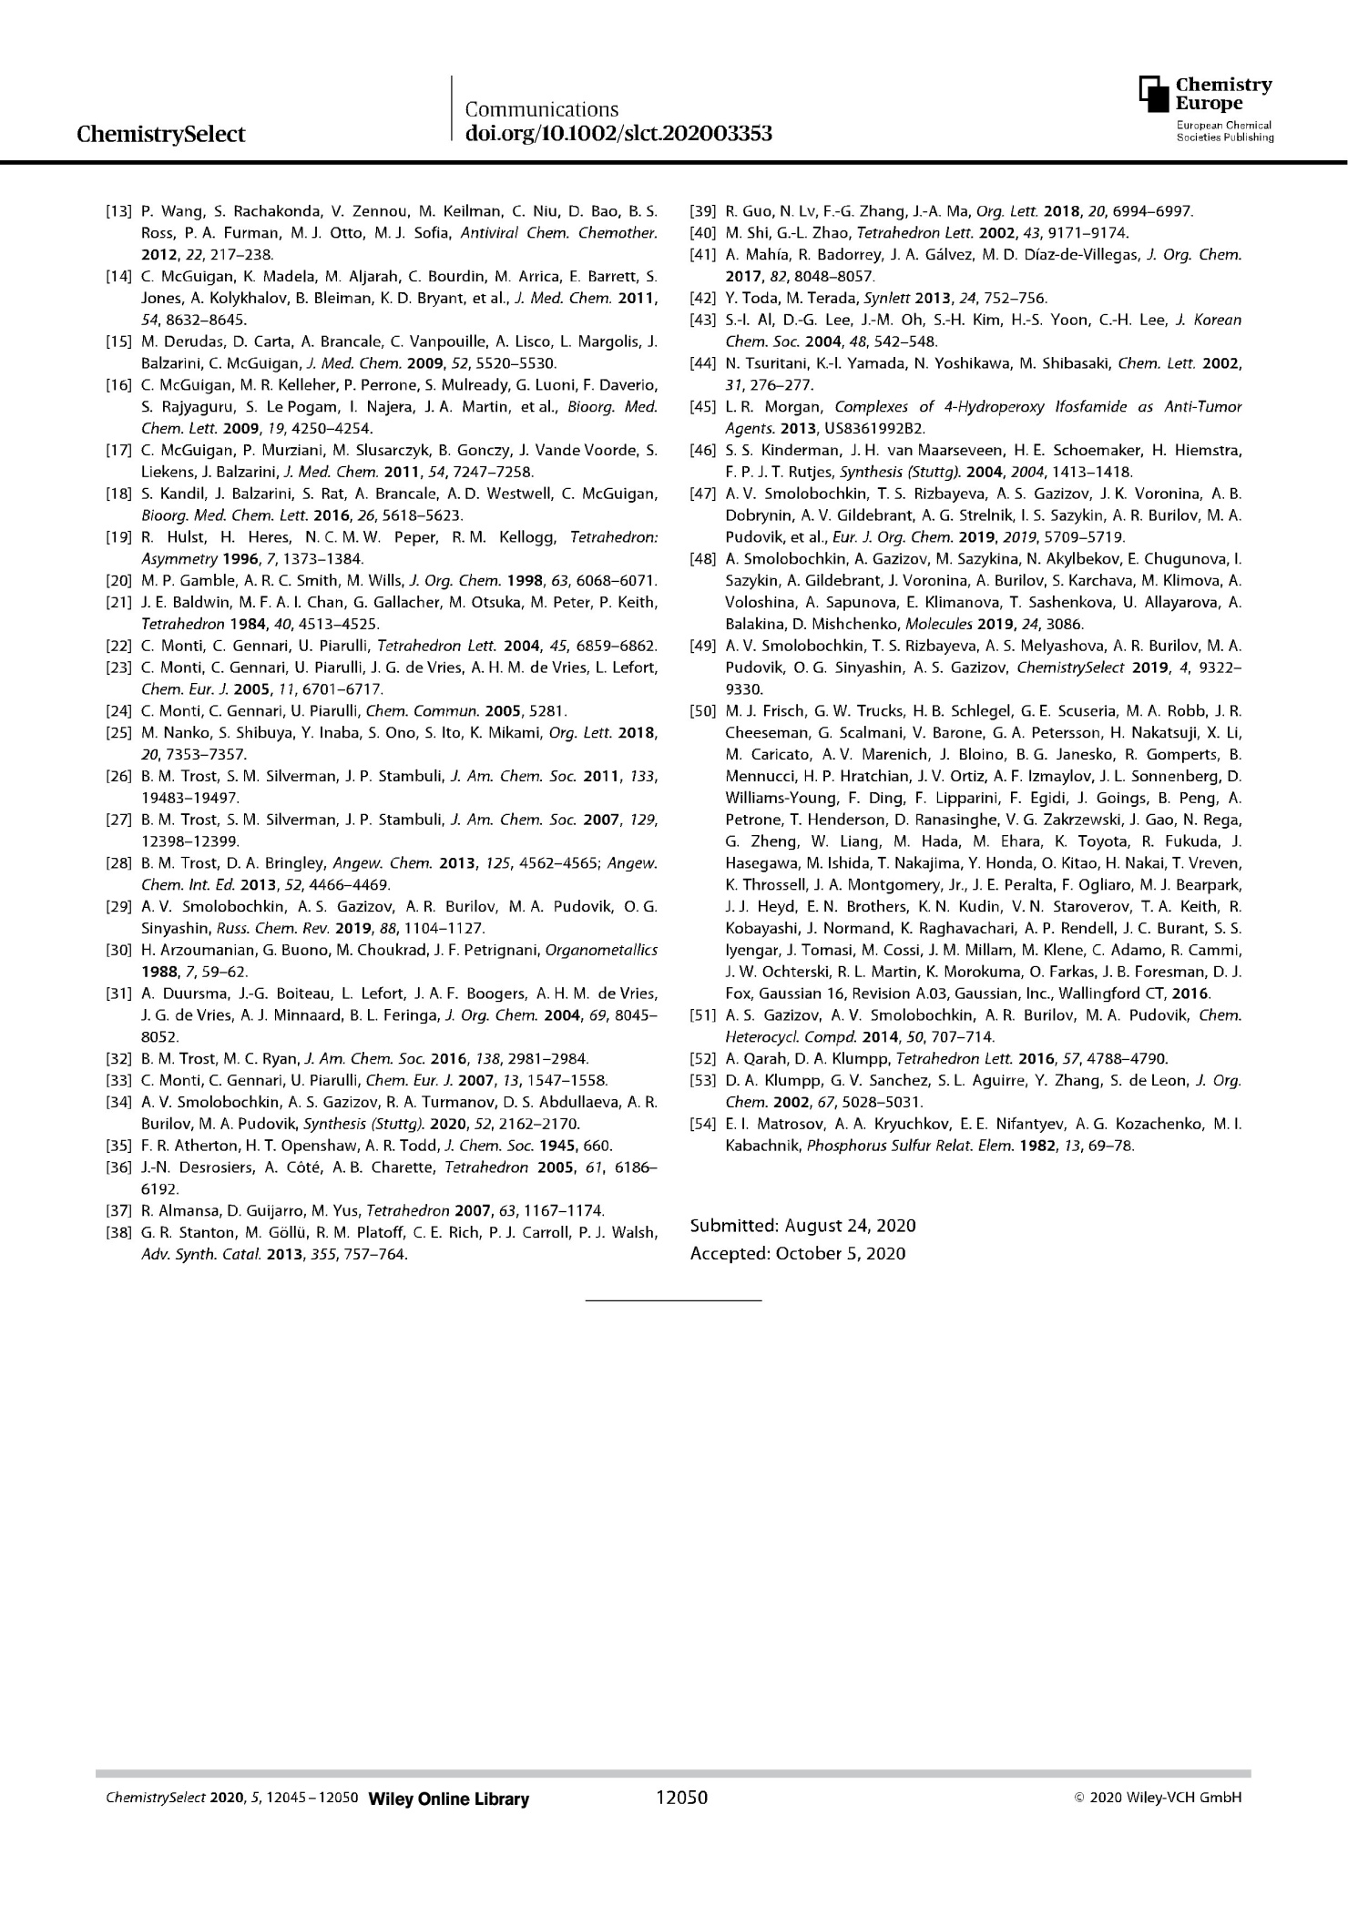
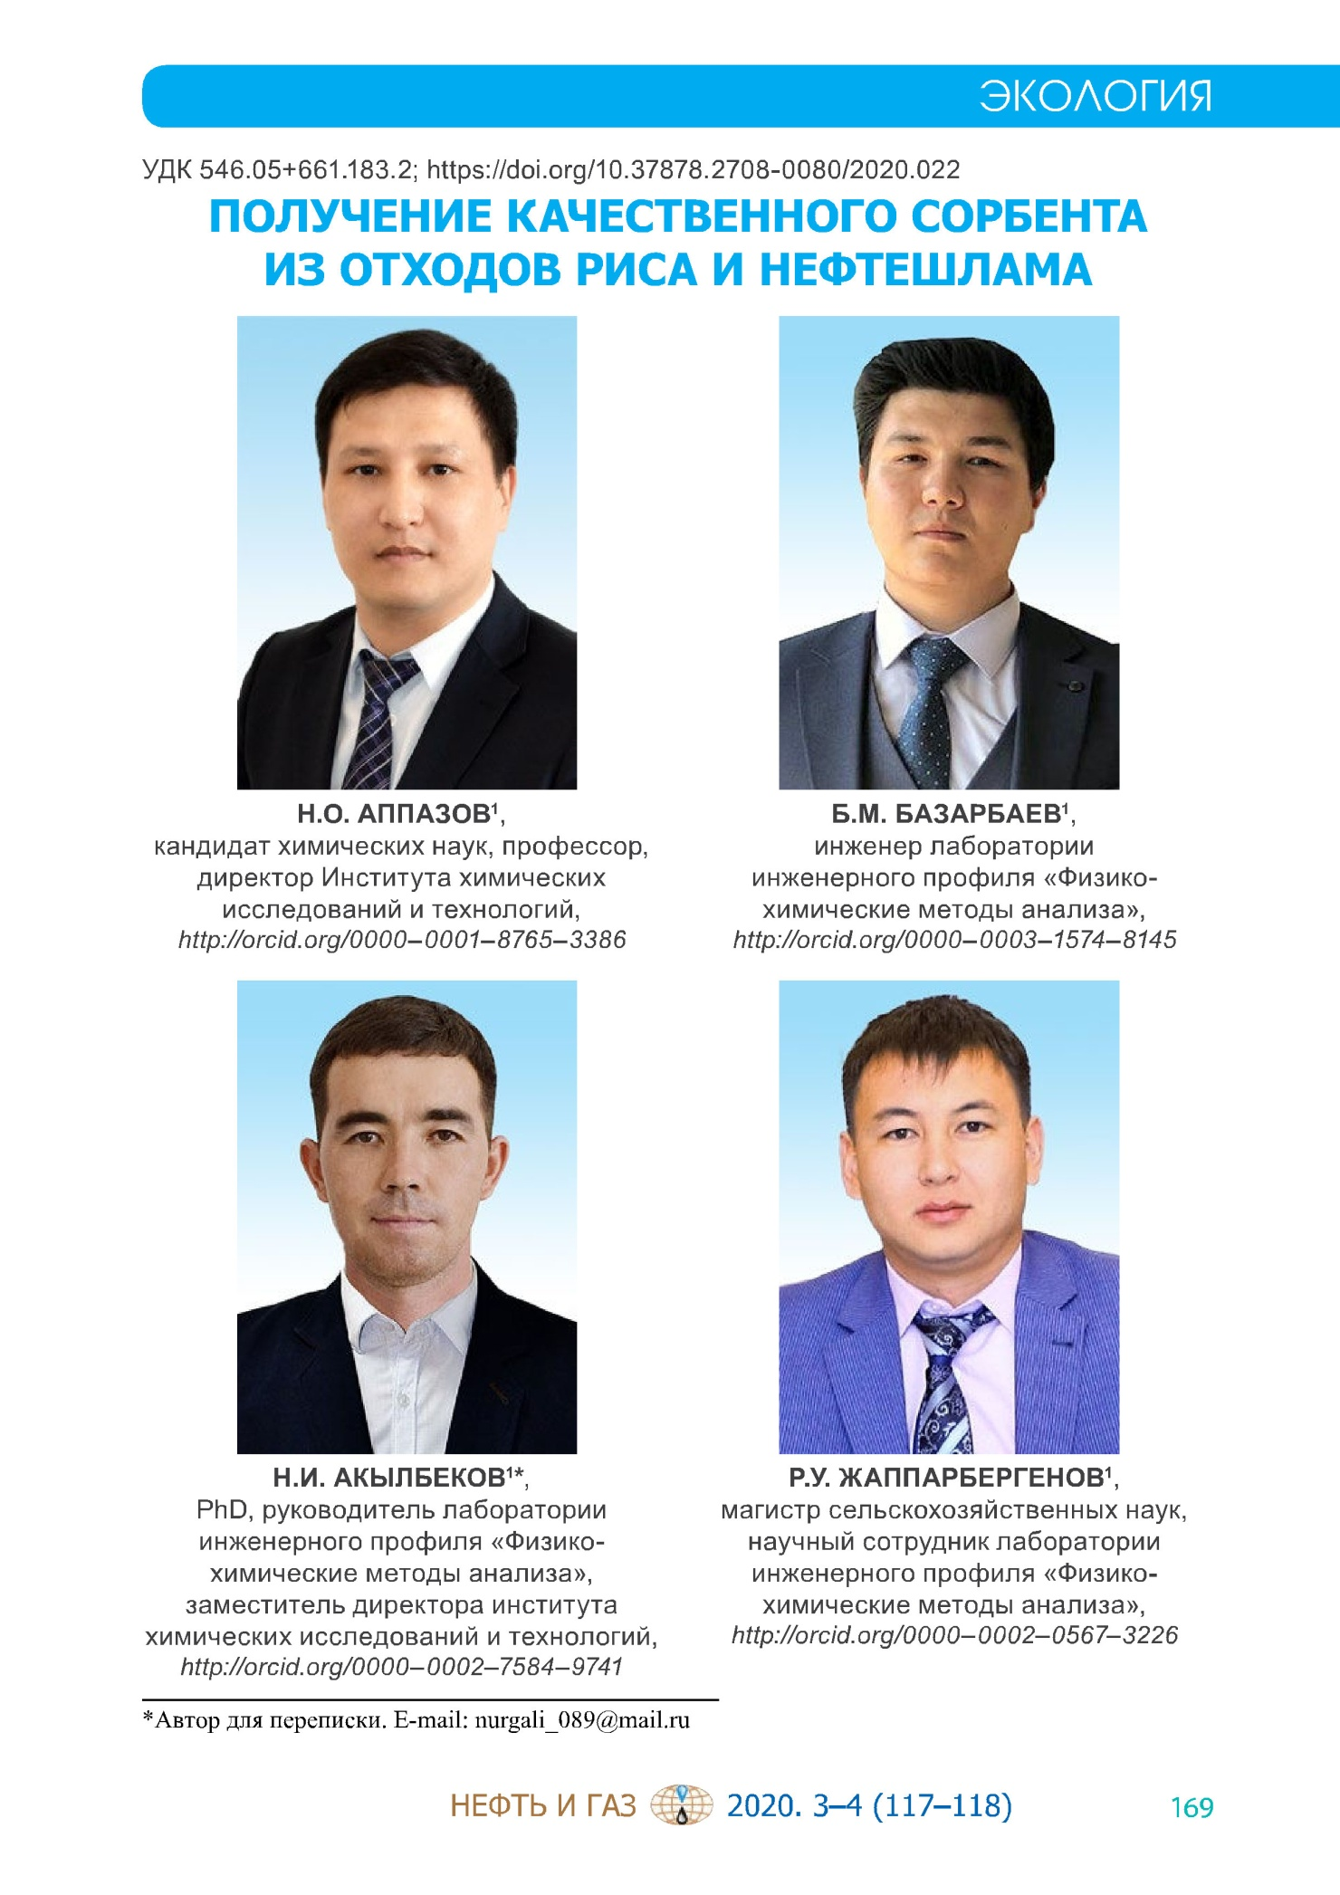
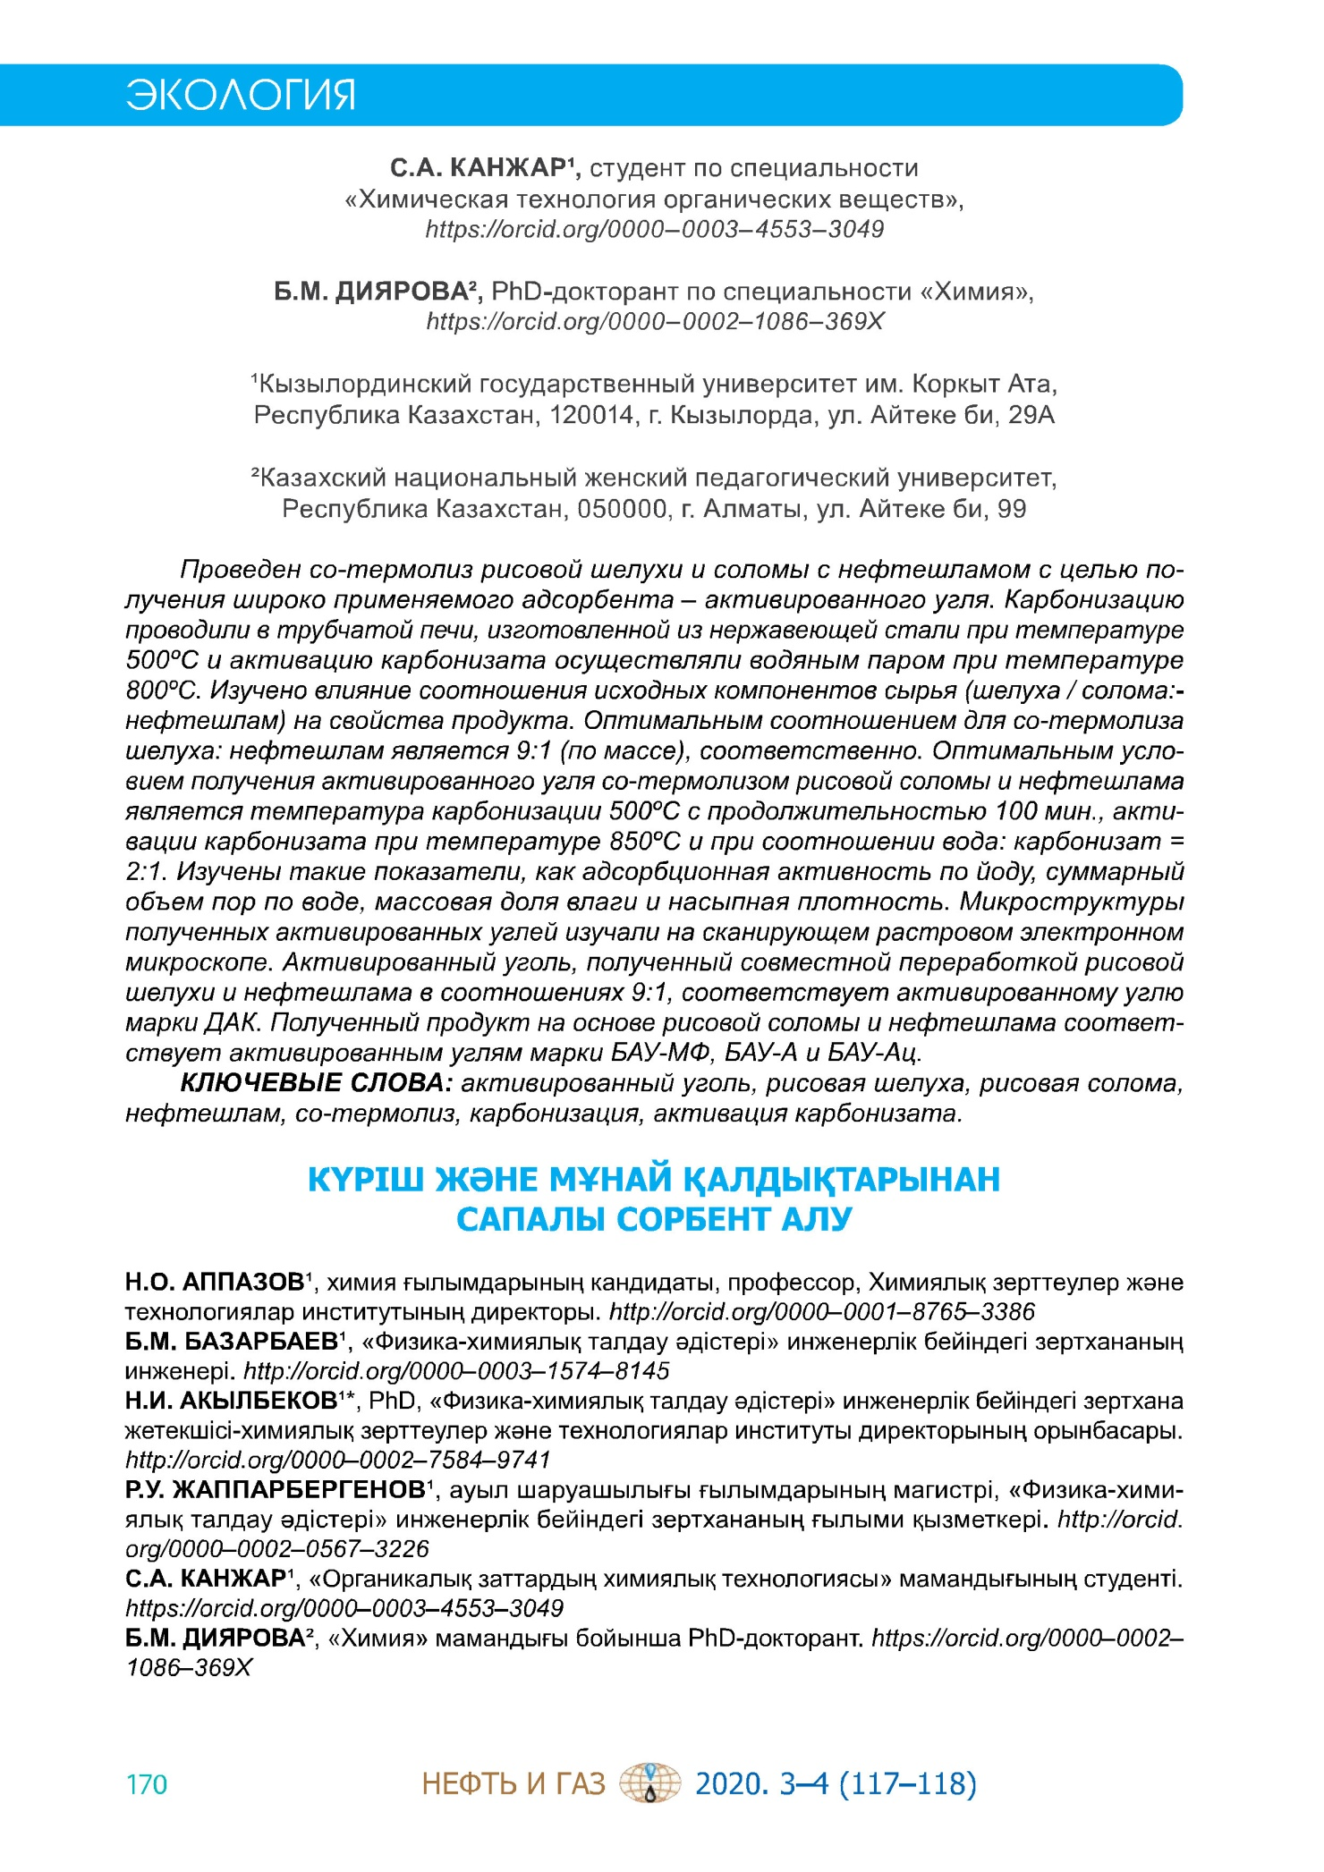
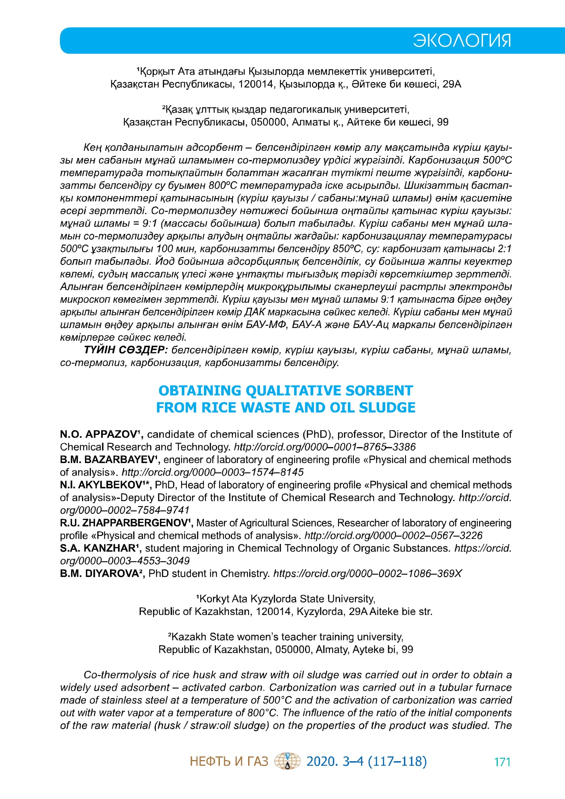
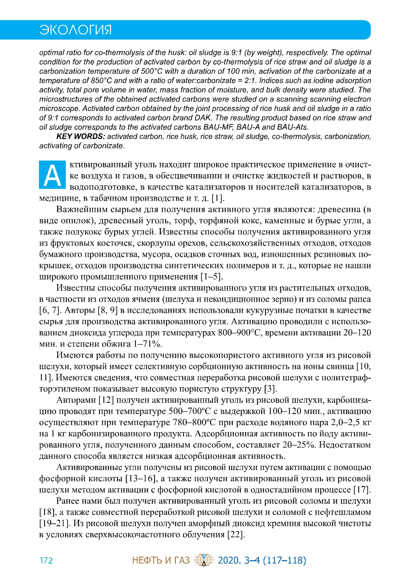
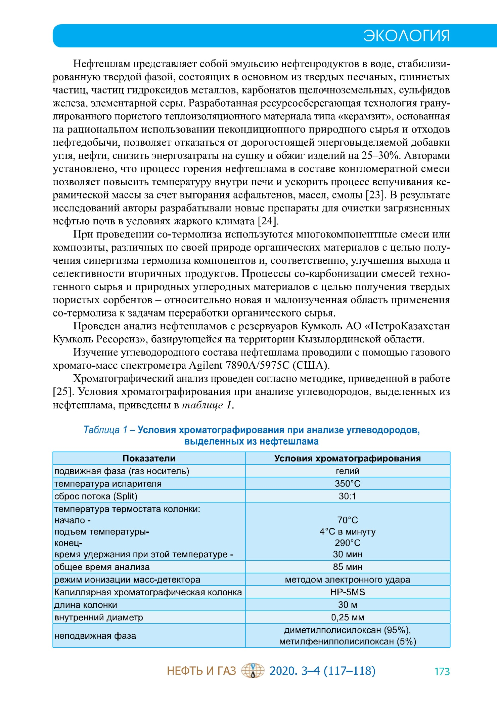
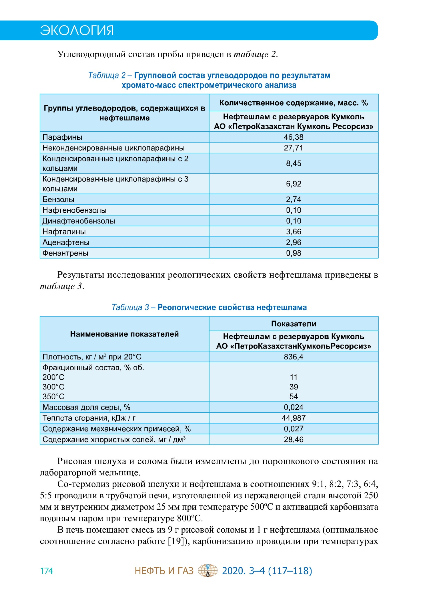
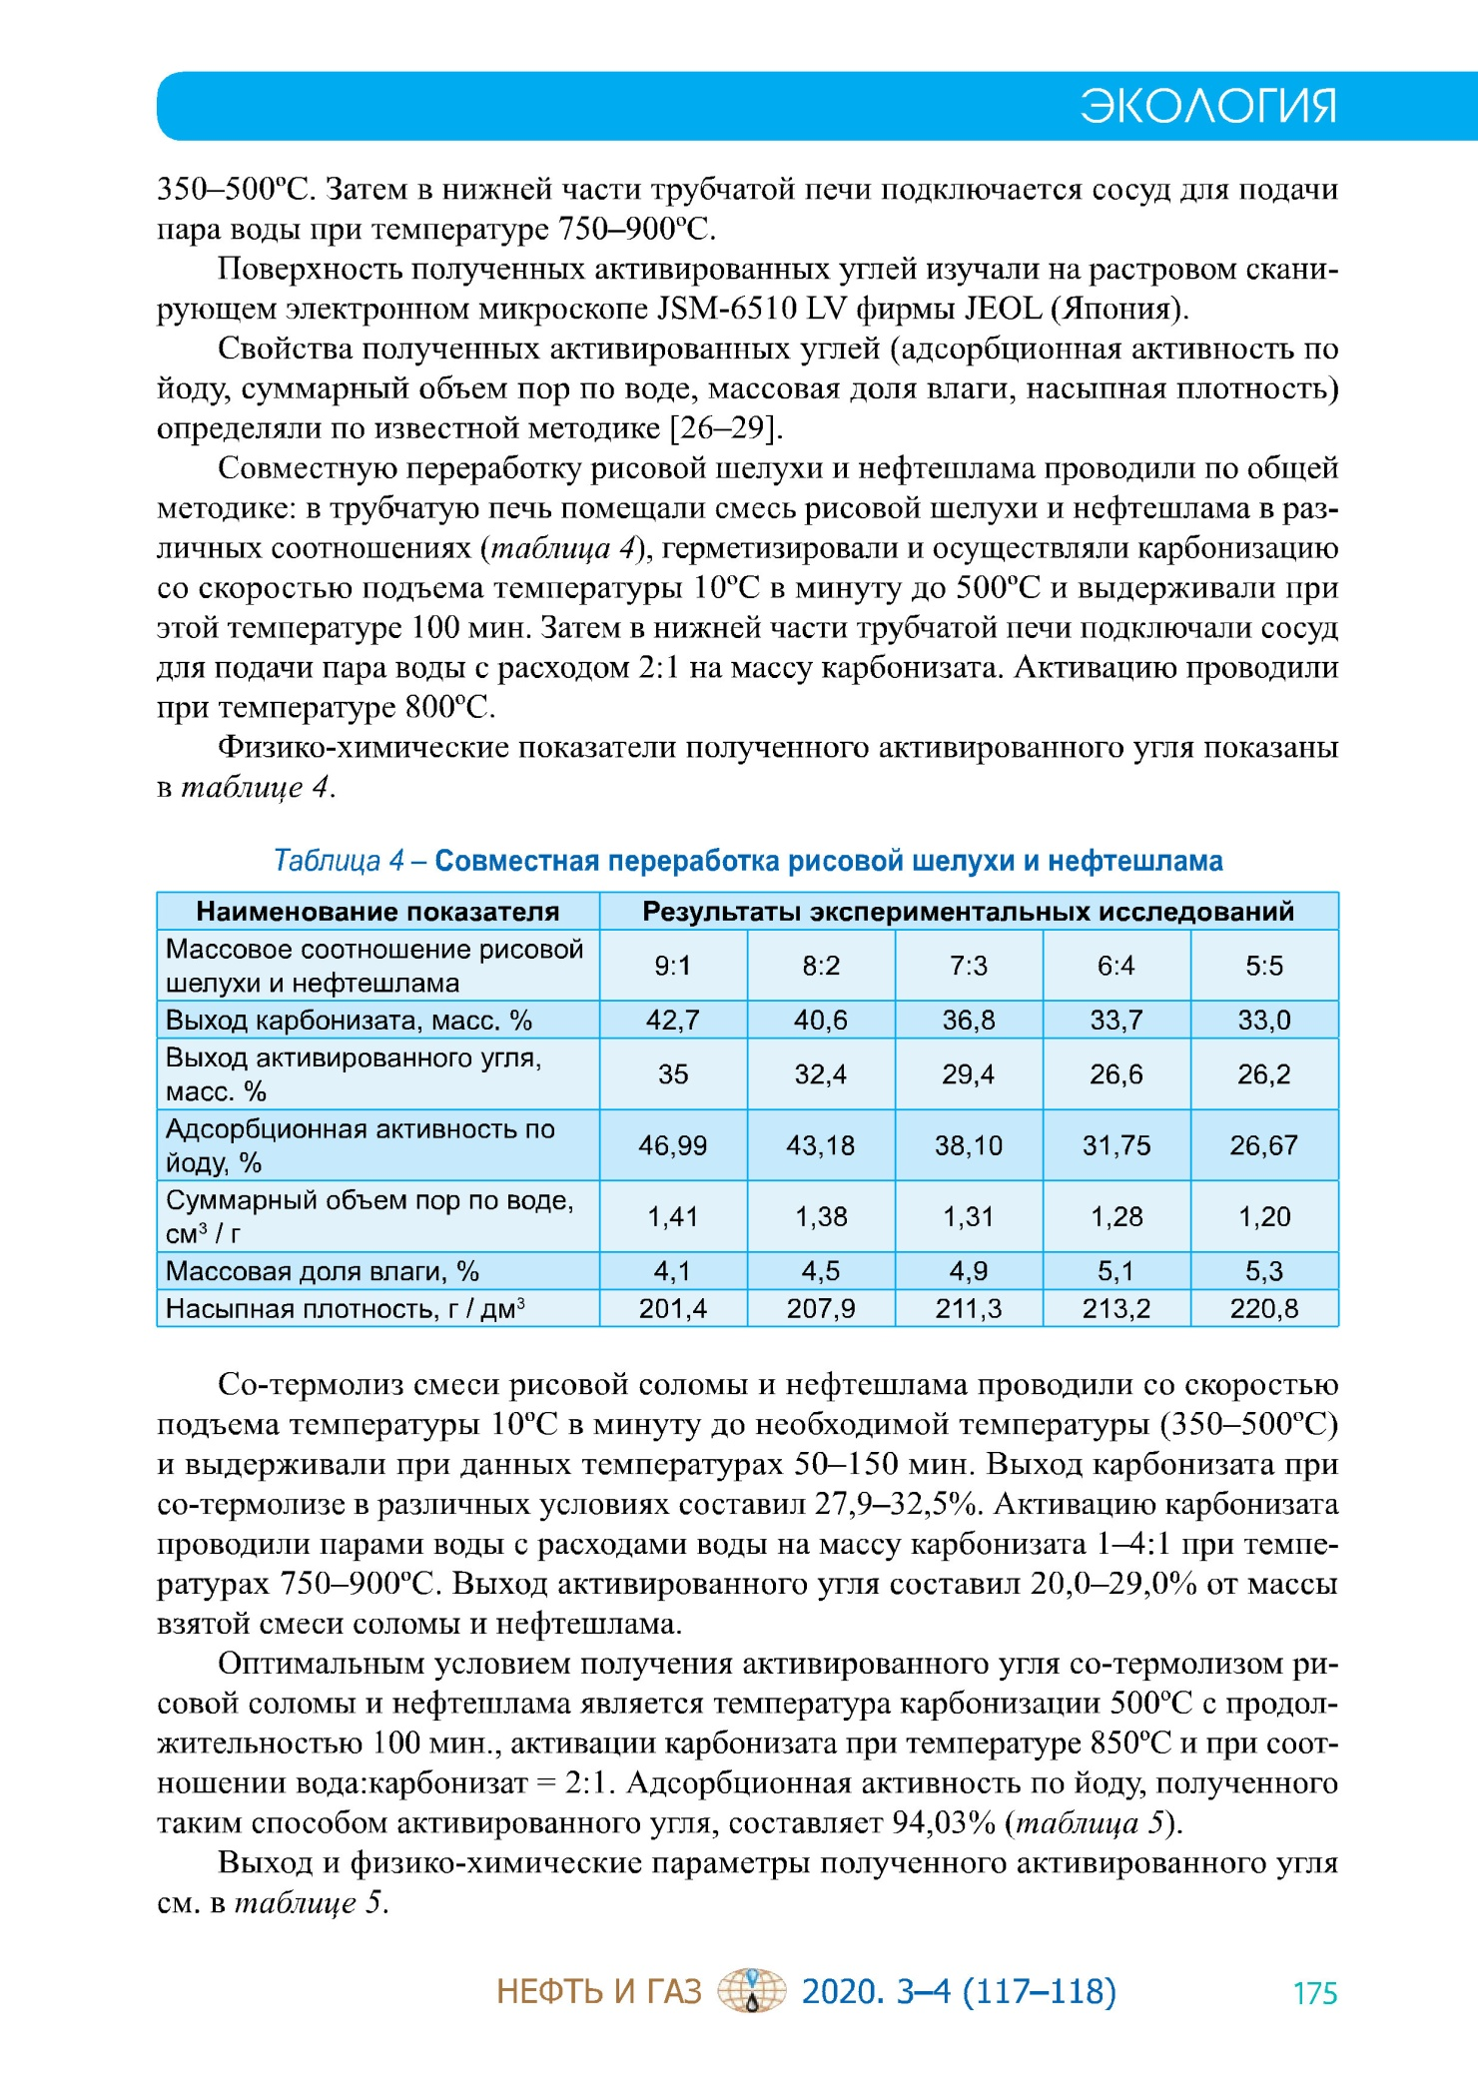
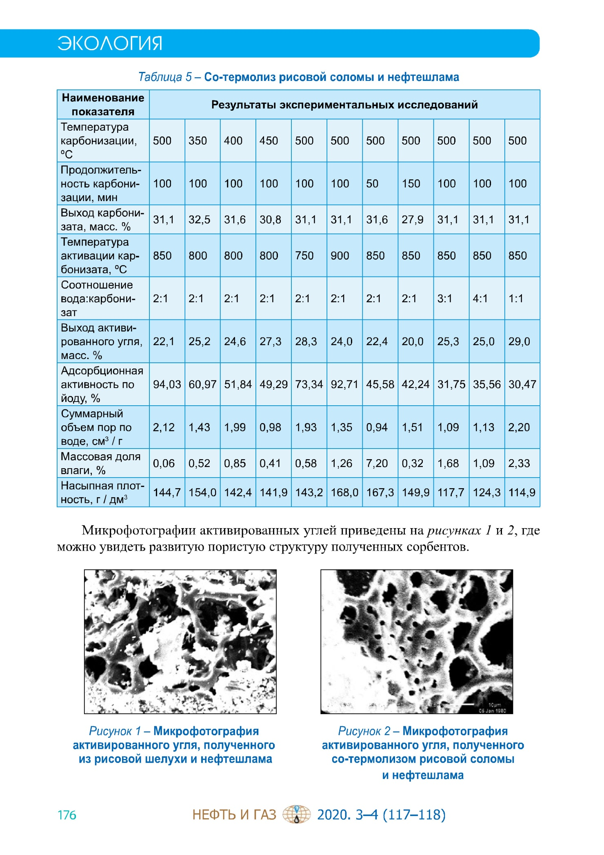
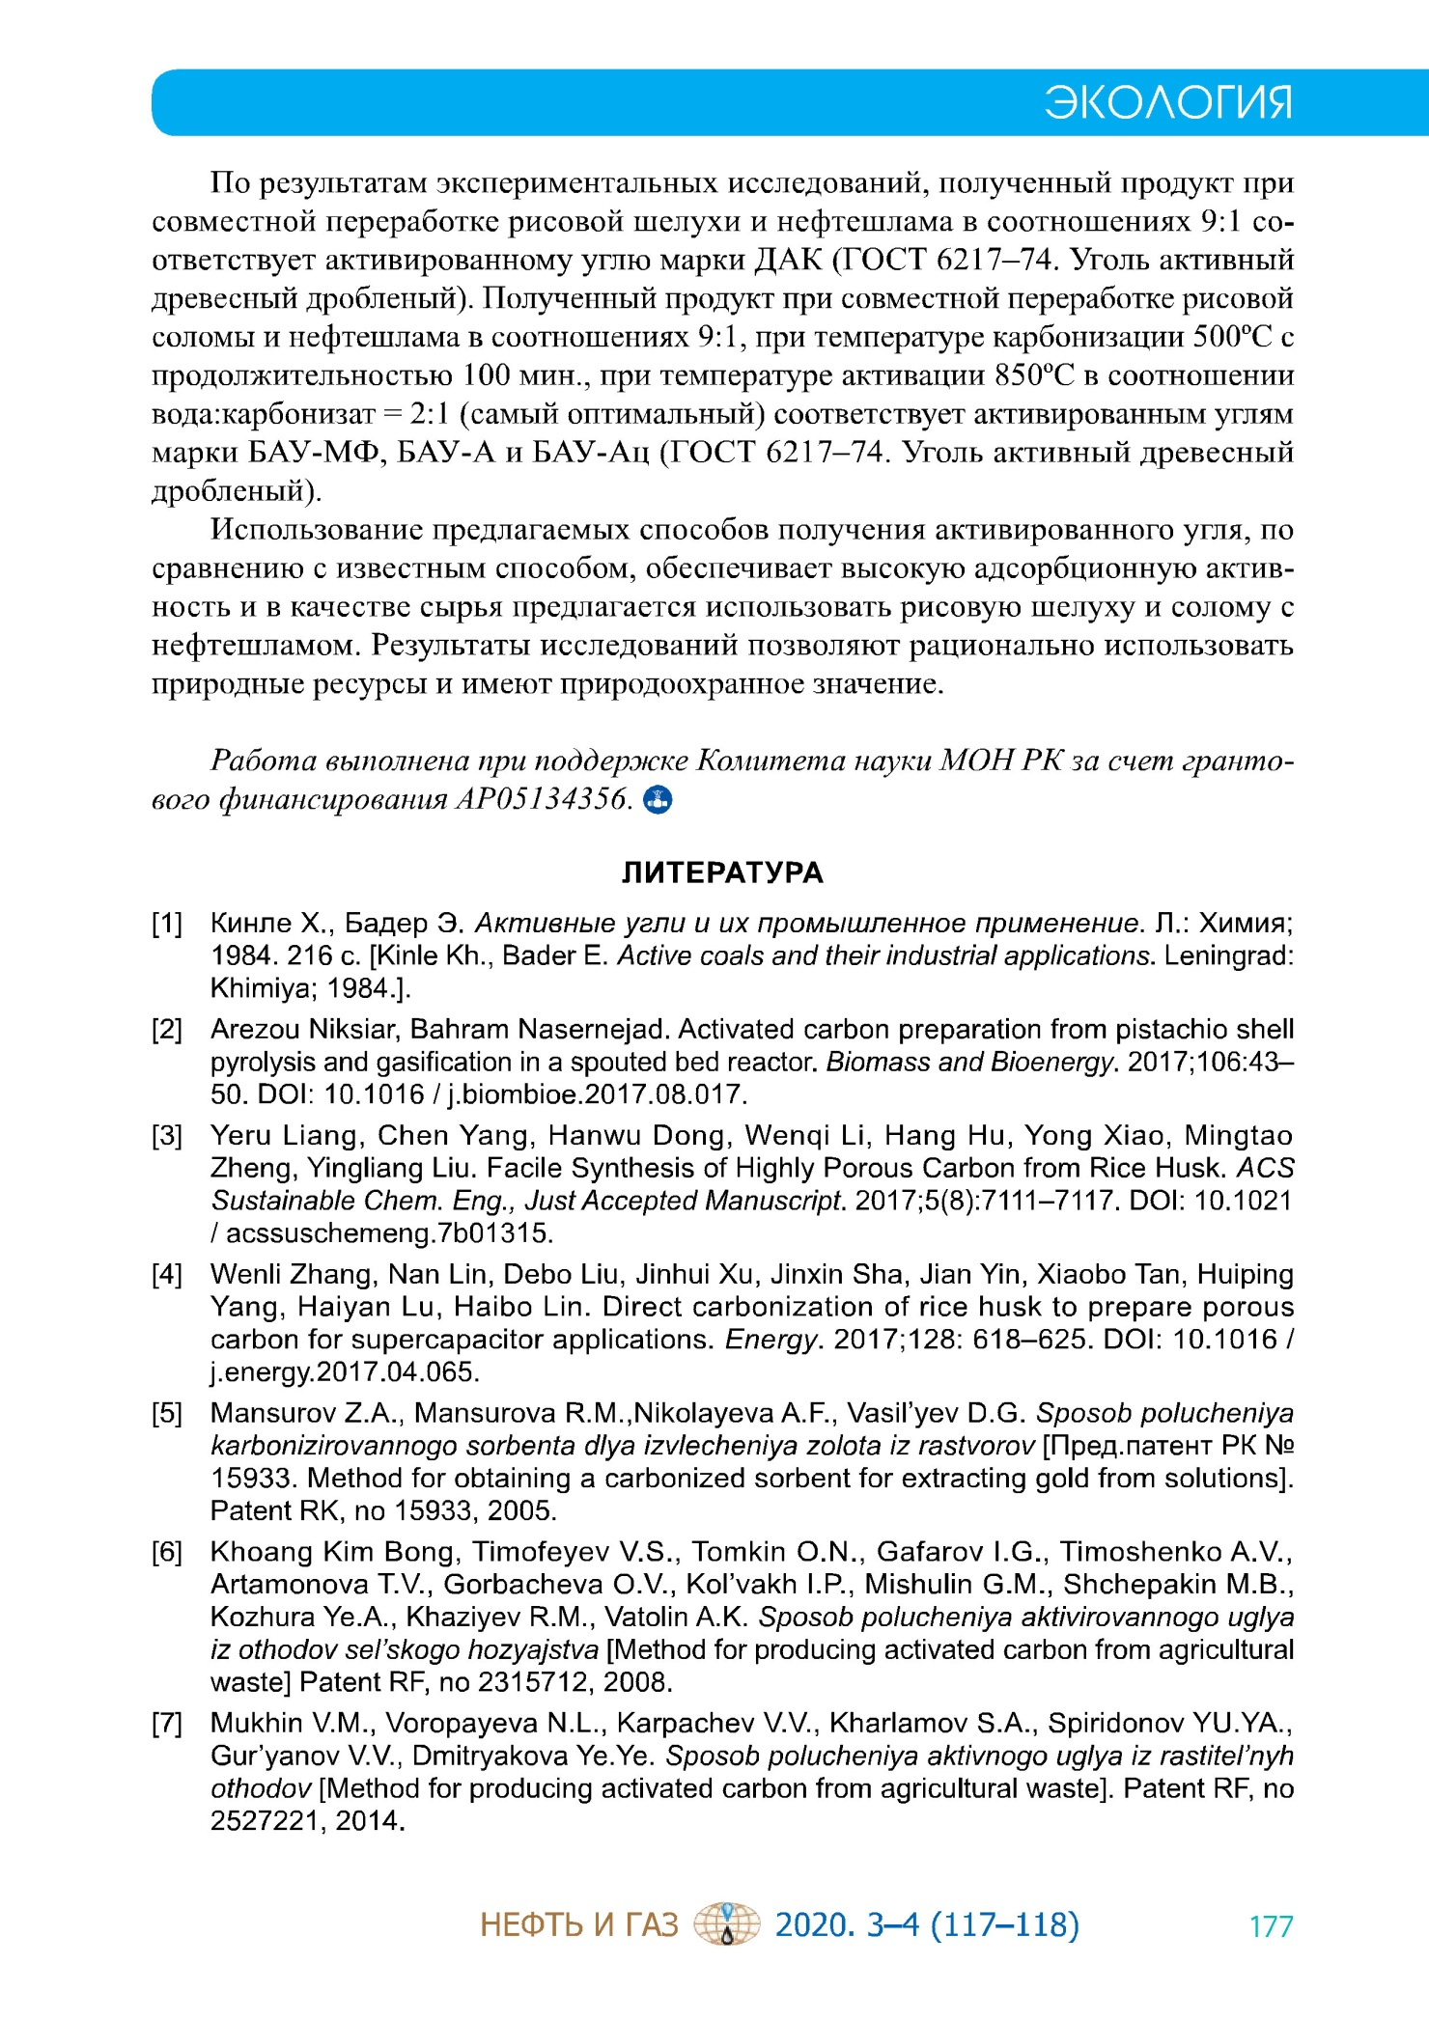
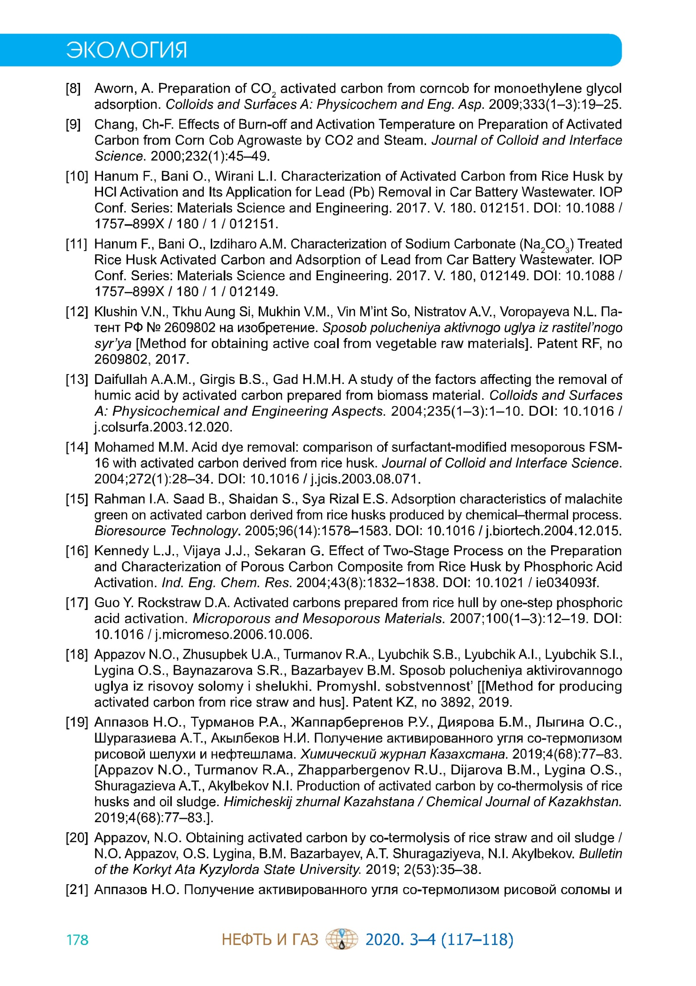
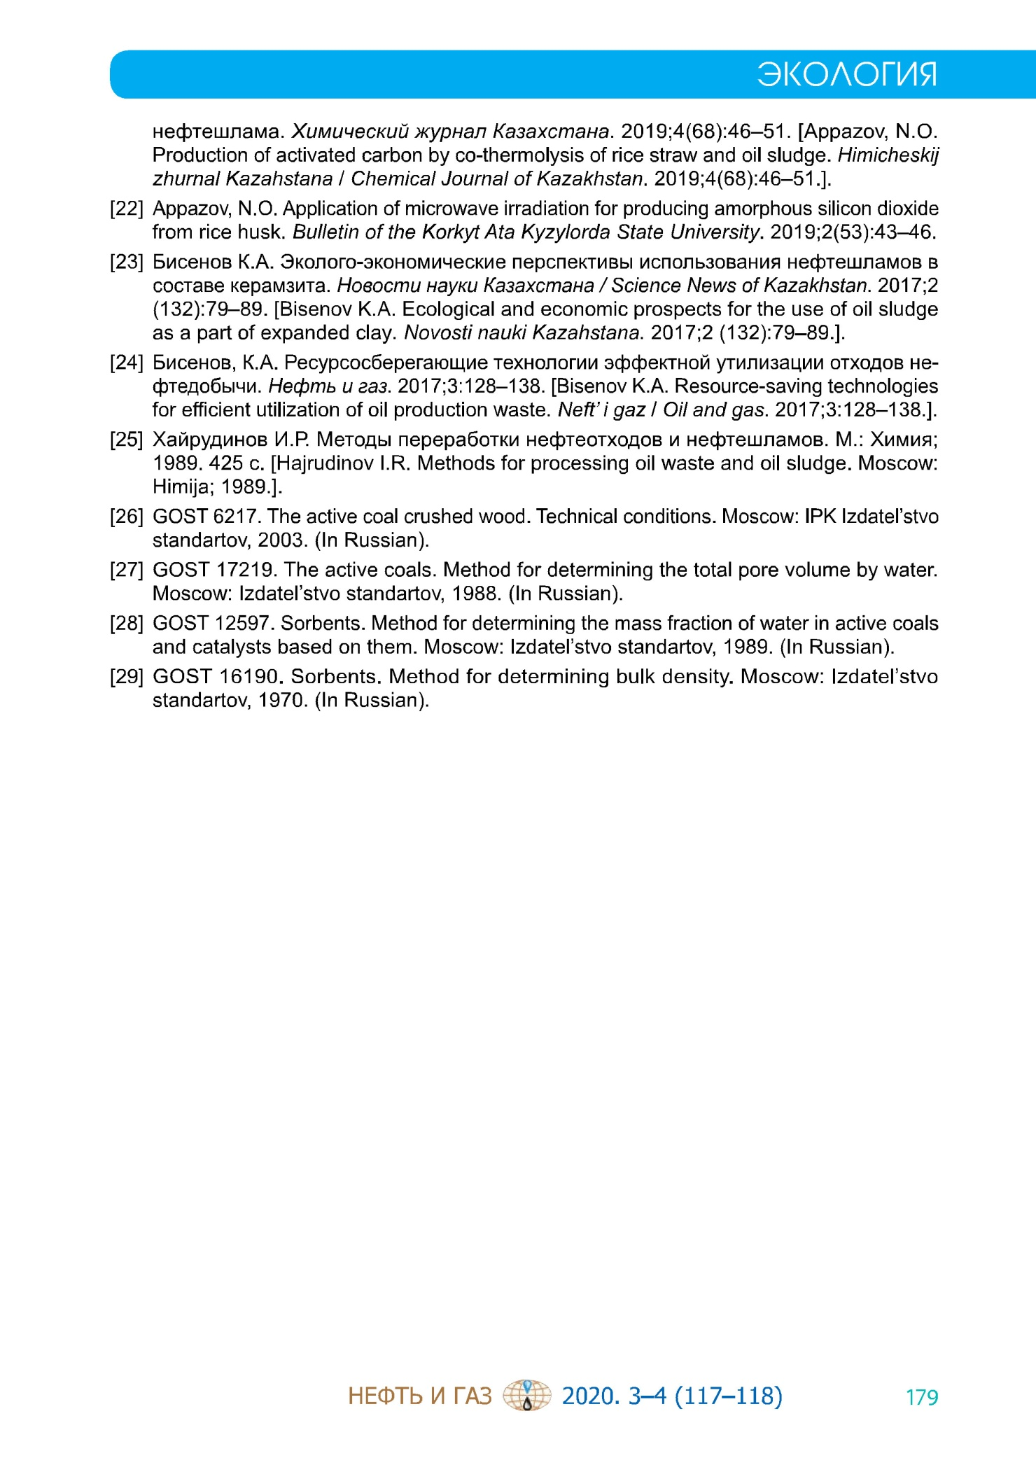
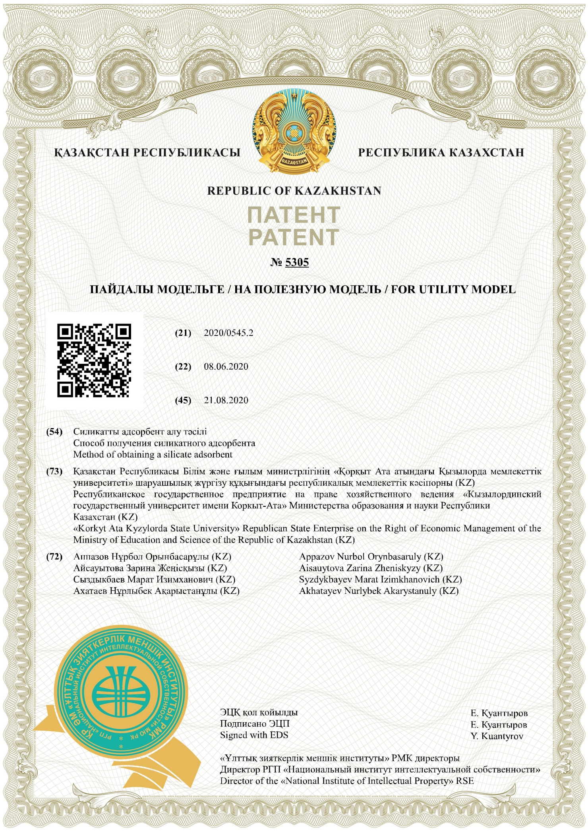
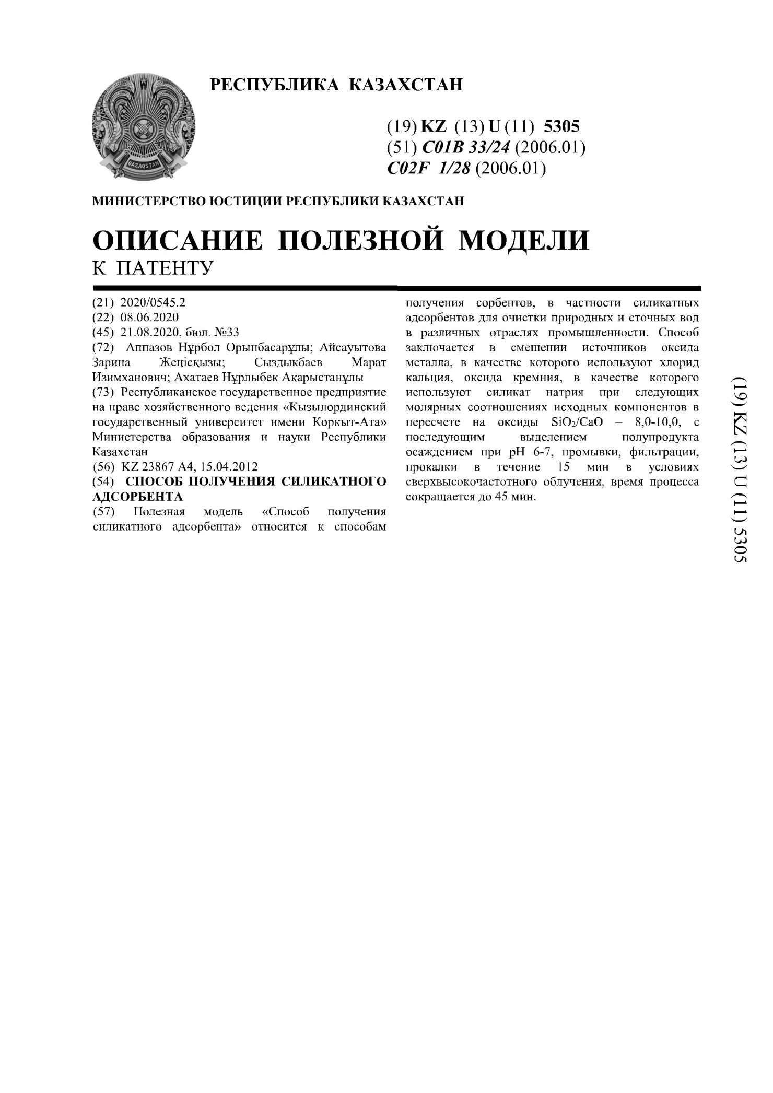
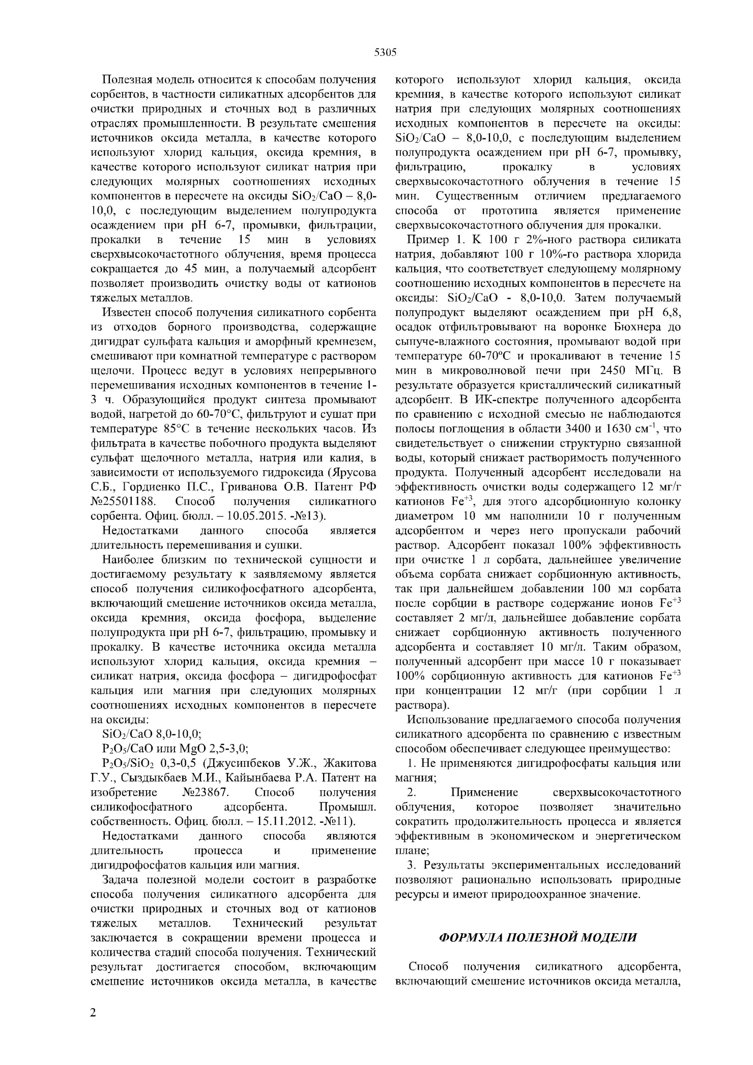
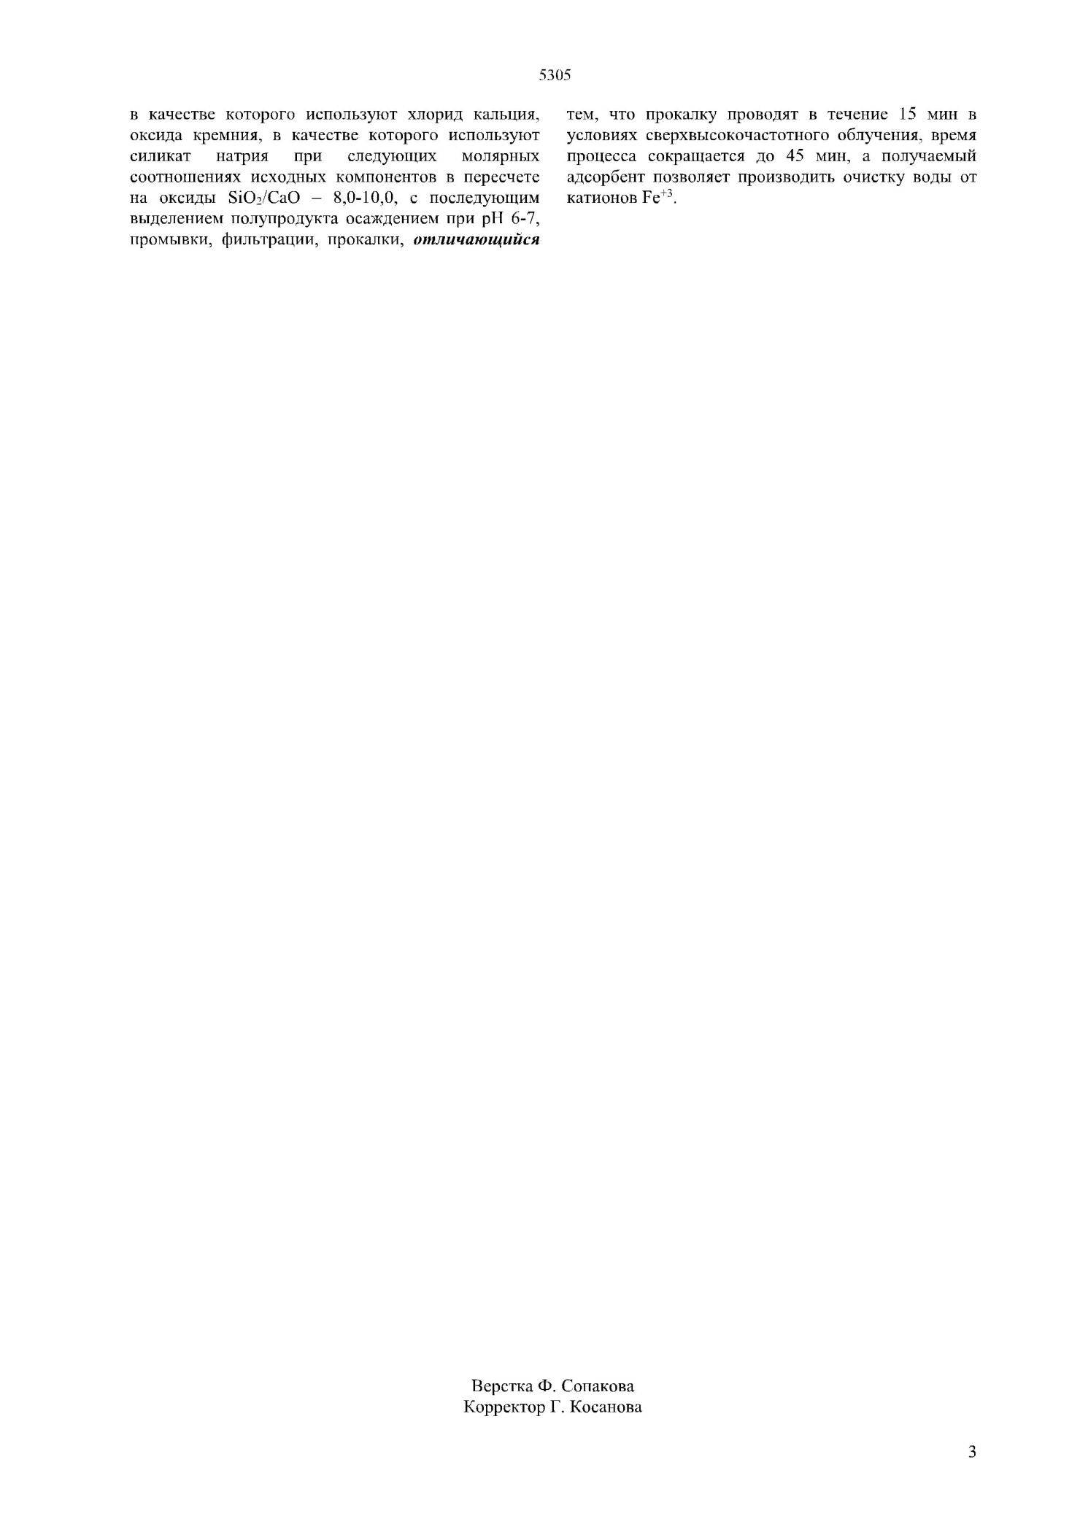
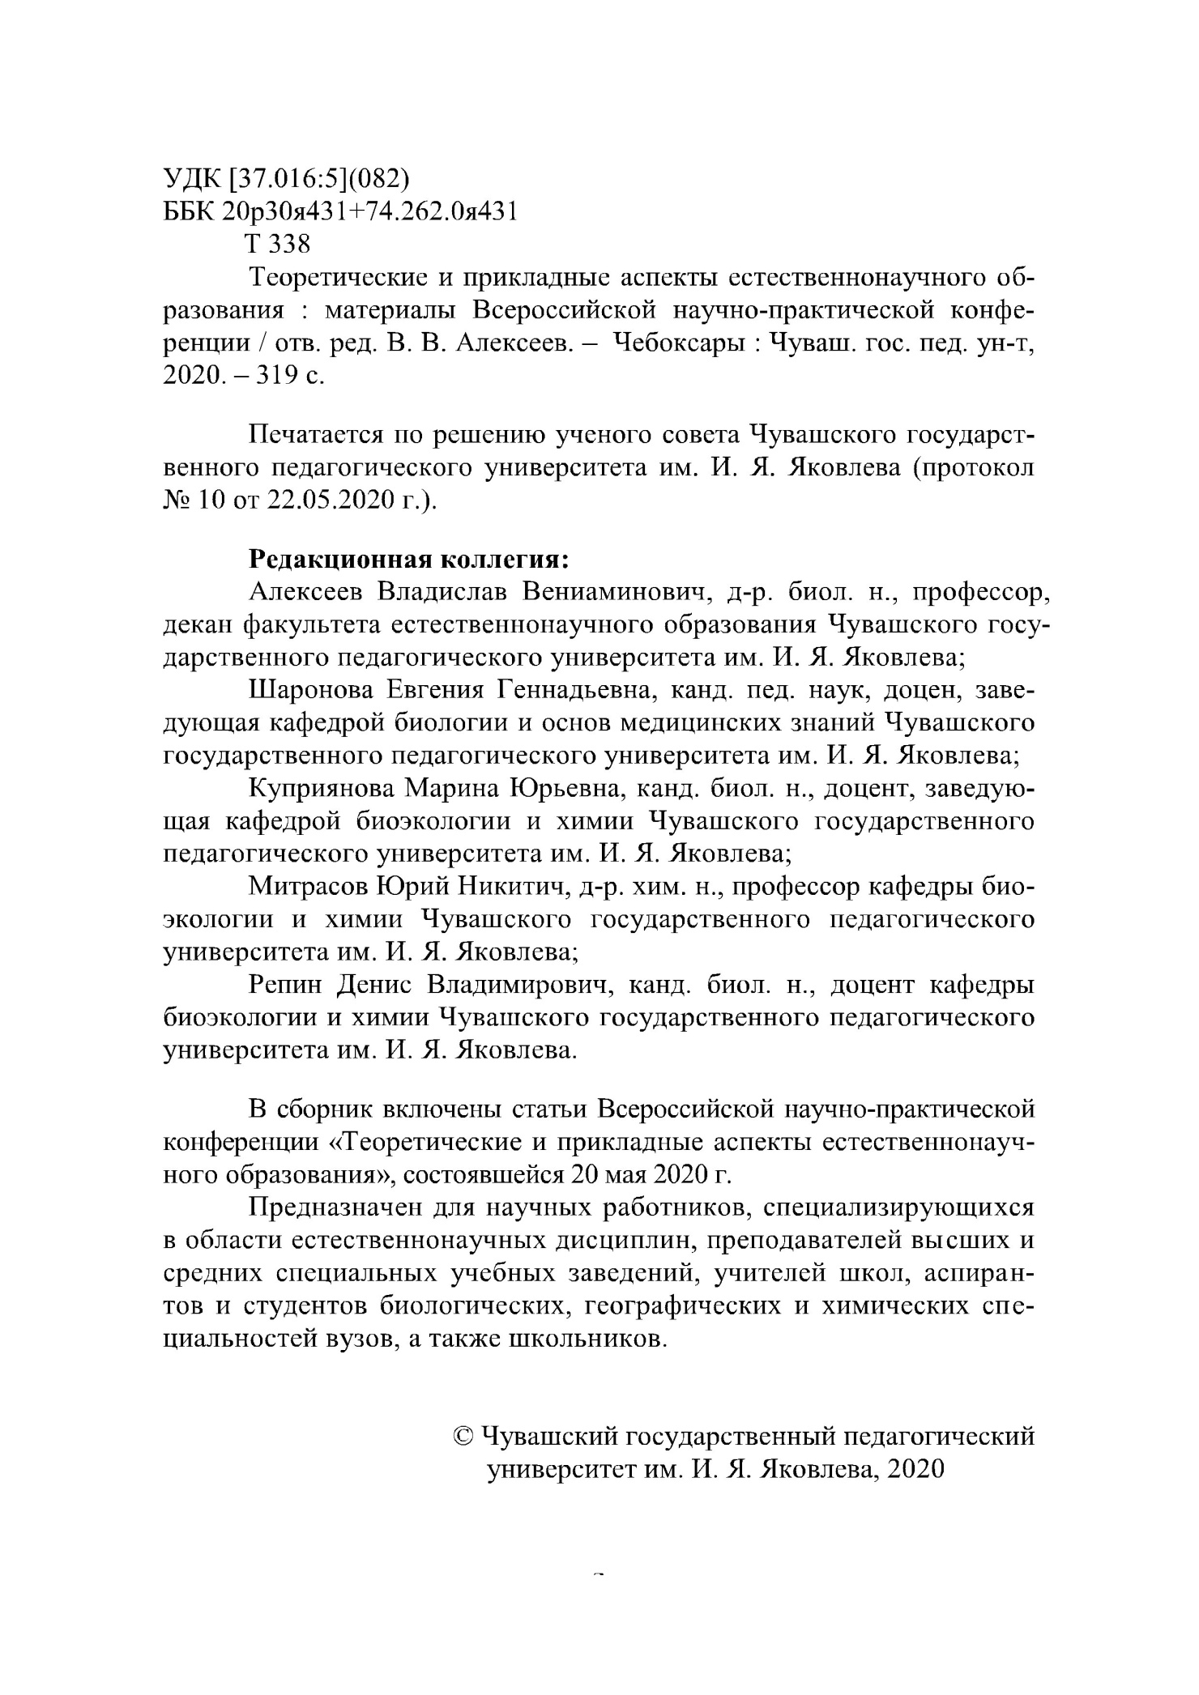
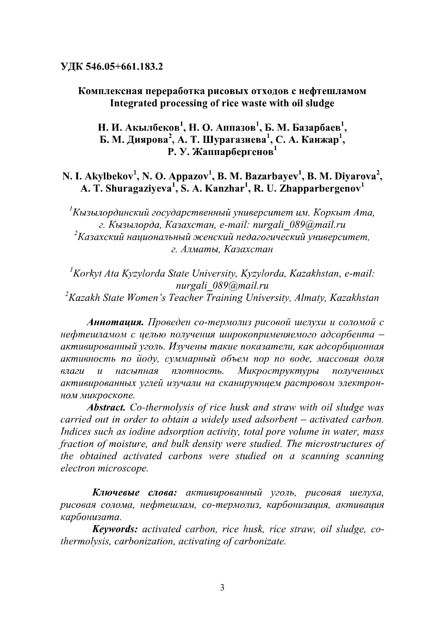
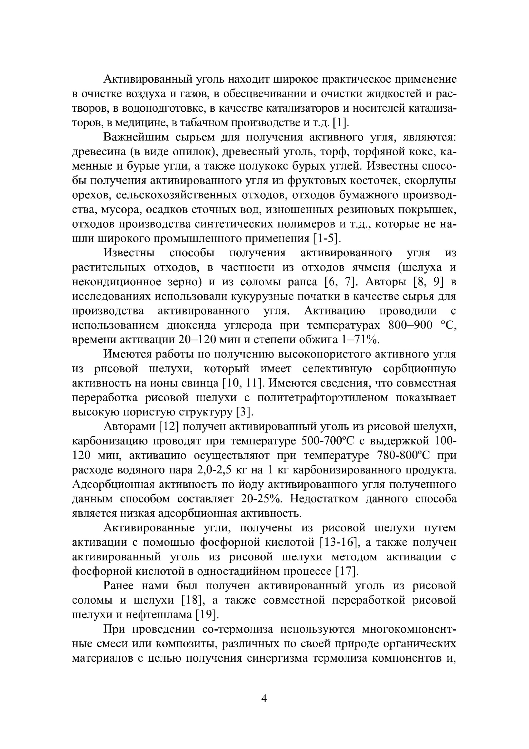
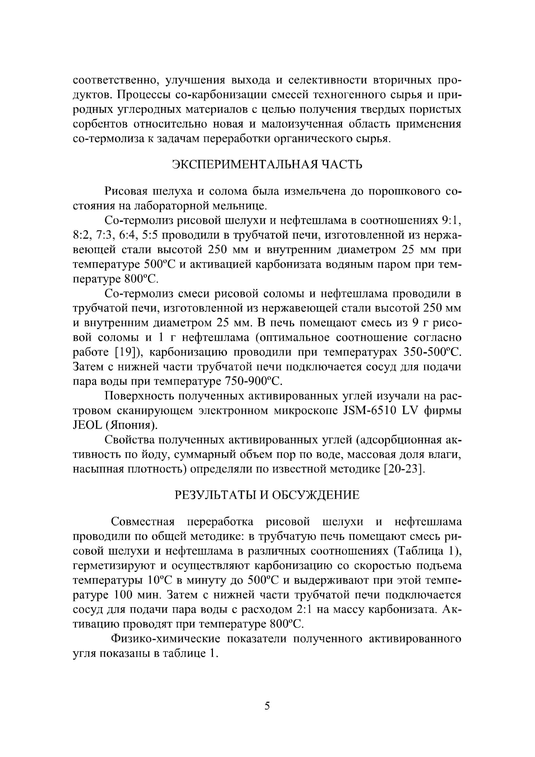
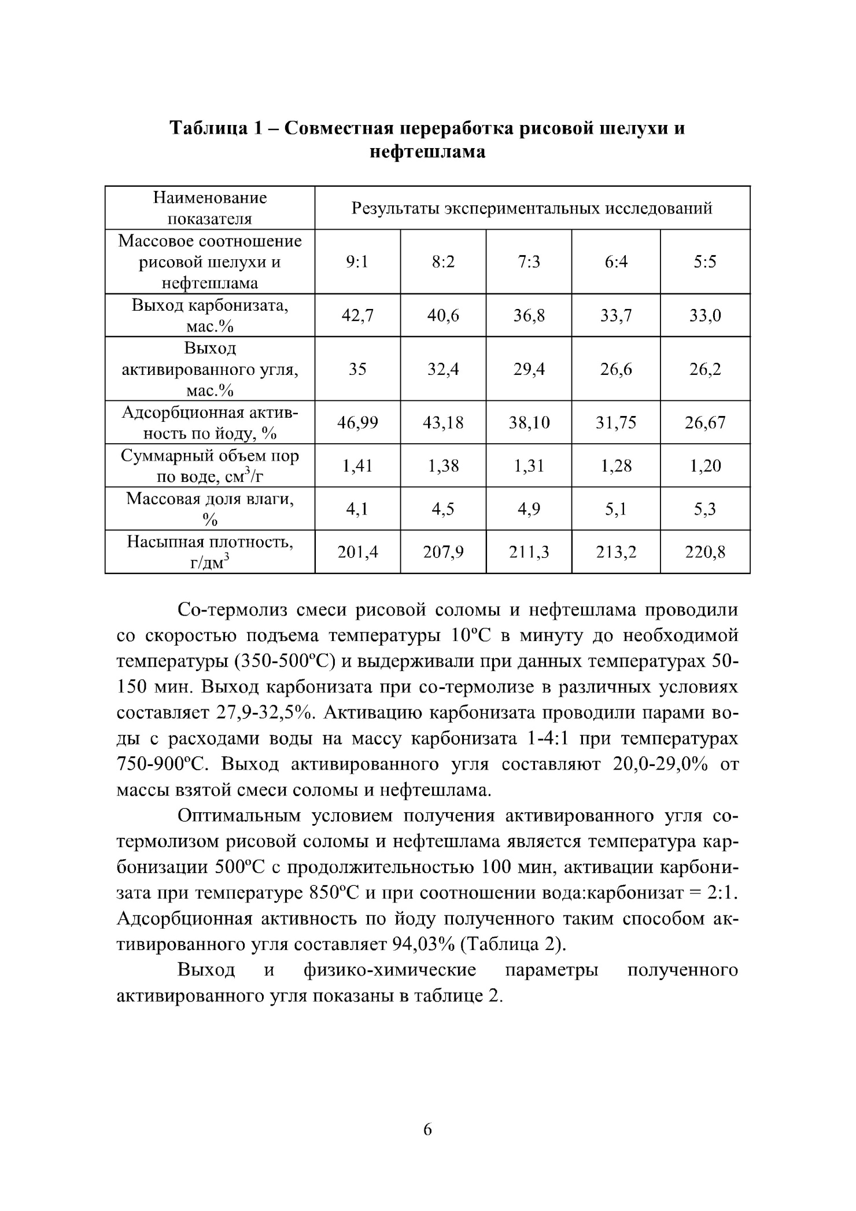
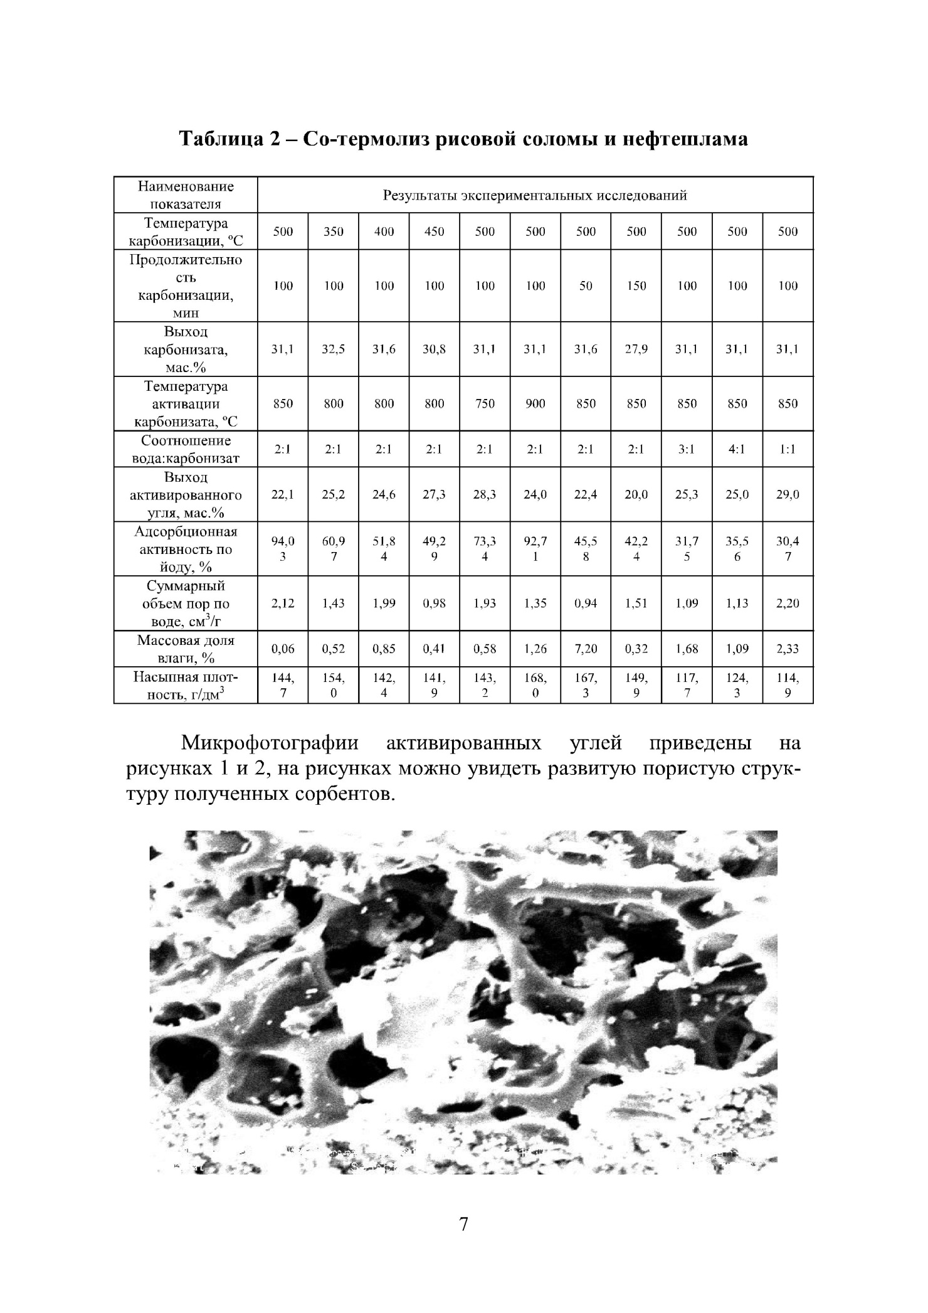
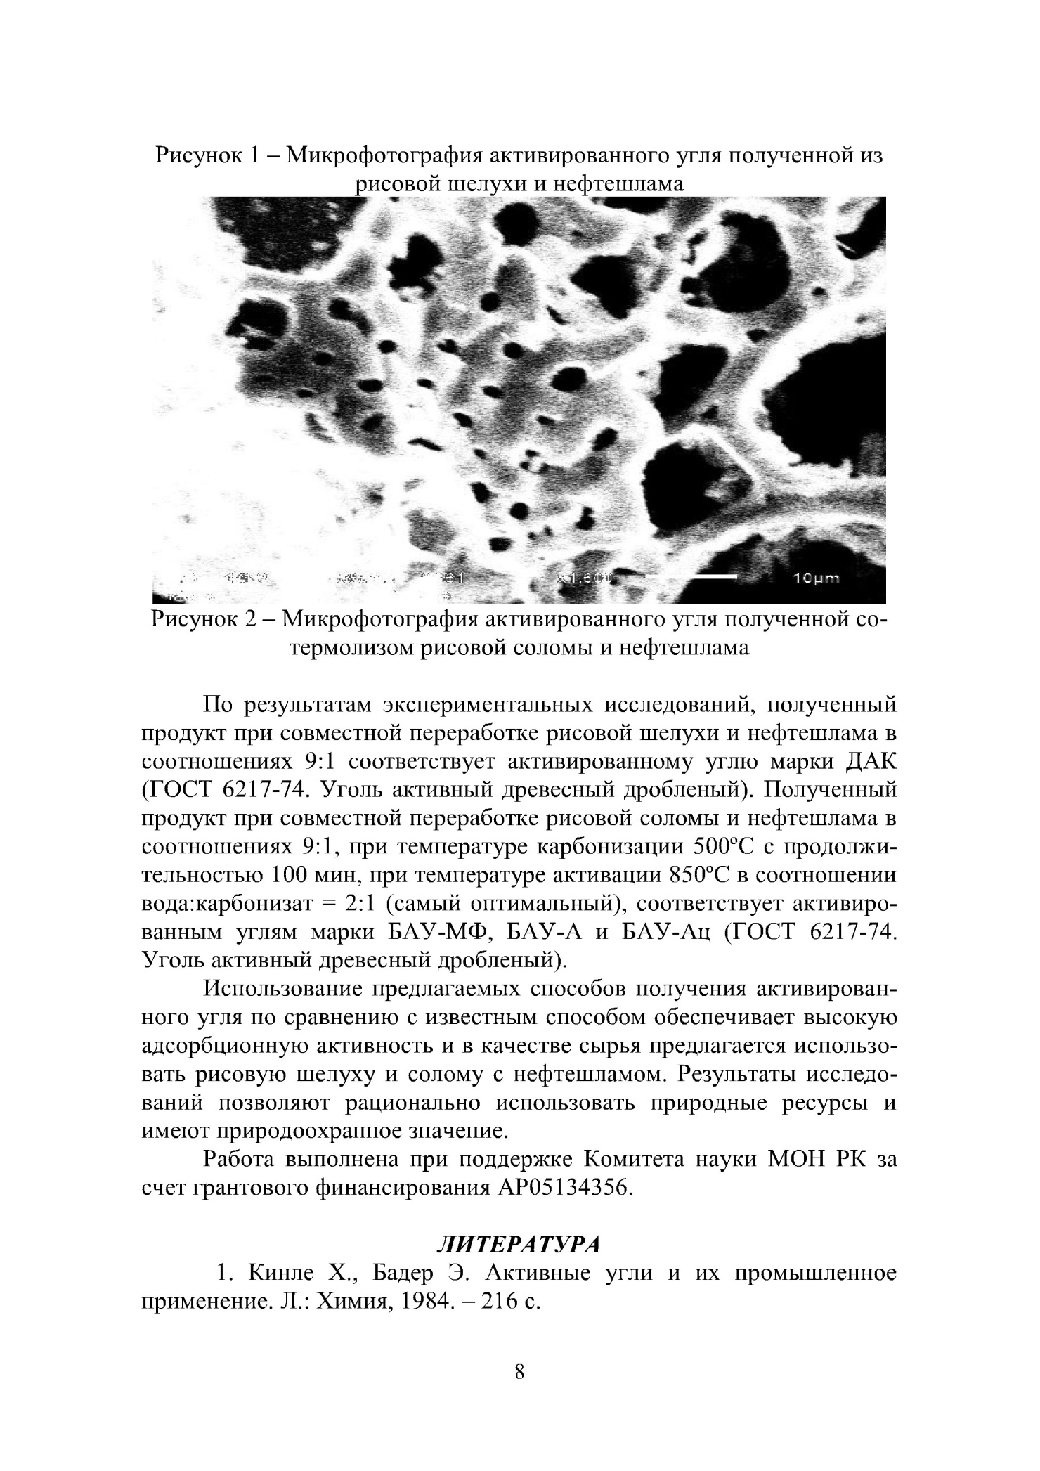
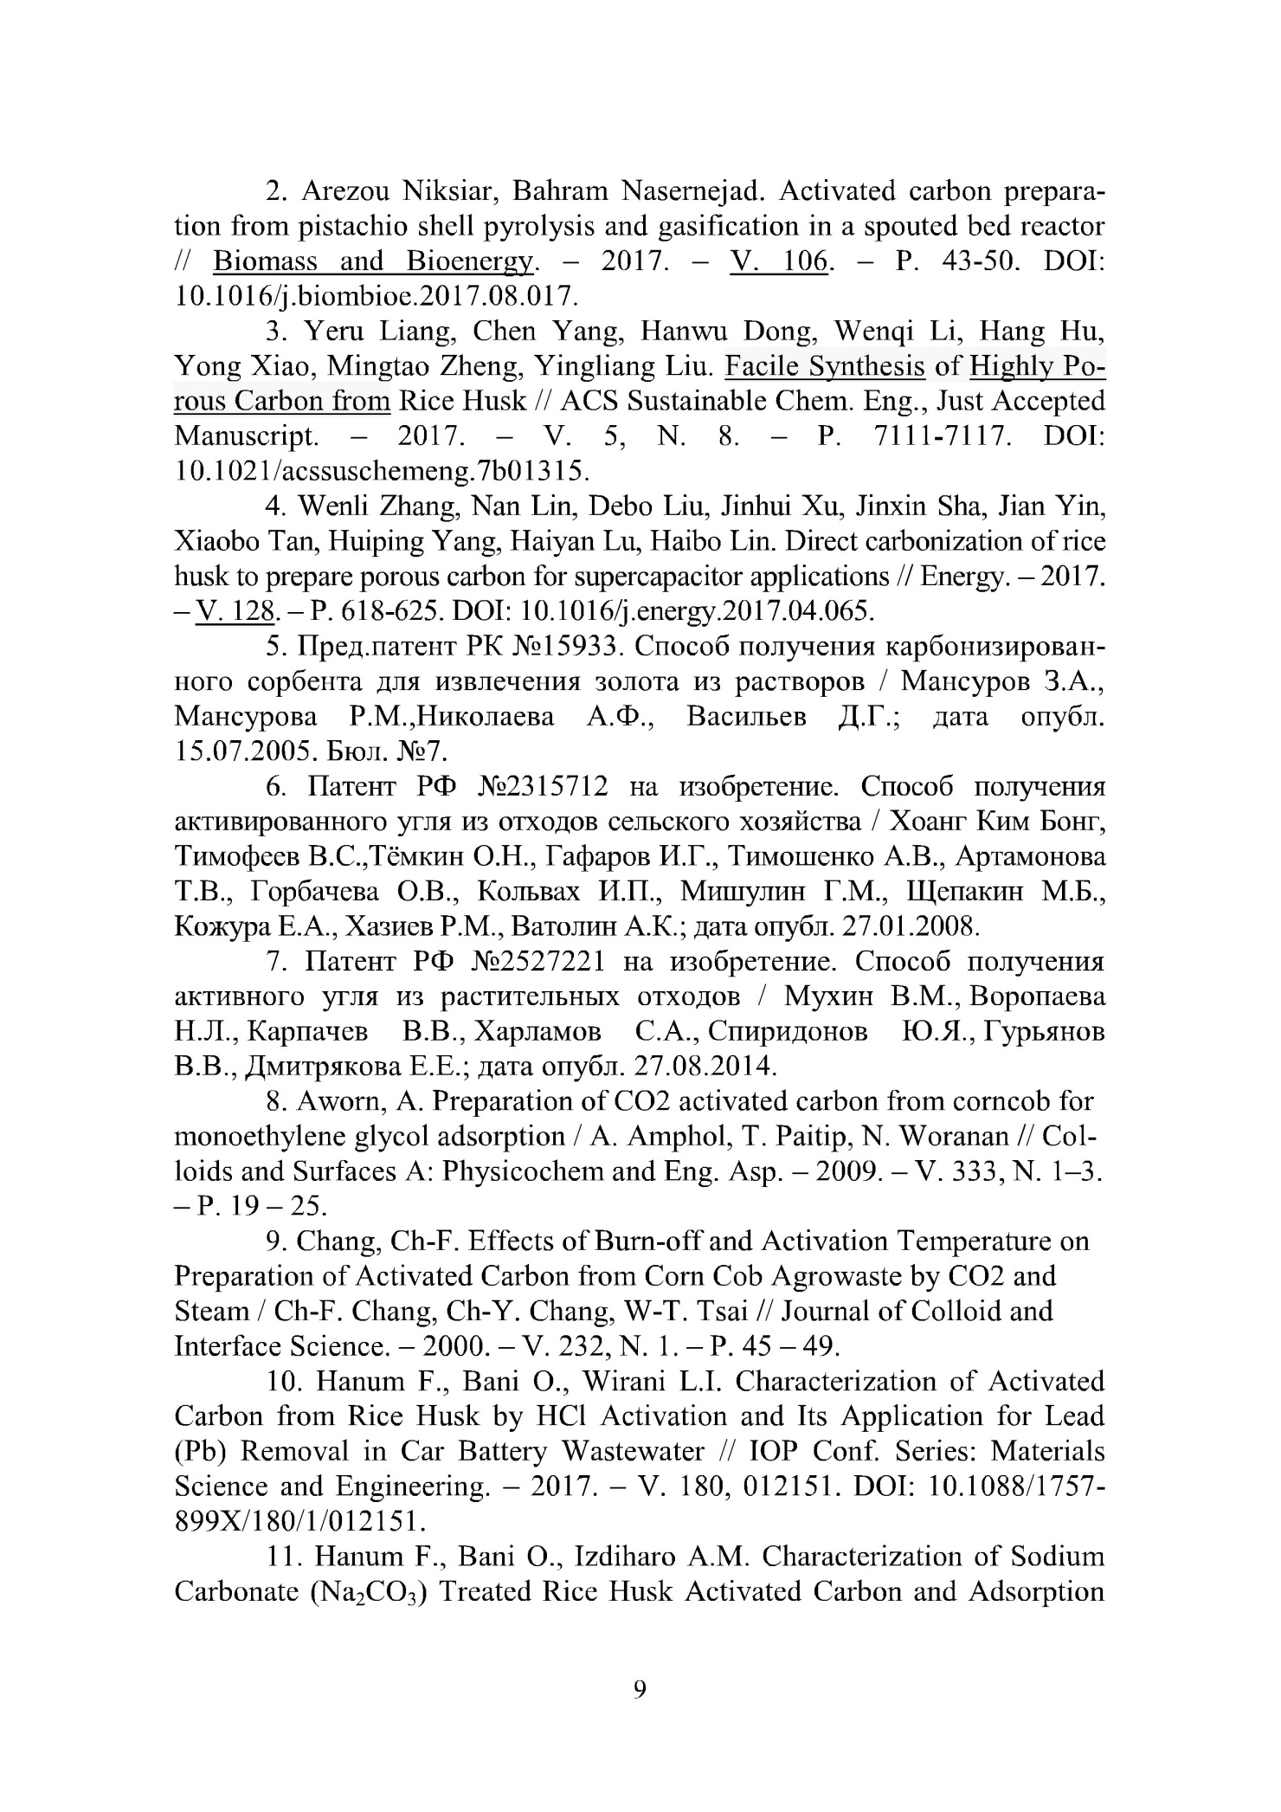
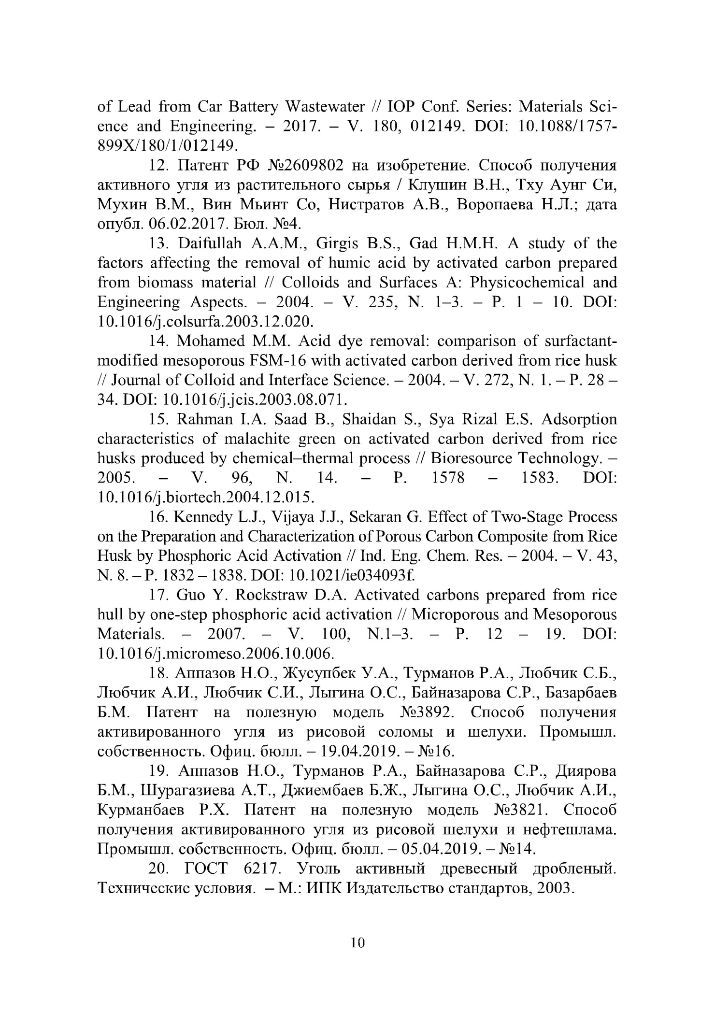
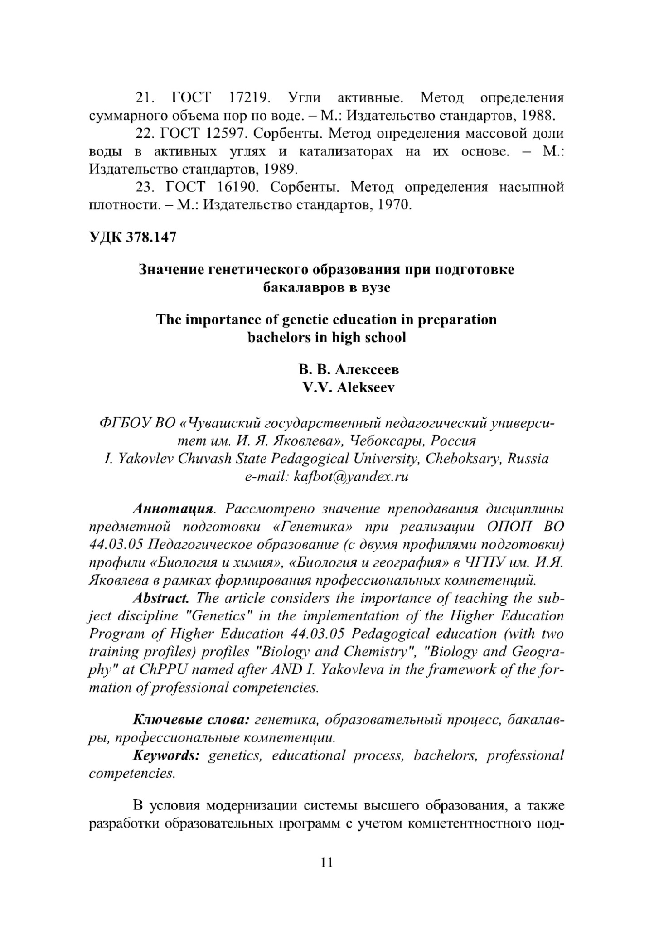

APPLICATION C – Technicaltask

