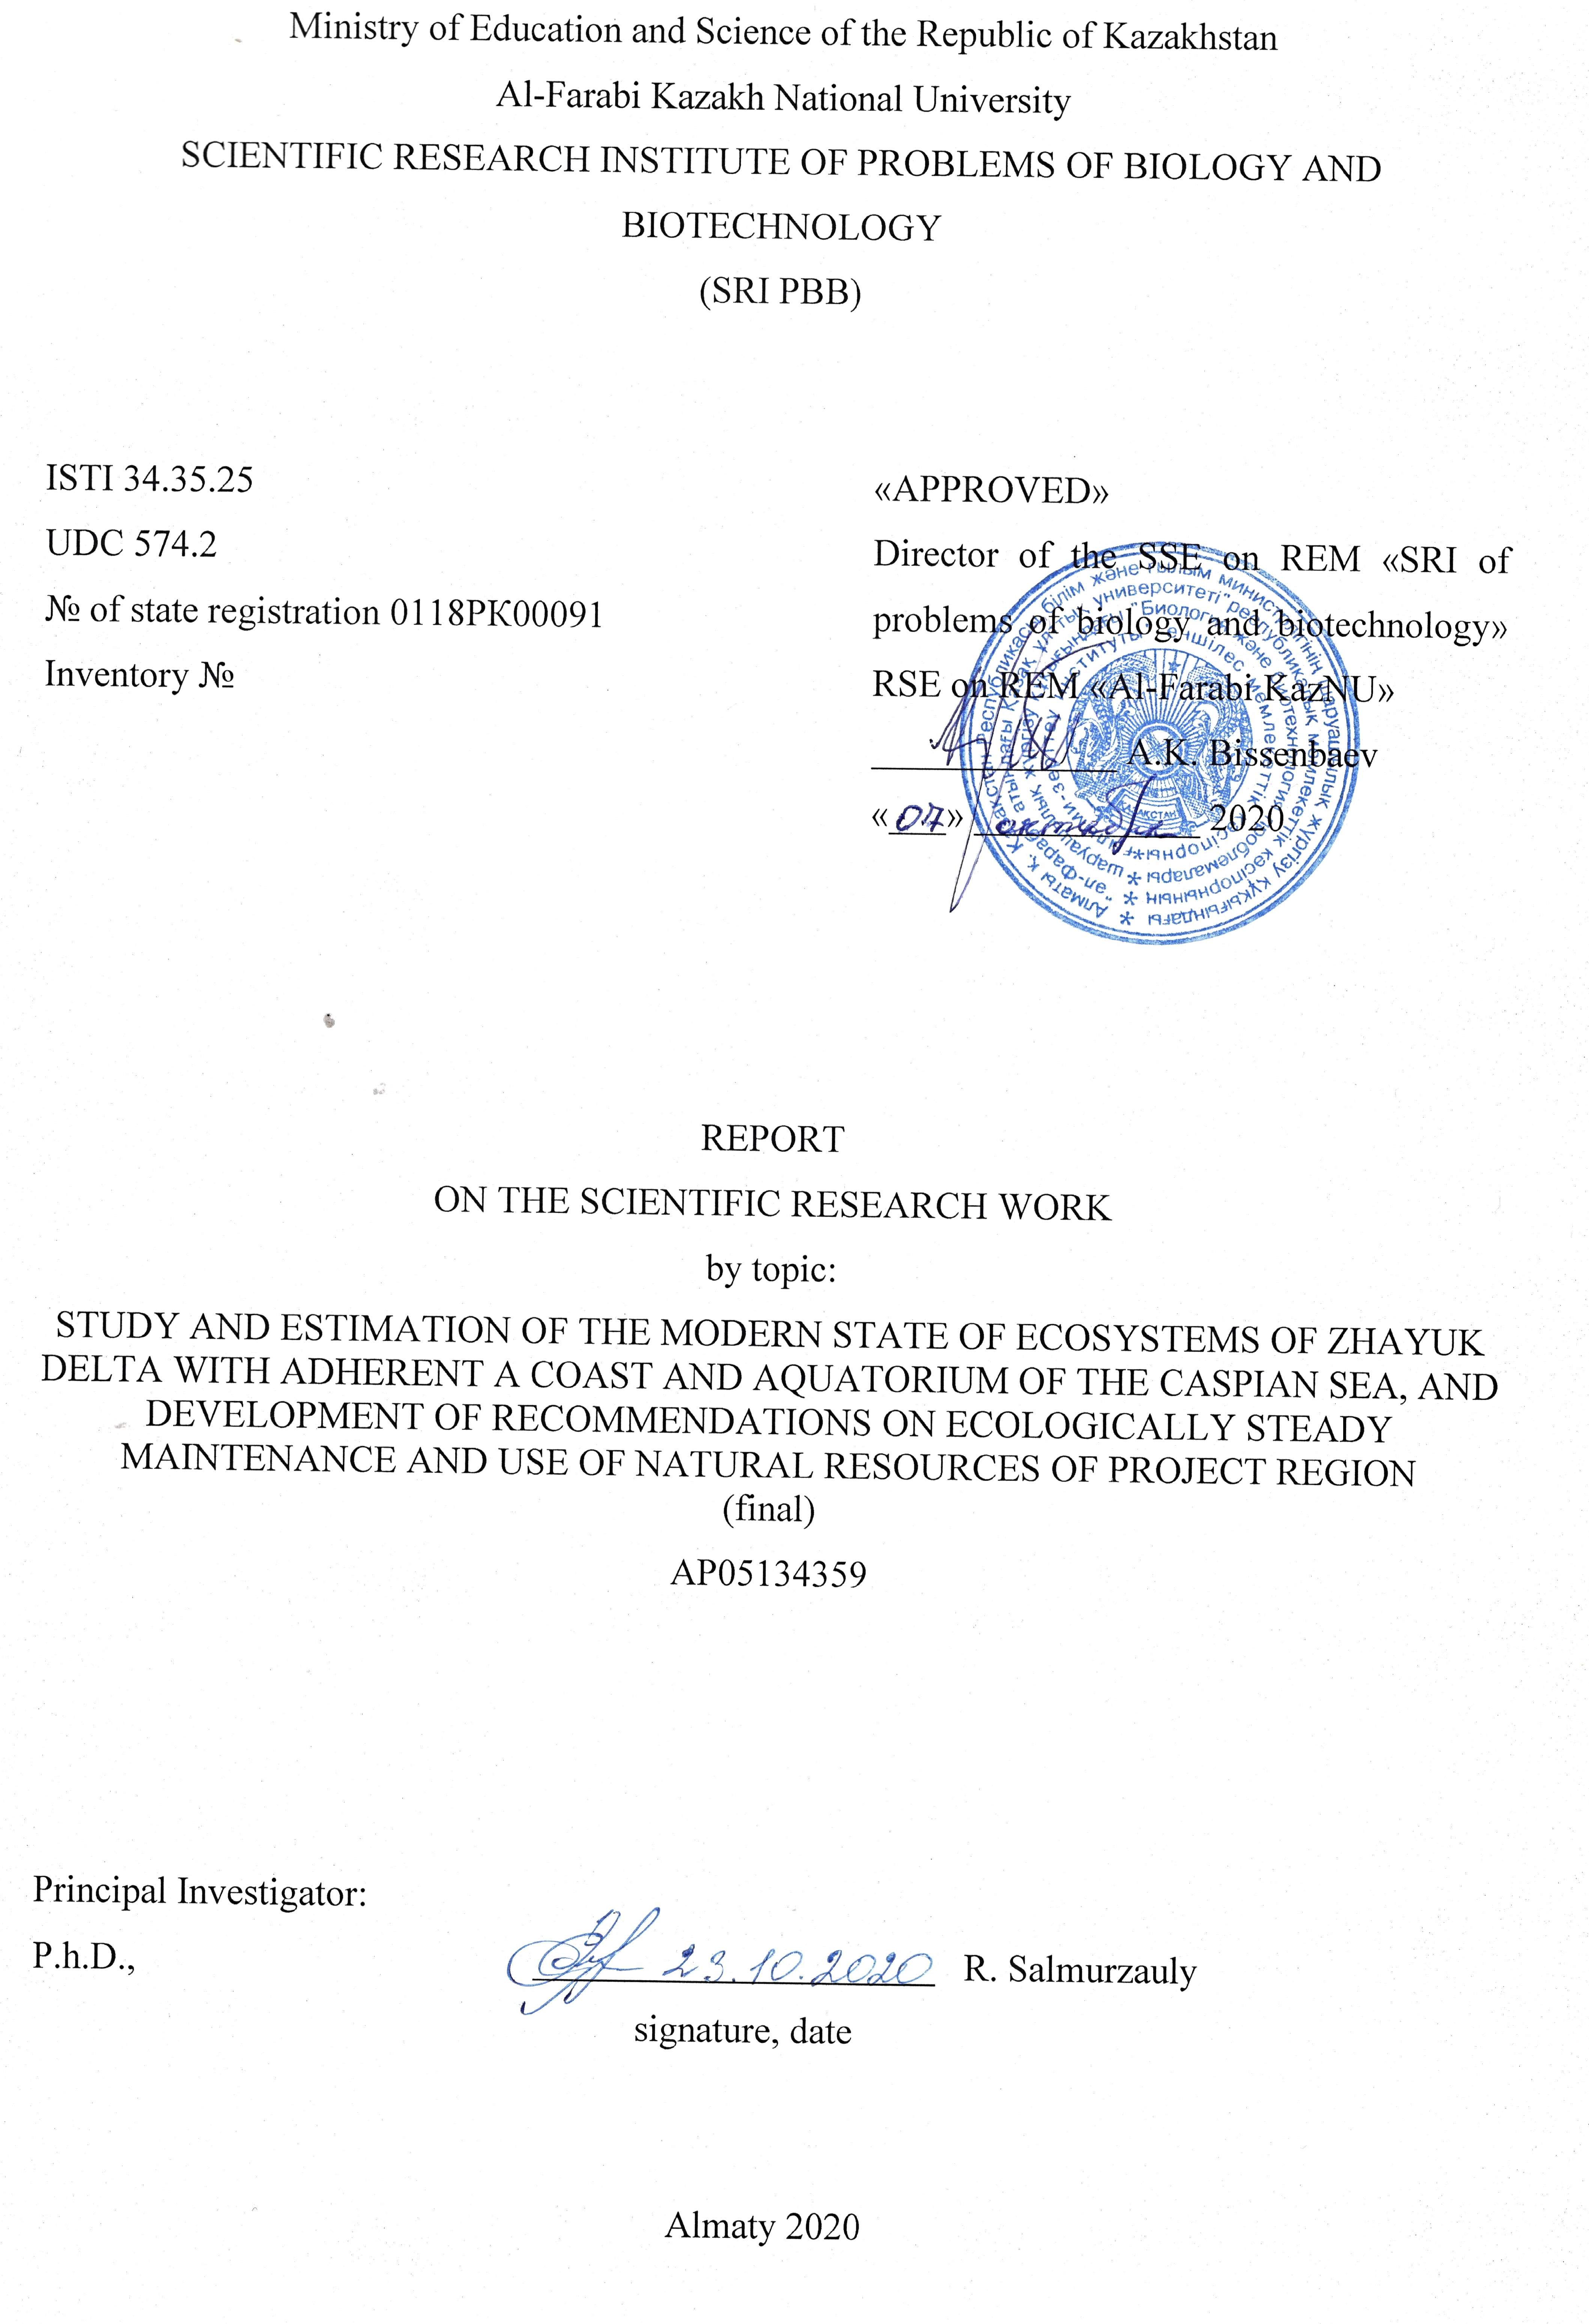

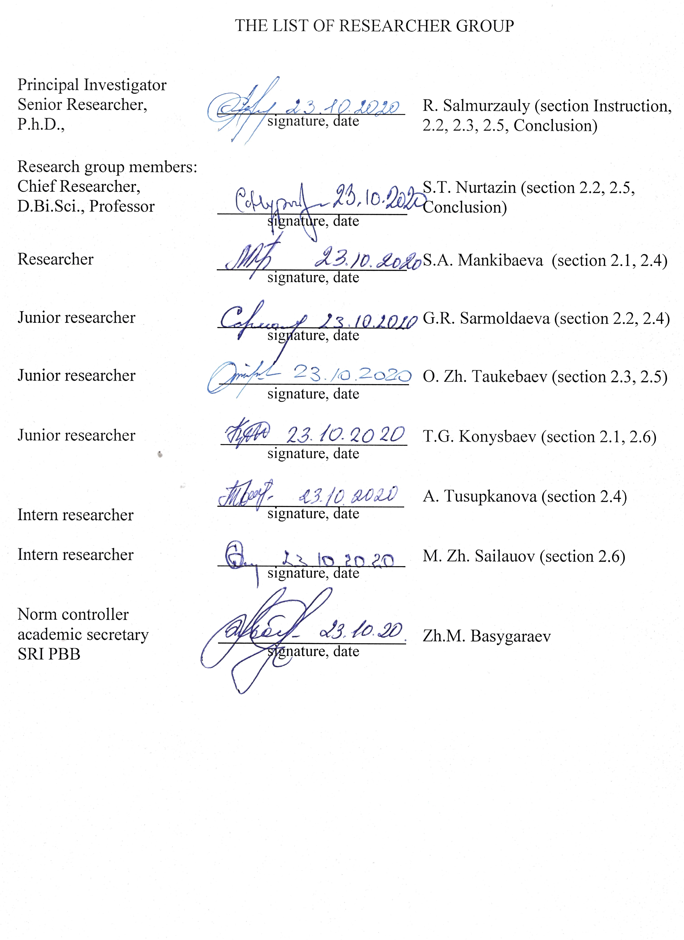

ABSTRACT

Report consist 73 p., 1 book, 18 fig., 38 sources, 6 appendix

AKJAYIK, HYDROLOGY, CLIMATE, SOIL COVER, TERRESTRIAL AND AQUATIC ECOSYSTEMS, BIODIVERSITY, PLANT COMMUNITIES, ZS-METHODS, MAPPING, GIS-TECHNOLOGIES, FAUNA, FLORA, ANTHROPOGENIC TRANSFORMATION, DEGREE OF ECOSYSTEM DISTURBANCE.
Objects of research: soil cover in the lower reaches of the Zhaiyk River. Changes in the hydrological and climatic regime of Kazakhstan's part of the river Zhaiyk and the adjacent coast of the Caspian Sea. Plant communities, flora and fauna of terrestrial and aquatic ecosystems in the project area.
The goal of the study: Based on the analysis of long-term data on the water content of the Zhaiyk River, air temperature and precipitation, the results of field studies, the use of remote sensing and GIS-technologies, multi-temporal space images, to assess the current status of the main types of terrestrial and aquatic ecosystems, land cover, flora and fauna of the eastern part of the Zhaiyk River delta.
Project tasks:
- Project objectives: Study the current state of land cover and biodiversity of flora and fauna in the project area;
- Study the current state of landscapes, aquatic and terrestrial ecosystems in the eastern part of the Zhaiyk River Delta and develop modern methods of regular monitoring of the project area based on the integrated use of field, laboratory, remote sensing and GIS technologies;
- To analyze long-term data: surface air temperature, atmospheric precipitation, dynamics of hydrological regime of the Zhaiyk River in the project area;
- Develop thematic GIS maps of the ecological zoning of the project area;
The volume of research planned for 2020 has been fully fulfilled.

РЕФЕРАТ

Отчет 68 с., 1 кн., 18 рис., 38 источ., 6 прил.

БИОСФЕРНЫЙ РЕЗЕРВАТ «АКЖАЙЫК», гидрология, климат, почвенный покров, наземные и аквальные экосистемы, биоразнообразие, растительные сообщества, ДЗЗ-МЕТОДЫ, картирование, ГИС-технологии, фауна, флора, Антропогенная трансформация, степень нарушенности экосистем.
Объекты исследования: почвенный покров в низовьях реки Жайык. Изменения гидрологического и климатического режима казахстанской части р. Жайык и в прилегающем побережье Каспия. Растительные сообщества, флора и фауна наземных и аквальных экосистем проектной территории.
Цель исследования: На основе анализа многолетних данных по водности реки Жайык, температуре воздуха и количеству осадков, результатам полевых исследований, использования методов-ДЗЗ и ГИС-технологий, разновременных космических снимков, дать оценку современного состояния основных типов наземных и аквальных экосистем, почвенно-растительного покрова, флоры и фауны восточной части дельты реки Жайык .
Задачи проекта:
- Исследовать современное состояние почвенно-растительного покрова, биоразнообразия флоры и фауны на проектной территории;
- Изучить современное состояние ландшафтов, аквальных и наземных экосистем восточной части дельты реки Жайык, разработать современные методы регулярного мониторинга проектной территории на основе комплексного использования полевых, лабораторных, дистанционных методов и ГИС-технологий;
- Провести анализ многолетних данных: по температуре приземного воздуха, атмосферным осадкам, динамике гидрологического режима р. Жайык на проектной территории;
- Разработать тематические ГИС-карты экологического зонирования проектной территории;
Запланированный на 2020 г. объем НИР полностью выполнен.

CONTENTS
INTRODUCTION ...…………………………………………………………………………... |  | 7
MAIN PART …………..………………………………………………………………............ |  | 9
1 | Research materials and methods ……………………………………………………... | 9
1.1 | Methods of soil research …………...………………………………………………… | 9
1.2 | Geobotanical research methods …………..………………………………………….. | 9
1.3 | Methods of zoological research ………....…………………………………………… | 9
1.4 | Methods of satellite images and GPS data processing ………………………………. | 10
2 | Results of research………..…………………………………………………………... | 11
2.1 | Analysis of climate change dynamics on the project territory..……………..……….. | 11
2.2 | Hydrographic features of the Zhaiyk River and the adjacent water area of Caspian Sea…………………………….………………………………………………………. | 14
2.3 | Influence of rush phenomena to coastal ecosystems of the Zhaiyk River Delta and on adjacent coastal of Caspian Sea …………………………………….…………….. | 18
2.4 | Current state of the vegetation cover of the investigated area …………………...…... | 23
2.5 | Development of systems for regular monitoring of the ecosystem transformation in the central part of the Zhaiyk River Delta and adjacent coast and water area of the Caspian Sea for the period 1977-2020……...………………………………………… | 32
2.6 | Current condition of vertebrate animals of the study area ……………………...……. | 39
CONCLUSION………………………………………………………………………………... |  | 40
REFERENCES………………………………………….……………………………………... |  | 42
APPENDIX A - Calendar plan ………………………………………………………………... |  | 45
APPENDIX B - List of published articles on the project ……………...……………………… |  | 58
APPENDIX C - Hydrographic network map of the project area…………………..………….. |  | 59
APPENDIX D - Vegetation maps of the project area ..……………………………………….. |  | 60
APPENDIX E - GIS maps of changes in aquatic and hydromorphic ecosystems of the central part of the Zhaiyk River delta and coastal zones of the Northern Caspian Sea……..………… |  | 62
APPENDIX F - Prints of published articles on the project………………..………………….. |  | 68

DESIGNATIONS AND ABBREVIATIONS
The following abbreviations and designations have been applied in this report.

SNR | - | State Natural Reserve
GIS |  | Geographic Information Systems
RSE | - | Remote sensing of the Earth
МС | - | Weather station
WS | - | Gauging station
NASA | - | National Aeronautics and Space Administrationа
ESA | - | European Space Agency
JAXA | - | Japan Aerospace eXploration Agency
GPS | - | Global Positioning System
NDVI | - | Normalized Difference Vegetation Index
NDWI | - | Normalized Difference Water Index
BAI | - | Burn Area Index
ISODATA | - | Iterative Self Organizing Data Analysis Technique)
MLC | - | Maximum likelihood classification)

INTRODUCTION

The project area is characterized by a significant diversity of ecosystems, among which are terrestrial and aquatic ecosystems (the deltas of the Zhaiyk River and its channels, sleeves, lakes, the adjacent coast and water area of the Caspian Sea).
In recent years, the problems of environmentally safe and cost-effective development of territories, while ensuring ecosystem and public health preservation, have been widely discussed. The standards of such ecosystems are specially protected natural areas (SPNAs), primarily biosphere reserves that reflect the global biodiversity of the planet to the fullest extent possible. Officially recognized by international organizations, protected areas, in particular, biosphere reserves and biosphere reserves are a critical component of the system of global and regional biodiversity conservation, and therefore their development is of great importance for all UN member states.
An important component of the natural ecosystems of the Republic of Kazakhstan are wetlands of the Zhaiyk River delta, with the adjacent coast and water area of the Caspian Sea. Here, in the climatic and geographical zone of northern semi-deserts and deserts, thanks to the azonal aquatic ecosystems of the river Zhaiyk and the Caspian Sea, unique conditions for the richest species and cenotic diversity have been formed. Research, monitoring and protection of such areas is one of the priorities of the national biodiversity conservation policy.
State Nature Reserve "Akzhaiyk" was organized by the Government of the Republic of Kazakhstan № 119 "On some issues of creating a public institution" State Nature Reserve "Akzhaiyk" dated February 6, 2009 in the Ural Delta and the adjacent coast of the Caspian Sea. And on April 1, 2009, the reserve "Akzhayik" was included in the list of wetlands of international importance [1]. In 2014, the reserve was included in the UNESCO World Network of Biosphere Reserves. The total area of the reserve is 11500 ha.
The Zhaiyk River flows through the territory of Russia and Kazakhstan and, as a major transboundary river, it is characterized by most problems of shared water resources (water allocation, water pollution, excessive use of fish resources, especially sturgeon, etc.) [1]. In the Zhaiyk basin there are large industrial centers, many manufacturing and mining enterprises, large-scale agricultural production, including about 360 thousand hectares of irrigated land [2]
In the middle and lower reaches of the Zhaiyk River flows through Kazakhstan in areas with insufficient and extremely low humidity [3]. But it is here that the river and its floodplain are characterized by maximum species diversity and peculiarity of flora and fauna. It should be noted that due to various reasons, the Akzhaiyk Reserve is under pressure from a whole complex of natural and anthropogenic unfavorable factors, risks and threats. Among these factors should be listed global and regional climatic changes [4], significant annual and seasonal fluctuations in water availability with a trend of declining river runoff [5, 6], significant discharge of harmful industrial, agricultural and domestic runoff, both in the Russian and Kazakh sectors of the river [7].
It is known that river deltas can be considered as indicators of global and regional, natural and anthropogenic changes occurring in the environment. Under such negative pressure, more or less pronounced degradation processes in delta ecosystems may develop. Economic activity in the Zhaiyk River Basin (Ural) leads to a decrease in the quantity and quality of river water entering the delta and the Caspian Sea. Zhaiyk is the only major source of fresh water in the protected ecosystems of the delta. Annually, the river brings in over 8 km³ of fresh water [8]. This is the second largest flow of fresh water to the Caspian Sea after the Volga River.
On the other hand, the pressure on the ecosystems of the delta and the adjacent sea coast continues to increase as a result of the Caspian waters pollution as a result of the ever-increasing development of oil fields and also so-called "Storm surge wave events" phenomena. At the same time, in recent years there has been a decline in the level of the Caspian Sea, which, combined with a decrease in the water content of the Zhaiyk River, leads to the drying up of a number of aquatic and mesomorphic ecosystems.
Taking into account the specific conditions of the Zhaiyk Delta, which is under increased natural and anthropogenic pressure, the control of water quality - habitats of hydrobionts and human food products - fish, mammals, birds - becomes very important for the preservation of the unique nature of the reserve "Akzhaiyk". Special attention should be paid to the conservation of especially valuable and endemic representatives of fauna, including a huge number of migrating and nesting birds, sturgeon fish, which are the most powerful press for poaching.
To assess the current state of ecosystems and its biota in the project area of the Ural Delta, we conducted a study of soil cover, floristic and faunistic composition, studied multi-temporal space images of the project area, collected and analyzed long-term meteodata and data on Ural River water availability and the level of the Caspian Sea. Inventory IDs of reports for 2018 - 0218RK00626; 2019 - 0219RK00363

MAIN PART

- Research materials and methods
In our research, we used common and well-tested classical methods and approaches to conduct a comprehensive environmental analysis of natural and cultural landscapes and their various components.

1.1 Methods of soil research
In the field studies, the comparative geographic method and the method of soil keys (sites), which has become classic, were used. In the study of specific soils were used morphological and profile methods, which are the basis for field studies and form the basis of soil diagnosis. Traditional field morphological descriptions of soils were conducted, samples were selected for chemical analysis by genetic horizons [9-11].

1.2 Geobotanical research methods
Geobotanical research was conducted to study the current state of the vegetation cover. Researches were carried out by a route method according to the Instruction on carrying out large-scale (1:1000 - 1:100000) geobotanical researches of natural forage lands of the Republic of Kazakhstan, 1996, developed in the system of land management of the Republic of Kazakhstan [12].
In the course of fieldwork, descriptions of plant communities were made, GPS coordination of description points was carried out, and a herbarium was photographed and collected to clarify the floral composition of the study area vegetation.
In the course of vegetation study, the following were determined: floral composition of plant communities; their structure and spatial location; confinement to habitat conditions; degree of anthropogenic impact on vegetation; projected soil cover with plants; height of grasses; their stage of development and yield.

1.3 Methods of zoological research
Observations of vertebrate fauna were made in the summer period of 2020. Road, walking and boat routes were carried out to identify biodiversity of birds and animals and their distribution in biotopes. The total length of the routes in the project area was over 1,100 km, including over 50 km of foot routes and over 100 km of boat routes. The methods of investigation are generally accepted zoological [13,14]. Bushnell brand binoculars and telescopes were used for bird watching, Olympus G14 and Fujifilm HX30R cameras were used for fixing birds. Bushnell Trophy Cam (Model 119437) photo traps were used for fixing animals.

1.4 Methods of satellite images and GPS data processing
The tasks were performed using remote sensing data, methods of its interpretation, as well as classification of space images with subsequent generation of thematic GIS maps.
Satellite images with high spatial resolution of Sentinel 2 (10 meters) were used to map key areas. In addition, radar space data from Alos Palsar (10 meters), Sentinel-1 (20 meters) and Shuttle Radar Topography Mission - SRTM (30 meters) were used to map aquatic and ground biocoenosis. All used space images were taken from open official catalogs of the U.S. space agency - NASA http://landsat.gsfc.nasa.gov and http://earthexplorer.usgs.gov, the European Space Agency ESA https://sentinel.esa.int/ and the Japanese Space Agency - JAXA http://global.jaxa.jp/.
Classification and comparison of the area ratios of the main biocoenoses were performed on the basis of five paired multispectral images acquired by the Landsat series spacecraft (SC): Multispectral Scanner (MMS); Thematic Mapper (TM); Enhanced Thematic Mapper Plus (ETM+) and Operational LandImager (OLI), which are widely used in studies of wetlands and delta ecosystems [15,16].
Classification of images. Classification of satellite images was performed depending on the tasks, using different methods. Preliminary clustering (ISODATA) of the investigated region was carried out in camera conditions before the field research. Controlled classification, based on field data of 2019 of the main ecosystems of the Zhaiyk River Delta, was performed by the "Maximum Likelihood" method as the most reliable and widely used algorithm for classification of environmental objects [17,18].
Preliminary processing and classification of satellite images and further thematic mapping was carried out using widely used GIS packages ENVI 5.0; PCI Geomatica; ArcGis and Surfer Golden Software.

- Results of research
2.1 Analysis of climate change dynamics on the project territory
Long-term fluctuations of precipitation and air temperature regime are considered according to the data of 2 meteorological stations (MS) in the lower reaches of the Ural River (MS Peshnoy and MS Makhambet) for the period 1980 - 2017. The analysis of the data of the MS "Peshnoy" on the amount of precipitation for the 38 summer period from 1980 to 2017 gave an average annual value of 199.9 mm, and the data of the MS "Makhambet" - 192.4 mm, which indicates a pronounced aridity of the climate in the project area. At the same time, in the annual course of precipitation of maximum monthly 17.1 mm falls on the spring months (March-April-May) and the secondary maximum - monthly 14.4 mm in autumn. The minimum amount of precipitation per month by 12.7 mm falls in winter (December-January-February) throughout the territory under consideration. In general, the year is dominated by precipitation of a warm period.
The analysis of the linear trend in the time course of the annual sums of precipitation for the 38-year period under consideration for two meteorological stations shows, first of all, that since 1980 in the first 30 years we can see a distinct trend of growth of the average annual precipitation from 139.9 mm in the period 1980-1989 to 294.9 mm in the period 1990-1999. From 2000 to 2007, the average annual precipitation has slightly decreased (to 174.7 mm/year). The maximum positive values of the linear trend coefficient have been noted on MS Mahambet (22.3 mm/10 years in the period 1980 - 1999) (Figure 1).

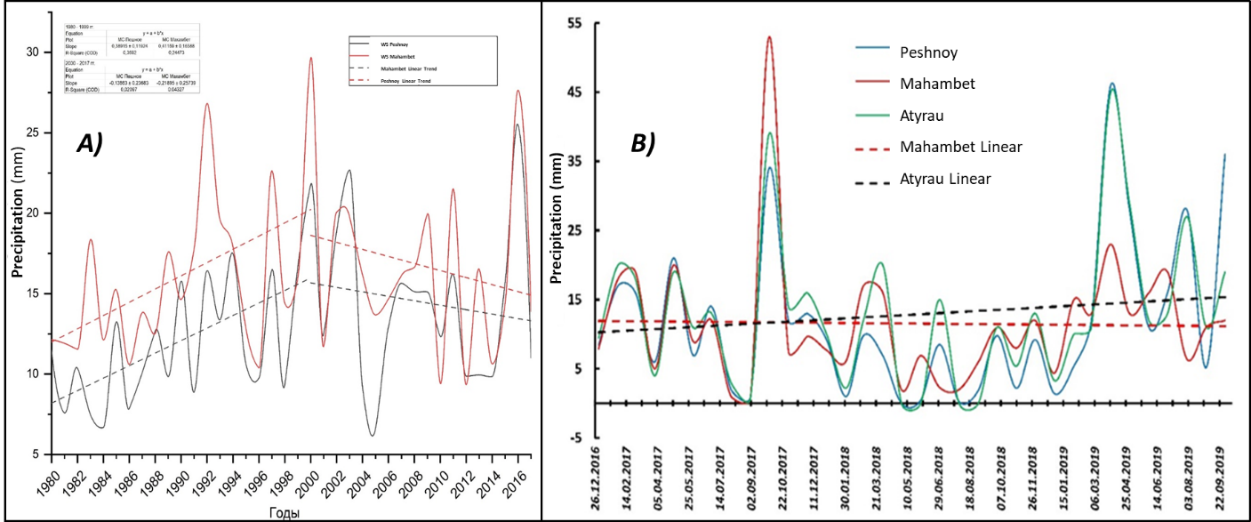

Figure 1 - Average annual (a) and average monthly (b) precipitation amounts in the period 1980 - 2017 for the 2nd MS "Peshnoy" and "Mahambet".

Despite the great variability in precipitation from year to year in the period considered (1980-2017), analysis of the linear trend in the time course of precipitation shows that trends in precipitation growth were expressed more strongly in the first 30 years and then slightly decreased (Figure 1 a). The minimum annual precipitation in the period under review was registered in 2005 at MS "Peshnoy" 79.6 mm, and the maximum in 2000 at MS "Mahambet” 355 mm.
Average monthly data from three meteorological stations were used to analyze changes in precipitation over the past three years: "Mahambet", "Atyrau" and "Peshnoy" (Figure 1 b).
According to these weather stations in 2017, the average monthly rainfall in the spring-summer period did not differ significantly for all three MS and was equal to 13.3 mm, while the amount of precipitation in October reached a record 42 mm, amounting to 26.2% of the total annual volume. This amount of autumn precipitation at positive atmospheric temperatures contributed to the secondary vegetation of ephemera and some solyanka. In 2018, the average annual rainfall was 245 mm, which makes this year the most arid of all considered. And the average monthly rainfall in the spring period was 10.4 mm, and in the summer months has halved. In 2019, the average monthly rainfall for the first 9 months has increased significantly, amounting to 16.7 mm, which is twice as much as in 2018. At the same time, 43% of precipitation fell in the spring months, while the summer average monthly precipitation is 27 mm, which is the highest for the described period. Analysis of the linear trend in the temporal course of average annual precipitation over the past three years shows an upward trend in two weather stations (Atyrau, Peshnoy) due to heavy precipitation in 2019, while the average precipitation according to the MS "Mahambet" has not changed
Changing of thermal regime for the period 1980 - 2017. The initial information for estimating the trend in time series of meteo-values was the data on the average monthly and annual temperature of surface air at MS "Peshnoy" and "Mahambet" for the period 1980 - 2017. The first thing that can be highlighted is an insignificant positive trend of surface air temperature for January, July and the average annual temperature. Thus, the average annual temperature according to MS "Mahambet" grew by 0.4°C/10 years. Winter months have the highest inter-annual variability, while summer months have the lowest variability. Thus, the average monthly air temperature in January on the study area varied from -2.8 °С in 2000 to -14.7 °С in 2006 at MS "Peshnoy", and the average monthly temperature in July from 23.3 °С in 1980 to 27.5 °С in 2010 at the same MS. According to MS "Mahambet", the average monthly air temperature value in January ranged from -3.4 °С in 2000 to -16.9 °С in 2006, and in July from 23.1 °С in 1994 to 30.4 in 2010 (Figure 2 a).

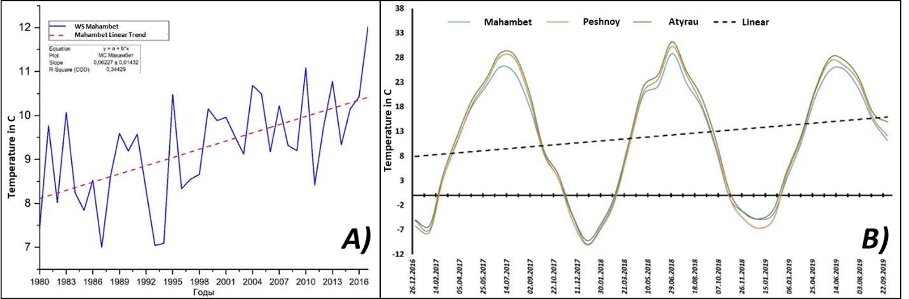

Figure 2 - Changing and linear trend of average annual (a) and average monthly temperature (b) of ground air at MS Mahambet

Thus, the variability of air temperature fluctuated in winter months from -11.9 °С to -13.5 С, and in summer months from 4.2 °С to 7.3 °С. Temperatures of the warm period of the year, especially summer, are quite stable, their inter-annual variability is minimal in comparison with other months of the year. The absolute maximum temperature was fixed at MS Mahambet in 1981 +53 С. The absolute minimum air temperature was observed in 2003 and was - 46 °C.
Analysis of changes in the thermal regime for the last four years (2016-2019) was considered on the basis of data from weather stations "Makhambet", "Peshnoy" and "Atyrau" and revealed minor differences in the average annual temperature regime in the studied region (Figure 2 b).
In the period under review, according to MC "Atyrau" average annual summer temperature ranged from 20.1 to 26.9 °C, while the hottest summer was observed in 2018 with an average monthly temperature of July 31 °C. During the winter period, the temperature ranged from - 9.6 °C to - 2.5 °C and maintained the general trend of warming. In general, the project area retains the trend of climate warming due to winter months, despite the fact that the average monthly summer temperature in 2019 was 2.5 degrees lower than in 2018.

2.2 Hydrographic features of the Zhaiyk River and the adjacent water area of Caspian Sea
Zhaiyk transboundary river, flowing through the territory of Russia and Kazakhstan. In its basin there are industrial centers of Magnitogorsk, Novotroitsk, Orsk, Orenburg, Uralsk, Atyrau and Aktobe [19].
The length of the river is 2428 km, of which within the Republic of Kazakhstan its length is 1084 km. The area of the catchment is 220 thousand km². The tortuosity coefficient is 2.38. The angle of water fall Zhaiyk is not particularly large: from the upper reaches to Orsk it has about 0.9 meters per 1 kilometer, from Orsk to Uralsk it is no more than 30 centimeters per 1 kilometer, lower even less [20].
Hydrography of the Zhaiyk River Delta. The hydrographic network of the project area is poorly developed and represented mainly by small channels such as Bugylozek, through which in spring part of the Zhaiyk River water supplies the north-western part of the Caspian lowland. The Bugylozek duct branched off from the Zhaiyk River just above the Mahambet hydrological post and is the longest (190 km), underdeveloped one. Passing through a complex terrain of bumpy sands, it gives the beginning of the Zhanbaiskiy canal in the area of Akkystau settlement. The Baksai flow originates near the village of Zhalgansai and during the spring flood in the lower reaches turns into a powerful stream that spills over many kilometers and partially discharges its water through a system of canals that dry up in summer. In the 50s of the last century, a network of irrigation canals was dug in the coastal zone of the Caspian Sea in order to develop irrigated agriculture. At present, due to periodic fluctuations in sea level, Baksay, Tumanny and Karakamys canals are partially preserved (Appendix C, Figure 1).
The hydrographic network of the Zhaiyk Delta consists of two main sleeves: Golden and Yaitsky. The continuation of the Golden Sleeve at the mouth of the estuary is the Ural-Caspian Canal, and the Yayitsky Canal, which was artificially dug in the 60s, is a fisherman's canal. Near the eastern shore of the Peninsula Peshnoy is located Zolotinsky kultuk. The average slope of the sea bottom is 5 cm per kilometer. The modern delta starts from the place of branching from the bed of small Peretasky channel and then stretches south - south-west for almost 40 km. The navigable branch of the Golden Channel runs through the Ural-Caspian Canal, which then passes to the sea part of the canal with depths up to 1.8 m for 16 km on the estuary seaside. This channel connects the mouth of the Zhaiyk River with the Ural Furrow, the deepest region of the eastern part of the Northern Caspian. The Ural Furrow is an extension of the Zhaik submarine channel and was developed by a river with a lower standing sea level. In recent years, there has been a process of extinction of a number of watercourses, especially the left-bank ones (Peretaska, Bukharka, Zastroty, Zolotenok). In this regard, in the eastern coastal zone of the estuary completely stopped the flow of water, sediment, mineral and organic substances. There is intensive siltation of the Ural-Caspian Canal and bar sections of the sleeves (Appendix C, figure 1).
Hydrological regime. In the upper reaches of the Zhaiyk River usually freezes in early November. In the middle and lower reaches the ice flow starts at the end of November. Zhaiyk opens from the ice in the upper course in early April, in the lower course - at the end of March. The ice flow on Zhaiyk is short. During the ice drift congestion is common. Feeding of the Ural River and its tributaries is mainly snowy. Snow cover accounts for more than 80% of the annual flow of the Zhaiyk River. Feeding occurs almost exclusively during the snow melting period in spring. Rainwater meals have a small share. Relatively high air temperatures and a significant humidity deficit cause significant losses of moisture for evaporation.
In the lower reaches, spring floods are observed from late March to early April, in the upper reaches - from late April to June. In the upper reaches of Zhaiyk, there may be small floods in summer and autumn, and steady low temperatures during the rest of the year. In the middle reaches of the Zhaiyk flood spills over 10 kilometers, and in the delta to several tens of kilometers. The highest water levels in the upper reaches are recorded at the end of April and in the lower reaches - at the beginning of May. One of the main features of the river is a significant unevenness in runoff. 80 percent of the runoff is in spring. Average water discharge recorded near Orenburg - 104 m3 / sec, in the village of Kushum - 400 m³ / sec.
Flow rate assessment. According to the peculiarities of water regime Zhaiyk refers to the rivers with sharply pronounced prevalence of runoff in the spring period. The river receives its main food due to snow melting, in the other seasons of the year it is fed by ground water, less precipitation. One can observe long-term, seasonal and rush (for the downstream) fluctuations of water level. The river flood is somewhat stretched as a result of multitime melt water inflow from different parts of the basin. The hydrograph's shape is asymmetric; there is a sharp rise of the flood and its slow decline. During the spring flood period, water levels are high. In the summer low water levels are low, with rare increases due to rainfall floods. The natural course of the level is disturbed in the period of ice formation, the emergence of local blockages, and in the lower reaches - as a result of racing phenomena. The highest water level is usually observed in the second half of April or May, less often - in June, the lowest - in December - March.
To analyze the dynamics of the hydrological regime of the river Zhaiyk (for the period 1977 - 2019) were used data from gauging station (GS) Kushum (50 ° 52'6.97 "N, 51° 7'58.95" E), located Zhelenovsky area of the West-Kazakhstan region and is the furthest point of observation of the hydrological regime of the middle course of the river Zhaiyk. The second gauging station Mahambet (47 ° 40'18.15 "N, 51 ° 34'47.89" E) is the most favorable point for assessing the regime, as it has the longest period and the composition of observations in the natural course of levels. The post in Atyrau, located below, does not have a long enough number of years of observation of hydrological characteristics, especially water runoff. The level regime in this area is disrupted by surges.
According to long-term data on the gauging station Kushum and Mahambet over the past 40 years, several periods of reduction and increase in water availability can be identified, which influenced the further development of the current state of biocoenosis of the Zhaiyk River delta.
Over the period 1977-2019, the average annual runoff of the Zhaiyk River during the average course was 8.91 km³/year and varied from 2.9 km3 (1977) to 17.55 km3 (1993), while in the lower reaches of the Mahambet gauging station the average annual runoff was 7.92 km3 and varied from 2.53 to 15.06 km3 in similar years (Figure 3).

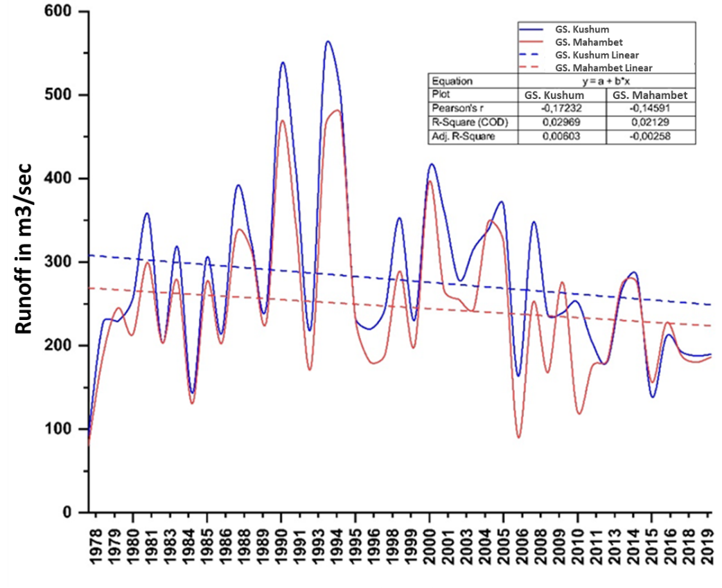

Figure 3 - Combined graph of the annual average water flow of the Zhaiyk River at the GS. Kushum and GS. Makhambet (1977-2019).

Noticeable difference in average annual flow loss is observed mainly in multiyear years, e.g., in 1990-1994 with average flow rate of 414 m³/sec of flow loss between MCs. Kushum and Mahambet was 20% of the total flow of 1.87 km³. This is explained by flooding of the floodplain, increased infiltration, and also depends on economic activity. According to O.K. Tlenbekov, in the mid-60s, annual water withdrawal from the Zhaiyk River reached 0.15 km³/year, and the total flow loss in the area of the village of Kushum and Makhambet. Mahambet - Atyrau was 0.8 km³/year [21]. At the same section of the site in the low-water years (1995 - 2016) flow loss did not exceed 0.85 km3, with an annual average water content of 229 m³/ sec in the village of Kushum and 199 m³/ sec in the Makhambet. In the considered series of hydrological regime of the Zhaiyk River, the average water years (1978 - 1989 and 1995 - 2005) with average water discharge of 255 and 285 m3/sec respectively dominate. In average water years, the maximum average water discharge reached 388 m³/sec in 1987 and 412 m³/ sec in 2000, exceeding the indexes of low-water (1995-2016) by 15% and not reaching the indexes of high-water (1990 - 1994) by 37%.
In the annual flow of the Zhaiyk River, according to long-term data for the period 1977 - 2016, it is possible to allocate three monthly spring floods (April-June, with an average monthly flow of 682 m³ / sec - Kushum; 545 m³ / sec - Mahambet and 420 m3 / sec - Atyrau), four monthly summer-autumn low-water (July - October, with an average monthly flow of 151 m³ / sec - Kushum; 142 m³/sec - Mahambet and 143 m³/sec - Atyrau) and winter lowland (with an average monthly flow of 111 m3/sec - Kushum; 88 m³/sec - Mahambet and 118 m³/sec - Atyrau) (Figure 4).

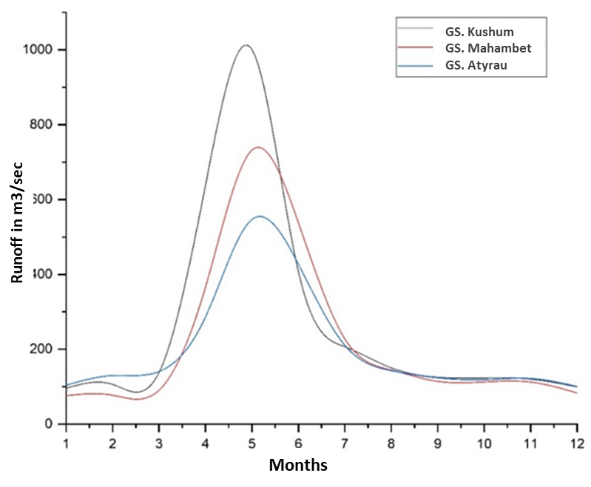

Figure 4 - Combined schedule of average monthly water discharge in three reviewed gauging stations (Kushum, Makhambet, Atyrau)

According to the observation, the rise of the flood usually starts in late March and early April and lasts 3 months. In the village of Kushum the rise of the level is observed 10 days later than at the GS Topoli. The duration of the flood rise is on average 40 days, sometimes up to 50 days. In a long, cold spring, the duration of the rise increases. The peak of flood falls on the middle of May, in low-water years - on the end of April, in high-water years passage of peak can be observed in the end of May.
Usually in the runoff of the flood for the Mahambet post during the period of observation is on average 80% of the annual runoff. For example, in 1994, the average daily maximum water discharge during the flood in the village of Kushum varied from 200 to 5540 m³ / sec., while at the level of Mahambet ranged from 197 to 1080 m3 / sec. Thus, downstream the maximum discharge decreases, which indicates a significant transformation of the water content of the flood, which on average were equal to 1233 m3/sec.
In general, over 40 years of observation, in the hydrological regime of the Zhaiyk River there is a weak negative trend due to a sharp decrease in water availability mainly over the last ten years (2006 - 2019), which negatively affected the general state of the delta biocoenosis and the coastal ecosystems.

2.3 Influence of rush phenomena to coastal ecosystems of the Zhaiyk River Delta and on adjacent coastal of Caspian Sea
On the Caspian Sea, non-periodic level fluctuations include, first, runaway phenomena. Peculiarities of the appearance and development of sea level fluctuations (storm surges and drifts) in the Caspian Sea have been studied by many authors [22-26].
The main characteristics of storm surges are the dates of the beginning and end of the phenomenon, the height of the water level rise and its provision, the intensity of the level rise, the duration of the high-level sea, the distance overland and the rate of penetration of seawater, the total area of flooding. In case of storm surge, this difference is positive, in case of drifting - negative.
Storm surge, which coincides with a low level of sea, can create risks for navigation (especially for large ships in coastal waters) and problems with water cooling at power plants. During drifting, water intakes are disrupted, port water areas and navigable sea canals are shallowned, the area of spawning grounds and feeding of valuable commercial fish, primarily sturgeons, the landscape structure of coastal areas is changed, and large areas of coastal areas are exposed [27].
Both tides can be caused by the same storm at different stages of its development. Storm surge is generated partly as a result of changes in atmospheric pressure, but mainly as a result of direct exposure to wind. In this case, the effects of pressure and wind are equally important [28,29].
Due to the shallow waters of the Northern Caspian Sea, periodic sea level fluctuations of anemobaric origin, as well as changes in the water content of the Zhaiyk River have a significant impact on the biocoenosis of both the river delta itself and the adjacent sea coast. Periodic inundation of a wide strip of the northern Caspian coast and the lower part of the Zhaiyk delta as a result of racing phenomena, when in a few hours the sea level may change by 1.5-2.5 m, as well as unstable sea level dynamics over the past 40 years, have caused a serious transformation of the land cover on the respective territory, particularly in hydromorphic and aquatic ecosystems. Statistics of rush events in the Northeast Caspian Sea (according to MS "Peshnaya") show that 3 - 5 rush events and 5 - 6 water rush events of different intensity occur on average per month. The highest frequency and height of surge events in the northeastern part of the sea are usually observed in spring and autumn. Sea level rise up to 1 m occurs at wind speed 10 - 15 m/sec and duration of 10 - 2 hours to 1 - 2 days, and in strong winds, with a speed of 15 - 25 m/sec surge height can reach 1.0 - 1.5 m and more, which is accompanied by flooding of a large area of the coast (Figure 5).

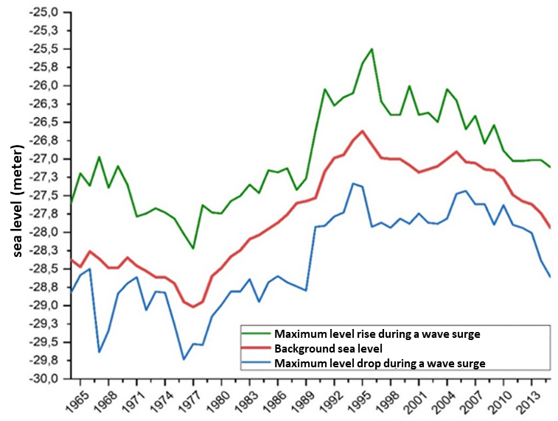

Figure 5 – Amplitude of the Caspian Sea level fluctuations during rush events

On the contrary, with strong winds along the northern and eastern shores of the Northern Caspian Sea a 5-10 km wide drying zone is formed. Surges in shallow sea areas with low coastlines are particularly dangerous, where they periodically flood a large area, resulting in soil salinization and destruction of indigenous plant communities. Significant areas adjacent to the mouth of the Zhaiyk River also dry up, causing soil salinization and subsequent transformation of meadow ecosystems into saline and sorghum. Therefore, regular monitoring of rush events in the North Caspian and their timely prediction is important for developing measures to preserve coastal ecosystems.
The problem of storm surge forecasting is to some extent relevant for almost all shallow coasts of the Caspian Sea. Storm surges are among the natural hazards, in particular for such shipping lanes as the Zhaiyk River and coastal areas where oil production rigs are concentrated.
Until recently, mainly empirical and physic-statistical methods of sea level prediction have been used in operational practice, the main limitations of which are the impossibility of making forecasts for individual points in the absence of long series of observations over wind and sea level at these points [30-33].
At present, the use of remote methods for prediction of rush events, as having a number of advantages in comparison with classical methods, is becoming increasingly important.
For detection and evaluation of rush events on the project territory we used modern remote sensing methods and Sentinel 2 satellite images with spatial resolution of 10 meters. Data on wind direction and speed, as well as on Caspian Sea levels, were taken from the official website of the National Oceanic and Atmospheric Administration (NOAA) of the USA.
The size of surges and drifts in the North Caspian is influenced by such factors as: wind speed and direction, duration of its action, as well as the depth of the sea, slopes and relief of the bottom, configuration of the coastline, the size of the flow in the estuary of the rivers flowing into the sea [34]. These are due to very strong and steady winds of effective directions, which in the northern Caspian are southeast, east (for the western part of the sea) and northwest, west (for the eastern part of the sea). The duration of wind surges varies from several hours to several days (Figure 6).

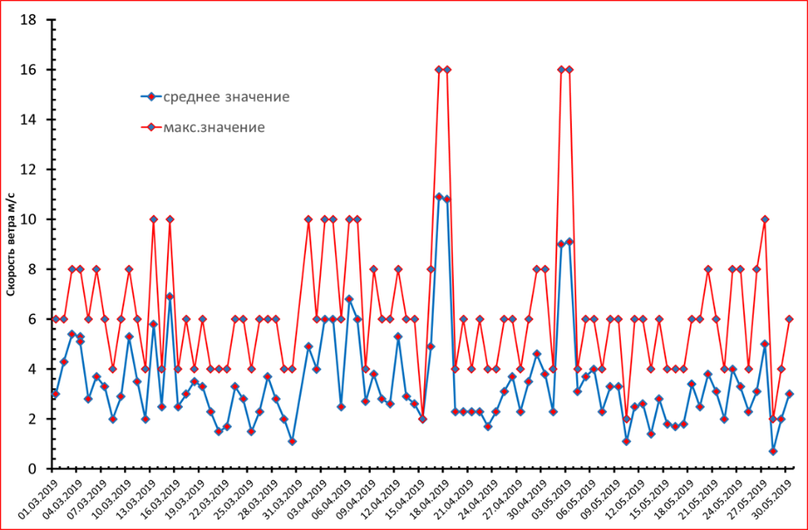

Figure 6 – Wind speed in the observed period according to Peshnoy weather station.

Dozens of large rush events were detected on the space images, performed in the period of 2018-2019 on the project territory, with most of them occurring in spring and autumn, when the temperature regime changes and circulation activity of the lower atmosphere layer increases. According to our analysis of the space photo array, one of the pronounced rush events occurred in mid-April 2019, when a strong storm surge resulted in the drying up of a vast territory of coastal areas (Figure 7).

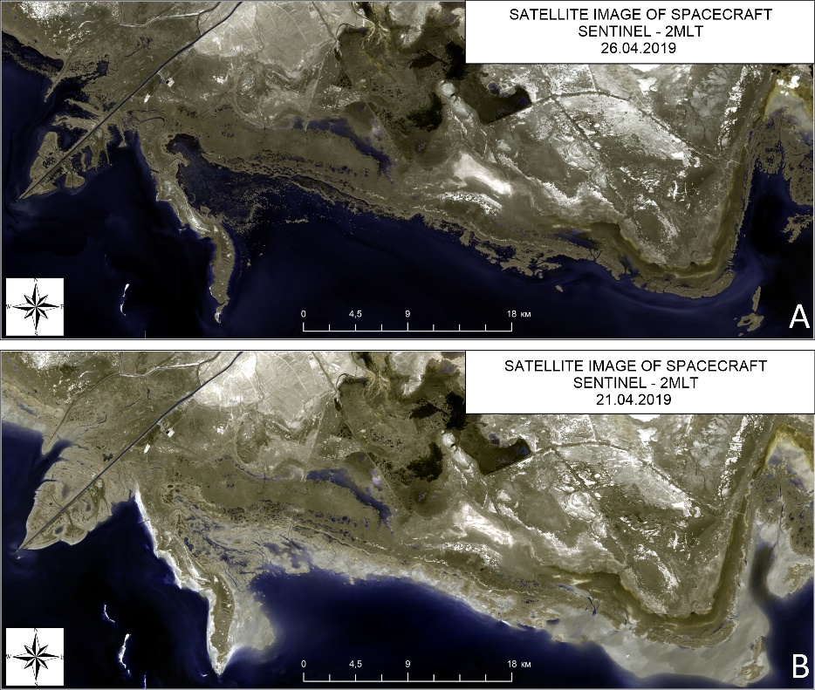

Рисунок 7 – Comparative satellite images of the coastal area of the Northern Caspian Sea rush phenomena from 21.04.2019 to 26.04.2019.
In Figure 7 you can clearly see the scale of combustion phenomena, when the drying zone occupies the entire coastal territory, and its width in some places reaches 4 km with a total area of 275.24 km2. Due to a sharp decline in the level of the Caspian Sea and shallowing of the coastal zone of the sea, the events are manifested even more strongly at low wind speeds, causing extensive transformations in coastal ecosystems.
Subsequent analysis of pre- and post-discharge satellite images gave us an opportunity to estimate the total scale of dispersion events in case the coastal area was previously covered with water for five days (Figure 8).

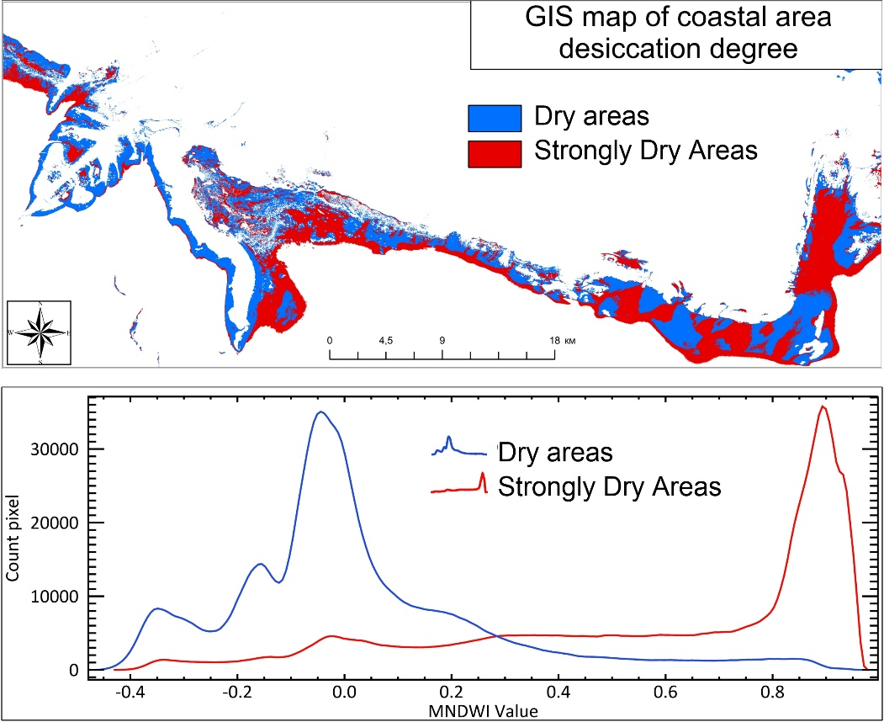

Figure 8 – Thematic map of the drying zone of the coastal area as a result of
rush phenomena

Based on the results we have obtained, we can judge about the distribution of rush phenomena along the coastline, where transects were laid in the most vulnerable areas. One of the most extensively drained areas is located along the Bolshoi Hiking Island and at the mouth of the Ural-Caspian Canal, which are part of the Akzhaiyk Reserve. Seasonal drains in these areas cover vast areas of hydromorphic ecosystems, which leads to gradual transformation of soil and vegetation cover. In addition, there are constant fluctuations in the salt balance of the soil cover, which has a negative impact on hydrobionts as a feed base for fish and birds.
2.4 Current state of the vegetation cover of the investigated area
In the summer period of 2018-2020, a geobotanical survey of vegetation in the central part of the Ural Delta and the adjacent to the delta coastal plain was conducted.
The vegetation was studied by the route method according to the instruction for large-scale surveys of forage lands developed in the land management system of the Republic of Kazakhstan. Routes were laid out by car in such a way that the most typical landscapes of the area were visited. Geobotanical descriptions of vegetation were made at randomly selected sites (points). All points have GPS fixation and are mapped (figure 9).

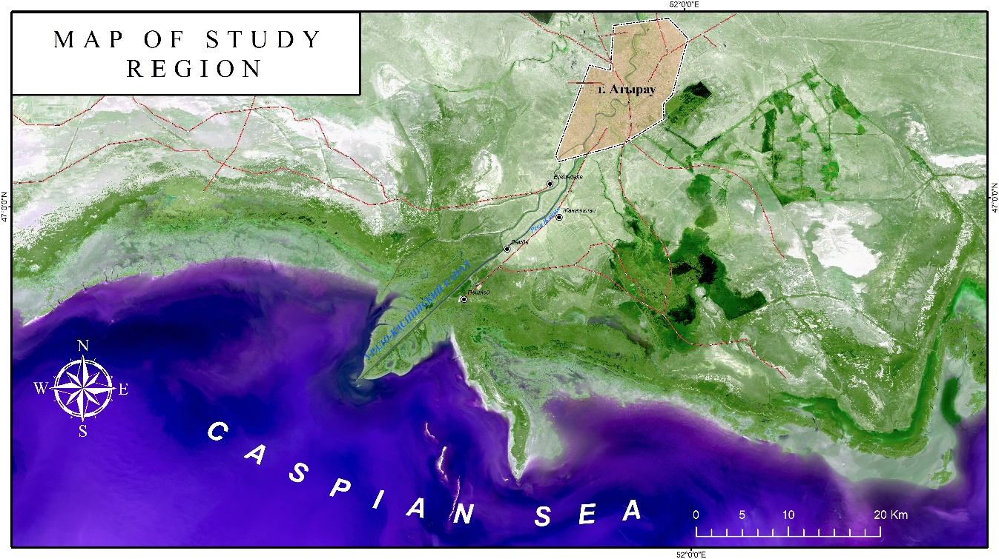

Figure 9 – Map of study region

In the course of vegetation study the main plant communities composing the vegetation cover of the territory were identified, their species composition, vertical and horizontal structure, projective soil cover by plants, their height, phenological condition and development were determined. Special attention was paid to assessment of current state of vegetation and the degree of anthropogenic impact on its composition and structure. All data on vegetation were recorded in the field diary and forms of geobotanical descriptions.
The vegetation cover on the investigated territory is formed under the influence of unfavorable conditions of desert climate, the main factors of which are aridity, high summer and low winter air temperatures, salinity of soils and soils, low natural fertility of soils. To a large extent, the formation of vegetation is determined by geomorphological and geological features of the territory, periodic transgressions and regressions of the Caspian Sea, the constant influence of racing phenomena.
In the course of vegetation study the main plant communities composing the vegetation cover of the territory were identified, their species composition, vertical and horizontal structure, projective soil cover by plants, their height, phenological condition and development were determined. Special attention was paid to assessment of current state of vegetation and the degree of anthropogenic impact on its composition and structure. All data on vegetation were recorded in the field diary and forms of geobotanical descriptions.
The vegetation cover on the investigated territory is formed under the influence of unfavorable conditions of desert climate, the main factors of which are aridity, high summer and low winter air temperatures, salinity of soils and soils, low natural fertility of soils. To a large extent, the formation of vegetation is determined by geomorphological and geological features of the territory, periodic transgressions and regressions of the Caspian Sea, the constant influence of racing phenomena.
In the lower part of the river Zhaiyk (Ural) is alluvial delta plain. It is formed by river load and marine sediments as a result of complex processes of Caspian Sea retreat and retreat and gradual transition of the river regime to the sea. In the floodplain part of the Zhaiyk valley (Ural) there are floodplain terraces transitioning to the delta or sea plains. The flat surface of the alluvial-delta plain is complicated by delta tributaries, old-timers, beams, liman and pine depressions.
On the seaside plain there is a certain pattern in vegetation distribution: plant communities change in strips from the sea coast to the periphery according to changes in habitat conditions. Reed beds with sea clubroot, cattail, sedge and water plantain extend into shallow waters along the coast. Spike rush adjoins the very cut of water in a narrow strip, and at higher levels on the march solonchaks it is replaced by beds of saltwort and seepweed with reed beds and sea clubroot. Saltwort is replaced by communities of annual saltwort and sarsazan as it moves from the sea and the soil become saline. Perennial semi-shrubby saltworts: Kalidium cuspidatum and Kalidium foliatum, Halostachys belangeriana and Halocnemum strobilaceum are widely distributed behind the seashell berm and are added to the annual saltworts.
Next, Strandling and Puccinellia meadows spread and are replaced by ephemeral-wormwood and saltwort-shrub communities (Climacoptera, Atriplex and Suaeda) as they move away from the sea.
Vegetation of the alluvial-delta plain is formed in the conditions of flooding and inundation from the sea. In this regard, meadow and wetland vegetation is of dominant importance in this area, and soil salinization is caused by overflowing of seawaters and underlying saline marine sediments.
Reed beds and reed marshes fringed with dense sea clubroot and cattail beds dominate the coastal part of the delta. Beds of submerged plants like water spike and parrot's-feather are formed in the water, and water chestnut, salvinia, and duckweed grow on the surface.

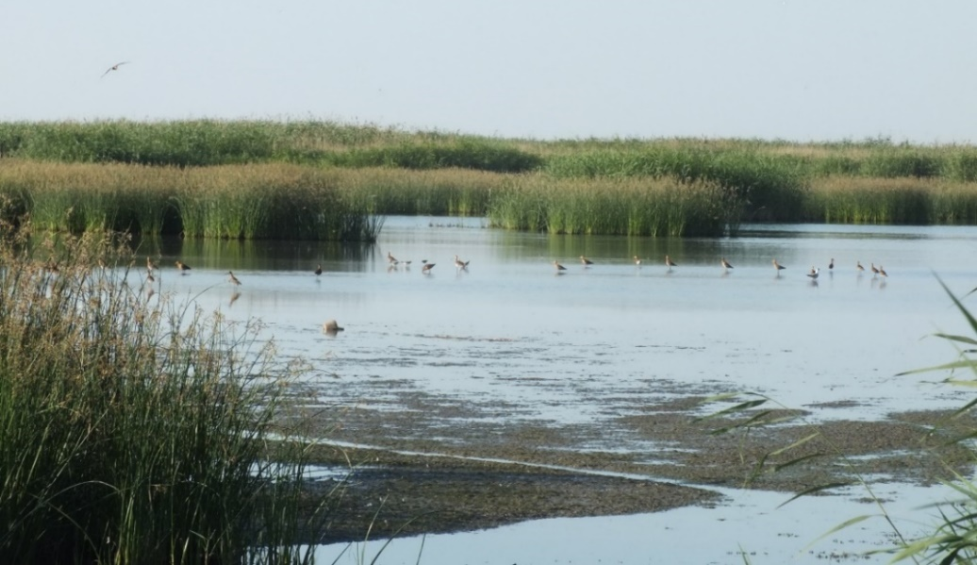

Figure 10 - Reed beds with horn in the Zhaiyk river delta

Reed and cattail beds are replaced by sea clubroot, rush and Aeluropus communities at a distance from inland water bodies (Figure 10).
Solonchaks with sarsazan, saltwort, Salpeterstrauch, Aeluropus and Tamarisk beds dominate on higher steps. Spots of meadow vegetation (Common reed, small reed, Aeluropus) are found along the banks of ducts, and they are interspersed with halophytic groups of annual saltworts and sarsazan ( Figure 11).

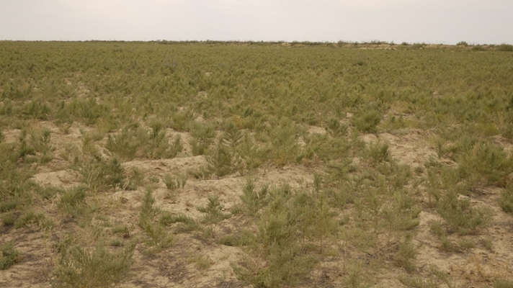

Figure 11 - Sarsazan communities in combination with annual saltworts

The development of saltworts and ephemers is unstable by years and their mass growth is observed in the years favorable for precipitation. Good development of Halimocnemis, Suaeda heterophylla (Kar. & Kir.) Bunge and Suaeda acuminata (С. A. Mey.) Moq., Atriplex aucheri ass., Kochia sieversiana and Petrosimonia was noted during our study, while the growth of ephemers was insignificant. Sarsazan communities are confined to the lowest areas of the coastal plain or surround solonchak depressions in upland areas.
The central floodplain of the Ural River is occupied by wheatgrass, reed, licorice and small reed meadows, which are complemented by weed groups with the participation of Peganum harmala L., Xánthium strumárium and Karelinia. Vegetation is distinguished by a noticeable diversity and richness in the territory of the alluvial-delta plain due to the peculiarities of the relief, the variety of soils and hydrological conditions. Wheatgrass, reed and small reed meadows with significant participation of Glycyrrhiza, Karelinia and Sophóra alopecuroídes are developed in the central part of the floodplain. Salix and Eleagnus trees and Tamarisk and Halimodendron shrubs and Nitraria are widespread along the banks of the canals and near the river bed.
A special feature of the vegetation cover of the project area is the predominant importance of annuals in the composition of plant communities in large areas. The surface of the desert is covered with a rather dense layer of ephemerals throughout the early spring period, among which the main role belongs to the Eremopyrum triticeum. It is mixed in various abundance with ephemeral herbs: Descurainia, Lepidium, Alyssum, Malcolmia, and some Poacea ephemeras: Poa bulbosa and Bromus tectorum. Ephemeras dry up and gradually collapse in summer and they are replaced by Salsolas. Annual Salsolas: Salicornia, Suaeda, Climacoptera, Atriplex have widespread community along with the ephemeras the coastal plain. They are confined to the zone of seawater run-up activity and represent a temporary, unstable vegetation that is in one or another stage of vegetation cover formation.
The following Tamarix-Poacea- motley herbs, Tamarix-Salsolas, annual Salsolas and annual Salsola- Phragmites, Halostachys belangeriana - ephemeras, Halocnemum strobilaceum and Halocnemum strobilaceum - Kalidium caspium communities were identified and described during the geobotanical survey in the area. They are characterized by a rather variegated floral composition including both dominant and secondary plant components from numerous ephemeras, annual and perennial Salsolas, motley herbs and shrubs. From 12-15 to 20 or more species were recorded at various points (Figure 12).

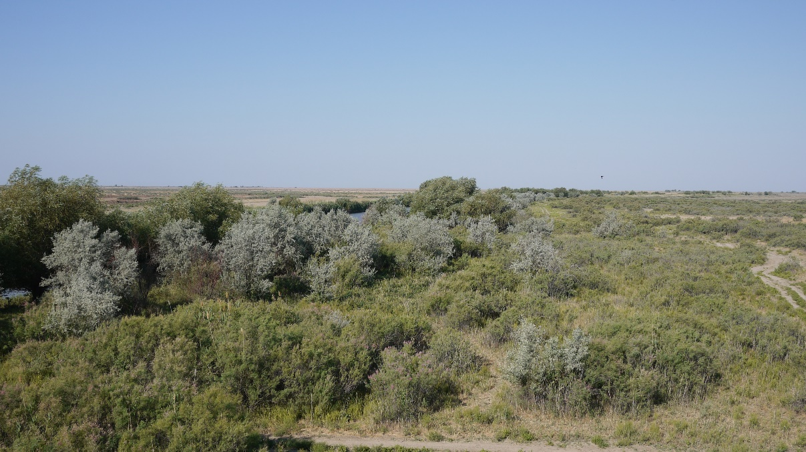

Figure 12 - Reed beds with cattail in the delta of the Zhaiyk river

The vegetation on the terraces above the floodplain is largely desertified and is represented by halophytic saltwort groups and annual saltwort with the participation of Kalidium shrubs and Halostachys belangeriana.
The vegetation cover of the coastline with periodically flooded sea waters and recently emerged from the flooding is represented by sparse beds of annual saltworts: Salicornia, Climacoptera brachiata (Pall.) Botsch., Climacoptera lanata (Pall.) Botsch. and Suaeda salsa (L.) Pall. They alternate in stripes at the lowest levels of the coastal plain with absolute elevations from -26 m to -27 m and represent the initial stages of the formation of plant communities.
In addition to natural factors of relief formation, anthropogenic, especially technogenic, impacts are of great importance in the project area. It includes the construction of dams, the laying of irrigation canals, roads, power transmission lines, various oil and gas production facilities and other activities. Unfavorable natural and anthropogenic factors caused the formation of vegetation cover in the composition of the dominant role of desert plant communities with a predominance of xerophytic and halophytic plants.
The vegetation cover on a geologically young coastal plain, and relatively recently emerged from the influence of the sea, is of a primary and unstable nature. It is in the stage of formation, which is expressed in dynamism, frequent changes in plant groups, significant participation and frequent predominance of annual components in their composition.
On the coast, which has recently emerged from the flooding, but is periodically flooded with sea waters, the vegetation cover is represented by sparse beds of annual saltwort: Salicornia, Climacoptera brachiata (Pall.) Botsch., Suaeda salsa (L.) Pall. and Halimocnemis.
They form at the lowest levels of the coastal plain and represent the initial stages of the formation of plant communities (Figure 13).

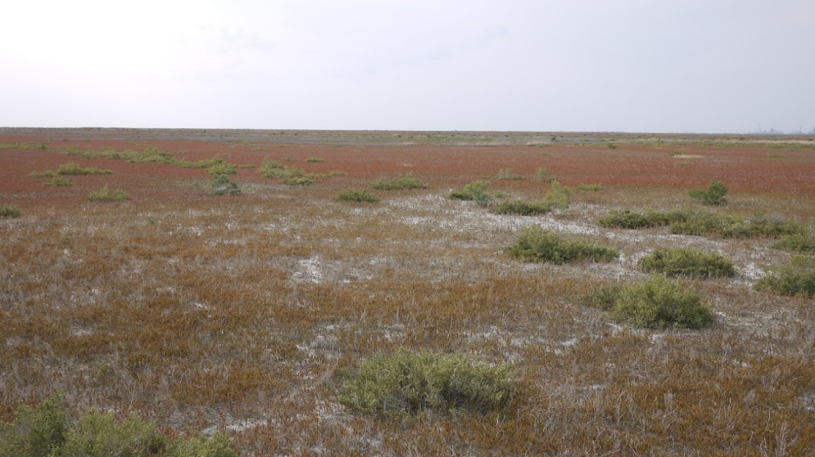

Figure 13 – Coastal plain, annual saltwort community

Reed beds and marshes, which are bordered by dense beds of sea clubroot and cattail, dominate the coastal part of the delta. Beds of submerged plants like water spike and parrot's-feather, hornwort and tape-grass are formed in the water. Reed and cattail beds are replaced by sea clubroot, Poacea and Acacia meadows at a distance from the inside of deltaic reservoirs.
The central floodplain of the Zhaiyka River (Ural) is occupied by reed, small reed and bluegrass meadows, which are supplemented by weed groups with the participation of Karelinia, Xanthium strumarium Z, Peganum harmala L., and Limonium. The terraces above the floodplain have a deserted appearance. Halophytic saltwort groupings with the participation of wormwood and shrubs: Tamarisk, Nitraria and Halostachys belangeriana are widespread there. Salix and Eleagnus trees, Tamarisk and Halimodendron shrubs and Nitraria are developed along the banks of the channels and near the river bed (Figure 14).

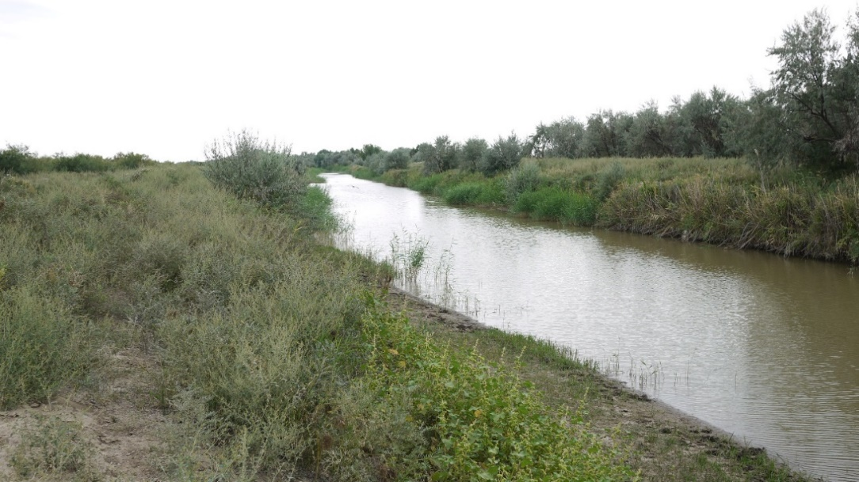
Figure 14 - Trees and shrubs along the Peretaska canal

Shrubs with a domination of Tamarix ramosissima form the upper tier with a height of from 80-100 to 120-180 cm. In the lower tier there are Numerous Salsolas: Suaeda heterophylla and Suaeda altissima, Halimocnemis sclerosperma, Kochia scoparia, Kalidium capsicum and Kalídium foliátum, Átriplex tatárica are in the lower tier. Aeluropus and Phragmites and some types of motley herbs like Limonium gmelinii, Karelinia capsica, Zygophyllum, Alhagi, Persicaria lapathifolia and Inula caspica join them. The total projective coverage is 40-50% and floral composition includes 15-20 species (Figure 15).

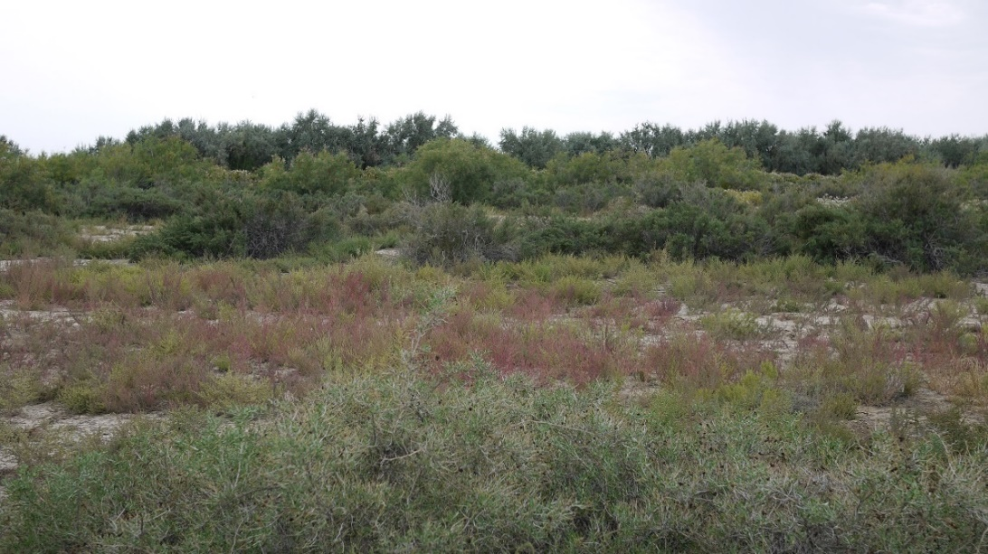

Exhibit 15 - Shrub-hushy combined with weed-hushy
There is a dying off of reeds in the coastal areas flooded by surge waters. In addition, reed beds are often damaged by fires.
Reed beds and swampy reed meadows on the coast are most exposed to periodic flooding by high seawater pressure. The partial or complete dying off of reed beds occurred as a result of prolonged flooding. At the same time, the territory on large areas takes the form of a wasteland with single specimens or small clumps of Climacoptera, Suaeda, Bolboschoenus and Phragmites, Salicornia, some other hydrophytes (Figure 16).
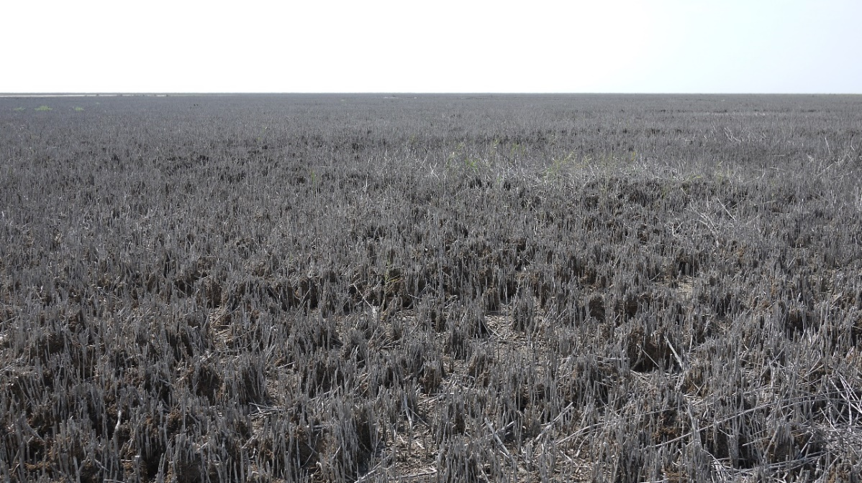

Figure 16- Extensive area of dead reed beds after long flooding

The predominance of annuals in the composition of plant communities over vast areas is a feature of the vegetation cover of the project area. Communities of annual Salsolas: Salicornia, Climacoptera, Atriplex, Suaeda and Halimocnemiss are most widespread. They are confined to the zone of seawater run-up activity or anthropogenic disturbances and represent a temporary, unstable vegetation that is in one or another stage of vegetation cover formation or its degradation. Annual vegetation is unstable over the years and its development is closely dependent on precipitation, temperature and other conditions of the growing season. Therefore, the species composition, abundance, and regrowth of annuals can vary highly from year to year.
Conclusions. The vegetation cover of the investigated territory is formed under the influence of unfavorable conditions of desert climate, geological peculiarities of the region and intensive human economic activity for a long time.
The main natural factors determining the distribution and composition of plant communities are aridity of climate, high summer and low winter air temperatures, salinity of soils and soils, low natural fertility of soils, as well as geomorphological and geological features of the territory, periodic transgressions and regressions of the Caspian Sea, the constant influence of racing phenomena.
These factors led to the development of desert plant communities, which are dominated by xerophytic and halophytic plants with wide participation of annual components: ephemers and haylings. The vegetation is variable and subject to frequent changes depending on changing external conditions of both natural and anthropogenic.
Anthropogenic impact is determined by a complex of various factors of human economic activity for a long time.
One of the main factors affecting the development of plant communities is cattle grazing. Desert pastures under the influence of long-term economic use change significantly. Unsystematic cattle grazing leads to overloading of pastures, knocking out of vegetation and anthropogenic changes, in which the dominant native species of plants fall out of the grass, replaced by secondary groups of low-value or weed plants.
Other factors of anthropogenic disturbances are construction of roads, protective dams to limit the impact of racing phenomena, laying irrigation channels, oil and gas pipelines, conducting exploration and drilling works, construction and operation of oil and gas production facilities, pollution of soil and ground water by oil production wastes. As a result of anthropogenic impacts, the vegetation cover near the oil production facilities, on road fields and other man-made objects has been significantly transformed and degraded, and in some areas completely destroyed.
Adverse natural and anthropogenic factors resulted in the formation of a peculiar vegetation cover of the studied area characterized by the prevailing importance of annuals and widespread secondary communities with depleted floristic composition. Based on the field survey and remote sensing data a map of vegetation in the studied area was created (Appendix D, Figure D.1, Figure D.2).
In general, the vegetation cover of the area is of pasture value. Fodder plants: ephemerals, annual and perennial salts, grains growing in different seasons create forage base for most of the pasture period. The disadvantage of desert pastures is the instability of yield over the years, poor provision of fodder in dry years, as well as limited opportunities for the preparation of hay.

2.5 Development of systems for regular monitoring of the ecosystem transformation in the central part of the Zhaiyk River Delta and adjacent coast and water area of the Caspian Sea for the period 1977-2020
When developing the program for long-term monitoring and identification of biocoenosis transformation trends in the coastal zone and the Zhaiyk River Delta, we widely used remote sensing methods and all available Landsat LMM/LT/ETM+/OLI and Sentinel 2 space images database in the period from 1977 to 2020. We analyzed shoreline changes, dynamics of coastal flooding and drainage, and area ratios of hydromorphic and aquatic ecosystems in the central part of the Zhaiyk River delta. In addition, long-term monitoring of the transformation of the adjacent coast of the Caspian Sea covering the northwestern and northeastern parts of the Zhaiyk River floodplain was carried out.
Information on the Aquatic and Hydromorphic Ecosystems of the Zhaiyk River Delta and Coastal Areas of the Northwest Caspian Sea in 1977-2018. 1977. Analysis of satellite images from 1975 to 1977 confirmed the largest decrease in sea level and water content of the Ural River during this period. Prolonged 64 cm sea level drop over fourteen years (1964-1977) and decrease of the Zhaiyk River water content to 123 m3/s caused negative transformation of coastal biocoenoses and desertification of hydromorphic ecosystems in the delta. Decrease in sea level to -29.02 m caused drainage and subsequent degradation of kultuk reed thickets and other water macrophytes, previously widely represented at depths up to 1 m. In the coastal zone kultuk reed thickets have the form of narrow strips, with a total area of about 141 km2. Noticeable desiccation of hydromorphic ecosystems in the delta is recorded even in the Ural-Caspian Canal area. The Uzenky, Right and partially Shamanozek ducts have completely disappeared. In the middle floodplain of the Shaman channel and interfluve plains of the Golden and Wide are observed the final stage of desiccation and salinization of meadow soils. The total area of river and marine aquatic ecosystems was 1614 km2, approximately 34% of the total study region (Appendix E, Figure E.1).
1984. In comparison with the previous decade, in 7 years (from 1977 to 1984) the sea level has risen by almost one meter (98 cm). This caused a number of positive changes in the delta, as well as in the coastal zone as a whole. The processes of recovery of Island reeds and coastal aquatic macrophytes with the total area of 298 km² have started. Rapid development of macrophytes was also observed in the delta, especially near the Ural-Caspian Canal. The increase of average annual water content of the Zhaiyk River up to 222.1 m3/sec (according to GS Mahambet) caused the increase of soil moisturization degree in floodplains of Shamanozek and Golden streams. In addition, the right part of the Zhaiyk River delta, which dried up in 1970, was fully restored; its flooding was provided by the Peretosk, Bukharka and Zaroshilya channels. In the floodplains of the Uzenky duct connecting Shiroky with Shamanosek, no noticeable changes were observed. With the total area of aquatic ecosystems of 2015 km², the coastline was shifted on average by 8 km to the north, mainly in the eastern regions of the coast, closer to the delta of the Zhaiyk River. The total area of submerged areas was 348 km2 in the western part and 62 km² in the eastern part. (Appendix E, Figure E.1).
1990. As sea level continued to rise and the water content of the Zhaiyk River increased, the area of flooded areas and hydromorphic ecosystems increased. With the sea level rise by 76 cm and the increase in water content of the Zhaiyk River by 466 m³/sec, multiyear years begin. Numerous shallow kultuk lakes with abundant reed thickets were formed throughout the delta and coastal zones. Compared to 1984, the coastline of the western coastal zone has shifted on land for another 7 km, increasing the area of watering to 559 km². As a result of flooding, the upper edge of the delta shifted on average 4 km upstream and increased in size by 241 km². Particularly noteworthy is the flooding of the Atamansky and Kamensky Kultuk tract, which are part of the Akzhaiyk Reserve, with their average height of -26 -27 meters. The total area of the submerged territory in this area was 98 km². Submerged reed thickets in coastal waters at depths of 0.5-1.5 meters finally separated from the modern coastline. The total area of hydromorphic biocoenosis, represented mainly by reed thickets, was 574 km2 (Appendix E, Figure E.2).
2014 year. Over the past 20 years, after the anomalous high water levels in the coastal water area and the delta of the river Zhaiyk, there has been a negative transformation of ecosystems associated with a sharp decline in water availability of the river Zhaiyk and the fall of the Caspian Sea. The sea level fell by one meter from -26.75 m to -27.74 m. The average annual flow of Zhaiyk decreased by 1.9 km³. This caused the coastline to retreat towards the sea for almost 10 km, while the drying zone amounted to almost 600 km2. On the dried area for years there was salinization of soil, the area in 2014 was 280 km².
In the upper delta, signs of desertification and salinization are repeated, especially in the western part of the Shaman channel. Fully dried up, flooded in the high water years of lowlands Ataman and Kamensky Kultuk. The process of salinization begins in the upper parts once flooded by the Black River channel. There is a clear upper limit of the delta due to the sea rush fluctuations. As a result of silting and overgrowth with reeds of channels of small channels Uzenky, Zolotaya, Shamanozek, their capacity has decreased (Appendix E, Figure E.3).
2018. Special attention was paid to the current state of the project territory in the face of growing environmental risks and threats. The most urgent is the continuing decline in the water content of the Zhaiyk River and the drop in sea level. Analysis of space images showed that at present the picture and location of the coastline are identical to those of 1984, which may indicate approximately the same sea level. Decrease of the total area of aquatic ecosystems by 15% as compared to 2014 led to the shoreline retreat by 9 km on average and drainage of about 385 km² of coastal zones and 68 km² in the estuary and periphery of the delta. The total area of hydromorphic ecosystems has also decreased to 460 km². Submerged reed thickets, which are not directly connected to the coastline in 2014, were detected mainly along the coastline in 2018, as well as in 1984. Due to the low water content in the delta of the Zhaiyk River, only large channels have been preserved: the left and right Yayitsky, the Shiroky and Shamansky channels. And smaller channels such as the Uzenkiy, Shaman-Ozek and Zolotaya remain active only in spring months during the flood. Signs of desiccation and salinization are well visible throughout the upper delta and their distribution along the Golden sleeve and in the central part of the Peshnoy Peninsula. In the right part of the delta are also processes of salinization of previously flooded irrigated land, in some places still preserved hydromorphic vegetation due to seasonal activity of the Peretaska and Bukharka channels (Appendix E, Figure E.3).
Transformation on the Aquatic and Hydromorphic Ecosystems of the Zhaiyk River Delta and Coastal Areas of the North-East Caspian Sea in 1977-2020. 1977. Analysis of satellite images from 1975 to 1977 showed the largest negative changes in the coastal territory, as a consequence of a prolonged decline in sea level and water content of the Ural River just in this period. Prolonged sea level drop by 64 cm during fourteen years (1964-1977) and decrease of the Zhaiyk River water content to 123 m³/s (3.87 km³/sec) caused negative transformation of coastal biocoenoses and desertification of hydromorphic ecosystems in the delta. Characteristic complex morphology of the coastline of the project area by 1977 has found a smoothed, finally formed species. Ubiquitous desiccation of meadow-marsh ecosystems adjacent to the coastlines with subsequent transition to the salinization stage is observed. Decrease in sea level to -29.02 m accelerated drying and subsequent degradation of kultuk reed thickets and other aquatic macrophytes, previously widely represented at depths up to 1 m. In the coastal zone reed thickets have the form of an intermittent island strip, with a total area of about 97.8 km². Noticeable desiccation of hydromorphic ecosystems in the delta is recorded at the mouth of the Ural-Caspian Canal, where the main channel is silted and shallowned. The Zolotoenka duct has dried out completely, and the Zastroty, Peretraska and Bukharka ducts have seen a decrease in water content, which, in turn, has caused meadow biocoenosis to dry out and salinization in the lower reaches, the area of which has decreased to 165.8 km². Despite water pumping from the main channel of the Zhaiyk River, in the irrigated massifs with the area of 61.8 km², there are also signs of desertification and lowland salinization. The total area of river and marine aquatic ecosystems was 894.8 km², which is approximately 32.6% of the total study region (Appendix E, Figure E.4).
1987. Compared to the previous decade, in 10 years (from 1977 to 1987) the sea level has risen to -27.13 m. Rising sea level just over a meter (1.06 m) caused a number of positive changes in the delta, as well as in the coastal zone as a whole. Rapid development began in shallow waters of kultuk reed thickets and coastal macrophytes, the total area of which was 414.76 km2. Rapid development of macrophytes was also observed in the delta, near the Ural-Caspian Canal. The increase in average annual water content of the Zhaiyk River up to 388.9 m3/sec (according to GS Mahambet) caused an increase in the degree of soil moisturization in the floodplains of Peretraska and Zastroy streams. In addition, meadow ecosystems adjacent to the irrigation canals that dried up in 1977 were waterlogged and restored. They were fed by the Kotlovan, Gogolsky and Upper Mokrinsky canals. With the total area of aquatic ecosystems 1295.42 km², the coastline was shifted on average by 4 km to the north, mainly in the eastern parts of the coastline, closer to the Zhaiyk River delta. The total area of submerged areas was 409 km2. (Appendix E, Figure E.4).
1994. With an average annual runoff rate of Zhaiyk at 477 m³/ sec, 1994 was the most high-water year in the last 40 years. Sea level also increased by 42 cm and reached the highest point -26.75 m. Such an abnormal increase in water content (with an average flow rate of 470 m3/sec) was observed in 1946 - 1950. This increase in the water content of Zhaiyk and the sea level pushed the coastline for another 5 km on average, capturing heights up to - 26 m. With a total area of 3357 km2, aquatic ecosystems accounted for 68% of the study region. The inundation area of the coastal regions reached its peak in 1994 and increased by another 477 km² as compared to 1990. A similar picture can be traced in the delta, which is especially noticeable in the Ural-Caspian Canal, which was fringed by reed thickets and sediments in 1990. The upper reaches of the delta, up to the dam of the last century built in the 40s, were significantly flooded. Flooding of the lowlands of the Atamansky and Kamensky Kultuk Gorges continued, which increased in area from 98 km2 to 128 km2. In addition to coastal ecosystems, abandoned old-growth land irrigated by the Baksai channel was also flooded. As for semi-submerged reed thickets, on the contrary, their area has decreased by 200 km2 as compared to 1990, amounting to 378 km2 this year. This is explained by inundation due to sea level rise by 2.27 meters over the last 17 years. The flooding of vast areas of arid ecosystems led to the transformation of automorphic ecosystems into semi-hydromorphic and hydromorphic (Appendix E, Figure E.5).
2002 year. Over the past 8 years, after the anomalous high water levels in the coastal water area and the Zhaiyk River Delta, there has been a significant reduction in the area of flooded areas. There are extensive land masses covered with saline lands formed after prolonged sea water flooding. Sea level dropped from -26.75 m to -27.14 m. The average annual consumption of Zhaiyk decreased to 223.2 m3/sec. This caused a shift of the coastline towards the sea by almost 3 km, while the drying zone was almost 366.1 km2. Soil salinization has been taking place on the dried territory for years, the area of which in 2002 was 179.4 km2. Despite the reduction of submerged areas, the area occupied by reed thickets increased by 187.84 km2 per year compared to 1994 (Appendix E, Figure E.5).
2014 year. For the past 20 years after the anomalous high water level of 1994 in the coastal water area and the delta of the river Zhaiyk, there has been a negative transformation of ecosystems associated with a sharp decline in water availability of the river Zhaiyk and the fall of the Caspian Sea. The sea level fell by one meter from -26.75 m to -27.74 m. The average annual flow of Zhaiyk decreased by 1.9 km3. This caused the coastline to retreat towards the sea for almost 10 km, while the drying zone amounted to almost 103.9 km2. Due to sharp decrease of wetlands, the area of hydromorphic ecosystems decreased by 25%. Soil salinization has been taking place on the dried territory for years and its area in 2014 was 171.4 km2. (Appendix E, Figure E.6).
2020 year. Special attention was paid to the current state of the project area in the face of growing environmental risks and threats. The most urgent issue is the continuing decline in the water content of the Zhaiyk River and the drop in sea level. Decrease in the total area of aquatic ecosystems by 16.8% compared to 2014 led to the retreat of the coastline by an average of 2 km and drainage of about 144.6 km² of coastal, 42 km² in the estuary area and the periphery of the delta. There is also a decrease in the total area of hydromorphic ecosystems to 437.49 km2. Kultuk reed thickets, which had no direct connection with the coastline in 2014, were found mainly along the coastline in 2019. Well visible signs of desiccation and salinization throughout the territory and their spread to the central part and partly to irrigated land. In 2019, the areas affected by salinisation increased by 50% to 342.68 km². Closer to the delta are also processes of salinization of previously flooded irrigated land, in some places still preserved hydromorphic vegetation due to seasonal activity of Peretaska and Bukharka channels (Appendix E, Figure E.6).
Conclusions. Retrospective comic monitoring of the Zhaiyk River delta, the adjacent coast and the Caspian Sea water area for the period 1977-2020 made it possible to assess the transformation of aquatic, hydromorphic and semihydromorphic ecosystems as a result of fluctuations in the Zhaiyk water content, level drop and overrun events in the Caspian Sea. The general tendency of changes is: increase in the area of flooded territory, salinization zone after drying, as a result of surge events (Figure 17).

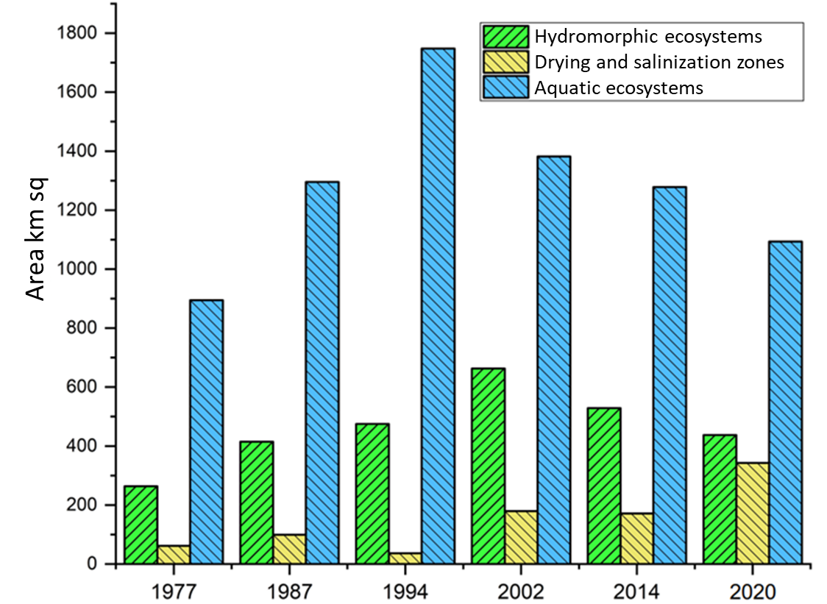

Figure 17 - Dynamics of area ratio of some ecosystems over the last 40 years

2.6 Current condition of vertebrate animals of the study area
Pisces. According to different estimates, the ichthyofauna of the Caspian Sea and the rivers flowing into it include from 100 to 126 fish species and subspecies (35). Carp, goby and herring fish dominate in the number of species, and their share is 75% of the ichthyofauna. Not less than 76 species and 47 subspecies from 17 families live directly in the Caspian Sea and the river delta Zhaiyk, but only part of them is found in Kazakh waters. Species composition of fish also depends on the location of stations. In the Northeast Caspian Sea species composition of catches is much wider than in the Middle Caspian Sea.
Representatives of marine (43.5%) and river (34.4%) fish species dominate in terms of species [36].
Sturgeons. Well-known group of autochthonous fish species of sturgeon family (Acipensiridae) is a bright indicator of extreme reduction of fish stocks in the Ural-Caspian Sea. The following species migrate to the Zhaiyk River delta: beluga (Huso huso), sevruga (Acipenser stellatus), Russian sturgeon (Acipenser guldenstadi), Sevruga (Acipenser nudiventris). All species of sturgeon living in the study area are specially protected fish species.
The trend of catching sturgeon fish and determining the high status of this group was the beginning of irrational reduction of resources. Local herds of sturgeon fish in the Zhaiyk River are historically linked to traditional spawning grounds. Unfavorable conditions were created in the conditions of unregulated river runoff at the usual spawning grounds of sturgeon fish species proper. To preserve these unique fish species, the Ural Delta and adjacent areas are crucial, primarily as a natural corridor that connects spawning and flying habitats with feeding and wintering grounds. The state of the sturgeon fish population in the coming years will depend on the environmental situation in the Zhaiyk River Delta and adjacent waters of the Caspian Sea. The smallest class of vertebrates in the study area are amphibians. The amphibian class is represented by three species from the group of tailless species: green toad (Bufo viridis), lake frog (Rana ridibunda) and common garlic (Pelobates fuscus). From the class of reptiles, in the region we met representatives of three groups: turtles, lizards and snakes. A common species from the group of turtles, is the swamp turtle (Emus orbicularis). Wetland turtle in the Zhaiyk River Delta is numerous and is a background species, mainly in their diet are crustaceans, clams, frogs and small fish.
Seven species of lizards were represented on the territory researched this year: multicolored lizard (Eremias arguta), tachyr round head (Phrynocephalus helioscopus), squeaky gecko (Alsophylax pipiens), fast lizard (Eremias velox), A pimpled lizard (Lacerta agilis), an ear-shaped round head (Phrynocephalus mystaceus), a vertically-headed round head (Phrynocephalus guttatus). Of the snakes we have noticed: a common muzzle (Gloydius halys), a patterned snake (Elaphe dione), a water snake (Natrix tessellate) and a common snake (Natrix natrix).
Of the mammals in the delta of the Zhaiyk River in the project area we surveyed, 48 species belonging to 7 groups can be found. In terms of species, rodents (21 species), including large gerbil (Rhombomys opimus), midday gerbil (Meriones meridianus), red-tailed gerbil (Meriones libycus) and crested gerbil (Meriones tamariscinus), the latter are pests of natural pastures and carriers-feeders of the plague microbe Yersinia pestis. Ondatra zibethicus is a semi-aqueous mammal, a rodent introduced into the Ural Delta. Among aquatic mammals, the Caspian seal (Phoca caspica) is a bright representative and endemist of the Caspian Sea. From the detachment of pairs of hoofed animals, the boar (Sus scrofa) is quite numerous - a typical habitat of which are reed thickets of the coastal part of the delta and islands. During the field work, in two places we observed traces of small herds of different age boars, consisting of two and eight individuals. Among the predators in the project area live: badger (Meles meles), reed cat (Felis chaus), raccoon dog (Nuctereutus procyonoides), fox (Vulpes vulpes), korsak (Vulpes corsac), wolf (Canis lupus), jackal (Canis aureus).
В казахстанском секторе прибрежной части Каспийского моря и в дельте реки Урал обитают 287 видов перелетных и гнездящихся птиц, принадлежащих 18 отрядам [37,38]. Из них 37 видов занесены в Красную книгу Казахстана.
Вовремя 13-километрового лодочно-маршрутного исследования дельты Урала мы заметили несколько стай лоферов (Plegadis falcinellus) рядом с кварками (Nycticorax nycticorax), больших белых цаплей (Egretta alba), с мелкими белыми цаплями (Egretta garzetta), ходулях (Himantopus heantopus), со смехом чаек (Larus cachinnans), черноголовым смехом (Larus ichthyaetus). Во время маршрута мы заметили колышек (Platalea leucorodia). Кряква (Anas platyrhunchos), серая утка (Anas Strepera), красноносая утка (Nettra ruffina) кормились в узких протоках дельты с птенцами, а из манжет видна лысая куропатка (Fulica atra).

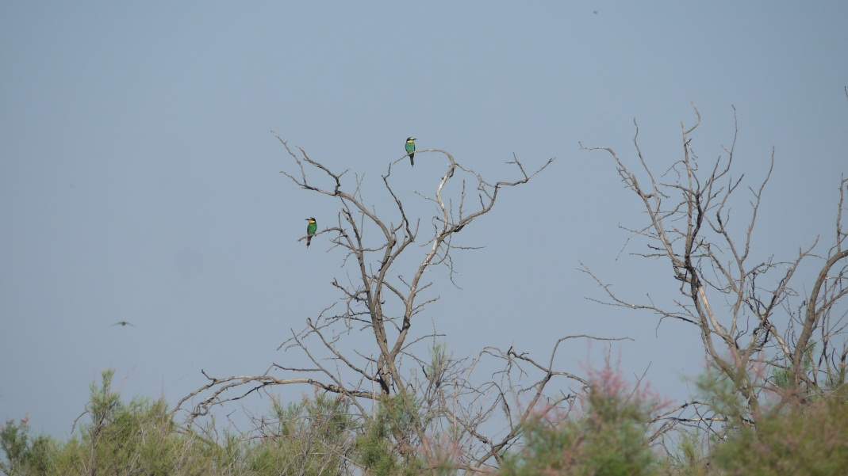

Exhibit 18 - Golden pike (Merops apiaster)

As a result of the route study in the steppe zones we have observed several pairs of golden pike (Figure 18), four adults of the steppe eagle (Aquila rapax), we also recorded several individuals of black belly grouse (Pterocles orientalis) and a pair of beautiful cranes (Anthropoides virgo).
Thus, on the surveyed territory for the period of bird observations we have noticed 11 bird species listed in the Red Data Book of Kazakhstan, other protected species were not observed.

CONCLUSION

Based on the analysis of literature sources, long-term data on the water dynamics of the Zhaiyk River (Ural) in the middle and lower reaches, changes in air temperature and precipitation in the period 1980-2020, study of multi-temporal space images of the project area, the results of field and laboratory studies, the use of remote sensing and GIS-technologies, we believe it is possible to formulate the following conclusions:
- The State Nature Reserve "Akzhaiyk" has been included in the UNESCO list, first of all, due to the historically developed biodiversity of ichthyo and avifauna, unique wetland ecosystems, azonal, due to the pronounced aridity of the climatic and geographical zone of the region. In this regard, the existing species and cenotic diversity of the Akzhaiyk Reserve and the adjacent territory primarily depends on the hydrological and hydrochemical state of the transboundary Zhaiyk River (Ural) and the processes occurring as a result of natural and anthropogenic factors affecting the Caspian Sea. It is also impossible to underestimate the importance of global and regional climate change processes and economic and economic activities in the Zhaik River Basin in its Russian and Kazakh parts due to growing water consumption, industrial, agricultural and domestic pollution of river waters, poaching, disturbance factor, etc.
- Analysis of meteorological data for two WSs of the project territory for the period 1980-2017 showed a pronounced trend of increasing average annual air temperature, especially from 1980 to 2003, when a fairly steady warming of 1.30 ⁰C occurred every 10 years. And, approximately since 2004, abnormally cold and warm years began to appear. But in general, during this period the average annual temperature in the region has increased significantly, by 50 ⁰C. The average annual precipitation for the period under review was 173 mm.
- The study of the dynamics of the hydrological regime of the Zhaiyk River for the period 1977-2016, according to the Mahambet and Kushum gauging stations, showed that there is a decrease in the average annual water content of the river, albeit slight, but with a fairly steady trend. Taking into account the trend of global climate warming and the ubiquitous growth of water consumption in the Russian Federation and Kazakhstan, the oil and gas complex intensively developing in the region, a catastrophic situation with water supply in the Zhaiyk-Caspian Basin is likely in the near future. Contamination of the river and the Caspian Sea in both neighboring countries remains. This poses a real threat to the ecosystems of the Akzhaiyk reserved area. The decrease of the Caspian Sea level to -25.0 - 25.5 m by 2020 - 2030 also remains an unfavorable factor;
- The study of terrestrial and aquatic ecosystems of the project area revealed an alarming situation requiring urgent measures to restore species diversity and population numbers of valuable commercial fish species, especially sturgeon;
- modern methods of regular monitoring of the project area have been developed based on the integrated use of field, laboratory and GIS methods - remote sensing and GIS-technologies;
- created thematic GIS maps of the ecological landscape zoning of the project area in the eastern part of the Zhaiyk River delta, reflecting area ratios of the main biogeocenoses, including aquatic ones, which are the most important in terms of biodiversity conservation in different water years.
- During the reporting period, three publications were published in rating journals indexed on the basis of Scopus (Appendix B).

REFERENCES

- 1 Globally significant wetlands of Kazakhstan (Delta of Ural River and adjacent coast of the Caspian Sea). - Astana, 2007. - 264 p.
- Resources of surface and underground water, their use and quality // State water inventory -L., SPb., - M., 1981. – 2014.
- National atlas of the Republic of Kazakhstan. - Almaty, 2010. – T. I. - – 150 p.
- Second assessment report of Roshydromet on climate change and its consequences in the Russian Federation. – М., 2014. – 1017 с. (in Russian)
- Polonskiy, V.F.; Mikhailov, V.N.; Kravtsova, V.I.; Ostroumova, L.P.; Isupova, M.V. Modern hydrologic-morphological processes in the Ural estuary // Caspian region estuaries: history of formation, modern hydrologic-morphological processes and dangerous hydrological phenomena. –М., 2013. – С. 448 - 482. (in Russian)
- Ivkina N.I. Changes in water inflow into the Caspian Sea as a result of anthropogenic impact and climate change on the example of Zhaiyk river (Ural) // Hydro meteorology and ecology. - – 2016. - – № 3. – С. 50 - 55. (in Russian)
- Alferov I.N., Yakovenko N.V. Water use in a river basin the Urals: current state and geoenvironmental problems // Bulletin of the Orenburg scientific center OurO RAHN. - – 2015. - No. 2. - P. 1–8.
- Reserves of Central Asia and Kazakhstan. // Materials of the IUCN project "Evaluation of management efficiency of reserves in Central Asia and Kazakhstan", under the guidance of R.V. Yashchenko. -Almaty: Tethys, 2006. -Vyp.1. - 352 с. (in Russian)
- Arinushkina E.V. Manual for Soil Chemical Analysis. - MGU, 1970. - 489 с. (in Russian)
- Soil Science Workshop. - Moscow: Agropromizdat, 1986. - 330 с. (in Russian)
- Instruction to conduct large-scale (1:1000 - 1:100000) geobotanical surveys of natural forage lands of the Republic of Kazakhstan. - Almaty, 1995. – С. 4-5. (in Russian)
- Field Geobotany: in 5 volumes. - Moscow: Science, 1959-1976. (in Russian)
- Novikov G.A. Field studies on ecology of terrestrial vertebrates. -M.: Soviet Science, 1953. – 123 с. (in Russian)
- Y.A. Pesenko. Principles and methods of quantitative analysis in faunistic research. - – М., 1982. – С. 23-24. (in Russian)
- Kanika K., Anil K, G. and Rhythm G. A Comparative Study of Supervised Image Classification Algorithms for Satellite Images // International Journal of Electrical, Electronics and Data Communication. - – 2013. - Vol. 1, Issue 10. – P. 10-16.
- Cowardin L.M., Carter V., Golet F.C., La Roe E.T. Classification of Wetlands and Deepwater Habitats of the United States. Report No. FWS/OBS/-79/31 // U.S. Fish and Wildlife Service. - Washington, DC, USA, 1979.
- Watts A.C., Ambrosia V.G., Hinkley E.A. Unmanned aircraft systems in remote sensing and scientific research: Classification and considerations of use // Remote Sens. – 2012. - Vol. 4. - – P. 1671-1692.
- Frohn R.C. et al. Satellite remote sensing of isolated wetlands using object-oriented classification of Landsat-7 data // Wetlands. - 2009. - Vol. 29. – P. 931-941.
- Globally significant wetlands of Kazakhstan (Delta of Ural River and adjacent coast of the Caspian Sea). - Astana, 2007. – 264 p.
- Kurmangaliyev R.M. Environmental problems of transboundary watercourse - Ural rivers and ways of solving / R.M. Kurmangaliyev // Ғылым жəне Bilim. - 2008. - № 3. - С. 91-97. (in Russian)
- Tlenbekov O.K. Modern state of the Ural Delta // Proceedings of the Institute of Ichthyology and Fish. Farms of the Academy of Sciences of Kaz. SOVIET SOCIALIST REPUBLIC. 1963. Vol.4. Pp. 47 - 55. (in Russian)
- Gerstansky N.D. Peculiarities of Run-Off Water Level Oscillations in the Volga Delta // Proceedings of GOIN. – 1973. - Proceedings. 116. – С. 131– 145. (in Russian)
- Koshinsky S.D., Ryzhkova L.M. Flood conditions in the north-western Caspian Sea 10-13 November 1952 // Proc. of Intern. ZapSibNII. – 1980. - Exhibit. 9. – С. 63-75. (in Russian)
- Skryptunov N.A., Gorelits O.V. Wind surges and drifts at the western coast of the North Caspian // Proceedings of GOIN. – 2000. - Episode. 207. – С. 204–223. (in Russian)
- Fomina N.D. Characteristics of rush levels near the western coast of the Caspian Sea // Collection of works of Baku GMO. – 1967. - Ep. 3. – С. 30–34. (in Russian)
- Fomina N.D. About wind and level connection in the region of Middle and South Caspian // Collection of works of Baku GMO. – 1968. - Episode. 4. – С. 61–67. (in Russian)
- A.S. Sargsyan, Y.L. Demin, etc. Methods and Results of Calculating the Circulation of World Ocean Waters. - L.: Hydrometeoisdat, 1986. – 151 с. (in Russian)
- Bukharitsyn P.I. Influence of storm surges on the work of coastal oil fields of the North Caspian // Proceedings to the All-Union Scientific and Practical Conference "Ecology and the impact of natural gas on the organism". - Astrakhan, 1989. – С. 3. (in Russian)
- Ivkina N.I. Influence of Runaway Phenomena on the Processes of Environment Pollution in the Caspian Region // Hydro Meteorology and Ecology. – 2000. – № 2. - P. 156-162 (in Russian)
- Abuzyarov Z.K., Dumanskaya I.O., Nesterov E.S. Operative oceanographic service. - M.; Obninsk: IG-SOCIN, 2009. – 287 с. (in Russian)
- Belinsky N.A. Marine hydrometeorological information and forecasts. - Leningrad: Hydrometeoizdat, 1956. – 254 с. (in Russian)
- Kan S.I. Method of short-term forecast of the northern part of the Caspian Sea level // Proceedings of CIP. – 1948. - Episode. 3(30).– С. 3-50. (in Russian)
- Karakash A.I. Prediction method of short-term level changes in the inland seas // Meteorology and hydrology. – 1939. – № 3. – С. 78–82. (in Russian)
- Shivareva S.P., Ivkina N.I., Stroeva T.P., Vasenina E.I. Wind surges of sea water Kazakhstan coast of the Caspian Sea. Ecological problems of the Caspian Sea. http://www.caspinfo.ru/data/2002.HTM/001381.HTM (in Russian)
- Kuanysheva G.A., Kanbetov A. Sh., Sokolsky A.F. Study of the current state of ichthyofauna of the Caspian Sea / Eurasian Union of Scientists (ESU). 2015. - №7 (16).
- Kazancheev E.N. Fish of the Caspian Sea - Moscow, 1981. – 168 с. (in Russian)
- Diarov M.D., Sarayev F.A., Bolshov A.A., Ergaliyev T.J. Animal world of coast and water area of Kazakhstan sector of the Caspian Sea. Monograph. -Almaty, 2008. – С. 424
- Berezovikov, N.N.; Gistsov, A.P. Ornithological complexes of the Ural Delta and their changes in connection with another transgression of the Caspian Sea (in Russian) // Russian Ornithological Journal. -2012. - Т. Express Issue 727: 287 - 299. (in Russian)

APPENDIX А
Calendar plan 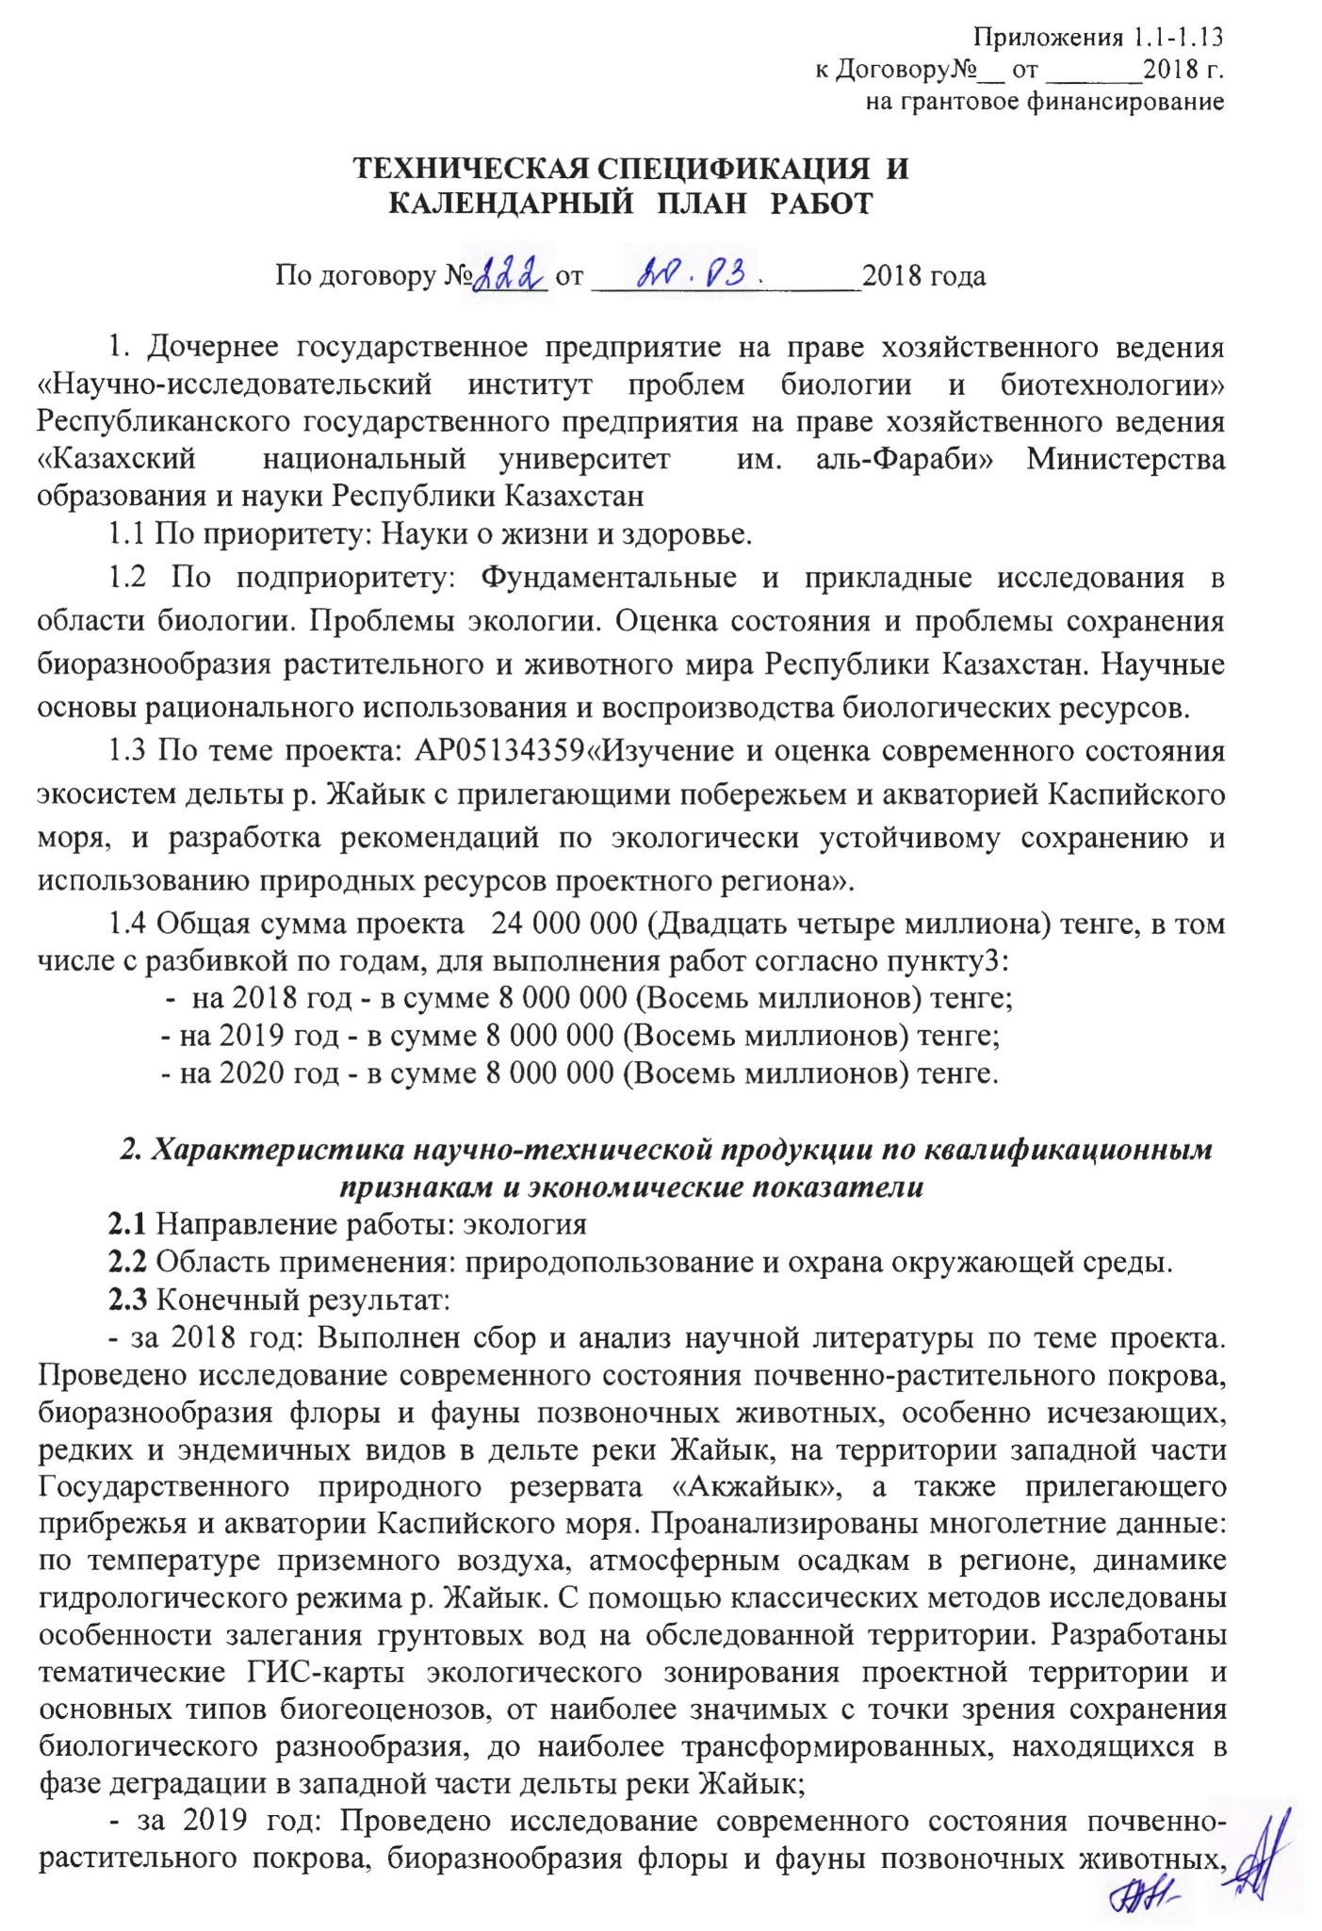
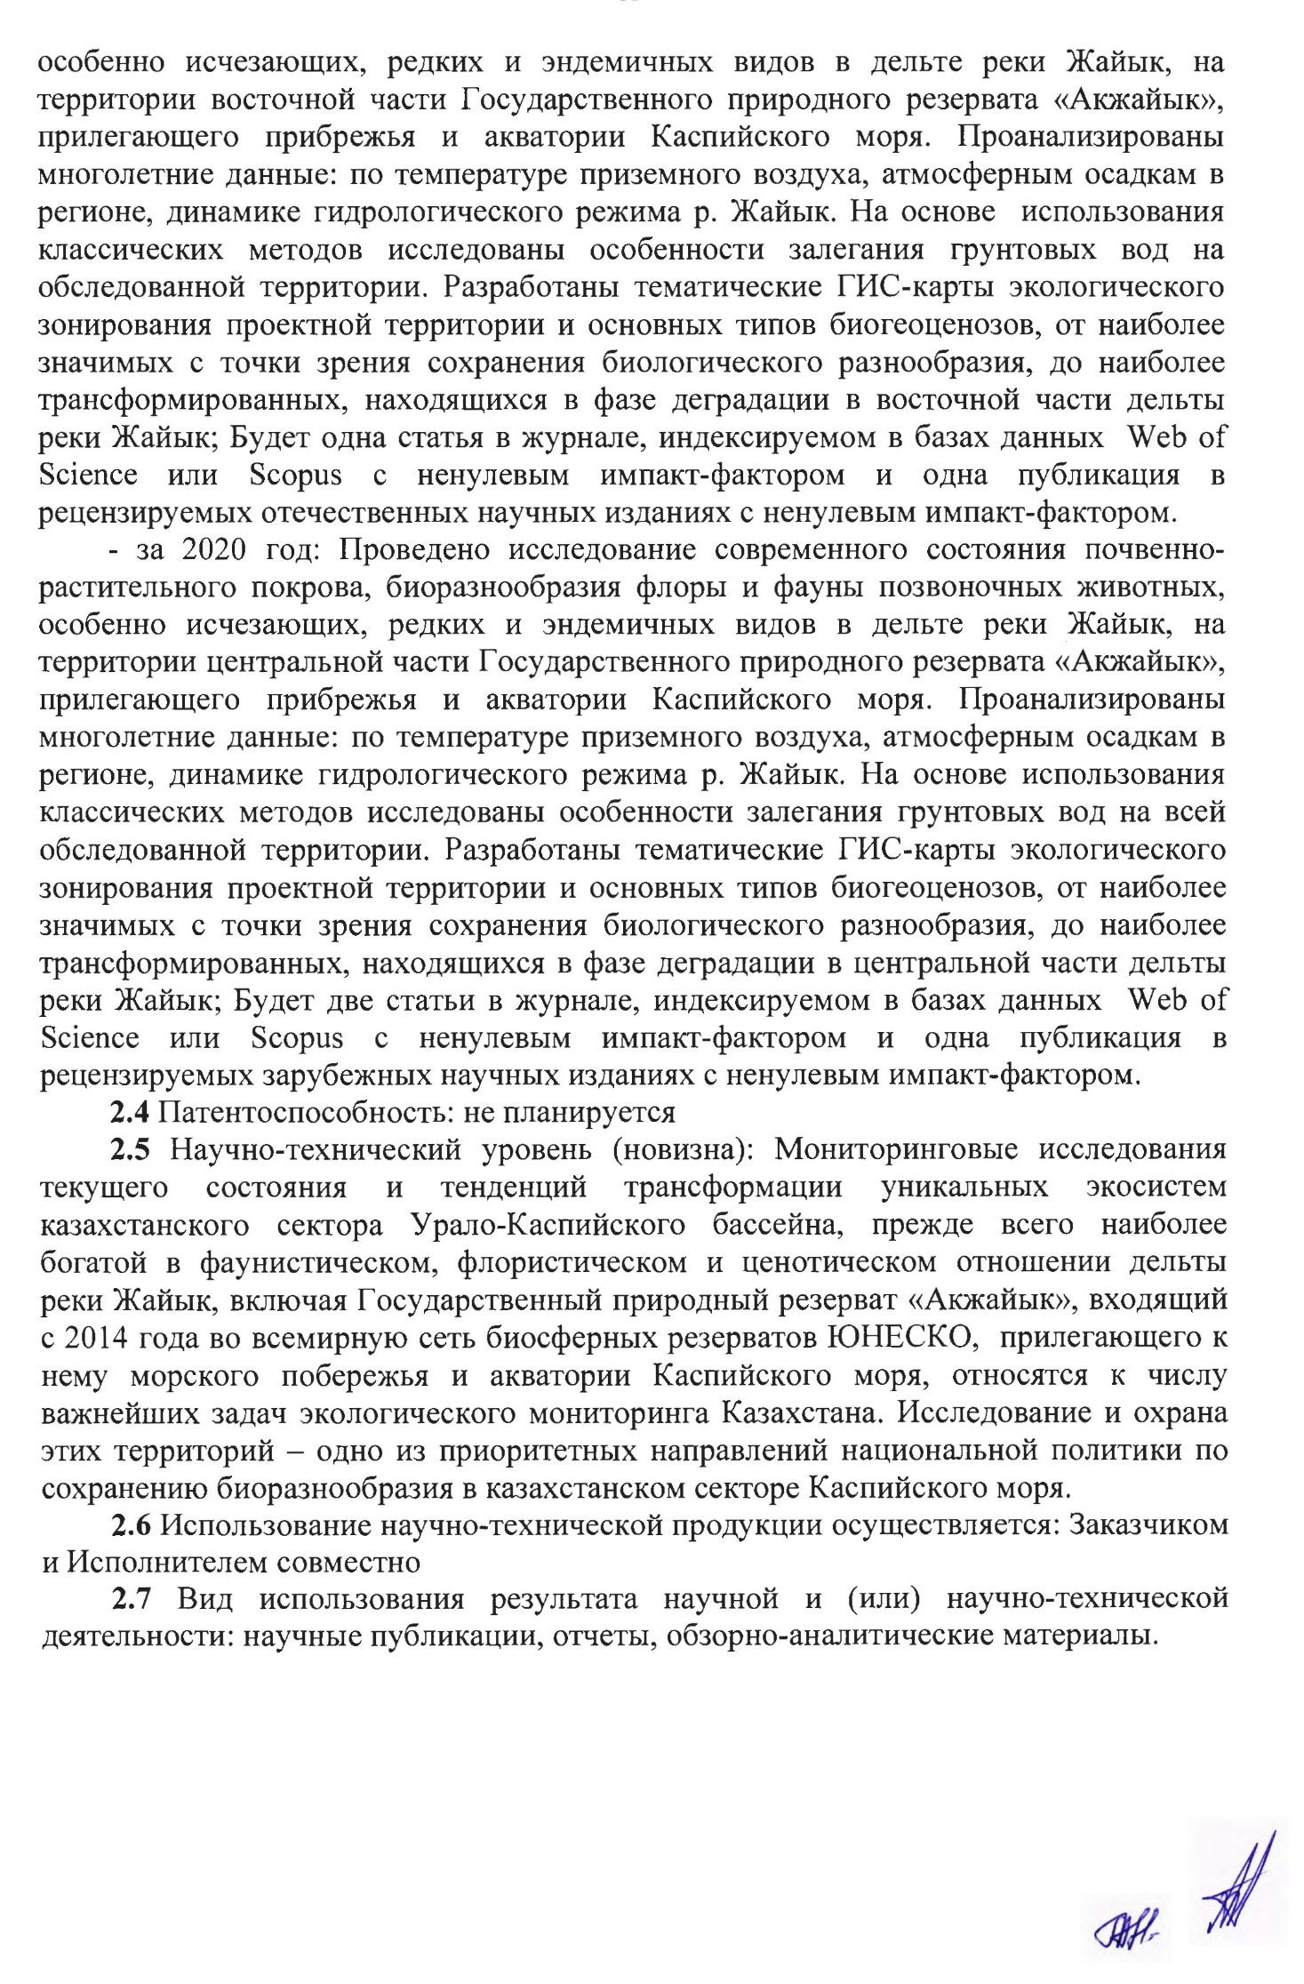
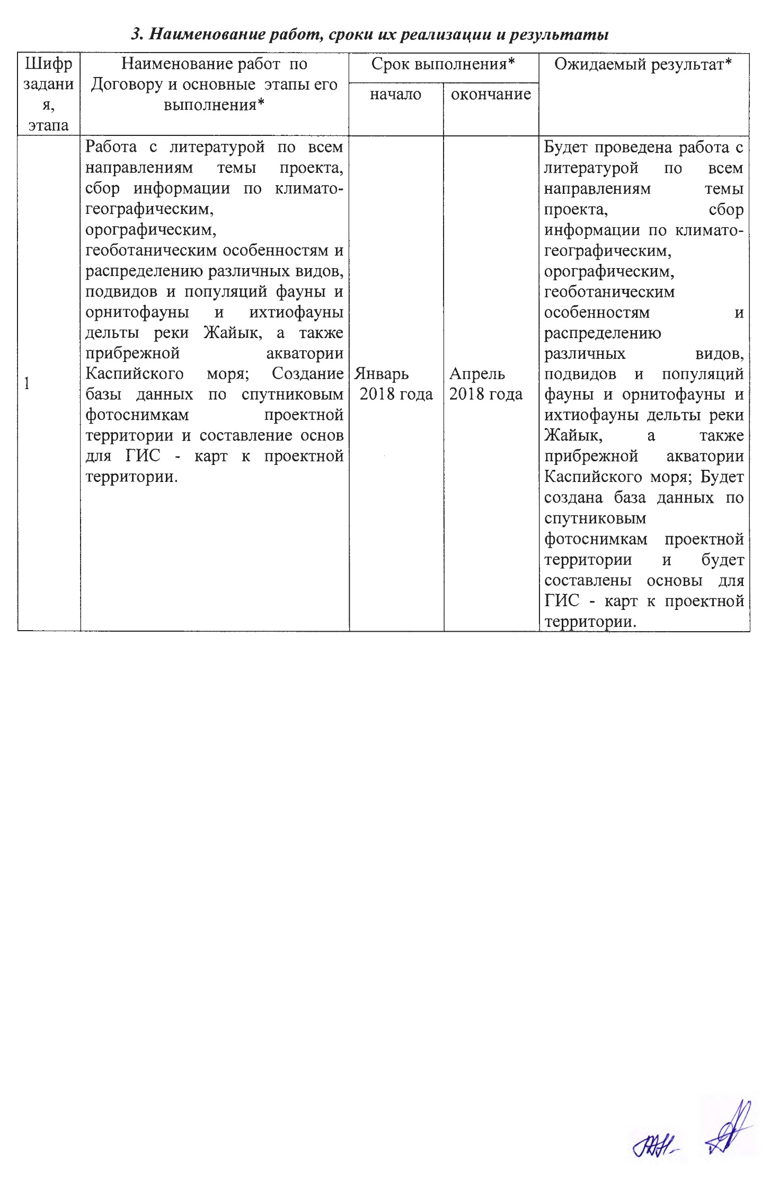
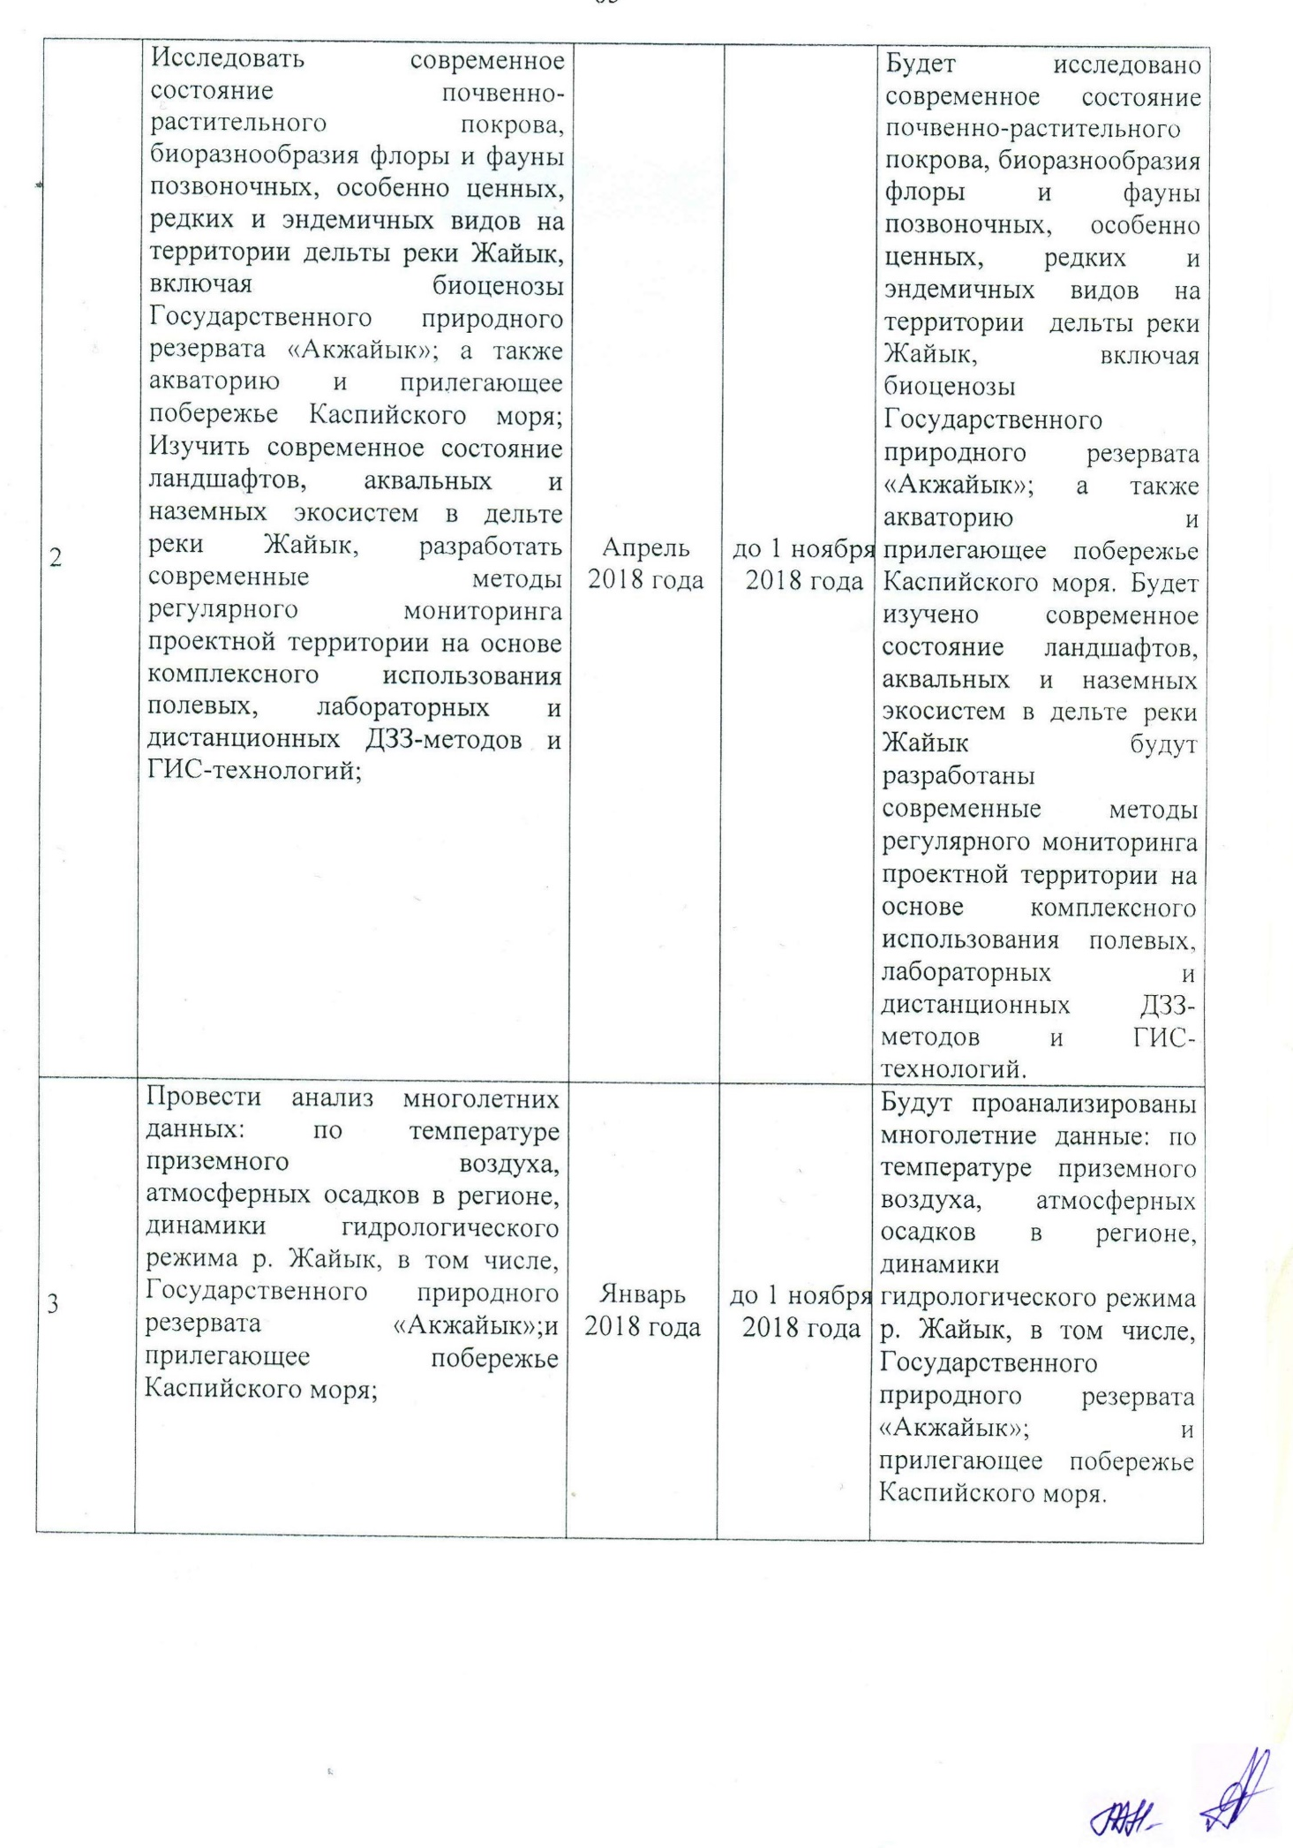

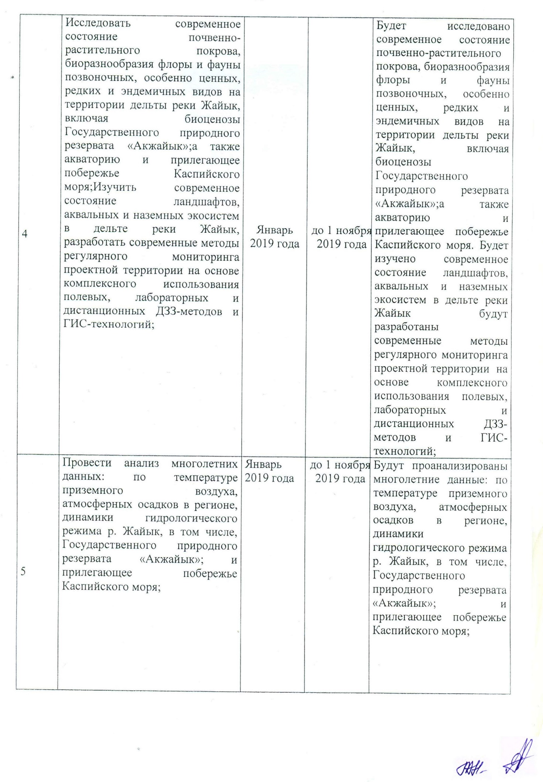
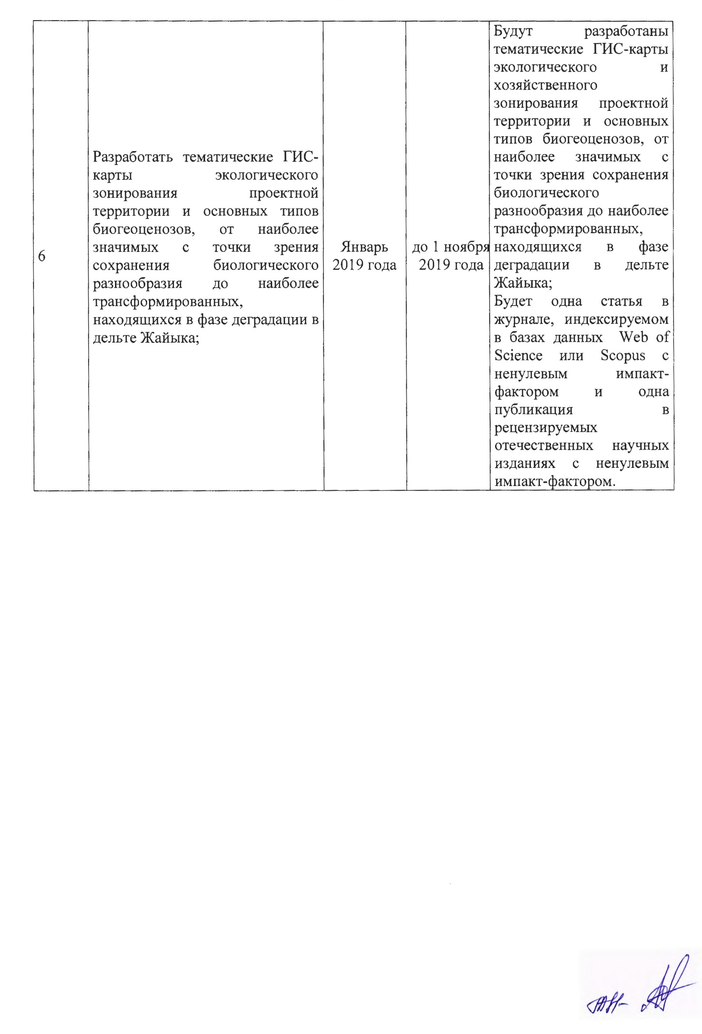
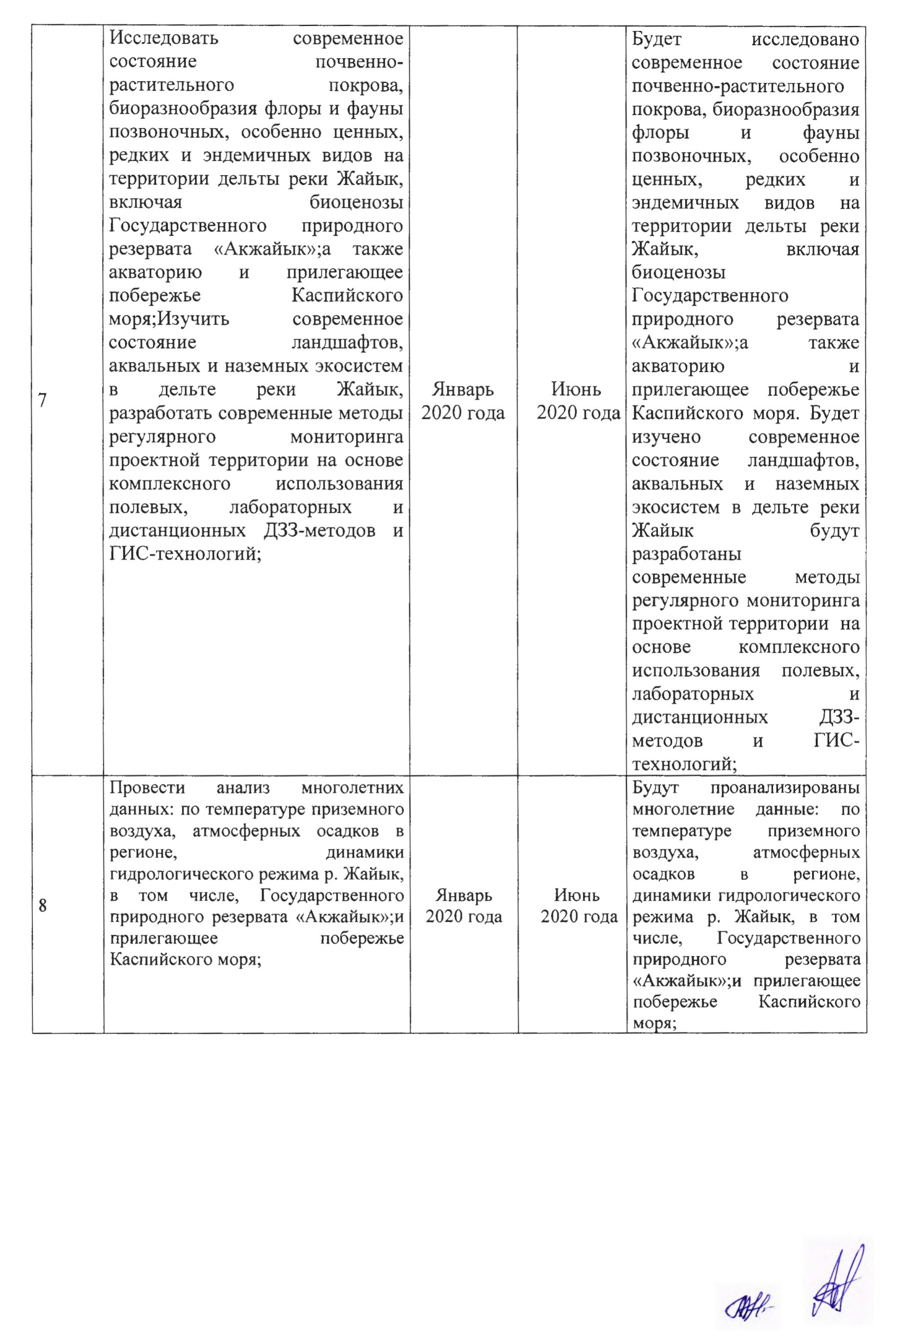
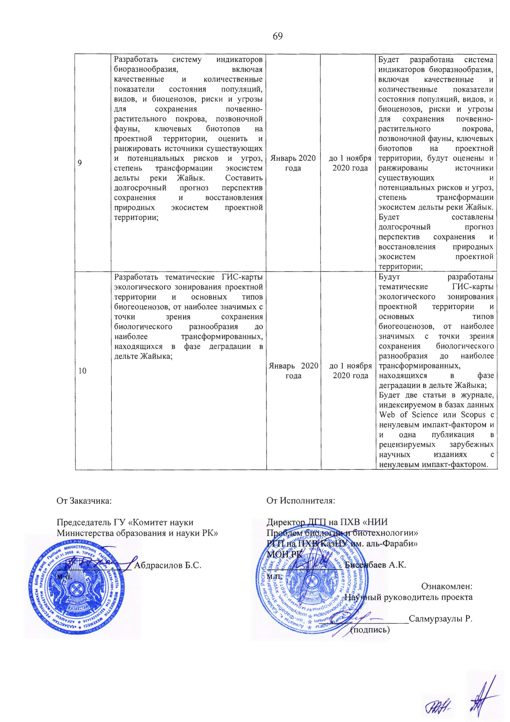

Annexes 1.1-1 . 13 to the Agreement
No._of ___ 2018 .
for grant financing

TECHNICAL SPECIFICATION AND WORK SCHEDULE

Under contract No. 222 of 20.03 2018

1. Subsidiary State Enterprise on the right of economic management "Research Institute of Biology and Biotechnology Problems" of the Republican State Enterprise on the right of economic management "Al-Farabi Kazakh National University" of the Ministry of Education and Science of the Republic of Kazakhstan.
1.1 By priority: Life and health sciences.
1.2 By priority: Basic and applied research in biology. Problems of ecology. Assessment of the status and problems of biodiversity conservation in flora and fauna of the Republic of Kazakhstan. Scientific bases of rational use and reproduction of biological resources.
1.3 Project topic: AP5134359 "Study and assessment of the current state of ecosystems in the Zhaiyk River delta with adjacent coast and water area of the Caspian Sea, and development of recommendations for environmentally sustainable conservation and use of natural resources in the project area".
1.4 Total amount of the project 24 000 000 (Twenty-four million) tenge, including a breakdown by years, to carry out the works under the paragraph "The project is aimed at the implementation of the project":
- for 2018 - in the amount of 8 000 000 (Eight million) tenge;
- for 2019 - at the amount of 8 000 000 (Eight million) tenge;
- for 2020 - at the amount of 8 000 000 (Eight million) tenge.

2. Characteristics of scientific and technical products by qualification characteristics and economic indicators
2.1 Work area: Ecology
2.2 Scope of application: environmental management and protection .
2.3 Final result:
- For 2018: Collection and analysis of scientific literature on the project topic was carried out. A study was conducted on the current state of soil cover and biodiversity of flora and fauna of vertebrate animals, especially endangered, rare and endemic species in the Zhaiyk River Delta, the western part of the Akzhaiyk State Nature Reserve, and the adjacent coast and water area of the Caspian Sea. The long-term data are analyzed: surface air temperature, precipitation in the region, dynamics of hydrological regime of the Zhaiyk River. With the help of classical methods, the features of groundwater occurrence in the surveyed territory were studied. Thematic GIS maps of the ecological zoning of the project area and the main types of biogeocenoses, from the most significant in terms of biodiversity conservation to the most transformed, being in the phase of degradation in the western part of the Zhaiyk River delta, have been developed;
- For 2019: A study of the current state of soil, vegetation cover, biodiversity of flora and fauna of vertebrate animals was conducted particularly endangered, rare and endemic species in the delta of the Zhaiyk River, on the territory of the eastern part of the State Nature Reserve "Akzhaiyk". , the adjacent coast and water area of the Caspian Sea. The long-term data are analyzed: surface air temperature, precipitation in the region, dynamics of hydrological regime of the Zhaiyk River. Using classical methods, the features of groundwater occurrence in the surveyed territory were studied. Thematic GIS maps of the ecological zoning of the project area and the main types of biogeocenoses, from the most significant in terms of biodiversity conservation, to the most transformed, in the phase of degradation in the eastern part of the Zhaiyk River delta, there will be one article in the journal, indexed in databases Web of Science or Scopus with a non-zero impact factor and one publication in peer-reviewed domestic scientific publications with a non-zero impact factor.
- For 2020: A study of the current state of the soil cover and biodiversity of flora and fauna of vertebrate animals, especially endangered, rare and endemic species in the delta of the Zhaiyk River, on the territory of the central part of the State Nature Reserve "Akzhaiyk". , the adjacent coast and water area of the Caspian Sea. Multi-year anecdotes are analyzed: on the surface air temperature, atmospheric precipitation in the region, and the ike of the hydrological regime of the Zhaiyk River. Using classical methods, the peculiarities of groundwater occurrence in the whole surveyed territory were studied. Thematic GIS maps of the ecological zoning of the project area and the main types of biogeocenoses, from the most significant in terms of biodiversity conservation, to the most transformed, being in the phase of degradation in the central part of the Zhaiyk River delta; two articles in the journal indexed in databases Web of Science or Scopus with a non-zero impact factor and one publication in peer-reviewed foreign scientific publications with a non-zero impact factor.
2.4 Patentability: not planned
2.5 Scientific and technical level (novelty): Monitoring studies of the current state and trends of transformation of unique ecosystems in the Kazakhstan sector of the Ural-Caspian basin, primarily the richest in phasist, floristic and cenotic terms delta of the Zhaiyk River, including the State Natural Reserve "Akzhaiyk". included in the UNESCO World Network of Biosphere Reserves, the adjacent sea coast and the Caspian Sea since 2014, are among the most important tasks of environmental monitoring of Kazakhstan. The study and protection of these areas is one of the priorities of the national policy on biodiversity conservation in the Kazakhstan sector of the Caspian Sea.
2.6 The use of scientific and technical products is performed by: the Client and the Contractor jointly
2.7 Type of use of the result of scientific and (or) scientific and technical activity: scientific publications, reports, review and analytical materials.

3) Name of works, terms of their realization and results
Job code, steps | Name of works under the Agreement and the basic stages of its implementation | Completion date |  | Expected Result
Job code, steps |  | beginning | ending | Expected Result
1 | Work with literature on all areas of the project subject, collecting information on climatic-geographical, orographic, geobotanical features and distribution of different species, subspecies and populations of fauna and avifauna and ichthyofauna of the Zhaiyk River delta, as well as coastal water area of the Caspian Sea; creating a database of satellite images of the project area and compiling the basis for GIS - maps to the project area. | January 2018 | April 2018 | Work will be done with literature on all areas of the project theme, collecting information on climatographic, orographic, geobotanical distribution and various species, subspecies and populations of fauna and avifauna and ichthyofauna of the Zhaiyk River delta, as well as coastal water area of the Caspian Sea; a database of satellite images of the project area will be created and the basis for GIS - maps to the project area will be made.
2 | Analyze the current state of the soil and plant pores, biodiversity of flora and fauna of tranquillizers, especially valuable, rare and endemic species on the territory of the Zhaiyk River Delta, including biocoenoses of the State Nature Reserve "Akzhaiyk", as well as water area and the adjacent Caspian Sea coast; Study the current state of landscapes, aquatic and terrestrial ecosystems in the Zhaiyk River Delta and develop modern methods of regular monitoring of the project area based on the integrated use of field, laboratory and remote sensing methods and GIS technology; | April 2018 | until 1st November , 2019 | The current state of the land cover, biodiversity of flora and fauna of late stage, especially valuable, rare and endemic species on the territory of the Zhaiyk River Delta, including biocoenoses of the State Nature Reserve "Akzhaiyk", as well as the water area and the adjacent coast of the Caspian Sea, will be studied; The current state of landscapes, aquatic and terrestrial ecosystems in the Zhaiyk River Delta will be studied and modern methods of regular monitoring of the project area will be developed based on the integrated use of field, laboratory and remote remote sensing methods and GIS technology;
3 | Carry out the analysis of long-term data: the temperature of surface air, precipitation in the region, the dynamics of the hydrological regime of the river Zhaiyk, including the State Natural Reserve "Akzhaiyk"; and the adjacent coast of the Caspian Sea; | January 2018 | until 1st November , 2019 | The following long-term data will be analyzed: surface air temperature, precipitation in the region, dynamics of hydrological regime of the Zhaiyk River, including the State Nature Reserve "Akzhaiyk"; and the adjacent coast of the Caspian Sea;
4 | Study the current state of the soil and vegetation cover, biodiversity of flora and fauna of vertebrates, especially valuable, rare and endemic species on the territory of the Zhaiyk River delta, including biocenoses of the Akzhaiyk State Nature Reserve; as well as the water area and the adjacent coast of the Caspian Sea; To study the current state of landscapes, aquatic and terrestrial ecosystems in the Zhaiyk river delta, to develop modern methods of regular monitoring of the project area based on the integrated use of field, laboratory and remote sensing methods and GIS technology. | January, 2019 | until 1st November , 2019 | The current state of the soil and vegetation cover, biodiversity of flora and fauna of vertebrates, especially valuable, rare and endemic species on the territory of the Zhaiyk river delta, including biocenoses of the Akzhaiyk State Nature Reserve, will be investigated. As well as the water area and the adjacent coast of the Caspian Sea.  The current state of landscapes, aquatic and terrestrial ecosystems in the Zhaiyk delta will be studied, modern methods of regular monitoring of the project area will be developed based on the integrated use of field, laboratory and remote sensing methods and GIS technology.
5 | Analyze long-term data: on the surface air temperature, atmospheric precipitation in the region, the dynamics of the hydrological regime of the Zhaiyk River, including the State Natural Reserve "Akzhaiyk"; and the adjacent coast of the Caspian Sea. | January, 2019 | until 1st November , 2019 | Long-term data will be analyzed: on the surface air temperature, atmospheric precipitation in the region, the dynamics of the hydrological regime of the Zhaiyk River, including the Akzhaiyk State Natural Reserve and the adjacent coast of the Caspian Sea
6 | Develop thematic GIS maps of ecological zoning of the project area and the main types of biogeocenoses, from the most significant in terms of  conservation of biological diversity to the most transformed, in a phase of degradation in the Zhaiyk delta; | January, 2019 | until 1st November , 2019 | Thematic GIS maps will be developed  ecological and economic zoning of the project  territory and main types of biogeocenoses, from  most significant in terms of conservation  biological diversity to the most transformed, in the phase of degradation in the Zhaiyk delta; There will be one article in a journal indexed in the Web of Science or Scopus databases with a non-zero impact factor and one publication in  peer-reviewed domestic scientific journals with non-zero  impact factor.
7 | To investigate the state of the current state of soil and vegetation cover, biodiversity of flora and fauna of vertebrates, especially valuable, rare and endemic species on the territory of the Zhaiyk River delta, including biocenoses of the Akzhaiyk State Natural Reserve, as well as the water area and the adjacent coast of the Caspian Sea; To study the current state of landscapes, aquatic and terrestrial ecosystems in the Zhaiyk river delta, to develop modern methods of regular monitoring of the project area based on the integrated use of field, laboratory and remote sensing methods and GIS technologies; | January, 2020 | June, 2020 | The current state of the soil and vegetation cover, biodiversity of flora and fauna of vertebrates, especially valuable, rare and endemic species on  the territory of the Zhaiyk river delta, including biocenoses of the Akzhaiyk State Natural Reserve; and  the water area and the adjacent coast of the Caspian Sea. Will be  the current state of landscapes, aquatic and terrestrial ecosystems in Zhaiyk has been studied; the river delta will be developed modern methods of regular monitoring of the project area based on the integrated use of laboratory remote sensing methods and technologies;
8 | Analyze long-term data: on the surface air temperature, atmospheric precipitation in the region, the dynamics of the hydrological regime of the river. Zhaiyk, including the Akzhaiyk State Natural Reserve; and  adjacent coast of the Caspian Sea; | January, 2020 | June, 2020 | Long-term data will be analyzed: on the surface air temperature, atmospheric precipitation in the region, the dynamics of the hydrological regime of the river. Zhaiyk, including the State Natural Reserve "Akzhaiyk", and the adjacent coast of the Caspian Sea;
9 | To develop thematic GIS-maps of the ecological zoning of the project area and the main types of biogeocenoses, from the most significant in terms of biodiversity conservation to the most transformed ones that are in the phase of degradation in the Zhaiyk delta; | January, 2020 | until 1st November , 2020 | Thematic GIS maps of the ecological zoning of the project area and the main types of biogeocenoses will be developed, from the most significant in terms of biodiversity conservation to the most transformed ones, which are in the phase of degradation in the Zhaiyka river delta; There will be two articles in a journal syndicated in Web of Science or Scopus databases with a non-zero impact factor and one publication in peer-reviewed foreign scientific journals with a non-zero mapact factor.

From customer:  Chairman of the State Institution:  "Committee of Science of the Ministry of Education and Science of the Republic of Kazakhstan"  __________ Abdrasilova B.S. |  | From the Contractor:  Director of the "Research Institute of Problems of Biology and Biotechnology"  _____________ Bisenbaev A.K.  Familiarized with:  Scientific supervisor of the project  ___________ Salmurza R.
APPENDIX B
List of published publications on the project
2018
- Steven G. Pueppke, Sabir Nurtazin, Norman A. Graham, Jiaguo Qi. Central Asia’s Ili River Ecosystem as a Wicked Problem: Unraveling Complex Interrelationships at the Interface of Water, Energy, and Food. Water 2018, 10, 541; https://doi:10.3390/w10050541
2019
- Salmurzauly R., Nurtazin S. T., Konysbaev T. G., Iklasov M. K., Barakov R. T., Elebesov T. A., Saulauov M. J. Biosphere reserve "Akzhaiyk" - dynamics of changes since 1980, current state, main risks and threats // Vestnik KazNU Ecology Series. 2019. - № 3(60). – С. 24 - 40. (in Russian)
- Sabir Nurtazin, Niels Thevs, Margulan Iklasov, Norman Graham, Ruslan Salmurzauli, and Steven Pueppke Challenges to the sustainable use of water resources in Ili River basin of Central Asia // E3S Web of Conferences 81, 01009 (2019) WREM 2018.
https://doi.org/10.1051/e3sconf/20198101009
2020
- Azim Baibagyssov, Niels Thevs, Sabir Nurtazin, Rainer Waldhardt, Volker Beckmann and Ruslan Salmurzauly (2020) Volker Beckmann and Ruslan Salmurzauly. Biomass Resources of Phragmites australis in Kazakhstan: Historical Developments, Utilization, and Prospects. Resources 2020, 9, 74; http://doi:10.3390/resources9060074
- Sabir Nurtazin, Steven Pueppke, Temirkhan Ospan, Azamat Mukhitdinov and Timur Elebessov. Quality of Drinking Water in the Balkhash District of Kazakhstan’s Almaty Region.Water. 2020, 12, 392; https://doi.org/10.3390/w12020392
- Mukhitdinov A. Nurtazin, S. Alimova, S. Ablaikhanova, N. Yessimsiitova, Z. Salmurzauly R. Margulan, I. Mirasbek, Y. The Transformation Of Ecosystems Of The Ili River Delta (Kazakhstan) Under The Flow Regulation And Climate Change. APPLIED Ecology And Environmental Research 18(2):2483-2498. Http://Www.Aloki.Hu Issn 1589 1623 (Print) Issn 1785 0037 (Online), Alöki Kft., Budapest, Hungary. http://dx.doi.org/10.15666/aeer/1802_24832498

APPENDIX C
Hydrographic network map of the project area

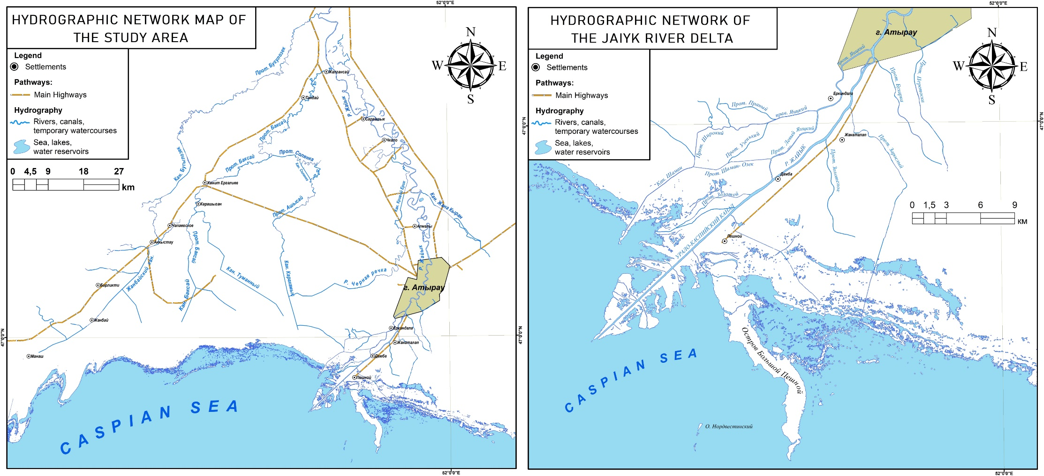

Figure C.1 - Map of the hydrographic network of the study area
Note - Map is made based on data from spacecraft: Sentinel 2 and designation of topographic map at 1:100 000 scale.

APPENDIX D
Vegetation maps of the project area

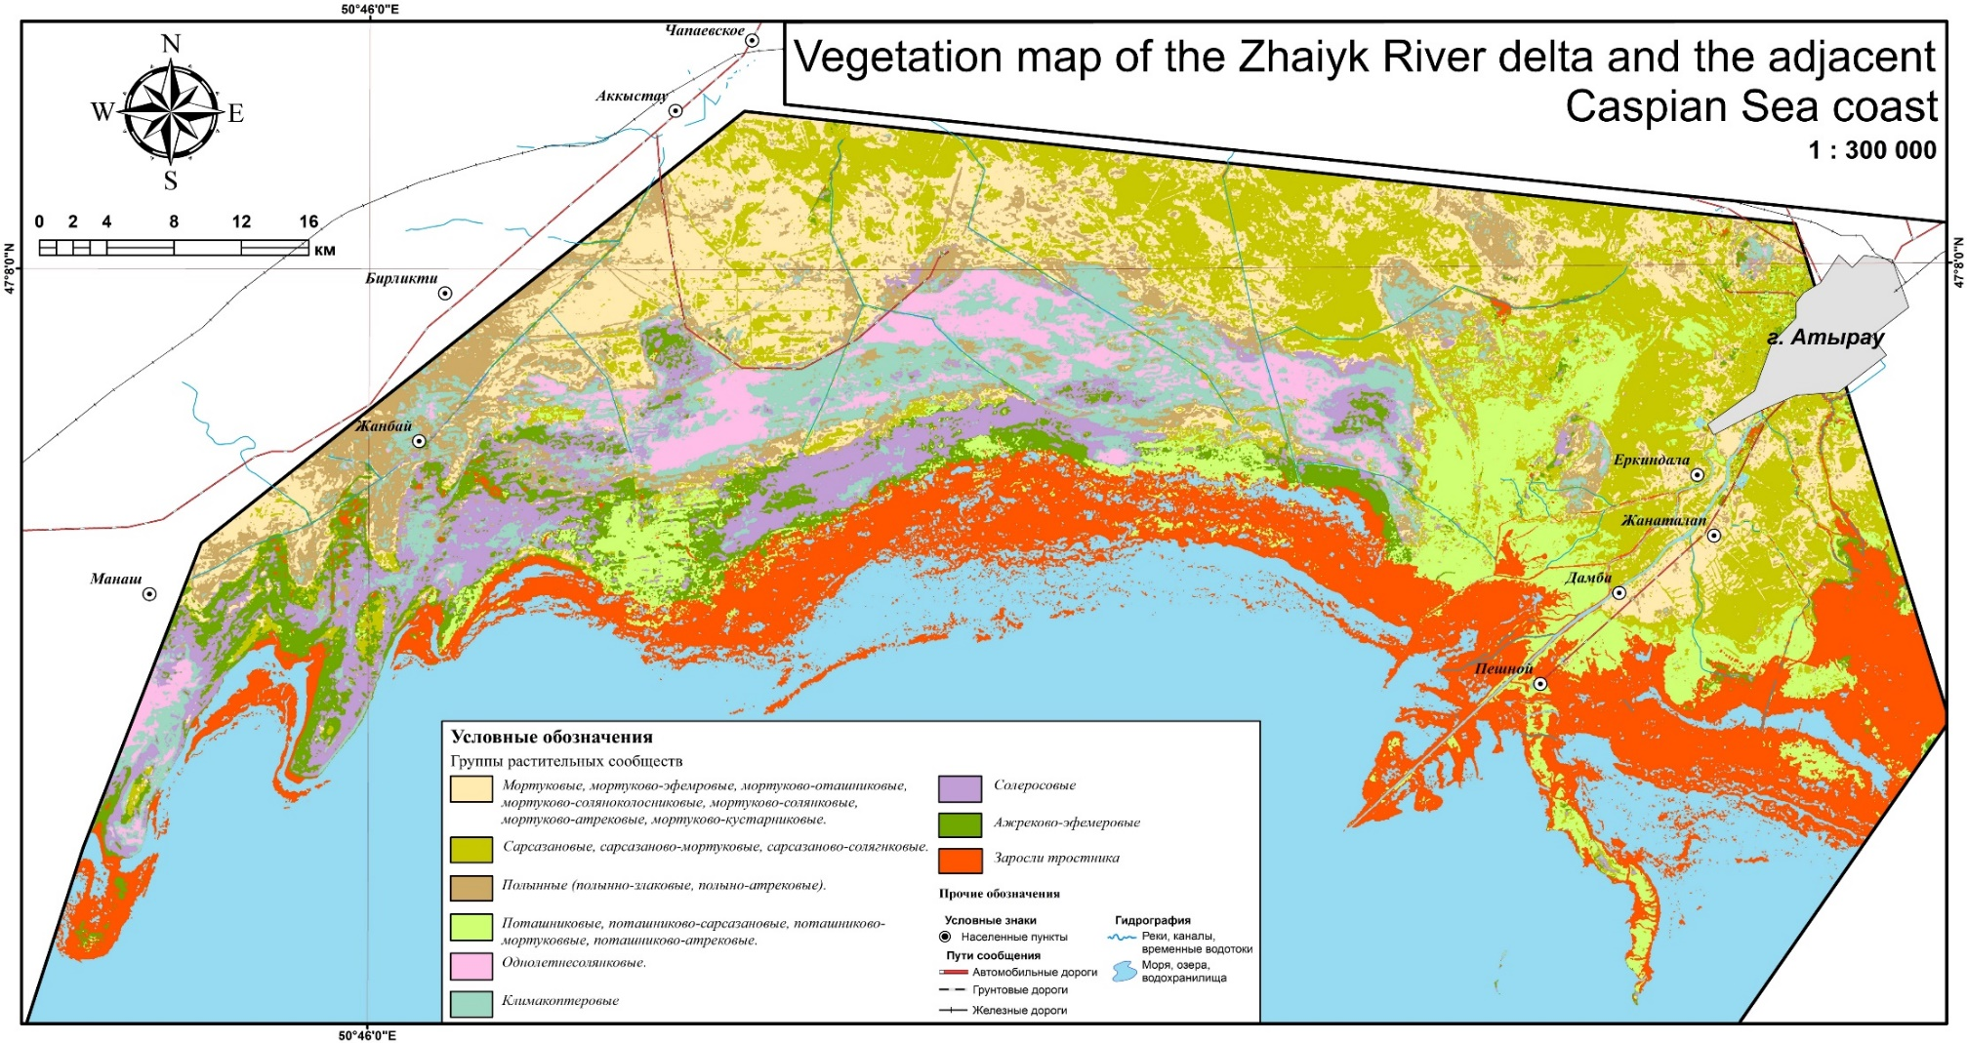

Figure D.1 - Vegetation map of the Zhaiyk River delta and coastal zones of the Northwest Caspian Sea
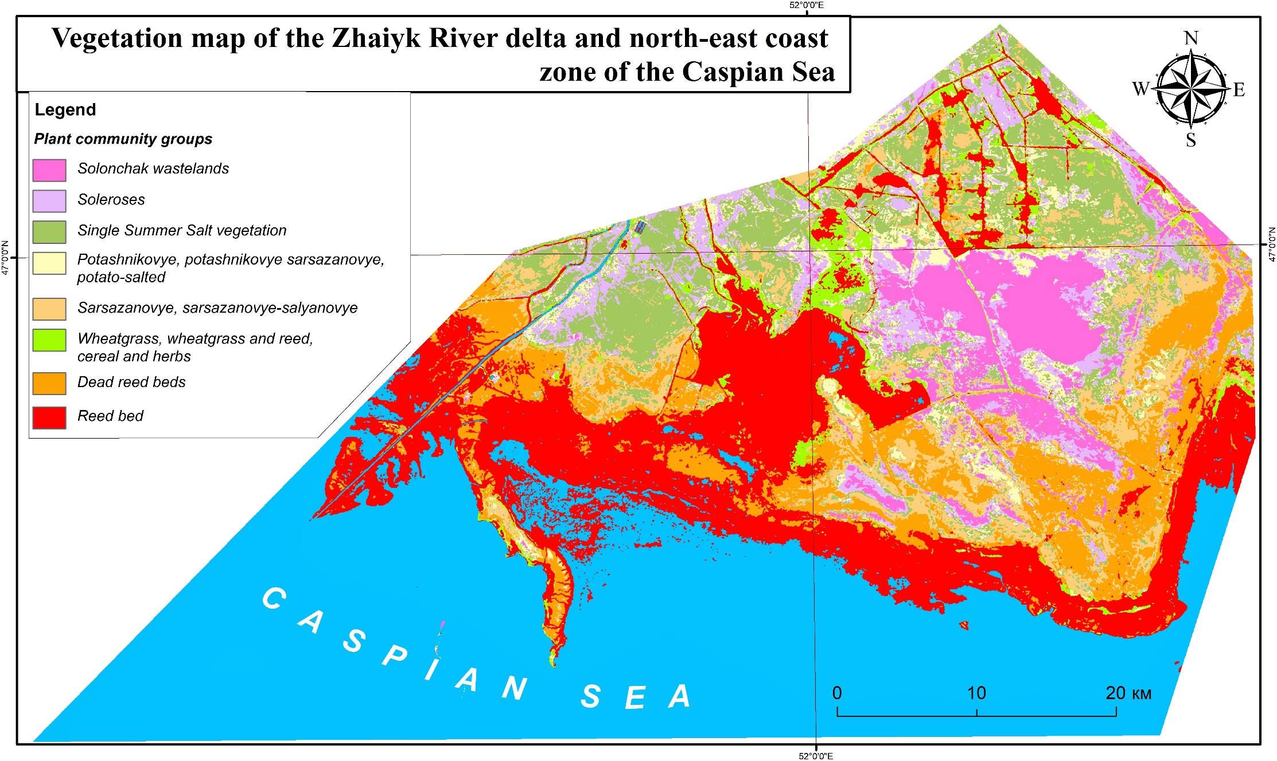
Figure D.2 - Vegetation map of the Zhaiyk River delta and coastal zones of the North-East Caspian Sea
APPENDIX E

GIS maps of changes in aquatic and hydromorphic ecosystems of the Zhaiyk River delta and coastal zones of the Northwest Caspian Sea.
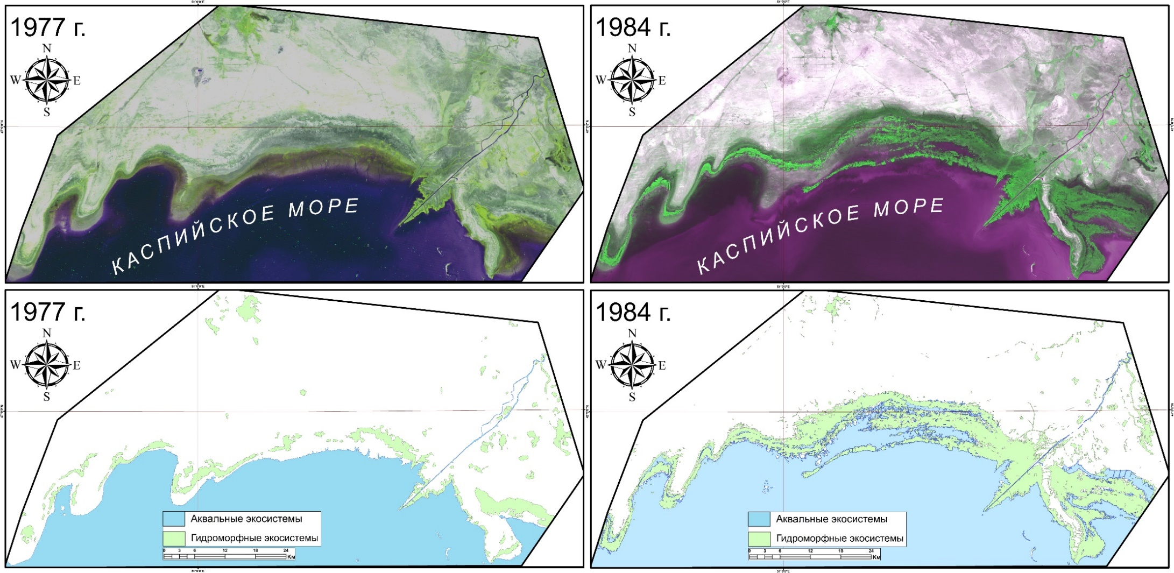

Figure E.1 - Thematic GIS map of changes in aquatic and hydromorphic ecosystems of the Zhaiyk River delta and coastal zones of the Northwest Caspian Sea in 1977 - 1984.
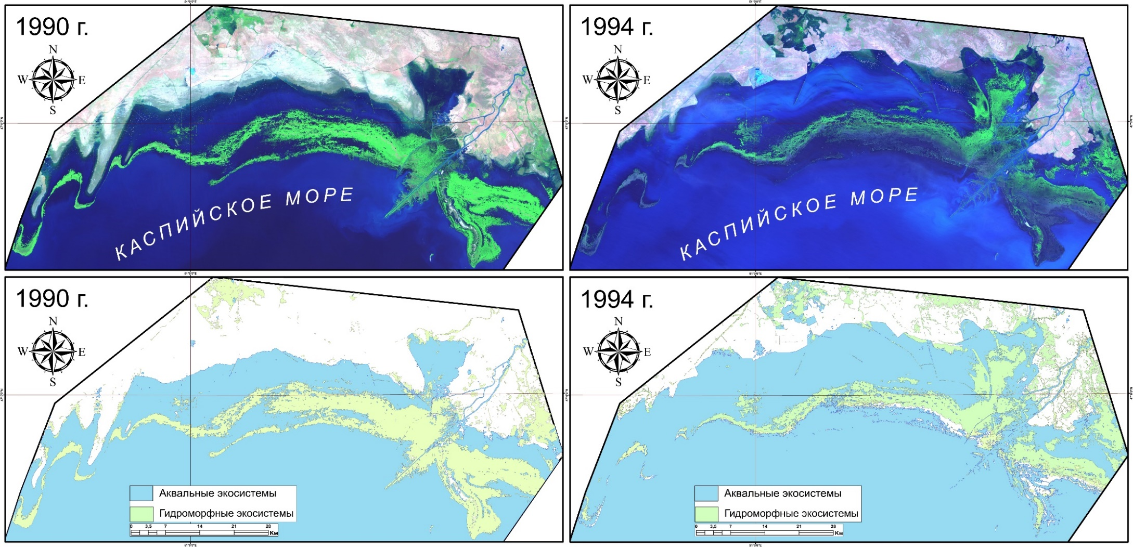

Figure E.2 - Thematic GIS map of changes in aquatic and hydromorphic ecosystems of the Zhaiyk River delta and coastal zones of the Northwest Caspian Sea in 1977 - 1984.

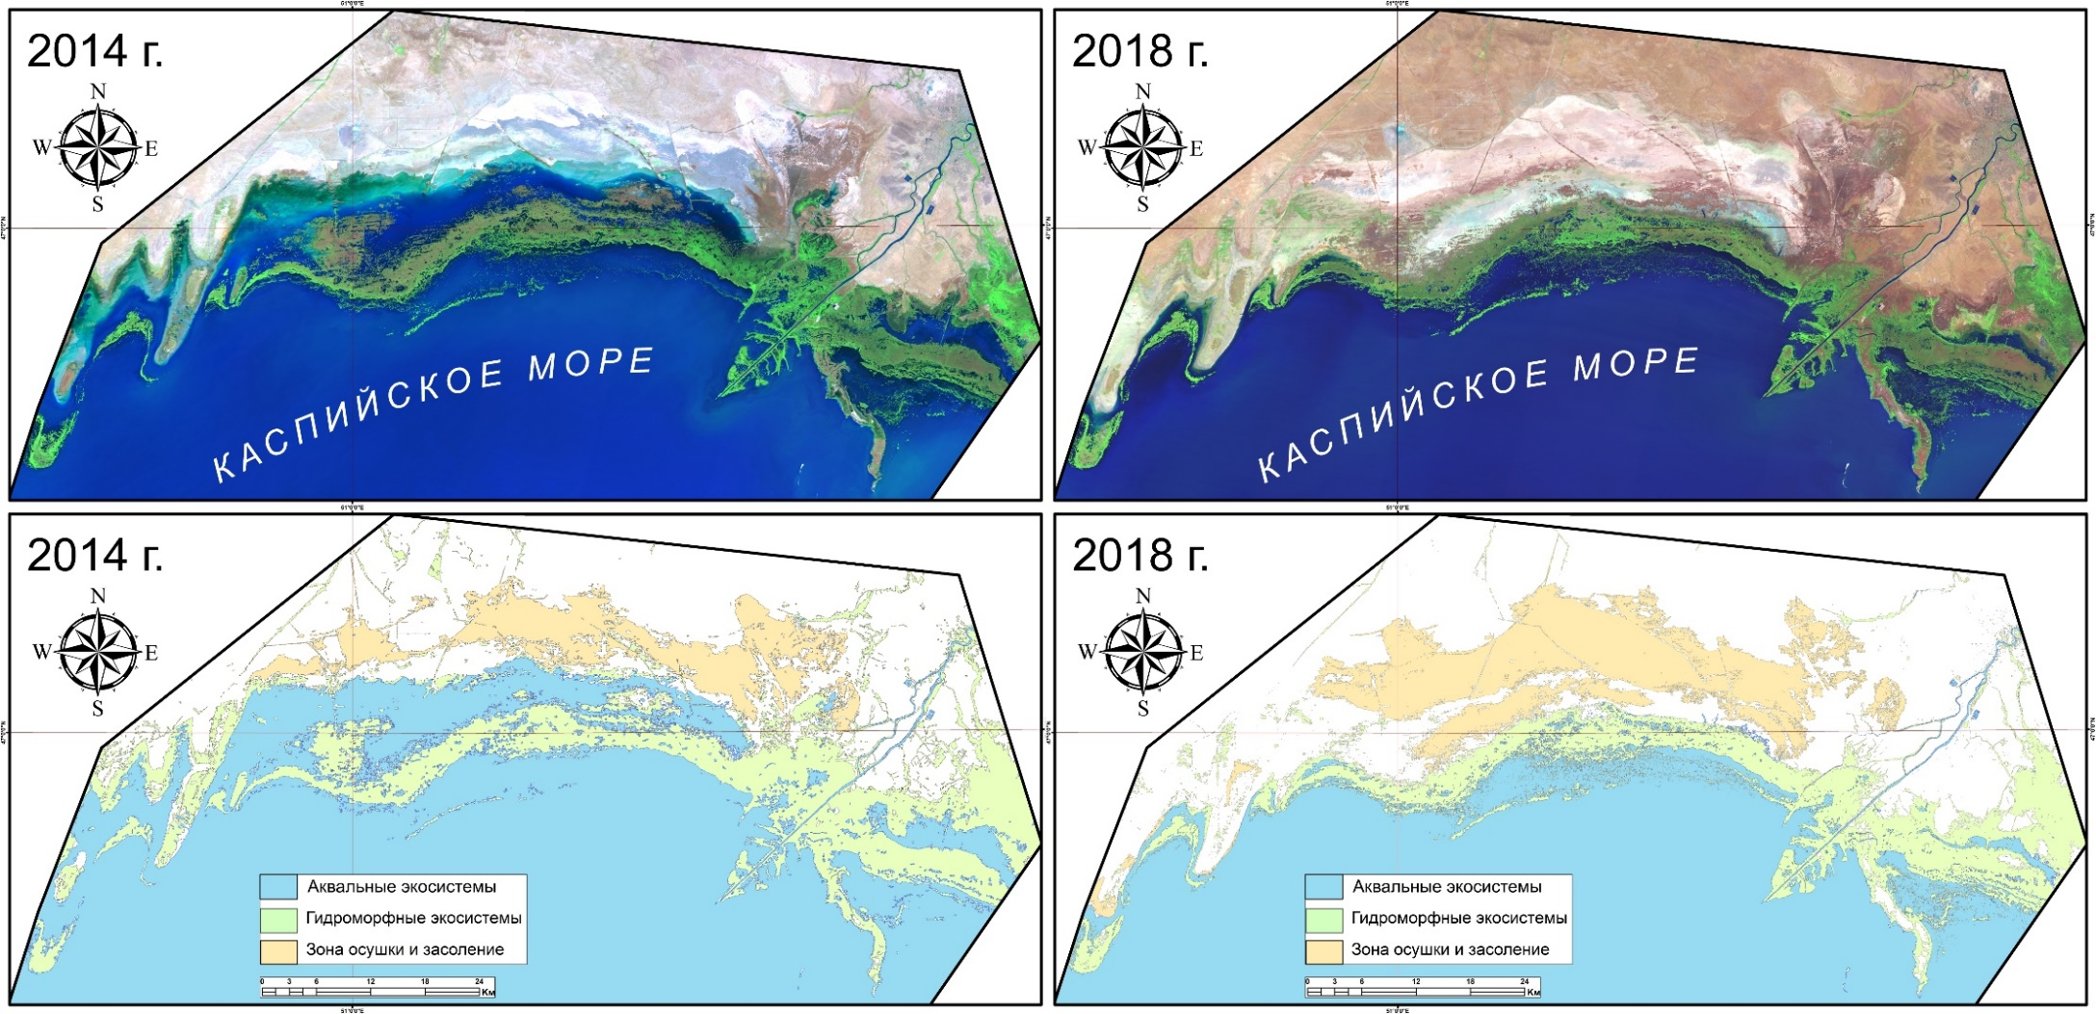

Figure E.3 - Thematic GIS map of changes in aquatic and hydromorphic ecosystems of the Zhaiyk River delta and coastal zones of the Northwest Caspian Sea in 2014 - 2018.

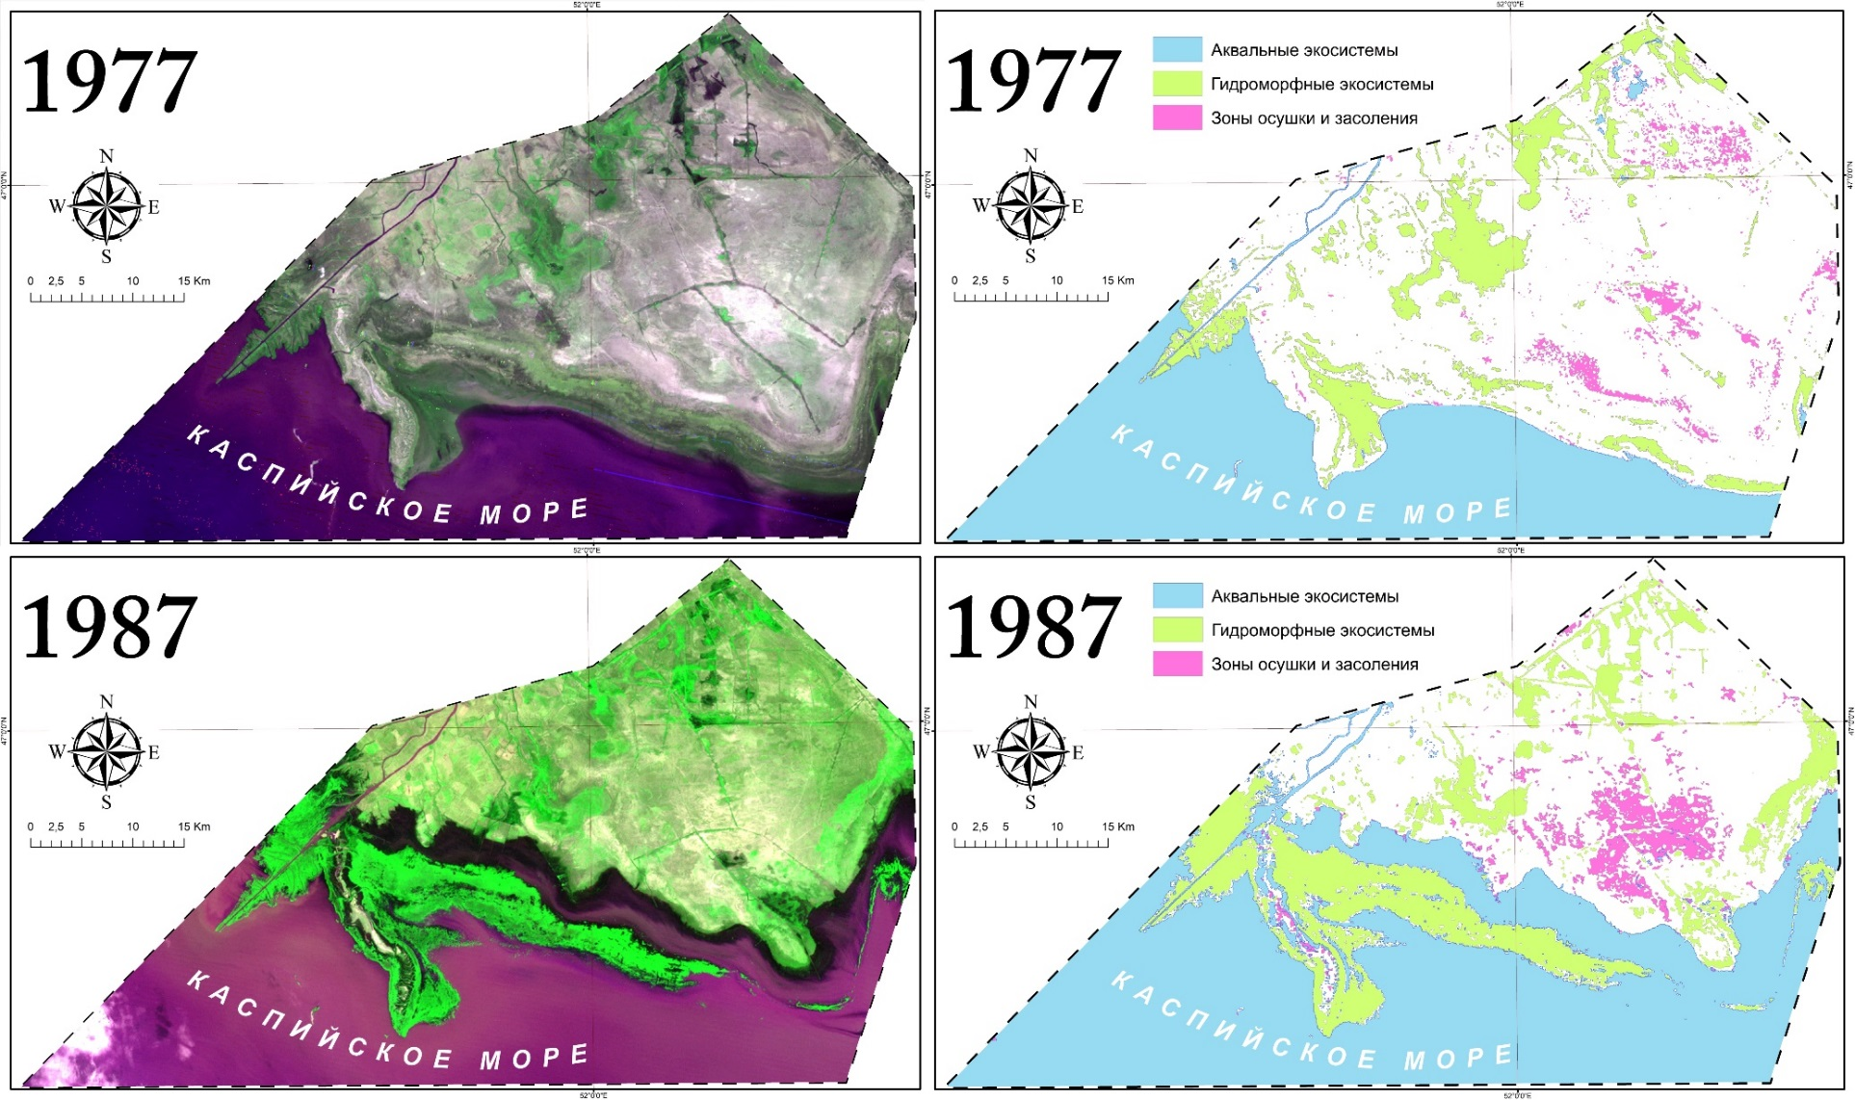
Figure E.4 - Thematic GIS map of changes in aquatic and hydromorphic ecosystems of the Zhaiyk River delta and coastal zones of the Northeast Caspian Sea in 1977 - 1987
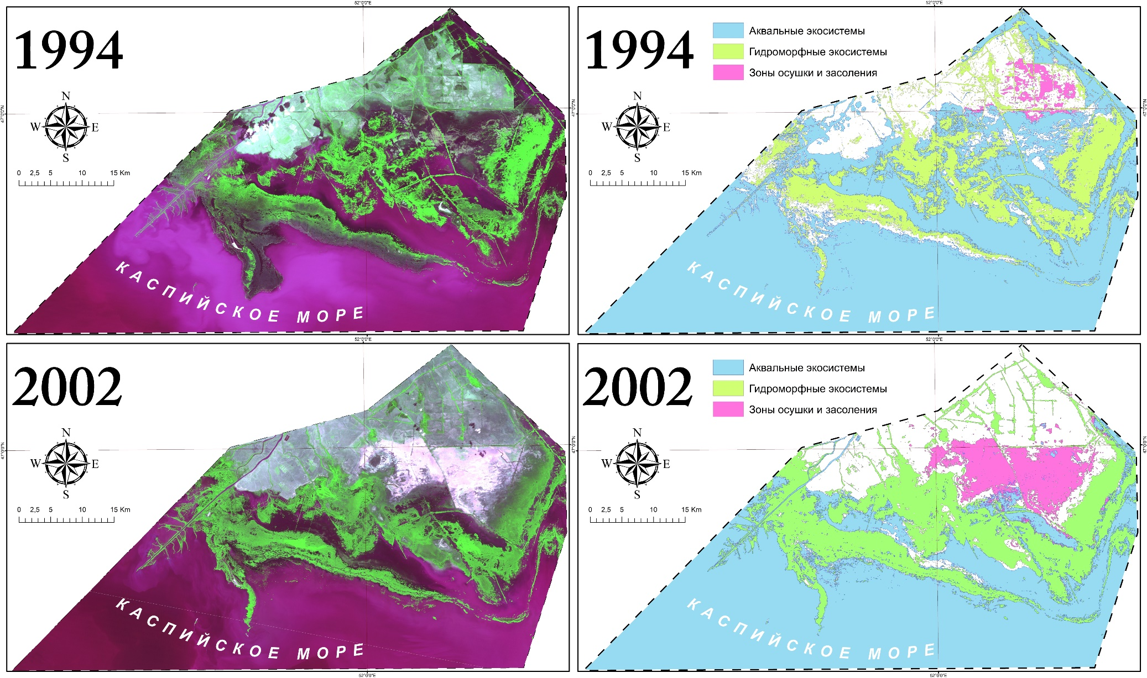

Figure E.5 - Thematic GIS map of changes in aquatic and hydromorphic ecosystems of the Zhaiyk River delta and coastal zones of the
Northeast Caspian Sea in 1994 - 2002
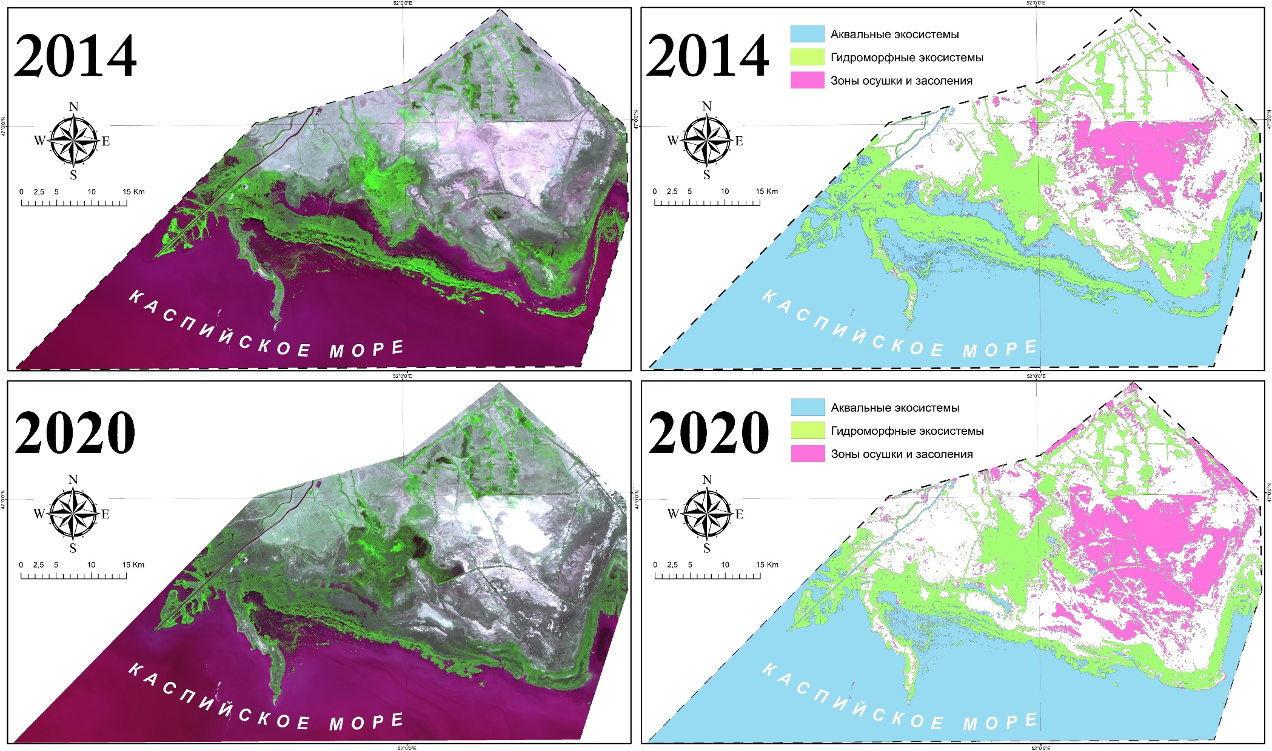
Figure E.6 - Thematic GIS map of changes in aquatic and hydromorphic ecosystems of the Zhaiyk River delta and coastal zones of the
Northeast Caspian Sea in 2004 - 2020.

APPENDIX F

Prints of published publications on the project for 2018
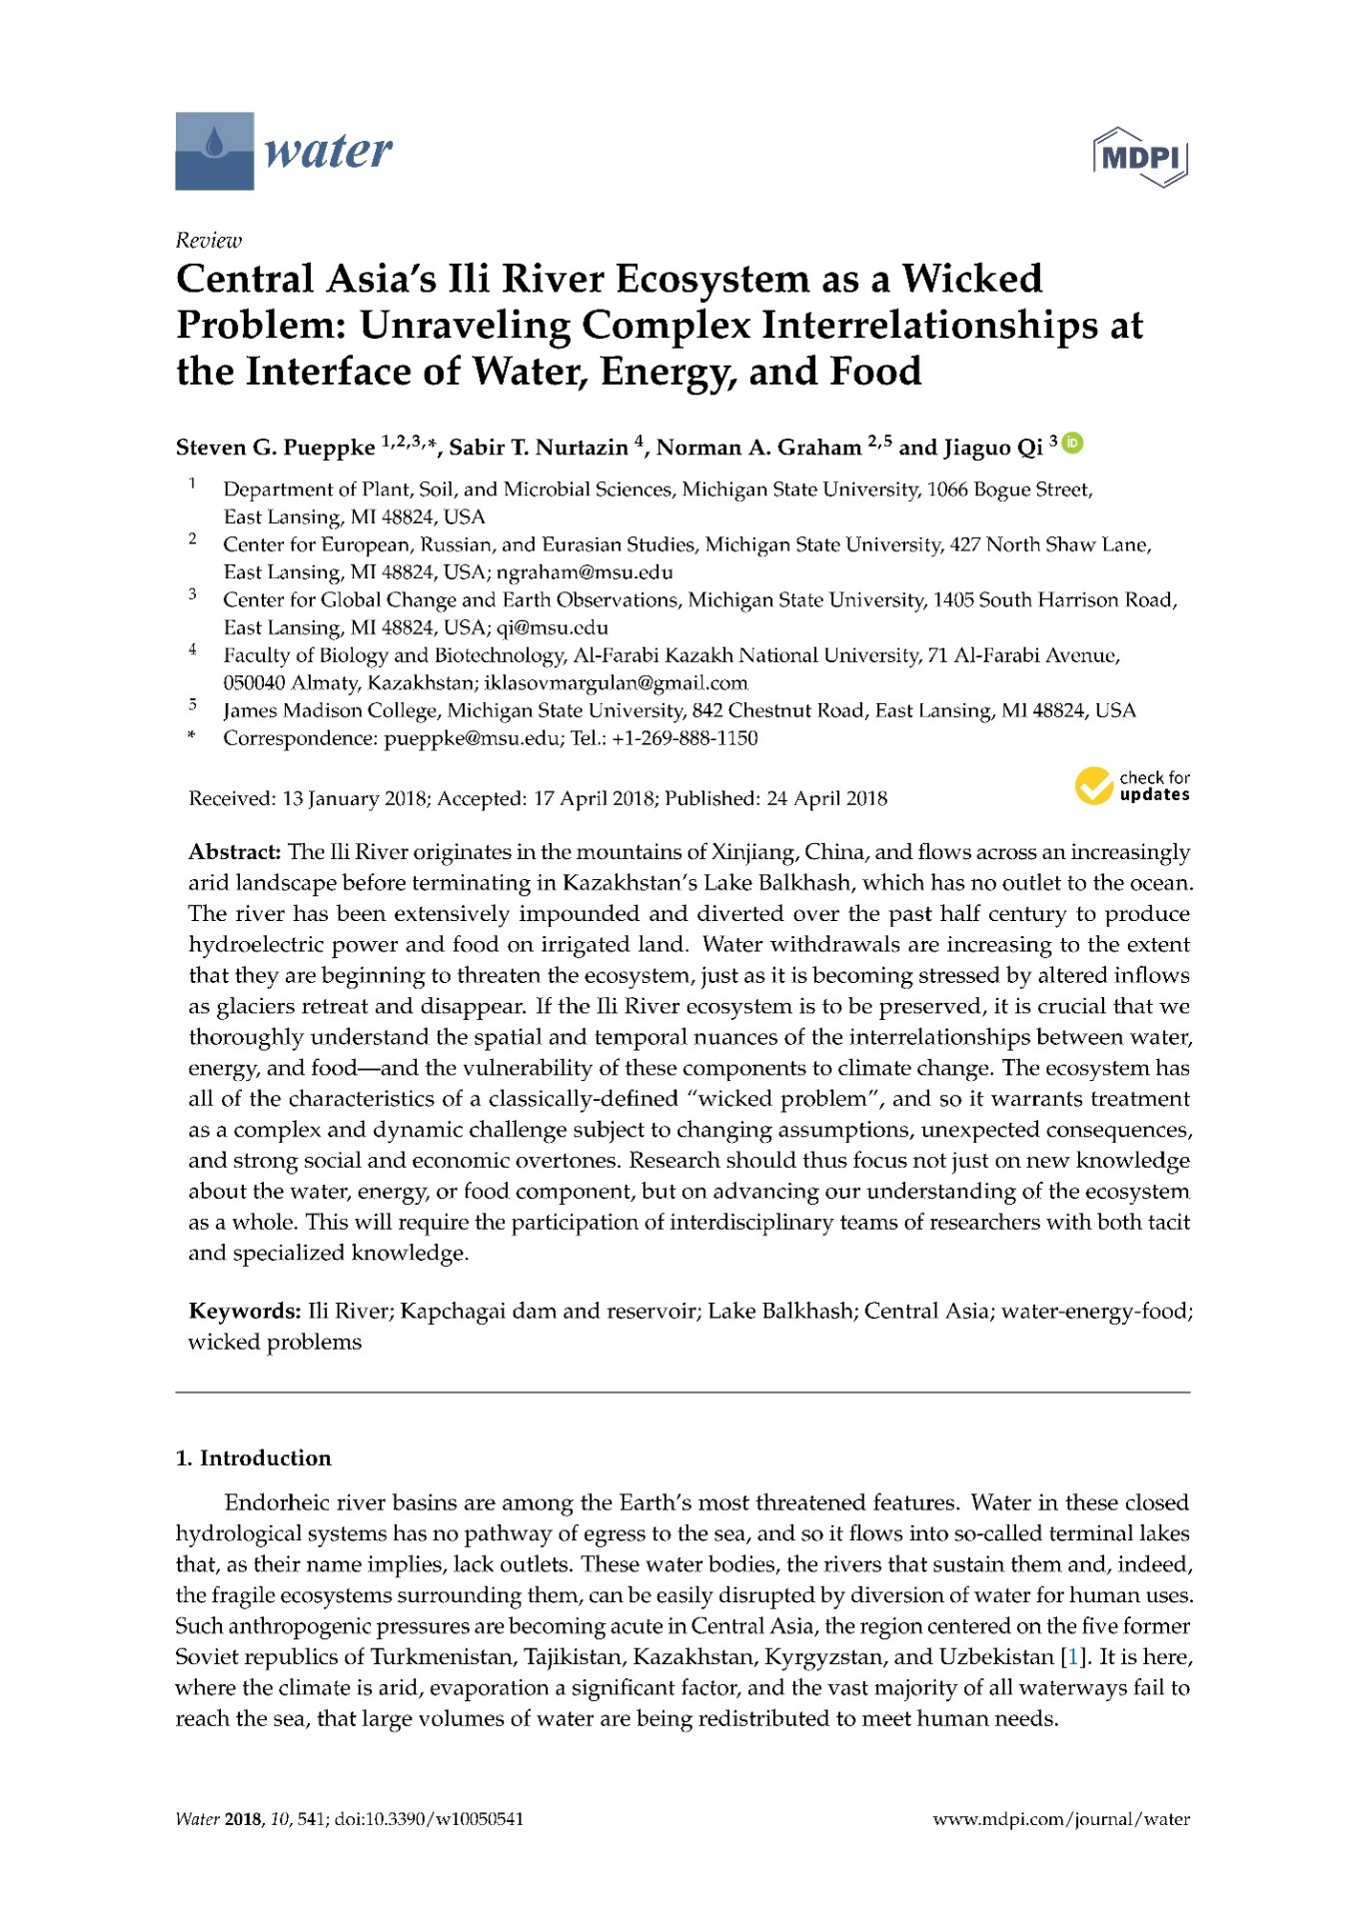

Prints of published publications on the project for 2019

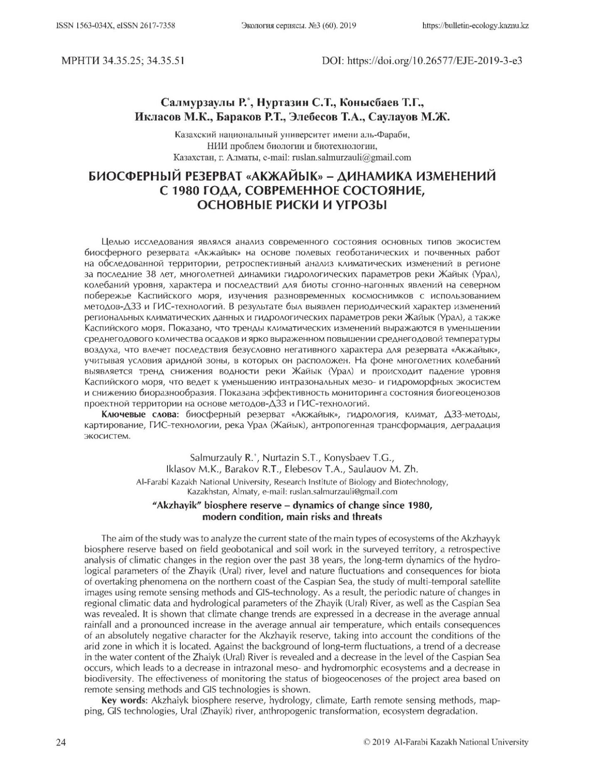
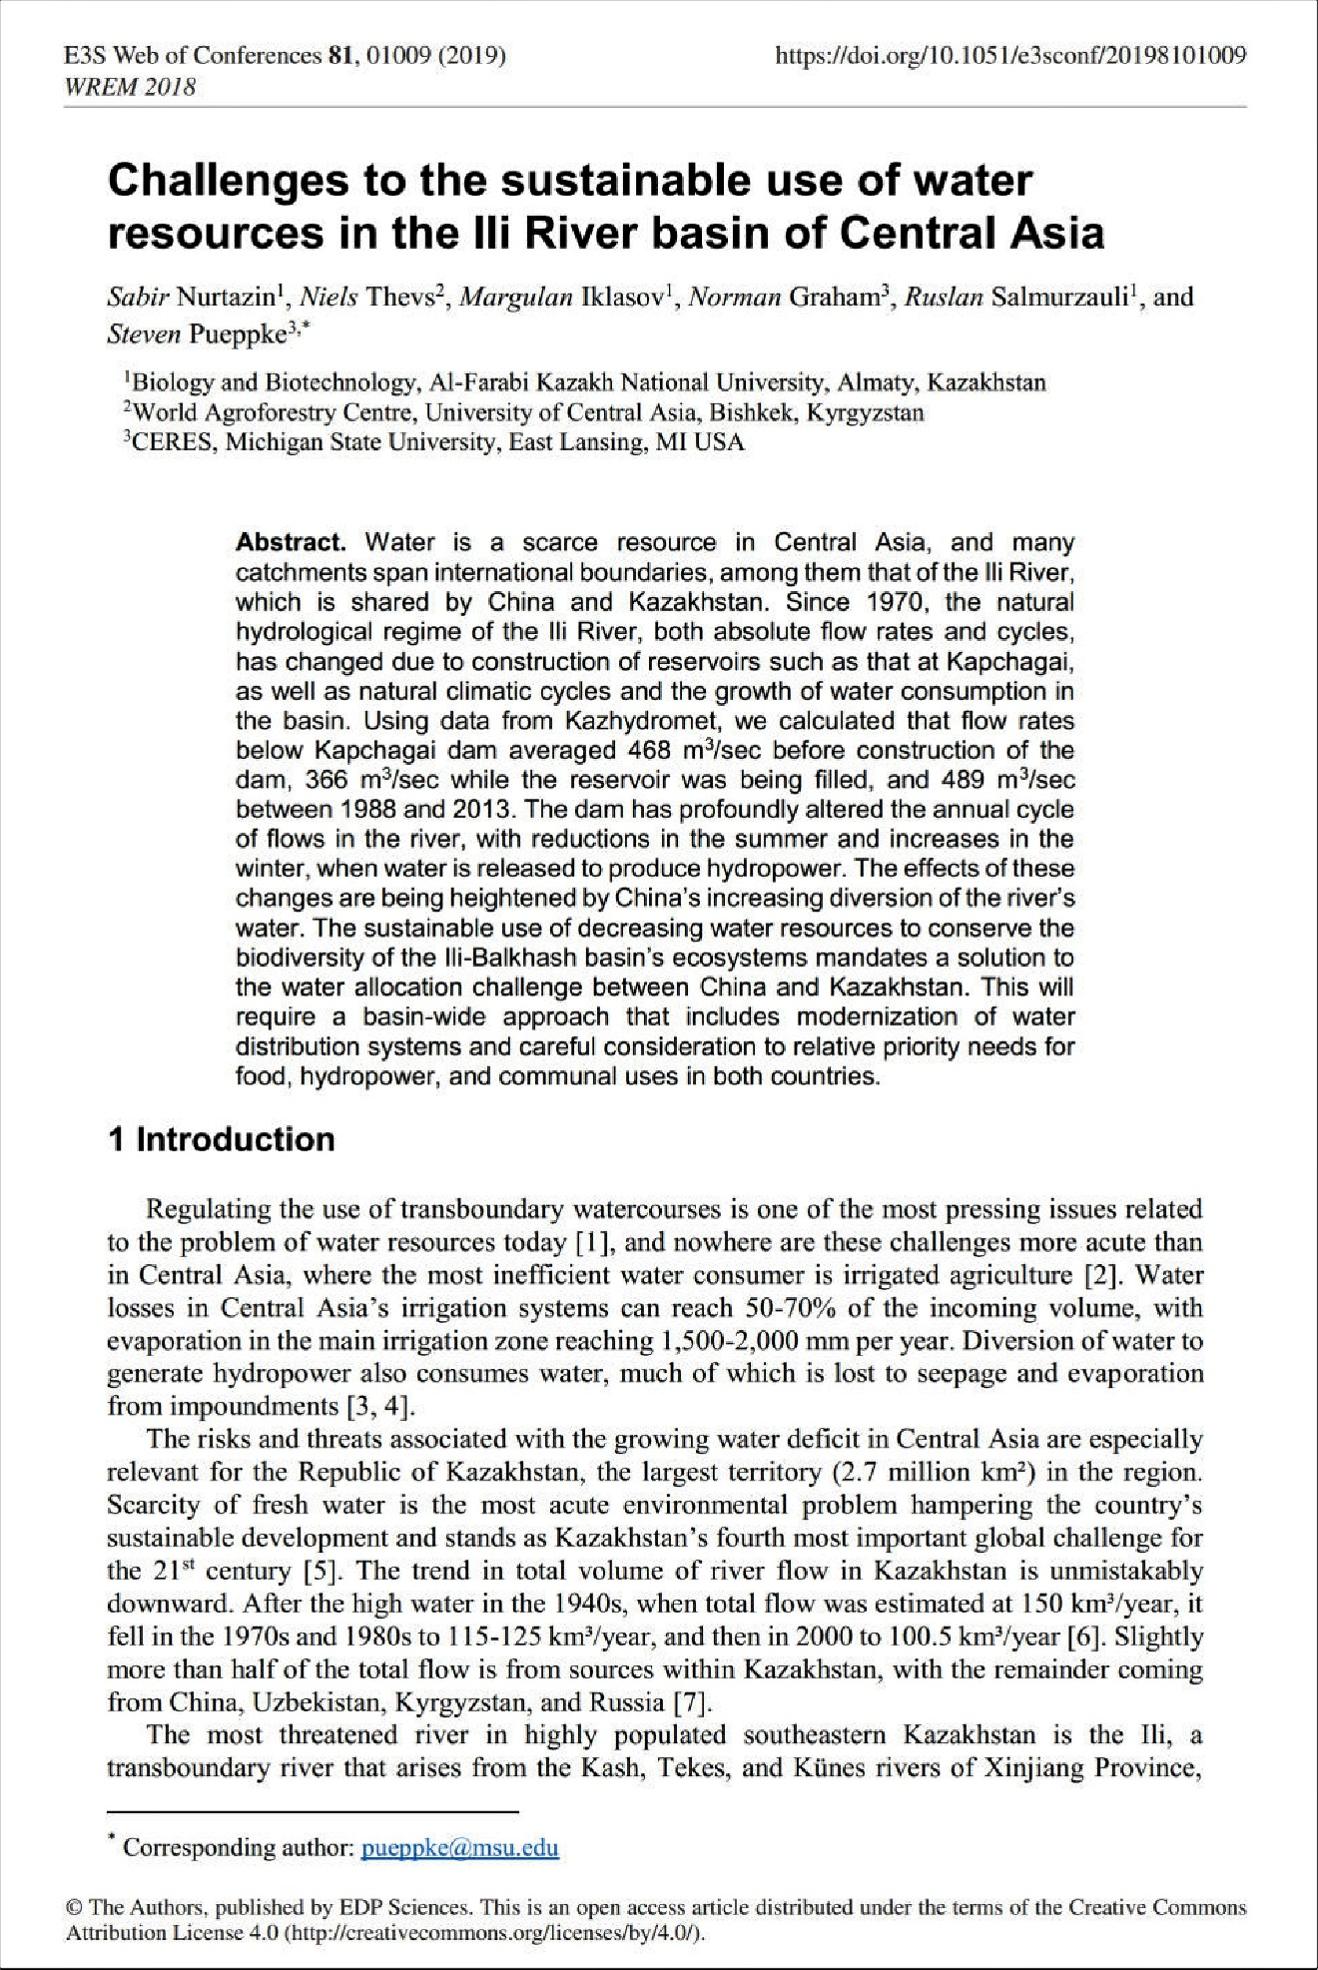

Prints of published publications on the project for 2020

