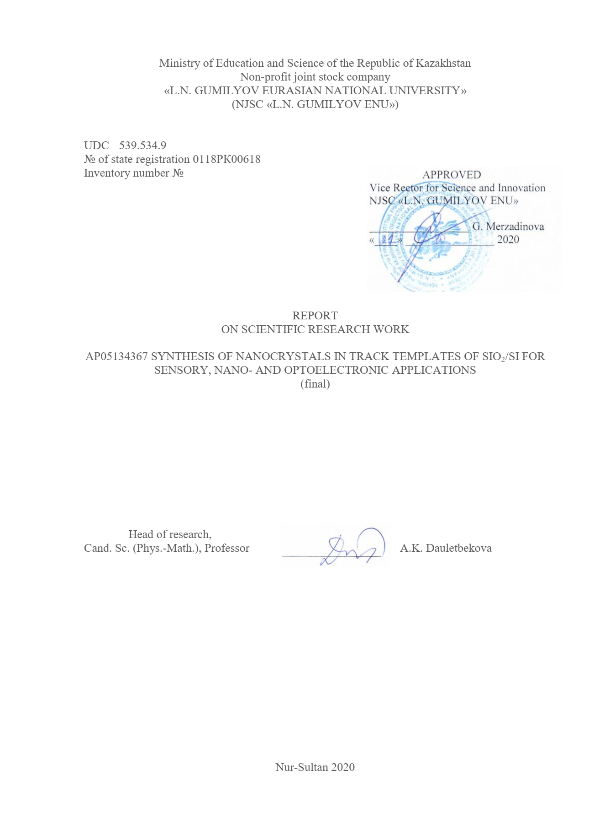
ABSTRACT

Report 48 p., 23 fig., 6 tables, 56 source, 3 app.
swift HEAVY IONS, NANOCRYSTAL, TRACK TEMPLATE a-SiO₂/Si, ELECTROCHEMICAL DEPOSITION, CHEMICAL DEPOSITION
The objects of research are track templates - SiO₂/Si with deposited semiconductor nanocrystals. Research methods: SEM, X-ray structural analysis, measurement of CVC, PL. The aim of the work at this stage was to synthesize nanocrystals based on ZnSe, CdTe, CdSe in а-SiO₂/Si track template and study the properties. The main results at the stage of 2020 for previous years are reflected in the conclusion:
- For two types of ECD electrolytes, CdTe(NCs)/SiO₂/Si-nwith WS monophase were obtained. CD in sulfate solution were obtained CdO(NCs)/SiO₂/Si-n ZBS. Comparison of the deposition results suggests the effect of an electric field on the structure of nanocrystals. ECD and CD on p-type silicon substrate does not lead to deposition into nanopores.
- For the first time, a monophase WZ structure of CdO was obtained at a sufficiently low temperature of 343 K, with a simple CD in a track template.
- Investigation of the I-V characteristic of CdO(NCs)/SiO₂/Si made it possible to estimate the number of grain boundaries ⁓1522 and the height of the grain barrier at 1.05 eV, conductivity - n-type.
- It was found that during ECD, nanocrystals of an oxide compound based on ZnSe, zinc diselenate ZnSe₂O₅(NCs)/SiO₂/Si, are formed. Studies have shown that it is an n-type semiconductor. With CD, a decrease in the inclusion of oxygen in the structure of nanocrystals was obtained and zinc deselenite - ZnSeO₃(NCs)/SiO₂/Si, Si - n and p-type was formed. An increase in the temperature of the CD solution leads to the complete displacement of oxygen from the structure of nanocrystals and forms ZnSe(NCs)/SiO₂/Si, Si - n and p-type on the template surface.
- The band structure of the density of electronic states of CdTe was calculated using the CRYSTAL program. The crystal is direct-gap with the smallest band gap at the T-point.
- Patent of the Republic of Kazakhstan No. 3418 dated 08.21.2020 “A method for producing ZnO nanocrystals in two crystal structures by electrochemical deposition into track templates SiO₂/Si-n” was obtained. Three articles have been published in magazines Q1, Q2.
Applications: for sensor devices, opto-and nano-electronics systems.

CONTENT

INTRODUCTION………………………………………………………………………….. | 6
- Preparation of track templates: irradiation of SiO₂/Si structures, chemical etching……… | 8
2 Research methods. electrochemical or chemical deposition of “cluster-forming” elements of groups II and VI into nanoporous structures SiO₂/Si......................................... | 10
2.1 Research methods........................................................................................................... | 10
2.2 Electrochemical or chemical deposition of “cluster-forming” elements of groups II and VI into nanoporous structures SiO₂/Si……………………………………...………….. | 12
3 Surface, structural, optical and electrophysical properties of the obtained samples. Computer modeling…..……………………………………………………………….……. | 13
3.1 Effect of temperature and deposition methods on the structural properties of CdTe nanocrystals………………………………………………………………………………. | 13
3.2 Effect of deposition methods on structure……..……………………………………... | 16
3.3 Volt-ampere characteristics…………………………………………………………… | 17
3.4 Electrochemical deposition of ZnSe-based nanocrystals ………………..………….... | 20
3.5 Chemical deposition of nanocrystals based on ZnSe and CdSe ……...………………  3.6 Computer modeling…………………………………………………………………… | 22  28
CONCLUSION………………………..…………………………………………………… | 31
REFERENCES……………………………..………...…………………………………….. | 32
APPENDIX А – Calendar work plan …............................................................................ | 38
APPENDIX B – List of published works on the project.................................................... | 43
APPENDIX C – Act on implementation....................................................................... | 48

SYMBOLS AND ABBREVIATIONS

In this research report, the following abbreviations and symbols are used:

α-SiO₂ | – Amorphous SiO₂
Si-n | – Silicon substrate with n-type conductivity
Si-p | – Silicon substrate with p-type conductivity
NCs | – Nanocrystals
WZ | – Wurtzite structure
ZBS | – Zinc blende structure (sphalerite)
FHI | – Fast heavy ions
CD | – Chemical deposition
ECD | – Electrochemical deposition
SEM | – Scanning electron microscopy
AFM | – Atomic force microscopy
PL | – Photoluminescence
XSA | – X-ray structural analysis
VAC | – Volt-ampere characteristics

INTRODUCTION

The goal of the Project was to synthesize nanocrystals based on ZnSe, ZnO, CdTe, CdSe in a SiO₂/Si track template and study their properties.
The relevance and novelty of the research is associated with the production of new nanomaterials using track technologies. Currently, there is particular interest in track technology, since this technology is a tool for obtaining new nanomaterials. Track technologies are based on the idea of using ion tracks [1-4]. The most striking use of this technology relates to the creation of polymer track membranes, the so-called nuclear membranes [5].Nuclear membranes are obtained by irradiation with high-energy heavy ions of a polymer film, followed by physicochemical treatment. As a result, the original film is transformed into a membrane with cylindrical through pores. These systems are widely used in medicine, biology, biotechnology.
At present, nuclear membranes are also used to form various nanomaterials by template synthesis. This method was used to obtain nanotubes of Au, Cu, Ni, Ag, Zn [6-12].
In addition to polymeric materials, a-SiO₂/Si structures are used as track templates. In [13], the formation of nanostructures based on a nanoporous SiO₂ layer on a silicon substrate and the features of these systems are described. Using this type of templates, metal nanocrystals of Au, Cu [14], nanoparticles of Ni, Cu [15], PbSe, CdTe [16] were obtained.
Nanocrystals of semiconductors CdSe, CdS, ZnSe, CdTe, ZnO and others luminesce in the visible spectral range, the intensity of which, in most cases, significantly exceeds that of bulk materials [17]. Zinc selenide nanostructures [18, 19] exhibit luminescence in the red region. CdTe is a direct-gap semiconductor with a bandgap E_{g} = 1.49 eV at 300 K [17]. As is known, cadmium telluride belongs to the materials most suitable for the creation of solar cells [17]. This is due to the width of the forbidden zone, which is close to the optimal value, as well as the high absorption coefficient of light in the entire spectral range of photosensitivity [18]. Zinc oxide is a wide-gap semiconductor with a band gap of 3.37 eV, which allows one to expect intense edge exciton emission of this material formed in silicon dioxide at room temperature.
Research methods: the most modern analytical methods for studying the structure (scanning electron microscopy with energy dispersive analysis, X-ray phase analysis, etc.), the study of electrical and optical properties, computer simulation of properties using the licensed CRYSTAL program.
Direction of work: applied scientific research, creation of new nanomaterials.
Applications: gas sensors, opto- and nanoelectronic systems.
The main tasks of the study at the stage of 2018-2020:
- Develop modes of etching latent tracks of formation of nanopores of a given size and shape in а-SiO₂/Si (n- and p-type silicon substrates);
- To develop modes and carry out ECD or CD of “cluster-forming” elements of groups II and VI into nanoporous structures of а-SiO₂/Si (n- and p-type Si); heat treatment of samples;
- Investigate surface, structural, optical and electrophysical properties of samples;
- Computer modeling of electrophysical and adsorption properties of samples.
The research materials are nanocrystals, nanoclusters based on ZnO, ZnSe, CdSe, CdTe in track templates.
The scientific and technical level (novelty) is that new nanomaterials will be obtained. The reliability of the results obtained is confirmed by:
1) using a complex of modern research methods;
2) the correctness of the formulation of the problems being solved and their physical validity and the use of well-tested methods of physical experiment;
3) wide testing of the obtained data and conclusions of the research at scientific conferences, as well as in publications.
The results can be used to create sensors and devices for opto- and nanoelectronics. The results of the work were discussed together with Corresponding Member of NAS RB, Doctor of Physical and Mathematical Sciences Komarov F.F. and Ph.D. L.A. Vlasukova, Belarusian State University, Minsk, Belarus.

- Preparation of track templates: irradiation of SiO₂/Si structures, chemical etching

a-SiO₂/Si-n or p-typediscs were obtained by thermal oxidation of a silicon substrate (Si-n-type or p-type), with an oxide layer thickness of 600 to 700 nm according to ellipsometry data. The disks were irradiated with 200 MeV Xe ions to a fluence of 10⁷ ions/cm² (Figure 1a). Samples of 5x5 mm and 20x20 mm were cut from the disks.
Chemical etching is a process of pore formation, during which the damaged area of the latent track is removed and turns into a hollow channel (pore) [20, 21]. Chemical etching of SiO₂/Si samples was carried out in a 4 or 1% aqueous solution of HF, the etchant contained m (Pd) = 0.025g, the etching temperature was Т=18˚±1°С (Figure 1b).
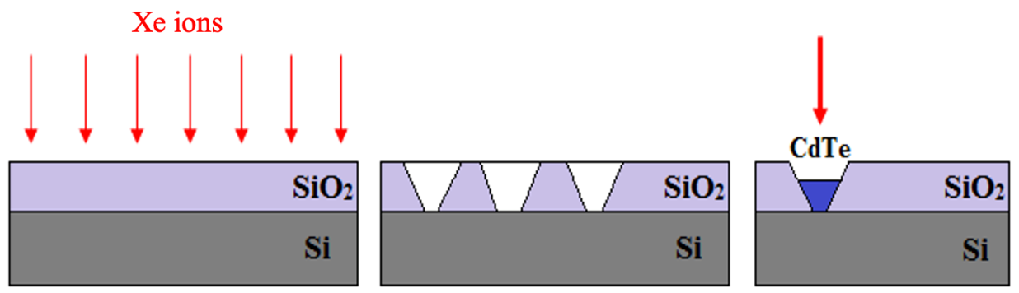
а) b) c)
а) irradiated substrate; b) etched tracks;с) besieged tracks

Figure 1 – Schematic representation of the preparation of the track template

By varying the etching time, nanopore diameters from 200 to 350 nm were obtained (Figure 2).
Etching was carried out in a special cabinet (Figure 3). Before etching the tracks, the surface of the samples was ultrasonically cleaned with visopropanol for 15 minutes in a 6.SB25-12DTS ultrasonic cleaner.
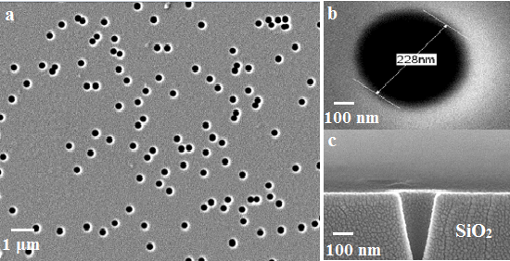
a) general view of the etched surface; b) enlarged nanopore; с) cross section of a nanopore

Figure 2 – SEM image of the track template SiO₂/Si

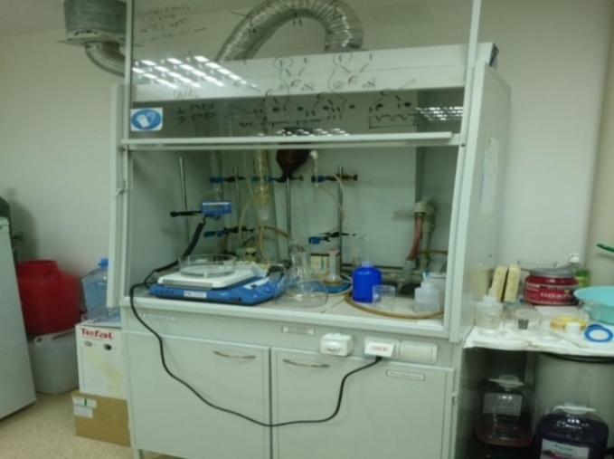

Figure 3 – Fume hood for etching in HF

The cleaner at two frequencies (25kHz/40kHz) provides intensive cleaning of the sample surface. Control range (room temperature) – 80˚С. After treatment in HF, the samples were washed in deionized water (18.2 MΩ).
The analysis of nanopores after etching was carried out on a JSM-7500F SEM (Figure 4). Rows of nanochannels were obtained having a conical shape with a cut off top. The shape and size of nanopores was controlled by the etching time.

2 Research methods. electrochemical or chemical deposition of “cluster-forming” elements of groups II and VI into nanoporous structures SiO₂/Si

2.1 Research methods
The surface of the samples after etching, after deposition was examined on a scanning electron microscope JSM 7500FJEOL, Japan (Figure 4a).

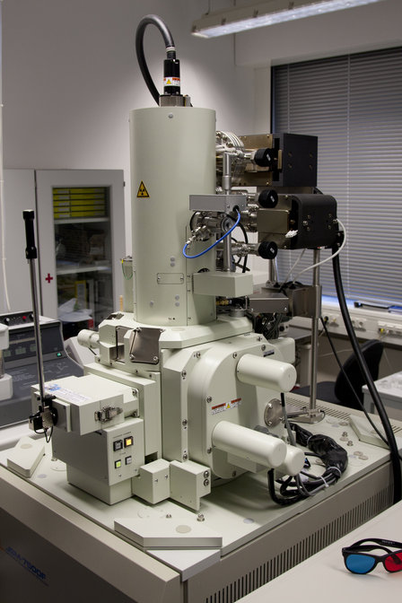 | 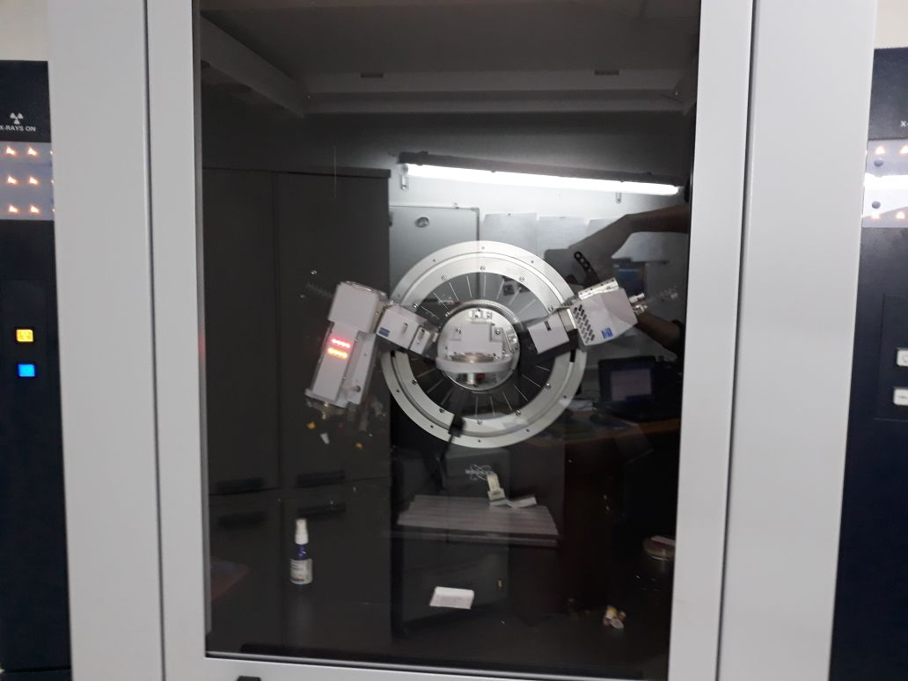
a | b
a) Field emission scanning electron microscope JSM-7500F;
b) X-ray diffractometer D8 ADVANCE ECO

Figure 4 – Devices for SEM and XRD

X-ray diffraction analysis (XRD) was carried out on a D8 ADVANCE ECO X-ray diffractometer (Bruker, Germany) (Figure 4b) using an X-ray tube with Cuanaod (Cu Kαλ=0.154 nm, 40 pV, 25 mA), in the angular range 2θ (30° –110°) with a step of 0.01° (measurement time - 1 s). The X-ray tube was operated under the following conditions: voltage - 40 kV, current - 25 mA. The crystal lattice parameters, as well as the dynamics of their change, were determined using the DiffracEVA v.4.2 program code. The degree of perfection of the crystal structure was assessed using the TOPAS v.4 program code.
X-ray diffraction analysis of the samples was also carried out on a Miniflex 600 X-ray Diffraction (XRD) Analyzer (Rigaku) using an X-ray tube with a Cu anode in the angle range 2θ0⁰ – 90⁰ with a step of 0.020. Shooting parameters: cathode current 15 mA, accelerating voltage 40 kV, sweep speed 10 deg/min.
An HP 66312A current source and an Agilent 34401A multimeter (USA) were used to measure and electrical properties. The setup for measuring the I-V characteristic is shown in Figure 5.
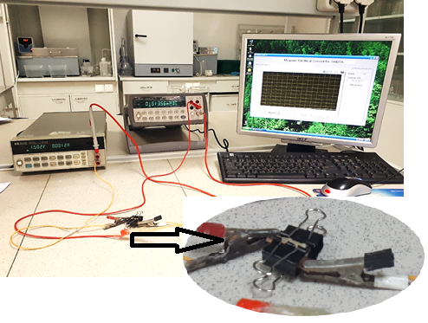

Figure 5 – Measurement of current-voltage characteristic

The photoluminescence (PL) spectra were measured using an Agilent CaryEclipse fluorescence spectrophotometer at the Open-Type National Nanotechnological Laboratory at Al Farabi KazNU (Figure 6). The light source in the spectrofluorimeter is a flash xenon lamp.

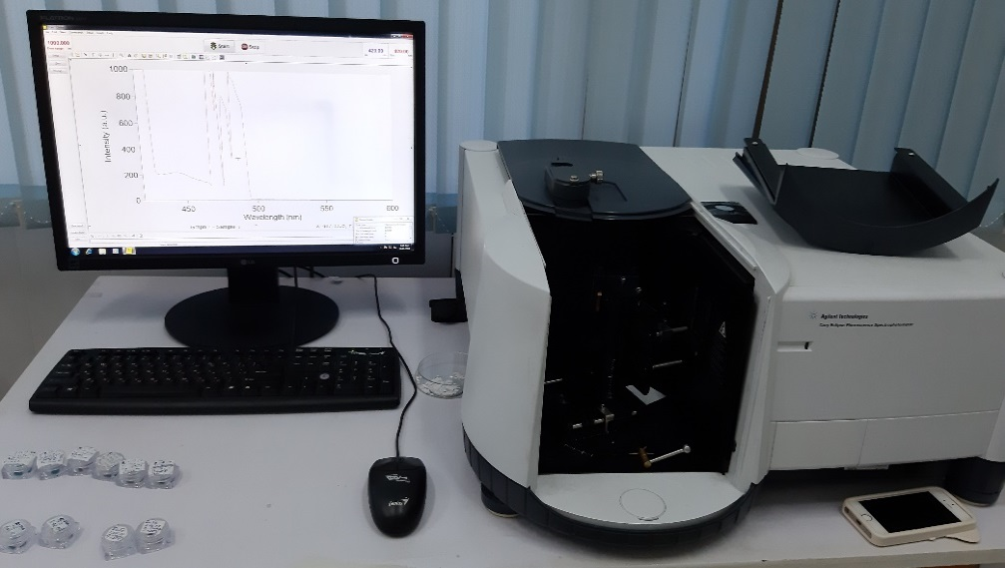

Figure 6 – Fluorescence spectrophotometer

The device uses diffraction gratings 30x35 mm, 120 lines/mm. The optical excitation and emission range is from 190 to 1100 nm. The spectral region selected by the slit can vary discretely within 1.5, 2.5, 5, 10 nm.

2.2 Electrochemical or chemical deposition of “cluster-forming” elements of groups II and VI into nanoporous structures SiO₂/Si
Since the chemical deposition technique does not require special equipment, for deposition, all the constituents of the solution are dissolved using a magnetic stirrer in 100 ml of deionized water (Figure 7a). For ECD, a special cell is made (Figure 7b, c).
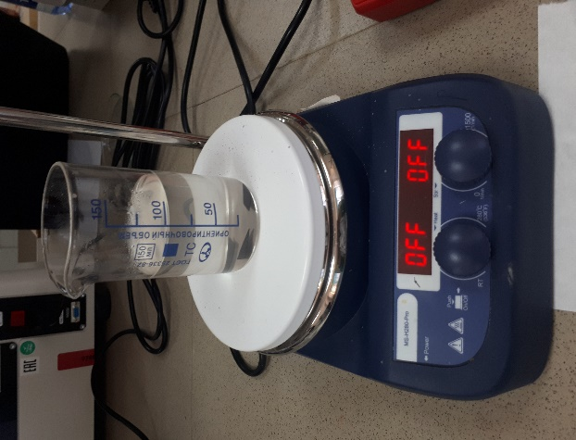  a) | 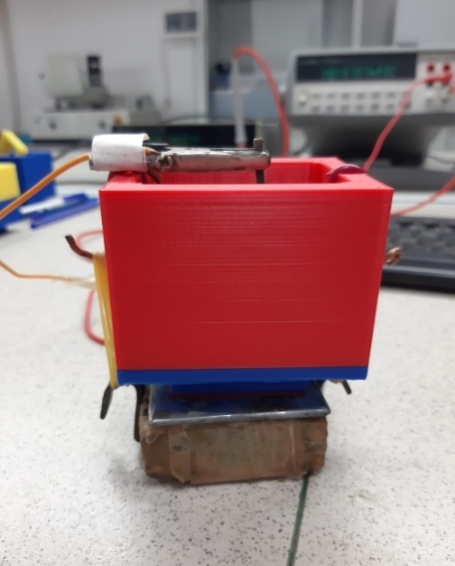  b) | 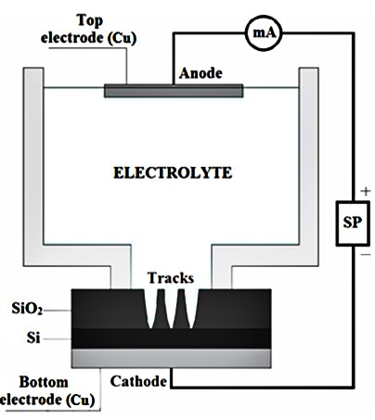  с)

а) chemicaldeposition; b) electrochemical deposition; с) ECD cell model

Figure 7 – Devices for chemical and electrochemical deposition

The composition of the solution is given for each specific case, as well as the voltage on the electrodes and the material of the electrodes.

3 Surface, structural, optical and electrophysical properties of the obtained samples. Computer modelling

3.1 Effect of temperature and deposition methods on the structural properties of CdTe nanocrystals
The n-type а-SiO₂/Si samples were 700 nm thick, irradiated with 200 MeV Xe ions to a fluence of 10⁷ ion/cm². Samples were cut with dimensions 5x5mm and 20x20mm. Chemical etching was carried out in a 4% aqueous solution of HF, the etchant contained m(Pd) = 0.025 g, the etching temperature was T=18˚±1°С.Before and after etching, the samples underwent ultrasonic cleaning of the surface. By varying the etching time, the nanopore diameters were obtained from 200 to 350 nm. Chemical deposition (CD) of CdTe into an n-type template using a sulfate solution was carried out for 1 hour. Electrochemical deposition (ECD) of CdTe in an n-type template using sulfate and chloride solutions was performed in a constant voltage mode on the electrodes - 1.5 V for 5 and 10 minutes. Chemical deposition of CdTе was carried out using a sulfate electrolyte: 1M CdSO₄+1mMTeO₂. CdSO₄ was dissolved in water, TeO₂ - in a minimum amount of concentrated sulfuric acid. By combining the two solutions and brought the pH to a value of 2; Electrochemical deposition of CdTе was carried out using two electrolyte systems: 1) sulfate, the composition is similar to that used for CW; 2) 1МCdCl₂+1mMTeO₂.CdCl₂ was dissolved in water, TeO₂ - in a minimum amount of concentrated hydrochloric acid. The two solutions were combined, and the pH was adjusted to 2. TeO₂ is extremely poorly soluble in sulfuric acid; neither concentrated sulfuric nor its solutions dissolve this oxide quickly. It takes several hours to dissolve in sulfuric acid when heated. In hydrochloric acid, this oxide dissolves instantly.
Figures 8 (a, b) and 9 (a, b) show the corresponding SEM images of filled nanopores after CD.
X-ray diffraction analysis of samples obtained using CD showed the formation of CdTe nanocrystals in the structure of zinc blende and cadmium oxide with a hexagonal crystal structure (Table 1).

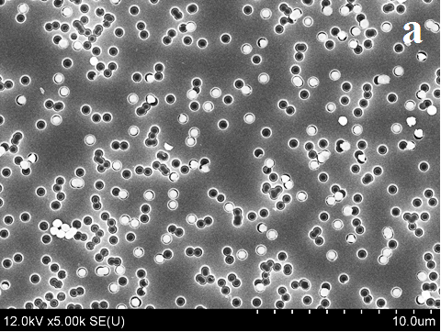

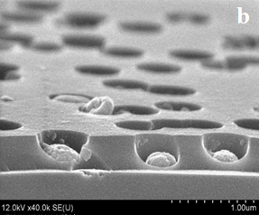

a) SEM images of the frontal and b) cross section of n-type template surfaces after CdTe CD at room temperature

Figure 8 – SEM images of filled nanopores after CD of CdTe

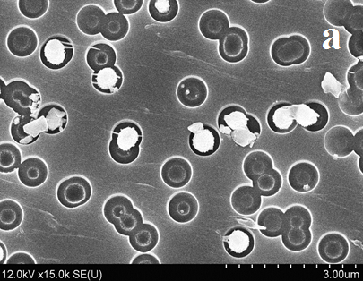

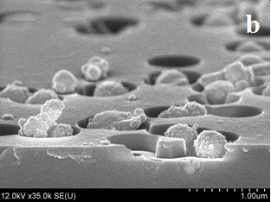

a) SEM images of the frontal and b)cross section of the n-type template surface after CD of CdO at 40°C
Figure 9 – SEM images of filled nanopores after CD of CdO

Table 1 – Results of X-ray diffraction analysis after chemical deposition
T=298 K
Phase | Structure | Space group | (hkl) | 2θº | d, Å | Crystal lattice parameters, Å | Crystallinity,% | Phase content,%
CdTe | Cubic | F-43m(216) | 220 | 40.34 | 2.233 | a=6.31817 | 54 | 68.4
CdTe | Cubic | F-43m(216) | 311 | 46.96 | 1.933 | a=6.31817 | 54 | 68.4
CdO | Hexagonal | P63mc(186) | 002 | 32.18 | 2.779 | a=3.54588, c=5.72256 | 54 | 31.6
CdO | Hexagonal | P63mc(186) | 101 | 33.31 | 2.687 | a=3.54588, c=5.72256 | 54 | 31.6
CdO | Hexagonal | P63mc(186) | 103 | 56.62 | 1.624 | a=3.54588, c=5.72256 | 54 | 31.6
T=343 K
CdO | Hexagonal | P63mc(186) | 311 | 47.52 | 1.911 | a=3.56465, c=5.72368 | 61 | 100

An increase in the electrolyte temperature during CD leads to an increase in the fraction of the cadmium oxide phase, and only cadmium oxide crystallites with a hexagonal crystal structure are formed in nanopores at 343K. It is well known that cadmium oxide is an n-type semiconductor [22]. Table 2 also presents the main characteristics of the studied samples obtained by the ECD method from sulfate and chloride solutions before and after annealing at T=100°C.

Table 2 – Results of X-ray structural analysis after electrochemical deposition
Parameters | CdTe(chloride solution) |  | CdTe(sulfate solution)
Parameters | Initial | 100°С | Initial | 100°С
Crystal lattice parameters, Å | а=4.53445Å,  с=7.43525Å | а=4.52033 Å,  с=7.42212 Å | а=4.51185 Å,  с=7.40234 Å | а=4.51015 Å,  с=7.40214 Å
Average crystallite size, nm | 11.24 | 12.84 | 11.19 | 10.15
Crystallinity,% | 54.5 | 72.6 | 45.1 | 51.2

Comparison of our experimental values of the unit cell parameters of CdTe (Tables 1 and 2) with the literature data: sphlerite (ZBS) a = 0.6478 nm, z = 4, space group F43m [23] and wurtzite (WS) a = 0.457 nm, s = 0.747 nm, z = 2 [23], indicate good agreement.Studies of thin CdTe films carried out by the method of X-ray structural analysis showed that the microstructure of the films depends on the substrate temperature, and in this case, the formation of amorphous, hexagonal and cubic modifications is possible [24-29]. The microstructure of CdTe films depends on the substrate temperature: at 493 K, a cubic body-centered one is formed, and at 620 K, a hexagonal one [30]. There is a sufficient number of works where thin and relatively thick films of cadmium oxide telluride on various substrates have been obtained [27, 31-33]. However, the authors of these works strove to obtain polycrystalline films. We have obtained a monophase wurtzite structure of cadmium oxide at a sufficiently low temperature of 343 K by simple chemical deposition into a track template.

3.2 Effect of deposition methods on structure
Thus, when using the same solution for CD and ECD, we get different crystal structures due to the presence and absence of an electric field. Here, one should take into account the influence of charged defects arising during irradiation of the a-SiO₂/Si-n structure. Our photoluminescence study for irradiated SiO₂/Si showed that the PL spectrum of the initial SiO₂/Si sample includes only one weak band at 450 nm. It should be noted that the overlapping of tracks up to a fluence of 1∙10¹⁰cm⁻² is insignificant. Annealing does not change the PL spectrum of the initial sample. Therefore, this band can be attributed to intrinsic defects of silicon dioxide, the so-called ODC (II) of the oxygen-deficient center (II) [28–30].Thus, point defects will not have a significant effect. Tracks arising from irradiation in a layer of amorphous silicon dioxide mainly contain dangling oxygen bonds, which leads to siliconization of the track surface. Under the influence of an external field during ECD, negatively charged oxygen ions and hydroxyl groups accumulate in the surface layer of the dioxide. Thus, an additional electric field appears. As a result, the Cd²⁺ and Te⁴⁺ ions in the electrolyte will be more mobile than in the usual CD process. In addition, the mass ratio m_{Сd}/m_{Te} = 4, tellurium ions will be more mobile than cadmium. These conditions are more convenient for the formation of wurtzite-type CdTe nanocrystallites. This assumption is confirmed by the results obtained in [31], when, during electrodeposition of CdTe films from an alkaline solution, the composition and phase structure of the film changed depending on the position on the electrodes. The wurtzite phase increased with increasing potential. In the absence of an external field, free movement with free conditions will form a sphalerite structure and cadmium oxide in a hexagonal structure. An increase in temperature leads to an increase in the role of oxygen, leading to the formation of TeO₂, associated with the oxidation of tellurium with an increase in temperature.

3.3Volt-ampere characteristics
The current-voltage characteristic was performed by connecting a controlled current source to the sample electrodes and using measuring instruments, voltmeters and ammeters, the voltages and currents in the sample circuits are measured at different voltage values (Figure 5, section 2.1).The obtained volt-ampere characteristics for the samples synthesized at different temperatures have a different form, which is due to the difference in the phase composition.
In our case, CdO also has n-type conductivity. The conductivity of polycrystalline samples is strongly influenced by grain boundaries. This is clearly seen from two VACs. The I-V characteristic for a sample containing two phases CdTe + CdO (Figure 10, curve 1) is much lower than the I–V characteristic of a single phase CdO sample (Figure 10, curve 2).

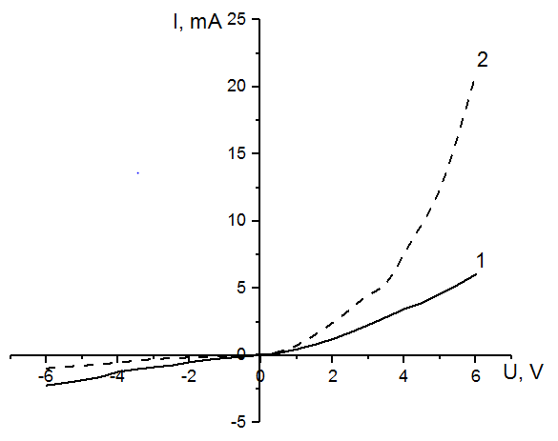
Figure 10 – I-V characteristics of CdTe and CdO (chemical deposition) at room temperature
1 – n-typeCdTe +CdO 25°C, 2 – CdONCs/SiO₂/Si

Figure 11 – VAC obtained for CdTe (WZ NCs)/SiO₂/Si (electrochemical deposition)

Diffusion and thermionic models are used to explain the conductivity of polycrystalline samples. If the barrier width W is much larger than the carrier mean free path I, then the diffusion theory is applicable. The thermionic emission model is applied in the case I> W. In accordance with this model, the boundary can be crossed only by those carriers whose kinetic energy is greater than the height of the barrier.
If we consider that for each barrier, we assume that we have barriers of the same type, on average, a voltage V/m is applied (m is the number of barriers between the electrodes, V is the inter-electrode voltage), then for the current-voltage characteristic, we can write the relation:

$I=I_{0}exp⁡[\frac{\left(-e\left(φ- \frac{V}{m}\right)\right]}{kT},$ $I=I_{0}exp⁡[\frac{\left(-e\left(φ- \frac{V}{m}\right)\right]}{kT},$ (1)

which determines the height of the potential barrier φ and the number of barriers connected in series m. This ratio was used to analyze the current transport in polycrystalline gallium phosphite [27, 28]. The number of barriers can be estimated from the formula

$m= \frac{H}{h_{k}},$ (2)

where H is the height of the nanopore,$h_{k}$ is the linear size of the nanocrystallite, for which we took the average value of the crystal lattice parameters from Table 3.

Table 3 – Parameters of intercrystalline barriers in CdO nanocrystallites
H, nm | T, K | m | $h_{k}$h_{k}, Å | Barrier height E, eV
700 | 300 | 1522 | 4,6 | 1,05

It is known that for CdTeWZ it is a metastable phase, which is difficult to obtain under normal conditions [34]. Therefore, it is clear why efficient solar cells based on CdTe ZB are being created [35, 36].Note that only a small number of studies have been devoted to CdTe with the WZ structure [37–40]. In particular, polycrystalline CdTe WZ films were obtained by ECD in an acid solution [41] and alkaline solutions [42, 43]. It was found that the composition and phase structure strongly depend on the voltage applied to the electrodes.The formation of CdTe NC in various forms is a rather difficult task. Therefore, to obtain NC CdTe in the form of dots, rods, tetrapods, either a high-temperature (up to 200 C) hot injector based on an organic solvent or the corresponding low-temperature (<100° C) method based on an aqueous solution is used [38, 44].When fabricating CdTe with a branched architecture, it was found that phase control and switching play a very important role in achieving the branched shape [44, 45]. During the formation of branched CdTeNCs, the zinc blende phase with the growing wurtzite phase is generated.To recover CdTeNCs from the reaction system, the CdTeNCs product is washed with a solvent and separated by centrifugation. Further operations ensure the production of CdTeNCs for the manufacture of various devices [46].In [46], the latest achievements and prospects in this area are considered, focused on new knowledge about the synthesis of CdTe NC, the fabrication of devices, work with solar cells from CdTe NC, and based on the conclusions, recommendations are given for optimizing the operation of solar cells.
In our Project, we have successfully obtained CdTe nanowires with a WZ crystal structure by simple ECD at room temperature. The resulting CdTe (WZ NCs)/SiO₂/Si system can be easily integrated into silicon technologies.
In the CdTe (WZ NCs)/SiO₂/Si, Si, structure, the substrate has n-type conductivity. From the analysis of the CdTe (WZ NCs)/SiO₂/Si structure CdTe (WZ NCs)/SiO₂/Si, it can be argued that this structure exhibits an electronic type of conductivity. We calculate the conductivity of nanowire arrays using the formula:

(3)

where l – length of the nanowire, approximately corresponds to the thickness of the oxide layer - 700 nm, A is the area and dI/dU is the tangent of the slope angle I–U.
In accordance with the I-V characteristic (Figure 11), the differential resistance at forward voltage R=ΔU/ΔI≈1V/8mA=29,2Ohm. A=2πr²≈2x3.14x1372nm²=117869 nm², σ = 700nm/29,2x117869nm²=2x103 Ohm cm⁻¹.It is important to note that this CdTe (WZ NCs) / SiO₂/Si structure has one-sided conductivity.
Thus, such a structure can potentially be used in devices where the reverse current is unacceptable or should be negligible. It should be noted that ECD and CD of CdTe in templates with a p-type substrate using sulfate and chloride solutions did not fill the nanopores, which requires an explanation.

3.4 Electrochemical deposition of ZnSe-based nanocrystals
The morphology and transverse cleavage of the obtained samples after deposition were investigated using a Hitachi S-4800 scanning electron microscope with gold deposition. ECD was carried out in electrolyte: ZnSO₄×7 H₂O- 7.2 g/L; SeO₂- 0.2 g/l. The precursors ZnSO₄ and SeO₂were dissolved in deionized water, then the two solutions were mixed. Deposition was carried out at a voltage of U = 1.25 V for 15 min at room temperature (18°C).
Investigation of the surface and cross section of track templates after deposition
Figure 12 shows SEM images of samples after ECD. Analysis of SEM images showed that the filling of nanopores is 80%.

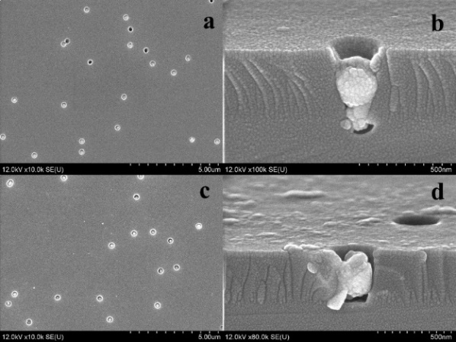

a, с – depicted surfaces, b, d – cross section
Figure 12 – SEM images of the surface and cross sectionof two samples deposited at 1.25 V

Figure 13 and Table 4 show the XRD results for one of the samples.
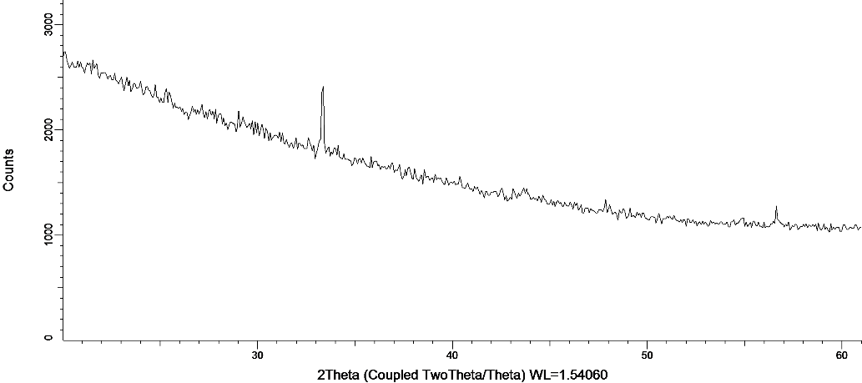

Figure 13 – X-ray diffractogram of the test sample

Table 4 – Parameters of nanocrystals ZnSe₂O₅
Phase | Structure type | Space group | (hkl) | 2θº | d, Å | L, nm | Cell parameters, Å | Crystallinity %
ZnSe₂O₅ | Orthorhombic | Pbcn(60) | 161 | 56.66 | 1.6230 | 108.21 | a=6.8249,  b=10.3097,  c=6.1640 | 62

The lattice parameters of the ZnSe₂O₅orthorhombic unit cell obtained by us coincide with the data obtained for single crystals [47]. It should be noted that there are practically no studies on ZnSe₂O₅, which is associated with the difficulty of obtaining its monophase. Figure 14 shows the differential PL spectrum after ECD.
Comparison of this spectrum with the PL spectra of ZnO [45–49] and ZnSe [50] suggests that the PL band with a maximum at 500 nm (2.48 eV) (green luminescence) may be due to oxygen vacancies (VO), as in ZnO [43], while the band with a maximum at 422 nm (2.94 eV) (blue luminescence) is due to zinc vacancies (V_{Zn}) [43] in ZnO.

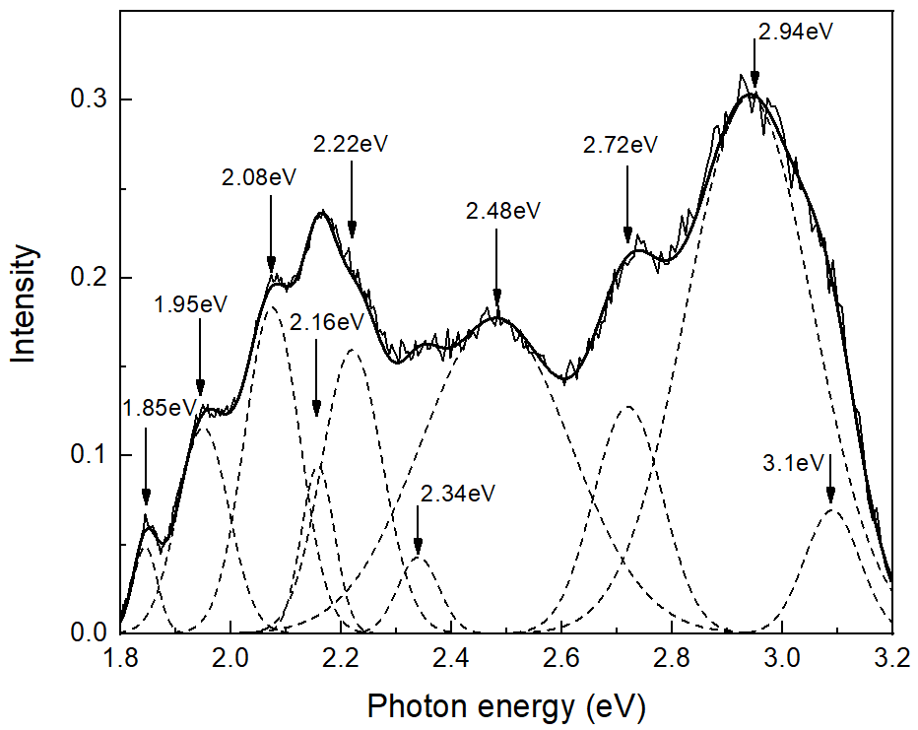

Figure 14 – Differential PL spectra after ECD

Thus, the PL band with a maximum at 422 nm can be associated with zinc vacancies (V_{Zn}) in the ZnSe₂O₅lattice. The X-ray and photoluminescence spectra of ZnSe single crystals exhibit broad recombination bands with peaks at 626 and 963 nm [44]. In our case, the PL band also has a maximum at 635 nm (1.95 eV). In the case of ZnSe, a similar characteristic is inherent in the complex center consisting of a zinc vacancy and an impurity small donor V_{Zn} + D [50].

3.5 Chemical deposition of nanocrystals based on ZnSe and CdSe
Chemical deposition of ZnSe-based nanocrystals
For CD, the following composition was used: ZnSO₄ - 7.2 g/L, SeO₂- 0.2 g/L, deposition time –15, 20, and 25 min, deposition temperature - 20⁰С. By varying the etching time, the nanopore diameters were obtained from 430 nm to 492 nm.
Figure 15 shows SEM images of the sample surface after CD. SEM studies have shown that most of the pores of the template are filled and that the chemical deposition method is excellent for growing with controlled morphology and a high degree of order. It was found that the filling of nanopores depends on the deposition time

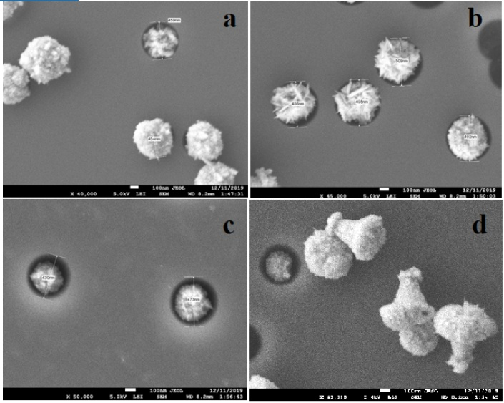

a, b, с – sample surfaces, d – nanocrystal shapes

Figure 15 – SEM images of the surface and cross section of three samples after deposition: after 15 min of deposition (a), after 20 min of deposition (b), after 25 min of deposition (c)

X-ray structural study of the samples (Fig. 16) established the formation of monophase v nanocrystals with an orthorhombic crystal structure and space group Pnma (62).The cell parameters of ZnSeO₃ nanocrystals after CD at 15 min are a = 5.923100, b = 7.665200, c = 5.040000, at 20 mina = 6.036763, b = 7.770250, c = 5.087153, at 25 mina = 5.920700, b = 7.665500, c = 5.037700.

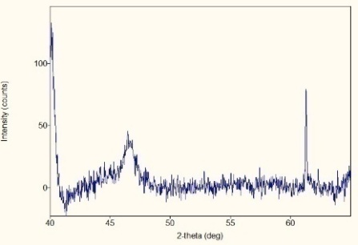 | 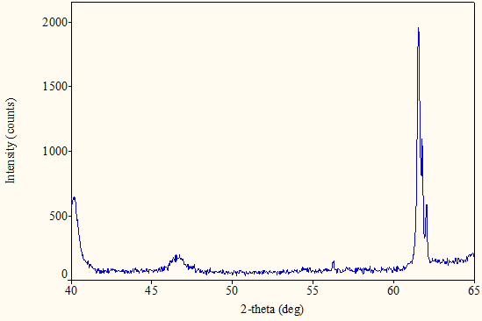 | 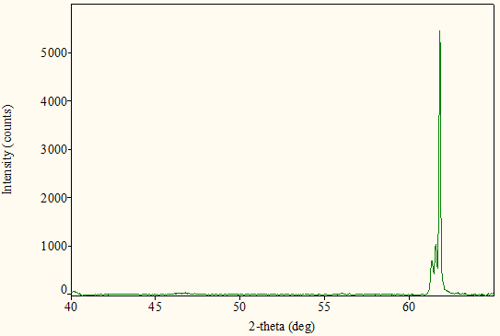
a) | b) | c)
Figure 16 – X-ray diffraction patterns of samples after CD: a-at 15 min; b - 20 min; c - 25 min

An analysis of X-ray diffraction images shows that the degree of monophasicity increases with the deposition time at room temperature. Thus, ZnSeO₃ nanocrystals were obtained for the first time by template synthesis with the aid of CD.
CD at higher temperatures required the use of templates with large nanopores; nanopores had diameters from 699 nm to 779 nm. CD was carried out in templates with n and p-type silicon substrates for 30 min at a temperature of 40°С.
Figure 17 shows SEM images of the sample surface after CD. SEM analysis shows that CD on p-type substrates is not as effective as in the case of n-type. It should be noted that a decrease in the nanopore diameter results in no deposition. We have already encountered the difficulties of deposition into templates with p-type substrates for nanoprecipitates based on ZnO, CdTe.

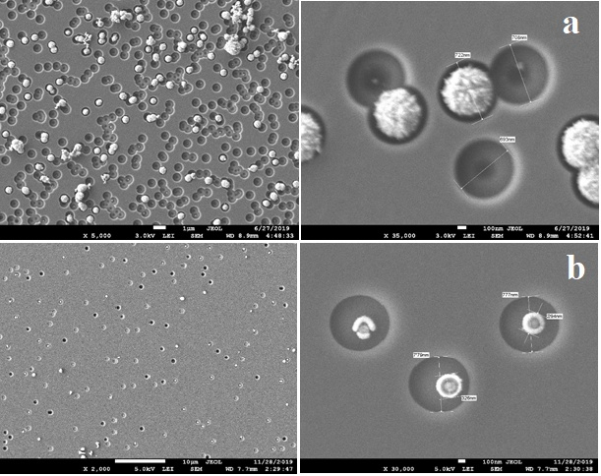

а) n – type, D = 699D = 722nm; b) p – type; D = 777 nm, D = 779nm

Figure 17 – SEM images of the surface of the samples after deposition
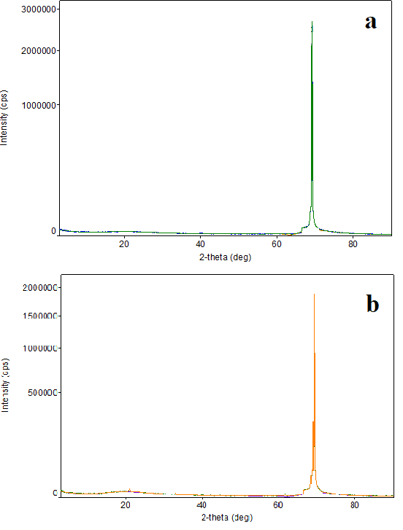

а) n – type; b) p - type

Figure 18 – X-ray diffraction patterns of the obtained samples after CD of chloride solution

X-ray structural analysis of the samples (Figure 18) showed the formation of ZnSeO₃ nanocrystals with orthorhombic structures with the space group Pnma (Table 5).

Table 5 – Parameters of ZnSeO₃ nanocrystals
No. | Phase | (hkl) | 2θº | d, Å | L, Å | Cell parameter, Å | FWHM | Density, (g/cm³)
1 | ZnSeO₃ – n type | 242 | 69.1369 | 1.357610 | 61.296 | 5.906720  7.753907  5.041927 | 0.0637 | 5.584
2 | ZnSeO₃ – p type | 242 | 69.1773 | 1.356917 | 42 | 5.981129  7.704250  4.953133 | 0.06261 | 5.584

A further increase in the CD temperature to 75⁰C leads to the formation of ZnSe nanocrystals. The settling effect was only observed at sufficiently long settling times (Figure 19).

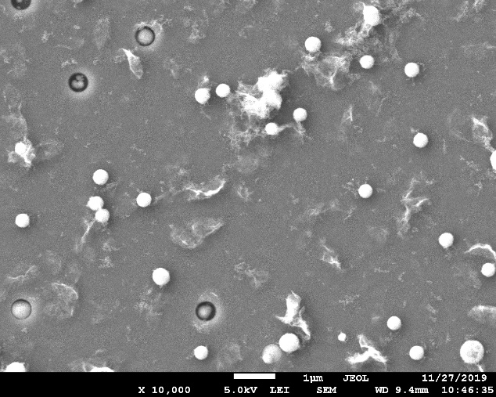 | 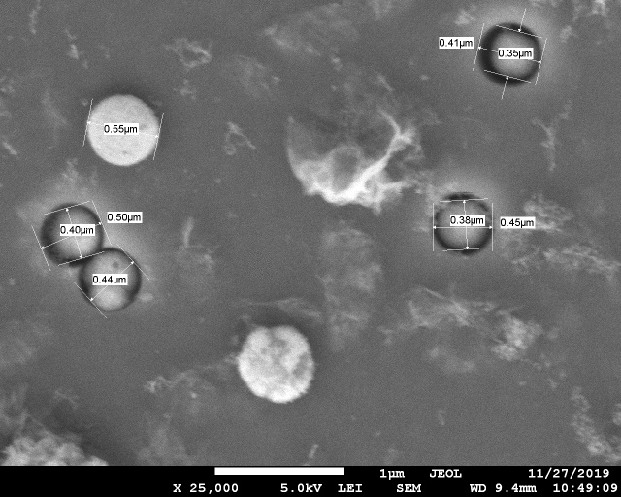
a | b
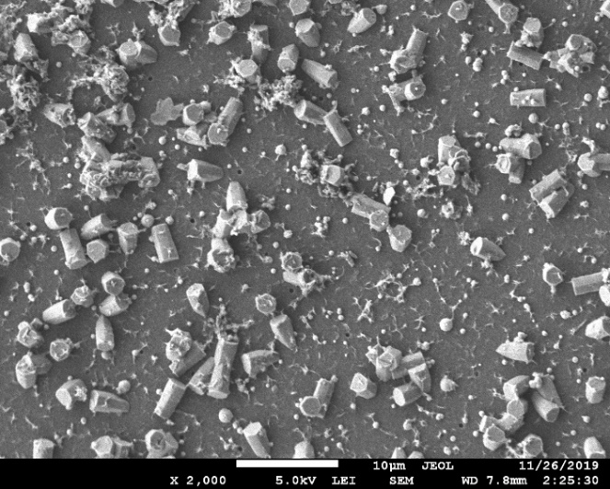 | 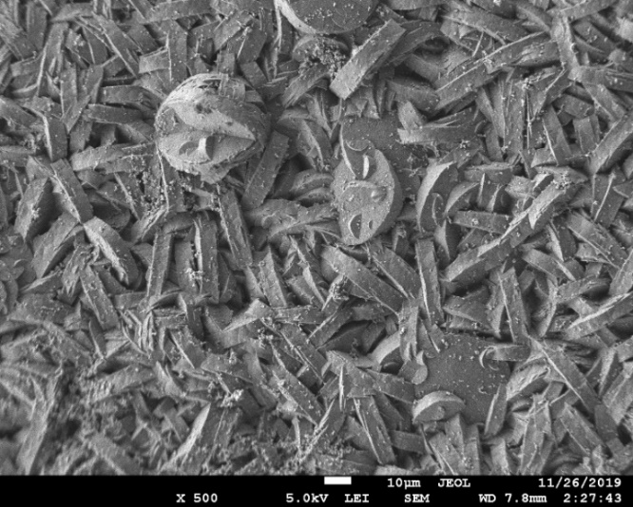
c | d
a-, b-40 min, c – 60 min, d– 90 min

Figure 19 – SEM images of the surface of samples after CD for 90 min at a temperature of 75⁰С

Decoding of radiographs (Fig. 20) is given in Table 6.

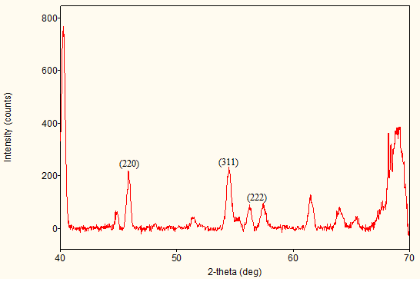 | 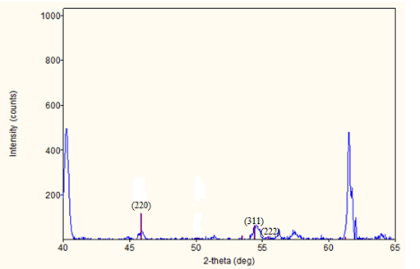 | 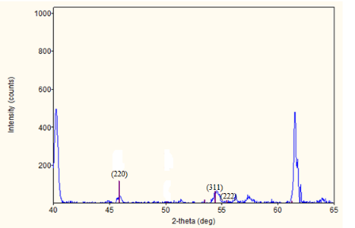
a | b | c
A – 40min, b – 60 min, c – 90 min

Figure 20 – X-ray diffraction patterns of samples after CD 75⁰C

Table 6 – XRD results versus deposition time at temperature 75⁰ С
№ | Phase | Structure type | Space group | (hkl) | 2θº | d, Å | Cell parameter, Å
40 min | ZnSe | Sphalerite | 216: F-43m | (2,2,0)  (3,1,1)  (2,2,2) | 45.81(3)  54.46(3)  57.37(4) | 1.9790(10)  1.6834(9)  1.6047(11) | a=5.59208
60 min | ZnSe | Sphalerite | 216: F-43m | (2,2,0)  (3,1,1)  (2,2,2) | 45.83(5)  54.49(5)  57.27(8) | 1.978(2)  1.6825(15)  1.607(2) | a=5.59220
90 min | ZnSe | Sphalerite | 216 : F-43m | (2,2,0)  (3,1,1)  (2,2,2) | 45.818(13)  54.405(9)  57.36(2) | 1.9788(5)  1.6850(3)  1.6051(6) | a=5.59220

We see that ZnSe nanocrystals are formed only at a high solution temperature. Significant surface deposition is observed. Thus, we have established that during ECD nanocrystals of the oxide compound ZnSe, zinc deselenateZnSe₂O_{5.}(NCs)/SiO₂/Si/are formed.Research has shown that it is an n-type semiconductor. With CD, we obtained a decrease in the inclusion of oxygen in the structure of nanocrystals, and zinc deselenite is formed - ZnSeO₃.(NCs) / SiO₂/Si, Si- n and p-type. An increase in the temperature of the CD solution leads to the complete displacement of oxygen from the structure of nanocrystals, and ZnSe (NCs)/SiO₂/Si, S - n and p-type are formed. It should be noted that an increase in temperature leads to the formation of nanocrystals on the template surface.

Chemical deposition of CdSe-based nanocrystals
Chemical deposition into an n-type template was carried out using a solution 0,1 М CdCl₂ x 2,5 H₂O + 0,1 М SeO₂during 30, 40 and 50 min at 30°С, 35°С and 40°С.
Sample surface analysis is shown in Figures 21, 22.

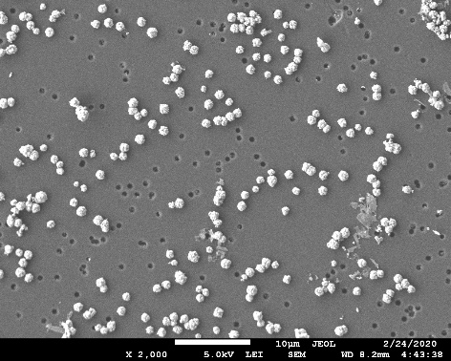 | 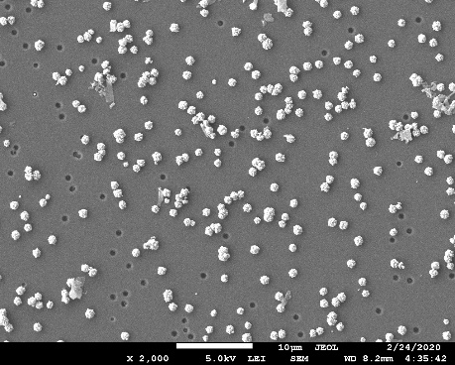 | 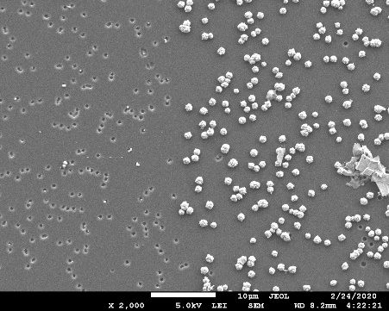
a | b | c
Figure 21 – SEM images of CD CdSe samples: a- 40⁰C,b - 35⁰C,c -30⁰C; t=40 min

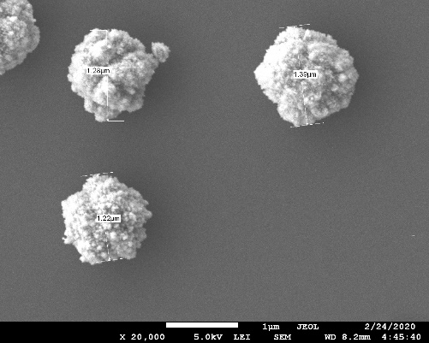 | 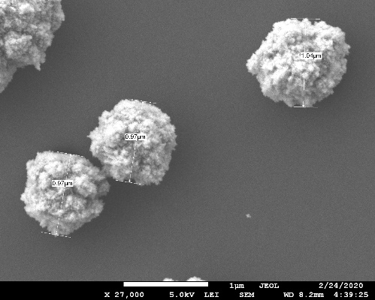 | 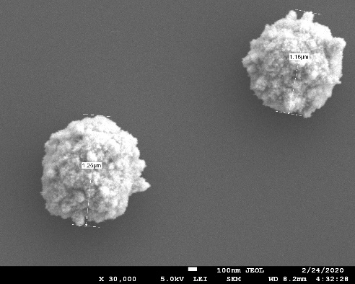
a | b | c
Figure 22 – SEM images of CD CdSe samples: a- 40⁰C,b - 35⁰C,c -30⁰C; t=40 min

No deposition was observed at room temperature of CdSe, an increase in temperature leads to deposition. It is not yet entirely clear that nanoprecipitate is formed on the surface or in nanopores. However, judging by the size of nanoprecipitates, one can assume their formation on the surface.

3.6 Computer modelling
In addition to experimental studies, we carried out computer quantum-chemical calculations of a pure CdTe crystal using the hybrid exchange-correlation method HSE06 [48] and a periodic supercell model. For pure CdTe, ordinary and primitive cells with a hexagonal lattice are shown (Fig. 12).The calculations were performed using the CRYSTAL program [49]. Basic sets (BS) for Cd and Te atoms are taken from [47]. It is known that for a better description of the electronic structure of a crystal, it is necessary to accurately determine the total energy of the crystal cell [50 -51].
It is known from theory that the calculation of the total energy within the framework of the periodic crystal model is not simple [52]. For this reason, the CRYSTAL program has introduced a complex scheme for preliminary analysis and subsequent calculation of a series of crystal integrals.In our calculations, high convergence tolerances were chosen for Coulomb and exchange integrals [53, 54]: for Coulomb overlap (10⁻⁷), Coulomb penetration (10⁻⁷), exchange overlap (10⁻⁷), first exchange pseudo-overlap (10⁻⁷) and the second exchange pseudo-overlap (10⁻¹⁴).The force gradients relative to atomic coordinates and lattice parameters are analytically estimated. The equilibrium structure is determined using a quasi-Newtonian algorithm using the Broyden-Fletcher-Goldfarb-Shanno Gessen update scheme [49]. Convergence in the geometry of optimization processes is checked for root-mean-square (rms) and the absolute value of the largest component of both gradients and nuclear displacements.For all atoms, the threshold values for the maximum and root mean square forces are set at 0.000450 and 0.000300 a.u, and for the maximum and root mean square atomic displacements - at 0.001800 and 0.001200 a.u. respectively. Effective charges on atoms were estimated using Millikan population analysis. The integration over the Brillouin zone in the reciprocal space has been performed within a 5×5×3 Pack–Monkhorst grid. As a result, we calculated the lattice parameters (a, c), which are in good agreement with our experimental data (Table 2, Section 3).
Figure 23 also shows the calculated band structure of the CdTe crystal together with the density of states. Horizontal dotted lines in the right figure mark the boundaries of the valence and conduction bands.
The break of the 1.62 eV band at the T-point of the Brilouin zone (Fig. 23) is close to the experimental value of 1.6 eV [55, 56].

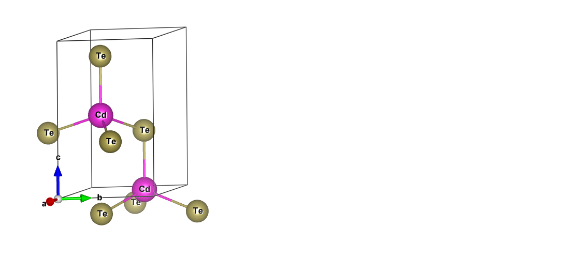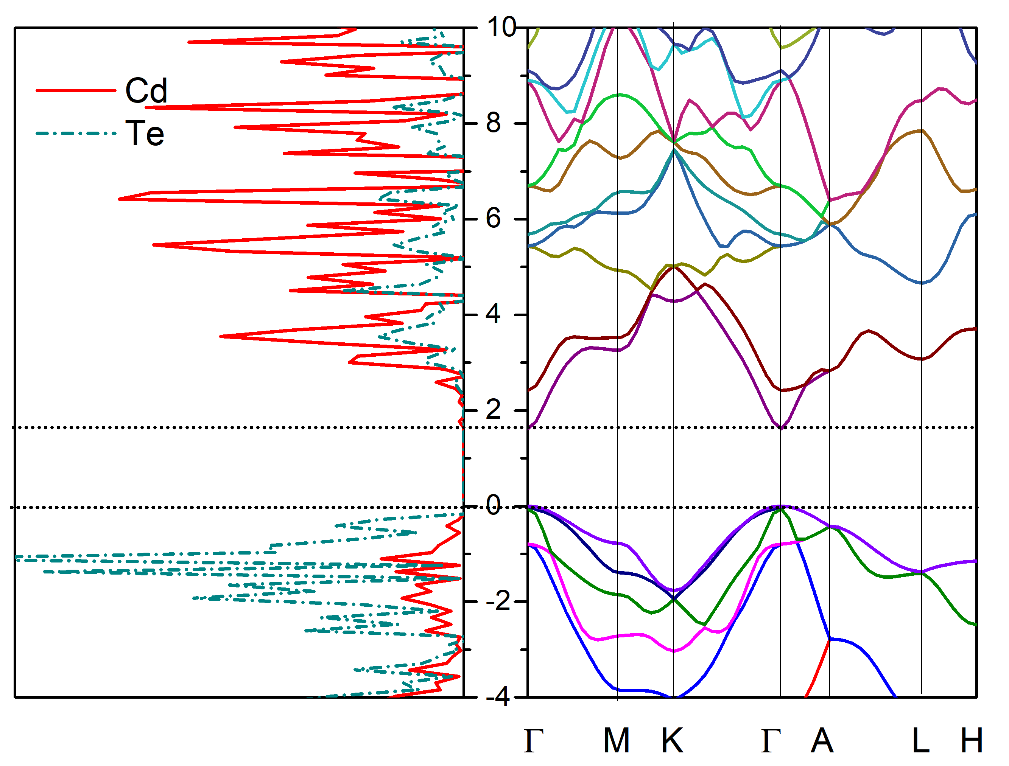
- b)

а) primitive cell CdTe; b) density of states and band structure

Figure 23 – Calculated band structure of the crystal

Also, as follows from the density of electronic states, the upper part of the valence band is represented mainly by Te 5p orbitals, while the lower part of the conduction band consists mainly of Cd and Te 5s orbitals, charge analysis indicates a mixed ionic-covalent boundary
CONCLUSION

The conclusion reflects the results obtained in 2020 and in the previous years 2018-2019.
According to studies carried out in 2020, the following results were obtained:
- Using two types of electrolytes: template synthesis using ECD, nanocrystals CdTe(NCs)/SiO₂/Si with WZ monophase were obtained. CdO(NCs)/SiO₂/Si nanocrystals in the WZ structure were obtained at CD of the sulfate solution. Comparison of the deposition results suggests the effect of an electric field on the structure of nanocrystals. It should be emphasized that we have obtained a monophase wurtzite structure of cadmium oxide at a sufficiently low temperature of 343 K by a simple CD into a track template. The study of the I – V characteristic of the structure with the CdO monophase made it possible to estimate the number of grain boundaries ⁓ 1522 and the height of the grain barrier at 1.05 eV, and the n-type conductivity. ECD and CD on p-type silicon substrate does not lead to deposition into nanopores.
- It was found that during ECD, nanocrystals of the oxide compound ZnSe, zinc diselenate ZnSe₂O₅, are formed. (NCs)/SiO₂/Si. Research has shown that it is an n-type semiconductor. With CD, a decrease in the inclusion of oxygen in the structure of nanocrystals was obtained and zinc diselenite - ZnSeO₃.(NCs)/SiO₂/Si, Si - n and p - type was formed.
- Zinc diselenide nanocrystals ZnSeO₃ with an orthorhombic crystal structure, space group Pnma were obtained for the first time by template synthesis (62).
- At room temperature CD of CdSe was not observed, increasing the temperature leads to deposition. From the analysis of SEM images, one can assume the formation of nanoprecipetates on the surface.
- ECD of zinc oxide in the track template showed that it was not enough in the voltage range (1.5 - 1.85 V) for 10 minutes to completely and evenly fill all the pores. There are empty pores on the SiO₂ surface (almost 25 - 30% of the total number of pores), as well as completely filled pores. As the voltage increases, the deposited substance protrudes from the nanopores, as well as the formation of deposits on unirradiated areas of the SiO₂ surface. According to X-ray diffraction data, the formation of ZnO nanocrystals with different phases depending on the voltage at the electrodes was established.
For the first time, ZnO(NCs)/SiO₂/Si nanocrystals were obtained in three crystalline phases: wurtzite, sphalerite, and the structure of rock salt with ECD in a track template. We assume that the formation of cubic structures of zinc oxide (sphalerite and stone ol) in nanopores is associated with phase stabilization of a cubic face-centered Si substrate. The wurtzite ZnO structure is formed on the surface of amorphous SiO₂. According to this result, in 2020, a patent of the Republic of Kazakhstan No. 3418 was obtained from 08.21.2020 “A method for producing ZnO nanocrystals in two crystal structures by the method of electrochemical deposition into track templates a-SiO₂/Si-n”.
- In 2020, one article Q1 and two articles with Q2 were published.
- The monograph "Track Technologies" was published, which is implemented in the training process for PhD doctors.
- ZnO(ZBSNCs)/SiO₂/Si nanocrystals with a zinc blend (ZBS) crystal structure were obtained by ECD. This structure is poorly understood. Our study of the I – V characteristic showed that an n-type semiconductor is formed. Comparison of the PL ZnO(ZBSNCs)/SiO₂/Si with the PL spectrum for ZnO with a wurtzite structure showed their similarity, but the ratio between the bands changes. Comparison of the band intensities showed that oxygen variations are the dominant defects in ZnO(ZBSNCs)/SiO₂/Si.
- The band structure of the density of electronic states of CdTe was calculated using the CRYSTAL program. The crystal is direct-gap with the smallest band gap at the T-point. The band structure of the ZnSe₂O₅ crystal is calculated together with the density of the electronic state, from which it can be seen that the band gap is 0.102 a.u. (1 a.u. = 27.21 eV) or 2.8 eV, which is very close to another calculated value equal to 3.04 eV. The crystal is direct-gap with the smallest band gap at the T-point.
Application: for sensor devices, opto-and nano-electronics systems.

REFERENCES

- Fink D., Chadderton L.T., Hoppe K., Fahrner W.R., Chandra A., Kiv A. Swift-heavy ion track electronics // Nucl. Instr. and Meth. B. –2007. –Vol. 261. –P.727. (Eng)
- Fink D., Petrov A., Hoppe H., Fahrner W.R., Papaleo R.M., Berdinsky A., Chandra A., Biswas A.Etched ion tracks in silicon oxide and silicon oxynitride as charge injection channels for novel electronic structures // Nucl. Instr. and Meth. B.–2004. –Vol. 218.– P.355. (Eng)
- Fink D., Petrov A., Fahrner W.R., Hoppe K., Papaleo R.M., Berdinsky A., Zrineh A., Chadderton L.T. Ion track based nanoelectronics //Int. J. Nanosci. –2005. –Vol. 4. – P.965. (Eng)
- Hoppe K., Fahrner W.R., Fink D., Dhamodoran S., Petrov A., Chandra A., Saad A., Faupel F., Chakravadhanula V.S.K., Zaporotchenko V. An ion track based approach to nano- and micro-electronics // Nucl. Instr. and Meth. B. –2008. –Vol. 266. –P.1642. (Eng)
- Apel P.Y.Track-Etching. Encyclopedia of Membrane Science and Technology.–Wiley, 2013. –Р.332-356. (Eng)
- Velleman L., Shapter J.G., Losic D. Gold nanotube membranes functionalised with fluorinated thiols for selective molecular transport // J.Membr. Sci. –2009. –Vol. 328.–Р.121-126. (Eng)
- Muench F., Oezaslan M., Seidl T., Lauterbach S., Strasser P., Kleebe H., Ensinger, W. Multiple activation of ion track etched polycarbonate for the electroless synthesis of metal nanotubes // Appl. Phys. A. –2011. –Vol. 105.– Р.847-850. (Eng)
- Enculescu I., Sima M., Enculescu M., Matei E., ToimilMolares M.E., Cornelius Th. Nickel nanotubes prepared by electroless deposition in ion track templates // Optoelectron. Adv. Mat.2. – 2008. –Vol. 3. – P. 133-136. (Eng)
- Shao P. Gold nanotube membranes: Preparation, characterization and application forenantioseparation // J. Membr. Sci.–2005. –Vol. 255. –P. 1-11. (Eng)
- Kumar V., Singh R., Chakarvarti S.K. Novel electroless template based synthesis of silver microtubules and their characterization // Dig. J. Nanomater. Biostruct. –2007. –Vol. 2. №1.–P. 163-167. (Eng)
- Pashchanka M., Hoffmann R.C., Gurlo A., Swarbrick J.C., Khanderi J., Engstler J., Issanin A., Schneider J.J. A molecular approach to Cu doped ZnO nanorods with tunable dopant content // Dalton Trans. – 2011. –Vol. 40. – P. 4307. (Eng)
- Kadyrzhanov D.B., Zdorovets M.V., Kozlovskiy A.L., Kenzhina L.E., Petrov A.V. Modification of structural and conductive properties of Zn nanotubes by irradiation with electrons with an energy of 5 MeV // Mater. Res. Express–2017.–Vol. 4, №12.–P. 125023. (Eng)

- Dauletbekova А.К., Giniyatova Sh., Akylbekova А., Balakhaeva R., Usseinov А., Baimukhanov Z. Track technologies. Monograph. – Nur-Sultan: ЕNU, 2019. – p. 212. (Rus)
- Kluth P., Johannessena B., GloverC.J., Foran M.C. Ridgway Disorder in Au and Cu nanocrystals formed by ion implantation into thinSiO₂ // Nucl. Instr. Meth. B. – 2005. – Vol. 238. – P. 285-289. (Eng)
- Ivanova Yu.A., Ivanou D.K., Fedotov A.K., Streltsov E.A., Demyanov S.E., Petrov A.V., Kaniukov E.Yu., Fink D. Electrochemical deposition of Ni and Cu onto monocrystalline n-Si(100) wafers and into nanopores in Si/SiO₂ template // J Mater Sci. – 2007. –Vol. 42, №22. –P. 9163–9169.(Eng)
- Ivanou D.K., Streltsov E.A., Fedotov A.K., Mazanik A.V., Fink D. Electrochemical deposition of PbSe and CdTe nanoparticles onto p-Si(100) wafers and into nanopores in SiO₂/Si(100) structure //Thin Solid Films. –2005. –Vol. 490, №2. –P. 154-160. (Eng)
- Bonnet D., Meyers P.V. Cadmium telluride – materials for thin film solar cells // J. Mater. Res. – 1999. – Vol. 13. – P. 2740-2753. (Eng)
- KosyachenkoL.A., MaslyanchukO.L., SklyarchukV. etal. Electrical characteristics of Schottky diodes based on semi-insulating CdTe single crystals// J. Appl. Phys. – 2007. –Vol. 101. –P. 013704. (Eng)
- Beard M.C., Turner G.M., Schmuttenmaer C.A. Size-Dependent Photoconductivity in CdSe Nanoparticles as Measured by Time-Resolved Terahertz Spectroscopy //Nano Letters. – 2002. – Vol. 9. –P.983-987. (Eng)
- Apel P. Track etching technique in membrane technology // Radiat. Meas. – 2001. – Vol. 34. – P. 559-566. (Eng)
- Fleisher R., Price P., Walker R. Nuclear Tracks in Solids: Principle and Applications. – University of California Press: Berkley, CA, 1975. – Р. 626. (Eng)
- https://commons.wikimedia.org/w/index.php?curid=3837309
- Chu L., Shirley S.Degenerate cadmium oxide films for electronic devices // JournalofElectronicMaterials. – 1990. – Vol. 19, №9.– Р. 1003-1005. (Eng)
- ShafesР., NiedschН. Growth of (100) and (111) CdTe film an (100) GaAs by hot well epitaxg // Phys. Statussolidt. –1987. – Vol. 1, №99. – P. 41-44. (Eng)
- Kolodriejski L.A., Gunshor R.L., Otsuka N. Epitaxial growth of CdTe on GaAs by molecular beam epitaxial // Vac. Sciandtechnoe.–1986. – Vol. 4, №4.– P. 2150-2152. (Eng)
- PolS.,SanaU.,Chaudchuri A.K., BanepjesH.D. Structure charoctcritotion of thin films of CdTe //ThinSolidfilms. –1988. – Vol. 1-2. – P. 85-86. (Eng)
- Telaya O., Sancher P., PenaJ.L. Characteritation of CdTe Polycrystalline films by X-roy photoelectron and Auger spectroscopys // Vac. Sci. and Technol. –1989.– Vol. 2.– P. 245-248. (Eng)
- JanowitzC., KippL., ManikeR., OrlowsiB.A. Experimental surface band structure of CdTe (110) // SurfaceSci.–1990. – Vol. 2, №231.– P. 25-31. (Eng)
- Lu P.Y., Willams L.M., Chn N.G. Crystal orientation of CdTe film on by metal-organical vapor deposition // Vac. Technol. –1986. – Vol. 4. – P.2137. (Eng)
- TouskovaJ., TousekJ., KlierE., KuselR. Preparation and basic electrical properties of CdTe thick films // Physstatussolidi.–1979. – Vol. 1, №56.– P.315-322. (Eng)
- Rizokhonov M.A., Abramov Ch. Electrical and photoelectric properties of CdTe crystals due to double injection // Phys. And Tech. of Semiconductors. –1979. – Vol. 11, №13.– P.2240. (Eng)
- Belyaev A.P., Zibets V.A., Kalinkin I.P. Electrophysical characteristics of epitaxial CdTe films // University News of Physics. –1990. – Vol. 3, №33. – P.71-74. (Eng)
- LitvinenkoYu.Yu., Panin G.N., Serdyuk V.V. The influence of growth kinetics on the structural and electrophysical properties of CdTe films // Surface Physics. Chemistry. Mechanics.–1992. – Vol. 5.– P.107. (Eng)
- Wei S.H., ZhangS .B. Structure stability and carrier localization in CdX(X = S, Se, Te) semiconductors // Phys. Rev.B. –2000. – Vol. 62, №11. – P.6944-6947. (Eng)
- Liu H. Li, X., Yang B., Wang P. Influence of substrate bias and post-deposition Cl treatment on CdTe film grown by RF magnetron sputtering for solar cells // RSCAdvances.–2014. – Vol. 4, №10. – P.5046-5054. (Eng)
- Gessert A., Wei S.H., Ma J., Albin D.S., Dhere R.G., Duenow J.N., Kuciauskas D., Kanevce A., Barnes T.M., Burst J.M., Rance W.L., Reese M.O., MoutinhoH.R..Research strategies toward improving thin-film CdTe photovoltaic devices beyond 20% conversion efficiency // Solar Energy Materials and SolarCells. –2013. – Vol. 119. – P.149-155. (Eng)
- Moure-Flores D., Quiñone-Galván J.G., Guillén-Cervantes A., Santoyo-Sala-zar J., Hernández-Hernández A., Contreras-Puente G., Olvera M.D.L., Melédez-Lira M., Meléndez-LiraM. Hexagonal CdTe films with Te excess grown at room temperature by laser ablation // Materials Letters. –2013. – Vol. 92. – P.94-95. (Eng)
- Murray C.B., Norris D.J., Bawendi M.G. Synthesis and Characterization of Nearly Monodisperse CdE (E=S, Se, Te) Semiconductor Nanocrystallites // Journal of the American Chemical Society. –1993. – Vol. 115, № 19.– P.8706-8715. (Eng)
- Brennan J.G., Siegrist T., Carroll P.J., Stuczynski S.M., Reynders P., Brus L.E., Steigerwald M.L. Bulk and Nanostructure Group II-VI Compounds from Molecular Organometallic Precursors // Chemistry of Materials. –1990. – Vol. 2, № 4. – P.403-409. (Eng)
- Pehnt M., Schulz D.L., Curtis C.J., Jones K.M., Ginley D.S. Nanoparticle precursor route to low-temperature spray deposition of CdTe thin films // Applied Physics Letters. –1995. – Vol. 67. – P.2176. (Eng)
- Panicker M.P.R., Knaster M., Kroger F.A. Cathodie deposition of CdTe from aqueous electrolytes // Journal of The ElectrochemicalSociety.–1978. – Vol. 125.– P.566-572. (Eng)
- Arai K., Murase K., Hirato T., AwakuraY. Effect of Chloride Ions on Electrodeposition of CdTe from Ammoniacal Basic Electrolytes // Journal of The ElectrochemicalSociety.–2006. – Vol. 153, №2. – P.121-C126. (Eng)
- Shan B., Wu W., Feng K., Nan H. Electrodeposition of wurtzite CdTe and the potential dependence of the phase structure // MaterialsLetters. –2016. – Vol. 166. – P.85-88. (Eng)
- Yu W.W., Wang Y.A., Peng X. Formation and stability of size-, shape-, and Structure-Controlled CdTe nanocrystals: Ligand effects on monomers and nanocrystals // Chem. Mater. –2003. – Vol. 15. – P.4300-4308. (Eng)
- Yu W.W., Peng X. Formation of High-Quality CdS and other II_VI semiconductor Nanocrystals in noncoordinating solvents: Tunable reactivity of monomers //Angew. Chem. Int. Ed. –2002. – Vol. 41.– P.2368-2371. (Eng)
- Xue H., Wu R., Xie Y., Tan Q., Qin D., Wu H., Huang W. Recent Progress on Solution-Processed CdTe nanocrystals solar nells // Applied Science. –2016.– Vol. 6, №7. – P.197-212. (Eng)
- Meunier G., Bertaud M. Cristallochimie du Sélénium (+IV). II. Structure Crystalline de ZnSe₂O₅ //Acta Crystallographica. Section B, Structuralscience. –1974. – Vol. 30. – P.2840-2843 (Eng)
- Heyd J., Peralta J.E., Scuseria G.E., Martin R.L. Energy Band Gaps and Lattice Parameters Evaluated with the Heyd-Scuseria-Ernzerhof Screened Hybrid Functional // J. Chem. Phys. –2005. – Vol. 123. – P.174101. (Eng)
- Dovesi R., Saunders V.R, Roetti C., Orlando R. et al. CRYSTAL14 User's Manual University of Torino, - Torino, 2014. – р. 253. (Eng)
- Gallino F., Pacchioni G., Valentin C.Di. Transition levels of defect centers in ZnO by hybrid functionals and localized basis set approach // J. Chem. Phys. –2010. – Vol. 133. – P. 144512. (Eng)
- Van de Walle C.G., Neugebauer J. First-principles calculations for defects and impurities: Applications to III-nitrides // Appl. Phys. Lett. –2008. – Vol. 95, № 8.– P. 3851-3879. (Eng)
- Dovesi R., Pisani C., Roetti C., Saunders V.R. Treatment of Coulomb interactions in Hartree-Fock calculations of periodic systems // Phys. Rev. B. –1983. – Vol. 28. – P. 5781. (Eng)
- Saunders V.R., Freyria-Fava C., Dovesi R., Salasco L., Roetti C. On the electrostatic potential in crystalline systems where the charge density is expanded in Gaussian functions // Mol. Phys. –1992. – Vol. 77. – P. 629. (Eng)
- Caus`a M., Dovesi R., Orlando R., Pisani C., Saunders V.R. Treatment of the exchange interactions in Hartree-Fock LCAO calculations of periodic systems // J. Phys. Chem. –1988. – Vol. 92.– P. 909. (Eng)
- GnatenkoYu.P., Kurik M.V., Matlak V.V. Band structure of hexagonal CdTe // Physics Letters A. –1969. – Vol. 28, № 7. – P. 522-523. (Eng)
- Deligoz E., Colakoglu K., Ciftci Y. Elastic, electronic, and lattice dynamical properties of CdS, CdSe, and CdTe // Physica B. –2006. – Vol. 373. – P. 124-130. (Eng)

APPENDIX А

TECHNICAL SPECIFICATIONS AND
CALENDAR WORK PLAN

Under contract №132 from 12 March 2018

1.Republican state enterprise on the right of economic management «L.N. Gumilyov Eurasian National University» Ministry of Education and Science of the Republic of Kazakhstan
1.1 By priority: Rational use of natural resources, including water resources, geology, processing, new materials and technologies, safe products and structures.
1.2 By sub-priority: Nanomaterials and nanotechnologies.
1.3 By project topic: № AP05134367«Synthesis of nanocrystals in track templates of SiO₂/Si for sensory, nano- and optoelectronic applications» 21140000 (twenty one million one hundred and forty thousand) tenge, including by year, for the performance of work in accordance with paragraph 3:
- for 2018 year -in the amount of 7000000 (seven million) tenge;
- for 2019 year -in the amount of7063000 (seven million sixty three thousand)tenge;
- for 2019 year -in the amount of7077000 (seven million seventy seven thousand)tenge

2. Characteristics of scientific and technical products by qualification criteria and economic indicators
2.1Direction of work: Applied research
2.2Application area: sensors, nano-and optoelectronic devices
2.3Endresult:
- for 2018year:а-SiO_{2nanopores}/Sisamples with nanoclusters. SEM, AFM images, X-ray diffraction patterns, luminescence spectra, volt-ampere characteristics
- for 2019 year: а-SiO_{2nanopores}/Sisamples with nanoclusters. SEM, AFM images, X-ray diffraction patterns, luminescence spectra, volt-ampere characteristics
- for 2020 year: а-SiO_{2nanopores}/Sisamples with nanoclusters. SEM, AFM images, X-ray diffraction patterns, luminescence spectra, volt-ampere characteristics
2.4Patentability: Provided
2.5Scientific and technical level (novelty): A technology will be developed and samples will be obtained based on track templates SiO_{2nanopores}/Si(n or p type) containing nanosized crystallites of direct-gap semiconductor compounds A²B⁶ (ZnSe, ZnO, CdSe, CdTe), as well as elementary Cd, Se, Te.A database of their luminescent, structural and electrophysical properties has been created. Data on computer modeling of electronic and adsorption properties. Based on the analysis of the research results, it is planned to identify the main prospects for using fundamentally new nanomaterials for sensor, nano - and optoelectronic devices.
2.6 The use of scientific and technical products is carried out: joint use in accordance with the legislation of the Republic of Kazakhstan
2.7Type of use of the result of scientific and (or) scientific and technical activities: new nanomaterials, technologies. Based on the analysis of the research results, it is planned to identify the main prospects for using fundamentally new nanomaterials for sensor, nano - and optoelectronic devices.

3. Name of work, terms of their implementation and results
Job code, stage |  | Name of work under the Agreement and the main stages of its implementation* | Period of execution* |  |  | Expectedresult*
 |  |  | start |  | ending
1 |  | Develop modes (irradiation with ions and etching of latent tracks) for the formation of nanopores of a given size and shape in  а-SiO₂/Si (n- and p-type silicon substrates) | 03/01/18 |  | 01/11/19 | Regimes (irradiation with ions and etching of latent tracks) will be developed for the formation of nanopores of a given size and shape inа-SiO₂/Si (n- and p-type silicon substrates). As a result, irradiated and etched a-а-SiO_{2nanopores}/Sistructures will be obtained.
1.1 |  | Develop irradiation modes for FHI | 03/01/18- |  | 01/11/19 | Irradiation modes of FHI will be developed and irradiated samples will be obtained
1.2 |  | Develop etching modes with size and shape control | 03/01/18- |  | 30/12/19 | Etching modes with size and shape control will be developed. As a result, etched samples will be obtained, controlled by SEM
2 |  | Develop modes and carry out ECD or if necessary CD of "cluster-forming" elements of groups II and VI into nanoporous structures of а-SiO₂/Si (n- and p-type Si); heat treatment of samples | 03/01/18 |  | 02/11/20 | Modes will be developed and ECD or if necessary CD of "cluster-forming" elements of groups II and VI into nanoporous а-SiO₂/Si structures (n- and p-type Si);and heat treatment of the samples was carried out. As a result, а-SiO_{2nanopores}/Si specimens with nanoclusters will be obtained
2.1 |  | ECD (or CD) of ZnSe, ZnO nanoclusters | 03/01/18 |  | 02/11/20 | ECD (or CD) of ZnSe, ZnO nanoclusters will be carried out. As a result а-SiO_{2nanopores}/Si samples with nanoclusters will be obtained
2.2 |  | ECD (or CD) of Cd, Te, Se | 03/01/18 |  | 02/11/20 | ECD (or CD) of Cd, Te, Se will be carried out.As a result а-SiO_{2nanopores}/Si samples with nanoclusters will be obtained
2.3 |  | ECD (or CD) of CdTe, CdSe | 03/01/18 |  | 02/11/20 | ECD (or CD) of CdTe, CdSe will be carried out.As a result, а-SiO_{2nanopores}/Si samples with nanoclusters will be obtained
3 |  | Investigate surface, structural, optical and electrophysical properties of samples | 03/01/18 |  | 02/11/20 | The surface, structural, optical and electrophysical properties of the samples will be investigated. As a result, SEM, AFM images, X-ray diffraction patterns, luminescence spectra, VAC and photovoltaics will be obtained.
4 |  | Computer modeling of electrophysical and adsorption properties of samples; | 02/02/18 |  | 02/11/20 | Computer modeling of electrophysical and adsorption properties of samples will be carried out; And as a result, the characteristics of the electrophysical and adsorption properties of the samples will be obtained.
5 |  | Step by step and complete analysis of results | 02/02/18 |  | 02/11/20 | Conference thesis, articles, reports, annual reports
6 |  | Аpprobation of results, publication and patenting | 02/02/18 |  | 02/11/20 | Conference thesis, articles, patent preparation. Monographs «Track Technologies»
 | From customer:  _________________________________  SI «Science committee of the Ministry of Education and Science of the Republic of Kazakhstan»  ______________Fullname_______________  p.p. |  |  | From the Contractor:  Vice-rector  for research work  ________________G. Merzadinova  p.p.  Familiarized with:  Scientific supervisor of the project (s)  ____________А.K. Dauletbekova  (signature)

Supplementary Agreement № 16
to the Grant Funding Agreement
№ 132 of «12 » March 2018 year

Nur-Sultan | 22 «10» 2020

State institution «Science Committee of the Ministry of Education and Science of the Republic of Kazakhstan», hereinafter referred to as the Customer,represented by the Chairman Zh.D. Kurmangalyeva, acting on the basis of the Regulations on the science Committee, approved by order of the Executive secretary dated July 10, 2018 № 169-K and by order of the Minister of Education and Science of the RK dated December 25, 2019 № 169-жқ on the one hand and non-profit joint-stock company «L.N. Gumilyov Eurasian National University»,hereinafter referred to as the Contractor, represented by the Vice-Rector for science and innovation G.T. Merzadinova, acting on the basis of Order №550-жк dated May 19 2020 year, on the other hand, hereinafter collectively referred to as the «Parties», on the basis of articles 401, 402 Civil Code of the Republic of Kazakhstan, the Law of the Republic of Kazakhstan dated February 18, 2011 «On Science»,resolutions of the Government of the Republic of Kazakhstan dated May 25, 2011 №575 "On approval of the Rules for basic, grant, program-targeted financing of scientific and (or) scientific and technical activities, resolution of the Government of the Republic of Kazakhstan dated May 16, 2011 № 519«About national scientific councils»,decisions of the National scientific council on the priorities: «Rational use of natural resources, including water resources, geology, processing, new materials and technologies, safe products and structures» (minutes of July 29, 2020 №4), «Life and health sciences» (Minutes of July 27, 2020 №6) concluded this supplementary Agreement to Agreement №132 dated March 12, 2018 (hereinafter referred to as the Agreement) and came to an agreement on the following:
1. In Appendix 1.5 to the Agreement (AR05134367), in section 3, clause 2.2 (for 2020), exclude;
2. In Appendix 1.6 to the Agreement (АР05134367):
In the third paragraph of clause 2.3 (Final result for 2020 year) of section 2, as well as in clause 3.3 (for 2020) of section 3, exclude the words “The monograph will be published”;

10. The supplementary agreement is made in two copies, one copy for each of the parties, having the same legal force.

6. Legaladdresses:

«Customer»: | «Executor»:
SI «Science committee of the Ministry of Education and Science of the Republic of Kazakhstan»  Nur-Sultan,  Mangilik El avenue, 8  BIN 061 140 007 608  BIC (BIK) KKMFKZ2A  IIC (IIK)KZ92070101KSN0000000  Beneficiary Code (Kbe) 11  RSI «Committee of Treasury of the Ministry of finance of the Republic of Kazakhstan» | NPJSC (NAO) «L.N. Gumilyov  Eurasian National University»  010008, Nur-Sultan, Satpayevst. 2  Tel. 8 (7172) 70-95-46, 70-94-57  IIC (IIK)KZ816010111000363791  JSC (AO) «Halyk Bank»  BIC (BIK)HSBKKZKX  BIN 140 003 594  Beneficiary Code (KBE) 16
The chairman  __________________ Zh. Kurmangalyeva  p.p. | Vice-rector for research work  ________________G. Merzadinova  p.p.

APPENDIX B

List of published works for 2018-2020

List of published works for 2018
Article recommended by CCSES MES RK
- Dauletbekova A., BaimukhanovZ., Kozlovskyi A., Giniyatova Sh., Murzagaliyev M., Zhurkin Е., Nauryzbaeva Р. Development and research for nanocomposite materials based on track templates of SiO₂/Si // Bulletin of ENU, Physics Series. Astronomy. –2018. –№1 (122). –P. 82-90. (Rus)
- Ybyraev N., Usseinov A., Akilbekov A., Zdorovets М.V., Dukenov А.B. Levels of the charge transition of acceptor impurities in ZnO crystals. Calculation from the first principles // Bulletin of ENU, Physics Series. Astronomy. –2018. –№2 (123). –P. 33-40. (Rus)
- Ybyraev N., Usseinov A., Akilbekov A., Zdorovets М.V., Оralbekov N.B., Dukenov А.B. Ab-initio calculation of charged defects in ZnO using the program CRYSTAL // Bulletin of ENU, Physics Series. Astronomy. –2018. –№2 (123). –P. 27-32. (Rus)
Theses and reports of international conferences
- Dauletbekova A.,Kozlovskyi A.,Akilbekov A.,Baimukhanov Z. Synthesis of nanocrystals in SiO₂/Si track templates by electrochemical deposition of Zn, Sn and Se // Abstracts book the European Materials Research Society. Spring meeting. –2018. –P.II.2. (Eng)
- GiniyatovaSh., DauletbekovaA., BaimukhanovZ., Vlasukova L., AkilbekovA., UsseinovA., Kozlovskyi A., Structural, optical and electrical properties 0f ZnO nanocrystals in a-SiO₂/Si-n track templates // Abstracts book the 10th European Conference on Luminescent Detectors and Transformers of Ionizing Radiation LUMDETR. – 2018. –P. 51. (Eng)
- Usseinov A.,Zhukovskii Yu., Kotomin E.A., Akilbekov A., Zdorovets M., Baubekova A. Transition levels of acceptor impurities in ZnO crystal by DFT-LCAO calculations // Abstracts book the International Congress on Energy Fluxes and Radiation Effects. –2018. –P. 652. (Eng)
- Akilbekov A.,DauletbekovaA.,Kozlovskyi A., Baimukhanov Z., GiniyatovaSh, Seitbayev A. Structure of Zinc oxide nanocrystals in track templates // Abstracts book the International Congress onEnergy Fluxes and Radiation Effects. –2018. –P. 432. (Eng)
- Dauletbekova A.,Kozlovskyi A.,Akilbekov A.,SeitbayevA., Alzhanova A. Synthesis of ZnO nanocrystals ina-SiO₂/Si ion track templates // Abstracts book the First Annual Meeting of Kazakh Physics Society KPS. –2018. –P.63. (Eng)
List of published works for 2019
Monograph
- Dauletbekova A., Giniyatova Sh., Balakhaeva R., Akilbekova A. Track technologies. Nur-Sultan. L.N. Gumilyov ENU, 2019. – p. 215 . ISBN 978-601-337-208-2 (Rus)
Articles with an impact factor
- Giniyatova Sh., Dauletbekova A., Baimukhanov Z., Vlasukova L., Akilbekov A., Usseinov A., Kozlovskiy A., Akylbekova A. Structure, electrical properties and luminescence of ZnO nanocrystals deposited in SiO₂/Si track templates // Radiation measurements. –2019. Vol. 125. – Р. 52-56. IF-1.512, Q2 https://doi.org/10.1016/j.radmeas.2019.04.001 (Eng)
- Dauletbekova A., Vlasukova L., Baimukhanov Z., Akilbekov A., Kozlovskiy A., Giniyatova Sh., Seitbayev A., Usseinov A., Akylbekova A. Synthesis of ZnO nanocrystals in SiO2/Si track template: Effect of electrodeposition parameters on structure // Physica Stat solidi B. –2019. –Vol. 256, №. 5. – P. 1800408. IF-1.481, Q3 https://doi.org/10.1002/pssb.201800408 (Eng)

Article recommended by CCSES MES RK
- Balakhaeva R., Akilbekov A., Dauletbekova A., Kozlovskiy A., Giniyatova Sh., Usseinov A., Baimukhanov Z. Creation CdTe nanoclusters in SiO₂/Si track tamplates using two types of electrolyte// Bulletin of ENU, Physics Series. Astronomy. –2019. –№ 1(126). –P. 8-14. (Rus)
Theses and reports of international conferences
- Dauletbekova A., Baimukhanov Z., Akilbekov A., Kozlovskii A., Komarov F., L. Vlasukova L., Giniyatova Sh., Usseinov A., Akylbekova A., Karipbayev Zh. Synthesis ofZnSe nanocrystals in a-SiO₂/Si track templates // Abstracts book the European Materials Research Society, Spring meeting 2019, International Conference on Advanced Materials. Simposium N. Nano-engineered coatings and thin films: from design to applications. –2019.–N PII-8. (Eng)
- Akilbekov A., Dauletbekova A., Komarov F., Baimukhanov Z., Kozlovskii A., Vlasukova L., Balakhaeva R., Giniyatova Sh., Usseinov A. Formation of CdTe nanocrystals in SiO₂/Si track templates by electrochemical deposition using two types of electrolytes// Abstracts book the European Materials Research Society, Spring meeting 2019, International Conference on Advanced Materials. Simposium P. Dielectric nanocomposites for energy, environment and health: from fundamental to devices. –2019.–P. 2.16. (Eng)
- Dauletbekova A., Balakhaeva R., Baimukhanov Z., Kozlovskii A., Vlasukova L., Akilbekov A., Giniyatova Sh., Zdorovets M. Structure and properties of CdTe nanocrystals synthesized in track template // Abstracts book the E-MRS2019, Fall meeting 2019, Simposium D. Materials for nanoelectronics and nanophotonics. –2019. –P2.7. (Eng)
- Dauletbekova A., Baimukhanov Z., Kozlovskii A., Vlasukova L., Giniyatova Sh., Usseinov A., Akylbekova A., Karipbayev Zh., Zdorovets M. Synthesis of new ZnSe₂O₅ in a-SiO₂/Si-n tract template: experiments and theoretical calculations // Abstracts book the E-MRS 2019, Simposium Q.Nanoparticles: advances in synthesis, characterization, theoretical modelling and applications. –2019. –Q.PI.23. (Eng)
- Dauletbekova A., Baimukhanov Z., Kozlovskii A., Vlasukova L., Giniyatova Sh., Usseinov A., Akylbekova A., Karipbayev Zh., Zdorovets M. Synthesis of ZnSe₂O₅ nanocrystals in a-SiO₂/Si-n tract template: experiments studies and theoretical calculations // Materials of the 21th International Conference on Surface Modification of Materials by Ion Beams.–2019. –P. 158. (Eng)
- Dauletbekova A., Balakhaeva R., Baimukhanov Z., Kozlovskii A., Vlasukova L., Akilbekov A., Giniyatova Sh., Zdorovets M. Structure and properties of CdTe nanocrystals created in SiO₂/Si track templates // Materials of the 21th International Conference on Surface Modification of Materials by Ion Beams.– 2019.–P. 159. (Eng)
- Balakhayeva R., Akilbekov A., Dauletbekova A., Kozlovskii A., Baimukhanov Z., Giniyatova Sh. Formation and investigation of CdTe nanocrystals // Materials of the 20th International Conference on Radiation Effects in Insulators.–2019. – P. 104. (Eng)
- Akylbekova A., Dauletbekova A., Baimukhanov Z., Kozlovskiy A., Usseinov A., Giniyatova Sh., Karipbayev Zh. Formation of ZnSe₂O₅ nanocrystals in a-SiO₂/Si-n Track Template // Materials of the 20th International Conference on Radiation Effects in Insulators.–2019.– P. 186.(Eng)
- Akylbekova A., Usseinov A., Baimukhanov Z., Zdorovets M., Giniyatova Sh. Vlasukova L., Dauletbekova A. New method of synthesis of ZnSe₂O₅ nanocrystals // Proceedings of the 13th International Conference on Interaction of radiation with solids.–2019.–P. 338-340.(Eng)
- Balakhayeva R., Akylbekov A., Dauletbekova A., Vlasukova L., Baimukhanov Z., Giniyatova Sh. Formation of CdTe and CdO nanocrystals during chemical deposition in SiO2/Si track templates // Proceedings of the 13th International Conference on Interaction of radiation with solids.– 2019.– P. 341-343. (Eng)
- Akilbekov A., Balakhayeva R., Dauletbekova A.,Kozlovskii A., Baimukhanov Z.,Usseinov A. Structure of CdTe nanocrystals synthesized by electrochemical deposition from different solutions onto the SiO₂/Si track template // Materials of the VI International Youth Scientific Conference Physics. Technology. Innovations.–2019. – P. 56-58. (Eng)
- Dauletbekova A.,Akylbekova A., Baimukhanov Z., Useinov A. ZnSe₂O₅ nanocrystals synthesis in a nanoporous layer of silicon dioxide on silicon // Materials of the VI International Youth Scientific Conference Physics. Technology. Innovations.–2019.– P. 639-640.(Eng)

List of published works for 2020
Patent application
1 Dauletbekova A., Akilbekov A., Baimukhanov Z., Akilbekova A., Usseinov A. Giniyatova Sh. «A method for obtaining ZnO nanocrystals in two crystal structures by electrochemical deposition into a-SiO₂/Si-n track templates», patent RК Registration No. 3418 dated 21.08.2020.(Eng)
Articles with an impact factor
2 BalakhayevaR., Akilbekov A., Baimukhanov Z., Giniyatova Sh., Zdorovets M., GorinY., Popov A.I., Dauletbekova A. Structure properties of CdTe nanocrystals created in SiO2/Si ion track templates // Surface and Coatings Technology. –2020. –Vol.401. –P.126269. IF-3.784, Q1. https://doi.org/10.1016/j.surfcoat.2020.126269 (Eng)
- Akilbekov A., Balakhayeva R., M. Zdorovets, Baymukhanov Z., Komaro F.F., Karima K., Popov A.I., Dauletbekova A. Ion track template technology for fabrication of CdTe and CdO nanocrystals // Nucl. Instr. Meth. B.–2020. –Vol. 481.–P.30-34. IF-1.27, Q2 https://doi.org/10.1016/j.nimb.2020.08.009 (Eng)
- Akilbekov A., Akylbekova A., Usseinov A., Kozlovskyi A., BaymukhanovZ., Giniyatova Sh., Popov A.I., Dauletbekova A. Ion track template technique for fabrication of ZnSe₂O₅ nanocrystals //Nucl. Instr. Meth.B. –2020. –Vol. 476.–P.10-13. IF-1.27, Q2. https://doi.org/10.1016/j.nimb.2020.04.039 (Eng)
Article recommended by CCSES MES RK
- Akylbekova A., Shayamanov B., Dauletbekova A. Kozlovskyi A., Giniyatova Sh., Popov A.I., Baymukhanov Z. Experimental and theoretical studies of ZnSe₂O₅ nanocrystals // Bulletin of ENU, Physics Series. Astronomy. –2020. –№ 1(130). –P. 34-43. (Rus)
- Balakhayeva R., Karim А.Т., Akilbekov A., Dauletbekova A., Giniyatova Sh., Baymukhanov Z. Influence of temperature and deposition methods on the structural properties of CdTe nanocrystals // Bulletin of ENU, Physics Series. Astronomy. –2019. – № 1(130). –P. 100-109. (Rus)
Theses and reports of international conferences
- Akilbekov A., Balakhaeva R., Baimukhanov Z., Giniyatova Sh. Dauletbekova A., Baimukhanov Z., Kozlovskii A., Vlasukova L. Track template synthesis and investigation of nanocrystals based on cadmium compounds // Abstracts book the 7th International Congress on Energy Flues Effects.15th CMM: Nanoscience and nanotechnology. –2020. –P.361. (Eng)
- Dauletbekova A., Akilbekova A., Baimukhanov Z., Kozlovskii A., Vlasukova L., Giniyatova Sh., Usseinov A. Formation of nanocrystals based on zinc selencompaunds using track technology// Abstracts book the 7th International Congress on Energy Flues Effects.15th CMM: Nanoscience and nanotechnology. –2020. –P.355. (Eng)

APPENDIX C

«APPROVE»
Vice-rector of academic Affairs
L.N. Gumilyov Eurasian National University
_______________ E. A. Ongarbaev
«___» _____________ 2020

The act of implementing
the results of research work in the educational process

We, the undersigned, Director of the Department ofAcademic affairsKashkhynbai B.B.,Dean of the Faculty of Physics and Technology Nurmoldin E.E., Head of the Department of Technical Physics SalikhodjaZh.M.and the scientific project manager Dauletbekova A.K., drew up this act stating that the results of research work on the topicAP05134367 «Synthesis of nanocrystals in track templates of SiO₂/Si for sensory, nano- and optoelectronic applications» (Grant funding for research in 2018-2020)andmonograph«Track technologies»of Dauletbekova A.K., GiniyatovaSh.G., Akilbekova A.D.,Balakhaeva R.K., UseinnovA. B. and BaimukhanovZ. K. published within the framework of the project, have theoretical and practical significance for the educational process.
The results of scientific research and the textbook are implemented in the educational process of the Universityin 1 semester forthe first-year doctoral students of the specialty 8D05323 «Technical physics» in the discipline Ion-beam modification of materials) in 2019-2020, 2020-2021 academic years.

Director of the Department of Academic Affairs |  | Kashkhynbai B.B.
Dean of the Faculty of Physics and technology |  | Nurmoldin E.E.
Head of the Department of Technical physics |  | SalikhodjaZh.M.
Scientificprojectmanager |  | Dauletbekova A.K.

