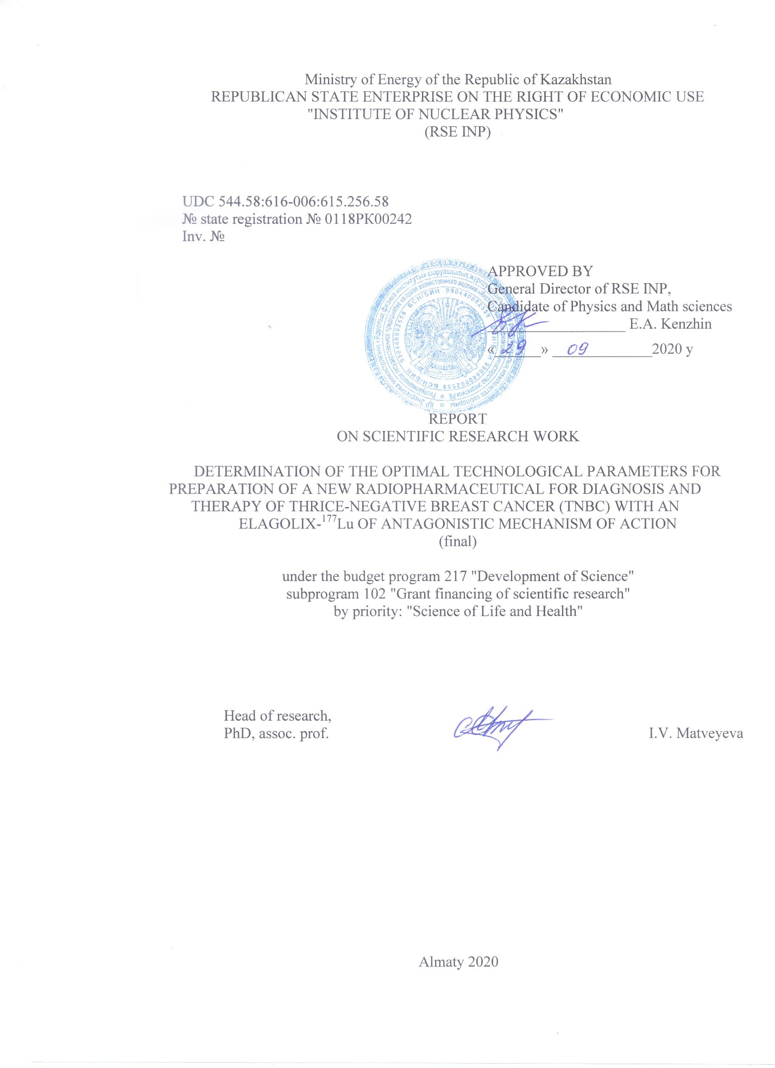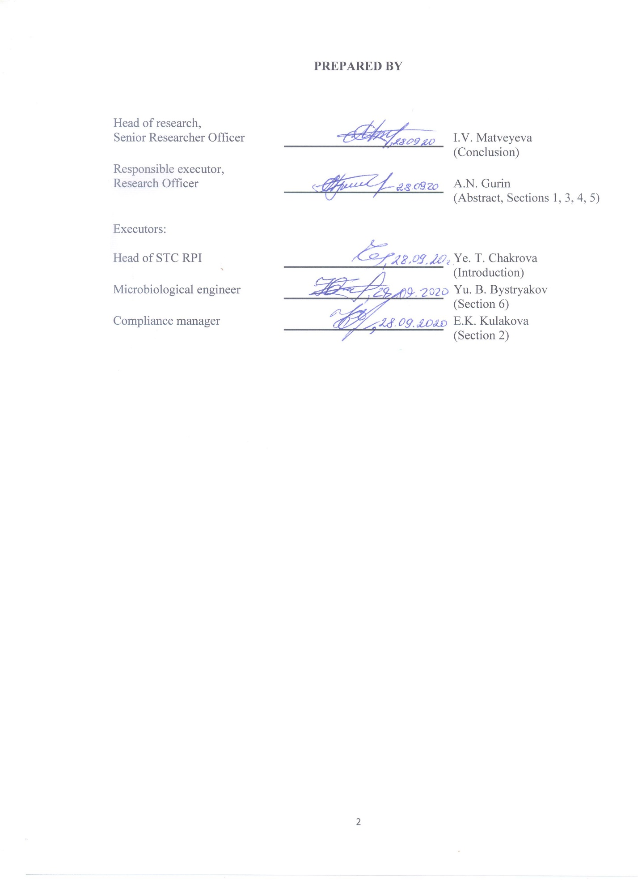

РЕФЕРАТ

Есеп 56 бет, 10 сурет, 4 кесте, 10 әдебиет көздерінен, 6 қосымша.
РАДИОФАРМДЫҚ ДӘРІ-ДӘРМЕК, ЯДРОЛЫҚ МЕДИЦИНА РАДИОХИМИЯЛЫҚ ТАЗАЛЫҚ, ¹⁷⁷Lu-DOTAELA, СҮТ БЕЗІНІҢ ҮШ РЕТ НЕГАТИВТІ ҚАТЕРЛІ ІСІГІ, ТЕРАПИЯ, ҚАҒАЗ ХРОМАТОГРАФИЯСЫ, ЛЮТЕЦИЙ-177
Зерттеу нысаны таңбаланған элаголикс-¹⁷⁷Lu (ары қарай ¹⁷⁷Lu-DOTAELA) кешені болып табылады.
Жоба мақсаты - СБҮРНҚІ диагностикалау мен емдеуге арналған дәрі-дәрмекті әзірлеу.
Синтез реакциясының технологиялық шығымына температураның, уақыттың және құрамының әсер етуін анықтау бойынша тәжірибелер, және де синтезделген топтамаларды тазалаудың қолайлы әдісін қарастыру герметикалық «ыстық» камерадағыдай жүргізілетін болады. Синтез кезеңіндегі технологиялық шығымды анықтау үшін гамма-спектрометрия (гамма-спектрометр EGPC 30-185-R), радиохимиялық тазалығын анықтауға арналған жұқақабатты хроматография, еріткіштердің құрамының және олардың өнімдегі қалдық мөлшерінің әсерін анықтауға газдық хроматография (газды хроматограф Agilent 7890A GC), сонымен қатар химиялық тазалығын анықтауға арналған жоғары тиімділікке ие сұйықтықтық хроматография (Agilent 1260) әдістері қолданылады. Қызбатуындатпаушылық LAL- тесті көмегімен, ал зарарсыздандырылғандығы - 25°С пен 37°С кезінде 14 күн ішінде үлгілерді артынша инкубациялаудан тұратын, қоректік ортаға тура себу әдісімен анықталады. Эксперессия ісік ұлпаларын тікелей таңбалау әдісімен анықталатын болады.

2018-2020 жыл аралығында келесі негізгі нәтижелер алынды.

Модификацияланған DOTAELA хелантының циклдік құрылымына радиобелсенді ^{l77}Lu изотобын толтыру шарттары анықталды. ¹⁷⁷Lu-DOTAELA шығымын бағалаудың қағаз хроматографиясының жүйесі таңдалды. ¹⁷⁷Lu-DOTAELA радиотаңбалаудың қолайлы параметрлері анықталды. ^{l77}Lu-DOTAELA кешенін тазалау әрекеттері жасалынды. ^{l77}Lu-DOTAELA пайдаланудың жарамдылық мерзімі анықталды. Қоспа құрамдастарын дайындау, емдік дәрі-дәрмекке арналған құтыларға реагенттерді бөліп салу кезеңдерінен тұратын, DOTAELA негізінде дәрі-дәрмек жасаудың технологиялық сызбасы әзірленді Оның негізгі құрамдастарының құрамында сапалық және сандық анықтау әдістемесі жүргізілді. Емдік дәрі-дәрмек өндірісінде жаңа радиофарм дәрі-дәрмегінің сынама партиясын жасауға арналған сипаттама жобасы ұсынылды. Үш сынама партиясы өндірілді және радиофармацевтикалық дәрі-дәрмегінің сапасына бақылау жүргізілді. MDA-MB-231 жасушаларын байлау мен интернализациялау динамикасы зерттелді.
Сүт безінің үш рет негативті қатерлі ісігін (СБҮРҚІ) диагностикалау мен терапиясына арналған радиофарм дәрі-дәрмегін әзірлеу бойынша алынған нәтижелер ғылыми-практикалық маңызға ие, себебі оның негізіндегі материалдар ұқсас дәрі-дәрмектерді әзірлеу үшін материалдар ретінде пайдаланылады. Жұмыс нәтижелері мен қорытындылары РФД жолдауымен ілесіп жүретін фармакопеялық мақалалары мен өзге де нормативтік құжаттарды әзірлеу мен сараптамасын жасау кезінде қолданылуы мүмкін. Алынған материалдар оларды ядролық медицинада қолдануда өте жоғары перспективаға ие.
Қолдану аумағы: ядролық медицина, радиохимия.
Алынған нәтижелер халықаралық конференцияларда баяндалып, индекстелетін журналдарда жарияланған, сонымен қатар пайдалы модельге патент алынды.
Міндеттің аяқталу дәрежесі - қорытындылау.

ABSTRACT

The report consists of 56 p., 10 fig., 4 tab., 10 ref., 6 app.
RADIOPHARMACEUTICAL, RADIOCHEMICAL PURITY, NUCLEAR MEDICINE, ¹⁷⁷Lu-DOTAELA, TRIPLE NEGATIVE BREAST CANCER, THERAPY, PAPER CHROMATOGRAPHY, LUTESIUM-177
The object of the study is the labeled complex elagolix-¹⁷⁷Lu (here in after ¹⁷⁷Lu-DOTAELA).
The goal of the project is to develop a drug for the diagnosis and treatment of TNBC and to introduce it into clinical practice.
The experiments to determine the effect of temperature, time and composition on the technological output of the synthesis reaction, as well as testing of the optimal method for purifying of the synthesized batches, were performed in a sealed "hot" cell. To determine the technological output at the synthesis stage, the gamma spectrometry methods (gamma spectrometer EGPC 30-185-R), thin-layer chromatography was used to determine the radiochemical purity, the effect of the solvents composition and their residual quantity in the product, the method of gas chromatography (Agilent 7890A gas chromatograph GC), as well as high-performance liquid chromatography was used for determination of chemical purity (Agilent 1260). Apyrogenity was determined with the help of the LAL-test, and the sterility was determined by direct seeding on nutrient media, followed by incubation of the samples for 14 days at 25 °C and 37 °C. Internalization and binding were determined by direct labeling of MDA-MB-231 cells.
For the period 2018-2020, the following main results were obtained:
The conditions for the impregnation of the ^{l77}Lu radioactive isotope into the cyclic structure of the modified chelant DOTAELA were determined. A system of paper chromatography for evaluating the yield of ¹⁷⁷Lu-DOTAELA was selected. The optimal parameters of ¹⁷⁷Lu-DOTAELA radio labeling have been determined. An attempt was made to purify the ^{l77}Lu-DOTAELA complex. The shelf life of ¹⁷⁷Lu-DOTAELA has been determined. A technological scheme for the preparation of a drug based on DOTAELA has been developed, including the stages of preparing the components of the mixture, filling the reagents into vials for medicines. The development of methods of qualitative and quantitative determination in the composition of its main components has been carried out. A draft specification is proposed for the development of pilot batches of a new radiopharmaceutical for the production of a drug. Three pilot batches were produced and the quality control of the radiopharmaceutical was carried out. The dynamics of binding and internalization of MDA-MB-231 cells was studied.
The results obtained on the development of a radiopharmaceutical for the diagnosis and treatment of triple-negative breast cancer (TNBC) are of scientific and practical importance, since materials based on them can be used as materials for the development of such drugs. The results and conclusions of the work can be used in the development and examination of pharmacopoeial monographs and other regulatory documents accompanying the circulation of the RP. The obtained materials have high prospects for their use in nuclear medicine.
Applications: nuclear medicine, radiochemistry.
The results were reported at international conferences, published in indexed journals, and a patent for a utility model was obtained.
The task completion is final.
The volume of financing in 2020 amounted to 8,000,000 tenge.

CONTENT

INTRODUCTION 9
MAIN PART 12
1 Development of the composition of reagents for obtaining an isotonic solution ¹⁷⁷Lu-DOTAELA 12
2 Method of preparation of the dosage form of radiopharmaceutical ¹⁷⁷Lu-DOTAELA 13
3 Block scheme 14
4 Draft specification for radiopharmaceutical "¹⁷⁷Lu-DOTAELA" 16
5 Production of pilot batches 18
6 Testing on cell culture MDA-MB-231 22
CONCLUSION 24
REFERENCES 26
APPENDIX A Work Schedule 28
APPENDIX B Supplementary Agreement 30
APPENDIX C List of published works for 2018-2020 32
APPENDIX D Reprints of published works in 2020 34
APPENDIX E Patent for utility model 54
APPENDIX F Title page of the thesis and extract from al-Farabi KazNU 55

LIST OF ABBREVIATIONS AND SYMBOLS

In this research report, the following abbreviations and symbols are used
¹⁷⁷Lu - DOTAELA – ¹⁷⁷Lu - 1,4,7,10-tetraazacyclododecane-1,4,7,10-tetraacetic acid - 4 - [[(1R) -2- [5- (2-fluoro-3-methoxyphenyl) - 3 - [[2-fluoro-6- (trifluoromethyl) phenyl] methyl] -4-methyl-2,6-dioxoprimidin-1-yl] -1-phenylethyl] amino] butanoic acid.
C18 – silica based cartridges with strong hydrophobicity
DMEM – a synthetic cell culture medium developed by Harry Eagle
GMP – Good Manufacturing Practice
in vitro – a technology for performing experiments, when experiments are carried out "in a test tube" - outside a living organism
In vivo – refers to experiments using a whole living organism
MDA-MB-453 – a highly aggressive, invasive and poorly differentiated triple negative breast cancer cell line
R_{f} – retention factor
AW – auxiliary work
HPLC – high performance liquid chromatography
GBq – gigabeckrel
GnRH – gonadotropin-releasing hormone
GP RK - State Pharmacopoeia of the Republic of Kazakhstan
QC - quality control
CCSES - Committee for Control in the Sphere of Education and Science
M - molar concentration, mol/L
IU - international unit
STC RIP INP RK - Scientific and Technical Center for Radiochemistry and Isotope Production of Institute of Nuclear Physics of the Republic of Kazakhstan
RSCI - Russian Science Citation Index
RK - Republic of Kazakhstan
RP - radiopharmaceutical
RCB - radiochemical building
RCP - radiochemical purity
TNBC - triple negative breast cancer
TP - technical process
UKTIA - type of transport packaging
PLS - packaging, labeling, shipping
ELAGOLIX (ELA) - antagonist of gonadotropin-releasing hormone, 4 - [[(1R) -2- [5- (2-fluoro-3-methoxyphenyl) -3 - [[2-fluoro-6- (trifluoromethyl) phenyl] methyl] -4-methyl-2,6-dioxopyrimidin -1-yl] -1-phenylethyl] amino] butanoic acid

INTRODUCTION

Treatment of breast cancer can be performed using one or a combination of the following methods: hormonal therapy, surgery, chemotherapy and radiation therapy. Their side effects limit the effectiveness of chemo-radio-therapy, but they can be avoided, and much more effective therapy is possible if the preparations used have tumor selectivity [1-4]. The required selectivity can be achieved through the development of targeted therapy using radiopharmaceuticals.
Three times negative breast cancer (TNBC) is characterized by a more aggressive course among all types of breast cancer, the maximum risk of recurrence within the first three years after surgical treatment, as well as metastasis and reduced life expectancy, lack of expression of estrogen, progesterone and HER-2 receptors. Until recently, it was believed that TNBC cells lack or have very few receptors on their surface. It was found that gonadotropin-releasing hormone is expressed in more than 50% of cases by receptors of TNBC cells. Therefore, the use of analogues of gonadotropin-releasing hormone (GnRH) will make it possible to transport the radionuclide to neoplastic cells and to carry out targeted radionuclide therapy [5-7].
The mechanism of action of GnRH agonists includes two phases: a short-term phase of stimulation and a phase of pituitary desensitization, when gonadotrophs remain resistant to stimulation and the level of gonadotropins in the blood decreases. The mechanism of action of GnRH antagonists is opposite to that of agonists. After the administration of GnRH antagonists, they competitively block GnRH receptors in the pituitary gland. Unlike GnRH agonists, antagonists act immediately and bind strongly to the GnRH receptor without causing its activation [8-10]. Exposure to TNBC cells, also, to-radiation, will allow achieving a double therapeutic effect.
The development of radiopharmaceuticals is a long and complex process that must meet the requirements of good manufacturing practices (GMP), pharmacopoeia and radiation safety.
The development of a new radiopharmaceutical includes the following stages: a selection of an active substance, selection of a radioisotope, mobile phase systems for chromatographic studies, determination of optimal labeling parameters, purification, preparation of an isotonic form of the drug suitable for in vivo and in vitro studies.
The goal of this project was to develop a drug for the diagnosis and treatment of TNBC and to introduce it into clinical practice. To do this, it was supposed to solve the following tasks:
- To investigate the influence of technological parameters of the synthesis of ¹⁷⁷Lu-DOTAELA on the technological yield and product quality.
- To develop methods for cleaning and conditioning ¹⁷⁷Lu-DOTAELA.
- To develop a quality control methodology for ¹⁷⁷Lu-DOTAELA.
- To obtain and carry out quality control of experimental batches of ¹⁷⁷Lu-DOTAELA.
- To study the expression of cells of triple-negative breast cancer to ¹⁷⁷Lu-DOTAELA.
The results of the first year are presented in the 2018 report (Inventory No. 0218RK00516). The purpose of the first year of the project was to study the influence of the technological parameters of the synthesis of the Elagolix-¹⁷⁷Lu complex on the technological yield and product quality. Experiments on the selection of the composition of mobile phases for radiochromatographic studies of DOTAELA labeled with lutetium-177 and synthesis products were carried out. The main peak of ¹⁷⁷Lu-DOTAELA, detected by the scintillation detector (NaI), after using an aqueous solution of sodium citrate as a mobile phase, is located on the start line (Rf = 0.0-0.1), and the peak corresponding to free Lu-177 moves along with the chromatogram together with a solvent front (R_{f} = 1.0). Hence, it follows that ¹⁷⁷Lu-DOTAELA does not interfere with the determination of unreacted Lu-177. It was found that the citrate buffer solution possesses the best parameters for studying the behavior of ¹⁷⁷Lu-DOTAELA and obtaining chromatograms of the products of its interaction with ¹⁷⁷Lu. The results obtained by HPLC are in agreement with those obtained by paper chromatography. However, the capture of ¹⁷⁷Lu³⁺ ions in the reverse phase of the HPLC column does not provide the necessary reliability in the analysis of radiochemical yield; therefore, in this case, it is preferable to use the method of paper chromatography, which gives an idea of the content of radiochemical forms of ¹⁷⁷Lu. The conditions for the impregnation of the ^{l77}Lu radioactive isotope into the cyclic structure of the modified DOTAELA chelating were determined. Optimal parameters of radio labeling: ¹⁷⁷Lu-DOTAELA synthesis pH 4.5, temperature 90-100 °С, complexation time 40 minutes. As a result of the research, a technological scheme for obtaining the ¹⁷⁷Lu-DOTAELA complex was developed. According to this scheme, the radiochemical yield is ≥ 95%. In 2019, work was carried out on the second and third stages (interim report for 2019, inventory number 0219RK00073). The studied purification process consisted of three parts: adsorption, washing and elution. According to the data obtained, in experiments on a cartridge with C18 and filled with various cation exchangers, the ¹⁷⁷Lu³⁺ cation is retained, as well as the ¹⁷⁷Lu-DOTAELA complex is retained. In the case of the C18 cartridge, the results obtained are consistent with the theory, however, in the case of cation exchangers, not retention occurs, but the destruction of the complex and the use of cation exchangers is reduced to the search for weaker cation exchangers. Distilled water and an acetate buffer solution with pH 5.0 were used to rinse the C18 cartridge. In both cases, as a result of washing, free ¹⁷⁷Lu³⁺ is removed from the cartridge, but the complex remains. Sequential elution of the complex from the C18 cartridge after washing with ethanol and acetonitrile did not give satisfactory results. The volume of eluents ranged from 5 ml to 100 ml, with a complex yield of 10-15%. Based on these results, it can be concluded that the standard implementation of C18 purification, which is usually effective for eliminating non-incorporated ¹⁷⁷Lu³⁺ ions, requires the use of substances that reduce the effect of radiolysis, for example, ascorbic acid, to maintain the RCP ¹⁷⁷Lu-DOTAELA, as well as the search for other eluents. For example, using trifluoroacetic acid to increase the polarity of the solvent. The stability of the ¹⁷⁷Lu-DOTAELA complex without purification for 48 hours and without the use of substances that reduce the effect of radiolysis after the radiolabeling process loses stability 24 after the formation of the complex. The development of methods of qualitative and quantitative determination in the composition of its main components has been carried out.
In 2020, work was carried out on the fourth and fifth, final, stages. The object of research is the labeled complex ¹⁷⁷Lu-DOTAELA. In accordance with the schedule (Appendix A), the following tasks were set and solved:
- Receipt of pilot batches of the ¹⁷⁷Lu-DOTAELA radiopharmaceutical and quality control;
- Study of cell expression of triple-negative breast cancer;
- Summarizing project results.

MAIN PART

1 Development of the composition of the reagents for obtaining isotonic solution ¹⁷⁷Lu-DOTAELA
The introduction of injection solutions, the osmotic pressure of which differs from the osmotic pressure of the blood plasma, causes sharp pain, the sensation of which is stronger, the greater the osmotic difference. The ability to eliminate the sensation of sharp pain when using injection solutions by introducing excipients for isotonizing the solution.
The osmotic pressure of a multicomponent solution according to Dalton's law consists of the partial osmotic pressures of the individual components (formula 1):

Р = P₁ + Р₂ + Р₃… etc. (1)
Each of the components accounts for the isotonization of the corresponding volume of solution in milliliters (formulas 2, 3).

V_{total} = v₁ + v₂ + v₃, there v₃=V_{total}-(v₁+v₂) (2)
$$V_{1}=\frac{1000m_{1}i_{1}}{0.29M} (3)$$
To 200 μL of DOTAELA solution, then 125 μL of an acetate buffer solution with pH 4.5 was added, after which lutetium-177 chloride dissolved in 0.01 M hydrochloric acid was added. The total volume is adjusted with water for injection to 2 mL.
DOTAELA + ¹⁷⁷Lu³⁺ → ¹⁷⁷Lu-DOTAELA + 3H⁺
The product contains:
- complex¹⁷⁷Lu-DOTAELA – 232.8 μg
- sodium acetate – 0.0079 g
The concentration of the ¹⁷⁷Lu-DOTAELA complex and hydrochloric acid are such that they practically do not affect the osmotic pressure. Perform calculations for sodium acetate.

V(CH₃COONa) = (1000*0.0079*1.86)/(0.29*71)=0.71 mL
V(NaCl)=V_{total}-V(CH₃COONa)=2-0.71=1.29 mL
The mass of sodium chloride for isotonizing the solution is calculated:
m(NaCl)=(0.29*58.5*1.29)/(1000*1.86)=0.012 g

2 Methods of preparing the dosage form of the radiopharmaceutical ¹⁷⁷Lu-DOTAELA
Based on the preliminary development of the optimal composition (table 12) of the ¹⁷⁷Lu-DOTAELA preparation and optimal radiolabeling conditions, the following block scheme was used to develop prototype radiopharmaceuticals in order to conduct quality control and study functional suitability:
- Preparation of solutions for the preparation of a mixture of reagents included in the composition and excipients.
- Target irradiation
- Preparation of bulk solution
- Radiolabelling
- Filtration and sterilization
- Quality control
In accordance with the developed technological scheme, 200 μL of a solution of DOTAELA in ethanol were taken into a 10 ml vial with pre-weighed sodium chloride weighing 0.012 g, then 125 μL of an acetate buffer solution with a pH of 4.5 was added, then lutetium-177 chloride was added with an activity of ≈ 7.4 GBq dissolved in 0.01 M hydrochloric acid was adjusted to 2 mL with distilled water. The final mixture was placed in a glycerin bath at 90-95 °C for 40 minutes. At the end of time, the vial was removed and cooled. At the end of the process, samples of preparations with a volume of 5 μL were taken from vials for chromatography and radiometric measurements.
Table 12 - Composition of the radiopharmaceutical «¹⁷⁷Lu-DOTAELA» in a bottle
Materials | The bottle of the finished product contains
Lutetium - 177 | 6.5 – 8.1 GBq
DOTAELA | 200 μg
Hydrochloric acid | 0.001М
Sodium Chloride | 12 mg
Sodium Acetate | 7.9 mg
Water for injections | till 1.8 mL

The resulting preparation has a radiochemical purity of > 95%, which allow sit to be used for biomedical tests.

3 Block scheme
As a result of studies to determine the optimal synthesis parameters of the ¹⁷⁷Lu-DOTAELA complex, a block scheme has been developed (figure 1).
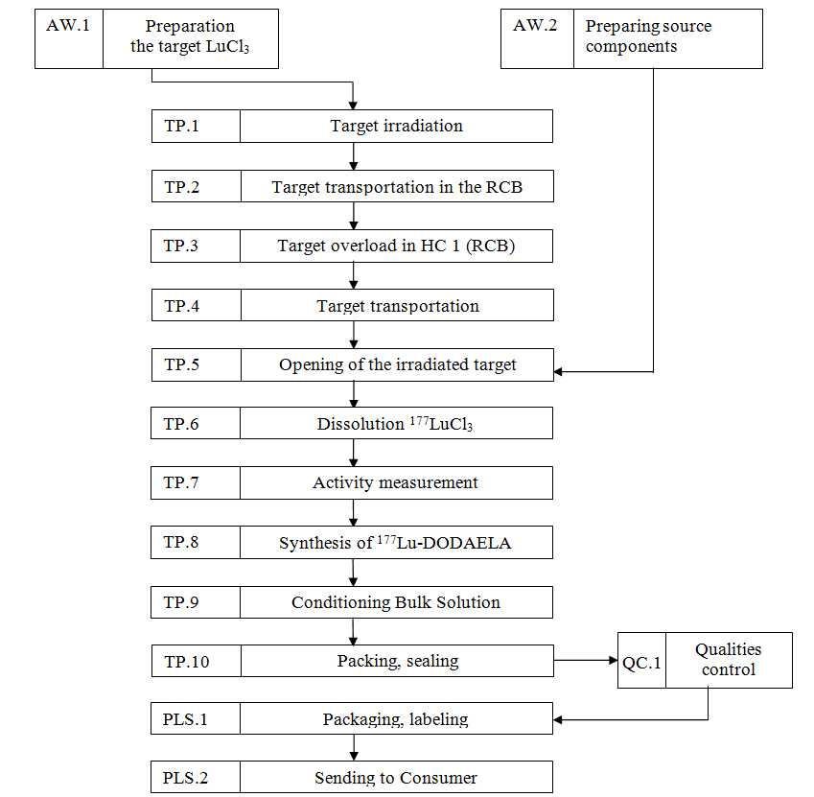
Figure 1 - The block scheme of obtaining ¹⁷⁷Lu-DOTAELA
Based on the developed technological scheme, a control synthesis of DOTAELA radio-labeling was carried out. 100 μL of DOTAELA solution with a solution concentration of 1 mg/mL was taken into a 10 mL vial, then 125 μL of acetate buffer solution with pH 4.5 was added, then 50 μL of lutetium-177 chloride was added and the volume was adjusted to 2 mL with distilled water. The final mixture was placed in a glycerin bath at 90-95 °C for 40 minutes.

Figure 2 – Radiochromatogram of ¹⁷⁷Lu-DOTAELA. I - ¹⁷⁷Lu-DOTAELA, II - ¹⁷⁷Lu³⁺.
When performing synthesis after determining the optimal synthesis parameters, the RCP was 96% (figure 2).

4 Draft specification on the radiopharmaceutical «¹⁷⁷Lu-DOTAELA»
Based on the studies carried out in the work on the development of the composition of the radiopharmaceutical «¹⁷⁷Lu-DOTAELA», as well as the above methods for analyzing its quality, a draft specification was developed for the production of experimental batches of radiopharmaceuticals shown in the table 2.
Table 2 – Draft specification for the radiopharmaceutical «¹⁷⁷Lu-DOTAELA», solution for intravenous administration

Test | Method | Requirements
1 | 2 | 3
Identification  ¹⁷⁷Lu-DOTAELA | HPLC  (SP RK I, т.1, 2.2.29) | The relative retention time of ¹⁷⁷Lu-DOTAELA should differ by no more than 3% from the retention time of the non-radioactive complex Lu-DOTAELA.
Identification ¹⁷⁷Lu | Gamma-spectrometry | The ¹⁷⁷Lu gamma spectrum of the test solution should have characteristic lines with energies of 0.113 and 0.208 MeV.
pH | Potentiometry  (SP RK I, т. 1, 2.2.3) | from 4.5 to 8.5
Transparency | SP RK I, т. 1, 2.2.1 | Transparent compared to water P
Chromaticity | SP RK I, т. 1, 2.2.2 | The color of the drug should not be more intense than the color of the solution of comparison Y7
Mechanical inclusions | SP RK I, т. 1, 2.9.20 | Mechanical inclusions must be absent
Sodium chloride | Direct titration | from 8 to 10 mg
Radionuclide impurities | Gamma-spectrometry | The content of gamma-emitting radionuclide impurities should not exceed a total of 0.1% of total radioactivity.
Radiochemical purity | Chromatography on paper (SP RK I, V. 1, 2.9.26) | Not less than 95%
Residual Solvents | Gas chromatography (SP RK I, т. 1, 2.2.28) | The ethanol content should be no more than 50 mg/V
Sterility | Direct culture inoculation (SP RK I, V. 2, 2.6.1) | Sterile
Bacterial end otoxins | Turbidimetric kinetic method (SP RK I, V. 1, 2.6.14) | Should not exceed 175/V ME/mL
Inactive impurities | Inductively coupled plasma atomic emission spectrometry SP RK I, V.1, 2.2.22 | Inactive impurities should not be detected in quantities that exceed their detection limits
Packaging |  | For packaging use the transport packaging set UKTIA-10 GOST 16327-88. The packing kit is sealed with lead seal.
Table 2 continued
1 | 2 | 3
Marking |  | Labeling is carried out in accordance with the «Rules for the Labeling of Medicines, Order of the Minister of Health and Social Development of the Republic of Kazakhstan» dated 04.16.2015, No. 22
Transportation |  | Transportation is carried out in accordance with the «Rules for the transport of radioactive materials and radioactive waste», order of the Minister of Energy of the Republic of Kazakhstan dated 02.22.2016, No. 75
Shelf life |  | No more than 24 hours from the time of preparation
Precautions |  | Must comply with the «Sanitary and epidemiological requirements for radiation safety»

5 Production of pilot batches
Based on the block scheme for the synthesis of the radiopharmaceutical “¹⁷⁷Lu-DOTAELA”, three series of the drug was produced under the conditions of compliance with the requirements of good manufacturing practice.
The production was carried out in several stages based on the developed documented procedure “Organization of production of radiopharmaceuticals in the RIPC INP ME RK”: irradiation of the prepared target, preparation of equipment and raw materials, implementation of the production process in a hot chamber, product quality control.
Before the start of production of each batch of the preparation, hot chambers, a loading gateway, a dose calibrator and a Thimotheo-LT filling device were prepared. All preparatory procedures were performed before the irradiated target was delivered to the hot chamber.
Preparation for the operation of the hot chambers and the loading gateway included checking the vacuum in the chambers and the gateway, connecting to power, connecting dosimetric equipment.
The preparation of the Capintec CRC-25R dosing calibrator consisted in calibrating the instrument with a standard Cs-137 source and measuring the background.
The preparation of the Thimotheo-LT filling device consisted of calibrating the scales built into the device using a standard with a known mass.
Figure 3 shows the preparation process for the synthesis of the radiopharmaceutical «¹⁷⁷Lu-DOTAELA».
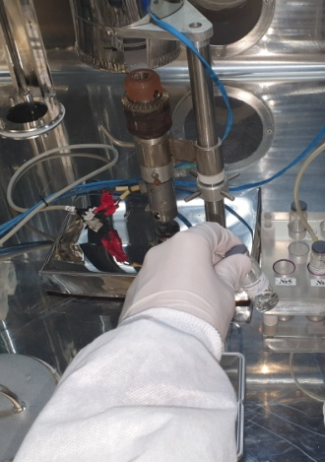
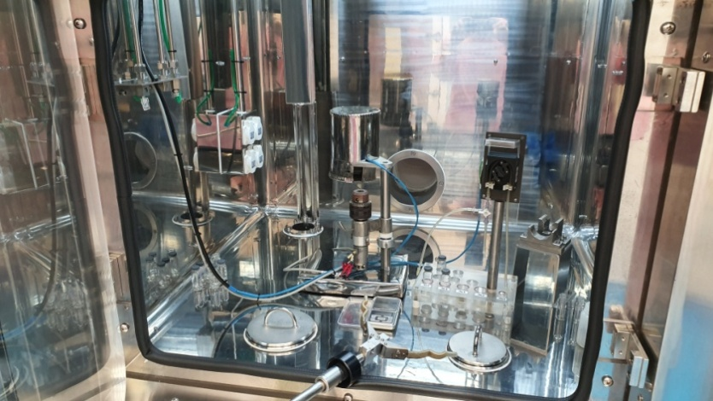
Figure 3 - Preparations for the synthesis

The parameters of irradiation and synthesis of the experimental series «¹⁷⁷Lu-DOTAELA» are presented in table 3.

Table 3 - Parameters of irradiation and synthesis of experimental series «¹⁷⁷Lu-DOTAELA»

Irradiation time, min | The activity of ¹⁷⁷Lu after dissolution, GBq | Time  synthesis | Activity ¹⁷⁷Lu-DOTAELA at the end of the synthesis, GBq
252 | 88.4 | 40 min | 7.6
408 | 152.30 | 40 min | 7.4
240 | 53.4 | 40 min | 7.5

After completion of the synthesis, the obtained preparation was dosed into vials using a filling device, one of which was used for quality control. Vials with the packaged preparation were sealed with rubber stoppers and crimped with aluminum caps, after which the activity of ¹⁷⁷Lu in each bottle was measured. In series, the vials were placed in protective containers and unloaded from the hot chamber. When unloading, a label was glued onto the container. Figure 4 shows an example label.
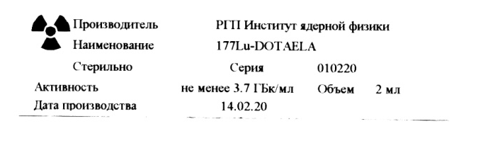
Figure 4 – An example of a label on a bottle with the drug «¹⁷⁷Lu-DOTAELA»
and shipping container

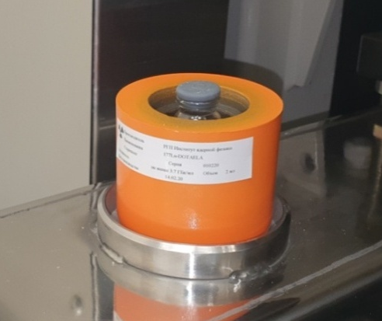
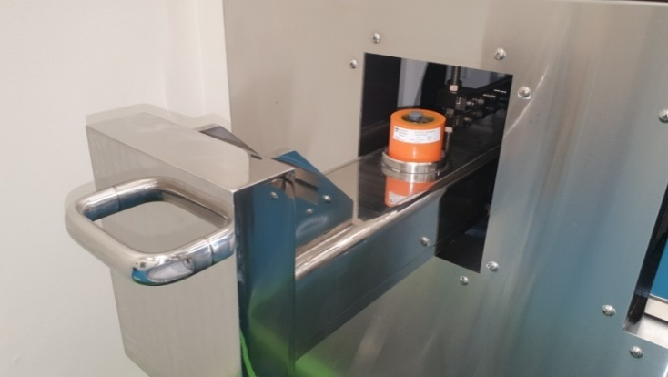
Figure 5 shows the process of unloading the container with the drug from the hot chamber, and figure 6 shows the process of transferring the drug to the laboratory for quality control.

Figure 5 – Unloading the drug container from the hot chamber
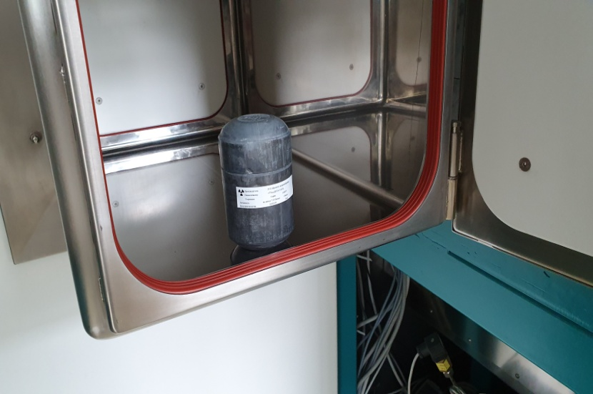
Figure 6 – Transfer of the container with the drug for quality control through a ventilated gateway
Quality control of the experimental series included the determination of volumetric activity, radionuclide and radiochemical purity, residual solvent content, and pH.
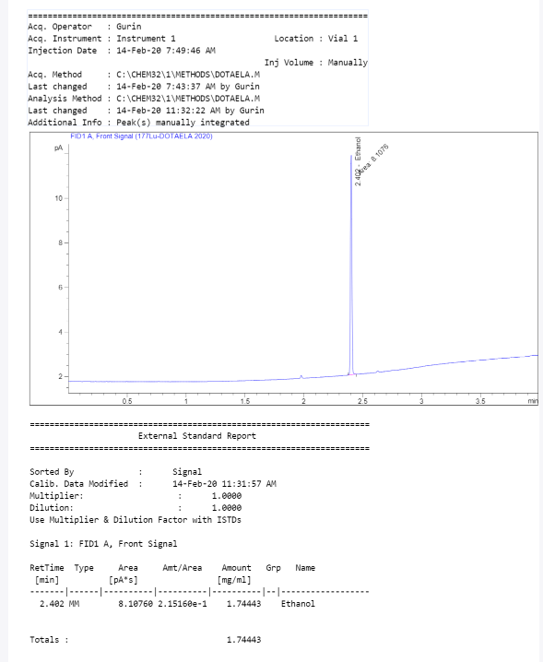
Figures 7 and 8 show graphical images of the results of tests to determine the content of residual solvents by gas chromatography and radiochemical purity by paper chromatography.

Figure 7 – Determination of residual solvent content by gas chromatography in the radiopharmaceutical «¹⁷⁷Lu-DOTAELA»
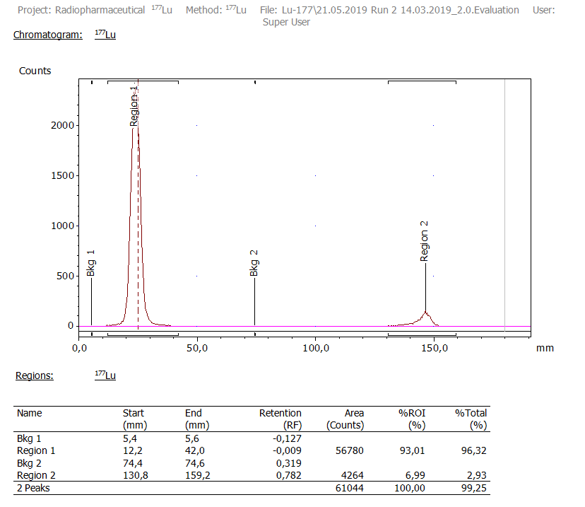
Figure 8 – Determination of radiochemical purity of the radiopharmaceutical «¹⁷⁷Lu-DOTAELA» by thin layer chromatography
The results of the quality control of the RP «¹⁷⁷Lu-DOTAELA» are presented in table 4.
Table 4 – Results of tests of pilot batches of RP «¹⁷⁷Lu-DOTAELA»
No.  series | рН | Volumetric  activity,  GBq/mL | RNP, % | RCP,% |  | The content of residual solvents, mg/mL  (Ethanol) | Microbiological purity
 |  |  |  | ¹⁷⁷Lu-DOTAELA | ¹⁷⁷Lu³⁺ | The content of residual solvents, mg/mL  (Ethanol) | Microbiological purity
Requirement | 4.5-8.5 | 3.4-3.8 | 99.8±0.005% | ≥95.0% | ≤ 5% | 6.25 | Sterile
010220 | 7.3 | 3.8 | 99.9 | 96.3 | 3.6 | 1.7 | Sterile
020220 | 7.6 | 3.7 | 99.9 | 95.5 | 4.2 | 0.9 | Sterile
030320 | 7.4 | 3.8 | 99.9 | 96.7 | 2.8 | 1.4 | Sterile

6. Testing on cell culture MDA-MB-231
Antagonists and agonists of gonadotropin-releasing hormone, aimed at binding to certain types of tumors, serve as selective carriers of radionuclides into tumor cells. Radionuclide therapy requires a very stable attachment of the radionuclide to the carrier since unbound radionuclides can infect normal tissues, resulting in increased doses to both normal organs and the whole body.
MDA-MB-231 cells were distributed in centrifuge tubes (in triplicate, for specific and non-specific binding). Non-specific internalization was assessed by the addition of unlabeled DOTAELA (9 μg). After 1 hour of incubation at 37 °C, 25 μl of ¹⁷⁷Lu-DOTAELA was added and incubated for 0.25, 0.5, 1 and 2 hours. The cells were washed 2 times with DMEM to remove free radioligand and incubated for 10 min in 1 ml of 0.2M sodium buffer acetate buffer pH 4.5. After removing the acidic buffer, the cells were washed twice with an additional 1 ml of buffer, and the supernatants were pooled to measure the amount of ¹⁷⁷Lu-DOTAELA associated with the plasma membrane. The cells were then solubilized in 1 ml of 1 N HCl. NaOH and transferred to tubes for the quantitative determination of internalized radioactivity. Results were expressed as a percentage of binding and internalization.

Figure 9 - Dynamics of ¹⁷⁷Lu-DOTAELA binding by tumor cells (p <0.05)

Figure 10 - Dynamics of internalization of ¹⁷⁷Lu-DOTAELA by tumor cells (p <0.05)

Studies of the receptor specificity of the tested radiopharmaceutical showed a satisfactory level of accumulation and internalization of ¹⁷⁷Lu-DOTAELA by tumor cells (Figures 9 and 10). The proportion of internalization of the labeled compound is practically independent of the concentration of the compound in the incubation medium. The drug strongly enough binds to tumor cells. This gives reason to believe that when it is introduced into the body of an animal and a person, the drug will be bound in the tumor focus for a sufficient amount for imaging and therapy.

CONCLUSION

During the reporting period, the following works were performed under the Project:
1) The conditions for the impregnation of the ^{l77}Lu radioactive isotope into the cyclic structure of the modified chelating DOTAELA were determined in accordance with the calculated and optimal radionuclide concentration in accordance with the algorithms for the diagnosis and treatment of malignant neoplasms and the recommendations of the Ministry of Health of the Republic of Kazakhstan.
2) A system of paper chromatography for evaluating the yield of ¹⁷⁷Lu-DOTAELA was selected. It was found that citrate buffer solution has the best parameters for studying the stability of the behavior of ^{l77}Lu-DOTAELA and obtaining chromatograms of the products of its interaction with ¹⁷⁷Lu.
3) The optimal parameters of radio labeling have been determined: the pH of the ¹⁷⁷Lu-DOTAELA synthesis is 4.5, the temperature is 90-100 ° C, the complexation time is 40 minutes. As a result of the research, a technological scheme for the synthesis of the ¹⁷⁷Lu-DOTAELA complex was developed, according to which the radiochemical yield is> 95%.
4) Study of the purification process of the ^{l77}Lu-DOTAELA complex with Cl8 and filled with various cation exchangers showed that the ¹⁷⁷Lu³⁺ cation is retained, as well as the ^{l77}Lu-DOTAELA complex is retained. It was concluded that the standard implementation of C18 purification, which is usually effective for eliminating unincorporated ¹⁷⁷Lu³⁺ ions, requires the use of substances that reduce the effect of radiolysis, for example, ascorbic acid, to maintain radiochemical purity, ¹⁷⁷Lu-DOTAELA.
5) It was found that the stability of the ¹⁷⁷Lu-DOTAELA complex decreases within 24 hours from the time of its formation.
6) A technological scheme for the preparation of a drug based on DOTAELA has been developed, including the stages of preparation of mixture components, filling of reagents into vials for medicines.
7) The development of methods of qualitative and quantitative determination in the composition of its main components has been carried out. A draft specification is proposed for the development of pilot batches of a new radiopharmaceutical for the production of a drug.
8) Three pilot batches were produced and quality control of the radiopharmaceutical was carried out. The drug meets the requirements and is suitable for biological research in vivo and in vitro.
9) The dynamics of binding and internalization of MDA-MB-231 cells was studied.
The possibility of practical application of a radiopharmaceutical based on lutetium-177-labeled DOTAELA has been shown, which will allow the treatment of TNBC and tumor visualization using a gamma camera, which can significantly reduce the cost of the diagnostic procedure. The use of such a radiopharmaceutical will provide an opportunity to conduct therapy without invasive methods, increase life expectancy and improve the quality of life.
The results and conclusions of the work can be used in the development and examination of pharmacopoeial monographs and other regulatory documents accompanying the circulation of RP.
Thus, in this work, a detailed discussion of the specific properties of radiopharmaceutical drugs based on ¹⁷⁷Lu-DOTAELA was carried out, which determine special approaches to their production (or manufacture) and quality control. The results and conclusions of the work can be used in the development and examination of pharmacopoeial monographs and other regulatory documents accompanying the RP application for the diagnosis and prevention of treatment of thrice-negative hormone-sensitive breast cancer.
The tasks for 2018, 2019 and 2020 stipulated by the calendar plan (see Appendix A) have been completed in full. The calendar plan was adjusted in accordance with additional agreement No. 4 to the contract No. 157 dated March 15, 2018 (Appendix B).
The results obtained were reflected in 9 publications, of which 2 are included in the Web of Science and Scopus databases (Appendix C, D), 2 articles were published in journals recommended by CCSES, 1 article is indexed by the RSCI database, 3 reports were presented at international conferences. In February 2020, an application for a utility model patent was filed, in August a patent was obtained (Appendix E).
Project participant Gurin A.N. on the basis of the data obtained, he prepared a thesis for the PhD degree in the specialty "6D060600-Chemistry" (Appendix F).
The planned works were completed in accordance with the schedule and in full.

REFERENCES

- Ma H., Xu X., Clague J., Lu Y., Togawa K., Wang S.S., Clarke C.A., Lee E., Park H.L., Sullivan-Halley J., Neuhausen S.L., Bernstein L. Recreational physical activity and risk of triple negative breast cancer in the California Teachers Study // Breast Cancer Res. Breast Cancer Research, –2016. –Vol. 18, Issue 1. – P. 1-16.
- Friedenreich C.M., Cust A.E. Physical activity and breast cancer risk: Impact of timing, type and dose of activity and population subgroup effects // Br. J. Sports Med. –2008. –Vol. 42, Issue 8. – P. 636-647.
- Ma H., Luo J., Press M.F., Wang Y., Bernstein L., Ursin G. Is there a difference in the association between percent mammographic density and subtypes of breast cancer? luminal a and triple-negative breast cancer // Cancer Epidemiol. Biomarkers Prev. – 2009. – Vol. 18, Issue 2. – P. 479-485.
- Anders C.K., Carey L.A. Biology, metastatic patterns, and treatment of patients with triple-negative breast cancer // Clin. Breast Cancer. Elsevier Ltd., – 2009. – Vol. 9, Issue 2. – P. S73-S81.
- Kwok C.W., Treeck O., Buchholz S., Seitz S., Ortmann O., Engel J.B. Receptors for luteinizing hormone-releasing hormone (GnRH) as therapeutic targets in triple negative breast cancers (TNBC) // Target. Oncol. – 2015. – Vol. 10, Issue 3. – P. 365-373.
- De Laurentiis M., Cianniello D., Caputo R., StanzioneB., ArpinoG., CinieriS., LorussoV., De Placidoet S. Treatment of triple negative breast cancer (TNBC): Current options and future perspectives // Cancer Treat. Rev. Elsevier Ltd. – 2010. – Vol. 36, № SUPPL. 3. – P. S80-S86.
- Dent R., Trudeau M., Pritchard K.I., Hanna W.M., Kahn H.K., Sawka C.A., Lickley L.A., Rawlinson E., Sun P., Narod S.A. Triple-negative breast cancer: Clinical features and patterns of recurrence // Clin. Cancer Res. – 2007. – Vol. 13, Issue 15. – P. 4429-4434.
- Hugues J.N., Durnerin I.C. Revisiting gonadotrophin-releasing hormone agonist protocols and management of poor ovarian responses to gonadotrophins // Hum. Reprod. Update. – 1998. –Vol. 4, Issue 1. – P. 83-101.
- Shim C., Khang I., Lee K., Kim K. Expression and regulation of gonadotropinreleasing hormone (GNRH) and its receptor MRNA transcripts during the mouse ovarian development // Korean J. Biol. Sci. – 2001. – Vol. 5, Issue 3. – P. 217-224.
- Olofsson J.I., Conti C.C., Leung P.C., Homologous and heterologous regulation of gonadotropin-releasing hormone receptor gene expression in preovulatory rat granulosa cells // Endocrinology. –1995. – Vol. 136, Issue 3. – P. 974-980.

APPENDIX А
Work schedule

APPENDIX B
Supplementary Agreement

APPENDIX С
List of works published for 2018-2020

2018
1 Gurin A.N., Soloninkina S.G. 3rd International Scientific Conference of Students and Young Scientists «Farabi Alemi», Almaty, Kazakhstan, April 9-12, 2018. «On the issue of the influence of pH synthesis on the radiochemical purity of the labeled compound DOTAELA -¹⁷⁷Lu», 6 section, p. 245 (Russian).
2 Gurin A.N., Soloninkina S.G., Riss P., Uralbekov B.M., Matveyeva I.V., Chakrova E.T. Selection of mobile phase systems for chromatographic research of ¹⁷⁷Lu-DOTAELA. // Chemical journal of Kazakhstan. – 2018. – Vol. 2. – P. 151-157 (English).
2019
3 Gurin A.N., Riss P., Chakrova Ye.T., Matveyeva I. V. Quality control test for ¹⁷⁷Lu-DOTAELA. International Journal of Biology and Chemistry, – 2019, – Vol. 12, № 2, – P. 112-115 (IF = 0, English).
4 Gurin A.N., Chakrova E.T., Riss P. Purification of DOTAELA labeled with ¹⁷⁷Lu // Proceedings of the III international scientific-practical conference «Actual problems of the development, production and use of radiopharmaceuticals - RADIOFARMA-2019» / Ed. G.E. Kodina and A.Ya. Maruk - M .: FSBI SSC FMBC them. A.I. Burnazyan FMBA of Russia, 2019 .- P. 61 (English).
5 Gurin A.N., Chakrova E.T., Riss P. Study of the stability of the ¹⁷⁷Lu-DOTAELA // Abstracts of the 1st international conference «Nuclear and Radiation Technologies in Medicine, Agriculture Industry» - Almaty. - 2019. P. 219 (English).
2020
6 Gurin A.N., Riss P., Chakrova Ye.T., Matveyeva I. V. et al. Study of the purification of 177Lu-DOTAELA complex // Pharmaceutical Chemistry Journal. – 2020. – Vol. 54. № 1, – P. 64-68 (Q4, IF-0.51; Percentile 18, English).
7 Gurin A.N., Riss P., Chakrova Ye.T., Matveyeva I. V. Development of a ¹⁷⁷Lu radionuclide-labeled bioconjugate, a gonadotropin releasing hormone antagonist // Medical physics. – 2020. – Vol. 85. №. 2, – P. 17-23 (RSCI IF – 0.23, Russian).
8 Gurin A.N., Riss P., Chakrova Ye.T., Matveyeva I. V. Optimization of Reaction Parameters for the Synthesis of ¹⁷⁷Lu DOTAELA // Revista de Chimie. – 2020. – Vol. 71. №. 8, – P. 55-62 (Scopus Percentile 51, English).
9 Gurin A.N., Chakrova Ye.T., Matveyeva I. V. Patent №5186 for utility model «Method for radiochemical labeling of an organic compound with the lutetium-177 isotope», application No2020/0213.2 dated 27.02.2020 of RSE «National institute of intellectual property» (Republic of Kazakhstan).

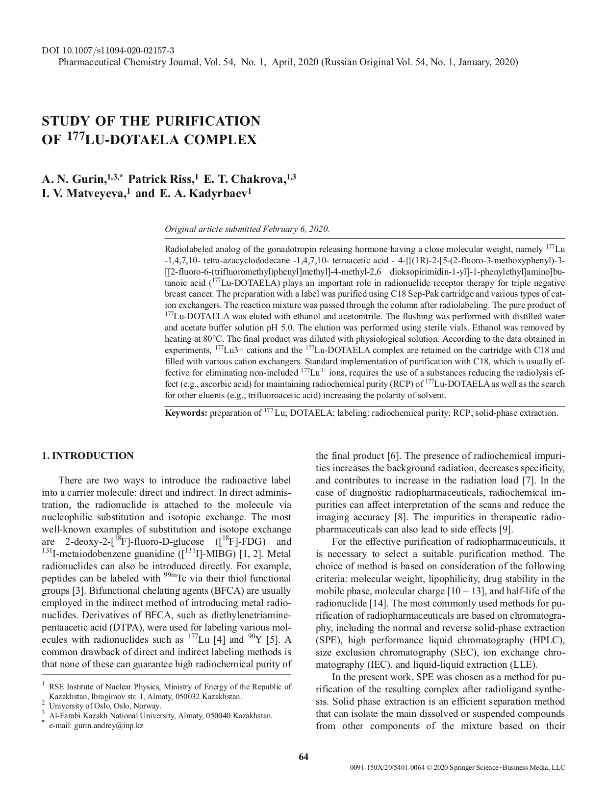
APPENDIX D
Reprints of works published in 2020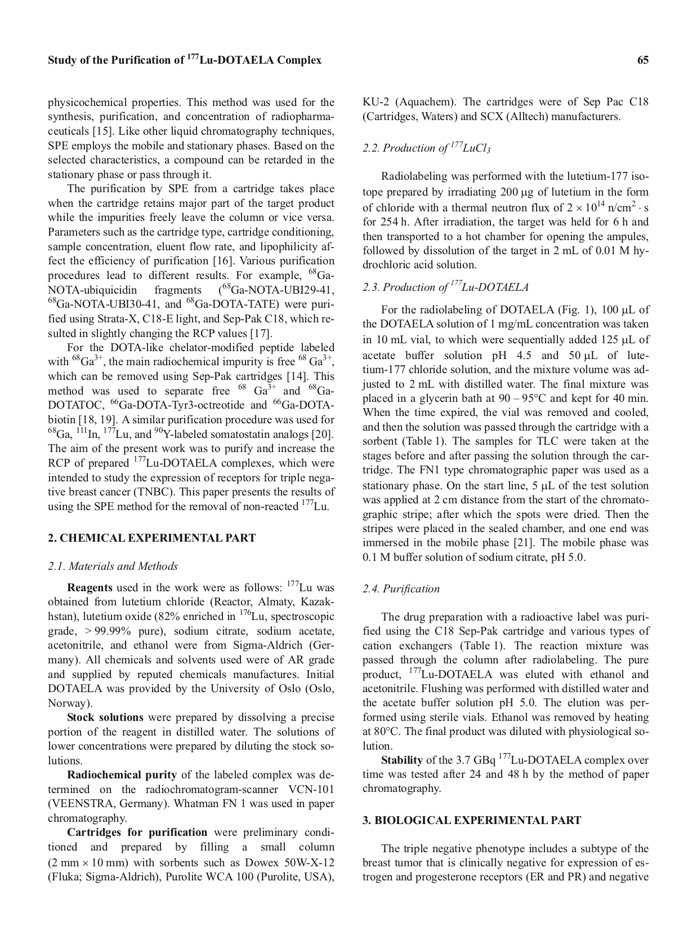

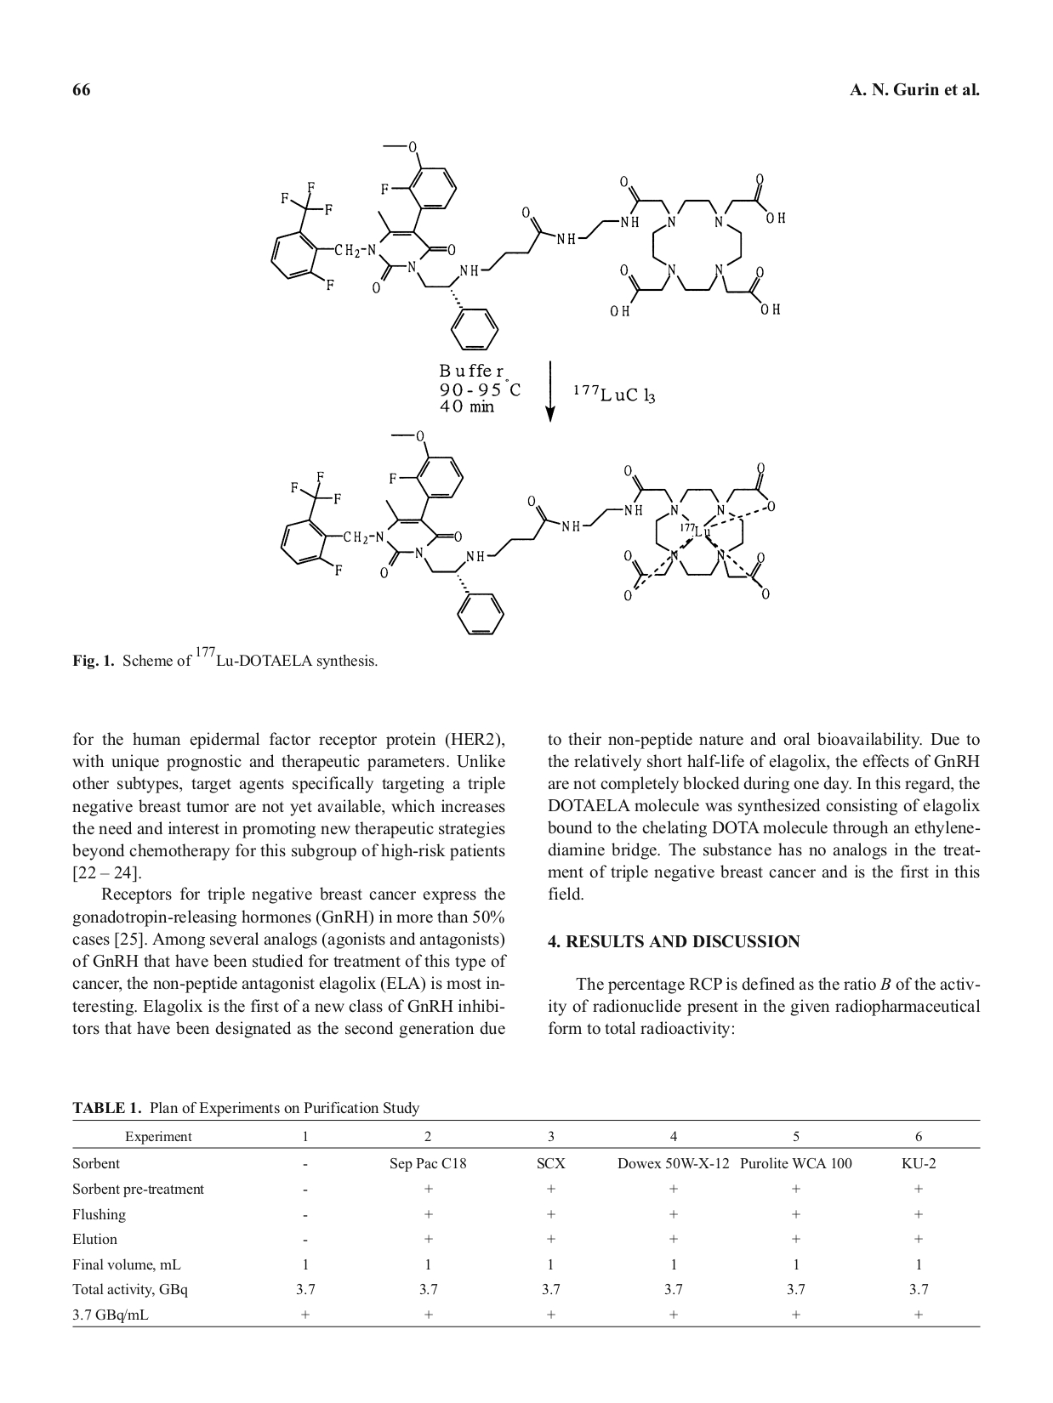

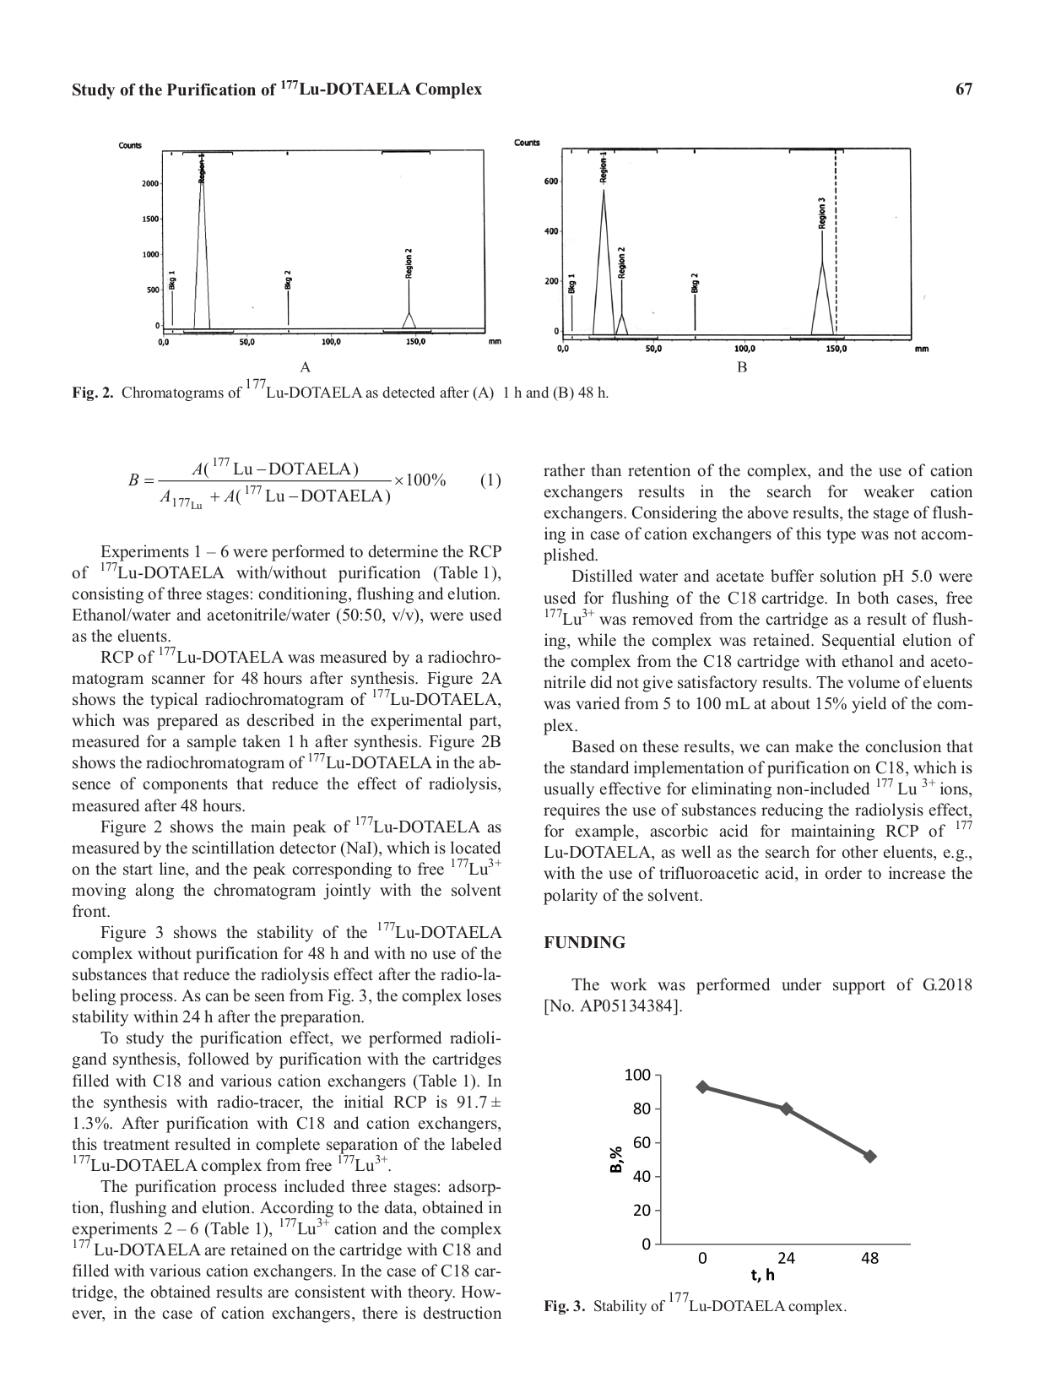

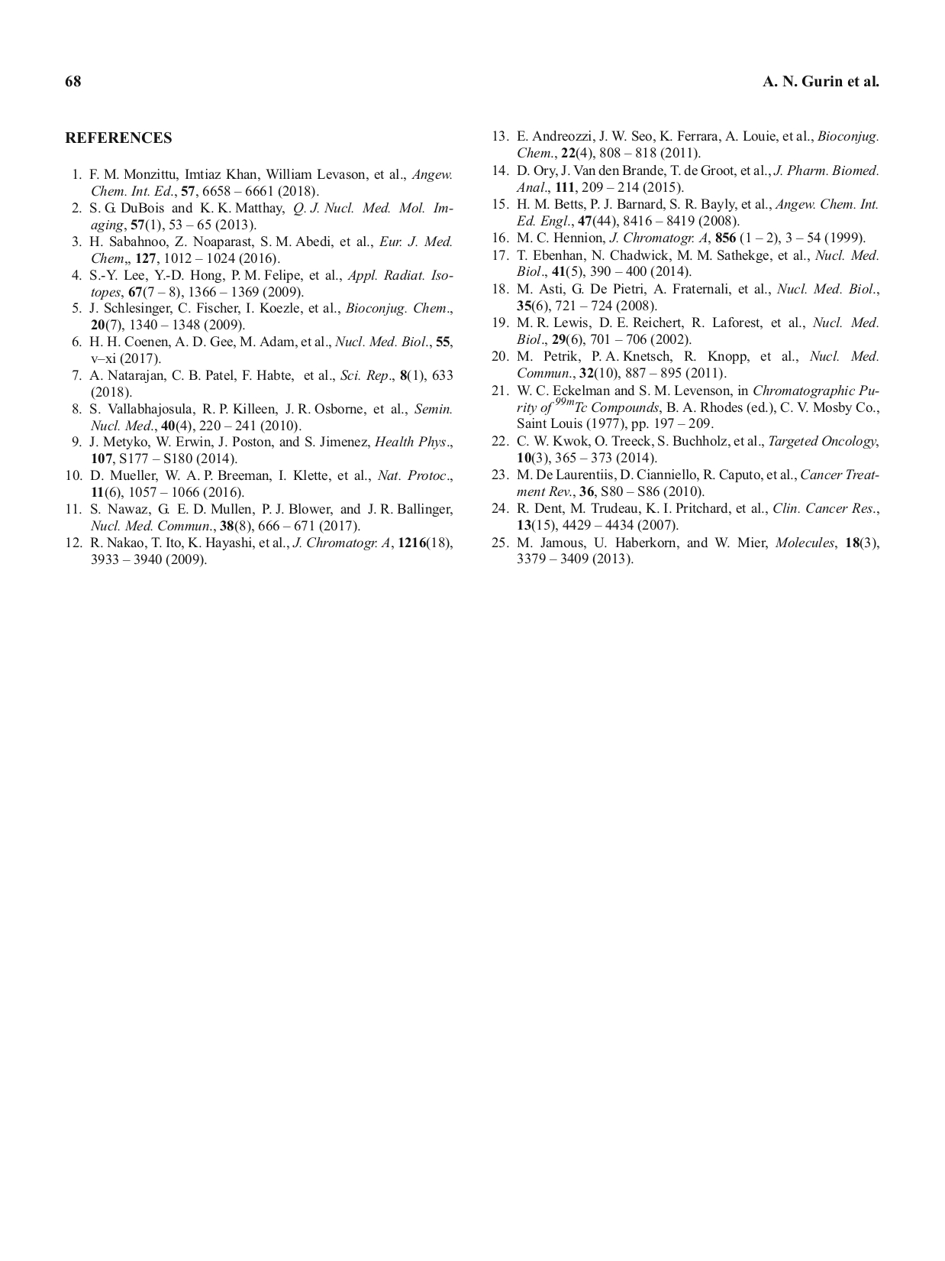

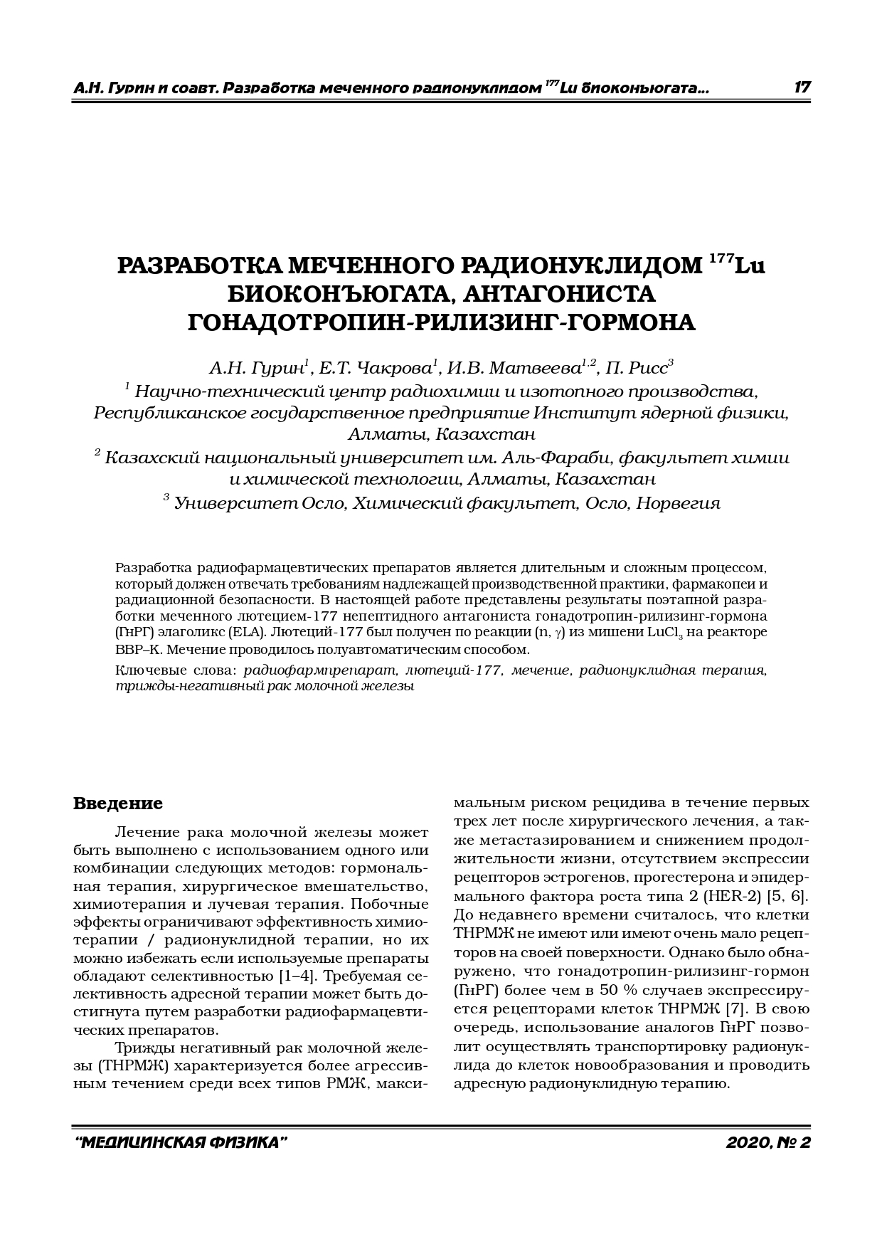

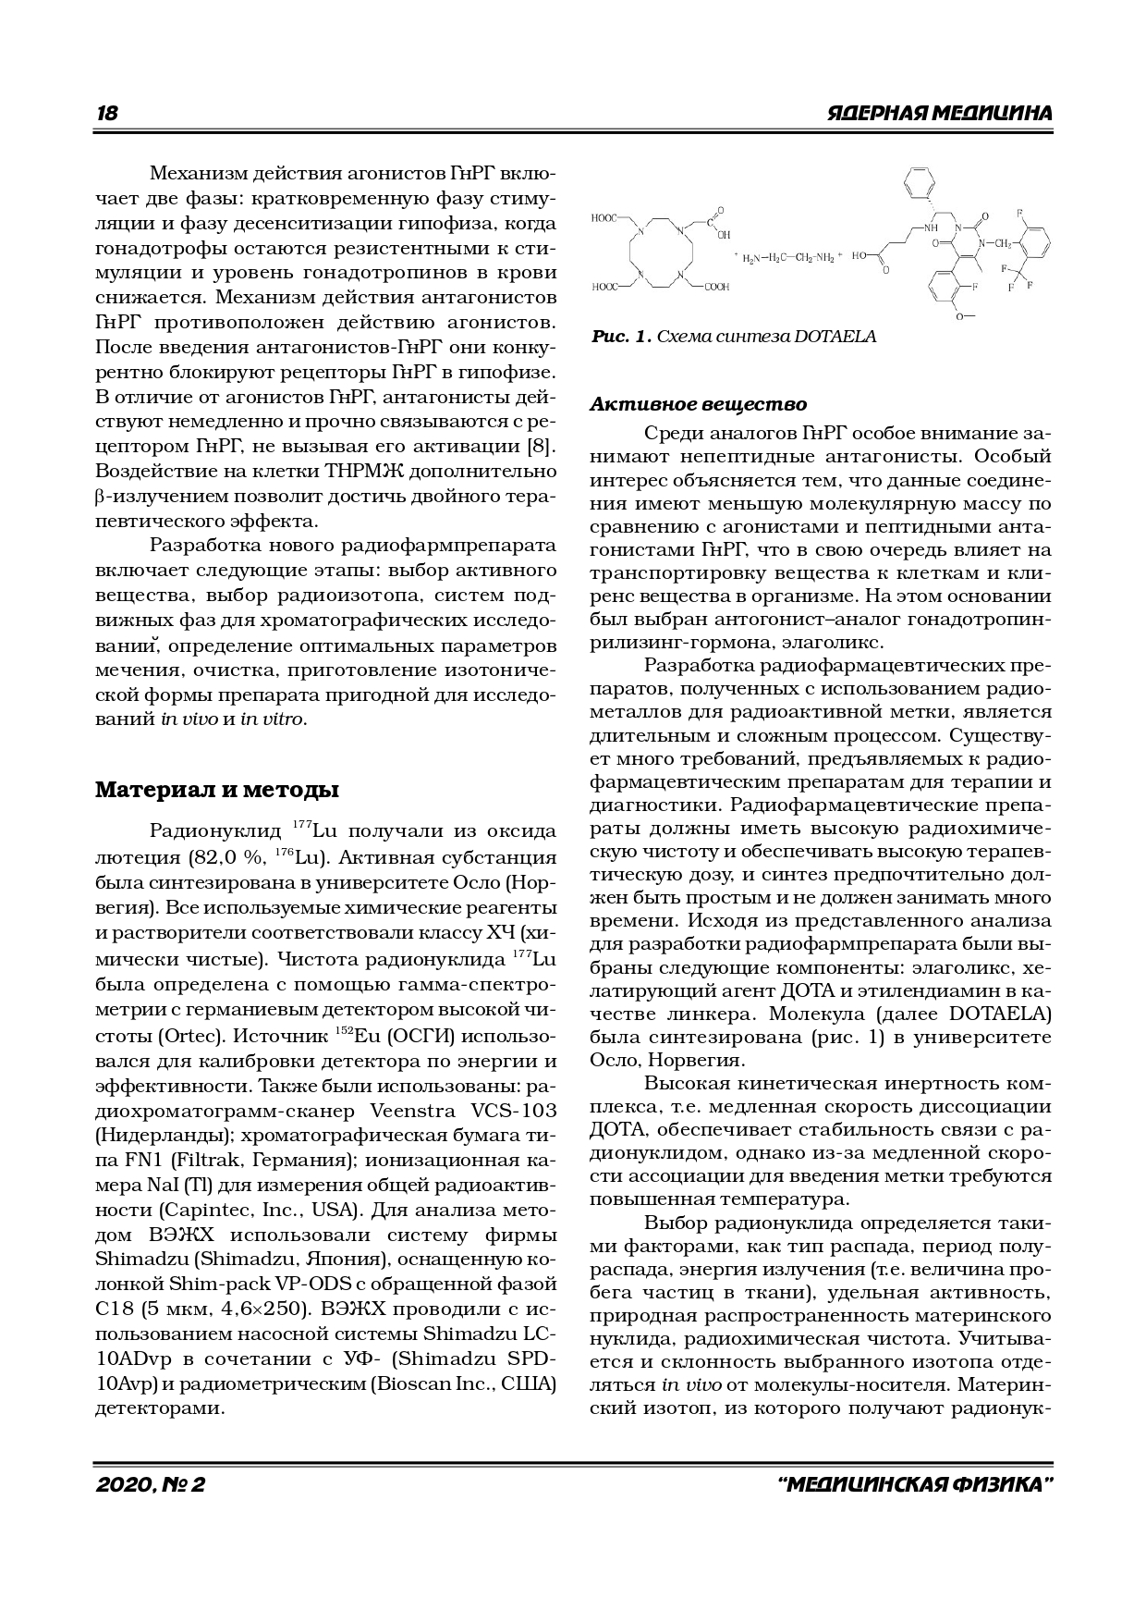

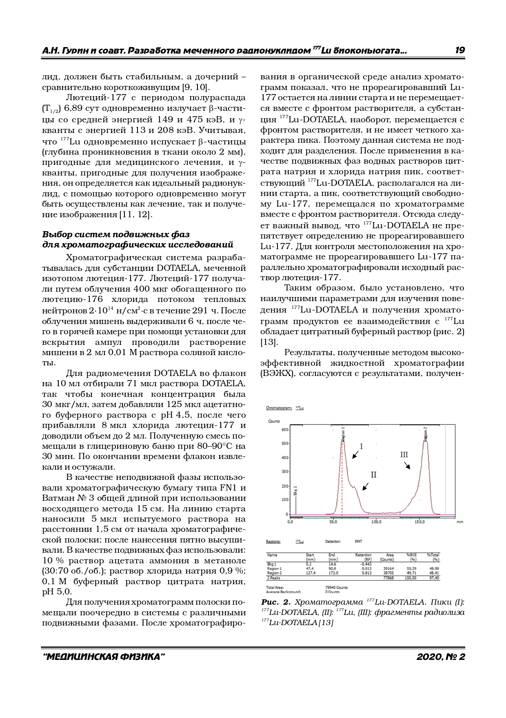

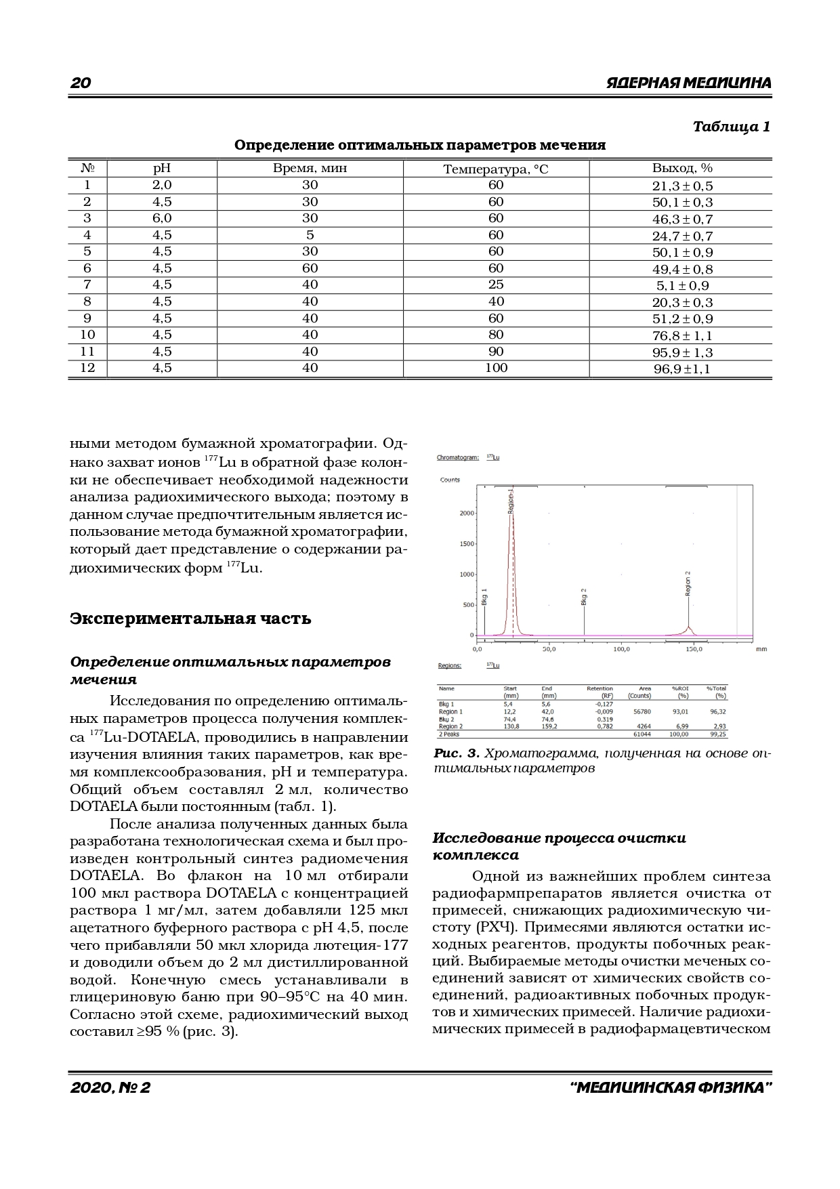

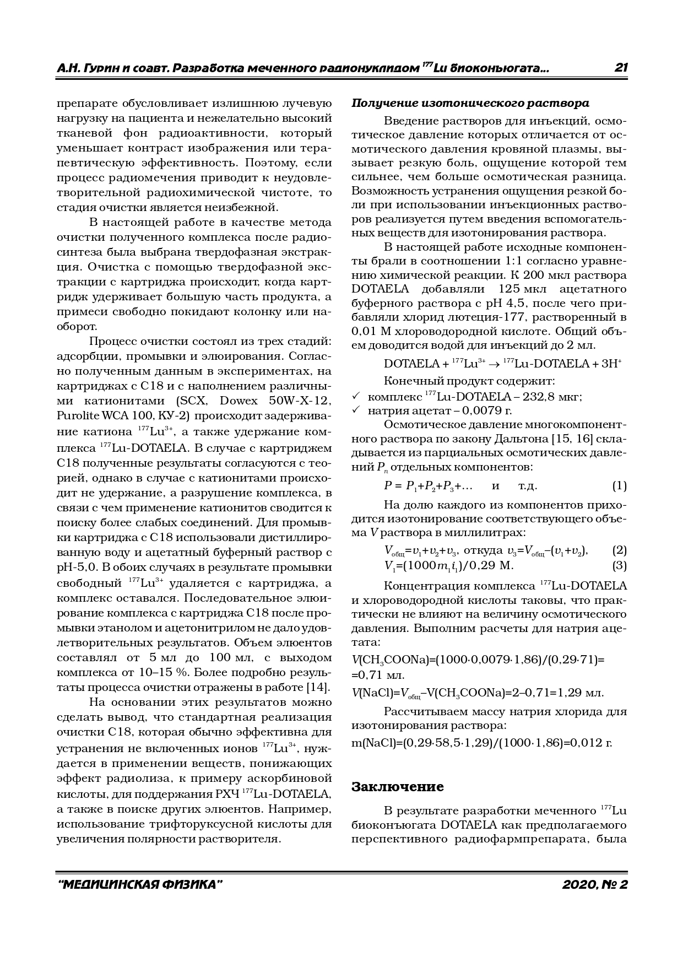

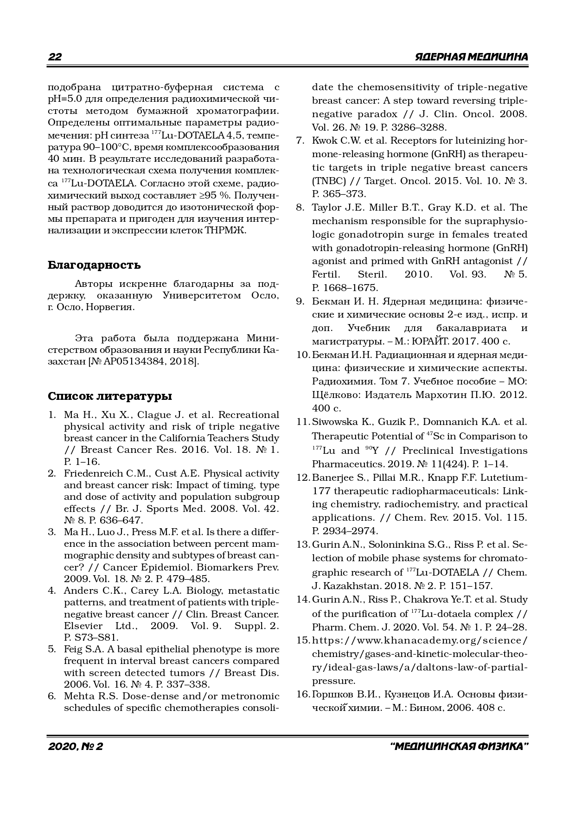

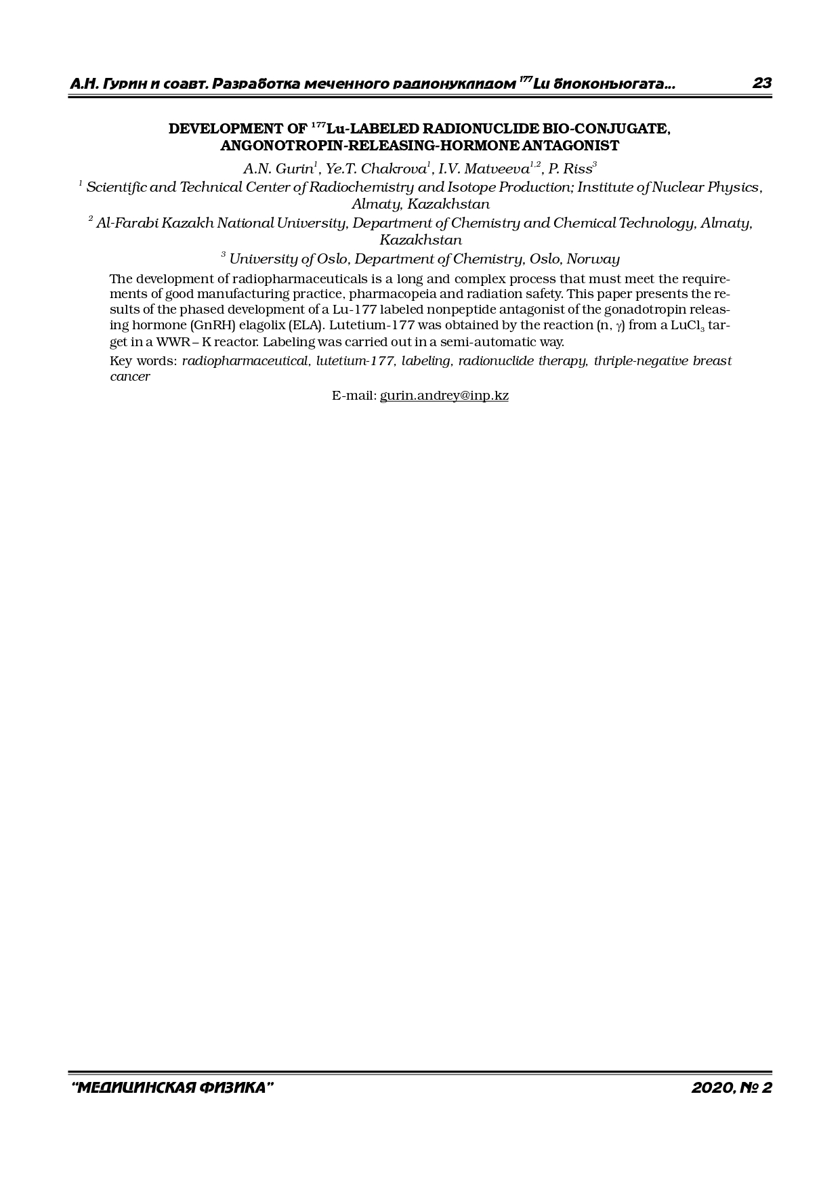

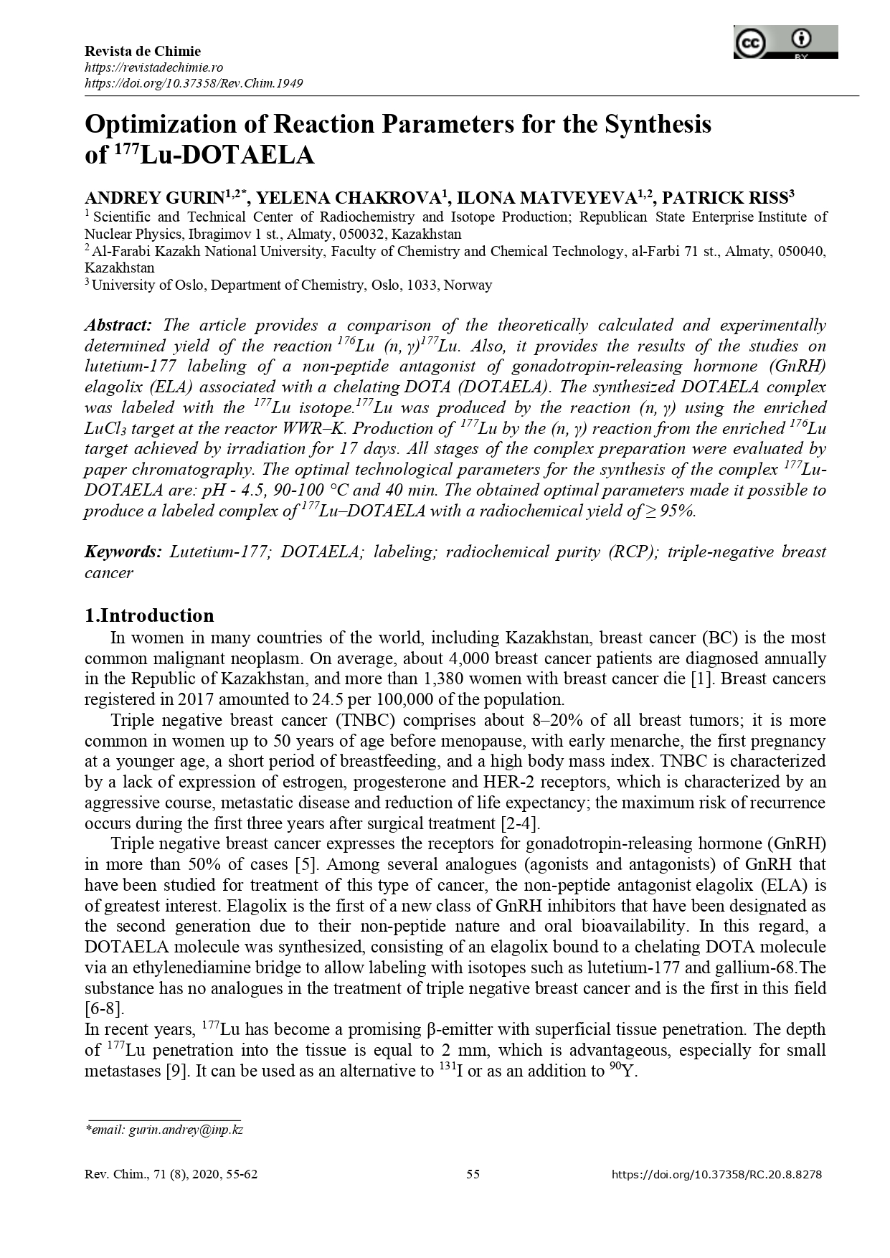

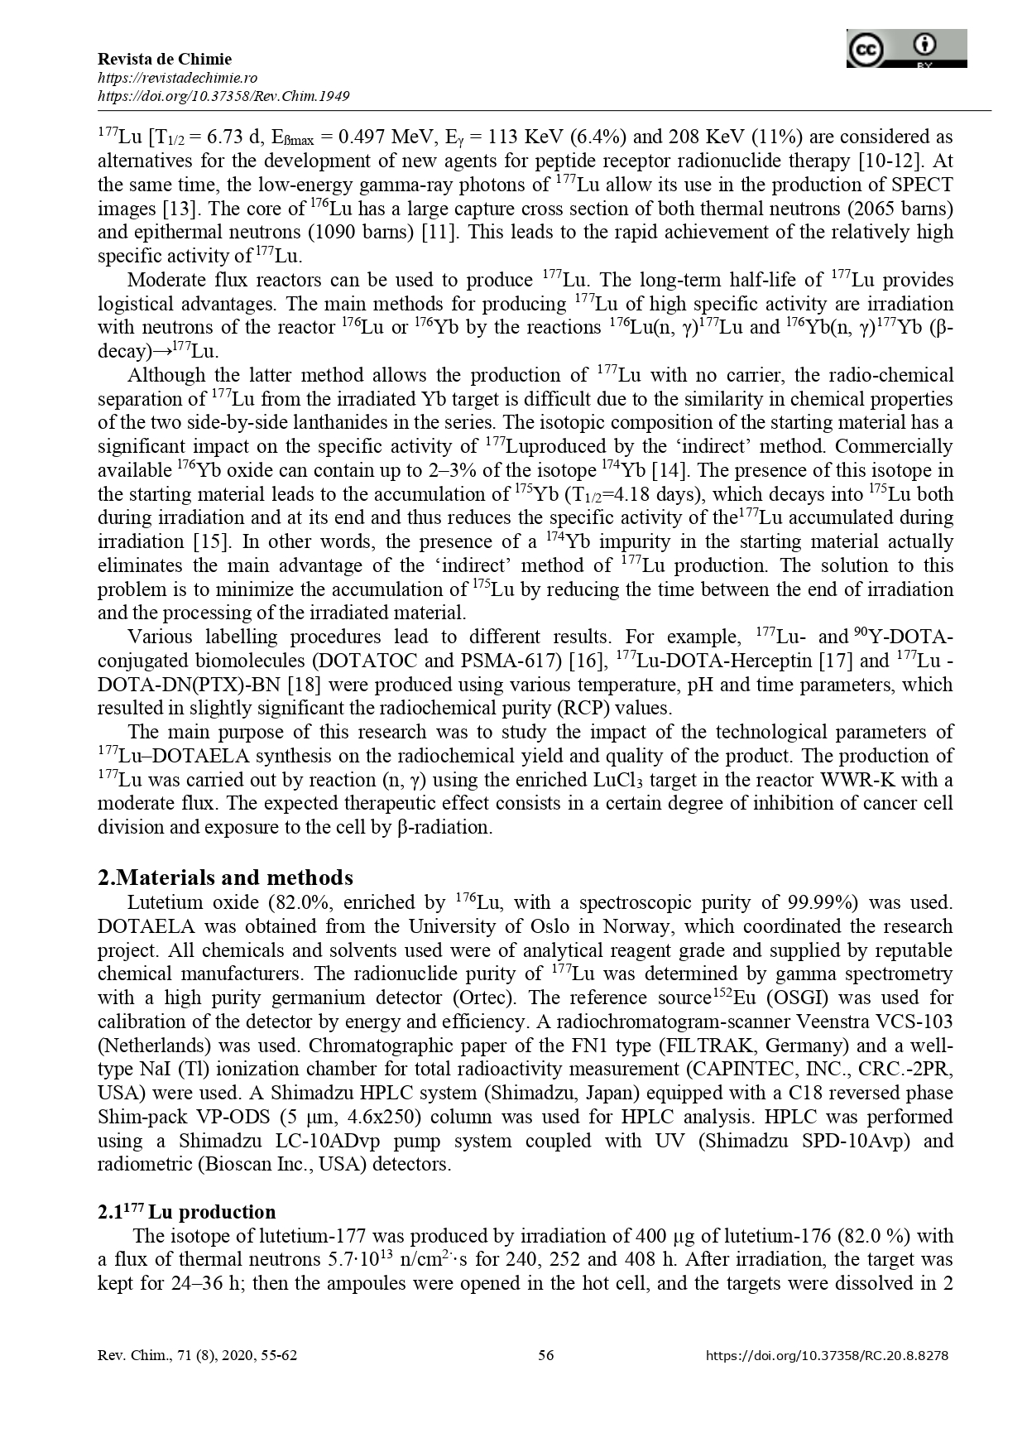

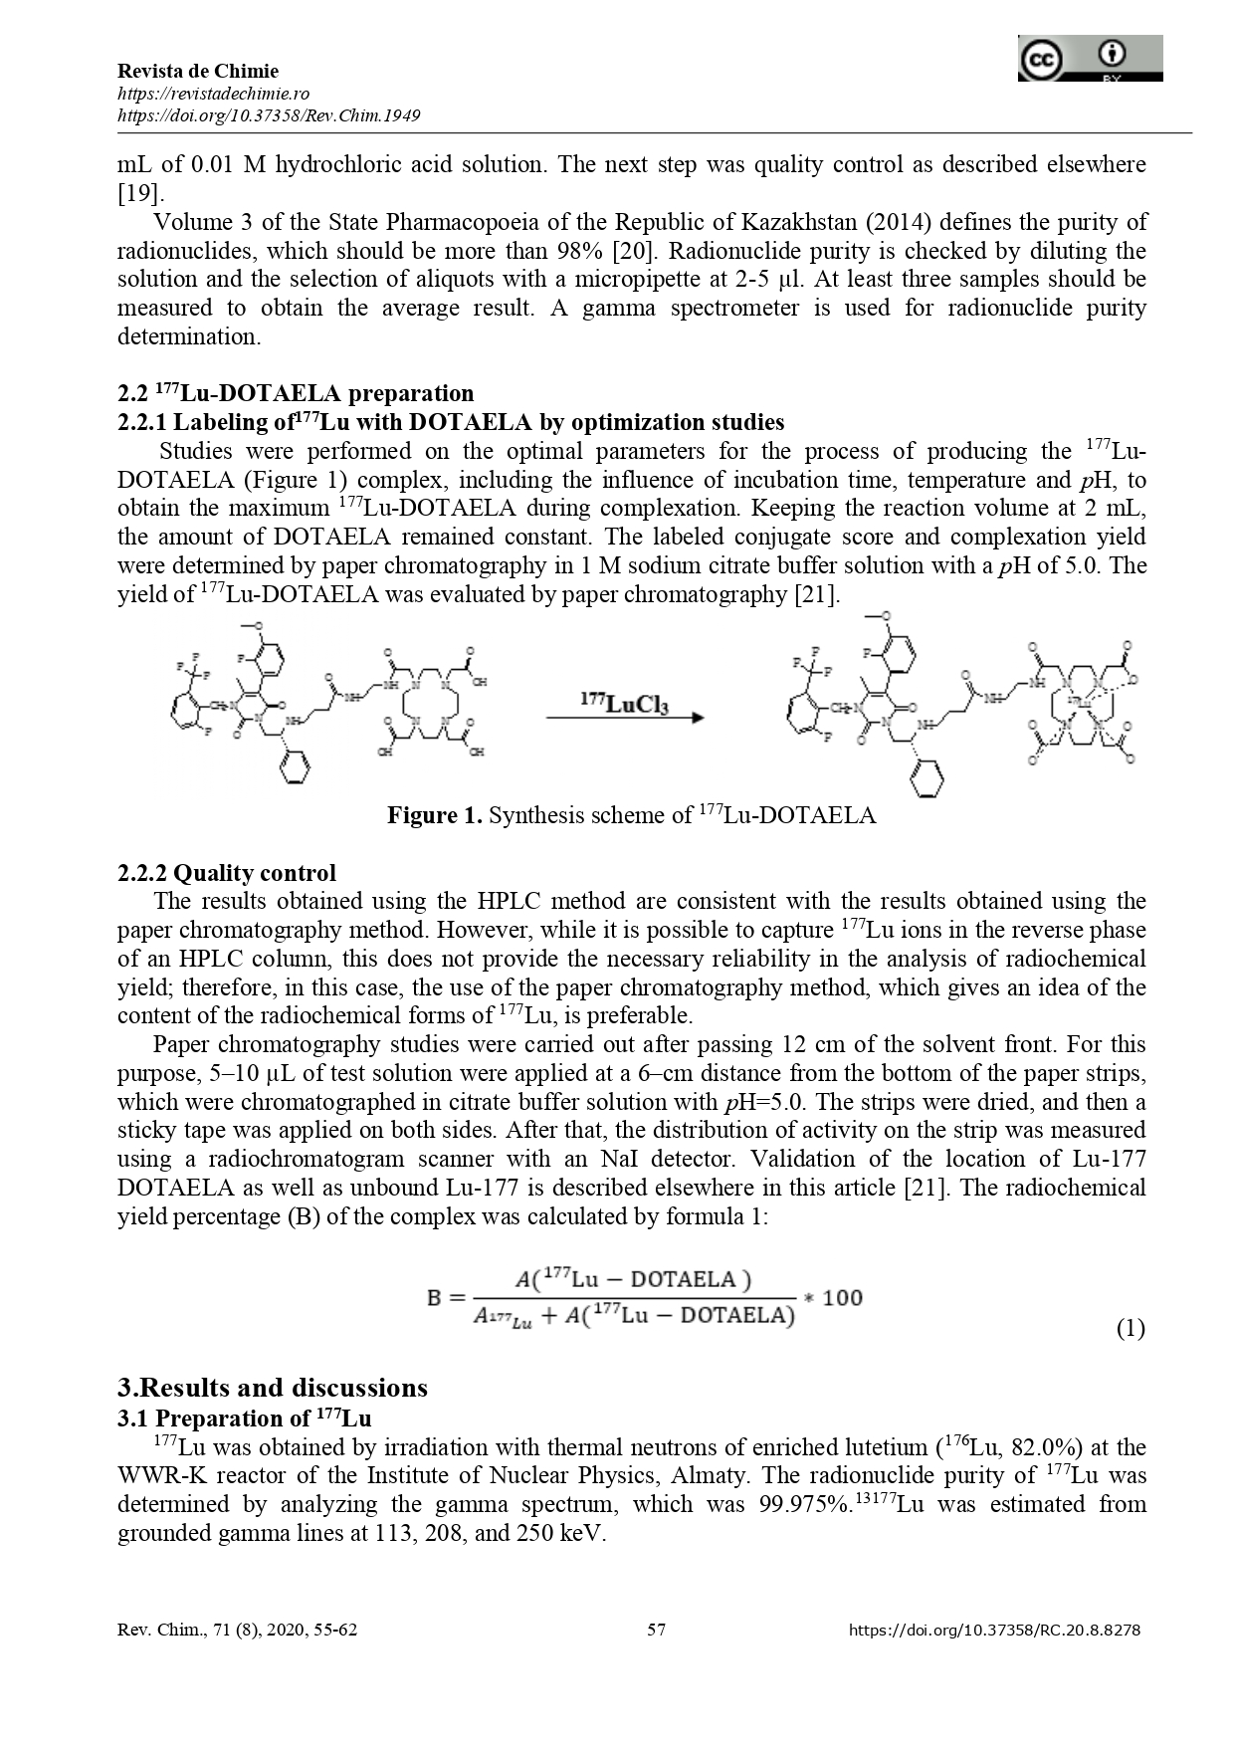

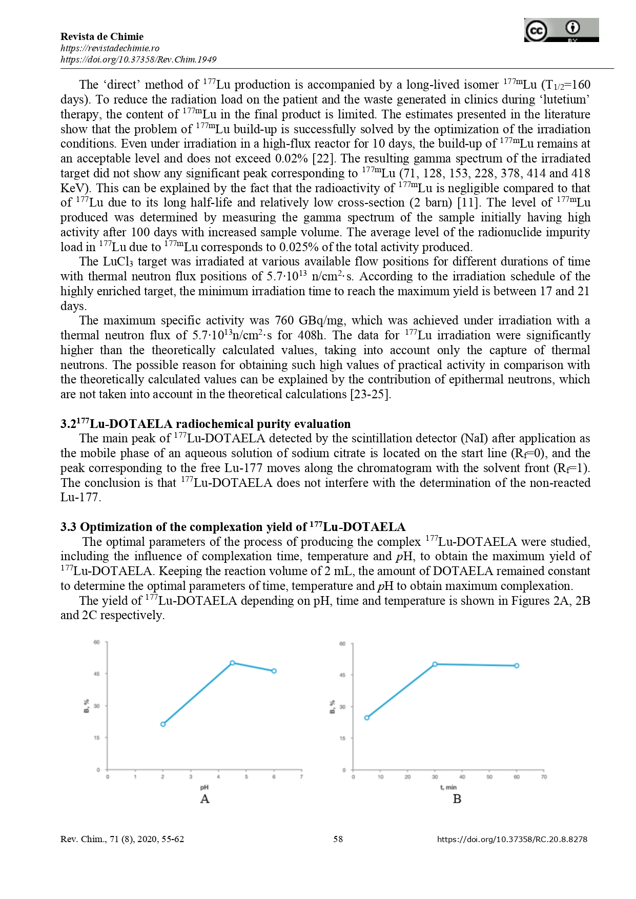

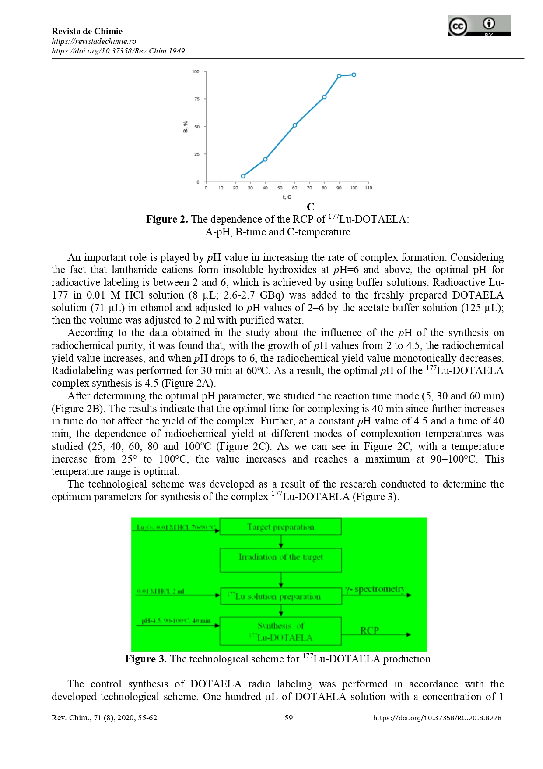

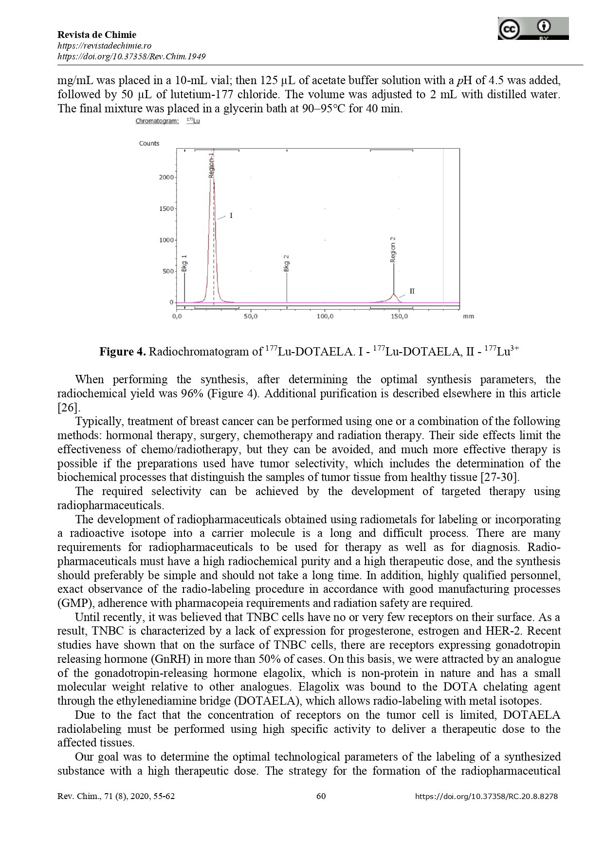

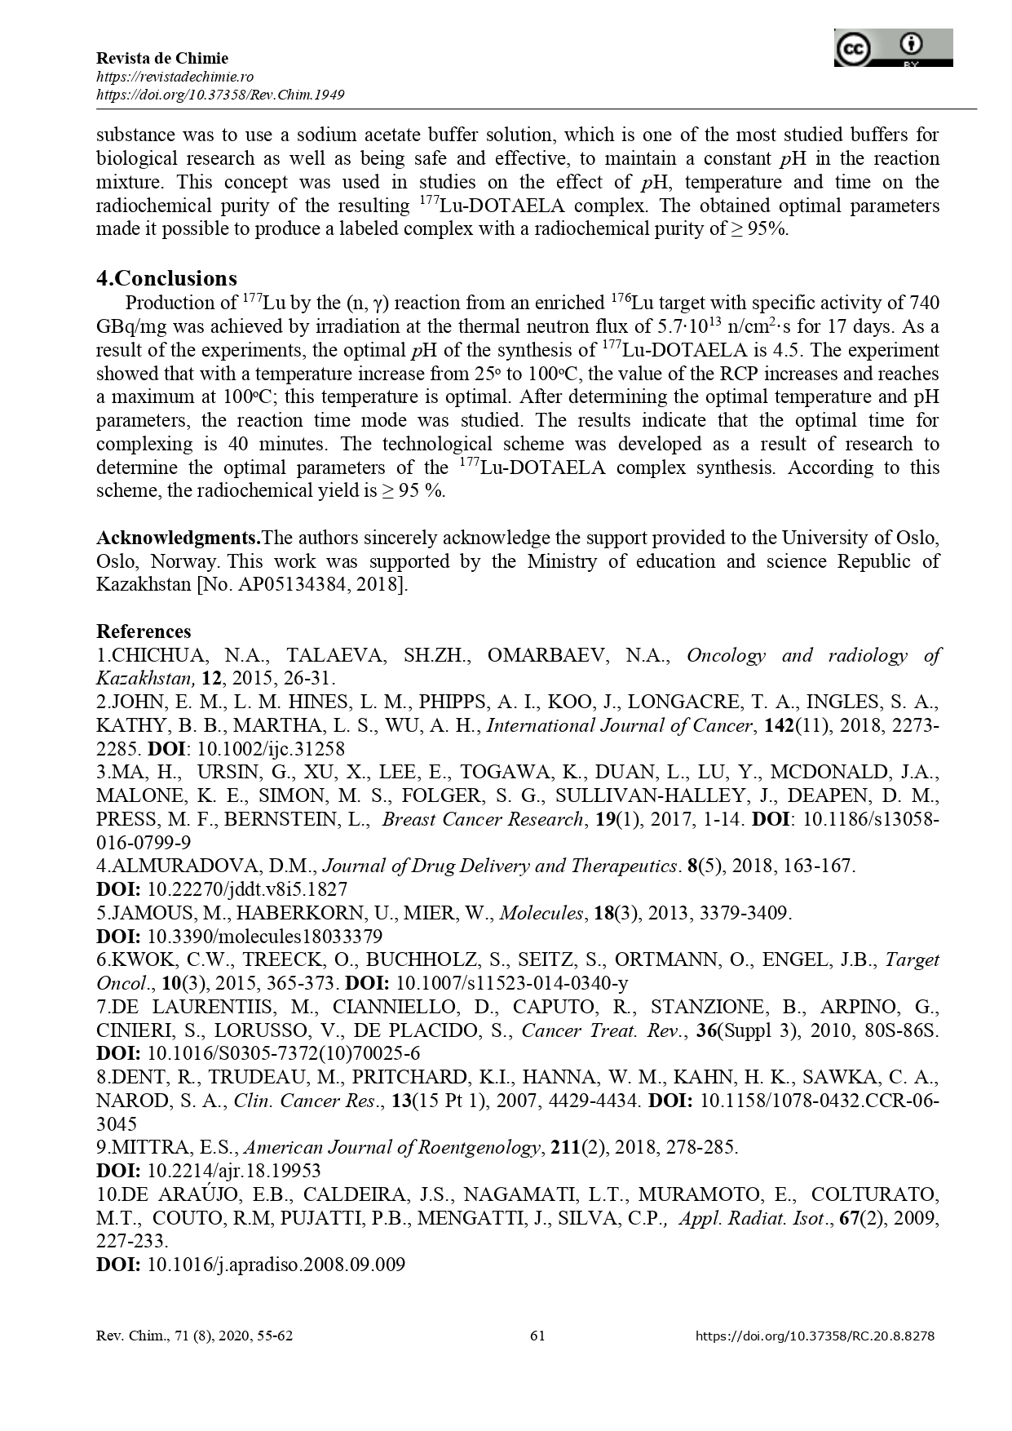

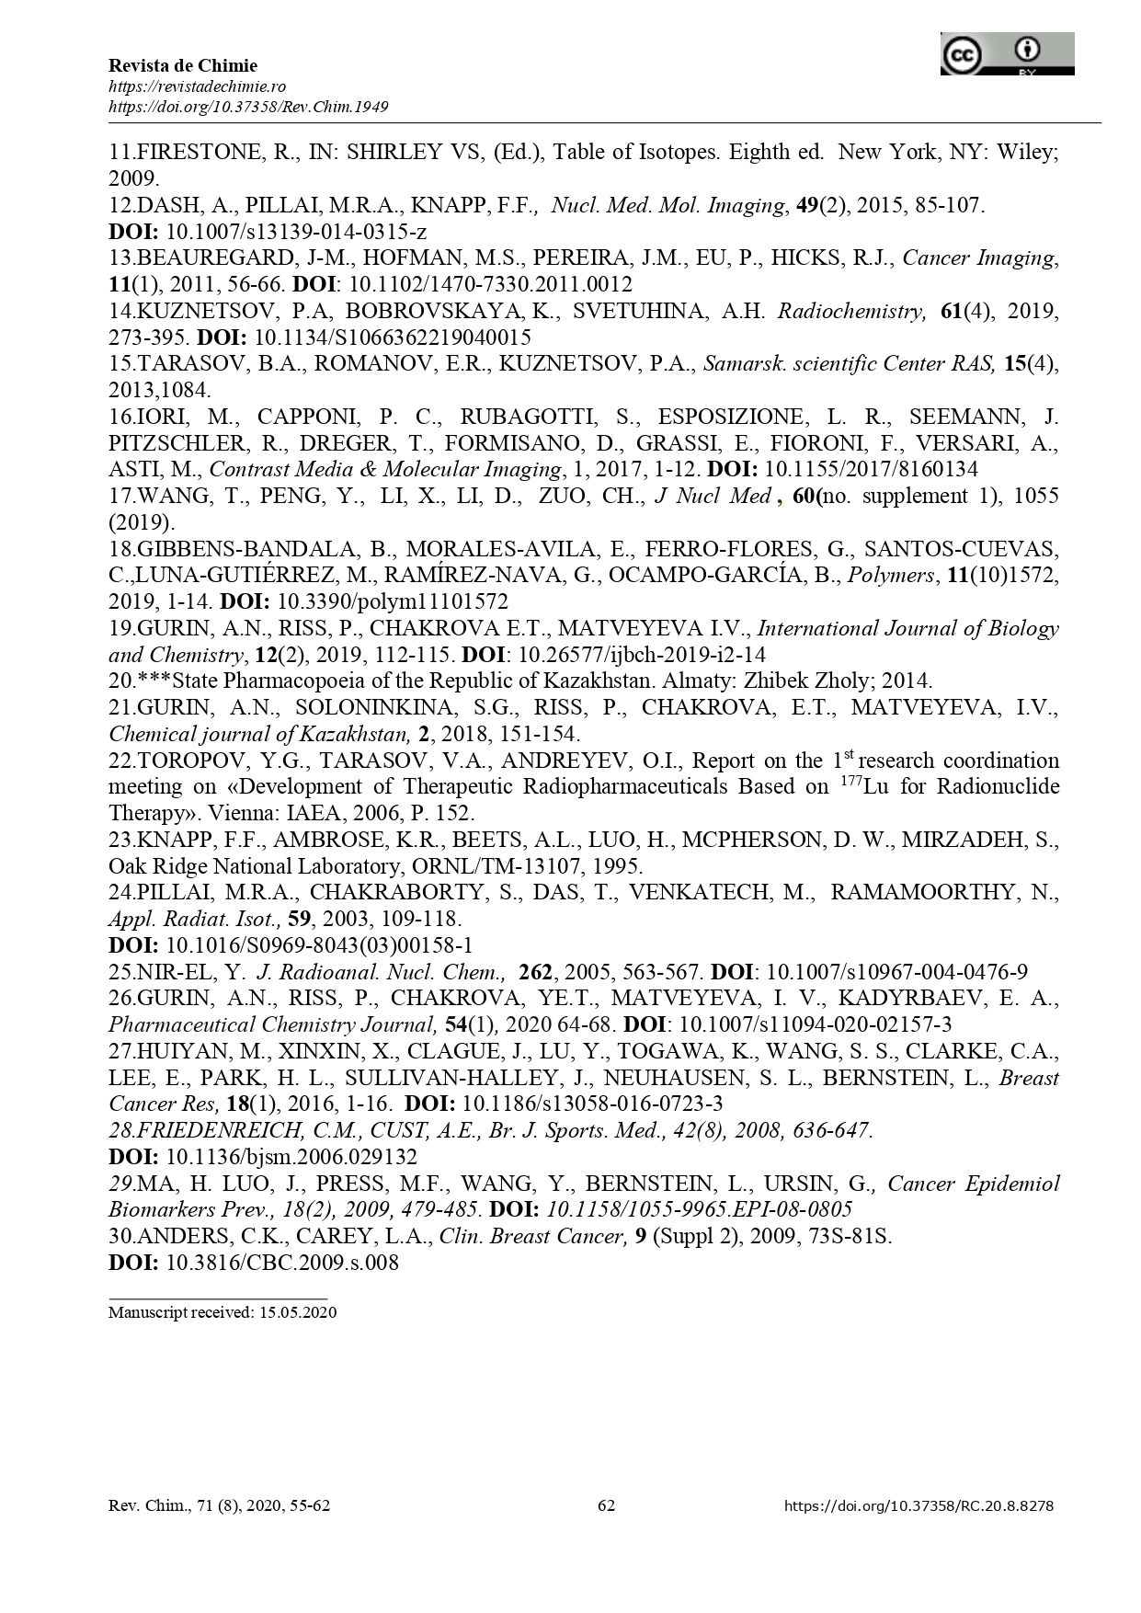

APPENDIX E
Utility model patent

APPENDIX E
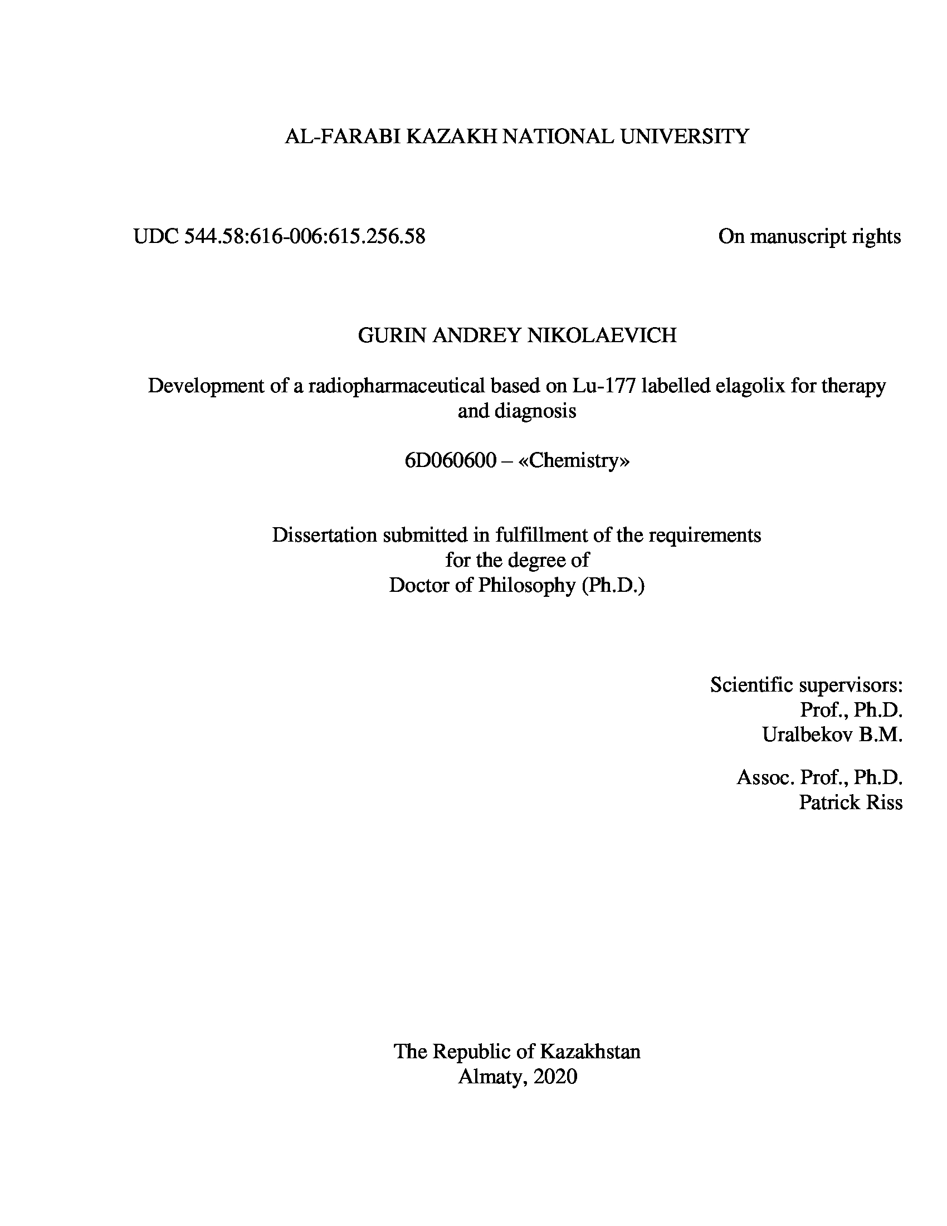
The title page of the thesis and the extract of al-Farabi KazNU

