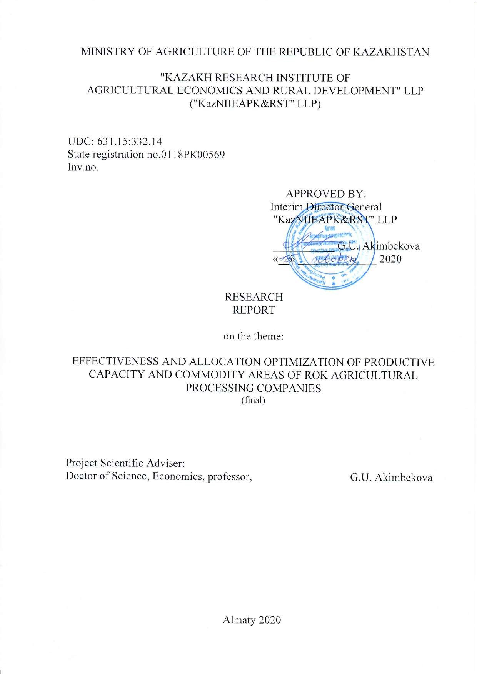

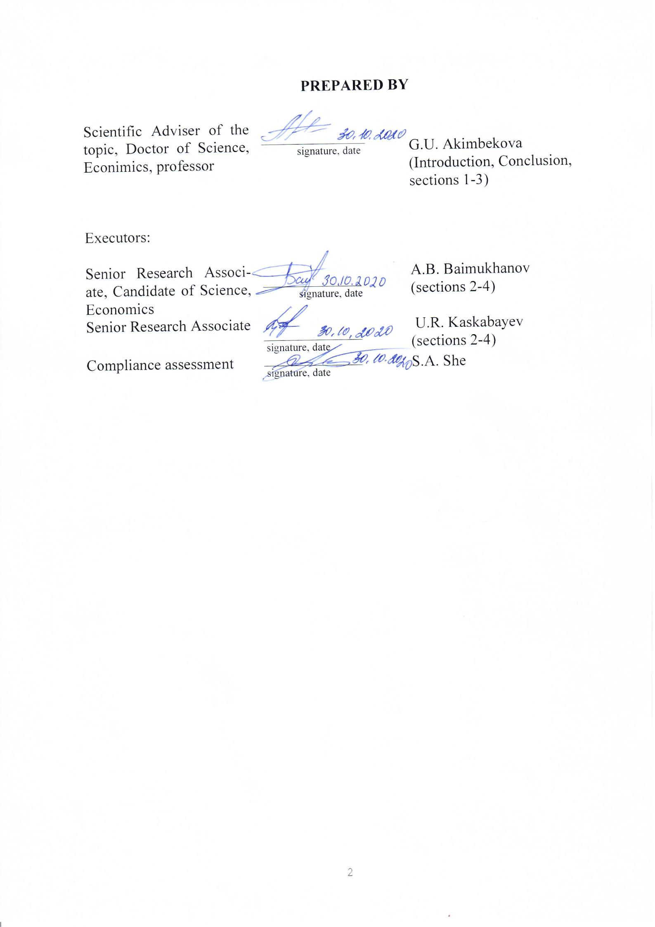

ABSTRACT

Report 149 p., 35 references, 97 appendices

EFFECTIVENESS, OPTIMIZATION, COMMODITY AREA, PROCESSING COMPANY, PRODUCTIVE CAPACITY, AGRO-INDUSTRIAL COMPLEX.
The study object is agricultural, processing and other AIC companies in dairy, meat and grain sectors of RoK AIC.
The goal of research is to develop suggestions on improvement of effectiveness and allocation optimization of production capacity and commodity areas of processing companies of RoK AIC in dairy, meat and grain sectors of RoK AIC.
Research and methodological ground for investigation were major works of academic economists on the project's subject. Depending on the allotted tasks, the following research methods were applied: statistical, monographic, analytical, computational-and-constructive, index, grouping methods, etc.
Results of investigations:
- based on the investigation of established scientific-methodological approaches, frameworks on improvement of effectiveness and allocation optimization of productive capacity and commodity areas of AIC processing companies, main principles, criteria, indicators, patterns were determined, which characterize the level of effectiveness and optimal allocation of productive capacity and raw material resources of AIC processing companies;
- considering the performed analysis of current state, development for development of agriculture and RoK AIC processing companies, concentration of milk, meat, grain and their derivative products production, appraisal is made of population's provision with these products, existing allocation patterns of productive capacity of processing companies and their compliance with the raw material resources across RoK regions, suggestions on improvement of effectiveness and optimization of their allocation are developed;
- considering small commodity nature of production of milk and meat in RoK, the need for organization of agricultural cooperatives (on procurement and sale, primary processing, feeding of cattle, etc.) in potential commodity areas of AIC processing companies was justified, mechanism of creation, economical efficiency of recommended models of agricultural cooperatives, prospective allocation patterns of the objects of cooperative (milk collecting station, slaughter halls, feed yards, etc.) and their interaction with existing and newly established processing companies by districts and regions are presented, also the forecast of financial requirement and other calculations in order to improve effectiveness and optimize their allocation;
- based on the presented assessment of grain production across RoK regions, regions with high potential of buildup with least costs, resource base of cereal processing factories, demands for new productive capacity of storage, processing are determined, suggestions on improvement of effectiveness and allocation optimization of cereal processing factories' productive capacity in accordance with their raw material resources are developed.
Extent of adoption and their scope: The presented suggestions on improvement of effectiveness and allocation optimization of productive capacity and commodity areas of processing companies in dairy, meat and grain sectors of RoK AIC allows for maximum charging of processing companies with raw materials by combination of small business forms into agricultural cooperatives in order to harness their potential to increase production of output, guaranteed sale of manufactured products, fostering their shift to a larger commodity economy and increase in earnings of rural population. The developed prospective allocation patterns of productive capacity of processing companies and their commodity areas by arrangement of cooperative milk collecting stations, feed yards and slaughter halls in Turkestan, Zhambyl, Almaty regions were handed to regional Administrations of agriculture.
Result of scientific research adoption is: implementing scientific support for creation of more than 90 agricultural cooperatives for procurement and sale, primary processing of milk, meat, etc., in Zhambyl, Turkestan regions, confirmed by the adoption deeds. The developed recommendations on effectiveness improvement and allocation optimization of productive capacity and raw material resources of processing companies in dairy, meat and grain sectors of RoK AIC are used by AIE&LE "Association of peasant (farming) households and agricultural cooperatives of Kazakhstan", Kazakh National Agrarian Research University, confirmed by the adoption deed. These suggestions may be also used by domestic AIC entities, sectoral ministries and departments, National Companies in the course of implementation of State program of RoK AIC development for 2017-2021.
Economical efficiency of the work or relevance of work. The developed recommendations on creation of agricultural cooperatives in the fields of storage, primary processing of products, prospective allocation patterns of milk collecting stations, feed yards, slaughter halls, large processing companies across RoK districts and regions in dairy, meat, grain sectors of RoK AIC facilitate maximum charging of productive capacity of processing companies, their optimal allocation in accordance with their raw material resources.
Projected suggestions on the development of investigation subject:
Implementation of recommended suggestions on effectiveness improvement and allocation optimization of productive capacity and commodity areas of processing companies in dairy, meat and grain sectors of RoK AIC will allow increasing production volumes of finished (ready) products of RoK AIC, increase its competitive advantage on the market and export potential of domestic enterprises.

TABLE OF CONTENTS

INTRODUCTION…………………………………………………………… | 13
THE BODY………………………………………………....……………...... | 16
- Development of scientific-methodological approaches on improvement of effectiveness and allocation optimization of productive capacity and commodity areas of aic processing companies (Stage 2018)……................… | 16
- Development of suggestions on improvement of effectiveness and allocation optimization of productive capacities and commodity areas of processing companies in dairy sector of RoK AIC (Stage 2018)…….........…... | 20
- Development of suggestions on improvement of effectiveness and allocation optimization of productive capacity and commodity areas of processing ............................................................................................................. | 27
- Development of suggestions on improvement of effectiveness and allocation optimization of productive capacity and commodity areas of processing companies in grain sector of RoK AIC (Stage 2020)………………........................................................................................ | 36
CONCLUSION…………………..…………………...………….....………… | 45
REFERENCES…………………………….…………...…….……………. | 47
APPENDIX А - The volume of gross and commercial production of cow's milk and their share by categories of farms in the Republic of Kazakhstan for 2017 | 50
APPENDIX B - Milk self-sufficiency ratio of the population in the context of regions of the Republic of Kazakhstan for 2016............................................. | 51
APPENDIX C - Structure of material costs for the production of cow's milk in the Republic of Kazakhstan in 2016,%........................................................... | 52
APPENDIX D - Indicators of economic efficiency of milk production in the Republic of Kazakhstan for 2016................................................................... | 53
APPENDIX E - The presence of milk processing enterprises and their production capacity for raw materials in the Republic of Kazakhstan in 2016.... | 54
APPENDIX F - The ratio of profits and costs of enterprises in the production, processing and sale of milk (per 1 ton of final product) using the example of these enterprises for 2016................................................................................ | 55
APPENDIX G - Forecast of milk production and production capacities of milk processing enterprises of the Republic of Kazakhstan in the context of regions for 2021, thousand tons................................................................. | 56
APPENDIX H - Production of dairy products by type in the Republic of Kazakhstan in 2017 (with reference to milk), thousand tons................................ | 57
APPENDIX J - Concentration of milk production and the coefficients of conformity of production capacities of milk processing enterprises to raw materials in the Republic of Kazakhstan for 2017............................................ | 58
APPENDIX K - Concentration of milk production and milk self-sufficiency coefficient of the population of Almaty region in 2017.............................. | 59
APPENDIX L - Concentration of milk production and milk self-sufficiency ratio of the population of Zhambyl region in 2017............................................ | 60
APPENDIX M - Number of milk collection points for loading milk processing enterprises in the Republic of Kazakhstan............................................ | 61
APPENDIX N - Balance of milk residues in households in the context of districts of Zhambyl region............................................................................... | 62
APPENDIX P - The need for milk collection points and milk carriers to increase the load on dairies in Zhambyl region.................................................. | 63
APPENDIX Q - The need to equip equipment and machinery for agricultural cooperatives of the dairy sector in the Zhambyl region.................................... | 64
APPENDIX R - The need to organize agricultural cooperatives for dairy production in the context of districts of Zhambyl region.................................. | 65
APPENDIX S - The number of agricultural cooperatives of the dairy sector by type of activity in the context of districts of the Zhambyl region.................. | 66
APPENDIX T - Recommended layout of the raw material zones of milk processing enterprises by organizing cooperative MPPs in the Merke district of the Zhambyl region.................................................................................... | 67
APPENDIX U - Recommended layout of the raw material zones of milk processing enterprises by organizing cooperative MPPs in the Zhambyl district of the Zhambyl region............................................................................. | 68
APPENDIX V - Recommended layout of the raw material zones of milk processing enterprises by organizing cooperative MPPs in the T. Ryskulov district of the Zhambyl region...................................................................... | 69
APPENDIX W - Recommended layout of the raw material zones of milk processing enterprises by organizing cooperative MPPs in the Korday district of the Zhambyl region................................................................................. | 70
APPENDIX X - Recommended layout of the raw material zones of milk processing enterprises by organizing cooperative MPPs in the Zhualin district of the Zhambyl region................................................................................. | 71
APPENDIX Y - Recommended layout of the raw material zones of milk processing enterprises by organizing cooperative MPPs in the Bayzak district of the Zhambyl region............................................................................... | 72
APPENDIX Z - Recommended layout of the raw material zones of milk processing enterprises by organizing cooperative MPPs in the Shu district of the Zhambyl region..................................................................................... | 73
APPENDIX 1 - Milk collection points reqired and milk trucks to increase the load of dairies in Almaty region...................................................................... | 74
APPENDIX 2 - The number of agricultural cooperatives of the dairy sector required by type of activity in the context of districts of the Almaty region....... | 75
APPENDIX 3 - Recommended layout of raw material zones of dairy processing enterprises by organizing cooperative MPPs in Enbekshikazakhsky district of Almaty region............................................................................... | 76
APPENDIX 4 - Recommended layout of raw material zones of dairy processing enterprises by organizing cooperative MPPs in Iliysky district of Almaty region............................................................................................ | 77
APPENDIX 5 - Recommended layout of raw material zones of dairy processing enterprises by organizing cooperative MPPs in Karasay district of Almaty region................................................................................................ | 78
APPENDIX 6 - Recommended layout of raw material zones of dairy processing enterprises by organizing cooperative MPPs in Eskeldynsky district of Almaty region............................................................................................... | 79
APPENDIX 7 - Recommended layout of raw material zones of dairy processing enterprises by organizing cooperative MPPs in Koksu district of Almaty region.............................................................................................. | 80
APPENDIX 8 - Recommended layout of raw material zones of dairy processing enterprises by organizing cooperative MPPs in Sarkandsky district of Almaty region..................................................................................... | 81
APPENDIX 9 - Recommended layout of raw material zones of dairy processing enterprises by organizing cooperative MPPs in Talgar district of Almaty region............................................................................................ | 82
APPENDIX 10 - Recommended layout of raw material zones of dairy processing enterprises by organizing cooperative MPPs in Karatal district of Almaty region............................................................................................ | 83
APPENDIX 11 - Recommended layout of raw material zones of dairy processing enterprises by organizing cooperative MPPs in Alakol district of Almaty region.................................................................................................. | 84
APPENDIX 12 - Number of livestock by types and categories of farms in the Republic of Kazakhstan for 2018, thousand heads.......................................... | 85
APPENDIX 13 - Meat production (dead weight) by farm category in the Republic of Kazakhstan in 2018, thousand tons............................................. | 86
APPENDIX 14 - Cattle meat production (in live and dead weight) per 100 hectares of farmland in agricultural formations by regions of the Republic of Kazakhstan for 2018, c. ................................................................................ | 87
APPENDIX 15 - Main economic indicators of meat production by types in the Republic of Kazakhstan for 2018................................................................ | 88
APPENDIX 16 - Volumes of meat production in feedlots in the context of regions of the Republic of Kazakhstan in 2018............................................ | 89
APPENDIX 17 - Meat production and capacity utilization of meat processing enterprises (excluding poultry meat) in Kazakhstan in 2018..................... | 90
APPENDIX 18 - Concentration of meat production and the coefficient of conformity of production capacities of meat processing enterprises to their raw materials in the Republic of Kazakhstan for 2018.................................... | 91
APPENDIX 19 - Cattle and poultry stock in Almaty, Turkestan and East Kazakhstan regions of the Republic of Kazakhstan by categories of farms for 2018, thousand heads............................................................................... | 92
APPENDIX 20 - Coefficient of self-sufficiency in meat of the population of Almaty region and Almaty city for 2018......................................................... | 93
APPENDIX 21 - Coefficient of self-sufficiency in meat of the population of the Turkestan region and Shymkent for 2018.................................................. | 94
APPENDIX 22 - Coefficient of self-sufficiency in meat of the population of the East Kazakhstan region for 2018................................................................ | 95
APPENDIX 23 - Concentration of meat production and the coefficient of conformity of production capacities of meat processing enterprises to their raw materials in the Almaty region and Almaty in 2018................................... | 96
APPENDIX 24 - Concentration of meat production and the coefficient of compliance of the production capacities of meat processing enterprises with their raw materials in the Turkestan region and Shymkent for 2018............... | 97
APPENDIX 25 - Concentration of meat production and the coefficient of conformity of production capacities of meat processing enterprises to their raw materials in the East Kazakhstan region in 2018...................................... | 98
APPENDIX 26 - Layout of meat processing enterprises in Almaty region in 2018.................................................................................................... | 99
APPENDIX 27 - Layout of meat processing enterprises in the East Kazakhstan region in 2018................................................................................. | 100
APPENDIX 28 - Layout of meat processing enterprises in the Turkestan region in 2018............................................................................................... | 101
APPENDIX 29 - Locations of new family farms and new processing plants under the National Program of Beef Livestock for 2018-2027......................... | 102
APPENDIX 30 - Calculation of the optimal feed requirement for fattening cattle for 1 and 800 head of cattle..................................................................... | 103
APPENDIX 31 - Calculation of the cost of fattening bulls when purchasing feed............................................................................................................ | 104
APPENDIX 32 - Calculation of the cost of fattening bulls in the production of their own succulent and dry feeds.............................................................. | 105
APPENDIX 33 - Efficiency of consumption of feed costs for own production and their purchase for fattening young cattle................................................... | 106
APPENDIX 34 - Overhead and operating costs for fattening an agricultural production cooperative with a feedlot for 800 head of cattle............................... | 107
APPENDIX 35 - The volume of investments required to create an agricultural cooperative with a feedlot for 800 head of cattle........................................ | 108
APPENDIX 36 - Economic efficiency of an agricultural production cooperative with a feedlot........................................................................ | 109
APPENDIX 37 - Mechanism for the formation of an agricultural production cooperative farm YNTYMAK-2019 in the Turkestan region............................ | 110
APPENDIX 38 - Production of forage crops (corn for grain, silage and alfalfa) in the agricultural production cooperative YNTYMAK-2019..................... | 111
APPENDIX 39 - Break-even forecast of the YNTYMAK-2019 agricultural production cooperative by years, thousand tenge............................................... | 112
APPENDIX 40 - Act of implementation of research results......................... | 113
APPENDIX 41 - Act of implementation of research results.......................... | 114
APPENDIX 42 - Recommended layout of production facilities of meat processing enterprises in accordance with their raw material resources by organizing agricultural cooperatives for fattening and slaughtering cattle in the Turkestan region........................................................................................... | 115
APPENDIX 43 - Recommended layout of production facilities of meat processing enterprises in accordance with their raw material resources by organizing agricultural cooperatives for fattening and slaughtering cattle in the  Almaty region..................................................................................................... | 116
APPENDIX 44 - Recommended layout of production facilities of meat processing enterprises in accordance with their raw material resources by organizing agricultural cooperatives for fattening and slaughtering cattle in the East Kazakhstan region.................................................................................... | 117
APPENDIX 45 - Forecast for the creation of family farms for growing and their unification into agricultural production cooperatives for fattening and slaughtering cattle in the Turkestan region......................................................... | 118
APPENDIX 46 - Forecast for the creation of family farms for growing and their unification into agricultural production cooperatives for fattening and slaughtering cattle in the Almaty region............................................................. | 119
APPENDIX 47 - Forecast for the creation of family farms for growing and their unification into agricultural production cooperatives for fattening and slaughtering cattle in the East Kazakhstan region.............................................. | 120
APPENDIX 48 - Forecast for the creation of family farms for growing and their unification into agricultural production cooperatives for fattening and slaughtering cattle in the Republic of Kazakhstan............................................. | 121
APPENDIX 49 - Map of the location of production facilities of meat processing enterprises and agricultural production cooperatives for fattening and slaughtering cattle in the Republic of Kazakhstan............................................. | 122
APPENDIX 50 - Gross harvest of cereals (including rice) and legumes in all categories of farms in the context of regions of the Republic of Kazakhstan in 2019, thousand tons............................................................................................ | 123
APPENDIX 51 - Volume of flour production from fine grain crops by region for 2017-2019, thousand tons................................................................ | 124
APPENDIX 52 - Availability of production capacity for grain storage facilities in all categories of farms in the Republic of Kazakhstan in 2019.............................................................................................................. | 125
APPENDIX 53 - Concentration of grain production and the coefficient of correspondence of the production capacity of grain processing enterprises to their raw materials in the context of regions of the Republic of Kazakhstan for 2019............................................................................................................... | 126
APPENDIX 54 - Coefficient of self-sufficiency in bread and cereal products of the population in the context of regions of the Republic of Kazakhstan for 2019 ............................................................................................................ | 127
APPENDIX 55 - Consumption of bakery products and cereals per capita per year in the Republic of Kazakhstan, kg.............................................................. | 128
APPENDIX 56 - Key indicators of the development of the grain industry in Akmola, Kostanay and North Kazakhstan regions for 2019, thousand tons...... | 129
APPENDIX 57 - Concentration of grain production and the coefficient of conformity of the production capacity of grain processing enterprises to their raw materials in the Akmola region in 2019...................................................... | 130
APPENDIX 58 - Concentration of grain production and the coefficient of conformity of the production capacity of grain processing enterprises to their raw materials in the Kostanay region in 2019................................................... | 131
APPENDIX 59 - Concentration of grain production and the coefficient of conformity of the production capacity of grain processing enterprises to their raw materials in the North Kazakhstan region in 2019...................................... | 132
APPENDIX 60 - Placement of grain production and production facilities for storage and processing in the context of districts of Akmola region for 2019.... | 133
APPENDIX 61 - Placement of grain production and production facilities for storage and processing in the context of districts of Kostanay region for 2019.. | 134
APPENDIX 62 - Placement of grain production and production facilities for storage and processing in the context of districts of North Kazakhstan region for 2019.......................................................................................................... | 135
APPENDIX 63 - Grouping of districts of Akmola region according to the index of cumulative efficiency of growing wheat for 2019............................. | 136
APPENDIX 64 - Grouping of districts of Kostanay region according to the index of cumulative efficiency of growing wheat for 2019............................ | 137
APPENDIX 65 - Grouping of districts of North Kazakhstan region according to the index of cumulative efficiency of growing wheat for 2019..................... | 138
APPENDIX 66 - Forecast of production of cereals and legumes in the context of regions Akmoly region.............................................................................. | 139
APPENDIX 67 - Forecast of production of cereals and legumes in the context of Kostanay region districts............................................................................... | 140
APPENDIX 68 - Forecast of production of cereals and legumes in the context of districts of North Kazakhstan region................................................ | 141
APPENDIX 69 - Forecast of production of cereals and legumes in the context of districts of Akmoly region ............................................................................ | 142
APPENDIX 70 - Forecast of production of cereals and legumes in the context of districts of Kostanay region........................................................................... | 143
APPENDIX 71 - Forecast of production of cereals and legumes in the context of districts of North Kazakhstan region.................................................. | 144
APPENDIX 72 - List of employees participating in the implementation of R&D ........................................................................................ | 145
APPENDIX 73 - List of articles in domestic scientific publications, according to the table: (attach a review of the article)........................................................ | 146

DEFINITIONS

The following terms with relevant definitions are used in this research report:

Commodity area is a community of agricultural commodity producers, providing the processing company with raw materials in the amount and quality, required for full loading of its productive capacity.
Productive capacity is a maximum possible annual output of products of production unit (sector of industry, company, its subdivision, work place).
Concentration of production is an increase of a number of large companies and centering of an increasing part of means of production, work force and products, available in the community, on them.
Optimization is a maximization process of beneficial features, ratios and minimization of expenses.
Allocation is an activity on determination of spacial location and arrangement of designed constructions, transport infrastructure, settlements, manufacturing complexes, etc.
Allocation optimization of productive capacity and commodity areas of AIC processing companies is an assurance of the required proportions between available processing capacity and development level of commodity areas, quantity distribution of reasonable proportions, which includes all technological stages of raw material production, its treatment and realization of end products.
Agricultural cooperative is a legal entity with form of business of production cooperative, created on the basis of membership by voluntary joining of individuals and (or) entities for the implementation of joint production and (or) other economic activity in order to meet their socio-economic demands for production, processing, sale, storage of agricultural products, aquaculture (fish farming) products, provision with means of production and materials and equipment, credit granting, water supply or another maintenance service of the cooperative members, as well as of associate memebers of cooperative.

DESIGNATIONS, ABBREVIATIONS

AIC | - | agro-industrial complex
ha | - | hectare
Y | - | year
c. | - | city
oth. | - | other
ea. | - | units
IE | - | individual entrepreneur
PH | - | peasant household
kg | - | kilogram
PSE | - | personal subsidiary economies
mln | - | million
MoA | - | Ministry of Agriculture
WDC | - | wholesale distribution center
RoK | - | Republic of Kazakhstan
AC | - | agricultural cooperative
AP | - | agricultural producer
r/d | - | rural district
thous.t | - | thousand tons
etc. | - | etcetera
as | - | as
LLP | - | Limited Liability Partnership
tng | - | tenge
PH | - | population's households
% | - | percent
RF | - | Russian Federation

INTRODUCTION

Relevance of investigations. The main factor, hindering the development of the principal sectors of Kazakhstan AIC, is underdevelopment of raw materials base of processing companies, which leads to underutilization of their productive capacity and, as a result, insufficient volumes of finished (processed) products and dependence on import on certain types of food.
One of the main reasons of raw materials base underdevelopment of RoK AIC processing companies is a small commodity nature of production, related with a high share of small forms of economy management in a total gross agricultural output, large number of intermediaries in the process of agricultural raw materials promotion to processing, absence of mutually agreed economic relations between the manufacturers and raw materials processors. The existing situation is a precursor to a low share of processing (milk – 22,5%, meat – 21,4%, grain – 21,4%), low load of productive capacity of processing companies (dairy plants - 66,5%, meat-packing factories - 45,8%, cereal processing factories - 33,6%) and import dependency (by sausage products - 38,8%, poultry meat – 47,9%, processed and canned vegetables – 63,1%, vegetable oil – 26,2%, butter – 23%, cheese and cottage cheese - 38,3%, sugar – 49,9%) [1].
The aforementioned problems justify the need for investigation of scientific-methodological approaches to effectiveness improvement and allocation optimization of production capacity and commodity areas of AIC processing companies, especially of its principal sectors (dairy, meat, grain), identification of development potential of agricultural and processing companies, existing allocation patterns of productive capacity and their compliance with raw material resources of AIC processing companies across RoK regions and development of recommendations on addressing of current problems.
Priority of the agricultural products manufacture and processing system, assurance of productive capacity load of AIC processing companies and other are confirmed by their compliance with the objectives, set in State program of RoK AIC development for 2017-2021 [2], as well as in the Address of the Head of State, K.-Zh. Tokayev, to the people of Kazakhstan "Productive public dialogues is a ground for stability and prosperity of Kazakhstan" dated 02.09.2019 "We should disengage from the commodity orientation of agricultural products export, which reached 70% while processing companies are loaded by 40% only" [3] and the Address dated 01.09. 2020 "Kazakhstan in a new reality: time for actions" "Competitive economy cannot be created without efficient agriculture. In our country it is possible to generate 7 large ecosystems on production and processing of: meat, fruit, vegetables, sugar, grains, oil seeds, dairy products. Within vertical cooperation potential of personal subsidiary economies should be effectively employed as well. Personal farmstead may enable millions of rural residents to gain an income. They should be involved in the creation of regional food hubs"[4].
Scientific novelty consists in comprehensive investigation, which includes analysis of existing theoretical and methodological approaches, development of research-and-practice recommendations on generation of mutually beneficial economic relations between the agricultural and processing companies of AIC for the purpose of effective use of resource potential of effective productive capacity of processing companies and their commodity areas, preparation of optimal maps of their allocation in accordance with the volumes of production of agricultural raw materials, taking into consideration industry and regional specific features, as well as development of effective coordination mechanism of agricultural cooperatives on preparation and primary processing of milk, meat and other products and large processing companies of RoK AIC. Similar investigations on improvement of effectiveness and allocation optimization of productive capacity and commodity areas in dairy, meat and grain sectors of RoK AIC were not performed earlier in the republic, which confirms their novelty.
The main goal of the project is to develop suggestions on improvement of effectiveness and allocation optimization of production capacity and commodity areas of processing companies in dairy, meat and grain sectors of RoK AIC.
At the first stage of investigation (2018) the followings objectives of investigation were addressed:
- development of scientific-methodological approaches on improvement of effectiveness and allocation optimization of productive capacity and commodity areas of RoK AIC processing companies;
- analysis of state and development potential of agricultural and processing companies in dairy sector of RoK AIC;
- analysis of milk and dairy products production concentration, existing allocation patterns of productive capacity of processing companies, compliance with their raw material resources across RoK regions;
- development of suggestions on improvement of effectiveness and allocation optimization of productive capacities and commodity areas of processing companies in dairy sector of RoK AIC.
Upon the results of the first stage of investigation, interim report for Y2018 was prepared "Development of suggestions on improvement of effectiveness and allocation optimization of productive capacities and commodity areas of processing companies in dairy sector of RoK AIC, identification no. 0218РК00980.
At the second stage of investigation (2019) the followings objectives of investigation were addressed:
- analysis of state and development potential of agricultural and processing companies in meat sector of RoK AIC;
- analysis of meat and meat products production concentration, existing allocation patterns of productive capacity of processing companies, compliance with their raw material resources across RoK regions;
- development of suggestions on improvement of effectiveness and allocation optimization of productive capacities and commodity areas of processing companies in meat sector of RoK AIC.
Upon the results of the second stage of investigation, interim report for Y2019 was prepared "Development of suggestions on improvement of effectiveness and allocation optimization of productive capacities and commodity areas of processing companies in meat sector of RoK AIC, identification no. 0219РК00481.
At the third stage of investigation (2020) the followings objectives of investigation were addressed:
- analysis of state and development potential of agricultural and processing companies in grain sector of RoK AIC;
- analysis of grain and grain products production concentration, existing allocation patterns of productive capacity of processing companies, compliance with their raw material resources across RoK regions;
- development of suggestions on improvement of effectiveness and allocation optimization of productive capacities and commodity areas of processing companies in grain sector of RoK AIC.
Upon the results of the third stage of investigation, interim report for Y2020 was prepared "Development of suggestions on improvement of effectiveness and allocation optimization of productive capacities and commodity areas of processing companies in grain sector of RoK AIC.
Upon the results of 2018-2020 investigations methodological recommendations "Effectiveness and allocation optimization of productive capacity and commodity areas of processing companies in the RoK AIC priority sectors (dairy, meat, grain)" were developed and monograph "Improvement of effectiveness and allocation optimization of productive capacity and commodity areas of processing companies in dairy, meat and grain sectors of Kazakhstan AIC" was prepared, also, 7 articles were published in the periodicals of RoK MES CCES, 2 in Scopus base, 6 - RSCI, 11 theses - in international research-to-practice conferences.

THE BODY

1 Development of scientific-methodological approaches on improvement of effectiveness and allocation optimization of productive capacity and commodity areas of AIC processing companies

Investigation of existing scientific-methodological approaches to the effectiveness improvement and allocation optimization of productive capacity and commodity areas of AIC processing companies lead to conclusion that under new conditions of market relations development some theories faded in their importance, other are preserved, enhance, new approaches, driven by the system of socio-economic relations, stages of AIC economical development, requirements of economic rationality emerged.
Review of economics literature on the research subject facilitated investigation of principal scientific approaches on achievement of improvement and allocation optimization of productive capacities and commodity areas of processing companies in the agro-industrial sector. Thus, analysis of existing theories of economy allocation enabled detection of main founders of economy allocation frameworks formulation, which is mostly linked with the German scientist I. Thunen and his work "Isolated state in its attitude to agriculture and national economy", which is dedicated to detection of common patterns of agricultural production allocation [5, 6].
In his investigations Thunen I. addressed abstract, economically isolated state, within which there is a central city — exclusive market outlet of agricultural products and source of country provision with industrial products. The price of each product at any spatial point differed from its price in the city by the amount of transportation costs, which were accepted as directly proportional to the weight of freight and length of its haul. From this provision I. Thunen proved that optimal allocation pattern of agricultural production is a system of concentric rings of various diameter around the central city, which are zones of various specializations of agriculture, and intensity of agricultural production should be reduced with the distance from the city [7].
German scientist W. Launhardt studied optimal allocation of individual industrial undertaking with regards to the sources of raw materials and market outlets for the products. The determining factor of production location, just as with Thunen I., was transportation expenses. Production costs were accepted as equal for all points of territory investigation. The place of optimal location of an enterprise was conditional on weight ratios of freights hauled and distances [8].
German economist Weber A. in his paper "On location of industry: pure standort theory" in addition to transportation expenses introduced new factors of production location to the theoretical analysis, setting a more general optimization objective: minimization of total production costs, not just transportation ones [9, 10].
Christaller W. developed a theory on functions and location of settlement system (central places) in market space. The author emanated from the condition of uniformity of populations settlement within one terrotiry. In this case the territory was broken into regular hexagons, representing marketing area of the central city's products, where the population comes for shopping. With marketing operations like this minimization of average distances of buyers' trips was ensured. W. Christaller's model stipulated hierarchy of central places (small, medium, large and largest), according to which differentiation of functions by service centers of various sizes, various ranks took place as well [11],
Theoretical studies in allocation of production forces in Kazakhstan in Soviet era focused on three directions:
- identification of patterns, principles and factors of production force allocation, which were investigated by the scientists Yu. G. Saushkin, A. Ye. Probst, Ya. G. Feigin;
- economic zoning and formation of regional complexes in scientific papers of N. N. Baransky, N. N. Kolosovsky, P. M. Alampiyeva [12].
Evaluation of production forces allocation effectiveness is carried out using methods of spatial economic analysis based on the complementarity of regional (identification of factors and specificity of economic development of region's territories in order to optimize dynamics of socio-economic processes, investigation of common development trends and patterns of region's territories, possibilities for reconstruction of economic complexes, infrastructure) and local (for identification of development factors and allocation of certain entities, determination of their sizes in territorial socio-economic system for the advancement of territorial division of labor) analyses [13].
Method of minimum of overhead costs characterizes the effectiveness of production location within the territory through the evaluation of production costs and amount of attracted investments. Overhead costs are used to make decision on selection of production location options.
One of the main principles of production location, including processing, is maximum approximation to the sources of raw materials, energy and consumption areas [14].
Effectiveness and allocation optimization of productive capacities and commodity areas of AIC processing companies is highly relevant today, as specific sectors of industry have their own specific features that significantly impact the nature of their allocation.
In the sectors of processing industry, for example, the following is referred to such peculiarities:
- seasonal nature of production of multiple raw materials.
- physical and economic non-transportability of certain raw material resources.
- multicomponent composition of process raw materials, which allows obtaining other products along with the core product.
- widespread nature of consumption of products manufactured.
- mass nature of consumption of multiple products.
The specified peculiarities make the allocation unique, and then functioning of processing industries as well, contributing to the differentiated approach to their effectiveness.
Depending on the degree of commodity and consumer factors impact, the food industry is divided into three groups:
- sectors, focused on raw material sources (at high rates of raw materials consumption): sugar, distillery, starch, oil extraction, concentrated milk, oil-pressing, etc.;
- sectors, which tend towards areas of finished products consumption (distinguished in case of coincidence or exceedance of the finished products mass over source raw material mass): baking, brewing, confectionery, dairy, etc.;
- sectors with simultaneous focus on raw material and consumer (raw material mass is more than finished products mass): meat, flour-milling, wine, tobacco, etc. [15]
Along with this, when making decision on location of processing companies at one place or another, it is necessary to take into account the criteria, which characterize the effectiveness level of AIC processing industry:
- compliance of population geography with the development level of food industry sectors;
- meeting the population's needs for food staples;
- qualitative change of consumption pattern;
- optimization of sectoral structure, which is related to the differences in the cost of raw materials, capital/labor ration and capital/output ratio of products, labor productivity;
- compliance of the raw materials resources, their quantity and quality with the productive capacity of processing companies.
In view of the foregoing, key efficiency indicators of production in the food industries may be delineated:
- dynamics and rate of growth of production volumes in physical and monetary terms;
- provision with food products per capita;
- dynamics of productive capacity of processors;
- utilization factor;
- utilization level of labor resources;
- embodied labor utilization degree - capital/labor ratio, capital/output ratio of products, capital/productivity ratio;
- raw material resources to processing companies' productive capacity ratio, density of raw materials procurement in t/km of region, district territory, taking the difference in labor costs and means into consideration;
- effectiveness of concentration of production, i.e. comparative technical and economic indices of enterprise performance;
- assortment of products manufactured, diversity of products is determined by the level of consumer demand satisfaction on the basis of comparison of available types of products compared to the previous periods and with the developed countries; quality of products, i.e. compliance with the international standards, sanitary requirements, standards of nitrates content, preservation of useful substances in processed food (vitamins, enzymes, mineral salts and other);
- food security, which characterizes the satisfaction level of needs for products of processing companies per one average consumer. This criterion is established when comparing actual consumption and norms, valid in this period;
- affordability of processed products for mass consumer, which is achieved by reduction of production cost, enhancement of pricing mechanism, government subsidies and so on [16].
Based on the performed analysis of existing scientific-methodological approaches to the effectiveness improvement of allocation optimization of productive capacity and commodity areas of processing companies in AIC, the most reasonable for the conditions of RoK dairy sector is recommended methodology of Yashkova N. V., implemented using the example of dairy industry of RF [17].
In order to implement prospective regional development, Yashkova N. V. distinguishes the following main principles of allocation optimization of AIC processing companies:
- principle of minimum production cost of raw materials, which enters the processing company;
- principle of maximum load of productive capacity, which ensures full capacity utilization of the processing companies throughout the year;
- principle of centralization of raw materials delivery for processing, according to which transportation of raw materials should be performed uninterruptedly until its full load [17].
According to her investigations, development of commodity area depends on the availability and size of each component, as well as on their compliance with each other. Every component of commodity area is characterized by the system of qualitative and quantitative indicators, which determine the level of its development. Effectiveness and optimization of productive capacity and commodity areas allocation of processing companies in AIC is possible providing the creation of the required organizational ties between the processing company and its commodity area. Creation of such ties is feasible on the basis of optimization of both commodity area composition and products delivery routes from its production place to the place of processing.
Organizational prerequisites of processing companies' commodity area allocation optimization are conditioned by a number of factors: sizes of processing company's productive capacity and their compliance with commodity area; regularity of pace of milk, meat, grain and their derivative products manufacture; organization of raw materials' transportation. Optimization of commodity area will make it possible to reduce the radius of raw materials delivery, make up a permanent list of its suppliers. As a result, processing plant's capacity utilization efficiency will increase, products' shipping and processing costs will be reduced [15].
In this view, when shifting to the organic combination of AIC sectors, the aforementioned factors should be taken into consideration in the course of production allocation and organization. First of all, both approximation of industrial processing to the raw materials sources and implementation of direct production ties will be required. Besides, current stage of optimal allocation of processing companies' productive capacity to their raw materials resources implies more consistent implementation of integration principle in the allocation and development of RoK AIC sectors considering zonal specialization and concentration, need for shift to inseparable unity. It is required to establish such forms of interaction between the processing and agricultural sectors, with which possibility of the lowest labor loss would occur when moving from raw materials processing by all consecutive technological stages to receiving finished end product.
Thus, allocation optimization of productive capacity and commodity areas of AIC processing companies implies an assurance of the required proportions between available processing capacity and development level of commodity areas, quantity distribution of reasonable proportions, which includes all technological stages of raw material production, its treatment and realization of end products. The balance equation of resources, capacities of products manufacture within food blocks and AIC as a whole enables the fullest capacity utilization in all links of single processing chain, optimal distribution of resources, increasing production volumes of end products, reducing raw stock and finished product losses.

2 Development of suggestions on improvement of effectiveness and allocation optimization of productive capacities and commodity areas of processing companies in dairy sector of RoK AIC (stage 2018)

During the investigation stage 2018, analysis of the following was performed: state and development potential of agricultural and processing companies, concentration of production of milk and dairy products, existing allocation patterns of processing companies' productive capacity, compliance with their raw materials resources by RoK regions, suggestions of effectiveness improvement and allocation optimization of productive capacity and commodity areas of processing companies in the dairy sector were developed.
Analysis of RoK dairy sector state shows that the main challenge remains to be underdevelopment of raw material base. Proportion of cows across the republic was 50% of total cattle stock or 3362,4 thousand heads among 6764,2 thousand heads. In this regard, it is necessary to increase the proportion of cow population and the number of total cattle stock, as in some regions, in spite of high proportion of cow population, their number by district is insufficient to provide its district with milk. Milk production in RoK was 5460,5 thous.t. across all categories of household, but, at the same time, the share of population households in total volume of milk production is high and accounted for 77,7%, share of peasant (farming) households – 13,9% and of agricultural enterprises – 8,4%, respectively (Appendix А) [18].
Performed grouping of regions by RoK population's provision with milk allowed to determine that population of North-Kazakhstan, East-Kazakhstan regions are provided with milk the most, where coverage ratio was more than 2, which confirms the population's provision by both national norm of milk consumption per 1 person (301 kg), and scientific-based consumption rate (405 kg) (Appendix B). The main economic indicators of milk production effectiveness and breakdown of material costs are given in Appendices C, D.
Analysis of current state and development potential of milk processing shows that there are 152 milk processing companies, functioning in the republic, among them 8 are large, 144 - medium and mini-shops, inferior to the former by 12-16 times in aggregate capacity. In the pre-reform period large dairy plants in the republic amounted to 168. As of today, total productive capacity of RoK companies on milk processing is 1893,3 thous.t. per year for raw materials, the percentage of their utilization is 61% or 1211,6 thous.t. (Appendix E) [19].
The capacities of milk processing plants in multiple regions of the country are wanting in activity, the main reason of existing situation is lack of sufficient production of raw materials, suitable for advanced processing by quality parameters, also, underdevelopment of system of raw materials procurement, transportation, storage and realization is manifested.
Performed analysis of dairy products movement system from the producer to the consumer through processing chain production-storage-processing-sale shows that this process depends primarily on the effective functioning of agricultural raw materials producers, on the quality and existing production costs.
At the same time, inequalities in distribution of earned revenue from sale of end products are noted. Thus, using the example of these enterprises of dairy sector, the ratio of incomes and expenses of the companies in the fields of production, processing and sale of milk and dairy products shows that in production of hard cheese, specific weight of expenses of agricultural establishments is 33,9%, of processing companies - 59,5%, trading companies - 6,6%, respectively. Herewith, specific weight of total income during hard cheese production in agricultural establishments is 22,3%, processing companies - 72,1%, considering subsidies per unit of production in milk equivalent (cheese 20 tenge/kg), trade - 5,6%. This confirms that the participants' shares in profits does not conform to their expenses. The profitability level of agricultural establishments in dairy products manufacture in combined profit is not adequate and equaled 23%, processing companies - 42,5%, trade - 29,8%. In production of butter profitability level in agricultural establishments was 23,1%, processing companies - 48,8%, trade - 30,8% (Appendix F).
One of the most important reasons of the low effectiveness of milk and dairy products manufacture today is lack of coordinated economic relationship between the rural commodity producers, processing and service companies. Low prices for raw materials, offered by processors and intermediaries do not promote increase of production volumes, leads to capacity underutilization of dairy plants, reduction of their efficiency.
Thus, the main factors, retarding the development of dairy industry enterprises are: lack of own working capital for the procurement of raw materials; low level of companies' physical facilities; underdevelopment of infrastructure; poor quantity of mini-plants for comprehensive processing of dairy raw materials, fitted with up-to-date equipment, located in the places of raw materials production; adverse entrepreneurial climate, suboptimal measures on protection of domestic commodity producers; breakdown of links between agricultural commodity producers and processors; deficiency of skilled professionals, able to work under present market conditions; ignorance of multiple companies regarding market conjuncture (requisites of operating enterprises, producers of raw materials, additives, equipment, prices and more).
Based on the development potential of agricultural and milk processing plants, production forecast for milk and its processing for Y2021 was calculated, also, forecast of capacity utilization of milk processing companies is given by RoK regions. According to the forecast, by year 2021 production of milk across RoK will reach 5725,4 thous.tons, and capacity utilization of milk processing plants will raise to 80% (Appendix G).
Current allocation of productive capacity of dairy sector companies does not comply with the raw material resources to the full extent yet. Location of manufacturers of milk, consumed fresh, should be performed in accordance with the location and production concentration of milk. Although presence or absence of favourable weather conditions affects the productivity of cows and economic performances of production, it cannot be determining factor for the allocation.
Milk (for production of butter, cheeses, canned milk, i.e. products, withstanding long-term storage and long-distance transportation) must be produced in the regions, most favourable for the dairy breeding. Hence, the method of milk utilization will determine location of its manufacturers. In the first instance the production will be approximated to the areas of consumption, in the second - processing companies shall be located in the commodity areas of cheaper milk production.
Analysis of productive capacity balances of milk processing companies in republican AIC showed low level of their utilization effectiveness. Underutilization of productive capacity is explained by the deficiency of raw materials due to decline of agricultural production, improvement of competition and reduction of marketing volumes (Appendix H).
With that in mind, priority areas of republican AIC development should be developed only in the regions with sufficient resource potential. Thus, production of condensed and concentrated milk, powdered milk, hard cheese should be developed in Almaty, Zhambyl and East-Kazakhstan regions.
During the investigation conformity factors of milk processing plants' productive capacity and their raw materials resources, and production concentration of milk and dairy products in RoK, where grouping of regions was performed, were determined as well. The first group was comprised of the regions with the factor below 1, which means bottleneck in capacity of milk processing companies. The second group with the factor of 1 to 2 included regions, provided with both raw materials, and productive capacity. The third group with the factor above 2 - regions and cities, which suffer lack of raw materials (Appendix J) [19].
Analysis of the development potential of dairy sector in the republic showed the greatest potential of growth in dairy products manufacture in Almaty, East-Kazakhstan, South-Kazakhstan, Zhambyl regions. Thus, during the investigation, analysis of livestock number was performed by categories of households, population's self-sufficiency ratio with regards to milk, milk production concentrations were determined, and conformity factors of milk processing companies' productive capacity to their raw materials resources were defined in Almaty, Zhambyl regions (Appendices K, L) [20].
The problem of milk production growth may be solved, both by means of production in the specialized farms and by procurement by milk processing plants from agricultural enterprises on reasonable mutually fruitful conditions of cooperation (contractual relationship), as well as through use of raw milk from the population's households, where their high share in total volume of milk production is observed. Herewith, the quality of incoming raw materials from population's households should be improved by combining small forms of economy into agricultural cooperatives for sale and primary processing of milk, which will allow arranging effective sale of products, long-distance transportation, availability of special vehicles, storage objects and point of sale equipment, organization of procurement of surplus supplies from the population's households.
Thus, the main factors, retarding the development of processing companies and their commodity areas, include:
- lack of own working capital for the procurement of raw materials;
- low level of physical facilities of milk processing plants;
- underdevelopment of infrastructure;
- poor quantity of mini-plants for comprehensive processing of dairy raw materials, as well as of milk collecting stations, fitted with state-of-the-art equipment, located in the places of raw materials production;
- unfavourable entrepreneurial climate, suboptimal measures on protection of domestic commodity producers;
- breakdown of links between agricultural commodity producers and processors;
- deficiency of skilled professionals, able to work under present market conditions;
- ignorance of multiple companies regarding market conjuncture (requisites of operating enterprises, producers of raw materials, additives, equipment, prices and more).
In the dairy industry long-term development strategy is required, which assumes deep structural reforms of production in general, by sector and by each company individually. Dairy plants desperately need investments for the upgrade of main production assets. At the facilities of dairy industry it is necessary to perform intensification of production by virtue of deepening of milk processing and rational use, improvement of dairy products assortment through increase in release of products, enriched with proteins, vitamins and vegetal components.
Import phase-out policy for dairy products, carried out by the government, should also rest on solid logistics infrastructure in the process of agricultural products movement from the manufacturer to the consumer, the main reasons of which include: first, lack of robust relationship between the producers of agricultural products, processing industry and trade, as for many processors and sales outlets imported products form the ground of commodity flow; second, low yield of agricuktural commodity producer on the back of existing price pressure; third, uncompetitiveness of domestic products, as there are no proper methods of their storage, improvement, package, etc. in place, it specifically refers to the small-scale producers; fourth, unsteady sale of the majority of small-and-medium business representatives, despite the fact that they account for the main part of food produced.
Thus and so, today the market participants in dairy sector deals with challenges such as lack of effective interaction between themselves, single coordinated mechanism of production, processing and sale of products. Manufacturers of dairy raw materials are not sure about guaranteed sale of products and fair procurement price, covering the production costs. In turn, the raw material processors are not satisfied with the quality of milk collected and low, unstable volumes of delivery. For many years this problem is not being solved, as a result, with the capabilities of raw materials base and availability of productive capacity of milk processing companies the population of the country is forced to buy imported milk.
On the basis of the revealed problems, retarding the development of dairy industry, as well as to improve the existing economic relationship between all market participants in dairy sector, we recommend forming agricultural cooperatives for primary processing and sale of milk using the example of Almaty and Zhambyl regions.
In 2017-2018 more than 3000 agricultural cooperatives were organized in RoK in order to implement the new RoK Law "On agricultural cooperatives", adopted in 2015 [21]. Cooperatives for sale and primary processing of milk were organized in dairy sector through creation of milk collecting stations. However, in 2019, due to cancelation of priority provision of measures of state support for the agricultural cooperatives, namely, in dairy industry, in the form of investment grants provision for the purchase of milk collecting station, milk tank vehicle, preferential loans, creation of agricultural cooperatives reprieved [22].
In view of the above, for further development of agricultural cooperatives and infrastructure of milk movement to processing companies, it is recommended to create dairy agricultural cooperatives taking purchase of their milk collecting stations and milk tank vehicles into consideration.
In the Address of RoK President K.-Zh. Tokayev in September 2020, the need for development of agricultural cooperatives, need for development of Development program for agricultural cooperatives are emphasized, the new Rules for their state support are developed in MoA, implementation of which will facilitate effectiveness improvement of milk production and allocation optimization of productive capacity of milk processing plants and commodity areas.
According to the calculations performed considering the yield of market milk in the republic, it is necessary to create 2379 milk collecting stations (MCSs), at the moment 384 MCSs are operating in the country, i.e. equipage is 16,1% only. Thus, it should be noted that there is a need for re-equipment with up-to-date milk collecting stations in the amount of 1999 and 1001 milk tank vehicles (assuming 2 milk tank vehicles per 1 MCS) across RoK (Appendix M).
In the course of investigation of development potential of dairy sector in Zhambyl region it was found that to provide the dairy plants of the region with high-quality dairy raw materials it is necessary to create agricultural cooperatives for preparation and primary processing of milk in potential commodity areas by combining of small forms of economy. With that in mind, in 10 districts of the region, where volumes of milk production are concentrated, located in the immediate proximity to the dairy plants, remaining balance of milk in the population's households as potential members of cooperation was presented. With total production of raw milk of 232,9 thous.tons in these districts, population's demand for domestic products was 180,1 thous.tons, herewith, the remaining balance of milk is 52,8 thous.tons. Required volume of milk is 103,7 thous.t. for loading of dairy plants (Appendix N).
Investigation of the demand for milk of seven dairy plants in Zhambyl region allowed revealing that for the effective capacity utilization up to 80%, additional 31,2 thous.t. of raw milk are required. In this view, it is required to create 32 milk collecting stations with the capacity of 2 t/day, as well as to purchase 32 milk tank vehicles, which will let to fit the agricultural cooperatives of dairy sector with the required equipment (Appendix Р).
As of today, in Zhambyl region in commodity areas of milk processing plants 27 agricultural cooperatives are operating, among them fitted with the equipment - 23, incl. those having milk collecting station and milk tank vehicles - 5 ea. Thus, for full equipage of remaining agricultural cooperatives of dairy sector, the following is required: milk collecting stations - 5 ea., financial assets in the amount of 25 mln.tg., milk tank vehicles - 23 ea. with total cost of 138,0 mln.tg., feed mixing buildings - 14 ea., purchase of breeding stock of cattle - 3012 heads for the amount of 753,0 mln.tg. Total of 939,0 mln.tg. of credit funds is required for the equipage of agricultural cooperatives (Appendix Q).
Potential commodity area of milk processing plants is determined in 10 districts of Zhambyl region, covering 154 rural districts, among them currently covered are 55 rural districts, 99 rural districts remain uncovered. To crate a commodity area in these counties, it is necessary to create agricultural cooperatives with the participation of population's households in the mount of 77 ea., incl. as of 2019 - 48 ea., 2020 - 29 ea., herewith, credit funds of 1560,0 mln.tg. are required (Appendix R).
Furthermore, for more effective functioning of agricultural cooperatives in dairy sector, analysis of districts under investigation for the presence of resource potential was carried out. In this view, it is recommended to arrange agricultural cooperatives by types of activity in the context of districts in Zhambyl region in 2013-2020: on milk preparation - 46 ea., on primary processing of milk - 31 ea., on purchase of breeding stock of cattle - 1800 heads, among them in 2019, on milk preparation - 32 ea., on primary processing of milk - 16 ea., purchase of breeding stock of cattle - 900 heads, in 2020, on milk preparation - 14 ea., on primary processing of milk - 15 ea., purchase of breeding stock of cattle - 900 heads (Appendix S).
The proposed allocation patterns of commodity areas of dairy plants by sale of milk, produced by PSE through cooperative MCSs, are shown broken down by districts of Zhambyl region. For instance, in Mergensky district there are 4 milk collecting stations with refrigerant tanker capacity of 2 t/day, in this district it is necessary to establish additional 9 milk collecting stations to load the dairy plant "Mergensky syrzavod" with the capacity of 18,8 thous.t (Appendix T).
In Zhambyl region there are 3 dairy plants, for their loading additional 8 milk collecting stations will be required, recommended allocation pattern of commodity areas of dairy plants by arrangement of milk collecting stations is given in Appendix Х. T. Ryskulovsky, Kordaisky, Baizaksky, Zhambylsky, Zhualinsky, Shusky distrcits were studied as well, and recommended allocation patterns of commodity areas of milk processing plants in Zhambylregion are given (Appendices V, W, X, Y, Z) [23].
Similar investigations were carried out for Almaty region, so, considering concentration of a large volume of manufactured dairy products, capabilities of milk production and processing, spacial location of the districts of Almaty region, as well as presence of metropolitan city, Almaty, it is suggested to consider creation of 77 agricultural cooperatives on preparation and primary processing of milk, located in one zone by geographical arrangement.
In Almaty city itself with population of 1,7 mln. people, internal demand for dairy products per head of population is 511,7 thous.t., among them 270.2 thous.t. are satisfied on account of surrounding districts, remaining volume of milk is ensured on account of import of foreign dairy products. In 2017, 22 milk processing plants of Almaty region produced 203,1 thous. toms of finished products, with total annual capacity of 285,7 thous. tons, companies' load was 71% (Appendix 1).
Thus, for the purpose of full additional loading of milk processing plants in Almaty region and provision of population with milk and dairy products, it is necessary to create agricultural cooperatives on preparation and processing of milk the participation population's households in the amount of 77 ea., incl. for 2019 - 58 eas., 2020 - 19 ea. At the same time, allocation of borrowed funds in the amount of 1 002,0 mln. tenge is required (Appendix 2).
The following patterns of milk realization, produced by PSE through cooperative MCSs in the districts of Almaty region are suggested. In Yenbekshikazakhsky district today there are 4 milk processing plants, which in 2017 produced 54,8 thous. tons of finished products. Herewith, average load of plants was 68%. There are 8 MCSs with total volume of 13 tons in the district. For additional loading of existing enterprises, 14 more MCSs with total capacity of 28 tons are required additionally. According to the calculations it is proposed to load the plants by 94% (Appendix 3).
In Iliisky district 3 milk plants produced 55,7 thous. tons of finished products with load of 72%. In case of creating additional 10 MCSs to the existing 6 NCS, the plants may be loaded by 117% (Appendix 4).
In Karasaisky district of Almaty region there is only 1 milk processing plant with annual capacity of 2,8 thous. tons of finished products per year. With this, the plant's load in 2017 was 59%. With the existence of 8 MCSs and arrangement of 4 new MCSs in the district, the plant will reach 86% of load from annual capacity by 2022 (Appendix 5).
Three plants in Yeskeldinsky district produce 3,2 thous. tons of finished dairy products, therewith, 9 additional MCSs to existing 6 MCSs are required (Appendix 4). In Koksusky district, 3 milk plants in 2017 produced 14,2 thous. tons of finished products with the load of 71%, with the creation of 10 additional MCSs to the existing 5 MCSs, the companies may be loaded by 116% (Appendix 7). In Sarkandsky district, one entity processes 5,5 thous. tons of raw milk per year with the capacity load of 10,2 thous. tons per year, it is necessary to arrange additionally 2 MCSs (Appendix 8).
In Talgarsky district the highest number of dairy plants (5 ea.) is concentrated. Herewith, total volume of products, manufactured in 2017, was 3,8 thous. tons with possible 5,1 thous. tons, only 2 MCSs for 4 tons of milk are operating in the district, 12 more MCSs will be able to bring the plants to full capacity (Appendix 9).
In Karatalsky district, one entity processes 5,5 thous. tons of raw milk per year with the capacity load of 10,2 thous. tons per year, it is necessary to arrange additionally 2 MCSs (Appendix 10). In Alakolsky district, one dairy plant processes 2,0 thous. tons of dairy raw products per year, herewith the plant's load is 88%, 1 MCS is required to load the plant by 111% by 2022 (Appendix 11) [24].
The developed suggestions on effectiveness improvement and allocation optimization of productive capacity and commodity areas of milk processing plants allowed determining capabilities of the resource base of active agricultural, processing companies, demands for new productive capacity and volume of the required raw materials for their full loading in the RoK regions concerned.

- Development of suggestions on improvement of effectiveness and allocation optimization of productive capacities and commodity areas of processing companies in meat sector of RoK AIC

In the country production of meat has been traditionally considered and is still considered as one of the priority sectors of AIC. The highest results were achieved in the end of 1980-s, when annual volumes of meat production (carcass weight basis) surpassed the limit of 1,5 mln.t., and per head of population 95 kg/Y were produced. Respectively, processing companies gained momentum significantly as well in the form of meat-preserving factories, refrigerated slaughterhouses, multiple sausage making shops and slaughter units. However, sharp reduction of the livestock of animals and poultry in the period from 1991 to 1997 (by 2-4 times) not only lead to the reduction of volumes and concentration of raw materials recourses, but adversely affected the operation of meat-packing factories of the country as well.
Production of the meat of all types of livestock in all categories of economies in RoK in 2018 was 1053,7 thous.t., among them, beef - 45,3% of total meat production across RoK, poultry meat - 17,7%, mutton - 14,3%, horse meat - 12%, production of other types of meat is less than 10,7%. (Appendices 12, 13) [18].
It should be noted that at present production of meat is characterized by high share of PSEs in total volume of production, by uncoordinated sales of products, with the use of obsolete technology and low level of mechanisation of main technological processes of breeding and feeding of livestock animals. In 2018, agricultural enterprises produced only 25,8% of total volume of meat, the main volumes (54,8%) of meat, produced in Kazakhstan, are accounted for the share of population's households, share of individual entrepreneurs and peasant households in production of meat of all types was 19,4%. The highest specific weight of population's households is in Turkestan region (78,5%), Almaty (40,5%), East-Kazakhstan (39,4%) regions. High concentration of meat production in personal subsidiary economies contributed to the reduction of productivity resulting from nondescript nature of herd, low level of advanced technology utilization, low attractiveness of sector and prevented from generation of export consignments, complying with the requirements of International Office of Epizootics (IOE).
Analysis of data on cattle meat production (live and carcass weight basis) per 100 ha/cwt of farmland in agricultural establishments across RoK for Y2018 was on a live weight basis - 18,4 cwt per 100 ha, on a carcass weight basis - 10,4 cwt. The highest indicator of meat production per 100 ha of farmland by all categories of economy in Turkestan region: live weight - 55,5 cwt, carcass weight - 30,2 cwt, Almaty region: live weight - 44,7 cwt, carcass weight - 26,2 cwt, East-Kazakhstan: live weight - 26,2 cwt, carcass weight -15,5 cwt (Appendix 14) [25]. The main economic indicators of meat production by types in RoK for Y2018 are given in Appendix 15.
The performed analysis of current state of meat production and processing shows that 370 feed yards with total capacity of 283,8 thous. heads operate in the country. The largest of the feed yards are located in Almaty region - capacity of 61,3 thous. heads, East-Kazakhstan - 34,4 thous. heads, Turkestan - 33,3, Kostanay - 32,4 thous. heads and Zhambyl regions - 26,2 thous. heads (Appendix 16).
The capacity of meat-packing factories in RoK for Y2018 is 403,5 thous.t., at the same time, 240,3 thous.t. were processed, share of processing was 22,8%, capacity utilization of mat-packing factories - 59,6% (Appendix 17) [19].
Despite the availability of raw materials base and productive capacity of meat-packing factories, Kazakhstan is the main importer of meat products. Import ratio of sausage products in 2018 was 40,7% (29560 t for the amount of 59,5 mln. US dollars), of meat and hybrid canned products - 42,3% (5265 t for the amount of 12 mln. US dollars). Within import of meat products the main share is accounted for Russia (up to 95%).
Availability of large volume of cheap imports restricts the sale of products of domestic manufacture, which, in turn, affects the capacity utilization of the companies. Unfolding situation is driven by a number of concerns, preventing from the development of the sector.
First of all, those are problems of underdevelopment of raw materials base, explained by low stock number of cattle, covering only domestic consumption, insufficient of food supply for the development of live stock breeding, high share of population's households in a total volume of production, characterized by low productivity of nondescript cattle and quality of products (meat for processing).
Second, those are problems of underdevelopment of meat processing system, which include low level of utilizing technology automation, high share of obsolete and worn-out equpment and application of obsolete technologies at production site, which does not allow manufacturing competitive finished products.
Third, those are the problems of underdevelopment of products sale, transportation, marketing system, accompanied by the lack of extensive (road and so on) infrastructure, lack of strict requirements to the certification and control in the area of safe food, low attractiveness of the sector and suboptimal mechanism of state support of the sector.
Fourth, those are the general problems, related to the inadequate control over the compliance with technical regulations, insufficient informational outreach, focusing consumers' attention on domestic products, complicated access to retail outlets.
In order to determine the effectiveness and optimal allocation of productive capacity of meat-packing factories and their compliance with raw materials resources, during investigation analysis was performed of concentration of meat production, conformity factors of processing companies' productive capacity to the raw materials resources were determined in the context of RoK regions (Appendix 18).
It is evident from the data of Appendix 18 that meat production is mainly concentrated in Almaty region (213,3 thous.t or 20,2% of total volume of republican indicator), East-Kazakhstan (162,1 thous.t or 15,4%), Turkestan region (126,4 thous.t or 12%).
Productive capacity is significant in Almaty region and Almaty c. - 111,2 thous.t, which represents 27,6% of total capacities of meat-packing factories in RoK, sufficient are capacities in East-Kazakhstan region as well (68,1 thous.t or 16,9%). Respectively, significant volumes of meat processing are in these regions (Almaty - 71,8 thous.t or 29,9% and East-Kazakhstan - 45,7 thous.t or 19%). Despite the aforementioned indicators, conformity factor of capacity to raw materials resources was more than 1, i.e. permissible, only in Almaty, Pavlodar, Akmola, Aktobe, East-Kazakhstan and West-Kazakhstan regions, but not optimal (more than 2). Appendix 19 shows concentration ratios of livestock and poultry number by the categories of households for Y2018.
During the investigation analysis of population's self-ufficiency with regards to meat was performed in the main Almaty, East-Kazakhstan and Turkestan regions, as these regions are the main manufacturers of meat in the country, specific weight of which is 47,6% of total volume of meat production in the republic.
According to the results of performed grouping of districts of Almaty, Turkestan and East-Kazakhstan regions by self-sufficiency of population with regards to meat, 3 groups were determined:
- the first group - districts, which are not provided with own production of meat for internal consumption by the population with self-sufficiency ratio below 1, which means that the meat production in these districts is below the national norm of consumption (78,4 kg/Y) [1]
- the second group is districts, where meat production complies with the national norms of consumption and self-sufficiency ratio is above 1;
- the third group - districts, where meat production exceeds the norms of consumption for meat by 2 and more times.
Investigation results in Almaty region show that the 1st group (not provided with own meat) included 81,8% of region's population, these are districts, located close of Almaty c. and Taldykorgan c., with self-sufficiency ratio below 1. The 2nd group with ratio above 1 included 8,2% of population, and the 3rd group – 10% (Appendix 20).
Appendix 21 shows data, according to which 72,2% of population of Turkestan region are not provided with own production of meat and refer to the first group, the second group with ratio of 1,0 to 2,0 included 27,8% of population, these are remote districts and specializing in on livestock production, lack of data in the third group indicates that there is no meat production in the region observed. The firs group consisted of the city of republican status Shymkent, capital city Turkestan, several districts surrounding Shymkent c.
Appendix 22 presents data on self-sufficiency of meat for population of East-Kazakhstan region, from which it is apparent that 67,7% of population are not provided with own production of meat and refer for the first group, the second group included 8% of population, and 24,3% were included in the third group. The first group consisted of the capital city Ust-Kamenogorsk, Semey, Ridder and Glubokovsky, Shemonaikhinsky, Altaisky districts.
In order to determine optimal allocation of productive capacity and commodity areas of processing companies in the meat sector, conformity factors of productive capacity of meat-packing factories to the raw materials resources in three main meat producing regions of RoK (Almaty, Turkestan, East-Kazakhstan regions) were determined during investigation.
The results of performed grouping of the districts of Almaty region and Almaty c. by concentration of meat production and conformity factor of productive capacity of meat-packing factories to their raw materials resources show the most optimal parameters, established in Iliisky district (with 71,2 thous.t of meat production, 65,7 thous.t are processed with the availability of productive capacity of 98,1 thous.t). In Almaty c. significant amount of productive capacity (7,6 thous.t) is concentrated. In the remaining districts capacity bottleneck is observed, which required upgrade of existing facilities and construction of new ones (Appendix 23) [24].
Also, conformity factors of productive capacity of meat-packing factories to their raw materials resources were determined in the context of the districts of Turkestan region. As a result, it was found out that there are no districts with optimal ratio of productive capacity to raw materials resources. In Kazygurtsky and Ordabasinsky districts conformity factor of productive capacity to raw materials resources is the highest - 3,1 and 4,9, which confirms sufficient volumes of raw materials, but capacity bottleneck of meat-packing factories (Appendix 24) [25]
In the remaining district, deficiency of productive capacity with sufficient volume of raw materials available is observed (in Sairamsky district - 16,9 thous.t of meat, but no processing companies). Based on the above, it is necessary to develop meat processing and increase production of meat products in the surrounding areas of Turkestan c., considering gaining the status of capital city, and to provide the city, large volumes of meat and meat products delivery are required.
In the context of the districts of East-Kazakhstan region, it was revealed that the highest indicators of productive capacity availability of meat-packing factories in Semey c. (with the production of 20,4 thous.t of meat, 19,4 thous.t are processed), Zharminsky district - with the production of 9,3 thous.t of meat and productive capacity of 10,9 thous.t, 2,3 thous.t of meat are processed (Appendix 25) [26]
Thus, according to the results of performed grouping of the districts of three regions it may be concluded that the most optimal parameters of conformity of productive capacity to the raw materials resources are observed in Almaty and East-Kazakhstan regions only.
Allocation pattern of meat-packing factories for Turkestan, Almaty and East-Kazakhstan regions (Appendices 26, 27, 28) are given by each object under investigation, where the largest meat-packing factories, their productive capacities and volumes of raw material processing are shown. From the appendices it can be seen that location of meat-packing factories in all investigated regions are in the surrounding areas of capital cities and in the large cities of the region, although raw materials producers are located in the remote areas. Considerable transportation costs negatively impact the quality of raw materials and production cost of finished products. Construction of meat packing plants in the large cities of the country was associated with the lack of refrigerating power, low village electrification, preventing from preservation of meat and long-distance transportation.
The results of the conducted analysis of conformity of meat-packing factories' productive capacity to their raw materials resources both generally across the country and in the context of investigated main meat producing regions justifies the need for improvement of capabilities of production volumes increase and capacity addition to the meat processing.
The Ministry of Agriculture developed National development program of beef farming for 2018-2027, aimed at increase of volumes of meat export [31]. According to this program, by 2027 the number of cattle across the country will increase by 4 mln. of heads, 80 thous. of new family farms, 80 new feed yards (20 thous. cattle heads each) and 4 new meat-processing factories will be established. Also, the number of sheep by 2027 should be increased by 12 mln. of heads, the number of family farms on sheep breeding will be increased by 20 thous. launch of 3 new meat-processing factories for processing of small ruminants' meat is expected. At the same time, it is planned to breed 50 heads of cattle or 600 heads of ruminants in each family farm.
In the regions, studied by us (Turkestan, Almaty and East-Kazakhstan regions), creation of 22 thous. family farms on beef breeding for 1100 thous. cattle heads is expected, among them, in Turkestan region - 3 thous. family farms for 150 thous. cattle heads, in Almaty region - 3 thous. of family farms for 150 thous. cattle heads and in East-Kazakhstan region - 16 thous. family farms for 800 thous. cattle heads. At the same time, it is planned to establish 3 meat-processing factories: in East-Kazakhstan region - 2, Almaty region - 1 (Appendix 29).
According to the National development program of beef farming for 2018-2027, the production of cattle meat in carcass weight across RoK is planned to be increased by 62,5 %. In three investigated regions increase by 145,2 thous.t or by 45,4% is expected, i.e. in Turkestan region by 19,8 thous.t or by 16,4%, in Almaty region by 19,8 thous.t or by 9,4% and in East-Kazakhstan region by 105,6 thous.t or by 66,1% [27].
As per our calculations according to the conducted analysis of population's self-sufficiency with regards to meat production: 24,1% of population in Almaty region, 56% of population in Turkestan and 34,8% of population in East-Kazakhstan regions are not provided with own production of meat. Utilization of productive capacity without poultry meat in RoK is 61%: Turkestan region - 97%, Almaty region - 34%, and East-Kazakhstan region -32%.
Based on the above, the following conclusions are made:
- the National development program of beef farming for 2018-2027 should primarily be focused on assurance of domestic demand for meat, self-sufficiency ratio of which across the country is 0,7 in average at the rate of 1;
- the locations of new farms, feed yards and meat-processing factories should be determined both considering climatic patterns and based on resource potential of the region and utilization of productive capacity, for example, in Turkestan region utilization of productive capacity (97%) is observed, herewith the population is not provided with own-produced meat. This circumstance justifies the needs for the construction of new meat-processing factories, according to our calculations, two factories with total capacity of 20 thous.t per year by raw materials;
- under the conditions of enormous expansion of Kazakhstan territory and low density of production, the system of slaughtering needs to be linked with the development of slaughter units network;
- meat-processing factories in large cities need to be upgraded. Slaughterhouses should preserve the capacity such as to ensure dressing of live-stock, delivered from optimal commodity area (radius of delivery - up to 100 km). Remaining cattle should be slaughtered at the slaughter units, from which the meat for processing in cooled or refrigerated state will be delivered for further processing to the meat-processing factories and packing houses, as well as to trade sector within the population's demand for fresh and cooled meat.
The problem of increasing the meat production volume may be solved both by means of production in the specialized farms and by procurement of raw materials by meat-processing factories from agricultural enterprises, based on mutually fruitful conditions of cooperation. Promising area of the raw materials base development of meat-processing factories is an organization of agricultural cooperatives on feeding and slaughtering of cattle. The world practice confirms the effectiveness of economic relationship development between the manufacturers and processors of meat based on cooperation.
Local practice of creation of agricultural cooperatives in 2016-2018 after the adoption of the new RoK Law "On agricultural cooperatives" in October 2015 [21] also demonstrates the economical efficiency of combination of small households into cooperatives on feeding and slaughtering of cattle. The role of cooperation enhanced and positively affected the economy of the regions and development of infrastructure (preparation, processing and sale of meat), especially provided for concession of priority to the agricultural cooperatives when receiving measures of state support (subsidies for meat and investment grants for the purchase of slaughteryhouse and other eqiupment of up to 50%)[22].
In this view, based on the revealed problems, restraining the development of meat sector (lack of procurement-and-marketing organizations; plurality of intermediaries, taking possession of the livestock breeders' income, as well as presence of intermediaries at the stage of meat delivery to the distribution network or processing company), in order to improve the existing economical relationship between all market participants of meat sector, we recommend arranging agricultural cooperatives on feeding, primary processing of meat (slaughtering of cattle and production of meat) and its delivery to the processing company.
As previously stated, according to the National development program of beef farming for 2018-2027, it is planned to crate new family farms, feed yards and processing plants in the country. In the framework of implementation of this program, we recommend to solve the tasks set based on the cooperation of family farms into agricultural cooperatives on feeding and primary processing of meat (slaughtering), which will allow improving the quality of incoming raw materials from the population's households through their aggregation, enable solving problems of realization of the manufactured products, organization of effective sale of products, long-distance transportation, availability of special vehicles, storage objects and point of sale equipment, organization of procurement of surplus supplies from the population's households.
Using the example of investigated objects (Almaty, Turkestan and East-Kazakhstan regions) calculations were performed and suggestions on productive capacity optimization of meat-processing factories and compliance with their raw materials resources were recommended.
According to our calculations and national norm of meat and meat products consumption (78,4 kg/person), in Turkestan region production of meat in carcass weight should be 229,7 thous.t, and today it accounts for 120,8 thous.t or 52,6% only. Large cities of Turkestan region, such as Shymkent c., Arys c., Turkestan c., Kentau c. and southern districts of the region, where 82,6% of population reside, are not provided with meat and meat products.
In this view, to provide the meat-processing factories of Turkestan region with high-quality meat, it is necessary to create agricultural cooperatives on feeding and primary processing of meat in potential commodity area by combining family farms. We recommend creating agricultural cooperatives on joining family farms in the nearby towns and districts to create a food belt around the large cities.
According to the model of family farms in the National development program of beef farming for 2018-2027, annual sale of 20 bull calves and 5 culled cowes via feed yards and packing houses is assumed on breeding of 50 heads of cattle. To that end, we suggest creating agricultural cooperatives on joint feeding of cattle young stock per 800 heads, average weight at entry to feed yard should be 230 kg. Feed yard concludes an agreement for delivery of bull calves with its cooperative members (family farmers) for its full loading well in advance.
During the investigation calculation of optimal demand for food stuff per 800 heads was carried out, with this diet the period of feeding to reach the desired pre-slaughter weight of 530 kg will be 180 days with average daily weight gain of 1,11 kg (Appendix 30). Calculation of the prime cost of food stuff providing 100% procurement of all types of food stuff on the market and with own food supply is given in Appendices 31, 32.
Based on the analysis of expenses for feeding of young stock with own production of food stuff and purchased food stuff, we provide a calculation of expenses for food stuff during baby-beef feeding (Appendix 33). Annual savings in case of organization of own production of succulent and coarse food will be 14889,6 thous. tenge.
Thus, providing significant savings with prduction of own succulent and coarse food, there is a merit in organizing their own production. Overhead and operational costs of agricultural production cooperative with feed yard for 800 heads of cattle account for 19,2 mln.tng, herewith, expenses per 1 head of cattle are 2,0 thous.tng. (Appendix 34). Calculation of the required financial assets for the creation of agricultural cooperative with feed yard for 800 heads of cattle and its economical efficiency are given in Appendices 35, 36.
Investigation of meat-processing factories in Turkestan region allowed establishing that capacity utilization is 97%, herewith, population's self-sufficiency with regards to meat and meat products is not achieved, which justifies the need for construction of two new meat-processing factories, which should be located in the vicinity of commodity areas.
For this, it is reasonable to combine small households into agricultural cooperatives on cattle feeding, according to our calculations, creation of 38 agricultural cooperatives with feed yard for 800 heads each is required in the region. One agricultural cooperative may include 80 new family farms (planned in the National program), where total number of livestock in the field of cattle will be 4 thous. heads. Besides, it is recommended to arrange 11 agricultural cooperatives with slaughter unit with the capacity of up to 120 cattle heads per day, as well as to purchase refrigerators in the amount of 11 ea. for the region.
During the investigation of commodity areas of meat-processing factories in Turkestan region, creation of food belt around Turkestan c., which in 2018 gained the status of capital city of Turkestan region, became necessary. Given that today one of the main problems of this region is small-scale nature of agricultural production and lack of access to the food stuff for the live-stock animals, we recommended creating agricultural production cooperative, where the main purpose of joining is organization of the production of feed crops to secure the feed yards. We developed the business mechanism for creation of operation of agricultural production cooperative (Appendix 37). Appendices 38, 39 show the indicators on production of feed crops and break-even forecast of agricultural production cooperative "Yntymak – 2019", as well as adoption deeds (Appendices 40, 41).
The recommended allocation pattern of production capacity of meat-processing factories and their compliance with raw materials resources through organization of agricultural cooperatives on feeding and slaughtering in Turkestan region are given in Appendix 42.
Similar investigations were conducted for Almaty region, thus, considering spatial location of districts in the region and presence of metropolitan city, Almaty, it is suggested to create 38 agricultural cooperatives on feeding of cattle, 11 agricultiral cooperatives on sale and primary processing of meat, located in one zone.
At the moment, population of Almaty c. is 1,7 mln. people, internal demand per head of population for meat products is 133,3 thous.t., among them 51,3 thous.t. are satisfied on account of surrounding districts, remaining volume of meat is provided on account of other regions or import of foreign meat products. Not provided with meat products in the context of Almaty region are Almaty c., Taldykorgan c., Tekeli c., Kapchagay c., Karasaisky, Talgarsky, Yenbekshikazakhsky and Zhambylsky districts, average self-sufficiency ratio of which is 0,2.
In this regards it is necessary to build two new meat-processing factories near Almaty c. and Taldykorgan c., organization of 38 agricultural cooperatives on feeding and primary processing of cattle meat with the purchase of slaughter unit and refrigerator is recommended in the districts, surrounding the cities, not provided with meat products as well. The recommended allocation pattern of production capacity of meat-processing factories and their compliance with raw materials resources through organization of agricultural cooperatives on feeding and slaughtering in Almaty region are given in Appendix 43.
Analysis of self-sufficiency in East-Kazakhstan region showed that the majority of districts in the region are provided with meat products. It follows that the development in the field of beef farming will be focused on improvement of export potential of the country. According to the National development program of beef farming for 2018-2027, construction of new meat-processing factories, creation of 16 thous. new family farms for 480 thous. cattle heards are expected in East-Kazakhstan region.
Fro the well-handled work and effective operation of sale by the family farms of their products, to reduce the expenses during transportation and sale we recommend to create in this region 80 large agricultural cooperatives on feeding, which join 200 family farms, aimed at simultaneous feeding of 2000 cattle heads, and 20 agricultural cooperatives on arrangement of slaughtering, with slaughter unit with the capacity of 120 cattle heads per day.
Thus, in Glubokovsky, Shemonaikhinsky, Borodulikhinsky, Zharminsky and Abaysky districts it is suggested to crate 40 agricultural cooperatives on feeding for the total amount of 400 thous. heads of cattle and 10 agricultural cooperatives on joint slaughtering and sale, and in the eastern areas of the region, Kurchumsky, Kokpektinsky, Zaisansky and Urdzharsky districts, it is recommended to create 40 agricultural cooperatives on feeding and 10 agricultural cooperatives on sale for the total amount of 400 thous. heads of cattle on joint slaughtering, which will be located within a radius of 100 km from the feed yards.
It will allow reducing losses of meat during transportation, reduce expenses for delivery of food stuff, increase the quality of raw materials during delivery to meat-processing factory and optimize the commodity areas of processing companies. The aforementioned districts have a great potential for the development of beef farming, conservation of fodder and existing capacities on processing of meat. The recommended allocation pattern of production capacity of meat-processing factories and their compliance with raw materials resources through organization of agricultural cooperatives on feeding and slaughtering in East-Kazakhstan region is given in Appendix 44.
For all three objects of investigation forecast of the required investment money for creation of agricultural cooperatives on feeding and slaughtering of cattle for Turkestan, Almaty, East-Kazakhstan regions was prepared (Appendices 45, 46, 47).
The forecast of the required investment finds for purchase of cattle for family farms and creation of agricultural production cooperatives in the long run implies annual increase of beef production and bringing it to 660 thous.t. Herewith, the required financial assets for the creation of agricultural cooperatives on slaughtering and feeding of baby-beef in RoK for the whole will be 157,7 bln.tng., among them. for feeding - 140,1 bln.tng., for slaughtering - 17,6 bln.tng. for purchase of cattle for family farms for the whole period will be 1580 bln.tng. The amount of all investment funds across the republic will account for 1737,6 bln.tng. (Appendix 48).
According to the forecast of beef production by agricultural cooperatives, the map of meat allocation and production across RoK was prepared. Stable volume of beef production from agricultural cooperatives will allow utilizing the existing and new productive capacities of meat-processing factories, which at the moment is in deficit of high-quality domestic raw materials (Appendix 49).
The developed suggestions on effectiveness improvement and allocation optimization of productive capacity and commodity areas of meat-processing factories allowed determining capabilities of the resource base of active agricultural, processing companies, demands for new productive capacity and volume of the required raw materials for their full loading in the RoK regions concerned.

- Development of suggestions on improvement of effectiveness and allocation optimization of productive capacities and commodity areas of processing companies in grain sector of RoK AIC

Analysis of the status of grain sector shows some changes in the structure of crops: the share of grains declines (from 77,4% in 2010 to 69% in 2019), shrinkage of acreage for grain crops in the period from 2010 to 2015 by 11,5% on account of wheat, rye and buckwheat further (2015-2019) showed increase by 5% on account of increase in crops of barley, corn, sorghum, beans. Diversification of crops within the group of grains takes places as well – share of wheat declines (from 85,4 to 74%), specific weight of barley crops (from 8 to 12,4%), corn (from 0,6 to 1,1%), beans (from 0,5 to 1,4%) grows [18].
18,6 mln. tons of grain raw materials were produced in 2019, assortment and quantity of the manufactured derivative products from grains: flour – more than 3,6 mln. tons; cereal and coarse flour, including rice – 160 thous. tons; noodles and macaroni – 158 thous. tons, starch and syrups – 50 thous. tons. The main producers of grain in the republic are North-Kazakhstan (4476,5 thous.t. or 24% of total production volume across RoK), Akmola (4471,2 thous.t. or 24%) and Kostanay (3064,9 thous.t. or 16,5 %) regions (Appendices 50, 51).
The capacity of domestic market of wheat reduced in the last 10 years from 10,7 to 9,6 mln. tons, wheat flour - from 1,5 to 1,3 mln. tons, cereals - from 138 to 119 thous. tons. External product market is unstable: in 2010-2015 export of wheat declined, which is associated not only with the variability of global conjuncture of grain market, but, primarily, with high competition with the countries, increasing their production and volumes of export resources of grain. However, in a follow-up the grain sector recovered and even extended the presence of its products at the external market. In RoK almost half of agricultural export are accounted for the deliveries of grains (48,9%), also significant part takes export of the products of flour-and-cereals industry (18,0%). The main trade partners are Uzbekistan (25,4%), Afghanistan (16,1%) and Iran (13,2%), which is conditioned mainly by similar structure of agricultural products import in these countries, as more than a half of import there accounts for the delivery of grains [28].
The internal marker of flour in the republic is fully provided, production of flour significantly exceeds the domestic needs of the country, consequently, it is important to increase the volumes of export on account of full utilization of annual capacity of flour-based food processing.
The effectiveness of grain market performance largely depends on the development of grain storage, processing and sale system. The country is endowed with a large network of elevators and cereal receiving stations, granaries. Herewith, the aggregate capacity of elevators is about 40%, mechanized warehouses - 54 %; non-mechanized warehouses and sheds – about 3% (Appendix 52).
In the system of grains distribution the agricuktural producers deal with high expenses for transportation of manufactured grain products. The grain producers often
unload it to the nearby elevators or to those, with which long-lasting cooperation was built, herewith, calculation of logistics expenses is not always possible, with the result that transport component is a significant factor in the total amount of logistics expenses during realization of grain raw materials.
Thus, the main factors, retarding the development of processing companies and their commodity areas during grain production, include:
- low profitability, high cost of production;
- high expenses for the manufacture of products by conventional technology and high-technology equipment, for the purchase of durable means of production (POL, machines, fertilizers, seeds, etc.);
- insufficient floating capital of agricultural producers for the provision of durable means of production;
- there is virtually no skilled professionals;
- low level of agricultural producers' equipage with specialty machinery and equipment;
- underfunding by the government for the upgrade of physical facilities;
- disparity of prices for agricultural and industrial products;
- lack of pledged collateral in crediting.
Problems at afterharvesting improvement and storage of grain:
- underdevelopment of the system of afterharvesting improvement and storage of grain;
- undercapacity of storages and mills, receiving grain terminals and milling complexes;
- high extent of wear and low rates of upgrade of storage equipment;
- lack of funds for existing upgrade of production;
- low automation level of raw materials loading, pre-packing processes;
- deficiency of up-to-date domestic developments of equipment and technology;
- expensiveness of high-performance foreign equipment.
Problems during grain processing:
- underdevelopment of advanced processing of grain;
- - underdevelopment of production of the dry gluten, bioethanol, etc.;
- undercapacity on advanced processing of grain;
- high level of tax burden on processing companies, including VAT;
- lack of funds for the upgrade of technical equipment;
- unavailability of credit funds from second-tier banks due to high interest rates at crediting.
In order to perform an analysis of production concentration of grain and grain products, existing allocation patterns of productive facility of processing companies and their compliance with their raw materials resources, conformity factors of productive capacity of cereal processing factories to their raw materials resources were determined in the context of RoK regions by grouping.
The first group comprised of Aktobe, Akmola, Almaty, Zhambyl, Kyzylorda, Pavlodar, North-Kazakhstan regions and cities of Almaty, Nur-Sultan with the factor below 1, which means the capacity bottleneck of grain processors with the availability of raw materials.
The second group comprised of East-Kazakhstan, West-Kazakhstan, Kostanay, Turkestan regions with the factor of 1 to 2, characterized by their compliance both by raw material securing and by productive capacity.
The third group is Karaganda region and Shymkent city with a coefficient above 2, which are experiencing a lack of raw materials. For 2019, the total volume of grain production in the Republic of Kazakhstan amounted to 18,601.9 thousand tons, with production capacity of 11,835 thousand tons. 4,003.3 thousand tons of grain were processed, the share of processing was 21.5%.
Despite the fact that significant volumes of grain production belong to the northern region (RMS-4476.5 thousand tons, Akmola -4471.2 and Kostanay - 3064.9 thousand tons), the ratio of raw material resources to production capacities of grain processing enterprises is more the optimal only in Kostanay region is 1.5, in the other two grain regions there is a lack of processing capacities, which requires their increase in order to increase the volume of final processed products and their export (Appendix 53).
The discrepancy between the production capacities of grain processing enterprises to their raw materials leads to problems in the sale of grain-growing farms' products, timely storage, processing, and as a result, leads to an increase in the presence of imported goods in the domestic market due to its price advantage, introduces misleading Kazakhstan consumers, and also significantly reduces the competitiveness of domestic grain processing enterprises.
In the course of the study, the regions were grouped according to the provision of the population of the republic with their own production of bakery and cereal products. The first group included 9 regions and 3 cities of the Republic of Kazakhstan (Aktobe, Almaty, West Kazakhstan, Zhambyl, Karaganda, Kyzylorda, Pavlodar, Turkestan, East Kazakhstan, Nur-Sultan, Almaty and Shymkent), where the coefficient security less than 1. This means that this group of regions is characterized by insufficient provision of this population group with bread and cereal products produced in the Republic of Kazakhstan. The share of this group in grain production is 35.4% of the total volume of the republican indicator, the share in terms of population is 81.1%.
The second group, with a security ratio of more than 1, included Akmola, Kostanay and North Kazakhstan regions, which are the main grain producers in the republic and, accordingly, the population in them is most provided with bakery products and cereals. The share of this group in grain production is 64.6%, which confirms the provision of the population of these regions not only with the national rate of consumption of bread and cereal products per 1 person (109 kg), but also according to the scientifically based rate of consumption (114 kg.). Thus, the supply ratio of Akmola region is 5.6, which means the supply of the population with grain - 109 kg per 1 person, or almost 5 times higher than the scientifically grounded consumption rate, in Kostanay - the supply ratio is 3.2 or the population supply is 348.8 kg per 1 person, in the North Kazakhstan region the coefficient of provision is 7.4 or the provision of the population with bakery products and cereals - 806.6 kg per 1 person (Appendix 54).
The assessment of the level of physical availability of food is carried out by comparing the volumes of actual consumption of food products by the population of the country with the standards of their consumption, which are scientifically grounded physiological norms of food consumption.
As can be seen from the data in Appendix 55, the average per capita consumption of bakery and cereal products has a significant variation across regions.
In all regions of the Republic of Kazakhstan, in 2019, the per capita consumption of bread products exceeded the standard value. The largest excess is observed in the Turkestan region and amounted to 164.9 kg per year (55.9 kg or 51.3% more than the standard level). The three leaders also include the Kyzylorda region, where consumption was 151.2 kg, which is 42.2 kg or 38.8% more than the standard and the East Kazakhstan region with an annual per capita consumption of 144.5 kg [1].
Hence the conclusion that in these areas carbohydrates are consumed more than necessary due to the increased use of bread and cereal products in food. In general, the energy value of the diet of the average resident of Kazakhstan has already exceeded the recommended standards, but the diet of the population of the republic has a low content of proteins and fats, primarily of animal origin.
In the course of the research, an analysis was made of the main indicators of the development of the grain industry, the concentration of grain production and the coefficient of correspondence of the production capacities of grain processing enterprises to their raw materials in the Akmola, Kostanay and North Kazakhstan regions, since these regions are the main producers of grain crops in the republic (Appendix 56, 57, 58, 59).
The results of determining the coefficient of compliance of the production capacities of grain processing enterprises to their raw materials in the grain industry of Akmola region in 2019 showed that the highest compliance coefficients in the city of Kokshetau are 1.4, where the production capacity of the processing enterprises in the production of 1,452 thousand tons of grain is 695, 3 thousand tons and processed 279 thousand tons of grain. At the same time, despite the high volumes of grain production in the city of Stepnogorsk (450 thousand tons), Burabaysk (368.4 thousand tons), Atbasar districts (285 thousand tons), their production capacities are insufficient, respectively, a low share of product processing [29].
The study of the correspondence of the production capacity of grain processing enterprises to their raw materials in the Kostanay region shows significant volumes of grain production in the city of Kostanay (850 thousand tons) with a production capacity of 965 thousand tons and 144.8 thousand tons of grain processed. The situation in the city of Rudny is very similar. 489 thousand tons and production capacity of 587.3 thousand tons, 74 thousand tons of grain were processed during the production of grain. In the Kostanay region, respectively, 236.3 thousand tons were produced, the production capacity is 224.5 thousand tons, 18.4 thousand tons of grain have been processed. In the city of Arkalyk, 242.3 thousand tons of grain were produced, 52.5 thousand tons of grain were processed, with a production capacity of 350 thousand tons. All these districts and cities were included in group 2 with a compliance coefficient of up to 1, which confirms the optimal correspondence of production capacities to raw materials [30].
The results of the analysis of the North Kazakhstan region show a similar trend: 876.9 thousand tons were produced in Petropavlovsk, only 15.3 thousand tons were processed. In Ayyrtau region 465.3 thousand tons of grain were produced and with the production capacity of 252.5 thousand tons, only 3 thousand tons of grain were processed. Despite the fact that these districts were included in group 2 with a coefficient of compliance from 1-2, all districts of the region are not provided with the production capacities of grain processing enterprises, which confirms the need to build them up [31].
Maps of the location of grain production and production facilities for the production and processing of grain in the context of the districts of the surveyed regions (Akmola, Kostanay, North Kazakhstan) for 2019 are presented in Appendices 60, 61, 62.
For flour mills located in the northern region, the advantage is the proximity to the raw material base and the availability of grain, and the weak side is the low level of population concentration and, as a result, the dispersed and small domestic sales market, for them the main sales market is the southern regions.
The main characteristics of modern flour mills are the continuity and flow of the technological process, high power-to-weight ratio and labor mechanization. The peculiarity of the milling industry is that most of its enterprises combine several types of activities and, as studies show, in the recent period there has been a process of dynamic combination of production. The number of combined enterprises combining procurement and industrial activities is constantly growing. In addition, the newly established flour mills are diversified, i.e. carry out the subsequent processing of finished products up to the release of pasta, packaged cereals, etc.
Competitiveness of flour-grinding enterprises, their financial stability, efficiency of activities and further development are in direct dependence on the range of products. The richer the assortment, the more types of finished products are sent to the sphere of trade, the better the needs of various segments of the population are satisfied and, as a result, the financial stability of enterprises increases.
In order to increase the efficiency and optimize the production capacities of grain processing enterprises and their raw materials, we have grouped the regions of the surveyed grain-producing regions (Akmola, Kostanay, North Kazakhstan) according to the efficiency of growing wheat, which made it possible to identify the optimal layouts of the raw material zones of grain processing enterprises. In this study, the methodology for assessing the efficiency of grain production was used to optimize the placement of grain crops A.A. and Tsvyrko A.A. [32] and adapted to the conditions of Akmola, Kostanay and North Kazakhstan regions of the Republic of Kazakhstan.
The methodology uses the index method, in which each of the indicators is reduced to a conventional measure by comparing it with the average level in the region. As a result of using this technique, three estimated indicators were obtained:

$I_{y}=\frac{У о}{У р}$ (1)
where the index of the yield of grain crops, Y o - the average yield of grain crops in the region, Y p - the average yield of grain crops in the region;$I_{y}-$
$I_{с}=\frac{С о}{С р}$ (2)

where is the cost index, C o is the average cost of grain crops in the region, Cp is the average cost of grain crops in the district.$I_{с}$

$I_{эф}=\frac{Ic }{I y}$ (3)

where I eff is the index of total efficiency, I y is the prime cost index, I c is the index of grain yield [32].
Based on the results of the grouping of districts of Akmola region, 3 groups were identified according to the cumulative efficiency index (Appendix 63):
- the first group includes regions in which wheat cultivation with an efficiency index does not exceed 0.8, which means that in these regions there are high costs for cultivation and low wheat productivity in comparison with regional indicators;
- the second group includes the regions in which the cultivation of wheat with an efficiency index from 0.8 to 1.170, in these regions the costs of growing and the yield of wheat correspond in comparison with the regional indicators;
- the third group includes areas where the efficiency index exceeds 1.170 are quite effective wheat cultivation, which is confirmed by the low cost and high wheat yield.
Thus, it is most effective to grow wheat in Zerendinsky, Sadyktau, Burabaysky, Zhaksynsky, Bulandinsky, Atbasarsky, Akkolsky districts of Akmola region, where high yields were obtained at low production costs.
A similar grouping of districts of Kostanay region by the index of aggregate efficiency identified 3 groups (Appendix 64):
- the first group includes regions in which wheat cultivation with an efficiency index does not exceed 0.8, these are Zhitikarinsky, Kamystinsky, Naurzum, Auliekolsky, Denisovsky, Dzhangeldinsky and the region named after B. Mailin;
- the second group includes regions in which wheat cultivation with an efficiency index from 0.8 to 1.170, in these regions the costs of growing and wheat yield correspond in comparison with the regional indicators - Kostanai, Altynsarin and Karasu regions;
- the third group includes areas where the efficiency index exceeds 1.170 are quite effective wheat cultivation, which is confirmed by the low cost and high yield of wheat - Amangeldinsky, Kostanaysky, Arkalyk, Uzunkolsky, Karabalyksky, Mendykarinsky, Sarykolsky and Fedorovsky districts.
The grouping of districts of the North Kazakhstan region by the aggregate efficiency index is as follows (Appendix 65):
- the first group includes areas in which high costs of cultivation and low productivity of wheat in comparison with regional indicators, the index of aggregate efficiency is on average - 0.753;
- the second group includes the regions in which the costs of growing and the yield of wheat correspond in comparison with the regional indicators, the index of aggregate efficiency is on average - 0.969;
- the third group includes regions in which wheat cultivation is quite efficient, which is confirmed by low cost and high wheat yield, the index of aggregate efficiency is on average - 1.207.
Thus, the assessment of grain production in Akmola, Kostanay and North Kazakhstan regions made it possible to identify areas with a high potential for increasing grain volumes at the lowest cost, which will optimize the placement of production capacities of grain processing enterprises.
To ensure regional specialization of grain production in the Northern region with reference to the processing infrastructure, it is necessary to stimulate the construction of infrastructure for storage, transportation, processing and marketing of products, the use of mineral fertilizers and pesticides, as well as the production and use of seeds of high reproduction on the basis of cooperation. These measures will allow you to get a high yield and quality products.
The analysis of the sown areas of grain and leguminous crops and their productivity when using seeds of high reproduction made it possible to predict the potential for growth in yield and gross harvest of grain and leguminous crops in the context of districts of the Akmolninsk region until 2024, so in 2019 the main production of grain and leguminous crops was concentrated in the Zhaksy region, where the gross harvest amounted to 523.4 thousand tons, while the yield in the region reached 11.5 c/ha, which is not the limit for this region. When using seeds of high reproductions, the gross yield will be 550.8 thousand tons with a yield of 12.3 c/ha. In Zerendinsky, Burabaysky and Sandyktau districts, the gross harvest will reach from 131.8 to 361.7 thousand tons, with a yield of 17 c/ha. In general, the gross harvest of cereals and legumes in 2021 will amount to 5470.9 thousand tons, while the increase in comparison with 2019 will be 1279.2 thousand tons. with an average yield of 12.3 in the region (Appendix 66) [33].
In the Kostanay region in 2019, the total sown area for grain and leguminous crops was 3965.1 thousand hectares, where the main crops are located in Karasuk - 617.9 thousand hectares, Kamystinsky - 301.3 thousand hectares, while despite large areas for crops, the average yield in these areas does not exceed 7.5 c/ha due to unfavorable natural and climatic conditions. But despite these conditions in the Sarykol and Fedorovsky districts, the average yield was 13 and more c/ha, while the gross harvest was 356.0 thousand tons in the Sarykol district, and in the Fedorovsky district the gross harvest reached 373.6 thousand tons. In total, in the Kostanay region, the gross harvest of grain and leguminous crops amounted to 3064.9 thousand tons, when using seeds of high reproduction, the average yield in the region will increase to 12.6 c/ha, the gross harvest will be 5014.3 thousand tons, an increase in compared with 2019 will amount to 1949.4 thousand tons. (Appendix 67) [34].
In the North Kazakhstan region in 2019, the total sown area for grain and legumes was 2872.9 thousand hectares, where the main crops are located in Musrepov - 498.2 thousand hectares, Tainshyn - 381.1 thousand hectares, at the same time, the average yield in these areas exceeds 14.3 c/ha, the gross harvest in Tainshyn district amounted to 557.6 thousand tons; in Musrepov district, the gross harvest reached 709.6 thousand tons. In total, in the North Kazakhstan region, the gross harvest of grain and leguminous crops amounted to 4476.5 thousand tons, when using seeds of high reproduction, the average yield in the region will increase to 17.8 c / ha, which will increase the gross harvest to 5026.8 thousand tons. tons, an increase in comparison with 2019 will be 550.3 thousand tons. (Appendix 68) [35]. The forecast of grain production in the context of the districts of Akmola, Kostanay and North Kazakhstan regions is presented in Appendices 69, 70, 71.
Ways of solving the constraining development of processing enterprises and their raw material zones in grain production are:
- diversification of the industry by optimizing the structure of sown areas by expanding the sowing of highly profitable export-oriented crops;
- concentration and specialization of production, taking into account regional natural and climatic characteristics;
- promoting compliance with science-based agricultural technologies;
- determination of a list of priority crops for each region;
- increasing the volume of production of strong and durum wheat, grain, grain feed crops;
- stimulating the unification of agricultural producers into medium and large formations;
- state support for agricultural producers by providing preferential loans for spring sowing and harvesting operations for the purchase of fixed and circulating assets;
- an increase in exports and a decrease in imports of grain;
When processing and storing grain:
- grain processing and storage;
- modernization of existing and construction of new storage enterprises (grain terminals) and mill complexes;
- improving the quality of grain, expanding its range, according to the degree of suitability for industrial processing;
- introduction of innovative technologies for post-harvest processing and grain storage;
- development of infrastructure for procurement, storage of grain;
- encouraging agricultural producers to unite in the process of production, sorting, storage and processing of grain;
During grain processing:
- an increase in the competitiveness of enterprises for deep processing of grain, an increase in exports and a decrease in the volume of imports of grain processing products;
- increasing the workload of grain processing enterprises;
- introduction of resource-saving production technologies;
- modernization of technical equipment and construction of new enterprises for deep processing of grain;
- training of qualified personnel.
The developed suggestions on effectiveness improvement and allocation optimization of productive capacity and commodity areas of meat-processing factories allowed determining capabilities of the resource base of active agricultural, processing companies, demands for new productive capacity and volume of the required raw materials for their full loading in the RoK regions concerned.

CONCLUSION

1 Based on the study of the existing scientific and methodological approaches, theoretical concepts for improving the efficiency and optimization of the location of production facilities and raw material zones of processing enterprises of the agro-industrial complex, criteria were determined (correspondence of the geography of the population to the level of development of the food industry, meeting the needs of the population in basic foodstuffs, a qualitative change in the structure of consumption , optimization of the sectoral structure, the compliance of raw materials, their quantity and quality with the production capacities of processing enterprises); indicators of production efficiency (dynamics and growth rates of production volumes in volume and value terms, provision of food products per capita, dynamics of production capacities of processing industry enterprises, coefficient of utilization of production capacities, etc.); principles for optimizing their placement (principles of the minimum cost of raw materials, maximum utilization of production facilities, the principle of centralizing the delivery of raw materials for processing).
considering the performed analysis of current state, development for development of agriculture and RoK AIC processing companies, concentration of milk, meat, grain and their derivative products production, appraisal is made of population's provision with these products, existing allocation patterns of productive capacity of processing companies and their compliance with the raw material resources across RoK regions, suggestions on improvement of effectiveness and optimization of their allocation are developed; The grouping of regions to determine the coefficients of correspondence of the production capacities of processing enterprises to their raw materials made it possible to determine the areas where there is a deficit or excess of production capacities, as well as a deficit and excess of raw materials in the dairy, meat and grain industries of the agro-industrial complex of the Republic of Kazakhstan.
3 Based on the production and resource potential of each of the regions, the need was determined to increase production capacity and production of raw materials in order to maximize the workload of processing enterprises in the context of industries (dairy, meat, grain) and regions of the Republic of Kazakhstan, as well as the need to equip technological equipment, machinery, etc.
4 On the basis of the analysis of the existing schemes for the location of production facilities of processing enterprises, their compliance with raw materials and problems of the small-scale nature of dairy and meat production in the Republic of Kazakhstan, promising schemes for the location of existing, newly created processing enterprises and cooperative milk receiving points, slaughterhouses are recommended, taking into account regional and industry characteristics. Reasonable calculations of their economic efficiency, the need for financial resources for their organization, the need for the organization of family farms, cooperative milk receiving points, slaughterhouses, feedlots, and other facilities are presented in order to maximize the production capacity of processing enterprises in the context of districts and regions of the Republic of Kazakhstan.
5 Analysis of the existing schemes for the allocation of production capacities of granaries, grain processing enterprises made it possible to group regions according to the correspondence of their production capacities to raw materials, as well as to provide the population of the Republic of Kazakhstan with their own production of bakery products and cereal products. The presented maps of the location of grain production, production facilities for its storage and processing in the context of regions of grain-producing regions of the agro-industrial complex of the Republic of Kazakhstan.
The grouping of the districts of the main grain-producing regions of the Republic of Kazakhstan (Kostanay, Akmola, North Kazakhstan) made it possible to determine the potential opportunities for increasing the efficiency of wheat cultivation by the cumulative efficiency index in order to increase the production capacity of storage and processing enterprises of the grain industry. According to the forecast of the production of grain and leguminous crops of the studied objects, maps of the location of the production of grain crops are presented, indicating the predicted indicators of yield, gross harvest, etc., in the section of the regions of North Kazakhstan, Akmola, Kostanay regions of the Republic of Kazakhstan.
6 Developed proposals to improve efficiency, optimize production capacities and raw material resources of processing enterprises in the main sectors of the agro-industrial complex of the Republic of Kazakhstan (dairy, meat, grain) will contribute to improving economic relations between agricultural and processing enterprises through the formation of mutually agreed, mutually interested contractual relations. The recommended layouts of cooperative milk receiving points, slaughterhouses, feedlots, the mechanism of their creation and calculations of economic efficiency confirm the possibility of ensuring the maximum load of production capacities of milk and meat processing enterprises. Optimization of raw materials and production capacities of processing enterprises will reduce the cost of processing products, increase the volume of sales, improve quality, expand the range of finished (final) products. In general, the implementation of the developed recommendations will increase the competitiveness and export potential of domestic enterprises of the agro-industrial complex of the Republic of Kazakhstan.

REFERENCES

- Balances of resources and use of the most important types of raw materials, industrial products and consumer goods in the Republic of Kazakhstan for 2015-2019, Committee on Statistics of the Ministry of National Economy of the Republic of Kazakhstan [Electronic resource]. - URL: http://www.stat.gov.kz (date of access 15.05.19).http://stat.gov.kz (Russian)
- State program for the development of the agro-industrial complex of the Republic of Kazakhstan for 2017 - 2021. - 2017. [Electronic resource]. - URL: http://www.mgov.kz (date of access 15.05.19) (Russian)
- Address from the Head of State Kassym-Zhomart Tokayev to the people of Kazakhstan dated 02.09.2019. Constructive public dialogue is the basis of stability and prosperity in Kazakhstan" - 2019. [Electronic resource]. - URL: http://www.akorda.kz (date of access 07.09.19). (Russian)
- Address from the Head of State Kassym-Zhomart Tokayev to the people of Kazakhstan dated 01.09.2019. http://www.akorda.kzKazakhstan in a New Reality: Time for Action. - 2020. [Electronic resource]. - URL: http://www.akorda.kz (date of access 10.09.20) (Russian)
- Oleinik A. Network Capitalism Model / A. Oleinik // Problems of Economics. - 2003. - No. 8 - P. 141 (Russian)
- Burkhanova N. Crib Notes On Economic Geography/ N. Burkhanova: textbook: Eksmo, Publishing House, 2007. - p. 32 (Russian)
- Kuznetsov I. A. Russian Agrarian and Economic Thought in the Tyunen Perspective (1875-1925) / I. A. Kuznetsov // History of Thought. Russian Thought Tradition. - 2013. - Issue 6. - P. 376–411. (Russian)
- Zharkova E. C. Economic Theories of Production Location: from Standard to Clusters / E. S. Zharkova: Bulletin of St. Petersburg State University. Series 5. 2011. Issue 1 (Russian)
- Gavrilov A.I. Regional Economy and Management / A.I. Gavrilov: University Textbook. - M.: UNITI-DANA, 2002.-- p. 239 (Russian)
- Zhichkin K.A. Optimization of the Location of Agricultural Production as the Basis of Regional Economic Policy / K.A. Zhichkin, A. Y. Kuvshinov: Bulletin of the Orenburg Scientific Center of the Ural Branch of the Russian Academy of Sciences. - 2011, p.145-146 (Russian)
- Lipets Y.G. Geography of the World Economy / Y.G. Lipets, V.A. Pulyarkin, S.B. Schlikhter: Student Texrbook. - M.: Hum. ed. center VLADOS 1999 .-- 400 p. (Russian)
- A.M. Nosonov A course of lectures on economic zoning: A.M. Nosonov, V.N. Presnyakov: an electronic tutorial. - Saransk, 2011. -- 66 p. (Russian)
- Smirnova T.L. Productive Forces Distribution in Russia / T.L. Smirnova: Textbook - Seversk: Publishing house of STI NRNU MEPhI, 2011. –17 p. (Russian)
- Kerashev M.A. Economics of industrial production / MA Kerashev: textbook . - Krasnodar: Publishing House of the Kuban, 1998.- 173 p. (Russian)
- Gordeev A.V. Economy of Food Industry Enterprises. / A.V.Gordeev, O.A. Maslenikova, S.V. Donskova, N.K. Dolgushkin, A.Kh. Zaveryukha, E.V. Ulyanov: textbook. - M.: Agroconsult, 2003. -- 616 p. (Russian)
- Akimbekova G.U. Formation of an effective system of production, processing and marketing of agricultural products / G.U. Akimbekova: - Almaty: Research Institute of Economics of the Agro-Industrial Complex and Development of Rural Areas, 2006. - 240 p. (Russian)
- Yashkova N.V. Raw material zone of the dairy industry: the essence and directions of optimization / N. V. Yashkova // Bulletin of NGIEI, 2011. P. 19-30
- Statistics of agriculture, forestry and fisheries in the Republic of Kazakhstan for 2017, 2018, 2019, Committee on Statistics of the Ministry of National Economy of the Republic of Kazakhstan [Electronic resource]. - URL: http://www.stat.gov.kz (date of access 10.09.20).http://stat.gov.kz (Russian)
- http://www.stat.gov.kzIndustry of Kazakhstan and its regions for 2017, 2018, 2019, Committee on Statistics of the Ministry of National Economy of the Republic of Kazakhstan, [Electronic resource]. - URL: http://www.stat.gov.kz. (date of circulation 10.09.20). (Russian)
- On the approval of scientifically grounded physiological norms of food consumption Order of the Minister of National Economy of the Republic of Kazakhstan dated December 9, 2016 No. 503. https://www.online.zakon.kz/Registered with the Ministry of Justice of the Republic of Kazakhstan on January 13, 2017 No. 14674. - 2017. [Electronic resource]. - URL: https://www.online.zakon.kz/ (date of access 25.10.18). (Russian)
- http://adilet.zan.kzThe Law of the Republic of Kazakhstan On agricultural cooperative enterproses dated October 29, 2015 No. 372-V ЗРК. - 2015 [Electronic resource]. - URL: http://www.adilet.zan.kz (date of access 25.10.18).
- http://adilet.zan.kzOn approval of the Rules for subsidizing to reimburse part of the costs incurred by the subject of the agro-industrial complex, with investment investments. [Electronic resource]. - URL: http://www.adilet.zan.kz (date of access 25.09.19). (Russian)
- http://ush.zhambyl.kz/ru/Data of the Department of Agriculture of the Zhambyl region. [Electronic resource]. - URL:http://www.ush.zhambyl.kz/ru/ (date of access 25.09.19). (Russian)
- Data from the Department of Agriculture of the Almaty Region. [Electronic resource]. - URL: http://www.ush.zhetisu.gov.kz/ (date of access 25.09.19).http://ush.zhetisu.gov.kz/ (Russian)
- http://ontustik.gov.kz/ru/Data of the Department of Agriculture of the Turkestan region. [Electronic resource]. - URL: http://www.ontustik.gov.kz/ru/ (date of access 25.09.19). (Russian)
- 26 Data from the Department of Agriculture of the East Kazakhstan region. [Electronic resource]. - URL: http: // www.
- www.akimvko.gov.kz, (date of access 25.09.19). (Russian)
- National Program for the Development of Beef Livestock for 2018-2027 Official site of the Ministry of Agriculture of the Republic of Kazakhstan. - 2018. [Electronic resource]. - URL: https://moa.gov.kz/ru/ (date of access 25.09.19).https://moa.gov.kz/ru/ (Russian)
- The structure of exports and imports of the Republic of Kazakhstan by main commodity groups for 2019, Committee on Statistics of the Ministry of National Economy of the Republic of Kazakhstan [Electronic resource]. - URL: http://www.stat.gov.kz (date of access 20.08.20). (Russian)
- The main indicators of the industry of the Akmola region for 2019, Committee on Statistics of the Ministry of National Economy of the Republic of Kazakhstan [Electronic resource]. - URL: http://www.stat.gov.kz. (date of access 20.09.20).http://stat.gov.kz (Russian)
- The main indicators of the industry of the Kostanay region for 2019, Committee on Statistics of the Ministry of National Economy of the Republic of Kazakhstan [Electronic resource]. - URL: http://www.stat.gov.kz. (date of access 20.09.20). (Russian)
- The main indicators of the industry of the North Kazakhstan region for 2019, Committee on Statistics of the Ministry of National Economy of the Republic of Kazakhstan [Electronic resource]. - URL: http://www.stat.gov.kz. (date of access 20.09.20).http://stat.gov.kz (Russian)
- Lazarenko A.L. Analysis of the efficiency of grain production to optimize the placement of grain crops in the Oryol region / A.L. Lazarenko, A.A. Tsvyrko // Regional economy: theory and practice. - 2009. - No. 15 (108). - p. 52–57. (Russian)
- Statistics of agriculture, forestry and fisheries of the Akmola region for 2019, Committee on Statistics of the Ministry of National Economy of the Republic of Kazakhstan [Electronic resource]. - URL: http: //www.stat.gov.kz (date of access 03.08.20).http://stat.gov.kz (Russian)
- Statistics of agriculture, forestry and fisheries of the Kostanay region for 2019, Committee on Statistics of the Ministry of National Economy of the Republic of Kazakhstan [Electronic resource]. - URL: http://www.stat.gov.kz (date of access 03.08.20).http://stat.gov.kz (Russian)
- Statistics of agriculture, forestry and fishery of the North Kazakhstan region for 2019, Committee on Statistics of the Ministry of National Economy of the Republic of Kazakhstan [Electronic resource]. - URL: http://www.stat.gov.kz (date of access 03.08.20).http://stat.gov.kz (Russian)

APPENDIX A

The volume of gross and commercial production of cow's milk and their share by categories of farms in the Republic of Kazakhstan for 2017

 | Cow's milk production, tons |  | Share of farms in marketmilk production, % |  |  | Spec. gravity of marketmilk, %
 | gross | market | agricultural | PH | PSE | Spec. gravity of marketmilk, %
Republic of Kazakhstan | 5460.5 | 3798.2 | 8.4 | 13.9 | 77.7 | 69.6
Akmoly | 383.8 | 321.4 | 20.3 | 3.9 | 75.8 | 83.8
Aktobe | 313.5 | 222.3 | 5.0 | 7.1 | 87.9 | 70.9
Almaty | 719.0 | 519.0 | 5.9 | 14.5 | 79.6 | 72.2
Atyrau | 60.3 | 20.2 | 19.4 | - | 80.6 | 33.6
West Kazakhstan Region | 231.5 | 102.8 | 3.2 | 8.7 | 88.1 | 44.4
Zhambyl | 303.6 | 238.8 | 1.9 | 20.6 | 77.5 | 78.6
Karaganda | 449.9 | 320.4 | 0.8 | 38.9 | 60.3 | 71.2
Kostanay | 382.5 | 311.0 | 17.6 | 8.7 | 73.7 | 81.3
Kyzylorda | 84.7 | 53.5 | 11.5 | 8.6 | 79.9 | 63.2
Mangistau | 6.3 | - | - | - | - | -
South Kazakhstan region | 726.7 | 582.5 | 2.8 | 2.2 | 95.1 | 80.2
Pavlodar | 370.0 | 290.5 | 10.5 | 13.5 | 76.0 | 78.5
North Kazakhstan Region | 546.1 | 450.5 | 13.6 | 15.3 | 71.1 | 82.5
East Kazakhstan Region | 876.8 | 360.4 | 8.3 | 24.3 | 67.4 | 41.1
Astana | 0.5 | 0.4 | - | 28.6 | 71.4 | 86.8
Almaty | 5.2 | 4.8 | - | 0.4 | 99.6 | 69.6
Note: the information was provided by the Committee on Statistics of the Ministry of National Economy of the Republic of Kazakhstan

APPENDIX B

Milk self-sufficiency ratio of the population in the context of regions of the Republic of Kazakhstan for 2016

Region | Production, th.t. | Population, th. p. | Utilization factor | Specific gravity of the group
 |  |  |  | in milk production | in population
I - less than 1.0
Astana | 0.5 | 1030.6 | 0.002 | 21.7 | 49.3
Almaty | 5.2 | 1802.0 | 0.01 | 21.7 | 49.3
Mangistau | 6.3 | 660.3 | 0.0 | 21.7 | 49.3
Atyrau | 60.3 | 620.7 | 0.3 | 21.7 | 49.3
Kyzylorda | 84.7 | 783.2 | 0.4 | 21.7 | 49.3
South Kazakhstan Region | 726.7 | 2929.2 | 0.8 | 21.7 | 49.3
Zhambyl | 303.6 | 1117.2 | 0.9 | 21.7 | 49.3
Total for the group | 1187.3 | 8943.2 | 0.1 | 21.7 | 49.3
II - from 1 to 2
Karaganda | 449.9 | 1380.5 | 1.1 | 52.2 | 40.0
Almaty | 719.0 | 2017.3 | 1.2 | 52.2 | 40.0
West Kazakhstan Region | 231.5 | 646.9 | 1.2 | 52.2 | 40.0
Aktobe | 313.5 | 857.7 | 1.2 | 52.2 | 40.0
Kostanay | 382.5 | 875.6 | 1.5 | 52.2 | 40.0
Pavlodar | 370.0 | 754.9 | 1.6 | 52.2 | 40.0
Akmoly | 383.8 | 738.9 | 1.7 | 52.2 | 40.0
Total for the group | 2850.2 | 7271.8 | 0.4 | 52.2 | 40.0
III - more than 2
East Kazakhstan Region | 876.8 | 1383.7 | 2.1 | 26.1 | 10.7
North Kazakhstan Region | 546.1 | 558.6 | 3.3 | 26.1 | 10.7
Total for the group | 1422.9 | 1942.3 | 0.7 | 26.1 | 10.7
Total for the republic | 5460.5 | 18157.3 | 0.3 | 100.0 | 100.0
Note: calculated based on research

APPENDIX C

Structure of material costs for the production of cow's milk in the Republic of Kazakhstan in 2016,%

Regions | Tangible  costs, | including
Regions | Tangible  costs, | feed | fuel | electricity | water | spare parts,  maintainance and construction  materials | payment  for services  and works
Akmoly | 100 | 69.6 | 10.9 | 6.1 | 2.5 | 10.5 | 0.4
Aktobe | 100 | 69.7 | 14.8 | 7.0 | 3.5 | 5.0 | -
Almaty | 100 | 75.4 | 7.3 | 5.7 | 1.1 | 5.8 | 4.7
Atyrau | 100 | 67.2 | 9.5 | 5.6 | 2.1 | 11.0 | 4.6
East Kazakhstan Region | 100 | 75.2 | 8.3 | 6.7 | 0.6 | 7.1 | 2.0
Zhambyl | 100 | 69.0 | 8.4 | 4.8 | 0.2 | 4.2 | 13.4
West Kazakhstan Region | 100 | 63.1 | 14.7 | 5.9 | 1.3 | 14.4 | 0.6
Karaganda | 100 | 66.9 | 10.3 | 10.4 | 4.6 | 6.9 | 0.9
Kostanay | 100 | 64.6 | 8.7 | 8.5 | 2.9 | 12.5 | 2.8
Kyzylorda | 100 | 77.2 | 8.6 | 3.1 | 4.4 | 6.5 | -
Pavlodar | 100 | 73.5 | 7.3 | 6.6 | 0.8 | 8.0 | 3.8
North Kazakhstan Region | 100 | 66.7 | 7.7 | 6.7 | 1.4 | 15.1 | 2.3
South Kazakhstan Region | 100 | 70.6 | 12.3 | 6.6 | 1.6 | 6.3 | 2.7
Total for the Republic of Kazakhstan | 100 | 69.9 | 9.2 | 6.7 | 1.8 | 9.2 | 3.2
Note: the information was provided by the Committee on Statistics of the Ministry of National Economy of the Republic of Kazakhstan

APPENDIX D

Indicators of economic efficiency of milk production in the Republic of Kazakhstan for 2016

Region | Average annual milk yield per cow, kg | Cost of housing one cow, tg | Cost of 1 centner of milk sold, tg | Average selling price of 1 centner, tenge | Profitability level,%
Akmoly | 2520 | 152038 | 6033 | 7759 | 28.6
Aktobe | 1696 | 144367 | 8512 | 9968 | 17.1
Almaty | 2744 | 172030 | 6269 | 8570 | 36.7
Atyrau | 1032 | 129660 | 12564 | 13242 | 5.4
East Kazakhstan Region | 2051 | 140260 | 6839 | 9307 | 36.1
Zhambyl | 2512 | 167447 | 6666 | 8299 | 24.5
West Kazakhstan Region | 1560 | 148297 | 9506 | 11331 | 19.2
Karaganda | 1457 | 126576 | 8687 | 11163 | 28.5
Kostanay | 2502 | 165627 | 6620 | 9182 | 38.7
Kyzylorda | 930 | 121639 | 13079 | 11915 | -8.9
Mangistau | 815 | 126794 | 15558 | 15676 | -11.6
Pavlodar | 2465 | 145356 | 5897 | 8963 | 52.0
North Kazakhstan Region | 2804 | 161772 | 5769 | 8712 | 51.0
South Kazakhstan Region | 1874 | 142109 | 7583 | 9388 | 23.8
Total for the Republic of Kazakhstan | 2128 | 146712 | 8542 | 10626 | 24.4
Note: the information was provided by the Committee on Statistics of the Ministry of National Economy of the Republic of Kazakhstan

APPENDIX E

The presence of milk processing enterprises and their production capacity for raw materials in the Republic of Kazakhstan in 2016

Region name | Number of milk plants, units | Available capacities (for raw materials), tons | Capacity utilization |  | Unloaded capacities, tons
Region name | Number of milk plants, units | Available capacities (for raw materials), tons | % | ton | Unloaded capacities, tons
Akmoly | 14 | 135,050 | 60 | 80884 | 54 166
Aktobe | 6 | 76 660 | 45 | 34680 | 41 980
Almaty | 14 | 405,900 | 84 | 340686 | 65 214
Atyrau | 6 | 810 | 42 | 340 | 470
East Kazakhstan Region | 23 | 161,156 | 35 | 56759 | 104,397
Zhambyl | 12 | 147,100 | 38 | 55968 | 91 132
West Kazakhstan Region | 7 | 4 700 | 80 | 3 756 | 944
Karaganda | 6 | 72 500 | 83 | 60278 | 12 222
Kostanay | 10 | 148,690 | 60 | 88577 | 60 113
Kyzylorda | 5 | 13 000 | 63 | 8160 | 4 840
Mangistau | 5 | 30 500 | 65 | 11362 | 19 138
Pavlodar | 9 | 102,130 | 75 | 76916 | 25 214
North Kazakhstan Region | 12 | 237,400 | 83 | 196953 | 40 447
South Kazakhstan Region | 17 | 131,000 | 81 | 104774 | 26 226
Astana | 2 | 72 600 | 7 | 5227 | 67 373
Almaty | 4 | 154,200 | 56 | 86352 | 67 848
Total for the Republic of Kazakhstan | 152 | 1 893 396 | 64 | 1211672 | 681,724
Note: the information was provided by the Committee on Statistics of the Ministry of National Economy of the Republic of Kazakhstan

APPENDIX F

The ratio of profits and costs of enterprises in the production, processing and sale of milk (per 1 ton of final product) using the example of these enterprises for 2016.

Enterprises | Share of total costs,% |  | Share of total profit,% |  | Profitability, %
Enterprises | cheese | butter | cheese | butter | cheese | butter
Agricultural | 33.9 | 49.8 | 22.3 | 32.9 | 23.0 | 23.1
Processing | 59.5 | 43.8 | 72.1 | 61.3 | 42.5 | 48.8
Commercial | 6.6 | 6.4 | 5.6 | 5.8 | 29.8 | 30.8
Note: Profit from the sale of processing enterprises is calculated taking into account subsidies per unit of production in terms of milk (cheese 20 tenge / kg, butter 16 tenge / kg).
Calculated based on research

APPENDIX G

Forecast of milk production and production capacities of milk processing enterprises of the Republic of Kazakhstan in the context of regions for 2021, thousand tons

Region | 2017 |  |  |  | Forecast for 2021
Region | Production  of milk | Processing  of milk | Productive  capacity | %  Capacity | Production  of milk | Processing of milk | Productive  capacity | %  Capacity
Akmoly | 385.3 | 85.5 | 161.3 | 53.0 | 406.2 | 157.6 | 179.0 | 88
Aktobe | 315.4 | 26.6 | 86.1 | 30.9 | 329.5 | 67.3 | 95.6 | 70.4
Almaty | 723.4 | 203.1 | 285.7 | 71.1 | 747.7 | 308.9 | 317.1 | 97.4
Atyrau | 62.1 | 0.9 | 0.4 | 225.0 | 65.8 | 0.4 | 0.4 | 90.9
East Kazakhstan Region | 879.6 | 8 | 182.6 | 47.9 | 900.5 | 158.3 | 202.7 | 78.1
Zhambyl | 306.2 | 37.3 | 86.6 | 43.1 | 319.3 | 76.9 | 96.1 | 80
West Kazakhstan Region | 231.9 | 51.1 | 8 | 100.0 | 244.2 | 6.1 | 8.9 | 68.8
Karaganda | 456.7 | 208.4 | 159.7 | 32.0 | 468.0 | 146.4 | 177.3 | 82.6
Kostanay | 384.1 | 6.8 | 251 | 83.0 | 408.0 | 226.2 | 278.6 | 81.2
Kyzylorda | 89.8 | 21.6 | 18 | 37.8 | 95.1 | 18.0 | 20.0 | 90
Mangistau | 11.7 | 58.1 | 18.5 | 95.1 | 11.7 | 13.9 | 20.5 | 67.9
Pavlodar | 371 | 83 | 166.1 | 50.0 | 391.0 | 133.9 | 184.4 | 72.6
North Kazakhstan Region | 546.1 | 210.4 | 342.3 | 61.5 | 563.9 | 287.2 | 380.0 | 75.6
South Kazakhstan Region | 734.4 | 87.4 | 192.4 | 30.2 | 774.4 | 167.2 | 213.6 | 78.3
Astana | 0.5 | 4 | 72.6 | 5.4 | 0.5 | 60.4 | 80.6 | 75
Almaty | 5.2 | 126.4 | 154.2 | 82.0 | 5.5 | 136.9 | 171.2 | 80
Total for the Republic of Kazakhstan | 5503.4 | 1248.6 | 2185.5 | 55.6 | 5725.4 | 1965.7 | 2425.9 | 81
Note: calculated based on research

APPENDIX H

Production of dairy products by type in the Republic of Kazakhstan in 2017 (with reference to milk), thousand tons

Region | drinking milk | dried milk | butter | others | cheese and cottage cheese | total | ice cream
Akmoly | 48.9 | 9.9 | 16.3 | 5.2 | 5.2 | 85.5 | 0.9
Aktobe | 13.4 | 0.0 |  | 11.7 | 1.5 | 26.6 | 0
Almaty | 100.6 | 0.0 | 35.4 | 21.8 | 45.3 | 203.1 | 5.5
Atyrau | 0.2 | 0.0 |  | 0.4 | 0.4 | 0.9 | 0
West Kazakhstan Region | 1.0 | 0.0 | 3.1 | 0.7 | 3.2 | 8 | 0
Zhambyl | 11 | 0.0 | 11.7 | 2.2 | 12.5 | 37.3 | 0
Karaganda | 12.4 | 0.0 | 5.7 | 21.2 | 11.8 | 51.1 | 5.2
Kostanay | 79.1 | 4.3 | 88.7 | 23.8 | 12.5 | 208.4 | 2.4
Kyzylorda | 5.9 | 0.0 | 0.2 | 0.5 | 0.2 | 6.8 | 0
Mangistau | 0.3 | 0.0 | 0.0 | 11.5 | 9.8 | 21.6 | 1.4
South Kazakhstan Region | 23.3 | 0.0 | 2.6 | 22.5 | 9.7 | 58.1 | 6
Pavlodar | 16.3 | 0.0 | 19.8 | 35.8 | 11.1 | 83 | 0
North Kazakhstan Region | 117.4 | 10.8 | 51.0 | 19.8 | 11.3 | 210.4 | 0
East Kazakhstan Region | 19 | 0.0 | 30.6 | 11.5 | 26.3 | 87.4 | 1.5
Astana | 0 | 0.0 |  | 0.0 | 4.0 | 4 | 0.1
Almaty | 33.2 | 0.0 | 102.1 | 2.3 | 18.8 | 156.4 | 19.6
Total for the Republic of Kazakhstan | 481.9 | 25.0 | 367.2 | 191.0 | 183.5 | 1248.6 | 42.6
Note: the information was provided by the Committee on Statistics of the Ministry of National Economy of the Republic of Kazakhstan

APPENDIX J

Concentration of milk production and the coefficients of conformity of production capacities of milk processing enterprises to raw materials in the Republic of Kazakhstan for 2017

Region | Milk production |  | Milk processing |  | Milk processing capacity |  | The coefficient of conformity of production capacities to raw materials (Ks.r)
Region | thous.t | specific gravity, % | thous.t | specific gravity, % | thous.t | specific gravity, %
I - less than 1.0
Atyrau | 62.1 | 1.1 | 0.9 | 0.1 | 0.4 | 0.02 | 0.0
West Kazakhstan Region | 231.9 | 4.2 | 8 | 0.6 | 8 | 0 | 0.0
Kyzylorda | 89.8 | 1.6 | 6.8 | 0.5 | 18 | 0.8 | 0.5
East Kazakhstan Region | 879.6 | 16.0 | 87.4 | 7.0 | 182.6 | 8.4 | 0.5
Zhambyl | 306.2 | 5.6 | 37.3 | 2.9 | 86.6 | 4.0 | 0.7
Aktobe | 315.4 | 5.7 | 26.6 | 2.1 | 86.1 | 3.9 | 0.7
South Kazakhstan Region | 734.4 | 13.3 | 58.1 | 4.7 | 192.4 | 8.8 | 0.7
Karaganda | 456.7 | 8.3 | 51.1 | 4.1 | 159.7 | 7.3 | 0.9
from 1 to 2.0
Almaty | 723.4 | 13.1 | 203.0 | 16.3 | 285.7 | 13.4 | 1.0
Akmoly | 385.3 | 7.0 | 85.5 | 6.9 | 161.3 | 7.4 | 1.1
Pavlodar | 371 | 6.7 | 83 | 6.7 | 166.1 | 7.6 | 1.1
Kostanay | 384.1 | 7.0 | 208.4 | 16.7 | 251 | 11.5 | 1.6
North Kazakhstan Region | 546.1 | 9.9 | 210.4 | 16.9 | 342.3 | 15.7 | 1.6
more than 2.0
Mangistau | 11.7 | 0.2 | 21.6 | 1.7 | 18.5 | 0.8 | 3.8
Astana | 0.5 | 0.0 | 3.9 | 0.3 | 72.6 | 3.3 | 330.0
Almaty | 5.2 | 0.1 | 156.4 | 12.6 | 154.2 | 7.1 | 78.9
Total for the Republic of Kazakhstan | 5503.4 | 100.00 | 1248.6 | 100.00 | 2185.5 | 100.00
Note: calculated based on research

APPENDIX K

Concentration of milk production and milk self-sufficiency coefficient of the population of Almaty region in 2017

Region | Production, th.t. | Population, th. p. | Self-sufficiency ratio | Specific gravity of the group, %
 |  |  |  | in milk production | in population
I - less than 1.0
Taldykorgan | 5.8 | 172.3 | 0.1
Kapchagay | 4.8 | 61.7 | 0.3
Tekeli | 3.3 | 32.9 | 0.3 | 15.4 | 31.4
Zhambyl | 40.9 | 163.4 | 0.8
Iliysk | 56.6 | 203 | 0.9
Total for the group | 111.4 | 633.3 | 0.5
from 1 to 2.0
Karatal | 16.9 | 47.1 | 1.2
Alakol | 36.9 | 69.8 | 1.8
Balkhash | 16.7 | 30.9 | 1.8
Enbekshikazakhsky | 133.5 | 298.7 | 1.5
Koksuk | 17.2 | 41.4 | 1.4
Karasay | 82.5 | 264.1 | 1.0 | 66.7 | 60.0
Panfilov | 43.9 | 127.7 | 1.1
Raymbek | 39.2 | 75.6 | 1.7
Talgar | 73.1 | 191.9 | 1.3
Uygyr | 22.4 | 63.3 | 1.2
Total for the group | 482.3 | 1210.5 | 1.4
more than 2.0
Eskeldinsky | 30 | 46.8 | 2.1
Kerbylak | 40.1 | 49.2 | 2.7
Sarkand | 29.2 | 37.9 | 2.6 | 17.9 | 8.6
Aksusk | 30.4 | 40 | 2.5
Total for the group | 129.7 | 173.9 | 2.5
Almaty region | 723.4 | 2017.6 | 1.5 | 100.0 | 100.0
Note: calculated based on research

APPENDIX L

Concentration of milk production and milk self-sufficiency ratio of the population of Zhambyl region in 2017

Region, district | Production, th.t. | Population, th. p. | Self-sufficiency ratio | Specific gravity of the group, %
 |  |  |  | in milk production | in population
Zhambyl | 306.2 | 1117.5 | 0.9 | 100.0 | 100.0
I - less than 1.0
Taraz | 5.6 | 356.5 | 0.1 | 9.0 | 53.1
Sarususky | 6 | 103.7 | 0.5 | 9.0 | 53.1
Talasky | 7.8 | 82.1 | 0.5 | 9.0 | 53.1
Moyinkum | 8.2 | 51.5 | 0.8 | 9.0 | 53.1
Total for the group | 27.6 | 593.7 | 0.5 | 9.0 | 53.1
II - from 1.0 to 2.0
Merken | 28.1 | 142.9 | 1.1 | 77.8 | 37.9
Shussky | 37.8 | 64.4 | 1.2 | 77.8 | 37.9
Ryskulovsky | 25.4 | 84.5 | 1.3 | 77.8 | 37.9
Korday | 61.8 | 32.7 | 1.4 | 77.8 | 37.9
Bayzak | 45.1 | 44.0 | 1.4 | 77.8 | 37.9
Zhambyl | 39.9 | 54.7 | 1.6 | 77.8 | 37.9
Total for the group | 238.1 | 423.3 | 1.4 | 77.8 | 37.9
III - from 2.0
Zhualinsk | 40.4 | 100.5 | 2.6 | 13.2 | 9.0
Note: calculated based on research

APPENDIX M

Number of milk collection points for loading milk processing enterprises in the Republic of Kazakhstan

Region | Milk production of private household farms, tons | Volume of marketmilk from private household farms, tons * | The volume of milk purchased by dairies in private household farms, tons | Remaining unprocessed commercial milk in private household farms, tons | Total milk collection points per mrketmilk volume, tons | Available milk collection points, units | Number of required milk collection points, units | Number of milk carriers required, units
Akmoly | 294,503 | 178414 | 31 350 | 147,064 | 245 | 35 | 210 | 105
Aktobe | 260,816 | 166323 | 34 102 | 132,221 | 220 | 69 | 151 | 76
Almaty | 561,736 | 137603 | 83 887 | 53 716 | 90 | 41 | 49 | 24
Atyrau | 49 777 | 1844 | 1 844 | 0 | 0 | 1 | 0 | 0
West Kazakhstan Region | 170,120 | 74687 | 8000 | 66 687 | 111 | 36 | 75 | 38
Zhambyl | 232,893 | 38390 | 16 724 | 21 666 | 72 | 26 | 46 | 23
Karaganda | 250,225 | 164670 | 42700 | 121,970 | 203 | 6 | 197 | 99
Kostanay | 288,348 | 164844 | 30900 | 133,944 | 223 | 46 | 177 | 89
Kyzylorda | 75 685 | 11500 | 11500 | 0 | 0 | 3 | 0 | 0
Mangistau | 7 690 | 450 | 450 | 0 | 0 | 0 | 0 | 0
Pavlodar | 265,967 | 179041 | 20484 | 158,557 | 264 | 0 | 264 | 132
North Kazakhstan Region | 371,835 | 277319 | 51600 | 225,719 | 376 | 34 | 342 | 171
East Kazakhstan Region | 566,363 | 235433 | 72890 | 162,543 | 271 | 33 | 238 | 119
South Kazakhstan Region | 696,255 | 221699 | 39560 | 182,139 | 304 | 54 | 250 | 125
Total | 4 092 212 | 1852217 | 445,991 | 1 406 226 | 2379 | 384 | 1999 | 1001
Note: calculated based on research

APPENDIX N

Balance of milk residues in households in the context of districts of Zhambyl region

Name of regions | Number of units | Number of units | Population, p. | Total cattle in household farms, heads | of which cows, heads | Milk production, tons | Demand of the population for milk, tons | Balance of milk residues, tons | Required volume of milk, tons | Number of farms able to sell milk, units
Bayzak | 18 | 42 | 103,675 | 21 880 | 9 880 | 27 485 | 26 956 | 529 | 9 795 | 8
Zhambyl | 17 | 43 | 82 058 | 24 920 | 11 911 | 32 935 | 21 335 | 11 599 | 15 199 | 11
Zualy | 14 | 49 | 51 528 | 16 395 | 10 941 | 24 836 | 13 397 | 11 439 | 13 276 | 11
Korday | 19 | 41 | 14 297 | 3 447 | 13 159 | 46 456 | 37 164 | 9 292 | 21 658 | 10
Merke | 15 | 43 | 64 445 | 24 956 | 9 115 | 21 927 | 16 756 | 5 171 | 10 929 | 9
Moyinkum | 14 | 44 | 84 499 | 30 160 | 7 030 | 26 960 | 21 970 | 4 990 | 0 | 7
Sarysu | 19 | 28 | 32 747 | 7 301 | 4 915 | 6 539 | 8 514 | -1 975 | 0 | 0
Talas | 9 | 26 | 42 584 | 13 200 | 4 285 | 5 424 | 11 071 | -5 647 | 0 | 0
T. Ryskulov | 13 | 23 | 24 951 | 13 193 | 8 280 | 5 094 | 6 487 | -1 393 | 11 296 | 0
Shu | 16 | 35 | 64 381 | 16 594 | 15 930 | 35 237 | 16 418 | 18 819 | 21 582 | 14
TOTAL | 154 | 374 | 565,165 | 172,046 | 95 446 | 232,893 | 180,068 | 52 825 | 103,734 | 70
Note: calculated based on research

APPENDIX Р

The need for milk collection points and milk carriers to increase the load on dairies in Zhambyl region

Location | Name of an enterprise | Annual capacity, tonns | Processed in 2017, tonns | Capacity, % | Utilized capacity |  | Required volume of milk, tons | Required MPP (for 2 tons), units | Required milk trucks, units
 |  |  |  |  | % | ton | Required volume of milk, tons | Required MPP (for 2 tons), units | Required milk trucks, units
Taraz | «Көкжиек-2020» ЖШС | 25 000 | 8850 | 35.4 | 80 | 20000 | 11 150 | 10 | 10
Taraz | «Шалкаров Б.К.» ЖШС | 3 200 | 1830 | 57.2 | 80 | 2560 | 730 | 1 | 1
Zualin Region | «СМТС» ЖШС | 1 800 | 937.9 | 52.1 | 80 | 1440 | 502 | 1 | 1
Zualin Region | «Мешелова З.Е.» ЖШС | 6 400 | 2210 | 34.5 | 80 | 5120 | 2 910 | 3 | 3
Zualin Region | «Бурное сүт компаниясы « ЖШС | 22 400 | 10082 | 45 | 80 | 17920 | 7 838 | 9 | 9
Merken region | «Мерке ірімшік зауыты» ЖШС | 17 000 | 6060 | 35.6 | 80 | 13600 | 7 540 | 7 | 7
Korday region | «Куликов сүт өнімдері» ЖШС | 1 800 | 895 | 49.7 | 80 | 1440 | 545 | 1 | 1
 | Total | 77 600 | 30 865 | 43 | 80 | 62 080 | 31 215 | 32 | 32
Note: calculated based on research

APPENDIX Q

The need to equip equipment and machinery for agricultural cooperatives of the dairy sector in the Zhambyl region

Name of region | Number of operating APC |  |  | Recommended quantity
Name of region |  |  |  | MPP |  | milk trucks |  | feed processing room |  | purchase of breeding stock of cattle |  | Total loan funds required, thousand tenge
Name of region | Number of units APC | of which are equipped | incl.  MPP+milk trucks, units | Q-ty, units | Financing amount, thousand tenge | Q-ty, units | Financing amount, thousand tenge | Q-ty, units | Amount, thousand tenge | Amount of livestock, heads | Amount, thousand tenge | Total loan funds required, thousand tenge
Bayzak | 6 | 5 | 3 | 1 | 5 000 | 3 | 18 000 | 3 | 6 000 | 371 | 92 750 | 121,750
Zhambyl | 4 | 3 |  | 1 | 5 000 | 4 | 24 000 | 2 | 4 000 | 462 | 115,500 | 148,500
Zualy | 5 | 5 | 2 | 0 | 0 | 3 | 18 000 | 2 | 4 000 | 600 | 150,000 | 172,000
Korday | 2 | 2 |  | 0 | 0 | 2 | 12 000 | 1 | 2 000 | 0 |  | 14 000
Merke | 4 | 3 |  | 1 | 5 000 | 4 | 24 000 | 2 | 4 000 | 900 | 225,000 | 253,000
T. Ryskulov | 2 | 2 |  | 1 | 5 000 | 3 | 18 000 | 2 | 4 000 | 0 | 0 | 27 000
Shu | 4 | 3 |  | 1 | 5 000 | 4 | 24 000 | 2 | 4 000 | 679 | 169,750 | 202,750
Total | 27 | 23 | 5 | 5 | 25 000 | 23 | 138,000 | 14 | 28 000 | 3 012 | 753,000 | 939,000
Note: calculated based on research

APPENDIX R

The need to organize agricultural cooperatives for dairy production in the context of districts of Zhambyl region

Name of regions | Q-ty, units | Registered agricultural company with participation of private household farms, units | Coverage of rural districts, units | Rural districts not covered, units | Agricultural companies, units |  |  | Loan funds required, thousand tenge
 |  |  |  |  | total | including |  | Loan funds required, thousand tenge
 |  |  |  |  |  | 2019 | 2020 | Loan funds required, thousand tenge
Bayzak | 18 | 10 | 10 | 8 | 8 | 6 | 2 | 108,000
Zhambyl | 17 | 7 | 7 | 10 | 10 | 8 | 2 | 132,000
Zualy | 14 | 8 | 8 | 6 | 10 | 8 | 2 | 120,000
Korday | 19 | 9 | 9 | 10 | 6 | 3 | 3 | 90 000
Merke | 14 | 5 | 5 | 9 | 9 | 5 | 4 | 108,000
Moyinkum | 19 | 0 | 0 | 19 | 5 | 3 | 2 | 240,000
Sarysu | 9 | 0 | 0 | 9 | 6 | 4 | 2 | 258,000
Talas | 13 | 1 | 1 | 12 | 6 | 4 | 2 | 258,000
T. Ryskulov | 15 | 8 | 8 | 7 | 8 | 3 | 5 | 114,000
Shu | 16 | 7 | 7 | 9 | 9 | 4 | 5 | 132,000
TOTAL | 154 | 55 | 55 | 99 | 77 | 48 | 29 | 1 560 000

APPENDIX S

The number of agricultural cooperatives of the dairy sector by type of activity in the context of districts of the Zhambyl region

 | 2019 |  |  |  |  |  |  | 2020
 | for milk procurement |  | for milk processing |  | purchase of breeding stock |  | Total, th. tenge | for milk procurement |  | for milk processing |  | purchase of breeding stock |  | Total, th. tenge
 | Q-ty agricultural companues, units | amount, th. tenge | Q-ty agricultural companues, units | amount, th. tenge | Q-ty, units | amount, th. tenge | Total, th. tenge | Q-ty agricultural companues, units | amount, th. tenge | Q-ty agricultural companues, units | amount, th. tenge | Q-ty, units | amount, th. tenge | Total, th. tenge
Bayzak | 6 | 72 000 |  |  |  |  | 72 000 |  |  | 2 | 36 000 |  |  | 36 000
Zhambyl | 8 | 96 000 |  |  |  |  | 96 000 |  |  | 2 | 36 000 |  |  | 36 000
Zualy | 8 | 96 000 |  |  |  |  | 96 000 | 2 | 24 000 |  |  |  |  | 24 000
Korday | 1 | 12 000 | 2 | 36 000 |  |  | 48 000 | 2 | 24 000 | 1 | 18 000 |  |  | 42 000
Merke | 5 | 60 000 |  | 0 |  |  | 60 000 | 4 | 48 000 |  |  |  |  | 48 000
Moyinkum |  |  | 3 | 54 000 | 300 | 75 000 | 129,000 |  |  | 2 | 36 000 | 300 | 75 000 | 111,000
Sarysu |  |  | 4 | 72 000 | 300 | 75 000 | 147,000 |  |  | 2 | 36 000 | 300 | 75 000 | 111,000
Talas |  |  | 4 | 72 000 | 300 | 75 000 | 147,000 |  |  | 2 | 36 000 | 300 | 75 000 | 111,000
T. Ryskulov | 2 | 24 000 | 1 | 18 000 |  |  | 42 000 | 3 | 36 000 | 2 | 36 000 |  |  | 72 000
Shu | 2 | 24 000 | 2 | 36 000 |  |  | 60 000 | 3 | 36 000 | 2 | 36 000 |  |  | 72 000
TOTAL | 32 | 384,000 | 16 | 288,000 | 900 | 225,000 | 897,000 | 14 | 168,000 | 15 | 270,000 | 900 | 225,000 | 663,000
Note: calculated based on research

APPENDIX T

Recommended layout of the raw material zones of milk processing enterprises by organizing cooperative MPPs in the Merke district of the Zhambyl region
Planned cooperatives
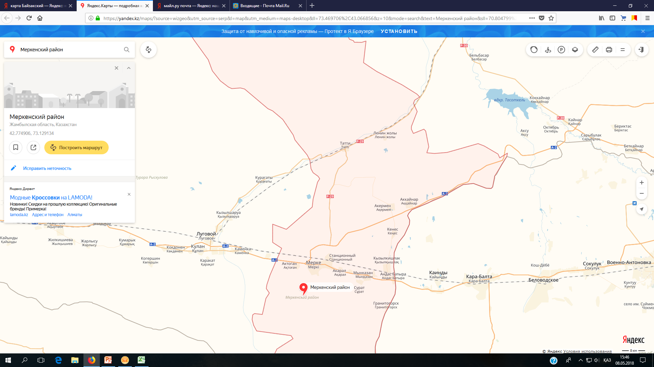
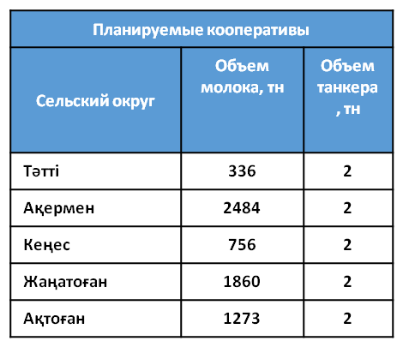


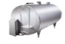
Ойтал
LLP “MerkiIrimshik Zauyty”
Жаңатоған
- Current MRC
- Planned MRC
2 t
2 t
2 t
2 t
2 t
2 t
2 t
2 t
2 t
3 km
17 km
35 km
34 km
23 km
55 km
Milk volume, t
Rural district
Tanker capacity, t

Tatti
Akermen
Kenes
Zhanatogan

Aktogan

APPENDIX U

Recommended layout of the raw material zones of milk processing enterprises by organizing cooperative MPPs in the Zhambyl district of the Zhambyl region
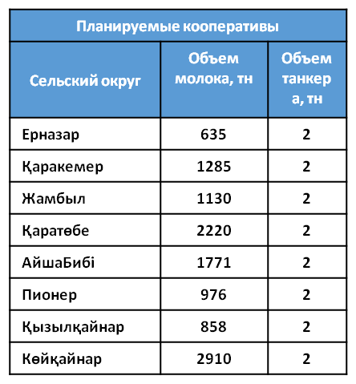
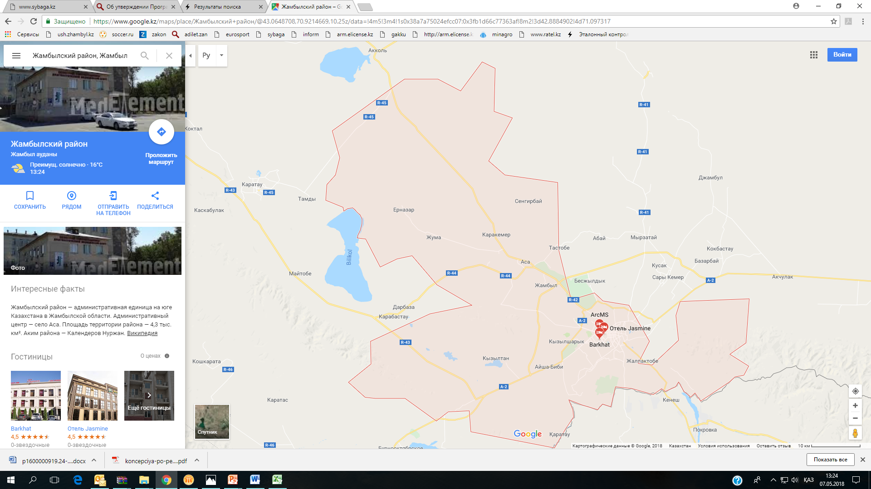
Planned cooperatives
Гродеково
2 t
KokZhek-2030
Milk Company Burnoe LLP
2 t
2 t
2 t
2 t
Қызылқайнар
1,5 t
2 t
Қаратөбе
2 t
2 t
Shalkarov LLP
2 t
40 km
40 km
27 км
40 км
20 km
45 km
50 km
60 km
75 км
85 km
2 t
25 km
27 km
Pioner
- Current MRC
- Planned MRC

Rural district Milk volume, Tanker
t capacity,
t

Yernazar
Karakemer
Zhambyl
Karatobe
AishaBibi
Pioner
Kyzylkainar
Koikainar

APPENDIX V

Recommended layout of the raw material zones of milk processing enterprises by organizing cooperative MPPs in the T. Ryskulov district of the Zhambyl region
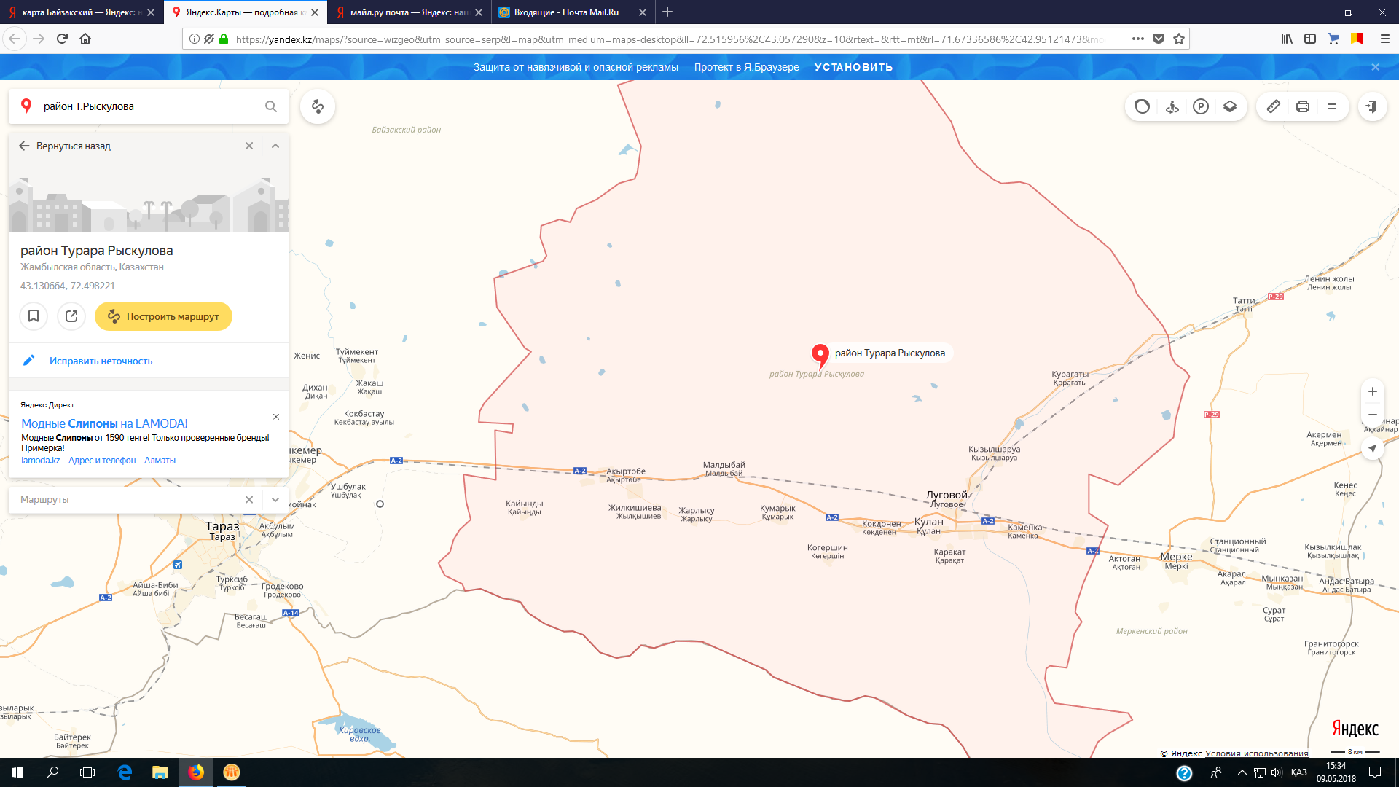
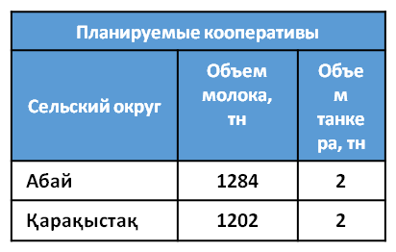
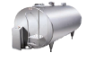
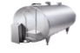
Merki Irimshik Zauyty LLP

2 tn
2 tn
Қарақыстақ
Abay
2 tn
2 tn
- Existing MPPs
- Planned MPPs
Planned cooperatives
Rural district Milk volume, Tanker
t capacity,
t

Abai
Karakystak

APPENDIX W

Recommended layout of the raw material zones of milk processing enterprises by organizing cooperative MPPs in the Korday district of the Zhambyl region
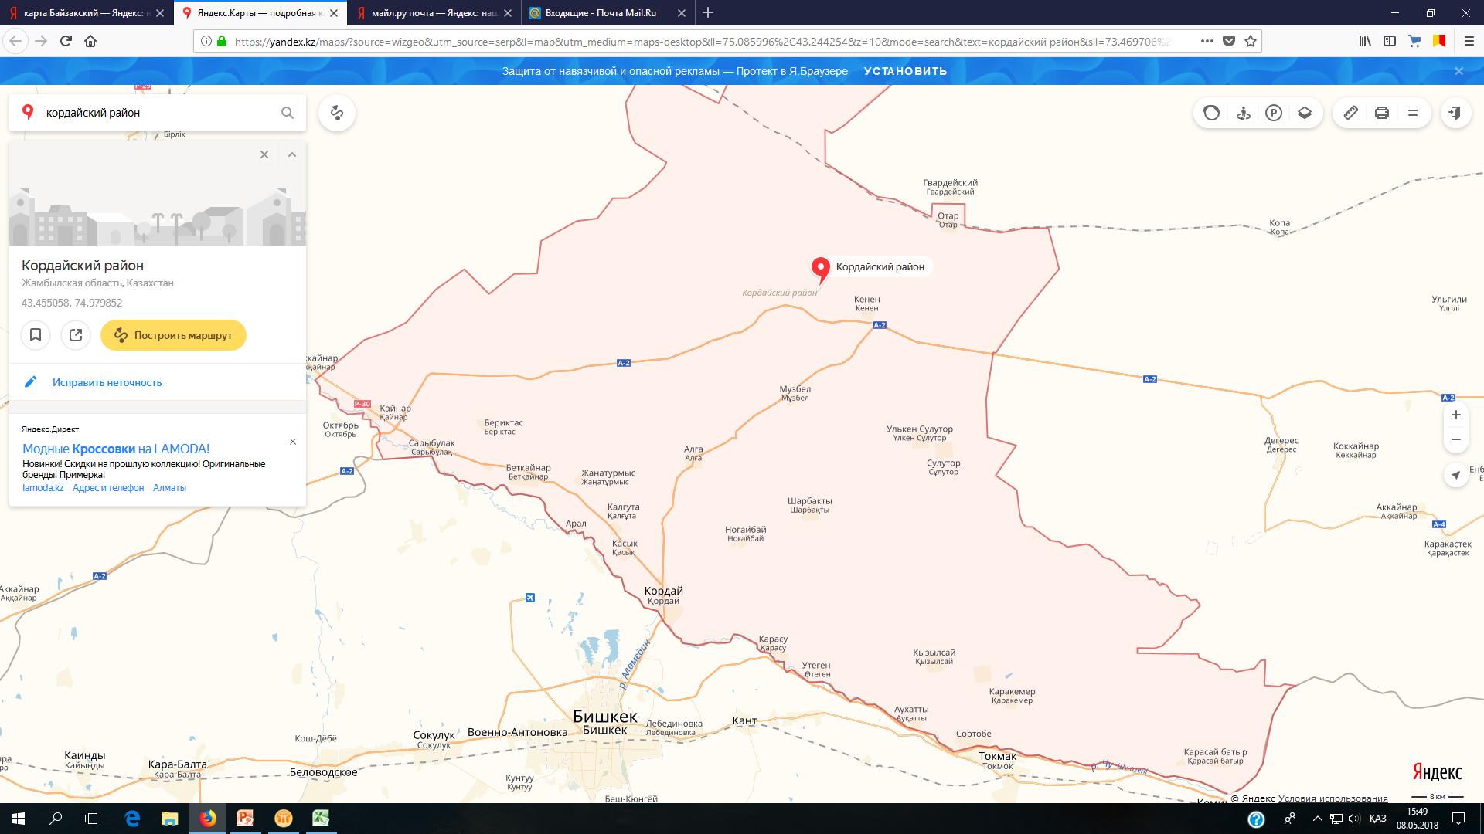
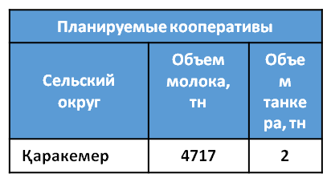
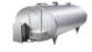
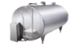
Planned cooperatives
Kulikov Milk Products LLP

2 tn
2 tn
47 km
53 km
2 tn
- Existing MPPs
- Planned MPPs

Rural district Milk volume, Tanker
t capacity,
t

Karakemer

APPENDIX X

Recommended layout of the raw material zones of milk processing enterprises by organizing cooperative MPPs in the Zhualin district of the Zhambyl region
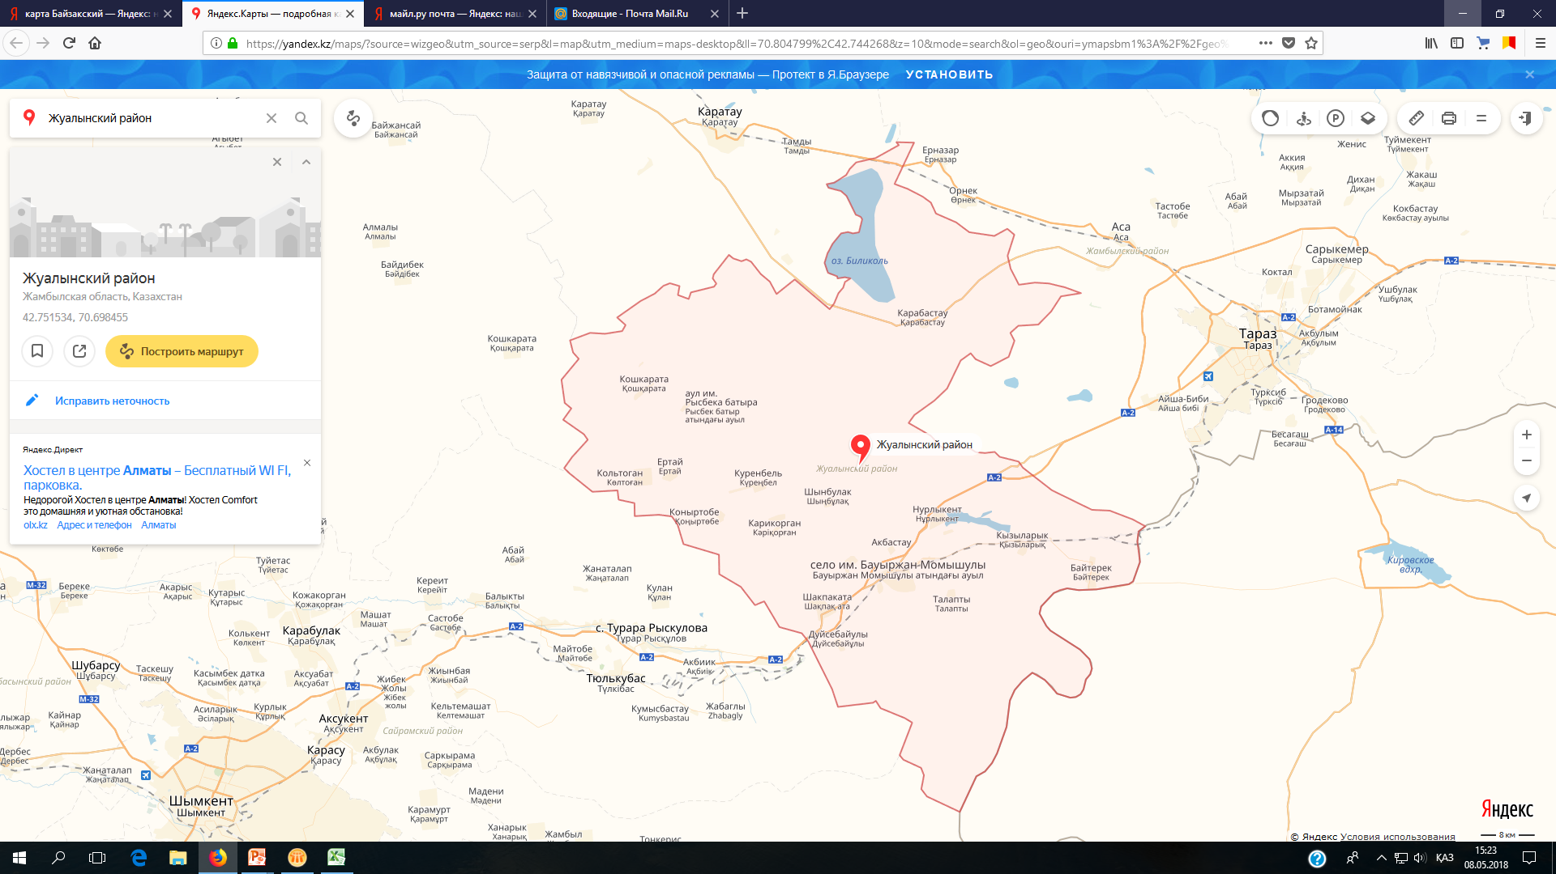
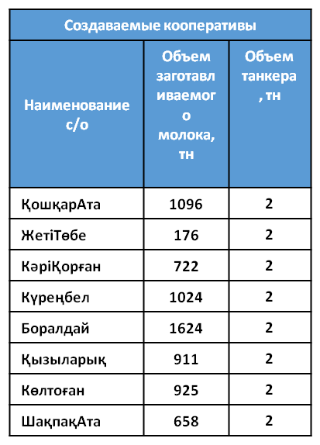
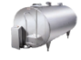
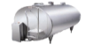
Planned cooperatives
SMTS LLP

Meshelova Z. E. I.

Milk Company Burnoe LLP

Aksay
2 tn
Aktobe
- Existing MPPs
- Planned MPPs
Мыңбұлақ
2 tn
2 tn
2 tn
2 tn
Қарасаз
Жетітөбе
Boralday
2 tn
2 tn
2 tn
2 tn
2 tn
2 tn
2 tn
13 km
15 km
7 km
27 km
28 km
43 km
65 km
60 km
23 km
19 km

Rural district Volume of Tanker
produced capacity,
milk, t t

KoshkarAta
ZhetiTobe
KariKorgan
Kurenbel
Boraldai
Kyzylaryk
Keltogan
ShakpakAta

APPENDIX Y

Recommended layout of the raw material zones of milk processing enterprises by organizing cooperative MPPs in the Bayzak district of the Zhambyl region
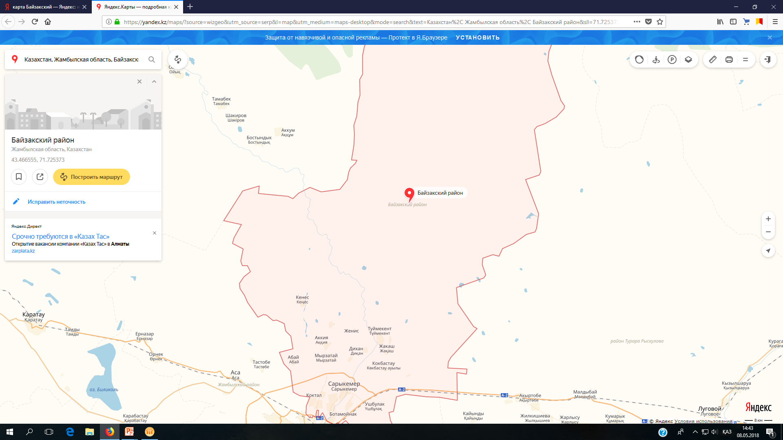
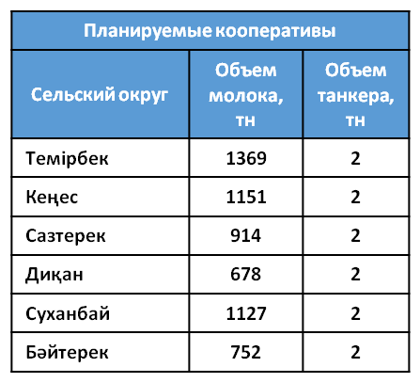
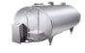

Planned cooperatives
Жаңатұрмыс
Бәйтерек
Sukhanbay
Тараз қаласы
35 km
45 km
40 km
Үлгілі
Темірбек
KokZhek-2030 LLP

40 km
55 km
27 km
2 tn
2 tn
2 tn
2 tn
2 tn
2 tn
2 tn
2 tn
2 tn
2 tn
2 tn
Lesnyak O.V. ZK
Agali IE

- Existing MPPs
- Planned MPPs
Rural district Milk volume, Tanker
t capacity,
t

Temirbek
Kenes
Sazterek
Dikan
Sukhanbai
Baiterek

APPENDIX Z

Recommended layout of the raw material zones of milk processing enterprises by organizing cooperative MPPs in the Shu district of the Zhambyl region

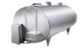
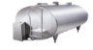
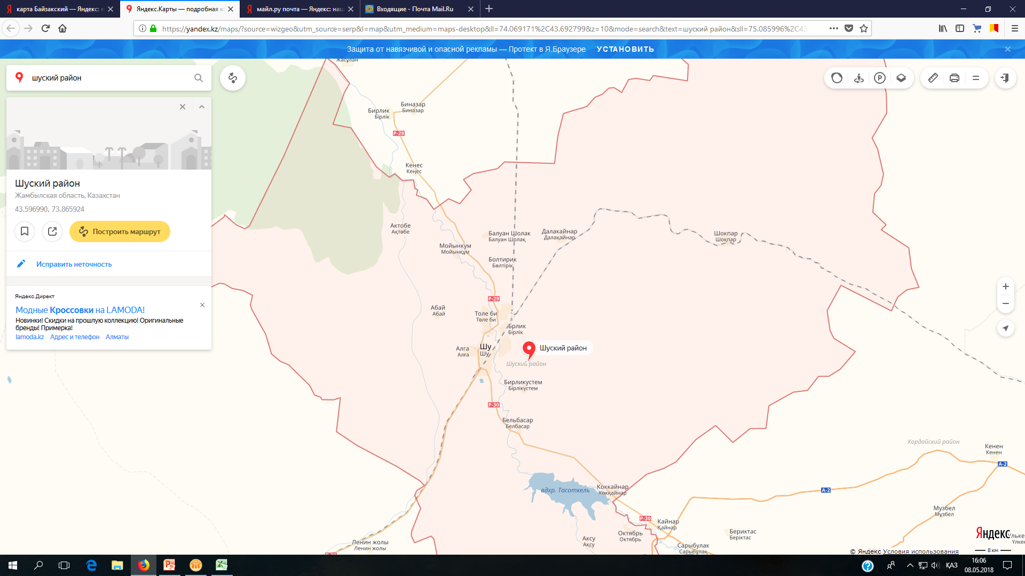
Еңбек
LLP “MerkiIrimshik Zauyty”

Жаңажол
103 km
119 km
123 km
107 km
2 tn
2 tn
2 tn
2 tn
2 tn
- Existing MPPs
- Planned MPPs

APPENDIX 1
Milk collection points reqired and milk trucks to increase the load of dairies in Almaty region
Region | Name of an enterprise | Raw material capacity, | Raw material processing per day, tonn | Production, ton | Capacity, % | MPP required (2 tons), units | Required milk trucks, units
Region | Name of an enterprise | ton | Raw material processing per day, tonn | 2017 | Capacity, % | MPP required (2 tons), units | Required milk trucks, units
Region | Total | 285717 | 666 | 203175 | 71.1 | 49 | 21
Alakol | Zhazylbekov & Co. | 2525 | 9 | 2 003 | 88 | 1 | 1
Enbekshikazakhsky | Foodmaster Company JSC | 90000 | 150 | 61 495 | 55 | 5 | 2
Enbekshikazakhsky | Asal sut LLP | 36500 | 100 | 33 219 | 95 | 4 | 2
Enbekshikazakhsky | Obis LTD LLP | 5200 | 5 | 2 500 | 42 | 2 | 1
Enbekshikazakhsky | Ak-Ni LLP | 160 | 1 | 125 | 78 | - | -
Eskeldyn | Lyazzat-2016 LLP | 11960 | 40 | 4 456 | 28 | 5 | 2
Eskeldyn | Imangaliyev APC | 317 | 1 | 208 | 22 | - | -
Iliysk | Raiymbek Agro LLP | 63780 | 50 | 42 852 | 66 | 6 | 3
Iliysk | Danone Berkut LLP | 12000 | 80 | 12 000 | 75 | 1 | -
Iliysk | Krasilnikov, self-employed individual | 900 | 2 | 871 | 76 | 1 | -
Karatalsky region | Ushtobe-Aydin LLP | 10270 | 40 | 5 467 | 78 | 2 | 1
Talgar | Ameran LLP | 4380 | 15 | 4100 | 95 | 1 | -
Talgar | Bayserke Agro LLP | 5000 | 15 | 1000 | 39 | 4 | 2
Talgar | Safro LLP | 1300 | 5 | 1256 | 95 | 2 | 1
Talgar | Sanamyan, self-employed individual | 440 | 1 | 231 | 60 | - | -
Talgar | Akku Alatay LLP | 2250 | 9 | 1395 | 62 | 2 | 1
Sarkand | Akbulakproduct LLP | 3000 | 15 | 621 | 50 | 2 | 1
Koksuk | Arkabayev, self-employed individual | 3000 | 10 | 994 | 39 | 1 | -
Karasay | Medeu Commerce LLP | 4800 | 13 | 3 090 | 59 | 1 | -
Tekeli | Tekeli GMZ LLP | 2935 | 10 | 1 242 | 48 | 2 | 1
Taldykorgan | JLC Sut LLP | 18000 | 60 | 17 050 | 99 | 3 | 1
Taldykorgan | GSK Lactis ltd LLP | 7000 | 35 | 7 000 | 74 | 4 | 2
Note: calculated based on research

APPENDIX 2

The number of agricultural cooperatives of the dairy sector required by type of activity in the context of districts of the Almaty region

Region | 2019 |  |  |  |  | 2020
Region | for milk procurement |  | for milk processing |  | Total, th. tenge | for milk procurement |  | for milk processing |  | Total, th. tenge
Region | Q-ty agricultural companues, units | amount, th. tenge | Q-ty agricultural companues, units | amount, th. tenge | Total, th. tenge | Q-ty agricultural companues, units | amount, th. tenge | Q-ty agricultural companues, units | amount, th. tenge | Total, th. tenge
Alakol | 1 | 12 000 |  |  | 12 000
Enbekshikazakhsky | 11 | 132,000 | 2 | 36 000 | 168,000 | 3 | 36000 | 1 | 18 000 | 54 000
Eskeldyn | 7 | 84 000 | 1 | 18 000 | 102,000 | 2 | 24000 |  |  | 24 000
Iliysk | 8 | 96 000 | 2 | 36 000 | 132,000 | 2 | 24000 |  |  | 24 000
Karatalsky region | 2 | 24 000 |  |  | 24 000 |  |  |  |  | 0
Talgar | 9 | 108,000 | 3 | 54 000 | 162,000 | 3 | 36000 | 1 | 18 000 | 54 000
Sarkand | 2 | 24 000 |  |  | 24 000
Koksuk | 8 | 96 000 | 2 | 36 000 | 132,000 | 2 | 24000 | 1 | 18 000 | 42 000
Karasay | 1 | 12 000 |  |  | 12 000 | 3 | 36000 | 1 | 18 000 | 54 000
TOTAL | 49 | 588,000 | 9 | 162,000 | 750,000 | 15 | 180000 | 4 | 72 000 | 252,000
Note: calculated based on research

APPENDIX 3

Recommended layout of raw material zones of dairy processing enterprises by organizing cooperative MPPs in Enbekshikazakhsky district of Almaty region
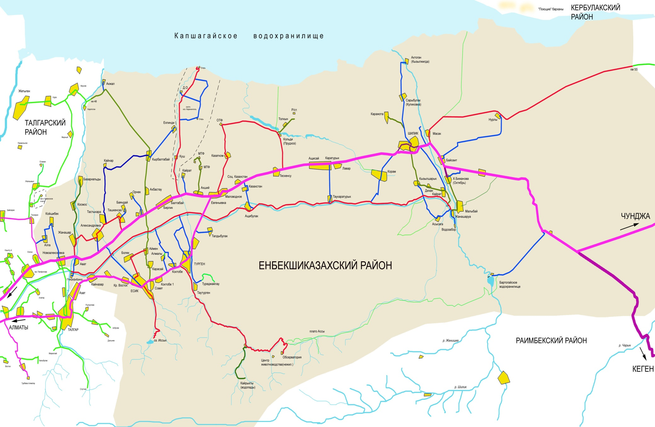
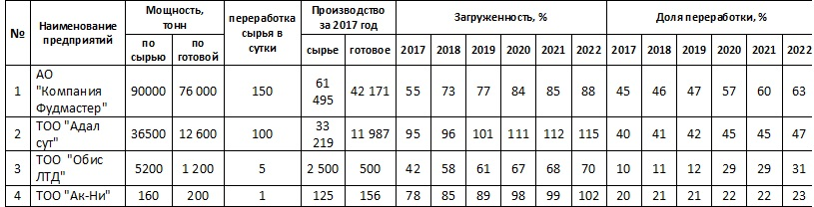
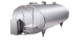
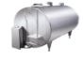
Kerbulak region
JSC AIC “Adal”

Foodmaster Company JSC

LLP “Obis LTD”

LLP “AK-NI”

2 tn
1 tn
1 tn
1 tn
2 tn
2 tn
2 tn
2 tn
- Existing MPPs
- Planned MPPs

Capacity, t
Name of the enterprise
Raw materials processing per day
Production per 2017
Loading, %
Processing share, %
By raw mat. By finished
Raw materials Finished
JSC “Foodmaster Company”
LLP “Adal sut”
LLP “Obis LTD”
LLP “Ak-Ni”

APPENDIX 4

Recommended layout of raw material zones of dairy processing enterprises by organizing cooperative MPPs in Iliysky district of Almaty region
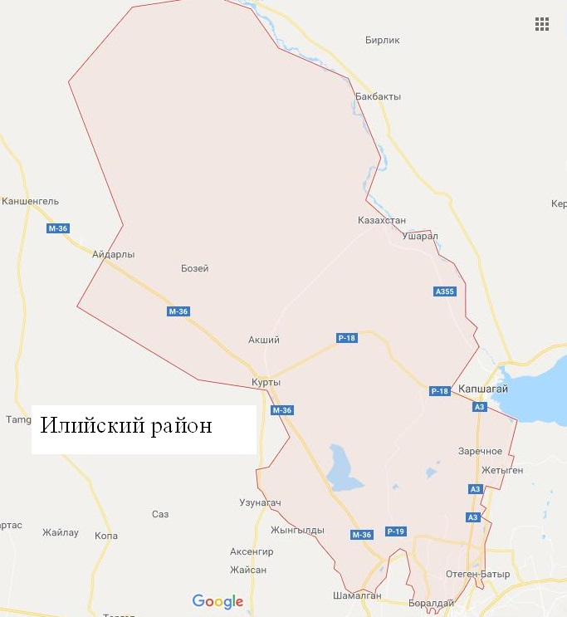
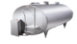
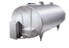
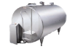
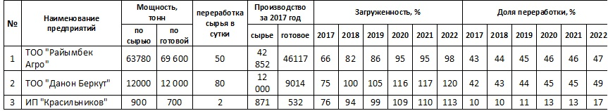
Raiymbek Agro LLP
IE Krasilnikov

Danone Berkut LLP
2 tn
2 tn
2 tn
2 tn
2 tn
2 tn
- Existing MPPs
- Planned MPPs

Ili region

APPENDIX 5

Recommended layout of raw material zones of dairy processing enterprises by organizing cooperative MPPs in Karasay district of Almaty region
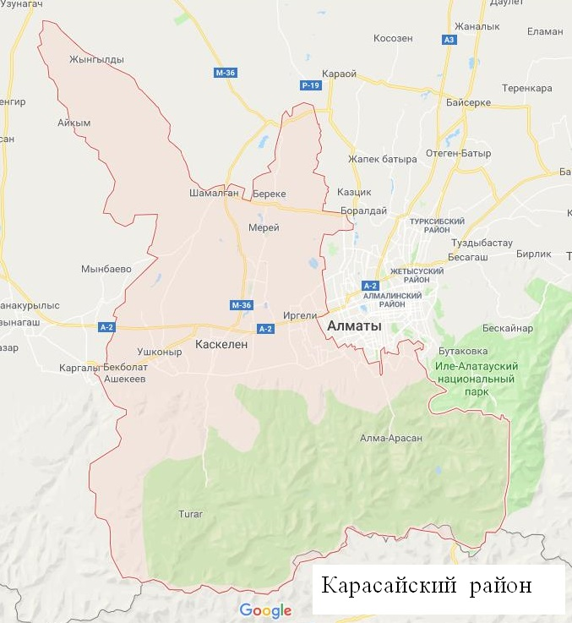
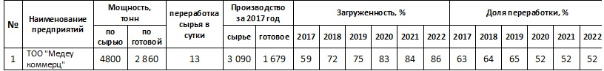
Name of the enterprise
Capacity, t
Raw materials processing per day
Production per 2017
Loading, %
Processing share, %
Medeu Commerce LLP
2 tn
2 tn
2 tn
2 tn
2 tn
- Existing MPPs
- Planned MPPs
By raw mat. By finished
Raw materials Finished
LLP “Medeu commerce”

APPENDIX 6

Recommended layout of raw material zones of dairy processing enterprises by organizing cooperative MPPs in Eskeldynsky district of Almaty region
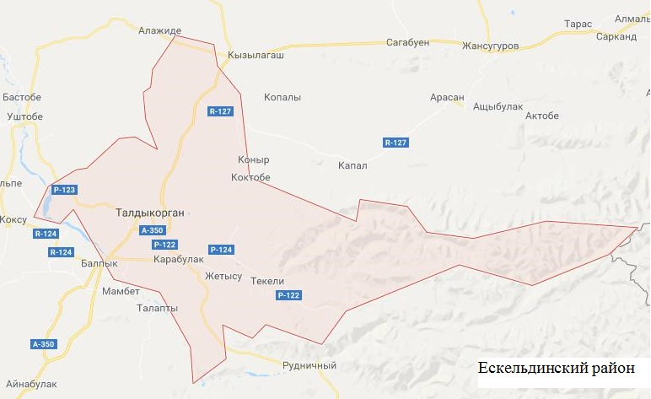
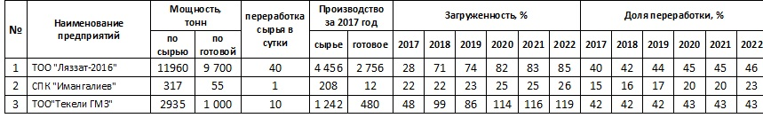
Name of the enterprise
Capacity, t
Raw materials processing per day
Production per 2017
Loading, %
Processing share, %
Lyazzat-2016 LLP
Imangaliyev APC
Tekeli GMZ LLP
2 tn
2 tn
3 tn
2 tn
2 tn
2 tn
- Existing MPPs
- Planned MPPs
By raw mat. By finished
Raw materials Finished
LLP “Lyazzat-2016”
AIC “Imangaliyev”
LLP “Tekeli GMZ”

Yeskeldinskiy region

APPENDIX 7

Recommended layout of raw material zones of dairy processing enterprises by organizing cooperative MPPs in Koksu district of Almaty region

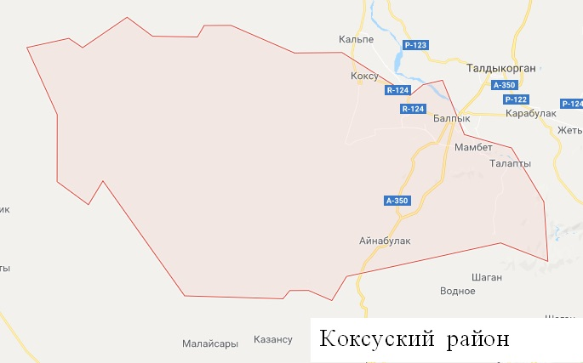
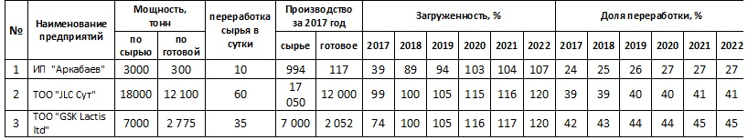

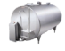
Arkabayev, self-employed individual
GSK Lactis ltd LLP
JLC Sut LLP
2 tn
1 tn
2 tn
2 tn
2 tn
- Existing MPPs
- Planned MPPs

Name of the enterprise
Capacity, t
Raw materials processing per day
Production per 2017
Loading, %
Processing share, %
Raw materials Finished
By raw mat. By finished

IE “Arkabayev”
LLP “JLC Sut”
LLP “GSK Lactis Ltd”

Koksuskiy region

APPENDIX 8

Recommended layout of raw material zones of dairy processing enterprises by organizing cooperative MPPs in Sarkandsky district of Almaty region

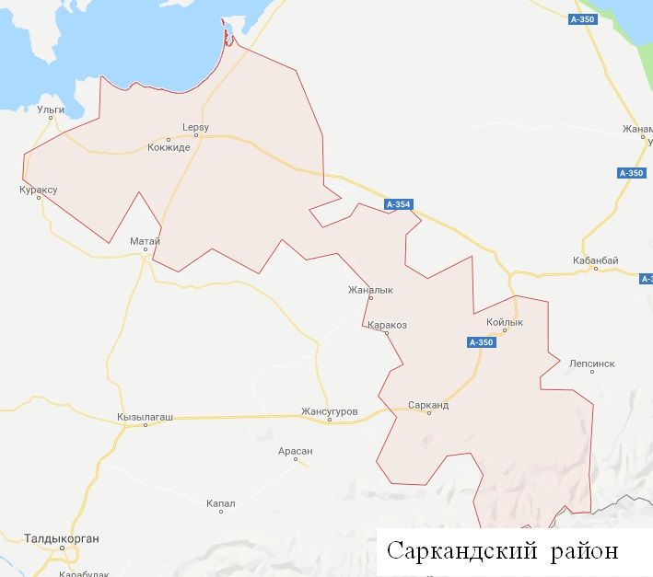
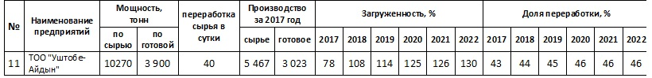

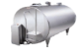
Name of the enterprise
Capacity, t
Production per 2017
Loading, %
Akbulakproduct
1 tn
1.5 tn
2 tn
2 tn
2 tn
- Existing MPPs
- Planned MPPs
Raw materials processing per day
Processing share, %
By raw mat. By finished
Raw materials Finished
LLP “Ushtobe-Aidyn”

Sarkandskiy region

APPENDIX 9

Recommended layout of raw material zones of dairy processing enterprises by organizing cooperative MPPs in Talgar district of Almaty region
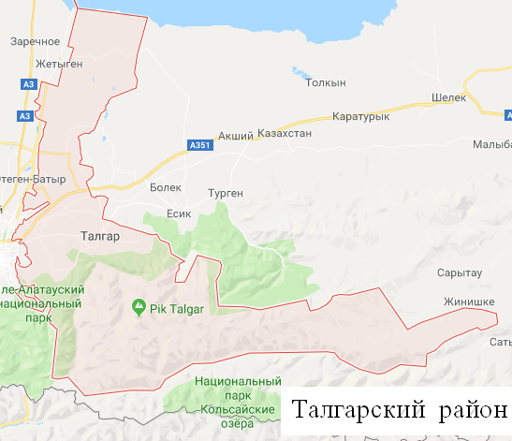
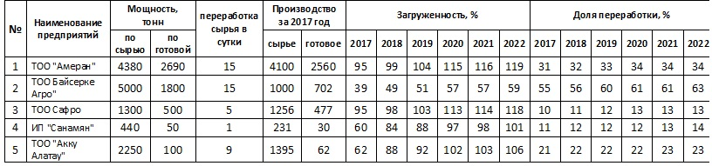
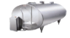
Name of the enterprise
Capacity, t
Raw materials processing per day
Production per 2017
Loading, %
Processing share, %
Bayserke Agro LLP
Ameran LLP
Safro LLP
Sanamyan, self-employed individual
Akku Alatay LLP
2 tn
2 tn
2 tn
2 tn
2 tn
- Existing MPPs
- Planned MPPs

By raw mat. By finished
Raw materials Finished
LLP “Ameran”
LLP Baiserke Agro
LLP Safo
IE “Sanamyan”
LLP “Akku Alatau”

Talgar region

APPENDIX 10

Recommended layout of raw material zones of dairy processing enterprises by organizing cooperative MPPs in Karatal district of Almaty region

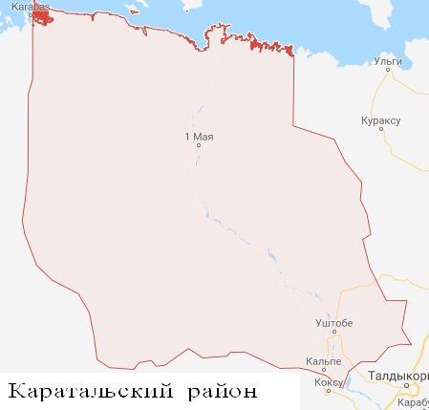
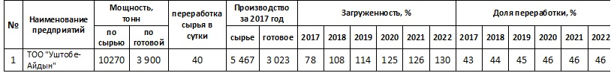
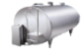
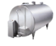
Name of the enterprise
Capacity, t
Production per 2017
Loading, %
Processing share, %
1 tn
1 tn
1 tn
1 tn
2 tn
- Existing MPPs
- Planned MPPs
Raw materials processing per day
By raw mat. By finished
Raw materials Finished
LLP “Ushtobe-Aidyn”

Karatal region

APPENDIX 11

Recommended layout of raw material zones of dairy processing enterprises by organizing cooperative MPPs in Alakol district of Almaty region
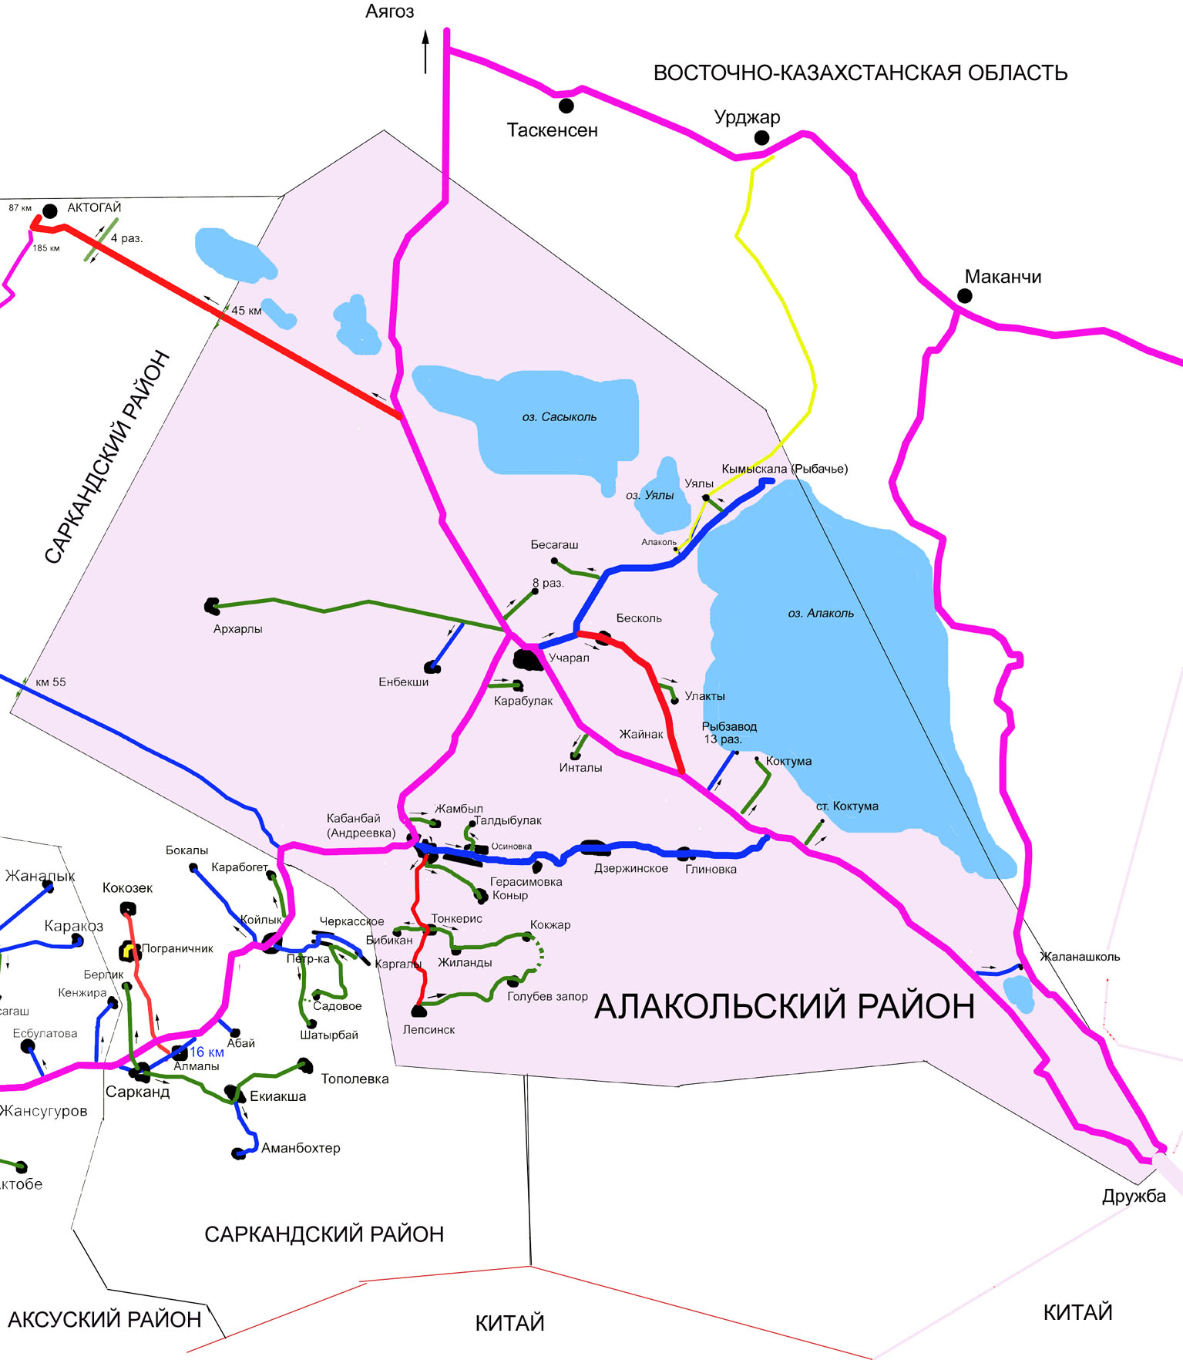
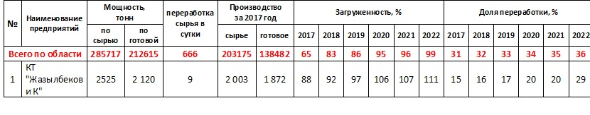
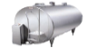
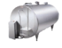
Zhazylbekov & Co.
2 tn
2 tn
2 tn
2 tn
2 tn
- Existing MPPs
- Planned MPPs

East-Kazakhstani area

Alakol region

Name of the enterprise
Capacity, t
Raw materials processing per day
Production per 2017
Loading, %
Processing share, %
CT “Zhazylbekov and Co”
Total in the area
By raw mat. By finished
Raw materials Finished

APPENDIX 12

Number of livestock by types and categories of farms in the Republic of Kazakhstan for 2018, thousand heads

Livestock species | All farming categories | including
Livestock species | All farming categories | agricultural enterprises |  | Self-employes farmers and companies |  | population's households
Livestock species | All farming categories | th.h. | spec. gravity, % | th.h. | spec. gravity, % | th.h. | spec. gravity, %
Large cattle | 7137.9 | 712.9 | 10.0 | 2401 | 33.6 | 4024.1 | 56.4
Sheep | 16399.3 | 816.1 | 5.0 | 6420.8 | 39.2 | 9162.4 | 55.9
Goats | 2278.6 | 13.5 | 0.6 | 638.1 | 28.0 | 1627 | 71.4
Pigs | 802.7 | 214.3 | 26.7 | 94.6 | 11.8 | 493.8 | 61.5
Horses | 2623.7 | 163.4 | 6.2 | 1178.4 | 44.9 | 1281.9 | 48.9
Camels | 202.2 | 14.2 | 7.0 | 82.1 | 40.6 | 105.9 | 52.4
Note: the information was provided by the Committee on Statistics of the Ministry of National Economy of the Republic of Kazakhstan

APPENDIX 13

Meat production (dead weight) by farm category in the Republic of Kazakhstan in 2018, thousand tons

Region | All farming categories | agricultural enterprises | Self-employes farmers and companies | population's households
Akmoly | 66.7 | 29.7 | 4.3 | 32.7
Aktobe | 73.3 | 17.3 | 10.9 | 45.1
Almaty | 213.3 | 81.4 | 45.6 | 86.3
Atyrau | 26.8 | 0.6 | 5.8 | 20.4
East Kazakhstan Region | 162.1 | 48.2 | 50.1 | 63.8
West Kazakhstan Region | 47.9 | 7.3 | 18.2 | 22.4
Zhambyl | 68.8 | 11.5 | 19.1 | 38.3
Karaganda | 78.3 | 14.2 | 21.6 | 42.4
Kostanay | 55.3 | 15.9 | 2.2 | 37.1
Kyzylorda | 18.8 | 0.6 | 2.6 | 15.7
Mangistau | 5.9 | 0.2 | 1.6 | 4.2
Pavlodar | 54.4 | 17.3 | 12.5 | 24.7
North Kazakhstan Region | 55.7 | 6.1 | 4.4 | 45.3
Turkestan | 126.4 | 21.4 | 5.9 | 99.2
For the whole Republic of Kazakhstan | 1053.7 | 271.7 | 204.8 | 577.6
Note: the information was provided by the Committee on Statistics of the Ministry of National Economy of the Republic of Kazakhstan

APPENDIX 14

Cattle meat production (in live and dead weight) per 100 hectares of farmland in agricultural formations by regions of the Republic of Kazakhstan for 2018, c.

Region | All farming categories |  | Including
Region |  |  | agricultural enterprises |  | Self-employes farmers and companies
Region | in live weight, dt | in dead weight, dt | in live weight, dt | in dead weight, dt | in live weight, dt | in dead weight, dt
Akmoly | 10.1 | 6.2 | 5.1 | 3.6 | 3.3 | 1.7
Aktobe | 13.4 | 7.1 | 10.5 | 6.5 | 2.9 | 1.4
Almaty | 44.7 | 26.2 | 40.8 | 31.7 | 16.1 | 8.2
Atyrau | 21.0 | 10.9 | 1.2 | 0.7 | 7.1 | 3.7
West Kazakhstan Region | 13.5 | 7.0 | 13.8 | 8.6 | 6.0 | 3.0
Zhambyl | 29.0 | 15.7 | 16.0 | 10.1 | 11.0 | 5.8
Karaganda | 9.5 | 5.4 | 6.6 | 5.0 | 3.5 | 1.9
Kostanay | 9.2 | 5.3 | 4.4 | 2.5 | 1.0 | 0.5
Kyzylorda | 16.7 | 8.7 | 1.8 | 1.0 | 3.2 | 1.7
Mangistau | 2.6 | 1.4 | 0.1 | 0.1 | 1.8 | 1.0
Pavlodar | 16.6 | 9.3 | 9.8 | 6.6 | 7.5 | 3.9
North Kazakhstan Region | 13.6 | 8.0 | 2.0 | 1.1 | 4.9 | 2.8
Turkestan | 55.5 | 30.2 | 15.5 | 10.1 | 4.7 | 2.5
East Kazakhstan Region | 26.2 | 15.5 | 32.1 | 25.5 | 10.6 | 5.6
For the whole Republic of Kazakhstan | 18.4 | 10.4 | 9.5 | 6.7 | 6.4 | 3.3
Note: the information was provided by the Committee on Statistics of the Ministry of National Economy of the Republic of Kazakhstan

APPENDIX 15

Main economic indicators of meat production by types in the Republic of Kazakhstan for 2018

Name | Cost of products sold, million tenge | Price of products sold, million tenge | Gross profit, million tenge | The level of profitability (loss ratio) in %
beef | 49 332 369 | 57 341 592 | 8 009 223 | 16.2
lamb | 2 513 300 | 2 958 972 | 445,672 | 17.7
pork | 3 685 768 | 4 566 210 | 880,442 | 23.9
horse meat | 3 721 484 | 4 613 688 | 892,204 | 24.0
camel meat | 283,228 | 316,223 | 32 995 | 11.6
poultry | 78 340 875 | 92 488 966 | 14 148 092 | 18.1
Note: the information was provided by the Committee on Statistics of the Ministry of National Economy of the Republic of Kazakhstan

APPENDIX 16

Volumes of meat production in feedlots in the context of regions of the Republic of Kazakhstan in 2018

Regions | Q-ty of enterprises, units | Feeding lots (capacity), heads | Capacity, heads | Capacity, % | Production volumes, tons
Akmoly | 7 | 19 000 | 8 555 | 45 | 834
Almaty | 91 | 61 270 | 27 815 | 45.4 | 10 478
Aktobe | 6 | 21 900 | 7 501 | 34 | 3570
East kazakhstan region | 74 | 34 370 | 8 595 | 25.0 | 1 083
Zhambyl | 26 | 26 228 | 13637 | 52 | 6 600,3
West Kazakhstan Region | 11 | 14 860 | 479 | 3.2 | 472.4
Karaganda | 12 | 7 600 | 1145 | 15 | 384
Kostanay | 40 | 32 400 | 14 632 | 45 | 3 959
Kyzylorda | 16 | 9 710 | 2 490 | 26 | 646
Pavlodar | 10 | 13 450 | 1624 | 12.1 | 424
North Kazakhstan Region | 20 | 9 700 | 2820 | 29 | 593.7
Turkestan | 54 | 33 290 | 10071 | 30.3 | 7926
Total for the Republic of Kazakhstan | 370 | 283,778 | 99 364 | 35.0 | 36 970
Note: the information was provided by the Committee on Statistics of the Ministry of National Economy of the Republic of Kazakhstan

APPENDIX 17

Meat production and capacity utilization of meat processing enterprises (excluding poultry meat) in Kazakhstan in 2018

Name of regions | Meat production, thousand tons | Capacity of enterprises (for raw materials), thousand tons | Processed, thousand tons | Share of processing, % | Capacity utilization, %
Akmoly | 66.7 | 36.8 | 1.9 | 2.8 | 5.2
Aktobe | 73.3 | 31.7 | 25.3 | 34.5 | 79.8
Almaty | 213.3 | 111.2 | 71.8 | 33.7 | 64.6
Atyrau | 26.8 | 0.9 | 0.1 | 0.4 | 11.1
East Kazakhstan Region | 162.1 | 68.1 | 45.7 | 28.2 | 67.1
West Kazakhstan Region | 47.9 | 24.5 | 16.9 | 35.3 | 69.0
Zhambyl | 68.8 | 14.8 | 6.1 | 8.9 | 41.2
Karaganda | 78.3 | 30.5 | 22.6 | 28.9 | 74.1
Kostanay | 55.3 | 14 | 10.4 | 18.8 | 74.3
Kyzylorda | 18.8 | 0.9 | 0.3 | 1.6 | 33.3
Mangistau | 5.9 | 0.2 | 0.1 | 1.7 | 50.0
Pavlodar | 54.4 | 35.9 | 21.2 | 79.1 | 59.1
North Kazakhstan Region | 55.7 | 9 | 5.6 | 10.1 | 62.2
Turkestan | 126.4 | 25 | 12.3 | 9.7 | 49.2
For the whole Republic of Kazakhstan | 1053.7 | 403.5 | 240.3 | 22.8 | 59.6
Note: the information was provided by the Committee on Statistics of the Ministry of National Economy of the Republic of Kazakhstan

APPENDIX 18

Concentration of meat production and the coefficient of conformity of production capacities of meat processing enterprises to their raw materials in the Republic of Kazakhstan for 2018

Region | Meat production |  | Capacity  of processing |  | Meat processed |  | Self-sufficiency  ratio  of the capacity referred to raw  materials
Region | th.  ton | spec. gravity, % | th.  ton | spec. gravity, % | th.  ton | spec. gravity, %
Total for the Republic of Kazakhstan | 1053.7 | 100.0 | 403.5 | 100 | 240.3 | 100
Akmoly | 66.7 | 6.3 | 36.8 | 9.1 | 1.9 | 0.8 | 1.4
Aktobe | 73.3 | 7.0 | 31.7 | 7.9 | 25.3 | 10.5 | 1.1
Almaty | 213.3 | 20.2 | 111.2 | 27.6 | 71.8 | 29.9 | 1.4
Atyrau | 26.8 | 2.5 | 0.9 | 0.2 | 0.1 | 0.0 | 0.1
East Kazakhstan Region | 162.1 | 15.4 | 68.1 | 16.9 | 45.7 | 19.0 | 1.1
Zhambyl | 68.8 | 6.5 | 14.8 | 3.7 | 6.1 | 2.5 | 0.6
West Kazakhstan Region | 47.9 | 4.5 | 24.5 | 6.1 | 16.9 | 7.0 | 1.3
Karaganda | 78.3 | 7.4 | 30.5 | 7.6 | 22.6 | 9.4 | 1.0
Kostanay | 55.3 | 5.2 | 14 | 3.5 | 10.4 | 4.3 | 0.7
Kyzylorda | 18.8 | 1.8 | 0.9 | 0.2 | 0.3 | 0.1 | 0.1
Mangistau | 5.9 | 0.6 | 0.2 | 0.05 | 0.1 | 0.0 | 0.1
Pavlodar | 54.4 | 5.2 | 35.9 | 8.9 | 21.2 | 8.8 | 1.7
North Kazakhstan Region | 55.7 | 5.3 | 9 | 2.2 | 5.6 | 2.3 | 0.4
Turkestan | 126.4 | 12.0 | 25 | 6.2 | 12.3 | 5.1 | 0.5
Note: calculated based on research

APPENDIX 19

Cattle and poultry stock in Almaty, Turkestan and East Kazakhstan regions of the Republic of Kazakhstan by categories of farms for 2018, thousand heads

Livestock species | All farming categories | Agricultural enterprises |  | Collective farms | PSE
Almaty region
Beef cattle | 1004.6 | 84.0 |  | 402.7 | 517.9
Pigs | 54.8 | 15.1 |  | 24.8 | 14.9
Sheep | 3022.4 | 135.0 |  | 1568.1 | 1319.3
Goats | 397.0 | 2.7 |  | 127.4 | 266.9
Horses | 311.9 | 16.6 |  | 156.1 | 139.2
Poultry | 10426.8 | 8968.1 |  | 135.9 | 1322.8
Camels | 7.1 | 4.4 |  | 2.3 | 0.4
Turkestan region
Beef cattle | 994.2 |  | 36.7 | 100.2 | 857.3
Pigs | 6.3 |  | 1.9 | 1.2 | 3.2
Sheep | 3787.4 |  | 291.5 | 649.4 | 2846.5
Goats | 300.7 |  | 1.1 | 23.3 | 276.3
Horses | 320.5 |  | 15.2 | 35.4 | 269.9
Poultry | 2047.6 |  | 785.2 | 55.3 | 1207.1
Camels | 28.0 |  | 3.8 | 10.7 | 13.5
East Kazakhstan Region
Beef cattle | 952.7 |  | 45.2 | 445.6 | 461.9
Pigs | 67.8 |  | 8.1 | 12.9 | 46.8
Sheep | 1367.2 |  | 45.8 | 695.7 | 625.7
Goats | 231.5 |  | 0.4 | 80.7 | 150.4
Horses | 362.4 |  | 7.3 | 216.4 | 138.7
Poultry | 3903.1 |  | 2983.3 | 20.7 | 899.1
Camels | 0.7 |  | 0.2 | 0.4 | 0.1
Note: the information was provided by the Committee on Statistics of the Ministry of National Economy of the Republic of Kazakhstan

APPENDIX 20

Coefficient of self-sufficiency in meat of the population of Almaty region and Almaty city for 2018

Region and city | Production, ton | Population  sizes, p. | Self-sufficiency  ratio | Specific gravity of the group, %
 |  |  |  | in meat production | in population
I - less than 1.0
Almaty | 191.6 | 1 854656 | 0.001 | 29.8 | 81.8
Taldykorgan | 1655.7 | 173176 | 0.1 | 29.8 | 81.8
Tekeli | 543.8 | 33071 | 0.2 | 29.8 | 81.8
Kapchagay | 1420.5 | 61770 | 0.3 | 29.8 | 81.8
Talgar | 7419.6 | 196866 | 0.5 | 29.8 | 81.8
Karasay | 11102.3 | 271042 | 0.5 | 29.8 | 81.8
Enbekshikazakhsky | 19837.7 | 300365 | 0.8 | 29.8 | 81.8
Zhambyl | 11724.6 | 166339 | 0.9 | 29.8 | 81.8
Panfilov | 9588.9 | 129158 | 0.9 | 29.8 | 81.8
Total for the group | 63484.7 | 3 186443 | 0.3 | 29.8 | 81.8
from 1 to 2.0
Karatal | 4817.4 | 46902 | 1.3 | 18.8 | 8.2
Eskeldinsky | 5553.4 | 46623 | 1.5 | 18.8 | 8.2
Koksuk | 5038.7 | 41571 | 1.5 | 18.8 | 8.2
Uygyr | 8297.9 | 63292 | 1.7 | 18.8 | 8.2
Alakol | 9139.9 | 69690 | 1.7 | 18.8 | 8.2
Kerbylak | 7315.1 | 48865 | 1.9 | 18.8 | 8.2
Total for the group | 40162.4 | 316943 | 1.6 | 18.8 | 8.2
more than 2.0
Aksusk | 7013.2 | 39677 | 2.3 | 51.4 | 10.0
Sarkand | 6714 | 36963 | 2.3 | 51.4 | 10.0
Raymbek | 8193.1 | 41708 | 2.5 | 51.4 | 10.0
Kegen | 7101.8 | 32395 | 2.8 | 51.4 | 10.0
Balkhash | 9460 | 30730 | 3.9 | 51.4 | 10.0
Iliysk | 71178.2 | 209173 | 4.3 | 51.4 | 10.0
Total for the group | 109660.3 | 390646 | 3.6 | 51.4 | 10.0
Total for the region | 213307.4 | 3 894032 | 0.7 | 100 | 100
Note: the information was provided by the Committee on Statistics of the Ministry of National Economy of the Republic of Kazakhstan

APPENDIX 21

Coefficient of self-sufficiency in meat of the population of the Turkestan region and Shymkent for 2018

Region and city | Production, ton | Population size, p. | Self-sufficiency ratio | Specific gravity of the group, %
 |  |  |  | in meat production | in population
less than 1.0
Shymkent | 6 086,1 | 1 009 086 | 0.1 | 36.9 | 72.2
Zhetysau | 4 690,8 | 170,157 | 0.4 | 36.9 | 72.2
ha Arys | 4 005,5 | 74 218 | 0.7 | 36.9 | 72.2
ha Kentau | 8 741,9 | 203,163 | 0.5 | 36.9 | 72.2
Turkestan | 757.3 | 164,963 | 0.1 | 36.9 | 72.2
Maktaaral | 3 322,4 | 133,256 | 0.3 | 36.9 | 72.2
Saryagash | 8 415,8 | 185,741 | 0.6 | 36.9 | 72.2
Shardarinsky | 3 156,8 | 78 081 | 0.5 | 36.9 | 72.2
Keless | 7 491,4 | 142,354 | 0.7 | 36.9 | 72.2
Total for the group | 46 668 | 2 161 019 | 0.2 | 36.9 | 72.2
from 1.0 to 2.0
Sayramsk | 16 896,3 | 206,399 | 1.0 | 63.1 | 27.8
Tolebi | 9 088,4 | 117,677 | 1.0 | 63.1 | 27.8
Kyzygurt | 12 239,5 | 106,104 | 1.5 | 63.1 | 27.8
Baidibek | 5 386,1 | 53 908 | 1.3 | 63.1 | 27.8
Ordabasy | 15 539,2 | 119,179 | 1.7 | 63.1 | 27.8
Otrar | 5 030,1 | 53 866 | 1.2 | 63.1 | 27.8
Suzak | 6 512,4 | 61 431 | 1.4 | 63.1 | 27.8
Tulkubas | 9 074,6 | 111,250 | 1.0 | 63.1 | 27.8
Total for the group | 79 766,6 | 829,814 | 1.2 | 63.1 | 27.8
Total for the region | 126,434.6 | 2 990 833 | 0.5 | 100.0 | 100.0
Note: calculated based on research

APPENDIX 22

Coefficient of self-sufficiency in meat of the population of the East Kazakhstan region for 2018

Region and city | Production, ton | Population size, p. | Self-sufficiency ratio | Specific gravity of the group, %
 |  |  |  | in meat production | in population size
less than 1.0
Ust-Kamenogorsk | 3 168,7 | 343,757 | 0.1 | 19.0 | 67.7
Kurchatov | 80.4 | 12 411 | 0.1 | 19.0 | 67.7
Ridder | 595.0 | 57 097 | 0.1 | 19.0 | 67.7
Altay | 2 004,9 | 66 380 | 0.4 | 19.0 | 67.7
Glubokovo | 2 916,6 | 61 943 | 0.6 | 19.0 | 67.7
Semey | 20 435,3 | 348,948 | 0.7 | 19.0 | 67.7
Shemonaikha | 2 515,5 | 43 739 | 0.7 | 19.0 | 67.7
Total for the group | 31 716,4 | 934,275 | 0.4 | 19.0 | 67.7
from 1.0 to 2.0
Beardulikha | 3 876,9 | 35 916 | 1.4 | 9.0 | 8.0
Urdzhar | 10 992,3 | 73 738 | 1.9 | 9.0 | 8.0
Total for the group | 14 869,2 | 109,654 | 1.7 | 9.0 | 8.0
more than 2.0
Ayagoz | 11 948,3 | 72 693 | 2.1 | 71.3 | 24.3
Zaysan | 8 011,7 | 36 976 | 2.8 | 71.3 | 24.3
Beskaragay | 4 318,1 | 18 684 | 2.9 | 71.3 | 24.3
Zharmin | 9 301,7 | 38 046 | 3.1 | 71.3 | 24.3
Katon-Karagay | 6 160,5 | 23 126 | 3.4 | 71.3 | 24.3
Kokpekty | 8 640,4 | 28 258 | 3.9 | 71.3 | 24.3
Targabatay | 12 597,2 | 38 851 | 4.1 | 71.3 | 24.3
Kurchum | 10 115,0 | 24 339 | 5.3 | 71.3 | 24.3
Ulan | 30142.3 | 39 184 | 10.1 | 71.3 | 24.3
Abay | 14 307,0 | 14 418 | 12.7 | 71.3 | 24.3
Total for the group | 115,542.2 | 334,575 | 4.4 | 71.3 | 24.3
Total for the region | 162,127.8 | 1 378 504 | 1.5 | 100.0 | 100.0
Note: calculated based on research

APPENDIX 23

Concentration of meat production and the coefficient of conformity of production capacities of meat processing enterprises to their raw materials in the Almaty region and Almaty in 2018.

Region | Meat  production |  | Capacity  of processing |  | Meat  production |  | Self-sufficiency  ratio  of the capacity referred to raw  materials
Region | ton | spec. gravity, % | ton | spec. gravity, % | ton | spec.  gravity, %
Total for the region | 213307.4 | 100.0 | 111208 | 100.0 | 71779.6 | 100.0 | -
I - less than 2.0
Taldykorgan | 1 655,70 | 0.8 | 126 | 0.1 | 107 | 0.1 | 0.1
Kapchagay | 1 420,50 | 0.7 | - | - | - | - | -
Tekeli | 543.8 | 0.3 | - | - | - | - | -
Aksusk | 7 013,20 | 3.3 | - | - | - | - | -
Balkhash | 9 460,00 | 4.4 | - | - | - | - | -
Enbekshikazakhsky | 19 837,70 | 9.3 | - | - | - | - | -
Kegen | 7 101,80 | 3.3 | - | - | - | - | -
Kerbylak | 7 315,10 | 3.4 | - | - | - | - | -
Koksuk | 5 038,70 | 2.4 | 25 | 0.02 | 11 | 0.02 | 0.01
Karasay | 11 102,30 | 5.2 | - | - | - | - | -
Panfilov | 9 588,90 | 4.5 | - | - | - | - | -
Raymbek | 8 193,10 | 3.8 | - | - | - | - | -
Sarkand | 6 714,00 | 3.1 | 24 | 0.02 | 16 | 0.02 | 0.01
Eskeldinsky | 5 553,40 | 2.6 | 1200 | 1.1 | 388 | 0.5 | 0.4
Uygyr | 8 297,90 | 3.9 | - | - | - | - | -
Alakol | 9 139,90 | 4.3 | - | - | - | - | -
Karatal | 4 817,40 | 2.3 | - | - | - | - | -
Zhambyl | 11 724,60 | 5.5 | - | - | - | - | -
Talgar | 7 419,60 | 3.5 | 4115 | 3.7 | 1517 | 2.1 | 1.1
II - from 2.0 to 3.0
Iliysk | 71 178,20 | 33.4 | 98089 | 88.2 | 65741.6 | 91.6 | 2.6
III - more than 3.0
Almaty | 191.6 | 0.1 | 7629 | 6.9 | 3999 | 5.6 | 76.4
Note: calculated based on research

APPENDIX 24

Concentration of meat production and the coefficient of compliance of the production capacities of meat processing enterprises with their raw materials in the Turkestan region and Shymkent for 2018

Region | Meat  production |  | Capacity  of processing |  | Meat  production |  | Self-sufficiency  ratio  of the capacity referred to raw  materials
Region | ton | spec. gravity, % | ton | spec. gravity, % | ton | spec. gravity, %
Total for the region | 126,352.80 | 100.0 | 24944 | 100.0 | 12 329 | 100.0 | 1
I - less than 2.0
Kentau | 8741.9 | 6.9 | - | - | - | - | -
Turkestan | 757.3 | 0.6 | - | - | - | - | -
Baidibek | 5386.1 | 4.3 | - | - | - | - | -
Zhetysau | 4690.8 | 3.7 | - | - | - | - | -
Keless | 7491.4 | 5.9 | - | - | - | - | -
Maktaaral | 3322.4 | 2.6 | - | - | - | - | -
Otyrar | 5030.1 | 4.0 | 342 | 1.4 | 91 | 0.7 | 0.3
Sayramsk | 16896.3 | 13.4 | - | - | - | - | -
Saryagash | 8415.8 | 6.7 | - | - | - | - | -
Sozak | 6612.4 | 5.2 | - | - | - | - | -
Tolebi | 9088.4 | 7.2 | - | - | - | - | -
Tulibas | 9074.6 | 7.2 | - | - | - | - | -
Shardarinsky | 3156.8 | 2.5 | - | - | - | - | -
Shymkent | 5 904,30 | 4.7 | 1 293,00 | 5.2 | 1 084,00 | 8.8 | 1.1
Arys | 4005.5 | 3.2 | 814 | 3.3 | 248 | 2.0 | 1.03
III - more than 2.0
Kazygurt | 12239.5 | 9.7 | 7 400,00 | 29.7 | 574 | 4.7 | 3.1
Ordabasy | 15539.2 | 12.3 | 15 095,00 | 60.5 | 10 332,00 | 83.8 | 4.9
Note: calculated based on research

APPENDIX 25

Concentration of meat production and the coefficient of conformity of production capacities of meat processing enterprises to their raw materials in the East Kazakhstan region in 2018

Region | Meat production |  | Processing capacity |  | Meat processed |  | Correspondence ratio of capacities to raw materials
Region | ton | spec. gravity, % | ton | spec. gravity, % | ton | spec. gravity, % | Correspondence ratio of capacities to raw materials
Total for the region | 162,055.9 | 100.0 | 68 091,9 | 100.0 | 45725.7 | 100.0
I - less than 2.0
Ust-Kamenogorsk | 3 168,70 | 2.0 | 605.6 | 0.9 | 84.2 | 0.2 | 0.5
Kurchatov | 80.4 | 0.0 | - | - | - | - | -
Abay | 14 307,00 | 8.8 | - | - | - | - | -
Ayaguz | 11 948,30 | 7.4 | - | - | - | - | -
Beskaragay | 4 318,10 | 2.7 | - | - | - | - | -
Glubokovo | 2 916,60 | 1.8 | 50.4 | 0.1 | 40.1 | 0.1 | 0.04
Kokpekty | 8 640,40 | 5.3 | - | - | - | - | -
Urdzhar | 10 992,30 | 6.8 | - | - | - | - | -
Shemonaikha | 2 515,50 | 1.6 | - | - | - | - | -
Zaysan | 8 011,70 | 4.9 | 1108.8 | 1.6 | 172.3 | 0.4 | 0.3
Targabatay | 12 597,20 | 7.8 | 1 008 | 1.5 | 385.4 | 0.9 | 0.2
Ulan | 34 542,30 | 21.3 | 19 374,30 | 28.5 | 18272 | 41.8 | 1.3
Kurchum | 10 115,00 | 6.2 | 4704 | 6.9 | 385.4 | 0.9 | 1.1
Altay | 2 004,90 | 1.2 | 1226.4 | 1.8 | 626.3 | 1.4 | 1.5
Katonkaragay | 6 160,50 | 3.8 | 4 704 | 6.9 | 2049.8 | 4.7 | 1.8
II - more than 2.0
Semey | 20 435,30 | 12.6 | 24 424 | 35.9 | 19372 | 44.3 | 2.8
Zharmin | 9 301,70 | 5.7 | 10886.4 | 16.0 | 2 337,50 | 5.3 | 2.8
Note: calculated based on research

APPENDIX 26

Layout of meat processing enterprises in Almaty region in 2018
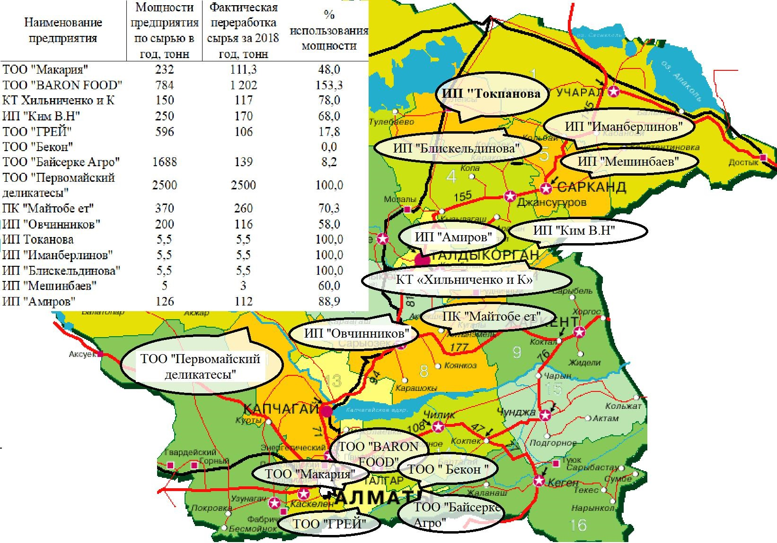
% of capacity usage
Actual processing of raw materials for 2018, ton
Capacity of the enterprise on raw materials per year, ton
Name of the enterprise
LLP “Makariya”
LLP “BARON FOOD”
PH “Khilchenko and Co”
IE “Kim V. N.”
LLP “Grey”
LLP “Bekon”
LLP “Baiserke Agro”
LLP “Pervomaiskiy delikatesy”
PH “Maitobe et”
IE “Ovchinnikov”
IE “Tokanova”
IE “Imanberlinov”
IE “Bliskeldinova”
IE “Meshinbayev”
IE “Amirov”

APPENDIX 27

Layout of meat processing enterprises in the East Kazakhstan region in 2018
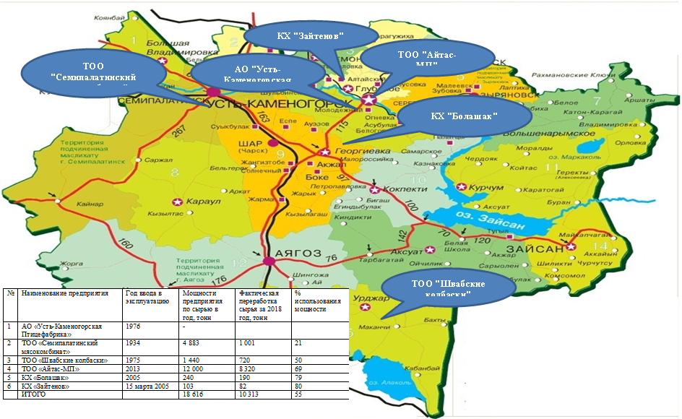
% of capacity usage
Actual processing of raw materials for 2018, ton
Capacity of the enterprise on raw materials per year, ton
Commissioning year
Name of the enterprise
JSC “Ust-Kamenogorsk Poultry Farm”
LLP “Semipalatinsk Meat Factory”
LLP “Shvabskie kolbaski”
LLP “Aitas-MP”
PH “Bolashak”
PH “Zaitenov”
TOTAL

APPENDIX 28

Layout of meat processing enterprises in the Turkestan region in 2018

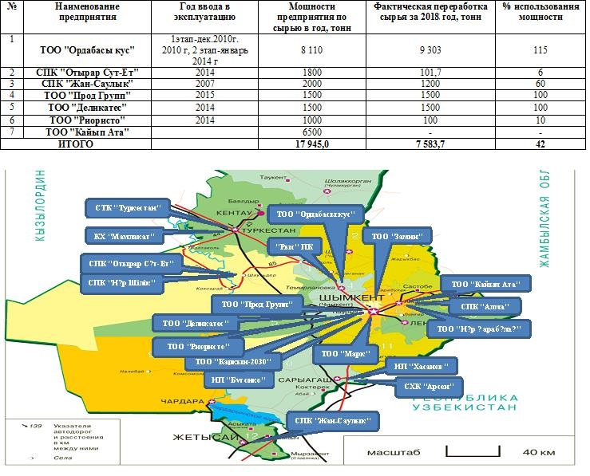
Road signs and distance between them in km
Villages
40 km
Scale
Ordabasy kus LLP

AIC “Otyrar Syt-Et”
AIC “Zhan-Saulyk”
LLP “Prod Group”
LLP “Delikates”
LLP “Rioristo”
LLP “Kaiyp Ata”
TOTAL

Name of the enterprise
1 stage – December 2010
2 stage – January 2014
Commissioning year
Capacity of the enterprise on raw materials per year, ton
Actual processing of raw materials for 2018, ton
% of capacity usage

APPENDIX 29

Locations of new family farms and new processing plants under the National Program
of Beef Livestock for 2018-2027

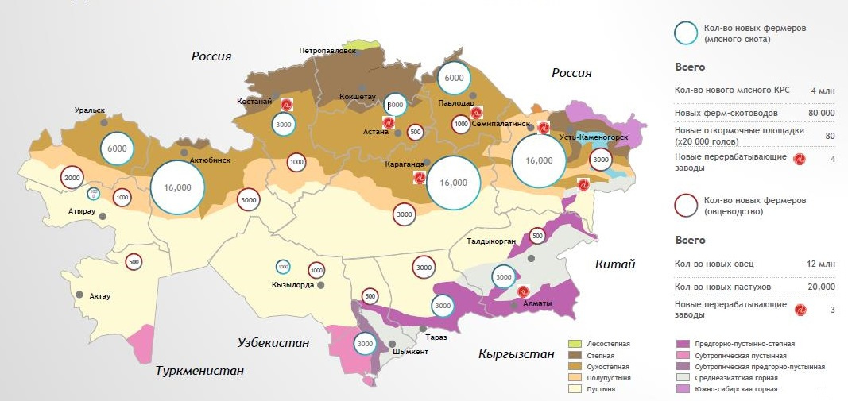
Forest steppe
Steppe
Dry steppe
Semi-desert
Desert
Submontane-desert-steppe
Subtropical desert
Subtropical submontane-desert
Central Asian mountain
South-Siberian mountain
New processing plants
Number of new shepherds
Number of new sheep
12 mln
Total
Number of new farmers (sheep farming)
New processing plants
New feeding areas (x 20 000 units
New breeder farms
Number of new meat cattle
Total
Number of new farmers (meat cattle)

APPENDIX 30

Calculation of the optimal feed requirement for fattening cattle for 1 and 800 head of cattle

Type of feed | Average consumption per day, kg | Consumption per 1 head for the entire period, tons | Consumption for 800 heads, tons
Cereals (barley) | 6.91 | 1.45 | 1160
Distillery stillage | 6.74 | 1.41 | 1128
Earlage | 1.98 | 0.41 | 328
Hay | 1.25 | 0.26 | 208
Mineral supplements | 0.13 | 0.03 | 24
Note: calculated based on research

APPENDIX 31

Calculation of the cost of fattening bulls when purchasing feed

Type of feed | Price, tenge/tons | Average consumption per day, kg | Cost, tenge/tons
Cereals (barley) | 45 000 | 6.91 | 311
Distillery stillage | 20 000 | 6.74 | 134.8
Succulent feed | 10 300 | 1.98 | 20
Hay | 20 000 | 1.25 | 25
Mineral supplements | 150,000 | 0.13 | 19
Total |  |  | 509.8
Note: calculated based on research

APPENDIX 32
-
Calculation of the cost of fattening bulls in the production of their own succulent and dry feeds

Type of feed | Price, tenge/tons | Average consumption per day, kg | Cost, tenge/tons
Cereals (barley) | 35 000 | 6.91 | 242
Distillery stillage | 20 000 | 6.74 | 134.8
Earlage | 2 500 | 1.98 | 5
Hay | 4 500 | 1.25 | 5.6
Mineral supplements | 150,000 | 0.13 | 19
Total |  |  | 406.4
Note: calculated based on research

APPENDIX 33

Efficiency of consumption of feed costs for own production and their purchase for fattening young cattle

Measure | Own production of juicy and roughage | Purchase of feed
Initial weight before fattening, kg | 230 | 230
Weight after fattening, kg | 530 | 530
Feeding duration, days | 180 | 180
Average weight gain per day, kg | 1.11 | 1.11
Cost of feed, tenge/day | 406.4 | 509.8
The cost price is 1 kg. weight gain, tenge | 366 | 485.5
Feed consumption per 1 head/tenge | 73152 | 91764
Feed consumption (800 heads), thousand tenge | 58521.6 | 73411.2

APPENDIX 34

Overhead and operating costs for fattening an agricultural production cooperative with a feedlot for 800 head of cattle

Measure | Amount, thousand tenge
Electricity | 1600
Expendable materials | 2072
Repair of machinery and equipment, spare parts | 2 500
Veterinary preparation | 1968
Fuels and lubricants for machinery and livestock vehicles | 7500
Administrative expenses | 3560
Total | 19 200
per 1 head | 2.0
Note: calculated based on research

APPENDIX 35

The volume of investments required to create an agricultural cooperative with a feedlot for 800 head of cattle

Measure | Total cost,  thousand tenge | Own funds, thousand tenge | Credit funds, thousand tenge
Design and construction  and installation work | 60 080 | 15 020 | 45 060
Technics and equipment for the site | 40 500 | 10 125 | 30 375
Technics and equipment for feed production | 55 600 | 13 900 | 41 700
Irrigation systems | 11 250 | 2 813 | 8 438
Replenishment  of working capital | 69 812 | - | -
Purchase of cattle | 110400 | - | 110400
Total | 347,642 | 111,670 | 235,973
Note: calculated based on research

APPENDIX 36

Economic efficiency of an agricultural production cooperative with a feedlot

Self-purchase of livestock | Per 1 head | For 800 heads
Income part | 291500 | 145 750 000
Realization of live cattle at a meat processing plant  (weight 530 kg, 850 tenge/kg live weight) | 450500 | 360 400 000
Expenditure side | 279600 | 223 680 000
Purchase of young stock for fattening (230 kg) | 138000 | 110 400 000
Feed costs | 85344 | 68 275 000
Overhead costs | 24 000 | 19 200 000
Wages fund | 32 256 | 25 800 000
Profit | 170,900 | 136 720 000
Percent | 61.1 | 61.1
Note: calculated based on research

APPENDIX 37
Mechanism for the formation of an agricultural production cooperative farm
YNTYMAK-2019 in the Turkestan region
Agricultural production cooperative
YNTYMAK-2019

Founders of the APC are 74 agricultural and personal subsidiary farms
Total land area: 1018 hectares

Fuctions:
- production, procurement of feed;
- feeding of farm animals;
- slaughter of livestock;
- sale of meat.
Management bodies: General Meeting, Management Board, Audit Commission
Conclusion of the Act on the transfer of property (land use rights, industrial complexes, etc.) to the mutual fund of the cooperative
The net income of the cooperative is distributed among its members in proportion to their participation in the activities of the APC
Property evaluation:
- land use rights at cadastral value
- production bases and other property in value terms
Borrowing costs
(loans)
Own funds (share contributions (introductory, and additional), proceeds from the sale of goods and services, dividends, subsidies, etc.)
Sources of formation of the property of the APC:
other property
production bases
land plot
livestock
PH
PH
PH
PH
PH to APC transition:
as a share contribution
APPENDIX 38

Production of forage crops (corn for grain, silage and alfalfa) in the agricultural production cooperative YNTYMAK-2019

Measure | Value
Total area | 1 000
Area (harvesting), ha
Grain maize | 300
Maize for silage | 300
Medick | 200
Productivity, dt/ha
Grain maize | 80.0
Maize for silage | 40
Medick | 17.5
Gross harvesting, t
Grain maize | 2 550
Maize for silage | 12 000
Medick | 3 500
Note: calculated based on research

APPENDIX 39

Break-even forecast of the YNTYMAK-2019 agricultural production cooperative by years, thousand tenge

Period | 2019 | 2020 | 2021 | 2022 | 2023 | 2024 | 2025
Income from service provision | 1 538 025 | 1 150 000 | 1 150 000 | 1 150 000 | 1 150 000 | 1 150 000 | 1 150 000
Balance sheet profit | 727,427 | 316,550 | 327,858 | 339,167 | 350,475 | 381,651 | 373,091
Full self-cost of services | 810,598 | 833,450 | 822,142 | 810,833 | 799,525 | 768,349 | 776,909
Overhead costs | 294,898 | 317,750 | 306,442 | 295,133 | 283,825 | 252,649 | 261,209
Variable expenses | 515,700 | 515,700 | 515,700 | 515,700 | 515,700 | 515,700 | 515,700
Marginal revenue amount | 1 022 325 | 634,300 | 634,300 | 634,300 | 634,300 | 634,300 | 634,300
Share of marginal income in revenue, % | 0.665 | 0.552 | 0.552 | 0.552 | 0.552 | 0.552 | 0.552
Break-even limit | 443,656 | 576,087 | 555,585 | 535,084 | 514,582 | 458,059 | 473,578
Break-even limit, ha | 2 900 | 2 900 | 2 900 | 2 900 | 2 900 | 2 900 | 2 900
Stock of financial stability of the enterprise (%) | 71% | 50% | 52% | 53% | 55% | 60% | 59%
Break-even point | 29% | 50% | 48% | 47% | 45% | 40% | 41%
Note: calculated based on research

APPENDIX 40

Act of implementation of research results

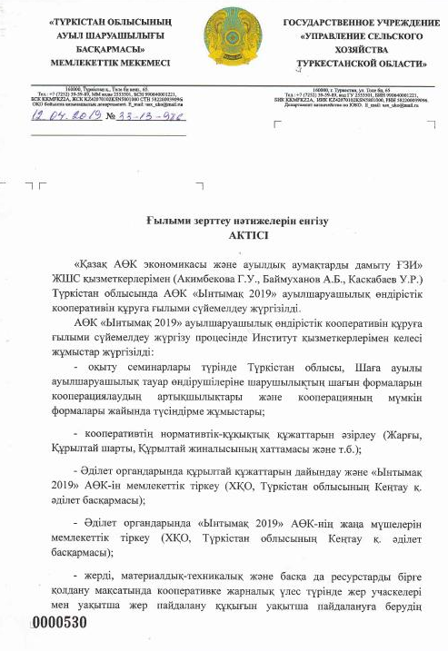
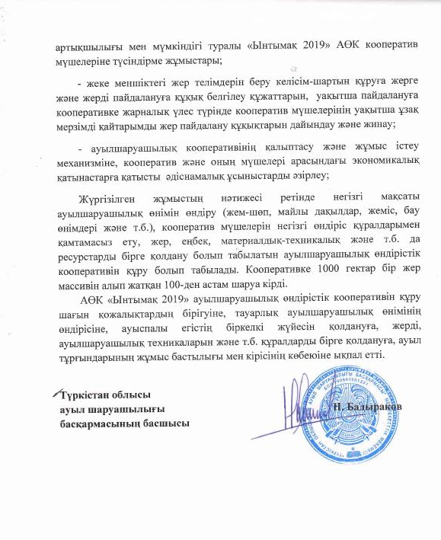
APPENDIX 41
-
Act of implementation of research results

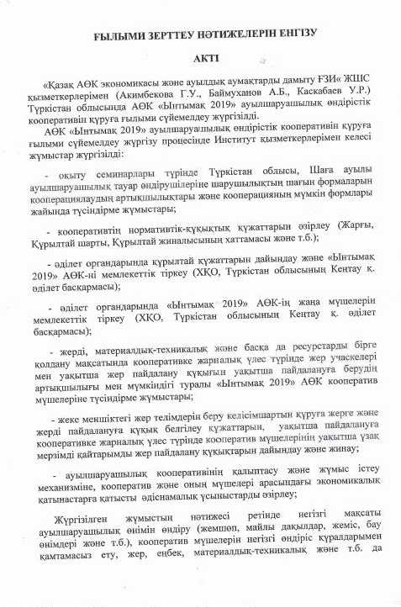
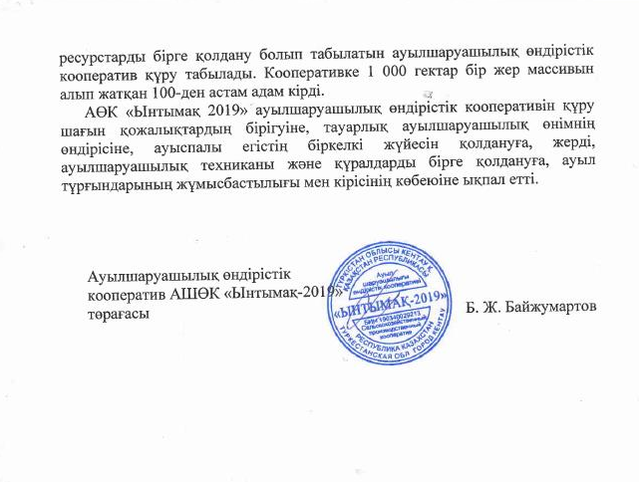

APPENDIX 42

Recommended layout of production facilities of meat processing enterprises in accordance with their raw material resources by organizing agricultural cooperatives for fattening and slaughtering cattle in the Turkestan region
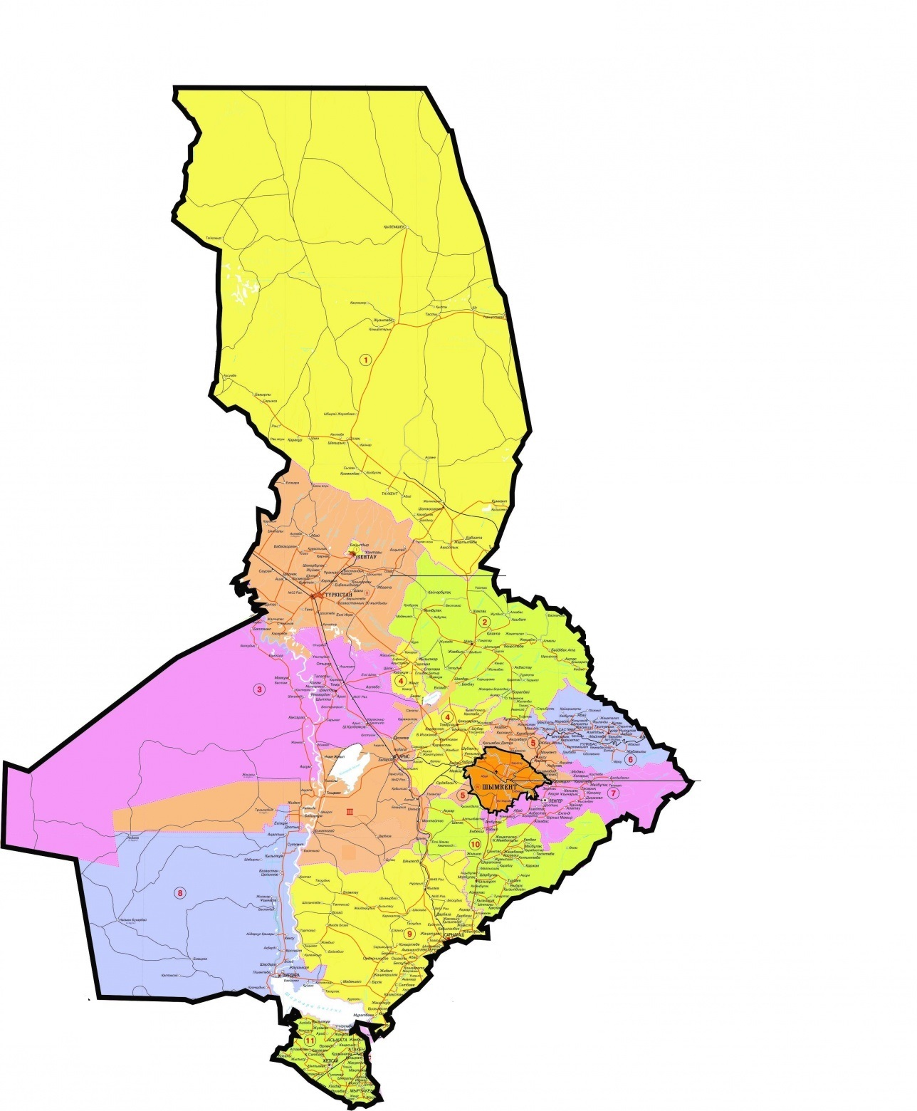

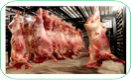





New meat processing plant
APC with feeding area
APC with slaughtering point

APPENDIX 43

Recommended layout of production facilities of meat processing enterprises in accordance with their raw material resources by organizing agricultural cooperatives for fattening and slaughtering cattle in the
Almaty region
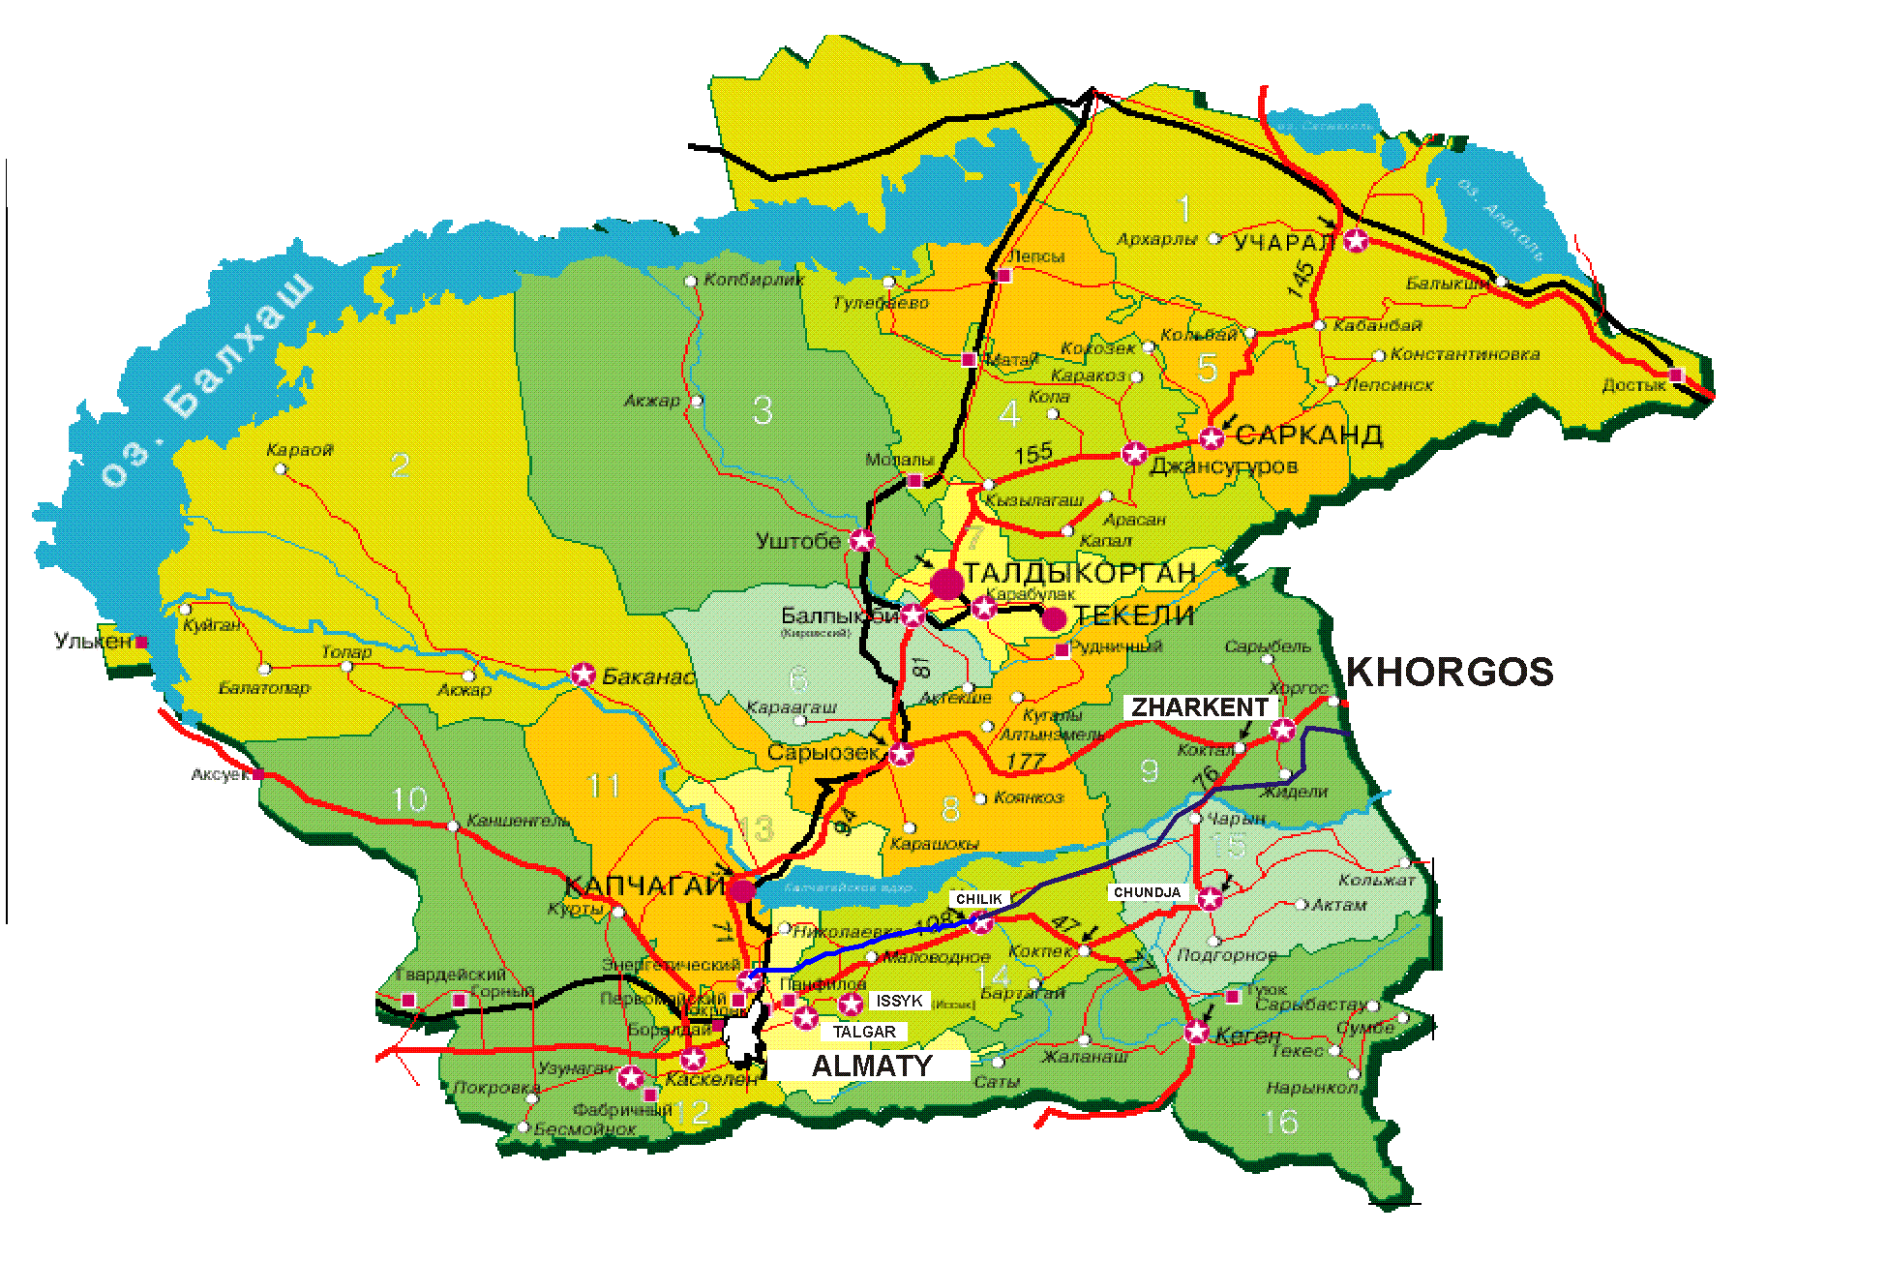


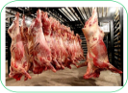




APC with feeding area
APC with slaughtering point

New meat processing plant

APPENDIX 44

Recommended layout of production facilities of meat processing enterprises in accordance with their raw material resources by organizing agricultural cooperatives for fattening and slaughtering cattle in the East Kazakhstan region
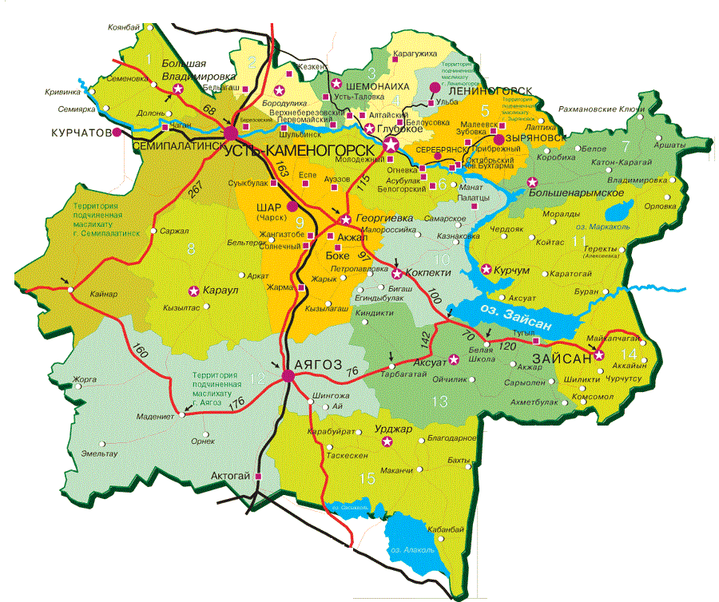

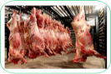


New meat processing plant
APC with feeding area
APC with slaughtering point

APPENDIX 45

Forecast for the creation of family farms for growing and their unification into agricultural production cooperatives for fattening and slaughtering cattle in the Turkestan region

 |  |  | 2021 | 2022 | 2023 | 2024 | 2025 | 2026 | 2027
  2019
  2020
Family farms to be created, units | 330 | 330 | 330 | 330 | 330 | 330 | 340 | 340 | 340
Total family farms, units | 330 | 660 | 990 | 1320 | 1650 | 1980 | 2320 | 2660 | 3000
APC to be created, units | 4 | 4 | 4 | 4 | 4 | 4 | 4 | 4 | 5
Total APC, units | 4 | 8 | 12 | 16 | 21 | 25 | 29 | 33 | 38
APC to be created, units | 1 | 2 | 3 | 4 | 5 | 6 | 8 | 10 | 11
Number of bulls for slaughter, head | 6600 | 13200 | 19800 | 26400 | 33000 | 39600 | 46400 | 53200 | 60000
Beef meat production, tons | 2178 | 4356 | 6534 | 8712 | 10890 | 13068 | 15312 | 17556 | 19800
Total breeding stock, tons | 16500 | 33000 | 49500 | 66000 | 82500 | 99000 | 116000 | 133000 | 150000
Capital outlays:
APC to be created, mil. tenge | 29 | 29 | 29 | 29 | 29 | 29 | 29 | 29 | 29
Total APC, units | 29.0 | 58.9 | 88.8 | 118.7 | 148.6 | 178.5 | 232.0 | 290.0 | 319.0
APC to be created, mil. tenge | 235.9 | 235.9 | 235.9 | 235.9 | 235.9 | 235.9 | 235.9 | 235.9 | 235.9
Total APC, mil. tenge | 973.1 | 973.1 | 973.1 | 973.1 | 973.1 | 973.1 | 1002.6 | 1002.6 | 1179.5
Purchase of cattle for the FF, mil. tenge | 6600 | 6600 | 6600 | 6600 | 6600 | 6600 | 6800 | 6800 | 6800
Total, mil. tenge | 7602.1 | 7632.0 | 7661.9 | 7691.8 | 7721.7 | 7751.6 | 8034.6 | 8092.6 | 8298.5
Note: calculated based on research

APPENDIX 46

Forecast for the creation of family farms for growing and their unification into agricultural production cooperatives for fattening and slaughtering cattle in the Almaty region

 |  |  | 2021 | 2022 | 2023 | 2024 | 2025 | 2026 | 2027
  2019
  2020
Family farms to be created, units | 330 | 330 | 330 | 330 | 330 | 330 | 340 | 340 | 340
Total family farms, units | 330 | 660 | 990 | 1320 | 1650 | 1980 | 2320 | 2660 | 3000
APC to be created, units | 4 | 4 | 4 | 4 | 4 | 4 | 4 | 4 | 5
Total APC, units | 4 | 8 | 12 | 16 | 21 | 25 | 29 | 33 | 38
APC to be created, units | 1 | 2 | 3 | 4 | 5 | 6 | 8 | 10 | 11
Number of bulls for slaughter, head | 6600 | 13200 | 19800 | 26400 | 33000 | 39600 | 46400 | 53200 | 60000
Beef meat production, tons | 2178 | 4356 | 6534 | 8712 | 10890 | 13068 | 15312 | 17556 | 19800
Total breeding stock, tons | 16500 | 33000 | 49500 | 66000 | 82500 | 99000 | 116000 | 133000 | 150000
Capital outlays
APC to be created, mil. tenge | 29 | 29 | 29 | 29 | 29 | 29 | 29 | 29 | 29
Total APC, units | 29.0 | 58.9 | 88.8 | 118.7 | 148.6 | 178.5 | 232.0 | 290.0 | 319.0
APC to be created, mil. tenge | 235.9 | 235.9 | 235.9 | 235.9 | 235.9 | 235.9 | 235.9 | 235.9 | 235.9
Total APC, mil. tenge | 973.1 | 973.1 | 973.1 | 973.1 | 973.1 | 973.1 | 1002.6 | 1002.6 | 1179.5
Purchase of cattle for the FF, mil. tenge | 6600 | 6600 | 6600 | 6600 | 6600 | 6600 | 6800 | 6800 | 6800
Total, mil. tenge | 7602.1 | 7632.0 | 7661.9 | 7691.8 | 7721.7 | 7751.6 | 8034.6 | 8092.6 | 8298.5
Note: calculated based on research

APPENDIX 47

Forecast for the creation of family farms for growing and their unification into agricultural production cooperatives for fattening and slaughtering cattle in the East Kazakhstan region

 |  |  | 2021 | 2022 | 2023 | 2024 | 2025 | 2026 | 2027
  2019
  2020
Family farms to be created, units | 1700 | 1700 | 1700 | 1700 | 1700 | 1700 | 1930 | 1930 | 1940
Total family farms, units | 1700 | 3400 | 5100 | 6800 | 8500 | 10200 | 12130 | 14060 | 16000
APC to be created, units | 9 | 9 | 9 | 9 | 9 | 9 | 11 | 11 | 12
Total APC, units | 4 | 13 | 21 | 30 | 38 | 47 | 57 | 68 | 80
APC to be created, units | 1 | 3 | 6 | 8 | 10 | 12 | 15 | 18 | 20
Number of bulls for slaughter, head | 34000 | 68000 | 102000 | 136000 | 170000 | 204000 | 242600 | 281200 | 320000
Beef meat production, tons | 11220 | 22440 | 33660 | 44880 | 56100 | 67320 | 80058 | 92796 | 105600
Total breeding stock, tons | 85000 | 170000 | 255000 | 340000 | 425000 | 510000 | 606500 | 703000 | 800000
Capital outlays
APC to be created, mil. tenge | 29 | 29 | 29 | 29 | 29 | 29 | 29 | 29 | 29
Total APC, units | 30.5 | 95.4 | 160.3 | 225.1 | 290.0 | 354.9 | 436.7 | 518.5 | 580.5
APC to be created, mil. tenge | 235.9 | 235.9 | 235.9 | 235.9 | 235.9 | 235.9 | 235.9 | 235.9 | 235.9
Total APC, mil. tenge | 2005.2 | 2005.2 | 2005.2 | 2005.2 | 2005.2 | 2005.2 | 2529.4 | 2529.4 | 2860.3
Purchase of cattle for the FF, mil. tenge | 34000 | 34000 | 34000 | 34000 | 34000 | 34000 | 38600 | 38600 | 38800
Total, mil. tenge | 36035.7 | 36100.5 | 36165.4 | 36230.3 | 36295.2 | 36360.0 | 41566.1 | 41647.9 | 42240.8
Note: calculated based on research

APPENDIX 48

Forecast for the creation of family farms for growing and their unification into agricultural production cooperatives for fattening and slaughtering cattle in the Republic of Kazakhstan

Measure units | 2019 | 2020 | 2021 | 2022 | 2023 | 2024 | 2025 | 2026 | 2027
Family farms to be created, th. units | 3 | 4 | 5 | 7 | 8 | 9 | 11 | 14 | 18
Total family farms, th. units | 3 | 7 | 13 | 20 | 28 | 37 | 48 | 62 | 80
APC to be created, units | 23 | 30 | 38 | 53 | 60 | 68 | 83 | 105 | 135
Total APC, units | 23 | 53 | 98 | 150 | 211 | 278 | 361 | 466 | 602
APC to be created, units | 6 | 14 | 26 | 41 | 57 | 75 | 98 | 126 | 163
Number of bulls for slaughter, th. heads | 60 | 140 | 260 | 400 | 560 | 740 | 960 | 1240 | 1600
Number of rejected cows for slaughter, thousand heads |  |  | 65 | 100 | 140 | 185 | 240 | 310 | 400
Beef meat production, th. tons | 19.8 | 46.2 | 107.2 | 165 | 231 | 305.2 | 396 | 511.5 | 660
Total breeding stock, th. heads | 150 | 370 | 630 | 978 | 1380 | 1831 | 2380 | 3096 | 3997
Capital outlays
APC to be created, mil. tenge | 29 | 29 | 29 | 29 | 29 | 29 | 29 | 29 | 29
Total APC, mil. tenge | 176.8 | 412.5 | 766.1 | 1178.6 | 1650.1 | 2180.5 | 2828.7 | 3653.7 | 4714.5
APC to be created, mil. tenge | 235.9 | 235.9 | 235.9 | 235.9 | 235.9 | 235.9 | 235.9 | 235.9 | 235.9
Total APC, mil. tenge | 5321.1 | 7094.7 | 8868.4 | 12415.8 | 14189.5 | 15963.2 | 19510.5 | 24831.6 | 31926.3
Purchase of cattle for the FF, mil. tenge | 60000 | 80000 | 100000 | 140000 | 160000 | 180000 | 220000 | 280000 | 360000
Total, mil. tenge | 65497.8 | 87507.3 | 109634.5 | 153594.4 | 175839.5 | 198143.6 | 242339.2 | 308485.3 | 396640.8
Note: calculated based on research

APPENDIX 49

Map of the location of production facilities of meat processing enterprises and agricultural production cooperatives for fattening and slaughtering cattle in the Republic of Kazakhstan

APPENDIX 48

Map of the location of production facilities of meat processing enterprises and agricultural production cooperatives for fattening and slaughtering cattle in the Republic of Kazakhstan

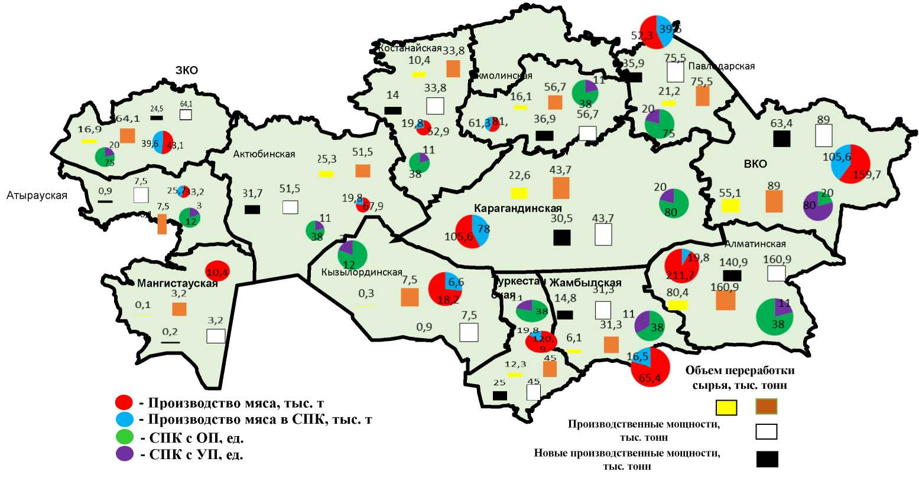

Meat production, thousand t
Meat production in APC, thousand t
APC with SS, thousand t
APC with UE, thousand t

New production capacity, thousand t

Production capacity, thousand t

Raw materials processing volume, thousand t

APPENDIX 50

Gross harvest of cereals (including rice) and legumes in all categories of farms in the context of regions of the Republic of Kazakhstan in 2019, thousand tons

 | In originally capitalized weight |  | In weight after revision |  | Reflection coefficient, in %
 | 2019 | 2019 in % to 2018 | 2019 | 2019 in % to 2018 | 2019
Republic of Kazakhstan | 18 601,9 | 85.6 | 17 428,6 | 86.0 | 6.3
Akmoly | 4 471,2 | 83.4 | 4 192,5 | 83.2 | 6.2
Aktobe | 403.2 | 80.2 | 386.0 | 80.2 | 4.3
Almaty | 1 378,6 | 99.7 | 1 331,6 | 100.2 | 3.4
West Kazakhstan Region | 255.0 | 142.2 | 242.2 | 141.4 | 5.0
Zhambyl | 780.0 | 103.1 | 749.6 | 103.3 | 3.9
Karaganda | 826.2 | 80.1 | 775.4 | 81.0 | 6.1
Kostanay | 3 064,9 | 61.1 | 2 872,4 | 61.4 | 6.3
Kyzylorda | 565.2 | 113.5 | 518.9 | 117.2 | 8.2
Pavlodar | 648.9 | 78.6 | 593.2 | 80.4 | 8.6
North Kazakhstan Region | 4 476,5 | 94.9 | 4 129,1 | 95.5 | 7.8
Turkestan | 715.8 | 125.9 | 691.4 | 125.7 | 3.4
East Kazakhstan Region | 999.8 | 113.8 | 930.3 | 113.9 | 7.0
Nur-Sultan | 1.4 | 5.8 | 1.3 | 6.2 | 4.3
Almaty | 0.2 | 54.5 | 0.2 | 69.1 | 7.4
Shymkent | 15.1 | 135.6 | 14.4 | 136.5 | 4.5
Note: calculated based on research

APPENDIX 51

Volume of flour production from fine grain crops by region for 2017-2019, thousand tons

Region | 2017 | 2018 | 2019
Republic of Kazakhstan | 4033.5 | 4121.7 | 3544.1
Akmoly | 451.3 | 431.2 | 315.4
Aktobe | 106.9 | 100.7 | 71.4
Almaty | 104.8 | 101.8 | 99.9
Atyrau | 2.0 | 1.0 | 0.6
West Kazakhstan Region | 110.6 | 104.6 | 126.0
Zhambyl | 38.9 | 14.2 | 5.5
Karaganda | 436.1 | 378.7 | 338.6
Kostanay | 1107.2 | 1289.9 | 1132.4
Kyzylorda | 0.8 | 1.0 | -
Mangistau | 26.0 | 11.7 | 11.9
Turkestan | 51.5 | 53.6 | 56.4
Pavlodar | 56.5 | 57.9 | 325.4
North Kazakhstan Region | 363.2 | 354.7 | 293.9
East Kazakhstan Region | 174.7 | 151.6 | 122.4
Astana | 157.2 | 140.3 | 122.3
Almaty | 92.0 | 121.0 | 8.5
Shymkent | 753.8 | 807.9 | 513.5

APPENDIX 52

Availability of production capacity for grain storage facilities in all categories of farms in the Republic of Kazakhstan in 2019

Region | Grain-seed  storage (including grain feed), total, |  | including
Region | ton | % | Grain-seed storage  tons | Seed  storage, tons | Grain storage facilities, tons
Republic of Kazakhstan | 15844.3 | 100.0 | 8224.3 | 978.1 | 634.6
Akmola region | 3035.5 | 19.2 | 1859.9 | 296.2 | 84.5
Aktobe region | 1136.6 | 7.2 | 359.7 | 32.3 | 5.0
Almaty region | 804.7 | 5.1 | 515.2 | 16.7 | 31.4
Atyrau region | 8.6 | 0.1
West Kazakhstan Region | 710.2 | 4.5 | 100.5 | 12.7 | 7.6
Zhambylu region | 146.6 | 0.9 | 82.7 | 5.4 | 10.5
Karaganda region | 790.3 | 5.0 | 376.4 | 50.1 | 22.3
Kostany region | 3327.6 | 21.0 | 2163.7 | 222.9 | 198.9
Kyzylorda region | 101.4 | 0.6 | 62.6 | 7.5 | 1.4
Mangistau | 1.0 | 0.0 | 0.0 | 0.0 | 1.0
South Kazakhstan Region | 172.0 | 1.1 | 96.5 | 14.7 | 51.1
Pavlodar region | 925.5 | 5.8 | 414.4 | 15.2 | 45.0
North Kazakhstan Region | 3116.3 | 19.7 | 1957.1 | 273.5 | 118.0
West Kazakhstan Region | 1564.8 | 9.9 | 235.6 | 30.0 | 47.3
Astana | 3.0 | 0.0 | 0.0 | 0.0 | 3.0
Almaty | 0.1
Note: the information was provided by the Committee on Statistics of the Ministry of National Economy of the Republic of Kazakhstan

APPENDIX 53

Concentration of grain production and the coefficient of correspondence of the production capacity of grain processing enterprises to their raw materials in the context of regions of the Republic of Kazakhstan for 2019

Region | Grain production |  | Capacity  of processing |  | Grain processing |  | Self-sufficiency  ratio  of the capacity referred to raw  materials
Region | th.  ton | spec. gravity, % | th.  ton | spec. gravity, % | th.  ton | spec. gravity, %
Republic of Kazakhstan | 18601.9 | 100.0 | 11835 | 100.0 | 4003.3 | 100 | 1.0
I - less than 1.0
Aktobe | 403.2 | 2.2 | 238.2 | 2.0 | 96.1 | 2.4 | 0.9
Akmoly | 4471.2 | 24.0 | 1553.2 | 13.1 | 529 | 13.2 | 0.5
Almaty | 1378.6 | 7.4 | 425.8 | 3.6 | 117.4 | 2.9 | 0.5
Zhambyl | 780 | 4.2 | 158.3 | 1.3 | 153.7 | 3.8 | 0.3
Almaty | 0.2 |  | 271 | 2.3 | 152.4 | 3.8 | 0.0
Nur-Sultan | 1.4 |  | 336.4 | 2.8 | 390.3 | 9.7 | 0.0
Kyzylorda | 565.2 | 3.0 | 14.2 | 0.1 | 1385.6 | 34.6 | 0.0
Pavlodar | 648.9 | 3.5 | 364.2 | 3.1 | 1.6 | 0.0 | 0.9
North Kazakhstan Region | 4476.5 | 24.1 | 1455.8 | 12.3 | 18.3 | 0.5 | 0.5
from 1 to 2.0
West Kazakhstan Region | 255 | 1.4 | 276.5 | 2.3 | 7.9 | 0.2 | 1.7
Kostanay | 3064.9 | 16.5 | 2838.3 | 24.0 | 378.1 | 9.4 | 1.5
Turkestan | 715.8 | 3.8 | 556.4 | 4.7 | 99.8 | 2.5 | 1.2
East Kazakhstan Region | 999.8 | 5.4 | 703.2 | 5.9 | 462.8 | 11.6 | 1.1
more than 2.0
Karaganda | 826.2 | 4.4 | 1295 | 10.9 | 11 | 0.3 | 2.5
Shymkent | 15.1 | 0.1 | 1348.5 | 11.4 | 199.3 | 5.0 | 140.4
Note: the information was provided by the Committee on Statistics of the Ministry of National Economy of the Republic of Kazakhstan

APPENDIX 54

Coefficient of self-sufficiency in bread and cereal products of the population in the context of regions of the Republic of Kazakhstan for 2019

Region | Production, th.t. | Population, th. p. | Self-sufficiency ratio | Specific gravity of the group, %
 |  |  |  | in grain production | in population
Republic of Kazakhstan | 18601.9 | 18395.6 | 0.9 | 100 | 100
I - less than 1.0
Aktobe | 403.2 | 869.6 | 0.4 | 35.4 | 81.1
Almaty | 1378.6 | 2038.9 | 0.6 | 35.4 | 81.1
West Kazakhstan Region | 255 | 652.3 | 0.4 | 35.4 | 81.1
Zhambyl | 780 | 1125.5 | 0.6 | 35.4 | 81.1
Karaganda | 826.2 | 1378.5 | 0.5 | 35.4 | 81.1
Kyzylorda | 565.2 | 794.3 | 0.7 | 35.4 | 81.1
Pavlodar | 648.9 | 753.9 | 0.8 | 35.4 | 81.1
Turkestan | 715.8 | 1983.9 | 0.3 | 35.4 | 81.1
East Kazakhstan Region | 999.8 | 1378.5 | 0.7 | 35.4 | 81.1
Nur-Sultan | 1.4 | 1078.4 | 0.01 | 35.4 | 81.1
Almaty | 0.2 | 1854.7 | 0.01 | 35.4 | 81.1
Shymkent | 15.1 | 1009.1 | 0.01 | 35.4 | 81.1
II - more than 1.0
Akmoly | 4471.2 | 738.6 | 5.6 | 64.6 | 19.9
Kostanay | 3064.9 | 872.8 | 3.2 | 64.6 | 19.9
North Kazakhstan Region | 4476.5 | 554.5 | 7.4 | 64.6 | 19.9
Note: calculated based on research

APPENDIX 55

Consumption of bakery products and cereals per capita
per year in the Republic of Kazakhstan, kg

Food product description | Physiological norms of consumption of bread and cereals, kg [1] | 2017 | 2018 | 2019
Republic of Kazakhstan | 109 | 129.8 | 130.7 | 133.7
Akmoly | 109 | 127.8 | 126.8 | 132.0
Aktobe | 109 | 128.5 | 123.3 | 121.8
Almaty | 109 | 134.0 | 132.7 | 135.8
Atyrau | 109 | 133.7 | 128.5 | 130.5
West Kazakhstan Region | 109 | 125.4 | 124.9 | 125.0
Zhambyl | 109 | 112.2 | 120.0 | 126.6
Karaganda | 109 | 121.6 | 127.4 | 127.1
Kostanay | 109 | 125.2 | 122.3 | 125.3
Kyzylorda | 109 | 150.2 | 155.7 | 151.2
Mangistau | 109 | 119.9 | 119.4 | 116.4
Turkestan | 109 | 156.7 | 157.1 | 164.9
Pavlodar | 109 | 134.9 | 137.5 | 140.8
North Kazakhstan Region | 109 | 118.1 | 121.6 | 120.2
East Kazakhstan Region | 109 | 140.0 | 144.0 | 144.5
Astana | 109 | 102.9 | 105.1 | 109.0
Almaty | 109 | 103.7 | 103.8 | 109.8
Shymkent | 109 | 118.1 | 121.6 | 120.2
Note: calculated based on research

APPENDIX 56

Key indicators of the development of the grain industry in Akmola,
Kostanay and North Kazakhstan regions for 2019, thousand tons

Region | Gross grain harvest | Production volume, thousand tons
Region | Gross grain harvest | Flour production | Production of cereals, coarse flour | Bread production | Production of pasta, noodles, couscous and flour products
Republic of Kazakhstan | 18 601,9 | 3544.1 | 71.2 | 672.5 | 354.7
Akmoly | 4 471,2 | 315.4 |  | 89.9 | 4.1
Kostanay | 3 064,9 | 1132.4 | 7.7 | 39.8 | 34.5
North Kazakhstan Region | 4 476,5 | 293.9 | 1.5 | 32.6 | 81.0
Note: the information was provided by the Committee on Statistics of the Ministry of National Economy of the Republic of Kazakhstan

APPENDIX 57

Concentration of grain production and the coefficient of conformity of the production capacity of grain processing enterprises to their raw materials in the Akmola region in 2019

Region | Grain production |  | Capacity  of processing |  | Grain processing |  | Self-sufficiency  ratio  of the capacity referred to raw  materials
Region | th.  ton | spec. gravity, % | th.  ton | spec. gravity, % | th.  ton | spec. gravity, %
Total for the region | 4471.2 | 100 | 1553.2 | 100 | 529 | 100 | 1.0
I - less than 1.0
Yereymentau | 11.3 | 0.3 | 1.2 | 0.1 | 0.4 | 0.1 | 0.1
Tselinograd | 100.3 | 2.2 | 0.8 | 0.1 | 1.1 | 0.2 | 0.0
Stepnogorsk | 450.1 | 10.1 | 118.9 | 7.7 | 30.2 | 5.7 | 0.8
Arshaly | 196.4 | 4.4 | 40.3 | 2.6 | 15.6 | 2.9 | 0.6
Esil | 15.6 | 0.3 | 0.2 | 0.0 | 0.1 | 0.0 | 0.0
Astrakhan | 146.8 | 3.3 | 10.2 | 0.7 | 3.5 | 0.7 | 0.2
Atbasar | 285.1 | 6.4 | 56.8 | 3.7 | 14.6 | 2.8 | 0.6
Egindykol | 135.4 | 3.0 | 42.5 | 2.7 | 19.1 | 3.6 | 0.9
Burabay | 368.4 | 8.2 | 84.2 | 5.4 | 25.4 | 4.8 | 0.7
Shortandy | 95.6 | 2.1 | 20.1 | 1.3 | 8.5 | 1.6 | 0.6
from 1 to 2.0
Kokshetau | 1452.1 | 32.5 | 695.3 | 44.8 | 279.0 | 52.7 | 1.4
Akkol | 252.3 | 5.6 | 90.1 | 5.8 | 27.5 | 5.2 | 1.0
Bulandy | 145.6 | 3.3 | 68.1 | 4.4 | 26.1 | 4.9 | 1.3
Birzhan sal | 193.1 | 4.3 | 75.5 | 4.9 | 10.2 | 1.9 | 1.1
Zhaksy | 98.3 | 2.2 | 35.6 | 2.3 | 12.1 | 2.3 | 1.0
Zharkay | 52.4 | 1.2 | 25.5 | 1.6 | 8.5 | 1.6 | 1.4
Zerenda | 146.9 | 3.3 | 58.7 | 3.8 | 12.3 | 2.3 | 1.2
Korgalzhyn | 146.6 | 3.3 | 59.1 | 3.8 | 14.5 | 2.7 | 1.2
Sandyktau | 178.9 | 4.0 | 70.1 | 4.5 | 20.3 | 3.8 | 1.1
Note: calculated based on research

APPENDIX 58

Concentration of grain production and the coefficient of conformity of the production capacity of grain processing enterprises to their raw materials in the Kostanay region in 2019

Region | Grain production |  | Capacity  of processing |  | Grain processing |  | Self-sufficiency  ratio  of the capacity referred to raw  materials
Region | th.  ton | spec. gravity, % | th.  ton | spec. gravity, % | th.  ton | spec. gravity, %
Total for the region | 3064.9 | 100.0 | 2838.3 | 100.0 | 378.1 | 100.0 | 1.0
I - less than 1.0
Lisakovsk | 125.6 | 4.1 | 104.5 | 3.7 | 15.7 | 4.1 | 0.9
Denisov | 42.8 | 1.4 | 10.7 | 0.4 | 1.1 | 0.3 | 0.3
Zhangeldin | 61.1 | 2.0 | 10.1 | 0.4 | 1.0 | 0.3 | 0.2
Kamysty | 45.5 | 1.5 | 5.1 | 0.2 | 0.5 | 0.1 | 0.1
Karabalyk | 80.6 | 2.6 | 30.5 | 1.1 | 3.1 | 0.8 | 0.4
Karasu | 95.6 | 3.1 | 40.0 | 1.4 | 4.0 | 1.1 | 0.5
Mendykarynsky | 61.2 | 2.0 | 30.3 | 1.1 | 3.0 | 0.8 | 0.5
Naurzum | 48.8 | 1.6 | 23.3 | 0.8 | 2.3 | 0.6 | 0.5
Sarykolsky | 69.8 | 2.3 | 20.1 | 0.7 | 2.0 | 0.5 | 0.3
Taranovsky | 70.4 | 2.3 | 15.3 | 0.5 | 1.5 | 0.4 | 0.2
Uzunkol | 68.9 | 2.2 | 12.5 | 0.4 | 1.3 | 0.3 | 0.2
Fedorovsky | 56.5 | 1.8 | 10.2 | 0.4 | 1.0 | 0.3 | 0.2
from 1 to 2.0
Kostanay | 850.2 | 27.7 | 965.0 | 34.0 | 144.8 | 38.3 | 1.2
Arkalyk | 242.3 | 7.9 | 350.0 | 12.3 | 52.5 | 13.9 | 1.6
Rudny | 489.4 | 16.0 | 587.3 | 20.7 | 74.0 | 19.6 | 1.3
Altynsarinsky | 98.4 | 3.2 | 93.5 | 3.3 | 14.0 | 3.7 | 1.0
Amangeldinsky | 54.2 | 1.8 | 51.5 | 1.8 | 7.7 | 2.0 | 1.0
Auliekol | 102.5 | 3.3 | 97.4 | 3.4 | 14.6 | 3.9 | 1.0
Zhitikara | 164.8 | 5.4 | 156.6 | 5.5 | 15.7 | 4.1 | 1.0
Kostanay | 236.3 | 7.7 | 224.5 | 7.9 | 18.4 | 4.9 | 1.0
Note: calculated based on research

APPENDIX 59

Concentration of grain production and the coefficient of conformity of the production capacity of grain processing enterprises to their raw materials in the North Kazakhstan region in 2019

Region | Grain production |  | Capacity  of processing |  | Grain processing |  | Self-sufficiency  ratio  of the capacity referred to raw  materials
Region | th.  ton | spec. gravity, % | th.  ton | spec. gravity, % | th.  ton | spec. gravity, %
Republic of Kazakhstan | 4476.5 | 100.0 | 1455.8 | 100.0 | 18.3 | 100.0 | 1.0
I - less than 1.0
Gabit Musirepov | 412.0 | 9.2 | 123.6 | 8.5 | - | - | 0.9
Esil | 257.2 | 5.7 | 77.2 | 5.3 | - | - | 0.9
Zhambyl | 271.3 | 6.1 | 81.4 | 5.6 | - | - | 0.9
Kyzylzhar | 360.0 | 8.0 | 10.2 | 0.7 | - | - | 0.1
Magzhana Zhumabayeva | 150.1 | 3.4 | 12.3 | 0.8 | - | - | 0.3
Mamlyut | 211.2 | 4.7 | 42.3 | 2.9 | - | - | 0.6
Taiynsha | 159.6 | 3.6 | 20.3 | 1.4 | - | - | 0.4
Timiryazev | 120.4 | 2.7 | 15.6 | 1.1 | - | - | 0.4
Ualikhanov | 256.6 | 5.7 | 22.6 | 1.6 | - | - | 0.3
Shal akyna | 275.9 | 6.2 | 35.8 | 2.5 | - | - | 0.4
from 1 to 2.0
Petropavlovsk | 876.9 | 19.6 | 463.1 | 31.8 | 15.3 | 83.6 | 1.6
Ayyrtau | 465.3 | 10.4 | 252.5 | 17.3 | 3.0 | 16.4 | 1.7
Akzhar | 250.0 | 5.6 | 125.0 | 8.6 | - | - | 1.5
Akkayyn | 410.0 | 9.2 | 174.0 | 12.0 | - | - | 1.3
Gabit Musirepov | 412.0 | 9.2 | 123.6 | 8.5 | - | - | 0.9
Esil | 257.2 | 5.7 | 77.2 | 5.3 | - | - | 0.9
Note: calculated based on research

APPENDIX 60

Placement of grain production and production facilities for storage and processing in the context of districts of Akmola region for 2019
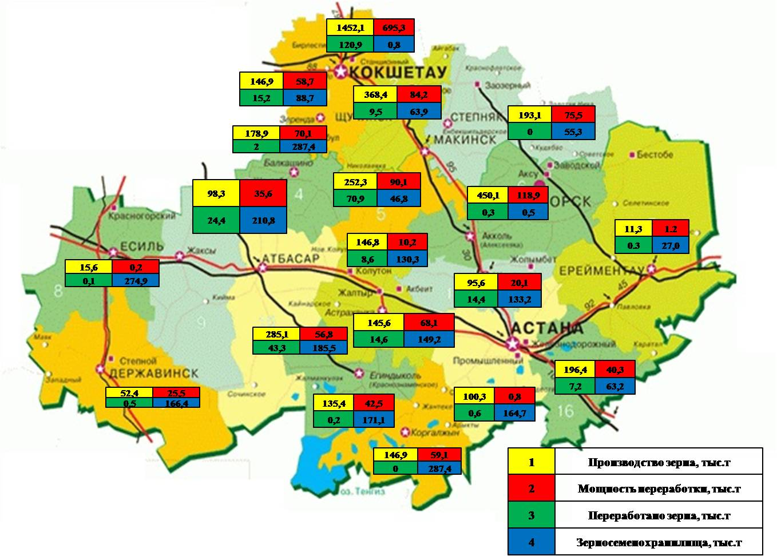
Grain production, thousand t
Processing capacity, thousand t
Processed grain, thousand t
Grain and seed warehouse, thousand t

APPENDIX 61

Placement of grain production and production facilities for storage and processing in the context of districts of Kostanay region for 2019
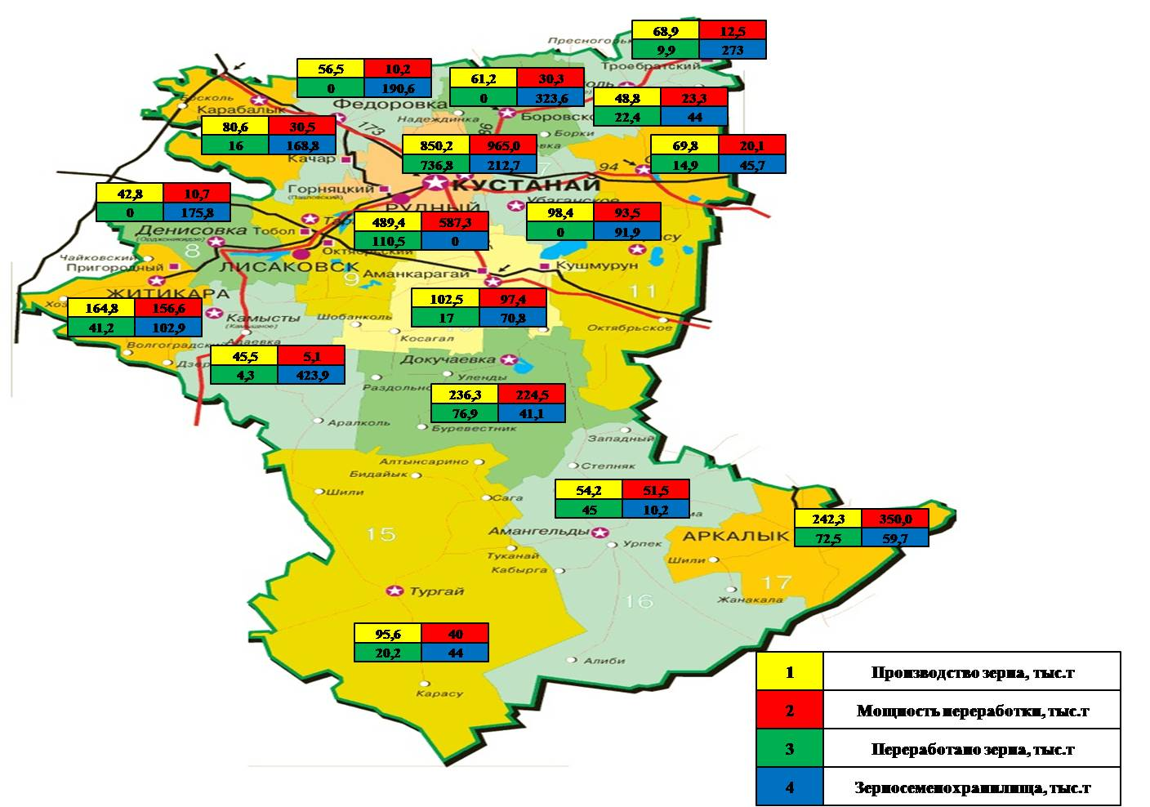
Grain production, thousand t
Processing capacity, thousand t
Processed grain, thousand t
Grain and seed warehouse, thousand t

APPENDIX 62

Placement of grain production and production facilities for storage and processing in the context of districts of North Kazakhstan region for 2019
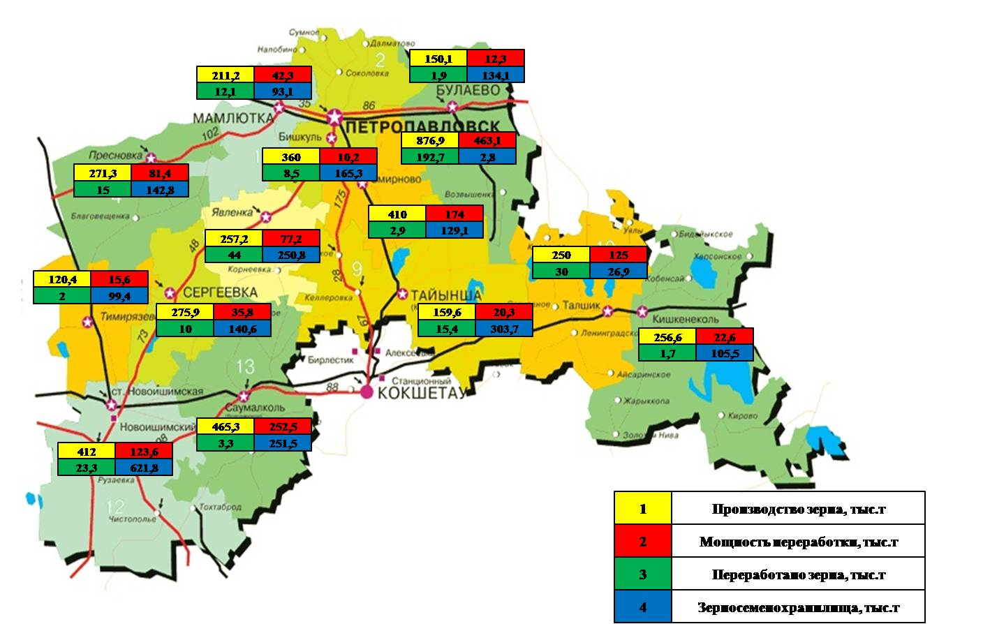
Grain production, thousand t
Processing capacity, thousand t
Processed grain, thousand t
Grain and seed warehouse, thousand t

APPENDIX 63

Grouping of districts of Akmola region according to the index of cumulative efficiency of growing wheat for 2019

Region | Composite efficiency index, Ief | Cost index, Iс | Yield index, Iy | Gross harvest after revision, t
Birzhan sal | 0.500 | 2.446 | 1.222 | 79116
Tselinograd | 0.568 | 1.566 | 0.889 | 142159.4
Korgalzhin | 0.592 | 1.313 | 0.778 | 65848.5
Yereymentau | 0.775 | 0.861 | 0.667 | 29022.6
Egindykol | 0.793 | 1.120 | 0.889 | 219271
Total for 1 group of 5 districts
Arshaly | 0.831 | 1.070 | 0.889 | 95463.9
Astrakhan | 0.933 | 1.191 | 1.111 | 278753.1
Esil | 1.050 | 0.952 | 1.000 | 307167.3
Zharkay | 1.103 | 0.806 | 0.889 | 423813.5
Shortandy | 1.142 | 0.973 | 1.111 | 160160.9
Total for 2 groups of 5 districts
Akkol | 1.176 | 0.945 | 1.111 | 106327.6
Atbasar | 1.284 | 0.883 | 1.133 | 313624.1
Bulandy | 1.528 | 0.872 | 1.333 | 178713.7
Zhaksy | 1.552 | 0.859 | 1.333 | 403494.6
Burabay | 1.891 | 0.881 | 1.667 | 67534.45
Sandyktau | 1.907 | 0.874 | 1.667 | 275933.1
Zerenda | 1.948 | 0.742 | 1.444 | 144375.5
Total for 3 groups of 7 districts
Note: calculated based on research

APPENDIX 64

Grouping of districts of Kostanay region according to the index of cumulative efficiency of growing wheat for 2019

Region | Composite efficiency index | Cost index | Yield index | Gross harvest after revision, t
Zhitikara | 0.148 | 2.458 | 0.363 | 41834.5
Kamysty | 0.161 | 2.170 | 0.350 | 66849.4
Naurzum | 0.205 | 1.946 | 0.398 | 63021.5
Auliekol | 0.334 | 1.250 | 0.417 | 53948.5
Denisov | 0.354 | 1.627 | 0.576 | 91857.2
Dzhangeldin | 0.472 | 0.747 | 0.353 | 5091.6
B. Mailin | 0.490 | 1.600 | 0.784 | 49796.5
Total for 1 group of 7 districts
Kostanay | 0.851 | 1.166 | 0.992 | 1471.9
Altynsarinsky | 0.891 | 1.148 | 1.023 | 93381.5
Karasu | 1.134 | 0.842 | 0.955 | 353079.8
Total for 2 groups of 3 districts
Amangeldinsky | 1.197 | 0.788 | 0.943 | 88056.5
Kostanay | 1.277 | 1.013 | 1.294 | 171641.1
Arkalyk | 1.419 | 0.688 | 0.977 | 157746.5
Uzunkol | 1.721 | 0.975 | 1.679 | 210658.3
Karabalyk | 2.036 | 0.765 | 1.557 | 154257.7
Mendykarynsky | 2.101 | 0.777 | 1.632 | 192040.5
Sarykolsky | 2.512 | 0.664 | 1.667 | 263381.2
Fedorovsky | 3.017 | 0.602 | 1.815 | 272518.8
Total for 3 groups of 8 districts
Note: calculated based on research

APPENDIX 65

Grouping of districts of North Kazakhstan region according to the index of cumulative efficiency of growing wheat for 2019

Region | Composite efficiency index | Cost index | Yield index | Gross harvest after revision, t
Timiryazev | 0.722 | 1.148 | 0.828 | 179,037.7
Ualikhanov | 0.764 | 1.329 | 1.015 | 117,818.6
Ayyrtau | 0.773 | 1.156 | 0.894 | 202,258.3
Total for 1 group of 3 districts
G. Musrepov | 0.914 | 1.016 | 0.929 | 477,862.1
Akzhar | 0.926 | 0.942 | 0.873 | 178,463.9
M. Zhumabaev | 0.937 | 1.015 | 0.951 | 292,751.5
Akkayyn | 1.098 | 1.046 | 1.148 | 172,278.6
Total for 2 groups of 4 districts
Shal akyna | 1.134 | 0.874 | 0.991 | 178,186.8
Taiynsha | 1.175 | 0.846 | 0.994 | 361,922.7
Mamlyut | 1.315 | 0.945 | 1.243 | 129,680.3
Esil | 1.336 | 0.909 | 1.214 | 240,556.9
Zhambyl | 1.138 | 0.953 | 1.084 | 171,657.2
Kyzylzhar | 1.146 | 1.117 | 1.280 | 171,814.8
Total for 3 groups of 6 districts
Note: calculated based on research

APPENDIX 66

Forecast of production of cereals and legumes in the context of regions
Akmoly region

 | Cultivation area, ha | Productivity, dt/ha | Gross grain harvest, th. tons | Forecast for 2024
 |  |  |  | Productivity, dt/ha | Gross grain harvest, th. tons | Increase, th. tons
Total for the region | 4 447 890 | 9.5 | 4471.2 | 12.3 | 5470.9 | 1279.2
Kokshetau | 3 616 | 11.7 | 4.4 | 12.3 | 4.4 | 0.0
Stepnogor | 2 850 | 8.0 | 2.4 | 12.3 | 3.5 | 1.1
Akkol | 137,888 | 9.6 | 144.7 | 12.3 | 169.6 | 24.9
Arshaly | 175,421 | 7.3 | 138.1 | 12.3 | 215.8 | 77.7
Astrakhan | 357,584 | 9.0 | 336.3 | 12.3 | 439.8 | 103.5
Atbasar | 395,124 | 9.7 | 403.7 | 12.3 | 486.0 | 82.3
Burabay | 107,144 | 13.8 | 161.4 | 17 | 131.8 | 20.7
Bulandy | 201,159 | 11.7 | 244.1 | 12.3 | 247.4 | 3.4
Birzhan sal | 122,085 | 10.0 | 137.0 | 12.3 | 150.2 | 13.2
Egindykol | 313,814 | 7.2 | 247.1 | 12.3 | 386.0 | 138.9
Yereymentau | 63 996 | 6.3 | 44.1 | 12.3 | 78.7 | 34.6
Esil | 446,787 | 8.3 | 395.9 | 12.3 | 549.5 | 153.7
Zhaksy | 447,785 | 11.5 | 523.4 | 12.3 | 550.8 | 27.4
Zharkay | 635,378 | 7.2 | 487.5 | 12.3 | 781.5 | 294.0
Zerenda | 193,252 | 13.1 | 271.9 | 17 | 237.7 | 56.6
Korgalzhin | 123,463 | 6.5 | 77.4 | 12.3 | 151.9 | 74.4
Sandyktau | 294,090 | 13.8 | 426.3 | 17 | 361.7 | 73.7
Tselinograd | 220,220 | 8.1 | 195.4 | 12.3 | 270.9 | 75.5
Shortandy | 206,237 | 10.7 | 230.0 | 12.3 | 253.7 | 23.7
Note: calculated based on research

APPENDIX 67

Forecast of production of cereals and legumes in the context of Kostanay region disrticts

 | Cultivation area, ha | Productivity, dt/ha | Gross grain harvest, th. tons | Forecast for 2024
 |  |  |  | Productivity, dt/ha | Gross grain harvest, th. tons | Increase, th. tons
Kostanay region | 3965119.1 | 7.9 | 3064.9 | 12.6 | 5014.3 | 1949.4
Kostanay | 2 042,0 | 7.6 | 1.6 | 12.4 | 2.5 | 1.0
Arkalyk | 266,359.4 | 7.4 | 194.6 | 12.4 | 330.3 | 135.7
Lisakov | 0.1 | 4.0 | 0.0 | 12.4 | 0.0 | 0.0
Rudny | 131.6 | 5.0 | 0.1 | 12.4 | 0.2 | 0.1
Altynsarinsky | 161,023.3 | 7.3 | 118.0 | 12.4 | 199.7 | 81.7
Amangeldin | 130,856.5 | 7.3 | 94.9 | 12.4 | 162.3 | 67.4
Auliekol | 225,983.4 | 3.4 | 71.7 | 12.4 | 280.2 | 208.5
Denisov | 256,870.3 | 4.2 | 108.9 | 12.4 | 318.5 | 209.6
Zhangeldin | 20 662,0 | 2.7 | 5.6 | 12.4 | 25.6 | 20.0
Zhitikara | 201,261.7 | 2.8 | 49.5 | 12.4 | 249.6 | 200.1
Kamysty | 301,398.3 | 2.7 | 75.4 | 12.4 | 373.7 | 298.4
Karabalyk | 180,179.5 | 12.3 | 222.4 | 12.4 | 223.4 | 1.0
Karasu | 617,976.4 | 7.5 | 464.7 | 12.4 | 766.3 | 301.6
Kostanay | 251,620.4 | 9.7 | 243.5 | 12.4 | 312.0 | 68.5
Mendikarin | 219,865.3 | 12.0 | 261.4 | 12.4 | 272.6 | 11.3
Nauyrzym | 237,318.0 | 3.2 | 75.2 | 12.4 | 294.3 | 219.0
Sarykol | 272,871.9 | 13.0 | 356.0 | 13.5 | 368.4 | 12.3
B. Mailin | 127,696.2 | 5.5 | 65.6 | 12.4 | 158.3 | 92.7
Uzunkol | 221,478.6 | 12.8 | 282.2 | 13.5 | 299.0 | 16.8
Fedorovsky | 269,524.2 | 13.9 | 373.6 | 14 | 377.3 | 3.8
Note: calculated based on research

APPENDIX 68

Forecast of production of cereals and legumes in the context of districts of
North Kazakhstan region

 | Cultivation area, ha | Productivity, dt/ha | Gross grain harvest, th. tons | Forecast for 2024
 |  |  |  | Productivity, dt/ha | Gross grain harvest, th. tons | Increase, th. tons
North Kazakhstan region | 2 872 951,4 | 15.6 | 4476.5 | 17.8 | 5026.8 | 550.3
Petropavlovsk | 40.0 | 1.9 | 0 | 14.5 | 0.1 | 0.1
Ayyrtau | 248,960.0 | 14.4 | 355.5 | 17.2 | 428.2 | 72.7
Akzhar | 187,872.4 | 13.7 | 257 | 16 | 300.6 | 43.6
M. Zhumabaev | 288,666.0 | 15.5 | 444.4 | 17 | 490.7 | 46.3
Esil | 195,069.6 | 19.5 | 377.9 | 21 | 409.6 | 31.7
Zhambyl | 181,296.0 | 17.4 | 314.6 | 20 | 362.6 | 48.0
Kyzylzhar | 126,852.0 | 20.7 | 262.1 | 22 | 279.1 | 17.0
Mamlyut | 111,389.5 | 19.8 | 220.1 | 22 | 245.1 | 25.0
Shal akyna | 177,657.0 | 15.1 | 267.8 | 16 | 284.3 | 16.5
Akkayin | 146,006.0 | 18.3 | 267 | 20 | 292.0 | 25.0
Taiynsha | 381,152.0 | 14.6 | 557.6 | 16 | 609.8 | 52.2
Timiryazev | 208,198.9 | 13.0 | 270.6 | 16 | 333.1 | 62.5
Ualikhanov | 121,517.0 | 14.2 | 172.5 | 16 | 194.4 | 21.9
G. Musirepov | 498,275.0 | 14.3 | 709.6 | 16 | 797.2 | 87.6
Note: calculated based on research

APPENDIX 69

Forecast of production of cereals and legumes in the context of districts of Akmoly region
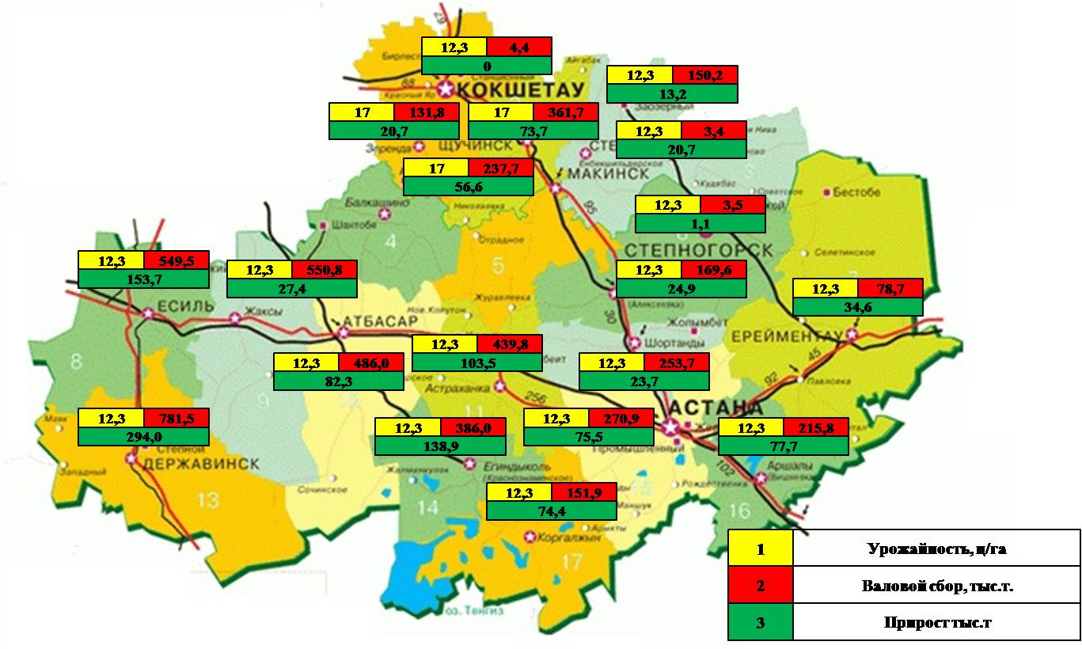
Yield capacity, k/ha
Gross yield, thousand t
Growth, thousand t

APPENDIX 70

Forecast of production of cereals and legumes in the context of districts of Kostanay region
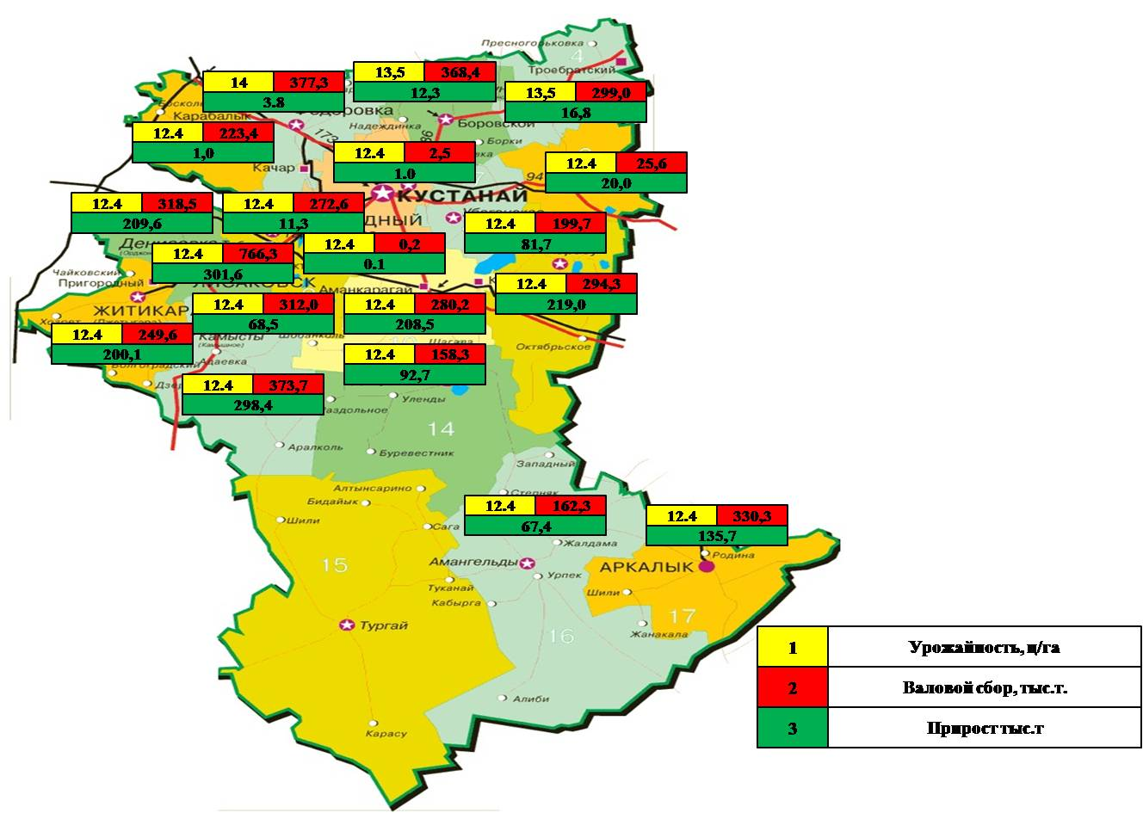
Yield capacity, k/ha
Gross yield, thousand t
Growth, thousand t

APPENDIX 71

Forecast of production of cereals and legumes in the context of districts of North Kazakhstan region

Yield capacity, k/ha
Gross yield, thousand t
Growth, thousand t

APPENDIX 72

List of employees participating in the implementation of R&D
(attach copies of their diplomas to the degree of doctors and candidates, PhDs and masters of science)

Full name | Title | Degree | Specialty
Akimbekova G.U. | Project Scientific Adviser: | Ph.D., Professor | Planning engineer
Baimukhanov A.B. | Senior Research Associate | CES | Agricultural scientist
Kaskabaev U.R. | Senior Research Associate | Master | Economist

APPENDIX CJ

List of articles in domestic scientific publications, according to the table: (attach a review of the article)

Name of the article | Name of the volume | Authors of the article
2018 y.
Agricultural cooperation in the Republic of Kazakhstan: problems and solutions (Russian) | Agricultural Market Problems. - 2018. - No. 1. - p. 7-15. KazBZ - 0,710 | Akimbekova G.U.  G.A. Kaliev
Features of the organization of agricultural cooperatives in the Republic of Kazakhstan and Zhambyl region (Kazakh) | Agricultural Market Problems. - 2018. - No. 2. - P.185-194. KazBZ - 0,710 | Akimbekova G.U.  G.K. Yegizbaeva,  Kaskabaev U.R.
Production and processing of meat and milk in the Republic of Kazakhstan (Russian) | Agricultural Market Problems. - 2018. - No. 3. - P.164-173. KazBZ - 0,710 | Akimbekova G.U.  Baimukhanov A.B.  Kydyrbaeva E.O.,  Kaskabaev U.R.
The current state and development potential of the storage and processing of fruit and vegetable products in the Republic of Kazakhstan (Russian) | Agricultural Market Problems. - 2018. - No. 4. P. 125 – 133 KazBZ - 0,710 | Akimbekova G.U. Saparov A.S., A.B. Baimukhanov, Kaskabaev U.R
2019 y.
Resource potential and development prospects оf processing enterprises of aic in almaty region (Russian) | Agricultural market problems, No. 1, 2019 KazBZ - 0,710 | Akimbekova G.U., Saparov A.S., Chen Shi, Jilili Abuduvayli
The role of agricultural cooperation in solving problems in the agricultural sector of Kazakhstan (Russian) | Mat. int. scientific and practical. conference on Science, economics and social modernization of society: reality and prospects, State Enterprise Institute of Economics of the KN MES RK, 18 oct. Dec 2019 | Kaliev G.A.  Akimbekova G.U.
2020 y.
Modern "Herd management" system on the example of model dairy farms (English) | Agricultural Market Problems, No. 3 -2020, P.156-163 KazBZ - 0,710 | A.B. Baimukhanov G.Y. Guseva
The effectiveness of the application of innovative technologies: the experience of farms in the Almaty region of the Republic of Kazakhstan (Russian) | Agricultural Market Problems, No. 3 -2020, P.13-20 KazBZ - 0,710 | Akimbekova G.U.,  Kaskabaev U.R.

to continue Appendix CJ

List of articles in foreign publications (attach reprints of articles).
Name of the article | Name of the volume | Authors of the article
2018 y.
On new approaches of state support of agricultural cooperatives in the Republic of Kazakhstan (Russian) | Scientific and theoretical journal Fundamental and Applied Research of the Cooperative Sector of the Economy - 2018. - No. 1. - p. 35-42. RINZ- 0,443 | Akimbekova G.U.  Baimukhanov A.B.  Kaskabaev U.R.
The years of life and work of A.V. Chayanov in Kazakhstan, contribution to the economic thought in Kazakhstan (Russian) | Reports of the scientific and practical conference "Scientific heritage of A. V. Chayanov and the present", VIAPI named after Nikonova A.A., March 2018, Moscow. | Kaliev G.A.
Development trends of cooperation of agricultural producers in the Republic of Kazakhstan (Russian) | Reports of the XII int. scientific and practical conference on  Current problems of the agro-industrial complex, Minsk, October 11-12, 2018, RNUP Institute for System Research in Agro-industrial Complex NASB, pp.15-19 | Akimbekova G.U.  Kaskabaev U.R.  Ayulov A.M.
Formation of an efficient system of production, processing and marketing of agricultural products in the Republic of Kazakhstan (Russian) | Reports of the XII int. scientific-practical conference on Actual problems of the agro-industrial complex, Minsk, October 11-12, 2018, RNUP Institute for System Research in Agroindustrial Complex NASB, pp. 121-124 | Akimbekova G.U.  Baimukhanov A.B  Kantureev M.T.
Advantages of formation and perspective models of agricultural cooperatives in the Republic of Kazakhstan (English) | Espacios (Revista) Vol. 39,  (Number 18) Yean 2018, 12 р, Page 6 revistaespacios.com Scopus-19 | Akimbekova G.U.  E. Horska  G. Yegizbayeva
2019 y.
Conceptual approaches to solving problems of agricultural  cooperation in the Republic of Kazakhstan (Russian) | Scientific and theoretical journal Fundamental and Applied Research of the Cooperative Sector of the Economy - 2019. - No. 1. January-February, pp. 56-63 | Akimbekova G.U., Kantureev M.T., Saparov A., Baimukhanov A. B.
Development of a logistics system for the promotion of agricultural products in the Republic of Kazakhstan (English) | All-Russian scientific and practical conference with international participation on Selection and genetic aspects of the development of cattle breeding, Makhachkala, July 4-5, 2019, Federal State Budgetary Scientific Institution "Federal Agrarian Scientific Center of the Republic of Dagestan" | Baimukhanov A.B.  Kaskabaev U.R.  Eleubaev A.E.
Problems and prospects of revitalization of rural areas in the Republic of Kazakhstan (Russian) | Reports of the fourth annual int. conferences on agricultural development, food security and nutrition in Eurasia. Eurasian Center for Food Security, Moscow State University, International Food Policy Research Institute 3 (IFPRI), Faculty of Economics, Moscow State University of M.V. Lomonosov, World Bank, May 28, 2019, Moscow, Russia | Akimbekova G.U. Akimbekova Sh.U.
Role of cooperatives and clusters in the development of value chains in the agro-industrial complex of Kazakhstan (Russian) | Reports of the fourth annual int. conferences on agricultural development, food security and nutrition in Eurasia. Eurasian Center for Food Security, Moscow State University, International Food Policy Research Institute 3 (IFPRI), Faculty of Economics, Moscow State University of M.V. World Bank, National Agrarian University of Armenia, 29-31 Oct. 2019, Yerevan | Akimbekova G.U.
Problems and Prospects of the Kazakhstan Rural Area in the Conditions of Rural Development (Russian) | Scientific and technical reports Nikon Readings - 2019 Conferences | Akimbekova G.U. Akimbekova Sh.U.
Integration of rural and urban economies and regulation of urbanization processes in Kazakhstan (Russian) | Scientific Review: Theory and Practice, Volume 9, Issue 7, 2019, pp. 1108-1117 RINZ -0,484 | Akimbekova G.U. Akimbekova Sh.U., Dosumova Zh.S., Yurkova M.S.
Organizational-economic directions of the effective use of supply chain strategy in rural territories of Kazakhstan (English) | Vol 8, No 2 (2019)  International Journal of Supply Chain Management (IJSCM), 868-873 стр. Scopus-11 | Kaliev G.A., Sabirova A.I., Akimbekova G.U., Glushan L.A., Zhildikbaeva A.N.
Development of cooperation in the production of organic agricultural products in the Republic of Kazakhstan (English) | Reports on the Conference on Green Development and Win-Win Cooperation along the Silk Road - Kazakhstan Science Center of Northwestern University of Agriculture and Forestry, May 11-14, 2019, Yanglin, Shanxi Province, China.  The International conference on Green Development and Win-Win Cooperation along the Silk Road – Kazakhstan Research Center of Northwest A&F University and The Silkroad Agricultural Education and Research Innovation Aliance, 11-14 may 2019 Yangling Shaanxi Province China | Akimbekova Sh.U., Klimov E.V.
2020 y.
Results of implementation of the Law of the Republic of Kazakhstan On Agricultural Cooperatives (Russian) | Scientific and technical reports Legal problems of agricultural entrepreneurship in the context of modern land reform in the Republic of Kazakhstan: experience, innovations and prospects, October 16, 2020, Zhetysu University named after I. Zhansugurova MES RK. Taldykorgan 2020. | Akimbekova G.U.
Organizational and economic problems of the development of agricultural cooperation and ways to solve them in the Republic of Kazakhstan (Russian) | Reports of the XIII int. conference Ensuring the quality of agricultural products in the context of regional and international integration, 15-16 October 2020, Institute of System Research in the Agro-industrial Complex of the National Academy of Sciences of Belarus, Minsk, 2020. | Akimbekova G.U.
The effectiveness of the application of innovative technologies: the experience of dairy farms in the Republic of Kazakhstan (Russian) | Scientific Review: Theory and Practice  Volume 10 Issue 8, 2020 RINZ -0,484 | Akimbekova G. U., Baimukhanov A. B., Kaskabaev U. R., Serdobintsev D.V.

