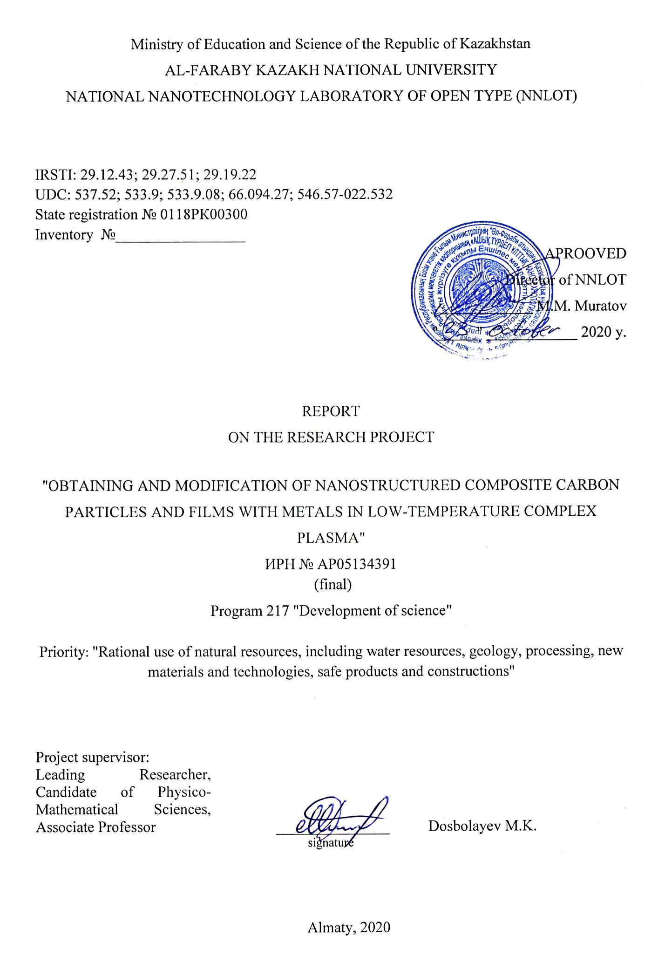

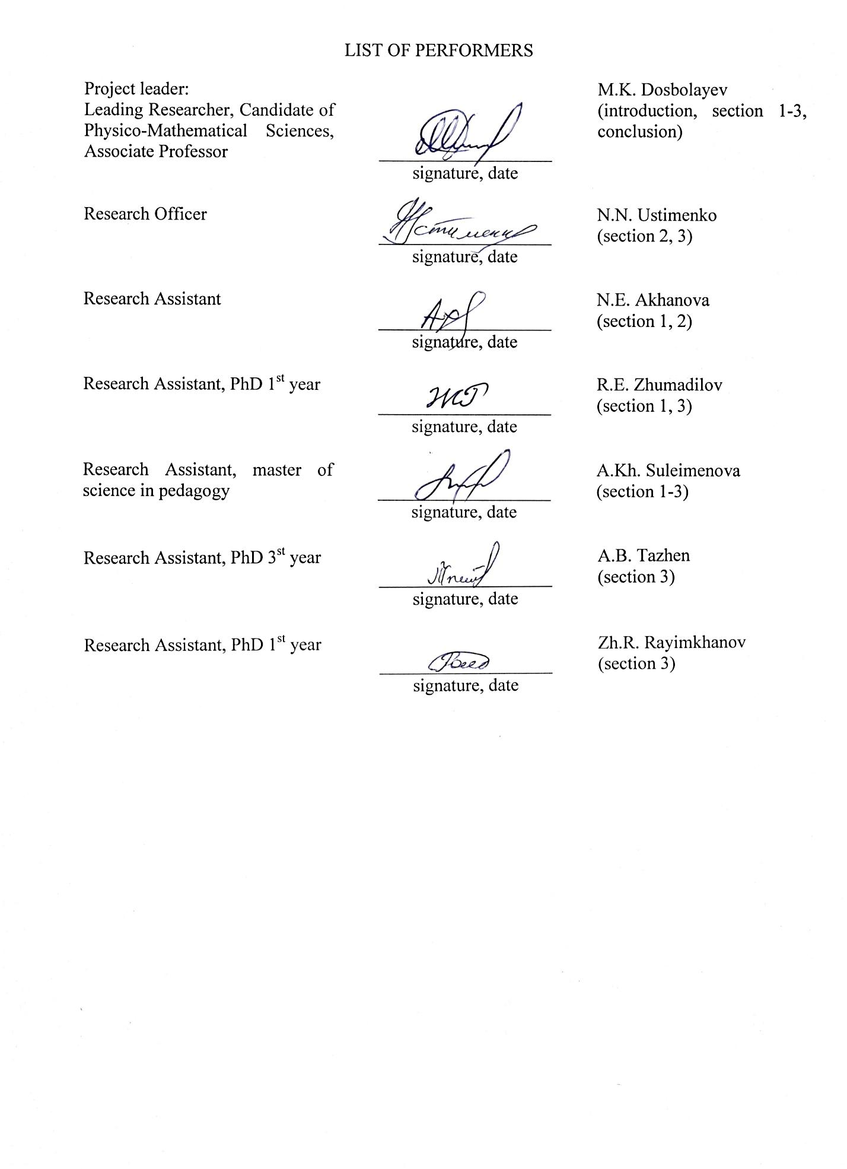

ABSTRACT

The report contains 69 pages, 48 figures, 48 sources of used literature.
Key words: COMPLEX PLASMA, NANOSTRUCTURED COMPOSITE PARTICLES AND FILMS.
The object of investigation is nanostructured composite particles and films with required physical and chemical properties.
The goal of this project is to design and develop scientific and technical foundations for obtaining new nanostructured composite particles and films with required properties.
Research methods and techniques, theoretical tools: spectral and probe plasma diagnostics, microanalysis of metal-carbon nanocomposites based on electron, tunnel and atomic salt microscopy. X-ray structure analysis and Raman spectroscopy of obtained samples.
Brief description of the result: the modification and assembly of a magnetron spraying unit "NanoChip" was performed to produce nanostructured composite particles and carbon films with metals in complex plasma. Probe and spectral diagnostics were performed to determine optimal modes of plasma combustion at growth of composite particles and films. Composite nanoparticles with an average size of 80 nm, consisting of copper and carbon, obtained by magnetron sputtering in plasma mixtures of methane-argon gases, were synthesized. The results of experiments with double magnetron electrode showed that in this way nanostructured composite films with thickness of 40-60 nm can be obtained. The samples were analyzed by electron and optical microscopy, Raman spectroscopy. Electrical properties of the obtained samples were investigated by volt-ampere characteristics. The data obtained from a nanodortometer indicate a comparatively high plasticity of the films when tested for indentation. Plasticity increases with increasing Cu content in the films.
Project novelty: synthesis and properties of nanostructured composite particles and films of metal with carbon with required physical and chemical properties in complex plasma environment were studied.
Scope of application: nanotechnology and nanomaterials, biomedicine, energy, electronics, optical devices, creation of new construction materials and various sensors.

Describe the bases of approbation and implementation of the obtained results: According to the results of scientific research, 16 works were published, 4 of them in the journals of RK recommended by CCES and 3 in the international journal with the impact factor of Scopus base. 1 patent application of the Republic of Kazakhstan, No. 2020/0968.2 is filed.

CONTENT

INTRODUCTION..……………………………………………………………………………... |  | 6
1 | Calculation, adjustment of separate assemblies and blocks, modification and assembly of experimental unit for obtaining nanostructured composite particles and carbon films with metals in complex low-temperature plasma. Determination of optimal operation modes of the experimental unit…………………………………………………………………… | 8
1.1 | Calculation and adjustment of separate units and blocks of the experimental installation. Results of work to determine technical and operational indicators of the installation……. | 8
1.2 | Optimization of operation modes of experimental unit for obtaining and modification of nanostructured composite particles and carbon films with metals in complex low-temperature plasma………………………………………………………………………... | 9
1.3 | Production of prototypes of nanostructured composite (sandwich) carbon films with metals……………………………………………………………………………………… | 11
1.4 | Production of prototypes of nanostructured metal particles with carbon coatings………... | 17
2 | Study of electrical and optical characteristics of combined discharge plasma and obtaining laboratory samples of nanostructured composite particles and films with required physical and mechanical properties……………………………………………… | 23
2.1 | Contact diagnostics of complex low-temperature plasma at NanoChip installation at growth of composite particles and films………………………………………………….. | 23
2.2 | Investigation of optical and spectral characteristics of complex plasma at Nano-Chip installation at growth of composite particles and films…………………………………… | 26
2.3 | Obtaining laboratory samples of nanostructured composite particles and films with required physical and mechanical properties……………………………………………… | 29
3 | Synergetic analysis and investigation of mechanical properties of obtained samples of nanostructured composite particles and films of carbon with metals……………………... | 35
3.1 | Analysis of obtained samples of nanostructured composite particles and films based on optical (profilometer), electronic, tunneling and atomic force microscopy………………. | 35
3.2 | Investigation of mechanical (elasticity and microhardness) and electrical (I-V characteristics) characteristics of obtained samples of nanostructured composite carbon films with metals………………………………………………………………………….. | 41
3.3 | X-ray structure analysis and Raman spectroscopy of metal-carbon nanocomposite film samples……………………………………………………………………………………. | 43
CONCLUSION…………………………………………………………………………………. |  | 45
LIST OF SOURCES USED…………………………………………………………………….. |  | 47
APPENDIX A. Principle scheme of a modernized experimental setup for complex discharge plasma ignition..………………………………………………………………………………… |  | 51
APPENDIX B. Principle scheme of a magnetron sputtering setup with an aggregation chamber…….…………………………………………………………………………………… |  | 52
APPENDIX C. Principle scheme of an experimental setup with a double single-wire cathode,  manufactured to produce nanocomposite carbon-metal films…..……………………………… |  | 53
APPENDIX D. Principle scheme of an experimental setup with a double two-contact cathode manufactured to produce nanocomposite carbon-metal films (sandwich)……………………… |  | 54
APPENDIX E. Principle scheme of an experimental setup NanoChip………………………… |  | 55
APPENDIX F. Principle scheme of an experimental setup manufactured to produce nanocomposite carbon-metal films …………………..…………….…………………………… |  | 56
APPENDIX G. Calendar Work Plan for 2018-2020 (in English)….…………………………… |  | 57
APPENDIX H. Calendar Work Plan for 2018-2020 (original version)………………………… |  | 63
APPENDIX J. List of published works for 2018-2020….……………………………………… |  | 68

INTRODUCTION

Nanotechnology, scientific revolution of the XXI century. It was rapidly developing due to developments and scientific research around the world. Nanomaterials are divided into three categories depending on their origin: natural, random and engineering. Today, one of the main directions in the modern development of surface engineering is the creation of nanocomposite structures. Nanocomposites represent a new generation of new materials that are formed by mixing one or more heterogeneous materials on a nanoscale to control and develop new and improved structures and properties. A special place in this row is occupied by metal-carbon composite materials, the complex of properties of which is determined not only by the specific electronic structure of the polyp adjugated system, but also by the nature of the metal. The study of peculiarities of formation of such materials, structural characteristics and functional properties of metal-carbon nanocomposites depending on the conditions of their production is an important task, the solution of which opens the possibility of controlling the structure of nanocomposites and, consequently, their properties [1-9]. Even though the science of "nanotechnology" is at the intersection of various disciplines such as physics, chemistry, biology. Physics of plasma occupies a special place in this list. This is due to the fact that many processes that are the basis for producing nanomaterials and nano-objects are inseparable from gas-discharge physics and plasma physics. Plasma methods for obtaining thin films, deposition on substrates of required materials and plasma chemical synthesis of nanostructured materials (nanofilms and nanoparticles) are developed along with nanotechnology, stimulating their further development. The possibilities of plasma technologies in the field of materials science and obtaining nanomaterials with new properties are very promising and require further research and new developments. Therefore, improvement of plasma technologies and creation of physical bases requires new.
This work is devoted to studying and obtaining nanostructured composite particles and carbon films with metals in complex low-temperature plasma.
This report consists of three chapters: the first chapter contains the results of the work carried out on the first annual stage of the project. According to the schedule, the calculation and adjustment of individual units and blocks of the experimental setup were carried out, and the magnetron sputter was modified to obtain nanostructured composite particles and films of carbon with metals in a complex low-temperature plasma.
In the second part, the results of the study of the electrical and optical characteristics of the combined discharge plasma are presented, as well as laboratory samples of nanostructured composite particles and films with the required physical and mechanical properties were obtained in the magnetron discharge plasma.
In the third chapter, works were carried out on synergetic analysis and study of the mechanical properties of the obtained samples of nanostructured composite particles and films of carbon with metals.
Inventory number of the report for 2018, 0218RK00865 and for 2019, 0219RK01245.

1 Calculation, adjustment of separate assemblies and blocks, modification and assembly of experimental unit for obtaining nanostructured composite particles and carbon films with metals in complex low-temperature plasma. Determination of optimal operation modes of the experimental unit

1.1 Calculation and adjustment of separate units and blocks of the experimental installation. Results of work to determine technical and operational indicators of the installation
In many experimental works for obtaining composite particles and films in gas discharges special technological solutions are used, including combined discharges.
Combined RF and magnetron discharge to produce composite particles. In the performed works for obtaining composite particles we have modernized gas discharge system. The unit consists of a magnetron (1), two plane-parallel electrodes (2 and 8), one of which (2) is connected to a RF generator (4), as well as a vacuum system (6) to obtain high vacuum in the chamber and a gas injection system (6), an ultrasonic membrane (5), which is used for injection of dust particles into a high-frequency plasma volume. (Appendix A).
As is known, plasma is a system consisting of electrons, ions and neutral atoms of plasma-forming gas. After the penetration of dust particles in the plasma volume, due to the high mobility of electrons, the particles are negatively charged due to the capture of electrons on the surface. After charging, the dust particles will be affected by two main forces - electrostatic and gravitational. When these forces are balanced, the dust particles are levitated to form a dust structure (7). It should be noted that glass particles were used in experiments. After dust formation, a magnetron sputtering is activated. Aluminum and copper plate were used in our experiments as an electrode, sputtered material. When the electrodes are sputtered with a magnetron, clouds of atoms of the material being sputtered are formed aimed at dust formation. After penetrating the plasma region, these particles are deposited on the surface of the plasma-dust formation dust particles, resulting in composite particles with nanostructured surfaces. The results of the analysis of the obtained composite particle samples are presented in detail in chapter 1.4.
Modernization of a magnetron sputtering. Previously presented modernized experimental unit is designed to produce composite particles, which uses samples of particles with previously known characteristics (shape, material, size).
It is known that the magnetron sputtering, without any technical specifications, is only designed to produce thin films on the surface of the target or specimen. The main mechanism of film formation on the surface is based on the deposition of atoms (molecules) of the sputtered material. If a cooling system (aggregation zone) is applied on the way of atoms directed to the substrate surface, then nanoparticles are formed in the volume due to condensation of molecules with subsequent formation of nanoclusters and nanoparticles.
To obtain nanoparticles, we have upgraded the magnetron sputtering, the design of which includes a cooling system for the medium (Appendix B).
The experimental unit consists of a magnetron (1) with a gas leak into the chamber volume (3) and its own cooling system (5), an aggregation chamber (7) with a cooling system (8), where the process of condensation of atoms (molecules) of sputtered material takes place. To obtain a large number of directed nanoparticles at the magnetron output and to prevent their radial removal, the aggregation chamber has a cone-shaped shape with a nozzle (9). After leaving the aggregation chamber, the nanoparticles will be directed towards the silicon substrate disc (11), where a screen (10) with a hole in its path will be located to obtain an even distribution of deposition on the target surface. The results of the analysis of the obtained samples of nanoparticles are presented in detail in Chapter 1.4.
1.2 Optimization of operation modes of experimental unit for obtaining and modification of nanostructured composite particles and carbon films with metals in complex low-temperature plasma
Optimization of operation modes of experimental unit for obtaining nanostructured composite carbon particles with metals. It can be concluded from the previous chapter that an upgraded experimental unit based on a combination of two discharges, a high-frequency and a magnetron, can be used to produce micron-sized composite particles (Chapter 1.3). But for creation of composite nanoparticles of carbon with metals, according to the set goal, we have optimized the work of this experimental unit using mixtures of argon and methane (10%) as plasma-forming working gas. It is known that in plasma formed as a result of discharge ignition of a mixture of inert and reactive leads to the growth of nanoparticles in this medium. In our case, we used methane (CH4) gas as a reactive gas. The use of reactive gas is due to the fact that as a result of experiments, carbon nanoparticles are synthesized, which corresponds to our goal. Subsequent connection of a magnetron sputtering leads to nanostructured composite carbon particles with metals that are sputtered from the material of the magnetron electrode (copper, aluminum, etc.).
Figure 1 shows the operating mode of this experimental unit, where the directional observed line corresponds to laser light reflected from synthesized nanoparticles.
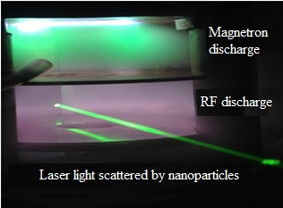
Figure 1 - Operating mode of the complex plasma system
in the mixture of methane and argon gases

It should be noted that the use of a laser beam is one of the main methods for visual observation of nanoparticle growth in plasma environments.
Detailed descriptions of the results obtained for the synthesis of nanocomposite carbon particles with metals are presented in Chapter 1.4.
Optimization of operation modes of the experimental unit for obtaining nanostructured composite carbon films with metals. As it was noted above, to obtain composite nanoparticles with the help of magnetron sputtering, the system must have a cooling chamber, where the process of condensation of the atoms of the atom of the material being sputtered takes place with the subsequent generation of nanoparticles. However, if there is no such chamber, the electrode material atoms directed to the substrate form a nanofilm on the deposition surface. As a result, by controlling the external characteristics at the output, it is possible to obtain composite nanofilms with the required properties.
The basic scheme of the experimental installation for obtaining nanostructured composite carbon films with metals is presented in Appendix B. The main part of the experimental unit consists of a magnetron (1) with a gas injection tube (3) and its own cooling system (5), where the magnetron electrode system consists of copper plates (7) with carbon rods (8), the locations of which are shown in Figure 2. The experimental unit also includes a screen, a substrate and a stepper motor with a drum cassette to replace the substrate being processed.
As it is visible from Figure 2, carbon rods have a hollow cylindrical configuration and have a projection above the surface of the copper electrode ~ 0.5 mm. Such manufacturing of carbon rods has been thought over to increase intensity of a stream of an electric field directed on carbon rods and by that to increase an output of carbon atoms (molecules) in the course of sputtering. The results of the analysis of the obtained nanofilm samples are presented in detail in chapter 1.3.
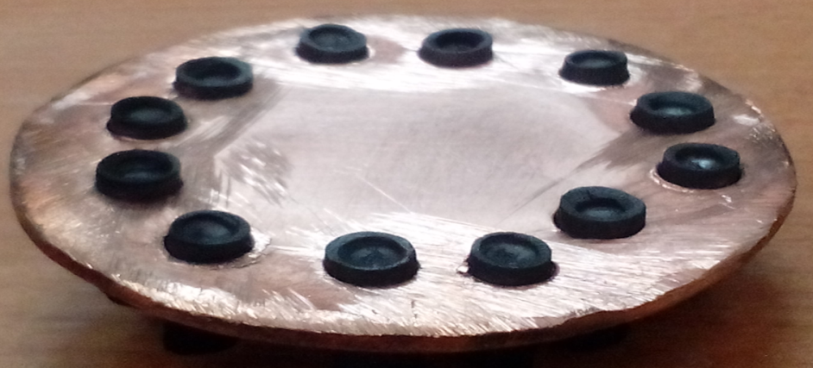 | 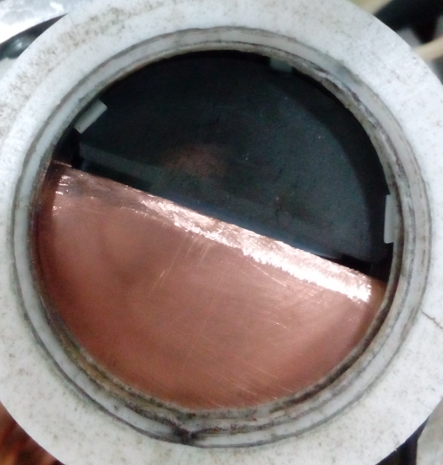
Figure 2 - Position of graphite rods on the surface of copper cathode of magnetron | Figure 3 - Photo image of a double cathode of magnetron made of copper and graphite

Appendix D presents another method of producing a magnetron configuration for producing nanocomposite carbon films with metals. The location of the magnetron electrodes in this unit is shown in Figure 3. Half of the electrode is made of copper, and the other half is made of graphite and each plate has a separate electrical contact, which allows the plates to use separately, at different points in time switching the electrical supply. The peculiarity, at the same time, the advantage of this configuration is the economic factor, when two separate magnetrons with different electrode materials are used to produce similar nanostructured composite films. In addition, you can see that the close to each other areas of the plates are ground, which leads to a decrease in the degree of contamination of the plates. As well as to prevent intense spraying of the plate edges. The results of the analysis of the obtained nanofilm samples are presented in detail in chapter 1.3.
1.3 Production of prototypes of nanostructured composite (sandwich) carbon films with metals
Production of composite nanostructured carbon-copper (sandwich) composite films by magnetron sputtering. At the installation, which is shown in Appendix B, the formation of nanostructured composite film of carbon with copper runs a slightly different way. However, as mentioned above, the configuration of the parts of the experimental installation is similar to that shown in Annex D. That is, to produce nanostructured composite films of carbon with metals, the magnetron works in the power switching to double electrodes. In the first act of the experiment, power is switched on supplied to the copper electrode, resulting in a flow of copper atoms directed to the substrate in the discharge interval. In a certain time the power supply is switched off and with a pause of 5 minutes the power supply to the carbon electrode is switched on. In this case, carbon atoms will precipitate on the film surface. Thus, we obtain a nanostructured composite carbon film with copper.
The obtained samples of nanostructured compositions of carbon monoxide films with copper were analyzed using atomic force microscope (Figures 4-5). As a result of the experiments it was found that the thickness of nanocomposite film increases with the discharge current.
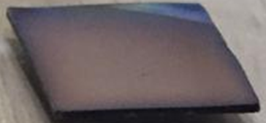  a) | b)
a) photo image of the substrate; b) film thickness profile
Figure 4 - Parameters p=1.2 Torr, t= 20 min, I=0.2 A, U=250 V, h=40 nm

  а) | b)
a) photo image of the substrate; b) film thickness profile
Figure 5 - Parameters p=1.2 Torr, t= 20 min, I=0.35 A, U=260 V, h=60 nm

Analysis was also carried out by means of Raman spectroscopy of nanocomposite films of carbon with copper. In the Raman spectra, it was found that the obtained films have a carbon layer. It was also noticed that with increasing current values in the film the amount of carbon component increases (Figure 6).
а) | b)
a) Raman spectrum of the sample obtained at p=1.2 Torr, t=20 min, I=0.3 A, U=249 V
b) Raman spectrum of the sample obtained at p=1.2 Torr, t=20 min, I=0.35 A, U=260 V
Figure 6 - Raman spectra of samples obtained under different experimental conditions
Below are presented the results of experimental works on investigation of different modes of obtaining composite dust particles with nanostructured surface layers, nanoparticles and nanofilms in complex plasma of gas discharge using the method of magnetron sputtering in direct current, as well as certain effective parameters of the experiment. A high-frequency capacitive gas discharge was used to produce the complex plasma. Such complex plasma is an open system [10, 11]. As noted above, the dust structure (crystal) in plasma is formed by the introduction of poly disperse spherical glass macro particles from outside using an ultrasonic membrane. The aluminum nano layer on the surfaces of the macro particles was precipitated by magnetron sputtering. Carbon nanoparticles in the volume of gas discharge are synthesized as a result of plasma chemical process running in the discharge mixture of argon and methane gases (10 %). The formation of carbon nanoparticles (growth) consists of several stages; the first stage is the formation of a single crystal from carbon nanoclusters with dimensions of 2-3 nm. The range of time spent on this process is determined experimentally. During the formation of carbon monocrystals, a stream of sputtered copper micro-particles from the material of the magnetron electrode is directed to them. As a result, we obtain composite nanoparticles consisting of carbon and copper.
Today, obtaining composite nanoparticles and films and their applications is a new stage in the development of technological progress of mankind. Composite nanoparticles and films are created when obtaining coatings in certain surfaces of materials, including particles. Such conditions lead to the appearance of exceptional properties of particles or films, resulting in changes in their catalytic properties, surface abrasivity, erosion resistance, shielding of the electromagnetic field, etc. [12-18]. Structural features of films, specific conductivity, surface quality, retention of substance properties - all these are very important aspects for the quality and application of the sample under study. One of the methods for obtaining dispersed nanocomposite particles is the complex plasma method. The principle of this method is based on the sputtering of plasma-dust macroparticles with the help of a magnetron, which results in dispersed composite particles of nano- and micro-sized, covered with metal ions. The peculiarity of this method is that the synthesized nano- and micro-particles do not have direct contact with the medium under study, resulting in a clean and homogeneous material. In case of films production, reactive sputtering (sputtering) in DC magnetron discharge is the most effective method. The peculiarity of the latter is a wide range of spraying.
To produce composite thin films and particles, an experimental unit was used on the basis of combined high-frequency capacitive (HF) and magnetron discharges (Appendix A).
RFC discharge is a system for creating dusty plasma structures. The system itself, where RF plasma is formed, consists of two electrodes with diameters of 10 cm located in parallel at a distance of 3 cm [19]. The lower electrode is connected to the RF (13.56 MHz) generator, the upper mesh electrode is grounded. The last electrode is used as a screen and is located between RF and magnetron plasma. Argon gas and a mixture of argon and methane were used as plasma gas. The pressure in the chamber varied from 0.1 to 0.4 Torr.
The magnetron spraying system is positioned perpendicular to the high-frequency discharge system. The magnetron cathode material is the source of metallic coating, copper electrode was used in the experiments, but any other metal can be used. During spraying, the resulting flow of atoms (molecules) due to its own initial thermal motion penetrates the RF plasma medium passing through the grounded electrode. In this area, plasma is an area of agglomeration.
This work consists of 2 stages: obtaining composite nanoparticles (nanoclusters) and nanofilms in plasma medium.
Production of composite nanoparticles (carbon-copper) in complex plasma by magnetron sputtering. For the synthesis of carbon nanoparticles, a plasma of a mixture of argon and methane (10%) is ignited in the RF discharge [20, 21]. After the electric discharge is ignited, methane molecules decompose into neutral radicals, i.e. into anions and cations of carbon hydride. The participation of argon in the discharge leads to an increase in the process of formation of neutral atoms, this phenomenon is due to the high rate of dissociation of methane as a result of collision of Ar* and Ar-. Thus, the number of neutral radicals becomes greater than the number of anions and cations. Neutral radicals, due to their high reactive properties, will participate in the polymerization reaction forming neutral clusters (С_{n}H_{x}) of 0.5 nm size. The growth of clusters continues until they reach 2-3 nm, i.e. until the development of single crystals of carbon nanoclusters. Nanoparticle growth consists of the following stages: polymerization, saturation, coagulation and the phase of surface nanoparticle growth.
The flow of copper atoms is obtained by magnetron sputtering and is activated during the coagulation phase of carbon particle growth. The moment of coagulation process is determined by experimental method. It depends on the parameters of high-frequency gas discharge. In our case it was 40-50 seconds from the moment of discharge ignition. The photo of the operating mode of the main part of the experimental unit, where these processes take place, was shown in Fig. 1. Composite nanoparticles in the process of their growth can be observed through a laser beam passed through the plasma dust formation.
After experimental work with a special mechanism, the samples were collected for analysis with a scanning electron microscope, where the results showed that the average size of nanoparticles is ~ 90 nm (Figure 7).
Figure 7 - SEM image of composite nanoparticles of copper-carbon

Production of nanostructured particles in complex plasma coated with aluminum using magnetron sputtering. Photos of dust structures formed in RF discharge and chemical composition of the dust are shown in Figures 8a and 8b.
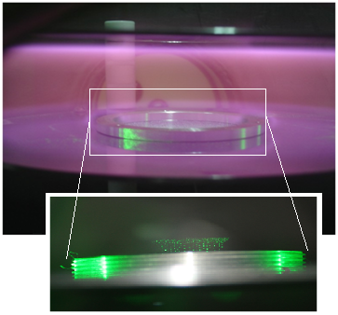 а) | 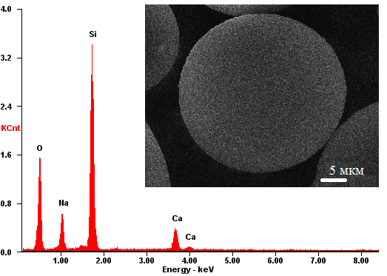 b)
a) dust structures formed in RF gas discharge
b) composition of glass macro-particles (35.97 SiO₂; 6.78 CaO; 46.64 O; 10.62 Na₂O)
used as a test sample
Figure 8 - Photo image of the dust structure and EMS of the sample

The flow of aluminum atoms (molecules) obtained by magnetron sputtering is directed towards dust formation. At the moment of penetration into the plasma (in the plasma aggregation region), some aluminum atoms settle on the surface of dust particles, while others are coagulated with each other and create nanoclusters. After the growth of nanoparticles, large dust particles will start to attract, which leads to adhesion on the surface (22-25). Thus, the composite nanostructured dust particles with aluminum surfaces were analyzed using a scanning electron microscope and energy dispersion X-ray spectroscopy, one of the samples is shown in Figure 9.
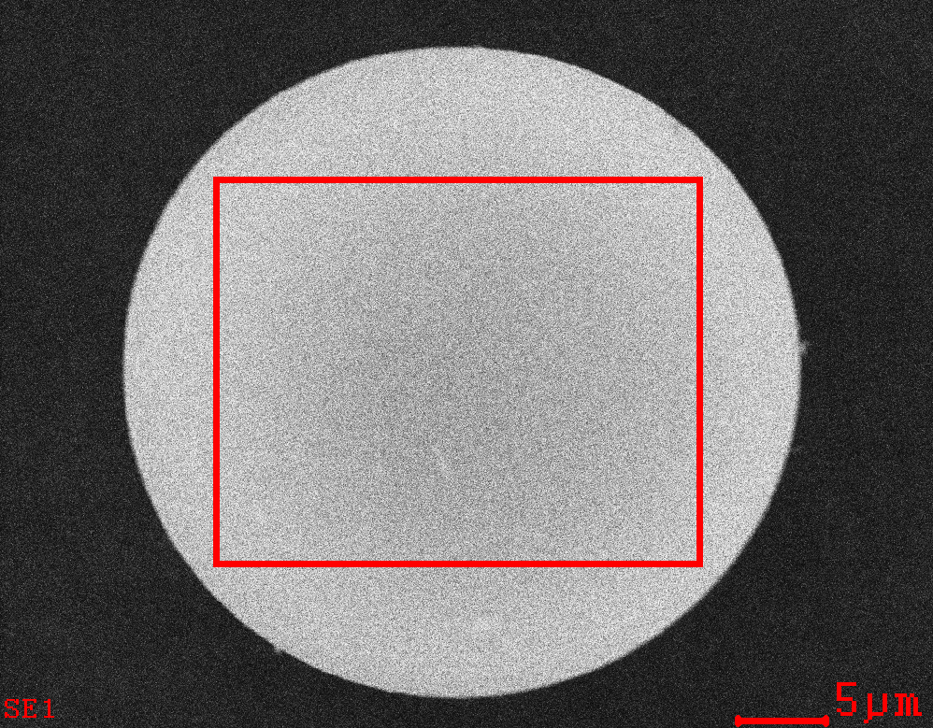 а) | 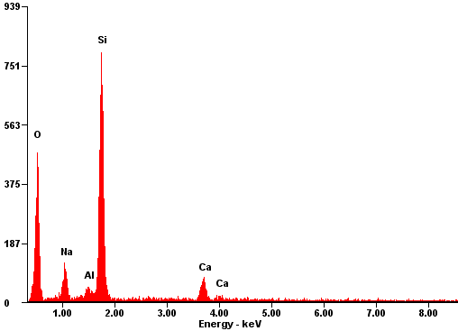 b)
a) composite dust particle, obtained at p=0.09 Torr, W=2 Watt
b) chemical composition of the composite dust particle, the proportion of aluminum is 1.98%
Figure 9 - SEM of composite dust particle and its chemical composition

Analysis of the results of experimental work shows that on the surface of sputtered microparticles there is an aluminum layer. In addition, it was found that the increase in gas pressure in the vacuum chamber leads to a decrease in the percentage of aluminum on the surface. This phenomenon can be explained by the fact that with increasing pressure the mechanism of formation of the layer is transformed, that is, the length of the thermalization of the flow of aluminum atoms becomes much smaller than the geometric parameters of the reactor. As the flow of atoms of sputtered material from the target to a dust cloud moves, they are thermalized due to collision with plasma gas atoms and lose speed, resulting in a reduced thickness of the nanofilm layer on the surface. In addition, the adhesion to the surface decreases. Production of nanostructured composite copper surface in complex plasma by using magnetron sputtering. The production of nanostructured copper films on the surface is carried out using the magnetron sputtering method. The work is carried out in the following way. Pre-cleaned silicon substrate is placed near the lower electrode in the RF discharge plasma. In this case, the same plasma parameters will act on the substrate as in the case of plasma dust formations, including shielded by Debye radius with inverse potential. In addition, due to poor contact with solid material, there will be less heat transfer between the substrate and the environment. The flow of copper atoms and nanoparticles formed by the adhesion of moving from the magnetron to the substrate will be affected by thermal and field forces. In other words, they are separated by a plasma field [26] and the thermal action reduces their speed. Thus, several experiments have been carried out. During the experiments, the variable parameter was sputterization time, 10, 20 and 35 minutes. One of the obtained samples is shown in Figure 10.

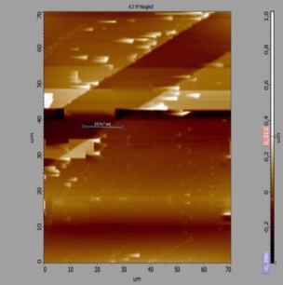а) | 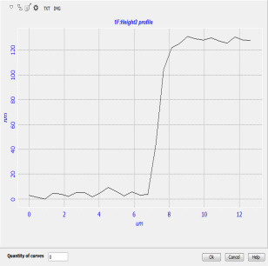b)
a) nanostructured copper layer obtained at U=355 V, I=0.58 A, p=0.11 Torr, t=10 min;
b) profile by thickness, 130 nm
Figure 10 - Nanostructured copper layer and its thickness profile

As shown by the results of experiments, the layer thickness at 10 minute discharge was 130 nm, at 20 minutes - 150 nm, at 35 minutes - 185 nm. Accordingly, the thickness increase rate was 13 nm/min, 7.5 nm/min and 5.3 nm/min.
Based on the experimental results, we can say that the structure of copper nanofilms depends on the condensation process and discharge parameters. With increasing spraying time, the temperature of the substrate surface increases due to the effect of adsorbing atoms, which leads to the escape of the sprayed copper atoms due to the thermal effect. Thus, the increase in nanofilm thickness over time slows down. In addition, the experimental results show that the surface of nanostructures is homogeneous. Homogeneity is the result of plasma separation of the nano cluster flow moving from the magnetron to the substrate.
1.4 Production of prototypes of nanostructured metal particles with carbon coatings
This chapter of the interim report presents the results of the study of dependence of nanoparticles growth obtained by magnetron copper sputtering on gas discharge parameters. As a result of experimental work, it was found that the synthesis of copper nanoparticles by this method is influenced by various parameters, such as the pressure of the working medium gas and current. The obtained samples were investigated by the scanning electron microscopy (SEM) method.
The use of metallic nanoparticles is of great interest due to their unique chemical, physical and catalytic properties [27]. Among other things, copper nanoparticles, which have high electrical and thermal conductivity [28], antibacterial properties [29], etc., are particularly distinguished. The most common method of copper nanoparticles synthesis is magnetron sputtering. The main advantages of this method are: high productivity, wide range of dispersion of the synthesized particles, purity of the chemical composition of the final product, the possibility of obtaining nanoparticles from dielectric material by feeding an alternating voltage into the discharge [30-35].
Features of the experimental installation. The operation of magnetron sputtering is performed at low pressure of the used gas in the volume. In our experiments argon was used as the working gas. The area where the permanent magnet is located and where agglomeration of particles (molecules, nanoclusters) takes place is cooled down by means of a tubular water channel (8), (Appendix B). The principle of operation of the main part of the experimental unit corresponds to that proposed by Haberlen [36, 37].
While performing experimental works, working gas pressure varied from 0.5 to 1.5 Torr, and gas discharge current varied from 0.2 to 0.6 A. Plasma (2) is formed between the copper electrode (cathode) and the edge of the agglomeration region. Burning time of plasma is 10 minutes.
Experimental results. In this paper, copper nanoparticles were synthesized by magnetron sputtering at different DC values. Figure 11 shows the results of SEM analysis and chemical composition of copper nanoparticles.
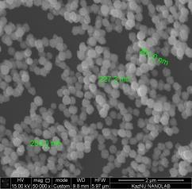 а) | 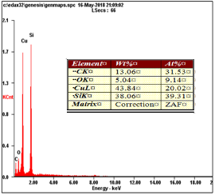 b)
a) EMS of nanoparticle samples; b) Chemical composition
Figure 11 - EMS image and chemical composition of copper nanoparticles prototypes

The dependence of the size of the synthesized nanoparticles on the gas pressure in the volume was determined experimentally. It was found that as the pressure of gas and gas flow changes, the size of nanoparticles and their concentration changes. SEM image and size distribution of the synthesized copper nanoparticles at magnetron current of 0.5 A, gas pressure of 0.6 Torr and 1.2 Torr are shown in Figures 12a and 12b, respectively. Relatively high value of gas pressure in the volume (1.2 Torr) leads to increased frequency of atom collision and subsequent energy loss. This fact is caused by the small number of synthesized particles (Fig. 12) in comparison with the results at low values of gas pressure in the volume. And at gas pressure values of 0.6 torr due to increased mobility of sputtered atoms leads to an increase in the number of copper nanoparticles synthesized.
а) | 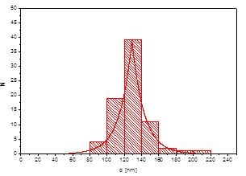 b)
c) | 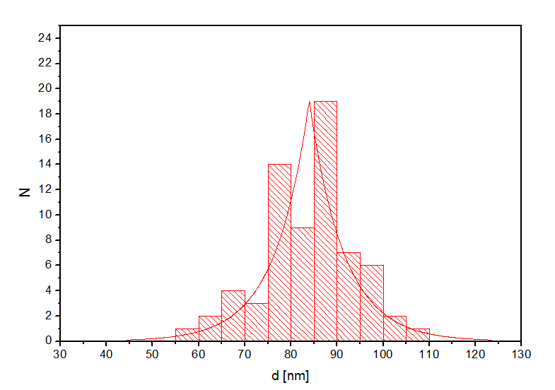 d)
- SEM of synthesized nanoparticles at 0.6 Torr; b) size distribution
- of nanoparticles at 0.6 Torr;
- c) SEM of synthesized nanoparticles at 1.2 Torr;
d) - size distribution of nanoparticles at 1.2 Torr.
Figure 12 - SEM of synthesized nanoparticles and their size distribution
at discharge current I=0.5 A

SEM image of copper nanoparticles under other experimental conditions are shown in Figure 13: gas discharge current 0.2 A and 0.5 A, gas pressure 0.6 torr. It was found that with increasing discharge current the size of synthesized nanoparticles increases. This is explained by the fact that the increase in discharge current leads to an increase in the frequency of collision process of electrons and ions with the target, which in turn leads to an intensive spraying of the surface of the latter. The consequence of the latter phenomenon is rapid development of nanoparticles in plasma.
а) | 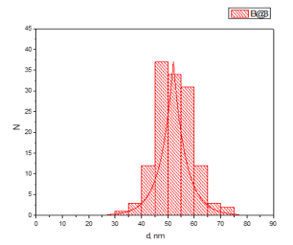 b)
c) | 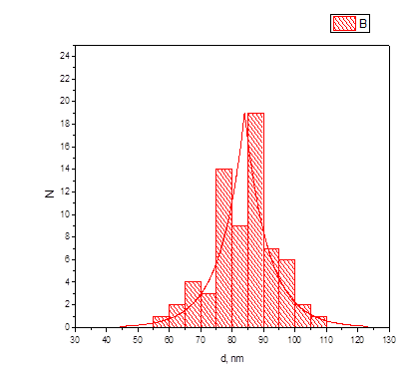 d)
a) SEM of synthesized nanoparticles at 0.2 A; b) - distribution of nanoparticles by size at 0.2 A; c) SEM of synthesized nanoparticles at 0.5 A; d) distribution of nanoparticles by size at 0.5 A
Figure 13 - SEM of synthesized nanoparticles and their size distribution at p=0.6 Torr

Magnetic atomizer for producing nanostructured composite carbon particles with copper. For the synthesis of nanocomposite carbon particles with copper, an experimental unit presented in Appendix B was used. The distinctive feature of this unit is the presence of a cooling chamber near the magnetron. As it was mentioned above, the cooling (aggregation) chamber plays an important role for creation of composite nanoparticles - atoms (molecules) sputtered from the magnetron material condense through this chamber, and at the output we obtain nanoparticles of the electrode material.
The plasma in the magnetron discharge is formed near the copper electrode. It should be noted that on the surface of copper electrodes are carbon rods. The experiments were carried out at gas pressure of 0.5-1.2 Torr and discharge current of 0.2-0.4 A. The plasma burning time was 20 minutes.
The process of synthesis of nanostructured composite carbon particles with copper is as follows. After pumping the vacuum chamber to high vacuum (cleaning the experimental chamber) argon gas is injected into the volume to a certain pressure. After filling with the required amount of gas the magnetron discharge is ignited. As the magnetron electrode consists of two components (copper disk and carbon rod, figure 3), carbon atoms (molecules) with copper are formed near the electrode in plasma, which appear after the electrode is sprayed. It should be noted that all the work is carried out in a gas stream (argon) that gives a directed movement to the cloud of atoms (molecules) of carbon with copper towards the exit (nozzle). On the way to the output these particles stick together in the process of condensation in the cooled medium, that at the output are synthesized composite nanoparticles of carbon with copper.
The results of the analysis of the obtained nanoparticles with a scanning probe microscope and the chemical composition of the samples are shown in Figure 14.

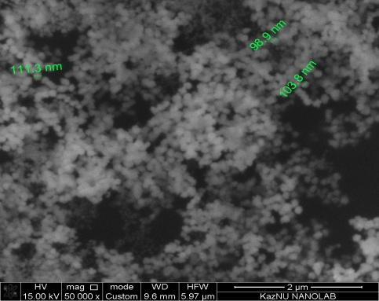 a) | 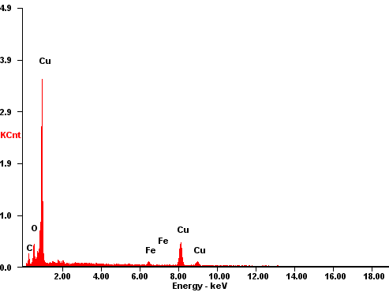 b)
a) EMS of a prototype of nanostructured copper particles with carbon;
b) chemical composition of the sample
Figure 14 - Samples of nanostructured copper particles with carbon

Figures 15-16 show EMS images of samples of nanostructured copper particles with carbon at different current values and gas pressure in the volume. Fig. 16 shows that with increasing gas pressure in the volume at a fixed current value (0.2 A) the size of the synthesized nanocomposite particles decreases. For example, at the pressure value of 0.5 torr the average size of synthesized particles was ~ 200 nm, while at 1 torr the average size was ~ 80 nm.
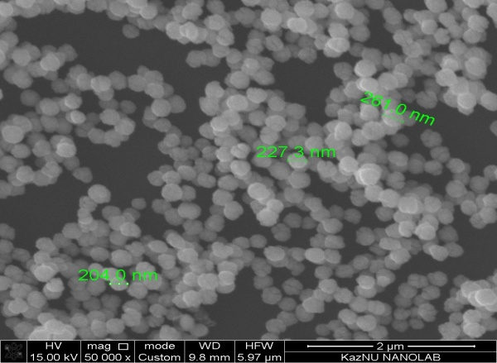 а) | 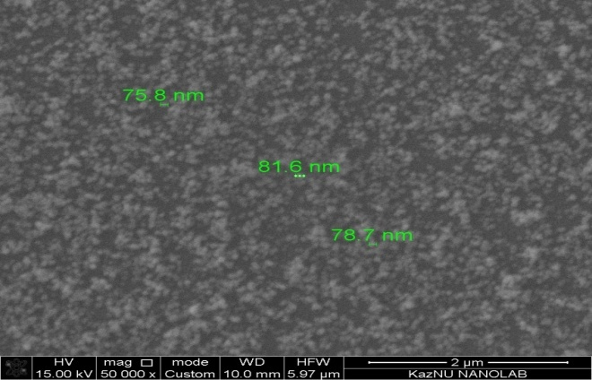 b)
a) SEM of nanoparticle samples at 0.5 Torr; b) SEM of nanoparticle samples at 1 Torr
Figure 15 - SEM image of synthesized samples of nanoparticles at 0.2 A current

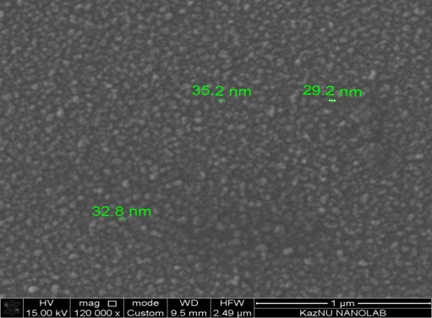 c) | 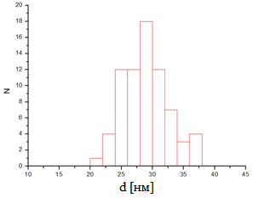 d)
c) EMS of nanoparticles samples at 1.2 Torr: d) size distribution of nanoparticles
Figure 16 - SEM image of synthesized samples of nanoparticles at 0.4 A discharge current

2 Study of electrical and optical characteristics of combined discharge plasma and obtaining laboratory samples of nanostructured composite particles and films with required physical and mechanical properties

2.1 Contact diagnostics of complex low-temperature plasma at NanoChip installation at growth of composite particles and films
The study of electrical characteristics of complex low-temperature plasma was carried out at the NanoChip installation, where the circuit diagram of the installation is shown in Appendix D. The experimental unit consists of a DC sputtering magnetron (1), a cooling system for the magnetron body (3), an electric single probe (6), plane-parallel electrodes (5 and 7), one of which (7) is connected by a HF current generator, quartz sight glasses (8), as well as a vacuum system (9) to obtain high vacuum in the chamber (chamber cleaning) and a gas injection system (10) to work with the necessary gas at the required pressures. Argon gas of special purity was used in experiments.
To determine the optimal modes of combustion of complex gas discharge, probe diagnosis of complex low-temperature plasma at the NanoChip unit with the growth of composite particles using an electric probe was carried out. Thus, I-V probe characteristics of the investigated discharge with the help of the single electric probe were obtained, i.e. current values flowing through the probe depending on the applied voltage to it were measured. This characteristic is the most important source of information about the properties of burning gas discharge. I-V characteristics for different pressure values are obtained, it is determined that the dependence of current on voltage is nonlinear, which corresponds to the normal state of plasma burning of RF/DC discharge. In the course of investigation of voltamper plasma characteristics in the working pressure ranges of 0.1 - 0.7 Torr and power 0 - 25 W, α - γ the transition was not detected, as in low-pressure plasma this transition is smooth and practically not felt, and the discharge power is sufficient to support the plasma and the growth of composite carbon nanoparticles with copper.
When the discharge current (I) increased, discharge expansion was also observed. Above a certain threshold, the discharge volume remained virtually unchanged, and the brightness continued to increase as the current increased. The ions generated in this region are accelerated to the cathode, causing erosion of the target. It was also noted that the discharge brightness and ion current on the magnetron cathode strongly depend on gas pressure. Examples of measured voltamper characteristics of the probe are shown in Figures 17 and 18.
Figure 17 - I-V curve of the electric probe in magnetron discharge | Figure 18 - I-V curve of the electric probe in Complex (RF+DC) Discharge

Current range of I-V characteristic in magnetron discharge (Figure 17) lies within 0.1-0.5 A. The current strength reaches 0.5 A at a discharge voltage of 420 V, for a lower pressure of 0.12 Torr. When the gas pressure increases to 1.5 Torr, the voltage decreases to 320 V to obtain a discharge current of 0.5 A. In the second series of our experiments the combined discharge of high-frequency and direct current was used (figure 18). In these experiments the RF discharge power is 15 W and invariably. In all cases the increase in gas pressure allowed to reach the maximum probe current at lower voltages. For example, an increase in gas pressure from 0.12 to 1.4 Torr resulted in a voltage reduction from 450 to 300 V.
As can be seen from Figures 17 and 18, an increase in gas pressure leads to an increase in current on the probe. More precisely, at constant current, discharge voltage decreases, i.e. it shows decrease of gas discharge resistance. Most likely, this is due to an increase in the number of ionization acts in the discharge volume. And also, with effective collision of electrons with atoms. This goes out of Pashen's law, if we increase gas pressure further, it would lead to a decrease in current.
Figure 19 shows I-V characteristic of the probe at various operating gas pressures.
а) | b)
a) p=0,3 Torr | b) p=0.6 Torr
Figure 19 - I-V characteristic of magnetron and combined discharge probe at different gas pressure values

As can be seen from Figure 19, connection to a high frequency discharge magnetron discharge leads to an increase in the energy value of the initial one. This can be seen from the steeper VAC probe. It is also noticeable that the gas discharge of lower pressures (0.3 Torr) burns less energy intensively under unchanged conditions.
If the current of electrons on the graph is plotted on a semi-logarithmic scale (Fig. 20) depending on the voltage, then the temperature of electrons can be determined by the slope of the graph.
, (1)
where ψ- the angle of inclination of a straight line section of the chart to the U axis.
a) | b)
a) p=0.3 Torr | b) p=0.6 Torr
Figure 20 - Semi-logarithmic I-V characteristic of the probe at different values of current and working gas pressure

The current of electrons Ie0 at the probe potential equal to the plasma potential allows to determine the concentration of electrons according to the expression
, (2)
where S is the surface area of the probe.
The temperature of electrons was determined on a semi-lographic scale from the probe characteristics using equation (1), and the concentration of electrons was estimated using ion saturation current (2). The corresponding results are given in tables 1 and 2.

Table 1 - Plasma parameters at p=0.3 Torr
I, mА | T_{e}, eV | I_{sat}, mkА | n_{i}, m⁻³
240 | 4,453 | 16,4 | 8,84E+15
180 | 2,721 | 16,4 | 1,13E+16
120 | 2,601 | 16,15 | 1,14E+16
60 | 1,408 | 15,9 | 1,52E+16

Table 2 - Plasma parameters at p=0.3 Torr
I, mА | T_{e}, eV | I_{sat}, mkА | n_{i}, m⁻³
180 | 2,007 | 19,95 | 1,60E+16
120 | 1,727 | 17,4 | 1,51E+16
60 | 1,675 | 14 | 1,23E+16

2.2 Investigation of optical and spectral characteristics of complex plasma at Nano-Chip installation at growth of composite particles and films
Development of methods of optical and spectral diagnostics of plasma is an important scientific task in view of wide application of plasma technologies in modern microelectronics and materials science. Optical methods provide extensive information about the parameters of complex plasma and achieve a more detailed understanding of the physical processes in the system. In contrast to traditional methods, optical diagnostics is non-contact and allows to determine different physical parameters of plasma without affecting it. In order to determine the optimal parameters of discharge combustion and the dependence of the properties of sprayed materials on plasma parameters, work has been done to investigate the optical properties of the buffer and complex plasma.
Works on investigation of optical properties of complex plasma have been carried out to determine optimal plasma combustion parameters and dependence of properties of synthesized materials on plasma parameters.
To study the optical properties of complex low-temperature plasma a magnetron and high-frequency discharge unit and a linear spectrometer are used. The working chamber of the unit is equipped with a special quartz window through which the gas discharge plasma spectrum is captured. The optical system used for plasma diagnostics consists of a Solar S100 lens system and a linear spectrometer. The lens system is selected so as to provide a clear image of the interelectrode space on the spectrometer's entrance slit. The sensitivity and capabilities of the Solar S100 allow simultaneous linear measurement of optical spectra in the range of 190 - 1100 nm.
Emission spectra were obtained and properties of plasma glow in argon gas were investigated. The dependencies of spectral line intensity on the parameters of complex discharge were also presented. Figure 21 shows an example of one experiment where emission spectra of high-frequency discharge were obtained. For spectral line identification, the NIST atomic spectra base was used. Since the plasma of gas discharge burns in pure argon, respectively, the spectral lines of only this gas are emitted. The Ar I line with a wavelength of 750.38 nm is more intensive.
 | 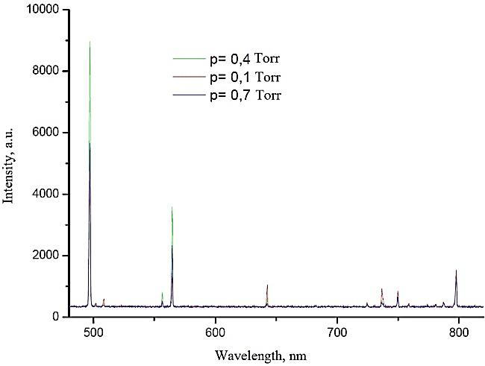
Figure 21 - Argon plasma spectrum at  p=0.3 Torr | Figure 22 - Magnetron discharge spectrum at I=0.5A

Figure 22 shows the optical spectra of magnetron discharge plasma obtained in different values of the working gas. At the same time other parameters such as magnetron discharge current I=0.5 A and generator RF power W=15 W remained constant. The results show the presence of copper lines, as the magnetron cathode is copper.
To clarify the effect of magnetron discharge on high-frequency discharge glow in pure argon, the following experiments were carried out. At the beginning of the experiment, only the high-frequency discharge is ignited, then the magnetron discharge is activated after some time and spectra are captured at certain time intervals. At the end of the experiment, the magnetron discharge is switched off. In this way, the contribution of the magnetron discharge to the high-frequency discharge is determined. More precisely, it is noticed with changes in glow intensity of gas discharge [38]. This suggests that the plasma of high-frequency discharge contains nano-sized particles. In other words, the incoming flow of atoms and molecules coagulate and turn into nanoparticles and nanoclusters. Further deposition of these particles in the form of nanoparticles or as a nanostructured film depends on the parameters of high-frequency discharge, in particular gas pressure. An example of emission spectra is shown in Figure 23.
Figure 23 - Complex discharge spectrum at I=0.36 A and p=0.47 Torr | Figure 24 - Complex discharge spectrum at I=0.36 A and p=0.47 Torr

For detailed study, spectral lines were obtained on a large scale (Figure 24). As can be seen from figure 24, spectral lines of copper appear at magnetron operation. This line corresponds to a wavelength of 510.55 nm. This shows that the flow of copper atoms penetrating the high-frequency discharge volume from the magnetron discharge is also excited in the high-frequency discharge.
As can be seen from Figure 25, when the magnetron discharge (DC) is turned on, the Ar I line intensity increases several times. This is due to the fact that when the magnetron operates, the flow of metal atoms entering the high-frequency discharge region coagulate and form nanoparticles. Since nanoparticles have a large total surface area due to their size, which leads to a redistribution of plasma charges and, consequently, to an increase in the intensity of plasma glow itself. When the magnetron switches off after 240 seconds (see Figure 25), the line intensity does not drop, which indicates that the electromagnetic field of the magnetron does not influence the high-frequency discharge. Thus, the increase in plasma intensity is influenced by the presence of a nanoparticle.
Figure 25 - Complex discharge spectrum at I=0.36 A and p=0.47 Torr | Figure 26 - Complex discharge spectrum at I=0.36 A and p=0.47 Torr

Figure 26 shows another case, when at the beginning of the experiment only the high-frequency discharge burns, then after 2 seconds the magnetron discharge is activated. As you have noticed, the line intensity increases sharply as explained above. Then, it remains practically unchanged during a minute. But when both discharges are switched off and only the high-frequency discharge is switched back on after a few seconds, the line intensity slows down to the same level. This indicates that when the high-frequency discharge is turned off, the nanoparticles are carried away with the gas stream because there are no restraining forces on the high-frequency discharge side.
Thus, the formation of nanoparticles in complex plasma and their influence on the properties of the plasma itself are shown. Coagulation of the particles occurs due to surface deposition and depends on the parameters of the complex plasma, in particular the gas composition and gas pressure on the chamber.
2.3 Obtaining laboratory samples of nanostructured composite particles and films with required physical and mechanical properties
The schematic diagram of the experimental unit designed to produce nanostructured composite particles and carbon films with metals is shown in Appendix E. The main part of the experimental unit consists of DC magnetron sputtering (1) with a gas injection tube (3) and its own cooling system (5), where the electrode system of the magnetron consists of copper plates (2) with carbon rods, the locations of which are shown in Figure 27. The experimental unit also includes a screen and a substrate.

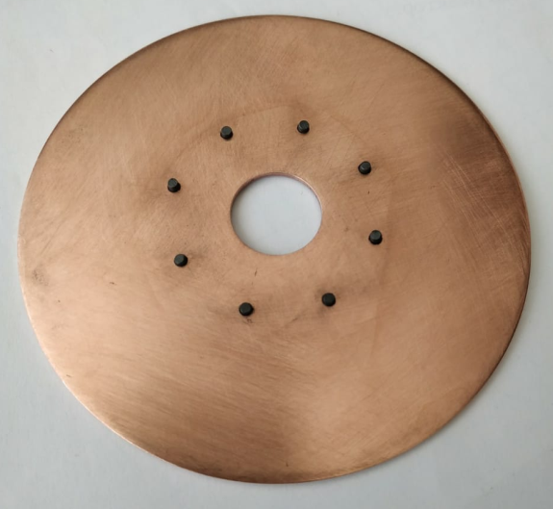 | 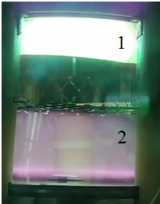
Figure 27 - Position of thin graphite rods on the copper electrode surface of a magnetron | Figure 28 - Picture of complex gas discharge

As can be seen from Figure 27, carbon rods have a hollow cylindrical configuration and have a projection above the surface of the copper electrode with a diameter of 100 mm. Such manufacture of carbon rods was designed to increase the electrical field strength at the ends of the carbon rods and thus increase the yield of carbon atoms in the process of spraying.
Figure 28 shows a photo image of a magnetron in operating mode. Magnetron discharge marked by the number 1, high-frequency smoldering discharge by the number 2. Nanostructured composite films of carbon with copper in plasma of magnetron discharge were obtained at the following plasma parameters: high-frequency discharge power P=20 W, magnetron discharge current I=0.4 A, plasma burning time 25 min. The pressure in the working chamber was p=1.2 torr. Argon was used as the working gas.
The obtained samples of nanostructured composite carbon films with copper were analyzed using a scanning electron microscope. Figures 29-30 show the cross-section of these films.
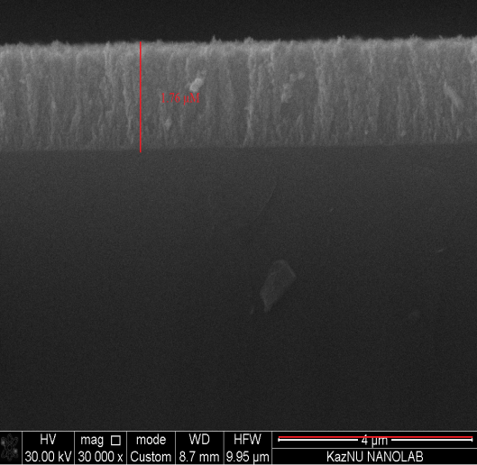
Figure 29 - SEM image of the obtained sample in plasma of magnetron discharge at  p=1.2 Torr, t= 25 min, I=0.4 A, U=300 V | Figure 30 - SEM image of the obtained sample in RF+DC plasma discharge at p=1.2 Torr, t=25 min, I=0.4 A, U=300 V
The following experiment was made to study electrical properties of the obtained samples. Based on the condition of nanodimensionality of structures obtained as a result of magnetron sputtering of metal-carbon composite films on silicon substrates, it was proposed to use two homogeneous contacts for measuring I-V characteristic. Both as a smooth aluminum surface, Figure 31.
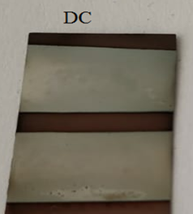 а) | 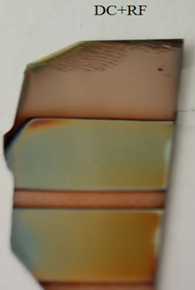 б)
a) - Photo image of the obtained sample in plasma of magnetron discharge at p=1.2 Torr, t= 25 min, I=0.4 A, U=300 B | b) - Photo image of the resulting sample in RF+DC plasma at  p=1.2 Torr, t= 25 min, I=0.4 A, U=300 B
Figure 31 - Photo of the obtained samples for taking the I-V characteristic

The results of I-V characteristic measurement of composite film samples obtained in magnetron plasma and RF+DC discharge are presented in Figures 32 and 33 respectively. I-V characteristic measurements were made in the range of voltages from (-1.5) V to (+1.5) V.
Figure 32 - I-V characteristic composite film of magnetron discharge obtained in plasma | Figure 33 - I-V characteristic composite film obtained in RF+DC discharge

As can be seen from figures 32-33, I-V characteristic of composite films have a linear dependence. On this basis, we will analyze experimental I-V characteristic samples of nanostructured metal-carbon films on a silicon substrate. The type of I-V characteristic is determined by the properties of the rectifying contact between the composite film and the silicon substrate. In the case of composite film with a thickness of 1.75 µm, the resistance of the film was 62 ohms. For a sample of metal-carbon film on a silicon substrate, which was obtained in the RF+DC plasma discharge, the resistance of the film with a thickness of 466.3 nm was 7.4 ohms. This result suggests that the obtained composite film in RF+DC plasma discharge is completely nanostructured. Based on the experimental results, we can say that the structure of carbon-copper nanofilms depends on the condensation process and discharge parameters. As the spraying time increases, the substrate surface temperature increases due to the effect of adsorbing atoms, which leads to the escape of the sprayed copper atoms due to the thermal effect. Thus, the increase in nanofilm thickness over time slows down. In addition, the experimental results show that the surface of nanostructures is homogeneous. Homogeneity is the result of separation of the flow moving from the magnetron to the substrate, with transformation into nanoclusters in the interval.
The resistance of the film is determined by the following formula:

$R=ρ\frac{l}{S}=ρ\frac{l}{AH}$, (3)

where ρ - specific resistance of the substrate, l - length of the composite film, S - surface area of the composite film.
Formula (3) determines the specific resistance and specific conductivity of the film, where the corresponding results are shown in Table 3.

Table 3 - Electrical conductivity of film
 | $$ρ [Оhm*{mm}^{2}/m]$$ | $$γ [S/m]$$
Film obtained in RF+DC plasma discharge | $$20,89*{10}^{-3}$$ | 47,87
Film obtained in magnetron discharge plasma | $$678*{10}^{-3}$$ | 1,47

The dependence of electric conductivity of the film on temperature was also investigated. In order to achieve this goal, we designed a heating element (Fig. 34). The research was carried out at different heater temperatures.
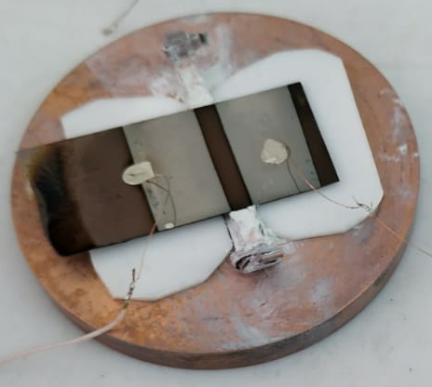
Figure 34 - Photo image of film with electric contacts on the heater

Figure 35 shows the effect of temperature on the resistance of the composite film which was placed on the high-frequency discharge during sputtering.
Figure 35 - Electrical conductivity of composite film | Figure 36 - Electrical conductivity of composite film

As can be seen from the figure, when the heater temperature reaches 70 C, the resistance of the composite film begins to increase. Then at 120 C it becomes almost an insulator. This is rather due to the appearance of cracks and breaks in the nanostructured surface.
Figure 36 shows the effect of temperature on the resistance of the composite film, which during spraying was located directly on the surface of the anode of magnetron discharge. In this case, the resistance of the film does not change much because the mixture of carbon and copper must be effectively homogeneous. In other words, the temperature coefficient of copper is negative and that of carbon is positive, thus the compensation of the change of resistance should take place.
As shown in Figure 37, composite nanoparticles are synthesized together with the film of the same material and are strongly oxidized when released into the atmosphere.
Figure 37 - Composite nanoparticles synthesized with film

3 Synergetic analysis and investigation of mechanical properties of obtained samples of nanostructured composite particles and films of carbon with metals.

At this stage of the report, the results of the work performed for the third annual stage of the project are presented. According to the calendar plan, work was carried out on synergetic analysis and mechanical properties of obtained samples of nanostructured composite particles and carbon films with metals. Detailed information on the results obtained for analysis of obtained samples of nanostructured composite particles and films based on optical, electronic, tunnel and atomic force microscopy is given in item 3.1 of this report.
We have investigated mechanical (elasticity and microhardness) and electrical (voltamper characteristics) characteristics of the obtained metal-carbon nanocomposites. The results are given in point 3.2 of this report.
The results of metal-carbon nanocomposites analysis based on X-ray structure analysis and Raman spectroscopy are given in point 3.3.
3.1 Analysis of obtained samples of nanostructured composite particles and films based on optical (profilometer), electronic, tunneling and atomic force microscopy
The schematic diagram of the experimental installation is presented in Appendix B. This experimental unit is designed to produce nanostructured composite films and carbon particles with metals. The main part of the experimental unit consists of a magnetron (1) with a gas injection tube (3) and its own cooling system (9), where the magnetron electrode system consists of copper plates. Before deposition, the system was pumped to vacuum up to 3-10⁻⁵ Torr. The copper target was sprayed into mixtures of argon (working gas) and methane (reactive gas). Silicon wafers were used as a substrate. The distance from the target to the substrate is 60 mm.
Metal-carbon nanocomposites were obtained in the plasma of magnetron discharge in a mixture of gases Ar (98) and CH₄ (2%) and studied their mechanical and physical properties on the Quanta 3D 200i electron microscope (SEM, USA FEI company). In the course of experimental works the working gas pressure varied from 1-10⁻² to 1 Torr and the gas discharge current varied from 0.2 to 0.6 A.
Figure 38 shows the cross section and chemical composition of a metal-carbon nanofilm on a silicon substrate. Obviously, the thickness of the coatings depends on the plasma parameters: gas pressure and magnetron discharge current.
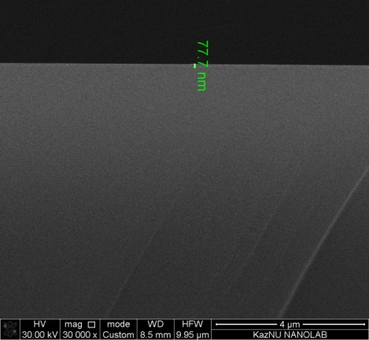 а) | 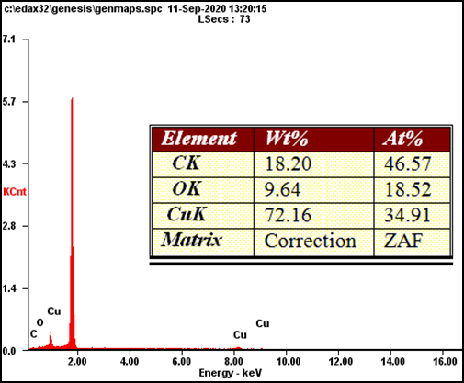 b)
a) The cross section of the film | b) the chemical composition of the film
Figure 38 - Thickness of the film obtained at sputtering time 5 min, p=7.5-10⁻² Torr, I=0.2 A

Copper-carbon nanocomposite films with thicknesses from 70 to 400 nm were obtained by controlling atomization time, working gas pressure and magnetron discharge current. Detailed information on film deposition is presented in Table 4.

Table 4 - Data from a model experiment on deposition of nanocomposite films in plasma of magnetron discharge in a mixture of gases (Ar+CH₄)
Sample № | Operating gas pressure, Torr | Sputtering current, mA | Sputtering  voltage, V | Sputtering time, min | Thickness of film, nm
А1 | 1,7*10⁻² | 400 | 357 | 5 | 398
А2 | 3,5*10⁻² | 400 | 357 | 5 | 262
А3 | 7,5*10⁻² | 400 | 329 | 5 | 145
А4 | 1,7*10⁻² | 200 | 313 | 5 | 131
А5 | 3,5*10⁻² | 200 | 301 | 5 | 109
А6 | 7,5*10⁻² | 200 | 298 | 5 | 70
В1 | 2*10⁻² | 400 | 337 | 2 | 150
В2 | 2*10⁻² | 200 | 305 | 2 | 77

As the sputtering time decreases, the thickness of the coating layer decreases as well. This process can be seen in Figure 39, which shows photographic images of copper-carbon nanofilms thickness depending on the deposition time, obtained at the same parameters (gas pressure and discharge power, magnetron discharge current) of plasma combustion of magnetron discharge.
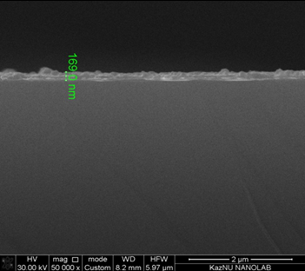 а) | 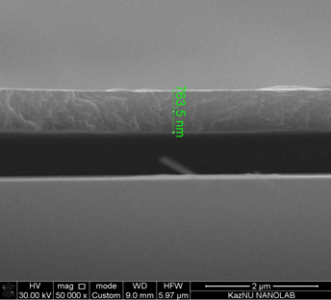 b)
а) t=10 min | b) t=25 min
Figure 39 - Thickness of the film obtained at p=0.2 Torr; I=0.4 A

When pressure changes, the coating mechanism undergoes a noticeable transformation. With increasing pressure, the characteristic length of thermolysis of carbon and copper atoms, determined by the length of their directional run, becomes much smaller than the geometric dimensions of the reactor. In the process of movement in the plasma medium, ions are thermalized by collisions with plasma gas atoms. This results in the formation of oversaturated vapor of the precipitating element, its condensation and the appearance of clusters. The same effect of changing the film thickness is observed when the working gas pressure decreases, under the same conditions of spraying. Figures 40 and 41 show photo images of copper-carbon nanofilms thickness depending on the working gas pressure (I=0.4 A; t=5 min).

а) | b)
р=1,7·10⁻² Torr | р=3,5·10⁻² Torr
Figure 40 - Thickness of the film obtained from the sputtering time of 5 min.
а) | b)
р=7.5*10⁻² Torr | р=0.1 Torr
Figure 41 - Thickness of the film obtained from the sputtering time of 5 min.

The detected dependence of the thickness of the gas pressure layer is explained by an increase in the concentration of Ar atoms in the reactor, a decrease in the number of molecules of the precipitated material bombarding the silicon surface, and thus causing a decrease in the film thickness. Since the plasma power of the magnetron discharge is not sufficient to ionize all the working gas atoms in the reactor.
Figure 42 shows the chemical composition of deposited thin films of Cu/C as a function of gas pressure Ar/CH₄. We can see that the carbon content of the films increased slightly with the increase in gas pressure of Ar/CH₄ from 3.50 to 40.70 at %. On the contrary, the concentration of copper in films decreased from 92.05 at% to 43.57 at%. There is evidence that with increasing CH₄ content, the surface of the target from copper is covered with organic compounds and, accordingly, the yield of spraying copper target decreases [39].
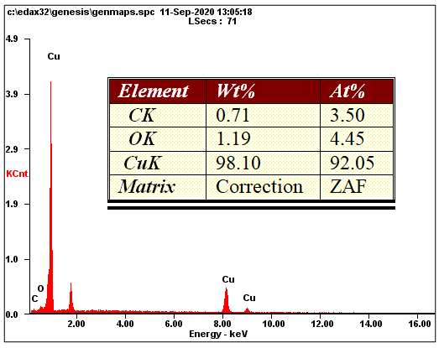 а) | 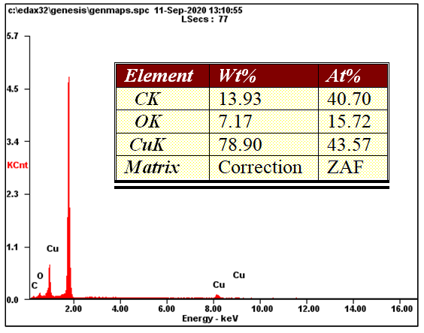b)
p=1.7·10⁻² Torr | p=7.5·10⁻² Torr
Figure 42 - Chemical composition of obtained samples of Cu/C nanocomposites at various working gas pressures Ar/CH₄
Samples of copper-carbon nanofilms and nanoparticles synthesized on a silicon substrate were studied using an atomic force microscope. The atomic force microscope makes it possible to determine and evaluate the surface structure of the obtained film samples.
Qualitative coating of copper-carbon film on silicon substrate is carried out at values of pressure of gas medium 1*10⁻² - 3*10⁻² Torr, current of magnetron discharge I = 0.4 A. It is related to the behavior of electrons. At increase of pressure the kinetic energy of electrons increases, accordingly the frequency of collisions of electrons with neutral atoms of buffer plasma increases proportionally, up to the values of pressure 1*10⁻² - 3*10⁻² Torr. Fig. 43 shows 2D and AFM images of samples surface synthesized in plasma of magnetron discharge at different pressures of gas and current of magnetron discharge.

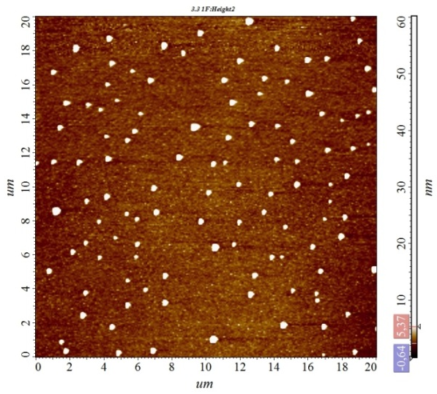 a) | 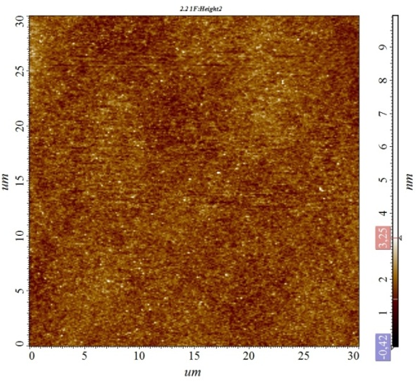 b)
а) I=400 mА; p=7.5·10⁻² Torr | b) I=200 mА; p=7.5·10⁻² Torr
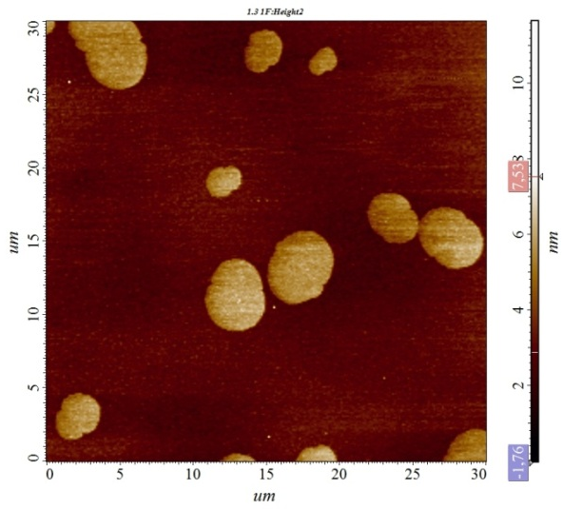 c) | 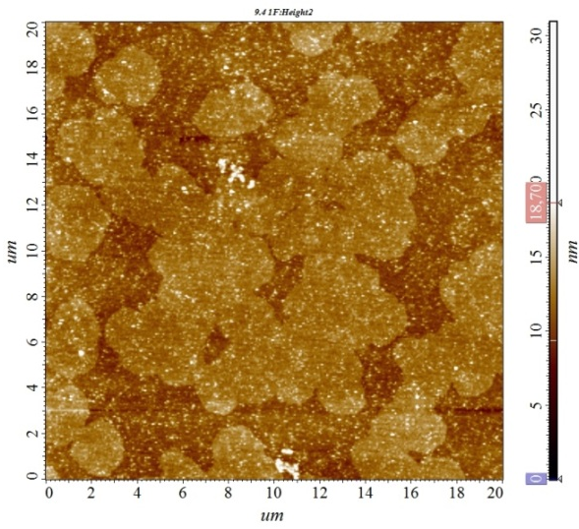 d)
c) I=400 mА; p=3.4·10⁻² Torr | d) I=400 mА; p=1.9·10⁻² Torr
Figure 43 - 2D ACM image of the sample surface of magnetron discharge synthesized in plasma at different gas pressures and discharge current

The morphology of Cu/C film surface was studied by atomic force microscopy (AFM). It should be noted that in case of Cu/C films applied in plasma of magnetron discharge, the surface morphology depended on the used magnetron DC current and working gas pressure (Fig. 43). For Cu/C films deposited with magnetron discharge current I = 400 mA, one can see relatively large (sizes in the range of tens and even hundreds of nm) features of irregularly shaped surfaces (Fig. 43a). The dimensions of these surface elements, as well as surface roughness (RMS), decreased with increasing working gas pressure. Surface elements are smaller and have a different shape - they are rounded. Taking into account the data from Figure 44 (Surface Profiler of specimens) showing significantly reduced intensity of peaks associated with copper oxide, it can be assumed that the observed flat surface features can be described as copper nanoclusters. The atomic force tunneling microscope data presented in Figure 44 support this assumption.

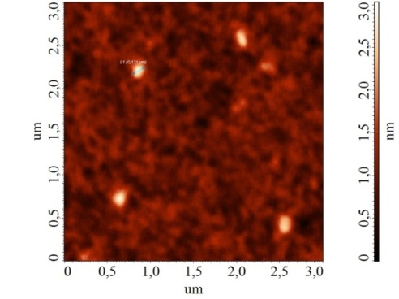а) | 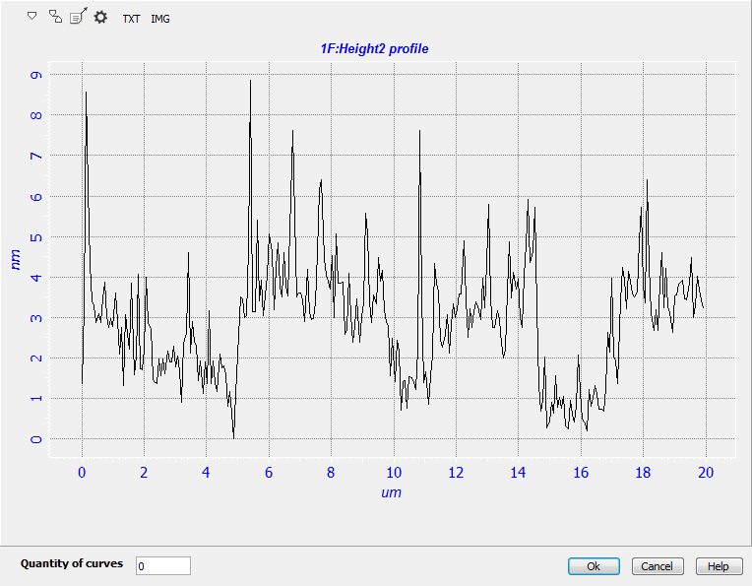b)
a) Surface photo of the sample; b) profile line. I=200 mA, p=1.9*10⁻² Torr
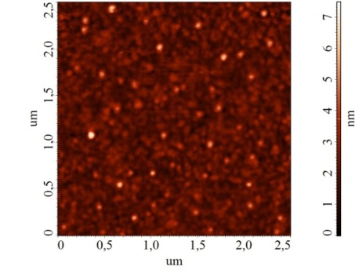c) | 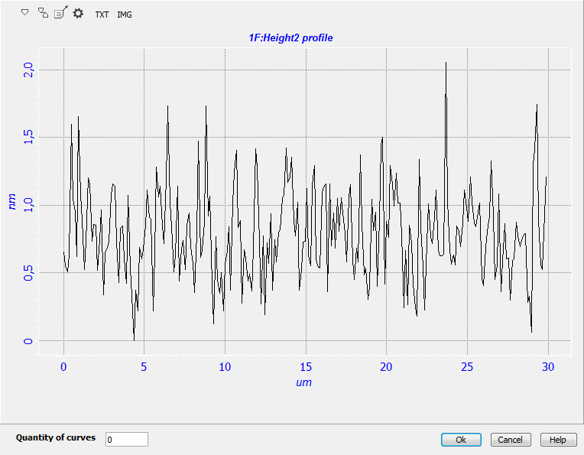d)
c) Surface photo of the sample; d) profile line. I=200 mA, p=7.5*10⁻² Torr
Figure 44 - Tunnel AFM image and surface profiler of plasma synthesized magnetron discharge sample

In particular, the higher copper content observed in the upper layer of Cu/C films deposited with a magnetron current of 400 mA and containing 43.57 a.% Cu is in good agreement with the larger surface features observed with ACM for the corresponding and related films. It seems that in case of increasing working gas pressure, the distribution of copper nanoclusters, as well as their sizes, are inhomogeneous. It should be noted that in [40] Au nanoclusters were observed with both TEM and ASM for gold-containing carbon films. While in [41] Cu nanoclusters were observed with both SEM and ASM for Cu/DLC films deposited by reactive RF diode sputtering. As for the size of observed surface objects, it should be noted that in [41] Cu nanoclusters of up to several hundred nanometers in size were observed for Cu/DLC films deposited by HF-diode reactive deposition. Similar to the present study, some larger surface nanoclusters were found on DLC films containing silver deposited by reactive magnetron sputtering [42].
Further increase in pressure leads to formation of microparticles of carbon and copper on the surface of the films, due to heterogeneity of ionized flow. This is explained by the supersaturation of neutral atoms, which form a barrier to the thermal motion of electrons. As a result, the temperature of electrons decreases, as the kinetic energy of electrons is lost due to collisions with a large concentration of neutral atoms. Fig. 45 shows an optical image of the surface of the obtained samples.
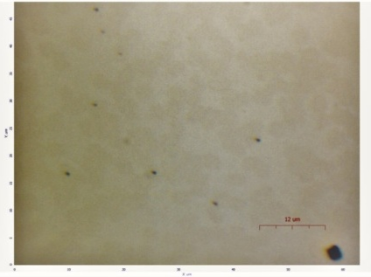 а) | 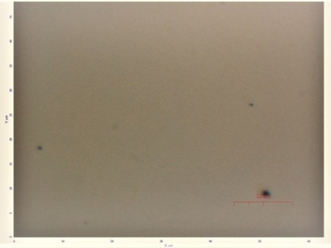 b)
а) I=200 mА; p=1.9·10⁻² Torr | б) I=200 mА; p=7.5·10⁻² Torr
Figure 45 - Optical image of obtained samples at different gas pressures Ar/CH₄

3.2 Investigation of mechanical (elasticity and microhardness) and electrical (I-V characteristics) characteristics of obtained samples of nanostructured composite carbon films with metals
To study elasticity and microhardness, a TI Premier nanoindenter (Bruker) with a Berkovich sharp diamond cantilever (tip radius <20 nm) was used. Nanoindentation experiments with depth measurements were carried out using the continuous stiffness measurement (CSM) method. The permissible load of the TI Premier (Bruker) nanoindenter reaches 600 mN. The indentation test site on the sample surface was targeted using an optical microscope. The CSM method was used to continuously measure the harmonic contact stiffness as a function of depth, which allowed the mechanical properties to be calculated as hardness and elasticity.
The measurements were carried out on four samples of Cu/C films with different carbon content in the range from 3.8 at.% To 40.70 at.% To monitor the dependence of the film hardness on the carbon content. The results of nanoindentation tests performed on nanocomposite films with different carbon contents are presented in Table 5.

Table 5 - Data from the exemplary experiment on testing nanoindentation
Sample № | Carbon content (%) | Hardness (GPa) | Plasticity (%)
A1 | 3.8 | 1.8 | 85
A2 | 10 | 2.2 | 80
A3 | 27.30 | 2.9 | 76
A4 | 40.70 | 3.9 | 72

The results show that the hardness of nanocomposite films depends on the composition of the films and decreases from about 4 GPa for films with a carbon content of 30–40 at.% To 2–2.5 GPa for films with a carbon content of 7–10 at.%.
The analysis of loading - unloading of the cantilever during nanoindentation tests allows determining the work of plastic deformation (A_{p}) as the area between the loading and unloading curves. In the studied films of carbon / copper nanocomposites, the ratio of the work of plastic deformation to the total work of deformation (A_{tot}), defined as the area under the loading curve, varied in the range from A_{p}/A_{tot} = 72% for samples with 40 at.% Carbon to A_{p}/A_{tot} = 85 % for samples with 4 at.% carbon. The latter is close to the values for a pure Cu film (85%). These data indicate a relatively high plasticity of the films when tested for indentation. Plasticity increases with increasing Cu content in the films.
Electrical measurements or conducting atomic force microscopy (C-ASM) is a visualization mode for determining electrical nanoscale characteristics in the fields of nanoelectronics, molecular electronics and material science [43]. Electrical properties are obtained simultaneously with full correlation with the topographic image obtained with the same probe. The DC bias is fed to the probe or sample, and the current is measured through the sample, while the ACM feedback is set to create an electrical contact. The diagram below describes this configuration of the C-ASM.
Electronic transport properties of Cu/C nanocomposites on a silicon substrate were investigated by C-ASM methods. In the current-voltage (I-V) measurements, the point contact between the probe and the Cu/C nanocomposite was formed by placing a conductive probe with the Cu/C nanocomposite surface. The other end of the nanocomposite is in contact with a metal electrode. When a bias voltage (from +0.5 to -0.5 V) is applied to the probe of the atomic force microscope, a clearly non-linear I-V characteristics is obtained, as shown in Figure 46.

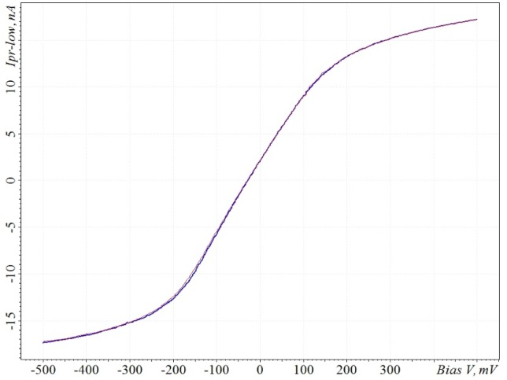 а) | 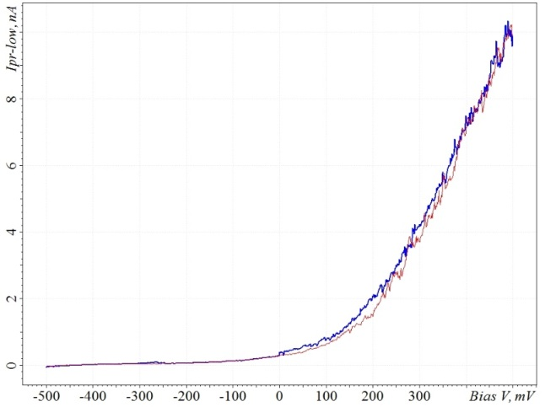 b)
а) I=400 mА; p=3.5·10⁻² Torr | b) I=200 mА; p=1.9·10⁻² Torr
Figure 46 - I-V characteristics of copper-carbon nanocomposites at different parameters of magnetron discharge plasma

3.3 X-ray structure analysis and Raman spectroscopy of metal-carbon nanocomposite film samples
For further verification of composites' graphicity, the materials were characterized by Raman spectroscopy. Raman spectroscopy is a very useful tool for characterizing carbon nanomaterials.
The obtained samples of metal-carbon nanocomposites were studied at Raman spectrometer in the Laboratory of Engineering profile at Al-Farabi Kazakh National University. Raman spectra of thin films Cu /C are shown in Figure 47.
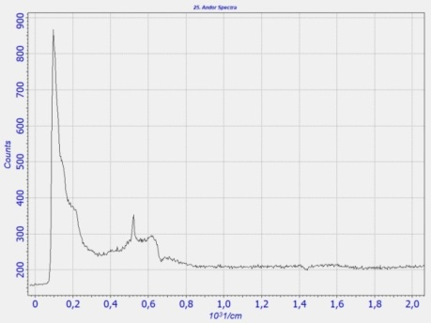  a) | 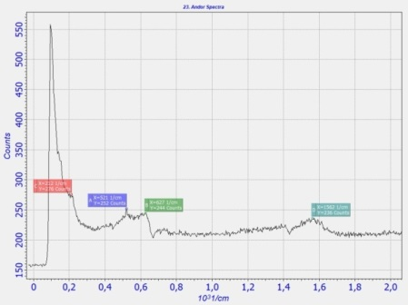  b) | 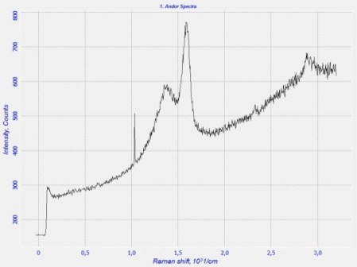  c)
а) I=200 mА; p=1.9·10⁻² Torr | b) I=200 mА; p=7.5·10⁻² Torr | c) I=200 mА; p=1.5·10⁻¹ Torr
Figure 47 - Raman spectrum, synthesized copper-carbon nanocomposites

From Figure 47 we can see that the Cu/C ratio (gas pressure Ar/CH₄) strongly influences the peaks of Raman spectroscopy. Raman spectra of composite film are characterized by wide bands of about 1590 cm-1 (G-band) and 1360 cm-1 (D-band), which are typical for hydrogen-free amorphous (a-C) carbon with a predominant sp2 bonding [44]. Maximum peaks at 144, 215 and 640 cm-1 are related to the presence of Cu₂O.
You may notice that the position of peak D, composite films depend on the Cu/C content. Accordingly, the peak D and G ratio increases with the Cu/C ratio (increase in gas pressure Ar/CH₄), which is a sign of a higher proportion of carbon bound sp2 and an increase in the size of the graphite domain. Thus, thin films of Cu/C with higher Cu content show a higher degree of carbon clustering of sp2 and a lower value of diamondlike characteristics (sp3 bond). It was demonstrated in [45, 46] that metal inclusion contributes to the formation of sp2-bound carbon domains. The higher proportion of sp2-bonded carbon leads to DLC films with lower internal stress and higher adhesion for alloyed metals [47]. The peak values of D and G provide additional information on the crystallinity of carbon films [48]. When most of the carbon film is amorphous, wide and blurred peaks and sharp peaks appear in the crystalline material. The value of D and G peaks decreased with increasing Cu content in thin Cu/C films (Fig. 47), which indicates higher crystallinity of the films.
Figure 48 - X-ray structure analysis of Cu/C composite thin film

X-ray structure analysis shows diffraction peaks of copper, while crystalline forms of carbon are not observed (fig. 48). The results confirm that the films consist of two phases - the crystalline phase of copper and the amorphous carbon phase. A small amount of Cu₂O was also found. Oxidation of copper during the deposition phase seems unlikely because the deposition conditions include a sufficiently high base vacuum, high purity and high working gas flow rate. We assume that oxidation occurs in the post-deposition phase due to porosity and leakages in carbon casings containing copper nanograins.

CONCLUSION

As part of this work, the following main results were obtained.
The final stage of the report on designing and developing scientific and technical foundations for obtaining nanostructured composite particles and films with required properties was completed.
Separate units and blocks of plasma experimental unit "NanoChip" based on magnetron sputtering system have been modernized. In particular, the work of the aggregation chamber was adjusted, which plays a major role in the creation of nanostructured composite films and carbon particles with metals. To determine optimal modes of plasma combustion of complex gas discharge, I-V characteristics were obtained, as well as probe and spectral diagnostics of plasma were performed. Test samples of nanostructured composite (sandwich) films of carbon with metals in the plasma medium of high-frequency capacitive discharge by magnetron sputtering were obtained. The results of experiments with the magnetron double electrode (copper and graphite) showed that in this way nanostructured composite films with thickness of 40-60 nm can be obtained. By means of magnetron sputtering of dust plasma, nanostructured composite films of aluminum on the surface of macro particles were obtained. As a result of analysis of laboratory samples using optical, electronic, tunnel and atomic force microscopy, it was found that with increasing gas pressure in the vacuum chamber, the percentage of aluminum decreases, which is the basis for the following assumption - varying experimental parameters can control the thickness of the resulting films on the surface of composite particles. Composite nanoparticles with an average size of 80 nm, consisting of copper and carbon, obtained by magnetron sputtering in plasma of high-frequency discharge mixture of methane-argon gases, have been synthesized. The results of the experiments revealed that the increase in the discharge current of magnetron leads to an increase in the size of composite nanoparticles carbon-copper, as well as an increase in the thickness of nanostructured films. In addition, it was found that when using pure argon gas without an impurity of carbon-containing gas (methane), it is necessary to use special magnetron electrodes that contain graphite rods. It was also noted that the increase in gas pressure in the volume leads to a decrease in the size of nanoparticles at the outlet. But in the case of formation of nanostructured composite films, the picture is somewhat different: when the gas pressure increases up to 1 Torr, the thickness of the films increases, but at relatively high pressures, > 1.1 Torr at the outlet are formed films with a smaller thickness. In addition, experiments have been carried out to determine the dependence of nanocomposite films and carbon-copper particles on ambient temperature. It was found that a decrease in the temperature of the medium leads to an increase in the thickness of the resulting films. And in the case of composite nanoparticles, the temperature effect is similar, that is, when the temperature of the medium decreases the size of nanoparticles increases. To study the electrical properties of the obtained samples, VAС films were removed. The obtained VAС has a nonlinear character. This result suggests that the resulting composite film in plasma RF+DC discharge is fully nanostructured. In addition, the experimental results show that the surface of nanostructures is homogeneous. Homogeneity is the result of separation of the flow moving from the magnetron to the substrate, with transformation into nanoclusters in the gap. X-ray structural analysis of the composite film showed wide bands of about 1590 cm⁻¹ (G-band) and 1360 cm⁻¹ (D-band), which are typical for hydrogen-free amorphous (a-C) carbon with a sp2 bonding. Maximum peaks at 144, 215 and 640 cm⁻¹ are due to the presence of Cu₂O. The results of studying the structure and nanoindentation characterize Cu/C nanocomposite films as a plastic component of complex tribological coatings.
Based on the results of scientific research, 16 works were published, 4 of them in the journals of the Republic of Kazakhstan, recommended by the CCES and 3 in the international journal with the impact factor of the Scopus base and 1 patent application was filed for the Republic of Kazakhstan, No. 2020/0968.2.
The work performed is fully consistent with the schedule, the results obtained are new and original.

LIST OF SOURCES USED

- Vysikaylo P.I., Mitin V.S., Markin A.A., Yakovlev A.Yu., Belyaev V.V. Cooper-Carbon Nanostructured Composite Coatings with Controlled Structure // Open Journal of Applied Sciences. – 2016. – Vol. 6. – P. 195-207.
- Jakle F. Advances in the Synthesis of Organoborane Polymers for Optical, Electronic, and Sensory Applications // Chem. Rev. – 2010. – Vol. 6.– P. 3985-4022.
- Sherlock S.P., Tabakman S.M., Xie L.M., Dai H.J. Photothermally Enhanced Drug Delivery by Ultrasmall Multifunctional FeCo/Graphitic Shell Nanocrystals // ACS Nano. – 2011. – Vol. 5. – P. 1505-1512.
- Seo W.S., Lee J.H., Sun X.M., Suzuki Y., Mann D., Liu, Z., Terashima M., Yang P. C., McConnell M.V., Nishimura D.G., Dai H.J. FeCo/graphitic-shell nanocrystals as advanced magnetic-resonance-imaging and near-infrared agents / /Nat. Mater. – 2006. – Vol.5. – P. 971-976.
- Hsin Y.L., Lin C.F., Liang Y.C., Hwang K.C., Horng J.C., Ho J.A., Lin C.C., Hwu J.R. Microwave arcing induced formation and growth mechanisms of core/shell metal/carbon nanoparticles in organic solutions // Adv. Funct. Mater. – 2008. – Vol. 18. – P. 2048-2056.
- Alonso F.A Highly reusable carbon−supported platinum catalyst for the hydrogen−transfer reduction of ketones // Chem. Cat. Chem. – 2009. – Vol.1. – P. 75-77.
- Ryashentseva M.A. The use of metal-carbon catalysts in the conversion of lower aliphatic alcohols // Advances in chemistry. – 2006. – Vol. 75. – P. 1119-1132. (in Russian)
- Efimov M.N. Obtaining and structure of catalytic nanocomposite carbon materials containing platinum group metals // Bulletin of MITHT im. M.V. Lomonosov.– 2008. – Vol. 3. – P. 66-69. (in Russian)
- Kozhitov L.V., Kozlov V.V., Kostikova A.V., Popkova A.V. Novel Metal Carbon Nanocomposites and Carbon Nanocrystalline Material with Promising Properties for the Development of Electronics // Russian Microelectronics. – 2013. – Vol. 42. – P. 498-507.
- Tsytovich V.N. Plasma-dust crystals, drops and clouds //UFN. – 1997. – Vol. 176. – P. 57-99. (in Russian)
- Dosbolaev M.K. Experimental study of the properties of dusty plasma as an open system // PEOS. – 2007.– Vol. 2. – P. 60-63. (in Russian)
- Sahay R., Jayarama V., Ramakrishna R., Ramakrishna S. Synthesis and applications of multifunctional composite nanomaterials // International Journal of Mechanical and Materials Engineering. – 2017. – Vol. 9. – P. 25.
- García-Cruz L., Conchi O.A., Carvalho A. P., Bandosz T.J., Montiel V., Iniesta J. The Role of Carbon on Copper–Carbon Composites for the Electrooxidation of Alcohols in an Alkaline Medium // Journal of Carbon Research. – 2017. – Vol. 3. – P. 1-16.
- Chaudhuri R.G., Paria S. Core/Shell Nanoparticles: Classes, Properties, Synthesis Mechanisms, Characterization, and Applications // Chem. Rev. – 2012. – Vol. 112. – P. 2373-2433.
- Biondi M., Borzacchiello A., Mayol L., Ambrosio L. Nanoparticle-Integrated Hydrogels as Multifunctional Composite Materials for Biomedical Applications // Gels. – 2015. – Vol. 1. – P. 162-178.
- Huu Do B.P., Nguyen D.B., Nguyen H.D., Nguyen T.P. Synthesis of magnetic composite nanoparticles enveloped in copolymers specified for scale inhibition application // Adv. Nat. Sci.: Nanosci. Nanotechnol. – 2013. – Vol. 4. – P. 045016-045023.
- Burda C., Chen X., Narayanan R., El-Sayed M.A. Chemistry and properties of nanocrystals of different shapes // Chem. Rev. – 2005. – Vol. 105. – P. 1025-1030.
- Liu Y.C., Lee H.T., Peng H.H. New pathway for sonoelectrochemical synthesis of gold–silver alloy nanoparticles from their bulk substrates // Chem. Phys. Lett. – 2004. – Vol. 400. – P. 436-441.
- Ramazanov T.S., Dzhumagulova K.N., Jumabekov A.N., Dosbolayev M.K. Structural properties of dusty plasma in direct current and radio frequency // Phys. Plasmas. – 2008. – Vol. 15. – P. 053704-053709.
- Boufendi L., Jouanny M.Ch., Kovacevic E., Berndt J., Mikikian M. Dusty plasma for nanotechnology // Journal of Physics D: Applied Physics. – 2011. – Vol. 44. – P. 174035-174011.
- Dosbolayev M.K., Ramazanov T.S., Daniyarov T.T., Silamiya M., Gabdullin M.T. Coating of thin nanofilms on microparticles in dusty plasma // Book of abstracts ICPDP-6. – 2011. – Vol.3. – P. 124.
- Kersten H., Thieme G., et. all. Complex (dusty) plasmas: Examples for applications and observation of magnetron-induced phenomena // Pure Appl. Chem. – 2005. – Vol. 2. – P. 415-428.
- Kashtanov P.V., Smirnov B.М. et. all. Magnetron plasma and nanotechnology // Uspekhi Phys. Nauk. – 2007. – Vol. 50. – P. 455-488.
- Mankelevich Yu.A., Olevanov M.A., Pal A.F., Rakhimova T.V., Ryabinkin A.N., Serov A.O., Filippov A.V. Coagulation of dust particles in an argon plasma of an RF discharge // Plasma Physics. – 2009. – Vol. 35. – P. 219-228. (in Russian)
- Dosbolayev M.K., Ramazanov T.S., Daniyarov T.T. et. all. The Physics of Dusty and Burning Plasmas // Book of abstracts of 3rd International conference. – 2010. – Vol.4. – P. 85.
- Batryshev D.G., Ramazanov T. S., Dosbolayev M.K., Gabdullin M. T. A Method of Separation of Polydisperse Particles in the Plasma of Radio-Frequency Discharge // Contrib. Plasma Phys. – 2015. – Vol. 55. – P. 407-412.
- Donnelly V.M., Kornblit A. Plasma etching: Yesterday, today, and tomorrow // Journal of Vacuum Science & Technology. – 2013. – Vol. 31. – P. 050825.1-050825.48.
- Din M.I., Rehan R. Synthesis, Characterization, and Applications of Copper Nanoparticles // Analytical Letters. – 2017. – Vol. 50. – P. 50-62.
- Galletti M.R., Antonetti C., Marracci M., Piccinelli F., Tellini B. Novel microwavesynthesis of Cu nanoparticles in the absence of any stabilizing agent and their antibacterial and antistatic applications // Applied Surface Science. – 2013. – Vol.2. – P. 610-618.
- Hahn H., Averback R. S. The production of nanocrystalline powders by magnetron sputtering // Journal of Applied Physics. – 1990. – Vol.2. – P. 1113-1115.
- Safi I. Recent aspects concerning DC reactive magnetron sputtering of thin films: a review // Surface and Coatings Technology. – 2000. – Vol. 127. – P. 203-219.
- Kim G.S., Kim B.S., Lee S.Y., Hahn J.H. Structure and mechanical properties of Cr-Zr-N films synthesized by closed field unbalanced magnetron sputtering with vertical magnetron sources // Surf Coat Technol. – 2005. –Vol.2. – P. 1669-1675.
- Dung Dang T.M., Thu Le T.T., Fribourg-Blanc E., Dang M.C. Synthesis and optical properties of copper nanoparticles prepared by a chemical reduction method // Advances in Natural Sciences: Nanoscience and Nanotechnology. – 2011. – Vol.2. – P. 015009.
- Kapoor S., Mukherjee T. Photochemical formation of copper nanoparticles in poly // Chemical Physics Letters. – 2003. – Vol.2. – P. 83-87.
- Salavati-Niasari M., Davar F., Mir N. Synthesis and characterization of metallic copper nanoparticles via thermal decomposition // Polyhedron. – 2008. – Vol.1. – P. 3514-3518.
- Haberland H., Insepov Z., Kurrais M., Mall M., Moseler M., Thurner Y. Thin films from energetic cluster impact; experiment and molecular dynamics simulations // Nuclear Instruments and Methods in Physics Research. – 1993. – Vol. 80-81. – P. 1320-1323.
- Haberland H., Mall M., Mosseler M., Qiang Y., Rainers T., Thurner Y. Formation and Deposition of Nanosize Particles on Surfaces // J Vac. Sci. Technol A. – 1994. – Vol. 12. – P. 2925-2931.
- Orazbayev S.A., Utegenov A.U., Zhunisbekov A.T., Slamyiya M., Dosbolayev M.K., Ramazanov T.S. Synthesis of carbon and copper nanoparticles in radio frequency plasma with additional electrostatic field // Contributions to Plasma Physics. –2013. – Vol. 58. – P. 961-966.
- Choi H.W., Choi J.H., Lee K.R., Ahn J.P., Oh K.H. Structure and mechanical properties of Ag-incorporated DLC films prepared by a hybrid ion beam deposition system // Thin Solid Films. – 2007. – Vol. 3. – P. 248-251.
- Paul R., Hussain S., Pal A.K. Characterization of nanocrystalline gold/DLC composite films synthesized by plasma CVD technique // Appl. Surf. Sci. – 2009. – Vol. 2. – P. 8076-8083.
- Xiang Yu, Zhenwu Ning, Meng Hua, Chengbiao Wanga and Fuzhai Cuic. Mechanical and biomedical properties of copper-containing diamond-like carbon films on magnesium alloys // Journal of Materials Chemistry B. – 2013. –Vol. 1. – P. 4773-4780.
- Ahmadirad M., Yazdania A., Rahimi K. Optical detection of CO gas by the surface-plasmon resonance of Ag nanoparticles and nanoclusters synthesized on a hydrogenated amorphous carbon (a-C:H) film // The European Physical Journal Plus. – 2019. – Vol.134. – P. 1-14.
- Despont M., Krause O., Sebastian A., Platinum Silicide probes: A novel approach to manufacture highly conductive AFM probes with small radii and high wear resistance // TechConnect Briefs. – 2012. – Vol. 1. – P. 125-127.
- Robertson J. Diamondlike amorphous carbon // Mater. Sci. Eng. – 2002. – Vol.37. –P. 129-281.
- Ji L., Li H., Zhao F., Chen J., Zhou H. Microstructure and mechanical properties of Mo/DLC nanocomposite films // Diam. Relat. Mater. – 2008. Vol. 17. – P. 1949-1954.
- Wei S., Kang W.P., Davidson J.L., Huang J.H. Aligned carbon nanotubes fabricated by thermal CVD at atmospheric pressure using Co as catalyst with NH3 as reactive gas // Diam. Relat. Mater. – 2006. – Vol. 15. – P. 1828-1833.
- Ha C.T., McKenzie D.R., Bilek M.M., Kwok C.H., Chu P.K., Tay B.K., Raman spectroscopy study of DLC films prepared by RF plasma and filtered cathodic arc // Surf. Coatings Technol. – 2007. – Vol. 201. – P. 6734-6736.
- Hellgren N., Johansson M., Broitman E., Hultman L., Sundgren J.-E., Role of nitrogen in the formation of hard and elastic CNx thin films by reactive magnetron sputtering // Phys. Rev. B. – 1999. – Vol. 59. – P. 5162-5169.

APPENDIX A
Principle scheme of a modernized experimental setup
for complex discharge plasma ignition

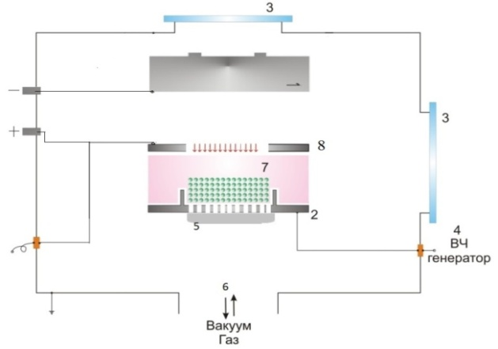

APPENDIX B
Principle scheme of a magnetron sputtering setup with an aggregation chamber

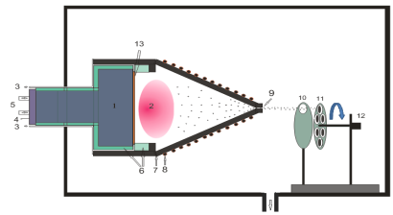

APPENDIX C
Principle scheme of an experimental setup with a double single-wire cathode,
manufactured to produce nanocomposite carbon-metal films

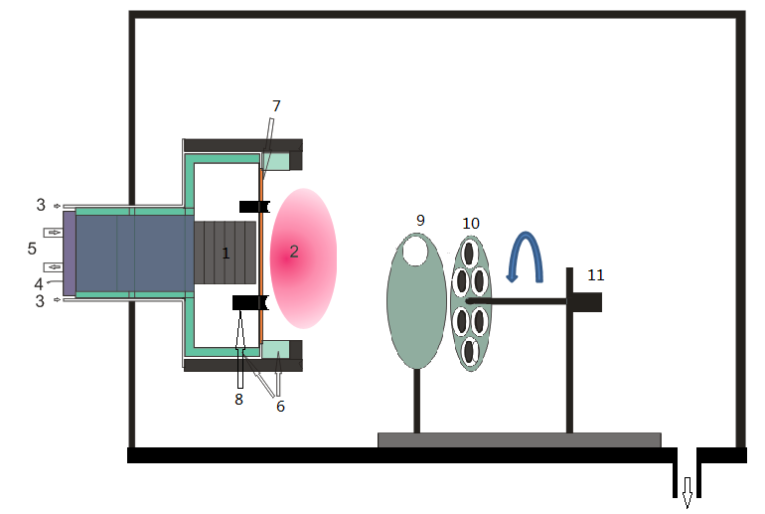

APPENDIX D
Principle scheme of an experimental setup with a double two-contact cathode manufactured to produce nanocomposite carbon-metal films (sandwich)

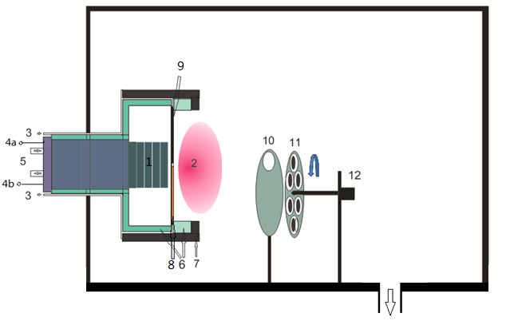

APPENDIX E
Principle scheme of an experimental setup NanoChip

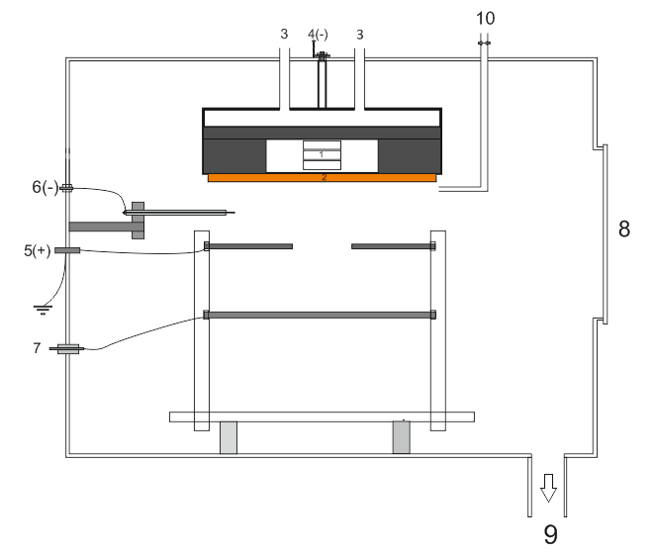

APPENDIX F
Principle scheme of an experimental setup
manufactured to produce nanocomposite carbon-metal films

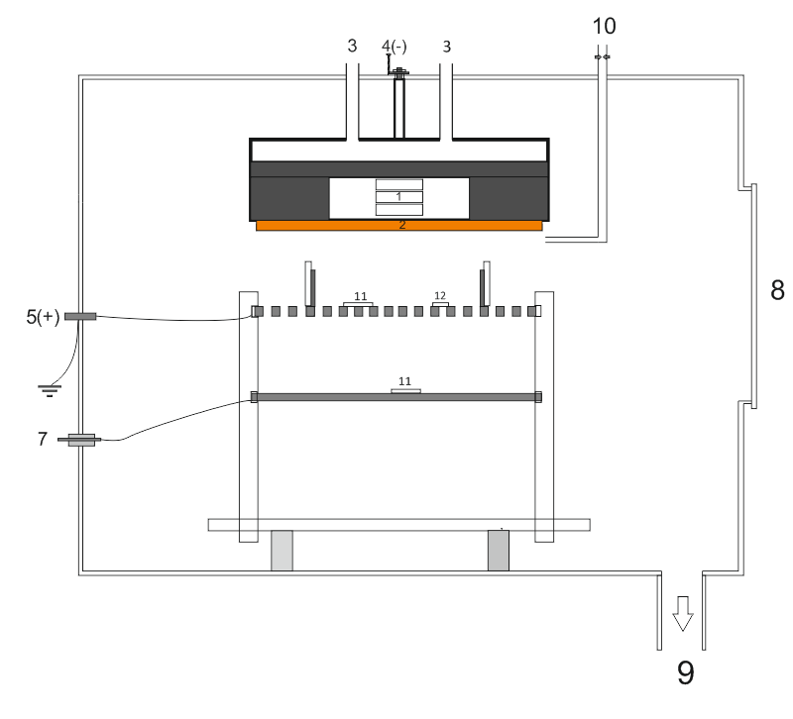

APPENDIX G
Calendar Work Plan for 2018-2020 (in English)

Appendix 1.6
to the Agreement №___ from _______ 2018.
for grant financing

TECHNICAL SPECIFICATION AND CALENDAR WORK PLAN
Under contract No 159 of 15 March 2018
- Name of performer
Subsidiary state enterprise on the right of economic management « National Nanotechnology laboratory of open type»
Republican state enterprise on the right of economic management «al-Farabi Kazakh national university» MES RK

1.1 By priority: Rational use of natural resources, including water, geology, recycling, new materials and technologies, safe products and structures.
1.2 By sub-priority: Nanomaterials and nanotechnology.
1.3 Project subject: AP05134391 "Obtaining and modification of nanostructured composite carbon particles and films with metals in low-temperature complex plasma".
1.4 Total amount of the project 27180000 (twenty-seven million one hundred eighty thousand) tenge, including with breakdown by years, for performance of works according to point 3:
- for 2018 - in the amount of 9000000 (nine million) tenge;
- for 2019 - in the amount of 9081000 (nine million eighty-one thousand) tenge;
- for 2020 - in the amount of 9099000 (nine million ninety-nine thousand) tenge.
2. Characteristics of scientific and technical products by qualification characteristics and economic indicators
2.1 Direction of work: Design and development of scientific and technical foundations for obtaining new nanostructured composite particles and films with required properties.
2.2 Field of application: Nanotechnology and nanomaterials; creation of new structural materials.
2.3 The end result:
- 2018: Modified magnetron sprayer and RF plasma chamber.
- 2019: Electrical and probe characteristics of complex low-temperature plasma of NanoChip installation.
- 2020: Results of optical (profilometer), electronic, tunnel and atomic force microscopy of metal-carbon nanocomposite particles and films.
2.4 Patentability: patentable.
2.5 Scientific and technical level (novelty): Researches on synthesis of nanostructured composite metal-carbon particles with required physical and mechanical properties in the environment of complex plasma of combined high-frequency and magnetron discharge.
2.6 The use of scientific and technical products is carried out by: The Performer.
2.7 Type of use of the results of scientific and (or) scientific and technical activities: The results obtained will form the basis for new innovative technologies and can be applied in the field of nanotechnology and chemistry as catalysts.
3. Name of works, terms of their realization and results

Task code, stages | Name of tasks under the Agreement and main stages of its implementation | Deadline |  | Expected results
Task code, stages |  | Start | End | Expected results
1 | Calculation, adjustment of separate assemblies and blocks, modification and assembly of experimental unit for obtaining nanostructured composite particles and carbon films with metals in complex low-temperature plasma. Determination of optimal operation modes of the experimental unit | January  2018 | November  2018 | The calculation, adjustment of separate assemblies and blocks, modification and assembly of the experimental unit for obtaining nanostructured composite particles and carbon films with metals in complex low-temperature plasma will be performed. Modification of separate parts of experimental unit. The optimal operating modes of the experimental unit will be determined. Experimental sample of nanostructured carbon films with metals.

1.1 | Calculation and adjustment of separate units and blocks of the experimental installation. Results of work to determine technical and operational indicators of the installation | January  2018 | March  2018 | The calculation, adjustment of separate units and blocks of the experimental installation will be made. There will be given the results of work to determine the technical and operational performance of the installation. Magnetron sputtering and RF plasma chamber will be modified and assembled.
1.2 | Optimization of operation modes of experimental unit for obtaining and modification of nanostructured composite particles and carbon films with metals in complex low-temperature plasma | March  2018 | July  2018 | There will be optimization of operation modes of experimental unit for obtaining and modification of nanostructured composite particles and carbon films with metals in complex low-temperature plasma. Dependence of parameters of nanocomposite films and carbon particles with metals on the main experimental conditions (discharge capacity, plasma gas composition, pressure in the working chamber, medium temperature, etc.).
1.3 | Production of prototypes of nanostructured composite (sandwich) carbon films with metals | June 2018 | October  2018 | Pilot samples of nanostructured composite (sandwich) films of carbon with metals will be obtained.
1.4 | Production of prototypes of nanostructured metal particles with carbon coatings | August  2018 г. | November  2018 | Prototypes of nanostructured metal particles with carbon coatings will be obtained. A prototype of metal nanoparticles with carbon coatings.
2 | Study of electrical and optical characteristics of combined discharge plasma and obtaining laboratory samples of nanostructured composite particles and films with required physical and mechanical properties | March  2019 | November  2019 | Electrical and optical characteristics of combined discharge plasma will be investigated and laboratory samples of nanostructured composite particles and films with required physical and mechanical properties will be obtained. Electrical and optical characteristics of complex plasma. Laboratory samples of metal-carbon nanocomposites sandwich with required physical and mechanical properties.
2.1 | Contact diagnostics of complex low-temperature plasma at NanoChip installation at growth of composite particles and films | January  2019 | April  2019 | There will be a contact diagnosis of complex low-temperature plasma at the NanoChip installation with the growth of composite particles and films. Electrical (I-V characteristics) and probe characteristics of complex low-temperature plasma at Nanochip unit.
2.2 | Investigation of optical and spectral characteristics of complex plasma at Nano-Chip installation at growth of composite particles and films | May  2019 | August  2019 | Optical and spectral characteristics of complex plasma at the NanoChip unit at growth of composite particles and films will be investigated. Optical and spectral characteristics of low-temperature plasma composition at NanoChip unit.
2.3 | Obtaining laboratory samples of nanostructured composite particles and films with required physical and mechanical properties | July  2019 | November  2019 | Laboratory samples of nanostructured composite particles and films with required physical and mechanical properties will be obtained.
3 | Synergetic analysis and investigation of mechanical properties of obtained samples of nanostructured composite particles and films of carbon with metals | January  2020 | November  2020 | A synergistic analysis will be carried out and the mechanical properties of the obtained samples of nanostructured particles and films of carbon with metals will be investigated. Results of the analysis of metal-carbon materials based on electron, tunnel and atomic force microscopy, X-ray structural analysis and Raman spectroscopy. Microhardness and I-V characteristic of laboratory samples of films. It is planned to file an application for a patent of the Republic of Kazakhstan for a method for producing metal-carbon nanocomposite materials in low-temperature plasma.
3.1 | Analysis of obtained samples of nanostructured composite particles and films based on optical (profilometer), electronic, tunneling and atomic force microscopy | January  2020 | April  2020 | An analysis of the obtained nanostructured composite particles and films will be given based on the optical (profilometer), electron, tunnel and atomic force microscopy. Results of optical (profilometer), electron, tunneling and atomic force microscopy of the obtained samples of metal-carbon composite particles and films.
3.2 | Investigation of mechanical (elasticity and microhardness) and electrical (I-V characteristics) characteristics of obtained samples of nanostructured composite carbon films with metals | March  2020 | August  2020 | The mechanical (elasticity and microhardness) and electrical (I-V characteristics) of the obtained samples of nanostructured composite films of carbon with metals will be investigated. Microhardness and I-V characteristics of the obtained samples of nanostructured composite films of carbon with metals.
3.3 | X-ray structure analysis and Raman spectroscopy of metal-carbon nanocomposite film samples | July  2020 | November  2020 | X-ray diffraction analysis and Raman spectroscopy of samples of films of metal-carbon nanocomposites will be investigated. X-ray structural analysis and Raman spectroscopy of composite films of carbon with metals. Presumably, several scientific articles will be published in peer-reviewed journals, 4 of them in domestic journals recommended by the CCES MES RK: "Bulletin of al-Farabi KazNU". Physical series, Bulletin NAS RK, etc., as well as 2 in foreign journals, such as: "International Journal of Nanotechnology" and "Acta Physica Polonica A".

APPENDIX H
Calendar Work Plan for 2018-2020 (original version)
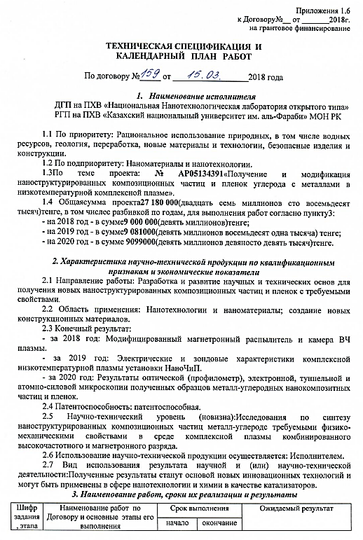

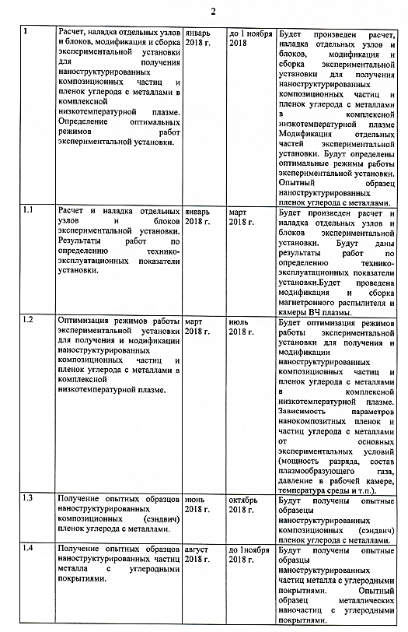

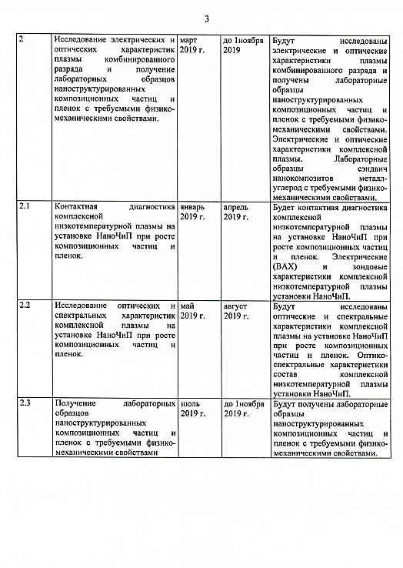

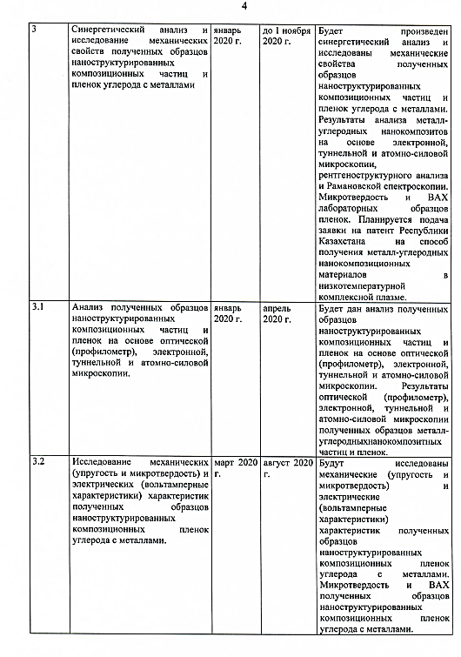

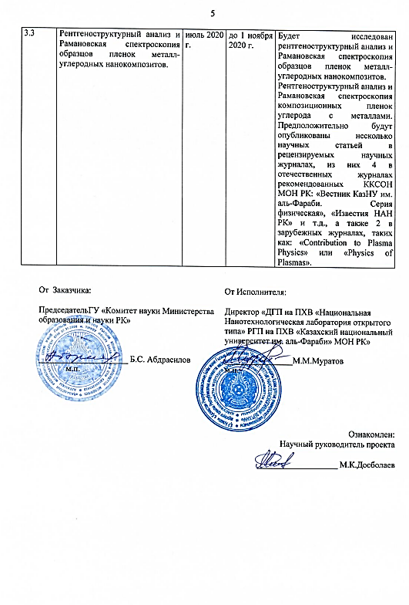
APPENDIX J
List of published works for 2018-2020

List of published works for 2018
- Slamia M., Zhumadilov R., Dosbolayev M.K., Ertaev O.A., Ramazanov T.S.. Growing of copper nanoparticles by modified magnetron spattering method // KazNU Bulletin, physics series. – 2018. – № 4. – Vol. 67. – P. 57-63. (in Kazakh)
- Yerlanuly Ye., Batryshev D.G., Ramazanov T.S., Gabdullin M.T., Ahmetzhanov N.E., Ahanova N.E., Omirzhanov O. Effect of plasma parameters on the synthesis of carbon nanomaterials by the pecvd method // Of the National Academy of Sciences of the RK, physic and mathematical series. – 2018. – Vol. 3. – N319. – P. 14-22.
- Slamia M., Saidibek E., Ertaev O.A., Kambarov A., Dosbolayev M.K. Obtaining of nanostructured composite particles and films by complex plasma magnetron sputtering // Journal of issues of evolution of open systems. – 2018. – № 20. – Vol. 2. – P. 21-28. (in Kazakh)
- Abdirakhmanov A.R. Influence of cathode sputtering on the parameters of a gas discharge // International Scientific Conference of Students and Young Scientists «Farabi Alemi». Book of Abstract. – 2018. – P. 240. (in Russian)
- Dosbolayev M.K., Abdirakhmanov A.R., Ramazanov T.S. Influence of the cathode sputtering on gas discharge parameters // 24th Europhysics Conference on Atomic and Molecular Physics of Ionized Gases (ESCAMPIG) Proceedings. – 2018. – P. 30-31.
- Slamia M., Ertaev O.A., Utegenov A.U. Obtaining of nanocomposite carbon metal films in low-temperature complex plasma // International Scientific Conference of Students and Young Scientists «Farabi Alemi». Book of Abstract. – 2018. – P. 268. (in Kazakh)
- Zhumadilov R.E., Zhunisbekov A.T. Obtaining of copper nanoparticles in the plasma of a combined RF + DC discharge // International Scientific Conference of Students and Young Scientists «Farabi Alemi». Book of Abstract. – 2018. – P. 254. (in Russian)
List of published works for 2019
- Dosbolayev M.K., Raiymkhanov Z., Tazhen A.B. and Ramazanov T.S. Impulse Plasma Deposition of Carbon Nanoparticles // ACTA PHYSICA POLONICA A. –2019. –Vol.136. –P.348-350. (IF - 0.579, quartile Web of science - Q4, percentile Scopus - 50%).
- Zhumadilov R.E., Dosbolayev M.K., Slamia M. and Ramazanov T.S. Obtaining of composite metal-carbon nanoparticles in complex plasma // Int. J. Nanotechnol. – 2019. – Vol. 16. – N. 6/7/8/9/10. – P. 613-618. (IF - 0.532, quartile Web of science - Q4, percentile Scopus - 87%).
- Dosbolayev M.K., Abdirakhmanov A.R., Ramazanov T.S. The role of cathode sputtering in low-pressure glow discharge // XXXIV ICPIG & ICRP-10, Sapporo, Japan. Book of Abstracts – 2019. – PO18PM-010.
- Zhumadilov R.E., Slamia M., Dosbolayev M.K., Ramazanov T.S. Obtaining nanostructured composite particles and films of carbon with metals in complex plasma // Book of Abstracts of the X Annual Conference of the Nanotechnological Society of Russia. – 2019. – P.26-28. (in Russian)
- Zhumadilov R.E. Obtaining of composite metal-carbon nanoparticles in a magnetron discharge plasma in an AR/CH4 gas medium // International Scientific Conference of Students and Young Scientists «Farabi Alemi». Book of Abstract. – 2019. – P. 376. (in Russian)
- Slamia M., Zhumadilov R.E. Growing of copper nanoparticles by modified magnetron sputtering method // International Scientific Conference of Students and Young Scientists «Farabi Alemi». Book of Abstract. – 2019. – P. 389. (in Kazakh)
- Tuimebek K.A., Abdirakhmanov A.R. Influence of cathode spattering process on weak discharge parameters // International Scientific Conference of Students and Young Scientists «Farabi Alemi». Book of Abstract. – 2019. – Б. 396. (in Kazakh)

List of published works for 2020
- R. Zhumadilov, M. Slamyiya, M. Dosbolayev, T. Ramazanov. Obtaining of composite metal-carbon nanoparticles by magnetron sputtering // Materials Today: Proceedings – 2020. – Vol. 31. – P. 464–468. (percentile Scopus - 39%).
- Zhunisbekov A.T., Zhumadilov R.E., Orazbaev S.A., Alisherov N., Gabdullin M.T., Ibrashev K.N., Үsenkhan S.S. Obtaining a hydrophobic surface in atmospheric pressure plasma // KazNRTU Bulletin, physical and mathematical sciences. – 2020. – Vol. 1. – № 137. – P. 584-589. (in Russian)
- Dosbolaev M.K., Tazhen A.B., Ramazanov T.S. RK patent application for utility model « A method for producing metal-carbon composite nanoparticles and films in complex plasma and a device for its implementation». № 2020/0968.2. (in Russian)

