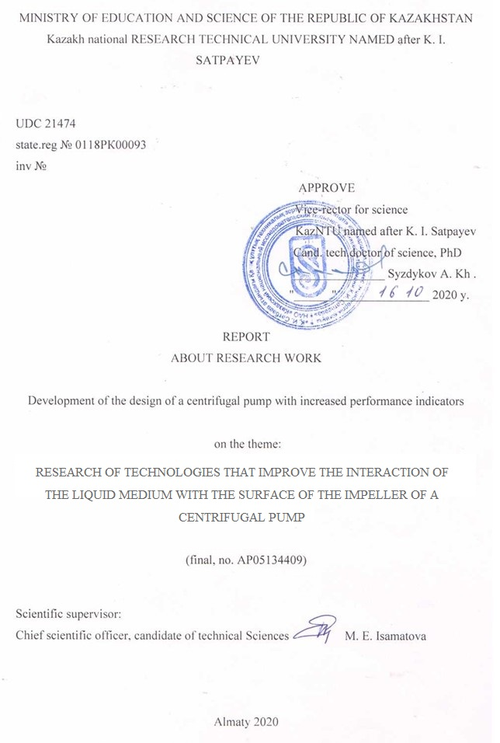
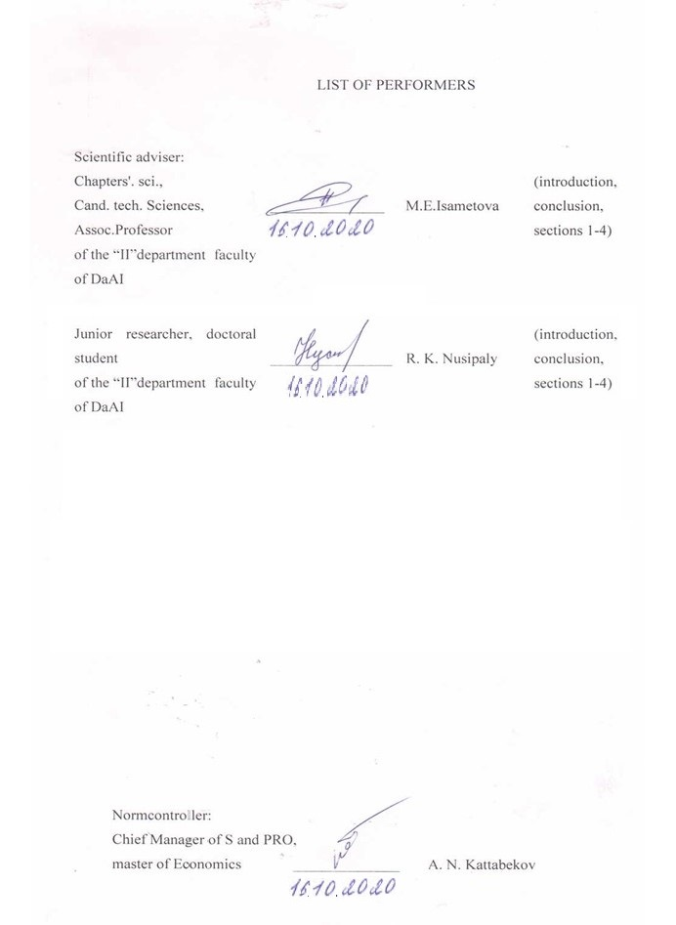

REPORT

The report contains: 165 pages, 27 figures, 7 tables, 31 bibliographic sources, 8 appendices.
the centrifugal pumP, hydrophobization Technologies, impeller, durability, efficiency, Assembly, Testing
Object of research or development: impeller and rotor of a centrifugal pump of the «ODDESSE zentralasien» brand- UPP 13 – 7 / 6.
Purpose of the work: To develop a methodology for the design of a centrifugal pump with increased performance indicators, such as: efficiency, durability of the main machine units, reliability.
Method and methodology of conducting the work: analysis of existing theories of the interaction of liquids with surfaces of the centrifugal impeller and the impact of the contact angle of smachivaemogoti on the hydraulic efficiency of the pump, the engineering analysis of the strength of the impeller, made of polymer material in NASTRAN/PATRAN and selection of sectional drives for sufficient strength impellers for industrial test, comparing the parameters of surface roughness after 3D printing technology, FDM and SLA for setting up a double centrifugal wheel , working in real conditions of pressure and flow.
Work results:
- the training manual "Designing hydraulic machines in the Nastran/PATRAN integrated environment" was written and sent to the printing house;
- the analysis of technological processes of hydrophobization used at modern pumping enterprises was carried out;
- As a result of the analysis, it was revealed: as a type of modification - for pumps of the "KM" type, a modification based on a surfactant, and for pumps of the "CM" type - on the basis of fluoroplastic; the limiting realizable contact angle of wettability for surfactants is 135 °, for fluoroplastic - 150 °; for the SIC method - 130 °, modernization in order to increase energy efficiency, the increase in efficiency for medium-speed pumps with surfactant surfaces will lead to an increase in the efficiency of about 1.3%, when applying a fluoroplastic coating 2%, when applying SIC 1.7%;;
- based on the results of research of existing technologies to improve the interaction of the flow with the impeller surface, a technology for applying a fluoroplastic coating was proposed;
- based on the results of the study, the design of an automated line for applying a fluoroplastic coating to the centrifugal impeller of the pump was proposed;
- verification calculations of polymer impellers with a disc thickness of 2 mm were performed in the NASTRAN environment, the stress level of 118 MPA in cross-sections from operating loads was determined, these results allow to conduct industrial tests on polymer wheels with a disc thickness of 2 mm;
- printed impellers with spatial blades by SLA technology for pump assembly;
- the parameters of 3D printing of the first prototypes of impellers with spatial blades using the SLA technology were selected: printing along the X and Y axes, depending on the diameter of the extruder nozzle - 0.6 mm; printing along the vertical Z axis (layer thickness) - 0.2 mm; printing speed mm / s - 35 mm / s; extruder temperature - 220 ° C; heating table temperature - 60 ° C, position 450;
- the possibilities of replacing metal impellers with polymer ones have been studied;
- developed technology for assembling a pump with polymer impellers;
- completed a set of design documentation in the amount of 12 drawings of 2D format and geometric 3D models - tested on the industrial stand of the plant in order to determine the hydrodynamic characteristics, the test results show an increase in efficiency by 2%;
- based on the research results, the article "Determination of the rational number of blades of the centrifugal wheel of a submersible pump" was published in the Eastern-European Journal of Enterprise Technologies ISSN 1729-3774 №2 / 7 (104) 2020 49 p., indexed in the Scopus database (51% percentile);
- the study resulted in the publication of an article “Computer simulation and investigation vibration parameters of a centrifugal submersible” in the Journal of Vibroengineering, vol. 22, no. 5, pp. 993-1005, Aug. 2020.https: //doi.org/10.21595/jve.2020.21014 (SCOPUS)..
The scientific novelty lies in the development of a method for rapid prototyping of working bodies of a centrifugal submersible pump made of polymer materials for industrial testing.
Degree of implementation. It is proposed to introduce a method of rapid prototyping through 3D printing and the creation of a digital twin of the main impeller of a centrifugal pump, which will reduce the economic costs of the plant for carrying out full-scale tests and will allow predicting the price of new products. At the third stage of 2020 the PUMP software module was introduced into production for the automated design of the channel geometry and the curvature of the centrifugal impeller blade, and the CAD/CAE/CAM method of computer design of centrifugal pump assemblies was also introduced into the production of the «KARLSKRONA LC AB» plant..
Scope: The results obtained will influence the development of the science of hydraulics, the science of designing machines for pumping liquid media, the development of the design of computer-aided design systems used in the development of designs of machines with paddle wheels, the method of parametric design and optimization of paddle wheels.
Recommendations for the implementation or the results of the implementation of research results: the automated PUMP module was introduced into production, computer-aided design techniques were also introduced using the NASTRAN integrated environment to carry out verification and design calculations of centrifugal pump units. It is also recommended to introduce the technology of rapid prototyping of centrifugal wheels for industrial tests and further development of the design.
Cost-effectiveness or relevance of the work: at present, high power submersible pumps are widely used for pumping liquid media from wells. In order to expand the capabilities of downhole pumps, the implementation of 3D printing technology of the main parts and components of the pump, as well as the use of hydrophobic coatings of the inner cavity of the pump, is used. Thereby reducing mechanical and electrical losses, increasing the service life and production volume. The probability of achieving an economic effect in this case is close to 100 %, i.e. an increase in the power coefficients. The average service life of the pump increases.
Forecast proposals for the development of the research object
The use of high-strength polymer for the manufacture of centrifugal impellers is a promising direction in pump engineering and may be the topic of further research.

Content

DEFINITIONS, SYMBOLS AND ABBREVIATIONS............................................................ | 8
Introduction...................................................................................................................... | 9
1 Design of the main units of a centrifugal pump with the development of an automated module for the parametric creation of the geometry of the main impeller..... | 16
- Jurisprudence systematic study of existing analogues centrifugal pumps..................... | 16
- Analytical determination of the main geometric parameters of the impeller...……….. | 16
1.3 Static calculation and selection of cross-sections of the nodes of the projected CP….. | 17
1.4 Rotary dynamics research.......................................................................................... | 17
2 CAD / CAE / CAM end-to-end design and optimization of the impeller geometry of a centrifugal submersible pump with increased performance...................... | 20
- Conducting a systematic study of optimization methods and methods for constructing impellers of centrifugal analogs of CP…………………………...................... | 20
2.2 Calculation of the stress-strain state and analysis of the influence of the number of wheel blades on the vibration activity of the rotor of the designed impeller….............. | 21
3 Analysis of means of hydrophobization of flow channels of a centrifugal wheel ... | 25
3.1 Analysis of means of hydrophobization of flow channels of a centrifugal impeller...................................................................................................................................... | 25
3.2 Using fluoropolymer to create hydrophobic coatings on the surfaces of the flow part of centrifugal pumps…………………………………………….................................... | 27
4 Investigation of the prospects for the use of polymer wheels in centrifugal pumps…………………………………………………………………………….………….. | 33
4.1 Checking the strength of the CN impeller made of polymer material…….......................... | 33
- Pump Assembly and carrying out industrial tests..................................................... | 36
- 4.3 Test conditions………………………………….......................................................... | 38
Conclusion.......................................................................................................................... | 40
List of References............................................................................................................ | 42
Appendix A list of published works....................................................................................... | 45
Appendix B Calendar plan...................................................................................................... | 47
Appendix C Registration card................................................................................................ | 52
Appendix D Extract from the minutes of the Academic Council......................................... | 54
Appendix F Article imprint.......................................... | 55
Appendix Е Tables and figures from the Chapter 1............................................................. | 147
Appendix G. Images from Chapter 2................................................................................... | 151
Appendix Z Drawings.......................................................................................................... | 154

DEFINITIONS, SYMBOLS AND ABBREVIATIONS

In this research work report, the following terms are used with appropriate definitions:
Efficiency - the efficiency factor.
MCP - multi-stage centrifugal pump;
P - the density of the pumped medium;
P_{axial} - axial force;
CAD – computer added designed;
CAE - computer added engineering;
CAM - computer added manufacturing;
F_{R} - radial force;
H - pressure.
SC - surfactant coatings
SIC - surfactant inhibitor coatings

INTRODUCTION

Assessment of the current state of the scientific and technical problem being solved. The development of energy saving determines the importance of improving the efficiency of equipment that uses most of the energy consumed. Pumping equipment is one of the most significant consumers of electrical energy. Thus, the drive of pumps (mainly centrifugal) at some CHPPs consumes up to 10% of the total energy generated at the station [1]. In general, the total share of consumption of pumping equipment operating in industry, according to various estimates, is from 15 to 25% of all generated electricity. Currently, more and more stringent requirements are imposed on the operational reliability of pumping equipment, which can determine the reliability of the entire technological cycle in which it is used, which is especially important at large power facilities. [2]. Thus, the first way to reduce the energy consumption for the pump drive, which is important for the considered case, is to expand the effective working area of the pump.
Volumetric efficiency is determined by the amount of fluid leaks through the impeller throat seals, which depend on the size of the clearances of these seals and on the nature of the interaction of the fluid with the solid surfaces of the clearances and behind the disk cavities formed by the impeller and the pump casing. Mechanical efficiency is primarily determined by disc losses due to fluid friction against the outer surfaces of the impeller discs and the inner surfaces of the pump casing. They depend on the amount of fluid leaks through the disc sinuses and on the nature of the hydrodynamic interaction of the fluid with the corresponding solid surfaces. [3]
The hydraulic efficiency is determined by the losses of the hydrodynamic head in the flow path of the pump, which are made up of the following main components:
- impact losses when the liquid flow enters the impeller;
- losses due to hydraulic friction when the fluid flow interacts with the walls of the inter-blade channels;
- vortex losses associated with the circulation and expansion of the liquid in the inter-blade diffuser channels;
- losses in the diffuser behind the impeller.
Thus, all losses in the pump are determined either by the geometry of the impeller or by the nature of the interaction of the fluid flow with the solid surfaces of the flow path.
The nature of the interaction of a fluid flow with solid surfaces is determined by the hydrodynamic properties of these surfaces, the properties of the fluid (density and viscosity), velocity and pulsation characteristics at the outer boundary of the boundary layer, as well as the pressure gradient along the streamlined solid surface. Moreover, the last two factors, in turn, depend on the geometry of the flow path of the pump [4]. Today, there are two main ways to solve the problem of increasing reliability and efficiency: the development and manufacture of new pumps, more advanced than the previous generation, or the modernization of existing equipment. The second way - the modernization of functioning pumps - makes it possible for a relatively quick and low-cost set of measures to increase the efficiency and reliability of pumping equipment.
Thus, the following three directions of increasing the pump efficiency can be distinguished:
- improving the geometry of the flow path of the pump in order to reduce vortex losses, which are especially large at low pump flows;
- changing the properties (modification) of solid surfaces interacting with the pumped liquid;
- reduction of vibration of the rotor-wheel system
Thus, up to 10% of the electricity generated at CHPPs is spent on the operation of pumping units. In the cost of operating costs for servicing pumps, payment for electricity for the drive is up to 85%. Moreover, over time, the energy consumption of the considered units grows due to the increasing wear of the elements of the pumping unit associated with the nature of the pumped medium, operation in a non-design mode, as well as the conditions of repair and subsequent operation. In addition, additional, negative effects are manifested - an increase in noise and vibration over time. Along with the development and creation of new, more advanced centrifugal pumps, the direction associated with their modernization is relevant. Moreover, modernization can be implemented both by replacing pump elements (assemblies), and by based on imparting new properties to the elements of pumping units [5]. The basis for increasing the efficiency of centrifugal pumps is the improvement of the hydrodynamic properties of the flow path, which in turn reduces losses in the transfer of mechanical energy to the working stream. Of considerable interest to operating organizations are modifications that change the hydrodynamic interaction of the surfaces of the flow path elements and the working flow without changing the pump design. The implementation of this approach is possible on the basis of changes in the properties of the functional surfaces of centrifugal pumps with structured coatings that reduce losses.
Selection of means of hydrophobization of flow channels. As a structured coating, it is promising to use surfactants (surfactants) and fluoropolymers, which create hydrophobic effects, which reduce losses and provide surface protection from corrosion processes, while simultaneously increasing operational reliability. Many centrifugal pumps operate under conditions of rapid wear of the flow path elements by abrasive particles contained in the pumped liquid. Protecting the surface of these pumps can significantly extend their life. At present, in the production and modernization of operating pumps, various coatings are used to increase the resistance of the surfaces of the flow path to abrasive wear. Basically, these are coatings based on ceramics and polymer materials [6, 7]. Ceramic-based coatings [8, 9] provide an increase in the service life of centrifugal pumps when applied to various structural elements (RC and other elements of the flow path, floating seal rings), the most loaded and exposed to aggressive media, abrasive and erosive wear. Lining of the surface with various elastomeric materials (rubbers and rubbers based on them) is also used [10, 11]. Various types of such coatings also make it possible to increase the surface resistance to erosive wear, which is extremely active in cavitation conditions, to provide protection against corrosion and to increase resistance to aggressive chemical agents [12].
Currently, in order to increase the service life of the manufactured equipment, pump manufacturers use thermal gas coatings [13]. In addition, coatings based on tungsten carbide, applied by a high-speed gas-thermal method, are used, which have high wear resistance, low friction coefficient, high corrosion resistance (including in aggressive media), show high performance under conditions of hydroabrasive wear, and are also characterized by the absence of sparking. When modernizing operating pumping equipment, in addition, coatings are often used that can provide partial restoration of the geometry of the flow path elements. These are mainly coatings based on polymer materials. Therefore, the selection of hydrophobic means that improve the flow kinematics is an urgent task, the solution of which will lead to an increase in the overall pump efficiency.
Another way to increase the indicators of energy saving and efficiency of centrifugal pump wheels is to make them from wear-resistant thermoplastic plastics with a finite isotropic structure - low-pressure polyethylene, polycarbonate, glass-filled nylon, etc. The closed design of the pump wheels predetermines the technological complexity of their manufacture from materials similar to those mentioned.
In foreign and domestic pump engineering, research is continuing to find the optimal process flow diagrams for manufacturing parts from polymers that meet the necessary technical and economic requirements. The main methods of processing plastic products include pressing, injection molding, extrusion, vacuum forming, blowing, stamping. In some cases, mechanical processing from blocks of material is also used. The use of polymer compositions for the manufacture of impellers of centrifugal pumps is associated with significant technological difficulties [12]. So, all metals are characterized by a high coefficient of friction and inability to dry friction, and powder compositions exhibit insufficient resistance to cavitation. In addition, ESP working bodies made of metals are also characterized by a large mass due to the high density of the material.
For example, «ИНЖНЕФТЕПЛАСТ» company used carbon composites for the production of centrifugal pump parts, these materials are distinguished by unique corrosion and chemical resistance (1-14 pH), low specific density (less than 2 g/cm3), can have high operating heat resistance (above 250°C) and maintain strength properties at high temperatures. The latter fundamentally distinguishes them from conventional polymer compounds. The USA has experience in the manufacture of pumping equipment from carbon materials. However, the high cost of such equipment limits their use, and, in general, they are used for special tasks, in particular, for purposes related to military needs, and in the chemical and nuclear industries, where their thermal and chemical resistance is in maximum demand. MIM-technologies are based on injection molding of parts from various metal and ceramic powders. In Russia, there is experience in the manufacture and implementation of pumps with working bodies both from metal powder and from ceramic powders. However, their entry to the mass market is also hindered by the high cost and instability of some types of oxide ceramics in environments containing water. At the same time, the main goals were to give the product the following characteristics: heat resistance within 250-300 ° C, chemical resistance, surface hydrophobicity (low ability to deposit salts, the angle of edge wetting with water and salt solutions exceeds 90°), abrasion resistance and the possibility of long-term operation under conditions dry friction. In addition, it was necessary to maintain an acceptable cost of the product. The problem for this company was the situation with the vagueness of technical requirements for the physical and mechanical properties of products during operation, ensuring the implementation of the principle "necessary/sufficient". That is, the spectrum of properties that you need to focus on. [14]. Considering the above, it can be concluded that improving the pump's energy performance by upgrading the impeller with hydrophobicity or replacing it with a polymer wheel is a promising topic for further research.
Basis and initial data for the development of the theme. In the conditions of modern economic relations, there is a need to increase the efficiency of using the products of machine-building production with the use of the latest technologies on a large scale. One of the important aspects in solving this problem is to improve the quality of products by domestic manufacturers, which will lead to the state entering the world machine-building market to a leading position. This is easy to achieve if the manufacturer will conduct in-depth scientific research on the direction of its activities and introduce the latest technologies into the production process.
One of these domestic manufacturers is a young but rapidly developing enterprise in Kazakhstan - the machine-building plant "KARLSKRONA LC AB" LLP, working in the field of solutions for the management of fluid flows in the field of water supply, water treatment, heating, sewerage, as well as various technological processes based on modern equipment and advanced Kazakhstani technologies. The plant is an authorized dealer and service partner of such leading world manufacturers of pumping equipment as Oddesse (Germany), Sulzer (Finland), Grundfos (Denmark), and realizing the importance and prospects of development of the domestic industry, in 2011 launched a production enterprise in the city of Shymkent, where the production of pumping stations, submersible pumps, as well as control cabinets for them, using the automatics of ABB, Mitsubishi is carried out. All products manufactured and supplied by the company have certificates of conformity, submersible pumps and control cabinets are goods of Kazakhstan origin and have ST-KZ certificates.
Justification of the need for research. Currently, high power submersible pumps are widely used for pumping liquid media from wells.
Modern global trends in research and development of pumps and pumping equipment are based on the following technological principles:
- high energy efficiency;
- maximum compactness of installations and convenience during the subsequent operation of the equipment;
- automated control over the activity of pumping units with the possibility of remote control;
- compliance with accepted environmental safety standards;
- constant updating of the assortment;
- ease of installation and subsequent maintenance.
This approach ensures the high quality of the units and the ability to choose the equipment that best suits the customer's requirements. The modern pumping equipment market is represented by a variety of configuration options for various production. For connoisseurs of domestic quality and a demanding approach to every detail, the products of domestic leaders in the production of pumps are suitable: the group of companies «ГМС Ливгидромаш» JSC, «Джилекс» and «Насосы Ампика» companies. We also have European, Asian and American pump manufacturers with a long history of successful work, such as Pedrollo, Tapflo, Finish Thompson, Value, Grundfos and many others.
It can be stated that unfortunately the hydraulic test readings of the pump brand, UPP 18 – 11 / 6 at the stand of the plant "KARLSKRONA LC AB" shows the overall efficiency of the pump 40.25 %, while the test rate of a similar pump of German production is 58 %. This work is aimed at designing and optimizing the design of the UPP brand pump 18 – 11 / 6 to increase energy and strength indicators.
Information about the planned scientific and technical level of development. The results of scientific research carried out within the framework of the project will be published in foreign publications with a non-zero impact factor of at least 2 (two) scientific publications, within the framework of the project for the entire research period, as well as in an international journal on Mechanical Engineering and others. Materials of the book "Проектирования центробежных машин в системе NASTRAN" will be sent to the publishing house "Ғылым" for publication.
Information about the metrological support of research work. The tasks were solved based on the analysis of experimental data. The use of mathematical models makes it possible to conduct a process of multivariate design with an assessment of the pump's qualities and the choice of the optimal option at the design stage, which makes it possible to reduce the amount of work on finishing pumps at experimental stands. Currently, quasi-three-dimensional methods have proved to be effective for assessing flow and losses in vane pump systems, which require little time to implement, compared to three-dimensional methods, and which give satisfactory results in practice. Reducing the time and improving the quality of pump design is possible with the use of computer-aided design (CAD) systems, which are based on mathematical models (MM) for calculating the flow, losses and predicting the characteristics of the central pump. Modern techniques and capabilities of computer-aided design systems make it possible to optimize the structure by force factors, by the mass of the structure, by the flow rate of the liquid medium. Research on rotor dynamics will be based on the fundamental principles of vibration theory. Until recently, the provision of vibration reliability of the blade apparatus was mainly due to the improvement of calculation and experimental methods, the determination of natural frequencies in order to detune from dangerous resonances, as well as by specifying the permissible static stresses.
Research and development work will be carried out at the KazNRTU named after K.I.Satpayev, which for this has a technical base equipped with modern equipment, for example, an accredited computing cluster with a peak performance of 34.6 TFLOPS, registration certificate KZ.T.02.1333, 3D printer "Dimension Elite », Test bench for the pumping equipment of the Oddesse Company.
Relevance. Scientific and technological needs are expressed in the need to create recommendations for creating a design of a centrifugal pump with increased performance will affect the improvement of assembly and processing technologies for the main units of pumping equipment, which will lead to an increase in the pump pressure characteristic, to a decrease in power consumption, an increase in pump efficiency, and will increase competitiveness domestic pumps.
The results obtained will affect the development of the science of hydraulics, the science of designing machines for pumping liquid media, the development of the design of computer-aided design systems used in the development of designs of machines with impeller wheels on the method of parametric design and optimization of impeller wheels.
Scientific novelty. When developing the design of a centrifugal pump with increased performance indicators, a multi-stage centrifugal pump produced in Kazakhstan at «KARLSKRONA LC AB» LLP will be used as a prototype, machine parts and assemblies will be optimized in terms of kinematic power and energy indicators, as a result of which parts with new geometry, as well as sealing elements with increased sealing properties.
Preliminary stages of research: 0218RK00829, AP05134409-OT-18 "Design of the main components of the centrifugal pump with the development of an automated module for parametric creation of the main wheel geometry." 0219РК00410 AP05134409-OT-19 CАD/ /CAE/CAM end-to-end design and optimization of the geometry of the impeller of a centrifugal submersible pump with increased performance
The aim of the stage. Selection of means of hydrophobization of a centrifugal wheel, assembly of a pump with polymer wheel prototypes and industrial tests to determine the efficiency of the designed pump.
Tasks of the stage. Research of existing methods of hydrophobization, selection of modern equipment for the technological process of applying hydrophobic coatings. Investigation of the possibility of conducting industrial tests with wheels made by sterolithography technology, carrying out the strength calculation of a centrifugal wheel made of liquid polymer, printing impellers using SLA technology. Technology design and assembly of a UPP 18 - 11/6 pump with polymer wheels. Industrial testing.
Solving these problems will improve the interaction of the elements of the flow path of centrifugal pumps and the working medium, thereby increasing the energy efficiency of the pump by increasing the hydraulic efficiency, using the model of the digital twin of the centrifugal impeller for testing the pump, using the developed technology to assemble multistage centrifugal pumps with polymer impellers.
1 Design of the main nodes of the centrifugal pump with development of the automated module on parametrical creation of geometry of the main wheel

1.1 Law of systematic study of existing CP analogues

As a result of the planned work at the first stage, the terms of reference for the design of the pump design with increased performance indicators should be drawn up.
When choosing the best option, you have to take into account various quality criteria, among which there are contradictory ones. Therefore, the task of designing the pump is multi-criterion. To solve this problem, in our project, in agreement with the partner plant KARLSKRONA, one criterion was chosen as the decisive efficiency. Based on the analysis (Table 1), the reference efficiency of 60% was taken. In table 1 appendix G the comparative analysis of the existing models is presented at the market of centrifugal pumps
According to the hydrodynamic tests carried out on the basis of the partner plant, the following results of the efficiency of serial models were obtained. Figure 1 and table 2 appendix G
When compiling the terms of reference, the parameters of the designed pump, such as the speed factor, and the permissible cavitation margin, were also determined. The terms of reference were drawn up
Submersible and downhole pump is designed for pumping of solution with sulphuric acid content for extraction of minerals by method of downhole underground leaching.
Composition of pumped solution:
1) water with sulfuric acid content - 40 g per 1 l.;
2) chlorine - 2 g per 1 l.;
3) fine impurities (sand) - 50 g per 1 m3
4) density - 1050 kg/m3
5) temperature - 20-40 ̊ С
Parameters of the pump are specified in table 3 Appendix G

1.2 Analytical determination of the main geometrical parameters of impeller

For analytical determination of centrifugal wheel geometry parameters, the methods of the authors Lomakin A.A., [15 11], Kuznetsov A.V., [16 13], Rzhebaev N.K. [17] were compared, we selected the method [17]
Initial data: Q=13m3/h giving; H =55 m pressures; N = 2850 rpm motor speed; iQ = 1-number of streams; iH = 7-number of stages.
To improve computational accuracy and as a consequence of the geometric parameters of the wheel, a module was compiled to calculate the geometry of the flow channel and the curvature of the blade in the Payton programming language
In figure 1 appendix G the module in console option and result of calculation of curvature is presented

1.3 Static calculation and selection of sections of the designed CP units

To select the optimal version of the pump design diagram for the specified parameters, optimization calculations were performed, according to the procedure given in the literature [18]
In the practice of designing pumps, centrifugal dimensions are most often set not on the basis of strength, but on the basis of design considerations and depending on technological capabilities. In addition, new pumps are usually designed on the basis of tested prototypes. Therefore, when designing, the main importance is the test calculation for the strength of the main elements of the pump design: shaft, impeller, housing, key or pin connection, coupling. [19].
The task of verification calculation is to determine the values of parameters with which, in each particular case, the loss of strength (destruction) of a particular element (normal or tangent stresses, deformations, rotation speed, etc.) is associated, followed by comparing them with some limit permissible values. Automated calculation of pump rotor shaft strength was performed in NASTRAN/PATRAN program. The preliminary stage for finite element calculation was the creation of an adequate calculation scheme and the preparation of input data. In figure 3 Appendix G charts of tension and movements of the bearing rotor wave of CN are submitted/
Analysis of the results showed a sufficient safety factor at maximum supply, according to the diagram σ_{max}==158 MPa, the allowable stress for steel 40Х [σ₋] = 680 MPa, the coefficient of safety factor was 4.3. In the form of recommendations, it can be said that the use of steel of grade 40Х leads to an increase in the cost of the pump, at such a level of stress in the sections of the shaft, it is possible to manufacture a shaft from steel with a lower strength value of Steel 10.

1.4 Rotor Dynamics Study

The reliability and life of the centrifugal pump is largely determined by its vibratory state. The technology for calculating the critical speed of the pump rotor is complex, and until now it is not possible to accurately determine it due to the impossibility of reliable prediction of coefficients that take into account the effect of all possible factors that affect the vibration state of the pump. [20].
At the present stage of the development of computer technologies, the problem of determining the intrinsic frequencies of rotor systems based on linear mathematical models is well defined in automatic mode, for these studies the Patran Module of the standardized DMAP procedure "Rotodynamics" included in the sequence of solving the dynamic problem MSC.Nastran was used. (in all versions since 2004). When choosing the calculation type, calculation of complex eigenvalues of SOL 107- direct method, Frequency diagram is obtained as a result of calculation of complex eigenvalues by direct method using ASYNC option, at rotor rotation frequencies 0, 900,1800,2700,3000 rpm. [20].
In figure 4 Appendix G one of forms of flexural fluctuations of the rotor is presented
Based on the frequency results, a Campbell diagram was constructed for zero and maximum feed Figure 5 Appendix G
Despite the fact that the oscillation tones of the second model are 20% lower than the models in zero feed, we can say that the machine operates relatively stably.
It is not possible to compensate for the instability of movement in the launch zone by changing the circuit structurally, for example, the use of a bearing at the lower end of the shaft, by successfully solving the problem of smooth entry of the machine into working mode - the use of a magnetic coupling.
Magnetic clutches for pumps allow the transfer of torque to the pump shaft from the electric motor using magnetic fields generated by permanent magnets instead of clamping devices. At the same time, there is no need to withdraw the shaft from the flow part of the pump to the drive device, which makes it possible to make the flow part in the form of a completely sealed system operating without leaks, with a smooth start, which are characteristic of pumps with mechanical shaft seals.
Brief conclusions on the results of R & D
On the basis of the pump pressure characteristics Q = 13 m³/h, H = 55 m, efficiency = 40% determined by the test of the pump of the brand "ODDESSE zentralasien" - UPP 13-7/6 and systematic studies of existing CP analogues, a priority efficiency indicator was chosen, the reference value is taken as 60%. The developed terms of reference for the development and design of the downhole multi-stage centrifugal pump unit made it possible to design the main units of the CP. On the basis of multivariable calculations of the energy and power indicators of the CP, a computer model of the design of the CP was built.
The strength calculations carried out indicate a sufficient strength margin factor σ_max = 286 MPA, the allowable stress for steel 40Х [σ_-]=680 MPA, the safety margin factor was 2, 37. The calculation for the durability of the rotary shaft showed a life margin of 1.7, which means that the shaft can operate safely until the uranium well is fully operational. Analysis of the results of the static calculation showed the possibility of replacing the material of the CP shaft with a less expensive one. Dynamic analysis of determining the critical rotor speeds by constructing a Campbell diagram showed instability of movement and vibration during the start-up of the CP. Certain frequencies of disturbed oscillations, critical speeds of rotation for the first forms of oscillations -366, 488.732 Hz are in the area of 47 Hz (2200 rpm) for reverse and direct precession, respectively. Additional damping elements in the form of magnetic coupling must be introduced to ensure steady input of CP into operating mode.
The created flowchart allowed to design the first console version of the automated module in the Python programming language for parametrical drawing of geometry of a centrifugal wheel, verification with analytical calculations yielded good results in respect of consistency with analytical results of d_{в}= 0.026 m, D₀ =0.047, D₁=0.41, D₂=0.21, b₁=0.03, b₂=0.02 m and showed good performance in calculations and saving of time for design of geometry of the CN driving wheel.

2 CAD/CAE/CAM end-to-end design and optimization of centrifugal submersible pump impeller geometry with improved performance

2.1 Systematic study of methods of optimization and methods of construction of impellers of centrifugal analogues of CP

At this stage of the study, methodologies for digital design and optimization of CP nodes were used. The work included the following steps: creating an automated module user interface for designing the geometric characteristics of the CN impeller in the MATLAB environment; Using CAD/CAE/CAM End-to-End Design to Create and Optimize Centrifugal Wheel Model, CAD Design in COMPASS engineering analysis of impeller strength, development of power scheme for analysis of vibration activity, dynamic calculations of forced oscillations of NASTRAN/PATRAN shaft-wheel system; determination of rotor life at complex stress state in NASTRAN/FATIGUE ESCS; 3D FDM printing of the first centrifugal wheel prototypes.
When designing a new design of CN impellers, graphoanalytic methods are widely used, when it is not possible to find a mathematical solution to this process, for example, the process of fluid flow movement in the pump, similarity theory is used. This theory allows you to model physical phenomena without solving or even compiling physical equations. Applying the similarity theory, it is possible to choose a model pump, the flow cavity of which is similar in its geometry to the cavity of the designed pump.
In designing the impeller, the NIR participants considered it more appropriate to use the design and analytical method, since it gives a more detailed picture of the distribution of meridian speeds, depending on the meridian profile of the wheel and the shape of the blade.
Based on the hydrodynamic calculation algorithm compiled at the first stage of 2018, an automated module and a user interface in the MATLAB program were developed.
At the stage of 2019, the automated module was supplemented with an algorithm for drawing the profile of the blade with determining its geometry through Cartesian coordinates, which are set as a function of the girth angle and wheel radius determined in cylindrical coordinates.
This created algorithm allows you to accurately draw the geometry of the designed blade in any CAD system, and in particular the drawings and wheel model were executed in the COMPASS program. Figure 6 appendix Z represents windows of the user interface of the automated module. On design data of the automated module the model of a centrifugal wheel with cylindrical blades figure 7 appendix Z was constructed
To optimize the geometry of the impeller, the cylindrical blades were replaced with double curvature blades. The blade of the double curvature impeller allows the stage to work with greater efficiency while maintaining the head compared to the cylindrical blade, the greater the supply, the more noticeable this is. The selection of optimal velocity ratios and the optimal expedient shape of the flow portion are among the main ways to significantly improve the performance of the submersible centrifugal pump stage. During the design of the double curvature blade, an automated construction method was developed.
The algorithm of the developed method for creating a 3D impeller model:
1. The wheel channel is sketched according to the data table of the automated module "PUMP"
2. The rotation operation creates a shell 3D model of the CP flow channel
3. To profile the blade of double curvature, the bush line of the blade, Cartesian coordinates, which are defined in the automated module "PUMP," is selected as the calculated one and the sketch is drawn by coordinates using the curve "spline by points."
4. Using the recommendations given in the manual [21] for centrifugal wheels with the space surface of the blades at the inlet, the following angles of attack are recommended:
- on the external line of current $∆β_{с}=+ \left(1^{0}÷3^{0}\right)$;
- on the average line of current $∆β_{в}=+ \left(5^{0}÷7^{0}\right)$;
- by bushing line of current $∆β_{а}=+ \left(7^{0}÷{10}^{0}\right)$.
The developed method of construction and model of the wheel with blades of double curvature constructed by the automated method are given in figure 8 Appendix Z.

2.2 Calculation of stress-strain state and analysis of impact of number of wheel blades on vibration activity of rotor of designed wheel

Damage to the CP impeller leads to a decrease in operational performance (supply, head and pressure), which leads to deterioration and complication of the process, as well as to associated economic costs. Due to the fact that the sudden failure of the pump unit due to any defect can create an emergency situation and cause additional repair costs, the determination of the operational life of the impellers is undoubtedly relevant [21]. To calculate the stress-strain state of the designed impeller using the finite element method, the NASTRAN PC was used.
Calculation for strength of impeller of submersible centrifugal downhole pump includes calculation of blades for tension from action of centrifugal forces and calculation of disks, action of liquid pressure on front and rear part of rear disk. Calculation of blades for tension consists in determination of stress caused by centrifugal force.
The analysis of a picture of tension of the driving wheel shows (figure 9 appendix Z) that the maximum tension σ_max=181mPA arises on the periphery of a disk of the driving wheel in the field of an adjunction of shovels. And maximum displacements occur in blades y_(max )= 2∙〖10〗^(-3) m. In the analytical calculation of the number of blades of the CN wheel, we got that z_i=8,5 (z_i- количество blades), here the question arose about choosing the number of blades between the numbers 9 and 8, and this problem was solved based on the dynamic characteristics of the rotor, that is, the response of the system to the force at a frequency of 400 Hz (8 blades), and a frequency of 450 Hz (9 blades)
Resonant conditions of the AChH CN rotor were investigated in the range of own frequencies of fluctuation of the rotor of 4000 Hz, influence of hydrodynamic force of Fr at a frequency of fr = 450 of Hz is presented in figure 10 appendix Z.
At number of shovels of the 8th centrifugal wheel, a system response to influence of hydraulic force at a scapular frequency of 400 Hz, are submitted on AHCh(AХЧ) to the chart in figure 11 appendix Z.
Analyzing the frequency spectra of vibration (Figure 5.6 Appendix B), the dynamic gain at resonance is determined. Coefficient η=δ/δ_ст is determined through the ratio of amplitude of forced harmonic oscillations δ to static movement δ_ст under the action of force equal to amplitude of harmonic excitation. The largest amplitude arises from perturbation by the unbalance force δ=2∙〖10〗^(-3)m, according to the results of the VAT(НДС), the static movement δ_ст=9,29∙〖10〗^(-5) m, thus, the dynamic gain at resonance is η=20. For pumps, the dynamic coefficient according to the data [22] can be within the limits of 20... 25. According to [23] for rotor aggregates, the value of the coefficient? must not exceed 50.
Computer calculation of CP shaft durability in complicated state. During long-term operation, in addition to the design, additional loads may appear that reduce the fatigue strength of the parts. When fatigue damages accumulate on the surface of rotor shafts, destruction processes can begin. During operation of the centrifugal pump, the alternating loading cycle gives a load from the residual imbalance, which in the design scheme was taken into account as a radial force acting on the rotor. The service life of the shaft rotor is determined by wear; after six thousand hours of work, they are buried in the well.
The durability calculation was carried out in the FATIGUE module using the S-N (stress-number of cycle) method of calculating the total durability, as a result of which the safety factor for fatigue durability of parts with respect to the design (standard) service life should be determined, this parameter is taken as the operating time of the uranium well in the amount of 6000 hours. Figure 9 shows the result in the Log of Life (Cycles) view. In the diagram, the smallest durability is expressed by the number 9.5 of the decimal logarithm. By presenting durability values in logarithmic units, durability isolines provide a more understandable interpretation of the calculation results. Figure 12 appendix Z
Operation time before destruction is 7640 hours. The designed service life of the rotary shaft is 6000 hours, as a result of computer simulation, the operating life of the machine is 7640 hours, therefore, the fatigue strength margin is 1.27. According to the designed dimensions of the centrifugal wheel, the technological process and parameters of the 3D printing of prototypes for hydrodynamic tests were selected. Figure 13 appendix Z
Performance:
- for hydrodynamic calculations and design of meridian section and profiling of CP wheel blade, user interface of automated module in MATLAB environment is developed;
- the geometric dimensions of the impeller CP are defined as the diameter of the shaft d_в=0,0157 m, the diameter of the wheel hub d_cm= 0.0189 m, the diameter of the entrance to the wheel D_0=0,0578 m, the approximate diameter of the beginning of the blades D_1=0,0462 m, the outer diameter of the wheel D_2=0,0949 m, the width of the channel at the entrance b_1=0,0096 m, the inlet angle of the blade β_1Л=29, the outlet angle of the blade β_2Л=24, the number of blades z = 9;
- according to the design data, a 3D model of the CP wheel with cylindrical blades was built;
- the geometry of the CР driving wheel is optimized, CР wheel 3D model with spatial blades parameters of the blade of double curvature with parameters for the vtulochny line of current β_α= 〖29〗^0 is constructed; for the middle current line 〖 β〗_β=〖27〗^0, for the outer current line 〖 β〗_с=〖24〗^0, output angle β_2Л=〖24〗^0;
- an automated method of designing and constructing the 3D geometry of the impeller with double curvature blades in CAD systems has been created;
- design mechanical diagram for automated static calculation of CP wheel;
- automated calculations in the integrated NASTRAN/PATRAN environment for determination of stress-strain state of the designed CP wheel were performed, σ_max=181 MPa, permissible stress for steel 40Х [σ_-]=680 MPA, safety factor was 3, 37;
- design mechanical scheme for hydrodynamic calculations with determination of value of disturbing forces and frequencies at which perturbation occurs Pdis = 8.4 H frequency f = 50 Hz, F_r==105 Hat frequency f = 400 Hz at 8 blades, f = 450 Hz at 9 blades;
- computer analysis of vibration activity and amplitude-frequency response of the shaft-wheel system in rigid supports in the MSC NASTRAN system, frequency range of natural oscillations of the rotor 200... 4000 Hz, harmonics at frequency 1330 Hz with amplitudes δ = 2∙10-3;
- the analysis of results of the automated calculation of vibroactivity and an amplitude-frequency response of a system a shaft wheel is carried out with conclusions the coefficient of dynamic strengthening at a resonance is equal in rigid support η = 20. For pumps, the dynamic data factor can be within the limits of... 20 25;
- minimum coefficient of dynamic stability of the shaft-wheel system in rigid supports is determined, k = 4;
- analysis of influence of fluid pulsation forces at blade frequencies was carried out, and when comparing versions of the wheel with 8 and 9 blades, a choice was made in favor of 8 blade impeller;
- computer analysis of rotor durability in MSC FATIGUE system was carried out, the shaft durability in the volume of 7400, hours was determined, which was the value of durability coefficient 1.7;
- parameters 3D printing of the first prototype impellers with cylindrical and spatial blades of FDM technology are selected: printing on X and Y axes, depends on the diameter of the extruder nozzle - 0.4 mm; printing along the vertical Z axis (layer thickness) - 0.2 mm; printing speed mm/s - 30 mm/s; extruder temperature - 220 ° C; heating table temperature - 60° C, location 450;
- printed the first prototype impellers with cylindrical and spatial blades FD technology;
- recommendations on rapid prototyping of CP impellers have been developed;
- set of design documentation for centrifugal wheels is completed.

3 Analysis of means of hydrophobization of flow channels of the centrifugal wheel

3.1 Conducting a systematic study of methods for improving the hydrodynamic properties of centrifugal wheels

For the selection of hydrophobization tools, studies of existing methods of applying hydrophobic coatings were performed in order to improve the hydrodynamic parameters of the designed wheel.
Modification of the flow part of the centrifugal wheel is a promising way to modernize pumping equipment for both manufacturers and operating organizations. The main advantage of this modernization is the preservation of the geometry of the working elements of the flow part and the design of the pump as a whole without changing.
The main goals of modifying the flow part surfaces to improve the efficiency and reliability of centrifugal pumps are:
- reduction of roughness (reduction of hydraulic friction losses);
- improving the corrosion resistance of the surface;
- increased resistance to erosion and abrasive wear.
One of the promising areas that are currently being developed due to progress in the field of protection technologies and improving the efficiency of power equipment is [24] changes in the hydrodynamic interaction of the surface and the working flow.
These tasks can be solved by:
- additional surface treatment of flow part elements;
- creating various coatings on the surfaces of the flow part.
Surface modification by additional mechanical processing is practically not widespread when upgrading pumping equipment by operating organizations. This is due to the fact that such modernization requires expensive high-tech equipment necessary for processing complex surfaces of the flow part, such as closed channels of the Republic of Kazakhstan, with restrictions on the processing of landing surfaces.
In the course of the study, data were analyzed on methods for improving the hydrodynamic characteristics of the wheel based on the method of using surfactants based on fluoroplast and technologically the method of using surface-active corrosion inhibitors [25]. Currently, the world's leading manufacturers of pumping equipment use coatings that provide corrosion protection for flow parts made of cast iron. Some of these coatings also slightly reduce the surface roughness. One of the types of such coatings is based on cataphoresis [26] (figure 14).

Figure 14 - Impeller made by casting cast iron in a sand mold, the surface of which is protected by a coating based on cataphoresis

However cataphoresis coatings are not suitable for pumps that distill aggressive media for UPP pumps 18 – 11 / 6 we considered the possibility of using coatings based on fluoropolymer.
Also, the following results of the author's research served as a justification for choosing the method of hydrophobization based on fluoroplast [27]. When considering a centrifugal pump with an average speed coefficient, the feature of these hydraulic units was a significant external surface of the impeller disks, as well as the presence of a discharge device whose working cavities are connected to the suction area of the impeller. Modifications (both on the basis of surfactants and on the basis of fluoroplast) of the entire surface of the impeller, the value of the increase in efficiency is comparable and is about 2 %. The impeller that have been upgraded differ in their outer diameter; the wettability angle for these modification options (on cast iron, based on the analysis of a number of data) is about 130° for surfactants and 150° for fluoropolymers; other design features are identical; accordingly, based on the data we can say that the loss of hydraulic friction for the two impellers will be different, as the disk friction losses, the level of losses associated with leaks through the front seal and through the unloader will also vary (modification of surfactant-based losses are higher), therefore, the increase in efficiency for the same diameter (for sizes of different types) will be different in the case of PTFE is higher.
After processing with fluoroplast, the roughness of the raw surfaces of the impeller (including the roughness of the surfaces of disks and internal channels) in the initial state averaged 75 microns.
After the formation of the fluoroplastic coating, the surface roughness of the disks decreased and averaged from 35 to 45 microns. The surface of the impeller has acquired pronounced hydrophobic properties. The value of the edge angle was approximately 150⁰.
The efficiency increase in the optimal mode was 1.7 % after creating a hydrophobic coating based on surface-active corrosion inhibitors, and 1.8% after creating a fluoroplastic hydrophobic coating. It is noted that, despite the decrease in surface roughness when creating a fluoroplastic coating, the values of the increase in efficiency are approximately equal, which suggests that the determining value of the hydrophobicity of the surface when reducing hydraulic losses.
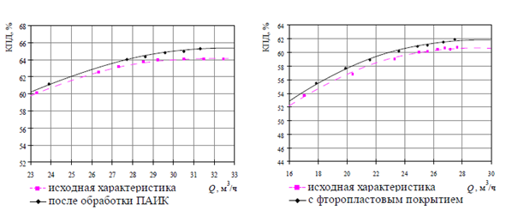
Figure 15- КМ 65- 50 - 160 pump efficiency

The research data were summarized in table 4, where a comparative analysis of three methods of hydrophobization of the flow part of a centrifugal pump is obvious

Table 5-Comparative analysis of the results of hydrophobization methods

Method water repellency treatment | surfactants | surface-active corrosion inhibitors | Based on fluoroplast
Roughness | 35-45 micrometer | 35-45 micrometer | 35-45 micrometer
Edge wettability angle | 135⁰ | 130⁰ | 150⁰
efficiency | 1,3% | 1,7% | 1,5-2%

3.2 Use of fluoroplast for creating hydrophobic coatings on the surfaces of the flow part of centrifugal pumps

Fluoroplast-4 (polytetrafluoroethylene, or "Teflon") is the most chemically stable of all known polymers. It does not burn, does not dissolve in any solvent at temperatures up to 260 °C, and is not affected by acids and alkalis (even highly concentrated ones), strong oxidizing agents, and other aggressive substances [28]. Fluoroplast-4 does not withstand only the effects of molten alkali metals, as well as chlorine TRIFLUORIDE, fluorine gas at 150 °C or increased pressure; it swells in perfluorocerosene at temperatures of about 300 °C. Biologically, fluoroplast-4 is harmless. Destruction with a significant release of gaseous products begins only at temperatures slightly higher than 415 °C. Fluoroplast-4 exhibits the most pronounced hydrophobic properties among polymers. Water absorption in 24 hours is 0.00 %.
To increase energy efficiency, a discrete modification is required, which should consist of the following: the sealing surfaces and the axial force discharge system must be left in their original state (for pumps in the delivery state) , or the surfaces must be cleaned and modified (including hydrophobization, but with a wetting angle of up to 100°) - for units that were in operation; the surface of the driven disk and the blade system must be modified (the wettability angle of 130° or higher), and the surface of the drive disk must either be left in its original state, or modified with a wettability angle of up to 100°. If the conditions for upgrading to improve energy efficiency are met, the efficiency increase for medium-speed pumps will be about 4-5 %[29 5].
The results of energy and cavitation tests to study the effect of hydrophobic fluoroplastic coating on the surfaces of the impeller demonstrate:
- increasing the pressure characteristics of the pump after creating a hydrophobic coating, which is due to a decrease in hydraulic friction losses that pass into the head;
- maintained the efficiency of the pump to ensure the pressure;
- reduced power consumption, especially in the operating range, which is due to a reduction in the power consumed to compensate for hydraulic losses;
- increase the pump efficiency by 1.5-2 % in optimal operation mode;
- the reduction in power consumption is approximately 90 watts.
Despite a slight reduction in surface roughness when creating a fluoroplastic coating, the increase in efficiency is 1.5-2 %, as in the case of modernization by creating a hydrophobic coating based on surface-active corrosion inhibitors, which leads to the conclusion that the determining factor in reducing hydraulic losses is the hydrophobicity of the coating, and not the surface roughness. [28]. Based on the results of the study, the following technology and equipment for applying fluoroplast will be proposed. To create a fluoroplast coating on the impellers of pumps, a technological complex is proposed, consisting of technological lines shown in figure 16.
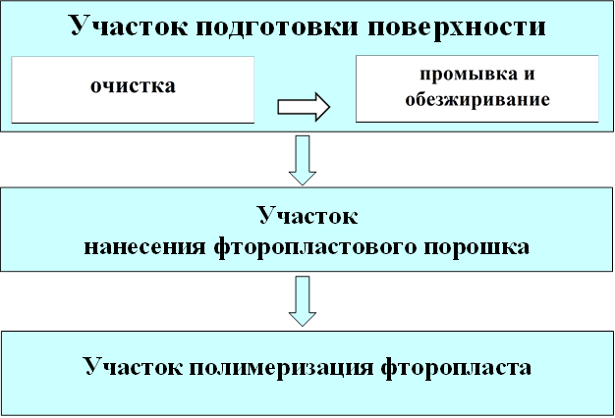

Figure 16-Production areas of the technological complex for creating structured fluoroplastic coatings

The coatings are applied by pneumatic spraying followed by heat treatment of the wheel. The first step is to prepare the part for coating and clean the surface, pre-heat the part, and then start spraying. Based on research on the equipment used for applying fluoroplastic coatings, we offer an automated coating line. The line for spraying powder materials is shown in figure 17.

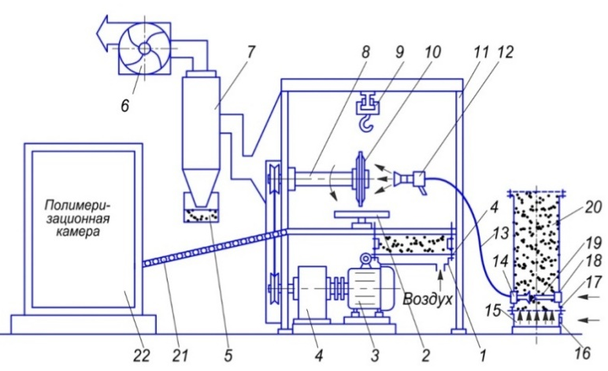

1 –bath with pseudosignal layer ; 2 – rotary table; 3 – motor; 4 – bath of a fluidized bed of powder; 5 – powder collector; 6 – fan; 7 – bag filter; 8 – rotating mandrel; 9 low products;10 – coloured product; 11 – chamber for sputtering; 12 – an atomizer; 13 – a hose; 14– pneumatic chamber; 15-pneumatic chamber ; 16 –pipe for air supply ; 17 – porous partition; 18 – fittings for air supply; 19 – ejectors; 20 powder material; 21-roller conveyor for feeding; 22 - curing oven;

Figure 17 - Scheme of the installation for spraying of powder materials for pump parts
Technological complex and stages of modernization of operating centrifugal pumps based on fluoroplast implemented and proposed by the author G. p. Khovanov [8]. The composition of production sites for improving the hydrodynamic characteristics of pump impeller surfaces using structured fluoroplastic coatings is listed below.
The surface preparation area is represented by two technological lines: a cleaning line and a washing and degreasing line. To clean the functional surfaces of pumps before applying the coating, the technology of jet-abrasive cleaning is applied. The industrial jet cleaning chamber KCO-100 of the injection type is installed in the cleaning line (figure 19). The chamber is equipped with exhaust ventilation and a high-efficiency filter with a recuperator.
The design of the chamber uses the principle of ensuring electrical safety of installations: the supply voltage is only suitable for the filter module, and the abrasive supply is controlled using pneumatic units; lighting of the working area is implemented using low voltage. Thus, the voltage of 220V and 380V to the body of the camera, which is directly operated by the operator, is not supplied. In the working chamber (figure 18), air and air-abrasive lines are connected to the injection nozzle. The speed and flow rate at the nozzle outlet are controlled by the air pressure and nozzle diameter.

Figure 18-KCO-100 working chamber with an injection nozzle

The air supply to the CSR-100 is provided by an industrial compressor of the OMV series with an air dryer and receiver (figure 19). The compressor is mounted on a vibration-proof, moisture-resistant carrier frame attached to the receiver, and does not require a special Foundation. The electrical switchboard is integrated into the sound-absorbing casing of the compressor.

Figure 19-General view of the cleaning process line.

The area of application of Fluoroplastic powder is represented by an impassable chamber. Individual lighting is installed in the camera, and its walls are made of transparent plastic, which provides the necessary lighting for the workplace. Together with the camera, a filter-recuperator with individual supply and exhaust ventilation is mounted on a separate frame. The three-stage filter recuperator allows you to return 97% of the powder that has not settled on the parts for further use. The application of fluoroplastic powder to the working surfaces of pump parts in the chamber is provided by a spray gun with electrostatic and tribostatic barrels. The powder is supplied from the discharge hopper of the gun by injection due to the supply of compressed air through the barrel of the gun. The gun is operated by an oil-free coaxial electric compressor.
The fluoroplast polymerization section is represented by a polymerization chamber, which is made on the basis of a chamber muffle electric furnace. The chamber has a pull-out tray and is insulated on the inner surfaces with mulite-silica fire-resistant fiber with built-in electric wire heaters. The pallet is heat-insulated with fire-resistant fireclay bricks. The chamber is equipped with a powerful Autonomous exhaust ventilation of the ejector type. The technical characteristics of the camera are shown in the table 6

Table 6 - technical characteristics of the polymerization chamber

№ | Name of parameter | Value
1 | Maximum operating temperature, º С | 1100
2 | Power, kW | 20,0
3 | Mains voltage, V | 380
4 | dimensions of the working chamber:
5 | - width, mm | 600
6 | -height, mm | 1050
7 | -depth, mm | 840
8 | The volume of the working chamber, l | 500

Figure 20-General view of the polymerization chamber with temperature field sensors.

The polymerization chamber is equipped with an individual controller (figure 20), which has an interface for connecting to a computer and provides:
- automatically heating the camera, temperature stabilization and cooling the camera;
- setting and maintaining the temperature for the entire period of operation;
- setting and maintaining temperature over time intervals;
- discreteness of setting the temperature 1°C;
- discreteness of setting time intervals of 1 min;
- setting time intervals from 1 to 9999 min;
- audible alarm of excess temperature.
Having researched the market of polymerization chambers, we offer a new generation Politex camera for the hydrophobization process

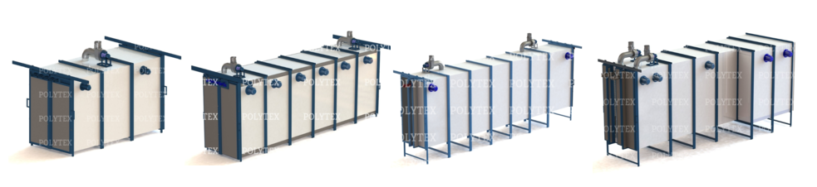
Figure 21 - the Curing chamber of the company Politex
4 Study Prospects for the use of polymer wheels in centrifugal pumps

4.1 Checking the strength of the impeller of a centrifugal pump made of polymer material

The production cycle of centrifugal wheels with increased hydrodynamic properties is possible with the use of new composite polymer materials, in addition, the technological process of wheel production can be reduced by one labor-intensive stage-hydrophobization by applying fluoropolymer, which was mentioned above.
The performance of the wheels of centrifugal pumps increases, and the strength is provided if they are made of wear-resistant thermoplastic plastics with a finite isotropic structure: low-pressure polyethylene, polycarbonate, glass-filled nylon, etc. The closed design of the pump wheels determines the technological complexity of their manufacture from materials similar to those mentioned.
In foreign and domestic pump engineering, research continues to be conducted to find optimal schemes for the technological process of manufacturing polymer parts that meet the necessary technical and economic requirements. The main methods of processing plastic products include pressing, injection molding, extrusion, vacuum forming, blowing, and stamping. In some cases, mechanical processing of blocks of material is also used.
The use of polymer compositions for the manufacture of impellers of submersible centrifugal pumps is associated with significant technological difficulties. The centrifugal pump wheel is a closed type spatial structure [29]
For example, KMM-E pumps of a new generation for petroleum products and highly flammable liquids, pumps that pump petroleum products and other highly flammable liquids, in accordance with the state standard of Russia 52743-2007 (EN 809: 1998) " Pumps and pumping units for pumping liquids. General safety requirements" should have a number of design features. KMM-E pumps are manufactured using the most modern technologies. Thus, body parts are obtained by casting metal using gasified models. Impellers of KMM-E pumps are obtained from a conductive composite material by casting on molten rods. In addition, KMM-E pumps have a number of design features that increase their reliability and ensure safety during operation. [30]
To determine the hydrodynamic characteristics and conduct industrial tests, photopolymer wheels were printed using SLA technology with geometric parameters designed on the "PUMP" module and with double curvature blades. The choice of stereolithography technology was based on the criteria of roughness and surface quality of printed products. In accordance with the manufacturing technology and the requirements applied to the details of the stage of centrifugal submersible pumps, an absolute roughness value of 3 microns is allowed on the internal surfaces of the structural elements. Figure 22 shows samples of wheels printed with SLA and FDM technology.

. 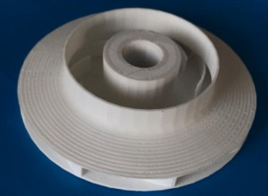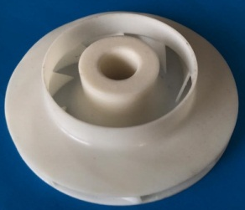

а) FDM technology printed wheel, б) SLA printed wheel
Figure 22 – Samples of wheels

The most advanced and widespread materials in additive manufacturing include photopolymers-substances that change their properties and aggregate state when they are exposed to ultraviolet rays.
Advantages of photopolymers in comparison with other materials for 3D printing:
- high detail and perfectly smooth surfaces of printed objects;
- the ability to grow geometrically complex products (accuracy - up to 0.025 mm on 25.4 mm parts);
- превосходные excellent physical and mechanical properties of finished models and prototypes;
- large selection of 3D printing materials with various properties;
- простота easy post-processing – they are easy to glue, sand, paint, etc.
However, in order for the polymer wheel to withstand real loads under real loading conditions during testing, it is necessary to increase the thickness of the disk walls and conduct a strength calculation.
The task of checking the static strength of the disk is to determine the stresses that occur under the action of operational loads. Comparing them with the permissible stresses allows you to evaluate the performance of the structure. In this formulation, the problem is the content of the verification calculation of the disk strength.
The wheel model was imported from the CAD system, since the wheel was created as an Assembly of elements, the "Boolean" operation was used in the PATRAN preprocessor to combine all the parts. this created computer model corresponds to the technology of manufacturing the wheel by casting. The grid was approximated by eight-node tet structural elements. to generate a detailed grid, the element size was chosen from the condition of the smallest size of the wheel wall thickness of 0.002 m. The dimension of the problem with this size of the face of the final element was 256700 elements. Figure 23 shows a finite element grid of a centrifugal wheel with 8 blades

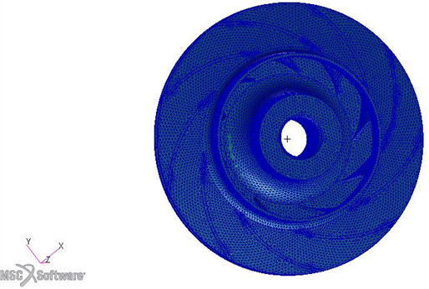

Figure 23 – Final mesh of the polymer wheel

In the input data, the data on the mechanical properties of the material were changed, the wheel made of photopolymer has the following mechanical characteristics elastic modulus E=10 GPA, Poisson's ratio μ=0,25 [31]

Table 7 - The input data for the static calculation

№ | Parameter | Value
1 | Material | steel
2 | Elastic modulus Е | 10$∙$10⁹ PА
3 | Poisson Ratio | 0,25
4 | Support 1 | The ball joint around the axis of rotation of the model
5 | Support 2 | The ball joint around the axis of rotation of the model
6 | $P_{5}$ The inlet pressure to the wheel | $$0,4МPА$$
7 | $P_{6}$ Pressure at the exit of the wheel | 0,56МPА
8 | $F_{c}$- centrifugal force | 24,19 N
9 | Calculation type | Static Solver 120

The results of calculations of polymer centrifugal wheels are shown in figure 5. the Maximum stress in a centrifugal wheel with 8 blades is σ_max = 118MPA, which indicates a sufficient strength coefficient of the polymer wheel.

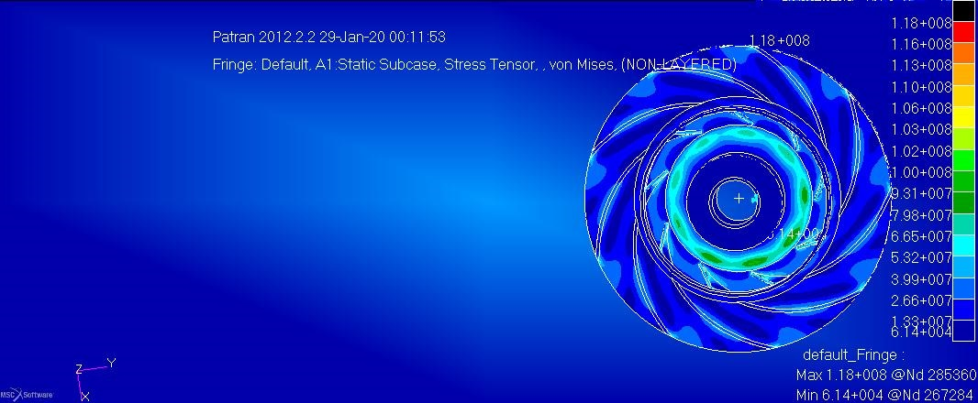

Figure 24 - Diagrams of stresses in the wheel are made of photopolymer

  - Pump Assembly and carrying out industrial tests

For industrial testing, the pump with polymer wheels was disassembled and assembled (3 wheels). The main components are a metal body and a two-disc impeller with blades. Connection to the pipeline is carried out by means of branch pipes (pressure and suction).
The design of the centrifugal submersible pump includes:
- the impeller is the main element of the equipment made of polymer material;
- impeller blades that create a centrifugal force to suck in water;
- housing that protects the impeller from mechanical damage;
- the suction area through which the liquid is pumped;
- pressure pipe that transfers water from the pump to the pipeline system;
- non-return valve that prevents water from escaping from the pump to the source;
- safety net required to protect the working part of the pump from impurities that negatively affect the operation of the device.
With the help of a motor, the wheels begin to rotate around their axis, the blades located on them create a lifting (centrifugal) force that moves the liquid along the sleeve. The increased pressure "pushes" water into the pipeline. Due to the design features, the flow "twists", so a leveling device is located at some distance from the sleeve: water passes through it, and then enters the pressure water supply.
The impellers move freely along the shaft in the axial direction and are limited in movement by the lower and upper guide devices. The axial force from the impeller is transmitted to the lower textolite ring and then to the shoulder of the guide device. Part of the axial force is transmitted to the shaft due to wheel friction against the shaft or wheel sticking to the shaft during salt deposition in the gap or metal corrosion. The torque is transmitted from the shaft to the wheels.
Impellers are made of polymer material. The guide devices are connected to each other along the peripheral parts, in the lower part of the housing they all rest on the lower bearing and the base, and from above they are clamped in the housing through the upper bearing housing.
Specifications. The technical condition of the parts of the centrifugal pump should be determined in accordance with the defect and repair cards. After assembling the pump, the shaft must rotate by hand without jamming the impeller. The ends of the edges of the fan blades must be in the same plane. Figure 25 shows the Assembly of a pump with polymer wheels

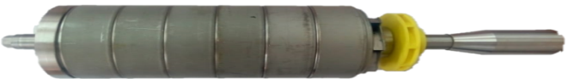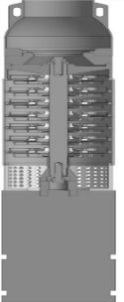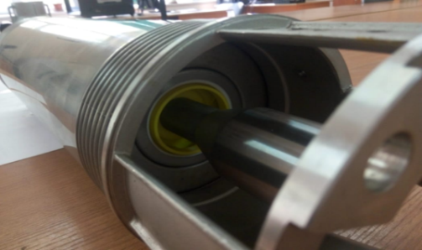

Figure 25-Pump Assembly with polymer wheel

The formation of the Assembly scheme was carried out taking into account the convenience of Assembly work and Assembly quality control, while taking into account the number of Assembly jobs, the availability of necessary technological equipment and equipment, the possibility of reducing the Assembly time, reducing its cost, and the use of mechanization and automation tools.
Assembly sequence. A shaft is installed in the housing, on which a locking ring is pre-dressed, then two bearings and an oil seal are pressed. Another oil seal is put on the installed shaft, and a key is installed on which the hub is put on. a spacer sleeve is put on the shaft, the impeller chamber is installed on it, which is compressed by the impeller with a fluoroplastic ring, which are tightened with a bolt after Assembly. The last step is to install the shaft in the electric motor. The flow diagram of the centrifugal submersible pump Assembly is shown in figure 26
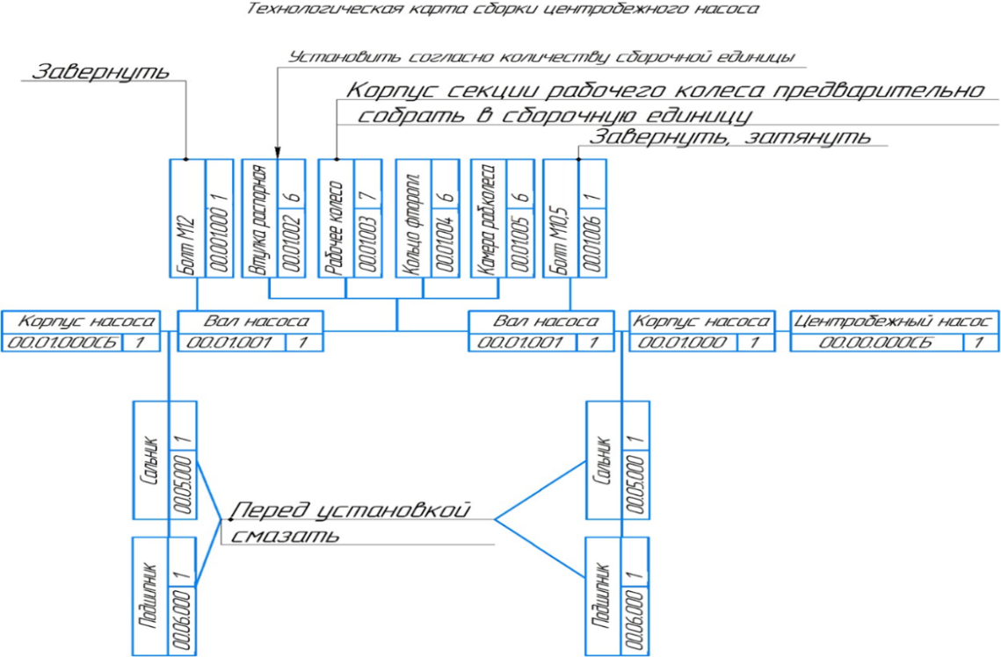

Figure 26-pump Assembly Flow chart

4.3 Test conditions

The tests were carried out on a certified test stand of the brand "Oddesse pumping equipment Test stand" in accordance with the state standard 6134.
In-plant testing of the pump:
- performance characteristics, mechanical testing, is carried out on the factory drive with adjustable speed according to the technological instructions. Tests are performed at maximum speed, on water (as a working medium) with a relative density of 1.0 or higher;
- the actual head-flow, power, and efficiency values will be determined from factory performance tests;
- the design point is the only point at which performance is guaranteed. The shape of the curve is not guaranteed;
- the flow rate at which the pump stops is defined as the minimum flow rate of the pump
During installation testing, the factory auxiliary lubrication system and the factory auxiliary sealing system are used. The test results are shown in figure 27
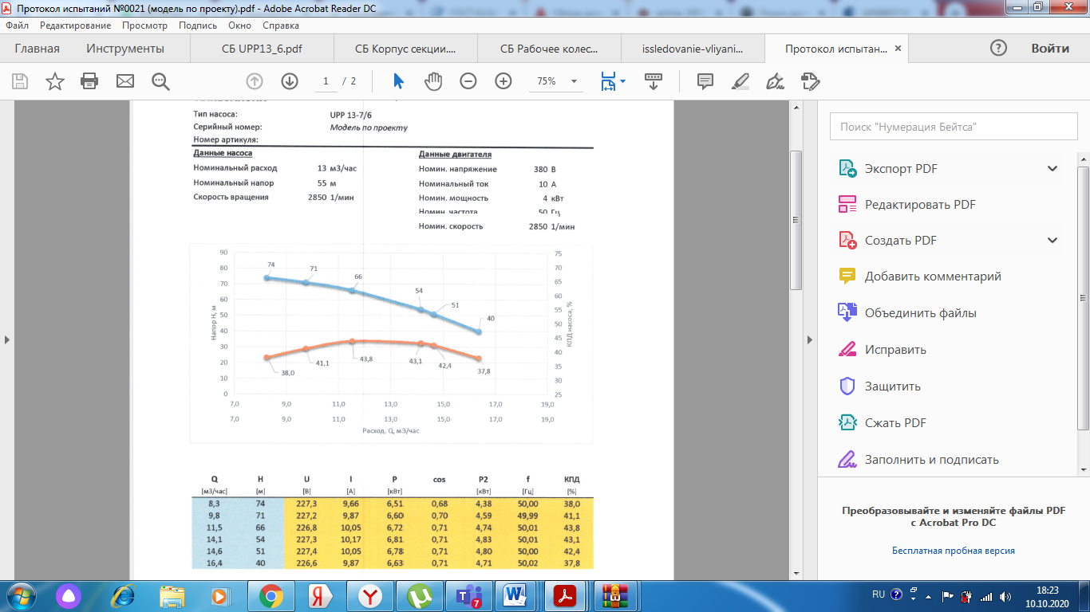

Figure 27-UTP 13-7/6 pump test Report

The test report shows an efficiency of 42.1% percent, the increase in efficiency compared to the original pump model is 2%.

Conclusion

Brief conclusions on the results of scientific research work
The results of the research work correspond to the tasks planned according to the calendar plan:
1. Based on the results of research and calculations of the main pump nodes in NASTRAN/PATRAN computer systems, a manual was submitted to the Piarika publishing house. The manual describes General theoretical concepts of the finite element method and its practical application in the PATRAN finite element analysis module, which is part of the NASTRAN integrated system. A method for creating finite element models, methods for setting boundary conditions, performing numerical calculations, and analyzing their results is described. Training materials allow you to use examples to learn how to enter information about the research object, select the appropriate options from the program interface, and control all actions on the display screen. These examples demonstrate the capabilities of the software product to solve strength problems in the design of pumping equipment. It is intended for University students, as well as designers of machines and mechanisms.
2. The developed set of design documentation in the amount of 12 2D drawings and 12 3D models will allow developing technological processes for manufacturing a wheel with double curvature blades and with new geometric parameters of the Meridian section.
3. The conducted research and comparative analysis of the parameters of hydrophobization methods allow us to make a choice in favor of the technological method of applying a fluoroplastic coating. By results of research the result was revealed: the type of update - for pumps type "KM" modification-based surfactants, and for pumps of type "SM" - based on PTFE; limit implemented by contact angle wettability for PAV - 135°, for PTFE 150°; for the PIAC - 130° method, modernization to improve energy efficiency, an increase in the efficiency coefficient for medium-speed pumps with surfactant surfaces leads to an increase in the value of the efficiency coefficient of the order of 1.3%, when applying a fluoroplastic coating of 2%, when applying a PIAC of 1.7%;
4. The use of the developed technology for rapid prototyping and creating a digital twin of the impeller will allow you to avoid design errors and reduce the cost of fine-tuning the design of the centrifugal pump.
5. The printed impeller with SLA technology is as close as possible to the roughness of the wheel produced from metal by stamping in terms of the roughness parameters of 3 microns. Calculations for the strength of a polymer impeller with a modified disk thickness from 1 m to 2 mm allowed testing the pump in real power conditions.
6. Industrial tests show a 2% increase in the efficiency of a submersible centrifugal pump due to changes in the geometry of the flow channel and the curvature of the blade.
Assessment of completeness of solutions to tasks
The tasks set for 2020 have been fully completed.
Research work on the project was carried out on the basis of the University's collective use laboratory using the power of a supercomputer. A team of performers, including 1 candidate of technical Sciences, 11 employees with experience as a designer at a machine-building plant, 1 PhD doctoral student, 1 Junior researcher. The project has the necessary research infrastructure: production facilities, modern research equipment, access to sources of scientific and technical information. The licensed computer aided design system MSC NASTRAN was used in the research.
Results of evaluation of the technical and economic efficiency of the project within the partner enterprise and machine-building enterprises the project meets the goals and strategy of the enterprise aimed at modern trends in creating digital design and creating digital doubles in order to reduce the economic costs of testing physical models.
Results of evaluation of the scientific and technical level of research work performed. Research work was carried out at the modern technical level for the design and calculation of pump units, the highest-level computer-aided design system MSC NASTRAN was used, digital models of centrifugal wheels were manufactured using the latest technologies of layer-by-layer cultivation. To calculate large tasks on the basis of the University's shared use laboratory, the power of a supercomputer was used. A team of performers, including 1 candidate of technical Sciences, 1 doctor of PhD, 1 employee with experience as a designer at a machine-building plant, 1 Junior researcher. The project has the necessary research infrastructure: production facilities, modern research equipment, access to sources of scientific and technical information.
Research work was carried out in accordance with the international standard ISO 10006 " Administrative quality management. Guidelines for ensuring the quality of project management." For the successful implementation of project tasks, there are laboratory facilities equipped with the appropriate infrastructure. Patent and license security of research is carried out by the relevant service of the organization at all stages of the project.

LIST OF SOURCES USED

1 Andrievsky, A. A. Energy-saving designs and technologies for industrial enterprises. [Text] / A. A. Andrievsky, S. G. Valyukhov, A. A. Vitoshkin Conversion in mechanical engineering. - 2003. - №6. - P. 30-32.
2 Wiseman, W. A. Selection and economical operation of pumps [Text]/ V. A. Shenderovich, I. A. Lubin Equipment. - 2006. - №2. - P. 15-17.
3 Burkovsky, V. L. Analysis of energy losses due to changes in flow and pressure [Text] / V. L. Burkovsky, D. V. Karevsky Industrial Informatics. - Voronezh: Voronezh state technical University, 2005. - P. 140-144.
4 Volkov, A.V. Development of a methodology for improving the efficiency and reliability of operation of heat and power pumping equipment. [Text]: abstract of the dissertation for the degree of doctor of technical Sciences: 05.04.13; defended 2006-Moscow, 2006. - 40 p.
5 Volkov, A.V., Ways to improve the performance of pumping equipment of heat and power facilities. [Text]/A.V. Volkov, S. N. Pankratov. Hydraulic machines, hydraulic drives, hydro pneumatic automation: Proceedings of the third international scientific and technical conference in Saint Petersburg, 2005. - P. 82-89.
6 Gurinovich, A.D. Analysis of the life cycle cost when choosing energy-efficient pumping equipment for water intake wells [Text] / A.D. Gurinovich housing and construction. - 2007. - №1. - P. 64-67.
7 Manring Noah, D. Measuring pump efficiency: uncertainty considerations [Text]/ D.Manring Noah, Trans. ASME. J. Energy Resour. Technol. - 2005. - V. 127. - № 4. - P. 280-284.
8 Khovanov, G. P., Investigation of the effect of hydrophobicity of the surfaces of flow elements on the performance and certain types of losses of centrifugal pumps [Electronic resource]. – Access mode: http://tekhnosfera.com/issledovanie-vliyaniya-gidrofobnosti-poverhnostey-elementov-rotochnoy-chasti-na-ekspluatatsionnye-kachestva-i-otdelnye-v
9 [Electronic resource].– Access mode: https://www.pseau.org/outils/ouvrages/ grundfos_pump_handbook_2004.pdf
10 [Electronic resource].– Access mode: https://www.intechopen.com/books/aspects-of-polyurethanes/erosive-and-abrasive-wear-resistance-of-polyurethane-liners
11 Bolewski, Ł. Cavitation erosion degradation of Belzona® Coatings dol: 10.1515 [Text]/11 Ł. Bolewski, M. Szkodo, M. Kmieć adms‐2017‐0002
12 Barton, N.A. Erosion in Elbows in Hydrocarbon Production Systems[Text]/ N.A. Barton Review Document, TUV NEL Limited, Research Report, p. 2-8.
13 Kvasov, G. G. Improving the efficiency of pumping units for oil pipeline transport [Text] / G. G. Kvasov Chemical and oil and gas engineering - 2006. - №11.-P. 29.
14 Pyatov, I. S. Working stages of pumps made of organic ceramic-like materials for the complicated Fund of the Board of Directors LLC "REAM-RTI" [Electronic resource]. – Access mode: https://ream -rti.ru/upload/ iblock/492/4927153105dd0b7b0a7b388071747833.pdf
15 Lomakin, V. O. Development of a comprehensive method for calculating the flow parts of centrifugal pumps with optimization of parameters [Electronic resource]. / V. O. Lomakin-access mode: http://www.dissercat.com
16 Kuznetsov, A.V. Computer-aided design of a multi-stage centrifugal pump.. [Text]/ A. V. Kuznetsov, S. S. Panaioti, A. I. Savel'ev - Kaluga 2017y.
17 Lunati, E. D. On the highest level of efficiency and cavitation qualities of General industrial centrifugal pumps of the main design types. [Text]/ E. D. Lunati Hydromeliorative. Present and future: report of the international scientific and technical conference, October 2004-Moscow, Bauman Moscow state technical University publishing House, 2004, p. 43.
18 Ivanov, S. A. Design and optimization of machinery and equipment structures. [Text] / S. A. Ivanov, A.V. Nefedov, N. A. Chichenev-Novotroitsk 2014.
19 Hehui Zhang Numerical Investigation of Periodic Fluctuations in Energy Efficiency in Centrifugal Pumps at Different Working Points Energies[Text]/ Hehui Zhang , Shengxiang Deng and Yingjie Qu - 2017, 10(3), 342.
20 Kelzon, A. S., Zhuravlev Yu. N., Yanvarev N. V. Calculation and design of rotary machines. [Text]/ A. S. Kelzon, Yu.N. Zhuravlev, N. V. Yanvarev Leningrad, "Mashinostroenie" (Leningrad, ed.) - 1977-288 p.
21 Rubaeva, N. K. Calculation and design of centrifugal pumps: a tutorial / N. To. Rubaev, E. E. Riebel - Sumy: publishing house of Sumy state University, 2009. -220p.
22 Vibrations in technology [Text]: Handbook. In b-ti T. T. O. Protection from vibrations and shocks. - Moscow: Mechanical Engineering 1981. - 456 p.
23 Vibration of energy machines [Text] / edited by N., V. Grigorieva - .Moscow: Mechanical Engineering 1974. - 464 p.
24 Kuzmin S. A. Improving the efficiency of operation of pumping units. // Proceedings 25 State national research Institute Ministry of defense of the Russian Federation. - 2006. - №53. - P. 408.
25 Volkov, A.V. Studies of the effect of hydrophobization of the surfaces of the flow part of centrifugal pumps on various types of energy losses [Text]/ A.V. Volkov, G. P. jovanov, S. A. Chernyshev, Hydraulic machines, hydraulic drives and hydro pneumatic automation: Abstract of the report of the all-Russian student scientific and technical conference-Moscow, 2007. - P. 35.
26 Volkov, A.V. Device for forming anticorrosive coating patent / A.V. Volkov, M. Yu. Pomortsev, V. A. Ryzhenkov / / RF № 47364 B. I. - 2005. - № 24. - 2 p.: ill.
27 Volkov, A.V., Effect of flow conditions on the flow surfaces of centrifugal pumps on various types of losses [Text] / A.V. Volkov, S. A. Chernyshev Hydraulic machines, hydraulic drives and hydropneumoautomatics: TEZ. docl. Everything is fine. student scientific and technical conference-Moscow, 2005. - P. 40.
28 Chernyshev, S. A. Improving the performance of centrifugal pumps based on changes in the hydrodynamic interaction of the working flow with the elements of the flow part [Text]: author's abstract. on the map. the academic degree of Dr. Techn.Sciences: 05.04.13; protected 2008-Moscow, 2008.
29 D. I. Chukov, Andrey Stepashkin,Alexey Salimon Mechanical Properties and Chemical Resistance of New Composites for Oil Pump Impellers https://www.researchgate.net/publication/325062983_Mechanical_Properties_and_Chemical_Resistance_of_New_Composites_for_Oil_Pump_Impellers
30 [Electronic resource].– Access mode: http://spb-sovtrans.ru/polimernye-kompozicii/963-rabochie-kolesa-nasosov-iz-polimernyh-kompoziciy.html
31 Research of physical and mechanical properties of polymers and polymer composites. [Electronic resource].– Access mode: http://window.edu.ru/resource/958/21958/files/yarzev.pdf
.

APPENDIX A

List of published works for 3 years

table A. 1 - list of works.
№  п/п | Наименование научного труда | Место издания | Авторы
1 | 2 | 3 | 4
 | Сentrifugal pump rotor dynamics study | Известия НАН РК  Серия Геологии технических наук 5 (431) стр 226 | M. E. Isametova, B. N. Absadykov, M. K. Batyrgaliyev1, I. I. Borovik
 | Исследование динамики бурового ротора в интегрированной среде Patran | Вестник КазАТК 2018 ISSN № 1609-1817 №1, стр.82-89 | М.Е. Исаметова  М.Д. Ибрайханов, О. Ежембеков
 | Прогнозирование долговечности вала  центробежного насоса для перекачки агрессивных сред | IV Международная научно-практическая конференция  «Современные технологии в машиностроении и литейном производстве» 05-07 декабря 2018 г.г. Чебоксары (сборник РИНЦ)  Принято к публикации | Исаметова М.Е., Абсадыков Б.Н., Машеков С.А., Боровик И., Нусипали Р.
 | «Моделирование и анализ прочности вала погружного центробежного насоса» | Международная научно-практическая конференция пользователей MSC Software Москва 14-15 октябрь 2018 г. | Исаметов А.  Нусипали Р.
 | «Аддитивные технологии в производстве узлов центробежных насосов» | Труды Сатпаевских чтений «Инновационные технологии – ключ к успешному решению фундаментальных и прикладных задач в рудном и нефтегазовом секторах экономики РК», том I – Алматы: КазНИТУ имени Сатпаева, 2019. – 1486 с. | Нусипали Р.  Исаметова М.
 | «The simulation of the service life of the rotary shaft of a centrifugal pump» | в материалах Международной конференции 6th International BAPT Conference “POWER TRANSMISSIONS 2019” June 19-22, 2019, Varna, Bulgaria MATEC Web of Conferences (indexed in Conference Proceedings Citation Index Web of Science). | Исаметов А.  Нусипали Р.
 | CAD/CAE/CAM end-to-end design and optimization of the principal wheel of a centrifugal submersible pump | International Scientific Journal  Machines. Technologies. Materials.  Scientific Technical Union of Mechanical Engineering «Industry-4.0» Bulgaria | Исаметова М.Е.  Караиванов Д.,  Арымбеков Б., Ангарбеков У., Нусипали Р.
 | Аддитивті технология арқылы жасалған прототипті қолданып ортадан тепкіш суасты сорғының негізгі доңғалағын оңтайландыру. | Вестник КазНИТУ, № 1 (137), Алматы 2020. | М.Е. Исаметова, Р.К. Нусіпәли, У.Д. Ангарбеков, А.М. Дүйсенғали.
 | Қабаттап өсіру әдісімен ортадан тепкіш сорғының жұмысшы доңғалағының прототипін жобалау және дайындау. Материалы конференции | «Сатпаевские чтения -2020» – Алматы: КазНИТУ имени Сатпаева, 2020. - 744 с | Р.К. Нусіпәли,  Я.К. Готман,  М.Е. Исаметова.
 | Determination of the rational number of blades of the centrifugal wheel of a submersible pump. | Eastern-European Journal of Enterprise Technologies. Applied Mechanics. 2020 (104) 2/7, pp. 49-58. ISSN 2226-3780 (print), ISSN 2312-8372 (on-line), https://doi.org/10.15587/1729-4061.2020.200998 процентиль 50% | M. Isametova,  D. Karaivanov,  R. Nussipali.
 | Computer simulation and investigation vibration parameters of a centrifugal submersible pump | Journal of Vibroengineering, vol. 22, no. 5, pp. 993–1005, Aug. 2020. https://doi.org/10.21595/jve.2020.21014 (SCOPUS процентиль 35%). | M. Isametova,  B. Omarbekov  R. Nussipali,  U. Angarbekov,  A. Isametov,

APPENDIX B
Job schedule
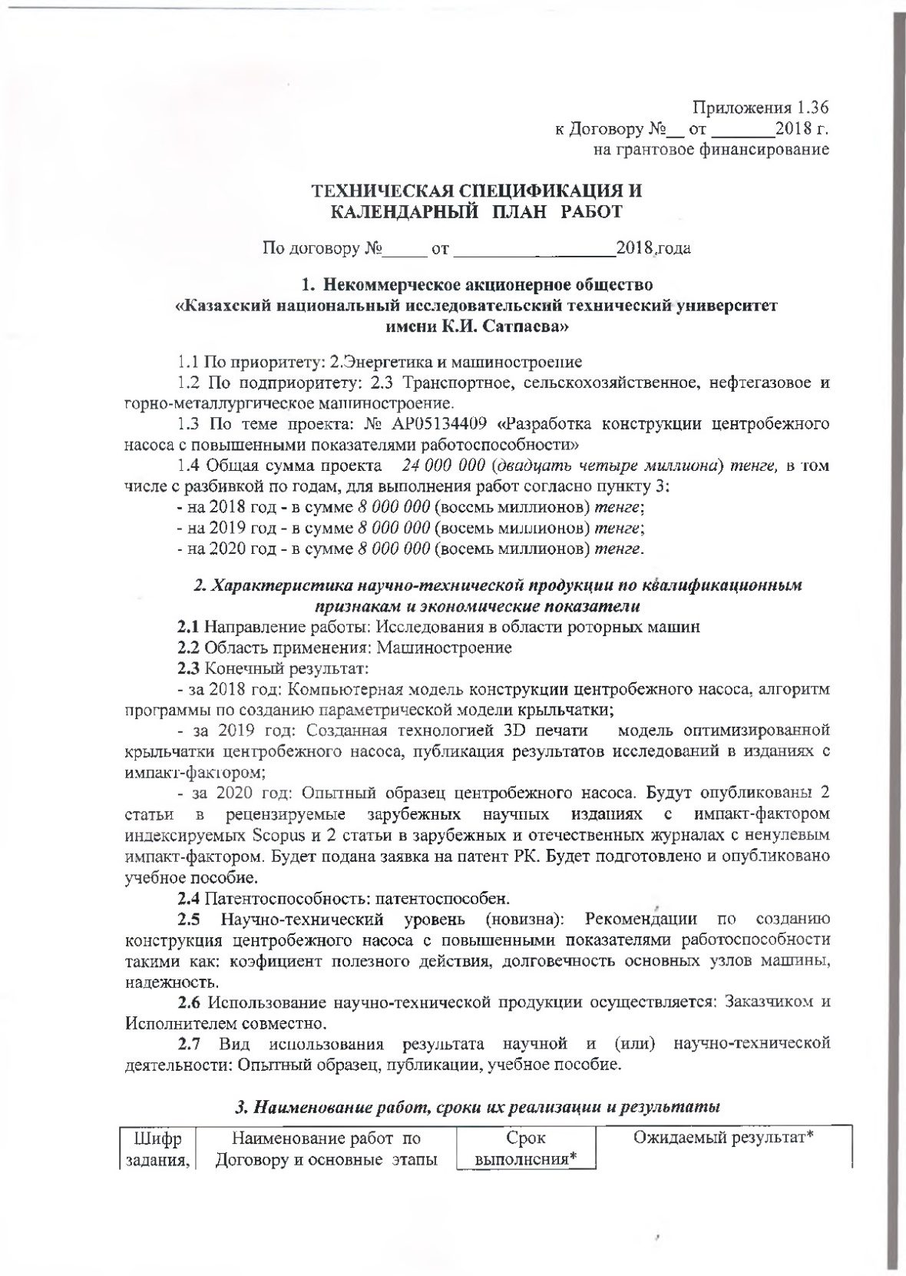
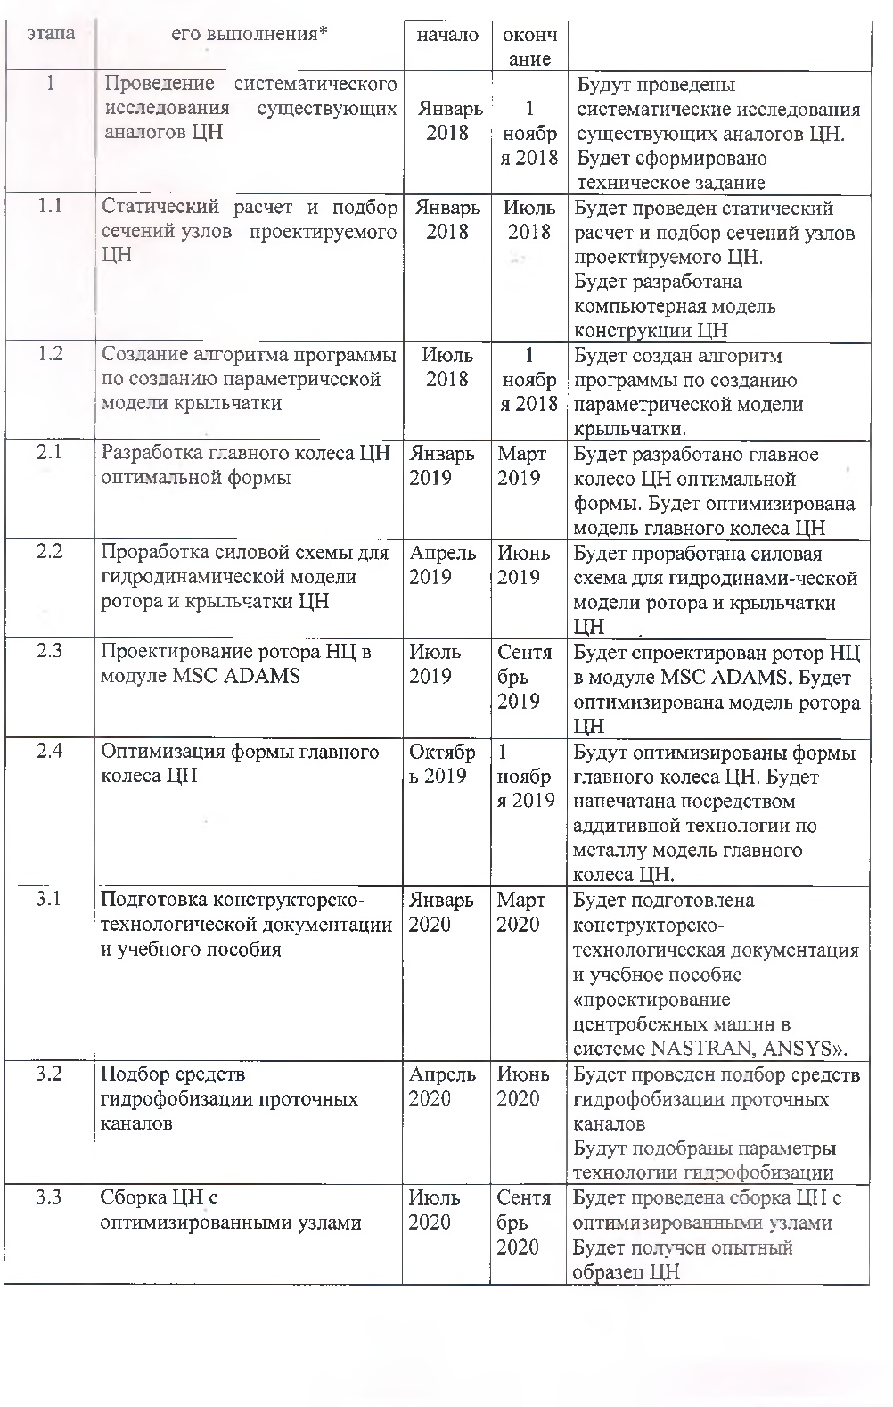
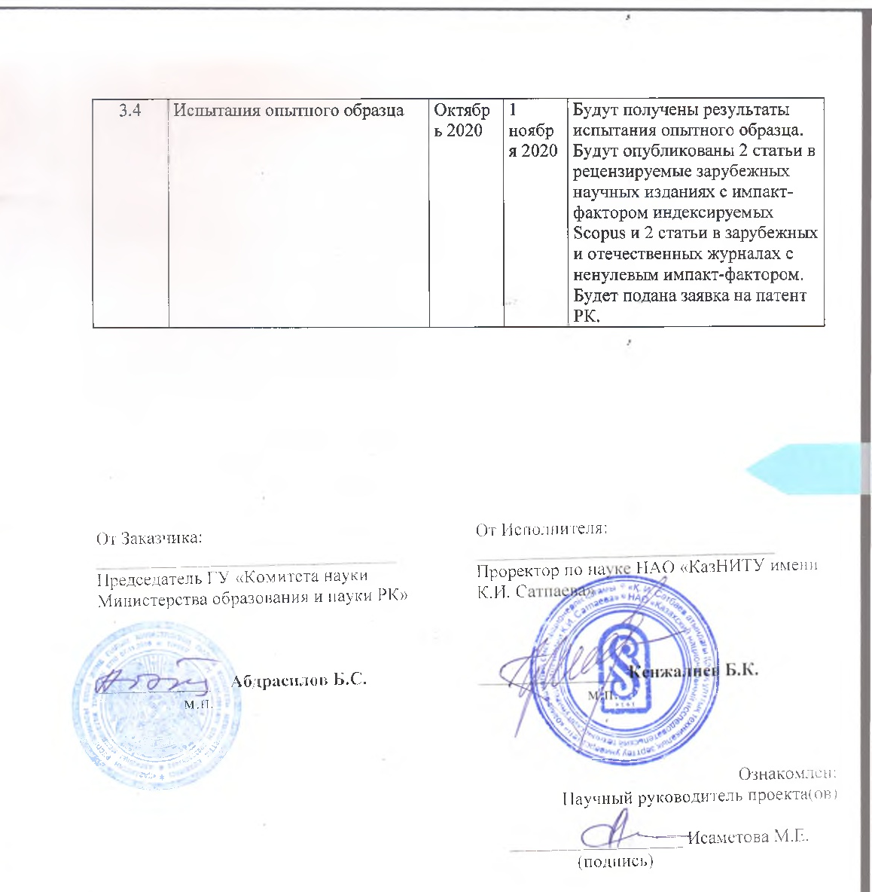

Standard work schedule
The cipher of the task stage | Names of works under the contract and the main stages of its implementation | Due date |  | Expected result
The cipher of the task stage |  | Beginning | Ending | Expected result
1. | Conducting a systematic study of existing analogues of the CP | January 2018 | November 1, 2018 | Systematic research will be conducted on existing analogues of the Central heating system. a technical task will be formed
1.1 | Static calculation and selection of the cross section of the nodes of the designed СР | January 2018 | July 2018 | Be held static calculation and selection of cross-section nodes of the projected operation. Will be developed a computer model of the structure of CР
1.2 | Creating an algorithm for creating a parametric model of the impeller | July 2018 | 2018November 1, 2018 | The program algorithm for creating a parametric model of the impeller will be created
2.1 | Development of the main wheel of the Central control unit of the optimal shape | January 2019 | March 2019 | The main wheel of the Central heating system of optimal shape will be developed. The model of the main wheel of the СР will be optimized
2.2 | Development of the power scheme for the hydrodynamic model of the rotor and impeller of the Central control unit | April 2019 | June 2019 | The power scheme for the hydrodynamic model of the rotor and impeller of the CР will be developed
2.3 | Design of the Central heating system rotor in the MSC ADAMS module | July 2019 | September 2019 | The rotor of the Central control unit in the MSC ADAMS module will be designed.  The CPU rotor model will be optimized
2.4 | Optimizing the shape of the main wheel | October 2019 | November 1, 2019 | The shape of the main wheel will be optimized. the model of the main wheel will be printed using additive technology on metal
3.1 | Preparation of design and technological documentation and training manual | January 2020 | March 2020 | Design and technological documentation and training manual "design of centrifugal machines in the NASTRAN, ANSYS system" will be prepared»
3.2 | Selection of means for hydrophobization of flow channels | April 2020 | June 2020 | The selection of means of hydrophobization of flow channels will be carried out . Parameters of the hydrophobization technology will be selected
3.3 | Building a CP with optimized nodes | July 2020 | September 2020 | The СР will be assembled with optimized nodes. A prototype of the Central control system will be received
3.4 | Testing of the prototype | October 2020 | November 1, 2020 | The test results of the prototype will be obtained. Two articles will be published in peer-reviewed foreign scientific publications with an impact factor indexed in SCOPUS and two articles in foreign and domestic journals with a non-zero impact factor. An application for a patent of the Republic of Kazakhstan will be submitted

APPENDIX C

Registration card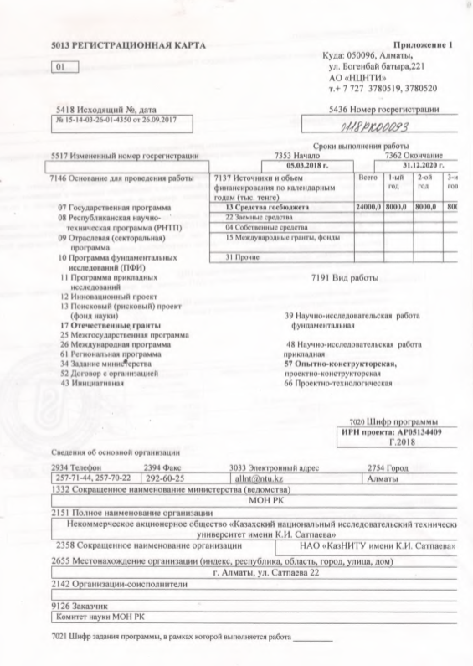

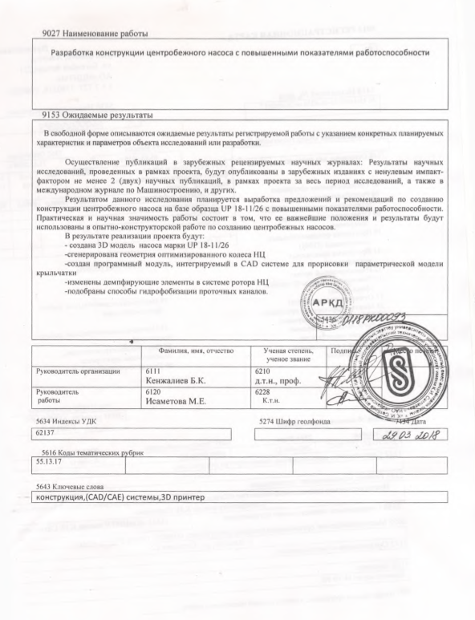

APPENDIX D

Extract from the minutes of the academic council

APPENDIX F

Reprints of articles published over 3 years
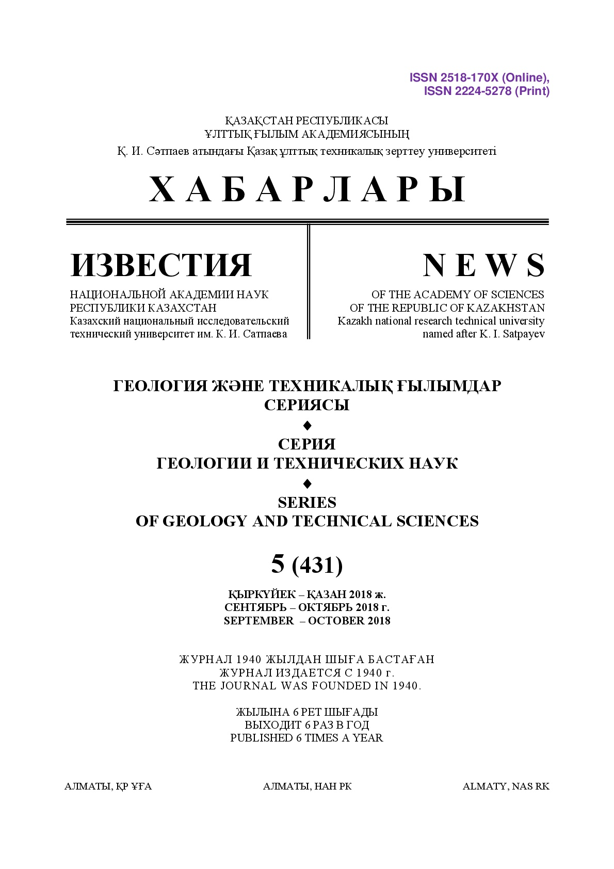

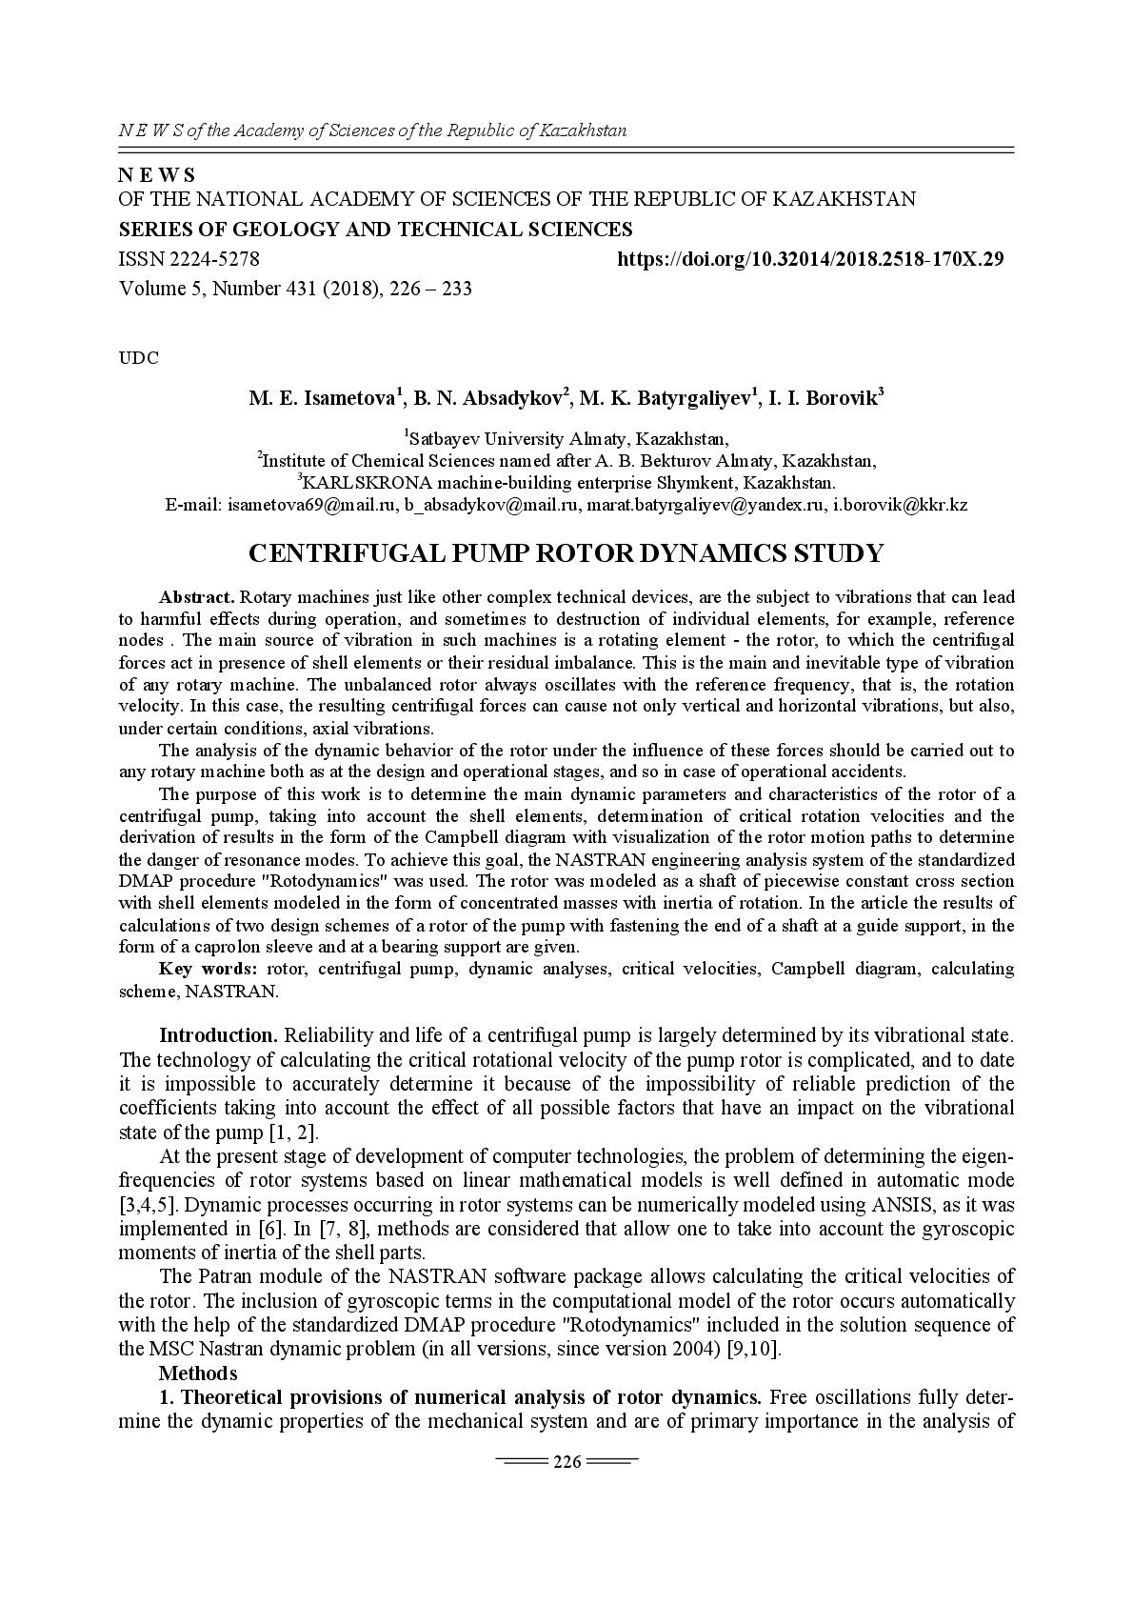

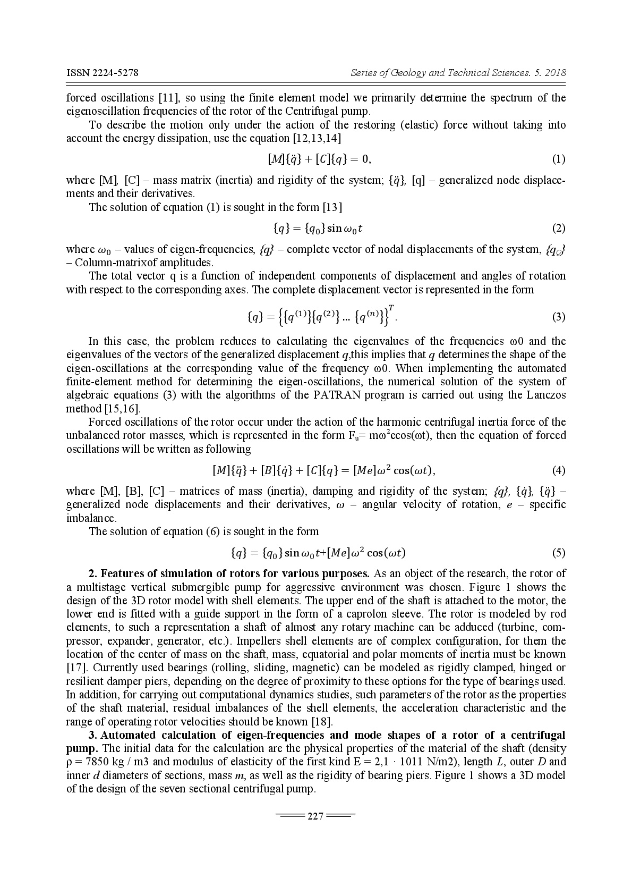
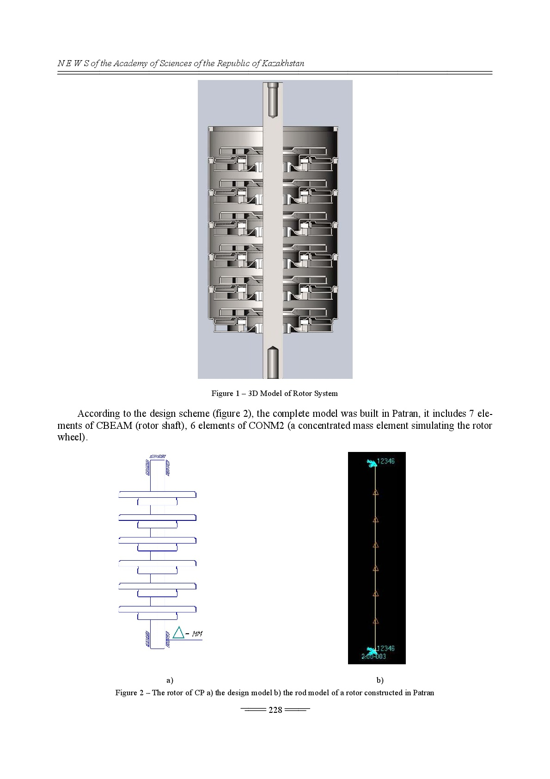
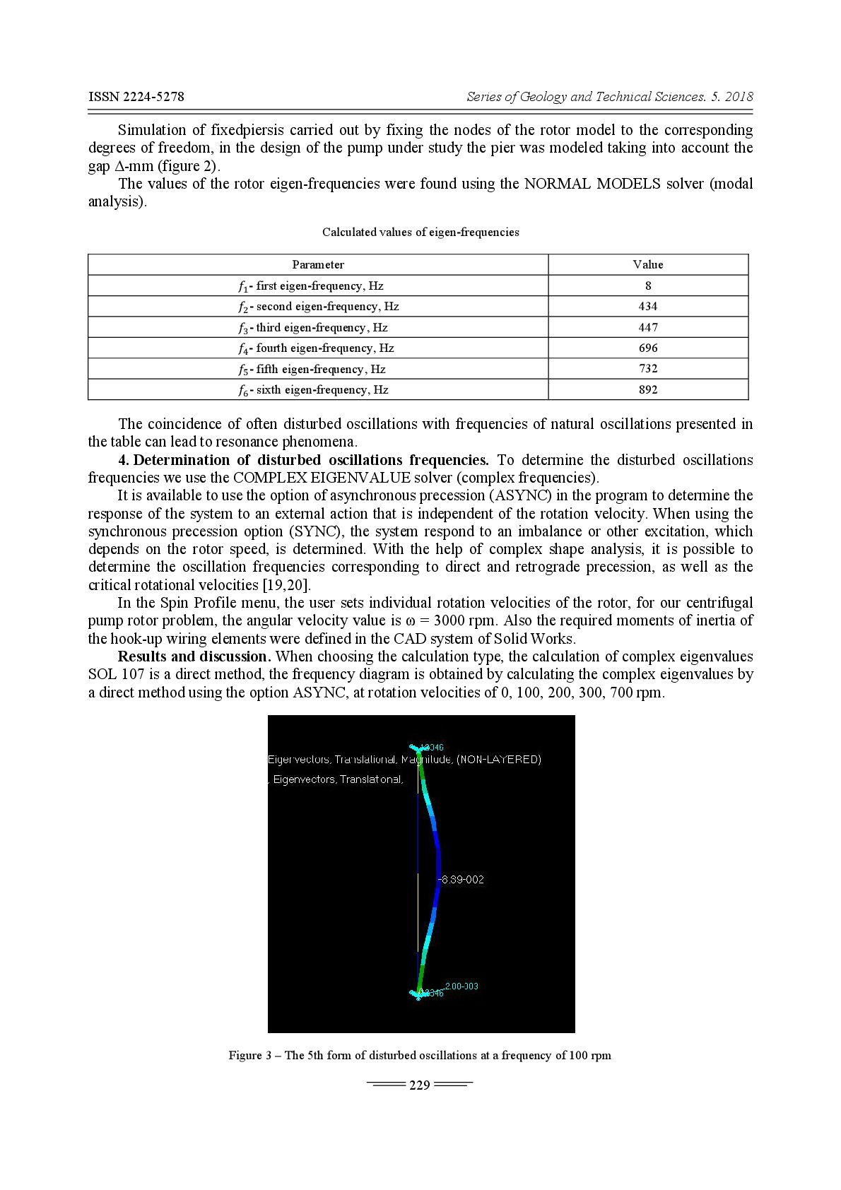

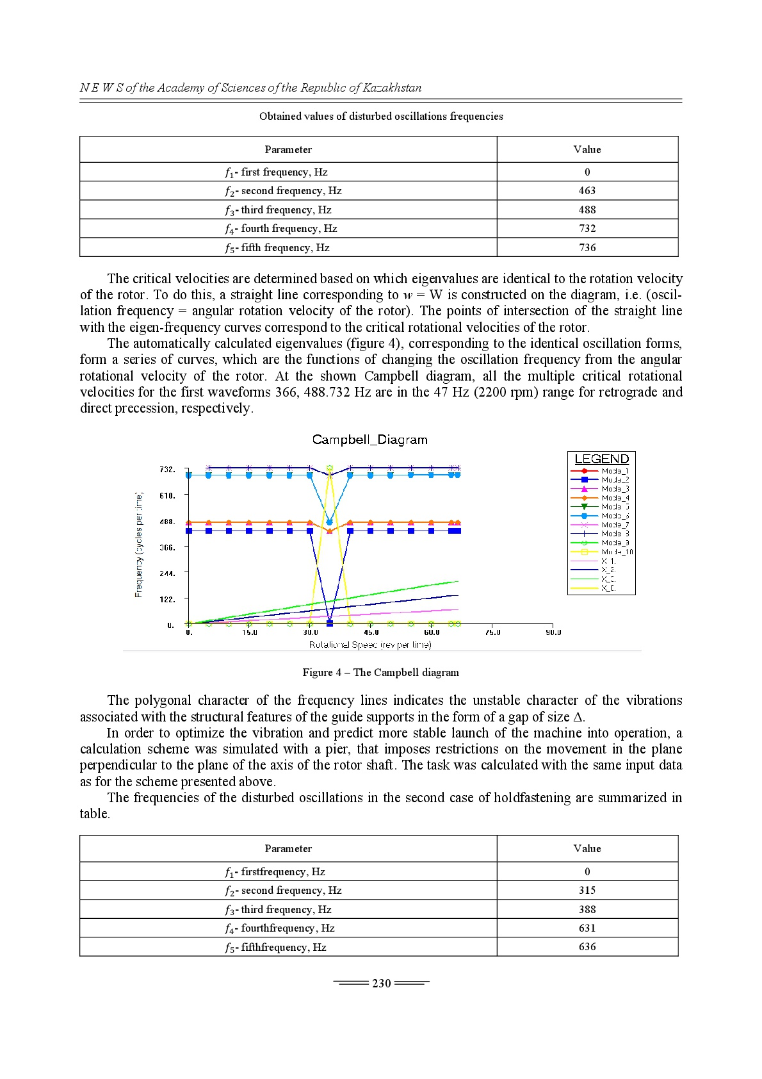
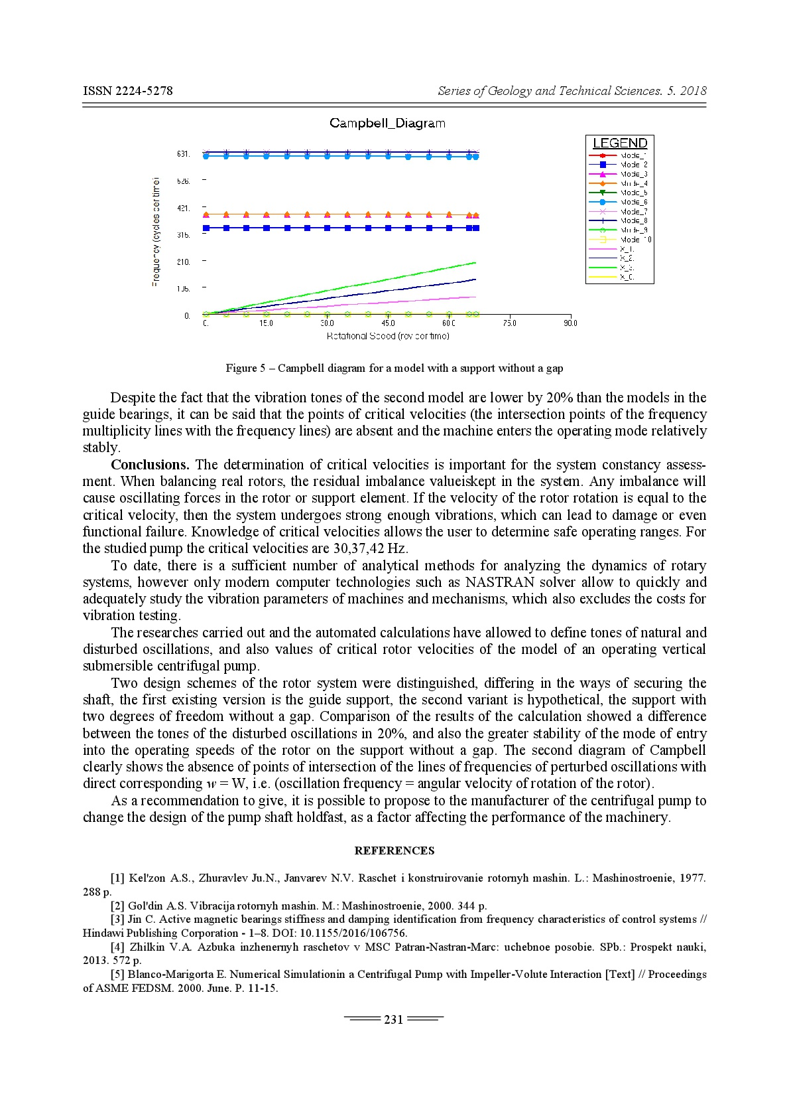

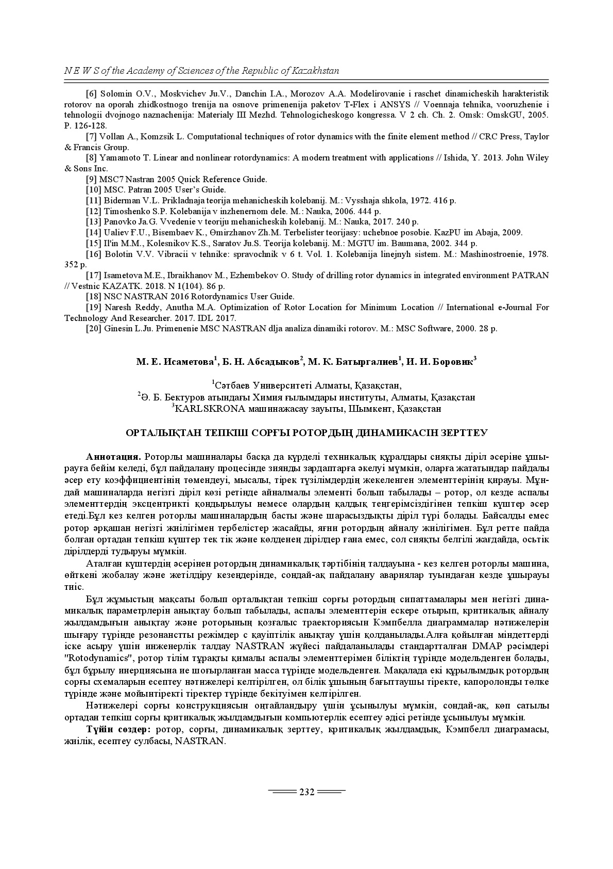

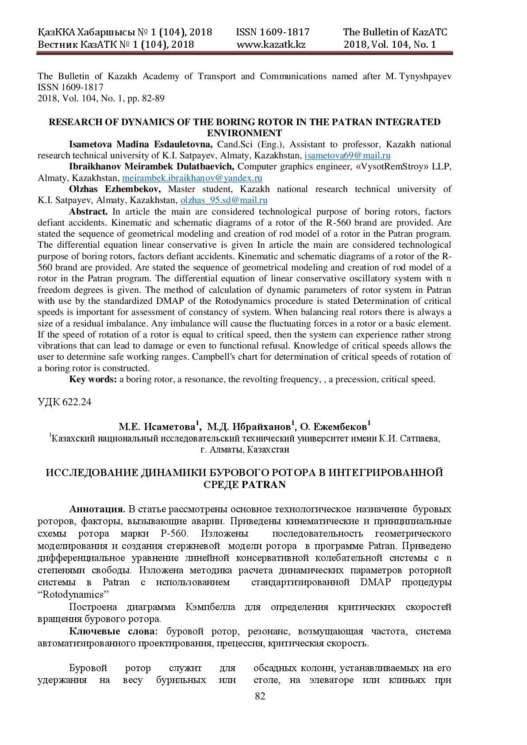

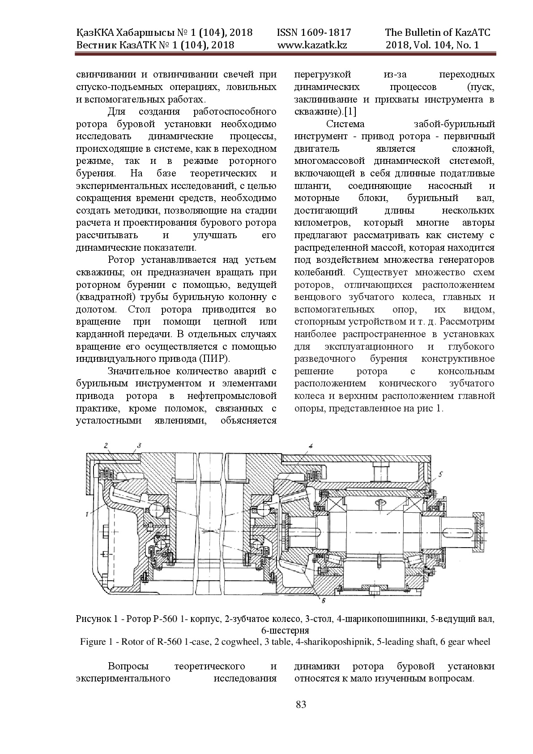

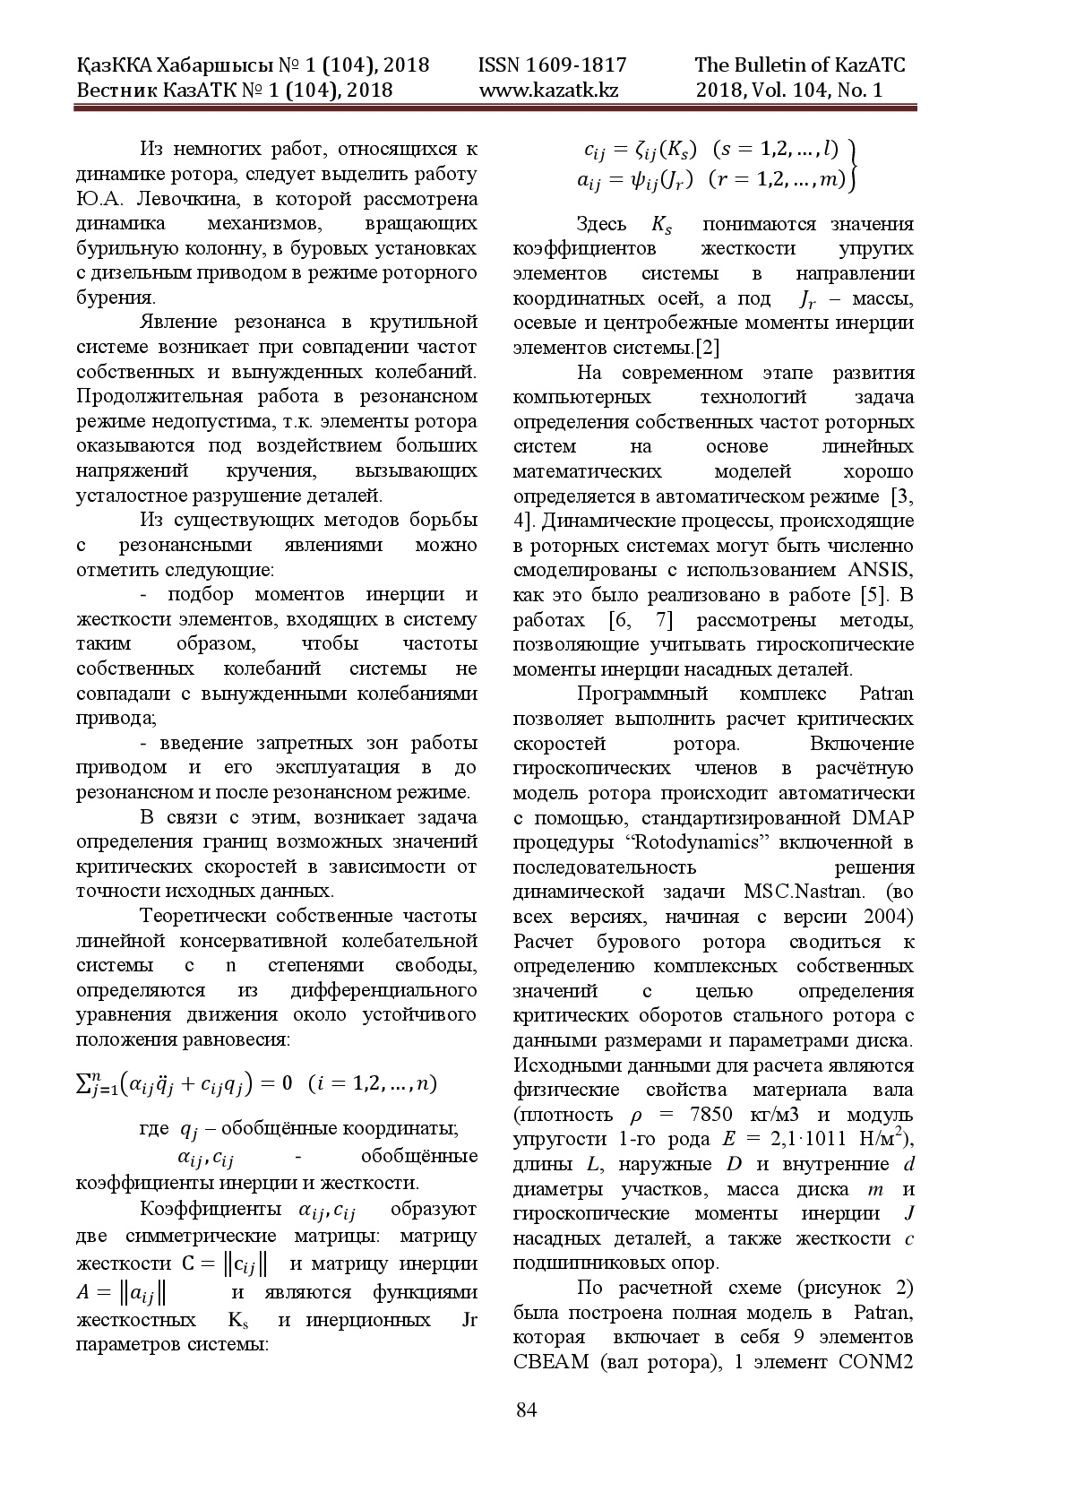

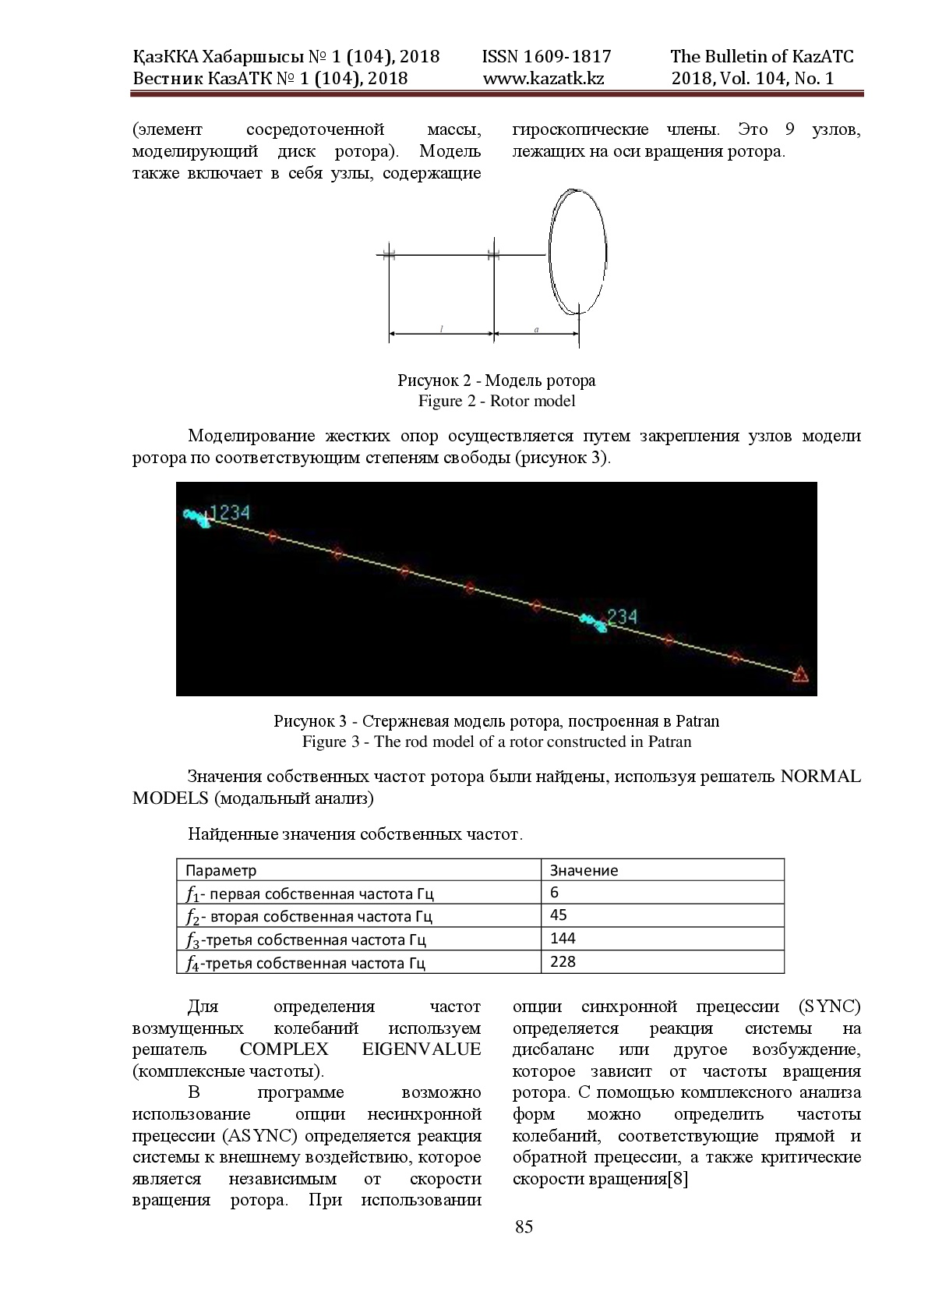

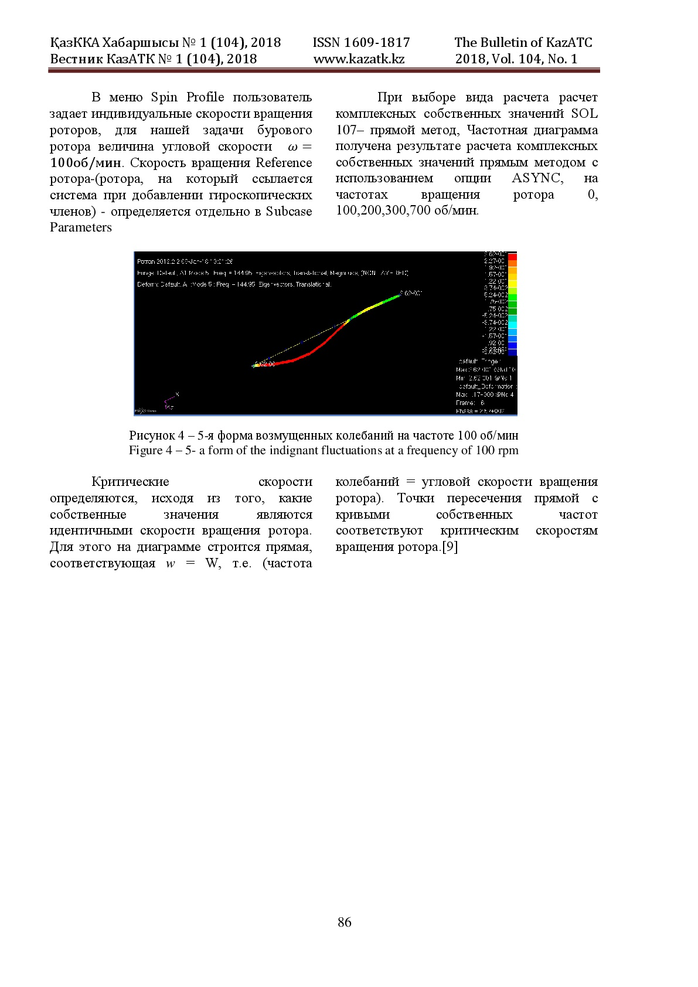

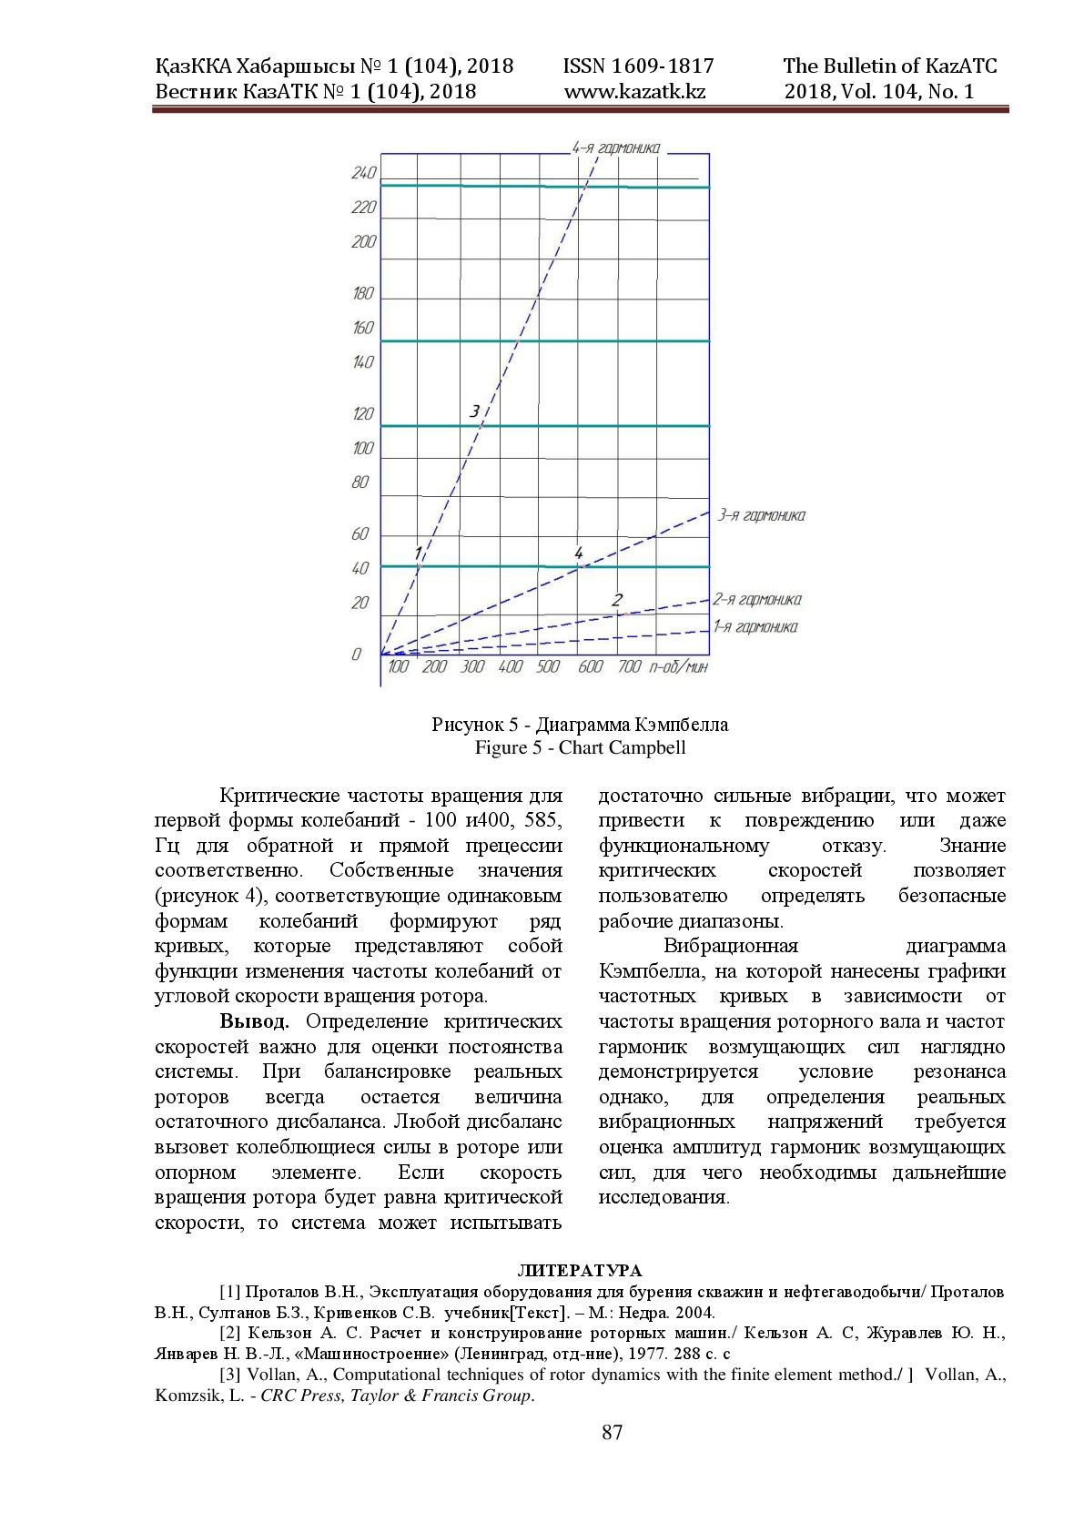

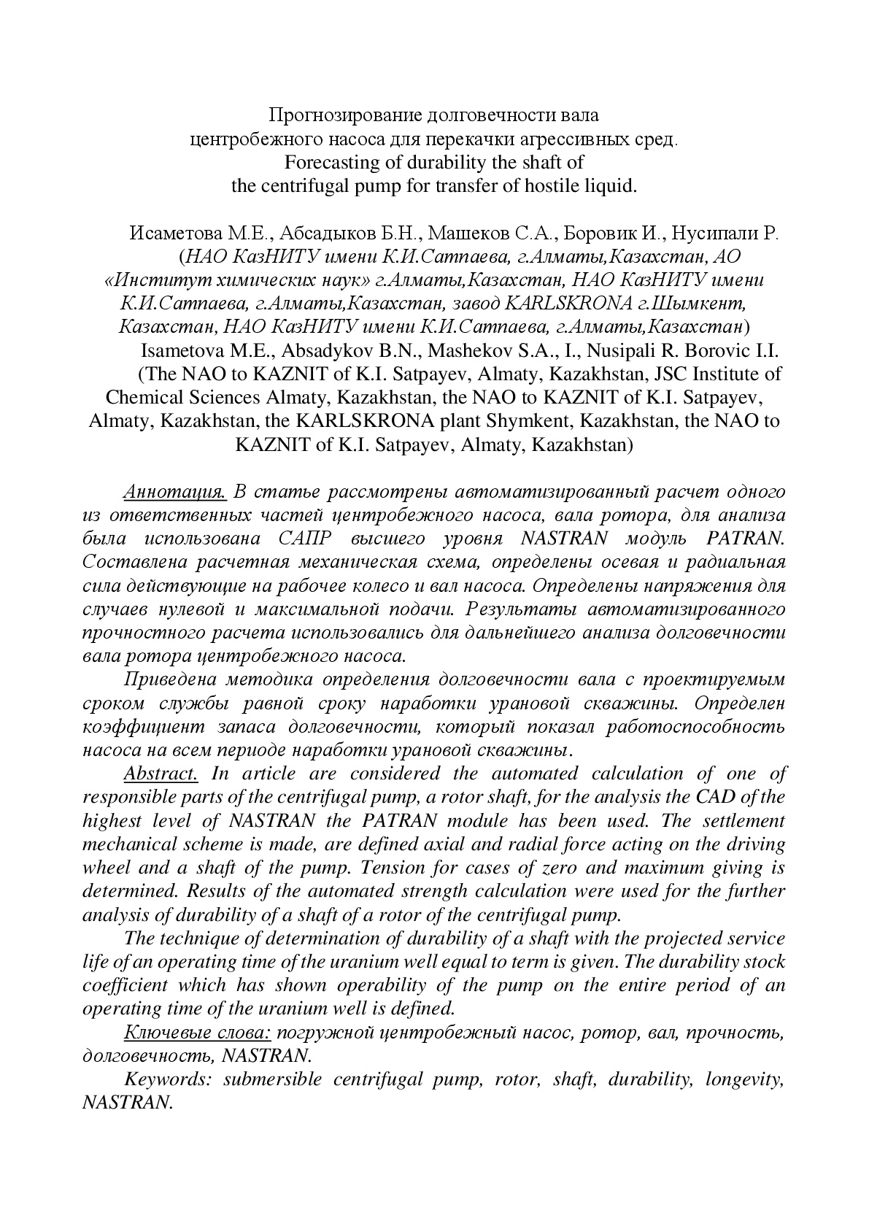

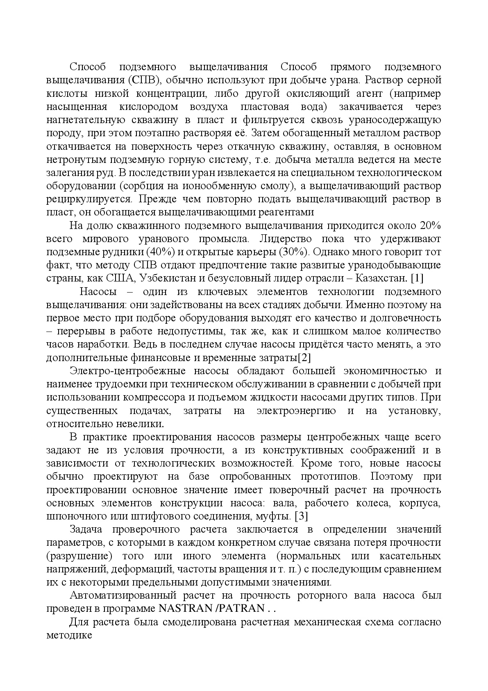

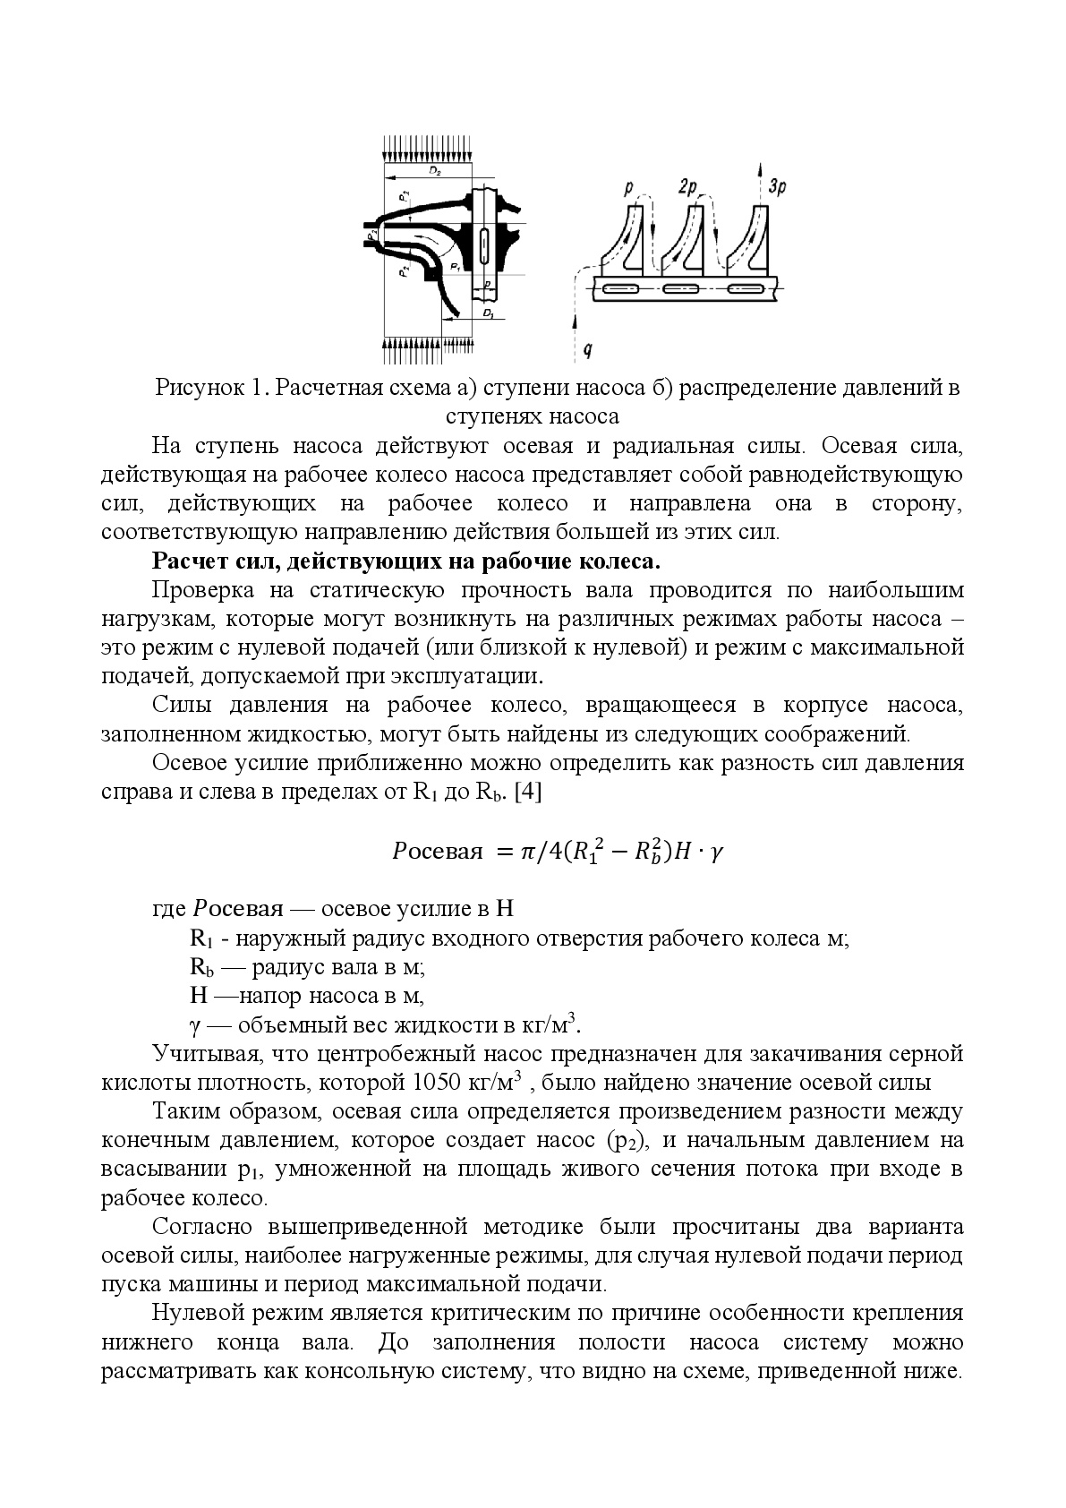

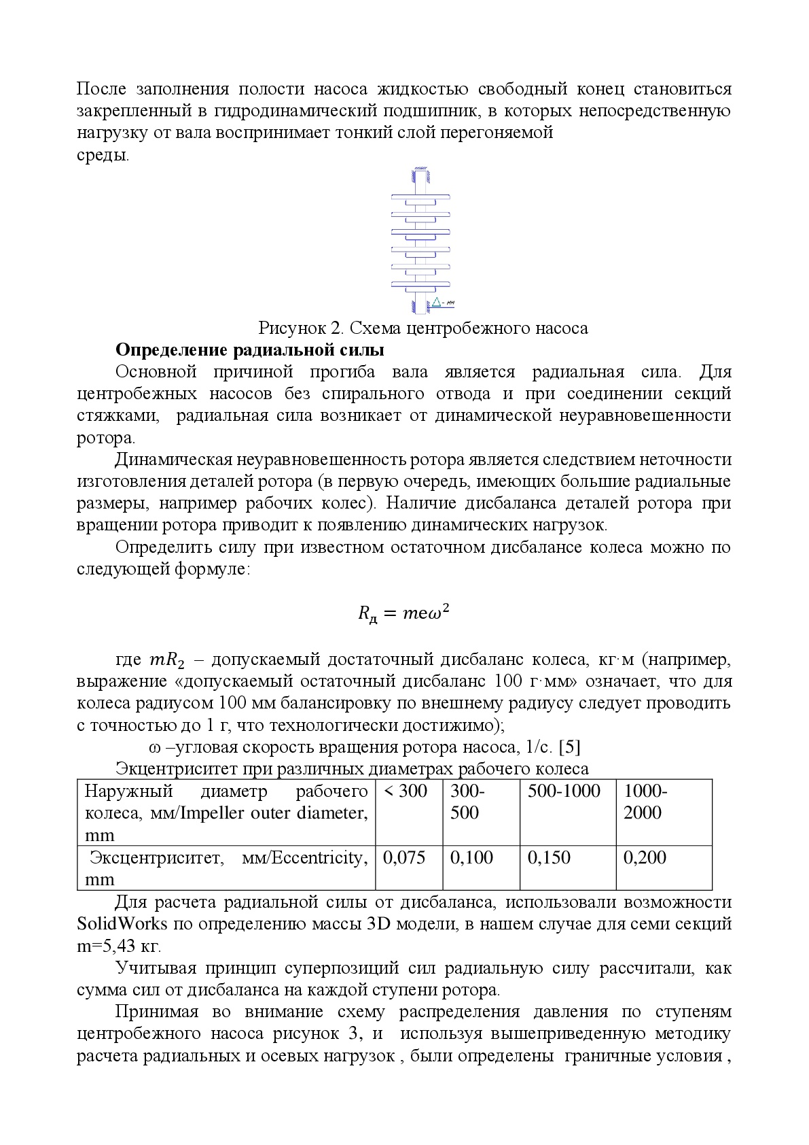

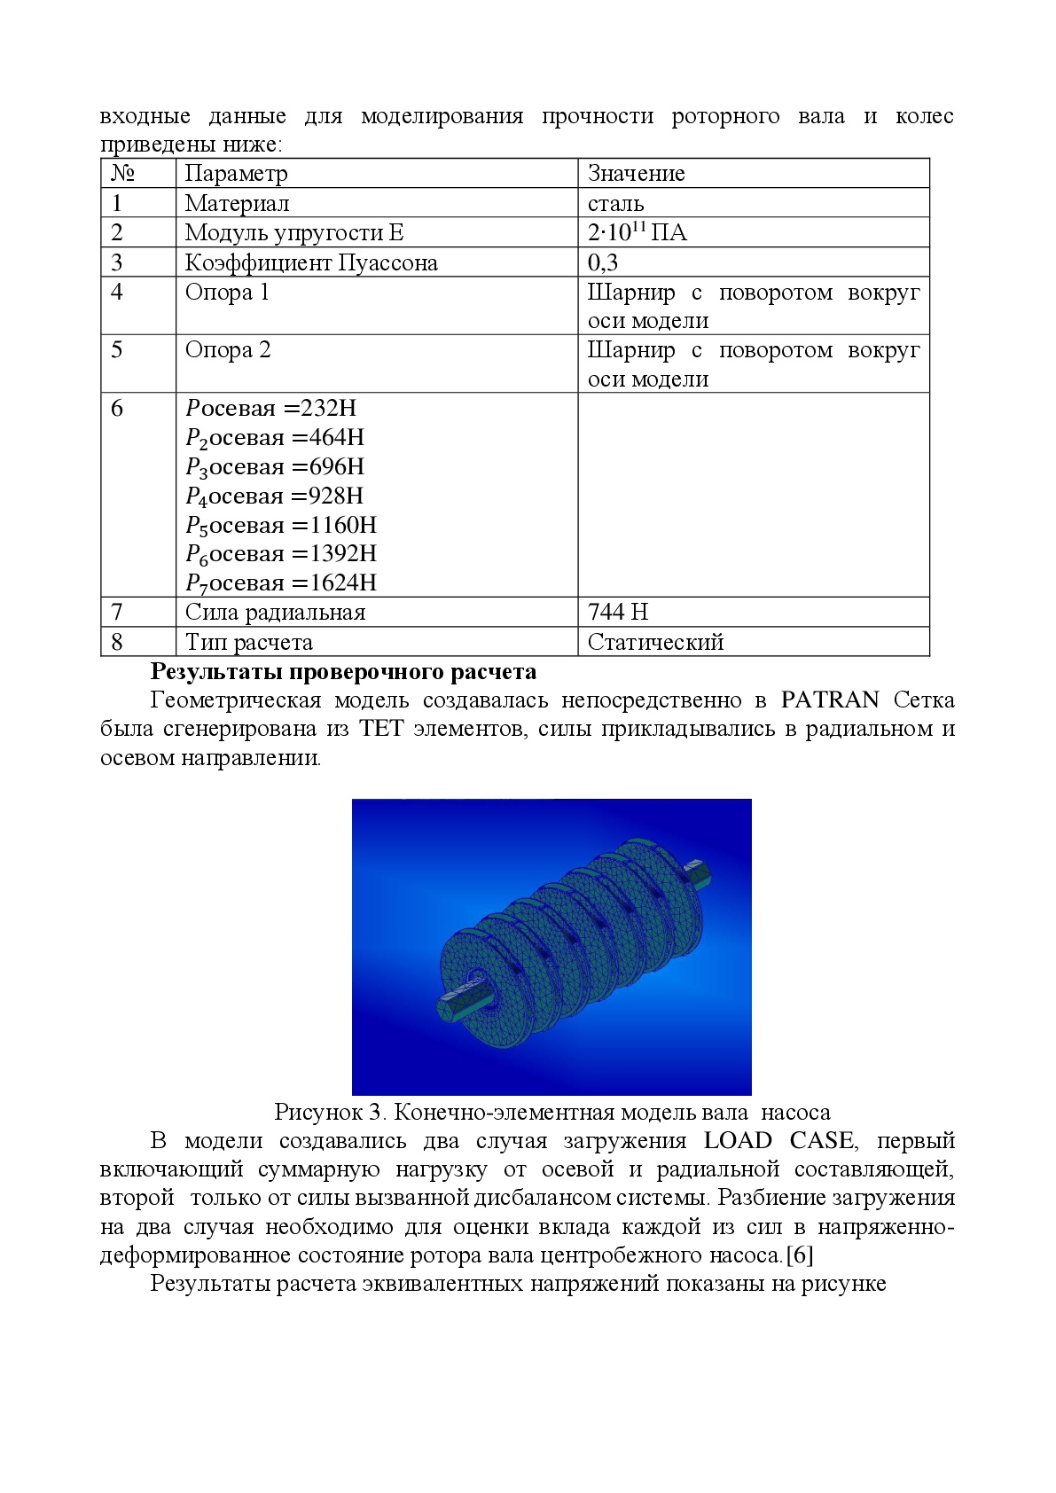

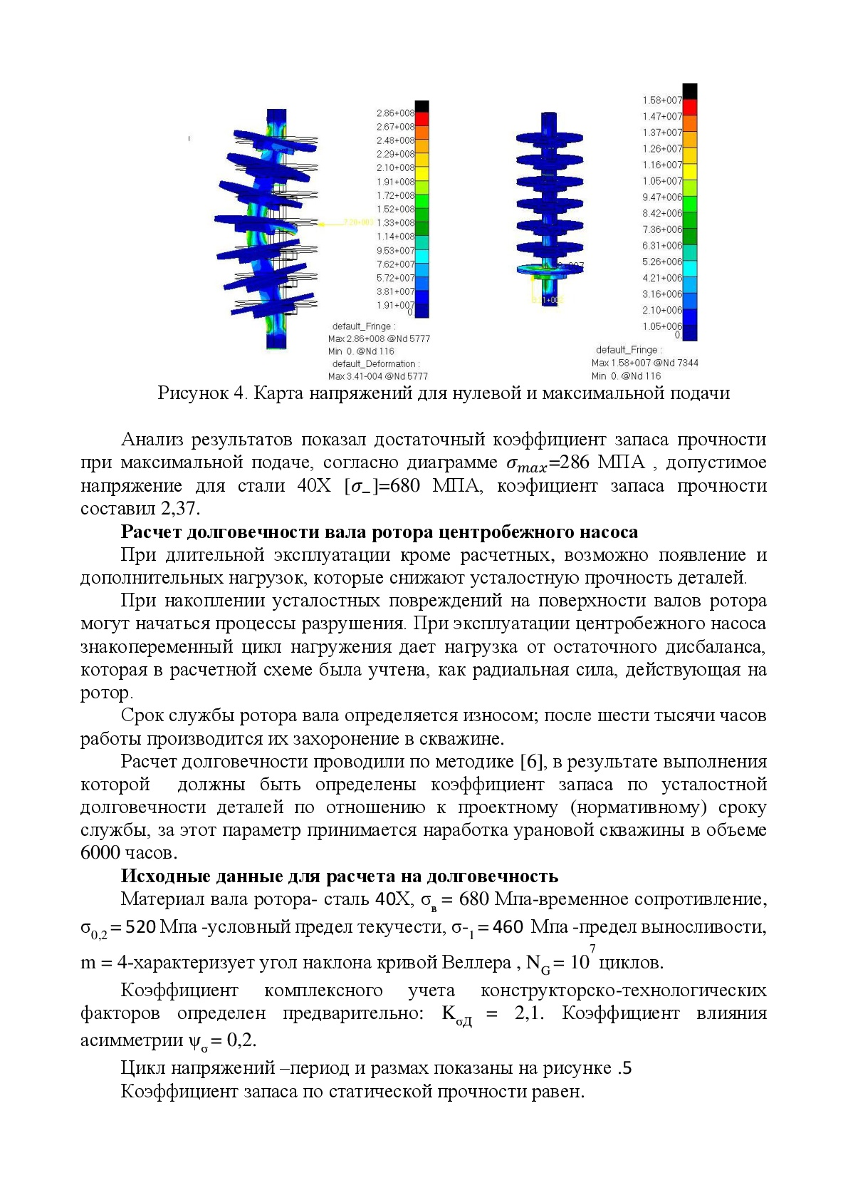

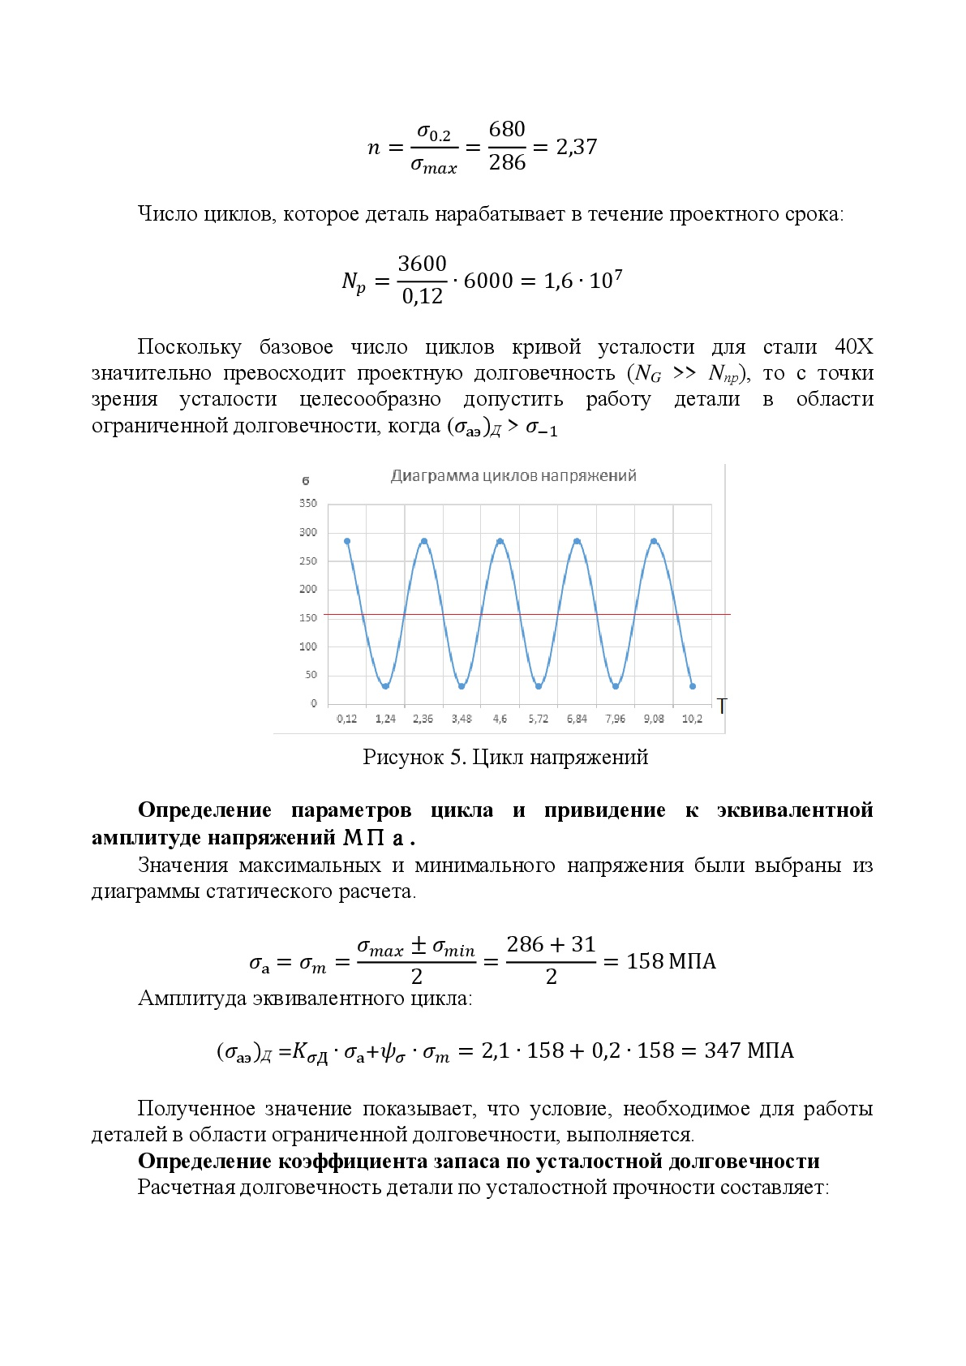

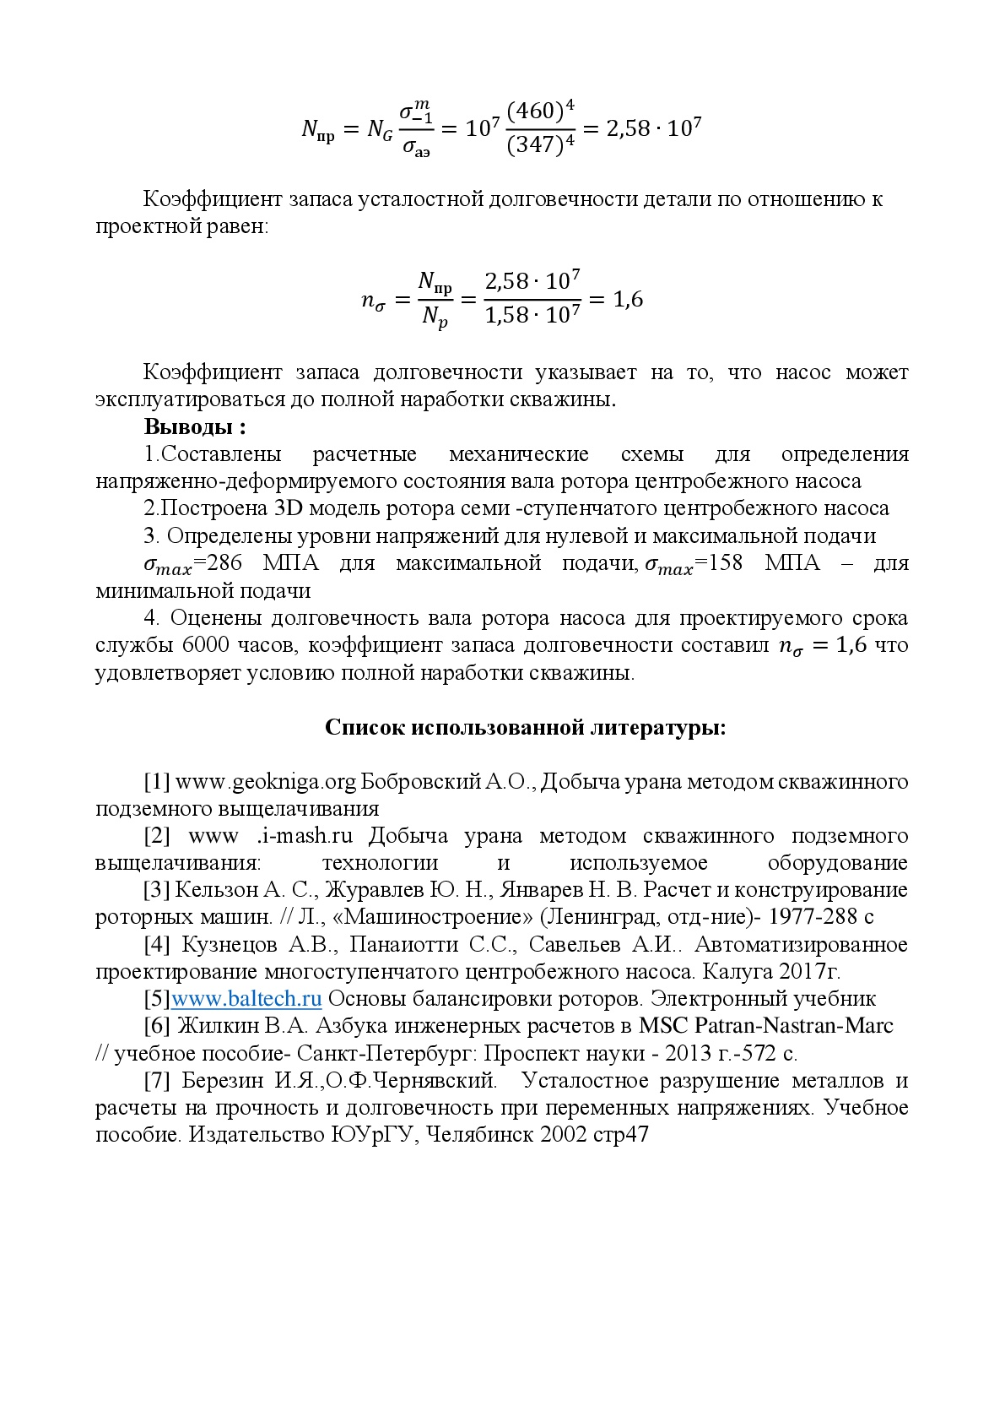

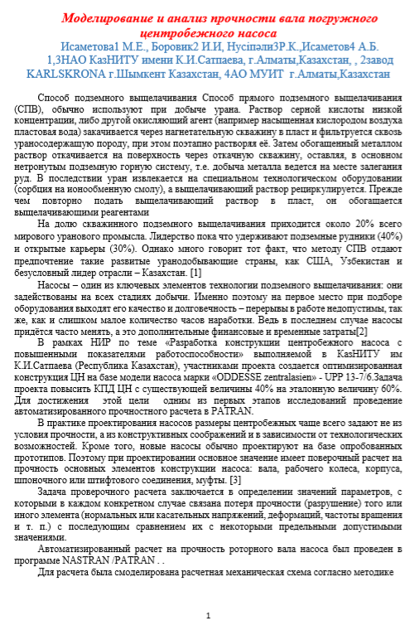

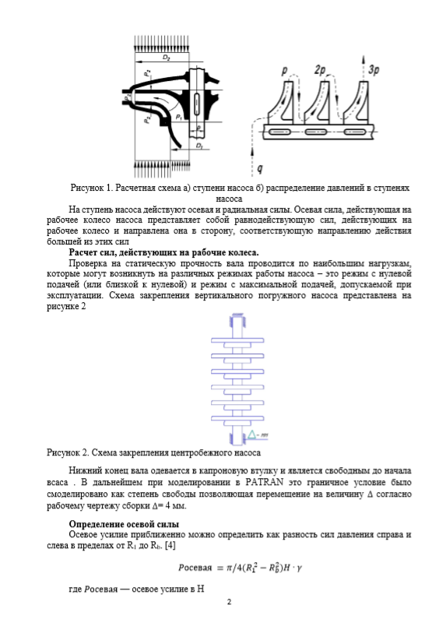

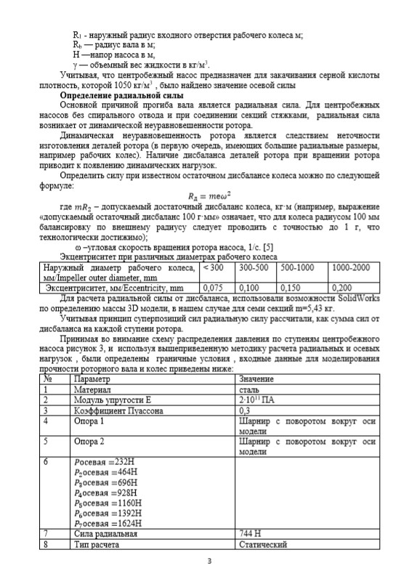

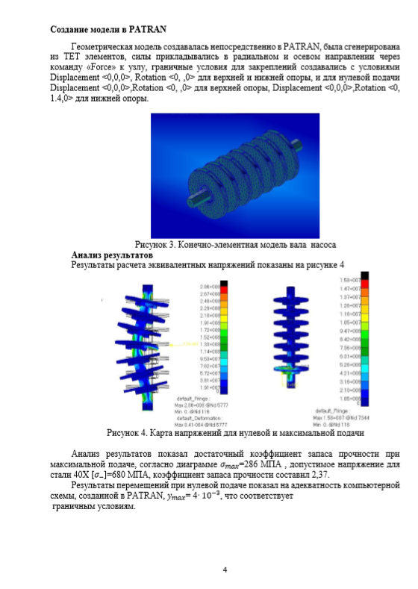

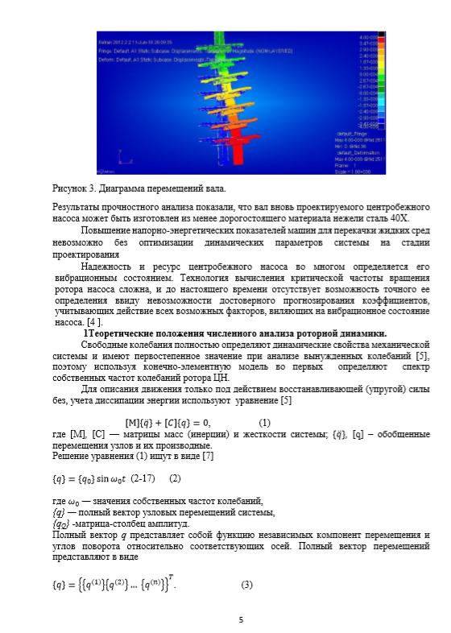

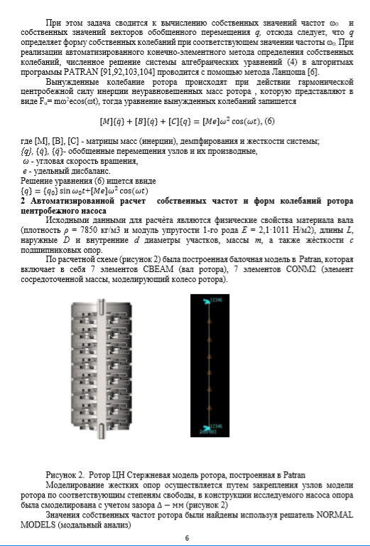

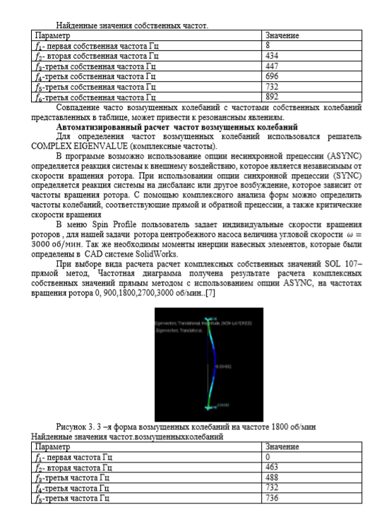

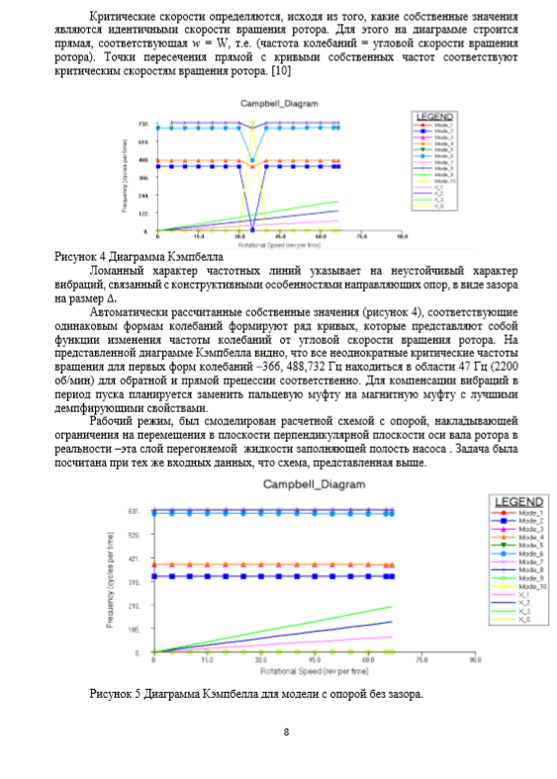

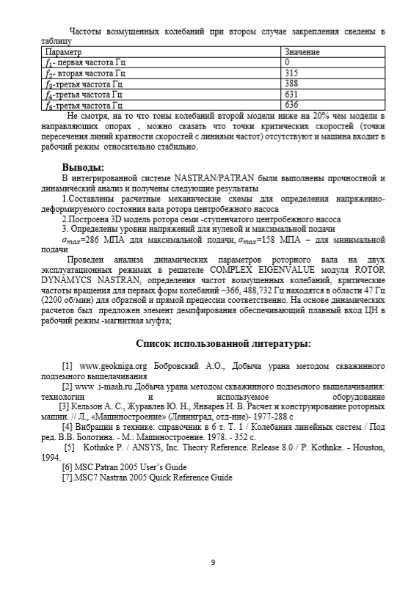

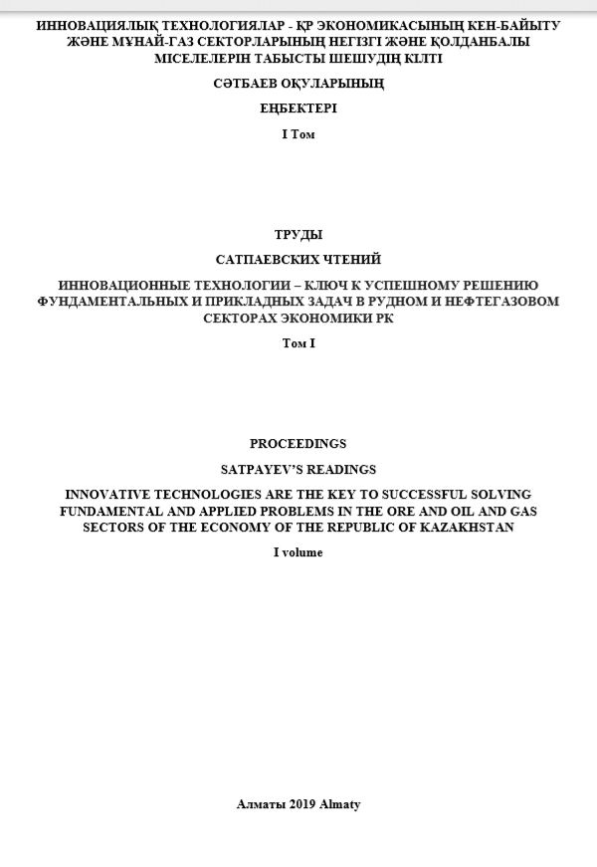

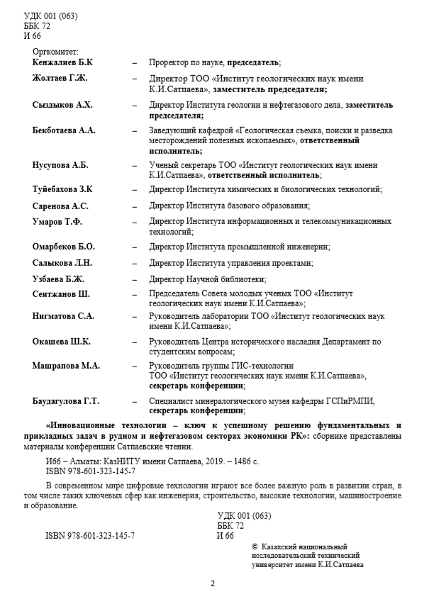

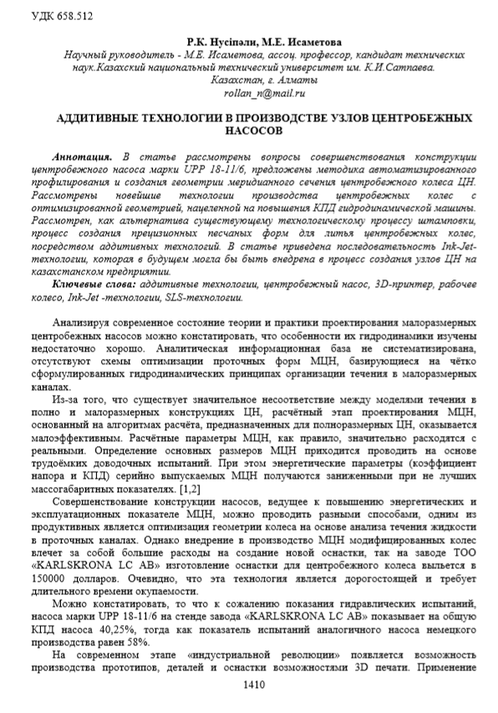

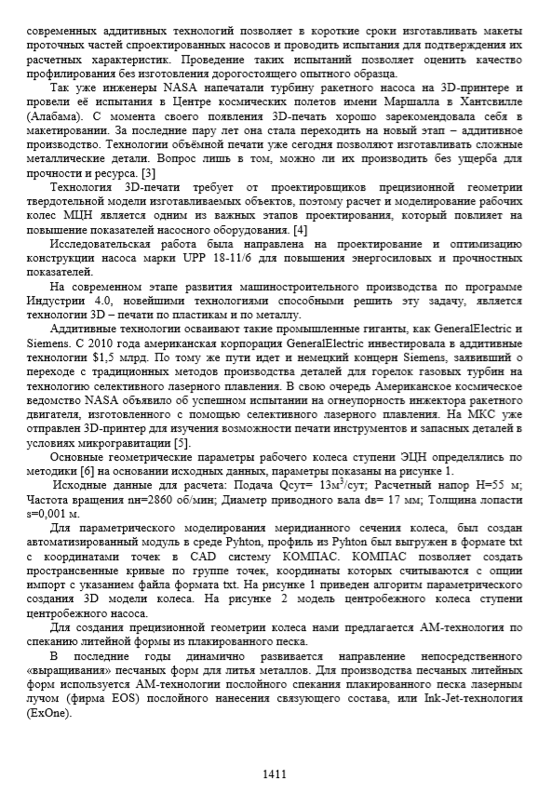

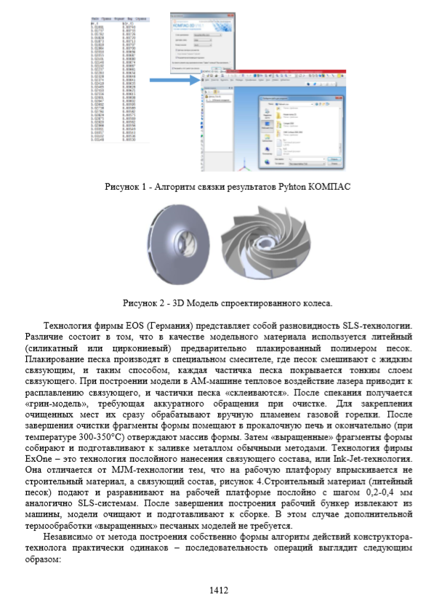

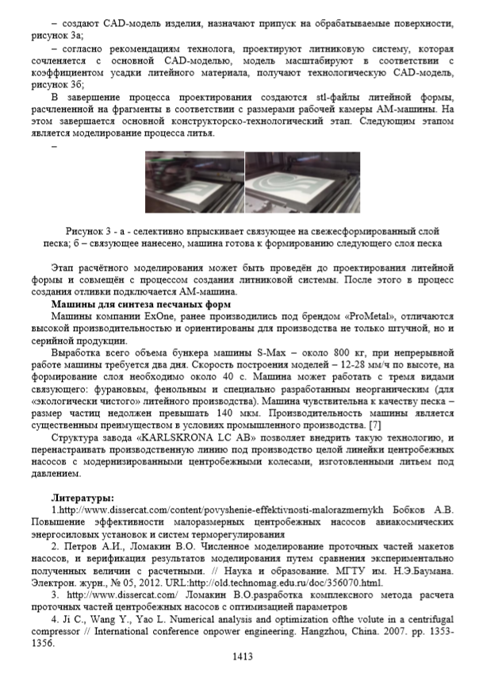

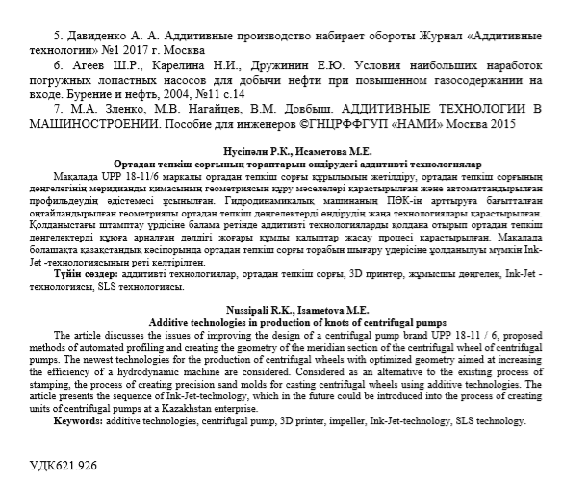

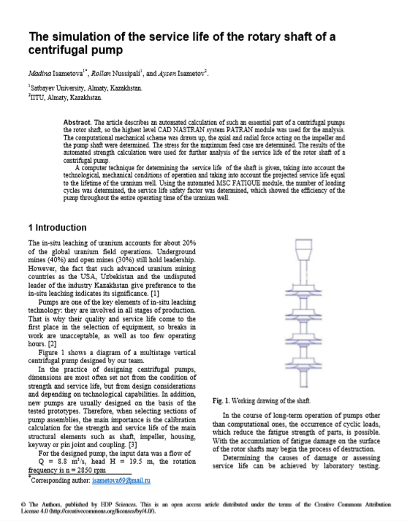

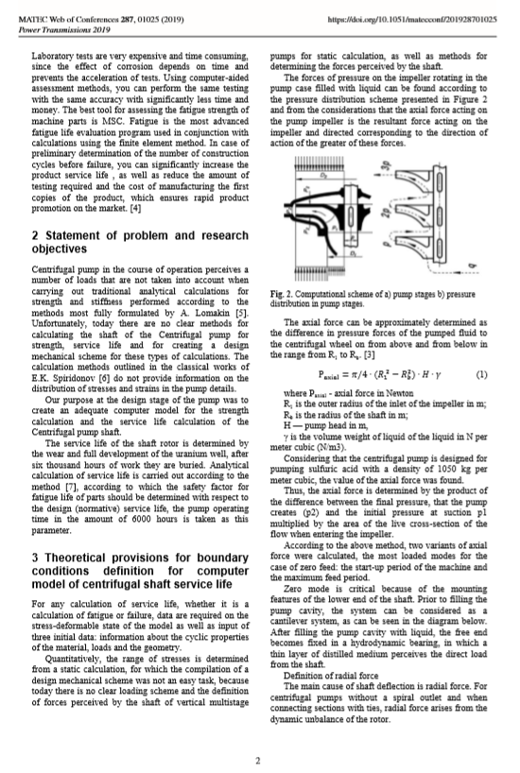

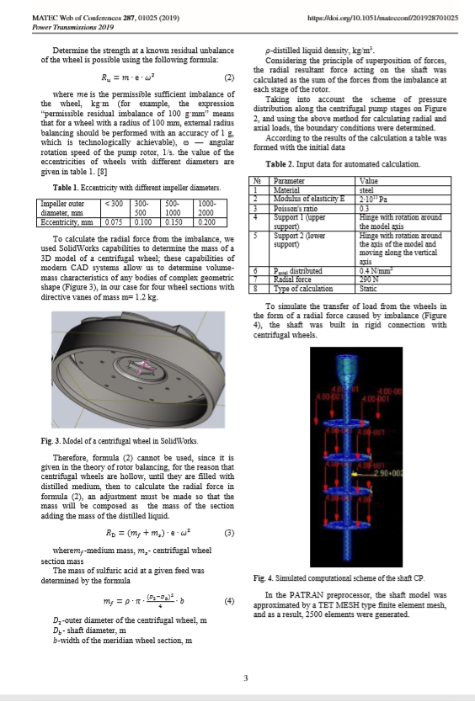

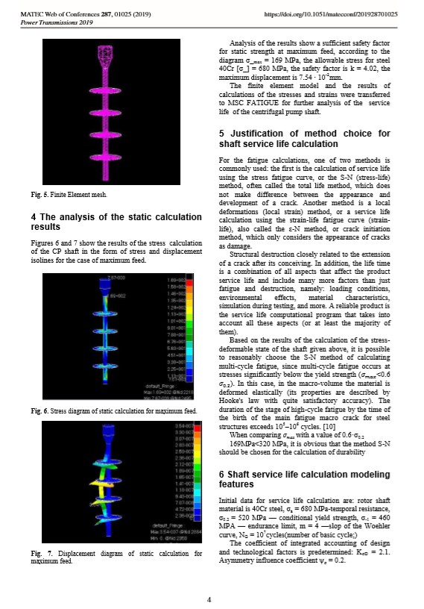

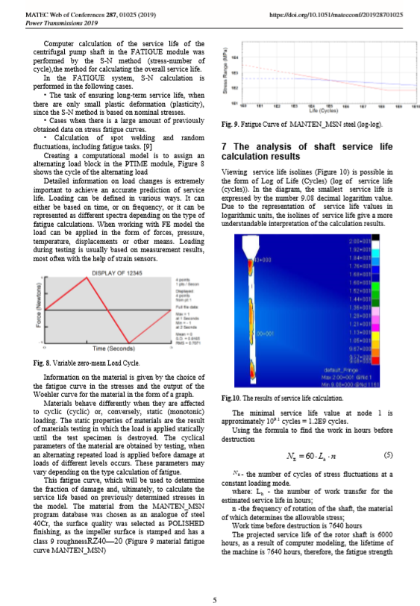

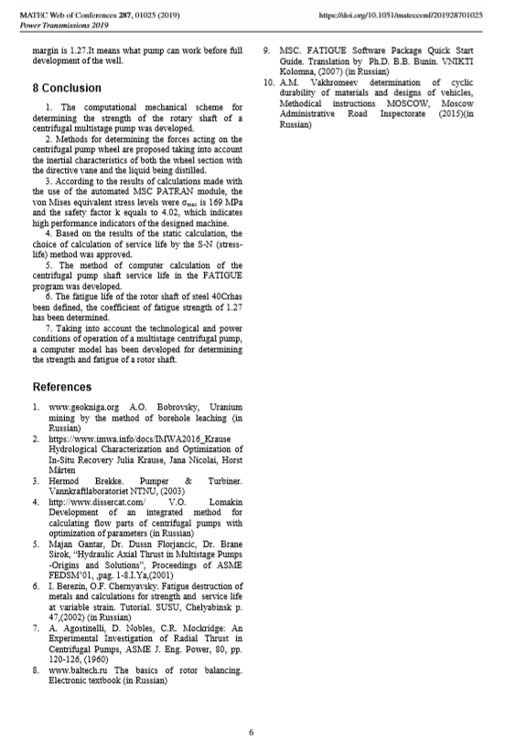


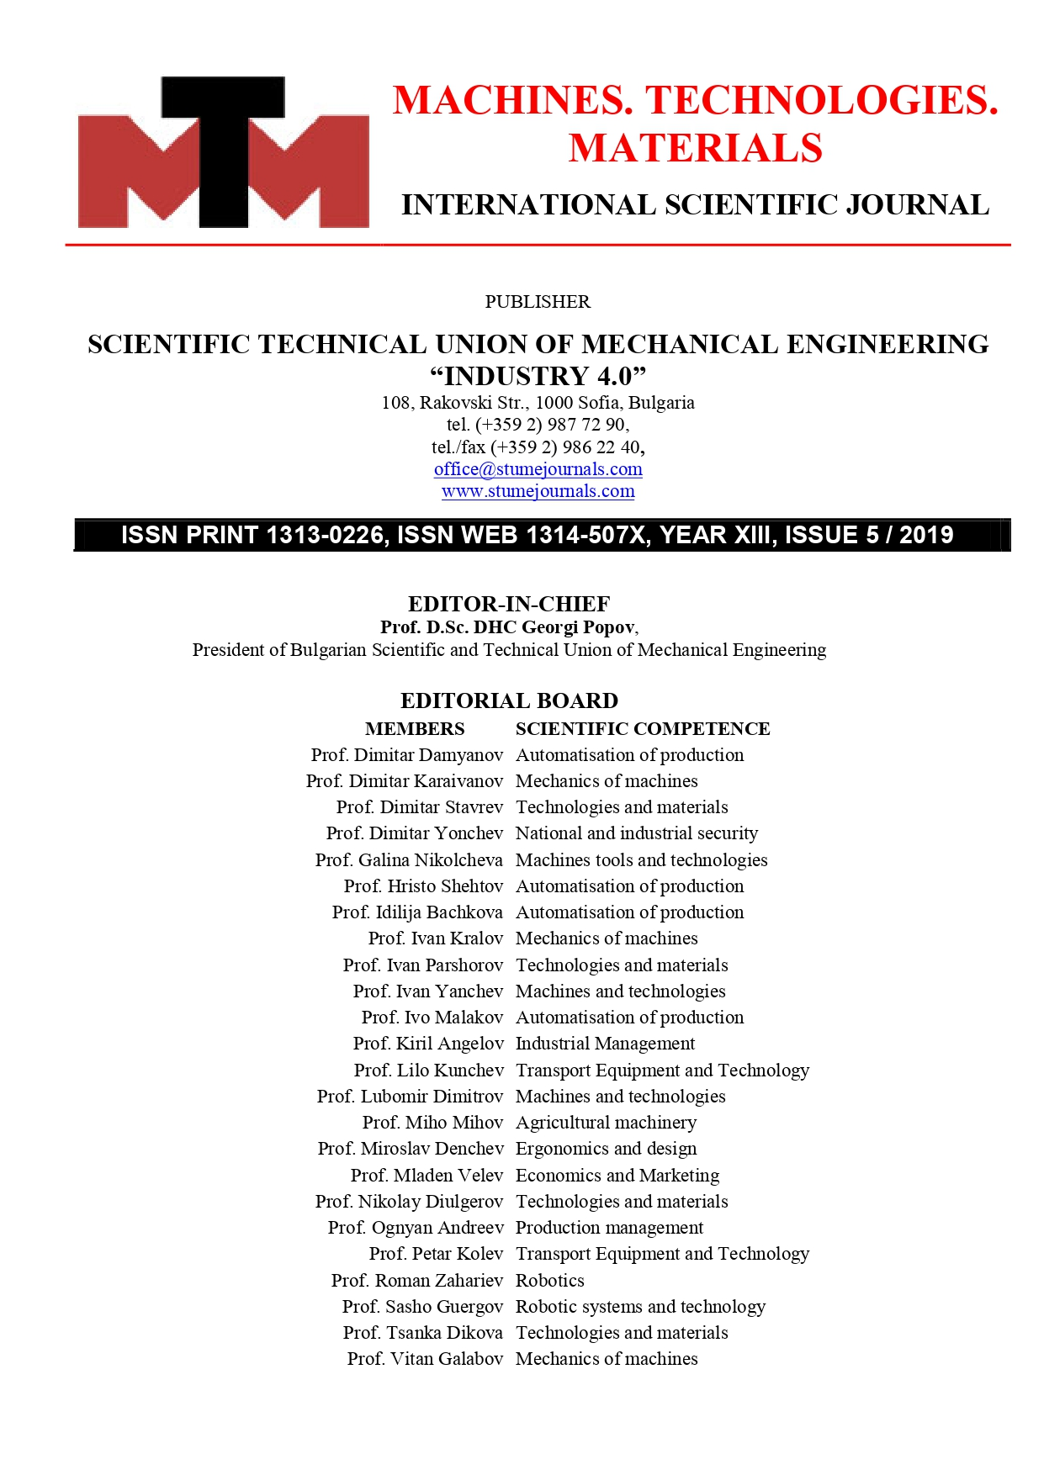

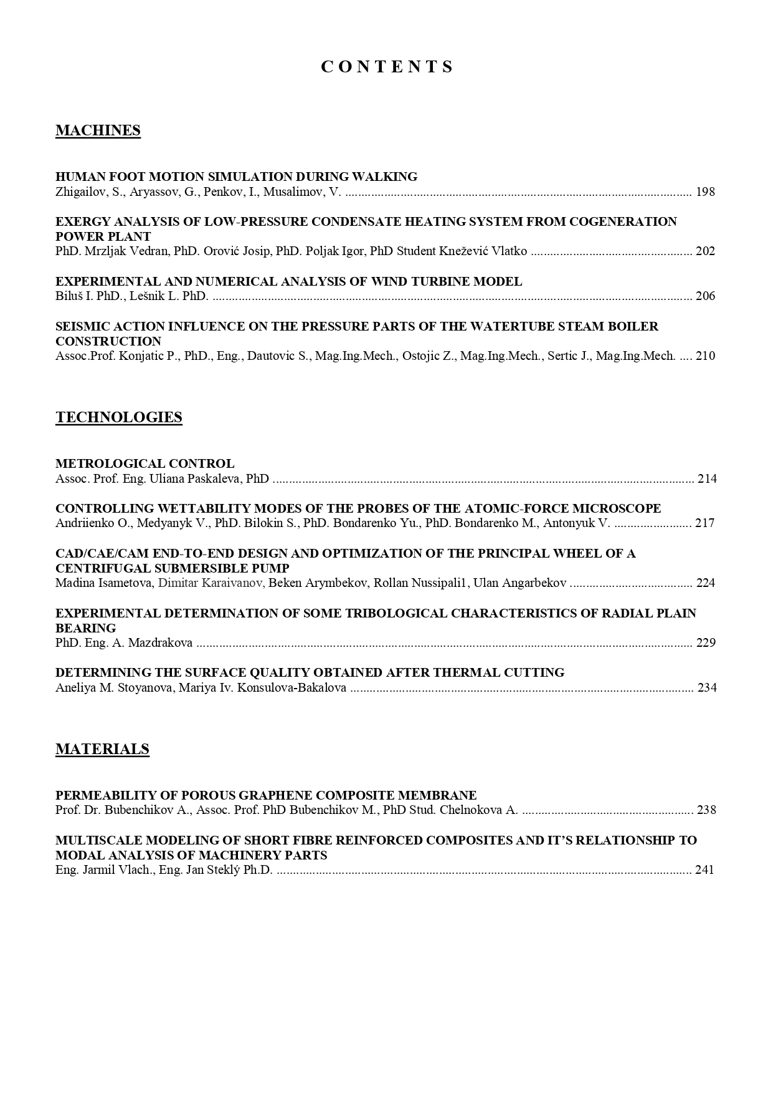
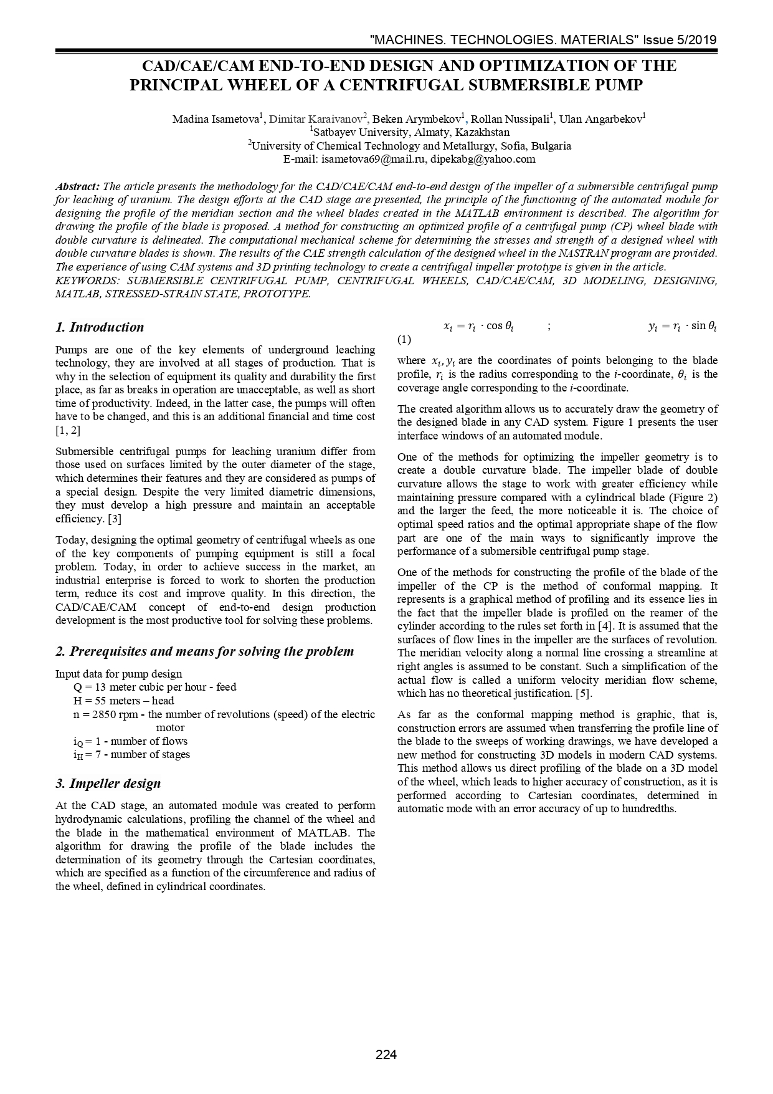

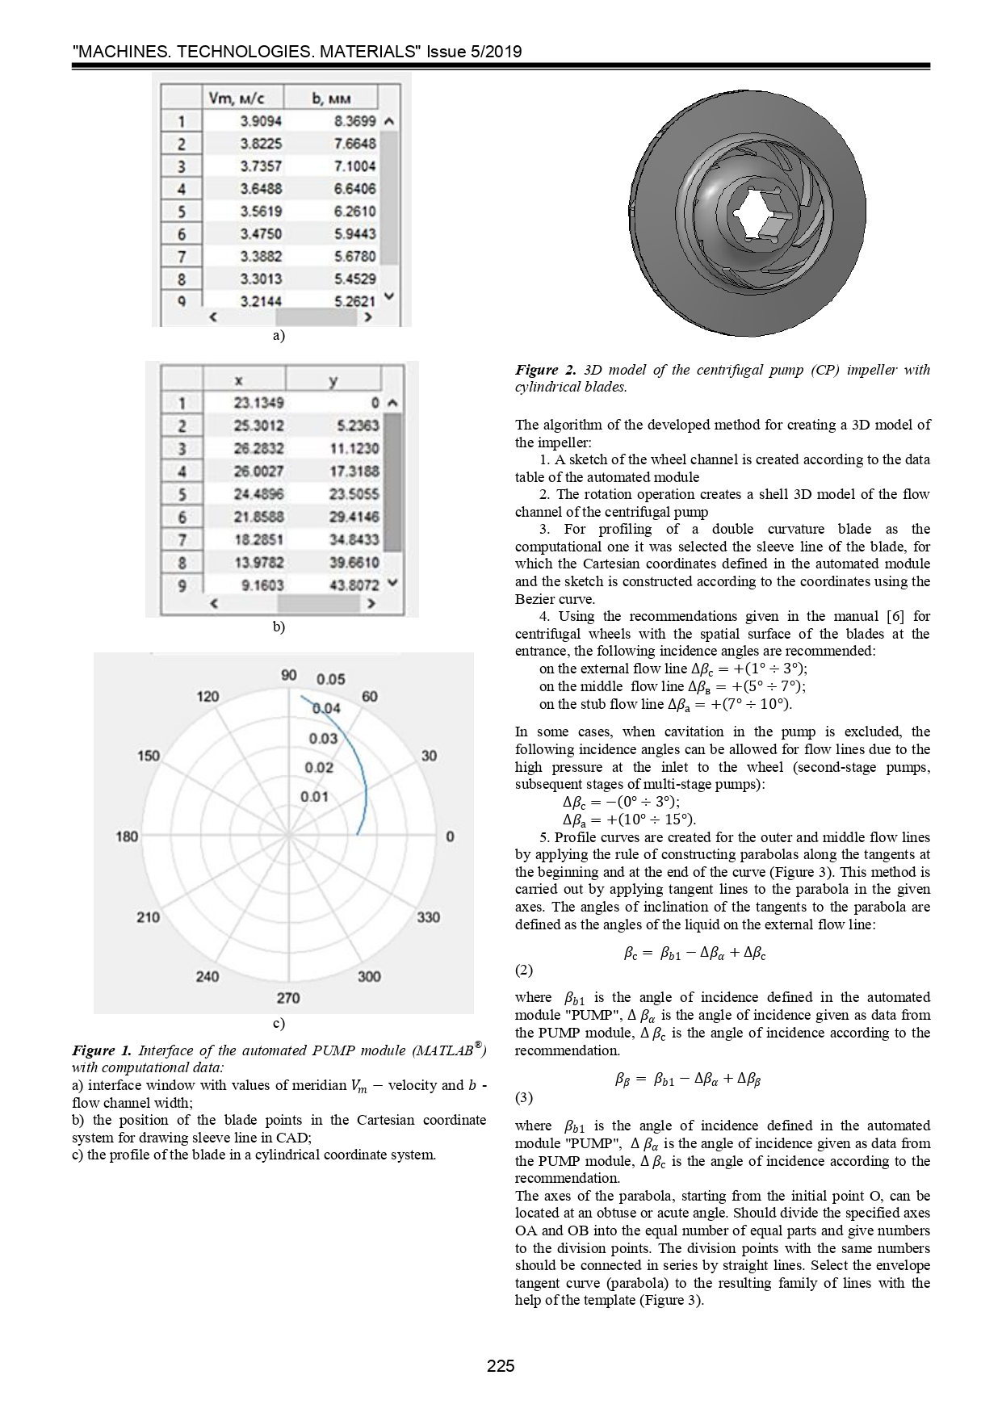

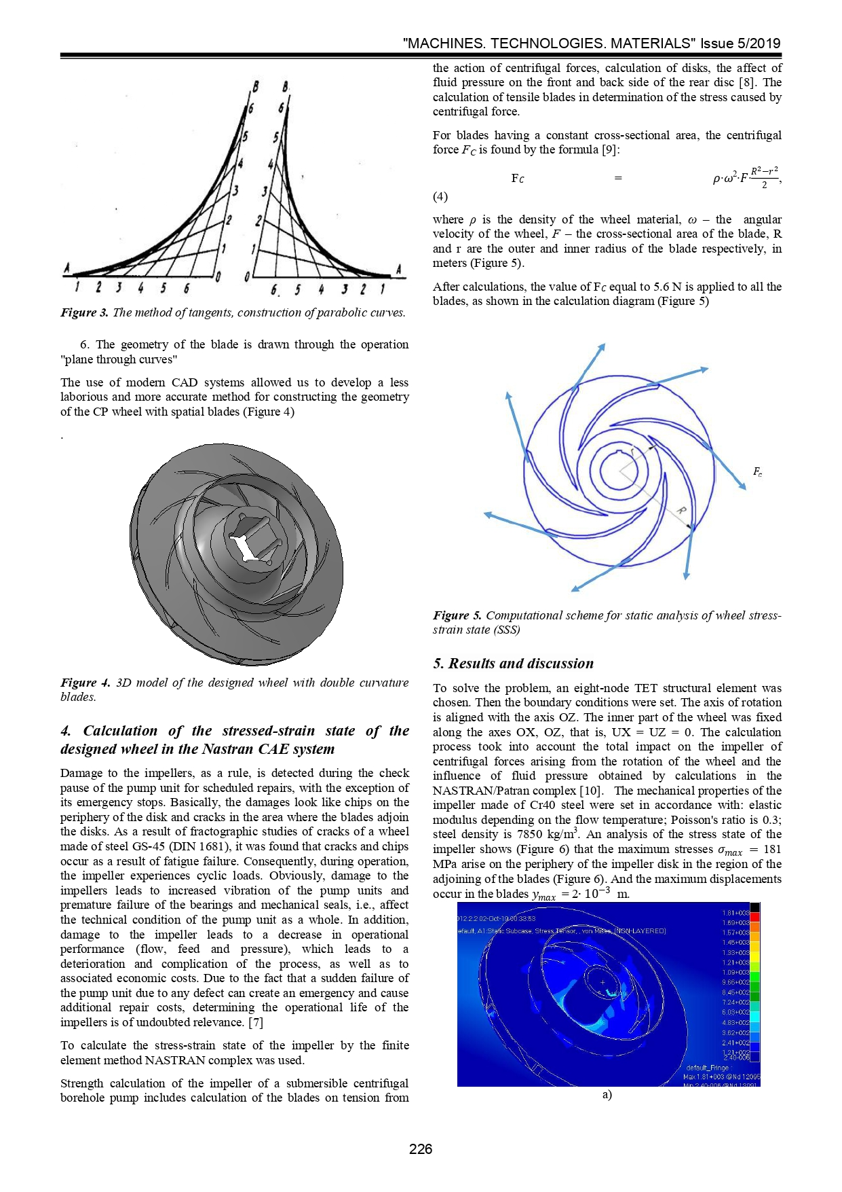

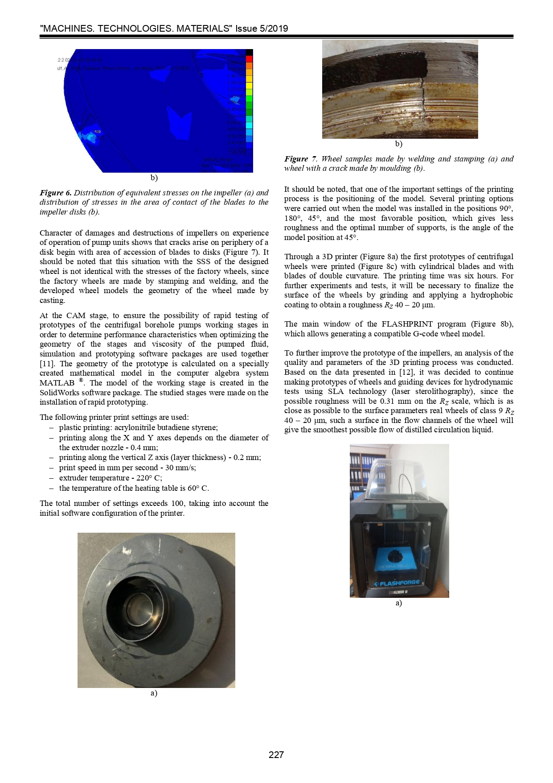

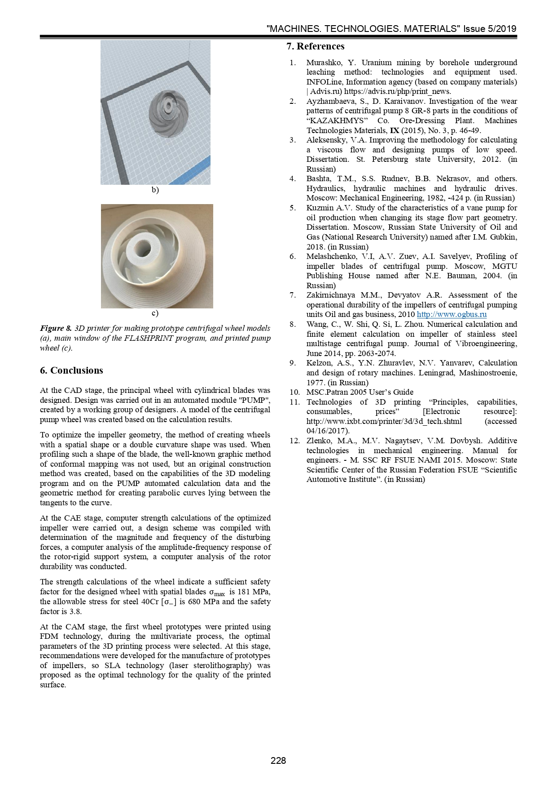
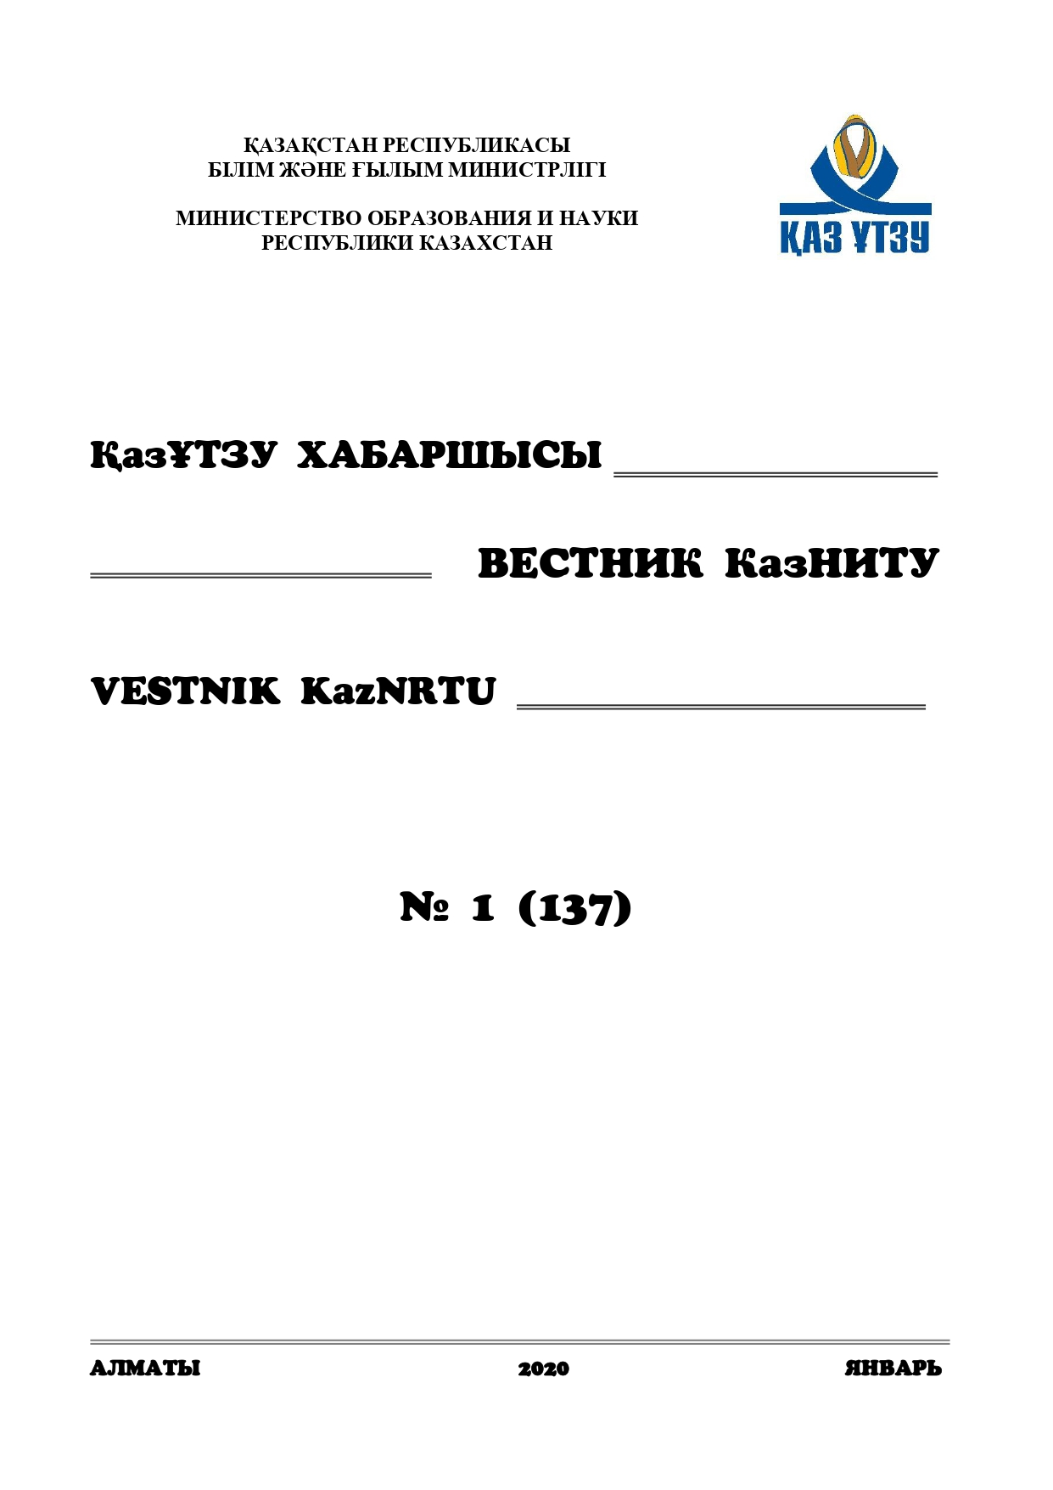
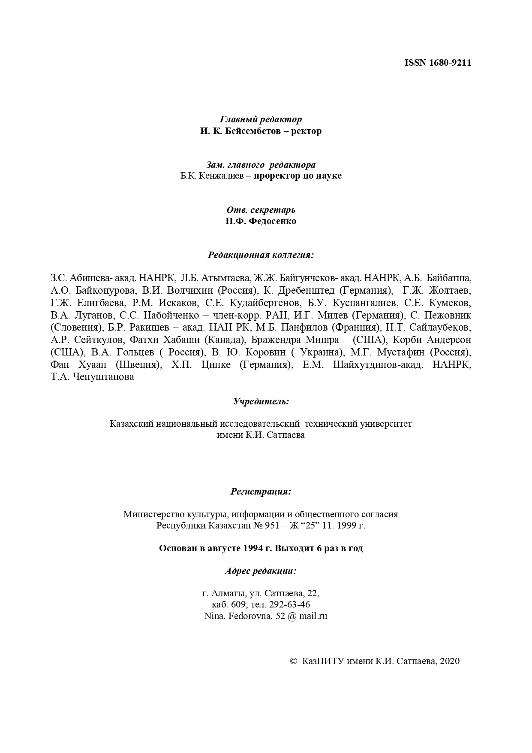
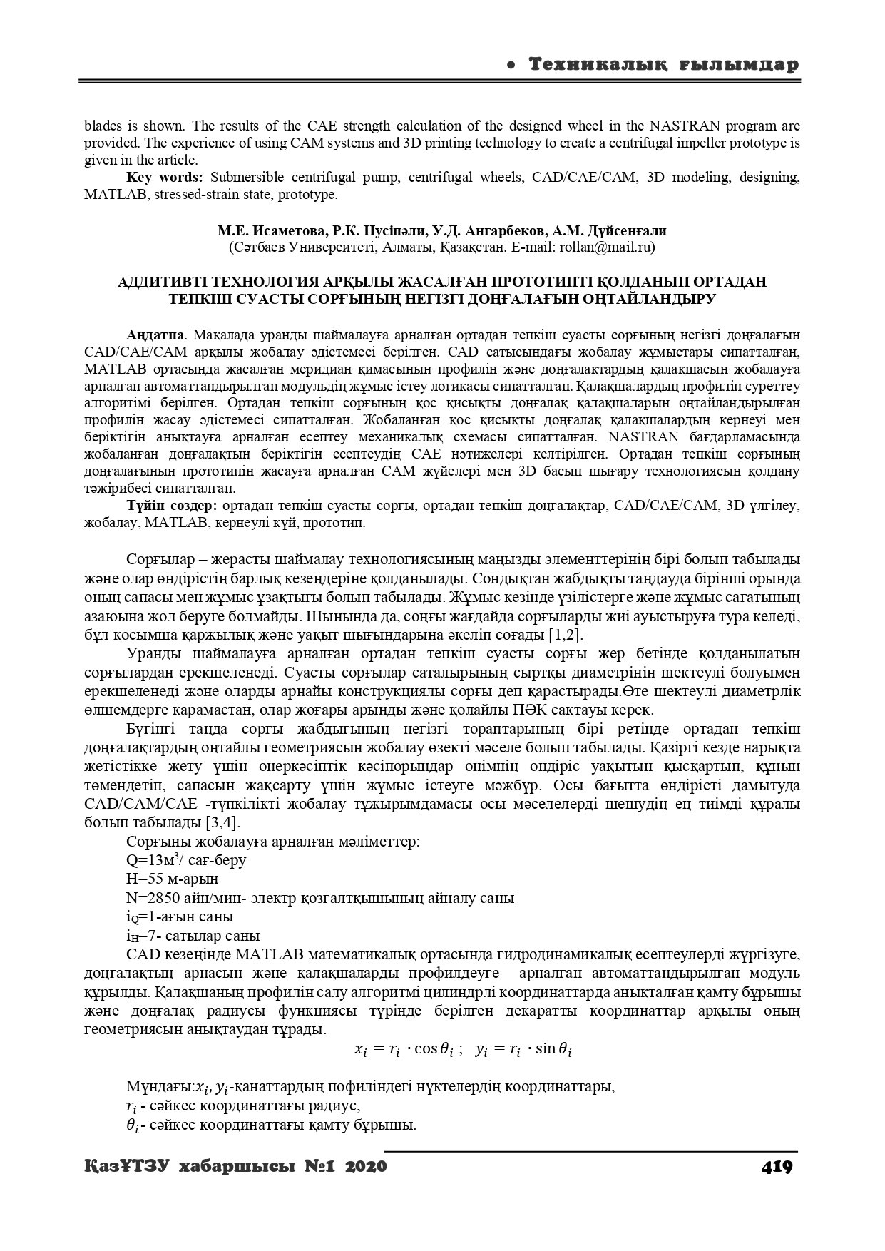
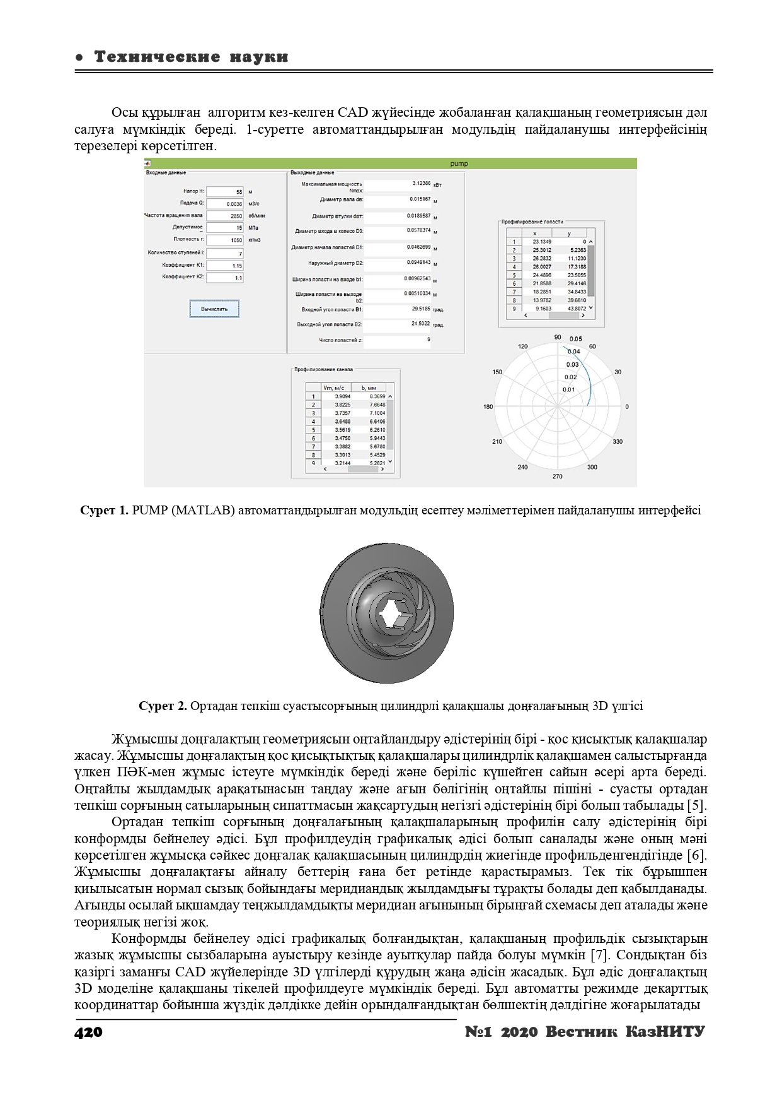
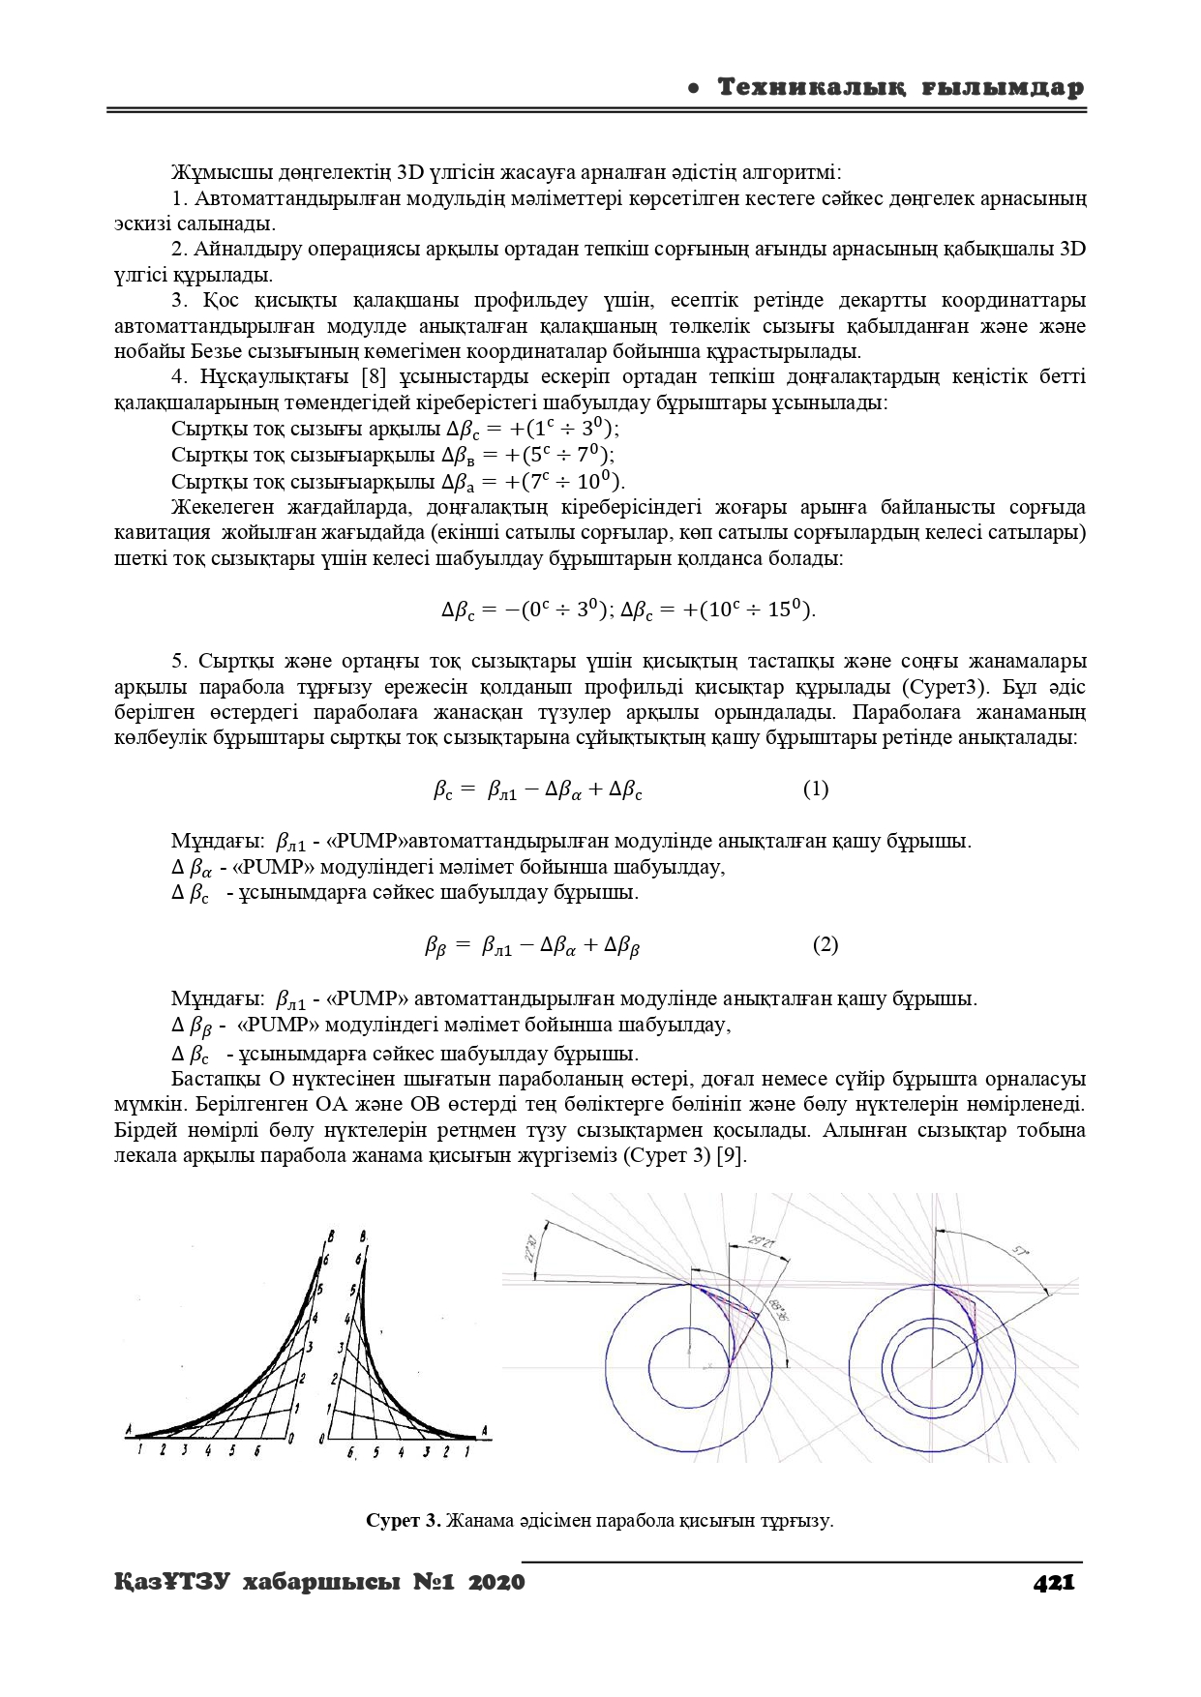
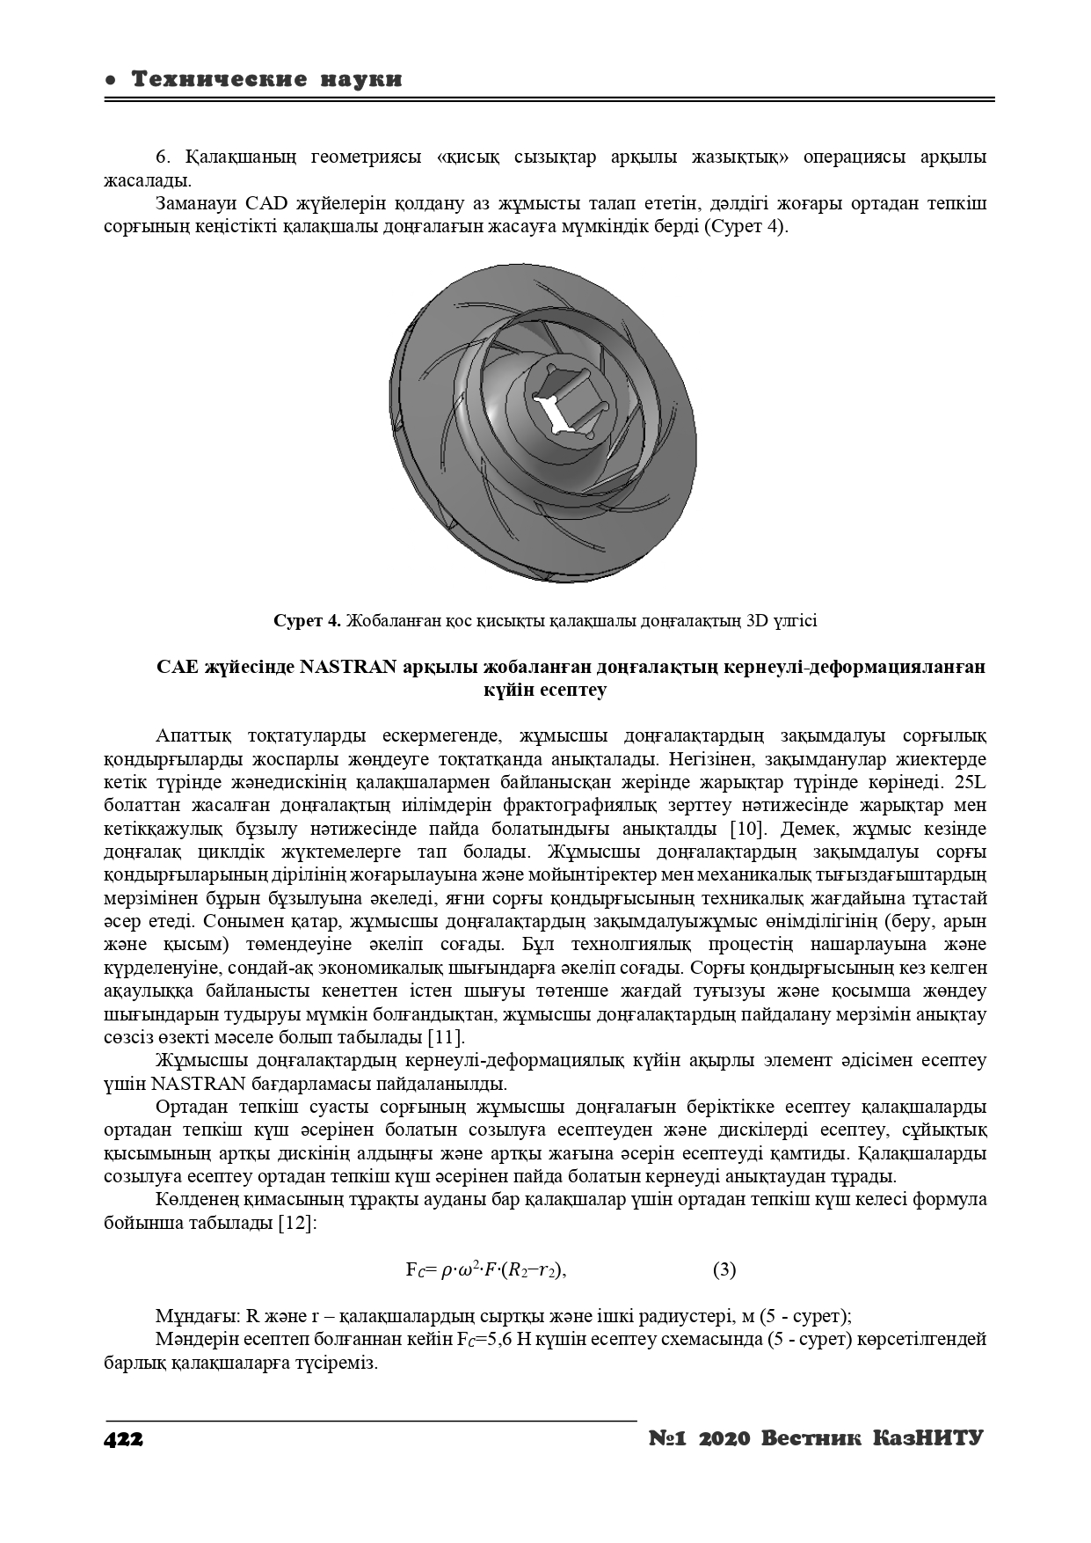
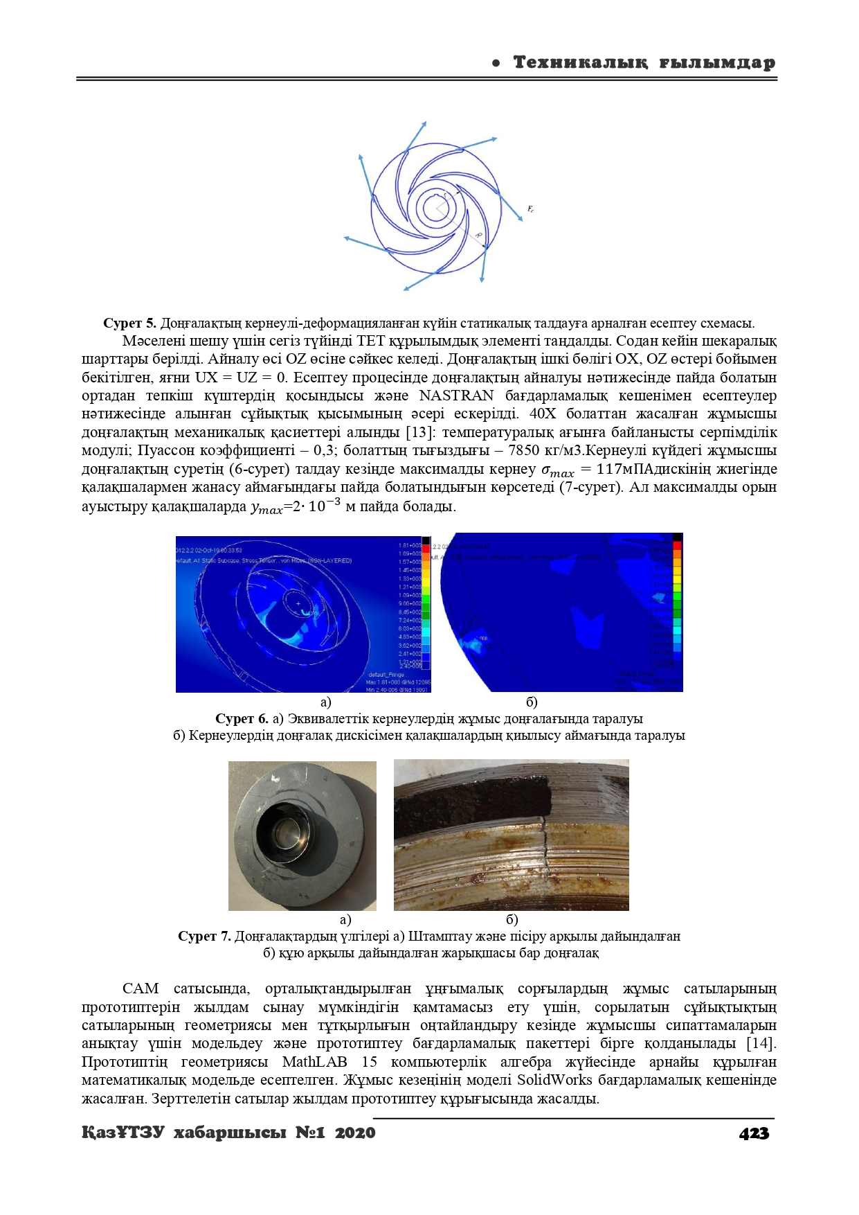
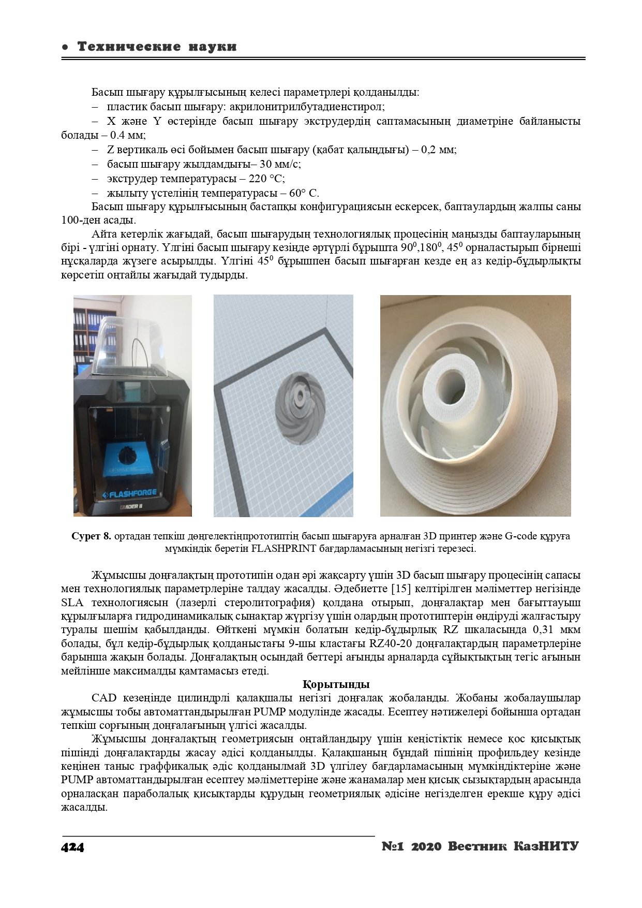
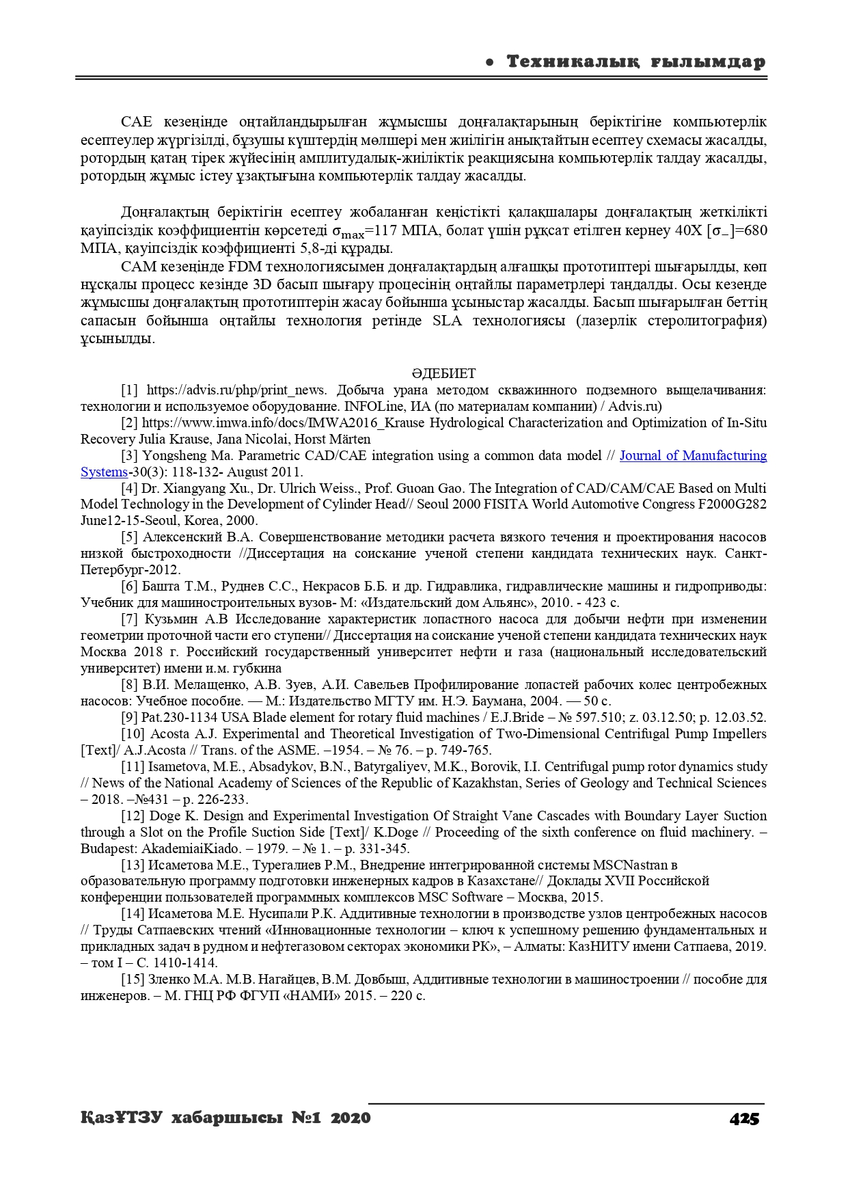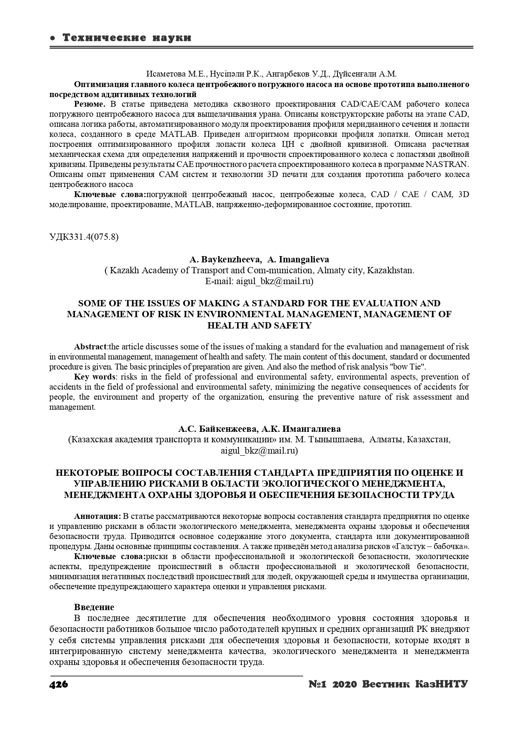
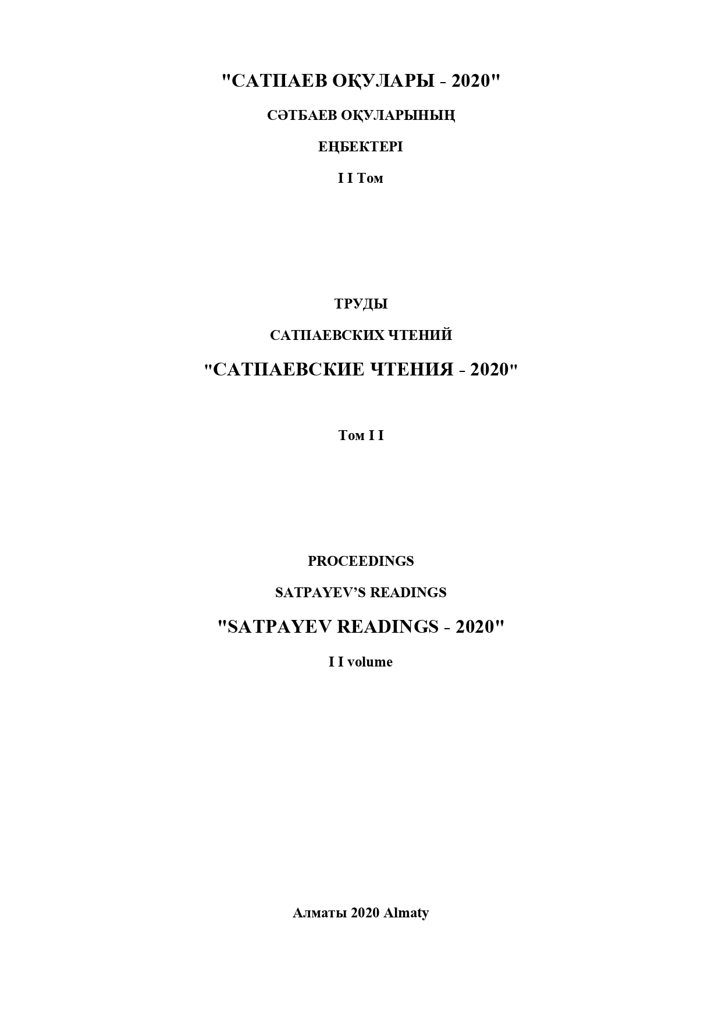

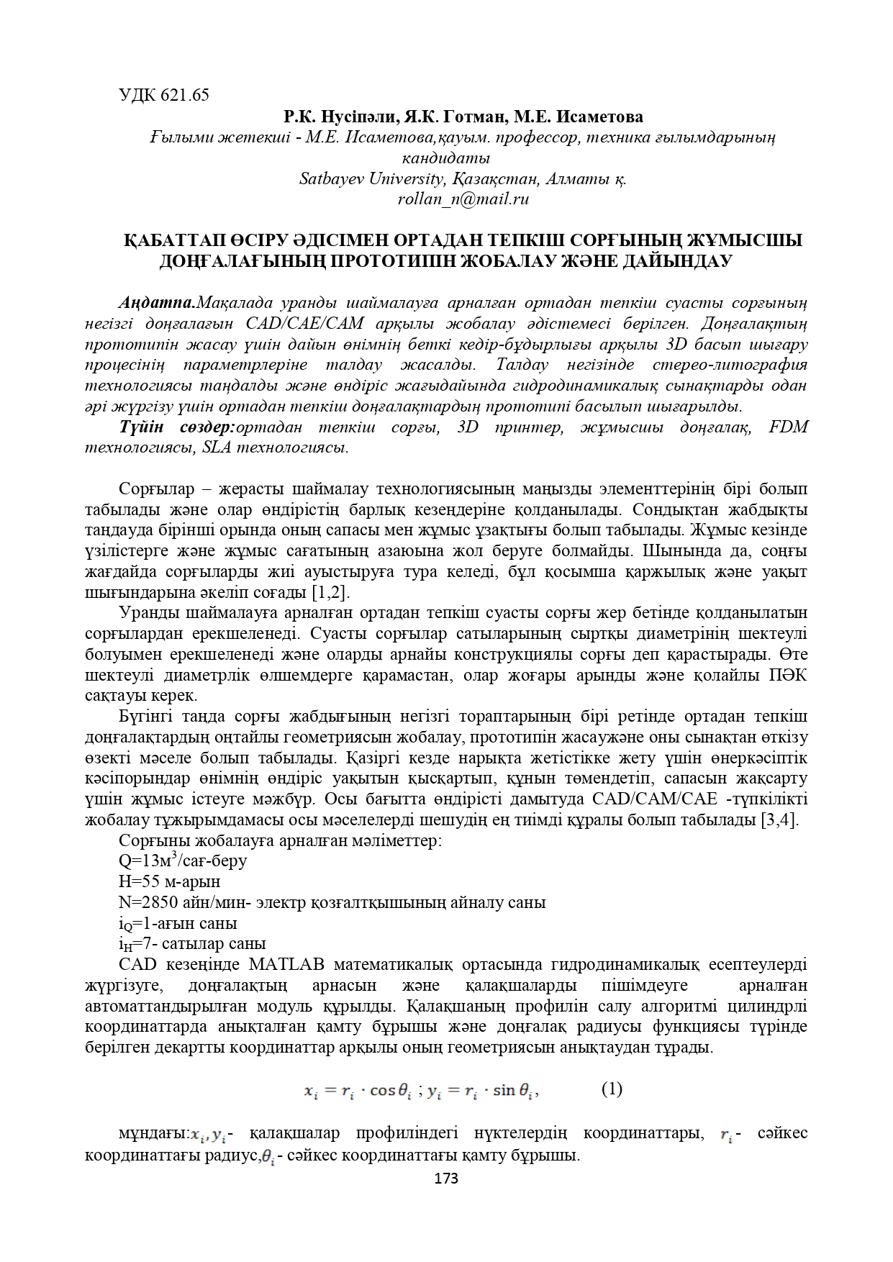
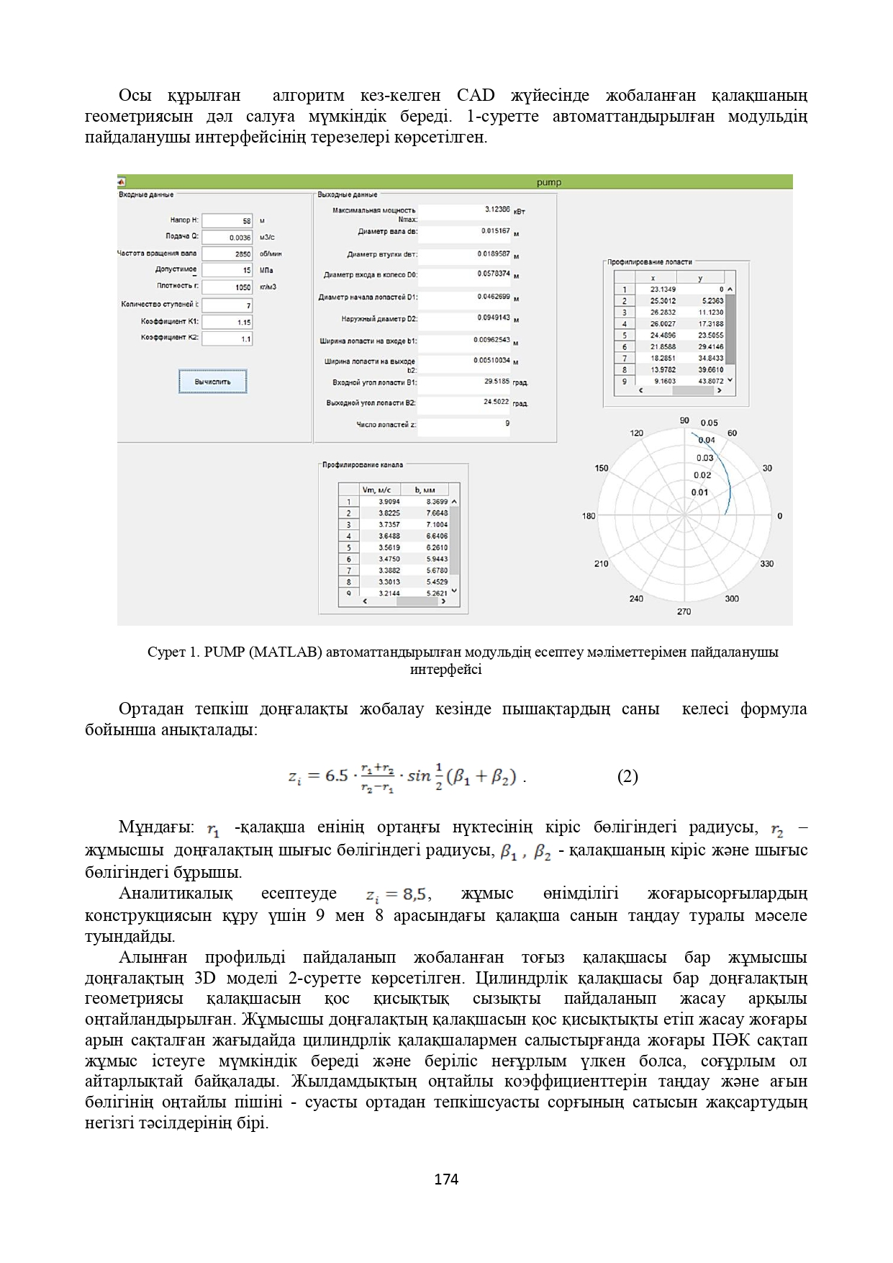
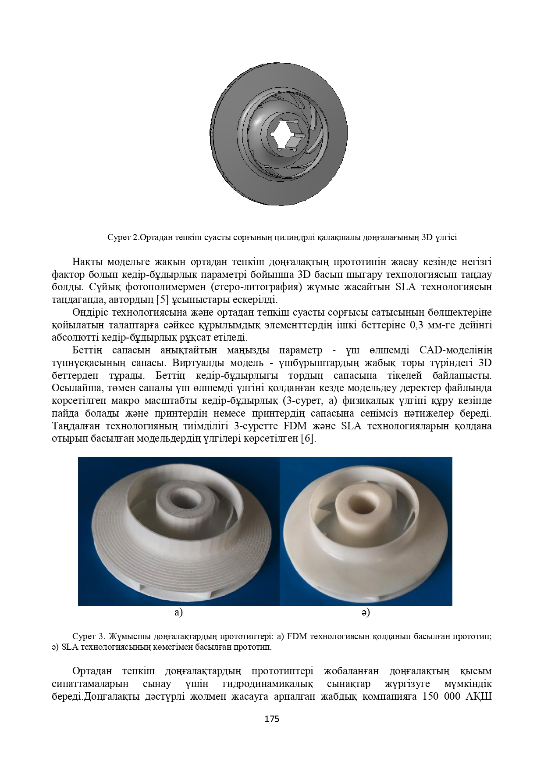
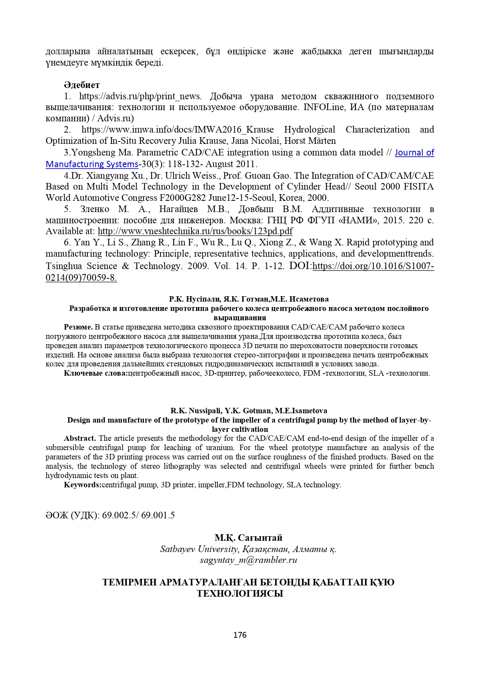
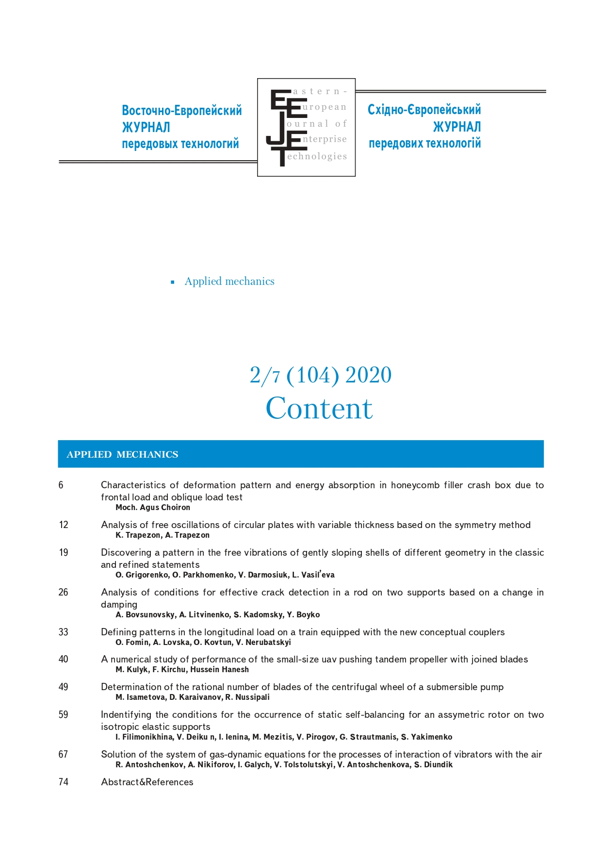
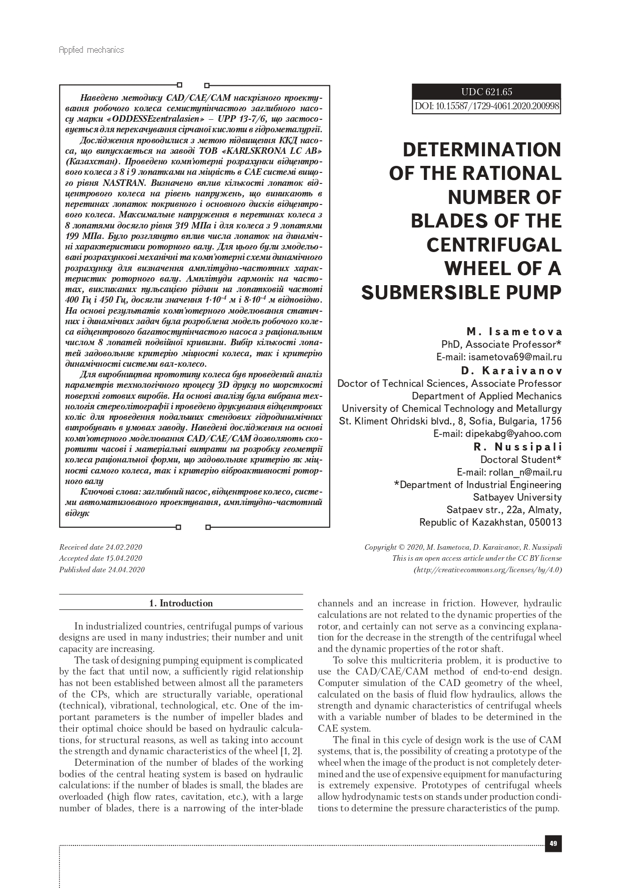
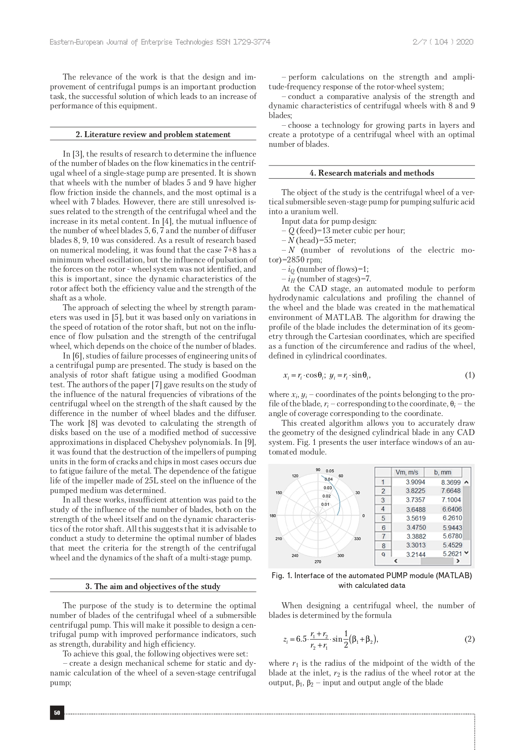
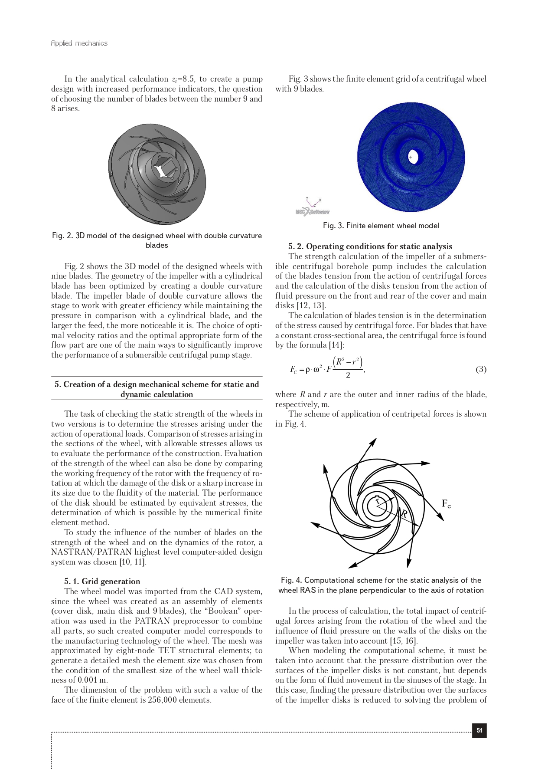

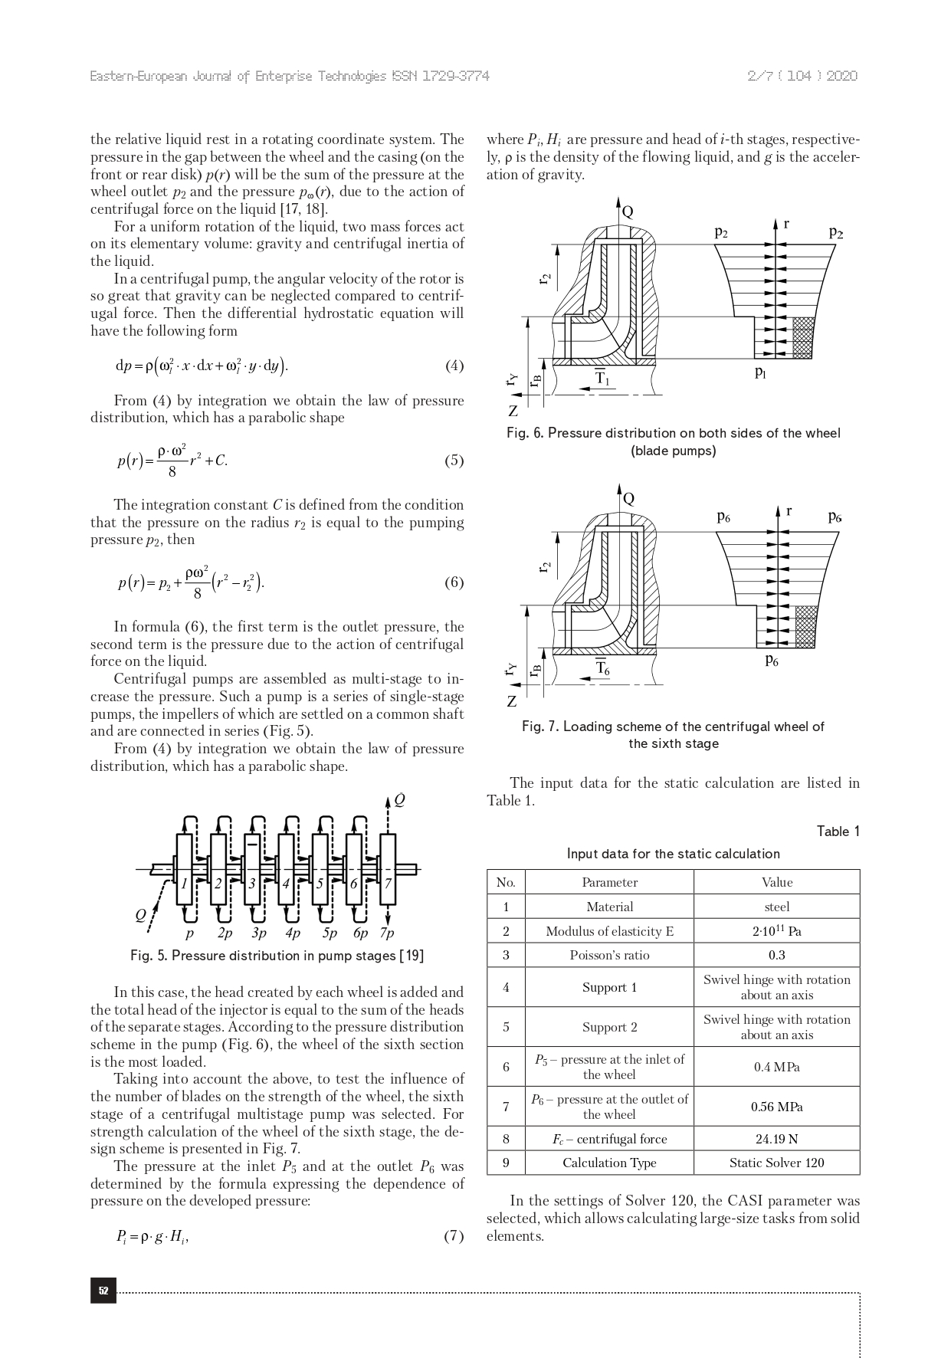

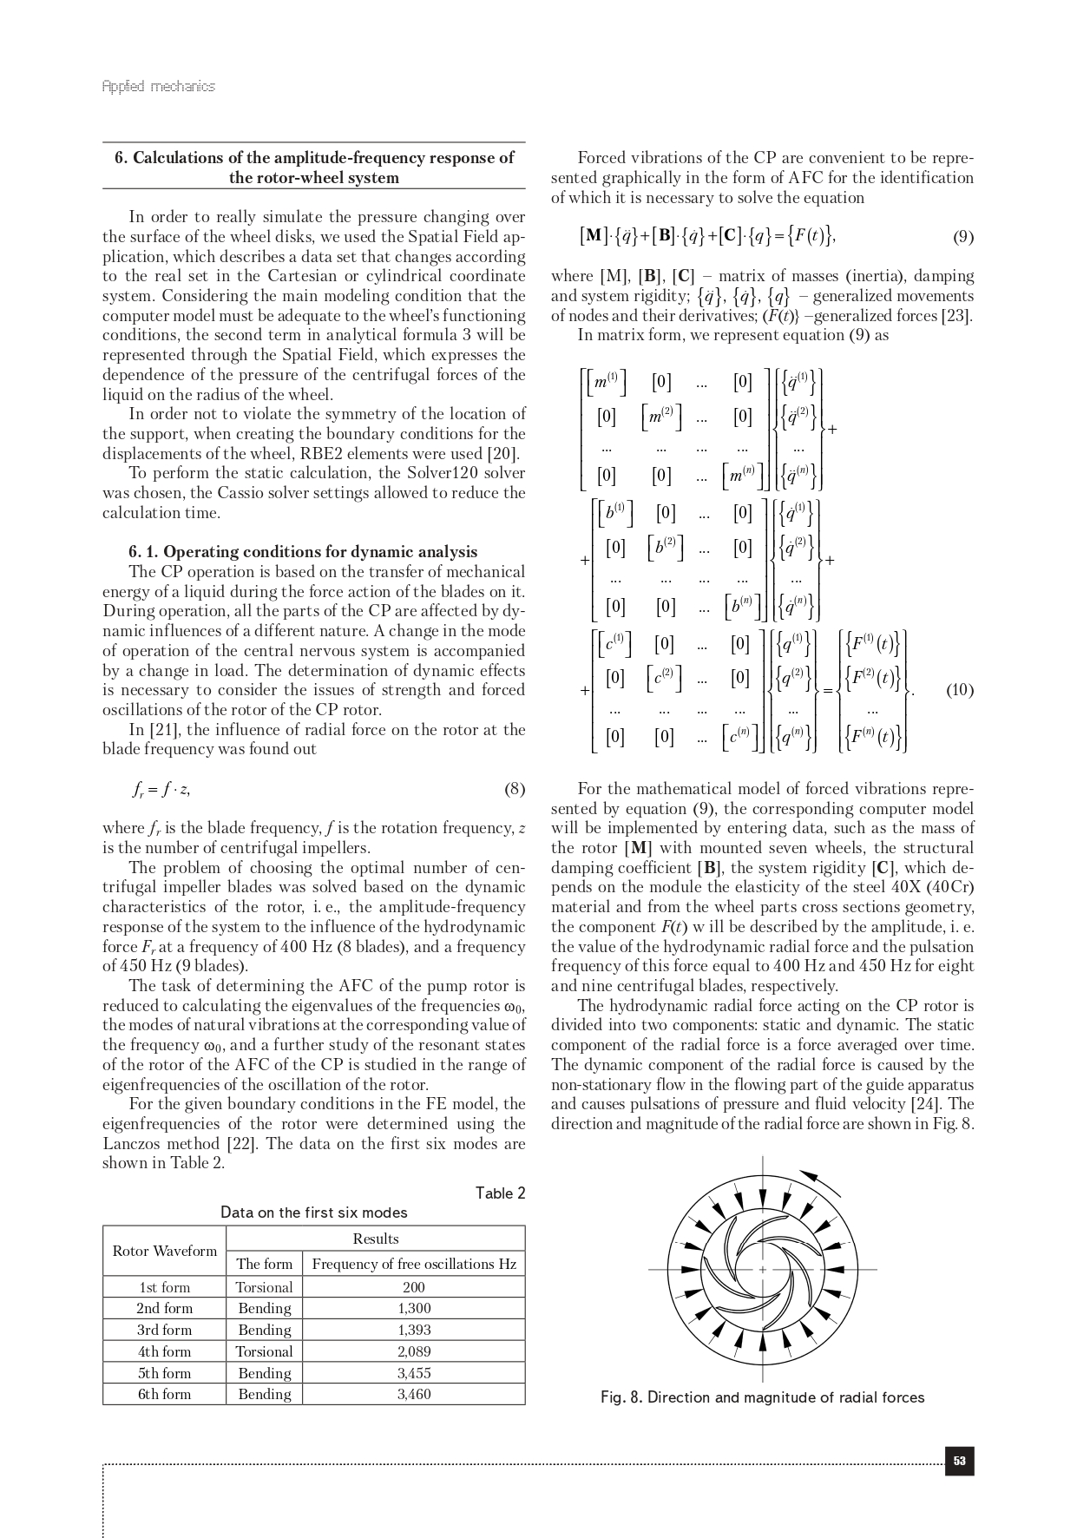
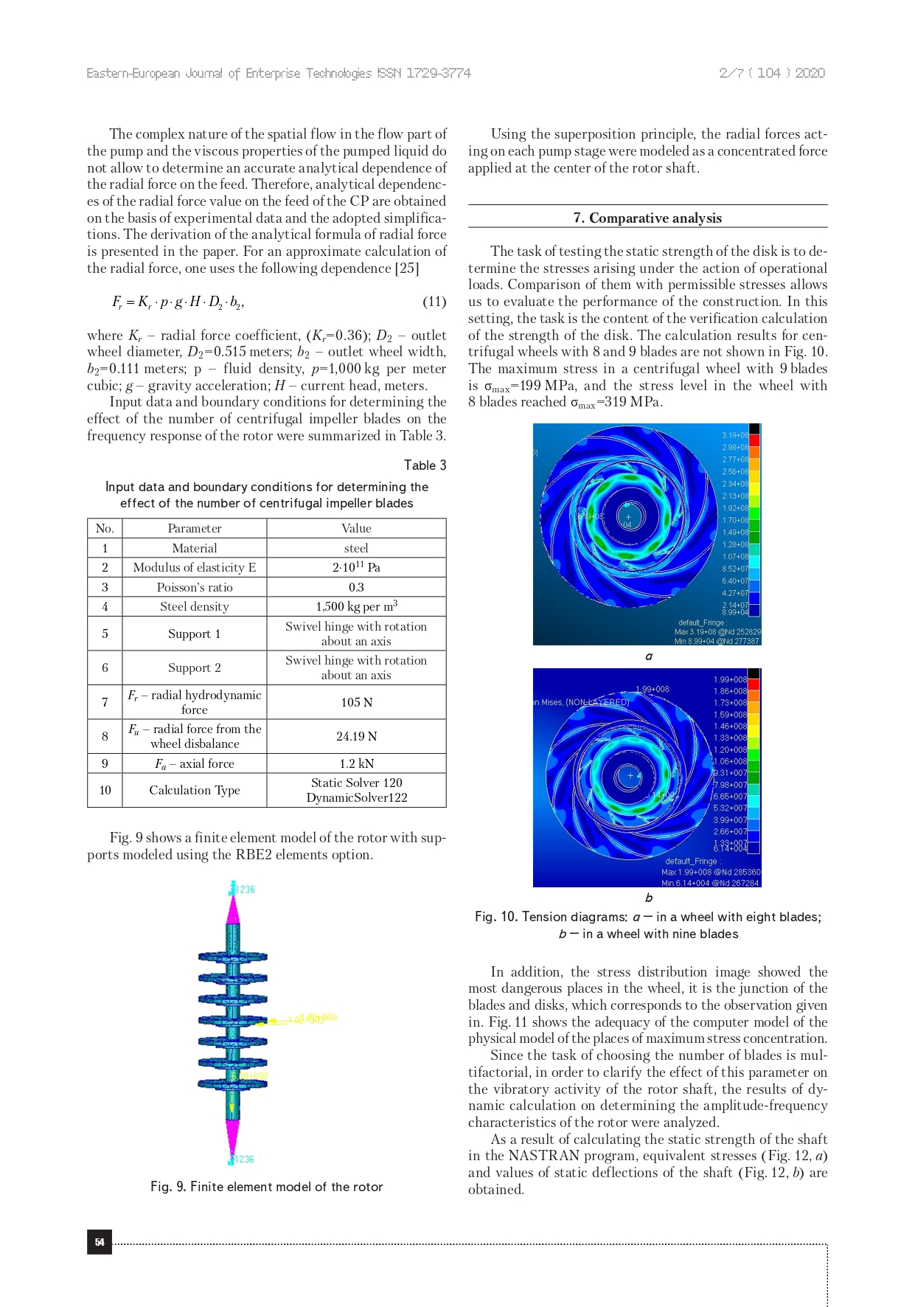

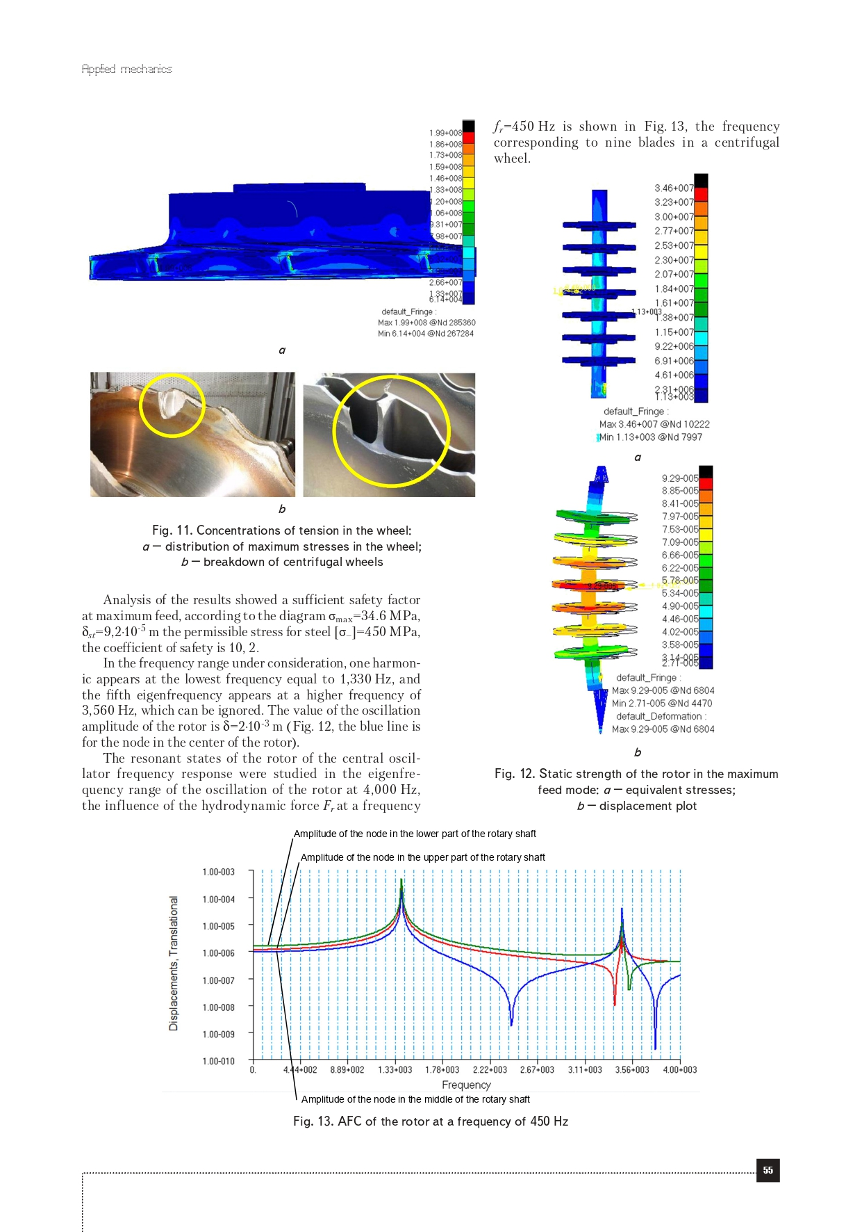

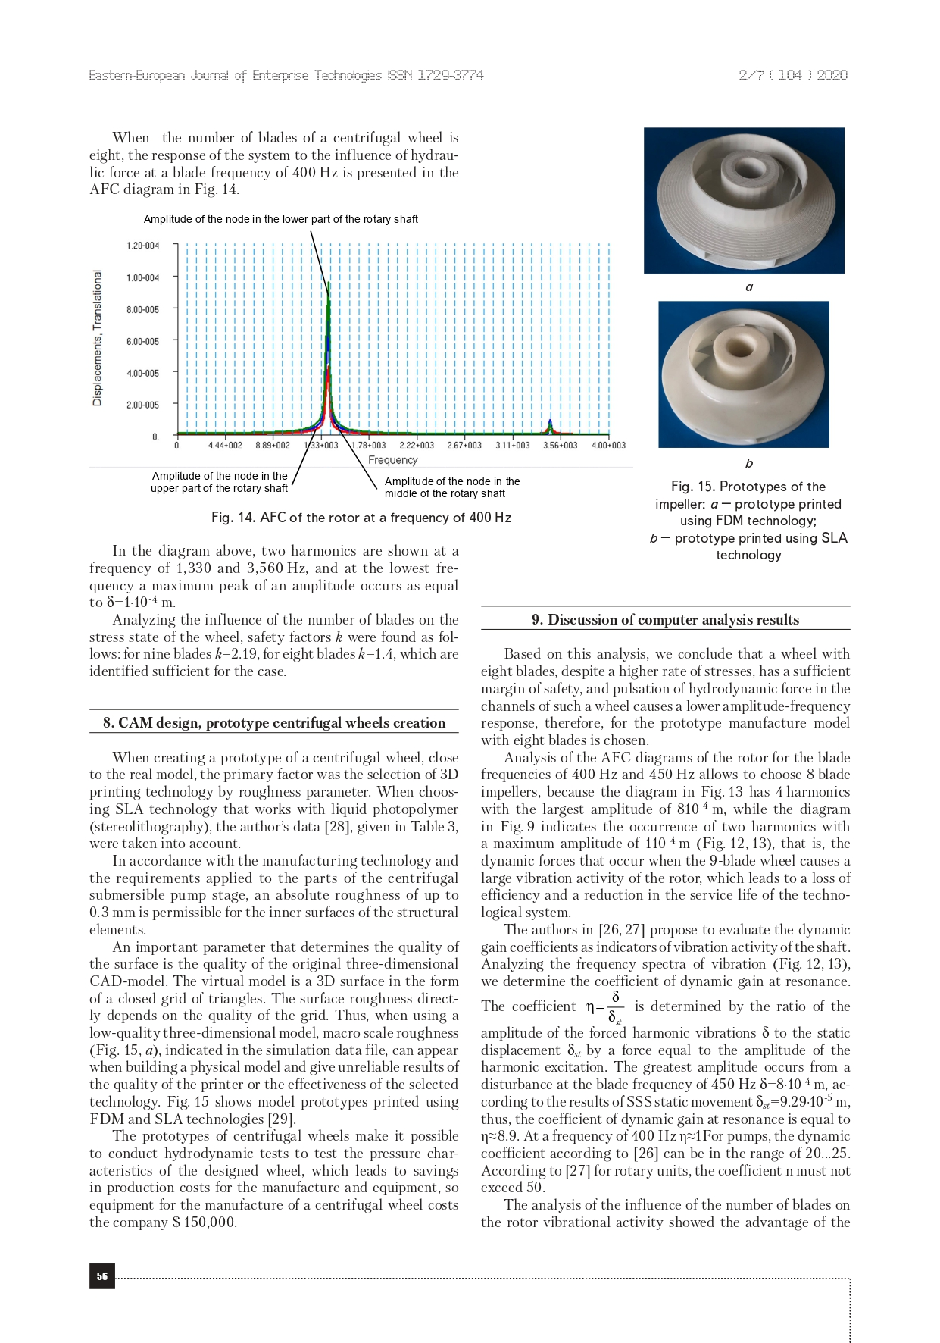

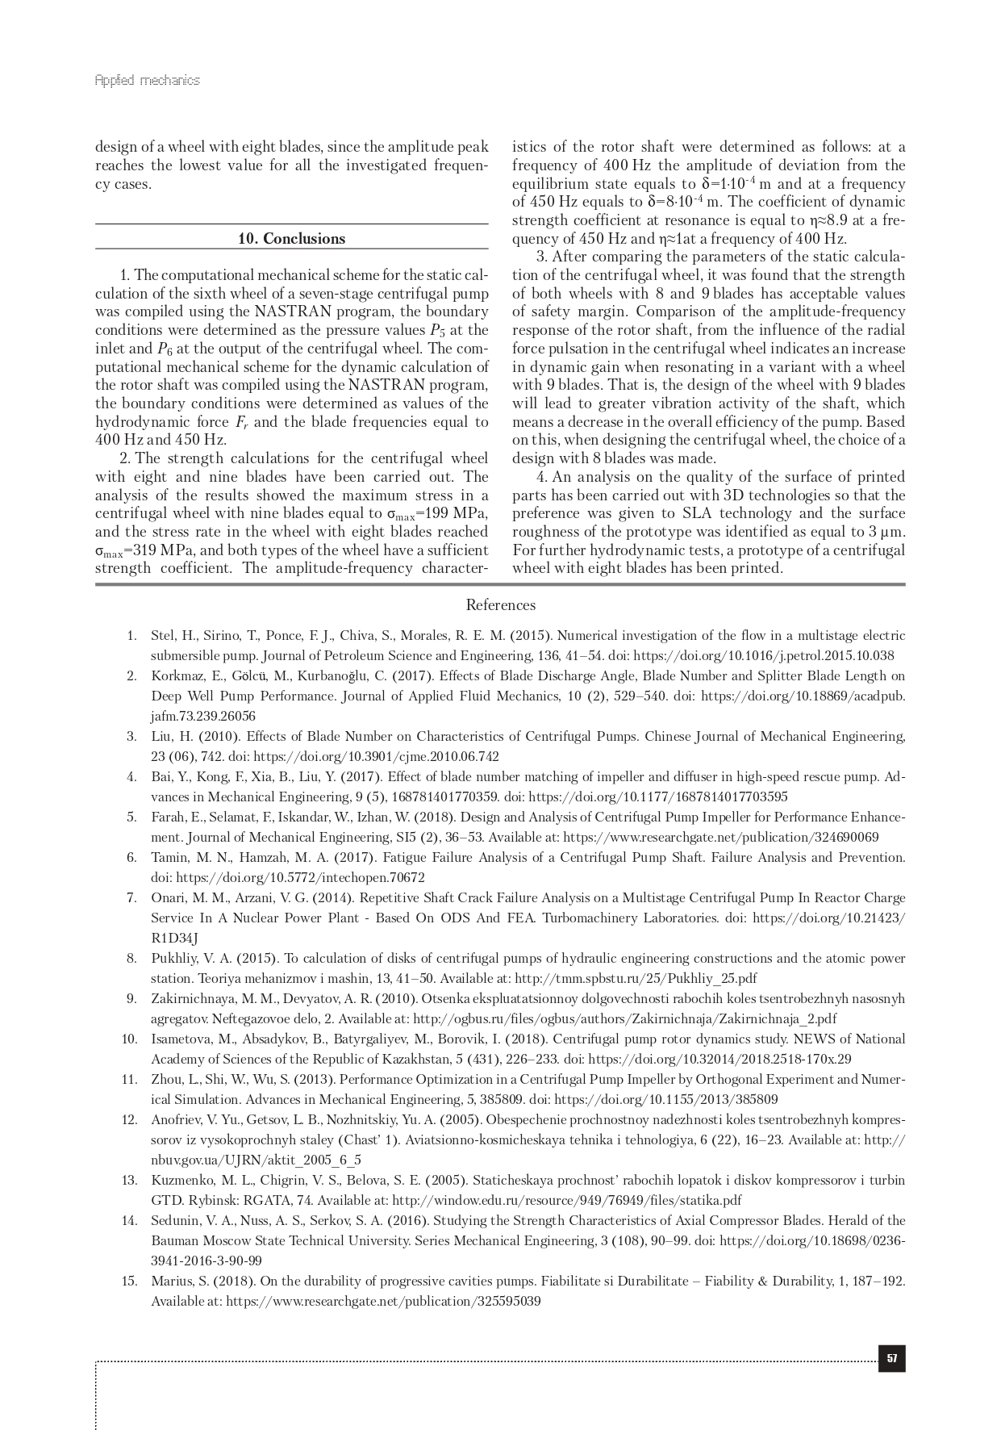

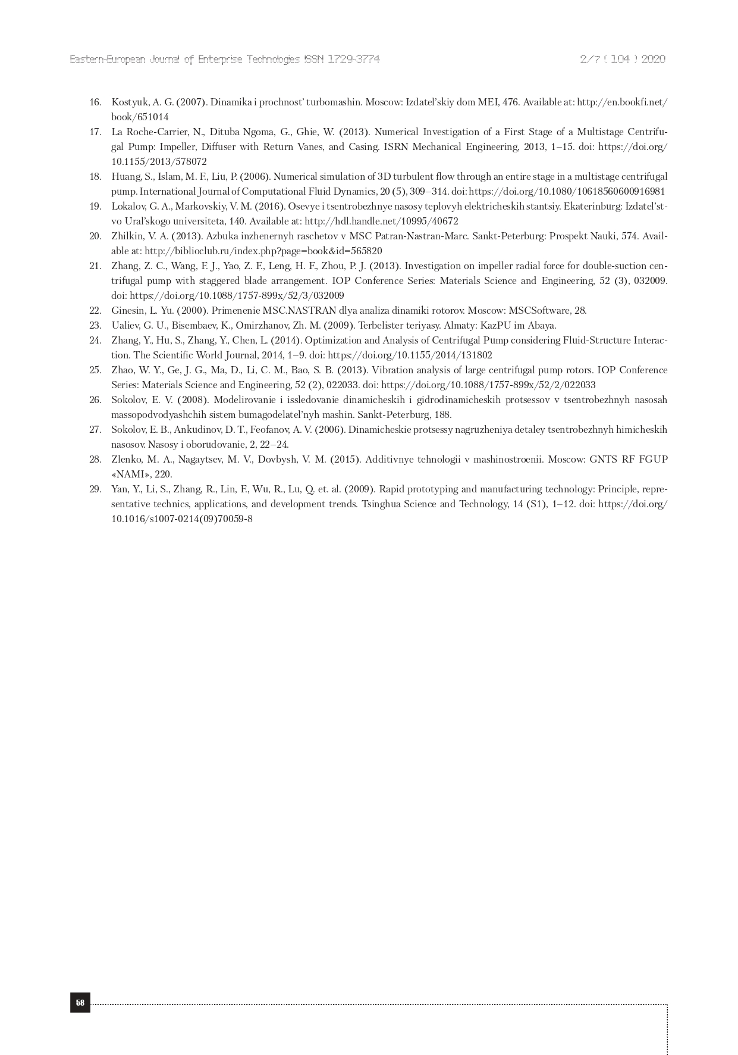



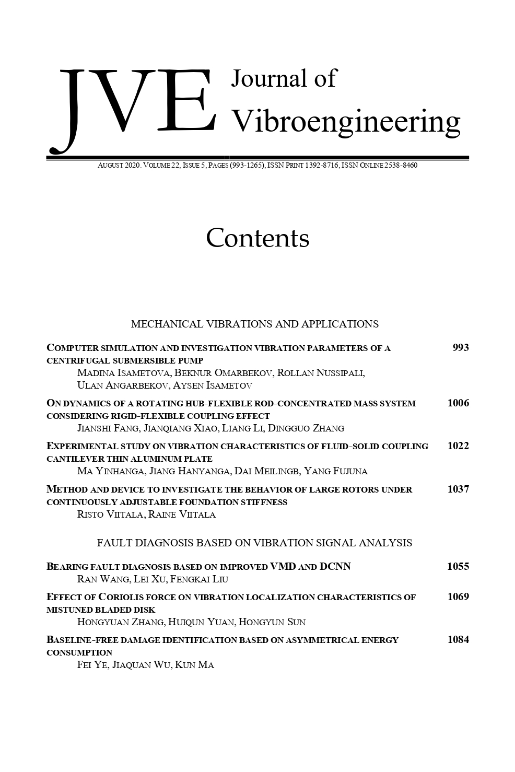
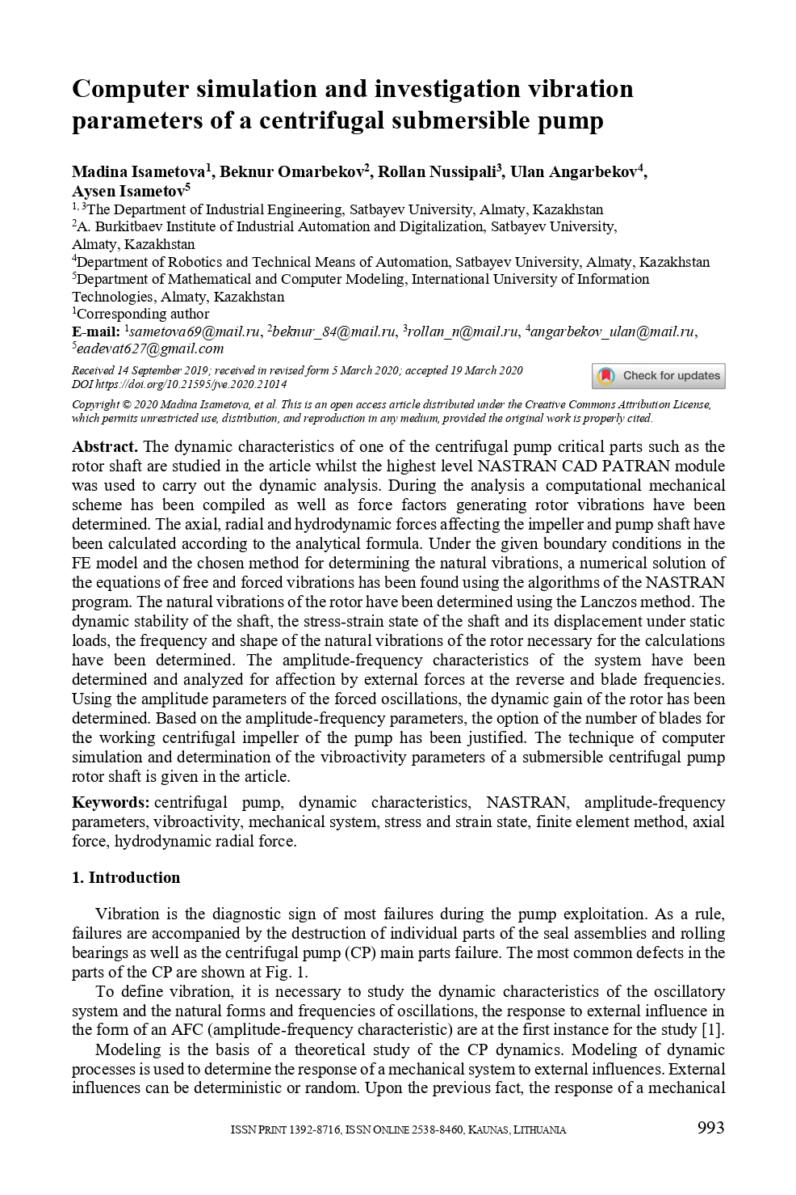
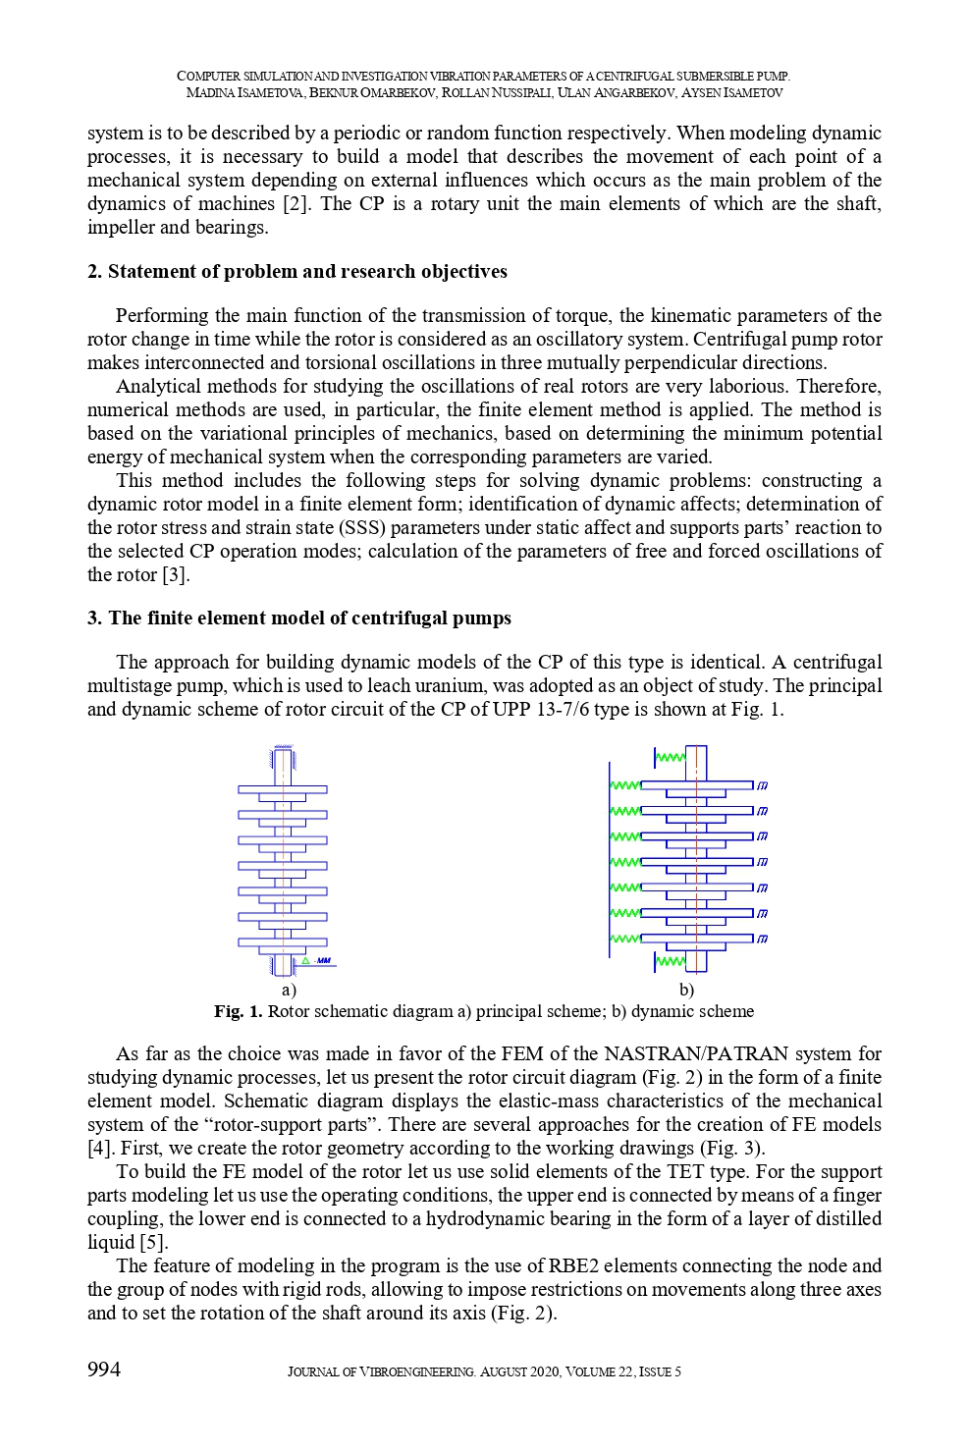
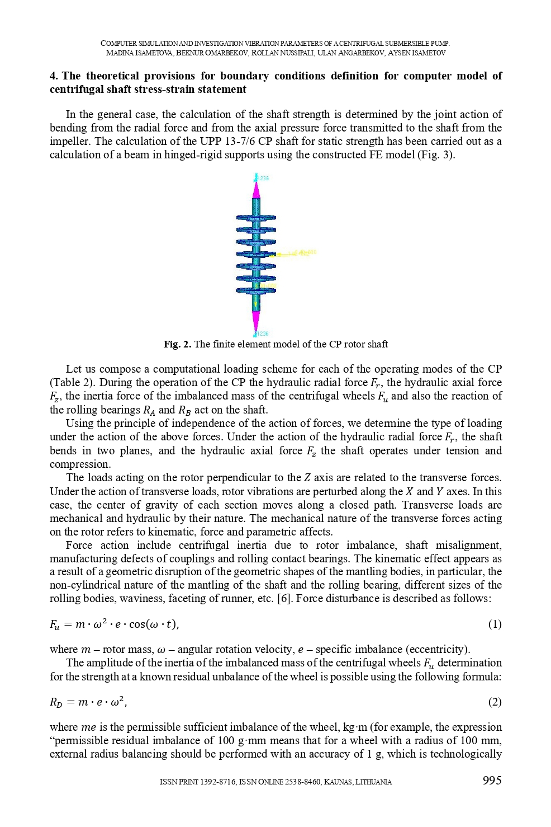
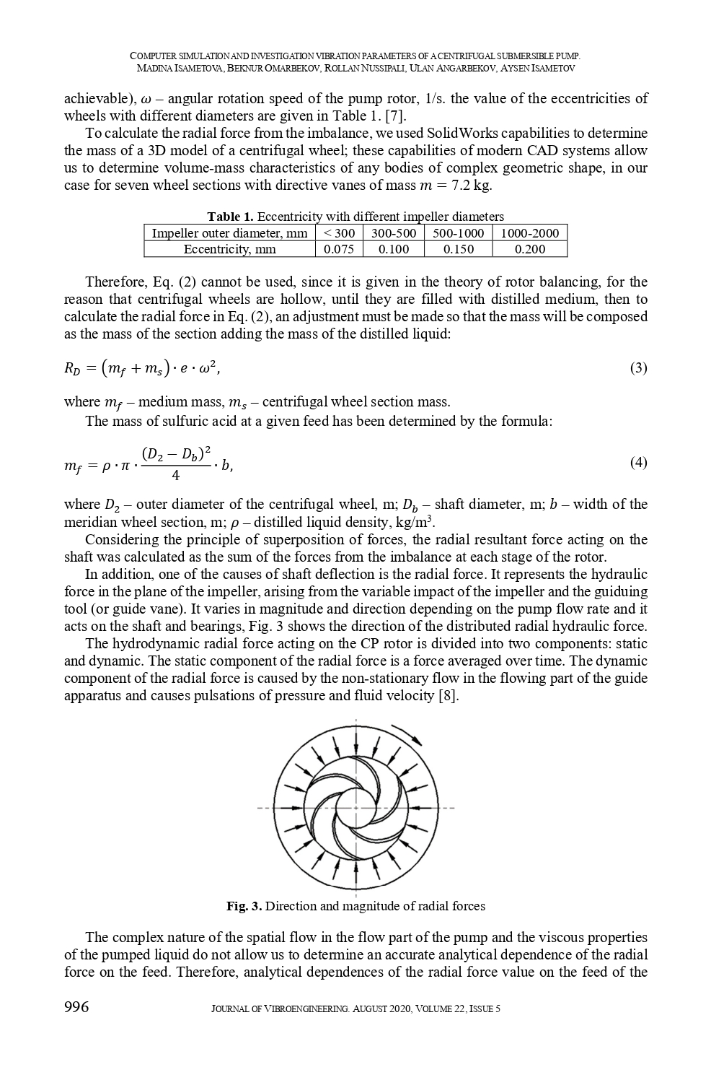
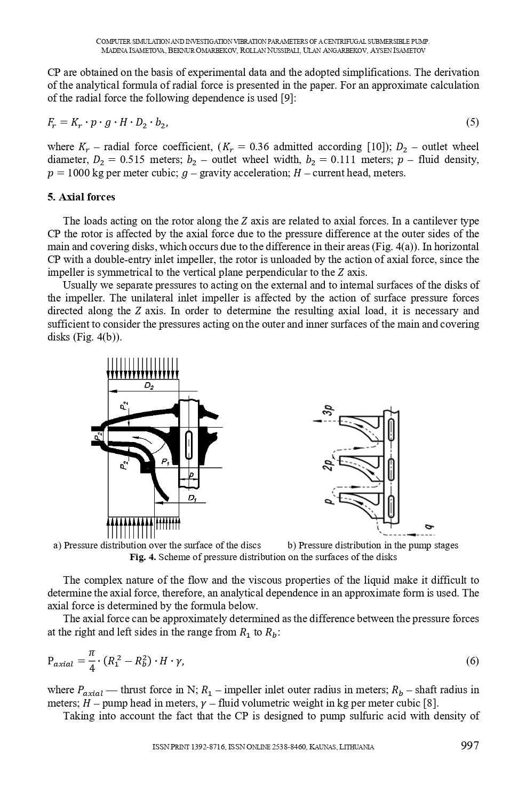
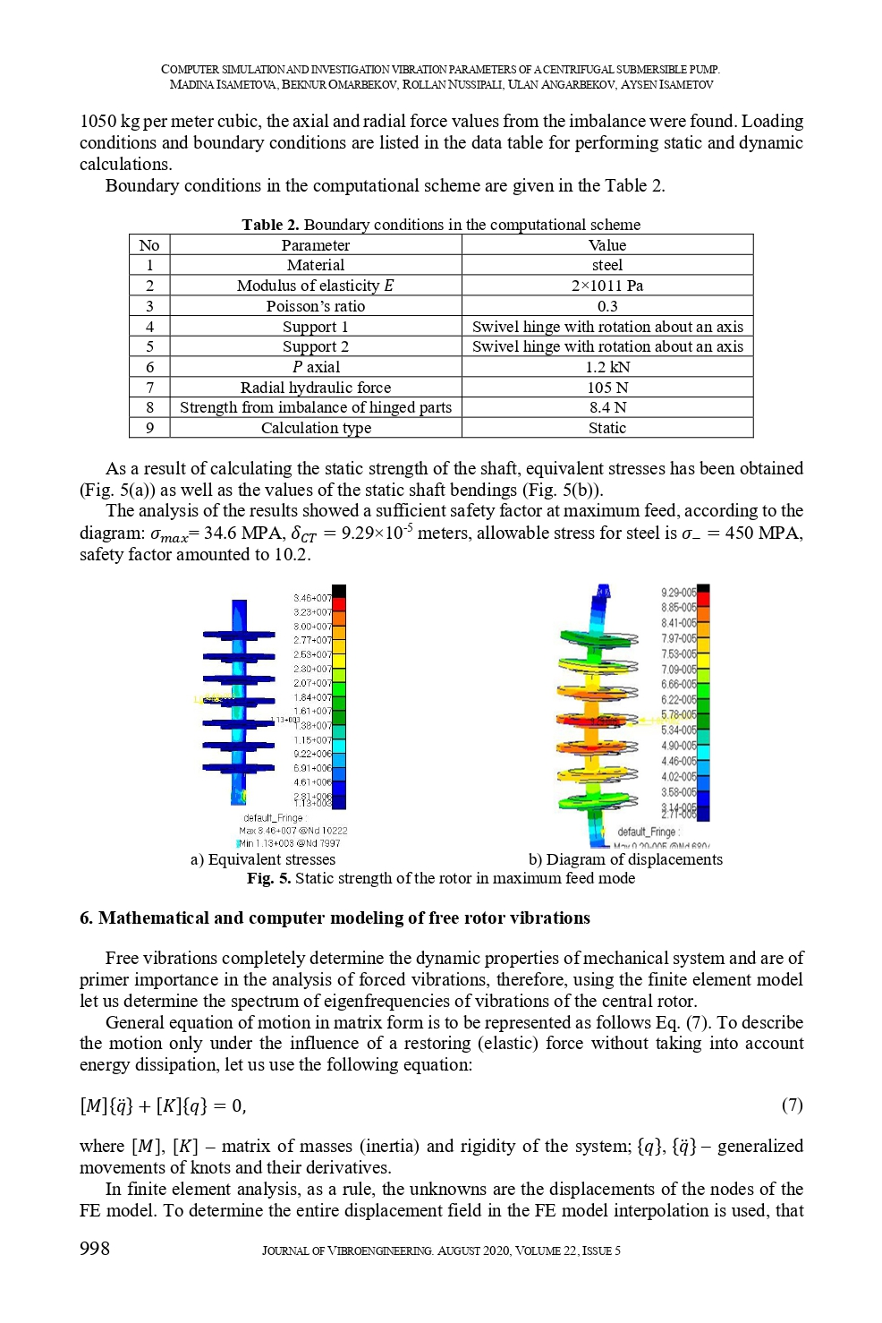
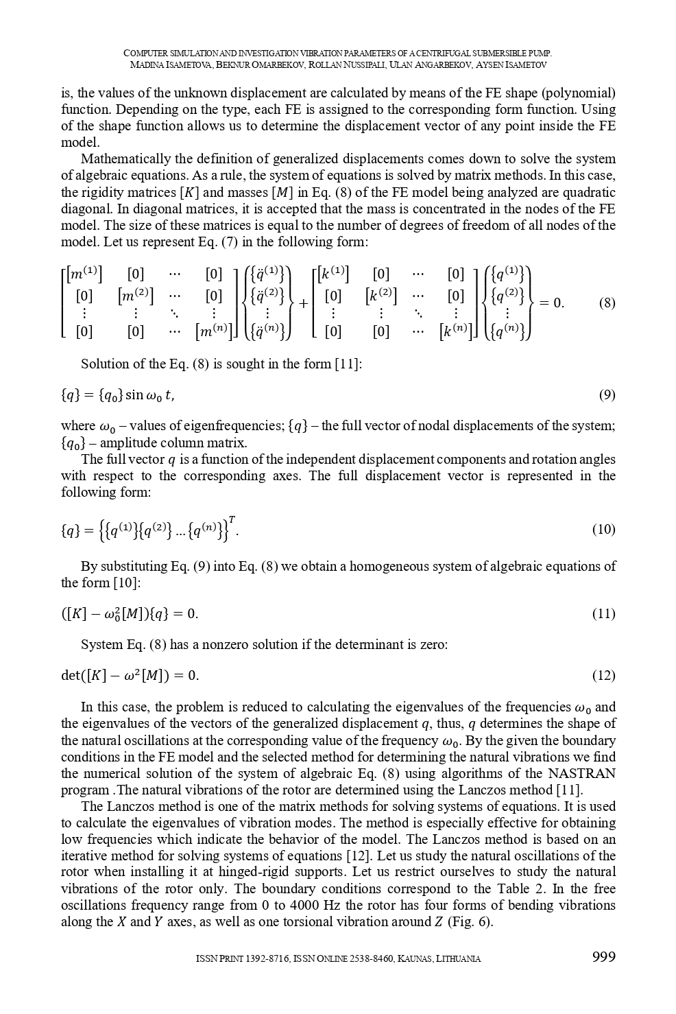
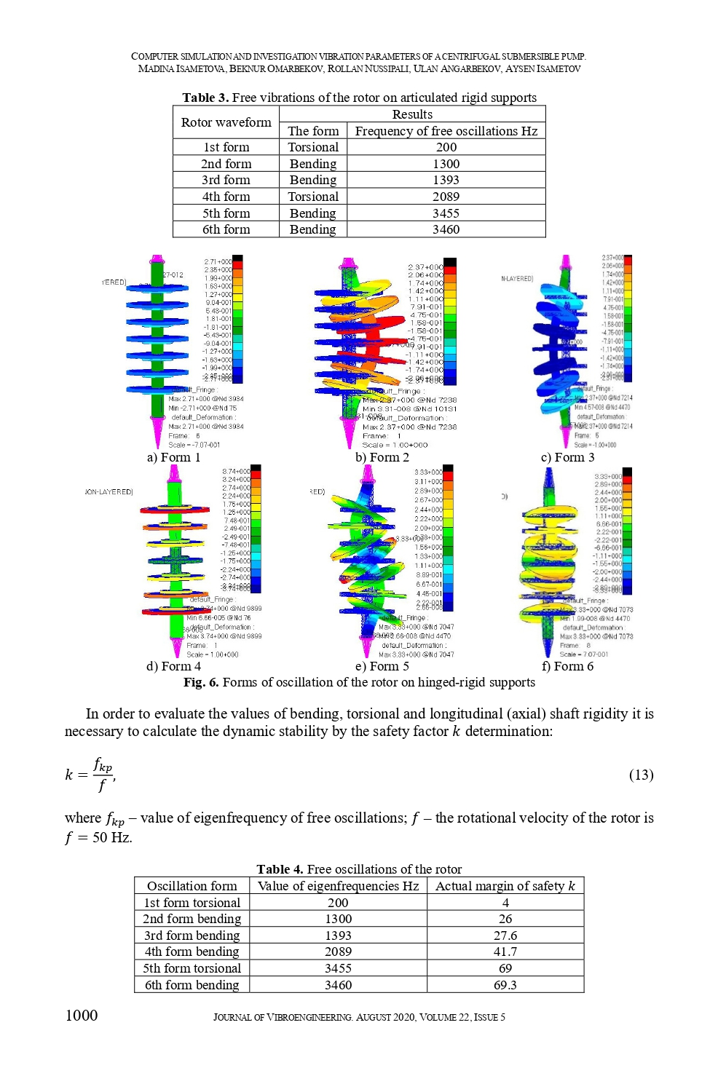
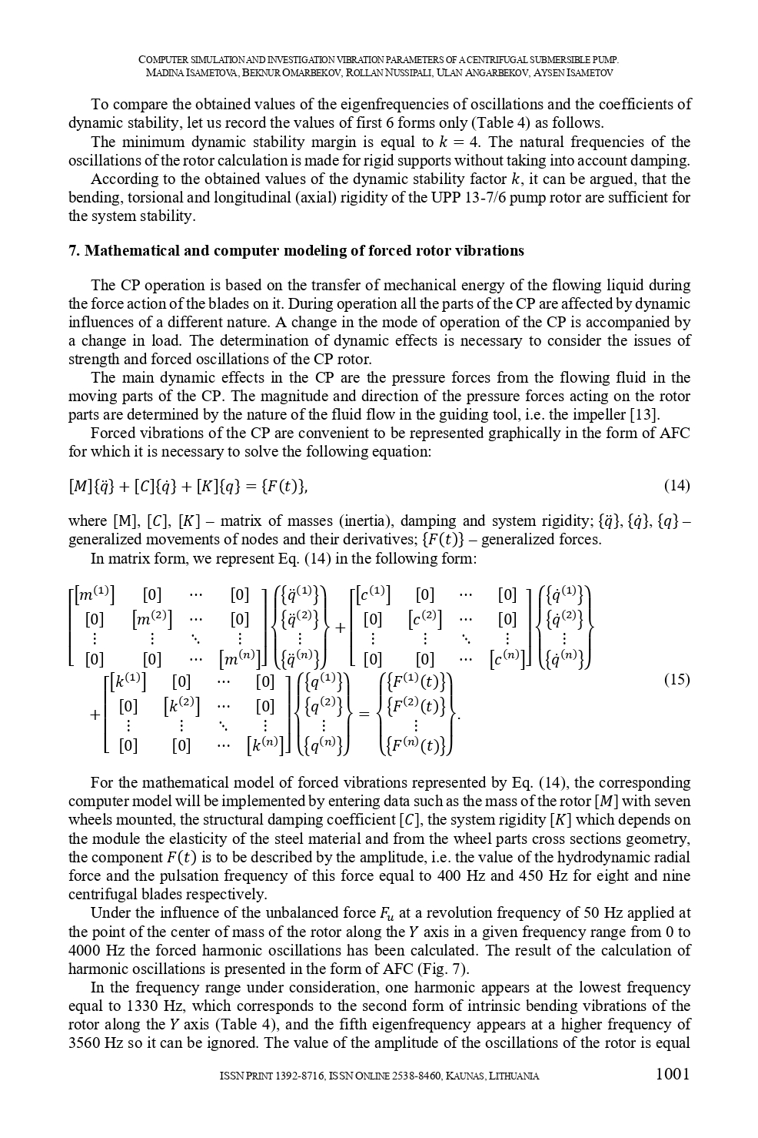
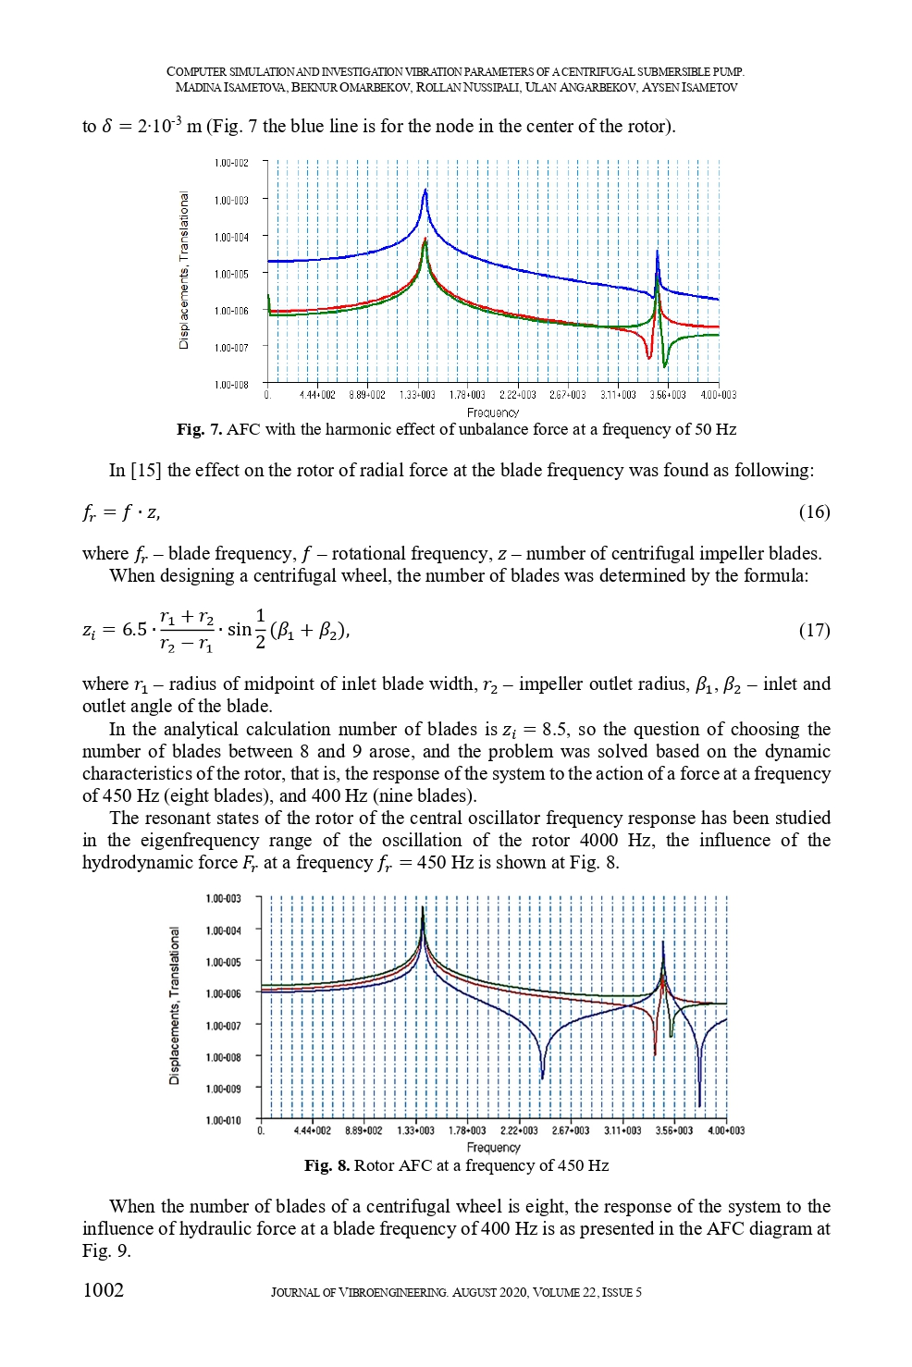
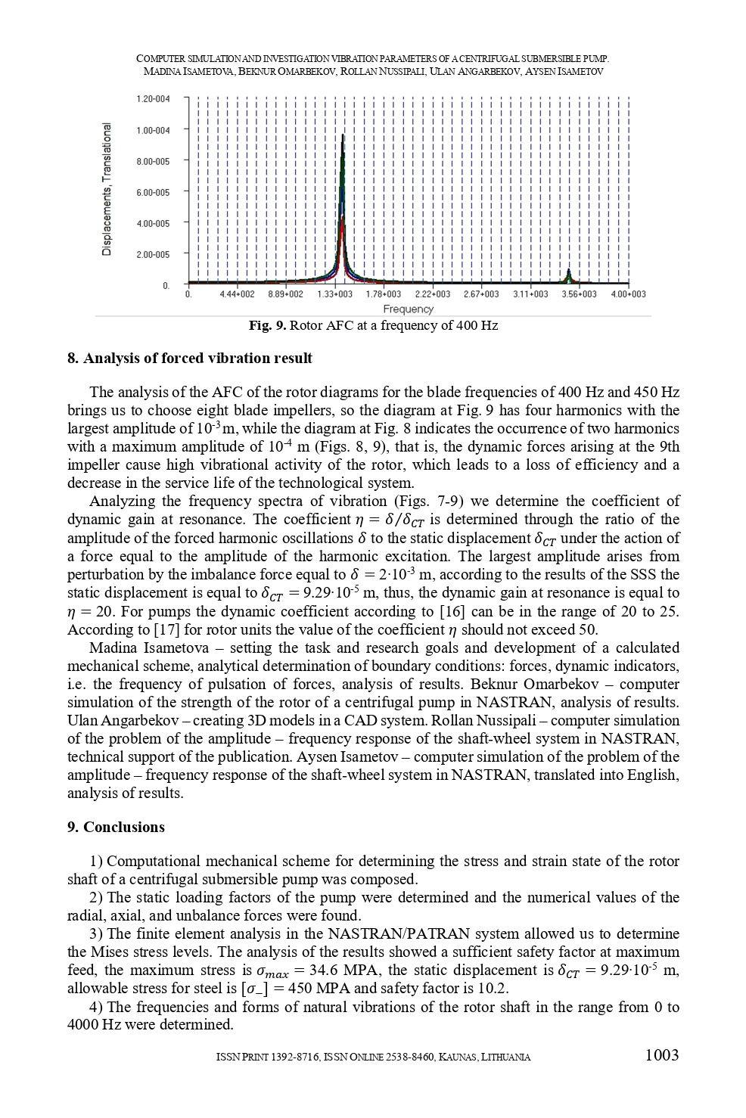
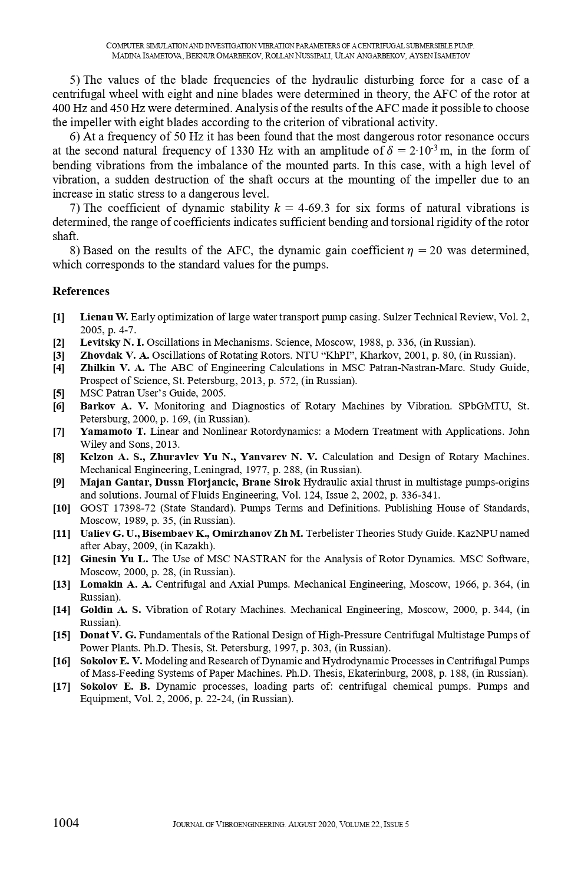
APPENDIX E

Tables and figures from Chapter 1

Table 1-Analysis of existing downhole multi-stage centrifugal pumping units

№ | The manufacturer's name, brand of pump | Efficiency (with an electric motor power of 1.5 kW) % | Duration between major repairs (depending on the medium being pumped)
1 | «GRUNDFOS» MS 402 | 71,0 | 1-3 years
2 | «ЛИВГИДРОМАШ» - ЦНСВ 12,5-40 | 50,0 | 1-3 years
3 | «CALPEDA» - MXV4 25-220 | 58,0 | 1-3 years
4 | «PEDROLLO» - 65R12/15 | 60,0 | 1-3 years
5 | «ODDESSE zentralasien» - UPP 13-7/6 | 40,72 | 1-3 years
6 | «ZDS» - O3.150.45.DRP | 65,0 | 1-3 years

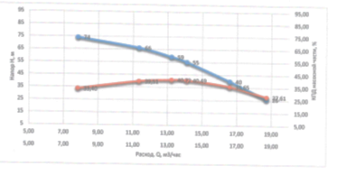
Figure 1-test Report

Table 2-test Data

Q  (м³/час) | H  (м) | U  (В) | I  (А) | P  (кВт) | COS | P2  (кВт) | F  (Гц) | КПД мас.ч.  (%)
7,80 | 74 | 232,40 | 8,25 | 5,91 | 0,80 | 4,71 | 50,00 | 33,40
11,34 | 66 | 233,00 | 8,91 | 6,30 | 0,82 | 5,16 | 50,01 | 39,51
13,22 | 59 | 232,80 | 9,03 | 6,39 | 0,82 | 5,22 | 50,00 | 40,72
14,10 | 55 | 232,20 | 8,97 | 6,33 | 0,82 | 5,22 | 49,99 | 40,49
16,58 | 40 | 232,20 | 8,76 | 6,21 | 0,82 | 5,07 | 49,98 | 35,65
18,71 | 26 | 232,80 | 8,43 | 5,97 | 0,81 | 4,80 | 49,98 | 27,61

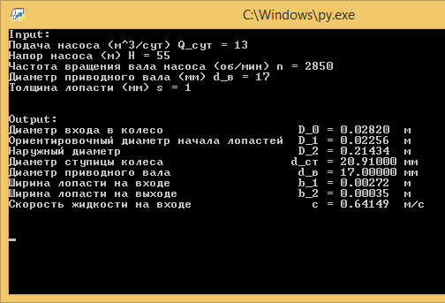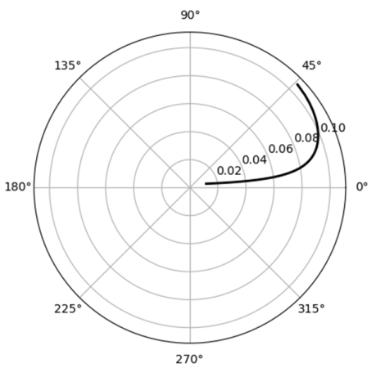

Figure 2 - window for the console version of the module
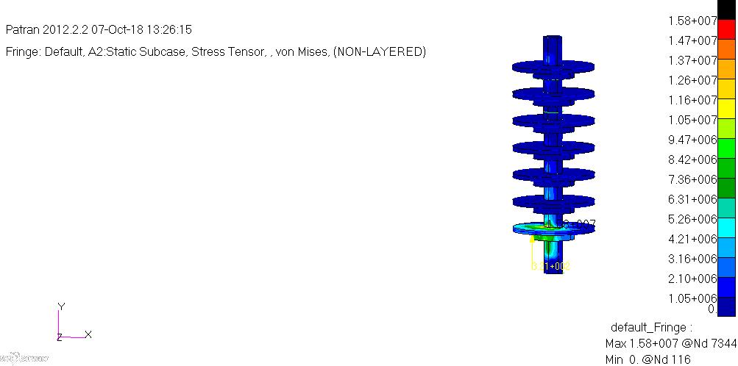

Figure 3-maximum supply voltage Map

Table 3 - Parameters of the pump

№ п/п | Name value |  | Overview | Dimension | Value
 | 1. Technical task
1 | Pump volume flow nominal | QH |  | М3/ч | 13
2 | Pump head | HH |  | м | 55
3 | Rotational speed | nH |  | rpm | 2850
4 | Allowed cavitation margin | Δhдоп |  | м | 14
5 | Pressure promotora | Pno |  | МПа | 7,3
6 | Working fluid | вода с содержанием серной кислоты
7 | Temperature | t |  | оС | 20-40
8 | Density | p |  | Кг/м3 | 1050
9 | Saturated steam pressure | pHn |  | МПа | 6,18ЗЕ-01
10 | Kinematic viscosity | v |  | см2/с | 0,044
11 | The minimum acceptable pump efficiency | ηmin |  | % | 50
12 | Min. Resource between major repairs | T |  | ч | 40000
13 | Shaft location | Vertical
19 | Direction of rotation of the shaft from the input side | Clockwise
14 | Shaft end seals | Frontal
15 | Other requirement | Pump weight-no more than 15 kg  Drive motor-electric motor 2AMZ-3000  Daily schedule of work of pump:  0-00– 6-00 30% QH; 6-00-8-00 125% QH;  8-00 – 22-00 100% QH; 22-00-24-00 80 % QH
16 | 1. Efficiency of consumed power and the diameter of the pump shaft
1 | Number of pump stages |  | N | м | 7
2 | Average speed coefficient of the stage |  | nS |  | 120
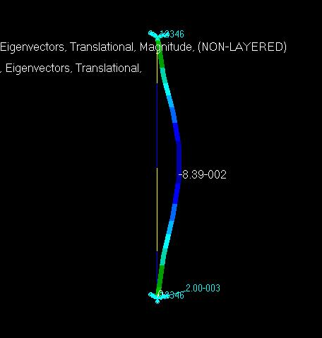

Figure 4-the Fifth form of perturbed oscillations at a frequency of 1800 Hz

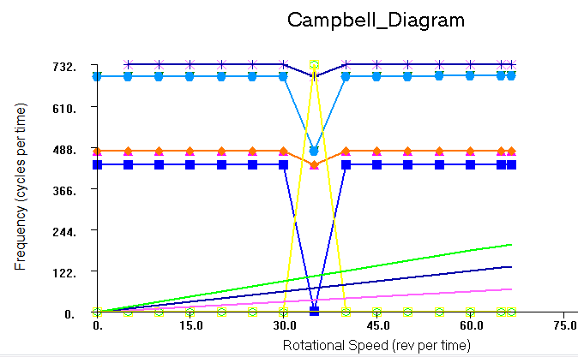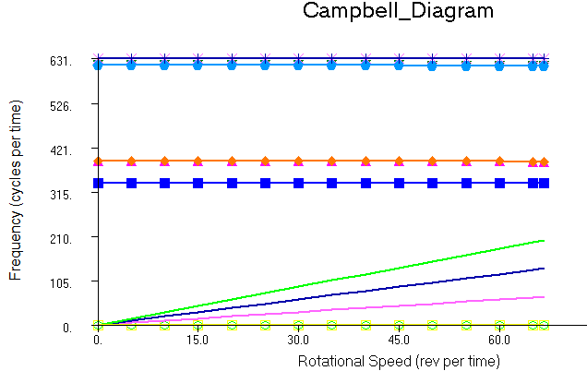
а)с зазором б) без зазора

Figure 5-Campbell Diagram for a supported model

appendix G

Figures from Chapter 2

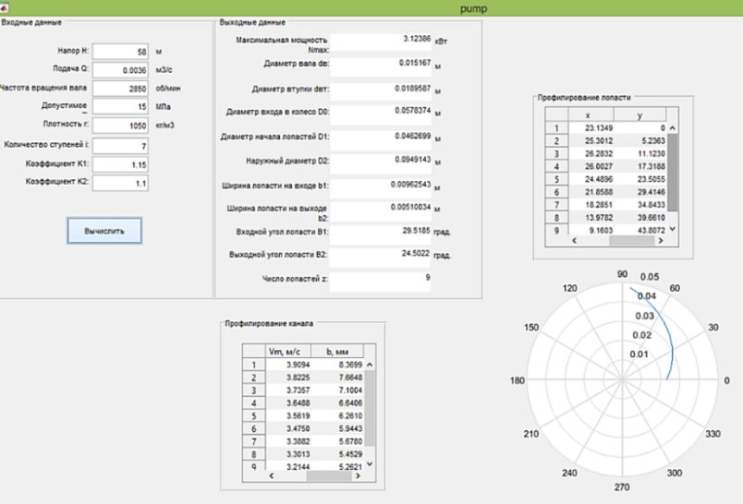

Figure 6-Interface of the automated PUMP module (MATLAB) with calculated data
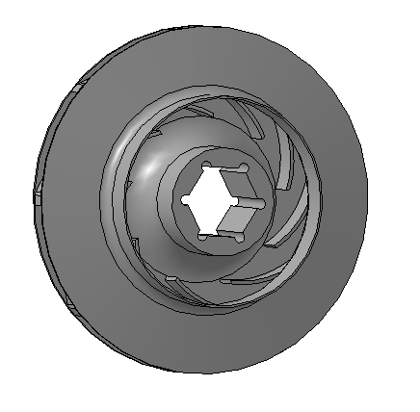

Figure 7-3D model of a Central engine wheel with cylindrical blades

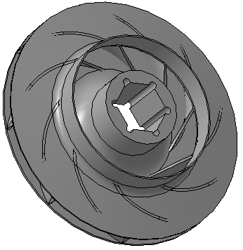
Figure 7-3D model of a CN wheel with cylindrical nozzle paddles 8-3D model of a designed wheel with double curvature paddles and a developed method for constructing a double curvature paddles

Table 4 -

1. create a sketch of the wheel channel according to the data table of the automated module " PUMP” | 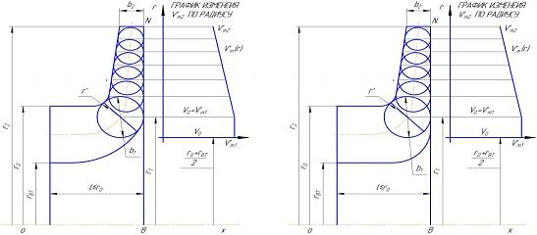
2. the rotation Operation creates a 3D shell model of the Central heating system flow channel | 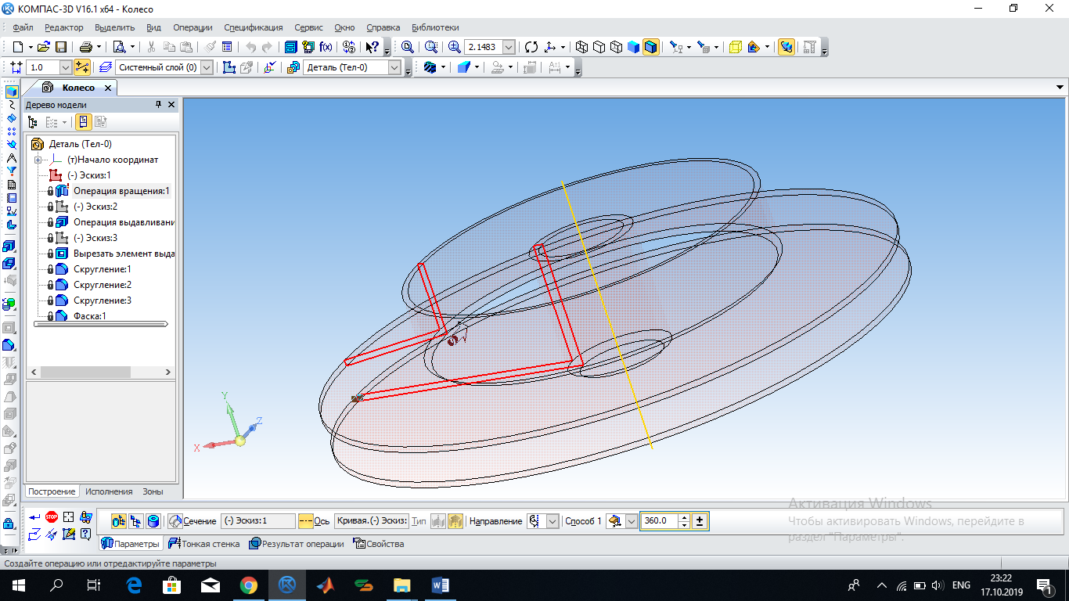
3. To profile a blade of double curvature, the calculated one is the bushing line of the blade, the Cartesian coordinates of which are defined in the automated "PUMP" module and the sketch is drawn from the coordinates using the spline curve by points. | 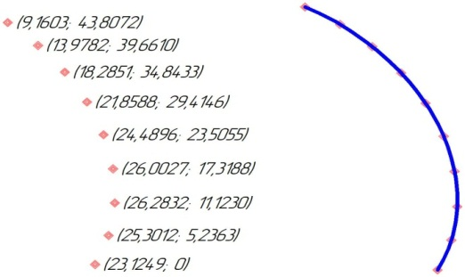

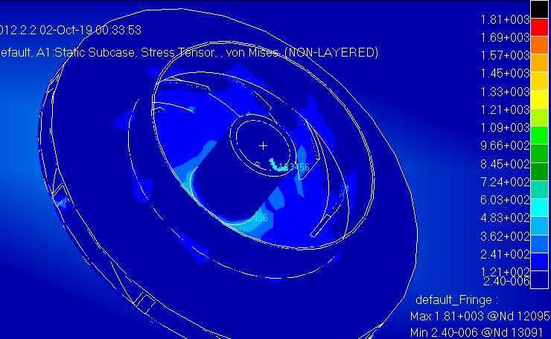

Figure 9-distribution of equivalent stresses across the impeller

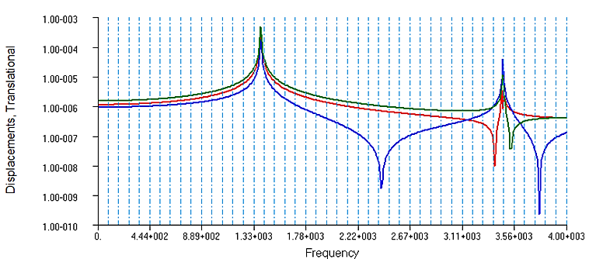

Figure 10 - quartermaster of the rotor at a frequency of 450 HZ
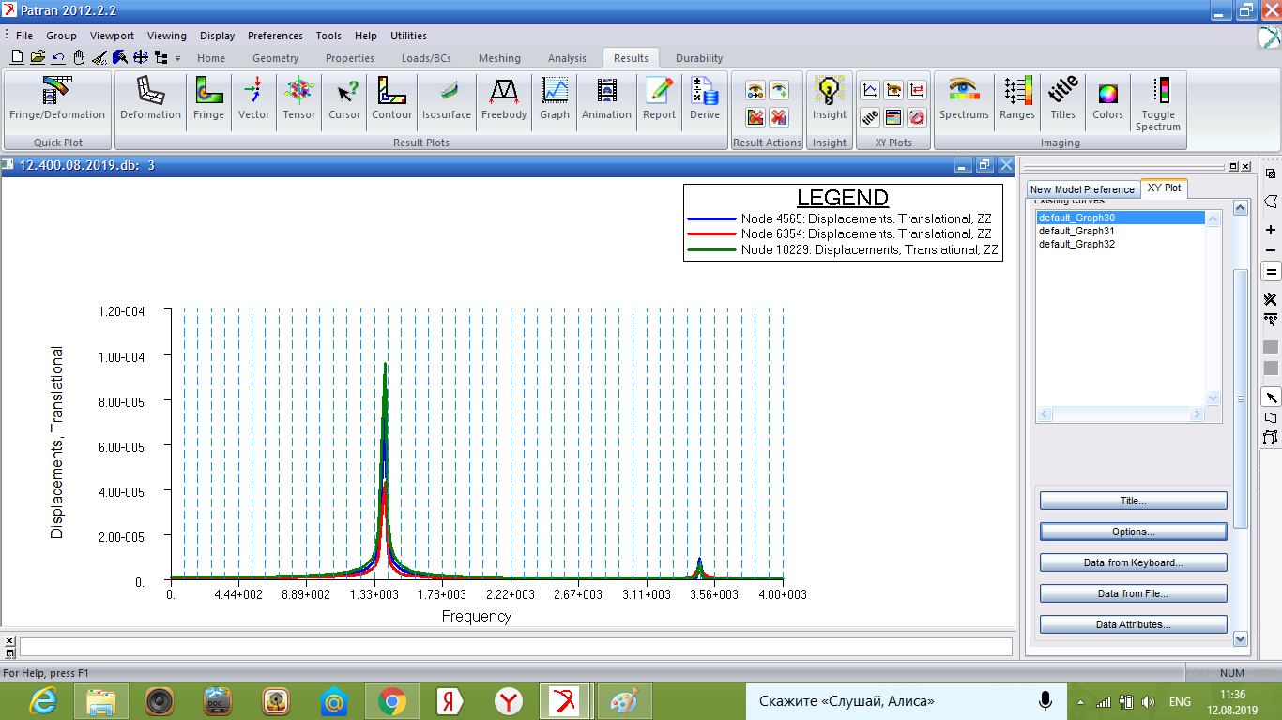

Figure 11-AHF of the rotor at a frequency of 400 HZ

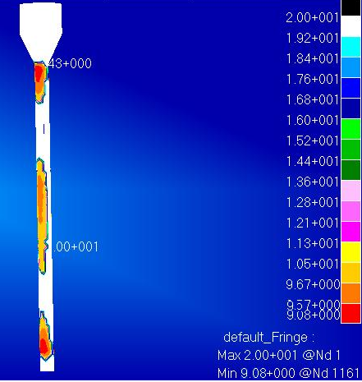

Figure 12 - Results of calculation of durability

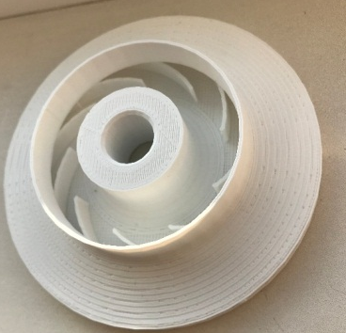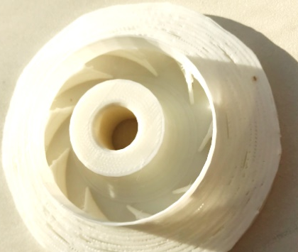

a) wheel with cylindrical blades b) wheel with double curvature blades
Figure 13-models of wheels grown by 3D printing

APPENDIX Z

DRAWINGS

