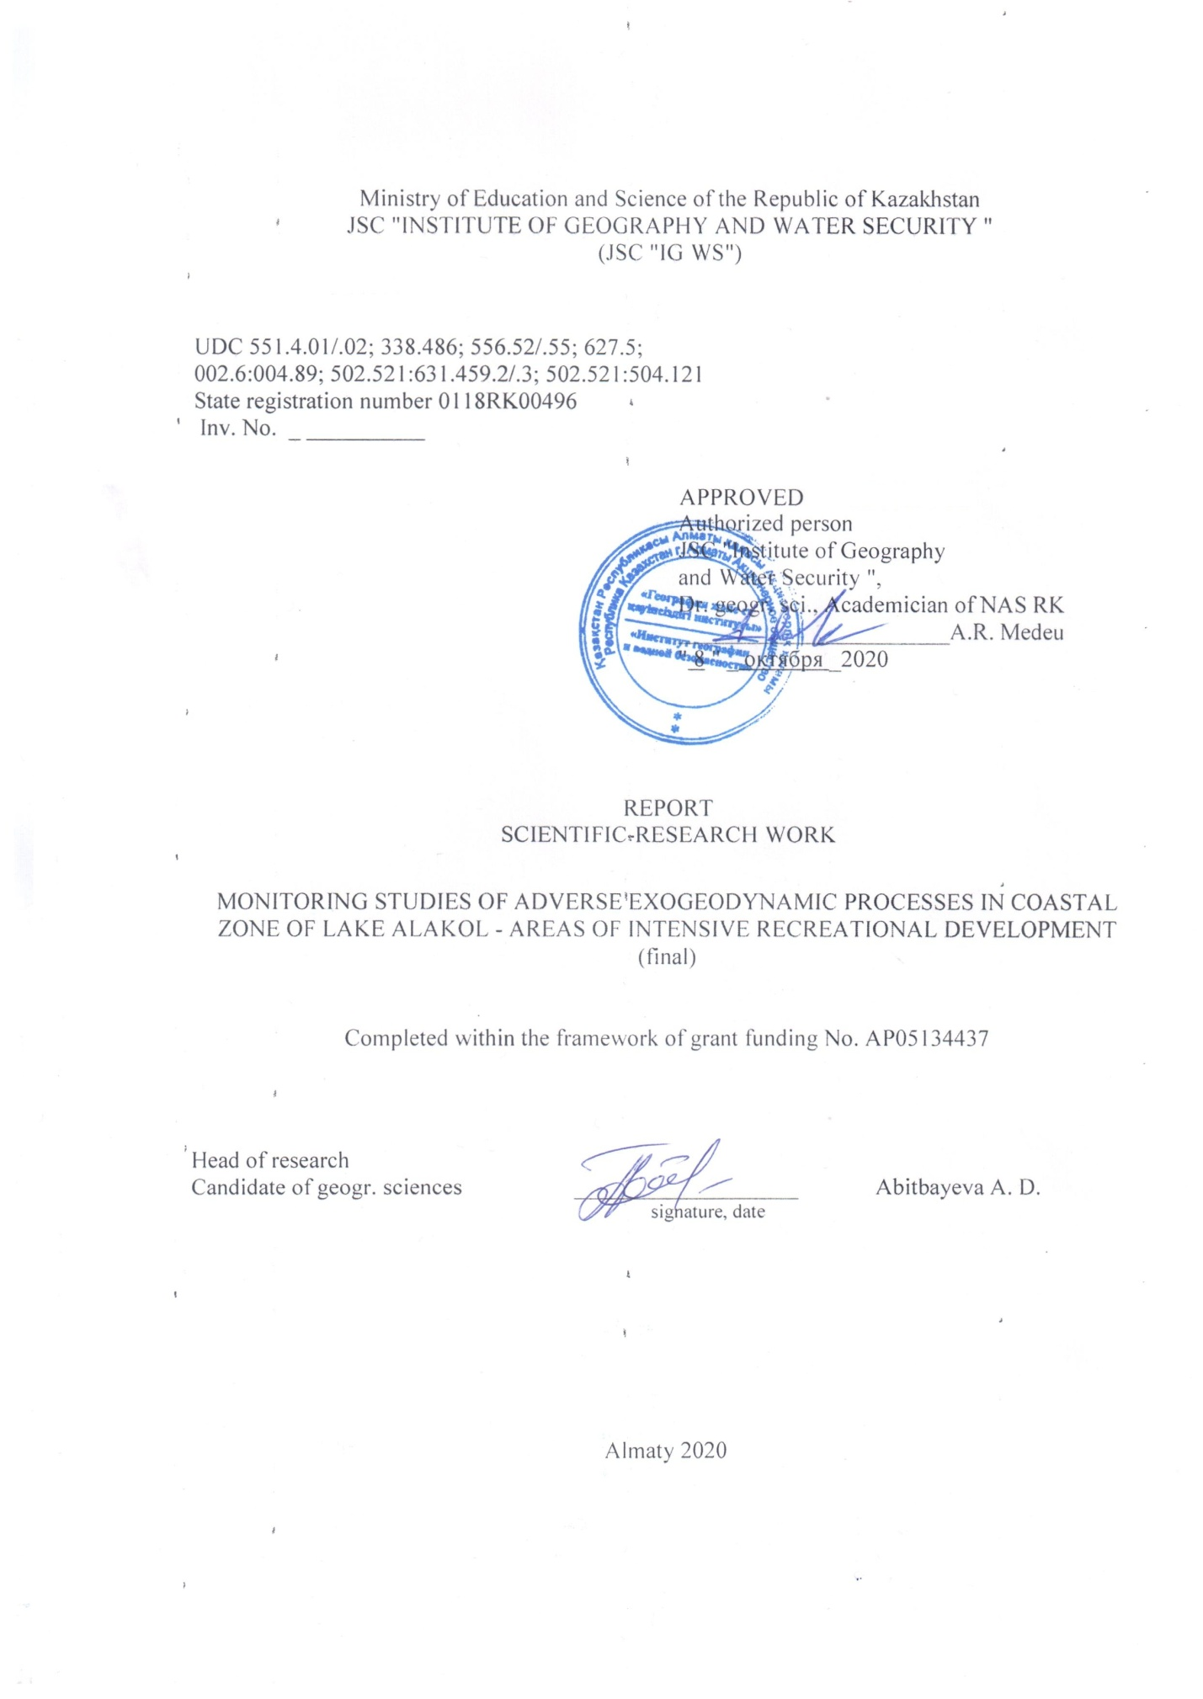

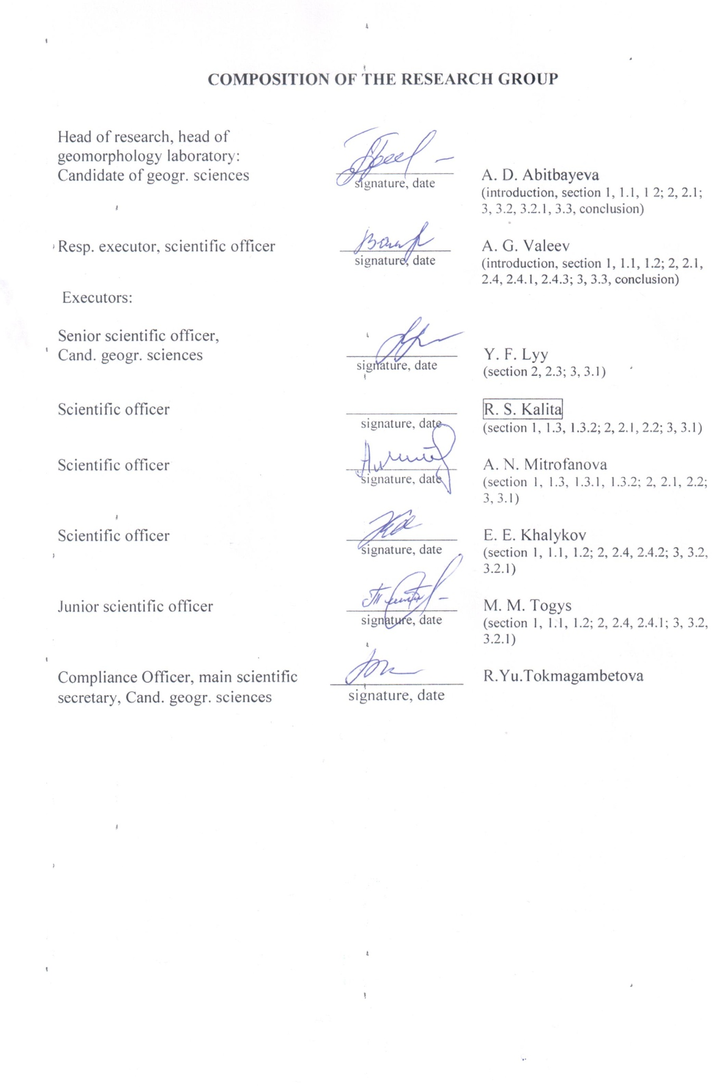
ESSAY

Report 190 p., 87 figures, 30 tables, 82 sources, 8 app.
MONITORING, EXOGEODYNAMIC PROCESSES, SHORE TYPES, LASER SCANNING, ABRASIA, SERIES OF MEASURES
The object of study: exogeodynamic processes coastal zone of lake Alakol
The goal of the project is to carry out monitoring studies of exogeodynamic processes in the coastal zone of lake Alakol, for solving problems of sustainable development and optimal recreational development of coastal territories.
Methods of operation: Comparative, quantitative (mathematical), remote sensing, surface laser scanning, expeditionary, cartographic.
Results of work and their novelty: 2018 y. – adapted GIS theoretical and methodological foundations, performed monitoring fieldwork, analysis of natural and anthropogenic factors exogeodynamic development processes completed. 2019 y. – defined role of natural and anthropogenic factors in activation of exogeodynamic processes, performed coast classification and created maps of leading exogeodynamic processes and geomorphological recreational conditions. 2020 y. – carried out zoning of the coastal zone of the lake Alakol by the intensity of exogeodynamic processes and their influence on recreational development. Developed environmental and coastal protection events for the stabilization process of the relief formation. Maps of zoning, system of measures and sustainable development of the recreational zone have been compiled.
The main constructive and technical and economic indicators. For monitoring, areas were selected and studies of exogeodynamic processes in the coastal zone of lake Alakol, a territory of intensive recreational development, were performed.
Scope of application. Application of project results by governing bodies in the development of territorial planning programs, construction and design work, bank protection measures.
The economic significance of the work: consists in obtaining multi-aspect and scientifically grounded recommendatory materials to improve the management efficiency of the intensively developing recreational zone of lake Alakol.
The forward-looking assumptions about the development of the research object: the received materials needed for development of system of measures on sustainable development and the disclosure of the recreational potential of the lake Alakol.
CONTENT
INTRODUCTION..…..….…………………………………………….………….............. | 8
1 Methodological foundations of the study of the coastal zone of lake Alakol.………….. | 10
- Geoinformational theoretical and methodological basis for monitoring research processes exogeodynamic coastal zone of lake Alakol…………………………… | 10
- Results of field and laboratory monitoring studies of exogeodynamic processes of coastal zone of lake Alakol.………………………………………………………… | 11
1.3 Natural and anthropogenic factors in the development of exogeodynamic processes | 14
1.3.1 Analysis of geomorphological conditions.…………………………………… | 14
1.3.2 Analysis of engineering and geological conditions…………………………… | 14
1.3.3 Analysis of recreational and infrastructural load.…………………………….. | 15
- The role of natural and anthropogenic factors in the activation of exogeodynamic processes and classification of the shores of lake Alakol……………………………… | 17
- The role of natural and anthropogenic factors in the activation of exogeodynamic  processes in the coastal zone of lake Alakol………………………………………... | 17
2.2 Classification of coasts by prevailing exogeodynamic processes…………………... | 20
2.3 Classification of coasts according to recreational and geomorphological conditions. | 21
2.4 The results of field and laboratory monitoring studies of exogeodynamic processes  of coastal zone of the lake Alakol…………………………………………………... | 22
2.4.1 Results of monitoring studies using instrumental measurements along the  profile…………………………………………………………………………. | 22
2.4.2 Results of monitoring studies of abrasion processes using a RIEGL VZ-4000  3D laser scanner and bathymetric studies of the underwater coastal slope in  keyareas………………………………………………………………………. | 22
- Maps of the dynamics of development of the above-water part of the coastal zone………………………………………………………………………….. | 25
- Zoning of the coastal zone of lake Alakol and development of proposals for a system of measures……………………………………………………………………………. | 26
3.1 Zoning of the above-water part of the coastal zone of lake Alakol according to the  intensity of exogeodynamic processes and their impact on recreational develop-  ment…………………………………………………………………………………. | 26
3.2 Results of field and office monitoring studies of the development of exogeodyna-  mic processes in the coastal zone of lake Alakol…………………………………… | 32
3.2.1 Results of monitoring studies using instrumental measurements along the  profile…………………………………………………………………………. | 32
3.3 Priority environmental and bank protection measures for stabilizing the relief for-  mation processes…………………………………………………………………….. | 33
CONCLUSION.…………………………………………………………………………... | 43
BIBLIOGRAPHY.………………………………………………………………………... | 45
APPENDIX A – Technical Specification and Schedule………………………………….. | 52
APPENDIX B – Publications in scientific journals, participation in conferences for 2018-2020………………………………………………………………………………… | 59
APPENDIX С – Extract from the protocol.………………………………………………. | 71
APPENDIX D – Review of the research report by the Head of the Department of Cartogra-phy and Geoinformatics, Doctor of PhD, Acting Associate Professor, Asylbekova A. A………………………………………………………………………….. | 72
APPENDIX E – Review of the research report by head of geography of tourism and recrea-tion laboratory, candidate of geogr. sciences, Yegemberdiyeva K. B…………….. | 73
APPENDIX F – Initial data for section 1…………………………………………………. | 74
APPENDIX G – Initial data for section 2……………………………………………….. | 128
APPENDIX H – Initial data to section 3.……………………………………………….. | 178

TERMS AND DEFINITIONS

In this research report, the following terms and definitions are used.
Abrasion – | abrasion (from Latin abrasio – scraping) - destruction of the shores of seas, lakes, reservoirs, canals by wind and ship waves
Accumulation – | (from Lat. Accumulatio – accumulation) processes of accumulation of loose mineral matter on the surface of the Earth
Voxel – | displayed as cubes of certain physical dimensions in meters
Distortion – | curvature, aberration of optical systems, and which the coefficient of linear magnification changes as the displayed objects move away from the optical axis
Iteration – | is the organization of data processing, in which actions are repeated many times, without leading to calls to themselves
Cliff – | (english – cliff "cliff") – a sheer abrasion cliff, formed as a result of the destruction of a high bedrock coast by the action of the surf
Morphometry – | section of geomorphology, dedicated numeric characteristics of elements, shapes (linear, areal, volumetric) and relief types
A point cloud – | is a set of vertices in a three-dimensional coordinate system, which are determined by coordinates X, Y and Z
Patches – | are plasters on the surface
Polydates – | are sparse point clouds
Recreation – | (lat. Recreatio «recovery») – a package of health activities carried out in order to restore normal state of health and working capacity of a healthy but tired man
Scanpoints – | points of scanning by a ground laser scanner
Delaunay – | triangulation is a triangulation for a given set of points S on a plane, in which for any triangle all points from S, except for the points that are its vertices, lie outside the circle circumscribed around the triangle
Filtration – | separation, cleaning
RiSCAN PRO – | is the software for all models of the Riegl line of terrestrial laser scanners

LIST OF ABBREVIATIONS AND DESIGNATIONS

In this research report, the following abbreviations and symbols are used.
PRP – natural and recreational potential
TRD – tourist and recreational activities
TRS – Territorial Recreational System
DEM – digital elevation model
GLS – ground laser scanning
MSE – multistation equalization
RFP – surface flat patches
RS – Remote Sensing Data - Earth Sounding Data
GIS – Geographic Information Systems
SNR – State Nature Reserve

INTRODUCTION

The report presented final research results on the theme: "Monitoring studies of adverse exogeodynamic processes in coastal zone of lake Alakol - areas of intensive recreational development", three-phase (2018-2020) implementation provided. Report on research work for the 2018 -2020 years prepared according to the Contract № 120 from 05. 03. 2018 with the Science Committee of RK Ministry of Education and Science. The research work received the state registration number 0118 RK00496 at the JSC “National Center for Scientific and Technical Information” of the Republic of Kazakhstan.
The relevance of research. The research is directed to study exogeodynamic processes coastal zones of Alakol lake, which present conductive threat to recreational and infrastructural objects, as well as the transport system. Solving the problem requires detailed monitoring studies for development of system of measures for sustainable development and the disclosure of the recreational potential of the lake Alakol.
All assigned tasks carried out according to the approved calendar plan for 2018 -2020 years (Appendix A). 2018 – adapting GIS theoretical - methodological foundations for the study of the exogeodynamic processes at the coastal zone of lake Alakol, perform monitoring field studies. To establish monitoring sites, to carry out an analysis of natural and anthropogenic factors in the development of exogeodynamic processes (SRW 2018, Inv. No. 0218РК00075); 2019 – to determine the role of natural and anthropogenic factors in the activation of exogeodynamic processes, to determine the classification of the shores of lake Alakol on the prevailing exogeodynamic processes and recreational conditions. Make a map of geomorphological and recreational conditions, a map of exogeodynamic processes, conduct monitoring seasonal field research. Make maps of the dynamics of the development of the above-water part of the coastal zone (SRW 2019, Inv. No. 0219РК00243); 2020 – to carry out zoning of the coastal zone of the lake Alakol. Develop coastal protection measures. To compile zoning maps, system of measures and sustainable development of the recreational zone.
Scientific novelty of the research lies in the fact that for the first time for the model area of the coastal zone of the lake Alakol new research methods were applied, which allow to determine the dynamics of exogeodynamic processes, identify active and passive areas of abrasive denudation bank, to give an assessment of hazard abrasion process. For the first time, monitoring of exogeodynamic processes was organized and monitoring data on their dynamics were obtained. For the first time new methods and technologies were utilized, including terrestrial laser scanner Riegl VZ -4000 for three-dimensional modeling of the coasts and identified high-precision quantitative data processing shores, refined bathymetry under water part of the coastal zone with the use of echo-sounder. For the first time, the role of natural-anthropogenic factors in the activation of exogeodynamic processes has been determined. For the first time, the classification of the shores was carried out according to the prevailing processes and recreational conditions. For the first time, zoning of coastal areas of lake Alakol by intensity exogeodynamic processes and their impact on recreational development was performed, defined their degree of danger, defined and categorized coastal vulnerability. Most promising, science-based protection methods of lake Alakol denudation banks. Composition of zoning maps, the system measures and sustainable development of recreational areas were compiled.
The scientific significance of the research. The results of the study are scientific and methodological foundations for the study of natural quaternary factors, influencing exogeodynamic processes on coastal zones of lake Alakol, for the sustainable development of tourist - recreation of potential. There is an increase in the level (area and volume) of lake Alakol, this phenomenon does not coincide with the general trend of the impact of the effects of climate change on the levels of continental closed lakes, where their decline is observed. The object of the study and the results obtained are unique in the field of study of closed lakes in the region.
The practical significance of the research results is due to the need to solve the problems of reducing the negative impact of the coastal exogeodynamics on recreational and infrastructural facilities, agricultural land and residential lands in the coastal area of lake Alakol.
Potential consumers of research results – the administrative authorities of the Committee for Construction, Investment and Development of the Ministry of the Republic of Kazakhstan, the Committee of Tourism Industry of the Ministry of Culture and Sports, the Emergency Situations Ministry of the Interior Committee of the RK Minister, experts in different fields, scientists, teachers, students, citizens interested in the development of the coastal area of the lake Alakol.
According to research work for the 2018-2020 years 8 scientific articles have been published (Appendix B) and 2 articles submitted for printing. Extract from the protocol № 5 of the meeting of Scientific Council of JSC "Institute of Geography and water security" from 08.10.2020, for the discussion of this research is attached (Annex C). Reviews of R & D for the 2018 -2020 year s in annexes D and E.
7 specialists took part in the research work, including 2 candidates of science.
1 Methodological foundations of the study of the coastal zone of lake Alakol

1.1 Geoinformation theoretical and methodological basis for monitoring research processes exogeodynamic coastal zone of lake Alakol
A review and analysis of research works, applied methods and their effectiveness, carried out by foreign and domestic scientists, was carried out. The basis for the classification of research methods were taken writings A. Morang, of L. T. Gorman et al. [1, 2, 3]. Under the conditions of monitoring the impact of unfavorable exogeodynamic processes on the coastal zone of lake Alakol, the research group identified the following classes of methods of different composition: 1. cameral method (collection, processing and analysis of data; 2. remote sensing method; 3. field instrumental research methods.
In office conditions, the existing geoinformation theoretical and methodological foundations and methods of monitoring studies were determined and adapted to study unfavorable exogeodynamic processes in the coastal zone of lake Alakol. A database was compiled on the annual data on the regime and resources of surface waters of the land from 2002 to 2015 based on the materials of the State Water Cadastre ( water temperature near the coast, ice phenomena at the station site, ice thickness and snow depth on ice near the coast) [4] (figure F.1 – F.2).
Archival first material climate Kazakhstan directory (long-term data from 1971 to 2000 year) on the main wind indicators for meteorological stations 5 (Alakol Zhal anashkol, Usharal, Bacto, Urzhar) was compiled [5] (figure F.3). A database of historical and fund materials of thematic maps was collected (engineering geology, geomorphology, state geological maps (1:200,000) with explanatory notes, etc.), topographic bases of scale 1:200,000 and 1:100,000. A database of available space images was formed Landsat 7, Landsat 8 (10m), Sentinel-2A (10m), as well as digital terrain model SRTM (30 m) (figure F.4 – F.5). The data will be used to create thematic maps, highlight the contours of key areas, recreational areas, route development, etc. [6, 7, 8].
In office conditions, criteria have been developed for identifying the area of study of the coastal zone of the lake based on natural and anthropogenic conditions (table F.1). According to the criteria, the territory of the study area around the lake Alakol (figure F.4). Criteria have also been developed for the selection of key sites (table F.2). Key areas were identified that met the criteria (figure F.4).
Remote sensing methods. The main criteria for the development of the methodology and the formation of the remote sensing database for monitoring the coastline of lake Alakol from different spacecrafts, namely Landsat-5,7,8 and Sentinel-2 (figure F.4 – F.5) are: availability of open ERS resources, maximum survey frequency; the presence of a multispectral imaging system for assessing the state of the water mass and monitoring the coast, the accuracy and maximum resolution of space images [9, 10, 11].
Field instrumental research methods. The method of measuring the distance of the planned movement of the edge of the coast along the preliminary planned alignment, for a certain period of time, has been adapted [12]. When organizing observations using this method, profile lines are marked on the ground. Installed benchmarks, stationary objects (trees, pillars, foundations, wells, etc.) can be used as a benchmark. Measurements are carried out with a laser rangefinder and a GPS receiver, determining the distance between the benchmark and the edge of the coastal ledge and their coordinates (figure F.6).
The main works of the field method include: 1) stationary observations, route areal surveys and photography; 2) study of the manifestations of exogeodynamic processes and technogenic-caused processes at the local level; 3) assessment of the degree of affection of exogeodynamic processes and the ecological danger of their manifestation. To study the characteristics of relief formation and obtain the actual profiles of the underwater coastal slope and compare it with the equilibrium profile, bathymetric measurements were carried out using a Lowrance echo sounder within the monitoring sites (Akshi, Koktuma, Kabanbay, the northern part of the Katynsu river delta, the background section of the village of Kamyskala). The method of terrestrial laser scanning was adapted for the task taking into account the active dynamics of coastal processing. The main stages of data processing: georeferencing and merging point clouds; data interpolation to create a digital elevation model; creation of a digital terrain model, etc. (figure F.7) [13].

1.2 Results of field and laboratory monitoring studies of exogeodynamic processes of coastal zone of lake Alakol
The studies include preliminary results of field monitoring and analysis of remote sensing data, materials of wind-wave and ice-thermal regimes.
Application of remote sensing data. Data the Landsat-5,7,8 were selected in the geological service catalog United States (the USGS). We selected 6 Landsat 8 OLI images with the lowest cloud cover (less than 15%) for the summer period from 2013 to 2018, as well as 3 Landsat 7 ETM + images with a period every 5 years (cloud cover less than 15%) and Landsat 5 TM for 1990 and 1995 y. for the 5 year period (figure F.8 – F.9). The analysis of changes in the coastline is carried out by the method of recognizing water surfaces based on calculations of the multichannel spectral index for different years. Further, the coastline is monitored based on the analysis of the dynamics of coastal processes and the configuration of the shores of lake Alakol according to the main morphometric characteristics for different years – the area of the water surface, the length of the coastline, the length of the accumulative coast, the length of the abrasive coast, the tortuosity coefficient of the abrasive and accumulative shores [14-15]. From the results of the obtained works, the dynamics of the coastline of lake Alakol is clearly observed almost everywhere from 1990 to the present. The accumulative part of the coastal zone (mainly the northern, northeastern, northwestern parts of the coastline) undergoes the greatest changes, since it is intensively flooded due to an increase in the volume of water in the lake. This is confirmed by the results of determining the water surface and coastline, obtained during the processing of space images using the calculated MNDWI index, as well as a result of classification based on the synthesized composite (table F.3).
Wind-wave conditions. To analyze the wind-wave conditions of lake Alakol, long-term data on meteorological stations (MS) Alakol, Usharal and Zhalanashkol were used (figure F.10) [5]. At key sites No. 1 and 2, an increase in average monthly wind speeds is observed in September-November and April, according to MS Alakol data. The winds of the southeastern and western points prevail. The most frequent and strong waves are observed in October-December; accordingly, the destruction of the coastal zone from wind waves should be expected at this time. In addition to strong winds and waves, the development of exogeodynamic processes is influenced by the structure of the underwater coastal slope. Based on the results of field studies of the laboratory for bathymetric surveying of the underwater coastal slope, deep shores were identified at key sites 1 and 2. At these key sites, the beach width ranges from less than 1 meter to several meters or is completely absent (figure F.11). During waves, the water edge reaches the base of the coastal ledge, enhancing the processes of coastal processing.
The wave regime of the key site No. 3 (recreational zone of the village of Kabanbay) is influenced by the southeast wind "Ebi" and the northwestern wind "Saikan". The average width pebble beach 7 mю Currently coastal zone of the key area, and e infrastructure recreational facilities intensively exposed exodynamic processes.
When conducting field research in key areas (No.3 – recreational zone of Kabanbay village, 4 – Kosayshagyl level, 6 – Kamyskala village), the Davis Vantage Vue professional meteorological station was used, which recorded the main wind characteristics (figure F.12, table F.4). At key sections No.3 (figure F.13) and No. 4 (figure F.14), visual observations of wind-wave processes were carried out, which made it possible to determine the parameters of the wave elements, including the wavelength, wave height and the value of the surf height (from 1 to 2 m) (table F.5).
Ice-thermal regime. Preliminary data collection for the analysis of ice-thermal conditions showed the presence of two operating meteorological stations and one gauging station in the study area, as well as various archival meteorological data (figures F.10, F.15, table F.6 – F.10). For example, the water temperature near the coast is presented for 2015 by decades (table F.6), but we analyzed the average values from a number of annual monthly values for the period 2002-2015 (table F.7). According to the table, the maximum water temperature is 25. 50 C, the freezing point of water is 00 C. Depending on wind conditions and cloudiness in different years, ice formations can vary widely (table F.8). The water temperature at a depth of 0. 1–0. 4 m on the day of the appearance of ice phenomena ranges from 0 to 2. 90 [16, 17]. Spring freeze-up of lake Alakol takes an active part in coastal processing. Direct and indirect impact on the relief environment of the coastal land strip occurs through collision with the coastal ledge, hummock, accumulation and melting of blocks of ice cover and ice fields under the influence of wind and temperature.
Analysis of data from meteorological stations Alakol and Zhalanashkol for the period 2001-2015 found that the maximum values of wind speed fall on the winter and spring months. The maximum wind speeds in March reach 40 – 52 m/s (table E.9). The considered directions and wind speeds are the driving force behind the formation of waves and their destructive effects, together with ice formations on the abrasion and accumulative shores of the lake, including the eastern coast (recreational zone of Kabanbay) and the southwestern coast (recreational zones of Koktuma and Akshi). The compiled database on the annual data on the regime and resources of surface waters of the land from 2002 to 2015 (water temperature at the coast, ice phenomena at the station site, ice thickness and snow depth on ice at the coast) (table E.10) [4] allowed analyze climatic, hydrological data and ice phenomena.
Bathymetric survey of the underwater coastal slope. Investigations of the morphometry of the relief of the underwater coastal slope were carried out on the basis of obtaining bathymetric survey data, using a Lowrance HDS 10 echo sounder (figure F.16). The survey covered the aquatic areas of the coastal zone 1, 2, 3 and 6 of key areas. A total of 573 points were obtained from which actual profiles of the underwater coastal slope and bathymetric schematic maps were constructed (figure F.17-F.20).
Ground laser scanning. Abrasion shores were surveyed with a RIEGL VZ-6000 3D scanner in key areas: No. 1 (recreational zone of the village of Akshi), No.2 (coastal strip of land of the village of Koktuma), No.3 (recreational zone of the village of Kabanbay). For highly accurate determination of scan point coordinates, the multichannel and multifrequency system of the Trimble R8-4 GNSS receiver was applied.
In situ field investigations within the project included the following types of work: monitoring sites were selected and organized, including background sites; instrumental work was carried out; soil samples were taken to determine the physicochemical properties; survey of abrasive shores with a ground 3D scanner was carried out; a bathymetric survey of the coastal underwater slope was carried out; meteorological observation was made; collection of statistics on recreational coastal development; the contours of maps of relief-forming processes, geomorphology, etc. ; the main features of the geological and geomorphological structure of the lake coast are described; the modern development of relief-forming and anthropogenic processes of the coast is described; correction of cartographic materials was made, modern conditions for the development of the recreational potential of the coast of lake Alakol; morphometric and morphographic characteristics of abrasion shores in key areas were obtained; diaries were filled in, profiles and diagrams of monitoring sites were drawn up (table F.11, figure F.21-F.36).

1.3 Natural and anthropogenic factors in the development of exogeodynamic processes
1.3.1 Analysis of geomorphological conditions
In the formation of the modern relief of the Alakol depression, along with tectonic factors, the processes of denudation and accumulation took part (figure F.37). The main morphostructures of the depression are inclined alluvial and lacustrine plains [18]. Lacustrine-alluvial plains, formed by river deltas, are composed of sandy, less often gravel-pebble and sandy loam deposits from the Middle-Quaternary to the modern age. Lacustrine terraces represented by sandy-clayey material are associated with accumulative formations of the end of the Middle Quaternary age. Aeolian processing, which began in the second half of the Upper Quaternary and continued to this day, has formed ridge-hilly and ridge-cellular sands, occupying large areas within the Alakol depression. The flat part of the Alakol depression descends towards the lake basins of the Sasyk-Alakol group from 800 m at the foothills to 347 m in the area of the lake Alakol. Northern and northwestern shores of the lake Alakol is low, accumulative with sandy spits and bays. The southwestern shores are steep and terraced [19].

1.3.2 Analysis of engineering and geological conditions
Modern engineering-geological conditions of the coastal zone of lake Alakol are largely due to the development of hazardous exogenous processes. The main elements of the map "Engineering and geological conditions of the coastal zone of lake Alakol" are geological and genetic complexes of rocks, modern geodynamic processes and phenomena. In the coastal zone of the lake Alakol, 5 engineering-geological groups of rocks, 9 geological-genetic complexes (figure F.38) were identified. As a geological basis, the authors used state geological maps with explanatory notes to them and a topographic basis of scales: 1:200000, 1:100000, as well as materials obtained by the authors during field research. The legend is based on the genetic classification of hazardous geotechnical processes. The legend reflects the regularities of the distribution and intensity of the development of OGP, a classification of geodynamic processes by genetic characteristics is made. The source of information was the earlier work carried out by V. P. Bochkarev, S. A. Novitskiy, V. A. Smolyar. and others [6, 7, 8, 18, 20-21].
Hazardous geodynamic processes are developed in the coastal zone of lake Alakol: deflation, abrasion; plane washout, river lateral erosion; waterlogging, coastal flooding, salinization [21].

1.3.3 Analysis of recreational and infrastructural load
Analysis of foreign and domestic literature of teaching processes influence exogeodynamic recreational development of coastal areas indicates that the topic is relevant worldwide [22-27].
To study the recreational and infrastructural load, the recreational zone of the village of Akshi, v. Koktuma, Alakol district, Almaty region and recreational zone with Kabanbay of the Urzhar region of the East Kazakhstan oblast (key sites No.1-3), which are the main tourist recreation areas and have significant processing of the banks with varying degrees of intensity. Also, during the field work, route studies were carried out along the entire coast of the lake in order to identify areas with recreational potential.
Alakol lake and coastal areas are experiencing an increasing recreational load of unorganized and organized recreants due to high recreational attractiveness of the lake, as well as actively of the administration, I commissioned new infrastructure vacation: resorts, hotels, and family entertainment centers. In connection with this, the negative aspects of recreational activities began to increase, primarily affecting the state of the beaches, coastal cliffs and coastal areas of the lake. The rest of the main part of tourists is associated with the beach, i. e. directly with the shores, where, in general, the recreational infrastructure develops, which is one of the anthropogenic factors in the development of exogeodynamic processes of the shores [28-29].
Large hotel complexes, for the purpose of landscape design, arrangement and construction of the embankment and providing access to the beach for vacationers, produce significant man-made disturbances to the underlying soil of the banks. Heavy equipment is used to artificially flatten and remove the soil of the coastal cliff along the entire length of the used coastal area and to the width towards the land for several tens of meters (figure F.39a, F.39b). Guest houses also everywhere create artificial gentle slopes and equip them with wooden stairs (figure F.39c).
Despite the dynamic development of recreation and active development of the coastal area of lake Alakol, the associated infrastructure is not yet fully developed. There is no centralized sewerage and water supply network on the coast, and not everywhere there is a fire service and medical centers. Development of the recreational zone village On the one hand, Kabanbay is complicated by the intense exogeodynamics of the coastal zone, on the other hand, by the hydrogeological and morphometric conditions of the land, it is crossed by small permanent and temporary streams fed by groundwater. Backfilling of such streams leads to the formation of small reservoirs, waterlogging and salinization of the area (figure F. 40).
An increase in the recreational value of the coastal zone provokes an increase in anthropogenic load in the villages of Akshi, Koktuma and Kabanbay. Route field research around the lake Alakol made it possible to identify promising coastal areas for the development of additional recreational activities.
2 The role of natural and anthropogenic factors in the activation of exogeodynamic processes and classification of the shores of lake Alakol

2.1 The role of natural and anthropogenic factors in the activation of exogeodynamic processes in the coastal zone of lake Alakol
As a result of the analysis, the most significant natural and anthropogenic factors of coastal exogeodynamics were identified and their role was determined.
The role of the hydrological factor. One of the main factors in the formation of the lake Alakol is a hydrological regime that reflects the physical and geographical features and climatic conditions of the Alakol-Sasykkol lake system (2,3). A review of previous studies, an analysis of the water balance based on calculated data for the last 45 years [30], an analysis of the dynamics of the lake level according to stationary observation data for 65 years [30], the dynamics of the area ofthe lake water surface for a 28 year period according to satellite imagery data Landsat. Analysis of the water balance on the basis of the calculated data in the past 45 years shows an increase trend receipt and discharge of water in the lake [30] (figure G.41). Analysis of the results of decoding the coastline of lake Alakol on multitemporal space images revealed an increase in the area of the lake mirror (figure G.42). Higher water levels leads to flooding of coastal land and accumulative enhancement processing erosive shores (figure G.43).
In retro-wave conditions. The destruction of the coastline of lake Alakol, as shown by the analysis of monitoring based on remote sensing data from 1990 to 2018. 28 year period constituted and from 66-218 m (Kabanbay, Akshi, Koktuma) to 204-925 m (north-east, north-west shore). Pri south-eastern, eastern and western shore of lake wind abrasion. Alakol is subject to the highest values of heights of wind waves (Kabanbay village, Koktuma village, Akshi village). In autumn-spring and winter periods, wind-wave conditions are the leading factors in the processing of the shores of the lake Alakol [5,18] (table G.12).
The role of the ice-thermal regime of relief formation. The destructive impact of the ice hummock on the coast depends on the speed (40-52 m/s) and the direction of the wind [5]. On accumulative banks ice blocks are carried on shore, pushing sand-pebble material with a clay component to tens of meters (figures G.44, G.45), creating enormous ice ridges (figure G.45). On abrasion shores, ice blocks tens of centimeters thick (ice thickness in 2013 was 80 cm, snow height near the coast in 2011 was 65 cm) [4] cut into the base of the coastal cliff under the influence of the power and speed of the wind, then the ice melts, creates a niche that leads to the destruction of the coastal cliff, as well as the infrastructure located on it. As a result, ice fields that have settled on the slopes break tree stands, bushes and infrastructure facilities. The direction, speed of winds, as well as the period of spring freeze-up indicate a strong impact of ice masses on the coastal processes of recreational zones and settlements (Akshi, Koktuma and Kabanbay). Rapid destruction of the coast under the action of ice blocks also depends on the lithological composition of rocks (sandy loam, loam, sand, gravel) [31].
Alongshore transport is one of the reasons for the formation of accumulative and erosional shores. Common landforms formed by alongshore transport to lake Alakol is a pebble beach and spits of the southwestern and eastern coasts, deep underwater coastal slopes and areas of erosional shores. In the course of field studies, the dependence of the formation of beaches and the seasonality of the wind-wave regime was revealed (figure G.46). In the autumn-spring period, the frequency of extreme seasonal winds (early spring, late autumn) increases and the average wind speed increases. The above phenomena lead to different rates of coastal abrasion, as well as to a more active rate of accumulative processes (formation of spits, beaches). All key areas located on the southwestern, eastern and northern coasts of the lake are dominated by intermediate and deep transverse profiles of the underwater coastal slope (figure G.47) [32-34]. At the same time, the studied shores are composed of easily eroded rocks: sandy loam, loam, sand and gravel, unstable to abrasion [35].
The role of morphometric conditions (relief). Analysis of the morphometric characteristics of the coast using the DEM (slope, exposure and hypsometry) revealed the relationship between the prevailing exogeodynamic processes and the morphometry of the drainage basin (figure G.48) [36]. Accumulative lake, delta and aeolian shores of the northeastern and northwestern shores of the lake Alakol is subject to extensive processes of flooding, debris formation, as well as surge phenomena. These shores differ in the dynamics of changes in the position of the coastline. The shores are low-lying, the rise in absolute heights from the water's edge occurs gradually and extends over long distances. Erosion-accumulative alluvial and lacustrine-alluvial shores are subject to the processes of intensive processing of the shores, abrasion and accumulation in the dynamic part of the coastal zone (figure G.49). These shores are located in the southwestern, eastern and northern parts of the lake Alakol. The intensification of abrasion has led to the formation of a steep 9-meter cliff that threatens residential areas and infrastructure (figure G.50). Field studies made it possible to determine areas of reformation of the abrasion scarp (denudation) of the southwestern and eastern coasts with dynamics of more than 3-4 meters per year [35].
The role of the hydrogeological factor. At present, the Alakol depression is undergoing a transgression phase, with an intense rise in the level in the lake itself, which leads to the closure of the groundwater level with the water level in the lake. This, in turn, stimulates the activation of the processes of waterlogging, flooding, salinization, manifesting itself in the form of widespread development of swamps, puffs, litters on the southeastern, eastern, western and northern shores of the lake Alakol (figure G.51). The processes of waterlogging, salinization, and flooding are formed as a result of irregular irrigation of irrigated lands. Thus, underground water coastal areas are one of the major factors activating waterlogging processes salting eniya, flooding [37-38].
The role of geology in coastal relief formation. The western, northern and eastern shores of the lake are composed of easily eroded deposits (table G.13). Disconnected sedimentary group is represented by gravel-pebbles, soils with sandy loam, sandy, less often loamy filler. These soils are subjected to intense lake abrasion under unfavorable conditions. The southern coast is represented by clayey sediments of lacustrine-boggy genesis of modern age. Under conditions of a positive water balance, waterlogging develops on the surface of water-resistant clay soils [39-41].
The role of tourist and recreational coastal development. Large hotel complexes for the purpose of arranging and building the embankment and providing access for vacationers to the beach, produce significant man-made disturbances to the underlying soil of the banks. Heavy equipment is used to artificially flatten and remove the soil of the coastal cliff along the entire length of the used coastal area and to the width towards the land for several tens of meters (figures G.52, G.53). Guest houses are also ubiquitous creating artificial gentle slopes and equipping them with wooden stairs. Along the coast in the village. A modern embankment promenade was built in Kabanbay, and in 2018 it was increased by another 400 meters. Together with these reconstructions, the coastal strip of land is also technologically transformed, and the morphometric and morphological conditions of the relief change. The development of the coastal zone is mainly carried out without taking into account local geological and geomorphological, wind-wave, ice-thermal and other natural conditions, as well as along coastal transport and accumulation. According to the results of field studies, it was noted that during the construction small watercourses, which have a discharge zone in lake Alakol, were not taken into account, the storm runoff system was not taken into account, which is why stagnant water can lead to premature destruction of the promenade infrastructure [46]. The impact of recreation on the banks is manifested in the processing of banks, flooding, changes in channel processes, pollution of soil and water, contamination of the territory, and successional changes in plants (table G.14) [42].
Extraction of inert minerals (uncontrolled removal of sand and pebbles from the beach and delta zones for construction needs). The predominant reason for the development of erosion in the coastal zone associated with anthropogenic loads is the extraction of mineral raw materials (uncontrolled removal of sand and pebbles from the beach and delta zones for construction needs). Extraction of sand, gravel and pebbles leads to a lack of sediment, which in turn increases abrasion and erosion of beaches and leads to retreating shores. Cases of seizure of building material in the coastal zone of the lake Alakol is due to the active commissioning of new recreation infrastructure facilities due to the high recreational attractiveness of the lake. This anthropogenic activity has an additional reinforcing effect on the dynamics of erosion processes on the coastal slopes of the lake in the recreational zones of the village of Akshi and the village of Koktuma. In particular, in the coastal zone of lake Alakol in the delta part of the Zhamanty River (near the recreational zone of the village of Koktuma), gravel and pebble material is removed for construction (figure G.54). As the analysis of the dynamics of the lake coastline from 1990 to 2018 according to remote sensing data (Landsat, 5,7,8) shows, this part of the coast has undergone significant changes, since 1990, the coastline of the lake has moved in places by about 100 m on average, in some places it reaches almost 200 m. During the period of field research in the area of the village of Kabanbay, the removal of sand-gravel-pebble material in the delta of the Zharbulak river was recorded for the construction of a new road (figures G.55-G.56), similar works are taking place near the river Arasanka near the Barlyk gorge (figure G.56) [43-44].
Agricultural development (cattle grazing, forage preparation). On the western coast of the lake, according to remote sensing data (Landsat 5,7,8), for several decades, land has been used for agricultural development. Active agricultural activity on the foothills of the western coast of the lake, namely the use of fertilizers on irrigated lands, irregular irrigation activates the processes of flat washout and gully erosion, combined with the fact that the terrain has a pronounced slope towards the lake. Based on topographic materials (scale - 1:100,000 for 1985, 1:200,000 for 2018), as well as images of medium resolution Sentinel-2A, 2B for 2018, 2019. gullies, gullies, dry channels were recorded on the territory of arable lands and pastures (Figure G.57). The degradation of the vegetation cover due to overgrazing and the preparation of fodder acts in a similar way, leading to increased wind erosion and the removal of weathered rocks from the coastal zone system [45-47].

2.2 Classification of coasts by prevailing exogeodynamic processes
The compiled map "Classification of the shores of the lake Alakol zone according to the prevailing exogeodynamic processes and its analysis" gives an idea of the patterns of coastal processing, their types and the spread of hazardous exogenous processes in the adjacent territories. As a geological basis, the authors used state fund materials (geomorphological, geological and topographic maps of scales: 1:200,000, 1:100,000); remote sensing data (ERS), as well as materials obtained during field research from 2003 to 2019 (monitoring points of GPS observations). The legend is based on the classification and classification of coastal processes. The main forms of relief created by the wave-breaking activity of the lake are reflected: abrasion ledges, accumulative forms - beaches, barrows, spits (figure G.58). In total, five types of shores were identified, formed under conditions of wave, potamogenic and biogenic factors (table G.15).
Served as a source of information previously held by the work [6, 8, 48-50], in which the generalized perennial field and experimental geotechnical research. The morphology and dynamics of the shores of lake Alakol are considered [6,8,16,18,20, 48-52]. lake Alakol is an important recreational resource, along which recreationally attractive objects are located, one of the most popular among vacationers is beach and bathing holidays. When assessing water bodies for beach and bathing recreation, the conditions of shore accessibility, the presence of a beach strip, the nature of the bottom, the speed of the current (river), the prevalence of weak waves on large bodies of water (wind speed), and temperature conditions are considered. The shores should be dry terraced, without steep slopes, suitable for development in their natural state, the approaches to the water are open, and the beaches are sandy or covered with small pebbles, the water should be clean, without sources of pollution. The swimming season is considered possible for a wide range of holidaymakers, when the water temperature reaches +16 - +17 ^{о}С, the current speed should not exceed 0.5 m/s (table G.16) [53].
As the experience of studying the natural and recreational potential of the territory (NRP) shows, the main factor by which vacationers assess the comfort of recreation on the coast of water bodies are geological and geomorphological conditions [54]. The geomorphological criteria for assessing the recreational potential of the coast include: morphology (absolute and relative height, steepness of slopes, dissection; beach, bar, lagoon, coastal embankments; cliff, bench, wave-breaking niche; aeolian formations; underwater slope, underwater alongshore banks), genesis (abrasion, accumulative), dynamics (abrasion of the coast; erosion of the underwater slope; accumulation of sediments; denudation; resistance of the coast to destruction depending on the strength properties of coastal rocks), age and stage of development.
Abrasion, abrasion-accumulative and accumulative processes are involved in modern coastal formation (table G.17) [6].

2.3 Classification of coasts according to recreational and geomorphological conditions
Classification of coasts according to recreational and geomorphological conditions is a process of identifying territorial units on the basis of general principles of geomorphological zoning developed by S.S. Voskresensky, O.K. Leontiev and A.I. Spiridonov (1980) [55, 56]. An important principle is internal geomorphological integrity (homogeneity or diversity). However, at the same time, among the existing recreational principles of zoning, it is also necessary to take into account the existing specialization and degree of development, as well as the level of recreational development of the territory [57]. A "Geomorphological-recreational map of the coast of lake Alakol" was compiled, on which eight geomorphological-recreational regions were identified (table G.18, figure G.59).

2.4 The results of field and laboratory monitoring studies of exogeodynamic processes of coastal zone of the lake Alakol
2.4.1 Results of monitoring studies using instrumental measurements along the profile
Field research conducted on all 4 key areas planned coastal zone of lake Alakol been described where 12 pixels (figure G.60-G.67, table G.19-G.20). The obtained materials of field studies are used to monitor unfavorable exogeodynamic processes in the coastal zone of lake Alakol in areas of intensive recreational development .
At the monitoring site No.1 village Akshi (south western part) (figure G. 68) determined by the dynamics processing shores instrumental measurements along the profile frames. In total, the distance was measured from 4 reference points (observation points) to the edge of the ledges near the shore of the lake Alakol. The dynamics of the abrasion process on benchmark I for 10 months (2018-2019) was 6.5 m, on benchmark II – 6.3 m, on benchmark III – 6. 4 m and on benchmark IV – 6.7 m. The height of the ledge is about 0.7-2 m. Key site number 2 village Koktuma, at the monitoring site No.3 (figure G.69), instrumental work was performed on 4 benchmarks. The site is located in the southeastern part of the village Koktuma. The dynamics of the retreat of the coastal scarp on benchmark I for 10 months (2018-2019) was 3.1m, on benchmark II – 3.5m, on benchmark III – 2.5m, on benchmark IV – 4.2 m. The height of the ledge is 4.5 m. At the monitoring sites No.1,2,3 in the village Kabanbay instrumental measurement work was not carried out, since the natural coastal scarp was completely artificially modified.

2.4.2 Results of monitoring studies of abrasion processes using a RIEGL VZ-4000 3D laser scanner and bathymetric studies of the underwater coastal slope in key areas
During the preparatory work for the GLS in the field, the following criteria were determined for scanning exogeodynamic processes on the shores of lake Alakol: 1) minimum distance to the object (5m); 2) m Maximum Feed object distance (4000m); 3) control over diffusely scattering targets (walls, shrubs and trees) to obtain a complete set of data on the object's surface; 4) vertical scanning range of 60 °; 5) horizontal scan step 0.03 ° (Frame Res); 6) Measuring frequency Meas Program 200 kHz (scanning range 1-2 km); 7) overlapping scans 10-15%; 8) determination of a stable position of the scanner (scan positions). Terrestrial laser scanning of selected areas with a VZ-4000 3D scanner. Scanning of objects is usually carried out using several scans obtained from different points of the scanner in relation to the studied natural object. Installation of scanning in the "Rectangular field of vision" mode. Usually, the same angular increment is set for structural and linear scans, thus, the resulting point cloud has no distortion, but has a constant angular grid along both axes. In the rectangular scanning mode, rotation of the head begins, data collection, and the end of rotation, after the entire field of view has been scanned (table G. 20) [58].
Work on office processing of the received field data in the RiSCAN PRO program. Briefly, data processing consists of the following components: registration of scan positions and multi-station adjustment (MSE); creation of a single point cloud; cleaning from "echo"; filtration from vegetation and from built non-natural objects; comparative analysis of the point cloud for different periods; creation of a digital elevation model; calculation of the volume of washed away soil masses for 2 years of observation.
Creation of a digital elevation model. In the future, to create a DEM, it is necessary to create polydata using a data filter. In the data filter, choosing the 2.5D raster mode, we get polydata. Further, the obtained poldata will be triangulated through the Delaunay triangulation algorithm. Delaunay triangulation is calculated from 2. 5D vertex coordinates converted to a reference plane. This calculation method uses the terrain surface at the time of the survey (triangulation) to calculate the volume. Each triangle in the grid, together with the reference plane, forms a triangular prism. The sum of all the volumes of the prisms forms the total volumes of the object. As a result of data triangulation, we obtain the DEM of the abrasion shore for further analysis (figure G.70).
Calculation of the volume of washed away soil masses for 2 years of observation. The RiSCAN PRO software can calculate the volume of objects from the point cloud (scan or polydate objects) or cells (polydate objects only) in different ways, depending on the calculation method. To identify the volume of washed away soil for a certain period, it is necessary to prepare a DEM for different periods. Calling DEM of different years into one project and using the option, volume calculation, we obtain quantitative data in the unit cubic meter (figure G.71). The volume is calculated between the plane and the resulting surface. DEMs are used in many studies, including geomorphological ones. Scientists Lin Z. and others in their works with the help of DEM identified small tectonic-geomorphological features and performed the identification of faults in the mountains of central Japan [59]. In other works, researchers, using the output data of ground-based laser scanning in the form of a DEM, identified fractures in outcrops of various lithological rocks to prevent dangerous processes [60].
Obtained quantitative data. As a result of comparative studies of the DEM of the monitoring key area No.2 on the retreat of the abrasive coast for 2018-2019 on the eastern part of the village Koktuma, the rate of retreat on the 1st transverse profile is 2 m/year at a bench height of 9 m, on the 2nd transverse profile, 1.3m/year at a bench height of 8.7m, on the 3rd transverse profile, 4 m/year at bench height 8.7 m, on the 4th transverse profile 3 m/year with a bench height of 8m, on the 5th transverse profile 3.3m/year with a bench height of 7.7m and on the last 6th transverse profile 4 m/year m with a bench height of 7.2 m (figure G.72).
The highest values according to quantitative data of the washed away volume of soil masses were recorded in the eastern part of the village Koktuma (key site No.2) – 5536 m³ per 200 m of the observed coastal section. In the northwestern part of the village Akshi (key site No.1) washed-out volume of soil masses – 3394 m³ for 200 m and 2794 m³ for 150 m of the observed coastal section (table G.21). This is due to the difference in the heights of the coastal ledges: in the eastern part of the village Koktuma (key site No.2) the height of the ledge is from 7.2m to 9m, and in the northwestern part of the village Akshi (key site No.1), the height of the bench is from 1.2m to 4.4m. As a result, when calculating the soil volumes in the RiSCAN PRO program, the difference in the washed-off soil volumes near the village Koktuma is almost twice as large as in the village Akshi. The significant quantitative data obtained on the washed-out volume of soil masses are the consequences of coastal exodynamic processes. During abrasion of the shores of lake Alakol mechanical water wave exerts pressure and weakens the base of coastal scarps, provoking changes in their morphology and morphometry, and ultimately leads to a change in the coastline. Using the obtained data from the GLS, we created a DEM for the abrasive shore of lake Alakol for individual monitoring sites. The results show that, with suitable parameters, this method can quickly identify the most actively receding abrasion scarps on the coast of lake Alakol and get quantitative data. Based on the analysis of a series of digital elevation models for different years of observation, obtained using the GLS method, an estimate was made of the average velocity of the washed-out volume of soil masses and the retreat of the shore of lake Alakol. Finite difference analytical activities were performed to quantify the volume of material moved and the retreat of the abrasion bank.
Studies of the morphometry of the relief of the underwater coastal slope were carried out on the basis of obtaining bathymetric survey data using a Lowrance HDS 10 echo sounder (figure G.73). The bathymetric survey covered the aquatic areas of the southwestern, eastern and northwestern coastal zones of lake Alakol. On the southwestern coast (recreational area of the village of Akshi), 18 cross tracks were laid, 200 to 400 m long from the water's edge, 4575 points with depth values were taken. To the south of the village of Akshi, on the coast of the village of Koktuma, 27 cross tracks were made at a distance of 600 m from the water's edge, 7157 points with depth values were recorded. On the eastern coast (recreational zone of the village of Kabanbay), 16 tracks perpendicular to the coast were laid, 900-1000 m long from the water's edge, 3643 points with depth data were obtained. On the northwest coast (southwest of the Kamyskala village), 6 transverse tracks were obtained, up to 600 m long from the water's edge, 67 points with depth values were taken. A total of 15442 points were obtained, on which the actual profiles of the underwater coastal slope and bathymetric schematic maps were constructed (figures G.74-G.76). Comparison of the transverse profiles obtained for 2 years for the same territory shows that the position of the underwater coastal slope in key areas remains unchanged (figure G.77). At the same time, field observations showed high surface dynamics of the alongshore movement of clastic material (figure G.46). It should be noted that the bathymetric changes were carried out in the month of June; it is possible that the variability of the transverse profiles occurs in certain seasons of the year and by the summer it acquires a form characteristic of this period.

2.4.3 Maps of the dynamics of the development of the above-water part of the coastal zone
Coastal dynamics maps for key areas are the result of desk and field studies. The intensive change in the surface of the above-water part of the coastal zone is determined by its coastal land use. The main factors of dynamics are the recreational and infrastructural development and the modern rise in the lake water level, which enhances the critical interaction of water-land in the off-season. In key areas No.1-3, there is an intensive development of the above-water part of the coastal zone, while the coast is characterized by the dynamism of coastal relief formation (figures G. 78-G.80). Key areas No.4 and 5 are mainly subject to flooding processes as a result of water level rise and shock-surges (figures G.81-G.82). On the key site No.6 from the side of the lake, along the perimeter of the Kamyskala village, the bank is a bulk dam. The dam performs protective functions of the Kamyskala village from flooding (figure G.83). The rise in the level of the lake led to the flooding of about 40% of the land area, together with the active processing of the coastal scarp. The development of the above-water part of the coastal zone of this area is largely influenced by natural conditions. Key areas 1-6 show the numerical values of the dynamics of the coastline of lake Alakol for 28 years, from 1990 to 2018, according to the analysis of Landsat satellite images. The greatest changes were recorded on the accumulative shores of the northern, northeastern, and northwestern parts of the lake. The results of the work carried out revealed the regularities of changes in the configuration of the coastline depending on the types of coast.
3 Zoning of the coastal zone of lake Alakol and development of proposals for a system of measures

3.1 Zoning of the above-water part of the coastal zone of lake Alakol according to the intensity of exogeodynamic processes and their impact on recreational development
The relevance of the study is due to the active use of the coastal area of lake Alakol. A zoning map of the intensity of manifestation of exogeodynamics in the coastal zone of lake Alakol and its impact on recreational development has been compiled (figure H.84). As a geological basis, the authors used state geological maps with explanatory notes to them and a topographic basis of scales: 1:200000, 1:100000, as well as materials obtained by the authors during field research. Sentinel-2A space images were used. The zoning was carried out on the basis of taking into account the patterns of changes in engineering-geological conditions caused by the transgression of the lake Alakol. The structure of the substrate, morphostructure and landscape-climatic factors determine the intensity of the manifestation of exogeodynamic processes. The legend is based on the classification of coastal processes. The main forms of relief created by the wave-breaking activity of the lake are reflected: abrasion ledges, accumulative forms - beaches, spits, spits.
The source of information was the previously carried out works: "Alakol depression and its lakes" [6], "Engineering geology of the USSR" [49], "Dangerous geological processes in the territory of southeastern Kazakhstan" [8]. These works summarize long-term field and experimental engineering-geological studies: geology, morphology, coastal dynamics, risk assessment of the development of geodynamic processes in lake Alakol [6,8,20,49,61].
At present, the Alakol depression is undergoing a phase of transgression, and an intense rise in the level is observed in the lake itself, which leads to the activation of relief-forming processes. The results of observations showed that the most dangerous exogeodynamic processes for the population, nature and economic facilities on the coast of lake Alakol is currently the flooding of territories, the intensification of abrasion erosion of the banks, an increase in the width of the zone of penetration of lake waters into the inland, high seismic activity. Flooding of territories entails a decrease in the bearing capacity of soils. The rise in the water level of the lake Alakol, and erosion of coastal areas contribute to an increase in the depth and steepness of coastal slopes. The abrasion destruction of the coastal terraces, on which the main buildings, recreational and agricultural facilities are located, has been intensified.
From a geomorphological point of view, there are favorable and unfavorable conditions for the development of recreation: The warm and clean waters of the lake, the spatial and geoecological possibilities of construction and subsequent development of various recreational facilities, and transport accessibility are favorable.
To unfavorable - hazardous exogenous geological processes; limited territorial spaces of sandy and pebble beaches; high seismotectonic hazard. From the monitoring points of observation at key sites (No.1, 2, 3, 4, 5, 6), in the course of field research, materials of the modern relief-formation of the coastal zone of lake Alakol were obtained, which is largely due to the development of dangerous geological and geodynamic processes. The analysis of data on the degree of exposure to hazardous exogeodynamic processes at monitoring sites is given in table H.22, figure H.85.
Key site No.1 covers the territory of the Akshi settlement. Most of the territory has the appearance of an accumulative alluvial-proluvial plain. According to monitoring field data for 2013-2018 here the activation of abrasion processes with intensive dynamics of coastal processing is noted. The height of the abrasion ledges reaches 4.4 m. The width of the beach varies from 1.3-5.5 to 20m, in some places the abrasive shore does not have a beach, the coastal zone consists of a bench and a coastal cliff. The ripple movements of water wash away the cliffs at the base, leading to the collapse of the ledges with debris up to 1-1. 5 m in size. The active coastal retreat during this period at observation points (GPS) 003, 010 was 50-95m, which allows us to classify this coastal zone as III - a strong degree of intensity of the process development and 1 - category of vulnerability of the coastal area. The intensity of the development of a hazardous process is confirmed by the values of the quantitative data obtained in 2019. On the observed section of the coast with a length of 150m, the volume of washed away soil masses is 2794-3394 m³. At points 015, 017, the coastline retreated by 21-23 m – II degree of intensity and 2 category of vulnerability. At point 016, the retreat was 9 meters, which corresponds to 3 categories of vulnerability and a weak I degree of intensity of development of exogeodynamic processes.
Planar washout is developed on alluvial-proluvial slopes. The activation of the process falls on the period of spring floods and the time of heavy rains. In sandy-clayey soils, planar mud leads to the formation of ruts, ravines and general leveling of the relief. Considering these characteristics, the territories with developed planar washout can be attributed to the 2nd category of vulnerability and to the moderate - 2nd degree of the intensity of the development of the exogeodynamic process. The intensification of erosion processes is also facilitated by human economic activities aimed at the destruction of vegetation and soil cover. During recreational development, it is necessary to take into account the possible development of ravines and their destructive effect in case of violation of technical requirements during construction.
Salinization occurs when groundwater rises to a level where it begins to evaporate. The depth of this level depends on the lithological composition of the rocks of the aeration zone, climatic conditions and a number of other factors. Most often, salinization processes develop when the groundwater level is less than 2-3 meters from the earth's surface. In the lowered areas of the lacustrine-alluvial plain, the high salt content leads to the formation of sors and salt marshes. When constructing structures, it should be borne in mind that the increased salinity of sediments worsens their road construction properties, increasing their corrosive capacity.
Swamping is confined to the northern and southern parts of the plot. As a result of the rise in the water level in the lake, there is a possibility of activating the process of waterlogging. In the complex of factors complicating the economic development of the territory, the processes of waterlogging and salinization are of practical importance. The intensity of the development of salinization and waterlogging processes is moderate - II, the vulnerability category is low - 3. However, under conditions of technical impact, these processes can intensify and significantly worsen the situation. This is a complicating factor in recreational development.
The most dangerous process at site No.1 is the abrasive destruction of the coast, which threatens the nearby buildings. The main type of technogenic load on the site is developing recreation areas. The construction of three boarding houses and a sanatorium with all the necessary infrastructure is underway. Rainfed and irrigated areas, laid railways, asphalt and grader roads are also a factor of anthropogenic impact.
Key site No.2 of Koktuma has the appearance of an accumulative alluvial-proluvial, alluvial plain. The processes of denudation and accumulation took part in the formation of the modern topography of the site.
Abrasion-accumulative processes, developed in the coastal zone of Alakol, have intensified at the present time against the background of the recent rise in the lake water level. The southwestern steep coast is covered with talus and broken by vertical cracks. The coastal scarp, composed of easily eroded loess-like sandy loam and loam, is subject to intense erosion. Along the entire coastline of the territory of the site, the height of the ledges is 2.2-9 m, the width of the beaches is 3.5-10.2 m. There is an active process of abrasive collapse of the ledges, namely, a collapse body is observed on the beach. In the coastal scarp, coastal erosional niches develop up to 4.5 m deep, about 20m long. Intensive coastline retreat over a six-year period (2012-2018) observations at points (GPS 023, 024, 027, 029, 032) Table B. 22 amounted to 8-35 m. The total coastal retreat according to our data and data from literary sources was for the period 1990-2018. - 122 m. Quantitative data of the washed-out volume of soil masses is – 5536 m³ per 200m of the observed coastal section, which indicates the intensive development of abrasion processes and allows the coastline to be classified as high – 1 category of vulnerability and strong – III degree of intensity of the process.
Gully erosion, planar washout intensively develop in loams of alluvial-proluvial genesis. South of the river delta Zhamanty on agricultural lands (irrigated areas, rainfed arable lands and hayfields) rainfed and irrigated agriculture has intensified the processes of plane washout, secondary salinization and agrochemical salinization of lands. Linear and lateral erosion develops on the channels of the drainage network. On roads located near irrigation canals, deformations of the bed and erosion of roadside ditches occur. Within the territory, the intensity of the development of gully erosion and planar washout is moderate – II, the category of vulnerability is medium – 2. A number of complicating factors include the presence of subsidence rocks in areas of possible economic use. Natural subsidence phenomena in the form of subsidence depressions and saucers are found on the near-watershed areas of the piedmont plain of the Upper Quaternary-modern age of alluvial-proluvial genesis with a close occurrence of groundwater. Sometimes, on the surface of loams, suffusion subsidence with a diameter of 15-20 m and a depth of 1.5 m is formed. Considering the ever-increasing recreational development of this territory, it is necessary to take into account the subsidence properties of soils, their moderate intensity of development – II and an average category of vulnerability – 2. The most dangerous process at site No.2 is an abrasive destruction of the coast that threatens nearby buildings. Under the influence of abrasion processes, fertile land is lost, the width of the beaches is reduced, and there is a threat of destruction of the recreational and residential infrastructure of facilities in the risk zone. Agricultural production (irrigated areas, arable land and hayfields) with an irrigation system is one of the main factors of anthropogenic influence. In places of compact residence of the population, in the territories of recreation centers, processes directly related to human activities are manifested. Additional research will make it possible to draw objective conclusions about the dynamics of the development of processes and measures to combat them.
Key site No.3 Kabanbay is located on an accumulative plain filled with Upper Quaternary-modern sediments of lacustrine-alluvial genesis. Abrasion processes have intensified here and are observed along the coastline on the territory of the Dorozhnik recreation area. The height of the ledges is 1.75 - 3.0 m, the width of the beach is 10.2 m. The process of destruction and flooding of the coast is especially active during severe storms in the autumn-spring time, when up to 100 meters of the coast go under water. The composition of the deposits indicates their easy erosion and subsequent destruction of the coastal scarp (point 079). Based on the materials obtained as a result of field work, it was found that the coastal area is characterized by active processing of the shores reaching 2-9 m per year. These data allow us to classify the coastal zone as a strong – III degree of intensity of the abrasion process. This process negatively affects the recreational development of the coastal land area. At present, the water's edge has come close to the capital recreational and infrastructure buildings.
The low-lying coastline at the southern end of the territory is completely flooded and overgrown with reeds and reeds. Flooding leads to irreversible loss of pastures and arable lands. The intensity of the processes of waterlogging and waterlogging caused by the rise in the water level in the lake belongs to us to a strong – III degree. The development of the recreational zone of the Kabanbay village, on the one hand, is complicated by the intensive exogeodynamics of the coastal zone, on the other hand, by the hydrogeological and morphometric conditions of the land, it is crossed by small permanent and temporary streams fed by groundwater. Backfilling of such streams leads to the formation of small reservoirs, waterlogging and salinization of the territory. The entire territory of the eastern coast is characterized by widespread salinization [6,8,20,49]. Considering the whole complex of processes, it would be correct to classify this territory as high – 1 category of vulnerability.
Key site No.4 Kosayshagyl, located on the eastern side of lake Alakol, is a sandy plain formed on the surface of waving lake sands (Barmakum sands). Under the influence of deflationary processes, the modern appearance of the relief was formed. The sandy massifs are well fixed by vegetation, however, there are areas of secondary waving. Strong winds are intensifying the deflation process. In addition, it depends on the composition and size of sediment particles, the degree of moisture, on the state of the vegetation cover, etc. According to field research data at points 090, 091, 092, among the fixed sands, there are massifs subject to waving and rebuilding. Deflationary processes have areal distribution. The degree of intensity of development of deflationary processes is moderate – II. In most cases, the negative manifestations of deflationary processes provoke irrational human management and, ultimately, lead to the activation of the process. The intensity of anthropogenic aeolian processes especially increases where nomadic animal husbandry is developed. On the territory of the site, as a result of anthropogenic impact, deflation centers are confined to pastures, wintering grounds, and cattle farms. Here, mobile sands carry residential buildings, wells, highways, which necessitates the organization of anti-deflation measures. Considering these characteristics, the areas prone to deflationary processes belong to the high – 1 category of vulnerability.
Sandy abrasive scarps 1.10 – 3m high, composed of medium-grained sands, are formed along the coastline. The abrasion scarp was formed as a result of a rise in the water level of the lake Alakol and due to wind-wave movements. The sandy coast from the land side is limited by saucer-shaped depressions with a diameter of 10-15m, which are filled with water. According to monitoring observations for the period 2012-2018. the coastline moved inland at points 090, 091, 092 at 32-47-79 meters. Total for the observation period 1990-2018 years flooded from 200 to 279 meters of the coast, which indicates a moderate degree of intensity of development of the process of flooding and abrasion. However, the loss of pasture areas indicates a high – 1 category of vulnerability, requiring a set of measures aimed at preventing the development of processes.
Key area No.5 Koktal is located on the northeastern shore of lake Alakol and covers the territory of the lower course of the interfluve of the river. Emel and Katynsu. The site is a flat, gently sloping plain, filled with deposits of alluvial, lacustrine-alluvial and aeolian genesis of modern and Upper Quaternary-modern age. Currently, the site is almost completely flooded with the waters of the lake. Waterlogging and flooding processes cover the entire territory of the lake shoreline. Over the six-year observation period 2012-2018 at point 131, 434 meters of land went under the water, at point 100-208 m. For 1990-2018, respectively, 841-925 m. The degree of intensity of these processes is high – III. As a result of the rise in the water level in the lake, roads, hayfields and pastures are flooded. The distance between the village Koktal and the water's edge today is about 5 km. Vulnerability of the territory from high – 1 to moderate – 2.
At GPS 100 points, the coastline deviation is insignificant and ranges from 2 to 53 m. Over a long-term period from 7 to 204 m. Such characteristics make it possible to classify the degree of intensity of the processes as weak – I, the category of vulnerability to low – 3. aturally, the flooded and swamping is usually not suitable for the construction of any structures or communications [8, 20]. In the complex of factors complicating the economic development of the territory, the processes of waterlogging and salinization are of significant practical importance.
Key site No.6 of Kamyskala is a flat lacustrine plain filled with Upper Quaternary deposits of lacustrine genesis. Abrasion destruction of the coastline is noted along its entire length – these are points 150, 23, 24. The height of the abrasion ledges is 1-7 m. The dynamics of abrasion is high, the collapse of the ledges with fragments up to 50 cm wide is observed. There is an active denudation with the development of blades, the water edge runs along the base of the ledge folded with sandy loam. The development of ledges is facilitated by the influence of the east wind. Wind speed up to 2.5-3 m/s is sufficient for active coastal processing. With stronger winds, the process intensifies.
Active flooding is taking place throughout the entire area of the site, residential buildings are flooded (some are destroyed), grader roads, power lines are in disrepair. The coastal surface in the direction of land is degraded from the impact of animals, automobile and water transport, motorcycles, installations of anchors of large boats. Recycling of banks and flooding lead to the loss of land and pasture land. The lake shore is overgrown with young reeds and reeds.
According to the results of long-term observations, the active flooding of land by lake waters at (GPS points 150, 23, 24) for 2012-2018 ranges from 13 to 43 m. For 2000-2018, from 53 to 278 m. Based on the data presented, the degree of intensity of the development of flooding and abrasion processes belongs to III – strong. Vulnerability Category 1 – High.
The considered territory of the Alakol depression, according to the degree of seismic activity, belongs to the 6-8 point seismicity zone. Here, the activation of the latest tectonic movements is noted, which in the past caused a number of earthquakes from weak to strong – 7-8 points, which allows us to classify this region as moderately dangerous – II and dangerous – I in terms of the degree of manifestation of the exogeodynamic process.
For the sustainable development of various types of recreation on lake Alakol, it is necessary to monitor dangerous endodynamic, exogeodynamic and technodynamic geological and geomorphological processes at the stages of construction and operation of recreation facilities. Monitoring, which will allow the development of measures and recommendations to prevent the risk of emergencies in recreational areas. World experience shows that the effectiveness of coastal protection is largely determined by the correct consideration of local geological and geomorphological conditions and modern endodynamic, exodynamic and technodynamic processes.

3.2 Results of field and office monitoring studies of the development of exogeodynamic processes in the coastal zone of lake Alakol
3.2.1 Results of monitoring studies using instrumental measurements along the profile
Field scientific studies of the northwestern and southwestern shores of lake Alakol were carried out, where instrumental measurements of the distances from the benchmarks to the edge of the ledge were carried out with the reference of the benchmarks to the GPS system, the passports were filled out, photographs were taken and a description of the terrain (table H.23-H.24)/
Field research was carried out at the planned 3 key areas of the coastal zone of lake Alakol, where the planned work was carried out at the monitoring sites.
Monitoring field data were received, then cameral processing of materials for the period (2019-2020) is carried out. At the first key site (Akshi village), at two monitoring sites, the dynamics of the coastal scarp retreat from 1.5 to 15m was revealed. In the second key site (the Koktuma village), the coastal scarp retreat dynamics from 0.9 to 5.2 m was revealed. Section northwest of the village Kamyskala in the area of the monument was 6-7 m in one year.

3.3 Priority environmental and bank protection measures for stabilizing the relief formation processes
A review of international experience [62-71] made it possible to identify the main necessary provisions for the development of measures: 1) the availability of long-term monitoring data, 2) forecasting the development of erosional and accumulative banks using mathematical modeling, 3) a scientific approach, 4) interest and interaction administrative bodies , local residents, land users and the scientific community.
The local coastline management program includes three main components: 1) prevention: development and implementation of control measures, rules and approaches to prevent flooding and erosion threats during new economic development of the territory; 2) protection: implementation of capital works provided there is no adverse impact on the properties of the upward / downward flow in the underwater part of the coast; 3) emergency response: provision of emergency measures by local municipalities and governments and coordination of public and private resources [64].
In the study of ways to stabilize the coast of lake Alakol were guided by the generally accepted approach of setting and solving predictive problems that ensure the adoption of managerial decisions in the field of environmental management [72].
Analysis of natural conditions and anthropogenic land use made it possible to determine the percentage of different types of shores of lake Alakol (table H.25). The total length of the coast, including islands and spits, was 559.3 km in 2018 [73]. Of these, 323.7 km pass through the territory of the Alakol region and 235.6 km in the Urzhar region. More than 60% of the coast is low-lying flooded plains, steep coastal ledges occupy about 7%, pebble beaches with accumulative spits about 20%. Characterization of the types of banks in the study is a necessary indicator in forecasting and proposing recommendations.
The analysis of the land use map made it possible to determine the percentage of developed economic activities on the coast (table H.26). The land use of the study area is dominated by agriculture, 4.3% irrigated agriculture and 61% pastures and grasslands. The areas of hayfields and grazing lands on the northwestern and northeastern coasts are decreasing as a result of the rise in the lake level, and are subject to extensive flooding. The bulk of the economically active local population is involved in agriculture and fishing. Residents of the villages of Kamyskala, Koktal, Kabanbay, Akshi and Koktuma are involved in commercial fishing. Kenzhebekov B. K. (2018) and others note a decrease in the volume of fish products (550 . . . 650 tons instead of 4500 . . . 5000 tons in the 80s of the last century), despite an increase in water content and an improvement in the ecological conditions of the reservoir. One of the main reasons the authors note is the thriving poaching that appeared after the abolition of the planned economy and the establishment of market relations [74]. Residential territories occupy 0.4% of the territory, connected by highwaysOf these, the lands of the settlements of Koktuma and Kamyskala are the most vulnerable to modern processes of coastal processing. Every year, the territory of the village of Koktuma along the coastal cliff decreases by 3-5 meters as a result of the processing of the coast [35]. A similar problem of coastal recycling occurs in the recreational zones of Akshi and Kabanbay. Under the pressure of coastal erosion processes are the recreation areas of the first line. According to instrumental monitoring, the dynamics of erosion is from 3 to 6 meters annually [35]. Recreational lands occupy 0.8% of the study area Alakol State Nature Reserve occupies 3% of the territory, taking into account the regional significance of the wetlands of the reserve, it is recommended to expand the territory in low-lying banks, deltas and river floodplains. Wetlands occupy 26.6% of the coastal area of the study area.
Forecast. Coastal management measures should take into account current and projected future changes in climate change. For the most accurate forecasting, a long time series of observations is required , which has been performed since 2013. In total, for forecasting, we used 2-6 years of measured instrumental dynamics data, long-term meteorological data (30 years) from meteorological stations, long-term data of the lake level (over 50 years), as well as a digital elevation model SRTM (with a resolution of 30 m).
Forecast data of coastal retreat were calculated on the basis of field measurements of dynamics along the profiles since 2013. The results of forecasting erosion of the southwestern, eastern and northern coasts for 20, 50 and 80 years are shown in table H.27. The calculations were carried out until 2100, where on average until 2040 the denudation bank will recede from 70 to 100 m from its present position, depending on the part of the coast. By 2070, the coastal processing will reach from 175 to 250 meters, in 2100 the coastal cliff will be from 280 to 352 m inland from the present position.
If no bank protection measures taken, the coastal cliff of the village of Koktuma can recede up to 70 meters within 20 years. Erosional areas of the coast of the Akshi recreational zone can move inland up to 80-90 meters from the modern water line. The morphometry of accumulative spits and beaches of the recreational zone of the village of Akshi may change significantly. It is impossible to assess the development of the coast of the recreational zone of the village of Kabanbay in the conditions of the ongoing technogenic strengthening of the coast by engineering structures. A coastal cliff with relative heights of 10 m or less (Manitowoc okrug), responds more quickly to changes in the water level in the lake, wind-wave conditions than higher cliffs. As a rule, low coastal scarps are most vulnerable to coastal processing and are susceptible to changes in lake level [63].
The forecast of future conditions and natural state of the accumulative shores of the northwestern, northern and northeastern shores will closely correlate with trends in the water level in the lake. Key components of meteorological conditions – precipitation and temperature according to long-term data show trends towards an increase in both indicators. It should be noted that accumulative shores are subject to surging phenomena. A strong unidirectional wind lasting from several hours to several days can cause a significant rise in the water level by several tens of hours, while the surge height can reach 1 meter [76].
For many years, precipitation affects the level of the lake. It is likely that periods of intense precipitation affect the rate of retreat of denudation banks and flooding [63]. Some experts predict that warmer temperatures will lead to more rainfall and therefore higher lake levels. Others predict that an increase in temperature will lead to more evaporation, intense melting of glaciers and, as a consequence, a decrease in river flow in the lake and, consequently, a decrease in its level [76]. In this connection, some scientists believe that fluctuations can come faster and the maxima will be higher and the minima lower [77]. Climate change indicators for lakes of various types are determined by their characteristics of climatic and basin morphometry, as well as by the peculiarities of the location of drainage basins. The water level in natural closed lake basins is a good indicator of climate change, as it reflects the dynamic balance between water input (precipitation, runoff) and water loss (evaporation), as well as the ice-free season on time scales ranging from hours to centuries. Water level measurements are particularly useful in the case of undrained lakes basin where long fluctuations in water level can be associated with the same large-scale E changes climate [78]. Considering that the lake is fed by surface and ground waters, as well as precipitation, possibly in the future with the depletion of glacial fields, an increase in evaporation will change the water balance towards a decrease in inflow and increase in water discharge in the lake. This possible scenario will require new research and decision making on the conservation of the lake ecosystem and coastal areas [79].
The main task of the development of accumulative lake shores in the study is to determine the flooding areas and their area as a result of a possible continuation of the lake level rise, based on the analysis of the SRTM digital relief model. DEM processing made it possible to extract a hypsometric network with absolute heights from 348m to 355m. The obtained isolines were correlated with the measured data of the lake level over the years, using the method of geospatial statistics, the values of the areas subject to flooding were calculated as a result of a possible increase in the lake level (table H.28).
Throughout the history of observing the level of the lake, compared with the present, the level has risen by seven meters from 343 to 350 meters (1950-2018). According to the observed historical data, since 1989 the level of the lake has risen by 2 meters. The elevation 348 m above sea level was recorded for 6 years (1989-1994), since 1995 the lake level exceeded the threshold of 349 m, which gradually increased over 15 years (from 1996 to 2009) to 350 m. from 2010 to the present, the level of the lake is at around 350 meters. The availability of historical long-term data on water level changes and a digital elevation model (2000) with a resolution of 25-30 meters made it possible to carry out a spatial-temporal analysis of changes in the position of low-lying accumulative banks over the past 30 years (table H. 28, figure H.86). The morphometric conditions of the relief affect the flooded area when the level rises. So, for example, an increase in the level from 348 to 349 meters led to the flooding of 56 km², the next rise in the level from 349 to 350 meters, already 179 km² were flooded hus, an increase in the level by 2 meters over the past 30 years led to the flooding of 235 km² of accumulative lacustrine, alluvial and deltaic plains. The next stage of the forecast is the analysis of the extracted contours of the relief from the DEM at intervals of every meter up to an absolute height of 355 meters. With an increase in the current level to 351 m, the lake basins of Alakol, Sasykkol and Uyala will merge. In this case, 210 km² of the coastal plains of lake Alakol may be flooded, mainly in the northern and northeastern parts of the lake. An increase in the level to 352 m may lead to an increase in the surface of lake Alakol by 163 km². If the level rises to 353 m, 207 km² of coastal areas will be flooded, including the residential lands of the Kamyskala village. An increase in the level to 354 m will contribute another 148 km², mainly in the northwestern and northeastern parts. With an increase to 355 meters, an additional 93 km² of coastal areas will be flooded. In general, a change in the level by 5 meters from the current position will lead to flooding and, accordingly, an increase in the lake surface by more than 1000 km². As can be seen from the DEM analysis map (figure H.86), an increase in level will lead to inundation of the northeastern, northern and northeastern part of the coastal accumulative plains.
Recommendations. An empirical approach to predicting the development of denudation banks made it possible to obtain quantitative characteristics of the retreat rate of a steep ledge (table H.27). In the next 20 years, provided the natural characteristics are preserved, erosion on the denudation banks will be from 70 to 100 meters towards the land. The obtained indicators make it possible to include in the risk group the land users of the first line of recreational and residential coastal lands. According to forecasts, material damage will reach significant proportions, which will affect more land users on the southwestern and eastern shores of the lake. At the same time, the predicted dynamics does not take into account possible regional climate changes, sea level rise, intensification of extreme meteorological conditions, which together will intensify the processes of coastal erosion. To solve this situation, measures are being taken both at the government level (Carrying out bank protection works as part of the implementation of the Roadmap for the development of the tourism industry of the Republic of Kazakhstan until 2020), and by single forces of several land users of the first line [80]. State bank protection projects have not yet been implemented on site, except for the only unfinished breakwater on the east bank.
Various methods of protection have been developed in the world, especially of sea coasts [7, 67, 70]. In his research, Bruun P. (1972) predicted an increase in pressure on coastal areas for the needs of recreation and housing. He author analyzed the methods of bank protection, where he highlighted the strengths and weaknesses of the common methods of bank protection, table H. 29. For widespread coastal protection, the most practical method is artificial feeding, a suitable material that provides the best protection. However, this approach may require the support of additional engineering bank protection structures, for example, bank dams, water walls, breakwaters or breakwaters. The main technical advantage of the artificial feeding method is "unhindered" and "rationalized", which not only has no adverse side effects, but on the contrary, benefits neighboring shores by gradually releasing sedimentary material. Other measures, especially breakwaters and breakwaters, have significant adverse effects on leeward shores [67].
The results of the review of the applied bank protection methods and their brief description are given below:
– The main purpose of the groynes is the accumulation or retention of beach sediments in the inter-groyne compartments. Groyne is an active coastal protection structure, which on the one hand (upwind) traps beach-forming sediments moving along the coast, and on the other (leeward) causes downstream erosion. Thus, the natural balance is disturbed. In addition, due to erosion of the leeward sections, it is necessary to continue construction and stretch the coastal protection section, which leads to an increase in the anthropogenic, engineering load, to a decrease in the stability of the surrounding landscapes. Properly designed groynes can slow down and even completely stop the movement of beach sediment along the coast. As a result, a beach accumulates in the inter- groynes compartments, which protects the coast from waves. However, this action also has a negative effect. The protective properties of the groynes are of a local nature - they contribute to the accumulation of the beach and the protection of the coast only where they are built. It is also worth noting groynes disturb the natural landscapes of the sea coast and from the modern aesthetic point of view, their use is undesirable [71]. The groynes are built from massive masonry from one to three courses, depending on the topography of the underwater part of the coastal slope. In the process of designing such structures, they are calculated for the force effect of waves and drifting ice fields [81]. The method has become widespread on the Sochi Black Sea coast.
– Longitudinal dams are constructed from quartzite blocks and serve as longitudinal protection of the cliff base. The structure of the dam performs the function of dissipating wave energy through absorption, which differs from other stationary wave breakers, which perform the function of reflecting wave energy. They were spread on the Argentine coast to protect the denudation coast from the destructive effects of wind waves. The longitudinal dams are 1. 5–2. 5 m high and 13–16 m wide on average, 135–760 m long, depending on the stage of construction. They are located at the base of the coastal scarp or at a distance of about 25 m [70].
– Breakaway walls. As a result of the work of the breakwalls, the beach is eroded and narrowed. The wave rolling onto the beach gradually loses its energy, and when it hits the breaker wall, with all its energy, it reflects off it and rolls back with force, eroding the beach. The disappearance of beaches leads to more intense erosion of the underwater slope, which leads to deformation or overturning of the walls [71].
– Breakwaters. Underwater breakwaters contribute to breaking waves on the underwater part of the coast, at some distance from the coast. Structurally, they are ordinary flooded walls of a vertical or inclined profile. Breakwaters can be fixed and mobile, permeable and impenetrable. An important quality of the breakwaters is the possibility of accumulation under their protection of accumulative formations in the form of sediments of the beach-forming material – salientes and tombolo – elongated towards the breakwater. This makes it possible to form cove beaches with the help of breakwaters alone [71].
– Intermittent breakwaters. The effectiveness of intermittent breakwaters is determined by their ability to reduce wave energy in the area beyond the breakwater. As a result, a wave shadow is created between the coast and the structure and sediment accumulates. In one case, a protrusion or salient is formed, and in the case of the connection of the accumulative form with the coast, a rim or tombolo. The use of intermittent breakwaters has a positive effect in stabilizing beaches over long stretches [71].
– Bay accumulative forms. On lake Alakol, they became widespread near the recreation area of Akshi. The bays are formed by the Bolshoi and Malyi Balgyn spits, they formed closed bays. The inner water area is connected to the lake by a narrow strait, which provides maximum protection of the coast of the inner water area from wave impact. In open bays, the water area is not separated from the sea, and the capes bounding the bay perform a double function – they exclude the possibility of carrying away the forming material to the beach and cause the transformation of a suitable wave, changing the angle of its approach to the beach and ensuring self-regulation and dynamic stability of the beach along the entire perimeter of the bay [71]
Practical proposals for the protection of the southwestern shores of the lake Alakol were considered by D. K. Nusupov. and Tursunov E. A. (2018). The most promising method of bank protection is the artificial feeding of accumulative beaches with sedimentary gravel-pebble material. Artificial beach formation is provided by dumping in the zone of action of storm waves, followed by processing by waves and currents until a relative dynamic equilibrium of the artificial beach is achieved. In the process of processing, the beach-forming material is redistributed over the surf zone, rolled and sorted by size with a denser packing. Larger fractions are deposited directly near the coast, forming a small pebble beach. Fine clay fractions are carried away by coastal currents, and sandy fractions form the beach slope. The authors believe that an increase in the width of a pebble beach with an equilibrium dynamic profile will make it possible to exclude the erosion of the coastal scarp by waves, provided that the current level is preserved [68, 69].
At this stage of our research, taking into account the results obtained, analysis of scientific international works, we single out the most promising, scientifically based methods of protecting denudation shores in the conditions of lake Alakol from abrasion processes (figure H. 87).
– Artificial feeding with gravel and pebble material alongshore beach area located between the ledge and the water's edge. The proposed Nusupov D. K. and Tursunov E. A. (2018) the method of artificial feeding of beaches, corresponds to the scientific conclusions of our study and the ecological criteria for not disturbing the natural conditions of the coast [69]. At the same time, according to the data of our studies, we recommend conducting more detailed studies along the coastal and transverse transport of sedimentary material. Using special methods and equipment, as well as conducting experiments. Which will make it possible to apply additional methods to reduce the transfer of beach-forming material, etc. Otherwise, it becomes obvious the need for annual and sometimes seasonal artificial recharge of the beach area in order to preserve the design characteristics of the beach area. Separately, it should be noted about the place of extraction of sedimentary material, which requires detailed analysis and development for the minimum adverse impact on the environment.
– Bay accumulative forms. One of the most effective and time-tested in the conditions of the lake Alakol coast protection methods. Remote Sensing analysis showed variability in the shape and size of the accumulative streamers of the Akshi recreational zone, however, the complete disappearance of streamers on this coast was not observed. According to local residents, the spits were artificially created by a dredge to protect the fish factory from destruction. As we can see, the braids continue to perform their functions; moreover, they have become an excellent recreational place during the beach and swimming season. The braids have improved the coastal environment and ecology, and excellent conditions have been created for human life. Often, during the ice-free period, vehicles enter the spits for fishing and beach-bathing holidays, this can lead to unfavorable processes. Detailed studies of lithology, underwater and terrestrial morphometry, as well as streamer dynamics have not been carried out; therefore, vehicle access to the streamers should be limited.
– Intermittent breakwaters. A promising method for application in the protection of the eastern and southwestern denudation shores of lake Alakol. For use in the conditions of lake Alakol, additional research is needed, including conducting experiments, the impact of ice fields and the behavior of the alongshore current. The method impresses with its effectiveness in protecting the coastal scarp and beneficial effect on the coastal environment. It naturally increases the width of the beach in the shaded area, thereby reducing erosion, increasing the recreational area for beach and bathing rest. A significant disadvantage of the method is the absence of a special water vessel (dredge) on lake Alakol for the construction of breakwaters in the coastal water area.
Also, research has allowed to identify less practical methods of bank protection in the conditions of lake Alakol. Transverse (grooves, breakwaters) and wave-breaking walls (reinforced concrete, pile) are ineffective, have a short service life. Moreover, as the analysis has shown, the existing structures intensify the process of coastal retreat in the leeward side, adversely affecting the coast. It is worth noting that the anchorage of the ledge can affect the nutrition of the accumulative spits and beaches. Changes in the current conditions in Akshi can provoke the development of erosion of accumulative landforms (spits, beaches), and further increase the erosion of denudation banks.
Scientists Nusupov D.K. and Tursunov E.A. (2018) came to the conclusion that all coastal protection structures designed for direct wave reflection (breakwalls, breakwaters, groins, etc.), will not be able to protect the shore of lake Alakol from destruction, giving at best a temporary effect [69].
The village of Koktuma with a population of 4500 people, whose economy is distinguished by distant pasture farming, irrigated agriculture, as well as seasonal employment in the field of recreational services, it is necessary to apply coastal protection measures for 2.5 km. It is necessary to improve the infrastructure of the railway platform in the village of Koktuma [82]. Significant investments in the development of recreational infrastructure on the coasts of the Akshi village and the Kabanbay village justify the development and implementation of preventive measures to reduce the negative impact of the modern relief formation of these shores. The measures should include the development of engineering, scientifically grounded shore protection methods for protecting abrasive banks. Taking into account the scenarios of forecasting the water level in the lake and the position of the coastline, water protection zone, based on a scientific approach, in the future for 20, 50 and 80 years. Recreational and infrastructural development of the coast must be carried out strictly observing the morphometric conditions of the relief, while minimizing the technogenic transformation of the natural conditions of the coast, which will preserve the natural processes of coastal aquatic and terrestrial ecosystems.
Recommendations for sustainable development of the accumulative shores of lake Alakol. The accumulative plains in the coastal area of lake Alakol are rich in diverse vegetation. Local residents use these territories for agriculture (pastures, hayfields), therefore it is recommended to continue traditional activities, subject to access to them. Territories are promising for the development of various zoo and botanical areas of ecotourism, as well as amateur fishing, in general, recreational activities, and nature conservation. It is highly discouraged to develop transport, mining, or other similar technogenic development. Obviously, industrial anthropogenic activity can cause irreversible adverse processes. It is necessary to develop preventive organizational measures for local executive bodies to manage farms located in the coastal zone. Taking into account the current rise in the lake level, changes in the level during surges, a decrease in pasture load on saline areas, etc. It is advisable to transfer flooded infrastructure facilities (power lines, dirt roads, wintering grounds) to safer land areas. Carrying out protective works does not bring economic benefits, firstly, significant material resources are required for the implementation of the measure, and secondly, it will negatively affect the coastal environment and disrupt natural conditions.
Residential lands of the Kamyskala village (Alakol district) are located in the zone of unfavorable influence of flooding processes, as well as erosion and surge phenomena. As protective measures from the side of the lake, the lands of the villages were reinforced with a bulk earthen dam, which is currently being destroyed and washed away by wind waves. It is worth noting the embankment of the road connecting the city of Usharal with the regional center, it was flooded to the side of the road in several places, parallel to the road, power transmission line supports were also flooded. With the population of the village of Kamyskala less than 500 people, as well as the type of activity of commercial fishing with possible poaching [74], it is advisable to apply measures to resettle the village to more prosperous lands in the Alakol region. For example, the inhabitants of the village can be relocated to the villages of Alakol, Akshi, Koktuma, Zhaipak, and others located on the coast and not far from it. This will allow adapting and integrating into a new place where there will be an opportunity to engage in agriculture, recreation and other activities. Thereby reducing the burden on commercial fishing. The relocation of the village will allow to optimize funds from the budget for maintaining the life support of the village, including bank protection (table H.30)
Comprehensive studies of the relief of the coast of lake Alakol, relief-forming processes, as well as the factors of their formation, along with an overview of international experience in the development of recommendations and management of coastal areas, made it possible to identify, determine and propose the most attractive measures in land use of coastal areas that meet the requirements of sustainable development of natural and anthropogenic conditions of the coast reservoir. To carry out engineering methods of coastal protection, significant material resources will be required, while alternative methods of managing denudation shores can be considered, namely, taking into account the forecast of dynamics, transferring the coastal infrastructure inland, and also taking into account exogeodynamic processes at the planning stage.
Any man-made transformations on the shore are the reason for the activation of a number of different processes that tend to balance in a particular area. For example, the protection of the coastal escarpment in Argentina by artificial longitudinal dams of quartzite blocks reduced coastline retreat, but caused ecological changes in natural dynamic conditions. These changes have had serious consequences in coastal configuration, local and regional hydrodynamics, beach morphometry, coastal environment and ecology, and hence in human activities (accommodation, recreation) [70, 71]. Therefore, before technogenic intervention, it is necessary to work out in detail the natural conditions and scenarios for the development and assessment of changes. It is obvious that engineering coastal protection structures are also subject to destruction. The main agents are the storm activity of wind waves, especially during periods of extreme indicators, drifting ice fields, which also have a destructive force effect on coastal protection structures. For the coast of the lake Alakol is the third natural force factor, possibly a seismic effect, which must also be taken into account when designing bank protection [81].
The analysis of existing separate objects of bank protection on the lake, in the process of field research, showed inefficiency. These structures only protect the coastal area of the owner who has made efforts to protect their coast from erosion for a period of 1 to 2 years. At the same time, the structures have a negative impact on the leeward coast, coastal landscapes, in the form of an increase in the dynamics of processing or coastal flooding.
Coastal protection from wave erosion should be carried out on the basis of regularities that determine the natural dynamics of lithodynamic systems. The problem of coastal protection should not be considered as the problem of protecting individual coastal sections; it must be solved for the entire coastline, or for several large areas (lithodynamic and coastal systems). Also, in the resort area, only such design and construction solutions should be used, which, along with ensuring the protection of the shores from destruction, will simultaneously create beaches that are actively used for recreational purposes [71].

CONCLUSION

Seven research workers took part in solving the problems of the project this year. High qualifications and significant experience of the working group made it possible to complete the assigned tasks and obtain results according to the schedule. Special attention was required to adapt modern scientific methods of monitoring studies of exogeodynamic processes in the coastal zone of lake Alakol. Analysis of geoinformation theoretical and methodological foundations made it possible to identify 3 applicable directions: cameral (cartographic, comparative, descriptive, etc. ), the method of decoding space images (remote sensing) and the field method (setting benchmarks along the profile, instrumental measurements, ground laser scanning, bathymetric measurements, etc. ). On the basis of the developed criteria for selecting the study area, 6 key coastal areas were identified (Akshi village, Koktuma village, Kabanbay village, Kosayshagyl tract, delta banks of the Katynsu and Emel rivers, background area Kamyskala village).
Particular attention was required to determine the role of natural and anthropogenic factors in the activation of exogeodynamic processes and classification of the lake shores according to the prevailing exogeodynamic processes and recreational conditions. The analysis made it possible to distinguish various types of banks: abrasion (area of the village of Koktuma), abrasion-accumulative (areas of the villages of Akshi, Kabanbay, Kamyskala), accumulative (southern, south-western coasts of Alakol), deltaic (mouths of the Zhamanty, Katynsu, Emel, Zhamanotkel, Yrgayty) and accumulative-phytogenic (western, northern eastern shores of the lake). Geomorphological and recreational zoning was carried out (eight regions were identified - southwestern, southern, eastern, northeastern, northern, northwestern, western, Ulken, Sredny and Kishkene Araltobe islands) of the coast of lake Alakol. Based on the analysis, five types of tourist and recreational activities have been identified: medical and health improving, health improving, sports, educational, ecological tourism. A geomorphological-recreational map and a map of the shore classification based on the prevailing exogeodynamic processes of lake Alakol have been compiled. Instrumental and measuring works were carried out in key areas (Akshi village, Koktuma village, Kabanbay village, Kamyskala village). The morphometric and morphographic characteristics of abrasion shores are obtained. A high-precision three-dimensional laser survey of abrasive shores was carried out at 5 monitoring sites. The exact volume of processed soil of the coastal cliff of lake Alakol for 2018-2019 has been determined. On the example of 5 monitoring sites (Akshi village and Koktuma village). The dynamics of the processing of abrasive banks for 2018-2019 was determined, from 1.3 to 7.4 m (the village of Koktuma, the village of Akshi). Bathymetric studies of the coastal underwater slope were carried out, bathymetric maps and cross-sections were constructed for key areas. Maps of the dynamics of the development of the above-water part of the coastal zone were compiled for key areas. The dynamics of the retreat of the coastline of lake Alakol towards land from 1990 to 2018 has been determined. n erosional banks from 90 m (Koktuma village) and on accumulative banks more than 1 km (Kamyskala village). 8 (eight) scientific articles have been published and accepted for printing 2 in foreign and domestic scientific journals with a nonzero impact factor (Scopus).
For the first time, monitoring studies were organized in 6 key areas of the coast of lake Alakol. For the first time, modern methods and equipment were used to monitor exogeodynamic processes of lake Alakol – Sentinel-2A satellite images were used to decipher the coastline and create thematic maps; point clouds were obtained (for use in modeling) by 3D ground-based laser scanning of coastal abrasion ledges using a Riegl VZ-4000 laser scanner; high-precision geographic coordinates of scan positions and water level of the lake were determined using geodetic equipment Trimble R 8-4; a bathymetric survey of the relief of the underwater part of the coastal zone was carried out using the Lowrens echo sounder; determined the physical and mechanical properties of soils in laboratory conditions. The analysis of natural-anthropogenic factors of development on the shores of exogeodynamic processes made it possible to study geomorphological, engineering-geological, wind-wave and ice-thermal conditions, as well as to reveal the technogenic modification of naturally formed coastal landscapes for the purposes of recreational and infrastructural development. The zoning of the coastal zone of lake Alakol was carried out according to the intensity of exogeodynamic processes and their influence on recreational development. A zoning map of the intensity of manifestation of exogeodynamics in the coastal zone of lake Alakol and its impact on recreational development has been compiled. The analysis made it possible to determine the intensity of the development of hazardous exogeodynamic processes based on the materials of field research and Remote Sensing materials from 1990 to 2020, to determine the degree of their danger and their impact on recreational development, and also to determine the vulnerability category of the coastal zone for 6 key areas. A map of sustainable development of the recreational zone of the coast of lake Alakol has been compiled.
The most promising, scientifically substantiated methods of protecting the denudation shores of lake Alakol are highlighted: artificial feeding with gravel-pebble material, bay accmulative forms, intermittent breakwaters. A map of measures to reduce the negative impact of exogeodynamic processes has been compiled.

BIBLIOGRAPHY

1 Andrew Morang, Laurel T. Gorman. Monitoring coastal geomorphology // Encyclopedia of coastal science. – Netherlands: Springer, 2005. – P. 663–674. – ISBN-13 978-1-4020-1903-6 (HB).
2 Sunamura T. Cliffs, erosion rates // Encyclopedia of coastal science. – Netherlands: Springer, 2005. – P. 240–241. – ISBN-13 978-1-4020-1903-6 (HB).
3 Khabidov A. S, Marusin K. V., Fedorova E. A. Monitoring of the coastal zone of seas, lakes and reservoirs // Seashore – evolution, ecology, economics: Materials of the XXIV International Coastal Conference dedicated to the 60th anniversary of the founding of the Working Group "Seashore" (Tuapse, October 1-6, 2012): in 2 volumes – T. 2. – Tuapse, 2012. – P. 287–297 (russian).
4 State Water Cadastre of the Republic of Kazakhstan. Annual data on the regime and resources of land surface waters: Part 1. – Rivers and canals., Part 2. – lakes and reservoirs. – Issue. 7. River basins of the lake. Balkhash and lake Alakol. – Almaty, 2003–2017. – 381p. (russian).
5 Handbook on the climate of Kazakhstan. Long-term data 1971-2000. / RSE "Kazhydromet". – Almaty, 2004. – 38 p. (russian).
6 "Alakol depression and its lakes". Questions of geography of Kazakhstan / Edited by N. N. Palgova, no. No.12. – Alma-Ata, 1965. – 310 p. (russian).
7 Dzhurkashev T. N. Anthropogenic history of the Balkhash-Alakol depression. – Alma-Ata: Nauka, 1972. – 126 p. (russian).
8 Mustafaev S.T., Smolyar V. A., Burov B.V. Dangerous geological processes in the southeast of Kazakhstan. – Almaty: Gylym, 2008. – 261 p. (russian).
9 John R. Dingler Beach processes // Encyclopedia of coastal science. – Netherlands: Springer, 2005. – P. 161–168. – ISBN-13 978-1-4020-1903-6 (HB). (https://earthexplorer. usgs. gov/).
10 Abrosimov A. V., Dvorkin B. A. Using remote sensing data from space for monitoring water bodies // Geoprofi – Moscow, 2009. – No.5. – P. 40–45. (russian).
11 Bocharov A. V., Tikhomirov O. A. Using remote sensing data to assess changes in the coastal zone of reservoirs // Izvestia of the Samara Scientific Center of the Russian Academy of Sciences. – 2015. – T. 17, No.4 (4). – P. 625–632. (russian).
12 Tyunyatkin D. G. Comparison of methods for determining the rates of abrasion destruction of the shores of lowland reservoirs // Dynamics of ravine-gully forms and channel processes. – M.: Publishing house of Moscow State University, 2002. – P. 99–102. (russian).
13 Pauline Letortu, Stéphane Costa, Olivier Maquaire, Christophe Delacourt, Emmanuel Augereau, Robert Davidson, Serge Suanez, Jean Nabucet. Retreat rates, modalities and agents responsible for erosion along the coastal chalk cliffs of Upper Normandy: The contribution of terrestrial laser scanning // Geomorphology. – 2015. – P. 3–14. (https://doi. org/10. 1016/j. geomorph. 2015. 05. 007).
14 Tsydypov B.Z., Garmaev E.F., Ayurzhanaev A.A., Andreev C.G, Batotsyrenov E.A., Alymbaeva Z. B. About the space-time dynamics of the coastline north of Baikal lake terminal // Baikal Institute of Nature Management SB RAS, Irkutsk State Technical University Bulletin. – Ulan-Ude, 2014. – No. 11 (94). – P. 111–116. (russian).
15 Sun F. Comparison and improvement of methods for identifying waterbodies in remotely sensed imagery / F. Sun, W. Sun, J. Chen, P. Gong // International Journal of Remote Sensing. – 2012. – Vol. 33. – No. 21. – P. 6854–6875.
16 Surface water resources of the USSR. Central and southern Kazakhstan. Lake basin Balkhash. – Leningrad: Hydrometeorological Publishing House, 1970. – T. 13., Issue. 2. – 328 p. (russian).
17 Bukharitsin P.I., Ogorodov S.A., Arkhipov V.V. Assessment and forecast of the intensity of the ice cover impact on the bottom and coast of the northern part of the Caspian Sea in conditions of level fluctuations and ice coverage // Materials of the international scientific-practical conference. "Ensuring hydrometeorological and environmental safety of maritime activities"/ – Astrakhan, October 16-17, 2015. – P. 143–144. (russian).
18 Relief of Kazakhstan. (Explanatory note to the geomorphological map of Kazakhstan m-ba 1:1 500 000). – Almaty, 2017. – 2nd ed. – 236 p. (russian).
19 Didenko-Kislitsina L.K. Cenozoic of South-East Kazakhstan. Geomorphology. The latest tectonics. – Almaty, 2001. – 91p. (russian).
20 Geological map of the Kazakh SSR. Scale 1: 200 000. L-44-XVI, L-44-XVII, L-44-XXII, L-44-XXIII. – M: Nedra, 1961–73. (russian).
21 Mitrofanova A.N., Kalita R.Sh. Development of anthropogenic processes on the territory of the Almaty region // Izvestiya NAN RK geological series. – Almaty, 2014. – No.4. – P. 74–79. (russian).
22 Carolina Peña-Alonso, Luis Hernández-Calvento. The relationship between heritage, recreational quality and geomorphological vulnerability in the coastal zone: A case study of beach systems in the Canary Islands. Ecological Indicators 82 (2017). – Р. 420–432.
23 Frederico M. Scarelli, Flavia Sistilli, Stefano Fabbri, Luigi Cantelli, Eduardo G. Barboza, Giovanni Gabbianelli. “Seasonal dune and beach monitoring using photogrammetry from UAV surveys to apply in the ICZM on the Ravenna coast (Emilia-Romagna, Italy)” // Remote Sensing Applications: Society and Environment. – Italy, August 2017. – Volume 7. – P. 27–39.
24 Mukayev Zh. T. Geoecological assessment of territorial and recreational systems of the Alakol lake basin // Diss. to apply for an account degree of Doctor of Philosophy (PhD). – Astana, 2015. – 171 p. (russian).
25 Comprehensive studies of the tourist and recreational potential of the Alakol basin for the development of recreation and tourism: report on research (final) / KazNU: hands. Erdavletov S.R.; execution Artemiev A.M., Iskakova K.A. – Almaty, 2014. – No. GR0112RK00583. – 128 p. (russian).
26 Globally significant wetlands of Kazakhstan / Ed. M.Zh. Burlibayeva and others – Astana: TOO "Typography Complex", 2007. – T. 3. – 254 p. (russian).
27 Asubayev B.K. Recreational and geographical bases of tourism development in Zhetysu-Balkhash-Alakol basin. Author's abstract PhD. – Almaty, 2010. – 16 p. (kazakh)
28 Lake Alakol. URL : http://almatyregion-tour.kz/ru/location/alakol-lake.html (date of access 17. 07. 2018). (russian).
29 Socio-economic passport of the Alakol region for 2017. Department of Economics and Budget Planning. – Usharal, 2018. – 38p. (russian).
30 Lakes Of The Republic Of Kazakhstan. URL : http://elake.kagis.kz/ (date of access 11. 08. 2018). (russian).
31 Mitrofanova A.N., Kalita R.Sh., Valeyev A.G., Abitbayeva A.D., Bekkulieva A.A., Sharapkhanova Zh.M., Uksukbaeva S.A. Geomorphological and engineering-geological conditions of the Quaternary deposits of the Alakol depression / Issues of geography and geoecology. No.3, Almaty, 2018. – P. 94–103. ISSN 1998 – 7838. (russian).
32 Guidelines for research methods and calculations of sediment movement and coastal dynamics during engineering surveys. Moscow branch of hydrometeoizdat: Moscow, – 1975 – P. 192–206. (russian).
33 Longinov V.V. Energy method for assessing alongshore sediment movements in the coastal zone of the sea // Proceedings of the Soyuzmor RI project. – 1966. – No.12 (18). – P. 13–28. (russian).
34 Study of the current state and water quality of lake Onega: Research report (final) according to the Civil Code No.31/14 dated 16.09.2014 / FGBU "GOIN". The leader is I.V. Zemlyanov. – M., 2015. – 622 p. (russian).
35 Valeyev A.G., Akiyanova F.Zh., Abitbayeva A.D., Khalykov Ye.Ye., Togys M.M. Development of abrasion shores of Alakol lake according to the field research materials / News of the National Sciences Academy of the Republic of Kazakhstan. Geology and Technique sciences part. – Almaty, 2019. – Vol.1/ – No.433. – P.195–205. https://doi.org/10.32014/2019.2518-170X.24. Процентиль 26%, CiteScore 0.8.
36 Google Earth. URL: https://www.google.com/intl/ru/earth/ (date of access 25. 08. 2019).
37 Espaev S. A. Hydrogeological map of the USSR Scale 1:200000. L-44-XVI. – M.; NPO Aerogeology, 1981. (russian).
38 Isabaev T. T. Underground waters of the Alakol depression. Hydrogeology of the USSR. – Proceedings of the Institute of Gyrogeology and Hydrophysics of the Academy of Sciences of the Kazakh SSR. – Volume XXXIII. – 1968. – P. 202–209. (russian).
39 Geological map of scale 1:200 000, East Kazakhstan series. Explanatory Note, 1962–68.
40 Mitrofanova A.N., Kalita R.Sh. Exogenous processes and ecological state of the Alakol and Zaysan depressions. Sergeev Readings. – M.: Science, 2002. – 257 p. (russian).
41 Mitrofanova A.N., Kalita R.Sh. The risk of coastal processing Alakol group of lakes // Atlas of natural and technogenic hazards and risks of emergency situations in the Republic of Kazakhstan. – Almaty, – 2010. – 264 p. (russian).
42 URL: https://lektsii.org/9-34597.html (date of access 25.02.2019). (russian).
43 Agarkova-Lyakh I.V., Skrebets G.N. Methodological aspects of environmental monitoring of the coastal zone of the sea. URL: http://dspace.nbuv.gov.ua/bitstream/handle/123456789/74732/02-garkova.pdf?sequence=1 (date of access 25.02.2019). (russian).
44 Coastal erosion. URL: https://ru-ecology.info/term/1417/ (date of access 17.03.2019). (russian).
45 Topographic maps L-44-55. 56, L-44-67. 68. 69, L-44-79. 80. 81; scale 1: 100,000 (state of the area in 1985, published in 1985); L-44-XVI, XVII, L-44-XII, XIII, 1:200,000 (state of the area for 1972-1985, published in 1990). (russian).
46 Mitrofanova A.N., Kalita R.Sh. Engineering-geological map of lake Alakol scale 1:200,000, 2018. (russian).
47 USGS Earth Explorer. URL: https://earthexplorer.usgs.gov/ (date of access 05.04.2019).
48 Zenkovich V.P. Fundamentals of the doctrine of the development of sea coasts. – M., 1962. – 72 p. (russian).
49 Bochkarev V.P., Pecherkin I.A. and other. Engineering Geology of the USSR, – Almaty, 1990. (russian).
50 Safyanov G.A. Geomorphology of sea coasts. – M., 1996. – 400 p. (russian).
51 Mikhailova N.I., Loginovskaya A.N. The problem of destruction of the shores of lake Alakol. – Ust-Kamenogorsk, 2012. – 6 p. (russian).
52 Zenkovich V.P., Popov B.A. Marine geomorphology. – M., 1980. – 268 p. (russian).
53 Kolotova E.V. Recreational resource science: textbook. pos. for stud., teaching. by spec. "Management" / Ros. int. acad. tourism. – M.: Soviet sport, 1998. –135 p. (russian).
54 Nazarov N.N., Frolova I.V. Assessment of the natural recreational potential of the shores of the Kama reservoir // Bulletin of the Udmurt University. 2012. Issue. 4. – P. 9–13. (russian).
55 Voskresensky S.S., Leontiev O.K. Geomorphological zoning of the USSR // M.: Higher school, 1980. – 343 p. (russian).
56 Bredikhin A.V. Recreational-geomorphological systems // Smolensk: Oikumena, 2010. – 328 p. (russian).
57 Mironenko N.S., Tverdokhlebov I.T. Recreational geography // Moscow: Moscow University, 1981. – 207 p. (russian).
58 RIEGL. URL: http://riegl. com/ (date of access 08.09.2019).
59 Lin Z., Kaneda H., Mukoyama S., Asada N., Chiba T. Detection of subtle tectonicegeomorphic features in densely forested mountains by very highresolution airborne LiDAR survey. Geomorphology 182 (0), 2013 – P. 104–115.
60 TingCao, Ancheng Xiao, Lei Wua, Liguang Maoc, 2017. Automatic fracture detection based on Terrestrial Laser Scanning data: A new method and case study. Computers & Geosciences. Volume 106, September 2017. – P. 209–216.
61 Piotrovskaya T. Yu. On the system of engineering-geological assessment of spatial variability of natural processes in the study of the state of the geological environment // Engineering geology. – M., 1988, no 5. – P. 38–44. (russian).
62 Anthony M. Foyle, Kevin P. Norton, Sediment Loading During the 20th Century in Presque Isle Bay, Lake Erie, Pennsylvania, Journal of Great Lakes Research – 2006. – Volume 32, Issue 4. – P. 697–711. – ISSN 0380-1330. https://doi.org/10.3394/0380-1330(2006)32[697:SLDTTC]2.0.CO;2.
63 Brown, E. A., Wu, C. H., Mickelson, D. M., & Edil, T. B. Factors Controlling Rates of Bluff Recession at Two Sites on Lake Michigan. Journal of Great Lakes Research – 2005. – 31(3). – P. 306–321. doi:10.1016/s0380-1330(05)70262-8.
64 Lawrence, P. L. Integrated coastal zone management and the Great Lakes. Land Use Policy – 1997. – 14(2). – P. 119–136. doi:10.1016/s0264-8377(96)00039-7.
65 Rangel-Buitrago, N., de Jonge, V. N., & Neal, W. How to make Integrated Coastal Erosion Management a reality. Ocean & Coastal Management. – 2018. – 156. – P. 290–299. doi:10.1016/j.ocecoaman.2018.01.027.
66 Castedo, R., Fernández, M., Trenhaile, A. S., & Paredes, C. Modeling cyclic recession of cohesive clay coasts: Effects of wave erosion and bluff stability. Marine Geology – 2013. – 335. – P. 162–176. doi:10.1016/j.margeo.2012.11.001.
67 Bruun, P. (1972). The History and Philosophy of Coastal Protection. Coastal Engineering. – 1972. – P. 33–74. doi:10.1061/9780872620490.003.
68 Nusupov D.K., Tursunov E.A. Design solutions for the protection of the lake Alakol near the village of Akshi and the village of Koktuma // Hydrometeorology and Ecology. – Алматы, 2018. – No 3. – P. 181–188. (russian).
69 Nusupov D. K., Tursunov E. A. Artificial pebble beaches as the most effective way to protect the shores of the lake Alakol from destruction // Hydrometeorology and Ecology. – Алматы, 2018. – No 2. – P. 174–180. (russian).
70 M. Paula Bunicontro, Silvia C. Marcomini, Ruben A. Lopez.The effect of coastal defense structures (mounds) on southeast coast of Buenos Aires province, Argentine. Ocean & Coastal Management. – 2015. – P. 404–413. http://dx.doi.org/10.1016/j.ocecoaman.2015.08.016.
71 Serebryakov G.B., Grishin N.A. Review of methods of coastal protection on the Black Sea coast of Russia. URL: – http://arch-sochi.ru/2012/10/obzor-metodov-beregozashhityi-na-chernomorskom-poberezhe-rossii/ (date of access 15.06.2020). (russian).
72 Makarov V.Z., Novakovsky B.A., Chumachenko A.N. Ecological and geographical mapping of cities. – M.: Scientific world, 2002. – 176 p. (russian).
73 Adilet Valeyev, Marat Karatayev, Ainagul Abitbayeva, Saule Uxukbayeva, Aruzhan Bektursynova and Zhanerke Sharapkhanova. Monitoring Coastline Dynamics of Alakol Lake in Kazakhstan Using Remote Sensing Data // Geosciences. MDPI, Switzerland – 2019, Volume 9, Issue 9, 404. – P. 1–10. https://doi.org/10.3390/geosciences9090404, Процентиль 58%, CiteScore 2.1, Q2.
74 Kenzhebekov B.K., Danko E.K., Sansyzbaev E.T. To the current state of the lakes of the Alakol system //Hydrometeorology and Ecology. – 2018. – No 3. – P. 145–151. (russian).
75 Korovin V. I., Kurdin R. D. Level regime of Alakol lakes. "Alakol depression and its lakes", 1965. Questions of geography of Kazakhstan / Edited by N.N. Palgova.. – Alma-Ata, 1965. – No.12– P. 122–140. (russian).
76 Emptying Water Towers? Impacts of Future Climate and Glacier Change on River Discharge in the Northern Tien Shan, Central Asia. Maria Shahgedanova, Muhammad Afzal, Wilfried Hagg, Vassiliy Kapitsa, Nikolay Kasatkin, Elizabeth Mayr, Oleg Rybak, Zarina Saidaliyeva, Igor Severskiy, Zamira Usmanova, Andrew Wade, Natalia Yaitskaya and Dauren Zhumabayev. Water – 2020. – P. 627. doi:10.3390/w12030627.
77 Rising water raises concerns about climate change in the Great lakes region. URL: https://www.ft.com/content/5f6f4ade-5193-11ea-8841-482eed0038b1 (date of access 13.04.2020). (russian).
78 Rita Adrian, Catherine M. O’Reilly, Horacio Zagarese, Stephen B. Baines, Dag O. Hessen, Wendel Keller, David M. Livingstone, Ruben Sommaruga, Dietmar Straile, Ellen Van Donk, Gesa A. Weyhenmeyer, and Monika Winder. Lakes as sentinels of climate change. Limnol Oceanogr 54(6) – 2009. – P. 2283–2297. DOI:10.4319/lo.2009.54.6_part_2.2283.
79 Babkin A. V., Madibekov A. S., Musakulkyzy A., Cherednichenko A. V. Verification and actual forecast of the water level of lake Alakol for the near future // Hydrometeorology and ecology. – Almaty, 2017. – No.3. – P. 60–71. (russian).
80 Roadmap for the development of the tourism industry of the Republic of Kazakhstan until 2020. URL: https://bestprofi. com/document/580178241?0. (russian).
81 Rogachko S.I., Shunko N.V. Scientific support for the design of coastal protection structures. Hydraulics. Engineering hydrology. Hydraulic engineering // MGSU Bulletin, 2016. – No.12. – P. 103–113. (russian).
82 A.G. Valeev, A.D. Abitbaeva, A.N. Mitrofanova, E.E. Khalykov, M.M. Togys, S.A. Uksukbaeva, Zh.M. Sharapkhanova. Tourist and recreational potential of the Alakol lake // Issues of geography and geoecology. – Almaty , 2019. – No.3. – P. 3–11. ISSN 1998 – 7838.
APPENDIX A
Technical Specification and Schedule
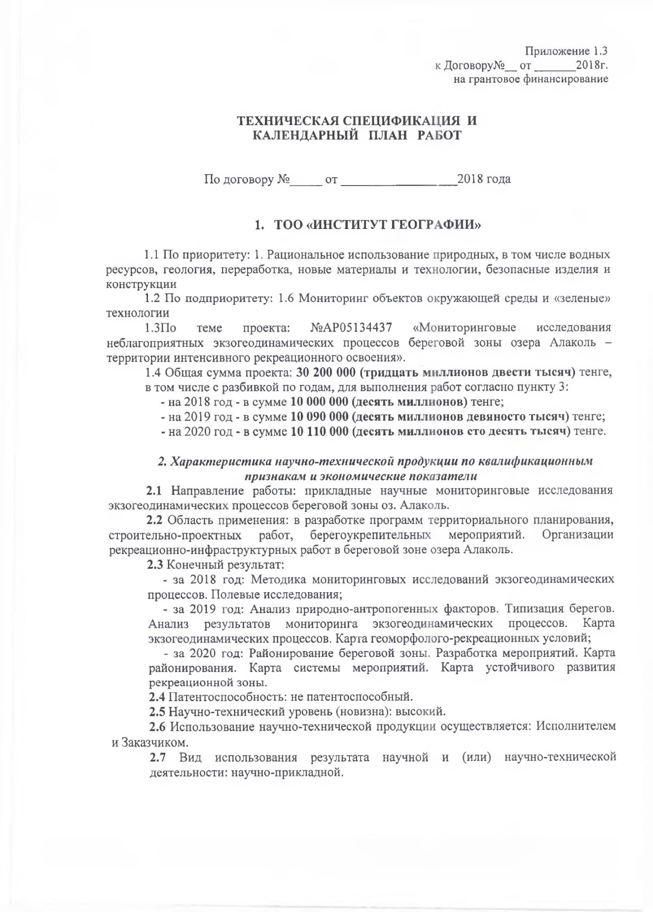

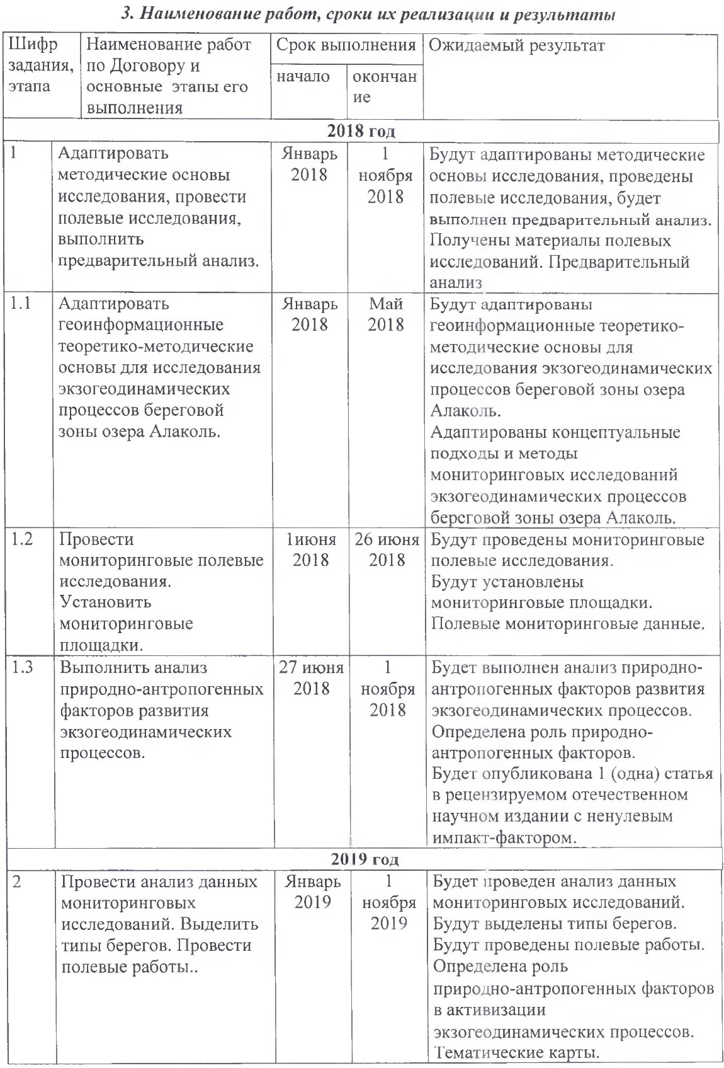
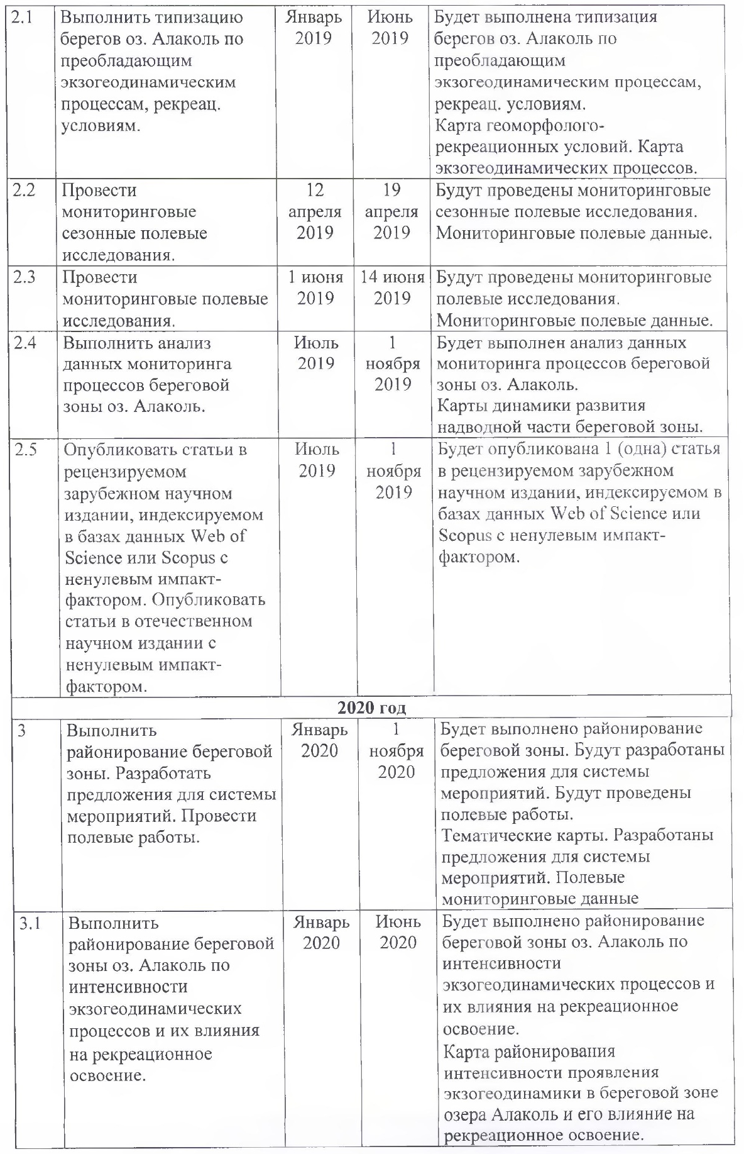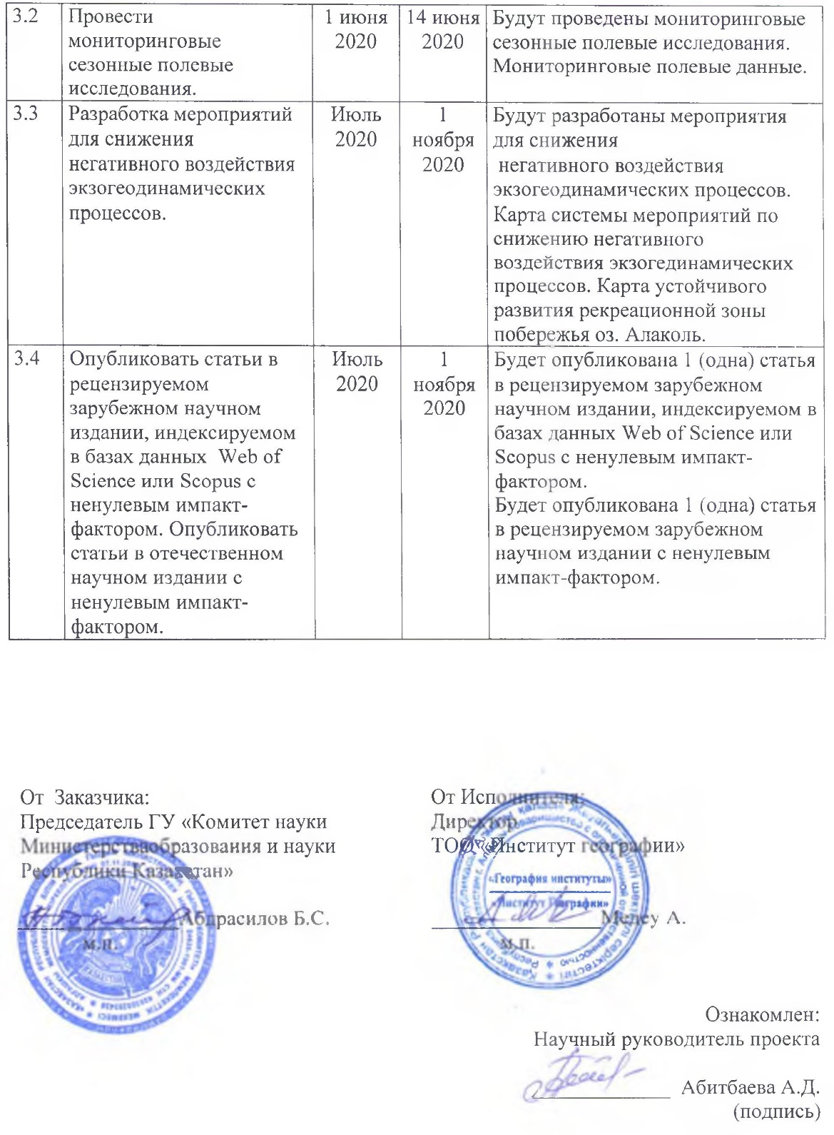

TECHNICAL SPECIFICATION AND
CALENDAR WORK PLAN

Under contract No. _____ dated __________________2018

1. LLP "INSTITUTE OF GEOGRAPHY"

1.1. By priority: 1. Sustainable use of natural resources, including water resources, geology, processing, new materials and technologies, safe products and constructures.
1.2. By sub-priority: 1.6 Environmental monitoring and green technologies.
1.3. On the theme of the project: №AP05134437 "Monitoring studies of adverse exogeodynamic processes in coastal zone of lake Alakol – areas of intensive recreational development".
1.4. Total project amount: 30 200 000 tenge (thirty million two hundred thousand tenge), including with ranging by years, for the implementation of work in accordance with paragraph 3:
- 2018 - 10 000 000 (ten millions) tenge;
- 2019 - 10 090 000 (ten million ninety thousand) tenge;
- 2020 - 10 110 000 (ten million one hundred ten thousand) tenge.

2. Characteristic of scientific and technical products by qualification signs and economic indicators
2.1. Direction of work: applied scientific monitoring studies of exogeodynamic processes in the coastal zone of the lake Alakol.
2.2. Application area: in the development of territorial planning programs, construction and design works, and coastal protection measures. Organization of recreational and infrastructure works in the coastal zone of the lake Alakol.
2.3. Final result:
2018: Methods of monitoring studies of exogeodynamic processes. Field research.
2019: Analysis of natural and anthropogenic factors. Coast typing. Analysis of the results of monitoring exogeodynamic processes. Map of exogeodynamic processes. Map of geomorphic and recreational conditions.
2020: Zoning of the coastal zone. Development of activities. Zoning of the coastal zone map. Map of the system of activities. Map of sustainable development of a recreational area.
2.4. Patentability: not patentable.
2.5. Scientific and technical level (novelty): High.
2.6. The use of scientific and technical products is carried out: by the Contractor and Customer.
2.7. Type of use of the result of research and (or) scientific and technical activities: scientific-applied.

3. Name of works, terms of their realization and results

Task number, stage | Name of works under the Contract and the main stages of its realization | Period of implementation |  | Expected result
Task number, stage |  | start | end
2018
1 | Adapt the research methodology, conduct field research, and perform preliminary analysis. | January 2018 | Nov. 1 2018 | The methodological basis of the study will be adapted, field research will be conducted, and a preliminary analysis will be performed.  Field research materials were obtained. Preliminary analysis.
1.1 | To adapt geoinformation theoretical and methodological foundations for the study of exogeodynamic processes in the coastal zone of lake Alakol. | January  2018 | May  2018 | Geoinformation theoretical and methodological bases and methods for monitoring exogeodynamic processes in the coastal zone of lake Alakol will be adapted.
1.2 | To conduct monitoring in the field. Set up monitoring platforms. | June 1  2018 | June 26  2018 | Monitoring field studies will be conducted.  Monitoring platforms will be installed.  Field monitoring data.
1.3 | Perform an analysis of natural and anthropogenic factors in the development of exogeodynamic processes. | June 27  2018 | Nov. 1 2018 | The analysis of natural and anthropogenic factors in the development of exogeody-namic processes will be performed. The role of natural and anthropogenic factors is determined.  1 (one) article will be published in a domestic scientific publication with a non-zero impact factor.
2019
2 | To highlight the types of banks. Conduct field work. Analyze data from monitoring studies. | January  2019 | Nov. 1 2019 | The types of banks will be highlighted. Field work will be carried out. Data from monitoring studies will be analyzed. Thematic map.
2.1 | Perform typing on the shores of the lake. Alakol by prevailing exogeodynamic processes and recreational conditions. | January  2019 | June  2019 | The shores of the lake will be typed. Alakol by prevailing exogeodynamic processes and recreational conditions.  Map of geomorphic and recreational conditions. Map of exogeodynamic processes.
2.2 | Conduct monitoring seasonal field studies. | April 12  2019 | April 19 2019 | Monitoring seasonal field studies will be conducted.  Monitoring field data.
2.3 | To conduct monitoring in the field. | June 1  2019 | June 14  2019 | Monitoring field studies will be conducted.  Monitoring field data.
2.4 | Analyze data for monitoring processes in the coastal zone of the lake Alakol. | July  2019 | Nov. 1 2019 | The analysis of data for monitoring processes in the coastal zone of the lake will be performed Alakol.  Maps of the dynamics of development of the surface part of the coastal zone.

2.5 |  | Publish articles in a peer-reviewed foreign scientific publication indexed in the Web of Science or Scopus databases with a non-zero impact factor. Publish articles in a domestic scientific publication with a non-zero impact factor. | July  2019 | Nov. 1 2019 | 1 (one) article will be published in a peer-reviewed foreign scientific publication indexed in the Web of Science or Scopus databases with a non-zero impact factor.
2020
3 | Perform zoning of the surface part of the coastal zone. Develop proposals for the system of activities. Conduct field work. |  | January 2020 | Nov. 1  2020 | The above-water part of the coastal zone will be zoned. Proposals for the system of activities will be developed. Field work will be carried out.  Thematic map.  Proposals for the system of activities have been developed. Field monitoring data.
3.1 | Perform zoning of the surface part of the lake's coastal zone Alakol by the intensity of exogeodynamic processes and their influence on recreational development. |  | January 2020 | June  2020 | The above-water part of the lake's coastal zone will be zoned. Alakol by the intensity of exogeodynamic processes and their influence on recreational development.  Map of zoning of the intensity of develope of ecogeodynamics in the coastal area of Alakol lake and its effect on recreational mastering.
3.2 | Conduct monitoring seasonal field studies. |  | June 1  2020 | June 14  2020 | Monitoring seasonal field studies will be conducted. Monitoring field data.
3.3 | Develop proposals for a system of activities to reduce the negative impact of exogeodynamic processes. |  | July  2020 | Nov. 1  2020 | Proposals will be developed for a system of activities to reduce the negative impact of exogeodynamic processes.  The map system of activities to reduce the negative impact exogeodynamic processes. Map of sustainable development of the recreational zone of the lake coast Alakol.
3.4 | Publish articles in a peer-reviewed foreign scientific publication indexed in the Web of Science or Scopus databases with a non-zero impact factor. Publish articles in a domestic scientific publication with a non-zero impact factor. |  | July  2020 | Nov. 1  2020 | 1 (one) article will be published in a peer-reviewed foreign scientific publication indexed in the Web of Science or Scopus databases with a non-zero impact factor.  1 (one) article will be published in a foreign scientific publication with a non-zero impact factor.

APPENDIX B

Publications in scientific journals, participation in conferences for 2018-2020
2018
Scientific journals in the editions of the Republic of Kazakhstan (CCSE&SMES RK):
- Mitrofanova A.N., Kalita R.Sh, Valeyev A.G., Abitbayeva A.D., Bekkulieva A.A., Sharapkhanova Zh.M., Uksukbaeva S.A. Geomorphological and engineering-geological conditions of the Quaternary deposits of the Alakol depression // Issues of geography and geoecology. №3, Almaty, 2018. – P. 94–103. ISSN 1998 – 7838. (russian).
Proceedings of international conferences:
- Valeyev A.G. Application of DEM for the analysis of morphometry of the drainage basin of Lake Alakol // Regional problems of remote sensing of the earth. Proceedings of the V International scientific conference, 11–14 september. – Krasnoyarsk, 2018. – P. 264–267. (russian).
2019

Scientific journals in the editions of the Republic of Kazakhstan (CCSE&SMES RK):

3. Valeev A.G., Kalita R.Sh., Mitrofanova A.N., Ye. Khalykov, Togys M.M., Uksukbaeva S.A., Sharapkhanova Zh.M. Recreation development potential of lake Alakol // Issues of geography and geoecology. – №3. – Almaty, 2019. –P. 3–11. – ISSN 1998 – 7838. (russian).
Articles in Kazakhstan publications included in the Scopus database:
4. A.G. Valeyev, F.Zh. Akiyanova, A.D. Abitbayeva, Ye.Ye. Khalykov, M.M. Togys. Development of abrasion shores of Alakol lake according to the field research materials / News of the National Sciences Academy of the Republic of Kazakhstan. Geology and Technique sciences part. – Almaty, 2019. – Vol. 1, No. 433. – P. 195–205 https://doi.org/10.32014/2019.2518-170X.24. Процентиль 26%, CiteScore 0.8.
Articles in foreign publications included in the Scopus database:
5. Adilet Valeyev, Marat Karatayev, Ainagul Abitbayeva, Saule Uxukbayeva, Aruzhan Bektursynova and Zhanerke Sharapkhanova. Monitoring Coastline Dynamics of Alakol Lake in Kazakhstan Using Remote Sensing Data // Geosciences. MDPI, Switzerland. 2019, Volume 9, Issue 9, 404. – P. 1–10 doi:10.3390/geosciences9090404 https://doi.org/10.3390/geosciences9090404, Процентиль 58%, CiteScore 2.1, Q2.
Proceedings of international conferences:
- Bektursynova A.A., Mitrofanova A.N., Kalita R.Sh., Valeev A.G., Kalita R.Sh., Valeev A.G. Assessment of natural and anthropogenic factors of recreational development of the coastal zone of Lake Alakol // Anthropogenic transformation of geospace: nature, economy, society. Proceedings of the V International Scientific and Practical Conference, 1–4 october. – Volgograd, 2019 – P.390–395. (russian).
2020

Scientific journals in the editions of the Republic of Kazakhstan (CCSE&SMES RK):
7. Valeyev A.G., Akiyanova F.Zh., Sagintayev J. The coastal zone of Alalkol lake madern relief-formaition processes // Hydrometeorology and ecology. № 2, Almaty, 2020. – P.129–149. – ISSN 2079-6161. (russian).
8. Valeyev A.G., Akiyanova F.Zh., Lyy Yu.F., Radusnova O.V. Modern geomorphological conditions of the Alakol lake coast // Issues of geography and geoecology. №3, Almaty, 2020. – P. 112–125. ISSN 1998-7838. (russian).
Articles in foreign publications included in the Scopus database:
9. A. Abitbayeva, Yu. Lyy, A.Valeyev, R. Kalita, A.Mitrofanova. Classification of Alakol lake coastes by prevailing exogeodinamic processes and recreational conditions // 20th International Multidisciplinary Scientific GeoConference Surveying Geology and Mining Ecology Management SGEM. – Bulgaria, Albena. – 16.08–25.08.2020 (в печати). Процентиль – 17 %, CiteScore – 0.4.
10. Ye. Khalykov, Yu. Lyy, A. Abitbayeva, M. Togys, A.Valeyev. Terrestrial laser scanning method for monitoring erosion of the southwestern shore of Alakol lake // 20th International Multidisciplinary Scientific GeoConference Surveying Geology and Mining Ecology Management SGEM. – Bulgaria, Albena. – 16.08–25.08.2020 (в печати). Процентиль – 17 %, CiteScore – 0.4.

2018
- Mitrofanova A.N., Kalita R.Sh, Valeyev A.G., Abitbayeva A.D., Bekkulieva A.A., Sharapkhanova Zh.M., Uksukbaeva S.A. Geomorphological and engineering-geological conditions of the Quaternary deposits of the Alakol depression // Issues of geography and geoecology. №3, Almaty, 2018. – P. 94–103. ISSN 1998 – 7838. (russian).
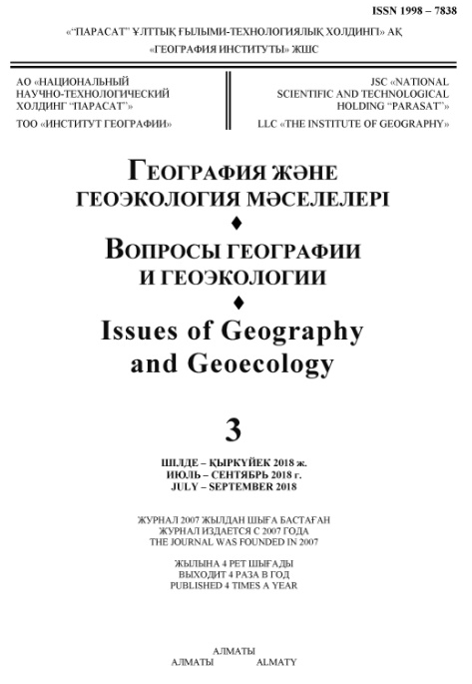 | 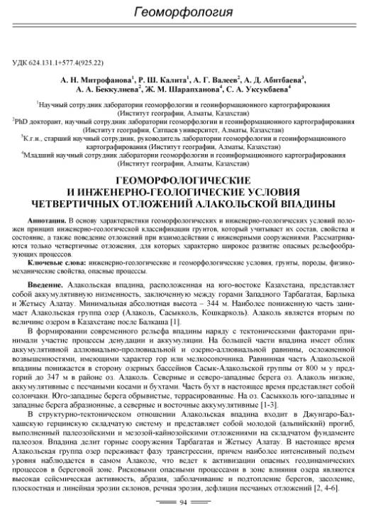
 | 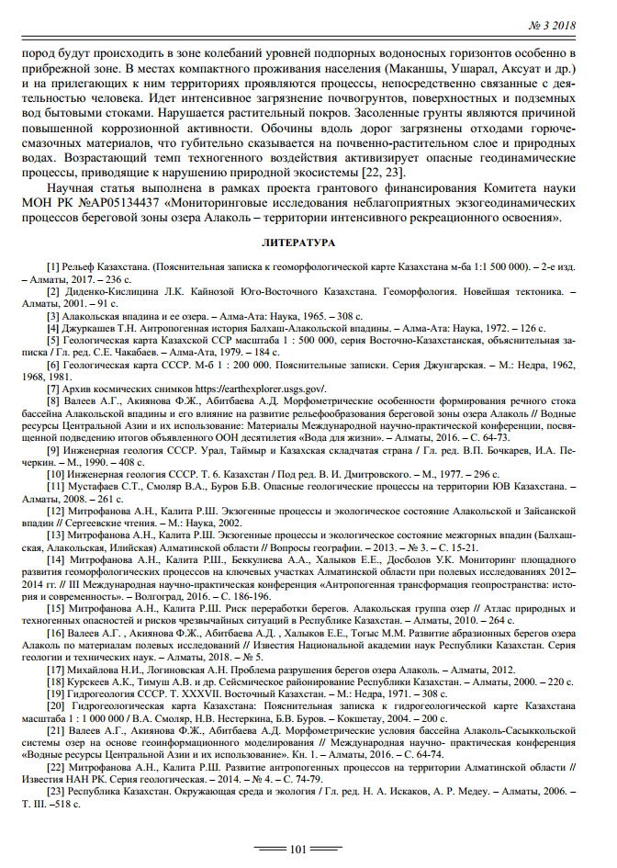

2.Valeyev A.G. Application of DEM for the analysis of morphometry of the drainage basin of Lake Alakol // Regional problems of remote sensing of the earth. Proceedings of the V International scientific conference, 11–14 september. – Krasnoyarsk, 2018. – P. 264–267. (russian).
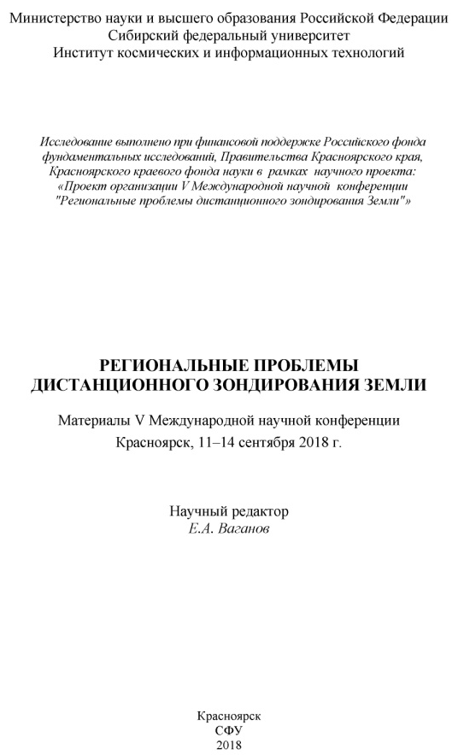 | 
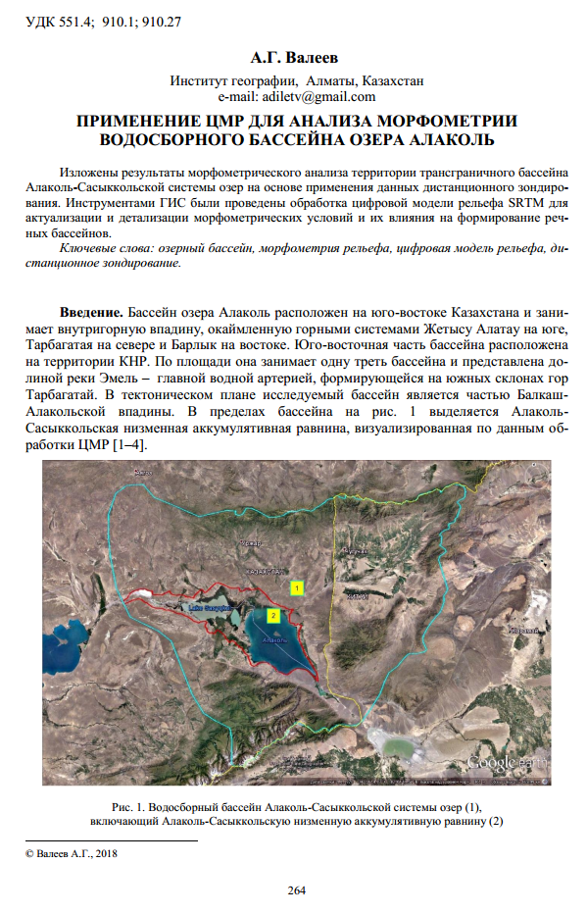

2019
3.Valeev A.G., Kalita R.Sh., Mitrofanova A.N., Ye. Khalykov, Togys M.M., Uksukbaeva S.A., Sharapkhanova Zh.M. Recreation development potential of lake Alakol // Issues of geography and geoecology. – №3. – Almaty, 2019. –P. 3–11. – ISSN 1998 – 7838. (russian).
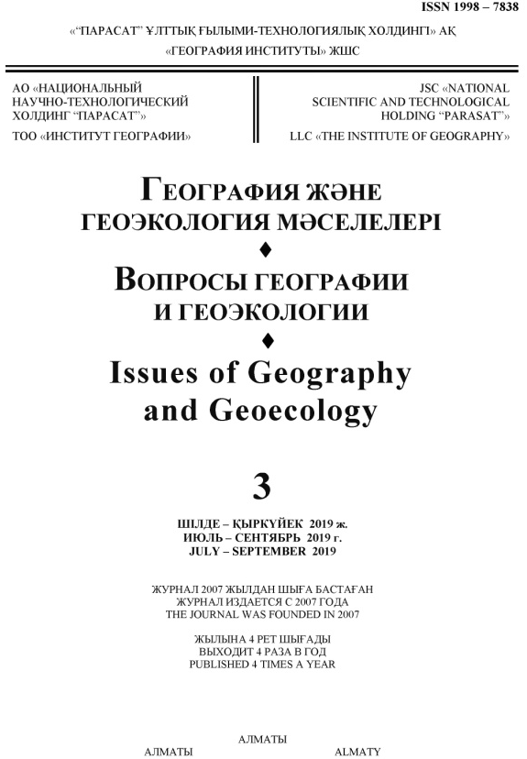 | 
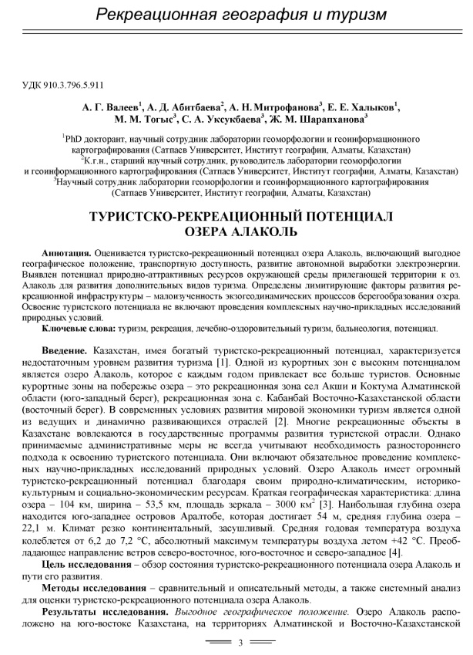 | 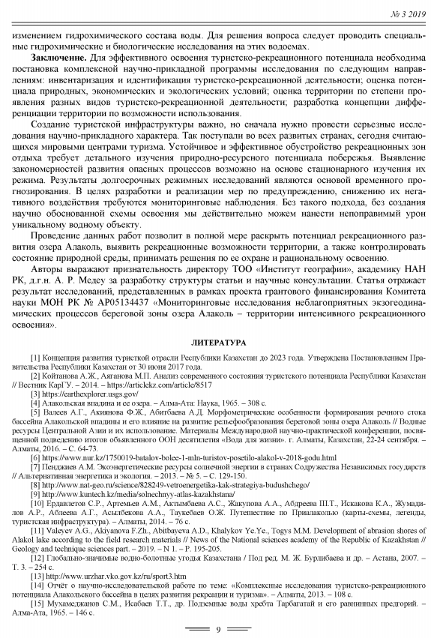

4. A.G. Valeyev, F.Zh. Akiyanova, A.D. Abitbayeva, Ye.Ye. Khalykov, M.M. Togys. Development of abrasion shores of Alakol lake according to the field research materials / News of the National Sciences Academy of the Republic of Kazakhstan. Geology and Technique sciences part. Almaty, 2019.– №. 1. – P. 195–205 https://doi.org/10.32014/2019.2518-170X.24. Процентиль 26%, CiteScore 0.8.
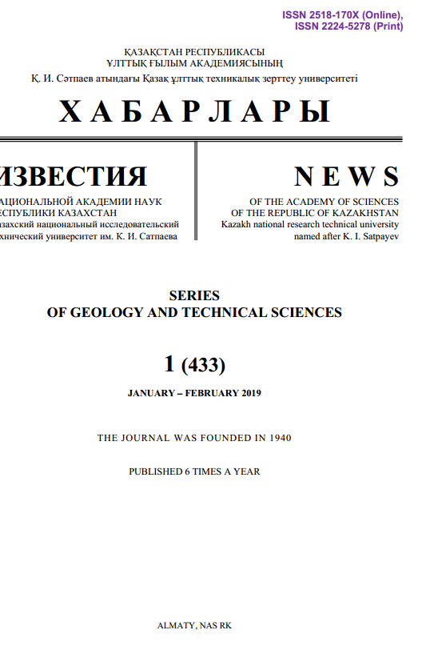 | 
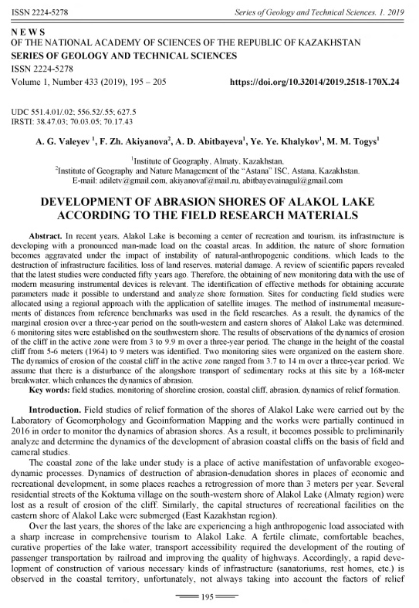 | 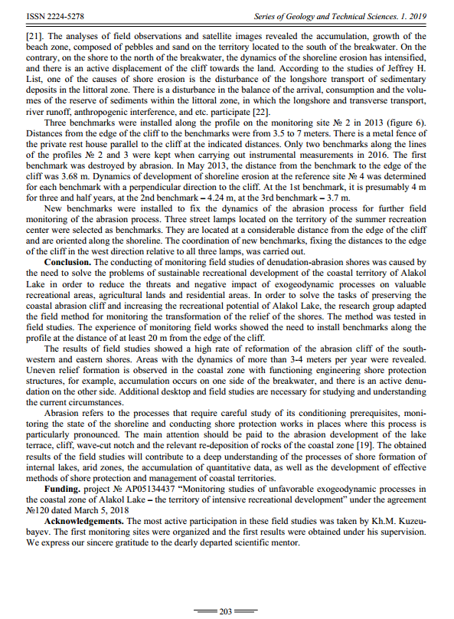

5.Adilet Valeyev, Marat Karatayev, Ainagul Abitbayeva, Saule Uxukbayeva, Aruzhan Bektursynova and Zhanerke Sharapkhanova. Monitoring Coastline Dynamics of Alakol Lake in Kazakhstan Using Remote Sensing Data // Geosciences. MDPI, Switzerland. 2019, Volume 9, Issue 9, 404. – P. 1–10 doi:10.3390/geosciences9090404 https://doi.org/10.3390/geosciences9090404, Процентиль 58%, CiteScore 2.1, Q2.
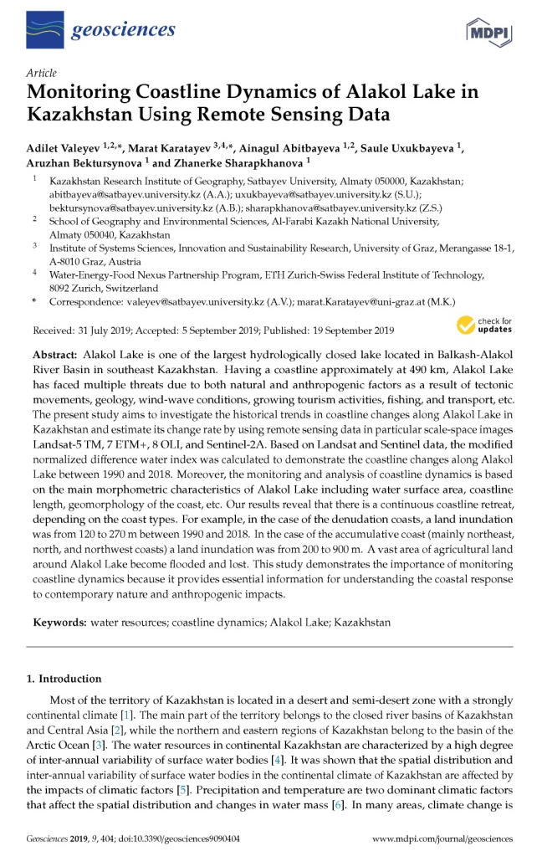 | 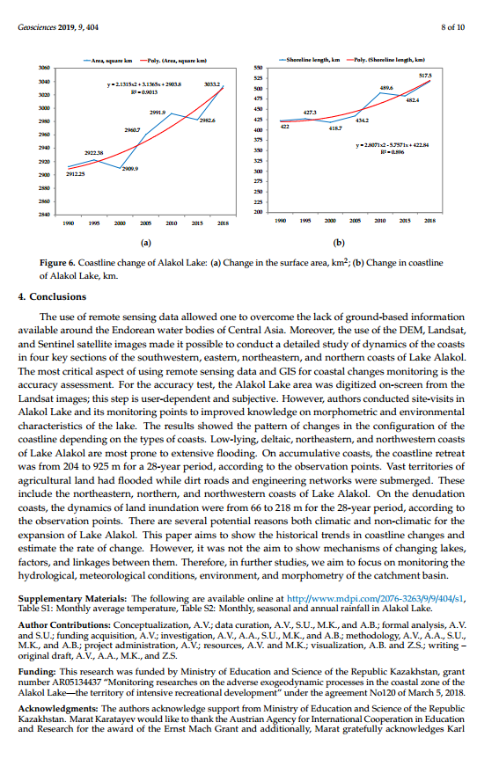
- Bektursynova A.A., Mitrofanova A.N., Kalita R.Sh., Valeev A.G., Kalita R.Sh., Valeev A.G. Assessment of natural and anthropogenic factors of recreational development of the coastal zone of Lake Alakol // Anthropogenic transformation of geospace: nature, economy, society. Proceedings of the V International Scientific and Practical Conference, 1–4 october. – Volgograd, 2019 – P.390–395. (russian).
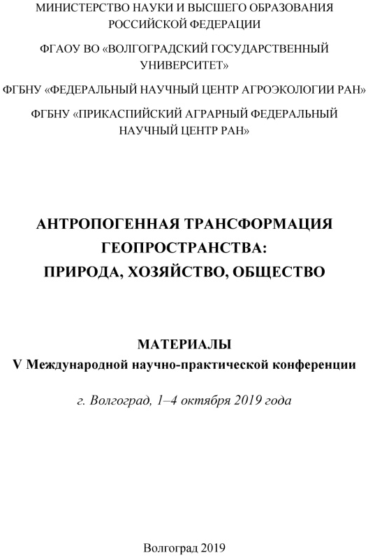 | 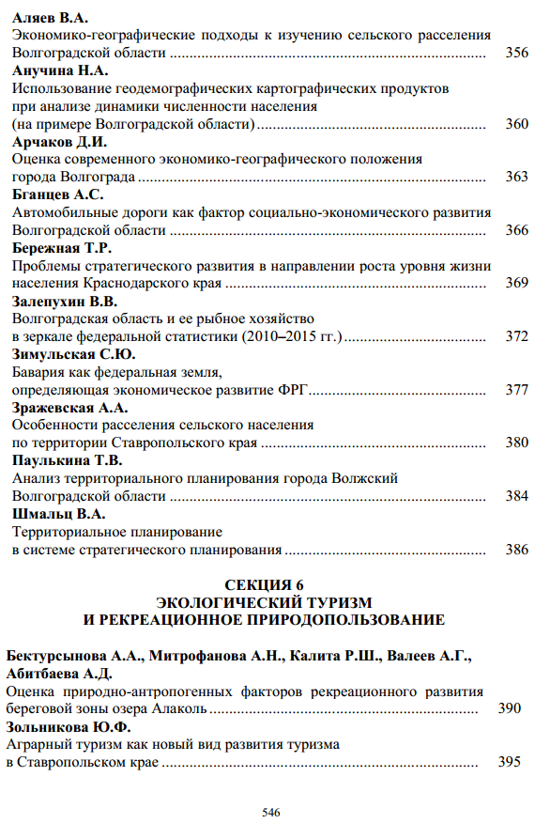
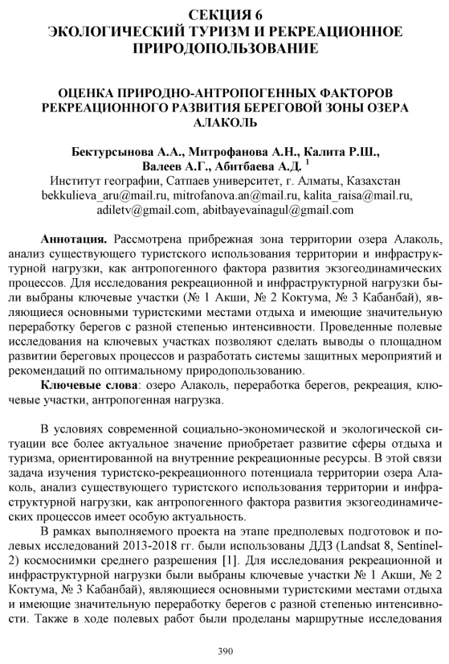 | 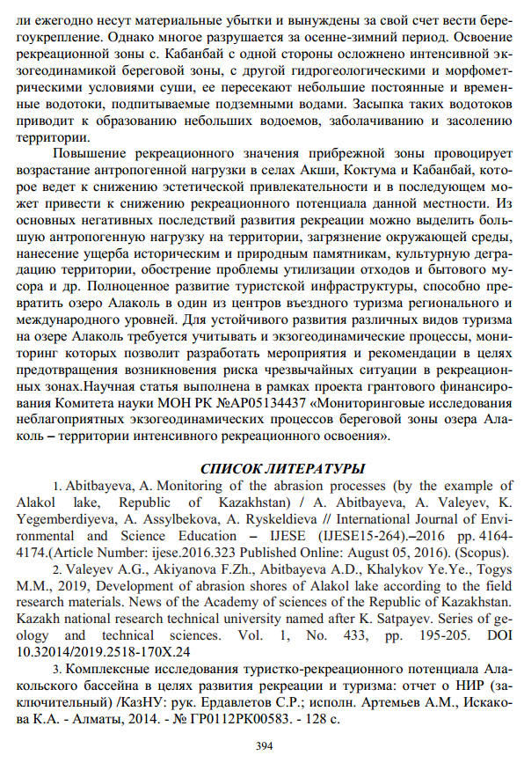

2020
7.Valeyev A.G., Akiyanova F.Zh., Sagintayev J. The coastal zone of Alalkol lake madern relief-formaition processes // Hydrometeorology and ecology. № 2, Almaty, 2020. – P.129–149. – ISSN 2079-6161. (russian).
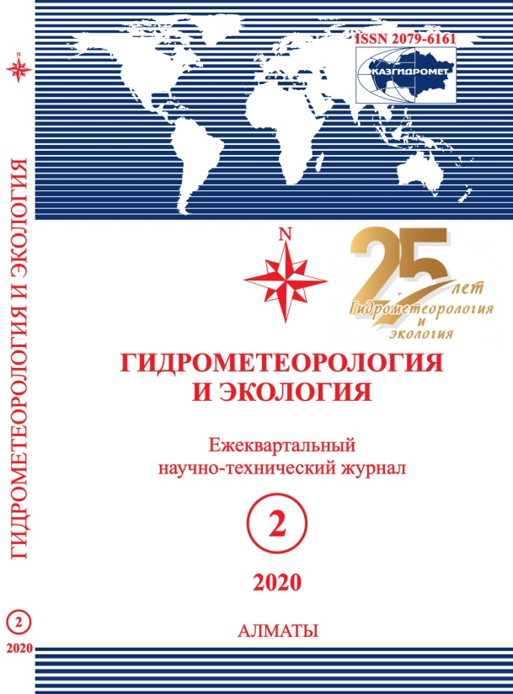 | 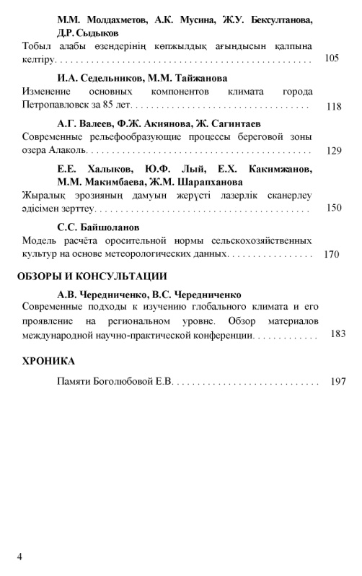
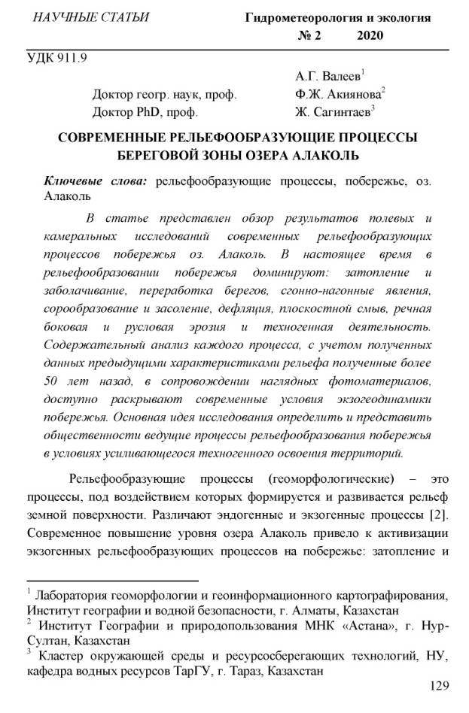
8.Valeyev A.G., Akiyanova F.Zh., Lyy Yu.F., Radusnova O.V. Modern geomorphological conditions of the Alakol lake coast // Issues of geography and geoecology. №3, Almaty, 2020. – P. 112–125. ISSN 1998-7838. (russian).
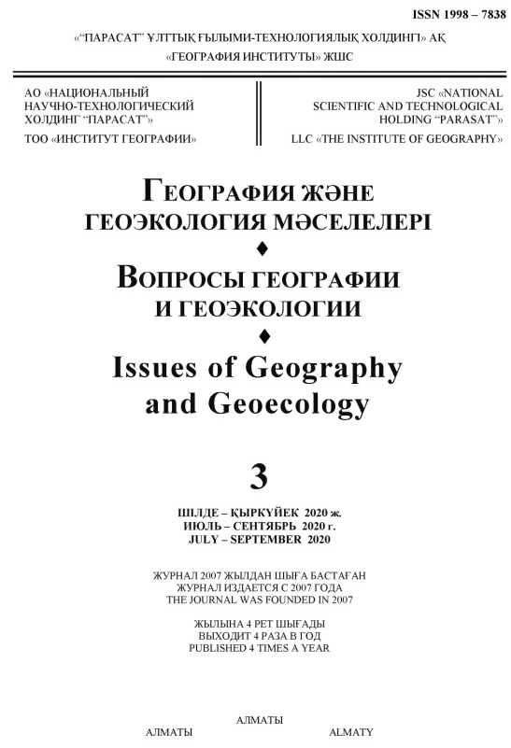 | 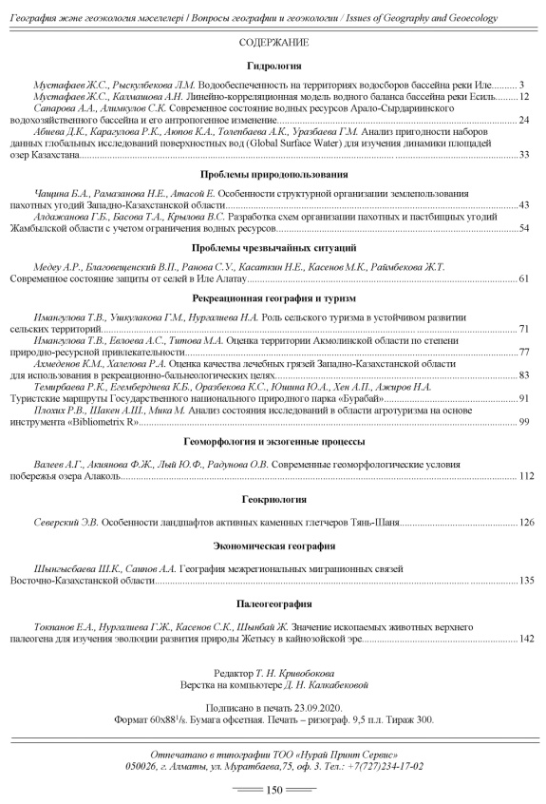
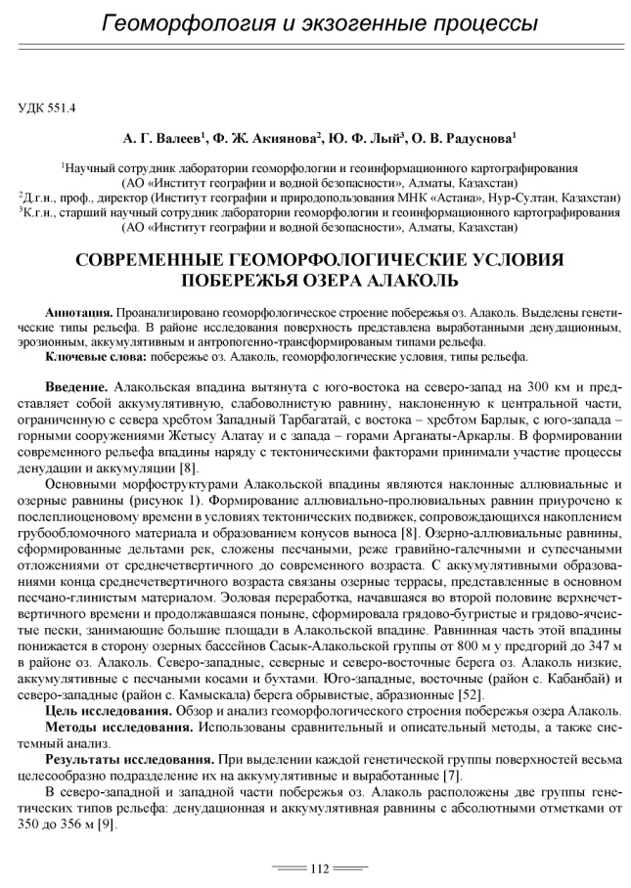 | 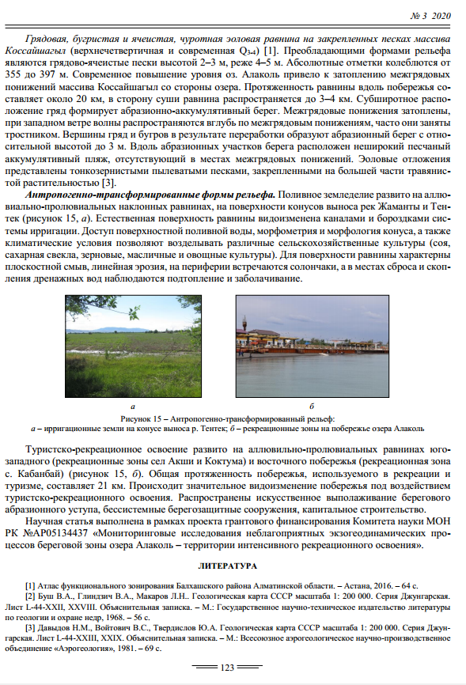

9.A. Abitbayeva, Yu. Lyy, A.Valeyev, R. Kalita, A.Mitrofanova. Classification of Alakol lake coastes by prevailing exogeodinamic processes and recreational conditions // 20th International Multidisciplinary Scientific GeoConference Surveying Geology and Mining Ecology Management SGEM. – Bulgaria, Albena. – 16.08–25.08.2020 (в печати). Процентиль – 17 %, CiteScore – 0.4.
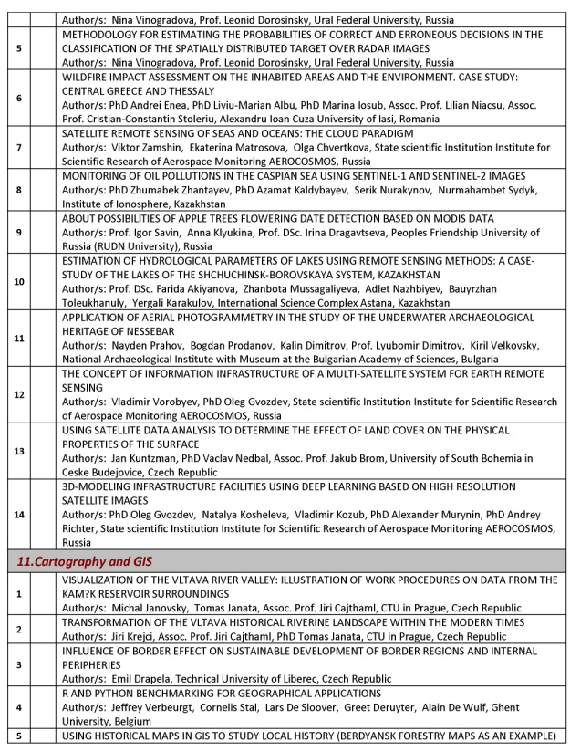 | 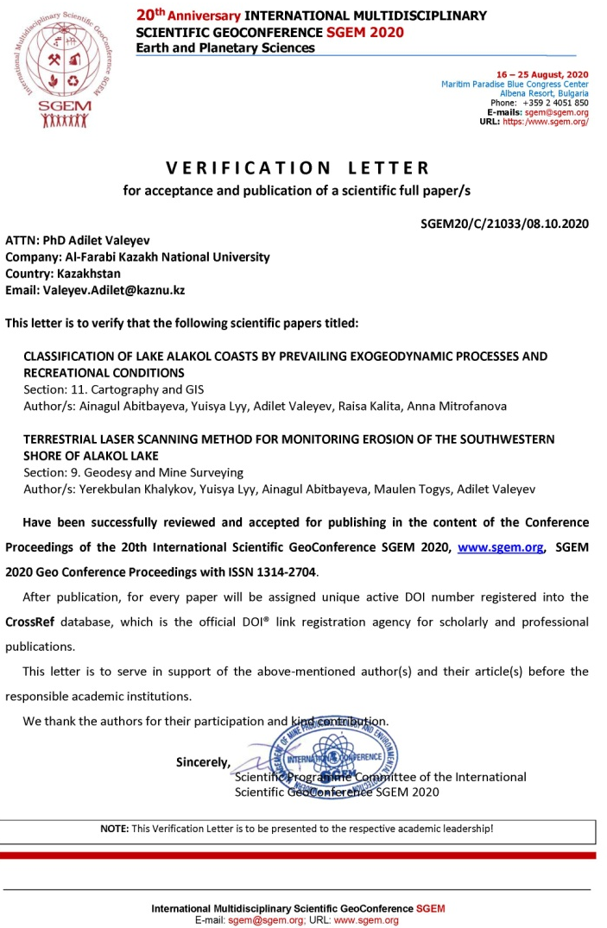
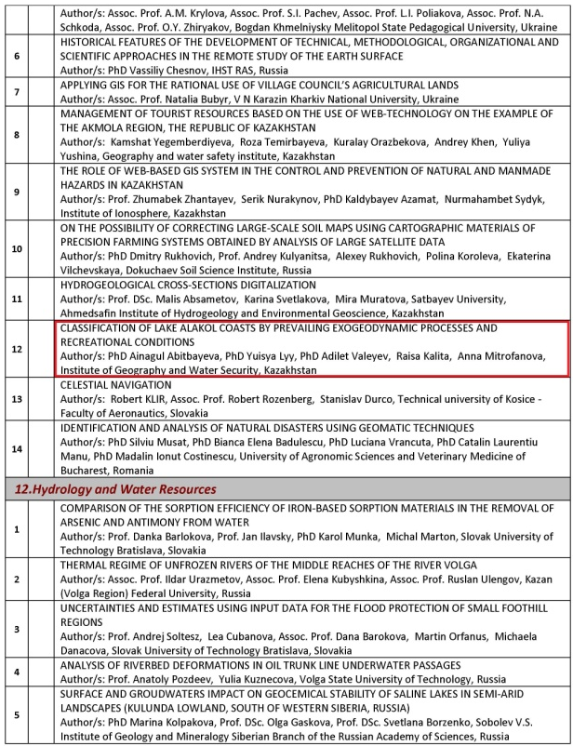

10. Ye. Khalykov, Yu. Lyy, A. Abitbayeva, M. Togys, A.Valeyev. Terrestrial laser scanning method for monitoring erosion of the southwestern shore of Alakol lake // 20th International Multidisciplinary Scientific GeoConference Surveying Geology and Mining Ecology Management SGEM. – Bulgaria, Albena. – 16.08–25.08.2020 (в печати). Процентиль – 17 %, CiteScore – 0.4.
 | 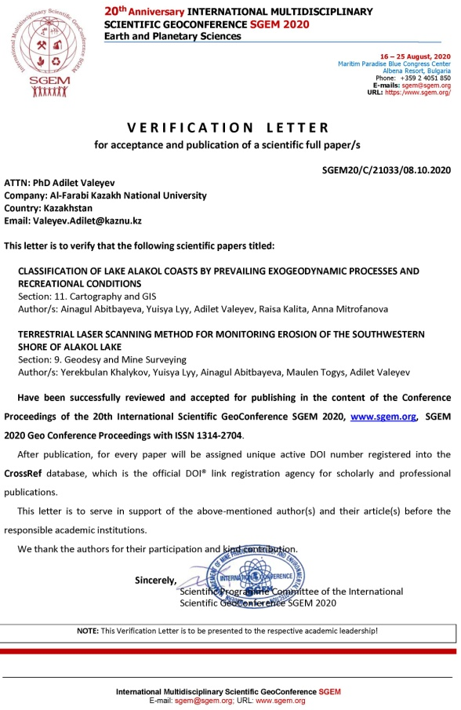
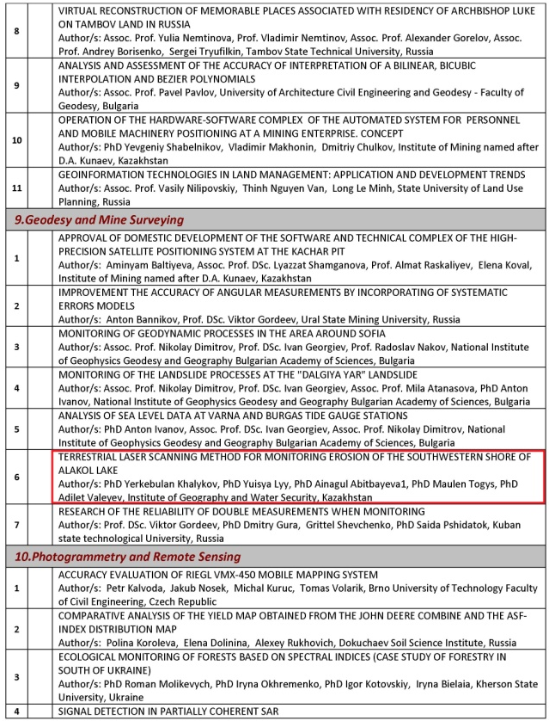

APPENDIX C
Extract from the protocol
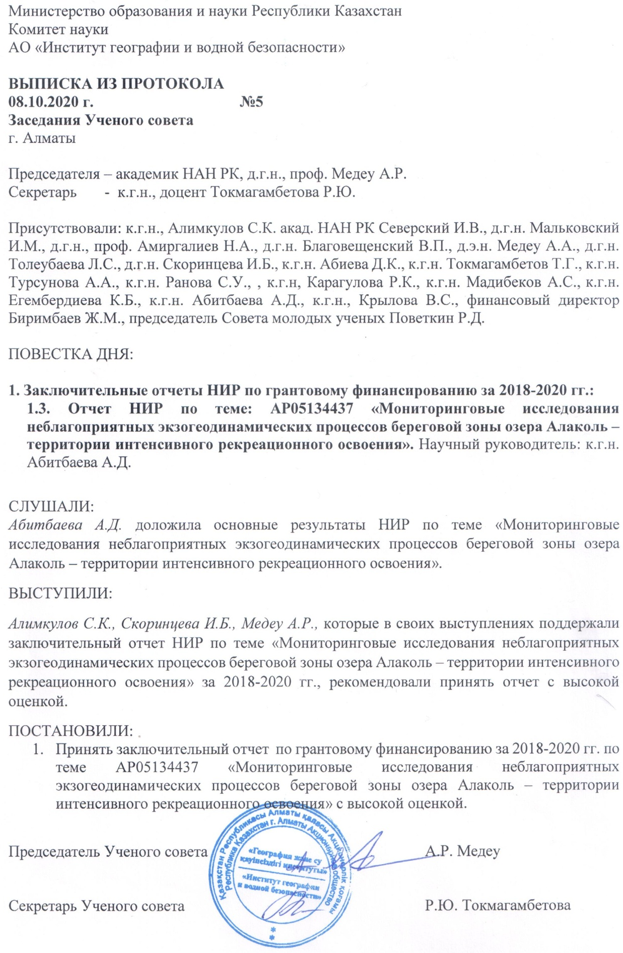

APPENDIX D
Review of the research report by the Head of the Department of Cartography and Geoinformatics, Doctor of PhD, Acting Associate Professor, Asylbekova A. A
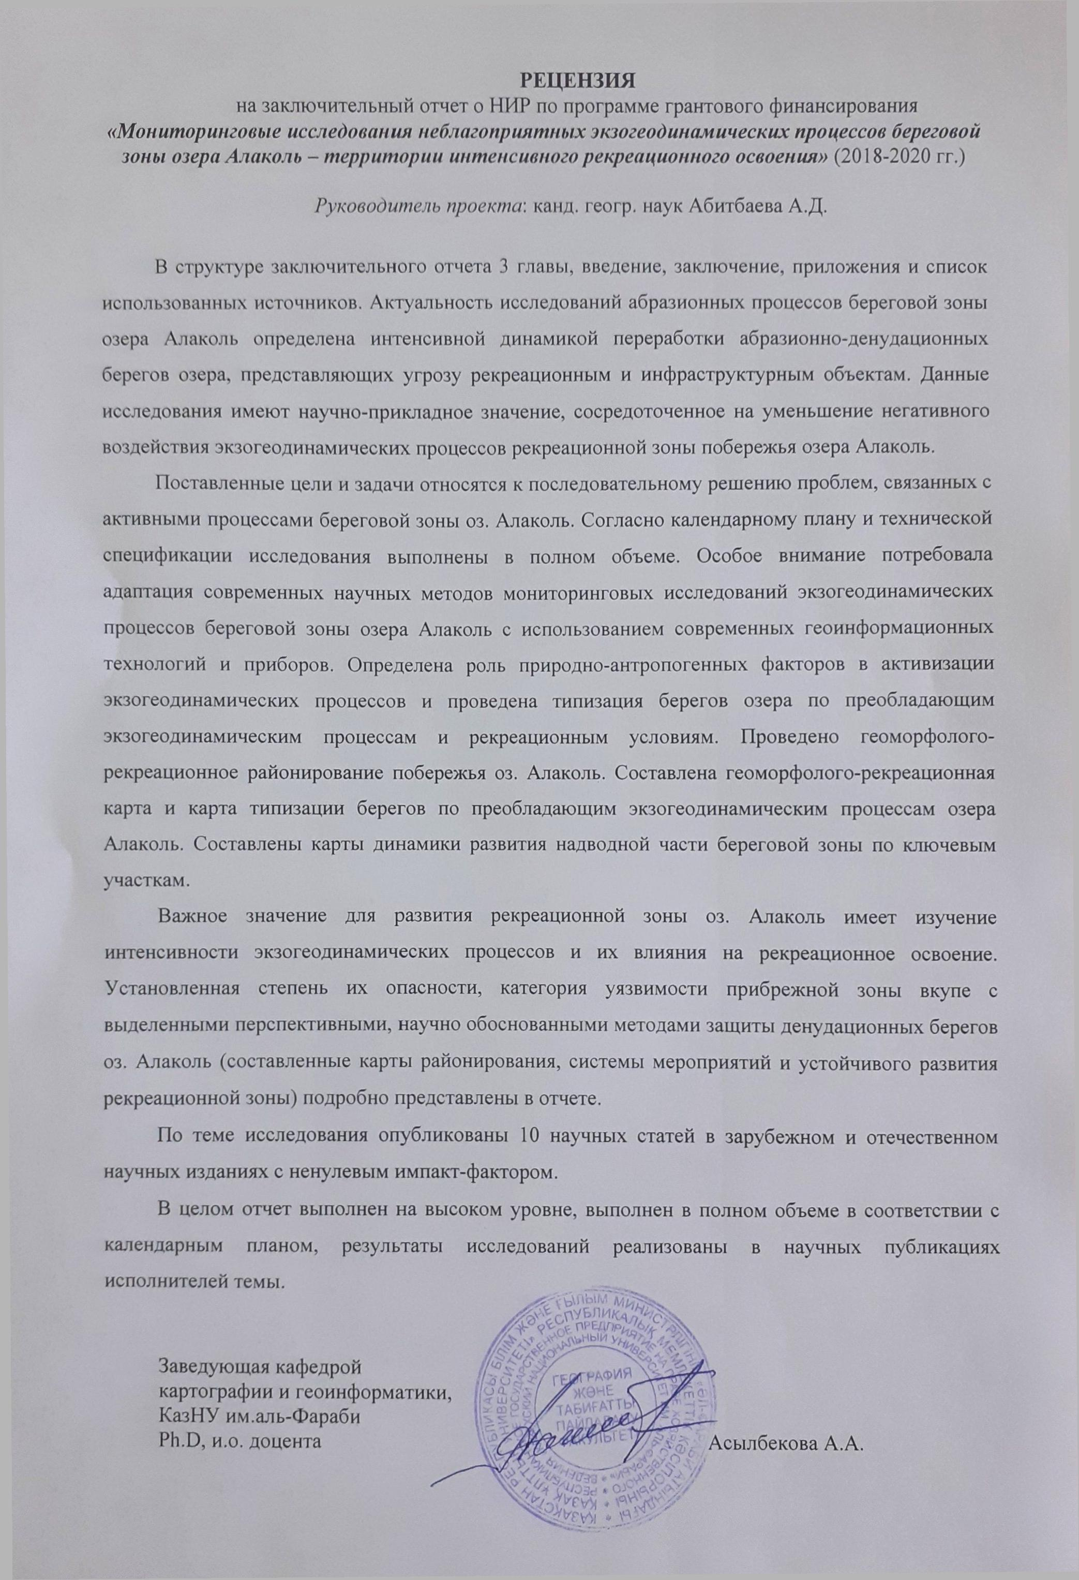

APPENDIX E
Review of the research report by head of geography of tourism and recreation laboratory, candidate of geogr. sciences, Yegemberdiyeva K.B.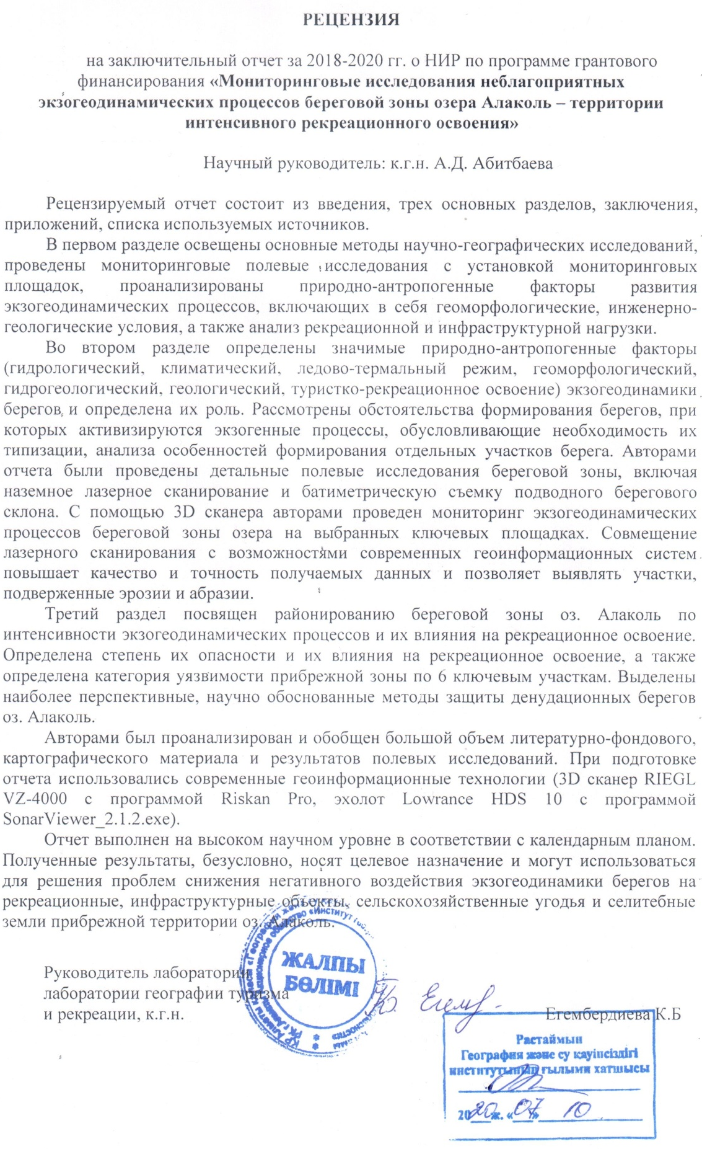

APPENDIX F
Initial data for section 1
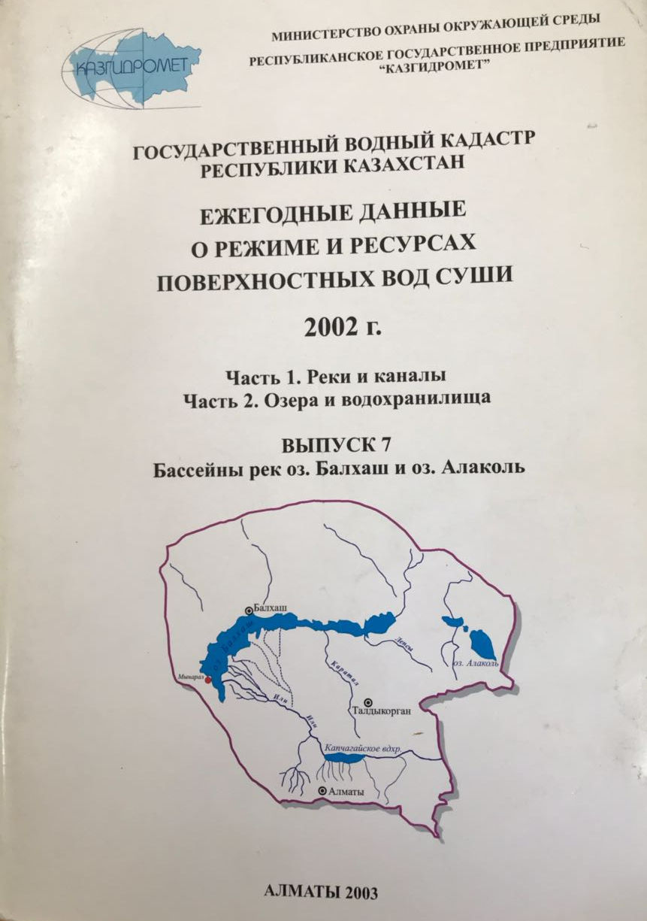 | 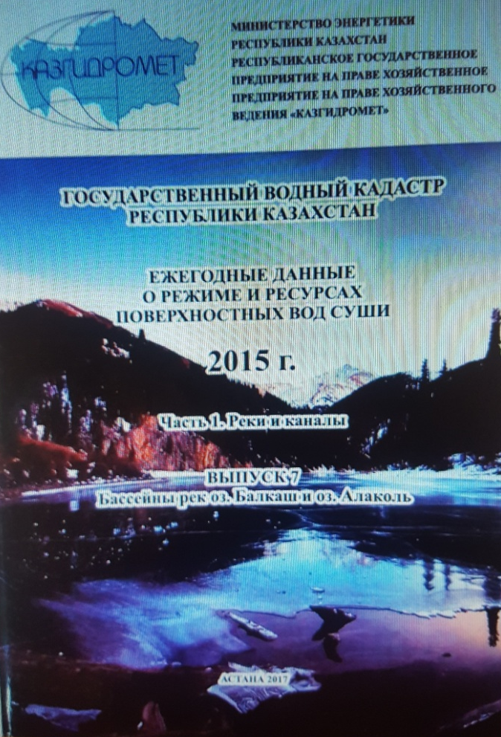
Figure F.1 – Annual data on regime and resources of land surface waters for 2002 | Figure F.2 – Annual data on the regime and resources of land surface waters for 2015
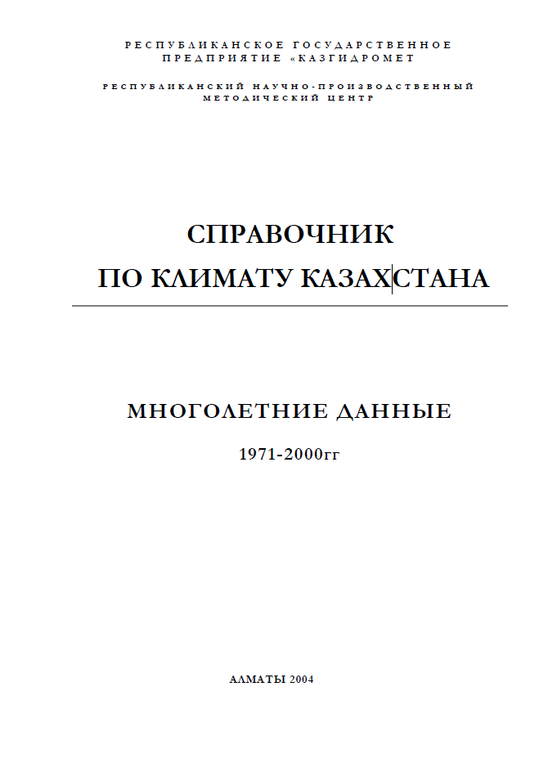
Figure F.3 – Kazakhstan Climate Handbook. Long-term data 1971-2000
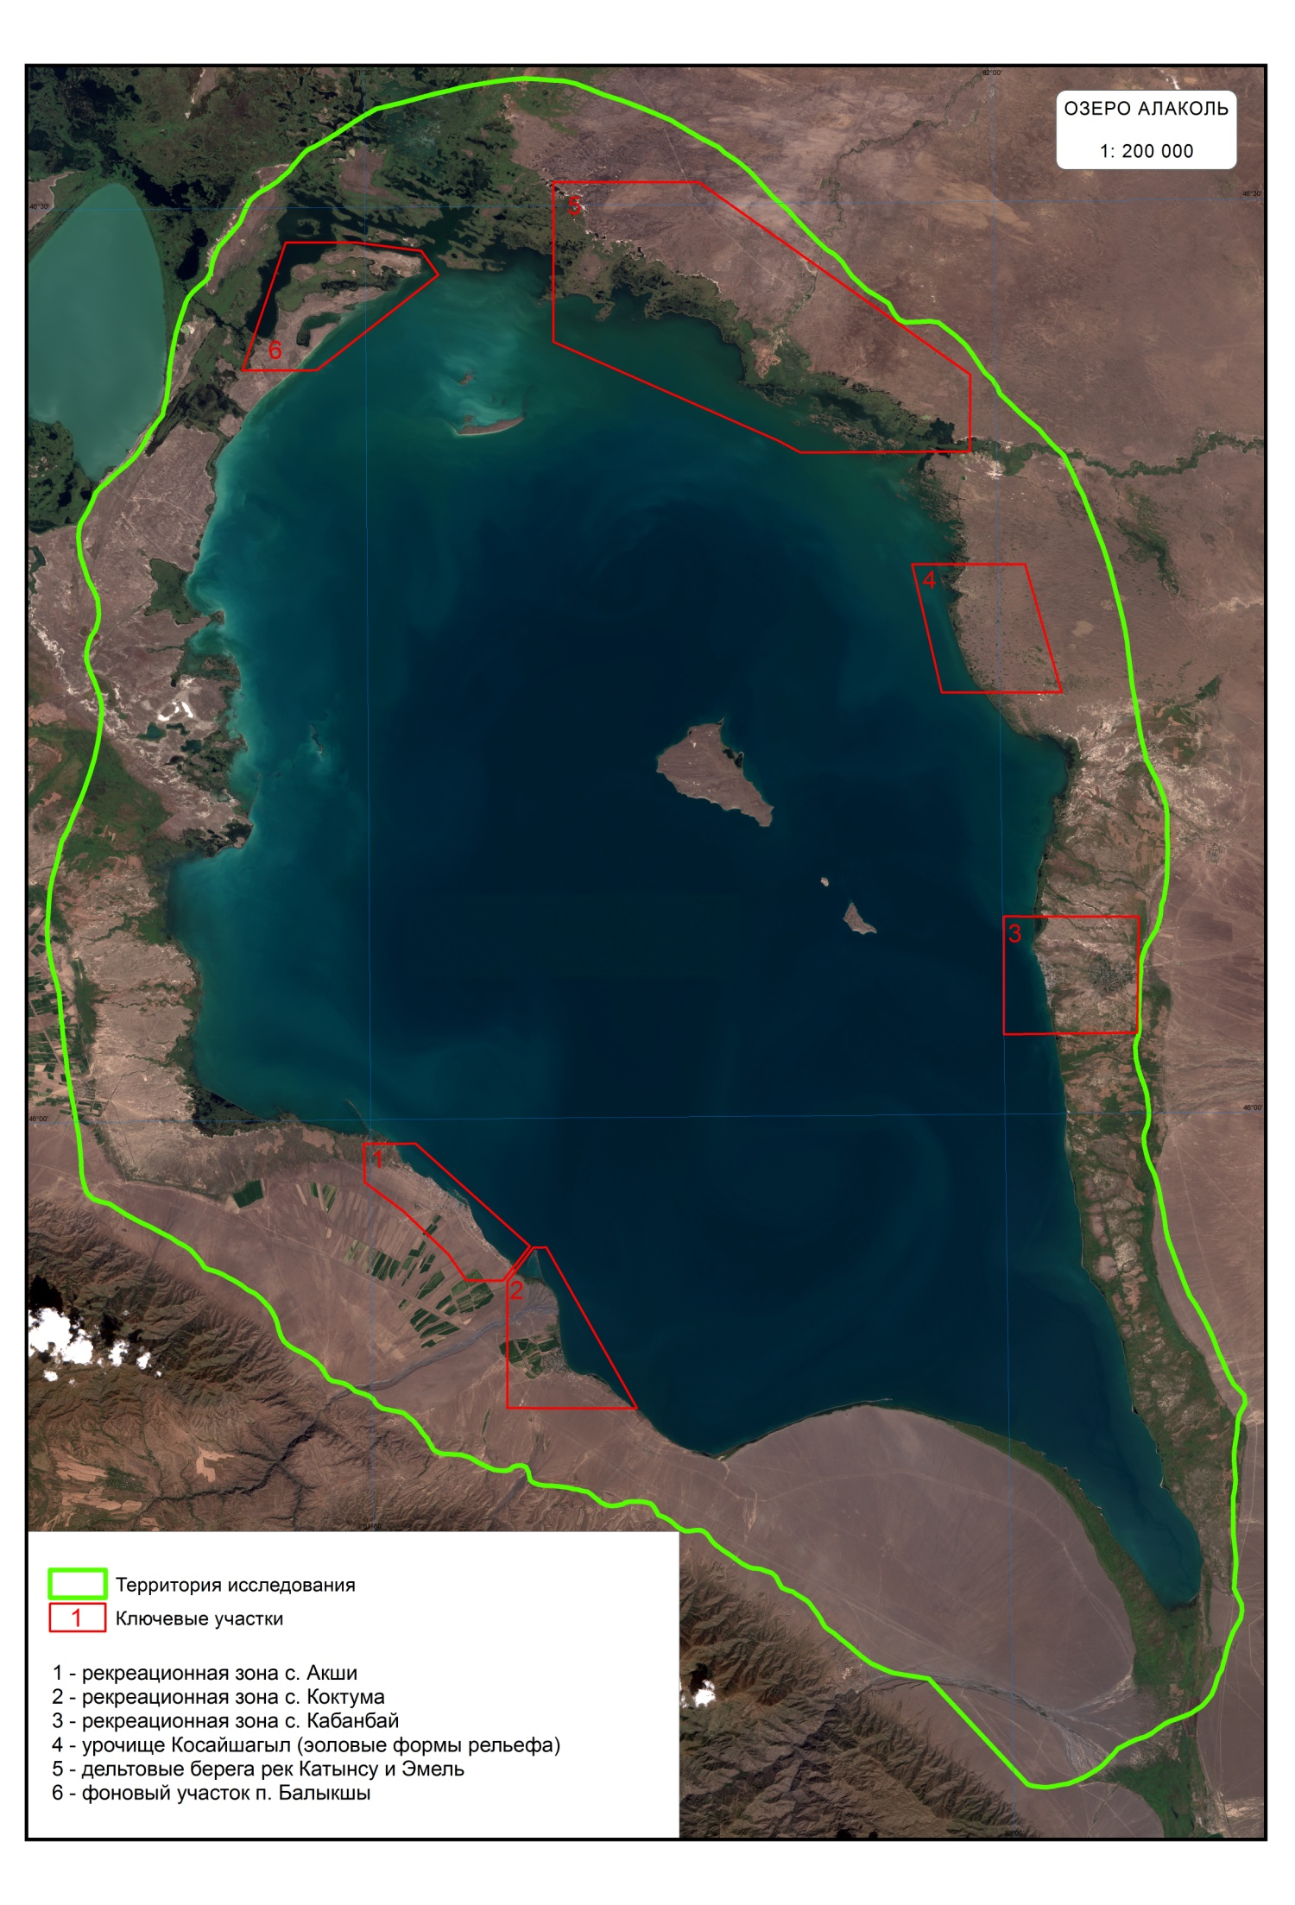
Figure F.4 – Sentinel-2A image (10m) on the territory of lake Alakol. Key sites
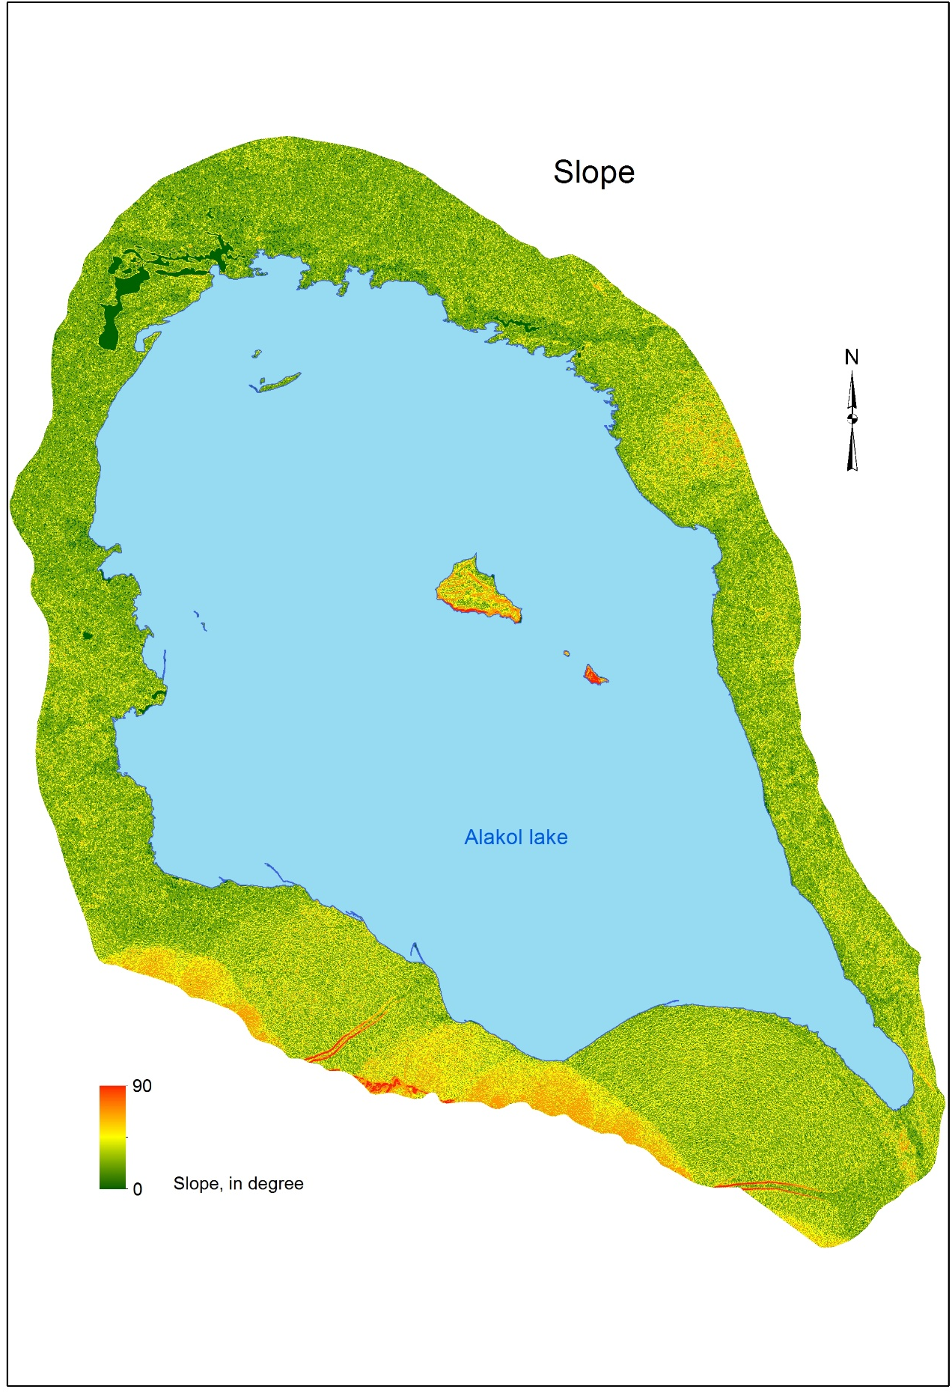
Figure F.5 – SRTM Digital Terrain Model (30m)

Table F.1 – Criteria for identifying the study area of the coastal zone of lake Alakol
Фактор | Критерии
Природный | Абсолютные высоты рельефа (горизонтали 360-800 м)
Природный | Эоловые формы рельефа
Природный | Территория активной разгрузки подземных вод
Природный | Дельтовые участки
Антропогенный | Населенные пункты
Антропогенный | Автомобильные дороги
Антропогенный | Железные дороги
Антропогенный | Туристко – рекреационная зона
Антропогенный | Добыча полезных ископаемых
Антропогенный | Сельскохозяйственные земли
Антропогенный | Историко-археологический (курганы)
Антропогенный | Рыбный промысел

Table F.2 – Criteria for identifying the study area of key sites
Фактор | Критерии
Природный | Активный экзогеоморфогенез в пределах надводной части береговой зоны
Природный | Риск негативного воздействия экзогеодинамических процессов на селитебные территории
Природный | Форма рельефа
Природный | Литологический состав береговых отложений
Антропогенный | Автодороги
Антропогенный | Железные дороги
Антропогенный | Населенные пункты
Антропогенный | Туристко-рекреационная зона
Антропогенный | Историко-археологический (курганы)
Антропогенный | Наличие сооружений инженерной защиты берегов (волнорез, пирс, волноломы и др.)

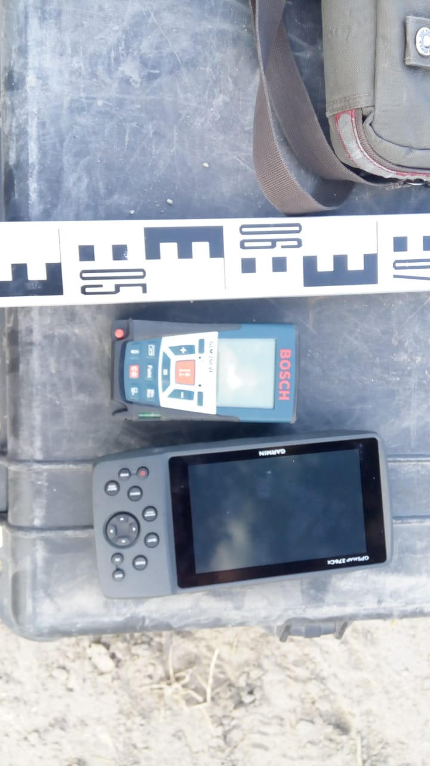
Figure F.6 – Laser rangefinder BOSCH Professional GLM 250 VF, GPS receiver Garmin GPSMAP 276Cx
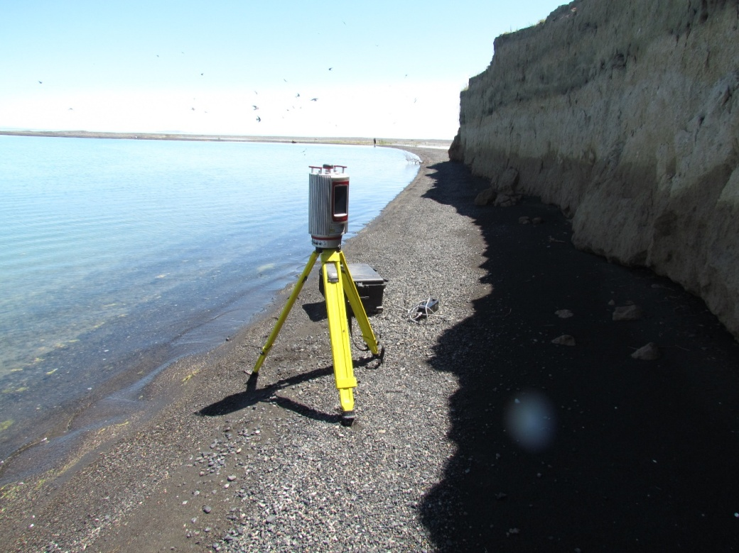
Figure F.7 – RIEGL VZ-4000 three-dimensional ground laser scanner

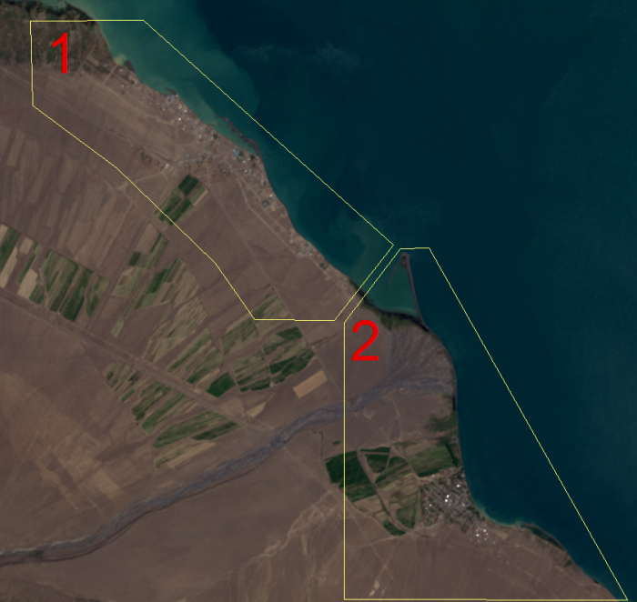 | 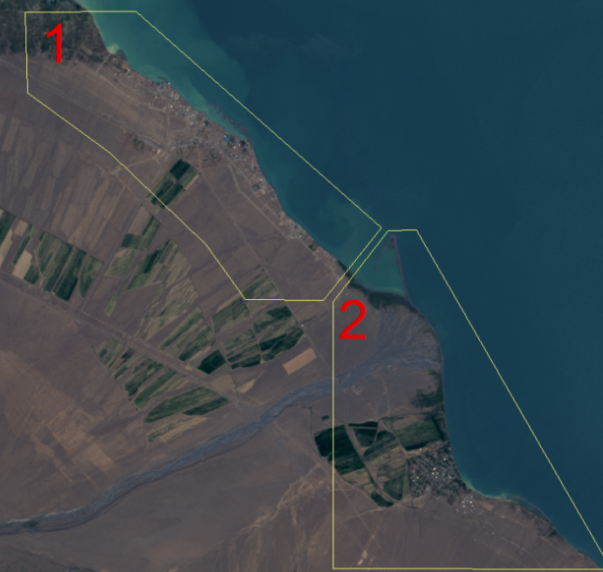
Figure F. 8 – Fragment of Landsat-8, 2018. Radiometric and atmospheric correction. Cell size 30 m. | Figure F. 9 – Fragment of Landsat-8, 2018. Panchromatic fusion. Cell size 15 m.
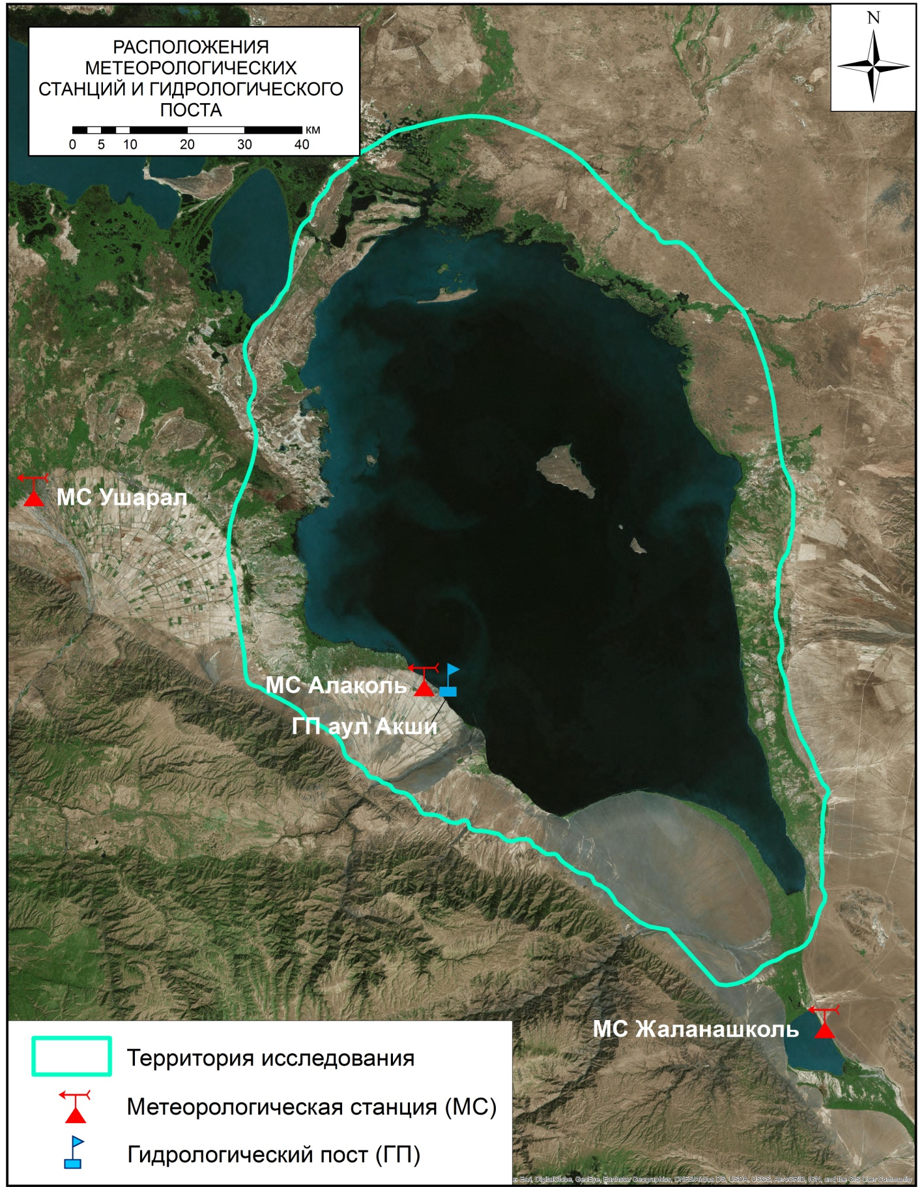
Figure F.10 – Location of meteorological stations

Table F. 3 – Distance from the observation points of the field exit to the coastline for 1990-2018
№ (GPS) | Расстояние от точек наблюдения полевого выезда до береговой линии за 1990-2018 годы
№ (GPS) | 2018-2013 | 2018-2010 | 2018-2005 | 2018-2000 | 2018-1995 | 2018-1990
1 | 2 | 3 | 4 | 5 | 6 | 7
Ключевой участок №1 (рекреационная зона с. Акши)
1 (003) | 95 м | 96 м | 200 м | 288 м | 356 м | 393 м
2 (010) | 50 м | 55 м | 119 м | 158 м | 180 м | 242 м
3 (015) | 21 м | 40 м | 49 м | 58 м | 61 м | 65 м
4 (016) | 9 м | 24 м | 36 м | 39 м | 58 м | 88 м
5 (017) | 23 м | 25 м | 33 м | 36 м | 36 м | 39 м
Ключевой участок № 2 (рекреационная зона с. Коктума)
6 (023) | 22 м | 28 м | 47 м | 70 м | 87 м | 118 м
7 (024) | 32 м | 37 м | 71 м | 92 м | 105 м | 112 м
8 (027) | 16 м | 22 м | 31 м | 84 м | 101 м | 120 м
9 (029) | 8 м | 26 м | 60 м | 110 и | 117 м | 122 м
10 (032) | 35 м | 52 м | 61 м | 93 м | 101 м | 112 м
Ключевой участок № 3 (рекреационная зона с. Кабанбай)
11 (Кабанбай 1.2) | 24 м | 29 м | 37 м | 111 м | 168 м | 203 м
12 (Кабанбай 1.4) | 20 м | 24 м | 31 м | 94 м | 151 м | 190 м
13 (078) | 46 м | 57 м | 98 м | 150 м | 173 м | 206 м
14 (Кабанбай 1.13) | 34 м | 59 м | 84 м | 158 м | 180 м | 218 м
15 (Кабанбай 2.5) | 22 м | 29 м | 33 м | 74 м | 83 м | 112 м
Ключевой участок № 4 (урочище Косайшагыл)
16 (090) | 32 м | 57 м | 82 м | 121 м | 167 м | 200 м
17 (091) | 79 м | 95 м | 142 м | 180 м | 207 м | 279 м
18 (092) | 47 м | 66 м | 150 м | 171 м | 179 м | 210 м
Ключевой участок № 5 (п. Коктал)
19 (131) | 434 м | 634 м | 803 м | 815 м | 835 м | 841 м
20 (000) | 208 м | 427 м | 550 м | 735 м | 864 м | 925 м
1 | 2 | 3 | 4 | 5 | 6 | 7
21 (000 ) | 53 м | 62 м | 124 м | 187 | 192 м | 204 м
Ключевой участок № 6 (п. Камыскала)
22 (150) | 40 м | 66 м | 133 и | 141 м | 160 м | 250 м
23(158) | 13 м | 21 м | 48 м | 53 м | 65 | 66 м
24 (181) | 43 м | 78 м | 138 м | 278 м | 320 м | 470 м

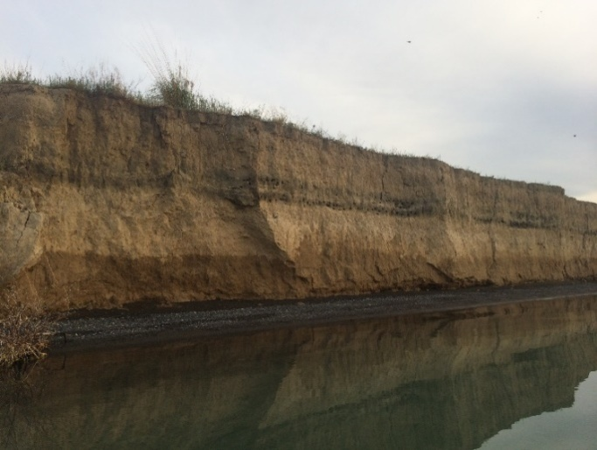 | 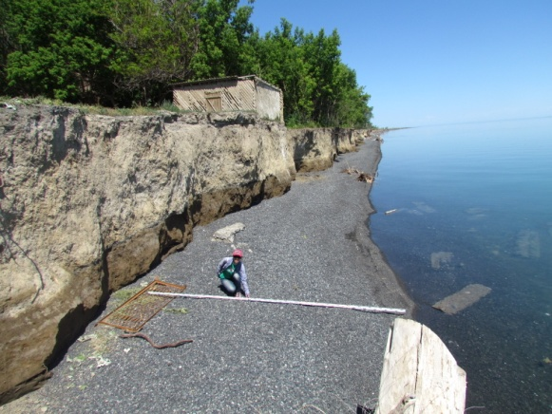
Figure F.11– Narrow beach at the abrasion scarp v. Akshi
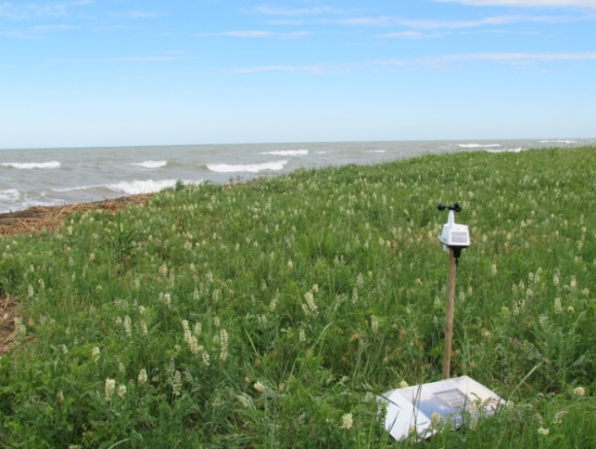
Figure F.12 – Davis Vantage Vue Weather Station

Table F.4 – Davis Vantage Vue weather data for key sites No. 3-4, 6
Ключевой участок | Дата | Преобладающее направление ветра | Средняя скорость ветра, м/с
№3 | 12.06.2018 | западное, юго-западное | 0,7
№3 | 13.06.2018 | южное, юго-западное, юго-восточное | 0,7
№3 | 14.06.2018 | южное, юго-западное | 1,0
№4 | 16.06.2018 | северное, северо-западное | 1,13
№6 | 21.06.2018 | южное, юго-западное | 1,8
№6 | 22.06.2018 | южное, юго-восточное | 2,2

a)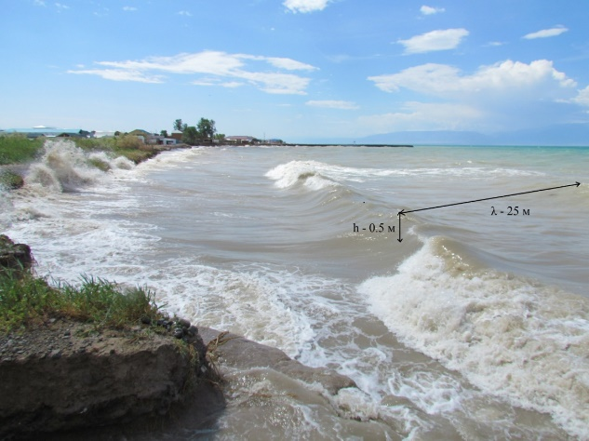 | b)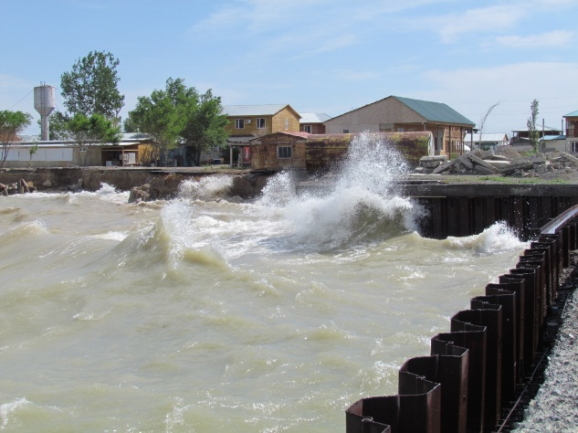
Figure F.13 – Wind and wave impact on the coastal cleave of the north-eastern coast of lake Alakol (recreational zone of the village of Kabanbay). a) visual determination of wavelength and height; b) processing of the coast of recreationally developed territories.

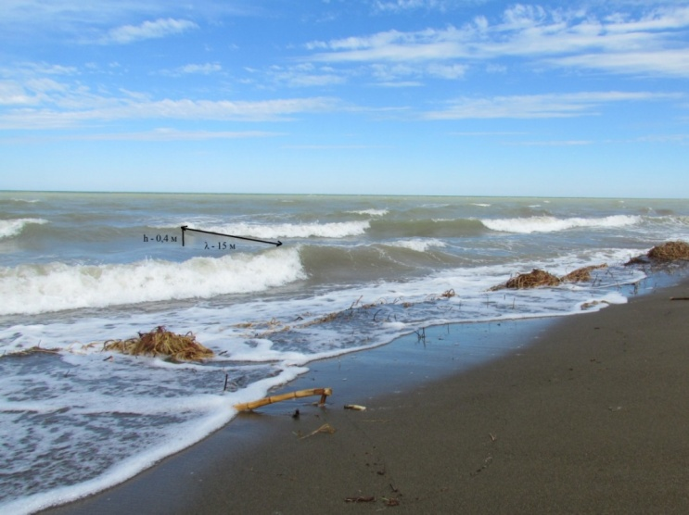
Figure F.14 – South coast of ur. Kosayshagyl

Table F.5 – Parameters of wave elements according to visual observations
Ключевой участок | Скорость ветра по Davis Vantage Vue | тип волнения | высота волны (h) | длина волны (λ) | период волны
№ 3 | 2,2 м/с | ветровой | ~ 0,5 м | ~ 25 м | 5 сек.
№ 4 | 1,5 м/с | ветровой | ~ 0,5 м | ~ 15 м | до 5 сек.

Figure F.15 – Ice thickness and snow depth on ice near the coast, cm lake Alakol – a. Akshi (2002-2015))

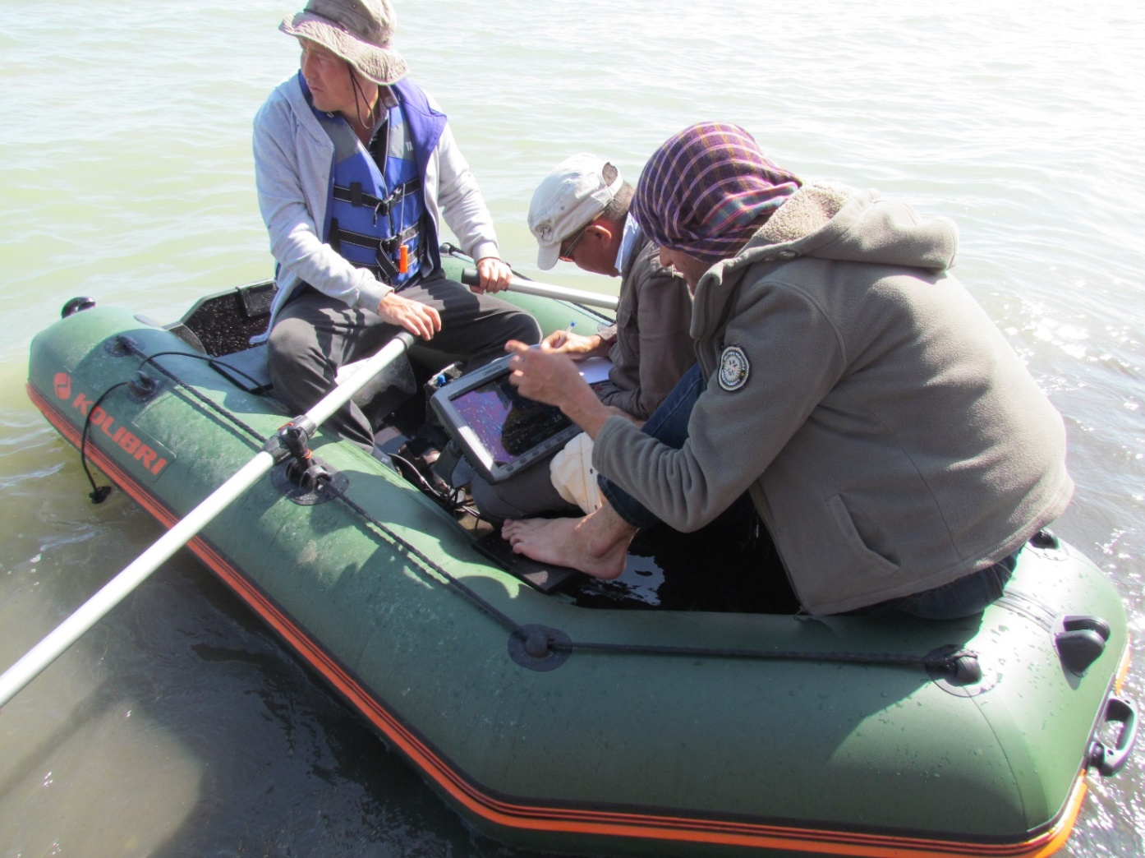
Figure F.16 – Bathymetric measurements of the underwater coastal slope, coast village Koktuma

Table F.6 – Water temperature at the coast ˚С, lake Alakol – aul Akshi, 2015
Декада | Месяц |  |  |  |  |  |  |  |  |  |  |  |  |  |  |  |  |  |  |  | Наибольшая температура за год, дата начало, дата окончания, число случаев
Декада | 1 | 2 |  | 3 |  | 4 |  | 5 |  | 6 |  | 7 |  | 8 |  | 9 | 10 |  | 11 | 12
1 | 0,7 |  |  |  |  | 5,4 |  | 13,4 |  | 18,7 |  | 21,3 |  | 24,1 |  | 19,1 | 11,9 |  | 7,6 | 4,6 | 25,5
2 | 0,2 |  |  |  |  | 7,2 |  | 14,2 |  | 17,9 |  | 22,6 |  | 21,9 |  | 16,4 | 11,2 |  | 7,2 | 2,8 | 27,07
3 | 0,0 |  |  | 0,5 |  | 9,6 |  | 14,8 |  | 22,8 |  | 24,5 |  | 20,8 |  | 12,9 | 9,1 |  | 5,5 | 2,6 | 07,08
Средн. | 0,3 |  |  | 0,2 |  | 7,4 |  | 14,1 |  | 19,8 |  | 22,8 |  | 22,3 |  | 16,1 | 10,7 |  | 6,8 | 3,3 | 3
Table F.7 – Average long-term water temperature near the coast (0С) lake Alakol – aul Akshi (2002-2015)
Декада | Месяц |  |  |  |  |  |  |  |  |  |  |  |  |  |  |  |  |  |  |  |  | Наибольшая температура за год, дата, число случаев
Декада | 1 |  | 2 |  | 3 |  | 4 |  | 5 |  | 6 |  | 7 |  | 8 |  | 9 | 10 |  | 11 | 12 | Наибольшая температура за год, дата, число случаев
2002 | 3,6 |  | 3,9 |  | 3,3 |  | 5,2 |  | 12,1 |  | 18,3 |  | 22,3 |  | 22,7 |  | 16,3 | 14,4 |  | 8,7 | 2,9 | 1
2003 | 2,8 |  | 2,8 |  | 3,4 |  | 4,4 |  | 11 |  | 19 |  | 21,8 |  | 21,1 |  | 18,9 | 11,6 |  | 6 | 2,7 | 1
2004 | 2,6 |  | 2,9 |  | 2,8 |  | 4,7 |  | 11,5 |  | 18,3 |  | 25,2 |  | 20,8 |  | 18,1 | 11,1 |  | 6,8 | 3 | 1
2005 | 0 |  | 0 |  | 2,6 |  | 5,8 |  | 12,6 |  | 19,2 |  | 24,2 |  | 21,7 |  | 18,8 | 12,2 |  | 7,4 | 1,9 | 1
2006 | 0 |  | 0 |  | 1,7 |  | 6,9 |  | 12,3 |  | 19,3 |  | 22,4 |  | 22,1 |  | 17 | 13,6 |  | 9,4 | 2,7 | 1
2007 | 0,2 |  | 0 |  | 1,6 |  | 5,8 |  | 11,3 |  | 18 |  | 22,5 |  | 22,1 |  | 18,6 | 12,3 |  | 10,5 | 3,3 | 1
2008 | 0 |  | 0 |  | 1,3 |  | 6,5 |  | 14 |  | 20,5 |  | 22,5 |  | 21,8 |  | 17,1 | 13,2 |  | 8,2 | 2,8 | 1
2009 | 0 |  | 0 |  | 1 |  | 7 |  | 12,1 |  | 18,1 |  | 21,2 |  | 21,9 |  | 17,6 | 13,8 |  | - | - | 1
2010 | - |  | - |  | - |  | - |  | 10 |  | 19,5 |  | 22,3 |  | 20,8 |  | 16,6 | 13,1 |  | 8,1 | 2,6 | 1
2011 | - |  | - |  | - |  | - |  | 11,6 |  | 19,1 |  | 22,6 |  | 23,4 |  | 19,9 | 12,6 |  | 7 | 2 | 1
2012 |  |  |  |  |  |  | 5,6 |  | 12,3 |  | 18 |  | 22,5 |  | 22,1 |  | 17,5 | 12,3 |  | 6 | - | 2
2013 |  |  |  |  |  |  | 5,6 |  | 12,3 |  | 18 |  | 22,5 |  | 22,1 |  | 17,5 | 12,3 |  | 6 | - | 2
2014 |  |  |  |  |  |  | 6,3 |  | 12,2 |  | 18,8 |  | 21,7 |  | 21,5 |  | 17,3 | 12,3 |  | 6,8 | 3,4 | 1
2015 | 0,3 |  |  |  | 0,2 |  | 7,4 |  | 14,1 |  | 19,8 |  | 22,8 |  | 22,3 |  | 16,1 | 10,7 |  | 6,8 | 3,3 | 3

Table F.8 – Ice phenomena at the site of the station of the lake Alakol – a. Akshi
годы | Осенние и зимние ледовые явления |  |  |  | Весенние ледовые явления |  |  |  | Продолжительность, дни
годы | дата |  | Продолжительность, дни |  | дата |  |  | продолжительность весенних ледовых явлений дни | периода с ледовыми явлениями | периода свободного ото льда
годы | появления ледяных образований | начала ледостава | осенних ледовых явлений | ледостава | начала разрушения льда | окончания ледостава | очищение ото льда
2002 | 15,12 | 24,12 | 9 | 96 | 26,02 | 29,03 | 10,04 | 43 | 107 | 252
2003 | 18,12 | 30,12 | 12 | 92 | 25,03 | 31,03 | 16.04 | 22 | 119 | 249
2004 | 21,12 | 27,12 | 6 | 94 | 06,03 | 29,03 | 19,04 | 24 | 120 | 255
2005 | 30,12 | 07,01 | 8 | 67 | 10,03 | 22,03 | 14,04 | 35 | 105 | 252
2006 | 22,12 | 13,12 | 1 | 79 | 01,03 | 11,03 | 16,04 | 46 | 115 | 257
2007 | 29,12 | 10,01 | 12 | 78 | 21,03 | 28,03 | 20,04 | 30 | 112 | 250
2008 | 26,12 | 05,01 | 10 | 70 | 11,03 | 14,03 | 29,03 | 18 | 94 | 272
2009 | 30,12 | 04,01 | 8 | 72 | 16,03 | 19,03 | 24,03 | 9 | 85 | 273
2010 | 23,12 | 10,01 | 18 | 92 | 01,04 | 11,04 | 13,04 | 12 | 111 | 248
2011 | 17,12 | 01,01 | 15 | 93 | 01.04 | 03,04 | 28,04 | 27 | 132 | 248
2012 | 01,01 | 16,01 | нб | 88 | 27,03 | 07,04 | 11,04 | 15 | 101 | 244
2013 | 11,12 | 01,01 | 21 | 82 | 06,03 | 22.03 | 09,04 | 34 | 119 | 267
2014 | 01,01 | 13,01 | 12 | 71 | 19,03 | 18,03 | 20,04 | 32 | 109 | 236
2015 | 12,12 | 04,01 | 23 | 79 | 24,03 | 23,03 | 26,04 | 33 | 135 | 250

Table F.9 – Maximum wind for the period 2001-2015, (m/s)
Метеостанция | 1 | 2 | 3 | 4 | 5 | 6 | 7 | 8 | 9 | 10 | 11 | 12 | Год
Алаколь | 40 | 40 | 34 | 40 | 25 | 25 | 25 | 24 | 23 | 30 | 29 | 34 | 40
Жаланашколь | 48 | 40 | 52 | 40 | 40 | 28 | 26 | 24 | 40 | 34 | 40 | 46 | 52

Число | Месяц |  |  |  |  |  |  |  |  |  |  |  |  |  |  |  |  |  |  |  | Наибольшая толщина льда за год, дата, число случаев
Число | 9 |  | 10 |  | 11 |  | 12 |  | 1 |  | 2 |  | 3 |  | 4 |  | 5 |  | 6 |  | Наибольшая толщина льда за год, дата, число случаев
Число | лед | снег | лед | снег | лед | снег | лед | снег | лед | снег | лед | снег | лед | снег | лед | снег | лед | снег | лед | снег | Наибольшая толщина льда за год, дата, число случаев
5 |  |  |  |  |  |  |  |  |  |  | 31 | 6 | 42 | 0 |  |  |  |  |  |  | 44
10 |  |  |  |  |  |  |  |  |  |  | 37 | 6 | 42 | 0 |  |  |  |  |  |  | 20,02
15 |  |  |  |  |  |  |  |  |  |  | 39 | 0 | 41 | 0 |  |  |  |  |  |  | 1
20 |  |  |  |  |  |  |  |  |  |  | 44 | 3 | 41 | 0
25 |  |  |  |  |  |  |  |  |  |  | 42 | 1
Последний день |  |  |  |  |  |  |  |  | 24 | 07 | 42 | 1
Table F.10 – Ice thickness and snow depth on ice near the shore, lake Alakol – aul Akshi, 2014-2015

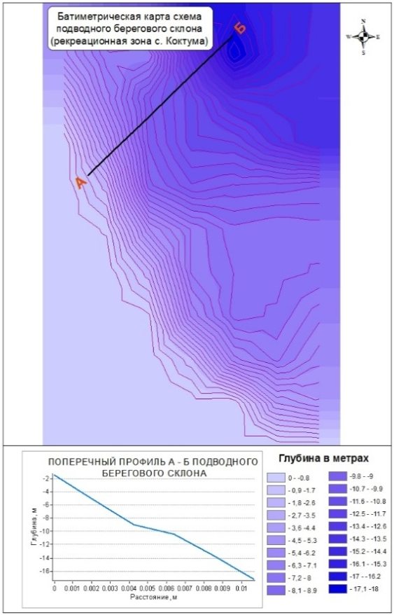 | 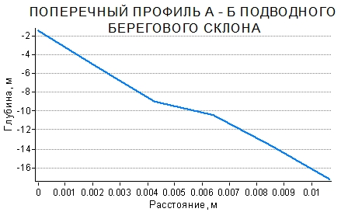
Figure F.17 – Bathymetric map-scheme of the underwater coastal slope, coastal zone village Koktuma

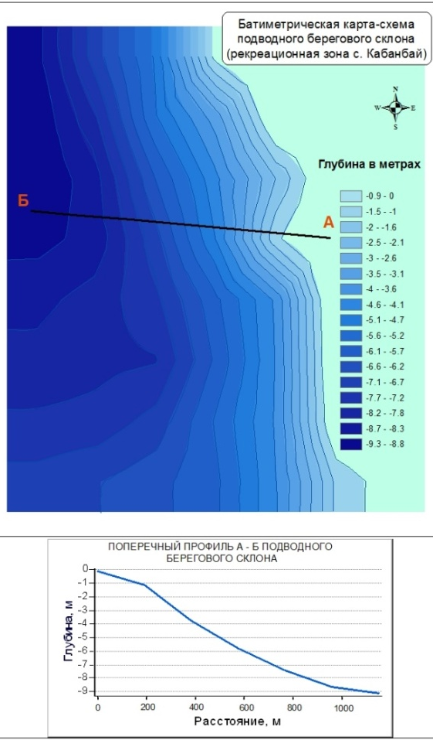 | 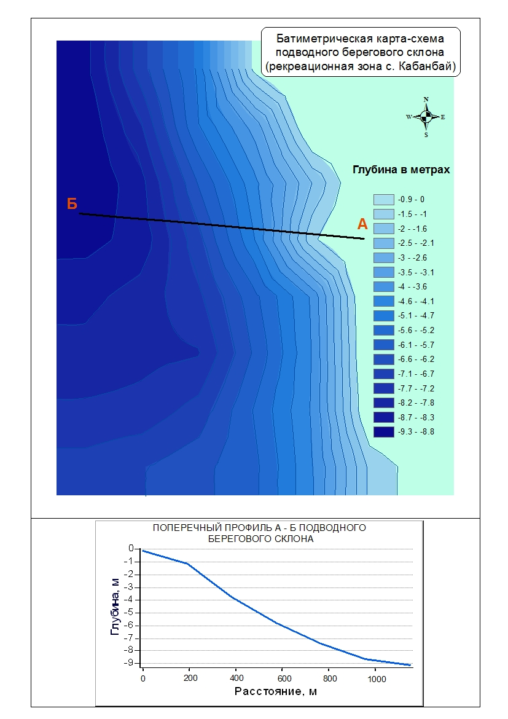
Figure F.18 – Bathymetric map-scheme of the underwater coastal slope, coastal zone of the recreational area village Kabanbay
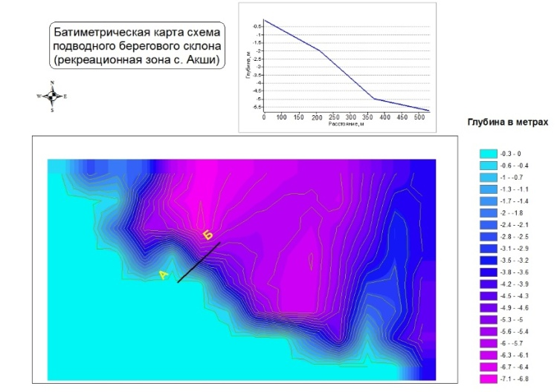 | 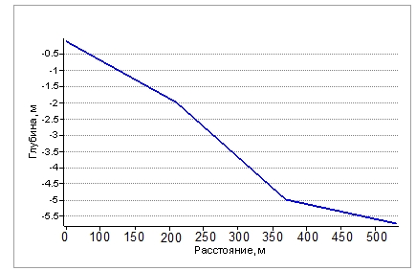
Figure F.19 – Bathymetric map-scheme of the underwater coastal slope, coastal zone, recreational area village Akshi

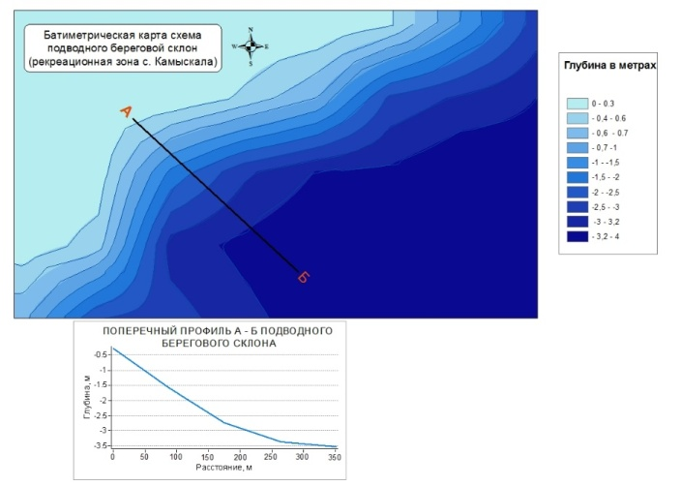 | 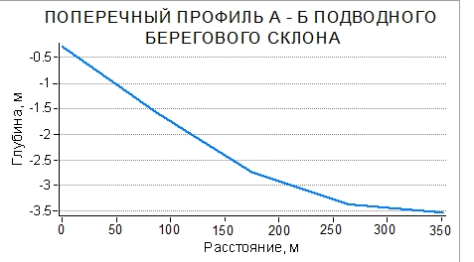
Figure F.20 – Bathymetric map-scheme of the underwater coastal slope, coastal zone of the peninsula, south-west of the village Kamyskala

F.21 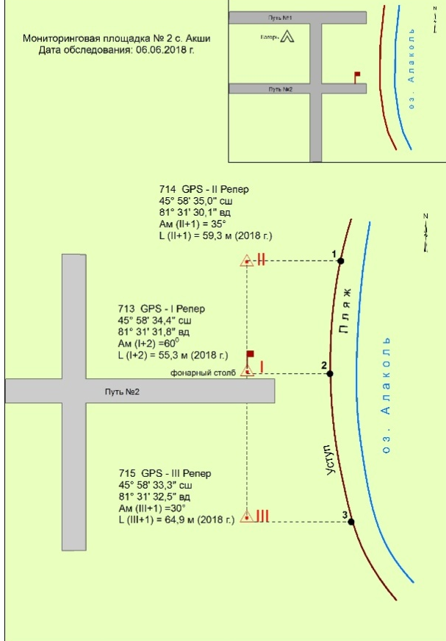 | F.22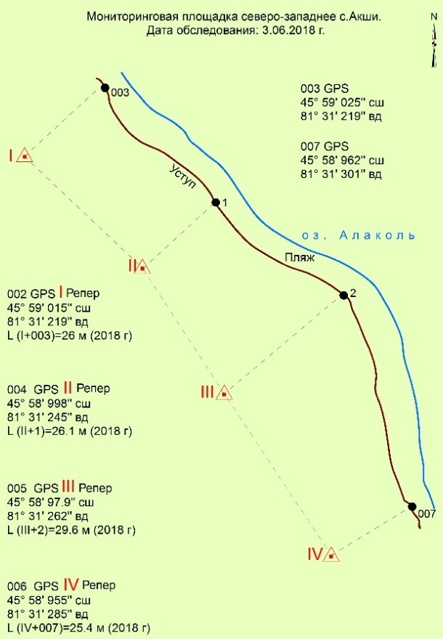
F.23 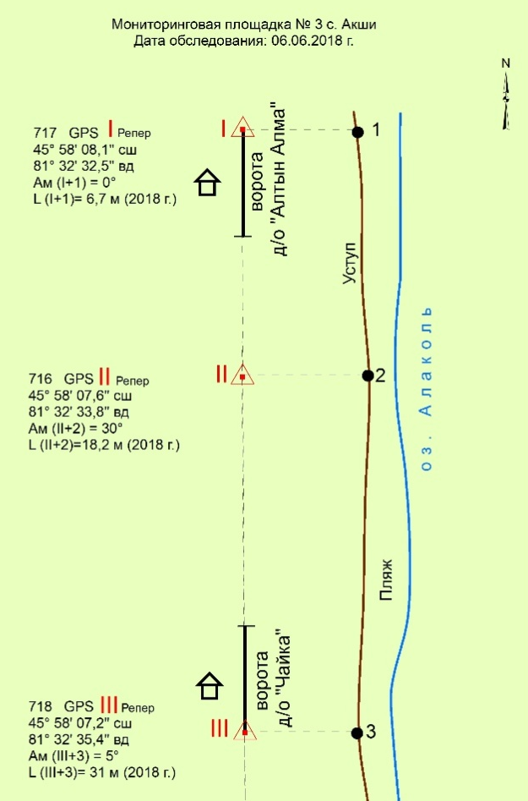
Figure F.21–F.23 – Monitoring instrumental areas of the recreational zone village Akshi

F.24 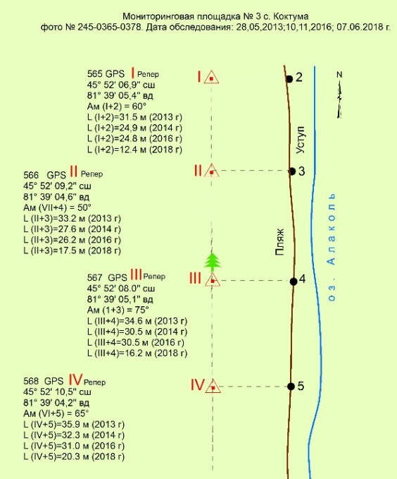 | F.25 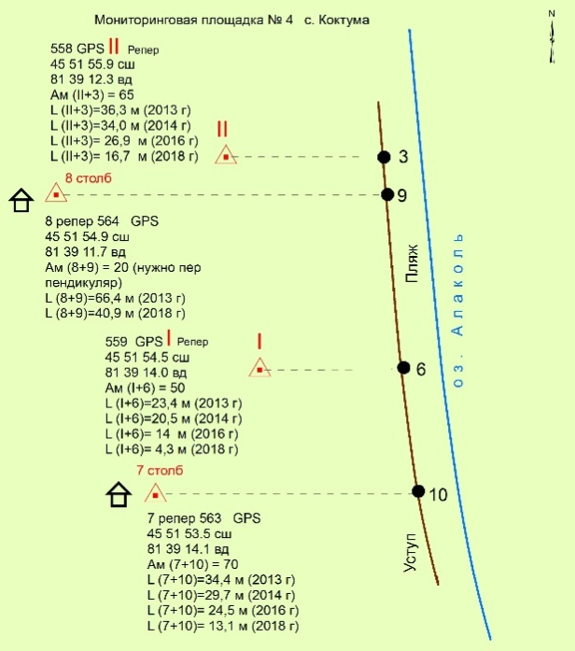
F.26 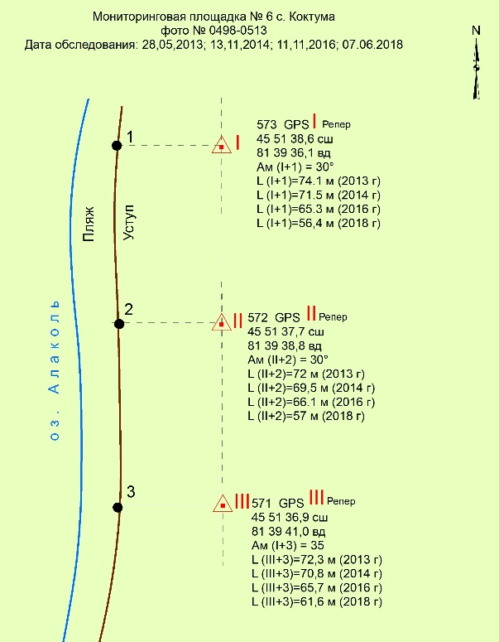 | F.27 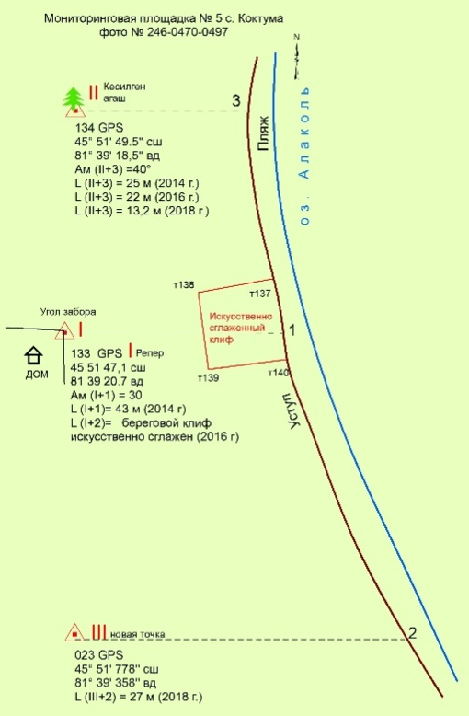
Figure F.24–F.27 – Monitoring tool platforms residential area village Koktuma

F.28 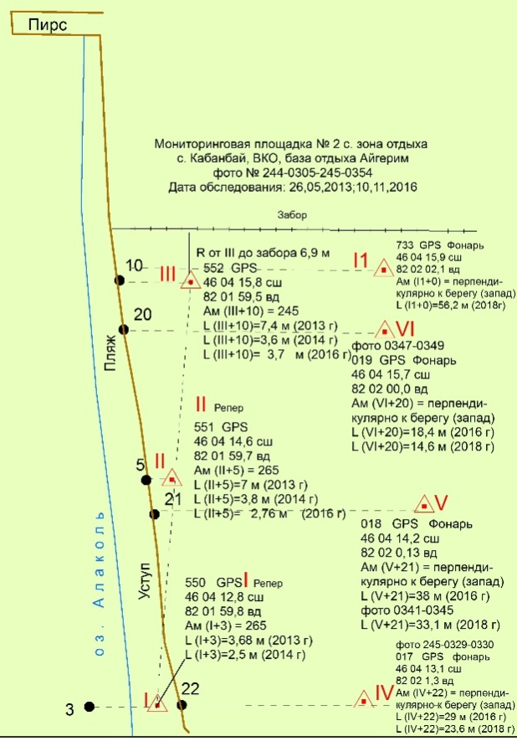 | F.29 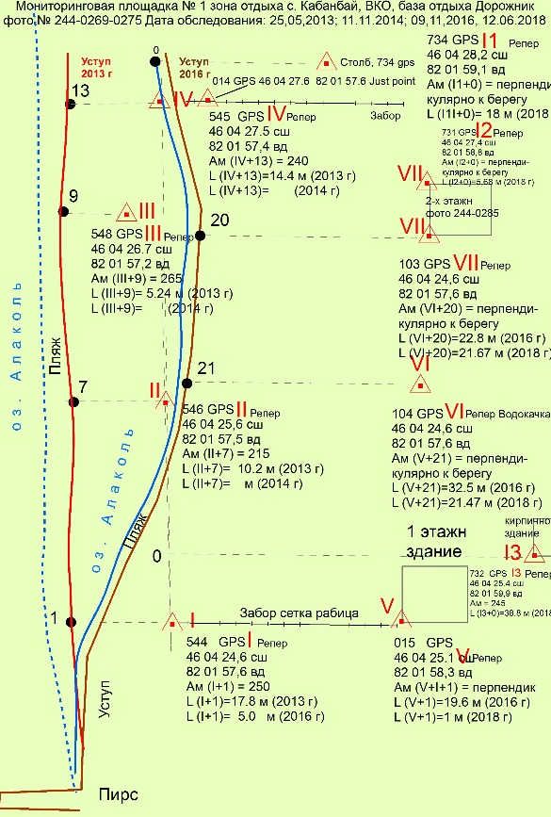
Figure F.28–F.29 – Monitoring tool platforms recreational area village Kabanbay

F.30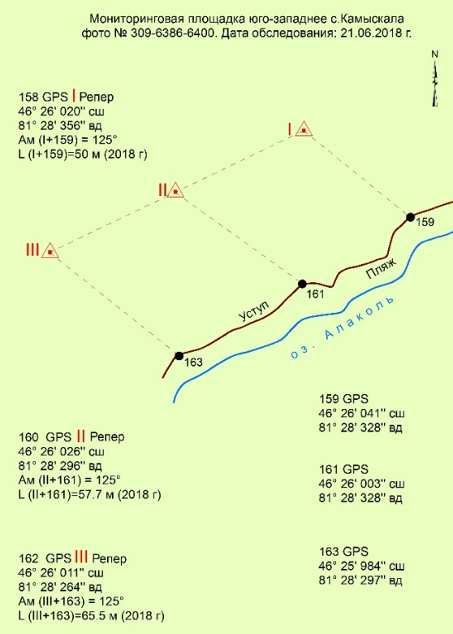 | F.31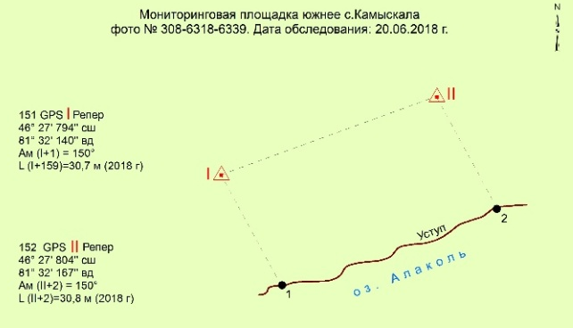
Figure F.30–F.31 – Monitoring instrumental sites south-west of the village Kamyskala

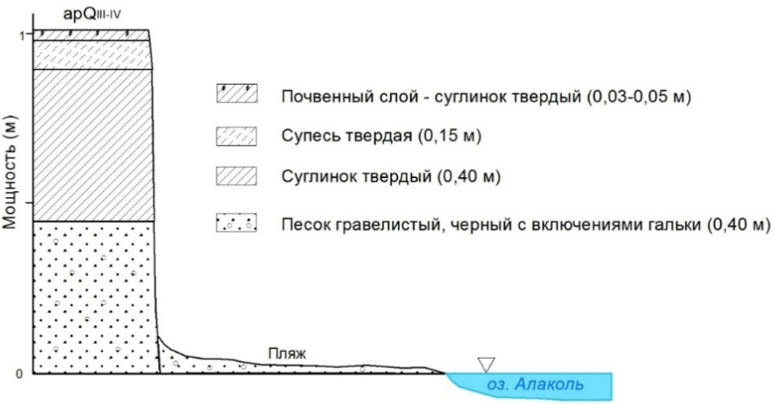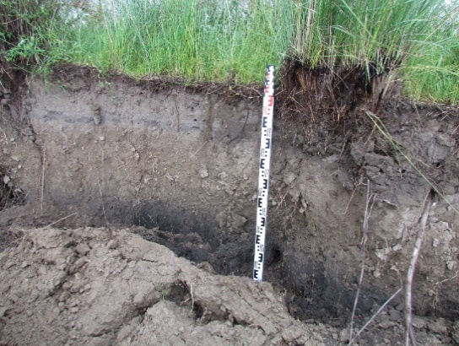
Figure F.32 – Profile of outcrops on the abrasion scarp recreational zone v. Akshi, observational point 001 (GPS) (beginning of abrasion), key site No. 1

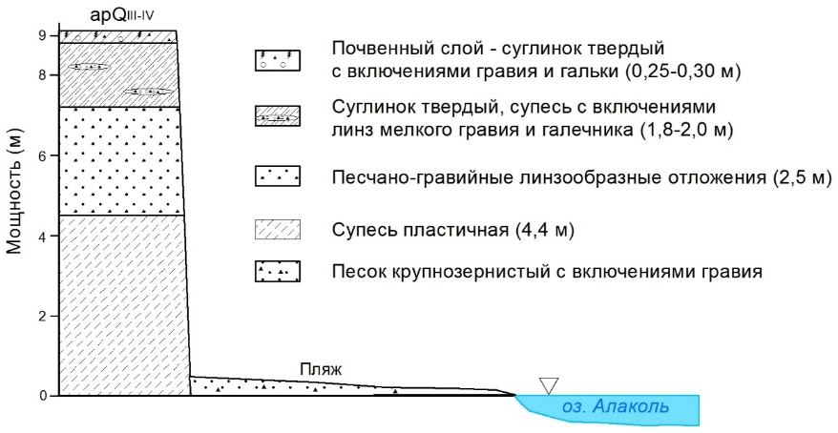 | 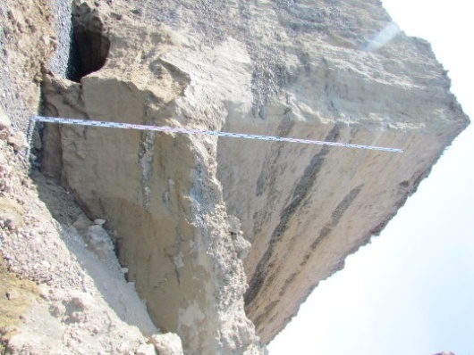
Figure F.33 – Profile of outcrops on the abrasion ledge of the recreational zone v. Koktuma, observation point 022 (GPS), key site No.2

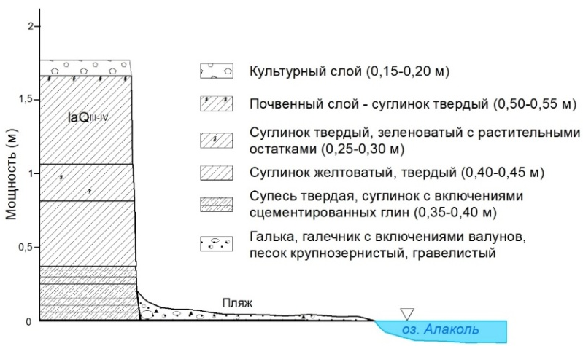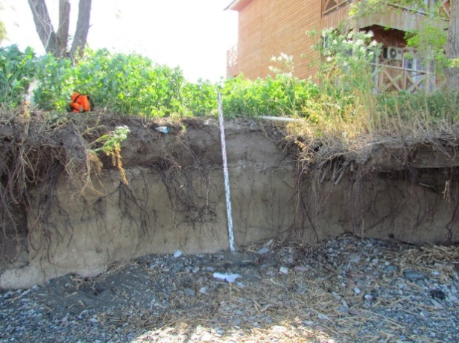
Figure F.34 – Profile of outcrops on the abrasion ledge of the recreational zone v. Kabanbay, observational point 079 (GPS), key site No.3
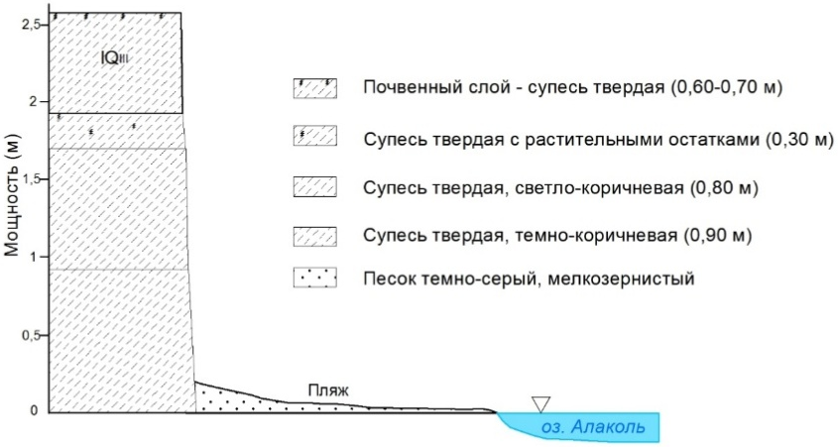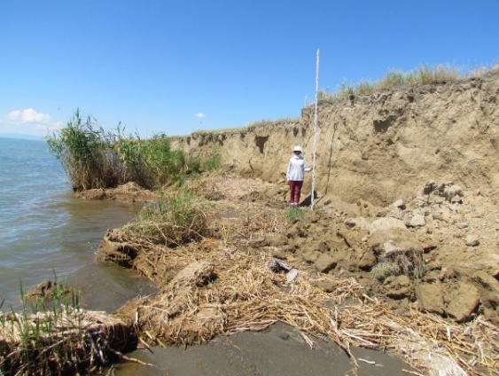
Figure F.35 – Profile of outcrops on the coastal zone abrasion scarp v. Kamyskala, observation point 164 (GPS), key area No. 6

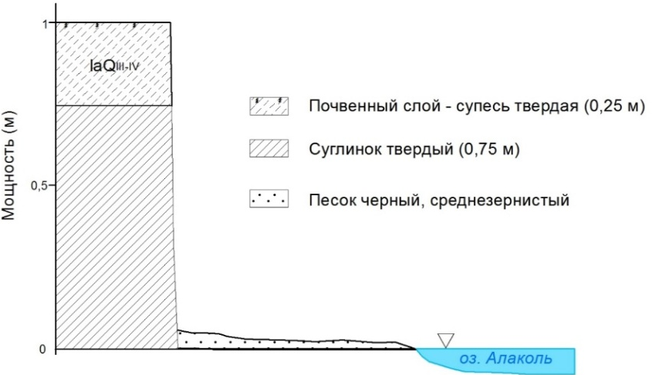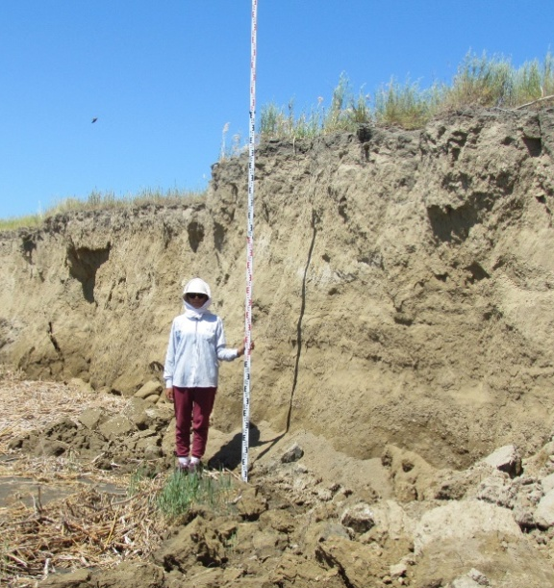
Figure F.36 – Profile of outcrops of observation point 164 (GPS) island Piski

Table F.11 – Field diary
01.06.2018 – 26.06.2018
№ GPS точки | Координаты | Абсолют-ная высота над уровнем моря, м | Название, место расположение | Описание | Генезис и геологичес-кий возраст | Раститель-ность | Современные рельефообразу-ющие процессы | Фото (серия-номер) | Антропоген-ное воздействие | Примечание:
день экспедиции – 01.06.18.
 | Выезд из ИГ. Закупка продуктов. Ночевка в Сага Буйен.
день экспедиции – 02.06.18.
 | г. Сарканд. Заехали на базар, купили газовую плиту. Ночевка недалеко от с. Акши.
Ключевой участок №1, с. Акши день экспедиции – 03.06.18.
GPS т. Начало абразии | 45-59-062 с.ш.  81-31-202 в.д. | 350 | Начало абразии, точка находится в 2 км севернее с. Акши | Точка находится на стыке ярко выраженных процессов аккумуляции и абразии. Аккумулятивный пляж имеет дугообразную форму, с выраженным выходом пологий (выпуклый) в сторону озера. Тогда как абразионный берег не имеет пляжа, береговая зона состоит из бенча и берегового клифа. В свою очередь волны озера подмывает клиф у основания. Абразионный береговой уступ состоит из: у основания – глина, в верхней части переходит в мелкозернистый песок.  Высота абразионного уступа увеличивается в сторону с. Акши. Происходит активное нарушение берегового уступа. У подошвы уступа происходит обваливание кусками уступа до 1,0-1,5 м.  На широкой части ширина пляжа 5,5-6,0 м и сужается на стыке с абразионным уступом до 1 м. пляж сложен песком (черный, среднезернистый).. у уреза воды галька среднего размера с включением среднезернистого песка.  Профиль грунта:  3-5 см – почвенный слой;  15 см – супесь + песок;  40 см – суглинки и супеси  40 см – черный песок с вклячениями гальки (d – 1,5 см) | laQ_{III-IV} | Травини-стая, местами кустарниковая | Абразия  Биогенная аккумуляция | 291-3759-3796 | Полевые дороги, активный выпас скота, мусор | Взяты образцы грунта
Continuation of table F.11
№ GPS точки | Координаты | Абсолют-ная высота над уровнем моря, м | Название, место расположение | Описание | Генезис и геологичес-кий возраст | Раститель-ность | Современные рельефообразу-ющие процессы | Фото (серия-номер) | Антропоген-ное воздействие | Примечание:
GPS т.2 | 45-59-201 с.ш.  81-31-147 в.д. | 348 | Начало косы, точка находится севернее от с. Акши | Ширина пляжа 20 м у основания | laQ _{III-IV} | Травинистая. Заросли камышей | Биогенная аккумуляция | 291-3831-3847 | Бумажно-пластиковый мусор
GPS т. 09 | 45-59-408 с.ш.  81-29-948 в.д. | 357 | Конец косы, точка находится севернее от с. Акши | Между сушей и косой наблюдается водно-болотные угодья с преобладанием тростника. К северу от косы расположены серия небольших островков, образованных за счет размыва косы | laQ _{III-IV} | Травинистая. Заросли камышей | Абразия,  биогенная аккумуляция |  | Бумажно-пластиковый мусор
GPS т. 10 | 45-58-593 с.ш.  81-31-561 в.д. | 354 | Абразионный уступ, точка находится севернее от с. Акши | Высота абразионного уступа – 4,4 м. Абразионный берег – дугообразный, с актиыной динамикой переработки берегов. Ширина пляжа до 3,0 м. Уступ сложен из осадочно-горных пород: суглинки, супеси с включением гальки | laQ_{III-IV} | Травинистая, изредка кустарниковая | Абразия, биогенная аккумуляция | 291-3852-3862 | Полевые и асфальтированные дороги, рядом строения для рекреационных нужд | Центральная часть новой туристичес-кой инфраструк-туры (2-й съезд к берегу). Вблизи строятся 3 пансионата.  Инфраструктура: освещение, асфальтная дорога, арычная система, канализационные люки, электри-чество.
GPS т. 12 | 45-58-466 с.ш.  81-31-912 в.д. | 350 | Начало косы, точка находится севернее от с. Акши |  | laQ_{IV} | Травинистая | Абразия  Биогенная аккумуляция | 291-3868-3882 | Полеве дороги, бумажно-пластиковый мусор
Continuation of table F.11
№ GPS точки | Координаты | Абсолют-ная высота над уровнем моря, м | Название, место расположение | Описание | Генезис и геологичес-кий возраст | Раститель-ность | Современные рельефообразу-ющие процессы | Фото (серия-номер) | Антропоген-ное воздействие | Примечание:
GPS т. 14 | 45-58-458 с.ш.  81-31-906 в.д. | 351 | Точка находится севернее от с. Акши | Береговой уступ. База отдыха подвержена риску обвала.  Обрушение на побережье территории зоны отдыха «Аялы» | laQ_{IV} | Травинисто-кустар-никово-древест-ная | Абразия | 291-3883-3895 (упав-ший контей-нер) | Полевые дороги, тропинки. База отдыха и заборы.
GPS т. 15 | 45-56-594 с.ш.  81-34-969 в.д. | 353 | Точка находится северо-восточной части с. Акши | Высота уступа 6,3 м | laQ_{III-IV} | Травинистая | Абразия | 291-3898-3921 | Исскуствен-но выположен-ный берег для пляжа. Заборы и тропинки
GPS т. 16 | 45-55-477 с.ш.  81-36-9298 в.д. | 348 | Точка находится северо-восточной части с. Акши | Высота уступа 1,3 м. Ширина пляжа 5,6 м. | laQ_{III-IV} | Травинистая | Абразия | 291-3898-3902-3921 | Заборы, трубы с диаметром 30 м | Демалыс орны -Айдынколь. Фото «Alakol Resort». Высота клифа 6,3 м.  Фото д/о “Grand Ville”.В с.Акши вода привозная, также имеются подземные скважины. Крайняя южная точка в Акши, дом отдыха «Алаколь General». Идет стройка
Continuation of table F.11
№ GPS точки | Координаты | Абсолют-ная высота над уровнем моря, м | Название, место расположение | Описание | Генезис и геологичес-кий возраст | Раститель-ность | Современные рельефообразу-ющие процессы | Фото (серия-номер) | Антропоген-ное воздействие | Примечание:
день экспедиции – 04.06.18.
Поездка в г. Ушарал. Были в акимате г. Ушарал, поставили печати на командировочные листы. Встретились и переговорили с сотрудниками отдела «Транспорта, предпринимательства и промышленности», с отделом «Экономики». В департаменте градостроительства и архитектуры получили генсхему с. Акши и Коктумы.
день экспедиции – 6.06.18.
На территории Дамира Сарканбаева (+7 702 621 81 80) поставили репера (между д/о «Посейдон» и Абай ага). Возможно его д/о будет называться Байтерек. |  |  |  |  |  |  |  |  |  | Зарисовки в виде схемы
 | 45-57-19,1 с.ш.  81-34-01,1 в.д. |  | Метеостанция, точка находится в центре с.Акши, ближе берегу озера Алаколь | Алакольская метеостанция функционирует с 1965 г. переговорили с дежурным наблюдателем Верой. | laQ_{III-IV}
 | 45-57-14,2 с.ш.  81-32-09,5 в.д. |  | Новый жд вокзал, расположен 1 км западнее с.Акши | Новый жд вокзал с. Акши (скоро открытие). Фото – недалеко вертолетная площадка. Недалеко расположены д/о Volna, Балсулу, Оркен. | аpQ_{III-IV}
GPS 716 | 45-58-07,6 с.ш.  81-32-33,8 в.д. | 348 | На стыке двух бетонных плит крайних с лева у д/о Алтын Алма | Д/о «Алтын Алма» с разрушенными железными контейнерами. У забора д/о Алтын Алма поставили Инструментальную мониторинговую площадку №3 | laQ_{III-IV} |  |  |  |  | Зарисовки в виде схемы
GPS т. 019 | 45-54-573 с.ш.  81-37-371 в.д. | 355 | Не организован-ный карьер, точка находится 6,7 км юго-восточнее с.Акши и 0,5 км от побережья оз.Алаколь | К югу от дороги техногенное воздействие в виде изъятия поверхностного слоя почв. Выпас скота на приозерных лугах | аQ_{III-IV} | Древесно-кустарниковая растительность травянис-то-луговая растительность | Плосткостной смыв в сторону озера, струйчатая эрозия | 294-4271-4274 | Добыча каменисто-галечьного материала для строительных нужд | Нарушение естествен-ного фона
Continuation of table F.11
№ GPS точки | Координаты | Абсолют-ная высота над уровнем моря, м | Название, место расположение | Описание | Генезис и геологичес-кий возраст |  | Раститель-ность | Современные рельефообразу-ющие процессы | Фото (серия-номер) | Антропоген-ное воздействие | Примечание:
GPS т. 020 | 45-54-537 с.ш.  81-37-454 в.д. | 355 | Не организован-ный карьер, точка находится 6,7 км юго-восточнее с. Акши и 0,5 км от побережья оз. Алаколь | Добыча строительного инертного материала- гальки, щебня, песка.  Дно карьера залито водой | аQ_{III-IV} |  | растительность: ива, тамарикс, жида, соран, ажирек, чий | Плосткостной смыв в сторону озера, струйчатая эрозия |  | Добыча каменисто-галечьного материала для строитель-ных нужд | Нарушение естествен-ного фона
GPS т. 021 | 45-54-513 с.ш.  81-38-314 в.д. | 346 | Начало косы, точка находится 7,3 км юго-восточнее с.Акши | Между сушей и косой наблюдается водно-болотные угодья с поросшей травянистой растительностью | аQIV |  | древесно-травинистая растительность | Абразия  Биогенная аккумуляция | 294-4287-4290 | Полевые дороги и выпас скота
GPS т. 022 | 45-53-558 с.ш.  81-38-004 в.д. | 359 | Дельта р. Жаманты, правый борт, точка находится 8 км юго-восточнее с. Акши | Смена экосистем | аpQ_{III-IV} |  | полынь, типчак | Речная эрозия |  | Выпас скота
Ключевой участок №2, с. Коктума. день экспедиции – 07.06.18.
Т.022 | 45-51-562 с.ш.  81-39-686 в.д. | 366 | В 2 км восточнее с.Коктума | с.Коктума. Инстр. измерения мониторинговой площадки восточнее 1 км от п. Коктума. В 2 км восточнее с. Коктума. Береговой уступ, активная динамика прохождения процессов абразии. Наблюдается тело обрушения на пляже, береговые ниши вымывания, антропогенное выполаживание уступа для спуска туристов шириной около 9 м, уступ высотой 8,5-9,0 м. Угол выполаживания (пологий 25-30 град.). Ширина пляжа 4,5-3,5 м, уступ на высоту до 2-х метров от основания сырой. На данной точке произведена установка базовой точки (ref. point) |  | аpQ_{III-IV} | Травинистая, изредка кустарниковая | Абразия | 295-4303-4320-4326-4333 | Полевые дороги и антропоген-ное выполаживание уступа для спуска туристов | Зарисовки мониторинговой площадки в виде схемы. Профиль уступа, где были отобраны пробы грунта тоже зарисован
Continuation of table F.11
№ GPS точки | Координаты | Абсолют-ная высота над уровнем моря, м | Название, место расположение | Описание | Генезис и геологичес-кий возраст | Раститель-ность | Современные рельефообразу-ющие процессы | Фото (серия-номер) | Антропоген-ное воздействие | Примечание:
GPS Trimble, а также лазерное сканирование тела, основания уступа и самого пляжа. Произведен инструментальный замер реперов по профилю, установленному ранее (2013 г.). Наблюдается динамика отхода берегов, которая составляет за период 5 лет – 13-20 м.
Произведен отбор образцов грунта, из слоев уступа на физ-хим. анализ. Произведены батиметрические измерения эхолотом по 4-м поперечным профилям подводного берегового склона.
GPS 023 | 45-51-778  81-39-358 | 363 | Точка находится юго-восточной части с. Коктума рядом с сглаженным искусственным клифом, расстояние до берега 37 м | Ключевые участок №2, с. Коктума. | аpQ_{III-IV} | Травинистая, изредка кустарниковая | Абразия |  | Полевые дороги и антропогенное выполаживание уступа для спуска туристов | Расположе-ние зарисовано в виде схемы
GPS 558 | Ключевой участок №2, с. Коктума.  Высота уступа 5,0 м, расстояние от репера (GPS 558) до берегового обрыва 16,7 м. |  |  |  |  |  |  |  |  | Расположе-ние зарисовано в виде схемы
Ключевой участок №2, с. Коктума.
Со слов жителей села за этот год ушло под воду 5,0-6,0 м полезной площади. Был произведен опрос владельца гостиного домика «Райхан» (Райхан апай +7 702 469 75 92). Стоимость стандартных номеров на чел – 6 000 тг, на ребенка 50 % скидка. Имеется 4 номера люкс класса по 7 500 тг. В этом году стоимость проживания повысилась на 500 тг. Начало сезона – июль, конец – август, начало сентября. Максимальное количество проживающих в гост. домике 40 чел., 3-х разовое питание. Есть постоянные клиенты, которые приезжают с России (Кемерово, Красноярск). В основном отдыхающие приезжают в среднем на 5-7 дней, кто из далека на 12 дней остаются. В основном приезжают на своей машине. Скоро пустят направление поезда Оскемен – Жаланашколь. Телефонные сети Теле2 и Алтел не ловят. Акимат села за счет местного бюджета прокладывает асфальтную дорогу. Местное население в основном работает вахтовым методом в Достык
Continuation of table F.11
№ GPS точки | Координаты | Абсолют-ная высота над уровнем моря, м | Название, место расположение | Описание | Генезис и геологичес-кий возраст | Раститель-ность | Современные рельефообразу-ющие процессы | Фото (серия-номер) | Антропоген-ное воздействие | Примечание:
день экспедиции – 8.06.18.
GPS т. 024 | 45-53-111 с.ш.  81-38-842 в.д. | 348 | Полевой пеший маршрут по косе р.Жаманты.  Южная часть береговой зоны с. Коктума | Уменьшение берегового уступа с переходом его на аккумулятивный пляж. Пляж сложен крупнозернистым песком, галечником с характерным продольной сортировке обломочного материала | аQ_{III-IV} | Травянисто-кустарниковая | Абразия  Биогенная аккумуляция | IMG 6905-6919 | Выпас скота, бумажно-пластиковый мусор | GPS т. 024
GPS т. 027 | 45-53-728 с.ш.  81-38-815 в.д. | 346 | Восточная коса дельты р.Жаманты, точка находится 2,5 км севернее от с. Коктума | Коса сложена разнозернистыми песками, галечниками и валунами. Южнее от косы протекает протока р. Жаманты. Направление косы с запада на восток.  Дельта сложена аллювиально-пролювиальными разнозернистыми обломочными материалами.  Восточнее дельты к с. Коктума прирастает чий – индикатор близкого расположения грунтовых вод на расстоянии не более 1 км к сторону гор.  Образование дельты и поймы реки связаны с силой Кариолиуса. В нашем случае, руслообразование происходит в восточном направлении.  Ширина косы на данной точке составляет – 27,9 м | аQ_{III-IV} | Древесно-травянис-то-кустарниковая | Абразия  Речная эрозия  Биогенная аккумуляция | IMG 6921-6930 | Выпас скота, бумажно-пластиковый мусор | Дельтовая часть реки служит пастбищем и водопоем для домашних животных (Данной восточной части дельты реки начинается тугайные экосистемы, включающие тамарикса, чингиля, редко иву. К южной части отчетливо выделяется выпуклообразная старая сухая дельта р. Жаманты, с редкими тамариксами растительностью

Continuation of table F.11
№ GPS точки | Координаты | Абсолют-ная высота над уровнем моря, м | Название, место расположение | Описание | Генезис и геологичес-кий возраст | Раститель-ность | Современные рельефообразу-ющие процессы | Фото (серия-номер) | Антропоген-ное воздействие | Примечание:
GPS т. 029 | 45-54-424 с.ш.  81-38-483 в.д. | 345 | Коса, точка находится 3,6 км севернее с.Коктума | Коса делена на 2 части – северная, сложена крупнозернистыми песками, галечниками, гальками. Ширина ее – 15,8 м.  Южная часть косы сложена крупнозернистыми песками с включениями гравия и гальки, ширина ее средней части – 10,85 м | аQ_{III-IV} | Травянисто-кустарниковая | Абразия  Биогенная аккумуляция | IMG 6931-6934 | Выпас скота
GPS т. 030 | 45-54-771с.ш.  81-38-093 в.д. | 345 | Коса Кызылагаш, точка находится 4,4 км севернее с.Коктума | Коса отходит от берегового вала дельты р. Жаманты в северо-западную часть с ответвлением ее оконечностей на юго-запад. Коса сложена крупнозернистым песком, галечником, галькой, валуном. На поверхности аккумулирован прибоем сухой тростник.  Ширина косы в данной точке составляет – 37,2 м.  С южной стороны косы образуется заводь, который впадает протока р. Жаманты – место скопление водоплавающих птиц.  Р. Жаманты в своей дельте разделяется на 2 основные части – левый и правый проток. Левый проток впадает в выше описанный заводь. Правый проток впадает в оз. Алаколь в районе с. Коктума | аQ_{III-IV} | Травинистая | Речная эрощия  Абразия  Биогенная аккумуляция | IMG 6942-6958 | Бумажно-пластиковый мусор | 3261 м вместе с дугой  Отобраны пробы грунта. На косу есть доступ по грунтовой дороге
день экспедиции – 9.06.18.
GPS т. 032 | 45-52-517  81-38-956 | 353 | Северная часть с. Коктума | Береговой уступ западной части с. Коктума. Древесный массив (клен) находится в зоне разрушений берегового клифа. Корневая система выходит в оголенную часть клифа. Разрушены опоры ограждений, высота от 3-х метров повышается в восточном направлении. Клиф у основания увлажнен до 1 метра. Ширина пляжа примерно 5,1 м. В структуре клифа | laQ_{III-IV} | Древест-но-кустарниково-травинистая | Абразия | 297-4556  297-4577-4579 | Полевые дороги, выпас скота, мусор
Continuation of table F.11
№ GPS точки | Координаты | Абсолют-ная высота над уровнем моря, м | Название, место расположение | Описание | Генезис и геологичес-кий возраст | Раститель-ность | Современные рельефообразу-ющие процессы | Фото (серия-номер) | Антропоген-ное воздействие | Примечание:
 |  |  |  | расположены береговые ниши. Отложения пляжа отсортированы, от уреза воды на растоянии до 80 см – крупнозернистый песок и мелкозернистый гравий. Далее к уступу – разнозернистый галечник, гравий.
GPS т. 033 | 45-52-459  81-38-967 | 355 | Северная часть с. Коктума | Высота уступа – 3,80 м, ширина пляжа 5,5 м. Хоз. Постройки в зоне разрушения от кромки уступа на расстоянии 0,5 м. На пляже и литоральной зоне находятся бетонные конструкции от разрушенного фундамента. Повалены деревья вместе с корневой системой. В 3-4 м от края уступа расположены жилые дома. | aQ_{IV} | Древест-но-кустарниково-травинистая | Абразия | 297-4580  297-4587-4595 | Заброшенные дома и хозяйственные постройки | Со слов бывшей жительницы села в этом году берег ушел на более чем  10 м.
GPS т. 034 | 45-52-456  81-38-977 | 355 | Северная часть с. Коктума | Поваленное дерево – начало расширения пляжной зоны от поваленных в поперечном направлении. Ширина пляжа – 10,5 м, Количество деревьев – 5 шт. Самое длинное 9,5-10,0 м. Из них в зоне суши находятся около 4-х м. До деревьев ширина пляжа – 4,5 м. | aQ_{IV} | Древест-но-кустарниково-травинистая | Абразия
GPS т. 035 | 45-52-392  81-38-992 | 357 | Северная часть с. Коктума | На поверхность уступа расположенные большие деревья карагачи, клен и тополя от 1 м до 30 м от кромки уступа. Корневая система способствует образованию береговой ниши вымывания под данными деревьями. Данная ниша и пляж представляют собой опасную зону, так как в любой момент возможно обрушение деревьев в сторону пляжа. Глубина ниши максимум – 4,5 м, и от 2-х до 3,5 м в средней части. Длина ниши около 20 м. Высота уступа примерно 3,65 м. Ширина пляжа 8,1 м | aQ_{IV} | Древест-но-кустарниково-травинистая | Абразия | 297-4625-4651 | Данная точка пользуется как пляж для отдыхающих | Прорублен уступ и установлена деревянная лестница для комфортного доступа к озеру туристам

Continuation of table F.11
№ GPS точки | Координаты | Абсолют-ная высота над уровнем моря, м | Название, место расположение | Описание | Генезис и геологичес-кий возраст | Раститель-ность | Современные рельефообразу-ющие процессы | Фото (серия-номер) | Антропоген-ное воздействие | Примечание:
GPS т. 036 | 45-52-349  81-39-010 | 358 | Северная часть с. Коктума | Место, где заканчивается уступ и начинается дельта временного водотока. Ширина пляжа – 5,7 м | aQ_{IV} | Травинис-тая, местами кустарни-ковая | Абразия |  | Полевые дороги, выпас скота
GPS т. 037 | 45-49-169с.ш.  81-44-709 в.д. | 375 | Точка находится  8-9 км юго-восточнее от с. Коктума. | Высота уступа – 2,20 м. Ширина пляжа – 5,1 м. Уступ сложен супесью с линзообразными включениями гальки, валунов | аpQ_{III-IV} | Травинис-тая, местами кустарни-ковая | Абразия | 297-4714-4720 | Полевые дороги, выпас скота
GPS т. 038 | 45-49-109с.ш.  81-45-000 в.д. | 375 | Конец абразионного уступа, точка находится  250 м северо-западнее от Турбазы «АРК-ТУР» и 8,4 км юго-восточнее с. Коктума | Восточная оконечность абразионного уступа. На уступе растут заросли чия. Ширина пляжа 3,5 м. Пляж состоит из гравия и гальки | аpQ_{III-IV} | Травинистая, местами кустарниковая | Абразия | 4723-4727 | Данная точка пользуется как пляж для отдыхающих Полевые дороги, выпас скота | Восточнее от точки расположен Турбаза АРК-ТУР.  Администратор Бояубаева Райхана +7 777 864 72 66.  С 2015 г. сменились хозяева.  Стоимость проживания– 10 000 тг., Люкс номера – 12 500 тг. максимально 82 койки. Детям до 3-х лет бесплатно, детям 7-12 лет имеются скидки. 3-х разовое питание.
Continuation of table F.11
№ GPS точки | Координаты | Абсолют-ная высота над уровнем моря, м | Название, место расположение | Описание | Генезис и геологичес-кий возраст | Раститель-ность | Современные рельефообразу-ющие процессы | Фото (серия-номер) | Антропоген-ное воздействие | Примечание:
GPS т. 039 | 45-48-731с.ш.  81-46-321 в.д. | 374 | Урочище Онагаш (озерные отложения), точка находится в 11 км юго-восточнее с.Коктума | Граница между озерной и делювиально-пролювиальной равниной. Севернее находится - озерная, южнее делювиально-пролювиальная равнина. | lbQ _{IV} | Травинис-тая, местами кустарниковая | Плосткостной смыв, слабая водная эрозия | 4734-4744 | Активный выпас скота, летовка, полевые дороги | На делювиально-пролювиальной равнине – степное разнотравье. На озерных отложениях густо растет чий
GPS т. 040 | 45-48-857с.ш.  81-46-810 в.д. | 368 | Точка находится в 11,5 км юго-восточнее с.Коктума | Граница между озерной и делювиально-пролювиальной равниной | lbQ _{IV} | Травини-стая, местами кустарниковая | Плосткостной смыв, слабая водная эрозия | 4744-4747 | Активный выпас скота, полевые дороги
GPS т. 041 | 45-49-161с.ш.  81-47-407 в.д. | 360 | Точка находится в 11,8 км юго-восточнее с.Коктума | Расстояние до уреза воды 15-20 м.  На расстоянии 150 м севернее расположена коса | lbQ _{IV} | Травини-стая, местами кустарниковая. Камыши | Болотообразо-вание | 4748-4751 | Выпас скота, полевые дороги
GPS т. 042 | 45-49-027с.ш.  81-48-338 в.д. | 356 | Точка находится в 11,8 км юго-восточнее с.Коктума | Вынос оплывин сухого тростника от сгонно-нагонных явлений. До уреза воды от точки от 20 до 50 м | lbQ _{IV} | Травини-стая, местами кустарниковая. Камыши | Болотообразо-вание | 297-4752-4754 | Выпас скота, полевые дороги
GPS т. 044 | 45-50-170с.ш.  81-52-352 в.д. | 358 | Самоизливающаяся сважина, точка находится 0,4 км южнее оз. Алаколь рядом зимовка | Современные озерно-болотные отложения | аpQ_{III-IV} | Травини-стая, местами кустарниковая. Камыши | Болотообразо-вание, слабая дефляция, незначительный плосткостной смыв | 297-4762-4774 | Активый выпас скота, полевые дороги
GPS т. 045 | 45-50-325с.ш.  81-54-271 в.д. | 349 | Точка находится в 14,1 км юго-вост. с.Коктума | Летовка | аpQ_{III-IV} | Травини-стая, кустарниковая. | Болотообразо-вание | 297-4775-4778 | Выпас скота, полевые дороги
Continuation of table F.11
№ GPS точки | Координаты | Абсолют-ная высота над уровнем моря, м | Название, место расположение | Описание | Генезис и геологичес-кий возраст | Раститель-ность | Современные рельефообразу-ющие процессы | Фото (серия-номер) | Антропоген-ное воздействие | Примечание:
GPS промежуточная точка | 45-48-305с.ш.  82-00-785 в.д. | 368 | Точка находится в 28,7 км юго-восточнее с. Коктума | Залив Киши Алаколь | lbQ _{IV} | Травини-стая, местами кустарниковая. Камыши, чи | Болотообразование |  | Выпас скота, полевые дороги
день экспедиции – 10.06.18.
GPS т. 047 | 45-41-181с.ш.  82-05-675 в.д. | 386 | Точка находится в 36,7 км юго-восточнее с. Коктума  Западная часть дельты р. Ыргайты | Дельта сложена песками, илами | аQ _{IV} | Тугайная дельтовая растительность: тамарикс, ива, псаммофиты, кустарниковая растительность, ажырык, чий, тростник, солянка и др. | Речная эрозия, незначительная дефляция | 298-4802-4809 | Полевые дороги, выпас скота
GPS т. 049 | 45-40-964 с.ш.  82-04-573 в.д. | 406 | Точка находится в 6 км южнее побережья оз. Алаколь | Граница между делювиально-пролювиальной равниной и дельтой р.Ыргайты | аQ _{IV} | Травини-скустарниковая. Различа-ются экосистемы: на дельте – тугайная растительность; | Дефляция, незначительная водная эрозия | 298-4810-4819 | Полевые дороги, выпас скота | Полевая дорога проходит между дельтой и делювиально-пролювиальной равниной
Continuation of table F.11
№ GPS точки | Координаты | Абсолют-ная высота над уровнем моря, м | Название, место расположение | Описание | Генезис и геологичес-кий возраст | Раститель-ность | Современные рельефообразу-ющие процессы | Фото (серия-номер) | Антропоген-ное воздействие | Примечание:
GPS т. 050 | 45-40-964 с.ш.  82-04-573 в.д. | 406 | Точка находится в 5,8 км южнее побережья оз.Алаколь | Высокая пойма р. Ыргайты | аQ _{IV} | Травяни-стая, местами кустарниковая (чи) | Речная эрозия | 298-4820-4832 | Полевые дороги, выпас скота
GPS т. 052 | 45-40-568 с.ш.  82-03-146 в.д. | 437 | Точка находится в 8 км южнее побережья оз.Алаколь | Первая надпойменная терраса | аQ _{IV} | Травяни-стая | Плоскостной смыв | 298-4833-4839 | Полевые дороги, слабый выпас скота
GPS т. 053 | 45-40-506 с.ш.  82-01-969 в.д. | 455 | Точка находится в 9,1 км южнее побережья оз.Алаколь | Первая надпойменная терраса. Левый борт р. Ыргайты | аQ _{IV} | Травяни-стая, местами кустарниковая | Плоскостной смыв | 298-4840-4850 | Полевые дороги, слабый выпас скота
GPS т. 054 | 45-40-376 с.ш.  82-01-803 в.д. | 556 | Точка находится в 9,2 км южнее побережья оз.Алаколь | Левое русло р. Ыргайты | аQ _{IV} | По берегу реки травянисткустарниковая | Речная эрозия | 298-4851-4861 | Полевые дороги
GPS т. 055 | 45-40-161с.ш.  82-01-789 в.д. | 453 | Точка находится в 9,7 км южнее побережья оз.Алаколь | Правое русло р. Ыргайты | аQ _{IV} | По берегу реки травяни-сто-кустарниковая | Речная эрозия, береговое обрушение | 298-4862-4864 | Полевые дороги
GPS т. 056 | 45-40-854с.ш.  82-06-010 в.д. | 381 | Точка находится в 5,2 км южнее побережья оз. Алаколь и 9 км севернее оз.Жаланашколь | Левый борт р. Жаман-Откель | lbQ _{IV} | Травяни-сто-кустарниковая | Слабая дефляция | 298-4865-4879 | Полевые дороги и слабый выпас скота | Незначительная деградация растительно-го покрова
Continuation of table F.11
№ GPS точки | Координаты | Абсолют-ная высота над уровнем моря, м | Название, место расположение | Описание | Генезис и геологичес-кий возраст | Раститель-ность | Современные рельефообразу-ющие процессы | Фото (серия-номер) | Антропоген-ное воздействие | Примечание:
GPS т. 057 | 45-40-747с.ш.  82-06-968 в.д. | 367 | Точка находится в 5,3 км южнее побережья оз.Алаколь, пересечение с ж/д в районе дельты  р. Ыргайты | По правую сторону ж/д наблюдаются водно-болотные угодья. Местами встречаются западины глубиной до 2,0 м, диаметром -1,5 м разной формы. Вытянуты с северо-востока на юго-запад. Берег западины сложен крупнозернистым песком, окатанной галькой с размером 2 см и более. | аQ _{IV} | Встреча-ются древесно-кустарниковая ратсительность: рогоз, камыш, ива | Заболачивание | 298-4882-4896 | Заболачива-ние, затопление | Точка находится на стыке с дельтой р. Ыргайты с пойменной экосистемой река ЖаманоткельНа данной точке западина залита водой, обитают ондатры, водоплавающие птицы
GPS т. 058 | 45-40-552с.ш.  82-07-694 в.д. | 358 | Точка находится в 5,7 км южнее побережья оз. Алаколь и 8,2 км севернее оз.Жаланашколь | Пойменно-дельтовая равнина рек Жаманоткель | lbQ _{IV} | пойменно-луговое разнотравье | Заболачивание | 298-4900-4906 | Полевая дорога
GPS т. 059 | 45-39-905с.ш.  82-07-879 в.д. | 357 | Точка находится в 7 км южнее побережья оз. Алаколь и 7 км севернее оз.Жаланашколь | Пойменно-дельтовая равнина | аQ _{IV} | пойменно-луговое разно-травье. Луговая растительность смени-лась на тростник | Заболачивание, затопление | 298-4907-4911 | Полевая дорога
Continuation of table F.11
№ GPS точки | Координаты | Абсолют-ная высота над уровнем моря, м | Название, место расположение | Описание | Генезис и геологичес-кий возраст | Раститель-ность | Современные рельефообразу-ющие процессы | Фото (серия-номер) | Антропоген-ное воздействие | Примечание:
GPS т. 060 | 45-39-798с.ш.  82-07-999 в.д. | 358 | Мост через р. Жаманоткель, точка находится в 7 км южнее побережья оз. Алаколь и 7 км севернее оз. Жаланашколь | На данной точке ширина русла р. Жаманоткель – 6,3 м, ширина поймы – 12,5 м. Расстояние от моста до поверхности воды - 3,4 м. | аQ _{IV} | По обеим бортам реки густые заросли трост-ника | Заболачивание, затопление | 298-4912-4922 | Полевая дорога, мост
GPS т. 061 | 45-39-532с.ш.  82-08-169 в.д. | 357 | ЖД мост, точка находится в 7,6 км южнее побережья оз. Алаколь и 6,6 км севернее оз. Жаланашколь | На данной точке ширина поймы р. Жаманоткель – 10-12 м | аQ _{IV} | По обеим бортам реки густые заросли трост-ника | Заболачивание, затопление | 298-4923-4927 | Полевая дорога, жд мост
GPS т. 062 | 45-39-730с.ш.  82-08-904 в.д. | 362 | Точка находится в 7,3 км южнее побережья оз. Алаколь и 6,4 км севернее оз. Жаланашколь | Предгорная пологонаклонная делювиально-пролювиальная равнина горы Катутау.  Южнее на 200 м расположена субширотная пойменная равнина р. Жаманоткель. Четко прослеживается граница пойменной и горной равнины | lbQ _{IV} | Травинисто-кустарниковая растительность (саксаул) | Плосткостной смыв | 298-4928-4934 | Полевая дорога
GPS т. 063 | 45-40-133 с.ш.  82-08-948 в.д. | 362 | Исторический памятник архитектуры (мог.), точка находится в 7,3 км южнее побережья оз. Алаколь и 6,4 км севернее оз. Жаланашколь | Предгорная пологонаклонная делювиально-пролювиальная равнина горы Катутау | lbQ _{IV} | Травинисто-кустарниковая растительность (саксаул) | Плосткостной смыв | 298-4935-4939 | Полевая дорога, могила
Continuation of table F.11
№ GPS точки | Координаты | Абсолют-ная высота над уровнем моря, м | Название, место расположение | Описание | Генезис и геологичес-кий возраст | Раститель-ность | Современные рельефообразу-ющие процессы | Фото (серия-номер) | Антропоген-ное воздействие | Примечание:
GPS т. 064 | 45-44-207 с.ш.  82-09-852 в.д. | 376 | Пограничная застава «Узынбулак», точка находится в 1,3 км восточнее побережья оз.Алаколь | Северная часть залива Киши Алаколь. | аpQ_{III-IV} | Левый борт мальенкой речки, заросший лохом, шиповником, камышом и др. растительностями | Плосткостной смыв | 298-4941-4947 | Полевая дорога
GPS т. 065 | 45-44-328 с.ш.  82-08-927 в.д. | 344 | Залив Киши Алаколь, точка находится на южном побережье оз.Алаколь | Западная часть залива Киши Алаколь. Берег представлен аккумулятивным пляжем в виде косы. Между сушей и косой нзина залита водой. Пляж представляет собой рекреационную зону отдыха. Пляж сложен крупнозернистым песком в составе гальки, гравия | lbQ _{IV} | Озерная равнина представлена луговым разнотравьем, редко лох. | Заболачивание | 298-4948-4956 | Полевые дороги, пляж и выпас скота | Данная местность активно используется для пастбищ
GPS т. 067 | 45-45-996 с.ш.  82-10-688 в.д. | 406 | Точка находится 2,4 км восточнее побережье оз.Алаколь | Граница между озерными отложениями и делювиально-пролювиальной равниной | lbQ _{IV} | Травянисто-кустарниковая растительность | Плоскостной смыв | 298-4962-4974 | Полевые дороги и выпас скота
GPS т. 068 | 45-47-100 с.ш.  82-10-985 в.д. | 406 | Точка находится 4 км восточнее побережье оз.Алаколь | Граница между озерными отложениями и делювиально-пролювиальной равниной | lbQ _{IV} | Травянисто-кустарниковая растительность | Плоскостной смыв | 298-4975-4991 | Полевые дороги и выпас скота
GPS т. 069 | 45-47-914 с.ш.  82-10-031 в.д. | 386 | Точка находится 3,8 км восточнее побережье оз.Алаколь | Современная плоская озерно-болотная равнина | lbQ _{IV} | кустарниковая растительность | Заболачивание | 298-4992-5001 | Полевые дороги и активный выпас скота | Рядом расположена зимовка
Continuation of table F.11
№ GPS точки | Координаты | Абсолют-ная высота над уровнем моря, м | Название, место расположение | Описание | Генезис и геологичес-кий возраст | Раститель-ность | Современные рельефообразу-ющие процессы | Фото (серия-номер) | Антропоген-ное воздействие | Примечание:
GPS т. 070 | 45-47-734 с.ш.  82-10-829 в.д. | 400 | Точка находится 4,4 км восточнее побережье оз.Алаколь | Граница между озерной и предгорной равниной | lbQ _{IV} | Травянисто-кустарниковая растительность | Заболачивание, плоскостной смыв |  | Полевые дороги и выпас скота
GPS т. 071 | 45-48-787 с.ш.  82-11-206 в.д. | 405 | Точка находится 5,5 км восточнее побережье оз.Алаколь | Предгорная равнина | apQ _{III-IV} | Травянисто-кустарниковая растительность | Заболачивание, плоскостной смыв | 298-5003-5007 | Полевые дороги и выпас скота
GPS т. 072 | 45-50-370 с.ш.  82-10-027 в.д. | 492 | Урочище Узынбулак расположен в южной части оз. Алаколь, 5,2 км западнее от побережья | Озерная равнина | lbQ _{IV} | Травянисто-кустарниковая растительность | Заболачивание, плоскостной смыв | 298-5008-5021 | Полевые дороги и выпас скота
GPS т. 073 | 45-51-442 с.ш.  82-19-847 в.д. | 397 | Точка находится 5,5 км восточнее побережье оз.Алаколь | Граница между озерной и предгорной равниной | lbQ_{IV-} apQ _{III-IV} | Травянисто-кустарниковая растительность | Заболачивание, плоскостной смыв | 298-5022-5029 | Полевые дороги и активный выпас скота | Рядом расположена зимовка
GPS т. 075 | 45-53-195 с.ш.  82-08-093 в.д. | 392 | Точка находится 4 км восточнее побережье оз.Алаколь | 50 м южнее начинается озерная равнина. Непроходимая | lbQ_{IV} | Растительность густая: чий, тростник | Заболачивание, плоскостной смыв | 298-5030-5035 | Полевые дороги и выпас скота
GPS т. 076 | 45-56-047 с.ш.  82-07-040 в.д. | 397 | мог. Космола | Южнее озерная равнина | lbQ_{IV-} apQ _{III-IV} | Растительность густая: чий, тростник | Заболачивание, плоскостной смыв | 298-5036-5051 | Полевые дороги и выпас скота
Continuation of table F.11
№ GPS точки | Координаты | Абсолют-ная высота над уровнем моря, м | Название, место расположение |  | Описание | Генезис и геологичес-кий возраст | Раститель-ность | Современные рельефообразу-ющие процессы | Фото (серия-номер) | Антропоген-ное воздействие | Примечание:
Ключевой участок №3, с. Кабанбай день экспедиции – 12.06.18.
 | Зона отдыха «Аквамарин» с. Кабанбай, (Алина +7 707 550 01 01, Ержан Мынкабаев +7 701 663 68 88). Со слов администаторов осенью, весной сильные штормы. При самых сильных штормах вода захлестывается на берег до 100 м (в основном осенью). Зона открылась в 2015 г. За один год из 60 соток территории зоны отдыха, осталось 54-55 соток, остальное ушло под воду. Провели мониторинговые инструментальные исследования старых реперов. Зарисовки мониторинговых площадок.
день экспедиции – 13.06.18.
 | Опрос работников ДО «Айгерим» (Серик). ДО относится к улучшенному типу. Стоимость проживания в сутки составляет 4000 тг., входит 3-х разовое питание. Сдаются отдельные домики за 50 000-60 000 тг. без питания. ДО максимум может принять до 100 человек. В центральной части зоны отдыха с. Кабанбай на общественном пляже строится новый променад. Провели мониторинговые инструментальные исследования старых реперов. Зарисовки мониторинговых площадок.
 | Опрос работников ДО «Инжу». ДО открылся в 2017 г. Относится к элитному типу. Стандартные номера стоят на 4-х человек по 40 000 тг., с видом на озеро по 50 000 тг. Пик сезона приходится на 15 июля. В этом году уже все номера забронированы до конца сезона. На всем побережье оз. Алаколь только здесь пляж песчаный. По словам работников песок местный с озера, не завезенный. За зиму произошел перенос крупнозернистого песка с галечником на расстояние 20-25 м от уреза воды в результате таяния нанесенного льда за холодный перид года.
день экспедиции – 14.06.18.
GPS т. 079 | 46-04-460 с.ш.  82-01-987 в.д. | 342 |  | с. Кабанбай, з/о Дорожник, отбор грунта, се. | Высота уступа 1,75 м, ширина пляжа – 10,2 м.  профиль обнажения:  - А-В – до 35-40 см – супеси, суглинки с вклячениями сцементированных глин;  - B-C – 40-45 см – супеси желтоватые;  - C-D – 25-30 см - зеленоватые переходные от супесей желтых к почвенную слою с включениями прослоев почвы в верхней части  - D-Е – 50-55 см – почвенный слой;  - Е-F –от 15 до 20 см - культурный слой (балластическая насыпь), галечник, галька, щебень, глины.  Пляжные отложения слабо выраженные. Состоит из гальки, галечника с включениями валунов, крупнозернистые пески у основания уступа | laQ _{III-IV} | Травянисто-кустарниково-древесная | Абразия, засоления | 302-5456-5484 | Рекреацион-ные зоны, дороги, дома
Continuation of table F.11
№ GPS точки | Координаты |  | Абсолют-ная высота над уровнем моря, м | Название, место расположение | Описание | Генезис и геологичес-кий возраст |  | Раститель-ность | Современные рельефообразу-ющие процессы | Фото (серия-номер) | Антропоген-ное воздействие | Примечание:
Ключевой участок №4, ур. Косайшагыл. день экспедиции – 15.06.18.
GPS т. 084 |  | 46-13-466 с.ш.  82-06-574 в.д. | 456 | Урочище Косайшагыл, точка находится 6 км восточнее побережье оз. Алаколь и 17 км северо-восточнее с.Кабанбай | Ширина песчаных бугров 100-120 м, длина около 200-220 м. вытянуты с востока на запад. Точка расположена на незакрепленном бугристом песке. Между буграми на понижениях прослеживается пологообразные соровые понижения (ширина от 30 до 40 м, длина до 400 м). ширина понижения между бугами от 150 до 200 м. На данном бархане от воздействия ветра развиваются эоловые процессы (ветровая эрозия), ниша выдувания и с аккумуляции песка на гребне бархана, а также образование фитобугров у корневиш кустарников (чингиль).  на бархане расположены песчаные рябы. Имеют расположение поперек. Вытянуты с севера на юг, поперечно востоку и западу. Данный процесс является антропогенно-техногенного воздействия. Пески средне- и мелкозернистые (темные) |  | vQ _{III-IV} | Травинисто-кустарниково-древесная | Дефляция, сорообразования, засоление | 303-5638-5666 | Активный выпас скота, полевые дороги | Рядом расположена зимовка. Наблюдается перевыпас скота. Пастбища деградированы, переходят незакрепленным пескам без раститель-ности.
GPS Trigapoint |  | 46-16-801 с.ш.  81-59-076 в.д. | 350 | Точка находится 1,7 км восточнее побережье оз.Алаколь | Бугристые пески. Относительная высота бугров до 20 м |  | vQ _{III-IV} | Разнотравно-луговая растительность | Дефляция, сорообразования, засоление | 303-5681-5704 | Выпас скота, полевые дороги
GPS Берег абразия Касайшагыл |  | 46-15-550 с.ш.  81-58-077 в.д. | 340 | Данная точка находится юго-западной части ур. Косайшагыл | Песчаный абразионный уступ. Высота уступа 3,0 м. ширина пляжа 3,0 м. Уступ и пляж сложен среднезернистыми песками. Абразионный уступ образовался в результате поднятия уровня оз. Алаколь и за счет ветро-волновых действий |  | vQ _{III-IV} | Травинисто-кустарниково-древесная | Абразия, дефляция | 303-5721-5788 | Выпас скота, полевые дороги
Continuation of table F.11
№ GPS точки | Координаты |  | Абсолют-ная высота над уровнем моря, м | Название, место расположение | Описание | Генезис и геологичес-кий возраст | Раститель-ность | Современные рельефообразу-ющие процессы | Фото (серия-номер) | Антропоген-ное воздействие | Примечание:
GPS т. 090 | 46-15-373 с.ш.  81-58-136 в.д. |  | 340 | Точка находится на восточном побережье оз. Алаколь и юго-западной части ур. Косайшагыл | Песчаный берег с шириной 10,9 м. Длина песчаного пляжа – 480 м. К востоку пляж переходит на тростниковый заросль к сторону суши. Тростниковые заросли затопленыместами водой. К западу пляжная зона ограничивает уступы песчаных бугров ур. Косайшагыл высотой до 3 м. Также пляжную зону со стороны суши ограничивает блюдцеообразные понижения, которые заполнены водой, диаметр их 10-15 м. | vQ _{III-IV} | Травинисто-кустарниково-древесная | Абразия, дефляция |  | Выпас скота, полевые дороги | На пляжной зоне вынесены оплывины тростника
GPS т. 091 | 46-14-653 с.ш.  81-58-532 в.д. |  | 341 | Точка находится на восточном побережье оз. Алаколь и юго-западной части ур. Косайшагыл | Высота уступа 1,10 м. Длина пляжа 30-35 м, ширина ее до 2 м. Песчаная гряда ур. Косайшагыл до 35 м образует песчаный пляж. Наблюдаются следы пляжного отдыха | vQ _{III-IV} | Травинисто-кустарниково-древесная | Абразия | 303-5792-5813 | Выпас скота, полевые дороги, охота
 |  | Ключевой участок №5, с. Коктал день экспедиции – 16.06.18.
GPS т. 097 | 46-22-124 с.ш.  82-12-865 в.д. |  | 372 | Долина реки Емель, точка находится 21 км восточнее дельты реки Емель | Долина реки граничит с песками Бармаккум. Граница отчетливо прослеживается по растительностью | аQ _{IV} | Долина р. Емель представ-лена луговой растительностью, лохом и джида. Поймен-ные тугаи. | Речная эрозия | 304-5874-5884 | Выпас скота, полевые дороги, охота
GPS т. 100 | 46-22-319 с.ш.  81-59-501 в.д. |  | 342 | Правый борт р.Емель, точка находится 4,5 км восточнее дельты реки Емель | Точка находится на стыке верхней и нижней поймы | аQ _{IV} | Русло реки занято густыми зарослями рогоза | Речная эрозия | 304-5889-5892 | Выпас скота, полевые дороги, охота | Были замечены пеликаны, аисты и др. Водоплавающие птицы
Continuation of table F.11
№ GPS точки | Координаты | Абсолют-ная высота над уровнем моря, м | Название, место расположение | Описание | Генезис и геологичес-кий возраст | Раститель-ность | Современные рельефообразу-ющие процессы | Фото (серия-номер) | Антропоген-ное воздействие | Примечание:
день экспедиции – 17.06.18.
GPS т. 118 | 46-26-132 с.ш.  81-50-166 в.д. |  | Река Катынсу, точка находится 4,6 км северо-восточнее дельты реки Катынсу | точка находится на левом борте реки Ширина русла 40 м. Река имеет живое течение | аQ _{IV} | Травинисто-кустарниково-древесная | Боковая эрозия, струйчатая эрозия | 305-5948-5960 | Активный выпас скота, полевые дороги
день экспедиции – 18.06.18.
GPS т. 119 | 46-26-202 с.ш.  81-47-753 в.д. | 342 | Точка находится 1,5 км северо-восточнее дельты реки Катынсу | Северо-западная часть дельты р. Катынсу. Правый борт реки. Аллювиально-пролювиальная равнина переходящая в дельту. Дорога местами затоплена, наблюдается повышение уровня воды в озере Алаколь. Затапливаются сенокосные и пастбищные угодья. Урез воды до с. Коктал 4,5-5 км | аQ _{IV} | Травинисто-кустарниково-древеснаяЗаросли тростника 205-3 м. | Заболачивание, речная эрозия | 306-5965-5978 | Выпас скота, рыболовства, полевые дороги | Место сплыва рыбаков с. Коктал.
GPS т. Зимовка 08 | 46-28-684 с.ш.  81-43-118 в.д. | 340 | Точка находится 10,9 км северо-западнее дельты реки Катынсу и 3,7 км северо-восточнее побережья оз. Алаколь | Затопленная территория.  Урез воды проходит по аллювиально-пролювиальной равнине, о чем говорит затопленные грунтовые дороги, отсутствие озерной (буферной) зоны между озером и аллювиально-пролювиальной равниной. Вода занимает понижения рельефа местности. Уклон поверхности рельефа находится от севера к югу – в сторону озера. Очень четко прослеживается по грунтовым дорогам, которые расположены вдоль уреза воды | lаQ _{III-IV} | Травинисто-кустарниковая растительность Водоем пророс тростником | Заболачивание, плоскостной смыв | 306-6093-6113 | Активный выпас скота | Рядом зимовка к западу. Вода затопила полевую дорогу.  Нет озерной равнины
Continuation of table F.11
№ GPS точки | Координаты | Абсолют-ная высота над уровнем моря, м | Название, место расположение | Описание | Генезис и геологичес-кий возраст | Раститель-ность | Современные рельефообразу-ющие процессы | Фото (серия-номер) | Антропоген-ное воздействие | Примечание:
GPS т. 133 | 46-28-415 с.ш.  81-42-875 в.д. | 340 | Точка находится 10,9 км северо-западнее дельты реки Катынсу и 3,7 км северо-восточнее побережья оз. Алаколь | Наблюдается отмирание аллювиально-пролювиальной равнины (пересохшая полынь) и на поверхности поросль пионеров озерной равнины (солянка, галофиты). Данная молодая озерная равнина протянулась от 40 до 100 м. Местами наблюдаются положительные формы рельефа – островки аллювиально-пролювиальной равнины. Определили по растительностью.  Наблюдается подтопление территории аллювиально-пролювиальной равнины, о чем свидетельствует затопленные грунтовые дороги, уцелевшие островки, растительность не характерна на озерную равнину | lаQ _{III-IV} | Травинисто-кустарниковая растительность Залив озера порос-ший местами трост-ники | Заболачивание, плоскостной смыв, засоление | 306-6114-6126 | Выпас скота | Почва представляетсобой набухшую почвенную поверхнсоть. При ходьбе продавливается почва. Дорога к ур. Зелененкое затоплена с 2007 г. Доступ к нему возможно только с водном транспортом. На заливе обитают разные водоплавающие птицы. Была отобрана проба грунта поверхности
GPS т. 134 | 46-28-863 с.ш.  81-43-459 в.д. | 340 | Точка находится 3,6 км северо-восточнее побережья оз. Алаколь и 11 км северо-западнее дельты реки Катынсу | Образец поверхностного почвенного грунта на аллювиально-пролювиальной равнине.  В 1 км от уреза воды | laQ_{III-IV} | Травинисто-кустарниковая растительность. Залив озера местами тростником | Заболачивание, засоление, затопление | 306-6143-6153 | Выпас скота и полевые дороги | Обитают разные водоплавающие птицы
Continuation of table F.11
№ GPS точки | Координаты | Абсолют-ная высота над уровнем моря, м | Название, место расположение | Описание | Генезис и геологичес-кий возраст | Раститель-ность | Современные рельефообразу-ющие процессы | Фото (серия-номер) | Антропоген-ное воздействие | Примечание:
GPS т. 137 | 46-31-102 с.ш.  81-37-453 в.д. | 342 | Точка находится 5,9 км северо-восточнее побережья оз. Алаколь и 18,7 км северо-западнее дельты реки Катынсу | Граница озерной равнины. Старая автодорога на с. Камыскала | laQ_{III-IV} | Травинисто-кустарниковая растительность. Местами порос-ший трост-ником | Заболачивание, затопление | 306-6158-6182 | Полевые дороги, рыболовство | Обитают разные водоплавающие птицы
GPS т. 140 | 46-30-411 с.ш.  81-36-617 в.д. | 340 | Точка находится 3,6 км севернее побережья оз. Алаколь и 20 км северо-западнее дельты реки Катынсу | Дорога между с. Маканшы и с.Камыскала. Затопленная часть проросла тростником и залита водой | laQ_{III-IV} | Травинисто-кустарниковая растительность. Порос-ший трост-ником | Заболачивание, затопление |  | Рыболовство, охота | Обитают разные водоплавающие птицы
день экспедиции – 19.06.18.
 | Поездка в с. Уржар. Были в акимате с. Уржар, поставили печати на командировочные листы. Встретились и переговорили с сотрудниками акимата. Получили данные и контакты
Ключевой участок №6, с. Камыскала день экспедиции – 20.06.18.
GPS т. 147 | 46-21-130 с.ш.  81-17-369 в.д. | 349 | Оз. Уялы (Кошкарколь)  Точка находится на северо-западной части с. Алаколь и 7,4 км северо-западнее побережья оз. Алаколь | Берег НП Алаколь. Северо-восточная часть оз. Уялы. | lQ_{II} | Травинисто-кустарниковая растительность. Порос-ший трост-ником | Заболачивание, затопление | 308-6276-6315 | Близость населенного пункта, рыболовство, полевые дороги, построения | На берегу расположен рыбный инкубатор, который выращивает промысло-вых рыб, как сазан, белый амур, толстолобик, карась, окунь, осетры
Continuation of table F.11
№ GPS точки | Координаты | Абсолют-ная высота над уровнем моря, м | Название, место расположение | Описание | Генезис и геологичес-кий возраст | Раститель-ность | Современные рельефообразу-ющие процессы | Фото (серия-номер) | Антропоген-ное воздействие | Примечание:
GPS т. 149 | 46-27-778 с.ш.  81-32-098 в.д. |  | Северная часть оз. Алаколь, точка находится юго-восточной части с. Камыскала | Абразионный уступ высотой до 1 м. Активная денудация с выработкой лопастей, урез воды проходит по основанию уступа. Уступ сложен супесью. Также вынесены оплывины и сухой тростник по всему береговому уступу (по всей длине). В озере редко на видимость глаза находятся оплывины. Ветер западный, примерная скорость 5-6 м/с. (Сайкан) | lQ_{III} | Травинисто-кустарни-ковая растительность. Мест-ность порос-ший трост-ником | Заболачивание, затопление | 308-6318-6339 | Близость населенного пункта, рыболовство, полевые дороги, построения | Установлены репера, имеется схема расположе-ние и местоположение реперов
GPS т. 153 | 46-28-095 с.ш.  81-32-607 в.д. | 337 м | Северная часть оз. Алаколь, точка находится в восточной часть с. Камыскала. | Вдоль дороги со стороны суши повсеместно наблюдается просадки воды с озера. Берег озера зарос молодым камышом и зеленым и сухим тростником. Вдоль дороги находятся лодки (на побережье). Некоторые жилые дома, которые расположены вблизи от дороги находятся полуразрушенном состоянии, некоторые до сих пор жилые | lQ_{III} | Травинисто-кустарниковая растительность. Мест-ность порос-ший трост-ником | Заболачивание, затопление | 308-6340-6351 | Близость населенного пункта, рыболовство, полевые дороги, построения | Грейдерная дорога по периметру начиная с северо-востока отделяет земли НП от уреза воды.
GPS т. 154 | 46-28-380 с.ш.  81-32-349 в.д. | 337 м | Причал. Северная часть оз. Алаколь, точка находится в северной части с. Камыскала | Сильный ветер с запада. От уреза воды в пределах от 15 до 20 м, поверхность берега в сторону суши деградирована от воздействия животных, автомобильных, водных транспортов, мотоциклов, установок якорей больших лодок.  При данном скорости ветра наблюдается движение оплывин в восточном направлении, их диаметр от 5 до 7 м | lQ_{III} | Травинисто-кустарниковая растительность. Берег пророс тростни-ком | Заболачивание, затопление | 308-6356-6359 | Близость населенного пункта, рыболовство, полевые дороги, построения | Рыбацский пристань, причальные лодки. Доступ к открытой воде является коротким

Continuation of table F.11
№ GPS точки | Координаты | Абсолют-ная высота над уровнем моря, м | Название, место расположение | Описание | Генезис и геологичес-кий возраст | Раститель-ность | Современные рельефообразующие процессы | Фото (серия-номер) | Антропоген-ное воздействие | Примечание:
GPS т. 155 | 46-27-735 с.ш.  81-30-714 в.д. | 346 м | Затопленная дорога, точка находится 1 км северо-западнее побережья оз. Алаколь и 1,8 км юго-западнее с. Камыскала | Место подтопление дороги с двух сторон.  На суше остается обочина и асфальтированное полотно | lQ_{III} | Травинистая растительность. Мест-ность пол-ностью пророс трост-ником | Заболачивание, затопление | 308-6360-6375 | Выпас скота, дорога, рыболовство | Представляет собой пастбище для КРС.  С западной части находятся ЛЭП, также затоплены. Столбы ЛЭП наклонены от воздействия воды (находятся аварийном состоянии)
GPS т. 157 | 46-25-304 с.ш.  81-24-061 в.д. | 343 м | Точка находится 11,2 км от с. Камыскала, между озерами Алаколь и Уялы | Дорога на с. Уялы местами затоплена водой. НП Уялы затоплен., проезд туда не представляется возможным (из уст местных), население села переселены. | lQ_{III} | Травинистая растительность. Мест-ность пол-ностью пророс трост-ником | Заболачивание, затопление | 308-6380-6385 | Дорога | С обеих сторон дороги проросли тростники
день экспедиции – 21.06.18.
GPS т. 164  отбор почвы | 46-26-039 с.ш.  81-28-395 в.д. | 416 м | Точка находится на северном побережья оз. Алаколь и 6 км юго-западнее с Камыскала | Установка по профилю на абразионные процессы на побережье оз. Алаколь новых реперов.  Наблюдается обрушение уступа разных размеров обломков, от 10 до 50 см шириной.  На пляже вырброшены камышовые оплывины. Песок пляжа темно-серые среднезернистой фракции | lQ_{III} | Травянисто-кустар-никовая.  Местами выросли трост-ники. | Абразия, плосткостной смыв | 309-6386-6400 | Слабый выпас скота, полевые дороги | Установлены репера, имеется схема.  Отобрана проба грунта у обнажения (профиль)
Continuation of table F.11
№ GPS точки | Координаты | Абсолют-ная высота над уровнем моря, м | Название, место расположение | Описание | Генезис и геологичес-кий возраст | Раститель-ность | Современные рельефообразующие процессы | Фото (серия-номер) | Антропоген-ное воздействие | Примечание:
GPS т. 172 | 46-22-522 с.ш.  81-34-747 в.д. | 337 м | Остров Писки, точка находится на северной части оз. Алаколь и 10,7 км южнее с. Камыскала. Южный берег острова Писки | Имеет абразионный уступ с нарастанием высотой уступа с запада на восток. Высота абразионного уступа на данной точке 1,30 м. Ширина пляжа до 1м. Урез воды проходит в основном к основанию уступа. Происходит активная денудация от воздействия ветро-волновых условий (ветер Еби). Почва сложен суглинками, супесью. Пляж сложен среднезернистым песком.  северная часть острова представляет собой низменный хемогенный берег, поросший тростником. По периметру острова местами пребиты тростниковые оплывины | lQ_{II} | Травянисто-кустарниковая.  Местами заросли трост-ника | Абразия, плосткостной смыв | 6406-6435 | Рыболовство | В западной конечности острова северо-западной ее части грунты сильно увлажнены, представляет собой болотистую местность. Это первый признак, по нашим представлениям, размыва (утери) данного участка берега. Была взята проба грунта от обнажения (имеется профиль)
GPS т. 174 | 46-22-36 с.ш.  81-35-56 в.д. |  | Остров Пески, точка находится на северной части оз. Алаколь и 10,7 км южнее с. Камыскала. Южный берег острова Писки | Высота уступа более 6 м. Урез воды проходит от основания уступа. Наблюдается активная денудация уступа | lQ_{II} | Травянисто-кустарниковая.  Местами заросли трост-ника | Абразия, плосткостной смыв | 6446-6455 | Рыболовство
Continuation of table F.11
№ GPS точки | Координаты | Абсолют-ная высота над уровнем моря, м | Название, место расположение | Описание | Генезис и геологичес-кий возраст | Раститель-ность | Современные рельефообразующие процессы | Фото (серия-номер) | Антропоген-ное воздействие | Примечание:
GPS т. 176 | 46-23-061 с.ш.  81-37-461 в.д. | 336 м | Остров Пески, точка находится на северной части оз. Алаколь и 11,8 км юго-восточнее с. Камыскала. Восточный берег острова Писки | Восточная часть о. Писки | lQ_{II} | Травянисто-кустарниковая.  Повсе-местно заросли трост-ника | Заболачивания, затопления | 6467-6478 | Рыболовство
GPS т. 178 | 46-28-120 с.ш.  81-32-390 в.д. |  | Точка находится на восточной части с. Камыскала и 140 м от берега озера Алаколь | Дамба (дорога) | lQ_{III} | Травянисто-кустарниковая | Заболачивания, затопления |  | Населенный пункт, ррыболовство
GPS т. Дамба начало | 46-27-797 с.ш.  81-37-219 в.д. | 339 м | Точка находится на южной части с. Камыскала и 37 м от берега озера Алаколь | Южная оконечность плотины. Плотина (дорога) размывается со стороны дороги | lQ_{III} | Травянисто-кустарниковая | Абразия, заболачивания, затопления | 6497-6502 | Населенный пункт, ррыболовство
день экспедиции – 22.06.18.
GPS т. 180 | 46-25-583 с.ш.  81-27-761 в.д. | 339 м | Уступ холмистой равнины, точка находится на северной части оз. Алаколь, 30 м от берега озера. | Первая возвышенная часть холмистой равнины от малого залива (к юго-западу от с.Камыскала). Клиф сложен глинами, суглинками, супесьями. Урез воды проходит по основанию уступа. Выработка данного уступа происходит от восточного ветра Еби. С юга омывается оз. Алаколь, с севера Малым заливом.  Переработка берегов сокращает площадь территории земельных угодий данного полуострова. Динамика абразии высокая, | lQ_{III} | Травянисто-кустарниковая.Полупустынная растительност. Проект-ное покрытие 50-60% | Абразия, плосткостной смыв | 310-6506-6528 | Полевые дороги, активный выпас скота, рыболовство | Равнина является пастбищем. Инфраструктура отсутствует.
Continuation of table F.11
№ GPS точки | Координаты | Абсолют-ная высота над уровнем моря, м | Название, место расположение | Описание | Генезис и геологичес-кий возраст | Раститель-ность | Современные рельефообразующие процессы | Фото (серия-номер) | Антропоген-ное воздействие | Примечание:
 |  |  |  | интенсивная, о чем свидетельствуют останцы, а так же основания уступа выходящие на водную поверхность, литологический состав которых трудно размываем (глины, суглинки). Высота уступа 6 м
GPS т. 181 | 46-25-152 с.ш.  81-27-174 в.д. | 343 м | Уступ равнины, точка находится на северной части оз. Алаколь, 5 м от берега озера | Высота уступа 7 м.  Основания полуострова между озером и Малым заливом. Западнее от с. Камыскала. Волнистая равнина.  Вершина второй врзвышенной части равнины.  Расстояние от памятника до кромки уступасоставляет 19,5 м. по перпендикуляру. На береговом уступе происходит активная переработка. Урез воды проходит по основанию уступа. Происходит подмывание грунтов основания уступа волнами. Грунты размывают, теряют своей упругости и прочность, в следствие происходит обрушение верхней части на пляж. Главной причины волнового действия является поперечное расположение берегового уступа к восточному ветру Еби. При скорости ветра от 2,5-3 м/с вызываемое волнение достигает основание уступа, в результате происходит размывание и увлажнение грунтов (промачивание). Данная скорость ветра является достоточной для прохождения активной переработки берегов. При более сильных показателях ветра вероятно процесс усиливается.  К основанию уступа повсеместно перевиты оплывины, которые на пляжной зоне, расположенные к южной оконечности полуострова | lQ_{III} | Травянисто-кустарниковая. Полупу-стынная растительность | Абразия, плосткостной смыв | 310-6529-6543 | Полевые дороги, активный выпас скота, памятник, рыболовство | Равнина является пастбищем. Инфра-структура отсутствует. Рядом находится памятник герою труда Изведенова П.
Continuation of table F.11
№ GPS точки | Координаты | Абсолют-ная высота над уровнем моря, м | Название, место расположение | Описание | Генезис и геологичес-кий возраст | Раститель-ность | Современные рельефообразующие процессы | Фото (серия-номер) | Антропоген-ное воздействие | Примечание:
 |  |  |  | выполняет функцию защиты уступа от действия волн, помогая аккумулировать осадочную породу (песок, сухой тростник) образуя и увиличивая ширину пляжа – корорый переходят вподобие косы, замыающая границу полуострова с водной поверхностью. Оплывины на уступах не выполняют
GPS т. 182 | 46-25-152 с.ш.  81-27-173 в.д. | 342 м | Уступ равнины, точка находится на северной части оз. Алаколь, 5 м от берега озера | Останцы берегового уступа (островки), образованные в результате активной переработки берега.  Индикаторы значительного отступания уступа за короткое время. Высота уступа 1,20-1,30 м.  Высота уступа на понижение идет на южном направлении | lQ_{III} | Травянисто-кустарниковая. Полупу-стынная растительность. | Абразия, плосткостной смыв | 310-6544-6564 | Полевые дороги, активный выпас скота, памятник, рыболовство
GPS т. 183 | 46-23-358 с.ш.  81-25-484 в.д. | 337 м | Уступ равнины, точка находится на северной части оз. Алаколь, 3 м от берега озера | Продолжение волнистой равнины в западном направлении. Третья возвышенная часть волнистой равнины. Абразионный уступ так же подвержен активной переработке. Урез воды омывает основание уступа. Уступ имеет осложненную структуру – телом обвало, нишами вымывания, останцами, в основном фундаметов основания. Высота уступа – 3,9 м. Вблизи кромки уступа наблюдаются трещины.  К западу наблюдается понижение уступа до 0,5 м, так же подвержене к денудации. На расстоянии 10 м наблюдается вынос оплывин и сухого тростника, о чем свидетельствует низменность данного берега, который более высоких волнах затопливается | lQ_{III} | Травянисто-кустарниковая. Полупу-стынная растительност | Абразия, плосткостной смыв | 310-6565-6578 | Полевые дороги, активный выпас скота, рыболовство
Continuation of table F.11
№ GPS точки | Координаты | Абсолют-ная высота над уровнем моря, м | Название, место расположение | Описание | Генезис и геологичес-кий возраст | Раститель-ность | Современные рельефообразующие процессы | Фото (серия-номер) | Антропоген-ное воздействие | Примечание:
GPS т. | 46-23-881 с.ш.  81-23-274 в.д. | 342 м | Конец тростниковых зарослей. Точка находится 1,7 км северо-западнее побережья оз. Алаколь и 3,8 км юго-восточнее оз. Уялыколь | Зона затопления. Территория вдоль дороги затоплены со стороны оз. Алаколь, а также со стороны оз. Кошкарколь. Примерно от данной точки в сторону оз. Алаколь заканчивается абразионный уступ. Абразионный тип берега переходит на территорию аккумулятивно-хемогенной равнине. По картам данная местность являлась сушей. Сейчас затоплена водой озер. Предварительно это является резкое повышение уровня воды бассейна Алаколь-Сасыккольской системы озер. Данный участок дорожного полотна с подтоплением двух сторон является вторым по счету от с. Камыскала. | lQ_{II} | Травянисто-кустарниковая. Повсе-местно растет тростник | Заболачивание, затопление | 6588-6604 | Автомобиль-ная дорога, ЛЭП, выпас скота | На суши выходят дорожное полотно и обочина. Водная поверхность местами заросла тростником. Обитают водоплавающие птицы

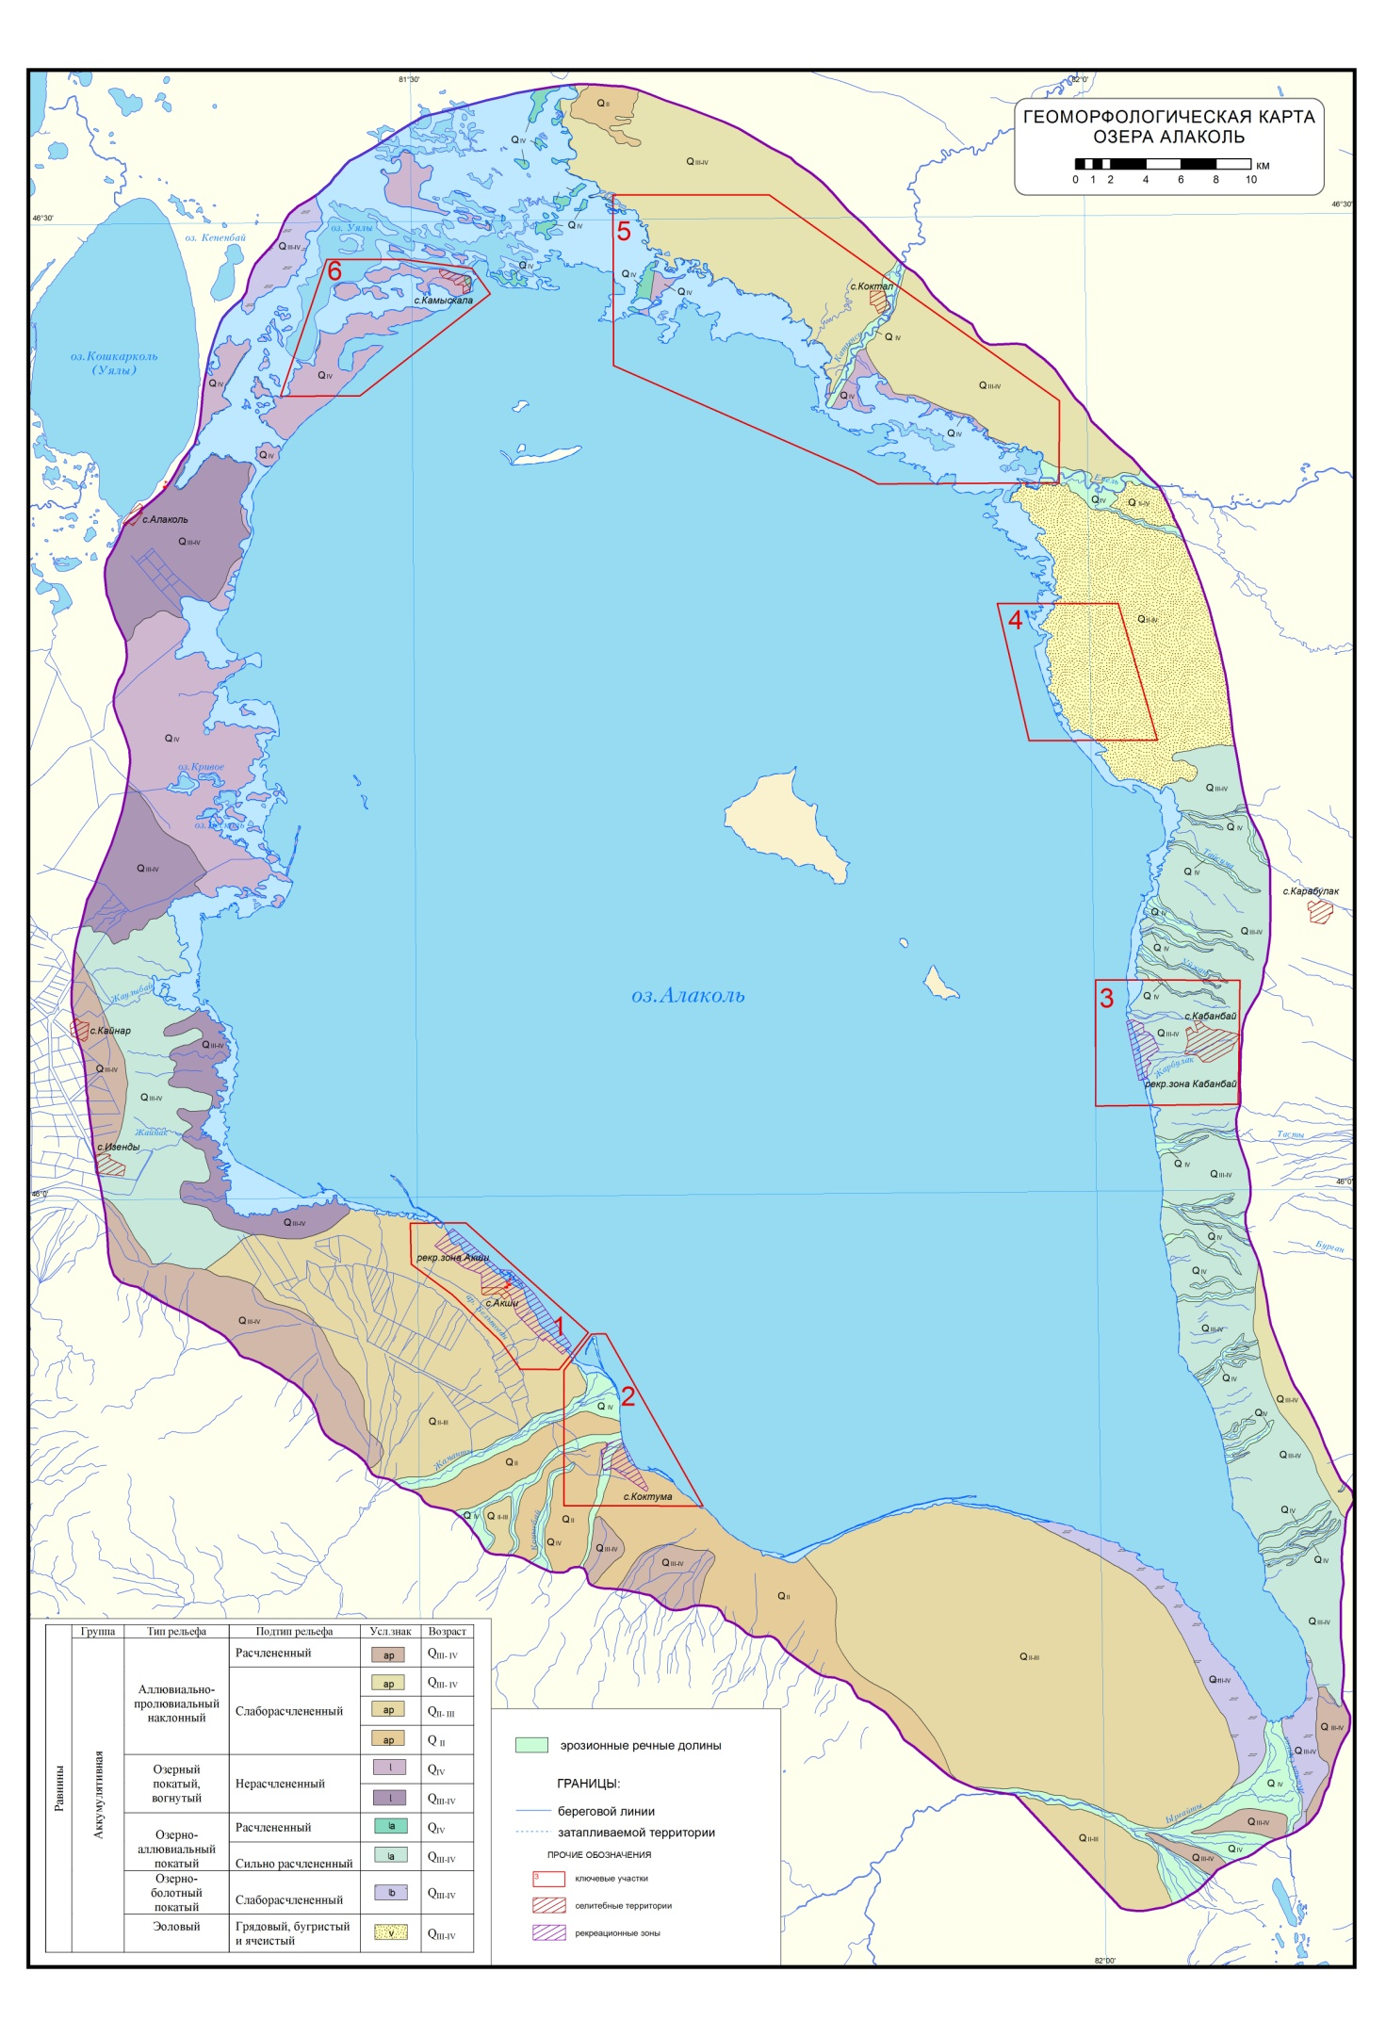
Figure F.37 – Geomorphological map of lake Alakol
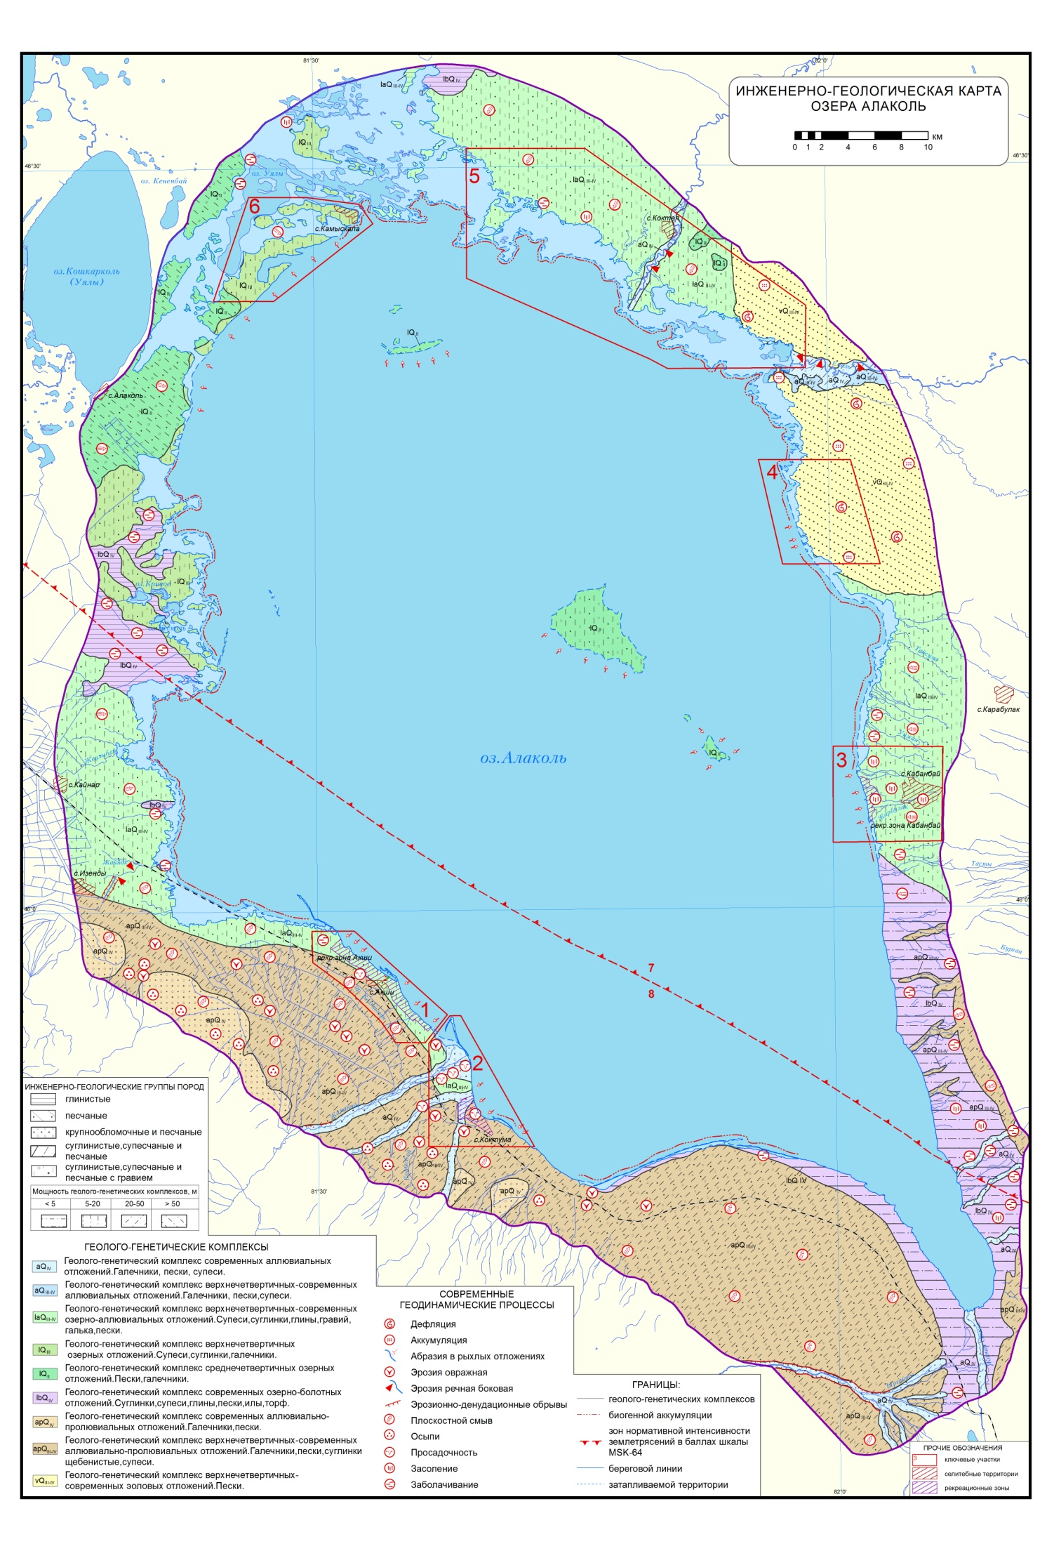
Figure F.38 – Engineering-geological map of lake Alakol
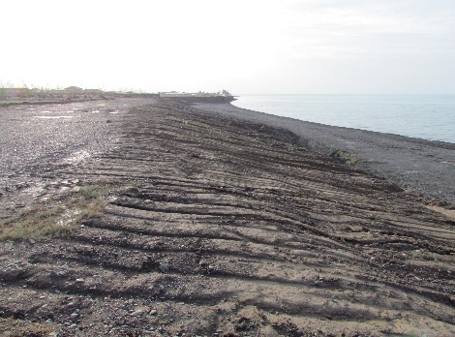  a) | 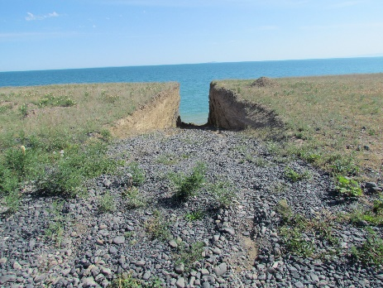  b) | 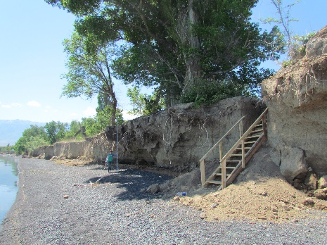  c)
Figure F.39 – a), b) Artificially flattened coastal ledges of the lake in the resort area village Akshi; c) Equipped with a wooden staircase, an artificially created descent in the coastal cliff, p. Koktuma

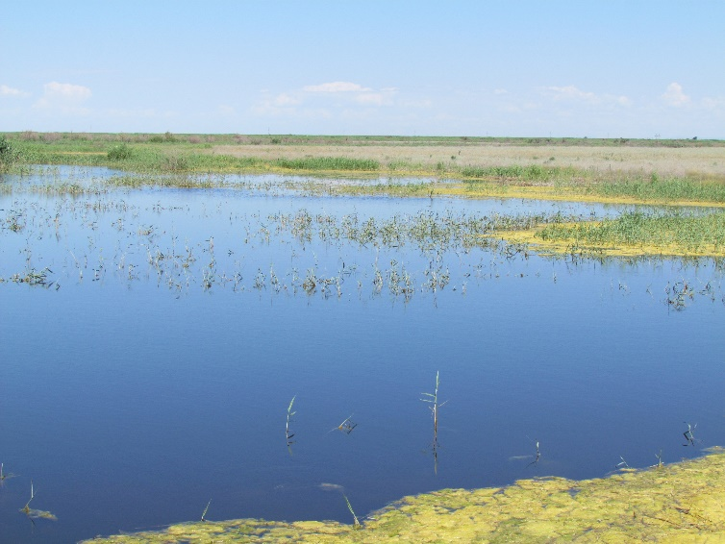
Figure F.40 – Swampy northeastern part of lake Alakol

APPENDIX G
Initial data for section 2

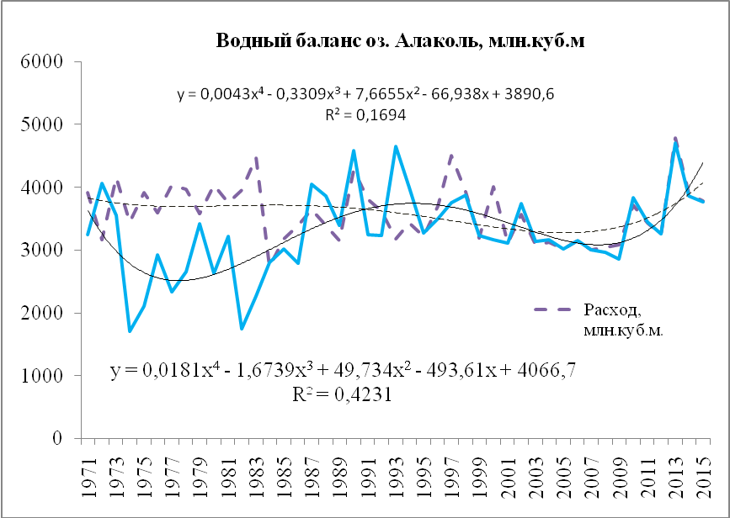
Figure G.41 – Water balance of the lake Alakol for the period from 1971 to 2015

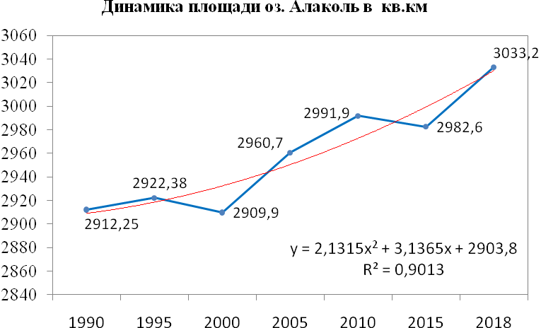
Figure G.42 – Change in the area of the lake Alakol in the context of years according to space images, sq. km

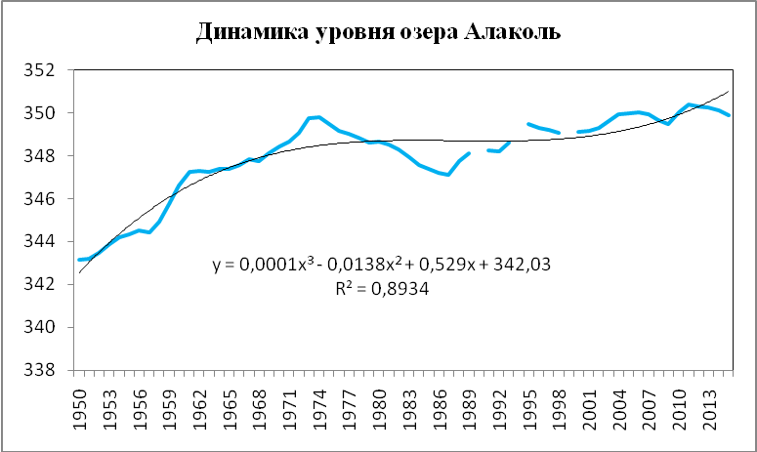
Figure G.43 – Dynamics of the average annual level of lake Alakol

Figure G.12 – Frequency of wave heights (%) by months
Месяц |  | Высота волны, см
 |  | 0-25 | 25-50 | 55-75 | 80-100 |  | 105-150 | 155-200 | 205-250
VI |  | 94,9 | 4,0 | 1,1 | 0 |  | 0 | 0 | 0
VII |  | 95,5 | 3,6 | 0,9 | 0 |  | 0 | 0 | 0
VIII |  | 88,9 | 7,7 | 1,0 | 0,5 |  | 1,9 | 0 | 0
IX |  | 89,2 | 8,2 | 2 ,1 | 0,5 |  | 0 | 0 | 0
X |  | 70,9 | 16,6 | 4,6 | 3,3 |  | 3,3 | 1,3 | 0
XI |  | 35,8 | 18,9 | 10,8 | 12,5 |  | 10,8 | 9,5 | 1,7
XII |  | 16,5 | 10,6 | 15,2 | 21,8 |  | 19,8 | 13,2 | 2,8
 | 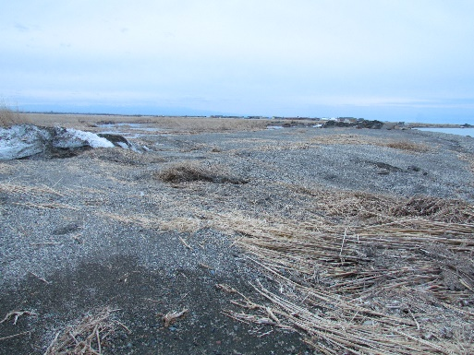 |  |  |  |  | 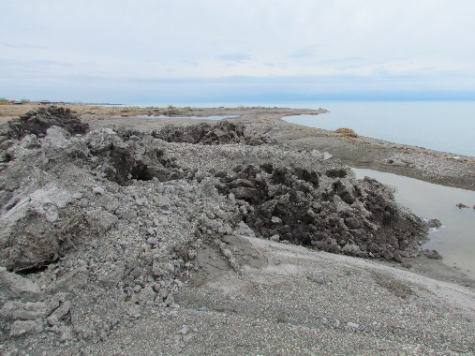

Figure G.44 – Accumulative shore with a sandy-pebble and clay component exposed to ice blocks (near the recreational zone of the village of Kabanbay)

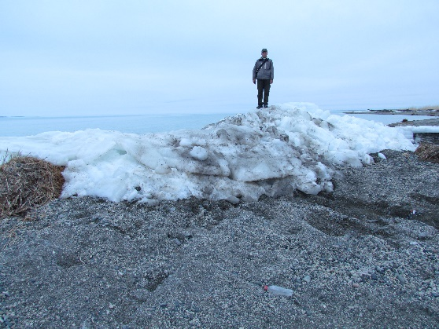 | 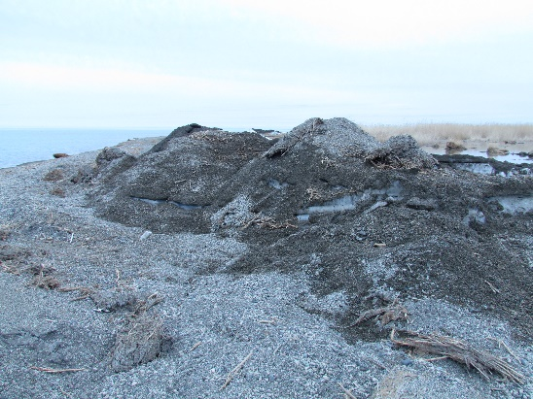
Figure G.45 – Formation of ice hummocks of the accumulative coast (near the recreational zone of the village of Kabanbay)

June 2018 | April 2019
a)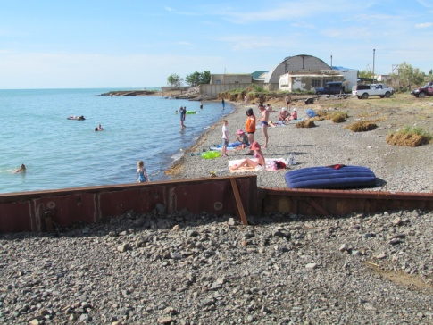 | b)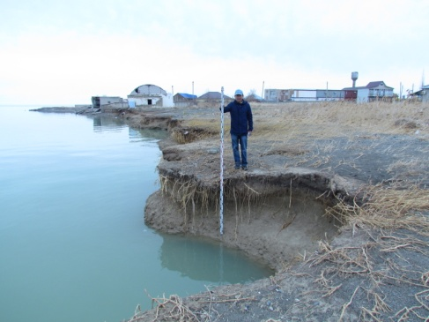
c)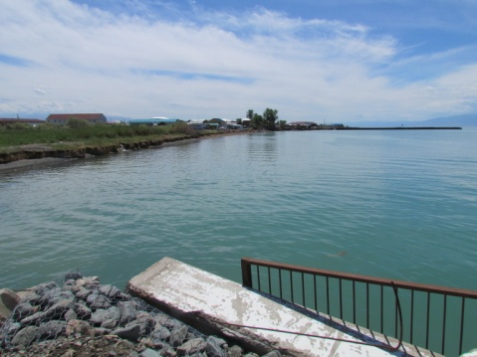 | d)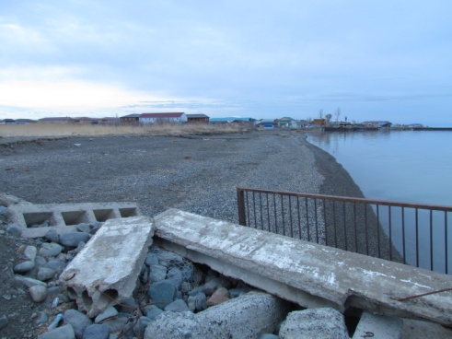
Figure G.46 – Seasonal accumulation (a, d) and erosion (b, c) of the beach as a result of alongshore transfer of clastic material. The coast near the d / o "Aquamarine", a-b to the north, c-d to the south (recreational zone of the village of Kabanbay EKR)

Eastern coast, (Kabanbay village) | South-western coast, (Akshi village)
Figure G.47 – Profiles of the underwater coastal slope of lake Alakol

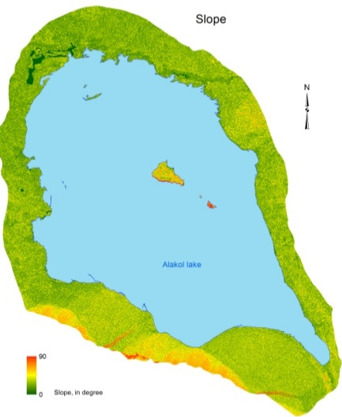 | 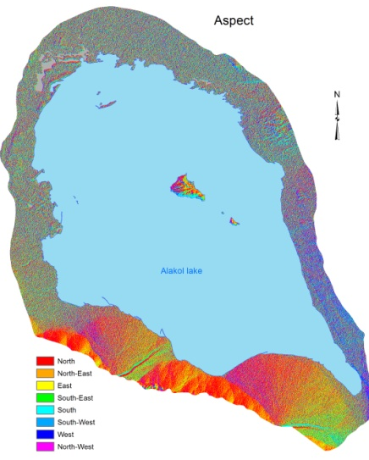 |  | 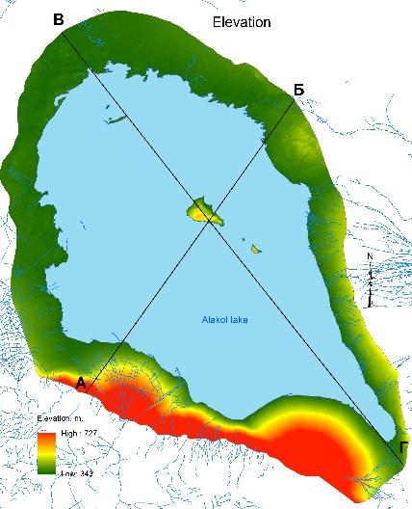
Figure G.48 – Morphometric characteristics of the relief of the land strip adjacent to the coastal zone

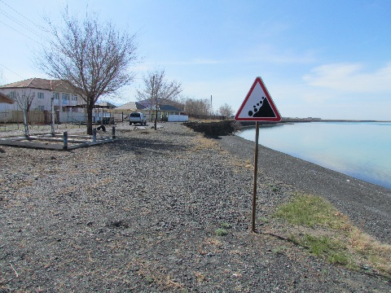  a) | 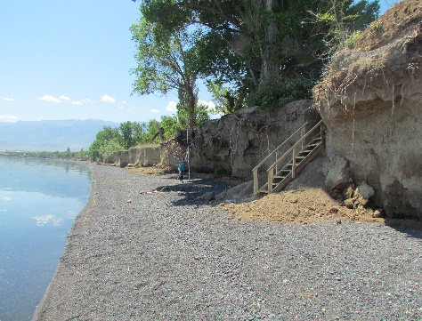  b) | 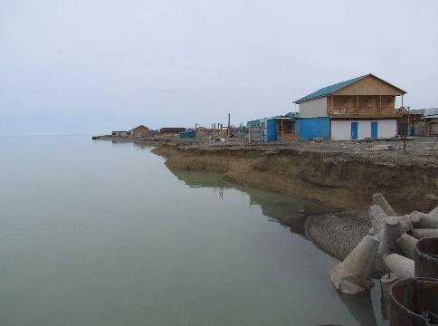  c)
Figure G.49 – Recycling of erosional-accumulative shores with the formation of a beach and a cliff: on the southwestern coast a) recreational zone village Akshi, b) p. Koktuma on the east coast, c) recreational zone village Kabanbay

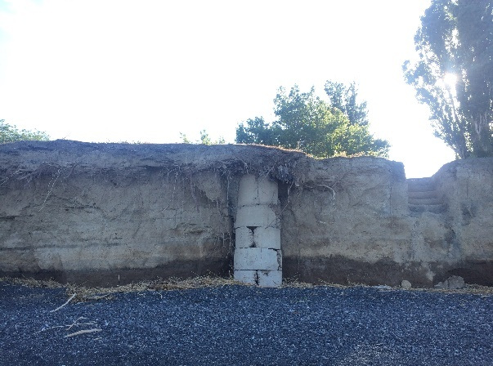  a) | 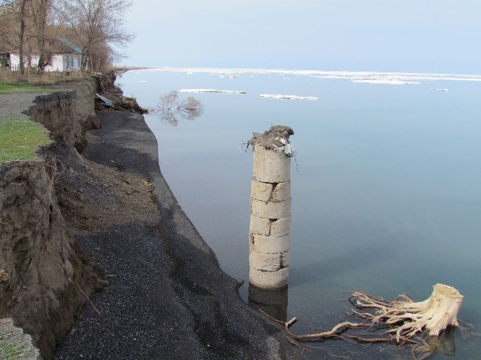  b)
Figure G.50 – Intensive processing of the coastal scarp in the village. Koktuma, photos were received: a) June 9, 2018; b) April 16, 2019

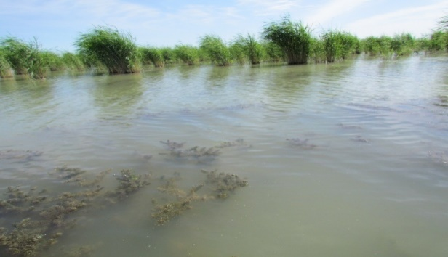 | 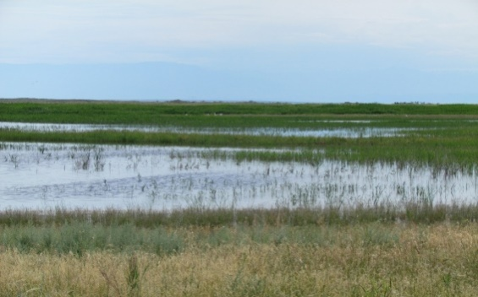
Figure G.51 – Flooding and waterlogging of the shores of the lake Alakol

Table G.13 – Granulometric composition of soils
№ | Геологи-ческий  индекс | Литология  пород | Глубина  отбора  пробы,  м | Содержание фракций в %
 |  |  |  | менее  0,001 мм | 0,001-  0,005 | 0,005-0,01 | 0,01-  0,05 | 0,05-0,10 | 0,10-0,25 | 0,25-0,5 | 0,5-1,0 | 1,0-2,0 | 2,0-3,0
1 | 2 | 3 | 4 | 5 | 6 | 7 | 8 | 9 | 10 | 11 | 12 | 13 | 14
1 | apQ_{III-IV} | Песок | 1,0 | 12,90 | 18,80 | 0,58 | 30,15 | 25,68 | 2,81 | 9,08 | - | - | -
2 | apQ_{III-IV} | Супесь | 1,0 | 3,33 | 7,26 | 4,90 | 13,77 | 42,71 | 23,37 | 4,40 | 0,26 | - | -
3 | apQ_{III-IV} | Супесь | 1,0 | - | - | 8,73 | 8,85 | 57,47 | 21,49 | 1,81 | 0,82 | 0,83 | 0,40
4 | lQ_{II} | Супесь | 1,0 | 3,57 | 10,88 | 10,03 | 24,30 | 47,85 | 3,23 | 0,14 | - | - | -
5 | lQ_{II} | Песок | 1,0 | - | - | 3,30 | 3,09 | 20,42 | 56,27 | 16,66 | 0,26 | - | -
6 | lbQ_{IV} | Суглинок | 1,0 | 8,80 | 23,08 | 13,41 | 34,81 | 17,68 | 1,12 | 0,58 | 0,30 | 0,22 | -
7 | laQ_{III-IV} | Суглинок | 1,0 | 17,56 | 19,44 | 13,89 | 25,80 | 21,65 | 1,38 | 0,28 | - | - | -
8 | vQ_{III-IV} | Песок | 1,0 | - | - | 1,88 | 0,22 | 3,58 | 66,52 | 27,80 | - | - | -

a)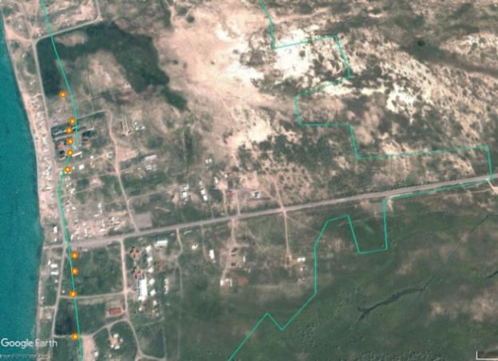 | b)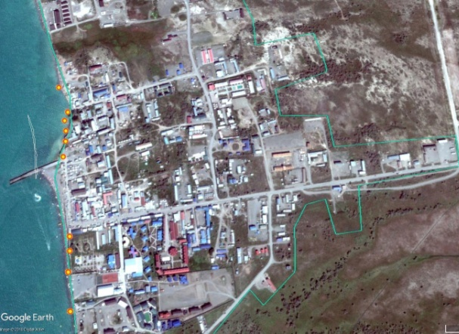
c)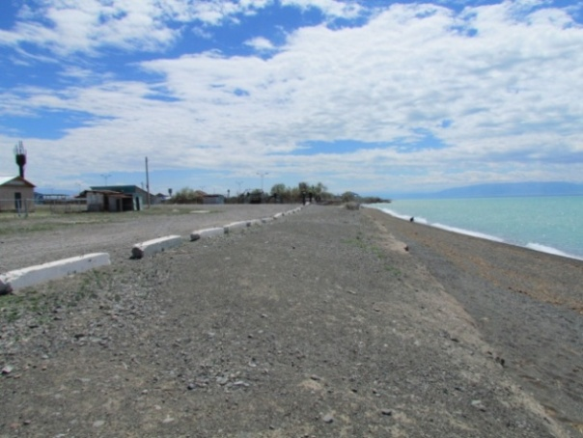 | d)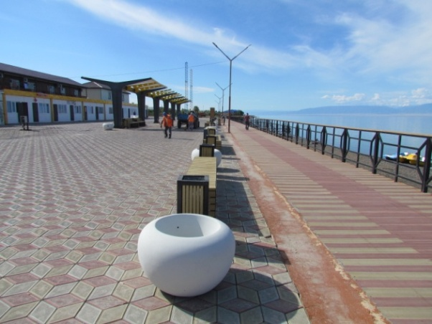
Figure G.52 – Resort area village Kabanbay (eastern coast), change in the area of the recreational zone: a) 2003; b) 2017; transformation of the coastal strip of land: c) artificially leveled surface of the coastal cliff (2013), d) equipped embankment promenade (2018)

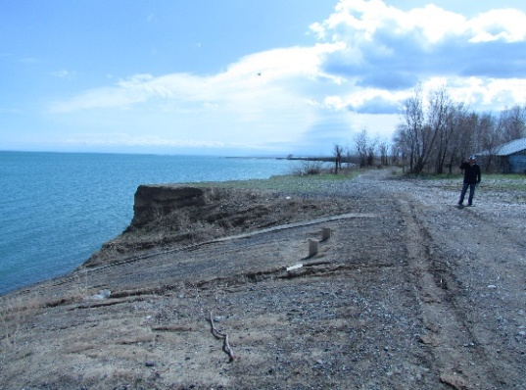 | 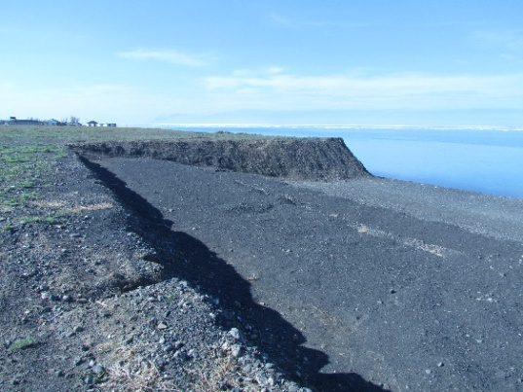
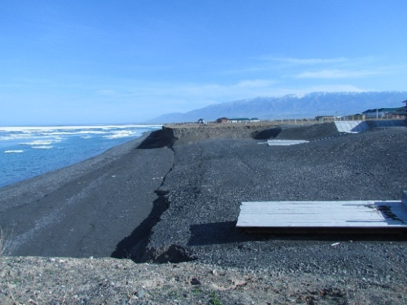 | 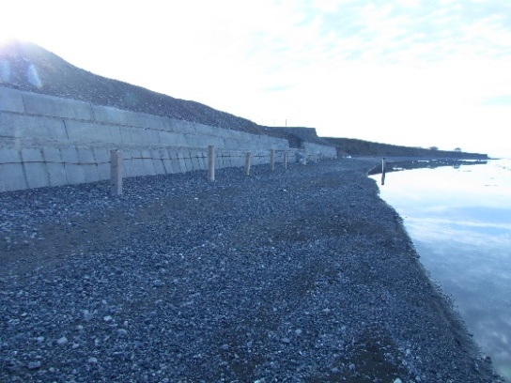
Figure G.53 – Anthropogenic flattening of the coastal scarp (Akshi, April 2019)

Table G.14 – Changes in the environment in the process of recreational nature management [42]
Компонент | Последствия влияния туризма | Причина
Почва | Потеря плодородных слоев. Уменьшение рыхлости. Изменение влажности, температуры микрофлоры | Вытаптывание, уплотнение почвенного покрова
Растительность | Изменение видового состава, распределения по ярусам пространственной структуры индивидуальных характеристик растений | Вытапливание, сбор растений и их частей (корни, плоды, цветки и т.д.) для различных целей, лесные пожары и т.д.
Водная система | Изменение характеристик береговой линии, характеристик дна. Увеличение количества отложений и мутности. Изменение органического, химического состава | Вытапливание, вырубка лесов, строительство плотин и водохранилищ и т.п.

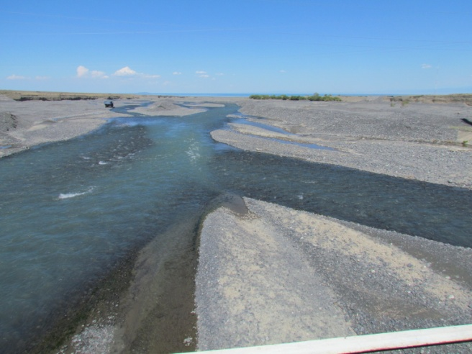
Figure G.54 – Removal of gravel and pebble material in the delta of the Zhamanty river

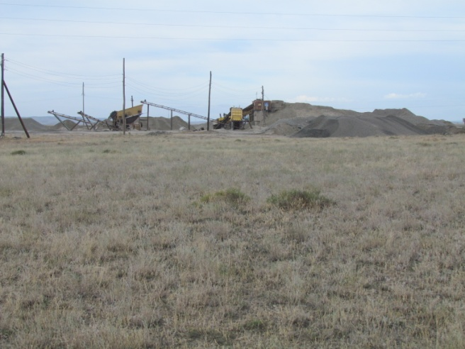 | 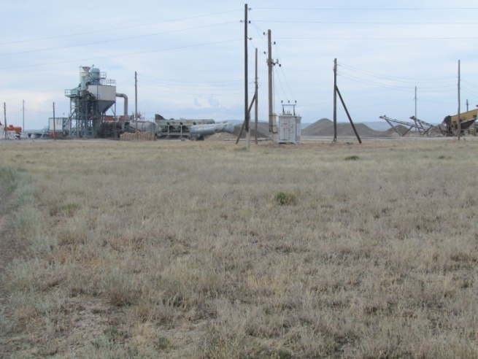
Figure G.55 – Removal of sand-gravel-pebble material in the delta of the Zharbulak river for the construction of a new road

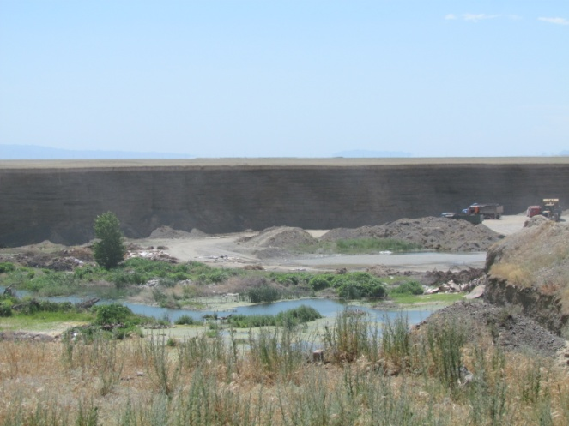 |  | 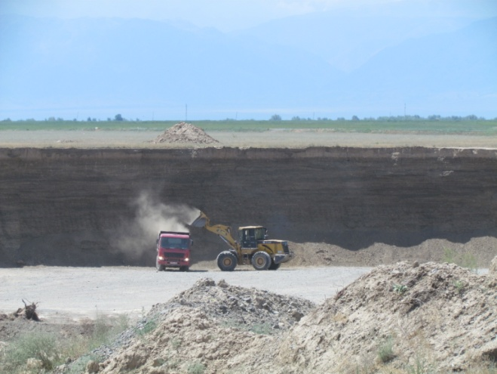
Figure G.56 – Extraction of raw materials from r. Arasanka near the gorges Barlyk Arasan

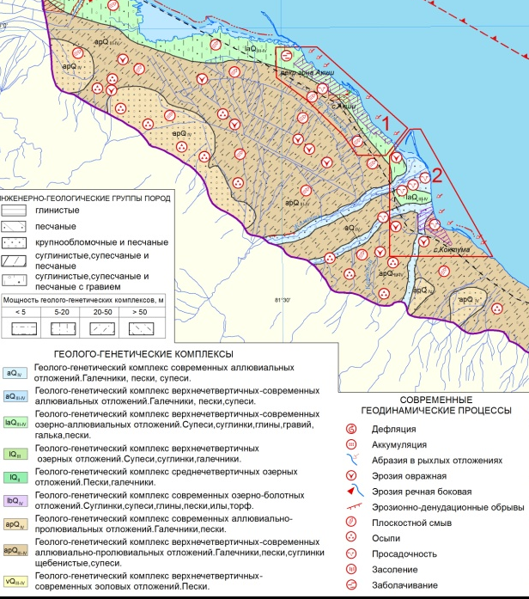 | 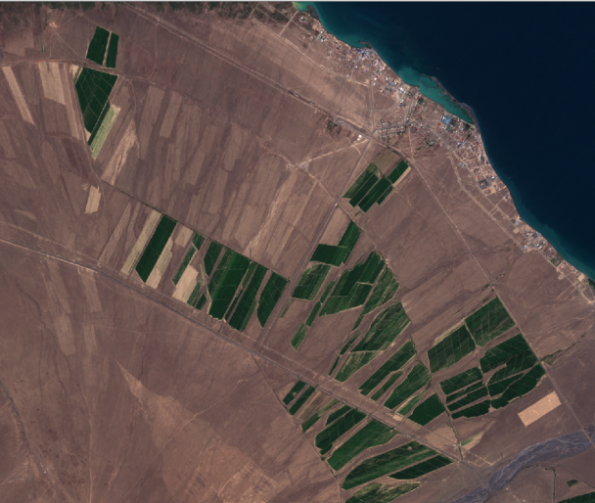

Figure G.57 – Fragment of the engineering-geological map of lake Alakol - recreational zones of SAkshi and the village of Koktuma and a fragment of the Sentinel-2B satellite image for this territory

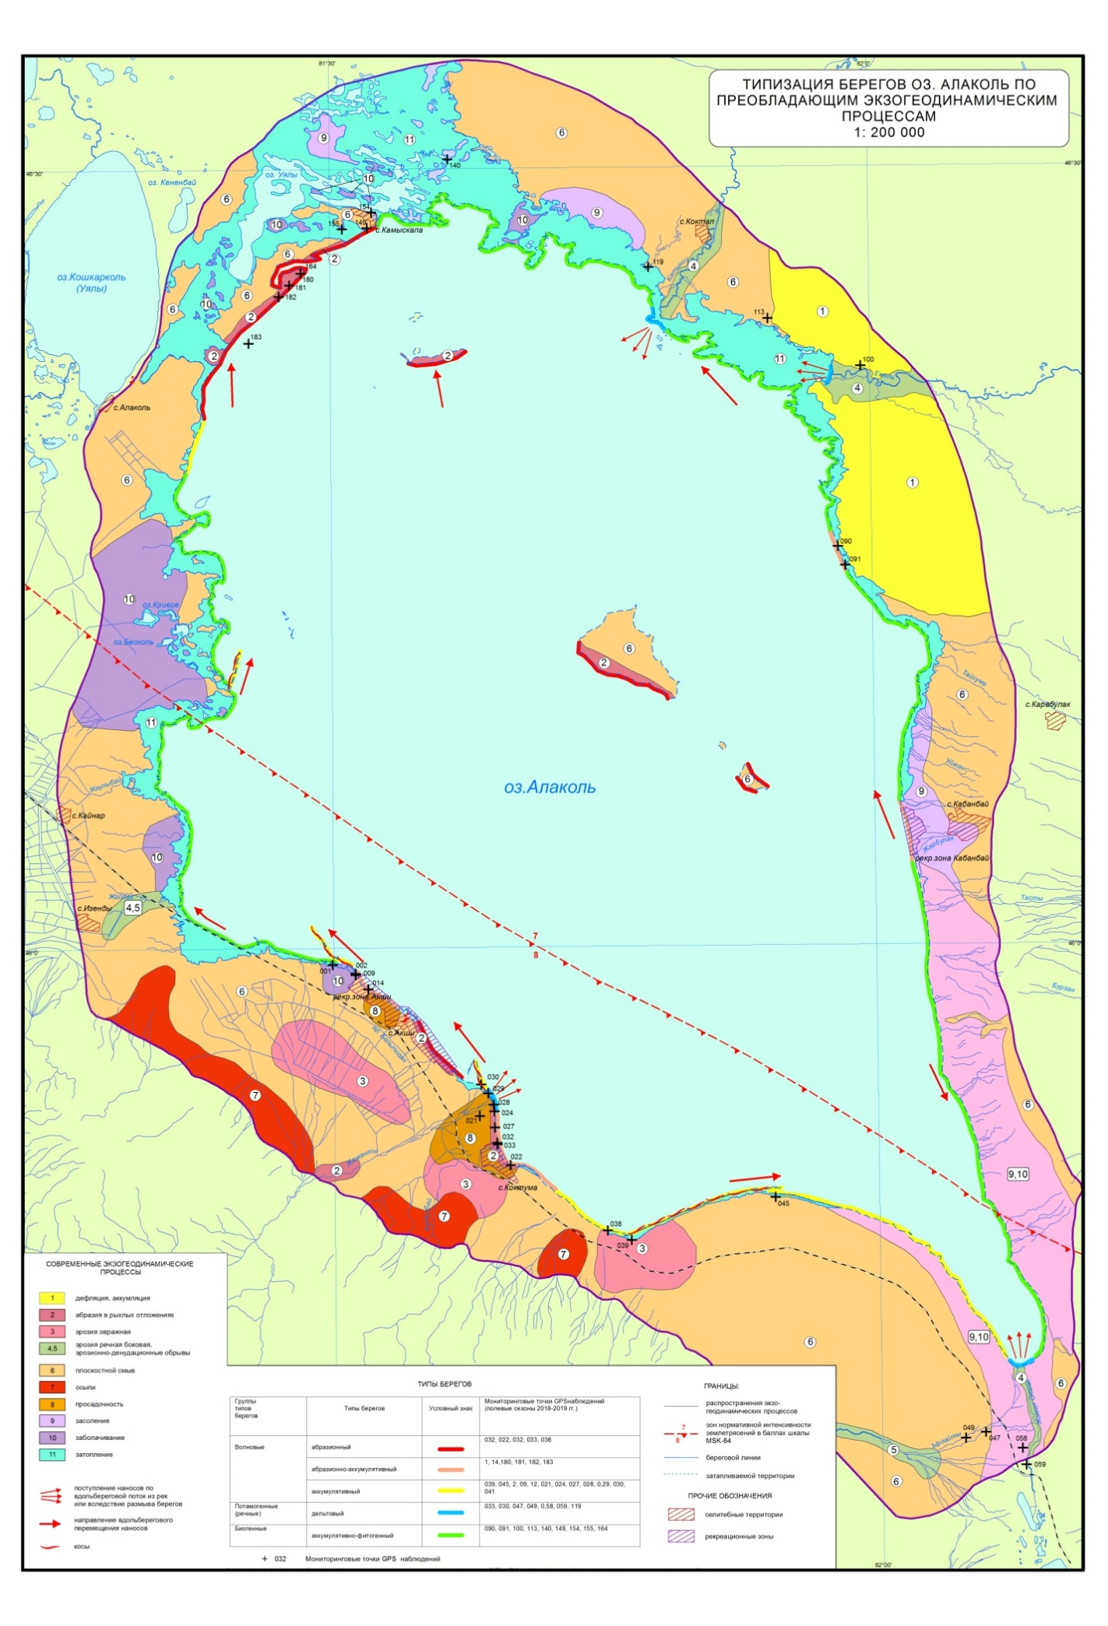
Figure G.58 – Typification of the shores of the lake Alakol on the prevailing exogeodynamic processes

Table G.15 – Classification of types of shores of the lake Alako [48, 50, 52]
Районы | Типы берегов | Современные формы рельефа | Опасный экзогеодинамический процесс | Участки распространения | Мониторинговые точки GPS наблюдений (полевые сезоны 2018-2019 гг.)
Юго-западный | абразионный, абразионно-аккумулятивный,  аккумулятивно-фитогенный, дельтовый | аллювиально-пролювиальная наклонная слаборасчлененная равнина, осложненная абразионными клифами, косами, нишами вымывания, с обрушениями и обвалами | абразия, просадочность, овражная эрозия, плоскостной смыв, заболачивание | рекреационная зона сел Акши, Коктума | 002, 009, 014, 022, 024, 027-030, 032, 033
Южный | аккумулятивный,  аккумулятивно-фитогенный,  дельтовый | аллювиально-пролювиальная наклонная слаборасчлененная и нерасчлененная равнина с полигенетическими валами, косами | аккумуляция, плоскостной смыв, засоление, заболачивание, эрозия овражная, речная, боковая, денудационные обрывы | южное побережье озера, устье р. Жаман Откел | 038, 039, 045, 047, 049, 0,58, 059
Юго-восточный | аккумулятивно-фитогенный | озерно-аллювиальная покатая слаборасчлененная и озерная покатая вогнутая нерасчлененная равнины | засоление, заболачивание | юго-восточный берег Алаколя | -
Восточный | абразионно-аккумулятивный, аккумулятивно-фитогенный | озерно-аллювиальная покатая равнина расчлененная, осложненная абразионными клифами, береговыми нишами вымывания, останцами, вторичными микроформами | абразия, аккумуляция, формирование фрагментарных пляжей, засоление, заболачивание, плоскостной смыв | рекреационная зона села Кабанбай | 090, 091
Северо-восточный | аккумулятивно-фитогенный, дельтовый | аллювиально-пролювиальная слаборасчлененная равнина, переходящая в долины и дельты рек Катынсу и Емель | дефляция, аккумуляция, плоскостной смыв, затопление, эрозия речная боковая, эрозионно-денудационные обрывы | район междуречья Катынсу и Емель | 100, 113, 119
Северный | абразионный,  аккумулятивно-фитогенный,  дельтовый | аллювиально-пролювиальная  слаборасчлененная равнина | затопление, заболачивание, засоление, эрозия речная, боковая | северный берег озера | 119, 140, 149, 154, 155
Северо-западный | абразионный | озерная покатая вогнутая равнина нерачлененная с  аброзионными уступами, пляжами, бухтами | абразия, плоскостной смыв, засоление | северо-западное побережье озера Алаколь, район села Камыскала | 164, 180, 181, 183
Западный | аккумулятивно-фитогенный,  аккумулятивный | озерная покатая вогнутая нерасчлененная равнина | затопление, аккумуляция, заболачивание, плоскостной смыв, речная эрозия, эрозионно-денудационные обрывы | западное побережье Алаколя | 100, 113, 140, 149, 154, 155, 164
Острова:  Писки,  Улькен и Кишкене-  Аралтобе | абразионно-аккумулятивный,  абразионный |  | абразия, плоскостной смыв |  | 172, 174, 176

Table G.16 – Criteria for assessing water bodies for beach and bathing recreation [53]
Параметр | Степень благоприятности
Параметр | благоприятно | относительно благоприятно | неблагоприятно
Берега | Сухие террасированные, без крутых спусков, пригодные для освоения в естественном состоянии | Сухие, но крутосклонные, часто обрывистые, освоение которых требует несложных сооружений для спуска к воде (если у воды есть полоса пляжа) | Берега либо заболочены, либо очень крутые с высоким клифом или обрывом
Подходы к воде | Просто открытые | Требуют небольшой расчистки | Топкие, закустаренные, закрытые
Пляжи | Песок, мелкая галька | Трава, крупная галька | Глина, торф, крупный камень
Характер отмели | 20-50 м | Менее 20; более 50 м | Отмель отсутствует
Характер дна | Песок и мелкая галька | Крупная галька, заиленные пески, валуны | Ил, камень, глина, крупный острый камень, большие плиты, покрытые водными микроорганизмами
Скорость течения реки, м/с | Менее 0,3 | 0,3-0,5 | Более 0,5
Температура воды, °С | 18-24 | 16-17; 25-26 | Менее 16; более 26
Санитарно-гигиенические  условия | Чистые, источников загрязнения нет | Легко устранимые источники загрязнения, вода самоочищается | Загрязнения превышают ПДК, и источники загрязнения неустранимы

Table G.17 – Classification of the shores of the lake Alakol [6]
Группа типов берегов | Районы распространения
Аккумулятивные | - дельты рек Уржар, Катынсу, Емель, Жаманты  - Киши-Алакольский залив  - урочища: Каратума, Жайпак, Бельбулак  - заливы северного берега  - южный берег  - западный берег
Абразионные | - восточный берег  - северо-западный берег  - берега островов Улькен и Кишкене Аралтобе
Абразионно-аккумулятивные | - юго-западный берег  - северо-восточный берег

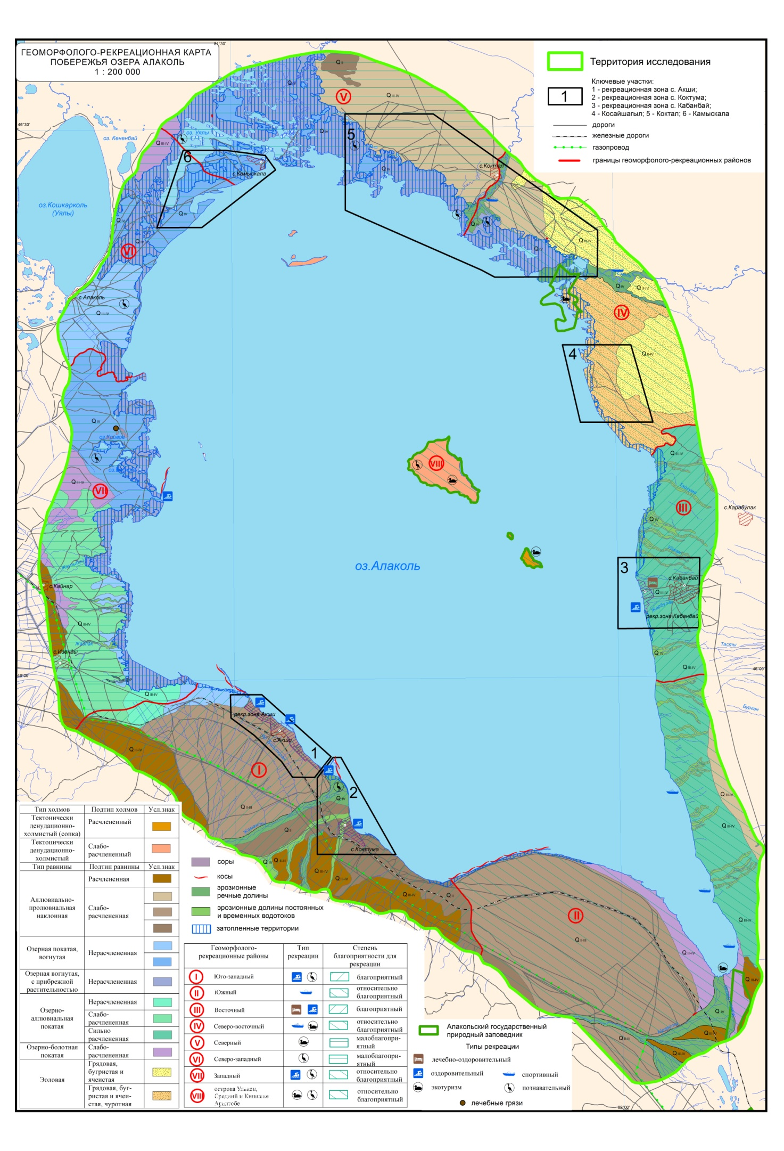
Figure G.59 – Geomorphological and recreational map of the coast of lake Alakol
Table G.18 – Geomorphological and recreational coastal areas of lake Alakol
Геоморфолого-рекреационные районы | Ведущий процесс берегообразования | Наличие пляжей¹, кос², минеральных источников³, лечебных грязей⁴, заповедников⁵ | Наличие транспортной сети (дороги с асфальтовым покрытием*, грунтовые дороги**,ж/д***) | Степень развитости инфраструктуры | Тип рекреации | Степень благоприятности для рекреации
I. Юго-  западный | Абразионно-аккумулятивный | ¹+, ²+ | *+, **+, ***+ | высокая | Пляжно-купальный, познавательный | Благоприятный
II. Южный | Аккумулятивный | ¹+, ²+, ⁵+ |  | средняя | Cпортивный туризм | Относительно благоприятный
III. Восточный | Абразионно-аккумулятивный | ¹+, ³+ | *+ | средняя | Лечебно-оздоровительный | Благоприятный
IV. Северо-  восточный | Аккумулятивный, эоловый | ⁵+ | **+ | низкая | Спортивный туризм | Относительно благоприятный
V. Северный | Аккумулятивный |  |  | низкая | Экотуризм | Малоблагоприятный
VI. Северо-западный | Абразионно-аккумулятивный |  | **+ | низкая | Познавательный | Малоблагоприятный
VII. Западный | Аккумулятивный | ¹+, ⁴+ | **+ | средняя | Пляжно-купальный, познавательный | Относительно благоприятный
VIII. Острова Улькен, Средний и Кишкене Аралтобе | Абразионно-аккумулятивный | ⁵+ |  | – | Познавательный,  экотуризм | Относительно благоприятный

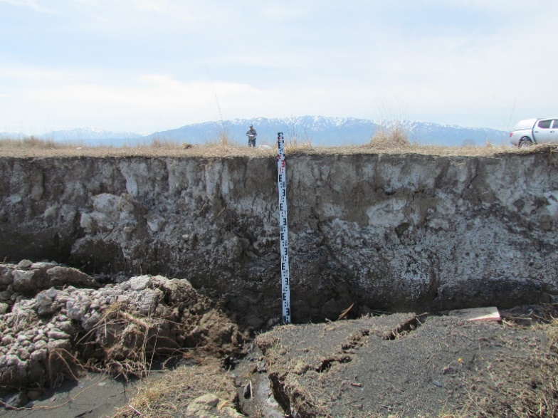 | 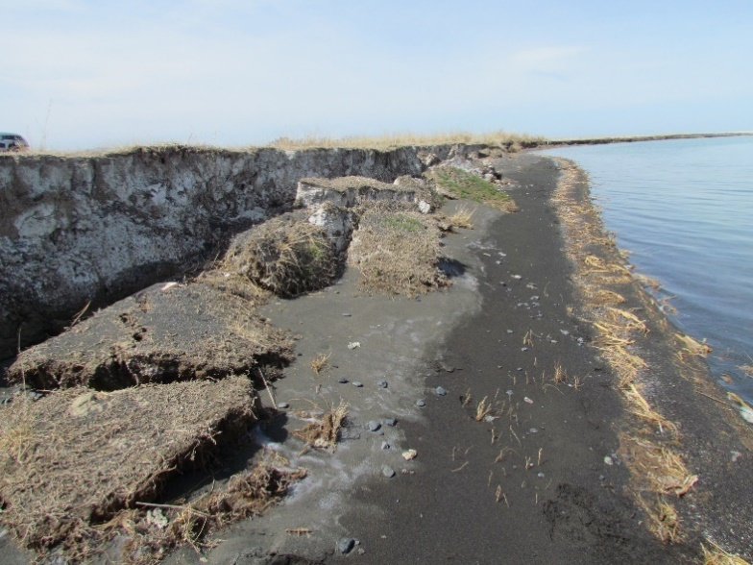
Figure G.60 – Fresh consequences of abrasion after the autumn-winter season on the western coast of the lake Alakol (north-west of the village of Akshi)

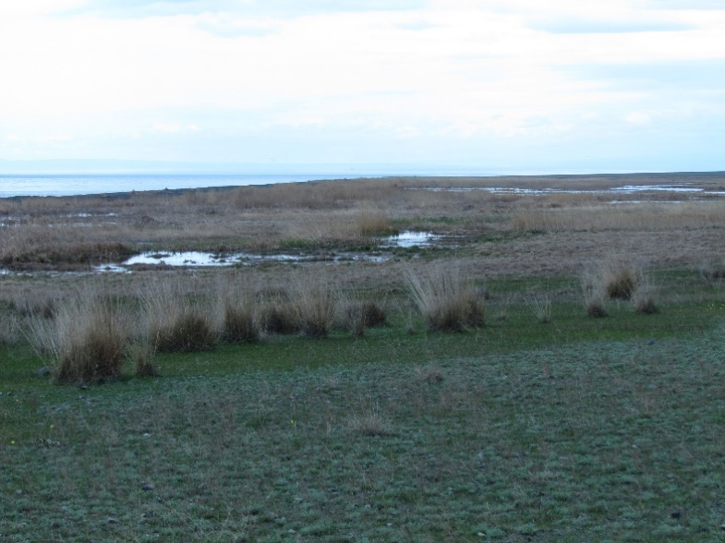 | 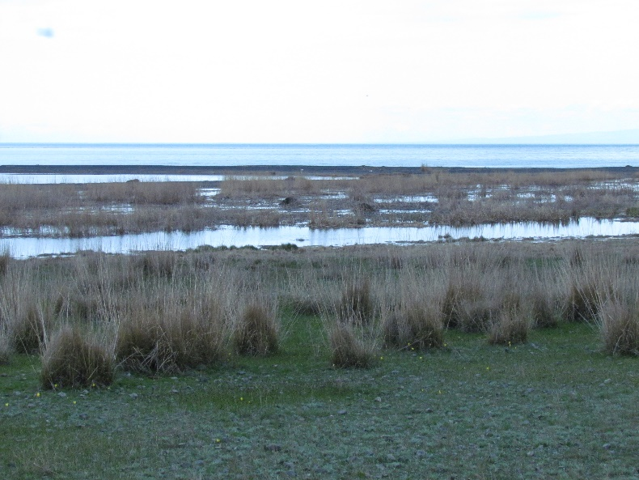
Figure G.61 – Swamp formation on the southern coast of lake Alakol

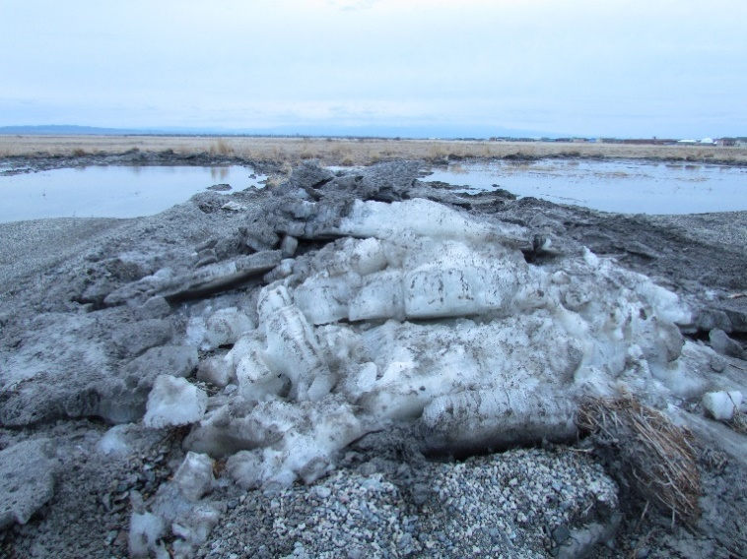 | 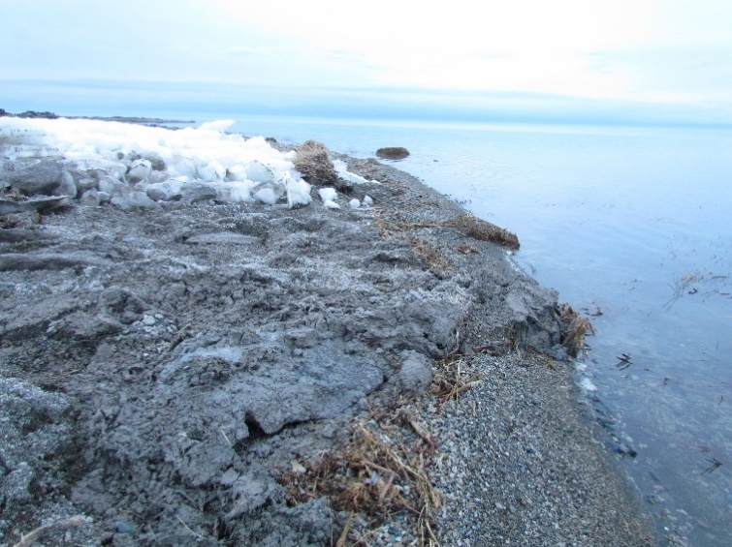
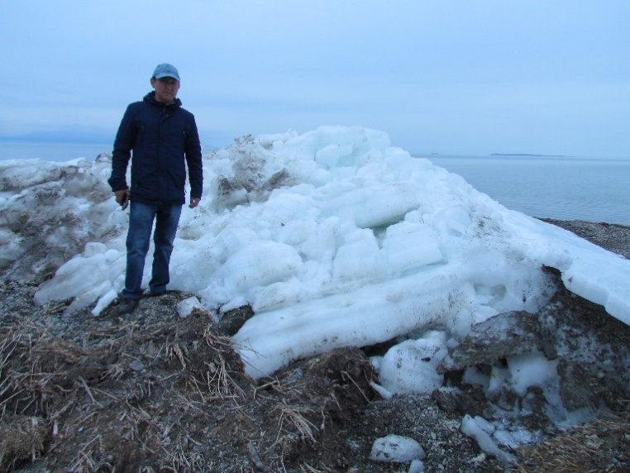 | 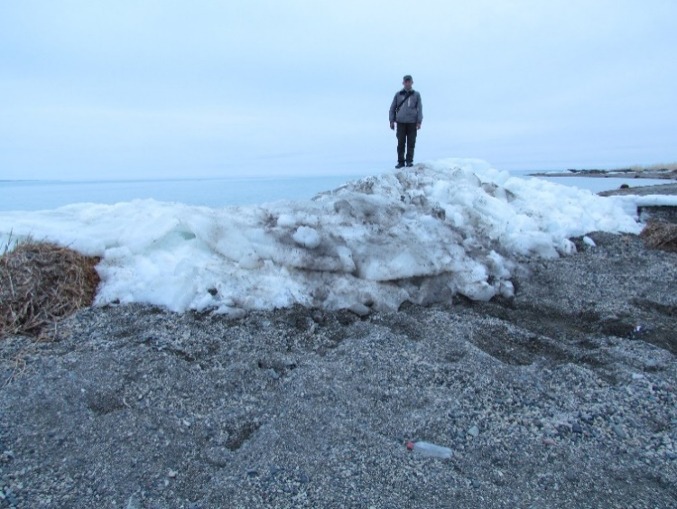
Figure G.62 – Ice hummock on the eastern coast of the lake Alakol

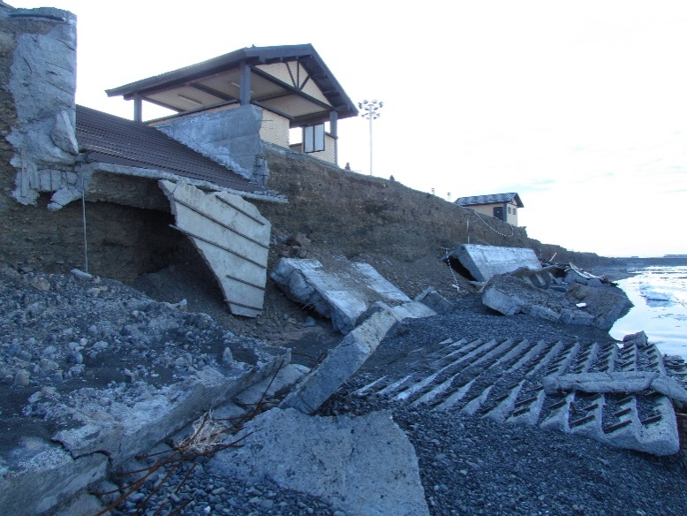 | 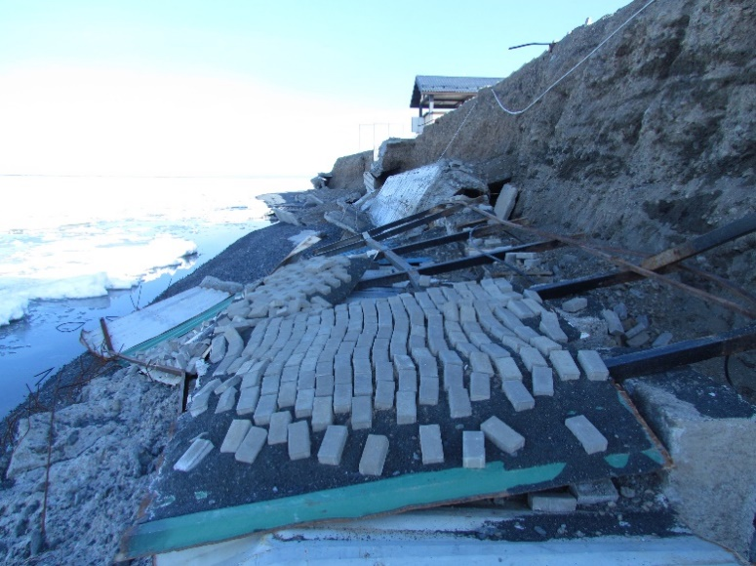
Figure G.63 – The destructive impact of waves and ice hummocks on the recreational infrastructure of the lake Alakol near the village Akshi
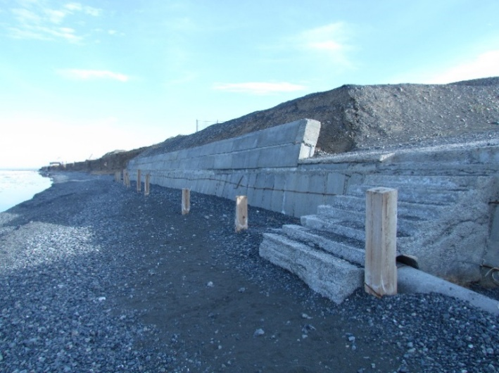 | 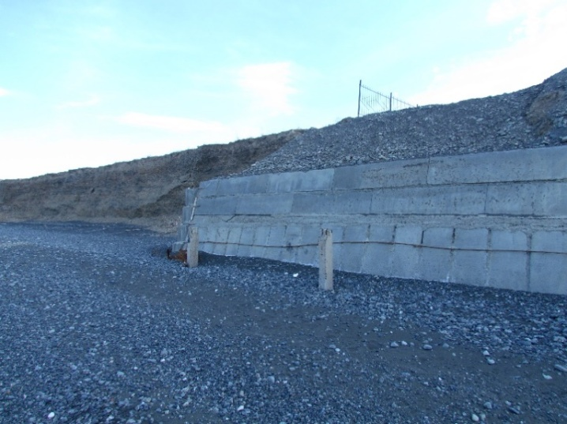
Figure G.64 – Conducted bank protection works on the coast of the lake Alakol by the owners of recreation areas near the village Akshi

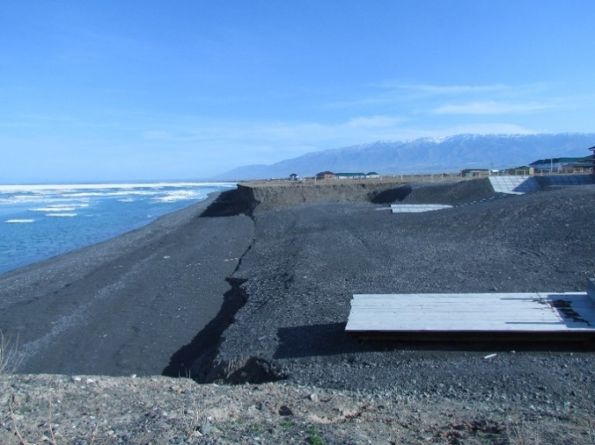 | 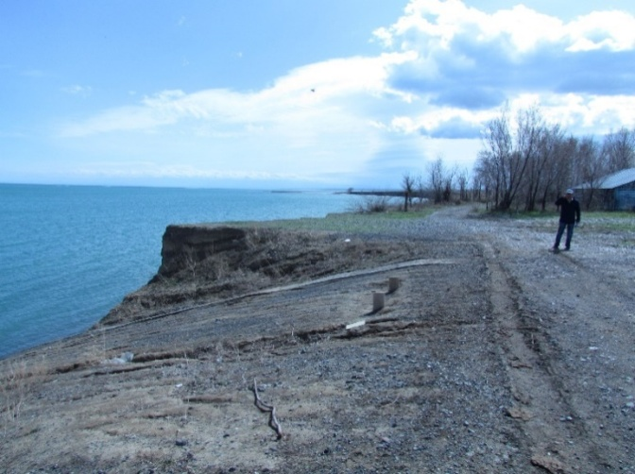
Figure G.65 – The owners of recreation areas on the shores of lake Alakol near the villages of Koktuma and Akshi for the convenience of tourists

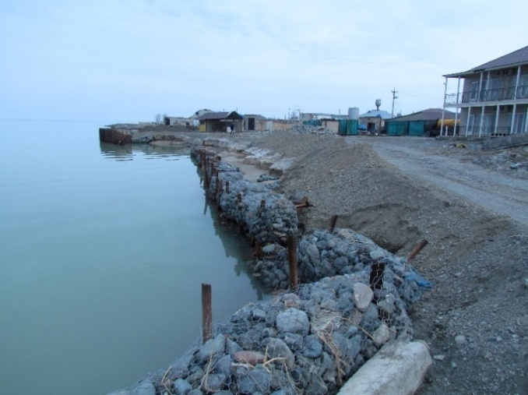 | 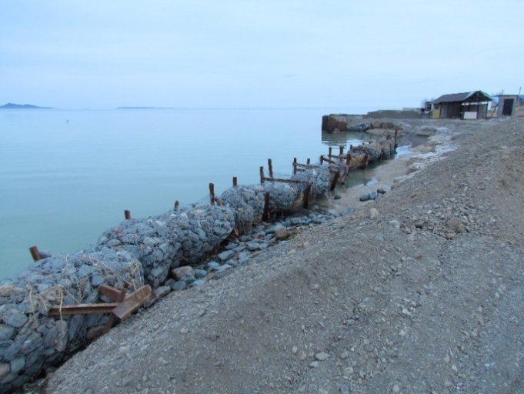
Figure G.66 – Conducted bank protection works using gabions on the shores of lake Alakol (Kabanbay village) by the owners of recreation areas

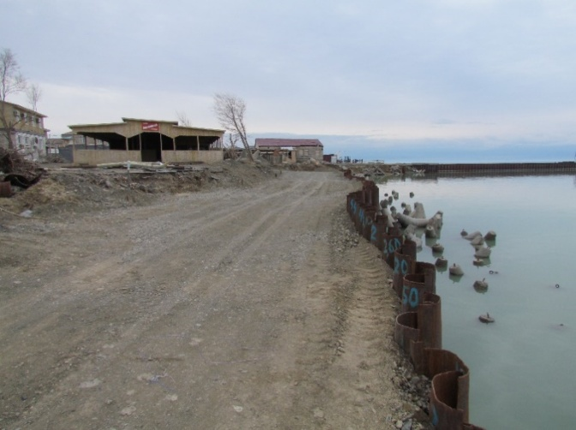 | 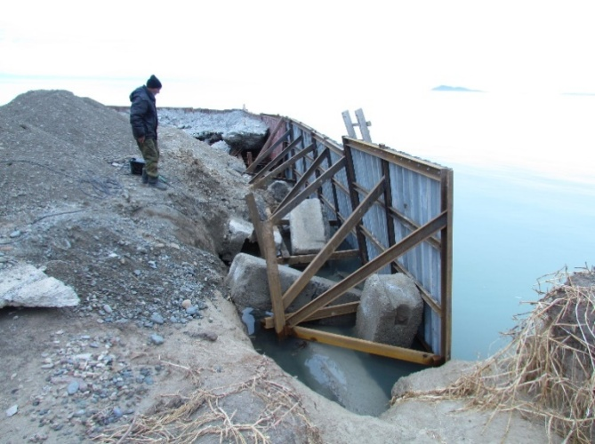
Figure G.67 – Conducted bank protection works using metal structures on the shores of lake Alakol (Kabanbay village) owners of recreation areas

Table G.19 – Field diary
13.04.2019 г. – 19.04.2019 г. (весенний выезд)
№ GPS точки | Координаты | Абсолютная высота над уровнем моря, м | Название, место расположение |  |  | Описание | Генезис и геологический возраст |  |  |  |  | Растительность |  |  | Современные рельефообразующие процессы |  | Фото (серия-номер) | Антропогенное воздействие | Примечание:
1 | 2 | 3 | 4 |  |  | 5 | 6 |  |  |  |  | 7 |  |  | 8 |  | 9 | 10 | 11
День экспедиции – 13.04.19.
Выезд из г. Алматы в с. Акши. Ночевка недалеко от с. Акши.
Ключевые участки у с. Акши. День экспедиции – 14.04.19.
 | 45-59-015 с.ш.  81-31-219 в.д. | 350 | Мониторинговая площадка № 1 у с. Акши. |  |  | Выполнение инстументальных измерительных работ на мони-торинговой площадке сев. западнее с Акши (1). Всего было измерено расстояние от 4 реперов (точки наблюдения) до бровки уступов у берега оз. Алаколь.  1) Динамика отступания бровки берегового уступа на репере I за 10 месяцев (2018-2019 гг.) составила 6,5м, на II репере – 6,3 м за такой же период, на III репере – 6,4 м и на IV репере – 6,7 м. Расстояние от репера I до бровки уступа 19,5 м.  2) Ширина пляжа (от уреза воды до основания уступа) составляет 3-3,2 м. Пляж сложен из разно-зернистого песка темного цвета (почти черного) и гравийно-галечной смеси. Также местами встречаются сухой грунт и частички обрушившегося грунта от бровки уступа.  3) Высота уступа на данном мониторинговой площадке около 0,7-2 м.  4) Проводилась фотофиксация мониторинговой площадки. | laQ_{III-IV} |  |  |  |  | Травянистая, местами кустарниковая |  |  | Абразия  Биогенная аккумуляция |  | 327-8823-8845 | Полевые дороги, активный выпас скота, мусор | Взяты образцы грунта
Continuation of table G.19
1 | 2 | 3 | 4 |  | 5 |  | 6 |  |  |  |  | 7 |  |  | 8 |  | 9 | 10 | 11
 | 45-58-35,0 с.ш.  81-31-30,1 в.д. | 350 | Мониторинговая площадка № 2 у с. Акши |  | Выполнение инструментальных измерительных работ на мониторинговой площадке №2 у с. Акши. Всего было измерено расстояние 3 реперов до бровки уступов у берега оз. Алаколь.  1) Динамика отступания бровки берегового уступа на репере I за 10 месяцев (2018-2019 гг.) составила 5,3 м. Расстояние от I репера до бровки уступа 54 м.  Динамика отступания бровки берегового уступа на репере II за 10 месяцев (2018-2019 гг.) составила 4,3 м. Расстояние от II репера до бровки уступа 51 м. Динамика отступания бровки берегового уступа на репере III за 10 месяцев (2018-2019 гг.) составила 5,6 м. Расстояние от III репера до бровки уступа 59,3 м.  2) Ширина пляжа (от уреза воды до основания уступа) составляет 2-3 м. Пляж сложен из разнозернис-того песка темного цвета (почти черного) и гравийно-галечной смеси. Также местами встречаются сухой грунт и частички обрушившегося грунта от бровки уступа. Пляж повсеместно завален обвалившимся грунтом из уступов. Происходит активная абразия берега. Обвалившийся грунт смывается волнами озера.  3) Высота уступа на данном мониторинговой площадке около 3-4 м.  4) Проводилась фотофиксация мониторинговой площадки. |  | laQ_{III-IV} |  |  |  |  | Травянистая, изредка кустарниковая |  |  | Абразия, биогенная аккумуляция |  | 327-8846-8861 | Полевые и асфальтированные дороги, рядом строения для рекреационных нужд
Continuation of table G.19
1 | 2 | 3 | 4 |  |  | 5 | 6 |  |  |  |  | 7 |  |  | 8 |  | 9 | 10 | 11
День экспедиции – 15.04.19.
Выезд из с. Акши в город Ушарал.
Были в акимате Алакольского р-на. Были проставлены печати на командировочных документах. Встретились с руководителем управления архитектуры Алакольского района Азаматом Ахметовичом для обсуждения текущей ситуации по вопросам берегоукрепительных работ и планов. После обеда прибыли в с. Акши для продолжения полевых работ.
 | 45-58-08,1 с.ш.  81-32-32,5 в.д. | 350 | Мониторинговая площадка № 3 у с. Акши. |  | Выполнение инструментальных из-мерительных работ на монито-ринговой площадке №3 у с.Акши для определения динамики переработки берегов. Всего было измерено расстояние 3 реперов.  Динамика отступания бровки бере-гового уступа на репере I за 10 месяцев (2018-2019 гг.) составила 0,4 м. Расстояние от I репера до бровки уступа 6,3 м.  Динамика отступания бровки бере-гового уступа на репере II за 10 месяцев (2018-2019 гг.) составила 0,2 м. Расстояние от II репера до бровки уступа 18 м.  Динамика отступания бровки бере-гового уступа на репере III за 10 месяцев (2018-2019 гг.) составила 1,4 м. Расстояние от III репера до бровки уступа 29,6 м.  2) Ширина пляжа (от уреза воды до основания уступа) составляет 16,2 м. Пляж сложен из разнозер-нистого песка темного цвета (почти черного) и гравийно-галечной смеси. Данный участок в связи с расположением вблизи косы меньше подвержен абра-зионным процессам, так как основной удар волны принимает тело самой косы. Обвалы уступа незначительны.  3) Высота уступа на данном мониторинговой площадке 3,3 м.  4) Проводилась фотофиксация мониторинговой площадки |  |  | laQ_{III-IV} |  |  |  | Травянистая, изредка кустарниковая |  |  | Абразия, биогенная аккумуляция |  | 327-8862-8884 | Полевые и асфальтированные дороги, рядом строения для рекреационных нужд
Continuation of table G.19
1 | 2 | 3 | 4 |  | 5 |  |  | 6 |  |  |  | 7 |  |  | 8 |  | 9 | 10 | 11
Т.196 | 45-56-596 с.ш.  81-34-967 в.д. | 350 |  |  | Измерения основных морфометри-ческих характеристик у зоны отдыха. Ширина пляжа – 26,2м. Высота уступа – 5,6м. |  |  | laQ_{III-IV} |  |  |  | Травянистая, изредка кустарниковая |  |  | Абразия, биогенная аккумуляция |  | 327-8898-8920 | Полевые и асфальтированные дороги, рядом строения для рекреационных нужд
Т.198 | 45-55-949 с.ш.  81-31-592 в.д. | 350 |  |  | Антропогенное выравнивание берегового уступа на прилегающей территорий у дома отдыха. Измерение основных морфомет-рических характеристик у зоны отдыха. Ширина пляжа – 14,9м. Высота уступа – 6м. |  |  | laQ_{III-IV} |  |  |  | Травянистая, изредка кустарниковая |  |  | Абразия, биогенная аккумуляция |  | 327-8921-8944 | Полевые и асфальтированные дороги, рядом строения для рекреационных нужд
День экспедиции – 16.04.19.
Выезд из с. Акши в с. Коктума для проведения инструментально-измерительных работ. Всего были сняты данные с 4 реперов.
 | 45-52-06,9 с.ш.  81-39-05,4 в.д. | 366 | Мониторинговая площадка № 3 у с. Коктума |  | Точка находится в юго-восточной части с. Коктума рядом со сглаженным искусственным клифом, расстояние до берега 37 м. Динамика отступания бровки берегового уступа на репере I за 10 месяцев (2018-2019 гг.) составила 3,1 м. Расстояние от I репера до бровки уступа 9,3 м.Динамика отступания бровки берегового уступа на репере II за 10 месяцев (2018-2019 гг.) составила 3,5 м. Расстояние от II репера до бровки уступа 14 м.Динамика отступания бровки бере-гового уступа на репере III за 10 месяцев (2018-2019 гг.) составила 2,5 м. Расстояние от III репера до бровки уступа 13,7 м.  Динамика отступания бровки бере-гового уступа на репере IV за 10 месяцев (2018-2019 гг.) составила 4,2 м. Расстояние от III репера до бровки уступа 16,5 м. 2) Ширина пляжа (от уреза воды до основания уступа) составляет 6м. |  |  | аpQ_{III-IV} |  |  |  |  |  | Травянистая, изредка кустарниковая |  | Абразия | 327-9004-9017 | Полевые дороги и ан-тропогенное выполаживание уступа для спуска туристов
Continuation of table G.19
1 | 2 | 3 | 4 |  |  | 5 |  |  |  | 6 |  | 7 |  |  | 8 |  | 9 | 10 | 11
Пляж сложен из разнозернистого песка темного цвета (почти черного).
3) Высота уступа на данном мониторинговой площадке 4,5 м.
4) Проводилась фотофиксация мо-ниторинговой площадки.
 | 45-51-54,5 с.ш.  81-39-14,0 в.д. | 366 | Мониторинговая площадка № 4 у с. Коктума |  |  | Выполнение инструментальных измерительных работ на мониторинговой площадке № 4 у с. Коктума, всего было сняты данные с 3-х реперов.  Динамика отступания бровки бере-гового уступа на репере I за 10 месяцев (2018-2019 гг.) составила 2 м. Расстояние от I репера до бровки уступа 2,3 м. Данный репер ближайший год станет пляжем и требуется обновления репера.  Динамика отступания бровки берегового уступа на репере II за 10 месяцев (2018-2019 гг.) сос-тавила3,2 м. Расстояние от II репера до бровки уступа 13,5 м.  Динамика отступания бровки бере-гового уступа на репере III за 10 месяцев (2018-2019 гг.) составила 4,7 м. Расстояние от III репера до бровки уступа 13,7 м.  Динамика отступания бровки бере-гового уступа на репере IV (столб) за 10 месяцев (2018-2019 гг.) составила 2,1 м. Расстояние от III репера до бровки уступа 11 м.  2) Ширина пляжа (от уреза воды до основания уступа) составляет 8м. Пляж сложен из разнозернистого песка темного цвета (почти чер-ного).  3) Высота уступа на данном мониторинговой площадке 5 м.) Проводилась фотофиксация мониторинговой площадки. |  |  |  |  | аpQ_{III-IV} |  | Травянистая, изредка кустарниковая |  | Абразия |  | 327-9018-9030 | Полевые и асфальтированные дороги, рядом строения для рекреационных нужд
Continuation of table G.19
1 | 2 | 3 | 4 | 5 |  |  |  |  | 6 |  |  | 7 |  |  | 8 |  | 9 | 10 | 11
 | 45-51-47,1 с.ш.  81-39-20,7 в.д. | 366 | Мониторинговая площадка № 5 у с. Коктума | Выполнение инструментальных из-мерительных работ на монито-ринговой площадке № 5 у с. Коктума, всего было сняты данные с 3-х реперов.  Ранее установленный репер I не дает количественные данные, так как, уступ был искусственно выпо-лажен.  Динамика отступания бровки берегового уступа на репере II за 10 месяцев (2018-2019 гг.) составила 4,3 м. Расстояние от II репера до бровки уступа 8,9 м.  Динамика отступания бровки бере-гового уступа на репере III за 10 месяцев (2018-2019 гг.) составила 2,3 м. Расстояние от III репера до бровки уступа 24,7 м.  2) Ширина пляжа (от уреза воды до основания уступа) составляет 5-6м. Пляж сложен из разнозернистого песка темного цвета (почти чер-ного).  3) Высота уступа на данном мони-торинговой площадке 7 м.  4) Проводилась фотофиксация мо-ниторинговой площадки. |  |  |  |  | aQ_{IV} |  |  | Древесно-кустарниково-травянистая |  |  | Абразия |  | 327-9031-9055 | Полевые и асфальтированные дороги, рядом строения для рекреационных нужд
 | 45-51-38,6 с.ш.  81-39-36,1 в.д. | 366 | Мониторинговая площадка № 6 у с. Коктума | Выполнение инструментальных из-мерительных работ на монито-ринговой площадке № 6 у с. Коктума, всего было сняты данные с 3-х реперов.  Динамика отступания бровки бере-гового уступа на репере I за 10 месяцев (2018-2019 гг.) изменении не наблюдается. Расстояние от I репера до бровки уступа 56,4 м.  Динамика отступания бровки бере-гового уступа на репере II за 10 месяцев (2018-2019 гг.) составила 2,4 м. Расстояние от II репера до бровки уступа 54,6 м. |  |  |  |  | aQ_{IV} |  |  | Древесно-кустарниково-травянистая |  |  | Абразия |  | 327-9056-9067 | Полевые и асфальтированные дороги, рядом строения для рекреационных нужд
Continuation of table G.19
1 | 2 | 3 | 4 |  |  | 5 | 6 |  |  |  |  | 7 |  |  | 8 |  | 9 | 10 | 11
Динамика отступания бровки бере-гового уступа на репере III за 10 месяцев (2018-2019 гг.) составила 7,7 м. Расстояние от III репера до бровки уступа 53,9 м.
2) Ширина пляжа (от уреза воды до основания уступа) составляет 3-4м. Пляж сложен из разнозернистого песка темного цвета (почти черного).
3) Высота уступа на данном мони-торинговой площадке 9,5 м.
4) Проводилась фотофиксация мо-ниторинговой площадки.
День экспедиции – 17.04.19.
с. Кабанбай (бывш. Жарбулак)
Выезд из с. Коктума в с. Кабанбай (бывшый Жарбулак), по южному побережью оз. Алаколь.
Рекогнисцировка ранее установленных мониторинговых площадок в рекреационной зоне с. Кабанбай. Разместились в здании дома отдыха Аквамарин. Админстрацией дома отдыха Аквамарин ежегодно проводятся самостоятельные берегоукрепительные работы от воздействия волн озера Алаколь на сумму около 10 млн тенге. Каждый год защитные сооружения частично или полностью разрушаются от воздействия волн, ветра и тороса.
День экспедиции – 18.04.19.
Т199 | 46-04-648 с.ш.  82-01-875 в.д. | 342 | Рекреационная зона у с. Кабанбай.  Зона отдыха Аквамарис. | Денудационный берег, ведутся берегоукрепительные работы. По устным сообщениям админстра-тора дома отдыха Аквамарис, к основаниям забитых опор (швеи-лер) и к берегу подходит вымытый грунт. Т.е. опоры были забиты на глубину 4 м, сейчас это глубина уменьшилась на 2 метра (в грунте), так как подводные отложения смывается и понижается почти до основания опор.  Ширина пляжа от 1 до 3м.  Технология берегоукрепления вби-вается швеилер на глубину 4 м, с тыльной стороны заливается бетон, армируется и затем сверху засы-пается баласом. Опоры забиваются гидромолотом. |  |  |  | laQ_{III-IV} |  |  |  | Травянисто-кустарниково-древесная |  |  | Абразия |  | 327-2152-9108 | Рекреационные зоны, дороги, дома
Continuation of table G.19
1 | 2 | 3 | 4 | 5 |  |  |  | 6 |  |  |  | 7 |  |  | 8 |  | 9 | 10 | 11
 | 46-04-460 с.ш.  82-01-987 в.д. | 342 | Мониторинговые площадки №1,2,3 в с. Кабанбай | Инструментальные измерительные работы не были проведены на мониторинговых площадках №1, 2,3 в с. Кабанбай, так как при-родный береговой уступ был полностью исскуственно видоиз-менен. На мониторинговой пло-щадке №1 у дома отдыха «Дорож-ник» береговой уступ подвергся капитальным берегоукрепитель-ным работам.  На расстоянии более 100м, вдоль уреза воды вбиты на глубину 4м толстостенные металлические по-лукруглые сваи, с применением гидромолота. Данные сваи сварены между собой от поверхности воды до верхней части. Таким образом, данная металлоконструкция пред-ставляет собой едино-целый бере-гоукрепительный щит. Со стороны суши на расстоянии 5-6м вбиты на землю металлические швеилеры, от которых приподнято установлены распорны, для придания устой-чивости берегоукрепительной ме-таллической конструкции. Тыловая часть металлического щита из сваренных полукругов залита бетонной смесью и засыпано баласом. Высота металлического щита с засыпным грунтом с тыльной части под урезом воды составляет около 1 м. С внешней стороны щита в воде расположено большое количество бетонных конструкции, от которых выходят на поверхность воды. Также были проведены собственниками дома отдыха «Дорожник» защитные работы от разрушения двухэтаж-ного корпуса и другой инфраструктуры. |  |  |  | laQ_{III-IV} |  |  |  | Травянисто-кустарниково-древесная |  |  | Абразия |  |  | Рекреационные зоны, дороги, дома
Continuation of table G.19
1 | 2 | 3 | 4 | 5 |  |  | 6 |  |  |  |  | 7 |  |  | 8 |  | 9 | 10 | 11
Дальнейшее проведение монито-ринга с применением инструмен-тальных измерении считаем не-уместными. Проведена фотофикса-ция.
Аналогичная ситуация с монито-ринговой площадкой №3. Соб-ственниками близ расположенных зон отдых были проведены бере-гоукрепительные работы, где были уничтожены ранее установленные репера. Проведена фотофиксация.
На мониторинговой площадке №2 у зоны отдыха «Айгерим» бере-говой уступ полностью видоиз-менен. На данном участке построе-на пляжная инфраструктура, с при-менением железобетонных кон-струкции и отделочных материа-лов. В связи с чем не представ-ляется возможным проведение мо-ниторинга природного берегообра-зования на данном участке.
 | Начало косы  46-05-263 с.ш.  82-01-568 в.д.  Конец косы  46-05-659 с.ш.  82-01-433 в.д  Ледовый торос  46-05-540 с.ш.  82-01-439 в.д | 342 | Коса (севернее от рекреационных зон с. Кабанбай) | Коса сложена окатанной галькой, галечником, разнозернистым пес-ком. Ширина косы в среднем – 10м, длина – 1км (подводная часть). На поверхности косы находились множественные пова-ленные ледовые бугры, следы ледового тороса, сдвинутые и сгре-бенный осадочный материал. Ледяные навалы высотой до 3м, активнотают. Некоторые ледяные повалы покрыты толстым слоем гравия-галечника и разнозернис-того песка. Ледяной торос про-ходил местами до 100м в сторону суши от уреза воды, сгребая поверхностный грунт и образовывая ниши, которые сейчас заполнены водой. |  |  | laQ_{III-IV} |  |  |  |  | Травянисто-кустарниково-древесная |  |  | Абразия |  | 327-9174-9261 | Полевые дороги и бытовой мусор
Continuation of table G.19
1 | 2 | 3 | 4 |  |  | 5 | 6 |  |  |  |  | 7 |  |  | 8 |  | 9 | 10 | 11
 |  |  |  |  |  | Данное явление на данной терри-тории может быть одним из глав-ных факторов рельефообразования берегов, которое зависит от силы и направления ветра и волны. Также данный процесс представляет се-рьезную угрозу прибрежной ин-фраструктуре береговых рекреа-ционных зон. На данном примере можно предположить, что в зоне воздействия находятся территории от уреза воды – 100м, которые могут подвергнуться разрушению.
День экспедиции – 19.04.19.
Выезд из с. Кабанбай в г. Алматы.

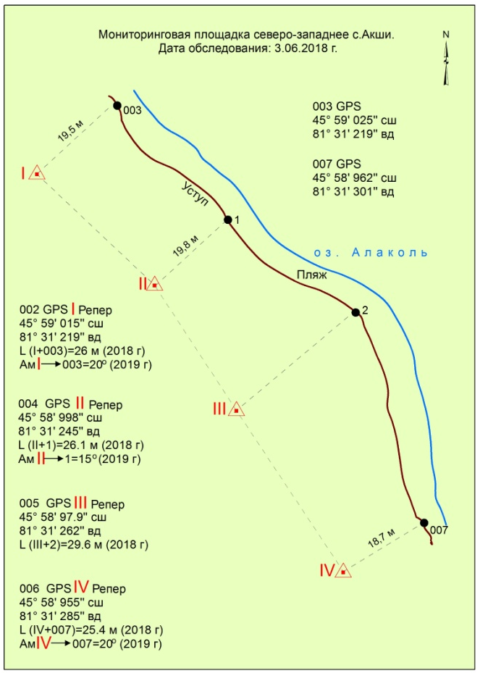
Figure G.68 – Diagram of the dynamics of coastal processing performed by the instrumental method (monitoring site No.1, Akshi village)

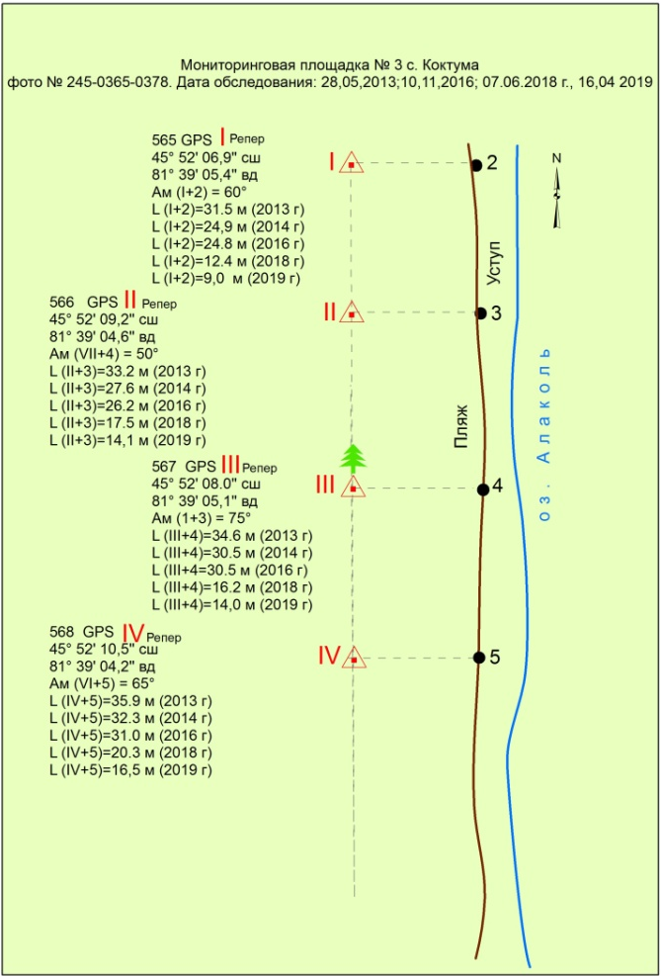
Figure G. 69 – Scheme of the dynamics of coastal processing performed by the instrumental method (monitoring site No.3 of the village of Koktuma)

Table G.20 – Field diary
01.06.2019 г. – 22.06.2019 г. (летний выезд)
№ GPS точки | Координаты | Абсолют-ная высота над уровнем моря, м |  | Название, место расположение |  | Описание | Генезиси геологичес-кий возраст |  |  | Раститель-ность | Современные рельефообразу-ющие процессы | Фото (серия-номер) | Антропоген-ное воздействие |  | Примечание:
1 | 2 | 3 |  | 4 |  | 5 | 6 |  |  | 7 | 8 | 9 | 10 |  | 11
день экспедиции – 01.06.19.
Выезд из г. Алматы в г. Ушарал.
день экспедиции – 02.06.19.
Выезд из г. Ушарал в с. Акши.
Ключевой участок №1, с. Акши
GPS Акши 3.19-19 | 45-58-133 с.ш.  81-32-516 в.д. | 354 |  | Точка находится у зоны отдыха "Керемет" на побережье озера | Выбор места для разбивания лагеря. Сбор мотора для лодки, подготовка самой лодки, снаряжения и оборудования для проведения батиметрической сьемки. Обкатка нового лодочного мотора и пробретение навыков вождения водного транспорта. Для этого лодка была спущена в залив, образованный косой. Был обкатан двигатель и освоены методы батиметрической сьемки. Глубина залива в пределах 4,1 метров. |  |  | laQ_{III-IV} | Травинистая, местами кустарниково-древест-ная |  | Абразия  Биогенная аккумуляция |  | Полевые дороги, активный выпас скота, мусор | Зона отдыха "Керемет" находится очень близко к побережью
день экспедиции – 03.06.19.
GPS Акши 3.19-19 | 45-58-133 с.ш.  81-32-516 в.д. | 354 | Точка находится в зоне отдыха "Керемет" на побережье озера |  | Опрос местных жителей на предмет интенсивности динамики эрозии берегового уступа и также берего-укрепительных работ, применяющих-ся хозяйном дома отдыха «Керемет». Для защиты берегового уступа от эрозионных процессов применены два способа:  1) Поставлены 40 тонные контейнеры, которые были деформированы и разрушены, абразия продолжилась.  2) Между клифом и урезом воды были установлены железо-бетонные кон-струкции, которые также оказались не эффективным берегоукрепительным способом. Влияние вопроса укрепления берега остается открытым для землепользователей и жителей первой линии. |  |  | laQ_{III-IV} | Травяни-стая, местами кустарниково- древест-ная |  | Биогенная аккумуляция |  | Бумажно-пластиковый мусор | Все усилия по берегоукреплению проводят за свой счет без поддержки государства.

Continuation of table G.20
день экспедиции – 04.06.19.
1 | 2 | 3 |  | 4 |  |  | 5 |  |  | 6 |  | 7 |  | 8 |  | 9 | 10 | 11
GPS Акши 1.1-19 | 45-59-091 с.ш.  81-31-172 в.д. | 345 |  | Точка находится в северной части рекреационной зоны с. Акши |  |  | Работы были прерваны ветром и проливным дождем. Были выполнены всего 4 поперечных профиля.  Продолжение лазерного сканирования на мониторинговой площадке №1 у с. Акши. На данном мониторинговой площадке было отсканированно 18 скан позиции. Сканирование проводи-лось на пляжной части побережья с постепенным переходом на поверх-ность уступа.  На уступах проводилось круговое ска-нирование на 360˚. |  |  | laQ_{III-IV} |  | Травянистая,изредка кустарниковая |  | Абразия,  биогенная аккумуляция |  | 122139,122142,122147,122201,122218,124847,124906,124956,125010,125603,125607. | Бумажно-пластиковый мусор | Центральная часть новой туристической инфраструк-туры (2-й съезд к берегу). Вблизи строятся 4-5 пансионата.
день экспедиции – 05.06.19.
- | - | - | Абразионный уступ, точка находится северной части рекреационной зоны с. Акши |  | Продолжены работы по сьемке ре-льефа подводного берегового склона рекреационной зоны с. Акши. Макси-мальные глубины доходили до 8 м от уреза воды. Целый день наблюдалось ветровое волнение высотой 20-30 см. При данном волнении эхолот часто не выдавал значения глубины. Прихо-дилось сбавлять ход, вплоть до ос-тановки, для нормализации работы излучателя и приемника. Ветер до обеда был восточным, после обеда направление ветра изменилось, волны участились и пошли осадки. Мы были вынуждены приостановить батиметри-ческую сьемку. Продолжение лазерно-го сканирования на мониторинговой площадке №1 у с. Акши. На данным мониторинговой площадки было отсканировано 8 скан-позиции. Сканирование проводилось на рав-нинной части рядом с абразионным побережьем. После обеда начали снимать на сканер следующую мониторинговую площадку №2 (название в программе Akshi_2_cen-ter_19). На мониторин-говой площадке №2 у. с. Акши было отсканированно 8 скан-позиции. |  |  |  |  | laQ_{III-IV} |  | Травинистая, изредка кустарниковая |  | Абразия, биогенная аккумуляция |  |  | Полевые и асфальтированные дороги, рядом строения для рекреационных нужд | Центральная часть новой туристической инфраструк-туры (2-й съезд к берегу). Вблизи строятся 4-5 пансионата.  Инфраструктура: освещение, асфальтная дорога, арычная система, канализационные люки, электри-чество.
Continuation of table G.20
1 | 2 | 3 |  | 4 |  |  |  | 5 | 6 |  |  | 7 |  | 8 |  | 9 | 10 | 11
день экспедиции – 06.06.19.
GPS т.043 | 45-59-14,2 с.ш.  81-31-03,2 в.д. | 347 |  | Северная оконечность косы, с. Акши |  |  | Северная оконечность косы, в 2018 г. на данной косе до 5 км, в этом году коса местами размыта. Коса сложена разнозернистым песком, галькой и гравием. Ширина косы у ее око-нечностти –12 м, расширяется к основанию косы до 20,1 м. Ветер – юго-восточный. На озере волнение ветровое. С западе идут грозовые тучи.  Продолжение лазерного сканирования на мониторинговой площадке №2 у. с. Акши. На данной мониторинговой площадке было отсканированно 13 скан-точек. Сканирование проводилось в береговой части, съемка сканером берегового уступа и пляжа. На равнинной части съемка проводилась панорамно на 360˚ и на пляжной части на 0-200˚. |  |  | laQ_{IV} |  | С запада идут грозовые тучи |  | Абразия  Биогенная аккумуляция |  | 100-0586, Видео 100-06,09 | Полевые дороги, бумажно-пластиковый мусор
день экспедиции – 07.06.19.
GPS т.45 | 45-59-12,08 с.ш.  81-31-0,73 в.д. | 344 |  | точка находится северной части рекреационной зоны с. Акши |  |  | Батиметрическая съемка северной час-ти рекреационнной зоны с. Акши от уреза воды были выполнены 4 попе-речных профиля до 10 м глубины. В 9:30 ч. начал дуть СЗЗ ветер. Поднялись волны высотой до 0,5 м. Волнение продолжается, солнечно, без осадков, ветренно. Работу прекретили, т.е. проводить батиметрию стало небезопасно. Урез воды местами доходит до основания берегового уступа, здесь глубины варьируются от 1 до 1,5 м. Данные участки будут интенсивно разрушаться размываться. Создание мониторинговой площадки д.о «Керемет»: GPSт. 047 45 59 11,7 с.ш., 81 31 07,8 в.д.; GPSточка 048 и 049; 1) 45 58 08,3 с.ш., 81 32 29,4 в.д., 2) 45 57 37,2 с.ш., 81 33 38,6 в.д.  Сканирование ключевого участка №3 (мониторинговая площадка 3 у с. Ак-ши, рядом с зоной отдыха). |  |  | laQ_{IV} |  | Травянисто-кустар-никово-древест-ная |  | Абразия |  | 100-0617 | Полевые дороги, тропинки. База отдыха и заборы. |  | Зарисовки в виде схемы. Сканирование в программе Riscan: Akshi_3_south_19. На сегодня на данном мониторинговом площадке было отсканировано 11 скан-точек. Сканирование проводилось на равнинной части, между до-мами отдыха на открытых про-странствах.
Continuation of table G.20
1 | 2 | 3 | 4 |  |  |  | 5 |  |  |  | 6 |  | 7 |  | 8 | 9 | 10 |  |  | 11
GPS т. 50 | 45-57-51,7 с.ш., 81-33-11,5 в.д. | 344 | точка находится в северной части рекреационной зоны с. Акши |  |  |  | Ветер. Волны доходят местами до основания уступа, где расположен пляж, но не доходят до уступа, пляж защищает уступ |  |  |  | laQ_{IV} |  | Травянистая |  | Абразия | 100-0740–0746 | Полевые дороги, тропинки. База отдыха и заборы.
GPS т.51 | 45-57-43,6 с.ш.  81-33-23,5 в.д. | 348 | Точка находится в североной части с. Акши |  |  |  | 5-ти звездочный отель Grand Ville. Зона отдыха-Айдынколь. Фото «Alakol Resort». Высота клифа 6,3 м. Фото д/о “Grand Ville”. В с.Акши вода при-возная, также имеются подземные скважины. Крайняя южная точка в Акши, дом отдыха «Алаколь General». Идет стройка |  |  |  | laQ_{III-IV} |  | Травянистая |  | Абразия | 100-0751-0773-0782 | Полевые дороги, выположенный берег для пляжа. Заборы и тропинки
GPS т.052 | 45-57-40,7 с.ш.  81-33-32,3 в.д. | 348 | Точка находится начало 3 косы |  |  |  | Внутренняя часть залива образован-ного большой косой №3 GPS 45-57-34.2 с.ш., 81-33-41,8 в.д. Фото 100- 0815-0821. Пеший обход вдоль берега. Посещение метеопоста Акши. По данным начальника станции Н. Алексеевой, климат изменился. Рань-ше огород сажали в марте, сейчас в июне и до сих пор холодно. Когда «Евгей» был тепло приходило, а «Сайкан» – приносил холод, а сейчас – наоборот. После «Евгея» заморозки, а «Сайкан» тепло приносит. Не реко-мендуется плавать при волнении, особенно надо быть осторожным при ветре «Горняк» (южный ветер) и «Сайкан» – западный ветер. Купальный сезон в июне 1 месяц жары, с 5 августа начинается по холодание.GPS т. 062 Центральная часть рекреационной зоны Акши. 45-57-06,1 с.ш., 81-34-41,1 в.д. Фото 100-0906-0910 |  |  |  | laQ_{IV} |  | Травянистая |  | Абразия | 100-0783-0790 | Полевые дороги, бумажно-пластиковый мусор
GPS т. 100 | 45-57-12,5 с.ш. 81-34-37,3 в.д. |  | Точка находится начало большой третий косы. |  |  |  | Коса протягивается на 2,7 км. Взяли точку у начала косы, когда проводили батиметрию, чтобы узнать расстояние. Ширина основания - 69,6 м. Коса сложена из разнозернистого песка. Вперемежку с галькой, гравием и валунами. т. 101 GPS |  |  |  | laQ_{IV} |  |  |  | Абразия  Биогенная аккумуляция | 100-0928-0935 | Полевые дороги, бумажно-пластиковый мусор
Continuation of table G.20
1 | 2 | 3 |  | 4 |  | 5 |  |  |  | 6 |  | 7 |  | 8 |  | 9 | 10 |  | 11
GPS т. 101 | 45-57-00.5 c.ш., 81-34-43,1 в.д. | 343 |  | Точка находится на косе, следы от автотранспорта. |  | Начало берегового уступа в восточном направлении после 3-ей длинной косы, высота уступа начинается от 0,5 м и повышается в восточном направлении. Данное место отличается широким пляжем, шириной 18 м, урез воды не достигает основания уступа. Пляж сложен разнозернистой песком, галь-кой гравием, валунником, выражена сортировка: галька, галечник, валун-ник отложены ближе к урезу, песок отложен у уреза воды и в центральной части косы. Уступ сложен из суглин-ков, глины с включением песка, гальки и гравия. |  |  |  | laQ_{IV} |  |  |  | Абразия  Биогенная аккумуляция |  | 100-0936-0941 | Полевые дороги, бумажно-пластиковый мусор
GPS т. 102 | 45-57-00,6 c.ш., 81-34-43,3 в.д. | 343 |  | Точка находится в средней части берега Акши. |  | Высота уступа достигает более 4 м. Пляж сложен галькой, галечником и разнозернистой песком. Ширина – 21 м, береговой уступ отвесный - 90˚. Урез воды не достигает основания уступа. Средняя часть правого берега Акши, высота уступа 5,5 м, сложен галькой, галечником с супесями. Ширина пляжа – 20,6 м. Урез воды до основания уступа не доходит. 100-0954-0968. |  |  |  | laQ_{IV} |  | Травяни-стая, местами кустарниково- древес-ная |  | Абразия  Биогенная аккумуляция |  | 100-0942-0951 | Исскуственно выположенный берег для пляжа. Заборы и тропинки
день экспедиции – 08.06.19.
GPS т. 105 | 45-56-22,8 c.ш., 81-35-11,6 в.д. | 343 |  | Средняя часть берегового уступа. 3-ей большой косы (с. Акши) |  | Встали в 6:00, чтобы выполнить батиметрическую съемку. Предыду-щие дни были с нестабильными погодными условиями (ветер).  Однако с утра до 9:30, волнение не наблюдалось, была спокойная гладь озера, необходимая в нашем случае – для съемки батиметрии. В вечернее предзакатное время озеро также становится более спокойным. Сегодня до начала волнения (7-20) успели сделать 4 поперечных профиля подводного берегового склона. Подул ветер и поднялись волны, в целях безопасности были вынуждены прекратить батиметрическую съемку. Максимальные глубины – 10-14 м. |  |  |  | laQ_{IV} |  | Травяни-стая, местами кустарниково- древес-ная |  | Абразия  Биогенная аккумуляция |  | 100-1066-1084 |  |  | Урез воды не доходит до основания уступа. Пляж преимуществен-но сложен песком, галькой, гравием и валунником. Ветер восточный.
Continuation of table G.20
1 | 2 | 3 |  | 4 | 5 |  |  |  |  |  | 6 | 7 |  | 8 |  | 9 | 10 |  | 11
 |  |  |  |  | Встречаются трещины глубиной до 20 м. Всего за эти дни были зафиксированы 3 трещины. В 10:00 продолжили пеший маршрут вдоль берегового клифа рекреационной зоны Акши. Высота уступа от 5,5 м до 6 м, ширина пляжа – 17 м. Уступ сложен разнозернистым песком, галькой, галечником, суглинками, с вклю-чением валунника. Продолжение ла-зерного сканирования на монито-ринговой площадке №3 у с. Акши. На сегодняшнее число 11 скан точек, а всего на участке 22 скан-точек.
GPS т. 106 | 45-56-22,8 c.ш., 81-35-11,6 в.д. | 343 |  | Метеостанция, точка находится в центре с.Акши, ближе к берегу озера Алаколь | Укрепление берегового уступа желе-зобетонными конструкциями. Кон-струкция целая, без повреждений, пирс сохранен от разрушений.  В метре от фронтальной части уступа установлены волнорассекатели, пред-ставляющие собой сваи, вбитые или закопанные в землю. Сваи установ-лены на расстоянии друг от друга около 4 м и 1 м от бетонной конструкции, по основанию свай проходит продольно круглая железо-бетонная конструкция d 50-80 см, зарытая в землю.  Каждый рассекатель закреплен проводом с зарытой конструкции. Высота уступа начала понижаться идет на понижение в сторону дельты р. Жаманты (коса Кызылагаш). Высота уступа 3,50-3,80 м. Ширина пляжа – 14,6 м. Ширина пляже началось сокрашаться. Вдольбереговой перенос осадочного материала целиком и полностью зависит от направления ветра и соответственно формируемым направлением волн. Трактор сдвинул грунт к урезу воды. В ветренную погоду (ветер сев., сев-зап.) взмугченная вода начала двигаться в поветренном направлении. Если меняется направление ветра, соот-но меняется и перенос вдольбереговой. Уровень а) Алаколь по данным гидропоста Акши на 7.06.2019 г. |  |  |  |  |  | laQ_{IV} | Травяни-стая, местами кустарниково- древес-ная |  | Абразия  Биогенная аккумуляция |  | 100-1119-1137, 1162-1178, 1197-1215. | Исскуственно выположенный берег для пляжа. Заборы и тропинки |  | Относительный уровень (данные измерения) 15,13 см. Отметка нуля поста – 335,65 (БО) Всего 335,65 +15,13 = 350.78 м.  Батиметрия от уровня уреза воды: 350,78 м и на понижение.

Continuation of table G.20
1 | 2 |  | 3 |  |  | 4 |  | 5 | 6 |  |  | 7 | 8 |  | 9 | 10 | 11
день экспедиции – 09.06.19.
GPS т. 108 | 45-58-13,7 с.ш.  81-32-17,0 в.д. |  |  | 358 |  | Точка расположена севернее косы №2. |  | Ясная погода, ветер восточный, на озере волнение. В целях безопасности батиметррию не выполняли. Пеший маршурт, обход левого берега Акши.Выположен береговой уступ для спуска отдыхающих на поверхности берегового уступа.расположен ДО. Уступ высотой 3 м. Ширина пляжа – 9,1 м. Литология уступа: разнозеристый песок, галька, галечник 0,5 м верхний части клифа занимает суглинки, глины с включением разнозер. песка. Пляж сложен галькой, галечником, песком. | laQ_{III-IV} |  | Травини-стая, местами кустарниково- древест-ная |  |  | Абразия  Биогенная аккумуляция | 100-1319-1326 | Исскуственно выположен-ный берег для пляжа. Заборы и тропинки
GPS т. 109 | 45-58-19,5 с.ш.  81-32-04,4 в.д. |  |  | - |  | Урез воды до основания уступа не доходит |  | Лопастное углубление в сторону суши. Ширина пляжа – 15 м (увеличилось), высота уступа – 2,5 м, уступ сложен преимущественно из суглинков 2 м и у основания – песок, галька. У основания уступа отложена обрушенное тело клифа. Ширина косы – 14 м. | аpQ_{III-IV} |  | - |  |  | Абразия  Биогенная аккумуляция | 100-1340-1360, 1361-1479 | - | Зарисовки в виде схемы
GPSт. 110 | 45-58-28,8 с.ш.  81-31-55,4 в.д. |  |  | 352 |  | Основания коса №1 |  | Высота косы от уреза воды достигает 2 метра, ширина 40,3 м. | laQ_{III-IV} |  | - |  |  | Абразия  Биогенная аккумуляция | 100-1359-1396 | Полевые дороги, бумажно-пластиковый мусор | Зарисовки в виде схемы
GPS т. 111. | 45-58-39,6 с.ш., 81-31-44,2 в.д. |  |  | 345 |  | Конусовая часть косы №1. |  | Высота от уреза воды около 1 м. Коса полукругом поворачивает в сторону берегового уступа, где образовался малый залив между уступом и косой. Ширина косы 32,1 м | laQ_{IV} |  | - |  |  |  | 100-1400-1418 | Полевые дороги, бумажно-пластиковый мусор | Зарисовки в виде схемы
GPS т. 112. | 45-58-09,5 с.ш., 81-31-26,9 в.д. |  |  | 342 |  | Вершина расположена в концевой части косы №2. |  | Высота уступа 3 м, ширина пляжа – 5,4 м | laQ_{IV} |  | Древесно-кустар-никовая, травянис-то-луго-вая рас-тительность |  |  | Абразия  Биогенная аккумуляция | 100-1419-1444 | Полевые дороги, бумажно-пластиковый мусор | Зарисовки в виде схемы
Continuation of table G.20
1 | 2 |  |  | 3 | 4 |  | 5 |  |  | 6 |  | 7 | 8 |  | 9 | 10 | 11
GPS т.113 | 45-58-08,5 с.ш.  81-32-50,1 в.д. |  |  | 348 | Основание косы №2 |  | Ширина пляжа – 47,2 м. Превышение над урезом воды около 1 м. Преимущественно песок, галька, гравий. GPS т.115. 45-58-11,9 с.ш.  81-32-33,4 в.д.һ-349 м. Ширина косы 14 м, глубина залива 4 м, росстояние от уступа до косы – 70 м. |  |  | laQ_{IV} |  | - | Абразия  Биогенная аккумуляция |  | 100 – 1461-1479 | Полевые дороги, бумажно-пластиковый мусор | Нарушение естествен-ного фона, зарисовки в виде схемы
день экспедиции – 10.06.19.
- | - | - |  |  | д.о «Керемет» |  | Опрос местных жителей. За последние 2 года уступ предвинулся на 40 м. Северная оконечность косы №2 за один год нарасло на 70 м, северная оконечность год назад находилось на уровне его ДО, а в этом году краевая часть продвинулось в северном направлении. (выросла). Т. о. его уступ сейчас защищает коса, эрозия прекратилась. В основном разрушение берега просходит в сентября и очень интенсивная эрозия была за последние 2 года. Берегоукрепление в виде 6 м железобетонных плит и 2, 40 футовых контейнеров за один год были разрушены. Ветер «Сайкан» сильно не действует на эрозию берега в Акши в основном действует «Евгей», однако по форме косы, завернутые в сторону уступа говорит о том. Что в этом процессе участвует «Сайкан». |  |  | аQ_{IV} |  | растительность: ива, тамарикс, жида, соран, ажирек, чий | Абразия  Биогенная аккумуляция, родник |  | 333-9581-9585 | Полевые дороги, бумажно-пластиковый мусор | Нарушение естествен-ного фона, именно на этот берег основное воздействие оказывает «Евгей» осений период.
Ключевой участок №2, с. Коктума. день экспедиции – 11.06.19.
- | - | - |  | Средняя часть берегового уступа с. Коктума |  | Батиметрическая съемка подводного берегового склона у с. Коктума. Штиль, облачно температура воды 15˚С. Построены 10 поперечных профиля до глубины 13 м. Погодные условия благоприятны и позволили закончить батиметрию за 1 день. Глубина увеличивается постепенно. Есть углубления в виде желобов глубиной до 17,3 м. Сканирование на оборудовании VZ-4000 ключевой участок находится в западной части от с. Коктума, рядом пионерский лагерь «Шағала». Название проекта сканирование в программе Riscan: Koktuma_west_19.На данном мониторинговой площадке было отсканировано 12 скан-точек. |  |  |  |  | аQ_{IV} |  | Древест-но-кустарниково-травинистая растительность | Абразия  Биогенная аккумуляция | ----- | Полевые дороги и выпас скота,антропогенное выполаживание уступа для спуска туристов |  | Сканирование проводился в пляжной части оз. Алаколь. При сканировании были сложности в виде близости уступа, так как, сканер не может от стять расстояние в радиусе до 5 м.
Continuation of table G.20
1 | 2 |  | 3 |  | 4 |  |  |  | 5 | 6 |  |  | 7 | 8 | 9 | 10 |  |  | 11
день экспедиции – 12.06.19.
GPSт.116 | 45-52-11,8 с.ш.  81-39-04,1 в.д. |  | - |  | Пеший обход берега с. Коктума. Сканирование на равнинной части. |  |  |  | Средняя часть берегового уступа с. Коктума. Высота уступа – 4 м. Ширина пляжа – 5,3 м. Уступ сложен суглинком, пляж – песком, гравием. Погода облачная. Штиль 2-ой день.  Продолжение лазерного сканирования на монитоинговой площадке №3 у села Коктума. Ключевой участок расположен в западной части от с. Коктума, рядом находится пионерский лагерь «Шағала». На сегодня на данной мониторинговой площадке было отска-нировано 19 сканточек. | аpQ_{III-IV} |  |  | Древес-но-кустарниково-травянистая растительность | Абразия  Биогенная аккумуляция | 100-1813-1828 | Полевые дороги и выпас скота, антропогенное выполаживание уступа для спуска туристов |  |  | При сканиро-вании были сложности в виде густых зарослей кус-тарников, деревьев, которые создают больше теневых сторон или не отсканир-ованных части сторон.
GPS т.117 | 45-52-32,8 с.ш.  81-38-57,0 в.д. |  | - |  | Северная часть (крайняя) с. Коктумы. |  |  |  | Береговой клиф высотой 3,3 м, ширина пляжа 6,5 м. Литология – песок, галька, галечник. Уступ сложен суглинком. Идет активный процесс переработки берегов, поваленные деревья, разрушение берегового уступа. Т. 6. Северная часть уступа с. Коктума. Ширина пляжа – 5,2 м. Высота уступа – 1,5 м. Высота уступа понижается в северном направлении к правого рукава дельты р. Жаманты. На поверхности уступа тугайная густая растительность. | аQ_{IV} |  |  | Древес-но-кустарниково-травянистая растительность | Абразия  Биогенная аккумуляция | 100-1884-1888  100-1903-1908 | Полевые дороги и выпас скота, антропогенное выполаживание уступа для спуска туристов
GPS т.118 | 45-52-05,1 с.ш.  81-39-07,4 в.д. |  | - |  | Центральная часть уступа |  |  |  | Береговой залив с. Коктума. Высота уступа 4,1-4,2 м, сложен суглинками. Ширина пляжа – 6,5 м. | аQ_{IV} |  |  | Древес-но-кустарниково-травянистая растительность | Абразия  Биогенная аккумуляция | 100-1928-1935 | Полевые дороги и выпас скота, антропогенное выполаживание уступа для спуска туристов
Continuation of table G.20
1 | 2 |  | 3 |  | 4 |  |  | 5 |  | 6 |  |  | 7 | 8 | 9 | 10 |  |  | 11
GPS т.119 | 45-52-50,4 с.ш.  81-39-18,1 в.д. |  | - |  | Восточная часть береговой зоны с. Коктума |  |  | Береговой уступ высота – 5,5 м. Литологический состав: суглинки. Ширина пляжа – 6,2 м. Волноприбойные ниши и обрушения. |  | аpQ_{III-IV} |  |  | Древес-но-кустарниково-травянистая растительность | Абразия  Биогенная аккумуляция | 100-1962-1975 | Полевые дороги и выпас скота, антропогенное выполаживание уступа для спуска туристов
GPS т.120 | 45-51-40,5 с.ш.  81-39-36,7 в.д |  | - |  | Восточнее с. Коктума. |  |  | Самая высокая часть уступа h =10 м. Ширина пляжа 4,5 м. Высота уступа повышается, ширина пляжа сокращается. |  | аpQ_{III-IV} |  |  | Древес-но-кустарниково-травянистая растительность | Абразия  Биогенная аккумуляция | 100-1991-2004 | Полевые дороги и выпас скота, антропогенное выполаживание уступа для
день экспедиции – 13.06.19.
Отсканирование точка №1 Коктума 2,2-19 | 45-51-684 с.ш.  81-39-584 в.д |  | 357 |  | Ключевой участок находится на юго-восточной части от с. Коктума, рядом овраг и южнее расположены новостроенные дома отдыха. |  |  | Ветер, дождь. Уровень воды - 350,78 м. Сканирование на оборудовании VZ 4000 ключевого участка №2 у с. Коктума. Изучение динамики абразионного процесса на побережье оз. Алаколь. Сканирование в програме Riscan: Koktuma_East_19. На сегодня на данном мониторинговой площадке было отсканированно 10 скан-точек. |  |  | аpQ_{III-IV} |  | Древес-но-кустарниково-травянистая растительность | Абразия  Биогенная аккумуляция | 336-96-57-9680 | Полевые дороги и выпас скота, антропогенное выполаживание уступа для спуска туристов |  |  | Сканирование проводилось в равнинной части, при сканировании были сложности в виде густой заросли растении и проводился панорамно на 360˚.
Continuation of table G.20
1 | 2 |  | 3 |  | 4 |  |  | 5 |  |  | 6 |  | 7 | 8 | 9 | 10 |  |  | 11
день экспедиции – 14.06.19.
GPS т.121 | 45-53-15,7 с.ш.  81-38-50,6 в.д. |  | 349 |  | Полевой пеший маршрут по косе р.Жаманты. ( правый приток).  Ключевой участок расположен в юго-восточной части с. Коктума. |  | Правый рукав р. Жаманты выходит между южной оконечностью косы – пляж дельты р. Жаманты. 1): оценка динамики переработки берегов для эффективного (изменения) прибрежными (отступания) территориями. 2) оценка скорости и обьема изменения берегов оз. Алаколь для планирования и землеустройства береговогой зоны. 3) оценка динамики изменения эрозионных берегов рекреационных зон с. Акши и Коктума для разработки рекомендации и мероприятии по землеустройству планирования (развитию) рекреационных. и селитебных инфраструктур. Коса-пляж расположена на фронтальной части дельты Жаманты, опоясывая ее полу-кругом с южной части, размывающаяся между пляжем берега правым рукавам в р. Жаманты. С сев. части коса-пляж переходит в косу Кызылагаш. Образуя заводь, втекает левый рукав р. Жаманты. Подтопление дельтовой части образует водно-болотные угодья. Выше по течению ВБУ сменяются тугайной растите-льностью. У уреза воды проходит пляж. Продолжение лазерного сканирования на мониторинговой площадке №2 у с. Коктума. На сегодня на данной мониторинговой площадке было отсканировано 18 скан-точек. Скани-рованиие проводилось на равнинной части, на пляже и косе. |  |  |  | Q_{III-IV} |  | Лох, шенгель, чий. превалирует кустарниковая растителность, переходящая в густую древесную, деревесно-кустар-никовую растительность. | Правый берег правого притока р. Жаманты представляет аккумулятивную аллювиально-дельтовую равнину. | 100-2013-2034, 100-1777-1737. | Выпас скота, бумажно-пластиковый мусор | Расположение зарисовано в виде рисунка. Правый рукав ярко выражен видем при впадими в водоем 1) струя течение продолжается в водоеме на расстоянии от 50 до 100 м. 2) от личается цвет воды речной от озерной. Левый берег правого притоке сложен обломочными породами:  разнозернистый песок, валунник, галечник, галька.
день экспедиции – 15.06.19.
GPSКоктума 2,29-19 | 45-51-92,1 с.ш.,  81-39-21,9 в.д. |  | 354 |  | Точка находиться на юго-восточной части с. Коктума. |  | Продолжение сканирования в. с Коктума и далее поездка на мониторинговые участки в с. Кабанбай ВКО. Точка на уступе, от бровки уступа 1,5 м. Точка для этого скан-проекта является завершаюшим. Проверка резуль-татов сканирования, предварительная сшив-ка. Сбор лагеря. Выезд из с. Коктума в с. Ка-банбай. Вечером прибытие в с. Кабанбай. Обустройство лагеря. |  |  |  | Q_{III-IV} |  | густая древесная, деревесно-кустар-никовая растительность. | Абразия  Биогенная аккумуляция |  | Выпас скота, бумажно-пластиковый мусор | Каждую скан-позицию фиксировали на GPSи проводили фотофиксацию.
Continuation of table G.20
1 | 2 |  | 3 |  | 4 |  |  | 5 |  |  | 6 |  | 7 | 8 | 9 | 10 | 11
16.06.2019 Выходной день
день экспедиции – 17.06.19.
GPS т.506 | 46-04-924 с.ш.  82-01-754 в.д. |  | 423 |  | Полевой пеший маршрут. Точка расположена севернее волнореза в 1 км. |  |  | Ветренно, ветер СЗ. З сильный на озере волнение высотой 0,5 м. Берег аккумулятивный, выположенный (антро-погенно), сложен разнозернистым песком, галькой и галечником. |  |  | lаQ_{III-IV} |  | Древесно-травянис-то-кустарниковая | Абразия  Биогенная аккумуляция | 100-2245-2250 | Выпас скота, бумажно-пластиковый мусор
GPS т.507 | 46-05-15,9 с.ш.  82-01-66,4 в.д. |  | 422 |  |  |  |  | Береговой уступ высотой до 1 м. Шириной 50-60 м, поверхность уступа искуственно сглажена. Уступ сложен суглинками. Волны подмывают основание уступа, урез воды у основания уступа территории дома отдыха 1 и 2-х этажныого здания. Севернее начинается аккумулятивная равнина с песчано-галечниковым пляжем-косой, которая переходит в косу. |  |  |  | аQ_{III-IV} | Травянисто-кустарниковая | Абразия  Биогенная аккумуляция | 100-2251-2276 | Выпас скота, бумажно-пластиковый мусор
GPS т.508 | 46-05-22,1 с.ш.  82-01-62,5 в.д. |  | 424 |  | Точка находится начала косы |  |  | Коса отделяет озерную равнину от уреза воды. У косы озерная равнина пред-ставлена болотистой местностью, которая подвергатся активной застройке, делаются насыпи. Ширина косы – 21,5 м. |  |  |  | аQ_{III-IV} | Травянистая | Озерная и  биогенная аккумуляция | 100-2277-2291 | Бумажно-пластиковый мусор
день экспедиции – 18.06.19.
 |  |  |  |  | Пеший обход центр. части набережной рекр. зоны с. Кабанбай. |  |  | Пеший обход центр. части набережной рекр. зоны с. Кабанбай. Зафиксирована переработка берегового уступа с апреля месяца текущего года на 2-3 м, расположенного сев-е д.о «Аквамарин», начиная с берегоукрепительной метал-лической конструкции и до д.о. «Алаколь». Восстановлена вся инфраструктура набе-режной по сравнению с апрелем. Пеший обход южной части рекр. зоны с. Ка-банбай. Коса предположительно протя-гивается до дельты р. Тасты и далее на юг. Затопленная часть засыпается грунтом (между косой и сушей). |  |  |  | laQ_{III-IV} | Древес-но-кустарниково-травянистая | биогенная аккумуляция | 100-2314-2509, 2510-2560 | Полевые дороги, выпас скота, мусор |  |  | Зафиксирована эрозия правой части (севернее) основания волнореза, разрушение бетона. Происходит застройка рекреационным обьектом: построен парк.
Continuation of table G.20
1 | 2 |  | 3 |  | 4 |  |  | 5 |  |  |  | 6 | 7 | 8 | 9 | 10 |  |  | 11
GPS т. 509 | 46-05-51,4 с.ш.  82-01-44,2 в.д. |  | 423 |  | Середина косы |  |  | Между равниной и косой расположено ВБУ, занятое водой, образуя болотце. |  |  |  | laQ_{III-IV} | Древес-но-кус-тарниково-травянистая | биогенная аккумуляция | 100-2302 | Полевые дороги, выпас скота, мусор
день экспедиции – 19.06.19.
GPS т. 510 | 46-05-51,4 с.ш.  82-01-44,2 в.д. |  | 423 |  | Северная оконечность косы |  |  | Батиметрическая съемка подводного берегового склона рекр. зоны с. Кабанбай. Безветренная погода, штиль. Подводный склон пологий до 100 метров расстояние. После обеда в 17:00 выезд в Камыскала, ночевка в Ушарале. |  |  |  | laQ_{III-IV} | Древес-но-кустарниково-травянистая | биогенная аккумуляция | 100-2303-2313, 2568-2753 | Полевые дороги, выпас скота, мусор
день экспедиции – 20.06.19.
- | - |  | - |  | Мониторинговая площадка №1 у с. Камыскала. |  |  | Замер ранее установленных реперов динамики абразионного берега оз. Алаколь. Памятник расстояние от бровки уступа – 5,65 м. Штормовой восточный ветер. Высота волн достигает 1 метра. Волнами вода размывает основание уступа. Батиметрию в целях безопасности решили не выполнять. |  |  |  | lQ_{III} | Травянистая растительность. Мест-ность пол-ностью проросла трост-ником | Заболачивание, абразия, затопление |  | Полевые дороги, активный выпас скота, памятник, рыболовство |  |  | Установлены репера, имеется схема расположе-ние и местоположение реперов
день экспедиции – 21.06.19.
 |  |  |  |  | Выезд из Камыскала в г. Алматы. |  |  | Начевка у реки Акешки, 50 км не доезжая г. Талдыкорган.
день экспедиции – 22.06.19. Приезд в. г. Алматы

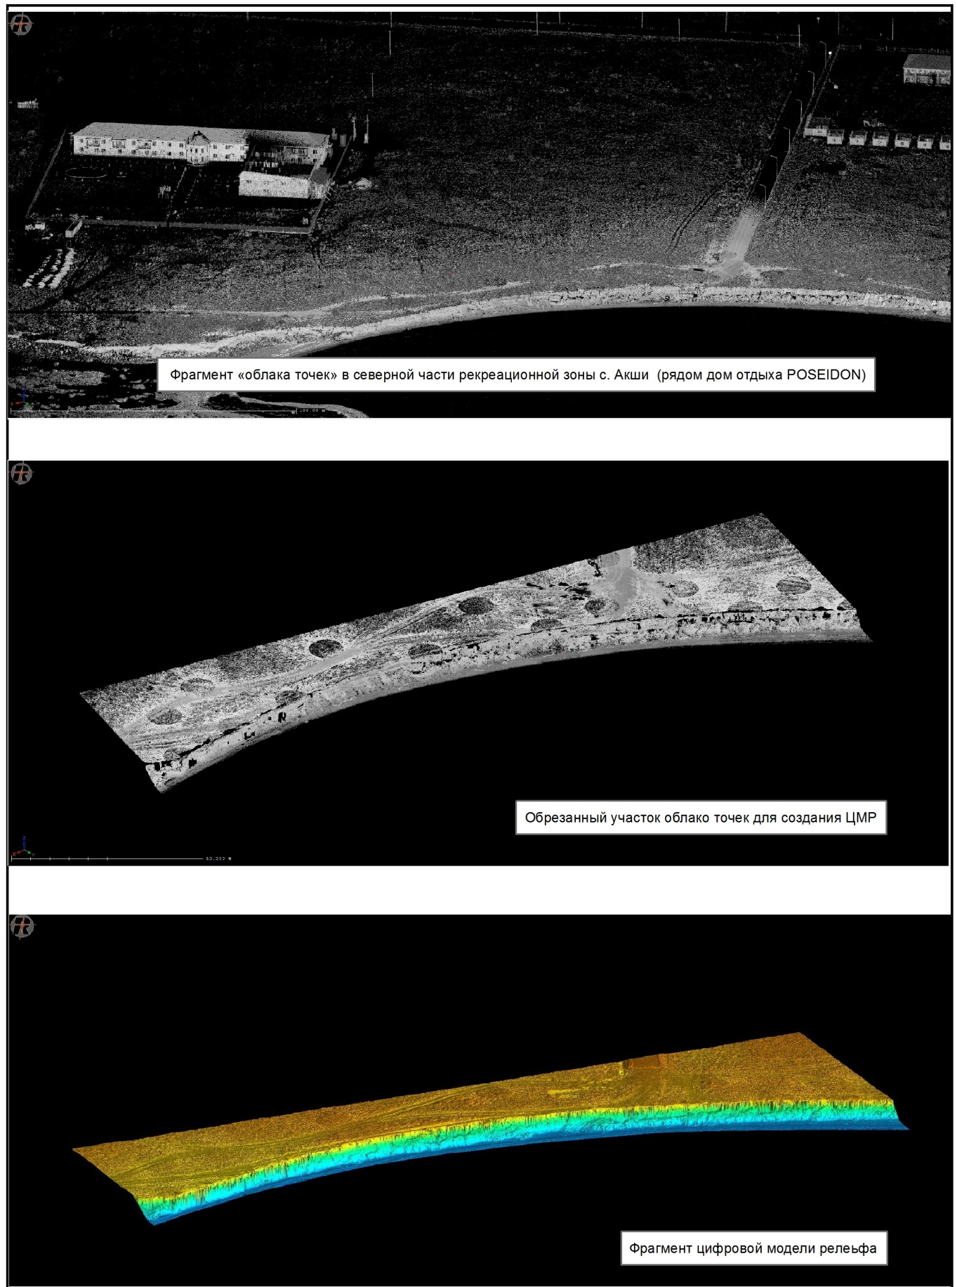
Figure G.70 – The main stages of creating a DEM

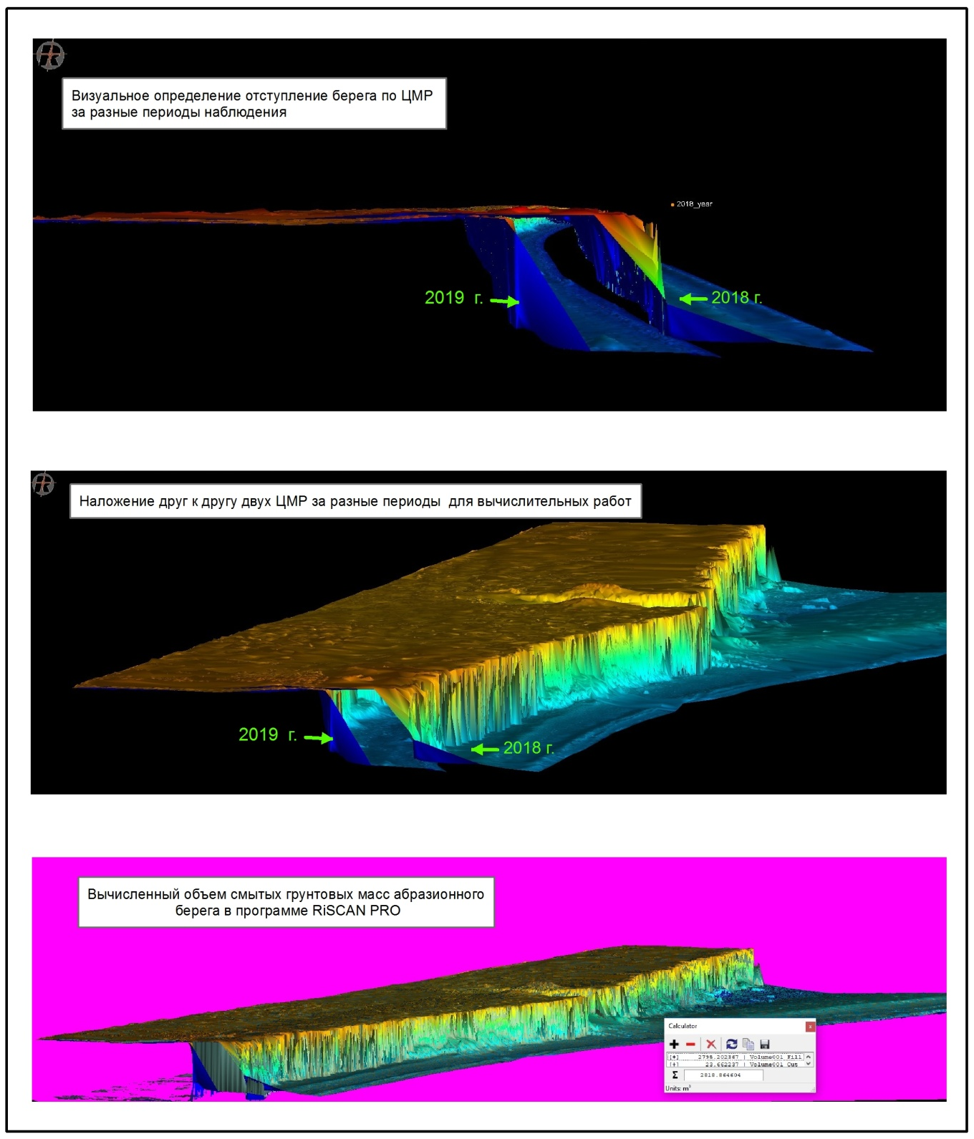
Figure G.71 – The main stages of creating a DEM

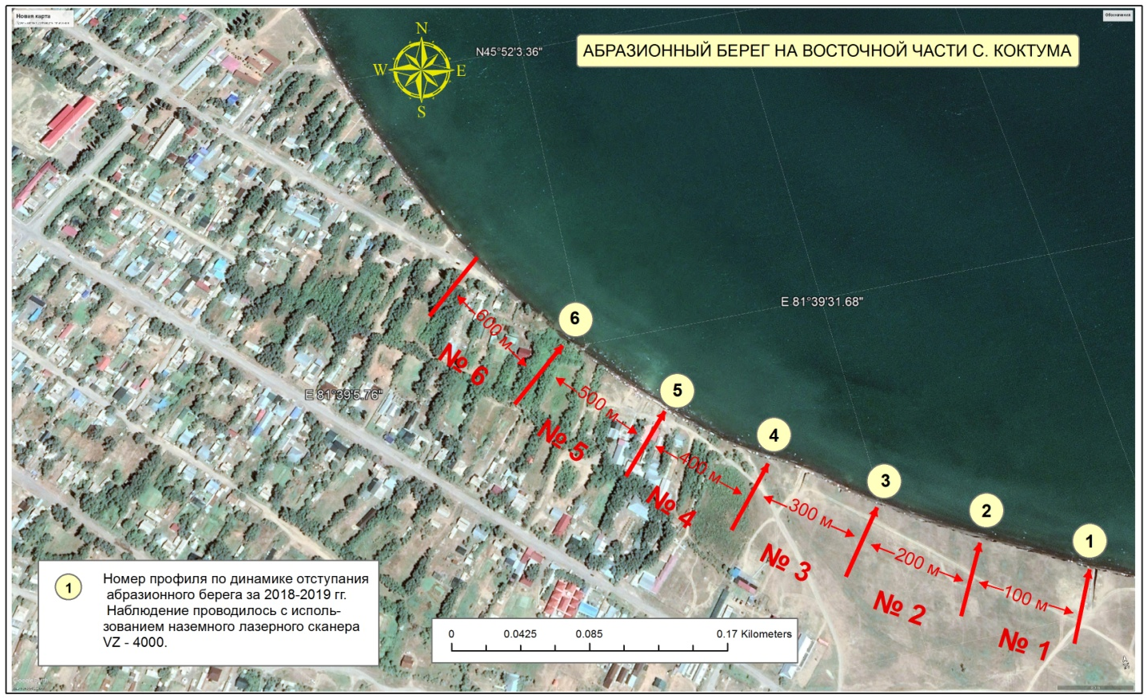
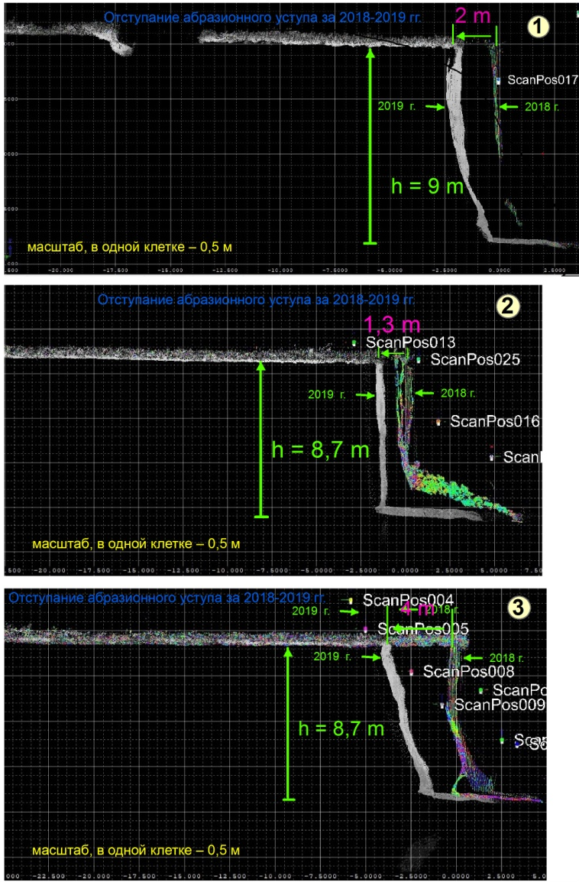 | 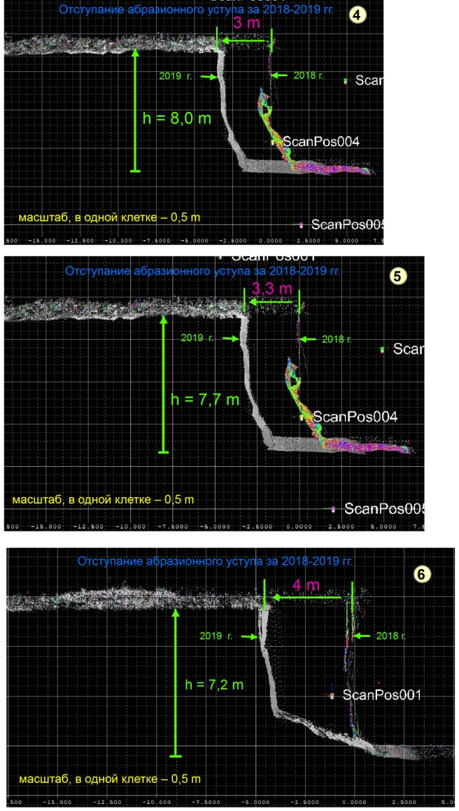
Figure G.72 – Transverse profiles to identify the retreat of the abrasion coast in the eastern part of the village Koktuma

Table G.21 – Recycled soil volume of the coastal scarp of lake Alakol (2018-2019)
Место наблюдения | Координаты места наблюдения | Название проекта в программе RiSCAN PRO | Наблюдаемое расстояние вдоль берега, в метрах | Смытый объем грунтовых масс, в куб.м.
Ключевой участок №2, восточная часть с. Коктума | 45º51′39,25″  81º39′38,83″ | Koktuma East | 200 | 5536
Ключевой участок №1, 2.5 км сев.зап. с. Акши | 45º58′10,83″  81º32′23,68″ | Akshi 3 sourth | 150 | 2794
Ключевой участок №1, 3.8 км сев.зап. с. Акши | 45º58′35,61″  81º31′33,14″ | Akshi 2 center | 200 | 3394
Ключевой участок №1, 4,5 км сев.зап. с. Акши | 45º59′00,25″  81º31′15,87″ | Akshi 1 north | 100

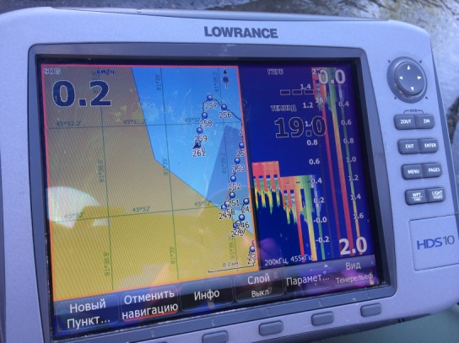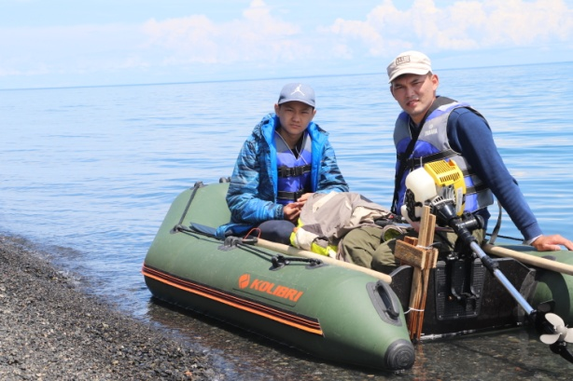
Figure G.73 – Bathymetric survey with a LOWRANCE echo sounder, coastal zone village Koktuma

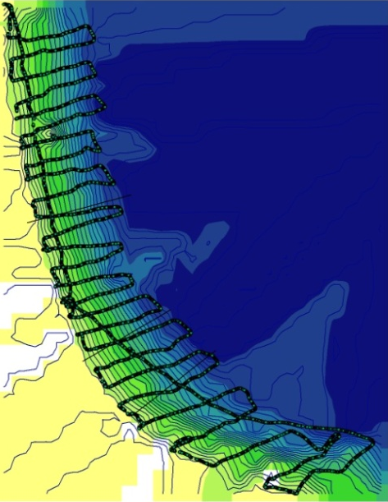
Figure G.74 – Scheme of the underwater coastal slope and bathymetric survey track (Koktuma village)
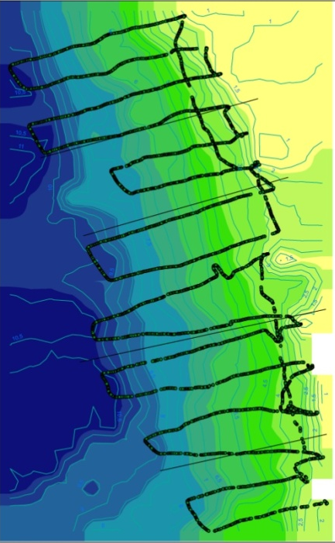
Figure G.75 – Scheme of the underwater coastal slope and bathymetric survey track (Kabanbay village)

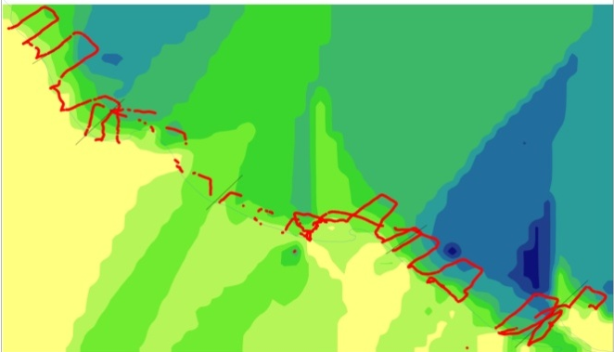
Figure G.76 – Scheme of the underwater coastal slope and bathymetric survey track (v. Akshi)

2018 | 2019
a)
2018 | 2019
b)
2018 | 2019
c)
Figure G.77 – Cross-sectional profiles for 2018 and 2019: a) p. Kabanbay, b) s. Koktuma,
c) village Akshi

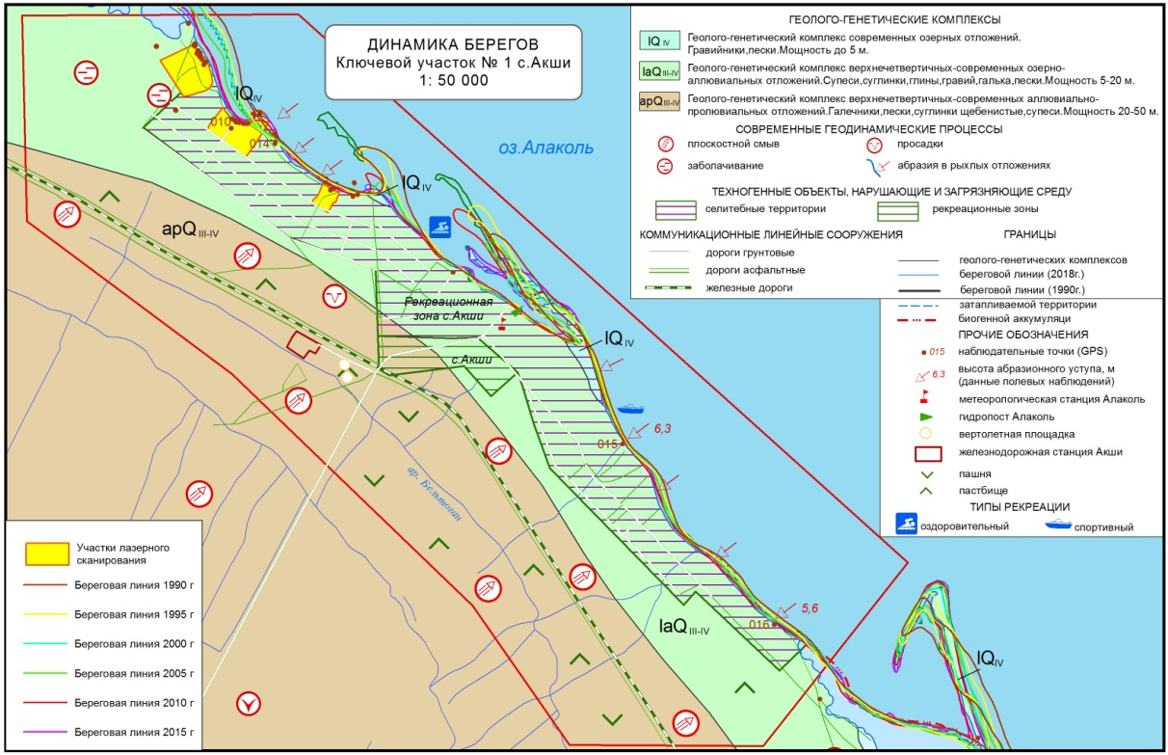
Figure G.78 – Coastal dynamics. Key plot No.1 of Akshi village

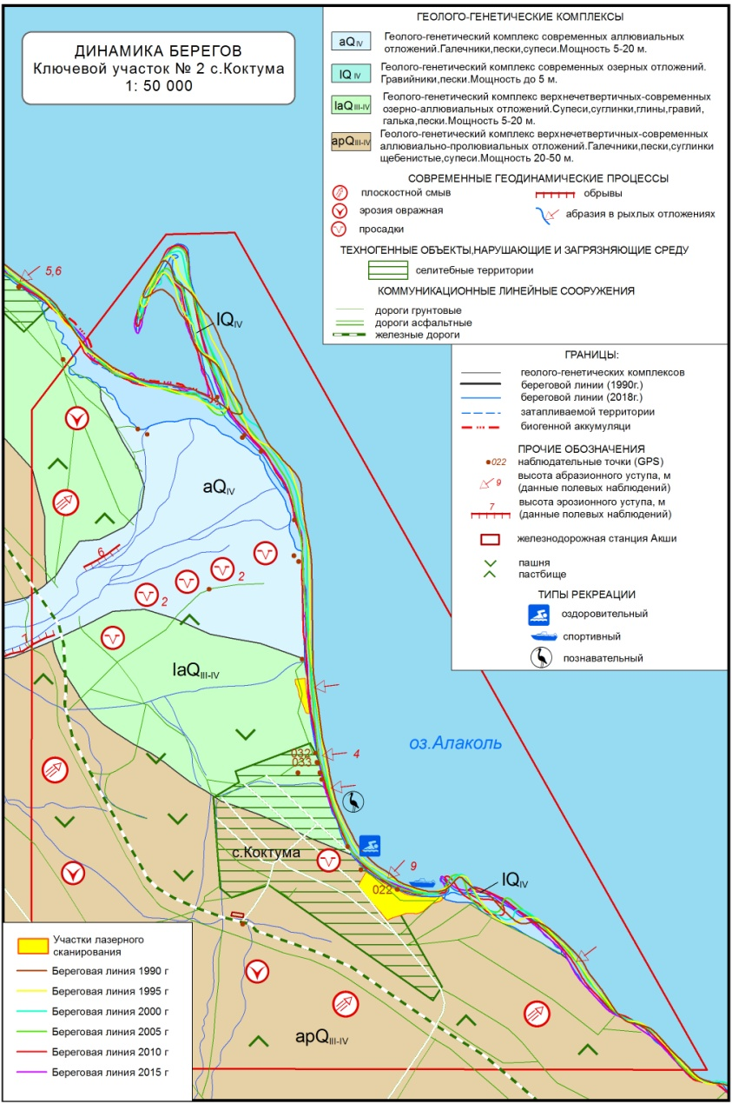
Figure G.79 – Coastal dynamics. Key site No.2 of Koktuma village
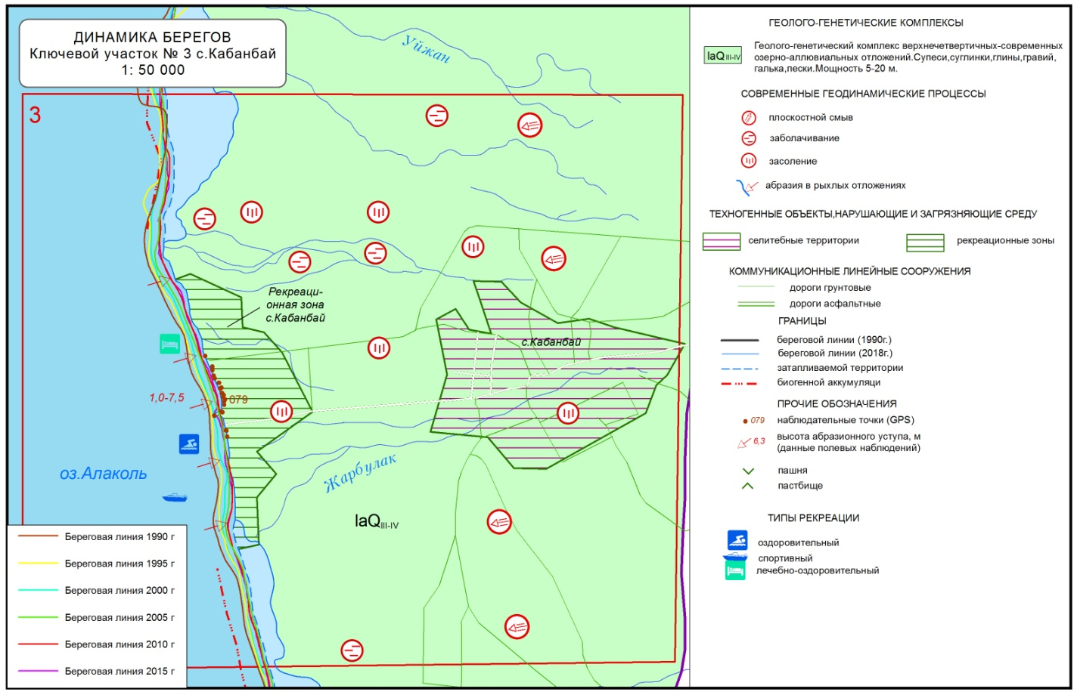
Figure G.80 – Coastal dynamics. Key site No.3 village Kabanbay

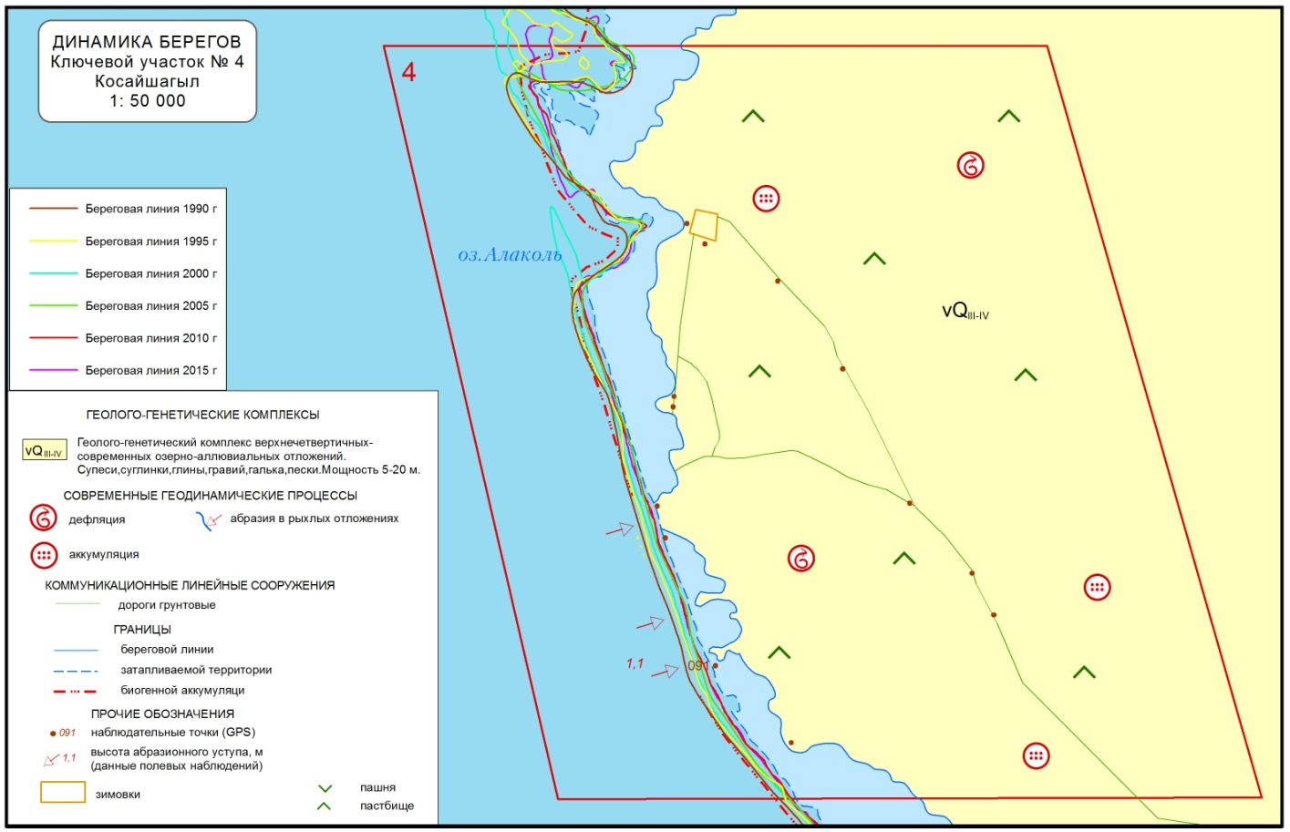
Figure G.81 – Coastal dynamics. Key site No.4 village Kosayshagyl

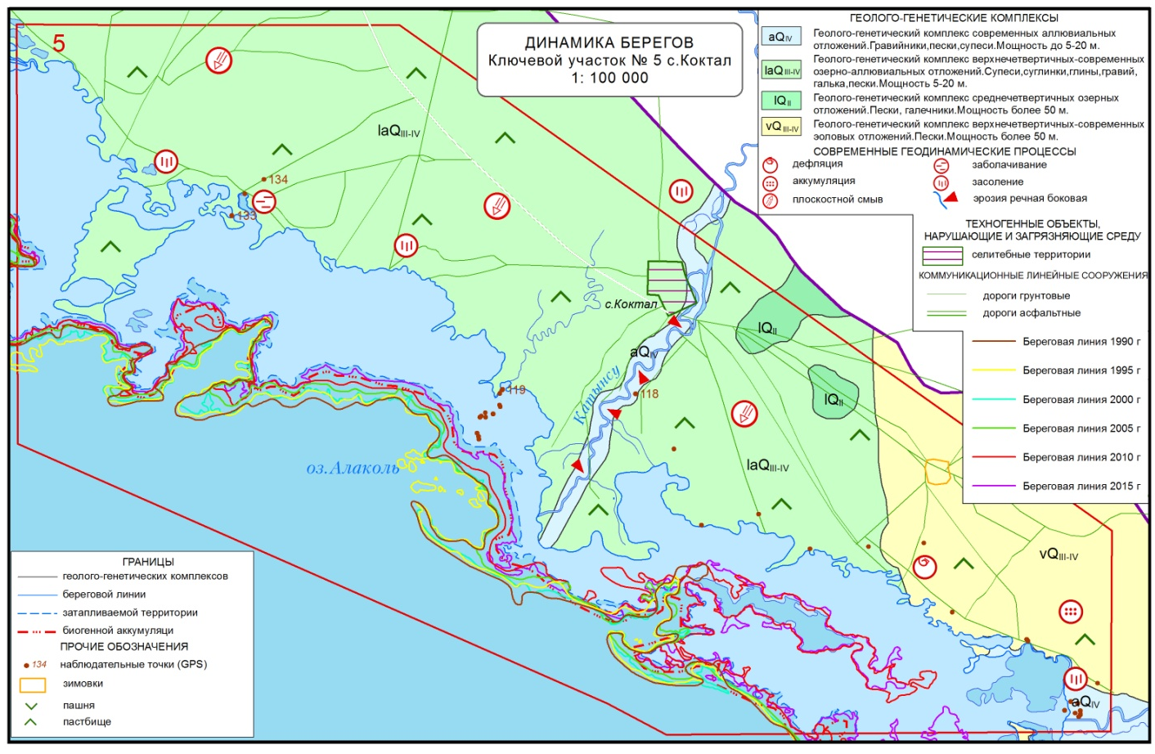
Figure G.82 – Coastal dynamics. Key site No.5 of Koktal village

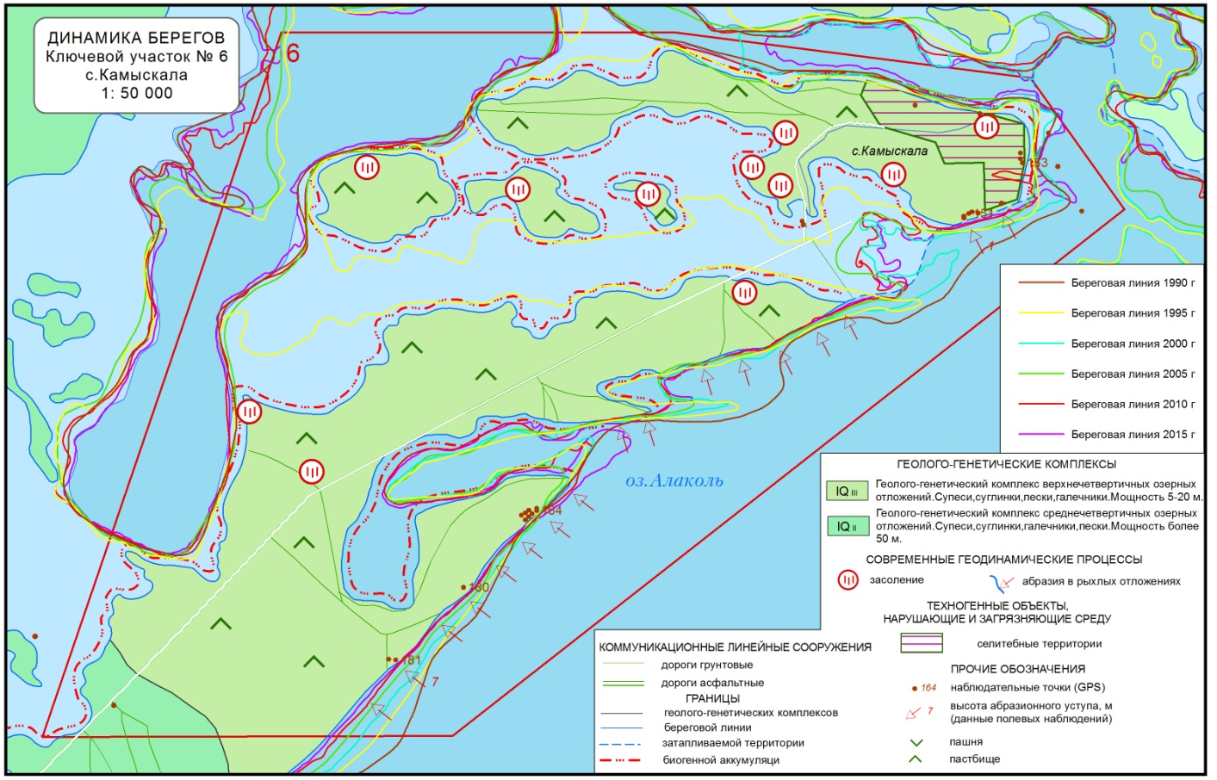
Figure G.83 – Coastal dynamics. Key site No.6, Kamyskala village
APPENDIX H
Initial data to section 3
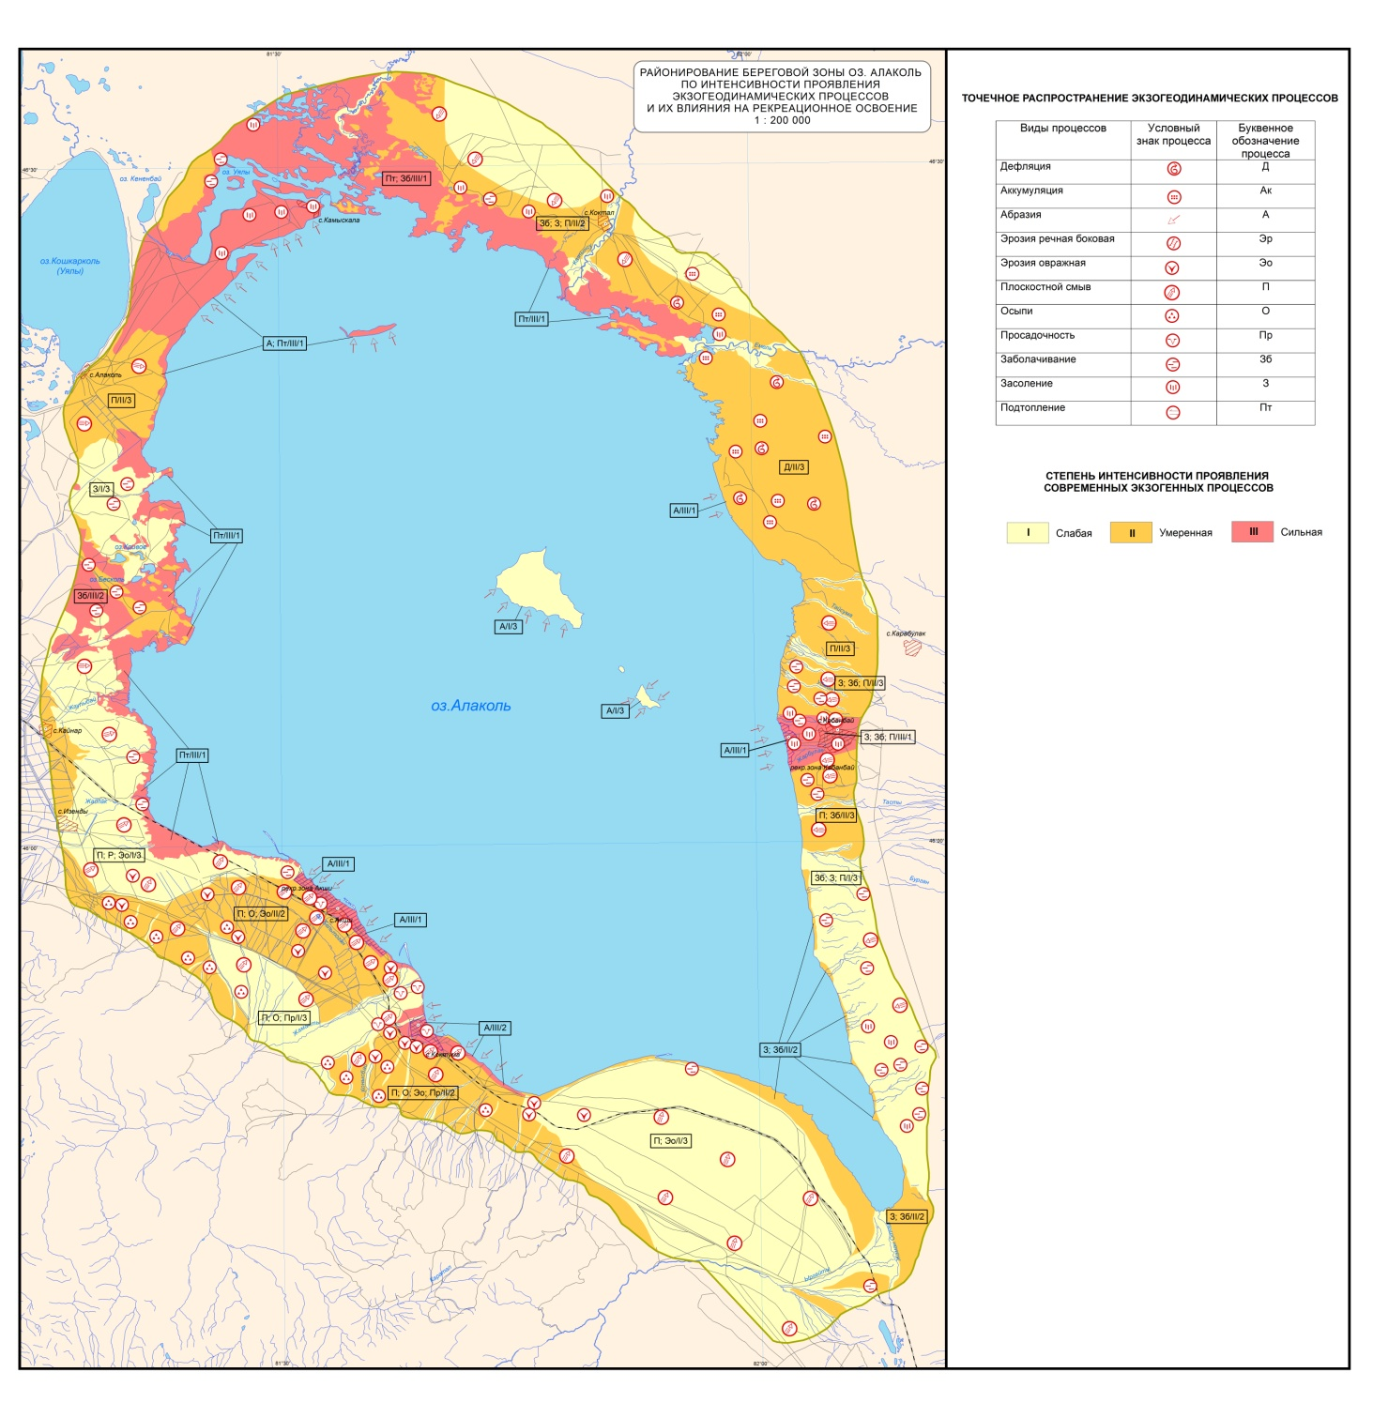
Figure H.84 – Zoning of the coastal zone of lake Alakol according to the intensity of manifestation of exogeodynamic processes and their impact on recreational development

Table H.22 – Assessment of the intensity of exogeodynamic processes of the shoreline of lake Alakol
№ наблюдательной  точки (GPS) | Расстояние от точек наблюдения до береговой линии за 1990-2018 год, м |  |  |  |  |  |  | Экзогеодинамические процессы | Сте  пень интен  сивности |  | Катего  рия уязви  мости  прибрежной зоны
№ наблюдательной  точки (GPS) | 1990-2018 | 1995-2018 | 2000-2018 |  | 2005-2018 | 2010-2018 | 2013-2018 | Экзогеодинамические процессы |  |  | Катего  рия уязви  мости  прибрежной зоны
Ключевой участок №1 (с. Акши)
003 | 393 | 356 |  | 288 | 200 | 96 | 95 | абразия | III |  | 1
010 | 242 | 180 |  | 158 | 119 | 55 | 50 | абразия | III |  | 1
015 | 65 | 61 |  | 58 | 49 | 40 | 21 | абразия | III |  | 3
016 | 88 | 58 |  | 39 | 36 | 24 | 9 | абразия | III |  | 3
017 | 39 | 36 |  | 36 | 33 | 25 | 23 | абразия | III |  | 3
Ключевой участок № 2 (с. Коктума)
023 | 118 | 87 |  | 70 | 47 | 28 | 22 | абразия | III |  | 1
024 | 112 | 105 |  | 92 | 71 | 37 | 32 | абразия | III |  | 1
027 | 120 | 101 |  | 84 | 31 | 22 | 16 | абразия | III |  | 1
029 | 122 | 117 |  | 110 | 60 | 26 | 8 | абразия, просадочность | III |  | 1
032 | 112 | 101 |  | 93 | 61 | 52 | 35 | абразия, просадочность | III |  | 1
Ключевой участок № 4 (урочище Косайшагыл)
090 | 200 | 167 |  | 121 | 82 | 57 | 32 | абразия, подтопление,  дефляция,аккумуляция |  | II | 1
091 | 279 | 207 |  | 180 | 142 | 95 | 79 | абразия,подтопление,  дефляция, аккумуляция |  | II | 1
092 | 210 | 179 |  | 171 | 15032 | 66 | 47 | абразия,подтопление,  дефляция,аккумуляция |  | II | 1
Ключевой участок № 5 (с. Коктал)
131 | 841 | 835 |  | 815 | 803 | 634 | 434 | подтопление, заболачивание, засоление,  плоскостной смыв |  | III | 2
100 | 925 | 864 |  | 735 | 550 | 427 | 208 | подтопление,  заболачивание,засоление,  плоскостной смыв |  | III | 1
1 | 7 | 6 |  | 5 | 4 | 3 | 2 | подтопление,  заболачивание, засоление,  плоскостной смыв |  | III  I | 3
000 | 204 | 192 |  | 187 | 124 | 62 | 53 | подтопление,  заболачивание, засоление,  плоскостной смыв |  | III  I | 3
Ключевой участок № 6 (с. Камыскала)
150 | 250 | 160 |  | 141 | 133 | 66 | 40 | абразия, подтопление,  плоскостной смыв |  | III | 1
23 | 66 | 65 |  | 53 | 48 | 21 | 13 | абразия, подтопление,  плоскостной смыв |  | III | 2
24 | 470 | 320 |  | 278 | 138 | 78 | 43 | абразия, подтопление,  плоскостной смыв |  | III | 1

Степень интенсивности
I | слабая
II | умеренная
III | сильная
Категория уязвимости
1 | Высокая
2 | Средняя (умеренная)
3 | Пониженная
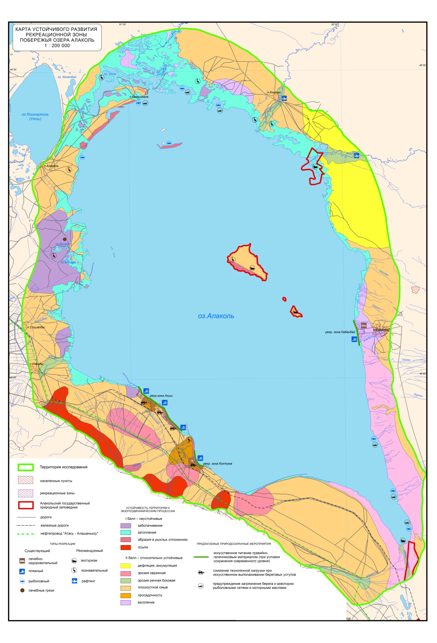
Figure H.85 – Sustainable development of the recreational zone of the coast of lake Alakol

Table H.23 – Instrumental measurements of the dynamics of abrasion of the coast of lake Alakol
№ Мониторинговая площадка | № реппера и GPS | Географические координаты (в.д., с.ш.) | Расстояние от реппера до уступа за период в метрах; |  |  |  |  |  | средняя динамика в год
№ Мониторинговая площадка | № реппера и GPS | Географические координаты (в.д., с.ш.) | 2013 | 2014 | 2016 | 2018 | 2019 | 2020
1, Северо-западнее с. Акши | I, 002 | 45°59′015″ |  |  |  | 26 | 19,5 | 4,5 | 21,5
1, Северо-западнее с. Акши | I, 002 | 81°31′219″
1, Северо-западнее с. Акши | II, 004 | 45°58′998″ |  |  |  | 26,1 | 19,8 | 5 | 21,1
1, Северо-западнее с. Акши | II, 004 | 81°31′245″
1, Северо-западнее с. Акши | III, 005 | 45°58′97,9″ |  |  |  | 29,6 | - | 9 | 20,6
1, Северо-западнее с. Акши | III, 005 | 81°31′262″
1, Северо-западнее с. Акши | IV, 006 | 45°58′955″ |  |  |  | 25,4 | 18,7 | 0 (пляж) | 25,4
1, Северо-западнее с. Акши | IV, 006 | 81°31′285″
3, коса Малый Балгын, с. Акши | I, 717 | 45°58′08,1″ |  |  |  | 6,7 | 6,3 |  | 0,4
3, коса Малый Балгын, с. Акши | I, 717 | 81°32′32,5″ |  |  |  |  |  |  | 0,4
3, коса Малый Балгын, с. Акши | II, 716 | 45°58′07,6″ |  |  |  | 18,2 | 18 |  | 0,2
3, коса Малый Балгын, с. Акши | II, 716 | 81°32′33,8″ |  |  |  |  |  |  | 0,2
3, коса Малый Балгын, с. Акши | III, 718 | 45°58′07,2″ |  |  |  | 31 | 29,6 |  | 1,4
3, коса Малый Балгын, с. Акши | III, 718 | 81°32′35,4″ |  |  |  |  |  |  | 1,4
2, северо-западнее с. Акши | I,713 | 45°58′34,3″ |  |  |  | 55,3 | 51 | 49,7 | 5,6
2, северо-западнее с. Акши | I,713 | 81°31′31,8″
2, северо-западнее с. Акши | II,714 | 45°58′35,0″ |  |  |  | 59,3 | 54 | 52,4 | 6,9
2, северо-западнее с. Акши | II,714 | 81°31′30,1″
2, северо-западнее с. Акши | III,715 | 45°58′33,3″ |  |  |  | 64,9 | 59,3 | 59,3 | 5,6
2, северо-западнее с. Акши | III,715 | 81°31′32,5″
3, с. Коктума | I,565 | 45°52′06,9″ | 31,5 | 24,9 | 24,8 | 12,4 | 9 | 8,65 | 22,85
3, с. Коктума | I,565 | 81°39′05,4″
3, с. Коктума | II,566 | 45°52′09,2″ | 33,2 | 27,6 | 26,2 | 17,5 | 14,1 | 13,15 | 20,05
3, с. Коктума | II,566 | 81°39′04,6″
3, с. Коктума | III,567 | 45°52′08,0″ | 34,6 | 30,5 | 30,5 | 16,2 | 14 | 14 | 20,6
3, с. Коктума | III,567 | 81°39′05,1″
3, с. Коктума | IV,568 | 45°52′10,5″ | 35,9 | 32,3 | 31 | 20,3 | 16,5 | 15,63 | 20,27
3, с. Коктума | IV,568 | 81°39′04,2″
4, c. Коктума | II,558 | 45°51′55,9″ | 36,3 | 34 | 26,9 | 16,7 | 13,5 | 8,26 | 28,04
4, c. Коктума | II,558 | 81°39′12,3″
4, c. Коктума | 8,564 | 45°51′54,9″ | 66,4 |  |  | 40,9 | 36,2 | 31,2 | 35,2
4, c. Коктума | 8,564 | 81°39′11,7″
4, c. Коктума | I,559 | 45°51′54,5″ | 23,4 | 20,5 | 14 | 4,3 | 2,3 | 0 | 23,4
4, c. Коктума | I,559 | 81°39′14,0″
4, c. Коктума | 7,563 | 45°51′53,5″ | 34,4 | 29,7 | 24,5 | 13,1 | 11 | 8,4 | 26
4, c. Коктума | 7,563 | 81°39′14,1″
6, с. Коктума | I,573 | 45°51′38,6″ | 74,1 | 71,5 | 65,3 | 56,4 | 56,4 | 54,7 | 19,4
6, с. Коктума | I,573 | 81°39′36,1″
6, с. Коктума | II,572 | 45°51′37,7″ | 72 | 69,5 | 66,1 | 57 | 54,6 | 52,2 | 19,8
6, с. Коктума | II,572 | 81°39′38,8″
6, с. Коктума | III,571 | 45°51′36,9″ | 72,3 | 70,8 | 65,7 | 61,6 | 53,9 | 53,9 | 18,4
6, с. Коктума | III,571 | 81°39′41,0″
юго-западнее с. Камыскала | I, 158 | 46°26′020″ |  |  |  | 50 | 50 |  | 0
юго-западнее с. Камыскала | I, 158 | 81°28′356″ |  |  |  |  |  |  | 0
юго-западнее с. Камыскала | II,160 | 46°26′026″ |  |  |  | 57,7 | 57,7 |  | 0
юго-западнее с. Камыскала | II,160 | 81°28′296″ |  |  |  |  |  |  | 0
юго-западнее с. Камыскала | III, 162 | 46°26′011″ |  |  |  | 65,5 | 61,8 |  | 3,7
юго-западнее с. Камыскала | III, 162 | 81°28′264″ |  |  |  |  |  |  | 3,7
юго-западнее с. Камыскала (памятник) | I, 181 | 46°25′152″ |  |  |  | 19,5 | 5,65 |  | 13,85
юго-западнее с. Камыскала (памятник) | I, 181 | 81°27′174″ |  |  |  |  |  |  | 13,85

Table H.24 – Field diary
08.06.2018 – 21.06.2020
№ GPS точки | Координаты | Абсолют-ная высота над уровнем моря, м | Название, место расположение | Описание | Генезис и геологический возраст | Растительность | Современные рельефообразу-ющие процессы | Фото (серия-номер) | Антропоген-ное воздействие | Примечание:
1 | 2 | 3 | 4 | 5 | 6 | 7 | 8 | 9 | 10 | 11
день экспедиции – 08.06.20.
 | Выезд из г. Алматы в г. Ушарал.
день экспедиции – 09.06.20.
 | Выезд из г. Ушарал в с. Акши.
Ключевой участок №1, с. Акши
GPS Акши 3.19-19 | 45-58-133 с.ш.  81-32-516 в.д. | 354 | Точка находится у зоны отдыха "Керемет" побережье озера | Организация лагеря, проживания и питания для членов исследовательской команды. Расположение в лагере, подготовка журналов, оборудования, согласование маршрута и схемы работ. Разделились на 2 группы, первая будет выполнять наземное лазерное сканирование, вторая инструментальные измерения по профилю и пеший обход вдоль берегового клифа. | laQ_{III-IV} | Травини-стая, местами кустарниково-древест-ная | Абразия  Биогенная аккумуляция |  | Полевые дороги, активный выпас скота, мусор
день экспедиции – 10.06.20.
GPS Акши 3.19-19 | 45-58-133 с.ш.  81-32-516 в.д. | 354 | Точка находится у зоны отдыха "Керемет" | Подготовка к лазерному сканированию побережья оз. Алаколь. Поиск прошлогодних точек сканирования. Планирования новых скан позиции на северо-западной с. Акши в конце рекреационных зон. Сканирование ключевого участка №1 (мониторинговая площадка №1 у с. Акши) с применинием лазерного сканера VZ-4000 Riegel. На мониторинговой площадке №1 у с. Акши было отсканировано 20 скан позиции. В основном сканирование проводилось на пляжной части побережья в направлении уступом, где активно развивается абразия. Все данные сканированных точек с координатами и номерами фотографии были занесены в заранее приготовленную таблицу. | laQ_{III-IV} | Травини-стая, местами кустарниково- древест-ная | Биогенная аккумуляция |  | Бумажно-пластиковый мусор | Коса соединилась с пляжем
Continuation of table H.24
1 | 2 | 3 |  | 4 |  | 5 |  | 6 |  |  | 7 |  | 8 |  |  | 9 |  | 10 |  | 11
день экспедиции – 11.06.20.
GPS Акши 1.1-19 | 45-59-091 с.ш.  81-31-172 в.д. | 345 |  | Точка находится северной части рекреационной зоны с. Акши |  | Продолжение лазерного сканирования на мониторинговой площадке №1 у с. Акши. На данном мониторинговой площадке было отсканированно 18 скан позиции. Сканирование проводилось на пляжной части побережья с постепенным переходом на верхней части уступов. На уступах сканирование прводилось на 360˚.  Выполнены инструментальные измерения по профилям на мониторинговых участках с использованием дальномера |  | laQ_{III-IV} |  |  | Травинистая,изредка кустарниковая |  | Абразия,  биогенная аккумуляция |  |  |  |  | Бумажно-пластиковый мусор |  | Очень интенсивная динамика,  Один реппер был утерян в результате абразии.
день экспедиции – 12.06.20.
- | - | - |  | Абразионный уступ, точка находится северной части рекреационной зоны с. Акши |  | Прдолжение лазерного сканирования на маниторингоой площадке №1 у с. Акши. На данным маниторинговой площадке было отсканированно 8 скан-позиции. Сканирование проводился на равнинной части рядом от абразионного набережья. После обеда начали снимать на сканер следующую мониторинговую площадку №2 (название в программе Akshi_2_center_19). На мониторинговой площадке №2 у. с. Акши было отсканированно 8 скан-позиции.  Выполнены инструментальные измерения по профилям на мониторинговых участках с использованием дальномера |  | laQ_{III-IV} |  |  | Травинистая, изредка кустарниковая |  | Абразия, биогенная аккумуляция |  |  |  |  | Полевые и асфальтированные дороги, рядом строения для рекреационных нужд
день экспедиции – 13.06.20.
GPS т.043 | 45-59-14,2 с.ш.  81-31-03,2 в.д. | 347 |  | Северная оконечность косы, с. Акши |  | Продолжение лазерного сканирования на мониторинговой площадке №2 у. с. Акши. На данном мониторинговом площадке было отсканировано 13 скан-точек. Сканирование проводилось на равниной части, снятие сканером стен уступа. На равнинной части сканирвам панорамно на 360˚ и на пляжной части на 0-200˚. |  | laQ_{IV}
Continuation of table H.24
1 | 2 | 3 |  | 4 |  | 5 |  | 6 |  |  | 7 |  | 8 |  |  | 9 |  | 10 |  | 11
день экспедиции – 14.06.20.
GPS т.45 | 45-59-12,08 с.ш.  81-31-0,73 в.д. | 344 |  | точка находится северной части рекреационной зоны с. Акши |  | Сканирование ключевого участка №3 (мониторинговая площадка 3 у с. Акши, рядом зоны отдыха). Название проекта сканирование в программе Riscan: Akshi_3_south_19. На сегодня на данном мониторинговом площадке было отсканировано 11 скан-точек. Выполнены инструментальные измерения по профилям на мониторинговых участках с использованием дальномера |  |  | laQ_{IV} |  | Травинисто-кустар-никово-древест-ная |  | Абразия |  |  |  |  | Полевые дороги, тропинки. База отдыха и заборы. |  |  | Зарисовки в виде схемы
день экспедиции – 15.06.20.
GPS т. 50 | 45-57-51,7 с.ш., 81-33-11,5 в.д. | 344 |  | точка находится северной части рекреационной зоны с. Акши |  | Выполнены инструментальные измерения по профилям на мониторинговых участках с использованием дальномера.  Пеший обход вдоль побережья, фотофиксация берегового уступа и инфраструктуры. Посещение метеопоста |  |  | laQ_{IV} |  | Травинистая |  |  | Абразия |  |  |  | Полевые дороги, тропинки. База отдыха и заборы.
GPS т. 100 | 45-57-12,5 с.ш. 81-34-37,3 в.д. |  |  | Точка находится начало большой третий косы. |  | Коса протягивается на 2,7 км. Взять точку у начало косы, когда будем делать батиметрию, чтобы узнать расстояние. Ширина основаниях - 069,6 м. Коса сложена из разнозернистых песка. Вперемежку с галькой, гравием и валунами.т. 101  GPS. Сбор лагеря, выезд в с. Коктума. |  |  | laQ_{IV} |  |  |  |  | Абразия  Биогенная аккумуляция |  | 100-0928-0935 |  | Полевые дороги, бумажно-пластиковый мусор
Ключевой участок №2, с. Коктума. день экспедиции – 16.06.20.
- | - | - |  | Средняя часть берегового уступа с. Коктума |  | Сканирование на оборудовании VZ-4000 ключевой участок находится в западной части от с. Коктума, рядом пионерский лагерь «Шағала». Название проекта сканирование в программе Riscan: Koktuma_west_19. На данном мониторинговом площадке было отсканировано 12 скан-точек. | аQ_{IV} |  |  |  | Древест-но-кустарниково-травинистая растительность |  |  | Абразия  Биогенная аккумуляция |  | ----- |  | Полевые дороги и выпас скота,антропогенное выполаживание уступа для спуска туристов |  |  |  | близость уступа,
Continuation of table H.24
день экспедиции – 17.06.20.
1 | 2 | 3 | 4 |  | 5 |  |  |  |  | 6 |  | 7 |  |  | 8 |  | 9 |  | 10 |  |  |  | 11
GPSт.116 | 45-52-11,8 с.ш.  81-39-04,1 в.д. | - | Пеший обход берега с. Коктума |  | Средняя часть берегового уступа с. Коктума. Высота уступа – 4 м. Ширина пляжа – 5,3 м. Уступ сложен суглинком, пляж песком, гравием. Погода облочная. Штиль 2-ой день.  Продолжение лазерного сканирование на монитоинговой площадке №3 у села Коктума. Ключевой участок расположен в западной части от с. Коктума, рядом находится пионерский лагерь «Шағала». На сегодня на данном мониторинговой площадке было отсканировано 19 скан-точек. Сканирование на равнинной части. Выполнены инструментальные измерения по профилям на мониторинговых участках с использованием дальномера. |  |  |  |  | аpQ_{III-IV} |  | Древестно-кустарниково-травинистая растительность |  |  | Абразия  Биогенная аккумуляция |  | 100-1813-1828 |  | Полевые дороги и выпас скота, антропогенное выполаживание уступа для спуска туристов |  |  |  | При скан-ировании были сложности в виде густой заросли кус-тарников,.
день экспедиции – 18.06.20.
Отсканирование точка №1 Коктума 2,2-19 | 45-51-684 с.ш.  81-39-584 в.д | 357 | Ключевой участок находится на юго-восточной части от с. Коктума, рядом овраг и южнее расположены новостроенные дома отдыха. |  | Сканирование на оборудовании VZ 4000 ключевого участка №2 у с. Коктума. Изучение динамики абразионного процесса на побережье оз. Алаколь. Название проекта сканирование в програме Riscan: Koktuma_East_19. На сегодня на данном мониторинговом площадке было отсканированно 10 скан-точек. Выполнены инструментальные измерения по профилям на мониторинговых участках с использованием дальномера. |  |  |  |  | аpQ_{III-IV} |  | Древестно-кустарниково-травинистая растительность |  |  | Абразия  Биогенная аккумуляция |  | 336-96-57-9680 |  | Полевые дороги и выпас скота, антропогенное выполаживание уступа для спуска туристов
день экспедиции – 19.06.20.
 |  |  | Ключевой участок расположен в юго-восточной части с. Коктума. |  | Продолжение лазерного сканирования на мониторинговой площадке №2 у с. Коктума.На сегодня на данном мониторинговой площадке было отсканировано 18 скан-точек.Сканированиие проводился на равнинной части. В пляже и на косе. |  |  |  |  |  |  |  |  |  |  |  |  |  |  |  |  |  | разнозерн. песок, валунними, галечник, галька.
день экспедиции – 20.06.20.
GPSКоктума 2,29-19 | 45-51-92,1 с.ш.,  81-39-21,9 в.д. | 354 | Точка находиться на юго-восточной части с. Коктума. |  | Сбор лагеря и выезд на 5 мониторинговую площадку, в с. Камыскала. Пребытие на место, проведение инструментальных измерений по профилям на мониторинговых участках с использованием дальномера.  Выезд в г. Алматы |  |  |  |  | Q_{III-IV} |  | в густую древесную, деревесно-кустарник. растительность. |  |  | Абразия  Биогенная аккумуляция |  |  |  | Выпас скота, бумажно-пластиковый мусор |  |  |  | Памятник разрушен.
день экспедиции – 21.06.20 Приезд в г. Алматы

Table H.25 – Percentage of lake shore types Alakol (in% of total length)
 | Отвесный берег, с пляжем | Галечниковые пляжи | Коренная порода | Затопленные низменные берега | Косы | Дельтовые | Исскуственные
Алакольский район | 6,5 | 5,7 | ООПТ | 31,9 | 7,1 | 0,6 | 0,4
Уржарский район | 0,5 | 7,8 | ООПТ | 28,2 | 1,1 | 4,5 | 0,1
Всего | 6,9 | 13,4 | 5,8 | 60,0 | 8,2 | 5,0 | 0,5

Table H.26 – Land use of the coast of the lake Alakol
 | Береговая линия (км) | Население (тыс. чел.) | Селитебные земли (%) | Рекреация (%)/общее кол-во туристов | ВБУ (%) | Пастбища, сенокосы (%) | Поливные земли (%)
Алакольский район | 323,7 | 5,9  (69,8) | 0,2 | 1/ 1 млн. чел. | 33,5 | 53 | 6,6
Уржарский район | 235,6 | 6,5  (73,7) | 0,4 | 0,3/ 500 тыс. чел. | 46,9 | 46,8 | -

Table H.27 – Forecast dynamics of the retreat of denudation banks
Ключевые  Участки | Средняя скорость эрозии уступа в год, по данным реперов наблюдений, в метрах | Общая прогнозная динамика эрозии берега за 20 лет, м | Общая прогнозная динамика эрозии берега за 50 лет, м | Общая прогнозная динамика эрозии берега за 80 лет, м
Рекреационная зона Акши (левый берег) | 4,3 (10 профилей) | 86 | 215 | 344
с. Коктума | 3,5 (11 профилей) | 70 | 175 | 280
Рекреационная зона с. Кабанбай | 5,0 (13 профилей) | 100 | 250 | 400
Западнее с. Камыскала | 4,4 (4 профиля) | 88 | 220 | 352

Table H.28 – Historical and predicted data on the dynamics of the flooded area of ​​accumulative banks
Годы | Продолжительность, лет | Уровень озера, м | Площадь затопления  оз. Алаколь, км² | Общая площадь затопления оз. Алаколь, км² | Общая площадь единого водоема котловины, км²
1989-1995 | 6 | 348 |  |  | 2903,0
1995-2010 | 15 | 349 | 56,0 | 56,0 | 2981,0
2010-2018 | 8 | 350 | 179,0 | 235,0 | 3385,8
Прогноз |  | 351 | 210,1 | 445,1 | 4742,7
Прогноз |  | 352 | 163,7 | 608,8 | 5100,2
Прогноз |  | 353 | 207,0 | 815,8 | 5458,2
Прогноз |  | 354 | 148,2 | 964,0 | 5722,1
Прогноз |  | 355 | 93,7 | 1 057,7 | 5917,3

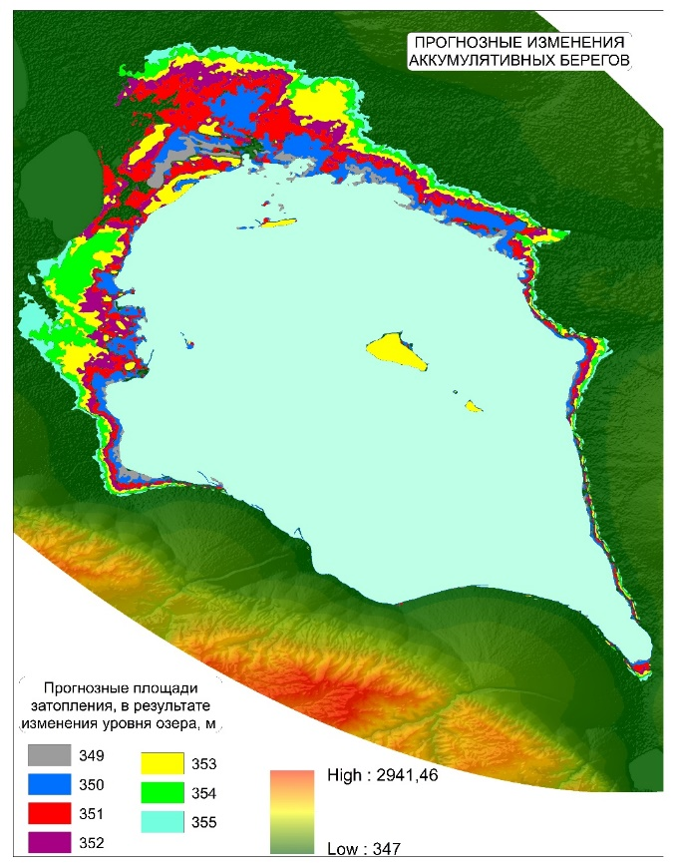
Figure H.86 – Projected area changes in the territory when the water level rises, according to the DEM analysis

Table H.29 – Lists the different methods of coastal protection and their relative ability to provide protection and impact on adjacent shores (beneficial or unfavorable)
Виды берегозащиты | Большой масштаб | Малый масштаб | Эффект | Влияние на соседние берега
Волноломы | (х) | Х | Может остановить или уменьшить отступание береговой линии, однако может не остановить, если эрозия продолжится в оффшорной зоне | Неблагоприятное, часто очень  Сильное
Противоволновая дамба | Х | Х | Может остановить эрозию, там где расположена дамба, но не может остановить эрозию в оффшорной зоне | Может в некотором экстенте стать неблагоприятным
Отдельно стоящие волнорезы (параллельно береговой линии) | (х) | Х | Возможно остановит эрозию и нарастит пляж, на котором они возводятся | Неблагоприятно, часто очень сильно
Искусственное питание | Х |  | Расширяет пляжи, обеспечивает полную защиту, если в хорошем состоянии | Благоприятный
(х) менее привлекательное решение

Table H.30 – Advantages and Disadvantages of Resettlement p. Kamyskala
Преимущества | Недостатки
Экономия бюджетных средств от будущих вложений | Упразднение населенного пункта
Восстановление окружающей среды и экологии | -
Сокращение негативного воздействия браконьерства | -
Улучшение социально-экономических условий | -
Улучшение жилищных условий | -
Изменение сферы хозяйственной деятельности. Участие в востребованной сфере экономической активности района | -

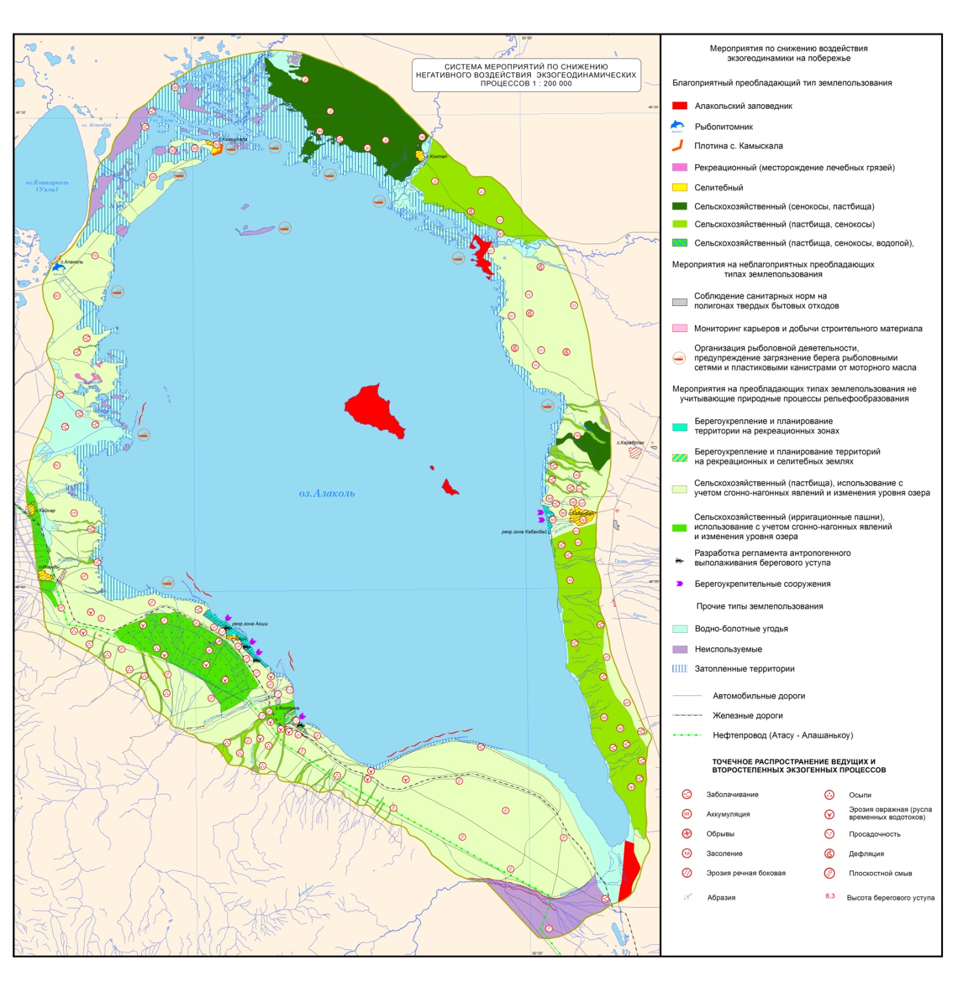
Figure H.87 – System of measures to reduce the negative impact of exogeodynamic processes

