Ministry of Education and Science of the Republic of Kazakhstan
Science Committee
RSE «National Center for Biotechnology»
(RSE NCB)

UDC 616-004.6; 57.085.23
IRSTI 62.33.31, 76.29.30, 34.19.23
№ state registration 0118РК00980
Inv.№

APPROVED
Deputy General Director
RSE «National Center for Biotechnology» SC MES RK, d-r vet. sciences, Prof.
________________________K.K. Mukanov
«_____» _______________ 2020

Report
on research work

Development of a new therapeutic strategy to enhance the effectiveness of atherosclerosis treatment by using preconditioned mesenchymal stem cells
(Final)

АР05134447

Subprogram 102 «Research grant funding»
Priority direction «Life science and health»

Head of research work,  Head of laboratory,  Cand.biol.sciences | V.B. Ogay

Nur-Sultan 2020
List of performers
Head of the project  Head of laboratory,  cand. biol. sciences | ______________________  signature, date | V.B. Ogay  (introduction, sections 1, 2, 3 conclusion)
Performers:  Res.fell. | ______________________  signature, date | A.E. Sekenova  (abstract, section 2)
Junior. res. fell. | ______________________  signature, date | Ye.A. Li  (section2)

РЕФЕРАТ
Есеп беру 57 бет, 1 кiтап, 9 сурет, 44 ақпарат көздері, 4 тіркеме
Мезенхимаді БАГАНАЛЫ ЖАСУША, ЫҚШАМ СҮЙЕК, АЛДЫН-АЛА КОНДИЦИЯЛАУ, ИММУНОМУЛЯЦИЯ, АТЕРОСКЛЕРОЗ
Зерттеу нысаны - тышқандардың ықшам сүйегінің мезенхимальді бағаналы жасушалары (МБЖ) болып табылады.
Жұмыстың мақсаты - модельді жануарларда атеросклероздың дамуына алдын-ала кондицияланған мезенхималды бағаналы жасушаларының терапиялық әсерлерін зерттеу.
Жұмыстың әдістері: жасушалық биотехнология, ағындық цитометрия, жасуша физиологиясы, биохимия және иммунохимия әдістері қолданылды.

Жұмыс нәтижелері: Алғаш рет емделмеген МБЖ-мен салыстырғанда, TNF алдын-ала шартталған МБЖ-лар CXCR-4 экспрессиясының жоғарылауы есебінен oxLDL зақымдалған тышқанның қолқа эндотелиалды жасушаларына (ECAM) қарай көбірек қоныс аударып, олардың NO түзетін белсенділігін қалпына келтіре алатындығы дәлелденді. In vivo зерттеулерінің нәтижелері көрсеткендей, жүйеге тамырішілік трансплантация TNF алдын-ала жасалған МБЖ-лар атеросклерозбен ауырған тышқандардағы қолқа эндотелийінің функциясын бұзылмаған МЮЖ және PBS енгізуге қарағанда айтарлықтай жақсартады. Сонымен қатар TNF алдын-ала шартталған МБЖ бір жағынан қабынуға қарсы цитокиндердің (TNF-α және IFN-γ), холестериннің және төмен тығыздықтағы липидтердің (LDL) деңгейін басып, иммунорегуляторлық цитокиндердің (IL-6 және IL-10) деңгейін жоғарылатқандығы және атеросклерозы бар тышқандардың қан сарысуындағы жоғары тығыздықтағы липидтер (HDL). Сонымен қатар, TNF алдын-ала шартталған МБЖ трансплантациясы көкбауырдың массалық индексін қалыпты мәнге дейін төмендетіп, көкбауырдың қабыну күйін айтарлықтай басуға алып келгені анықталды.

Жаңалықтың мәні: бірінші рет ApoE тышқандарындағы атеросклерозды дамытуда TNF алдын-ала шартталған МБЖ-ды жүйелі түрде қолданудың терапиялық тиімділігі көрсетілді.

Негізгі жобалық-техникалық және эксплуатациялық параметрлері: TNF алдын-ала шартталған МБЖ-ды көктамыр ішіне енгізу ECAM функцияларын едәуір жақсартады, ApoE тышқандарында атеросклероз дамуы кезінде қабыну мен дислипидемияны басады.
Дамудың тиімділігі: TNF алдын-ала шартталған МБЖ-ды жүйелі түрде қолдану атеросклерозды емдеуде емделмеген МБЖ-ғе қарағанда әлдеқайда маңызды қабынуға қарсы және қорғаушы әсерге ие.
Abstract
Report 57 p., 1 b.,9 fig., 44 ref., 4 attach.
Mesenchymal stem cells, compact bone, preconditioning, immunomodulation, atherosclerosis
The object of the study is the mesenchymal stem cells (MSCs) of the compact bone of mice.
This work aims to study the therapeutic effects of preconditioned mesenchymal stem cells on the development of atherosclerosis in model animals.
Methods of work: the methods of cell biotechnology, flow cytometry, cell physiology, biochemistry and immunochemistry were used in the work.
Results of the work: For the first time, it has been shown that compared to untreated MSCs, TNF-preconditioned MSCs can more efficiently migrate towards oxLDL-damaged mouse aortic endothelial cells (MAEC) due to increased expression of CXCR-4 and restore their NO-producing activity. The results of in vivo studies showed that systemic intravenous transplantation of TNF-preconditioned MSCs significantly improved the function of the aortic endothelium in mice with atherosclerosis compared to the administration of intact MSCs and PBS. It was also found that TNF-preconditioned MSCs inhibited the level of pro-inflammatory cytokines (TNF-α and IFN-γ), cholesterol and low density lipids (LDL) on the one hand, and increased the level of immunoregulatory cytokines (IL-6 and IL-10) and high density lipids (HDL) in the blood serum of mice with atherosclerosis. Also, it was found that transplantation of TNF-preconditioned MSCs led to a significant suppression of the inflammatory state of the spleen, reducing the spleen mass index to normal values.
The essence of the novelty: For the first time, the therapeutic efficacy of systemic use of TNF-preconditioned MSCs in the development of atherosclerosis in ApoE mice has been shown.
Main constructional and technical-operational parameters: Systemic intravenous administration of TNF-preconditioned MSCs substantially improves MAEC functions, suppresses inflammation processes and dyslipidemia during the development of atherosclerosis in ApoE mice.
Efficiency of the development: Systemic applying of TNF-preconditioned MSCs has more considerable anti-inflammatory and protective response in the development of atherosclerosis than untreated MSCs.
CONTENT
INTRODUCTION……………………………………………………………………………. | 9
MAIN PART OF THE R&D REPORT……………………………………………………….. | 13
1 Choosing a direction of research…………………………………………………………….. | 13
2 Experimental studies………………………………………………………………………… | 14
2.1 Research methods ……………………………………………………………………… | 14
2.1.1 Animals…………………………………………………………………………….. | 14
2.1.2 Isolation and culture of mouse compact bone MSCs……………………………… | 14
2.1.3 Colony-forming unit assay ………………………………………………………… | 14
2.1.4 Multilileage differentiation test……………………………………………………. | 15
2.1.5 Flow cytometry…………………………………………………………………….. | 15
2.1.6 Obtaining of 3D MSC spheroids…………………………………………………… | 16
2.1.7 Obtaining a primary culture of mouse aortic endothelial cells…………………….. | 16
2.1.8 Preconditioning of MSCs………………………………………………………….. | 16
2.1.9 Transwell migration assay………………………………………………................. | 16
2.1.10 Assay for NO synthesis…………………………………………………………… | 17
2.1.11 Induction of atherosclerosis………………………………………………………. | 17
2.1.12 Determination of cytokine levels…………………………………………………. | 17
2.1.13 Measurement of cholesterol, LDL and HDL……………………………………... | 18
2.1.14 Aortic ring preparations and tension recording…………………………………… | 18
2.1.15 Assessment of the spleen mass index…………………………………………….. | 18
2.1.14 Statistical analysis……………………………………………................................ | 18
2.2 Obtained experimental data…………………………………………………………….. | 19
2.2.1 Obtaining and characterization of a primary culture of mouse compact bone MSCs and 3D spheroids…………………............................................................... | 19
2.2.2 Effects of preconditioned MSCs on oxLDL-induced endothelial cell damage in vitro ……………………………………………………………………………….. | 21
2.2.3 Effects of transplantation of preconditioned MSCs on inhibition of endothelial dysfunction in model animals with atherosclerosis………………………………… | 22
3 Summary and evaluation of the results……………………………………………………… | 26
Conclusion……………………………………………………………………………….. | 29
LIST OF REFERENCES……………………………………………………………………… | 31
ATTACHMENT А - Timetable and technical specification for 2018-2020………………….. | 35
ATTACHMENT B - Extract from the minutes of the meeting of the local ethics commission. | 43
Attachment c – List of published works for 2018-2020………………………………… | 44
Attachment D – Copies of publications…………………………………………………. | 45
TERMS AND DEFINITIONS
In this research report, the following terms with definitions are used.
Atherosclerosis | - Сhronic disease of the elastic and muscular-elastic type arteries originating from lipid and protein metabolism disorders and accompanied by the deposition of cholesterol and some lipoprotein fractions in the lumen of the vessels.
Cell differentiation | - Process of implementing a genetically determined program for the formation of a specialized phenotype of cells, reflecting their capability to perform certain profile functions.
Compact bone tissue | - One of two types of bone that makes up bone. Provides supporting, protective functions of the bone serves as a storehouse of chemical elements and mesenchymal cells.
Preconditioning of cells | - Preliminary treatment of cells with physical, chemical, or biological factors, contributing to an increase in the functional activity of cells (viability, proliferation, production of cytokines, and growth factors).
Cytokines | - Large and diverse group of small in size (molecular weight 8 to 80 kDa) – mediators of proteins nature – intermediary molecules (“binding proteins”), involved in cell-to-cell signaling, mainly in the immune system. Cytokines include tumor necrosis factor, interferons, several interleukins, etc.

LIST OF ABBREVIATIONS AND SYMBOLS
In this research report, the following abbreviations and symbols are used.
BSA | - bovine serum albumin
CCM | - complete culture medium
ECAM | - mouse aortic endothelial cells
FBS | - fetal bovine serum
LDL | - low density lipoprotein
MSCs | - mesenchymal stem cells
PBS | - phosphate buffered saline

Introduction
Atherosclerosis is the most common vascular disease and caused by the formation of lipid and cholesterol plaques on the inner side of the vessels leading to the occlusion of arteries and/or insufficient blood supply to organs and tissues [1]. In these regards, atherosclerosis is at the core of cardiovascular diseases that lead to myocardial infarction, coronary heart disease, stroke and lower limb ischemia [2]. Despite the available therapy that is designed to reduce lipids and cholesterol in the blood of patients, atherosclerosis is the most common cause of disability and premature mortality of the population around the world [1, 3].
Recent experimental and clinical studies have shown that the pathogenesis of atherosclerosis is mainly associated with inflammatory reactions in which cells of both innate and adaptive immunity are involved [4-7]. It was demonstrated that inflammation plays a key role in virtually all stages of development of atherosclerosis [6]. At an early stage of the disease, entrapped oxidized low-density lipoprotein (ox-LDL) in the vesselwalls leads to endothelial cell dysfunction and increased expression of selectins, integrins which induce inflammatory cell adhesion, rolling and migration of leukocytes to the subendothelial region. Macrophages and dendritic cells (DCs) phagocytose lipids and thentransdifferentiate into foam cells and simultaneously produce a number of inflammatory cytokines [8]. Accumulation of macrophages and lipid droplets in the intima of the vessels leads to the formation of so-called early atherosclerotic plaques. Moreover, it has been shown that both macrophages and DCs express TLRs to mediate the activation of antigen-presenting cells (APCs) and the production of inflammatory cytokines [9]. A significant role in the development of atherosclerosis playsthe population of CD4+ T cells, which produce a number of inflammatory cytokines such as IFN-γ [10]. This cytokine enhances vascular inflammation by activating APCs, increasing lipid uptake by macrophages and enhancing the expression of endothelial adhesion molecules to help attract leukocytes into the lesion area. Continuous involvement of leukocytes in atherosclerotic arteries leads to the stimulation of inflammatory reactions, which further exacerbate the development of this disease [11].
At present, drugs based on statins are used to treat atherosclerosis which can effectively reduce the total level of cholesterol and low-density lipoprotein (LDL) in the blood of patients [12]. However, despite the progress made in pharmacological treatment with statins, several large multicenter clinical trials have shown that approximately two thirds of patients treated with statins continue to suffer from cardiovascular disease [13]. Moreover, it has been found that many patients can not tolerate long-term use of statins to achieve optimal LDL levels [12]. Thus, in order to improve the therapy of atherosclerosis, an intensive search for new and more effective methods and approaches is currently ongoing, in particular to reduce the level of cholesterol, lipids and inflammatory processes in the development of this disease.
Recently, one of such new approaches is cell therapy using mesenchymal stem cells (MSC) [14]. MSCs are a heterogeneous fibroblast-like cell population that can be isolated from nearly all human tissues and organs, such as bone marrow, adipose tissue, synovial membrane, skeletal muscle, umbilical cord, etc. [15, 16]. MSCs have attracted the attention of scientists and clinicians due to their multilineage differentiation potential, low immunogenicity and active participation in tissue repair and regeneration after migration to the site of tissue injury [17]. When stimulated by appropriate signals, MSCs are capable of differentiating into a number of specialized cell types, such as adipocytes, chondrocytes, osteoblasts, and, less frequently, endothelial cells and cardiomyocytes [18]. Moreover, recent studies have shown that MSCs possess strong immunosuppressive and immunomodulatory properties that are mediated both by cell-cell contacts and production of various signaling factors. Indeed, it has been shown that MSCs are able to inhibit the activation of DCs, pro-inflammatory M1-like macrophages, natural killers, T and B cells, inducing the generation of immune cells with anti-inflammatory phenotypes [19]. It was found that the immunomodulatory effect of MSCs is realized through the production of growth factors, cytokines, mediators of angiogenesis by principle of the paracrine mechanism. Thus, MSCs produce transforming growth factor β (TGF-β), hepatocyte growth factor (HGF), prostaglandin E2 (PGE2), soluble protenin form HLA-G5, indolamine-2,3-dioxygenase (IDO), inducible nitric oxide synthase iNOS), etc. [20].
Based on these broad immunomodulatory properties, the therapeutic potential of MSCs in the treatment of atherosclerosis has been intensively studied recently in experimental animal models, mainly using ApoE and LDLR knockout mice [14]. A number of studies have shown that MSCs are able to provide immunosuppressive, regenerative and atheroprotective effects in animal model of atherosclerosis. For example, it was found that MSCs are able to migrate to the sites of atherosclerotic endothelium and differentiate into endothelial cells, and also inhibit endothelial dysfunction and plaque formation during the development of atherosclerosis [21, 22]. In addition, it has recently been found that MSCs can not only increase the regeneration of endothelium and the formation of collagen fibers in vessel walls, but can also stabilize vulnerable plaques due to immunosuppression of inflammatory responses and inhibition of cell apoptosis in atherosclerotic plaques [22, 23]. Indeed, it has recently been shown that transplantation of allogeneic MSCs significantly increase the production of anti-inflammatory cytokines such as TGF-β1 and IL-10, and decrease the production of pro-inflammatory cytokines and chemokines such as TNF-α, IL-6, IL-1β and CCL2 [24, 25]. In addition, it was found that MSCs can attract and activate the expansion of anti-inflammatory CD4+CD25+Foxp3+ T regulatory cells (Treg) which led to reduction of the activity of effector T cells, APCs, macrophages, and the formation of foam cells in vessels animals [24]. Along with suppression of the inflammatory state, MSCs are also able to significantly reduce the levels of cholesterol and LDL in the serum of experimental animals [25]. Thus, the published data indicate that application of MSCs has multifactorial therapeutic potential aimed at reducing inflammatory responses, the formation of atherosclerotic plaques and dyslipidemia during atherosclerosis development.
However, despite the results achieved on the study of the therapeutic effects of MSCs in atherosclerosis, there are a number of issues that remain to be studied. In particular, this concerns the development of new strategies for enhancing the effectiveness of MSCs in atherosclerosis. One of the approaches to improve the ability of MSC to survive in an unfavorable inflammatory microenvironment and to enhance their immunomodulatory and regenerative properties is to precondition the cells ex vivo in the specifically designed environment with different physical, biological or chemical factors [26]. To improve the therapeutic effectiveness of MSCs, various preconditioning strategies have been proposed. Hypoxic stimulation and cytokine application are two main approaches used to optimization the immunomodulatory properties of MSCs. For example, in comparison to intact MSCs, hypoxic treated MSCs can significantly improve their survival and immunosuppressive activity against both innate and adaptive immune cells [26]. In particular, it was shown that hypoxia markedly increased the immunosuppressive effects of human MSCs by increasing the production of IL-10 and the expression of FasL and IDO in MSCs, leading to suppression of CD4+ and CD8+ T cell proliferation as well as peripheral blood mononuclear cells. Preconditioning of MSCs with inflammatory cytokines such as IFN-γ, TNF-α, IL-1β and IL-17A also significantly increased the immunomodulatory properties of MSCs both in vitro and in vivo conditions [26].
Thus, in order to achieve progress in this biomedical direction, the main goal of our study was formulated and its tasks were determined.
The goal of the project is to develop a new therapeutic strategy to increase the effectiveness of MSCs in the treatment of atherosclerosis.
Research tasks for 2020, according to the work schedule (Appendix A) consist of the following stages:
- To study the effects of preconditioned MSCs on oxLDL-induced endothelial cell damage in vitro.
- To study the effect of transplantation of preconditioned MSCs on the inhibition of endothelial dysfunction in model animals with atherosclerosis.
Patent study
The patent information search was carried out in electronic databases, information and reference systems Elsevier (www.elsevier.com) and PubMed (www.pubmed.gov). According to the results of a preliminary patent search according to the National Institute of Intellectual Property of the Ministry of Justice of the Republic of Kazakhstan over the past 10 years, it was revealed that the leading countries in the development of cell therapy for cardiovascular diseases are the United States, Holland, China, South Korea and Germany.
Metrological provision of research and development
Research is carried out on the basis of the stem cells laboratory of the National Center for Biotechnology RSE. For the implementation of this project, there are the necessary appropriate premises and communications. The laboratory is equipped with all the necessary equipment: class 2 biological safety cabinets for working with cell cultures, CO2 incubators, universal refrigerated centrifuges, fluorescent and inverted microscopes, stereomicroscopes, cell analyzer, hypoxia incubator chamber, microtomes, PCR amplifier, water baths, spectrophotometer, refrigerators and Dewar vessels. All measuring instruments and test equipment used during scientific research have passed the procedures of verification and certification in the relevant accredited bodies - LLP "Infradin".
List of prepared of interim reports:
- Interim report for 2018, inv № - 0218РК00236
It was found that the optimal conditions for enhancing the immunomodulatory properties of MSCs from compact bone in mice is preconditioning of a 3D spheroid culture of MSCs using the proinflammatory cytokine TNF-α (20 ng/ml) for 24 hours.
- Interim report for 2018, inv № - 0219РК00402
It was shown for the first time that intravenous transplantation of TNF-preconditioned MSCs was more effective in suppressing the development of atherosclerosis in ApoE compared to untreated MSCs.
MAIN PART OF THE R&D REPORT
1 Choosing a direction of research
Atherosclerosis is the most common vascular disease, which is caused by the formation of lipid and cholesterol plaques on the inner side of the vessels leading to arterial occlusion and/or insufficient blood supply to organs and tissues. In this regard, atherosclerosis is the core of cardiovascular diseases leading to myocardial infarction, coronary heart disease, stroke and ischemia of the lower extremities. Despite the available therapy to lower lipid and cholesterol levels in patients' blood, atherosclerosis is the most common cause of disability and premature death in the population worldwide.
In this regard, there has recently been an intensive search for new effective approaches for the treatment of atherosclerosis, in particular using MSCs. Recently, it was shown that MSCs exert immunosuppressive and atheroprotective effects, reducing cholesterol levels and the size of atherosclerotic plaques in experimental animals. Thus, based on these assumptions, we come to the idea to develop the strategy for enhancing the therapeutic efficacy of MSCs in atherosclerosis by using various preconditioning approaches. Preconditioning is a preliminary treatment of cells with physical (hypoxia), chemical (hydrogen peroxide, cobalt chloride) or biological factors (cytokines, growth factors) leading to an increase in the functional activity of cells.In the world scientific literature at the end of September 2017, only 18 relevant publications on the study of the functions and therapeutic effects of MSCs in atherosclerosis were found. However, there was no published paper on the therapeutic effects of preconditioned MSCs on the atherosclerosis development. On this basis, the scientific idea of the project has an absolute scientific novelty worldwide.
During the implementation of this project, the effectiveness of transplantation of preconditioned MSCs for the development of atherosclerosis will be studied for the first time. To assess the therapeutic potential, a comparative analysis of the effects of preconditioned MSCs and intact MSCs on the inhibition of inflammatory status, endothelial dysfunction and the formation of atherosclerotic plaques will be conducted for the first time.
This project will have a great scientific and practical importance both national and international scope. Since, results of this research might provide new information about the therapeutic effectiveness of preconditioned MSCs in atherosclerosis. From a practical point of view, the results of this study can serve as the basis for application of a new cell-based therapeutic approach for the treatment of atherosclerosis with preconditioned MSCs.
2 Experimental studies
2.1 Research methods
2.1.1 Animals
Male knockout mice of the ApoE^{-/-} (B6.129P2-Apoetm1Unc/J) strain that were purchased from the Jackson Laboratory (USA, www.jax.org), weighed 27-29 gram were used in this study. The animals were kept in a vivarium condition, including a 12-hour day/night cycle, at a temperature of 22-23°C. All experiments with animals were carried out only after the approval of the local ethics committee (Appendix B).

2.1.2 Isolation and culture of mouse compact bone MSCs
To isolate compact bone, the animals were sacrificed using a device for euthanasia, according to the manufacturer's instructions, ООО «НПК Открытая Наука» (RF). Isolation of MSCs from mouse compact bone was performed according to the previously described protocol by Zhu et al. [27]. In the first step, the bones of the front and lower extremities were isolated, which were then cleaned from muscles and tendons using scissors and tweezers. Then the epiphysis was removed and bones were placed in a-MEM culture medium containing 1% penicillin/streptomycin and 2% fetal calf serum (FBS). To remove hematopoietic cells, tubular bone cavities were washed with α-MEM culture medium 3 times using a syringe. The washed tubular bones were crushed into small fragments 1-3 mm in size using a scalpel. Fragments of compact bone were transferred to a mortar, 3 ml of 0.05 mM EDTA solution in phosphate -buffered saline (PBS) was added and kneaded with a pestle. Then, fragments of compact bone tissue were washed 3 times with PBS and treated with 0.1% type II collagenase solution for 2 hours at 37 °C on an orbital shaker with a shaking speed of 200 rpm. After enzymatic treatment, the compact bone fragments were passed through a cell filter (70 µm) and washed 2 times with complete culture medium (CCM): α-MEM, 10% FBS, 1% penicillin/streptomycin, 1% essential amino acids. Fragments of compact bone that remained on the filter were transferred to a T-25 culture flask and cultured in CNC for 3 days at 37 ° C and 5% CO2. On the 4-th day, the CNC was carefully changed in flasks, leaving bone fragments. Then, on the 5-7 days of culture, the released compact bone MSCs was passaged in a 1:2 ratio using TrypLE Express solution (Gibco). The CCM was changed every 2 days. The primary culture of compact bone MSCs was passaged once a week at a ratio of 1:3 until 10 passage. Compact bone MSCs from passage 3-8 were used for in vitro experiments.

2.1.3 Colony-forming unit assay
The cells were plated into Petri dishes at a rate - 10 cells/cm² and cultured in CCM for 14 days at 37 °C and 5% CO₂. At the end of the culturing period, the cells were washed with PBS and stained with a 0.5% crystal violet solution for 5 min at room temperature. After washing twice with PBS, the counting of formed colonies was conducted using an SZ61 stereomicroscope (Olympus, Germany). The images were taken using an SC-100 CCD camera (Olympus, Germany).

2.1.4 Multilineage differentiation test
For differentiation into chondrocytes, the cells were resuspended in a differentiation medium consisting of a high glucose DMEM medium, 1% ITS solution, 100 μM ascorbate-2-phosphate, 10⁻⁷ M dexamethasone, and 10 ng/ml TGF-β1 at a concentration of 1.25 × 10⁶ cells/ml. To create chondrogenic microbeads, 2.5 × 10⁶ cells were loaded into each V-shaped well of a 96-well polypropylene plate (Phenix, Hayward, Calif.), then centrifuged at 500 g, and transferred to a CO₂ incubator at 37 °C, and 5 % CO₂. The medium was changed 3 times a week. On the 21-st day of differentiation, the formed microspheres were collected and fixed in a 4% paraformaldehyde solution (pH 7,2). The samples were embedded in paraffin, cut on a microtome and processed for staining with toluidine blue.
For osteogenic differentiation of cells, an induction medium containing 10⁻⁷ M dexamethasone, 10 mM β-glycerol phosphate, and 50 µM ascorbate 2-phosphate was used. The culturing was carried out for 3 weeks after which the cells were stained with alizarin red S.
Differentiation into adipocytes was performed by culturing them in an induction medium containing 10⁻⁶ M dexamethasone, 0.5 μM 3-isobutyl-1-methylxanthine, and 10 ng/ml insulin for 3 weeks. At the end of the culture, the cells were stained with Oil Red O.

2.1.5 Flow cytometry
For flow cytometry analysis, 1 × 10⁶ cells/sample were stained using the appropriate antibodies: PE Rat Anti-Mouse CD4 (Clone RM4-5), FITC Rat Anti-mouse CD90.2 (Clone 53-2.1), PE Rat Anti-mouse CD105 (Clone MJ7 / 18), PE Hamster Anti-mouse CD29 (Clone HM β1-1), FITC Rat Anti-mouse Ly-6A/E (Clone D7), PE Rat Anti-mouse CD31 (Clone MEC 13.3), FITC Rat Anti-mouse CD45 (Clone 30-F11), FITC Rat Anti-mouse CD106 (Clone 429 (MVCAM.A), conjugated to FITC CD44 (Clone IM7). Cells stained with rat isotype antibodies PE Rat IgG2a, k (R35-95), and FITC Rat IgG2b, k (Clone A95-1), as well as unstained cells were used as control. After incubation with antibodies, cells were fixed in fixing buffer (Fix/Perm buffer, BD Biosciences). All antibodies were purchased from BD Biosciences Company. Cells were analyzed using an Attune flow cytometer (Thermo Scientific, UK). Obtained data were processed using the FlowJo software (BD Biosciences).

2.1.6 Obtaining of 3D MSC spheroids
To obtain 3D spheroids by the rotational culture method as described earlier [28] MSCs from mice compact bones were plated into U-shaped wells of a 96-well plate in the amount of 2 × 10⁴ cells per well and incubated in CNC at 37 °C and 5% CO₂ on an orbital shaker at a rotation speed of 150 rpm/min. MSCs were incubated for 2 days until the formation of 3D spheroids.

2.1.7 Obtaining a primary culture of mouse aortic endothelial cells
The primary culture of mouse aortic endothelial cells (ECAM) was obtained according to the method described previously by Wang JM et al [29]. Briefly, the obtained pieces of aortic tissue were transferred to the wells of a 24-well plate, pretreated with 0.1% porcine skin gelatin solution and covered with selective culture medium consisting of DMEM/F12, 3% PBS, 1% antimycotic-antibiotic and growth factors: 10 ng/ml bFGF, 5 ng/ml, EGF, 0.5 ng/ml VEGF, 20 ng/ml IGF-1, 22.5 μg/ml heparin, 0.2 μg/ml hydrocortisone and 1 μg/ml ascorbic acid. For the best tissue attachment to the culture plastic, the volume of the complete culture medium was 200 μl. Shredded pieces of the aorta were transferred with a lumen to the plastic. Pieces of aortic tissue were cultured in an endothelial cell growth medium for 4 days. Endothelial germination was observed already on the 2-nd day. The segments were then removed and the cells were cultured until a confluent monolayer was formed. The primary medium change was carried out on the 4-th day, and then every 2 days.

2.1.8 Preconditioning of MSCs
For preconditioning with cytokines, 100 μl of fresh medium containing cytokines (α-MEM containing 10% FBS and 20 ng/ml TNF-α) were added to the wells with 3D spheroids of MSCs and incubated for 24 hours. Then the 3D spheroids were washed twice with PBS and treated with a 0,1% type I collagenase solution to obtain a cell suspension. The cell suspension was washed twice with PBS and filtered through a 40 µm cell filter, then counted with an automatic cell counter and resuspended in PBS at a concentration of 1 million cells/300 µl.

2.1.9 Transwell migration assay
The effect of MSCs on endothelial dysfunction was studied by the co-culturing of ECAM with MSCs. 4 wells were taken for the analysis of one group of MSCs. For this, ECAM in the amount of 5×10⁵ of the 2-nd passage was plated into the lower wells of a Transwell polycarbonate plate (pore size: 8 µm, Costar) in a volume of 600 µl of medium - ECGM-2 + 10% FBS. OxLDL (50 µg/ml) was added to all wells except the control. Then, antibodies against SDF-1 at a concentration of 100 ng/ml and antibodies against CXCR-4 at a concentration of 10 μg/ml were added to the 3-rd and 4-th wells to neutralize the effect of the corresponding receptors. Then, 1×10⁵ MSCs were added to the upper insert wells in a volume of 100 µl of ECGM-2 + 1% FBS medium and incubated for 24 hours at 37 °C and 5% CO2. Further, the remaining cells on the upper surface of the membrane were removed by wiping with a cotton swab, and the migrating cells on the lower side of the membrane were fixed with 4% paraformaldehyde and stained with Hoechst 33258 dye (Invitrogen). The number of migrated cells stained with Hoecst was analyzed under a fluorescence microscope (Axio Observer, Carl Zeiss).

2.1.10 Assay for NO synthesis
NO levels were measured by the Griess method after the conversion of nitrate to nitrite using nitrate reductase. A commercial Nitric Oxide Assay Kit (Invitrogen) was used. The analysis was performed according to the manufacturer's protocol. The following groups of MSCs were tested for nitric oxide levels: control (ECAM without MSCs), oxLDL (ECAM + oxLDL), oxLDL + MSCs, oxLDL + TNF-MSCs. Before the experiment, we collected conditioned media from cultures of untreated ECAM and oxLDL-treated ECs with groups of the corresponding MSCs. Then, working solutions of nitrite and nitrate standards, NADH concentrate, and nitrate reductase concentrate were prepared. 100 μl of conditioned medium was collected from all analyzed groups. Firstly, nitrite and nitrate standards and samples were added to a 96-well plate. Then Griess reagent was added to the samples in the same volume. The plate with the samples was incubated for 10 minutes in the dark at room temperature. Then the level of absorption of OA as a whole nitrite was measured at 540 nm wavelength on a spectrophotometer (Bio-Rad, USA). According to the obtained data, a graph on the effect of MSCs on oxLDL-induced damage to ECAM of the mouse aorta was drawn.

2.1.11 Induction of atherosclerosis
To create a model of atherosclerosis, ApoE mice were fed daily with atherogenic food containing 0.15% cholesterol and 0.21% butter oil (Western Diet E-15721-34, SSNIFF, Germany) for 8 weeks.

2.1.12 Determination of cytokine levels
To determine the levels of TNF-α, IFN-γ, IL-6, and IL-10 in the blood plasma of experimental animals were used commercial ELISA kits (BD Biosciences, USA). All of the procedures for the determination of cytokines were performed according to the manufacturer's instructions. Optical density was measured using a Bio-Rad 680 flatbed spectrophotometer. Data analysis was performed using the Zemfira software.

2.1.13 Measurement of cholesterol, LDL and HDL
Before collecting the blood from the tail vein, the mice fasted for 6 hours. Blood serum was collected after centrifugation and transferred to temporary storage in a freezer (-70 °C). Cholesterol, LDL and HDL levels were measured in the blood plasma of experimental animals using a commercial ELISA kit (Abcam, UK) according to the manufacturer's instructions.

2.1.14 Aortic ring preparations and tension recording
Sections of the thoracic aorta 2 mm below the subclavian artery were excised carefully and fixed isometrically in organ chambers (7 ml) containing a modified Krebs solution: 120 mM NaCl, 4.5 mM KCl, 2.5 mM CaCl₂, 1 mM MgSO₄, 27 mM NaHCO₃, 1 mM KH₂PO₄, and 10 mM glucose maintained at 37°C and through which a mixture of 95% O₂, 5% CO₂ was bubbled. Next, aortic rings of 2 mm in length were equilibrated under passive tension for 30 minutes. During this time, the tissues were washed every 15 minutes. After equilibration, the aortic rings were stabilized with a near-maximal contraction induced by phenylephrine (10⁻⁶ M). After the rings achieved a stable contractile tension, drugs were added inincreasing concentrations to obtain cumulative concentration-response curves: 10⁻⁹ to 10⁻⁵ M phenylephrine, 10⁻⁹ to 10⁻⁵ M acetylcholine (assessment of endothelium dependent aortic ring relaxation after precontraction with phenylephrine). The drug concentration was increased when aortic ring constriction or relaxation was completed. Drugs were washed out before the next substance was added.

2.1.15 Assessment of the spleen mass index
On the 123-rd day of the experiment, the mice were sacrificed by euthanasia. The isolated spleens from mice were measured with a ruler and weighed on a precision balance. The spleen length of all groups of mice was measured with a ruler and photographed. Based on the obtained data, calculations on the spleen index (%) for each group of experimental mice were performed.

2.1.16 Statistical analysis
The results were statistically processed using the ANOVA test. The results of the statistical processing of experimental data are presented in the form of graphs indicating the value of the standard deviation.
2.2 Obtained experimental data
2.2.1 Obtaining and characterization of a primary culture of mouse compact bone MSCs and 3D spheroids
The method proposed earlier by Zhu and colleagues [27] was taken as a basis for obtaining a primary culture of mouse compact bone MSCs. The process of obtaining a primary culture of MSCs is shown in Figure 1. MSC migration from fragments of mouse compact bone was detected on day 3 of cultivation in complete α-MEM growth medium (Figure 1A). Further, the migrated MSCs began to actively proliferate and form a confluent monolayer on the 10th day of cultivation (Figure 1B). After passage 2, morphological analysis, CFU-assay, multilineage differentiation test, and flow cytometry analysis were performed to determine the phenotype of mouse compact bone MSCs in mice. The results of morphological analysis showed that cultured mice compact bone MSCs had a well-defined fibroblast-like morphology and a large oval nucleus with characteristic two or more nucleoli (Figures 1B). Moreover, these cells were found to have the ability to form colonies (Figure 1C).
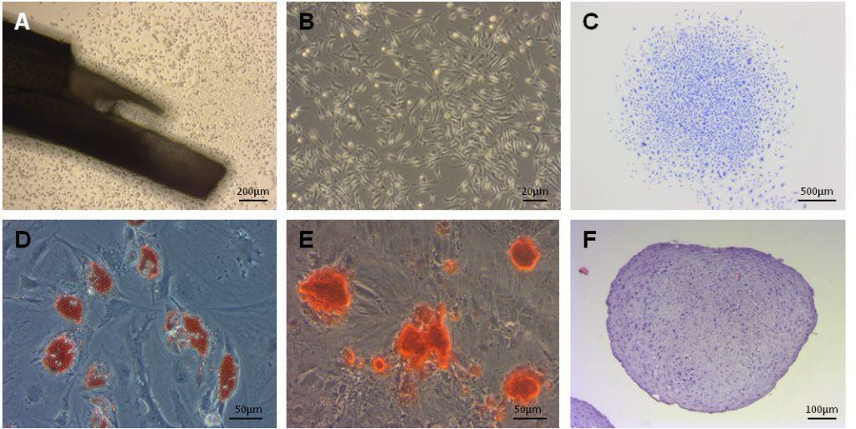
(A) Phase contrast image of MSCs migrating from a fragment of a compact bone of a mouse (B) Phase contrast image of a monolayer culture of MSC (passage 2). (C) A representative image of a fibroblast colony of MSCs after staining with crystal violet. (D) Phase contrast image of MSCs after adipogenic differentiation. Cells contain orange lipid vacuoles stained with oil red O. (E) Phase contrast image of MSCs after osteogenic differentiation The cells contain calcium deposits stained with alizarin red S. (F) Chondrogenic differentiation of MSCs in spheroid culture. Histological section of a chondrogenic pellet stained with toluidine blue
Figure 1 - Obtaining and characterization of the primary culture of mouse compact bone MSCs
The multilineage differentiation test showed that MSCs are able to differentiate into adipocytes, osteoblasts, and chondrocytes, that indicates their multipotent properties (Figures 1D - 1F).
Further, in order to prove that obtained cultures of compact bone MSCs are phenotypically homogeneous cell population, we performed flow cytometry analysis using antibodies to specific markers of mouse MSCs: CD29, CD44, CD90, CD105, CD106, and Sca-1. Antibodies to markers of hematopoietic and endothelial cells CD31 and CD45 were used as a negative control. The results of the analysis showed that cells isolated from the compact bone have a MSC phenotype with expression of CD29, CD29, CD44, CD90, CD105, CD106, and Sca-1 (Figure 2). The expression of markers of hematopoietic and endothelial cells CD31 and CD45 in MSC cultures was found at a very low level.
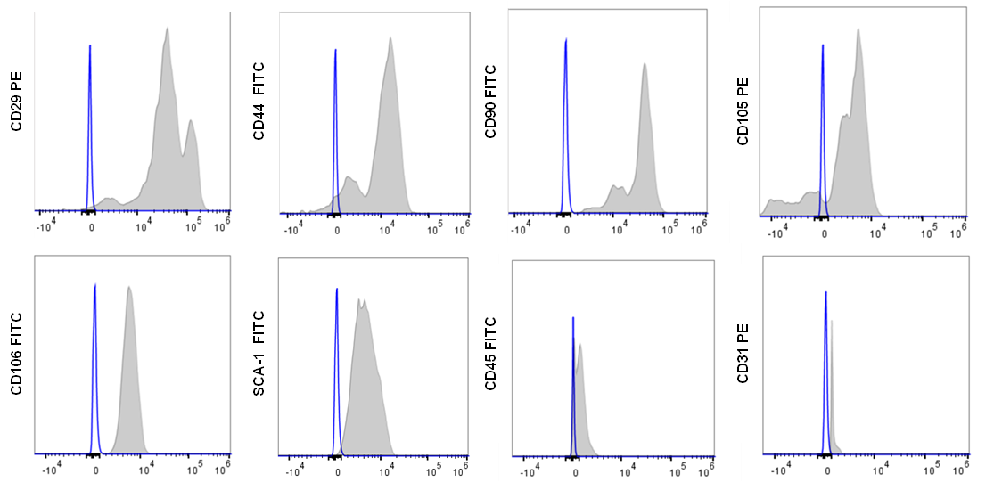
Figure 2 – Flow cytometry analysis of MSCs
For 3D spheroid formation, MSCs (passage ≤3) were aggregated into spheroids in microwells of low-binding plate within 3 days (Fig. 2A). MSC spheroids had an average diameter of approximately 65 μm (Fig. 2A, B). Morphologically, they had spherical or slightly oblong shapes. Confocal laser scanning microscopy (CLSM) imaging revealed that spheroids appeared as compact cellular structures without any cavities (Fig 2C). In addition, spheroids highly expressed CD90 – one of the surface markers of MSCs.
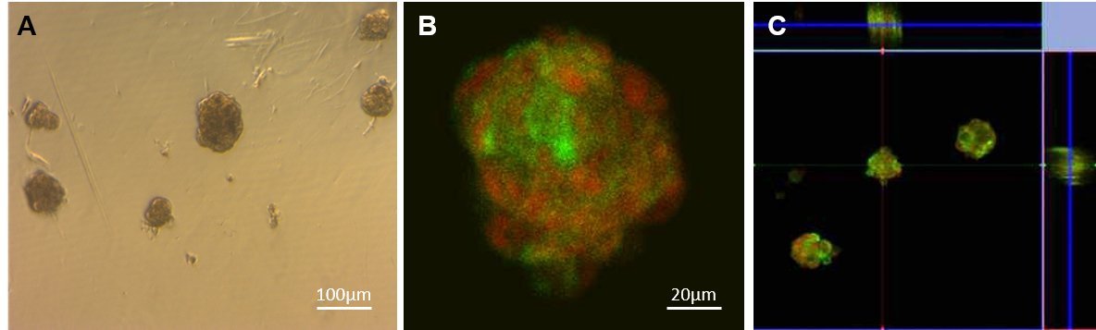
A) MSC spheroids formed after 72 h aggregation. B) A representative CLSM image of MSCs spheroid stained by CD90-FITC antibodies (green). The cell nuclei were stained by propidium iodide (red). (C) Orthogonal view of MSCs spheroids obtained with CLSM
Figure 3 – Characterization of 3D spheroid MSCs
2.2.2 Effects of preconditioned MSCs on oxLDL-induced endothelial cell damage in vitro
In order to study the therapeutic potential of TNF-preconditioned MSCs for restoring the functions of damaged vascular endothelium in atherosclerotic mice, we first conducted an in vitro study on the effect of TNF-preconditioned MSCs on oxLDL-induced ECAM damage using the translucent migration method. The results presented in Figure 4A showed that TNF-MSCs migrated most efficiently towards oxLDL-damaged ECAM compared to untreated MSCs.
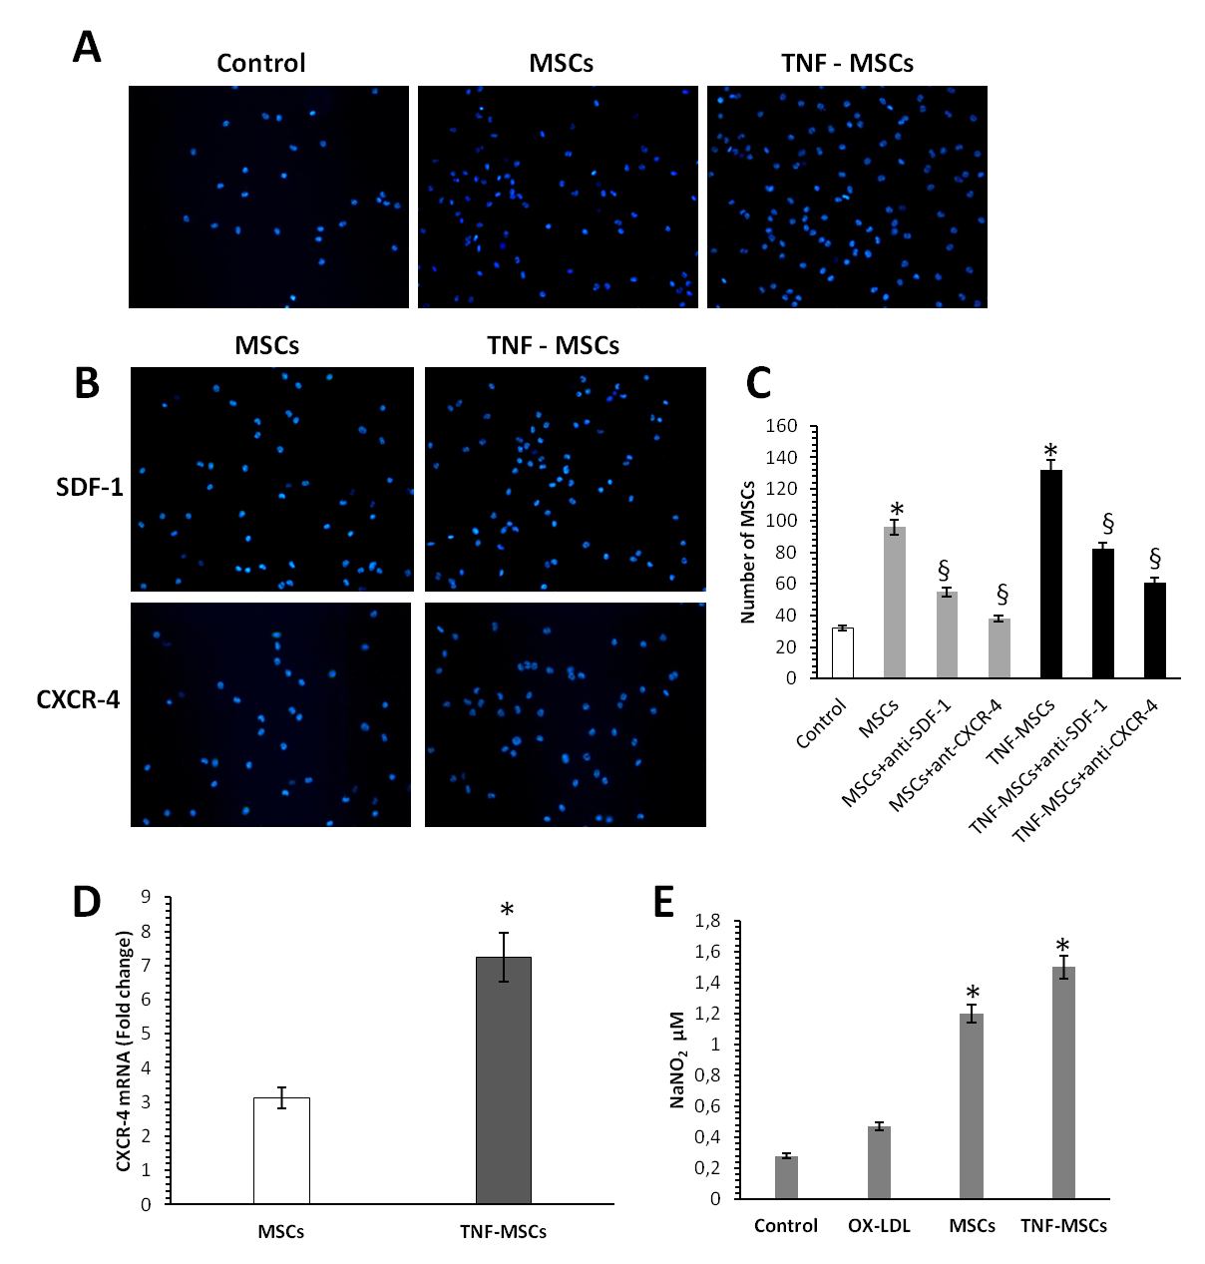
A) Tranwell migration analysis. ECAM were scattered into the lower wells without (Control) and with oxLDL treatment (50 mg / ml), while MSCs were scattered into the upper wells and incubated for 24 hours. Fluorescent images of the transwell membrane regions show stained MSCs migrating to the lower part of the membrane. C) Tranwell analysis of MSC migration in the presence of antibodies to SDF-1 and CXCR4 for 24 hours. C) Quantitative analysis of MSCs migrating to the lower part of the transwell membrane. D) Expression of the CXCR-4 gene in MSCs. E) Determination of NO production in supernatants by the Griess method. * Significant difference from control, p≤0.05; §- significant difference from oxLDL, p≤0.05
Figure 4 – Effect of TNF-preconditioned MSCs on oxLDL-induced damage to mouse aortic endothelial cells

This was due to the fact that TNF-MSCs expressed higher levels of CXCR4 than untreated MSCs, which led to their increased migration to oxLDL-treated ECAM (Figure 4D). However, blocking CXCR4 and SDF-1 with neutralizing antibodies led to a significant reduction in the induction of MSC migration (Figure 4B).
Next, we examined whether indirect MSC co-cultivation could protect ECAM from oxLDL-induced damage. For this, experiments were carried out to measure the levels of nitric oxide (NO) in the superntants of oxLDL-treated ECAM after 24 hours of co-culture with MSCs. The results of the study showed that TNF-MSCs significantly increased the level of NO production in oxLDL-treated ECAM compared to intact MSCs (Figure 4E). Thus, the results of in vitro studies indicate that oxLDL-treated ECAM can specifically recruit TNF-preconditioned MSCs, which have stronger protective effects on the functional activity of ECAM.
2.2.3 Effects of transplantation of preconditioned MSCs on inhibition of endothelial dysfunction in model animals with atherosclerosis
To create a model of atherosclerosis, ApoE mice were fed daily atherogenic food containing 0.15% cholesterol and 0.21% butter oil (Western Diet E-15721-34, SSNIFF, Germany) for 8 weeks. The mice were then divided into the following groups:
1) PBS group (intravenous injection of FSB),
2) MSC group (intravenous injection of 2 × 10⁶ cells),
3) TNF-MSC group (intravenous injection of 2 × 10⁶ cells).
The design scheme of a preclinical protocol for the induction of atherosclerosis and systemic use of MSCs is shown in Figure 5. Each group included at least 5 animals. Intravenous injection of MSCs was carried out into the tail vein of mice twice every 7 days.
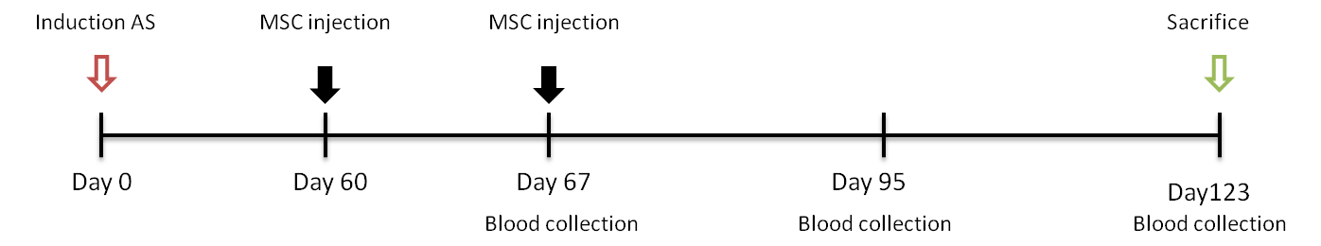
Figure 5 – Schematic diagram of a protocol for the induction of atherosclerosis in ApoE mice and the systemic use of compact bone MSCs
To study the effects of systemic intravenous administration of TNF-preconditioned MSCs on the restoration of endothelial function in atherosclerotic mice, experiments were performed to assess endothelial-dependent relaxation and contraction using acetylcholine and phenylephrine. For this, 8 weeks after the second intravenous injection of MSCs, the mice were sacrificed by euthanasia, after which the aorta was removed for use in an experiment to study endothelial-dependent relaxation and contraction. The research results are shown in Figure 6.
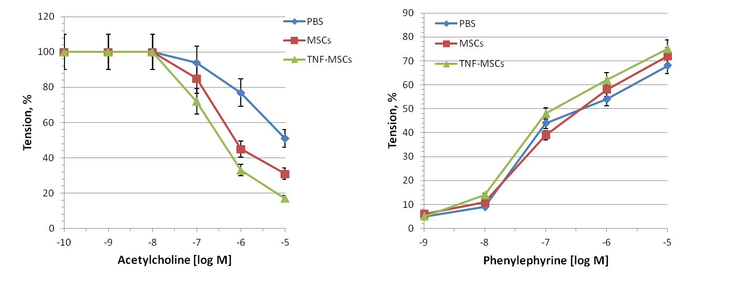
Figure 6 - Effect of systemic intravenous administration of TNF-preconditioned MSCs on endothelial-dependent relaxation and contraction in ApoE mice

The data obtained after recording the tension of the aortic rings showed that transplantation of TNF-preconditioned MSCs significantly increased the values of acetylcholine-dependent relaxation of the aorta as compared with the introduction of intact MSCs and PBS. However, the values of phenylephrine-dependent reduction after administration of TNF-preconditioned MSCs did not significantly differ from the control group (PBS) and MSC groups. Thus, these data indicate that TNF-preconditioned MSCs are able to improve endothelial-dependent relaxation of the aorta, but not vasolidation dependent on contraction of smooth muscle cells.
Since the development of atherosclerosis is accompanied by dyslipidemia and elevated levels of pro-inflammatory cytokines, this study analyzed the serum levels of cholesterol, LDL, HDL, and cytokines in mice with atherosclerosis 8 weeks after the second intravenous injection of MSCs. It was revealed that, compared to the PBS group (control), intravenous administration of both MSCs and TNF-MSCs induced a notable decrease in total cholesterol and LDL in the serum of mice with atherosclerosis, starting at 4 weeks (Figure 7). However, no significant difference was detected between the TNF-MSCs group and the MSCs group. Nevertheless, intravenous administration of TNF-MSCs moderately increased the HDL level in the blood serum of mice compared to the control and MSCs group.

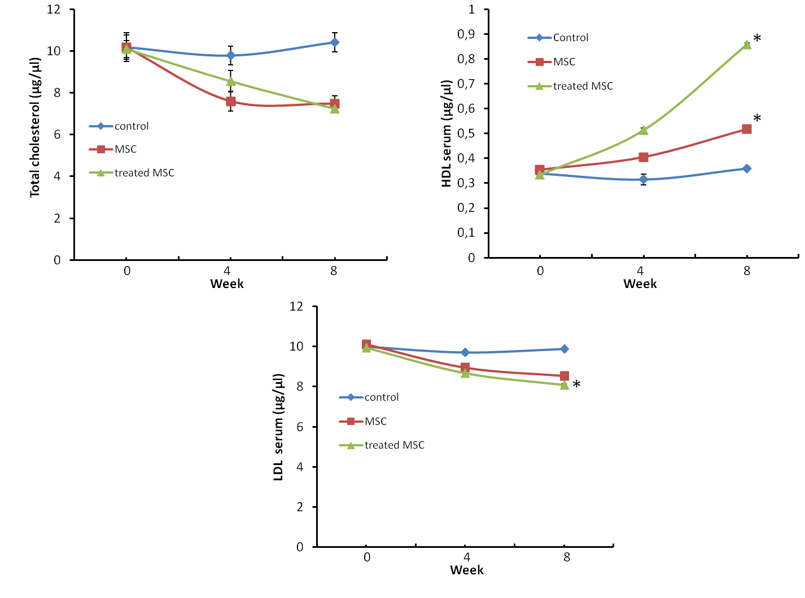
Each value is the average of 5 animals. * Significant difference from control, p <0.05
Figure 7 - Effect of systemic administration of TNF-preconditioned MSCs on cholesterol, LDL and HDL levels in blood plasma of mice with atherosclerosis

Analysis of cytokine degrees in the blood serum of mice demonstrated that systemic intravenous injection of TNF-preconditioned MSCs adducted to substantial suppression of the levels of pro-inflammatory cytokines TNF-α и IFN-γ in comparison with intact MSCs and control groups (PBS) (Figure 8).
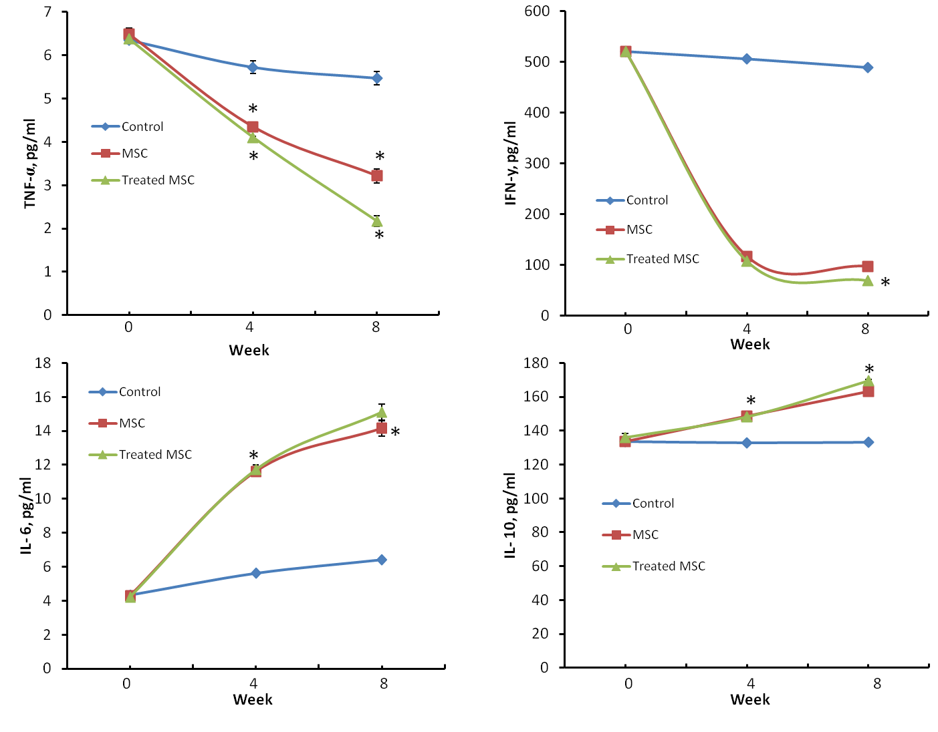
Each value is the average of 5 animals. * Significant difference from control, p <0.05
Figure 8 - The effect of systemic administration of TNF-preconditioned MSCs on the level of cytokines in the blood plasma of mice with atherosclerosis
On the other hand, both MSCs and TNF-MSCs considerably enhanced the level of immunoregulatory and anti-inflammatory cytokines such as IL-6 and IL-10. Nonetheless, the reliable difference between the TNF-MSCs and MSCs groups was not revealed. Analysis of the spleen mass index presented that induction of atherosclerosis in mice contributes to dramatic increase in spleen size (Figure 9). However, the systemic applying of TNF-preconditioned MSCs undoubtedly decreased the spleen mass index if compare with the groups of mice injected with MSCs and PBS. Wherein, the spleen mass index of the TNF-MSCs group was diminished approximately to that of the normal spleen of mice.
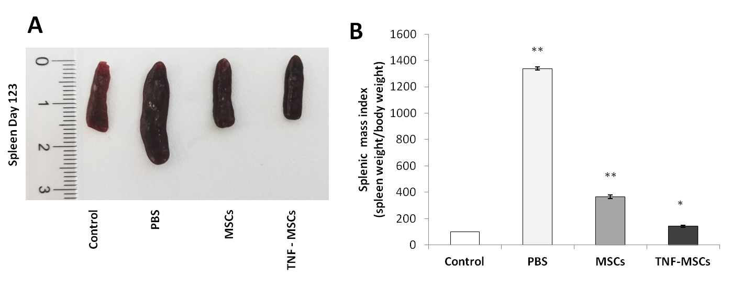
* Significant difference from control, p <0.05. ** Significant difference from control, p <0.01
Figure 9 - Effect of systemic administration of TNF-preconditioned MSCs on spleen size and weight in ApoE mice
3 Summary and evaluation of the results
Endothelial dysfunction is an important precursor and early marker of atherosclerosis, resulting in the recruitment of monocytes, T cells and platelets, accumulation of lipid molecules and subsequent formation of foam cells from monocyte-derived macrophages [30]. Endothelial dysfunction is induced mainly by ox-LDL which promotes endothelial cell activation, apoptosis, production of inflammatory mediators, impairment of vasorelaxation, and contributes to atherosclerosis development [31, 32]. In addition, oxLDL can suppress the activity of endothelial nitric-oxide synthase (eNOS) and NO production, resulting in the interruption of NO-mediated responses in endothelial cells [33]. In spite of the damage, the endothelium has the potential for self-repairing; MSCs are able to protect and restore the functions of endothelial cells. For example, it has been shown that human MSCs can protect endothelial cells from injury induced by oxidative stress or monocytes [34, 35]. MSCs reduced monocyte adhesion to endothelial cells and also reduced the stimulatory effect of monocytes on endothelial cell proliferation in the presence of H₂O₂. On the other hand, MSCs increased the activities of antioxidants, such as glutathione and thioredoxin reductases in H₂O₂-treated endothelial cells [36]. Human amnion-derived MSCs have been reported to enhance endothelial cell viability as shown by decreasing the lactate dehydrogenase level and stabilizing the endothelial network formation in vitro [37].
It was shown that human bone marrow-derived MSCs can ameliorate atherosclerotic lesions by restoring endothelial function which was impaired after treatment with ox-LDL [38]. Treatment with ox-LDL resulted in inactivation Akt/eNOS, induction of eNOS degradation and inhibition of NO production in endothelial cells. A in vitro study showed that human MSCs are able to reverse the harmful effects of oxLDL on endothelial cells and restore Akt/eNOS activity, eNOS level, and NO production due to increased production of IL-8 and macrophage inflammatory protein-2.
Based on these data, we hypothesized that the protective effects of MSCs on endothelial dysfunction in atherosclerosis can be enhanced by cytokine preconditioning. In order to test our hypothesis, we studied the therapeutic efficacy of transplantation of TNF-preconditioned MSCs in restoring the functions of the aortic endothelium in model animals with atherosclerosis. In our in vitro study, we have shown for the first time that TNF-MSCs are able to more efficiently migrate towards oxLDL-treated ECAM as compared to untreated MSCs and have beneficial protective effects leading to the restoration of NO-producing activity in oxLDL-treated ECAM. Moreover, we have shown that the induction of MSC migration towards oxLDL of damaged ECAM depends on the secretion of SDF-1 by ECAMs and the expression of CXCR4 on MSC.
Several studies have shown that stromal cell chemokine factor-1 (SDF-1, also known as CXCL12) plays an important role in MSC chemotaxis, as well as in organ-specific homing in damaged tissue by interacting with its receptor CXCR4 [39–41]. Despite the fact that CXCR4 is highly expressed by MSCs, its expression is markedly reduced during the ex vivo expansion of MSCs [42, 43], which reduces their ability to respond to homing signals emanating from damaged tissue sites.
In order to enhance the migration properties of MSCs, several research groups have attempted to develop alternative approaches to optimize the efficiency of MSC migration and enhance their positive effect at the site of injury by preconditioning MSCs prior to transplantation. For example, preconditioning with insulin-like growth factor (IGF-1) has been shown to improve the ability of MSCs to migrate and restore normal renal function after acute injury through upregulation of CXCR4 expression. Its functional role was further confirmed by blocking CXCR4, which completely neutralized the effect of IGF-1 on MSCs [44]. In our study, we found for the first time that TNF-preconditioned MSCs expressed higher levels of CXCR4 than untreated MSCs, which led to their increased migration to oxLDL-treated ECAMs. Thus, our results suggest that TNF-α leads to an increase in the regulation of CXCR4 expression in cultured MSCs, and thereby increases their migration ability.
Further, in vivo studies were carried out to study the effect of transplantation of preconditioned MSCs on the inhibition of endothelial dysfunction in model animals with atherosclerosis. To create a model of atherosclerosis in our study, we used B6.129P2-Apoetm1Unc mice (ApoE KO). These mice are knockout, homozygous for the Apoetm1Unc gene mutation, show a marked increase in total plasma cholesterol and atherogenic plaque formation in the arteries, which does not depend on age or sex. To induce the development of atherosclerosis in ApoE mice, a special recommended diet was used, consisting of foods with high cholesterol and fats. After 8 weeks of keeping experimental mice on an atherogenic diet, 2 intravenous injections of MSCs of 2 million cells were made (1 injection at 8 weeks and 2 injections at 9 weeks). The results of a physiological experiment showed that systemic intravenous transplantation of TNF-preconditioned MSCs significantly increased the values of acetylcholine-dependent relaxation of the aorta, but not phenylephrine-dependent contraction, compared with the introduction of intact MSCs and PBS. Thus, these data indicate that TNF-preconditioned MSCs are able to improve endothelial-dependent relaxation of the aorta, but not vasolidation dependent on the contraction of smooth muscle cells.
Our in vivo studies also showed that the systemic use of TNF-MSCs led to a decrease in total cholesterol and LDL, on the one hand, and a significant increase in the HDL level in the serum of mice, on the other hand. These data correlated well with the ELISA results, which showed that intravenous administration of TNF-preconditioned MSCs resulted in a significant suppression of the levels of proinflammatory cytokines TNF-α and IFN-γ compared with intact MSCs and the control group (PBS). On the other hand, both MSCs and TNF-MSCs significantly increased the level of immunoregulatory and anti-inflammatory cytokines such as IL-6 and IL-10. Interesting data were obtained when analyzing the spleen mass index in experimental mice. It was found that the spleen of atherosclerotic control (PBS) mice was greatly increased in size compared to the spleen of intact healthy ApoE mice. This indicates that a long-term atherogenic diet induces chronic inflammation in mice. However, the systemic use of TNF-preconditioned MSCs led to a significant suppression of the inflammatory state of the spleen, reducing the spleen mass index to normal values.
Taken together, our findings have shown that TNF-preconditioned MSCs exert powerful immunosuppressive and antiatherogenic effects in the development of atherosclerosis. We believe that the use of preconditioned MSCs can be recommended when developing a strategy for the prevention and treatment of atherosclerosis.

Conclusion
In accordance with the calendar plan for 2018-2020, all planned works were completed in full. According to the objectives of the study, the following results were obtained:
It was found that the optimal conditions for enhancing the immunomodulatory properties of MSCs from compact bone in mice is preconditioning of a 3D spheroid culture of MSCs using the pro-inflammatory cytokine TNF-α (20 ng / ml) for 24 hours (interim report 2018, inverted No. 0218PK00236).
It was shown for the first time that intravenous transplantation of TNF-preconditioned MSCs was more effective in suppressing the development of atherosclerosis in ApoE compared to untreated MSCs. In particular, it was found that, in comparison with MSCs, preconditioned MSCs are able to more effectively suppress the number of the total population of CD4 + T cells, and, on the other hand, significantly increase the number of circulating Treg cells in the peripheral blood of ApoE mice. It was shown that preconditioned MSCs significantly reduced the proinflammatory cytokines TNF-α and IFN-γ in the blood serum and reduced the size of atherosclerotic plaques in the arteries than untreated MSCs (interim report 2018, invert No. 0219RK00402).
It was shown for the first time that TNF-preconditioned MSCs significantly improved endothelial dysfunction, suppressed inflammation and dyslipidemia during the development of atherosclerosis in ApoE mice. In particular, it was found that, compared with untreated MSCs, TNF-preconditioned MSCs are able to more efficiently migrate towards oxLDL-damaged ECAM due to increased expression of CXCR-4 and restore their NO-producing activity.
The results of in vivo studies showed that systemic intravenous transplantation of TNF-preconditioned MSCs significantly improved the function of the aortic endothelium in mice with atherosclerosis compared to the administration of intact MSCs and PBS. It was also found that TNF-preconditioned MSC suppressed the level of pro-inflammatory cytokines (TNF-α and IFN-γ), cholesterol and low density lipids (LDL) on the one hand, and increased the level of immunoregulatory cytokines (IL-6 and IL-10) and high density lipids (HDL) in the serum of mice with atherosclerosis on the other side. In addition, it was found that transplantation of TNF-preconditioned MSCs led to a significant suppression of the inflammatory state of the spleen, reducing the spleen mass index to normal values.
Thus, the obtained results indicate that TNF-preconditioned MSCs have powerful immunosuppressive and antiatherogenic effects in the development of atherosclerosis. We believe that the use of preconditioned MSCs can be recommended when developing a strategy for the prevention and treatment of atherosclerosis.
The results of our study were presented and published in the 4 scientific articles and 2 abstracts in the proceedings of the international conferences (Appendix C, D).

List of references
- Hansson G.K. Inflammation, atherosclerosis, and coronary artery disease // N Engl J Med - 2005. - № 352 - Р.1685-1695. (in English)
- Lusis A.J. Atherosclerosis // Nature - 2000. - №. 407 - Р.233-241. (in English)
- Moran A.E., Roth G.A., Narula J., Mensah G.A. 1990-2010 global cardiovascular disease atlas // Glob Heart - 2014. - № 9 - Р.3-16. (in English)
- Jonasson L., Holm J., Skalli O., Bondjers G., Hansson G.K. Regional accumulations of T cells, macrophages, and smooth muscle cells in the human atherosclerotic plaque // Arteriosclerosis - 1986. - № 6 - Р.131-138. (in English)
- Antohe F. Endothelial cells and macrophages, partners in atherosclerotic plaque progression // Arch Physiol Biochem - 2006. - № 112 - Р.245-53. (in English)
- Libby P. Inflammation in atherosclerosis // Nature - 2002. - № 420 - Р.868-874.
- Tietge U.J. Hyperlipidemia and cardiovascular disease: inflammation, dyslipidemia, and atherosclerosis // Curr Opin Lipidol - 2014. - № 25 - Р.94-95. (in English)
- Weber C., Zernecke A., Libby P. The multifaceted contributions of leukocyte subsets to atherosclerosis: lessons from mouse models // Nat Rev Immunol - 2008. - № 8 - Р.802-815. (in English)
- Emeson E.E., Shen M.L., Bell C.G., Qureshi A. Inhibition of atherosclerosis in CD 4 T-cell-ablated and nude (nu/nu) C57BL/6 hyperlipidemic mice // Am J Pathol - 1996. - № 149 - Р.675–685. (in English)
- Frostegard J., Ulfgren A.K., Nyberg P., Hedin U., Swedenborg J., Andersson U. Cytokine expression in advanced human atherosclerotic plaques: dominance of pro-inflammatory (Th1) and macrophage-stimulating cytokines // Atherosclerosis - 1999. - № 145 - Р.33-43. (in English)
- Hermansson A., Ketelhuth D.F., Strodthoff D., Wurm M., Hansson E.M., Nicoletti A. Inhibition of T cell response to native low-density lipoprotein reduces atherosclerosis // J Exp Med - 2010.- № 207 - Р.1081-1093. (in English)
- Shapiro M.D., Fazio S. From lipids to inflammation // Circ Res - 2016. - № 118 - Р.732-749. (in English)
- Hague W., Forder P., Simes J., Hunt D., Tonkin A. Effect of pravastatin on cardiovascular events and mortality in 1516 women with coronary heart disease: results from the Long-Term Intervention with Pravastatin in Ischemic Disease (LIPID) study // Am Heart J - 2003. - № 145 - P.643-651. (in English)
- Li F., Guo X., Chen S.Y. Function and therapeutic potential of mesenchymal stem cells in atherosclerosis // Front Cardiovasc Med - 2017. - № 4 - Р.32. (in English)
- Short B., Brouard N., Occhiodoro-Scott T., Ramakrishnan A., Simmons P.J. Mesenchymal stem cells // Arch Med Res - 2003. - №. 34 - Р.565-571. (in English)
- Hass R., Kasper C., Bohm S., Jacobs R. Different populations and sources of human mesenchymal stem cells (MSC): a comparison of adult and neonatal tissue-derived MSC // Cell Commun Signal - 2011. - № 9 - Р.12. (in English)
- Wang Y., Chen X., Cao W., Shi Y. Plasticity of mesenchymal stem cells in immunomodulation: pathological and therapeutic implications // Nat Immunol - 2014. - Vol.15, №. 11 - Р.1009-1016. (in English)
- Kokabu S., Lowery J.W., Jimi E. Cell fate and differentiation of bone marrow mesenchymal stem cells // Stem Cells Int - 2016. - № 2016 - Р.3753581. (in English)
- Pittenger M.F., Mackay A.M., Beck S.C., Jaiswal R.K., Douglas R., Mosca J.D. Multilineage potential of adult human mesenchymal stem cells // Science - 1999. - № 284 - Р. 143-147. (in English)
- De Miguel M.P., Fuentes-Julián S., Blázquez-Martínez A., Pascual C.Y., Aller M.A., Arias J., Arnalich-Montiel F. Immunosuppressive properties of mesenchymal stem cells: advances and applications // Curr Mol Med - 2012. - Vol.12, №. 5 - Р.574-591. (in English)
- Lin Y.L., Yet S.F., Hsu Y.T., Wang G.J., Hung S.C. Mesenchymal stem cells ameliorate atherosclerotic lesions via restoring endothelial function // Stem Cells Transl Med - 2015. - № 1 - Р.44-55. (in English)
- Fang S.M., Du D.Y., Li Y.T., Ge X.L., Qin P.T., Zhang Q.H. Allogeneic bone marrow mesenchymal stem cells transplantation for stabilizing and repairing of therosclerotic ruptured plaque // Thromb Res - 2013. - №. 131 - Р.253-257. (in English)
- Wang S.S., Hu S.W., Zhang Q.H., Xia A.X., Jiang Z.X., Chen X.M. Mesenchymal stem cells stabilize atherosclerotic vulnerable plaque by anti-inflammatory properties // PLoS One - 2015. - № 10 - Р.0136026. (in English)
- Wang Z.X., Wang C.Q., Li X.Y., Feng G.K., Zhu H.L., Ding Y. Mesenchymal stem cells alleviate atherosclerosis by elevating number and function of CD4(+)CD25(+)FOXP3(+) regulatory T-cells and inhibiting macrophage foam cell formation // Mol Cell Biochem. - 2015. - № 400 - Р.163-172. (in English)
- Frodermann V., van Duijn J., van Pel M., van Santbrink P.J., Bot I., Kuiper J., de Jager S.C. Mesenchymal stem cells reduce murine atherosclerosis development // Sci Rep - 2015. - № 5 - Р.15559. (in English)
- Saparov A., Ogay V., Nurgozhin T., Jumabay M., Chen W.C. Preconditioning of human mesenchymal stem cells to enhance their regulation of the immune response // Stem Cells Int -2016. - №2016 - Р.3924858. (in English)
- Zhu H., Guo Z.K., Jiang X.X., Li H., Wang X.Y., Yao H.Y., Zhang Y. A protocol for isolation and culture of mesenchymal stem cells from mouse compact bone // Nat Protoc - 2010. - Vol. 5, № 3 - Р. 550-560. (in English)
- Achilli T.M., Meyer J., Morgan J.R. Advances in the formation, use and understanding of multi-cellular spheroids // Expert Opin Biol Ther - 2012. - № 12 - Р.1347-1360. (in English)
- Wang J.M., Chen A.F., Zhang K. Isolation and primary culture of mouse aortic endothelial cells // J Vis Exp - 2016. - № 118 - P.52965. (in English)
- Luscher T.F., Barton M. Biology of the endothelium // Clin Cardiol - 1997. - №. 20 - P.3-10. (in English)
- Chisolm G.M., Steinberg D. The oxidative modification hypothesis of atherogenesis: an overview. Free Radic Biol Med - 2000. - № 28 - P.1815-1826. (in English)
- Parthasarathy S., Santanam N., Ramachandran S., Meilhac O. Oxidants and antioxidants in atherogenesis. An appraisal // J Lipid Res - 1999. - № 40 - P.2143-2157. (in English)
- Li D., Mehta J.L. Antisense to LOX-1 inhibits oxidized LDL-mediated upregulation of monocyte chemoattractant protein-1 and monocyte adhesion to human coronary artery endothelial cells // Circulation - 2000. - № 101 - P.2889-2895. (in English)
- Blair A., Shaul P.W., Yuhanna I.S. Oxidized low density lipoprotein displaces endothelial nitric-oxide synthase (eNOS) from plasmalemmal caveolae and impairs eNOS activation // J Biol Chem -1999. - № 274 - Р.32512-32519. (in English)
- Alshabibi M.A., Khatlani T., Abomaray F.M. Human decidua basalis mesenchymal stem/stromal cells protect endothelial cell functions from oxidative stress induced by hydrogen peroxide and monocytes // Stem Cell Res Ther - 2018. - Vol. 9, №. 1 - P.275-283. (in English)
- Alshabibi M.A., Al Huqail A.J., Khatlani T. Mesenchymal stem/multipotent stromal cells from human decidua basalis reduce endothelial cell activation // Stem Cells Dev - 2017. - Vol. 26, № 18 - Р.1355-1373. (in English)
- Konig J., Huppertz B., Desoye G. Amnion-derived mesenchymal stromal cells show angiogenic properties but resist differentiation into mature endothelial cells // Stem Cells Dev - 2012, № 21 - Р.1309-1320. (in English)
- Lin Y.L., Yet S.F., Hsu Y.T., Wang G.J., Hung S.C. Mesenchymal stem cells ameliorate atherosclerotic lesions via restoring endothelial function // Stem Cells Transl Med - 2015. - Vol. 4, № 1 - Р.44-55. (in English)
- Cencioni C., Capogrossi M.C., Napolitano M., The SDF-1/CXCR4 axis in stem cell preconditioning // Cardiovas Res. 2012. - Vol. 94, № 3 - Р. 400-407. (in English)
- Wu Y., Zhao R.C.H., The role of chemokines in mesenchymal stem cell homing to myocardium // Stem Cell Rev Rep - 2012 - Vol. 8, № 1 - Р.243-250. (in English)
- Liu X., Duan B., Cheng Z. SDF-1/CXCR4 axis modulates bone marrow mesenchymal stem cell apoptosis, migration and cytokine secretion // Prot Cell - 2011. - Vol. 2, № 10 - Р.845-854. (in English)
- Petit I., Jin D., Rafii S. The SDF-1-CXCR4 signaling pathway: a molecular hub modulating neo-angiogenesis // Trend Immunol - 2007. - Vol. 28, № 7 - Р.299-307. (in English)
- Son B.-R., Marquez-Curtis L.A., Kucia M. Migration of bone marrow and cord blood mesenchymal stem cells in vitro is regulated by stromal-derived factor-1-CXCR4 and hepatocyte growth factor-c-met axes and involves matrix metalloproteinases // Stem Cell - 2006. - Vol. 24, № 5 - P.1254-1264. (in English)
- Xinaris C., Morigi M., Benedetti V. A novel strategy to enhance mesenchymal stem cell migration capacity and promote tissue repair in an injury specific fashion // Cell Transpl - 2013. - Vol. 22, №. 3 - P. 423-436. (in English)

Attachment А
Timetable and technical specification for 2018-2020

Addendum 1.1-1. __
to the contract №__ from _______2018y.
for grant funding

TECHNICAL SPECIFICATIONS AND
CALENDAR WORK PLAN

To the contract №_____ from __________________2018 year

1. RSE on the REM «National center for biotechnology» SC MSE of RK

1.1 Priority: Life and Health Sciences
1.2 By sub-priority: Scientific and innovative biomedicine.
1.3 On the topic of the project: № AP05134447 «Development of a new therapeutic strategy to enhance the effectiveness of atherosclerosis treatment by using preconditioned mesenchymal stem cells»
1.4 Total project amount: 33 753 650 (thirty-three million seven hundred fifty-three thousand six hundred fifty) tenge, в including with a breakdown by years, for the performance of work following paragraph 3:
- for 2018 - in total 12 000 000 (twelve million) tenge;
- for 2019 - in total 11 064 661 (eleven million sixty-four thousand six hundred and one) tenge;
- for 2020 - in total 10 688 989 (ten million six hundred eighty-eight thousand nine hundred eighty-nine) tenge.

2. Characteristics of scientific and technical products by qualification characteristics and economic indicators
2.1 Field of work: Regenerative medicine
2.2 Application: Biomedicine
2.3 Final result:
- for 2018: The optimal conditions for the preconditioning of MSCs, which increase their immunomodulatory properties, will be determined.
- for 2019: The effects of preconditioned MSCs on the development of atherosclerosis in model animals will be shown.
- for 2020: The effects of preconditioned MSCs on the inhibition of endothelial dysfunction in atherosclerosis will be shown.
2.4 Patentability: results are patentable
2.5 Scientific and technical level (novelty): High. A new therapeutic strategy will be developed to improve the effectiveness of MSCs in the treatment of atherosclerosis.
2.6 The use of scientific and technical products is carried out: by the Customer and the Contractor
2.7 Type of use of the result of scientific and (or) scientific and technical activities: publications, report

3. Name of work, terms of their implementation and results

№ п/п | Name of the tasks, activities to implement the objectives of the project* | Duration of implementation* |  | Expected Result*
№ п/п |  | start | end | Expected Result*
1  1. | To obtain the primary cultures of MSCs and to evaluate their immunomodulatory properties. | January 2018 | June 2018 | The primary cultures of MSCs will be obtained and an evaluation of their immunomodulatory properties will be given.
22. | Determine the optimal conditions for preconditioning mice MSCs to effectively increase their immunomodulatory properties in vitro. | July 2018 | Until November 1, 2018 | Optimal conditions for the preconditioning of mouse MSCs will be determined to effectively increase their immunomodulatory properties in vitro. The optimal conditions for the preconditioning of MSCs, which increase their immunomodulatory properties, will be determined.
4  3. | To study the therapeutic effects of preconditioned MSCs on the atherosclerosis development in model animals. | January 2019 | Until November 1, 2019 | The therapeutic effects of preconditioned MSCs on the atherosclerosis development in model animals will be studied. For the first time, the effects of preconditioned MSCs on atherosclerosis development in model animals will be shown.
33.1 | To investigate the effect of preconditioned MSCs on the functional activity of cells of the immune system. | January 2019 | June 2019 | The effect of preconditioned MSCs on the functional activity of cells of the immune system will be studied.  For the first time, the effects of preconditioned MSCs on the functional activity of cells of the immune system will be shown.
33.2 | To study the influence of preconditioned MSCs on the formation of atherosclerotic plaques in an experimental model of atherosclerosis. | July 2019 | Until November 1, 2019 | The influence of preconditioned MSCs on the formation of atherosclerotic plaques in an experimental model of atherosclerosis will be studied.  For the first time, influence of preconditioned MSCs on the formation of atherosclerotic plaques in an experimental model of atherosclerosis will be studied will be demonstrated.
4  4 | To study the effects of preconditioned MSC on the inhibition of endothelial dysfunction in the animal model of atherosclerosis. | January 2020 | Until November 1, 2020 | The effects of preconditioned MSC on the inhibition of endothelial dysfunction in the animal model of atherosclerosis will be studied. For the first time, the effects of preconditioned MSCs on the inhibition of the endothelial dysfunction in atherosclerosis will be shown.
34.1 | To investigate the effects of preconditioned MSCs on the oxLDL-triggerred damage of endothelial cells in in vitro conditions. | January 2020 | April 2020 | The effects of preconditioned MSCs on the oxLDL-triggerred damage of endothelial cells in in vitro conditions will be studied.  For the first time, the effects of preconditioned MSCs on the oxLDL-triggerred damage in the endothelial cells in in vitro conditions will be shown.
44.2 | To study the impact of transplantation of preconditioned MSCs on the inhibition of endothelial dysfunction at model animals with atherosclerosis. | May 2020 | Until November 1, 2020 | The impact of transplantation of preconditioned MSCs on the inhibition of endothelial dysfunction at model animals with atherosclerosis will be studied.  For the first time, the effects of transplantation of preconditioned MSCs on the inhibition of endothelial dysfunction in animals with atherosclerosis will be demonstrated. Two articles will be published in peer-reviewed foreign scientific journals indexed in the Web of Science or Scopus databases with a non-zero impact factor, as well as two publications in peer-reviewed foreign and domestic scientific journals with a non-zero impact factor.
Note: * - indicates the works, terms, and their results for 2018, 2019, 2020 for each year, according to the calendar plan of the competition application.

From customer :  _________________________________  S.I. "Science Committee of the Ministry of Education and Science of the Republic of Kazakhstan"  ______________ Abdrasilov B.S .  p.s. | From the Contractor :  General Director of the RSE on the REM «National center for biotechnology» SC MSE of RK  ________________ Ramankulov E.M.  p.s.  Familiarized with:  Scientific supervisor of the project (s)  ___________________ Ogay V.B .  ( signature )

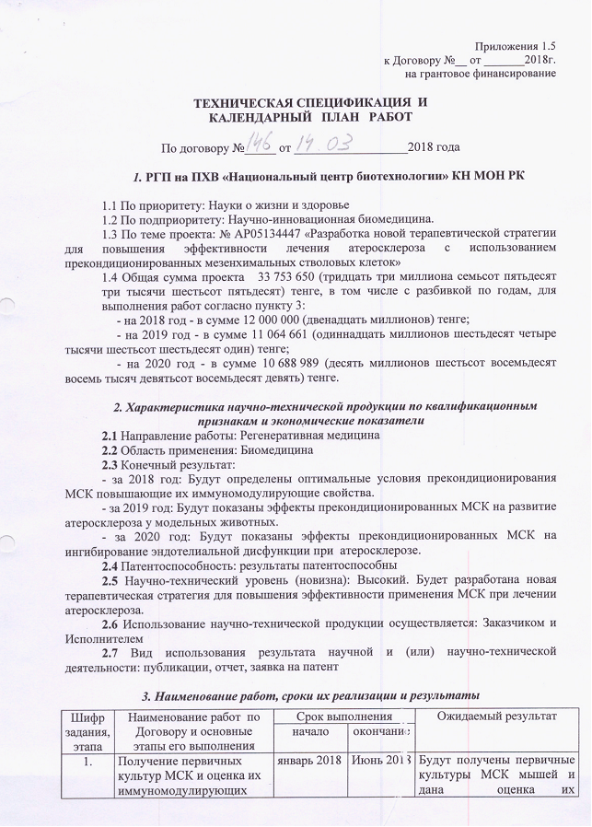
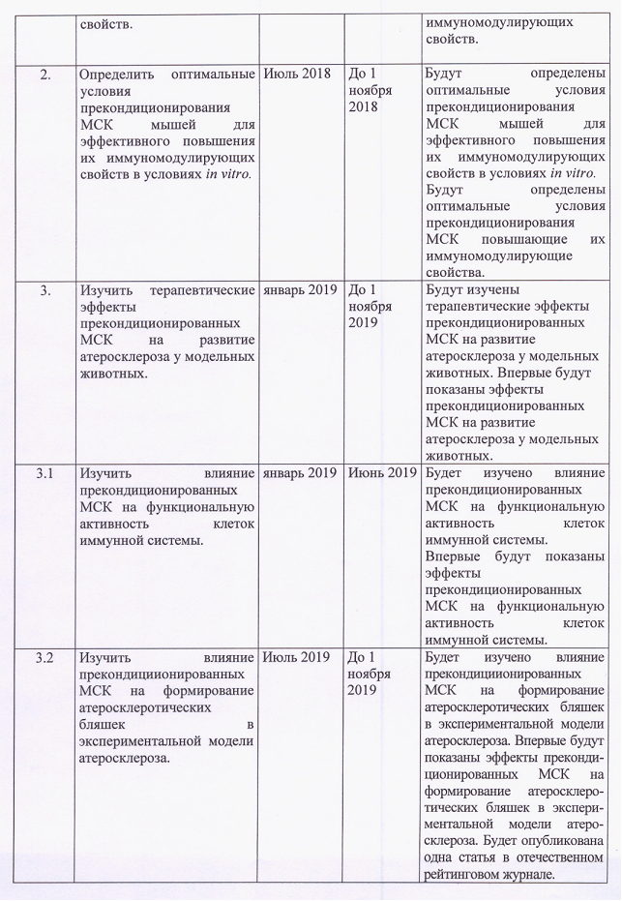
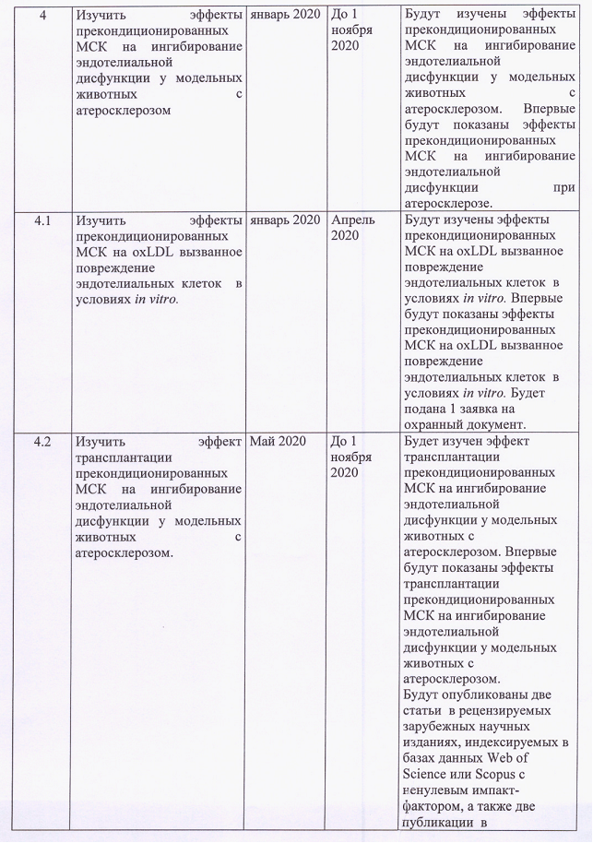
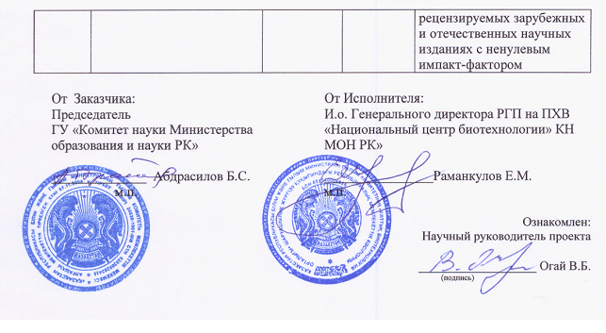

Attachment B
Extract from the minutes of the meeting of the local ethics commission
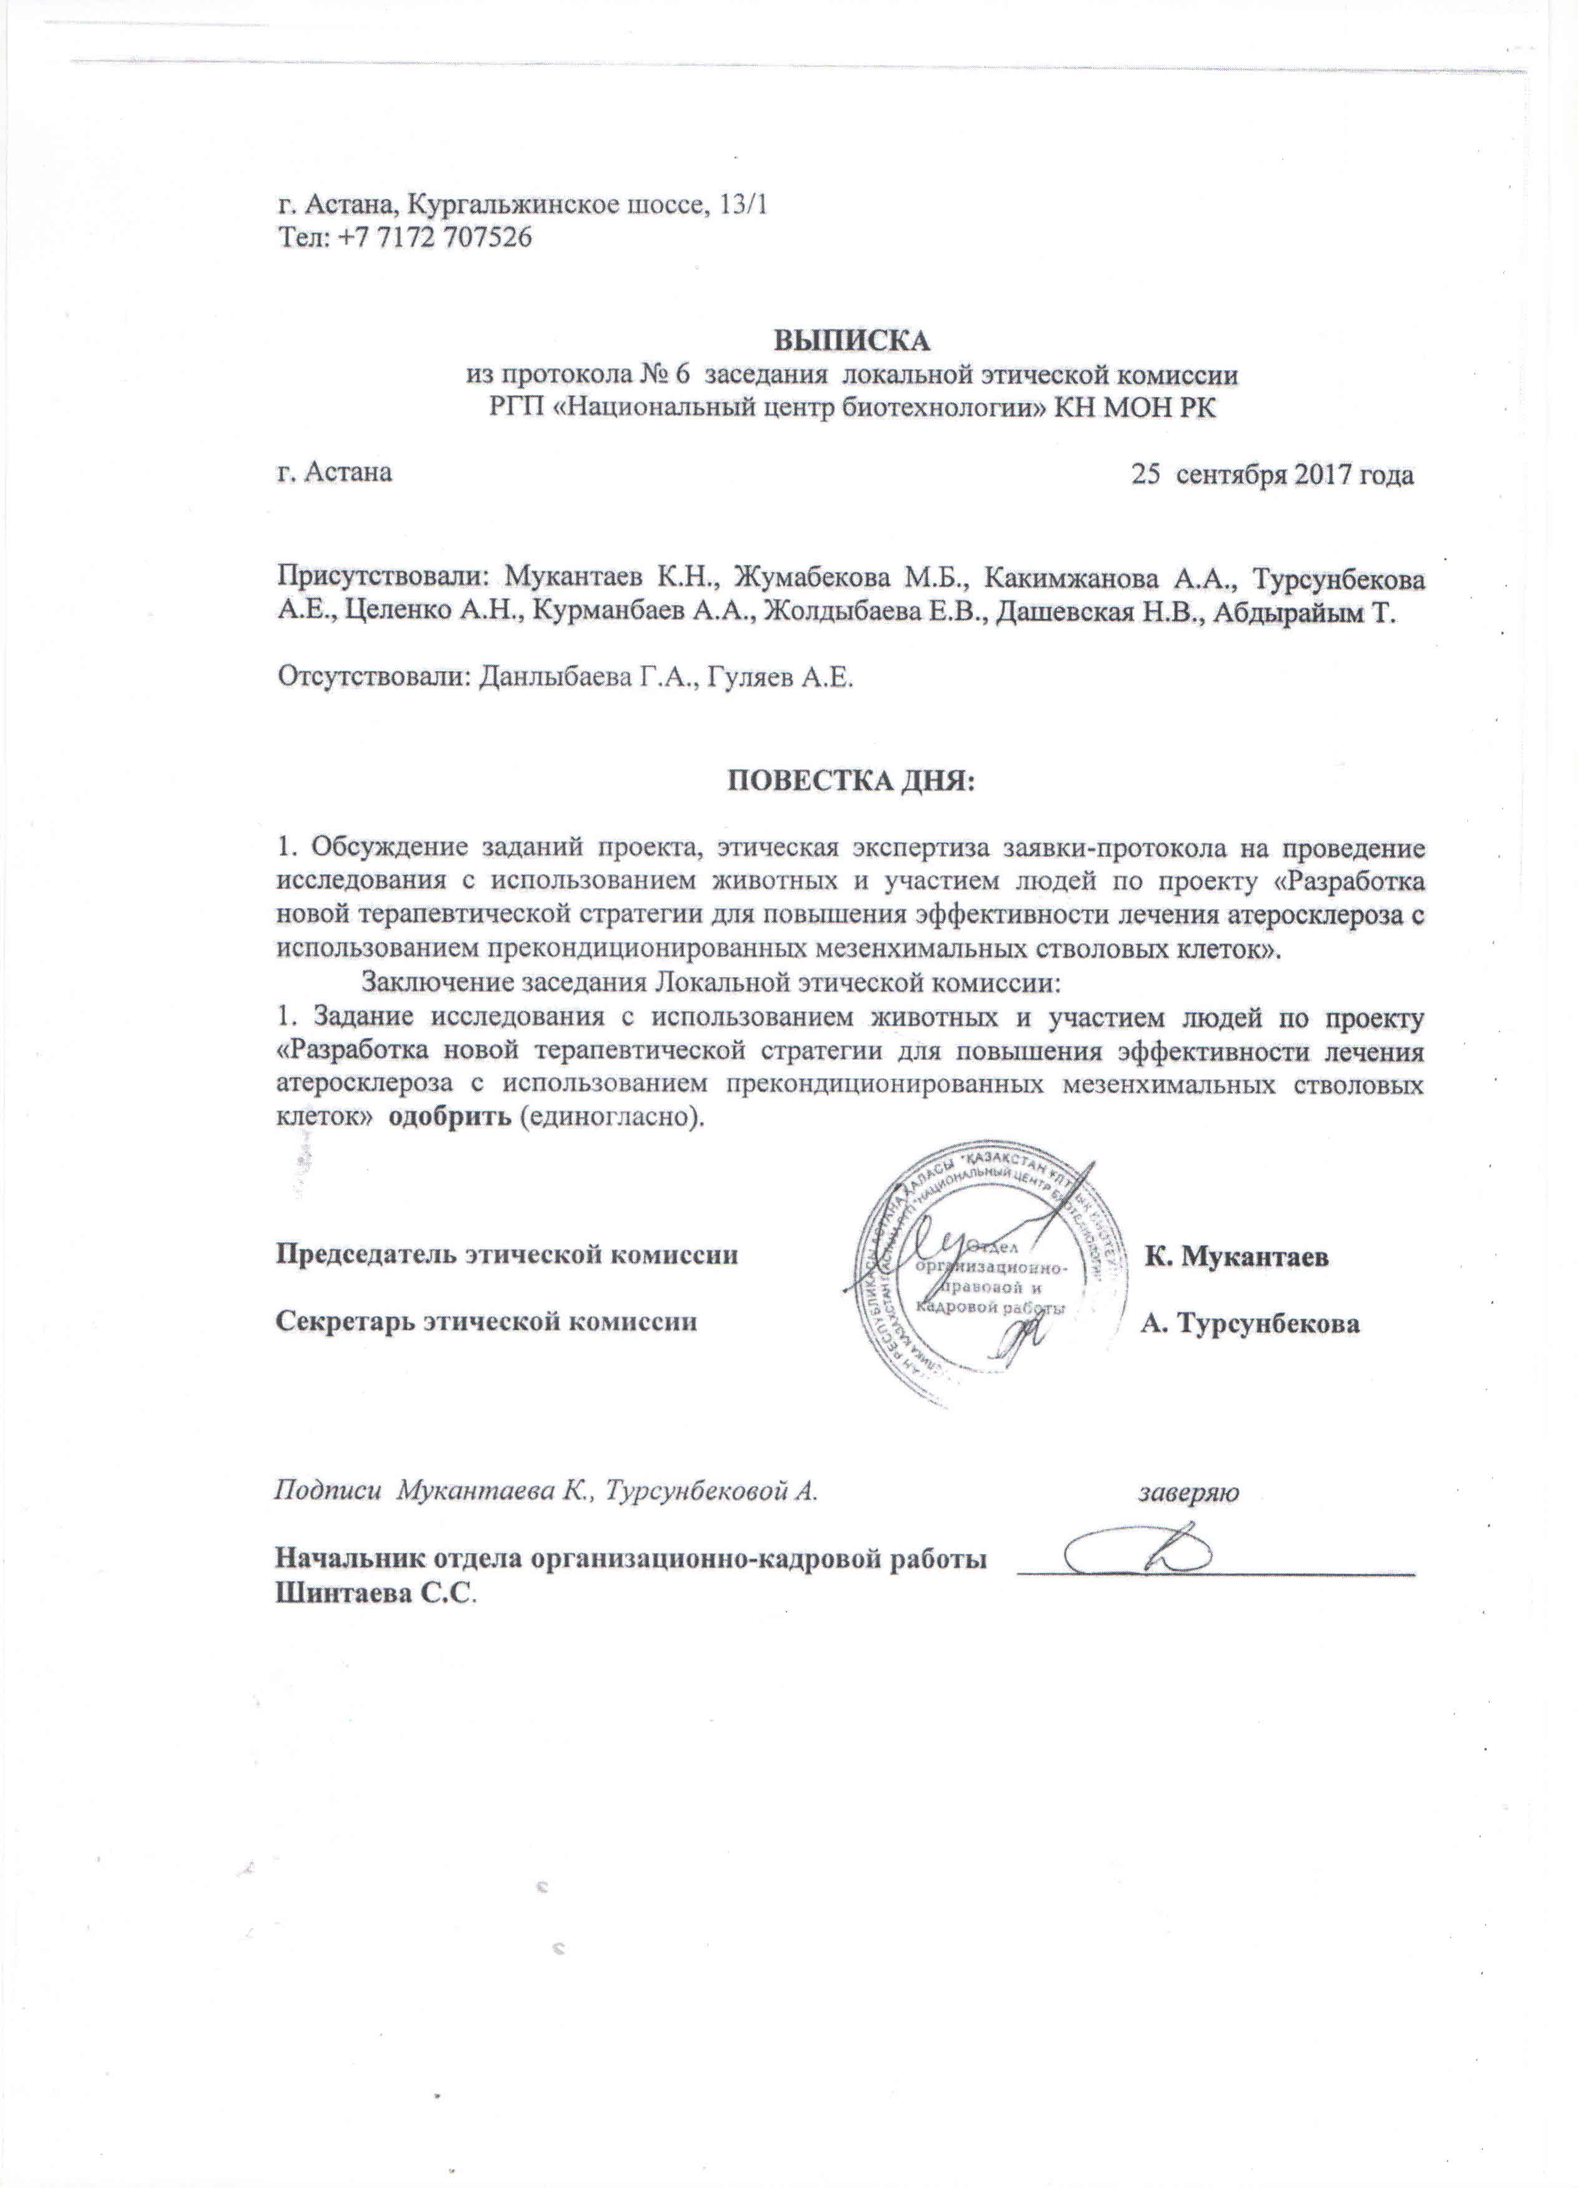

attachment C
List of published works for 2018 - 2020
- Sekenova A.Y., Ogay V.B. Isolation and characterization of mesenchymal stem cells from mouse compact bone // Proc. intern. symp. “Astana Biotech 2018” / Astana. - 2018 -P.44. (in English)
- Sarsenova M., Mukhlis S., Sekenova A., Ogay V. The effects of cobalt chloride and hydrogen peroxide on cell viability and proliferation of mesenchymal stem cells // Proc. intern. symp. “Astana Biotech 2018” / Astana. - 2018. - P.43. (in English)
- Sekenova A., Ogay V. Role of mesenchymal stem cells in the regulation of immune response // Bull Gumilyov Eurasian Natl Univ Biosci Ser - 2018. - №. 2 (123) - P.69-83. (in English)
- Ogay V., Sekenova A. Preconditioning as a new approach to enhance the therapeutic efficacy of mesenchymal stem cells // Actual Biotechnology - 2019. - №. 3(30) - Р.423-424. (in Russian)
- Sekenova A.Y., Rakhymzhanova A.K., Li E.A., Ogay V.B. Generation of three-dimensional spheroids from mouse mesenchymal stem cells // Eurasia J Appl Biotechnol - 2019. - № 2 - P.41-50. (in English)
- Ogay V., Sekenova A., Li Ye. Method for preconditioning of mesenchymal stem cells to increase their anti-inflammatory properties. Application for the issue of a patent of the Republic of Kazakhstan for an invention № 2020/0278.1, 30.04.2020. (in Russian)
- Ogay V., Kumasheva V., Li Y., Mukhlis S., Sekenova A., Olzhayev F., Tsoy A., Umbayev B., Askarova S., Shpekov A., Kaliyev A., Zhetpisbayev B., Makhambetov Y., Akshulakov S., Saparov А., Ramankulov Y. Improvement of neurological function in rats with ischemic stroke by adipose-derived pericytes // Cell Transpl - 2020. - Vol. 29 - P.1-12. (Q1, percentile 77). (in English)
- Ogay V., Sekenova A., Li Y., Issabekova A., Saparov A. The thera peutic potential of mesenchymal stem cells in the treatment of atherosclerosis // Curr Stem Cell Res Ther - 2020. (Status: awaiting Editor in Chief decision). (in English)

attachment D
Copies of publications
