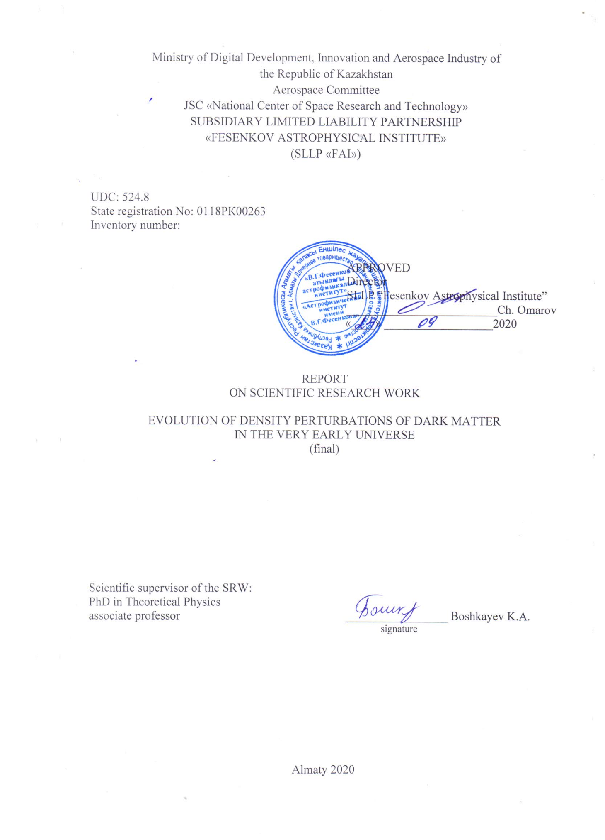
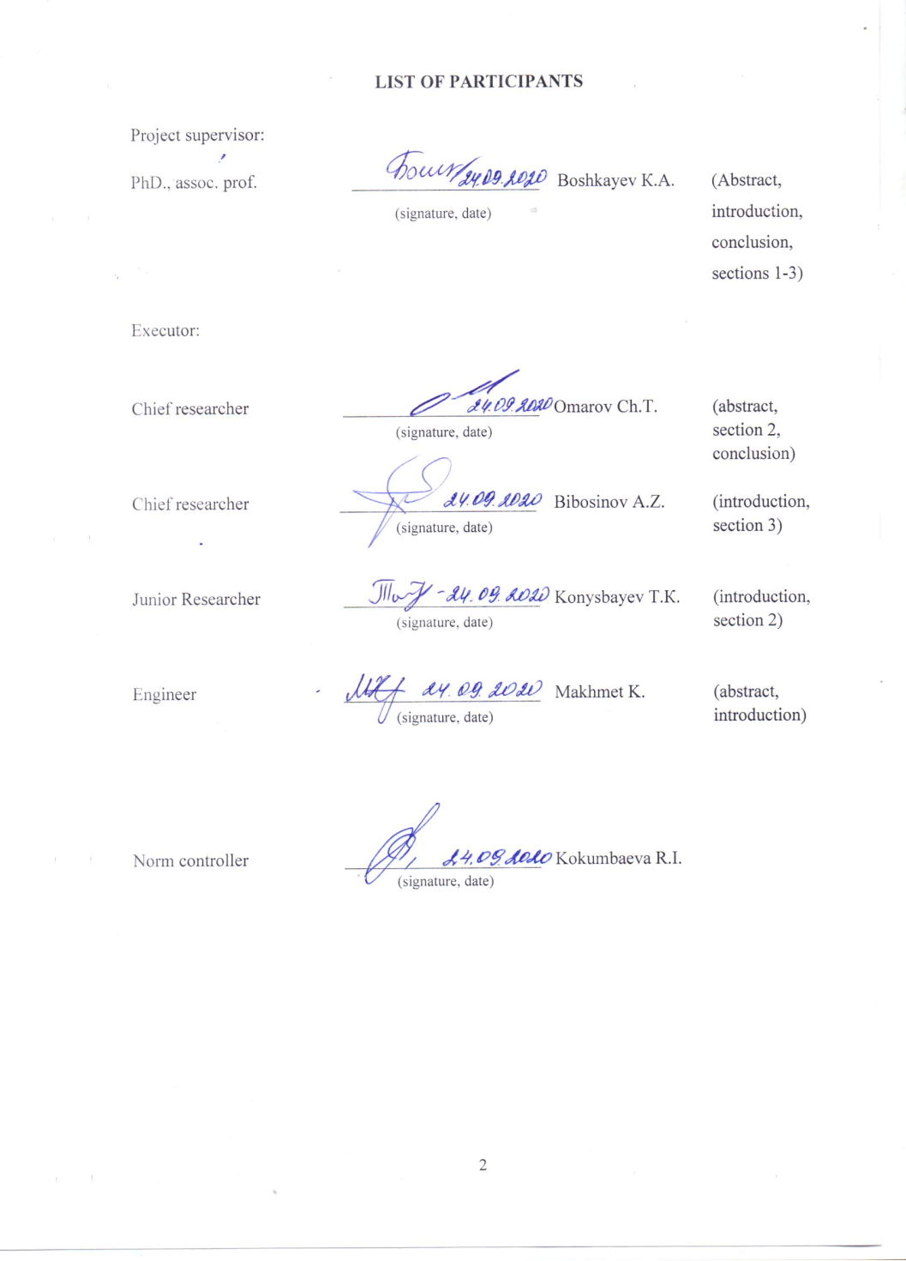

Андатпа
Есеп 55 бет, 1 кітап, 9 сурет, 1 кесте, 71 дерекнама, 2 қосымша.
ҚАРАҢҒЫ МАТЕРИЯ, СТАЦИОНАР ЕМЕС КҮЙ ПАРАМЕТРЛЕРІ, ГРАВИТАЦИЯЛЫҚ ЛИНЗАЛАР, ҚАРА ҚҰРДЫМДАР, АККРЕЦИЯЛЫҚ ДИСКТЕР
Зерттеу нысаны: Қараңғы материяның күй теңдеуі, қара құрдымдар, аккрециялық дисктер.
Жұмыс мақсаты: Қараңғы материямен қоршалған қара құрдымның аккрециялық дискісінің дифференциалдық және спектралдық жарқырауын зерттеу.
Зерттеу әдістері: Дифференциалдық теңдеулерді сандық шешу әдістері.
Жұмыстың нәтижелері және олардың жаңалықтары:
- Тұңғыш рет қараңғы материямен қоршалған қара құрдымдар зерттелді. Толман-Оппенгеймер-Волков теңдеулер жүйесі қара құрдымның сыртында шектеулі қалыңдықта таралған қараңғы материя үшін шешілді. Мүмкін болатын орнықты конфигурациялар табылды. Бұл жағдайда қараңғы материяның ішкі шекарасы қара құрдымның гравитациялық өрісінде қозғалып жүрген сынақ бөлшектердің ең ішкі орнықты дөңгелек орбитасының радиусы - 6M_{BH} - нен жоғары немесе төмен орналасады.
- Қараңғы материя бар болған жағдайда аккрециялық дисктің сәулелену ағыны мен дифференциалдық жарықтылығы есептелінді және олар қараңғы материя жоқ болған жағдаймен салыстырылды. Ең кіші орнықты дөңгелек орбитаның радиусы r_{i} < 6M_{BH} болғандықтан аккрециялық дисктің сәулелену ағыны мен дифференциалдық жарықтылығы қараңғы материя бар кезде жоқ болған кезден жоғары болатыны көрсетілді.
- Бариондық емес материя ұйытқуларының эволюциясы ерте Әлемде ірі масштабты құрылымдардың түзілуіне ықпал етуші фактор ретінде зерттелді. Сонымен бірге алғашқы бариондық емес нысандардың үлестірілуі қарастырылды, олардың физикалық, динамикалық және айналмалы сипаттамалары ерте Әлемде зерттелді.
Қолдану саласы: Релятивистік космология, Әлем эволюциясының алғашқы кезеңдері, гравитациялық линзалар теориясы, ықшам нысандар физикасы.
Жұмыстың маңыздылығы: Галодағы қараңғы материяның тығыздығы уақытқа тәуелді болуы мүмкін және сәйкесінше қараңғы материяның өзі де динамикалық қасиеттерге ие.
Жобаның маңыздылығы осы бағыттағы зерттеулерді жалғастыру болып табылады. Атап айтқанда, өте ерте Әлемдегі қараңғы материяның стационар емес өрісінде жарықтың таралу мәселесіне бағытталған.
Зерттеу нысанының дамуы туралы болжам: Айнымалы параметрі бар қараңғы материяның күй теңдеуін қорыту оның қасиеттерін толық зерттеуге мүмкіндік береді.
ABSTRACT
Report 55 pages, 1 book, 9 figures, 1 table, 71 sources, 2 appendices.
DARK MATTER, NON-STATIONARY STATE PARAMETER, GRAVITATIONAL LENSES, BLACK HOLES, ACCRETION DISCS
Research object: Dark matter equation of state, gravitational lenses, black holes, accretion disks
Purpose of the work: Investigation of the differential and spectral luminosities of the accretion disk of a black hole surrounded by dark matter.
Research methods: Numerical methods for solving differential equations.
Results of work and their novelty:
1) A black hole surrounded by dark matter was investigated and the Tolman-Oppenheimer-Volkoff system of equations for the dark matter distribution, extending in a finite thickness outside the black hole was solved for the first time. Acceptable equilibrium configurations for dark matter with an internal boundary located either below or above 6M_{BH} - the boundary of the innermost stable circular orbit of test particles in the gravitational field of a static black hole were found.
2) The radiative flux and differential luminosity of accretion disks in the presence of dark matter were calculated and they were compared with values in the absence of dark matter. It turns out that due to the fact that the radius of the innermost stable circular orbits r_{i} < 6M_{BH}, the flux and differential luminosity will be higher in the presence of dark matter than in its absence.
3) The evolution of perturbations of non-baryonic matter as a factor in the formation of large-scale objects in the early Universe; distribution properties of primary non-baryonic objects; physical, dynamic and rotational characteristics of primary non-baryonic objects in the early Universe were investigated.
Application area: Relativistic cosmology, early stages of the evolution of the Universe, theory of gravitational lenses, physics of compact objects.
Significance of the work: Dark matter density in a halo can depend on time and, therefore, dark matter itself possess dynamic properties.
The significance of the project: lies in the continuation of research in this direction. Namely, it focuses on the problem of light propagation in a non-stationary field of dark matter in a very early Universe.
Predictive assumptions about the development of the research object: Derivation of the equation of state of dark matter with a variable parameter allows a more complete study of its properties.
CONTENT

INTRODUCTION…………………………………………………………...……………….. |  |  |  | 7
MAIN PART ……………..……………………………………………….……………....…. |  |  |  | 10
1 | Accretion disc luminosity of a black hole surrounded by dark matter…………………..… |  |  | 10
1.1 |  | Current models of supermassive black holes formation ......…………...……………... |  | 10
1.2 |  | Model and methodology ...……………….…………….…………….………….…..... |  | 12
1.2.1 |  |  | Radiative flux and spectral luminosityn……………………..………………...….... | 13
1.2.2 |  |  | Radiative flux and spectral luminosity……………………....................................... | 15
1.3 |  | Theoretical set-ups and results …………………….………………………………...... |  | 17
1.3.1 |  |  | Numerical results ………….…………….………………......................................... | 18
1.3.2 |  |  | Gravitational lensing induced by dark matter…………………………………........ | 23
2 | Geometric optics in the universe with dark matter dominance…………………………..... |  |  | 27
2.1 |  | On the non-stationary equation of state of dark matter ……..……………….……....... |  | 27
2.2 |  | Solution of the Friedmann equations for the epoch of the end of dark matter dominance ……………………………………………………………………..…….... |  | 30
2.3 |  | To the theory of a gravitational lens in the Universe, taking into account the presence of non-stationary dark matter ………..…………….…………….……………….….... |  | 32
3 | Evolution of non-baryonic matter perturbations as a factor of formation of the large-scale objects in the early Universe …………….…………..……………………………............. |  |  | 34
3.1 |  | Properties of the distribution of primary non-baryonic objects in the early Universe.... |  | 34
3.2 |  | Physical characteristics of primary non-baryonic objects ……………………..…........ |  | 35
3.3 |  | Dynamical characteristics of the system of primary non-baryonic objects………….... |  | 36
3.4 |  | Rotational characteristics of the system of primary non-baryonic objects……….….... |  | 37
CONCLUSION ………………………………………………………………………...….… |  |  |  | 38
REFERENCES………………………………………….. …………….………………….…. |  |  |  | 43
APPENDIX A. List of published works ………………….…………….……………………. |  |  |  | 48
APPENDIX B. Calendar plan ………….……………………………………………..……... |  |  |  | 50
SYMBOLS AND ABBREVIATIONS
The following abbreviations and symbols are used in this report on SRW:
DM | – | Dark matter
GR | – | General theory of relativity
TOV | – | Tolman– Oppenheimer−Volkoff equations
BH | – | Black hole
АD | – | Accretion disc
Au | – | Astronomical unit
$$M_{ʘ}$$ | – | Mass of the Sun
$$M_{BH}$$ | – | Black hole mass
Sgr-A∗ | – | Sagittarius- A∗
ɀ | – | Cosmological redshift
рс | – | Parsec
G | – | Gravitational constant
C | – | The speed of light in vacuum
$r_{g}$ = 2$GM_{BH}/c^{2}$ | – | Black hole gravitational radius
N | – | Refractive index
WIMP | – | Weakly interacting massive particle
keV | – | Kilo electron volt
MeV | – | Mega electron volt
GeV | – | Giga electron volt
TeV | – | Tera electron volt
 | – | Dark matter temperature
 | – | Baryonic matter temperature
 | – | The time of the end of the dominance of dark matter
BOSS | – | Baryon Oscillation Spectroscopic Survey

INTRODUCTION

According to modern conceptions about the substantial structure of the Universe, it consists of 73% of dark energy (often identified with the cosmic vacuum), 23% of dark matter, and about 4% of baryonic matter – primary plasma and radiation. These types of substances play a different role in the process of the evolution of the Universe. Thus, the cosmic vacuum is responsible for the expansion of the Universe, dark matter ensures the stability of its large-scale structures (galaxies and their clusters) and baryonic matter is the “building material” of galaxies themselves and their small-sized objects (star clusters, stars and planets).
As for dark matter, it was used, for example, to explain one of the fundamental problems of modern physics and cosmology - the baryon asymmetry of the Universe; to describe the origin of various types of dark matter; to find the masses of dark matter particles. Questions about the influence of dark matter on the formation of galaxies also attracted considerable attention of researchers.
It was emphasized above that the initial ideas about the physical purpose of dark matter in the structure of galaxies and their systems were to ensure the stability of these large-scale objects of the Universe. In accordance with this, the rotation curves of various galaxies from the observational data were constructed; the question of the origin of the dark matter halo was raised, the profiles of the dark matter distribution were theoretically substantiated, the central density of the dark matter halo was discussed, and others.
But later, the idea began to form in which dark matter density in a halo may depend upon time, and, therefore, dark matter itself has dynamic properties. In the literature, the problem of the evolution of dark matter density was discussed and non-stationary models of dark matter were constructed. Also, a number of works are devoted to the discussion of the influence of dark matter perturbations, both on the evolution of its various substructures and on the dynamics of large-scale objects from a baryonic substrate.
The purpose of this work is to continue research in this direction. Namely, it focuses on studying the effect of dark matter on the radiative flux and differential luminosity of the accretion disk around a black hole, calculating the refractive index of our model and the evolution of perturbations of non-baryonic matter as a factor in the formation of large-scale objects in the early Universe.
Relevance and novelty of research: The aim of the project and its novelty is to study the influence of primary baryonic matter in the form of cosmic plasma on the evolution of dark matter perturbations considered as a gas of WIMPs.
Justification of the scientific and technical level: The research group includes scientists with various experiences in the specialty. Two-thirds of the staff are scientists with many years of experience in the field of astrophysics, having publications in international peer-reviewed journals. Approximately 60% of the employees are young scientists and engineers. There are access to computers and original programs created by the participants of the project, also programs and processing packages accepted in the international community. There is access to the Internet.
Information on patent research and metrological support of Scientific research work (SRW): Patent research and metrological support were not expected.
Relationship with other research projects and institutions: Scientific relations among the scientists from Kazakhstan, Russia, the United States are developing; international cooperation continues with the research teams of Sternberg Astronomical Institute, Space Research Institute (Moscow, Russia), St Petersburg State University.
The aim of the project - To study the influence of primary baryonic matter in the form of cosmic plasma on the evolution of disturbances in dark matter, considering as a gas of WIMPs. To achieve the goal of the project, the following tasks are formulated below, also their brief explanation and expected results were given.

Tasks for 2020 y:
- Investigate the distribution properties of primary non-baryonic objects in the early Universe
- Calculate physical characteristics (mass, size, angular momentum) of primary non-baryonic objects
- Calculate dynamic characteristics (energy, density of matter, dynamics) of a system of primary non-baryonic objects
- Describe the rotational characteristics (moment of inertia, angular momentum or spin, angular velocity) of a system of primary non-baryonic objects

The basis for execution SRW:
The decision of the National scientific Council "Information, telecommunications and space technologies, scientific research in the field of natural Sciences" on grant funding (Protocol No. 1 dated January 10, 2018), decision of the National scientific Council "Information, telecommunications and space technologies, scientific research in the field of natural Sciences" on adjustment of calendar plans (Protocol No. 2 dated February 15, 2018),
- Agreement with the Science Committee of the Ministry of Education and Science of the Republic of Kazakhstan No. 109 dated March 05, 2018.
- The decision of the National Scientific Council for the priority direction "Information, telecommunication and space technologies, scientific research in the field of natural sciences" on the further implementation of the project (Protocol No. 13 dated December 08, 2018).
- The decision of the National Scientific Council for the priority direction "Information, telecommunication and space technologies, scientific research in the field of natural sciences" on the further implementation of the project (Protocol No. 14 dated December 10, 2019).
List of interim reports
- Evolution of dark matter density perturbations in the very early Universe: report on SRW (interim) / Fesenkov Astrophysical Institute: principal investigator (PI) Chechin L.M. - Almaty, 2018. - 44p. Registration number 0218RK00063.
2) Evolution of dark matter density perturbations in the very early Universe: report on SRW (interim)/ Fesenkov Astrophysical Institute: PI Chechin L.M. - Almaty, 2019 .-- 34p. Registration number 0219RK00165.

The implementation period - 2018-2020 yy.

The amount of funding for 2018-2020 is 44,000. 00 thousand tenge. Including: 2018 – 15 000,00 thousand tenge, 2019 - 15 000,00 thousand tenge, 2020 – 14 000,00 thousand tenge.

MAIN PART

1 Accretion disc luminosity for black holes surrounded by dark matter
We consider the observational properties of a static black hole space–time immersed in a dark matter envelope. We investigate how the modifications to geometry induced by the presence of dark matter affect the luminosity of the black hole’s accretion disc. We show that the same disc luminosity as produced by a black hole in vacuum may be produced by a smaller black hole surrounded by dark matter under certain conditions. In particular, we demonstrate that the luminosity of the disc is markedly altered by the presence of dark matter, suggesting that the mass estimation of distant supermassive black holes may be changed if they are immersed in dark matter. We argue that a similar effect holds in more realistic scenarios, and we discuss the refractive index related to dark matter lensing. Finally, we show how the results presented here may help to explain the observed luminosity of supermassive black holes in the early Universe.

1.1 Current models of supermassive black hole formation
The recent observation of the ‘shadow’ of the supermassive black hole candidate in the galaxy M87 [1, 2] proves that extreme compact objects reside in galactic centres. The fact that such objects are seen in the electromagnetic spectrum while also being sources of gravitational waves means that they open up a new era of multi-messenger astronomy [3]
The current theoretical models of the formation of supermassive black holes do not, however, explain the distribution of black hole masses with distance [4]. It is not clear how and when supermassive black holes formed; that is, their formation is far less well understood than the formation of their light, stellar-mass counterparts. We know only a large number of supermassive black hole candidates exceeding one billion Solar masses, and that they have been observed in the early Universe [5].
The most striking example is the black hole candidate ULAS J1342 + 0928, which has a mass of ∼800 $×$ 10⁶ M_{ʘ} (Sun mass) and is located at ɀ = 7.54, so quite close to the big bang [6]. How did such enormous objects form in such a short time?
Currently, with the exceptions of Sgr-A∗ in the Milky Way and the supermassive black hole candidate in the galaxy M87, the most widely adopted method used to determine the mass of such objects consists of measuring the spectra from their accretion discs [7].
For example, black hole accretion at super-critical values does not imply that the disk radiates at the super-Eddington luminosity [8]. This is because of the properties of the accretion disc. Several assumptions are needed in order to produce accretion disc models, including, of course, an assumption regarding the geometry in which the accretion disc exists [9].
The theory of black hole accretion was developed by Novikov & Thorne (1973) and Page & Thorne (1974) [10, 11], and has been successfully applied to astrophysical black hole candidates to explain the features of their observed spectra for many years.
However, observations are almost always interpreted under the assumption that the black hole is in a vacuum (i.e. the Kerr metric). It is only in recent years that attempts have been made to study the theoretical properties of accretion discs in a geometry that departs from the Kerr line element [11-15]. Furthermore, we know that galaxies are surrounded by dark matter haloes, which are responsible for the observed rotation curves of stars far from the centre [16-18].
Dark matter haloes extend throughout galaxies, from the outer regions to the centre, and it is reasonable to consider the possibility that the central distribution may affect the geometry of the region. Some models have been developed to describe dark matter distributions at galactic centres [19] and dark matter profiles around black holes [20]. It is reasonable to suppose that such dark matter profiles will have non-negligible relativistic effects close to galactic cores, and therefore will modify the properties of the light emitted by accretion discs. In addition, the possibility that dark matter is responsible for the observed cosmic speed up has been recently investigated, see [21] for details.
In this paper we aim to study this effect qualitatively by constructing a simple toy model. For clarity, we will assume a static, spherically symmetric supermassive black hole surrounded by dark matter. Our approach to studying the spectrum of the disc is then based on a simple model for the dark matter envelope. To do this, we will assume that the interaction cross-section of dark matter with normal matter vanishes; that is, the dark matter envelope does not interact with the normal matter in the disc, allowing us to model the trajectories of baryonic matter in the accretion disc as moving on circular geodesics. We will also assume that the dark matter envelope extends inside the boundary radius of stable circular orbits in the accretion disc. This is reasonable if, for example, the dark matter content is made of weakly interacting particles travelling on various orbital trajectories.
We then evaluate the motion of test particles in the accretion disc in the geometry produced by the black hole plus dark matter source, and compute the effects of the presence of dark matter on the spectrum of the accretion disc, under simple reasonable assumptions for the emission profile. We show that, under certain circumstances, the flux and luminosity of the disc is noticeably increased by the presence of dark matter, especially in the inner parts of the accretion disc. Furthermore, the presence of the dark matter envelope alters the spectral luminosity of the disc at all frequencies, with respect to the case of a black hole in vacuum. This feature could in principle be tested against observations, once a more realistic version of the model and sufficiently accurate observational data become available. In light of this, we investigate the refractive index and obtain its shape, comparing the cases with and without dark matter. The discrepancy between these cases is also discussed and interpreted. These results suggest the possibility that supermassive black holes in the distant Universe may be less massive than previously estimated. This possibility highlights the role of dark matter in galactic cores, as dark matter acts as a source for increasing or decreasing the accretion disc’s luminosity.

1.2 Model and methodology
Recently, a toy model for a dark matter cloud located at the Galactic Centre without the presence of any supermassive black hole was considered by some of the present authors [22]. By analyzing the motion of test particles in the central regions of the galaxy, we showed that at distances greater than 100 au there was no observable difference between the gravitational fields of a black hole and a dark matter core of the same total mass. However, black holes are likely to exist at galactic centres, as suggested by the emission lines of quasars [23]. In this work, we consider a black hole located at the centre of a dark matter distribution and estimate the radiative flux emitted by the accretion disc and its spectral luminosity distribution as observed at infinity. To this end, we must make a choice for the density profile of the dark matter envelope. Because our argument is mostly qualitative, we will consider a simple exponential profile, which will suffice to approximate a reasonable matter distribution.
The following density profile has thus been adopted for the dark matter distribution:

$ρ\left(r\right)=ρ_{0}e^{-\frac{r}{r_{0}}}$ , $r$ $≥r_{b}$, (1.1)

where ρ₀ is the dark matter density at r = 0, r₀ is the scale radius, and r_{b} is the inner edge of the dark matter envelope, namely the boundary separating the interior vacuum region, described by the gravitational field of a black hole, and the exterior dark matter distribution. In principle, the inner edge of the dark matter envelope could be placed at any radius, although it is reasonable to assume that r_{b} should be greater than the black hole’s event horizon. Because in our model the dark matter envelope never reaches the limit r = 0, the parameter ρ₀ must be considered here to be a characteristic density. The corresponding dark matter mass profile is obtained as

M_{DM}(r) = $\int_{r_{b}}^{r}{4π{\tilde{r}}^{2}ρ\left(\tilde{r}\right)d\tilde{r}} =8πr_{0}^{3}ρ_{0}\left[e^{{-x}_{b}}\left(1+x_{b}+\frac{x_{b}^{2}}{2}\right)-e^{-x}\left(1+x+\frac{x^{2}}{2}\right)\right],$ $r>r_{b}$, (1.2)

where x = r/r₀ and x_{b} = r_{b}/r₀. For vanishing rb, equation (1.2) reduces to the equation obtained by [24]. The total mass profile of the system black hole plus dark matter is then defined as
M(r) = M_{BH} + M_{DM}(r), (1.3)

where М_{ВН} - is the black hole mass, which is a free parameter of the model. More explicitly, equation (1.3) can be written as

M(r) = $\left\{\begin{aligned}M_{BH}, r_{g}<r≤r_{b}, \\ M_{BH}+M_{DM}\left(r\right), r_{b}≤r≤r_{s}, \\ M_{BH}+M_{DM}\left(r_{s}\right), r_{s}≤r, \end{aligned}\right.$ (1.4)

where $r_{g}$ = 2$M_{BH}$ is the gravitational radius of a black hole. Hereafter, we use geometric units, setting. G = c = 1. Figure 1 provides a schematic illustration of the total mass, where $r_{s}$ is the surface radius of the dark matter envelope, namely the outer edge of the dark matter profile, as obtained by the solution of the Tolman– Oppenheimer−Volkoff (TOV) equation.

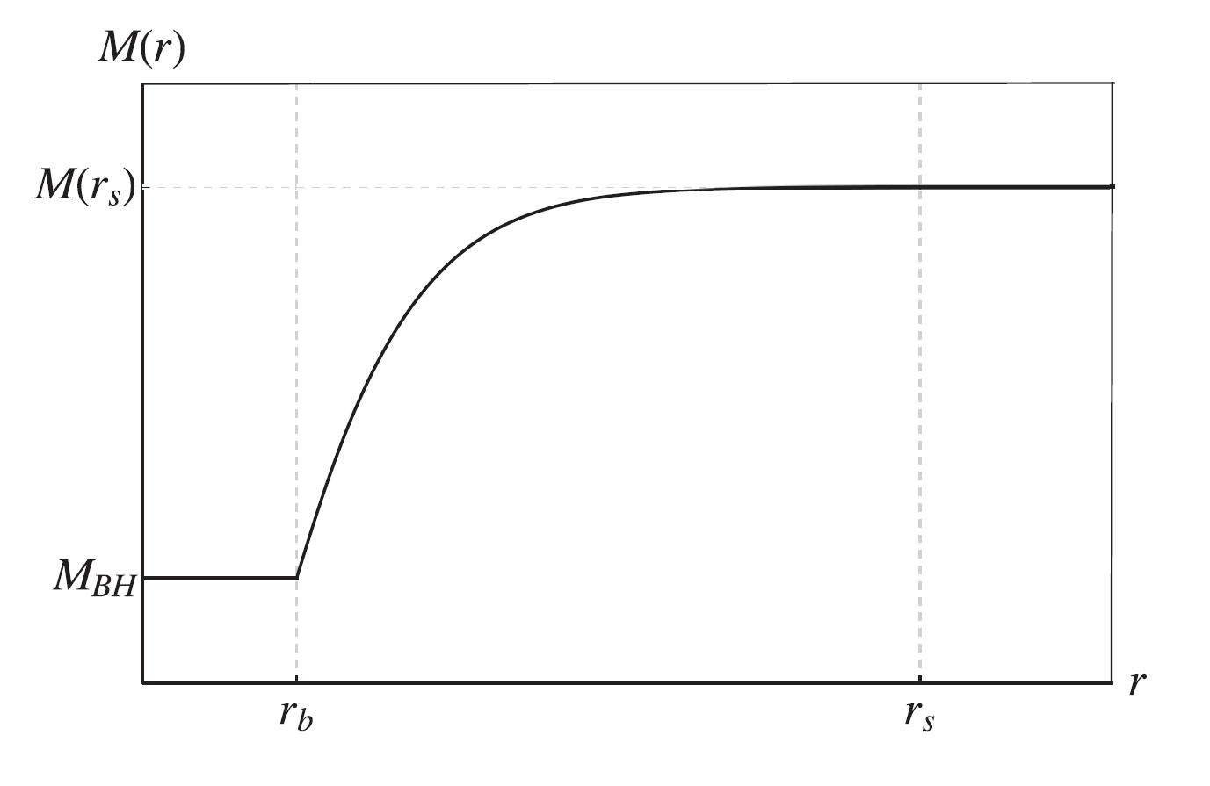
Figure 1 - Schematic illustration of the total mass profile

1.2.1 The Tolman– Oppenheimer−Volkoff equation
To analyse the properties of the system composed of a black hole and dark matter envelope, the line element is chosen in the standard static and spherically symmetric form as

ds² = e^{N(r)}dt² – e ^{Λ(r)}dr² – r²(d$θ$ ² + sin²$θ$ dϕ²), (1.5)

where (t, r, θ, ϕ) are the time and spherical coordinates, and N(r) and Λ(r) are the sought metric function.
In order to obtain a stable (static) spherical layer (envelope) of dark matter around the black hole, one has to match the inner black hole space–time with the outer, matter-filled, solution describing dark matter at the boundary r_{b}. This can be done following the same procedure as used to find interior solutions for the Schwarzschild space–time, because, as is well known, the matching conditions to be satisfied are the same [25] Hence we need to solve the TOV equations, which read

$\frac{dP(r)}{dr}$ = - ($ρ$(r) + P(r)) $\frac{M\left(r\right)+4πr^{3}P(r)}{r\left(r-2M(r)\right)},$ (1.6)

$\frac{dN(r)}{dr}$ = - $\frac{2}{ρ\left(r\right)+P(r)}\frac{dP(r)}{dr}$, (1.7)

where $P(r)$ is the dark matter pressure, $ρ(r)$ is given by equation (1.1) and $M(r)$ is determined by equation (1.4). At the boundary between the interior vacuum and the exterior dark matter, the following conditions are defined for ρ($r_{b}$), $P(r_{b})$ and $N(r_{b})$:

$ρ$($r$_{b}) = $ρ$_{b} = $ρ$₀ $e^{-\frac{r_{b}}{r_{0}}}$ (1.8)

$P(r_{b})$ = $P_{b}$ (1.9)

$N(r_{b})$ = N_{b} = $ln (1- \frac{r_{g}}{r_{b}})$ (1.10)

where $ρ$₀, r₀ and r_{b} are the free parameters of the model, and P_{b} is chosen to be equal to its newtonian limit as a test value. The TOV equation must be integrated until the pressure vanishes, namely P(r) = 0. This condition yields the radius of the dark matter envelope surface $r$ = $r_{s}$, so that the observed total mass of the system is equal to M(r_{s}).
Correspondingly, N(r) and Λ(r) are given as

e^{N(r )} = $\left\{\begin{aligned}1 - \frac{r_{g}}{r}, r_{g} < r ≤ r_{b} , \\ e^{N_{r}(r)}, r_{b} ≤ r ≤ r_{s} , \\ 1 - \frac{2M(rs)}{r}, r_{s} ≤ r, \end{aligned}\right.$ (1.11)
and
e^{Λ(r )} = $\left\{\begin{aligned}{(1 - \frac{r_{g}}{r} )}^{-1}, r_{g} < r ≤ r_{b} , \\ {(1 - \frac{2M(r)}{r} )}^{-1}, r_{b} ≤ r ≤ r_{s} , \\ {(1 - \frac{2M(rs)}{r} )}^{-1}, r_{s} ≤ r . \end{aligned}\right.$ (1.12)

where N_{r}(r) is given by the numerical solution of the TOV equation.
Note that, because the density of dark matter is not zero at r = r_{b} the matching is not continuous, as the first derivatives of the metric have a jump at the boundary. This can be interpreted, following the usual procedure, as reflecting the presence of a massive surface layer at r_{b} [26, 27].

1.2.2 Radiative flux and spectral luminosity
To model the accretion disc, we follow the standard treatment and assume that particles follow circular geodesics in the equatorial plane ($θ$ = $π$/2). Then, particles in the disc will have a specific energy, angular momentum and angular velocity, depending on their distance from the central object.
We can then study the characteristics of the radiative flux (i.e. the energy radiated per unit area per unit time) emitted by the accretion disc from the following formula:

$F\left(r\right)=-\frac{\dot{m}}{4π\sqrt{g}}\frac{Ω, r}{{(E-ΩL)}^{2}}\int_{r_{i}}^{r}{\left(E-ΩL\right)L,{}_{\tilde{r}}^{}{d\tilde{r}}}$, (1.13)

where $\dot{m}$ is the mass accretion rate, assumed to be constant, $g$ is the determinant of the metric tensor of the three-sub-space $\left(t, r, φ\right)$, i.e. $\sqrt{g}=\sqrt{g_{tt}g_{rr}g_{φφ}}$ , Ω is the orbital angular velocity, E is the energy per unit mass, and L is the orbital angular momentum per unit mass of test particles in the disc. In addition, r_{i} is the radius of the innermost stable circular orbit of the disc, which is defined via the condition dL/dr = 0. These quantities, evaluated on the equatorial plane $θ=π/2$, in a spherically symmetric, static space–time, take the form

Ω(r)$=\frac{dφ}{dt}=\sqrt{-\frac{∂_{r}g_{tt}}{∂_{r}g_{φφ}}},$ (1.14)

E(r)$=u_{t}=u^{t}g_{tt},$ (1.15)

L(r)$=-u_{φ}=-u^{φ}g_{φφ}=-Ωu^{t}g_{φφ},$ (1.16)

$u^{t}\left(r\right)=\dot{t}=\frac{1}{\sqrt{g_{tt}+Ω^{2}g_{φφ}}},$ (1.17)

where $∂_{r}$ is the derivative with respect to the radial coordinate, a dot denotes the derivative with respect to the proper time, and $u$_{t} and $u_{φ}$ are the covariant time and angular components of the four-velocity (for details see [28]).
For a better presentation of our results, it is convenient to introduce new dimensionless functions by defining $Ω^{*}\left(r\right)=M_{T}Ω\left(r\right),$ L∗(r)=L(r)/$M_{T}$, where $M_{T}=M\left(r_{s}\right)$ for the system with a black hole and dark matter, and $M_{T}=M_{BH}$ for the system without dark matter. Then in our dimensionless units the energy remains unchanged, namely $E^{*}\left(r\right)=E\left(r\right).$
Because the flux is not directly observable, the luminosity that reaches an observer at infinity $L_{∞}$ (energy per unit time) is a more useful quantity to consider (see [29]). The differential of the luminosity $L_{∞}$ can be estimated from the flux ℱ by the following relationship of [10, 11]:

$\frac{dL_{∞}}{d\ln{r}}=4π\sqrt{g}$Eℱ(r). (1.18)

Another characteristic of the accretion disc, the spectral luminosity distribution observed at infinity, is given by

$νL_{ν,∞}=\frac{15}{π^{4}}\int_{r_{i}}^{∞}{\left(\frac{dL_{∞}}{d\ln{r}}\right)\frac{{\left(u^{t}y\right)}^{4}{/F}^{*}}{exp\left[u^{t}y/F^{*1/4}\right]-1}d lnr,}$ (1.19)

where y=h$ν/kT_{*},$ h is the Planck constant, 𝜈 is the frequency of the emitted radiation, k - is the Boltzmann constant, $T_{*}$ is the characteristic temperature $u^{t}$ is expressed in terms of the characteristic redshift ɀ as $u^{t}\left(r\right)=1+ɀ(r)$ (for details see [29]), and $F^{*}\left(r\right)=M_{T}^{2}F\left(r\right)$. The above expression provides the luminosity measured by distant observers as a function of the frequency under the assumption that the gas in the accretion disc emits a blackbody spectrum. Taking into account equation (1.18), equation (1.19) can be written in the form

$νL_{ν,∞}=\frac{60}{π^{3}}\int_{r_{i}}^{∞}{\frac{\sqrt{g}E}{M_{T}^{2}}\frac{{\left(u^{t}y\right)}^{4}{/F}^{*}}{exp\left[u^{t}y/F^{*1/4}\right]-1}dr.}$ (1.20)

The last relationship is conveniently dimensionless, because it is normalized with respect to mass M_{T} . As is well known, astrophysical observations of black hole candidates cannot rely directly on measurements of the spectral luminosity. Typically, emission lines from the central regions of the accretion disc are used to probe the strong-gravity regime and to obtain information on the object’s properties, such as mass and angular momentum. Such emission lines are in the X-ray range of frequencies, and the most prominent and most widely used is the K$α$ line of iron at 6.4 keV (see for example [30]). The broadening of the K$α$ iron line resulting from gravitational redshift contains information about the gravitational potential, while the Doppler shift of the line contains information about the accretion disc’s rotation, and as a consequence about the source’s angular momentum (see [31] for a review). Therefore the K$α$ line of iron is an excellent tool with which to probe experimentally the geometry in the vicinity of black hole candidates (see for example [32]). It is reasonable to suppose that the presence of a dark matter envelope will affect the K$α$ iron line. In particular, a matter distribution in the vicinity of the black hole will alter the broadening of the line, thus introducing some uncertainties into the measurement of the black hole’s mass.
Using the above formalism, we can now analyze the effect that adding a dark matter envelope has on the light emitted by the gas in the accretion disc surrounding a supermassive black hole candidate.

1.3 Theoretical set-ups and results
Here we discuss the numerical and theoretical outcomes of the model outlined above, in the context of supermassive black holes. We start by setting the model’s free parameters as: M_{BH} = 5 $×$ 10⁸M_{ʘ} = 4.933 аu, r_{b} = 11M_{BH}/2 = 27.133 au, r₀ = 10 аu, and $ρ_{0}$ varying from 0.75 $×$ 10⁻⁵ to 3 $×$ 10⁻⁵ аu⁻², see Figs 2 - 7. Note, for density 1 аu⁻² $≈$ 60.173 g cm⁻³ $≈$ 8.9 $×$ 10²³ $М_{ʘ}$рс⁻³.
In Table 1 we present the initial inputs: the characteristic density $ρ_{0}$ and the corresponding pressure P_{b} at r = r_{b}, and the results of the numerical integration: the radius of the innermost stable circular orbits r_{i}, the surface radius of the dark matter envelope r_{s}, and the mass of dark matter M_{DM}(r_{s}).
The black hole case is shown without dark matter in the second line, for which r_{i} = 6M_{BH}, M_{BH} = 74/15 ≈ 4.933 аu. In the case with dark matter, the choice of the parameters $ρ_{0}$ and P_{b} determines the innermost stable circular orbit radius r_{i} the thickness of the dark matter envelope r_{s}, and the total mass of the dark matter envelope M_{DM}(r_{s}) in units of M_{BH}.
Table 1 – Physical parameters of the dark matter envelope
$ρ_{0}$ , аu⁻² | P_{b} , аu⁻² | r_{i} , au | r_{s} , аu | M_{DM}(r_{s}) , M_{BH}
0 | 0 | 29.600 | --- | 0
0.75 $×$ 10⁻⁵ | 3.132 $×$ 10⁻⁸ | 29.047 | 220.885 | 1.873 $×$ 10⁻²
1.50 $×$ 10⁻⁵ | 6.313 $×$ 10⁻⁸ | 28.483 | 227.407 | 3.747 $×$ 10⁻²
2.25 $×$ 10⁻⁵ | 9.545 $×$ 10⁻⁸ | 27.910 | 228.088 | 5.621 $×$ 10⁻²
3.00 $×$ 10⁻⁵ | 12.828 $×$ 10⁻⁸ | 27.331 | 228.790 | 7.494 $×$ 10⁻²
The TOV equations have been solved for selected values of $ρ_{0}$ from r_{b} outwards, with the initial value of the density set as $ρ_{b}=ρ_{0}exp\left(-r_{b}/r_{0}\right)$ and the corresponding value of the pressure P_{b}. These terms start from the boundary r_{b}, namely where the dark matter distribution begins, until the distance r_{s} at which the pressure vanishes, P(r_{s}) = 0. The value of P(r_{b}), chosen for the integration of the TOV equation is obtained from the Newtonian limit. However, while in the Newtonian case the envelope extends until infinity, the relativistic corrections ensure that the relativistic pressure profile P(r) vanishes at a finite radius r_{s}.
The solution of the TOV equations produces a stable, thin layer of dark matter. By increasing the pressure P_{b} by a factor of ~1.5, for a fixed $ρ_{0}$, the thickness (width) of the dark matter layer increases; that is, r_{s} increases. Once r_{s} is known, the metric functions, particularly N(r), must be fixed to satisfy the boundary conditions equation (1.11).
We note that the solution of the TOV equation is numerical for both the pressure and the metric function N(r). If the condition P(r = r_{s}) = 0 yields r_{s} to be the surface radius of the dark matter envelope, then the metric functions N and Λ must fulfil the condition on the surface that N(r_{s}) = - Λ (r_{s}). In practice, the numerical value of N_{n}(r_{s}) from the solution of the TOV equation is not equal to – Λ (r_{s}). To satisfy the boundary conditions, namely

$e^{N(r)}=\left\{\begin{aligned}1-\frac{r_{g}}{r_{b}}, r=r_{b} \\ 1-\frac{2M(r_{s})}{r_{s}}, r=r_{s}\end{aligned}\right.$ (1.21)

the function $N_{n}$ must be redefined. Clearly, at $r=r_{b}$ the numerical function $N_{n}$ is suitable, although it is not well defined at $r=r_{s}$. Thus, the suitable function turns out to be redefined by

N_{r}(r) = N_{n}(r) – [$N_{n}\left(r_{s}\right)-\ln\left(1-\frac{2M\left(r_{s}\right)}{r_{s}}\right)]\frac{r-r_{b}}{r_{s}-r_{b}},$ (1.22)

which fully satisfies the boundary conditions equation (1.21).
Once the metric functions are evaluated, the value of the radius of the innermost stable circular orbits, r_{i,} can be obtained following the standard procedure from the condition dL/dr = 0, which holds at r_{i} for a test particle on a circular geodesic.

1.3.1 Numerical results
From the numerical results, we have three possibilities for the location of the dark matter envelope and the innermost stable circular orbit, as follows.
(i) If the whole dark matter envelope is inside 6M_{BH}, i.e. r_{b} < r_{s}< 6M_{BH}, then r_{i} > 6M_{BH}.
(ii) If the whole dark matter envelope is outside 6M_{BH}, i.e. r_{b} >6M_{BH}, then r_{i} = 6M_{BH} as in the vacuum case.
(iii) If part of the dark matter is inside 6M_{BH} and another part is outside 6M_{BH}, i.e. r_{b} < 6M_{BH} < r_{s}, then r_{b} < r_{i} < 6M_{BH}.
This result is similar to the one obtained by [20], where the photon sphere radius was calculated for a black hole surrounded by dark matter. In our computations, we focus on the third case, where r_{b} < r_{i} < 6M_{BH}, because case (i) has small physical significance, while case (ii) does not depart significantly from the case of a black hole in vacuum. In particular, in the limiting case of a dark matter envelope extending from r_{b} = r_{i} = 6M_{BH} outwards, all the dark matter particles are located outside the Schwarzschild innermost stable circular orbit (ISCO), and there will be no appreciable differences in the disc’s flux and luminosity with respect to the Schwarzschild case. This is due to three factors, namely (i) the geometry for r < r_{i}, which is given by the Schwarzschild metric; (ii) the fact that the dark matter particles do not interact with the gas in the accretion disc; and (iii) the low mass of the dark matter envelope as compared with the black hole mass.
Figure 2(a) plots the orbital angular velocity of test particles in the field of a static black hole without dark matter (solid curves) and in the field of a black hole surrounded by dark matter (dashed curves) for different values of $ρ_{0}^{*}=ρ_{0}/\left({10}^{-5}{au}^{-2}\right)$ as a function of the radial distance. It can be seen that in the presence of dark matter, test particles on the accretion disc have a smaller angular velocity over all the range of the radial coordinate. Similar behaviour can be observed for test particles in the Kerr space–time, as shown Fig. 2(b). Here j is the dimensionless angular momentum (spin parameter) defined as j = a/M, where а is the Kerr parameter and М is the mass of the Kerr black hole. Our aim here is to compare the behaviour of a static black hole with dark matter with that of a rotating black hole in vacuum in order to assess the possibility that dark matter envelopes mimic the effects of angular momentum. Therefore, we consider here only prograde (direct, co-rotating) orbits in the Kerr metric, as they give smaller values of the ISCO radius r_{i} (for details, see [33]), similarly to a static black hole immersed in dark matter. So, we see that for increasing j the characteristics of Ω∗ is analogous to that of the static space–time with dark matter and it is not possible to distinguish the two space– times from Figures 2(a) and (b).
Figure 3 plots the energy of test particles as a function of the radial distance. The legends are the same as in Figure 2. It can be seen in Figure 3(a) that in the presence of dark matter, test particles on the accretion disc have a higher energy at small radii and a lower energy at large radii as compared with particles on accretion discs around a static black hole j = 0. In the Kerr space–time without dark matter, however, for increasing j the energy is always lower than in the j = 0 case. Therefore the two scenarios have distinguishable features in this case. Note that the energy has been calculated from the ISCO and to larger radii.

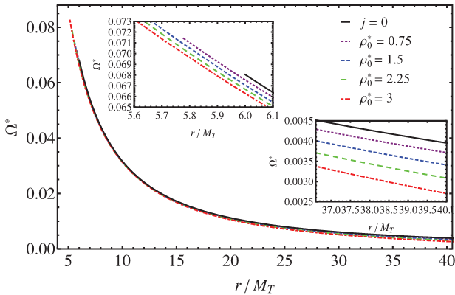 | 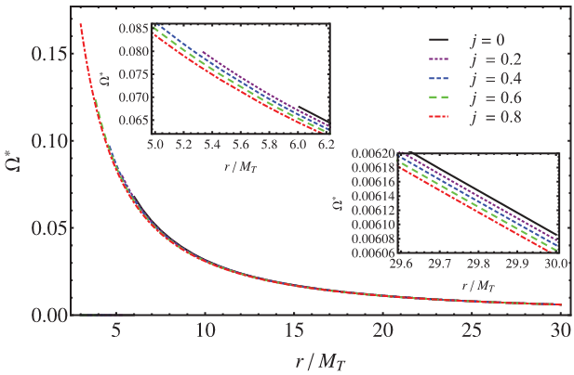
(a)  Angular velocity versus radial distance in the static space-time | (b)  Angular velocity versus radial distance in the Kerr space-time
In both panels, the solid curves correspond to the case of a static black hole without dark matter. Other curves correspond to different values of$ρ_{0}$ in (a), and to different values of j in (b)
Figure 2 - Numerical evaluation of the orbital angular velocity$Ω^{*}$ test particles (а) в of test particles (a) in the presence of dark matter for a static space–time, and (b) the Kerr black hole in the absence of dark matter as functions of r/M_{T}

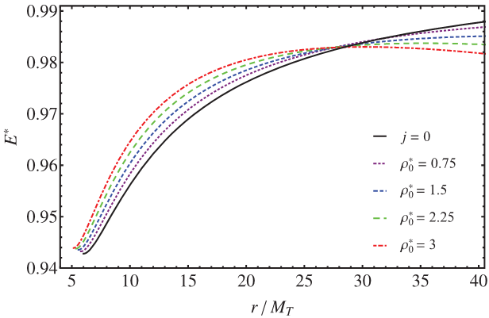 | 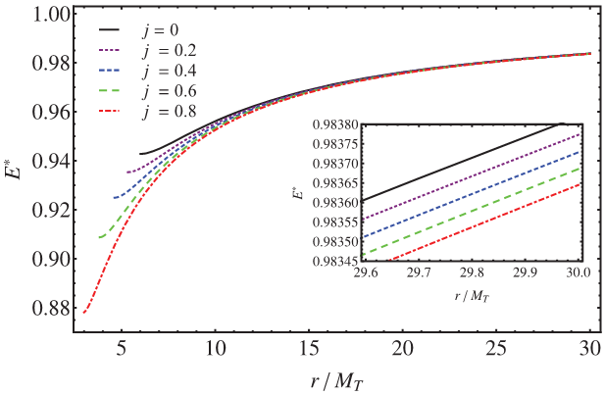
(a)  Energy versus radial distance in the static space-time | (b)  Energy versus radial distance in the Kerr space-time
In both panels, the solid curves show particles in the gravitational field of a static black hole without dark matter. Other curves correspond to different values of $ρ_{0}$ in (a), and to different values of j in (b)
Figure 3 - Numerical evaluation of energies Е* (а) in the static space–time with dark matter and (b) in the Kerr space–time without dark matter of test particles in the accretion disc as functions of r/M_{T}

Figure 4 (a, b) plots the orbital angular momentum of test particles as a function of the radial distance. The legends are the same as in Figure 2. It can be seen that in the presence of dark matter, the angular momentum departs from the black hole case at large r (see Figures 4(a)). Instead in the Kerr space–time the opposite occurs, and the angular momentum converges to the static case as r increases. In both cases, L* is higher for the static black hole case.

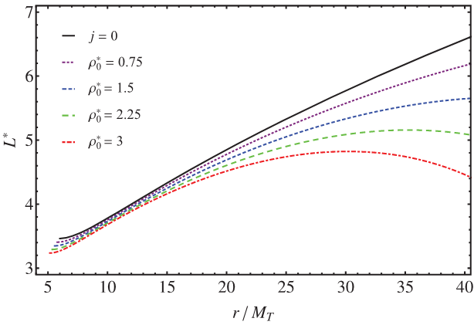 | 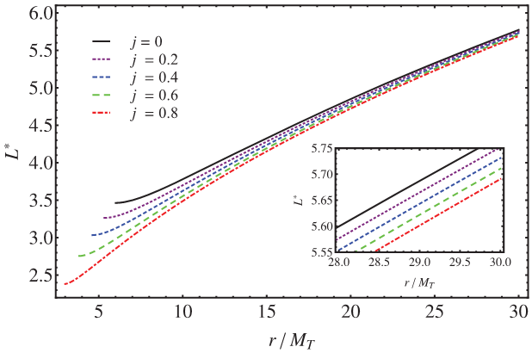
(a)  Angular momentum versus radial distance in the static space-time | (b)  Angular momentum versus radial distance in the Kerr space-time
In both panels, the solid curves show L* for particles in the gravitational field of a static black hole without dark matter. Other curves correspond to different values of $ρ_{0}$ in (a), and to different values of j in (b)
Figure 4 - Numerical evaluation of the orbital angular momentum L* of test particles in the accretion disc as a function of r/M_{T}

In Figure 5, the flux produced by the accretion disc is evaluated as a function of the dimensionless radial distance. Owing to the fact that for dark matter r_{i} < 6M_{BH}, the flux is higher with respect to the black hole without dark matter because the test particles, which are able to stay on circular orbits at smaller radii, will emit more radiation before falling towards the central object (Figure 5a). Note that because $F\left(r_{i}\right)$ = 0, the value of the innermost stable circular orbit determines also the smallest radial distance from which particle emission can occur. A similar situation can be observed in the Kerr space–time without dark matter with a co-rotating disc, which allows circular orbits to remain at smaller radii (Figure 5b). At larger radii, however, the two scenarios can in principle be distinguished
Of course, when making observations of astrophysical sources, one does not measure directly any of the above quantities, and therefore they cannot be used to distinguish the two scenarios in practice. On the other hand, measurements related to the disc’s luminosity are possible. In Figure 6, the differential luminosity of the accretion disc is evaluated as a function of the dimensionless radial distance. Here we have a similar behaviour to in Figure 5 at smaller radii owing to the fact that the ISCO is r_{i} < 6M_{BH} both for the static geometry with dark matter and for the Kerr geometry with positive values of j > 0. At larger radii, however, the two space–times display different features from each other

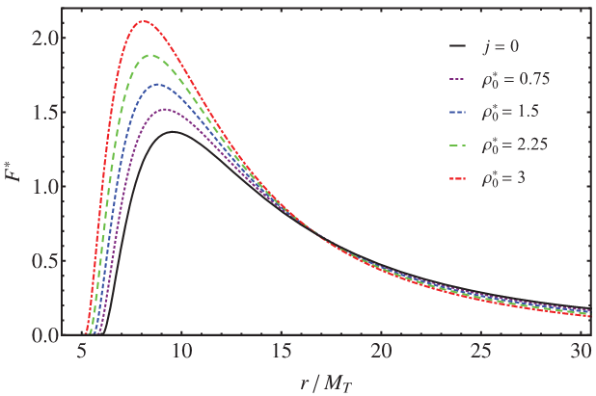 | 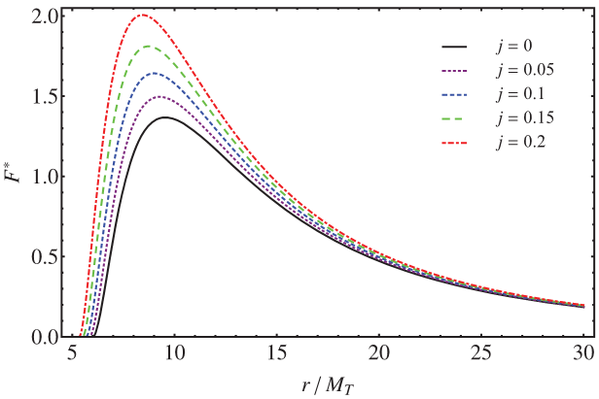
(a)  Radiating flux versus radial distance in the static space-time | (b)  Radiating flux versus radial distance in the Kerr space-time
The solid curves in both panels correspond to the case of Schwarzschild in vacuum. Other curves correspond to different values of $ρ_{0}$ in (a), and to different values of j in (b)
Figure 5 - Numerical evaluation of the flux ℱ divided by 10⁻⁵ of the accretion disc as a function of r/M_{T}

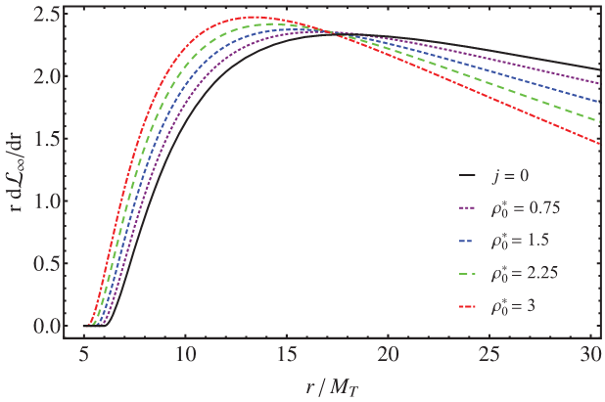 | 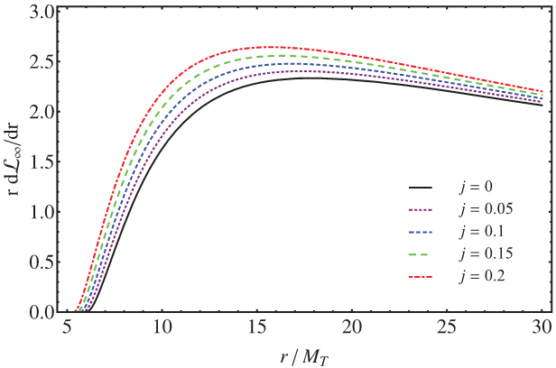
(a)  Differential luminosity versus radial distance in the static space-time | (b)  Differential luminosity versus radial distance in the static Kerr-time
The solid curves in both panels correspond to the case of Schwarzschild in vacuum. Other curves correspond to different values of $ρ_{0}$ in (a), and to different values of j in (b)
Figure 6 - Numerical evaluation of the differential luminosity scaled in powers of10⁻² as a function of r/M_{T}

In Figure 7, the spectral luminosity of the accretion disc is given as a function of radiation frequency 𝜈. The differences in the observable spectrum can be seen when dark matter is present (Figure 7a). One notable effect is a decrease in the spectral luminosity at low frequencies with respect to the case of a black hole in vacuum. At the same time, the most important effect comes from the fact that r_{i} < 6M_{BH} induces a higher spectral luminosity at high frequencies. This effect is due to the fact that particles in the inner regions of the accretion disc emit more energetic radiation at higher frequencies.
In the case of the Kerr space–time without dark matter, the spectral luminosity is always higher for positive j > 0than for j = 0. Indeed, this characteristic of the spectral luminosity can be used to test our model against the Kerr space–time at larger radii for lower frequencies.

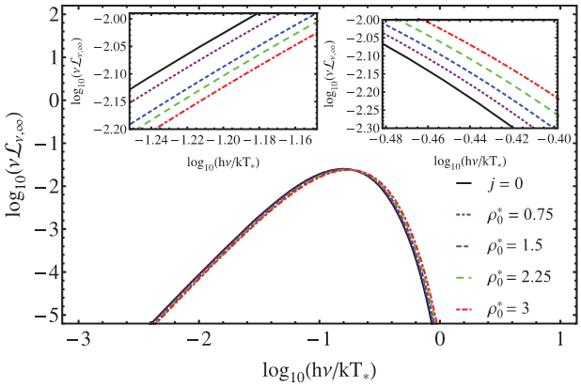 | 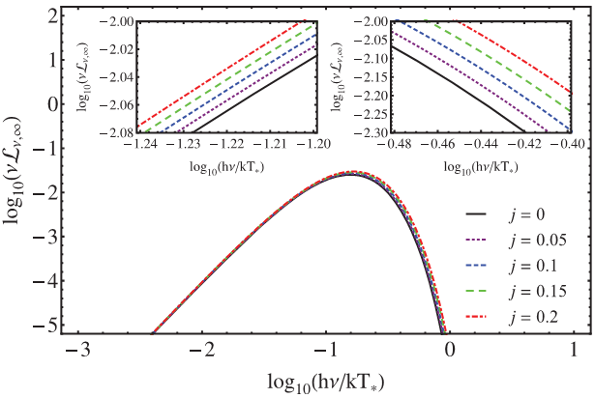
(а)  Spectral luminosity versus radial distance in the static space-time | (b)  Spectral luminosity versus radial distance in the static space-time
In both panels the solid curves represent the case of a static black hole without dark matter. Other curves correspond to different values of $ρ_{0}$ in (a), and to different values of j in (b)
Figure 7 - Numerical evaluation of the spectral luminosity of the accretion disc as a function of hv/kT, i.e. as a function of frequency

It is indeed interesting to investigate whether the dark matter envelope surrounding a static black hole can mimic the observable features of a rotating black hole in vacuum. In fact, this turns out to be the case for a Kerr black hole with a prograde accretion disc. However, it should be noted that in principle the two geometries can be distinguished from the luminosity at large radii, because for Kerr d$L_{∞}$/dlnr approaches Schwarzschild from above for j > 0, while in our model d$L_{∞}$/dlnr becomes smaller than the corresponding Schwarzschild value as r increases.

1.3.2 Gravitational lensing induced by dark matter
A distinctive product of the dark matter distribution, and another feature that can be used to test the model with observations, is its influence on gravitational lensing, whereby the refraction index is modified as a result of the presence of dark matter. For example, it would be interesting to evaluate how much gravitational lensing of the back of the disc is expected for our dark matter distribution in comparison to the case of a black hole in vacuum. A detailed investigation of this topic is beyond the scope of this paper. However, here we can provide some arguments regarding the effect of dark matter on the amount of lensing by following the standard formalism of the refraction index due to the dark matter gravitational field [34].
We assume that lensing is characterized by the superposition of the deflection angles of many infinitesimal point masses. Thus, invoking Fermat’s principle applied to the geodesic trajectories of our 4-dimensional curved space–time, we can find a description of light rays in a gravitational field analogous to that of classical optics. In particular, for a transparent medium with a continuous refractive index, say n, where Fermat’s principle holds, the optical length is minimized by $δ\int{n\left(\tilde{r}\right)\left[d{\tilde{r}}^{2}+{\tilde{r}}^{2}d{\tilde{Ω}}^{2}\right]=0,}$ where$d{\tilde{Ω}}^{2}=dθ^{2}+\sin^{2}θdφ^{2}$ and $\tilde{r}$ is the isotropic coordinate in the equivalent optical metric, provided by d$s^{2}=e^{2Ф}\left(dt^{2}-n^{2}\left[d{\tilde{r}}^{2}+{\tilde{r}}^{2}d{\tilde{Ω}}^{2}\right]\right)$. Comparing our metric, namely equation (5), with the isotropic coordinates described above , we immediately find the system [35]

$\left\{\begin{aligned}\frac{d\tilde{r}}{dr}=\frac{\tilde{r}}{r}e^{\frac{Λ}{2}} , \\ n=\frac{r}{\tilde{r}}e^{-\frac{Λ}{2}} ,\end{aligned}\right.$ (1.23)

and so the exact solution for $\tilde{r}$ in terms of r

$\tilde{r}=exp\left\{\int{\frac{dr}{r}}exp\left(\frac{Λ}{2}\right)\right\}$. (1.24)

Frequently this solution is approximated at large radii, where $\tilde{r}≃r$. In our case, however, we are interested in the envelope of dark matter in the proximity of a black hole, so the approximation $\tilde{r}≃r$ does not hold
In vacuum, the spherical solution reduces to Schwarzschild, where $Λ≡-ln⁡(1-2M/r)$, with $M/r$ the standard Newtonian potential. It is therefore convenient to quantify the amount of dark matter lensing by means of the incremental function:

$∆_{per cent}≡\frac{n_{DM}-n_{BH}}{n_{BH}}$, (1.25)

where we have computed the second relationship of the system (1.23), by substituting in the relationship (1.24). Thus, it is simple to notice that the amount of dark matter influences the refractive index directly through a correction related to both Λ(r) and the gravitational potential of our model. The numerical behaviours of n(r) and $∆_{per cent}$ are portrayed in Figures 8 and 9, respectively. In the dark matter envelope, the curve that includes dark matter tends to n →1 less strictly than in the vacuum case. However, the percentage evaluated by $∆_{per cent}$ is very small and effectively ≤ 1 per cent, indicating that dark matter works as a weak medium with small expected effects due to lensing. By calculating $∆_{per cent}$(r), we in practice exclude the black hole from the system, and Figure 9 essentially shows the potential of the dark matter envelope.

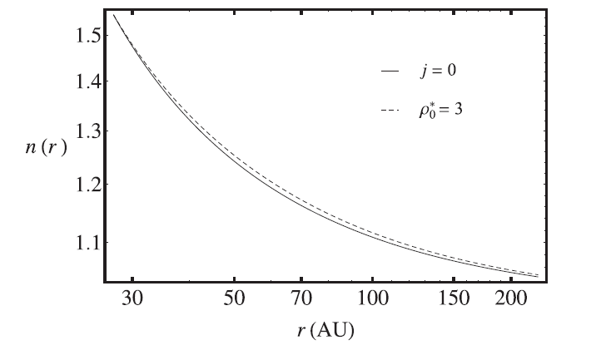
Figure 8 - Refractive index as a function of the radial coordinate.

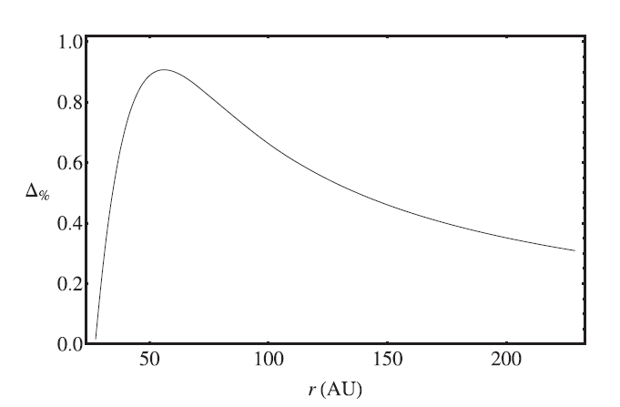
Figure 9 - $∆_{per cent}$ as a function of the radial coordinate.

Unlike in the case of a black hole, where the whole mass is concentrated inside the event horizon, possibly in the central singularity, the dark matter mass is distributed in an extended volume between r_{b} and r_{s}, where M_{DM} (r_{b}) = 0. As the radial distance r increases, the dark matter mass M_{DM} (r) first grows faster, and then grows slowly (see fig. 3, right panel, in [22]). Therefore, we observe maximum in Figure 9 whenthe gravitational potential of dark matter is ∼M_{DM}(r)/r.
2 Geometric optics in the universe with dark matter dominance
We consider the Friedmann cosmological model, generalized to the epoch of dark matter dominance. Its equation of state is chosen in a new, nonstationary form. Based on the light propagation process in such a metric, its refractive index is found, which turned out to be a constant quantity (or more accurately, depending on the epoch of the end of dark matter dominance) and a possible effect of a burst of incoming radiation is predicted.
One of the urgent goals of modern cosmology, and also of particle physics, is an elucidation of the physical properties of dark matter. To this end, for instance, one can use astronomical observations. Such observations reveal that dark matter is mainly concentrated around large-scale cosmic objects such as galaxies and galactic clusters, forming corresponding halos [36, 37].
Besides its local distribution, dark matter is also described on a global scale since it occupies the second place in the substance structure of the Universe (after dark energy) and comprises up to 26.8% [38]. Therefore, the investigation of the light propagation process in the epoch of dark matter dominance is a fundamentally important problem of modern cosmology.
Speaking of the physical properties of dark matter, we mention once more about its two important aspects – particles of dark matter and the corresponding equations of state of the medium.
The aim of the present work is to investigate the light propagation process in the epoch of dark matter dominance described by a nonstationary equation of state.

2.1 On the nonstationary equation of state of dark matter
According to Ref. [39], particles of cold dark matter at high temperatures were in chemical equilibrium with cosmic plasma, in which their concentration was determined by this temperature. After quenching, the particles of dark matter remain for some time in a kinetic equilibrium with the plasma, when the temperature of the gas of particles corresponds to the temperature of the plasma.
Let us now briefly discuss the characteristics of the particles that we select to describe dark matter. According to Ref. [40], they are similar to neutrinos and antineutrinos, but should be more massive. Such hypothetical heavy particles (with mass of the order of 1.0 TeV) are called WIMPs (weakly interacting massive particles). Their distinguishing feature is the absence of the annihilation effect, so that they can appear after quenching at any early time. Therefore, all of our calculations can be applied to a gas of WIMP particles. We emphasize that the equation of state of dark matter was considered in Ref. [41] and it was found that it corresponds to a medium with vanishingly low pressure, for example, a nonrelativistic or relativistic gas.
Thus, we consider a medium of WIMP particles as a relativistic ideal gas described by the Mendeleev–Clapeyron equation of state. By virtue of the thermodynamic equilibrium of such particles with the particles of the cosmic plasma, the approximate condition holds. Therefore, the Mendeleev–Clapeyron equation takes the following form

, (2.1)

with the gas density explicitly factored out. For the standard cosmological Friedmann model, filled with a relativistic gas, a definite approximate relation holds, linking the temperature of the primordial relativistic gas with the age of the Universe. This relation, as was shown in Ref. [42], is given by

, (2.2)

where is the current time. Therefore, it follows from Eqs. (2.1) and (2.2) that the equation of state of the ideal gas, generally speaking, has the form . As a result, taking relation (2.2) into account, its state parameter depends on time in a similar fashion, i.e.,

. (2.3)

Let us now consider the case in which the Universe is filled with a real gas consisting of molecules and described by the van der Waals equation of state. If the temperature is measured in degrees, then, according to Ref. [41], it takes the form

, (2.4)

in which and are constant quantities describing the properties of a gas of WIMP particles and is the Boltzmann constant. Recall the physical meaning of the parameters: the parameter describes the interaction of molecules of matter, and the parameter is responsible for taking molecules’ size into account. The parameter is the molar mass of the specific material of which the matter is composed, and is the universal gas constant.
Now our problem is in the combination of Eq. (2.4) with Eq. (2.3) and finding the explicit dependence of the state parameter of the real gas on time. Further, we assume that . This condition describes a real property of a gas of WIMP particles, where its volume is substantially greater than the dimensions occupied by all of its molecules. Moreover, it makes sense to assume that the interaction of the molecules is not too great. This corresponds to the situation in which the requirement is fulfilled.
Following these considerations and taking the equation of state of an ideal gas (Eq. (2.1)) into account, we obtain

. (2.5)

In an ultrarelativistic hot gas of baryon matter, the pressure is proportional to the temperature of the gas in the fourth power [43], i.e.,

, (2.6)

where is the effective number of types of particles (bosons and fermions) in different quantum states. In realistic theories of elementary particles, as is well known, it has an upper limit: , so that Eq. (2.6) can be rewritten in the form of a power function with the constant coefficient . Thus we have

. (2.7)

Substituting expression (2.7) into relation (2.5), we find the state parameter as a function of temperature

, (2.8)

or as a function of time with two different terms

. (2.9)

2.2 Solution of the Friedmann equations for the epoch of the end of dark matter dominance
Recall that the Friedmann equations link the expansion parameter of the Universe (specifically, the Hubble parameter) with the density of the matter contained within it (the evolution equation)

, (2.10)

and their time-like expression,

, (2.11)

the latter being the energy conservation law.
However, here the question arises – whether it is possible to use a nonstatic medium in the static Friedmann equations, for example, a medium with a nonstationary equation of state. According to Tolman [44] with the reference to the work of Lemaître, a nonstatic spherical interval differs from the static case by the presence of mixed terms in the energy-momentum tensor of the gravitating medium. In general, they correspond to the appearance of transverse waves associated with radial mass fluxes. How does this conclusion relate to the properties of a gas of WIMP particles under consideration here?
We emphasize again that they are massive particles, a priori moving with speeds much slower than the speed of light, i.e., . This fact allows to neglect matter fluxes in a gas of WIMP particles and, consequently, to confidently use the proposed energy-momentum tensor to investigate cold (ideal) dark matter.
Prepared in this way, let us turn directly to the solution of the Friedmann equations. There are, as was mentioned above, two unknown functions: is the size of the Universe is the matter density, both obeying Eq. (2.10). Moreover, in order for their unique solution, it is necessary to introduce the equation of state. In our case, based on Eq. (2.9), we will work with the equation of state in the form , where is the time marking the end of the epoch of dominance dark matter. Substituting it into Eq. (2.11), one can find the solution in the following representation.
Let , then

, (2.12)

Hence it follows that the density of dark matter, also for the nonstationary equation of state, falls down with time in the evolution process of the Universe. Thus, Friedmann’s evolution equation takes the form

(2.13)

with the standard expression for the Hubble parameter, but in contrast to the main vacuum model of the Universe the density of the considered substance depends on time. Employing relations (2.12) and (2.13), we obtain

(2.14)
where . Thus, the increment to the Hubble parameter is expressed as follows:

(2.15)

Analysis of this expression shows that the found increment, in contrast to the purely vacuum model of the Universe, decreases with time. But, by virtue of the limitations of the model that we have constructed, the full expression for the Hubble constant with the entire set of substances taken into account, in particular, the contribution of the vacuum, will increase. Now, as was shown above,
(2.16)
where is some constant quantity.
It was shown in Ref. [45] that an expanding Universe can slow down or speed up. Different cosmological models describing decelerated and accelerated expansion of the Universe have been considered. One of these models, a homogeneous and isotropic flat Universe filled with nonrelativistic matter and a scalar field with potential can provide not only accelerated, but also decelerated expansion of the Universe. In the early Universe, the equation of state of matter was expressed in the form of the law . Such a state of matter, characterized by negative pressure, leads to accelerated expansion of the Universe, where the scale factor grows with time exponentially .

2.3 To the theory of a gravitational lens in the universe, taking into account the presence of non-stationary dark matter
Gravitational lenses are massive galaxies or galactic clusters, acting as a gathering object, when light is refracted in their gravitational field.
Although more than 400 such lenses are known today, it is assumed that in a photographic survey of the sky (for example, the Sloan Digital Sky Survey [46]), there definitely are substantially more of them, but many of them have not yet been identified.
One of the more distant galaxies in the Universe is MACS0647-JD, located 13.3 billion light years away from us. We see it as it was around 420 million years after the Big Bang. An important factor in its discovery is the fact that it varied substantially under the influence of the intervening galaxy MACSJ0647 +7015 (gravitational lens) at a distance of five billion light years.
On the whole, dark matter can generate a refractive index which differs from the vacuum refractive index. Its presence, as was noted in Ref. [51], is described by frequency-dependent effects during the propagation and attenuation of light. Other characteristics of light propagation in the Universe are described in Ref. [52]. In Ref. [53], the influence of primordial baryonic matter in the form of cosmic plasma on the evolution of perturbations in dark matter treated as a gas of weakly interacting massive particles (WIMPs) was investigated. Nonstationary equations of state of a WIMP gas were proposed both for an ideal model and also for a real model of a WIMP gas. The state parameter of the gas was also proposed in the form of a power-law dependence on time.
Thus, we write the standard expression for the Friedmann metric:

(2.17)
from which it is easy to obtain the law of light propagation and the corresponding velocity of light in the medium. For simplicity, we will consider motion of light along the radial component. Consequently, the velocity of propagation of light in our case is . The corresponding variable refractive index, as follows from Eq. (2.16), in the approximation, will be described by the quasi-constant quantity

(2.18)

Next, it is important to turn our attention to the following possible cosmological effect. For time , vacuum expansion of the Universe will be equal to its deceleration. As a result, light will move practically in empty space. Therefore, in the indicated time interval a burst of incoming radiation from the galaxies can show up. However, the calculation of this period of time depends on the poorly known quantities and .

3 Evolution of non-baryonic matter perturbations as a factor of formation of the large-scale objects in the early Universe
The Newtonian theory, as a limiting case of general relativity, is only applicable to scales well within the Hubble radius where the effects of spacetime curvature are negligible. Even in this context, however, one can only analyze density perturbations in the non-relativistic limit [54]. This approximation is the most suitable one in which we can model non-baryonic matter contribution. Here, especially in the regime of early times, perturbations in the relativistic matter, at all scales, require the full theory of general relativity [55]. However, its study and evolution can be performed by means of the Newtonian approximation with great predictivity.
In particular, after equipartition the universe is dominated by non-relativistic pressureless matter, which is commonly referred to as “dust”. The Newtonian treatment suffices on sub-horizon scales and as long as we deal with fluctuations in the non-relativistic component. During the radiation and the curvature dominated eras, perturbations do not grow. This suppression occurs because, in both epochs, the expansion is too rapid for the perturbations to experience any growth. After equipartition, fluctuations with wavelengths larger than the Jeans length grow as δ ∝ a ∝ t^{2/3} , whereas those bellow the Jeans length oscillate like acoustic waves.
Note that baryonic perturbations do not grow until recombination due to the tight coupling between baryons and photons. Dark matter fluctuations, alternatively speaking as non-baryonic matter content, on the other hand, start growing immediately after matter-radiation equality. As soon as the baryons have decoupled perturbations in their density distribution will be driven by the gravitational potential of the collisionless species. Thus, shortly after recombination, baryonic fluctuations grow rapidly and soon equalize with those in the dark matter. Subsequently, perturbations in both components grow proportionally to the scale factor [56].

3.1 Distribution properties of primary non-baryonic objects in the early Universe
The distribution of non-baryonic matter follows the dark matter distribution in the universe. Since observations are in favor of the fact that it dominates, we need to understand which amount of non-baryonic matter is really expected by matching cosmology with high-energy astrophysics. In particular, it may be 10 per cent smoother than thought, potentially upending our understanding of the evolution of the cosmos. Observing more than 30 million galaxies in the universe up to 10 billion light years from Earth leads to results that reaffirm previous indications about the spread of dark matter [57].
We believe the universe appears to be less clumpy than our standard model, i.e. general relativity with homogeneity and isotropy, of the universe at the moment would suggest. Following the big bang 13.7 billion years ago, our universe went through a period of inflation and expansion, leaving behind remnant heat in the process that we can observe today – the cosmic microwave background (CMB) – which shows us the spread of matter throughout the universe. The imprinting of such an effect would leave the distribution of non-baryonic objects in the early universe and is our main task [58]. In particular, we need to investigate how:
- inflation can be modeled by means of extended theories of gravity to see whether dark matter is or is not a geometrical effect,
- non-baryonic matter can interact with standard matter giving rise to a repulsive effect due to the interaction capable of accelerating the universe today, dark energy and matter can be unified by means of models whose equation of state permits to recover the effects of current acceleration without assuming further exotic fluids but only the presence of matter under the form of non-baryonic matter.

3.2 Physical characteristics (masses, sizes, angular momentum) of primary non-baryonic objects in the early Universe
The survey of data that have been examined and that we are going to re-analyze shed light on how to get information about the nature of non-baryonic matter and objects in the universe. In particular, the process of lensing induced by the gravitational pull of dark matter in about five per cent of the universe as seen from Earth can give us information about the microphysics of dark matter [59].
This was combined with observations of the clustering of galaxies from a separate survey, called the Baryon Oscillation Spectroscopic Survey (BOSS), to provide an accurate measurement of the spread of dark matter and, in general, on non-baryonic objects throughout the universe evolution.
Our project aims at describing the optical properties of non-baryonic objects at the level of strong and weak gravitational fields. If our findings would be in agreement with previous ones, such as BOSS as above stated, they could have some broad implications. It could mean that gravity on large scales is different than thought, with the rate at which matter falls into dense regions of the universe, as predicted by Einstein’s theory of general relativity, slower than predicted. Or it could be that our understanding of dark energy, thought to be the driver behind the accelerated expansion of the universe, is far from complete [60].
The size and mass distribution can be therefore observed by a direct check using lensing techniques and skills. Moreover, the study of black holes and compact objects would lead to accretion disks whose dark matter presence distributes differently if the density of non-baryonic matter follows different shapes.
Matter content, spin and fundamental properties can be inferred by matching our predictions with pure cosmology, i.e. by removing the quantum fluctuations due to vacuum energy as demonstrated in previous papers that were published [61-63].

3.3 Dynamical characteristics (energy, density of matter, dynamics) of the system of primary non-baryonic objects in the early Universe
Non-baryonic matter, including the effects of what accelerates the universe today, namely dark energy, constitute 95% of the observable Universe. It is believed the two effects are distinct and yet the physical nature of these two phenomena remains a mystery [64].
Einstein suggested a long-forgotten solution: gravitationally repulsive negative masses, which drive cosmic expansion and cannot coalesce into light-emitting structures. However, contemporary cosmological results are derived upon the reasonable assumption that the Universe only contains masses whose equations of state is exactly zero, i.e. the ones due to dust. In the case of dark energy, the pressure might be negative. By reconsidering this assumption, we are going to construct models which suggest that both dark phenomena can be unified into a single mass fluid, whose equation of state provides a dynamic that naturally pushes up the universe to accelerate [65].
The model modifies the standard ΛCDM cosmology, and indicates that continuously-created antigravitational effects that can resemble the cosmological constant and can flatten the rotation curves of galaxies.
Our model leads to several predictions that culminate to the discovery of the intrinsic nature of dark matter. In particular, we agree with the possibility that a cyclic universe with a time-variable Hubble parameter, potentially providing compatibility with the current tension that is emerging in cosmological measurements [66].
In this respect, we fully remove any kinds of exotic materials that naturally form haloes around galaxies, in favor of particular non-baryonic contents, under the form of 1) geometrical contribution coming from extended and/or modified models [67] or 2) new particles that can be interpreted in the frameworks that extend the standard model of particle physics [68].
Our expectations can be tested at the regime of local universe by investigated the dark matter distribution. We model its distribution, checking if the corresponding haloes are or are not cuspy, leading to particular cosmological consequences that are able to predict the observed distribution of dark matter as source of dark energy under a unified scheme. To do so, we extend the standard Chaplygin approach in which a gas of baryons produces dark energy and we work to model several testable predictions to check at galactic scales [64]. We believe that our reconstructed potentials could be consistent with observations from distant galaxy clusters.
Both cases, i.e. large-scale cosmology and galactic scales, lead to the surprising conclusion that the compelling puzzle of the dark Universe may have been due to a simple unified model [69].

3.4 Rotational characteristics of the system of primary non-baryonic objects
The above picture assumes the existence of dark matter as a source of dark energy. This is a robust possibility that supports the fact that dark matter is invisible, i.e. as due to some properties related to its nature that can be interpreted in view of the standard model of particle physics and/or by means of extended theories of gravity. Although appealing, this scenario does not take into account the peculiar motion of the early universe and the possibility that the universe itself at early times could have a motion different than what expected by simple expansion as due to the big bang.
In other words, if we consider that the universe has non-homogeneous and isotropic properties then it is possible to argue that the corresponding distribution of matter and energy is modeled differently and may lead to a different perturbed universe that could be tested in view of incoming observations [70].
This intriguing landscape is intimately related to backreaction processes and to different metrics that could be used to disagree with the genuine homogeneity and isotropy of the universe. In other words, if the universe presents slight deviations from homogeneity and/or isotropy, one can get that the kinematic properties of dark matter can be modified accordingly. The interpretation of such effects can be due to a different motion, i.e. for example in terms of rotation of the early universe, than what it is expected by the standard cosmological model.
In this respect, measurable effects and the possibility to match our predictions with observations in the case of non-static metrics, i.e. involving stationary space-times, could be useful to define corrections to the Friedmann equations.
Working out the LTB space-time and metrics similar to it, is the main task that we want to carry on in order to check the goodness of Copernican principle and to understand how much the influence of early universe motion could be actually relevant in our numerical and theoretical findings and predictions [71].

CONCLUSION

Main results of 2018
Non-stationary equations of state of dark matter are obtained for an ideal gas and two types of real van der Waals gas and Diterici gas. Physical substantiation of their dependence on time is given. In this case, the corresponding parameter, as shown, is negative and makes it possible to analytically obtain the solution of the Jeans equations for perturbations of the gas of WIMP particles.
It is shown that the speed of the "test" galaxy in the dark matter field has a parabolic form and, together with the speed generated by the central baryonic mass, gives a general flat graph.
So taking into account the standard density of baryonic matter together with the density of dark matter leads to a correct description of the general gravitational field of a centrally symmetric galaxy and, therefore, the dynamics of a dwarf galaxy in it. And here we are talking about both the qualitative agreement of the description of the dynamics of the "test" galaxy, and the quantitative coincidence of its characteristics with the observed values.

Main results of 2019
In accordance with the results obtained, it is shown that the amplitude of the dark matter oscillations increases with time. This provides a good physical explanation for why the density of dark matter decreases with time and the transition to the dominance of the cosmic vacuum begins in the Universe. Consequently, the obtained conclusions physically correctly describe its evolution on the basis of modern cosmology.
It is emphasized that since WIMP - particles are massive particles, then they a priori move with speeds much less than the speed of light. This factor, in accordance with the general conclusion of Lemaitre, makes it possible to neglect the flows of matter in a gas of WIMP - particles and, therefore, to confidently use the proposed energy-momentum tensor for the study of cold (ideal) dark matter.
For time the vacuum expansion of the Universe will be equal to its deceleration. So the light will move in almost empty space. Therefore, a certain burst of incoming radiation from galaxies may occur during the indicated time interval. Although the calculation of this time period depends on little-known values and .

Main results of 2020
In the first section of the report a black hole surrounded by dark matter was considered and the TOV equations were solved for the dark matter distribution extending for a finite thickness outside the black hole. We found allowed equilibrium configurations for dark matter with the inner boundary located either below or above the limit of the black hole’s innermost stable circular orbit at 6M_{BH}.
The dark matter distribution in our toy model is static, even though it is understood that in more realistic models the dark matter particles should be dynamic and may fall on to the black hole once crossing the limit of bound orbits. However, because we are interested in accretion discs around supermassive black hole candidates, we assumed that the time-scales for all the dynamical processes involving the dark matter cloud’s macroscopic quantities (such as density and inner boundary) are long compared with the time-scales for the processes occurring in the accretion disc, thus making the assumption of staticity acceptable.
With the aim of evaluating the role played by the presence of dark matter on the radiative flux, and the differential and spectral luminosity of the accretion disc, we analysed the motion of test particles in the geometry produced by the black hole plus dark matter distribution.
We obtained the orbital parameters, such as the angular velocity, energy and angular momentum per unit mass, for test particles in the accretion disc. We then evaluated the innermost stable circular orbit r_{i} for various dark matter density profiles and used it to estimate the radiation flux emitted by the accretion disc. This study allowed us to qualitatively estimate and understand the effect of dark matter on accretion discs. In particular, we showed that the thickness of the dark matter envelope, which can be adjusted by varying the value of the pressure P(r_{b}) for any fixed density ρ(r_{b}), and the location of the innermost stable circular orbit affect the disc’s luminosity.
We determined the radiative flux and differential luminosity of accretion discs in the presence of dark matter and compared them with values in the absence of dark matter. It turns out that, owing to the fact that r_{i} < 6M_{BH}, the flux and differential luminosity are higher in the presence of dark matter.
This effect is similar to what is obtained for a rotating black hole with a co-rotating accretion disc. In both cases, the disc’s spectral luminosity at high frequencies is higher than the pure Schwarzschild case. Thus, in the presence of dark matter, the spectral luminosity is higher at higher frequencies and lower at lower frequencies with respect to the black hole in vacuum. However, at low frequencies, the spectral luminosity exhibits a different behaviour in our model as compared with the Kerr, suggesting that it might be possible, at least in principle, to experimentally test the validity of the model.
In fact, we have shown that the presence of dark matter affects the geometry, which in turn affects the luminosity of the accretion disc. As a consequence of our analysis, we suggest that supermassive black hole candidates in the distant Universe, if surrounded by a sufficiently dense dark matter envelope, may be less massive than currently estimated, as some of their measured luminosity may be due partially to the presence of dark matter.
Obviously, the approach depends on the choice of the background space–time, namely on the particular metric chosen for the black hole candidate, and the dark matter density profile. In the present article, for the sake of clarity, we limited the analysis to static black holes and a simple exponential density profile. However, similar approach should readily extend to rotating black holes and more realistic density profiles. In the future, we aim to extend this work to the case of rotating black holes (i.e. the Kerr metric), black hole mimickers (such as static axially symmetric vacuum solutions) and exotic compact objects.
Furthermore, we will also focus on the form of dark matter density in order to understand how different dark matter distributions can influence the results. Because the density of normal matter and dark matter was higher in the early Universe, it is indeed possible that the accretion discs that formed around supermassive black holes behaved somehow differently from the simple models of black holes in vacuum that work for the present Universe. Thus our analysis can help to elucidate the role played by dark matter distributions regarding the appearance of such objects.
In the second section we have constructed a model of the Friedmann universe with a nonstationary equation of state. We have shown that the density of dark matter decreases with time and the increment to the Hubble constant increases over time. But this result does not violate the overall conclusion regarding the evolution of the Universe (its expansion) together with the entire set of matter contained within it.
We calculated the refractive index of our model, which turned out to be a constant quantity (or more accurately, it depends on the epoch of the end of dark matter dominance) and we have predicted a possible effect of a burst of incoming radiation.
The third section the following problems have been examined:
- the evolution of perturbations of non-baryonic matter as a factor in the formation of large-scale objects in the early Universe;
- the distribution properties of primary non-baryonic objects in the early Universe;
- the physical characteristics (mass, size, angular momentum) of primary non-baryonic objects;
- the dynamic characteristics (energy, density of matter, dynamics) of the system of primary non-baryonic objects;
- the rotational characteristics (moment of inertia, angular momentum or spin, angular velocity) of the system of primary non-baryonic objects.
In addition, new models and directions were considered that will help shed light on the understanding of the nature of non-baryonic objects in the early universe.

Assessment of the completeness of solutions to the assigned tasks: The target tasks for 2020 have been fully completed.
Recommendations for the specific use of results SRW: The results obtained in the project can be used in further studies of the physical properties of dark matter, in the study of the dynamics of dwarf galaxies in crossed fields generated by baryonic and non-baryonic (dark) types of matter.
These results can be used when reading special courses in astronomy at physics, physics and mathematics and physics and technology faculties of the universities of the Republic of Kazakhstan.
Assessment of the technical and economic efficiency of implementation: Technical and economic implementation is not provided within the framework of the project.

Assessment of the scientific and technical level performed SRW: The scientific and technical level of conducted research corresponds to the level and is confirmed by publications in peer-reviewed international scientific journals, such as Monthly Notices of the Royal Astronomical Society, Russian Physical Journal, News of NAS RK and other publications in the near and far abroad.

Participation in editorial boards and expert councils in other organizations: Boshkayev К.А., PhD., associate professor, member of the editorial board of journals «News of NAS RK» from 2016 and «Physical Sciences and Technology» from 2015.

Information on the participation of young specialists: 2 young specialists are involved in the implementation of the project - 1 PhD student and 1 engineer.

Applied value of the project: The applied significance of the project lies in the training of qualified researchers (specialists) in the field of modern relativistic cosmology.

Popularization and educational methodical work
The project is underway to train students specializing in physics and astronomy at al-Farabi KazNU. Among them:
- PhD – Zhumakhanova Gulnur «Dark matter profiles in galactic bulges and halos»,
- PhD – Nurbakyt Gulmira «The gravitational field of compact objects in general relativity»,
- PhD – Konysbayev Talgar «Dark matter and dark energy in different geometrical scenarios»,
- Master – Omargali Ardak «Investigation of dark matter equation of state from rotational curves of galaxies»,
- Master – Mutalipova Kalbinur «Determination of dark matter mass in galaxies with different structures».

REFERENCES

- The Event Horizon Telescope Collaboration et al. First M87 Event Horizon Telescope Results. I. The Shadow of the Supermassive Black Hole // The Astrophysical Journal Letters. – 2019a. – Vol. 875. – L1.
- The Event Horizon Telescope Collaboration et al. First M87 Event Horizon Telescope Results. II. Array and Instrumentation // The Astrophysical Journal Letters. – 2019b. – Vol. 875. – L2.
- Meszaros P., Fox D. B., Hanna C., Murase K. Multi-messenger astrophysics // Nature Rev. Phys. – 2019. – Vol. 1. – P.585-599.
- Kormendy J., Ho L. C. Coevolution (Or Not) of Supermassive Black Holes and Host Galaxies // Annual Review of Astronomy and Astrophysics. – 2013. – Vol. 51. – P.511-653.
- Volonteri M. Formation of supermassive black holes // The Astronomy and Astrophysics Review. – 2010. – Vol. 18. – P.279-315.
- Banados E. et al. An 800-million-solar-mass black hole in a significantly neutral Universe at a redshift of 7.5 // Nature. – 2017. – Vol. 553. – P.473-476.
- Abramowicz M. A., Czerny B., Lasota J. P., Szuszkiewicz E. Slim Accretion Disks // The Astrophysical Journal. – 1988. – Vol. 332. – P.646-658.
- Shapiro S. L., Teukolsky S. A. Black Holes, White Dwarfs, and Neutron Stars: The Physics of Compact Objects // Wiley-Interscience, New York. – 1983. – 672p.
- Abramowicz M. A., Fragile P. C. Foundations of Black Hole Accretion Disk Theory // Living Reviews in Relativity. – 2013. – Vol. 16. – P.1.
- Novikov I. D., Thorne K.S. Astrophysics of black holes // Black holes (Les astres occlus). Edited by C. DeWitt and B. DeWitt, Gordon and Breach, N.Y. – 1973. – P. 343-450.
- Page D. N., Thorne K. S. Disk-Accretion onto a Black Hole. Time-Averaged Structure of Accretion Disk// The Astrophysical Journal – 1974. – Vol. 191. – P.499-506.
- Harko T., Kovacs Z., Lobo F. S. N. Can accretion disk properties distinguish gravastars from black holes? // Classical and Quantum Gravity – 2009a. – Vol. 26. – P. 215006.
- Harko T., Kovacs Z., Lobo F. S. N. Thin accretion disks in stationary axisymmetric wormhole spacetimes // Physical Review D. – 2009b. – Vol. 79. – P. 064001.
- Bambi C., Barausse E. Constraining the quadrupole moment of stellar-mass black hole candidates with the continuum fitting method // The Astrophysical Journal. – 2011. – Vol. 731. – P. 121-133.
- Bambi C., Malafarina D. Kα iron line profile from accretion disks around regular and singular exotic compact objects // Physical Review D. – 2013. – Vol. 88. – P. 064022.
- Bertone G., Hooper D. History of dark matter // Reviews of Modern Physics. – 2018. – Vol. 90. – P. 045002.
- Bertone G., Tait T. M. P. A new era in the search for dark matter // Nature. – 2018. – Vol. 562. – P. 51-56.
- Matarrese S., Colpi M., Gorini V., Moschella U. Dark Matter and Dark Energy: A Challenge for Modern Cosmology // Dark Matter and Dark Energy: A Challenge for Modern Cosmology, Edited by S. Matarrese, M. Colpi, V. Gorini, and U. Moschella. Astrophysics and Space Science Library, Berlin: Springer. – 2011. – Vol. 370.
- Salucci P. The distribution of dark matter in galaxies // The Astronomy and Astrophysics Review. – 2019. – Vol. 27. – P. 2.
- Konoplya R. A. Shadow of a black hole surrounded by dark matter // Physics Letters B. – 2019. – Vol. 795. – P. 1-6.
- Luongo O., Muccino M. Speeding up the Universe using dust with pressure // Physical Review D. – 2018. – Vol. 98. – P. 103520.
- Boshkayev K., Malafarina D. A model for a dark matter core at the Galactic Centre // Monthly Notices of the Royal Astronomical Society. – 2019. – Vol. 484. – P. 3325-3333.
- Davies M. B., Miller M. C., Bellovary J. M. Supermassive black hole formation via gas accretion in nuclear stellar clusters // The Astrophysical Journal Letters. – 2011. – Vol. 740. – P. L42.
- Sofue Y. Rotation Curve and Mass Distribution in the Galactic Center —From Black Hole to Entire Galaxy // Publications of the Astronomical Society of Japan. – 2013. – Vol. 65. – P. 118.
- Fayos F., Senovilla J. M. M., Torres R. General matching of two spherically symmetric spacetimes // Physical Review D. – 1996. – Vol. 54. – P. 4862.
- Israel W. Singular hypersurfaces and thin shells in general relativity // Nuovo Cimento B Serie. – 1966. – Vol. 44. – P.1-14.
- Israel W. Singular hypersurfaces and thin shells in general relativity // Nuovo Cimento B Serie. – 1967. – Vol. 48. – P.467.
- Joshi P. S., Malafarina D., Narayan R. Equilibrium configurations from gravitational collapse // Classical Quantum Gravity. – 2011. – Vol. 28. – P.235018.
- Joshi P. S., Malafarina D., Narayan R. Distinguishing black holes from naked singularities through their accretion disc properties // Classical Quantum Gravity. – 2014. – Vol. 31. – P. 015002.
- Reynolds C. S., Young A. J., Begelman M. C., Fabian A. C., X-ray iron line reverberation from black hole accretion disks // The Astrophysical Journal. – 1999. – Vol. 514. – P. 164-179.
- Bambi C. Testing black hole candidates with electromagnetic radiation // Reviews of modern physics. – 2017. – Vol. 89. – P. 025001.
- Bambi C. Testing the space-time geometry around black hole candidates with the analysis of the broad Kα iron line // Physical Review D. – 2013. – Vol. 87. – P. 023007.
- Bardeen J. M., Press W. H., Teukolsky S. A. Rotating Black Holes: Locally Nonrotating Frames, Energy Extraction, and Scalar Synchrotron Radiation // Astrophysical Journal. – 1972. – Vol. 178. – P. 347-369.
- Faber T., Visser M. Combining rotation curves and gravitational lensing: how to measure the equation of state of dark matter in the galactic halo // Monthly Notices of the Royal Astronomical Society. – 2006. – Vol. 372. – P. 136-142.
- Perlick V. Gravitational Lensing from a Spacetime Perspective // Living Reviews in Relativity. – 2004. – Vol. 7. – 9.
- Iocco F., Patom., Bertone G. Dark Matter distribution in the Milky Way: microlensing and dynamical constraints // Journal of Cosmology and Astroparticle Physics. – 2011. – Vol. 2011. – P. 1-12.
- Bertone G., Hooper D. Silk J. Particle dark matter: evidence, candidates and constraints // Physics Reports. – 2005. – Vol. 405. – P. 279-390.
- P. A. R. Ade et al.Planck 2013 results. I. Overview of products and scientific results // Physics Reports. – 2013. – Vol. 1303. – P. 1-48.
- Berezinsky V.S., Dokuchaev V.I., Eroshenko Yu.N. Small-scale clumps of dark matter (in Russian) // UFN – 2014. – V. 184. – P. 3-42.
- Green A.M., Hofmann S., Schwarz D.J. The power spectrum of SUSY-CDM on subgalactic scales // MNRAS. – 2004. – Vol. 353. – P. 23-27.
- Landau L.D., Lifshitz E.M. Statistical Physics //Butterworth-Heinemann London. – 1980. – 544 p.
- Dolgov A.D., Sazhin M.V., Zeldovich Ya.B. Basics of Modern Cosmology // Editions Frontiers. – 1990. – 237 p.
- Linde A. D., Elementary Particle Physics and Inflationary Cosmology // CRC Press, 1 edition. – 1990. –384p.
- Tolman R.Ch. Relativity, thermodynamics and cosmology // M: Nauka. – 1974. –520 p.
- Bolotin Yu.L., Erokhin D.A., Lemets O.A. Expanding Universe: Slowing Down or Accelerating // UFN. – 2012. – V. 182. – P. 941-986.
- http://www.astronet.ru/db/msg/1202878/index.html
- Blioh P.V., Minakov A.A. Gravitational lenses // Kiev Naukova dumka. – 1989. – P. 237.
- Chechin L.M., Avkhunbaeva G.M. Two-component gravitational lens // Russian Physics Journal.– 2013. – Vol. 56. – P. 144-150.
- Chechin L.M., Kairatkyzy D. Chechin L.M., Kairatkyzy D. Differential aberration equation in gravitational optics// NAS RK reports.– 2014. – V. 3. – P. 16-21.
- Chechin L.M., Kurmanov E.B. On a new direction in the theory of gravitational lensing // Rec. Cont. Phys.– 2019. – V. 68. – P. 13-19.
- Gardner S., Latimer D.C. Dark matter constraints from a cosmic index of refraction // Physical Review D.– 2010. – Vol. 82. – P. 6-15.
- Linder, E. V. Clustering correlations and limits on cosmological gravitational waves // Astrophysical Journal.– 1988. – Vol. 328. – P. 77-87.
- Chechin L.M., Kairatkyzy D., Konysbayev T.K. Toward a Theory of the Evolution of Perturbations of the Dark Matter Density in the Very Early Universe // Russian Physics Journal.– 2018. – Vol. 61. – P. 879-886.
- Altas Е., Tekin В. Second order perturbation theory in general relativity: Taub charges as integral constraints // Physical Review D.– 2019. – Vol. 99. – P. 104078.
- Garcia-Arroyo G., Cervantes-Cota J. L., Nucamendi U., Aviles A. Effects of Dark Energy anisotropic stress on the matter power spectrum // Physics of the Dark Universe.– 2020. – Vol. 2020. – P. 100668.
- Aviles A., Cervantes-Cota J. L. Dark degeneracy and interacting cosmic components // Physical Review D.– 2011. – Vol. 84. – P. 083515.
- Bertone G., Tait T. M.P. A new era in the search for dark matter // Nature.– 2008. – Vol. 562. – P. 51-56.
- Peebles P. J. E., Ratra B. Cosmology with a Time-Variable “Cosmological Constant”// Astrophysical Journal.– 1988. – Vol. 325. – P. L17.
- Peebles P. J. E. Principles of Physical Cosmology // Princeton University Press. – 2013. – 718 p.
- Copeland E. J., Sami M., Tsujikawa S. Dynamics of dark energy // Astrophysical Journal.– 2006. – Vol. 15. – P. 1753-1936.
- Luongo O., Muccino M. Speeding up the Universe using dust with pressure // Physical Review D.– 2018. – Vol. 98. – P. 103520.
- Boshkayev K., D'Agostino R., Luongo O. Extended logotropic fluids as unified dark energy models // The European Physical Journal. – 2019. – Vol.79. – P. 1-7
- Boshkayev K., Idrissov A., Luongo O., Malafarina D. Accretion disc luminosity for black holes surrounded by dark matter // Monthly Notices of the Royal Astronomical Society. – 2020. – Vol. 496. – P. 1115-1123
- Georgescu I. New eyes on the Universe // Nature Reviews Physics. – 2020. – Vol. 2. – P.70
- Dunsby P. K. S., Luongo O., Reverberi L. Dark energy and dark matter from an additional adiabatic fluid // Physical Review D. – 2016. –Vol. 94. – P. 083525-1-083525-11
- Bernal J. L., Verde L., Riess A. G. The trouble with H0 // Journal of Cosmology and Astroparticle Physics. – 2016. – Vol. 2016. – P.1-16
- Capozziello S., D'Agostino R., Luongo O. Extended gravity cosmography // International Journal of Modern Physics D. – 2019. – Vol. 28. – P.1930016
- Lancaster T., Blundell S. J. Quantum Field Theory for the Gifted Amateur // Oxford University Press. – 2014. – 512 p.
- Capozziello S., D'Agostino R., Luongo O. Cosmic acceleration from a single fluid description // Physical Dark Universe . – 2018. – Vol.20. – P. 1-12
- Cai M. Li, Y., Li H., Brandenberger R., Zhang X. Inflation in entropic cosmology: Primordial perturbations and non-Gaussianities // Physics Letters B. –2011. – Vol. 697. –280-287
- Boshkayev K., Konysbayev T.K., Kurmanov E.B., Luongo O., Muccino M. Dark matter distribution in ESO0140040 Spiral galaxy // submitted to Galaxies, currently under review, (2020).

APPENDIX A
List of published works in 2018

Publications in foreign journals:
- Chechin, L. M., Kairatkyzy, D., Konysbaev, T. K. Toward a Theory of the Evolution of Perturbations of the Dark Matter Density in the Very Early Universe // Russian Physics Journal. –2018. – Vol. 61. – P. 879-886. IF 0.143 (Scopus), Percentile 31, doi: 10.1007/s11182-018-1472-9

Publications in domestic journals:
- Kairatkyzy D. Investigation of the influence of primary baryonic matter in the form of cosmic plasma on the evolution of disturbances in dark matter (in Russian) // International Farabi Readings: mater. int. scientific. conf. – Almaty, 2018. –P. 68-73.

List of published works in 2019

Publications in domestic journals:
1 Chechin L.M., Kurmanov E.B. On a new direction in the theory of gravitational lensing (in Russian) // KazNU Bulletin, physical series. – №1(68). – P. 3-19. – 2019
2 Kurmanov E.B. Weak lensing in a nonstationary dark matter field (in Russian) // International scientific conference of students and young scientists "Farabi Alemi". – Almaty, Kazahstan. – P.263
3 Chechin L.M., Kurmanov E.B. and Konysbayev T.K. On the theory of light propagation in the non-stationary gravitational lens. Problem formulation // Second Annual Meeting of Kazakh Physical Society, P.24, 6-8 June, 2019, Kazakh-British Technical University, Almaty, Kazakhstan

List of published works for 2020

Publications in foreign journals:
- Chechin L.M., Kurmanov E.B., Konysbayev T.K. Geometrical Optics in a Universe with Dominance of Dark Matter // Russ Phys J.- Vol. 63.- P. 58–63. - 2020. https://doi.org/10.1007/s11182-020-02002-w (IF = 0.616, Scopus, Percentile 31, SJR=0.32, USA - Russia).
- Boshkayev K., Idrissov A., Luongo O., Malafarina D. Accretion disk luminosity for black holes surrounded by dark matter // Monthly Notices of the Royal Astronomical Society. – Vol. 496. - P. 1115–1123. – 2020. doi:10.1093/mnras/staa1564 (IF = 5.231, Web of Science, Scopus, Q1, SJR=1.94, UK).

Publications in domestic journals:
- Panamarev T., Otebay A., Shukirgaliyev B., Kalambay M., Just A., Spurzem R., Berczik P., Omarov Ch. Population of double white dwarfs in the galactic center // News of the National Academy of Sciences of the Republic of Kazakhstan. Physico-Mathematical Series. - № 331.- Vol. 3. - P. 15 - 20. – 2020.

Abstracts in the proceedings of the international scientific conference of students and young scientists, «FARABI ALEMІ» 2020, Almaty, 6-9 April, 2020.

- Zhumakhanova G.D., Konysbayev T.K., Mutalipova K.M., Omargali A.M., Boshkayev K.A. Distribution of dark matter in the galactic core and halo. P. 9 (in Russian)
- Omargali A.M., Konysbayev T.K., Zhumakhanova G.D., Mutalipova K.M., Boshkayev K.A. Study of the equation of state of dark matter from the rotation curves of galaxies. P. 20 (in Russian)
- Konysbayev T.K, Zhumakhanova G.D, Mutalipova K.M, Omargali A.M, Boshkayev K.A NGC 2403 Determination of the mass of dark matter in spiral galaxies. P. 291 (in Kazakh)

Accepted for publication:
- Boshkayev K., Konysbayev T.K., Kurmanov E.B., Muccino M. Dark matter properties in galaxy U5750 // News of the National Academy of Sciences of the Republic of Kazakhstan. Physico-mathematical series, 2020.

APPENDIX B

Calendar plan

Appendix 1.3
to the contract № 109 from 05 March 2008 y.
for grant funding

TECHNICAL SPECIFICATION AND WORK CALENDAR PLAN

Under contract № 109 dated March 5, 2018

1. SLLP “Astrophysical Institute named after V.G. Fesenkov”

1.1 Priority: Information, telecommunication and space technologies, scientific research in the field of natural sciences.
1.2 Sub-priority: Scientific research in the field of natural sciences: Fundamental and applied research in physics and astronomy
1.3 On the topic of the project: IRN AP05134454 "Evolution of dark matter density perturbations in the very early Universe".
1.4 Total project amount 44 000 000 (forty four million) tenge, including a breakdown by years, for the performance of work in accordance with paragraph 3.
- for 2018 - in the amount of 15 000 000 (fifty million) tenge;
- for 2019 - in the amount of 15 000 000 (fifty million) tenge;
- for 2020 - in the amount of 14 000 000 (fourteen million) tenge.

2. Characteristics of scientific and technical products according to the classification criterion and economic indicators

2.1 Direction of work: Investigation of the influence of primary baryonic matter on the evolution of dark matter perturbations, considered as WIMP particles.
2.2 Field of application: Cosmology
2.3 Final result:
- for 2018: Derivation of the non-stationary parameter state of the baryonic substrate;
- for 2019: Generalizations of the Jeans equation to describe the evolution of non-baryonic matter;
- for 2020: Evolution of perturbations of non-baryonic matter as a factor in the formation of large-scale objects in the very early Universe.
2.4 Patentability: No
2.5 Scientific and technical level (novelty): The novelty of the research is the study of the influence of primary baryonic matter in the form of cosmic plasma on the evolution of perturbations of dark matter, considered as WIMP particles.
2.6 Using of scientific and technical products: The results of the research can be widely used in the practice of scientific research and the prospects for the development of science in Kazakhstan.
2.7 Type of use of the result of scientific and (or) scientific and technical activities: Report on scientific research work, scientific publications.

3. Name of work, terms of their implementation and results
Stage assignment code | The name of tasks, activities for the implementation of project objectives | Period of execution |  | Expected results
Stage assignment code |  | start | end
1. | Justification of non-stationary parameter of state of a non-baryonic cosmological substrate | January 2018 | Until November 1, 2018 | The non-stationary parameter of the state of the non-baryonic cosmological substrate will be justified  Derivation of the non-stationary parameter of the state of a non-baryonic cosmological substrate
1.1 | Study the thermodynamic equilibrium of dark matter (DM) particles with the particles of cosmic plasma in the early stages of the Universe evolution | January 2018 | March  2018 | A study of the physics of thermodynamic equilibrium of dark matter (DM) particles with the cosmic plasma particles in the early stages of the evolution of the Universe will be carried out
1.2 | Study the Mendeleev-Clapeyron equation for DM particles in the early Universe | April 2018 | June  2018 | The study of the ideal equation of state of the Mendeleev-Clapeyron type of a non-baryonic cosmological substrate in the early Universe will be carried out
1.3 | Investigate the van der Waals equation for DM particles in the early Universe | July  2018 | September 2018 | The study of the influence of a real equation of state of the van der Waals type of a non-baryonic cosmological substrate in the early Universe will be carried out
1.4 | Propose a general expression of the nonstationary non-baryonic matter equation of state at the epoch of very early Universe | October 2018 | Until November 1, 2018 | A study of the influence of a real equation of state of the Diterici and Pitty-Bridgman type of a non-baryonic cosmological substrate in the early Universe will be carried out.  Publication of the results of work in a domestic scientific publication with a non-zero impact factor
2. | Apply Jeans equations to describe the evolution of perturbations of non-baryonic matter | January 2019 | Until November 1, 2019 | A generalization of the Jeans equation will be carried out to describe the evolution of perturbations of non-baryonic matter
2.1 | Derive Jeans equations with the general variable equation of state | January 2019 | March 2019 | The Jeans equation with the general variable equation of state will be derived.  Justification of the Jeans equation with a general variable equation of state
2.2 | Derive the Jeans equations for the WIMP particles gas | April 2019 | June  2019 | The Jeans equation for the WIMP particle gas will be derived
2.3 | Solve the Jeans equations for the WIMP particles gas and search its cosmological consequences | July  2019 | September 2019 | The Jeans equations for the WIMP gas will be solved and its cosmological implications will be investigated.  Cosmological consequences of the Jeans equation for a gas of wimp particles
2.4 | Search the Jeans equations for a WIMP-particle gas at very early Universe | October 2019 | Until November 1, 2019 | A study of the Jeans equation for a gas of wimp particles in the very early universe will be carried out  Cosmological implications of the Jeans equation for WIMP gas in the very early universe.  Publication of 1 article in a peer-reviewed foreign scientific journal indexed in the Web of Science or Scopus databases with a non-zero impact factor, and 1 publication in a foreign or domestic scientific publication with a non-zero impact factor
3. | Study the evolution of non-baryonic matter perturbations as a factor of formation the large-scale objects in the early Universe | January 2020 | Until November1, 2020 | Study of the evolution of perturbations of non-baryonic matter as a factor in the formation of large-scale objects in the early Universe will be carried out
3.1 | Investigate the distribution properties of primary non-baryonic objects in the early Universe | January 2020 | March 2020 | The study of the distribution properties of primary non-baryonic objects in the early Universe will be carried out. Distribution of primary non-baryonic objects in the early Universe
3.2 | Calculate the physical characteristics (masses, sizes, angular momentum) of primary non-baryonic objects in the early Universe | April 2020 | June  2020 | The physical characteristics (mass, size, angular momentum) of primary non-baryonic objects will be calculated
3.3 | Calculate the dynamical characteristics (energy, density of matter, dynamics) of the system of primary non-baryonic objects in the early Universe | July  2020 | September 2020 | Physical characteristics (mass, size, angular momentum) of primary non-baryonic objects will be calculated
3.4 | Consider the influence of early Universe rotation on the distribution and properties of primary non-baryonic objects in the early Universe | October 2020 | Until November 1, 2020 | The rotational characteristics (moment of inertia, angular momentum or spin, angular velocity) of the system of primary non-baryonic objects will be described.  Publication of at least 2 articles in peer-reviewed foreign scientific journals indexed in the Web of Science or Scopus databases with a non-zero impact factor, and 1 publication in a foreign or domestic scientific publication with a non-zero impact factor
From the Customer: From the performer
The chairman acting Director SLLP «Fesenkov
State Agency “Science Committee astrophysical institute»
of the MES RK”
________________Abdrasilov B.S. ___________Bibosinov A.Zh.

Acquainted:
Scientific supervisor of the project
__________________Chechin L.M.
