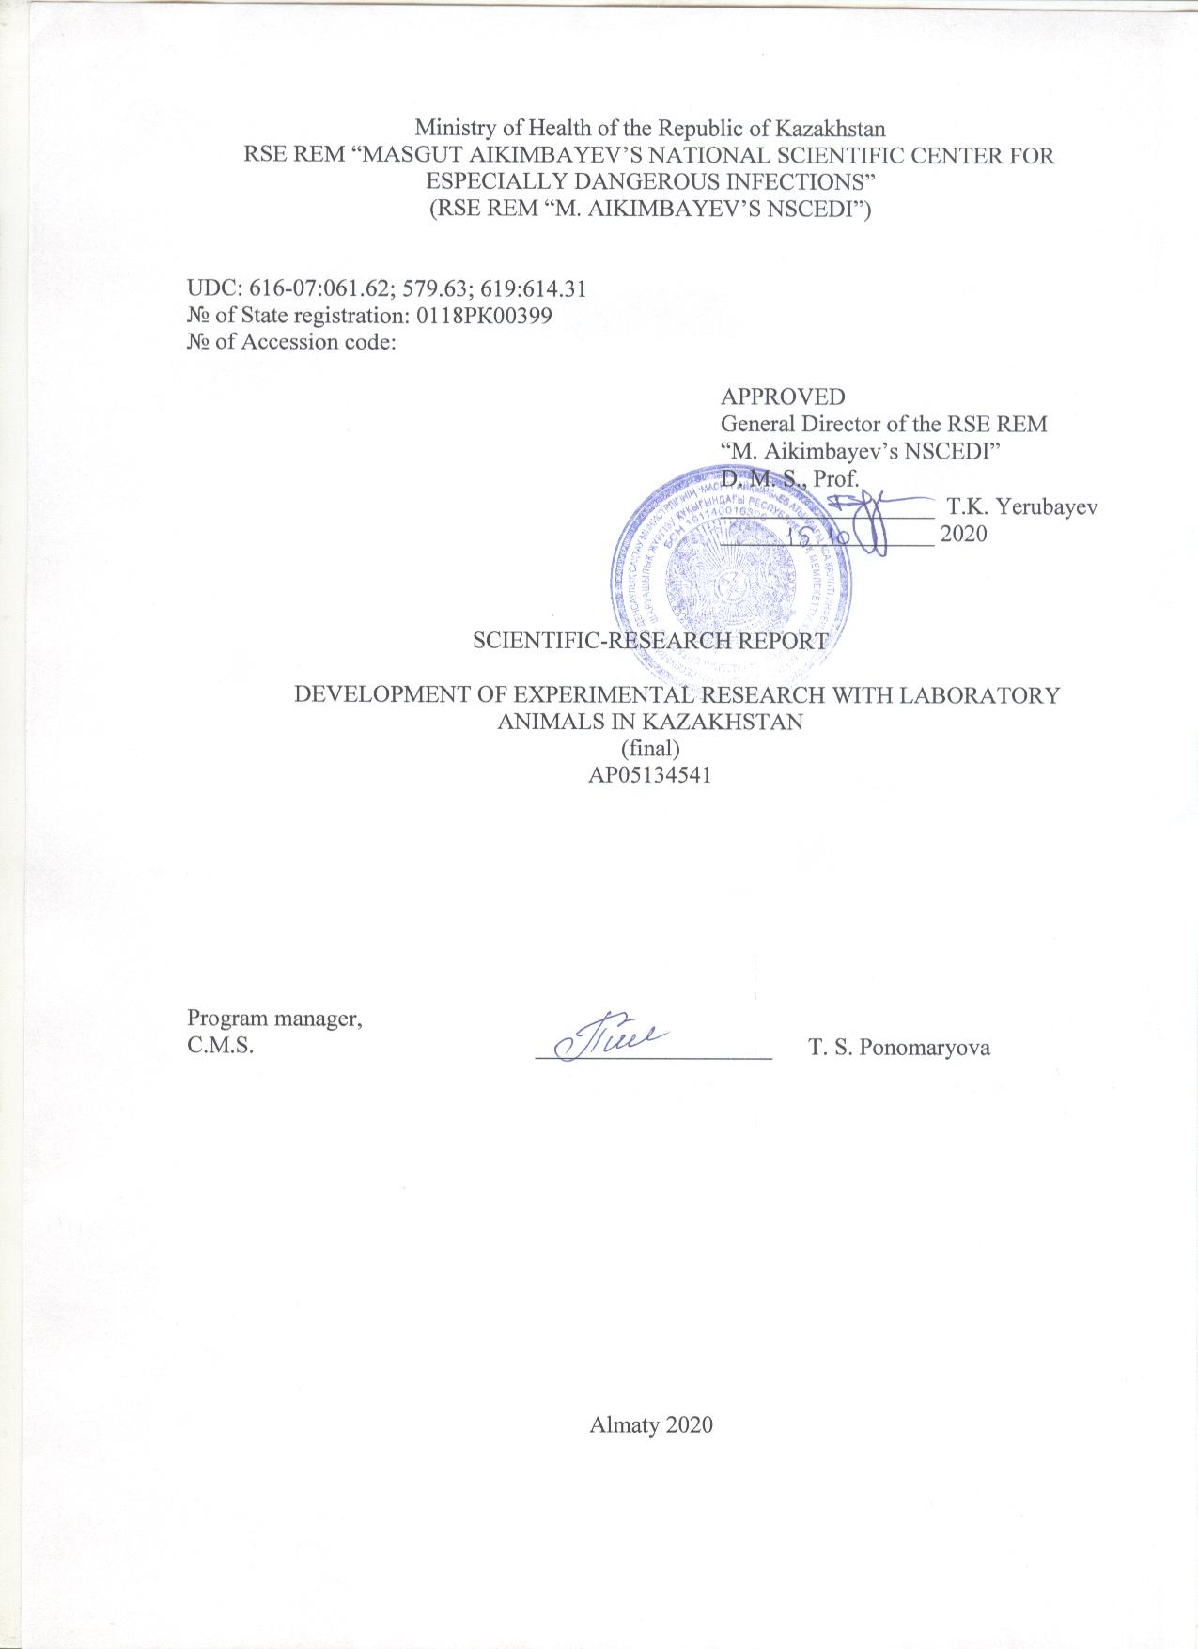

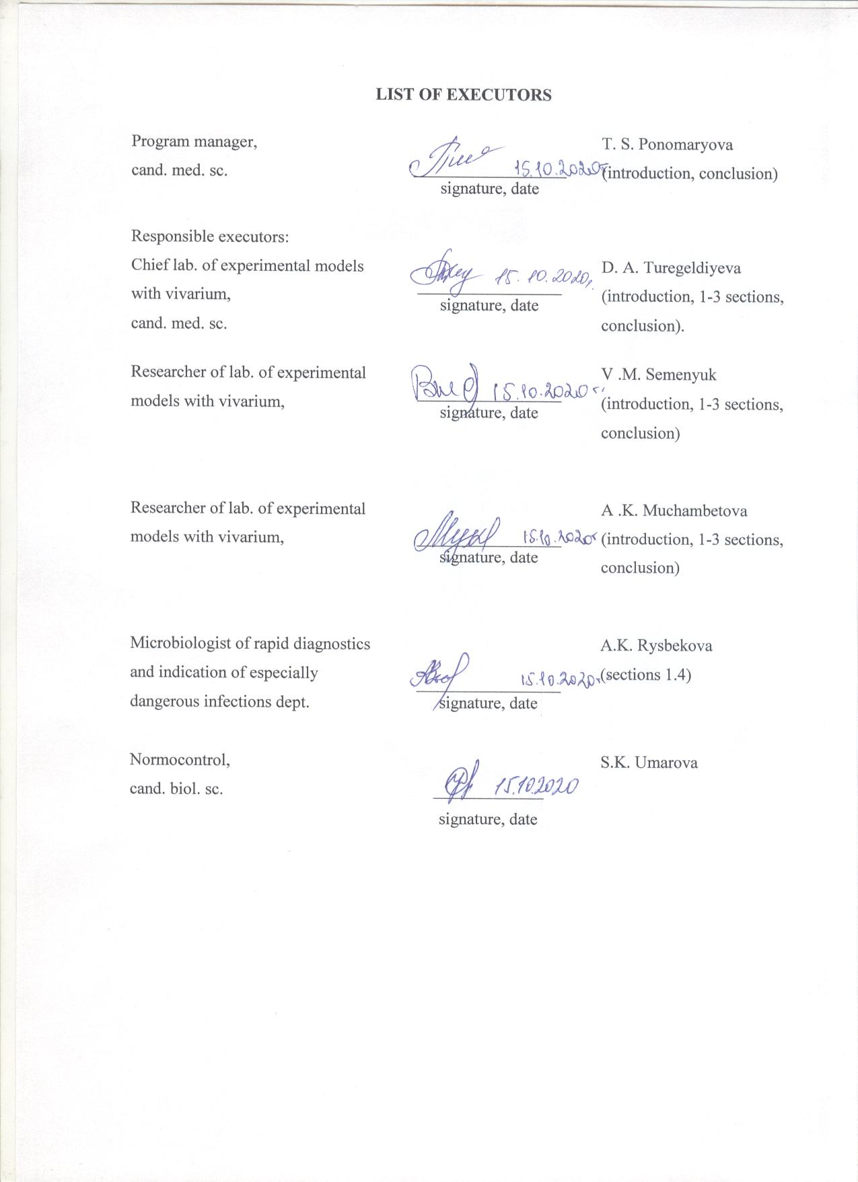

Abstract

Report 97 p., 2 figures, 7 tables, 59 references, 4 appendixes
SPF LABORATORY ANIMALS, INBRED AND OUTBRED ANIMALS, pure premises TECHNOLOGY, HEALTH MONITORING OF LABORATORY ANIMALS, BIOETHICS, INSTITUTIONAL PROGRAM
Objects of research – laboratory animals, national regulatory documents on the experimental research and vivarium’s, international standards and guidelines on laboratory animals.
This project aims to organize the production of SPF (Specific Pathogen Free) animals that are healthy by their microbiological status and with known genetic background including inbred and outbred strains of mice, rats, guinea pigs and rabbits. It is also aimed to determine the prospects of the using of high quality animals in experimental studies in Kazakhstan.
Methods: bacteriological, molecular genetic, statistical, comparative analysis.
Results obtained and their novelty:
Organized the production is of 4 SPF lines of laboratory animals: 1) ICR outbred mice, 2) Sprague Dawley outbred rats, 3) C57BL/6 inbred mice, 4) BALB/c inbred mice.
For the first time in Kazakhstan, the health of laboratory animals (mice, rats and rabbits) was monitored. The technology of "”pure rooms”, class D, for preservation of SPF microbiological status of laboratory animals was implemented at the nursery of NSCEDI.
Implementation degree: The training program “Organization of the work of the vivarium of conventional and SPF laboratory animals” was developed and the training of personnel of the SPF vivarium of NSCEDI was carried out; the Institutional program on the maintenance and use of laboratory animals, including Animal Research Protocol was developed and implemented, the IACUC was created; the “Manual on the organization, equipment and maintenance of experimental biological clinics (vivariums) and organization of work with experimental animals” and a certificate for the object of copyright was developed..
Application area: medical, pharmaceutical, biomedical, biotechnological, veterinary organizations having experimental vivariums and vivariums on reproduction of laboratory animals.

CONTENT

INTRODUCTION ………………………………………………………………………....... | 9
basic part of the report on sRW ………………………………………………... | 11
1 Breeding of standardized biological models of SPF laboratory animals (inbred and  outbred mice and rats)…………………………………………………………………… | 11
1.1 Quality categories of biological models and delivery of SPF laboratory animals to the  NSCEDI nursery………………………………………………………………………  …………………………………………………… | 12
1.2 Ensuring "pure premises" conditions and disinfection of the premises of NSCEDI  nursery prior to receipt of SPF animals  ………………………………………….... | 17
1.3 Breeding of the purchased four lines of laboratory animals of SPF category (mice  and rats) in the conditions of pure premises technology at the NSCEDI vivarium  ………………. | 20
1.4 Monitoring of health of laboratory animals from three vivaria in the Republic of  Kazakhstan and training  …..……………………….......................................................... | 24
1.5 Training the personnel for the SPF vivarium  ………………………………………………... | 28
2 Determining the prospects of SPF laboratory animals use in the Republic of Kazakhstan. | 29
2.1 Determining the virulence of a plague microbe on SPF laboratory animals…………. | 29
2.2 Determining the acute toxicity of disinfectants on conventional and SPF laboratory  animals ………………………………………………................................................... | 30
3 Spread of knowledge about international standards of laboratory animal production …… | 33
3.1 Analysis of international and national rules of the Republic of Kazakhstan on  laboratory animal production and development of the Guide………….................... | 36
3.2 Organization and holding a republican seminar on laboratory animal production for  experts of the Republic of Kazakhstan ………………………………………………. | 41
CONCLUSION ……………………………………………………………………………… | 43
LIST OF SOURCES USED ………………………….………………………...……………. | 46
APPENDIX A – Patent search report …………………………………...…………..………. | 51
APPENDIX B ‒ List of published works for 2018-2020………………..…………………... | 55
APPENDIX C ‒ Copies of supporting materials for 2018-2020…………..………………… | 56
APPENDIX D – Calendar plan on subject for 2018-2020 and supplementary  agreement ……………………………………..……………………………...... | 81

TERMS AND DEFINITIONS

The following terms with the following definitions are used in this report on the scientific research work:

Outbred laboratory animals | –laboratory animals obtained by mating unrelated animals from various families, and having genetic heterogeneity
Inbred laboratory animals | –linear laboratory animals originating from single common ancestor and/or obtained as a result of closely related mating (brother and sister), and having genetic heterogeneity
Microbiological status of the laboratory animals | – laboratory data of assessment of the animal health condition and confirmation of absence of certain pathogenic and opportunistic agents of infectious and invasive nature: viruses, bacteria and parasites
Knockout animals | – experimentally obtained animals with certain genes removed or blocked
Technology of pure premises | – a set of technological and organizational solutions for support of low concentrations of airborne particulates (dust, microorganisms, aerosol particles) in the premises air, where certain physical parameters can be controlled, e.g. humidity, pressure and temperature. Pure premises are built and used so that to minimize supply, generation and accumulation of particles indoors
Transgenic animals | – experimentally obtained animals with additional foreign DNA (trangene) integrated in chromosomes, which is hereditary
Animal Breeding Facility | – a unit of the organization where various animal species are kept and bred with further transfer for experiments and manipulations
Experimental vivarium | – a unit of the organization where experimental works (infectious and non-infectious) are performed, related to laboratory or wild animals
AAALAC (Association for Assessment and Accreditation of Laboratory Animal Care) | – international Association which promotes responsible handling of experimental animals through introduction of the program of rational use of animals and voluntary activity accreditation
Adlibitum (lat.) | – from Latin: «unlimitedly»
ARRIVE (Animal Research: Reporting of In Vivo Experiments) | – an approach of ethical expert review of the research protocols aimed at improvement of the report quality in publications on research involving animals
FELASA (Federation of Laboratory Animal Science Associations) | – Federation of European associations of laboratory animals which represents common interests in promotion of all aspects of laboratory studies with animals in Europe and beyond
DF animal – defined flora | – laboratory animals having only defined non-pathogenic microorganisms, e.g. dimorphic yeast, mold, aerobic spore-forming bacteria and anaerobic spore-forming bacteria; such animals are strictly kept in isolators
EF animal – excluded flora | – laboratory animals free from standard rodent pathogens and additionally, from seven opportunistic pathogens, such as, segmented thread bacteria, normal commensal rodent microorganisms which impact development of the immune system
GF animal – germfree | – laboratory animals free from all types of microorganisms, including bacteria, fungi and viruses which can be detected by various methods
MD animal – minimal diseases | – laboratory animals of SPF category with confirmation of absence of a minimum list of controlled infections
MPF animal – murine pathogen free | – laboratory animals free from known rodent pathogens
HEPA (High Efficiency Particulate Air) | – the type of high-efficiency air filters filtering out 99.9% of particles with several micrometers size, and used for highly efficient air cleaning
IACUC (Institutional Animal Care and Use Committee) | – institutional committee for care and use of laboratory animals, which goal is ethical expert review of the research projects involving laboratory animals
ICLAS (International Council for Laboratory Animal Science) | – international scientific organization aimed at improvement of human and animal health through encouraging ethical care and use of laboratory animals in studies in the whole world
Rus-LASA (Russian Laboratory Animal Science Association) | – Russian Association of laboratory animal specialists, which goal is to spread modern knowledge on laboratory animals and humane methods of work with them
SPF (Specific Pathogen Free) animals | – animals free from specific pathogenic micro flora, and with documented confirmation

LIST OF ABBREVIATIONS AND DESIGNATIONS

The following abbreviations and designations are used in this research report

dB | − decibel
IVC | - Individually Ventilated Cages
IPKULA | – Institutional program for the keeping and use of laboratory animals
LEC | - Local ethical commission
MH | - Ministry of Health
NSCEDI | - National Scientific Center for Especially Dangerous Infections
RSE REM | – Republican state enterprise on the right of economic management
RK | - Republic of Kazakhstan
SOP | - Standard Operating Procedure
NS RK | - National Standard of the Republic of Kazakhstan
BSLL-3 | - Biosafety Level 3 of Laboratory for Animals
UV | - ultraviolet
AAALAC | - Association for Assessment and Accreditation of Laboratory Animal Care
ARRIVE | - Animal Research: Reporting of In Vivo Experiments
DF | - defined flora
EF | - excluded flora
FELASA | - Federation of Laboratory Animal Science Associations
GF | - germ free
GLP | - Good Laboratory Practice
GMP | - Good Manufacturing Practice
HEPA | - High Efficiency Particulate Air или High Efficiency Particulate Arrestance
IACUC | - Institutional Animal Care and Use Committee
ICLAS | - International Council for Laboratory Animal Science
Lx | - Lux
MD | - minimal diseases
MPF | - murine pathogen free
Rus-LASA | - Russian Laboratory Animal Science Association
SPF | - Specific Pathogen Free
INTRODUCTION

The SPF status of laboratory animals is certainly necessary for preclinical, scientific and toxicological studies in the international laboratory practice, because the induced effects in biological test models should not be combined with possible diseases due to pathogenic microorganisms present in the test object, which are able to cause the same consequences [1, 2]. SPF animals ensure reliability and reproducibility of experimental data, which allows statically permitted reduction of the test model number in the experiment, thereby meeting international principles of humane and rational use of laboratory animals - «three R» principles (Reduction, Refinement, Replacement) [3]. In order to maintain their microbiological status, the SPF-category biological models are kept in a barrier or microisolator system supported by a set of technical, veterinary and sanitary-hygienic measures.
The vivaria in the Republic of Kazakhstan exist in all biological and medical educational institutions, at scientific research institutes and centers, in pharmacological and biotechnological laboratories, in laboratories of the sanitary-epidemiologic service, in veterinary facilities, and other laboratories of various ministries of the Republic of Kazakhstan. Laboratory animals are used for scientific purposes, preclinical studies, diagnostics, production (of immune sera, biomaterials, quality control of immunobiological preparations, etc.), toxicological tests and training. Annual number of the laboratory animals (mice, rats, guinea pigs, rabbits, etc.) used in the Republic of Kazakhstan reaches several thousand animals per year.
At the same time well-being and conditions of use of laboratory animals in Kazakhstan do not correspond to international standards: principles of the humane animal treatment and requirements to the ethical expert review of studies involving animals are not formulated properly, requirements to quality of laboratory animals are not defined sufficiently, rules of euthanasia/analgesia of animals and differentiation of experiments by stress categories do not exist, and monitoring of health of laboratory animals is not carried out. Numerous vivaria use the so-called "outbred" laboratory animals contained in inadequate conditions not corresponding to international standards applicable to biological test models. The vivaria employees are not trained on work with experimental animals, and there are no curriculums of post degree professional development on laboratory animal production 4 .
This condition of the laboratory animal production in the Republic of Kazakhstan complicates entry of the Kazakhstan scientific community, especially in the field of pharmaceutics and experimental biology, in the group of scientifically developed countries.
The goal of this project is organization of production of SPF laboratory animals (mice, rats and rabbits), healthy according to their microbiological status and genetically pure lines, and determining the prospects of use of the standardized biological models in experimental studies in the Republic of Kazakhstan. Spread of knowledge about principles of humane and rational use of laboratory animals among the Kazakhstan experts performing experimental studies was an important objective of the project.
Organization of the SPF vivarium in the Republic of Kazakhstan and use of SPF animals by the Kazakhstan scientists will allow to improve the quality of the laboratory expert review and scientific-practical works and to meet international standards in performance of experimental studies. Introduction of «three R» principles in practical activities of Kazakhstan vivaria is of great importance for strengthening of the ethical expert review of experimental studies involving laboratory animals and improvement of competence and responsibility of scientists and experts in the Republic of Kazakhstan.
Development of laboratory animal production in the Republic of Kazakhstan in conformity with international standards and development of biomedical sciences and pharmaceutical industry correspond to areas of the Densaulyk Development Program and the Program of Development of Ministry of Health of the Republic of Kazakhstan for 2018-2020.
Patent search was performed and a report on its results (appendix A) was prepared. The list of published works is given in appendix B. Copies of confirming materials are given in appendix C. Appendix D contains a Calendar Plan of the project performance under the contract №165 dated March 15th, 2018 between the Science Committee of Ministry of Education and Science of the Republic of Kazakhstan and the National Scientific Centre of Especially Dangerous Infections named after M.Aikimbaev for 2018-2020, and an additional agreement to the contract №1 dated November 05th, 2018.
The list of progress reports by the project stages and their inventory numbers:
The progress report «Development of experimental research with laboratory animals in Kazakhstan » for 2018. Inventory number: 0218РК00458.
The progress report «Development of experimental research with laboratory animals in Kazakhstan » for 2019. Inventory number: 0219РК00735.

basic part of the report on sRW

- Breeding of standardized biological models of SPF laboratory animals (inbred and outbred mice and rats)

Standardization of biological test models is required for both scientific experimental studies, and practical purposes, such as preclinical studies, study of medicine safety, obtaining biomaterials, etc. Modern laboratories use high-quality standardized biological models - laboratory animals of the isogene nature of SPF-category 1, 2 . SPF laboratory animals have a confirmed microbiological and genetic status and are kept in the barrier system in pure premises. Scientists and experts who are carrying out experimental studies with laboratory animals are obligated to indicate the supplier, the animal line and the ethical permission, thereby specifying their responsibility for reliability of the obtained results. International standards of laboratory animal production are based on principles of humane and rational use of laboratory animals – the «three R» rules 3, 5, 6 . Replacement - replacement of experiments painful for animals by experiments which are not causing sufferings, including alternative ones. Reduction - reduction of the number of animals in experiments by choosing optimum experimental ways. Refinement - refinement of a technique for the purpose of alleviation of sufferings of experimental animals.
The entire cycle of work involving laboratory animals at the National Scientific Center of Especially Dangerous Infections (NSCEDI) named after M.Aikimbaev of Ministry of Health of the Republic of Kazakhstan is carried out in experimental vivaria and vivaria for breeding of laboratory animals – the nursery. The nursery of laboratory animals of NSCEDI has a registration veterinary number of the Ministry of Agriculture (№KZ A.07/K-0003) as a facility for breeding and selling animals, and meets international standards applicable to SPF vivaria. The nursery building was reconstructed and upgraded according to technological requirements to pure controllable premises for creation of a barrier zone and protection of the microbiological status of SPF animals. The duplicated system of ventilation, the air filtration and conditioning system was established in a building with regulation of temperature, pressure and air humidity. NSCEDI nursery is equipped with modern vivarium equipment for the SPF animal care: Individually Ventilated Cages (IVC), laminar cabinet for changing laboratory animals, pass-through autoclave, disinfection chamber, automatic washer, pass-through sluices with UV-lamps, water filtration units, chamber for СО₂ euthanasia, barrier installations in decontamination stations, automatic timers, etc. [7].
Experimental vivarium of NSCEDI is also equipped with IVC, pass-through autoclaves, washers, and in addition, 2nd class biosafety cabinets and supply and exhaust ventilation with negative pressure and HEPA-filtration of exhaust air. Additional equipment in experimental vivarium is intended for work with an infectious material.
Thus, we have defined two kinds of vivaria depending on their functional use: 1) vivarium for breeding of laboratory animals (nursery), 2) experimental vivarium (experimental-biological clinic).
The micro-isolation technology chosen for SPF animals care, along with available engineering systems and equipment, create prerequisites for sustainable development of standard animal production not only for meeting requirements of research-production activity of NSCEDI, but also for potential external consumers performing biomedical studies based on GLP/GMP quality standards 8, 9, 10. The available equipment allows producing up to 10,000 standard mice per year.
By the end of 2020 NSCEDI has signed several contracts on sale of linear animals, and also a memorandum with the Higher School of Medicine of the Kazakh State University named after Al-Farabi about use of NSCEDI experimental vivarium for non-clinical studies and training of medical personnel.

  - Quality categories of biological models and delivery of SPF laboratory animals to the NSCEDI nursery

In 1913 Clarence Little, an American biologist developed the first inbred line of mice with a stable genotype, in 1980 for the first time Turrens & Boveris published a technique of production of transgene mice, and in 1989 Mario Capecchi, Martin Evans and Oliver Smithies developed the first knockout mouse, and were awarded the Nobel Prize in 2007 for this work [11, 12, 13]. Finally in 2002 the complete genome sequence of the mouse was published which has shown that a human gene and a mouse gene are of same size, and almost each gene in human genome has an analogue in a mouse genome. Presently over 600 various inbred lines of the mice exist, every with a different genetic background; also over 300 lines of different species of animals, birds and fish (rats, guinea pigs, hamsters, rabbits, gerbils, etc.) were developed. 14, 15.
Three quality models from a genetic viewpoint are distinguished today: 1) outbred (genetically undefined), 2) isogene/inbred (genetically defined), and 3) genetically partially defined (mutants, transgenes).
Three classes of laboratory animals are distinguished from a health quality viewpoint 16:
- Conventional, who are kept in open cage systems or in a barrier system of incomplete type. The initial animals for this category can be only animals of a better quality - SPF category animals;
- SPF animals, kept in a barrier system and with a confirmed microbiological status, can be advanced ones with a maximum list of controllable infections (EF/DF), and simple ones with a minimum list of controllable infections (MPF);
- Gnotobiotes, germ-free and axenic animals (GF), kept in the individual isolators with HEPA filters.
Use of animals-gnotobiotes in studies is extremely expensive due to use of isolators. However, gnotobiote technologies represent the best way of development of a base line of SPF animals, and that is why they are contained in nurseries of international suppliers of laboratory animals.
SPF animals with a confirmed microbiological status are a cost-effective alternative to gnotobiotes, and consequently are widely used in global laboratory practice.
Review of the world scientific literature has shown that researchers more often use outbred mice of CD-1/ICR line and inbred mice of C57BL/6 and BALB/c lines [17, 18], rats - outbred lines Sprague-Dawley and Wistar [19], and rabbits - New Zeeland White line for scientific and scientific-practical purposes. The main suppliers of laboratory animals in the world are Jackson Laboratory, Charles River Laboratories, Taconic Farms, and ENVIGO + (previously - Harlan). The most frequently quoted experimental works with laboratory animals are scientific research works in the field of immunology, oncology, physiology, pathology and neurology. [20].
C57BL/6 mice represent a widely used inbred strain. These animals are easily produced and have a genotype stability. C57BL/6 mice are used in the following areas: 1) physiological and/or pathological models for invivo experiments, 2) creation of transgene and knockout models, 3) generation of congenic spontaneous and induced mutations. C57BL/6 mice are resistant to autogenous convulsions, have rather low bone density and develop age-related hearing loss, are sensitive to obesity, second type diabetes and atherosclerosis. Elderly C57BL/6 mice are used in studies on immunology, oncology, neurodegenerative disorders and bone density disorders [17].
BALB/c mice represent an albinic, immune-deficient inbred line, are characterized by ease of breeding and minimum variations in weight between females and males, and have a long reproductive period. BALB/c mice are sensitive to carcinogens, and frequency of tumors in sublines reaches 20-40%. Many cell cultures and tissue cultures widely applied in biomedical experiments originate from BALB/c mice. These animals are producers of plasmocytes (tumors forming a basis for production of monoclonal antibodies), are used for creation of knockout and transgene animals. They are also used for studying slow viral infections and fibrinolytic components, lysis and processes of thromboses formation; reproductive function disorders caused by mycoplasma, and are used in study of animal behavior [18].
Sprague Dawley rats represent a hybrid albinic line with long narrow heads. They have a high reproduction rate and a low level of spontaneous tumors morbidity. Calmness of rats of this line, their temperament and handling convenience make them attractive for researchers. They are widely used in research on toxicology, pharmacology, oncology, and in behavioral experiments [19].
For the purpose of production of linear animals, NSCEDI nursery determined two outbred and two inbred lines of SPF laboratory animals applicable to the Republic Kazakhstan. Marketing of these lines was conducted among Charles River Laboratories, Taconic, The Jackson Laboratory, Envigo + companies. On September 14th, 2018 four lines of SPF laboratory rodents produced by ENVIGO + were delivered to NSCEDI nursery by the flight Netherlands-Germany-Almaty ( <http://www.envigo.com>):
- outbred mice of ICR (CD-1) line
- outbred rats of Sprague Dawley (SD) line
- inbred mice of C57BL/6J line
- inbred mice of BALB/c line
The delivered laboratory animals were accompanied by their health certificate (appendix C). Laboratory animals were examined, weighed, registered and placed in IVC microisolators of Labproduct & Allentown (USA) on quarantine for 10 days with unlimited access to feed and water adlibitum (picture 1). According to standards [21, 22] the animals are provided with the following environmental conditions: air temperature - 20-24°С, air humidity - 45-65%, lighting - 325-350 Lx, noise level – max. 60 dB, air volume per one animal – 0.25 cubic m/h, air flow rate – 0.2 m/s, number of animals in one cage - max. 10, minimum cage area – starting from 180 cm², standard volume of a complete feed for adult animals - 12 g/head per day, for youngsters - 5-8 g/head per day. The laboratory animals are provided with daily veterinary control, conditions to support normal health status, possibility of satisfaction of both physiological and behavioral needs, and quick elimination of factors which can entail stress and sufferings of animals.

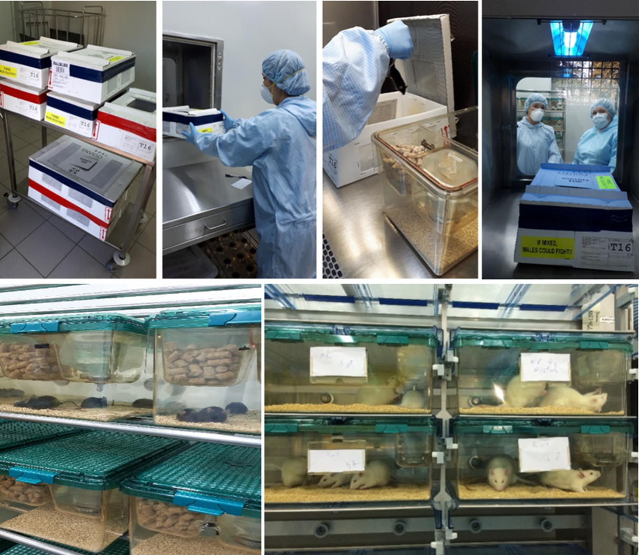

Picture 1 – Receipt of SPF laboratory animals and transfer to IVC microisolators of NSCEDI nursery

The factors ensuring quality of animals in experimental works were defined as follows: receipt and acclimatization of animals, environmental and care conditions, microbiological status of a colony and performance of routine manipulations. 67 SOP were developed on all aspects of work with laboratory animals (table 1).

Table 1 - Standard Operating Procedures in NSCEDI vivarium

SOP | Name
1 | 2
001 | Rules of breeding inbred mice and rats in the nuclear stock
002 | Rules of breeding inbred mice and rats in the commodity herd
003 | Rules of breeding outbred mice, rats, guinea pigs and rabbits in the nuclear stock
004 | Rules of breeding outbred mice, rats, guinea pigs and rabbits in the commodity herd
006 | The procedure of submission of the application for allocation of the laboratory premise in the vivarium

Continued table 1
1 | 2
012 | Program of monitoring of laboratory equipment in the vivarium – refrigerators, freezers, thermostats, autoclaves
023 | General requirements to access to the vivarium and training of employees
025 | Requirements to training of the laboratory personnel of the vivarium
026 | Requirements to training of the auxiliary laboratory personnel of the vivarium
036 | Procedure of registration and informing about the accidents in the vivarium
040 | Safe use and disposal of sharps in the vivarium
044 | Procedure of operation and maintenance of biosafety cabinets in the vivarium
046 | Use of personal protection equipment (PPE) in the vivarium
047 | Assessment of biorisks in the vivarium
053 | Procedure of response to emergencies in case of earthquakes, floods, fires, explosions, acts of terror, full electric power shutdown, and threat of use of explosives
054 | Procedure of evacuation during fire in the vivarium
083 | Waste management in the vivarium – General lab waste
084 | Animal disposal (infected and non-infected)from the vivarium
085 | Operation of the autoclaves and validation of autoclaving cycles in the vivarium
086 | Routine decontamination of lab equipment and materials in the vivarium
088 | Procedure of decontamination of racks and cages for animals in the vivarium
091 | Decontamination of laboratory tables, equipment, dishes and cloths in the vivarium
092 | Elimination of consequences of biological spills
093 | Plan of actions for pest control in the vivarium
105 | Washing of potentially contaminated lab cloths in the vivarium
106 | Requirements to daily maintenance of lab premises in the vivarium
108 | Monitoring and registration of the animal health condition
109 | Animal handling and use of the fixing devices
110 | Care and health support of lab animals
111 | Care conditions and health status of lab rabbits
113 | Preparation and use of the patient’s cards for animals
114 | Detection and control of pain and illnesses in lab animals
115 | Surveillance and prevention of diseases of rodents and rabbits
117 | Principles of care of rodents and rabbits
118 | Access to the vivarium, including premises of BSL-3 lab
119 | Purchase, quality control and storage of bedding materials for lab animals
120 | Purchase, quality control and storage of feeds for animals
121 | Purchase of lab animals from the approved sources
124 | Program of quality control for lab animals
125 | Receipt of lab animals in the vivarium
126 | Procedures of quarantine for animals delivered to the vivarium
127 | Transportation of lab animals to the vivarium
128 | Selection and delivery of animals and samples from fields

Continued table 1
1 | 2
129 | Procedures of cleaning the animal cages
130 | Procedures of providing feed and water to animals
132 | Changing the cages for lab animals in the vivarium
133 | Handling the runaway animals
134 | Transfer of animals from cages to the washing room
135 | Transfer of live animals from animal premises to the necropsy premises
137 | Removal of dead animals from animal premises
138 | Use of the receipt bunker for cages
139 | Procedure of use of the cage washing room
140 | Procedure of use of the ventilated racks
142 | Preparation of acidified water for rodents
144 | Sanitary cleaning of premises for lab animals, corridors and necropsy premises
145 | Use of necropsy premises in the vivarium laboratory
146 | Procedure of identification of mice, rats and rabbits
147 | Handling, storage and retrieval of registration data and records
148 | Requirements to animal registration in the research protocols
149 | Daily procedures of animal care, including on weekends and holidays
151 | Requirements to cloths and PPE for personnel caring for lab animals and researchers
152 | Use of anesthesia for lab animals
154 | Procedure of informing the Committee for control of conditions of animal care about deficiencies in animal care and improper handling
393 | Enrichment of the environment where rodents and rabbits are kept in the lab
395 | Euthanasia of rodents and rabbits
398 | IACUC functions and structure
400 | Entry to and exit from the BSL-3 labs

All SOP were discussed with participation of all employees, were approved by the management, and the vivarium and nursery personnel got acquainted with them. The decision was made on requiring new employees to get acquainted with those SOP.

1.2 Ensuring "pure premises" conditions and disinfection of the premises of NSCEDI nursery prior to receipt of SPF animals

SPF laboratory animals must be kept in the "pure premises" conditions for preservation of the "pure" microbiological status of animals. Standard 14-644 «Pure premises and the related controllable environments» defines a pure premise as the premise in which concentration of the particulates (dust, microorganisms, aerosol particles) is under control, and which is built and used so that to reduce to a minimum supply, generation and accumulation of particles indoors [23-29]. Standard 14-644 establishes classes of air cleanliness based on concentration of the particulates (aerosols) in pure premises and defines approaches to achieve the technology of pure premises:
1. Supply of great volumes of air filtered by highly effective filters to a pure premise, and creation of excessive air pressure for dilution and removal of particles and bacteria allocated with the personnel and the equipment.
2. Use of materials which do not generate aerosols and can be easily cleaned and disinfected.
3. Use by the personnel of special cloths isolating them from the environment and reducing quantity of particles allocated with the personnel and microorganisms.
4. Appropriate cleaning and disinfection of pure premises, and personnel training on behavior in pure premises and personal hygiene requirements.
Creation of pure premises in nurseries for breeding of SPF laboratory animals is aimed at prevention of conditions which can lead to contamination of an organism of the animal who is considered a product, with requirements to the building, equipment, personnel, correct technological production processes, personnel training, reporting, and the producers validation [30].
In SPF vivarium the class of air cleanliness in premises for animal care should conform to D class (EU GMP), which corresponds to the maximum particles content of no more than 3.5 million particles in one cubic meter in an operational condition [31]. Air cleaning is done by using two- or three-stage filtration of supply air in the cascade of filters, for example, filters G4-F9 or G4-Н10 etc. [32].
The area of NSCEDI nursery for laboratory animals is 600 sq.m. and is divided into pure, dirty and auxiliary functional zones, which ensures division of the personnel, animals and materials flows:
− "Pure" vivarium zones A and B for reproduction and care of rodents and for care of rabbits, a room for manipulations, an unloading zone of an autoclave, a premise for the sterilized materials (cages, feeds, bedding), a room for euthanasia, a wardrobe for technological clothes;
− "Dirty" zone - a washing-sterilizing room, a "dirty" corridor, a room for waste storage, a room for "receipt/delivery" of animals, decontamination station with a shower;
− Auxiliary premises – a wardrobe for outer clothes, an office, a bathroom, a laundry, ventilation unit, a room for the personnel, warehouses.
Up to 2,000 commodity standard mice, 500 rats or 300 guinea pigs can be kept simultaneously in the vivarium of NSCEDI nursery, taking into account available IVC and in conformity with technical standards and minimum requirements of animals’ needs in space [6, 33, 34]. The maximum annual production can reach 10,000 commodity biological models.
For the purpose of production of SPF laboratory animals in the pure premises conditions at the NSCEDI nursery a number of technological decisions were developed and introduced:
- Adjustment of the nursery ventilation system with a two-staged filtration of supply air (G4-F7) in order to create an elevated air pressure in rooms with SPF animals, which will allow preventing the aerogene contamination risk,
- Maintenance of constant physical factors of the environment (temperature 18-24°С depending on the animal species, humidity 40-65%, air exchange rate 8-15 rev/hours, illumination timers with a 12-hours mode),
- Keeping SPF linear rodents in IVC microisolators,
- Transfer of SPF animals from dirty cages to pure cages in a laminar cabinet,
- All objects touching SPF animals (cages with a bottle and a feeding trough, feed, bedding, water) are sterilized at temperature 121°С for 20 minutes,
- Personnel when entering the vivarium zone put on technological clothes (suit/pajamas, overalls, hat, mask, respirator, gloves and laboratory footwear), protecting air space from spread of bacteria and particles,
- Vivarium premises are cleaned daily by using modern cleaning technologies - Mop-technologies,
- Large-sized equipment (racks, carts, MOP-carts, buckets, pallets, etc.) before getting into the vivarium zone is disinfected in the disinfection chamber with simultaneous exposure to ozone (PortOzone ™, GreenTech) and UV-radiation,
- Autoclaved complete feed without addition of other products is used for feeding SPF animals,
- Water after ion-exchange filtration is used for SPF animals,
- СО₂ euthanasia of laboratory animals,
- Washing cage equipment of IVC, including bottles, caps and tips, pallets, and cardholders in the automatic washer.
Also NSCEDI nursery uses the refrigeration room for feed storage, the lift, access control to the building, video surveillance, and sluices. In case of an emergency, the equipment (IVC, autoclave, washer, lighting) is switched to an operating mode from the emergency diesel engine-generator.
Prior to receipt of SPF laboratory animals in nursery premises, a spring cleaning is performed by using sterilization and Glutex (Spain) disinfectant in the form of working solutions with 0.5-2.0% concentration. Total sterilization was performed in rooms for SPF rodents care by means of VHP Steris sterilizer using a biodecontamination technology, hydrogen peroxide vapors and subsequent control of sterilization by VHP ™ and Spordex® (appendix C).
Complete autoclaved granulated feed by SSNIFF (www.sniff.com <http://www.sniff.com>) was bought for laboratory animals; standardized feed enriched with vitamins, amino acids and minerals (62 elements). This feed contains min. 19-22% of crude protein, without animal and growth additives, without antibiotics, and with the ISO 9001quality certificate. Complete granulated feeds most fully meet the standardization requirements for environmental conditions of laboratory animals, the feeding diet consists only of complete feeds and water. Also RehofixMK-2000 bedding material by JRS company (www.jrs.de <http://www.jrs.de>) was bought, which is autoclaved, dust-free, made of natural materials, with high absorption capacity, compatible with ventilated units. Within the project framework, Glutex (Spain) disinfectant, washing and neutralizing substances NeodisherLaboCleanFLA / NeodisherN for the Techniplas Easy IWT-400 washer were bought.

  - Breeding of the purchased four lines of laboratory animals of SPF category (mice and rats) in the conditions of pure premises technology at the NSCEDI vivarium

According to the recommendation of the Committee of Standardization an inbred line can be registered as a standard line, if animals of this line were produced by using close monogamous inbreeding (brother-sister) for at least 20 generations, with allowed cross-breeding of mothers with sons or fathers with daughters. The lines descending from the same ancestors, but divided by transfer of animals to another laboratory on 8-19 generation of brother-sister inbreeding and kept separately during the subsequent generations, are considered sublines [1, 2]. Thus, the breeding stock of rodents exhaust the breeding capacity on 3-5 year after the breeding was started, because natural genetic heterogeneity appears in populations above 20 generations.
Rules of breeding inbred mice and rats in a nuclear stock.
The breeding stock (nuclear stock) of inbred lines represents a group of animals bred by monogamous crossing of brothers and sisters. Animal mating is performed taking into account the fact, that each animal from a nuclear stock should not depart from the common ancestor for more than three generations. It is necessary to minimize a distinction between animal pairs who are in the reproduction process. For this purpose it is necessary to choose one pair as the base pair, and divergent sublines should be removed from the reproduction process, so that in each line generation all animals were descendants of the same pair. Animals of two-three sublines are simultaneously in the reproduction process in a nuclear stock. It is necessary to join not less than five and not more than twenty pairs of brothers and sisters for a nuclear stock.
Blue cards were put on all cages of inbred animals with the following data: the line name, generation, date of birth, number of a parent family, mating date, cage number (litter number and pair number). White cards with a blue strip were put on cages with youngsters of the inbred nuclear stock with the following data: the line name, generation, number of females and males, date of birth, number of a parent family and date of separation.
Selection of inbred animals was performed in the minimum volume - only for preservation of biological properties of the given line and support of reproduction capability. Whenever possible, three pairs of brothers and sisters were left from each pair of producers for replacement of a nuclear stock. Youngsters were separated from parents at the age of 21-28 days by gender groups for growth completion. At the age of 7-8 weeks breeding pairs were formed as required. The remaining youngsters were separated by gender and used either for expanded production, or for experiments. In order to form and maintain the nuclear stock, animals of different age and different generations were used. Every culling of pairs by age was compensated by equal number of pairs.
Culling of inbred animals and youngsters was performed in the following cases: from cut-off sublines, no reproduction capability, with repeated cannibalism, over 300 days old, underdeveloped, illnesses, unsuitable for replacement of the nuclear stock.
Rules of breeding inbred linear mice and rats in a commodity herd.
Depending on the need in animals, the commodity herd can have two variants of breeding. If the delivery volume is rather small, it is possible to limit to the so-called ″expanded herd «№1». If the need in animals is high, the commodity herd «№2» is used.
Mice and rats of the expanded production were bred based on the color code system. Necessary quantity of breeding animals for each line was defined based on the need in the commodity herd. The animals for further breeding were chosen from a nuclear stock – either animals who were dropped out of breeding in a nuclear stock, or redundant youngsters. During joining of the youngsters at the age of 7-10 weeks it is not necessary to mate brothers and sisters. Animals of one color code can be mated among themselves irrespective of an origin. Animals of herd «№1» were bred using bigamous relations (two females per one male).
Size of the commodity herd «№2» was defined based on requests for inbred animals for research. Animals who were needed for reproduction in the commodity herd «№2» were provided from herd «№1». The replacement youngsters arrived for breeding under a yellow code, thus brother-sister pairing was not required. All inbred mice from the commodity herd were transferred for experiments.
Replenishment of the commodity herd «№1» was performed only at the expense of youngsters of a nuclear stock. Replenishment of the stock of herd «№2» was done only at the expense of youngsters from the production herd «№1».
The documentation of commodity breeding included the following: 1) green cards of producers in the commodity herd №1, and cards of commodity youngsters - white with a green strip, 2) yellow cards of producers in the commodity herd №2, and cards of commodity youngsters - white with a yellow strip.
The following requirements were introduced for breeding registration: 1) daily work with the production documentation performed by the nursery laboratory technician under supervision of the veterinarian, 2) all procedures with animals (litter registration, separation, joining, expedition, culling) were documented in «Animal Registration Sheets».
Outbred animals were bred based on a rotational system of nonlinear breeding, i.e. division of a nuclear stock into groups was used with subsequent mating under the scheme: joining of animals of odd generations (F1, F3, F5 etc.) and joining of animals of even generations (F2, F4, F6 etc.). Rules of outbred breeding of nonlinear mice and rats in a nuclear stock are explained by the necessity of preservation of the population genetic fund which guarantees reproduction of breeding animals on a rotational system.
All animals in a nuclear stock were divided into five identical groups by size. Each group was assigned a sequential number. Mating between groups was performed according to a strictly observed scheme (table 2).

Table 2 - Joining of animals of odd generations (F1, F3, F5 etc.) on a rotational system of outbred (nonlinear) breeding

Number of the formed group | Number of the female group for joining | Number of the male group for joining
1 | 3 | 5
2 | 4 | 1
3 | 5 | 2
4 | 1 | 3
5 | 2 | 4

According to the scheme, the group of producers №1 was made of the 3rd group of females and the 5th group of males, etc. The order of group formation was repeated in next generations in the same sequence, but with a gender shift (table 3).
In order to form the following generation the litter was selected evenly from all groups regardless of reproduction capability of each family. Thereby selection by economical-practical signs was excluded. Formation of a nuclear stock of next generation was done exclusively at the expense of a litter of animals of the same group. Replacement of one generation by another was performed simultaneously. Separation of youngsters was performed at the age of 21 days. Depending on the stock size, the mating and culling schedule was calculated so that during a year the stock of the breeding herd could be completely replaced.

Table 3 - Joining of animals of even generations (F2, F4, F6 etc.)

Number of the formed group | Number of the female group for joining | Number of the male group for joining
1 | 5 | 3
2 | 1 | 4
3 | 2 | 5
4 | 3 | 1
5 | 4 | 2

In order to avoid the impact of casual culling and to preserve the set quantity of animals in each group of a nuclear stock, it is necessary to have an animal reserve mated under the similar scheme. In case of culling of animals from any group of a nuclear stock, they should be replaced by similar animals from the reserve.
Animals from a nuclear stock of all litters, except for those intended for formation of a nuclear stock of the next generation, were transferred to the commodity herd or for research.
Culling of breeding animals and youngsters from the breeding herd was done in case of: no reproduction capability, illnesses, repeated cannibalism, age over 250 days, underdevelopment of youngsters, unfit for breeding, impossibility of sale. Culled animals were euthanized.
The breeding work documentation included the following: 1) blue cards for cages with breeding animals, which indicated: the stock name of nonlinear animals, number of a rotational group, quantity, generation number, date of birth, date of mating, date of birth of the offspring, quantity of newborns, quantity of transferred animals with separation by gender, 2) cards for cages with youngsters - white with a blue strip, which indicated the line name, generation, quantity of females and males in a cage, date of birth, which group of a breeding herd these youngsters were separated from and date of separation.
Also registration of breeding work, archiving of documents, and control were performed in «Animals Registration Sheets». Physiological indicators of outbred and inbred mice, rats, guinea pigs and rabbits kept in the nursery were registered: line/stock, coat color, puberty age in weeks, duration of pregnancy in days, a ratio during mating, and number of babies.
Rules of breeding of nonlinear mice, rats, guinea pigs and rabbits in the commodity herd. Animals in the commodity herd were bred under a more simplified rotational scheme, compared to the breeding herd. In order to form the commodity herd, females from groups 1; 2; 3 were mated with males from groups 4; 5; 6, and on the contrary, females from 4; 5; 6 were mated with males from 1; 2; 3 (tables 2 and 3). Replenishment of culled families was done at the expense of the youngsters received from the breeding herd who were used for breeding, when needed. Young mice and rats were separated at the 21-days age, rabbits at the 28-days age. All youngsters from the commodity herd were transferred for research. Culling of producers and youngsters from the commodity herd was conducted in the following cases: no reproduction capability, illnesses, animals over 250 days for mice and rats, 360 days for guinea pigs, and 420 days for rabbits, with repeated cannibalism, underdevelopment of the youngsters, impossibility of sale.

1.4 Monitoring of health of laboratory animals from three vivaria in the Republic Kazakhstan and training

Standards of animal categories were developed in economically developed countries for quality assurance of laboratory animals based on their health status. They include the list of pathogens, which presence must be excluded, and the higher the category of an animal quality, the longer is the list of excluded pathogens. Monitoring of health of laboratory animals represents a periodic examination of laboratory animals in order to search for certain infectious diseases. During the recent years a trend is noted of unification of criteria of animal quality and creation of uniform standards, for example work results of the European researchers are widely used under the aegis of FELASA which recommends the list of controllable infectious agents for each species of laboratory animals. [35].
Currently monitoring of health of SPF animals includes the following stages: 1) assays of animals for pathogens (viruses, bacteria, protozoan, endoparasites and ectoparasites, 2) assays of sterility of materials (feeds, bedding, potable water) and, 3) ensuring the technology of pure premises in the vivarium zone.
In order to determine the quality of laboratory animals from Kazakhstan vivaria and conditions of their care we conducted research of SPF and conventional laboratory mice from three vivaria in Almaty: NSCEDI, Kazakh National Medical University named after S.Asfendiyarov (Х1) and Kazakh Scientific-Research Institute of Oncology and Radiology (Х2). All three vivaria use different conditions of animal care (open cages and microisolators), feeding type (complete feed and combined feeding), level of sanitary-hygienic measures (disinfection of feeds, bedding, cages, and premises).
Initially we performed bacteriology and serology studies of internal organs (lungs, liver, spleen, blood) of sentinel animals from every vivarium on 50 models. Sentinel animals are the so-called signal animals who are added to cages with 50 models for a period of seven days. Bacteriological inoculation of internal organs of sentinel animals was done after humane euthanasia and aseptic necropsy on cups with meat-and-peptone agar (Himedia, India). Serology study to search for antibodies was conducted with use of the erythrocytic diagnosticum for the following zoonotic infections: yersiniosis, listeriosis, pasteurellosis, and brucellosis.
In 2019 testing of laboratory animals under the list of infections recommended by FELASA (www.felasa.eu <http://www.felasa.eu>) by means of PCR and ELISA tests was done for the first time in the Republic of Kazakhstan. The instructor of carrying out health monitoring was the company Belki-Biotechnologies LLP accredited by ICLAS (International Council for Laboratory Animal Science). Training of NSCEDI vivarium personnel was performed on sampling and algorithm of PCR and ELISA assays for monitoring of health of laboratory animals (appendix C).
The following materials were used for research: excrements, oral cavity washing and blood. The list of monitored infections included the following nosologies:
Diseases of rats:
− Viruses: Kilham rat virus, Rat minute virus, Rat Parvovirus, Toolan’s H-1 virus, Pneumonia virus of mice, Rat coronavirus, Rat Theilovirus.
− Bacteria: Clostridium piliforme, Helicobacter spp., Mycoplasma pulmonis, Pasteurella pneumotropica, Streptococci b-haemolytic (not group D), Streptococcus pneumoniae.
Diseases of mice:
− Viruses: Mouse Hepatitis Virus, Mouse rotavirus (EDIM), Theiler’s murine encephalomyelitis virus, Murine norovirus, Minute Virus of Mice, Mouse Parvovirus NS1, Mouse Parvovirus VP2.
− Bacteria: Helicobacter spp., Pasteurella pneumotropica, Streptococci b-haemolytic (not group D), Streptococcus pneumoniae.
Diseases of rabbits:
Viruses: Rabbit haemorrhagic disease virus (RHDV), Rabbit rotavirus.
Bacteria: Bordetella bronchiseptica, Clostridium piliforme, Encephalito zooncuniculi, Pasteurella multocida.
Results of bacteriological and molecular-genetic examinations are given in table 4.
Results of bacteriological assays have shown that animals from vivaria Х1 and Х2 had microorganisms in their internal organs, and isolation rate was 30.0-50.0%. The following were isolated: gram-negative rods, cocci, diplococci, streptococci and fungoid microorganisms. The microbial content of liver and spleen pointed at chronic diseases and insufficient social conditions of the laboratory animal care. Positive results of inoculation from blood and lungs showed an acute infectious process and low immune status. Bacteriological inoculations of internal organs of animals from NSCEDI gave negative results.

Table 4 - Generalized results of bacteriological, serological and molecular-genetic examinations of laboratory animals from Almaty vivaria

Animal species | Vivarium | Examinations
Animal species | Vivarium | bacteriology, n (%) | serology, n (%) | PCR/ELISA
Outbred mice ICR (CD-1) line | NSCEDI | Neg. | Neg. | Pasterella+
Inbred mice C57BL/6J line | NSCEDI | Neg. | Neg. | Pasterella+
Inbred mice BALB/c line | NSCEDI | Neg. | Neg. | Pasterella+
Rats Sprague-Dawley | NSCEDI | Neg. | Neg. | Neg.
Rabbits New Zeeland White | NSCEDI | Neg. | Neg. | Neg.
Conventional mice | Х1 | 15 (30%) | Neg. | Mouse Hepatitis Virus, Mouse rotavirus, Theiler’s murine encephalomyelitis virus, Murine norovirus, Minute Virus of Mice, Mouse Parvovirus NS1, Mouse Parvovirus VP2; Helicobacter spp., Pasteurellapneumotropica
Conventional rats | Х2 | 25 (50%) | Neg.

PCR and ELISA assays of SPF mice of ICR (CD-1), C57BL/6J and BALB/c lines from NSCEDI nursery detected Pasteurella pneumotropica. A considerable number of infections were identified in conventional animals from vivaria Х1 and Х2, which is confirmed by the results of bacteriological examination. The report with PCR and ELISA assays results is given in appendix C.
Results of monitoring of health pointed at poor quality of laboratory animals from vivaria Х1 and Х2 and necessity of sanitary-veterinary and zootechnical actions in vivaria of those organizations.
In 2020 NSCEDI experts carried out an independent monitoring of health of laboratory animals by using ELISA and PCR methods and XpressBio (USA) test systems, and received similar results. Monitoring of health of laboratory animals from NSCEDI nursery will be conducted annually.
In addition to monitoring of animal health an assay of materials (feed, bedding, and water) sterility was carried out quarterly after autoclaving at 120°С during 20 minutes, and negative results were received, and the reports are in appendix C.
Also in 2020 impact of unsterile feed and bedding on distribution of some pathogens among SPF mice was studied. 40 males and females of BALB/c mice were used in research, with weight 21-25 g. RehofixMK 2000 (JRS, Germany), a corn granulate, was the bedding material. Complete autoclaved feed V1534-300 (SSNIFF, Germany) was used for feeding laboratory mice. Microbiological examinations included: two samples of bedding from each cage, analyzed by bacteriological methods of breeding. For this purpose 10 g of each sample was homogenized with sterile water in ratio 1 to 10. 0.1 ml of homogenous bedding was put on a surface of a cup with Meat Infusion Agar (Himedia, India) and Sabouraud agar (Himedia, India). Selective media Baird-Parkeragar (Himedia, India) and Endoagar (Himedia, India) were used for identification of microorganisms, and incubated at 37°C for 48 hours, and Sabouraud agar at 22°C for five days.
Experimental groups with various impact factors and microbiological examinations of bedding are given in table 5.

Таблица5 – Experiment design

Groups | Factors | Microbiology assays, days | Number of animals in cage /total animals
1. IVC, sterile bedding, feed and water | Control | Prior to start, 30, 60 and 90 days | 5/10
2. IVC, sterile feed and water | Non-sterile bedding подстил | Prior to start, 30, 60 and 90 days | 5/10
3. IVC, sterile bedding and water | Non-sterile feed | Prior to start, 30, 60 and 90 days | 5/10
4. OAC, sterile bedding, feed and water | Open system | Prior to start, 30, 60 and 90 days | 5/10
Note: IVC - individually ventilated cage; OAC – open-air cage

Microbiological examinations of feed and bedding from each cage were conducted monthly and after sterilization.
Results have shown that animals of groups 1, 3 and 4 were kept on sterile bedding, and the number of microorganism colonies reached 2.91±0.08 logcfu/g. It was expected that the number of microorganism colonies was always higher in the group with unsterile bedding, the level reached 3.02±0.08 logcfu/g. The major part of microorganisms which have been found in bedding belonged to Staphylococcus epidermidis. S. aureus was not detected. This bacterium was only detected when unsterile bedding or OAC (Open-Air Cage) was used. As expected, E.coli was also detected when Endoagar was used.

1.5 Training the personnel for the SPF vivarium

Training of personnel for breeding and care of SPF laboratory animals in the conditions of pure premises technology is of crucial value [6, 36]. The curriculum was developed for training of SPF vivarium personnel, which contained theoretical issues of national and international standards of care and use of laboratory animals, and also practical skills of work in an experimental vivarium and a nursery for breeding and care of SPF laboratory animals. The curriculum contains requirements and norms of the laboratory animals routine care and use, based on principles of humane treatment of animals - the “3 R” rules; information on modern vivarium equipment for animal care and use; issues of vivaria designing, reconstruction/building; prevention of occupational diseases and sanitary issues and safety of the personnel working with animals; rules of animal breeding and euthanasia; rules of behavior in the conditions of pure premises technology; requirements to the personnel and sanitary-hygienic measures in the vivarium.
The curriculum includes lectures - 20 hours, seminar and practical training, 6 and 10 hours respectively, independent work - 18 hours, and final certification in the form of testing. Total 54 class hours (appendix C). The curriculum was discussed and approved during the session of NSCEDI Academic Council (Extract from the Report № 2 dated 5/28/2018). Training of employees of NSCEDI vivarium and nursery was done in 2018, 2019, and 2020, and the training protocols are given in appendix C.

- Determining the prospects of SPF laboratory animals use in the Republic of Kazakhstan

In order to determine the prospects of use of the standardized biological models in Kazakhstan we have studied virulence of strains of a plague microbe on SPF mice models and toxicological tests for determining the class of toxicity of disinfectants on conventional and SPF animal models [37, 38].

2.1 Determining the virulence of a plague microbe on SPF laboratory animals

Research of virulence of a plague microbe included determining the LD₅₀ indicator in laboratory mice during infection invivo by plague strains (Y. pestis). Virulence of six newly isolated strains of the plague microbe was determined, which were isolated from natural plague foci in the Republic of Kazakhstan (Y. pestis №х1, х2, х3, х4, х5 and х6) on the SPF mice model - outbred mice of ICR (CD-1) line. Y. pestis in 10², 10³, 10⁴ and 10⁵cfu/g concentrations were taken for research. Experimental animals were infected (0.5 ml) hypodermically and were observed during ten days. Control groups of animals included: 1) positive control - animals infected with Y. pestis in a dose 109cfu/g; 2) negative control - animals who received a sterile saline solution. For all groups of animals we calculated the LD₅₀ indicator - the infecting dose causing death of 50% of experimental animals under the formula (1) of Kerber and Ashmarin-Vorobyev:

lg LD₅₀ = lg DN – δ(∑Li-0,5) (1)
where
DN - maximum size of a dose,
δ – logarithm of the relation of each subsequent dose to the previous one,
Li - relation of the dead animal number to their total number in a group,

Also we calculated the ST₅₀ indicator - average time to death of laboratory animals after their infection, calculated under the formula (2):

ST₅₀= (t1n1+ t2n2…+ tnnn)/N (2)

where
ST₅₀ - average time to death after infection,
n - number of dead animals in time t,
N - total number of animals in the experiment.

The received results were statistically analyzed by using Student’s criterion. LD₅₀ indicator of laboratory mice infected by plague strains was 79-125,000 microbial cells per ml, which points at high virulence of the plague microbe isolated from the natural plague foci, and corresponds to standard indicators.
ST₅₀ indicator of laboratory mice infected invivo by plague strains was 25-55 hours, which corresponds to the incubatory period of a plague infection. The research protocol is given in appendix C.

2.2 Determining the acute toxicity of disinfectants on conventional and SPF laboratory animals

Use of healthy animals kept in proper conditions and exposed to the researched disinfectant is allowed for assessment of toxicological parameters of disinfectants during preregistration studies [39]. At the same time the animal health status required for reliable experimental results for determining the danger class of the substance is not indicated.
It is known that infections of laboratory animals influence experiment results [40-42], including toxicity indicators of chemical substances [43]. Distinction between SPF and "outbred" conventional colonies, and which animal pathogens are excluded (or included), are seldom mentioned in discussions on how that impacts toxicological studies.
Comparative characterization of acute toxicity of disinfectants was conducted on SPF and conventional laboratory mice models with peroral administration. Outbred mice of ICR (CD-1) line from NSCEDI nursery were used as SPF test models. Outbred mice received from a standard vivarium of a healthcare organization in Almaty were used as conventional test models. Conventional animals were kept in open cages and received water and combined feed without disinfecting. Monitoring of health of conventional mice from 6/16/2019 showed their contamination by viruses: Mouse Hepatitis Virus, Mousero tavirus (EDIM), Theiler’s murine encephalomyelitis virus, Murine norovirus, Minute Virus of Mice, MouseParvovirusNS1, MouseParvovirusVP2; and bacterial infections: Helicobacter spp and Pasteurella pneumotropica.
Examinations were performed of 60 male mice aged 8-10 weeks and with weight 20-24 g. Each series of groups was accompanied by a control group which got a sterile physiological solution. Animals were observed during ten days. We determined acute toxicity of the following disinfectants: phenol-containing substance (Lizol), aldehyde-containing substances (Lizoformin 3000 and Glutex), insect-acaricidal substance from a class of cyano-containing synthetic pyrethroids (Cipermek).
Indicators of acute toxicity (LD50) were studied with peroral introduction of water solutions of disinfectants in increasing doses and calculated graphically by using Miller and Tainter method [44], and assessed according to classification of chemical substances [12]. Study results were processed statistically with use of the standard software package «Ms Excel ’ 1997-2003».
The results characterizing the comparative analysis of acute toxicity of disinfectants with their peroral introduction in SPF and conventional laboratory mice models are given in table 6.

Table 6 – LD₅₀ indicators of peroral introduction of disinfectants in a stomach of SPF and conventional laboratory mice

Lab animal category | Average LD₅₀, mg/kg
Lab animal category | Cipermek | Glutex | Lizoformin | Lizol
SPF | 817±44 | 1,750±144 | 1,800±29 | 767±145
Conventional | 1,403±290 | 2,067±224 | 2,333±441 | 1,600±306
Ratio of conventional to SPF animals | 1.7 | 1.2 | 1.3 | 2.0

Assessment of acute toxicity has shown that all disinfectants belong to the 3rd class of danger of chemical substances - moderately dangerous, when LD₅₀ indicator during introduction in a stomach is 151-5,000 mg/kg [45].
Survival rate of conventional animals with peroral introduction of disinfectants is 1.2-2.0 times higher, and with disinfectants Cipermek and Lizol the obtained ratio is reliable (Р <0.05). Toxicological tolerance of conventional animals is apparently related to the overall health status, and this phenomenon can explain the research of Beuraс et.al., 2016 which informed that immune system of the "standard" SPF adult mice was more "immature", than of the wild mice [46]. The method of conventional animal care in open cages in comparison with supervised SPF animals kept in microisolator conditions and provided with autoclaved feed and bedding, on the one hand, leads to natural antigene impact on local intestinal flora, and on the other hand, can cause wide variability of an intestinal microenvironment and change the research results.
Comparative characterization of acute toxicity of disinfectants with peroral introduction in SPF and conventional laboratory mice models showed reliable distinction between two disinfectants - Lizol and Cipermek: SPF mice are more sensitive to disinfectants in comparison with conventional animals (LD50 indicators are higher for conventional animals and the comparison ratio with SPF animals is for Lizol 2.0 and 1.7 for Cipermek. LD50 indicators of Glutex and Lizoformin are also higher for conventional animals, but the ratio for both categories of animals is not reliable. The received results have shown that all disinfectants, despite different LD₅₀ indicators, belong to the third class of danger of chemical substances in accordance with GOST 12.1.007-76 “Classification of chemical substances - moderately dangerous substances”.
Infections of conventional laboratory animals impact the indicator of acute toxicity of a disinfectant - LD₅₀ with peroral introduction. But in order to determine the class of toxicity of disinfectants in accordance with GOST 12.1.007-76 it is possible to use conventional animals, as the range of LD₅₀ indicators at peroral introduction, from both SPF and conventional animals, is within the regulated limits of GOST classes. In order to determine more exact indicators of toxicity it is necessary to use SPF animals with a confirmed microbiological status of their health.

3 Spread of knowledge about international standards of laboratory animal production

Presently the society is concerned by ethical aspects of animal use in research procedures. Modern trends demand animal handling as reasonable beings, and scientific-practical procedures should limit animal use only to those spheres, which will benefit human and animal health and the environment.
Institutions conducting studies with laboratory animals develop the Institutional Program for Laboratory Animal Care and Use (IPLACU), describing conditions of laboratory animal care, veterinary help volume, qualification and training of the personnel, biosafety issues, and also rules of functioning of the ethical commission for control of all aspects of animal care and use [47, 48]. The basis of IPLACU is the institution’s Policy on recognition of principles of humane handling of laboratory animals and their rational use in all fields of the institution’s activity. The policy contains obligations for control of animal care and use, adequate veterinary help and requirements to qualification and training of the personnel [49].
Implementation of the IPLACU program is assigned to the proper and functioning Institutional Animal Care and Use Committee (IACUC) [50]. The role of IACUC is to carry out ethical expert reviews of examinations, monitoring of conditions of animals care, and training of the vivarium personnel and researchers.
The IPLACU road map is the Protocol-Request of the researcher on experiments with laboratory animals – i.e. a request sent to IACUC about carrying out a research involving animals with description of the experiment, specie and number of animals, care conditions, manipulations, painful procedures, euthanasia methods, and also written guarantees of the lead researcher [51]. The Protocol-Request should justify the purpose of the experiment involving animals and demonstrate absence of alternative methods.
During IPLACU creation NSCEDI was guided by the strategy on development of such program [52], and an organization policy about recognition and observation of «three R» principles and carrying out ethical expert review of all procedures with laboratory animals.
«Ethical expert review» is a definition formulated by FELASA, to guarantee an adequate and accurate justification of animal use in all stages of scientific work, starting from initial planning to obtaining the results and their analysis [53]. «Ethical expert review» includes consideration of the following issues:
- Study of possibility of the goal achievement by using alternative methods,
- Observation of the balance between expected benefit of the performed experiment and the harm caused to the animals,
- Probability of achievement of the research goals with the given experiment design, the given conditions of animal care and qualification of employees,
- Minimizing animal sufferings, optimization of animal care standards; effective training of the personnel and management of all employees involved in such works.
The NSCEDI IPLACU determines the policy of the scientific centre, general provisions and definitions, the vivarium unit, engineering-technical issues, equipment and vivarium personnel qualifications. Separate chapter describes authorities and functions of IACUC, requirements to IACUC structure and organization of its activity. Also the procedure is described of review of complaints and proposals concerning non-observation of requirements to animal well-being. An integral part of IPLACU is the Protocol-Request for works with animals.
Developed Animal Research Protocol is reviewed by two experts during no more than 14 days and includes the following sections.
- Main information on the request, lead researchers, biosafety, financing, and a short review and area of the research.
- Methods of performing experiments with laboratory animals, including the experiment design, data about alternative methods, information on animal species, quantity, age, gender and weight, description of animal care conditions, identification and veterinary supervision.
- Procedures of the animal handling with indication of all manipulations with animals (fixing, injections, sampling, behavioral testing, surgical procedures, anesthesia/ euthanasia, tests for toxicity).
- Classification and assessment of manipulations by degree of an animal’s pain and stress based on categories B, C, D and Е, and methods of pain and stress alleviation.
- Researchers’ assurance of humane treatment of animals and their use in laboratory studies, with personal signatures.
The structure of NSCEDI IACUC included experts of three organizations using laboratory animals, and a public representative, which guaranteed competent review of protocols with a big range of topics. During 2019-2020 IACUC members reviewed 23 Protocol-Requests with the scientific research goals, educational process and production need (table 7).
Out of 23 requests submitted to IACUC, 14 Protocol-Requests had production goals and included 3,280 laboratory animals (60.4%); six requests had a scientific research goal and included 1,643 animals (30.3%); three requests had training goals and included 503 laboratory mice (9.3%). Researchers mainly used laboratory mice – 4,263 heads (78.6%), guinea pigs – 1,068 heads (19.7%), rats - 150 heads (2.8%) and laboratory rabbits - 45 heads (0.8%).

Table 7 – Issuance of laboratory animals in 2019-2020

Animal species | Production goals,  n (%) | Training,  n (%) | Scientific research,  n (%) | Total issued, n (%)
Lab mice | 2,017 (37.1%) | 503 (9.3%) | 1,643 (30.3%) | 4,163 (76.7%)
Lab rats | 150 (2.8%) | - | - | 150 (2.8%)
Guinea pigs | 1,068 (19.7%) | - | - | 1,068 (19.7%)
Lab rabbits | 45 (0.8%) | - | - | 45 (0.8%)
Total, n (%) | 3,280 (60.4%) | 503 (9.3%) | 1,643 (30.3%) | 5,426

Initially IACUC used a full format of the Protocol-Request for expert review, however at the beginning of 2020 the reduced variant of the Protocol-Request was developed for repeated studies, which included all production protocols, and the procedure was accepted for their speeded review. Production protocols are regulated by legislative documents and have a certain methodology. For example, acute and chronic toxicity tests are confirmed by the Order of Ministry of Health of the Republic of Kazakhstan №133 dated 2008 [54] where use of experimental animals (mice, rats, guinea pigs and rabbits) is defined. In addition to production works involving animals, the reduced Protocol-Request has been also applied to emergency-related cases, when speeded review of the request was necessary, and IACUC Chairman made a decision about approval of experimental work with animals. Corresponding provisions were included in the IPLACU program.
As a result of the protocol reviews, IACUC identified organizational, training-related and tactical gaps of the IPLACU program.
Organizational gaps: failure to observe the terms of the Protocol-Request reviews, incorrect filling of the documentation by the researcher, failure to observe the procedure of preparation and registration of the Protocol-Request and the process of its review.
Training-related gaps: insufficient training of IACUC members, researchers and the vivarium personnel, absence of the training coordinator.
Tactical gaps: low efficiency of expert reviews of production protocols of the research, conflict of interests between the parties, trade secrets, absence of the mechanism of assessment of efficiency of ethical expert reviews.
IACUC determined the main problem - low efficiency of ethical expert reviews of production protocols. Ensuring legitimacy of production protocols of the research did not leave chances for use of «three R» principles, because current methodical documents regulated concrete procedures with animals and were not subject to change. At the same time efficiency of expert review of scientific reports based on the full Protocol-Request was assessed as high in general, and as corresponding to IPLACU purposes and «three R» principles.
Gaps in the IPLACU training program for the vivarium personnel and researchers have shown low responsibility of employees concerning experimental work, and inability of some IACUC members to effectively check protocols. Some researchers resisted to changes, which also testified to insufficient informing and training. The important role of the IPLACU training coordinator was noted, whose tasks included organization and control of all kinds of trainings on works with animals for different types of personnel, preparation of teaching materials and the feedback analysis.
During review of Protocol-Requests from three organizations we have faced the need to observe confidentiality and to maintain the expert review integrity through prevention of the conflict of interests. As the Protocol-Request contains information which is sensitive enough for the Customer, it is important that Committee members signed the document on information confidentiality and nondisclosure. Corresponding provisions were also included in the IPLACU program.
Thus, in the course of introduction of the IPLACU program in work of our organization we have defined the following solutions for its improvement:
- Necessity of development of the training program for the vivarium personnel, researchers and ACUC members according to FELASA recommendations [55, 56],
- Observation of confidentiality of the research protocols and prevention of the conflict of interests,
- Determining the mechanism of assessment of efficiency of ethical expert reviews [57, 58],
- Improvement of documented procedures with animals taking into account the «three R» international standards.

3.1 Analysis of international and national rules of the Republic of Kazakhstan on laboratory animal production and development of the Guide

The following documents are referred to as the main standards of laboratory animal use, on which AAALAC, Association for Assessment and Accreditation of Laboratory Animal Care International, is based:
- The European Convention for the Protection of Vertebrate Animals used for Experimental and other Scientific Purposes (Strasbourg, March 18th, 1986) ETS №123 with updated Appendix A, 2006.
- The Directive of the European Parliament and the European Union Council on protection of animals used for scientific purposes, №63 dated September 22nd, 2010.
- Guide for the care and use of laboratory animals, Washington, 2011.
The international standards provide differentiation of procedures with laboratory animals based on severity of pain, suffering and distress, and also on degree of the prospective damages having long negative consequences for animal health: without anesthesia recovery, light degree, moderate degree and severe degree. Methods of humane euthanasia for each animal species, which allows quick are accurate removal of an animal from the experiment without serious consequences to it. Anesthesia is required for the procedures resulting in serious injury and severe pain to an animal. For example, the EU states are obligated to guarantee that all manipulations resulting in pain, suffering and distress to an animal, will be carried out under the general or local anesthesia.
International standards establish strict requirements to the suppliers of laboratory animals. Activity of such organizations is licensed by competent bodies with monitoring of their activity. Vivaria should have sufficient personnel with corresponding training and professional development training. Researchers planning projects and procedures with laboratory animals, should be trained on the corresponding discipline and possess knowledge of specie characteristics. Employees who are carrying out manipulations with animals, animals care and euthanasia, should be supervised during performance of their work until they reach due competence level. The vivarium should have an employee supervising the animal care, and responsible for timely training, professional development training and continuous improvement of professional skills of the personnel. Suppliers of laboratory animals in the EU should have a veterinarian in their vivarium staff, with experience of work with laboratory animals and bearing responsibility for well-being of laboratory animals. Government bodies regularly inspect vivaria regarding the personnel and the status of maintenance of vivarium premises.
Authorization of projects with use of laboratory animals is an important part of ethical expert review and guarantees that all projects will be implemented only after approval of a competent body, such as the local bioethical commission. The main objective of projects expert review is justification of their scientific value and possibility of application of alternative methods, the personnel competence and measures for alleviation of pain, sufferings and distress of experimental animals during procedures [59].
Rule of work with laboratory animals in the Republic of Kazakhstan are regulated by a number of legal documents: 1) Code of the Republic of Kazakhstan on health of the people and the system of public health services, 2009, 2) The Order of Minister of Health of the Republic of Kazakhstan №392 dated 5/27/2015 «On approval of appropriate pharmaceutical practices» (appendix 5 to GLP standard), 3) The Order of Minister of Health of the Republic of Kazakhstan №142 dated 4/2/2018 «On approval of Rules of performing medical and biologic experiments, preclinical (non-clinical) and clinical studies, and also requirements to preclinical and clinical bases», 4) Sanitary rules «Sanitary rules on devices, equipment and maintenance of experimental-biological clinics/vivaria», 1997, 5) Methodical recommendations «Rules for expenses on feeds for laboratory animals», 1997.
Article 180.2 of the Health Code of the Republic of Kazakhstan mentions that preclinical (non-clinical) studies are done on laboratory animals for the purpose of obtaining the scientific proof of safety and efficiency of techniques and chemical preparations. Article 181 requires creation of the Central Ethical Commission and the local ethical commissions concerning ethics of clinical studies, however the requirement to the ethical expert review of studies involving laboratory animals is not specified.
The procedure of carrying out preclinical studies is given in the Order of Minister of Health of the Republic of Kazakhstan №142, which requires an obligatory permission by the local ethical commission for scientific validity and ethical acceptability of laboratory animal use. Thus, ethical expert review of preclinical studies is regulated.
The Order of Minister of Health of the Republic of Kazakhstan №392 «On approval of appropriate pharmaceutical practices» defined requirements to quality of the biological test models – i.e. laboratory animals. This Order is the only national standard where for the first time in the Republic of Kazakhstan use of linear animals for some preclinical studies is regulated, and monitoring of infectious diseases in animals-donors and animals used as raw materials is recommended.
Sanitary rules “Sanitary-hygienic requirements to the vivaria premises and personnel, rules of routine animal care” are given in “Sanitary rules on devices, equipment and maintenance of experimental-biological clinics (vivaria)” dated 6/19/1997, which presently has no legitimate status, its provisions have become outdated and need revision regarding the areas of premises and the cage equipment, feeding and use of new bedding materials. These sanitary rules do not contain requirements to protective clothes of the vivarium personnel or requirements to personnel training.
Thus, the review of the Kazakhstan rules has shown that principles of humane animal handling are not formulated properly, there are no requirements to euthanasia/analgesia/anesthesia of animals and differentiation of experiments by stress categories, also requirements to quality of laboratory animals are defined insufficiently, health of "pure" laboratory animals is not monitored, and requirements to the vivaria personnel training need further improvement and regulation.
Numerous Kazakhstan vivaria perform both practical research, and scientific research experiments with use of outbred laboratory animals who do not have the passports of their microbiological purity. Laboratory animals are contained in open cage systems, in premises which are not ventilated, in the conditions of uncontrollable physical parameters. As a rule, inexpensive bedding material is used for them, usually wood sawdust (waste from the carpenters' shops), tap water and the combined feeding consisting of mixed fodder and additives in the form of grain subcultures (oats, wheat, corn), vegetables, sunflower seeds, cottage cheese, grain crackers, etc. This type of feeding belongs to non-standard, as it depends on traditions and circumstances of every concrete vivarium.
The personnel of Kazakhstan vivaria does not pass special training, and only gets initial orientation on performance of their functions, and is provided with the special protective clothes which type is not regulated and varies in different bodies and departments. In the majority of the organizations having vivaria, there is no policy aimed at humane and rational use of laboratory animals, and ethical expert review is limited by formal registration of the permission. There are numerous cases when the research protocol review is not conducted [4].
There are absolutely no requirements to humane euthanasia, and animals are killed by using non-ethical ways. The overwhelming number of procedures and manipulations causing pain and suffering to animals, are performed without anesthesia and analgesia. Certainly, there are some organizations with a local ethical commission, appropriate anesthesia, analgesia and euthanasia, however such situations are rare and are often related to international projects.
In general, the picture of laboratory animal care in Kazakhstan vivaria creates preconditions for use of non-standard biological models, which can influence experimental results, and also does not correspond to international requirements to laboratory animal care and well-being.
Taking into account international standards of laboratory animal production, recommendations were offered on improvement of experimental studies with laboratory animals: to harmonize national standard rules of laboratory animal care and use in conformity with international standards; to regulate development of the concept of the ethical expert review of protocols of research involving laboratory animals at the government level; to strengthen requirements to quality of health of laboratory animals, and to veterinary-zootechnical and sanitary-hygienic actions in vivaria; to develop and introduce the multilevel program of improvement of professional skills of researchers and members of ethical committees; to develop international cooperation on laboratory animal production, to participate and/or hold a conference of vivaria experts and IACUC members.
Within the project framework the Guide was developed on devices, equipment and maintenance of experimental-biological clinics (vivaria) and organization of work with experimental animals taking into account modern requirements to laboratory animal production, with the updated specifications on premises zoning, cage equipment, feeds and bedding material, vivaria personnel training. The Guide contains modern requirements to quality of laboratory animals, describes procedures of monitoring of animal health and the environment, and includes the following sections:
- Categories of laboratory animal quality and their use in studies. Monitoring of health of laboratory animals and control of the environment.
- Creation and provision of equipment to the experimental vivarium and nursery. Barrier and microisolator systems of the animals care. Washing and disinfection in the vivarium.
- Training program for work with laboratory animals.
- Well-being of laboratory animals and ethical expert review of the research protocols. Organization of the IACUC work.
- Documentation in the vivarium. Examples of SOP and forms for organization of processes.
- Appendices: 1) Standards of placing of animals in cages, 2) Registration sheet of movement of laboratory/experimental animals in the vivarium, 3) Rules of expenses on feeds for laboratory animals, 4) Standard expenses on disinfectants, hygienic kits and PPE, 5) Composition of protective/technological clothes for employees of the experimental vivarium and vivarium for laboratory animal breeding, 6) Templates of acts, forms, registration logs, sheets, etc.
For the first time the Guide contains definitions of various vivaria depending on their functional orientation:
Vivarium for breeding laboratory animals (nursery) - division where different species of laboratory animals are kept and bred for subsequent expedition and experiments.
Experimental vivarium - division where experimental works (infectious and non-infectious) are performed involving laboratory or wild animals.
The premises of pure and dirty zones for the experimental vivarium and for nursery are regulated.
The structure of "pure" premises of the nursery includes the following:
- Sanitary room for the personnel for changing technological clothes;
- Rooms for receipt, quarantine and adaptation of newly arriving animals;
- Rooms for laboratory animals;
- A room for manipulations and sampling for studies and diagnostics;
- Premises for storage of the pure (disinfected) equipment and materials for animal care (cages, drinking bowls, feed containers, equipment);
- Premises for storage and preparation of feeds for animals;
- Surgery room for experimental works (if necessary);
The "dirty" premises of the nursery include the following:
- Isolator premises intended for care of animals with suspected infections or sick animals.
- A room for washing and disinfection of equipment and materials,
- A refrigeration room or chamber for gathering and storage of animal corpses and waste,
- Premises for the vivarium personnel (shower, toilet and wardrobe).
Administrative and technical premises are separate from vivarium zones: an office for work with documents, a laundry, technical room for conditioners, ventilation, electrotechnical and other special installations, warehouses. The structure of premises for the experimental vivarium is different, and is given in the Guide.
This Guide will provide methodological support to organizations of the Republic of Kazakhstan working with laboratory animals, during creation of the vivarium according to international standards.
The copyright certificate was developed for the «Manual on the organization, equipment and maintenance of experimental biological clinics (vivariums) and organization of work with experimental animals».

3.2 Organization and holding a republican seminar on laboratory animal production for experts of the Republic of Kazakhstan

Knowledge is spread about international standards of laboratory animal production in order to improve competence of experts of the Republic of Kazakhstan on laboratory animal production. On April 19-20th, 2019 during the Congress of the Kazakhstan Association of Medical Laboratory Diagnostics (www.kamld.kz <http://www.kamld.kz>) a separate session was organized «Prospects of laboratory animal use in of the Republic of Kazakhstan: the present and the future» where the report was presented «Category of quality of laboratory animals. Monitoring of health of laboratory animals of SPF category». Vladimir Popov, Rus-LASA (Russian Society of work with experimental animals, www.ruslasa.ru <http://www.ruslasa.ru>) President spoke during the session (picture 2) with the report on Activity of Associations of experts in laboratory animals. Also reports were presented on legal requirements to preclinical studies, ethical expert review of works with animals, experimental models of tumor growth, etc. During the meeting there were 37 vivarium experts of the Republic of Kazakhstan from research and educational institutions. The full agenda of the session is in appendix C.

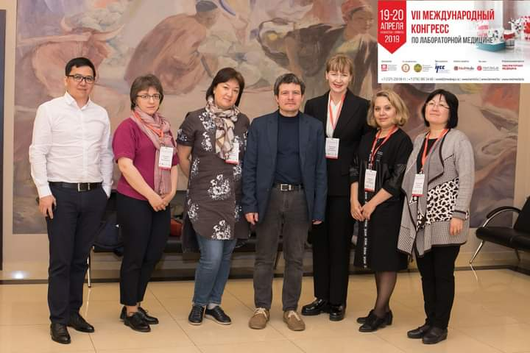
Picture 2 – Participants of the laboratory animal session at KAMLD conference

Also on August 28th, 2020 the online seminar «Organization of the vivarium for carrying out preclinical studies» for vivarium experts of the Republic of Kazakhstan was conducted. The seminar agenda included presentations on GLP standards and technologies of pure premises (ISO 14-644), requirements and norms of designing / reconstruction / building of vivaria, ethical expert review with «three R» rules, modern technologies and equipment for animal care, sanitary rules and safety of the personnel during works with animals. During the seminar a round table was organized «Monitoring of health of laboratory animals and the environment of the laboratory animal care», with discussion.
CONCLUSION

Activity of organizations performing experimental works with animals should be carried out according to current national legislation and be based on international standards of «three R». Strict sanitary-hygienic requirements exist to institutions working with laboratory animals, and serious moral-legal aspects of work of the personnel. Absence of the national standard requirements harmonized with the international analogues essentially impairs the process of proper expert review of experimental works with animals, causes insufficient financing for appropriate premises of experimental vivaria and nurseries of laboratory animals, which can lead to adverse consequences for laboratory animals, employees and the environment. In order to evolutionize ethical thinking it is necessary at the government level to require ethical expert review before each use of experimental animals.
International standards of laboratory animal use are based on principles of humane animal treatment, observation of bioethical standards and ensuring responsibility for performed activity with laboratory animals. «Three R» principles allow reaching reliable and reproducible experimental results with use of the minimum number of animals; thus it is extremely important to use laboratory animals standardized by genotype, micro flora, ecological parameters and qualitative under their hygienic status. Modern laboratories use genetically defined (linear) laboratory animals of SPF-category who are kept in a barrier system in pure premises, and periodic confirmation of their microbiological and genetic status is required.
In Kazakhstan well-being and conditions of use of laboratory animals do not correspond to international standards: principles of humane animal treatment («three R» principles) are not formulated properly, and there is no ethical expert review of studies involving animals, requirements to quality of laboratory animals are not defined sufficiently, there are no rules for euthanasia/analgesia of animals and differentiation of experiments by stress categories, and monitoring of health of laboratory animals is not carried out. Numerous vivaria use the so-called "outbred" laboratory animals who are kept in inadequate conditions and cannot correspond to international standards to biological test models. Vivaria employees are not provided with special training, including training on biosafety during works with experimental animals, and there are no curriculums of post degree professional development on laboratory animal production.
Within the project framework, production of four lines of SPF laboratory animals applicable to the Republic of Kazakhstan was organized at NSCEDI nursery: 1) outbred mice of ICR line, 2) outbred rats of SpragueDawley SD line, 3) inbred mice of C57BL/6 line, and 4) inbred mice of BALB/c line. Animals are bred according to rules of preservation of genetic uniformity and microbiological SPF status.
Training program was developed «Organization of work of the vivarium for breeding and care of conventional laboratory animals and SPF-category animals» and training of personnel of NSCEDI SPF vivarium was carried out. SOP program was developed and introduced: general, veterinary, on breeding of linear animals, sanitary-hygienic, technical, bioethical, SOP related to safety.
In order to preserve the microbiological status of laboratory animals, NSCEDI nursery introduced a number of technological solutions of "pure premises»: ensuring an elevated air pressure in rooms with SPF laboratory animals with a two-level filtration of supply air (G4-F7), care of SPF rodents in individually ventilated units in microisolators, transfer of SPF animals from dirty cages to pure cages only in a laminar cabinet with HEPA filter, sterilization of cages and cage accessories, feed, bedding, and water, use by the personnel of the technological protective clothes reducing spread of particles, disinfection of the large-sized equipment in the disinfection chamber, introduction of the modern cleaning technology (Mop-technologies).
For the first time in Kazakhstan annual monitoring of health of laboratory animals from NSCEDI nursery and monitoring of the environment in the vivarium was organized.
IPLACU was introduced and IACUC work was organized for observation of principles of rational animal use, optimization of work for labor safety and protection of employees, and protection of well-being of laboratory animals. Work for IPLACU improvement continues, guaranteeing execution of decisions and giving weight to recommendations.
The Guide on laboratory animal production in the Republic of Kazakhstan was developed, where requirements were given to designing vivaria and installation of the modern vivarium equipment, requirements to training of vivaria personnel and experimenters, proposals for improvement of sanitary and ethical rules of the laboratory animals care, drafts of such documents, as IPLACU, and the draft Protocol-Request of research and rules of IACUC work.
It is possible to perform training of the highly skilled personnel at the SPF vivarium and NSCEDI nursery, to master new methods of veterinary science on laboratory animal breeding, to approve and use new technologies for genetic and microbiological control, cryonconservation of embryos, and rederivation, to introduce alternative technologies, which is being planned by NSCEDI.
Taking into account international standards of laboratory animal production, recommendations were offered on improvement of experimental studies involving laboratory animals in the Republic of Kazakhstan:
1. To harmonize national standard rules of care and use of laboratory animals in conformity with international standards.
2. To require development of the concept of ethical expert review of protocols of research involving laboratory animals at the government level (creation of the system of assessment of quality of ethical expert review, training of experts, creation of professional associations and forums).
3. To strengthen requirements to quality of health of laboratory animals, and to veterinary-zootechnical and sanitary-hygienic actions in vivaria.
4. To develop and introduce the multilevel program of improvement of professional skills of researchers and members of ethical committees.
5. To develop international cooperation on laboratory animal production, to participate and/or hold a conference of vivaria experts and IACUC members.
Organization of the SPF vivarium in the Republic of Kazakhstan and use by the Kazakhstan scientists and experts of SPF animals will allow improving the quality of laboratory examinations and scientific-practical works, and reaching international standards in performance of experimental studies. Development of laboratory animal production in the Republic of Kazakhstan in conformity with international standards and development of biomedical science and pharmaceutical industry correspond to the Densaulyk Development Program and the Program of Development of Ministry of Health of the Republic of Kazakhstan for 2018-2020.

LIST OF SOURCES USED

- Karkishchenko N.N. Basics of biomodelling. - Moscow: Interacademy publ. house of VPK, 2005. – 607 p. (in Russian)
- Karkishchenko N.N., Grachev S.V. Guidelines for laboratory animals and alternative models in biomedical technologies. – Moscow: Profile 2C, 2010. – 358 p. (in Russian)
- W.M.S. Russell and R.L.Burch. The Principles of Humane Experimental Technique. - London: Methuen & Co. –1959. – 238 р. (in Russian)
- Turegeldiyeva D.A., Bugybayeva D.A., Semenyuk V.M., Kovaleva G.G. Problems of normative regulation of laboratory animal husbandry in the RK // Proceedings of the 5th Annual Conference of the Association for Biosafety of Central Asia and Caucasus, Tbilisi, April 2014. (in Russian)
- Guidelines for the upkeep and care of laboratory animals (Article 5 of the European Convention for the protection of vertebrate animals used for experimental and other scientific purposes (ETS No. 123). Attachment A. Saint-Petersburg, 2014. – P. 98. (in English)
- Directive 2010/63/EU of the European Parliament and of the Council of the European Union on the protection of animals used for scientific purposes. - Saint-Petersburg, 2012. – P.50. (in Russian)
- Turegeldiyeva, D.A.; Semenyuk, V.M. Sustainable development of SPF-category laboratory animals kennel M. Aikimbayev’s NSCEDI // Environment and public health. –2016. – № 1. – P. 39-44. (in Russian)
- Bekmukhambetov E.Zh., Dzharkenov T.A., Iskakova S.S. International standard GLP and prospects of its implementation in scientific research of Kazakhstan. Problem article // Medical Journal of Western Kazakhstan. – 2009. – № 1 (21). – P. 7-8. (in Russian)
- International guiding principless for biomedical research involving animals. Council for International Organization of Medical Sciences (CIMS) and the International Council for laboratory animal science (ICLAS) - 2012. – P. 4. (in English)
- Raskosha O.V., Kichigin A.I. Basic principles of good laboratory practice (NLP, GLP) in arrangement of vivarium and organization of scientific research // Herald of the institute of biology of the KOMI SC of the Urals dept. of RAS. –2016. – № 3. – P. 19-25. (in Russian)
- James F Crow. C. C. Little, cancer and inbred mice // Genetics. – 2002 Aug;161(4):1357-61. (in English)
- Boveris, A., Turrens, J.F. (1980) in Chemical and biochemical aspects of superoxide and superoxide dismutase, Vol I, eds. Bannister, J.V., (Elsevier, Amsterdam), P. 84-91. (in English)
- Capecchi, M. R. Gene targeting in mice: functional analysis of the mammalian genome for the twenty-first century. Nat. Rev. Genetics. 6, 507-512 (2005).William R. Shek, Abigail L. Smith, Kathleen R. Pritchett-Corning. Chapter 11 – Мicrobiological Quality Control for Laboratory Rodents and Lagomorphs Laboratory animal medicine. Laboratory Animal Medicine. 3d Edition – London: Elsevier – 2015. – P. 463-510. (in English)
- William R. Shek, Abigail L. Smith, Kathleen R. Pritchett-Corning. Chapter 11 - Microbiological Quality Control for Laboratory Rodents and Lagomorphs Laboratory animal medicine // Laboratory Animal Medicine. 3d Edition – London: Elsevier – 2015. – P. 463-510. (in English)
- Target Identification and Validation in Drug Discovery. – New York: Springer Science+Business Media. – 2013. – 368 р. (in English)
- Turegeldiyeva, D.A.; Semenyuk, V.M.; Muhambetova, A.K.; Utepova, I.B.; Ismakova, A.M.; Sarmantaeva, K.B.; Genievskaya, L.P. Health monitoring of laboratory animals // Herald of the Asfendiyarov’s KazNMU. –2017. – № 3. – P. 207-210. (in Russian)
- Karkishchenko V.N.; Schmidt, E.F.; Braitseva, E.V. Researchers prefer BALB/c mice // Biomedicine. –2007. – № 6. – P. 57–70. (in Russian)
- Schmidt E.F. Variability of alcohol preference in laboratory mice depending on genotype and medium// Biomedicine. – 2005. – № 1. – P. 81-85. (in Russian)
- Blandova Z.K., Dushkin V.A., Malashenko A.M., Schmidt E.F. Lines of laboratory animals for medical and biological research // Biomedicine - 1983. – № 5. – P.54-59. (in Russian)
- V.N. Karkishchenko, E.V. Braitseva. New Biomodels for Evaluation of High-Virulent Strains of Plague Yersinia pestis // Biomedicine. – 2005. – № 1. – P. 67-75. (in Russian)
- Interstate Standard GOST 33215-2014 Guidelines for the maintenance and care of laboratory animals. – Moscow, 2014. (in Russian)
- Interstate Standard GOST 33216-2014 Guidelines for the maintenance and care of laboratory animals. Rules for the maintenance and care of laboratory rodents and rabbits. – Moscow, 2014. (in Russian)
- GOST ISO 14644-1-2002 Clean premises and related controlled environments. Part 1. Classification of air purity. – M.: IPK Standard Publishing House, 2003. – P. 15. (in Russian)
- GOST R ISO 14644-2-2011 Clean premises and related controlled environments. Part 2: Clean premises and related controlled environments. Requirements for control and monitoring to confirm permanent compliance with ISO 14644-1. – Gosstandart of Russia. - Moscow, 2011. – 124 p. (in Russian)
- GOST R ISO 14644-3-2007 Clean premises and related controlled environments. Part 3: Clean premises and related controlled environments. Methods of testing. -Moscow: Standardinform, 2008. – 110 p. (in Russian)
- GOST R ISO 14644-4-2002 Clean premises and related controlled environments. Clean premises and related controlled environments. Part 4. Designing, Construction and Commissioning. – M.: Standartinform, 2010. – 36 p. (in Russian)
- GOST R ISO 14644-5-2005 Clean premises and Related Controlled Environments. Part 5: Clean premises and related controlled environments. Operation. – M.: Standartinform, 2005. – 32 p. (in Russian)
- GOST R ISO 14644-7-2007 Clean premises and related controlled environments. Part 7: Clean premises and related controlled environments. Insulation devices (shelters with clean air, boxes, gloves, insulators and mini-environments). – M.: Standardinform, 2007. – 36 p. (in Russian)
- GOST R ISO 14644-8-2011 Clean premises and related controlled environments. Clean premises and related controlled environments. – M.: GOST R ISO 14644-8-2011. Part 8. Classification of air purity by concentration of chemical impurities. – M.: Standardinform, 2014. – 20 с. (in Russian)
- David Neil and Donald McKay with the collaboration of the CCAC Facilities Standards Subcommittee. Guidelines on: laboratory animal facilities – characteristics, design and development. –Ottawa on Canada: Canadian Council on Animal Care, 2003. – Р.106. (in English)
- White W. Cleanroom technology. Basics of design, testing and operation. – Moscow, 2002. – 304 p. (in Russian)
- GOST R 1822-1-2011 High-efficiency air purification filters (EPA, HEPA and ULPA) Part 1 Classification, testing methods and marking. – M.: Standartinform, 2011. – 20 p. (in Russian)
- Guidelines for the keeping and use of laboratory animals. National Research Council Commission on Life Sciences Institute of Laboratory Animal Resources. NationalAssademPress. – Washington, D.C., 1996. –138 p. (in Russian)
- Guidelines for the Care and Use of Laboratory Animals (8th Edition) / per. from English; edited by I.V. Belozertseva, D.V. Blinova, M.S. Krasilshchikova. - Moscow: Irbis. - – 2017. – 304 p. (in Russian)
- Mahler M., Berard M., Feinstein R., Gallagher A., Illgen-Wilcke B., Pritchett-Corning K., Raspa M. Working Party Report: FELASA recommendations for the health monitoring of mouse, rat, hamster, guinea pig and rabbit colonies in breeding and experimental units // Laboratory Animals. – 2014. – Vol. 48(3). – P. 178-192. (in English)
- Guidance on the use of laboratory animals for scientific and educational purposes at PSPBSMU named after I.P. Pavlov. I.V. Belozertseva, O.A. Dravolina, M.V. Tour; edited by I.V. Belozertseva, O.A. E.E.Zvartau, - Published in 2nd edition. - St. Petersburg: St. Petersburg State Medical University Publishing House. – 2014. – 80 p. (in Russian)
- James O Marx, Diane J Gaertner, Abigail L Smith. Results of Survey Regarding Prevalence of Adventitial Infections in Mice and Rats at Biomedical Research Facilities // J Am Assoc Lab Anim Sci. 2017 Sep; 56(5): 527–533. (in English)
- Implications of infectious agents on results of animal experiments. Report of the Working Group on Hygiene of the Gesellschaft für Versuchstierkunde--Society for Laboratory Animal Science (GV-SOLAS) // Lab Anim 1999; 33 Suppl 1:S39-87. (in English)
- Methodological guidelines for laboratory pre-registration tests of disinfectants, disincectants and deratisation. Order of the MH of the RK №133 of Nov. 4, 2008. (in Russian)
- Turner P. V., Brab Th., Pekow C., Vasbinde M. A. Administration of substances to laboratory animals: routes of administration and factors to consider // J. Am. Assoc. Lab. Anim. Sci. – 2011. – Vol. 50. – No. 5. – P. 600-613. (in English)
- Wang R. F., Campbell W. L, Cao W. W., Colvert R. M., Holland M. A., Cerniglia C. E. Diagnosis of mouse hepatitis virus contamination in mouse population by using nude mice and RT-PCR // Mol. Cell. Probes. – 1999. – Vol. 13. – No. 1. – P. 29-33. (in English)
- Nicklas W., Homberger F. R., Illgen-Wilcke B., Jacobi K., Kraft V., Kunstyr I., Mahler M., Meyer H. Pohlmeyer-Esch G. Implications of infectious agen ts on results of animal experiments. Report of the Working Group on Hygiene of the Gesellschaft fur Versuchstierkunde–Society for Laboratory Animal Science (GV-SOLAS) // Lab. Anim. – 1999. - Vol. 33. – Suppl. 1S. – P. 39–87. (in English)
- Baker D. G. Natural pathogens of laboratory mice, rats, and rabbits and their effects on research // Clin. Microbiol. Rev. – 1998. – Vol. 11. – No. 2. – P. 231-266. (in English)
- Arzamastcev E.V., Gusjkova T.A., Berezovskaya I.V. et al. Methodological guidelines for studying the general toxic effect of pharmacological substances: guidelines for experimental (preclinical) study of new pharmacological substances. – М., 2005. – P. 41-54. (in Russian)
- Interstate Standard GOST 12.1.007-76. System of labor safety standards. Harmful substances. Classification and general safety requirements. – Moscow, Standartinform, 2007. (in Russian)
- Beura L. K, Hamilton S. E, Bi K, et al. Normalizing the environment recapitulates adult human immune traits in laboratory mice. Nature 2016; 532:512–6. (in English)
- https://olaw.nih.gov/sites/default/files/Guide-for-the-Care-and-Use-of-Laboratory-Animals.pdf
- Laboratory animals (Regulations and Guidelines) / edited by and with the participation of N.N. Karkishchenko, corr.-member of the RAMS. – Moscow: Inter-Academic Publishing House "MIC", 2003 – 138 p. (in Russian)
- https://cyberleninka.ru/article/n/eticheskie-i-pravovye-aspekty-provedeniya-eksperimentalnyh-biomeditsinskih-issledovaniy-in-vivo-chast-i/viewer
- https://olaw.nih.gov/sites/default/files/GuideBook.pdf
- https://grants.nih.gov/grants/OLAW/references/PHSPolicyLabAnimals.pdf
- Belozertseva I.V. Setting of activity of the IACUC Commission at PSPbGMU: per a speraadhorizontem // Russian Scientist. – 2017. – T.1. – P. 10-11.
- https://pubmed.ncbi.nlm.nih.gov/17430615/
- Methodological guidelines for laboratory pre-registration tests of disinfectants, disincectants and deratisation. Order of the MH of the RK №133 of November 4, 2008. (in Russian)
- Federation of European Laboratory Animal Science Associations. FELASA guidelines for education of specialists in laboratory animals science (Category D) // Lab. Anim. – 1999. – No 33. – P.1-15. (in English)
- FELASA recommendations for the education and training of persons carrying out animal experiments (Category B). Report of the Federation of European Laboratory Science Associations Working Group on Education of Person carrying out animal experiments (Category B) – Nevalainen T. et. al. // Laboratory animals. – 2000. – Vol. 34. – № 3. – P. 229-235. (in English)
- https://journals.plos.org/plosbiology/article?id=10.1371/journal.pbio.3000410
- Landis, S. C., Amara, S. G., Asadullah, K., Austin, C. P., Blumenstein, R.,Bradley, E. W., Silberberg, S. D. (2012). A call for transparent reporting to optimize the predictive value of preclinical research. Nature, 490(7419), 187–191. https://doi.org/10.1038/nature11556 PubMed PMID: 23060188; PubMed Central PMCID: PMC3511845. (in English)
- Dairov A.K.; Turegeldiyeva D.A.; Adekenov S.M. Breeding and maintenance of the conventional laboratory and SPF-category animals according to GLP standards // Pharmaceutical bulletin. – 2017. – №1-4. – P. 36-45.

APPENDIX A

Patent search report

REPORT

Report on patent research on the implementation of research work under the budget program: 217 “Development of science”, subprogram 102 “Grant financing of scientific research”, specifics 156 “Payment for consulting services and research”. By priority: “Science of life and health” on project АР05134541 “Development of experimental research with laboratory animals in Kazakhstan”, the Patent Law of the Republic of Kazakhstan and state standard 15.011-2005 “The system of product development and launching into production. Patent research. Content and procedure”.

Table A.1 – Number of published protection documents by year (inventive activity)

Equipment object and components | The country of application | The number of patents, published applications by year of filing of the application (excluding the patents-analogues)
Equipment object and components | The country of application | 2014 | 2015 | 2016 | 2017 | 2018
1 | 2 | 3 | 4 | 5 | 6 | 7
METHOD OF MODELING THE ACQUIRED TOXIC HEMOLYTIC ANEMIA IN THE EXPERIMENT | RU | 1

Table A.2 – Mutual patenting

The nationality of the applicant | Страна патентования |  |  |  |  |  |  |  | Количество патентов |  | Всего
The nationality of the applicant |  |  |  |  |  |  |  |  | Национальных патентов | Запатентовано в других странах
1 | 2.1. | 2.2. | 2.3. | 2.4. | 2.5. | 2.6. | 2.7 | 2.8 | 3 | 4 | 5

NOT FOUND

Table A.3 – Geography of patenting of industrial property objects by the studied firms (by analogous patents)

Name of the patent owner's company | Name of the technical solution (invention) | The number of initial applications | Priority date | Date of publication of the initial application | Numbers of issued patents (filed applications) by country of issue
1 | 2 | 3 | 4 | 5 | 6 | 7 | 8 | 9 | 10 | 11 | 12 | 13
State budgetary educational institution of higher professional education “Perm State Medical Academy named after Academician E.A. Wagner” of the Ministry of Health of the Russian Federation | Method of modeling the acquired toxic hemolytic anemia in the experiment | 2013132288/14 | 11.07.2013 | 20.09.2014 | 2528976  C1 | RU

MAIN PART OF THE PATENT RESEARCH REPORT
A.4 Technical level and development trends of the economic activity object
Form A.4.1 Indicators of the technical level of the equipment object

Name of indicators | Value of indicator
Name of indicators | Development object for 2018 “Method of modeling the acquired toxic hemolytic anemia in the experiment”. | Domestic and foreign objects of similar purpose (including models, companies, countries, and years of fame) |  |  |  |  |  |  | Объект по госу-дар-ствен-ному стан-дарту | Меж-дуна-род-ные и на-цио-наль-ные стан-дар-ты | Прогноз на  2020 г.  «Способ моделирования приобретенной токсической гемолитической анемии в эксперименте»
Name of indicators |  | “Method of modeling the acquired toxic hemolytic anemia in the experiment”, patent RU2528976, patent holder State budgetary educational institution of higher professional education “Perm State Medical Academy named after Academician E.A. Wagner”.  Polina Kosareva (RU),  Oksana Matkina (RU),  Evgeniy Samodelkin (RU),  Lyudmila Sivakova (RU),  Vitaly Khorinko (RU),  Valery Chereshnev (RU),  Yuri Shilov (RU) |  |  |  |  |  |  | Объект по госу-дар-ствен-ному стан-дарту | Меж-дуна-род-ные и на-цио-наль-ные стан-дар-ты
1 | 2 | 3.1 | 3.2 | 3.3 | 3.4 | 3.5 | 3.6 | 3.7 | 4 | 5 | 6
Number of erythrocytes | High -3.182-109 in 1 mcl of blood | Low - 6,779·109 in 1 mcl of blood
Hemoglobin concentration | High - 81 g/l | Low - 138 g/l

APPENDIX B

List of published works for 2018-2020

1 Turegeldiyeva D.A., Kovaleva G.G., Katarbayev A.K., Bugybayeva D.A., Semenyuk V.M. Efficacy of Tonsilgon preparation in case of acute intestinal infections on SPF (Specific Pathogen Free) model of laboratory animals // Medicine. – 2018. – № 8/194. – P. 56-61. (in Russian)
2 Turegeldiyeva D. A., Kovaleva G. G., Semenyuk V. M. et al. Evaluation of acute toxicity of disinfectants at oral Injection on SPF- and conventional laboratory mice // East European Scientific Journal. – 2019. – No. 8/48, – Vol. 1. – 59-62 p. (in Russian)
- Copyright Certificate № 12930 dated October 30, 2020. "Guidelines for the arrangement, equipment and maintenance of experimental biological clinics (viriiriums) and organization of work with experimental animals". Author: D.A. Turegeldiyeva. (in Russian)

Submitted for printing:
1. Turegeldiyeva D.A., Islamov R.A., Rysbekova A.K., Semenyuk V.M., Zhambyrbayeva L.S., Panevina A.V. Influence of non-sterile feed and bedding on distribution of some pathogens among Balb/c mice in SPF vivarium.
2. Turegeldiyeva D. A., Ponomaryova T. S., Islamov R. A., Semenyuk V. M., Kovaleva G.G. Development of the Institutional Program for the Keeping and Use of Laboratory Animals.
APPENDIX C

Copies of supporting materials for 2018-2020

SPF Certificate of Sprague Dawley rats status

SPF Certificate of Sprague Dawley rats status (continuation)

BALB/c, C57BL/6J, ISR(CD-1) mice SPF status certificate

BALB/c, C57BL/6J, ISR(CD-1) mice SPF status certificate (continuation)

General cleaning and sterilization of the brewery area
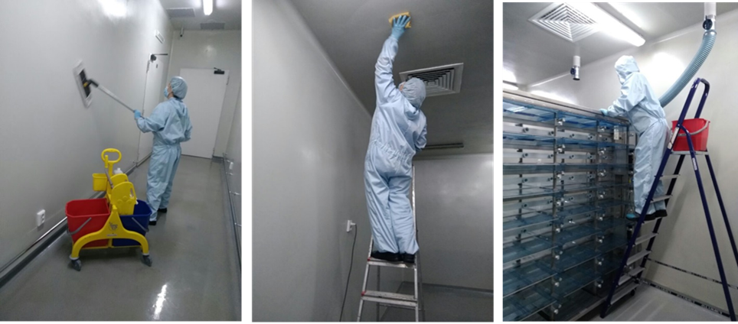

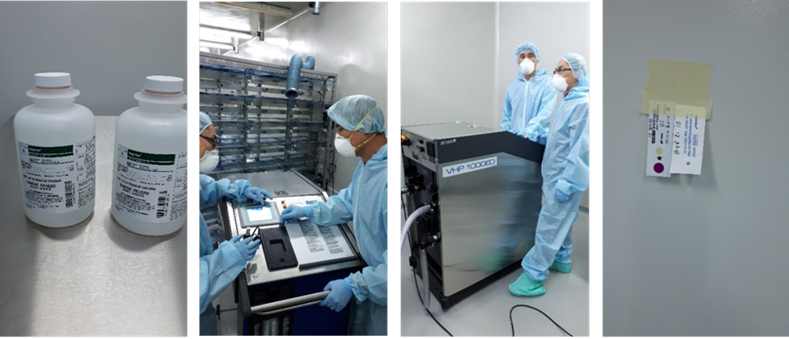

Training certificates on health monitoring of laboratory animals
from “Belki-Biotechnologies” LLC (Russia). 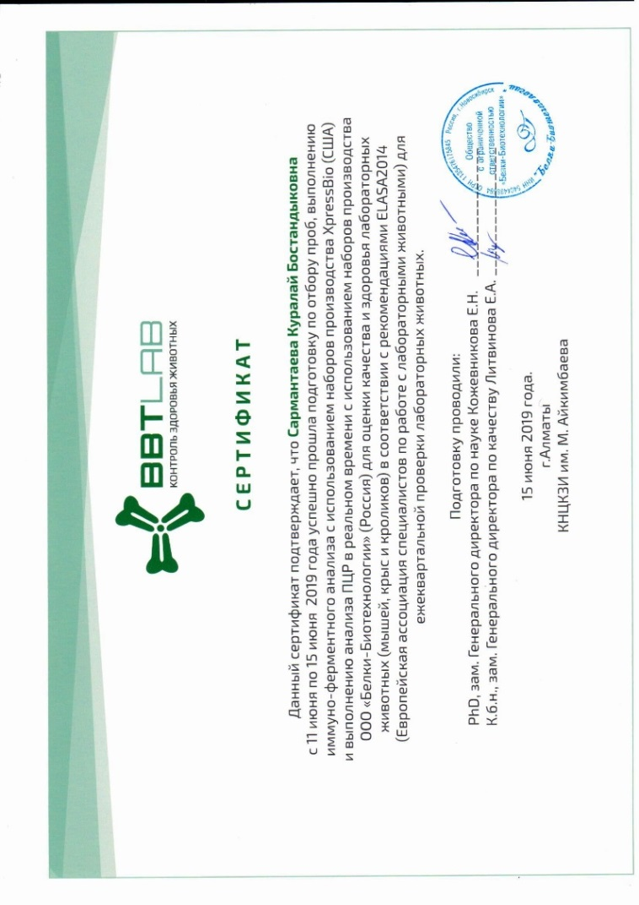
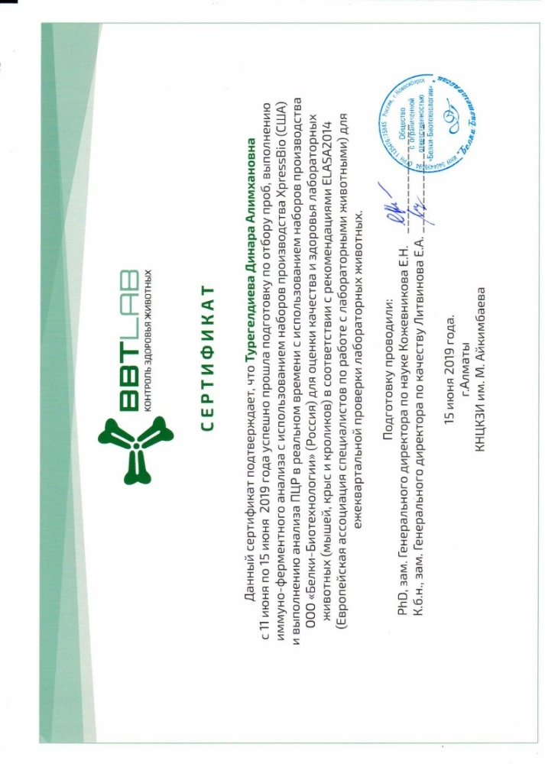

Training certificates on health monitoring of laboratory animals
from “Belki-Biotechnologies” LLC (Russia). (contituation)
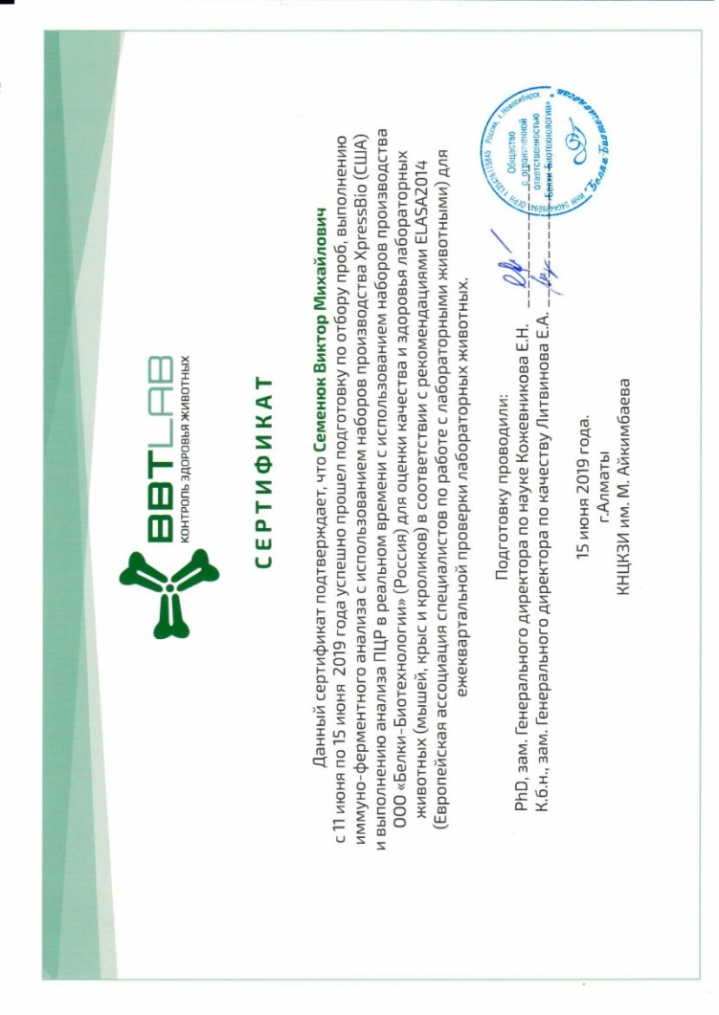
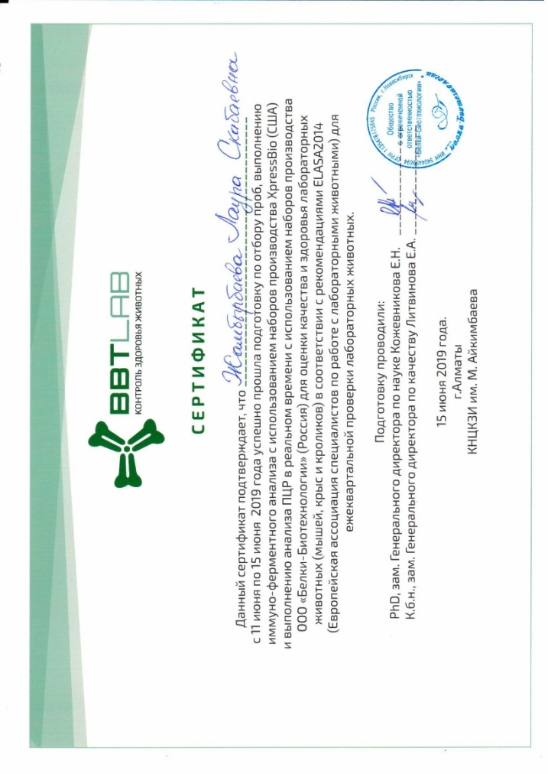

Health monitoring results of laboratory mice ICR line (CD-1), BALB/c, C57BL/6
form “Belki-Biotechnologies” LLC (Russia). 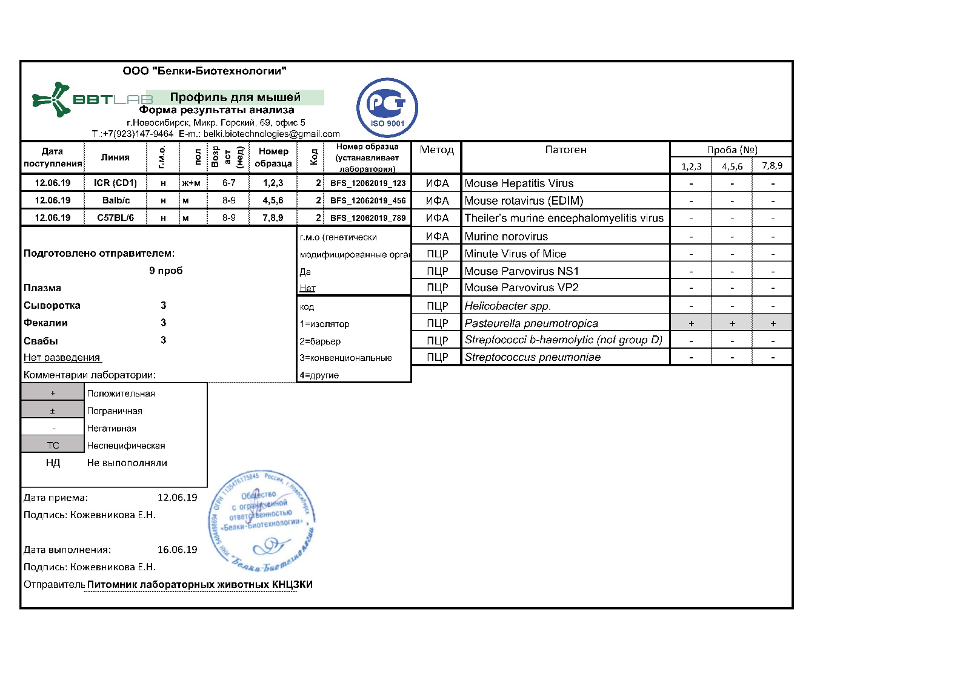

Health monitoring results of laboratory mice ICR line (CD-1), BALB/c, C57BL/6
form “Belki-Biotechnologies” LLC (Russia). (contituation)
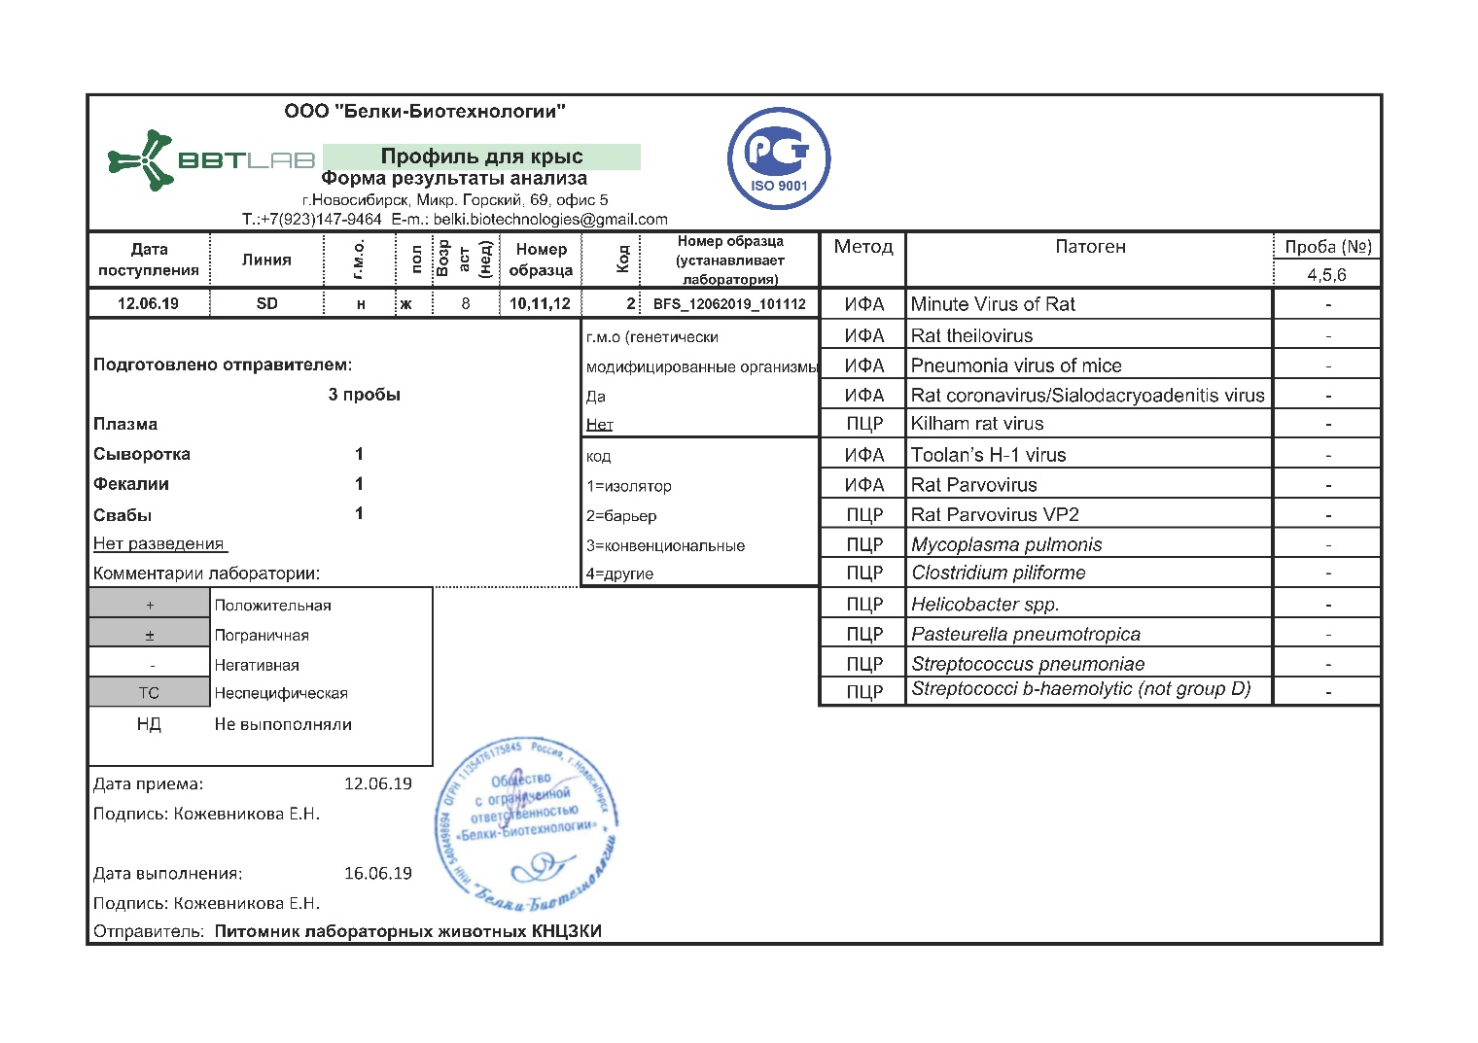

Health monitoring results of laboratory mice ICR line (CD-1), BALB/c, C57BL/6
form “Belki-Biotechnologies” LLC (Russia).
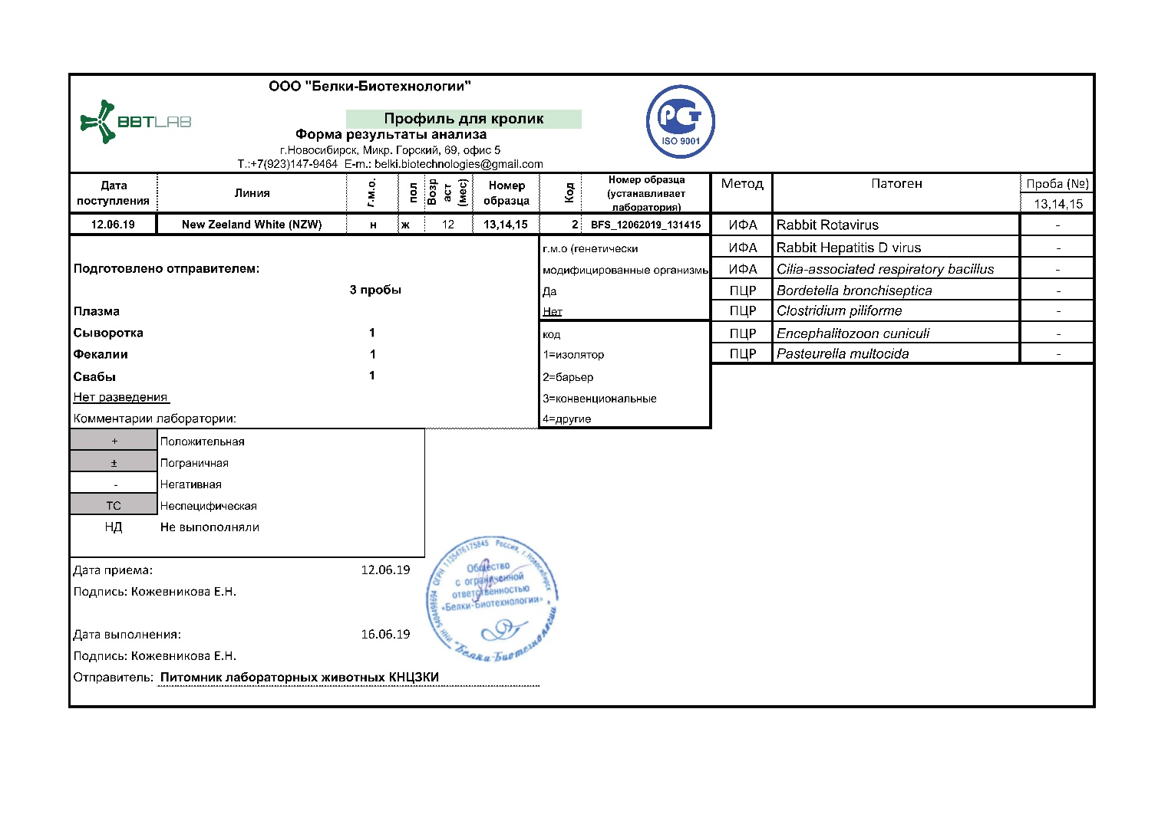

Protocol for monitoring of laboratory animals, animal feed, bedding and drinking water for animals

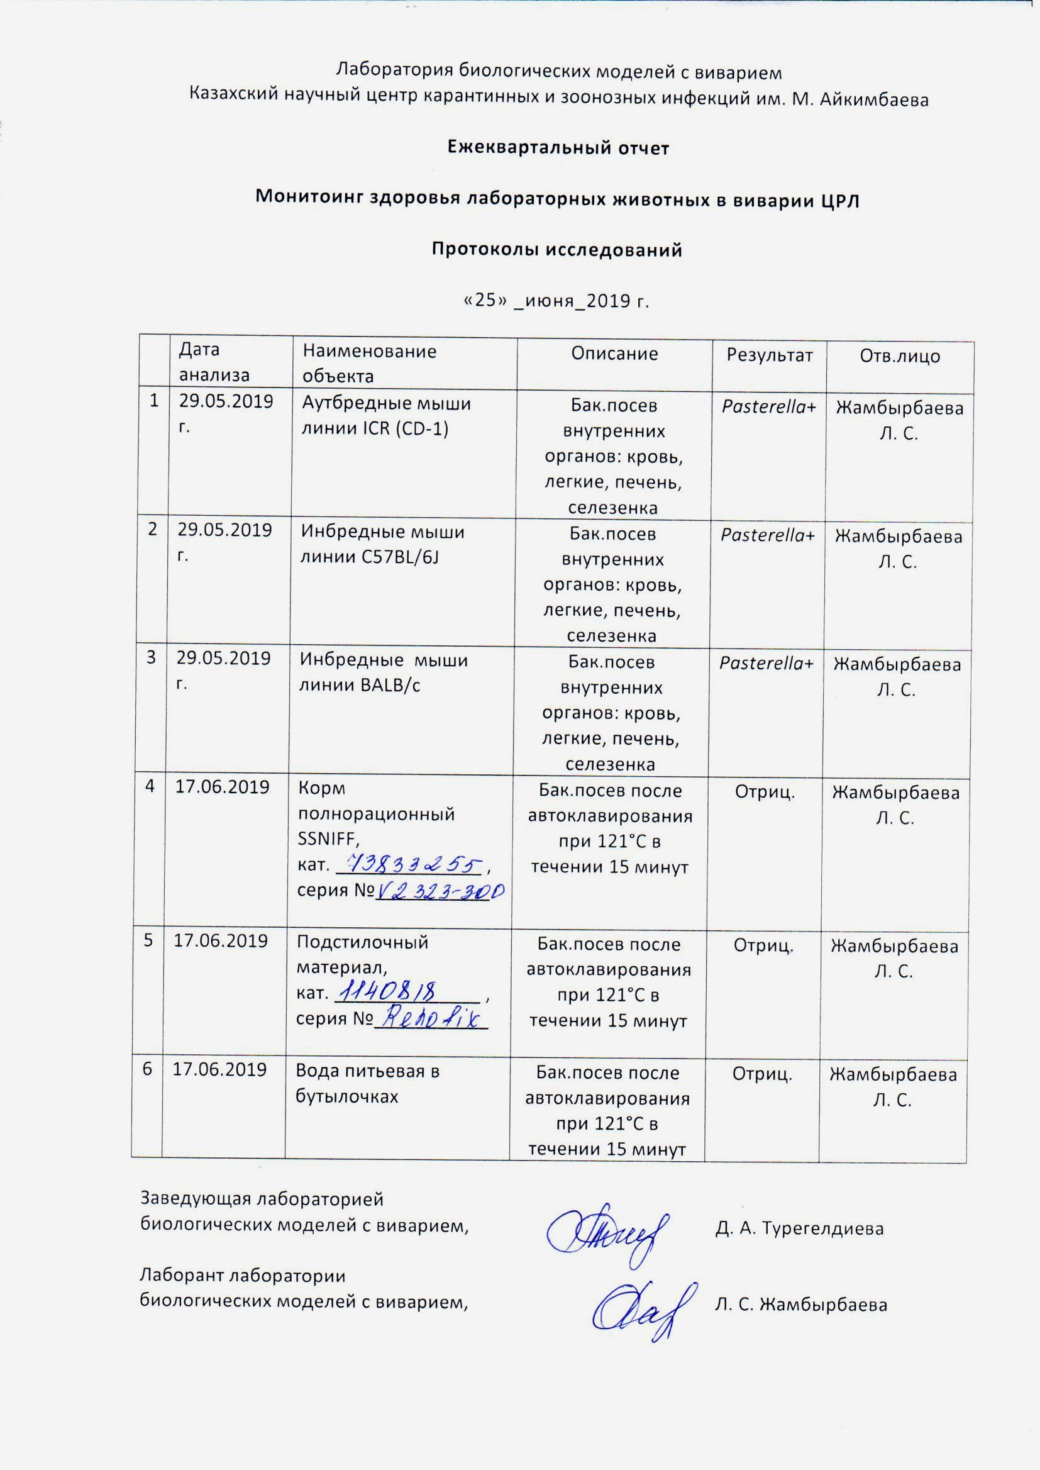

Protocol for monitoring of laboratory animals, animal feed, bedding and drinking water for animals (continuation)

Training program

Extract from the Protocol № 2 of 28.05.2018 on the approval of the training program
Training protocols for 2018

Training protocols for 2019

Training protocols for 2020

In vivo research protocols

In vivo research protocols (continuation)

In vivo research protocols (continuation)

Article in journal Medicine. – 2018. – № 8/194

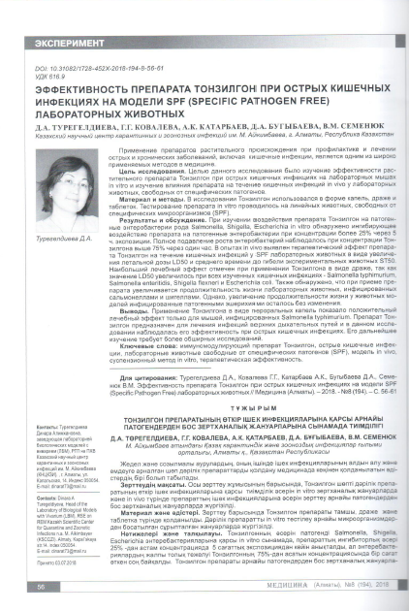

Article in journal East European Scientific Journal. – 2019. – № 8/48

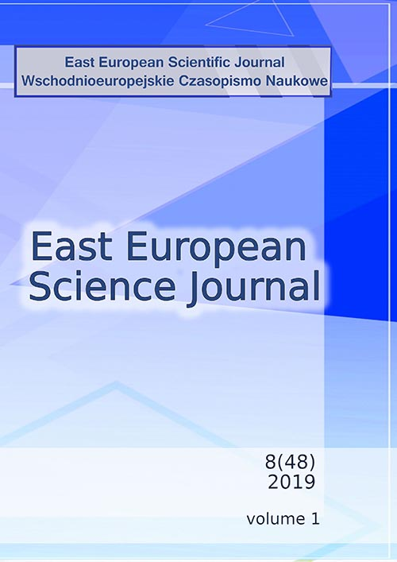

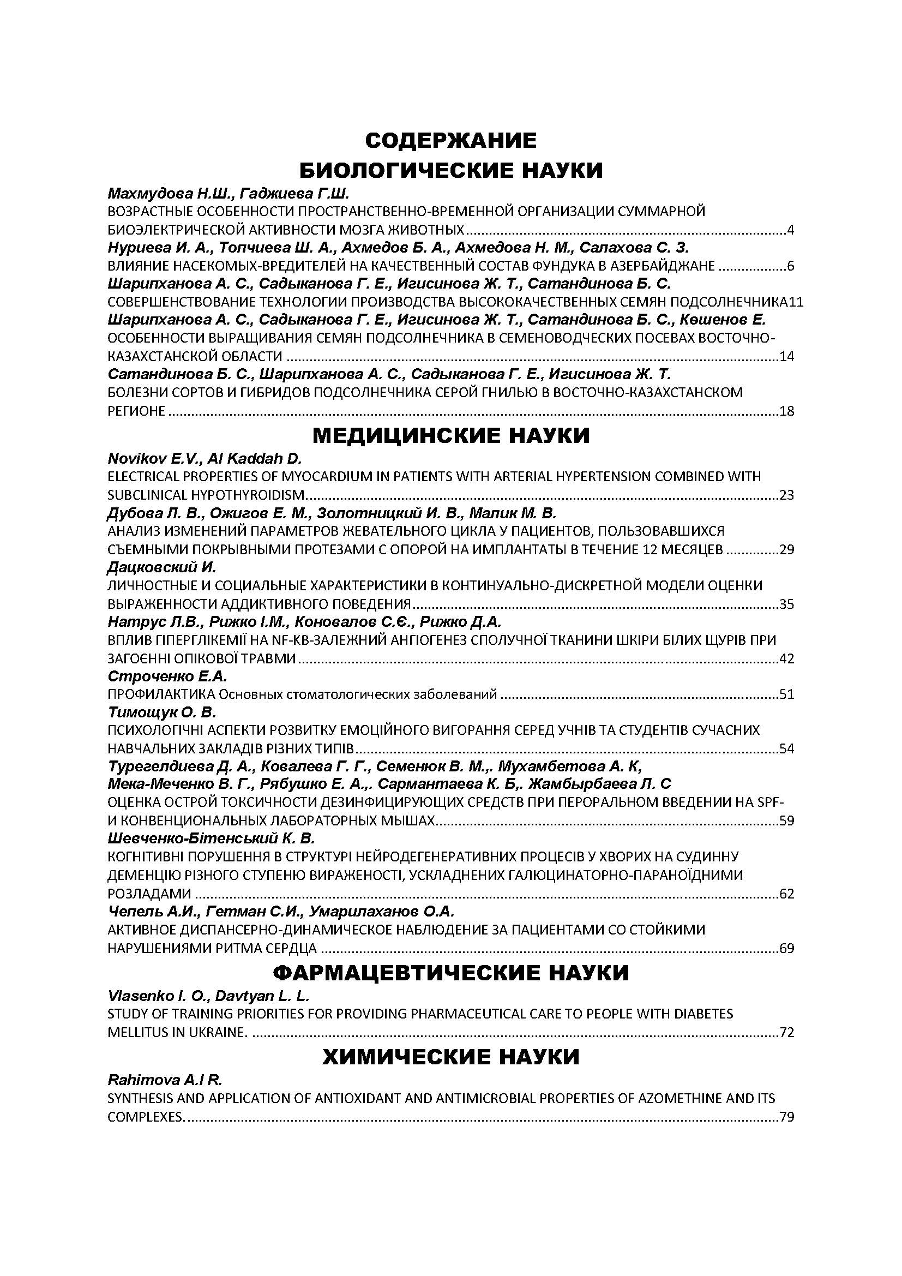

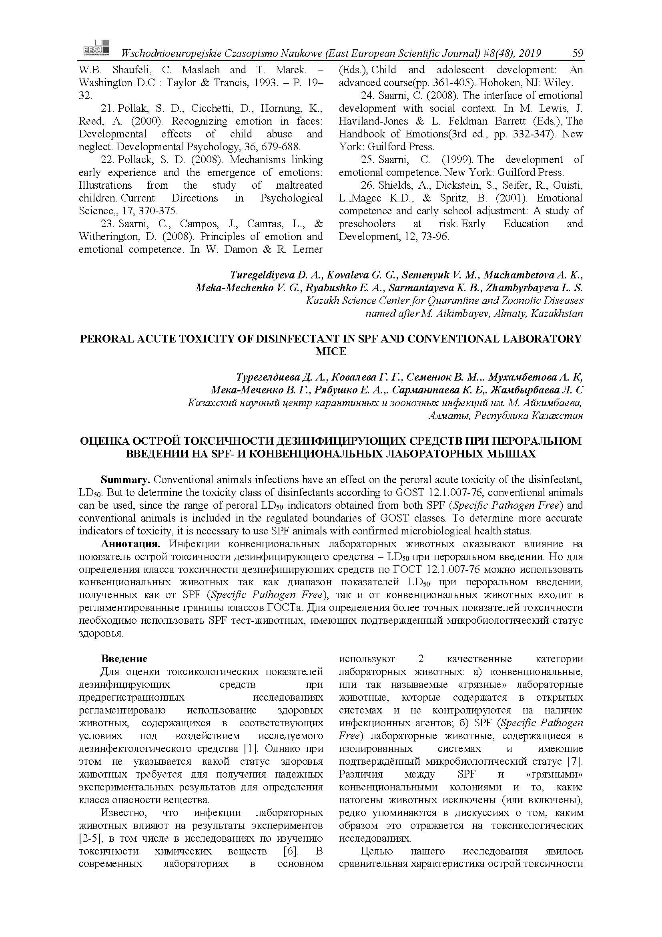

Copyright Certificate № 12930 dated October 30, 2020

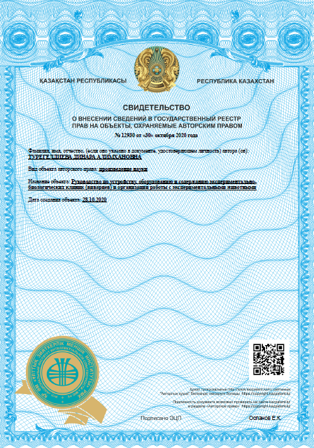

ATTACHMENT D

Calendar plan of works for 2018-2020 Supplementary agreement No 1
to the contract

Attachment 1.2
to Contract No.____ of _________ 2018
on grant funding

TECHNICAL SPECIFICATION AND
CALENDAR PLAN OF WORKS

Under contract No 165 of 15.03.2018

- RSE on REM “Masgut Aikimbayev’s Kazakh Scientific Center for Quarantine and Zoonotic Diseases” of the Ministry of Health of the Republic of Kazakhstan

1.1 By priority: Life and health sciences.
1.2 By sub-priority: Development of domestic pharmaceutical science and industrial biotechnology. Applied research.
1.3 On project’s subject: № АР05134541 “Improvement of experimental research with laboratory animals in the Republic of Kazakhstan”.
1.4 The total amount of the project is 30,000,000 (thirty million) KZT, including division by year, to perform the works according to paragraph 3:
- for 2018 – in the amount of 10 000 000 (ten million) KZT;
- for 2019 – in the amount of 10 000 000 (ten million) KZT;
- for 2020 – in the amount of 10 000 000 (ten million) KZT.

- Characteristics of scientific and technical products by qualification attributes and economic indicators
2.1 Work area: Medicine, veterinary medicine
2.2 Application area: Medicine and health care, veterinary medicine, toxicology and microbiology.
2.3 Final result:
- for 2018: Logistics for the purchase of 4 lines of SPF category laboratory animals (outbred and inbred mice and rats) with confirmed microbiological status and genetic background will be organized. There will be production of 4 lines of SPF category laboratory animals (mice and rats) with known microbiological status and genetic background under conditions of clean premises technology and barrier zone. 1 article in a peer-reviewed domestic scientific edition with a non-zero impact factor will be published.
- for 2019: A number of experimental works with SPF laboratory animals will be conducted, including obtaining a conclusion with the results of animal health monitoring of 3 kennels in RK, determination of LD₅₀ values for plague microbe strains with correction of the method and determination of the toxicity class of disinfectants. Production of 4 lines of SPF category laboratory animals (outbred and inbred mice and rats) will be continued. 1 article in a peer-reviewed foreign scientific edition with a non-zero impact factor will be published.
- for 2020: a manual for laboratory animal husbandry in the Republic of Kazakhstan will be prepared and a certificate for the object of copyright will be formalized.
Training will be held to improve the competence and responsibility of laboratory animal husbandry specialists in Kazakhstan. 2 articles in peer-reviewed foreign scientific publications, indexed in Web of Science or Scopus databases with non-zero impact factor will be published. Production of SPF category laboratory animals will be continued.
2.4 Patentability: design of a copyright certificate for guidelines for laboratory animal husbandry in Kazakhstan.
2.5 Scientific-technical level (novelty): Practice of using linear animals with certain SPF microbiological status is available worldwide. For the first time in The Republic of Kazakhstan the production of linear animals and their microbiological status maintenance in accordance with international standards will be organized. Production of laboratory animals will be held in the laboratory animals kennel of the M. Aikimbayev’s KSCQZD in conditions of clean premises technology. Performance of this task will increase repeatability and reliability of scientific results of scholars in Kazakhstan. Dissemination of knowledge about modern laboratory animal husbandry will also contribute to the promotion of science in Kazakhstan, which requires the use of experimental animals free from pathogens. The use of linear animals in the future will allow reduce the number of animals in biological and medical experiments.
2.6 The use of scientific-technical production: obtained project results and dissemination of knowledge on proper use of animals will be promising for institutions engaged in breeding and maintenance of laboratory animals, as well as those institutions where experimental work with laboratory animals is conducted.
2.7 Type of use of the result of scientific and (or) scientific-technical activity: Applied scientific research

- Name of works, their realization terms and results

Cipher of task and stage | Name of works under the Contract and main stages of its identification | Completion date |  | Expected result
Cipher of task and stage |  | beginning | end | Expected result
1 | Breeding of standardized biological models of  SPF laboratory animals (inbred and outbred mice and rats) | February 2018 | till November 1, 2018 | There will be breeding of standardized biological models of SPF laboratory animals (inbred and outbred mice and rats). There will be breeding of 4 lines of laboratory animals (mice, rats). 1 article in a peer-reviewed domestic scientific publication with a non-zero impact factor will be published
1.1 | Marketing and purchase of linear laboratory animals from international supplier Charles River Laboratories and their subsequent breeding | July 2018 | till November 2018 | Linear laboratory animals marketing and purchase from international supplier Charles River Laboratories and their subsequent breeding will be conducted. Passports and SPF certificates for 4 lines of laboratory animals will be obtained
1.3 | Provision of “clean premises” conditions and total disinfection of the KSCQZD kennel building before SPF animal reception | April 2018 | till November 1, 2018 | The conditions of “clean premises” and total disinfection of the KSCQZD kennel building before SPF animal reception will be provided. A report on consumables will be presented
1.4 | Personnel training for SPF vivarium | February 2018 | June 2018 | Personnel training for SPF vivarium will be conducted and  the program and training protocols will be presented
3.1 | Preparation of report on the analysis of the national rules of RK on laboratory animal husbandry | July 2018 | till November 1, 2018 | Reports on the analysis of national rules of RK on laboratory animal husbandry and on the vivar service will be prepared
1 | Breeding standardized biological models of SPF laboratory animals (inbred and outbred mice and rats) | January 2019 | till November 1, 2019 | There will be breeding of standardized biological SPF models of laboratory animals (inbred and outbred mice and rats). The work on breeding of 4 lines of laboratory animals will be carried out.  The number of SPF animals (mice and rats) will be increased
1.1 | Marketing and purchase of linear laboratory animals from international supplier Charles River Laboratories and their subsequent breeding | January 2019 | till November 1, 2019 | Linear laboratory animals marketing and purchase from international supplier Charles River Laboratories and their subsequent breeding will be conducted. There will be breeding of 4 lines of laboratory animals. 1 article in a peer-reviewed foreign scientific edition with a non-zero impact factor will be published
1.2 | Monitoring of laboratory animals health from 3 vivariums in RK and training | January 2019 | till November 1, 2019 | Monitoring of laboratory animals health from 3 vivariums in RK and training will be carried out. The specialists of 3 vivariums will be trained in the sentinelles program, and certificate of health monitoring training will be presented.  There will be conclusion with the results of an infection test and a certificate of health monitoring training
1.3 | Provision of “clean premises” conditions and total disinfection of the KSCQZD kennel building before SPF animal reception | January 2019 | till November 1, 2019 | The conditions of “clean premises” and total disinfection of the KSCQZD kennel building before SPF animal reception will be provided. A report on consumables will be presented and the animals welfare conditions will be observed
2 | Determination of SPF laboratory animals using perspectives in RK | January 2019 | till November 1, 2019 | The perspectives of using SPF laboratory animals in Kazakhstan will be determined and a report with recommendations on methods correction in toxicology and determination of plague microbe virulence will be presented.
2.1 | Determination of the plague microbe virulence on conventional and SPF laboratory animals for comparative characterization | January 2019 | till November 1, 2019 | The virulence of the plague microbe on conventional and SPF laboratory animals will be determined with the purpose of comparative characteristic for  LD₅₀ indicators correction for plague microbe strains isolated in the territory RK
2.2 | Determination of the general toxicity of disinfectants on conventional and SPF laboratory animals for comparative analysis | January 2019 | till November 1, 2019 | The general toxicity of the disinfectants on conventional and SPF laboratory animals will be determined for comparative characterization. A report on  determining the toxicity class of disinfectants, including correction of the method will be prepared
3 | Distribution of knowledge about international standards in laboratory animal husbandry | January 2019 | till November 1, 2019 | There will be dissemination of knowledge about international standards in laboratory animal husbandry.  There will be promotion of competence of RK specialists in animal husbandry.  1 article in peer-reviewed foreign scientific edition indexed in Web of Science or Scopus databases with a non-zero impact factor will be published
1 | Breeding standardized SPF biological models of laboratory animals (inbred and outbred mice and rats) | January 2020 | till November 1, 2020 | There will be breeding of SPF standardized biological models of laboratory animals (inbred, outbred mice and rats). The breeding of 4 lines of laboratory animals (mice, rats) will be continued. Animal models with known genetic background will be obtained.
1.1 | Marketing and purchase of linear laboratory animals from international supplier Charles River Laboratories and their subsequent breeding | January 2020 | till November 1, 2020 | Linear laboratory animals marketing and purchase from international supplier Charles River Laboratories and their subsequent breeding will be conducted. The breeding of 4 lines of laboratory animals (mice, rats) will be continued. The breeding stock of standardized animals will be produced.
1.3 | Provision of “clean premises” conditions and total disinfection of the KSCQZD kennel building before SPF animal reception | January 2020 | till November 1, 2020 | The conditions of “clean premises” and total disinfection of the KSCQZD kennel building before SPF animal reception will be provided.
3 | Distribution of knowledge about international standards in laboratory animal husbandry | January 2020 | till November 1, 2020 | There will be dissemination of knowledge about international standards in laboratory animal husbandry.  There will be promotion of competence of RK specialists in animal husbandry.  1 article in peer-reviewed foreign scientific edition indexed in Web of Science or Scopus databases with a non-zero impact factor will be published
3.2 | Organization and conducting of the republican seminar on laboratory animal husbandry for specialists of Kazakhstan | January 2020 | till November 1, 2020 | National seminar on laboratory animal husbandry will be organized and held for specialists of RK. The seminar program and list of participants will be prepared. Conditions for improving breeding quality after disinfection of the kennel building will be created.
3.3 | Preparation of a manual on laboratory animal husbandry and preparation of scientific articles | January 2020 | till November 1, 2020 | A manual on laboratory animal husbandry and preparation of scientific articles will be prepared. Copyright certificate will be registered. 1 article in peer-reviewed foreign scientific edition indexed in Web of Science or Scopus databases with a non-zero impact factor will be published

From Customer:  Chairman | From Performer:  Acting director
of SI “Committee of Science of the Ministry of Education and Science of RK”  _______________ Abdrassilov B.C.  P.A. | RSE on REM “Masgut Aikimbayev’s Kazakh Scientific Center for Quarantine and Zoonotic Diseases” of MH of RK  _________________ Sansyzbayev Ye.B.  P.A.

Acquainted:
Scientific manager of project
_______________ Ponomaryeva T.S.

Supplementary agreement No 1
to the contract on grant financing No 165 of March 15, 2018

Astana c. “__” _____________ 2018

State Institution “Committee of Science of the Ministry of Education and Science of Republic of Kazakhstan”, hereinafter referred to as the Customer, represented by Acting Chairman Sadykov Ye.T., acting on the basis of Regulations on Science Committee, approved by the order of Executive Secretary № 169-K of July 10, 2018 and by assignment order of September 12, 2018 No 227-K, on the one hand, and the republican state enterprise on the right of economic management “Masgut Aikimbayev’s Kazakh Scientific Center for Quarantine and Zoonotic Diseases” of the Ministry of Health of the Republic of Kazakhstan: hereinafter referred to as the Performer, represented by Director Yerubayev T.K., acting on the basis of the Charter, on the other hand, on the basis of Article 401 of the Civil Code of the Republic of Kazakhstan, the Law of the Republic of Kazakhstan of February 18, 2011 “On Science”, the Resolution of Government of the Republic of Kazakhstan of May 25, 2011 № 575 “On approval of Rules of basic, grant, program-target financing of scientific and (or) scientific-technical activities”, the order of the Minister of Education and Science of the Republic of Kazakhstan from August 15, 2017 № 410 “On approval of the competitive documentation for grant financing on scientific and (or) scientific-technical projects for 2018-2020”, order of the Chairman of the Science Committee of the Ministry of Education and Science of the Republic of Kazakhstan of January 26, 2018 № 15-ls on “Science of life and health” priority “On approval of the decision of the National Scientific Council on grant financing of scientific research for 2018-2020”, solutions of National Science Councils on grant financing for the priority “Life and health sciences” (Protocol No 2 of “19” January 2018, Protocol No 4 of “26” February 2018, Protocol No 12 of “01” November 2018), have concluded the following supplementary agreement to the contract No 165 on grant financing of March 15 2018 (hereinafter - the Agreement) on the following:

- Paragraph 7 of the Contract to set out in a new edition:

“Customer: | Performer:
State Institution “Committee of Science of the Ministry of Education and Science of Republic of Kazakhstan”  Astana c., Mangilik El, 8 Ave  BIN 061 140 007 608  BIC KK MF KZ 2A  IIC KZ92 0701 01KS N000 0000  BC 11  RSI “Treasury Committee of the Ministry of Finance of the Republic of Kazakhstan” | Republican state enterprise on the right of economic management “Masgut Aikimbayev’s Kazakh Scientific Center for Quarantine and Zoonotic Diseases” of the Ministry of Health of Republic of Kazakhstan  Almaty c., Zhahanger street, 14  BIN 990 240 008 244  BIC HS BK KZ KX  IIC KZ47 6017 1310 0000 0690  BC 16  JSC “Halyk Bank of Kazakhstan”  Tel.: 8 (727) 223-38-78, 223-39-39”

- In attachment 1.2 to the Contract in section 3 in subsection 1.1 for 2018 to set out in the following edition:

Cipher of task and stage | Name of works under the Contract and main stages of its identification | Completion date |  | Expected result
Cipher of task and stage |  | beginning | end | Expected result
1.1 | Marketing of international suppliers of linear laboratory animals and determination of biological models actual for the Republic of Kazakhstan for their import and further breeding | July 2018 | till November 1, 2018 | The marketing of international suppliers of linear laboratory animals will be carried out and biological models for their import and further breeding relevant for the Republic of Kazakhstan will be determined. Passports and SPF certificates for 4 lines of laboratory animals will be obtained

for 2019:

Cipher of task and stage | Name of works under the Contract and main stages of its identification | Completion date |  | Expected result
Cipher of task and stage |  | beginning | end | Expected result
1.1 | Breeding of the acquired 4 lines of SPF category laboratory animals (mice and rats) in clean premises technology conditions in vivarium of KSCQZD. | January 2019 | till November 1, 2019 | The 4 SPF category lines (mice and rats) acquired in 2018 will be breededed under the conditions of clean premises technology in the vivarium of the KSCQZD by rotation system. Publication of 1 article in a peer-reviewed foreign scientific edition with a non-zero impact factor

for 2020:

Cipher of task and stage | Name of works under the Contract and main stages of its identification | Completion date |  | Expected result
Cipher of task and stage |  | beginning | end | Expected result
1.1 | Breeding of 4 lines of SPF category laboratory animals (mice and rats) in clean premises technology conditions in vivarium of KSCQZD. | January 2019 | till November 1, 2019 | Breeding 4 SPF lines of laboratory animals (mice and rats) acquired in 2018 under clean premises technology in the vivarium of the KSCQZD will be continued. The breeding stock of standardized animals will be produced.

3. This additional agreement is valid until December 31, 2020.
4. The additional agreement is an integral part of the Contract No 165 of March 15, 2018 on grant financing.
5. The terms and conditions of the Contract not affected by this additional agreement, remain intact.
6. The terms and conditions of the additional agreement will come into force from the moment of its registration in the Treasury authorities of the Ministry of Finance of the Republic of Kazakhstan.
7. The additional agreement is made in two copies, one for each of the parties having the same legal force.

8. Legal addresses and details of the parties

Customer: | Performer:
State Institution “Committee of Science of the Ministry of Education and Science of Republic of Kazakhstan”  Astana c., Mangilik El, 8 Ave  BIN 061 140 007 608  BIC KK MF KZ 2A  IIC KZ92 0701 01KS N000 0000  BC 11  RSI “Treasury Committee of the Ministry of Finance of the Republic of Kazakhstan”  Acting Chairman  ______________ Sadykov Ye.T. | Republican state enterprise on the right of economic management “Masgut Aikimbayev’s Kazakh Scientific Center for Quarantine and Zoonotic Diseases” of the Ministry of Health of Republic of Kazakhstan  Almaty c., Zhahanger street, 14  BIN 990 240 008 244  BIC HS BK KZ KX  IIC KZ47 6017 1310 0000 0690  BC 16  JSC “Halyk Bank of Kazakhstan”  Tel.: 8 (727) 223-38-78, 223-39-39  Director  ________________ Yerubayev T. K.

