

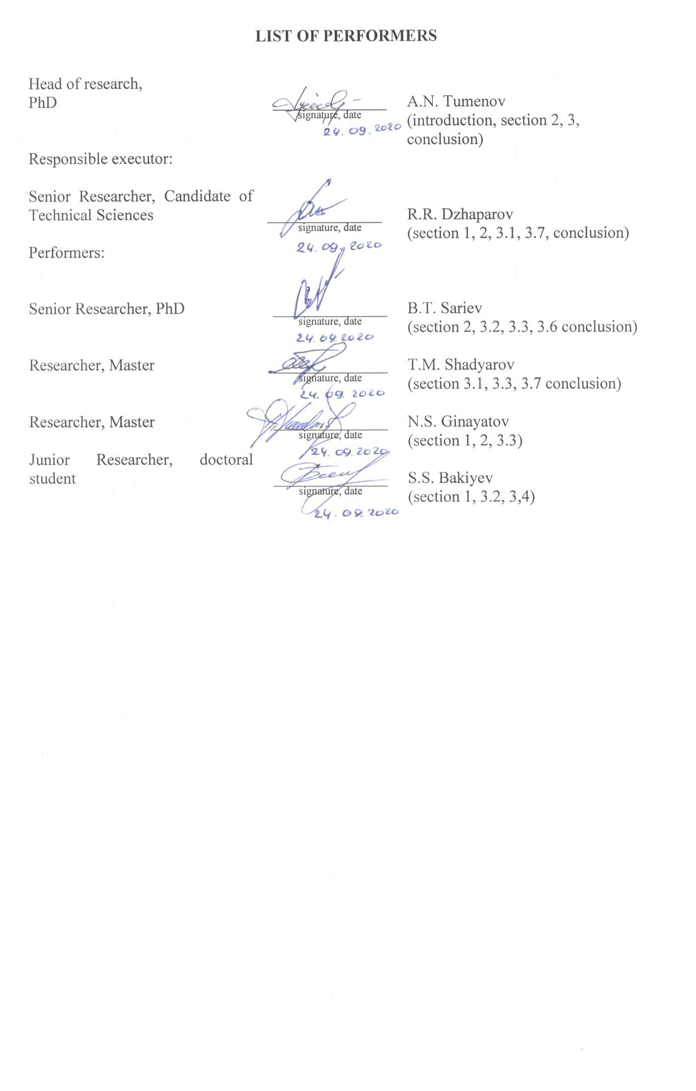
РЕФЕРАТ
Есеп 95 б., 1 кіт., 17 сур., 7 кес., 43 әдеб., 7 қосым.
ТАБИҒИ СУ ҚОЙМА, ЖАСАНДЫ КӨБЕЙТУ, МОБИЛЬЛІ ИНКУБАТОР, ИНКУБАЦИЯЛЫҚ АППАРАТ, КӘСІПТІК АБОРИГЕНДІК БАЛЫҚ ТҮРЛЕРІ

Зерттелітін нысан – мобильдік инкубатория, инкубациондық аппарат, табиғи су қоймаларда мекендейтін аборигендік кәсіптік балықтарды жасанды көбейту.
ҒЗЖ-ның мақсаты – абориген балық түрлерін алшақта орналасқан су қоймаларында жасанды өсіріп көбейтуге мүмкіндік беретін қозғалмалы, мобильді инкубаторияны пайдалану арқылы абориген балық түрлерін өсіріп көбейтудің биотехнологиясын қалыптастыру.
Зерттеу әдістері. Өзеннің орташа жылдық су мөлшерін, және де орташадекадалық су мөлшері «Казгидромет» мәліметтерінен алынды. Мобильдік инкубаторияның технологиялық сызбасы «AutoCAD» автоматтандырылған компьютерлік бағдарламасы арқылы құрастырылды. Аборигендік балық түрлерінің өндіргіштерінің балық шаруашылық-биологиялық көрсеткіштерін анықтау И.Ф. Правдиннің әдісі бойынша жүргізілді. Гипофизарлық инъекция Н.Л. Гербильскийдің ұсыныстарына сәйкес өткізілді.
Алынған нәтижелер. Инкубациялық аппараттарды қолдану арқылы мобильді инкубаторияның технологиялық сызбасы құрастырылды. Мобильді инкубатория жасау үшін қолайлы құрылғы таңдалды. Инкубациялық аппараттарды қолдану арқылы абориген балық түрлерін өсіріп көбейту үшін мобильді инкубаторияның рационалды құрылымдық-технологиялық сызбасына сәйкес тәжірибелік мобильді инкубатория жинақталды. Ғылыми зерттеу нәтижелерінде зертханалық және далалық жағдайларда іске қосу-жөндеу жұмыстары жүргізілді. Табиғи орта жағдайында кәсіптік аборигендік балықтарды жасанды жолмен өсіру, атап айтқанда жасанды ұрықтандыру, ұрықтандырылған уылдырықты дернәсілалды кезеңіне дейін инкубациялау жүргізілді. Табиғи жағдайда ұрықтандырылған уылдырықты инкубациялау үшін инкубациялық аппаратты әзірлеу және сынау жұмыстары өткізілді.
Қолдану салалары: балық шаруашылық кәсіпорындары, балық шаруашылығы ғылыми-зерттеу институты, экологиялық орталықтар, балық өсіруші фермерлер.

ABSTRACT
Report 95 p., 1 book, 17 figures, 7 tables, 43 sources, 7 appendices.
NATURAL WATER, ARTIFICIAL REPRODUCTION, MOBILE INCUBATOR, INCUBATION APPARATUS, ABORIGINAL COMMERCIAL FISH SPECIES

The objects of research are a mobile hatchery, incubation devices and artificial reproduction of indigenous commercial fish species inhabiting natural reservoirs.
The purpose of the research is to create biotechnology for the reproduction of aboriginal fish species using mobile hatcheries, which allow artificial reproduction of aboriginal fish species in remote natural reservoirs.
Research methods. When studying the average annual flow of the river, as well as average ten-day water levels, we used the data of “Kazhydromet”. The technological scheme of the mobile hatchery was developed using the automated design system “AutoCAD”. The determination of fish-breeding and biological indicators of spawners of native fish species was carried out in accordance with the guidance of I.F. Pravdin. Pituitary injections were performed in accordance with the recommendations of N.L. Gerbilsky. Determination of hydrochemical parameters was carried out in accordance with the established GOST. Determination of biochemical parameters of the blood of fish spawners was carried out according to generally accepted methods.
Results. A technological scheme of a mobile hatchery with the use of incubation devices has been developed. The optimal equipment has been selected for creating a mobile hatchery. In accordance with the technological scheme of a mobile hatchery for the reproduction of native fish species using incubation devices, an experimental mobile hatchery was assembled. As a result of scientific research, commissioning works were carried out in the field. In the conditions of the natural environment, research work was carried out on the artificial reproduction of indigenous commercial fish, namely, artificial fertilization, incubation of fertilized eggs until the prelarvae hatch. The tests of the incubation device and the apparatus for the incubation of fertilized eggs in natural conditions were carried out.
Application area: fisheries enterprises, fisheries research institutes, ecological centers, fish farmers.

CONTENT

INTRODUCTION…………………………………………………….……….…………… | 8
MAIN PART ABOUT RESEARCH WORK……………….…………..………….……… | 10
1 Choosing a direction of research...............……..…………………..…..……..……...….. | 10
2 Materials and research methods ………………………………………………………… | 13
2.1 Research methodology………………………………….…………………………..…. | 13
3 Research results and discussion……………..………...………………….………........... | 17
3.1 Installation of a mobile hatchery and commissioning of equipment in the field…….... | 17
3.2 Testing an incubator for the incubation of fertilized eggs in the field…...….…..…….. | 24
3.3 The main natural factors affecting the natural spawning of the carp of the Ural-Caspian population………………………………………………………............................ | 29
3.3.1 Hydrological regime of the Zhaiyk River (Ural)……….………………………….. | 29
3.3.2 Results of hydrochemical analysis of water from a natural reservoir…….....……... | 30
3.4 Fish-breeding physiological assessment of carp spawners of the Ural-Caspian population.............................................................................................................................. | 33
3.5 Stimulating the maturation of reproductive products in spawners with the use of synthetic and pituitary drugs………………………………………………………..……… | 36
3.6 Study of the optimal methods of insemination and de-gluing of eggs during artificial reproduction in a mobile hatchery…………………………………………………………. | 38
3.7 Biotechnology for rearing and feeding juveniles of native commercial fish in a mobile hatchery………………………………………………………………………….. | 40
CONCLUSION..................................................................................................................... | 41
LIST OF USED SOURCES………………………………………………………...……... | 43
APPENDIX A. List of published works for 2018-2020……………………….……….…... | 47
APPENDIX B. Work schedule………………..….……………………………..……….… | 49
APPENDIX C. Decision of the Academic Council…………………………..…….……… | 59
APPENDIX D. Reprints of publications….……………………………………..………… | 60
APPENDIX E. Granted patents………….……...………………………………..………… | 89
APPENDIX F. Monograph……….……...…………………………………..…………….. | 92
APPENDIX G. Act of release of juvenile fish…………………………………..…………. | 95

TERMS AND DEFINITIONS

In this research report, the following terms and definitions are used.
Aboriginal fish species | – fish species that arose and evolved in this particular water body
“Weiss” apparatus | – an apparatus designed for the incubation of fertilized fish eggs, which is a cylindrical glass vessel, narrowing downward with a volume of 8 liters, at the narrow end containing a stopper in which a metal tube is fixed. Water enters the apparatus under pressure from below, keeping the eggs in suspension
“Chalikov” apparatus | – is a box measuring 70x34x15.5 cm, the walls of which consist of wooden frames covered with a metal mesh, covered with asphalt varnish, covered from above with a mesh lid. Non-sticky caviar is incubated
Hydrometric spinner | – designed to measure the speed of the river, both on the surface and at a given depth
Diffuser | – part of the channel in which the water flow slows down and the pressure increases
Incubation apparatus | – apparatus used for incubating fish eggs
Incubation of eggs | – keeping fertilized fish eggs in a reservoir or in fish-breeding (incubation) devices until juveniles hatch
Artificial reproduction | – obtaining offspring and rearing juveniles of aquatic biological resources at fish breeding enterprises with subsequent release into natural and artificial reservoirs
Mobile hatchery | – a set of necessary equipment for the incubation of fertilized eggs of aboriginal fish species in the natural (natural) environment
Commercial fish | – fish species for which fishing can be organized
Working fertility | – the average number of eggs for artificial fertilization of fish, always lower than the individual absolute fertility, depends on the method and time of taking eggs from females

LIST OF ABBREVIATIONS AND SYMBOLS

In this research report, the following abbreviations and symbols are used.
^{о}С | – degrees centigrade
g | – gram
kg | – kilogram
L | – liter
m | – meter
mm | – millimeter
m/s | – meter per second
рН | – active reaction of the aquatic environment
s | – second
cm | – centimeter
thousand pcs | – thousand pieces
RAS | – recirculating aquaculture system

INTRODUCTION

In the course of preparing the final report, materials of interim reports for 2018, 2019 were used:
Design of a portable hatchery and development of biotechnology for breeding of indigenous commercial fishery species: research report (interim) / NJSC “Zhangir Khan WKATU”: hands. Tumenov A.N. - Uralsk, 2018. - 55 p. - No. GR 0118RK00853. Inventory number: 0218RK00863;
Design of a portable hatchery and development of biotechnology for breeding of indigenous commercial fishery species: research report (interim) / NJSC “Zhangir Khan WKATU”: hands. Tumenov A.N. - Uralsk, 2019. - 59 p. - No. GR 0118RK00853. Inventory number: 0219РК01064.
Currently, there is a significant reduction in the native commercial fish species representing the ichthyofauna of local water bodies. Fish resources are decreasing every year, this phenomenon has a direct negative impact not only on the number of fish populations, but also affects the ecological situation of water bodies in general.
Often, the main factors that have a significant negative impact on the number of fish populations are anthropogenic factors, including the regulation of river flows, the use of water resources in agriculture, industrial emissions, as well as unregulated fishing and poaching.
One of the solutions to the problem of reducing the number of populations of indigenous commercial fish in natural reservoirs is the use of biotechnology of artificial reproduction in the conditions of installations with a closed water supply cycle (RAS), with the subsequent receipt of juveniles from aboriginal fish, to replenish their numbers in the natural environment. Due to artificial reproduction associated with the release of juveniles of native commercial fish, the replenishment and maintenance of the number of fish populations in natural water bodies is carried out.
When using mobile hatcheries for artificial reproduction, there is no need to transport spawners of native commercial fish caught from their natural habitat to fish factories. Due to the use of mobile hatcheries, stress factors for fish (transportation, temperature and oxygen fluctuations) are reduced, since reproduction is carried out in the field directly near the reservoir using water from a natural source.
The purpose of this project is to develop biotechnology for the reproduction of aboriginal fish species inhabiting the natural environment using special, mobile hatcheries.
The scientific novelty of the project lies in the fact that a mobile hatchery and biotechnology for the reproduction of indigenous commercial fish species were developed using new engineering and biotechnical solutions, which made it possible in a short time, in a mobile hatchery near their natural habitat, to carry out artificial insemination and subsequent incubation of fertilized eggs until hatching of prelarvae.
To achieve this goal, the following tasks are envisaged:
- collection of the improved design of the mobile hatchery;
- elimination of design flaws, commissioning of a mobile hatchery in the field;
- carrying out fish-breeding and physiological assessment of spawners during selection for reproduction;
- determination of the main fish-breeding parameters and biochemical parameters of fish blood;
- carrying out hydrochemical analysis of water;
- determination of optimal schemes for stimulating the maturation of reproductive products from spawners using synthetic and pituitary drugs;
- study of the optimal methods of insemination and de-gluing of eggs during artificial reproduction in a mobile hatchery;
- development of biotechnology for rearing and feeding juveniles of indigenous commercial fish in a mobile hatchery;
- release of grown-up fry of aboriginal fish into their natural habitat;
- creation of an experimental broodstock of commercial fish species under RAS conditions.
The results of research work on the project were published in scientific journals (Appendix A), reprints of the journals are given in Appendix D.
The work was carried out according to the project schedule for 2020 (Appendix B). The report on the project was heard and approved at the meeting of the Academic Council of Zhangir Khan WKATU (Appendix C). RK patents for a utility model were received (Appendix E), a monograph was published (Appendix F).

MAIN PART ABOUT RESEARCH WORK

1 Choosing a direction of research

Aboriginal fish represent the ichthyofauna of a certain water body, the species diversity of which is the main indicator of the ecological state of the entire water body. Depending on the type of food and lifestyle, fish are peaceful and predatory. The balance between the abundance of populations of peaceful and predatory fish has a significant impact on the species diversity of natural water bodies. Many species of aboriginal fish are the objects of fishing, and therefore the number of these fish may be regulated by increasing or decreasing the volume of catches in the range of allowable catches [1-5].
One of the largest rivers in the West Kazakhstan region (WKR) is the Ural River, which flows into the Caspian Sea and forms the Ural-Caspian basin. The Ural-Caspian basin is characterized by a diverse composition of the local ichthyofauna, including such most common fish species as: from the cyprinid family (Cyprinidae) - carp (Cyprinus carpio L.), bream (Abramis brama L.), asp (Leuciscus Aspius), silver Prussian carp (Carasius auratus gibelio), from the catfish family (Siluridae) - catfish (Silurus glanis L.), from the pike family (Esocidae) - pike (Esox lucius L.), from the perch family (Percidae) - pike perch (Stizostedion lucioperca L.), perch (Perca fluviatilis L.) and many other species [6-8].
Recently, the number of populations of commercial fish has been significantly reduced, the main reason is the influence of an anthropogenic factor, which manifests itself in the deterioration of the ecology of water bodies as a result of emissions from industrial enterprises, regulation of river flow for water use in agriculture, as well as unregulated fishing and poaching [9-11].
Unregulated fishing and poaching are especially dangerous during spawning periods, at which time spawning fish spend a lot of energy and are in a low-activity state [12-15].
It was also noted that dry years, characterized by insufficient water availability and duration of floods, are unfavorable factors that have a negative impact on the spawning of phytophilous fish, in particular for late spawning carp populations [7, 16].
Due to the influence of the anthropogenic factor, individual individuals of different fish species do not reach sexual maturity, which violates the frequency of natural self-reproduction of fish. A low level of self-reproduction can lead to negative consequences, such as a decrease in the number of fish, changes in the ecological balance, and in some cases, the extinction of the species as a whole [17, 18].
To preserve and increase the number of commercial fish, it is necessary to stock fish with fish seed - juveniles of fish obtained under artificial conditions. Biotechnology of artificial reproduction of commercial objects is becoming more and more relevant in the field of fisheries. The pool method is the most common in cultured fish farming. When fish are raised in installations with a closed cycle of water supply, optimal oxygen and temperature regimes are created, a feeding regime is selected, these conditions have a beneficial effect on the growth and development of fish. Due to the creation of optimal conditions for growing in the RAS, fish reach sexual maturity in a shorter time compared to individuals living in the natural environment, and therefore the time for obtaining fish fry for stocking is reduced. When releasing juveniles, the time of the year, the temperature of the natural reservoir, the age and adaptive capacity of the fish seed are taken into account [19, 20].
For reproduction purposes, it is necessary to carry out a high-quality selection of fish spawners to obtain viable juveniles. When selecting spawners, an important indicator is the combination of physiological and biochemical characteristics. The sex products obtained are also determined for quality [21].
For artificial reproduction, reproduction brood stocks of fish are used to reach sexual maturity, which reach at different times. It depends, first of all, on the species, conditions of detention, as well as the individual physiological characteristics of the fish. In the study of V.V. Zalepukhin in the spawning company used female carp in the age range from 4+ to 13+ years, scaled carp from 6+ to 9+ years, mirror carp from 5+ to 10+ years, the average amount of eggs obtained from one female was 690.5 g , 733.2 g, 713.3 g, respectively [22].
For the purposes of hybridization, it is advisable to periodically capture spawners from natural water bodies. The use in artificial reproduction of broodstock herds and captured broodstock from natural reservoirs contributes to obtaining the highest quality offspring, characterized by a high adaptive ability to the conditions of the natural environment [23].
Currently, the most effective use of mobile hatcheries with the formation of laboratories in the field. During the transportation of the broodstock on live fish machines over long distances, mechanical damage in fish, a lack of dissolved oxygen in the water, and a change in the chemical composition of water under the influence of decomposition of the waste products of the transported fish are possible. The mobile hatchery creates a favorable environment to prevent stress and injury to fish. Captured spawners are kept in cages in the reservoir until the spawning state is reached, that is, within the same temperature range as before capture [24].
From the research of M.E. Shapovalov and V.P. Koroleva it follows that spawning in natural conditions occurs for different species of fish at a certain water temperature - for pike, the spawning temperature in coastal areas is 7-15° C. At the end of March, flowing individuals are observed, for pike-perch spawning begins from the last decade of April and ends by the end May at a water temperature of 11-12.5° С, for carp and goldfish mass spawning occurs in late May and early June at water temperatures of 18-24° С [25].
To achieve a spawning state, pituitary suspensions are administered to spawners. When calculating the dose of administration, individual indicators of the mass of spawners, the sex of the fish, as well as the temperature regime at which the fish are kept are taken into account [26]. During the period of maturation, the selection of reproductive products is carried out by means of the lifetime method - milking. The selection of eggs from females is carried out in plastic basins well-dried in advance, sperm from males is taken into glass tubes. Then artificial insemination of eggs is carried out. Further, the fertilized eggs are de-glued in skim milk by bubbling in the flasks of the Weiss apparatus [24].
After the process of de-gluing, the incubation period begins, during which the fertilized eggs go through all stages of development [27]. The resulting juveniles are fed with live food - crustaceans (Artemia salina), characterized by a high content of proteins, fats and vitamins necessary for growth and development in the early stages.
When using mobile hatcheries for the reproduction of indigenous commercial fish, the time for obtaining fish fry is significantly reduced, the catch of spawners is carried out directly in the studied reservoir, the lack of transportation of fish to fish factories for artificial reproduction reduces the possible waste of the number of spawners resulting from stress factors, mechanical damage and hydrochemical regime. As a result of growing the obtained fry in a mobile hatchery using water from a natural reservoir, it allows the fry to better adapt to environmental conditions when released into the reservoir.

2 Materials and research methods
2.1 Research methodology

When studying the hydrological regime, the data of “Kazhydromet” on WKR were used, the data of the average annual river flow, as well as the average ten-day water levels during the periods of spring high water, were studied.
The technological scheme of a mobile hatchery for the reproduction of indigenous commercial fish is shown in Figure 1.
Mobile hatchery for reproduction
aboriginal commercial fish

Fishing for spawners, selection for reproduction
Water intake from the river

Keeping spawners, selection for reproduction
Preliminary preparation of water for pools and incubators (filtration, disinfection and control of chemical and thermal conditions)

Selection of reproductive products, insemination and de-gluing of eggs

Release of spawners into the natural environment
Water supply to incubators

Incubation of eggs

Keeping larvae in pools, feeding with live food

Release of juvenile commercial fish into a natural reservoir

Figure 1 - Scheme of a mobile hatchery for the reproduction of indigenous commercial fish
Artificial reproduction of carp was carried out using a mobile hatchery based on a trailer, including the following equipment: a pump (drainage pump), a fine filter - body FH 10 B-WB, pools for water and fry, a centrifugal pump - VALTEC (3-mode), glass vessels (Weiss apparatus), an electric generator (gasoline generator DY8000LX - HUTER), thermostats - T-105 at 16A with a heating range of 0-77° С, rack frame, air compressor for oxygen supply.
Determination of fish-breeding biological indicators of spawners was carried out in accordance with the guidelines [28].
Body fatness coefficient was determined according to Fulton, the indicator of which is defined as the ratio of weight to body length of fish in the third degree, the result of which is multiplied by 100 [29]. Formula 1 was used to determine the body fatness coefficient.

C_{f (F)} = P * 100 / L³, (1)

where, P is the mass of the fish (g), L is the length of the body to the end of the scaly cover (cm).
Pituitary injections were performed in accordance with the recommendations [26, 27]. As a preliminary and permissive injection, a solution of acetonized carp pituitary glands was used at intervals of 12 hours. In accordance with the readiness of the spawners for spawning, intravital sampling was carried out. First of all, we received sexual products from females, then from males. The resulting semen was collected in dried glass tubes. Then the resulting sex products were mixed by insemination. Water from a natural reservoir was used to activate spermatozoa. After artificial insemination, low-fat milk at a concentration of 0.3 liters per 5 liters of water was used to de-stick the eggs. The subsequent incubation of eggs was carried out in a mobile hatchery; during the entire incubation period, the temperature and oxygen regimes were monitored, the values ​​of which were in the range of 20-22° C, the oxygen value was from 5 to 7 mg/L.
The water analysis was carried out at the accredited test center of the Science Department of the Zhangir Khan West Kazakhstan Agrarian Technical University.
The pH measurement was carried out on a pH meter Seven Easy Mettler Toledo, according to GOST 26449.1-85; the dry residue content was determined by the gravimetric method; The content of heavy metals was determined according to PNDF 14.1: 2: 4.139-98 on a Varian AA-140 atomic absorption spectrometer with flame atomization; hardness and cation-anion composition were determined according to GOST 26449.1-85. Determinations of ammonium nitrogen, nitrites, nitrates were carried out spectrophotometrically on a Varian, Cary-50 instrument.
For the normative values ​​for drinking water, the values ​​according to the sanitary rules "Sanitary and Epidemiological Requirements for Water Sources, Water Intake Points for Domestic and Drinking Purposes, Domestic and Drinking Water Supply and Places of Cultural and Domestic Water Use and Safety of Water Bodies" (approved by order of the Minister of National Economy of the Republic of Kazakhstan March 16, 2015 No. 209). For the normative values ​​for the water of fishery reservoirs, the values ​​according to the List of fishery standards are taken: maximum permissible concentrations (MPC) and tentatively safe exposure levels (TSEL) of harmful substances of water bodies of fishery importance (Approved by order of the State Committee of the Russian Federation for Fisheries dated April 28, 1999 No. 96).
In large individuals, blood sampling was carried out using a syringe or needle, which is inserted into the tail artery. The blood is collected in a test tube and settled until the complete separation of plasma and blood cells. If the blood serum is in the lower layer of the sample, then a blood clot is separated along the wall using a Pasteur pipette, which should then settle to the bottom of the test tube. After separation, the blood serum is poured into a clean tube to determine total protein or to preserve it for subsequent determinations using a Pasteur pipette.
The determination of the protein content in blood plasma was also carried out by the biuret method. The essence of the method is as follows. Copper ions in an alkaline medium interact with peptide bonds of blood serum to form a red complex, the color intensity of which is proportional to the concentration of total protein and is measured photometrically at a wavelength of 540 (500-560) nm. 5 ml of the working solution of the biuret reagent was added to the test tubes, 0.1 ml of blood serum was added, thoroughly mixed and incubated at a temperature of 18-20 ° C for 30 minutes. Then the optical density of the experimental samples was measured against the control sample (a working solution of a biuret reagent with the addition of 0.1 ml of distilled water), in a cuvette with a 10 mm light-absorbing layer. The calibration sample is 5 ml of a biuret reagent solution with the addition of 0.1 ml of calibration blood plasma with a known concentration of total protein (60 g/L) and is processed in the same way as the test samples [30].
The concentration of glucose in the blood serum of cyprinids was determined by the colorimetric method. The principle of the method is as follows: glucose oxidase oxidizes D-glucose to glucuronic acid with the formation of hydrogen peroxide; the latter, under the action of peroxidase, reacts with 4-aminoantipyrine and phenol with the formation of a red compound, the color intensity of which is proportional to the glucose concentration in the analyzed sample and is measured photometrically at a wavelength of 510 (470-540) nm.
Determination of the amount of hemoglobin was carried out by the hemiglobincyanide method. Blood hemoglobin, when interacting with iron-cyanide potassium (red blood salt), is oxidized into methemoglobin (hemiglobin), which forms hemiglobin cyanide (cyanmethemoglobin) with acetonecyanohydrin, the color intensity of which is proportional to the concentration of hemoglobin in the blood and is measured photometrically at 500 nm to 560 nm. 5 ml of the transforming solution was added to the test tubes, 0.02 ml of blood was added, thoroughly mixed and incubated at room temperature (+ 18-20° C) for 20 minutes, after which the optical density of the experimental samples was measured against a blank sample (transforming solution) in a cuvette with an absorbing light layer 10 mm thick. The calibration sample consisted of 5 ml of a transforming solution with the addition of 0.02 ml of calibration blood with a known concentration of hemoglobin (120 g/L) and was processed in the same way as the test samples.

3 Research results and discussion
3.1 Installation of a mobile hatchery and commissioning of equipment in the field

Reducing the biological resources of water bodies, namely fish, negatively affects the ecological system of the entire water body, since fish are a fundamental link in the food chain and the cycle of substances in their habitat [31]. The main reasons for the decrease in fish resources in water bodies are environmental factors, as well as anthropogenic influence in general [32, 33]. In this regard, in order to replenish the declining fish population, their artificial reproduction is becoming increasingly important from an economic and environmental point of view.
A promising direction for the stocking of rivers is the development of biotechnology for the reproduction of aboriginal fish species inhabiting the natural environment using a mobile mobile hatchery, which allows artificial reproduction of these fish species in remote natural reservoirs in places of their greatest concentration. In this case, the spawners are released back into the reservoirs.
Mobile hatcheries allow for a relatively short period of time in the field to stock fish ponds. It should be noted that fish are not exposed to unnecessary stress conditions that occur as a result of the transportation of spawners from natural reservoirs to the artificial reproduction laboratory.
Mobile incubators are used for research and aquaculture purposes in many countries engaged in fisheries and aquaculture research [34–36].
The use of a mobile hatchery for artificial reproduction of fish allows, regardless of the geographic location of the investigated reservoir, to carry out research and fish breeding work directly near the natural habitat. This allows the full use of biological resources without causing harm to the environment.
During reproduction by means of a mobile hatchery, the main commercial local fish species for a certain water body are used as objects of research. In most cases, they use cyprinids, catfish and other fish species characterized by a short incubation period. The incubation of fertilized eggs of these fish species allows, within a short time of the research team's presence in the investigated reservoir, to produce artificially reproduced generations for subsequent release into their natural habitat in order to replenish the number of indigenous commercial fish.
When carrying out artificial reproduction for the purpose of stocking fish in the investigated reservoir, it is advisable and efficient to use a mobile hatchery with a direct exit to the reservoir. When using a mobile hatchery, reproduction time is significantly reduced due to the close proximity to the hatchery reservoir. In addition, the use of a mobile hatchery on wheels on a single platform eliminates the need to perform disassembly and assembly operations of the installation at each change of location for the incubation of eggs and rearing fish fry.
For the reproduction of fish directly from the investigated reservoir using a mobile hatchery, mature spawners are used.
Weiss devices are used in the designs of mobile incubators currently in use. They are installed rigidly to the rack using clamps with two slots, one of which holds the lower part, and the other - the middle part of the bulb. In this case, the devices must be installed in a strictly vertical position (Figure 2).
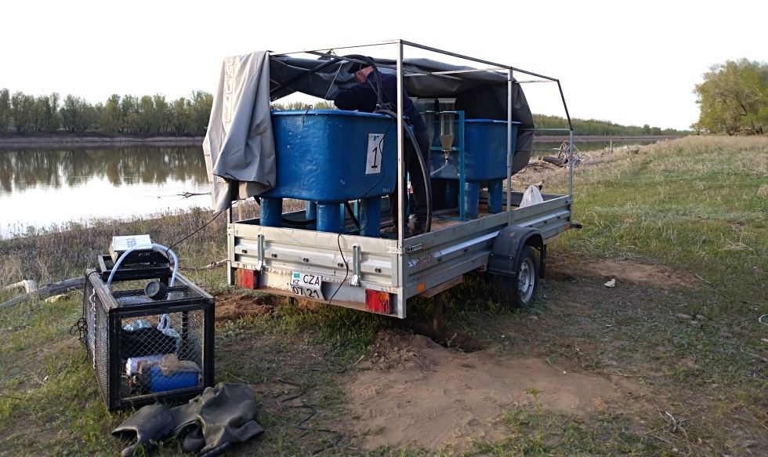

Figure 2 - Installation of a mobile incubator

Our earlier studies of the mobile hatchery indicated the influence of the terrain on the technological process of incubation of eggs. At the same time, a significant drawback of mobile hatcheries is that when eggs are incubated in the field near the river in conditions of uneven coastal relief, the verticality of the flasks is disturbed due to the design features of the apparatus, which has a fixed rigid attachment to the rack in two nests. This leads to disruption of the technological process of eggs incubation. Water jets will be directed along one side of the flasks, which will cause uneven rotation of the eggs and, as a result, freeze of the eggs in certain parts of the apparatus. As a result, the efficiency of fish eggs incubation decreases.
In this regard, the task was set to create a mobile incubator for the reproduction of fish, providing favorable conditions for incubation of eggs and not depending on the terrain and climatic conditions.
We have developed such a mobile incubator for fish reproduction, the novelty of the technical solution of which is confirmed by the patent of the Republic of Kazakhstan for utility model No. 4749 (Figure E.1) [37].
The technical result from the use of the proposed utility model is to create an effective device and reduce the cost of the technology for incubating fish eggs, providing an increase in the actual yield of larvae from the incubated eggs.
Figure 3 shows a mobile fish breeding incubator; Figure 4 - view A in Figure 1; Figure 5 - section B-B according to figure 4; Figure 6 - fastening Weiss flasks to the frame.
A mobile incubator for fish reproduction consists of a mobile car trailer 1 on wheels, covered with an awning 2 to maintain the required temperature regime inside the trailer and prevent direct sunlight and precipitation from entering the incubation apparatus, two fish-breeding pools 3 1x1x1 m in size connected to each other along the bottom by a polypropylene pipe 4. In the pool for hatching larvae, the polypropylene pipe is equipped with a fine mesh 5, which blocks the drain hole to prevent the emerging larvae from leaving along with the water flow. The pools are fixed to the bottom of the trailer, equipped with wooden planks throughout the entire area, to prevent their possible free movement when the vehicle is moving to the place of deployment. A thermostat 6 is installed in the pools to maintain the required water temperature there. A frame 7, made of a metal rectangular profile 50x20 mm in size, is installed between the two pools along the side and is attached to the bottom of the trailer. On the frame are mounted posts 8 to the upper part, which are rigidly attached to the upper plate 9 with holes for Weiss flasks 10 and rods 11. The holes for the rods in the upper plate, like the rod heads, have a spherical shape in the connection - a hinge joint, which allows the rods change position relative to the plane of the upper plate. On the opposite side of the rod, a lower plate 12 is put on it, which holds the Weiss flask in an upright position, a spring plate 13, a spring 14, a nut 15. The holes in the upper plate for Weiss flasks are equipped with rubber cuffs 16. The pump 17 is connected to the distribution pipe 18, which by means of flexible hoses 19 it is connected to Weiss flasks 10. In the upper part of the Weiss flasks there are drain grooves 20 made in a plastic hoop, fitting the upper edges of the flasks and installed at the other end, into the drain chute 21. Water is pumped into the pools through a fine filter 22 by a pump 23.
The mobile incubator for fish reproduction works as follows. Water from any source (river or lake) is pumped by a pump 23 through hoses through a fine water filter 22 into a pool for water 3. Thanks to a connecting pipe 4, both pools are filled simultaneously, where it is heated by a thermostatic element 6. From the pool, water is supplied by a pump 17 through distribution pipe 18 and hoses 19 into Weiss flasks 10. Water currents raise the caviar placed in the flasks upward. In the upper part of the flask, the water pressure weakens, so the eggs begin to gradually sink to the lower part, where they are picked up by jets of water and again carried up.
In the developed design, the installation of Weiss flasks to the posts 8 is carried out only in the upper socket to the plate 9. The lower part of the flask is held in a vertical position by plate 12, a spring plate 13, a spring 14, a nut 15 and a rod 11. Spherical rod heads and holes for rods in the upper plate 9 allow the rods to freely change their position relative to the plane of the upper plate.
The proposed design makes it possible to constantly keep the Weiss flasks in an upright position, regardless of the terrain, which will allow the eggs to move evenly throughout the flask and, as a result, prevent freezing in certain parts of the apparatus, as a result of which the efficiency of fish eggs incubation will increase.
Thus, throughout the entire incubation period, the eggs are in flasks in a continuously suspended state in the water column. The cycle of water exchange continues until the larvae hatch completely. The hatched larvae through the drain grooves 20 of the Weiss flasks and the drain gutter 21, together with the water flow, are carried away into the fry basin equipped with a pipe with a fine mesh 5, which prevents the hatching of the larvae from leaving through the drain hole along with the water flow.
When choosing an autonomous source of electricity - a gasoline generator, we took into account the total power of the devices included in the mobile hatchery.

Figure 3 - Mobile hatchery for fish reproduction
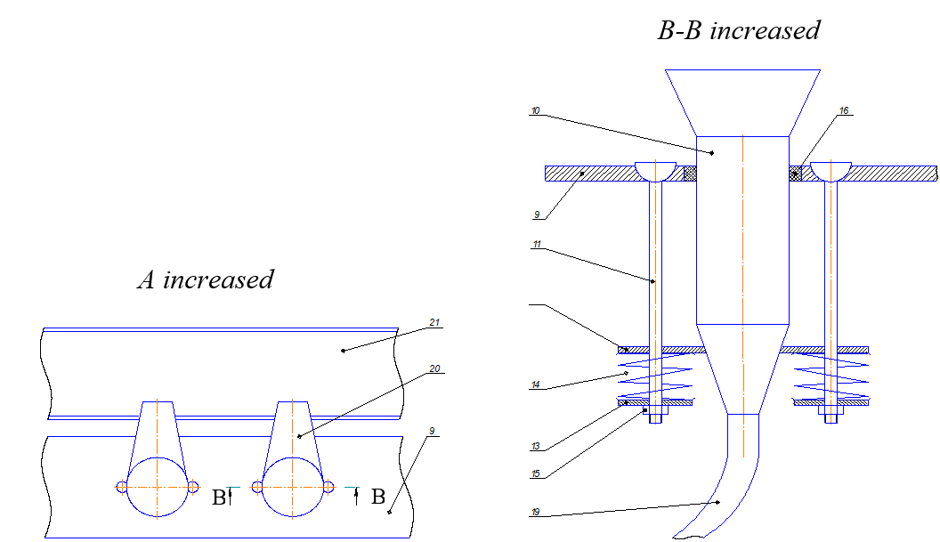
Figure 4 - View A in Figure 3 Figure 5 - Section B-B in Figure 4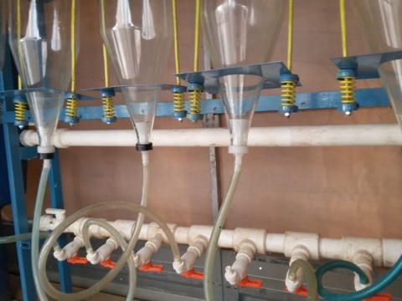

Figure 6 - Fastening Weiss flasks to the frame
During the period of operation of the mobile hatchery, there were no significant breakdowns of its equipment. Minor water leaks at the joints during the hatchery operation were quickly eliminated. The mobile hatchery developed by us is easy to attach to the car, stable during transportation, does not tip over when moving, easy to operate. All components of the mobile hatchery are suitable for repair and maintenance. The advantages of this mobile hatchery should also include minimal disassembly and assembly work when changing its location.
Thus, the proposed mobile hatchery for fish reproduction will effectively replenish the stocks of indigenous commercial fish in natural reservoirs and maintain the ecological balance of water bodies.

3.2 Testing an incubator for the incubation of fertilized eggs in the field

The development of “green” technologies involves the use of non-traditional energy sources. One of the promising areas for fish breeding in water bodies is the development of devices that allow fish eggs to be incubated directly in rivers using the natural energy of water flow. These devices with artificially fertilized eggs are placed in reservoirs. In this regard, along with the use of a mobile mobile hatchery, which allows artificial reproduction of fish, we carried out studies with incubation devices located directly in the reservoir.
Based on the analysis of the work of existing structures, we developed an incubation apparatus, the novelty of a technical solution, which was recognized as an invention and confirmed by a patent of the Republic of Kazakhstan for a useful model No. 4633 “Device for incubating fish eggs” (Figure E.2) [38]. The diagram of the device is shown in Figure 7. This incubator is installed directly in the reservoir.
The incubator consists of: a diffuser 1 mounted on a frame 2 with the ability to change the angle of inclination and height; drum 3, made in the form of a cylinder with a lateral surface made of a metal mesh 7 and two bases of textolite.
The bases are rigidly connected to each other by wooden slats-blades 5, covered with a thin layer of foam rubber to prevent damage to the eggs. In one of the bases there is a hole with a tight-fitting cover 8 for launching fish eggs into the drum. The drum 3 is mounted on the shaft 9 and is fixed by means of sliding bearings on the frame 6. The frame 6 is made with the possibility of adjusting the drum in height. On the outer side along the lateral surface of the drum, six blades 4 are rigidly mounted. Both outer and inner blades are located radially.
The proposed incubator works as follows. The flow of water, captured by the diffuser 1, passes along its surface and, due to the decrease in the cross-section along the movement, enters the outer blades of the drum 3 at an increased speed, driving it into rotational motion. The inner blades of the 5th drum capture fish eggs inside the drum, drawing them into a circular motion. In this case, the flow of water passing through the mesh 7 of the drum "dumps" the eggs from the internal blades, thereby ensuring that they are in a suspended state inside the drum with constant washing with water, which allows the process of incubation of eggs to be as close to natural conditions as possible. Coating the inner blades of the drum with a thin layer of foam rubber promotes soft interaction of the eggs with the blades and, as a result, prevents the damage of the eggs during their contact with the blades.
In the proposed design of the incubation apparatus, the main driving force that drives the roe drum into rotary motion is the water flow passing through the diffuser and exerting pressure on its outer blades.
Thus, in the proposed device, eggs are periodically suspended with constant washing with water, which allows incubation to resemble a natural process as much as possible and increase the yield of viable larvae during incubation of fish eggs by creating optimal incubation conditions.

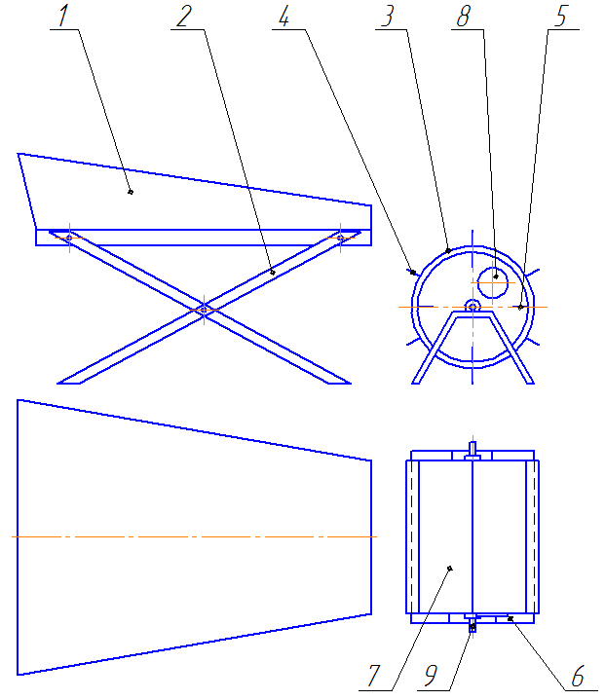

1 - diffuser, 2 - frame; 3 - drum; 4 - blades; 6 - frame; 7 - metal mesh and two PCB bases; 8 - drum hole; 9 - sleeve bearing

Figure 7 - Scheme of a device for incubating fish eggs
Figure 8 shows in action a device we have developed for incubating fish eggs.

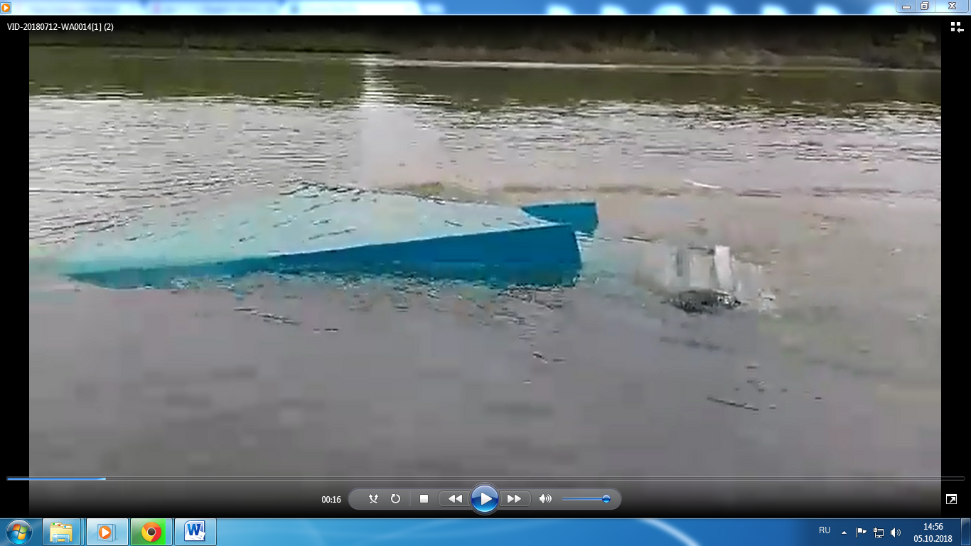

Figure 8 - Testing the incubator

In order to reduce metal consumption and simplify the design, we have developed an apparatus for incubating fish eggs, the novelty of a technical solution, which is recognized as an invention and confirmed by the patent of the Republic of Kazakhstan for a useful model No. 4792 “Apparatus for incubating fish eggs” (Figure E.3) [39]. The diagram of the apparatus is shown in Figure 9. This incubation apparatus is installed directly in the reservoir. For the drive, in the movement of the working body of which the energy of the moving water in the river is also used.

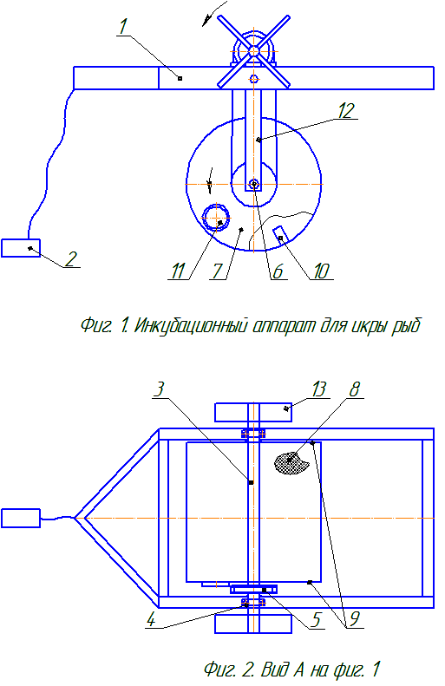

1 - floating frame; 2 - anchoring node; 3 - drive shaft; 4 - supports; 5 - belt drive; 6 - shaft; 7 - drum; 8 - perforated surface; 9 - bases; 10 - blades; 11 - removable cover; 12 - metal plates; 13 – plates

Figure 9 - Structural diagram of the incubation apparatus

The apparatus for incubating fish eggs consists of: a floating frame 1, equipped with an anchoring unit 2; drive shaft 3, mounted on both sides on supports 4 to the floating frame 1 and connected by a belt drive 5 to the shaft 6 of the drum 7, which is a cylindrical container with a perforated side surface 8 and two bases 9.
The bases are rigidly connected to each other from the inner side of the drum by blades 10, covered with an elastic material, for example, foam rubber. One of the bases is made with a loading opening for launching fish eggs into the drum and is equipped with a removable cover 11 with locks. The drum shaft is installed in the holes of the metal plates 12, which are attached on both sides to the floating frame 1 and serve as supports for the drum shaft. Blades 13 are rigidly mounted on the drive shaft 3 on both sides.
Figure 10 shows the incubator in action.

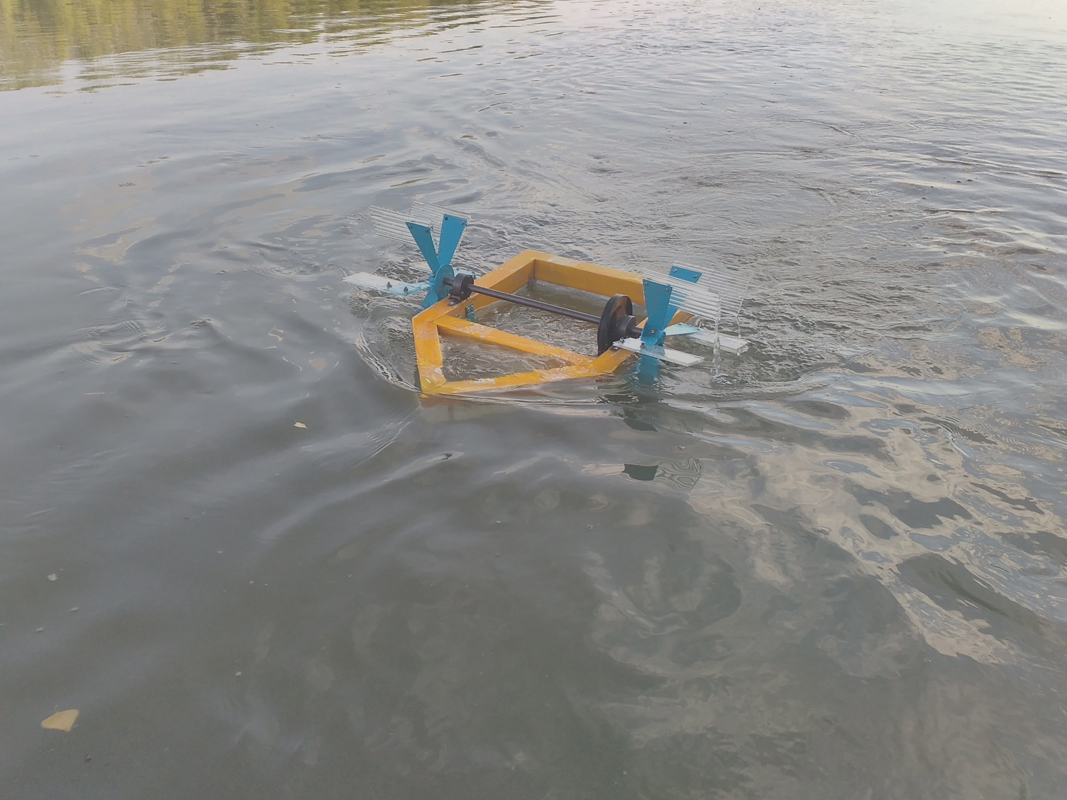

Figure 10 - Tests of the incubator

The proposed incubator works as follows. The flow of moving water, acting on the blades 13, drives the drive shaft 3 in a rotational motion around its axis. The belt drive connecting the drive shaft 3 with the shaft 6 drives the drum 7 in rotational motion. The inner blades 10 of the drum capture fish eggs inside the drum, drawing them into a circular motion. In this case, the flow of water, passing through the perforated surface of the drum, "dumps" the eggs from the inner blades as they move into the upper part of the drum, thereby ensuring that they are periodically suspended inside the drum with constant washing with water, which allows the process of incubation of eggs to be as close as possible to natural conditions. Coating the inner blades of the drum with a thin layer of foam rubber promotes soft interaction of the eggs with the blades and, as a result, prevents the damage of the eggs during their contact with the blades.
And during the operation of the incubation apparatus, due to the rotation of the drum, the fertilized eggs are periodically suspended in the natural environment, which favorably affects the process of incubation of fish eggs.
As a result of our experimental studies with the proposed device for incubating fish eggs and an apparatus for incubating fish eggs during incubation of fertilized eggs of aboriginal fish species, the yield of prelarvae was - 87 ... 89%.

3.3 The main natural factors affecting the natural spawning of the carp of the Ural-Caspian population
3.3.1 Hydrological regime of the Zhaiyk River (Ural)

Studies show that there are significant fluctuations in the hydrological regime of the Ural River over the years. The decrease in the annual runoff is associated with global climate change, which has a negative impact on the overall ecosystem of the reservoir, as a result of which changes in the composition of the ichthyofauna occur. Some researchers associate long-term fluctuations in the annual flow with cyclicality, that is, they believe that after a certain time the river flow will recover.
In years of high water, the runoff value is 3-5 times higher than the average long-term value, in low water it is characterized by an extremely low runoff value (Figure 11).

Figure 11 - The volume of water flow of the Ural River in the period from 2001 to 2020

Long-term hydrological data show that the highest values ​​of water availability fell on the period from 2001 to 2005 with the highest water availability in 2002 up to 14 km³. In 2005, there was a sharp drop in the annual runoff from 11.6 km³ to 5.2 km³. Since 2008, the average annual flow of the river has not exceeded 9 km³, there has been a gradual decrease in the annual flow within the range of 8.96 km³ to 3.7 km³. The annual flow of the river in 2020 compared to 2019 is slightly higher and amounted to about 4 km³, which favorably influenced the natural reproduction of phytophilous fish. During the spring flood, the river partially flooded the oxbow lakes of the river, phytophilous fish got the opportunity to breed in favorable conditions.
In 2020, a mobile incubator was placed near the oxbow, the water temperature in which was several degrees higher than the temperature in the riverbed itself, which facilitated the process of artificial incubation of eggs.

3.3.2 Results of hydrochemical analysis of water from a natural reservoir

The hydrochemical regime of the reservoir is one of the main factors influencing not only the physiological state, but also the process of reproduction of native fish species. To assess the habitat of fish, a hydrochemical analysis of water samples from natural spawning grounds and mass feeding in the river was carried out. Ural near Bazartobinsky rural district of Akzhayik district of West Kazakhstan region (Figures 12, 13).

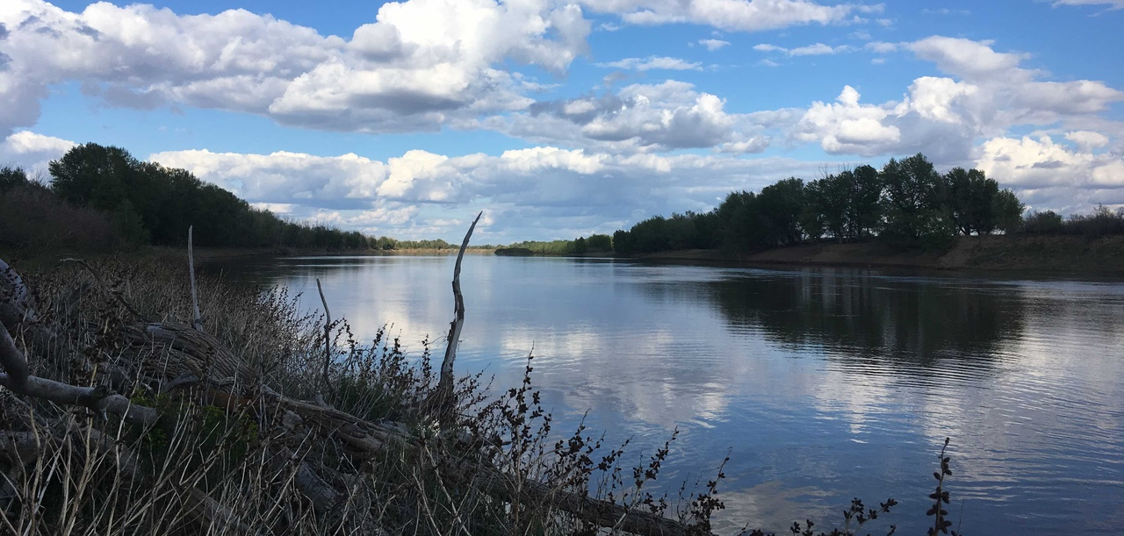
Figure 12 - The Ural River near Bazartobinsky rural district of Akzhaiyk district of West Kazakhstan region
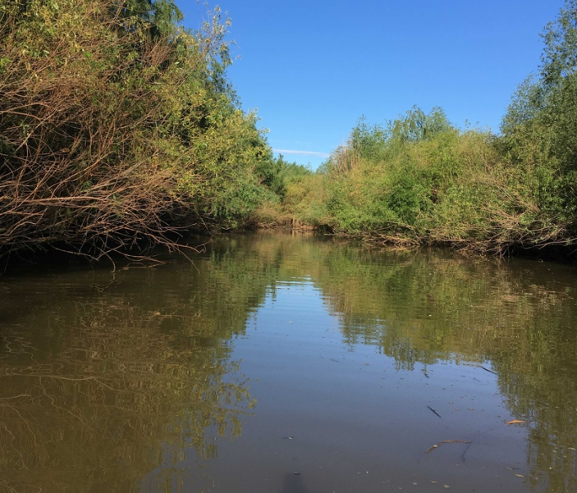
Figure 13 - Areas of natural spawning grounds and mass feeding of fish in the Ural River
Sampling for hydrochemical analysis of water was carried out according to the method of taking initial material from an open reservoir from the surface and deep layers of the studied areas. The selected water samples were poured into clean polyethylene bottles with a volume of 1 liter. Further, the preparation of water samples for storage was carried out using conservatives such as sulfuric acid (H₂SO₄) at the rate of 1 ml per 1 water, nitric acid (HNO₃) - 5 ml per 1 water, chloroform (CHCl₃) 3 ml per 1 L of water. Water analysis was carried out by conventional methods, as a result of which data on the main hydrochemical parameters presented in Table 1 were obtained.
According to the results of the carried out hydrochemical analysis of water samples from the surface and deep layers in the locations of natural spawning grounds and mass feeding, it was found that, according to the pH value, the studied water samples were assessed as neutral, according to the degree of mineralization, fresh. The obtained dry residue indicators, which do not exceed the maximum permissible concentration, indicate the freshwater content of the river. Ural in the studied areas. The anionic-cationic composition is within acceptable values.
Among the identified deviations from the MPC of the main water parameters for fishery reservoirs, according to the results of hydrochemical analysis, it is worth noting a decrease in the pH level to 5.3, an increase in turbidity and permanganate oxidizability by 22.1-25.3% and 52.3-65.4% respectively. These deviations are due to the increased content of humic substances, fulvic acid, etc. in the water during the spring flood.

Table 1 - Results of hydrochemical analysis of samples from natural spawning grounds and mass feeding of fish in the Ural River in the spring of 2020
Water indicators | Samples |  |  |  |  |  |  | MPC*
Water indicators | Surface layer |  |  | Deep layer |  |  | Without preservation | MPC*
Preservative | H₂SO₄ | HNO₃ | CHCl₃ | H₂SO₄ | HNO₃ | CHCl₃ | Without preservation | MPC*
pH | 2.05 | 1.63 | 5,3 | 2.2 | 1.8 | 5.29 | 5.72 | Within 6.0-9.0
Nitrite, mg/dm³ | 0.013 | 0.032 | 0.174 | 0.009 | 0.024 | 0.121 | 0.230 | 3.0
Ammonium ions, mg/dm³ | 0.2 | 0.3 | 1.4 | 2.0 | 0.1 | 1.8 | 2.3 | 2.0
Nitrates, mg/dm³ | 0 | 0.6 | 0 | 0 | 1.5 | 0.1 | 0 | not more than 45.0
Calcium, mg/dm³ | 40 | 80 | 40 | 30 | 60 | 50 | 70 | not standardized
Total hardness, mg-eq/dm³ | 4.5 | 3.5 | 5.5 | 6.5 | 5 | 6.8 | 7.0 | not more than 7.0 (10.0)
Magnesium, mg/dm³ | 14.8 | 17.2 | 15.3 | 16.1 | 16.8 | 15.8 | 19.9 | not standardized
Chlorides, mg/dm³ | 75.1 | 86.0 | 89.2 | 65.3 | 72.4 | 88.1 | 77.9 | No more than 350
Permang. oxidizability, mg/dm³ | 7.5 | 7.7 | 7.8 | 8.2 | 8.0 | 8.7 | 8.5 | 5.0
Sulfates, mg/dm³ | 89.7 | 95.0 | 95.4 | 91.0 | 79.2 | 81.7 | 99.6 | 500
Dry residue, mg/dm³ | 560 | 588 | 579 | 680 | 663 | 684 | 692 | Not more than 1000 (1500)
Turbidity, mg/dm³ | 2.1 | 2.4 | 2.3 | 2.7 | 2.0 | 2.5 | 2.3 | Not more than 1.5 (2)
Carbonates, mg/dm³ | n.d** | n.d | n.d | n.d | n.d | n.d | n.d | not standardized
Hydrocarbonates, mg/dm³ | 250 | 210 | 296 | 257 | 234 | 288 | 305 | not standardized
Phosphates, mg/dm³ | 0.15 | 0.17 | 0.26 | 0.14 | 0.15 | 0.31 | 0.35 | 3.5
* MPC - according to “Sanitary and Epidemiological Requirements for Water Sources, Water Intake Points for Domestic and Drinking Purposes, Domestic and Drinking Water Supply and Places of Cultural and Domestic Water Use and Safety of Water Bodies” No. 209 of 03/16/2015;
** n.d - not detected.

3.4 Fish-breeding physiological assessment of carp spawners of the Ural-Caspian population

Fishing of carp spawners of the Ural-Caspian population for the purpose of artificial reproduction and incubation in a mobile incubator was carried out in the spring spawning period of 2020 in the rural district of Bazartobe, Akzhayik district, West Kazakhstak region, in the oxbows of the Zhaiyk River (Ural).
Procurement of spawners was carried out with the help of seines and fixed nets (Figure 14). The caught carp breeders were separated by their exterior qualities and sex characteristics, then specially prepared cages were planted, placed in the reservoir.

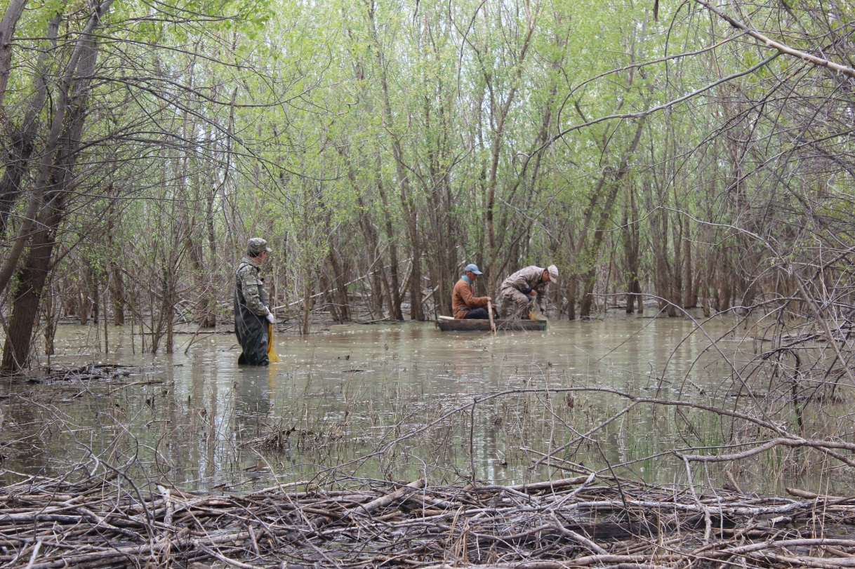

Figure 14 - Catching carp spawners using fixed nets

Biological analysis of spawners in 2020 revealed significant heterogeneity of broodstock in terms of size and age composition (Table 2).

Table 2 - Biological characteristics of female carp in the spawning campaign in 2020
No. | Parameters of spawners | Female carp
1 | Number of fish, n | 15
2 | Age of fish | 6+ - 9+
3 | Weight Р, kg | 1.44-2.65
4 | Length L, cm | 46.86±3.12
5 | Length l, cm | 39.14±4.18
6 | Body height H, cm | 13.70±2.45
7 | Body fatness coefficient C_{f} _{(F)} | 1.63
8 | Working fertility, thousand units | 118.64±45.25
9 | Relative working fertility, thousand units | 70.619

Table 2 shows that the age of spawners ranges from 6+ to 9+. Weight (P) from 1.44 kg to 2.65 kg. Average absolute length (L), cm - 46.86 ± 3.12, Smith length (l), cm - 39.14±4.18. Maximum body height (H), cm - 13.70 ± 2.45. Body condition coefficient C_{f} _{(F)} - 1.63. Working fertility, thousand units - 118.64 ± 45.25. Relative working fertility, thousand units - 70.619.
An important indicator allowing to assess the physiological state of carp spawners is blood composition indicators. It has been proven that the level of hemoglobin in the blood of females is interrelated with working fertility, fatness and the diameter of ovulated eggs.
Blood samples were taken from each age class of carp breeders to study the composition (Table 3).

Table 3 - Summary data of morphological and biochemical parameters of blood of carp spawners
Indicators (n=4) | Values
Indicators (n=4) | X̅ ± m_{x̅} | σ | Сv, %
Hemoglobin, g/L | 89±22 | 22.65 | 24.85
Protein, g/L | 20.4±6,85 | 8.58 | 42.38
Glucose, mmol/L | 2.44±0.19 | 0.22 | 9.35
Cholesterol, mmol/L | 2.25±0.12 | 0.11 | 5.45
Triglyceride, mmol/L | 1.04±0.55 | 0.72 | 68.56
Note: X ± x - mean value and average linear deviation, σ - standard deviation, Cv - coefficient of variation

The data in Table 3 show that the concentration of hemoglobin is high and averaged 89 g/L, the concentration of protein (20.4 g/L), cholesterol (2.25 mmol/L) and triglyceride (1.04 mmol/L) were in average level, this indicates that the spawners have approached spawning in optimal condition. Thus, it was found that carp spawners correspond to healthy spawners in terms of the morphological and biochemical composition of blood.
The fish-breeding and biological characteristics of carp breeders for the study period from 2018 to 2020 are shown in Table 4.

Table 4 - Fish-breeding and biological characteristics of spawners (females) of common carp of the Ural-Caspian population
Parameters of spawners | Female carp
Parameters of spawners | 2018 | 2019 | 2020
1 | 2 | 3 | 4
Number of fish, n | 20 | 19 | 25
Age of fish | 5 - 8 | 6 - 12 | 6+ - 9+
Weight Р, kg | 3.86±0.28 | 7.1±1.62 | 1.68
Length L, cm | 66.4±2.16 | 79.15±3.41 | 46.86±3.12
Length l, cm | 59.5±6.42 | 70.35±3.15 | 39.14±4.18
Body fatness coefficient C_{f} _{(F)} | 1.83 | 2.03 | 1.63
Working fertility, thousand units | 325.62±76.55 | 521.30±64.38 | 118.64±45.25
Relative working fertility, thousand units | 84.35 | 73.42 | 70.61

The data in Table 4 show that the spawning stock of carp consists mainly of breeders aged 5 to 12 years. As a result of the analysis of the spawning herd for the entire period of research, it was established that the sex ratio at the beginning of the course - in favor of males at the end - is dominated by females. In the weight ratio, females are larger than males. Body condition ranged from 1.5 to 2.13 on average. The smallest average producer weight was recorded in 2020 at 1.68 kg, which is 4.2 times less than the average producer size in 2019.
One of the important fish breeding indicators is the relative working fertility. A comparative, high relative working fecundity is observed in the spawners of 2018, with an average weight of 3.86 kg, the relative working fertility was 84.35 thousand pieces, which is 19.45% more than in 2020. If we summarize the data for all years of observation, the average relative working fertility is 76.12 thousand.
The age composition of the spawning herd of broodstock varies from year to year, and in different years the main age composition of the broodstock varies. The spawning herd of carp consists of breeders aged 5 to 12 years, the sex ratio is 1:1.5 in favor of males. The average Fulton body fatness coefficient of spawners is 1.83.

3.5 Stimulating the maturation of reproductive products in spawners with the use of synthetic and pituitary drugs

After preparatory work, the female carp were divided into 3 groups. The first group was injected with the drug "Nerestin-6A" gradually in the ratio 20:80. A preliminary and permissive injection was carried out to females, with an interval of 12 hours. The total dose of the drug on the recommendation was 0.25 ml/kg of female weight. The second group was injected with the pituitary gland of carp in the ratio 20:80, the total dose of the drug was 3 mg/kg. Accordingly, as in the first group, a preliminary and permissive injection was carried out to females, with an interval of 12 hours. The third group was injected in combination at a ratio of 20:80, preliminary injection was performed with Nerestin-6A at a dosage of 0.25 ml/kg, allowing injection was performed by the carp pituitary gland in an amount of 3 mg/kg.
The males were injected with the carp pituitary gland at a dosage of 2 mg / kg once during the second injection to the females. The development of male reproductive products is more uniform, the volume of ejaculate varied depending on age and weight within 4-8 ml (Figure 15).
The caviar was strained in the shade, out of direct sunlight. The resulting ovulated unfertilized caviar in the course of visual assessment has the following features: color - yellow, consistency - thick (Figure 16).
The results of this experiment are shown in Table 5.
The first batch of caviar was received from an individual of group II, the caviar was fluid, it was visually visible that the caviar was overripe. Within 2 hours, the remaining individuals of the II - group gave up eggs. Analysis of the results of the experiment for group III showed that at the scheduled time 80% of the females gave up eggs and the quality of the eggs was visually good, only one female (20%) gave up eggs after the injection after 26 hours. The delay did not affect the quality of the caviar. The results of group I show that the majority of females gave up eggs with a delay, one female did not respond to the injection and did not give up eggs.
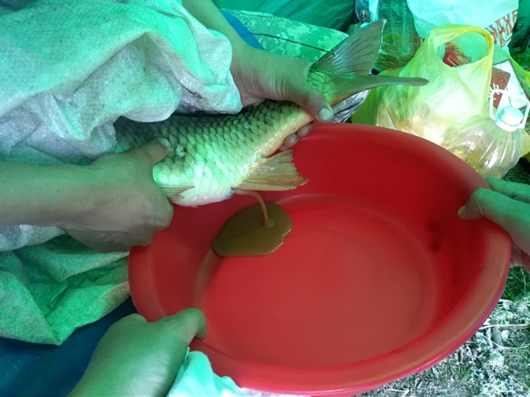
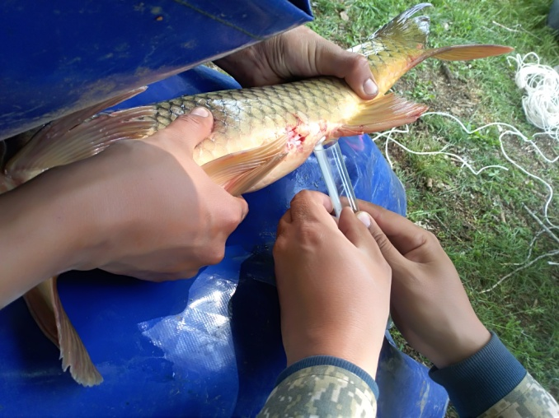
Figure 15 - Taking sperm from the male Figure 16 - Straining the eggs from the female

Table 5 - The results of obtaining eggs of female carp using various stimulation schemes
№ | Group name | n | Fish weight, kg (average) | Working fertility, thousand pieces | Relative working fertility, thousand units | The number of mature females,%
 |  |  |  |  |  | from 20 to 24 hours | from 24 to 27 hours | Females that have not spawned
1 | I-group | 5 | 3.45±0.210 | 65.7±7.5 | 228.85±23.4 | 20 | 60 | 20
2 | II-group | 5 | 3.85±0.155 | 69.4±5.3 | 268.25±18.3 | 100 | - | -
3 | III-group | 5 | 3.55±0.180 | 73.4±4.9 | 262.65±14.6 | 80 | 20 | -

Thus, females of groups II and III showed good results, that is, with the use of the pituitary gland and with the combined use of “Nerestin-6A” and the pituitary gland. In terms of the quality of eggs and working fecundity, the results of group III (“Neretin-6A” and the pituitary gland) compared with group II were higher in terms of working fertility by 5.7%.

3.6 Study of the optimal methods of insemination and de-gluing of eggs during artificial reproduction in a mobile hatchery

In fish farming practice, several methods of insemination are used, among which the main ones are distinguished: wet, semi-dry and dry methods. Each insemination method is applied to specific fish species.
With the wet method, at the beginning, water is added to the resulting eggs, then sperm is introduced and inseminated. In particular, the wet method is used for insemination of the African Clary catfish [40].
With the semi-dry method, the obtained sperm is pre-diluted with water, as a result, the resulting mixture is mixed with eggs for subsequent insemination. The most common semi-dry method. In studies conducted on spawners of sturgeon fish species [41]. Two-stroke insemination of sturgeon eggs is also used [42].
The dry method is most suitable for spawners of salmonids, carp fish, since in these species of fish spermatozoa after activation by water lose their activity. Therefore, during insemination by the dry method, sperm is added to the resulting eggs and mixed, and then water is added [27, 43].
When carrying out insemination of eggs of indigenous commercial fish in the field using a mobile hatchery, a dry method was used, in which sperm of several males was added to the eggs obtained from female carp and mixed with smooth movements of the hands, then water was added, thereby completing the fertilization process. We also used a semi-dry method, as well as two-stroke insemination, in which, after 50-60 seconds, the eggs are re-inseminated. The results of the percentage of fertilization of carp eggs are presented in Table 6.

Table 6 - The results of the percentage of fertilization of carp eggs when inseminated by several methods
Name | Insemination method
Name | Dry | Semi-dry | Two-stroke
Fertilization percentage of carp eggs,% | 75 | 65 | 70

From table 6, it can be seen that the most effective dry insemination method. With artificial reproduction in a mobile hatchery, the percentage of fertilization of carp eggs by the dry method was 75%, two-stroke insemination -70%, semi-dry - 65%.
The fertilized eggs were de-glued with skim milk and an aqueous talcum suspension in the Weiss apparatus. De-gluing time was 40 to 50 minutes as a result of intensive bubbling. Then the caviar was strained and washed with water. As a result of a comparative analysis of the de-gluing agent, it was determined that the two methods are effective in de-gluing fertilized eggs. Debonding of fertilized eggs with skim milk occurs due to the formation of droplets of fat “capsule” that prevents the eggs from sticking together. When talc is used, fertilized caviar is mixed in the water column with talc particles and, due to the formation of a talc layer on the surface of the fertilized eggs, the process of de-sticking occurs. Thus, the two de-bonding methods are effective, but when used in the field, it is most practical to use talcum powder for long distance transport.
De-glued eggs were incubated in a mobile incubator in the flasks of the Weiss apparatus; the average incubation period before the larvae emerged from the shell was 2-3 days. The results of the conducted studies of the effect of the temperature regime of fertilized eggs on the duration of the release of prelarvae are presented in Table 7.

Table 7 - The results of the effect of water temperature during incubation of fertilized eggs on the timing of the release of prelarvae
Name | Water temperature, ^{о}С | Time from the moment of fertilization of eggs, hour
Prelarvae release | 18-20 | 68-84
Prelarvae release | 22-24 | 56-72

Thus, as a result of the studies carried out, it was determined that there is a direct dependence of the time of release of carp prelarvae on the water temperature during incubation in the flasks of the Weiss apparatus. At water temperature values ​​in the range of 18-20° C, the prelarvae emergence was observed 68-84 hours after fertilization of the eggs, at water temperatures of 22-24° C, the prelarvae emergence time noticeably decreases to 56-72 hours from the moment of fertilization compared to the temperature regime 18-20° C. On average, the difference in prelarvae emergence time between the presented temperature regimes was 12 hours.
During incubation, optimal conditions were created in the incubation apparatus of the mobile hatchery, the dissolved oxygen in the water was maintained in the aisles of 8-9 mg/L, the temperature was 21-22° С.Thus, negative factors that could slow down or lead to to the death of carp embryos during the incubation period.

3.7 Biotechnology for rearing and feeding juveniles of native commercial fish in a mobile hatchery

After hatching of the larvae, most of them were released into their natural habitat, the rest of the larvae were transported in special plastic bags to a fish-breeding complex equipped with a recirculation system. The larvae were kept for 12 days in the recirculating water basins and fed with live food Artemia salina. Under optimal conditions, the larvae reached a mass of 28-30 mg in 10-12 days. Having reached such a mass, the larvae are resistant to predatory invertebrates, they are able to consume all forms of zooplankton, including cyclops.
The grown juvenile carp under recirculation conditions weighing 27-30 mg for further rearing was stocked with fish in ponds, some were left for the formation of replacement broodstock under recirculation conditions (Figure 17). The planting density was 50-60 thousand pcs/ha.

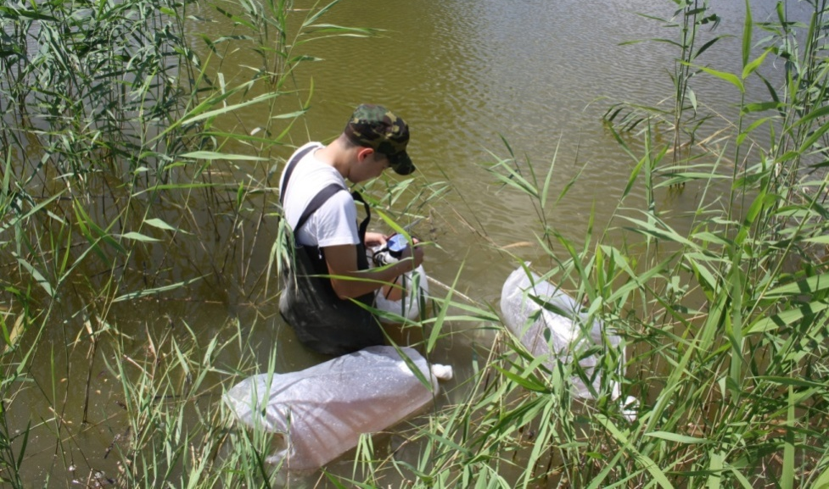
Figure 17 - Stocking of the pond with young carp

During the growing period during the growing season, control fishing was carried out every 10-15 days, tracking the dynamics of growth and development of juveniles. According to the data of control catches, it was found that the fatness coefficient of juveniles in September was 2.2, in October 2.4, this indicates that the juveniles were actively feeding during the growing season.
Thus, on the basis of the research results, it can be concluded that the fish stock obtained with the use of a mobile hatchery is viable and characterized by a high survival rate. With the use of this fish stock, the carp breeding stock is formed under controlled conditions (RAS).
In autumn, the reared juveniles in the ponds were released into their natural habitat in the reservoirs of FE “Aya-T”, the act of stocking is attached (Appendix G).
CONCLUSION

Based on the research results, a mobile hatchery was constructed on the basis of a car trailer, which makes it possible to effectively replenish stocks of indigenous commercial fish in natural reservoirs and maintain the ecological balance of reservoirs.
In accordance with the developed technological block diagram of a mobile hatchery based on a car trailer, the possibilities of locating the hatchery directly near the reservoir are expanded, which eliminates the cost of transporting caught fish to the laboratory for artificial reproduction.
When incubating eggs by using the developed incubation devices, alternative energy sources are used, such as the energy of moving water.
As a result of the analysis of the spawning herd for the entire period of research, it was found that the sex ratio at the beginning of the course - in favor of males at the end - is dominated by females, in the weight ratio, females are larger than males. Body condition ranged from 1.5 to 2.13 on average. The smallest average producer weight was recorded in 2020 at 1.68 kg, which is 4.2 times less than the average producer size in 2019.
According to the results of biochemical studies of the blood of fish spawners, it was determined that the concentration of hemoglobin is high and averaged 89 g/L, the concentration of protein (20.4 g/L), cholesterol (2.25 mmol/L) and triglyceride (1.04 mmol/L) were at an average level, this indicates that the spawners approached spawning in optimal condition.
According to the results of the carried out hydrochemical analysis of water samples from the surface and deep layers in the locations of natural spawning grounds and mass feeding, it was found that, according to the pH value, the studied water samples were assessed as neutral, according to the degree of mineralization, fresh. Deviations from the MPC of the main water parameters for fishery reservoirs were revealed. According to the results of hydrochemical analysis, it is worth noting a decrease in the pH level to 5.3, an increase in turbidity and permanganate oxidizability by 22.1-25.3% and 52.3-65.4%, respectively.
The results of a comparative analysis of various schemes for stimulating the reproductive products of fish breeders showed good results in females of groups II and III. That is, with the use of the pituitary gland and with the combined use of “Nerestin-6A” and the pituitary gland. In terms of the quality of eggs and working fecundity, the results of group III (“Neretin-6A” and the pituitary gland) compared with group II were higher in terms of working fertility by 5.7%.
According to the results of a comparative analysis of methods of insemination of eggs of cyprinids, the most effective method is the dry method for artificial reproduction in a mobile hatchery. Fertilization of carp eggs with dry insemination was 75%, two-stroke - 70%, semi-dry - 65%.
As a result of artificial reproduction, most of the larvae were released into their natural habitat, the rest were transported to a fish breeding complex equipped with a recirculating water system. The larvae were kept for 12 days in the basins of the RAS, fed with live food Artemia salina. Under optimal conditions, the larvae reached a mass of 28-30 mg in 10-12 days.
The reared juvenile carp under recirculation conditions weighing 27-30 mg was stocked in ponds for further rearing. The planting density was 50-60 thousand pcs/ha.

LIST OF USED SOURCES
1 Kulikov E.V., Isbekov K.B., Asylbekova S.Zh. Finding the coefficients of removal for fish populations that have reached the critical values of the biomass of the commercial stock // Issues of fishing. - 2016. - No. 17 (3). - P. 368-373. (In Russ.)
2 Villéger S. Functional ecology of fish: current approaches and future challenges // Aquat Sci. – 2017. – No.79. – P. 783-801. (In Eng.)
3 Rudenko G.P. Issues of fishing regulation on the example of pike perch Sander lucioperca from the southern part of Lake Ladoga // Issues of fishery. - 2018. - No. 19 (2). - P. 226-237. (In Russ.)
4 Kulikov E.V., Isbekov K.B., Asylbekova S.Zh. Development of fishing effort standards for the regulation of fishing in water bodies of Kazakhstan // Issues of fishing. - 2019. - No. 20 (2). - P. 206-215. (In Russ.)
5 Tumenov A.N., Sariev B.T., Bakiyev S.S. Results of spring monitoring of fish fauna and fish productivity of the Donglek reservoir // Science and Education. - 2019. - No. 3 (56). - P. 197-202. (In Russ.)
6 Kuanysheva G.A., Kanbetov A.Sh., Sokolsky A.F. Study of the current state of the ichthyofauna of the Caspian Sea // Eurasian Union of Scientists. - 2015. - No. 7-6 (16). - P. 114-117. (In Russ.)
7 Kim A.I., Asylbekova S.Zh., Kadimov E.L. Research of natural reproduction of fish of the Ural River in the West Kazakhstan region of the Republic of Kazakhstan // Bulletin of the Astrakhan State Technical University. Series: Fisheries. - 2018. - No. 4. - P. 39-45. (In Russ.)
8 Tumenov A.N. The current state of natural reproduction and prospects of artificial reproduction of European carp of the Urals-Caspian population in the middle reaches of the Ural River // Ecology, Environment and Conservation Journal Papers. –2019. – No. 4. – P. 1865-1870. (In Eng.)
9 Bukola D. Consequences of Anthropogenic Activities on Fish and the Aquatic Environment // Poult Fish Wildl Sci. – 2015. – No. 138. – P. 1-12. (In Eng.)
10 Aghilinejhad S.M. What are the drivers of the occurrence of illegal fishing and conservation barriers of sturgeons in the Caspian Sea // Aquatic Conservation-marine and Freshwater Ecosystems. – 2018. – No. 28. – P. 690-701. (In Eng.)
11 Assylbekova S. Evaluation of the habitat state of the Zhaiyk River ichthyofauna in modern conditions and its influence on the impacts of anthropogenic factors // Eurasian Journal of Biosciences. – 2020. – No. 1. – P. 467-473. (In Eng.)
12 Krainyuk V.N., Asylbekova S.Zh. Linear-weight ratios in pike Esox lucius L., 1758 (Esocidae) from the reservoirs of the K. Satpayeva // Bulletin of the Astrakhan State Technical University. Series: Fisheries. - 2015. - No. 3. - P. 33-43. (In Russ.)
13 Barneche D. Fish reproductive-energy output increases disproportionately with body size // Science. – 2018. – No. 360. – P. 642-645. (In Eng.)
14 McBride R. Energy Acquisition and Allocation to Egg Production in Relation to Fish Reproductive Strategies // Fish and fisheries. – 2015. – No. 16. – P. 23-57. (In Eng.)
15 Van Overzee H.M.J., Rijnsdorp A.D. Effects of fishing during the spawning period: implications for sustainable management // Rev Fish Biol Fisheries. – 2015. – No. 25. – P. 65-83. (In Eng.)
16 Badryzlova N.S., Fedorov E.V., Koishybaeva S.K., Asylbekova S.Zh. Domestication of individuals of different ages, obtaining offspring and rearing underyearlings of zander in the fish farm of the Almaty region of Kazakhstan // Bulletin of the Astrakhan State Technical University. Series: Fisheries. - 2018. - No. 3. - P. 78-88. (In Russ.)
17 Levashina N.V., Ivanov V.P. Fertility of bream (Abramis bramа Linnaeus, 1758) of the Volga delta // Bulletin of the Astrakhan State Technical University. Series: Fisheries. - 2018. - No. 2. - P. 49-61. (In Russ.)
18 Fisenko S.V., Bochkovar A.S., Startsev A.V. Evaluation of the commercial catch of fish of the cyprinid family (Cyprinidae) in the Azov-Don basin // Young researcher of the Don. - 2016. - No. 2. - P. 72-77. (In Russ.)
19 Burlachenko I.V., Yakhontova I.V. Fish-breeding technologies in artificial reproduction: current state, problems, solutions // Proceedings of VNIRO. - 2015. - No. 153. - P. 137-153. (In Russ.)
20 Khodorevskaya R.P., Nekrasova S.O. Current state and prospects of reproduction of aquatic biological resources for industrial aquaculture in the Astrakhan region // Bulletin of the Astrakhan state technical university. Series: Fisheries. - 2019. - No. 3. - P. 107-116. (In Russ.)
21 Zalepukhin V.V. Diverse quality of cyprinid fish spawners and its role in the formation of biological resources // Bulletin of the Astrakhan State Technical University. - 2008. - No. 3. - P. 39-42. (In Russ.)
22 Zalepukhin V.V. Reproductive variability of cyprinids grown in different ecological conditions of the Lower Volga // Bulletin of the Astrakhan State Technical University. - 2006. - No. 3. - P. 52-58. (In Russ.)
23 Isbekov K.B., Kulikov E.V., Asylbekova S.Zh. To the question of stocking the reservoirs of Kazakhstan with high-quality fish planting material of valuable fish species // Bulletin of the Astrakhan State Technical University. Series: Fisheries. - 2018. - No. 2. - P. 7-14. (In Russ.)
24 Tumenov A.N. Artificial reproduction of indigenous commercial fish in the field by means of a mobile incubator // International scientific research journal. - 2018. - No. 10-1 (76). - P.91-96. (In Russ.)
25 Shapovalov M.E., Koroleva V.P. Spawning time, fertility and reproductive capacity of some fish species of Lake Khanka // Izvestiya TINRO (Pacific Research Fisheries Center). - 2013. - No. 175. - P. 69-92. (In Russ.)
26 Gerbilsky N.L. The method of pituitary injections and its role in fish farming // Hormonal stimulation of the sexual cycle of fish in connection with the tasks of reproduction of fish stocks: Proceedings of VNIRO. - 1975. - Vol. 111. - P. 7-22. (In Russ.)
27 Bulavin E.F. Comparative fish-breeding biological characteristics of the development of eggs and larvae of common carp and carp during hatchery reproduction // Universum: chemistry and biology. - 2017. - No. 5 (35). - P. 4-8. (In Russ.)
28 Pravdin I.F. Manual for the Study of Fish (Mainly Freshwater) Fourth edition revised and enlarged. - M .: Food industry. - 1966 . - 372 p. (In Russ.)
29 Kozlov V.I., Abramovich L.S. A short dictionary of a fish breeder. - M .: Rosselkhozizdat, 1982. - 160 p. (In Russ.)
30 Zalepukhin V.V. Physiological and biochemical blood picture of cyprinids in the process of obtaining eggs after exogenous stimulation of maturation // Vestnik AGTU. - 2005. - No. 3 (26). - P. 104-111. (In Russ.)
31 Reimers N.F. Ecology. Theories, laws, rules, principles and hypotheses. - Moscow: Young Russia, 1994.- 367 p. (In Russ.)
32 Dgebaudze Yu.Yu. Ecological patterns of fish growth variability. - M .: Nauka. - 2001. - 276 p. (In Russ.)
33 Bogeruk A.K. Biotechnology in Aquaculture: Theory and Practice. - M.: FGNU “Rosinformagrotech”, 2006. - 232 p. (In Russ.)
34 Volkova A.Yu., Huobonen M.E. Artificial reproduction of fish. Guidelines. - Perm: PerGU. - 2014. - 37 p. (In Russ.)
35 Peterson D.L., Vecsei P., Jennings C.A. Ecology and biology of the lake sturgeon // A synthesis of current knowledge of a threatened North American Acipenseridae: Reviews in Fish Biology and Fisheries. – 2007. – No. 17. – P. 59-76. (In Eng.)
36 Sutherland, J.L. A portable freshwater closed-system fish egg incubation system / J.L. Sutherland, A. M. Bruce, W. K. Gregory, F. R. Edward, D. A. Jeffrey, M. Glen Black // North American Journal of Aquaculture. – 2014. – No. 76. – P. 391–398. (In Eng.)
37 Tumenov A.N., Sergaliyev N.Kh., Dzhaparov R.R., Shadyarov T.M., Sariev B.T. Mobile incubator for fish reproduction. Utility model patent of the Republic of Kazakhstan. - No. 4749. - 2020. (In Russ.)
38 Tumenov, A.N., Dzhaparov, R.R., Shadyarov, T.M., Sariev, B.T., Gabdullina, A.T. Device for incubating fish eggs. Utility model patent of the Republic of Kazakhstan. - No. 4633. - 2020. (In Russ.)
39 Tumenov A.N., Dzhaparov R.R., Shadyarov T.M., Sariev B.T., Apparatus for incubating fish eggs. Utility model patent of the Republic of Kazakhstan. - No. 4792. - 2020. (In Russ.)
40 Kareem Ajani O.K., Akintunde E., An M., Oduntan O. Effect of Different Fertilization and Egg De-adhesion Methods on Hatching and Survival of Clariasgariepinus (Burchell 1822) // Journal of Fisheries Sciences. – 2017. – No. 11. – P. 102-117. (In Eng.)
41 Matishov G.G., Matishov D.G., Ponomareva E.N., Sorokina M.N., Kazarnikova A.V., Kovalenko M.V. Fundamentals of sturgeon breeding in closed water supply conditions for farms. - Rostov-on-Don: YUNTs RAN. - 2008. - 112 p. (In Russ.)
42 Chebanov M.S., Galich, E.V. Manual for artificial reproduction of sturgeon fish. - Ankara: FAO. - 2013. - 325 p. (In Russ.)
43 Ponomarev S.V., Babak S.A. Experience of growing Pacific salmon: sockeye salmon and chinook salmon at the Malkinsky hatchery of the Kamchatka region // Bulletin of the Astrakhan state technical university. - 2007. - No. 1. - P.164-167. (In Russ.)

APPENDIX A
List of published works for 2018-2020

List of published works for 2018
Articles published in the near abroad:
1 Tumenov A.N., Sariev B.T., Dzhaparov R.R., Shadyarov T.M., Bakiev S.S. Artificial reproduction of indigenous commercial fish in the field by means of a mobile incubator // International scientific research journal. - Russian Federation, Yekaterinburg. - 2018. - No. 10 (76). - P. 91-97. (In Russ.)
Articles published in publications recognized by the Committee for Supervision and Attestation in Education and Science of the Ministry of Education and Science of the Republic of Kazakhstan:
1 Tumenov A.N., Sariev B.T., Gabdullina A.T., Shadyarov T.M. Experience of artificial reproduction of local fish through a mobile incubator // Science and Education. Zhangir khan ZKATU. Uralsk. - 2018. – No. 3 (52). - P 172-178. (In Kaz.)

List of published works for 2019
Articles published in non-CIS countries:
1 Tumenov A. N., Sariyev B. T., Shadyarov T. M., Gabdullina A. T., Bakiyev S. S. The Current State of Natural Reproduction and Prospects of Artificial Reproduction of European Carp of the Urals-Caspian Population in the Middle Reaches of the Ural River // Ecology, Environment and Conservation. - 2019. – No. 25 (4). – P. 1865-1870. Scopus CiteScore percentile 15. (In Eng.)
Articles published in publications recognized by the Committee for Supervision and Attestation in Education and Science of the Ministry of Education and Science of the Republic of Kazakhstan:
1 Tumenov A.N., Sariev B.T., Bakiyev S.S. Results of spring monitoring of fish fauna and fish productivity of the Donglek reservoir // Science and Education. Zhangir Khan WKATU. Uralsk. - 2019. - No. 3 (56). - P. 197-202. (In Russ.)
2 Dzhaparov R.R., Tumenov A.N., Shadyarov T.M., Bakiyev S.S. Research of the apparatus for incubation of fertilized eggs in natural conditions // Science and Education. Zhangir Khan WKATU. Uralsk. - 2019. - No. 3 (56). - P. 178-184. (In Russ.)

List of published works for 2020
Monograph, recommendations published in the RK:
1 Tumenov A.N., Dzhaparov R.R., Sariev B.T., Shadyarov T.M., Bakiyev S.S. Artificial reproduction of indigenous commercial fish species: monograph / - Uralsk: West Kazakhstan Agricultural and Technical University named after Zhangir Khan. - 2020. - 105 p. (In Russ.)
Articles published in the near abroad:
1 Tumenov A.N., Sariev B.T., Bakiyev S.S. Analysis of the spawning population of carp in the lower reaches of the Ural River within the boundaries of the West Kazakhstan region // Monthly scientific and practical journal “Fish farming”, publishing house “Selkhozizdat”. - 2020. - No. 6 (173). - P. 51-55. DOI: 10.33920 / sel-09-2006-06. (In Russ.)
Articles published in publications recognized by the Committee for Supervision and Attestation in Education and Science of the Ministry of Education and Science of the Republic of Kazakhstan:
1 Tumenov A.N., Dzhaparov R.R., Sariev B.T., Shadyarov T.M. Incubation apparatus for fish roe // Science and Education. Zhangir Khan WKATU. ISBN 2305-9397. Uralsk. - 2020. - No. 3-2 (60). - S. 126-130. (In Russ.)
2 Tumenov A.N., Dzhaparov R.R., Sariev B.T., Shadyarov T.M. Mobile incubator for fish reproduction // Science and Education. Zhangir Khan WKATU. ISBN 2305-9397. Uralsk. - 2020. - No. 3-2 (60). - P. 130-136. (In Russ.)
Inventive activity:
RK patents for utility model
1 Tumenov A.N., Sergaliev N.Kh., Dzhaparov R.R., Shadyarov T.M., Sariev B.T. “Mobile incubator for fish reproduction”. No. 4749 dated 03.03.2020. (In Russ.)
2 Tumenov A.N., Dzhaparov R.R., Shadyarov T.M., Sariev B.T., Gabdullina A.T. “Device for incubation of fish eggs”. No. 4633 dated 28.01.2020. (In Russ.)
3 Tumenov A.N., Dzhaparov R.R., Shadyarov T.M., Sariev B.T., Gabdullina A.T. “Apparatus for incubating fish eggs”. No. 4792 dated 03.17.2020. (In Russ.)

APPENDIX B
Work schedule
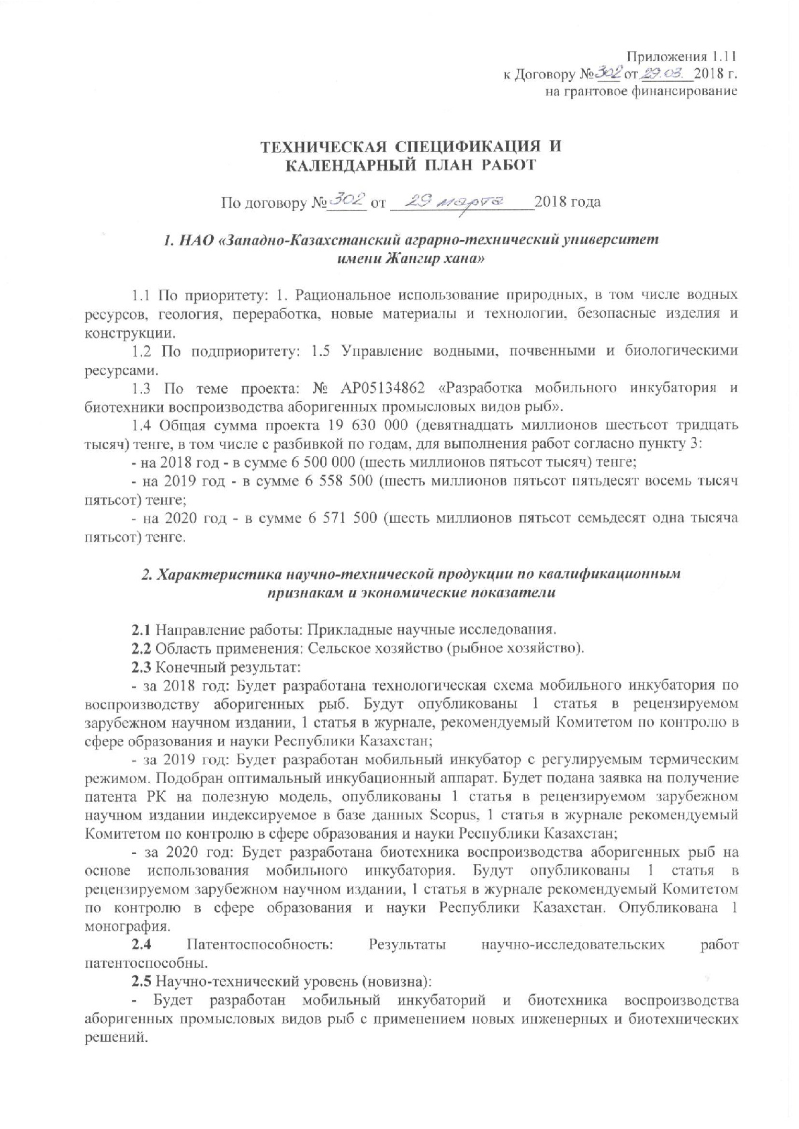
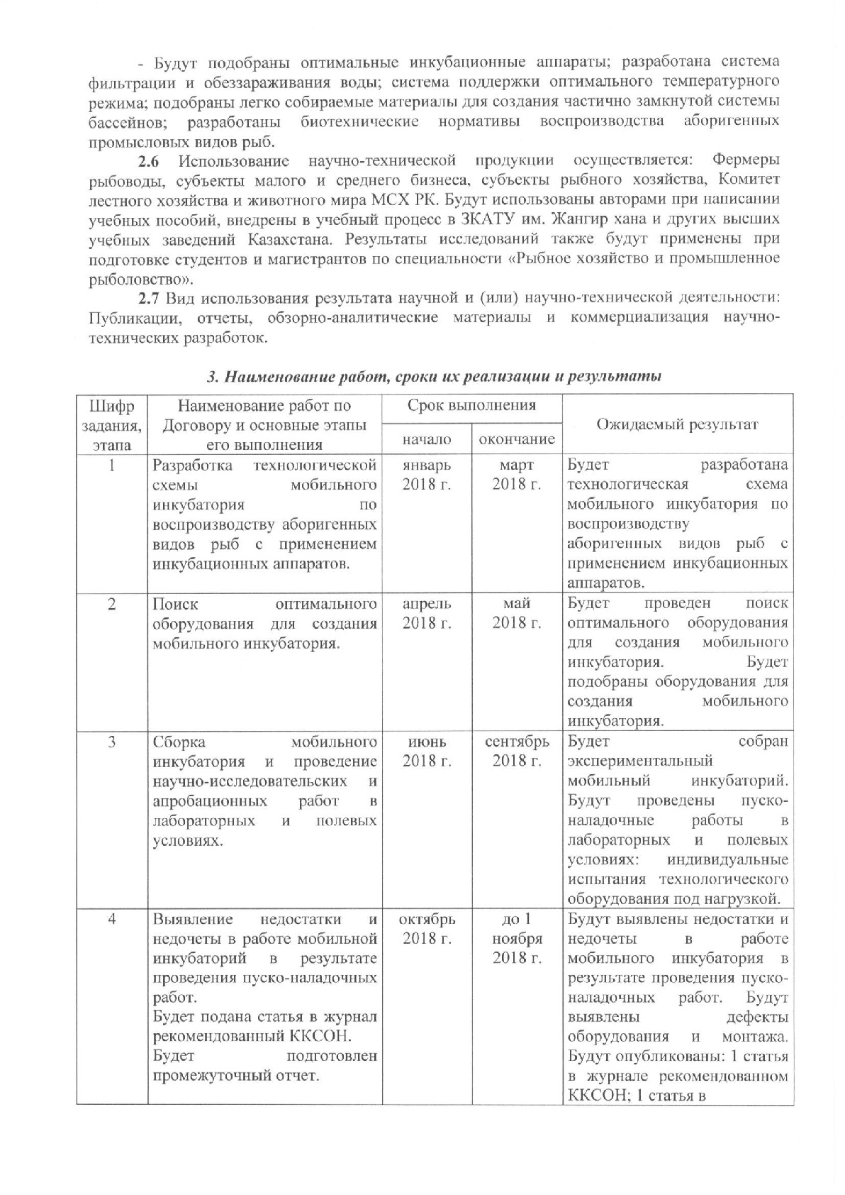

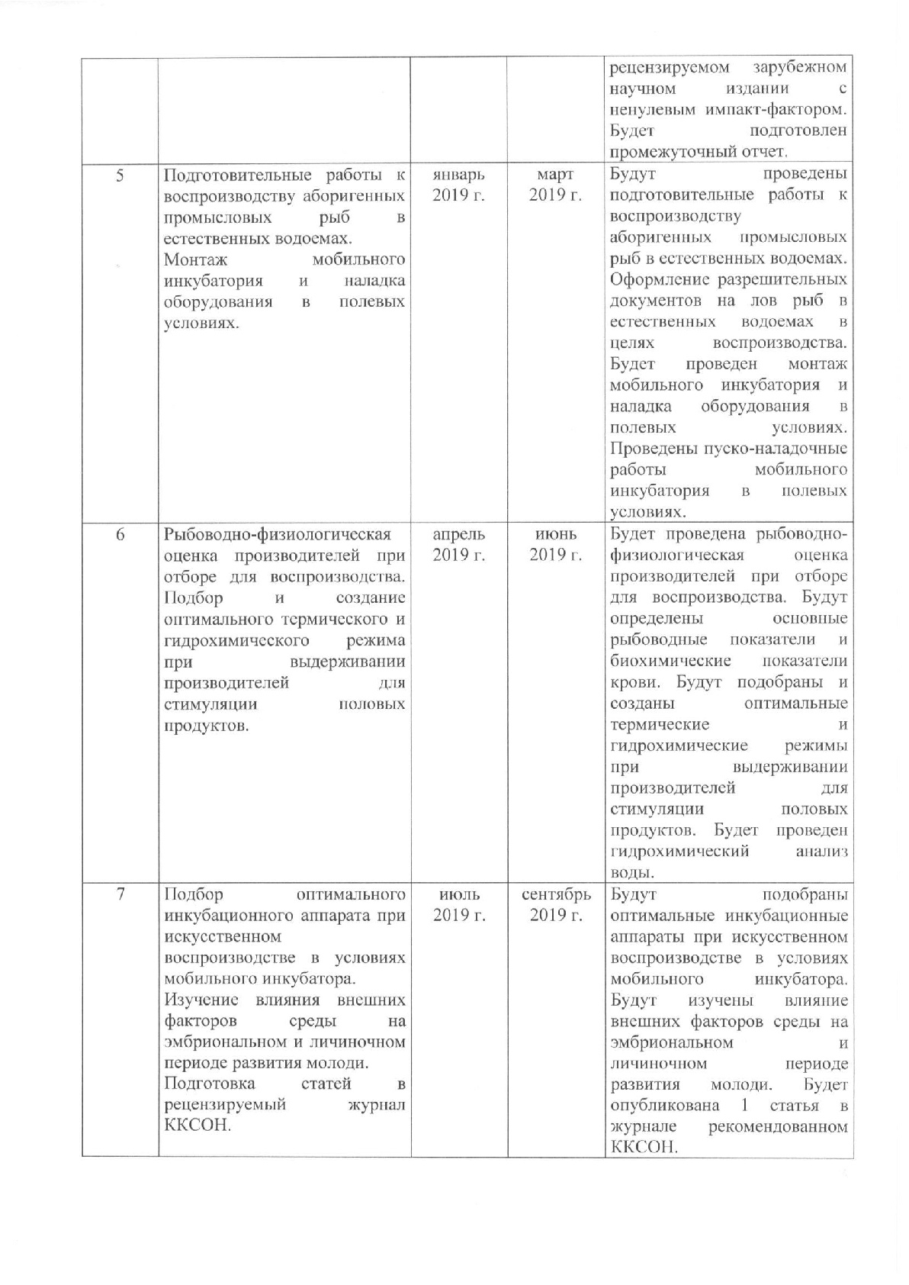

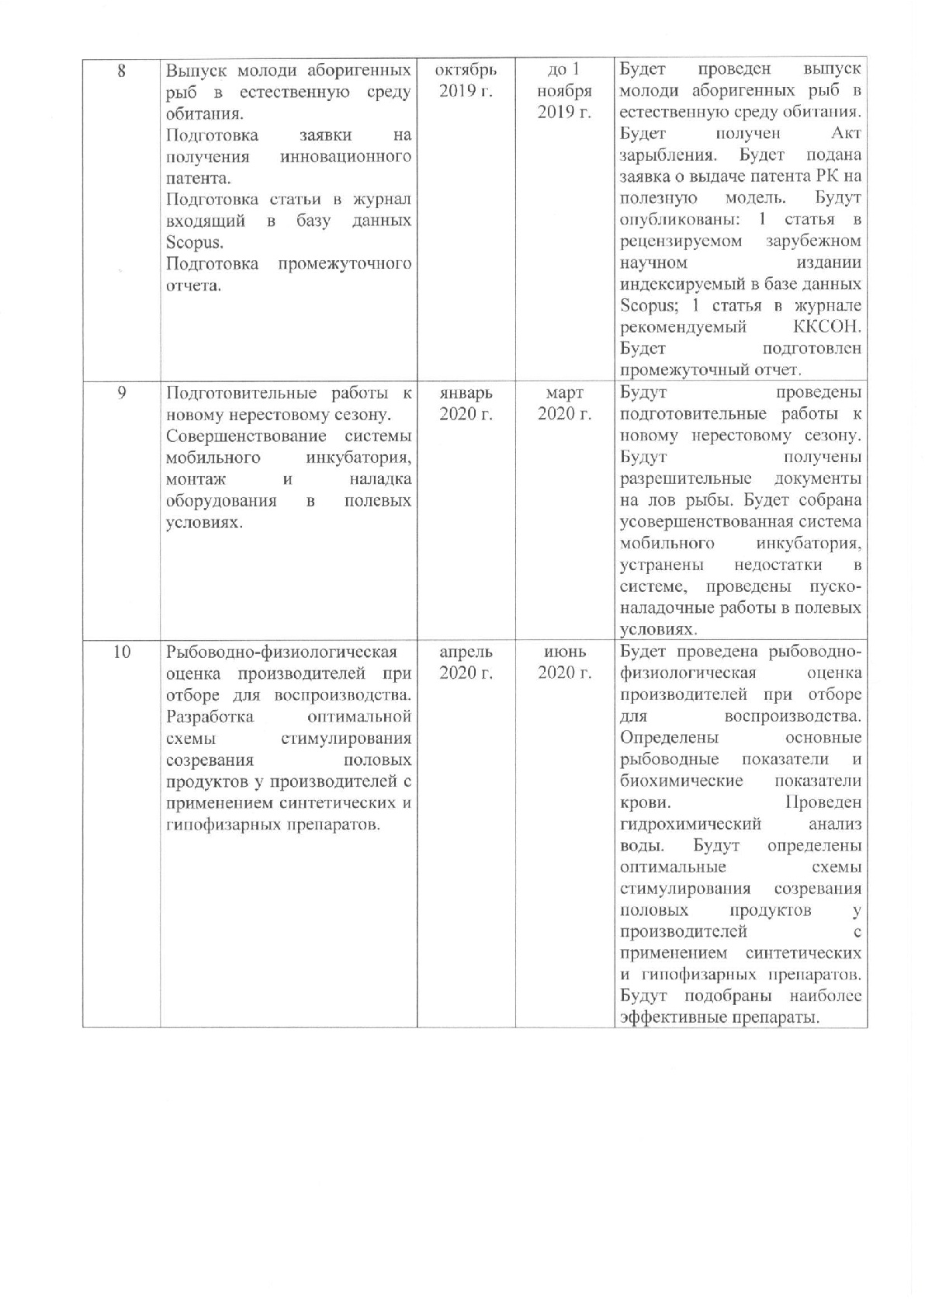

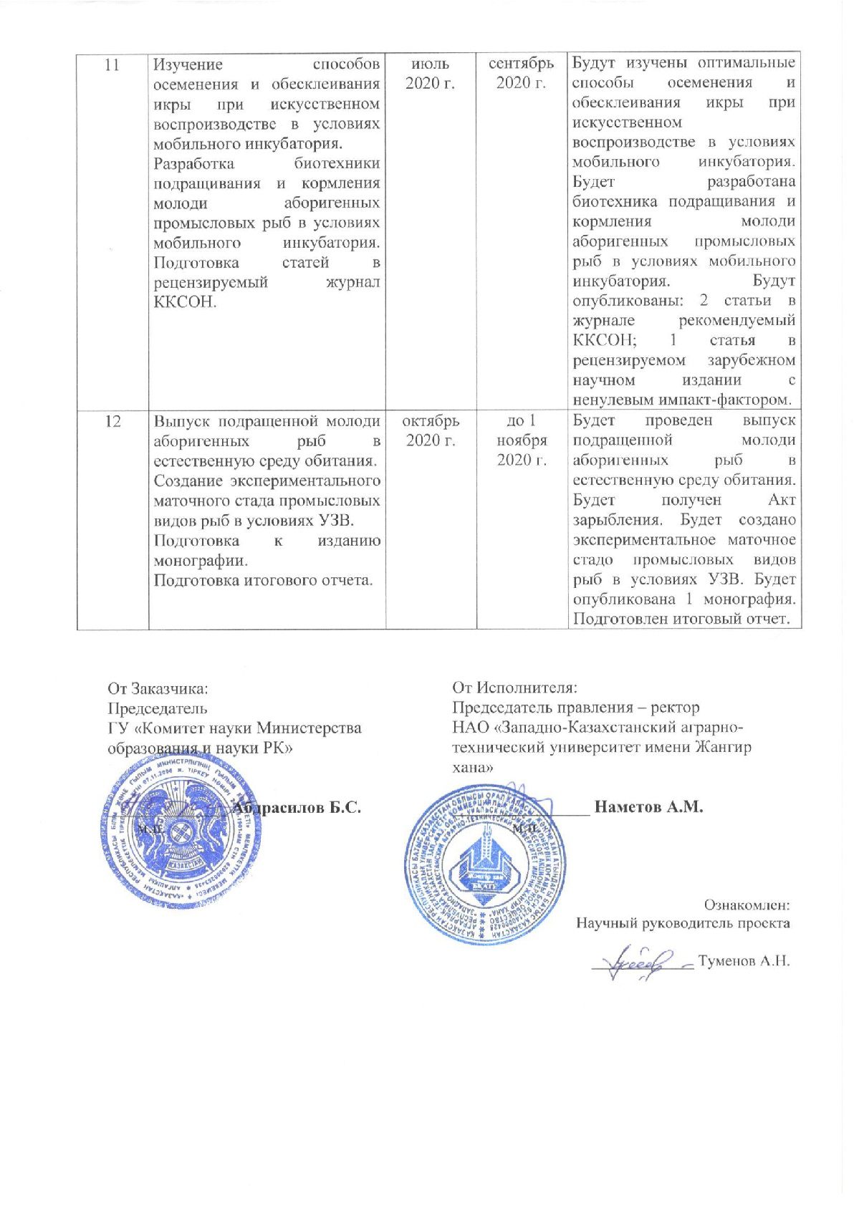
Appendices 1.11
to Agreement No. ___ dated _______2018
for grant funding

TECHNICAL SPECIFICATIONS AND
CALENDAR WORK PLAN

Under contract No. _____ dated __________________2018

1. NJSC “Zhangir Khan West Kazakhstan Agrarian-Technical University”

1.1 By priority: 1. Rational use of natural resources, including water resources, geology, processing, new materials and technologies, safe products and structures.
1.2 For sub-priority: 1.5 Management of water, soil and biological resources.
1.3 On the topic of the project: No. AP05134862 "Design of a portable hatchery and development of biotechnology for breeding of indigenous commercial fishery species".
1.4 The total amount of the project is 19 630 000 (nineteen million six hundred thirty thousand) tenge, including with a breakdown by years, for the performance of work in accordance with clause 3:
- for 2018 - in the amount of 6,500,000 (six million five hundred thousand) tenge;
- for 2019 - in the amount of 6,558,500 (six million five hundred fifty-eight thousand five hundred) tenge;
- for 2020 - in the amount of 6,571,500 (six million five hundred seventy-one thousand five hundred) tenge.

2. Characteristics of scientific and technical products by qualification characteristics and economic indicators

2.1 Direction of work: Applied research.
2.2 Scope: Agriculture (fisheries).
2.3 End result:
- for 2018: A technological scheme of a mobile hatchery for the reproduction of native fish will be developed. 1 article will be published in a peer-reviewed foreign scientific publication, 1 article in a journal recommended by the Committee for Control in Education and Science of the Republic of Kazakhstan;
- for 2019: A mobile incubator with controlled thermal regime will be developed. The optimal incubation apparatus has been selected. An application will be filed for a patent of the Republic of Kazakhstan for a utility model, 1 article in a peer-reviewed foreign scientific publication indexed in the Scopus database will be published, 1 article in a journal recommended by the Committee for Control in Education and Science of the Republic of Kazakhstan;
- for 2020: Biotechnology for the reproduction of native fish will be developed based on the use of a mobile hatchery. 1 article will be published in a peer-reviewed foreign scientific publication, 1 article in the journal recommended by the Committee for Control in Education and Science of the Republic of Kazakhstan. Published 1 monograph.
2.4 Patentability: The results of research projects are patentable.
2.5 Scientific and technical level (novelty):
- A mobile hatchery and biotechnology for the reproduction of indigenous commercial fish species will be developed using new engineering and biotechnical solutions.
- Optimal incubation devices will be selected; a water filtration and disinfection system has been developed; support system for optimal temperature conditions; selected easily assembled materials to create a partially closed pool system; biotechnical standards for the reproduction of indigenous commercial fish species have been developed.
2.6 The use of scientific and technical products is carried out by: Farmers, fish farmers, small and medium-sized businesses, fisheries, the Committee of the forestry and animal world of the Ministry of Agriculture of the Republic of Kazakhstan. They will be used by the authors when writing textbooks, introduced into the educational process at Zhangir Khan WKATU and other higher educational institutions of Kazakhstan. The research results will also be applied in the preparation of students and undergraduates in the specialty “Fish Industry and Industrial Fishing”.
2.7 Type of use of the result of scientific and (or) scientific and technical activities: Publications, reports, review and analytical materials and commercialization of scientific and technical developments.

3. Name of work, terms of their implementation and results
Job code, stage | Name of work under the Agreement and the main stages of its implementation | Period of execution |  | Expected Result
Job code, stage |  | Starting | Ending | Expected Result
1 | Development of a technological scheme for a mobile hatchery for the reproduction of aboriginal fish species using incubation devices. | January 2018 | March  2018 | A technological scheme of a mobile hatchery for the reproduction of native fish species using incubation devices will be developed.
2 | Finding the optimal equipment for creating a mobile hatchery. | April 2018 | May  2018 | The search for the optimal equipment for the creation of a mobile hatchery will be carried out. Equipment for the creation of a mobile hatchery will be selected.
3 | Assembling a mobile hatchery and conducting research and testing in laboratory and field conditions. | June  2018 | September 2018 | An experimental mobile hatchery will be assembled. Commissioning works will be carried out in laboratory and field conditions: individual tests of technological equipment under load.
4 | Identification of shortcomings and shortcomings in the work of the mobile hatchery as a result of commissioning.  An article will be submitted to the journal recommended by the Committee for the Control of Education and Science.  An interim report will be prepared. | October 2018 | until November 1, 2018 | Shortcomings and shortcomings in the operation of the mobile hatchery will be identified as a result of commissioning. Equipment and installation defects will be identified. Will be published: 1 article in the journal recommended by the Committee for the Control of Education and Science; 1 article in a peer-reviewed foreign scientific publication with a non-zero impact factor. An interim report will be prepared.
5 | Preparatory work for the reproduction of native commercial fish in natural reservoirs.  Installation of a mobile hatchery and adjustment of equipment in the field. | January 2019 | March  2019 | Preparatory work will be carried out for the reproduction of indigenous commercial fish in natural reservoirs.  Registration of permits for fishing in natural reservoirs for reproduction. The installation of a mobile hatchery and adjustment of equipment in the field will be carried out. Commissioning of the mobile hatchery was carried out in the field.
6 | Fish-breeding physiological assessment of spawners during selection for reproduction. Selection and creation of the optimal thermal and hydrochemical regime while keeping the spawners to stimulate the genital products. | April 2019 | June  2019 | Fish-breeding physiological assessment of spawners will be carried out during selection for reproduction. The main fish-breeding parameters and blood biochemical parameters will be determined. Optimal thermal and hydrochemical regimes will be selected and created while keeping spawners to stimulate sexual products. Hydrochemical analysis of water will be carried out.
7 | Selection of the optimal incubation apparatus for artificial reproduction in a mobile incubator.  Study of the influence of external environmental factors on the embryonic and larval period of juvenile development. Preparation of articles for the peer-reviewed journal of Committee for the Control of Education and Science. | July  2019 | September 2019 | The optimal incubation apparatus will be selected for artificial reproduction in a mobile incubator. The influence of external environmental factors on the embryonic and larval period of juvenile development will be studied. 1 article will be published in the journal recommended by Committee for the Control of Education and Science.
8 | Release of young aboriginal fish into their natural habitat.  Preparation of an application for an innovative patent.  Preparation of an article for a journal included in the Scopus database.  Preparation of interim report. | October 2019 | until November 1, 2019 | The release of young aboriginal fish into their natural habitat will be carried out. The Stocking Act will be received. An application will be filed for a patent of the RK for a utility model. Will be published: 1 article in a peer-reviewed foreign scientific journal indexed in the Scopus database; 1 article in the journal recommended by Committee for the Control of Education and Science.  An interim report will be prepared.
9 | Preparatory work for the new spawning season.  Improvement of the mobile hatchery system, installation and commissioning of equipment in the field. | January 2020 | March  2020 | Preparatory work will be carried out for the new spawning season. Permits for fishing will be obtained. An improved mobile hatchery system will be assembled, deficiencies in the system will be eliminated, and commissioning will be carried out in the field.
10 | Fish-breeding physiological assessment of spawners during selection for reproduction. Development of an optimal scheme for stimulating the maturation of reproductive products in manufacturers using synthetic and pituitary drugs. | April 2020 | June  2020 | Fish-breeding physiological assessment of spawners will be carried out during selection for reproduction. The main fish-breeding parameters and blood biochemical parameters were determined. Hydrochemical analysis of water was carried out. The optimal schemes for stimulating the maturation of reproductive products from manufacturers using synthetic and pituitary drugs will be determined. The most effective drugs will be selected.
11 | Study of methods of insemination and de-gluing of eggs during artificial reproduction in a mobile hatchery.  Development of biotechnology for rearing and feeding juveniles of indigenous commercial fish in a mobile hatchery. Preparation of articles for the peer-reviewed journal of Committee for the Control of Education and Science . | July  2020 | September 2020 | Optimal methods of insemination and de-adhesion of eggs during artificial reproduction in a mobile hatchery will be studied. A biotechnology will be developed for rearing and feeding juveniles of indigenous commercial fish in a mobile hatchery. Will be published: 2 articles in the journal recommended by Committee for the Control of Education and Science; 1 article in a peer-reviewed foreign scientific publication with a non-zero impact factor.
12 | Release of grown-up juveniles of native fish into their natural habitat.  Creation of an experimental broodstock of commercial fish species under RAS conditions.  Preparation for the publication of the monograph.  Preparation of the final report. | October 2020 | until November 1, 2020 | The release of grown-up fry of native fish into their natural habitat will be carried out. The Stocking Act will be received. An experimental broodstock of commercial fish species will be created under RAS conditions. 1 monograph will be published.  Final report prepared.

From customer:  The chairman  State Institution "Science Committee of the Ministry of Education and Science of the Republic of Kazakhstan"  ______________ Abdrasilov B.S.  LS | From the Contractor:  Chairman of the Management Board - Rector  NJSC " Zhangir Khan West Kazakhstan Agrarian and Technical University "  ________________ Nametov A.M.  LS  Familiarized with:  Scientific supervisor of the project  _____________ Tumenov A.N.

APPENDIX C
Decision of the Academic Council
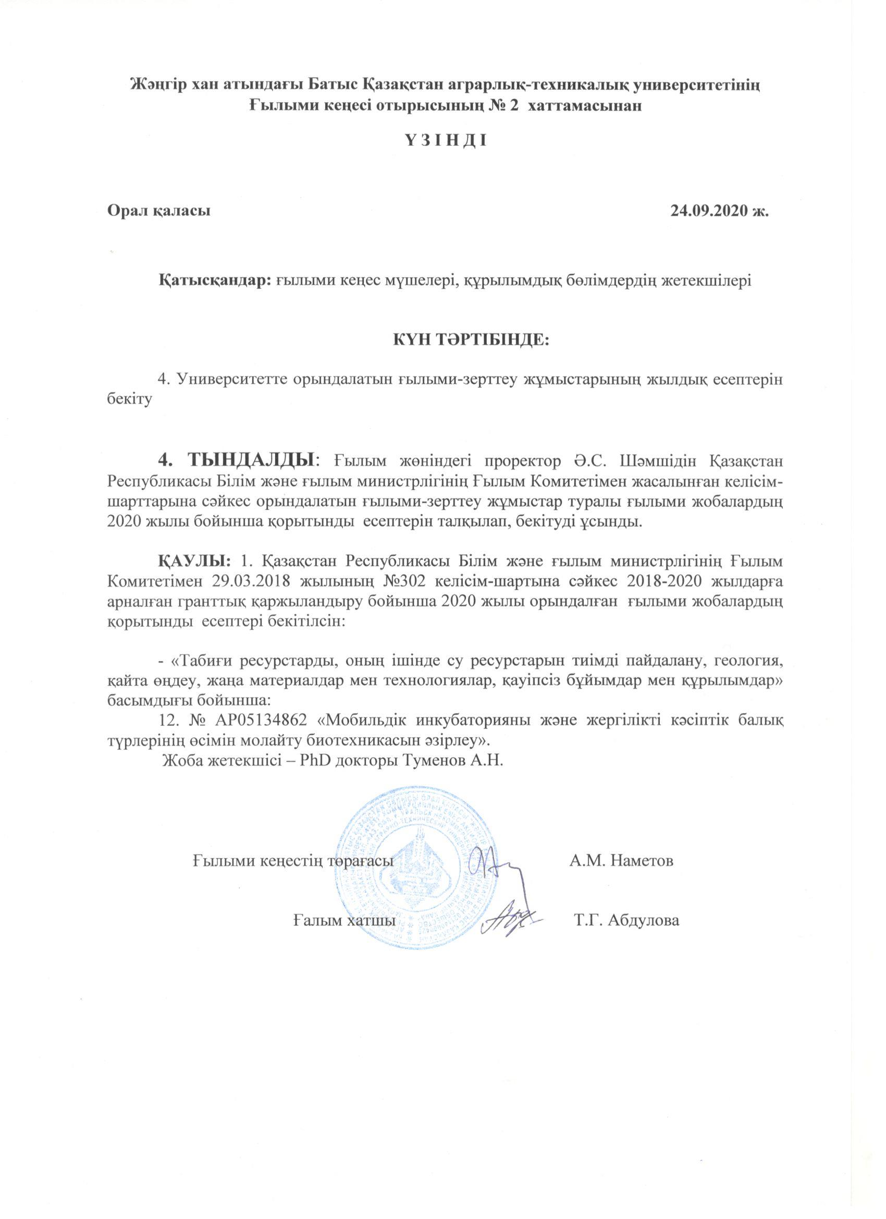
APPENDIX D
Reprints of publications
Tumenov A.N., Sariev B.T., Dzhaparov R.R., Shadyarov T.M., Bakiyev S.S. Artificial reproduction of indigenous commercial fish in the field by means of a mobile incubator // International scientific research journal. - Russian Federation, Yekaterinburg, 2018. - No. 10 (76). - P. 91-97. DOI: https://doi.org/10.23670/IRJ.2018.76.10.019. (In Russ.)
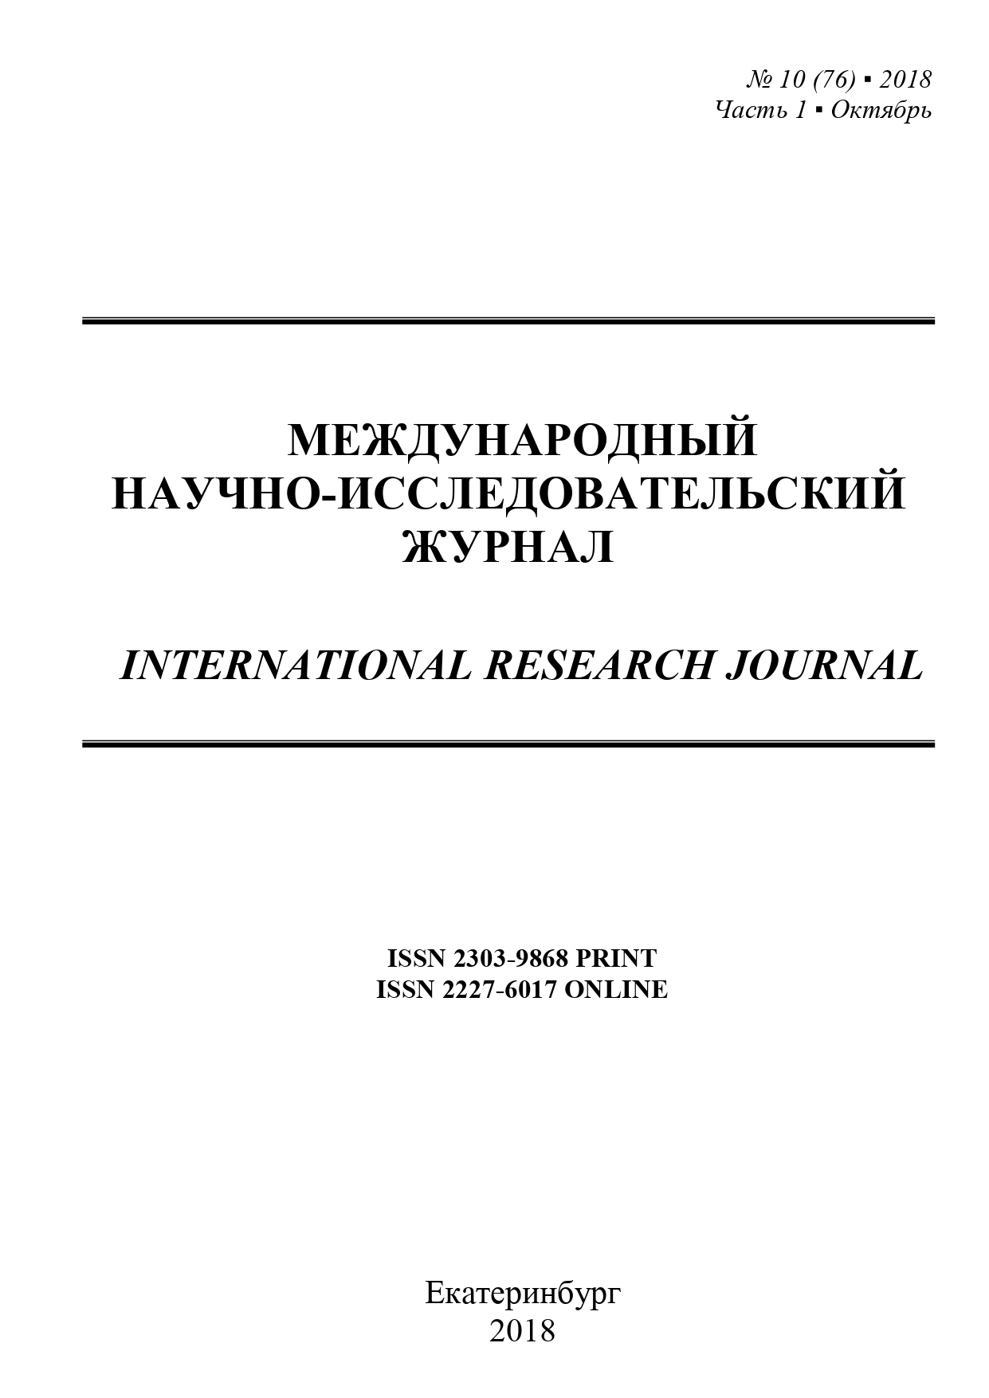
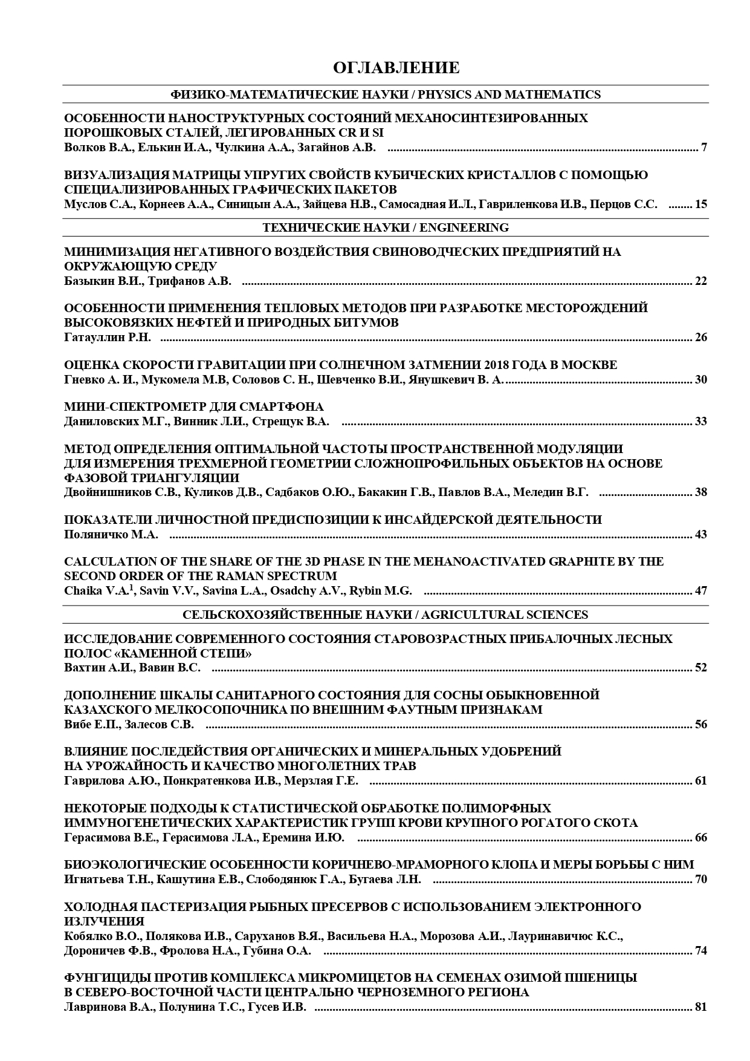



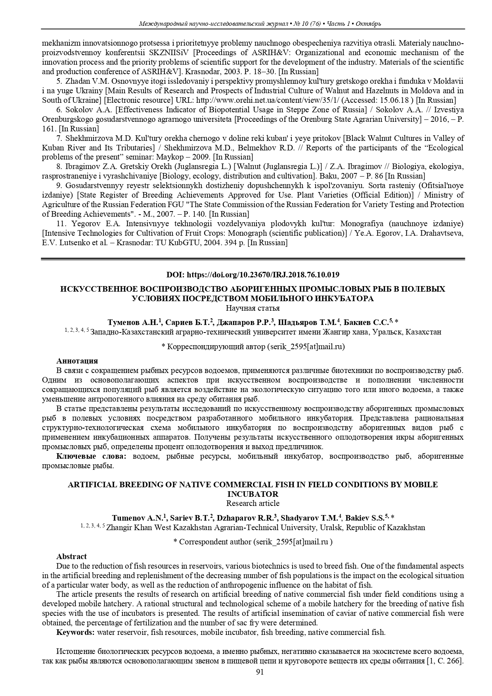

Tumenov AN, Sariev BT, Gabdullina AT, Shadyarov T.M. Experience of artificial reproduction of local fish through a mobile incubator // Science and Education. Zhangir khan ZKATU. Uralsk. - 2018. – No. 3 (52). – P. 172-178. http://nauka.wkau.kz/cache/Jurnal/2018/nomer-3/29.pdf. (In Kaz.)

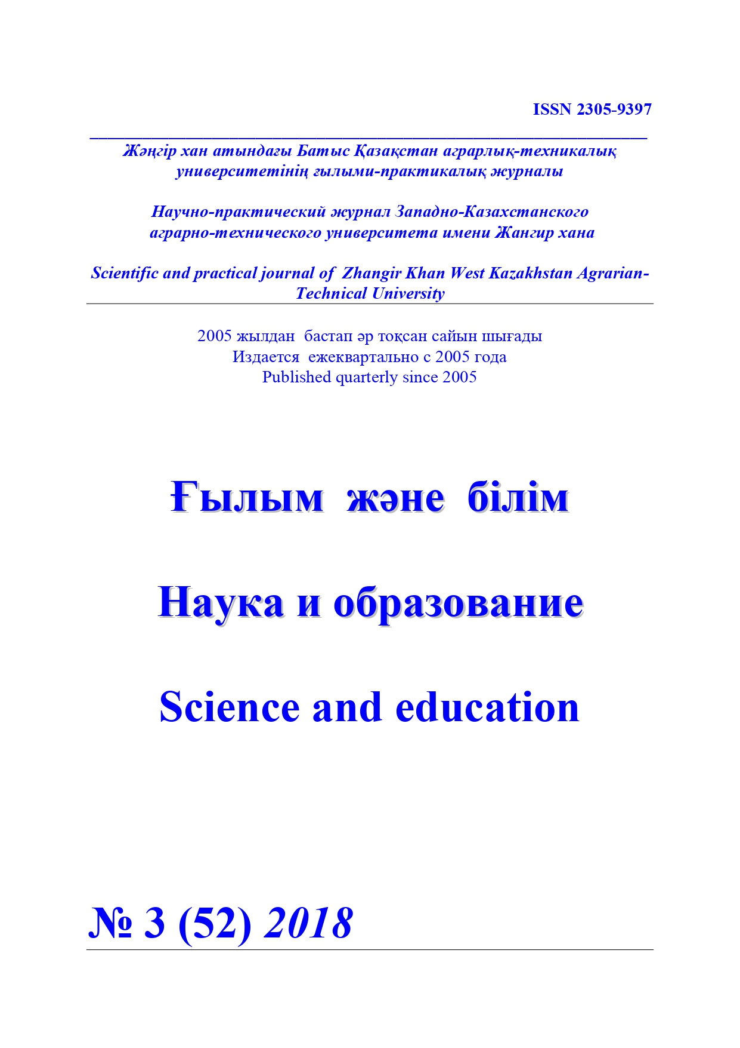

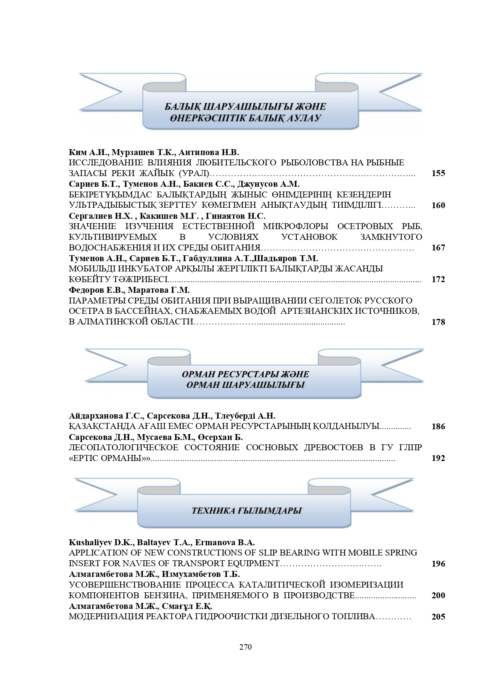

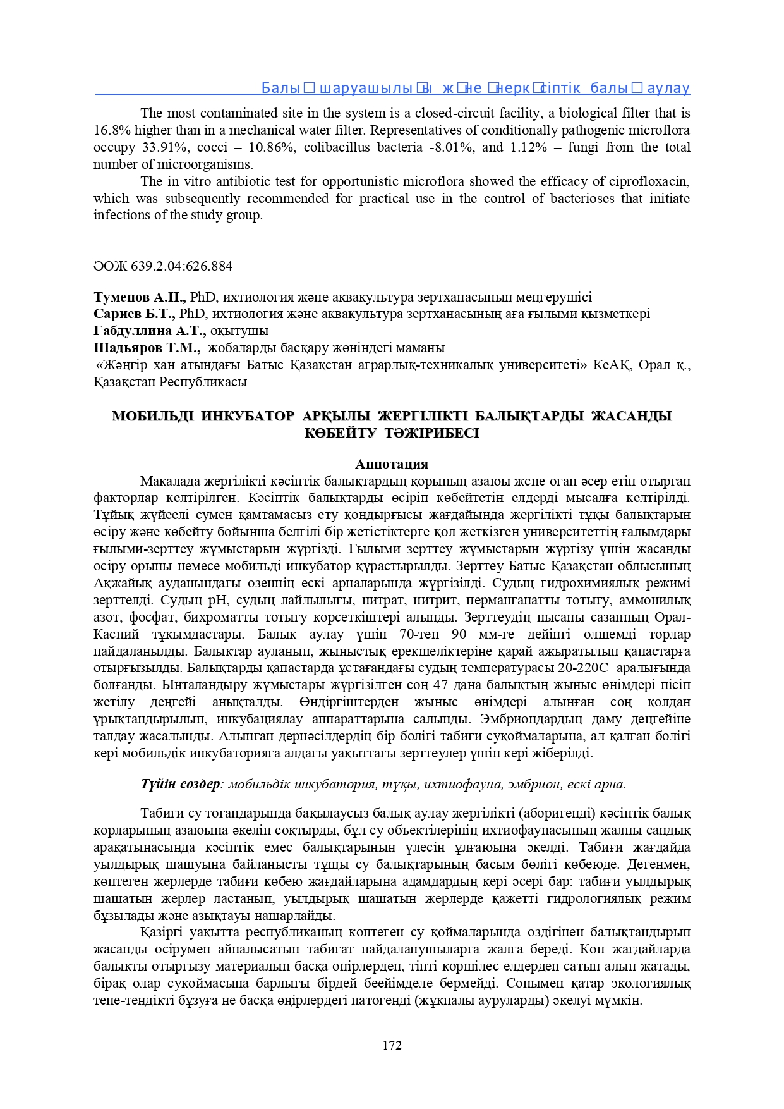
List of publications for 2019
Dzhaparov R.R., Tumenov A.N., Shadyarov T.M., Bakiyev S.S. Research of the apparatus for incubation of fertilized eggs in natural conditions // Science and Education. Zhangir khan ZKATU. Uralsk. - 2019. - No. 3 (56). - P. 178-184. http://nauka.wkau.kz/cache/Jurnal/2019/nomer-3/31.pdf. (In Russ.)
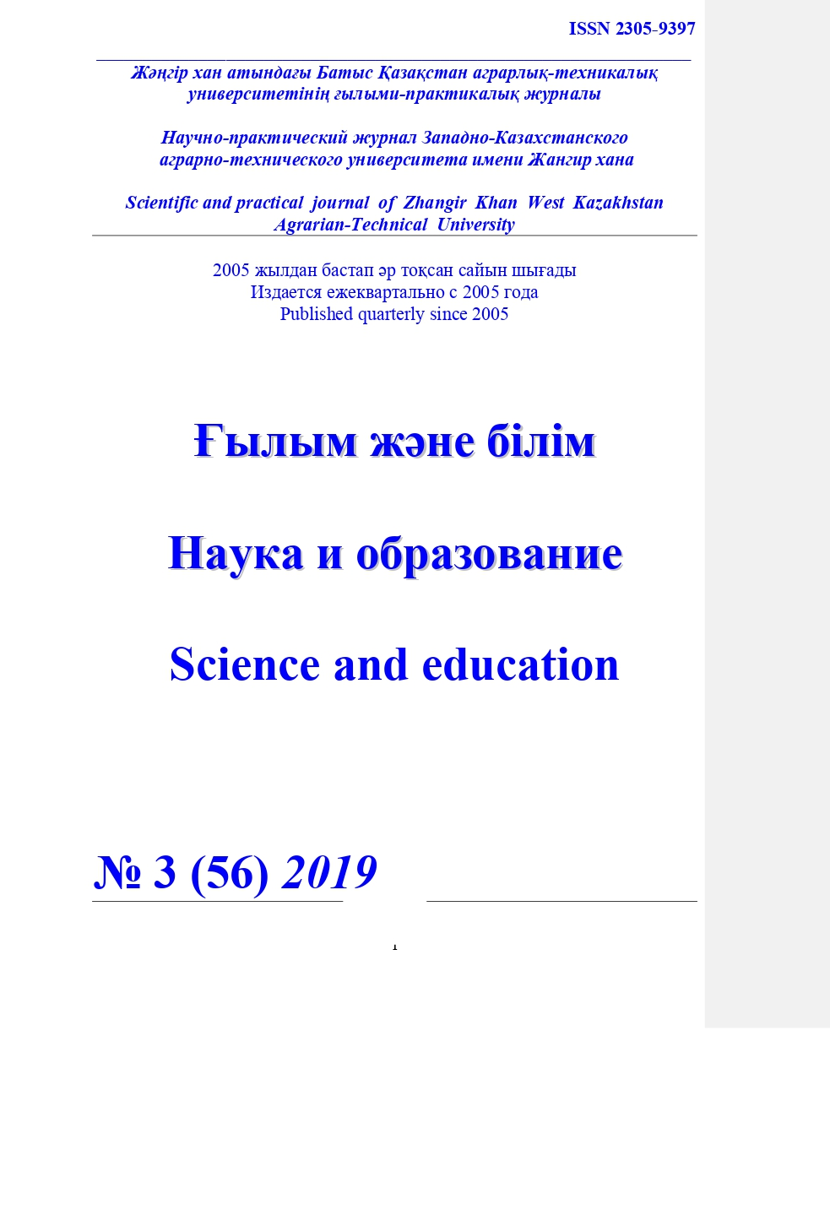
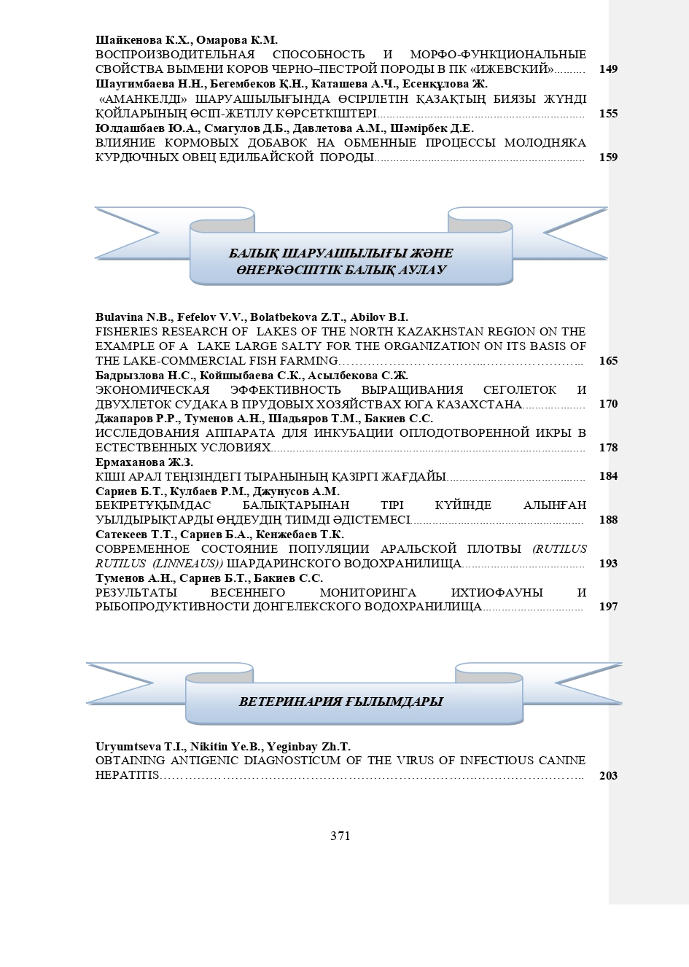
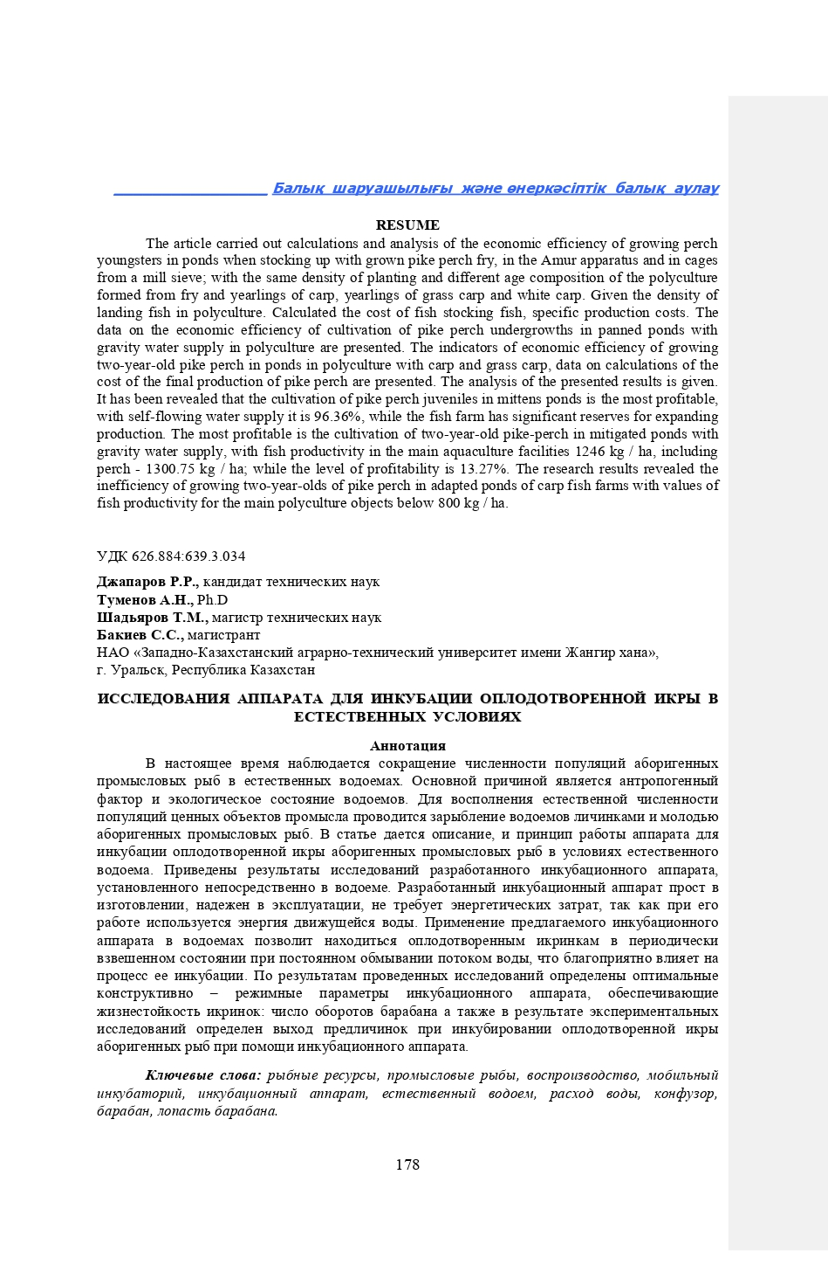
Tumenov A.N., Sariev B.T., Bakiyev S.S. Results of spring monitoring of ichthyofauna and fish productivity of the Dongelek reservoir // Science and Education. Zhangir khan ZKATU. Uralsk. - 2019. - No. 3 (56). - P. 197-202. http://nauka.wkau.kz/cache/Jurnal/2019/nomer-3/35.pdf. (In Russ.)

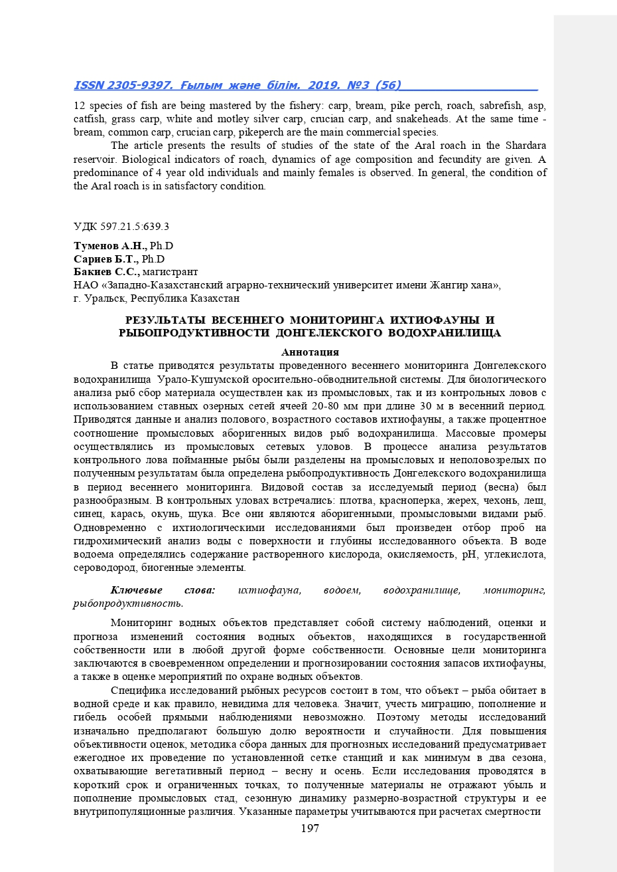

Tumenov A. N., Sariyev B. T., Shadyarov T. M., Gabdullina A. T., Bakiyev S. S. The Current State of Natural Reproduction and Prospects of Artificial Reproduction of European Carp of the Urals-Caspian Population in the Middle Reaches of the Ural River // Ecology, Environment and Conservation. - 2019. – No. 25 (4). – P. 1865-1870. http:// www.envirobiotechjournals.com/article_abstract.php?aid=10150&iid=287&jid=3. (In Eng.)

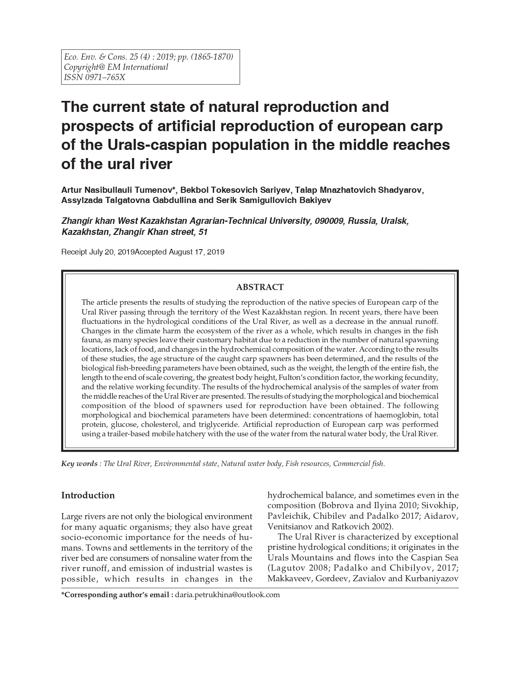

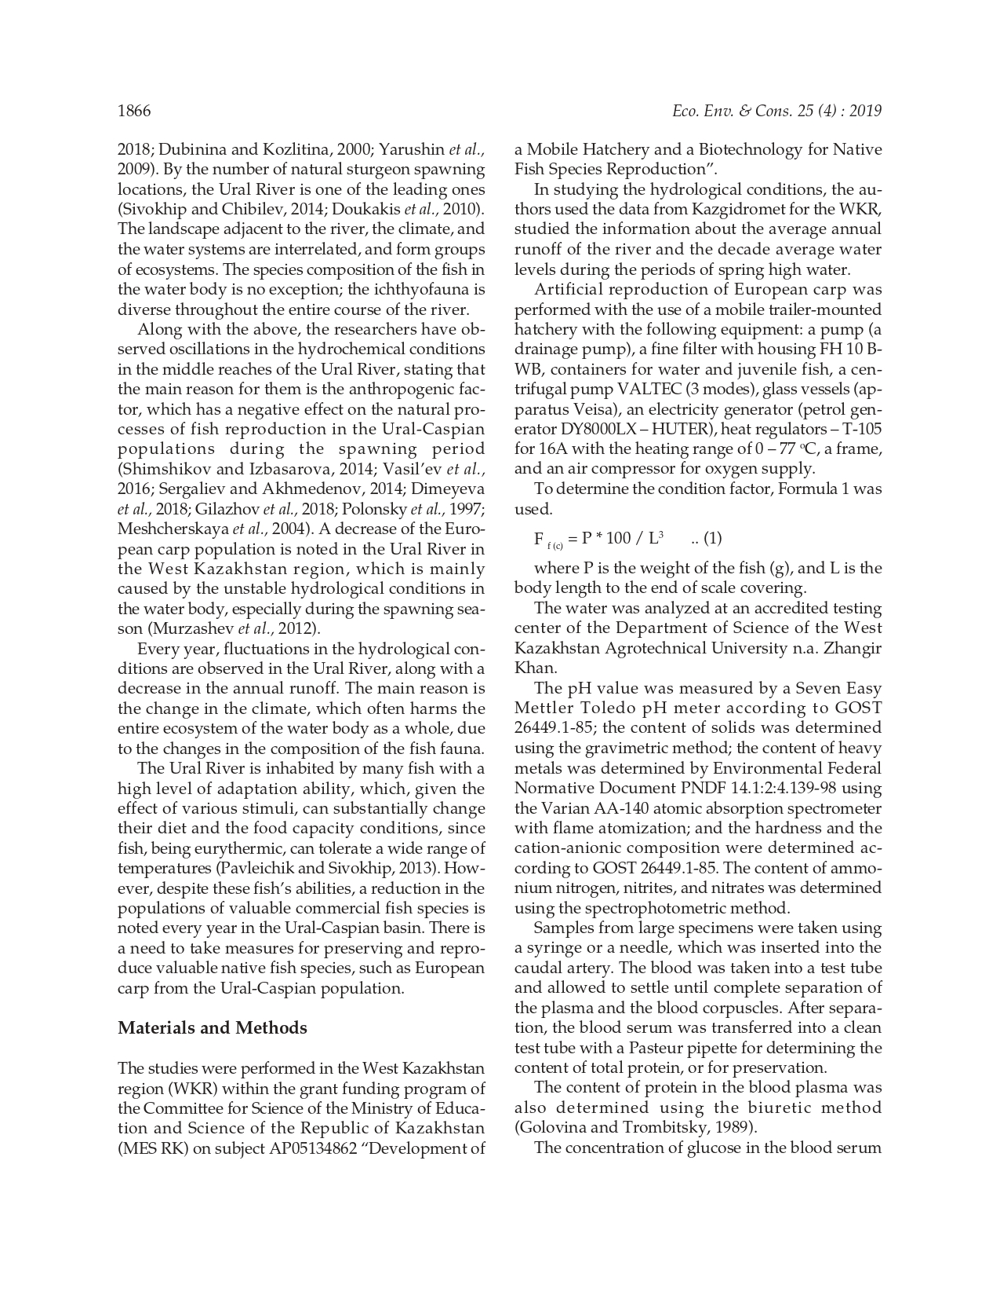

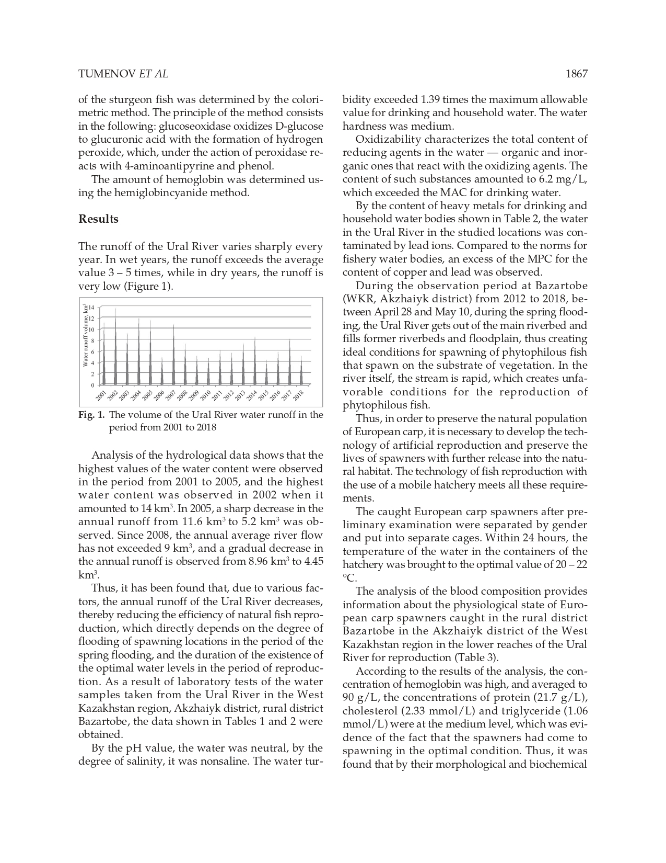

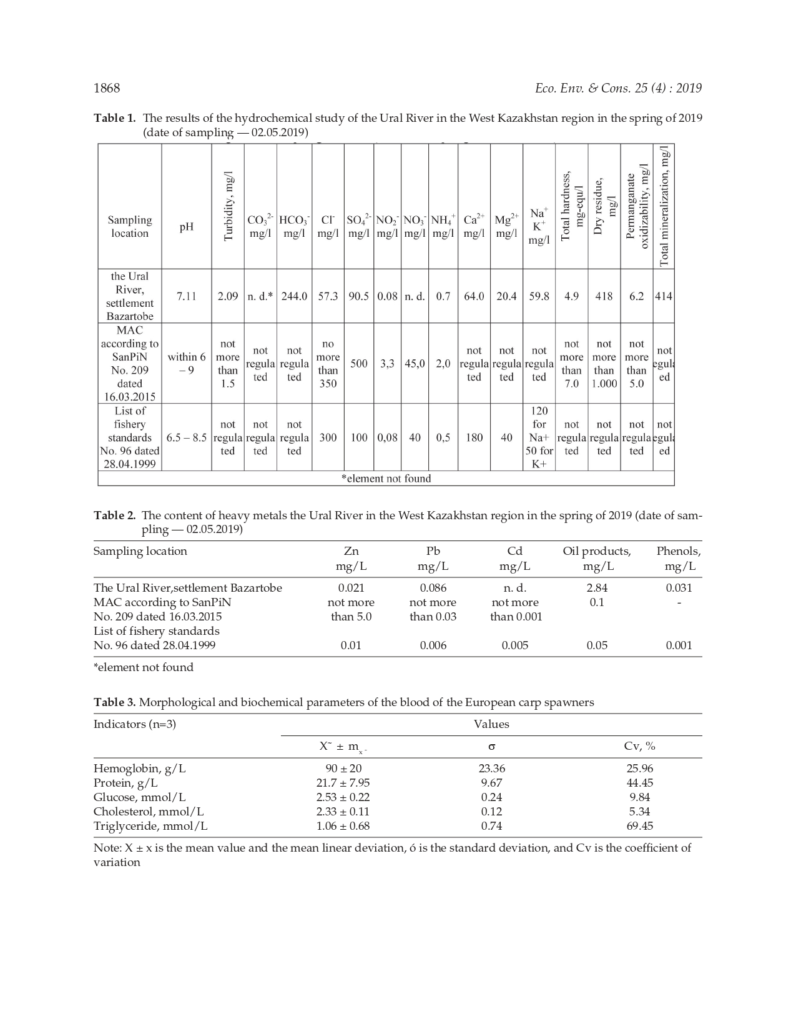

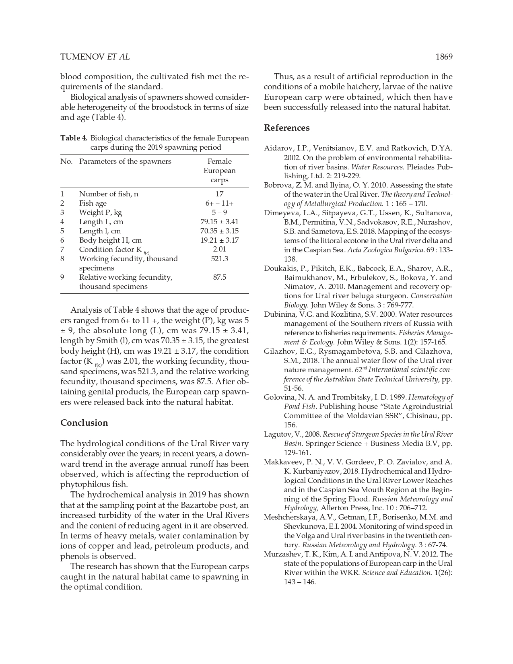

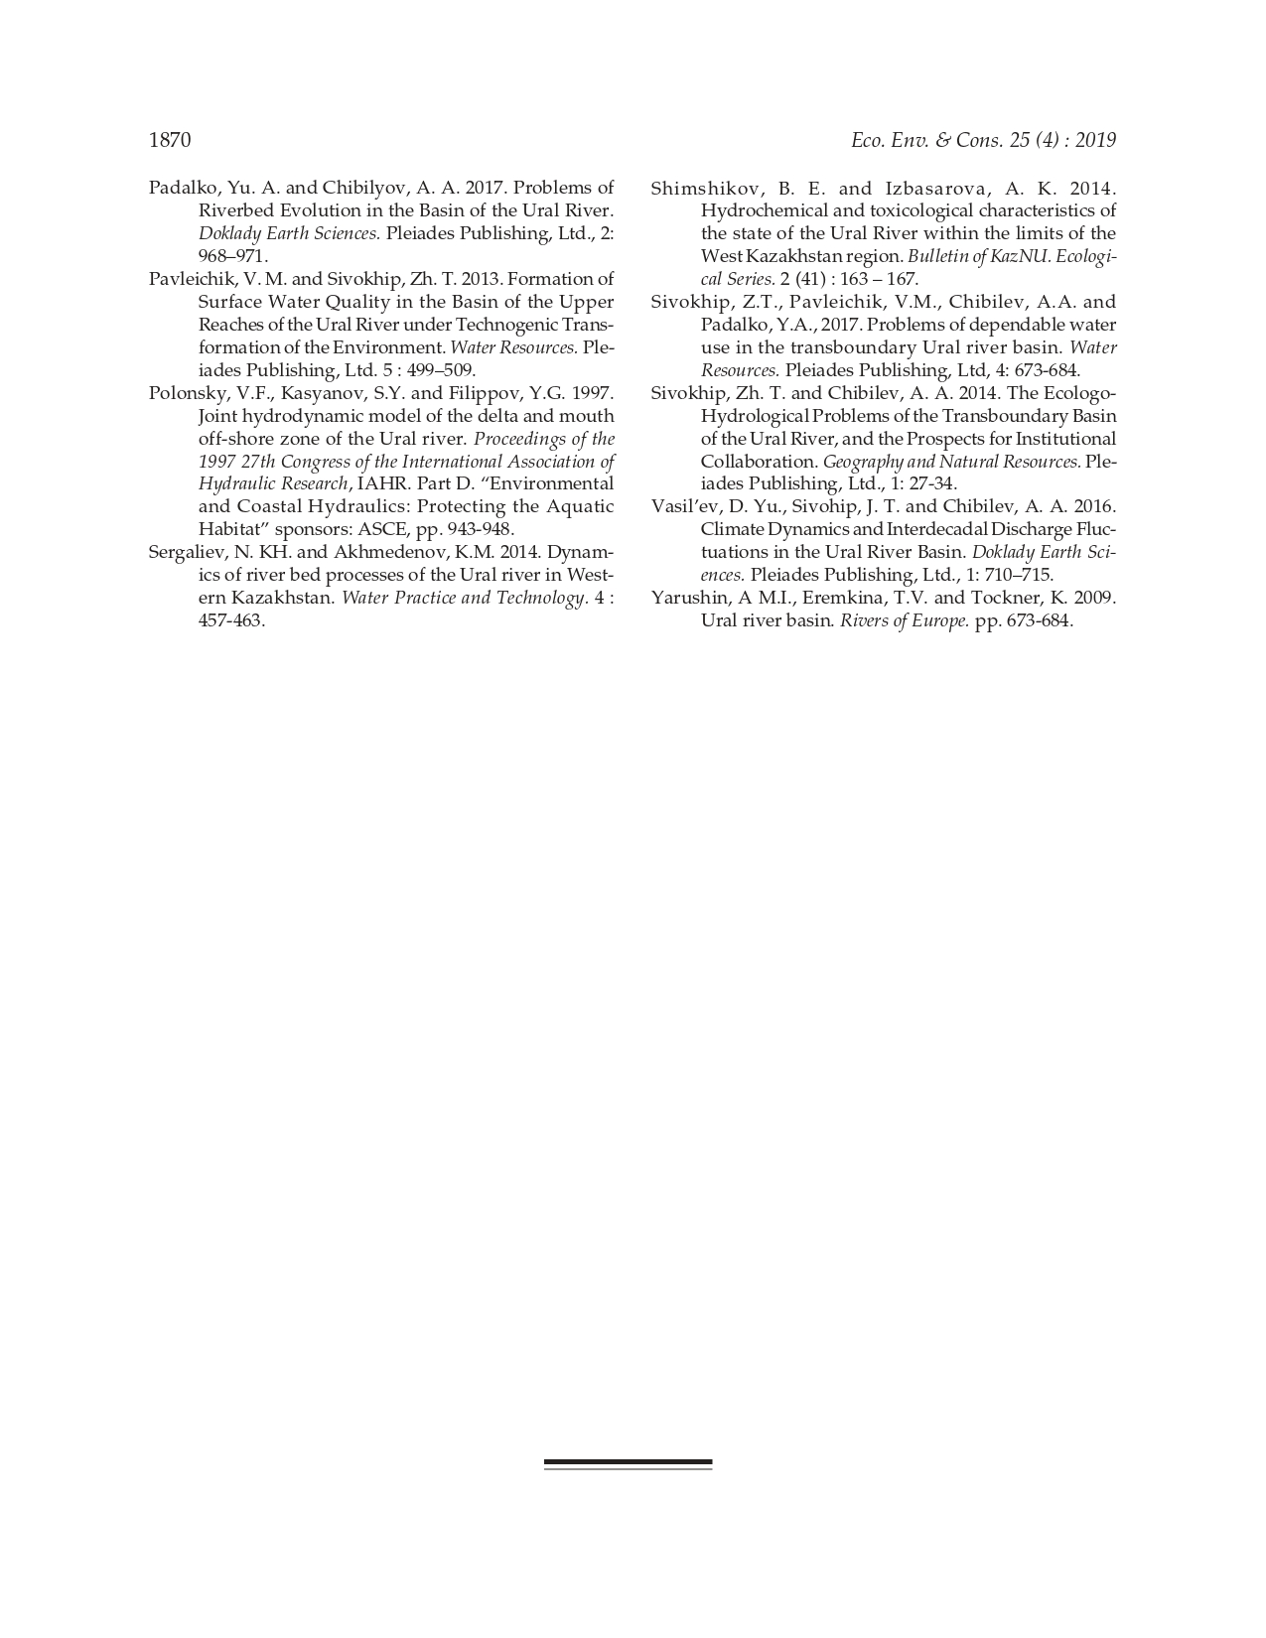

List of publications for 2020
Tumenov A.N., Sariev B.T., Bakiyev S.S. Analysis of the spawning population of carp in the lower reaches of the Ural River within the boundaries of the West Kazakhstan region // Monthly scientific and practical journal “Fish farming”, publishing house “Selkhozizdat”. - 2020. - No. 6 (173). - P. 51-55. DOI: 10.33920/sel-09-2006-06. https://panor.ru/articles/analiz-nerestovoy-populyatsii-sazana-v-nizhnem-techenii-reki-ural-v-granitsakh-zapadno-kazakhstanskoy-oblasti/44152.html. (In Russ.)
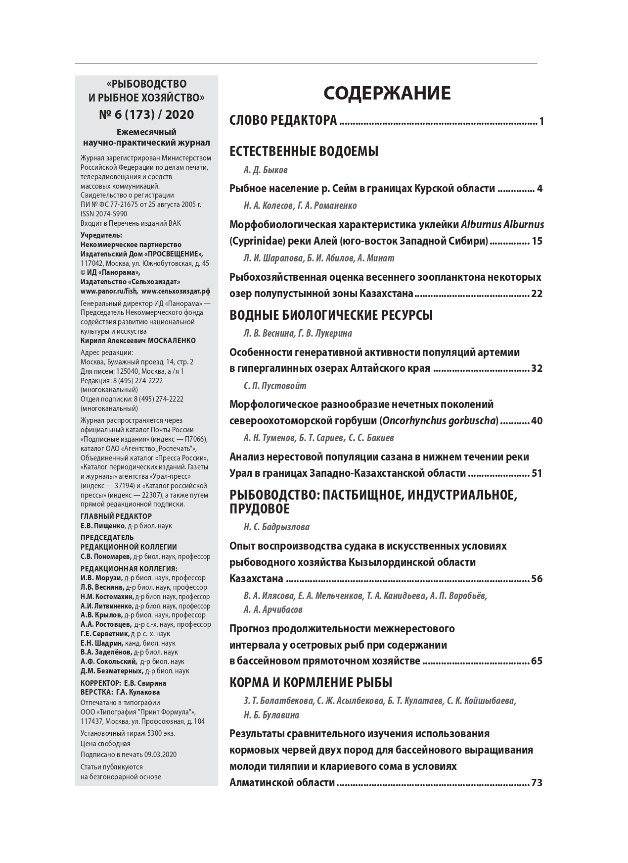
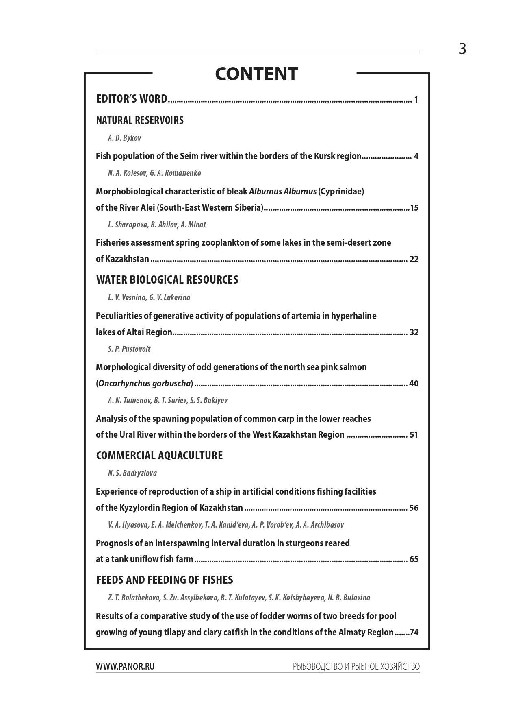

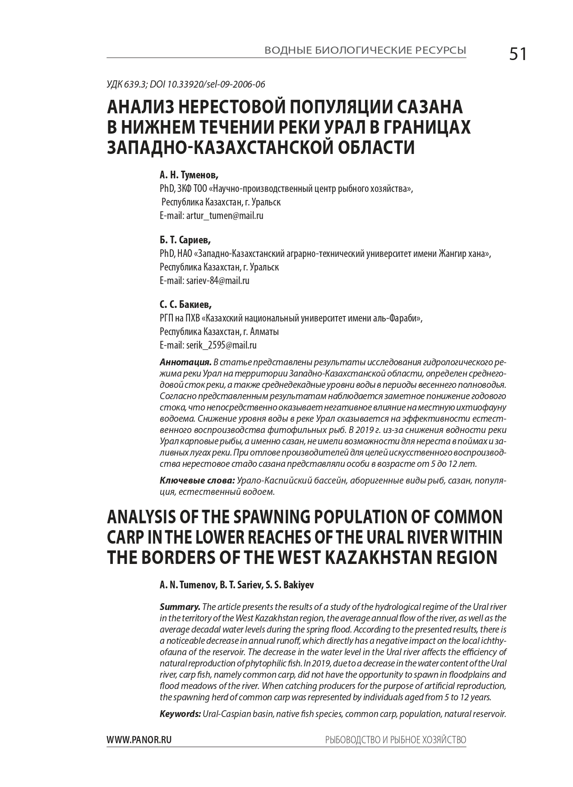

Tumenov A.N., Dzhaparov R.R., Sariev B.T., Shadyarov T.M. Incubation apparatus for fish roe // Science and Education. Zhangir khan ZKATU. ISBN 2305-9397. Uralsk. - 2020. - No. 3-2 (60). - P. 126-130. http://nauka.wkau.kz/cache/Jurnal/2020/202032.pdf. (In Russ.)

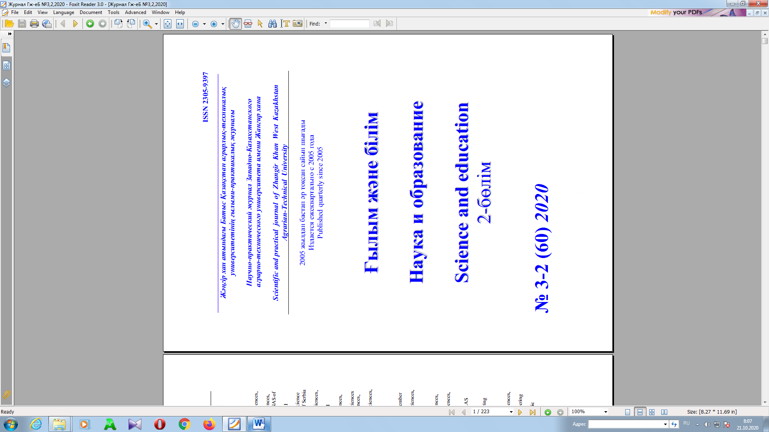
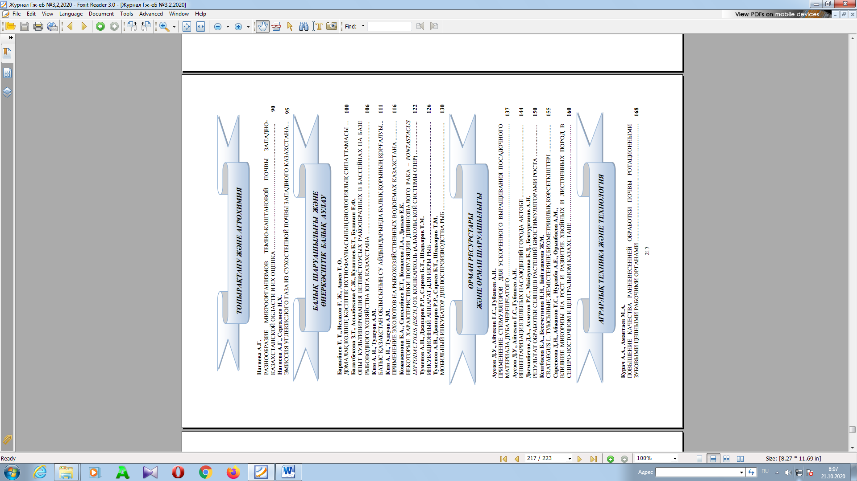

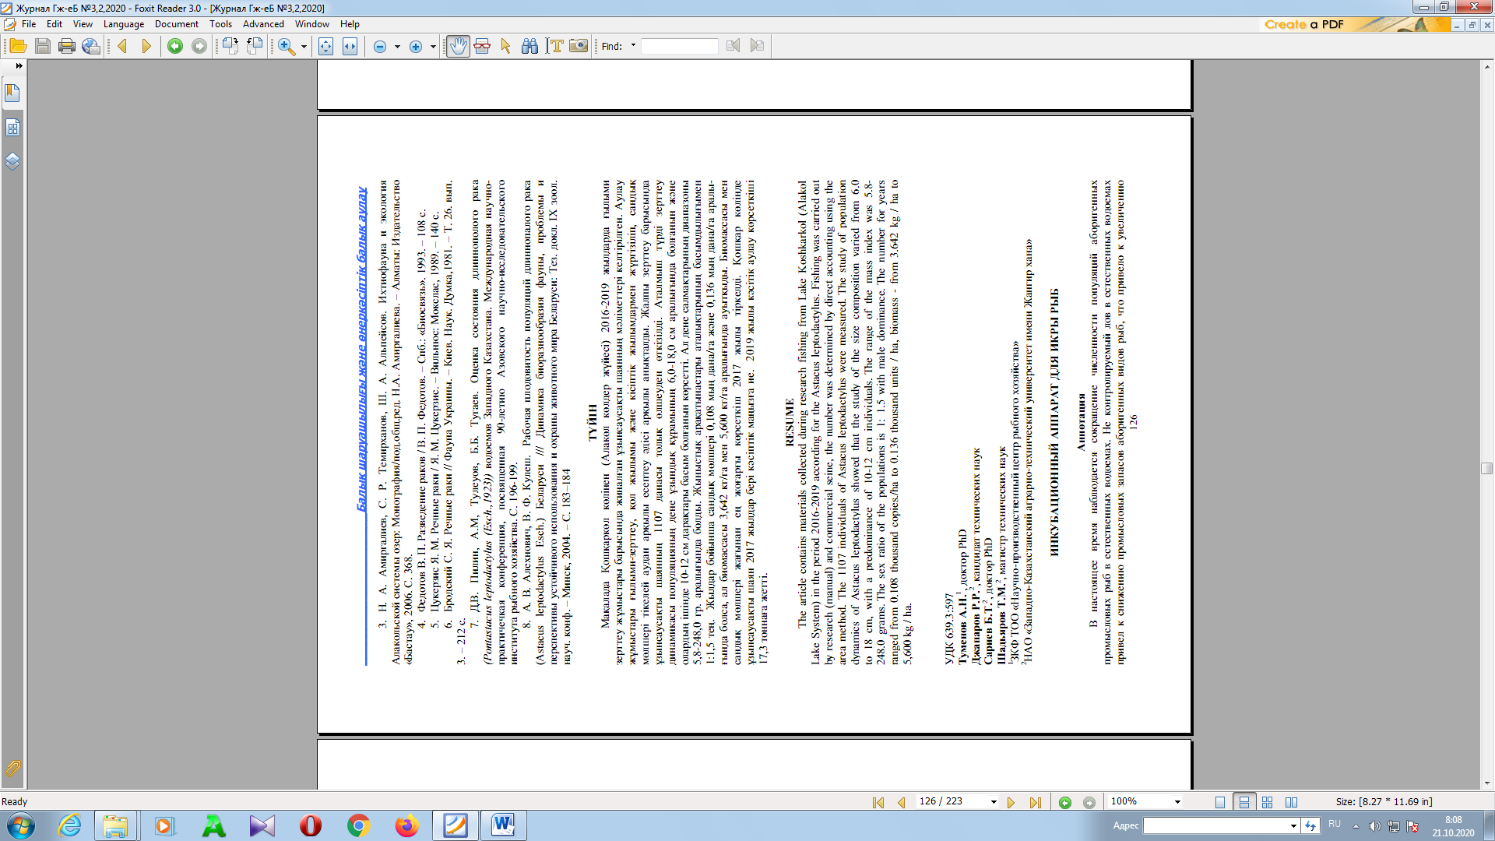
Tumenov A.N., Dzhaparov R.R., Sariev B.T., Shadyarov T.M. Mobile incubator for fish reproduction // Science and Education. Zhangir khan ZKATU. ISBN 2305-9397. Uralsk. - 2020. - No. 3-2 (60). - P. 130-136. http://nauka.wkau.kz/cache/Jurnal/2020/202032.pdf. (In Russ.)

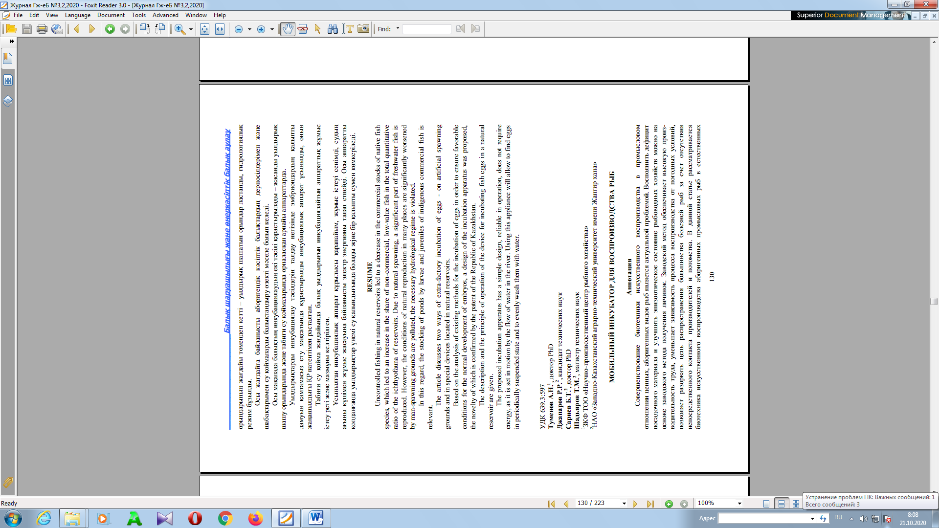

APPENDIX E
Granted patents 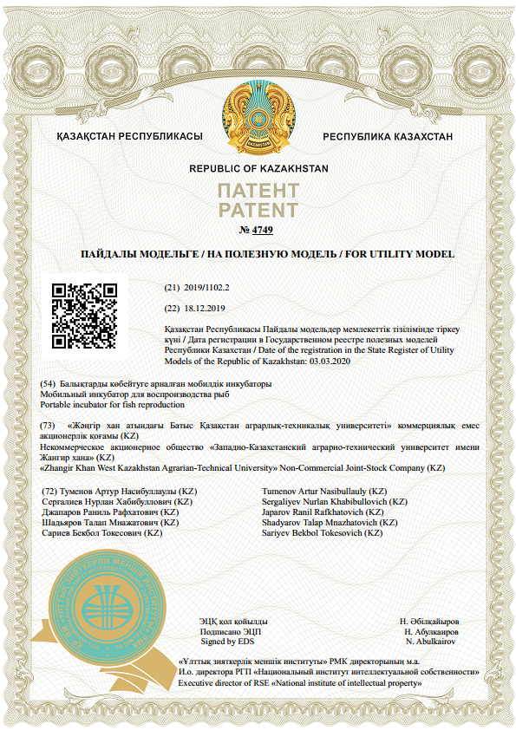
Figure E.1 - Patent for utility model
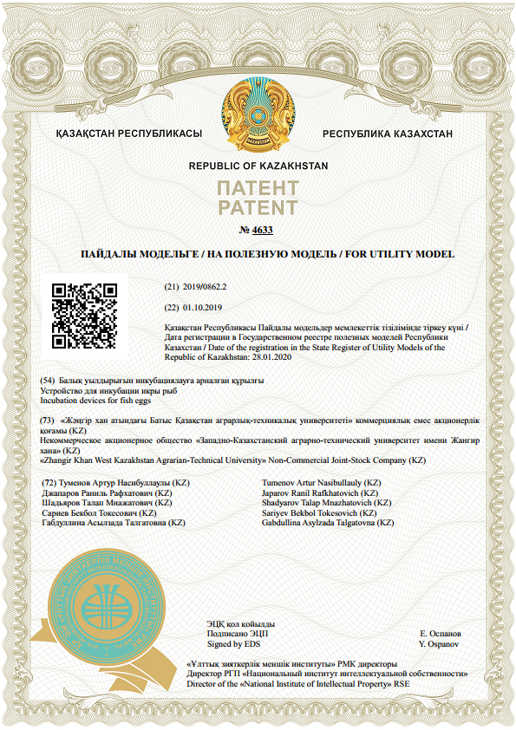
Figure E.2 - Patent for utility model

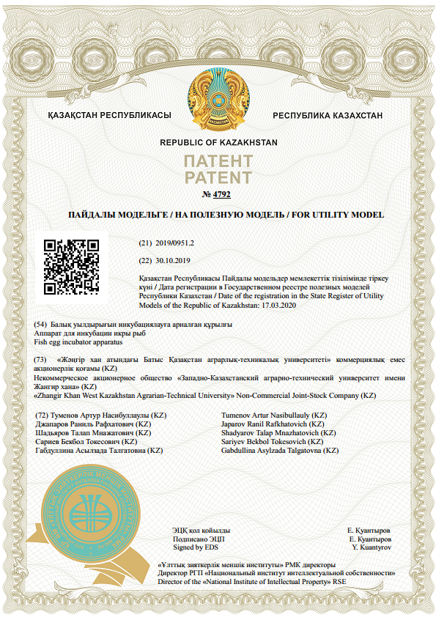
Figure E.3 - Patent for utility model

APPENDIX F
Monograph
1 Tumenov A.N., Dzhaparov R.R., Sariev B.T., Shadyarov T.M., Bakiyev S.S. Artificial reproduction of indigenous commercial fish species: monograph / - Uralsk: West Kazakhstan Agricultural and Technical University named after Zhangir Khan. - 2020. - 105 p. http://rep.wkau.kz/handle/123456789/1467. (In Russ.)
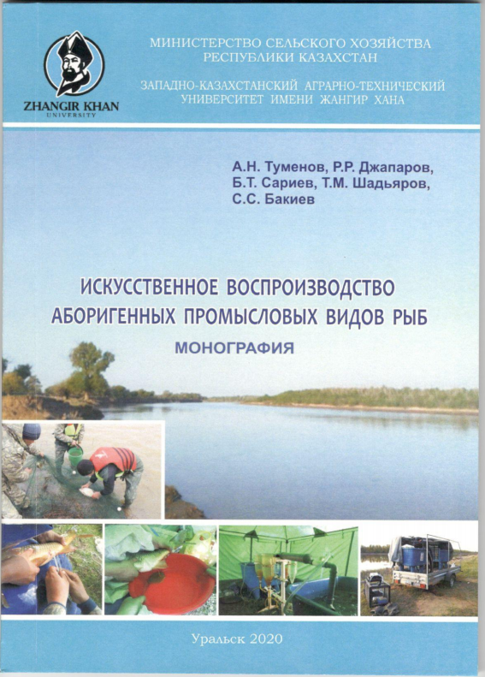





ПРИЛОЖЕНИЕ Е
Акт зарыбления

APPENDIX G
Act of release of juvenile fish 