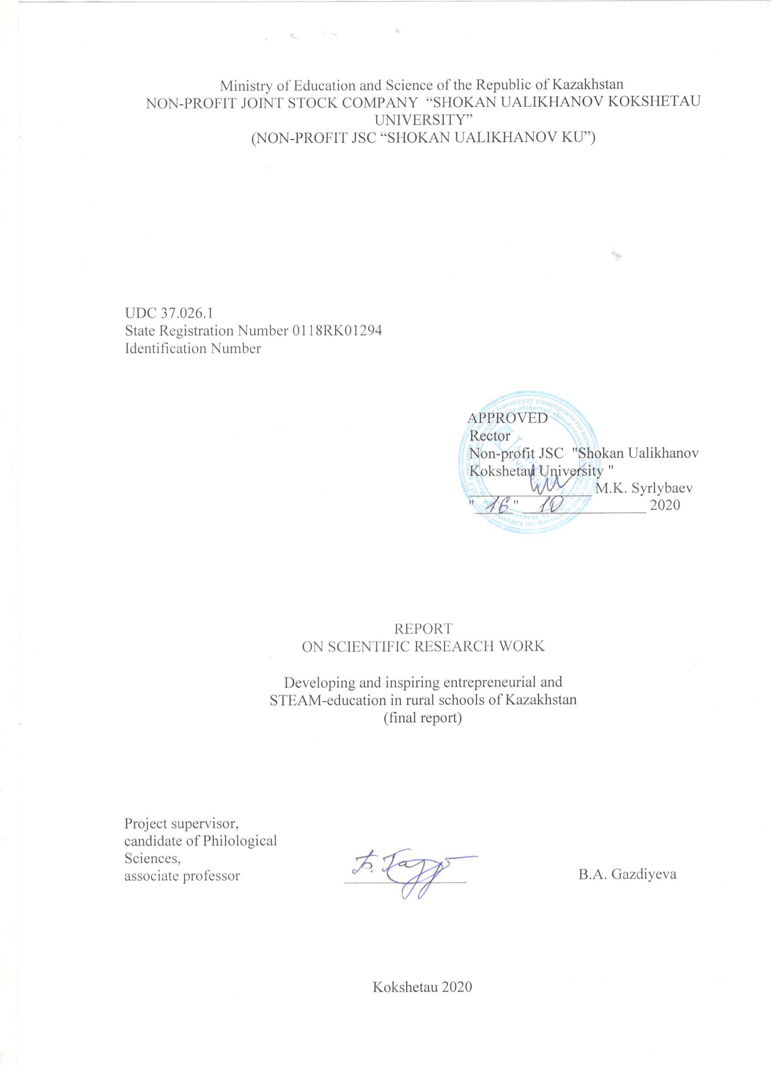

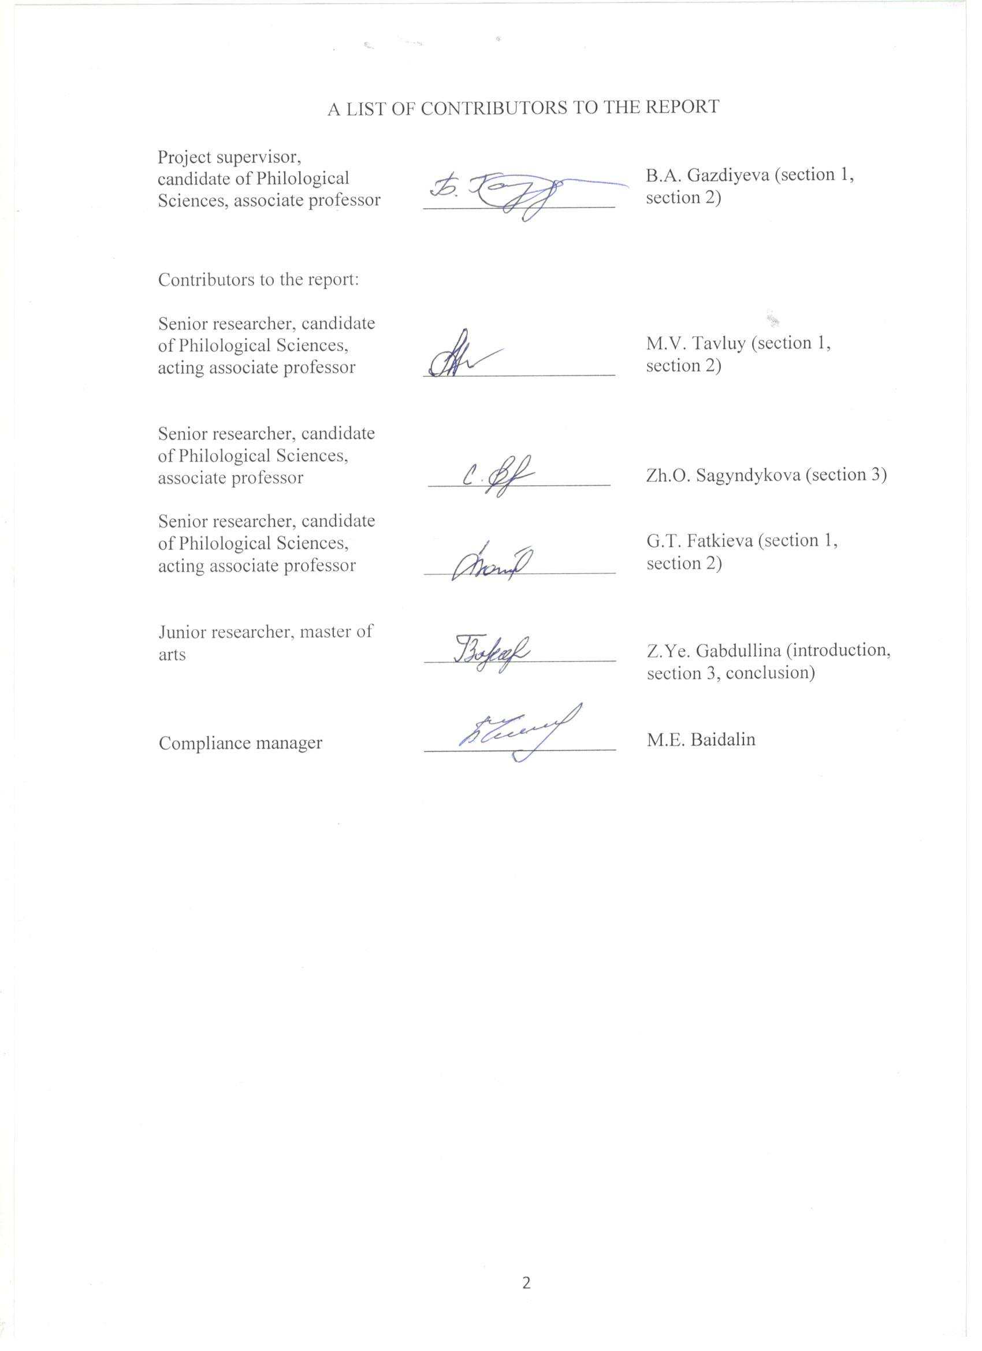

PRECIS

Report 132 pp., 3 parts, 1 pic., 13 references, 6 appendices.

RURAL SCHOOLS, ENTREPRENEURSHIP, ENTREPRENEURIAL EDUCATION, MAGNET SCHOOL, ENTREPRENEURIAL CULTURE, INNOVATIVE CULTURE, INNOVATION
The object of the research is the process of formation and development of entrepreneurial and STEAM education in rural schools of Kazakhstan.
The purpose of the work is to develop and test a mechanism of the development and promotion of entrepreneurial and STEAM education in rural schools of Kazakhstan.
The interdisciplinary nature of this research work requires the use of methods from different areas of knowledge, including: observation (direct and participant), interviews, survey through the draft questionnaire developed by the performers, methods of mathematical statistics for processing the results of the questionnaire, systematization, which allows you to organize and group all the collected material in order to prepare it for writing scientific articles, as well as to develop a “magnet program” in the target rural school. In addition, the scientific project includes the analysis of data, allowing to interpret them in order to obtain answers to the questions stated in the study, as well as a systematic, thorough and critical study of information.
It is relevant to highlight the following items as the research main results for this reporting period: a model of a magnet school based on the practice of the OECD countries and the current situation of rural schools was developed; a platform for the development of entrepreneurial and STEAM education of students with the involvement of the academic and business communities was developed.
The theoretical and practical significance of the implemented research stands for its focus on the development of rural schools in Kazakhstan in the context of their approximation to the OECD standards. The results of the study will help to reveal the general picture of the state of STEAM and entrepreneurial education in the world, to form a certain scientific and methodological vision, to develop a number of proposals for improving technical, mathematical, innovative and business education in Kazakhstani schools, in particular in rural schools.
State and administrative structures can use the results of the scientific research when building pedagogical and methodological models, the business sector and educational institutions can use the results of the research as a translation of the experience accumulated in the world.

CONTENT

INTRODUCTION.................................................................................................................. | 7
1 Relevance and key values of the magnet school ................................................................. | 11
1.1 Relevance of the model of “magnet schools” in the context of rural schools of Kazakhstan ..........................................................................................................................  1.2 Customer segments .........................................................................................................  1.3 Channels of interaction with consumers .........................................................................  1.4 Attitude towards students ................................................................................................  1.5 Key resources and key actions.........................................................................................  1.6 Key partners ....................................................................................................................  1.7 Structure of income and expenses .................................................................................. | 11  14  14  18  19  22  22
2 Scientific and methodological support of the project in 2020: seminars, publications.............................................................................................................................. | 24
3 The results of the research for 2018-2020 years: main publications, seminars, summer schools .................................................................................................................................... | 27
CONCLUSION ...................................................................................................................... | 34
LIST OF REFERENCES ....................................................................................................... | 38
APPENDIX A Work schedule calendar.................................................................................  APPENDIX B List of published works and certificates of authorship on the topic of the research ...................................................................................................................................  APPENDIX C Reprints of the scientific publications, copyright certificates on the topic of the research project for 2018-2020..........................................................................................  APPENDIX D Information on the participation of the research group of the project at significant Kazakhstani and foreign forums............................................................................  APPENDIX E Photo material on the activities carried out within the framework of the project during 2018-2019........................................................................................................  APPENDIX F Photo material on the activities carried out in 2020........................................ | 40  51  55  100  107  117

TERMS AND DEFINITIONS
In this report on research work on the topic “Development and promotion of entrepreneurial and STEAM education in rural schools in Kazakhstan”, the authors used the following terms with the appropriate definitions:
Busing – is the transportation of children of a certain ethnic group by buses from one residential area to another, with a different ethnic composition, in order to achieve ethnic or “racial” balance in schools
Webinar – a seminar held in the teleconference mode using web technologies
Innovation – the result of intellectual activity, fantasy, creativity and human rationalization. Innovation is brought to the market in the form of products with new beneficial properties. Innovation dramatically improves the user experience. Electric cars, internet banking, 3D -printing or e-government website are the examples of innovations that solve problems faster, more efficient and easier
Innovative culture – is the susceptibility of people to new ideas and their willingness and ability to support and implement innovations in all spheres of life, and therefore - it is the knowledge, skills and experience of focused training, the implementation of an integrated and comprehensive development of innovations in various fields of human activity
An integrated lesson – a type of lesson that combines teaching simultaneously in several disciplines while studying one concept, topic or phenomenon. In such a lesson, the following are always distinguished: the leading discipline, which acts as an integrator, and auxiliary disciplines, contributing to the deepening, expansion, clarification of the material of the leading discipline
Collaboration – a process of joint activities, for example in the intellectual sphere, of two or more people or organizations to achieve common goals, where knowledge share, learning and reaching agreement occur
Modernization – the process of changing any objects, giving them modern properties that meet the requirements of the time. Improvement process through equipment renewal, reforms, social attitudes, culture. Modernization is divided into economic, political, cultural and social
OECD – Organization for Economic Cooperation and Development. It is a unique alliance in which the governments of 30 democracies with market economies work together to solve the socio-economic and governance problems that arise in the context of globalization, as well as explore the opportunities it provides. The organization is a forum where they can exchange their experience in solving political problems, get answers to common questions, learn about the positive experiences of other countries and coordinate their national and foreign policies
Entrepreneurial culture – a system of legal and ethical criteria (norms) that regulates relations within the business community, subject to the existing legal acts, rules, and norms
Entrepreneurial education – the process of organizing the activities of a group of people aimed at developing their ability to translate ideas into actions independently, including actions aimed at creating and developing new business, as well as forming their interests, knowledge necessary for creating and developing new business, skills, competencies, personal qualities and mindset
Entrepreneurship – an initiative independent activity of citizens and their associations aimed at making profit
Transparency – frankness, sincerity; openness, transparency of something; honesty
Magnet School – a school that offers innovative programs through a specialized focus or topic, and provides broad opportunities to choose an educational institution that suits the interests of students
Project - based learning (PBL) – a teaching methodology in which students gain knowledge and skills in the process of long-term research and search for an answer to a cognitive and complex question or in the process of solving a complex problem
STEAM-education (Science, Technology, Engineering, Art and Mathematics) – an abbreviation that appeared based on STEM. STEAM education is based on the use of an interdisciplinary and applied approach, as well as on the integration of all five disciplines into a single teaching scheme

INTRODUCTION
According to the World Bank, at the present stage, the top countries in educational rankings successfully use the method of “magnet” schools – these are schools that in addition to the basic curriculum implement an additional education program [1]. Additional education provides in-depth study of individual subjects.
One of the world leaders in applying “magnet” programs is the United States of America. In this country, magnet schools initially began to function in large urban districts. The main goal of the activities of such educational organizations was to reduce racial isolation in “regular” schools. In the 70s of the XX century, American “magnet” schools took a prominent place in the national education system as a tool for achieving voluntary desegregation (the name adopted in the United States for the movement against discrimination of black Americans) instead of forced busing (bus transportation of children of a certain ethnic group from one residential area to another with a different ethnic composition, with the aim of achieving ethnic or “racial” balance in schools).
The name “magnet” schools became widespread after the opening of educational institutions of this type in Dallas and Texas. The organizers of magnet schools, striving to provide adolescents with the freedom to choose educational activities, attracted the interests of students and their parents – for this activity the schools received a figurative name – “magnetic”, “magnets” [2].
The “magnet” school, which has a specialized curriculum, is characterized by a highly qualified teaching staff and a good level of material and technical support. The magnet school is designed to attract students from different parts of the city or localities of the district. The basic principles of the magnet schools are based on pedagogical ideas that are in demand today: “to teach in different ways”, “there are as many ways as children”. “Magnetic” schools define by their main didactic setting the following: “encouraging the interests and self-choice of students.” This didactic attitude is supported by four major theses:
- all children should learn “in their own way”;
- the success of the student will be required when taking into account his/her interests;
- the student's motivation and success are determined by his/her independent choice;
- a student is able to study well if he/she receives favorable opportunities for this [3].
In recent decades the goals and directions of work of magnet schools operating around the world have expanded significantly. Added to the original areas were, for example, the following: narrowing the student achievement gap; creation of a wide range of conditions for a real choice by students and their parents of an educational institution; incubation of innovative teaching methods that improve the quality of educational services provided. In magnetic schools, as a rule, research groups of teachers are created, they study the experience of other magnet schools, analyze it and accumulate it in the activities of their educational institutions. Magnetic schools are public schools with a specialized curriculum aimed at developing children's leadership skills, international education, teaching languages, arts, etc. [3].
The educational content of magnet schools, which implement academic programs that provide the opportunity to receive an equal basic education, and at the same time - “magnet programs” as an option, include: fundamental sciences, math, informatics, art, communication, humanities and culture, literature, foreign languages, medicine and physical development.
Today subjects that provide the formation of high-level skills necessary for life in the society of the future are introduced into the curricula of Kazakhstani schools. Such disciplines include, for example, “Fundamentals of Science”, “Technology”, “Engineering”, “Robotics”, “Entrepreneurship”, etc. A special place in this work is occupied by promising ideas related to the development of STEAM and entrepreneurial education. The “magnet” program of a high school №33 of the rural district Rodina developed under the present project includes these two perspective areas. The school appears to be the basic platform for the present scientific research.
In the 21st century, STEAM is one of the main trends in the global educational space. STEAM is a complex of disciplines that are most in demand at the present stage and in the long term. It is recognized that STEAM education is based on the progressive experience of the past, and new teaching methods and tools are used in its implementation.
The main ideas of STEAM education have something in common with the conceptual ideas of “magnetic” schools. STEAM provides a blended learning environment and shows how the scientific method can be applied to life. STEAM is one of the areas of design, educational and cognitive activities in and out of school. This work does not provide for the only correct solutions and approaches, cultivates freedom of creativity, the generation of ideas and their implementation, the ability to plan their activities based on the task and available resources is formed. One of the fundamental ideas of STEAM education is to work on the development of collaboration skills as a platform for the formation of teamwork skills, corporate activities and mutual assistance.
A specific work within the direction of “Entrepreneurial education in a magnet school” has been implemented within the project. This direction directly relates to such important concepts as entrepreneurial culture – an established set of principles, methods, techniques for carrying out entrepreneurial activities, corresponding to legal norms, ethical and moral principles; innovation culture is the process of mastering and introducing new knowledge and skills in various spheres of human life that preserve the principle of continuity.
Issues related to the development of the model of the school-magnet were discussed at seminars and webinars, which were organized by the project executors and contained items reflecting the latest scientific and methodological content. As part of the implementation of the program of the magnet school, the forecast demonstrates improving the overall quality of education, methodologically grounded and intensive expansion of the zone of proximal development of students, and increase the efficiency of work on the development of multiple intelligences in children. At the present stage, these issues are of particular importance.
The research work reflects the results of research related to the development of the magnet school model. This work presents a model of a magnet school, developed within the framework of the grant scientific project No. AP05135242 “Developing and Inspiring Entrepreneurial and STEAM education in rural schools of Kazakhstan” for 2018-2020, and also reflects the prospects associated with the introduction of the methodological model of magnet schools in the educational system of rural schools in Kazakhstan and with the dissemination of advanced methodological experience, which is a necessary component of updating the content of education in the Republic of Kazakhstan.
The relevance and novelty of the study lies in its focus on the development of rural schools in Kazakhstan in the context of their approximation to the OECD standards. The undeniable fact is that the learning aimed at reducing the gap in student achievement, creating a wide range of conditions for a real choice of students and their parents of the educational institution, learning aimed at incubation of innovative teaching methods, will enable to improve the quality of educational services, and to develop the high-level skills necessary for life in the society of the future.
The purpose of the scientific project is to establish and pilot a mechanism for the development and promotion of entrepreneurial and STEAM education in rural schools in Kazakhstan.
To achieve this goal at this stage of the study, it is necessary to solve the following tasks:
- develop a model of a magnet school based on OECD country practices and the current situation of rural schools;
- pilot the magnet school model in the educational process of High School №33 of Tselinograd district of Akmola region (Rodina province) which is the platform for the implementation of a research project;
- build five playgrounds in the development of business and STEAM-education students with involvement of the academic and business communities;
- implement transfer of the experience of developing entrepreneurial and STEAM-education in the rural schools of Akmola region;
- organize a refresher course based on the state institution “Secondary school №33 Tselinograd district” Akmola region;
- open a Center for Innovation and Entrepreneurship at the state institution “High school №33 Tselinograd district” Akmola region;
- publish five scientific articles in journals recommended by the Committee of Control in Education and Science of the Ministry of Education and Science of the Republic of Kazakhstan, as well as in journals with non-zero impact factor included in the Scopus database.
The scientific significance of this study is due to the need to provide conditions for the development of entrepreneurial and STEAM education among students of rural schools in Kazakhstan. The development of entrepreneurial and STEAM skills even at the school level is an indispensable condition for the successful implementation of innovations in the country, since the state’s innovative activity depends not only on available resources, but also on the quality of human capital. Enhancing the entrepreneurial and innovative culture of schoolchildren, in particular in rural ones, will help to increase the educational achievements of students and the status of rural schools. This explains the need for this research work.

1 Relevance and key values of the magnet school
1.1 Relevance of the “magnet school” model in the context of the development of rural schools in Kazakhstan
Conceptual ideas of the scientific project “Developing and Inspiring Entrepreneurial and STEAM education in rural schools of Kazakhstan”, funded by the Ministry of Education and Science of the Republic of Kazakhstan, correspond to global didactic trends that reflect the main vectors of work to provide citizens with affordable and equal educational opportunities.
According to the World Bank, today the top countries in educational rankings are successfully using various modifications and methods of “magnet” schools, which, in addition to basic curricula, implement programs of additional education [1]. The educational sphere of additional education is provided in this case by an in-depth study of individual subjects and an expansion of the range of academic disciplines at the expense of promising and in-demand subjects.
One of the tasks of the educational sector in Kazakhstan is the development of rural schools, which have specific features associated, as a rule, with their geographical and informational remoteness from administrative and educational centers, with a small student population and with the lack of a sufficient number of highly qualified subject teachers.
According to information extracted from the National Educational Database (NED), as of January 16, 2020, 5285 rural schools are operating in Kazakhstan. The State Program of Education and Science Development for 2020-2025 states: “For the infrastructural development of small schools, 185 pivotal schools (resource centers) are currently operating. 605 magnet ungraded schools are attached to them (21% of all ungraded schools). Boarding schools are functioning only at 70 pivotal schools. It is necessary to continue the development of the network of pivotal schools and boarding schools until they are fully covered by all ungraded schools” [4].
There are significant issues reflecting the current situation in the rural school sector:
- insufficient competitiveness of graduates of rural schools at different stages of their education, social and professional adaptation;
- the shortage of information in rural schools, lack of necessary career guidance for children, lack of knowledge of trends in the labor market and a modern atlas of the future disciplines, as well as incomplete idea about job prospects after graduating from s higher education institution.
As a result of studying the current situation and analytical processing of the research material, the authors identified the following problem “zones” and issues requiring a competent scientific and methodological solution:
- incomplete provision of highly qualified teaching staff, in particular teachers of the English language and physics;
- insufficient development of the information and communication infrastructure of schools, limiting the involvement of rural students and teachers in the global educational process, which is characterized by the use of didactic and technical content of innovative technologies, for example, e-learning content (e-learning, m-learning, etc.);
- the lack of electiveness of additional academic disciplines that correspond to modern trends in world school education;
unprofessional or ill-conceived image and advertising activities of rural educational institutions, etc.
Against the background of existing risks and problems, a group of researchers, which includes university staff dealing with the problems of modern didactics and private methods, practical teachers from the Nazarbayev Intellectual School of Physics and Mathematics in Kokshetau and a rural school, which is the basis of the project “Development and promotion of entrepreneurial and STEAM education in rural schools of Kazakhstan”, has developed a model of magnet school, which will improve the quality of the educational process in a rural school and prepare competitive graduates who are guided by labor market trends and competently planning their future professional career.
The research is based on the theory of L.S. Vygotsky, G. Gardner, didactic ideas on the integration of academic subjects, the formation of functional literacy of students, the development of high-level skills, the introduction of entrepreneurial and STEAM education into the practice of Kazakhstani schools, the use of innovative ideas aimed at the comprehensive development of representatives of “generation Z”.
A kind of research hypothesis was a conceptual idea represented by the following priority components:
- the current personnel, material and technical, information and communication state of rural schools can be changed due to the formation of a new school model, positioned as a magnet school, which has the specific features of a resource center – a supporting institution of the education system with a modern educational and production base, providing training facilities based on advanced technologies [5].
- additional innovative programs offered by the “magnet school” through a specialized focus or theme should be based on the disciplines of the “new set”, which arouse genuine interest of students - representatives of the “generation Z”. The authors of the model refer to such subjects, first of all, academic disciplines from the spectrum of entrepreneurial and STEAM education;
- real work on the formation and testing of the model of the “magnet” school is possible only on the basis of an operating rural school. The State Institution “Secondary School No. 33 of the Tselinograd District” of the Akmola Region of the Republic of Kazakhstan (Rodina province), which is geographically surrounded by small schools and has the starting capabilities for modeling the “magnet” program, was designated as such a base site.
As part of the formation and implementation of the “magnet school” program, the project participants forecast an improvement in the overall quality of education, a methodologically grounded and intensive expansion of the zone of proximal development of students, and an increase in the efficiency of work on the development of multiple intelligences in children. At the present stage, these issues are of particular importance.
The “magnet school” model was developed taking into account the practice of the OECD countries - the leaders of the international PISA assessment. The Canvas business model was taken as the basis for the development of the “magnet school” model (Picture 1). The model of the magnet school was tested in the educational process of secondary school No. 33 of the Tselinograd district of the Akmola region (Rodina province), which is a platform for the implementation of a scientific project.
The “magnet school” model is focused on the development of rural schools in Kazakhstan in the context of their approximation to OECD standards. The results of the study help to reveal the general picture of the state of STEAM and entrepreneurial education in the world, to form the necessary scientific and methodologically correct vision, to develop a number of proposals for improving technical, mathematical, innovative and business education in Kazakhstani schools, in particular, in rural schools.

Picture 1 - Key values ​​of the “magnet school” model

1.2 Customer segments
The model of the “magnet school” is addressed to the organizers and participants of the educational process in a rural school, as well as to a wide range of the public interested in the problems of modern school education.
The interest of potential consumers is ensured by the relevance and prospects of the “magnet school” model, based on the promotion of the interests of students by giving them the right to choose the direction and content of educational activities.
One of the important components of the presented model is STEAM, which today is one of the main trends in world education. For reference: STEAM is based on a set of disciplines that are most in demand at the present stage and in the long term: natural sciences (S - science), technology (T - technology), engineering (E - engineering), creativity (A - art), mathematics (M - mathematics).
The second direction of the “magnet school” at the school which appears to be a platform for the implementation of a scientific project is “Entrepreneurial education”. This direction is directly related to such important concepts as entrepreneurial culture - an established set of principles, methods, techniques for carrying out entrepreneurial activity, in accordance with legal norms, ethical and moral principles; innovation culture is the process of mastering and introducing new knowledge and skills in various spheres of human life, in which the principle of continuity is preserved. The project executors, in a sense, “outstripped” the educational program, proposing back in 2017, based on monitoring the current situation and rigorous analytics, to introduce the course “Fundamentals of Entrepreneurship” into the program of rural schools in the Tselinograd district.
Today, secondary school No. 33 of the Tselinograd region is one of the general educational institutions in which training classes on entrepreneurship are conducted on a trial basis - as part of the implementation of the program proposed by the Chamber of Entrepreneurs of Kazakhstan “Atameken”.
3. The results of the research can be used by state and administrative structures in the formation of pedagogical and methodological models, by the business sector and educational institutions. Recommendations developed with the consideration of the specifics of the development of the modern education system in Kazakhstan can be useful to school teachers, as well as students and teachers implementing pedagogical educational programs.

1.3 Channels of interaction with consumers
1. Providing interested parties with the results of analysis and synthesis of the latest information reflecting 1) the world experience of entrepreneurial and STEAM education (OECD countries with the best PISA results), 2) scientific and methodological content related to the organization and functioning of magnet schools, in the program of which STEAM and entrepreneurship education can be included. The results of this work are reflected in the analytical report “International experience in the development of entrepreneurial and STEAM education in the OECD countries” and in the accompanying guidelines [6].
2. The opening of a career and leadership center in secondary school No. 33 of the Tselinograd district, the purpose of which is to provide professional guidance to students in career planning (in accordance with their capabilities, abilities, achievements and taking into account the requirements of the modern labor market).
3. Equipping the school with a language laboratory.
4. Equipping a modern chemistry classroom in accordance with the latest technical, hygienic and didactic standards.
5. Creating a platform for the development of entrepreneurial and STEAM education with the involvement of the academic and business community.
6. Organizing meetings of students with representatives of the business community - individual entrepreneurs, heads of peasant farms, heads of LLP and JSC, establishing contacts with participants in existing startups.
7. Conducting Summer Schools in secondary school No. 33 of the Tselinograd district, uniting in the joint productive activity of university and school teachers, students, socially responsible entrepreneurs, creative people for whom a high-quality school education is one of the necessary conditions for the country's sustainable development:
- Summer School “Leadership School” (2016), dedicated to the development of leadership skills of students and improving their language competence. The speakers and trainers of the Summer School were the Bolashak scholarship holders;
- Summer School “Global English” (2017), held as part of the republican action “Our knowledge for our country.” Within the framework of the Summer School, schoolchildren from 8 to 17 years old, under the guidance of graduates of the “Bolashak” program (specialty “Translation”), intensively studied English;
- Summer school “You can STE @ M it” (2018), associated with the initial testing of the ideas of the “magnetic” school - the introduction of STEAM content and entrepreneurial education into the practice of a general educational institution;
- Summer school “Make it smART” mutually with the Academy of Public Administration under the President of the Republic of Kazakhstan (2019), which brought together school students from two settlements (Rodina village, Semyonovka village). The Summer school was dedicated to the development of entrepreneurial and STEAM education. The working language of the Summer School was English, and the priority goal of its holding was the development of soft skills and language competence of students in rural schools. The Summer school was held with the support of the Academy of Public Administration under the President of the Republic of Kazakhstan. The main speakers were the graduates of the Bolashak program.
8. Development of methodological recommendations in the direction of “Entrepreneurial education”, presented in the analytical report “Monitoring and assessment of entrepreneurial and innovative culture of students in rural schools” [7].
9. Full transparency of work, continuous exchange of scientific and methodological experience with colleagues from the university and school environment of Kazakhstan and other states, translation of work experience into the community of rural schools in the country.
10. As part of the research work, multi-vector seminars and webinars were held, reflecting the theoretical and applied aspects of the formation of the “magnet school” model based on the development of entrepreneurial and STEAM skills of students:
- methodological seminar “Prospects for the development of entrepreneurial and STEAM education in rural schools” (February 2018);
- a methodological seminar dedicated to new approaches to teaching within the framework of the updated educational content and the introduction of STEM and STEAM technologies in the learning process (June 2018);
- methodological webinar “Embedding Entrepreneurship Activities and Developing its
Culture in Kazakh Schools » (September, 2010);
- workshop “Formation of entrepreneurial culture of students in rural schools: the experience of scientific research” (June, 2019);
- seminar “The role of teachers in the formation of the entrepreneurial culture of modern schoolchildren” (November 2019).
Representatives of the academic community took part in the work of the seminars: teaching staff, students and undergraduates of the Ualikhanov Kokshetau University; administration and teachers of secondary school No. 33 Rodina village of the Tselinograd region; heads of district education departments of Akmola and Kostanay regions; head teachers of rural schools.
The speakers of the seminars were: the principal investigator of the project, international expert – Dr. Abraham Althonayan, senior lecturer of the Brunel University London (Great Britain), Rector of the Academy of Public Administration under the President of Kazakhstan, representatives of the National Chamber of Entrepreneurs of the Republic of Kazakhstan “Atameken”, etc.
11. A webinar was held for all interested parties, within the framework of which it is planned to work in the following areas:
- the experience of secondary school No. 33 of the Tselinograd district in organizing cooperation with nearby educational institutions in the context of the implementation of the “magnet school” model;
- building the educational process from the perspective of using the conceptual ideas of the “magnet”;
- organizing and conducting classes on STEAM and entrepreneurship;
- ways and mechanisms of interaction with the local community and business structures.
The webinar provided an opportunity to broadcast the accumulated experience to schools with similar needs and requests.
12. In 2020, conducted an online course training of teachers, administrators, members of the boards of trustees of rural schools included in the “magnet”. In the courses used, it involves not only implementing a research project, but also domestic and foreign experts on teaching subjects, new approaches to learning, the implementation of “magnet”, etc.
13. The content and intermediate results of the research, and methods/forms of work on the development of entrepreneurial and STEAM skills, as well as on the creation of a rural “magnet school” model based on the ideas of the resource center, were presented by the principal investigator of the project – PhD, Associate Professor B. Gazdiyeva at local and international conferences, forums.
14. The interim results of the implementation of the scientific project and the formation of the model of the “magnet school”, as well as the results of monitoring the entrepreneurial and innovative culture of rural school students are presented by the project manager Gabdullina Z.E. at the August conference of teachers of the North Kazakhstan region (target audience – head teachers of schools, teachers).
15. Experience in the formation and testing of the “magnet school” model is reflected in significant publications (Appendix A, Appendix B):
- research paper “A Research on the Practice of Developing a Rural ‘Magnet’ School Model: Theoretical and Applied Aspects”. B.A. Gazdiyeva, M.V. Tavluy, Z.Ye. Gabdullina, A.A. Akhmetzhanova, G.T. Fatkiyeva. International Journal of Engineering Research and Technology. ISSN 0974-3154 Vol.13, No.4 (2020), pp. 720-724 © International Research Publication House. Cite Score 2019 – 0.2, Cite Score 2020 – 0.4, SJR (IF) 2019 – 0.145, SNIP 2019 – 0.251 [8];
- research paper “The Development of Entrepreneurial Culture in Rural Schools”. Gazdiyeva, B., Althonayan, A., Sagyndykova, Z., Akhmetzhanova, A., Gabdullina, Z., Tavluy, M., & Fatkieva, G. Journal of Entrepreneurship Education. Print ISSN 1098-8394, Online ISSN 1528-2651 Vol.23, Issue 3 (2020). Cite Score 2019 – 2.7, Cite Score 2020 – 3.1, SJR (IF) 2019 – 0.283, SNIP 2019 – 1.030. [9].
16. Active image and advertising activities of Rodina province school No33, which is a platform for testing the “magnet school” model:
- the presence of a staff unit – a teacher responsible for the development of programs for the “magnet school” and the implementation of its marketing plan;
- providing parents and potential students with complete information about the opportunities of the educational institution, directions of study and the content of the curriculum (study tours / training, catalogs, advertising albums).

1.4 Attitude towards students
In international practice, the history of “magnet schools” dates back to the 1970s, when they were created to ensure equal access to education for representatives of other races and to enroll a larger number of students in school. Today, magnet schools are characterized by a diversity of students, as they attract children from different families with different backgrounds from the surrounding areas. Relying on their academic performance one third of “magnet schools” focuses on attracting gifted students, [10].
In Kazakhstan, according to the Standard Rules for the Activities of Educational Organizations, “magnet school” is defined as a small school assigned to a resource center by order of local educational authority [10].
The activity of Rodina province school No33, is “magnet” in terms of its specificity as a resource educational institution. In accordance with the Standard Rules for the Activities of Educational Organizations, a resource school is defined as an organization of general secondary education, on the basis of which educational resources of nearby small schools are consolidated for conducting short-term sessions, intermediate and final certification of students in order to provide access to quality education for students of small schools [11].
Rodina province school No33, is resource-based in terms of methodological and infrastructural support. Thus, the school has sufficient conditions (laboratories, equipment, additional classes) necessary for the use of teachers and students and, accordingly, for raising the standard of living in rural areas.
With the adoption of the State Program of Education and Science Development for 2020-2025, a new stage in the development of resource schools began. Within the framework of the new State program, in the next 5 years to solve the problem of small schools, various models will be developed and tested, covering the issues of the functioning of resource centers - based on the expediency of their opening and the needs in the region [4].
A feature of the work of secondary school No. 33 of the Tselinograd district is the integration of the STEAM approach into the educational process. The curriculum of the general education institution is based on the idea of ​​teaching students using an interdisciplinary and applied approach. The school forms a wide range of skills, improves skills in the field of functional and creative application of knowledge, develops critical thinking, practices research and the use of information and communication technologies. This approach reflects the policy of the Republic of Kazakhstan in the process of updating the content of secondary education and is fully consistent with the State Program of Education and Science Development for 2020-2025.
The content of the subjects in the school is related to real life. The school does not try to limit the student in the only correct solution to a particular problem, but provides the student with complete creative freedom. With the help of such tasks, the student not only generates interesting ideas, but also immediately brings them to life. Thus, he learns to plan his activities, based on the task and the available resources, which will certainly come in handy in real life.
To retain and develop the potential of children, Rodina province school No33, adheres to the following principles:
- application of research and design methods and teaching techniques;
- organization of “problem weeks” instead of “subject weeks”, which allows teachers of different disciplines to focus on a particular problem and develop the potential of students through joint efforts;
- cooperation at the level of individual teachers and subjects to deepen students' understanding of the same laws (schemes, models) on the material of various fields of knowledge, setting common tasks;
- providing free access to STEAM-laboratory, equipment (microscope, reagents, materials) for creativity, experiments, research and implementation of project ideas.

1.5 Key resources and key actions
Intellectual resources
1. The curriculum in the school contributes to the academic success of students and develops skills such as critical thinking, communication, functional skills in the context of life situations. The principle of the school is based on the fact that the student receives knowledge not in a finished form, but obtains it himself.
2. Education at school is based on a project-based learning approach. Students master cases using different strategies. This approach contributes to the deepening of knowledge of the subject and increases the motivation of children.
3. Classes are conducted using group training. This approach helps children learn to work in a team, develop communication skills, and socialize.

Human resources
1. The key object of changes in Rodina province school No33, is a team that strives for innovation. The school employs 25 teachers. All teachers have education or pedagogy degree.
2. In terms of gender: the prevailing proportion of teachers are women (80%) due to the feminization of the teaching profession in general in the country. In terms of categories: 7 teachers have the category of expert teacher, 5 teachers – research teacher, 3 teachers each – the first and the highest category, 2 teachers each – the category of teacher, master teacher, teacher-moderator and one teacher – the second category [12].
3. The research team of the project includes 5 employees from Rodina province school No33: the head teacher; deputy head teacher for Academic Affairs, teacher of the Kazakh language and literature of the first qualification category; the English teacher, the Math teacher.
4. The school uses research and design methods and teaching techniques.
5. Collaboration at school affects not only students, but, above all, teachers. Cooperation at the level of individual teachers and subjects allows to develop the potential of students on the material of various fields of knowledge.
Physical resources
1. Rodina province school No33 was built in 1980. At present, the design capacity of the school is 407 student places. The school has 14 subject classes, a library, a sport hall, a canteen, a medical office with appropriate equipment, and a museum.
2. The digital infrastructure of the school includes telephone communications, as well as 67 computers and 11 laptops with broadband Internet access, interactive whiteboards and projectors in each classroom. All computers and laptops are working and produced in 2015-2019.
3. The school is equipped with a STEAM laboratory with the appropriate equipment (interactive whiteboard, microscope, reagents, materials), a language laboratory (linguaphone and multimedia room) for creativity, experiments, research and implementation of project ideas.
Key actions
1. Within the framework of approbation and implementation of the “magnet school” model, which has the specific characteristics of a resource center, a working group was created in secondary school No. 33 of the Tselinograd district to conduct the project (in agreement with the School's Advisory Board).
2. Work continues on the modernization of educational content, infrastructure and material and technical base of the general education institution. Additions were made to the process of teaching children; work was done to improve the subject-spatial environment. The emphasis is shifting towards individualization and personalization of space, taking into account the individual characteristics of students, multifunctionality. The school is engaged in the transformation of the internal space, providing for the possibility of increasing/decreasing it, creating optimal conditions for group work.
3. Key changes include:
- equipping the school with a language laboratory;
- equipping a modern chemistry room in accordance with the latest technical, hygienic and didactic standards;
- opening a STEAM laboratory;
- reconstructing the mathematics office;
- creating recreation areas in the classrooms and the foyer of the school, which significantly increases the level of students' comfort;
- the opening of the Career Center “Looking into the Future”, created to support students in the process of planning their future careers - in accordance with opportunities, abilities, achievements, and also designed to promote the preparation of professionally oriented graduates.
The school schedule is designed in such a way that all students have the opportunity to attend STEAM and language laboratories at least twice a week.
4. In the context of the development of a network of teachers and the organization of work on individual and joint projects, Rodina province school No33 provides an opportunity to visit the STEAM laboratory for general educational institutions of the district. There is a visit log.
5. Rodina province school No33 is one of the pilot general educational institutions in which from the 2019-2020 academic year training sessions on entrepreneurship are conducted.
6. In the context of approbation and implementation of the “magnet school” model as a resource center, the educational institution conducts open training sessions and events, for example:
- methodological day “STEAM-learning: problems and prospects”.
- an integrated lesson of the English language and the history of Kazakhstan on the topic “The role of the Great Silk Road in the development of international relations”;
- an integrated lesson of the Russian language and computer science on the topic “Using algorithms. Unstressed vowels at the root of the word “;
- an integrated lesson of the Kazakh and Russian languages on the topic “Otbasy / Family”;
- an integrated lesson in the Kazakh language and art work, topic: “Kiiz uy”, cross-cutting topic: “Yurt” module: “Cultural heritage”, etc.
7. The school has an active extracurricular activity. Students attend classes in robotics, 3D modeling, IT classes, as well as language circles. The course “Fundamentals of Robotics” in the 2019-2020 academic year is included in the school curriculum from grade 3.
8. The application of new approaches to teaching, which have become relevant during the implementation of the project, is effective, since it makes positive changes in the process of joint work of teachers and students. The motivation of students has increased, new forms of education give children the opportunity to be creative and realize their abilities.

1.6 Key partners
Key partners / stakeholders in the implementation of the “school-magnet” model can be divided into several categories:
- students, parents of students, teachers;
- School Advisory Board, certain as magnetic/resource / support (for the nearby secondary schools), as well as the Advisory Boards of schools involved in “magnet” - the number of ungraded and other nearby schools;
- the regional education department, which are administrators of the relevant programs, since the sphere of secondary education in the Republic of Kazakhstan is centralized and is determined by the priorities of state policy;
- schools that can be characterized as “chef” schools, i.e. stronger schools providing methodological and other support to the “magnet school”. For reference: in accordance with the SPESD RK for 2020-2025, “the issue of” patronage “of schools” in matters of management, pedagogical support, educational and methodological content and dissemination of successful experience” [4] will be worked out.
- strategic partnership between competitors, which can also be considered as key;
- the local community, as the “magnet school” aims to support children from nearby schools, and therefore to support and develop the rural area.

1.7 Structure of income and expenses
1. The structure of expenses of the “magnet school” is determined by the form of ownership of the educational institution, management system, mission and goals. The school sponsors and the Advisory Board play an important role in this (in terms of determining priority areas for development, and, accordingly, funding, transparency and accountability). The presence of the Public Fund at the school allows you to participate in various grants and foundations, accept donations and sponsorship.
2. The structure of the income and expenditure side of Rodina province school No33 was formed as follows:
- funding from budgetary funds is carried out within the framework of state obligations for the maintenance of schools. This amount of funding includes teachers' salaries, professional development, building maintenance, payment of utility bills, purchase of equipment and textbooks, etc.;
- financing of the expenses through the research project fund (internships at the STEAM center of Brunel University, visiting secondary schools in the UK, attracting foreign and Kazakh experts, writing methodological recommendations, conducting educational seminars and trainings for teachers of rural schools involved in the “magnet”).
3. In schools, funding from extra-budgetary sources is possible:
- at the expense of sponsors - so, in the “magnet” / pivotal school presented in the model, the corresponding classrooms / auditoriums were renovated, equipment was purchased for the engineering class, language laboratory, center of entrepreneurship and innovation;
- at the expense of foreign and domestic funds, grants, state social orders: schools in Kazakhstan can officially participate in international grants, for example, in the US Embassy Small Grants Program, in grants from the British Council / American Council.

2 Scientific and methodological support of the project in 2020: seminars, publications
At the final stage of the implementation of the scientific project, the research group carried out the following work:
1. Studied the latest scientific and methodological material related to the organization of the activities of magnet schools, the program of which can include STEAM and entrepreneurship education. A model of a magnet school has been developed, taking into account the practice of the OECD countries and the current situation of rural schools.
The model of the magnetic school was tested in the educational process of Rodina province school No33, which is a platform for the implementation of a scientific project. The “magnet school” model was developed taking into account the practice of the OECD countries - the leaders of the international PISA study. The canvas business model was taken as the basis for the development of the “magnet school” model.
The “magnet school” model is focused on the development of rural schools in Kazakhstan in the context of their approximation to OECD standards. The results of the study help to reveal the general picture of the state of STEAM and entrepreneurial education in the world, to form the necessary scientific and methodologically correct vision, to develop a number of proposals for improving technical, mathematical, innovative and business education in Kazakhstani schools, in particular, in rural schools. The model of the “magnet school” is addressed to the organizers and participants of the educational process in the rural school, as well as to a wide range of the public interested in the problems of modern school education.
The interest of potential consumers is ensured by the relevance and promising nature of the “magnet school” model, based on encouraging the interests of students by giving them the right to choose the direction and content of educational activities. One of the important components of the presented model is STEAM, which today is one of the main trends in world education.
The second “magnet” direction in the basic school of the project is the direction “Entrepreneurial education”. This direction is directly related to such important concepts as entrepreneurial culture - an established set of principles, methods, techniques for carrying out entrepreneurial activities, corresponding to legal norms, ethical and moral principles; innovation culture is the process of mastering and introducing new knowledge and skills in various spheres of human life, in which the principle of continuity is preserved.
2. Created a platform for the development of entrepreneurial and STEAM-education of students with the involvement of the academic and business communities. As part of the implementation of the scientific project and co-financing of the project at the expense of the private investor “AF Rodina”, the Center for Innovation and Entrepreneurship was opened in the State Institution “Secondary School No. 33 of the Tselinograd District” of the Akmola region, which includes a language laboratory, a STEAM laboratory, a specialized chemistry room, as well as the Career and Leadership Center.
3. The transfer of the experience on developing business and STEAM-education in the rural schools of Akmola region, as well as organized training courses on the basis of Secondary school №33 Tselinograd district of Akmola region and KU name Ualikhanov is shown below.
On September 11-12, 2020, on the basis of the State Institution “Secondary School No. 33 of the Tselinograd District” of the Akmola region and the KU named after Sh. Ualikhanov, a webinar” School-magnet as a factor of sustainable development of rural areas” was held. The goal of the webinar is to improve the professional competencies of teachers and heads of rural schools, which are necessary for the effective organization of the activities of a modern educational institution, the development of entrepreneurial and STEAM education. The speakers of the seminar were B.Gazdiyeva, Ph.D., associate professor, head of a research project; A.Althonayan, foreign expert, professor at Brunel University, London, UK; Fatkieva G.T., Ph.D. in Philology, Head of the Department of Russian Philology and BD KU im. Sh.Ualikhanov; E.V. Nizhnik, Director of the State Institution “Secondary School No. 33 of the Tselinograd District”; Tavluy M.V., Candidate of Philosophy, Senior Lecturer of the Department of Russian Philology and Library of the KU named after Sh.Ualikhanov; Mektepbayeva D.K., Senior Manager of the Department of Development of the Innovation Ecosystem, Nazarbayev University; Sagyndykova Zh.O., Ph.D., associate professor, Narxoz University. Speakers’ presentations were focused on modern pedagogically technologists in Higher Education, Scientific Research work e school, fundraising have in rural schools, the formation of the reader’s literacy of students in the context of the interaction between the magnet school and university, Innovative management have, and the role of entrepreneurship in rural development.
4. The certificate of entering information into the state register of rights to an object protected by copyright No. 11472 dated July 29, 2020 was received. Authors: Gazdiyeva Bella Aslanbekovna, Tavlui Marina Vasilievna, Akhmetzhanova Aida Amantayevna. Type of copyright object: a work of science. Object name: Model of the “magnet school”.
5. A certificate was received on the entry of information into the state register of rights to an object protected by copyright, No. 8952 dated March 19, 2020. Authors: Gazdieva Bella Aslanbekovna, Sagyndykova Zhailagul Oralovna, Gabdullina Zarina Eslyambekovna. Type of copyright object: a work of literature. Object name: Program of the Summer Language School “Make it smART by APA & FRIENDS SUMMER SCHOOL (Academy of Public Administration under the President of the Republic of Kazakhstan”).
6. The scientific article was published in the Bulletin of the Pavlodar State University named after Toraigyrov, which is included in the list of publications recommended by the KKSON MES RK ( Features of the formation of entrepreneurial skills among schoolchildren of the Republic of Kazakhstan: ways of implementation and development. Gazdieva B.A., Fatkieva G.T., Sagyndykova Zh.O., Tavluy M. V., Akhmetzhanova A.A., Gabdullina Z.E. Bulletin of PSU. Pedagogical series. - Pavlodar. - 2020. - No. 1. pp. 167-178).
7. Published the article in the journal with a non-zero impact - factor, included in the base data Scopus (A Research on the Practice of Developing a Rural ‘Magnet’ School Model: Theoretical and Applied Aspects. B.A. Gazdiyeva, M.V. Tavluy, Z.Ye. Gabdullina, A.A. Akhmetzhanova, G.T. Fatkiyeva. International Journal of Engineering Research and Technology. ISSN 0974-3154 Vol.13, No.4 (2020), pp. 720-724 © International Research Publication House. Cite Score 2019 – 0.2, Cite Score 2020 – 0.4, SJR (IF)2019 – 0.145, SNIP 2019 – 0.251).
8. The article was published in a journal with a non-zero impact factor included in the Scopus database (The Development of Entrepreneurial Culture in Rural Schools. Gazdiyeva, B., Althonayan, A., Sagyndykova, Z., Akhmetzhanova, A., Gabdullina, Z., Tavluy, M., & Fatkieva, G. Journal of Entrepreneurship Education. Print ISSN 1098-8394, Online ISSN 1528-2651 Vol.23, Issue 3 (2020). Cite Score 2019 – 2.7, Cite Score 2020 – 3.1, SJR (IF)2019 – 0.283, SNIP 2019 – 1.030.).

3 Research results for 2018-2020
According to the calendar plan of scientific research on the topic “Developing and inspiring of the entrepreneurial and STEAM-education in rural schools of Kazakhstan” in the period from 2018 to 2020. The research group carried out the following work:
1. International experience was carefully analyzed in terms of the development of entrepreneurial and STEAM education in OECD countries with the highest PISA results. An analytical report was prepared with recommendations for introducing the best world experience in rural schools in Kazakhstan.2. Monitoring and assessment of entrepreneurial and innovative culture of rural schoolchildren was carried out. The main problems and challenges in the field of development and promotion entrepreneurial education in rural schools in Kazakhstan are identified. The SWOT-analysis of entrepreneurial and innovative culture of rural schools was implemented. An analytical report has been prepared describing the current entrepreneurial and innovative culture.
3. A “magnet school” model was developed in regards with best OECD countries practice and the current situation of rural schools, which was piloted in the educational process of secondary school No. 33 of Tselinograd district of Akmola region (Rodina province), which is a platform for the implementation of a scientific project. The “magnet school” model was developed taking into account the practice of the OECD countries - the leaders of the international PISA study. The CANVAS business model was taken as the basis for the development of the “school-magnet” model.
4. Four (4) articles were published in the journals recommended by the Committee for Control in Education and Science of the MES RK (Appendix B, Appendix C):
- Gazdiyeva B.A., Tavluy M.V., Fatkieva G.T., Sagyndykova Zh.O. Development of entrepreneurial and STEAM-learning in the context of updating the content of education // Bulletin of KSU im. Sh. Ualikhanov. Philological series. - Kokshetau, 2018. - No. 1 (2). - S. 287-292);
- Gazdiyeva B.A., Sagyndykova Zh.O., Tavluy M.V., Fatkieva G.T., Akhmetzhanova A.A., Gabdullina Z.E. Magnet school as a trend of modern education: experience and prospects // Bulletin of KSU Sh. Ualikhanov. Philological series. - Kokshetau, 2018. - No. 2. - P. 303-309;
- Fatkieva G.T., Gazdiyeva B.A., Sagyndykova Zh.O., Tavluy M.V., Akhmetzhanova A.A.,
- Gabdullina Z.E., Aubakirova D.S. Improving philological education in line with world integration trends (from the experience of implementing a scientific project) // Bulletin of KSU im. Sh. Ualikhanov. Philological series. - Kokshetau, 2019. - No. 2. - P.392-396;
- Features of the formation of entrepreneurial skills among schoolchildren of the Republic of Kazakhstan: ways of implementation and development. Gazdiyeva B.A., Fatkieva G.T., Sagyndykova Zh.O., Tavluiy M.V., Akhmetzhanova A.A., Gabdullina Z.E. PSU Bulletin. Pedagogical series. - Pavlodar. - 2020. - No. 1. cc. 167-178.
5. Two (2) articles were published in the journals with non-zero impact factor (Appendix B, Appendix C):
- A Research on the Practice of Developing a Rural ‘Magnet’ School Model: Theoretical and Applied Aspects. B.A. Gazdiyeva, M.V. Tavluy, Z.Ye. Gabdullina, A.A. Akhmetzhanova, G.T. Fatkiyeva. International Journal of Engineering Research and Technology. ISSN 0974-3154 Vol.13, No.4 (2020), pp. 720-724 © International Research Publication House. Cite Score 2019 – 0.2, Cite Score 2020 – 0.4, SJR (IF)2019 – 0.145, SNIP 2019 – 0.251.
- The Development of Entrepreneurial Culture in Rural Schools. Gazdiyeva, B., Althonayan, A., Sagyndykova, Z., Akhmetzhanova, A., Gabdullina, Z., Tavluy, M., & Fatkieva, G. Journal of Entrepreneurship Education. Print ISSN 1098-8394, Online ISSN 1528-2651 Vol.23, Issue 3 (2020). Cite Score 2019 – 2.7, Cite Score 2020 – 3.1, SJR (IF)2019 – 0.283, SNIP 2019 – 1.030.
The third research paper “The Role of Summer Intensive Programs on Students Learning Outcomes” was not published in time, that is why, according to Article 5.2 of the Agreement a penalty of 0.03% of the total project amount for each overdue calendar day has been paid.
6. Two (2) analytical reports were published (Appendix B, Appendix C):
- International experience in the development of entrepreneurial and STEAM education in OECD countries: Analytical report / Auth-comp. Gazdieyva B.A., Akhmetzhanova A.A., Sagyndykova Zh.O., Tavlui M.V., Fatkieva G.T., Gabdullina Z.E., Aubakirova D.S. - Kokshetau: Publishing house of KSU im. Sh Ualihanov, 2018. - 85 p. This research shows the results of the analysis of the best practices of the OECD countries in the development of entrepreneurial and STEAM culture (USA, Finland, South Korea, Israel). The practice of Singapore, China, Russia and Georgia was also studied, since these countries show positive results in the international program for assessing the educational achievements of students PISA. In addition, the report reveals a general picture of the state of entrepreneurial and STEAM education in the world, helps to form a certain scientific and methodological vision, to develop a number of methodological recommendations for increasing the entrepreneurial culture among students of Kazakhstani schools, in particular among students of rural schools
https://kgu.kz/sites/default/files/Documents/Repozitory/Mezhdunarodnyy%20opyt%20razvitiya%20predprinimatel'skogo%20i%20steam-obrazovaniya%20v%20stranakh%20oesr%20i%20v%20mire.pdf;
- Monitoring and assessment of entrepreneurial and innovative culture of students in rural schools: Analytical report/Auth.-comp. Gazdiyeva B.A., Akhmetzhanova A.A., Sagyndykova Zh.O., Tavluy M.V., Gabdullina Z.Ye. - Kokshetau: publishing house “Print World”, 2019. - 72 p. ISBN978-601-7582-86-9. The report reflects the results of a sociological study demonstrating the current state of the entrepreneurial and innovative culture of students in rural schools in Kazakhstan. The study presents the results of monitoring and evaluating the innovative and entrepreneurial culture of students in rural schools in Kazakhstan, namely Akmola, North Kazakhstan and Kostanay regions; describes the current state of the entrepreneurial and innovative culture of students in rural schools in Kazakhstan; identified the main problems and challenges in the formation and development of entrepreneurial education in rural schools in Kazakhstan; presented a SWOT analysis of the development of entrepreneurial and innovative culture of rural school students; recommendations were given for the development of entrepreneurial and innovative culture of students in rural schools;
7. Copyrights at the Intellectual Property Rights Committee were registered. Were received four (4) copyright certificates (Appendix B, Appendix C):
- Certificate of entering information into the state register of rights to an object protected by copyright, No. 5572 dated October 2, 2019. Authors: Gazdiyeva Bella Aslanbekovna, Akhmetzhanova Aida Amantayevna, Tavluy Marina Vasilievna, Sagyndykova Zhailagul Oralovna, Gabdullina Zarina Yeslyambekovna. Type of copyright object: a work of science. Name of the object: Results of the research “Monitoring and assessment of entrepreneurial and innovative culture of students in rural schools”;
- Certificate of entering information into the state register of rights to an object protected by copyright, No. 5755 dated October 11, 2019. Authors: Gazdieva Bella Aslanbekovna, Sagyndykova Zhailagul Oralovna, Gabdullina Zarina Yeslyambekovna. Type of copyright object: design work. Object name: Logo of the research project “Formation and development of entrepreneurial and STEAM education in rural schools in Kazakhstan.”
- Certificate of entering information into the state register of rights to an object protected by copyright, No. 8952 dated March 19, 2020. Authors: Gazdiyeva Bella Aslanbekovna, Sagyndykova Zhailagul Oralovna, Gabdullina Zarina Yeslyambekovna. Type of copyright object: a work of literature. Object name: Program of the Summer Language School” Make it smART” by APA & FRIENDS SUMMER SCHOOL (Academyof Public Administration under the President of the Republic of Kazakhstan).
- Certificate of entering information into the state register of rights to an object protected by copyright, No. 11472 dated July 29, 2020. Authors: Gazdiyeva Bella Aslanbekovna, Tavluy Marina Vasilievna, Akhmetzhanova Aida Amantayevna. Type of copyright object: a work of science. Object name: Model of the “school of the magnet”.
8. The research team has performed at different local and international conferences, forums (Appendix D):
- B. Gazdiyeva – principal investigator of the research project presented the Second Central Asian Science Forum on Sustainable Development and Innovation on March 18, 2019 at Loughborough University, UK. The presentation was dedicated to “Developing STEAM and Entrepreneurial Education in Rural Schools: the Case of Kazakhstan”. The Forum aimed to become an interdisciplinary research event providing a platform for the design, discussion and implementation of scientifically based and action-oriented sustainable development projects with a focus on the needs of the Central Asian region;
- B. Gazdiyeva – principal investigator of the research project presented at the Second Central Asian Scientific Forum on Sustainable Development and Innovation in Nur-Sultan on April 4. The presentation was on the following topic: “Advancing STEAM Education in Kazakhstan”;
- B. Gazdiyeva – principal investigator of the research project presented at the August Conference of school teachers in the Akmola region on August 22, 2019. The presentation was devoted to the obtained results of the research, conducted to describe the current situation of entrepreneurial and innovative culture of students in rural schools in Kazakhstan;
- Project manager Gabdullina Z.E participated in the August conference of teachers in North-Kazakh Region on August 22, 2019. She presented the intermediate results of the project, as well as the results of monitoring to assess the entrepreneurial and innovative culture of students in rural schools in Kazakhstan. Information about the presentation was covered on the regional TV channel “Qyzyljar”: http://petropavltv.kz/ru/news/education/steam-obrazovanie ;
- B.A. Gazdiyeva – principal investigator of the research project, participated in the XI International Research and Practical Conference of Nazarbayev Intellectual Schools AEO “Teachers Changing the World of Schools” on October 24, 2019. The topic “Development of entrepreneurship skills among students of rural schools: the experience of the Rodina village” https://conferences.nis.edu.kz/wp-content/uploads/2019/12/%D0%93%D0%B0%D0%B7%D0%B4%D0%B8%D0%B5%D0%B2%D0%B0-%D1%80%D1%83%D1%81.pdf .
9. During the research project period 6 seminars were held with the participation of Kazakhstani and international experts (Appendix E):
- Seminar “Prospects for the development of entrepreneurial and STEAM education in rural schools” (February 2018) https://www.inform.kz/ru/steam-obrazovanie-vnedryaet-sel-skaya-shkola-v-akmolinskoy-oblasti_a3459352; http://apgazeta.kz/2018/02/21/obrazovanie-steam-obrazovanie-v-selskoj-shkole-ne-tolko-slovami-no-i-lichnym-primerom-mezhdunarodnye-igry-dlya-yunyx-diplomatov-pozharnyj-spasatel-kakaya-eto-professiya/; http://so-rodina.akmol.kz;
- a methodological seminar dedicated to new approaches to teaching within the framework of the updated educational content and the introduction of STEM and STEAM technologies in the learning process (June 2018);
- webinar «Embedding entrepreneurship Activities and developing its culture in Kazakh Schools» ( September, 2018) https://bilimdinews.kz/?p=18731; https://www.facebook.com/Акимат-сельского-округа-Родина-1678689759068998/; http://so-rodina.akmol.kz/content/seminar; http://www.kgu.kz/node/1396;
- workshop “Developing entrepreneurial culture among students in rural schools: the experience of research” (June, 2019) https://polpred.com/?ns=1&ns_id=3045821; https://ru.testing.kz/news/d88fc5cf719495e84440357ef764d1f6/;
- seminar “The role of teachers in shaping the entrepreneurial culture of modern schoolchildren” (November, 2019) https://balanews.kz/;
https://balanews.kz/predprinimatelskoe_obrazovanie_razvivaut_v_selskih_shkolah/
- webinar “Magnet school as a factor of sustainable development of rural areas” (September, 2020).
10. 2 Summer schools, connected to primary approbation ideas of “magnet” school the introduction into the practice of general educational institutions STEAM- content and business education were held (Appendix E):
- the Summer School “You can STE @ M it” in English, the aim of which was the development of STEAM-skills among rural students, the formation of critical thinking skills and scientific communication, as well as the basics of entrepreneurship (Rodina province School No33, June 25 - 30, 2018)
https://www.instagram.com/steam_ee_project;
- the Summer language school “Make it smART” in cooperation with the Academy of Public Administration under the President of the Republic of Kazakhstan, the purpose of which was to develop soft skills and language competencies of students in rural schools. Within the framework of the Summer School, psychological trainings, seminars on creative entrepreneurship, leadership development and the study of foreign languages (English and Spanish) were held for students of rural schools. As part of the work of the Summer Language School, in a test mode, the attraction of pupils from the Semyonovka village to participation in the Summer Language School was piloted. This aspect of the work is consistent with the basic idea of ​​the functioning of the magnet school as a resource center (State Institution “Secondary School No. 33 of the Tselinograd District” of the Akmola Region, June 24 - 29, 2019).
11. A platform has been created for the development of entrepreneurial and STEAM education of students with the involvement of the academic and business communities (Appendix F). As part of the implementation of the scientific project and co-financing of the project at the expense of the private investor “AF Rodina”, the material and technical base of the State Institution “Secondary School No. 33 of the Tselinograd District” of the Akmola region was attached to the State Institution “Secondary School No. 33 of the Tselinograd District” a condition for the functioning of the school-magnet as a resource center: the Center for Innovation and Entrepreneurship was opened, which includes a language laboratory, a STEAM laboratory, a specialized chemistry room, and a Career and Leadership Center. This center was presented to the Prime Minister of the Republic of Kazakhstan A.U. Mamin during his working trip to the Rodina village of Akmola region https://primeminister.kz/ru/media/photo/prem-er-ministr-rk-askar-mamin-oznakomilsy-s-razvitiem-apk-na-primere-raboty-agrofirmy-rodina09112019.
12. Transfer of experience in the development of entrepreneurial and STEAM education to rural schools in Akmola region was carried out. All members of the research group took part in the dissemination of innovative experience, reflecting the results of the scientific project. The transfer of content and methodological ideas of the research was carried out at different levels of interaction between the scientific and school communities. Teachers and schoolchildren of the Akmola region, representatives of the administration of educational institutions, university teachers, undergraduates and students took part in seminars, summer schools, online courses, discussions of intermediate and final results of the project. The participants of the scientific project paid special attention to the organization and monitoring of feedback.
Approbation of the “magnet school” model on the basis of the State Institution “Secondary School No. 33 of the Tselinograd District” of the Akmola Region made it possible to include educational institutions of the Tselinograd District in the collective work to improve entrepreneurial and STEAM education, which not only received access to the updated material and technical base of the School No. 33 of the Tselinograd District (as a resource center), but they were also able to master the broadcast experience, directly participating in the educational process.
13. Online courses for advanced training of teachers, administrators, members of the board of trustees of rural schools have been organized. In conducting the courses, not only the performers of the scientific project were involved, but also national and foreign experts in teaching methods of disciplines, new approaches to teaching, the implementation of the “magnet”, etc. Presentations of the speakers were devoted to modern pedagogical technologies in the field of higher education, research work at schools, fundraising in a rural school, the formation of reading literacy of students in the context of interaction between the magnet school and the university, innovative management, as well as the role of entrepreneurship in rural development.

CONCLUSION
Within the framework of this study No. AP05135242 “Developing and Inspiring Entrepreneurial and STEAM Education in Rural Schools in Kazakhstan” for 2018-2020, a magnet school model was developed, taking into account the practice of OECD countries and the current situation of rural schools. The presented model of the magnet school demonstrates the main components of the “magnetic” program, which are distinguished by their relevance and methodological novelty: STEAM and entrepreneurial education.
In the 21st century, STEAM is one of the main trends in the global educational space. STEAM is a complex of disciplines that are most in demand at the present stage and in the long term. It is recognized that STEAM education is based on the progressive experience of the past, and new teaching methods and tools are used in its implementation.
The main ideas of STEAM education have something in common with the conceptual ideas of “magnet” schools. STEAM provides a blended learning environment and shows how the scientific method can be applied to life. STEAM is one of the areas of design, educational and cognitive activities in and out of school. This work does not provide for the only correct solutions and approaches, the freedom of creativity is cultivated, the generation of ideas and their implementation, the ability to plan their activities based on the task and the available resources is formed. One of the fundamental ideas of STEAM education is to work on the development of collaboration skills as a platform for the formation of teamwork skills, corporate activities and mutual assistance.
Entrepreneurial education , the second direction of the presented model and magnet school , is directly related to such important concepts as entrepreneurial culture – an established set of principles, methods, techniques for carrying out entrepreneurial activity, in accordance with legal norms, ethical and moral principles; innovation culture is the process of mastering and introducing new knowledge and skills in various spheres of human life, in which the principle of continuity is preserved.
Magnet school model displays it as relevance in the context of rural schools of Kazakhstan, points significant problems, reflecting the current situation in the sector of agriculture school, introduces potential consumers and interaction with consumers. In addition, the presented model shows the results of the research project and the formation of the model of “magnet schools”, as well as work on the formation and piloting the model of “magnet schools”. The model reflects the prospects associated with the introduction of the methodological model of the “magnetic” school in the education system of rural schools in Kazakhstan and with the dissemination of advanced methodological experience, which is a necessary component of updating the content of education in the Republic of Kazakhstan.
As a part of the implementation of the magnet school program, an improvement in the overall
quality of teaching, methodically grounded and intensive expansion of the zone of proximal development of students, increasing the efficiency of work on the development of multiple intelligences in children. At the present stage, these issues are of particular importance.
This work also reflects the results of the implementation of the research project in the period from 2018 to 2020: information on the activities carried out within the framework of the project (seminars, Summer schools), information on scientific publications, copyright certificates, and on the sites created within the framework of the project.
Based on the results of the study No. AP05135242 “Developing and Inspiring Entrepreneurial and STEAM Education in Rural Schools in Kazakhstan” for the development of entrepreneurial and innovative culture of students in rural schools, the research group of the project recommends:
- to elaborate a comprehensive strategy for development of entrepreneurial education in Kazakhstan. In Kazakhstan, despite the increased interest of the state in the development of entrepreneurial skills of the population, there is still no common vision of what the essence of entrepreneurship which is the key competency. In the countries of the European Union, entrepreneurial education is implemented on the basis of the Europe 2020 Strategy and the Entrepreneurship 2020 Action Plan. In 2016, the European Commission launched the Entre Comp Framework for all levels of education. The framework serves as an effective tool for policymakers, educators and teachers to build entrepreneurial skills in learners. The Entre Comp Framework is a flexible framework designed to understand entrepreneurship as a key skill for lifelong learning. Today EU countries use it to develop curricula [13]. In this regard, it is necessary to define and describe entrepreneurship as a key competence through the development of the comprehensive strategy with the definition of entrepreneurial learning outcomes;
- to form a target working group in the field of entrepreneurial education development from among interested stakeholders. The creation of a targeted working group will develop awareness and understanding of the curriculum requirements, methods and tools for teaching entrepreneurship. The target working group may include central and regional education authorities, teaching staff, employers and other stakeholders;
- to develop an electronic platform for teachers to promote entrepreneurship education. The development and launch of an electronic platform will promote and activate the understanding of methods that contribute to the development of entrepreneurial skills of students, will serve as an effective tool to promote entrepreneurship learning for teachers. Also, the online platform can become a networking platform for teachers in order to exchange successful experiences, the main challenges in the process of introducing entrepreneurial education;
- to create a network of schools, teachers and principals to further build knowledge. The presence of a separate association of schools for the development of entrepreneurial education will become a unique platform, the main goal of which will be the synthesis of experience in entrepreneurial education, as well as the improvement of the pedagogical, methodological and scientific base in this area;
- to lead the foundations of entrepreneurial activity into the education system at an earlier stage and to ensure the continuity of entrepreneurial education at all levels of education (school-college-university). Entrepreneurship education should be provided at all levels of education, starting with school. At the level of primary education, entrepreneurship does not involve training in financial activities. At this stage, it is necessary to instill in student’s creativity, initiative, independence, self-confidence and other “soft” skills. At the lower and upper secondary level, the introduction of a financial literacy framework will help develop entrepreneurial skills and financial literacy in students. In higher education, the development of entrepreneurial education must go through the development and commercialization of developments, the launch of startups, spin-outs and other legal entities;
- to become involved in parallel out-of-school initiatives that contribute to the development of entrepreneurial education. Schools can also pursue a “third mission” or social inclusion mission through participation in other civic initiatives that promote entrepreneurial education. Such events may include entrepreneurship clubs, information days on entrepreneurship development, competitions for young entrepreneurs;
- to use the current potential of the National Platform for Open Education of Kazakhstan. Schools can be involved in the implementation of the Open Master Class project (http://omc.moocs.kz/) - available to everyone online courses of people known in Kazakhstan, including entrepreneurs. In these e-master classes, successful entrepreneurs openly and honestly share their knowledge, experience and opinions with the audience. This approach will stimulate the development of entrepreneurial skills of students and contribute to the implementation of digitalization in the educational process.
The results of this research work No. AP05135242 “Developing and Inspiring Entrepreneurial and STEAM Education in Rural Schools in Kazakhstan” can be used:
- as methodological foundations to create new programs for rural schools in Kazakhstan, contributing to the development of financial literacy and entrepreneurial skills of rural students;
- as methodological foundations to create new programs for rural schools in Kazakhstan, contributing to the advancement of knowledge in engineering and physics, introducing STEM / STEAM technologies;
- on the introduction of the magnet school model in rural educational institutions, which implies the creation of an accessible intellectual environment for additional education that can stimulate the creative interest of schoolchildren, the development of a wide range of their abilities, as well as pedagogically competent organization of children's leisure.
Taken together, students will be able to generate and integrate all the acquired knowledge into the ability to think critically and creatively already at an early stage of education, thereby increasing their potential for employment.

LIST OF REFERENCES

1 Tertiary education: The United Kingdom. - URL: www.web.worldbank.org (access date 2020-10-12).
2 Magnet schools URL: https://studme.org (access date 2020-10-10) (Магнитные школы. - URL: https://studme.org (дата обращения 2020-10-10).
3 Schools for gifted children URL: https://studme.org (access date 2020-10-12) (Школы для одарённых детей. - URL: https://studme.org (дата обращения 2020-10-12).
4 State programs of education and science development of the Republic of Kazakhstan for 2020-2025. - URL: http://adilet.zan.kz/rus/docs/ (accessed date 2020-10-10) (Государственная программа развития образования и науки Республики Казахстан на 2020-2025 годы. - URL: http://adilet.zan.kz/rus/docs/ (дата обращения 2020-10-10).
5 Rural school: infrastructure, educational process, place in society: practice-oriented almanac / V.B. Lebedintseva, O. V. Zapyataya. - Krasnoyarsk educationб 2008. - 150 pp. (Сельская школа: инфраструктура, образовательный процесс, место в социуме: практико-ориентированный альманах / под ред. В.Б. Лебединцевой, О.В. Запятой. - Красноярск, 2008. - 150 с.).
6 International experience in the development of entrepreneurial and STEAM education in OECD countries: Analytical report / Gazdieva B.A., Akhmetzhanova A.A., Sagyndykova Zh.O., et al. - Kokshetau: Publishing house of Shokan Ualikhanov KSU, 2018. - 85 p. (Международный опыт развития предпринимательского и STEAM-образования в странах ОЭСР: Аналитический отчет / Б.А. Газдиева, А.А. Ахметжанова, Ж.О. Сагындыкова и др. - Кокшетау: Издательство КГУ им. Ш. Уалиханова, 2018. - 85 с.).
7 Monitoring and assessment of entrepreneurial and innovative culture of students in rural schools: Analytical report / Gazdiyeva B.A., Akhmetzhanova A.A., Sagyndykova Zh.O., et al. - Kokshetau: Publishing house “Mir Pechati”, 2019. - 72 p. (Мониторинг и оценка предпринимательской и инновационной культуры учащихся сельских школ: Аналитический отчёт. / Б.А. Газдиева, А.А. Ахметжанова, Ж.О. Сагындыкова и др. - Кокшетау: Издательство «Мир печати», 2019. - 72 с.).
8 Gazdiyeva B.A., Tavluy M.V., Gabdullina Z.Ye., Akhmetzhanova A.A., Fatkiyeva G.T. A Research on the Practice of Developing a Rural ‘Magnet’ School Model: Theoretical and Applied Aspects // International Journal of Engineering Research and Technology. Vol.13. - 2020. - No.4. - pp. 720-724. ISSN 0974-3154.
9 Gazdiyeva B., Althonayan A., Sagyndykova Z., Akhmetzhanova A., Gabdullina Z., Tavluy M., & Fatkieva G. The Development of Entrepreneurial Culture in Rural Schools // Journal of Entrepreneurship Education. Vol.23. - 2020. - Issue 3. Print ISSN 1098-8394, Online ISSN 1528-2651.
10 Order of the Minister of Education and Science of the Republic of Kazakhstan as of September 17, 2013 No. 375 “On Approval of the Model Rules for Activities by Types of General Educational Organizations (Primary, Basic Secondary and General Secondary Education)”. - URL: http://adilet.zan.kz/rus/docs/ (access date 2020-10-10) (Приказ Министра образования и науки Республики Казахстан от 17 сентября 2013 года №375 «Об утверждении Типовых правил деятельности по видам общеобразовательных организаций (начального, основного среднего и общего среднего образования)». - URL: http://adilet.zan.kz/rus/docs/ (дата обращения 2020-10-10).
11 Decree of the Government of the Republic of Kazakhstan dated December 27, 2019 No. 988 “On approval of the State Program of Education and Science Development of the Republic of Kazakhstan for 2020-2025”. - URL: http://adilet.zan.kz/rus/docs/ (дата обращения 2020-10-10).
(Постановление Правительства Республики Казахстан от 27 декабря 2019 года №988 «Об утверждении Государственной программы развития образования и науки Республики Казахстан на 2020-2025 годы». - URL: http://adilet.zan.kz/rus/docs/ (дата обращения 2020-10-10).
12 National educational database - URL: http://iac.kz/ru/project/nobd (access date 2020-10-10) (Национальная образовательная база данных. - URL: http://iac.kz/ru/project/nobd (дата обращения 2020-10-10).
13 European Training Foundation / Entre Comp: The Entrepreneurship Competence Framework. - URL: https:www.etf.europa.eu (access date 2020-10-10) (European Training Foundation Entre Comp: The Entrepreneurship Competence Framework. - URL: https:www.etf.europa.eu (дата обращения 2020-10-10).

APPENDIX А
Work schedule calendar
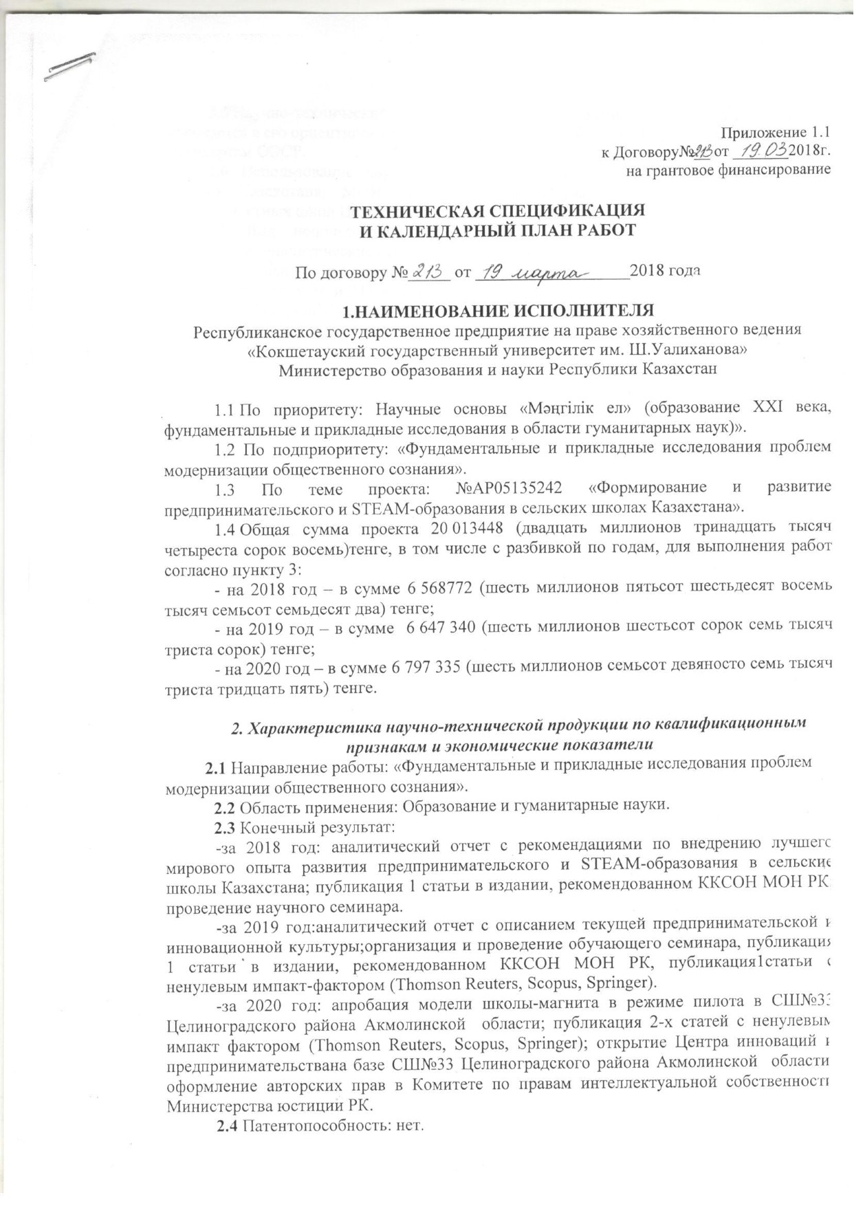
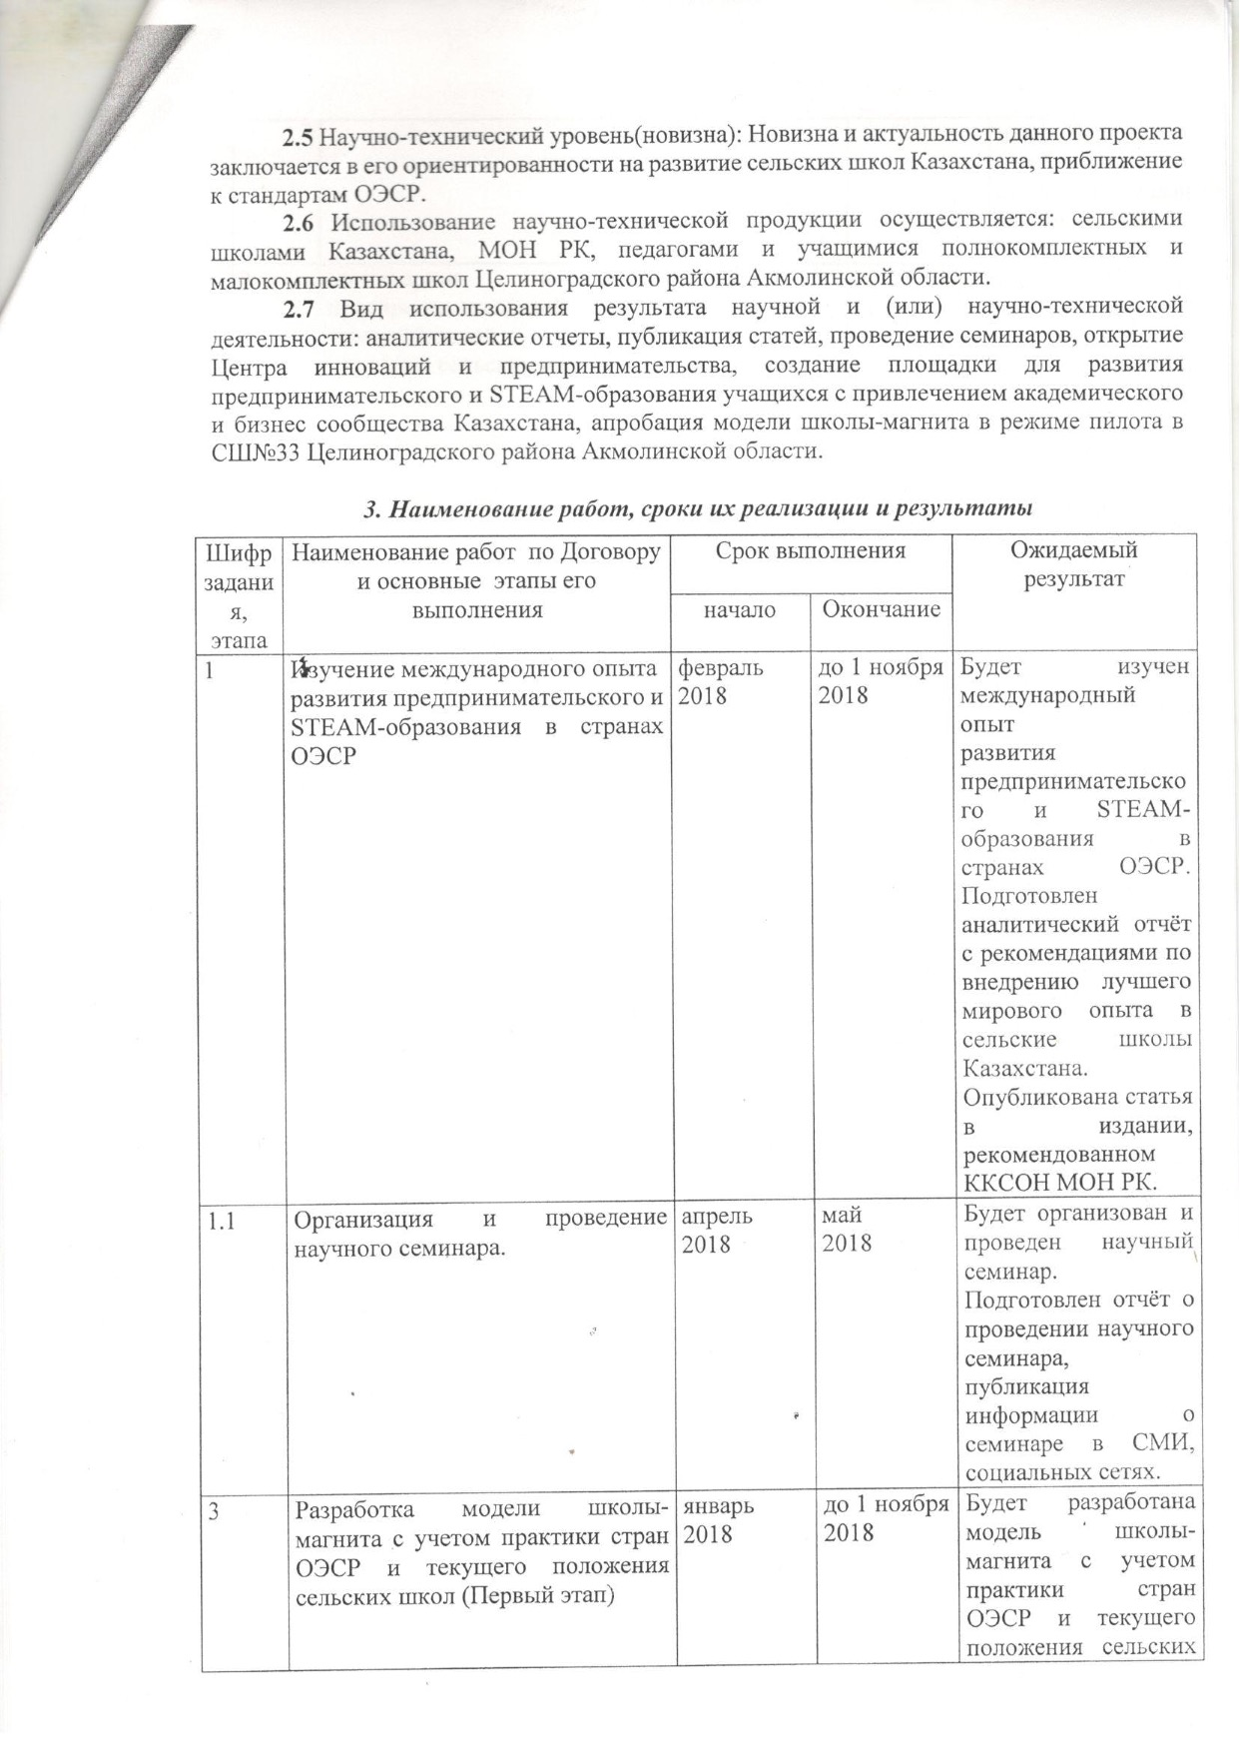

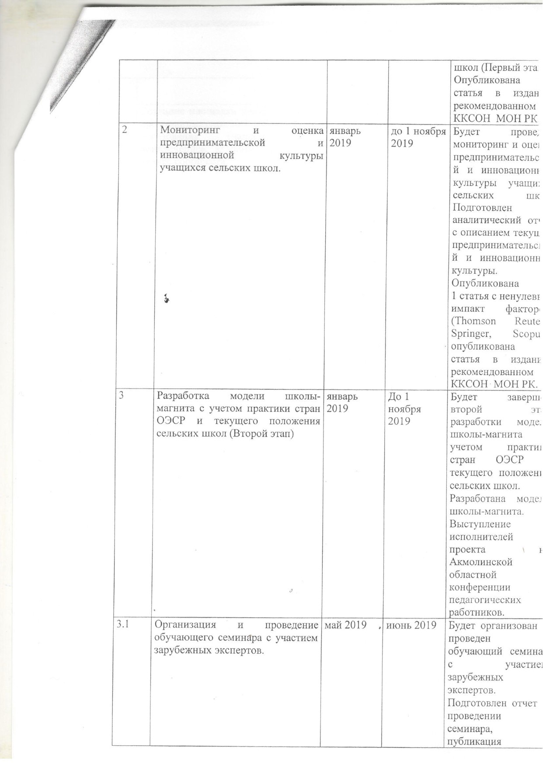

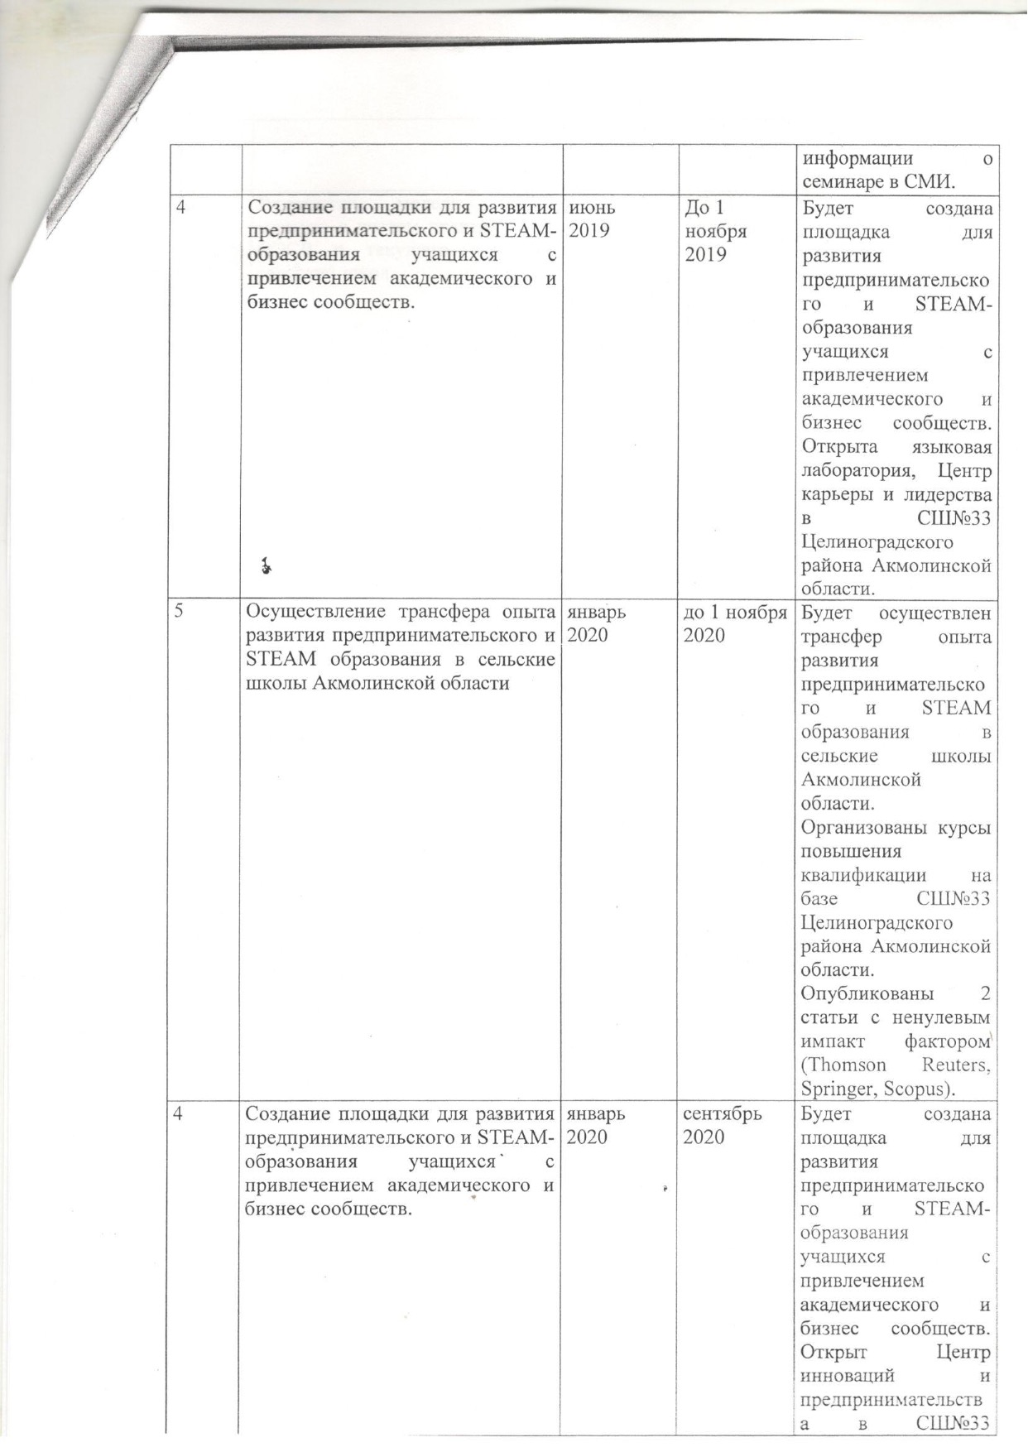

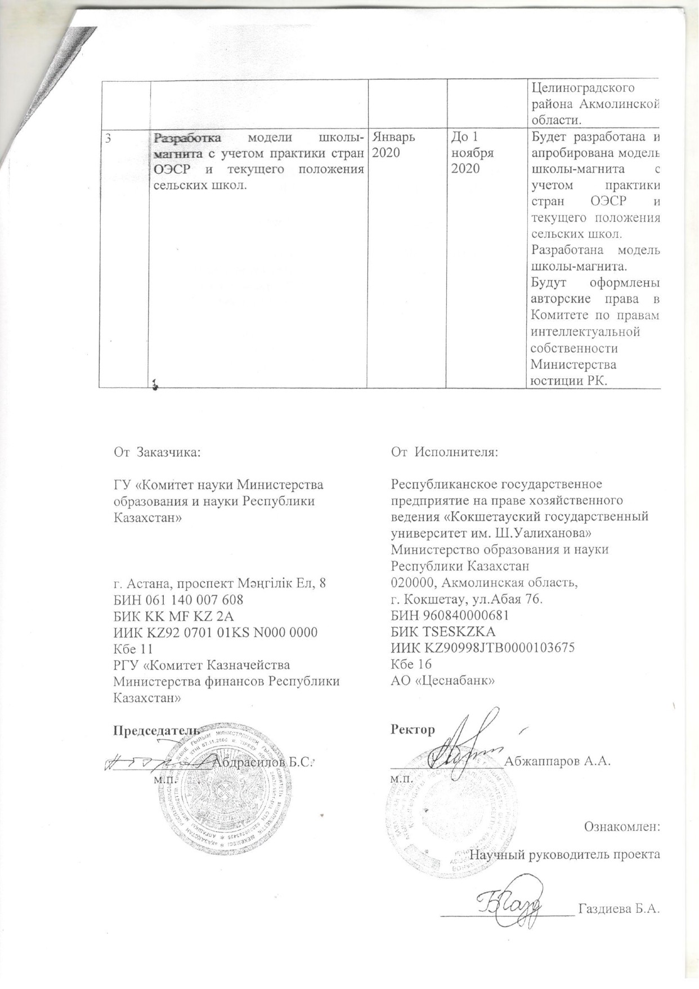

Appendix 1.1
to the Agreement No.__ dated _______ 2018.
for grant funding

DATA SHEET AND WORK SCHEDULE CALENDAR

to the Agreement No._______ dated _______ 2018.

1.NAME OF THE PROJECT EXECUTIVE
Republican state enterprise on the right of economic management
“Shokan Ualikhanov Kokshetau State University”
Ministry of Education and Science of the Republic of Kazakhstan

1.1 The priority area: Scientific basis “Mangilik El" (education of the XXI century, fundamental and applied research in the field of Humanities)”.
1.2 The sub-priority: “Fundamental and applied research of the problems of modernization of public consciousness”.
1.3 The topic of the project: №AP05135242 “Developing and Inspiring Entrepreneurial and STEAM Education in Rural Schools of Kazakhstan."
1.4 Total project amount: 20 013448 (twenty million thirteen thousand four hundred forty-eight) tenge, including the breakdown by years for the performance of work in accordance with paragraph 3:
- for 2018 – in the amount of 6 568772 (six million five hundred sixty-eight thousand seven hundred seventy-two) tenge;
- for 2019 – in the amount of 6 647 340 (six million six hundred forty-seven thousand three hundred forty) tenge;
- for 2020 – in the amount of 6 797 335 (six million seven hundred ninety-seven thousand three hundred thirty-five) tenge.

2. Characteristics of scientific and technical products by qualification characteristics and economic indicators
2.1Field of work: “Fundamental and applied research of the problems of modernization of public consciousness”.
2.2 Field of use: Education and Humanities.
2.3 Final outcome:
- in 2018: analytical report with recommendations on the implementation of the best world experience in the development of entrepreneurial and STEAM education in rural schools of Kazakhstan; the publication of 1 article in the edition recommended by the Committee for Control in the Sphere of Education and Science of the Ministry of Education and Science of the Republic of Kazakhstan; conducting a scientific seminar.
-in 2019: analytical report describing the current entrepreneurial and innovative culture; organization and conduct of a training seminar, publication of 1 article in a publication recommended by the Committee for Control in the Sphere of Education and Science of the Ministry of Education and Science of the Republic of Kazakhstan; publication of an article with a non-zero impact factor (Thomson Reuters, Scopus, Springer).
-in 2020: the approbation of the model of a magnet school in pilot mode in secondary School №33 of Tselinograd district of the Akmola region; the publication of 2 articles with a non-zero impact factor (Thomson Reuters, Scopus, Springer); the opening of the Center for Innovation and Entrepreneurship at Secondary School №33 of Tselinograd district of the Akmola region; the registration of copyrights in the Committee on Intellectual Property Rights of the Ministry of Justice of the Republic of Kazakhstan.
2.4 Patentable invention: no.
2.5 Scientific and technical level (novelty): The novelty and relevance of this project lies in its focus on the development of rural schools of Kazakhstan and their approximation to OECD standards.
2.6 The use of scientific and technical products is carried out by: rural schools of Kazakhstan, the Ministry of Education and Science of the Republic of Kazakhstan, teachers and students of complete and small schools of Tselinograd district of the Akmola region.
2.7 The type of using the result of scientific and (or) scientific and technical activities: analytical reports, publication of articles, seminars, opening the Center for Innovation and Entrepreneurship, creating a platform for the development of entrepreneurial and STEAM education with the involvement of the academic and business community of Kazakhstan, testing the model of a magnet school in pilot mode at Secondary School №33 of Tselinograd district of the Akmola region.

3. Name of work, terms of its implementation and results
Task code, stage | Name of work under the Agreement and the main stages of its implementation | Implementation date |  | Expected  outcome
Task code, stage |  | Start date | End date
1 | Studying international experience in the development of entrepreneurial and STEAM education in OECD countries | February 2018 | until November 1, 2018 | The international experience on the development of entrepreneurial and STEAM education in OECD countries will be studied. An analytical report with recommendations for the implementation of the best world experience in rural schools of Kazakhstan will be prepared. An article will be published in the edition recommended by the Committee for Control in the Sphere of Education and Science of the Ministry of Education and Science of the Republic of Kazakhstan.
1.1 | Organization and conduct of a scientific seminar. | April 2018 | May 2018 | A scientific seminar will be organized and conducted. A report on the scientific seminar will be prepared, the information about the seminar will be published in the media and social networks.
3 | The development of a model of a magnet school with reference to the practice of OECD countries and the current situation of rural schools (First stage) | January  2018 | until November 1, 2018 | A model of the magnet school with reference to the practice of the OECD countries and the current situation of rural schools (First stage) will be developed.  1 article in the edition recommended by the Committee for Control in the Sphere of Education and Science of the Ministry of Education and Science of the Republic of Kazakhstan will be published.
2 | Monitoring and evaluating the entrepreneurial and innovative culture of rural school students. | January 2019 | until November 1, 2018 | Monitoring and evaluation of entrepreneurial and innovative culture of rural school students will be carried out. An analytical report describing the current entrepreneurial and innovative culture will be prepared.  1 article with a non-zero impact factor (Thomson Reuters, Springer, Scopus), and 1 article in the edition recommended by the Committee for Control in the Sphere of Education and Science of the Ministry of Education and Science of the Republic of Kazakhstan will be published.
3 | The development of a model of a magnet school with reference to the practice of OECD countries and the current situation of rural schools (Second stage) | January  2019 | until November 1, 2018 | The second stage of the development of the model of a magnet school with reference to the practice of the OECD countries and the current situation of rural schools will be completed. The model of the magnet school will be developed.  The project team will present the results of the project at the Akmola regional conference of teachers.
3.1 | Organization and conduct of a training seminar with the participation of foreign experts. | May2019 | June 2019 | A training seminar with the participation of foreign experts will be organized and conducted. A report on the seminar will be prepared, information about the seminar will be published in mass media.
4 | Creation of a platform for the development of entrepreneurial and STEAM education with the involvement of the academic and business communities. | June  2019 | until November 1, 2018 | A platform for the development of entrepreneurial and STEAM education with the involvement of the academic and business communities will be created. Language Laboratory, Career and Leadership Center in Secondary School №33 of Tselinograd district of Akmola region will be opened.
5 | The transfer of the experience in the development of entrepreneurial and STEAM education to rural schools of Akmola region | January 2020 | until November 1, 2018 | The transfer of experience in the development of entrepreneurial and STEAM education to rural schools of the Akmola region will be carried out. Career enhancement training at Secondary School №33 of Tselinograd district of the Akmola region will be organized.  2 articles with non-zero impact factor will be published (Thomson Reuters, Springer, Scopus).
4 | Creation of a platform for the development of entrepreneurial and STEAM education with the involvement of the academic and business communities. | January  2020 | September 2020 | A platform for the development of entrepreneurial and STEAM education with the involvement of the academic and business communities will be created. The Center for Innovation and Entrepreneurship will be opened at Secondary School №33 of Tselinograd district of the Akmola region.
3 | The development of a model of a magnet school with reference to the practice of OECD countries and the current situation of rural schools. | January 2020 | until November 1, 2018 | A model of a magnet school with reference to the practice of OECD countries and the current situation of rural schools will be developed. The model of the magnet school will be developed. The copyrights in the Committee on Intellectual Property Rights of the Ministry of Justice of the Republic of Kazakhstan will be registered. |  | Модель школы-магнита в режиме пилота в СШ№33 Целиноградского р-на,Акмол. обл.

APPENDIX B
List of published works and certificates of authorship on the topic of the research project
List of scientific publications on the topic of the research project for 2018:
1. Gazdiyeva B.A., Tavluy M.V., Fatkieva G.T., Sagyndykova Zh.O. The Development of Entrepreneurial and STEAM Education in the framework of updated content of education //Shokan Ualikhanov Kokshetu State University Bulletin. Philological series. - Kokshetau, 2018. - No. 1 (2). - pp. 287-292) (Газдиева Б.А., Тавлуй М.В., Фаткиева Г.Т., Сагындыкова Ж.О. Развитие предпринимательского и STEAM-обучения в контексте обновления содержания образования // Вестник КГУ им. Ш. Уалиханова. Серия филологическая. – Кокшетау, 2018. – № 1 (2). – С. 287-292);
2. Gazdiyeva B.A., Sagyndykova Zh.O., Tavluy M.V., Fatkieva G.T., Akhmetzhanova A.A., Gabdullina Z.Ye. Magnet School as a Trend of Modern Education: Experience and Prospects Shokan Ualikhanov Kokshetu State University Bulletin. Philological series. - Kokshetau, 2018. - No. 2. - pp. 303-309. (Газдиева Б.А., Сагындыкова Ж.О., Тавлуй М.В., Фаткиева Г.Т., Ахметжанова А.А., Габдуллина З.Е. Школа-магнит как тренд современного образования: опыт и перспективы // Вестник КГУ им. Ш. Уалиханова. Серия филологическая. – Кокшетау, 2018. – № 2. – С. 303-309).
3. International Experience in the Development of Entrepreneurial and STEAM Education in OECD Countries: Analytical Report / Authors: Gazdiyeva B.A., Akhmetzhanova A.A., Sagyndykova Zh.O., Tavluy M.V., Fatkieva G.T., Gabdullina Z.Ye., Aubakirova D.S. - Kokshetau: Publishing house of Shokan Ualikhanov Kokshetu State University, 2018.- 85 pages. (Международный опыт развития предпринимательского и STEAM-образования в странах ОЭСР: Аналитический отчет /Авт-сост. Газдиева Б.А., Ахметжанова А.А., Сагындыкова Ж.О., Тавлуй М.В., Фаткиева Г.Т., Габдуллина З.Е., Аубакирова Д.С. – Кокшетау: Изд-во КГУ им. Ш. Уалиханова, 2018. – 85 с.).

List of scientific publications, copyright certificates on the topic of a research project for 2019:
1. Monitoring and Evaluation of Entrepreneurial and Innovative Culture of Students in Rural Schools: Analytical Report / Authors: Gazdiyeva B.A., Akhmetzhanova A.A., Sagyndykova Zh.O., Tavluy M.V., Gabdullina Z.Ye. - Kokshetau: publishing house "Mir Pechati", 2019. - 72 pages. ISBN978-601-7582-86-9 (Мониторинг и оценка предпринимательской и инновационной культуры учащихся сельских школ: Аналитический отчёт / Авт.‐сост. Газдиева Б.А., Ахметжанова А.А., Сагындыкова Ж.О., Тавлуй М.В., Габдуллина З.Е. – Кокшетау: издательство «Мир печати», 2019. – 72 с. ISBN978-601-7582-86-9).
2. Fatkieva G.T., Gazdiyeva B.A., Sagyndykova Zh.O., Tavluy M.V., Akhmetzhanova A.A., Gabdullina Z.Ye., Aubakirova D.S. Improving Philological Education in Line with World Integration Trends (From the Experience of a Scientific Project Implementation) // Shokan Ualikhanov Kokshetu State University Bulletin. Philological series. - Kokshetau, 2019. - No. 2. - pp.392-396; (Фаткиева Г.Т., Газдиева Б.А., Сагындыкова Ж.О., Тавлуй М.В., Ахметжанова А.А., Габдуллина З.Е., Аубакирова Д.С. Совершенствование филологического образования в русле мировых интеграционных трендов (из опыта реализации научного проекта) // Вестник КГУ им. Ш. Уалиханова. Серия филологическая. – Кокшетау, 2019. – № 2. – С.392-396).
3. Certificate of entering information into the state register of rights to an object protected by copyright, No. 5572 dated October 2, 2019. Authors: Gazdiyeva Bella Aslanbekovna, Akhmetzhanova Aida Amantayevna, Tavluy Marina Vasilievna, Sagyndykova Zhaylagul Oralovna, Gabdullina Zarina Yeslyambekovna. Type of copyright object: a work of science. Name of the object: Results of the research “Monitoring and Evaluation of Entrepreneurial and Innovative Culture of Students in Rural Schools” (Свидетельство о внесении сведений в государственный реестр прав на объект, охраняемый авторским правом, № 5572 от «2» октября 2019 года. Авторы: Газдиева Белла Асланбековна, Ахметжанова Аида Амантаевна, Тавлуй Марина Васильевна, Сагындыкова Жайлагуль Ораловна, Габдуллина Зарина Еслямбековна. Вид объекта авторского права: произведение науки. Название объекта: Результаты научного исследования «Мониторинг и оценка предпринимательской и инновационной культуры учащихся сельских школ»).
4. Certificate of entering information into the state register of rights to an object protected by copyright, No. 5755 dated October 11, 2019. Authors: Gazdiyeva Bella Aslanbekovna, Sagyndykova Zhaylagul Oralovna, Gabdullina Zarina Yeslyambekovna. Type of copyright object: design work. Object name: Logo of the research project "Developing and Inspiring Entrepreneurial and STEAM Education in Rural Schools of Kazakhstan." (Свидетельство о внесении сведений в государственный реестр прав на объект, охраняемый авторским правом, № 5755 от «11» октября 2019 года. Авторы: Газдиева Белла Асланбековна, Сагындыкова Жайлагуль Ораловна, Габдуллина Зарина Еслямбековна. Вид объекта авторского права: произведение дизайна. Название объекта: Логотип научно-исследовательского проекта «Формирование и развитие предпринимательского и STEAM-образования в сельских школах Казахстана»
List of scientific publications, copyright certificates on the topic of a research project for 2020:
1. A Research on the Practice of Developing a Rural ‘Magnet’ School Model: Theoretical and Applied Aspects. B.A. Gazdiyeva, M.V. Tavluy, Z.Ye. Gabdullina, A.A. Akhmetzhanova, G.T. Fatkiyeva. International Journal of Engineering Research and Technology. ISSN 0974-3154 Vol.13, No.4 (2020), pp. 720-724 © International Research Publication House. Cite Score 2019 – 0.2, Cite Score 2020 – 0.4, SJR (IF)2019 – 0.145, SNIP 2019 – 0.251.
Ссылка на статью: http://www.irphouse.com/ijert20/ijertv13n4_16.pdf
2. The Development of Entrepreneurial Culture in Rural Schools. Gazdiyeva, B., Althonayan, A., Sagyndykova, Z., Akhmetzhanova, A., Gabdullina, Z., Tavluy, M., & Fatkieva, G. Journal of Entrepreneurship Education. Print ISSN 1098-8394, Online ISSN 1528-2651 Vol.23, Issue 3 (2020). Cite Score 2019 – 2.7, Cite Score 2020 – 3.1, SJR (IF)2019 – 0.283, SNIP 2019 – 1.030. Ссылка на статью: https://www.abacademies.org/articles/the-development-of-entrepreneurial-culture-in-rural-schools-9250.html
3. Features of the formation of entrepreneurial skills among schoolchildren of the Republic of Kazakhstan: ways of implementation and development. Gazdieva B.A., Fatkieva G.T., Sagyndykova Zh.O., Tavlui M.V., Akhmetzhanova A.A., Gabdullina Z.E. Pavlodar State University Bulletin. Pedagogical series. - Pavlodar. - 2020. - No. 1., pp. 167-178. (Особенности формирования предпринимательских навыков у школьников Республики Казахстан: пути внедрения и развития. Газдиева Б.А., Фаткиева Г.Т., Сагындыкова Ж.О., Тавлуй М.В., Ахметжанова А.А., Габдуллина З.Е. Вестник ПГУ. Педагогическая серия. – Павлодар. – 2020. – № 1. CC. 167-178).
4. Certificate of entering information into the state register of rights to an object protected by copyright, No. 11472 dated July 29, 2020. Authors: Gazdieyva Bella Aslanbekovna, Tavluy Marina Vasilievna, Akhmetzhanova Aida Amantayevna. Type of copyright object: a work of science. Object name: Model of the "magnet school" (Свидетельство о внесении сведений в государственный реестр прав на объект, охраняемый авторским правом, №11472 от «29» июля 2020 года. Авторы: Газдиева Белла Асланбековна, Тавлуй Марина Васильевна, Ахметжанова Аида Амантаевна. Вид объекта авторского права: произведение науки. Название объекта: Модель «школы магнита»).
5. Certificate of entering information into the state register of rights to an object protected by copyright, No. 8952 dated March 19, 2020. Authors: Gazdiyeva Bella Aslanbekovna, Sagyndykova Zhaylagul Oralovna, Gabdullina Zarina Yeslyambekovna. Type of copyright object: a work of literature. Object name: Program of the Summer Language School “Make it smART by APA & FRIENDS SUMMER SCHOOL (Academy of Public Administration under the President of the Republic of Kazakhstan”) (Свидетельство о внесении сведений в государственный реестр прав на объект, охраняемый авторским правом, № 8952 от «19» марта 2020 года. Авторы: Газдиева Белла Асланбековна, Сагындыкова Жайлагуль Ораловна, Габдуллина Зарина Еслямбековна. Вид объекта авторского права: произведение литературы. Название объекта: Программа Летней языковой школы “Make it smART by APA&FRIENDS SUMMER SCHOOL (Academy of Public Administration under the President of the Republic of Kazakhstan”).

APPENDIX C
Reprints of the scientific publications, copyright certificates on the topic of the research project for 2018-2020
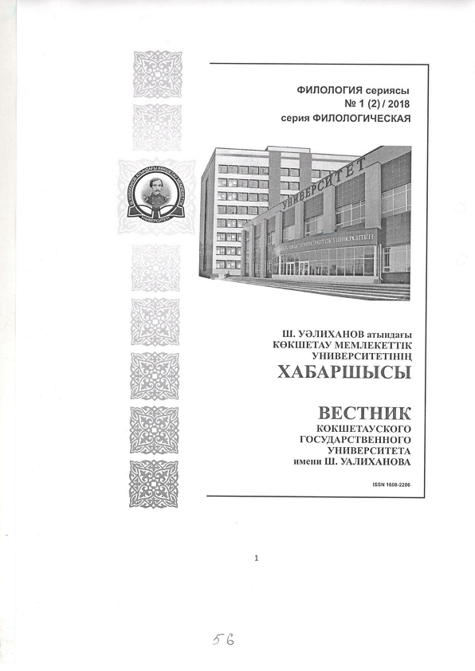

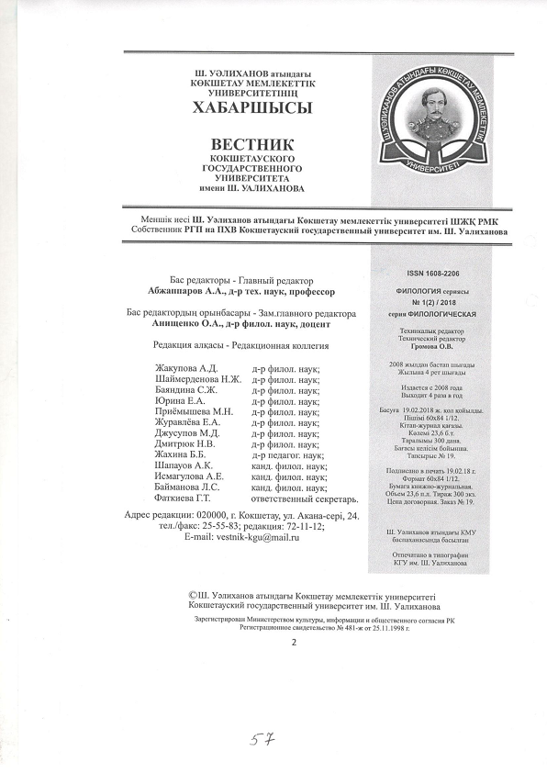

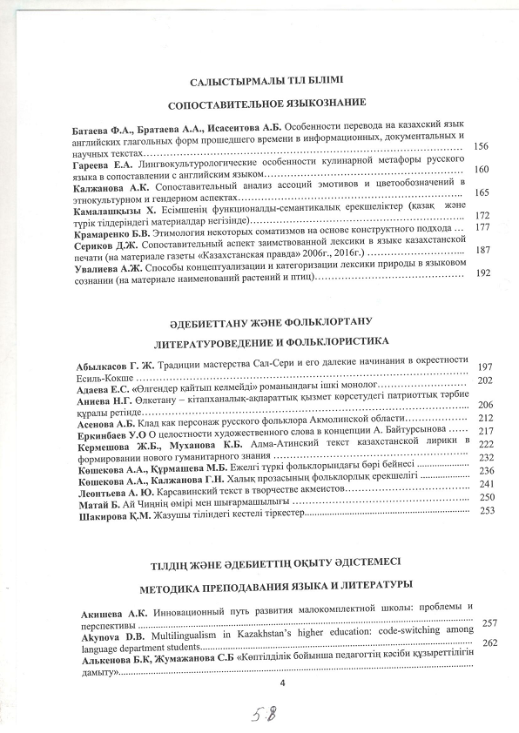

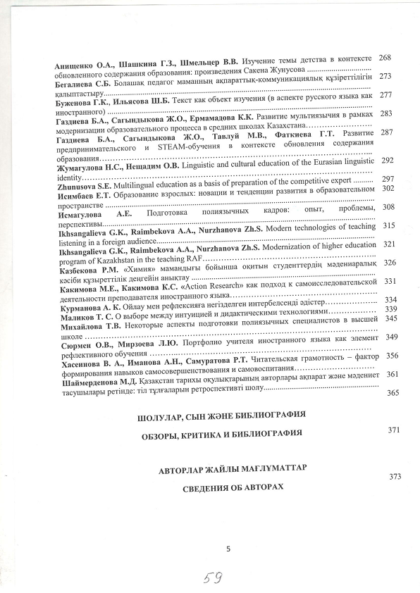
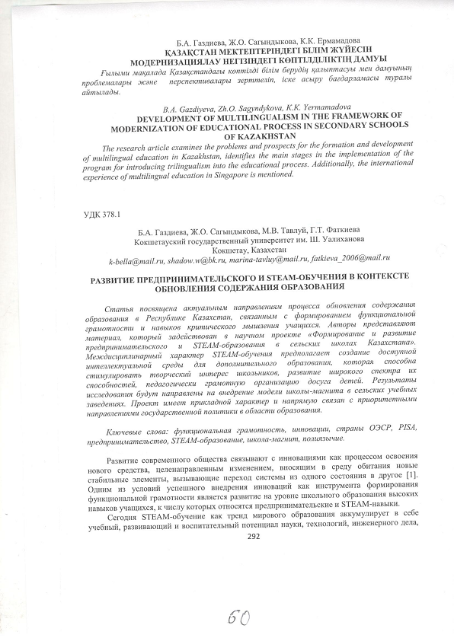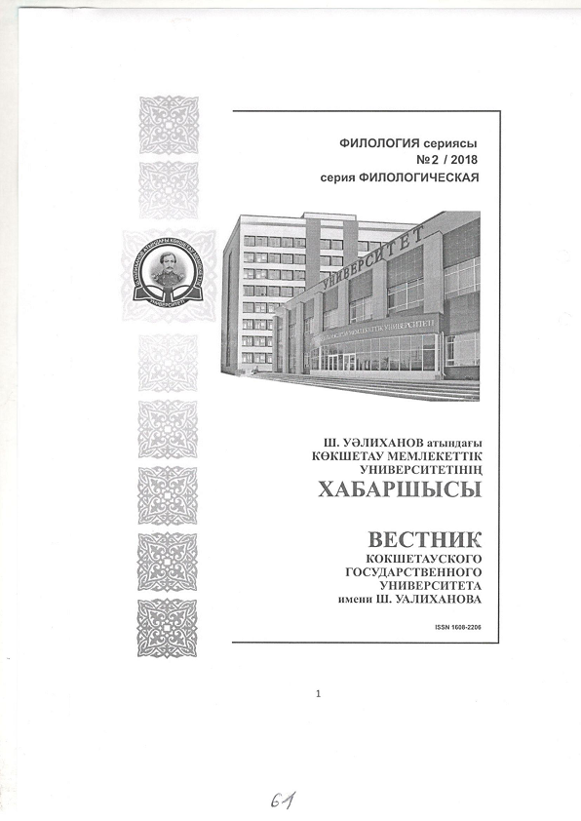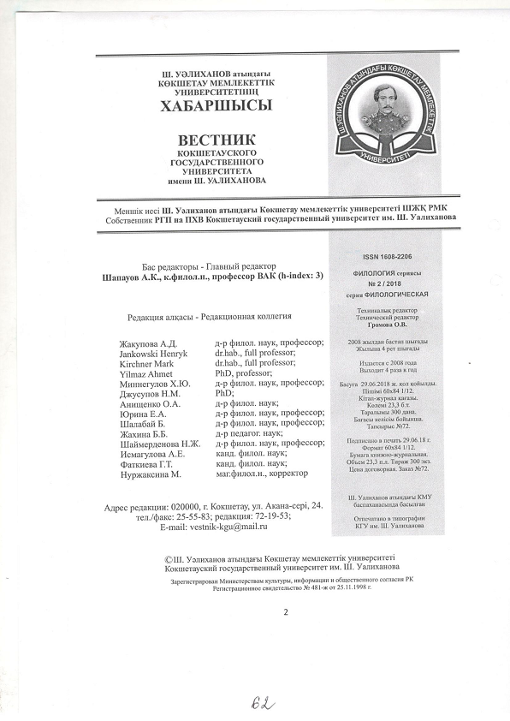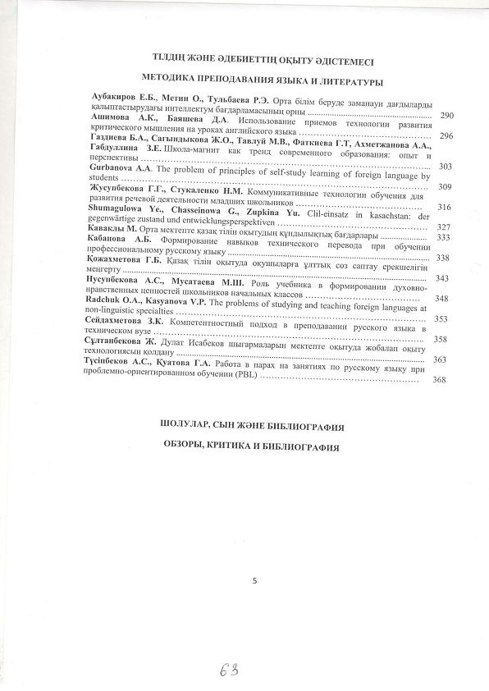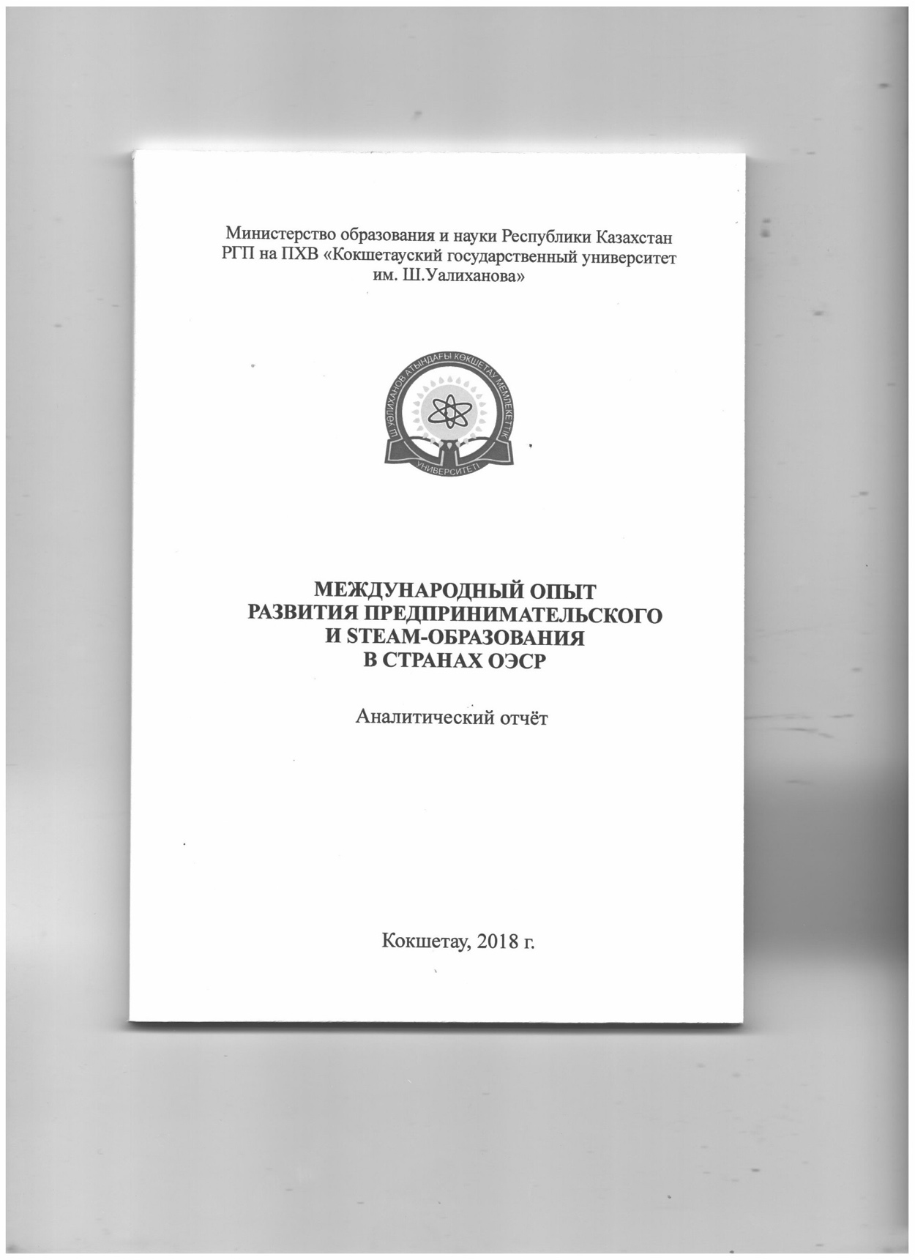

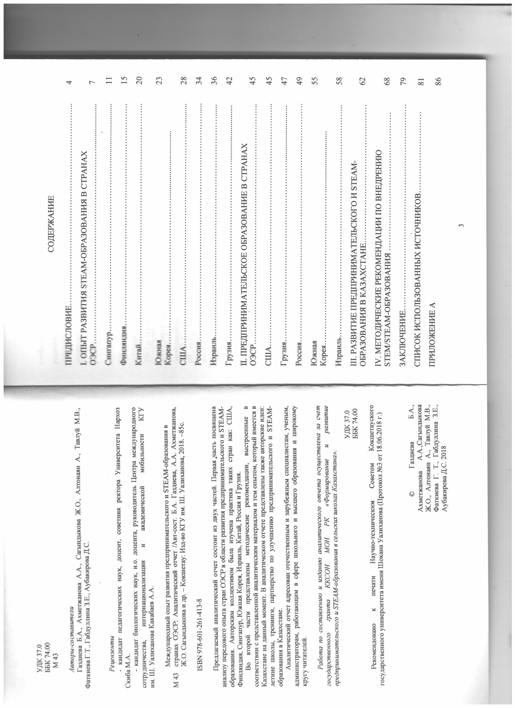

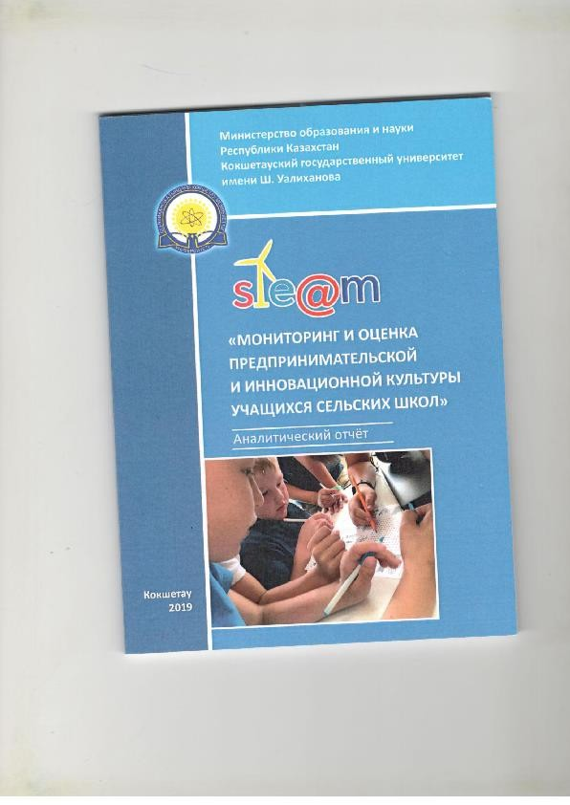

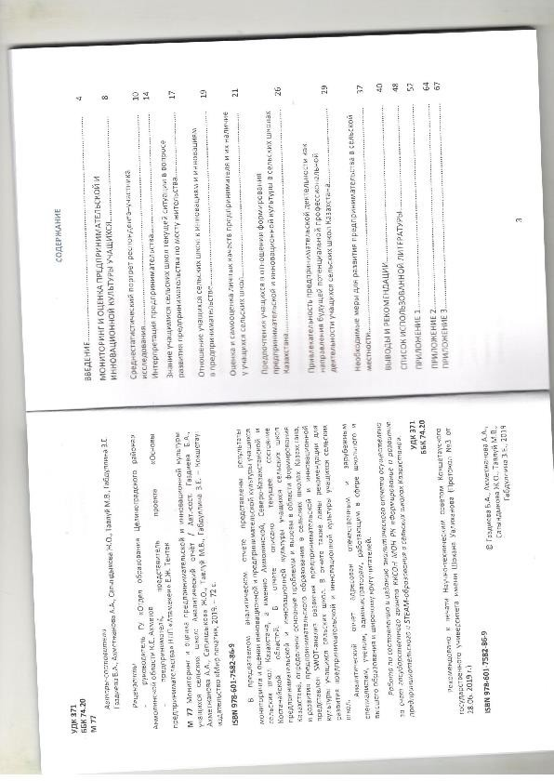

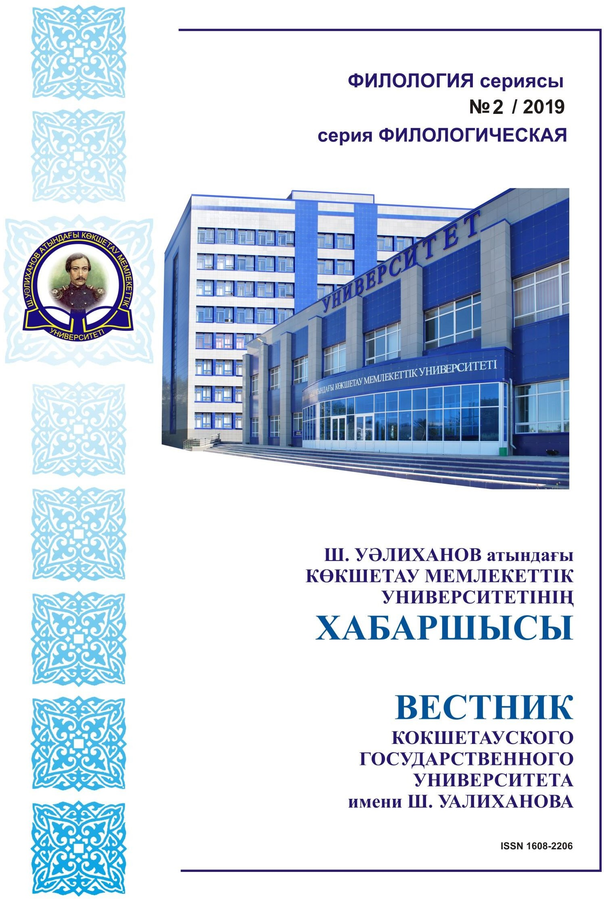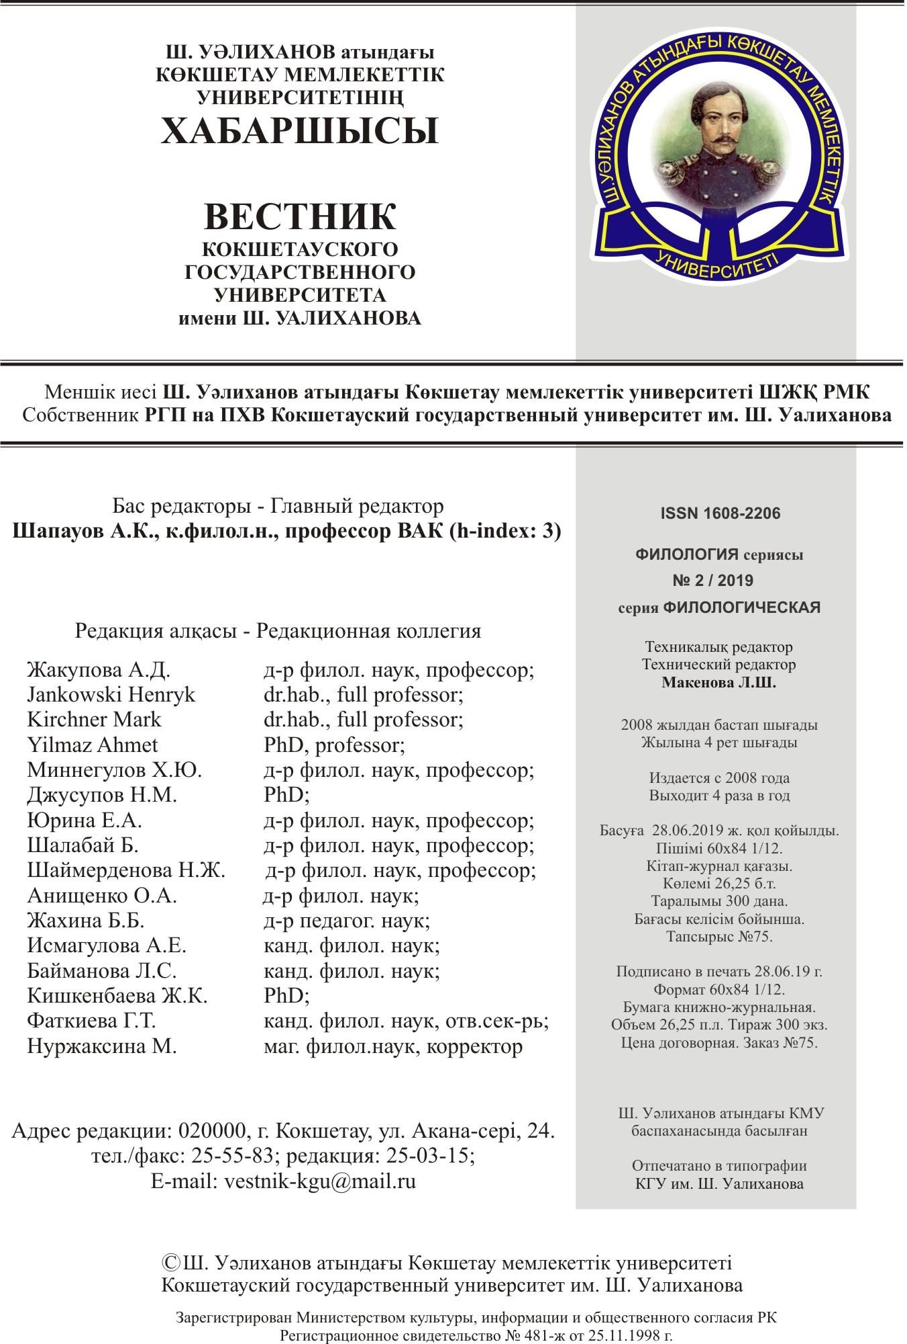

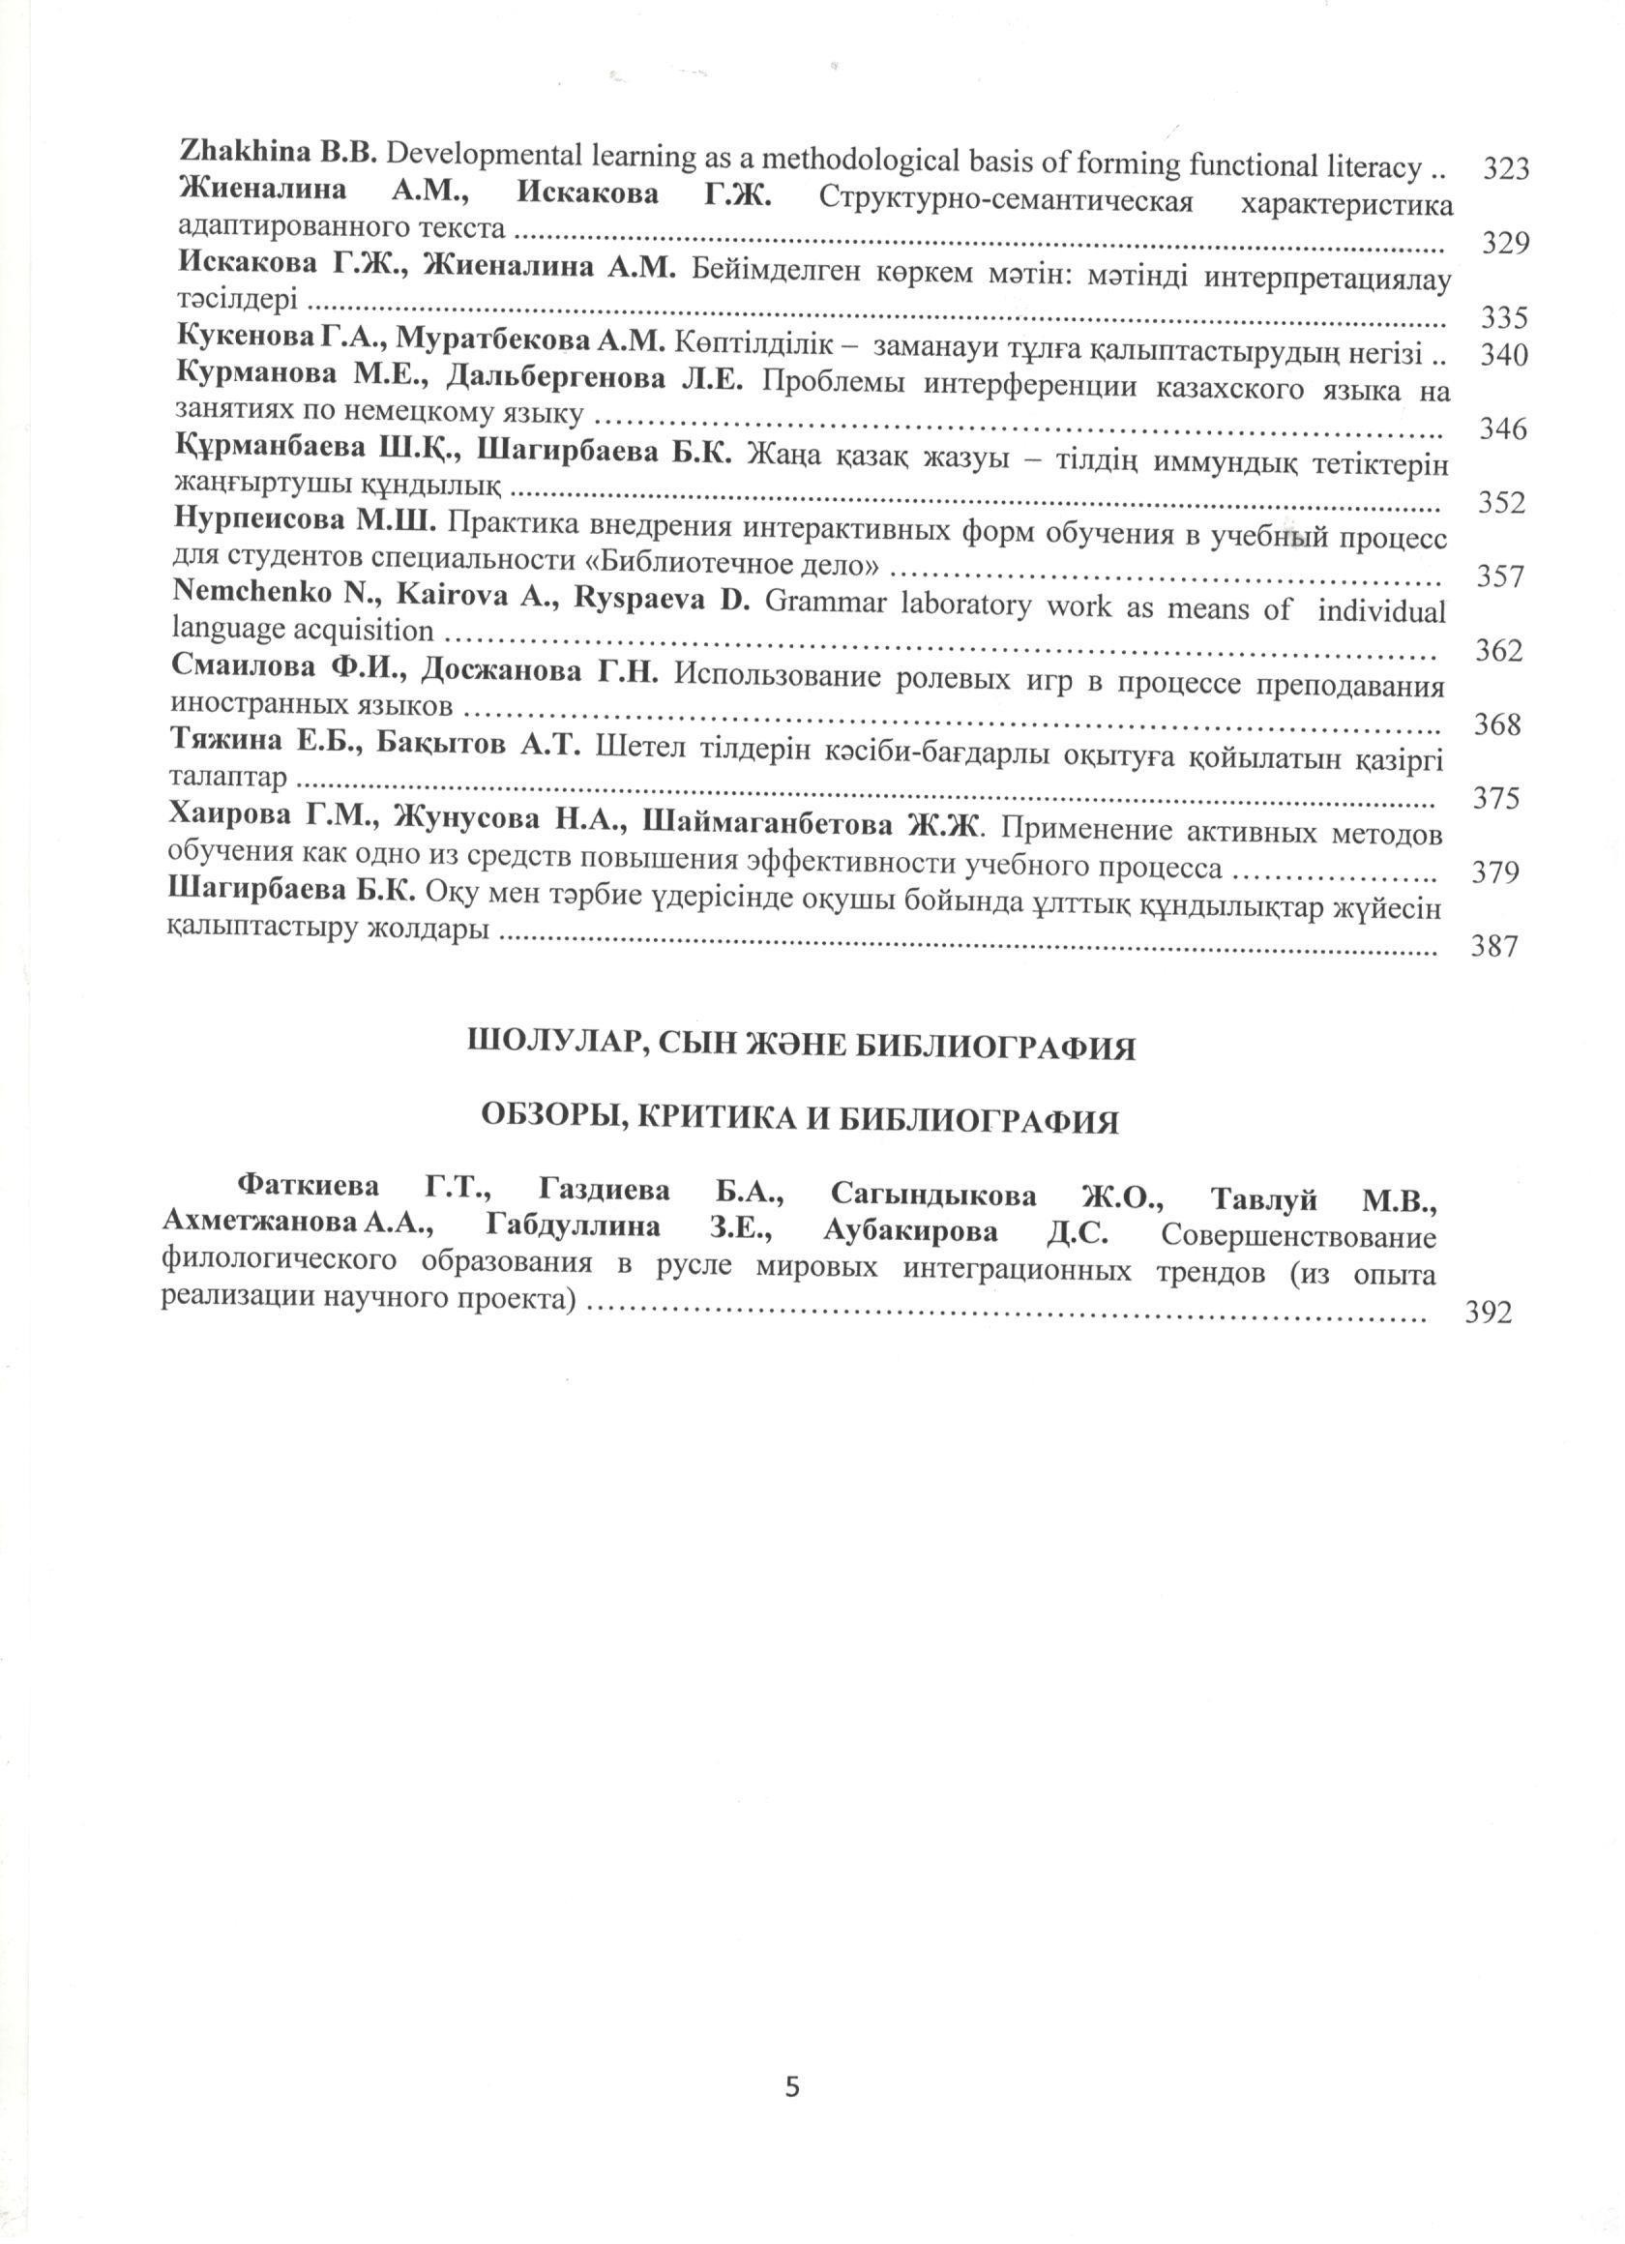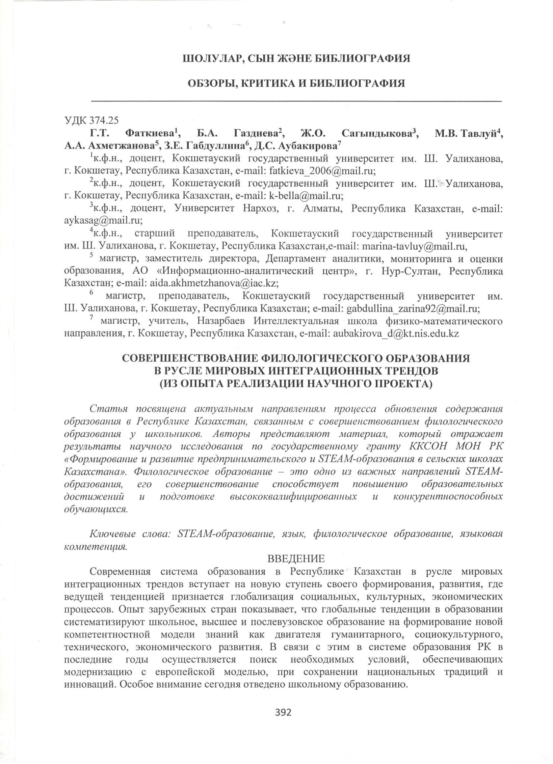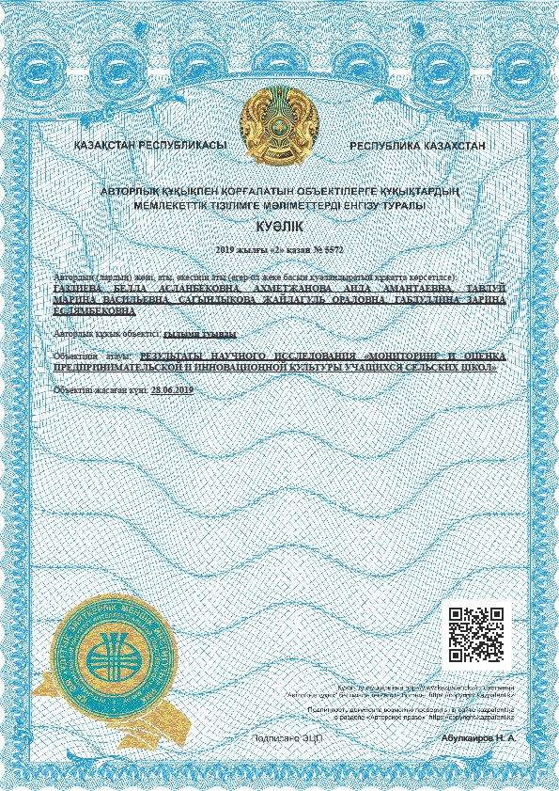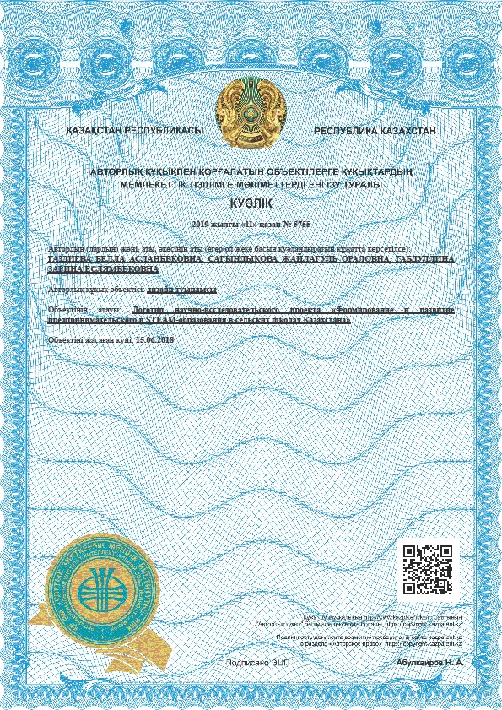

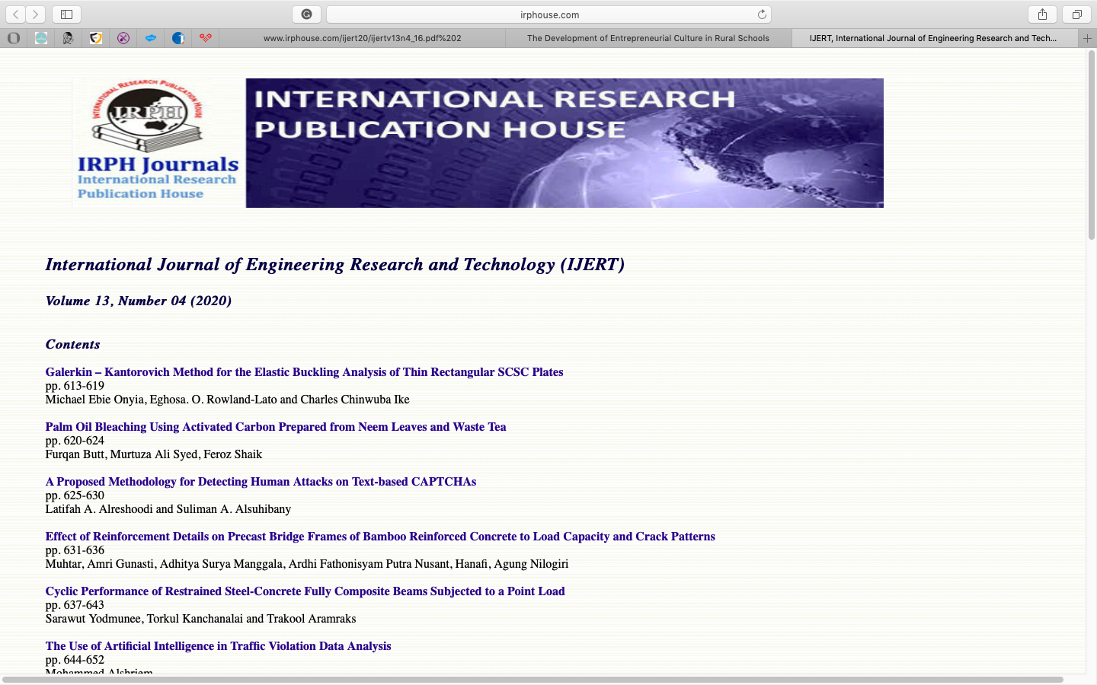

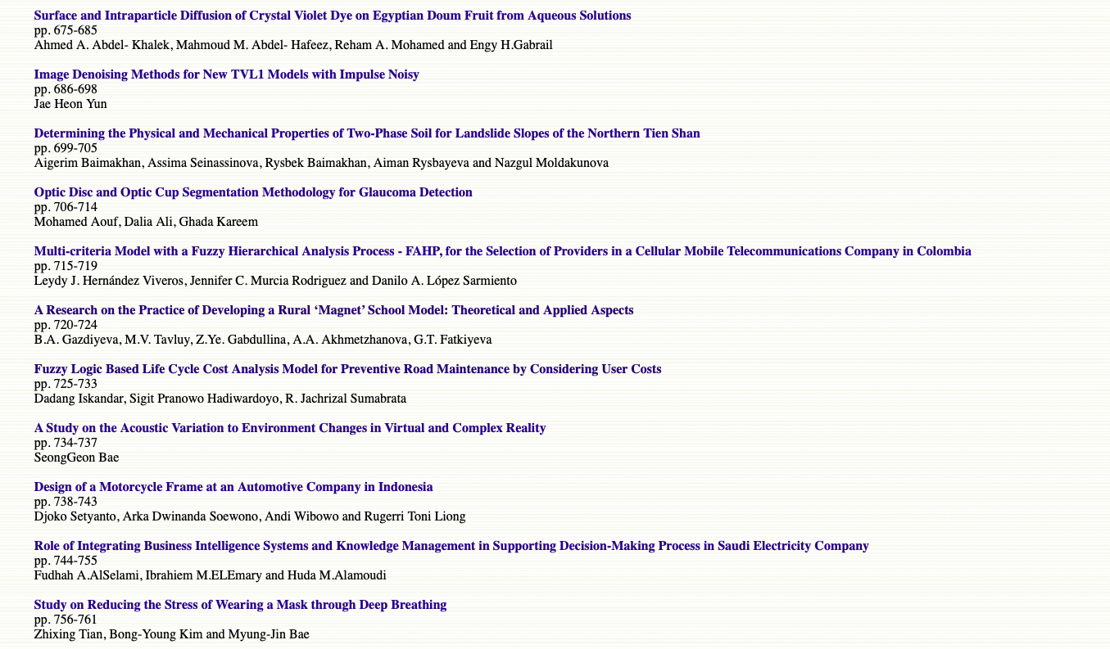

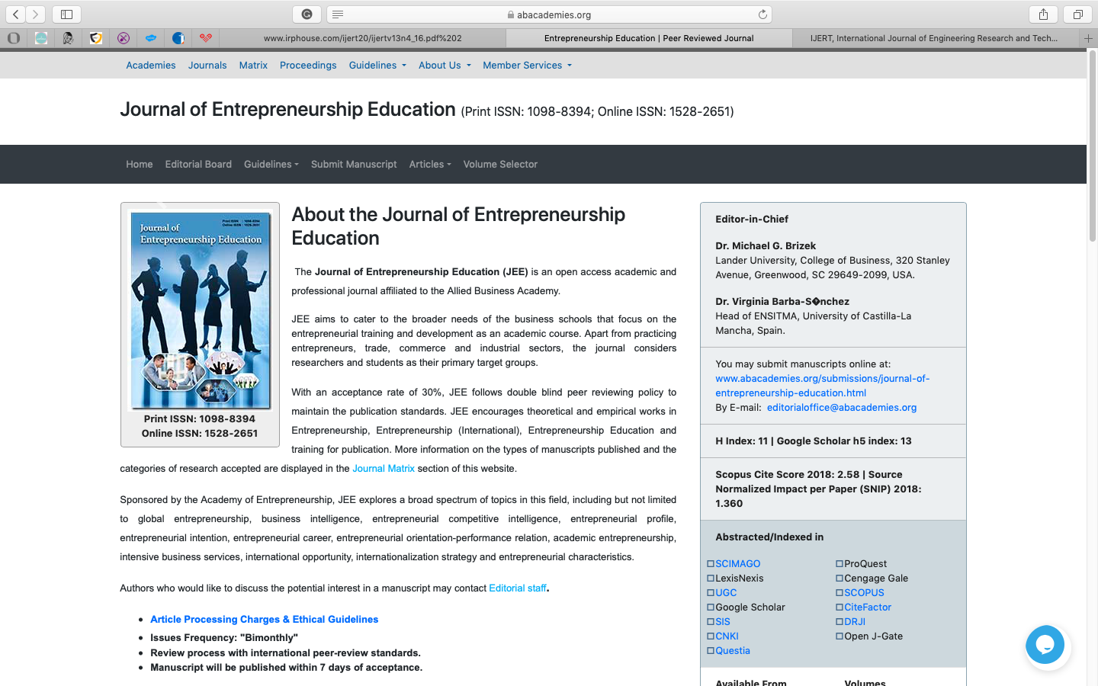

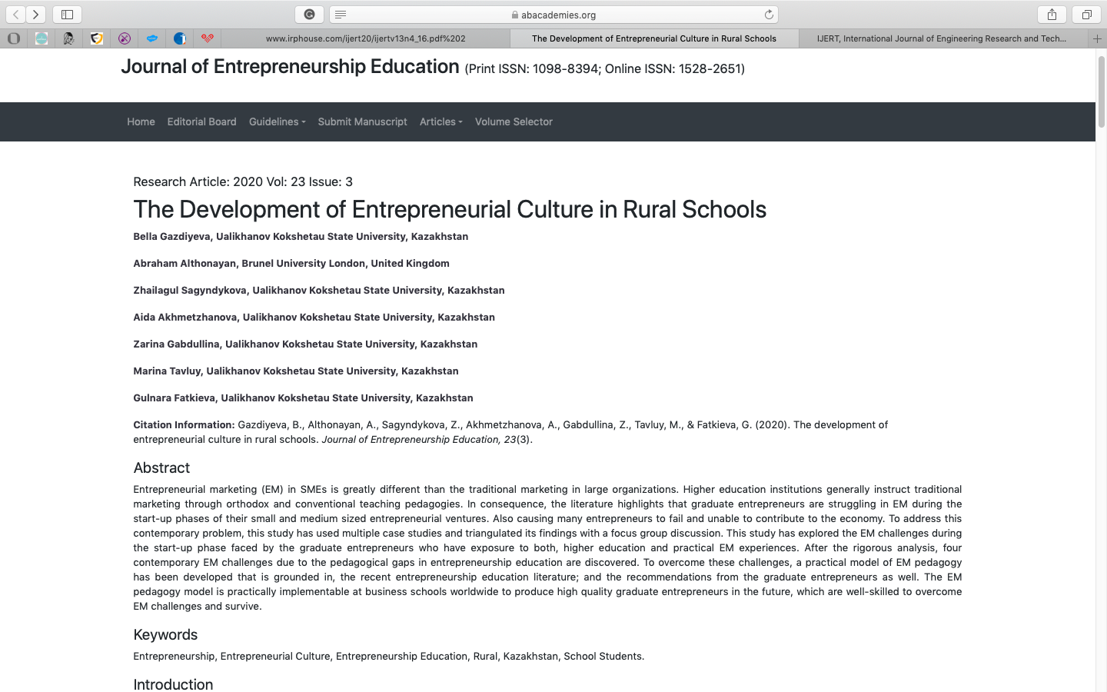

APPENDIX D
Information on the participation of the research group of the project at significant Kazakhstani and foreign forums

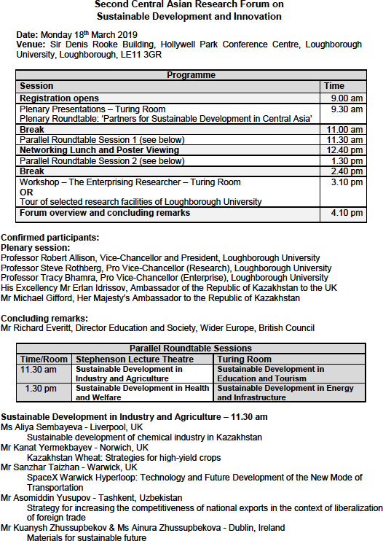

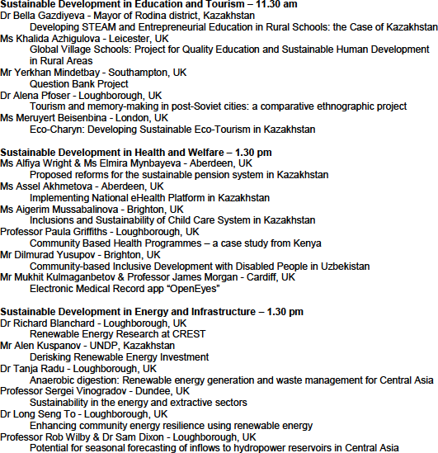

Program of the Second Central Asia Science Forum on Sustainable Development and Innovation, Loughborough University,
United Kingdom, 18th March 2019

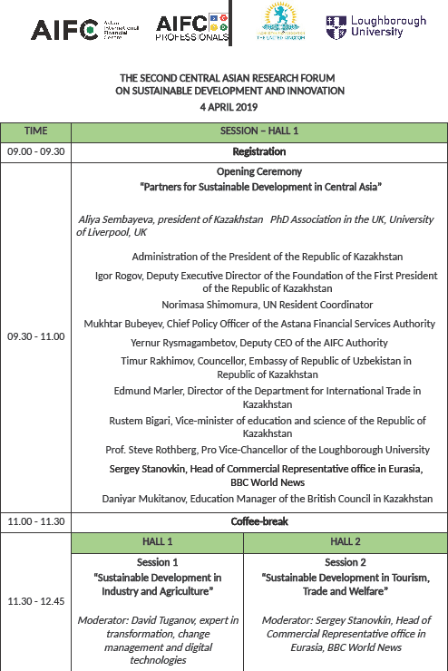

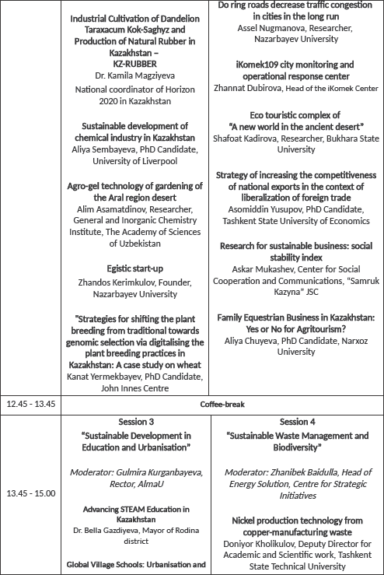

Program of the Second Central Asian Scientific Forum on Sustainable Development and Innovation, Nur-Sultan, 4th March, 2019

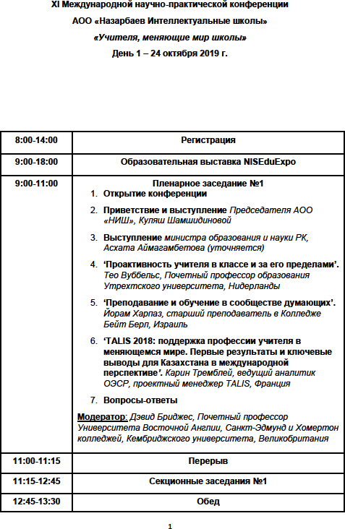

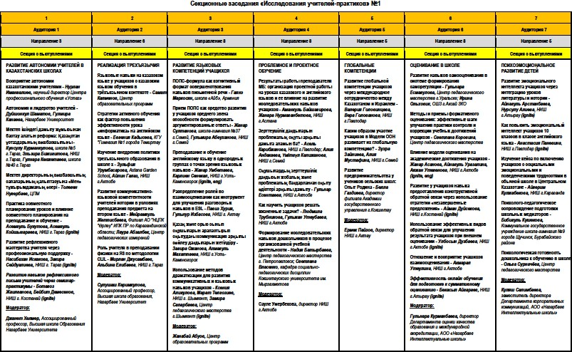

Program of the XI International Scientific and Practical Conference of the Autonomous Educational Organization “Nazarbayev Intellectual Schools” “Teachers Changing the World of Schools”, October 24, 2019

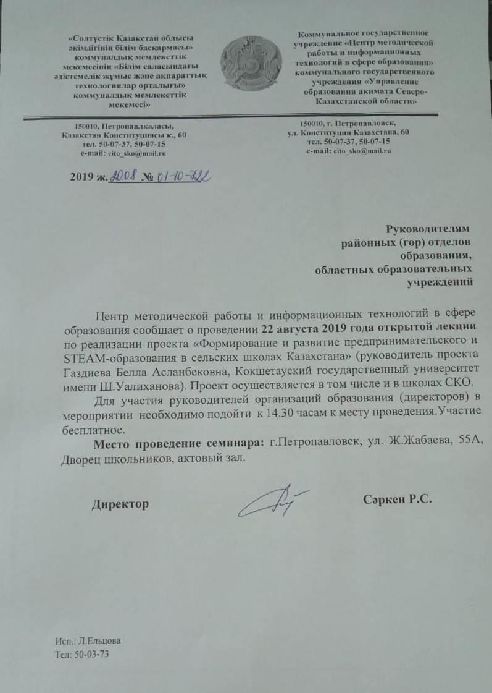

August conference of teachers "Knowledge and Science August Conference – 2019”, Petropavlovsk, August 22, 2019

APPENDIX E
Photo material on the activities carried out within the framework of the project
during 2018-2019

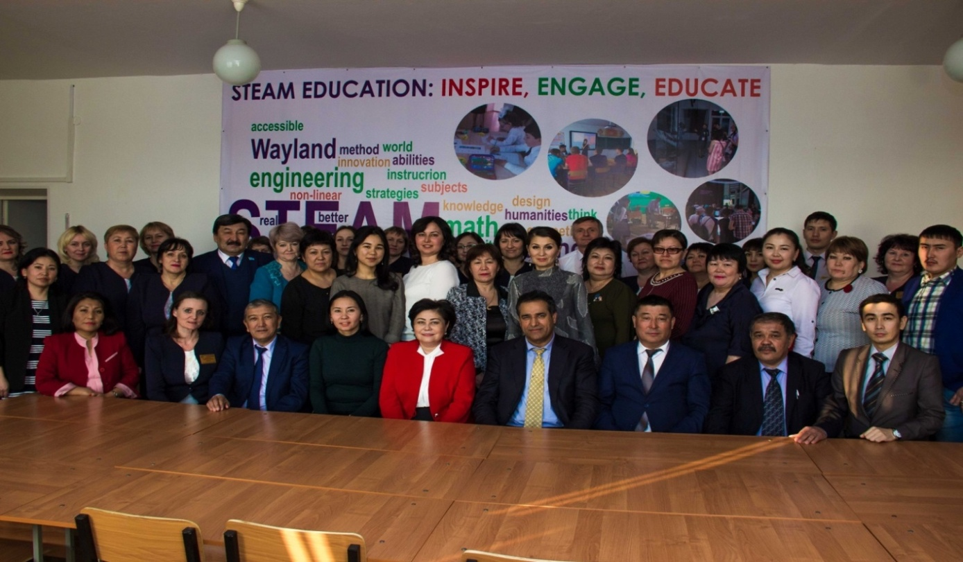

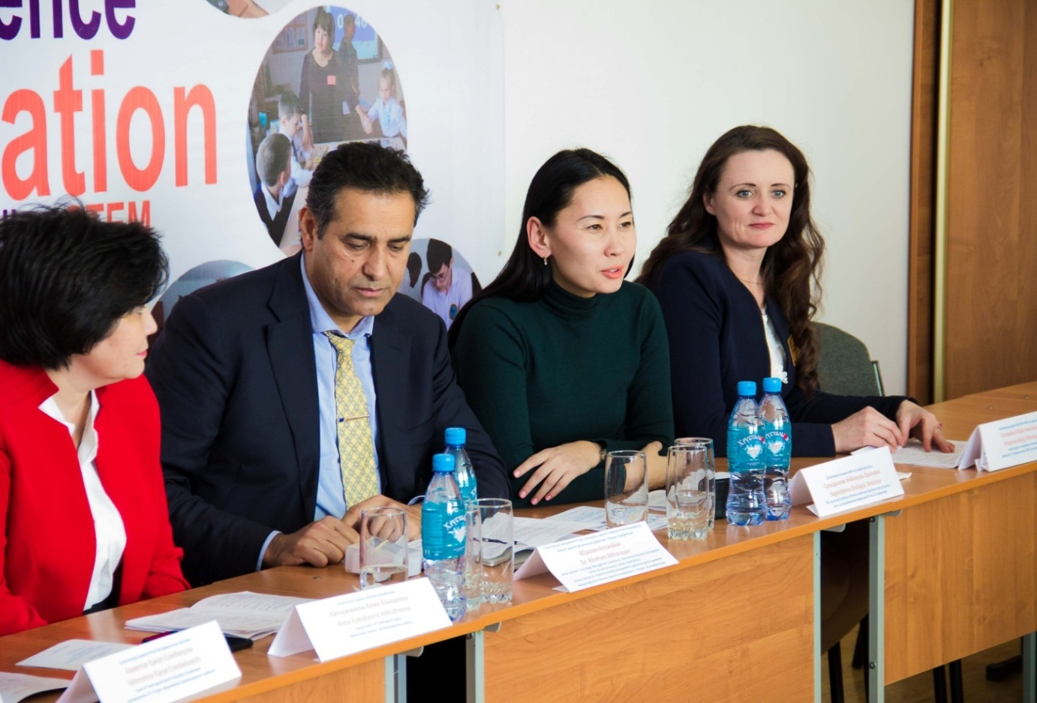

Scientific seminar “Prospects for the development of entrepreneurial and STEAM education in rural schools”, State Institution “Secondary School No. 33 of Tselinograd District”,
February 2018

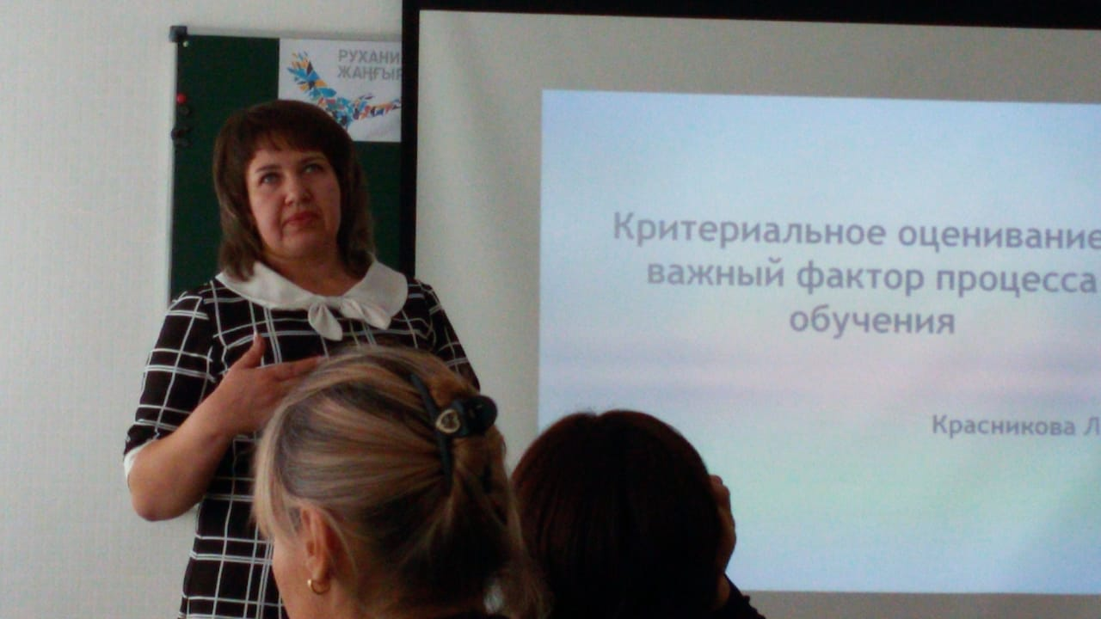

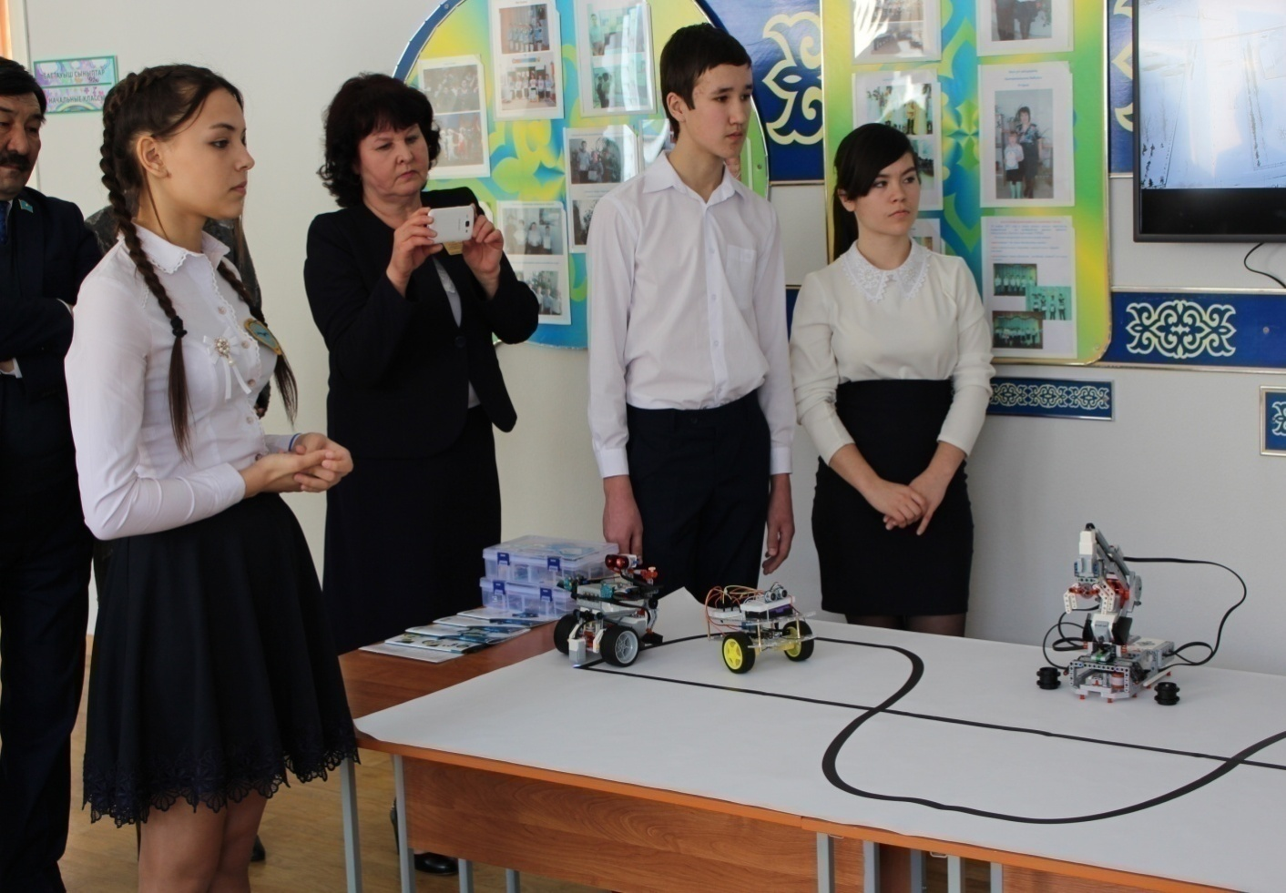

Scientific and methodological seminar dedicated to new approaches in teaching within the framework of the updated educational content and the introduction of STEM and STEAM technologies in the learning process, State Institution “Secondary School No. 33 of the Tselinograd District”, June 2018

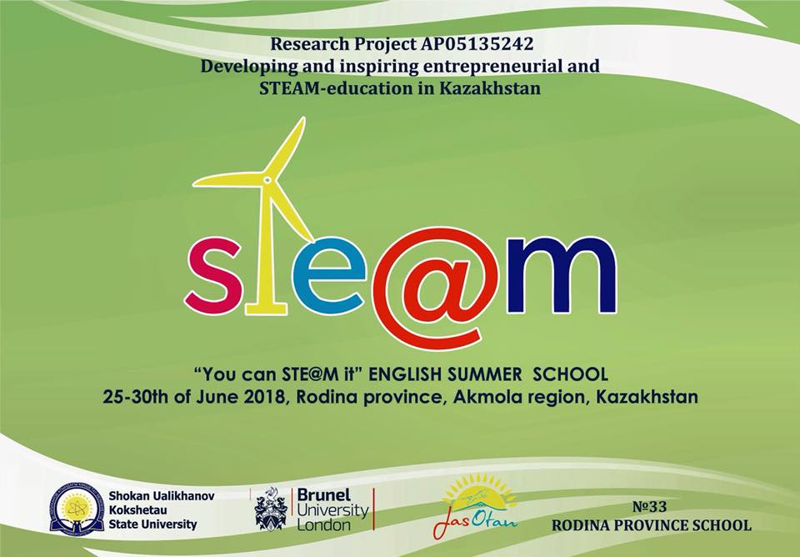

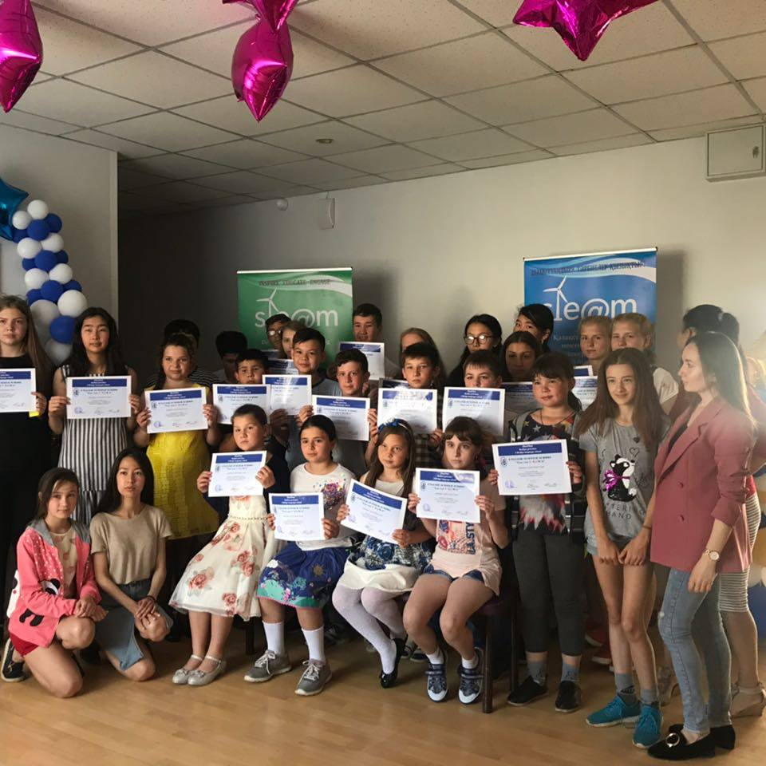

Summer School “You can STE@M it”, State Institution “Secondary School No. 33 of Tselinograd District”, June 2018
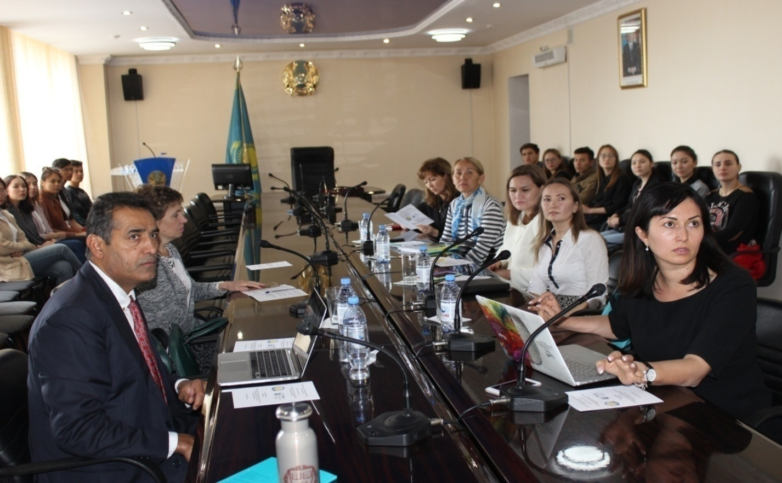

Scientific and methodological Seminar "Entrepreneurship and its Developing in Kazakh Secondary Education", Shokan Ualikhanov University, Kokshetau, September 2018

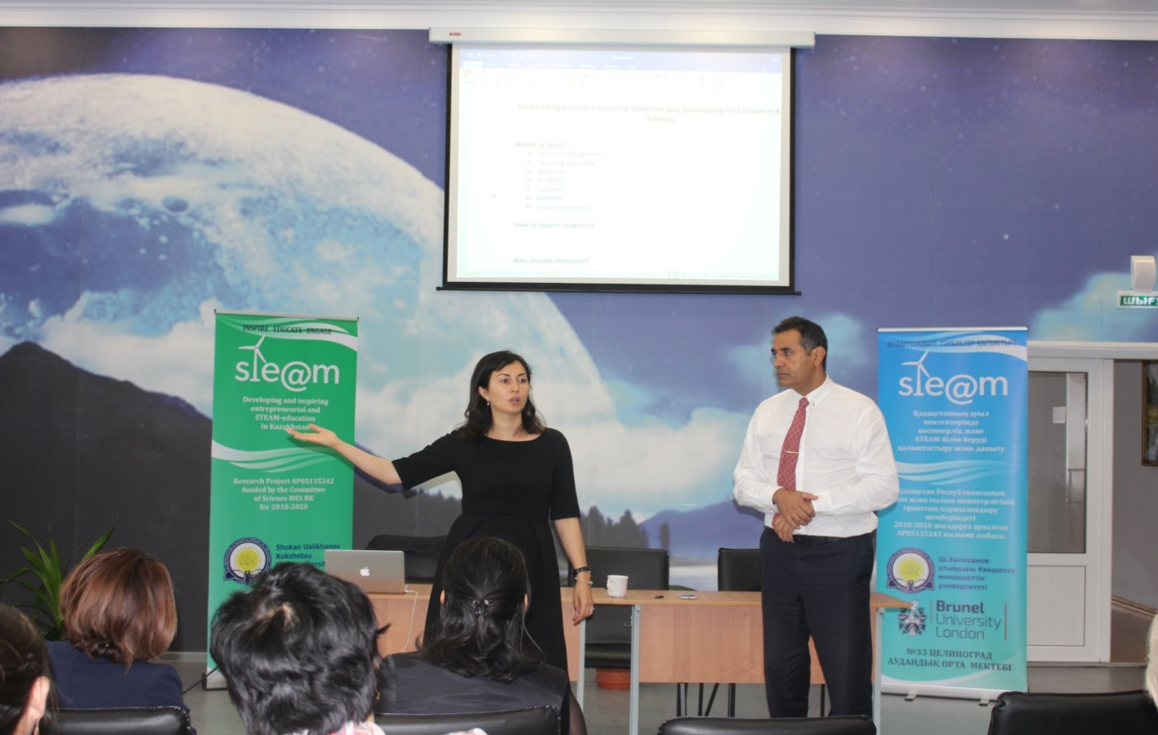

Training-Seminar “Embedding Entrepreneurship Activities and Developing Its Culture in Kazakh Schools”, State Institution “Secondary School No. 33 of Tselinograd District”, September 2018

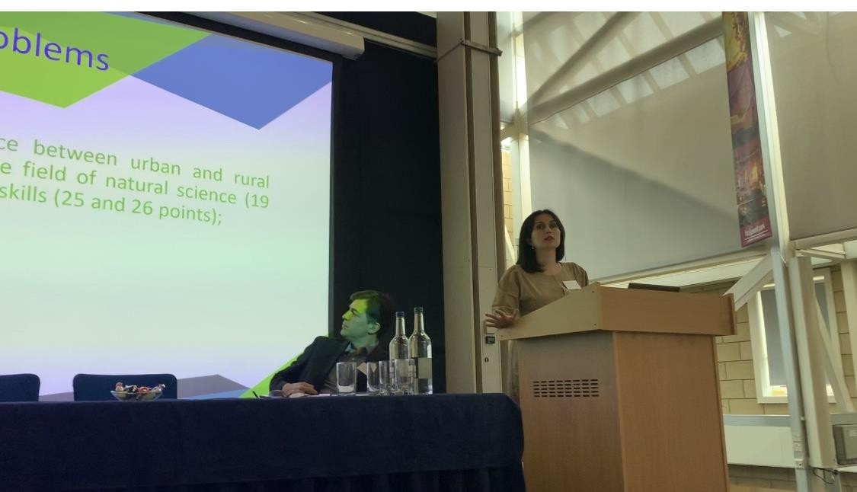

B.A. Gazdiyeva at the Second Central Asia Science Forum on Sustainable Development and Innovation, Loughborough University, UK, 18th March 2019

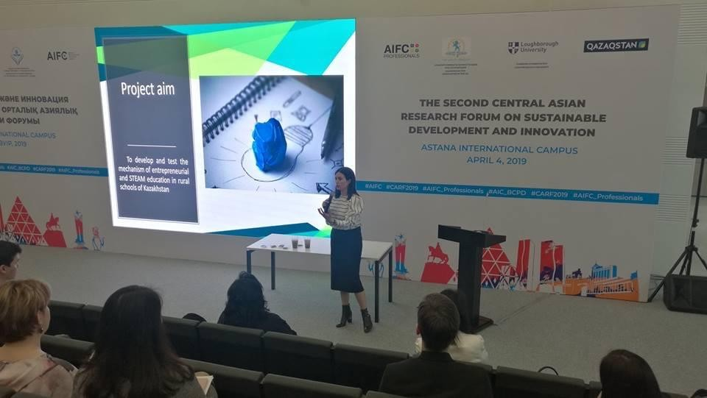

B.A. Gazdiyeva at the Second Central Asian Scientific Forum on Sustainable Development and Innovation, Nur-Sultan, 4th March, 2019

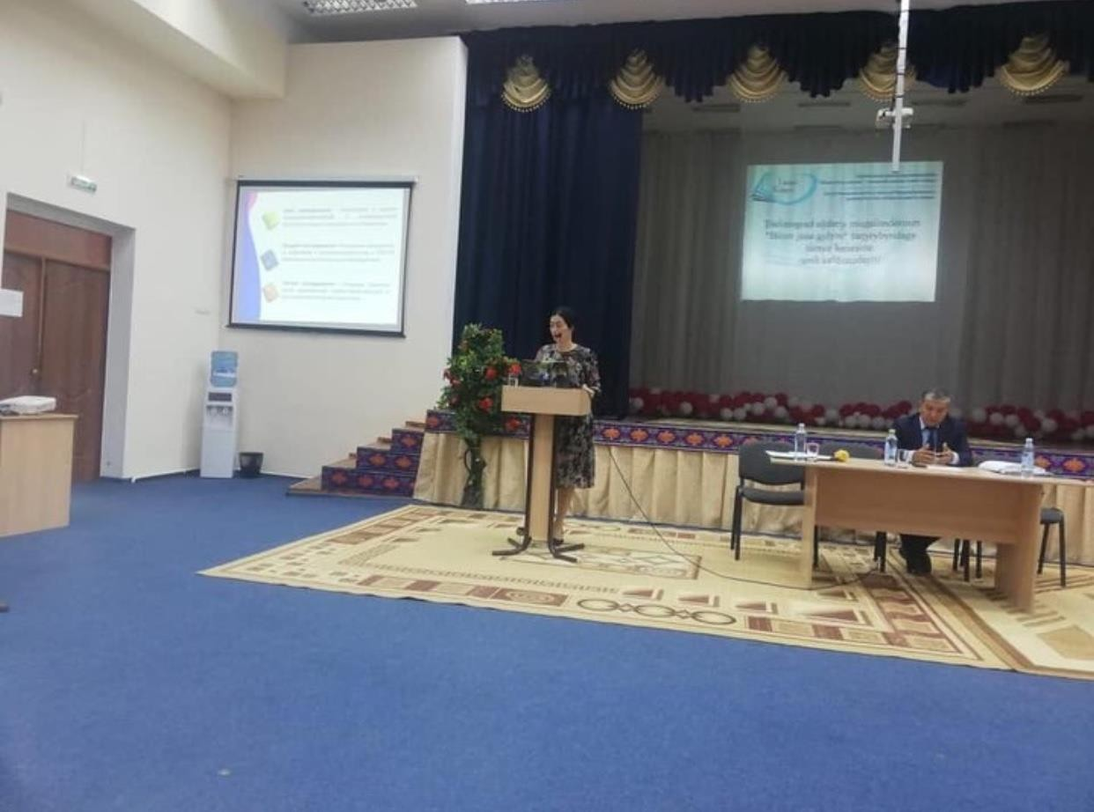

B.A. Gazdiyeva at the August conference at the school of Karaotkel village, Tselinograd District of Akmola region, Section of the Conference "Organization of the educational process in secondary schools in the 2019-2020 academic year”
August 22, 2019

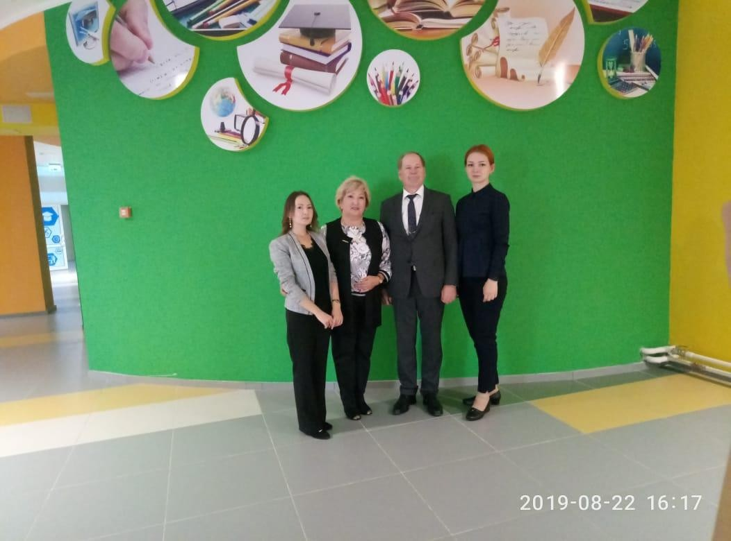

Z.Ye. Gabdullina at the August conference of pedagogical workers "Knowledge and Science August Conference – 2019”, Petropavlovsk, August 22, 2019

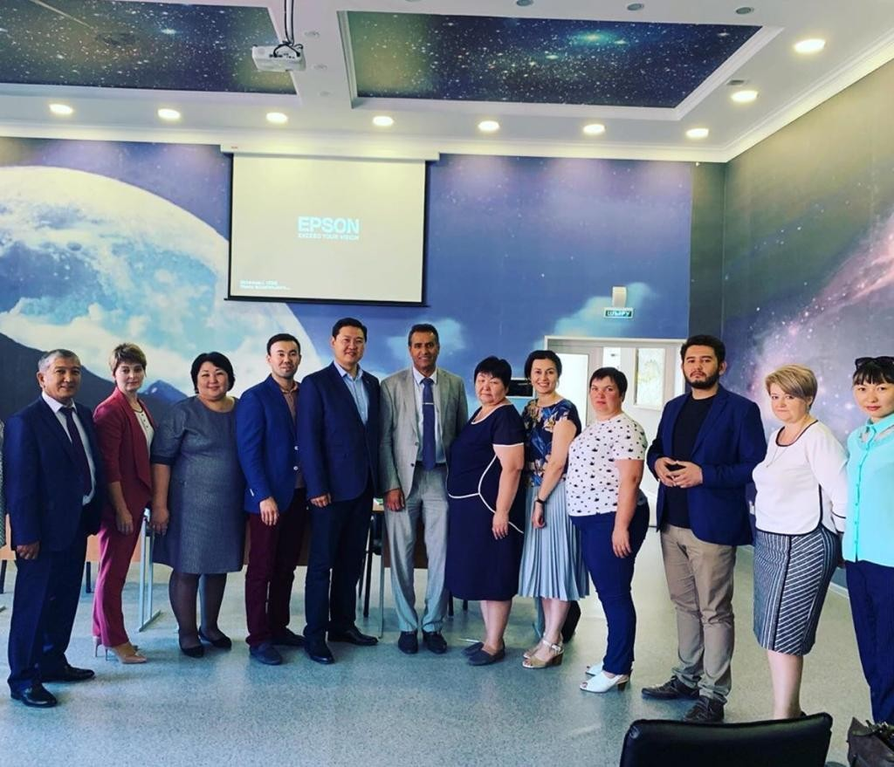
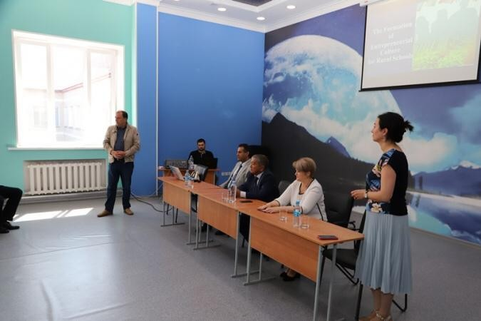

Training seminar “Formation of Entrepreneurial Culture of Students of Rural Schools: The Experience of Scientific Research”, State Institution “Secondary School No. 33 of Tselinograd District”, June 29, 2019

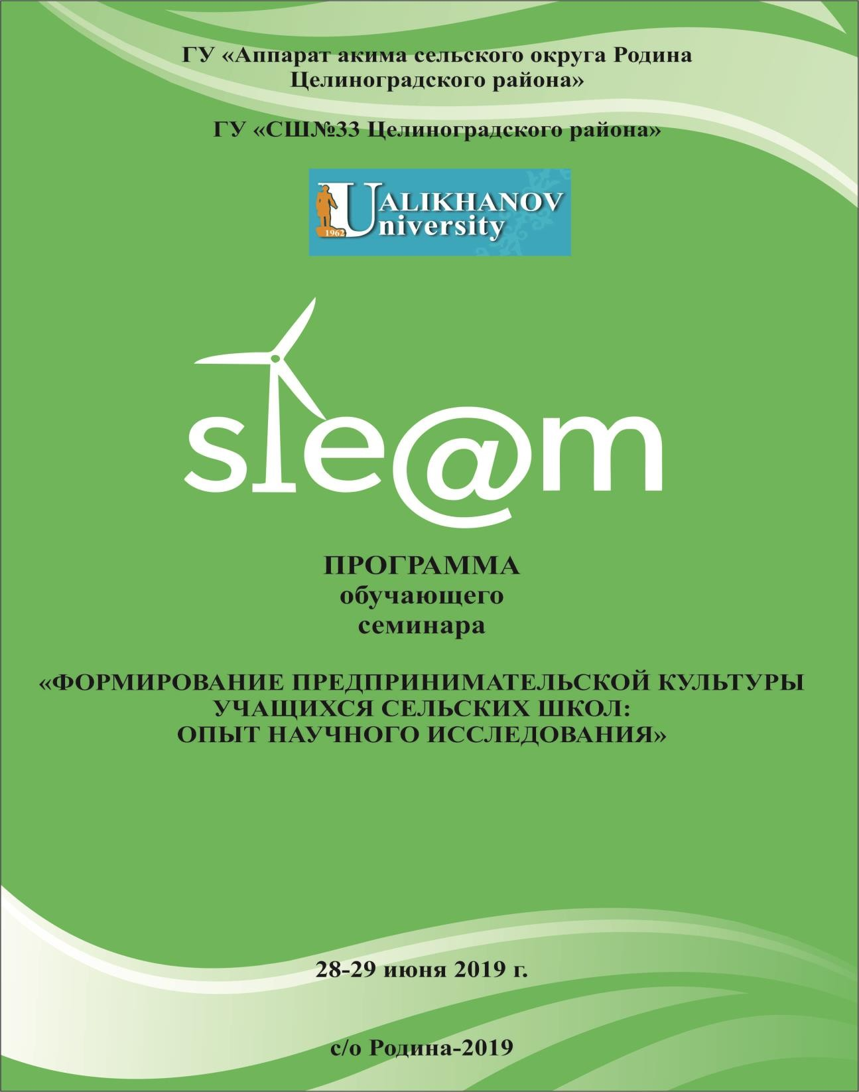

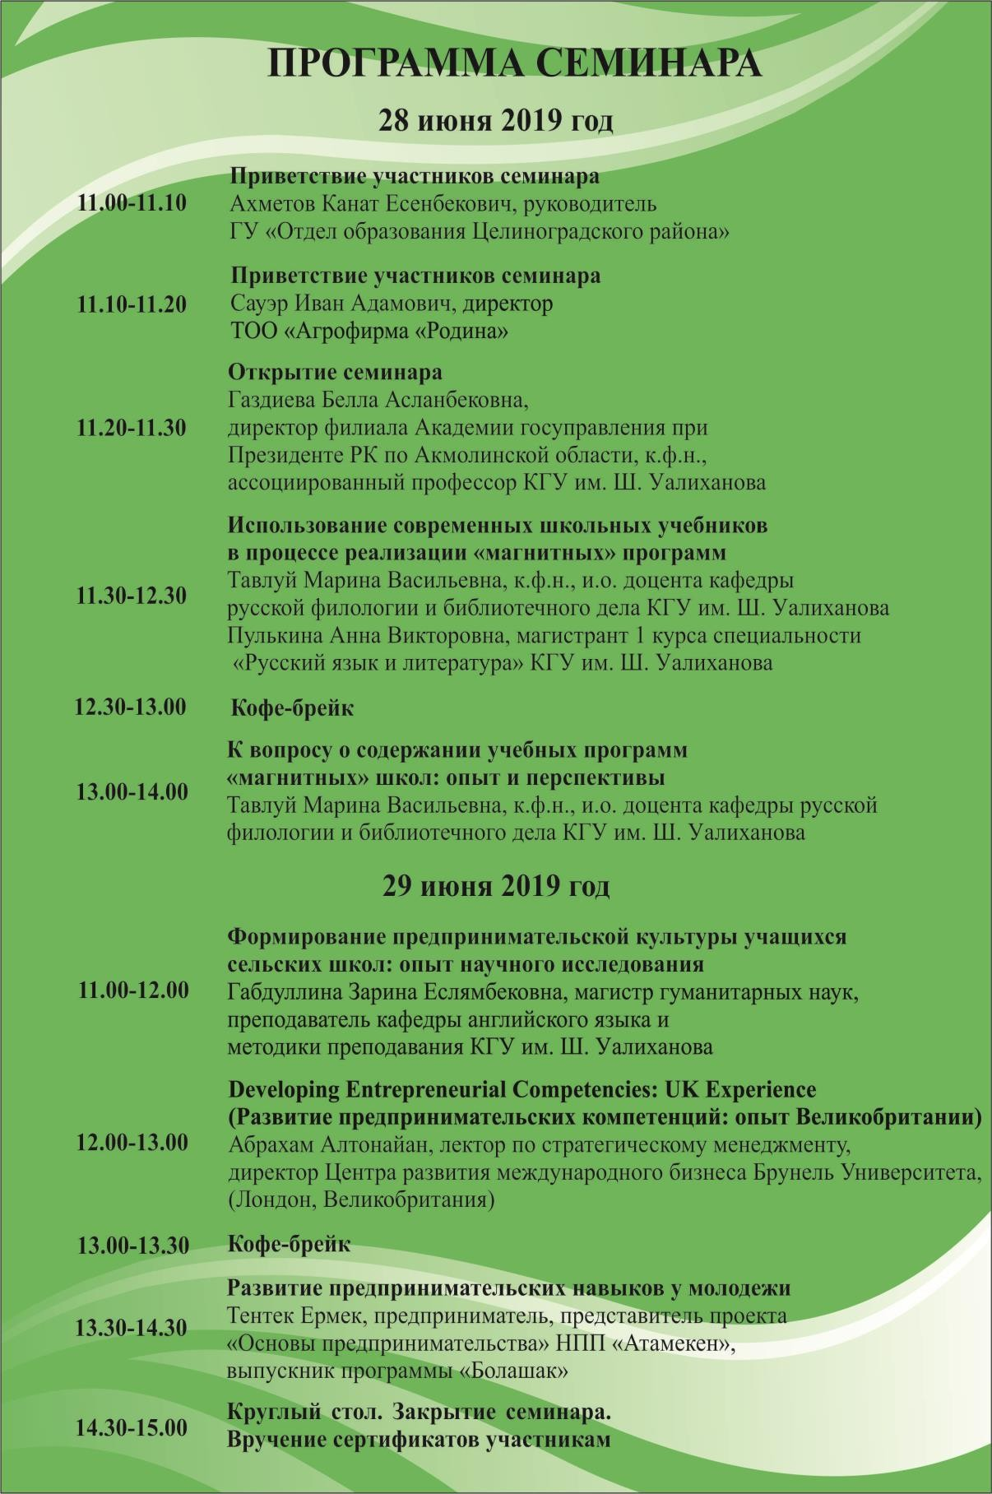

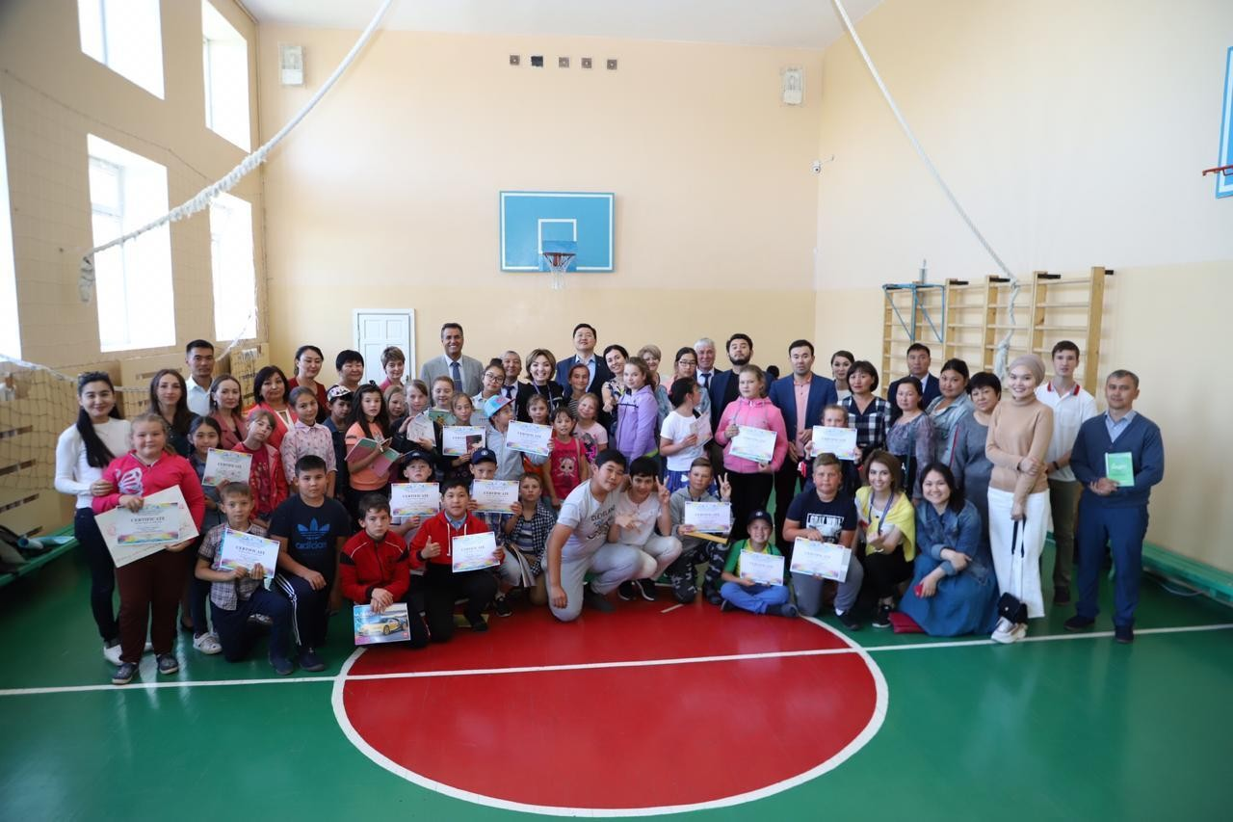
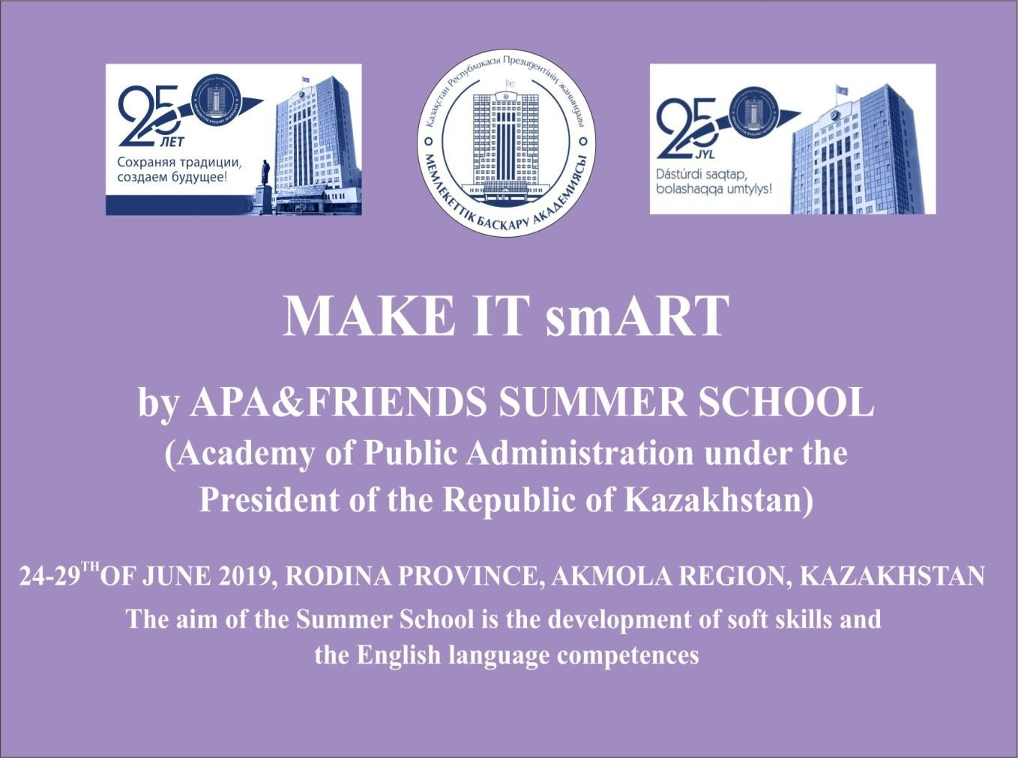

Summer language school "Make it smART", State Institution “Secondary School No. 33 of the Tselinograd District”, June 2019

APPENDIX F
Photo material on the activities carried out in 2020

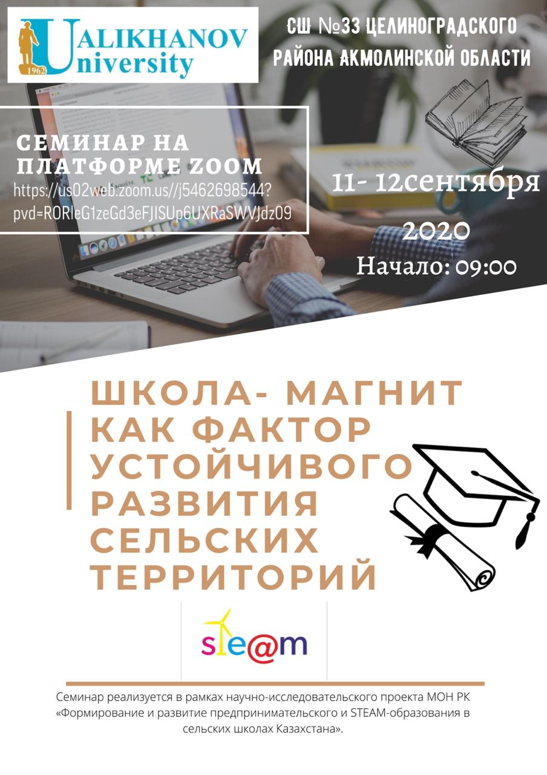

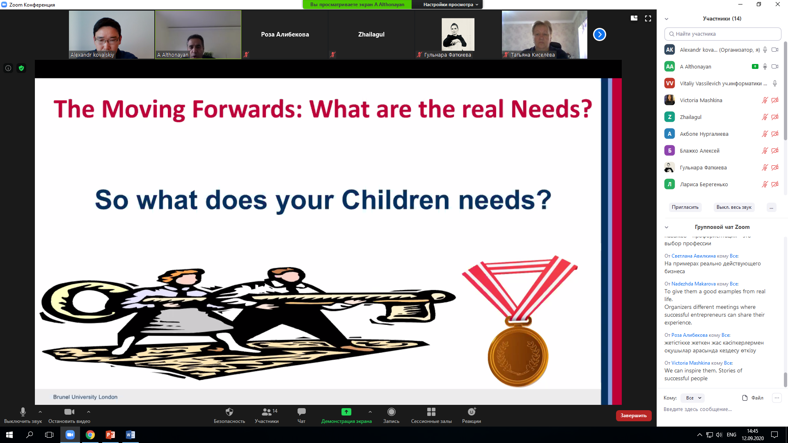
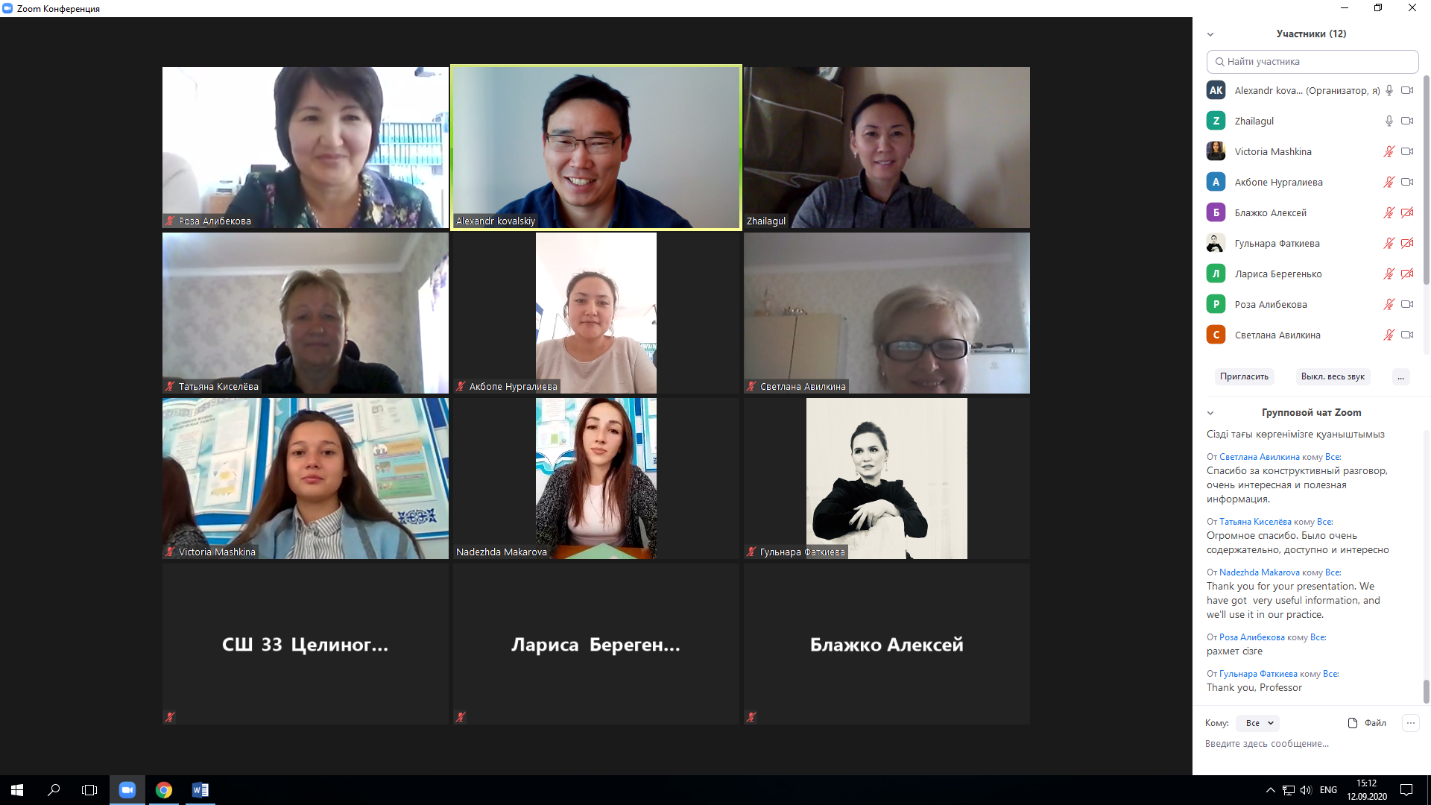

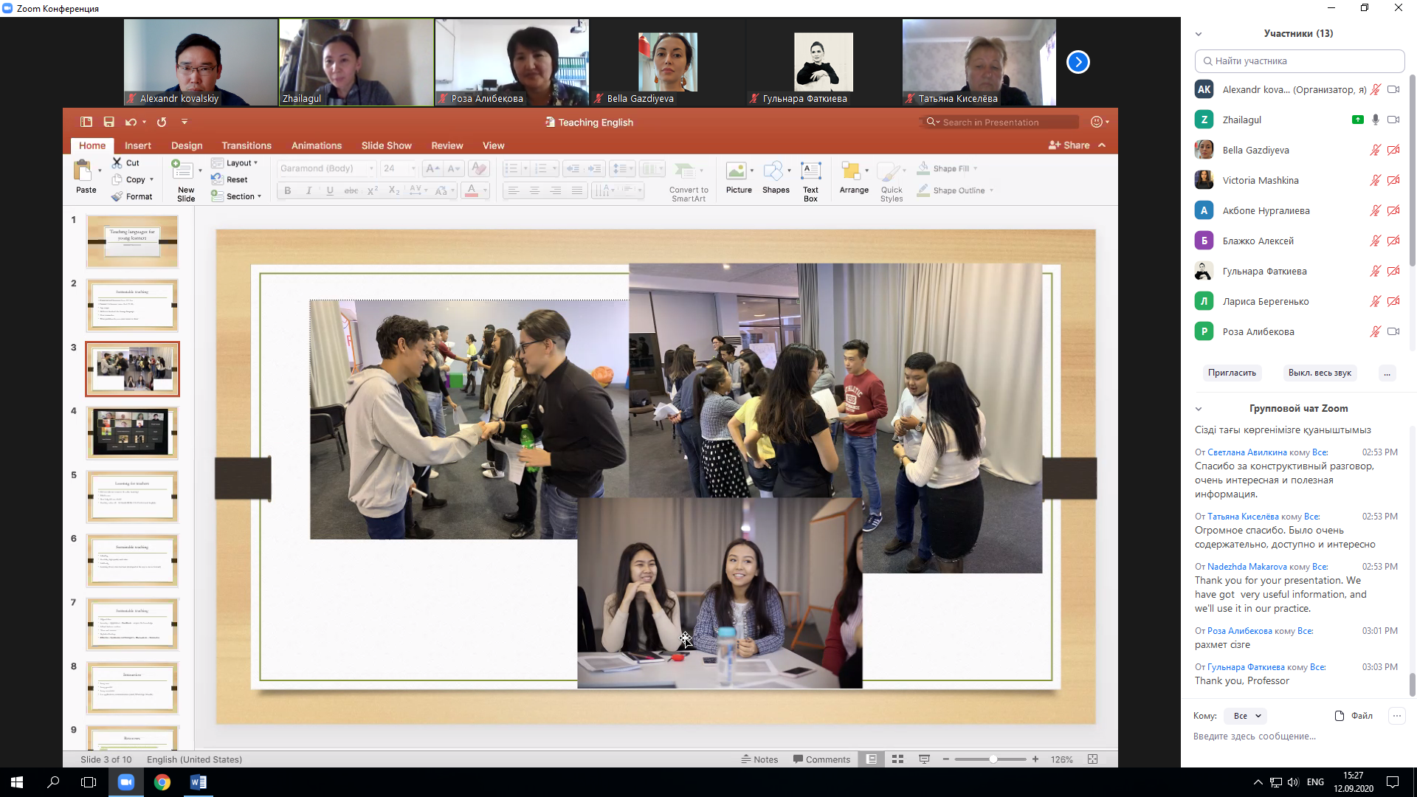

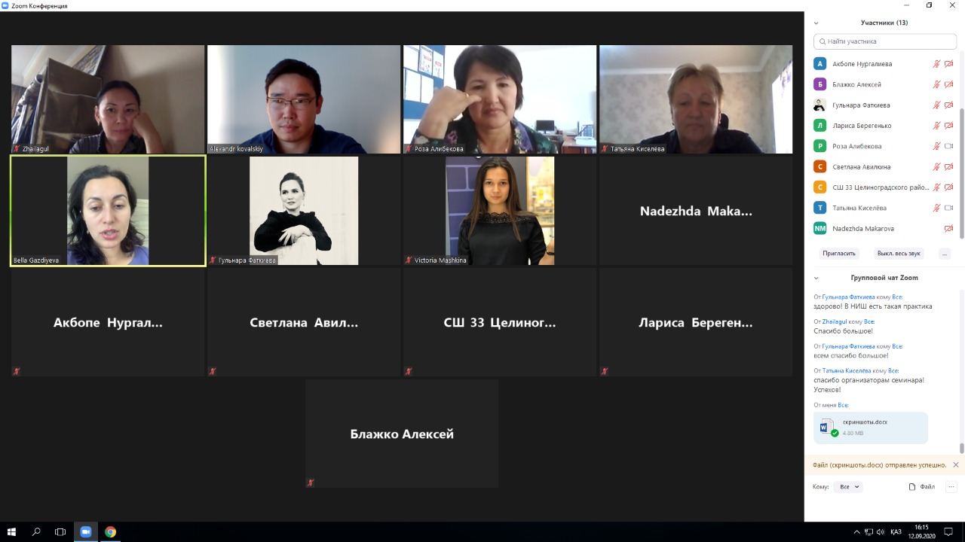

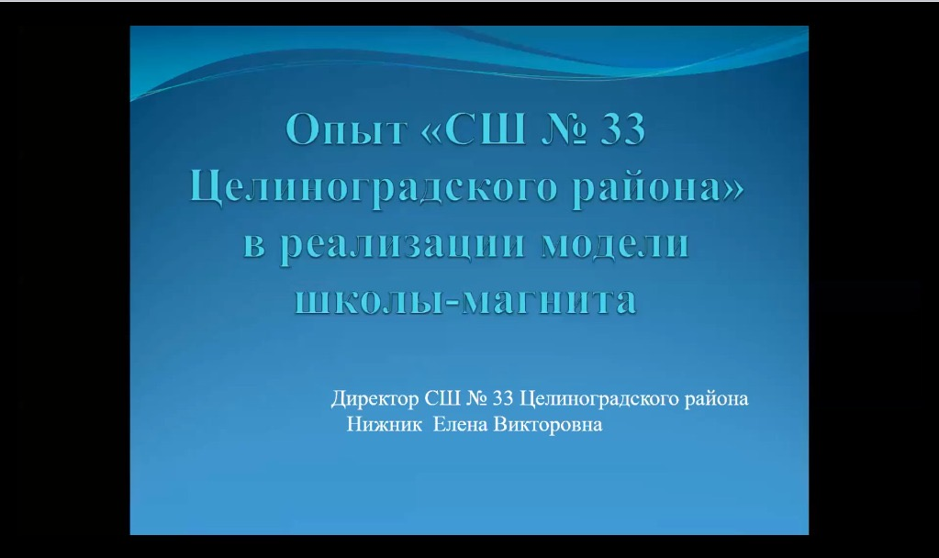

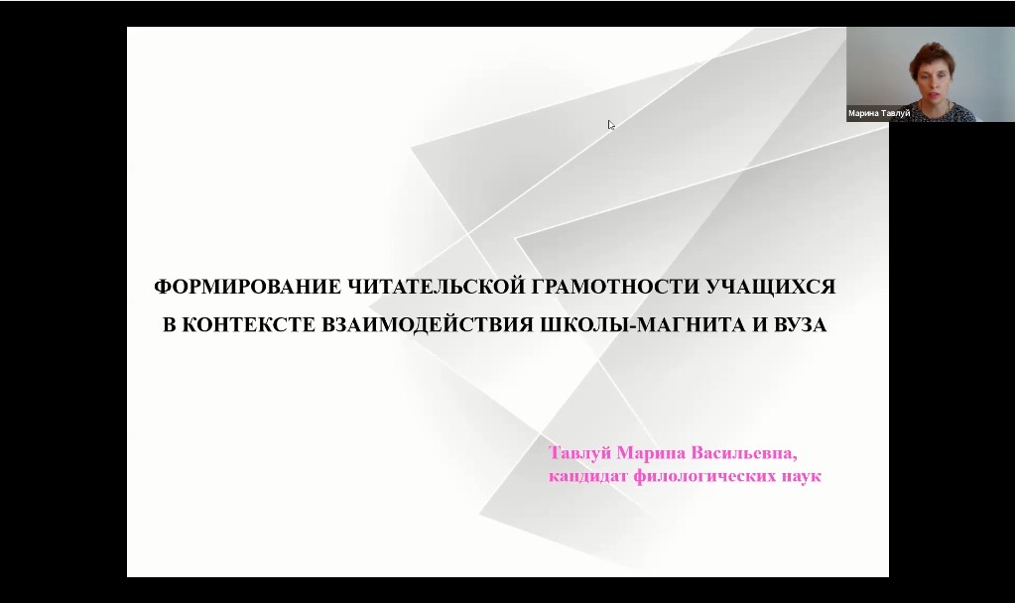

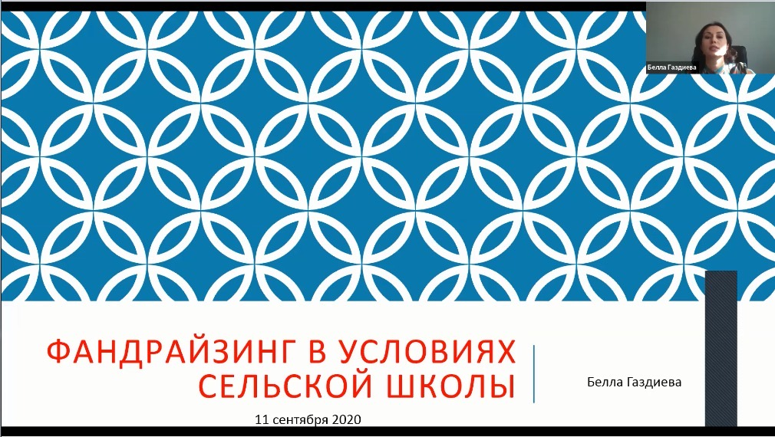

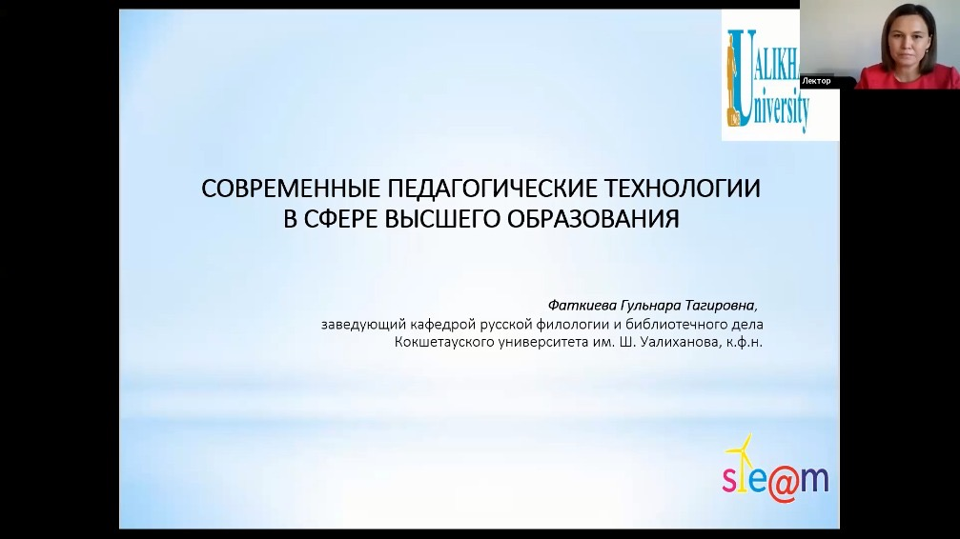

Webinar “Magnet School as a Factor of Sustainable Development of Rural Areas” Shokan Ualikhanov University, “Secondary School No. 33 of Tselinograd District” of Akmola region, September 11-12, 2020

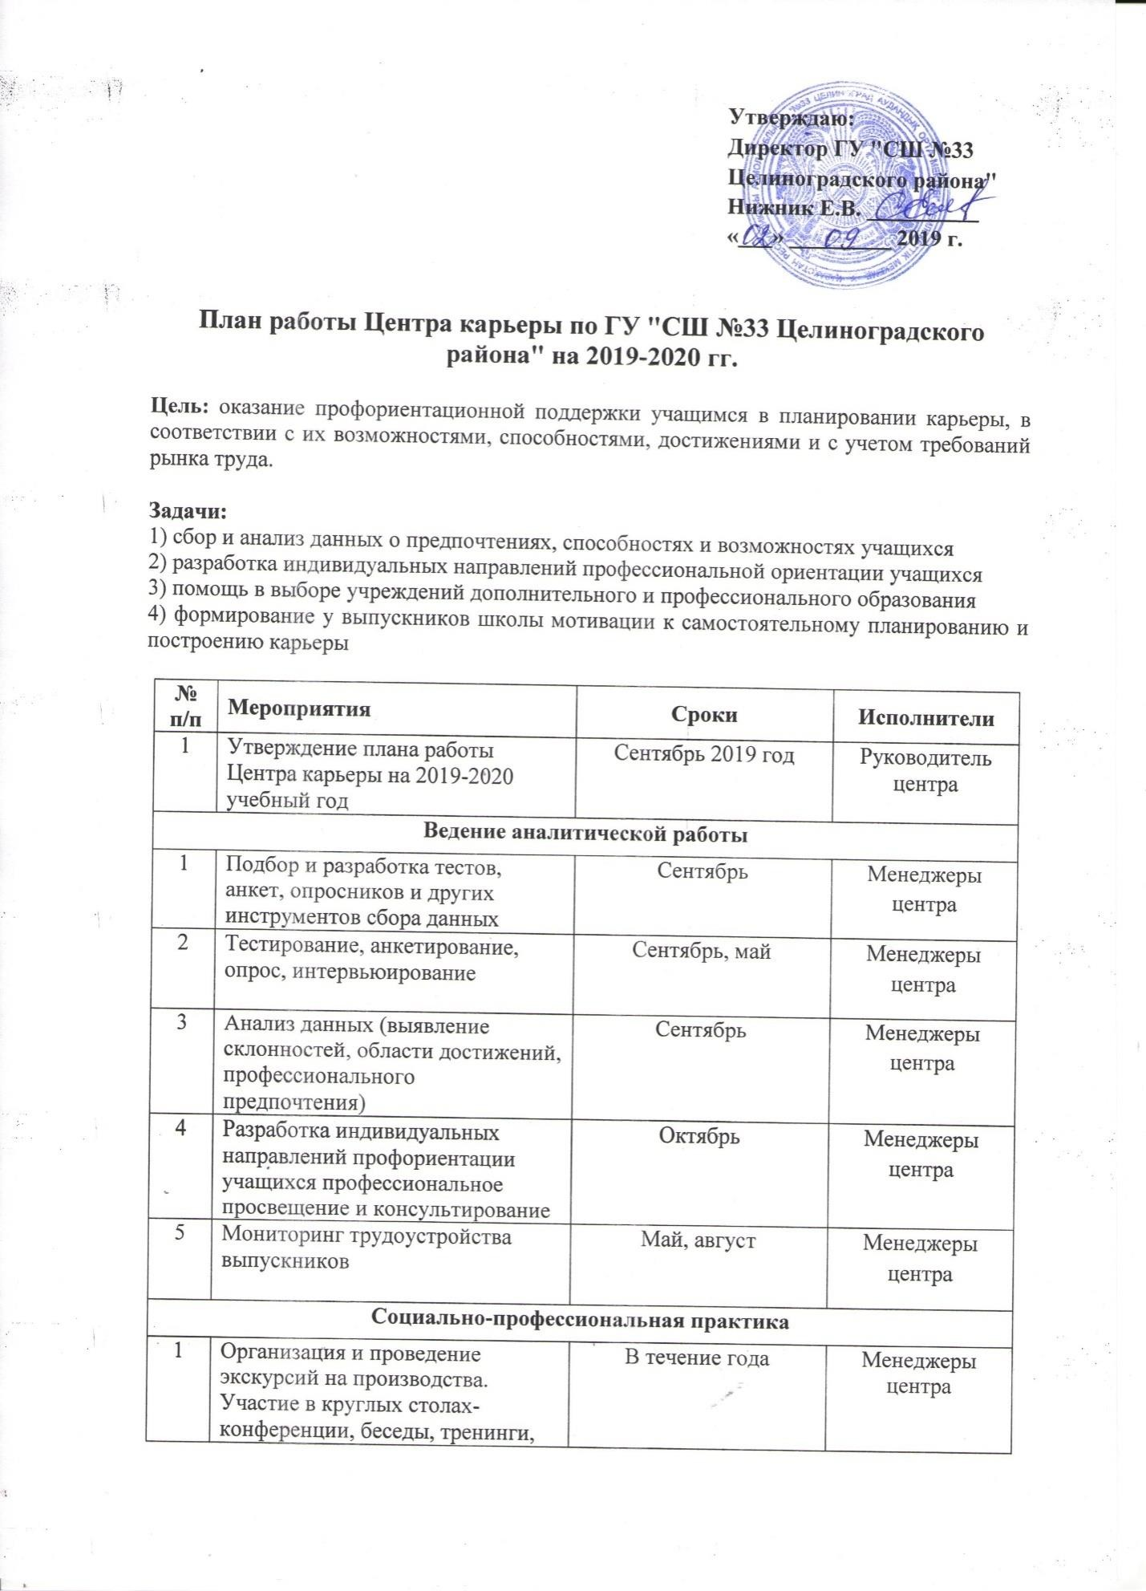

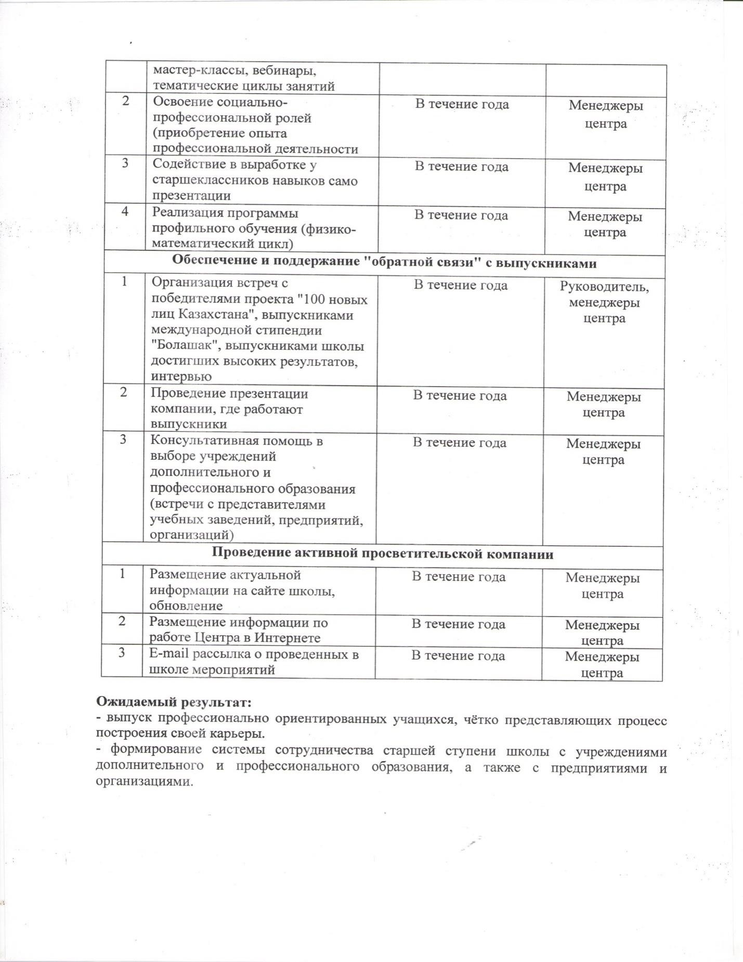

Work plan of the Career Center of the State Institution "Secondary School No. 33 of Tselinograd District" of Akmola region

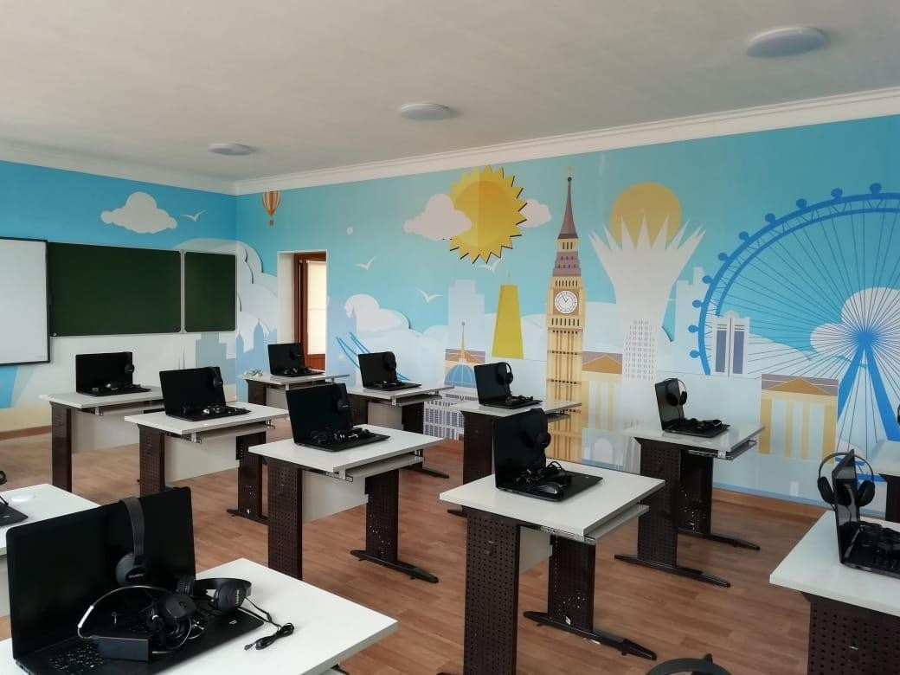
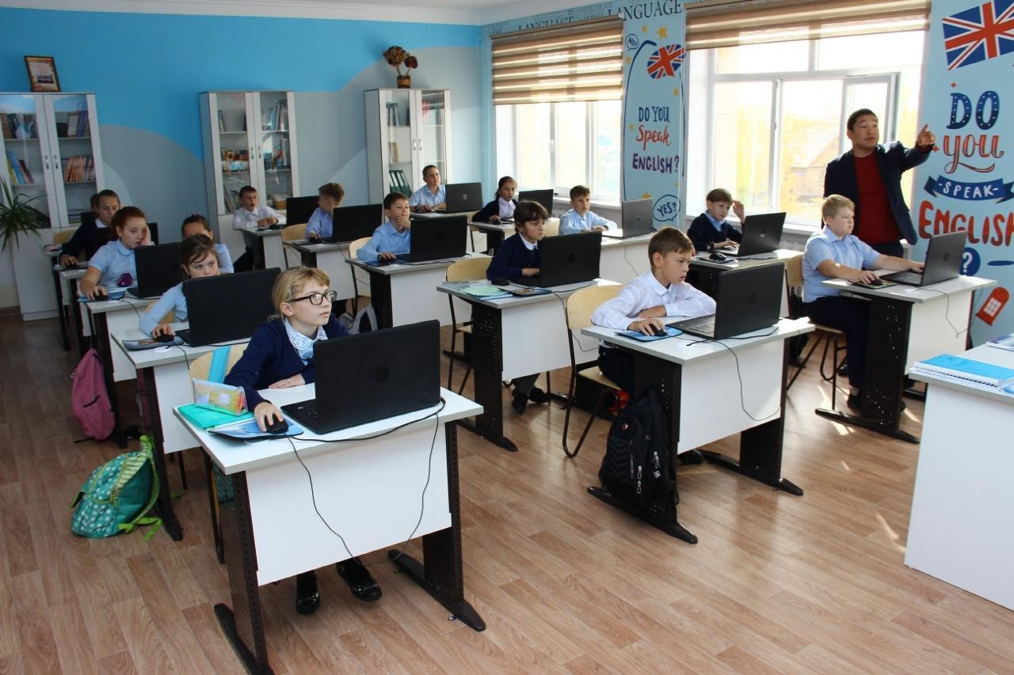

Language laboratory, State Institution "Secondary School No. 33 of Tselinograd District" of Akmola Region

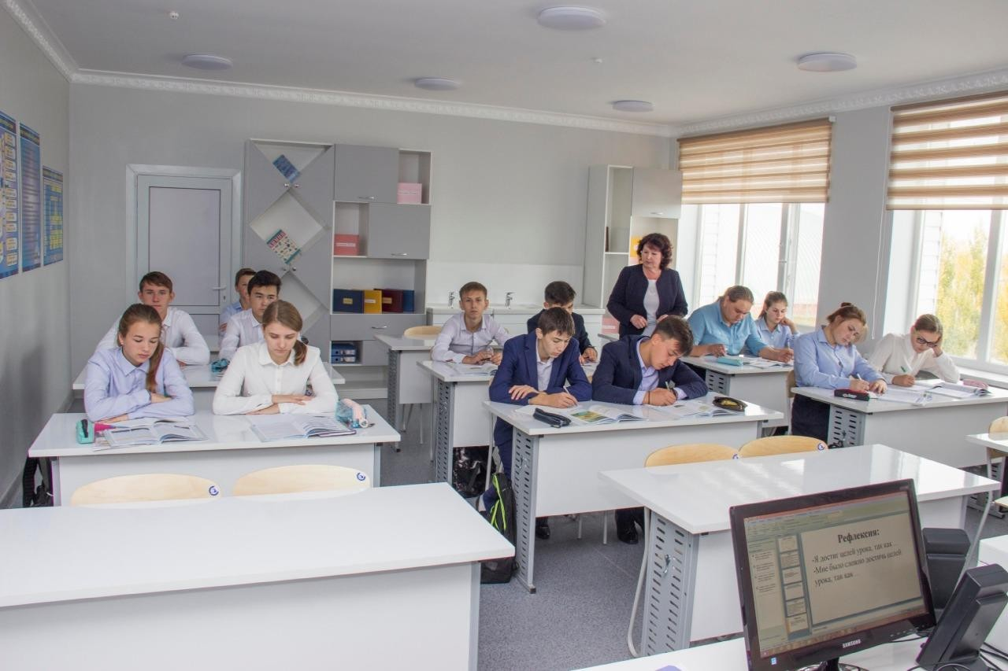
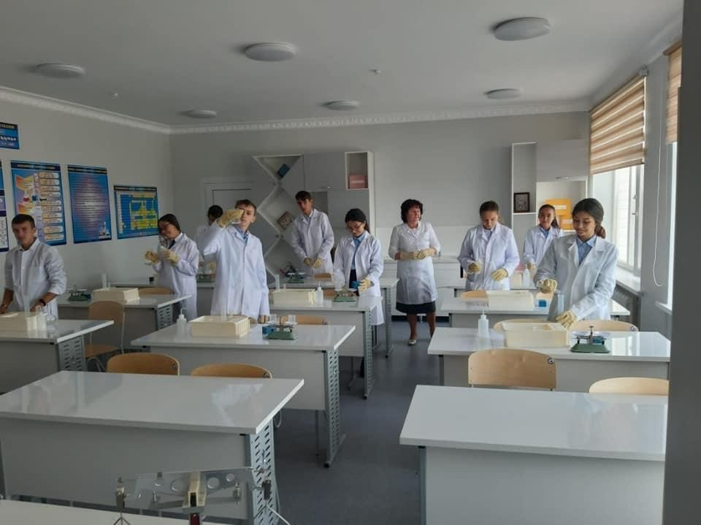

Chemistry Classroom, State Institution "Secondary School No. 33 of Tselinograd District"
of Akmola region

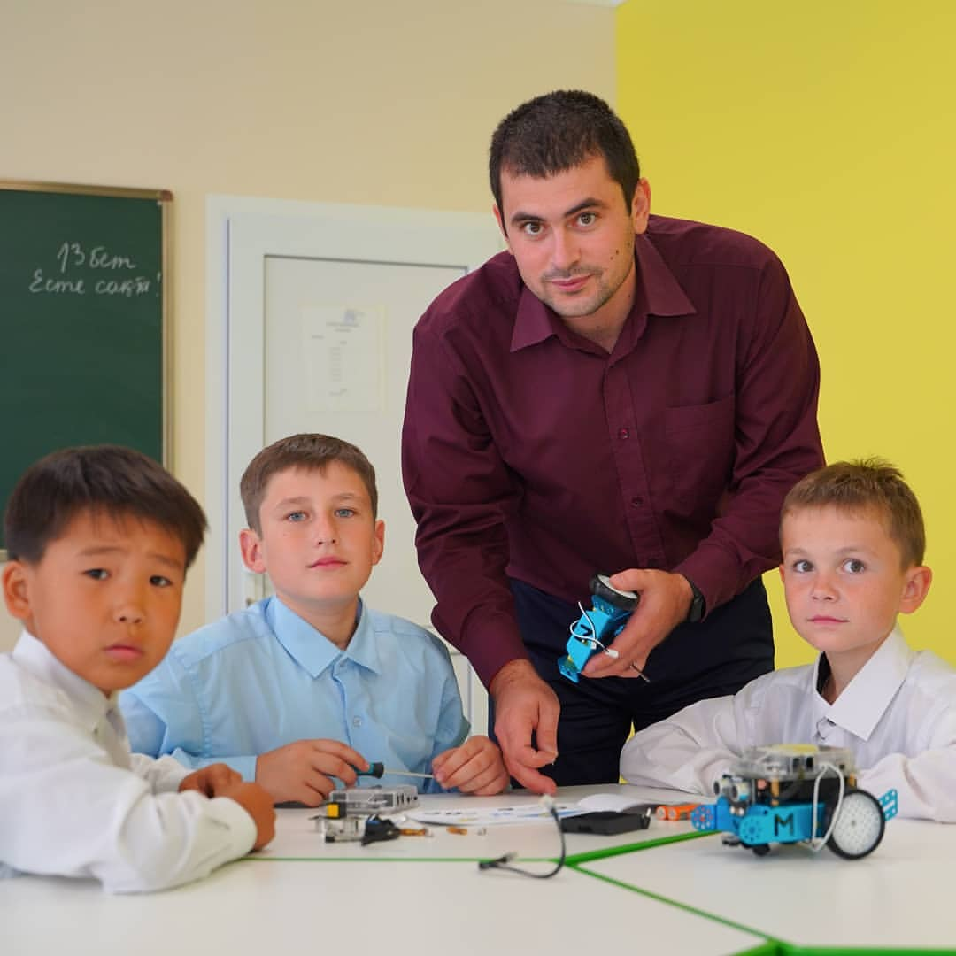
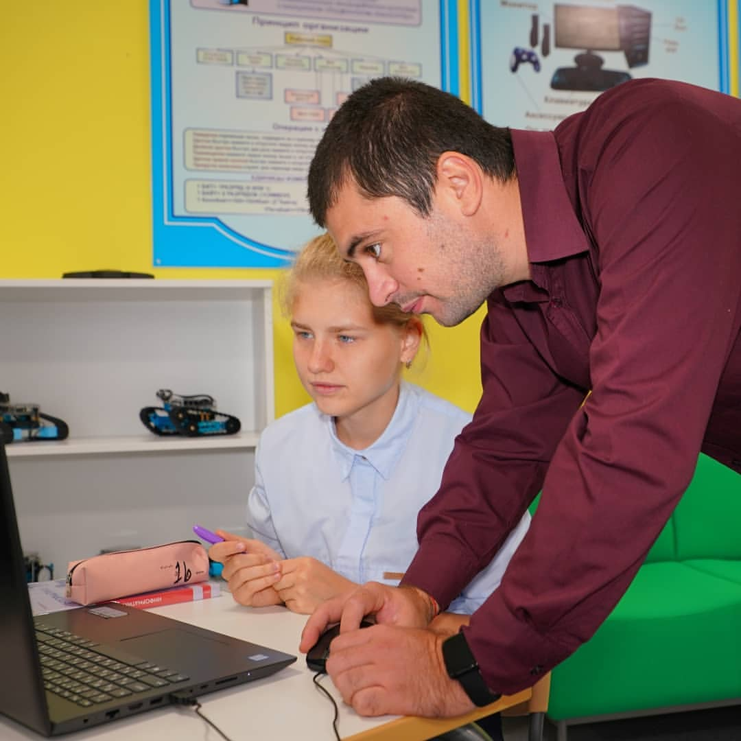

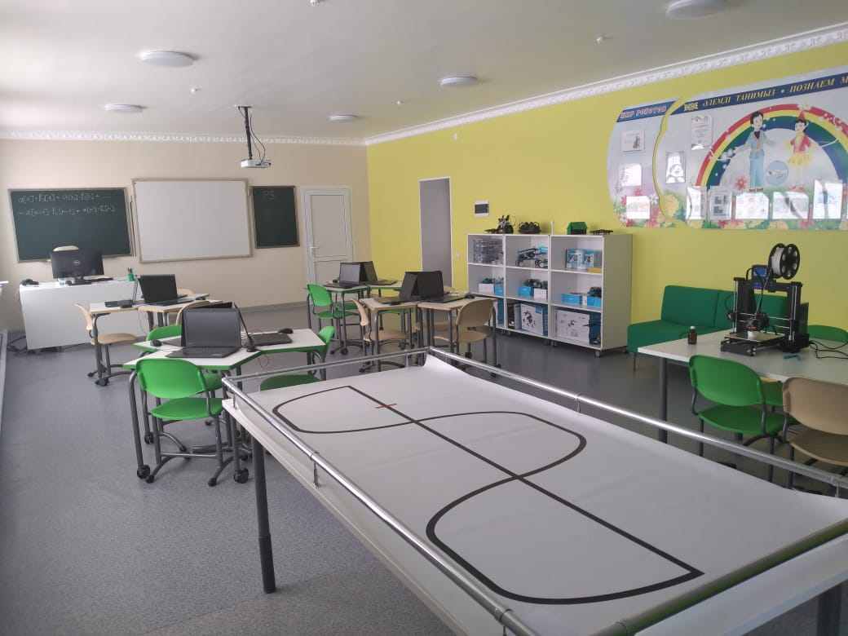

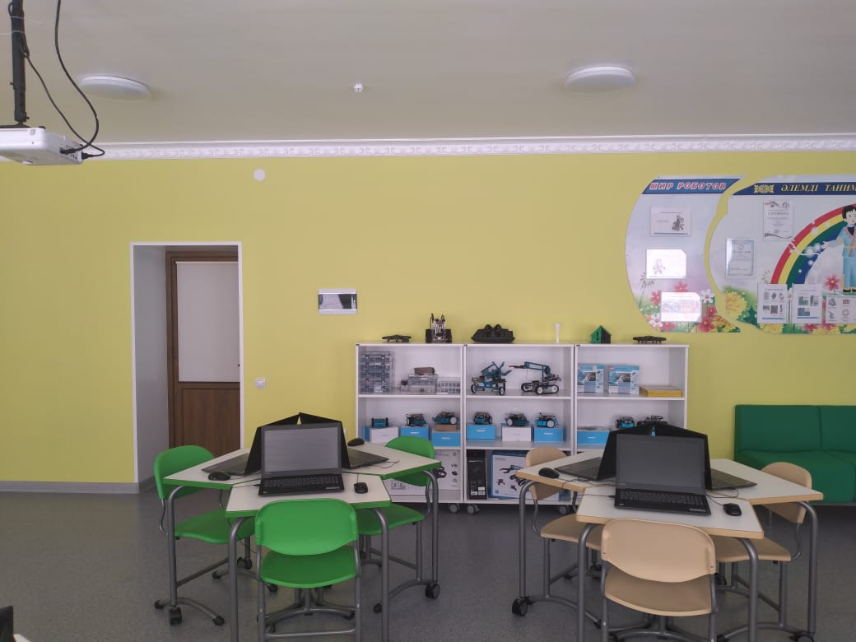

Robotics classroom, State Institution “Secondary School No. 33 of Tselinograd District” of Akmola Region

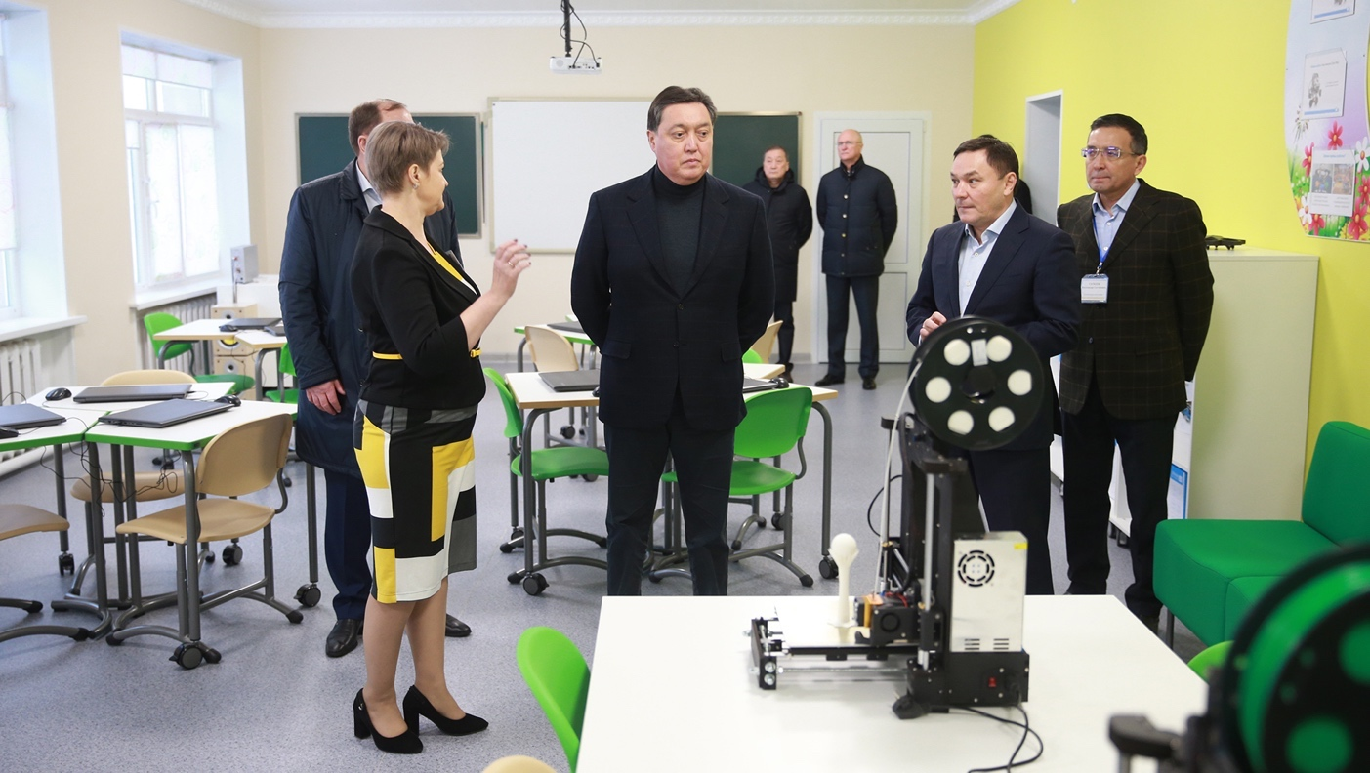

Presentation of the Career and Leadership Center to the Prime Minister of the Republic of Kazakhstan A.U. Mamin during his working trip to the village Rodina of Akmola region

