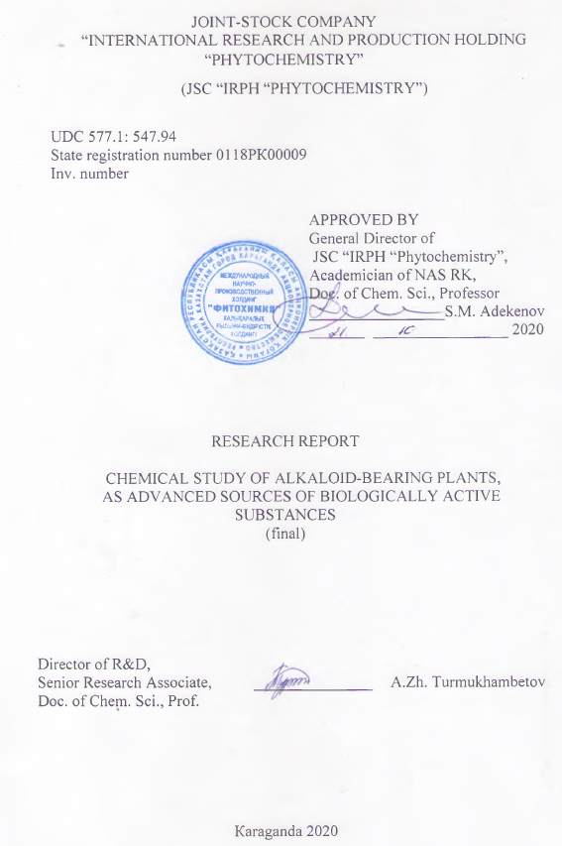

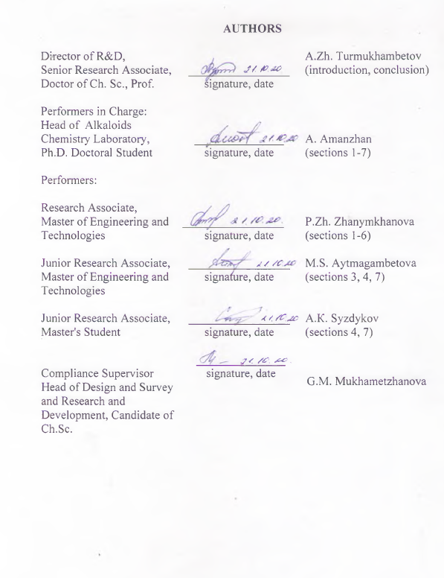

abstract

Report 40 pp., 3 figures, 2 tables, 42 sources, 8 appendices
ALKALOIDS, COLUMN CHROMATOGRAPHY, SPECTRAL ANALYSIS, CHEMICAL MODIFICATION, BIOLOGICAL SCREENING
The research object: alkaloid-bearing plants of the Kazakhstani flora.
The research aim is to chemically study plants for the alkaloids content, to optimize the methods for isolating alkaloids, to determine the reactivity of individual fragments in alkaloid molecules, to produce new derivatives with potential pharmacophore groups.
The research has allowed obtaining the following results:
We’ve studied chemically 11 plant species of the families Ranunculaceae Juss., Asteraceae Dumort., Gentianaceae Juss., Papaveraceae Juss. for the alkaloids content, and 16 alkaloids have been thereby isolated and identified. For the first time, the pyridine alkaloid gentianin and the indole alkaloid harmine have been siolated and identified from Gentiana decumbens L.; diterpene alkaloid-delphinopholine from Aconitum monticola Steinb., delcosine - from Aconitum anthoroideum DC.
We’ve modified chemically cytisine and harmine molecules, synthesizing 16 new derivatives through them; the molecules structure has been determined from the elemental analysis and spectral data (UV-, IR-, ¹Н-, ¹³С- NMR) and XRS.
We’ve performed the biological screening of isolated alkaloids and their derivatives for neurotropis, analgesis, antimicrobial, and cytotoxic activity. The research results have showed diterpenoid alkaloid delfinofolin to have a pronounced neurotropis, delcosin and lappaconitine antimicrobial, 8-acetylhydrazone harmine-pronounced analgesic activity.
The findings of the experiment on the model of Alzheimer's and Parkinson's disease have allowed determining harmine derivatives to have an inhibitory effect on the acetylcholinesterase enzyme, and also to have shown an inhibitory effect on the tyrosinase enzyme.
A laboratory procedure for the isolation of the echinopsine alkaloid from the white-stemmed thistle (Echinops albicaulis Kar. & Kir) has been elaborated.
Field of application: bioorganic chemistry, pharmacology and pharmaceutical production.

ТҰЖЫРЫМ

Есеп: 40 бет, 3 сурет, 2 кесте, 42 дереккөз, 8 қосымша.
АЛКАЛОИДТАР, БАҒАНАЛЫҚ ХРОМАТОГРАФИЯ, СПЕКТРЛІК ТАЛДАУ, ХИМИЯЛЫҚ ТҮРЛЕНДІРУ, БИОЛОГИЯЛЫҚ СКРИНИНГ
Зерттеу нысандары: Қазақстан флорасының алкалоидты өсімдіктері.
Зерттеу мақсаты – өсімдіктерді алкалоидтарды қамту тұрғысынан химиялық зерттеу, алкалоидтарды бөліп алу әдістерін оңтайландыру, алкалоид молекулаларындағы жеке фрагменттердің реакциялық қабілетін анықтау, әлеуетті фармакофорлық топтарға ие жаңа туындыларды алу.
Ғылыми-зерттеу жұмысты орындау барысында келесі нәтижелер алынды:
Ranunculaceae Juss., Asteraceae Dumort., Gentianaceae Juss., Papaveraceae Juss. тұқымдас 11 өсімдікке алкалоидтарды қамту тұрғысынан химиялық зерттеу жүргізіліп, 16 алкалоид бөліп алынды және сәйкестендірілді.
Алғаш рет Gentiana decumbens L. өсімдігінен генцианин пиридинді алкалоиды, гармин индолды алкалоиды, Aconitum monticola Steinb. өсімдігінен дельфинофолин дитерпенді алкалоиды, Aconitum anthoroideum DC. өсімдігінен делькозин бөліп алынды және сәйкестендірілді.
Цитизин және гармин молекулаларына химиялық түрлендіру жүргізілді, олардың негізінде 16 жаңа туынды синтезделді, молекулалардың құрылысы мен құрылымы элементтік талдау және спектрлік деректер (УК-, ИҚ-, ¹Н-, ¹³С- ЯМР) мен РҚТ негізінде дәлелденді.
Бөліп алынған алкалоидтар мен олардың туындыларының нейротропты, анальгетикалық, микробқа қарсы, цитоуытты белсенділігіне биологиялық скрининг жүргізілді. Зерттеу нәтижелері дельфинофолин дитерпенді алкалоиды айқын нейротроптық, делькозин мен лаппаконитин микробқа қарсы, гарминнің 8-ацетилгидразоны айқын анальгетикалық белсенділікке ие екенін көрсетті.
Альцгеймер және Паркинсон аурулары моделіндегі эксперимент нәтижелері бойынша гармин туындылары ацетилхолинестераза ферментінде ингибиторлық әсерге ие екендігі, сондай-ақ тирозиназа ферментінде ингибиторлық әсер көрсеткені анықталды.
Ақ сабақты лаңсадан (Echinops albicaulis Kar. & Kir) эхинопсин алкалоидын бөліп алудың зертханалық регламенті жасалды.
Қолдану саласы: биоорганикалық химия, фармакология және фармацевтикалық өндіріс.

table of contents

DESIGNATIONS AND ABBREVIATIONS 6
INTRODUCTION 7
1 Isolation from plants and identification of alkaloids, chemical modification of their molecules 10
2 Chemical study of plants of the families Ranunculaceae Juss., Gentianaceae Juss., Papaveraceae Juss. Chemical modification of cytisine and harmine molecules (Results for 2018) 14
3 Isolation and identification of alkaloids from plants of the genus Aconitum L. Synthesis of harmine derivatives (Results for 2019) 15
4 Isolation and identification of alkaloids from Aconitum villosum Reichenb., Anemone altaica Fisch. ex. C. A. Mey, Echinops albicaulis Kar. & Kir. 16
4.1 Isolation of alkaloids from Aconitum villosum Reichenb. 16
4.2 Isolation of alkaloids from Anemone altaica Fisch.ex. C.A. Mey 17
4.3 Isolation of alkaloids from Echinops albicaulis Kar. & Kir. 18
5 Chemical modification based on 8-acetylharmine. Study of the molecular structure of synthesized derivatives 20
6 Bioscreening and pharmacological study of isolated alkaloids and their derivatives 32
7 Elaboration of laboratory regulations for echinopsin isolated from white-stemmed thistle (Echinops albicaulis Kar. & Kir) 34
CONCLUSION 35
BIBLIOGRAPHY 37
APPENDIX A - Technical specifications and calendar work plan……………….41
APPENDIX B - List of publications 49
APPENDIX C - Analgesic activity of isolated and synthesized derivatives……...97
APPENDIX D - Neurotropic activity of isolated alkaloids …………………...…99
APPENDIX E - Neurotropic activity of synthesized derivatives……………….101
APPENDIX F - Cytotoxic activity of isolated and synthesized derivatives ..…..103
APPENDIX G - Laboratory regulations…………………………………………105
APPENDIX I - Patent search for 2010-2020…………………………………....107

DESIGNATIONS AND ABBREVIATIONS

This R&D report uses the following abbreviations and designations:
HPLC - high performance liquid chromatography
Hz - Hertz
IR - infrared spectrum
SSCC - spin-spin coupling constant
MHz - mega Hertz
ppm - parts per million
NCSSTE – national center of state scientific and technical expertise
PMR-proton magnetic resonance
Act.R. - activity rate
TLC - thin layer chromatography
Mp - melting point (° С)
UV - ultraviolet spectrum
XRS - X-ray structural analysis
CMS - chromatomass spectrometry
CNS - central nervous system
NMR ¹Н -nuclear magnetic resonance (proton)
NMR ¹³С -nuclear magnetic resonance (carbon)
Al₂O₃-aluminum oxide
CDCl₃-deuterochloroform
EtOH - ethyl alcohol
HMBC (¹H-¹³C) - experiment on 2- and 3-bond through heteronuclear multiple bond correlation
HMQC (¹H-¹³C) - experiment on 1-bond through heteronuclear single-quantum correlation
H₂SO₄ – sulfuric acid
HSQC (¹Н-¹³С) - two-dimensional heteronuclear NMR spectroscopy
KBr - potassium bromide
NaOH - sodium hydroxide
Na₂SO₃ - sodium sulfite
NBS - N-bromosuccinimide
NIS - N-iodosuccinimide
NOESY (¹Н-¹Н) - two-dimensional homonuclear NMR spectroscopy
pH - acid value

INTRODUCTION

The flora of Kazakhstan is described in terms of a variety of different herbal substances, many types thereof can be used commercially. The need for highly effective and low-toxic herbal extracts settles down in the study of bioactive substances and the production of medicines from crude plants. This systematically reduces the dependence of the Republic's healthcare system on imported medicines. For the purpose of this objective, it is necessary to use our own production facilities, primary resources, and scientific and technical potential. In this regard, the following is seen relevant: searching for potential sources of bioactive compounds, developing a substance technology from herbal substances.
The herbal extracts, among which about 30% contain alkaloid compounds, their functional or other nitrogen-containing derivatives have been found to be dominant among medicines.
The relevance of this paper is to search for new alkaloid-bearing plants in the flora of Kazakhstan, isolate alkaloids and synthesize new compounds from them, and produce alkaloid substances - the basis of new reference medicinal products.
The scientific novelty is to isolate alkaloids from previously unexplored plant products and synthesize from them new derivatives with analgesic and neurotropic activity.
The practical significance is associated with the isolation and synthesis of new alkaloid compounds with neurotropic and analgesic effects for the production of the substance of reference medicinal products.
The choice of the research trend is based in the study of the Kazakhstani plant chemical composition for the alkaloids content - sources of new drugs. To solve the problems posed in this paper, we’ve used improved methods for isolating alkaloids from plant products, know-how of alkaloids samples, established their fine chemical structures using spectral data (UV, IR, ¹Н-, ¹³С- NMR) and X-ray structural analysis.
The aim is to study chemically plants for the alkaloids content, improve methods for isolating alkaloids, determine the reactivity of individual fragments in alkaloid molecules in terms of the production of new derivatives with potential pharmacophore groups.
In this paper, according to the 2018-2020 calendar plan (Appendix A) the following main objectives have been fulfilled:
1. Study chemically and isolate alkaloids from plants of the families Ranunculaceae Juss, Gentianaceae Juss, Asteraceae Dumort;
2. Improve methods for isolating alkaloids from prospective wild plant species;
3. Synthesize new alkaloid derivatives to produce potential pharmacoactive agents with heterocyclic substituents;
4. Determine the structure of new isolated alkaloids and their synthetic derivatives using spectral methods;
5. Conduct bioscreening of plant-isolated alkaloids and their synthetic derivatives.
When fulfilling the main objectives under the AR05135304 project "Chemical study of alkaloid-bearing plants as promising sources of bioactive substances" according to the 2018-2020 calendar plan (Appendix A), the following main results have been obtained:
- 11 plant species of the families Ranunculaceae Juss., Asteraceae Dumort., Gentianaceae Juss., Papaveraceae Juss. have been studied chemically for the alkaloids content, and 16 alkaloids have been thereby isolated and identified. For the first time, the pyridine alkaloid gentianin and the indole alkaloid harmine have been siolated and identified from Gentiana decumbens L.; diterpene alkaloid-delphinopholine from Aconitum monticola Steinb., delcosine - from Aconitum anthoroideum DC. From Echinops albicaulis Kar. & Kir. The total extractive substances have been generated and echinopsin has been isolated.
- The quantitative content of diterpene alkaloids has been determined: songorine of 0.48% to 18.8%, delcosine of 7.51% to 17.7%, lappaconitine of 0.25% to 2.81% in extracts of plants of the genus Aconitum L.; the main component of Aconitum monticola Steinb. has found to be songorin, Aconite soongaricum Stapf. and Aconite anthoroideum DC. - delcosine, songorine, Aconitum villosum Reichenb. and Aconite altaicum Steinb. - delcosine.
- 16 new derivatives have been synthesized from harmine and cytisine, the molecular structure thereof has been found from elemental analysis, spectral data (UV, IR, ¹Н-, ¹³С- NMR) and X-ray structural analysis.
- Biological screening of isolated and synthesized compounds has been performed. The experiment findings have allowed determining samples of extracts of Gentiana decumbens L., Gentiana barbata Froel. and Echinops albicaulis Kon&Kir. to produce analgesic activity.
- Alkaloids and harmine derivatives isolated from plants of the genus Aconitum L. have neurotropis, antimicrobial, analgesic activity. Where delphinofoline has a pronounced neurotropic activity, and 8-acetylhydrazone harmine has a pronounced analgesic activity.
The findings of the experiment on the model of Alzheimer's and Parkinson's disease have allowed determining harmine derivatives to have an inhibitory effect on the acetylcholinesterase enzyme, and also to have shown an inhibitory effect on the tyrosinase enzyme.
A laboratory procedure for the isolation of the echinopsine alkaloid from the white-stemmed globe-thistle (Echinops albicaulis Kar. & Kir) has been elaborated.
The report has been performed by 5 employees, including 1 doctor of chemical sciences, professor, 2 masters of engineering and technologies, PhD-doctoral student, master's student. All performers of the report are experienced in this area.
According to the research results the performed T.S. Borovik has successfully defended a thesis for the degree of candidate of biological sciences, the performer M.S. Aytmagambetova - Master's thesis.
During the 2018-2020 reporting period, a patent of the Republic of Kazakhstan 2020/0159 for (E)-8-(1-hydrazonoethyl)-7-methoxy-1-methyl-9H-pyrido[3,4-b]indole with analgesic activity was applied from 10.03.2020 (Appendix B).
7 scientific papers have been published, 2 articles thereof - in peer-reviewed scientific journals, indexed and having percentile of 27 and 31 according to CiteScore in the Scopus database, 2 articles - in a domestic edition recommended by COXON and 3 abstracts (Appendix B).
The 2018-2019 interim reports were registered with NCSSTE JSC in conformity with applicable rules (inv. No. 0218RK01059 and inv. No. 0219RK00727).

1 Isolation from plants and identification of alkaloids, chemical modification of their molecules

Plants of the family Ranunculaceae Juss. are a rich source of semi – functional heterocyclic-diterpene alkaloids. But the most important, plants of the genus Aconitum L. are characterized by a wide range of pharmacological activity-antiarrhythmis, neurotoxis, central nervous system stimulating, and according to folk and traditional medicine, tinctures and ointments of these plant species are antitumor [1-4].
More than 70% of modern homeopathic remedies are produced from herbal substances. Plants of the genus Aconitum L. are among the most homeopathic. The homeopathic Pharmacopoeias of the top global countries (Germany, France, the USA and others) include Aconite preparations produced from the following plant species: Aconitum napellus L., Aconitum ferox Wall, Aconitum lycoctonum L.
Georgian researchers chemically studied the subterranean organs of Aconitum orientale Mill. and Aconitum nasutum Fisch. ex Rchb, thus isolating alkaloids: aconitine (1), lappaconitine (2), caracoline (3), gigactonine (4). The total alkaloids in the underground parts of Aconitum orientale Mill. and Aconitum nasutum Fisch. ex Rchb. in vitro showed cytotoxic activity against cell lines A-549 (lung carcinoma), DLD-1 (intestinal adenocarcinoma) and WS-1 (normal human fibroblasts) [5-6].

(1) (2) (3) (4)

Chinese researchers intensively study plants of the genus Aconitum L., where these plants are part of medicines of the traditional Chinese medicine, for example, a new C₁₉-diterpene alkaloid of the aconitine type atropurpursin was isolated from the roots of Aconitum hemsleyanium E. Pritz. [7].
The above-ground part of Aconitum smirnovii Steinb. gives to isolate C₁₉-diterpene alkaloids - aconitine (1), songorine (5), songoramine (6), aconiacarmicine A (7), benzoylaconine (8), 14-benzoyl-8-O-methylaconine (9), and two new alkaloids smirnotine A (10) and smirnotine B (11); the molecular structure has been determined from spectral data (¹Н-, ¹³С- NMR). These alkaloids have shown antiarrhythmis, cytotoxis, and antimicrobial activity [8-9].
(5) (6) (7) (8)

(9) (10) (11)

Russian researchers [10] have developed a method for isolating diterpene alkaloids from Aconitum kirinense Nakai., which grows on the Primorye Region. Alkaloids are separated through gas and high-performance liquid chromatography (GC and HPLC) with mass spectrometric detection of separated peaks and fragmentation in APCI, API-ES, and electron impact modes. The LC-MS method with fragmentation in APCI and API-ES mode has allowed identifying in Aconitum kirinense Nakai 6 diterpenoid alkaloids: 8-acetylecholine, tugiaconitine, akiramine, kirinine, lepenine.
[11] describes a chemical study of the roots of Aconitun kirinense Nakai, thereby isolating and identifying new C₁₈-diterpene alkaloids of the ranaconitine type kirizine (AD), lappaconitine type kirizine E, C₂₀-diterpene alkaloids of the denudative type kirizine (F-L) and napelline type kirizine (M-O). The isolated compounds were tested for neuroprotective and inhibitory acetylcholinesterase activity.
The crushed raw material of Aconitum anthoroideum DC is extracted with 95% ethanol, once the alcohol is removed, the alkaloids are extracted with 10% HCl, then alkalized and extracted with ethyl acetate, resulting in the total alkaloids, which is chromatographed on a silica gel column. The chromatographic separation produced a new diterpenoid alkaloid antorodin A (12); bisdyterpene alkaloid, connected by single carbon-carbon bond antorodin B (13); three C₂₀-diterpene alkaloids of the racemulosine type (14-16), hetidine type (17), three getizine types antorodine C-I (18-20) [12].
(12) (13) (14-16)
(17) (18) (19) (20)

Aconitum talassicum M. Pop. was extracted with chloroform, preliminarily alkalizing the product with Na₂CO₃, then the extract was acidified with H₂SO₄ and the alkaloids were separated with chloroform. The total alkaloids were eluted with a chloroform-methanol mixture (100: 1) on a silica gel column, followed by recrystallization with methanol, and the alkaloids of thalassamine, talatizamine, 14-O-acetylthalatizamine, isothalatizidine, isoboldine, talatizidine, crystallin hydrochloride [13-14] were thereby isolated.
Researchers of the Institute of Organic Chemistry, Ural Branch of the Russian Academy of Sciences (Ufa) isolated from Aconitum neosachalinense H. Lev. 6 previously known alkaloid hypaconitine, mezaconitine, neoline and three aporphine alkaloids glaucine, N-methyllaurotetanin and isoboldine. Extraction was performed with water in the presence of Na₂CO₃ followed by column separation [15].
The genus Anemone (family Ranunculaceae Juss.), which includes more than 150 species, has long been used in the folk medicine. Morphologically and phytochemically, it is closely related to Pulsatilla, Clematis, and Hepatica [16]. The genus Anemone contains triterpene saponines with anti-cancer activity. Anemone extracts have immunomodulatory, anti-inflammatory, antioxidant, and antimicrobial effects [17-22].
Anemone altaica Fisch. ex. C.A. Mey., an endemic plant species with the chemical composition poorly studied, grows on the East Kazakhstan. Chinese researchers as follows from the study of the chemical composition of Anemone altaica Fisch. ex. C.A. Mey. isolated 9 compounds, resulting in a new carboline type alkaloid of 4- (9H-β-carbolin-1-yl) 4-oxo-butyric acid isolated [23]. The Chinese medicine has been using the underground part of Anemone altaica for the treatment of epilepsy, neurasthenia and arthritis.
Echinops L. is one of the most systematically multi-species genera of the dicotyledonous plants in the family Asteraceae Dum. It includes more than 250 species of plants, widespread in Eurasia and North Africa, and 18 species of Echinops in Kazakhstan [24].
Foreign research centers are known to be studying the chemical composition of representatives of the genus Echinops L, from which alkaloids have been isolated. Extracts of these plant species have a strong inhibitory activity against stophylococcus, are active against gram-positive organisms and molluscs. Thiophenes of the species Echinops transiliensis, Echinops spinosissimus, and Echinops latifolius show anticancer activity [25-26].
In Kazakhstan, the works by N.G.Gemedzhyieva, N.Kurbatova, N. M.Mukhitdinov, N.Duysenova are worth of noting. They identify the biological and phytochemical features of the species Echinops sphaerocephalus, Echinops chantavicus [27].
Quinoline alkaloids, sesquiterpenoids, flavonoids, sterols, triterpenes have been identified in plants of the genus Echinops L. [28-29]. The quinoline alkaloid echinopsin (21) is the most readily available alkaloid of plants of this genus: its content in the Echinops fruits can be 2%. In addition to echinopsine (21), the following 7 more alkaloids with a quinoline skeleton were isolated and identified from the Echinops: echinopsidin (22), echinorin (23), 7-hydroxyequinosolinone (24), and 2 quinoline glycoalkaloids (25,26) [30-31].
(21) (22) (23) (24) (25-26)

Thy chemical study of bioactive substances from endemic plant species of the genus Echinops L., Aconitum L., Anemone L. growing in Kazakhstan, the determination of the qualitative, quantitative content and biological activity of the main groups of BAS and the development from them of new medicinal substances are promising.
One of the promising synthons in terms of modification and production of new biologically active substances is the plant alkaloid harmine (27) [32], which shows a wide spectrum of biological activity, in particular, it induces cell proliferation of β-cells in vitro and in vivo by activating the intracellular protein kinase enzyme DYRK1A [33-35]. In this regard, harmine is advantageous for the production of neurological treatment agents, and antidiabetic agents [36-38].
As a result of the literature analysis it is possible to determine that the isolation and chemical transformation of alkaloids is advantageous for the search for new medicinal substances and the development of the substance of reference herbal formulations from them.

2 Chemical study of plants of the families Ranunculaceae Juss., Gentianaceae Juss., Papaveraceae Juss. Chemical modification of cytisine and harmine molecules (Results for 2018)

During the АР05135304 project "Chemical study of alkaloid-bearing plants as promising sources of biologically active substances" in 2018, the following results have been produced:
Chemical screening of plants of the families Ranunculaceae Juss., Asteraceae Dumort., Gentianaceae Juss has been performed for the alkaloid content.
Plants of the family Gentianaceae Juss have been studied chemically. Indole alkaloid - harmine (27), pyridine alkaloid - gentianine (28) have been isolated and identified for the first time from Gentiana decumbens L.
From the plant product of Thalictrum foetidum L.- glaucin (29), N-methylcanadine (30); from Thermopsis lanceolata R. Br. – cytisine (31); from Chelidonium majus L. – protopine (32), coptisine chloride (33), L-stylopine (34).
(28) (29) (30) (31)
(32) (33) (34)

The quantitative alkaloid content in extracts of plants of the genus Aconitum L.
5 new derivatives of harmine and cytisine molecules were synthesized, with the structure established from spectral data (UV-, IR-, ¹Н-, ¹³С -NMR) and X-ray structural analysis.
The analgesic activity of the total extractives from plants of the families Ranunculaceae Juss., Asteraceae Dumort., Gentianaceae Juss was studied.
Screening of the model of Alzheimer's and Parkinson's disease showed harmine derivatives to have an inhibitory effect on the acetylcholinesterase enzyme, and to exhibit an inhibitory effect on the tyrosinase enzyme.
The 2018 interim report was registered with “NCSSTE” JSC in conformity with applicable rules (inv. No. 0218RK01059).

3 Isolation and identification of alkaloids from plants of the genus Aconitum L. Synthesis of harmine derivatives (Results for 2019)

The following results were attained during the AP05135304 project "Chemical study of alkaloid-bearing plants as promising sources of biologically active substances" in 2019:
A chemical study of plants of the genus Aconitum L. made it possible to isolate and identify diterpene alkaloids - aconitine (1), songorine (5), delcosine (35) from Aconitum soongаricum Stapf., songoramine (6), delcosine (35), atisinium chloride (37) from roots of Aconitum monticola Steinb., aconitine (1) from the above-ground part of Aconitum altaicum Steinb. It was first isolated and identified from Aconitum monticola Steinb. - delphinofoline (37), from Aconitum anthoroideum DC. - delcosine (35).

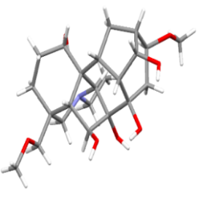
(35) (36) (37)

The spatial structure of the crystal molecular structure (1α, 4β, 6β, 7α, 8β, 14α, 16β) -20-ethyl-16-methoxy-4- (methoxymethyl) -aconitan-1,6,7,8,14-pentaola (37) was studied with X-ray structural analysis.
5 new derivatives of harmine were synthesized, with the molecular structure determined from spectral data (UV-, IR-, ¹Н-, ¹³С-, ¹⁹Ғ-NMR) and X-ray structural analysis.
We’ve conducted biological screening of isolated and synthesized compounds: derivatives of harmine 2-fluorochalcone, 8-acetylhydrazone, N-(2)-(3,4-dichlorophenacyl) harminium bromide show moderately expressed antimicrobial, 4-methoxychalcone harmine derivative, and diterpene alkaloids delcosine and lappaconitine have an antimicrobial activity, 2,3,4-trimethoxychalcone-, 2-fluorohydrazone harmine derivatives show neurotropic activity.
The 2019 interim report was registered with “NCSSTE” JSC in conformity with applicable rules (Inv. No. 0219RK00727).

4 Isolation of alkaloids from Aconitum villosum Reichenb., Anemone altaica Fisch. ex. C. A. Mey, Echinops albicaulis Kar. & Kir.

4.1 Isolation of alkaloids from Aconitum villosum Reichenb.

A chemical study of the above-ground part of Aconitum villosum L. collected in the Altay during the budding period in the Pechi village area, East Kazakhstan region, involved the isolation of biologically active components from plants of the genus Aconitum L.
The air-dry crushed raw material of the above-ground part of Aconitum villosum L. weighing 0.9 kg was exhaustively extracted with ethanol, and, once the extractant was stripped off in vacuum, the total extractives were thereby isolated. The derived total extractives were dissolved in hot 96% 70°C ethanol constantly stirred, and purified water heated to a similar temperature was added (total substances-ethyl alcohol ratio 1:2; ethyl alcohol-water ratio 2:1). The derived aqueous-alcoholic solution of the extract was filtered off. Water-alcohol treatment was performed twice. The combined filtrates were treated with chloroform 3 times (filtrate-chloroform ratio 3:1). In this case, total extractives were obtained. Once chloroform was removed, the alkaloids were extracted with 5% Н₂SO₄, then alkalized with aqueous Na₂CO₃ and extracted with chloroform. 8.73 g of the total alkaloids were obtained.
The total alkaloids derived were chromatographed on a Al₂O₃ column (II Act. R.) at the amount-carrier ratio 1: 20. When the column was eluted, total alkaloids of 5.42 g were isolated using a step gradient of the hexane-chloroform elution mixture (9:1; 1:1).
The total alkaloids derived were re-chromatographed on a Al₂O₃ column (II Act. R.) by elution with a hexane-ethyl acetate mixture (9: 1) and 0.03 g of crystal substance (2) of the С₃₄Н₄₇NО₁₁ composition, 216-218⁰С m.p. (СНCl₃) were isolated.
UV spectrum (EtOH), λ_{max}/нм (lg ε) (2): 223 (2.58), 252 (3.05), 311 (3.34).
IR spectrum (КВr, ν, сm⁻¹) (2): 3550, 3528 (ОН), 3009 (N-H), 2928 (СН₃), 1698 (С=О), 1684, 1585, 1504, 1414 (CH₂), 1375 (СН₃), 1318, 1270, 1160, 1084 (C-O), 1000, 968, 876, 764.
¹Н NMR spectrum (500 MHz, CDCl₃, δ, ppm, J/Hz) (2): 1.2 (3H, d., NCH₂CH₃, J=7.2) 1.6 (1Н, d.d., Н_{b}-6, J₁=15.2, J₂=8.3), 1.82 (1Н, t., Н_{b}-3, J=13.5), 1.95 (1H, m., Н_{b}-12), 1.99 (1H, m., Н_{b}-15), 2.08 (1Н, d.d., Н-10, J₁=12.6, J₂=4.4), 2.13 (1Н, m., Н-7) 2.14 (1Н, m., Н_{b}-2), 2.20 (3H, s., NHCOCH₃), 2.26 (1Н, m., Н_{a}-2), 2.35 (1Н, m., Н-13), 2.37 (1Н, m., Н-5), 2.38 (1Н, m., Н-15), 2.46 (1Н, d.d., Н_{a}12, J₁=14.5, J₂=4.7), 2.48 (1Н, m., Н_{b}-21), 2.52 (1Н, m., Н_{b} -19), 2.53 (1Н, m., Н_{a}-21), 2.63 (1Н, m., Н_{a}-3), 2.67 (1Н, d.d., Н_{a}-6, J₁=15.2, J₂=7.3), 2.85 (1Н, m, Н-1), 3.0 (1Н, s., Н-17), 3.05 (1Н, m., Н-5, J=4.5), 3.21 (1Н, t, Н-11), 3.16 (1Н, d.d., Н-1, J₁=10.4, J₂=6.7), 3.27 (1Н, m., Н-16), 3.27, 3.28, 3.38 (3H each, all s., 1-, 16-, 14- СН₃О, respectively), 3.44 (1Н, d., Н-14, J=5.1), 3.56 (1Н, d., Н_{а}-19, J=11.4), 7.01 (1Н, d.d.d., Н-5', J₁=8.0, J₂=7.4, J₃=1.1), 7.49 (1Н, d.d.d., Н-4', J₁=8.8, J₂=7.4, J₃=1.5), 7.90 (1Н, d.d ., Н-6', J₁=8.0, J₂=1.5), 8.65 (broad doublet, 1Н, Н-3', J=8.8), 11.02 (1H, broad singlet, NHAc).
The ¹Н NMR spectrum of the isolated compound (2) contains signals of a three-proton triplet of the NCH₂СН₃ groups at δ 1.2 ppm. with SSCC of 7 Hz, a singlet of the СОСН₃ groups at δ 2.2 ppm. The signal of the H-17 proton as a singlet is observed at δ 3.0 ppm, singlets of three ОСН₃ groups at δ 3.27, 3.28, 3.38 ppm. (at C-1, C-14 and C-16, respectively), and a doublet with SSCC of 5.1 Hz. at δ 3.44 ppm refers to the H-14 proton signal. Signals of the H-5 'and H-4' aromatic protons are manifested by doublet triplets at δ 7.01 with SSCC of 8.0 and 1.1 Hz and δ 7.49 ppm. with SSCC of 8.5 and 1.5 Hz, doublet doublets of the Н-6' proton at δ 7.9 ppm with SSCC of 8.0 and 1.5 Hz, and the H-3 'proton with a broad doublet at δ 8.64 ppm with SSCC of 8.8 Hz. The proton signal from Ar-NH-COR appears as a singlet at 11.02 ppm.
¹³С NMR spectrum (125 MHz, CDCl₃, δ, ppm) (2): 169.21 (C_{q}, COCH₃), 167.41 (C_{q}, C-7'), 141.77 (C_{q}, C-10, 134.59 (CHf, C-5), 131.14 (CH, C-6'), 122.45 (CH, C-4'), 120.34 (CH, C-3'), 115.70 (C_{q}, C-20), 90.10 (CH, C-14), 84.56 (C_{q}, C-4), 84.09 (CH, C-l), 82.88 (CH, C-16), 78.50 (C_{q}, C-9), 75.68 (C_{q}, C-8), 61.62 (CH, C-17), 58.06 (OCH₃, C-14), 56.68 (OCH₃, C-l), 56.28 (OCH₃, C-16), 55.75 (CH₂, C-18), 51.02 (C_{q}, C-ll), 49.76 (CH, C-5), 49.24 (CH₂, C-19), 48.49 (CH, C-7), 47.56 (CH, C-10), 44.89 (CH₂, C- 15), 36.37 (CH, C-13), 31.79 (CH₂, C-3), 29.78 (CH₂, C-12), 26.33 (CH₂, C-2), 25.67 (CH₃, Ac), 24.12 (CH₂, C-6), 13.48 (CH₃, C-20).
The ¹³С NMR spectrum of the isolated compound (2) contains signals of three ОСН₃ groups at δ 58.06, 56.68, and 56.28 ppm, corresponding to signals of the C-1, C-14, and C-16 atoms. The Ar-С=О signal appears at δ 167.41, and NHC=O at δ 169.21 ppm. The carbon signals of the acetylantronic acid residue appear at δ 115.7 -131.1 ppm, and the signals of the N-ethyl fragment with the nitrogen atom at δ 13.48 (for CH₃) and 49.24 ppm (for CH₂).
Based on the physicochemical constants, IR, UV and NMR spectra, the isolated compound (2) was identified as a diterpene alkaloid — lappaconitine [6].
The quantitative content of alkaloids was determined in the total extract of the aboveground part of Aconitum villosum L. The content was: aconitine (1) - 0.05%, lappaconitine (2) - 0.25%; songorine (5) was not found in this total extract.

4.2 Isolation of alkaloids from Anemone altaica Fisch.ex. C.A. Mey

We’ve chemically studied the underground part of Anemone altaica Fisch. ex. C. A. Mey collected in the East Kazakhstan region.
To isolate biologically active components from Anemone altaica Fisch. Ex. C.A. Mey, the product was extracted five times with chloroform. The derived total alkaloid extract was concentrated in a vacuum evaporator. The chloroform extraction was treated with a 5% solution of H₂SO₄; after the phase disengagement, the sulfuric acid extract of alkaloids was separated. The sulfuric acid solution of alkaloids was alkalized with Na₂CO₃ saturated solution to pH 8-9, and was extracted with chloroform. The chloroform solution was evaporated. The yield of the total extractive substances was 24.13% (based on air-dry products).
The derived total extractive substances were chromatographed on the Al₂O₃ column (II Act.R.) at the amount-carrier ratio of 1: 20. When eluting a column using a step gradient of the chloroform-methanol elution mixture (9:1; 1:1), the total alkaloids of 14.5 g were isolated.

4.3 Isolation of alkaloids from Echinops albicaulis Kar. & Kir.

During the expedition trips, commercial thickets were identified and raw product inventory of Echinops albicaulis Kar.et Kir. on the Balkhash district and in the Kerbulak village area, Almaty region was accounted.
White-stemmed thistle (Echinops albicaulis Kar. et Kir., the family Asteraceae Dumort) is found in the Turgay (South), Aral, Kyzyl-Orda regions, Betpakdala, Muyun Kum, near Balkhash lake, Kzylkum (North).
Air-dry crushed raw material of the aerial part (buds, flower baskets, leaves) of Echinops albicaulis Kar. & Kir. with mass of 0.5 kg was exhaustively extracted with 80% ethanol. After evaporation of the extractant under vacuum, 0.75 l of a water-still residue was obtained. The water-still residue of the extract was alkalized with 25% Na₂CO₃ solution to pH 8-9, then the alkaloids were extracted four times with chloroform. The chloroform extraction was treated with a 5% H₂SO₄ solution; after the phase disengagement, the sulfuric acid extract of alkaloids was separated. Sulfuric acid solution of alkaloids was alkalized with the saturated Na₂CO₃ solution to pH 8-9, and was extracted with chloroform. When the derived total alkaloids were purified with hexane, benzene and acetone, a light yellow crystalline powder was obtained with 149-150⁰С m.p., С₁₀Н₉NO composition; the yield was 0.17% (based on the weight of air-dry products).
The IR spectrum of compound (21) contains intense absorption bands of 3403, 3062, 1624, 1574, 1156 cm⁻¹ peculiar to -С=О, N-СН₃, С=С, С-N groups, respectively.
The UV spectrum of compound (21) exhibits absorption maxima at quinoline cycle wavelengths of 212, 238, 324, 337 nm.
¹Н NMR spectrum (500 MHz, CDCl₃, δ, ppm, J/Hz) (21): 3.78 (3H, s, N-CH₃), 7.37 (1Н, d, J=6.88, Н-3), 7.39 (1Н, d, J=8.41, Н-6), 6.24 (1Н, d, J=7.64, Н-8), 7.49 (1H, d, J=7.64, Н-2), 7.66 (1Н, d, J=8.41, Н-7), 8.44 (1Н, dd, J=8.41, 1.91, Н-5).
The ¹Н NMR spectrum of the isolated compound (21) exhibits a methyl three-proton singlet at δ 3.78 ppm, shifted to the low field due to the proximal nitrogen atom, the oxygen atom also shifts to the low field signals of H-6, H-7, H-8 aromatic protons, as doublets at δ 7.39, 7.66 and 6.24 ppm with SSCC of 8.41, 8.41, 7.64 Hz, respectively, also the proton signal at C-5 which is closest to the oxygen atom is shifted at of δ 8.44 ppm with SSCC of 1.91, 8.41 Hz. The H-3 and H-2 proton signals of the heterocyclic ring appear as doublets at δ 7.37 and 7.49 ppm with SSCC of 6.88, 7.64.
¹³С NMR spectrum (СDCl₃, δ, ppm) (21): 178.43 (s, С-4), 143.83 (d, С-2), 140.69 (s, С-8a), 132.33 (d, С- 7), 127.08 (s, C-4a), 126.98 (d, C-6), 123.89 (d, C-5), 115.42 (d, C-8), 110.09 (d, C-3), 40.77 (k, CH₃).
In the ¹³С NMR spectrum of the isolated compound (21), the signal of the C-4 carbon atom, the most shifted to the low field due to the close proximity of the oxygen atom is displaced at δ 178.43 ppm, the C-5, C-6, C-7, C-8 signals are at 123.89, 126.98, 132.33, 115.42 ppm as doublets, the signals of C-4A, C-8A carbon atoms at δ 127.08, 140.69 ppm accordingly have chemical shifts typical for aromatic carbon atoms. The signals of heterocyclic ring C-2 and C-3 carbon atoms appear at δ 143.83 and 110.09 ppm as doublets. The chemical shift is at δ 40.77, the methyl group signal is displaced due to the nitrogen atom.
From physicochemical constants, IR, UV, and NMR spectra, the isolated compound (21) was identified as a quinoline alkaloid - 1-methyl-1,4-dihydroquinoline-4 (1H) -one (echinopsine) [24].

5 Chemical modification based on 8-acetylharmine. Study of the molecular structure of synthesized derivatives

The analysis of the Mulliken charge distribution on non-hydrogen atoms using semi-empirical methods of quantum chemistryAM1 and PM3 has shown that the harmine molecule (27) behaves electrophilically. The N2, C4, C6 and C8 atoms are relatively preferred reaction sites for an electrophilic substitution.
The 8-acetylharmine molecule contains a carbonyl group, which can be used for addition and reduction reactions. Hydrazine and its derivatives, and aromatic aldehydes, can interact with carbonyl compounds to produce hydrazone and chalcon derivatives of harmine.
We have studied how 8-acetylharmine (38) interacts with hydrazine hydrate. The chemical modification has allowed for the synthesization of (Z) -8- (1-hydrazonoethyl) -7-methoxy-1-methyl-9H-pyrido [3,4-b] indole (39), which is of considerable interest for further modifications.
(27) (38)

(39) (40)

The compound structure (39) was determined from NMR, IR, mass spectra, XRS and elemental analysis. The signals in the NMR spectrum were assigned from ¹H, ¹³С NMR spectra and the ¹H-¹⁵N (HMBC) correlation spectrum. The ¹H-¹⁵N data were used to unambiguously assign the singlet signals of methyl groups with the C-1 atom of pyridine ring and hydrazone substituent. The upfield signal of the methyl protons (C-13) (δ 2.12 ppm) interacts with the nitrogen atom of hydrazone substituent (C=N) (δ_{N} 309 ppm). The signal of CH₃ protons with the C-1 atom (δ 2.71 ppm) and a H-3 proton (doublet, δ 8.15 ppm) interact with the nitrogen atom of pyridine ring (δ_{N} 279 ppm).
The compound (39) molecular structure is shown in Figure 1. The intermolecular interactions were analysed using the PLATON and MERCURY programs.

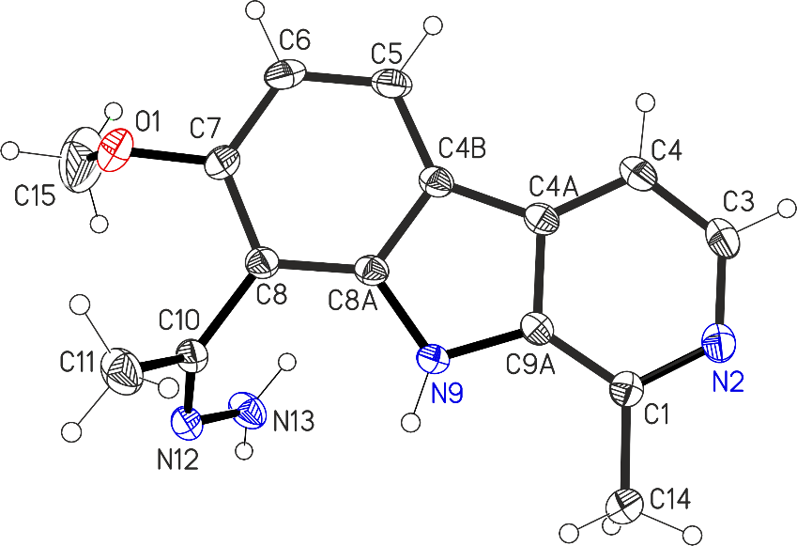
Figure 1 - Molecular structure and atomic numbering of the compound (39) (thermal ellipsoids are with a probability of 30%)

The geometric molecule parameters of the compound (39) stand for the average values and, within 3σ, coincide with those in the closest structural analogs, harmine derivatives: 8-formylharmine and 8-acetylharmine. The compound (39) molecule is almost flat; the root-mean-square deviation from the plane through all non-hydrogen atoms of the tricyclic fragment is 0.027 Å. The ethylenic bond C10=N12 has a Z-configuration (the torsion angle C8C10N12N13 is 2.2 (2)°). The nitrogen atom N13 is pyramidally shaped, its out-of-plane with the H and N12 atoms is 0.23 (1)Å. Crystallized compound (39) molecules stack due to π-stacking interactions. Figure 2 shows a stack packing of crystallized molecules along the b axis.
Adjacent stacked molecules are arranged as a head-to-tail; 6- and 5-membered heterocyclic fragments are involved in π-stacking; the intercentroid distance in Cg ... Cg stacks varies from 3.536 (1) to 3.864 (1) Å, and the interplanar distance varies from 3.428 (1) to 3.458 (1) Å. The stacks are interconnected due to weak hydrogen bonds of the N-H ... N and C-H ... O types. The hydrogen bond parameters are given in Table 1. The remarkable thing is that a similar packing appears in 8-acetylharmine.

Table 1-Intermolecular hydrogen bonds of the compound (39)

Hydrogen bond | Parameters
 | D-N | N…А, (Å) | D…А, (Å) | D-N …А, (°)
N9-H9a N12 | 0.86 | 2.27 | 3.126(2) | 176
N13-H13a N2 | 0.87(2) | 2.25(2) | 3.107(2) | 168(2)
N13-H13b N2 | 0.87(2) | 2.54(2) | 3.318(2) | 149(2)
C4-H4a O1 | 0.93 | 2.55 | 3.418(3) | 155

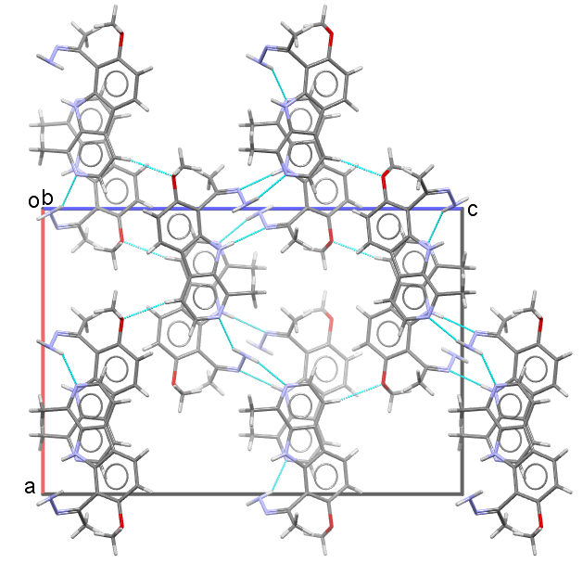
Figure 2 - Stack packing of crystallized molecules of the compound (39)
The derived hydrogen bonds involving the N-H group of pyrrole cycle are also confirmed from IR spectra. The IR spectrum of the parent 8-acetylharmine ν the pyrrole ring NH appears as an associated band at 3406 cm-1. The IR spectrum of hydrazone (39) shows NH stretching bands shifted to the low-frequency region (ν NН 3327, 3220 cm-1 narrow bands). These results are consistent with the reported data obtained when studying the IR spectra of substituted heterocyclic compounds: imidazoles [39] and 1,2,4-triazoles [40].
The parent compound was 8-acetylharmine (29), with the gross formula of C₁₅H₁₄N₂O₂, with 152-153 ° C m.p. The 8-acetylharmine (38) source is the alkaloid harmine (27), which is contained in the product of reference Péganum harmala L., which is widespread in the Southern Kazakhstan [41].
8-acetylhydrazone harmine (38) interacted with functionally substituted 2,4-dimethoxybenzaldehyde during boiling in methanol, makes (E) - 1-(2,4-dimethoxyphenyl)hydrazone) ethyl) - 7-methoxy-1-methyl-9H-pyrido[3,4-b]indole-8-yl (40).
(Z) -8- (1-hydrazonoethyl) -7-methoxy-1-methyl-9H-pyrido [3,4-b] indole (39). 0.5 g solution (1.96 mol) of 8-acetylharmine (38) in 25 ml of ethanol is added dropwise with stirring with hydrazine hydrate excessed to 2.94 g (0.06 mol). The reaction mixture was stirred over 7-8 hours at 60 ° C. The derived precipitate was filtered off and recrystallized from EtOH. Substance (39) in 69% yield, yellow fine-crystalline powder, 207-209 ° C m.p., [α]²⁴_{D} -187.5° (с 0.16; СНCl₃). UV spectrum (EtOH), λ_{max}/nm (lgε): 213 (2.85), 243 (2.99), 302 (2.66), 328 (2.22), 341 (2.17). IR spectrum (КВr, ν, сm⁻¹): 3327, 3220, (-NH), 3170, 3096, 2890, 2827 (-С-Н), 2983, 2927, 2915, (-ОСН₃ of phenyl fragment), 1617 (-С=N), 1569, 1446, 1418 (-С-С), 1293, 1222, 1202 (-С=N-N), 1113 (-N-N). ¹Н NMR spectrum (500 МHz, DMSO, δ, ppm, J/Hz): 2.12 (3H, s, СH₃С=N), 2.71 (3H, s, -СH₃), 3.86 (3H, s, -OCH₃), 7.04 (1H, d, J=8.2, H-6), 7.81 (1H, d, J=5.8, H-4), 8.03, 8.05 (2Н, s, NH₂), 8.12 (1H, d, J=8.2, H-5), 8.15 (1H, d, J=5.8, H-3), 10.51 (1Н, broad singlet, NН). ¹³С NMR spectrum (125 МHz, CDCl₃, δ, ppm): s.141.58 (С-1); d. 137.24 (С-3); d. 112.1 (С-4); s. 116.47 (С-4a); s. 129.02 (С-4b); d. 123.31 (С-5); d. 105.0 (С-6); s. 156.81 (С-7); s. 105.82 (С-8); s. 138.67 (С-8a); s. 135.64 (С-9a); quar. 18.51 (CH₃С=N); quar. 55.55 (-OCH₃); quar. 21.94 (-CH₃); s. 145.95 (C=N). Mass spectrum, m/z (Irel, %): 277 (100), 308 (37), 237 (22), 278 (18), 236 (15). Found, m/z: 268.1319 [M]⁺. C₁₅H₁₆N₄O. Analyzed, m/z: 268.1298. Elemental Analysis: Found, %: С 69.10; Н 7.17; N 17.8. C₁₅H₁₆N₄O. Analyzed, %: С 67.16; Н 7.00; N 17.87.
(Z) -1- (2,4-dimethoxyphenyl) hydrazone) ethyl) -7-methoxy-1-methyl-9H-pyrido [3,4-b] indol-8-yl (40). 0.186 g (1.12 mol) 2,4-dimethoxybenzaldehyde in 5 ml methanol are added dropwise with stirring to a 0.15 g (0.56 mol) solution of (Z) -8- (hydrazonoethyl) -7-methoxy-1-methyl-9H-pyrido [3,4-b] indole (39) in 20 ml methanol. The reaction mixture is stirred over 4 hours at 60-65⁰С. The derived precipitate is filtered off and recrystallized from ethanol. The substance (40) in 75% yield, C₂₄H₂₄N₄O₃ composition, [α]²⁴_{D} +125° (s 0.16; chloroform). UV spectrum (EtOH, λ_{max}/nm (lg ε): 216 (2.78), 236 (3.26), 293 (2.26), 317 (2.17). IR spectrum (КВr, ν, сm-1): 3220 (-NH), 3178, 3107, 3004, 2851, 2837 (-С-Н), 2970, 2926 (-ОСН₃ of phenyl fragment), 1623, 1606 (-С=N), 1570, 1462, 1421 (-С-С), 1290, 1271, 1226 (-С=N-N), 1173 (-N-N). ¹Н NMR spectrum (500 МHz, CDCl₃, δ, ppm, J/Hz): 2.54, (3H, s, СH₃СN); 2.68 (3H, s, -СH₃); 3.70 (3H, s, -OCH₃); 3.71 (3H, s, -OCH₃); 3.95 (3H, s, OCH₃); 6.18 (1H, d.d., J = 8.7, H-3'), 6.32 (1H, d, J = 8.8, H-6'), 6,94 (1H, d, J=8.7, H-6); 7.73 ppm (1H, d, J = 5.3, H-4), 8.04 (1H, d, J = 8.7, H-5), 8.32 (1H, d, J = 5.3, H-3), 8.69 (1H, d, J = 6.8, H-5’), 8.76 (1H, broad singlet, H-16), 10.56 (1H, broad singlet, NH). ¹³C NMR spectrum (125 МHz, CDCl₃, δ, ppm): s.129.1 (С-1'); d.139.28 (С-3); d.112.43 (С-4); s.115.49 (С-4a); s.117.07 (С-4b); d.123.31 (С-5); d.105.34 (С-6); s.162.34 (С-7); s.110.60 (С-8); s.141.73 (С-8a); s.135.65 (С-9a); quar. 24.33 (CH₃СN); quar. 56.40 (OCH₃); quar. 55.57 (OCH₃); quar. 56.52 (OCH₃); quar. 20.31 (CH₃); d.98.39 (С-6'); d. 28.52 (С-3',5'); d.155.01 (CН=N); s.163.59 (C=N). Mass spectrum, m/z (I_{rel}, %): 385 (100), 416 (32), 386 (26), 237 (11), 417 (9). Found, m/z: 416.1843 [M]⁺. C₂₄H₂₄N₄O₃. Analysed, m/z: 416.1840. Elemental Analysis: Found, %: С 68.99; Н 6.34; N 13.03. C₂₄H₂₄N₄O₃. Analysed, %: С 69.21; Н 5.82; N 13.45.
The X-ray diffraction study of a chloroform crystallized single crystal (39) was performed at 296 (2) K. An absorption correction was implemented using the SADABS program. The structure was decoded through a direct method using the SHELXS-97 program [42] and refined in the anisotropic-isotropic (for H atoms) approximation using the SHELXL-2014/7 program. The positions of hydrogens other than NH₂ group H atoms were analysed geometrically, and the parameters of hydrogen atoms were refined in the isotropic approximation in the riding model. The NH₂ group H atoms are localized from difference synthesis. Crystals (39) were rhombic and had a Pbca space group with the following crystallographic parameters: a = 15.4978(6), b = 7.6172(3), c = 22.7784(8) , V 2689.0(2) ³, Z = 8, C₁₅H₁₆N₄O, d_{an} = 1.326 g/cm³, μ = 0.087 мм⁻¹, sample size 0.15×0.80×0.80 mm, maximum angle 2θ 55.1°, the transmission of 0.7052 to 0.7456. The intensities of 3081 independent reflections (Rint = 0.030) were measured. Definite refinement parameters: R = 0.0565, wR₂ = 0.1362, S = 1.083 for all independent reflections and R = 0.0463, wR₂ = 0.1250 for 2585 F > 4σ. Refined parameters were of 189 and 2 restrictions. Atomic coordinates, bond lengths, and angles were deposited with the Cambridge Crystallographic Database, CCDC 2005036. (deposit@ccdc.cam.ac.uk or http://www.ccdc.cam.ac.uk).
Thus, we have proposed a simple method for a new harmine derivative – (Z)-8-(1-hydrazonoethyl)-7-methoxy-1-methyl-9H-pyrido[3,4-b]indole (39), with the structure determined by one-dimensional ¹Н, ¹³С and DEPT NMR methods, by two-dimensional COSY, HMQS, HMBC spectra, elemental analysis and mass spectra, and x-ray diffraction analysis.

Synthesis of a chalcon-containing harmine derivative

The chemical modification of harmine (27) at the aromatic ring gave 8-8-acetylharmine (38), with the condensation under the Claisen-Schmidt method with aromatic aldehyde in EtOH in the presence of aqueous NaOH solution that generates chalcone derivative harmine (E) -1- (7- methoxy-1-methyl-9H-pyrido [3,4-b] indol-8-yl) -3- (3-bromo-4-fluorophenyl) prop-2-en-1-one (41) in 49% yield.

(27) (38) (41)

(E) -1- (7-methoxy-1-methyl-9H-pyrido [3,4-b] indol-8-yl) -3- (3-bromo-4-fluorophenyl) prop-2-en-1 -on (41). A 1 g mixture (0.15 mmol) of compound (38) and 7.8 mmol 3-bromo-4-fluorobenzaldehyde were dissolved in a minimum amount (~ 15 ml) of EtOH, and 5 ml 25% aqueous NaOH solution (25 ° С) was added dropwise. The reaction mixture was stirred over 3 h at 25 ° C and additionally 1 h at 60 ° S, cooled and neutralized with concentrated HCl. The derived precipitate was filtered off and recrystallized from EtOAc. When chalcone was produced, the neutralized precipitate was separated and chromatographed on silica gel (CHCl₃ eluent). Substance (41) in 49% yield, yellow fine-crystalline powder, 201-203⁰С m.p.
UV spectrum (EtOH), λ_{max}/нм (lgε) (41): 202 (3.19), 208 (3.17), 232 (3.29), 269 (2.90), 276 (2.88), 321 (2.66), 363 (2.67).
The IR spectrum (41) shows (NH) group absorption bands at 3403 cm⁻¹, the bands at 2980, 2915, 2924, 2859, 2848 cm⁻¹ were related to ν (C-H) aromatic and aliphatic stretchings. Aromatic stretchings of the (C = C) bond were about 1602, 1577, 1495 cm⁻¹ other than the 1643 band due to (C = N). The compound (41) gives strong absorption at 1743 cm⁻¹ related to conjugated carbonyl group. It should be noted that the (C = C) band intensity was usually higher than the (C = O) band for most chalcones.
¹Н NMR spectrum (500 МHz, CDCl₃, δ, ppm, J/Hz) (41): 2.84 (3H, s., СH₃ at С-1); 4.13 (3H, s., OCH₃); 6.96 (1H, d., J = 8.6, H-6); 7.18 (1H, t., J = 8.31, J = 8.34, J = 8.38, H-5''); 7.58 (1H, d. quar., J₁ = 2.15, J₂ = 4.69, J₃ = 8.48, H-6''); 7.71 (1H, d., J =15.6, b-CH); 7.74 (1H, d., J = 5.3, H-4); 7.85 (1H, d.d., J ₁=2.15, J₂ = 6.55, H-2''); 7.91 (1H, d., J = 15.6, a-CH); 8.20 (1H, d., J = 8.6, H-5); 8.36 (1H, d., J = 5.3, H-3);10.79 (1H, broad singlet, NH).
The ¹Н NMR spectrum (41) shows a methyl signal at δ2.84 ppm, relevant to the C-1 proton signal as a singlet. The methoxyl proton signal of C-7 carbon atom appears as a singlet at δ 4.13 ppm respectively. The signals of H-3, H-4, H-5, H-6 phenyl substituent protons appear at δ 8.36, 7.74, 8.20, and 6.96 ppm. with SSCC of 5.3; 8.6 Hz respectively. The NH proton signal appears at δ10.79 ppm. as a broad singlet. The signals characteristic of H-2'' H-5'' and H-6'' aromatic ring protons appear at δ 7.18, 7.71, 7.58 ppm. accordingly, the proton signals of trans substituted double bond appear at δ 7.85–7.91 ppm, confirming the derived chalcone structure.
The ¹³С NMR spectrum (41) contains 10 singlet, 7 doublet, and 2 quartet signals. Typical signals of three carbon atoms (δС-2 '128, δС-3' 133, δС = O 190 ppm), confirming the chalcone structure formed.
¹³С NMR spectrum (125 МHz, CDCl₃, δ, ppm) (41): quar. 20.41 (CH₃ at С-1); quar. 56.84 (OCH₃); d. 104.61 (С-6); s. 110.02 (C-3''); s. 110.55 (С-8); d. 112.22 (С-4); d. 117.01 (C-5''); s. 117.50 (С-4a); s. 127.61 (С-4b); d. 128.67 (С-5); d. 128.82 (С-a); d. 129.14 (C-6''); s. 129.20 (С-8a); d. 133.18 (C-2''); s. 134.93 (С-9a); d. 139.41 (С-3); d. 139.76 (C-b); s.142.18 (С-1); s. 142.56 (С-1''); s. 159.02 (С-4''); s. 161.44 (C-7); s. 190.76 (C=O).
The ¹⁹F NMR spectrum of compound (41) in the range -104.2 shows a single signal of the phenyl fragment fluorine.
Mass spectrum, m/z (I_{rel}, %) (41): 265 (100), 266 (15), 250 (10), 440 (10), 438 (9). Found, m/z: 438.0366 [M]⁺. С₂₂H₁₆ BrFN₂O₂. Analysed, m/z: 438.0374. Elemental Analysis: Found, %: С 62.04; Н 4.88; N 6.42. Analysed, %: С 60.27; Н 3.65; N 6.39. С₂₂H₁₆ BrFN₂O₂.
To assign chemical shifts of carbon atoms other than hydrogen atoms, the methods of long-range heteronuclear correlation were used: HMBC ¹Н–¹³С (figure 3 а). Correlation spectra for long-range bonds, which uniquely identify all carbon atoms in the molecule other than hydrogen atoms, fully confirmed the synthesized compound structure [41].
HMBC ¹Н–¹³С has a correlation peak of the H-2 ''aromatic ring protons with C-4 '' and C-3 ' atoms. The H-6 '' proton interacts with the C-5 '' and C-3 'atoms, and the protons of the trans substituted H-2' double bond interacts with the C-3 'and C = O atoms, the H-3' proton interacts with C-6 '' and C-5 '' atoms. This experiment confirms the chalcone structure formed.
To correlate the nuclear spins, the nuclear Overhauser cross-relaxation is used during the mixing period. The derived spectrum is similar to COZY, with diagonal peaks and cross-peaks. Using NOESY (figure 3b), we can observe signals between nuclei in space in close proximity, based on the dipole-dipole interaction, due to the nuclear Overhauser effect.
The NOESY spectra’s (41) cross peaks conforming to the close spatial arrangement of corresponding atom groups were observed between the signals of the cyclic H-3 and H-4, H-4 and H-5, H-2 'and H-3' , H-2 '' and H-6 '', H-5 '' and H-6 '' protons.
All these data allows for suggesting that the synthesized compound (41) has the following structure (figure 3 a, b).
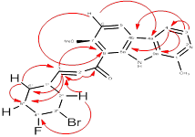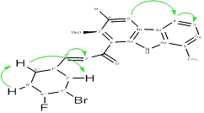
(а) (b)
Figure 3 - Confirmation of the carbon and hydrogen arrangement within the structure using HMBC (a) and hydrogens within the structure using NOESY (b) 3-bromo-4-fluoro-chalcone (41).
Thus, we have synthesized for the first time 3-bromo-4-fluoro-chalcone (41). The synthesized compound (41) structure has been determined through ¹Н, ¹³С and DEPT NMR methods, and through the two-dimensional COZY, HMQS, HMBS, NOESY spectra, elemental analysis and mass spectra.

8-acetylharmine halogenation reaction

We’ve performed the 8-acetylharmine (38) halogenation reaction under various conditions.
8-acetylharmine (38) with N-bromosuccinimide (NBS) (1.8 eq.) in dichloromethane (molar ratio 1:1.8) had been brominating over 24 hours and resulted in the mixture of 6-bromo-8-acetylharmine (42) and 4.6-dibromo-8-acetylharmine (43) isolated with column chromatography on silica gel in 72 and 19%, yield, respectively. Using a 2-fold excess of NBS and reducing the reaction time to 18 h result in a mixed monobromo-(42) and dibromo-β-carbolines (43) in 90 and 7.5% yield. We’ve found that the NBS-silica gel (molar ratio 1:4) has been brominating while completely converted over 12 hours and resulted to mixed bromine derivatives (42) and (43) isolated in 41 and 23% yield, respectively (Table 2).

(27) (38) (42-43)

8-acetylharmine (38) with liquid bromine (4 equiv.) in acetic acid (molar ratio 1: 4) was brominated over 6 h and resulted in the mixture of 6-bromo-8-acetylharmine (42) and 8-acetylharmine (38 ) isolated with column chromatography on silica gel in 33.8 and 23% yield, respectively.

(38) (42)

8-acetylharmine and N-bromosuccinimide reaction under various conditions:
Reaction in solution: 8-acetylharmine (38) and N-bromosuccinimide (NBS) in dichloromethane at a ratio of 1: 1.2 (24 h). The 1.25 g (7.0 mmol) N-bromosuccinimide solution in 50 ml dichloromethane was added dropwise with mixing to the 1 g (3.9 mmol) 8-acetylharmine (38) solution in 30 ml dichloromethane. 0.6 eq. NBS was added then. The reaction mixture was stirred over an additional 14 h at an ambient temperature at zero light, the reaction was monitored with TLC. The reaction mixture was washed with 0.1 n sodium hydroxide (3x15 ml) and then with water (3x15 ml). The organic layer was dried over magnesium sulfate, filtered and stripped off in vacuum, then a brown residue was obtained. The residue was purified with column chromatography on silica gel, (eluent-chloroform). 6-bromo-8-acetylharmine (42) was isolated in 72% yield. When the eluent polarity increased (chloroform:ethanol 100:1) 4,6-dibromo-8-acetylharmine (43) was isolated in 19% yield. The results are shown in Table 2.
8-acetylharmine (38) and N-bromosuccinimide (NBS) reaction in dichloromethane at a 1: 2 ratio (18 h). The 0.2 g (0.79 mmol) substrate and 0.28 g (1.6 mmol) NBS were mixed very carefully over 3-5 minutes. Then the reaction mixture was dissolved in dichloromethane. The reaction mixture was stirred over 18 h at zero light and at an ambient temperature; the reaction was monitored with TLC. The reaction mixture was washed with 0.1 n sodium hydroxide (3x15 ml) and then with water (3x15 ml). The organic layer was dried over magnesium sulfate, filtered and stripped off in vacuum, then a yellow residue was obtained. The residue was purified with column chromatography on silica gel, eluent-chloroform. 6-bromo-8-acetylharmine (42) was isolated in 90% yield. When the eluent polarity increased (chloroform:ethanol 100:1) 4,6-dibromo-8-acetylharmine (43) was isolated in 7.5% yield. The results are shown in Table 2.
Reaction in solution: 8-acetylharmine (38) and N-bromosuccinimide (NBS) in dichloromethane in the presence of silicon dioxide at a ratio of 1: 4 (12 hours). 15 g silicon dioxide was added to 0.5 g (1.9 mmol) 8-acetylharmine (38) solution in 50 ml dichloromethane, followed by 1.39 g (7.8 mmol) N-bromosuccinimide solution in 75 ml dichloromethane. The reaction mixture was stirred over 12 h at zero light and at an ambient temperature, then the reaction was monitored with TLC. Acros Organics silicon dioxide of chromatographic quality (60-200 µm, 60A, pH ≥5) was dried at 120⁰С before use. The reaction mixture was then filtered and the silicon dioxide was washed with dichloromethane (3x15 ml) and 1/1 ethyl acetate-ethanol mixture (3x15 ml). The combined extracts were washed with 0.1 n (3x15 ml) sodium hydroxide, then with water (3x15 ml); the organic layer was dried over magnesium sulfate, filtered and stripped off in vacuum, then a yellow residue was obtained. The residue was purified with column chromatography on silica gel, eluent-chloroform. 6-bromo-8-acetylharmine (42) was isolated in 41% yield. When the eluent polarity increased, (chloroform:ethanol 100:1), 4,6-dibromo-8-acetylharmine (43) was isolated in 23% yield. The results are shown in Table 2.
8-acetylharmine - liquid bromine reaction: 1 g (3.9 mmol) 8-acetylharmine (38) was dissolved in 20 ml acetic acid, then 1 ml (15.7 mmol) liquid bromine at a ratio of 1: 4 was added while being dissolved in acetic acid, stirred at room temperature over 6 hours. The reaction mixture was filtered, then the residue was washed with water and dried. The residue was separated by a flash column (wet method) on silica gel, (eluent – chloroform). The 6-bromo-8-acetylharmine hydrobromide and 8-acetylharmine mixture was isolated in 91% yield. When the reaction mixture was treated with ammonia and extracted with chloroform, the 6-bromo-8-acetylharmine (42) and 8-acetylharmine (38) mixture was isolated in 46.8% yield. The mixture was separated by a flash column (wet method) on silica gel, (eluent – chloroform). 6-bromo-8-acetylharmine (42) was isolated in 33.8% yield. When the eluent polarity increased, (chloroform:ethanol 100:1), 8-acetylharmine (38) was isolated in 23% yield.

Table 2 - Bromination of 8-acetylharmine with N-bromosuccinimide

No | Molar equivalent | Time, h. | Conversion,% | 1-product,% | 2-product,%
1 | 1:1,8 | 24 | 100 | 72 | 19
2 | 1:2 | 18 | 100 | 90 | 7,5
3 | 1:4/ silica gel | 12 | 100 | 41 | 23

6-bromo-8-acetylharmine (42). Light yellow powdery substance. M.p. 151-153⁰С. UV spectrum (EtOH), λ_{max}/nm (lgε): 379 (2.28), 291 (2.46), 232 (3.13). IR spectrum (КВr, ν, cm⁻¹): 3401 (-NH), 2924, 2853 (phenyl fragment -ОСН₃), 1656 (-С=N), 1096, 972, 899, 724, 594.
¹Н NMR spectrum (500 МHz, CDCl₃,δ, ppm, J/Hz): 2.80 (3H, s, СH₃); 2.85 (3H, с, СH₃); 4.01 (3H, s, OCH₃); 7.67 (1H, d, J = 5.8, H-4); 8.36 (1H, d, J = 8.2, H-5); 8.43 (1H, d, J = 5.8, H-3); 10.56 (1H, broad singlet, NH). ¹³С NMR spectrum (125 МHz, CDCl₃, δ, ppm): 20.20 (CH₃); 31.98 (CH₃); 62.77 (OCH₃); 109.07 (С-6); 112.44 (С-4); 115.81 (С-8); 120.74 (С-4a); 126.03 (С-4b); 131.56 (С-5); 135.05 (С-9a); 139.77 (С-3); 139.86 (С-8a); 142.50 (С-1); 158.38 (С-7); 199.99 (C=O).
Mass spectrum, m/z (I_{rel}, %): 335 (14), 334 (99), 333 (15), 332 [M]⁺ (100), 319 (20), 317 (21), 304 (8), 302 (8), 291 (6), 289 (6), 238 (5), 180 (6). Found, m/z: 332.0151 [M]⁺. C₁₅H₁₃N₂O₂Br. Analysed, m/z: 332.0155.
4,6-bromo-8-acetylharmine (43). Light yellow powdery substance. M.p. 157-159⁰С. UV spectrum (EtOH), λ_{max}/nm (lgε): 356 (2.36), 342 (2.30), 298 (2.69), 251 (3.16), 245 (3.16), 201 (2.87). IR spectrum (КВr, ν, сm⁻¹): 3423 (-NH), 2994, 2929, 2848 (phenyl fragment -ОСН₃), 1611 (-С=N), 1567, 1536, 1441, 1394 (-С-С), 1288, 1209, 1035, 983, 822, 754, 586.
¹Н NMR spectrum (500 МHz, CDCl₃,δ, ppm, J/Hz): 2.83 (3H, s, СH₃); 2.90 (3H, s, СH₃); 4.06 (3H, s, OCH₃); 7.91 (1H, d, J = 8.2, H-5); 8.45 (1H, d, J = 5.8, H-3); 10.62 (1H, broad singlet, NH). ¹³С NMR spectrum (125 МHz, CDCl₃, δ, ppm) (2): 20.20 (CH₃); 31.98 (CH₃); 63.25 (OCH₃); 108.82 (С-6); 116.47 (С-5); 119.34 (С-4); 119.64 (С-8); 128.93 (С-4a); 129.56 (С-4b); 130.40 (С-3); 135.36 (С-9a); 138.83 (С-8a); 144.15 (С-1); 156.11 (С-7); 199.64 (C=O).
Mass spectrum, m/z (I_{rel}, %): 414 (45), 412 [M]⁺ (100), 410 (46), 334 (58), 333 (41), 332 (61), 331 (31), 319 (25), 318 (30), 317 (31), 316 (38), 315 (39), 313 (34), 302 (27), 301 (29), 275 (28), 273 (29), 260 (33), 209 (46), 180 (26), 179 (62), 42 (42). Found, m/z: 409.9264 [M]⁺. C₁₅H₁₂N₂O₂Br₂. Analysed, m/z: 409.9260.
Bromine bromination requires very excessed bromine, which is consumed for 8-acetylharmine hydrobromide. The optimal condition for 6-bromo-8-acetylharmine (42) is bromination with N-bromosuccinimide.

8-acetylharmine - N-iodosuccinimide reactions under various conditions

Iodizing 8-acetylharmine (38) by N-iodosuccinimide (NIS) in СН₂Сl₂ was not successful. However, iodization in trifluoroacetic acid allowed the selective synthesis of 6-iodine-8-acetylharmine (44) and 6,8-diiodacetylharmine (45) (48% and 10.5% yield, respectively).
(38) (44) (45)

Reaction in a 8-acetylharmine (38) and N-iodosuccinimide solid mixture in dichloromethane at 1: 2 ratio (18 h). 0.5 g (1.96 mmol) substrate and 0.88 g (3.9 mmol) NIS were mixed very carefully over several minutes. Then the reaction mixture was dissolved in dichloromethane and the reaction was monitored with TLC. The reaction mixture was stirred over 18 hours at an ambient temperature. The reaction mixture was washed with 0.1 n sodium hydroxide (3x 15 ml) and then water (3x 15 ml), followed by sodium thiosulfate (3x 15 ml) and water (3x 15 ml). The organic layer was dried over magnesium sulfate, filtered and stripped off in vacuum; only the parent material was isolated.
20 ml trifluoroacetic acid was added to 1 g (3.9 mmol) compound (38) and mixed until completely dissolved, then 1 g (4.4 mmol) of N-iodosuccinimide was added dropwise in 3 ml trifluoroacetic acid over 30 minutes. The reaction mixture was stirred over 6 h at room temperature, poured into 120 ml cold water, alkalinized with NH₄OH conc. to pH 11, then the reaction products were extracted with chloroform (3×40 ml), the combined extracts were washed with saturated sodium bicarbonate solution, dried with MgSO₄, evaporated, in order to produce 1.14 g solid mixture. The residue was dissolved in a minimal chloroform and chromatographed on silica gel (eluent-chloroform:ethanol (100: 2). 6-iodine-8-acetylharmine (44) was isolated in 48% yield. When the eluent polarity increased, (chloroform:ethanol 100:4) 6,8-diiodoacetylharmine (45) was isolated in 10.5% yield.
6-iodo-8-acetylharmine (44). 48% yield. Light yellow powdery substance. M.p. 162-1640S. UV spectrum (EtOH), λ_{max}/нм (lgε): 381 (2.18), 292 (2.33), 236 (2.99). IR spectrum (КВr, ν, сm⁻¹): 3401, 3066 (-NH), 2990, 2955, 2921, 2851 (phenyl fragment -ОСН₃), 1650 (-С=N), 1586, 1554, 1448, 1360 (-С-С), 1268, 1212, 1049, 973, 813, 748, 554.
¹Н NMR spectrum (500 МHz, CDCl₃,δ, ppm, J/Hz): 2.80 (3H, s, СH₃); 2.85 (3H, s, СH₃); 4.01 (3H, s, OCH₃); 7.67 (1H, d, J = 5.8, H-4); 8.36 (1H, d, J = 8.2, H-5); 8.43 (1H, d, J = 5.8, H-3); 10.56 (1H, broad singlet, NH).
¹³С NMR spectrum (125 МHz, CDCl₃, δ, ppm): 20.20 (CH₃); 31.98 (CH₃); 62.77 (OCH₃); 109.07 (С-6); 112.44 (С-4); 115.81 (С-8); 120.74 (С-4a); 126.03 (С-4b); 131.56 (С-5); 135.05 (С-9a); 139.77 (С-3); 139.86 (С-8a); 142.50 (С-1); 158.38 (С-7); 199.99 (C=O).
6,8-diiodoacetylharmine (45). 10,5% yield. Light yellow powdery substance. M.p. 173-175⁰С. UV spectrum (EtOH), λ_{max}/nm (lgε): 356 (2.36), 342 (2.30), 298 (2.71), 251 (3.19), 245 (3.18). IR spectrum (КВr, ν, сm-1): 3408, 3014 (-NH), 2994, 2950 (phenyl fragment -ОСН₃), 1646 (-С=N), 1571, 1559, 1449, 1361 (-С-С), 1278, 1218, 974, 817, 723, 565.
¹Н NMR spectrum (500 МHz, CDCl₃,δ, ppm, J/Hz): 2.85 (3H, s, СH₃); 3.91 (3H, s, OCH₃); 7.83 (1H, d, J = 5.15, H-4); 8.17 (1H, d, J = 5.15, H-3); 8.54 (1H, s, H-5); 10.56 (1H, broad singlet, NH).
¹³С NMR spectrum (125 МHz, CDCl₃, δ, ppm): 18.83 (CH₃); 60.36 (OCH₃); 71.92 (С-6); 79.08 (С-8); 112.99 (С-4); 120.52 (С-4a); 128.12 (С-4b); 132.02 (С-5); 135.25 (С-9a); 137.85 (С-3); 141.01 (С-8a); 142.85 (С-1); 158.54 (С-7).
Thus, 8-acetylharmine (38) was tried and tested as a renewable material for the synthesis of new biologically active compounds. Conditions for halogenating the 8-acetylharmine molecule (38), involving the formation of 6-bromo-8-acetylharmine (42) and 6-iodo-8-acetylharmine (44), were fitted in 90% and 48% yields, respectively.

6 Bioscreening and Pharmacological Study of Isolated Alkaloids and Their Derivatives

We’ve studied the analgesic, neurotropic and cytotoxic activities of the isolated alkaloids: songoramine (6), echinopsine (21), delphinifoline (37), and harmine derivatives: 8-acetylharmine (38), (E) -8- (hydrazonoethyl) -7-methoxy -1-methyl-9H-pyrido [3,4-b] indole (39), (E) -1- (2,4-dimethoxyphenyl) hydrazone) ethyl) -7-methoxy-1-methyl-9H-pyrido [3,4-b] indol-8-yl (40), (E) -1- (2-fluorophenyl) hydrazone) ethyl) -7-methoxy-1-methyl-9H-pyrido [3,4-b] indol-8-yl (46), (E) -1- (methoxyphenyl) hydrazone) ethyl) -7-methoxy-1-methyl-9H-pyrido [3,4-b] indol-8-yl (47), 2,3,4-trimethoxychalcone (48).

(46) (47) (48)

The analgesic activity of harmine derivatives was determined in vivo: 8-acetylharmine (38), (E) - 1-(2,4-dimethoxyphenyl) hydrazone) ethyl) - 7-methoxy-1-methyl-9H-pyrido[3,4-b]indole-8-yl (40), (E)-1-(2-fluorophenyl)hydrazone)ethyl)-7-methoxy-1-methyl-9H-pyrido[3,4-b]indole-8-yl (46), (E)-1-(methoxyphenyl) hydrazone)ethyl)-7-methoxy-1-methyl-9H-pyrido[3,4-b]indole-8-yl (47), while (E)-8-(hydrazonoethyl)-7-methoxy-1-methyl-9h-pyrido[3,4-b]indole (39) at a dose of 50 mg/kg showed pronounced analgesic activity from the mouse acetic writhing test (Appendix C).
Delphinifoline (37) at a dose of 10 mg / kg has a pronounced neurotropic effect (Appendix D).
The biological screening in vivo has determined that harmine derivatives E) - 1-(2-fluorophenyl)hydrazone) ethyl) - 7-methoxy-1-methyl-9H-pyrido[3,4-b]indole-8-yl (46), (E) - 1-(methoxyphenyl)hydrazone) ethyl) - 7-methoxy-1-methyl-9H-pyrido[3,4-b]indole-8-yl (47) produce a moderate neurotropic effect (Appendix E).
Moderate cytotoxicity of larvae of crustaceans Artemia salina (Leach) under in vitro cultivation conditions is shown by the following samples: delphinopholin (median lethal dose = 65.9 μg / ml) (37), (E) -8- (hydrazonoethyl) -7-methoxy- 1-methyl-9H-pyrido [3,4-b] indole (median lethal dose = 73.8 μg / ml) (39), (E) -1- (2,4-dimethoxyphenyl) hydrazone) ethyl) -7-methoxy -1-methyl-9H-pyrido [3,4-b] indol-8-yl (median lethal dose = 86.3 μg / ml) (40), 1- (4,6-dibromo-7-methoxy-1-methyl -9H-pyrido [3,4-b] indol-8-yl) ethanone (median lethal dose = 79.5 μg / ml) (43), (E) -1- (2-fluorophenyl) hydrazone) ethyl) -7- methoxy-1-methyl-9H-pyrido [3,4-b] indol-8-yl (46) (median lethal dose = 68.2 μg / ml), (E) -1- (methoxyphenyl) hydrazone) ethyl) -7 -methoxy-1-methyl-9H-pyrido [3,4-b] indol-8-yl (median lethal dose = 58.3 μg / ml) (47) (Appendix F).
Thus, the study of the isolated alkaloids and their derivatives for biological activity has revealed promising compounds for their further study in order to produce effective analgesic and neurotropic agents from them.

7 Elaboration of laboratory regulations for echinopsin isolated from white-stemmed thistle (Echinops albicaulis Kar. & Kir)

Echinopsin has neurotropic, analgesic, cytotoxic, hepatoprotective activity. By studying biologically active substances and developing medicinal substances from raw products on their basis, we were able to expand the range of medicinal plants and meet the need for highly effective and low-toxic plant extracts.
Description: the target product-1-methyl-1,4-dihydroquinoline-4(1H) - one (21) isolated from aerial part (buds, flower baskets, leaves) of white-stemmed thistle (Echinops albicaulis Kar. & Kir), is a light yellow powdery product, tasteless and odorless, with molecular weight of 159.2, m.p. 149-150⁰С, С₁₀Н₉NO composition, in 0.17% yield (based on air-dry products). The substance (21) is highly soluble in ethanol, chloroform, acetone, ethyl acetate, diethyl ether, almost insoluble in water.
A laboratory regulation has been elaborated for alkaloid echinopsin isolated (21) from the above-ground (flowers and leaves) white-stemmed thistle (Echinops albicaulis Kar. & Kir), collected on the Balkhash region during the period of butanization and flowering in the Kerbulak village area, Almaty region.
The laboratory process for isolating 1-methyl-1,4-dihydroquinoline-4 (1H)-it contains the following steps:
- TP.1 - Producing a liquid extract of the white-stemmed thistle
0.5 kg crushed air-dry products (0.5-1 cm in size) of the aboveground part (buds, flower baskets, leaves) of white-stemmed thistle (Echinops albicaulis Kar. & Kir.) are put into an extraction flask and filled with a 4.0 kg extractant. The operation is performed when heated to 75,0°C over 4 hours six times, and each subsequent fill is equal to the previous drain.
- TP. 2 - Producing commercially pure echinopsin;
A saturated soda solution is added to the water-alcohol residue to a pH 8-9. The alkaline solution is re-extracted 4 times with chloroform. The chloroform extraction is treated with a 5% Н₂SO₄ solution at a ratio of 1: 4. The sulfuric acid alkaloid solution is treated 2 times with chloroform. The sulfuric acid extraction is alkalized with a saturated soda solution to pH 8-9. The alkaline solution is extracted with chloroform at a ratio of 1: 4. The chloroform extraction is stripped off in vacuum, resulting in commercially pure echinopsin.
- TP.3 Recrystallizing commercially pure echinopsin.
The obtained technical echinopsin is dissolved in ethyl acetate, then left for 12 hours. The precipitated powder is washed with acetone. Based on physical and chemical constants and spectral data, the isolated substance was identified as the alkaloid echinopsin (21), in 0.17% yield (by weight of air-dry products). According to HPLC results, the purity of echinopsin (21) is 98.67% (Appendix G).

CONCLUSION

The analysis of domestic and foreign scientific and technical literature, patent materials of 2010 to 2020 (Appendix I) is indicative of the prospects and relevance of the topic under research, dedicated to the alkaloid structure isolated and determined from plants, their molecules chemically modified, and new alkaloid-based drugs developed. The revealed inventions and scientific and technical information can be more or less useful in solving such problems as extraction of plant products, isolation and determination of the alkaloid structure, chemical modification of their molecules, study of physiological activity and production of medicines based on alkaloids and their derivatives.
When fulfilling the main objectives under the AR05135304 project "Chemical study of alkaloid-bearing plants as promising sources of bioactive substances" according to the 2018-2020 calendar plan, the following main results have been obtained:
1. Chemical screening of 10 plant species of the families Ranunculaceae Juss., Asteraceae Dumort., Gentianaceae Juss. has been performed for the alkaloid content.
2. 11 plant species of the families Ranunculaceae Juss., Asteraceae Dumort., Gentianaceae Juss., Papaveraceae Juss. have been studied chemically for the alkaloids content, and 16 alkaloids have been thereby isolated and identified. For the first time, the pyridine alkaloid gentianin and the indole alkaloid harmine have been siolated and identified from Gentiana decumbens L.; diterpene alkaloid-delphinopholine from Aconitum monticola Steinb., delcosine - from Aconitum anthoroideum DC. From Echinops albicaulis Kar. & Kir. The total extractive substances have been generated and echinopsin has been isolated.
3. 16 new derivatives have been synthesized from chemical modification of the molecules of harmine and cytisine alkaloids, the molecular structure thereof has been found from elemental analysis, spectral data (UV, IR, ¹Н-, ¹³С- NMR) and X-ray structural analysis.
4. Biological screening has allowed determining samples of extracts of Gentiana decumbens L., Gentiana barbata Froel. and Echinops albicaulis Kon&Kir. to produce analgesic activity.
The isolated alkaloids and harmine derivatives have neurotropic, antimicrobial, analgesic activity, and 8-acetylhydrazone harmine has produced thereby a pronounced analgesic activity, and delphinofolin produce a pronounced neurotropic activity.
The findings of the experiment on the model of Alzheimer's and Parkinson's disease have allowed determining harmine derivatives to have an inhibitory effect on the acetylcholinesterase enzyme, and also to have shown an inhibitory effect on the tyrosinase enzyme.
A laboratory procedure for the isolation of the Echinopsin alkaloid from the white-stemmed thistle (Echinops albicaulis Kar. & Kir) has been elaborated.
During the 2018-2020 reporting period, a patent of the Republic of Kazakhstan 2020/0159 for (E)-8-(1-hydrazonoethyl)-7-methoxy-1-methyl-9H-pyrido[3,4-b]indole with analgesic activity was applied from 10.03.2020.
7 scientific papers have been published, 2 articles thereof - in peer-reviewed scientific journals, indexed and having percentile of 27 and 31 according to CiteScore in the Scopus database, 2 articles - in a domestic edition recommended by COXON and 3 abstracts.
According to the research results the performed T.S. Borovik has successfully defended a thesis for the degree of candidate of biological sciences, the performer M.S. Aytmagambetova - Master's thesis.

BIBLIOGRAPHY

1 Bryzgalov О., Romanov А.Е., Tolstikova T.G., Shullts Е. Lappaconitine: lnfluence of halogen substituent on the antiar - rhithmic activity // Cardiovascular & hematological agents in medical chemistry. – 2013. – Vol.11. –Р.211-217. (in Eng.).
2 Sun J. Peng Y., Wu H., Zhang X., Zhang Y., Xiao Y. Ganfu base, an antiarrhythmic alkaloid of Aconitum coreanum, is a cyp 2D6 inhibita-of human, monkey, and dog isoforms // Drug Metab. Dispos. – 2015. –Vol. 43, No.5. – Р.713-724. (in Eng.).
3 Sun W., Zhang S., Wang H., Wang Y. Synthesis, characterization and antinociceptive properties of the lappaconitine salts // Medicinal chemistry Research. – 2015. – Vol. 24. No.9. – Р.3474-3482. (in Eng.).
4 Wang Y.Z., Xiao Y.Q., Zhang C., Sun X.M. Study of analgesic and inflammatory effects of lappaconitine gelata // J. Trad. Chin. Med. – 2009. –Vol. 29, No.2. – Р.141-145. (in Eng.).
5 Kintsurashvili L.G. Method for the quantitative determination of lappaconitine in the underground parts of Aconitum orientale Mill. growing in Georgia // Medical News of Georgia. - 2016. - N 5. - P.103-106. (in Russian).
6 Kintsurashvili L. G., Mshvildadze V. D., Suladze T. S. Alkaloids in underground organs of Aconitum orientale Mill. and Aconitum nasutum Fisch. ex Rchb. of Georgian flora and their biological activity // Georgian medical news. - 2018. - N 1. - P. 164-167. (in Russian).
7 Tang P., Chen D.L., Jian X.X., Wang F.P. Two new C19 – diterpenoid alkaloids from roots Aconitum hemsleyanium var atropurpureum // Chin. Chem. Lett. – 2007. – Vol. 18, No. 6. – P. 704-707. (in Eng.).
8 Zhao B., Zhao J. Y., Sagdullaev Sh. Sh., Asia A. Study of diterpene alkaloids from Aconitum smirnovii / / ХПС. - 2018. - N 4. - P. 699-701. (in Russian).
9 Zhao B., Ablajan Nu., Zhao J.Y., Kodirova D.R., Sagdullaev Sh.Sh., Aisa H.A. Two new C₁₉-diterpenoid alkaloids from Aconitum smirnovii // Phytochemistry Letters. – 2020. –Vol. 38. –Р. 96–100. (in Eng.).
10 Sonkina N.A., Sladkova V.V., Sokolova L.I., Gavrilenko I.G. Identification of diterpene alkaloids of Аconitum kirinense by LC-MS and GC-MS // Abstracts of VII conference "Analytics of Siberia and the Far East". - 2004. - 154 pp. (in Russian).
11 Jiang G.Y., Qin L.L., Gao F., Huang Sh., Zhou X.L. Fifteen new diterpenoid alkaloids from the roots of Aconitum kirinense Nakai // Fitoterapia. – 2020. –Vol. 141. –Р. 1–10. (in Eng.).
12 Huang Sh., Zhang J.F., Chen L., Gao F., Zhou X.L. Diterpenoid alkaloids from Aconitum anthoroideum that offer protection against MPPþ–Induced apoptosis of SH–SY5Y cells and acetylcholinesterase inhibitory activity // Phytochemistry. – 2020. –Vol. 178. –Р. 1–10. (in Eng.).

13. Eshmatov Zh. M., Sultankhodzaev M. N., Nigmatullaev A.M. Dynamics of alkaloid accumulation in the plant Aconitum talassicum / / Chemistry of natural compounds. - 2011. - N 1. - P. 133. (in Russian).
14. Sultankhodzaev M.N., Abraeva Z.Ch., Eshmatov Zh.M., Turgunov K.K., Tashkhodzaev B. Isotalatisidine hemyhydrochloride sesquihydrate from Aconitum talassicum // Chemistry of natural compounds. – 2015. – N 3(51). – P.601-603. (in Eng.).
15. Gabbasov T.M., Tsyrlyna E.M., Yunusov M.S., Teslenko V.V., Salokhin A.V., Sabutskii Yu.E., Gorovoi P.G. Alkaloids from Aconitum neosachalinense // Chemistry of natural compounds. – 2014. – N 6 (50). – P.1156-1157. (in Eng.).
16 Hao D.C., Xiao P.G., Ma H. Mining chemodiversity from biodiversity: pharmacophylogeny of medicinal plants of the Ranunculaceae // Chin. J. Nat. Med. – 2015. – N 13 (7). – Р.507–520. (in Eng.).
17 Liu Y., Li Y., Yang W. Anti-hepatoma activity in mice of a polysaccharide from the rhizome of Anemone raddeana // Int. J. Biol. Macromol. – 2012. – N 50 (3). – Р. 632–636. (in Eng.).
18 Hao D.Ch., Gu X., Xiao P. Anemone medicinal plants:ethnopharmacology, phytochemistry andbiology // Acta Pharmaceutica Sinica B. – 2017. – N 7 (2). – P. 146-158. (in Eng.).
19 Liu C., Yang Y., Sun D. Total saponin from Anemone flaccida Fr. Schmidt prevents bone destruction in experimental rheumatoid arthritis via inhibiting osteoclastogenesis // Rejuvenation Res. – 2015. – N 18 (6). – Р. 528–542. (in Eng.).
20 Liu Q., Zhu X.Z., Feng R.B. Crude triterpenoidsaponins from Anemone flaccida (Di Wu) exert anti-arthritic effects on type II collagen-induced arthritis in rats // Chin. Med. – 2015. – N 10. – Р. 1-9. (in Eng.).
21 Kong X., Yang Y., Wu W. Triterpenoid saponin W3 from Anemone flaccida suppresses osteoclast differentiation through inhibiting activation of MAPKs and NF-kB pathways // Int. J. Biol. Sci. – 2015. – N 11 (10). – Р. 1204–1214. (in Eng.).
22 Biodiversity, Chemodiversity, and Pharmacotherapy of Anemone Medicinal Plants / Hao Ch. – Book: Ranunculales Medicinal Plants, 2018. – Р.297-355. (in Eng.).
23 Zou Zh.J., Dong Y.Sh., Yang J.Sh. Chemical constituents of the roots of Anemone altaica Fisch. ex C. A. Mey. // Journal of integrative plant biology Fomely acta botanica sinica. – 2005. – N 47 (9). – Р.1145-1147. (in Eng.).
24 Akhtaeva N.Z., Mamurova A.T., Kiyekbaeva L. et al. Comparative morphological characteristics of plants Echinops albicaulis, Echinops transiliensis // KazNU Bulletin. Biological series. - 2013. - N 3 (59). - P. 472-476. (in Russian).
25 Nakano H., Cantrell C.L., Mamonov L.K., Osbrink W.L., Ross S.A. Echinops acetylenes A and B, new thiophenes from Echinops transiliensis // Organic Letters. – 2011. – N 13 (23). – Р. 6228-6231. (in Eng.).

26 Wu Y., Li Sh., Zhang Zh., Sauriol F., Shi Q., Yang J. New thiophene acetylene from Echinops spinosissimus subsp. spinosus // Chemistry of natural compounds. – 2017. – N 5. – P.796-797. (in Eng.).
27 Gemedzhieva N. G. Alkaloid-bearing plants of Kazakhstan and prospects for their use. // MES RK. Almaty: Institute of Botany and Phyto-introduction, 2012. - 312 pp. (in Russian).
28 Nakano H., Cantrell C.L., Mamonov L.K., Kustova T.S., Fronczek F.R., Ross S.A. Chemical constituents from Echinops nanus and Echinops transiliensis // Biochem. Syst. Ecol. – 2012. – Vol. 45. – P.127-129. (in Eng.).
29. Senejoux F., Demougeot C., Karimov U., Muyard F., Kerram P., Aisa H.A., Girard-Thernier C. Chemical constituents from Echinops integrifolius // Biochem. Syst. Ecol. – 2013. – Vol.47. – P. 42-44. (in Eng.).
30 Kiyekbayeva L., Mohamed N.M., Orazbekov Y., Mohamed E.I., Datkhayev U., Akhtayeva N., Mamurova A., Srivedavyasasri R., Ross S.A. Phytochemical constituents and antioxidant activity of Echinops albicaulis // Natural product research. – 2018. – Vol. 32, No.10. – P. 1203-1207. (in Eng.).
31 Kiyekbayeva L.N., Datkhayev U.M., Derbisbekova U.B., Akhtayeva N.C., Litvinenko Y.A. Phytochemical investigation and technology production of alkaloids in the Kazakh endemic plant Echinops albicaulis Kar.Et Kir. (Asteraceae) // Internat.Green Pharmacy. – 2017. – Vol. 11, No.1. – P. 312-319. (in Eng.).
32 Moloudizargari M., Mikaili P., Aghajanshakeri S., Asghari M.H., Shayegh J. Pharmacological and therapeutic effects of Peganum harmala and its main alkaloids // Pharmacogn. Rev. – 2019. – Vol. 7. – P. 199–212. (in Eng.).
33 Carvalho A., Chu J., Meinguet C., Kiss R., Vandenbussche G., Masereel B., Wouters J., Kornienko A., Pelletier J., Mathieu V. Data in support of a harminederived beta-carboline in vitro effects in cancer cells through protein synthesis // Data Brief. – 2017. – Vol. 12. – P. 546-551. (in Eng.).
34 Drung B., Scholz C., Barbosa V.A., Nazari A., Sarragiotto M.H., Schmidt B. Computational & experimental evaluation of the structure/activity relationship of beta-carbolines as DYRK1A inhibitor // Bioorg. Med. Chem. Lett. – 2014. – Vol. 24. –P. 4854-4860. (in Eng.).
35 Carvalho A., Chu J., Meinguet C., Kiss R., Vandenbussche G., Masereel B., Wouters J., Kornienko A., Pelletier J., Mathieu V. A harmine-derived betacarboline displays anti-cancer effects in vitro by targeting protein synthesis // Eur. J. Pharmacol. – 2017. – Vol. 805. – P. 25-35. (in Eng.).
36 Ferraz C.A., Oliveira Júnior R.G., Picot L., Silva Almeida J.R., Nunes X.P. Pre-clinical investigations of β-carboline alkaloids as antidepressant agents: A systematic review // Fitoterapia. – 2019. – Vol. 137. – P. 1-14. (in Eng.).
37 Liu F., Wu J., Gong Y., Wang P., Zhu L., Tong L., Chen X., Ling Y., Huang C. Harmine produces antidepressant-like effects via restoration of astrocytic functions // Prog. Neuro-Psychopharmacol. Biol. Psychiatry. – 2017. – Vol. 79. – P. 258–267. (in Eng.).

38 Dirice E., Walpita D., Vetere A., Meier B.C., Kahraman S., Hu J., Dancik V., Burns S.M., Gilbert T.J., Olson D.E., Clemons P.A., Kulkarni R.N., Wagner B.K. Inhibition of DYRK1A Stimulates Human β-Cell Proliferation // Diabetes. – 2016. – Vol. 65, No. 6. – P. 1660-1671. (in Eng.).
39 Galkina Yu.A., Vershinin M.A., Kolesov B.A. Raman spectra of molecular crystals with strong N-H ⋯ N hydrogen bonds in the temperature range of 5-300 K // Journal of Structural Chemistry. - 2019. - V. 60, No. 3. - P. 415-421. (in Russian).
40 Mulloyev N. U., Khodiyev M. Kh., Islomov Z. Z., Lavrik N. L. Influence of the molecular structure of triazole derivatives on the efficiency of intermolecular H-bond formation / / Journal of Structural Chemistry. - 2020. - Vol. 61, No. 2. - Pp. 246-251. (in Russian).
41 Baitulin I.O., Adekenov S.M., Egeubaeva R.A., Saparbaeva N.A. Current state of natural thickets of Peganum harmala on the Southern Kazakhstan // NAS RK Bulletin. Biological and medical series. - 2010. - N 5. - P. 55-59. (in Russian).
42 Sheldrick G.M.. Crystal structure refinement with SHELXL // Acta Crystallographica Section C. Structural Chemistry. – 2015. – Vol. 71. – P. 3-8. (in Eng.).

APPENDIX А

Appendix 1.9
to the Supplementary Agreement
№2 dated _______2018
for grant funding

TECHNICAL SPECIFICATIONS AND
CALENDAR WORK PLAN

Under agreement №79 dated March 02, 2018

1. JSC “International Research and Production Holding “Phytochemistry”

1.1 The priority direction: 1. “Rational use of natural resources, including water resources, geology, processing, new materials and technologies, safe products and constructions”.
1.2 The specialized scientific direction: 1.10 “Biomedical materials and biologically active substances”.
1.3 On the topic of the project: №АР05135304 “Chemical study of alkaloid-bearing plants as promising sources of biologically active substances”.
1.4 Project amount: for 2018 year – 10 000 000 (ten millions) tenge; for 2019 year – 10 090 000 (ten million ninety thousand) tenge; for 2020 year – 10 110 000 (ten million one hundred ten thousand) tenge.
2. Characteristics of scientific and technical products by qualification characteristics and economic indicators
2.1 Field of work: Chemistry of natural compounds, technology of drugs.
2.2 Area of application: Chemistry, pharmacology.
2.3 Final specific result for 2018-2020: Alkaloids samples, scientific publications, laboratory regulations.
2.4 Patentability: Patentable.
2.5 Scientific and technical level (novelty): High.
2.6 The use of scientific and technical products is carried out by: the Contractor.
2.7 Type of use of the result of scientific and (or) scientific and technical activities: scientific publications, samples of alkaloids, reports, application for a title of protection.
Code of objectivestage | Name of work under the Agreement and the main stages of its implementation | Period of execution |  | Expected result
Code of objectivestage |  | start | end | Expected result
1 | Chemical screening of 10 plant species of the Ranunculaceae Juss, Gentianaceae Juss, Asteraceae Dumort families for alkaloids content | January 2018 | 1 quarter  2018 | Chemical screening of 10 plant species of the Ranunculaceae Juss, Gentianaceae Juss, Asteraceae Dumort families for alkaloids content will be carried out.  Data of chemical screening of 10 plant species of the Ranunculaceae Juss, Gentianaceae Juss, Asteraceae Dumort families for alkaloids content.
2 | Isolation and production of alkaloids from Thalictrum foetidum L., Chelidonium majus L., Thermopsis lanceolata R. Br. | 2 quarter  2018 | 2 quarter  2018 | Alkaloids from Thalictrum foetidum L., Chelidonium majus L., Thermopsis lanceolata R. Br. will be isolated and produced. A method of isolating alkaloids from Thalictrum foetidum L., Chelidonium majus L., Thermopsis lanceolata R. Br.
3 | Chemical study of plants of the Gentianaceae Juss family.  Chemical modification based on alkaloids. | 3 quarter  2018 | 3 quarter  2018 | A chemical study of the plants of the Gentianaceae Juss family will be carried out.  Chemical modification based on alkaloids will be carried out. Data on a chemical study of plants of the Gentianaceae Juss family. New synthesized derivatives of alkaloids.
4 | Biological screening of extracts of alkaloid-bearing plants.  Preparation of a scientific publication and annual report. | 4 quarter  2018 | November 1,  2018 | Biological screening of extracts of alkaloid-bearing plants will be carried out. Biological screening data of extracts of alkaloid-bearing plants.  A scientific publication will be published in a peer-reviewed domestic scientific publication with a non-zero impact factor. Annual report.
5 | Isolation of alkaloids from the Aconitum soongoricum Stapl., Aconitum altaicum Steinb. | January  2019 | 1 quarter  2019 | Alkaloids will be isolated from Aconitum soongoricum Stapl., Aconitum altaicum Steinb. Alkaloids samples. Data on the structure of the isolated compounds by IR-, UV-, NMR ¹H-, ¹³C- spectroscopy.
6 | Isolation of alkaloids from Aconitum monticola Steinb., Aconitum anthoroideum DC. | 2 quarter  2019 | 2 quarter  2019 | Alkaloids will be isolated from the Aconitum monticola Steinb., Aconitum anthoroideum DC. Alkaloids samples. Data on the structure of alkaloids isolated from plants.
7 | Chemical modification based on alkaloids.  Production of alkaloids samples for biological screening. | 3 quarter  2019 | 3 quarter  2019 | Chemical modification based on alkaloids will be carried out.  Samples of alkaloids for biological screening will be produced.
8 | Biological screening of isolated alkaloids and their derivatives.  Preparation of a scientific publication and annual report. | 4 quarter  2019 | November 1,  2019 | Biological screening of the isolated alkaloids and their derivatives will be carried out.  Biological screening data of alkaloids and their derivatives.  An article will be published in a peer-reviewed foreign scientific journal, indexed in the Web of Science, Springer or Scopus databases with a non-zero impact factor. Annual report.
9 | Isolation of alkaloids from Aconitum villosum Reichenb., Anemone altaica Fisch.ex. C.A. Mey, Echinops albicaulis Kar. & Kir. | January  2020 | 1 quarter  2020 | Alkaloids will be isolated from the Aconitum villosum Reichenb., Anemone altaica Fisch.ex. C.A. Mey, and Echinops albicaulis Kar. & Kir. Alkaloids samples. Data on the structure of the isolated compounds by IR-, UV-, NMR ¹H-, ¹³C- spectroscopy.
10 | Chemical modification based on alkaloids.  Study of the molecular structure of isolated and synthesized alkaloids.  Preparation of a scientific publication | 2 quarter  2020 | 2 quarter  2020 | Chemical modification based on alkaloids will be carried out. The molecular structures of the isolated and synthesized alkaloids will be studied. New derivatives of alkaloids. An article will be published in a peer-reviewed domestic scientific journal with a non-zero impact factor.
11 | Study of neurotropic, nootropic, analgesic activity and cytotoxicity of isolated alkaloids.  Preparation of an application for a title of protection. | 3 quarter  2020 | 3 quarter  2020 | The neurotropic, nootropic, analgesic activity and cytotoxicity of the isolated alkaloids will be studied.  Data on the biological activity of the isolated alkaloids.  Application for a title of protection.
12 | Development of laboratory regulations for the isolation of a pharmacologically active alkaloid from plant raw materials.  Preparation of a scientific publication and a final report. | 4 quarter  2020 | November 1,  2020 | Laboratory regulations for the isolation of a pharmacologically active alkaloid from plant raw materials will be developed.  An article will be published in a peer-reviewed foreign scientific journal, indexed in the Web of Science, Springer or Scopus databases with a non-zero impact factor.  Final report.

From the Сustomer :  Acting Chairman of the State Institution  “Science Committee of the Ministry of  Education and Science of the Republic of Kazakhstan”  _______________ R.S. Nurseitov  stamp here | From the Contractor :  Chairman of the Board of  JSC “IRPH “Phytochemistry”  ________________ S.М. Adekenov  stamp here  Acquainted :  Scientific supervisor of the project  ___________ А.Zh.Turmukhambetov
Scientific Papers and Abstracts

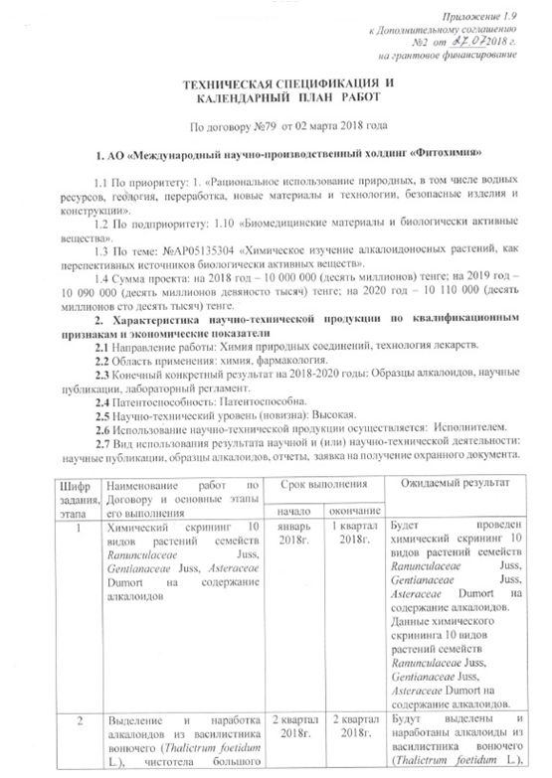

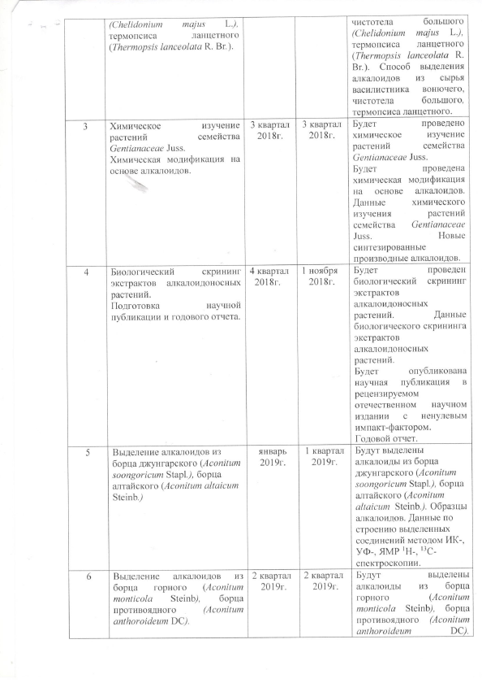

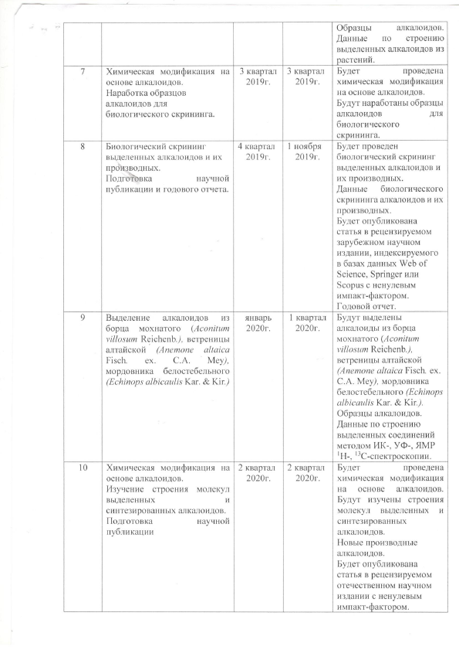

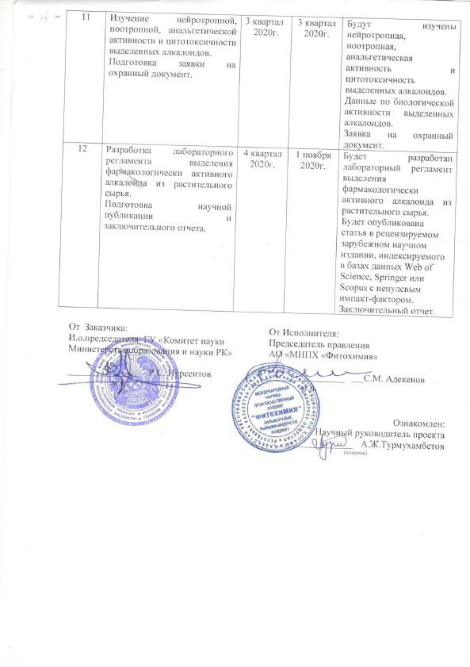

APPENDIX B

LIST OF PUBLICATIONS
Patents and Applications
1. Application for a patent 2020/0159.1 dated 10.03.2020. (E) - 8-(1-hydrazonoethyl) - 7-methoxy-1-methyl-9H-pyrido[3,4-b]indole with analgesic activity / Adekenov S. M., Zhanymkhanova P. Zh., Seidakhmetova R. B., Amanzhan A. (in Russian).
Scientific articles and abstracts
1. Adekenov S.M., Zhanimkhanova P.Zh., Nurmaganbetov Zh.S., Amanzhan A., Chernov S.V., Turmukhambetov A.Zh., Bagryanskaya I.Yu., Gatilov Y.V., Shults E.E. Synthetic modifications of carboline alkaloid harmine: Synthesis of 8-substituted derivatives // Chemistry of Heterocyclic Compounds. – 2019. -Vol.55. - Iss.2. - P. 135-141. (impact factors 1.401), according to the Scopus database, Percentile 30. (in Eng.).
2. A. Amanzhan, P.Zh. Zhanymkhanova, I. Yu. Bagryanskaya, E.E. Schults, A. Zh. Turmukhambetov, S.M. Adekenov. Structure and stereochemistry of 8-acetylhydrazone harmine // Journal of Structural Chemistry. - 2020. - Vol. 61. - No. 11. - P. 1780-1785. IF - 0.745 according to the Scopus database, Q4. Percentile 27. (in Russian).
3. Amanzhan A., Zhanymkhanova P. Zh., Bagryanskaya I. Yu., Schults, E. E., Turmukhambetova A. Zh., Adekenov S. M. Synthesis and structure of hydrazone derivatives of harmine// NAS RK Bulletin (chemistry and technology series). - 2020. - No. 3. - P. 88-95. (impact factors 0.06). (in Eng.).
4. Zhanymkhanova P.Zh., Gabdullin Ye.M., Turmukhambetov A.Zh., Adekenov S.M. Alkaloid-bearing species of the genus Aconitum L. // NAS RK Bulletin (chemistry and technology series) 2018. –No.4. - P.170-180 (impact factors 0.06). (in Eng.).
5. Amanzhan А., Aitmagambetova М.S., Abdraimovов А.М., Zhanymkhanova P.Zh., Turmukhambetov А.Zh., Seidakhmetova R.B., Adekenov S.М. Diterpene alkaloids from species of the Aconitum L. genus and their biological activity // In book: XIII International Symposium «Actual problems of chemistry, biology and technology of natural compounds». – Shanghai. – 2019. – Р. 61. (in Eng.).
6. Amanzhan А., Zhanymkhanova P.Zh., Turmukhambetov А.Zh., Seidakhmetova R.B., Rustembekov К.Т., Adekenov S.М. New hydrazone derivatives of harmine // In book: XIII International Symposium «Actual problems of chemistry, biology and technology of natural compounds». – Shanghai. – 2019. – Р. 62. (in Eng.).
7. Zhanymkhanova P.Zh., Amanzhan А., Aitmagambetova М.S., Turmukhambetov А.Zh., Adekenov S.М. Pharmacologically active alkaloids of Aconitum // In the collection: "Science, education and production in the conditions of the Fourth Industrial Revolution" Karaganda, 2018. - P. 180-184. (in Russian).

.
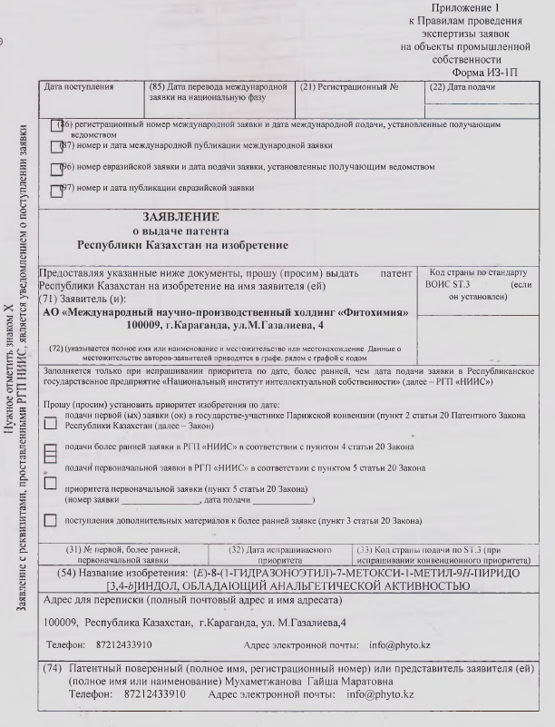

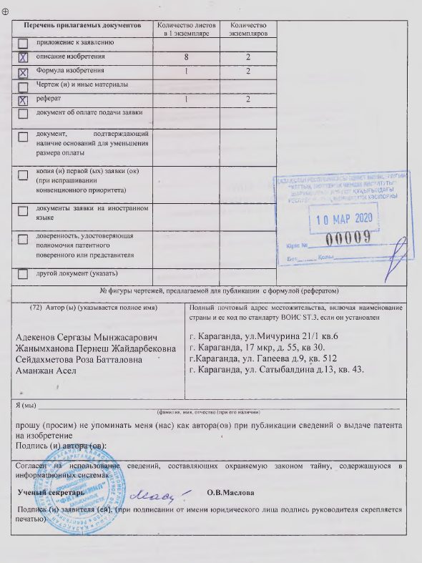

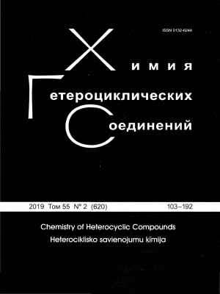
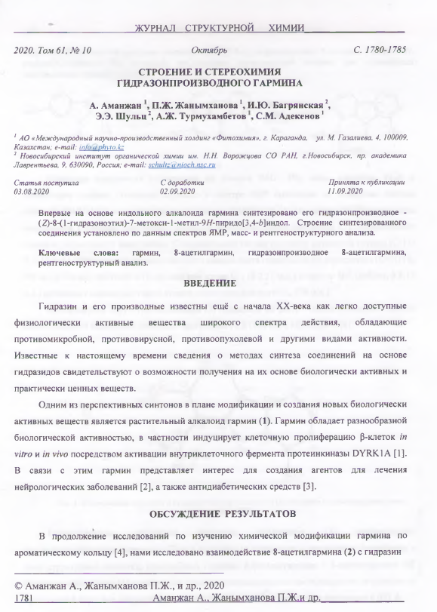

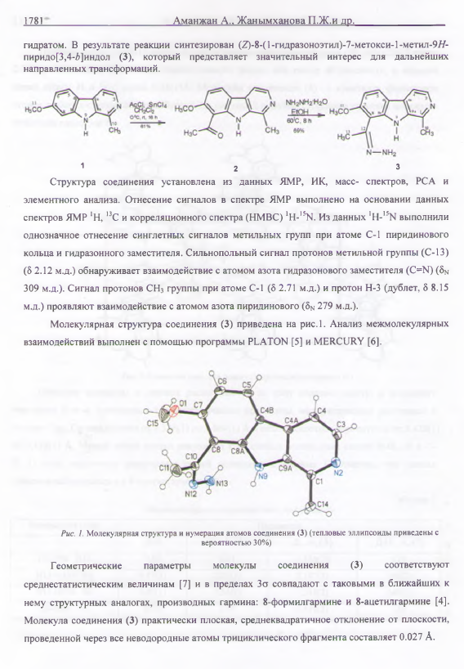

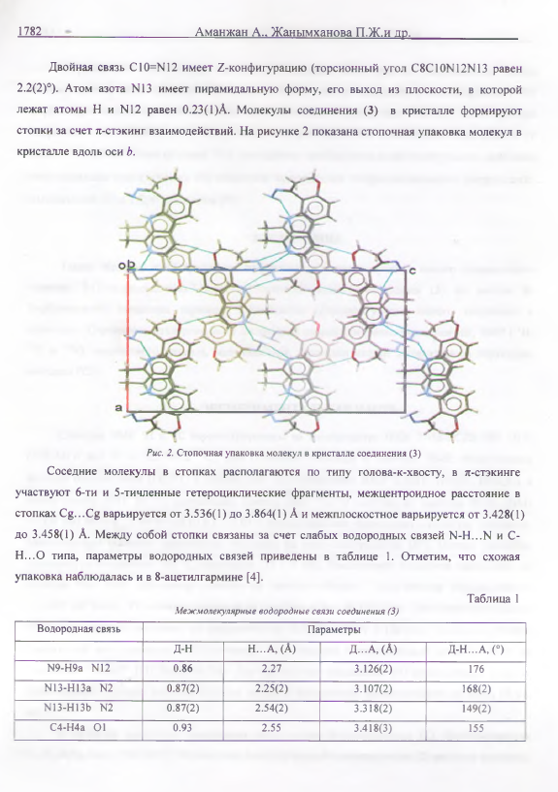

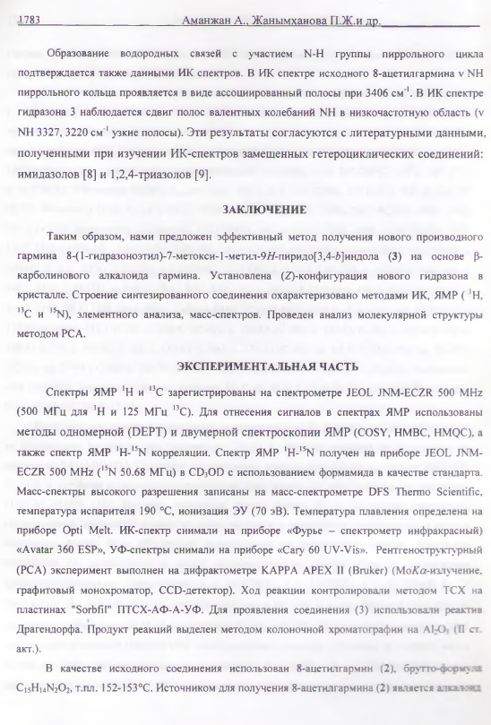

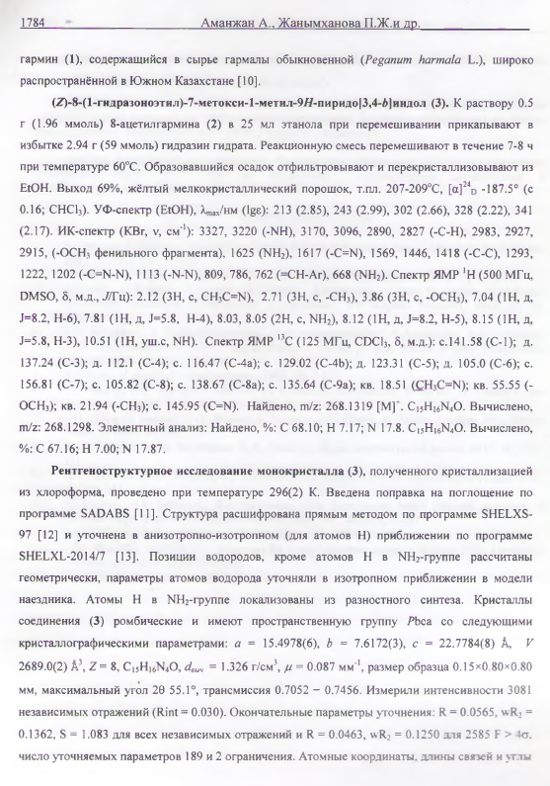

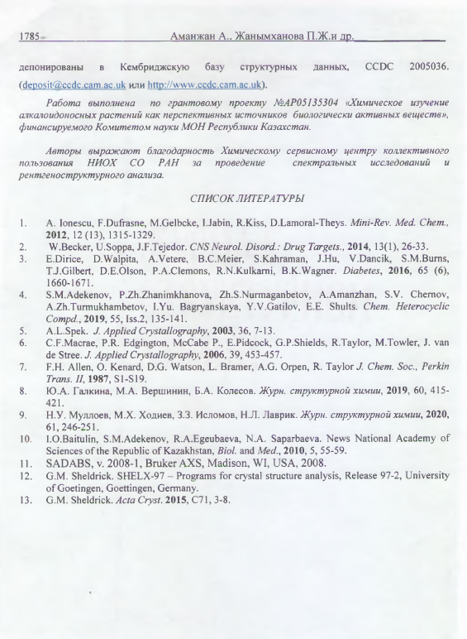
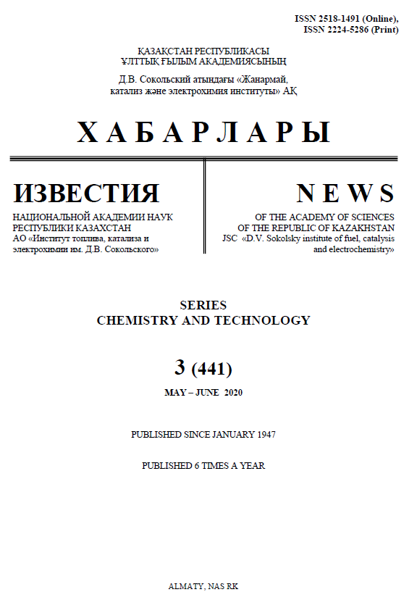

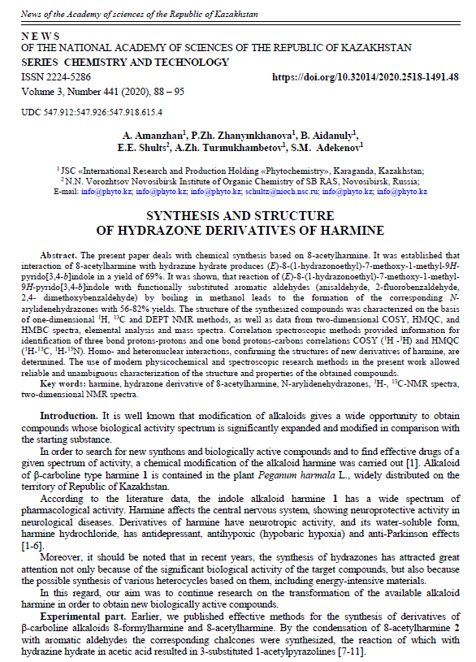

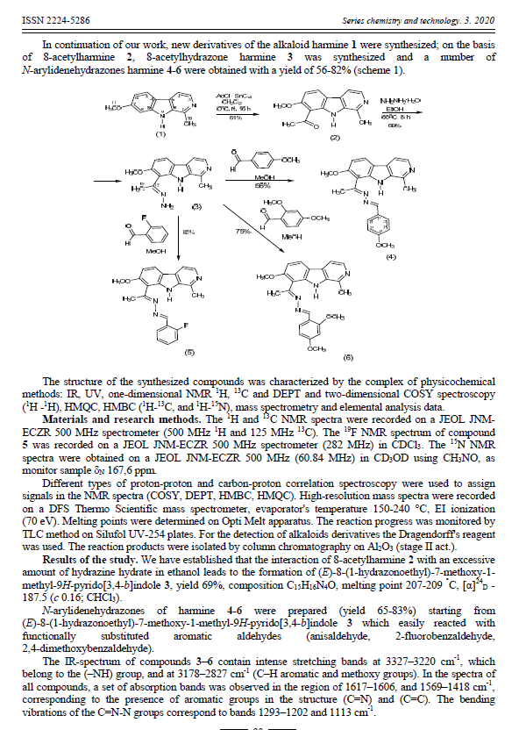

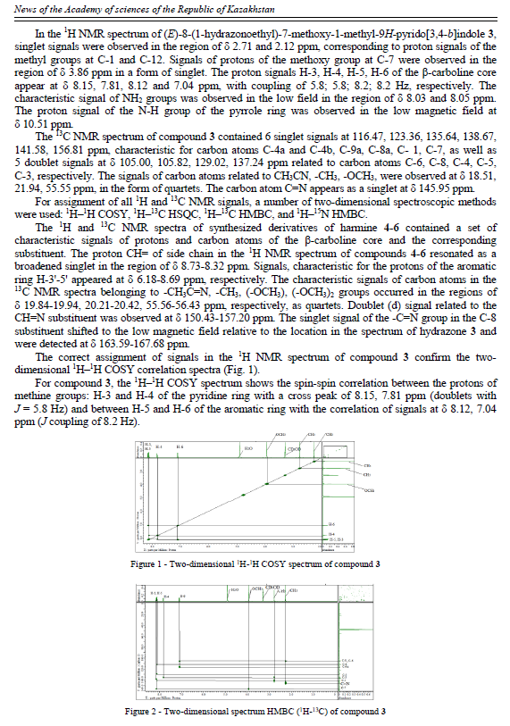

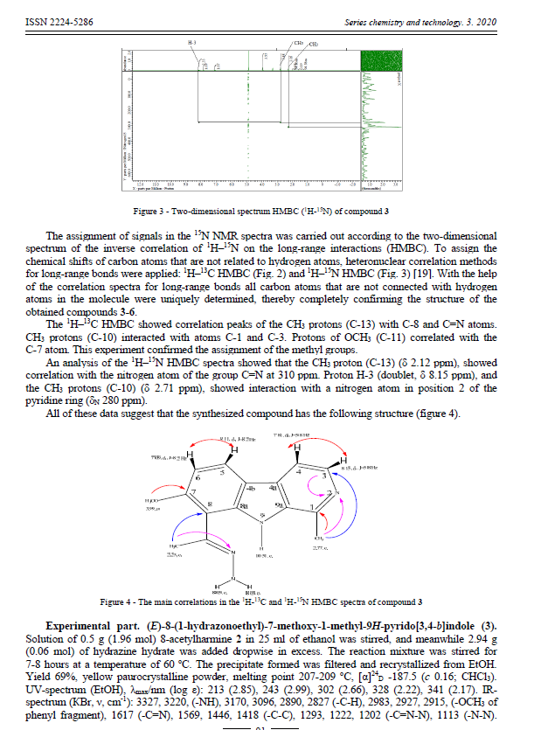

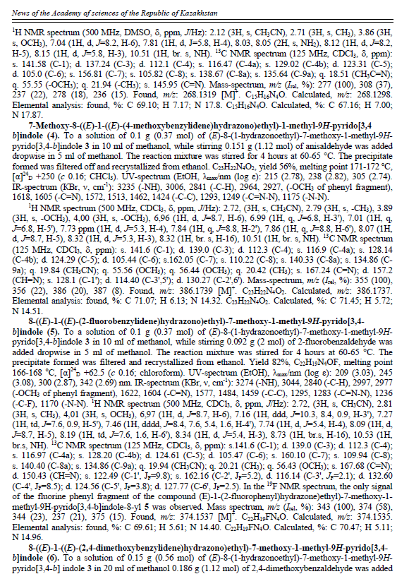

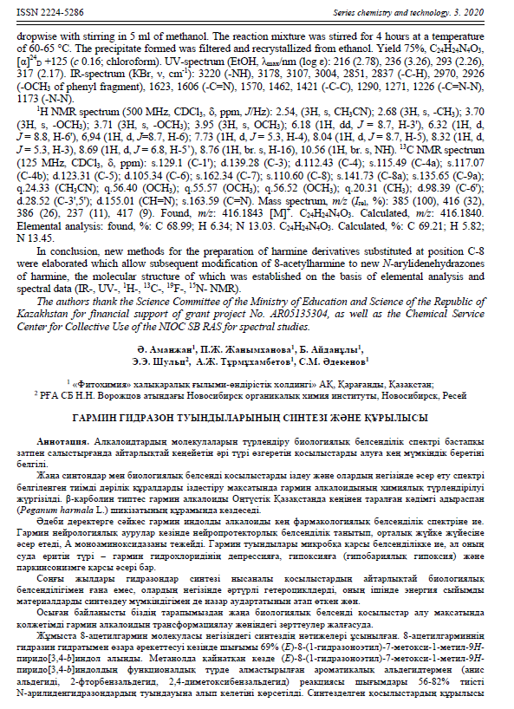

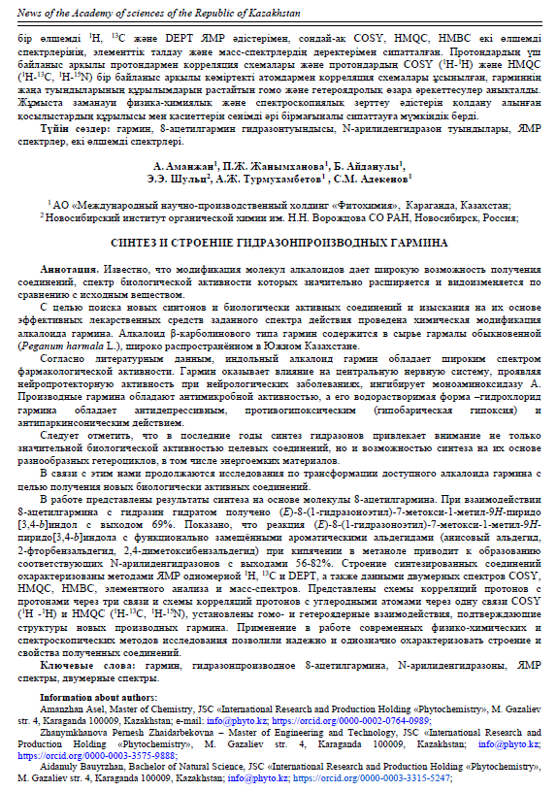

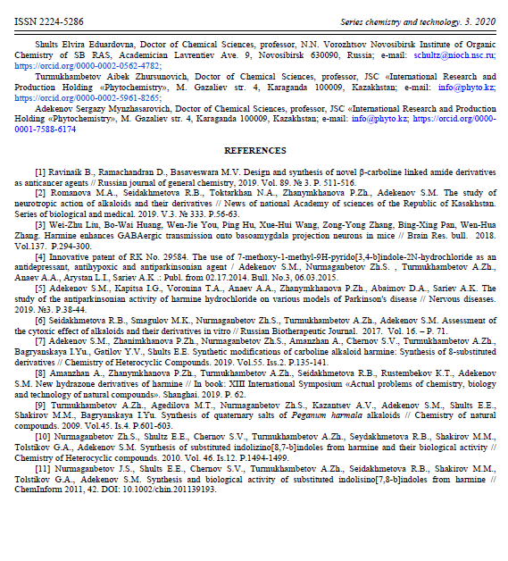

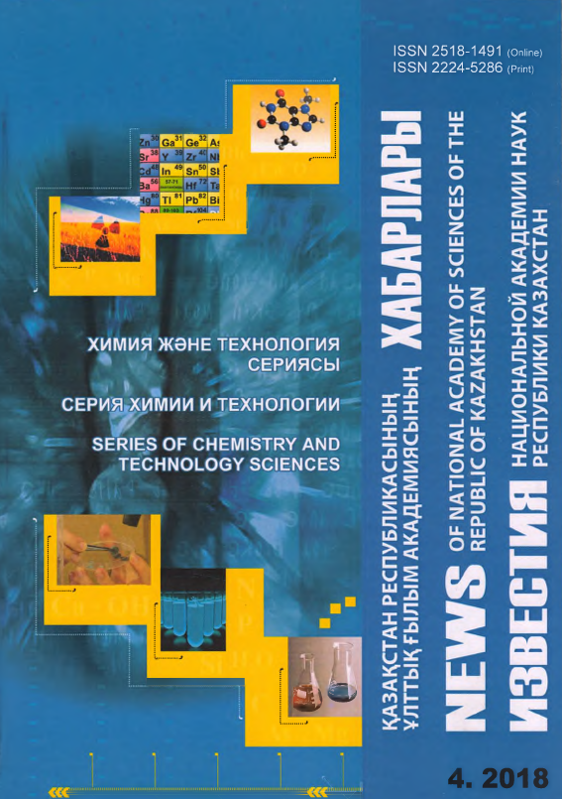

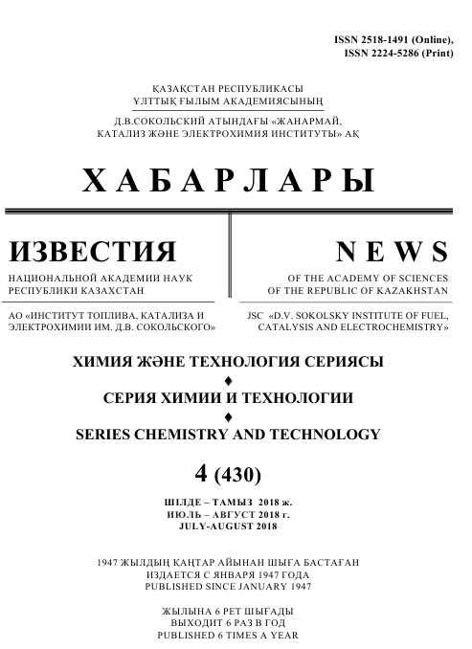

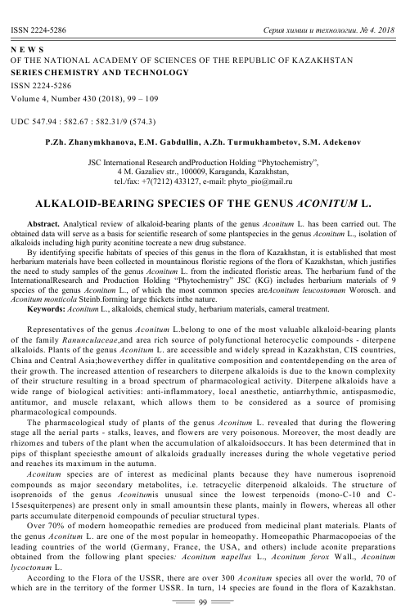

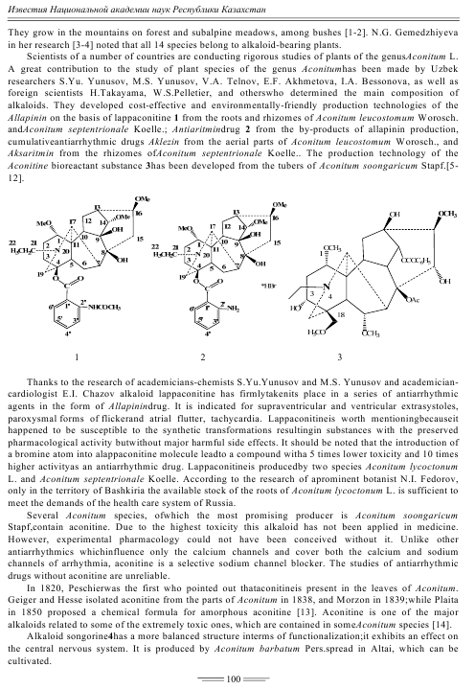
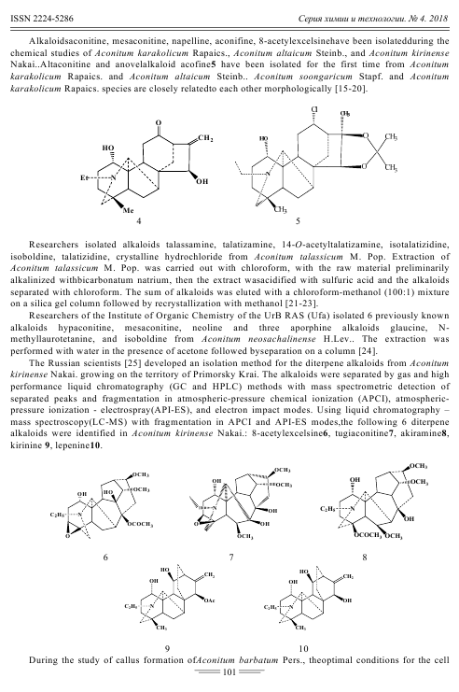

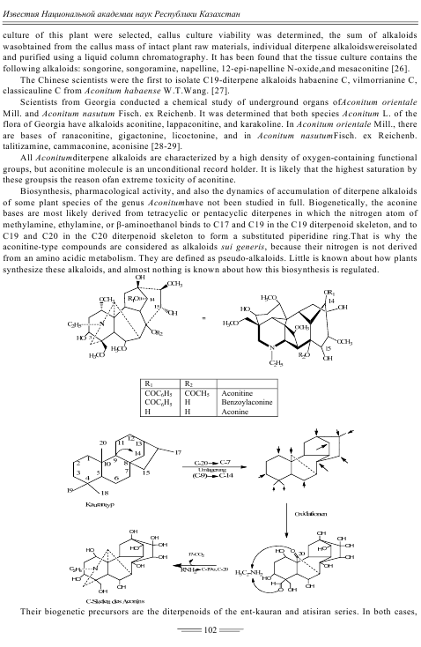

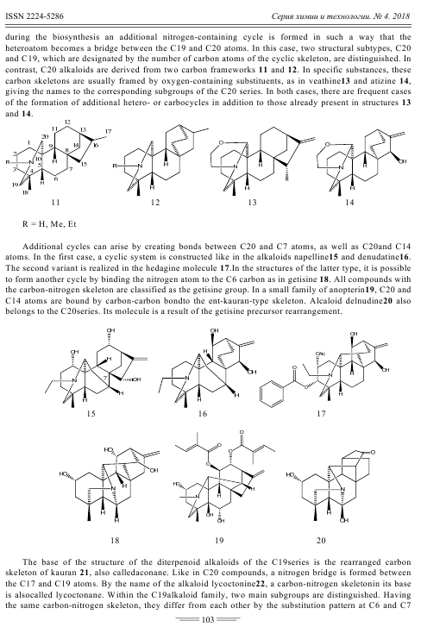

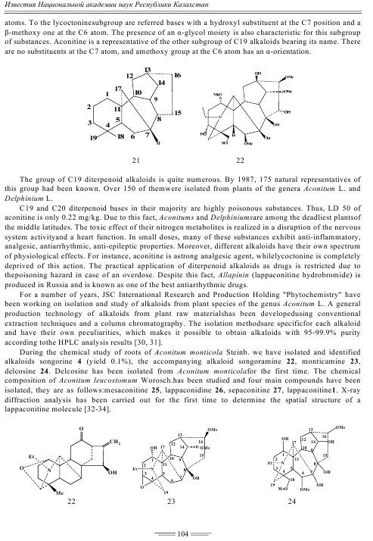

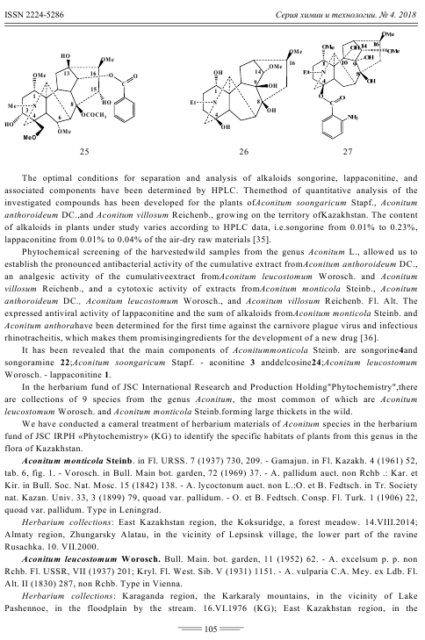
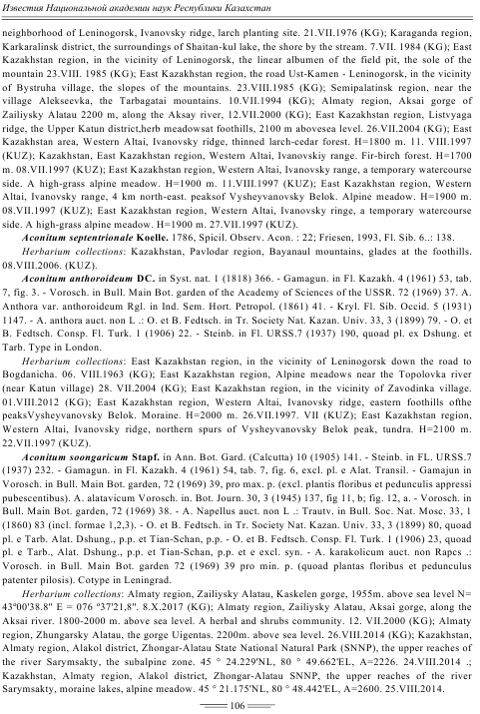

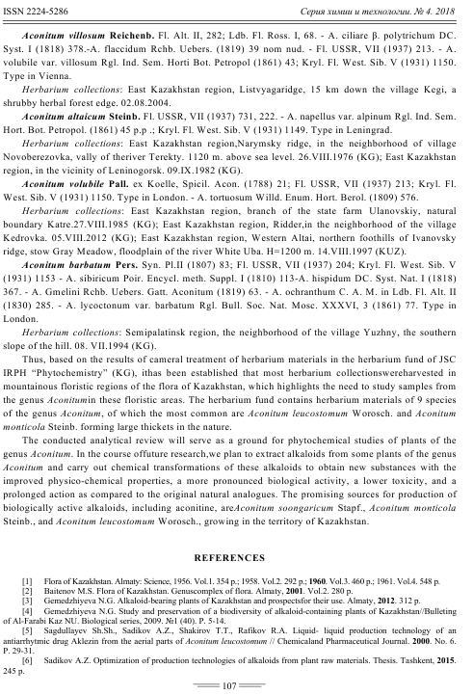

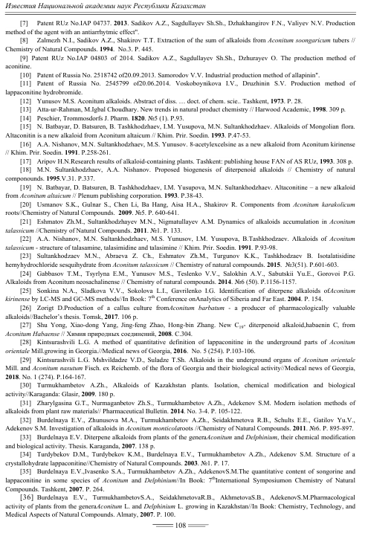

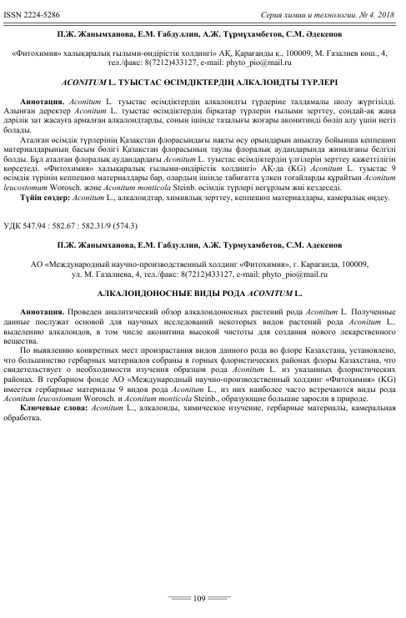

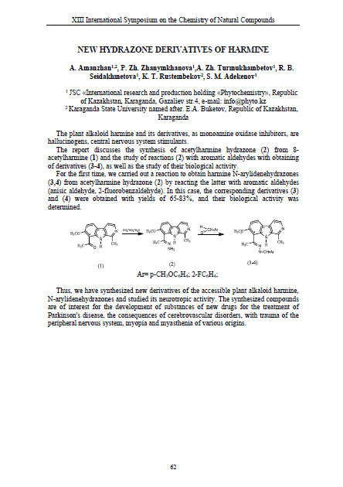

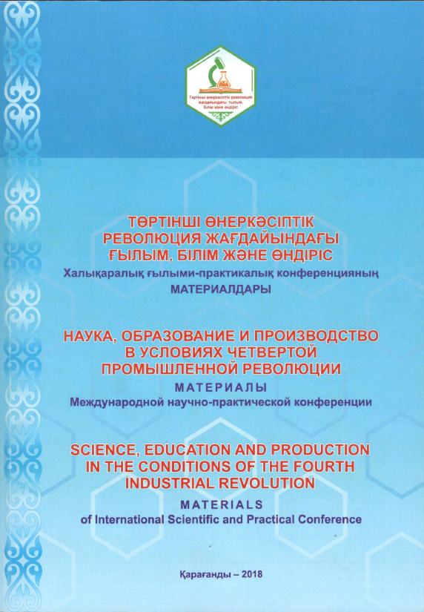

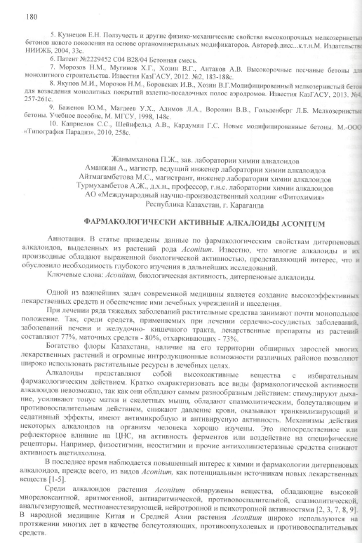

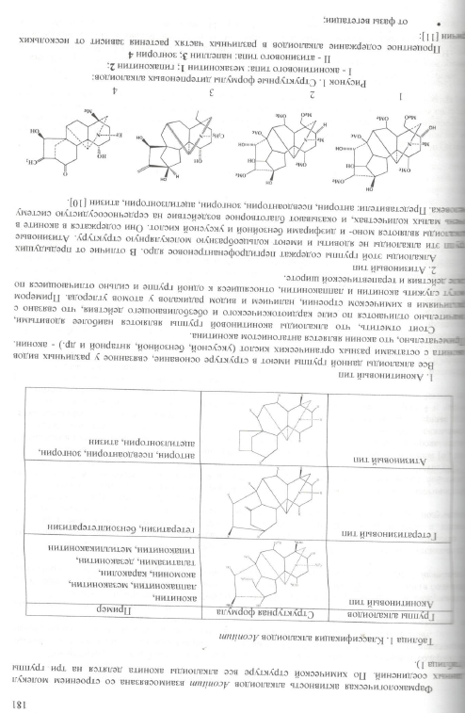
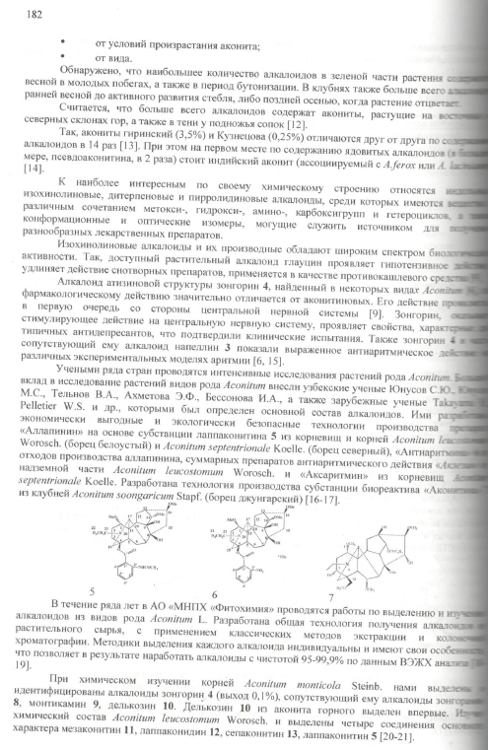

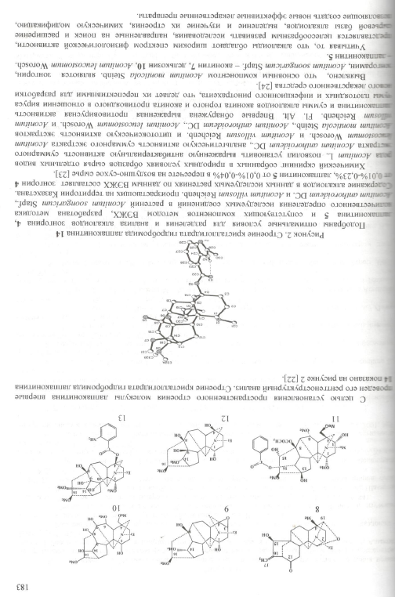

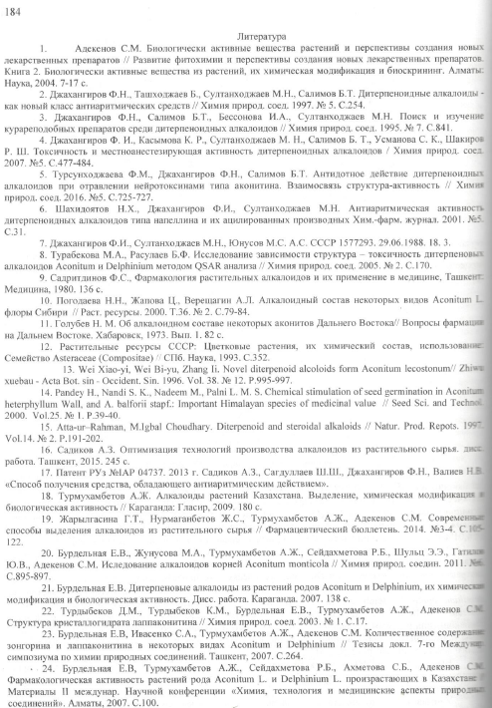
APPENDIX C

Analgesic activity of isolated and synthesized derivatives

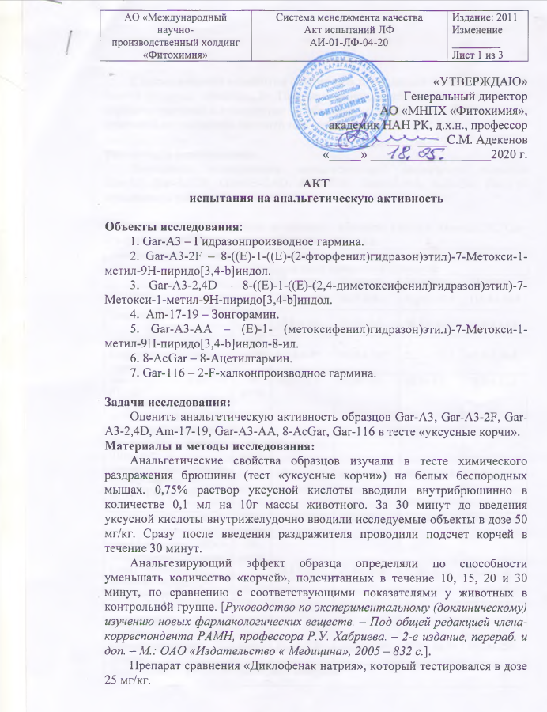

APPENDIX D

Neurotropic activity of isolated alkaloids

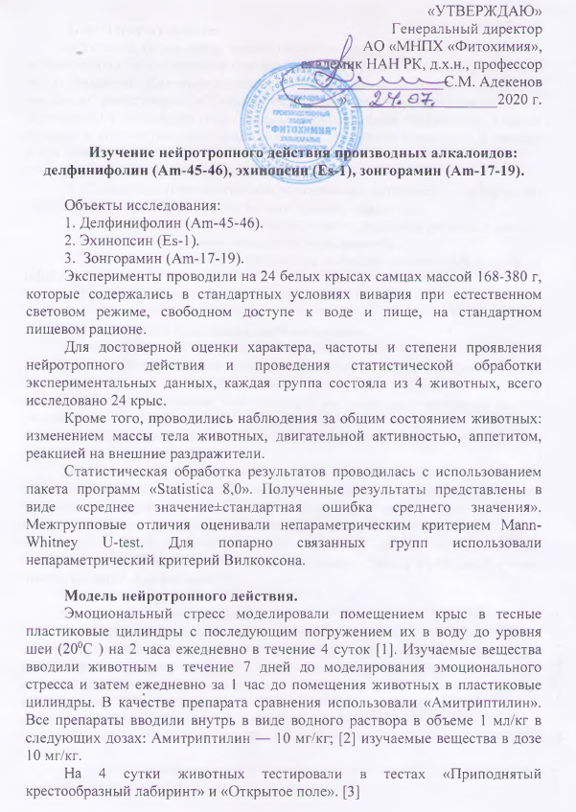

APPENDIX E

Neurotropic activity of synthesized derivatives

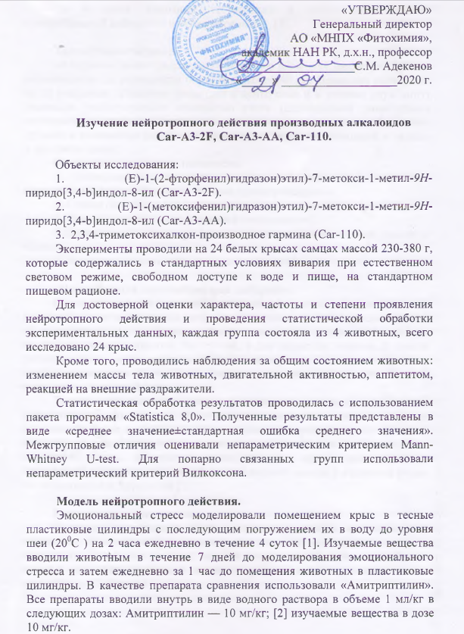

APPENDIX F

Cytotoxic activity of isolated and synthesized derivatives

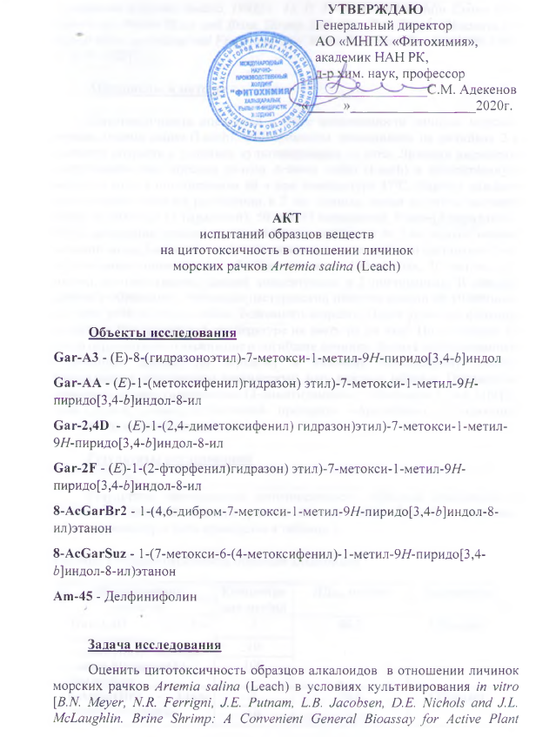

APPENDIX G

LABORATORY REGULATIONS
for the isolation of the alkaloid echinopsine from plant raw materials of Echinops albicaulis Kar. & Kir.

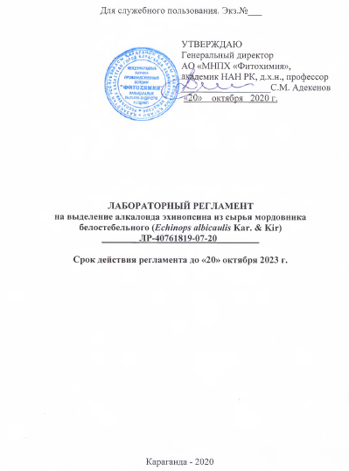

APPENDIX I
CONCLUSIONS ON THE SEARCH REGULATIONS

The analysis of scientific and technical literature and patent materials have revealed information concering focal points of the research project "Chemical study of alkaloid-bearing plants as promising sources of biologically active substances" (АР05135304).
The analysis of the patent and scientific - technical literature for 2010-2020 has not revealed any information disproving the novelty of working-outs based on the topic. 10 years patent information literature search is quite sufficient.
Researches in similar areas are performed in a number of well-known research centers, such as Xinhuang University (China), Kobe Pharmaceutical Institute (Japan), Antonio Gonzalez Institute of Bioorganic Chemistry (Spain), Dartmouth College (USA), University of Albert (Canada), N.N. Vorozhtsov Novosibirsk Institute of Organic Chemistry (Russia), Institute of Plant Chemistry (Uzbekistan), University of Karachi (Pakistan), Tbilisi State Medical University, I. Kutateladze Institute of Pharmacochemistry (Georgia) where alkaloid plants are under research. Data on the study of plants of the families Ranunculaceae Juss., Asteraceae Dum., new alkaloids, methods of isolating and determining the molecular structure of alkaloids, synthesis on their basis and their biological activity are evidenced by the absence of duplication, patent purity. The research is being carried out for the first time.
The materials found are indicative of the prospects and relevance of the search for new alkaloids in plants of the genera Aconitum L., Anemone L., Echinops L. since compounds from this taxon species produce pronounced neurotropic, antiarrhythmic, antispasmodic, antitumor, muscle relaxant, anti-inflammatory, local anesthetic, psychotropic activity.
The revealed inventions and scientific and technical information can be more or less useful in solving such problems as extracting plant products, isolating and determining the structure of alkaloids, modifying them chemically, studying physiological activity and creating drugs based on alkaloids and their derivatives.
Thus, the purposeful study of alkaloid-bearing plants of the Kazakhstani flora and the production of reference herbal medicinal products based on them is a promising trend, both scientifically and practically.

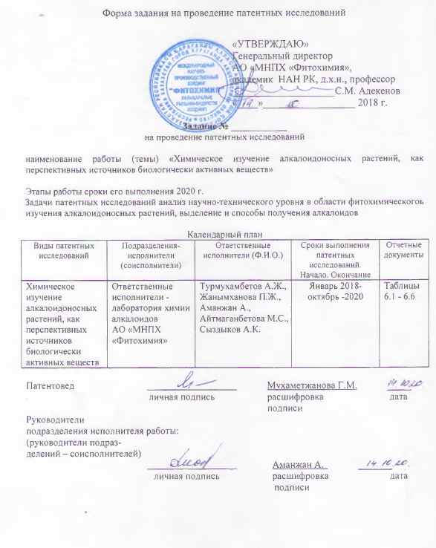

Регламент Поиска №

____________________________
Дата составления регламента

выполняемого по научно-исследовательской программе
«ХИМИЧЕСКОЕ ИЗУЧЕНИЕ АЛКАЛОИДОНОСНЫХ РАСТЕНИЙ, КАК ПЕРСПЕКТИВНЫХ ИСТОЧНИКОВ БИОЛОГИЧЕСКИ АКТИВНЫХ ВЕЩЕСТВ» (АР05135304)

Наименование работы (темы) «Химическое изучение алкалоидоносных растений, как перспективных источников биологически активных веществ»
Номер и дата утверждения задания Этап работы
Цель поиска информации (в зависимости от задач патентных исследований, указанных в задании)
Анализ научно-технического уровня в области фитохимического изучения алкалоидоносных растений, выделение и способы получения алкалоидов и их производных

Обоснование регламента поиска Исследование компонентного состава растений, выделение и изучение биологических свойств алкалоидных соединений и определение на их основе фундаментальных физико-химических констант обусловлена необходимостью ускорения поиска новых отечественных лекарственных препаратов природного происхождения и получения их синтетических аналогов.

Начало поиска 2018 г. Окончание поиска 2020 г.
Предмет поиска (объект исследования, его составные части, товар) | Страна поиска | Источники информации, по которым будет проводиться поиск |  |  |  |  |  |  |  | ретроспективность | Наименование информационной базы (фонда)
 | Страна поиска | патентные |  | НТИ |  | конъюктурные |  | другие |  | ретроспективность | Наименование информационной базы (фонда)
 | Страна поиска | наименование | классификационные рубрики: МПК (МКИ), МКПО, НКИ и другие | наименование | Рубрики УДК и другие | наименование | Код товара ГС, СМТК, БТН | наименование | Классификационные индексы | ретроспективность | Наименование информационной базы (фонда)

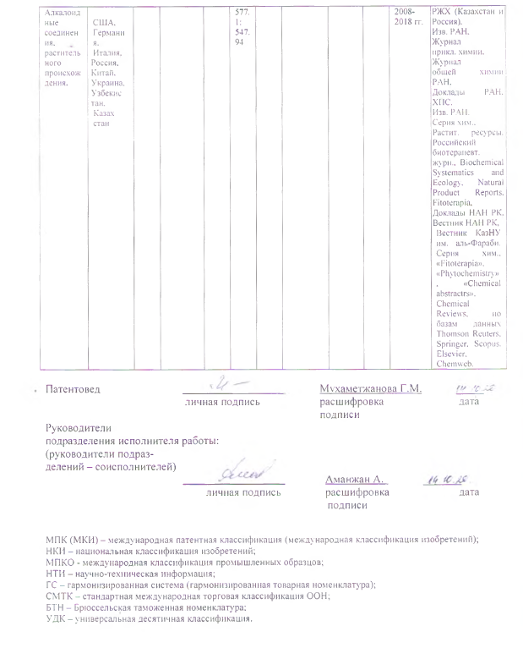

Форма отчета о поиске

В.1 Поиск проведен в соответствии с заданием должность и фамилия ответственного руководителя работы
№ от и Регламентом поиска № от
В.2 Этап работы
При необходимости
В.3 Сведения о выполнении регламента поиска (указывают степень выполнения регламента поиска, отступления от требований регламента, причины этих отступлений)
В.5 Предложения по дальнейшему проведению поиска и патентных исследований
В.6 Материалы, отобранные для последующего анализа

Таблица В.6.2 – Патентная документация

Предмет поиска (объект исследования, его составные части) | Страна выдачи, вид и номер охранного документа. Классификационный индекс)* | Заявитель (патентообладатель), страна. Номер заявки, дата приоритета, конвенционный приоритет, дата публикации* | Название изобретения (полной модели, образца) | Сведения о действии охранного документа или причина его аннулирования (только для анализа патентной чистоты)
1 | 2 | 3 | 4 | 5
Химическое изучение алкалоидоносных растений, как перспективных источников биологически активных веществ | Патент  № CN101697983,  Китай, МПК  A61K36/185;  B01D15/36. | Chai J., Li R., Wu J.  Заявл. 31.05.2007.  Опубл. 28.04.2010. | Method for separating Peganum harmala total alkaloids by ion exchange resin | Действует
 | Патент № CN101921277,  Китай, МПК  C07D487/04 | Wang J., Du H., Ren F.,  Su Y., Jun Zh.  Заявл. 09.08.2010.  Опубл. 22.12.2010. | Method for simultaneously preparing vasicine and vasicinone from Peganum harmala | Действует
 | Патент №CN101780123,  Китай, МПК  A61K36/185;  A61K9/20;  A61P17/04;  A61P21/00;  A61P25/00;  A61P31/04; | Qin D., Wang L.  Заявл. 13.11.2009.  Опубл. 21.07.2010. | Peganum harmala L. extract chewable tablets and preparation method there of | Действует
 | Патент №WO2010036567,  США, МПК  A61K31/437;  A61P13/12;  A61P19/10;  A61P35/00;  A61K31/437; A61K31/59; | Debra E., William R.  Заявл. 25.09.2008.  Опубл. 01.04.2010. | Harmine compounds for promoting bone growth | Действует

продолжение таблицы – В.6.2
1 | 2 | 3 | 4 | 5
 | Патент №WO2010080756  США, МПК  A61K31/437;  A61P3/00; | Debra E., William R.  Заявл. 06.01.2009.  Опубл. 15.07.2010. | Harmine derivatives for reducing body weight | Действует
 | Патент №CN101792442, Китай, МПК  C07D471/04. | Chen H., Chen X., Cui J., Lu Ch.  Заявл. 27.01.2010.  Опубл. 04.08.2010. | Production method based on harmel alkaloid physical and chemical properties | Действует
 | Патент № US20100226863A1,  США, MPK  A61K 9/12  A61K 33/36 | Roberto Piraino  Заяв. 08.11.2007  Опубл. 09.09.2010 | Homeopathic medicament useful for immunomodulation | Действует
 | Патент № US20100226863A1,  США, MPK  A61K 9/12  A61K 33/36 | Roberto Piraino  Заяв. 08.11.2007  Опубл. 09.09.2010 | Homeopathic medicament useful for immunomodulation | Действует
 | Патент РФ № RU2428200C2  A61K 36/714  A61P 35/00 | Костенникова З.П., Чубарова Г.Д.,  Мальдов Д.Г.,  Самылина И.А.  Заяв. 08.04.2009  Опубл. 10.09.2011 | Препарат для лечения онкологических заболеваний | Действует
 | Патент №KR20110094572, Китай, МПК  A61K8/30;  A61K8/37;  A61Q19/00;  A61Q19/02 | Joon L.S., Young P.S., Hun K.Y.,  Hee K.Y.  Заявл. 17.02.2010.  Опубл. 24.08.2011. | Composition including beta-carboline alkaloid for stimulating melanin production | Действует
 | Патент РФ  №A61K35/78 | Панкрушина Н.А., Ломовский О.И., Шульц Э.Э., Винокурова Е.Ю., Толстиков Г.А., Болдырев В.В.  Опубл. 11.08.2011. | Способ получения препаратов из растительного лекарственного сырья. | Действует
 | Патент РФ  №A61K31/435 | Савина А.А., Толкачев О.Н., Лаская О.Ф., Шейченко В.Н., Либизова Л.Ф., Копылова И.Е. Кабанов В.С.  Опубл. 20.05.2011. | Способ получения сангвиритрина. | Действует
 | Патент №  CN102579612A  Китай, MPK  A61K 36/714  A61P 29/00  A61K 125/00 | Zhang Fan, Cai Dongmei, Liu Yue, Yang Lijuan  Заяв. 27.03.2012  Опубл. 18.07.2012 | Method for extracting total alkaloid of Aconitum soongaricum | Действует

продолжение таблицы – В.6.2
1 | 2 | 3 | 4 |  | 5
 | Патент РФ  A61K45/00  A61K47/48  A61K47/32  A61K31/485  A61K31/138  A61P25/30  A61P25/00 | Лосев М.В., Троицкий А.В., Либман М., Золотарский В.  Заявл.25.01.2011.  Опубл.20.12.2013 |  | Лекарственные препараты, содержащие активные ингредиенты, не отнесенные к группам 31/100 | Действует
 | Пат. №IAP 04737 РУз. 03.10.2013, Бюл. №3.- 10с. | Садиков А.З., Сагдуллаев Ш.Ш., Джахангиров Ф.Н., Валиев Н.В.  Заяв. 12.12.2011  Опубл. 09.02.2013 |  | Способ получения средства, обладающего антиаритмическим действием | Действует
 | Патент №  CN102078394B, Китай, MPK  A61K 36/714  A61P 5/14  A61P 11/00  A61P 13/08  A61P 15/00  A61P 17/06  A61P 19/08  A61P 29/00  A61P 31/14  A61P 35/00  A61P 37/08 | Davreti Buick Nurshahan, Gu Lihan Khan Ayati Buick, Polati Macabili  Заяв. 24.12.2010  Опубл. 13.03.2013 |  | Aconite extract-containing medicinal composition, preparation method and application thereof | Действует
 | Патент CN103254239  Китай, МПК  A61K31/555;  A61P35/00;  C07F15/00 | Tan C., He L., Mao Z., Huang H., Ji L.  Заявл. 20.03.2013.  Опубл. 21.08.2013. |  | Аryl ruthenium-beta-carboline complex and its preparation method and application | Действует
 | Патент РФ 2518742  А61К36/714  В01D11/02 | Самородов В.В.  Заявл. 20.09.2013.  Опубл 10. 06.2014. |  | Способ промышленного получения аллапинина | Действует
 | Патент CN103896947  Китай, МПК  C07D487/04 | Feng X., Cai L.  Заявл. 31.12.2012.  Опубл. 02.07.2014. |  | Method for preparing natural alkaloid indoline and pyrrolidine compound | Действует
 | Пат. №IAP 04803 РУз. 23.05.2014, Бюл. №2.- 7с. | Садиков А.З., Сагдуллаев Ш.Ш., Джураев О.Т.  Заявл. 31.12.2013.  Опубл. 23.05.2014 |  | Способ получения аконитина | Действует
 | Патент, CN103275106  Китай, МПК A61K31/475;  A61K31/55;  A61P35/00;  A61P35/02;  C07D471/20; | Chen H., Ye W., Zhang D., Chen M., Xiao X., Xu N., Lei X., Hu J.  Заявл. 19.04.2013.  Опубл. 30.09.2015. |  | Indole alkaloid adduct, and preparation method and application thereof in preparing anti-tumor drug | Действует

продолжение таблицы – В.6.2
1 | 2 | 3 | 4 | 5
 | Патент РФ 2545799  А61К36/714  В01D11/02 | Воскобойникова И.В., Дружинин С.В.  Заявл. 20.06.2014.  Опубл. 10.04.2016 | Способ получения лаппаконитина гидробромида | Действует
 | Патент CN104529891,  Китай, МПК  A61P35/00;  C07D215/20 | Liu Y., Sun L., Nie J, Tian L.  Заявл. 21.01.2015.  Опубл. 22.04.2015. | Preparation and application of quinoline alkaloid in scolopendra subspinipes mulilans as tumor treatment medicine | Действует
 | Пат. RU2593362C2  A24B15/16 | Чжэнь Чжисюань  Заявл. 10.08.2015.  Опубл. 10.08.2016 | Никотинозамещающая цитизиновая оральная атомизируемая жидкость и способ ее получения | Действует
 | Патент №  CN105837506A  Китай, MPK  C07D 221/22  A61P 35/00 | Aji Aikebair Aisa, Outer Nikari Kamili, Zhao Bo  Заяв. 29.04.2016  Опубл. 10.08.2016 | Preparation method and application of diterpene alkaloid in Aconitum soongaricum | Действует
 | Патент №  US20170042865A1, США, MPK  A61K 31/437  A61K 31/12  A61K 31/11  A6IK 36/9066 | Gene H. Zaid, Thomas W. Burgoyne  Заяв. 28.10.2016  Опубл. 16.02.2017 | Therapeutic compositions containing curcumin, harmine, and isovanillin components, and methods of use thereof | Действует
 | Патент № US20170290873A1,  США, MPK  A61K 36/714  A61K 36/28  A61K 36/56  A61K 33/28  A61K 36/185 | Walter Tatch  Заяв. 08.04.2016  Опубл. 12.10.2017 | Method of using homeopathic kit containing gel, rinse and spray for management of post-oral surgical recovery and maintenance of oral health | Действует
 | Патент № WO2019136320A1  США, MPK  C07K 14/72  C12N 9/12  C12N 5/06  C12N 9/48 | Andrew F. Stewart, Ackeifi C., Peng Wang, Bob Devita  Заяв. 05.01.2018  Опубл. 11.07.2019 | Method of increasing proliferation of pancreatic beta cells, treatment method, and composition | Действует
 | Патент №  WO2019144888A1  Китай, MPK  C07D 221/22  A61K 31/439  A61P 9/04 | Wang Fengpeng, Yan Yuefei, Jian Xixian, Chen Donglin, Yan Fueng  Заяв. 23.01.2019  Опубл. 01.08.2019 | Method for preparing mesaconine and related intermediaries | Действует
 | Патент №  WO 2020/006115 A1  США, MPK  A61K 31/41  A61K 31/417 | Tam Betty, Bossard Carine, Chiu Kevin Tseng, Chung Heekyung Заяв. 26.01.2019  Опубл. 02.01.2020 | Metods of treating cancer using a CLK inhibitor | Действует
*заполняется при необходимости
Таблица В.6.1 – Научно-техническая, конъюктурная, нормативная документация и материалы государственной регистрации (отчеты о научно-исследовательских работах)

Предмет поиска | Наименование источника информации с указанием страницы источника | Автор, фирма (держатель) технической документации | Год, место и орган издания (утверждения, депонирования источника)
1 | 2 | 3 | 4
Химическое изучение алкалоидоносных растений, как перспективных источников биологически активных веществ | Four new nor-diterpenoid alkaloids from Aconitum brachypodum | Yong Shen, Ai-Xue Zuo, Zhi-Yong Jiang, Xue-Mei Zhang, Hong-Ling Wang, Ji-Jun Chen | Helvetica chimica acta. –2010. – Vol.93. – P.863-869.
-//- | Разработка способов выделения алкалоидов индольного ряда из листьев Сatharanthus roseus | Ромашко С.Н., Молчан О.В., Юрин В.М. | Сборник научных трудов БГУ. - 2010. - Т. 4. - С. 1-9.
-//- | Современное состояние природных зарослей гармалы обыкновенной на территории Южного Казахстана | Baitulin I.O., Adekenov S.M., Egeubaeva R.A., Saparbaeva N.A. | Известия НАН РК. Серия биологическая и медицинская. – 2010. – N 5. – Р. 55-59.
-//- | Studies on novel D-ring substituted steroidal pyrazolines as potential anticancer agents | Banday A.H., Mira B.P., Lonea I.H., Surib K.A., Sampath H.M. | Steroids. - 2010. - Vol. 75. - P. 805-809.
-//- | Chemical constituents of Gentiana macrophylla Pall. | Zhi-Bo Jiang, Hong-Li Liu, Ji-Ning Shang, Jia-Rui Zhao, Cheng-Shan Yuan | Natural Product Research. - Vol.24. -2010. –P. 1365-1369
-//- | Separation of alkaloids from herbs using high-speed counter-current chromatography | Fang L., Liu Y., Yang B., Wang X., Huang L. | J. Sep. Sci. - 2011. - V. 34. - P. 2545-2558.
-//- | Convertion of songorine into related alkaloids of some Aconitum species | Salimov B.T., Abdullaev N.D. | Abstracts of 9th International Symposium on the Chemistry of Natural Compounds (SCNC). - Urumgi Xinjiang, 2011. - P. 224.
-//- | Иследование алкалоидов корней Aconitum monticola | Бурдельная Е.В., Жунусова М.А., Турмухамбетов А.Ж., Сейдахметова Р.Б., Шульц Э.Э., Гатилов Ю.В., Адекенов С.М. | Химия природ. соедин. - 2011. - №6.  - С. 895-897.
-//- | Химия пептидных алкалоидов спорыньи. 1. Классификация и химия эргоалкалоидов | Комарова Е.Л., Толкачев О.Н. | Химико-фармацевтический журнал. - 2011. Т. 35. - №9. - С. 37-45.
-//- | Химия пептидных алкалоидов спорыньи, ч. 2. Аналитические методы контроля эргоалкалоидов | Комарова Е.Л., Толкачев О.Н. | Химико-фармацевтический журнал. - 2011. Т. 35. - №10. - С. 18-24.
-//- | Патофизиологическая характеристика действия аконита каракольского на сердечно-сосудистую систему у экспериментальных животных | Карымшаков А. | Автореферат Карымшакова А. к.б.н. – Бишкек. - 2011. - 25с.
продолжение таблица В.6.1
1 | 2 | 3 | 4
-//- | Chemical constituents of the aerial parts of Aconitum kongboense | Jian-Jun Fu, Jiang Qin, Qi Zeng, Hui-Zi Jin, Wei-Dong Zhang | Химия природ. соедин. - 2011. - № 5. - С. 746.
-//- | Динамика накопления алкалоидов в растении Aconitum Talassicum | Эшматов Ж.М., Султанходжаев М.Н., Нигматуллаев А.М. | Химия природных соединений. - 2011. -№1. - С.133.
-//- | Караконитин – новый С₁₉- нордитерпеноидный алкалоид из корней Aconitum karakolicum | Усманова С.К., Aisa H.A. | Химия природ. соедин. - 2011. - № 2. - С. 242-243.
-//- | Analytical studies of (+)-chelidonine, protopine, and l-stylopine in Chelidonium majus growing in georgia using high-performance liquid chromatography | Anna Bozhadze, Vakhtang Mshvildadze, Valentina Vachnadze, Vladimer Tsitsishvili, Aliosha Bakuridze | Химия природ. соедин. - 2011. - № 3. - С. 424-426.
-//- | Separation of alkaloids from herbs using high-speed counter-current chromatography | Fang L., Liu Y., Yang B., Wang X., Huang L. | J. Sep. Sci. - 2011. - V. 34. - P. 2545-2558.
-//- | Convertion of songorine into related alkaloids of some Aconitum species | Salimov B.T., Abdullaev N.D. | Abstracts of 9th International Symposium on the Chemistry of Natural Compounds (SCNC). - Urumgi Xinjiang, 2011. - P. 224.
-//- | Echinops acetylenes A and B, new thiophenes from Echinops transiliensis | 25 Nakano H., Cantrell C.L., Mamonov L.K., Osbrink W.L., Ross S.A. | Organic Letters. – 2011. – N 13 (23). – Р. 6228-6231.
-//- | Preparative separation and purification of alkaloids from Rhizoma coptidis by high-speed counter-current chromatography | Zhang Sh., Wang M., Wang Ch. | Separation and Purification Technology. - 2011. - V. 76, №3. - Р. 428-431.
-//- | A review on medicinal importance, pharmacological activity and bioanalytical aspects of beta-carboline alkaloid harmine | Patel K., Gadewar M., Tripathi R., Prasad S. K., Patel D. K. | Asian Pac. J. Trop. Biomed. – 2012. –Vol. 2, Is.8. -Р.660-664.
-//- | Structure-activity relationship in the antitumor activity of 6-, 8- or 6,8- substituted 3-benzylamino- β-carboline derivatives | Ikeda R., Kimura T., Tsutsumi T., Tamura S., Sakai N., Konakahara T. | Bioorg. Med. Chem. Lett. –2012. –Vol. 22. Is.10. –Р.3506-3515.
-//- | Алкалоиды Chelidonium majus, произрастающего в Грузии | Вачнадзе Н.С., Божадзе А.Д., Берашвили Д.Т., Бакуридзе А.Дж. | Химия природ. соедин. - 2012. - № 5. - С. 815.
-//- | Алкалоидоносные растения Казахстана и перспективы их использования | Гемеджиева Н.Г. | МОН РК. -Алматы: Институт ботаники и фитоинтродукции, 2012. - 312 с.
-//- | Краткая характеристика эргоалкалоидов и источники их получения (обзор) | Савина Т.А., Барсегян А.Г., Бобылева Р.И., Шаин С.С. | Вопросы биологической, медицинской и фармацевтической химии. - 2012. - №1. - С. 81-92.
-//- | Ionic liquid-supported solid-liquid extraction of bioactive alkaloids. I. New HPLC method for quantitative determination of glaucine in Glaucium flavum Cr. (Papaveraceae) | Bogdanov M.G., Svinyarov I., Keremedchieva R., Sidjimov A. | Separation and Purification Technology. - 2012. - V. 97, №3. - Р. 221-227.
-//- | Противоопухлевая активность настойки Aconitum soongaricum (Ranunculaceae) на модели карциномы Эрлиха | Алефиров А.Н., Беспалов В.Г., Стуков А.Н., Муразов Я.Г. | Раст. ресурсы. – 2012. – № 3. – С. 428-442.
продолжение таблица В.6.1
1 | 2 | 3 | 4
-//- | Противоопухлевая активность настойки Aconitum soongaricum (Ranunculaceae) на модели карциномы Эрлиха | Алефиров А.Н., Беспалов В.Г., Стуков А.Н., Муразов Я.Г., Семенов А.Л., Крупская Е.О. | Раст. ресурсы. – 2012. – № 3. – С. 428-442.
-//- | Растительные источники хинолизидиновых алкалоидов на территории Республики Башкортостан. Алкалоиды Thermopsis schischkinii и Thermopsis lanceolata SSP. Sibirica (Fabaceae) в условиях интродукции. | Цыпышева И.П., Галкин Е.Г., Каримова О.А., Байкова И.П. и др. | Химия растительного сырья. – 2012. - №4. – С. 181-186.
-//- | Chemical constituents from Echinops nanus and Echinops transiliensis | Nakano H., Cantrell C.L., Mamonov L.K., Kustova T.S., Fronczek F.R., Ross S.A. | Biochem. Syst.&Ecol. –V. 45. -2012. –P. 127-129
-//- | HPLC fingerprint and LC-TOF-MS analysis on extract from roots of Gentian macrophylla | SU Qi, ZHANG Ping-ping, ZHANG Yong-min, JIA Na, HE Jiao, ZHAO Wen-na, SUN Wen-ji | Chinese Herbal Medicines. -V. 4(3). -2012. –P. 245-251.
-//- | Anti-hepatoma activity in mice of a polysaccharide from the rhizome of Anemone raddeana | Liu Y., Li Y., Yang W. | Int.J.Biol. Macromol. – 2012. – N 50 (3). – Р. 632–636.
-//- | Synthesis and structure-activity relationships of harmine derivatives as potential antitumor agents | Cao R., Fan W., Guo L., Ma Q., Zhang G., Li J., Chen X., Ren Z., Qiu L. | Eur. J. Med. Chem. –2013. – Vol.60. –Р.135-143.
-//- | Identification of diterpene alkaloids from Aconitum napellus Subsp. firmum and GIRK channel activities of some Aconitum alkaloids | Kiss T., Orvos P., Bаnsаghi S., Forgo P., Jedlinszki N., Tаlosi L., Hohmann J., Csupor D. | Fitoterapia. –2013. – Vol.90. - P. 85-93.
-//- | Protective effect of Echinops galalensis against CCl₄-induced injury on the human hepatoma cell line (Huh 7) | Abdallah H.M., Ezzat S.M., Salah el Dine R., Abdel-Sattar E. | Phytochem. Lett. –V.6. -2013. –P. 73-78
-//- | Chemical constituents from Echinops integrifolius | Senejoux F., Demougeot C., Karimov U., Muyard F., Aisa H. A., Girard-Thernier C. | Biochem. Syst. Ecol. - 2013. - Vol. 47. - P. 42-44.
-//- | Растительные источники хинолизидиновых алкалоидов на территории Республики Башкортостан. Алкалоиды Thermopsis schischkinii. | Цыпышева И.П., Галкин Е.Г., Ерастов А.С., Каримова О.А., Байкова И.П. и др. | Химия растительного сырья. – 2013. - №4. – С. 55-60.
-//- | Определение алкалоидов в траве чистотела большого и листья маклеи сердцевидной методом ВЭЖХ | Моисеев Д.В. | Бутлеровские сообщения. - 2013. -Т.36. №11. С.134-138.
-//- | Screening of Echinops ellenbeckii and Echinops longisetus for biological activities and chemical constituents | Hymete A., Iversen T.-H., Erko B. | Phytomedicine - 2013. - V. 12. - P. 675-679.
-//- | PH-zone-refining counter-current chromatography: origin, mechanism, procedure and applications | Ito Y. | J. Chromatogr A. - 2013. - V. 1271. - Р.71-85.
-//- | К механизму антиаритмического действия аллапинина | Вахитова Ю.В., Фарафонтова Е.И., Хисамутдинова Р.Ю., Юнусов В.М., Цыпышева И.П., Юнусов М.С. | Биоорганическая химия. -2013. –Т.39. -№1. –С.105-106.
продолжение таблица В.6.1
1 | 2 | 3 | 4
-//- | Quantitative determination of diterpenoid alkaloid Fuziline by hydrophilic interaction liquid chromatography (HILIC)–electrospray ionization mass spectrometry and its application to pharmacokinetic study in rats | Jianguo Suna, Fengyi Zhanga, Ying Penga, Jinghan Liub, Yunxi Zhonga, Guangji Wanga | Journal of Chromatography B. - 2013. – V. 913 –914. – P. 55 –60.
-//- | STW 5 (Iberogast) – a safe and effective standard in the treatment of functional gastrointestinal disorders | Bertram Ottillinger, Martin Storr, Peterr Malfertheiner, Hans-Dieter Allescher | Wien Med Wochenschr. – 2013. – V. 163. – P. 65-72.
-//- | Modulation of multidrug resistance in cancer cells by chelidonine and Chelidonium maius alkaloids | Mahmoud Zaki El-Readi, SafaaYehia Eid, Mohamed Lotfy Ashour | Phytomedicine. – 2013. –V. 20. – P. 282-294.
-//- | Chemical composition of Celandine (Chelidonium maius L.) extract and its effects on Botrytis tulipae (Lib.) lind fungus and the tulip | Marcel Parvu, Laurian Vlase, Laszlo Fodorpataki, Ovidiu Parvu, Oana Rosca-casian, Csaba Bartha, Lucian Barbu-tudoran, Alina Elena Parvu | Not Bot Horti Agrobo. – 2013. – V. 41(2). – P. 414-426.
-//- | Сравнительно морфологические признаки растений Echinops albicaulis, Echinops transiliensis | Ахтаева Н.З., Мамурова А.Т., Киекбаева Л. И др. | Вестник КазНУ. Серия биологическая. – 2013. – N 3 (59). – С. 472-476.
-//- | Lappaconitine: lnfluence of halogen substituent on the antiar - rhithmic activity | Bryzgalov О., Romanov А.Е., Tolstikova T.G., Shullts Е. | Cardiovascular & hematological agents in medical chemistry. – 2013. – Vol.11. –Р.211-217.
-//- | Противоопухолевая активность настойки Aconitum Soongaricum (Ranunculaceae) на моделях перевиваемых лейкозов и солидных опухолей | А.Н. Алефиров, В.Г. Беспалов, А.Н. Стуков, Я.Г. Муразов, А.Л. Семенов, Е.Е. Лесиовская | Растительные ресурсы. – Том 49. –Выпуск 3. -2013. –С.435-451
-//- | Алкалоиды Annona senegalensis | Sory Fofana, Р. Зияев, Saliou Kaby Diallo, Mohamed Camara | Химия природных соединений. -№3. -2013. –С.501
-//- | Алкалоиды Buxsus sempervirens кристаллическая молекулярная структура циклобуксина-D и империалина | М.А. Эшонов, К.К Тургунов, Б.Ташходжаев, Р.Шакиров | Химия природных соединений. -№6. -2013. –С.1012-1014.
-//- | Analgesic activity of diterpene alkaloids from Aconitum baikalensis | Nesterova Yu.V., Povetyeva T.N., Suslov N.I., Zyuzkov G.N., Pushkarskii S.V., Aksinenko S.G., Schultz E.E., Kravtsova S.S. | Bulletin of experimental biology and medicine. –2014. –Vol.157, Is. 4. –Р.488-491.
-//- | Harmine mediated neuroprotection via evaluation of glutamate transporter 1 in a rat model of global cerebral ischemia | Sun P., Zhang S., Li Y.,  Wang L. | Neuros. Lett. –2014. –Vol. 583. –Р.32-36.
-//- | Computational & experimental evaluation of the structure-activity relationship of β-carbolines as DYRK1A inhibitors | Drung B., Scholz C., Barbosa V.A., Nazari A., Sarragiotto M.H., Schmidt B. | Bioorg. Med. Chem. Lett. – 2014. –Vol. 24, Is.20. –Р. 4854-4860.
-//- | Synthesis and biological evaluation of some 2-(3,5-dimethyl-1H-pyrazol-1-yl)-1-arylethanones: Antibacterial, DNA photocleavage, and anticancer activities | Kumar V., Kaur K., Karelia D.N., Beniwal V., Gupta G.K., Sharma A.K., Gupta A.K. | Eur. J. Med. Chem. –2014. –Vol. 81, Is.23. –Р. 267-276.
-//- | Изучение растений рода мордовник как перспективных источников биологически активных веществ | Ахтаева Н.З., Датхаев У.М., Гемеджиева Н.Г. | Вестник КазНМУ. – 2014. - №5. – С.96-99.
продолжение таблица В.6.1
1 | 2 | 3 | 4
-//- | Aconitine-induced Ca2+ overload causes arrhythmia and triggers apoptosis through p38 MAPK signaling pathway in rats | Gui-bo Sun, Hong Sun, Xiang-bao Meng, Jin Hu, Qiang Zhang, Bo Liu, Min Wang, Xiao-bo Sun. | Toxicology and Applied Pharmacology. - 2014. – V. 279. – P. 8–22.
-//- | Antioxidant activities of chemical constituents isolated from Echinops orientalis Trauv. | Erenler R., Yilmaz S., Aksit H. | Rec. Nat. Prod. - 2014. - P. 32-34.
-//- | Ultrasonic extraction of steroidal alkaloids from potato peel waste | Hossaina M.B., Tiwaria B.K., Gangopadhyaya N., O’Donnellb C.P., Bruntonc N.P., Raia D.K. | Ultrasonics Sonochemistry. - 2014. - V. 21. - P. 1470-1476.
-//- | Seven alkaloids from Picrasma quassioides and their cytotoxic activities | Zheng-Quan Lai, Wei-Hai Liu, Siu-Po Ip, Hui-Jun Liao, Xiao-Ping Lai, Zi-Ren Su, Zi-Ren Su, Zhi-Xiu Lin | Химия природных соединений. -№5. -2014. –С. 764-767.
-//- | Растительные препараты ВИЛАР на основе алкалоидов: химико-терапевтические исследования. Часть 1. Семейства Apocynaceae, Papaveraceae, Menispermaceae, Berberidaceae | Толкачев О.Н., Шейченко О.П., Крепкова Л.В., Савина Т.А., Сидельников Н.И. | Вопросы биологической медицинской и фармацевтической химии. - 2014. - №1. - С. 3-15.
-//- | Растительные препараты ВИЛАР на основе хинолизидиновых, пирролизидиновых, пептидных, мономерных и димерных изохинолиновых алкалоидов: химико-технологические исследования. Часть 2. Семейства Apocynaceae, Papaveraceae, Menispermaceae | Толкачев О.Н., Шейченко О.П., Крепкова Л.В., Савина Т.А., Сидельников Н.И. | Вопросы биологической медицинской и фармацевтической химии. - 2014. - №2. - С. 4-19.
-//- | Three new C₁₉-diterpenoid alkaloids from Delphinium tianshanicum | Zhao B., Usmanov S., Aisa H. | Phytochem. Lett. - 2014.- V. 10.- P. 189-192
-//- | Diterpenoid alkaloids and flavonoids from Delphinium trichophorum | Lin C., Zhao Z., Xie S., Mao J., Zhu C., Li X., Bairi Z. | Phytochemistry. - 2014. - V. 7. - P. 88-95.
-//- | Антиметастатическая активность настойки подземной части Aconitum soongaricum (Ranunculaceae) на моделях перевиваемых опухолей | Алефиров А.Н., Беспалов В.Г., Стуков А.Н., Муразов Я.Г., Семенов А.Л., Лесиовская Е.Е. | Раст. ресурсы. – 2014. – № 2. – С. 254-269.
-//- | Phylogeographic patterns of the Aconitum nemorum species group (Ranunculaceae) shaped by geological and climatic events in the Tianshan Mountains and their surroundings | Xiao-Long Jiang, Ming-Li Zhang, Stewart C. Sanderson | Plant syst evol. 2014. –P.51-61
-//- | Трициклические хинозолиновые алкалоиды: выделение, синтез, химическая модификация и биологическая активность | Шахидоятов Х.М., Элмурадов Б.Ж. | Химия природ. соедин. - 2014. - № 5. - С. 677-695.
-//- | Alkaloids from Aconitum neosachalinense | Gabbasov T.M., Tsyrlyna E.M., Yunusov M.S., Teslenko V.V., Salokhin A.V., Sabutskii Yu.E., Gorovoi P.G. | Chemistry of natural compounds. - 2014. - № 6 (50). – P. 1156-1157.
-//- | Chemical Constituents from Gentiana algida Pall. | AiMei Yang, Yun Men, HanHan, Lin Yang, XiaoLong Shi, Rui Wu, Wei Jie Guo | Advanced Materials Research. – Vols. 881-883. – 2014. –P. 419-422

продолжение таблица В.6.1
1 | 2 | 3 | 4
-//- | Norditerpenoid alkaloids from Delphinium anthriscifolium | Wang S., Zhou X.L., Gong X.M., Fan X.Y., Lan M.S. | J. Asian. Nat. Prod. Res. - 2015 - №8. - Р. 1-6.
-//- | Anxiolytic activity of diterpene alkaloid songorine | Nesterova Yu.V., Poveteva T.N., Suslov N.I., Shults E.E., Ziuzkov G.N., Aksinenko S.G., Afanaseva O.G., Krapivin A.V., Kharina T.G. | Bulletin of experimental biology and medicine. –2015. – Vol.159, Is. 5. –Р. 620-622.
-//- | Harmine blocks herpes simplex virus infection through downregulating cellular NF-kappaB and MAPK pathways induced by oxidative stress | Chen D, Su A, Fu Y, Wang X, Lv X, Xu W, Xu S, Wang H, Wu Z. | Antivir Res. – 2015. –Vol.123. –Р.27-38.
-//- | Potent AChE and BChE inhibitors isolated from seeds of Peganum harmala Linn by a bioassay-guided fractionation | Yang Y. D., Cheng X. M., Liu W., Chou G., Wang Z., Wang C. J. | J.Ethnopharmacol.–2015. –Vol.168. –Р.279-286.
-//- | Ganfu base, an antiarrhythmic alkaloid of Aconitum coreanum, is a cyp 2D6 inhibita-of human, monkey, and dog isoforms | Sun J. Peng Y., Wu H., Zhang X., Zhang Y., Xiao Y. | Drug Metab. Dispos. – 2015. –Vol. 43, No.5. – Р.713-724.
-//- | Synthesis, characterization and antinociceptive properties of the lappaconitine salts | Sun W., Zhang S., Wang H., Wang Y. | Medicinal chemistry Research. – 2015. – Vol. 24. No.9. – Р.3474-3482.
-//- | Effects of harmine, an acetylcholinesterase inhibitor, on spatial learning and memory of APP/PS1 transgenic mice and scopolamine-induced memory impairment mice | He D.D., Wu H., Wei Y., Liu W., Huang F., Shi H., Zhang B., Wu X., Wang C. | Eur. J. Pharmacol. –2015. –Vol.768. –Р.96-107.
-//- | Synthesis of new isoxazoline derivatives from harmine and evaluation of their anti-Alzheimer, anti-cancer and anti-inflammatory activities | Filali I., Bouajila J., Znati M., Garah F.B., Jannet H.B. | J. Enzyme Inhib. Med. Chem. – 2015. –Vol.30, Is.3. –Р.371-376.
-//- | 3D-QSAR,design, synthesis and characterization of trisubstituted harmine derivatives with in vitro antiproliferative properties | Meinguet C., Bruyère C., Frédérick R., Mathieu V., Vancraeynest C., Pochet L., Laloy J., Mortier J., Wolber G., Kiss R., Masereel B., Wouters J. | Eur. J. Med. Chem. –2015. –Vol. 94. –Р.45-55.
-//- | Синтез терпеновых индольных алкалоидов в растениях Vinca minor L. при интродукции и введении в культуру in vitro | Молчан О.В., Фатыхова С.А., Шабуня П.С., Юрин В.М. | Материалы Международной научной конференции: «Лекарственные растения: фундаментальные и прикладные проблемы». – Новосибирск. – 2015. – С.104-107.
-//- | Discovery of characteristic chemical markers for classification of aconite herbs by chromatographic profile and probabilistic neural network | Hua Yang, Wen Gao, Lei Liu, E-Hu Liu, Lian-Wen Qi, Ping Li | Journal of Pharmaceutical and Biomedical Analysis. – 2015. – V. 115. – P. 10-19.
-//- | Effect of change in floral openness with floral age on floral display and reproduction in Gentiana | Yusuke Fusato, Tomoyuki Itagaki, Michio Oguro, satoki Sakai | Acta Oecologica. –V. 67. -2015. –P. 17-23
-//- | Определение содержания винкамина и аймалицина в интродуцированном барвинке малом методом ВЭЖХ-МС | Молчан О.В., Фатыхова С.А., Шабуня П.С., Юрин В.М. | Химия растительного сырья. – 2015. - №3. – С. 135-141.

продолжение таблица В.6.1
1 | 2 | 3 | 4
-//- | Treatment of rheumatoid arthritis with flavonoids of Echinops latifolius Tausch. in rat model | Miao C.G., Zhou G.L., Qin M.S., Chen J.Z.,  Li C.F., Zhang B | Zhejiang Da Xue Xue Bao Yi Xue Ban. - 2015. - V. 44. - P. 43-48
-//- | Pharmacokinetics of aconitine-type alkaloids after oral administration of Fuzi (Aconiti Lateralis Radix Praeparata) in rats with chronic heart failure by microdialysis and ultra-high performance liquid chromatography–tandem mass spectrometry | Bing Yu a, Yi Cao b, Yao-Kang Xiong. | Journal of Ethnopharmacology. – 2015. – V. 165. – P. 173–179.
-//- | Comparative phytochemical analysis of Gentiana cruciate L. roots and aerial parts, and their biological activities | Vladimir Mihailovic, Danijela Misic, Sanja Matic, Mirjana Mihailovic, Snezana Stanic, Miroslav M. Vrvic, Jelena Katanic, Milan Mladenovic, Nevena Stankovic, Tatjana Boroja, Milan S. Stankovic | Industrial Crops and Products. – V. 73. -2015. –P. 49-62.
-//- | Chelidonium maius L. (Greater celandine) – a review on its phytochemical and therapeutic perspepectives | Amal K. Maji, Pratim Banerji | International journal of herbal Medicine - 2015. - №3 (1). - Р. 10-27.
-//- | Isotalatisidine hemyhydrochloride sesquihydrate from Aconitum talassicum | Sultankhodzaev M.N., Abraeva Z. Ch., Eshmatov Zh.M., Turgunov K.K., Tashkhodzaev B. | Chemistry of natural compounds. - 2015. - №3 (51). - P. 601-603.
-//- | Six new norditerpenoid alkaloids from Delphinium elatum | K. Wada , R. Chiba, R. Kanazawa, K. Suzuki, M. Ikuta, M. Goto, H. Yamashita, K.-H. Lee | Phytochem. Lett. - 2015. - V. 12. - P. 79-83.
-//- | Mining chemodiversity from biodiversity: pharmacophylogeny of medicinal plants of the Ranunculaceae | Hao D.C., Xiao P.G., Ma H. | Chin. J. Nat. Med. – 2015. – N 13 (7). – Р.507–520.
-//- | Сhemical and anatomical study of plants the genus Gentiana Western Siberia | Borovik T.S., Pribytkova L.N., Revushkin A.S. | Proceedings of the International Research and Practice Conference "Achievements and Prospects for the Development of Phytochemistry" (Karaganda, April 10-11, 2015). Karaganda: Glasir. – 2015. – PP. 45.
-//- | Triterpenoid saponin W3 from Anemone flaccida suppresses osteoclast differentiation through inhibiting activation of MAPKs and NF-kB pathways | Kong X., Yang Y., Wu W. | Int. J. Biol. Sci. – 2015. – N 11 (10). – Р. 1204–1214.
-//- | Total saponin from Anemone flaccida Fr. Schmidt prevents bone destruction in experimental rheumatoid arthritis via inhibiting osteoclastogenesis | Liu C., Yang Y., Sun D. | Rejuvenation Res. – 2015. – N 18 (6). – Р. 528–542.
-//- | Фитохимическое исследование растений рода Gentiana: Gentiana macrophylla Pall., Gentiana decumbens L., Gentiana algida Pall. | Боровик Т.С., Ревушкин А.С., Прибыткова Л.Н. | III (XI) Международная ботаническая конференция молодые ученые (Санкт-Петербург, 4-9 октября 2015 г.) – СПб.: БИН РАН. – 2015. – С. 57.

продолжение таблица В.6.1
1 | 2 | 3 | 4
-//- | Alkaloids from Chelidonium majus L.: Fractionated supercritical CO2 EXTRACTION with co-solvents | Nicolas A. Ganan, Ana M. A. Dias, Fernanda Bombaldi, Judio A. Zygadlo, Esteban A. Brignole, Herminio C. de Sousa, Mara E. M. Braga | Separation and Purification technology. – 2016. – V. 165. – P. 199-207.
-//- | Transcriptome analysis of 20 taxonomically related benzylisoquinoline alkaloid-producing plants | Jillian M. Hagel, Jeremy S. Morris, Eun-Jeong Lee, Isabel Desgagné-Penix, Crystal D. Bross, Limei Chang, Xue Chen, Scott C. Farrow, Ye Zhang, Jung Soh, Christoph W. Sensen, Peter J. Facchini | BMC Plant Biology. – 2015. – Vol. 15. –Is. 227. –P.1-16.
-//- | Crude triterpenoidsaponins from Anemone flaccida (Di Wu) exert anti-arthritic effects on type II collagen-induced arthritis in rats | Liu Q., Zhu X.Z., Feng R.B. | Chin. Med. – 2015. – N 10. – Р. 1-9.
-//- | Anemone altaica Induces Apoptosis in  Human Osteosarcoma Cells | I-Chang Chang, Tsay-I Chiang, Chun Lo, Yi-Hua Lai, Chia-Herng Yue, Jer-Yuh Liu, Li-Sung Hsu, Chia-Jen Lee | The American Journal of Chinese Medicine. – 2015. – Vol. 43. – No. 5. – P. 1–12.
-//- | Metabolome analysis of 20 taxonomically related benzylisoquinoline alkaloid-producing plants | Jillian M. Hagel, Rupasri Mandal, Beomsoo Han, Jun Han, Donald R. Dinsmore, Christoph H. Borchers, David S. Wishart, Peter J. Facchini | BMC Plant Biology. – 2015. – Vol. 15. –Is. 220. –P.1-17.
-//- | Crystal structure refinement with SHELXL | Sheldrick G.M. | Acta Crystallographica Section C. Structural Chemistry. – 2015. – Vol. 71. – P. 3-8.
-//- | Семейство Gentianaceae Juss. (Горечавковые) в народной и традиционной медицине | Боровик, Т.С., Ревушкин, А.С. | Материалы Всероссийской научно-практической конференции: Курганский государственный университет. – 2016. – С. 190-191.
-//- | Chemical constituents of aconitum flavum | Xin-Fang Wang, Liang Yu, Wen-Jing Hao, Ling Ma, Lei Yin, Xue-Yan Fu | Химия природных соединений. - 2016. - №4. - С. 658-659.
-//- | Циклоприсоединение карбонилилидов в синтезе алкалоидов | Падва А. | Известия Академии наук. Серия химическая Москва. – 2016. -№9. –С. 2183-2194.
-//- | Anemone medicinal plants: ethnopharmacology, phytochemistry and biology | Da-Cheng Hao, Xiaojie Gu, Peigen Xiao | Acta Pharmaceutica Sinica B. – 2016. – P. 1-13.
-//- | Identification of volatile organic compounds in leaves of Aconitum gymnandrum by HS-SPME-GC-MS | Wei Zhang, Zhenhua Yin, Wenyi Kang | Химия природных соединений. - 2016. - №5. - С. 789-788.
-//- | Выделение и идентификация дитерпеновых алкалоидов из растений рода Aconitum | Соколова Л.И., Афанасьева Е.Л., Роднова А.В., Сонкина Н.А., Горовой П.Г. | В сб. Х Всероссийской научной конференции с международным участием. -2016. –С.113.

продолжение таблица В.6.1
1 | 2 | 3 | 4
-//- | Anticancer activities of harmine by inducing a pro-dea thautophagy and apoptosis in human gastric cancer cells | Li C., Wang Y., Wang C., Yi X., Li M., He X. | Phytomedicine. – 2017. –Vol. 28. –Р.10-18.
-//- | Антидотное действие дитерпеноидных алкалоидов при отравлении нейротоксинами типа аконитина взаимосвязь структура-активность | Турсунходжаева Ф.М., Джахангиров Ф.Н., Салимов Б.Т. | Химия природных соединений. - 2016. - №5. - С. 725-727..
-//- | Метод количественного определения лаппаконитина в подземных частях Aconitum orientale Mill., произрастающего в Грузии | Кинцурашвили Л.Г. | Медицинские новости Грузии, 2016. - №5 (254). – Р.103-106.
-//- | Isolation, characterization, and bioactivity evaluation of alkaloids from soft coral Sinularia kotanianensis | Bin Yang, Jingxia Huang, Xiubao Li, Xuefeng Zhou, Huaming Tao, Yonghong Liu | Химия природ. соедин. - 2016. - № 3. - С. 487-488.
-//- | Chemical constituents of Aconitum flavum | Xin-Fang Wang, Liang Yu, Wen-Jing Hao, Ling Ma, Lei Yin, Xue-Yan Fu | Химия природных соединений. - 2016. - №4. - С. 658-659.
-//- | Synthesis and biological evaluation of N9-substituted harmine derivatives as potential anticancer agents | Du H., Tian S., Chen J., Gu H., Li N., Wang J. | Bioorg. & Med. Chem. Lett. – 2016. –Vol.26, Is.16. –Р.4015-4019.
-//- | Synthesis and mechanisms of action of novel harmine derivatives as potential antitumor agents | Zhang X.F., Sun R., Jia Y., Chen Q., Tu R.F., Li K., Zhang X.D., Du R.L., Cao R. | Sci. Rep. –2016. –Vol.6. –Р.1-16.
-//- | Synthesis and cytotoxic activites of some pyrazoline derivatives bearing phenyl pyridazine core as new apoptosis inducers | George R.F., Fouad M.A., Gomaa I.E.O. | Eur. J. Med. Chem. –2016. –Vol. 112, Is.13. –Р.48-59.
-//- | Diterpenoid alkaloids from the roots of Aconitum brachypodum Diels | Liguo Yang, Ying-Jie Zhang, Jia-Ying Xie, Wei-Jun Xia, Hai-Yuan Zhang, Meng-Yun Tang, Shuang-Xi Mei, Tao Cui, Jing-Kun Wang, Zhao-Yun Zhu. | Journal of Asian natural products research. –2016. –Vol. 18, Is.9. –Р.908-912.
-//- | Inhibition of DYRK1A stimulates human beta-cell proliferation | Ercument Dirice, Deepika Walpita, Amedeo Vetere, Bennett C. Meier, Sevim Kahraman, Jiang Hu, Vlado Dančík, Sean M. Burns, Tamara J. Gilbert, David E. Olson, Paul A. | Diabetes. – 2016. – Р.1-53.
-//- | A review on traditional uses, phytochemistry, pharmacology, pharmacokinetics and toxicology of the genus Peganum | Li S., Cheng X., Wang C.J. | Ethnopharmacol. – 2017. –Vol. 203. –Р. 127-162.
-//- | New thiophene acetylene from Echinops spinosissimus subsp. spinosus | 26 Wu Y., Li Sh., Zhang Zh., Sauriol F., Shi Q., Yang J. | Chemistry of natural compounds. – 2017. – N 5. – P.796-797.
-//- | Anemone medicinal plants:ethnopharmacology, phytochemistry andbiology | Hao D.Ch., Gu X., Xiao P. | Acta Pharmaceutica Sinica B. – 2017. – N 7 (2). – P. 146-158.
-//- | Harmine is an inflammatory inhibitor through the suppression of NF-kB signaling | Liu X., Li M., Tan S., Wang C. Fan S., Huang C. | Biochem. Biophysic. Res. Commun. – 2017. –Vol. 489, Is.3.Р.332-338.
продолжение таблица В.6.1
1 | 2 | 3 | 4
-//- | Лекарственные растения и их сородичи, представляющие семейства лютиковых (Ranunculaceae Juss.), обитающие на территории бассейна реки жазы (Ферганский хребет) | Тиллабаева Д.Р. | Вестник кыргызского национального аграрного университета им. К.И. Скрябина. -2017. -№2 (43). –С.260-264.
-//- | Design, synthesis and in vitro cytotoxicity studies of novel β-carbolinium bromides | Reddy P.O.V., Mishra S., Tantak M.P., Nikhil K., Sadana R., Shah K.,  Kumar D. | Bioorg. & Med. Chem. Lett. –2017. – Vol. 27, Is.6. –Р.1379-1384.
-//- | Дитерпеновые алкалоиды Aconitum soongaricum var. pubescens | Kamil W., Zhao Bo, Бобакулов Х.М., Aisa H.A. | Химия природных соединений. –2017. –№2. –С. 339-340
-//- | Assessment of in vitro cardiotoxicity of extract fractions and diterpene alkaloids from Aconitum leucostomum Worosch: A short communication | Jihong Nie, Fang Wang, Tengfei Ji, Jun Zhao, Feicui Zhao | Journal of Pharmaceutical and Biomedical Analysis. – 2017. – P. 1-20.
-//- | Изучение антиоксидантной активности апорфиного алкалоида глауцина и полученного в субкритической воде фенантренового алкалоида дес-глауцина | Ветрова Е.В., Борисенко Н.И., Хизриева С.С., Бугаева А.Ф. | Химия растительного сырья. -2017. -№1. –С.85-91.
-//- | Diterpenoid alkaloids from the root of Aconitum sinchiangense W. T. Wang with their antitumor and antibacterial activities | Liang X1, Chen L1, Song L2, Fei W1, He M1, He C1, Yin Z1. | Natural Product Research  Formerly Natural Product Letters  Volume 31, 2017 - Issue 17. –Р.6-8
-//- | Получение нуфлеина – алкалоида кубышки желтой – и его цитотоксическое действие на культуры нормальных и опухолевых клеток человека | Федотчева Т.А., Шейченко О.П., Ануфриева В.В., Шейченко В.И., Федотчева Н.И., Шимановский Н.Л. | Химико-фармацевтический журнал. – 2017. – Т.51. - №7. – С. 34-39.
-//- | A new aporphine alkaloid from Aconitum carmichaeli | Xiang-dong Qin, Shu Yang, Yan Zhao, Yan Gao, Fu-cai Ren, Dong-ying Zhang, Fei Wang. | Химия природных соединений. - 2017. - №3. - С. 426-427.
-//- | Effect of processing on the alkaloids in Aconitum tubers by HPLC/MS | Min L., Yan C., Diya L., Wen Z., Zhenyu Z., Hai Z., Yefeng C. | Journal of Pharmaceutical Analisys. - 2017. - №7. - P.170-175.
-//- | Gram-scale purification and identification of lappaconitine in Aconitum karacolicum | Tarbe M., Pomyers H., Mugnier L., Bertin D., Ibragimov T., Gigmes D. | Fitoterapia. - 2017. - №127. - P.85-92.
-//- | Therapeutic potential of songorine, a diterpenoid alkaloid of the genus Aconitum | Haroon Khan, Seyed Mohammaad Naabavi, Antoni Sureda | European jornal of medicinal chemistry. -2017. –P.1-5.
-//- | Получение каллусной культуры Aconitum barbatum продуцента фармакологически ценных алкалоидов | Зоригт Д. | Бакалаврская работа. Томск, 2017. 106 с.
-//- | Phytochemical investigation and technology production of alkaloids in the Kazakh endemic plant Echinops albicaulis Kar.Et Kir. (Asteraceae) | Kiyekbayeva L.N., Datkhayev U.M., Derbisbekova U.B., Akhtayeva N.C. | Internat.Green Pharmacy. – 2017. – Vol. 11, No.1. – P. 312-319.
-//- | Qualitative and Quantitative determination of main alkaloids of Chelidonium maius L. using thin-layer chromatographic-densitometric metod | Anna Bogucka-Kocka., Daniel Zalewski | Asta Cromatographica. - 2017. - №3. – Р. 385-397.
продолжение таблица В.6.1
1 | 2 | 3 | 4
-//- | Редкий лекарственный вид флоры якутии Thermopsis lanceolata subsp. Jacutica (Czeft.) schreter | Заровняева А.Н., Одорусова Т.С. | В сб. научн.трудов «Ботанические сады - центры изучения и сохранения биоразнообразия» Якутск. - 2017. – С. 15-18.
-//- | Harmine produces antidepressant-like effects via restoration of astrocytic functions | Liu F., Wu J., Gong Y., Wang P., Zhu L., Tong L., Chen X., Ling Y., Huang C. | Prog. Neuro-Psychopharmacol. Biol. Psychiatry. – 2017. – Vol. 79. – P. 258–267.
-//- | Data in support of a harminederived beta-carboline in vitro effects in cancer cells through protein synthesis | Carvalho A., Chu J., Meinguet C., Kiss R., Vandenbussche G., Masereel B., Wouters J., Kornienko A., Pelletier J., Mathieu V. | Data Brief. – 2017. – Vol. 12. – P. 546-551.
-//- | A harmine-derived betacarboline displays anti-cancer effects in vitro by targeting protein synthesis | Carvalho A., Chu J., Meinguet C., Kiss R., Vandenbussche G., Masereel B., Wouters J., Kornienko A., Pelletier J., Mathieu V. | Eur. J. Pharmacol. – 2017. – Vol. 805. – P. 25-35.
-//- | Алкалоиды в подземных органах Aconitum orientale Mill. и Aconitum nasutum Fisch. ex Reichemb. флоры Грузии и их биолгическая активность | Кинцурашвили Л.Г. Мшвилдадзе В.Д., Суладзе Т.Ш. | Georgian medical news, 2018. №1 (274). –Р.164-167.
-//- | Design, synthesis and neuroprotective effects of a series of pyrazolines against 6-hydroxydopamine-induced oxidative stress | Оzdemir A., Sever B., Altıntop M.D., Tilki E.K., Dikmen M. | Molecules. – 2018. – Vol.23, Is.9. –Р.2151-2155.
-//- | Harmine enhances GABAergic transmission onto basoamygdala projection neurons in mice | Wei-Zhu Liu, Bo-Wai Huang, Wen-Jie You, Ping Hu, Xue-Hui Wang, Zong-Yong Zhang, Bing-Xing Pan, Wen-Hua Zhang. | Brain Research bulletin. –2018. –Vol. 137. –Р.294-300.
-//- | Biodiversity, chemodiversity, and  pharmacotherapy of Anemone  Medicinal Plants | Da-Cheng Hao | Academic Press. – 2018. – 404 p.
-//- | Diterpenoid alkaloids from the roots of Aconitum brachypodum Diels. And their chemotaxonomic significance | Liguo Yang, Yingjie Zhang, Shuangxi Mei, Zhaoyun Zhu. | Biochemical systematics and ecology. –2019. –Vol. 85. –Р.43-45.
-//- | Syntheses and bioactivities of songorine derivatives as novel G protein-coupled receptor antagonists | Jiangming Wang, Changhao Bian, Yinan Wang, Quan Shen, Bin Bao, Junting Fan, Aixue Zuo, Wenhui Wu, Ruihua Guo. | Bioorganic & Medicinal Chemistry. –2019. –Vol. 27, Is. 9. –Р.1903-1910
-//- | High-performance thin-layer chromatography method for simultaneous determination of antipsychotic and medicinally important five β-carboline alkaloids | Nitin Suryakant Kadam, Archana Ashokrao Naik, Pooja Jignesh Doshi, Tukaram Dayaram Nikam | J.Chromat. Science. – 2019. –Vol.12. –P. 1-11.
-//- | Chemical constituent and chemotaxonomic study on the root of Anemone vitifolia Buch.-Ham | Xinxin Deng, Yunyun Ye, Lu Han, Huifeng Hao, Yanna Jiao, Shuyan Han, Changcai Bai | Biochemical Systematics and Ecology. – 2019. –Vol.87. –P. 1-4.

продолжение таблица В.6.1
1 | 2 | 3 | 4
-//- | Спектры KP молекулярных кристаллов с сильными водородными связями N-H⋯N в интервале температур 5-300 K | Галкина Ю.А., Вершинин М.А., Колесов Б.А. | Журнал структурной химии. – 2019. – Т. 60, No. 3. – С. 415-421.
-//- | Pharmacological and therapeutic effects of Peganum harmala and its main alkaloids | Moloudizargari M., Mikaili P., Aghajanshakeri S., Asghari M.H., Shayegh J. | Pharmacogn. Rev. – 2019. – Vol. 7. – P. 199–212.
-//- | Pre-clinical investigations of β-carboline alkaloids as antidepressant agents: A systematic review | Ferraz C.A., Oliveira Júnior R.G., Picot L., Silva Almeida J.R., Nunes X.P. | Fitoterapia. – 2019. – Vol. 137. – P. 1-14.
-//- | Raman spectra of molecular crystals  with strong hydrogen bonds N–H⋯N  in the temperature range of 5-300 K | Yu. A. Galkina, M.A. Vershinin, B. A. Kolesov | Journal of Structural Chemistry. – 2019. – Vol. 60, No. 3. – P. 398-404.
-//- | Phytochemical constituents and antioxidant activity of Echinops albicaulis | Kiyekbayeva L., Mohamed N.M., Orazbekov Y., Mohamed E.I., Datkhayev U., Akhtayeva N., Mamurova A., Srivedavyasasri R., Ross S.A. | Natural product research. – 2018. – Vol. 32, No.10. – P. 1203-1207.
-//- | Изучение дитерпеновых алкалоидов из Aconitum smirnovii // | Zhao B., Zhao J.Y., Сагдуллаев Ш.Ш., Asia A. | ХПС. – 2018. – N 4. – С.699-701.
-//- | Diterpenoid alkaloids from Aconitum brachypodum | Xianyou Wang, Dongxiao Wang, Guofang Lai, Zhihong Zhou, Yifen Wang. | Chemistry of natural compounds. –2018. –Vol. 54, Is.1. –Р.137-141.
-//- | Cytotoxic and apoptotic activity of the novel harmine derivative ZC-14 in Sf9 cells | Jingjing Zhang, Zhijun Zhang, Benshui Shu, Gaofeng Cui, Guohua Zhong | International Journal of Molecular Sciences. –2018. –Vol. 19, Is.3. –Р.1-13.
-//- | Harmines inhibit cancer cell growth through coordinated activation of apoptosis and inhibition of autophagy | Geng X., Ren Y., Wang F., Tian D., Yao X., Zhang Y., Tang J. | Biochem. Biophys. Res. Commun. –2018. –Vol.498, Is.1. –Р.99-104.
-//- | Two new C₁₉-diterpenoid alkaloids from Aconitum smirnovii | Bo Zhao, Nurfida Ablajan, Jiang-Yu Zhao, D.R. Kodirova, Sh.Sh. Sagdullaev, H.A. Aisa. | Phytochemistry Letters. – 2020. –Vol. 38. –Р. 96–100.
-//- | Fifteen new diterpenoid alkaloids from the roots of Aconitum kirinense Nakai | Guang-You Jiang, Li-Li Qin, Feng Gao, Shuai Huang, Xian-Li Zhou. | Fitoterapia. – 2020. –Vol. 141. –Р. 1–10.
-//- | Diterpenoid alkaloids from Aconitum anthoroideum that offer protection against MPPþ–Induced apoptosis of SH–SY5Y cells and acetylcholinesterase inhibitory activity | Shuai Huang, Ji-Fa Zhang, Lin Chen, Feng Gao, Xian-Li Zhou. | Phytochemistry. – 2020. –Vol. 178. –Р. 1–10.
-//- | Влияние структуры молекул производных триазола на эффективность образования межмолекулярной H-связи | Муллоев Н.У., Ходиев М.Х., Исломов З.З., Лаврик Н.Л. | Журнал структурной химии. – 2020. – Т.61, No. 2. – С. 246-251.

Таблица В.6.3 – Перечень покупных комплектующих изделий, по которым запрошена документация

Дата запроса. Реквизиты письма запроса | Наименование и обозначение покупных комплектующих изделий | Запрашиваемая документация (Ответ о ПИ, выписка из Отчета, ТУ, ПФ, выписка из ПФ)*. Цель получения запрашиваемой документации | Вид и номер документа, полученного при запросе или причина отказа. Реквизиты письма-ответа. | Наименование запрашиваемой организации или предприятия с указанием местонахождения (адрес)
Комплектующие изделия не имеются. Запрашивать сведения о комплектующих не требуется.

*ПИ – патентные исследования ТУ – технические условия ПФ – патентный формуляр

Таблица В.6.4 — Количество опубликованных охранных документов по годам (изобретательская активность)

Объект техники и его составные части | Страна подачи заявка | Количество патентов, опубликованных заявок по годам подачи заявки (исключая патенты-аналоги)
1 | 2 | 2010 | 2011 | 2012 | 2013 | 2014 | 2015 | 2016 | 2017 | 2019 | 2020
 | Россия |  | 3 |  | 1 | 1 |  | 2
 | Китай | 4 | 1 | 1 | 2 | 1 |  |  |  | 1
 | США | 4 |  |  |  |  |  |  | 2 | 1 | 1
 | Узбекистан |  |  |  | 1 | 1

Таблица В.6.5 — Взаимное патентование

Национальная принадлежность заявителя | Страна патентования |  |  |  |  |  |  |  | Количество патентов |  | Всего
Национальная принадлежность заявителя |  |  |  |  |  |  |  |  | Национальных патентов | Запатентовано в других странах
1 | 2.1 | 2.2 | 2.3 | 2.4 | 2.5 | 2.6 | 2.7 | 2.8 | 3 | 4 | 5
 | Не обнаружено

Таблица В.6.6 — География патентования объектов промышленной собственности исследуемыми фирмами (по патентам-аналогам)
Наименование  фирмы-патентовладельца | Наименование технического решения (изобретения) | Номер первичной заявки | Дата приоритета | Дата публикации первичной заявки | Номера выданных патентов (поданных заявок) по странам выдачи
1 | 2 | 3 | 4 | 5 | 6 | 7 | 8 | 9 | 10 | 11 | 12 | 13
 |  |  |  |  | Не выявлено

