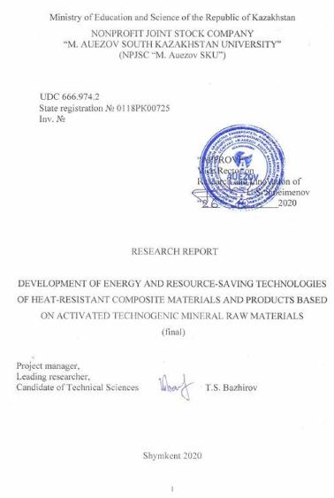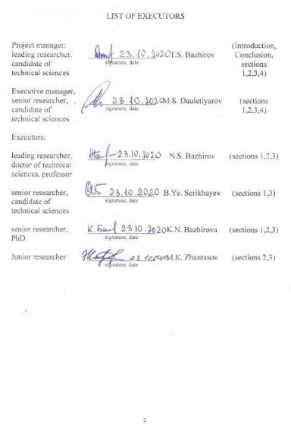
ABSTRACT

The report consists of 156 pages, 43 figures, 12 tables, 101 sources, 12 appendixes.
HEAT-RESISTANT COMPOSITE MATERIALS, TECHNOGENIC MINERAL RAW MATERIALS, SCRAP CHAMOTTE BRICK, FERROCHROME PRODUCTION SLAGS, SODIUM POLYSILICATE, TECHNOLOGICAL PARAMETERS OF PRODUCTION.
The research subject is energy and resource-saving technologies of heat-resistant composite materials based on activated technogenic mineral raw materials.
The aim of the work is to develop energy and resource-saving technologies for heat-resistant composite materials based on mechanochemically activated technogenic mineral raw materials using technological processes with low-temperature heat treatment and activator mills, which allow to provide import substitution of the need for heat-resistant materials, to reduce specific energy consumption for production processes and production costs.
Methodology of the work. When performing the work, the generally accepted chemical, physical, physicochemical, physical and mechanical research methods were used, which allowed to evaluate the properties of the initial and mechanically activated technogenic raw materials, obtained on their basis heat-resistant composite materials.
In the process of performing the work, a detailed analytical review of scientific and technical literature on the processes of mechanical activation of inorganic mineral raw materials and patents on the composition of heat-resistant concretes was carried out. The analysis of the methods of mechanical activation as applied to the production of heat-resistant materials based on technogenic raw materials was carried out.
Experimental studies of the processes of mechanochemical activation of a mixture of components of heat-resistant binders from technogenic mineral raw materials were carried out.
Studies of the physicochemical properties of the products of mechanochemical activation of a mixture of components of heat-resistant binders from technogenic mineral raw materials were carried out.
Research on intensification of grinding of raw materials of heat-resistant materials based on technogenic mineral raw materials was carried out.
Research on physical and technical and physicochemical properties of heat-resistant materials based on technogenic mineral raw materials and the developed surfactant – grinding intensifier were carried out.
Based on the research results, two patents for a useful model were obtained, one application for an invention was filed.
The field of application is production of heat-resistant composite binders for industries using high-temperature processes.
The interim report for the 2018. Inventory number 0218RK00278.
The interim report for the 2019. Inventory number 0218RK00805.

CONTENT
 |  | Page
 | DEFINITIONS, INDICATIONS AND ABBREVIATIONS | 7
 | INTRODUCTION | 8
 | MAIN PART | 11
1 | Technological foundations for development of energy and resource-saving technologies of heat-resistant composite materials based on activated technogenic mineral raw materials | 11
1.1 | Technological aspects of production of heat-resistant composite materials based on non-fired heat-resistant binders | 11
1.2 | Physicochemical aspects of production of heat-resistant composite materials based on non-fired heat-resistant binders | 14
1.3 | Research problem statement | 18
2 | Characteristics of the applied research and test methods | 20
2.1 | Methods of physicochemical research and used devices and equipment | 20
2.2 | Experimental research and test methods, used installations and equipment used | 22
3 | Development of technological parameters for production of composite heat-resistant materials based on mechanochemically activated technogenic mineral raw materials | 24
3.1 | Research of physical and technical properties of heat-resistant composite binders based on technogenic mineral raw materials and surfactants | 24
3.2 | Research and development of technological parameters for production of composite heat-resistant materials based on activated technogenic raw materials | 30
3.3 | Research of physicochemical properties of products of mechanochemical activation of a mixture of components of heat-resistant composite binders based on technogenic mineral raw materials | 39
4 | Pilot tests of the developed technology | 43
 | CONCLUSION | 47
 | LIST OF USED SOURCES | 49
 | APPENDIX A Tables to the sections 2, 3, 4 of the report | 60
APPENDIX B Figures to the sections 1, 2, 3, 4 of the report 66
APPENDIX C Contract 164-4 dated 15 March 2018 94
APPENDIX D Work schedule 102

APPENDIX E Copy of the scientific and technical council’s protocol 110
APPENDIX F List of published scientific work for 2018 111
APPENDIX G List of published scientific work for 2019 112
APPENDIX H List of published scientific work for 2018 113
APPENDIX I Copies of published scientific works 114
APPENDIX J Copies of patents and application for invention 128
APPENDIX K Pilot test certificate 136
APPENDIX L Practical project recommendations 142

DEFINITIONS, INDICATIONS AND ABBREVIATIONS

XRDGP | X-ray diffractometer of general purpose
XRPA | X-ray phase analysis
DTA | Differential thermal analysis
DTG | Differential thermogravimetry
REM | Raster electronic microscope
CEM | Centrifugal-elliptic mill
Surfactant | Surface active substance

INTRODUCTION

At the enterprises of many industries (ferrous and nonferrous metallurgy, thermal energy, oil refining, production of building materials, etc.) there are a large number of thermal units that constantly need to periodically replace the heat-resistant fettling during repair and reconstruction. This requires heat-resistant materials and products, which are currently imported in large quantities from other countries.
However, no one thermal unit in these and other industries can do without thermal protection in the form of a fettling from heat-resistant materials and products.
The creation of domestic production of refractory products is included in the List of priority sectors of the manufacturing industry in accordance with the State Program of Industrial and Innovative Development of the Republic of Kazakhstan for 2020-2025 and the Program “Business Roadmap – 2020” (Code of the General Classifier of Economic Activities 23.20) [1].
Attaching special importance to the production of refractory and heat-resistant materials, immediately after the attainment of independence by the Resolution of the Cabinet of Ministers of the Republic of Kazakhstan dated 22 December 1992 № 1070, the Republican program “On the development of refractory industry in the Republic of Kazakhstan” was adopted. This program prescribed to provide for measures of state support for proposals for the creation of new and reconstruction of existing industries, ensuring the implementation of the Republican program for the development of refractory industry [2]. However, the aims outlined in the specified Republican program for the development of refractory industry, for various objective reasons, then and still have not been realized.
Currently, the only unique enterprise LLP “Plant “Kazogneupor 2015” (Rudny, Kostanay region) is operating in Kazakhstan, which is a highly specialized production of highly refractory products – electromelted and corundum-mullite refractories based on its own electromelted corundum [3]. The plant’s products are mainly supplied to various regions of the Russian Federation.
There is no domestic production of chamotte heat-resistant materials and products in mass demand in Kazakhstan [4]. The need for heat-resistant materials and products is fully covered only by imports from the CIS countries, primarily from Russia and Ukraine.
At the same time, there are various types of technogenic mineral raw materials in the republic, which, with appropriate processing using special technologies and component compositions, can serve as full-fledged raw materials for production of heat-resistant materials. According to the authors [5], only JSC “ArcelorMittal Temirtau” during the repair of thermal units, generates about 12 thousand tons of scrap chamotte brick.
Thus, the development of energy and resource-saving technologies of heat-resistant composite materials using the mechanical activation of technogenic raw materials is an urgent scientific and technical problem.
The aim and tasks of the work. The aim of the work is to develop new energy and resource-saving technologies of heat-resistant composite materials based on technogenic raw materials using mechanochemical activation, which allow saving natural resources, reducing specific energy consumption for fine grinding processes and the cost of products.
Achievement of this aim will significantly expand the raw material base for production of heat-resistant composite materials, increase the competitiveness of products and reduce prices for heat-resistant materials in the domestic market.
Ways to achieve the aim of the work: theoretical, physicochemical, physical and technical, laboratory and experimental research, as well as pilot testing of the developed technologies. This aim is achieved by solving a whole range of tasks.
According to the schedule, the research tasks for 2020:
1. Research of the physical and technical properties of heat-resistant composite binders based on technogenic mineral raw materials and surfactants
2. Development of technological parameters for production of composite heat-resistant materials based on mechanochemically activated technogenic mineral raw materials
3. Preparation and implementation of pilot tests of the developed technologies based on activated technogenic mineral raw materials
4. Development of practical recommendations on the use of the project results in the technology of heat-resistant materials. Preparation and submission of the report.
The aims and tasks of the research, planned according to the schedule for 2020, have been completed in full.

MAIN PART

1 Technological foundations of development of energy and resource-saving technologies of heat-resistant composite materials based on activated technogenic mineral raw materials

1.1 Technological aspects of production of heat-resistant composite materials based on non-fired heat-resistant binders

One of the effective heat-resistant materials that meet modern industrialization requirements are heat-resistant concretes, which in recent years are increasingly used in various sectors of the national economy.
The main advantages of heat-resistant concretes over traditional piece heat-resistant chamotte bricks are that in the manufacture of heat-resistant products and structures using concrete technology, as a rule, such energy-intensive technological processing as high-temperature firing of chamotte and subsequent high-temperature firing of chamotte products is not required.
Currently, aluminosilicate systems based on liquid glass, anhydrous sodium silicate, including an alkaline sodium component, accelerating the dissolution and dispersion of silica particles, polymerization of hydrated new formations in a hardening system, a heat-resistant binder – a heat-resistant aggregate, are widely used in the production of heat-resistant concretes.
Heat-resistant materials based on liquid glass are increasingly used in thermal units in ferrous and nonferrous metallurgy, thermal energy, chemical, oil refining industries, as well as in production of building materials [6-11].
In this aspect, developments are very promising aimed at creating energy and resource-saving technologies for heat-resistant composite materials based on anhydrous sodium polysilicates (lump silicate) in the form of mechanically activated finely dispersed powders. The use of finely dispersed anhydrous sodium polysilicates as a binder can make it possible to reduce the content of water and an alkaline component in heat-resistant materials, and accordingly increase the temperature of their application.
The use of finely dispersed anhydrous sodium silicate instead of an aqueous solution of liquid glass for obtaining various building materials, in particular, heat-resistant concretes, is given in [12-14]. The finely dispersed anhydrous sodium silicate under steaming conditions at a temperature of 80-90°C will intensively hydrate with the formation of a water-soluble silicate of the total composition Na₂О∙mSiО₂∙nН₂О, which will subsequently react with Са(ОН)₂, and SiО₂, released during hardening of the composite binder.
In [11], in the study of chemical reactions on the surface of silicates, it was concluded that the interaction of lump silicate with water forms colloidal films of silicic acid with binding properties. The presented data showed that the reaction between the lump silicate and water proceeds very slowly. It was found in the work that in the future, the products of the interaction of the lump silicate with water cement the aggregate particles and thereby cause the processes of setting and hardening of the binder.
In a number of published works [15-32], as a result of many years of theoretical and experimental research, effective types of anhydrous sodium silicate composite binders were obtained and, on their basis, heat-resistant concretes for various purposes were developed.
As a result of the study of these works, it should be noted that the analysis of the modern theory and practice of obtaining heat-resistant concretes based on liquid glass showed that the formation of the structure of heat-resistant concretes is possible when creating a continuous film of the binder on the surface of refractory aggregate grains, which leads to volumetric homogenization of concrete [27].
Currently, according to traditional technology, to obtain a solution of liquid glass, anhydrous sodium silicates are dissolved (“softly boiled”) at an excess vapor pressure of about 0.5 MPa, mainly in autoclave silicate cookers of various designs.
When using anhydrous sodium silicate as a binder component of heat-resistant concrete, it is converted into liquid glass (dissolved) directly in the binder composition itself by adding a certain amount of water to it and subsequent low-temperature exposure (thermal or autoclave treatment).
The traditional technology for preparing a finely dispersed anhydrous sodium silicate composite binder provides for dry joint grinding of anhydrous sodium silicate with a part of the refractory component to a specific surface area of 2500 cm²/g.
From the analysis of published works, it follows that heat-resistant concretes based on sodium silicate composite binder passed industrial testing in various thermal units of the metallurgical and building materials industry with an operating temperature of up to 1600°C. At the same time, a high operational efficiency of products and structures from these heat-resistant concretes was revealed.
In [21, 33], studies proved the possibility of using heat-resistant concretes based on a sodium silicate composite binder as a fettling for the sintering zone of cement rotary furnaces. For the fettling of this zone in these works, magnesite-chromite heat-resistant concretes based on a sodium silicate composite binder were developed.
Based on the results of studies carried out in [19], heat-resistant concretes based on chamotte-silicate-sodium composite binder were developed for the manufacture of burner and wall blocks of melting furnaces instead of heat-resistant concretes based on liquid glass with chamotte aggregate and magnesite aggregate. To prevent a drop in strength at 800-1100°C, it was proposed in [19] to add 5-15% of a spent catalyst IM-2201, which is a highly dispersed aluminum-chromium waste from the production of synthetic rubber, into the composition of sodium silicate composite binder.
In [30, 31] studies established the possibility of obtaining light heat-resistant concretes, heat-insulating materials based on sodium silicate composite binders.
On the basis of these composite binders using expanded perlite, heat-resistant heat-insulating materials in the form of plates with thermal conductivity 0.08-0.1 W/m°C, compression strength 0.7 MPa, were obtained.
Thus, a new direction in the technology of heat-resistant composite materials for the development of effective energy and resource-saving technology that allows the complex use of raw materials, reduce energy costs for production and reduce capital investments for creating the production of products from heat-resistant concretes is very relevant.

1.2 Physicochemical aspects of production of heat-resistant composite materials based on non-fired heat-resistant binders

In recent decades, active scientific research has been carried out to develop technologies based on solid-phase chemical transformations in the process of mechanical and mechanochemical activation of inorganic substances [34-44].
The authors of a number of works [45-48] showed that in the process of mechanochemical activation, significant structural changes occur, leading to an increase in the reactivity and an improvement in the solubility of mechanochemically activated samples.
The author of the work [49] describes several states of matter arising under the influence of an impact during grinding in a mill, and gives a model of the process occurring during the collision of the particles being ground in accordance with Figure 1.1, given in Appendix B.
The author points out that mechanical shock causes a complex combination of deformation-structural, thermal, electromagnetic, optical and chemical processes leading to the appearance and migration of structural defects of the crushed solid, its partial amorphization and rapid local heating at the impact site. In this case, chemical bonds are simultaneously broken when a fresh surface is formed and short-lived active centers appear on it. In addition, the emission of electrons, photons, ions and the formation of electrostatic charge can occur.
As a result of the impact of grains against each other during grinding, energy is concentrated in a microscopically small area of the surface [50]. As a result, an ultrathin melt layer and even a substance in a high-energy state similar to plasma can be formed in this area for a very short period of time. This state was called triboplasm (from the Greek τριβος – friction).
The destruction of solid and fragile bodies, which include most inorganic mineral substances, is distinguished by a number of features. In the process of grinding with mechanical activation, the internal energy accumulated by the crushed substance causes an increase in potential chemical activity, which results in increased reactivity, a decrease in the temperature of solid-phase interaction, sintering and melting, thermal dissociation and other physicochemical phenomena. Studies of some regularities of the processes occurring in this case were carried out in works [51-53].
Mechanical activation by processing solids in grinding devices – activators has recently found more and more widespread use in industry. Using these methods, it is possible to significantly intensify many heterogeneous chemical processes, which are limited by the kinetics of interphase interaction and diffusion in the solid phase: dissolution of hardly soluble substances, solid-phase reactions, etc. The development of research of laws of such processes led to the emergence of a new science – mechanochemistry [54].
The author’s monograph [55] presents the results of a comprehensive study of the regularities of structural transformations, changes in physicochemical properties in various multicomponent inorganic systems in the process of mechanical activation in planetary mills and other energy-intensive grinding apparatuses.
Many authors argue that finely ground substances can be characterized as activated, and fine grinding of substances can be considered as the process of their activation. However, it should be noted that simple grinding of materials in a conventional ball mill fails to achieve the goals of mechanical activation.
Therefore, it should be noted that only free shock and abrasive mechanical influences are used in ball mills. In conventional ball mills, the only force through which the grinding process is carried out is gravity at the acceleration of free fall equal to 1g. This limits the efficiency of the mill because at high speeds of rotation centrifugal force forces the balls (grinding bodies) to constantly press against the inner surface of the mill drum. This problem can be eliminated by using other designs of mills with high energy intensity, and an example of such mills is activator – planetary mills, attritors, some vibration mills, etc. During comparative tests on mechanical activation, a clear advantage of a planetary mill over a vibration mill was established [56].
In energy-intensive planetary or centrifugal-elliptic mills of the activator type, three mechanical actions are simultaneously forcibly carried out: impact, shear and abrasion. These mills are called planetary because their drums rotate both around their own axis and around a common axis, like the planets in the solar system. Due to this, large accelerations, reaching 100g, are achieved, and as a result, not only finer grinding is achieved, but also the appearance of defects in the crystal structure of the material.
In a planetary mill, depending on the mode of its operation, both impact, abrasion, and shear (rolling balls) mechanical effects on the ground substance can be performed. At the same time, the intensity of the effects can be tens of times higher than the effects of ball mills, in which they occur only due to gravity (the forces of gravity).
A schematic representation of the grinding and activation processes in mills differing both in design and in the principle of mechanical effects on the ground material [57] is shown in Figure 1.2 in Appendix B.
In activator-type mills, along with fine grinding, deformation changes occur in the fine structure of particles due to the partial transition of crystalline compounds to amorphous ones, an increase in the degree of defectiveness of the crystal structure, accumulation of internal energy and an increase in the chemical activity (reactivity) of the crushed substance.
The physical aspects of the essence of the mechanical activation of minerals in the process of fine grinding are described in the work of the authors [58], who describe the changes and defectiveness of the crystal lattice of minerals in the process of fine grinding. The work emphasizes that activation by grinding or mechanical activation is a relatively new and effective way of intensifying physicochemical processes. The mechanical activation is based on the change in the reactivity of solids under the influence of mechanical effects. The authors note [58] that there is still no clarity in the issues of mechanical activation by grinding, since there are no scientifically grounded ideas about the nature and mechanism of mechanical activation of substances during grinding; a general theory of physical and chemical transformations during mechanical activation was not developed; the ways of converting mechanical energy into chemical energy of the crushed substance were not clarified.
It was shown in [59] that there is a correlation between the rate of the solid-phase reaction and the dispersion of the reacting particles – the smaller the particle size, the higher the rate of the interaction reaction.
The use of mechanical activation methods leading to the creation of an active state in a solid is a promising direction for increasing the reactivity of dispersed materials.
Relatively new and promising high-energy-intensive grinding units are activator-type mills: planetary and differential centrifugal mills, which can sharply increase the energy density during grinding and productivity per unit of power [60]. The effectiveness of planetary mills, as devices for fast and very fine grinding, is confirmed by the following comparison: the fine dispersion of quartz is achieved in a planetary mill within 2 minutes, the same dispersion in a conventional ball mill is achieved after 10-12 hours of grinding.
In [61], some regularities of the course of solid-phase mechanochemical reactions in mixtures of solids during grinding in a planetary mill were established. It was established that in planetary mills, conditions are created for a high concentration of energy in the grinding chamber and the resulting significant frequencies and energies of interaction of the grinding bodies with particles of the crushed material. This allows the planetary mill to be classified as a very efficient tribochemical reactor. The disadvantages of modern planetary mills are the structural difficulties in the manufacture of high-capacity machines [62, 63].
The performed analytical review showed that the correct choice of the method of mechanical activation and the type of activator mill, optimization of the activation parameters are of decisive importance in the development of technological parameters for the production of heat-resistant binders.
Due to the limited scope of the project report, the analysis of published works on scientific and technological aspects of the development of energy and resource-saving technologies of heat-resistant composite materials based on activated technogenic mineral raw materials performed in the project is presented in a reduced volume.

1.3 Research problem statement

The analysis of research in the field of mechanical activation of inorganic materials showed that, depending on the method of fine grinding, the pattern of destruction of a solid will be different, which, accordingly, should affect the surface properties of the crushed product, its reactivity, size and morphology of dispersed particles. The morphology of dispersed particles and the nature of the surface of the crushed materials determine the main physical and technical properties of heat-resistant binders, materials and products based on them.
The use of the process of mechanical activation of the initial raw materials in effective grinding units of the activator type can be used as the basis for the development of energy and resource-saving technology of heat-resistant composite binders and materials based on technogenic mineral raw materials of silicate and aluminosilicate nature.
The aim of the work: The aim of the work is to develop new energy and resource-saving technologies of heat-resistant composite materials based on technogenic raw materials using mechanochemical activation, which will save natural resources, reduce specific energy consumption for fine grinding processes and reduce the cost of production.
The ways to achieve the aim of the work: the implementation of a complex of physicochemical, laboratory and experimental research, as well as pilot tests of the developed technologies. This aim is achieved by solving a whole range of theoretical foundations and experimental problems.
According to the schedule, the research tasks for 2020:
The 1st stage. Research of the physical and technical properties of heat-resistant composite binders based on technogenic mineral raw materials and surfactants. At this stage, it is planned to conduct research on the physical and technical properties of the obtained heat-resistant composite binders, to study the physicochemical properties of products of mechanochemical activation of a mixture of components of heat-resistant binders.
The 2nd stage. Development of technological parameters for production of composite heat-resistant materials based on mechanochemically activated technogenic mineral raw materials. At this stage, it is planned to determine the main technological parameters for production of heat-resistant materials based on activated technogenic raw materials.
The 3rd stage. Preparation and implementation of pilot tests of the developed technologies based on activated technogenic mineral raw materials.
The 4th stage. Development of practical recommendations on the use of the project results in the technology of heat-resistant materials. Preparation and submission of the report.
2 Characteristics of the applied research and test methods

2.1 Methods of physicochemical research and used devices and equipment

X-ray phase analysis (XRPA) is one of the most versatile methods for studying crystalline materials [64, 65].
During the studies, the diffractograms of the samples under study were obtained using XRDGP-2 (X-ray diffractometer of general purpose) at CuК_{α} – radiation with a nickel filter. The speed of movement of the goniometer counter was 8 deg/min. The tube voltage was 40 kV, its current – 20 mA.
Interpretation of diffractograms, i.e. X-ray determination of the minerals of the sample under study was reduced to comparing the data d (hkl) and I (hkl) of the experimental study with data from reference books and card files [66]. To identify minerals and mineralogical composition of the mixture, the bases of X-ray powder mineral standards of ASTM and JCPDS systems were used.
Complex differential thermal analysis by methods of differential thermal analysis (DTA), thermogravimetry (TG) and differential thermogravimetry (DTG) was carried out using Q-1500 derivatograph of the system of F. Paulik, I. Paulik, L. Erdei (MOM, Hungary). The research conditions: temperature range 20-1500ºС; DTA sensitivity – 250 μV, DTG – 500 μV, TG – 200 mg, heating rate 7.5 º/min, chart tape advance rate 2 mm/min. The standard is aluminum oxide, previously fired at 1000°C, the crucibles for the standard and the sample are alundum. The filming was carried out in an air atmosphere.
Physicochemical studies of the microstructure of the samples were carried out using JSM-6490LV scanning electron microscope (JEOL, Japan), which was also used to determine the elemental chemical composition of the materials under study by the energy dispersive method.
Chemical analysis of the materials under study was carried out according to the procedure adopted for inorganic materials [67].
Determination of solubility of anhydrous sodium polysilicate was carried out in accordance with the interstate standard GOST 13078-81 “Sodium liquid glass. Technical conditions” [68].
Determination of specific surface area and dispersed composition of fine grinding products. To determine the specific surface area of finely ground materials, PSH-K device was used, designed to determine the specific surface area of powders, which is based on measuring the hydraulic resistance of a layer of a powdery material by the Kozeny-Karman method when filtering an air flow through it under reduced pressure.
Studies of disperse composition of finely ground materials were carried out using “Analizette 22” laser analyzer (MicroTec Fritsch GmbH, Germany).
Electron microscopic analysis. The method of raster and scanning electron microscopy allows obtaining high-resolution images of bulk samples by scanning them with an electron beam. Also, using electron microscopy, it is possible to obtain information about the nature of the surface of the research object and its elemental chemical composition. The physicochemical studies of the microstructure of the samples were carried out in the Testing regional laboratory of engineering profile of M. Auezov SKU with the use of JSM-6490LV electron microscope (JEOL, Japan), which was also used to determine the elemental chemical composition of raw materials and the resulting products by the energy dispersive method.
Physical and technical tests of the properties of heat-resistant composite binders based on mechanically activated technogenic mineral raw materials were carried out by analogy with the determination of the strength properties of cements in accordance with the requirements of GOST 310.1-310.4 [69-72]. The thermal properties of the samples were determined according to GOST 20910 [73].
Certain types of the physicochemical research were carried out on the basis of laboratories of physicochemical methods of analysis at Ukrainian State University of Chemical Technology (Dnipro, Ukraine) and Belorussian State Technological University (Minsk, Republic of Belarus) during business trips.

2.2 Experimental research and test methods, used installations and equipment used

When performing experimental research, material samples were ground in a laboratory ball mill of ML-1 type (manufactured by Paritet CJSC, Russia). The general view of the laboratory grinding plant ML-1 is shown in Figure 2.1 in Appendix B.
The fine grinding and mechanical activation of the materials were carried out using the activator mill “Aktivator 4” planetary mill (manufactured by Machine-Building Plant “Aktivator” CJSC, Russia), in which the material sample is crushed mainly due to the high-energy impact of grinding balls, and also partly due to the abrasion of the material between grinding balls and the wall of the grinding drum. Loaded with the material to be ground and steel balls, the grinding drums of the planetary mill rotate around their own axes on a planetary disc that rotates in the opposite direction. Thus, the material to be ground in the grinding drum is simultaneously affected by the centrifugal forces of rotation of the grinding drums and the planetary disc.
The technical characteristics of “Activator 4” activator planetary mill are given in Table 2.1 in Appendix A, its general view is shown in Figure 2.2 in Appendix B.
The fineness of grinding of the crushed materials was determined by the method of sieve analysis by the residue on sieves with meshes of a certain size using a set of sieves of “Analysette 3” vibrating scatterer (Fritsch, Germany), its general view is shown in Figure 2.3 in Appendix B.
When conducting the experimental research, the preparation of composite binders by mixing finely ground components was carried out using a specially designed installation, which is a drum rod mixer with a drum rotation frequency of 60 rpm, rotating on rollers mounted on a metal platform. The general view of the experimental installation is shown in Figure 2.4 in Appendix B.
The pilot tests were carried out on a production line using “Activator C500” centrifugal-elliptic mill with the capacity of 0.5 t/h (manufactured by Machine-Building Plant “Aktivator” CJSC, Russia). The general view and technical characteristics of “Activator C500” centrifugal-elliptic mill are shown in Figure 2.5 and Table 2.2 in Appendixes B and A.
The main equipment of the production line is a drying drum, a grinding plant, including feed hoppers, batchers and “Activator C500” centrifugal-elliptic mill, a two-shaft paddle mixer.
The general view of the production line and its main equipment are presented in Figures 4.1-4.4 in Appendix B.

3 Development of technological parameters for production of composite heat-resistant materials based on mechanochemically activated technogenic mineral raw materials

When planning and conducting research on the development of technological parameters for production of composite heat-resistant materials based on mechanically activated technogenic mineral raw materials, the basis was the results of theoretical, physicochemical and experimental research performed at the previous stages of this project in 2018 and 2019.

3.1 Research of physical and technical properties of heat-resistant composite binders based on technogenic mineral raw materials and surfactants

To develop the main technological parameters for the production of composite heat-resistant materials, the physical and technical properties of the components of heat-resistant binders based on technogenic mineral raw materials were studied.
The physical and technical and physicochemical properties of the main components of heat-resistant composite materials from the selected technogenic mineral raw materials – scrap of used chamotte bricks, slag from production of low-carbon ferrochrome and slag from production of high-carbon ferrochrome, as well as technical product of sodium polysilicate (lump silicate) were studied.
The scrap of used chamotte bricks. When performing the research, samples of the scrap chamotte brick of grade ШБ-5 (GOST 390-96) were used, the view of which is shown in the photo in Figure 3.1 in Appendix B.
The chemical composition of the sample of the scrap chamotte brick includes the following oxides, mass percent: АlО₃ – 47.97; SiO₂ – 53.15; TiO₂ – 1.05; Fe₂О₃ – 2.45; the rest is impurities.
The analysis of the diffractogram of a piece of the scrap chamotte brick (Figure 3.2 in Appendix B) showed the presence of diffraction reflections corresponding to the interplanar distances of quartz (d = 4.26; 3.3,6; 1.82Å), cristobalite (quartz modification) (d = 4.10; 2.52; 2.056; 1.78 Å) and mullite (d = 3.42; 3.39; 2.54; 2.28; 2.25; 2.25 Å). Due to the insignificant amount of impurities, they were not found in the diffractograms.
The results of the differential thermal analysis of the scrap chamotte brick sample (Figure 3.3 in Appendix B) when heated to 1000°C show the absence of endothermic effects due to the fact that the scrap chamotte brick was previously subjected to high-temperature firing during production of chamotte bricks. The exothermic effect at a temperature of 470-550°C is possibly associated with the transition of quartz from β-modification to α-modification.
Comparative studies of the dispersed composition, morphology and particle size of a scrap chamotte brick sample, ground by grinding in a ball mill, and a scrap chamotte brick sample, ground and mechanically activated in “Activator 4” activator planetary mill, were carried out.
The research results of the dispersed composition, obtained using “Analizette 22” laser analyzer (MicroTec Fritsch GmbH, Germany) are presented in Figures 3.4 and 3.5 in Appendix B.
The scrap chamotte brick sample mechanically activated in a planetary mill is a polydisperse material, in which a significant part is a fine fraction from 0.5 to 10 μm, while in the ground sample of the scrap chamotte brick crushed in a ball mill, a fraction of 5-50 μm prevails.
The studied samples of the scrap chamotte brick also differ in the size and shape of dispersed particles, which was revealed when studying the morphology of particles by electron microscopy using JSM-6490LV electron microscope (JEOL, Japan).
Comparing the electron micrographs presented in Figures 3.6 and 3.7 (given in Appendix B), it can be noted that there are no large grains in the micrographs of the mechanically activated sample of the scrap chamotte brick, as in the process of grinding and activation, their average size decreased by more than 2 times in comparison with the scrap chamotte brick sample crushed in a ball mill.
In the mechanically activated sample of the scrap chamotte brick, it is necessary to note significant changes in the morphology of dispersed particles – shapeless particles of an indefinite configuration prevail here, while in the original sample of the scrap chamotte brick crushed in a ball mill, there are particles with more pronounced flat faces.
Thus, according to the physicochemical studies’ results, it was revealed that during mechanical activation, the material can not only be finely ground with a significant increase in the number of smaller particles, but also significant changes occur in the microstructure and morphology of the mechanically activated material particles.
The results of the electron microscopic study of the morphology of particles on the surface and the spectral elemental composition during scanning of the surface of chamotte brick ground in a ball mill (S_{sp} = 3000 cm²/g) are shown in Figure 3.8 and Table 3.1 (given in Appendixes B and A).
An electronic photo of the morphology of particles on the surface of the scrap chamotte brick sample mechanically activated in “Activator 4” activator planetary mill is shown in Figure 3.9 in Appendix B.
The research results of the morphology of the sample particles, crushed to the same fineness of grinding, characterized by the specific surface S_{sp} = 3000 cm²/g, showed that the studied scrap chamotte brick sample crushed in a ball mill has a pronounced polydisperse character, with both dusty particles and more large particles in the form of fragmental material.
The research results of the morphology of the sample particles, crushed and mechanically activated in an activator planetary mill, showed that with the same fineness of grinding of the crushed material, the studied sample of the mechanically activated scrap chamotte brick is distinguished by the absence of large particles in the surface structure of the ground sample.
Ferrochrome production slags.
The choice of slags from ferrochrome production as components for composite heat-resistant materials is due to their mineralogical composition, as well as to the fact that these slags are large-tonnage and affordable technogenic mineral raw materials.
Aktobe Ferroalloy Plant Kazchrome TNC currently produces high, medium and low carbon ferrochrome, other ferroalloys, including ferrosilicochromium, ferrosilicomanganese and ferrosilicon, as well as chromium and manganese concentrates. The slag dumps of Aktobe Ferroalloy Plant contain about 15 million tons of slag wastes, of which 5 million tons are high-carbon ferrochrome slags, and more than 8-9 million tons are self-decomposing slag from low-carbon ferrochrome production.
The slag from the production of high-carbon ferrochrome of the current output is processed in the slag processing shop, where the slag is crushed and residual ferrochrome is extracted from it, and the crushed slag is sold as chip for road construction [75]. Taking into account the refractory properties, in [76] it is proposed to use high-carbon ferrochrome slag as a component of refractory materials. At the same time, in this work, as raw materials for the manufacture of refractory bricks, it is proposed to use finely ground slag from the production of high-carbon ferrochrome and bag dust from gas cleaning furnaces for the production of high-carbon ferrochrome.
According to the author’s data [77], dispersed slags of low-carbon ferrochrome self-decomposing into a fine powder can be promising for use as a hardener for liquid glass.
The type of samples of high-carbon and low-carbon ferrochrome slags of Aktobe Ferroalloy Plant are shown in Figures 3.10 and 3.11 (given in Appendix B).
The results of determining the granulometric composition and bulk density of slags from ferrochrome production are presented in Table 3.2 (given in Appendix A).
The chemical composition and refractoriness of high-carbon and low-carbon ferrochrome slags are presented in Table 3.3 (given in Appendix A).
According to the data of X-ray phase analysis by the diffractogram shown in Figure 3.12 (given in Appendix B), the mineralogical composition of the high-carbon ferrochrome slag is represented by the following main minerals: forsterite Mg₂SiO₄ (d=3.89, 3.48, 2.77, 2.27, 2.16, 1.75, 1.49 Å), spinel MgAl₂O₄ (d=4.81, 4.25, 2.47, 1.58 Å), partially amorphous glass phase and admixture of calcium orthosilicate Ca₂SiO₄.
The X-ray diffraction study of the slag from the production of low-carbon ferrochrome showed that the main crystalline phase in it is calcium orthosilicate γ-Ca₂SiO₄, there is also the phase α-Ca₂SiO₄, and magnesian silicates in the form of magnesium orthosilicate – forsterite Mg₂SiО₄.
On the diffractogram of the slag from the production of low-carbon ferrochrome (Figure 3.13 in Appendix B) the most intensive diffraction reflections with d = 3,81; 2,79; 2,74; 1,88; 1,62 Å correspond to the phase γ-Ca₂SiO₄.
The diffraction maxima with d = 2,71; 2,66, 1,72 Å, are, apparently, due to the presence in the slag of the modification of calcium orthosilicate in the form of α-Ca₂SiO₄. The presence of this crystalline phase in the slag indicates that the modification transformations α → α'_{H} → α'_{L} → β → γ did not occur completely, and a small amount of α-Ca₂SiO₄ is present in the system [79].
The presence of magnesium orthosilicate forsterite Mg₂SiО₄ is indicated by the reflections with d = 3,81; 2,74; 2,66 Å.
The research results of the specific surface area, determination of the average particle size and the results of sieve analysis showed that the slag from the production of low-carbon ferrochrome is a finely dispersed gray powder with the following characteristics: specific surface area ~ 2955 cm²/g, average particle size 6.8 μm, true density – 3,01 g/cm³, bulk density – 739 kg/m³.
Figure 3.14 (given in Appendix B) shows the results of element-by-element mapping of the surface structure of the slag sample from the production of low-carbon ferrochrome by the content of basic chemical elements. The images obtained using JSM-6490LV electron microscope show that the content of calcium Ca and silicon Si prevails in the slag, indicating the predominant content of the main phase in the form of calcium orthosilicate Ca₂SiO₄.
The results of element-by-element mapping allowed to draw a conclusion about the uniform distribution of silicon Si and calcium Ca elements, non-uniform distribution and local inclusions of magnesium Mg and chromium Cr elements.
The results of the electron microscopic study of the morphology of particles on the surface of the sample and the spectral elemental composition when scanning the slag from the production of low-carbon ferrochrome are shown in Figure 3.15 in Appendix B.
The predominant content of calcium orthosilicate Ca₂SiO₄ in the composition of the slag sample from the production of low-carbon ferrochrome is also confirmed by the research results of the elemental chemical composition using JSM-6490LV electron microscope presented in Table 3.4 in Appendix A.
Sodium polysilicate (lump silicate). The technical product, anhydrous sodium polysilicate (lump silicate) with the silicate modulus of 2.8, which meets the requirements of the international standard GOST 13079-93 “Soluble sodium silicate. Technical conditions” [78] was used as the main binding component of composite heat-resistant binders based on technogenic mineral raw materials.
Sodium polysilicate is a mixture of sodium salts of polysilicic acids with the general formula Na₂O∙nSiO₂, where n is the number of silicon oxide molecules per sodium oxide molecule. Some works suggest a generalized formula for sodium polysilicate Na₂SiO₃.
The chemical composition of sodium polysilicate is shown in Table 3.5 in Appendix A.
The results of X-ray diffraction analysis of anhydrous sodium polysilicate are shown in Figure 3.16 in Appendix B. The analysis of the diffractogram of anhydrous sodium polysilicate showed the absence of crystalline modifications of sodium silicates in it.
One of the main quality indicators of sodium polysilicate (lump silicate) is the silica modulus (M), which is calculated by the following formula:

М = (% SiO₂ / % Na₂O) ∙ 1,032

where 1,032 is the ratio of the molecular weight of silicon oxide and sodium oxide.
Previous studies by the authors [80-83] established the presence of several types of sodium silicate in the composition of liquid glass (obtained from lump silicate) – sodium metasilicate Na₂О∙2SiО₂, sodium orthosilicate 2Na₂О∙SiО₂, sodium disilicate Na₂О∙2SiО₂ and sodium trisilicate Na₂О∙3SiО₂.

3.2 Research and development of technological parameters for production of composite heat-resistant materials based on activated technogenic raw materials

The results of analytical studies carried out at the previous stages of this project in 2018-2019 showed that one of the effective types of heat-resistant materials is heat-resistant concretes based on composite heat-resistant binders using aqueous solutions of liquid glass.
However, the analysis of special building codes and regulations for the use of heat-resistant concrete compositions on liquid glass [84, 85] showed that their significant disadvantage is a large consumption of liquid glass per 1 m³ of heat-resistant concrete (300-500 kg), which entails a high water demand of the concrete mixture and the need to introduce into the composition of heat-resistant concrete a significant amount of finely ground mineral components as hardeners and refractory additives (more than 500 kg per 1 m³ of concrete). This leads to a very high cost and energy consumption of the technological process for the production of heat-resistant concrete. In addition, heat-resistant concrete compositions containing an increased amount of low-melting alkaline liquid glass as a binder component are unable to withstand high temperatures, which reduces their refractoriness.
In heat-resistant concrete, liquid glass is low-melting constituent unlike other refractory mineral components. Therefore, in order to increase the refractory properties of a heat-resistant binder, various types of refractory finely ground mineral additives are introduced into it.
In this direction, a large work on the study of the influence of the type of finely ground refractory additives and hardeners on the properties of heat-resistant concretes on liquid glass was carried out earlier in [86].
The use of sodium fluorosilicate as a hardener for binding compositions based on liquid glass is unsafe, since when heated it releases volatile toxic silicon tetrafluoride.
In addition, sodium fluorosilicate is a scarce product, therefore, studies aimed at finding new affordable and environmentally friendly components as a hardener for compositions on liquid glass are highly relevant.
According to the author [86], when obtaining heat-resistant materials, it is possible to effectively use calcium orthosilicate in γ-2СаО∙SiO₂ modification as a hardener for binding compositions based on liquid glass, since its refractory properties are much higher than that of other hardeners.
Along with hardeners and finely ground refractory additives, the type of used aggregates also affects the properties of heat-resistant concrete. It is known that aggregates of heat-resistant concrete based on liquid glass should be materials with high refractoriness and which, under high temperature conditions, do not form low-melting eutectics with liquid glass.
In [87], the experience of using heat-resistant concrete on liquid glass with nepheline sludge, finely ground chamotte and chamotte aggregate for fettling converter dust collectors in nonferrous metallurgy is presented. Prior to the use of heat-resistant concrete, the fettling of such dust collectors was made using chamotte bricks. At the same time, every 6 months it was necessary to replace the chamotte brick fettling, which caused the converter to fail and shut down.
When using heat-resistant concrete on liquid glass, the fettling of the converter dust collectors worked without repair for more than 10 years.
The authors in [87] presented the production experience of using heat-resistant concretes on liquid glass with ferrochrome slag, chamotte, chamotte-carborundum aggregates for fettling wagonettes of tunnel furnaces at ceramic enterprises, which allowed to increase the fettling service life on average up to 120 days.
It is shown in [88] that the replacement of small-piece calcined refractory products in metallurgical furnaces with heat-resistant concrete using anhydrous sodium silicate allowed to reduce by 2 times the consumption of scarce heat-resistant material per ton of melted steel. At the same time, the author notes that labor costs for replacing the furnace fettling decreased at least three times, and the energy-intensive technological process of firing, which takes place in the production of small-piece refractory products, was eliminated.
Developed light heat-resistant concretes using expanded clay and vermiculite aggregates are known. Chammote sand is recommended for use in such concretes as finely ground additives in heat-resistant binders.
However, the high energy intensity of the above-considered heat-resistant binders using liquid glass and heat-resistant concretes based on them, and the need for large capital investments in their production, led to the particular relevance of using new types of effective composite heat-resistant binders for heat-resistant concretes and, primarily, for non-fired technologies.
In this direction, studies aimed at creating energy-saving technologies for heat-resistant concretes based on the use of anhydrous sodium polysilicates in the form of activated finely dispersed powders are promising. The use of anhydrous finely dispersed sodium polysilicates as a binder creates preconditions for reducing the content of mixing water and an alkaline component in heat-resistant concretes, thereby increasing their thermal properties and contributing to the creation of energy-saving technologies for heat-resistant composite concretes.
In recent years, sodium polysilicate (a semi-finished product for the production of liquid glass) is increasingly recommended for the production of various heat-resistant concretes [89].
At present, as mentioned above, to obtain liquid glass, sodium polysilicate in the form of lump silicate is subjected to “soft boiling” in autoclave silicate cookers of various designs.
According to the technology developed by us, when using anhydrous finely dispersed sodium polysilicate as a binder of a heat-resistant composite binder for heat-resistant concrete, it is transferred into liquid glass (dissolution) directly in the medium of the binder composition by adding the required amount of hot water to it, thorough mixing and subsequent thermal treatment.
The technology developed by us for the production of composite heat-resistant binder provides for dry joint grinding of anhydrous sodium polysilicate with a part of the refractory mineral component to the specific surface area of ≥3000 cm²/g, combined with the process of mechanochemical activation in an activator mill.
To develop technological parameters for the production of composite heat-resistant materials based on activated technogenic raw materials, the processes and products of their separate and joint grinding in a ball mill and their joint grinding combined with the process of mechanical activation in an activator mill were studied.
With the well-known technologies of heat-resistant concretes based on liquid glass, dissolving lump silicate obtains the so-called liquid glass – an aqueous alkaline solution of sodium silicates Na₂O∙nSiO₂ + Н₂О in the form of a viscous syrupy liquid.
The solution of liquid glass is usually obtained by soft boiling in autoclaves at an excess vapor pressure of about 5 atmospheres, which is a very energy-consuming and unsafe process [83].
At this stage of technological research, we studied the effect of the silica modulus on the solubility of finely dispersed sodium polysilicate samples obtained by grinding in a ball mill and in “Activator 4” activator planetary mill to approximately the same specific surface area of ~ 3000 cm²/g.
In the study of solubility, sodium polysilicate with a silica modulus of 2.8 was used as the most recommended for the manufacture of concretes based on liquid glass.
In the process of grinding sodium polysilicate, due to its relatively low hardness, dispersed particles are subject to rapid aggregation (lumping), which complicates further fine grinding of the crushed material.
To eliminate the rapid aggregation of dispersed particles, a surfactant was introduced into the mill during grinding together with the material to be ground – a complex grinding intensifier developed by us in this project [74] based on a mixture of lignosulfonate of technical and thermochemically processed soap stock, which has a hydrophilic-hydrophobic effect and prevents the aggregation process of dispersed particles of the crushed material. The study of the influence of the developed complex intensifier of grinding on the processes of fine grinding of materials was carried out at the previous stage of the project in 2019.
The results of studies of the effect of the silica modulus on the solubility of finely dispersed sodium polysilicate are shown in Table 3.6 in Appendix A.
The analysis of the results of Table 3.6 (given in Appendix A) showed that with an increase in the value of the silica modulus of sodium polysilicate, an increase in its dissolution time occurs.
In this case, for finely dispersed sodium polysilicate, which has undergone mechanical activation during grinding in “Activator 4” activator planetary mill, the dissolution time is reduced by 1.77-2.17 times.
The study of the effect of water temperature on the solubility of finely dispersed sodium polysilicate in the temperature range of 20-100°C at the same exposure time (3 hours) and the same water content was carried out. The research results are shown in Figure 3.17 in Appendix B.
The analysis of the obtained research results shows that with an increase in temperature to 80-90°C, the solubility of finely dispersed sodium polysilicate increases and is 98-99%.
Therefore, in the future, when carrying out technological research, the temperature range of 85-90°C for the mixing water of the heat-resistant binder was taken as the optimal temperature of the water for dissolving finely dispersed sodium polysilicate in the conditions of application of heat-resistant composite binder close to real conditions.
The thermal treatment is an important technological factor that has a significant effect on the dissolution of finely dispersed sodium polysilicate and subsequent hardening in the binder composition at a temperature of 95°C and thermal treatment of the hardened system at a temperature of 200°C.
Samples of heat-resistant binder, formed in metal molds, were placed in a drying oven and subjected to thermal treatment according to a certain mode at 95°C and 200°C. Then the drying oven was turned off and the hardened samples of the heat-resistant binder were cooled to room temperature.
The research of the author [90] established that with a similar mode of thermal treatment, intensive dissolution of anhydrous sodium silicate with a silica modulus 2.8 occurs at 90-95°C.
The research was carried out on the effect of mechanically activated both separately and in a mixture of finely dispersed sodium polysilicate and scrap chamotte brick, as well as the effect of the component composition, grinding method, degree of dispersion and hardening conditions on the main physical and technical properties of composite heat-resistant binders.
The influence of the component composition on the strength properties of heat-resistant binders was assessed by the strength indicators of beams samples 4x4x16 cm in size, manufactured and tested according to standard procedures in accordance with the requirements of GOST 310.1 – GOST 310.4 [91-94].
When conducting research on the development of the optimal composition of heat-resistant binders, the task was to establish the dependence of the strength of the material on such technological factors as:
- the content of sodium polysilicate in the binder;
- the influence of the method of grinding the components of the binder;
- modes of thermal treatment.
Determination of these dependences allows to develop rational compositions and basic technological parameters that ensure the production of heat-resistant binders with desired properties.
During the research, first of all, the main dependences of the influence of the ratio between sodium polysilicate and chamotte component on the strength of heat-resistant binder after hardening according to specified thermal treatment modes and with high-temperature heating to 1000°C were studied.
The strength tests of heat-resistant binder were carried out on samples made from mixtures of sodium polysilicate and chamotte component, jointly ground to the specific surface area of 3000 cm²/g, according to the established procedure in accordance with GOST 310.4. The process of hardening of heat-resistant binder samples was carried out according to the following temperature regime:
- temperature rise up to 95°С within 2 hours;
- isothermal exposure at 95°C within 3 hours;
- further rise in temperature to 200°C within 3 hours;
- isothermal holding at 200°C within 3 hours.
The choice of the temperature regime was made according to the recommendation outlined in [95].
The samples were tested after cooling to room temperature of 20-25°C.
The research results are shown in Figure 3.18 (given in Appendix B). show that the content of sodium polysilicate in the binder composition has a significant effect on the strength of the samples. By the nature of the strength graph, it can be concluded that the high strength of heat-resistant binder samples is provided with an optimal ratio of 20-25% sodium polysilicate and 75-80% chamotte component in the binder composition.
The surface of the samples of heat-resistant binder with the content of 30 mass percent sodium polysilicate swelled when the samples were heated to 200°C; therefore, the limiting content of sodium polysilicate in the binder composition in subsequent studies was taken to be 25 mass percent.
The results of studying the strength of samples of heat-resistant binder (hardening of samples at 95°C), obtained by joint grinding of components in a ball mill, are shown in Figure 3.19 in Appendix B.
The results of studying the strength of samples of heat-resistant binder (hardening of samples at 95°C), obtained by joint grinding of components and mechanical activation in “Activator 4” activator planetary mill are shown in Figure 3.20 in Appendix B.
The analysis of the results of the performed studies of strength properties shown in Figures 3.19 and 3.20 showed that the strength of samples of heat-resistant binder hardened at 95°C, obtained by joint grinding of components in an activator planetary mill, increases by 30-40%.
The results of studying the strength of samples of heat-resistant binder obtained by joint grinding of components in a ball mill and mechanically activated in an activator planetary mill after thermal treatment at 200°C are shown in Figures 3.21 and 3.22.
The strength indices of samples of heat-resistant binder hardened at 95°C, obtained by joint grinding of components and mechanical activation in an activator mill, after subsequent thermal treatment and drying at 200°C, increased by 40%.
The analysis of the results of the performed studies of strength properties showed that after the subsequent thermal treatment and drying at 200°C, the strength for all samples of heat-resistant binder hardened at 95°C increases by 40%.
Samples of heat-resistant binder obtained by joint grinding and mechanical activation in “Activator 4” activator planetary mill of a mixture of sodium polysilicate and scrap chamotte brick showed 30-40% higher strength, compared to the strength of samples of heat-resistant binder obtained by joint grinding of these components in a ball mill.
The obtained research results are in good agreement with the conclusions in the previously published works of the authors [96,97].
Tables 3.7 and 3.8 show the properties of samples of heat-resistant composite binder of various compositions prepared by joint grinding of sodium polysilicate (silica modulus 2.8) and chamotte component to the specific surface area of ​​3000 cm²/g, and subsequent mixing with finely dispersed slag from the production of low-carbon ferrochrome. To carry out the strength tests, samples were made with preliminary heating of mixing water (90°C) with simultaneous mixing of the binder composition for 6 minutes, followed by molding and hardening of the samples at 95°C, and thermal treatment of the samples at 200°C.
From the research results given in Table 3.7 it follows that with an increase in the percentage of the chamotte component, the refractoriness of the samples of heat-resistant binder increases, but the strength of the binder decreases.
The use of finely dispersed slag of the production of low-carbon ferrochrome, with the specific surface ~ 3000 cm²/g, allows to replace 30-50% of the finely dispersed chamotte component in the composite heat-resistant binder. At the same time, due to the finely dispersed state of the slag from the production of low-carbon ferrochrome, the process of its fine grinding in mills is excluded.

3.3 Research of physicochemical properties of products of mechanochemical activation of a mixture of components of heat-resistant composite binders based on technogenic mineral raw materials

Comprehensive studies of the physicochemical properties of the products of mechanochemical activation of a mixture of components and hardening products of heat-resistant composite binders were carried out using the methods of X-ray phase, differential thermal analysis, electron microscopy and spectral analysis.
The results of studying the diffractograms of samples of mechanochemically activated mixture of components, hardening products of composite heat-resistant binder, as well as binder samples subjected to high-temperature thermal action at 1000°C (Figures 3.23-3.25 in Appendix B), showed that the composition of crystalline phases practically does not change, but it is necessary note the change in the intensity of diffraction reflections for some crystalline phases.
When studying the diffractograms (Figures 3.23-3.25), intensive diffraction reflections were established, corresponding mainly to crystalline phases of the chamotte component – mullite 3Al₂O₃∙2SiO₂ (d = 5.10; 3.38; 2.89; 2.66; 2.29; 2.20; 2.12; 1.53 Å), quartz SiO₂ (d = 3.38; 2.89; 1.74; 1.53 Å), cristobalite (quartz modification) SiO₂ (d = 4.09; 2.66; 2.20; 1.74; 1.53 Å), as well as crystalline phases of low-carbon ferrochrome slag – calcium orthosilicate shannonite γ-2CaO∙SiO₂ (d = 2,89; 2,66; 1,74; 1,62 Å) and magnesium orthosilicate forsterite 2MgO∙SiO₂ (d = 3,35; 2,74; 2,66 Å).
From the analysis of diffractograms of samples of hardened composite heat-resistant binder (Figures 3.23-3.25), it can be concluded that hydrated new formations in the hardening binder are presented mainly in a gel-like form in the form of a compacted and polymerized silica gel, in which particles of products of interaction of sodium polysilicate with chamotte component and particles of products of interaction of sodium polysilicate with slag of production of low-carbon ferrochrome are present.
Comprehensive physicochemical studies of hardened samples of the developed composite heat-resistant binder were also carried out by differential thermal analysis (DTA), thermogravimetry (TG) and differential thermogravimetry (DTG) using Q-1500 derivatograph (MOM, Hungary).
The analysis of the derivatogram of hardened samples of heat-resistant binder obtained by joint grinding in an activator mill of a mixture of sodium polysilicate and a chamotte component (Figure 3.26 in Appendix B) showed that, judging by the endothermic effects at a temperature range from 28 to 166°C, during heating, the main amount of heat is spent on removal of moisture from the compacted gel of polymerized silicic acid and is to a small extent consumed in the stepwise dehydration of crystalline hydrates, the endothermic effects of which occur at temperature peaks of 300°C, 518°C. The endothermic effect observed in the temperature range from 620 to 822°C is due to the onset of partial decomposition of low-melting impurities. The endothermic effects occurring in the range from 1050 to 1500°C are possibly associated with the processes of decomposition and liquid-phase sintering of the components that make up the composite binder. The total weight loss was ~ 10% of the initial binder weight.
The analysis of the derivatogram of hardened samples of composite heat-resistant binder mixed with a finely dispersed slag of low-carbon ferrochrome (Figure 3.27 in Appendix B) showed the presence of endothermic effects associated with both the removal of moisture from the compacted polymerized silica gel, the effects of which occur at temperatures of 40 and 221°C, and with dehydration of crystalline hydrates and recrystallization of new formations, the endothermic effects of which occur at temperatures of 643°C, 811°C. The total weight loss of the binder is ~ 5-6%.
It should be noted that the heat-resistant binder, into which a finely dispersed slag of low-carbon ferrochrome was introduced, showed less weight loss on heating, the peaks of the DTA and DTG effects are shifted towards higher temperatures, which is obviously associated with the crystalline phases of new formations in the hydrated binder. The significant endothermic effect in the temperature range from 321 to 988°C, not associated with weight loss, indicates polymorphic transformations of the crystalline phase of the original minerals of the binder components.
The analysis of the derivatogram of hardened sample of composite heat-resistant binder subjected to thermal action at a temperature of 1000°C (Figure 3.28) did not reveal significant endothermic effects. The removal of physical moisture can be attributed to the only diffuse effect of DTG, falling within the temperature range from 25 to 115°C. The stronger endothermic effect, which falls on the temperature range from 345 to 982°C, is obviously associated with the processes of sintering of the minerals of the components that make up the binder. The total weight loss was ~ 0.5%, and the entire weight loss was associated with the removal of adsorbed water in the first period when the binder sample was heated.
The results of physical and technical and physicochemical studies of the obtained composite heat-resistant binders showed that the use of mechanochemical activation, combined with fine grinding in an activator planetary mill, allowed to establish a higher chemical activity (reactivity) of the components in the composition of binders and their higher indicators of strength and heat resistance.
According to the results of physicochemical studies, it was revealed that during mechanical activation in an activator planetary mill, not only the material is ground faster and more finely, but also significant changes in the structure and morphology of the mechanically activated product particles occur.
Based on the results of studying electron microscopic images of sample of mechanochemically activated mixture of sodium polysilicate and scrap chamotte brick, it is possible to judge about partial amorphization and deformation in the fine structure of the ground substances, as well as changes in the morphology of dispersed particles of the ground components during their joint grinding in an activator planetary mill.
Summarizing the results of comprehensive physicochemical studies, it is possible to assume a probable mechanism of the processes occurring during the mechanical activation of a mixture of components, the essence of which is that in the process of mechanical activation the surface of the particles of the crushed material is amorphized. This is due to the fact that the amorphization of the surface of the particles of the ground material is a consequence of the plastic deformation of crystals in the surface structure of the substance during mechanical activation. Due to the formation of an amorphous layer on the surface of the particles, the density of the substance decreases, which, as a result, can lead to a significant increase in its reactivity and chemical activity in the environment of mechanically activated heat-resistant binder.
Based on the results of the performed comprehensive physicochemical studies, as well as taking into account the views of other researchers [98, 82], we propose a theoretical model of the macrostructure of heat-resistant binder particle, presented in Figure 3.29 (Appendix B), formed during mechanochemical activation during grinding in an activator planetary mill. The mechanochemically activated particle of the ground material has a multilayer structure, consisting of: a surface amorphized layer; a highly deformed near-surface layer containing many microcracks; a weakly deformed inner layer and particle core.

4 Pilot tests of the developed technology

The results of the performed research and the developed technology of heat-resistant composite binders based on mechanically activated technogenic raw materials successfully passed pilot tests on a pilot production line with the capacity of 0.5 t/h. The general view of the production line and its main equipment are presented in Figures 4.1-4.4, given in Appendix B. The main equipment of the production line is an activator-type grinding plant, which includes “Activator C500” centrifugal-elliptic mill (CEM) with feed hoppers and batchers, as well as a drying drum, a two-shaft paddle mixer.
The technological process consists of the following operations. Anhydrous sodium polysilicate and scrap chamotte brick are preliminarily subjected to crushing to a particle size of no more than 5 mm. Then, from the bunkers, individually or in a certain ratio, they are fed into a drying drum, where the raw materials are dried to a residual moisture content of no more than 2%. After drying, sodium polysilicate and scrap chamotte brick are fed into feed hoppers and, by means of batchers, are fed into “Activator C500” centrifugal-elliptic mill (CEM), where they are subjected to fine grinding combined with the process of mechanochemical activation.
The schematic flow diagram of the production of heat-resistant composite binders based on mechanically activated technogenic raw materials is shown in Figure 4.5 in Appendix B.
The finely dispersed mechanically activated mixture, consisting of sodium polysilicate and scrap chamotte brick, is fed into a two-shaft paddle mixer, where it is mixed with finely dispersed slag from the production of low-carbon ferrochrome, which acts as both sodium polysilicate hardener and active component of heat-resistant binder.
In the process of obtaining a heat-resistant composite material, special technological additives can also be used – vermiculite as a porous mineral additive [99, 100], as well as surfactants as a grinding intensifier [74].
The process of fine grinding in the activator-type “Activator C500” centrifugal-elliptic mill (CEM) allowed to obtain a homogeneous and mechanochemically activated mixture of sodium polysilicate and scrap chamotte brick.
On the indicated pilot production line, the project executors (Figure 4.6 in Appendix B) produced a pilot batch of 500 kg of heat-resistant composite binder. In the manufacture of a pilot batch of heat-resistant composite binder, a new grinding intensifier developed by us in the project [74] was introduced into the mill in an amount of 0.05 mass percent from the binder mass.
The component composition and strength parameters of the heat-resistant composite binder obtained on the pilot production line based on mechanically activated technogenic raw materials, established by standard tests in accordance with the requirements of GOST 310, are presented in Table 4.1, given in Appendix A.
The results of the pilot tests confirmed the high efficiency of the application of methods of mechanical activation in the production of heat-resistant composite binders.
The calculation of the economic efficiency of the developed technology for the production of heat-resistant composite binders was not carried out due to the lack of such production in the republic as a basis for comparison and comparative assessment.
In the course of pilot tests, the developed technology for the manufacture of products from fine-grained heat-resistant concrete with the use of a heat-resistant composite binder was also tested, and as heat-resistant aggregates (fraction ≤ 5 mm) - a mixture of chamotte brick scrap and slag from the production of high-carbon ferrochrome in a ratio of 2:1, which includes the following main redistributions:
- preparation of components - heat-resistant binder and aggregates;
- preparation of heat-resistant concrete mixture;
- molding of products and their heat and heat treatment.
As a result of the studies carried out on the project, it is recommended for the implementation of the following rational composition of heat-resistant concrete, which makes it possible to obtain products with assembly strength after heat treatment at 200 °C - at least 20 MPa, strength after firing at 1000 °C - at least 30 MPa, including, % wt.:
- Heat-resistant composite binder, % wt.:
sodium polysilicate - 5;
scrap of fireclay bricks - 12;
low-carbon ferrochrome slag - 8.
- Fine-grained filler, % wt.:
scrap of fireclay bricks - 50;
high-carbon ferrochrome slag - 25.
Recommended heat treatment mode for the hardening process of refractory concrete products:
- temperature rise to 95 °C for at least 2 hours;
- isothermal holding at 95 °С for at least 3 hours;
- further rise in temperature to 200 °С for at least 3 hours;
- isothermal holding at 200 °C for at least 3 hours.
A general view of the samples obtained from heat-resistant concrete is shown in Figure 4.7 in Appendix B.
The main physical and technical properties of the obtained heat-resistant concrete are shown in Table 4.2 in Appendix A.
The developed technology is notable for its simplicity, does not require complex equipment and allows to organize the production of products from the developed heat-resistant concrete directly at the enterprise - the consumer of products from heat-resistant concrete.

CONCLUSION

1 As a result of the analytical review of scientific and technical literature on the processes of production of heat-resistant materials, it was found that high energy consumption and large capital costs for their production led to the particular relevance of the development and use of new types of effective binders for heat-resistant materials and, first of all, non-fired composite binders using technogenic mineral raw materials.
2 The choice of technogenic components for the production of heat-resistant composite materials is due to their chemical and mineralogical composition and physical and technical properties, as well as their sufficient reserves in the republic, their availability at cost, the absence of the need for preliminary high-temperature treatment.
3 Comprehensive studies of the physical and technical and physicochemical properties of the products of mechanical activation of the components of heat-resistant binders from technogenic mineral raw materials were carried out.
Based on the results of the performed comprehensive studies, it was found that the heat-resistant binder sample, crushed and mechanically activated in the activator mill, is a polydisperse material, in which a significant part is a finely dispersed fraction from 0.5 to 10 μm, while in the sample ground in the ball mill, a larger fraction of 5-50 μm prevails. It was found that there are no large grains in the microstructure of the mechanically activated sample, since during the process of mechanical activation their average size decreased by more than 2 times compared to the sample ground in the ball mill (non-activated). In addition, in the mechanically activated sample, there is a change in the morphology of dispersed particles, since shapeless particles of an indefinite configuration prevail, while in the non-activated sample there are particles with more pronounced flat faces.
The results of the performed comprehensive studies served as the basis for creating the theoretical model of the mechanically activated particle macrostructure.
4 On the basis of theoretical, physicochemical and experimental studies, the chemical-mineralogical and physical-technical properties of heat-resistant binders obtained by grinding components from technogenic mineral raw materials in the activator mill, combined with the process of mechanochemical activation, were determined.
5 Based on the results of pilot tests of the developed energy and resource-saving technology, practical recommendations for the production of heat-resistant composite binders were drawn up. The production process of heat-resistant composite binders includes joint grinding and mechanical activation in the activator mill of the mixture of scrap chamotte brick and sodium polysilicate using the surfactant as the grinding intensifier, followed by mixing with the finely dispersed slag from the production of low-carbon ferrochrome.
6 The novelty of the developed technical and technological solutions for the project is confirmed by two patents of the Republic of Kazakhstan for useful models - No. 4040 "Heat-resistant concrete" and No. 5036 "Composition of non-fired fireclay heat-resistant concrete and the method of its production." Based on the results of the research, an application was submitted for the issuance of a patent of the Republic of Kazakhstan for the useful model "Heat-resistant concrete", registration No. 2020 / 0714.2 of 08/04/2020.

LIST OF USED SOURCES

1 State Program of Industrial and Innovative Development of the Republic of Kazakhstan for 2020-2025 years, approved by the Resolution of the Government of the Republic of Kazakhstan dated 31 December 2019 № 1050. – Astana, 2019 (Russian).
2 Republican program “On the development of refractory industry in the Republic of Kazakhstan”, approved by the Resolution of the Cabinet of Ministers of the Republic of Kazakhstan dated 22 December 1992 № 1070. – Alma-Ata, 1992 (Russian).
3 LLP “Plant “Kazogneupor”. [Electronic resource]. URL: http://kazogneupor.kz/ index/0-2 (Russian).
4 Abdrakhmanov Ye.A. State and trends in the production and use of refractory materials // Bulletin of Almaty University of Energy and Communications. – 2012. – № 1. – P. 19-24 (Russian).
5 Smailov S.A., Shishkin Yu.I., Yust V.G. Production of refractories using chamotte scrap. [Electronic resource]. URL: https://elar.urfu.ru/bitstream/10995/27687/1/ivmim_2012_80.pdf (Russian).
6 Nekrasov K.D. Heat-resistant concretes. – M.: Stroyizdat, 1974. – 176 p. (Russian).
7 Nekrasov K.D., Tarasova A.P. Heat-resistant concrete using industrial wastes // Concrete and reinforced concrete. – 1974. – № 4. – P. 15-16 (Russian).
8 Nekrasov K.D., Samoilenko V.A., Uskov I.N. Heat-resistant concretes and structures made of them. – M.: Central Institute for Scientific Information on Building and Architecture of Gosstroy USSR, 1977. – 80 p. (Russian).
9 Nekrasov K.D. Technology and application of heat-resistant concretes // News of the Academy of Sciences of the USSR. Inorganic materials. – 1984. – V. 20. – № 6. – P. 67-72 (Russian).
10 New in the technology of heat-resistant concretes / Under the editorship of K.D. Nekrasov. – М.: Research Institute of Concrete and Reinforced Concrete of Gosstroy USSR, 1981. – 110 p. (Russian).
11 Tarasova A.P. Heat-resistant binders based on liquid glass and concretes based on them. – M.: Stroyizdat, 1982. – 130 p. (Russian).
12 Dzhalilova N.A. Investigation of addition of powdered sodium silicate on the properties of steamed concrete: abstract of diss. ... cand. tech. sciences. – M., 1979. – 20 p. (Russian).
13 Medvedev V.M., Batrakov V.G. Acid-resistant compositions based on powdered alkaline silicate // Corrosion of concrete in aggressive environments. – M., 1971. – P. 36-39 (Russian).
14 Poluboyarinov D.N., Lukin Ye.S., Sysoyev E.P. Investigation of creep and long-term strength of ceramics made of magnesia-alumina spinel // Refractories. – 1970. – № 12. – P. 26-27 (Russian).
15 Alkhasova Yu.A. Heat-resistant zircon concrete on a zircon-silicate-sodium composite binder: abstract of diss. ... cand. tech. sciences. – M., 1999. – 192 p. (Russian).
16 Author’s certificate 1701693 USSR, IPC С04 В 28/24, 40/00. Method for the manufacture of non-fired refractories / B.D. Toturbiyev, Sh.D. Batyrmurzayev // Discoveries. Inventions. – 1991. – № 48 (Russian).
17 Author’s certificate 1261926 USSR, IPC С04 В 28/24. Mixture for heat-resistant concrete / B.D. Toturbiyev, Yu.P. Gorlov // Discovery. Inventions. – 1986. – № 37 (Russian).
18 Author’s certificate 1557139 USSR, IPC С04 В 35/20. Charge for the manufacture of forsterite refractories / B.D. Toturbiyev, A.M. Daitbekov, A.Sh. Ramazanov, Sh.D. Batyrmurzayev // Discovery. Inventions. – 1990. – № 14 (Russian).
19 Author’s certificate 1294797 USSR, IPC С04 В 40/00, В 28/26. Method of manufacturing heat-resistant concrete mixture / B.D. Toturbiyev, K.D. Nekrasov, A.P. Tarasova // Discovery. Inventions. – 1987. – № 27 (Russian).
20 Batyrmurzayev Sh.D. Heat-resistant chamotte concrete based on sodium silicate composite binder: abstract of diss. ... cand. tech. sciences. – M., 1986. – 25 p. (Russian).
21 Burov V.Yu. Heat-resistant concretes for fettling the sintering zone of cement rotary furnaces: abstract of diss. ... doct. tech. sciences. – M., 1994. – 31 p. (Russian).
22 Gorlov Yu.P., Merkin A.P., Toturbiyev B.D. Heat-resistant concrete based on compositions from natural and technogenic glasses. – M.: Stroyizdat, 1986. – 144 p. (Russian).
23 Korenkova S.F., Khlystov A.I., Shenna T.Ye. Application of heat-resistant concrete based on sodium silicate composite binder // Concrete and reinforced concrete. – 1992. – № 9. – P. 4-7 (Russian).
24 Paramazova F.Sh. Heat-resistant concrete on a complex binder: abstract of diss. ... cand. tech. sciences. – Rostov-on-Don, 1995. – 190 p. (Russian).
25 Toturbiyev B.D. Cementless heat-resistant concretes based on sodium silicate composite binders // Concrete and reinforced concrete. – 1986. – № 1. – P. 35-36 (Russian).
26 Toturbiyev B.D. Cementless building materials / Housing construction. – 1985. – № 9. – P. 26-27 (Russian).
27 Toturbiyev B.D. Heat-resistant concretes based on sodium silicate composite binder: abstract of diss. ... doct. tech. sciences. – M., 1987. – 421 p. (Russian).
28 Toturbiyev B.D. Refractory concrete on high-alumina binder: abstract of diss. ... cand. tech. sciences. – M., 1977. – 175 p. (Russian).
29 Toturbiyev B.D. Sodium silicate compositions for heat-resistant concretes // Concrete and reinforced concrete. – 1985. – № 10. – P. 5-7 (Russian).
30 Toturbiyev B.D. Building materials based on sodium silicate compositions. – M.: Stroyizdat, 1988. – 208 p. (Russian).
31 Toturbiyeva U.D. Effective expanded-clay concrete wall blocks of siliceous-silicate-sodium binder composition: abstract of diss. ... cand. tech. sciences. – Rostov-on-Don, 1994. – 179 p. (Russian).
32 Khadzhishalapov T.N. Influence of preheating on the thermomechanical properties of heat-resistant chamotte concrete based on sodium silicate composite binder: abstract of diss. ... cand. tech. sciences. – M., 1995. – 167 p. (Russian).
33 Gorlov Yu.P., Burov V.Yu., Krasheninnikov V.S. Heat-resistant magnesite-chromite concretes based on sodium silicate composite binder // Issues of resource saving in the construction materials industry. – M.: MICE, 1989. – P. 155-171 (Russian).
34 Boldyrev V.V. Mechanochemistry and mechanical activation of solids // Russian Chemical Reviews. – 2006. – № 75 (3). – P. 203-216 (Russian).
35 Fundamental foundations of mechanical activation, mechanosynthesis and mechanochemical technologies / under the editorship of Ye.G. Avvakumov. – Novosibirsk: Publishing house of the Siberian Branch of the Russian Academy of Sciences, 2009. – 342 p. (Russian).
36 Butyagin P.Yu. Problems and prospects for the development of mechanochemistry // Russian Chemical Reviews. – 1994. – V. 63. – P. 1031-1043 (Russian).
37 Bobkov S.P. Mechanical activation of solids in order to intensify heterogeneous processes: abstract of diss. ... doct. tech. sciences: 05.17.08. – М., 1992. – 31 p. (Russian).
38 Lyakhov N.Z. Achievements and prospects of mechanochemistry // Herald of the Russian Academy of Sciences. – 1988. – № 8. – P. 65-74 (Russian).
39 Boldyrev V.V., Avvakumov Ye.G. Achievements and prospects of mechanochemistry / In the book: XIV Mendeleyev’s congress on general and applied chemistry: abstracts of reports and messages. – М., 1989. – V. 1. – P. 7 (Russian).
40 Lu L., Lai M.O. Mechanical alloy // Boston-London: Kluwer Academic Publishers. – 1998. – Р. 292 (English).
41 Gaffet E., Bernard F. From nanostructured powders to dense nanostructured materials: mechanically activated powder metallurgy // Journal of Metastable and Nanocrystalline Materials. – 2003. – V. 15-16. – P. 259-266 (English).
42 Koch C.C. Material synthesis by mechanical alloying // Annual Review of Materials Science. – 1989. – V. 19. – P. 121-143 (English).
43 Kochetkov S.P. Scientific foundations of new highly efficient processes for complex processing of phosphorus-containing raw materials: abstract of diss. ... doct. chem. sciences: 05.17.01. – Ivanovo, 2004. – 36 p. (Russian).
44 Chaikina M.V. Physicochemical foundations of mechanical activation of complex phosphate-containing systems and their applied aspects: abstract of diss. ... doct. chem. sciences: 02.00.01. – Novosibirsk, 1996. – 36 p. (Russian).
45 Yaneva V., Petkova V., Dombalov I. Structural transformations of Syrian phosphorite during mechanochemical activation // Chemistry for sustainable development. – 2001. – № 2. – P. 351-358 (Russian).
46 Dorzhiyeva S.G. Regularities of changes in the physicochemical properties of natural phosphates during mechanical activation with additives: abstract of diss. ... cand. chem. sciences: 02.00.01. – Irkutsk, 2005. – 22 p. (Russian).
47 Heinicke G. Tribochemistry / translation from English; under the editorship of M.G. Goldfeld. – M.: Mir, 1987. – 582 p. (Russian).
48 Heinicke G. Tribochemistry. – Berlin, Akademie-Verlag, 1984. – 495 p. (English).
49 Boldyrev V.V., Avvakumov Ye.G. Mechanochemistry of inorganic substances // Russian Chemical Reviews. – 1971. – V. 40. – P. 1835-1856 (Russian).
50 Butyagin P.Yu. Kinetics and nature of mechanochemical reactions // Russian Chemical Reviews. – 1971. – V. 40. – P. 1935-1959 (Russian).
51 Butyagin P.Yu. Physical and chemical ways of elastic energy relaxation in solids, mechanochemical reactions in two-component systems // Mechanochemical synthesis in inorganic chemistry. – Novosibirsk: Nauka, 1991. – P. 32-50 (Russian).
52 Butyagin P.Yu. Physical and chemical ways of elastic energy relaxation in solids, mechanochemical reactions in two-component systems // Mechanochemical synthesis in inorganic chemistry. – Novosibirsk: Nauka, 1991. – P. 32-50 (Russian).
53 Boldyrev V.V. Reactivity of solids. – Novosibirsk: Publishing house of the Siberian Branch of the Russian Academy of Sciences, 1997. – 303 p. (Russian).
54 Avvakumov Ye.G., Gusev A.A. Mechanical methods of activation in the processing of natural and technogenic raw materials. – Novosibirsk: Academic publishing house “Geo”, 2009. – 155 p. (Russian).
55 Chaikina M.V. Mechanochemistry of natural and synthetic apatites. – Novosibirsk: Publishing house of the Siberian Branch of the Russian Academy of Sciences, “Geo” branch, 2002. – 218 p. (Russian).
56 Chaikina M.V., Amgalan Zh., Bayara D. Phase transformations of minerals in Dzabkhan phosphorites under mechanical activation // Chemistry for sustainable development. – 2001. – V. 9. – P. 787-796 (Russian).
57 Activator: grinding, activation, synthesis // http://www.activator.ru/rus/equipment_mills.php (Russian).
58 Molchanov V.I., Selezneva O.G., Zhirnov Ye.N. Activation of minerals during grinding. – M.: Nedra, 1988. – 208 p. (Russian).
59 Vlasova M.V., Kakazey N.T. Study of the process of mechanical activation of solids by the EPR method // News of the Siberian Branch of the Academy of Sciences of the USSR. Series of chemical sciences. – 1983. – Issue 5. – № 12. – P. 40-45 (Russian).
60 Boldyrev A.I. Infrared spectra of minerals. – M.: Nedra, 1976. – 162 p. (Russian).
61 Boldyrev V.V. Management of chemical reactions in the solid phase // Soros Educational Journal. – 1996. – № 5. – P. 49-55 (Russian).
62 Avvakumov Ye.G., Pavlenko S.I., Kosova N.V. Composite binder from mechanically activated industrial wastes // Chemistry for sustainable development. – 2000. – V. 8, № 5. – P. 657-660 (Russian).
63 Molotskiy M.I. Secondary effects in plastic deformation and destruction of crystals. – Chernogolovka, 1983. – 267 p. (Russian).
64 Nakhmanson M.S., Feklicheva V.G. Diagnostics of the composition of materials by X-ray diffraction and spectral methods. – L.: Mechanical engineering, 1990. – 357 p. (Russian).
65 Gorshkov V.S., Timashev V.V., Savelyev V.G. Methods of physical and chemical analysis of binders. – M.: Higher school, 1981. – 335 p. (Russian).
66 Kovba L.M. Radiography in inorganic chemistry. – M.: Publishing house of Moscow State University, 1991. – 255 p. (Russian).
67 Petrukhin O.M. Workshop on physicochemical methods of analysis / Under the editorship of O.M. Petrukhin. – M.: Chemistry, 1987. – 245 p. (Russian).
68 Interstate standard GOST 13078-81. Liquid sodium glass. Technical conditions. M. (Russian).
69 Interstate standard GOST 310.1-76. Cements. Test methods. General provisions. M.: PPC Publication of standards, 2003 (Russian).
70 Interstate standard GOST 310.2-76. Cements. Methods for determining the fineness of grinding. M.: PPC Publication of standards, 2003 (Russian).
71 Interstate standard GOST 310.3-76. Cements. Methods for determining normal density, setting time and uniformity of volume change. M.: PPC Publication of standards, 2003 (Russian).
72 Interstate standard GOST 310.4-81. Cements. Methods for determining ultimate strength in bending and compression. M.: PPC Publication of standards, 2003 (Russian).
73 Interstate standard GOST 20910-90. Heat-resistant concretes. Technical conditions. М.: Standardinorm, 2019. (Russian).
74 Patent of the Republic of Kazakhstan №2975 IRC С04В 7/52. Useful model Grinding intensifier / Bazhirov T.S., Dauletiyarov M.S., Bazhirov N.S. Publ. 23.07.2018, bul. № 27 (Russian).
75 Saspugayeva G.Ye., Akshabakova Zh.Ye., Satova K.M. Characteristics of the production wastes of Aktobe Ferroalloy Plant // Science and world. – 2015. – № 4 (20). – V. 3. – P. 71-73 (Russian).
76 Izbembetov D.D., Zuparov N.S., Ismailov N.Ye. Utilization of high-carbon ferrochrome slags // Theory and technology of metallurgical production. – 2016. – № 1 (18). – P. 63-66 (Russian).
77 Konoplyanik A.Yu., Ilyev I.M., Chernavskikh V.V. Influence of the type of hardener on the setting time of liquid glass mixtures // Bulletin of Dnieper State Academy of Civil Engineering and Architecture. – 2015. – № 3 (204). – P. 44-49. Electronic resource: https://cyberleninka.ru/article/n/ vliyanie-vida-otverditelya-na-sroki-shvatyvaniya-zhidkostekolnyh-smesey (Russian).
78 Interstate standard GOST 13079-93. Soluble sodium silicate. Technical conditions. M.: PPC Publication of standards, 2003. – 12 p. (Russian).
79 Bazhirov T.S., Dauletiyarov M.S., Bazhirov N.S. Physical and chemical studies of slag of production of low-carbon ferrochrome - component of heat-resistant binder material. Izv. Vyssh. Uchebn. Zaved. Khim. Khim. Tekhnol. 2020. V. 63. N 6. Рр. 58-64.
80 Matveyev M.A., Rabukhin A.I. About the structure of liquid glasses // Journal of All-Russian Chemical Society named after D.I. Mendeleyev, V. VIII, № 2, 1968. – P. 24-36 (Russian).
81 Kuatbayev K.K., Puzhanov G.T. Building materials on liquid glass. – Alma-Ata: Kazakhstan, 1968. – 61 p. (Russian).
82 Toturbiyev B.D., Zainalov Sh.M. Obtaining non-fired foam chamotte-silicate-sodium thermal insulation material // Building materials, equipment, technologies of the XXI century. – 2001. – № 12. – P. 8-9 (Russian).
83 Korneyev V.I., Danilov V.V. Production and application of soluble glass. – L.: Stroyizdat, 1991. – 176 p. (Russian).
84 Construction norms and regulations 02.03.04-84. Manual for the design of concrete and reinforced concrete structures intended for work in conditions of exposure of elevated and high temperatures. М.: Central Institute of Standard Design of Gosstroy USSR, 1987. (Registered by the Russian Standard as “Construction rules СП 27.13330.2010”). (Russian).
85 Guide for the construction of thermal units from heat-resistant concrete. – M.: Stroyizdat, 1983. – 64 p. (Russian).
86 Tarasova A.P. Heat-resistant liquid glass binders and concretes based on them. – M.: Stroyizdat, 1982. – 130 p. (Russian).
87 Strelov K.K. Theoretical foundations of refractory materials’ technology. – М.: Metallurgy, 1985, - 480 p. (Russian).
88 Alkhasova Yu.A. Heat-resistant zircon concrete on zircon-silicate-sodium composite binder: abstract of diss. ... cand. tech. sciences. – M., 1999. – 24 p. (Russian).
89 Korenkova S.F., Khlystov A.I., Shenna T.Ye. Application of heat-resistant concrete based on sodium silicate composite binder // Concrete and reinforced concrete. – 1992. – № 9. – P. 4-7 (Russian).
90 Toturbiyev A.B., Strokova V.V., Toturbiyev B.D. Heat-resistant chamotte concrete on nanodisperse polysilicate sodium binder // Concrete and reinforced concrete. – 2014. – № 3. – P. 2-5. (Russian).
91 Interstate standard GOST 310.1-76. Cements. Test methods. General provisions. M.: PPC Publication of standards, 2003. – 3 p. (Russian).
92 Interstate standard GOST 310.2-76. Cements. Methods for determining the fineness of grinding. M.: PPC Publication of standards, 2003. – 5 p. (Russian).
93 Interstate standard GOST 310.3-76. Cements. Methods for determining normal density, setting time and uniformity of volume change. M.: PPC Publication of standards, 2003. – 10 p. (Russian).
94 Interstate standard GOST 310.4-81. Cements. Methods for determining ultimate strength in bending and compression. M.: PPC Publication of standards, 2003. – 12 p. (Russian).
95 Toturbiyev A.B., Lesovik V.S., Toturbiyev B.D. Heat-resistant concrete on a composite binder from nanodispersed sodium polysilicate // Concrete and reinforced concrete. – 2013. – № 4. – P. 2-4 (Russian).
96 Toturbiyev B.D. Building materials on the basis of silicate compositions. – M.: Stroyizdat, 1988, - 186 p. (Russian).
97 Gorlov Yu.P. Heat-resistant concretes based on compositions from natural and technogenic glasses. – M.: Stroyizdat, 1986. – 144 p. (Russian).
98 Avvakumov Ye.G., Gusev A.A. Mechanical methods of activation in the processing of natural and technogenic raw materials. – Novosibirsk: Academic publishing house “Geo”, 2009. – 155 p. (Russian).
99 Bazhirov T.S., Dauletiyarov M.S., Bazhirov N.S. Physicochemical investigations of Kulantau field vermiculite – microporous component for heat-resistant materials. News of the National Асаdеmy of Sciences of the Republic of Kazakhstan. Series of Chemistry and Technology. 2019. № 5 (437). P. 136-142 (English).
100 Patent of the Republic of Kazakhstan № 4040. Useful model “Heat-resistant concrete” / Bazhirov T.S., Dauletiyarov M.S., Bazhirov N.S. Published on June 07, 2019, bulletin No. 23. (Russian).
101 Patent of the Republic of Kazakhstan № 5036. Useful model “Composition of non-fired fireclay heat-resistant concrete and method of its manufacture” / Bazhirov T.S., Dauletiyarov M.S., Bazhirov N.S. Published on June 12, 2020, bulletin No. 23. (Russian).

APPENDIX А
Tables to the sections 2, 3, 4 of the report

Table 2.1 – Technical characteristics of “Activator 4” activator planetary mill

Mill parameters | Values
Number of drums | 4 х 250 ml
Grinding ball mass | 600-1400 g
Loaded material mass | 1000 g
Planetary disk rotation speed | 100-800 rpm
Drum rotation speed | 150-1200 rpm
Centrifugal acceleration | up to 100 G
Power consumption of electric motor | 18 kW
Overall dimensions: length x width x height | 940 х 695 х 1150
Mass | 390 kg

Table 2.2 – Technical characteristics of “Activator C500” centrifugal-elliptic mill

Mill parameters | Values
Number of grinding chambers | 2
Productivity | 500 kg/h
Grinding fineness | 4-7 μm
Maximum rotation frequency | 1000 rpm
Centrifugal acceleration | up to 100 g
Power consumption of electric motor | 11 kW
Overall dimensions: length x width x height | 1370 х 2325 х 1600
Mass | 890 kg

Table 3.1 – Elemental composition of scrap chamotte brick when scanning the sample in the electron microscope

O | Si | Al | Ca | Mg | Fe | Ti | Na | K
53.41 | 26.18 | 14.83 | 0.39 | 0.41 | 2.97 | 1.03 | 0.12 | 0.65

Table 3.2 – Granulometric composition and bulk density of slags from the ferrochrome production

Indicators | Content of fractions in the slag from the ferrochrome production, mass percent
Indicators | high-carbon | low-carbon
Granulometric composition:  Fraction of more than 5 mm  Fraction of 3-5 mm  Fraction of 2-3 mm  Fraction of 1-3 mm  Fraction of 0.5-1 mm  Fraction of less than 0.5 mm  Including fraction of 0.088-0.5 mm  Fraction of less than 0.088 mm | 31,9  31,1  4,5  2,5  4,5  25,5  12,7  12,7 | 4,1  23,4  18,5  17,5  17,5  19,0  9,5  9,5
Bulk density, g/cm³ | 1,92 | 1,58

Table 3.3 – Chemical composition and refractoriness of slags from the ferrochrome production

Type of slag from the ferrochrome production |  |  |  |  | Content of oxides, % |  |  |  |  |  |  | Refractoriness, ºС
Type of slag from the ferrochrome production |  |  | SiO₂ |  |  | Al₂O₃ | СаО | MgO | Cr₂O₃ | Fе₂O₃
Slag from the high-carbon ferrochrome production |  |  |  |  | 31,2 | 17,8 | 2,4 | 43,1 | 5,1 | 1,1 | 1630
Slag from the low-carbon ferrochrome production |  |  |  |  | 29,3 | 7,1 | 45,2 | 13,4 | 5,2 | 1,1 | 1360

Table 3.4 – Elemental chemical composition of the slag sample from the low-carbon ferrochrome production when scanning the sample in the electron microscope (mass percent)

O | Mg | Al | Si | Ca | Cr | Fe
41.69 | 4.73 | 2.19 | 10.86 | 36.72 | 3.57 | 0.24

Table 3.5 – Chemical composition of sodium polysilicate

SiO₂ | Al₂O₃ | Fe₂O₃ | CaO | MgO | Na₂O | SO₃
72,09 | 0,21 | 0,05 | 0,42 | 0,07 | 26,89 | 0,27

Table 3.6 – The effect of silica modulus on the solubility of sodium polysilicate of different grinding

Silica modulus | Dissolution time of sodium polysilicate of different grinding, h
Silica modulus | in the ball mill | in the activator mill
2,8 | 3,7 | 1,7
2,9 | 4,6 | 2,3
3,0 | 5,5 | 3,1

Table 3.7 – Indicators of physical and technical properties of heat-resistant binder of joint grinding in the ball mill mixed with the slag of the low-carbon ferrochrome

Composition of binder of joint grinding, mass percent |  | Slag of the low-carbon ferrochrome | Average density, kg/m³ | Refractoriness, °С | Compression strength after drying at 200°С
Sodium polysilicate | Chamotte component
5 | 45 | 50 | 1750 | 1970 | 16,8
10 | 40 | 50 | 1660 | 1850 | 22,7
20 | 30 | 50 | 1540 | 1790 | 34,4
30 | 20 | 50 | 1380 | 1730 | 36,2

Table 3.8 – Indicators of physical and technical properties of heat-resistant binder of joint grinding in the activator mill mixed with the slag of the low-carbon ferrochrome

Composition of binder of joint grinding, mass percent |  | Slag of the low-carbon ferrochrome | Average density, kg/m³ | Refractoriness, °С | Compression strength after drying at 200°С
Sodium polysilicate | Chamotte component
5 | 45 | 50 | 1730 | 1980 | 22,7
10 | 40 | 50 | 1640 | 1870 | 31,6
20 | 30 | 50 | 1520 | 1780 | 48,4
30 | 20 | 50 | 1370 | 1740 | 50,8

Table 4.1 – Indicators of physical and technical properties of heat-resistant binder of pilot batch of joint grinding in the activator mill mixed with the slag of the low-carbon ferrochrome

Composition of binder of joint grinding, mass percent |  |  | Slag of the low-carbon ferrochrome | Average density, kg/m³ | Refractoriness, °С | Compression strength after drying at 200°С
Sodium polysilicate | Chamotte component | Surfactant
5 | 45 | 0,05 | 50 | 1730 | 1970 | 23,8
10 | 40 | 0,.05 | 50 | 1640 | 1850 | 35,6
20 | 30 | 0,05 | 50 | 1520 | 1760 | 49,3
30 | 20 | 0,05 | 50 | 1370 | 1690 | 51,7

Table 4.2 - Physical and technical properties of heat-resistant concrete

Name of properties | Units of measurement | Indicators
Average density | kg / m3 | 2800
Compressive strength:  - after heat treatment at 200 ° С  - after heat treatment at 1000 ° С | MPa  MPa | not less than 20  not less than 30
Heat resistance (1000 ° C - water) | change | 6
Temperature of the beginning of deformation under a load of 0.2 MPa | °С | 1550
Температура применения | °С | 1550

APPENDIX B
Figures to the sections 1, 2, 3, 4 of the report

Zones of states: D – deformed structure, E – exoemission,
P – “triboplasm”, N – normal structure
Figure 1.1 – Model of the process of collision of particles during grinding
(the direction of impact is shown by the arrow)

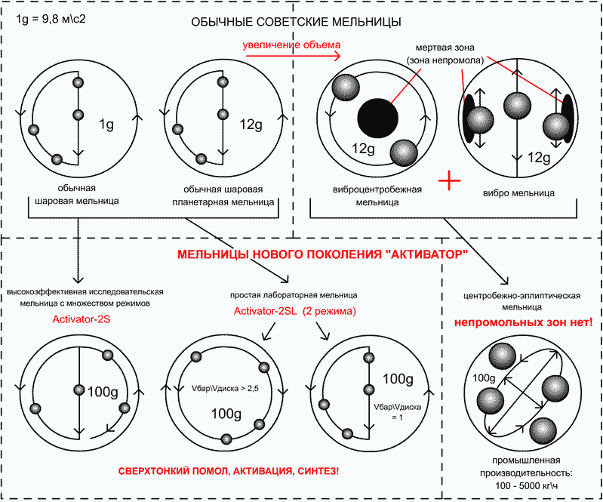
а | b | c
Figure 1.2 – Schemes of movement of grinding bodies during grinding in different mills: a – in the ball mill; b – in the planetary mill; c – in the centrifugal-elliptic mill

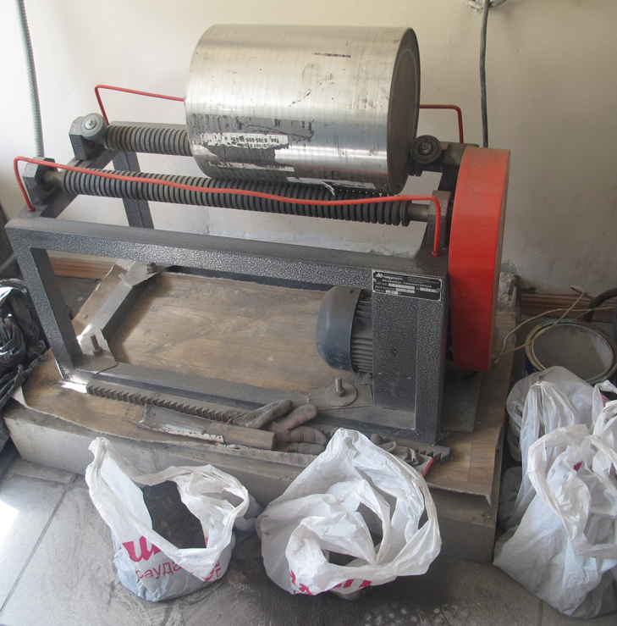
Figure 2.1 – The general view of the laboratory grinding plant “ML-1”

Figure 2.2 – The general view of the planetary mill “Activator 4”

Figure 2.3 – The general view of the vibrating scatterer “Analysette 3”

Figure 2.4 – The general view of the drum rod mixer

Figure 2.5 – The general view of the centrifugal-elliptic mill “Activator C500”

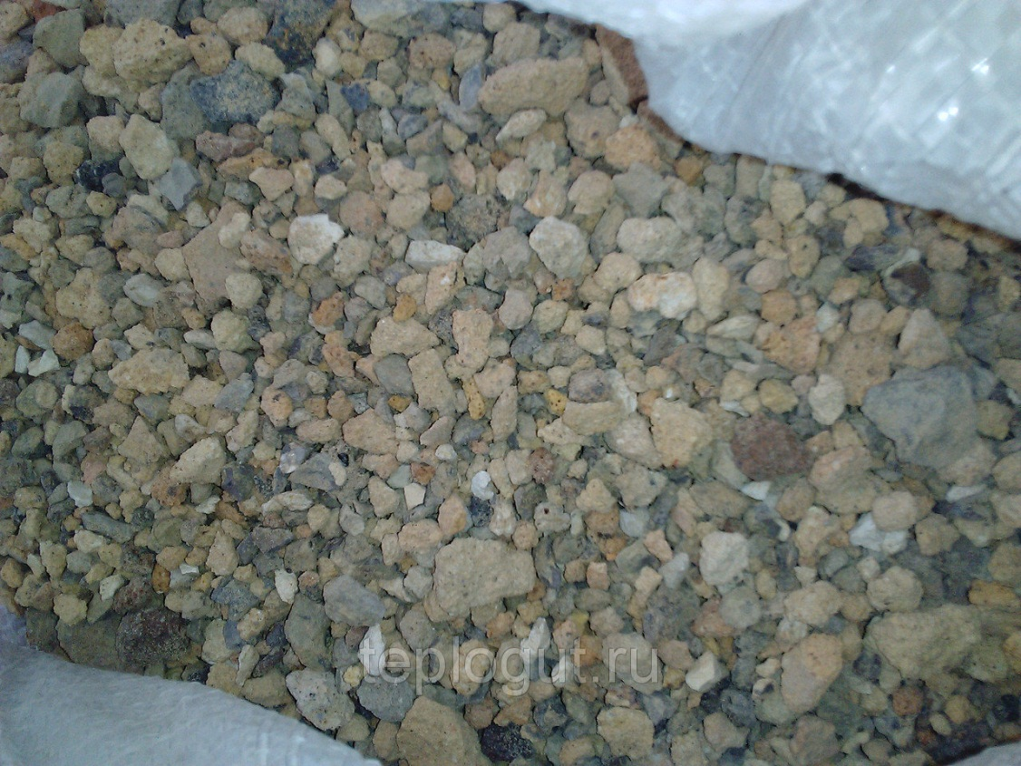

Figure 3.1 – The general view of the scrap chamotte brick

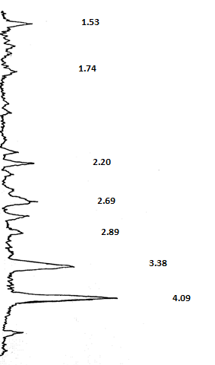

Figure 3.2 – The diffractogram of the scrap chamotte brick

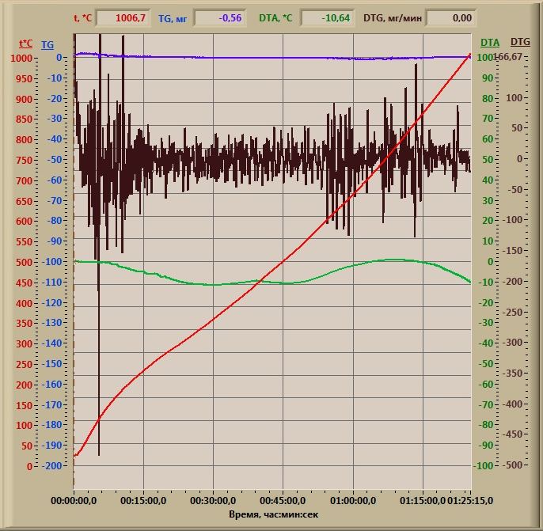

Figure 3.3 – The derivatogram of the scrap chamotte brick

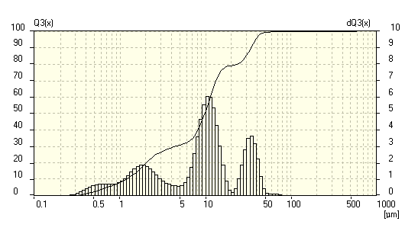
Figure 3.4 – The dispersion spectrum of the sample of the scrap chamotte brick ground in the ball mill

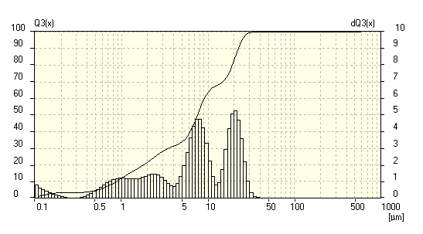
Figure 3.5 – The dispersion spectrum of the sample of the scrap chamotte brick mechanically activated in the activator mill

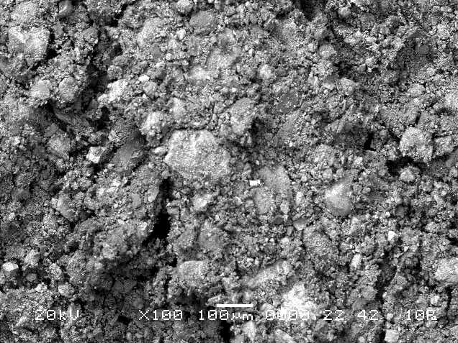
а) 100-fold magnification
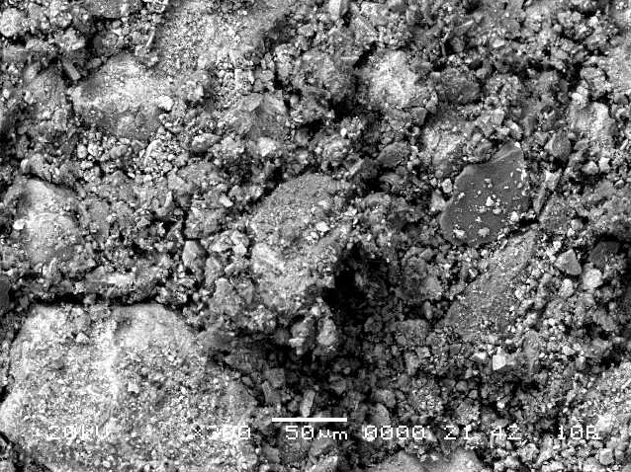
b) 300-fold magnification
Figure 3.6 – Electron microscopic images of the sample of the scrap chamotte brick ground in the ball mill

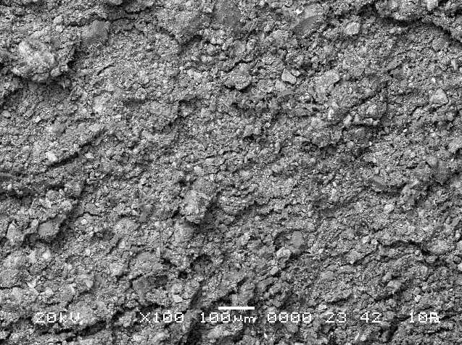
а) 100-fold magnification
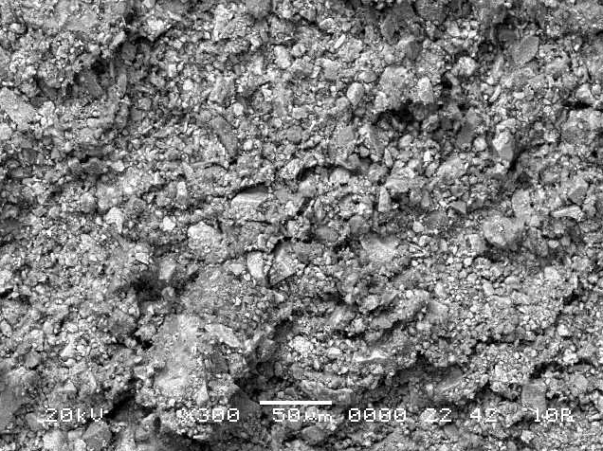
b) 300-fold magnification
Figure 3.7 – Electron microscopic images of the sample of the scrap chamotte brick mechanically activated in the activator mill

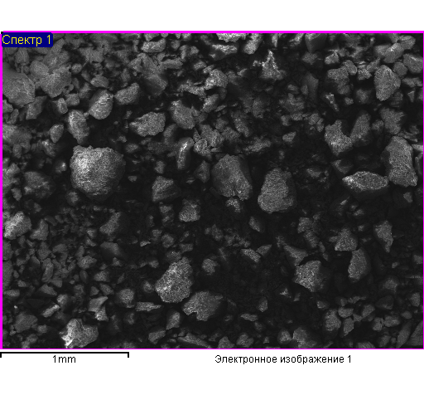
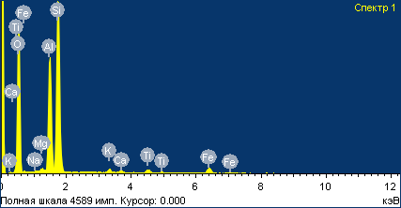

Figure 3.8 – Electronic photo of the surface particle morphology and the spectral analysis of the sample of the scrap chamotte brick ground in the ball mill

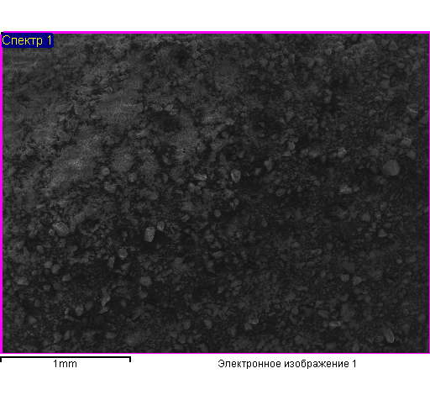
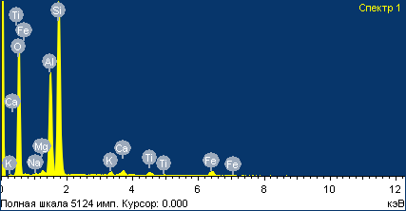

Figure 3.9 – Electronic photo of the surface particle morphology and the spectral analysis of the sample of the scrap chamotte brick mechanically activated in the activator mill

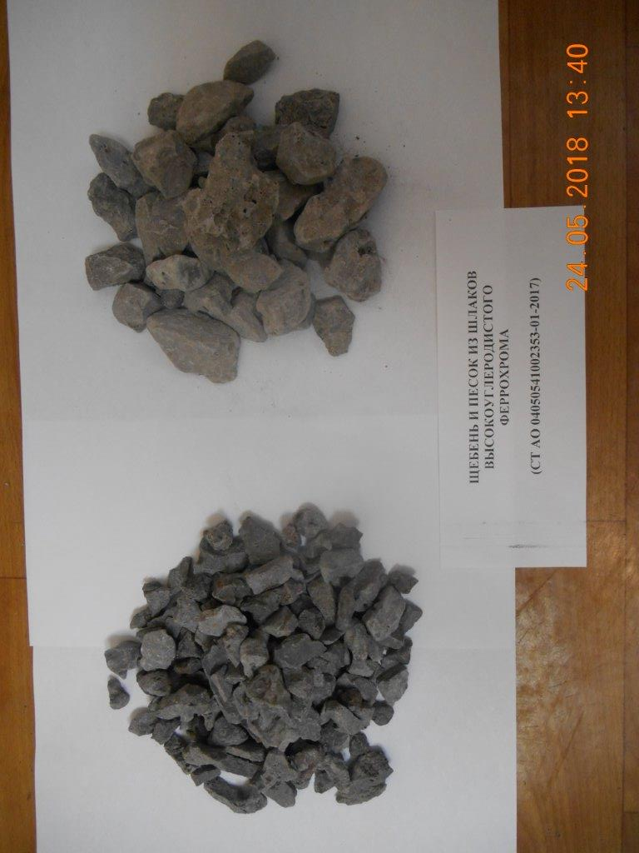
Figure 3.10 – Type of the slag from the high-carbon ferrochrome production

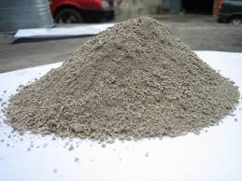
Figure 3.11 – Type of the slag from the low-carbon ferrochrome production

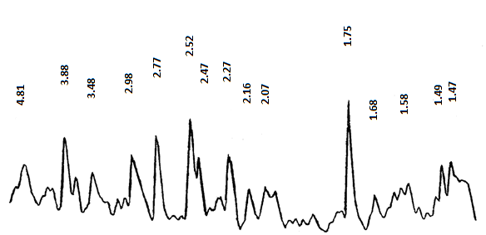

Figure 3.12 – The diffractogram of the slag from the high-carbon ferrochrome production

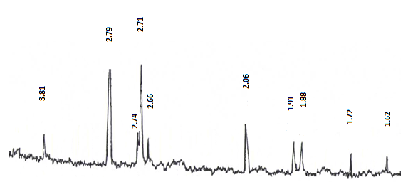
Figure 3.13 – The diffractogram of the slag from the low-carbon ferrochrome production

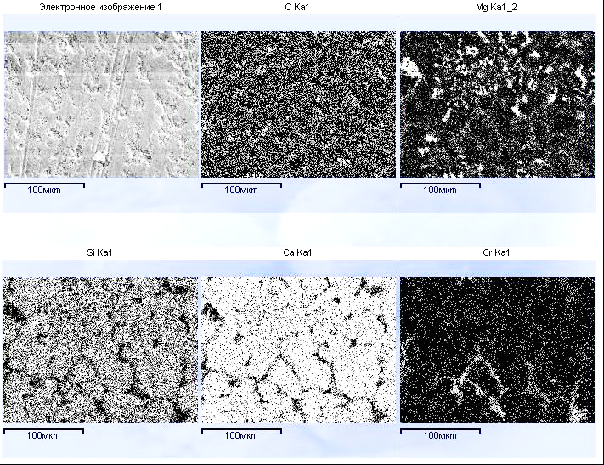

Figure 3.14 – Element-by-element mapping of the structure of the slag from the low-carbon ferrochrome production (x50)

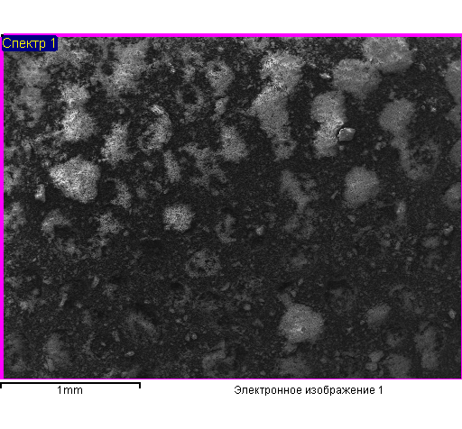
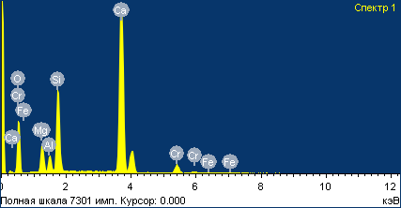

Figure 3.15 – Electronic photo of the surface particle morphology and the spectral analysis of the sample of the slag from the low-carbon ferrochrome production

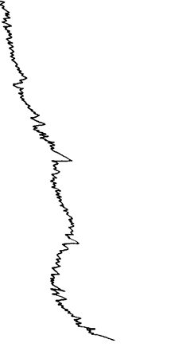

Figure 3.16 – The diffractogram of anhydrous sodium polysilicate

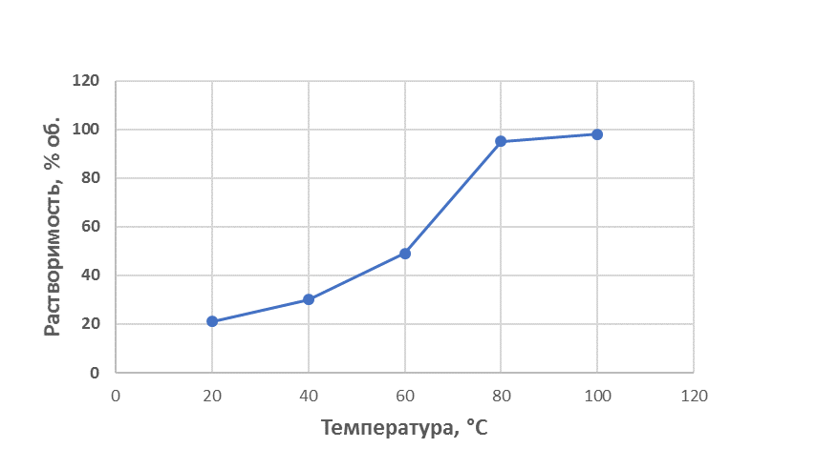
Figure 3.17 – The effect of temperature on the solubility of dispersed sodium polysilicate (S_{sp} = 3000 cm²/g)

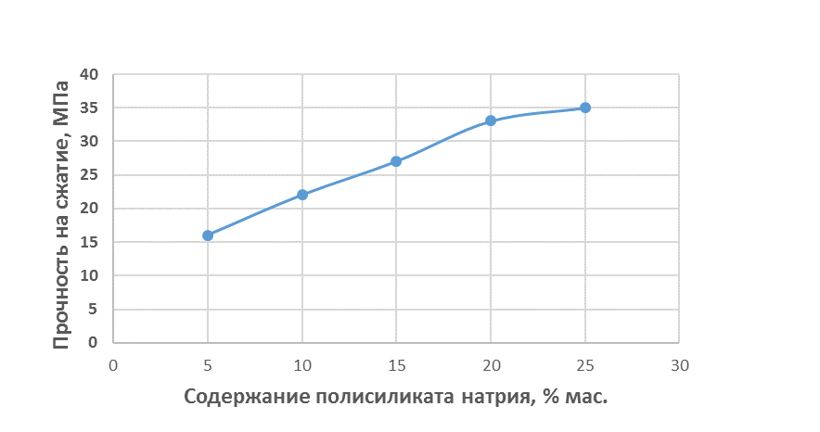
Figure 3.18 – The effect of the content of sodium polysilicate on the strength of the sample of the heat-resistant binder obtained by joint grinding the components in the ball mill (S_{sp} = 3000 cm²/g)
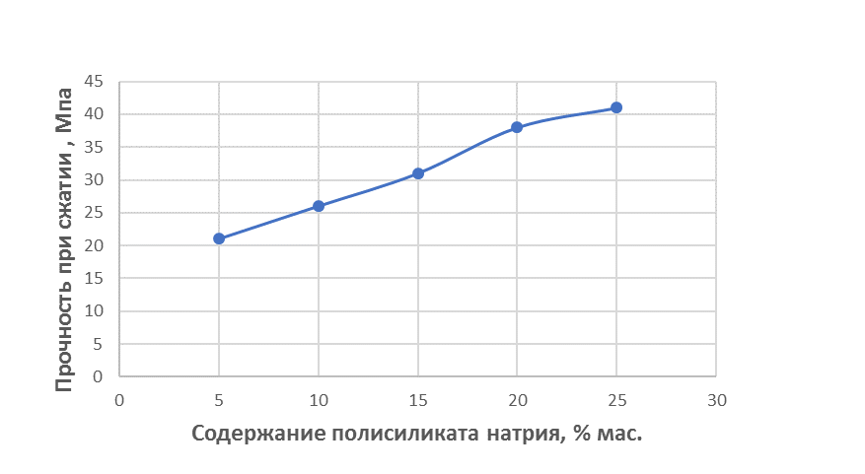
Figure 3.19 – The indicators of strength of the sample of the heat-resistant binder obtained by joint grinding the components in the ball mill
(the hardening of the samples at 95°C)

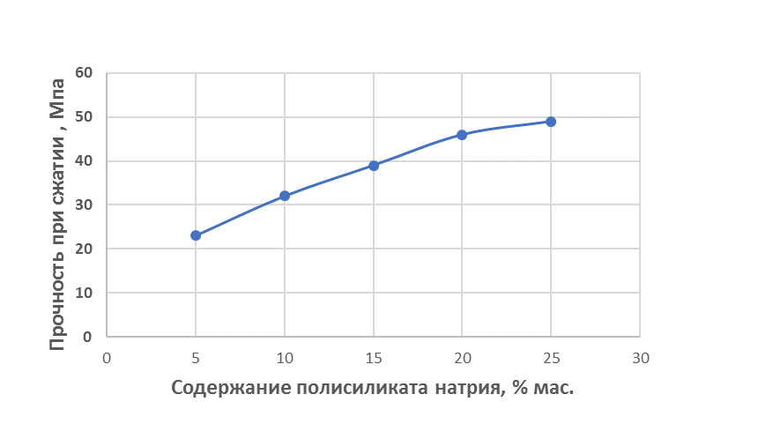
Figure 3.20 – The indicators of strength of the sample of the heat-resistant binder obtained by joint grinding the components in the activator mill
(the hardening of the samples at 95°C)

Figure 3.21 – The indicators of strength of the sample of the heat-resistant binder obtained by joint grinding the components in the ball mill after drying at 200°C

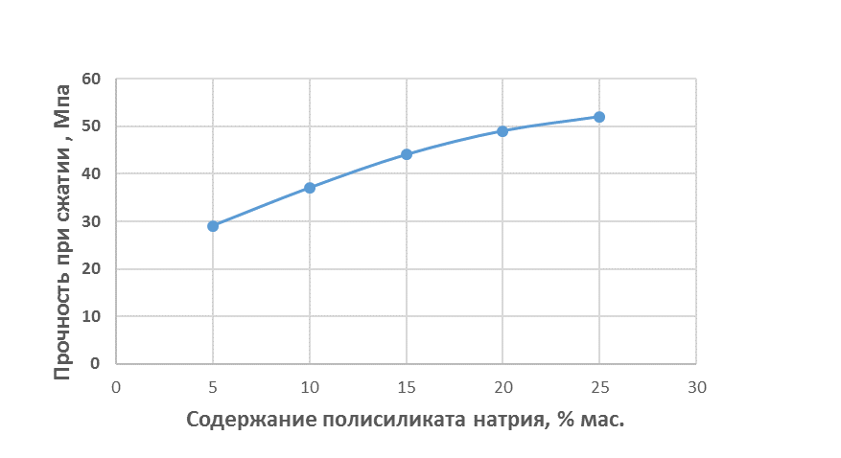
Figure 3.22 – The indicators of strength of the sample of the heat-resistant binder obtained by joint grinding the components in the activator mill after drying at 200°C

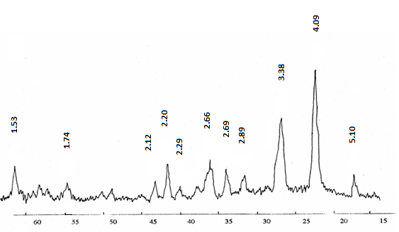
Figure 3.23 – The diffractogram of the hardened sample of the heat-resistant binder obtained by joint grinding in the activator mill of the mixture of sodium polysilicate and chamotte component

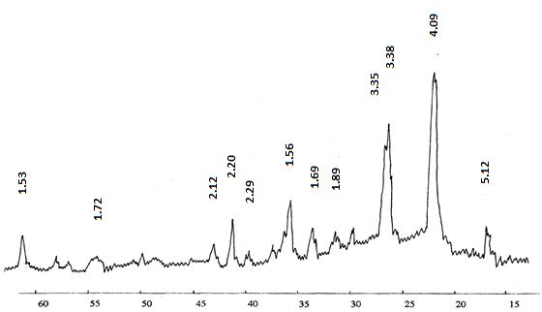

Figure 3.24 – The derivatogram of the hardened sample of the composite heat-resistant binder in the mixture with the finely ground slag of the low-carbon ferrochrome
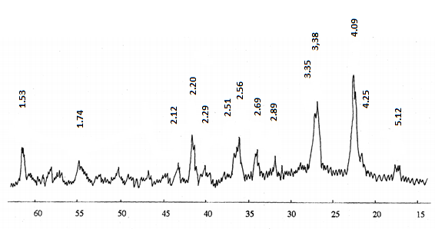
Figure 3.25 – The derivatogram of the hardened sample of the composite heat-resistant binder subjected to the thermal exposure at a temperature of 1000°C

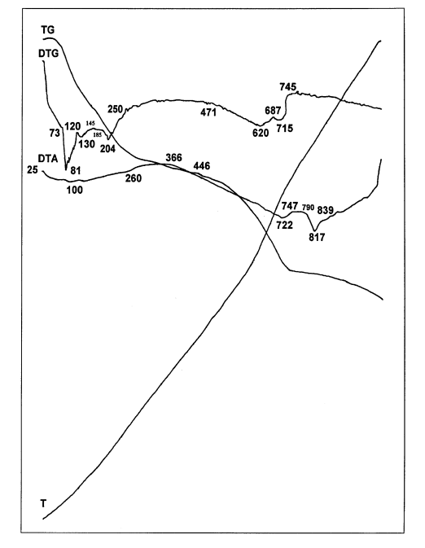
Figure 3.26 – The derivatogram of the hardened sample of the heat-resistant binder obtained by joint grinding in the activator mill of the mixture of sodium polysilicate and chamotte component

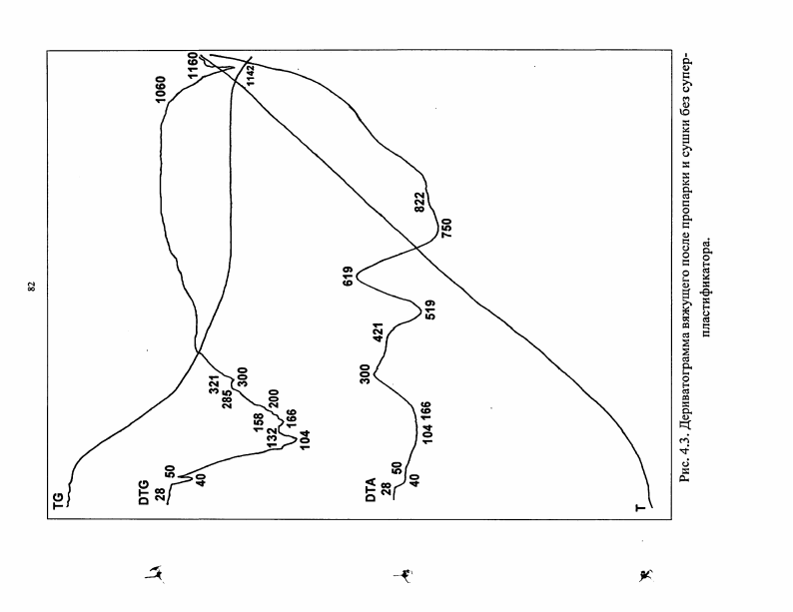

Figure 3.27 – The derivatogram of the hardened sample of the composite heat-resistant binder in the mixture with the finely ground slag of the low-carbon ferrochrome

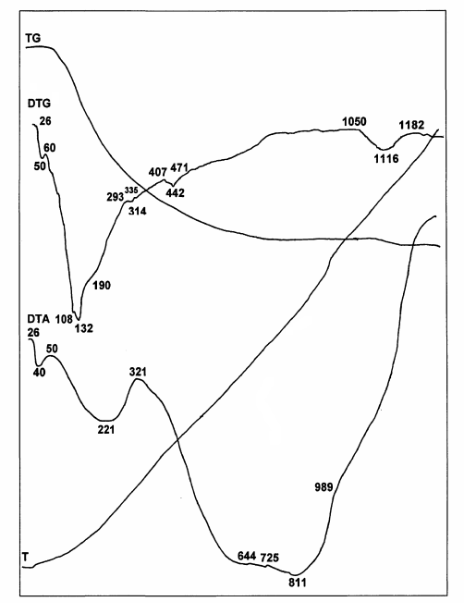
Figure 3.28 – The derivatogram of the hardened sample of the composite heat-resistant binder subjected to the thermal exposure at a temperature of 1000°C

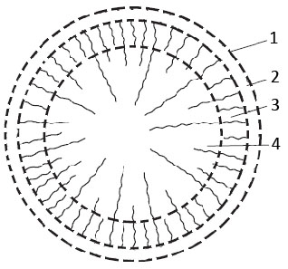

1 – amorphized surface layer;
2 – deformed near-surface layer;
3 – weakly deformed inner layer;
4 – core
Figure 3.29 – Model of the mechanically activated particle’s structure

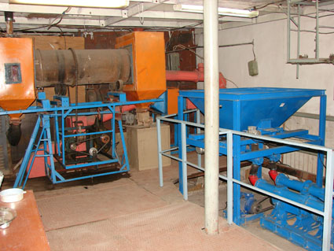
Figure 4.1 – The general view of the pilot production line

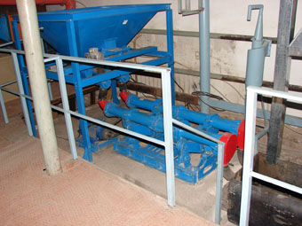
Figure 4.2 – The general view of “Activator C500” centrifugal-elliptic mill

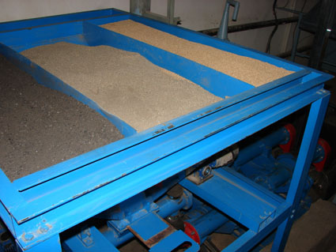
Figure 4.3 – The general view of “Activator C500” CEM bunkers

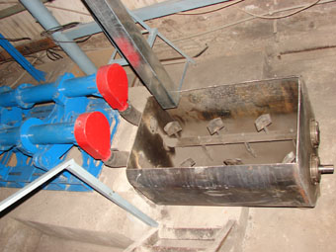
Figure 4.4 – The general view of the two-shaft paddle mixer

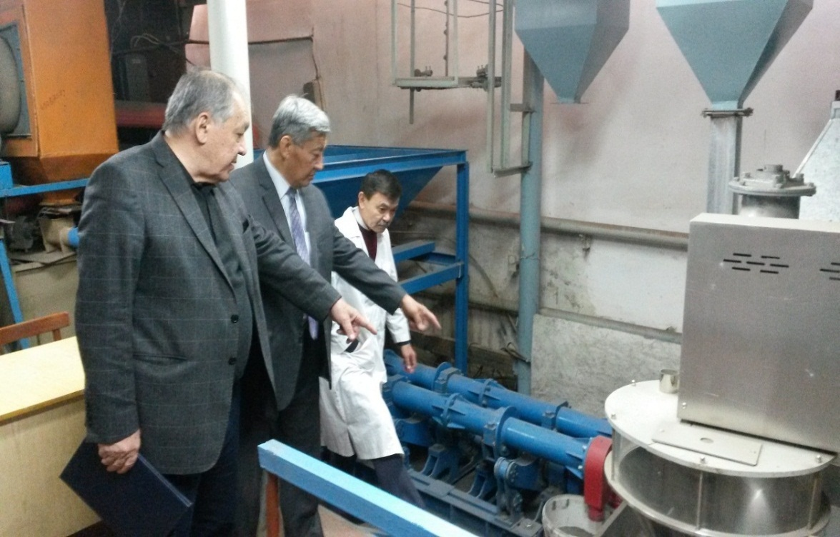
From the left to the right: Bazhirov N.S., Doctor of Technical Sciences, Professor,
Zhantasov K.T., Doctor of Technical Sciences, Professor,
Dauletiyarov M.S., Candidate of Technical Sciences
Figure 4.5 – Working moment during pilot testing for the production of heat-resistant composite binders on the production line with “Activator C500” CEM

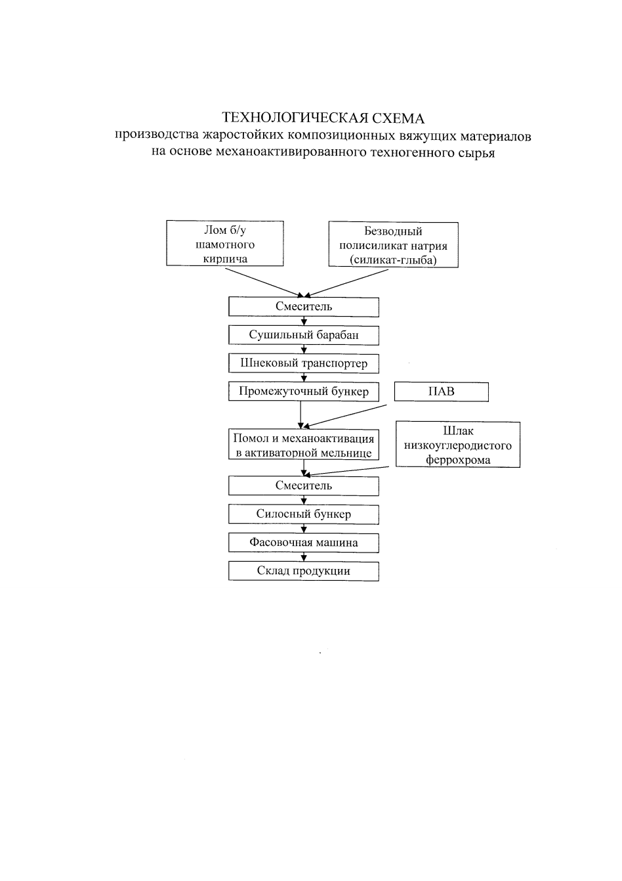
Figure 4.6 – Technological scheme for the production of heat-resistant
composite binders

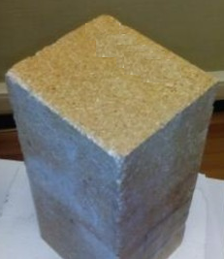
Figure 4.7 - Sample of heat-resistant concrete based on heat-resistant
composite binder

APPENDIX C
Contract 164-4 dated 15 March 2018
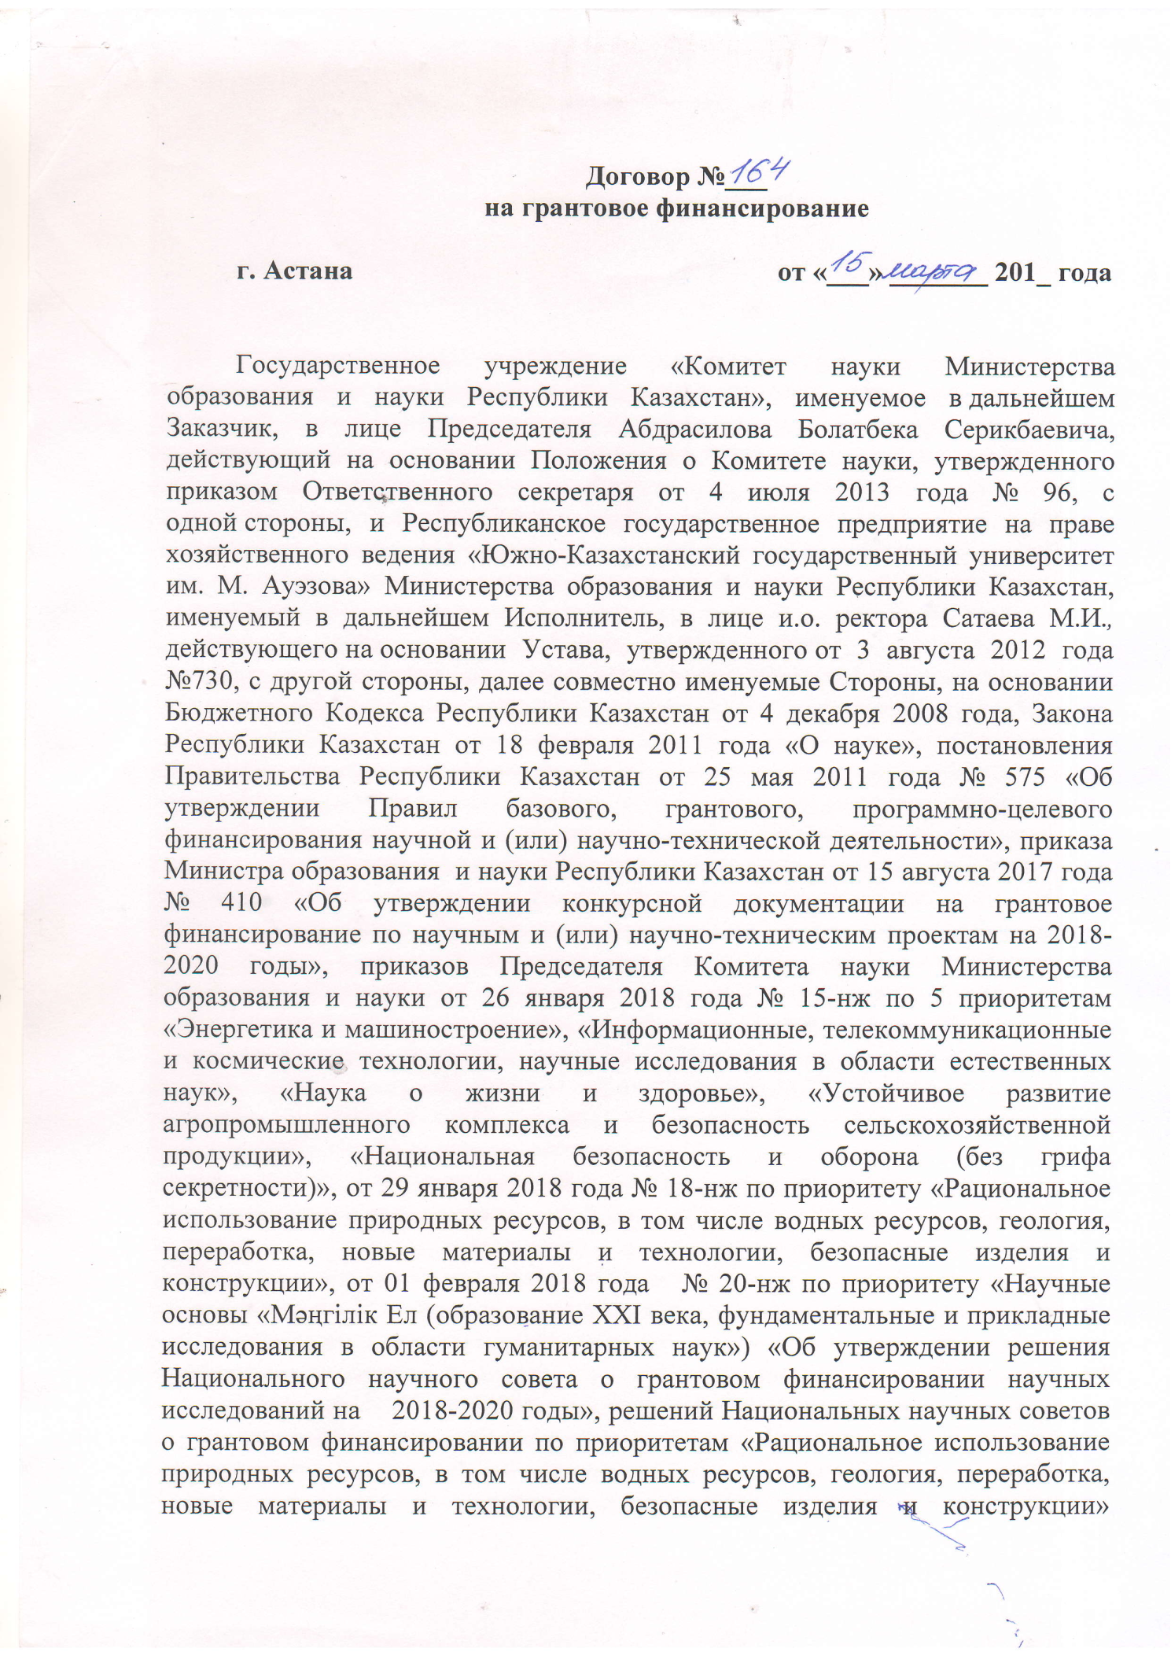

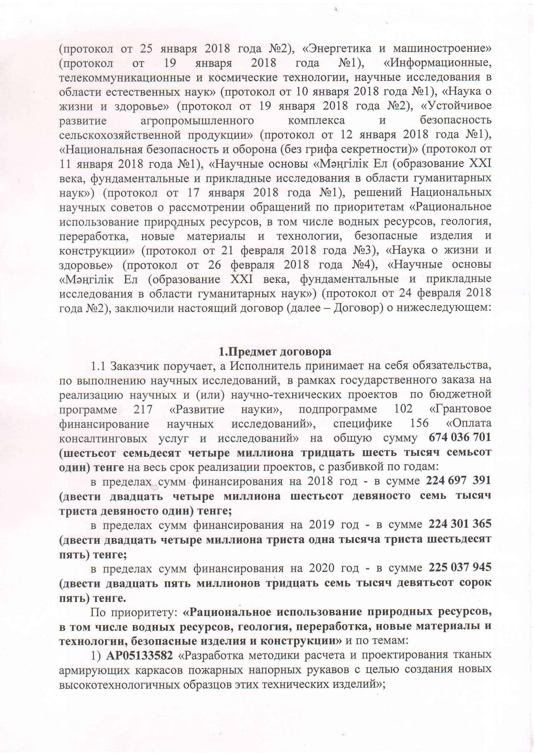
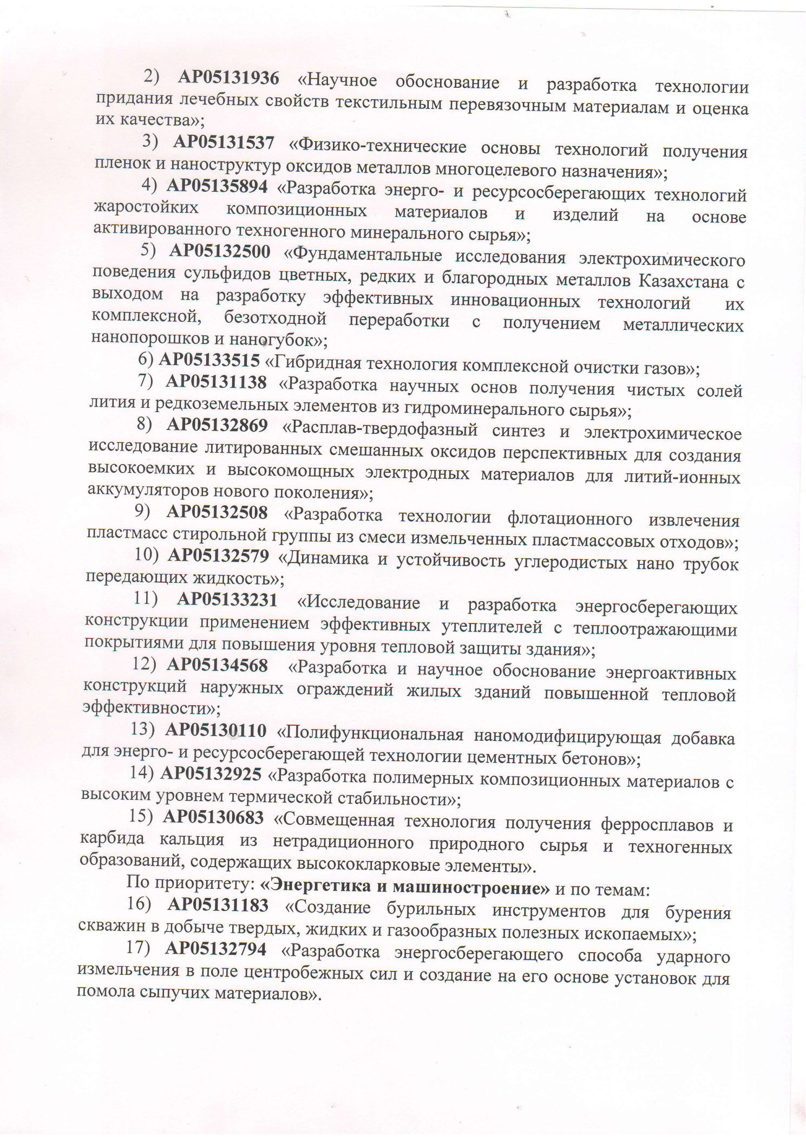

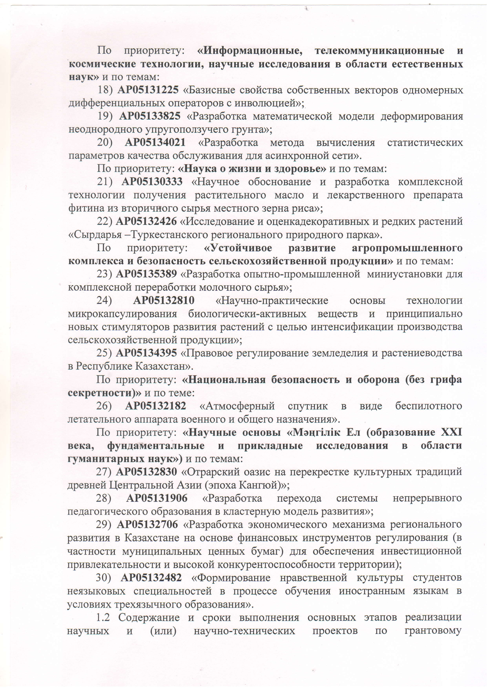

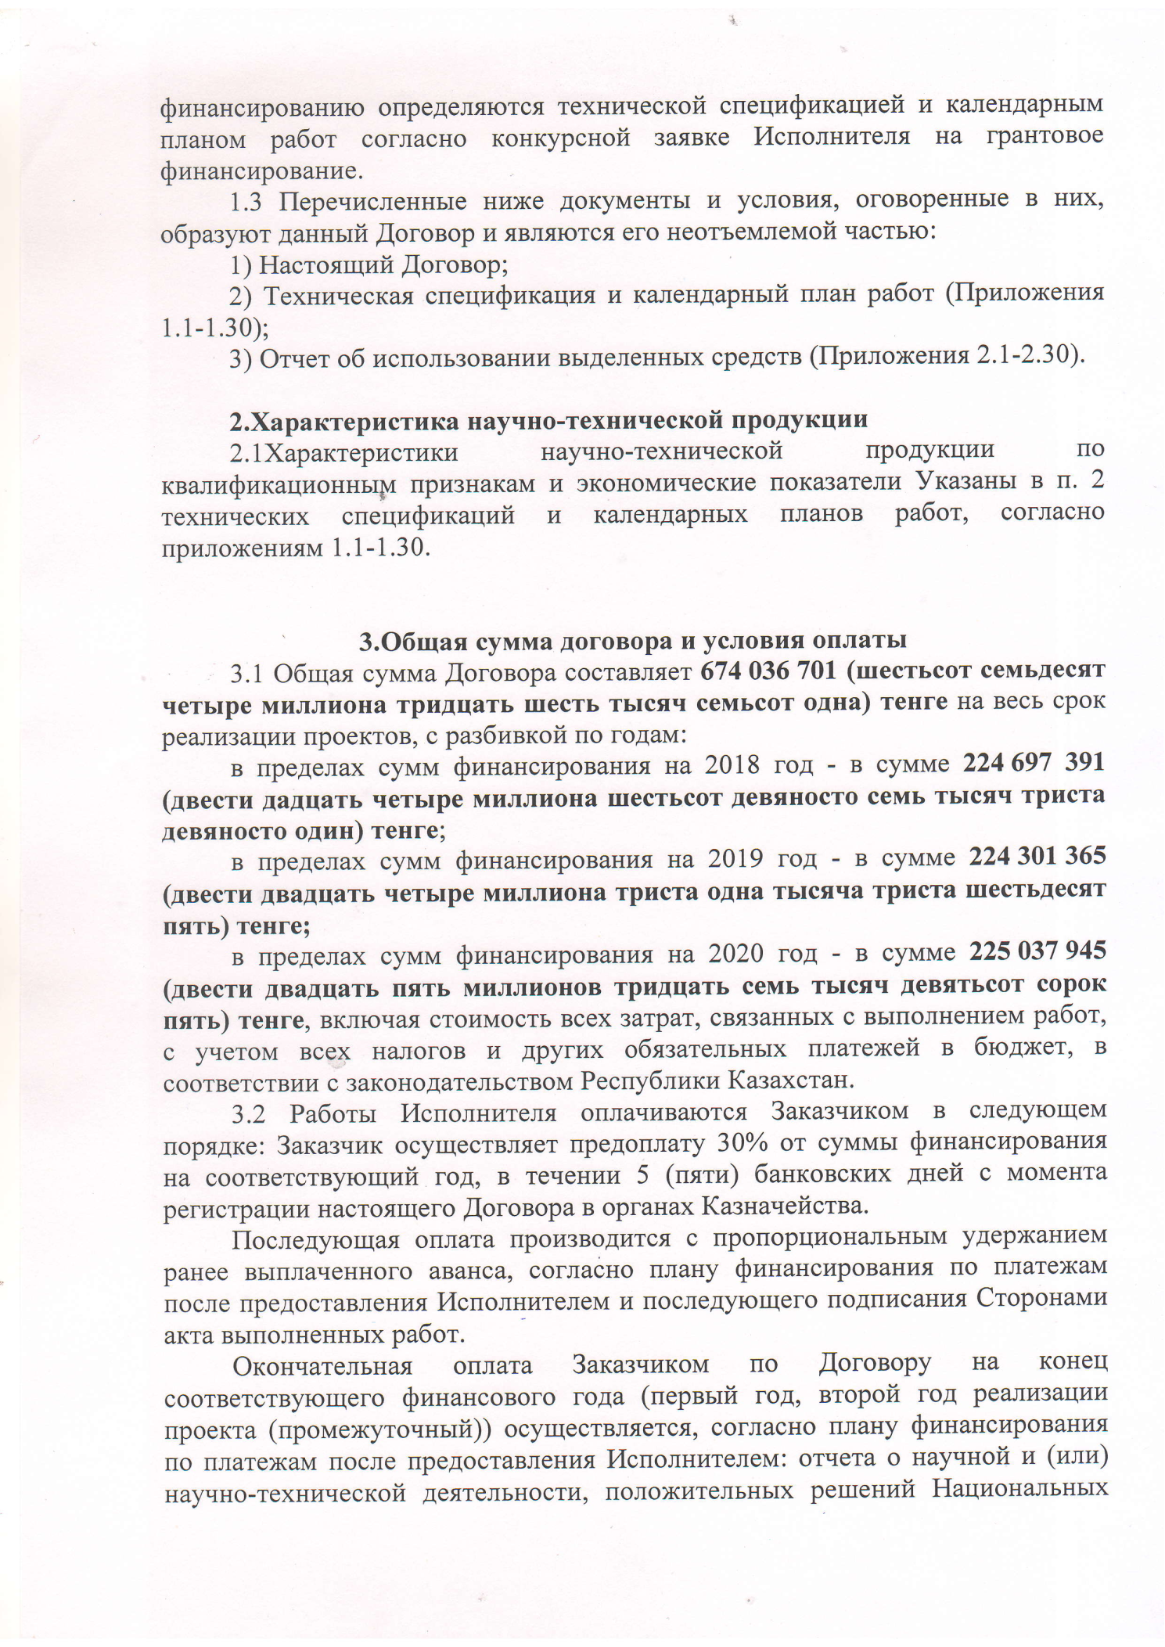

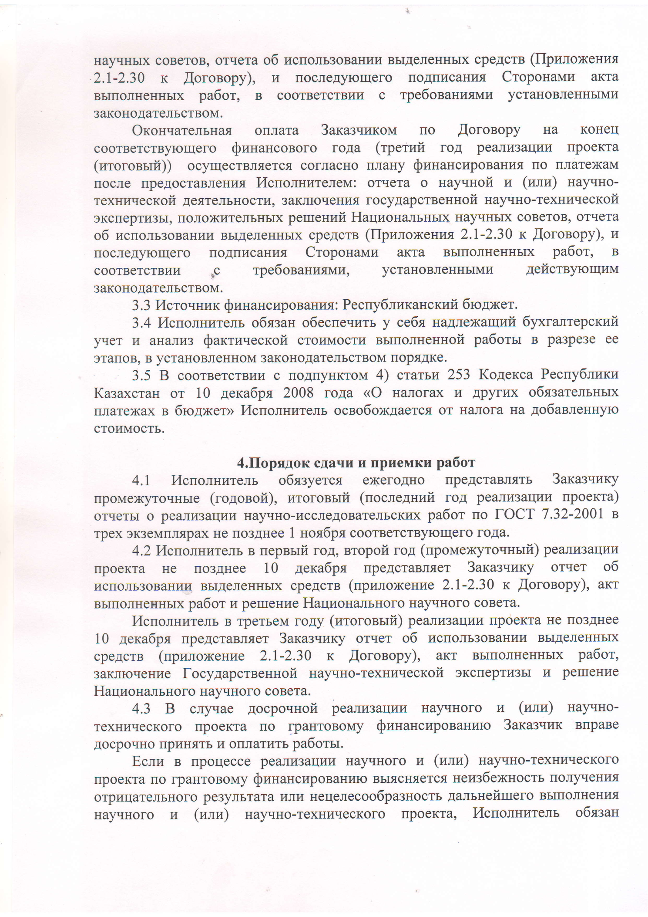

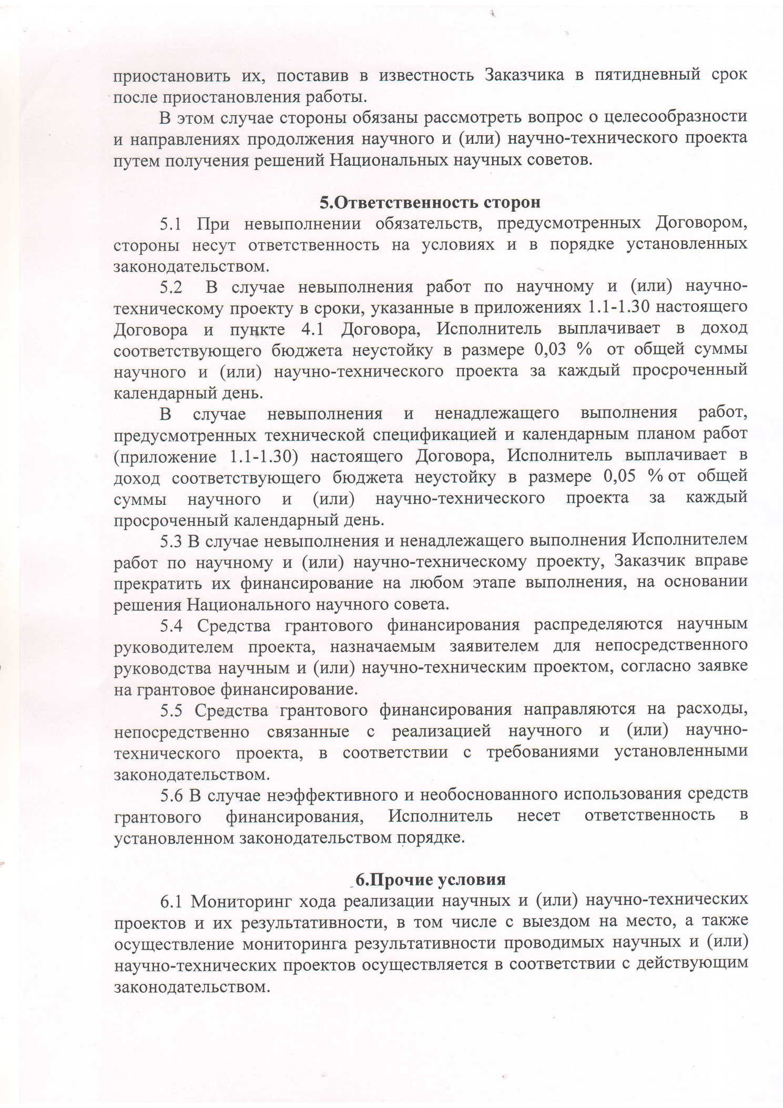

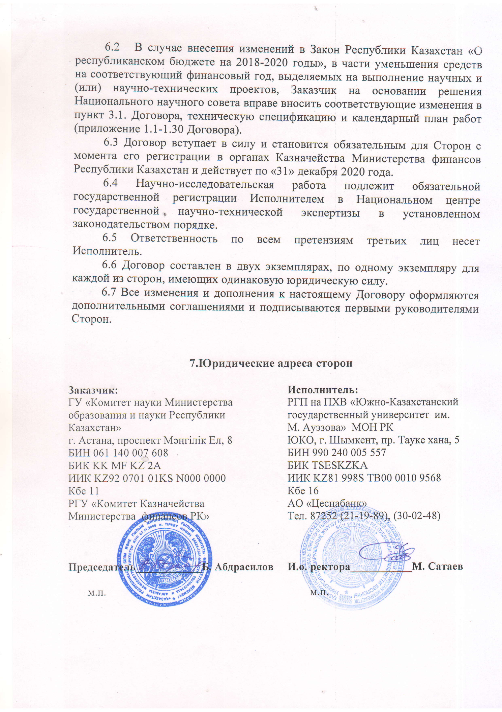

APPENDIX D
Work schedule

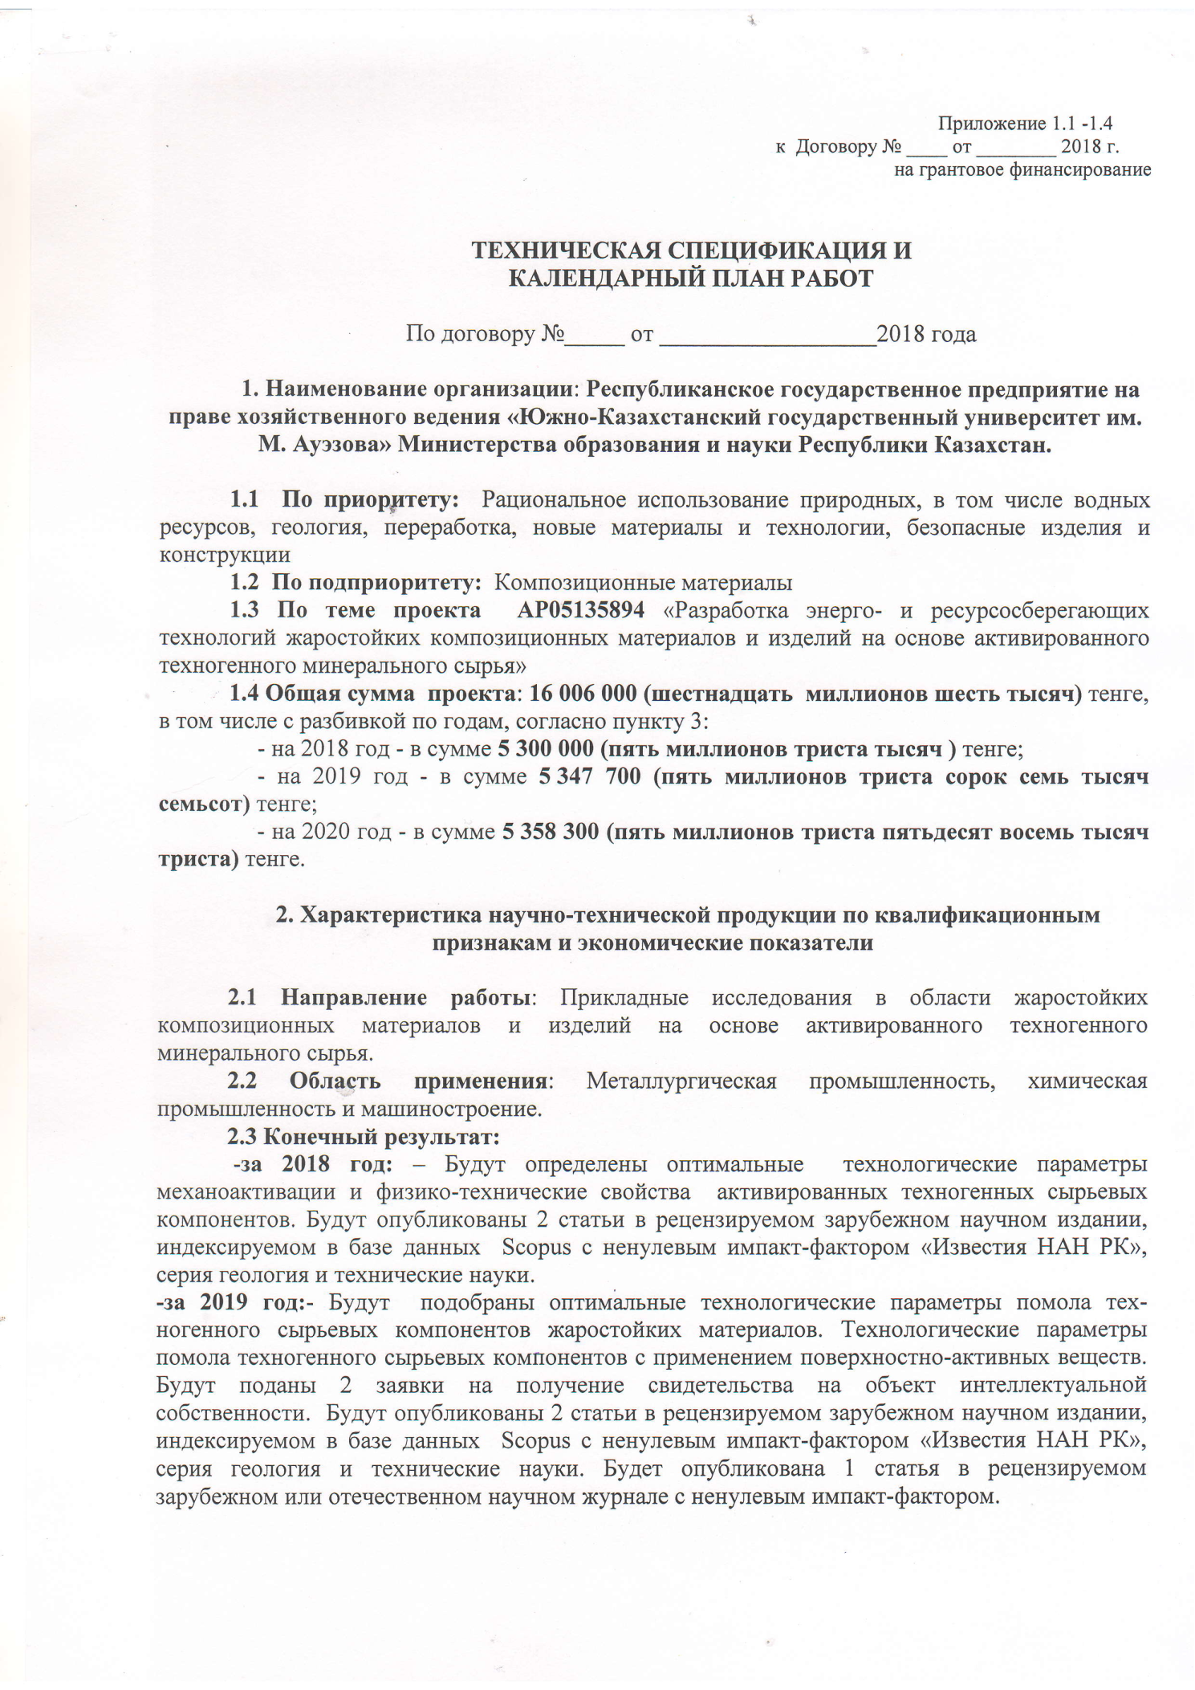

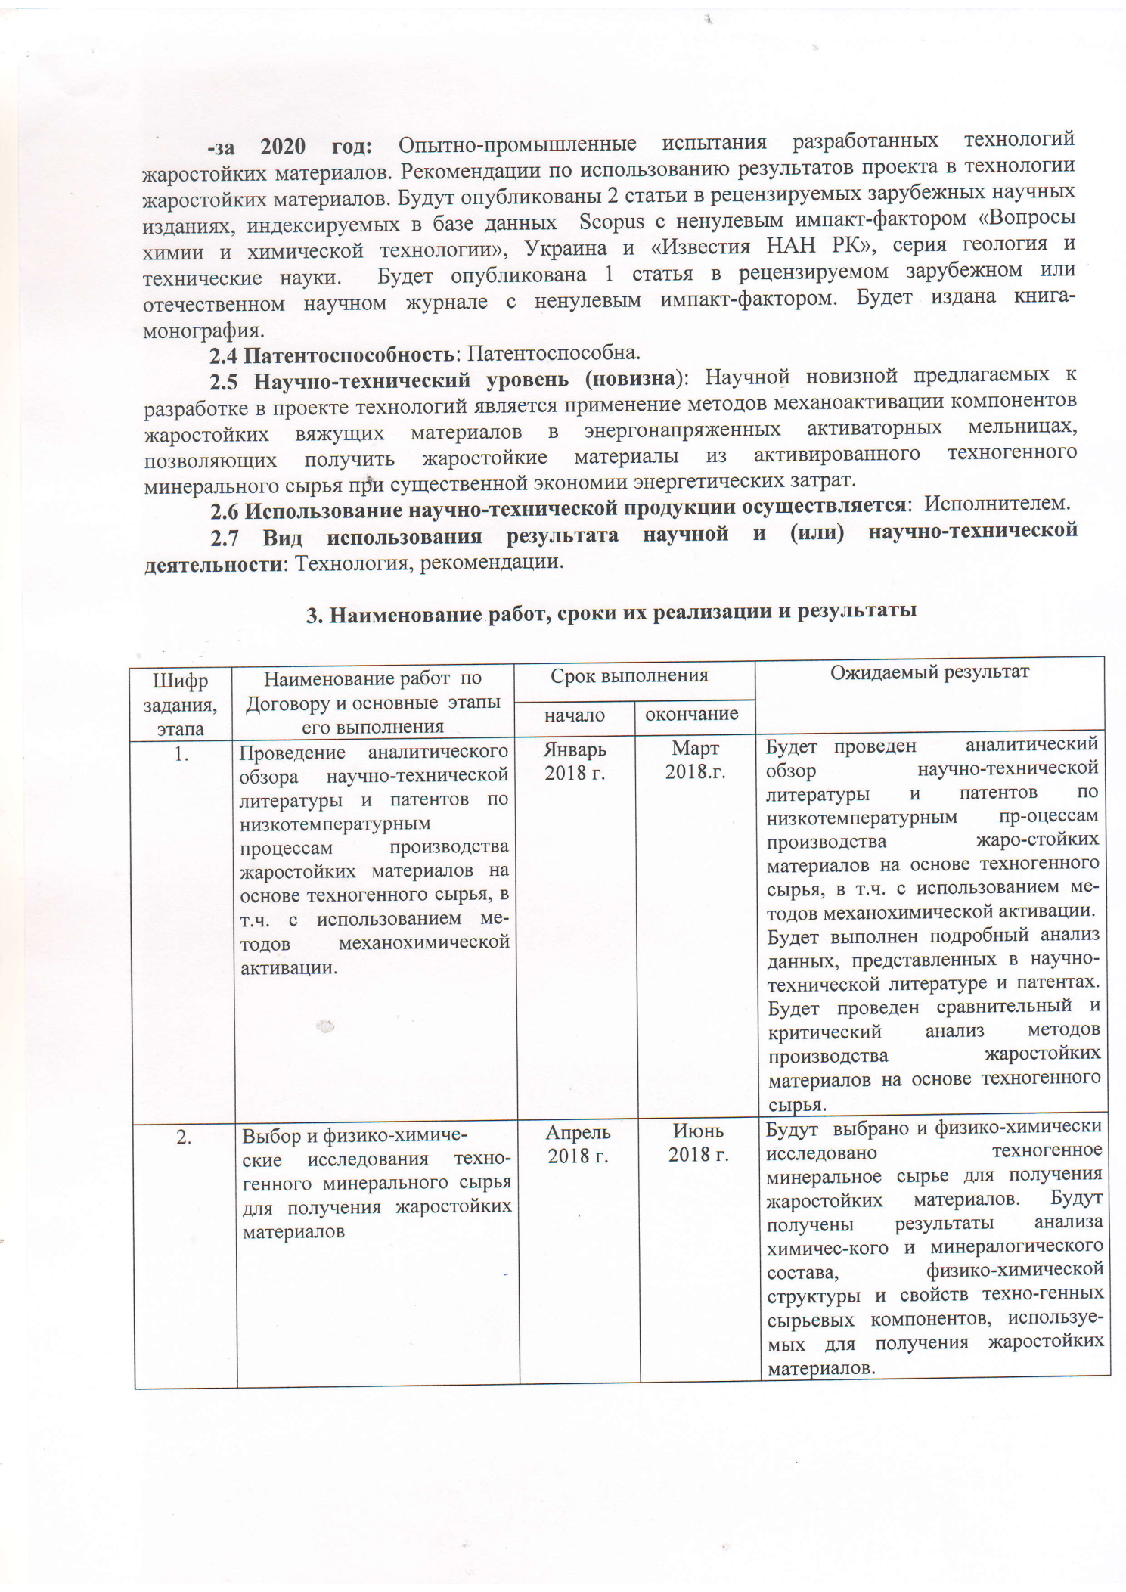

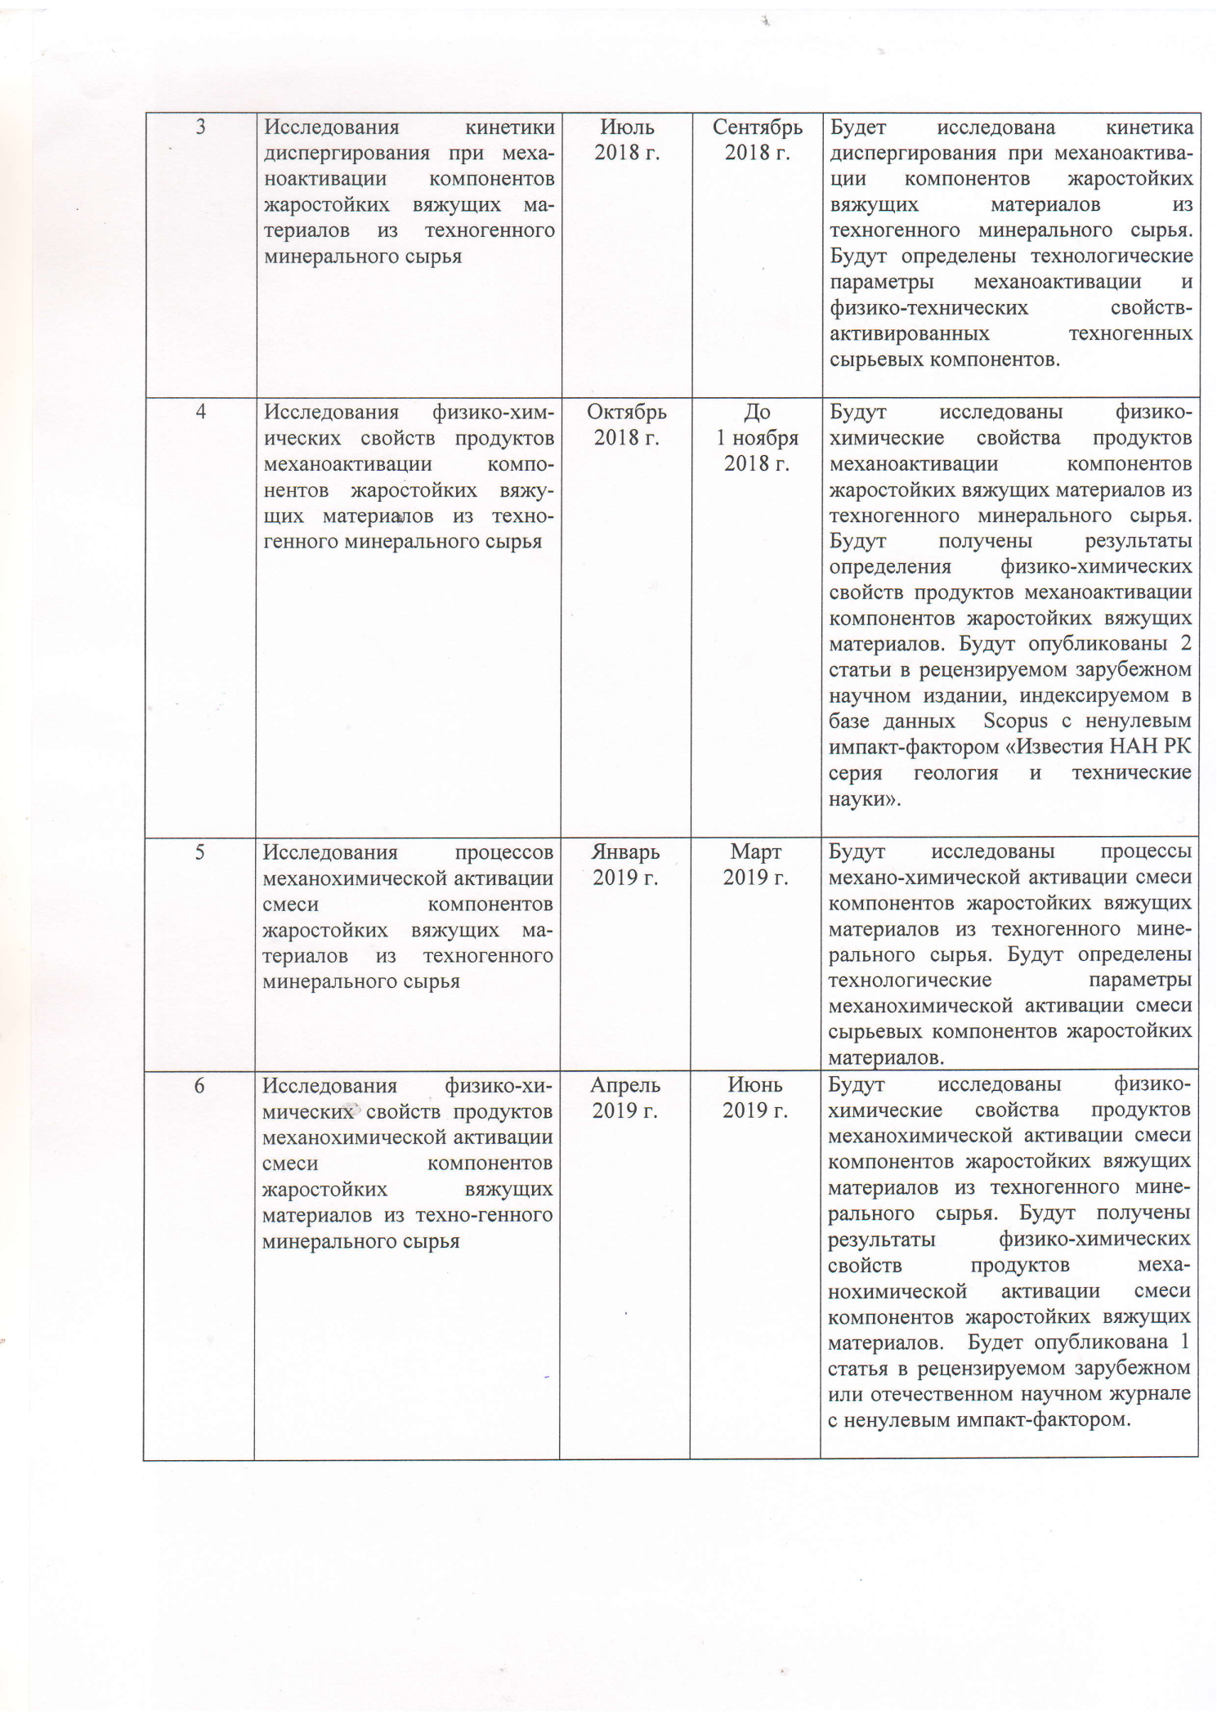

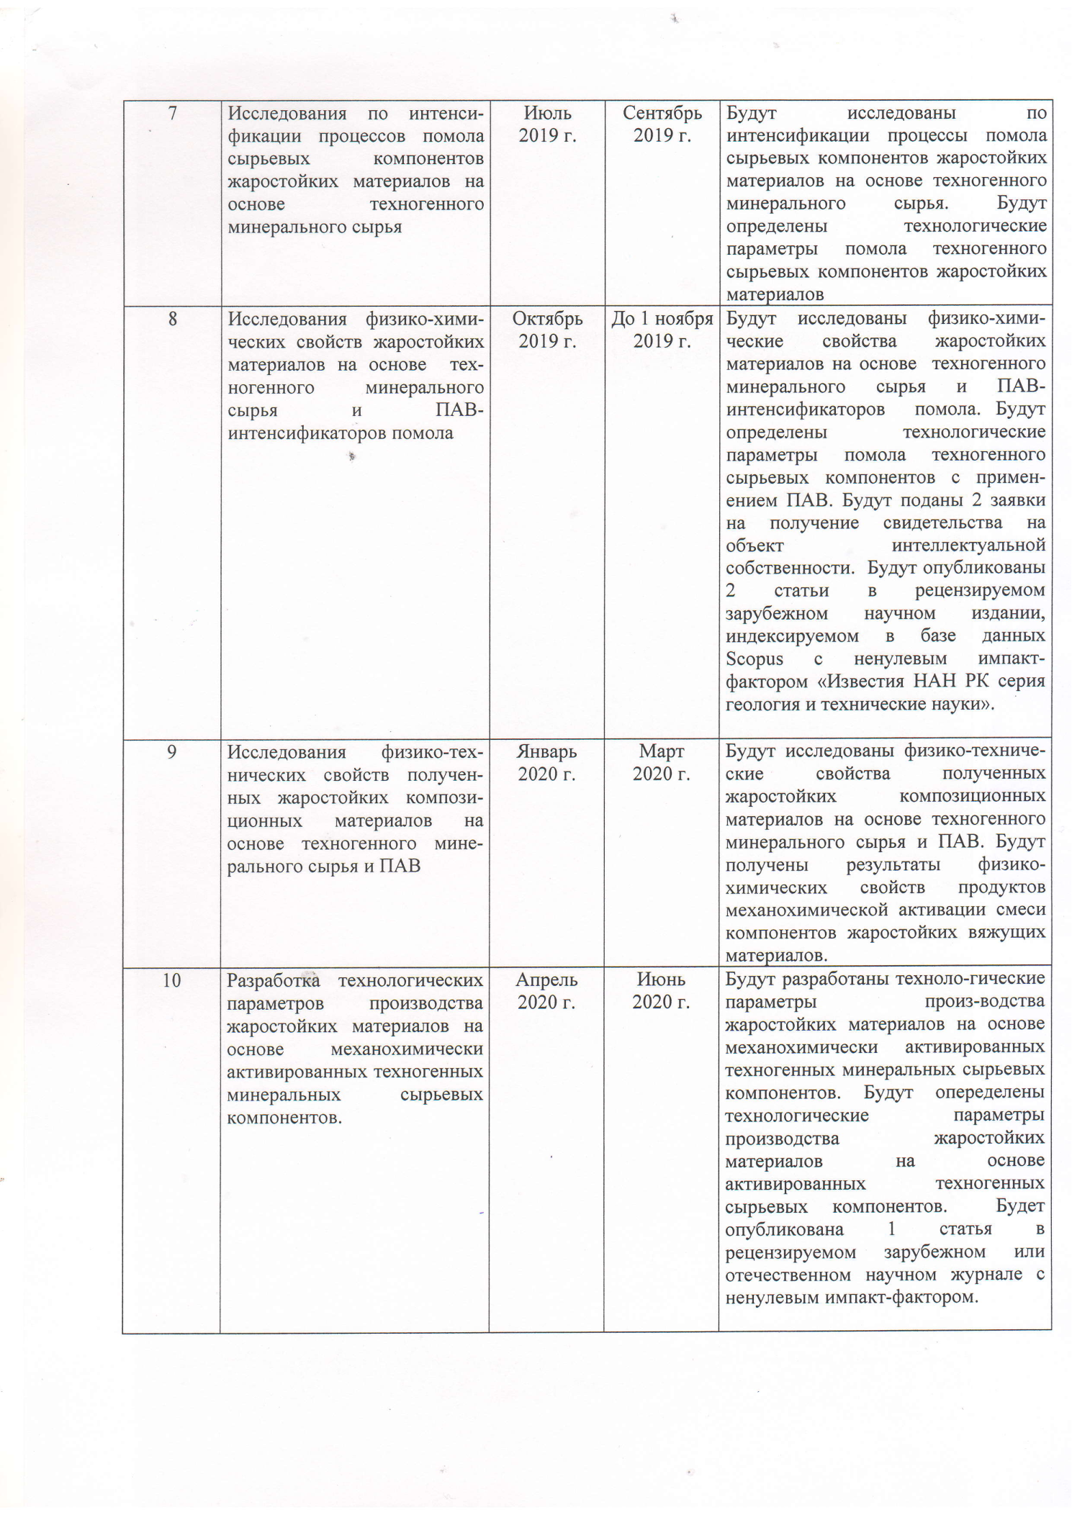

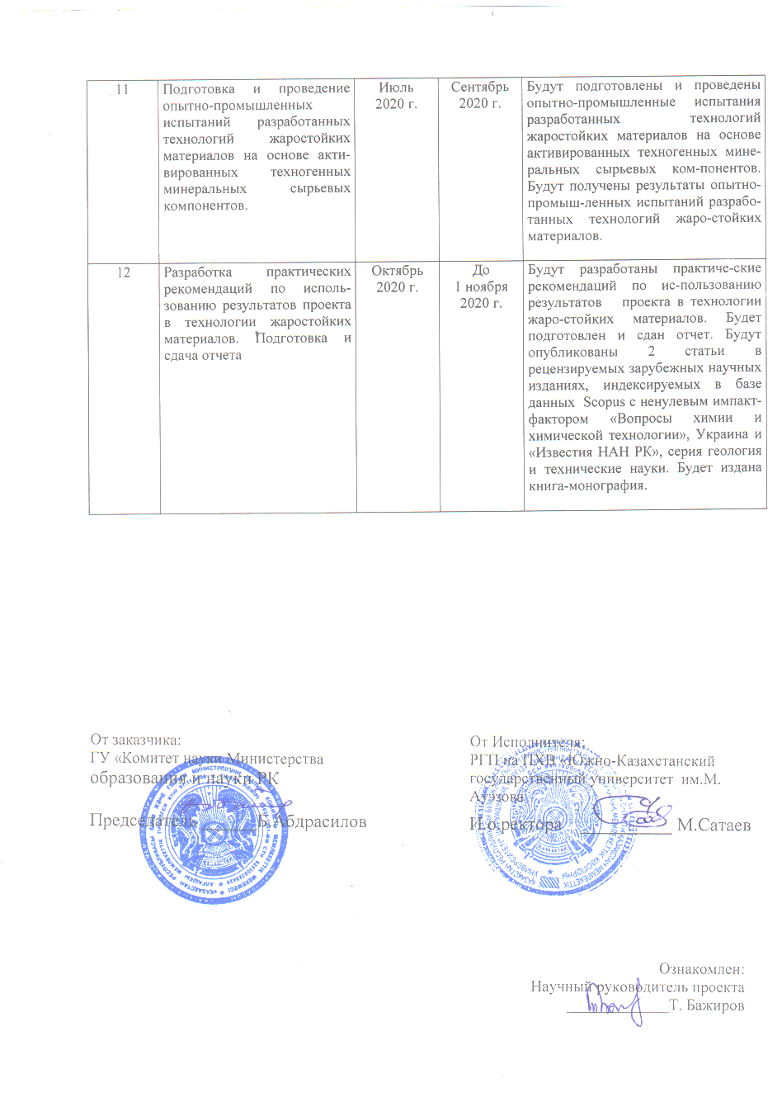

Work schedule

Code of task, stage | Name of works under the contract and the main stages of its implementation | Performance time |  | Expected result
Code of task, stage |  | Start | End | Expected result
1 | Conducting the analytical review of scientific and technical literature and patents on low-temperature processes for the production of heat-resistant materials based on technogenic raw materials, including with the use of methods of mechanochemical activation. | January  2018 | March 2018 | The analytical review of scientific and technical literature and patents on low-temperature processes for the production of heat-resistant materials based on technogenic raw materials, including with the use of methods of mechanochemical activation will be conducted.  The detailed analysis of the data presented in the scientific and technical literature and patents will be performed.  The comparative and critical analysis of methods for the production of heat-resistant materials based on technogenic raw materials will be carried out.
2 | Selection and physicochemical studies of technogenic mineral raw materials for obtaining heat-resistant materials. | April 2018 | June  2018 | The technogenic mineral raw materials will be selected and physicochemically studied to obtain heat-resistant materials.  The results of the analysis of the chemical and mineralogical composition, physicochemical structure and properties of technogenic raw materials used to obtain heat-resistant materials will be obtained.
3 | Investigations of the kinetics of dispersion during mechanical activation of the components of heat-resistant binders from technogenic mineral raw materials. | July 2018 | September 2018 | The kinetics of dispersion during mechanical activation of the components of heat-resistant binders from technogenic mineral raw materials will be investigated.  Technological parameters of mechanical activation and physical and technical properties of activated technogenic raw materials will be determined.
4 | Investigations of the physicochemical properties of the products of mechanical activation of the components of heat-resistant binders from technogenic mineral raw materials. | October 2018 | Before 1 November 2018 | The physicochemical properties of the products of mechanical activation of the components of heat-resistant binders from technogenic mineral raw materials will be investigated.  The results of determining the physicochemical properties of the products of mechanical activation of the components of heat-resistant binders will be obtained.  2 articles will be published in a peer-reviewed scientific journal, indexed in the Scopus database with a nonzero impact factor “News of the National Academy of Sciences of the Republic of Kazakhstan. Series of geology and technical sciences”.
5 | Investigation of the processes of mechanochemical activation of the mixture of components of heat-resistant binders from technogenic mineral raw materials. | January 2019 | March 2019 | The processes of mechanochemical activation of the mixture of components of heat-resistant binders from technogenic mineral raw materials will be investigated.  Technological parameters of mechanochemical activation of the mixture of raw materials of heat-resistant materials will be determined.
6 | Investigation of the physicochemical properties of the products of mechanochemical activation of the mixture of components of heat-resistant binders from technogenic mineral raw materials. | April 2019 | June 2019 | The physicochemical properties of the products of mechanochemical activation of the mixture of components of heat-resistant binders from technogenic mineral raw materials will be investigated.  The results of the physicochemical properties of the products of mechanochemical activation of the mixture of components of heat-resistant binders will be obtained.  1 article will be published in a peer-reviewed foreign or domestic scientific journal with a nonzero impact factor.
7 | Research on the intensification of grinding processes of raw materials of heat-resistant materials based on technogenic mineral raw materials. | July 2019 | September 2019 | The intensification of grinding processes of raw materials of heat-resistant materials based on technogenic mineral raw materials will be researched.  Technological parameters of grinding of technogenic raw materials of heat-resistant materials will be determined.
8 | Investigations of the physicochemical properties of heat-resistant materials based on technogenic mineral raw materials and surfactants – intensifiers of grinding. | October 2019 | Before 1 November 2019 | The physicochemical properties of heat-resistant materials based on technogenic mineral raw materials and surfactants – intensifiers of grinding – will be investigated.  The technological parameters of grinding technogenic raw materials using surfactants will be determined.  2 applications will be filed for obtaining the certificate for the intellectual property object.  2 articles will be published in a peer-reviewed scientific journal, indexed in the Scopus database with a nonzero impact factor “News of the National Academy of Sciences of the Republic of Kazakhstan. Series of geology and technical sciences”.
9 | Investigation of the physical and technical properties of the obtained heat-resistant composite materials based on technogenic mineral raw materials and surfactants. | January 2020 | March 2020 | The physical and technical properties of the obtained heat-resistant composite materials based on technogenic mineral raw materials and surfactants will be investigated.  The results of the physicochemical properties of the products of mechanochemical activation of the mixture of components of heat-resistant binders will be obtained.
10 | Development of technological parameters for the production of heat-resistant materials based on mechanochemically activated technogenic mineral raw materials. | April 2020 | June 2020 | The technological parameters for the production of heat-resistant materials based on mechanochemically activated technogenic mineral raw materials will be developed.  The technological parameters for the production of heat-resistant materials based on mechanochemically activated technogenic mineral raw materials will be determined.  1 article will be published in a peer-reviewed foreign or domestic scientific journal with a nonzero impact factor.
11 | Preparation and carrying out of pilot tests of the developed technologies of heat-resistant materials based on activated technogenic mineral raw materials. | July 2020 | September 2020 | The pilot tests of the developed technologies of heat-resistant materials based on activated technogenic mineral raw materials will be prepared and carried out.  The results of the pilot tests of the developed technologies of heat-resistant materials will be obtained.
12 | Development of practical recommendations for using the project results in the technology of heat-resistant materials. Preparation and submission of the report. | October 2020 | Before 1 November 2020 | Practical recommendations for using the project results in the technology of heat-resistant materials will be developed.  The report will be prepared and submitted.  2 articles will be published in peer-reviewed scientific journals, indexed in the Scopus database with a nonzero impact factor of “Issues of chemistry and chemical technology”, Ukraine, and “News of the National Academy of Sciences of the Republic of Kazakhstan. Series of geology and technical sciences”.  1 book-monograph will be published.

APPENDIX E
Copy of the scientific and technical council’s protocol for 2020

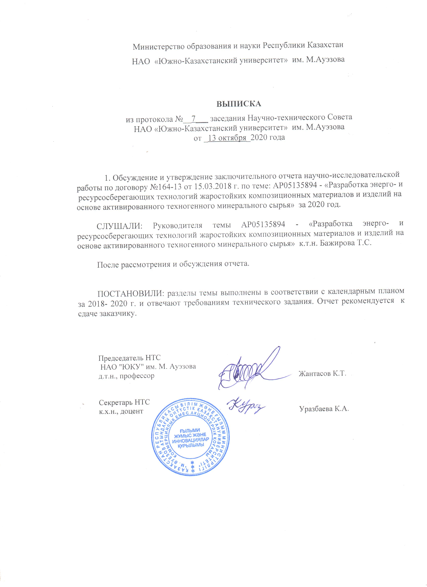
APPENDIX F
LIST
of published scientific work by the project for 2018

1. Bazhirov N.S., Dauletiyarov M.S., Bazhirov T.S., Serikbayev B.E., Bazhirova K.N. Research of waste of aluminum production as the raw components in technology of composite cementing materials. // New of NAS RK, Series of geology and technical sciences, 2018, № 1(427). – P. 93-98.
2. Bazhirov N.S., Serikbayev B.E., Bazhirov T.S. Composite binding materials with thermally activated bauxite sludge // Advanced technologies in modern mechanical engineering. Composite building materials. Theory and practice. – Penza (Russia), 2018. – P. 117-121 (Russian).
3. Bazhirov N.S., Serikbayev B.E., Bazhirov T. S. Investigation of strength properties of composite binders with bauxite sludge // Advanced technologies in modern mechanical engineering. Composite building materials. Theory and practice. – Penza (Russia), 2018. – P. 122-126 (Russian).
4. Bazhirov N.S., Bazhirov T.S., Dauletiyarov M.S., Bazhirov N.S. Physical and chemical studies of the processes of thermal activation of bauxite sludge – a component of composite binders // Issues of chemistry and chemical technology. – Dnipro (Ukraine), 2018. - № 5. – P. 87-91 (Russian).
5. Patent RK № 2975 IPC С04В 7/52. Useful model. Cement grinding intensifier / Bazhirov N.S., Bazhirov T.S., Dauletiyarov M.S., Bazhirov N.S. Publ. 23.07.2018, Bul. № 27 (Russian).

APPENDIX G
LIST
of published scientific work by the project for 2019

1. Bazhirov N.S., Ргоtsenko V.S., Dauletiyarov M.S., Bazhirov T.S., Serikbayev B.E., Bazhirova K.N. Physicochemical investigations of vermiculite – mic-roporous component for heat resistant materials. // New of NAS RK, Series of chemistry and technical technology, 2019, № 5(437). – P. 136-142.
2. Bazhirov N.S., Bazhirov T. S., Serikbayev B.E., Bazhirov N.S., Dauletiyarov M.S., Bazhirova K.N. Complex use of ferrochrome production slags as raw materials for heat-resistant concrete // Proceedings of International scientific and practical conference. Advanced technologies in modern mechanical engineering. Composite building materials. Theory and practice. – Penza (Russia), 2019. – P. 18-22 (Russian).
3. Bazhirov N.S., Bazhirov T. S., Serikbayev B.E., Bazhirov N.S., Dauletiyarov M.S., Bazhirova K.N. Investigation of properties of composite heat-resistant materials with the addition of expanded vermiculite // Proceedings of International scientific and practical conference. Advanced technologies in modern mechanical engineering. Composite building materials. Theory and practice. – Penza (Russia), 2019. – P. 23-27 (Russian).
4. Patent RK № 4040 IPC С04В 7/52. Useful model. Heat-resistant concrete / Bazhirov N.S., Bazhirov T.S., Iskakov T.U. Publ. 04.06.2019, Bul. № 23 (Russian).
5. Application № 2019/0215.2 dated 05.03.2019 for a patent for the useful model “Composition of non-fired fireclay refractory concrete and method of its manufacture” (Russian).

APPENDIX H
LIST
of published scientific work by the project for 2020

1. 1 article was published in the edition, included in the Scopus database:
- Bazhirov T.S., Dauletiyarov M.S., Bazhirov N.S., Serikbayev B.Ye., Bazhirova K.N. Physical and chemical studies of slag production of low-carbon ferrochrome – component of heat-resistant binder material // News of higher educational institutions. Chemistry and chemical technology. 2020. Issue 6. – P. 58-64. (Russia, Ivanovo, Ivanovo Chemical Technological University).
2. 1 article was published in the proceedings of international scientific practical conference:
- Bazhirov T.S., Dauletiyarov M.S., Bazhirov N.S., Serikbayev B.Ye., Bazhirova K.N. Investigation of the physical and chemical properties of slags from ferrochrome production / Proceedings of international scientific practical conference “Auezov readings – 18: Spiritual heritage of the great Abai”. Shymkent. – P. 315-319.
3. 1 article was accepted for publication in № 6 for 2020 to the edition with a non-zero impact factor:
- Bazhirov T.S., Protsenko V.C., Dauletiyarov M.S., Bazhirov N.S., Serikbayev B.Ye., Bazhirova K.N. Prospects for the integrated use of slag wastes from ferrochrome production for heat-resistant materials // News of the National Academy of Sciences of the Republic of Kazakhstan. Series of chemistry and technology. 2020. Issue 6.
4. A patent for the useful model was received:
- Patent of the Republic of Kazakhstan № 5036. Useful model “Composition of non-fired chamotte heat-resistant concrete and method of its production” / Bazhirov T.S., Iskakov T.U., Bazhirov N.S. Publ. 12.06.2020, bul. № 23.
5. Application was filed for a patent for the useful model “Heat-resistant concrete”, registration № 2020/0714.2 dated 04.08.2020.

APPENDIX I
Copies of published scientific works
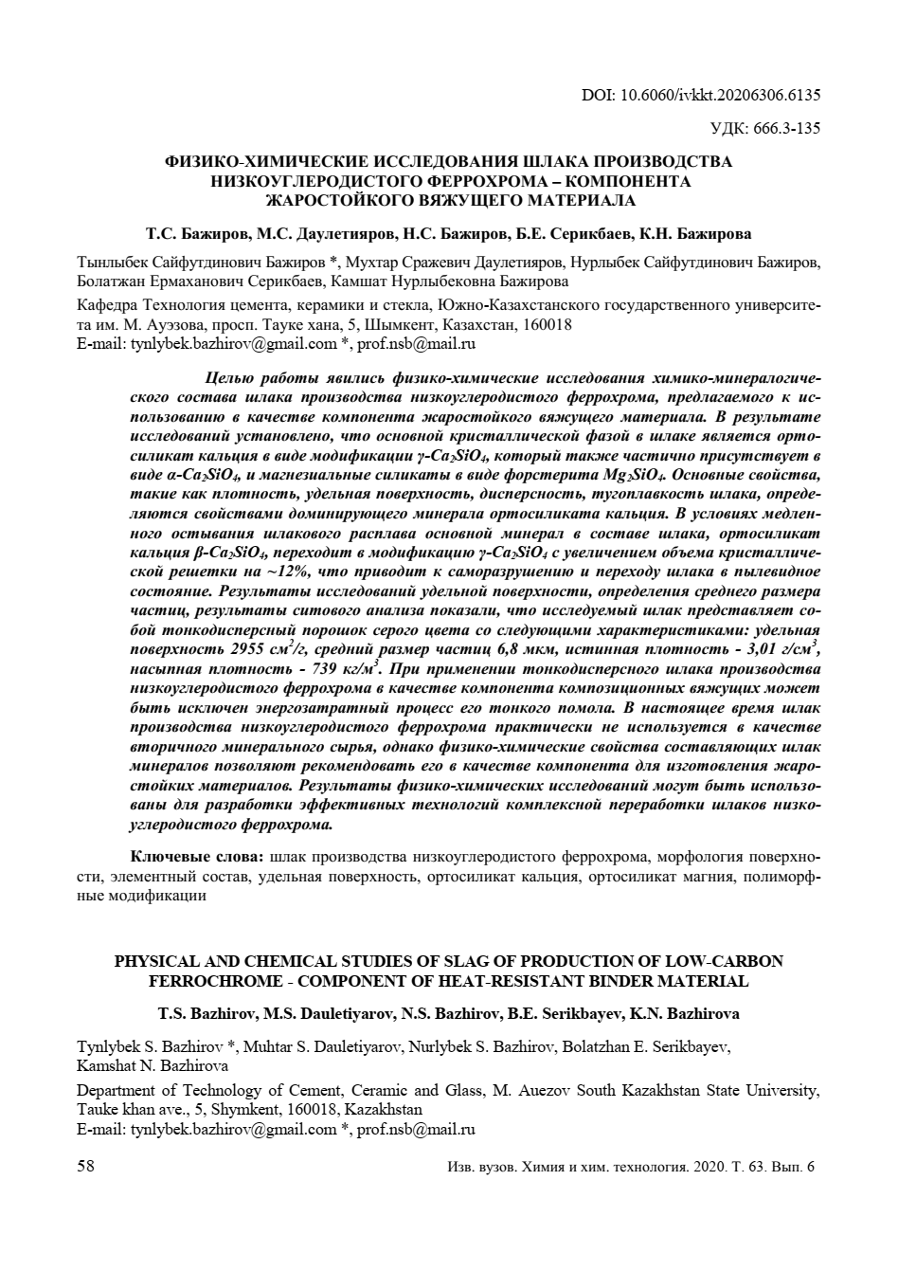

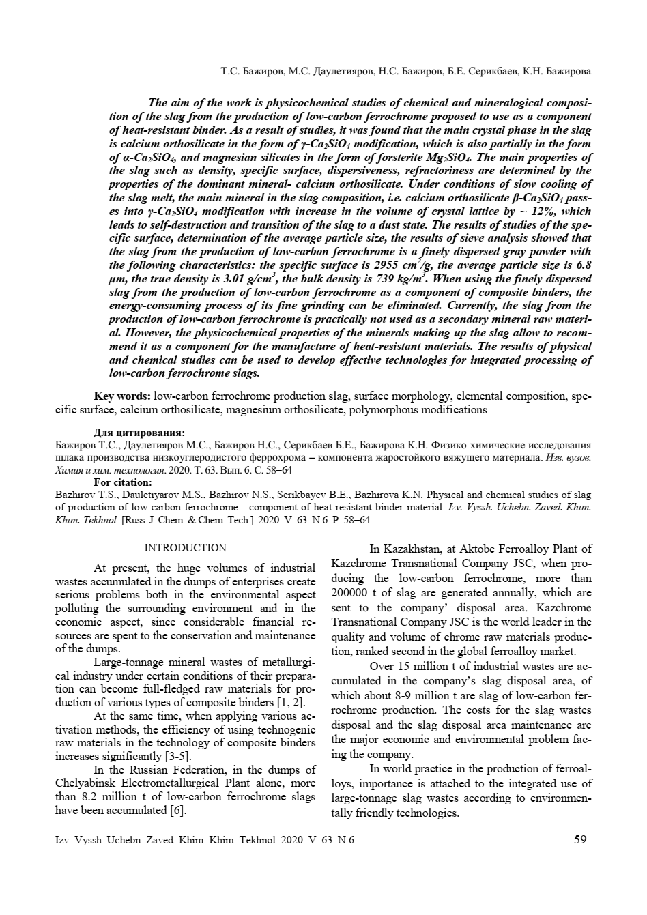

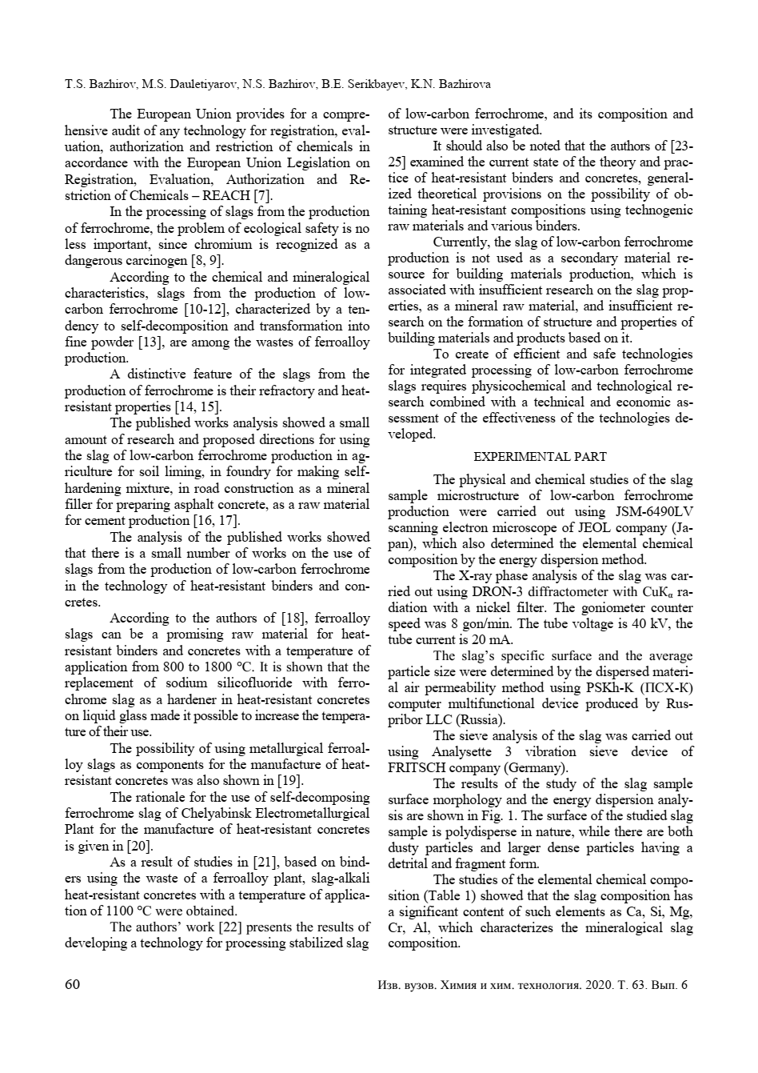

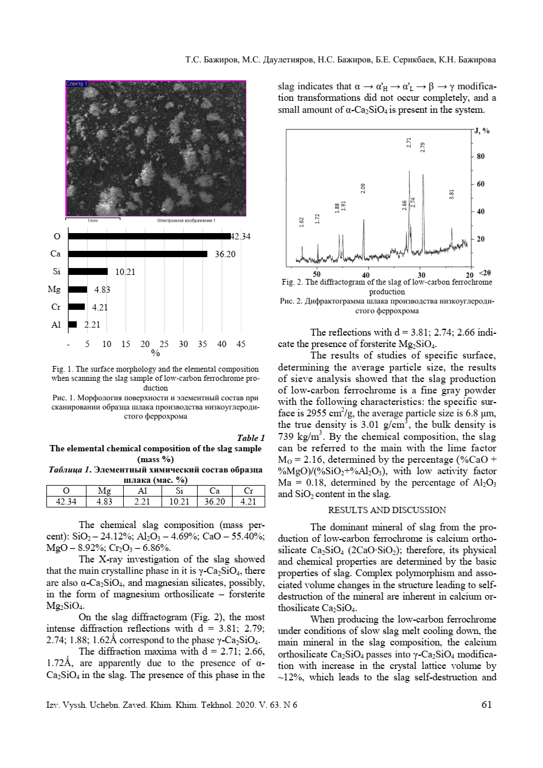

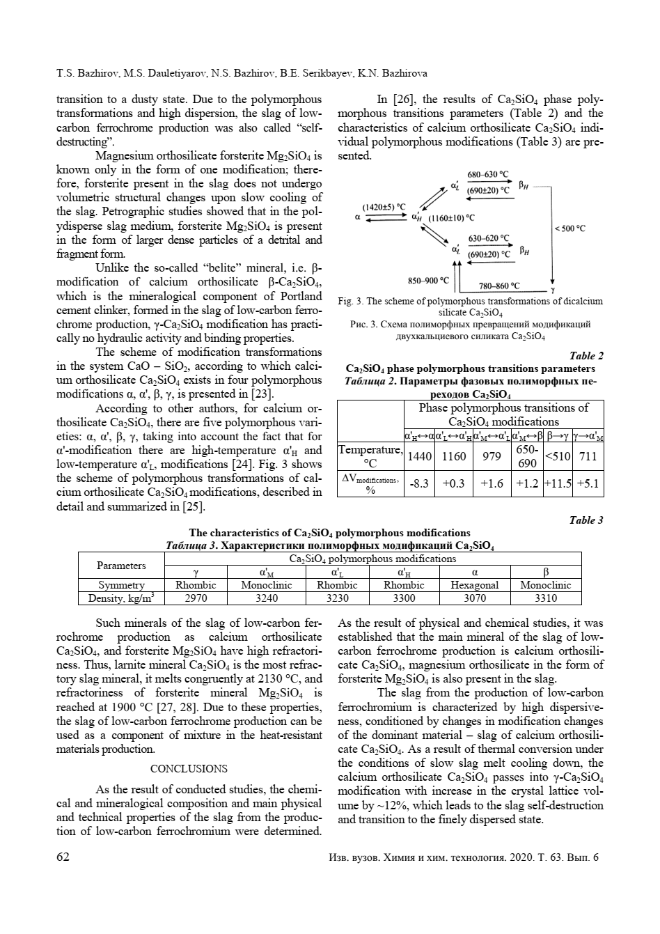

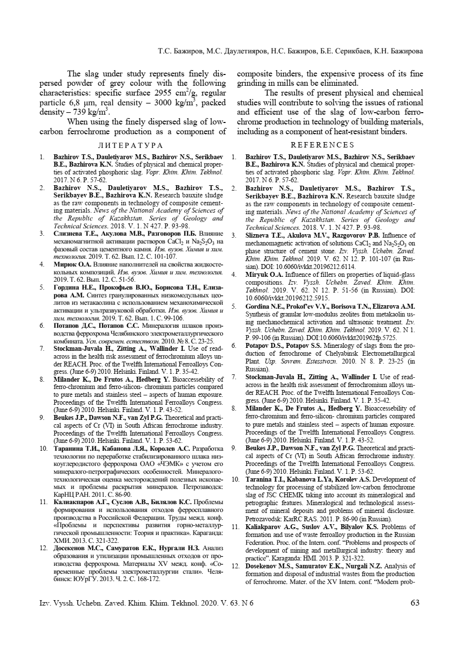

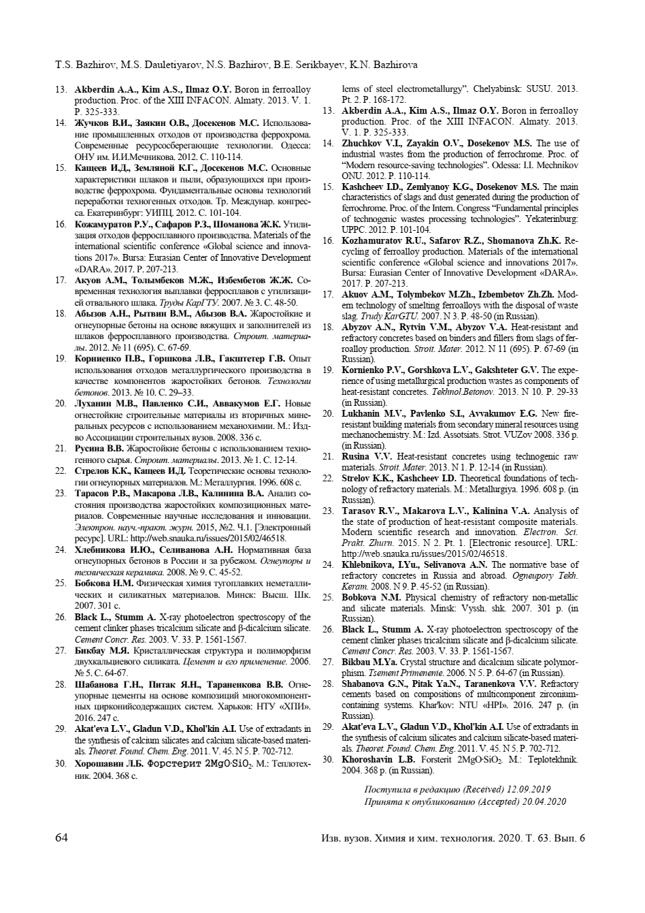

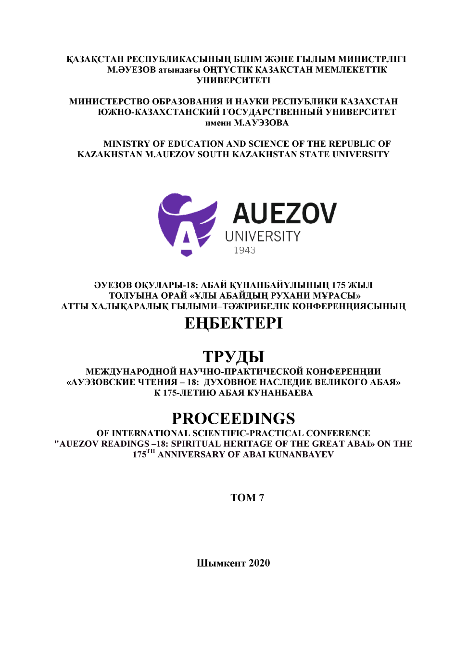

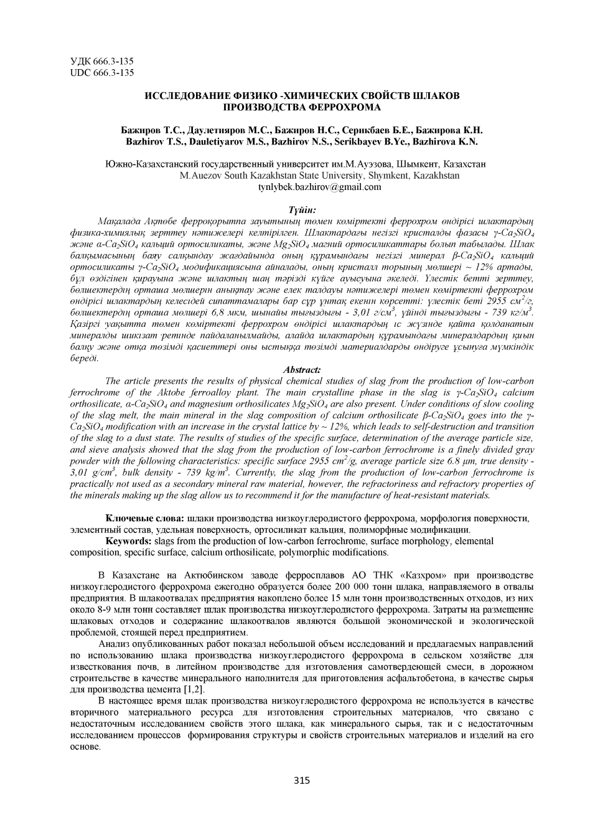

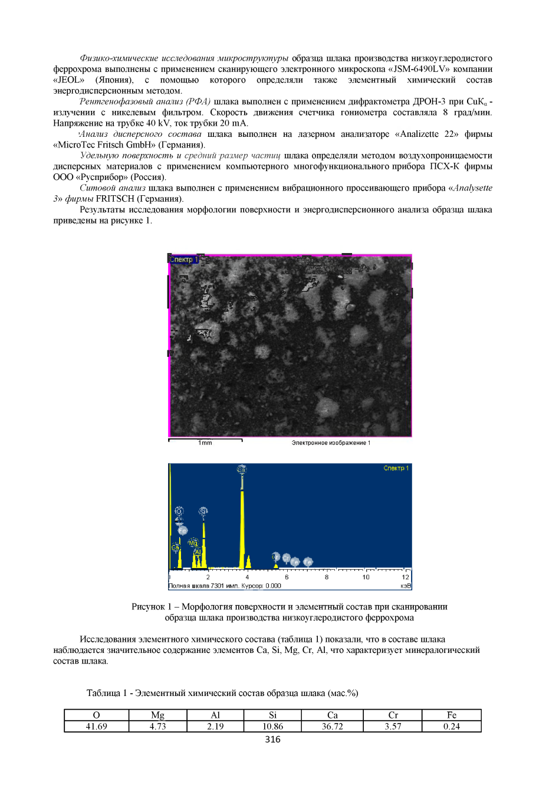

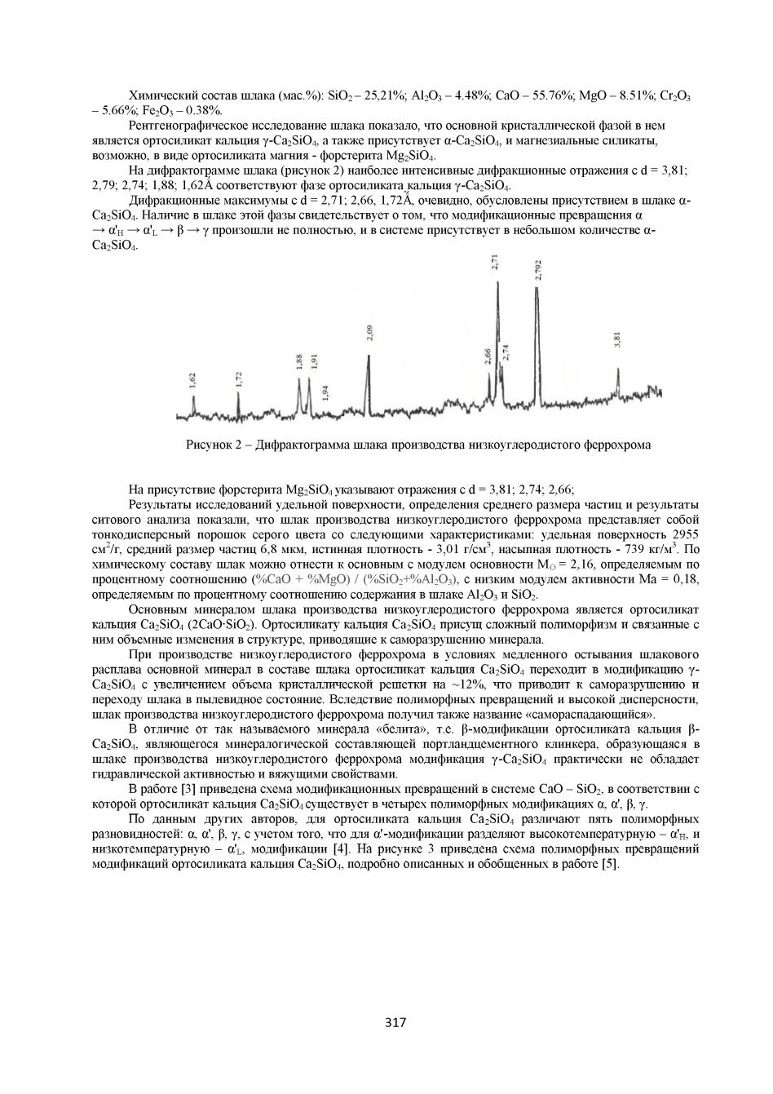

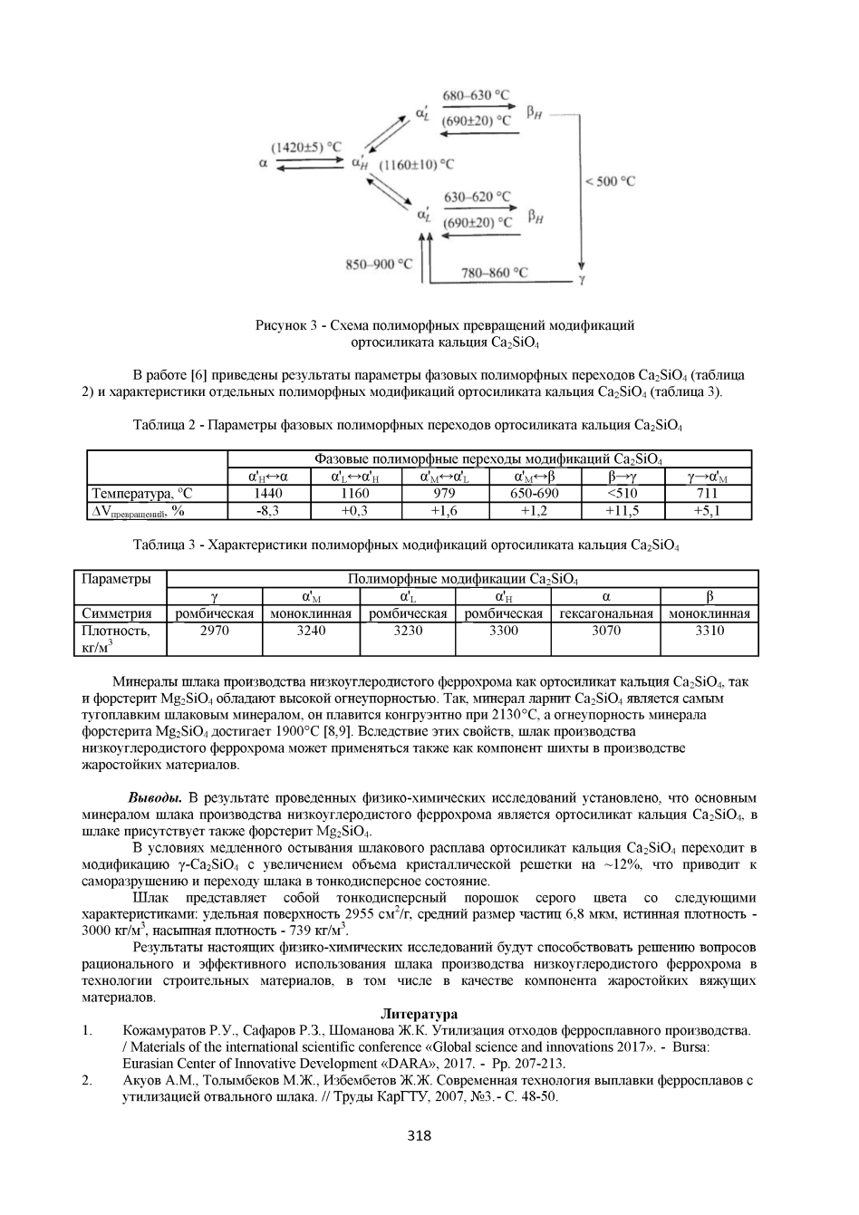

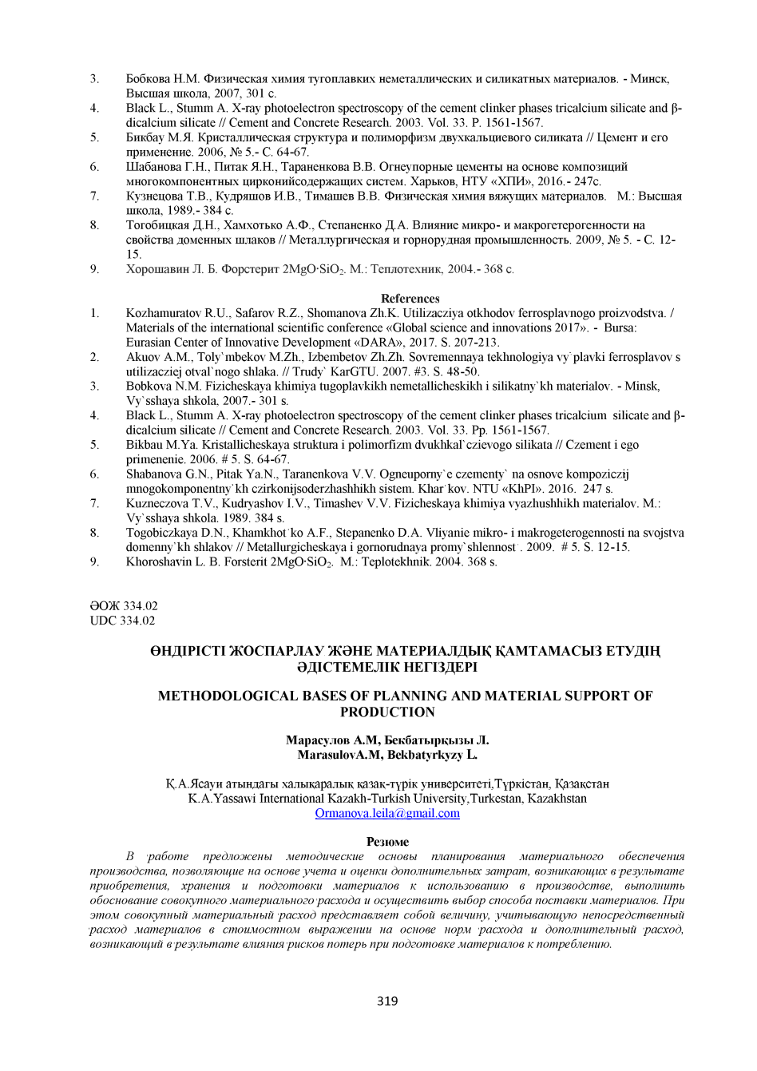

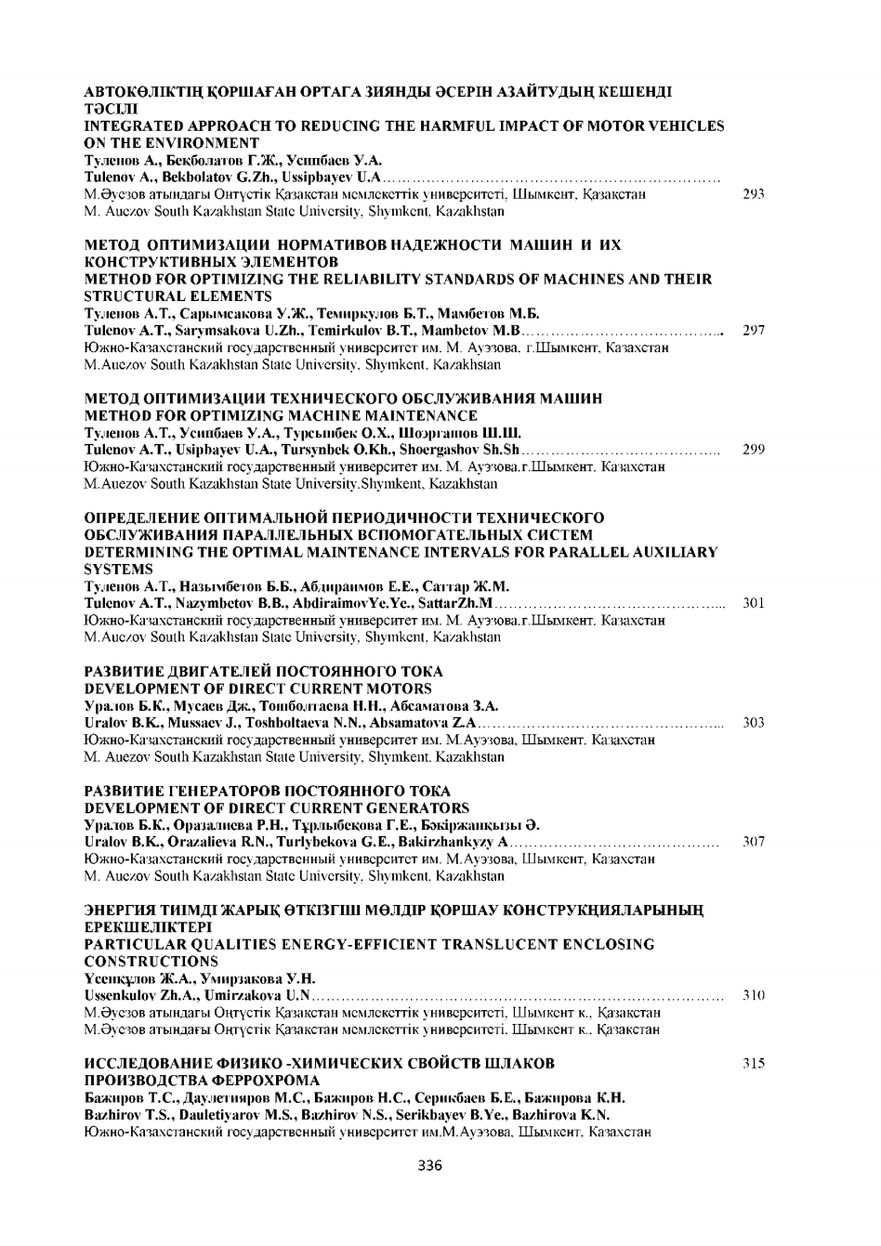

APPENDIX J
Copies of patents and application for invention
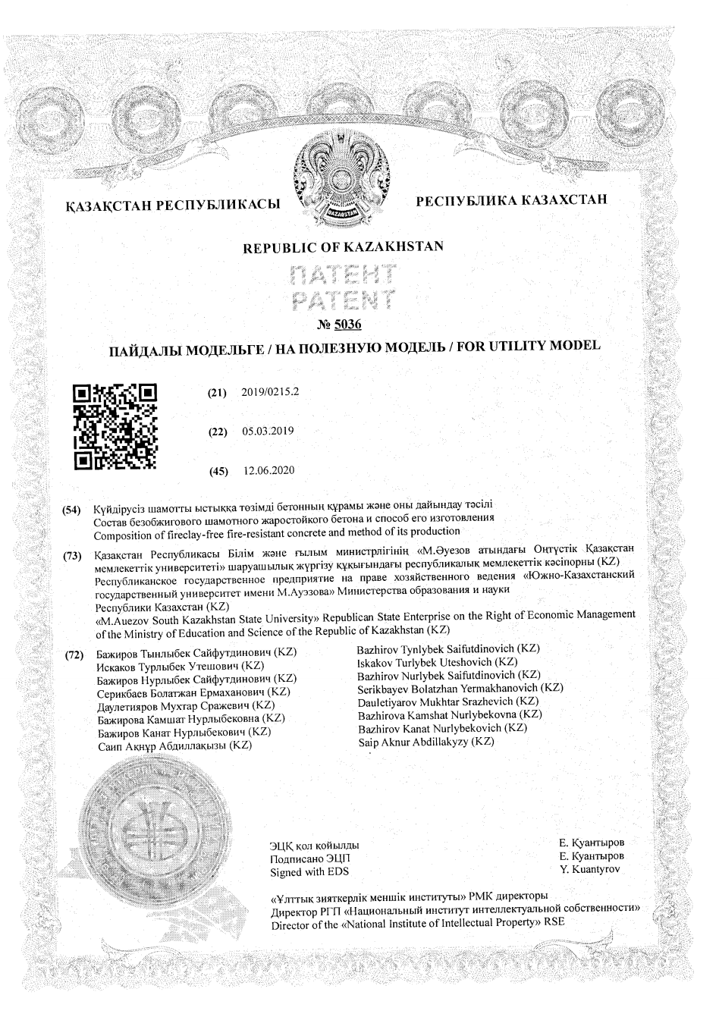

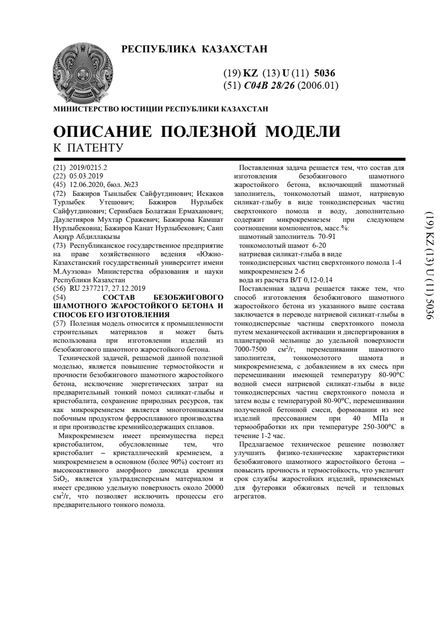

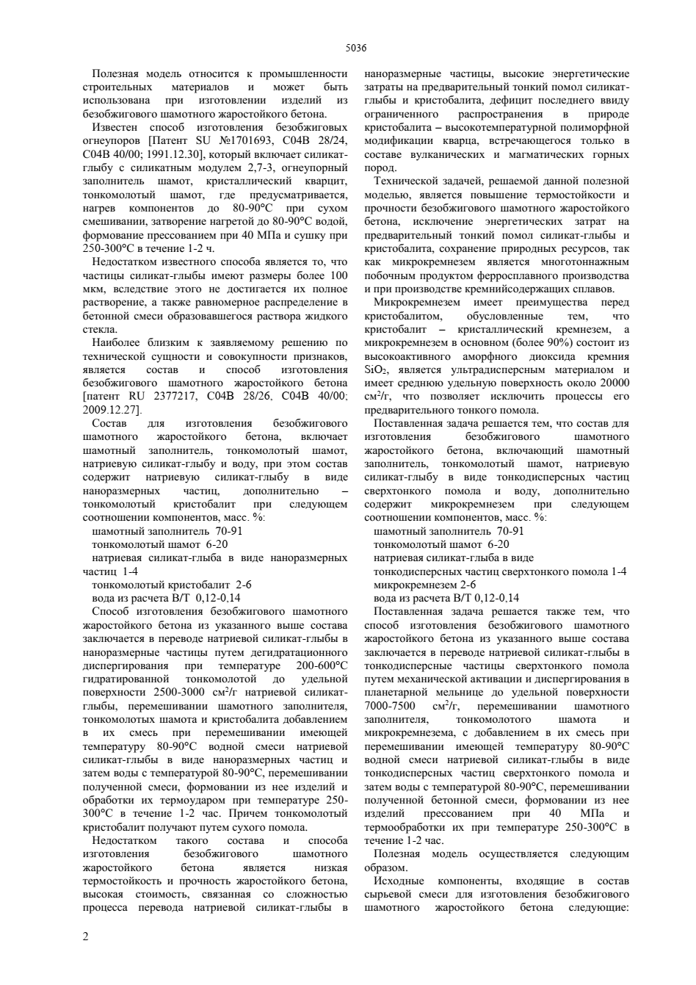

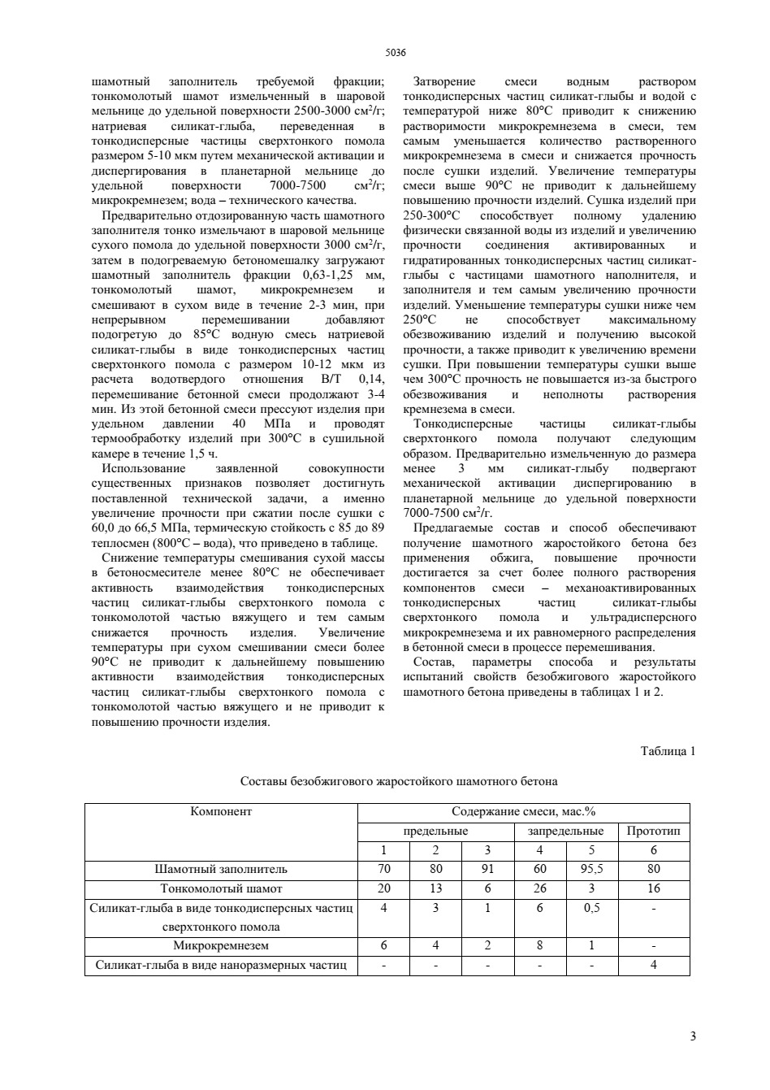

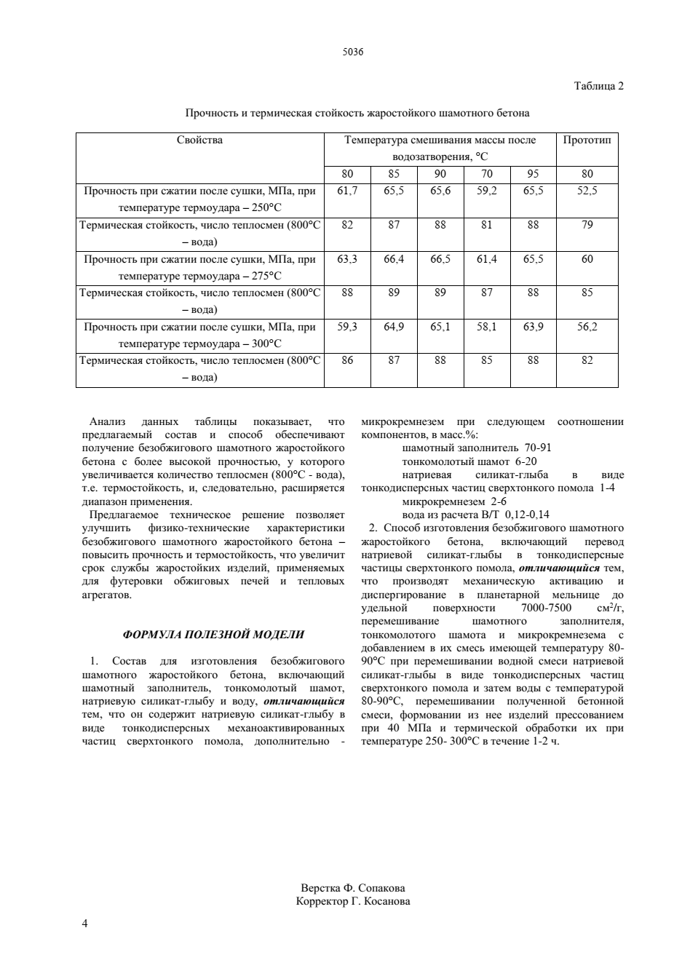

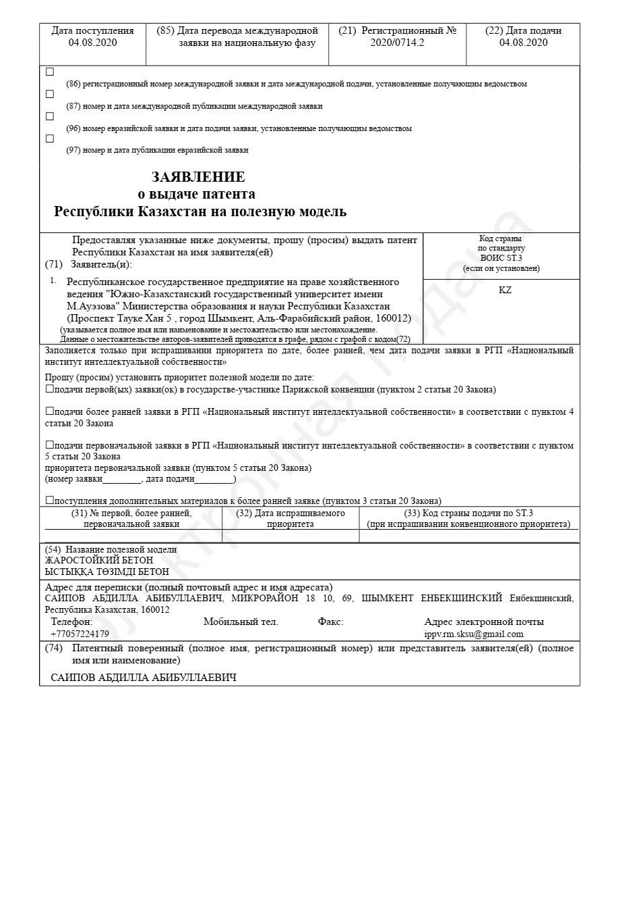

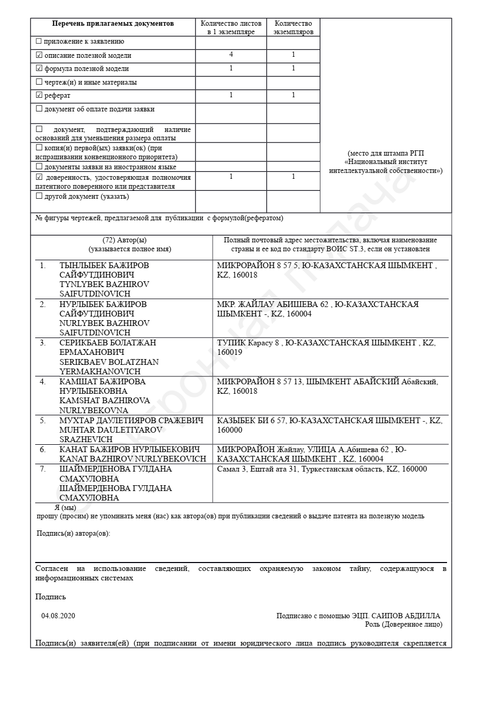



APPENDIX K
Pilot test certificate
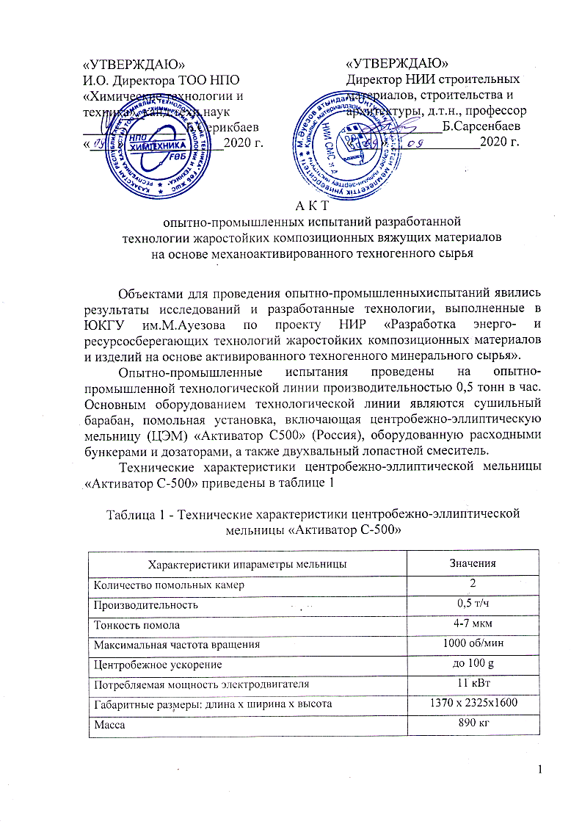
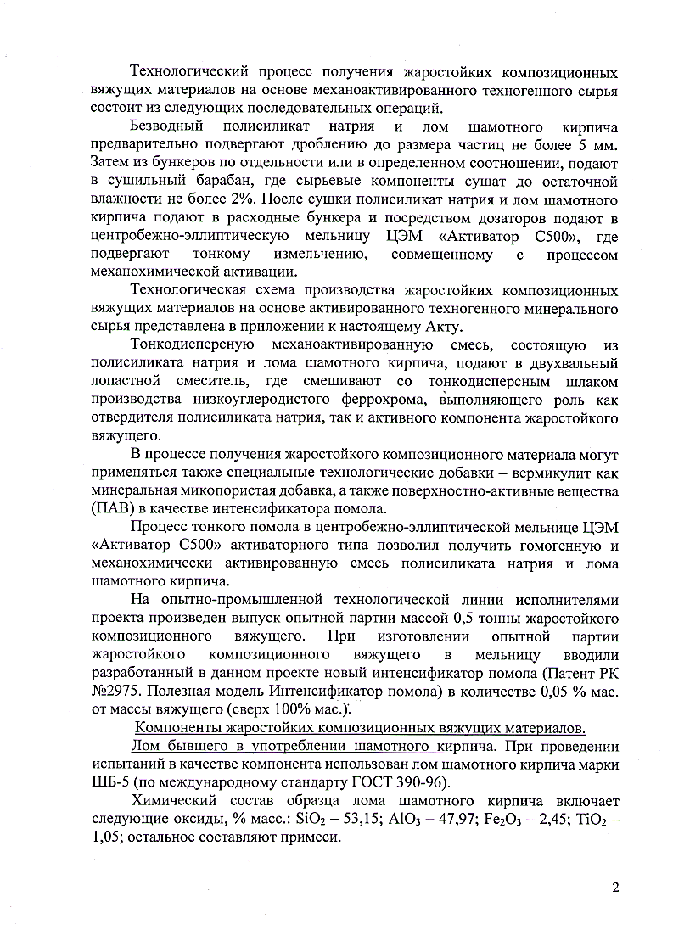

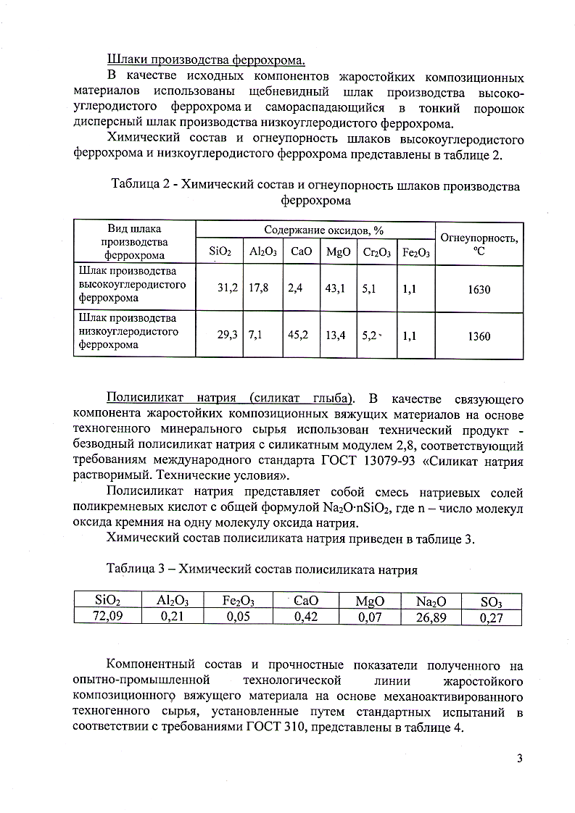

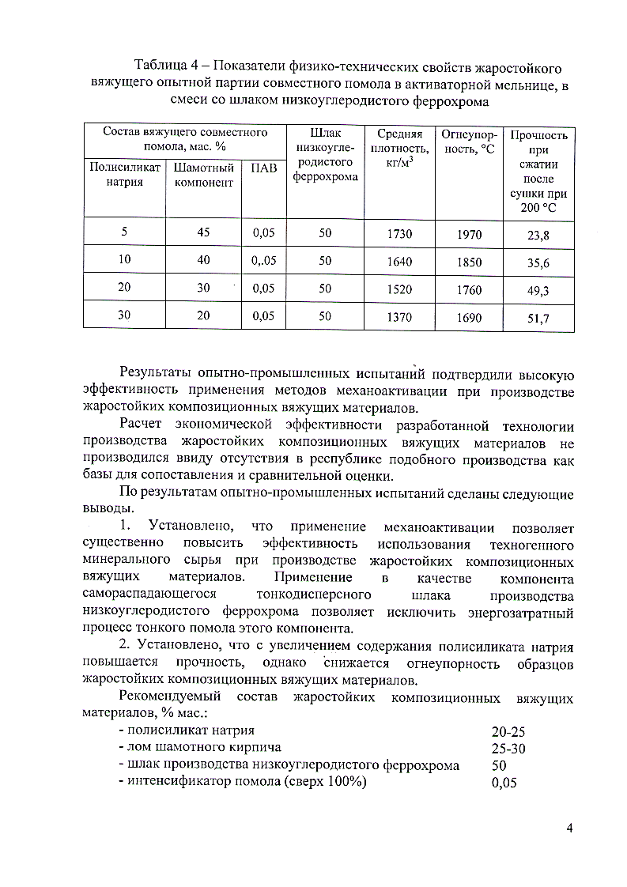

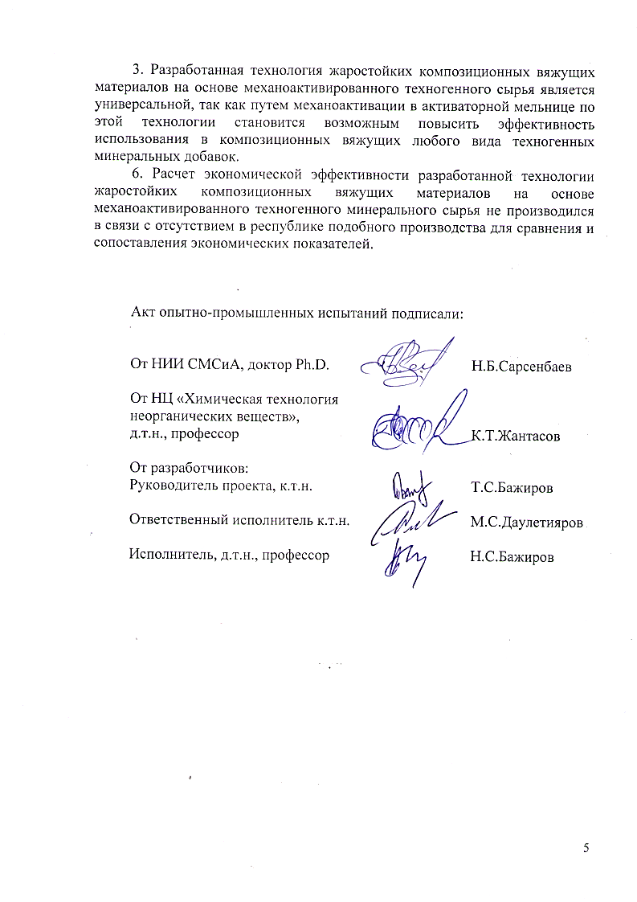
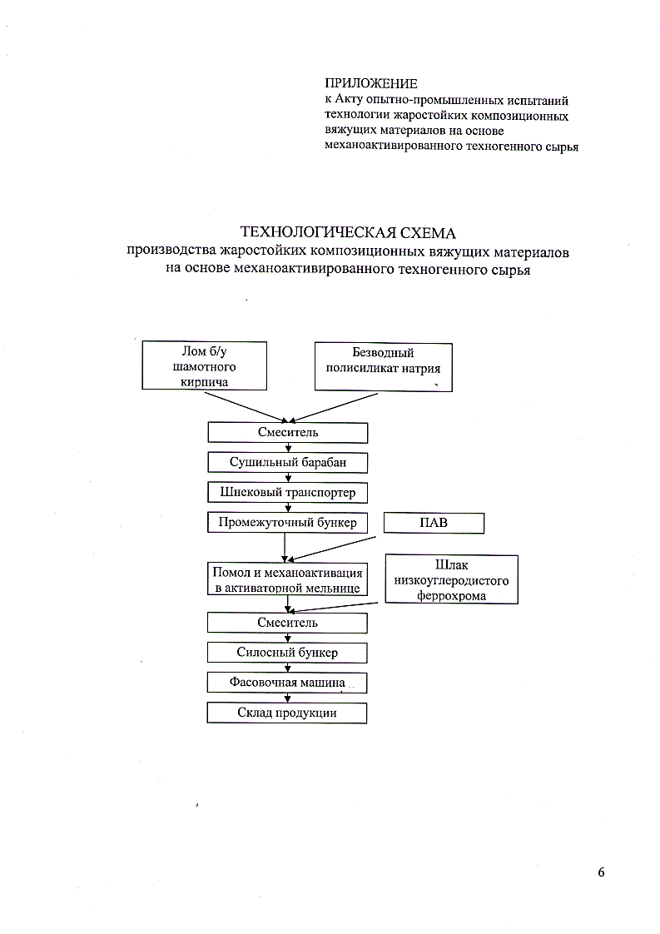

APPENDIX L
Practical project recommendations
