Ministry of education and science of the Republic of Kazakhstan

NC JSC «L.N.GUMILYOV EURASIAN NATIONAL UNIVERSITY»
(L. N. GUMILYOV ENU)

UDC 574:546.3:004.9  № of state registration 0118РК00600  Inv. № | APPROVE:  Vice-rector for science and innovation  NC JSC «L.N.Gumilyov ENU»  ____________________ G.Merzadinova  «____» ____________ 2020 y.

REPORT
ABOUT scientific-RESEARCH WORK

AP05135992 DEVELOPMENT OF A NEW INFORMATION SYSTEM AND DATABASE TO OPTIMIZE MONITORING OF ATMOSPHERIC AIR POLLUTION BY HEAVY METALS
(final report)

Head of the theme,
PhD ______________ Zh.О. Оralbekova
signature, date

Nur-Sultan 2020
LIST OF PERFORMERS
Head of the theme, PhD, acting assoc.prof. of the Department “Computer and software engineering” | ________________  signature, date | Zh. O. Oralbekova  (abstract, introduction, sections 2, 4, 6, 9, conclusion)
Leading researcher, Dr. Sci. (Phys.–Math.), Professor of the Department «Computer and software engineering» | ________________  signature, date | K. T. Iskakov  (sections 1, 3, 9, conclusion)
Senior Researcher, PhD, assoc.prof. of the Department «Computer and software engineering» | _______________  signature, date | Т.К. Zhukabayeva  (sections 4, 5, 8)
Researcher, Senior teacher of the Department «Computer and software engineering» | ________________  signature, date | A. T. Kussainova  (sections 3, 4, 6)
Researcher, PhD, Senior teacher of the Department «Computer and software engineering» | ________________  signature, date | М.G. Zhartybayeva  (sections 1, 5)
Researcher, head of the project management office NC JSC Serikbayev EKTU | ______________  signature, date | Z.T. Khassenova  (section 10)
Head researcher D.Sc. in Biology, professor of Abai KazNPU | ________________  signature, date | B.N. Mynbayeva  (sections 1, 8)
Researcher, software developer of «System research companies Factor» | ________________  signature, date | A.T. Toybekov  (sections 4, 5, 7)
Senior Researcher, cand.of tech.sci assoc.prof. NC JSC Serikbayev EKTU | ________________  signature, date | S.Zh. Rakhmetullina  (section 2)
Senior Researcher, cand.of ped.Sci. head of the testing center at the Abai KazNPU | ________________  signature, date | D.N. Issabayeva  (section 1)
Junior researcher, doctoral student spec. «Computer Engineering and Software» | ________________  signature, date | N.T. Aziyeva  (section 7)
Junior researcher, master's student spec. «Computer Engineering and Software» | ________________  signature, date | N.B. Yessimova  (section 3)
Normocontroller | ____________  signature, date | А.Y. Moldakhmetova

ESSAY
Report 67 p., 32 figures, 4 tables, 27 sources, 4 appendixes.
ENVIRONMENTAL PROTECTION, ENVIRONMENTAL MONITORING, AIR POLLUTION, INFORMATION SYSTEM, DATABASE
The object of research: the air of the surface layer of Almaty.
The goal of the project for 2020 - to develop an information system and database for optimizing monitoring of air pollution by heavy metals.
Methods of work: mathematical modeling, analysis, assessment of ecological problems, testing.
Results for 2020 and their novelty:
- developed an application format for the container of basic elements of the information modeling system;
- organization and testing of the database and access to it from problem-oriented applications;
- implementation and research of algorithms for assimilation of data for monitoring the chemical composition of the atmosphere in Almaty;
- developed software for a new information system for environmental monitoring and analysis of the results of monitoring changes in the chemical composition of the atmosphere; performed computing management on the server platform;
- developed software for a new information system for environmental monitoring and analysis of the results of monitoring changes in the chemical composition of the atmosphere; performed computing management on the server platform;
- developed software tools of human-machine interface for visualization of monitoring results;
- developed an information system for environmental monitoring of atmospheric pollution; were carried out testing and refinement of the system components;
- assessment ecological state of the air surface layer of atmosphere for the Almaty city;
- published a collective scientific publication "Creation of an effective information system and database for optimizing the control of atmospheric air pollution with heavy metals".
Main design and technological, technical and operational characteristics: development of an information system for environmental monitoring based on an algorithm for assimilation of atmospheric chemical composition data.
Level of implementation: in 2020, there are 6 articles in total and 1 collective scientific publication (monograph), 3 of them were published and 1 article was accepted for publication in peer-reviewed domestic scientific publications with a non-zero impact factor; 1 article in the proceedings of international conferences and 1 articles were submitted to international peer-reviewed rating journals included in the Scopus database; 2 certificates of state registration of copyright rights were obtained.
Field of application: environmental monitoring of air pollution in industrial cities.
Significance of the work: organization of a database, development of an information system and organization of a database for optimizing monitoring of air pollution by heavy metals.
Forecast assumptions about the development of the research object: the results of research work can be used for research of doctoral and master's students in the field of training "Information and communication technologies" and "Environmental protection" and are recommended not only for the branch of "Kazhydromet" in Almaty, but also for monitoring the air of large industrial cities of the Republic of Kazakhstan (Ust-Kamenogorsk, Karaganda, etc.).

Content

INTRODUCTION ………………………………………………………………………  MAIN PART OF THE RESEARCH REPORT ………………………………………… | 7  9
1 Development of the application format for the container of basic elements of the information modeling system, organization of the database and access to it from problem-oriented applications............................................................................................. | 9
2 Implementation and research of algorithms for assimilation of data for monitoring the chemical composition of the atmosphere in Almaty ………………………………….... | 12
3 Development of ways to interface the developed models and methods of atmospheric chemistry with real meteorological data of the created air pollution database................................................................................................................................. | 16
4 Development of software for a new information system for environmental monitoring and analysis of the results of monitoring changes in the chemical composition of the atmosphere ………………………………………………………....................................... | 19
5 Development of a human-machine interface for software visualization of monitoring results ………………………………………………........................................................... | 23
6 Formation of an information system for environmental monitoring of atmospheric pollution ………………………………………………………………............................... | 26
7 Testing and refinement of components of the environmental monitoring system for atmospheric pollution ………………………………………………………………........ | 29
8 Assessment of the air ecological state of the surface layer of atmosphere for Almaty city …………………………………………………………………………………........... | 33
9 Issue of a scientific collective publication ………………………………………………... | 37
CONCLUSION ………………………………………………………………………….. | 38
LIST OF REFERENCES ……………………………………............................................. | 41
APPENDIX А Copy of the technical specification and calendar plan for 2020.................. | 46
APPENDIX B List of published works for 2020………………………............................. | 59
APPENDIX C Author's certificates......................................................................................  APPENDIX D Сollective scientific publication.................................................................. | 61  63

LIST OF ABBREVIATIONS AND SYMBOLS
In this research report, the following abbreviations and symbols are used.
ANSI – American National Standards Institute
DA – Data assimilation
DB – database
DBMS - database management system
HM - heavy metals
ICMMG SB RAS -Institute of Computational Mathematics and Mathematical Geophysics of the Siberian Branch of the RAS
IEC – International Electrotechnical Commission
IEEE – Institute of Electrical and Electronic Engineers
IMDAF – Inverse Modeling and Data Assimilation Framework
ISO – Infrared Space Observatory
km – kilometer
MPC - maximum permissible concentration
MS – Microsoft
netCDF – Network Common Data Form
NoDA – No Data assimilation
POP- Pollution Observation Point
SB RAS - Siberian Branch of the Russian Academy of Sciences
SRG – scientific research group
st. - Street
TPP - Thermal Power Plant
WS– work schedule

INTRODUCTION
The problem of urban environment safety is the most urgent in the modern world. Well-known unfavorable natural and anthropogenic factors of Almaty: geographical and climatic features of the location, shortcomings of monitoring technologies, excess of the ecological capacity of the territory in terms of its traffic load, which together increases the dispersion of inorganic pollutants in the urban environment, in particular, toxic heavy metals.
The release of heavy metals (HM) into the environment is associated with active human activity. Their main sources are industry, motor transport, boilers, incinerators, and agricultural production [1]. HM compounds released into the environment pollute atmospheric air, water, and soil, and enter plants and animal organisms that inhabit this area.
The relevance of the problem of environmental pollution of HM is explained, first of all, by the wide range of their effects on the human body. This problem is also typical for the city of Almaty, where it continues to contain a certain amount, which leads to the need for environmental monitoring of the content of HM in the air, water, and soil.
This report under contract No. 132 dated 12.03.2018 is the final report and according to the technical specification and the calendar plan (CP) for 2020, the planned work has been completed in full. A copy of the technical specification and calendar plan for 2020 is attached in appendix A.
The goal of the project for 2020 - to develop an information system and database for optimizing monitoring of air pollution by heavy metals.
The first section is devoted to the development of the format of applications for the container of the basic elements of information-modeling system, described the organization database (DB) and access it from problem-oriented applications "Monitoring of atmospheric air pollution", as well as testing the components of the developed database " eco " and database management system (DBMS), providing correct information to the user and without loss when loading into the database, saving completed transactions and authorizing access to the database, checking the reliability and integrity of data, etc.
In the second section the implementation and results of the study effectiveness of algorithms for assimilation of data for monitoring the chemical composition of the atmosphere in Almaty, analysis and testing of the developed algorithms, and also studied the types, characteristics, and sources of noise in solving environmental problems.
The third section considers ways to combine the developed models and methods of atmospheric chemistry with real meteorological data of the created database on air pollution, as well as analysis and testing of the developed algorithms for modeling the processes of transport of impurities for the city of Almaty, taking into account the geographical location, terrain and transport emissions during "traffic jams".
The fourth section is devoted to software for the information system of environmental monitoring and analysis of the results of monitoring changes in the chemical composition of the atmosphere; management work was carried out on a server platform in the National scientific laboratory of collective use of information and space technologies in Almaty.
The fifth section describes the developed human-machine interface for software visualization of monitoring results, presents the main modules of the information system.
The sixth section describes the main points of forming an information system for environmental monitoring of atmospheric pollution.
The seventh section is devoted to testing and refining components of the environmental monitoring system for atmospheric pollution.
The eighth section provides an assessment of the air ecological state of the surface layer of atmosphere for Almaty city. Recommendations are offered.
The ninth section is devoted to the publication of a collective scientific publication by authors Zh.O.Oralbekova, B.N. Mynbayeva, K.T.Iskakov, Z.T.Khassenova, M.G.Zhartybayeva "Creating an effective information system and database for optimizing the control of air pollution with heavy metals" (monograph in Kazakh language: Ayur metaldarmen atmosferalyq ayanyn lastanuyn baqylaudy ontailandyru ushin tiymdi aqparattyq juye men derekter qoryn qyru).
In general, according to the research results for 2020 in 2020, there are 6 articles in total and 1 collective scientific publication (monograph), 3 of them were published and 1 article was accepted for publication in peer-reviewed domestic scientific publications with a non-zero impact factor; 1 article in the proceedings of international conferences and 1 articles were submitted to international peer-reviewed rating journals included in the Scopus database; 2 certificates of state registration of copyright rights were obtained. The list of published works for 2020 is presented in Appendix B, the author's certificates received are presented in Appendix C, collective scientific publication is presented in Appendix D.

MAIN PART OF THE RESEARCH REPORT
1 Development of the application format for the container of basic elements of the information modeling system, organization of the database and access to it from problem-oriented applications
This section is devoted to developing an application format for creating basic elements of an information modeling system, organizing a database, and accessing it from problem-oriented applications. Work on this section is a logical continuation of the task of the same name in 2018, 2019 according to the calendar plan.
To organize the database and access it from the problem-oriented application "Monitoring of atmospheric air pollution", data were updated and data were imported for 2020 on air pollution in Almaty. Figure 1.1 shows an example of the result of importing data for June 2020 for heavy metals in the atmosphere. This window contains 2 tabs: "Atmospheric phenomena "and "Heavy metals".
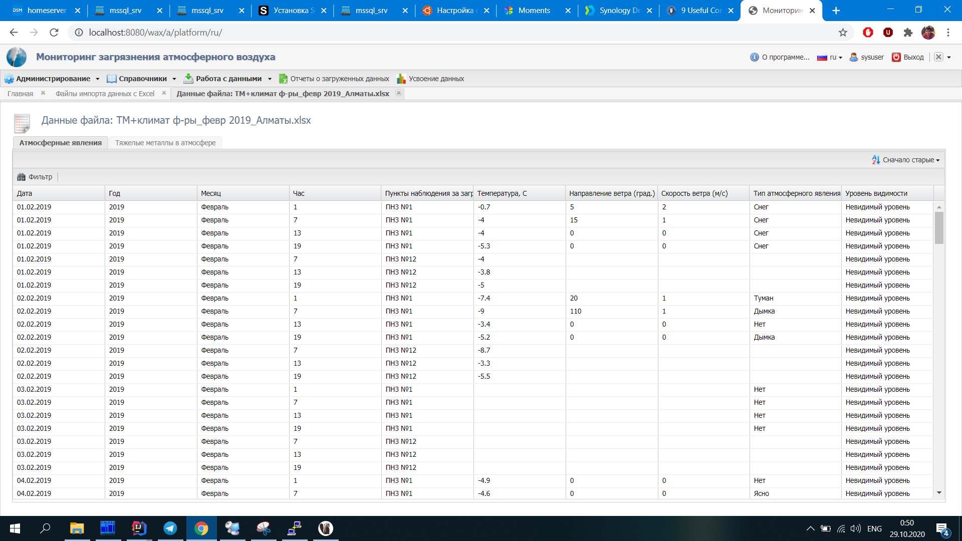
Figure 1.1 – Data import Files from MS Excel
For easy import to a systematized database, and access to it from the problem-oriented application "Monitoring of atmospheric air pollution", the source file is a file with the extension .xls according to a specific structure, which is shown in figure 1.2.
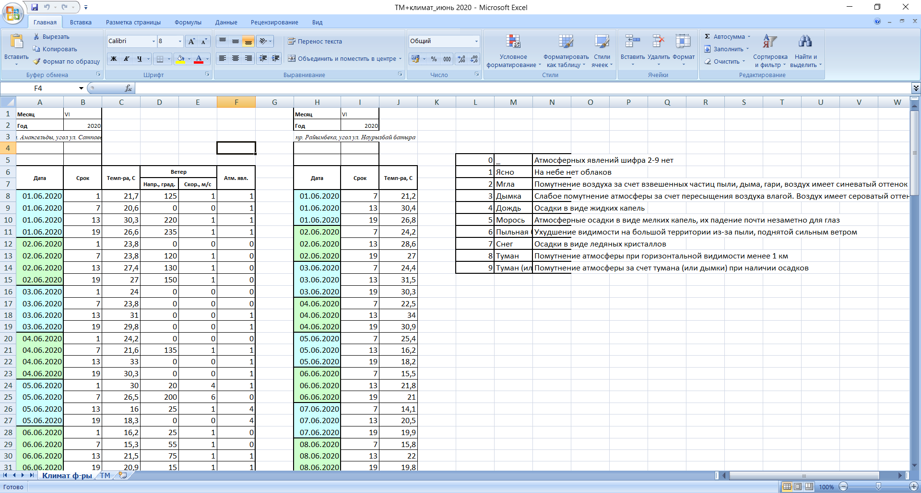
Figure 1.2 –Source file for data import
To optimize monitoring of air pollution with heavy metals by importing files, was created an archive of data for different years, which is shown in figure 1.3.
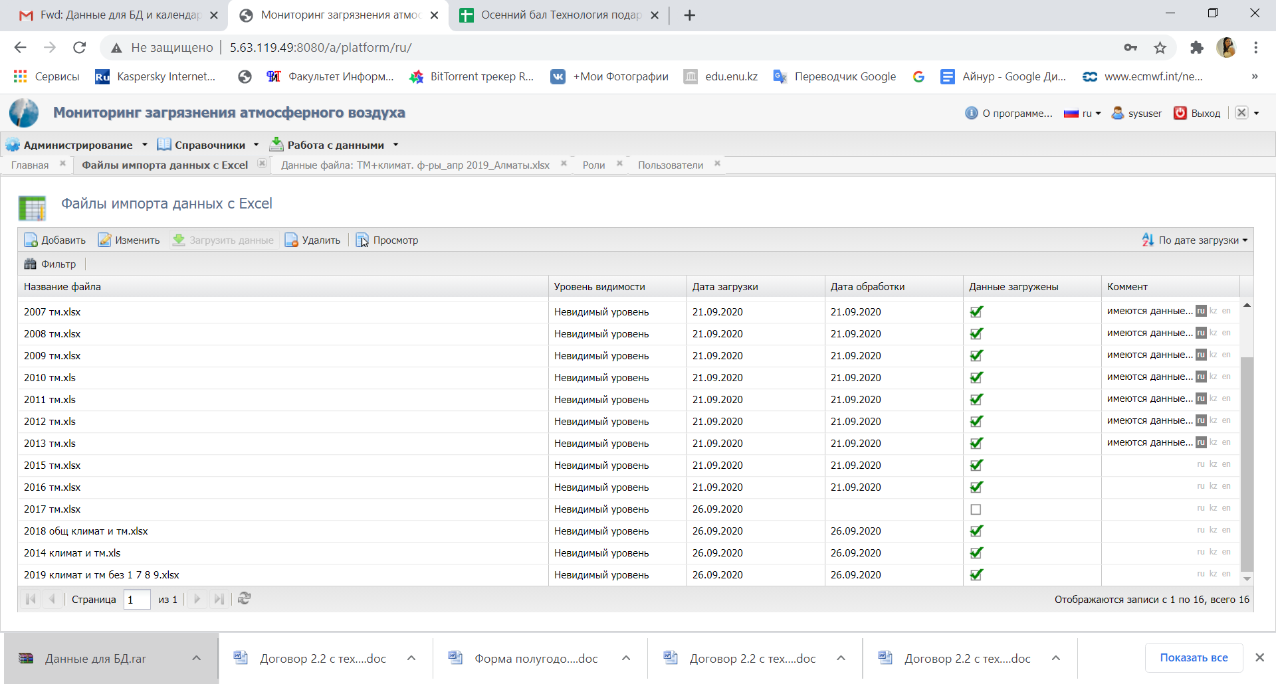
Figure 1.3 – Data import Files from MS Excel
To implement the data assimilation algorithm, NetCDF files are required. The goal of implementing the NetCDF format is to provide optimal conditions for storing and processing large volumes of data in a portable and self-defined form [2]. The turbulent diffusion model coefficient file is used for calculation, which consists of the following fields: horizontal and vertical diffusion fields; three-dimensional wind velocity fields; initial concentration distributions; background concentration values; data on space-time grids; geographical reference of grids; terrain information. In this regard, the developed system provides the upload NetCDF tab, which is shown in figure 1.4. the subprogram is written in the Python programming language.
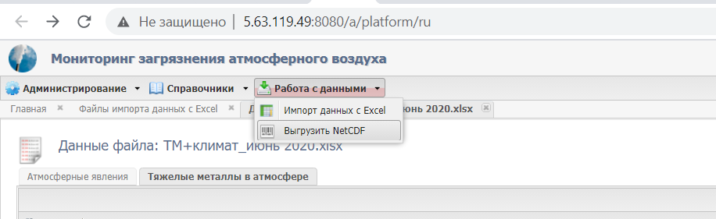
Figure 1.4- Tab «Upload NetCDF»
NetCDF files are input data for the data assimilation algorithm. The Panoply program shown in figure 1.5 is used for visualization, which allows you to view and visualize all the parameters of the coefficients. The most important feature of the NetCDF format is fast work with a large amount of data on any platform.
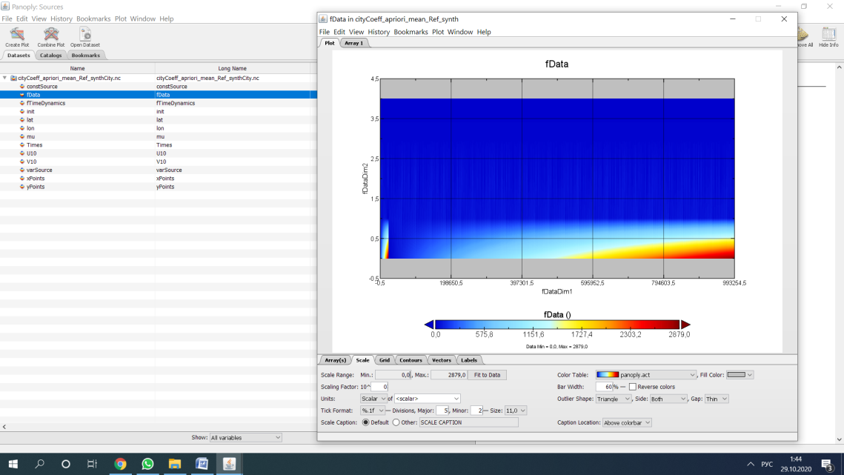
Figure 1.5-Working with created NetCDF files in Panoply
On the first section developed the format of applications for the basic elements container of information-modeling system, described the organization of the database, the results of access to it from the problem-oriented application testing of components developed by DB "eco" system, DBMS, providing correct information to the user and without the load in the database, save the completed transaction and authorization of access to database, checking for accuracy, data integrity, etc.
Based on the results of this section for 2020, 1 article was published in a peer-reviewed domestic scientific publication with a non-zero impact factor [3] and received 1 copyright certificate of state registration of rights to the copyright object of the database "Monitoring of the chemical composition of the atmosphere" [4].

2 Implementation and research of algorithms for assimilation of data for monitoring the chemical composition of the atmosphere in Almaty
This section is devoted to the implementation and research of algorithms for assimilation of data for monitoring the chemical composition of the atmosphere in Almaty. Work on this section is a logical continuation of the task of the same name in 2018 and 2019 according to the calendar plan. The mathematical statement of the problem can be found in the works of the members of the research group of this project [5-7].
The solution to the problem of ecological air pollution is the development of effective monitoring systems, the mathematical support of which is based on variational algorithms that take into account the chemical composition of the atmosphere, including heavy metals.
The task was implemented jointly with foreign scientists of the laboratory for Mathematical modeling of hydrodynamic processes in the natural environment, ICMMG, SB RAS (Novosibirsk).
Implemented at the previous stage of the project, the algorithm for assimilation of contact measurement data for a three-dimensional model of transport and transformation of impurities was tested on various scenarios of pollution distribution in Almaty from sources in transport and thermal HPP of the city. In particular, the dependence of the accuracy of restoration of pollution fields on the noise level in the data was studied.
To work in a sparse measurement network, an algorithm is considered with minimization of the spatial derivative of the uncertainty function (control) as part of the target functional, which is used for data assimilation.
Within the framework of the scenario, an "exact" 4-dimensional field of distribution of the pollutant concentration φ* was generated for the specified sources in the places of transport congestion and the HPP of Almaty.
Figure 2.1 shows the field of concentrations at some point in time - the "exact" solution. Figure 2.2 shows the result of the data assimilation algorithm. You can clearly compare the operation of the algorithm and the "exact" solution. Algorithms for data assimilation information about pollution sources is not available, only information from monitoring posts in Almaty marked with red dots is available. In the considered case, the assimilation algorithm worked with regularization with respect to the derivative of the uncertainty function in the sources. Regularization of this type leads to smoother solutions along the directions of the splitting scheme.
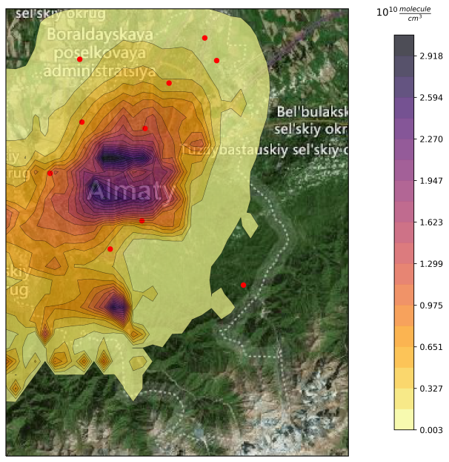
Figure 2.1 – Concentration fields at some point in time - "exact" solution
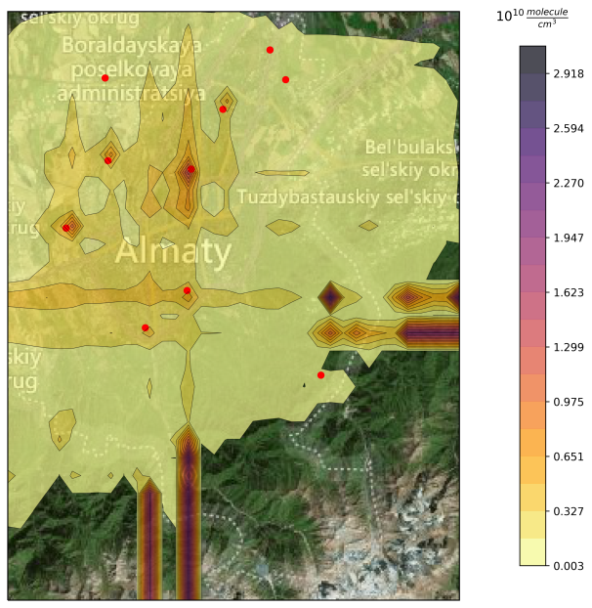
Figure 2.2 – Result of the data assimilation algorithm
To study the effect of measurement error on the result of the data assimilation algorithm as measurement data at a point was used
where,
- noise level,
- a random variable evenly distributed over the interval [-1,1].
Then we compared the relative recovery error for different noise levels in the measurement data at the terrain level (figure 2.3 a) and at the next vertical level (figure 2.3 b).

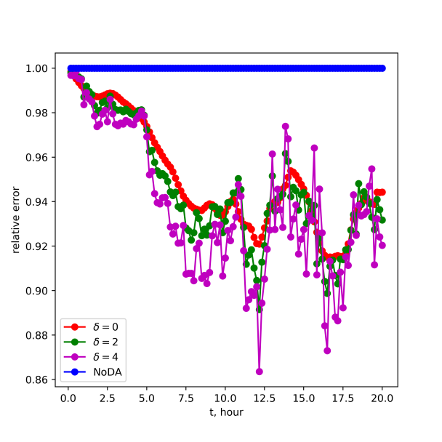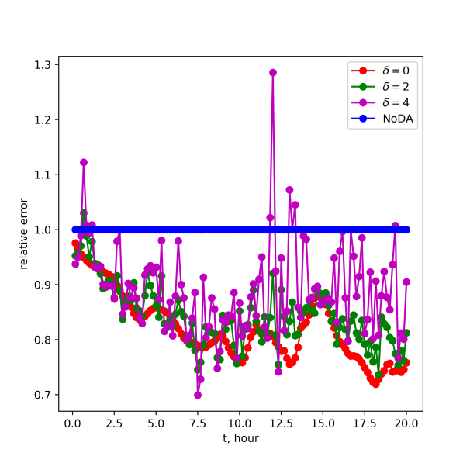
- terrain (b) verticals

Figure 2.3 – Comparison of the relative recovery error for different noise levels in the measurement data at the terrain level (a) and at the next level verticals(b))

Also was compared the relative recovery error for different noise levels in the measurement data over the whole region. The work result is shown in figure 2.4.
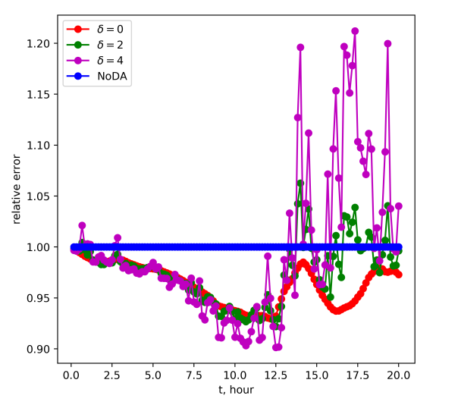
Figure 2.4. – Comparison of the relative recovery error for different noise levels in the measurement data over the entire area

Figure 2.3 shows the relative errors in restoring concentration fields at the terrain level (figure 2.3 (a)) and at the next vertical level (figure 2.3 (b)).
Figure 2.4 shows a comparison in the entire three-dimensional area. The curve NoDA (No Data assimilation) corresponds to a solution without assimilation. The other curves correspond to different noise levels . It can be noted that adding a higher error to the data is expected, which leads to a destabilization of the solution.
The data assimilation program is deployed on the server of the National scientific laboratory for collective use of information and space technologies in Almaty.
Thus, the efficiency of algorithms for assimilation of chemical composition monitoring data was studied, and the types, characteristics, and sources of noise in solving environmental problems were studied.
Based on the results of this section for 2020, was accepted 1 article in a peer-reviewed domestic scientific publication with a non-zero impact factor [8].

3 Development of ways to interface the developed models and methods of atmospheric chemistry with real meteorological data of the created air pollution database
This section is devoted to the development of ways to interface the developed models and methods of atmospheric chemistry with real meteorological data of the created air pollution database. Work on this section is a logical continuation of the task of the same name in 2019 according to the calendar plan.
Data assimilation is used in atmospheric chemistry models to optimize and refine air quality forecasting. Analysis of chemical concentrations and modeling of input variables or model parameters (in particular heavy metals) can improve the forecast result with real meteorological data on air pollution.
This study examines the most motorized region of the country, Almaty, where the population of the city is 1,916,822 people at the beginning of 2020. In general, about 700 thousand units of vehicles are operated in Almaty, including nonresident, transit, etc. According to available data, the number of nonresident vehicles entering the territory of Almaty every day is on average about 90 thousand units.
For example, according to the Yandex Traffic situation statistics, a" typical "Friday at 18.45 is rated" traffic jams " at 7 points (for Almaty, traffic congestion is determined on a 10-point scale), which is shown in figure 3.1.
Further, possible sites for air sampling in Almaty were studied to determine the degree of air pollution in the city. Air sampling and chemical analysis of Cd, Pb, As, Cr, and Cu content were carried out on several squares of streets in Almaty [9], and a scientific basis for modeling mesometeorological atmospheric processes for the city was created based on monitoring data.
The implemented algorithm for assimilation of contact measurement data for a three-dimensional model of transport and transformation of impurities was tested on various scenarios of pollution distribution in Almaty, both from transport sources and HPP.
For a more accurate solution, has been studied the dependence of the accuracy of restoration of pollution fields on the noise level in the data, described in section 2.
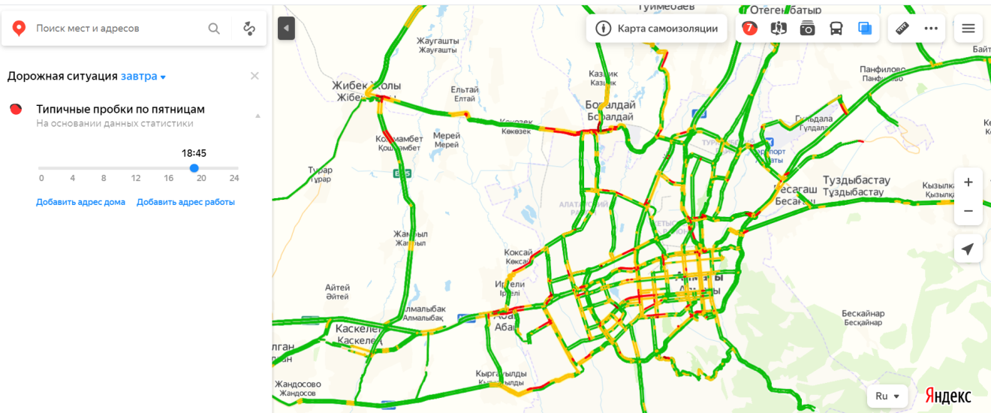
Figure 3.1 – Yandex «Traffic situation» Statistics - "typical"
Friday at 18.45

Further, the mathematical model also took into consideration the features of the relief of Almaty, shown in figure 3.2 using the Wolfram Mathematica 10.4 program.

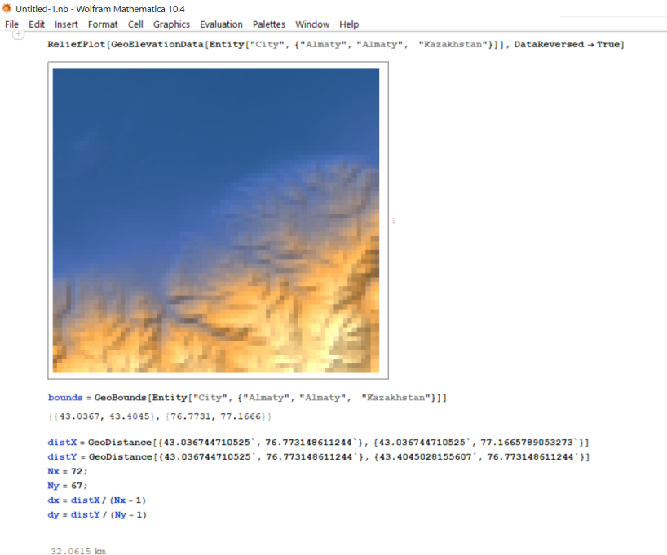
Figure 3.2 – Relief of Almaty city
The obtained data allow us to assess the ecological state of the air of the surface layer of the atmosphere in Almaty, as well as to make a local forecast of air pollution, taking into accounts mesometeorological factors and photochemical transformations. Thus, the analysis showed that heavy metal contamination was present in the air, and their content was higher in winter compared to the spring and summer months. Due to the state of heavy metal air pollution, the low-lying part of the city was more polluted than the upper part, which is due to the natural aerodynamics of the city. The effectiveness of a direct algorithm for variational data assimilation with quasi-independent data assimilation at separate steps of the splitting scheme was studied using the monitoring system data.
To work in a sparse measurement network, an algorithm is considered with minimization of the spatial derivative of the uncertainty function (control) as part of the target functional, which is used for data assimilation.
Thus, we have developed ways to interface the developed models and methods of atmospheric chemistry with real meteorological data of the created air pollution database in the form of input netCDF files. Meteorological models in a combination of chemistry, variational principles for direct and conjugate problems are considered, and the results of preparing the coefficients of the impurity transfer model from the format of the output data of the meteorological model are presented in the first section of this report.

4 Development of software for a new information system for environmental monitoring and analysis of the results of monitoring changes in the chemical composition of the atmosphere
This section is devoted to software tools for the information system of environmental monitoring and analysis of the results of monitoring changes in the chemical composition of the atmosphere. Work on this section is a logical continuation of the task of the same name in 2019 according to the calendar plan.
The environmental monitoring information system was developed in the IntelliJ IDEA integrated environment, which is shown in figure 4.1.
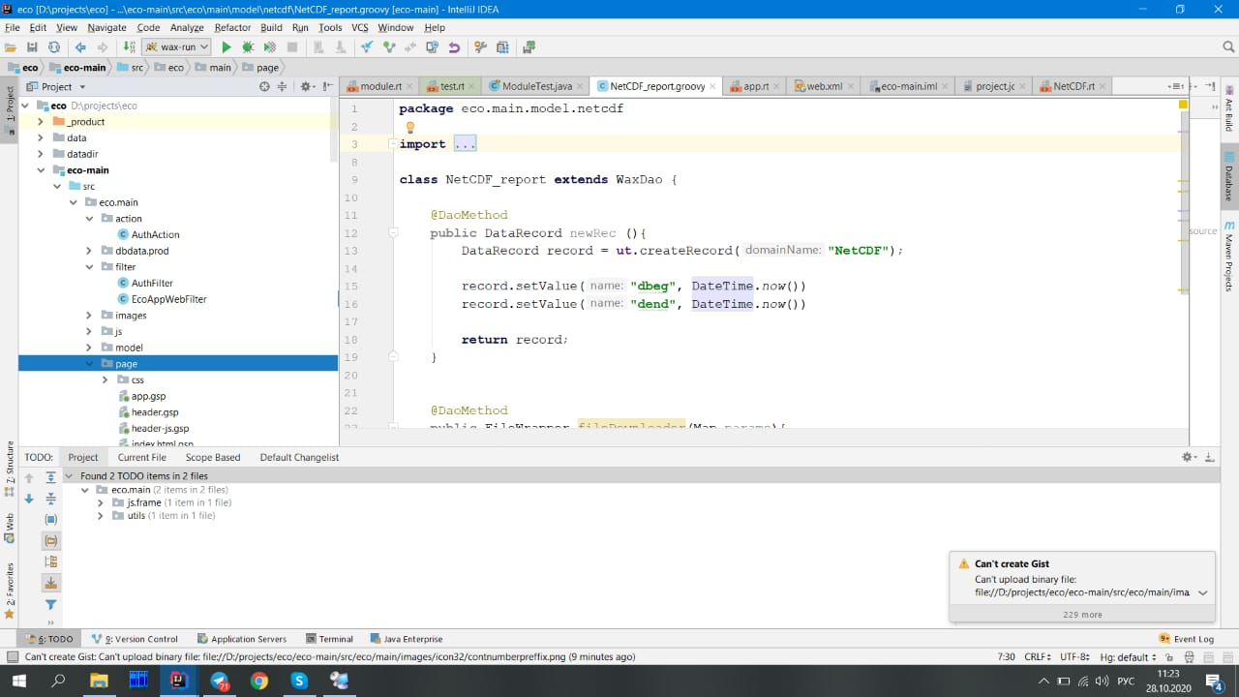
Figure 4.1 – Environment for developing an ecological monitoring information system

The server has capabilities for remote administration and operations management, organized on the basis of an object-oriented distributed management environment. The Web client uses widely used browsers (Google Chrome, Mozilla Firefox, Opera, and others). The developed software tools are implemented in the Windows operating system.
The server part was developed in the language of object-oriented programming: Java, Groovy, they are the computing platforms and work with different libraries, which are presented in figure 4.1.

Figure 4.2 shows the created database (DB) "eco" in the database management system (DBMS) MS SQL Server 2016, and more details on the structure of the tables and the relationships between them are described in [5].
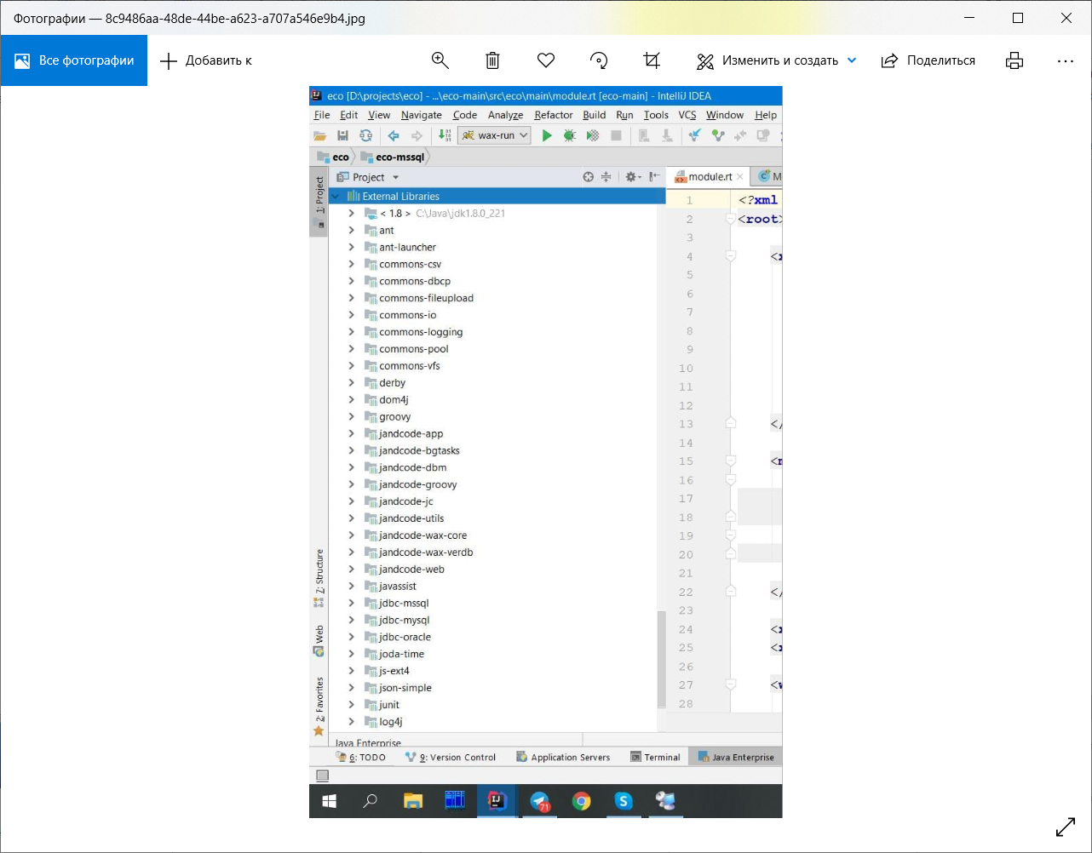
Figure 4.1 – Used libraries for development of information systems
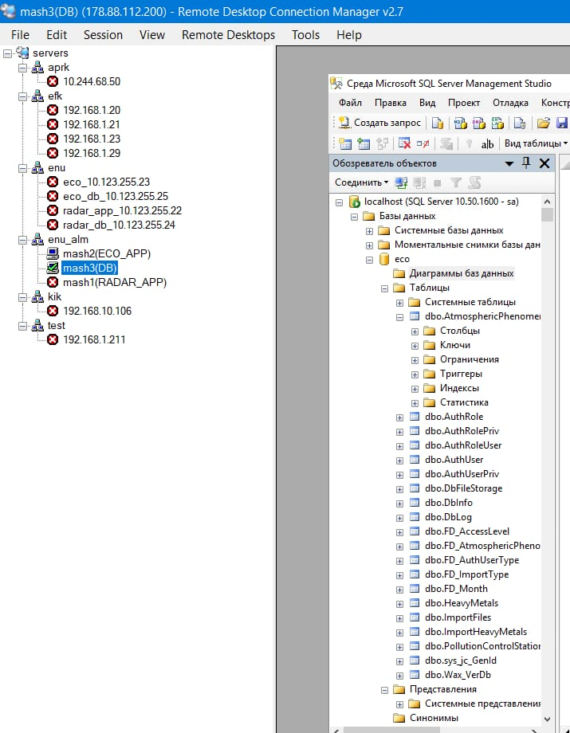
Figure 4.2 – Created DB «eco»
During the development of the information system, many classes were created, one of them is the class "class PollutionControlStation_updater extends EcoUpdaterDao" and its components are shown in figure 4.3.
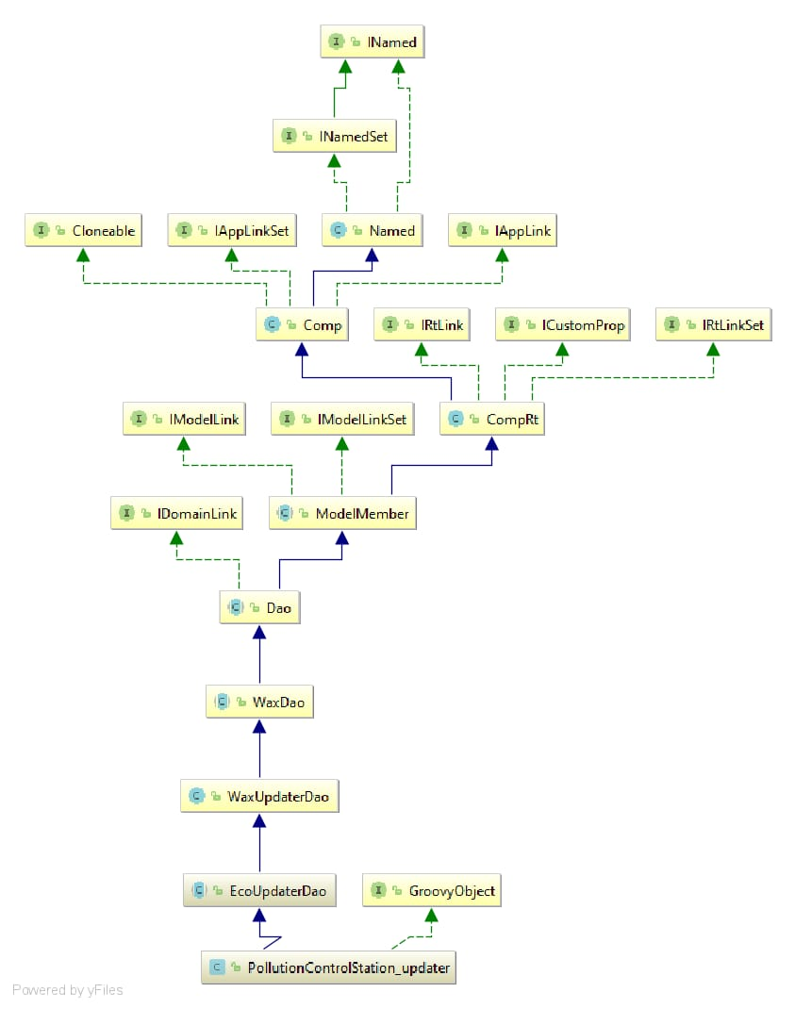
Figure 4.3 – Сlass " the pollutioncontrolstation_updater class extends Ecoupdaterdao»

Server performance plays an important role for the correct start-up and operation of the system, i.e. for managing calculations on the server platform. To calculate this type of simulation, a server with the following characteristics was used:
- 2 CPU Xeon X5550 2.67 GHz, 2 sockets, 16 threads
- 16 GB RAM, ~ 14 GB free
- 60 GB hard drive, 40 GB free (expandable)
The server can be accessed via RDP. The server operation characteristics are shown in figure 4.4.
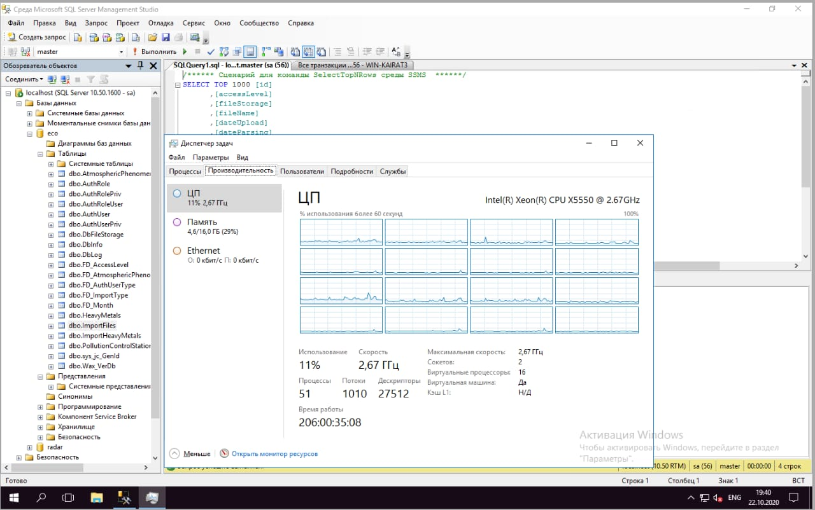
Figure 4.4 – Server operation

Currently, the server platform is located on the computer Of the national scientific laboratory for collective use of information and space technologies in Almaty. In figure 4.4, you can see the server running smoothly for 260 days.
When developing the client part, the following technologies were used: Cascading Style Sheets, HyperText Markup Language, JavaScript, Ext JS, which is described in more detail in [6].
The mechanism of integration with the system of reverse modeling and data assimilation IMDAF is developed (Inverse Modeling and Data Assimilation Framework ICMMG SB RAS.
While working in this direction, we reviewed modern methods and existing software solutions, as well as installation, configuration, and debugging of computing management on the server platform.
According to the results of the fourth section for 2020 y. published 1 article in a peer-reviewed Russian scientific publication with a non-zero impact factor [10] and received 1 author:s certificate on the state registration of the rights for object of copyright for computer software "Web-application for environmental data management" [11]..

5 Development of a human-machine interface for software visualization of monitoring results
The fifth section is devoted to the description of the human-machine interface for software visualization of monitoring results. the main modules of the information system are presented. Work on this section includes the development of all the main works implemented in the form of a human-machine interface. This section defines methods and means for ensuring direct interaction between the operator and the technical system, which allow the operator to manage this system and control its operation [12].
In our case, 5 types of users can manage and control the "Air pollution monitoring system”: administrator, ecologist, operator, expert, engineer, which are shown in figure 5.1.
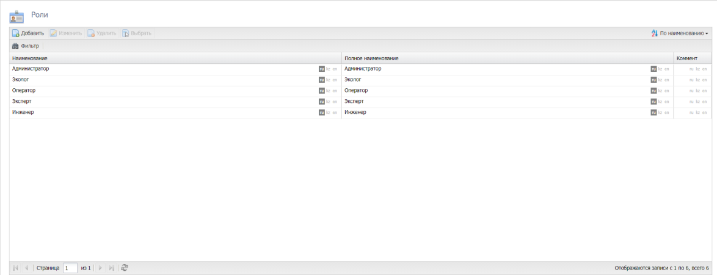
Figure 5.1 – Types of users to manage the system

During system startup, the graphical interface of the initial page is initialized, which is shown in figure 5.2
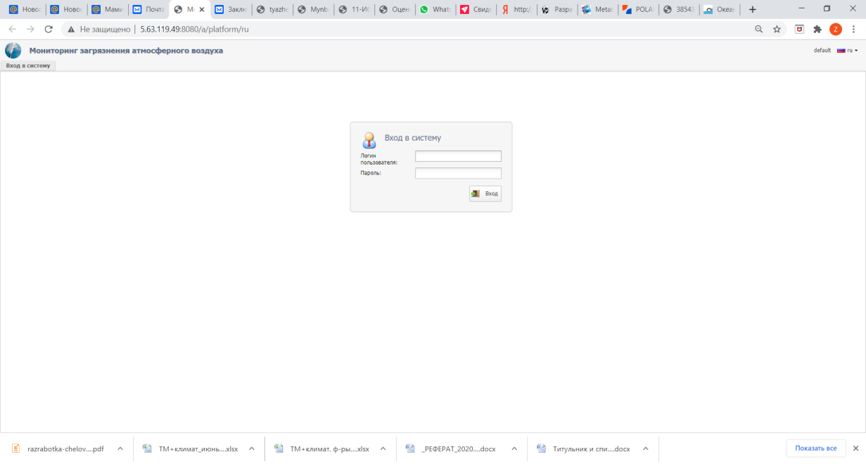
Figure 5.2 – Graphical interface at startup

During the development of the human-machine interface, all 3 stages of design are provided: 1-design (functional requirements, user analysis, conceptual, logical and physical design), 2 – implementation, and 3 –testing. The 1st stage of design is defined and described in [5-6], the results of the remaining stages are presented in this section.
The interface of the developed application "Monitoring of atmospheric air pollution" provides the user with the following menus:" Administration"," Reference books"," Working with data"," Reports on downloaded data", "Data Assimilation".
For convenience, the user can change the interface language, where in the right corner of the window there is a tab for selecting the language, which is shown in figure 5.3.
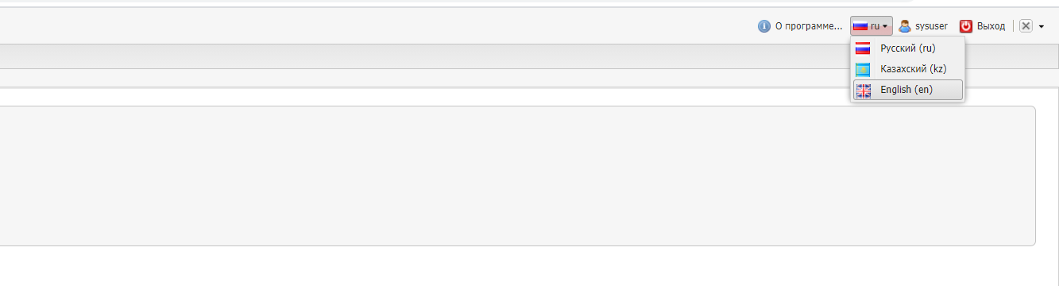
Figure 5.3 – Selecting the application interface language
As shown in figure 5.3, the developed application offers an interface in 3 languages: Russian, Kazakh, and English.
According to the functional requirements and tasks of this project, the following interfaces of the "Monitoring of atmospheric air pollution" application were implemented and tested, they are grouped into the following menus: "Administration", "Reference books", "Working with data", "Reports on downloaded data", "Data assimilation" are shown in figures 5.4.
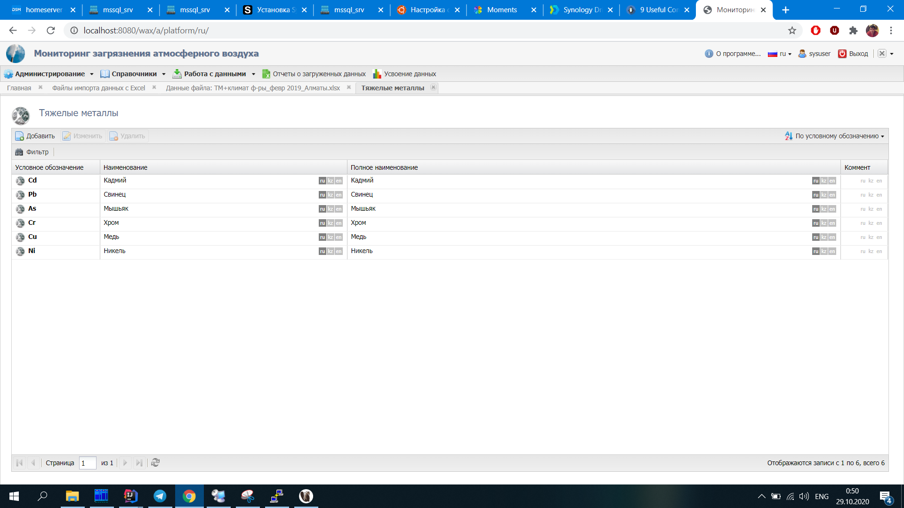
Figure 5.4 – System menu options
You can also demonstrate the interface sub-tab "Import data" when you select one file in preview mode, which is represented in figure 1.3.
Various types of visualization were created to demonstrate the results of solving the problem of data assimilation based on the Almaty data using the reverse modeling scenario, taking into account the configuration of sources and the Almaty monitoring system. For example, the result of a mathematically based local forecast of air pollution taking into account mesometeorological factors and photochemical transformations is shown in figure 5.5.
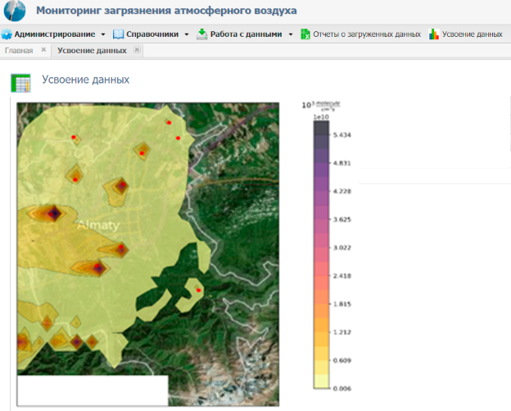
Figure 5.5 – Visualization results of the monitoring
Just like in standard applications, the interface provides information about the program, the user profile, and the exit button, which are shown in figure 5.6.
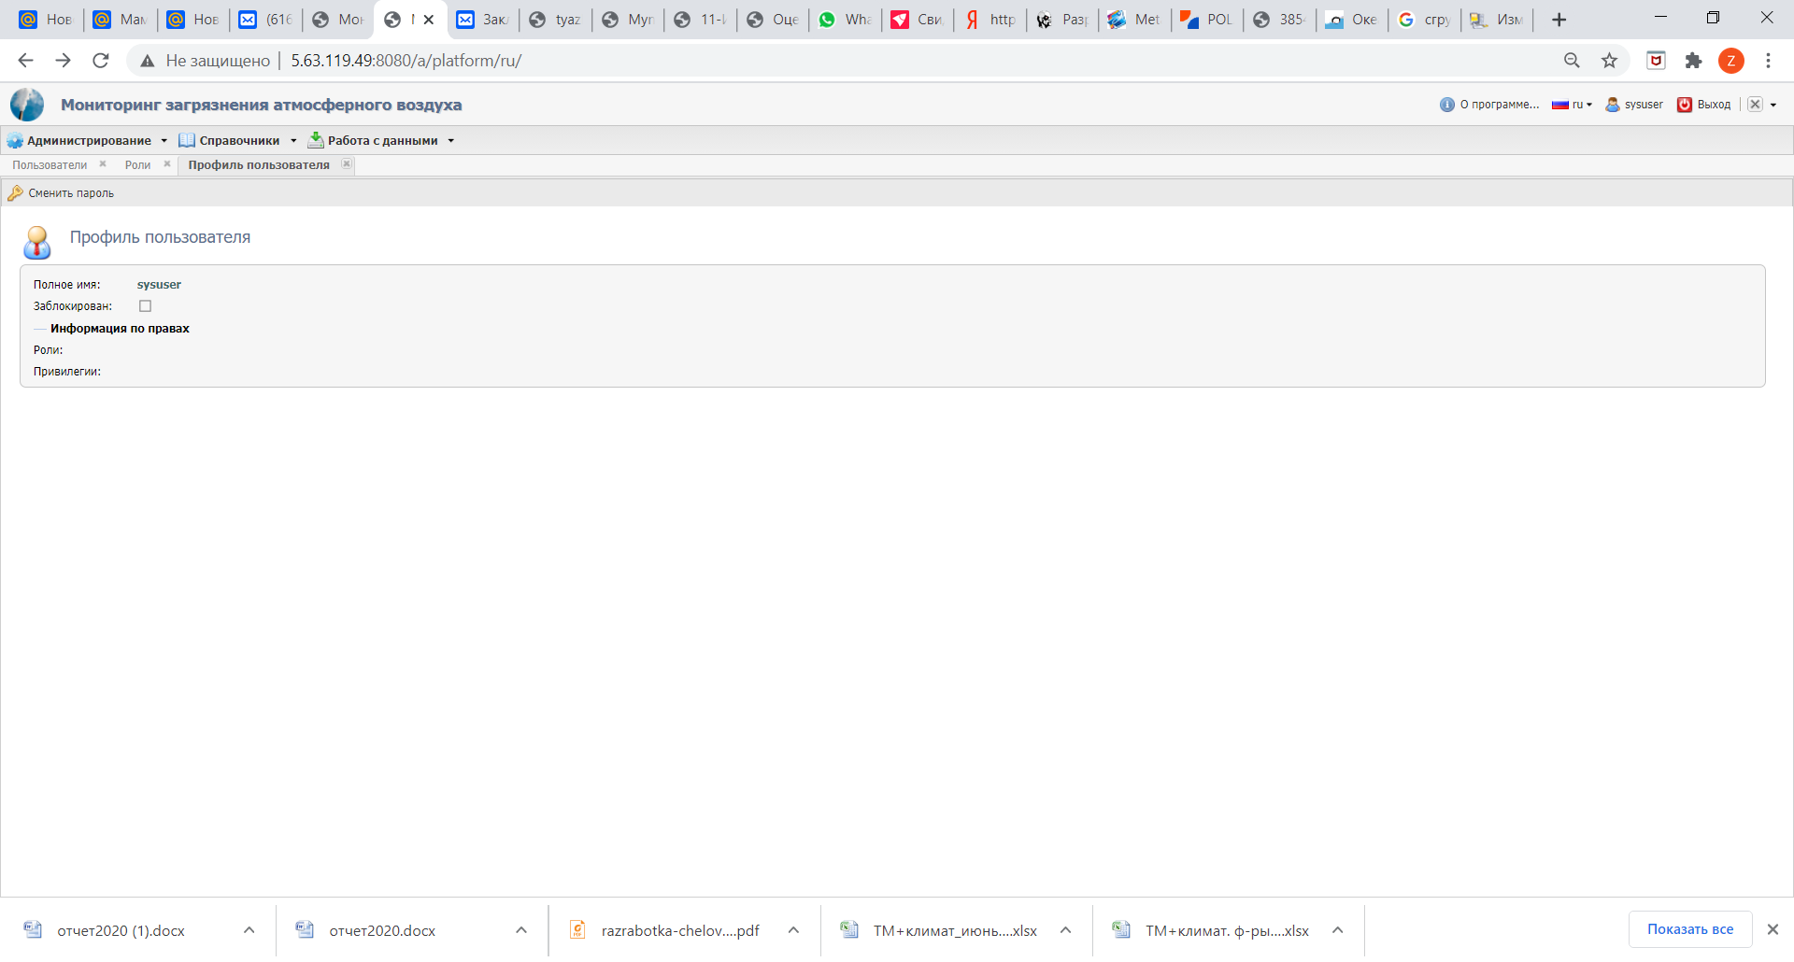 Figure 5.6 – Additional features of the app
To perform this work, first of all, software tools, methods, and methods for visualizing data in environmental problems are considered, and questions of organization and data presentation options are studied. Thus, an intuitive human-machine interface for software visualization of monitoring results has been developed.
Based on the results of this section for 2020, 1 article was published in a peer-reviewed domestic scientific publication with a non-zero impact factor [13].

6 Formation of an information system for environmental monitoring of atmospheric pollution
This section is devoted to the formation of an information system for environmental monitoring of atmospheric pollution with heavy metals.
During the implementation of the main goal of the project, an information system and database were created to optimize monitoring of atmospheric air pollution on the server of the National scientific laboratory for collective use of information and space technologies in Almaty. Earlier reports for 2018 and 2019 described the main modules of the system, as well as the database.
Figure 6.1 shows a diagram of the main blocks of the system being developed.ы.
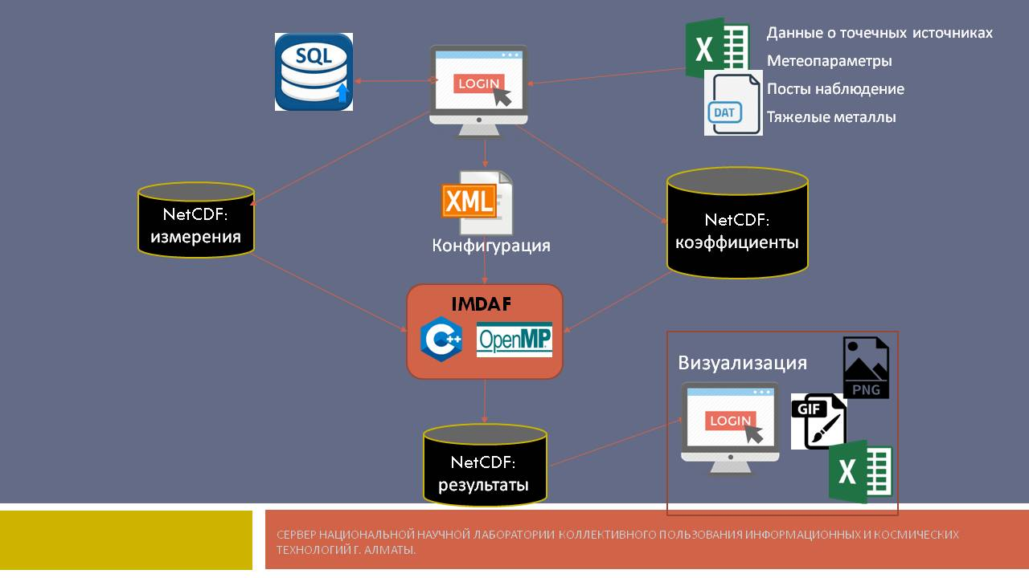
Figure 6.1 - Diagram of the main blocks of the developed system

- The developed information system provides for:
- collection and processing of initial data on environmental pollution by heavy metals (impurity concentrations) in the industrial city of Almaty;
- collection and processing of meteorological parameters (wind speed, wind direction, temperature, atmospheric pressure, etc.);
- formation of NetCDF files;
- mathematical support of the information system for environmental monitoring of atmospheric air with heavy metals: variational algorithms for sequential assimilation of data in real time;
- determination of the degree of atmospheric air pollution, assessment of the air condition of the surface layer of the city's atmosphere;
- visualization of theobtained results;- output data in the form of reports on the degree of air pollution in the city based on the results obtained.
To collect and process the initial data on environmental pollution of HM, as well as meteorological parameters, the following tasks were implemented: selected sites for air sampling and determined the content of HM in the samples of Almaty; created the structure and replenishment of the database on air pollution of Almaty TM; included in the database results on air pollution of Almaty, which are presented in [5-6], as well as in the first section of this report.
To generate NetCDF files, the following tasks were implemented: the application format for the container of the basic elements of the information modeling system, the organization of the database and access to it from problem-oriented applications, which are presented in [5-6], as well as in the first section of this report.
For the mathematical software of the information system were implemented the following tasks: carried out the implementation and research of algorithms of data assimilation for monitoring the chemical composition of the atmosphere of Almaty city; studied variational algorithms for sequential data assimilation in real-time; developed ways of interface of the developed models and methods atmospheric chemistry with real meteorological data created a database on air pollution which are presented in works [5-6], as well as in the second and third section of this report.
To determine the degree of atmospheric air pollution and assess the state of air in the city's surface layer, the following tasks were implemented: the analysis of selected air samples was carried out, the degree of atmospheric air pollution in Almaty was determined and evaluated; recommendations were proposed, which are presented in [5-6], as well as in the eighth section of this report.
To visualize the results, the following tasks were implemented: software tools were developed for a new information system for environmental monitoring and analysis of the results of monitoring changes in the chemical composition of the atmosphere; a human-machine interface was developed for software tools for visualizing monitoring results, which are presented in [6], as well as in the fourth and fifth sections of this report.
For data output in the form of reports on the extent of air pollution of the city on the basis of the obtained results, we implemented the following tasks: analysis of samples of air, the degree of pollution of atmospheric air of Almaty city; the development of software tools for the new information system of environmental monitoring and analysis of results of monitoring changes in the chemical composition of the atmosphere; developed human machine interface software tools, evaluation of environmental condition of air in ground layer of atmosphere for the city Almaty, which are presented in [5-6], as well as in the fourth and fifth sections of this report.
To form an information system for ecological monitoring of atmospheric pollution, the following task also plays an important role: testing and refining the components of the system for environmental monitoring of atmospheric pollution, which is presented in the seventh section of this report.
During the implementation of the research project, the IMDAF reverse modeling and data assimilation system (ICM&MG Inverse Modeling and Data Assimilation Framework) was used) The IMDAF System developed by a foreign participant of this project, A.V. Penenko, at Novosibirsk state University, solves a hierarchy of increasingly complex mathematical modeling problems: direct problems, sensitivity assessment problems, inverse problems, and data assimilation problems. By using splitting schemes and an ensemble approach, the algorithms that make up IMDAF are effectively mapped to parallel computing architectures.
To enable efficient development, IMDAF is developed in an object-oriented paradigm. Specific examples of how the system works are given for advection-diffusion-reaction models that are used in a wide range of practical applications,including atmospheric chemistry and developmental biology.
The system was developed on the basis of technical requirements and restrictions to the information system with modification of the functional scheme, which were presented in [5]. In the course of working on this section, the work of the libraries and frameworks used in the developed system was studied, and the architecture of algorithms with arbitrary Windows for data assimilation using high-performance machines was studied. The process model was developed and tested: establishing links between processes and computer system resources.\
Based on the results of this section for 2020 1 article was submitted to the international peer-reviewed rating journal included in the Scopus database [14].

7 Testing and refinement of components of the environmental monitoring system for atmospheric pollution
During the work, the main functions of the information system and database were tested to optimize monitoring of air pollution with heavy metals. The purpose of this section is to eliminate the comments that arose as a result of testing on the control example, and if necessary, make additional settings and improvements to the system modules.
Were tested Individual components of the following modules of the system "Monitoring of atmospheric air pollution": "Data input Module", "Weather parameter Module". Using the "Working with data" tab, various files were loaded using the MS Excel program. for example, Figure 7.1 shows the uploaded files to the system for testing.
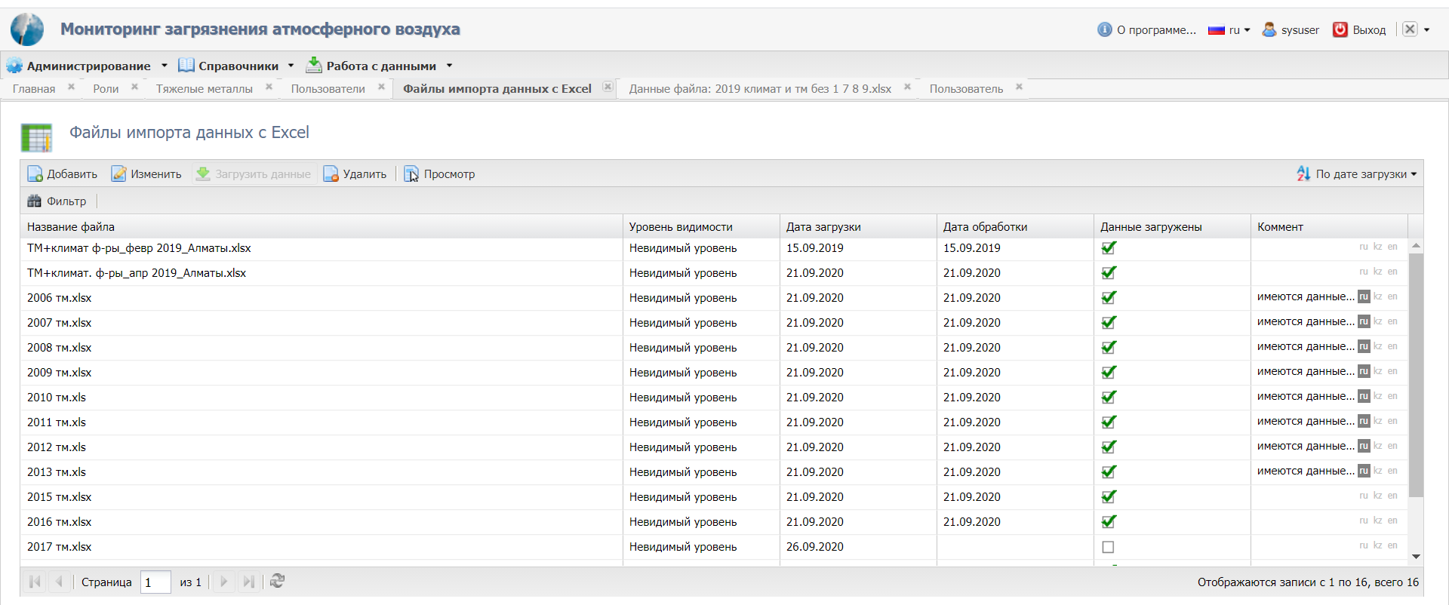
Figure 7.1 – Working with data in the ecological monitoring system

Then analyzed the measured data for heavy metals and loaded by the import tool, which are shown in figure 7.2.
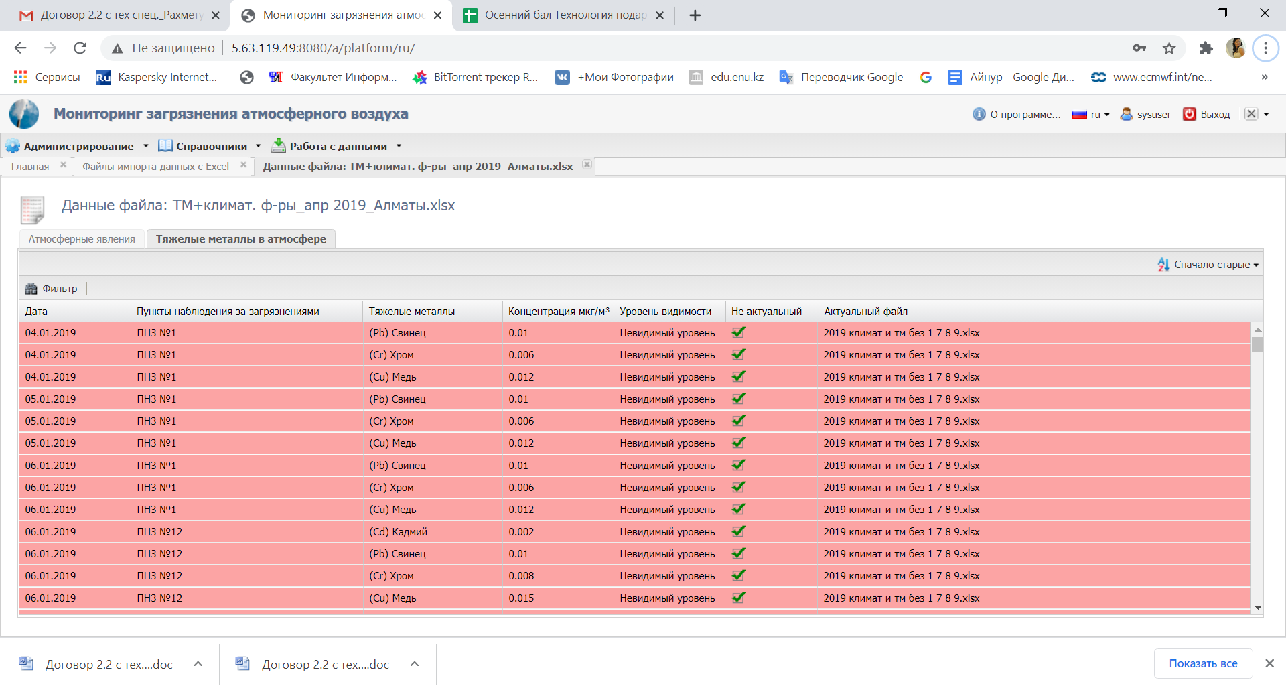
Figure 7.2 - Data viewing mode file
The work on the correctness of information guides developed monitoring system, the processing of the exception to the tab "Administration", "Reference", "Working with data" Sub-tab and the "Upload to NetCDF " in the system "Monitoring of atmospheric air pollution" under international standards relating to testing: : IEEE 829—2008 IEEE Standard for Software and System Test Documentation, ANSI/IEEE Std 1008—1987 — IEEE Standard for Software Unit Testing, ISO/IEC/IEEE 29119-1:2013 Software and systems engineering — Software testing — Part 1: Concepts and definitions, ISO/IEC/IEEE 29119-2:2013 Software and systems engineering — Software testing — Part 2: Test processes, ISO/IEC/IEEE 29119-3:2013 Software and systems engineering — Software testing — Part 3: Test documentation..
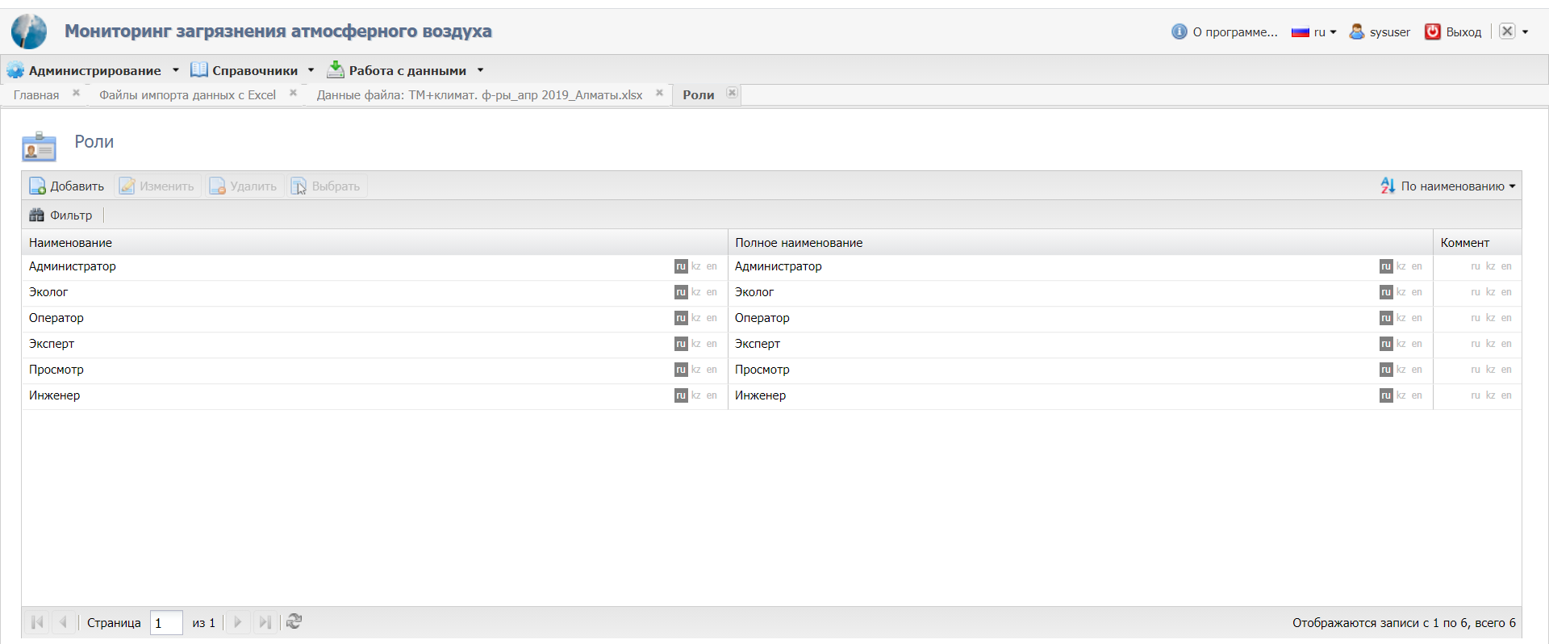
Figure 7.3 – Testing the "Roles" tab in the monitoring system

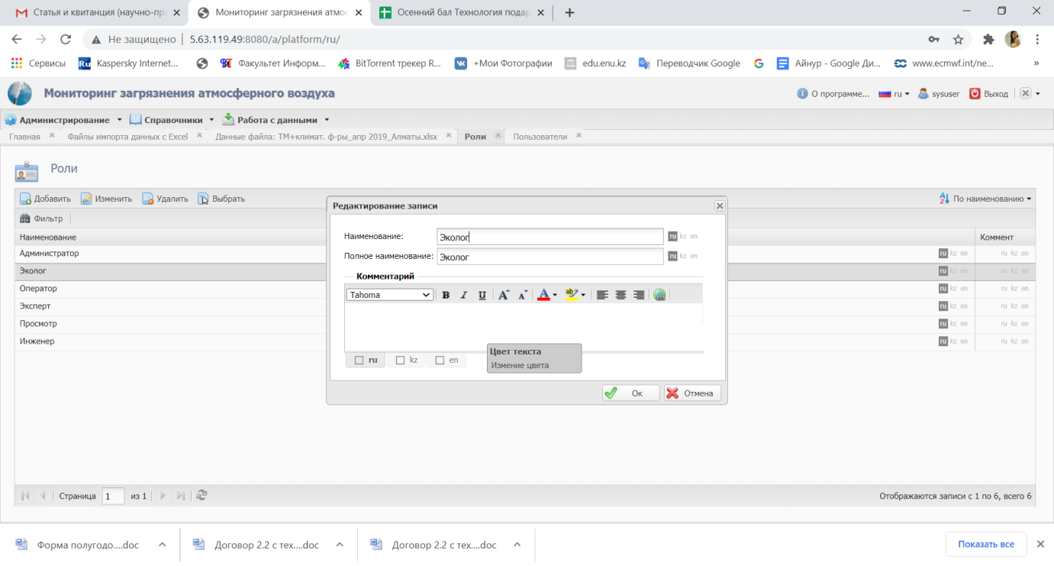
Figure 7.4 – Editing the role "Ecologist"

In the course of the work, various testing methods were carried out, the results of which are presented in tables 7.1, 7.2, 7.3.
Table 7.1 – Test results
Type of error | Test result
Incorrect interrupt processing | No error
Refusals related to runtime requirements | No error
Incorrect reaction of the system to hardware transients or hardware failures | No error
Competition issues for data buses and other resources | No error
The inability of built-in tests to detect certain types of failures | No error
Errors in hardware/software interfaces | No error
Incorrect behavior of feedback loops | No error
Incorrect operation of memory management hardware or other hardware running the system | No error
Stack overflow | No error
Incorrect functioning of mechanisms that support the correctness and no error. | No error
Software splitting failures | No error

Table 7.2 – Test results
Type of error | Test result
Invalid initialization of variables and constants | No error
Parameter transmission errors | No error
Mashing data, especially global data | No error
Incorrect sequence of events and actions | No error

Table 7.3 – Test results
Type of error | Test result
Algorithm error in implementing the software requirement | No error
Incorrect operation of the loop | No error
Incorrect logical decisions | No error
Failure when processing correctly formed combinations of input conditions | No error
Incorrect response to missing or distorted input data | No error
Incorrect handling of exceptional situations of the type arithmetic errors or out-of-bounds array | No error
Incorrect calculation sequence | No error
Inadequate accuracy of calculation in the algorithm, accuracy of data representation, or execution of calculations | No error

According to the data in the tables, you can see that there are no errors.
Based on the results of this work, we tested the protection of input data sent to users. Testing showed that sending input data is protected from incorrect parameters, and visual display was also tested. The result is a correct display in the application that corresponds to the input parameters. We tested individual components of the system under development-functions, as well as classes created earlier.
Thus, having carried out various methods of testing the "Monitoring of atmospheric air pollution" system, it should be noted that during testing, suggestions and comments were taken into account and corrected.
Based on the results of the tasks performed in this section, 1 article was published in the proceedings of international conferences [15].

8 Assessment of the air ecological state of the surface layer of atmosphere for Almaty city
This section is devoted to the ecological state assessment of the air surface layer of the atmosphere for Almaty city. Sources of pollution increase with the rapid development of modern cities and cause air, water and soil pollution. The high growth rate of the world's urban population puts enormous pressure on the quality of air, water, etc. In this regard, there is a need for a more in-depth study of pollution factors and assessment of the air ecological state in the surface layer of the atmosphere. In General, the study of the atmosphere is based on observations, theory, and modeling [15].
As an example of the assessment results, 54 air samples were taken from January 2020 to September 2020: 3 from each POP per month. Also was obtained a common database for HM in the atmospheric air of Almaty, which consists of the results of chemical analysis selected air samples in Almaty for the content of Cd, Pb, As, Cr, Cu and Ni. Further, for the period from January 2020 to September 2020. (inclusive) has been obtained a database of climate data that was taken 4 times a day daily. The database for climate factors consisted of: 4 time points (1 a.m., 7 a.m., 1 p.m., 7 p.m.), temperature, C0, wind direction and degrees of its movement. The numerical designation of atmospheric phenomena for working with the database is shown in table 8.1.
Table 8.1 – Numeric identification
Numeric identification | Atmospheric phenomenon | Description
1 | Clear | There are no clouds in the sky
2 | Mist | Turbidity of the air due to suspended particles of dust, smoke, burning, the air has a bluish tint
3 | Haze | Weak turbidity of the atmosphere due to supersaturation of air with moisture. The air has a grayish tint; visibility is more than 1 km
4 | Rain | Precipitation in the form of liquid drops
5 | Drizzle | Precipitation in the form of small drops, their fall is almost invisible to the eye
6 | Dusty  storm | Reduced visibility over a large area due to dust raised by strong winds
7 | Snow | Precipitation in the form of ice crystals
8 | Fog | Atmospheric turbidity with horizontal visibility less than 1 km
9 | Fog (or haze) with precipitation | Turbidity of the atmosphere due to fog (or haze) in the presence of precipitation
According to the above parameters of climate data, we found:
- - January: 11 days fog or haze with precipitation, 6 days snow, 17 days haze, 7 days clear, 16 days calm;
- - February: 5 days of fog or haze with precipitation, 7 days of snow, 7 days of haze, 1 day of rain, 10 days. clear, 10 days calm;
- - March: 4 days fog or haze with precipitation, 2 days snow, 6 days haze, 5 days rain, 16 days clear, 12 days calm;
- - April: 5 days of fog or haze with precipitation, 7 days of haze, 9 days of rain, 18 days. clear, 13 days calm;
- may: 4 days. haze, 8 days. rain, 22 days. clear, 12 days calm;
- June: 7 days rain, 24 days clear, 11 days calm;
- July: 6 days rain, 26 days clear, 1 d. haze, 1 d. haze, 22 days calm;
- August: 7 days rain, 25 days clear, 16 days calm;
- September: 2 days rain, 29 days clear, 14 days calm.
There are a lot of calm days, and if there is a wind, its speed is small: from 1 to 3 m / sec. Only in June, we noted that for 2 days there was a wind with a speed of up to 5 km / h. There were no dust storms in the summer months.
The analysis of the obtained data for 2020 was made (January-September), which showed that the content of the main analyzed HM (Cd, Pb, As, Cr, Cu and Ni) in the atmospheric air of Almaty still did not exceed the MPC, except for Pb and Cu. Their excess was on POP 1 (Amangeldy st./Satpayev st.) on average up to 1.3 MPC, on POP12 (Ave. Raiymbek/Nauryzbay Batyr st.) - up to 2.1 MPC in the environmental monitoring system of Almaty. Thus, from the analysis of chemical data during 2020, it follows that in the air of the studied square of streets in Almaty, the content of HM did not exceed the MPC.
According to the obtained climate data in 2020, from January 2020 to September 2020, unfavorable weather conditions in Almaty were noted: high air temperature in the summer months, low precipitation, weak air circulation, etc. These parameters increased the degree of air pollution.
For the user's convenience, the ability to upload reports on uploaded data was created to assess the environmental state of the air in the surface layer of the atmosphere. The system user is required to enter the observation period (dates), POP and heavy metal for which the report will be made. Generating a report on uploaded data is shown in figure 8.1.
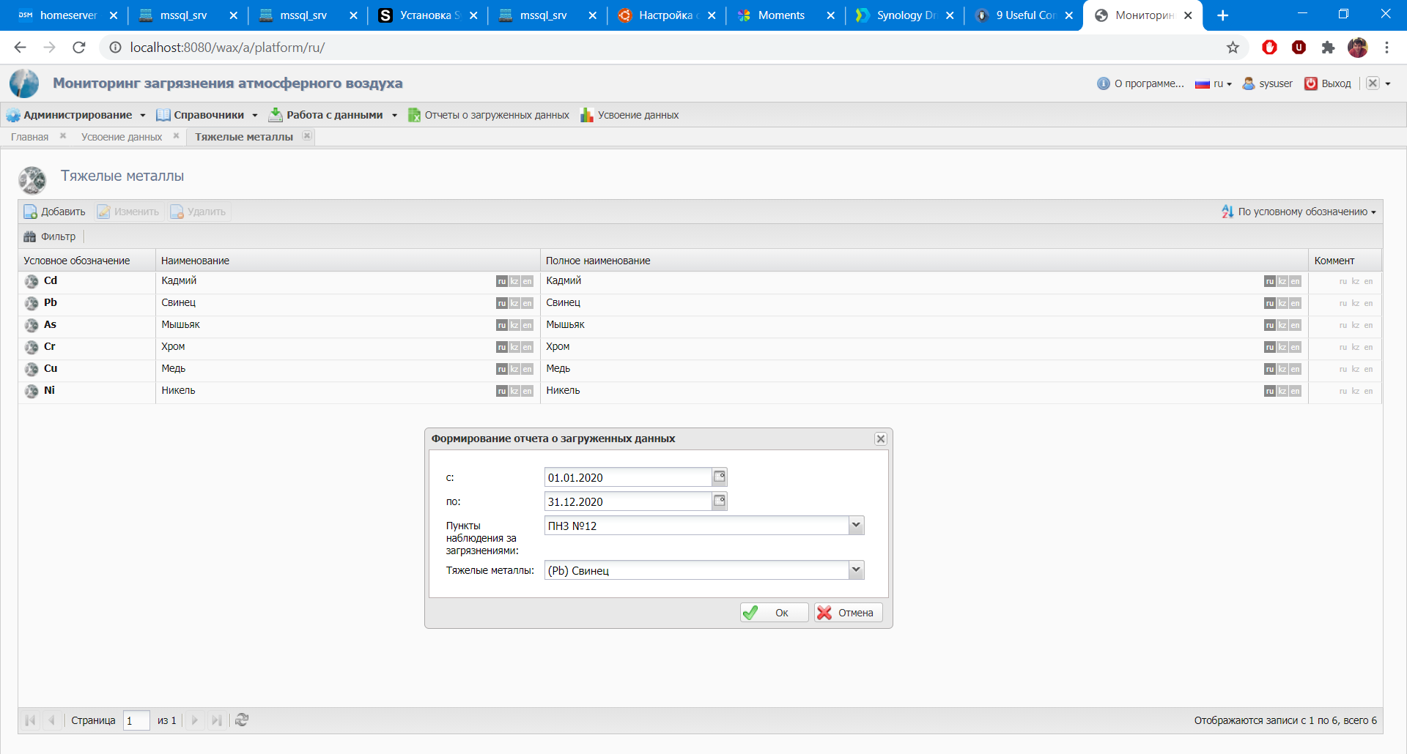
Figure 8.1 – Generating a report on uploaded data
As a result of the procedure for generating a report on uploaded data, the file report type is uploaded - Microsoft Office Excel 97-2003 Worksheet (.xls ), which is shown in figure 8.2.

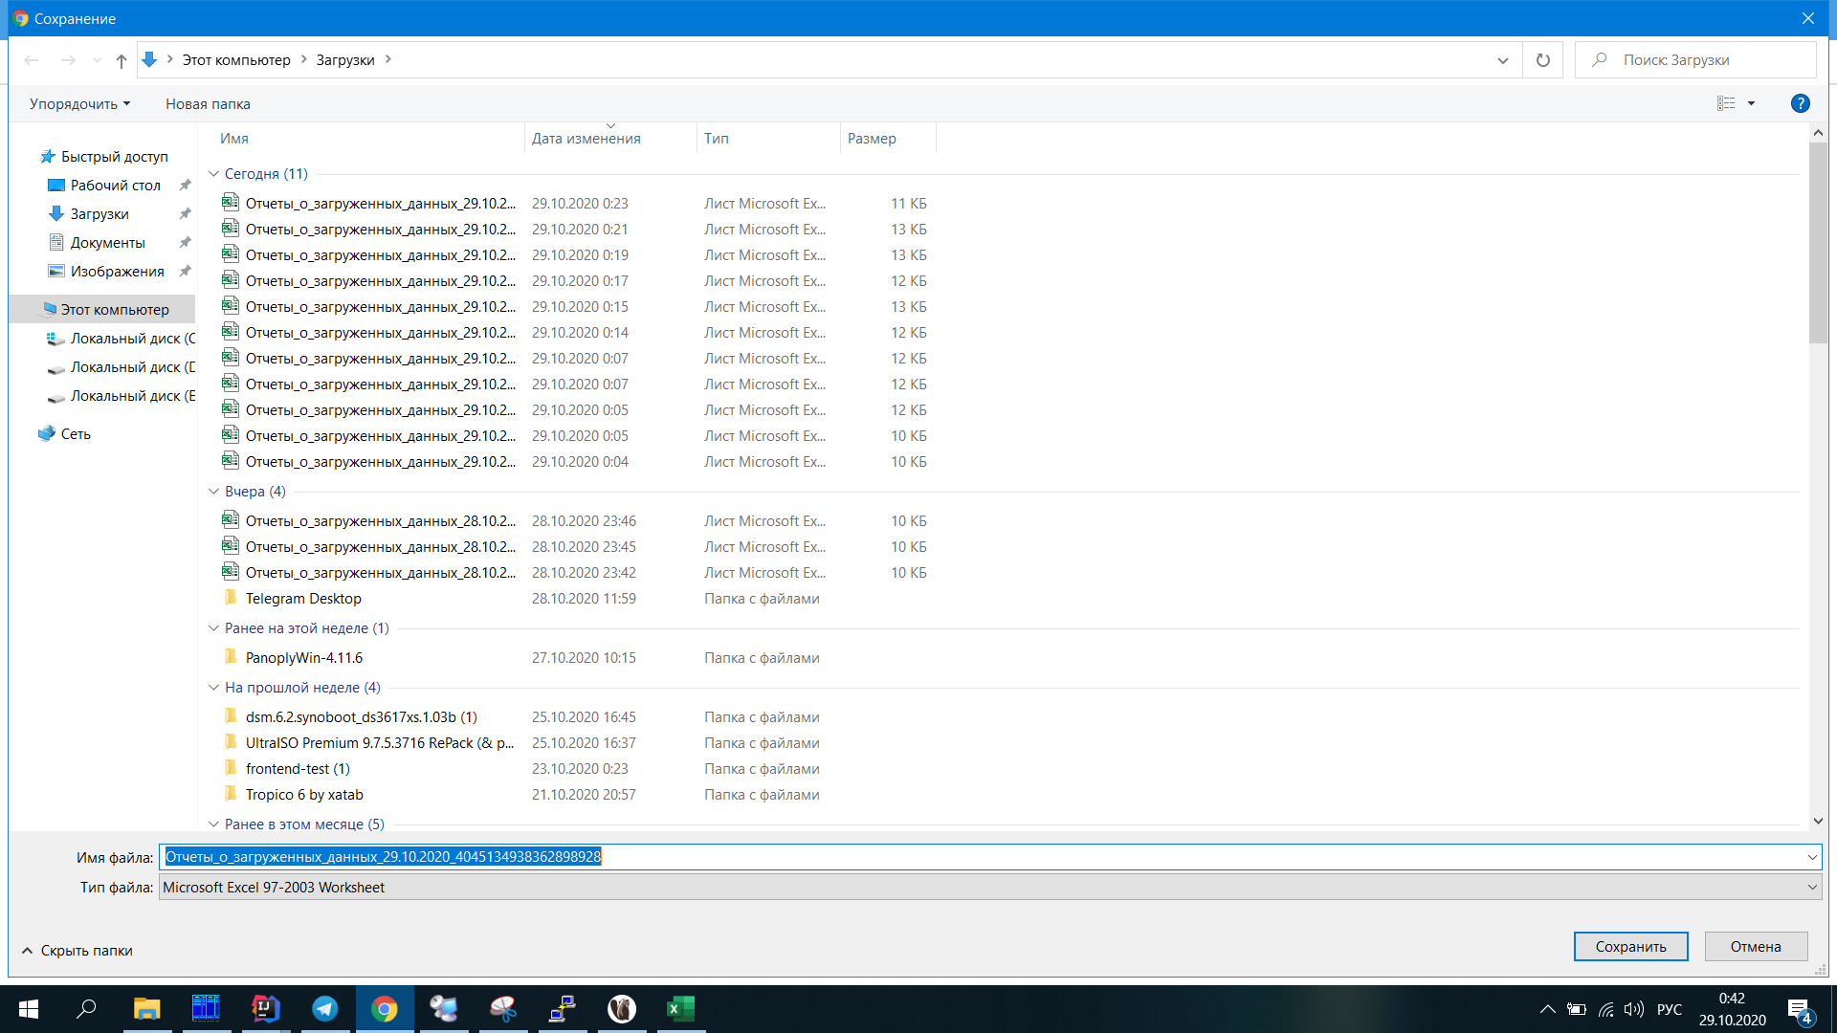
Figure 8.2 – Uploading file report type of Microsoft Office Excel 97-2003 worksheet (.xls)

The type of report on uploaded data is shown in figure 8.3. for example, heavy metal – lead is selected, and the collection point is POP 1.
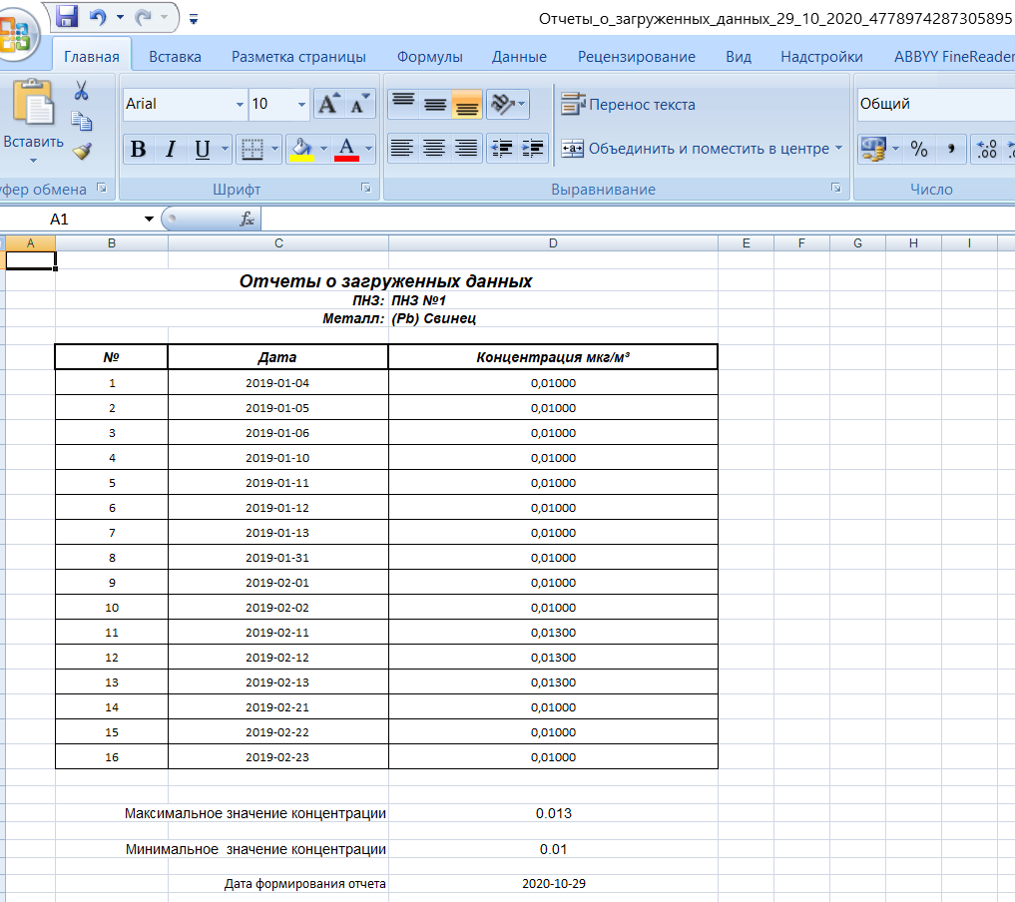
Figure 8.2 – Report on uploaded data
Thus, as in the previous 2018 and 2019, the assessment of the air ecological state of the surface layer of atmosphere for Almaty is unfavorable, because many pollutants, including HM, simply accumulated in the surface layer of air and on the surface of the city's soil. Moreover, the influence of climatic or meteorological factors is significant for the atmospheric processes of urban air pollution.
It is expected to recommend the results obtained on the basis of information and communication technologies not only in Almaty for the Kazhydromet branch, but also for air monitoring in large industrial cities of the Republic of Kazakhstan (Ust-Kamenogorsk, Karaganda, etc.).
Based on the results of the tasks performed in this section, 1 article were submitted in the proceedings of international conferences [15].

.

9 Issue of a scientific collective publication
This section describes a brief summary of the collective scientific editions in a state language of the authors Zh.O.Oralbekova, B.N. Mynbayeva, K.T.Iskakov, Z.T.Khassenova, M.G.Zhartybayeva «Creating an effective information system and database to optimize the control of air pollution with heavy metals» (Name of collective scientific edition in Kazakh language: Auyr metaldarmen atmosferalyq ayanin lastanyin baqylaudy ontailanyru ushin tiymdi aqparattyq juye men derekter qoryn qury).
The collective monograph consists of 8 sections, an introduction, a conclusion, a list of used sources and an Appendix. The content of the monograph includes the stages and results of research and development of the authors. The authors have been working on this problem for a number of years, where they consider the stages of developing an effective information system and database for optimizing monitoring of air pollution with heavy metals on the example of Almaty city. Air sampling sites were selected for the study, were determined the content of heavy metals and the degree of air pollution. The database contains data on air pollution in Almaty HM, archival data and own research. The technical requirements and restrictions for the information system, its functional scheme, as well as the application format for the container of the basic elements of the system, the organization of the database and access to it from problem-oriented applications are developed. Variation algorithms for sequential assimilation of data for monitoring the chemical composition of the atmosphere in Almaty city in real time are implemented and studied. While developing the mathematical support of the information system for environmental monitoring of atmospheric pollution, the methods of interfacing the developed models and methods of atmospheric chemistry with real meteorological data are taken into account. Software tools for the new information system of ecological monitoring and analysis of results monitoring changes in the chemical composition of the atmosphere made it possible to manage calculations on a server platform. The materials are presented sequentially and supplemented with figures and tables. The information presented in the collective monograph corresponds to modern science.
The monograph is intended for doctoral and master students in the direction of training personnel "information and communication technologies" and "Protection of the surrounding environment", as well as all issues of interest, tasks in the field of Ecology. With the brief content of the collective scientific work «Creating an effective information system and database to optimize the control of air pollution with heavy metals» (Name of collective scientific edition in Kazakh language: Auyr metaldarmen atmosferalyq ayanin lastanyin baqylaudy ontailanyru ushin tiymdi aqparattyq juye men derekter qoryn qury) can be found in the Appendix D.

CONCLUSION
In strict accordance with the technical specification and the work schedule for 2018-2020 under contract No. 132 dated 12.03.2018, the following scientific results were obtained:
1. Brief conclusions on the results of the SRW for 2018-2020.
- during the implementation of the SRW the following tasks were performed: selected sites for air sampling and determined the content of heavy metals in the samples of Almaty, presented technical details of air sampling, General characteristics of measurements, as well as methods for determining the content of heavy metal. The results are published in [5];
- was carried out the analysis of selected air samples in Almaty, determined the degree of air pollution in the city. The results of research on data analysis methods are presented, and application programs are used as tools. The results are published in [5, 9].
- developed technical requirements and restrictions for the information system, defined the main purposes, goals of creating the system, the technology on the basis of which this information system will be developed, its advantages, requirements for the server / client application, the database server, as well as restrictions. The results are published in [5];
- the functional scheme of the information system has been developed. The functional capabilities of the main modules that make up the system, types and functions of users are described, and the functional diagram of the information system is given. The results are published in [5, 16];
- developed an application format for the container of basic elements of the information modeling system, organization of the database and access to it from problem-oriented applications. The results are published in [5, 6, 17-21]; received 1 copyright certificate of state registration of rights on the object copyright of the database "Monitoring chemical composition of the atmosphere" [4];
- implementation and research of algorithms for assimilation of data for monitoring the chemical composition of the atmosphere in Almaty was carried out; were applied variational algorithms for sequential assimilation of data in real time, where modeling of impurity transfer processes was applied. The results are published in [5-8, 22-25];
- developed methods of coupling the developed models and methods of atmospheric chemistry with real meteorological data of the created database on air pollution; the problem of modeling the processes of transport of impurities for the city of Almaty is considered, taking into account the geographical location, terrain and transport emissions during "traffic jams". The results are published in [6, 26];
- - software tools have been developed for a new information system for environmental monitoring and analysis of the results of monitoring changes in the chemical composition of the atmosphere, and calculations have been managed on a server platform. The results are published in the papers [6, 10, 11, 27]; received 1 copyright certificate of state registration of rights to the object of copyright for the computer program "Web-application for ecological data management" [11];
- developed a human-machine interface for software visualization of monitoring results. The results are published in [13];
- an information system for environmental monitoring of atmospheric pollution has been formed. The results are published in [14];
- testing and improvement of components of the system of ecological monitoring of atmospheric pollution was carried out.
- assessment of the air ecological state of the surface layer of atmosphere for Almay city. Recommendations are offered. The results are published in [15]
- has been published a collective scientific publication of the authors Zh.O.Oralbekova, B.N. Mynbayeva, K.T.Iskakov, Z.T.Khassenova, M.G.Zhartybayeva «Creating an effective information system and database to optimize the control of air pollution with heavy metals» (Name of collective scientific edition in Kazakh language: Auyr metaldarmen atmosferalyq ayanin lastanyin baqylaudy ontailanyru ushin tiymdi aqparattyq juye men derekter qoryn qury).
2 Assessment of the completeness of solutions to tasks.
All the tasks assigned for the period 2018-2020 were completed efficiently and on time.
- for 2018: a database on air pollution with heavy metals was created, based on the example of Almaty; a functional scheme of the information system was created; variational algorithms for sequential assimilation of data in real time were studied.
- for 2019: the database on air pollution in Almaty with heavy metals was updated; mathematical support for the information system for environmental monitoring of atmospheric pollution was developed; a subsystem for managing calculations on the server platform was developed.
- for 2020: developed a new information system and database to optimize the monitoring of air pollution with heavy metals; evaluation of the ecological state of air in ground layer of atmosphere on the example of Almaty city; created a typographic layout of a scientific publication (monograph).
3 Development of recommendations and source data for specific use.
The results of the scientific research work can be used for research of doctoral and master's students in the field of training "Information and communication technologies" and "Environmental protection" and are recommended not only for the branch "Kazhydromet" in Almaty, but also for monitoring the air of large industrial cities of the Republic of Kazakhstan (Ust-Kamenogorsk, Karaganda, etc.)
- Results of evaluation of technical and economic efficiency of implementation.
In the course of the research, an information system and database organization were developed to optimize monitoring of atmospheric air pollution with heavy metals using algorithms for assimilation of data from monitoring the chemical composition of the atmosphere.
5 Results of the assessment of the scientific and technical level of the SRW performed in comparison with the best achievements in this field.
During the reporting period for the project for 2018-2020, there are 17 articles and 1 collective scientific publication (monograph), 4 articles were published and 1 article was submitted to the international peer-reviewed rating journal included in the Scopus database; 6 articles were published and 1 article was accepted for publication in peer-reviewed domestic scientific publications with a non-zero impact factor; 5 articles and 4 theses were published in the proceedings of international conferences; 2 certificates of state registration of copyright rights and 5 certificates of participants in international conferences were obtained.
The final report on the project "Development of a new information system and database for optimizing monitoring of air pollution by heavy metals" consists of 9 sections, introduction, conclusion, list of sources used and appendices. The content of the reports strictly corresponds to the tasks of the calendar plan for 2020. The authors describe all the results achieved within the project.
All the planned tasks according to the CP for 2018-2020 were fully completed and the goal was achieved.

LIST OF REFERENCES
- Teplaya G.A. “Heavy metals as a factor of environmental pollution”(literature review), Astrakhan Bulletin of environmental education. – 2013 (23). – №1. – P.182-192. [Теплая Г.А. Тяжелые металлы как фактор загрязнения окружающей среды (обзор литературы) // Астраханский вестник экологического образования. – 2013 (23). – №1. – С. 182-192.] (in Russian).
- Oceanology. Oceanography. Forum Oceanographers.ru. [Electronic resource], (2016), Mode of access: http://www.oceanographers.ru/forum (date accessed: 10.08.2020). [Океанология. Океанография. Форум Oceanographers.RU. [Электронный ресурс]. – 2016. Режим доступа: http://www.oceanographers.ru/forum (дата обращения: 10.08.2020 г.)] (in Russian).
- Zhartybayeva M.G., Yessimova N.B., Furaeva I.I., Zhukabayeva T.K., Zhumadillayeva A.K. «Rationale for choosing a DBMS and updating the database on air pollution of the Almaty city with heavy metals»// Bulletin of the Gumilyov ENU. – Astana. –2020. – №1 (130). – P. 78-89. [Жартыбаева М.Г., Есимова Н.Б., Фураева И.И., Жукабаева Т.К., Жумадиллаева А.К. «Обоснование выбора СУБД и пополнение базы данных по загрязнению атмосферного воздуха города Алматы тяжелыми металлами» // Вестник ЕНУ им.Л.Н.Гумилева. – Астана. – 2020. – №1 (130). – С.78-89.] (in Russian).
- Khasenova Z.T., Iskakov K.T., Oralbekova Zh.O., Furaeva I.I., Rakhmetullina S.Zh. Сopyright to the type of object «Databases», the name of the object «Monitoring chemical composition of the atmosphere» No.7458 dated January 9, 2020. [Хасенова З.Т., Искаков К.Т., Оралбекова Ж.О., Фураева И.И., Рахметуллина С.Ж. Авторское право на вид объекта «Базы данных», название объекта «Мониторинг химического состава атмосферы» №7458 от «9» января 2020 года.] (in Russian).
- Oralbekova Zh.O. “Development of a new information system and database for optimizing monitoring of atmospheric air pollution by heavy metals”, research report (interim) / JSC National center for science and techn.inform., manuscript, no. GR 0118RK00600. - inv. no. 0218RK00941, - Almaty. – 2018. –75 p. [Разработка новой информационной системы и базы данных для оптимизации мониторинга загрязнения атмосферного воздуха тяжелыми металлами: отчет о НИР (промежуточный) / АО «Нац. центр научно-техн. информ.»: рук. Оралбекова Ж.О. – Алматы. – 2018. –75 с. – № ГР 0118РК00600. – Инв. № 0218РК00941.] (in Russian).
- Oralbekova Zh.O. “Development of a new information system and database for optimizing monitoring of atmospheric air pollution by heavy metals”, research report (interim) / JSC National center for science and techn.inform., manuscript, no. GR 0118RK00600. - inv. no. 0218RK00941, - Almaty. – 2019. -55 p. [Разработка новой информационной системы и базы данных для оптимизации мониторинга загрязнения атмосферного воздуха тяжелыми металлами: отчет о НИР (промежуточный) / АО «Нац. центр научно-техн. информ.»: рук. Оралбекова Ж.О. – Алматы. – 2019. –55 с. – № ГР 0118РК00600– Инв. № 0219РК00981.] (in Russian).
- Penenko A.V., Khassenova Z.T., Penenko V.V., Pyanova E.A. Numerical study of a direct variational data assimilation algorithm in Almaty city conditions // Eurasian journal of mathematical and computer applications. ISSN 2306–6172. – 2019. Volume 7, Issue 1, - P. 53 – 64 (Scopus).
- Rakhmetullina S.Zh., Baklanova O.Y., Bugubaeva A.Zh., Dmitrieva T.S. Calculation of environmental hazards associated with the risk of emissions from large industrial enterprises in Ust-Kamenogorsk //Bulletin of Serikbayev EKSTU. - Ust-Kamenogorsk, - 2020. - No. 4 (accepted for printing) [Рахметуллина С.Ж., Бакланова О.Е., Бугубаева А.Ж., Дмитриева Т.С. Расчет экологической опасности, связанной с риском выбросов крупных промышленных предприятий города усть-каменогорска // Вестник ВКГТУ им. Д.Серикбаева. – Усть-Каменогорск, - 2020. - №4 (принята в печать)] (in Russian).
- Mynbayeva B.N., Oralbekova Zh.O., Isabayeva D. N., Iskakov K.T., Khassenova Z.T. An employment of mathematical toolkit for ecological information processing during heavy metals pollution monitoring in particular reference to Almaty city’s atmosphere // In: Conference proceeding: 18th INTERNATIONAL MULTIDISCIPLINARY SCIENTIFIC GEOCONFERENCE SGEM, 30 June – 9 July, 2018. – Bulgaria, Varna. – 2018. – Vol. 18: Ecology, Economics, Education and Legislation. Issue: 5.1. Ecology and Environmental Protection. – P. 27-34. DOI: 10.5593/sgem2017/52/S20.055 (Scopus).
- Khassenova Z.T., Iskakov K.T., Oralbekova Zh.O. Information system for monitoring atmospheric air pollution by heavy metals //Bulletin of the Shakarim state University of Semey. – 2020. – №3 (91). – P. 62-65 [Хасенова З.Т., Искаков К.Т., Оралбекова Ж.О. Информационная система мониторинга загрязнения атмосферного воздуха тяжелыми металлами // Вестник государственного университета им. Шакарима города Семей. – 2020. – №3 (91). – С.62-65.] (in Russian)
- Khasenova Z.T., Iskakov K.T., Toibekov A.T., Kusainova A.T. Copyright on the type of object «Сomputer program», the name of the object «Web application for ecological data management» No.12691 dated October 20, 2020. [Хасенова З.Т., Искаков К.Т., Тойбеков А.Т., Кусаинова А.Т.Авторское право на вид объекта «Программа ЭВМ», название объекта «Web-приложение для управления экологическими данными» № 12691 от 20 октября 2020 года] (in Russian).
- DS Sverchkov, “Development of the human-machine interface and its application in control systems”, Proceedings of the Krylov state scientific center, special issue. – 2018 (1). –P.184-190. [Сверчков Д.С. Разработка человеко-машинного интерфейса и его применение в системах управления // Труды Крыловского государственного научного центра, специальный выпуск. – 2018 (1). – С.184-190.] (in Russian).
- Z.T.Khassenova, A.T.Toybekov, A.T.Kussainova «Using information and communication technologies to assess the level of air pollution in real time» //Bulletin of Serikbayev EKSTU. - Ust-Kamenogorsk, - 2020. - №. 3. – P. 161-166 [Хасенова З.Т., Тойбеков А.Т., Кусаинова А.Т. «Использование информационно-коммуникационных технологий для оценки уровня загрязнения воздуха в реальном времени» // Вестник ВКГТУ им. Д.Серикбаева. – Усть-Каменогорск, - 2020. - №3. – С.161-166.] (in Russian).
- Oralbekova Zhanar, Zhartybayeva Makpal, Mynbayeva Bakhyt, Iskakov Kazizat, Khassenova Zarına «Information system for monitoring of urban air pollution by heavy metals» // Indonesian Journal of Electrical Engineering and Computer Science. – 2020 y. (Scopus).
- Aziyeva N.T., Kussainova A.T., Khassenova Z.T. «Methods for assessing the ecological state of air in the surface layer of the atmosphere» in the field of "Ecology" //
Proceedings of the VII International Scientific and Practical Conference "Science and Education in the Modern World: Challenges of the XXI Century". – Astana. – 2020 y. (were submitted) [Азиева Н.Т., Кусаинова А.Т., Хасенова З.Т. «Методы оценки экологического состояния воздуха приземного слоя атмосферы» авторов по направлению «Экология» // Cборник трудов VII Международной научно-практической конференции «Наука и образование в современном мире: вызовы ХХI века». – Астана. – 2020 г. (отправлена)] (in Russian).
- Khassenova Z., Kussainova A., Oralbekova Zh., Iskakov K. Development of the modules of information system monitoring atmospheric air for industrial city // 5th International conference on computational and experimental science and engineering (ICCESEN-2018) Antalya-Turkey, 12-16 October 2018. - P.326.
- Khassenova Z.T., Kussainova A.T. “Working with spatial-temporal data format NetCDF”, Collection of materials of the XIII international conference of students and young scientists "Science and education - 2018" RK, Astana. – 2018. – Pp.961-964. [Хасенова З.Т., Кусаинова А.Т. Работа с пространственно-временными данными формата NetCDF // Cборник материалов XIII международной конференции студентов и молодых ученых «Наука и образования - 2018» РК, Астана. – 2018. - С.961-964.] (in Russian).
- Khassenova Z.T. “Access to files in the netcdf format using MS Excel” International scientific-practical conference"global science and innovation 2018" Eger, Hungary, 28 February. 2018. – P.98-101 [Хасенова З.Т. Доступ к файлам NETCDF с помощью MS Excel // International Scientific Conference «Global Science and Innovations 2018» Eger, Hungary, February 28. – 2018. - С.98-101.] (in Russian).
- Oralbekova Zh.O., Khassenova Z.T., Zhartybayeva M.G. Collection And Processing Of Data To Optimize The Monitoring Of Atmospheric Air Pollution // Computational and Information Technologies in Science, Engineering and Education (CITech-2018). – 2018. – P. 161-170. (Scopus).
- Khasenova Z.T. “Modern tools for creating and deploying a server application”, Bulletin of the Shakarim state university. – 2018 (82). – № 2. P. 67-70. [Хасенова З.Т. Современные инструменты для создания и развертывания серверного приложения // Вестник государственного университета имени Шакарима. - 2018 (82). - № 2. - С. 67 - 70.] (in Russian).
- Iskakov K.T., Mynbayeva B.N., Oralbekova Zh.O., Mukhtarova Sh.O. “Development of an application format for an information modeling system for environmental monitoring”, Bulletin of KazNU. – 2018. – P.101-108 [Искаков К.Т., Хасенова З.Т., Мынбаева Б.Н., Оралбекова Ж.О., Мухтарова Ш.О. Разработка формата приложений для информационно - моделирующей системы экологического мониторинга // Вестник КазНУ. - 2018. – C.101-108. (in Russian).
- Rakhmetullina S.Zh., Bugubaeva A.Zh. “Application of Data mining technology to predict atmospheric air pollution”, Bulletin of Serikbayev EKSTU. – 2018. - №4. – P. 177-183 [Рахметуллина С.Ж., Бугубаева А.Ж. Применение технологии Data mining с целью прогнозирования загрязнения атмосферного воздуха // Вестник ВКГТУ им.Д. Серикбаева, -2018. - №4. – С. 177-183.] (in Russian).
- Khassenova Z.T., Kussainova A.T. Research of data assimilation algorithms in conditions industrial city // Communications in Computer and Information Science. – 2019. – P. 125-134. (Scopus).
- Yessimova N.B., Khassenova Z.T. “Assessment of atmospheric air quality in an industrial area”, Collection of scientific papers of the XIII International scientific and practical Internet conference "Problems and prospects of development of modern science in Europe and Asia". – Pereyaslav-Khmelnitsky. – 2019. – P.24-27 [Есимова Н.Б, Хасенова З.Т. Оценка качества атмосферного воздуха промышленного района // Сборник научных трудов ХІII Международной научно-практической интернет-конференции «Проблемы и перспективы развития современной науки в странах Европы и Азии». – Переяслав-Хмельницкий. - 2019. – С.24-27] (in Russian).
- Penenko A.V., khasenova Z.T., Penenko V.V., Pyanova E.A. “Application of the algorithm for assimilation of atmospheric pollution monitoring data for the conditions of the city of Almaty”, Collection of abstracts of the eleventh international youth scientific school-conference "Theory and numerical methods for solving inverse and ill-posed problems" Novosibirsk, Akademgorodok. 26.08 – 04.09 2019 г. – 2019. – P.46 [Пененко А.В., Хасенова З.Т., Пененко В.В., Пьянова E.A. Применение алгоритма усвоения данных мониторинга загрязнения атмосферы для условий города Алматы // Сборник тезисов одиннадцатой международной молодежной научной школы-конференции «Теория и численные методы решения обратных и некорректных задач» Новосибирск, Академгородок. 26.08 – 04.09 2019 г. – 2019. - С.46] (in Russian).
- Yergeshbay G.A. “Study of atmospheric chemistry models and methods with accurate meteorological data on air pollution”, XIV international scientific conference of students and young scientists "Science and education-2019", Gumilyov ENU, Nur-Sultan. –2019. –P.770-772 [Ергешбай Г. А. Ауаның ластануы бойынша нақты метеорологиялық деректермен атмосфералық химияның моделдері мен әдістерін зерттеу // ХIV Международная научная конференция студентов и молодых ученых «Наука и образование - 2019», Евразийский национальный университет имени Л.Н. Гумилева, г. Нур-Султан. – 2019. – С.770-772] (in Kazakh).
- Oralbekova Zh., Zhartybaeva M., Iskakov K., Khassenova Z., Mirgalikyzy T. Information system for monitoring urban pollution by heavy metals // 6th ICCESEN-2019 23-27 October, Antalya-Turkey, – 2019. – P. 75.

APPENDIX А
Copy of the technical specification and calendar plan for 2020
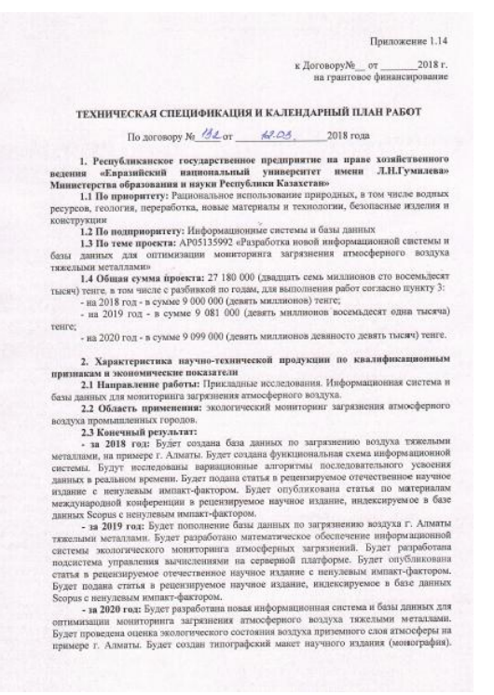

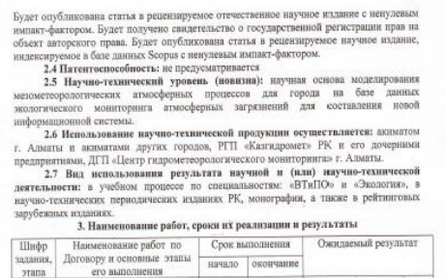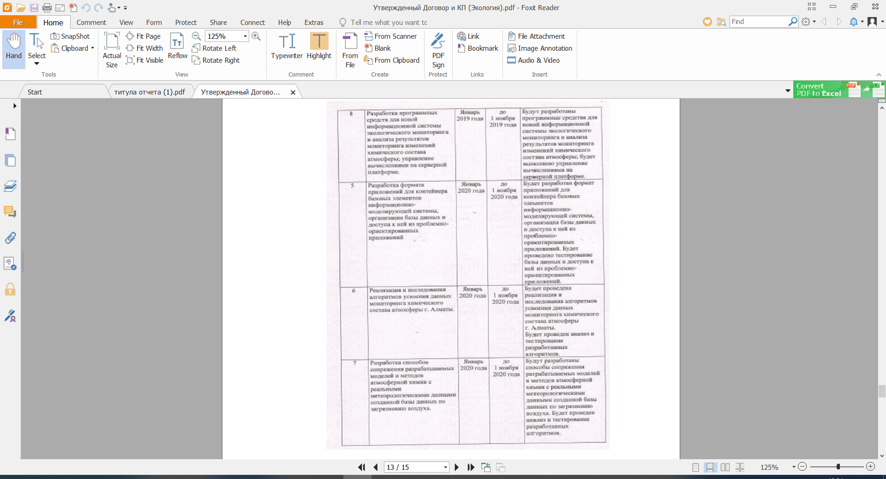
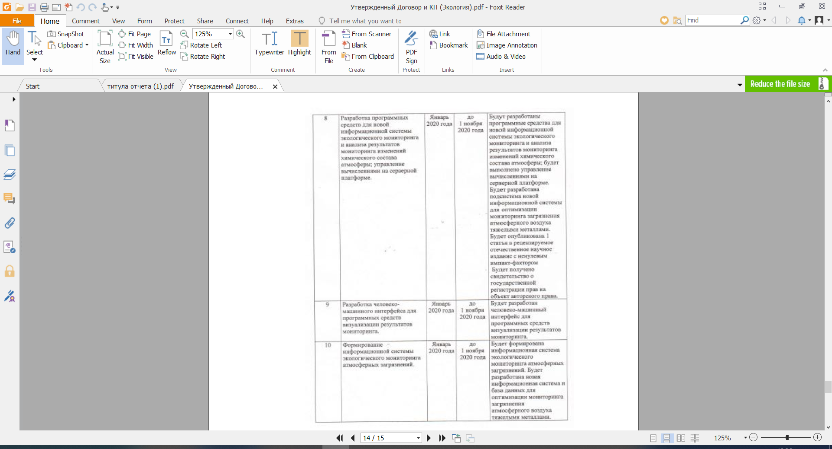
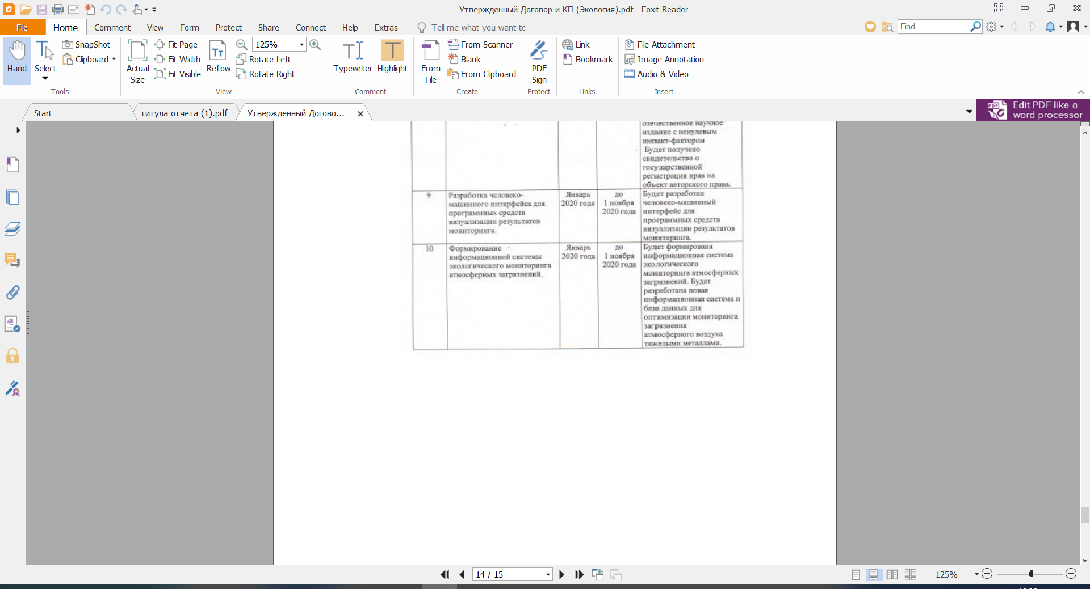
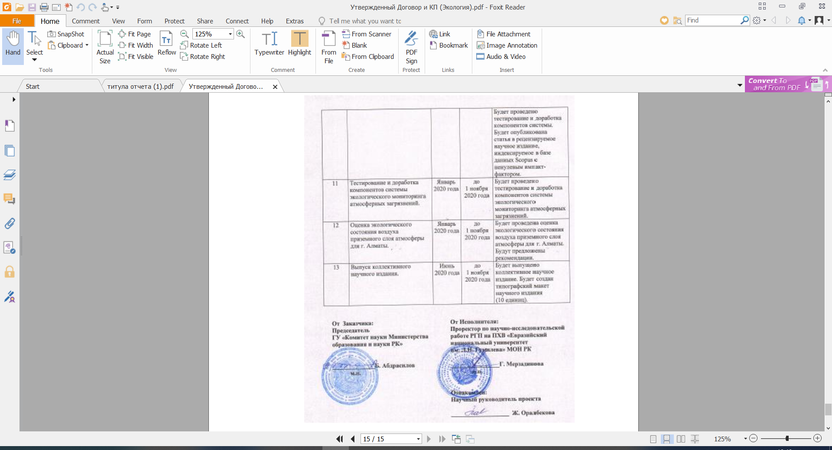

Appendix 1.14
to Agreement №__ from «___»_______ 2018 y.
for grant funding

TECHNICAL SPECIFICATION AND WORK SCHEDULE

on the agreement №_____ from__________________2018 y.
- Republican state enterprise on the right of economic management «L.N.Gumilyov Eurasian national university» Ministry of education and science Republic of Kazakhstan
  - By priority: rational use of natural resources, including water resources, Geology, processing, new materials and technologies, safe products and structures.1.2 По подприоритету: Информационные системы и базы данных
  - By sub-priority: information system and database
  - On the project topic: АР05135992«Development of a new information system and database to optimize monitoring of air pollution by heavy metals»
  - Total project amount: 27,180,000 (twenty-seven million one hundred and eighty thousand) tenge, including by year, for the performance of works in accordance with paragraph 3:
- for 2018-in the amount of 9,000,000 (nine million) tenge;
- for the year 2019 - a total of 9 081 000 (nine million eighty one thousand) tenge;
- for 2020-in the amount of 9,099,000 (nine million ninety-nine) tenge.
2. Characteristics of scientific and technical products by qualification criteria and economic indicators
2.1 Direction of work: applied research. Information system and database for monitoring air pollution.
2.2 Scope: Environmental monitoring of air pollution in industrial cities.
2.3 Final result:
- for 2018: A database on air pollution with heavy metals will be created, based on the example of Almaty. A functional diagram of the information system will be created. Variational algorithms for sequential data assimilation in real time will be investigated. The article will be submitted to a peer-reviewed local scientific publication with a non-zero impact factor. An article based on the materials of the international conference will be published in a peer-reviewed scientific publication indexed in the Scopus database with a non-zero impact factor.
- for 2019: The database on air pollution in Almaty with heavy metals will be updated. Mathematical support for an information system for environmental monitoring of atmospheric pollution will be developed. A computing management subsystem will be developed on the server platform. The article will be published in a peer-reviewed scientific publication indexed in the Scopus database with a non-zero impact factor.
- for 2020: A new information system and databases will be developed to optimize monitoring of air pollution with heavy metals. An assessment of the ecological state of the air of the surface layer of the atmosphere will be carried out on the example of Almaty. a typographic layout of the scientific publication (monograph) will be created.
The article will be published in a peer-reviewed local scientific publication with a non-zero impact factor. Will be received a certificate of state registration of rights to the copyright object. The article will be published in a peer-reviewed scientific publication indexed in the Scopus database with a non-zero impact factor.
2.4 Patentability: not provided
2.5 Scientific and technical level (novelty): scientific basis for modeling mesometeorological atmospheric processes for the city on the basis of environmental monitoring of atmospheric pollution to create a new information system.
2.6 The use of scientific and technical products is carried out by: local government of Almaty and local government of other cities, RSE "Kazhydromet" of the RK and its subsidiaries, SSE "Center for hydro meteorological monitoring" of Almaty.
2.7 Type of use of the result of scientific and (or) scientific and technical activities: in the educational process in the specialty "Computer engineering and software" and "Ecology", in scientific and technical periodicals presses of the RK as well as in rating foreign publications.
3. The name of the work, terms of their implementation and results
The code of the task, stage |  | Name of Work under the contract and the main stages of its implementation* | Due date* |  |  | Expected result*
 |  |  | beginning |  | ending
1 |  | Selection of air sampling sites and determination of heavy metal content in samples | January 2018 |  | to November 1, 2018 | Sites for air sampling will be selected and the content of heavy metals in the samples of Almaty will be determined
2 |  | Analysis of selected air samples | January 2018 |  | to November 1, 2018 | The selected air samples will be analyzed. The degree of air pollution in the city will be determined. 1 article will be published in a peer-reviewed scientific publication indexed in the Scopus database with a non-zero impact factor.
3 |  | Development of technical requirements and restrictions for the information system | January 2018 |  | to November 1, 2018 | Technical requirements and restrictions for the information system will be developed
4 |  | Development of technical requirements and restrictions for the information system | January 2018 |  | to November 1, 2018 | A functional diagram of the information system will be developed
5 |  | Development of the application format for the container of basic elements of the information modeling system, organization of the database and access to it from problem-oriented applications | January 2018 |  | to November 1, 2018 | An application format will be developed for the container of the basic elements of the information modeling system organization of the database and access to it from problem-oriented applications. A database structure for heavy metal air pollution in Almaty will be created. The article will be published in a peer-reviewed Russian scientific publication with a non-zero impact factor.
6 |  | Implementation and research of algorithms for assimilation of data for monitoring the chemical composition of the atmosphere in Almaty | January 2018 |  | to November 1, 2018 | Implementation and research of algorithms for assimilation of data for monitoring the chemical composition of the atmosphere in Almaty will be carried out. variational algorithms for sequential assimilation of data in real time will be investigated.
2 |  | Analysis of selected air samples | January 2019 |  | to November 1, 2019 | The selected air samples will be analyzed. Results on air pollution in Almaty since 2005 will be included in the database.(archive) for 2019(own analytical data 2018-1019). 1 article will be published in a peer-reviewed foreign scientific publication with a non-zero impact factor.
5 |  | Development of the application format for the container of basic elements of the information modeling system, organization of the database and access to it from problem-oriented applications | January 2019 |  | to November 1, 2019 | The application format for the container of the basic elements of the information modeling system, the organization of the database and access to it from problem-oriented applications will be developed. There will be an application of the database on air pollution of Almaty with heavy metals.
6 |  | Implementation and research of algorithms for assimilation of data for monitoring the chemical composition of the atmosphere in Almaty. | January 2019 |  | to November 1, 2019 | Implementation and research of algorithms for assimilation of data for monitoring the chemical composition of the atmosphere in Almaty will be carried out. Mathematical support for an information system for environmental monitoring of atmospheric pollution will be developed. 1 article will be published in a peer-reviewed scientific publication indexed in the Scopus database with a non-zero impact factor.
7 |  | Development of ways to interface the developed models and methods of atmospheric chemistry with real meteorological data of the created air pollution database. | January 2019 |  | to November 1, 2019 | Methods will be developed for interfacing the developed models and methods of atmospheric chemistry with real meteorological data from the created air pollution database.
8 |  | Methods will be developed for interfacing the developed models and methods of atmospheric chemistry with real meteorological data from the created air pollution database.  Development of software for a new information system for environmental monitoring and analysis of the results of monitoring changes in the chemical composition of the atmosphere; management of calculations on the server platform. | January 2019 |  | to November 1, 2019 | Software tools will be developed for a new information system for environmental monitoring and analysis of the results of monitoring changes in the chemical composition of the atmosphere; calculations will be managed on a server platform.
5 |  | Development of the application format for the container of basic elements of the information modeling system, organization of the database and access to it from problem-oriented applications. | January 2019 |  | to November 1, 2019 | The application format for the container of the basic elements of the information modeling system, the organization of the database and access to it from problem-oriented applications will be developed. The database and access to it from problem-oriented applications will be tested.
6 |  | Implementation and research of algorithms for assimilation of data for monitoring the chemical composition of the atmosphere in Almaty. | January 2019 |  | to November 1, 2019 | Implementation and research of algorithms for assimilation of data for monitoring the chemical composition of the atmosphere in Almaty will be carried out; analysis and testing of the developed algorithms will be carried out.
7 |  | Development of ways to interface the developed models and methods of atmospheric chemistry with real meteorological data of the created air pollution database. | January 2020 |  | to November 1, 2020 | Methods will be developed for interfacing the developed models and methods of atmospheric chemistry with real meteorological data from the created air pollution database. The developed algorithms will be analyzed and tested.
8 |  | Software development of a new information system for ecological monitoring and analysis of the results of monitoring changes in the chemical composition of the atmosphere; management of calculations on the server platform. | January 2020 |  | to November 1, 2020 | Software tools will be developed for a new information system for environmental monitoring and analysis of the results of monitoring changes in the chemical composition of the atmosphere; calculations will be managed on a server platform. A subsystem of a new information system will be developed to optimize monitoring of air pollution with heavy metals. 1 article will be published in a peer-reviewed scientific publication indexed in the Scopus database with a non-zero impact factor. Will be received a certificate of state registration of rights to the copyright object.
9 |  | Development of a human-machine interface for software visualization of monitoring results. | January 2020 |  | to November 1, 2020 | A human-machine interface for software visualization of monitoring results will be developed.
10 |  | Formation of an information system for environmental monitoring of atmospheric pollution. | January 2020 |  | to November 1, 2020 | An information system for environmental monitoring of atmospheric pollution will be formed. A new information system and database for monitoring air pollution with heavy metals will be developed. The system components will be tested and refined. 1 article will be published in a peer-reviewed scientific publication indexed in the Scopus database with a non-zero impact factor.
11 |  | Testing and refinement of components of the environmental monitoring system for atmospheric pollution. | January 2020 |  | to November 1, 2020 | The components of the environmental monitoring system for atmospheric pollution will be tested and refined.
12 |  | Assessment of the air ecological state of the surface layer of atmosphere for Almaty city | January 2020 |  | to November 1, 2020 | An assessment of the environmental condition of the ground layer air for Almaty will be carried out; recommendations will be offered.
13 |  | Issue of a collective scientific publication | June 2020 |  | Until November 1, 2020 | A collective scientific publication will be published. The layout of the scientific publication(10 units) will be created.
 | From the customer:  Chairman  State institution "Committee of science Ministry of education and science of the RK»  ______________ B.Abdrasilov |  |  | From the contractor:  Vice-rector for research work of the RSE on the REM "L. N. Gumilyov Eurasian national University" MES RK  _  _______________G.Merzadinova  Familiarized with:  Scientific supervisor of the project  ___________________ Zh.Oralbekova

APPENDIX B
List of published works for 2020
- Khasenova Z.T., Iskakov K.T., Toibekov A.T., Kusainova A.T. Copyright on the type of object «Сomputer program», the name of the object «Web application for ecological data management» No.12691 dated October 20, 2020. [Хасенова З.Т., Искаков К.Т., Тойбеков А.Т., Кусаинова А.Т.Авторское право на вид объекта «Программа ЭВМ», название объекта «Web-приложение для управления экологическими данными» № 12691 от 20 октября 2020 года] (in Russian).
- Khasenova Z.T., Iskakov K.T., Oralbekova Zh.O., Furaeva I.I., Rakhmetullina S.Zh. Сopyright to the type of object «Databases», the name of the object «Monitoring chemical composition of the atmosphere» No.7458 dated January 9, 2020. [Хасенова З.Т., Искаков К.Т., Оралбекова Ж.О., Фураева И.И., Рахметуллина С.Ж. Авторское право на вид объекта «Базы данных», название объекта «Мониторинг химического состава атмосферы» №7458 от «9» января 2020 года.] (in Russian).
- T.Aziyeva, A.T.Kussainova, Z.T.Khassenova «Methods for assessing the ecological state of air in the surface layer of the atmosphere» in the field of "Ecology" //
Proceedings of the VII International Scientific and Practical Conference "Science and Education in the Modern World: Challenges of the XXI Century". – Astana. – 2020 y. (were submitted) [Азиева Н.Т., Кусаинова А.Т., Хасенова З.Т. «Методы оценки экологического состояния воздуха приземного слоя атмосферы» авторов по направлению «Экология» // Cборник трудов VII Международной научно-практической конференции «Наука и образование в современном мире: вызовы ХХI века». – Астана. – 2020 г. (отправлена)] (in Russian).
- Zhartybayeva M.G., Yessimova N.B., Furaeva I.I., Zhukabayeva T.K., Zhumadillayeva A.K. «Rationale for choosing a DBMS and updating the database on air pollution of the Almaty city with heavy metals»// Bulletin of the Gumilyov ENU. - Astana, 2020. – №1 (130). – Pp. 78-89. [Жартыбаева М.Г., Есимова Н.Б., Фураева И.И., Жукабаева Т.К., Жумадиллаева А.К. «Обоснование выбора СУБД и пополнение базы данных по загрязнению атмосферного воздуха города Алматы тяжелыми металлами» // Вестник ЕНУ им.Л.Н.Гумилева. – Астана, 2020. – №1 (130). – С.78-89.] (in Russian).
- Oralbekova Zhanar, Zhartybayeva Makpal, Mynbayeva Bakhyt, Iskakov Kazizat, Khassenova Zarına «Information system for monitoring of urban air pollution by heavy metals» // Indonesian Journal of Electrical Engineering and Computer Science (Scopus) (were submitted).
- Z.T.Khassenova, A.T.Toybekov, A.T.Kussainova «Using information and communication technologies to assess the level of air pollution in real time» //Bulletin of Serikbayev EKSTU. - Ust-Kamenogorsk, - 2020. - No. 3. – Pp. 161-166 [Хасенова З.Т., Тойбеков А.Т., Кусаинова А.Т. «Использование информационно-коммуникационных технологий для оценки уровня загрязнения воздуха в реальном времени» // Вестник ВКГТУ им. Д.Серикбаева. – Усть-Каменогорск, - 2020. - №3. – С.161-166.] (in Russian).
- Khasenova Z.T., Iskakov K.T., Oralbekova Zh.O. Information system for monitoring atmospheric air pollution by heavy metals //Bulletin of the Shakarim state University of Semey. – 2020. – №3 (91). – Pp. 62-65 [Хасенова З.Т., Искаков К.Т., Оралбекова Ж.О. Информационная система мониторинга загрязнения атмосферного воздуха тяжелыми металлами // Вестник государственного университета им. Шакарима города Семей. – 2020. – №3 (91). – С.62-65.] (in Russian).
- S.Zh.Rakhmetullina, O.Y.Baklanova, A.Zh.Bugubaeva, T.S.Dmitrieva Calculation of environmental hazards associated with the risk of emissions from large industrial enterprises in Ust-Kamenogorsk //Bulletin of Serikbayev EKSTU. - Ust-Kamenogorsk, - 2020. - No. 4 (accepted for printing) [Рахметуллина С.Ж., Бакланова О.Е., Бугубаева А.Ж., Дмитриева Т.С. Расчет экологической опасности, связанной с риском выбросов крупных промышленных предприятий города усть-каменогорска // Вестник ВКГТУ им. Д.Серикбаева. – Усть-Каменогорск, - 2020. - №4 (принята в печать)] (in Russian).
- Zh.O.Oralbekova, B.N. Mynbayeva, K.T.Iskakov, Z.T.Khassenova, M.G.Zhartybayeva "Creating an effective information system and database for optimizing the control of air pollution with heavy metals" (monograph in Kazakh language: Ayur metaldarmen atmosferalyq ayanyn lastanuyn baqylaudy ontailandyru ushin tiymdi aqparattyq juye men derekter qoryn qyru).- Nur – Sultan: L.N. Gumilyov ENU, 2020. – 136 p. [Оралбекова Ж.О. , Мынбаева Б.Н., Искаков К.Т., Хасенова З.Т., Жартыбаева М.Г. Ауыр металдармен атмосфералық ауаның ластануын бақылауды оңтайландыру үшін тиімді ақпараттық жүйе мен деректер қорын құру. - Нур-Султан: ЕНУ им.Л.Н. Гумилева, 2020. - 136 с.] (in Kazakh).

APPENDIX C
Author's certificates




APPENDIX D
Сollective scientific publication
