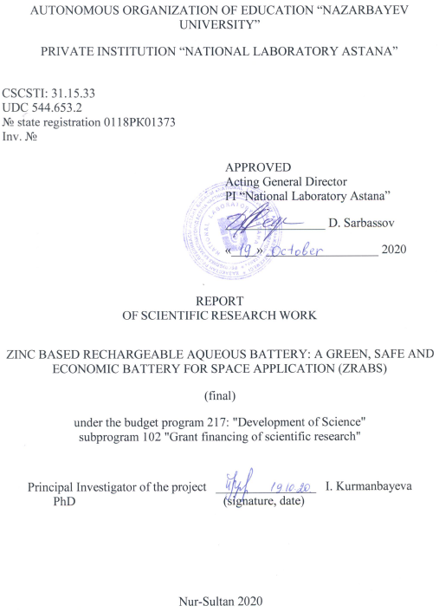



abstract

Report 100 p., 1 book, 18 fig., 2 tab., 53 references, 3 appendixes

AQUEOUS ELECTROLYTE, ZINC ANODE, ZINC DENDRITE, LITHIUM-ION BATTERY, DENDRITE SUPRESSION

Lithium-ion batteries are widely used for most energy storage systems due to the high energy density. However, the organic electrolyte in lithium-ion batteries is flammable, therefore alternative electrolytes should to be considered, including aqueous electrolytes. The aim of this research work in development of zinc-based aqueous battery (ZRAB).
The aim of this project is the investigation of zinc dendrite formation in Zn/LiCl-ZnCl₂/LiFePO₄ system. This report presents final report for 2018-2020 years.
For the first time, design and assembly of In-situ XRD cell was carried out for zinc dendrite formation investigation in Zn/LiCl-ZnCl₂/LiFePO₄ system. Modification of the anode surface with lauryl sodium sulfate, iridium oxide and the addition of 0.01 M tetrapropyl ammonium hydroxide to the aqueous electrolyte suppress the formation of zinc dendrites in the Zn / LiCl-ZnCl₂ / LiFePO₄ system (ZRAB).
The results obtained during the implementation of the project have been well tested: they were discussed at 9 international conferences and 5 articles were published in international peer-reviewed journals.
The significance of the work during the 2018-2020 period consists in design and assembly of in-situ XRD cell for zinc dendrite investigation in ZRAB, zinc dendrite suppression, assembling a cell for in-situ XRD of zinc dendrites in VPARC, passivation of zinc dendrite growth, design of a laboratory prototype and evaluation under conditions of near-earth space applications.
Application: industry, medicine, stationary energy storage.

ТҰЖЫРЫМ

Есеп 100 бет, 1 кітап, 18 сурет, 2 кесте, 53 әдебиет көзі, 3 қосымша.

СУЛЫ ЭЛЕКТРОЛИТ, МЫРЫШ АНОДЫ, МЫРЫШ ДЕНДРИТІ, ЛИТИЙ-ИОНДЫҚ АККУМУЛЯТОР, ДЕНДРИТТЕРДІҢ ПАССИВАЦИЯСЫ

Литий-иондық аккумуляторлар жоғары энергия тығыздығына байланысты ең көп таралған энергия сақтау жүйесі болып табылады. Дегенмен, батареяларда қолданылатын органикалық электролит тез тұтану қауіптілігіне байланысты, оларды алмастыру басты мақсат болып келеді. Бұл жоба мырыш негізінде қайта зарядталатын сулы аккумулятор жүйесін құруға бағытталған.
Жобаның басты мақсаты цинк негізіндегі аккумулятор Zn/LiCl-ZnCl₂/LiFePO₄ системасындағы мырыш дендриттерінің қалыптасуы мен өсу механизмдерін анықтау болып табылады. Бұл құжатта 2018-2020 жылдарда жасалған қорытынды есеп ұсынылған.
Zn/LiCl-ZnCl₂/LiFePO₄ жүйесіндегі мырыш дендритінің өсуін зерттеу үшін алғаш рет ЭХ in-situ платформасында рентгенофазды талдау және тестілеу жүргізілді. Анод бетін натрий лаурил сульфаты, иридий оксидімен модификациялау және 0,01 М тетрапропиламмоний гидкоксидін су электролитіне қосу Zn/LiCl-ZnCl₂/LiFePO₄ моделінде мырыш дендритінің түзілуінін бәсеңдеуіне ықпал етті.
Жобаның жүзеге асыру барысында жоғары нәтижелерге қол жеткізілді: 9 халықаралық конференцияларда талқыланды және халықаралық рецензияланатын журналдарға 5 мақала жарияланды.
Есеп беру кезеңдегі жұмыстың маңыздылығы мырыш негізіндегі қайта зарядталатын аккумуляторлардығы Zn дендриттерін in-situ РФА үшін ұяшықты жинау, мырыш дендриттерінің өсуін пассивациялау, зертханалық прототиптің дизайны және оны жерге жақын ғарыштық қосымшалар жағдайында сынау болып табылады.
Қолдану аясы: өнеркәсіп, медицина, стационарлық энергия сақтау.

CONTENTS

LIST OF ABBREVIATIONS AND SYMBOLS ……………………….………………… | 6
INTRODUCTION…………………………………………………………………………. | 7
MAIN PART OF THE R&D REPORT………………………………………………………….. | 10
1 Suppression of dendrite formation ………………………..………………… | 10
1.1 Electrolyte optimization………………………………………………… | 10
1.2 Zn electrode modification………………………………………………… | 17
2 Design of structure/dimensions and mechanical test. Cells characterization …… | 22
3 Result discussion ……………….……………………………………............ | 29
CONCLUSION………………………………………………..…………………………….. | 31
LIST OF USED SOURCES ……………………….………………………………………..  APPENDIX А – Calendar plan for 2019-2020 …………………………..........................  APPENDIX B - List of publications for 2019-2020 ……..………………………………  APPENDIX C - Copies of publications for 2019-2020 ……………………………. | 33  37  42  44

LIST OF ABBREVIATIONS AND SYMBOLS

In this R&D report, the following abbreviations and symbols are used:
AGM  ALIB  CV  LIB  LiCl  LiFePO₄, LFP  NMP  NMR  PVDF  рН  SEM  ТРАН  XRD  Zn  ZnCl₂  ZRABS | - separator  - aqueous lithium-ion batteries  - cyclic voltamagram  - lithium-ion batteries  - lithium chloride  - lithium iron phosphate  - N-1-methyl-2-pyrollidon  - nuclear magnetic resonance  - polyvinylidene fluoride  - acidity, environment  - scanning electron microscope  - tetrapropylammonium hydroxide  - x-ray diffraction analysis  - zinc  - zinc chloride  - Zinc based Rechargeable Aqueous Battery
INTRODUCTION

Zinc metal is considered as a promising anode material for rechargeable battery due to its high theoretical capacity (820 mAh g⁻¹), abundance, safety, scalability, low cost and environmentally friendliness [1–5]. Zinc based anode materials are used in such systems as zinc-manganese [6,7], zinc-air [8,9], nickel-zinc [10,11] zinc-vanadium based battery [12,13]. According to the Pourbaix diagram [14–17] zinc is thermodynamically unstable in the aqueous environment. It dissolves into Zn²⁺ ions under acidic conditions (pH<4), more stable at neutral pH, and it’s solubility increases in alkaline media (figure 1). Commercial, mainly used as primary batteries, aqueous zinc batteries (Zn-air, Zn-MnO₂ and etc) have alkaline media [18], where Zn(OH)₄⁻² complexes formed due to the abundance of OH⁻ ions. These zincate ions precipitate in the form of ZnO, resulting in dendrite growth or passivation of the anode. Mildly acidic aqueous (or neutral) electrolyte for lithium-ion batteries is being investigated relatively recently [5,19,20].
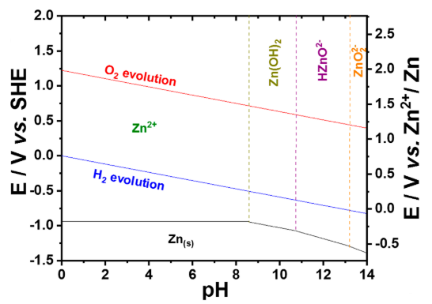
Figure 1 – Pourbaix diagram of Zn in aqueous solution

Xu C. and co-workers show that the replacment of alkaline electrolyte to mild acidic in the Zn-MnO₂ battery changed the chemistry [19]. In mild acidic media, Zn²⁺ ions are reduced and deposited in Zn metallic form, leaving place for side reaction (corrosion). However, non-uniform growth of dendrites and corrosion during cycling still prevents the widespread use of the zinc anode. Numerous works have been investigated to suppress the Zn dendrite formation, such as the modification of the zinc electrode surface [21,22] or adding an organic and inorganic additive into electrolyte [23,24].
Lan et al. [23] described the study of several tetra-alkyl ammonium hydroxides (TAAHs) as Zn dendrite’s inhibition additives to alkaline 0.45 M ZnO + 6.6 M KOH electrolyte Authors claim that inhibition of dendrites is positively correlated with the size of alkyl group of alkyl ammonium hydroxides. The authors claim that inhibition of dendrites is positively correlated with the size of alkyl group of alkyl ammonium hydroxides. The polarity of TAAHs should be not too strong or too weak to uniformly cover the Zn electrode surface. 0.01M TPAH was found as the best and ecological friendly Zn dendrite inhibitor [23]. The mechanism of zinc dendrites in alkaline electrolyte underlying the suppression of dendrite growth is related to the ability of additives to be absorbed on the surface of the electrode [23,25–27]. Ammonium based additives in electrolytes slowed down diffusional mass transport, adsorbed on the specific sites of the electrode and blocked the rapid growth of Zn dendrites via steric hindrance.
Recently, suppression of dendrites by electroplating is also attracted great interest [28–31]. J. McBreen was one of the first who studied the effect of electrodeposited metal oxides namely Mgo, Fe₂O₃, PbO, Cao, In₂O₃, Ga₂O₃, and Bi₂O₃ in small amounts (ppm) on the surface of Zn electrodes [32,33]. As a result, the polarization is increased and led to form layer on the Zn electrode, which is effective in maintaining the electrode capacity during cycling [29,30]. Yuehua Wen and co-authors [30] studied the effect of lead (II) ions and tetrabutylammonium bromide as an additive to the electrolyte in an 8 M KOH alkaline solution, where observed smooth and compact zinc deposition, increasing the cyclability of the zinc-nickel element.
The aim of this project is to identify the mechanisms of the formation and growth of zinc dendrites in a model of Zinc based Rechargeable Aqueous Battery (ZRABS) Zn/LiCl-ZnCl₂/LiFePO₄ with a mild acidic electrolyte.
The novelty of this project is the development of an in-situ method for studying the formation and growth of zinc dendrite in the model ZRABS: Zn/LiCl-ZnCl₂/LiFePO₄.
In the first year of the project (2018), materials were synthesized, the model of the Zinc based Rechargeable Aqueous Battery (ZRABS) Zn/LiCl-ZnCl₂/LiFePO₄ was studied morphologically and electrochemically. The ex-situ SEM and AFM data showed the formation and growth of zinc dendrites up to 200 nm during the cycling of ZRABC. A simple model of the phase field for one-component growth of the melt was presented, which includes anisotropy in a certain form. The formation of various dendritic patterns can be shown through numerical calculations using this model. Qualitative relationships between crystal shapes and some physical parameters were discussed. It was also shown that noise has a decisive influence on the structure of the lateral branches of dendrites in some situations. Published 2 articles in foreign journals with a non-zero impact factor, 3 abstracts in 2 international conferences (INESS-2018, 59th BSJ), in the annual interim report for 2018 (inv. number 0218РК01389).
In 2019, the tasks of setting up and electrochemical testing of the EC in-situ platform were completed. An in-situ electrochemical cell was developed, assembled to study the formation of dendrites during the cycling of an aqueous Zn//4M ZnCl₂ + 3M LiCl//LiFePO₄ battery. To study the X-ray phase analysis, the cell platform was adjusted in the Parallel Beam mode. The in-situ assembled XRD cell was connected to a multichannel potentiostat (VMP3, Biologic) with EC Lab software. Electrochemical tests were carried out in the potential range of 1 and 1.6 V relative to Zn/Zn²⁺. Research to suppress the formation of zinc dendrites by galvanizing zinc foil with sodium lauryl sulfate and optimizing the electrolyte by adding tetrapropylammonium hydroxide (TPAH) at various concentrations have been started. The surface morphology of the zinc electrode after battery cycling was comparatively studied. The results were published in 2 abstracts in the materials of international conferences (INESS-2019, EMRS) and in the 2019 interim report (inv. number 0219РК00174).
In 2020, the following tasks were identified to achieve the project goal (Appendix А):
1 Suppression of dendrite formation
2 Design of structure/dimensions and mechanical test. Cells characterization
3 Result discussion

MAIN PART OF THE R&D REPORT

1 Suppression of dendrite formation
1.1 Electrolyte optimization
This chapter presents the results of experimental studies to suppress the growth of dendrites by optimizing the electrolyte. The electrolyte preparation method was presented in previous reports (inventor numbers 0218РК01389, 0219РК00174). It was found that the addition of tetrapropylammonium hydroxide (TPAH) to the electrolyte promotes uniform deposition of zinc from the aqueous electrolyte solution onto the electrode surface, significantly improving the stability of the Zn//ZnCl₂ + LiCl//LiFePO₄ battery. The effect of the concentration of the TPAN additive on the cycling stability of a symmetric cell was studied.
To further study the Zn dendrite suppression mechanism of TPAH, the beaker-type Zn//ZnCl₂+LiCl//Cu cells were designed and assembled (figure 2 а). Using a copper foil as a current collector instead of a zinc foil allows to quantify an amount of Zn deposited onto Cu foil, and then to calculate the coulombic efficiency. In the first discharge 1.2 mg of Zn was deposited onto Cu foil, and then it was charged until 0.8 V during which the deposited zinc stripped from Cu foil [34]. Figure 2 b and c show charge/discharge curves of the cells without and with 0.01 M TPAH electrolyte additive, respectively, at a current density of 20 mA cm⁻². The cell without TPAH additive demonstrated a stable zinc deposition/stripping performance up to 50 cycles with overpotential of ~120 mV (figure 2 b). However, a sharp decrease of overpotential from ~120 mV to ~60 mV occurred after 50 cycles associated with a short-circuit of the cell (figure 2 b, d). Whereas, the presence of TPAH additive in the electrolyte improved a cycle stability of the cell over 70 cycles due to its zinc dendrite suppression effect (figure 2 c).
Figure 2 c shows Coulombic efficiency vs. cycle number profiles of the beaker cells without and with TPAH additive. The beaker cell without TPAH additive had a constant coulombic efficiency of 99 % over 50 cycles, while the coulombic efficiency of the cell with TPAH additive fluctuated in the initial cycles and then stabilized to 98.5 % in the subsequent cycles. However, the cell without TPAH additive short-circuited after 50 cycles with an abrupt increase of the coulombic efficiency, whereas the cell with TPAH additive demonstrated a stable cycle performance. The improved cycle stability of the cell further confirms a significant effect of TPAH additive on zinc dendrite suppression. To study the mechanism of TPAH additive for the dendrite suppression, the electrodes and electrolyte were analyzed by many characterization techniques before and after cycling.

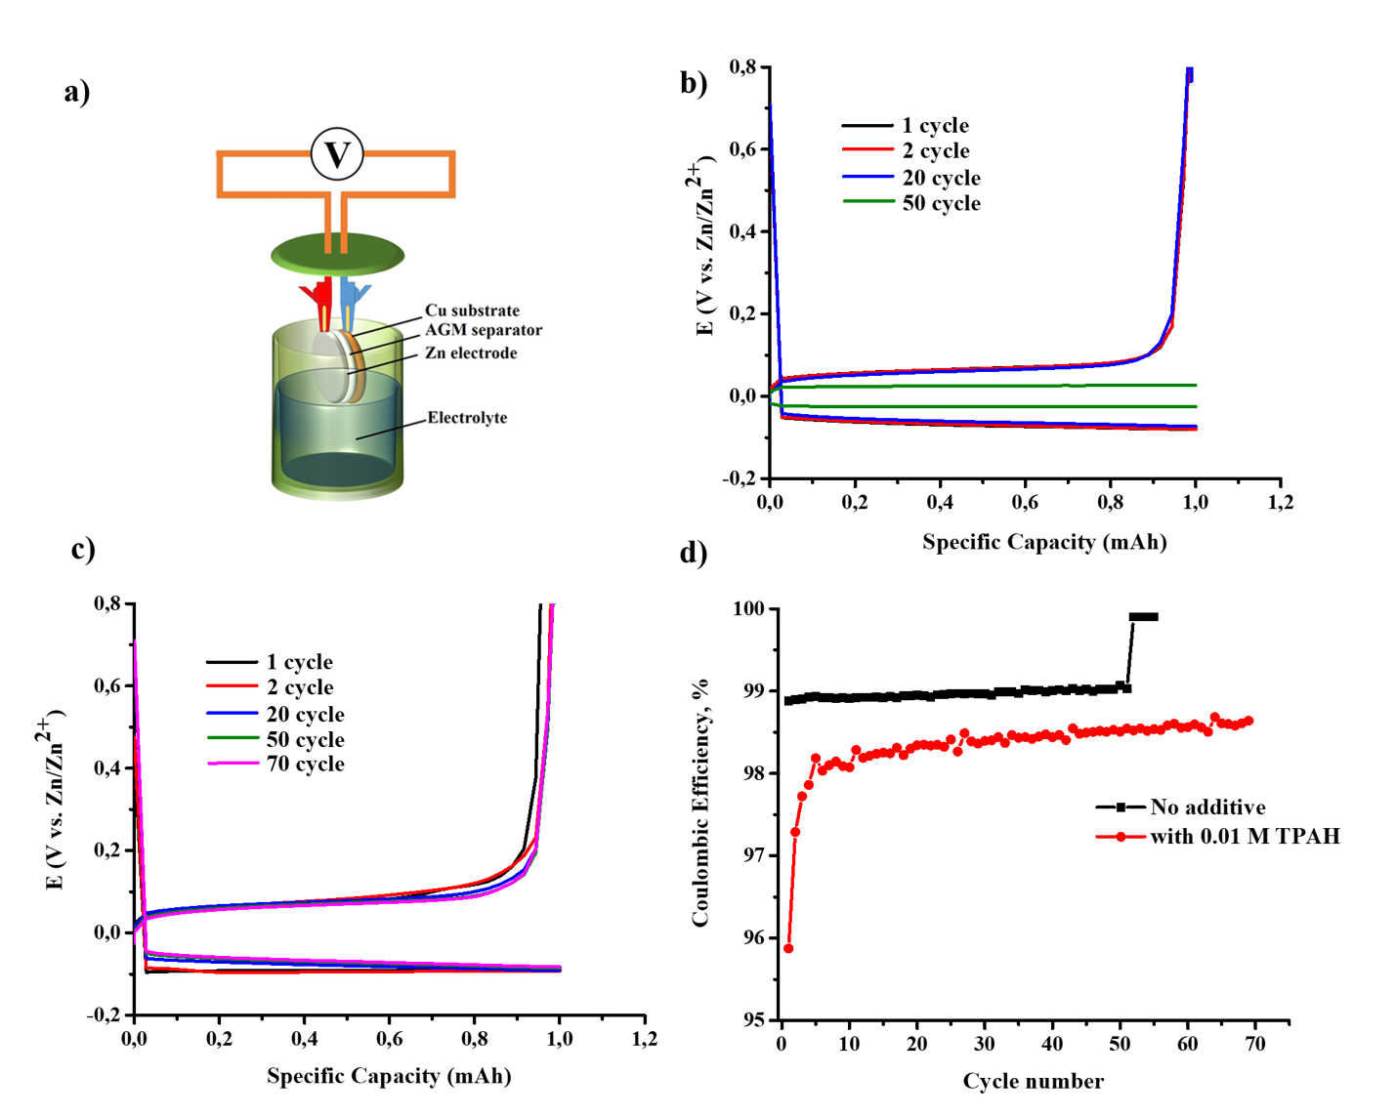
а) scheme; b) charge/discharge curves without TPAH; c) charge/discharge curves with TPAH; d) cycleability
Figure 2 – Electrochemical characteristics of Zn//ZnCl₂+LiCl//Cu beaker cell at 20 mА сm⁻²

A dendrite formation behavior of both Zn electrodes cycled with and without TPAH electrolyte additives was investigated by XRD. Figure 3 demonstrates XRD patterns of the Zn electrodes before and after cycling with and without TPAH electrolyte additive. The pattern obtained on the both electrodes after cycling has no significant difference from pure Zn reference, suggesting reversible behavior of Zn deposition/dissolution. Significant lattice planes (002), (100), (101), (102) are identical with a literature [35–37] and demonstrate the different directions of crystal growth. The highest intensity peak at 42° indicated that Zn grows in mostly directed (101) orientation, which causes the formation of tips [37]. However, the intensity of (002) peak of Zn anode with TPAH addition increases, indicating that zinc was preferentially deposited in a basal (parallel) oriented direction to anode surface, which is more resistant against dendrite formation [38]. Similar behavior of nitrogen-containing amine group of CTAB (cetryltrimethylammonium bromide) was investigated in zinc electrodeposition by Nayana and etc. [36]. This may explain the good battery performance of the battery with TPAH addition due to the more 002 oriented deposited zinc.
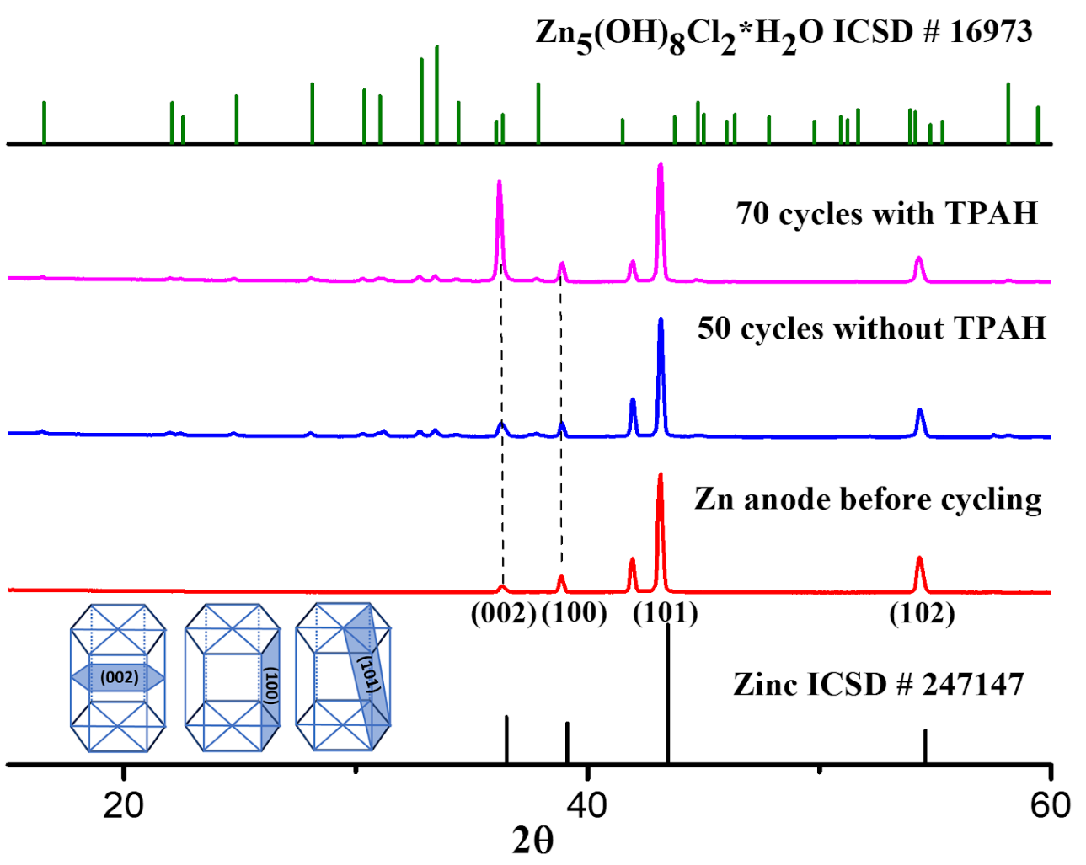
Figure 3 - XRD patterns of Zn electrodes before and after cycling with and without TPAH additive

An additional phase in the XRD patterns was observed and identified as simonkolleite (Zn₅(OH)₈Cl₂*H₂O) in both electrodes after cycling (figure 3). This also was confirmed by EDS mapping of cycled Zn anodes with /without TPAH, which shows the presence of Zn, O and Cl (figure 4). It can be noted that simonkolleite, which acts as a corrosion stabilizer, is formed in the case of high Cl⁻ content and low pH value (acidic media) [39–41].
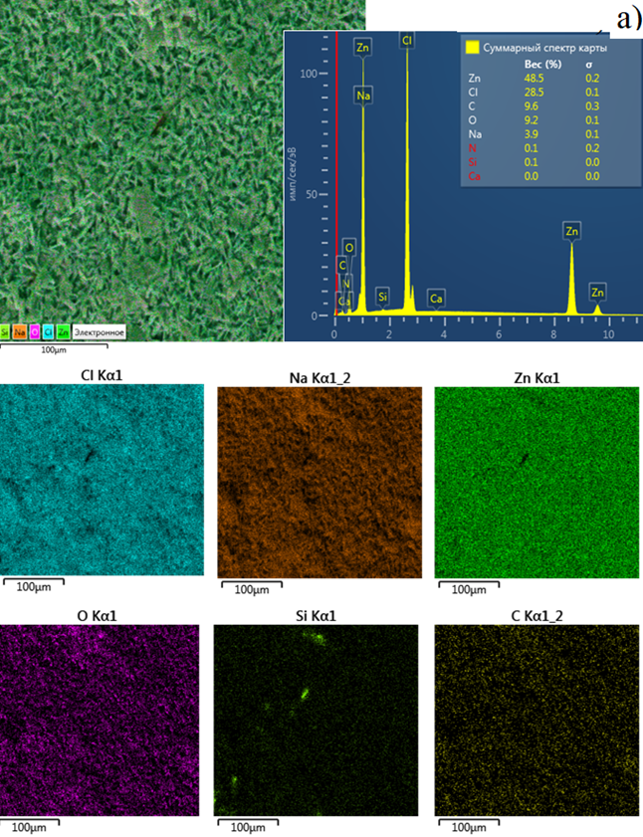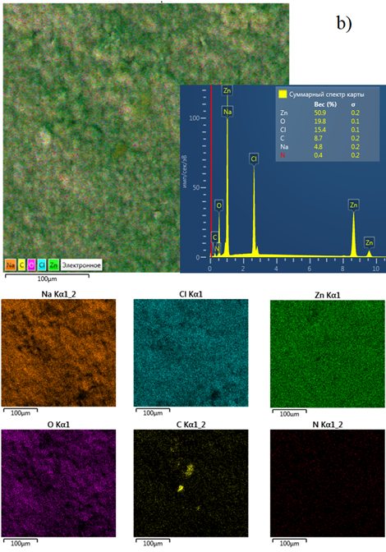
a) without TPAH; b) with 0.01M TPAH addition
Figure 4 – EDC mapping of cycled Zn electrodes

The comparison of zinc electrode surface morphology cycled in beaker-cells with and without TPAH addition was done by SEM. It is clearly seen from SEM images that the Zn electrode surfaces of both beaker cells have dendrites, but the character of deposition is different (figure 5 a, b). It can be seen from images with small magnification that Zn anode of cell without TPAH have uneven growth of dendrites; they are almost located on the right side (figure 5 a). Due to the growth upon cycling and penetration of dendrites into AGM separator, it was not possible to detach. The fibers of the separator are seen in the picture. Whereas the left corner of the image is clean from dendrites. The size of dendrites is smaller (figure 5 c) and, as a result, this cell worked longer for 20 cycles at 20C in comparison with battery without TPAH. The larger magnification shows that dendrites of the anode without TPAH have a compact structure with closely packed Zn disks (figure 5 c). Whereas TPAH addition makes these dendrites looser (figure 5 d). The high magnification images of Zn dendrites of both cells consist of the hexagonal disks (figure 5 е, f). The size of the disk is smaller in the left picture (about 1 µm in width), and they packed randomly and very close to each other like a sponge (figure 5 c). In the case of TPAH addition (figure 5 f), even distributed Zn disks have a size of 2-3 µm in width and they are much thicker than in figure 5 c.
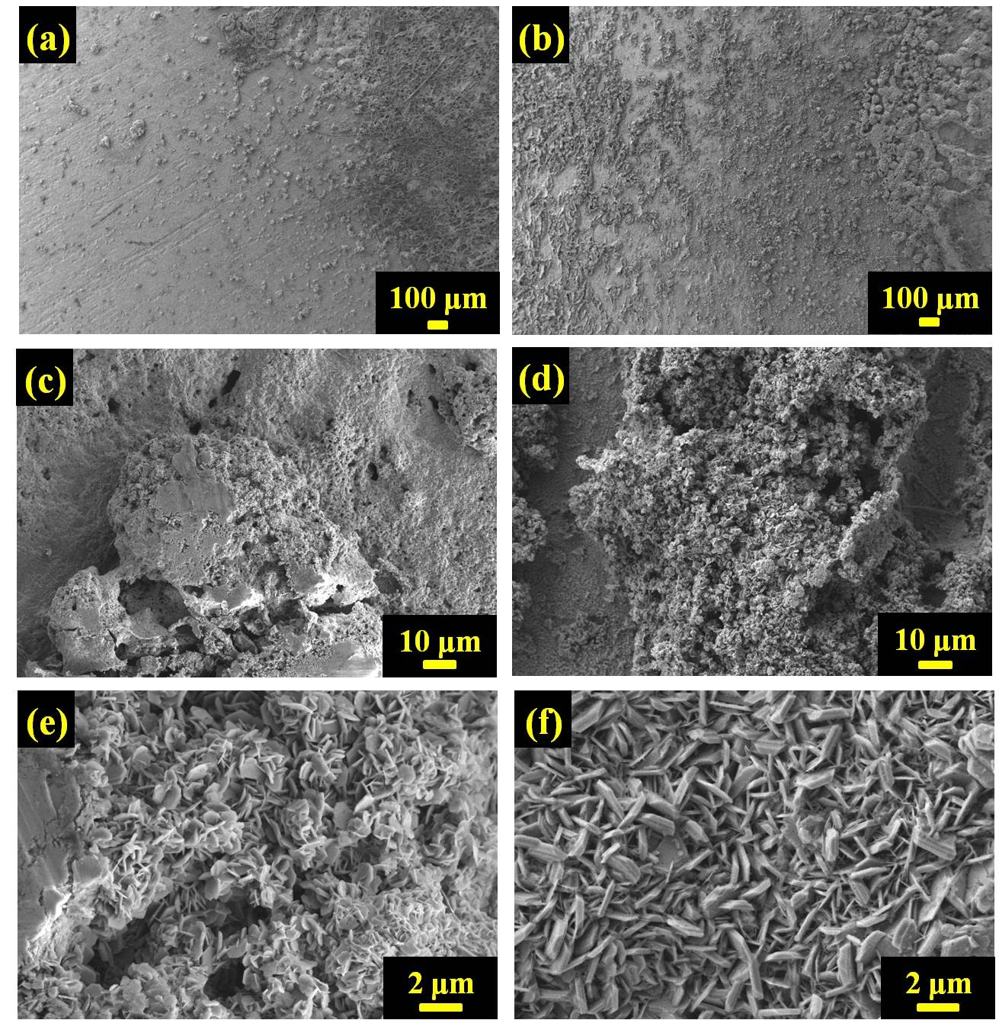
a, c, e) without TPAH; b, d, f) with TPAH additive
Figure 5 - SEM images of the Zn electrodes after cycling at different magnifications

Therefore, TPAH addition in electrolyte changed the distribution and structure of dendrites. With TPAH Zn dendrites are growth on the surface of anode more uniformly. Dendrite aggregates on the surface of Zn anode of beaker-cell with TPAH addition have almost the same size, even though they are cycled 70 times at 20 C. The beaker-cell without TPAH short circuited after 50 cycles due to the enlarged size of particular dendrites.
The electrolytes with TPAH before and after cycling were analyzed by FTIR and NMR. TPAH is a quaternary ammonium cation with four propyl substituents around the central nitrogen and hydroxyl group (figure 6 a). Figure 6 b gives the FTIR spectra of the commercial TPAH, the electrolytes with TPAH before and after cycling. The peaks in the range of 1630 -1650 cm⁻¹, 1850-2450 cm⁻¹, 3200-3500 cm⁻¹ appear due to the water. The spectra of commercial TPAH has its characteristic peaks due to propyl group (740-720 cm⁻¹, 1390-1375 cm⁻¹, 1490-1450 cm⁻¹, 3000-2850 cm⁻¹) and N-C vibrational mode (970-980 cm⁻¹) (figure 6 b, black line) [42,43]. When TPAH was added to ZnCl₂ and LiCl containing electrolyte, all corresponding to TPAH peaks disappear (figure 6 b, red line). We assume that aqueous electrolyte overloaded characteristic peaks, but new N-H vibration mode at 3243 cm⁻¹ [44] is seen in solution of electrolyte before cycling. The ions in the solution interact with TPAH and break vibrational modes of N-C and propyl bonds. The cycled electrolyte shows several features. Shifted peaks appear at 1050 cm⁻¹, 1250 cm⁻¹, indicating the presence of amine groups in the electrolyte. In addition, the vibrational mode of -CH=CH₂ appears at 1450 cm⁻¹, and the shoulder at 3600 cm⁻¹ which is ascribed to N-H vibration becomes more pronounced. These peaks confirm the aforementioned content of cycled electrolyte solution.
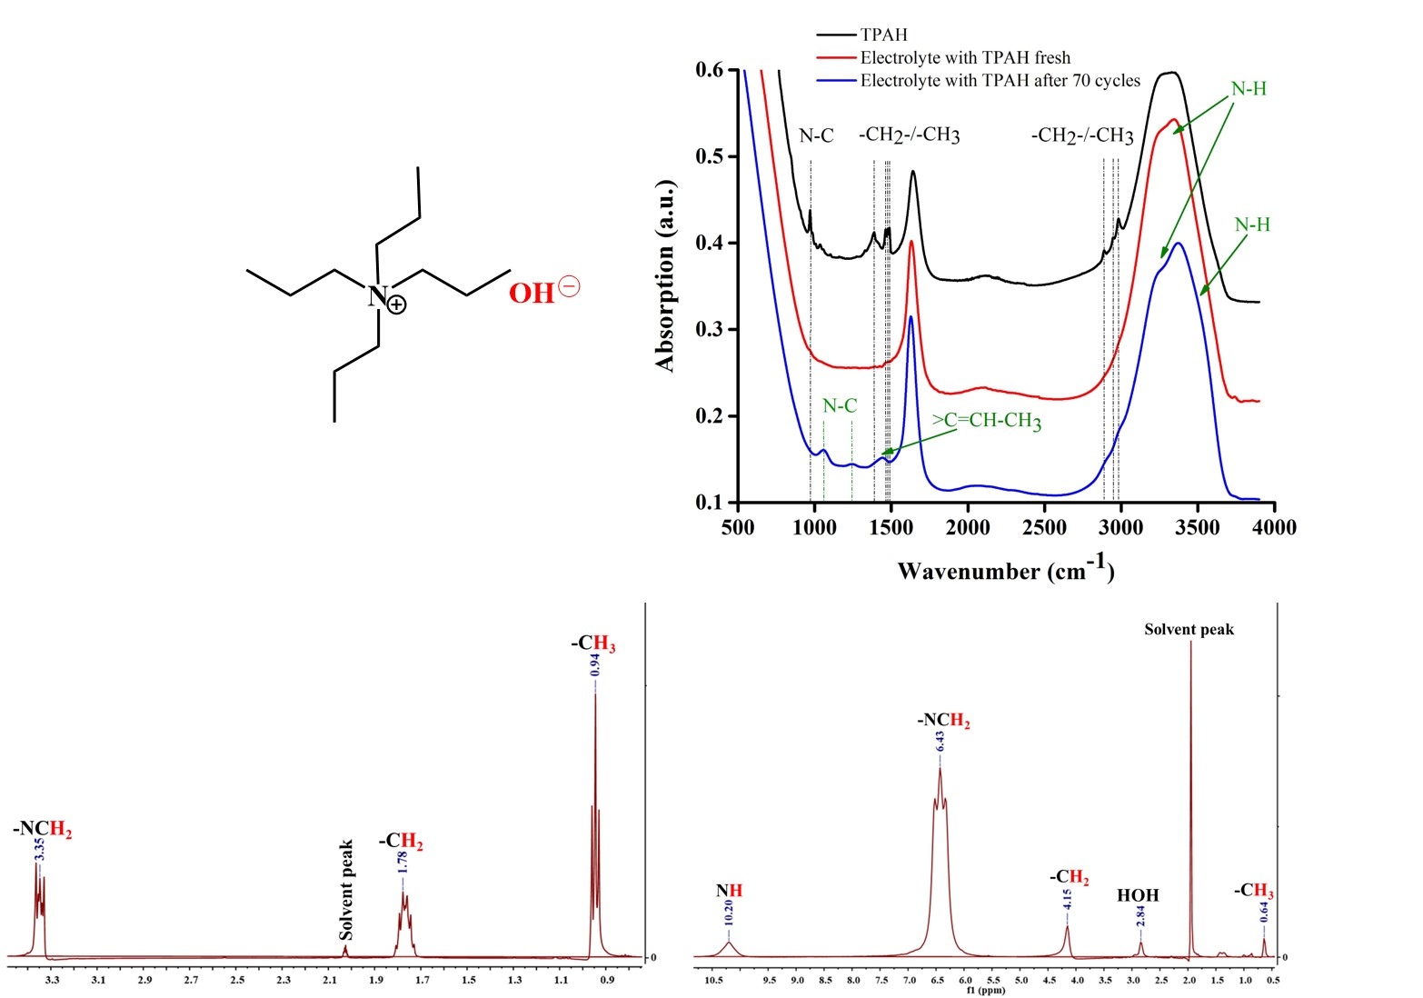
d)
b)
c)
a)
a) TPAH molecular structure; b) FTIR absorption spectra of TPAH; c) ¹H NMR spectrum of 1M TPAH commercial solution; d) ¹H NMR spectrum of electrolyte with 0.01 M TPAH additive after cycling
Figure 6 - Physical-chemical investigations

Figure 6 illustrates the ¹H NMR spectrum of (c) 1M TPAH commercial solution and (d) electrolyte with 0.01M TPAH after cycling, respectively. The ¹H NMR spectrum of initial TPAH is fully matched with published data [42,45]. The ¹H NMR spectrum of electrolyte after cycling revealed signals corresponding to methyl proton at 0.64 (m), methylene proton at 4.15 (br s), methylene proton attached to N atom at 6.43 (t) and amine group proton at 10.21 (br s). The structure of the propyl group attracted to N atom is assigned from the resonances at δH 0.64, 4.15, 6.43 and 10.21. From the NMR figures, we can observe the shifting of peaks that caused due to the strong resonance effect of the amine group. All the presented data suggested (predicted) that TPAH in electrolyte after cycling was decomposed to R_{n}-NH and propene by comparison of spectrums including in this study together with literature data [46,47].
Based on all experimental results the following mechanism of the influence of TPAH addition to the electrolyte on battery cyclability is proposed (figure 7). First, TPAH in electrolyte solution accelerates the formation of simonkolleite. Simonkolleite is unstable and can decompose to ZnO and ZnCl₂ or to ZnO + HCl + H₂O [39,48,49]. It is interesting to notice that simonkolleite disks appear with the combination of lower alkalinity, lower temperature, higher NH₄⁺ ions concentration and in existence of Cl⁻ anion [50]. Second, when the battery starts to cycle at high C rate (20 C), Zn dendrites are formed on anode by applying a negative current. During the cycling TPAH decomposes to propylamine (R_{n}N⁺H) and propene [44,51]. R_{n}N⁺H adsorbs on the active site of Zn dendrite to prevent its further growth [23]. Zinc in battery with TPAH addition deposited in a basal (parallel) oriented direction to electrode surface.
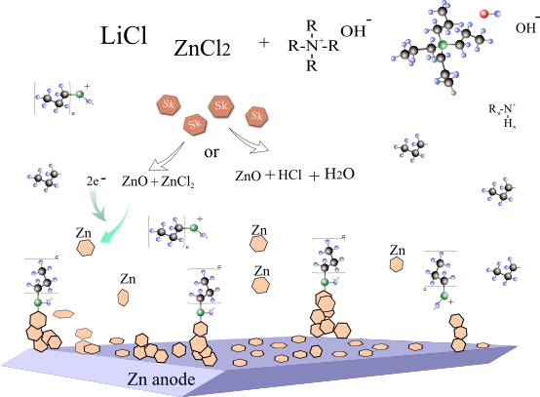
Figure 7 – Mechanism of zinc dendrite suppression by using TPAH as additive in aqueous electrolyte

The cyclability and the coulombic efficiency of the full Zn//ZnCl₂ + LiCl//LiFePO₄ batteries without additive and with the smallest and highest concentration of TPAH as 0.01 M and 0.1 M at 0.5 C are shown in figure 8. The coulombic efficiency of all systems is high (96% - 100%).
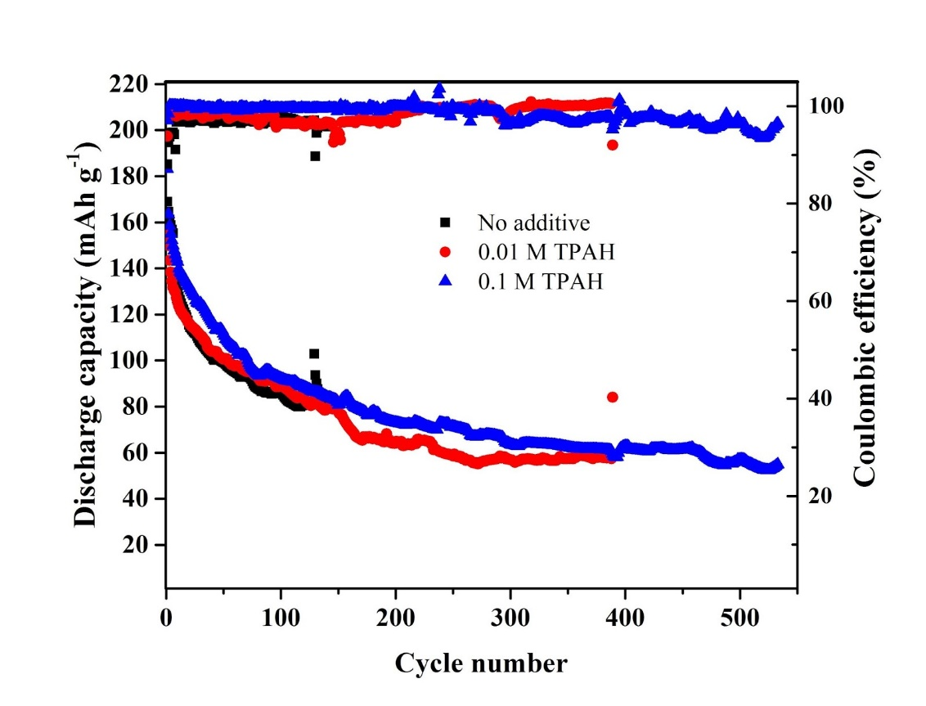
Figure 8 – The cyclability of Zn//ZnCl₂ + LiCl//LiFePO₄ batteries
with and without TPAH additive in electrolyte at 0.5 C

The specific discharge capacity of all batteries gradually decreases with each cycle. However, the cell without the additive is inferior in terms of the stability. Batteries with TPAH (0.01 M and 0.1 M) performed better cyclability, which are over 380 and 570 cycles, rather than the system with bare electrolyte. Apparently, the addition of the TPAH can prevent zinc dendrite growth, consequently prolongs cycle life of Zn/LiFePO₄ system.

1.2 Zinc electrode modification
This part presents the results of experimental studies on the suppression of dendrite growth by modification of a zinc electrode surface. Previously, experiments were conducted out on the galvanization of zinc foil with sodium lauryl sulfate [52]. Electrodeposition on the surface of the zinc anode was carried out in an aqueous solution containing a mixture of 0,6 М ZnCl₂ and 0,1М NH₄Cl at a current density of 0.32 mA cm⁻² for 5 minutes. The modification studied under the same conditions, but using germanium (GeO₂), vanadium (V₂O₅), scandium (Sc₂O₃), and iridium (IrO₂) oxide with a concentration of 100 ppm as additives.
The modified zinc electrodes were studied using X-ray diffractometry (XRD), the results of which are shown in Figure 9. For comparison, a Zn electrode without surface modification was also examined, which is herein referred to as the “bare Zn anode”.
As can be seen from the X-ray diffraction patterns in Figure 9, the bare Zn anode has intensity peaks at 42-43 ° and 70 °, indicating the orientation of zinc in the 101 and 103 directions. The intensity of the peaks of galvanized Zn electrodes with different oxides differs from the bare zinc. Each metal oxide creates a unique crystalline surface structure, encouraging crystal growth in different directions. After electroplating with metal oxides, all samples retain a strong orientation of the peaks in the 101 direction. The change in the preferred orientation from (103) to (101) suggests that metal oxides modify the galvanic anode, forming a unique crystal structure on the surface of the bare Zn anode.
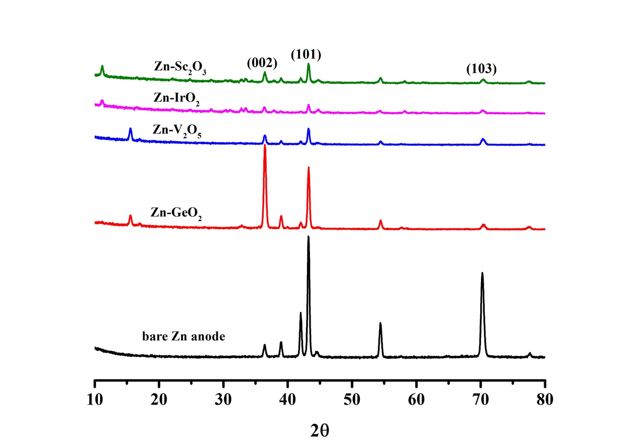
Figure 9 - X-ray diffraction pattern of Zn anodes after electrodeposition

The morphology of the modified Zn electrodes was studied using a scanning electron microscopy (SEM) (figure 10). The surface of the bare Zn anode is smooth with characteristic stripes that could have formed during its manufacture (figure 10 a). Zn-IrO₂ anode has a more uniform coating (figure 10 b) than other electrodeposited samples with. The surfaces of the Zn-V₂O₅, Zn-Sc₂O₃ and Zn-GeO₂ anodes have an inhomogeneous rough structure with an uneven coating where crystals deposited in different directions (figure 10 c, d, e).
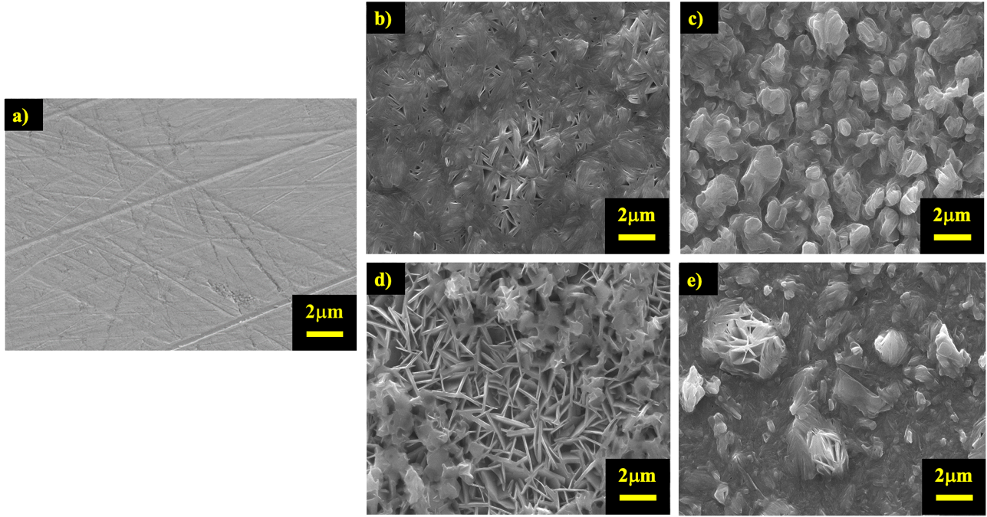
а) bare Zn anode; b) Zn-IrO₂; c) Zn-V₂O₅; d) Zn-Sc₂O₃; e) Zn-GeO₂
Figure 10 - SEM images of the Zn anode surface after electrodeposition with metal oxides

The modified zinc anodes were electrochemically tested using Swagelok type cells. The testing methodology and conditions were previously published in the 2018 and 2019 report and in the article [52]. For comparison, we also tested a battery with bare Zn anode. The results of testing the stability of battery cycling are shown in Figure 11 a.
It can be seen from the curves of the stability graph (figure 11 a) that the batteries modified with vanadium, scandium and germanium oxides anodeshave cycled only 50 cycles. However, the battery with the bare Zn anode and Zn-IrO₂ showed stability up to 400 cycles. Then, rate capability test was carried out with these two batteries at current densities from 0.1 to 10 C, the results of which are shown in fgure 11 b. In general, both batteries perform the same: at current densities of 0.1C, 0.5C, 1C, 2C, 5C and 10C, stable capacities of 170, 120, 90, 70, 50 and mAh g⁻¹ and 30 mAh g⁻¹ were achieved, respectively. Further with a decrease in the current density to 0.1C, the initial capacity was restored to 150 mAh g⁻¹ for both batteries, but with a slight advantage when using a modified Zn anode.

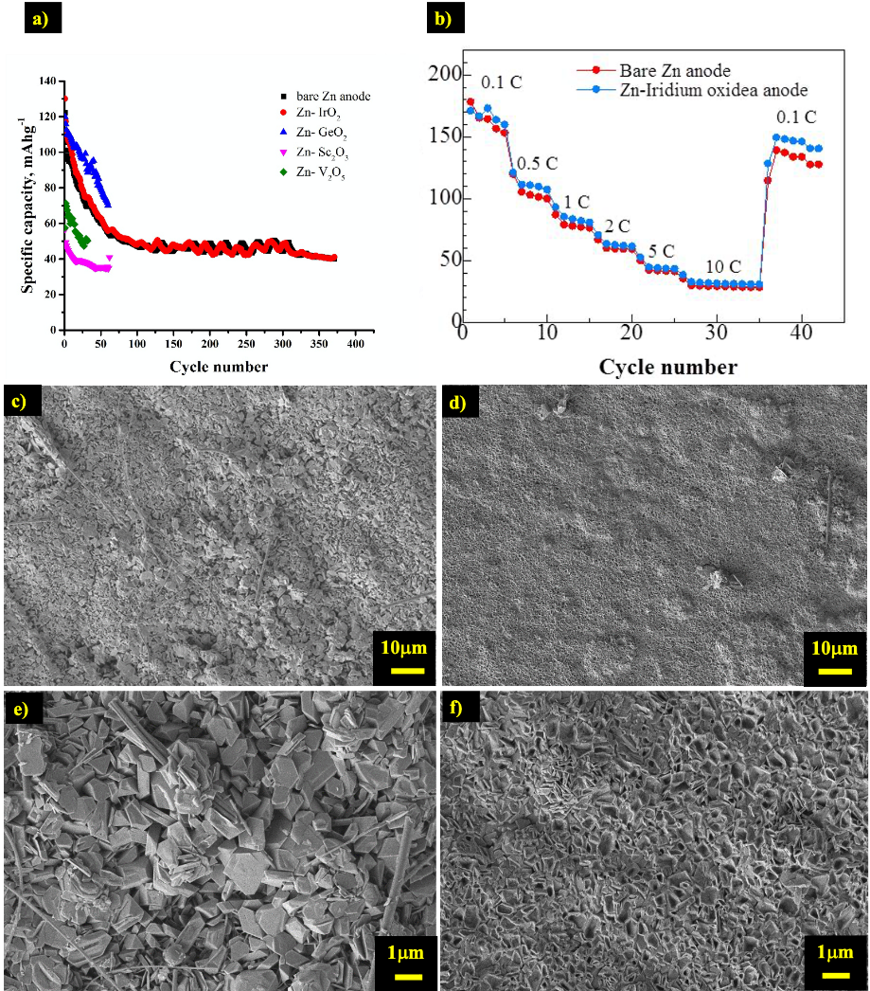
a) cyclability with modified anodes; b) rate capability test at different current densities;
c, e) bare Zn anode; d, f) Zn-IrO₂ anode
Figure 11 - Productivity of the Zn / LiCl-ZnCl₂ / LiFePO₄ system

To analyze surface morphology of the anodes, these two batteries were cycled for another 100 cycles and examined by SEM (figure 11 c-f). As can be seen from Figure 11 c, d and their magnification by 10 (figure 11 e, f), surface of both anodes have dendrites, the structure of which is noticeably different. Crystals of large size are visible on the surface of the bare Zn anode, while in the sample modified with iridium oxide, a more uniform deposition of smaller dendrites is observed.
Thus, dendrite suppression studies and battery characterization were carried out. It was found that tetrapropylammonium hydroxide (TPAH), depending on the concentration (0.01 M - 0.1 M), as an additive to the electrolyte of the aqueous Zn // ZnCl₂ + LiCl // LiFePO₄ battery, contributes to an increase in its life cycle. Based on the study Zn anode structure and the composition of the electrolyte, the mechanism of TPAH influence on the preservation of the battery capacity was proposed. X-ray diffraction analysis of the zinc electrode with the addition of TPAH showed that Zn is deposited mainly in the 002 direction, which prevents the formation of dendrite. This has also been confirmed by SEM images. FTIR and NMR spectra showed that TPAH decomposes to propylamine (RnN⁺ H) and propene during cycling, affecting the growth and distribution of the deposited zinc particles. The galvanization of zinc foil with metal oxides (IrO₂, V₂O₅, Sc₂O₃, GeO₂) was also investigated and their effectiveness in preventing the formation of zinc dendrites was studied. Modification with iridium oxide helped to reduce the size of the deposited zinc and slightly increase the battery capacity during cycling. Based on the above, a new anode material with electrodeposited iridium oxide on the zinc anode surface has been developed.

2 Cell design and mechanical testing. Cell characterization
The laboratory prototype was designed to carry out mechanical and vibration tests for the optimized ZRABs. The carrying out the design and dimensions of the ZRAB battery with an aqueous electrolyte, the following prototype forms were considered: Swagelok-type, Beaker-cell type, and Pouch-cell type (figure 12).
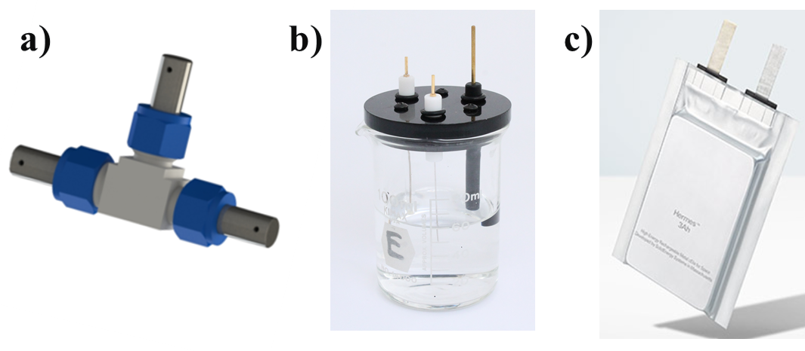

а) Swagelok cell; b) Beaker cell; c) Pouch cell
Figure 12 – cell types

The choice of prototype design for a microsatellite should be capable of operating in ultra-high vacuum (~ 10⁻⁴ Pa) and extreme vibrations, it is necessary to use cells with a high capacity (> 40 mAh). In pre-liminary electrochemical studies of the ZRAB battery, Swagelok cell and Beaker cell were used, which are used for laboratory research (capacity ~ 0.017 mAh), however they are not intended for testing in cosmic space applications. Therefore, for further testing of the developed battery for mechanical and vacuum effects, a pouch cell was chosen.
Positive electrodes were prepared by mixing 90 wt% LiFePO4, 4 wt% polyvinylidene fluoride (PVDF) dissolved in 1-methyl-2-pyrrolidone (NMP) as a binder, and 6 wt% acetylene black as a conductive agent. The prepared slurry was casted on carbon fiber paper using the Doctor Blade technique, then vacuum dried at 70 ° C for two hours. Iridium oxide coated zinc foil was used as the negative electrode. The electrolyte was prepared by dissolving 3 M LiCl and 4 M ZnCl₂ with the addition of 0.1 M TPAH in deionized water with pH = 4. Absorbed glass mat (AGM separator) was immersed in the obtained electrolyte and then used in a battery.
The cell consists of 2 cathodes and 1 anode. The cathode, anode and separator were cut into a 4 x 3 cm rectangular shape as shown in Figure 13a. The mass of the active material per unit area is 4 mg / cm². 4 prototypes were prepared with and without modification (table 1).
Тable 1 – Description of pouch cells
Description | Cells
Bare Zinc electrode | РС01, РС02
Modified Zinc electrode (IrO₂ coated zinc), electrolyte with TPAH additive | РСТ01, РСТ02
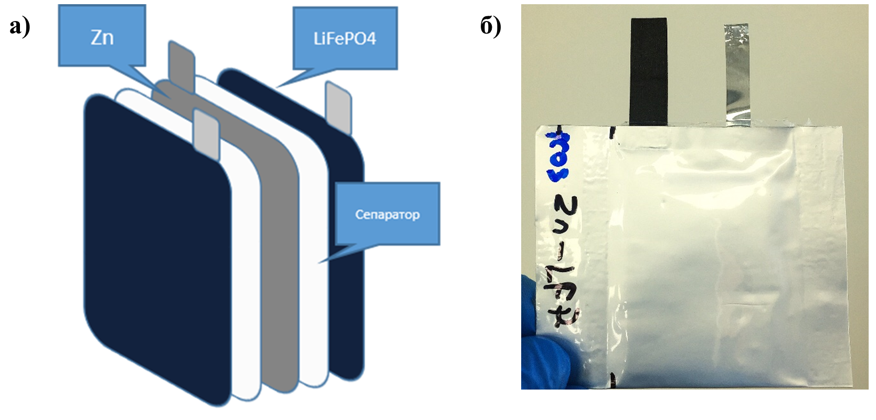
a) assembly scheme; b) assembled pouch cell
Figure 13 - Pouch cell

For electrochemical investigation of pouch cells the following methods were used: cyclic voltammetry to determine the reversibility of the reaction and galvanostatic charge / discharge to determine the cycling stability of the cell. Figure 14 a, b shows the comparative results of cyclic voltammetry of pouch cells with and without modification. Reversible characteristic peaks of lithium ions appear at 1.0 V and 1.4 V, which intercalate / deintercalate from the crystal lattice without changing the structure of the material. Based on the CV results, further galvanostatic testing was carried out in voltage range of 1.0 - 1.5 V. A plateau was observed in the charge-discharge curve of the pouch cells at 1.16 - 1.23 V vs. Zn / Zn² ⁺ (figure 14 c, d).
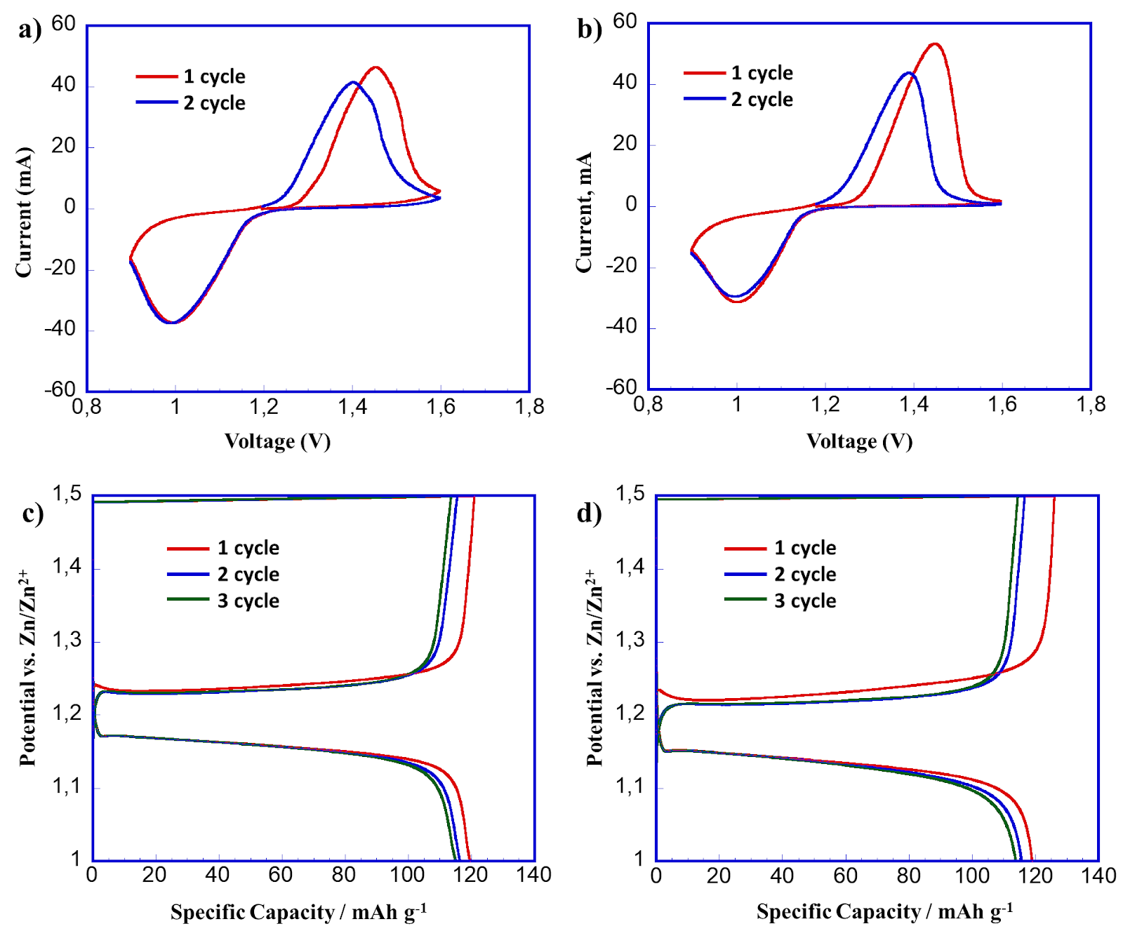
а) cyclic voltammetry of pouch cell without modification; b) pouch cell with modification; c) charge/discharge profile of pouch cell without modification; d) charge/discharge profile of pouch cell with modification
Figure 14 - Electrochemical performance of pouch cells

The initial discharge capacity of both pouch cells (PC01 and PCT01) at a current density of 0.1C show 120 mAh g⁻¹, which is 75% of the theoretical capacity of LiFePO₄ (1C = 160 mAh g⁻¹). In addition, the cells have identical curves both during charging and discharging, which indicates a good reversibility of the battery (figure 14 c, d). After 3 charge-discharge cycles, the cells were stopped and used for further mechanical and vacuum tests.
The pouch cells (PC01 and PCT01) were analyzed at deep vacuum for possible deformation and component leakage. The cells were placed in a special high vacuum chamber on a European synchrotron radiation facility (figure 15) and performed to a reduced pressure of 2.8 x 10⁻² Pa for 30 minutes. During the test, prototype deformation and electrolyte leakage were not observed.
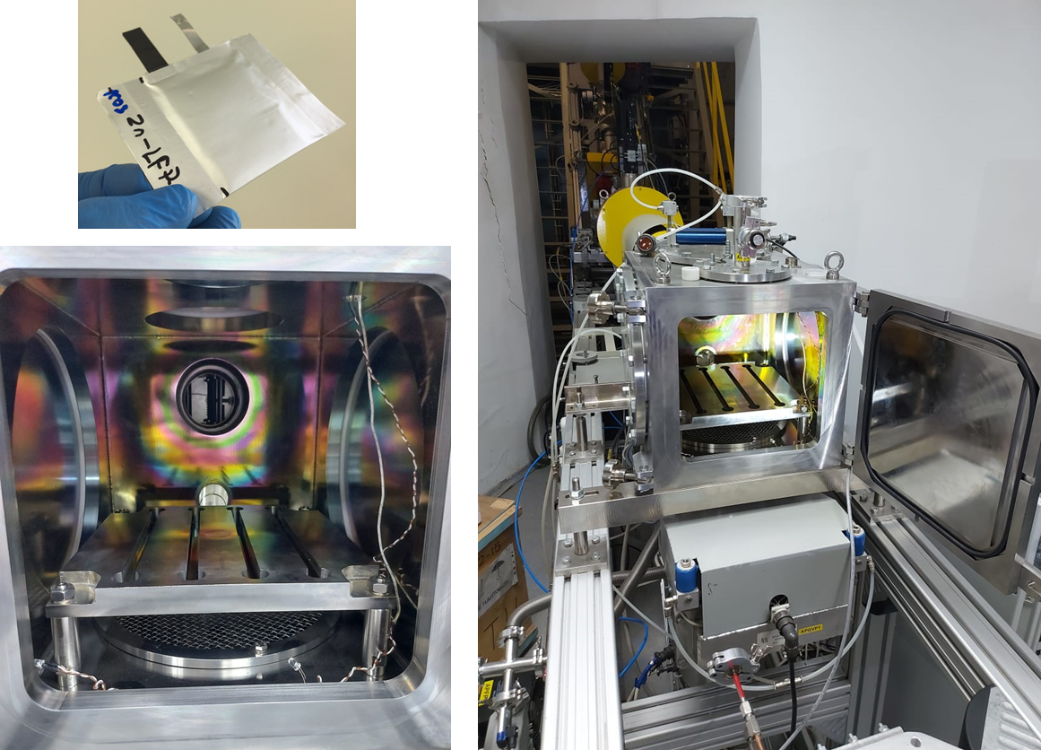
Figure 15 - Chamber for high vacuum exposure

After the high vacuum test, pouch cells were electrochemically investigated (figure 16). Before the vacuum test, the discharge capacity of both samples on the 3rd cycle was about 118 mAh g⁻¹ at a current density of 0.1C (figure 16 a, b). The cells have the same plateau at 1.16 - 1.23 V upon the cycling, which indicated the stable performance of the batteries. After testing for vacuum exposure, their discharge capacity was 117 mAh g⁻¹ and shows stable cycling (figure 16 c, d).

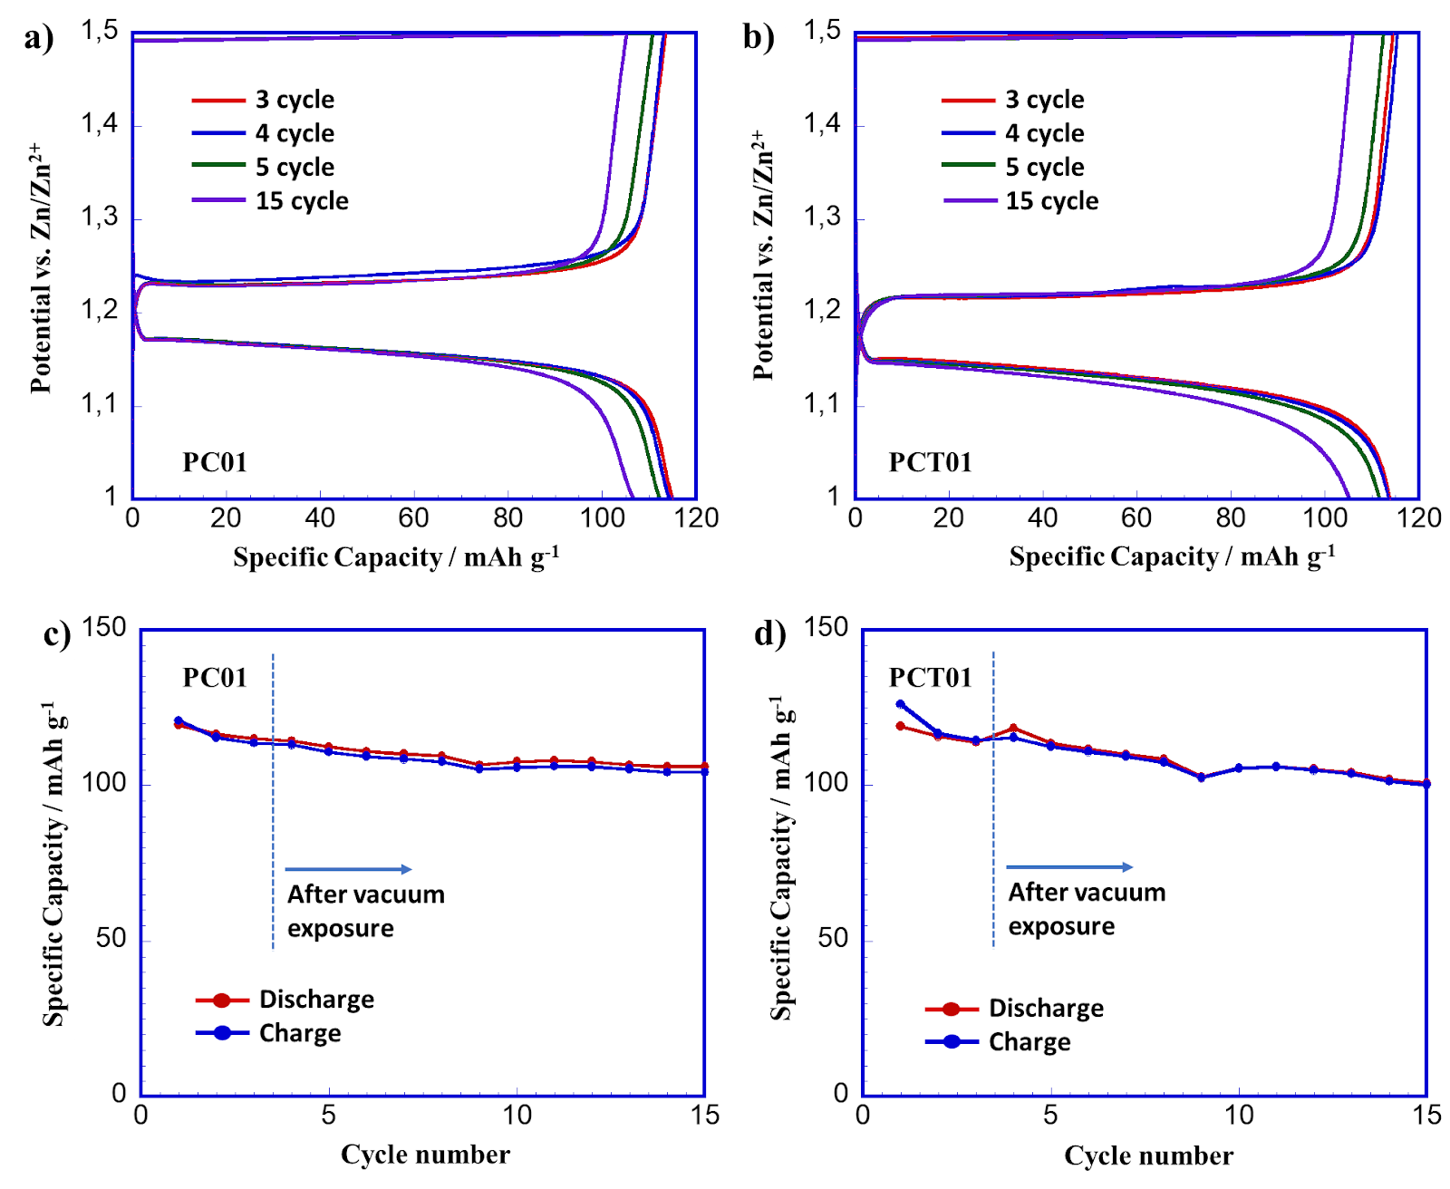
а) charge-discharge profile of PC01 cell; b) charge-discharge profile of PCТ01 cell; c) cycle performance of PC01 cell; d) cycle performance of PCT01 cell
Figure 16 - Electrochemical performance of pouch cells at 0.1C

Vibration tests to identify the mechanical stability of the cells were carried out on the Shaker LDS V8-440 installation in the testing laboratory of JSC "Kazakhstan Karash Sapary" and LLP "Galam" (figure 17). Cells PC02 and PCT02 were placed on a vibration stand and connected to measuring sensors.

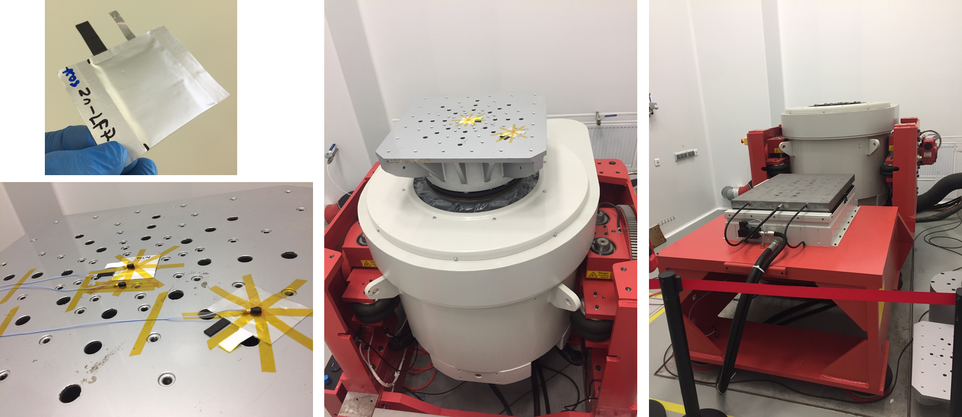
Figure 17- Vibration installation Shaker LDS V8-440

Vibration tests were carried out with sine and random mode for 20 minutes in the direction of the Z axis (up - down) (table 2) and [53]. Deformation of pouch cells after vibration test was not observed.

Table 2 – Characteristics of vibration testing
Mode | Minimum frequency (Hz) | Maximum frequency (Гц) | Maximum force (N) | Maximum acceleration (g)
Sine | 10 | 2000 | 500 | 0,5
Random | 5 | 1000 - 3200 | 5,65 х 10³ | 6,45

The electrochemical properties of the pouch cells (PC02 and PCT02) after vibration tests were electrochemically tested at a current density of 0.1C (figure 18).
After the vibration test, a clear difference in the capacities of the samples is observed. It should be noted that the discharge capacity at 4th cycle for the PCT02 sample was 100 mAh g⁻¹ compared to PC02, where the discharge capacity was only 80 mAh g⁻¹ (figure 18 a, b). The cell has one plateau at 1.16 - 1.23 V, which proves the stable operation of the batteries after the vibration test with different modes. According to the obtained results, both cells show good cyclability over 15 cycles (figure 18 c, d).
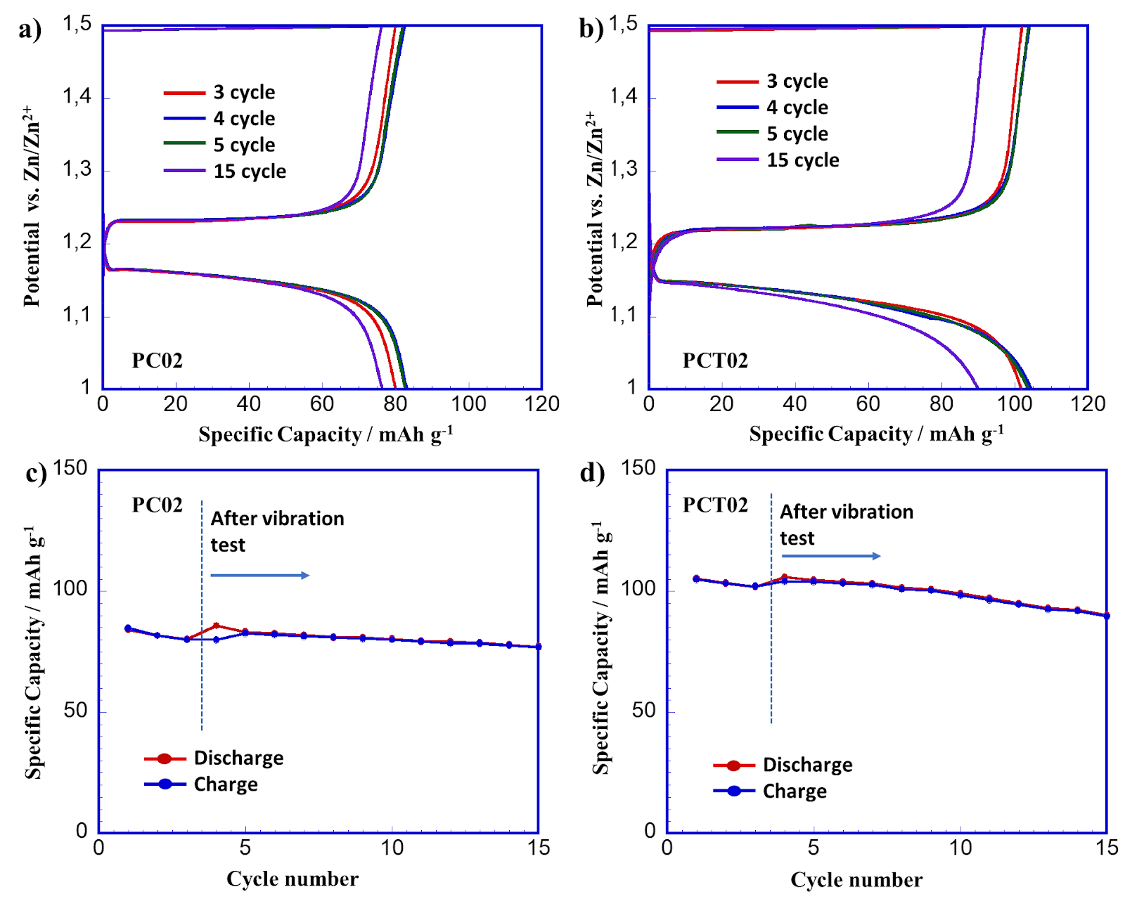
а) charge-discharge profile of PC02 cell; b) charge-discharge profile of PCТ02 cell;
c) cycle performance of PC02 cell; d) cycle performance of PCT02 cell
Figure 16 - Electrochemical performance of pouch cells at 0.1C

In conclusion, the design and dimensions of the ZRAB battery prototype with aqueous electrolyte was developed. Swagelok-type, Beaker-cell type, and pouch cells were considered for battery design. According to the physical stability and integrity of the prototype, a pouch cell is the most optimal for mechanical and vibration tests. Samples PC01 and PCT01 were analyzed for vacuum exposure with simulated earth orbit conditions (deep vacuum 2.8 x 10⁻² Pa). After vacuum testing, PC01 and PCT01 cells showed stable cycling and a discharge capacity of 105 mAh g⁻¹. Samples PC02 and PCT02 were evaluated for vibration (mechanical) test, while deformation of the pouch cells were not observed. After the test, the discharge capacity of the PC02 and PCT02 cells after 15 cycles was 76 mAh g⁻¹ and 90 mAh g⁻¹, respectively. Based on the obtained results of electrochemical results of laboratory prototypes, it can be concluded that the samples have been successfully tested as batteries for space applications.

3 Result discussion
The experimental results obtained during the implementation of the project were discussed in international conferences and published as articles of peer-reviewed international journals. For 2018-2020, the research group took part in international conferences, in which they made an oral presentation 6 times and 3 times a poster:
1) А. Аdi, R. Zakarina, I. Kurmanbayeva, Z. Bakenov, M R. Babaa «An investigation of the Zn dendritic growth in Zn//LiCl+ZnCl₂//LiFePO₄ rechargeable aqueous battery», The 6th International conference on Nanomaterials and Advanced Energy Storage Systems (INESS-2018), 8-10 August 2018, Astana, Kazakhstan, P. 94,
2) D. Batyrbekuly, I. Kurmanbayeva, Z. Bakenov, J-P. Pereira-Ramos Vanadium based cathode materials for aqueous battery // the 6th International conference on Nanomaterials and Advanced Energy Storage Systems (INESS-2018), 8-10 August 2018, Astana, Kazakhstan, P. 95 (oral).
3) D. Batyrbekuly, А. Аdi, I. Kurmanbayeva, J-P. Pereira-Ramos, M R. Babaa, Z. Bakenov In-situ characterization of zinc dendrite formation for Zinc based aqueous batteries The 59th Battery Symposium Japan, 27-29 November 2018, Osaka, Japan (oral).
4) Kurmanbayeva I., Zakarina R., Zhanadilov O. et al. The Zn dendrite growth investigation in Zn//LiCl+ZnCl₂//LiFePO₄ aqueous battery // the European Materials Research Society (E-MRS). – Niccа, 2019. – Р. 105
5) D.Batyrbekuly, B.Laïk, N.Emery, Z.Bakenov, J.-P. Pereira-Ramos, R.Baddour-Hadjea. Nanosized puckered V₂O₅’-polymorph as cathode material for Li-ion batteries with enhanced electrochemical properties // the 7th International conference on Nanomaterials and Advanced Energy Storage Systems (INESS-2019). – Almaty, 2019. – Р. 41 (oral).
6) Zakarina R., Korzhynbayeva K., Kurmanbayeva I., Bakenov Z. Suppression of dendrite formation on zinc anode of aqueous rechargeable batteries using electrodeposition with organic additives and boric acid in Zn/LiFePO₄ // the 7th International conference on Nanomaterials and Advanced Energy Storage Systems (INESS-2019). – Almaty, 2019. – Р. 82.
7) I.Kurmanbayeva, А.Коnarov, D.Batyrbekuly, A.Mentbayeva, Z.Bakenov, Investigation of aqueous lithium-ion batteries // X international Beremzhanov congress on chemistry and chemical technology «Investigation of aqueous lithium-ion batteries». Almaty, October, 24-25, 2019, http://chemconf.kaznu.kz/ (oral).
8) L.Rakhymbay, I.Kurmanbayeva, Z.Bakenov. Metal oxides as additives to suppress dendrite formation on Zn anode of rechargeable aqueous battery //the 8th International conference on Nanomaterials and Advanced Energy Storage Systems (INESS-2020. Abstract Book). - Nur-Sultan, 2020. - Р. 44 (oral).
9) D.Batyrbekuly, S.Cajoly, B.Laïk, J-P.Pereira-Ramos, N.Emery, Z.Bakenov, R.Baddour-Hadjean. Mechanistic investigation on hybrid Zn/V₂O₅ rechargeable battery using a binary Li⁺/Zn²⁺ aqueous electrolyte // the 8th International conference on Nanomaterials and Advanced Energy Storage Systems (INESS-2020. Abstract Book). - Nur-Sultan, 2020. - Р. 42. (oral).
Published papers in peer-reviewed foreign and domestic scientific journals, indexed in databases or with a non-zero impact factor:
1) Y. Zhang, Z. Bakenov, T. Tan, J. Huang, Synthesis of Core-Shell Carbon Encapsulated Fe₂O₃ Composite through a Facile Hydrothermal Approach and Their Application as Anode Materials for Sodium-Ion Batteries // Metals. - 2018. - V. 8. - P. 461; doi:10.3390/met8060461, 10 pages, foreign journal with impact factor IF=2.117 (2019), Q3.
2) Y. Zhang, Z. Bakenov, T. Tan, J. Huang, Polyacrylonitrile-nanofiber-Based Gel Polymer Electrolyte for Novel Aqueous Sodium-Ion Battery Based on a Na₄Mn₉O₁₈ Cathode and Zn Metal Anode // Polymers. - 2018. - V. 10. - P. 853; doi:10.3390/polym10080853, 10 pages, foreign journal with impact factor IF=3.426 (2019), Q1.
3) D. Batyrbekuly, S. Cajoly, B. Laïk, J.P. Pereira-Ramos, N. Emery, Z. Bakenov, R. Baddour-Hadjean, High performance Zn/V₂O₅ rechargeable battery in a hybrid Li⁺/Zn²⁺ aqueous electrolyte // ChemSusChem. – 2020. – V. 13. - P. 724-731, doi: 10.1002/cssc.201903072, foreign journal with impact factor IF=7.962 (2019), Q1,
4) R. Zakarina, I. Kurmanbayeva, Z. Bakenov, Suppression of zinc dendrite formation on anode of Zn/LiFePO₄ aqueous rechargeable batteries using electrodeposition // Materials Today: Proceedings. – 2020. – V. 25 (1). – P. 93 – 96, https://doi.org/10.1016/j.matpr.2019.12.278 , foreign journal with impact factor IF=0.97 (2018), CiteScore 1.3, Percentile 39
5) I. Kurmanbayeva, L. Rakhymbay, K. Korzhynbayeva, A. Adi, D. Batyrbekuly, A. Mentbayeva, Z.Bakenov, Tetra propyl ammonium hydroxide as a zinc dendrite growth suppressor for rechargeable aqueous battery // Frontiers in Energy Research – accepted for the publication.
Thus, the results of experiments obtained during the implementation of the project are discussed among experts in the field of battery development, presenting the data in international conferences and published in the form of articles. The research team participated in three conferences a year (international conferences with publication in Scopus). 5 articles have been published in peer-reviewed foreign scientific journals, indexed in the Web of Science or Scopus databases with a non-zero impact factor.
CONCLUSION

A set of studies for the implementation of the tasks of this project for the period 2018 - 2020 and the scientific data obtained at the same time allow to make the following conclusions:
1. Synthesized materials were structurally and electrochemically investigated in Zn/LiCl-ZnCl₂/LiFePO₄ system. Ex-situ SEM and AFM analysis shows the formation and growth of zinc dendrites up to 200 nm during the battery cycling.
2. Modelling of formation and growth of dendrites was carried out. New models of dendrite formation have been developed. Basic phase-field models for single component melt growth was presented by including anisotropic formation. The formation of various dendrite shapes can be shown through the numerical methods from the model. Qualitative ratio between crystal shapes and physical parameters were discussed. It has also been shown that the noise has decisive impact on the structure of the lateral sections of dendrites in some cases.
3. In-situ XRD cell was developed for investigation of zinc dendrites formation in Zn/LiCl-ZnCl₂/LiFePO₄ system. Parallel Beam mode was used for In-situ XRD study. The In-situ cell was connected to potentiostat at voltage range of 1 – 1.6 V vs. Zn/Zn²⁺.
4. Investigation on zinc dendrite suppression was carried out. Modification of the anode surface by zinc foil galvanization with sodium lauryl sulfate reduce the growth of zinc dendrites, improving the electrochemical performance of the battery. The optimal concentration of tetrapropylammonium hydroxide was found, equal to 0.1 M, when added to the electrolyte, zinc is uniformly deposited from the aqueous electrolyte solution onto the anode surface without forming large dendrites. This modification significantly improves battery stability.
5. Dendrite suppression studies and battery characterization were carried out. It was found that tetrapropylammonium hydroxide (TPAH), depending on the concentration (0.01 M - 0.1 M), as an additive to the electrolyte of the aqueous Zn // ZnCl₂ + LiCl // LiFePO₄ battery, contributes to an increase in its life cycle. Based on the study Zn anode structure and the composition of the electrolyte, the mechanism of TPAH influence on the preservation of the battery capacity was proposed. X-ray diffraction analysis of the zinc electrode with the addition of TPAH showed that Zn is deposited mainly in the 002 direction, which prevents the formation of dendrite. This has also been confirmed by SEM images. FTIR and NMR spectra showed that TPAH decomposes to propylamine (RnN⁺ H) and propene during cycling, affecting the growth and distribution of the deposited zinc particles. The galvanization of zinc foil with metal oxides (IrO₂, V₂O₅, Sc₂O₃, GeO₂) was also investigated and their effectiveness in preventing the formation of zinc dendrites was studied. Modification with iridium oxide helped to reduce the size of the deposited zinc and slightly increase the battery capacity during cycling. Based on the above, a new anode material with electrodeposited iridium oxide on the zinc anode surface has been developed.
6. The design and dimensions of the ZRAB battery prototype with aqueous electrolyte was developed. Swagelok-type, Beaker-cell type, and pouch cells were considered for battery design. According to the physical stability and integrity of the prototype, a pouch cell is the most optimal for mechanical and vibration tests. Samples PC01 and PCT01 were analyzed for vacuum exposure with simulated earth orbit conditions (deep vacuum 2.8 x 10⁻² Pa). After vacuum testing, PC01 and PCT01 cells showed stable cycling and a discharge capacity of 105 mAh g⁻¹. Samples PC02 and PCT02 were evaluated for vibration (mechanical) test, while deformation of the pouch cells was not observed. After the test, the discharge capacity of the PC02 and PCT02 cells after 15 cycles was 76 mAh g⁻¹ and 90 mAh g⁻¹, respectively. Based on the obtained results of electrochemical results of laboratory prototypes, it can be concluded that the samples have been successfully tested as batteries for space applications.
7. The experimental results obtained during the implementation of this project were published in international journals with a high impact factor: 4 papers in journals “Metals” (IF=2.117 (2019), Q3), “Polymers” (IF=3.426 (2019), Q1), “ChemSusChem” (IF=7.962 (2019), Q1), “Materials Today: Proceedings” (IF=0.97 (2018), CiteScore 1.3, Percentile 39), 1 manuscript is accepted for the publication in “Frontiers in Energy Research” (IF 2.746 (2019), Q3). Also, the research results were discussed at international conferences: 6 oral and 3 poster presentations (Appendixes В, C).
Thus, the goals set for 2018-2020 for the realization of the project goals were fully implemented: optimized, tested innovative zinc based water storage system, a cell for in-situ study of dendrite growth was created, battery design was made and prototypes were tested in space near-earth applications. Development of innovative zinc-based water storage system ready for industrial prototyping. They can be used for stationary storage of energy from renewable sources, can replace imported UPS, etc.
LIST OF USED SOURCES

1 Zhang N., Cheng F., Liu J., Wang L., Long X., Liu X., Li F., Chen J. Rechargeable aqueous zinc-manganese dioxide batteries with high energy and power densities // Nat. Commun. Springer US, – 2017. – Vol. 8, № 1. – P. 405.
2 Zhang N., Chen X., Yu M., Niu Z., Cheng F., Chen J. Materials chemistry for rechargeable zinc-ion batteries // Chem. Soc. Rev. Royal Society of Chemistry, – 2020. – Vol. 49, № 13. – P. 4203–4219.
3 Fang G., Zhou J., Pan A., Liang S. Recent Advances in Aqueous Zinc-Ion Batteries: review-article // ACS Energy Lett. American Chemical Society, – 2018. – Vol. 3, № 10. – P. 2480–2501.
4 Jia H., Wang Z., Tawiah B., Wang Y., Chan C.Y., Fei B., Pan F. Recent advances in zinc anodes for high-performance aqueous Zn-ion batteries // Nano Energy. Elsevier Ltd, – 2020. – Vol. 70, № January. – P. 104523.
5 Li H., Ma L., Han C., Wang Z., Liu Z., Tang Z., Zhi C. Advanced rechargeable zinc-based batteries: Recent progress and future perspectives // Nano Energy. Elsevier Ltd, – 2019. – Vol. 62, № April. – P. 550–587.
6 Beck F., Rüetschi P. Rechargeable batteries with aqueous electrolytes // Electrochim. Acta. – 2000. – Vol. 45, № 15–16. – P. 2467–2482.
7 Zhu H.W., Ge J., Peng Y.C., Zhao H.Y., Shi L.A., Yu S.H. Dip-coating processed sponge-based electrodes for stretchable Zn-MnO2 batteries // Nano Res. – 2018. – Vol. 11, № 3. – P. 1554–1562.
8 Clark S., Horstmann B., Performance C. Modeling and Simulation of Zinc-Air Batteries with Aqueous Electrolytes “ In situ ” and “ ex situ ” studies of lithium nucleation and dendritic growth during Simulations : electroplating Model : Outlook : – P. 3.
9 Wang K., Pei P., Wang Y., Liao C., Wang W., Huang S. Advanced rechargeable zinc-air battery with parameter optimization // Appl. Energy. – 2018.
10 Moser F., Fourgeot F., Rouget R., Crosnier O., Brousse T. In situ X-ray diffraction investigation of zinc based electrode in Ni–Zn secondary batteries // Electrochim. Acta. – 2013. – Vol. 109. – P. 110–116.
11 Parker J.F., Chervin C.N., Pala I.R., Machler M., Burz M.F., Long J.W., Rolison D.R. Rechargeable nickel–3D zinc batteries: An energy-dense, safer alternative to lithium-ion // Science (80-. ). – 2017. – Vol. 356, № 6336. – P. 415–418.
12 Batyrbekuly D., Cajoly S., Laïk B., Pereira‐Ramos J., Emery N., Bakenov Z., Baddour‐Hadjean R. Mechanistic Investigation of a Hybrid Zn/V 2 O 5 Rechargeable Battery with a Binary Li + /Zn 2+ Aqueous Electrolyte // ChemSusChem. – 2020. – Vol. 13, № 4. – P. 724–731.
13 Hu P. et al. Zn/V 2 O 5 Aqueous Hybrid-Ion Battery with High Voltage Platform and Long Cycle Life // ACS Appl. Mater. Interfaces. – 2017. – Vol. 9, № 49. – P. 42717–42722.
14 Li H. et al. An extremely safe and wearable solid-state zinc ion battery based on a hierarchical structured polymer electrolyte // Energy Environ. Sci. Royal Society of Chemistry, – 2018. – Vol. 11, № 4. – P. 941–951.
15 Konarov A., Kim H.J., Voronina N., Bakenov Z., Myung S.-T. P2-Na 2/3 MnO 2 by Co Incorporation: As a Cathode Material of High Capacity and Long Cycle Life for Sodium-Ion Batteries // ACS Appl. Mater. Interfaces. – 2019. – Vol. 11, № 32. – P. 28928–28933.
16 Shin J., Lee J., Park Y., Choi J.W. Aqueous zinc ion batteries: Focus on zinc metal anodes // Chem. Sci. Royal Society of Chemistry, – 2020. – Vol. 11, № 8. – P. 2028–2044.
17 Zeng X., Hao J., Wang Z., Mao J., Guo Z. Recent progress and perspectives on aqueous Zn-based rechargeable batteries with mild aqueous electrolytes // Energy Storage Mater. Elsevier Ltd, – 2019. – Vol. 20, № December 2018. – P. 410–437.
18 Yufit V., Tariq F., Eastwood D.S., Biton M., Wu B., Lee P.D., Brandon N.P. Operando Visualization and Multi-scale Tomography Studies of Dendrite Formation and Dissolution in Zinc Batteries // Joule. Elsevier Inc., – 2019. – Vol. 3, № 2. – P. 485–502.
19 Xu C., Li B., Du H., Kang F. Energetic zinc ion chemistry: The rechargeable zinc ion battery // Angew. Chemie - Int. Ed. – 2012. – Vol. 51, № 4. – P. 933–935.
20 Yan J., Wang J., Liu H., Bakenov Z., Gosselink D., Chen P. Rechargeable hybrid aqueous batteries // J. Power Sources. Elsevier B.V, – 2012. – Vol. 216. – P. 222–226.
21 Wang M., Emre A., Tung S., Gerber A., Wang D., Huang Y., Cecen V., Kotov N.A. Biomimetic Solid-State Zn2+ Electrolyte for Corrugated Structural Batteries: research-article // ACS Nano. American Chemical Society, – 2019. – Vol. 13, № 2. – P. 1107–1115.
22 Zhou Z. et al. Graphene oxide-modified zinc anode for rechargeable aqueous batteries // Chem. Eng. Sci. – 2019. – Vol. 194. – P. 142–147.
23 Lan C.J., Lee C.Y., Chin T.S. Tetra-alkyl ammonium hydroxides as inhibitors of Zn dendrite in Zn-based secondary batteries // Electrochim. Acta. – 2007. – Vol. 52, № 17. – P. 5407–5416.
24 Bani Hashemi A., Kasiri G., La Mantia F. The effect of polyethyleneimine as an electrolyte additive on zinc electrodeposition mechanism in aqueous zinc-ion batteries // Electrochim. Acta. Elsevier Ltd, – 2017. – Vol. 258. – P. 703–708.
25 Garcia G., Ventosa E., Schuhmann W. Complete Prevention of Dendrite Formation in Zn Metal Anodes by Means of Pulsed Charging Protocols // ACS Appl. Mater. Interfaces. – 2017. – Vol. 9, № 22. – P. 18691–18698.
26 Lu W., Xie C., Zhang H., Li X. Inhibition of Zinc Dendrite Growth in Zinc‐Based Batteries // ChemSusChem. – 2018. – Vol. 11, № 23. – P. 3996–4006.
27 Li M. et al. A Novel Dendrite-Free Mn2+/Zn2+ Hybrid Battery with 2.3 V Voltage Window and 11000-Cycle Lifespan // Adv. Energy Mater. – 2019. – Vol. 1901469. – P. 1–10.
28 Ortiz-Aparicio J.L., Meas Y., Trejo G., Ortega R., Chapman T.W., Chainet E. Effects of organic additives on zinc electrodeposition from alkaline electrolytes // J. Appl. Electrochem. – 2013. – Vol. 43, № 3. – P. 289–300.
29 Banik S.J., Akolkar R. Suppressing Dendritic Growth during Alkaline Zinc Electrodeposition using Polyethylenimine Additive // Electrochim. Acta. Elsevier Ltd, – 2015. – Vol. 179. – P. 475–481.
30 Wen Y., Wang T., Cheng J., Pan J., Cao G., Yang Y. Lead ion and tetrabutylammonium bromide as inhibitors of the growth of spongy zinc in single flow zinc/nickel batteries // Electrochim. Acta. Elsevier Ltd, – 2012. – Vol. 59. – P. 64–68.
31 Ein-Eli Y., Auinat M., Starosvetsky D. Electrochemical and surface studies of zinc in alkaline solutions containing organic corrosion inhibitors // J. Power Sources. – 2003. – Vol. 114, № 2. – P. 330–337.
32 McBreen J., Gannon E. Bismuth oxide as an additive in pasted zinc electrodes // J. Power Sources. – 1985. – Vol. 15, № 2–3. – P. 169–177.
33 McBreen J., Gannon E. The electrochemistry of metal oxide additives in pasted zinc electrodes // Electrochim. Acta. – 1981. – Vol. 26, № 10. – P. 1439–1446.
34 Higashi S., Lee S.W., Lee J.S., Takechi K., Cui Y. Avoiding short circuits from zinc metal dendrites in anode by backside-plating configuration // Nat. Commun. Nature Publishing Group, – 2016. – Vol. 7. – P. 1–6.
35 Gomes A., da Silva Pereira M.I. Zn electrodeposition in the presence of surfactants. Part I. Voltammetric and structural studies // Electrochim. Acta. – 2006. – Vol. 52, № 3. – P. 863–871.
36 Nayana K.O., Venkatesha T. V. Synergistic effects of additives on morphology, texture and discharge mechanism of zinc during electrodeposition // J. Electroanal. Chem. Elsevier B.V., – 2011. – Vol. 663, № 2. – P. 98–107.
37 Nayana K.O., Venkatesha T. V. Bright zinc electrodeposition and study of influence of synergistic interaction of additives on coating properties // J. Ind. Eng. Chem. The Korean Society of Industrial and Engineering Chemistry, – 2015. – Vol. 26. – P. 107–115.
38 Wang F. et al. Highly reversible zinc metal anode for aqueous batteries // Nat. Mater. Springer US, – 2018. – Vol. 17, № 6. – P. 543–549.
39 Yoo J.D., Volovitch P., Abdel Aal A., Allely C., Ogle K. The effect of an artificially synthesized simonkolleite layer on the corrosion of electrogalvanized steel // Corros. Sci. – 2013. – Vol. 70. – P. 1–10.
40 Cousy S., Gorodylova N., Svoboda L., Zelenka J. Influence of synthesis conditions over simonkolleite/ZnO precipitation // Chem. Pap. Springer International Publishing, – 2017. – Vol. 71, № 12. – P. 2325–2334.
41 Li S., Chen X., Wang X., Xiong Y., Yan Y., Tan Z., Yang X., Li Y. Simonkolleite coating on poly(amino acids) to improve osteogenesis and suppress osteoclast formation in vitro // Polymers (Basel). – 2019. – Vol. 11, № 9.
42 Tetrapropylammonium hydroxide | C12H29NO - PubChem [Electronic resource]. URL: https://pubchem.ncbi.nlm.nih.gov/compound/Tetrapropylammonium-hydroxide#section=1H-NMR-Spectra (accessed: 20.07.2020).
43 tetrapropylammonium hydroxide - 1H NMR Chemical Shifts - SpectraBase [Electronic resource]. URL: https://spectrabase.com/spectrum/KLXRcA3Yuni (accessed: 20.07.2020).
44 Zhai J.P., Tang Z.K., Li Z.M., Li I.L., Jiang F.Y., Sheng P., Hu X. Carbonization mechanism of tetrapropylammonium-hydroxide in channels of AlPO4-5 single crystals // Chem. Mater. – 2006. – Vol. 18, № 6. – P. 1505–1511.
45 Tetrabutylammonium hydroxide(2052-49-5) 1H NMR [Electronic resource]. URL: https://www.chemicalbook.com/SpectrumEN_2052-49-5_1HNMR.htm (accessed: 20.07.2020).
46 Spectroscopic Tools [Electronic resource]. URL: https://www.science-and-fun.de/tools/ (accessed: 20.07.2020).
47 NISHIOKA A. High Resolution NMR // Kobunshi. – 1974. – Vol. 23, № 4. 310–315 p.
48 Zhang W., Yanagisawa K. Hydrothermal synthesis of zinc hydroxide chloride sheets and their conversion to ZnO // Chem. Mater. – 2007. – Vol. 19, № 9. – P. 2329–2334.
49 Moezzi A., Cortie M., McDonagh A. Transformation of zinc hydroxide chloride monohydrate to crystalline zinc oxide // Dalt. Trans. Royal Society of Chemistry, – 2016. – Vol. 45, № 17. – P. 7385–7390.
50 Li Y., Zou Y., Hou Y. Synthesis and characterization of simonkolleite nanodisks and their conversion into ZnO nanostructures // Cryst. Res. Technol. – 2011. – Vol. 46, № 3. – P. 305–308.
51 Prokopova O., Bernauer B., Frycova M., Hrabanek P., Zikanova A., Kocirik M. Principal features of tetrapropylammonium hydroxide removal kinetics from silicalite-1 in quasi-isothermal heating regimes // J. Phys. Chem. C. – 2013. – Vol. 117, № 3. – P. 1468–1476.
52 Zakarina R., Kurmanbayeva I., Bakenov Z. Suppression of zinc dendrite formation on anode of Zn/LiFePO4 aqueous rechargeable batteries using electrodeposition // Mater. Today Proc. Elsevier Ltd., – 2019. – Vol. 25. – P. 93–96.
53 Mechanical (vibration) and vacuum test of Zn/LiCl-ZnCl2/LiFePO4 battery – FUNCTIONAL NANOMATERIALS AND ADVANCED ENERGY STORAGE SYSTEMS [Electronic resource]. URL: http://batterykazakhstan.com/mechanical-vibration-and-vacuum-test-of-zn-licl-zncl2-lifepo4-battery/ (accessed: 23.10.2020).

APPENDIX А

Translated calendar plan

TECHNICAL SPECIFICATIONS AND
CALENDAR WORK PLAN
by contract №_______ from__________ 2018

Private institution " National Laboratory Astana”

1.1 Priority: Energy and Mechanical Engineering
1.2 By sub-priority: Alternative energy and technologies: renewable energy sources, nuclear and hydrogen energy, other energy sources
1.3 On the title of the project: No. AP05136016 "Zinc based Rechargeable Aqueous Battery: A green, safe and economic battery for Space Applications (ZRABS)”.
1.4 The total amount of the project is 15 947 120 (fifteen million nine hundred forty seven thousand one hundred twenty) tenge, including with a breakdown by years, for the performance of work in accordance with paragraph 3:
- for 2019 - in the amount of 8,109,672 (eight million one hundred nine thousand six hundred seventy two) tenge;
- for 2020 - in the amount of 7 837 448 (seven million eight hundred thirty seven thousand four hundred forty eight) tenge.

2. Characteristics of scientific and technical products by qualification criteria and economic indicators
2.1 Direction of work: Energy engineering.
2.2 Area of application: Energy storage.
2.3 Final result:
- for 2019: Modeling of dendrites formation and growth;
- for 2020: Design configuration/ dimensioning and mechanical test
2.4 Patentability: No.
2.5 Scientific and technical level (novelty): Development and characterization of new structured anode materials as a positive electrode for aqueous rechargeable batteries based on zinc.
2.6 The application of scientific and technical products is carried out: space applications (microsatellites).
2.7 Type of application scientific and (or) scientific and technical activities result: new safe batteries.

3. Title of works, period of their implementation and results
Task code, |  | Наименование работ по Договору и основные этапы его выполнения  Title of work by the Agreement and the main tasks of its implementation | Period |  |  | Expected result
 |  |  | Starting | Ending |  | Expected result
1 |  | Setup and testing of the EC in situ platform. | January 2019 | July  2019 |  | The EC in situ platform will be configured and tested. Setting the instrument for in situ characteristics.
2 |  | Suppression of dendrite formation | January 2019 | Until 1st of November 2019 |  | Research will conducted to suppress the formation of dendrites by zinc electrode modification and optimization of the electrolyte. The battery will be characterized.
3 |  | Suppression of dendrite formation | January 2020 | Until 30th of July 2020 |  | Research will be conducted to suppress the formation of dendrites and a new anode material will be developed. The battery will be characterized.
4 |  | 1-Design of structure/dimensions and mechanical test.  4- Cells characterization | January 2020 | until1st of November 2020 |  | Construction / dimensional design and mechanical testing of the ZRAB battery will be performed. The optimized battery will be characterized by electrochemical methods.
5 |  | Result discussion | January 2020 | until 1st of November 2020 |  | The experimental results will be discussed in international conferences and published.  The research team will participate in two conferences a year (international conferences with publication in Scopus). 2 articles will be published in peer-reviewed foreign scientific journals, indexed in the Web of Science or Scopus databases with a non-zero impact factor. And also 2 publications in peer-reviewed foreign and domestic scientific journals with a nonzero impact factor.
 | from Customer:  Acting Chairman  SO "Science Committee of the Ministry of Education and Science of RK"  ____________________ A.B. Zharkenov  s.p. |  |  |  | From Contractor:  General Director  PI "National Laboratory Astana"  ___________________Zh.Sh. Zhumadilov  s.p.  Scientific supervisor of the project  ___________________ I.A.Kurmanbayeva  (signature)

APPENDIX B
List of publications for 2018-2020
Papers in 2018:
- Y. Zhang, Z. Bakenov, T. Tan, J. Huang, Synthesis of Core-Shell Carbon Encapsulated Fe₂O₃ Composite through a Facile Hydrothermal Approach and Their Application as Anode Materials for Sodium-Ion Batteries // Metals. - 2018. - V. 8. - P. 461. DOI: 10.3390/met8060461. IF=2.117, Quartile: Q3.
- Y. Zhang, Z. Bakenov, T. Tan, J. Huang, Polyacrylonitrile-nanofiber-Based Gel Polymer Electrolyte for Novel Aqueous Sodium-Ion Battery Based on a Na₄Mn₉O₁₈ Cathode and Zn Metal Anode // Polymers. - 2018. - V. 10. - P. 853. DOI: 10.3390/polym10080853. IF=3.426, Quartile: Q1.

Papers in 2020:
- D. Batyrbekuly, S. Cajoly, B. Laïk, J.P. Pereira-Ramos, N. Emery, Z. Bakenov, R. Baddour-Hadjean, High performance Zn/V₂O₅ rechargeable battery in a hybrid Li⁺/Zn²⁺ aqueous electrolyte // ChemSusChem. – 2020. – V. 13. - P. 724-731. DOI:10.1002/cssc.201903072. IF=7.962, Quartile: Q1.
- R. Zakarina, I. Kurmanbayeva, Z. Bakenov, Suppression of zinc dendrite formation on anode of Zn/LiFePO₄ aqueous rechargeable batteries using electrodeposition // Materials Today: Proceedings. – 2020. – V. 25 (1). – P. 93 – 96, DOI:10.1016/j.matpr.2019.12.278. IF=0.97, CiteScore 1.3, Percentile 39
- I. Kurmanbayeva, L. Rakhymbay, K. Korzhynbayeva, A. Adi, D. Batyrbekuly, A. Mentbayeva, Z.Bakenov, Tetra propyl ammonium hydroxide as a zinc dendrite growth suppressor for rechargeable aqueous battery // Frontiers in Energy Research, IF 2.746, Q3– accepted for publication

Conferences 2018:
- А. Аdi, R. Zakarina, I. Kurmanbayeva, Z. Bakenov, M R. Babaa. An investigation of the Zn dendritic growth in Zn//LiCl+ZnCl₂//LiFePO₄ rechargeable aqueous batter //The ^{6th} International conference on Nanomaterials and Advanced Energy Storage Systems (INESS-2018), August 8-10, 2018. Astana, Kazakhstan.
- D. Batyrbekuly, I. Kurmanbayeva, Z. Bakenov, J-P. Pereira-Ramos. Vanadium based cathode materials for aqueous battery // The 6th International conference on Nanomaterials and Advanced Energy Storage Systems (INESS-2018), August 8-10, Astana, Kazakhstan.
- D. Batyrbekuly, А. Аdi, I. Kurmanbayeva, J-P. Pereira-Ramos, M R. Babaa, Z. Bakenov. In-situ characterization of zinc dendrite formation for Zinc based aqueous batteries //The 59th Battery Symposium Japan, November 27-29, 2018. Оsaka, Japan.

Conferences 2019:
- Kurmanbayeva I., Zakarina R., Zhanadilov O. et al. The Zn dendrite growth investigation in Zn//LiCl+ZnCl₂//LiFePO₄ aqueous battery // The European Materials Research Society (E-MRS 2019), Nice, France.
- D.Batyrbekuly, B.Laïk, N.Emery, Z.Bakenov, J.-P. Pereira-Ramos, R.Baddour-Hadjea. Nanosized puckered V₂O₅’-polymorph as cathode material for Li-ion batteries with enhanced electrochemical properties // The 7th International conference on Nanomaterials and Advanced Energy Storage Systems (INESS-2019), Аugust 6-8, Almaty, Kazakhstan.
- Zakarina R., Korzhynbayeva K., Kurmanbayeva I., Bakenov Z. Suppression of dendrite formation on zinc anode of aqueous rechargeable batteries using electrodeposition with organic additives and boric acid in Zn/LiFePO₄ // The 7th International conference on Nanomaterials and Advanced Energy Storage Systems (INESS-2019), Аugust 6-8, Almaty, Kazakhstan.
- I.Kurmanbayeva, А.Коnarov, D.Batyrbekuly, A.Mentbayeva, Z.Bakenov, Investigation of aqueous lithium-ion batteries // X международный Беримжановский съезд по химии и химической технологии «Investigation of aqueous lithium-ion batteries». Ссылка на программу съезда - http://chemconf.kaznu.kz/ (oral).

Conferences 2020:
- L.Rakhymbay, I.Kurmanbayeva, Z.Bakenov. Metal oxides as additive to suppress dendrite formation on Zn anode of rechargeable aqueous battery // The 8th International conference on Nanomaterials and Advanced Energy Storage Systems (INESS-2020), Аugust 6-8, Nur-Sultan, Kazakhstan.
- D.Batyrbekuly, S.Cajoly, B.Laïk, J-P.Pereira-Ramos, N.Emery, Z.Bakenov, R.Baddour-Hadjean. Mechanistic investigation on hybrid Zn/V₂O₅ rechargeable battery using a binary Li⁺/Zn²⁺ aqueous electrolyte // the 8th International conference on Nanomaterials and Advanced Energy Storage Systems (INESS-2020), Аugust 6-8, Nur-Sultan, Kazakhstan.

APPENDIX C
Copies of the publications 2018-2020
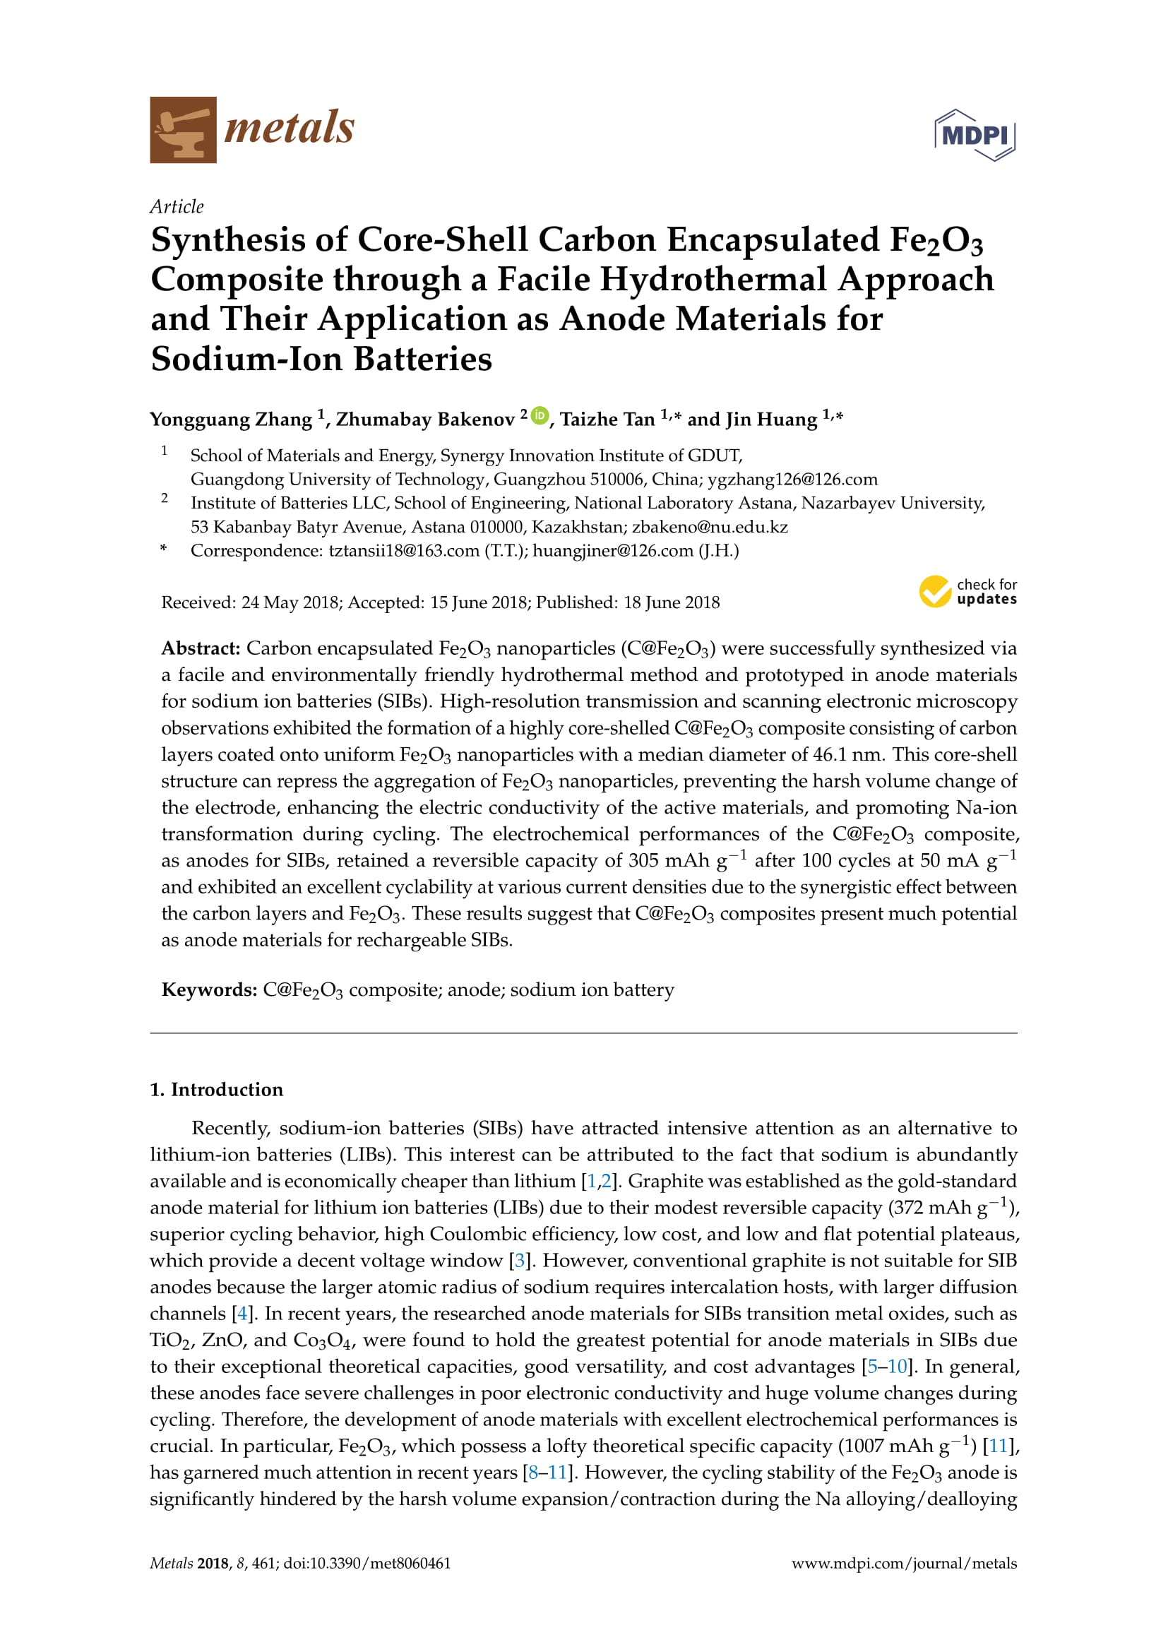
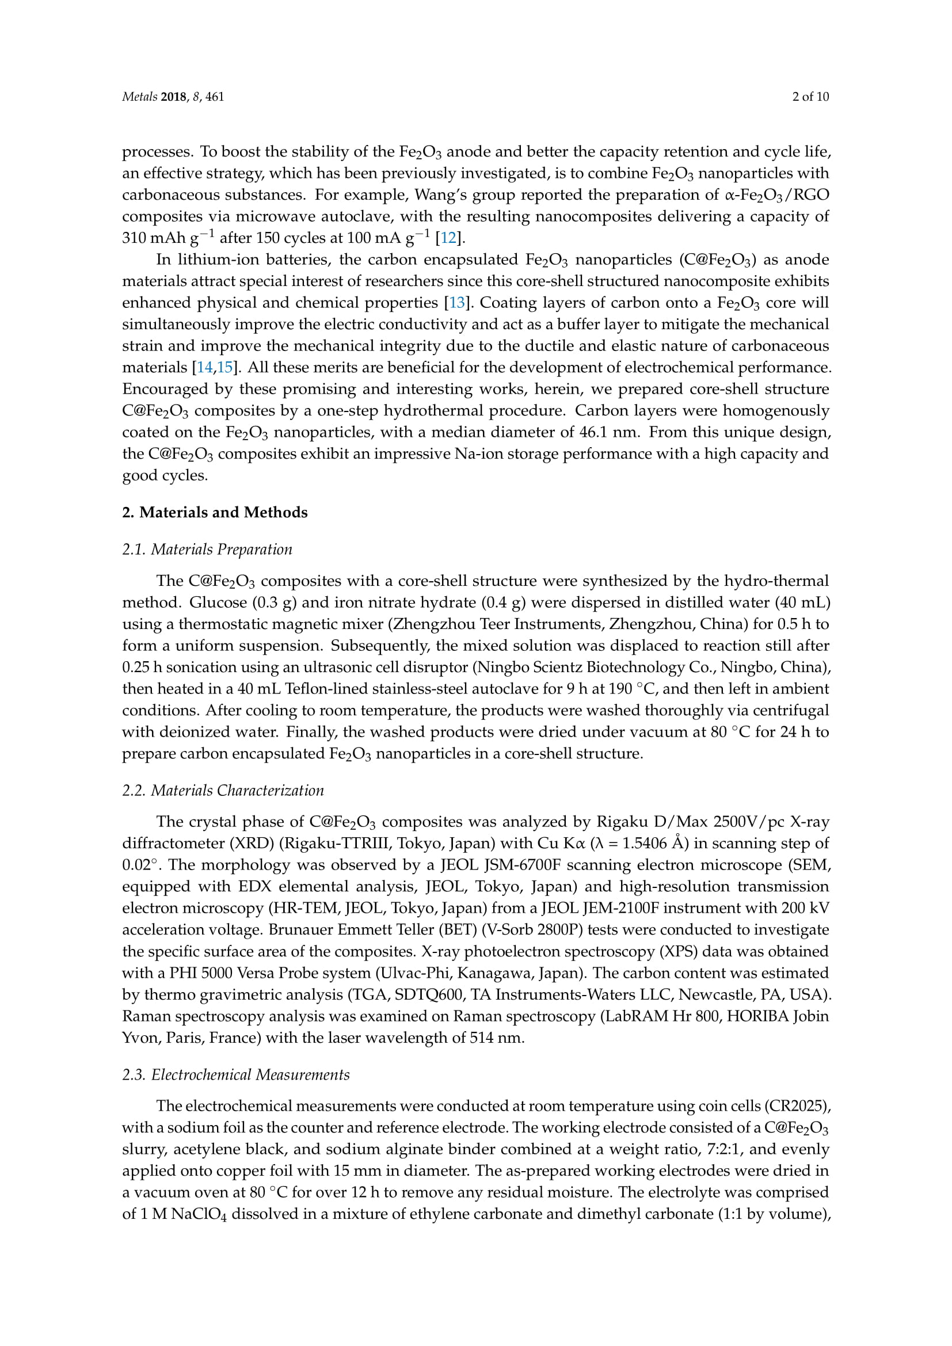
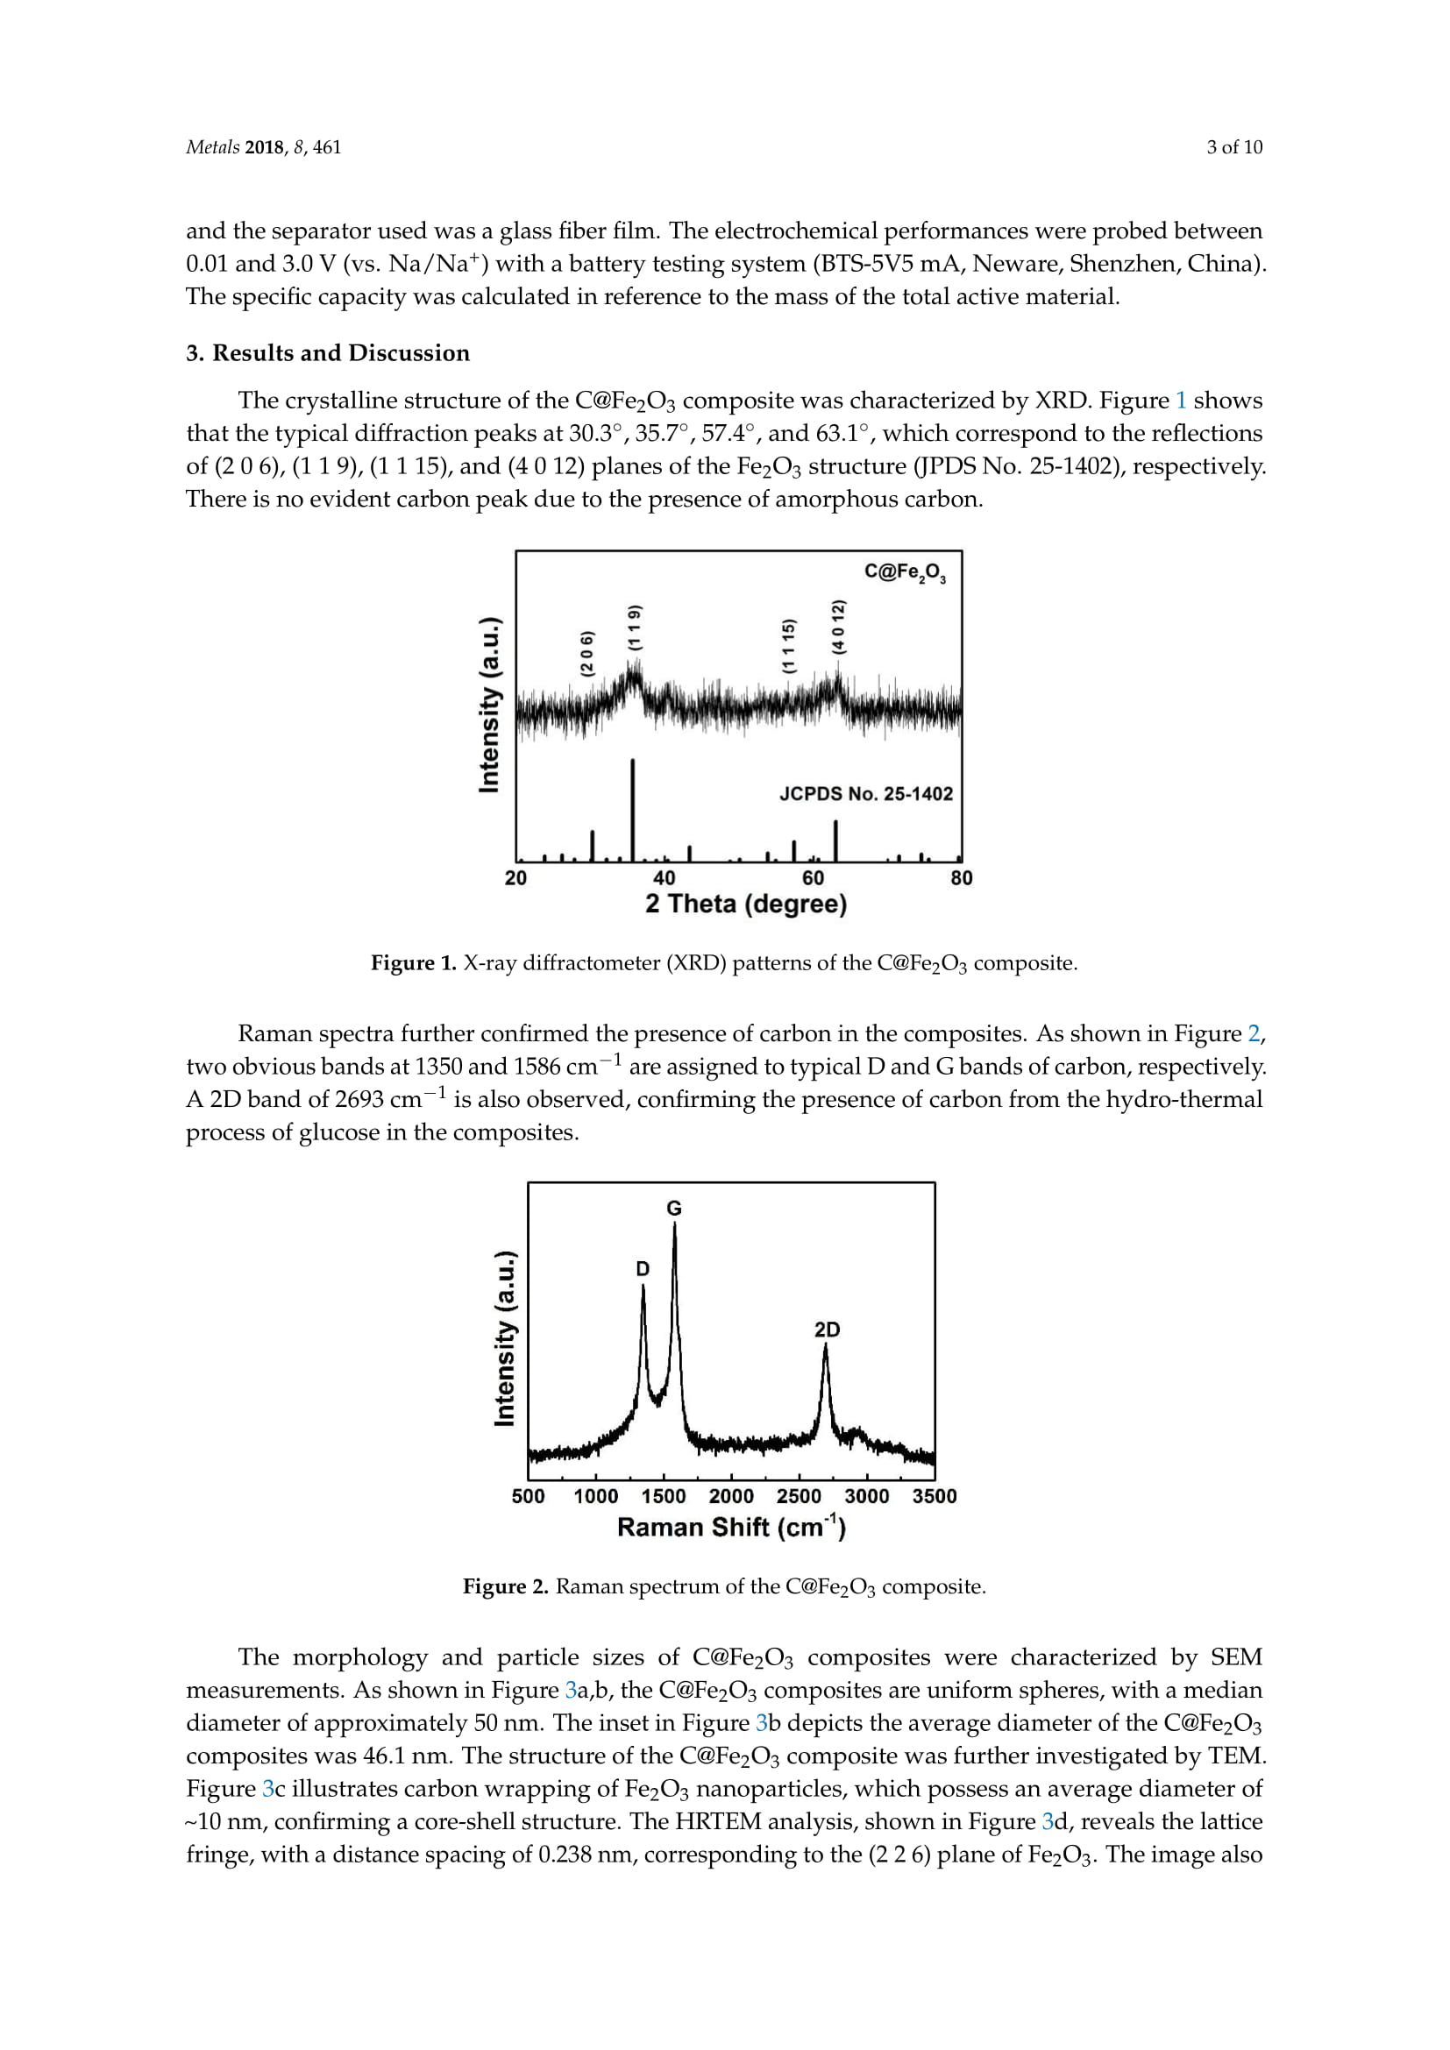

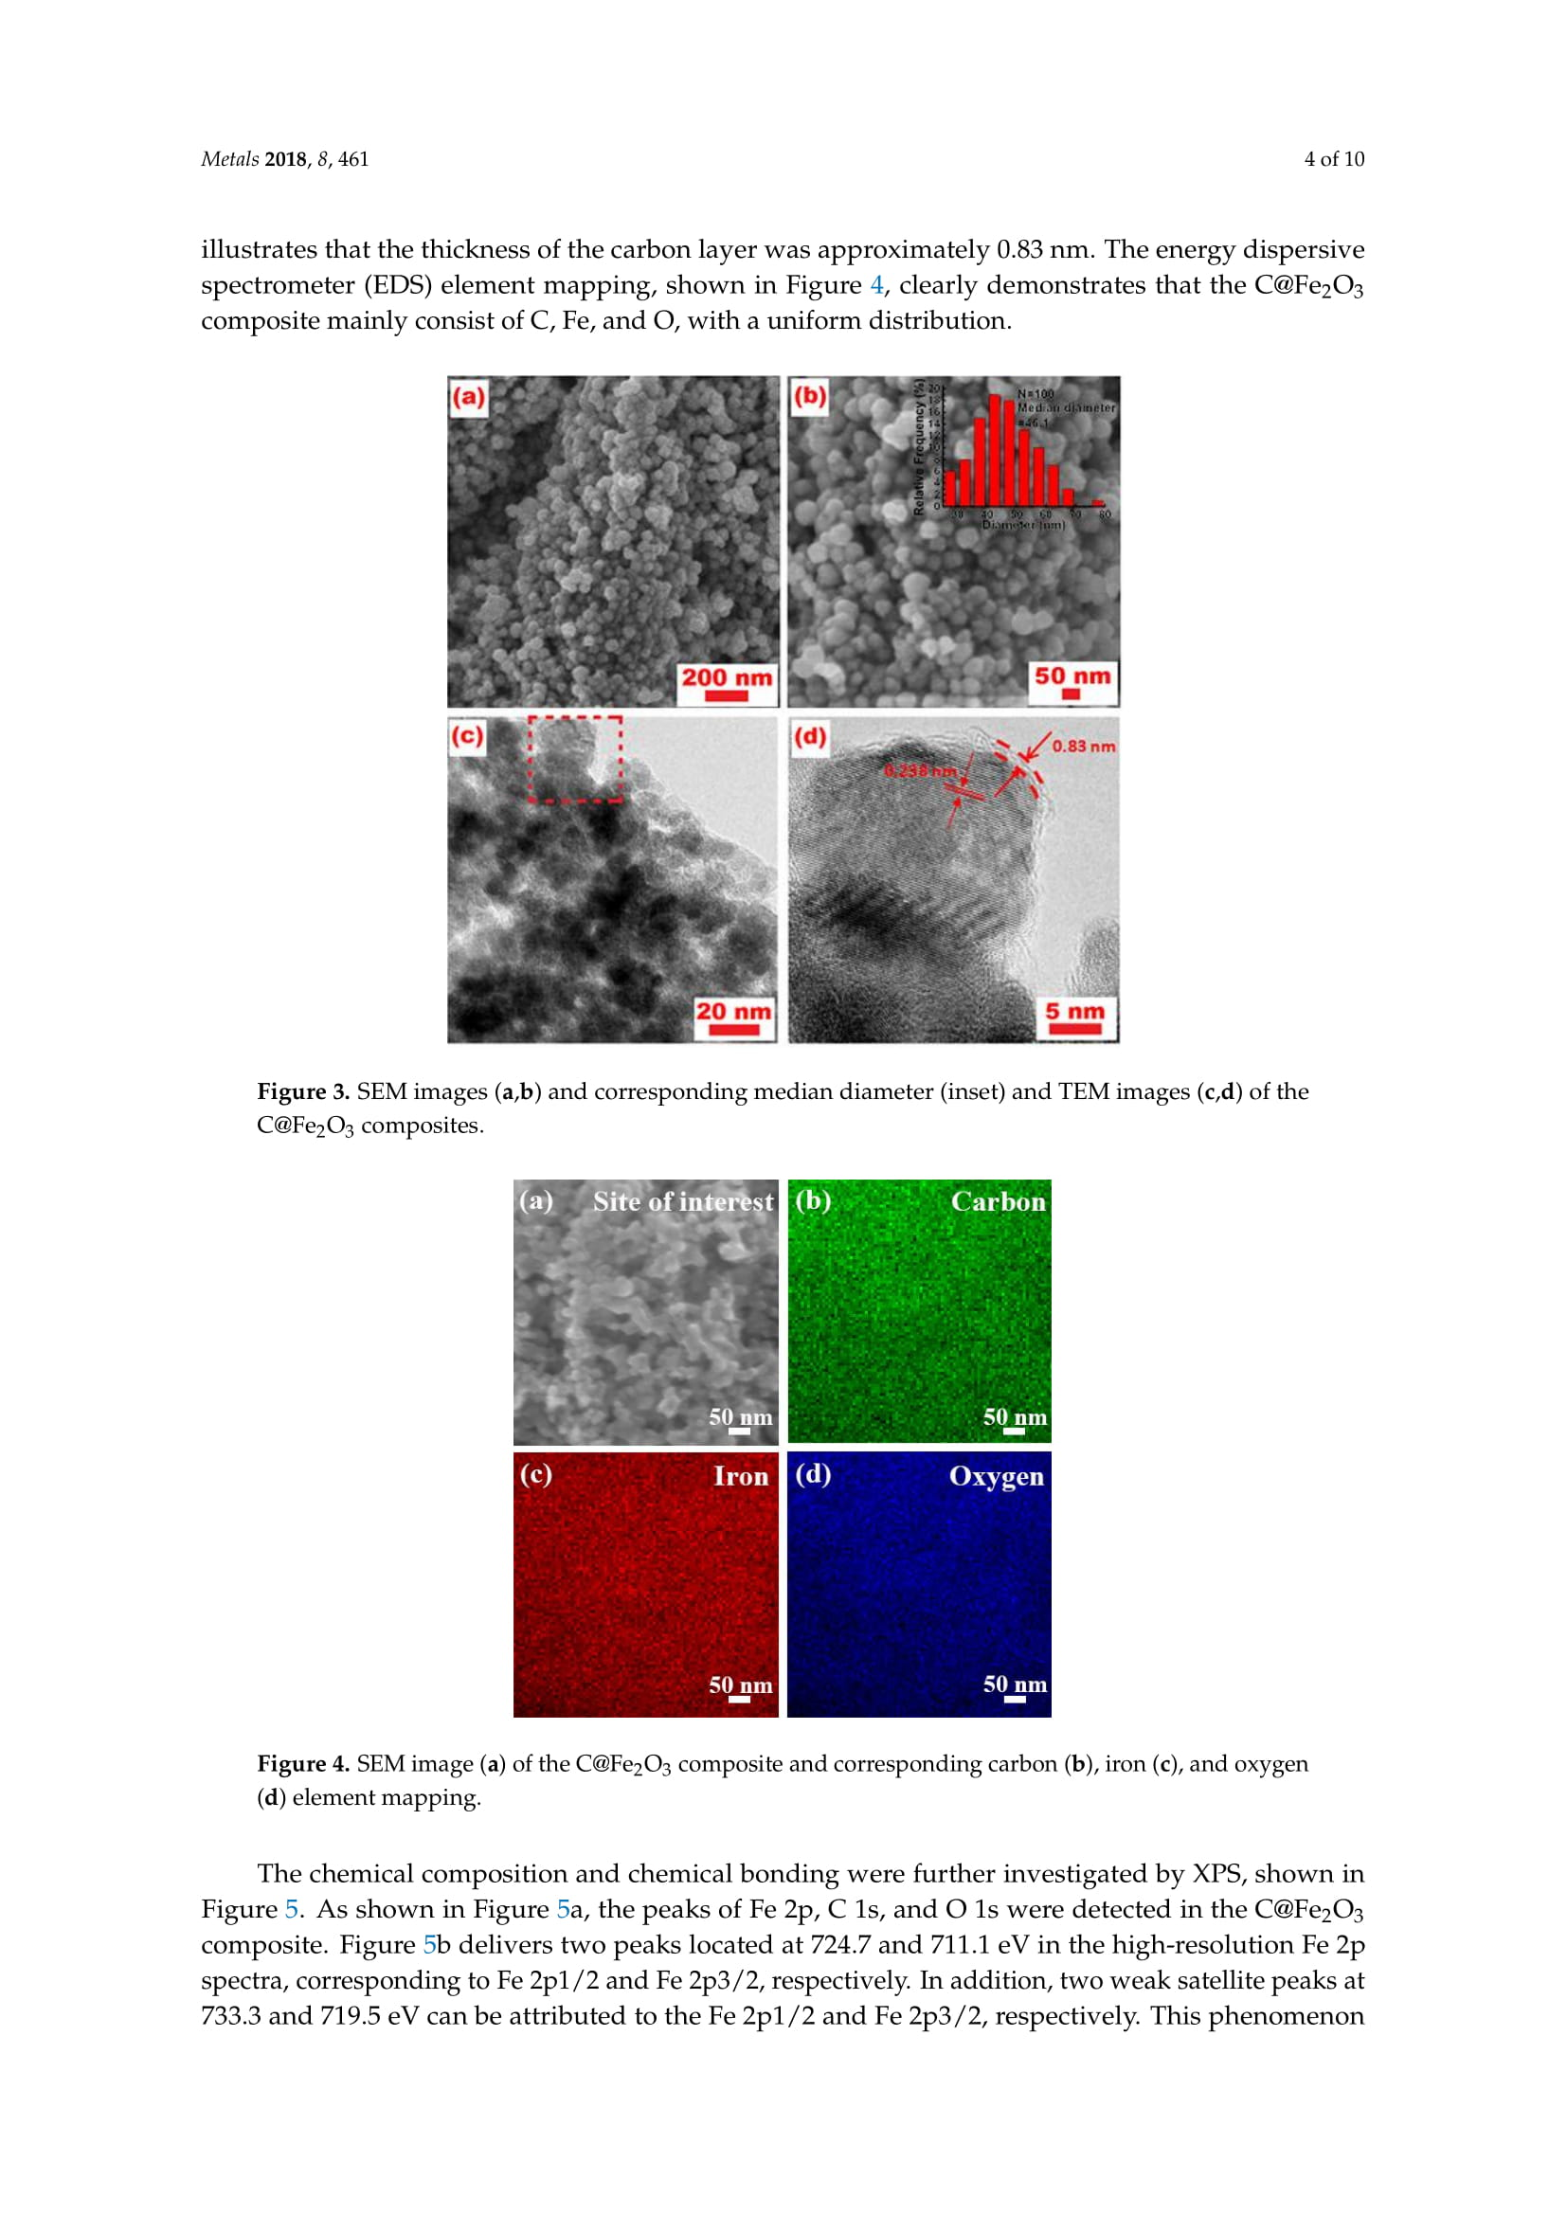

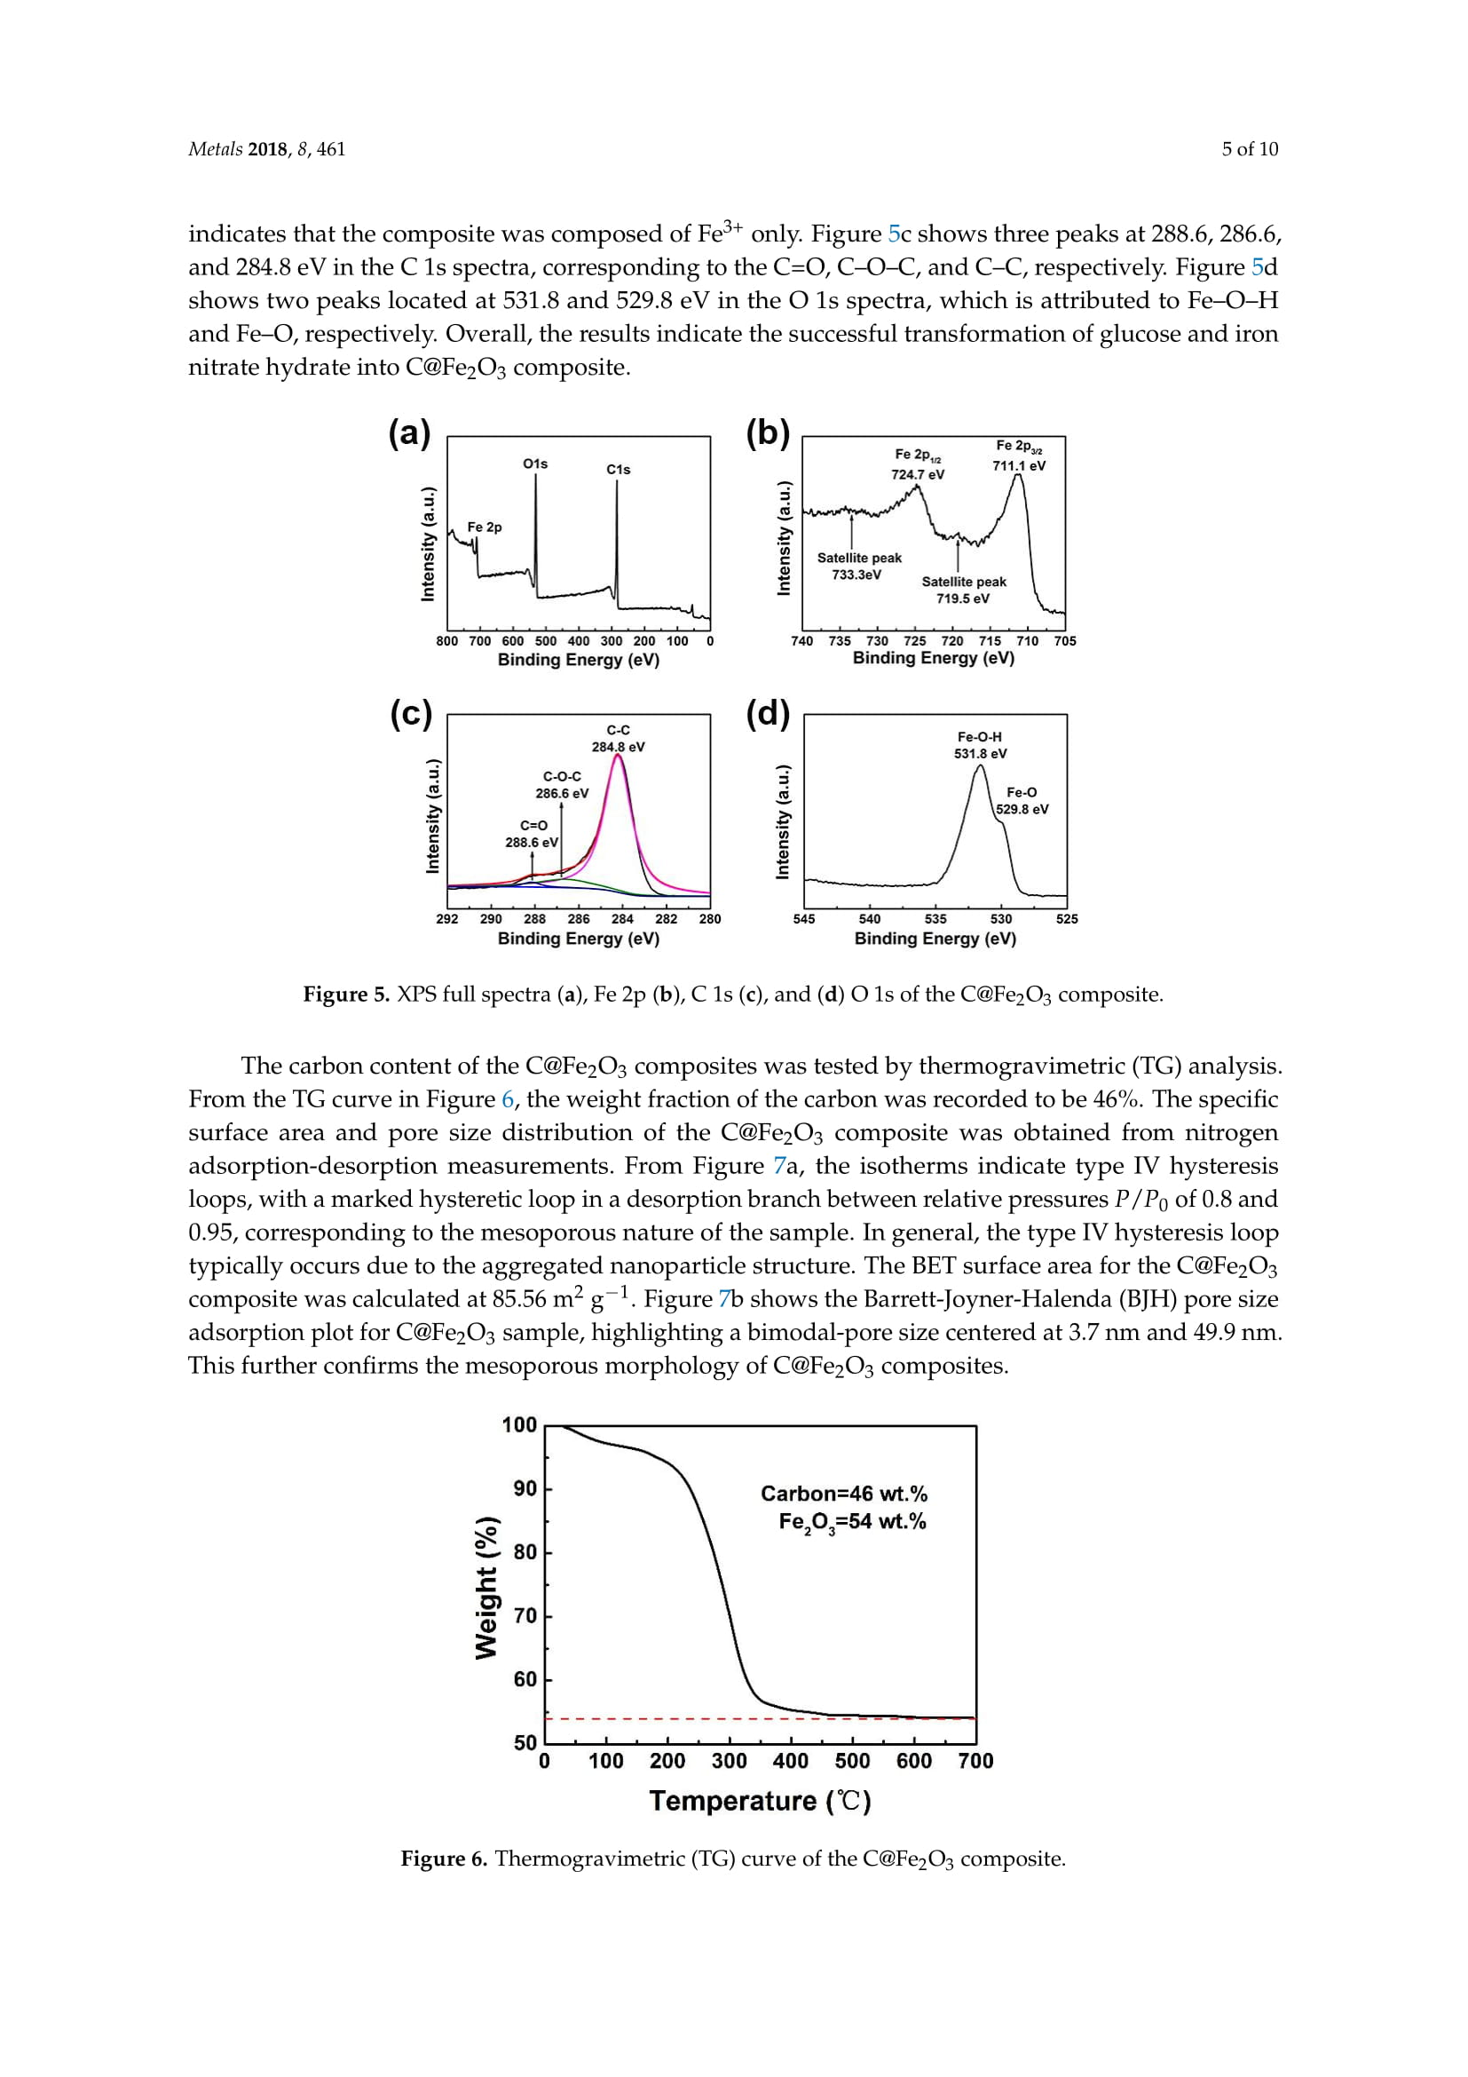
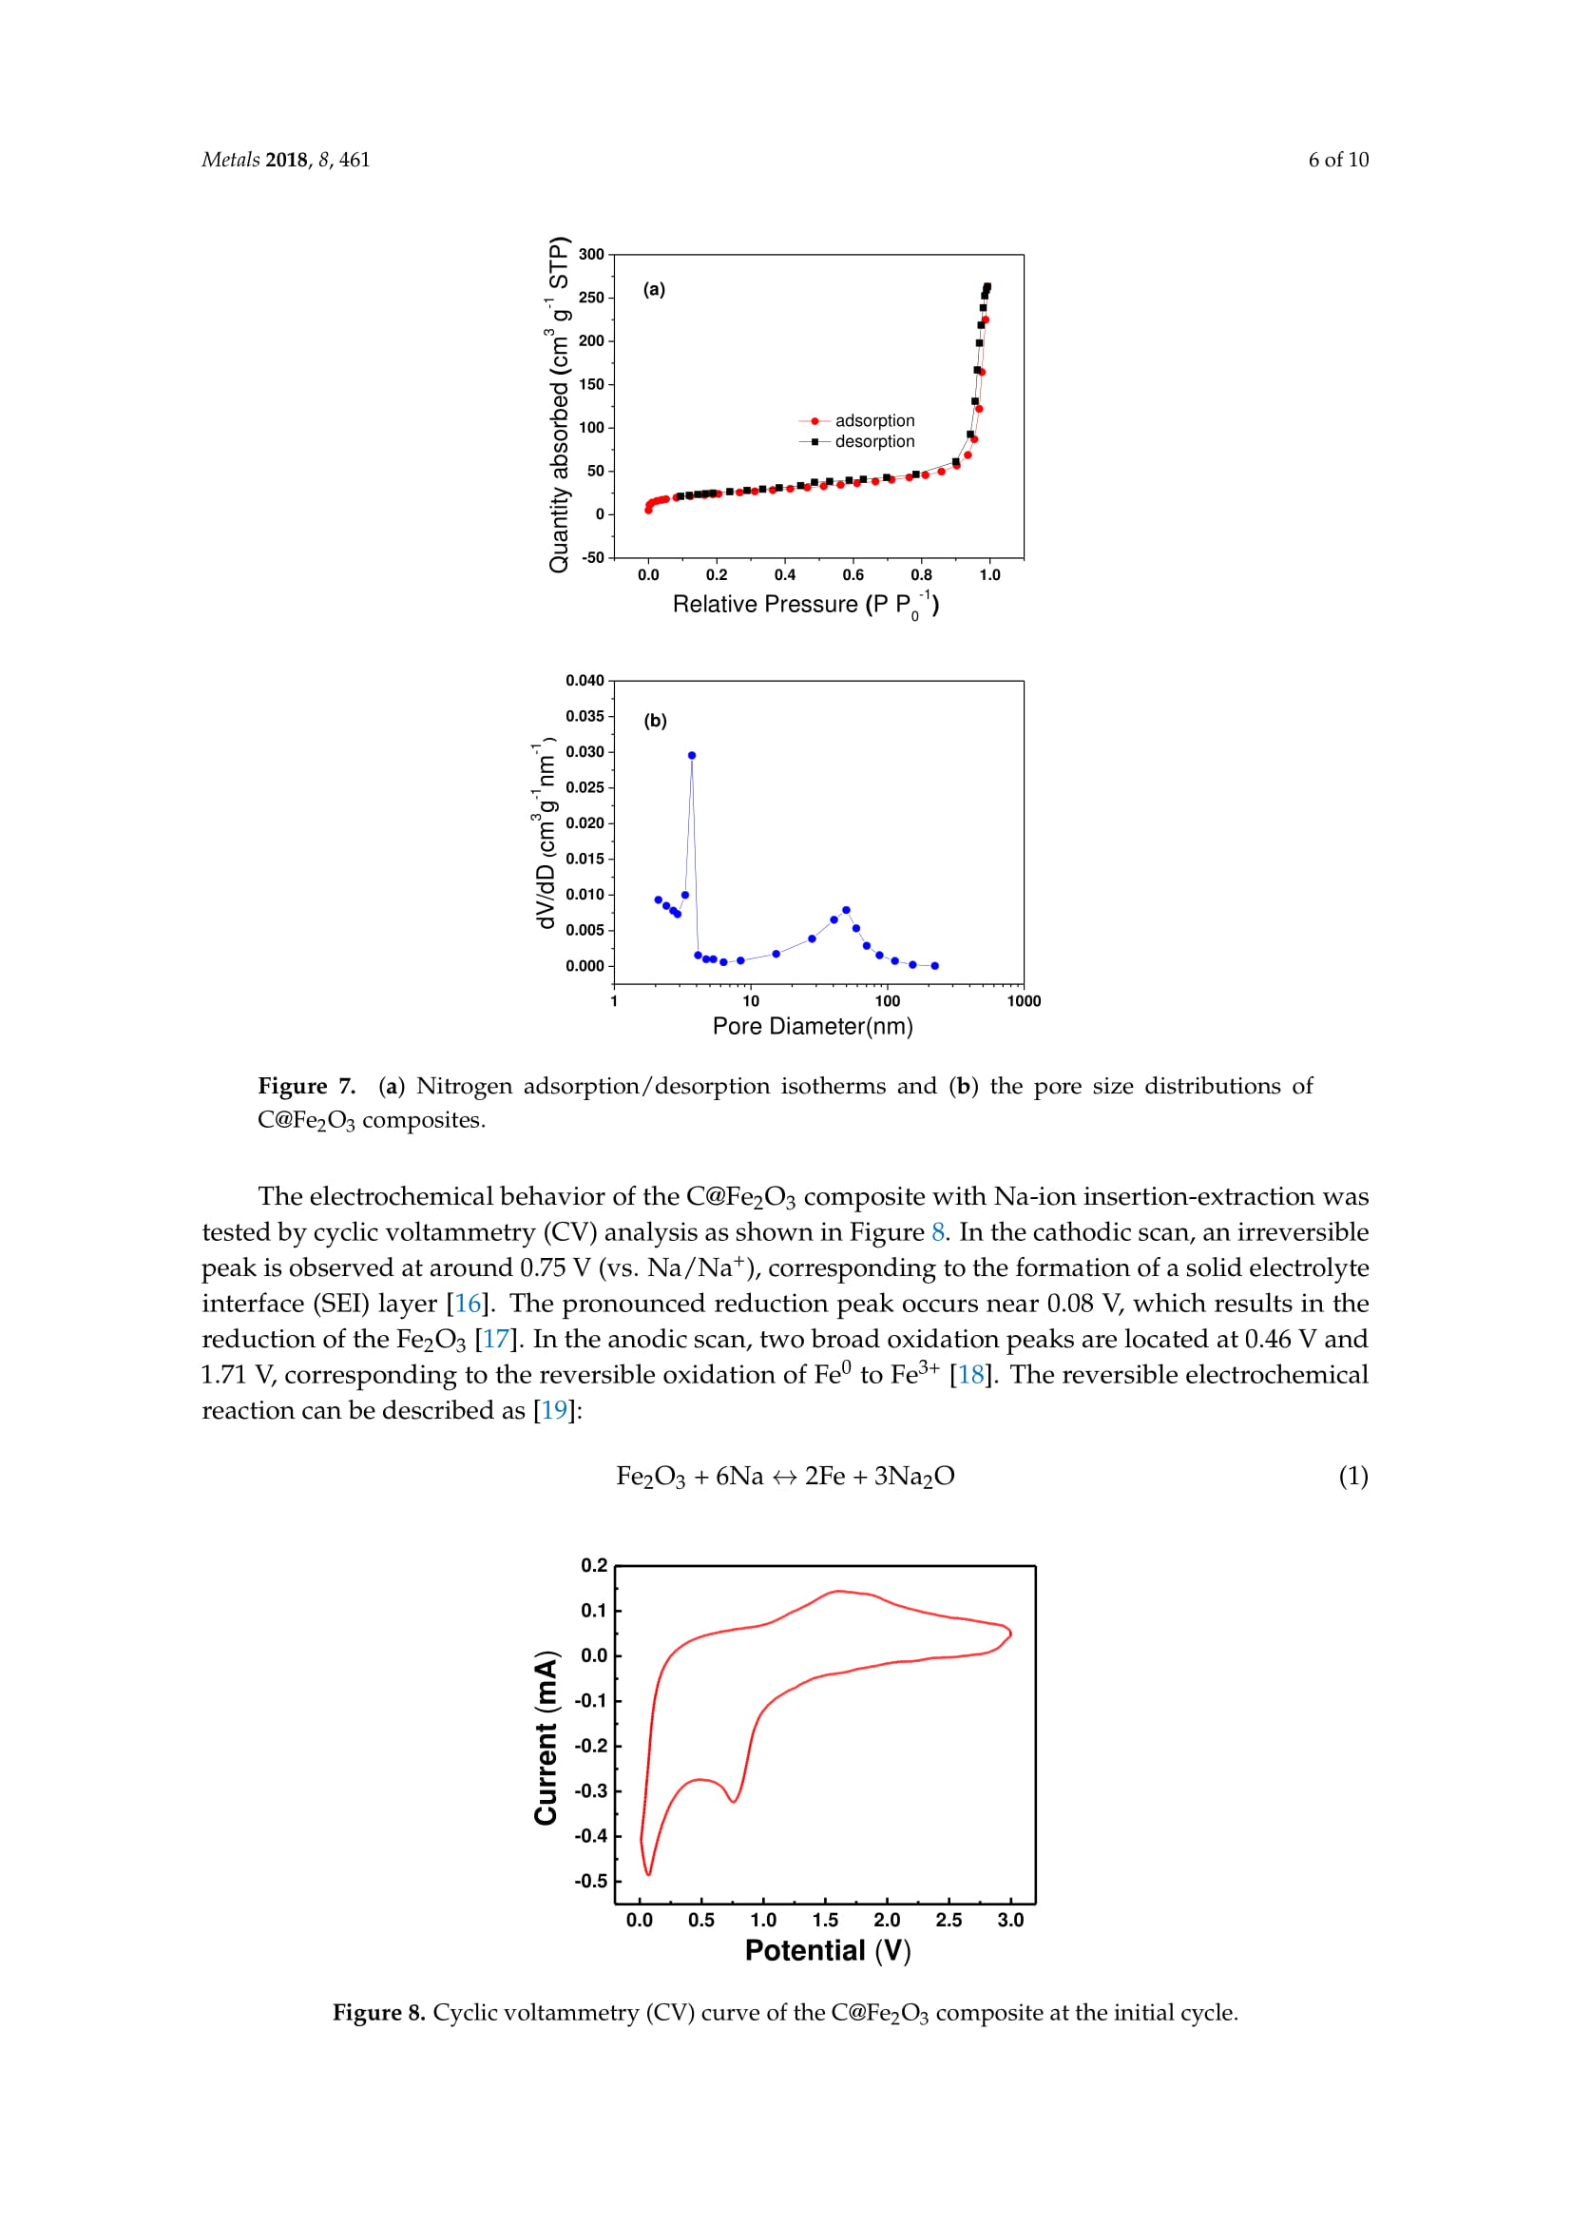
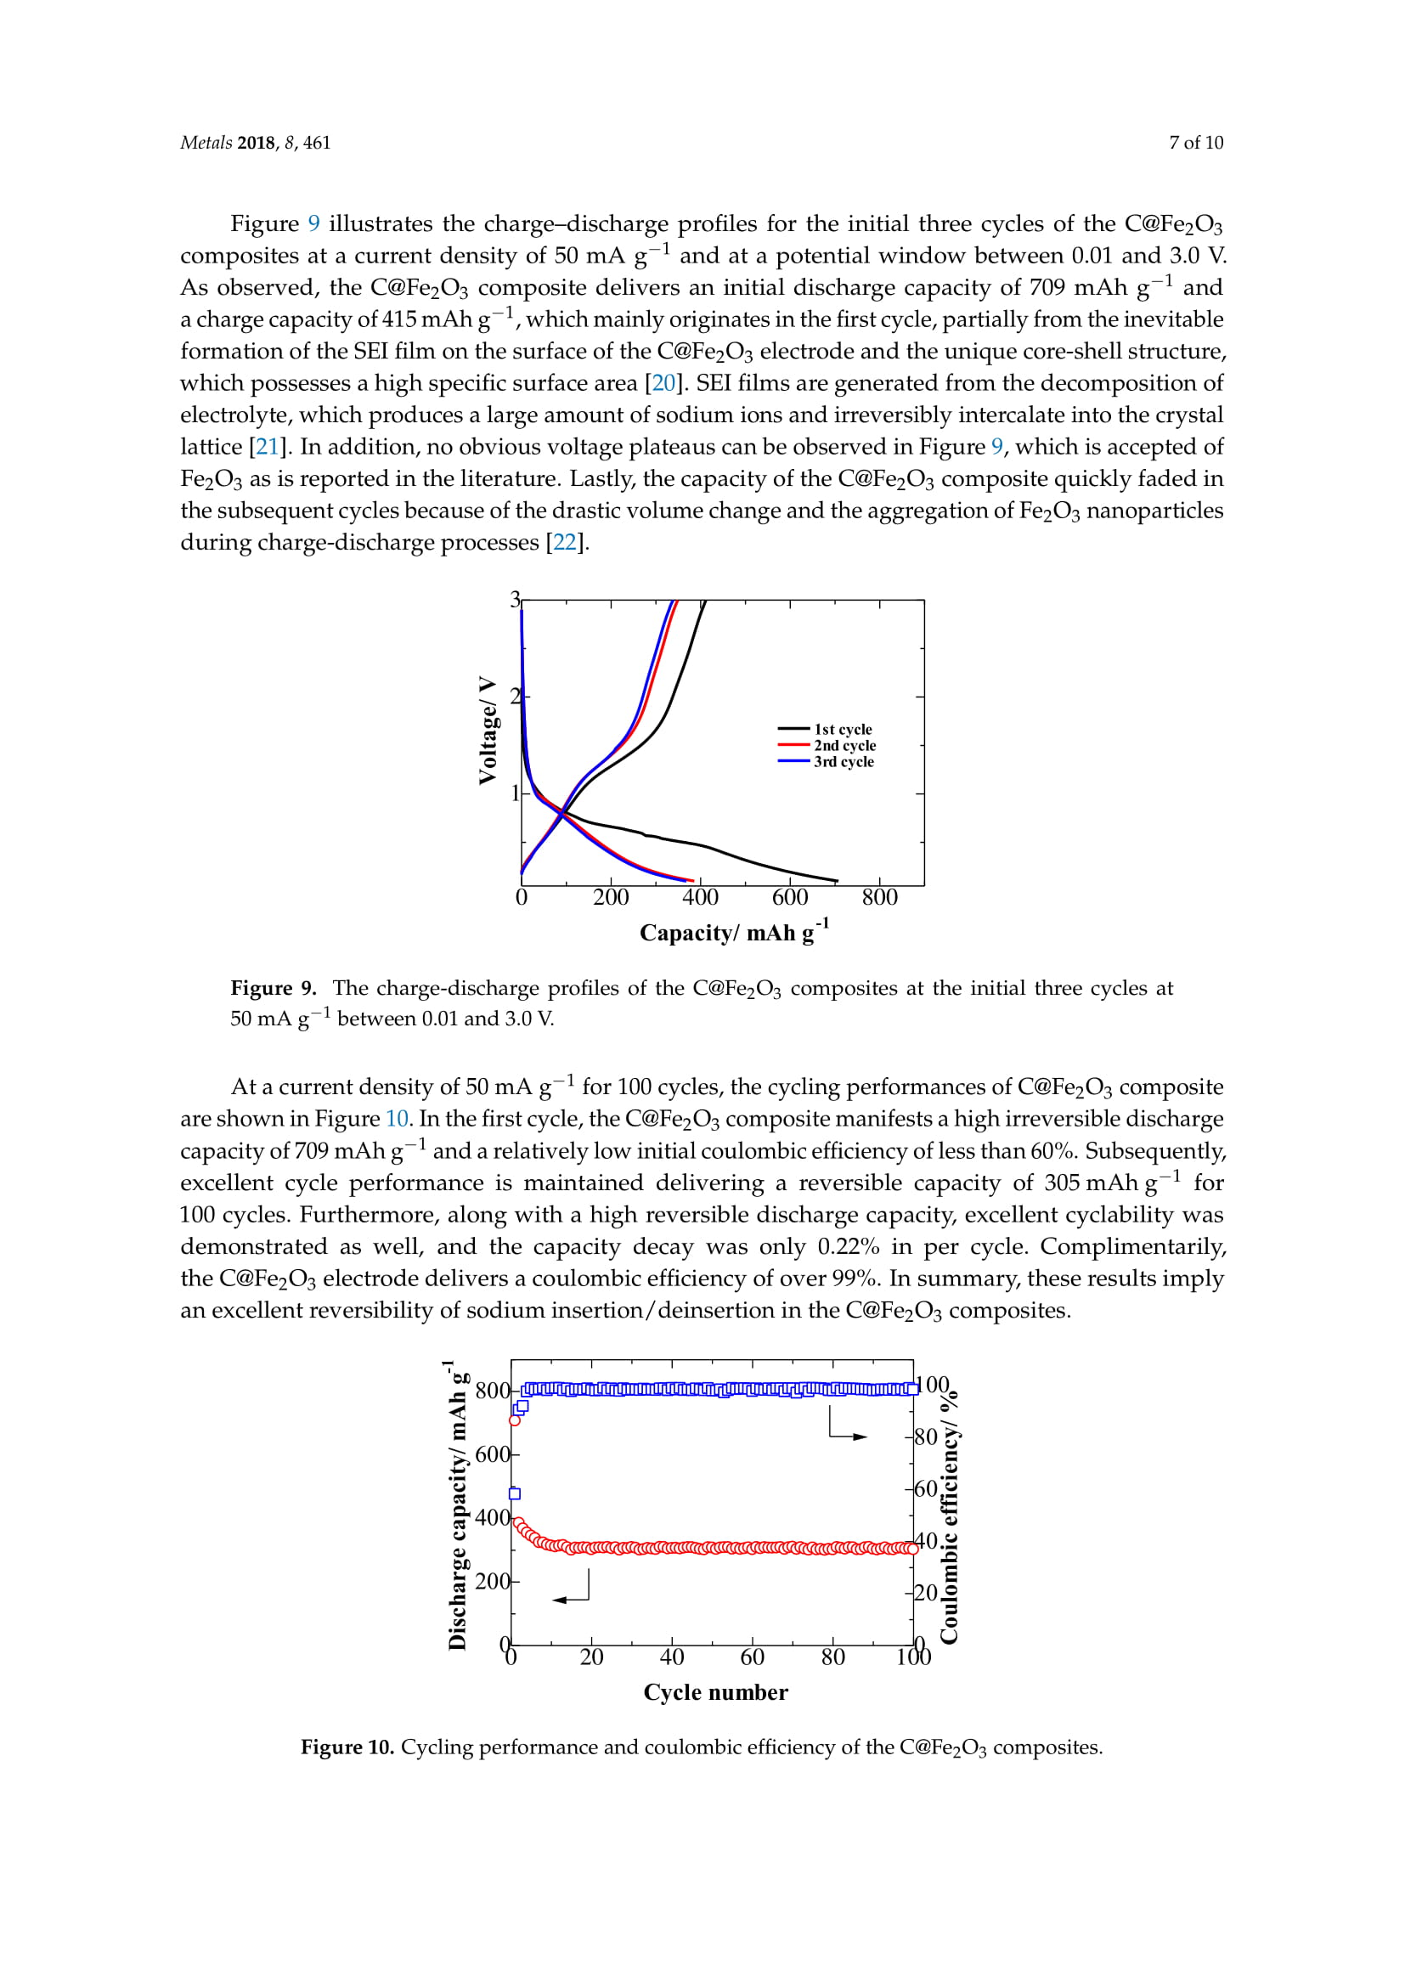
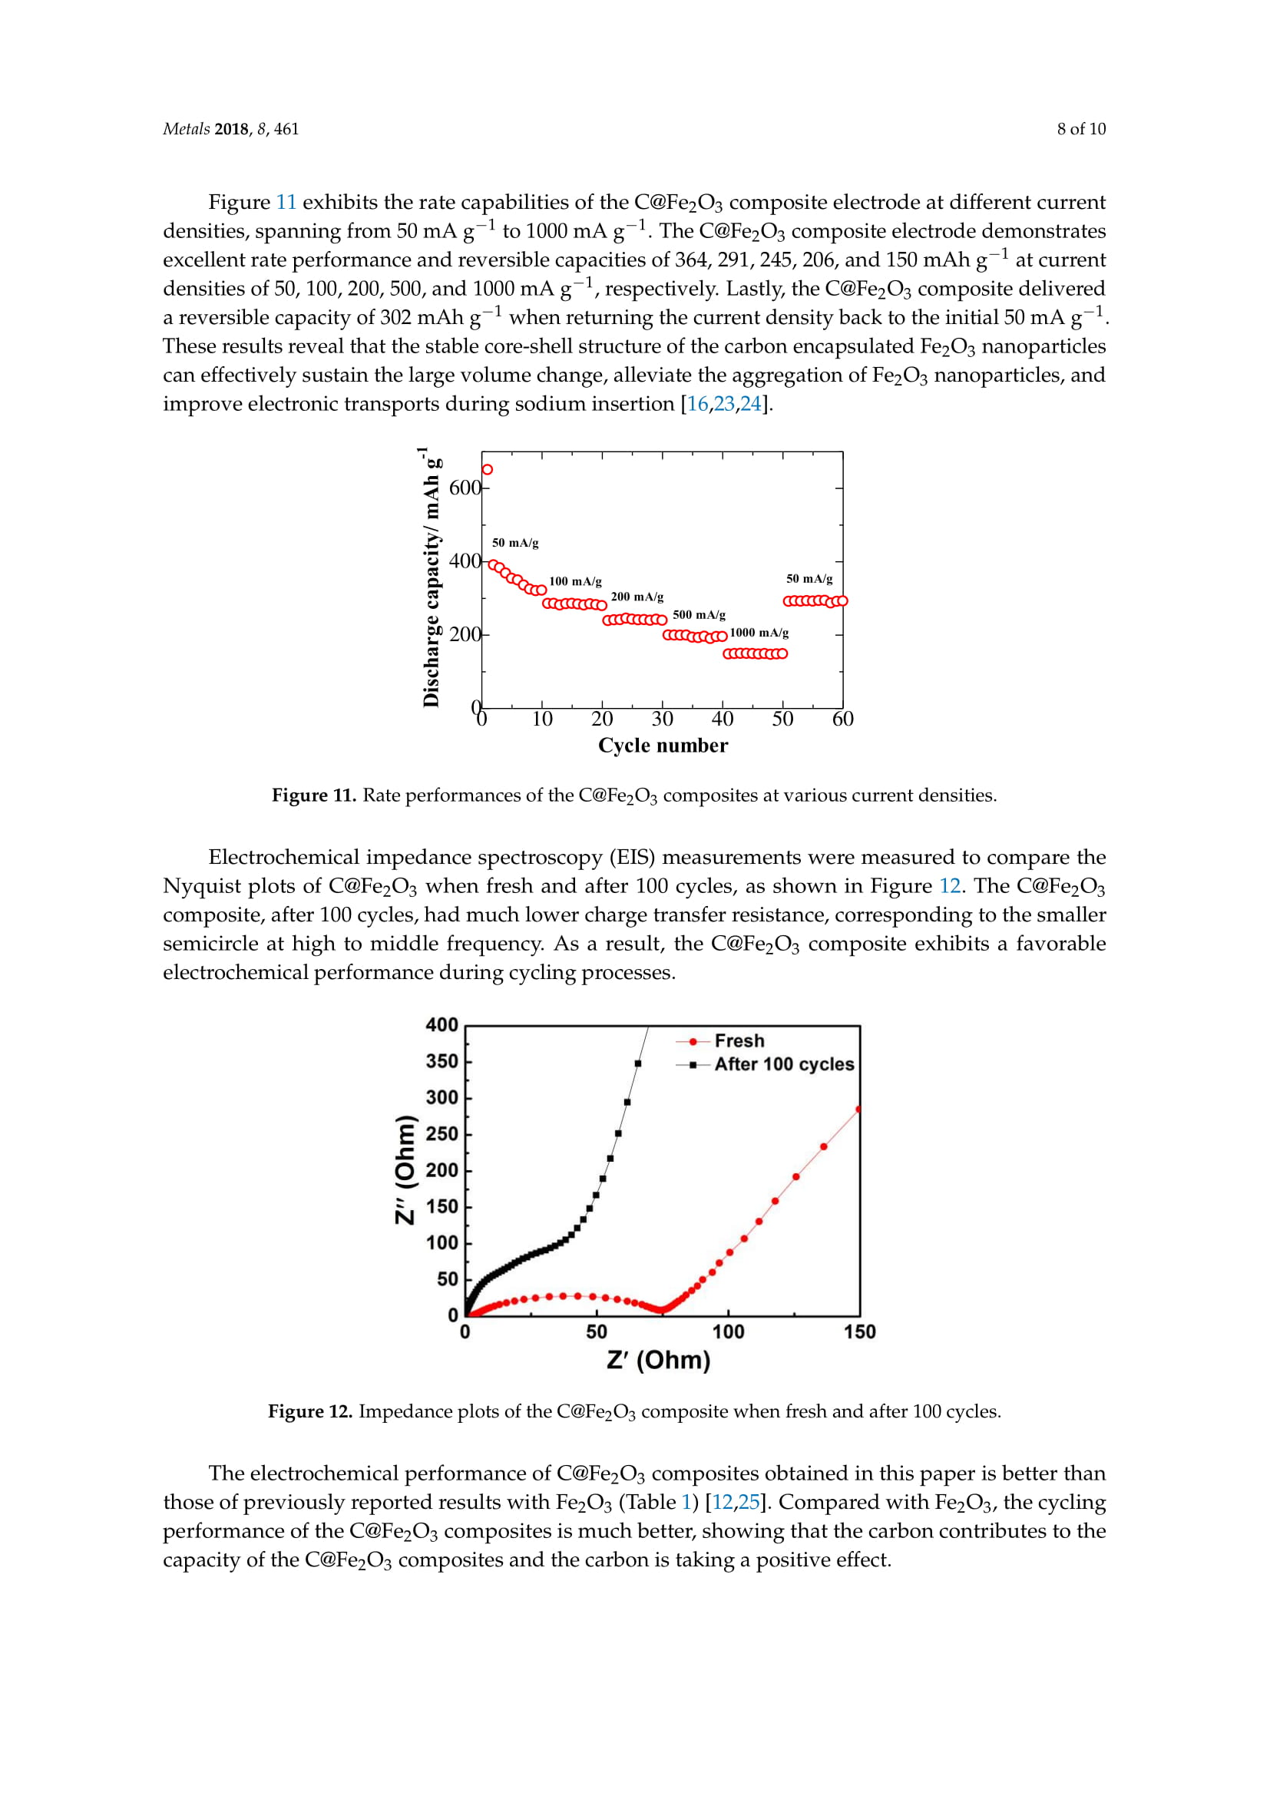

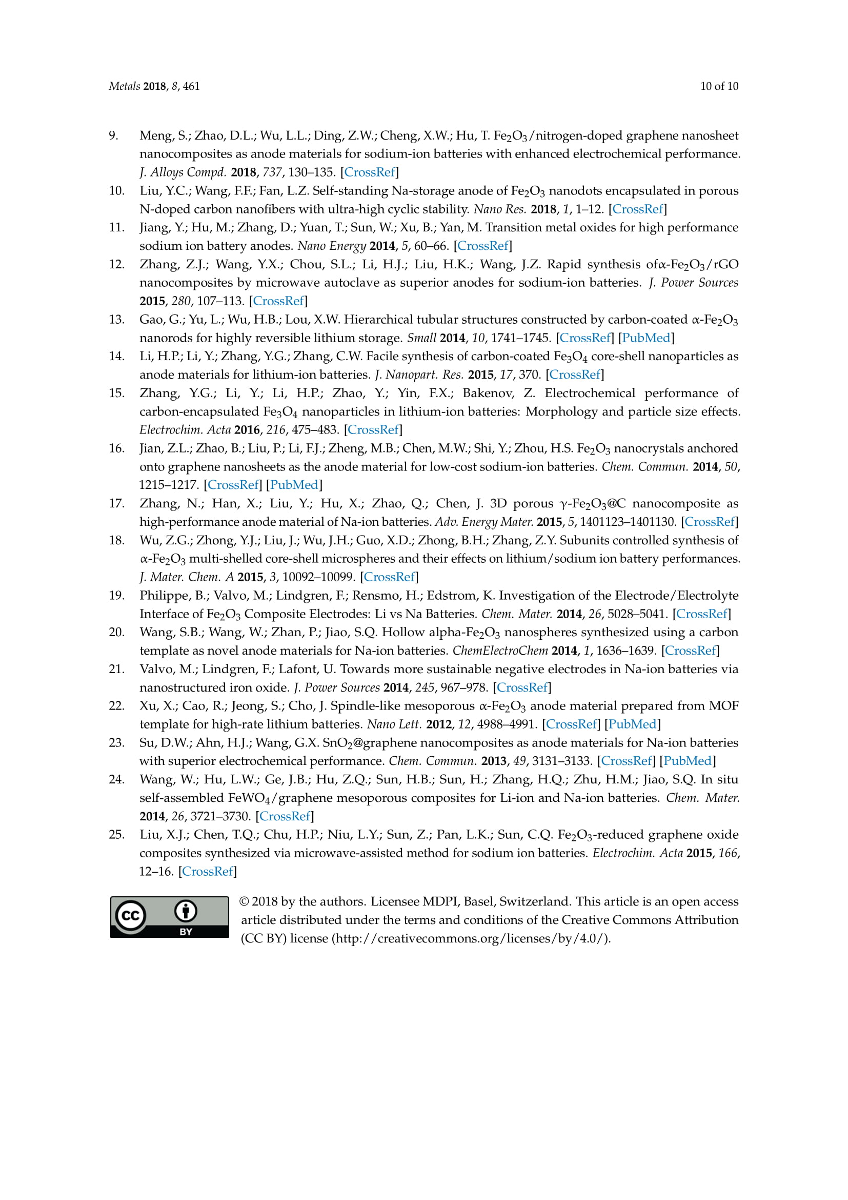
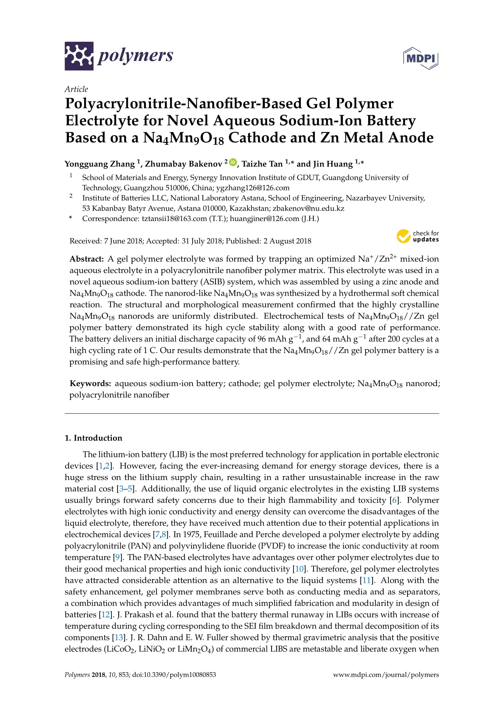
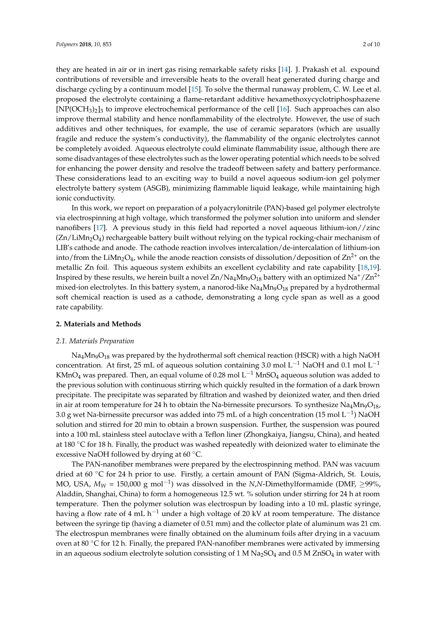
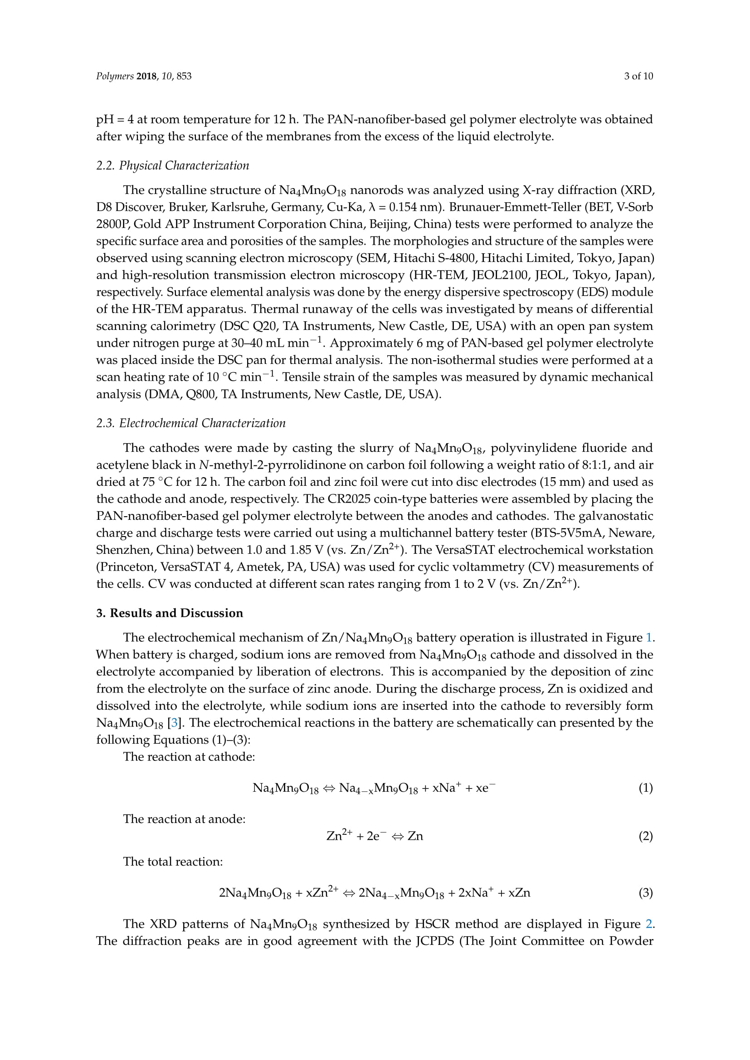
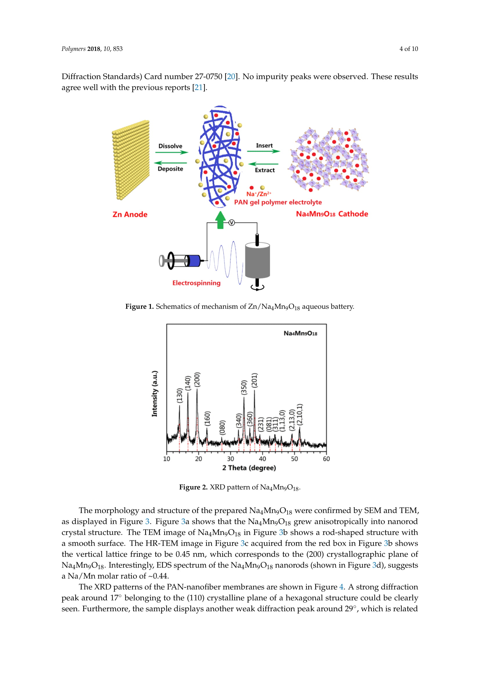
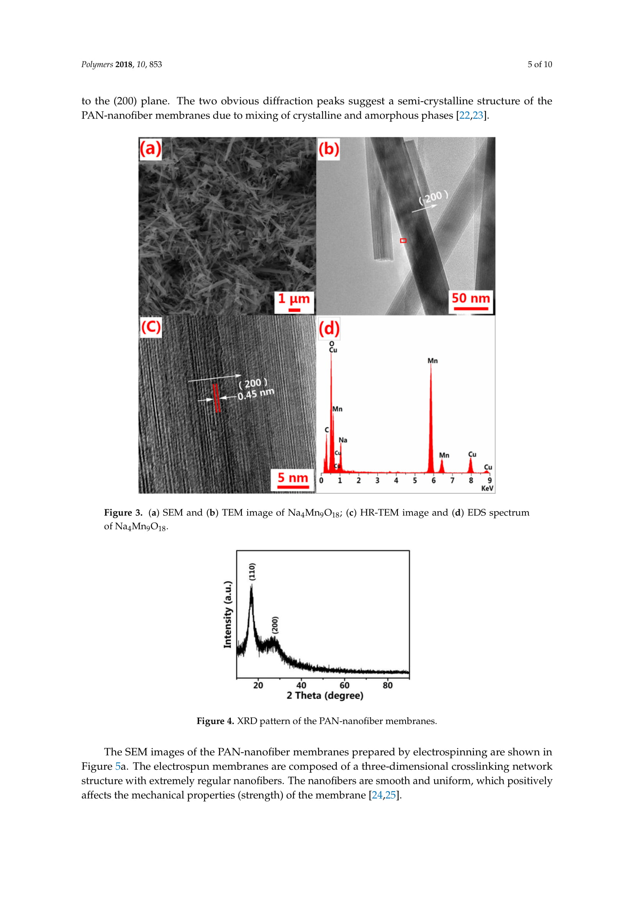

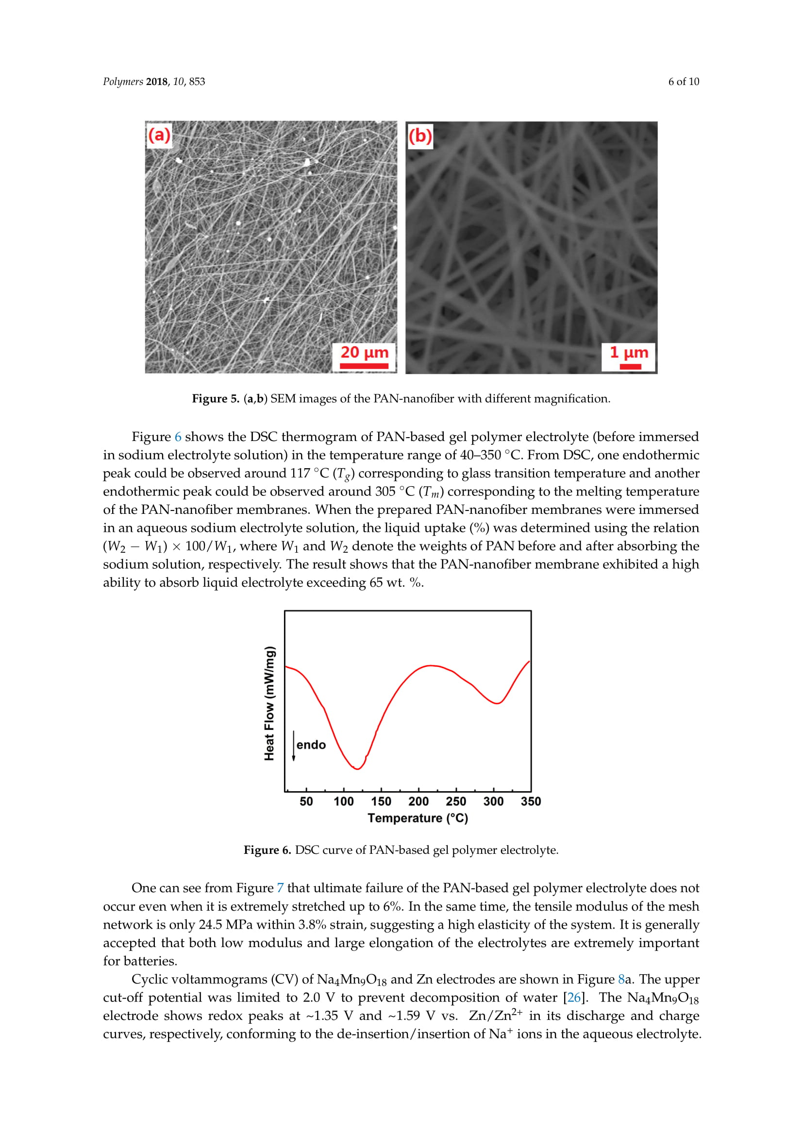

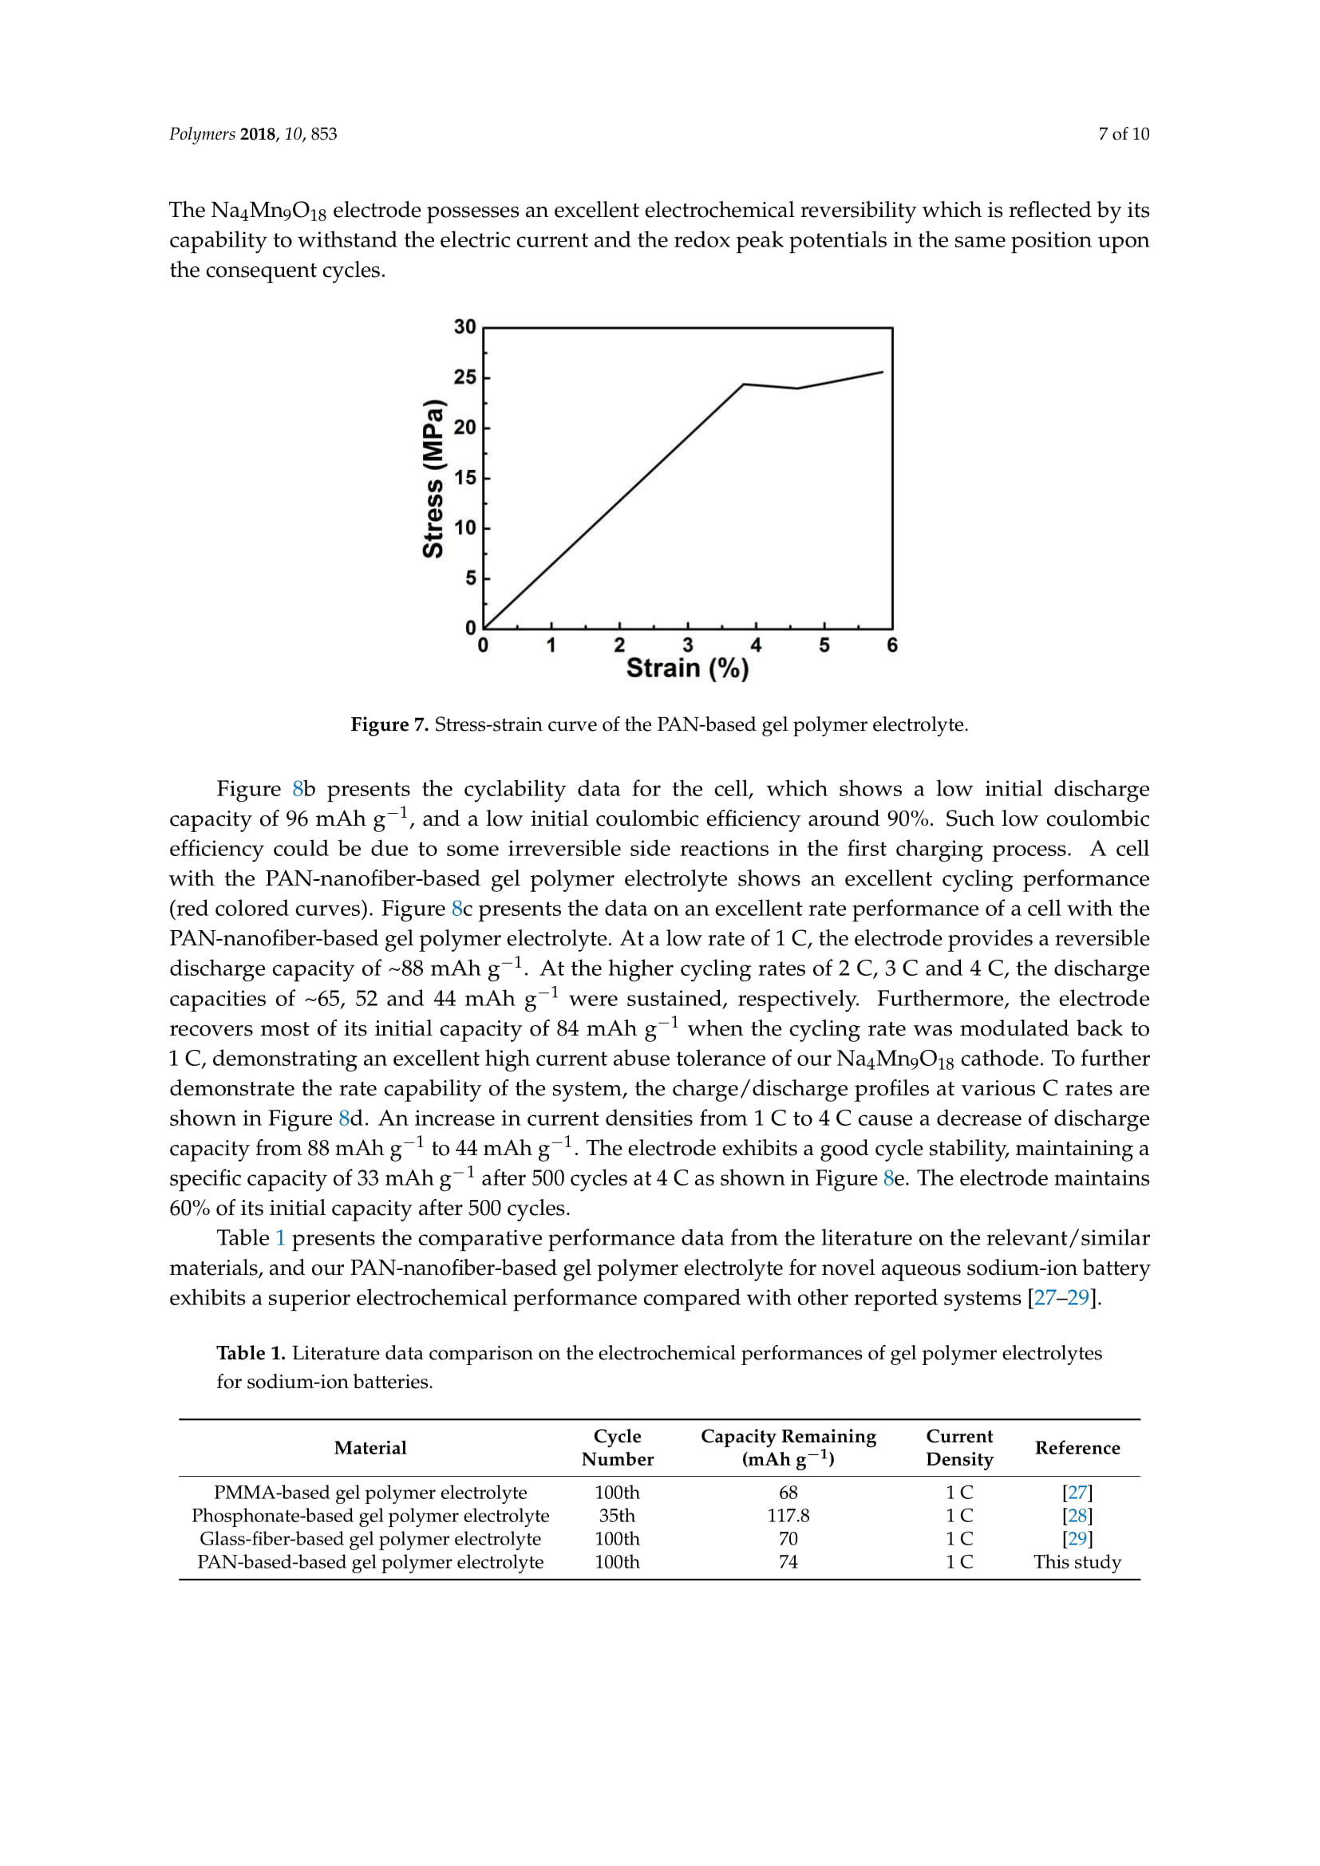

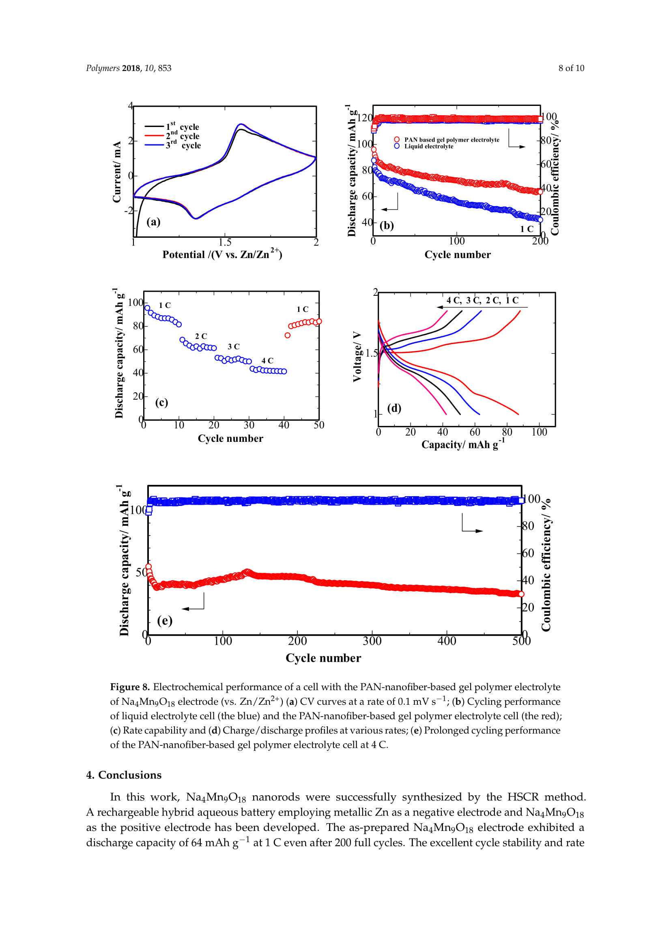
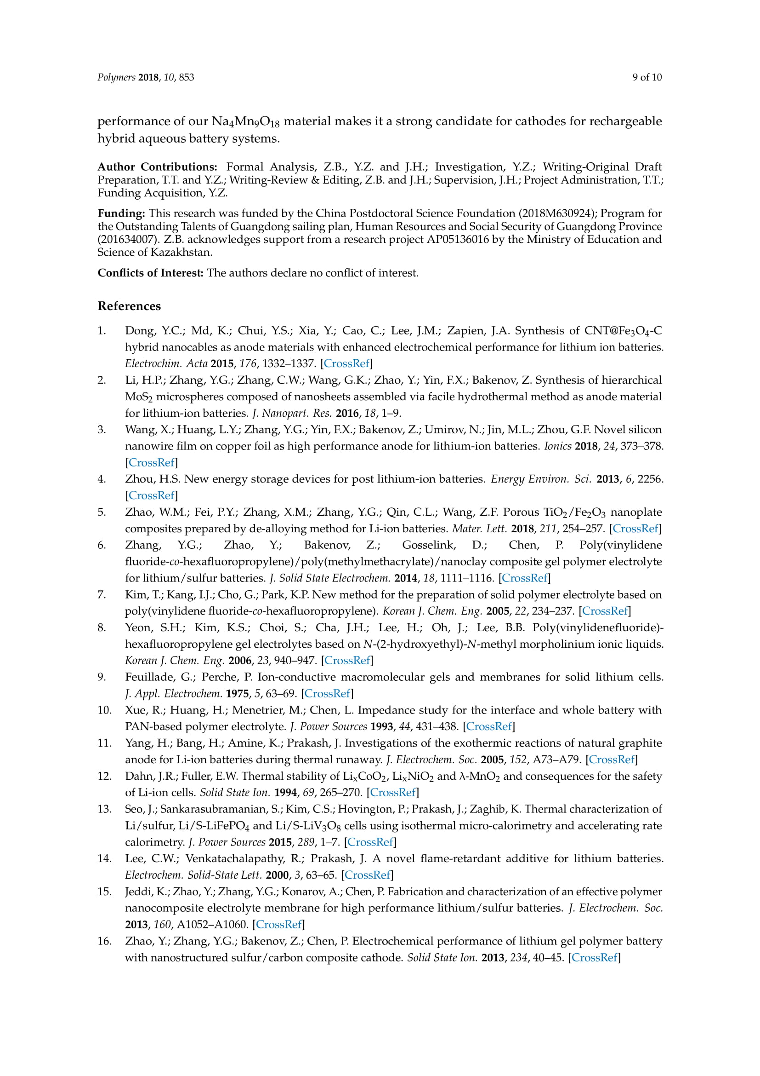
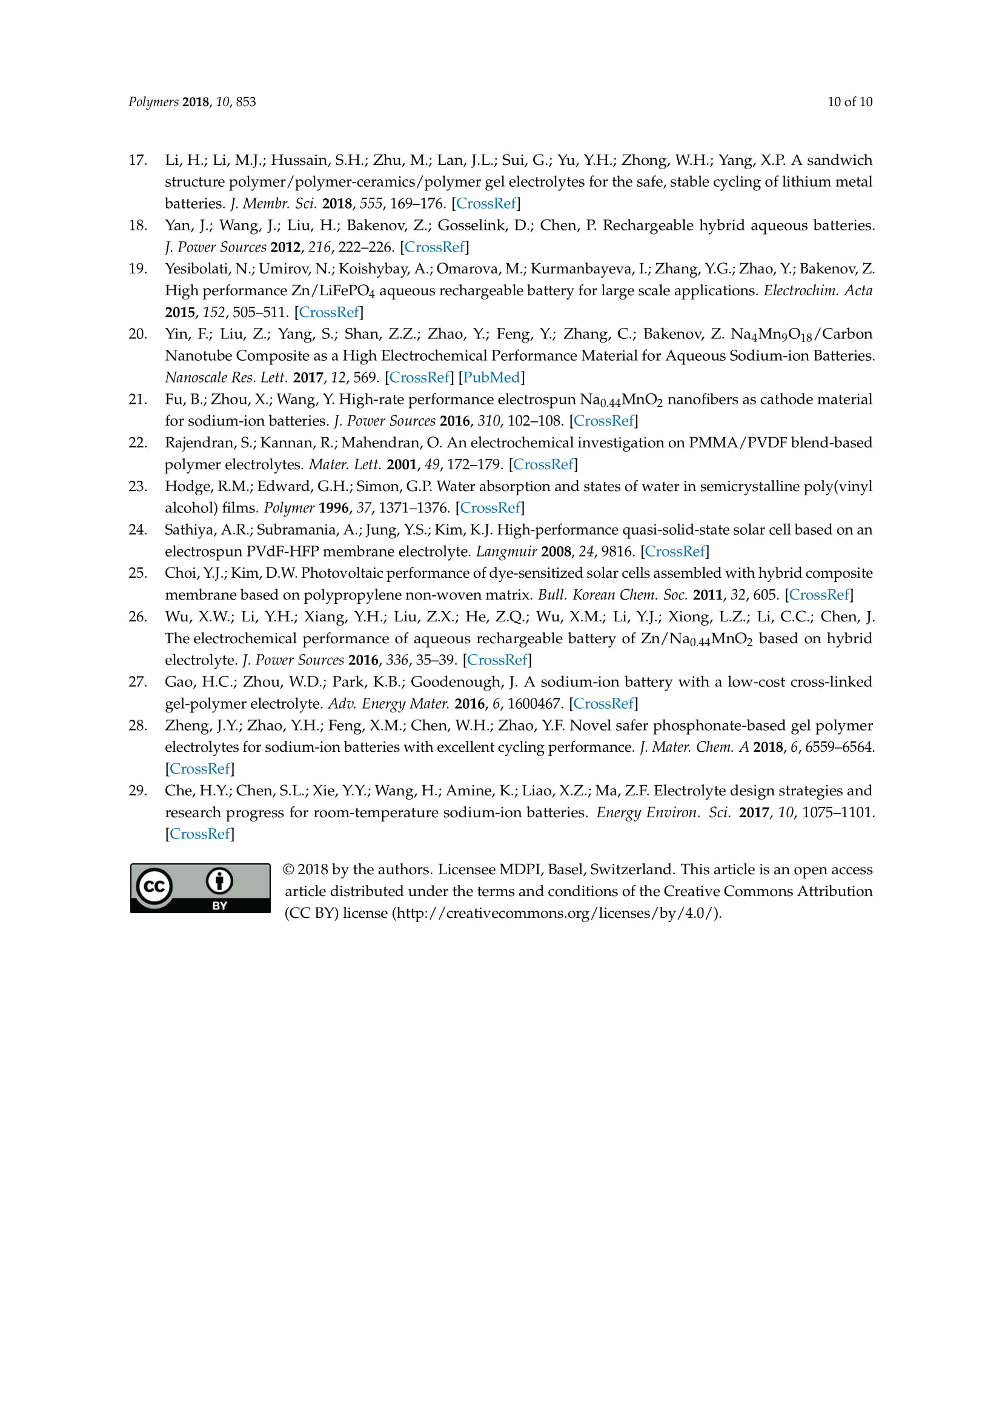

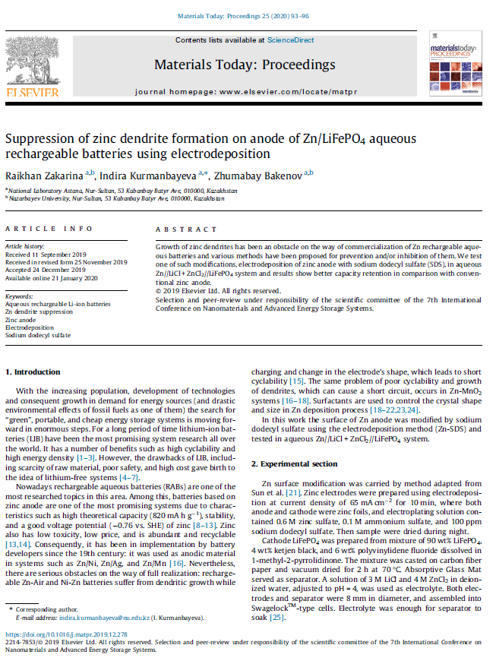

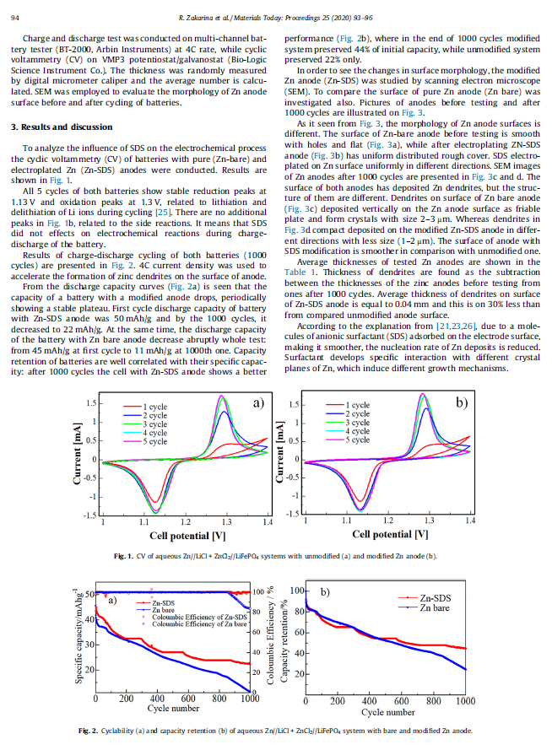

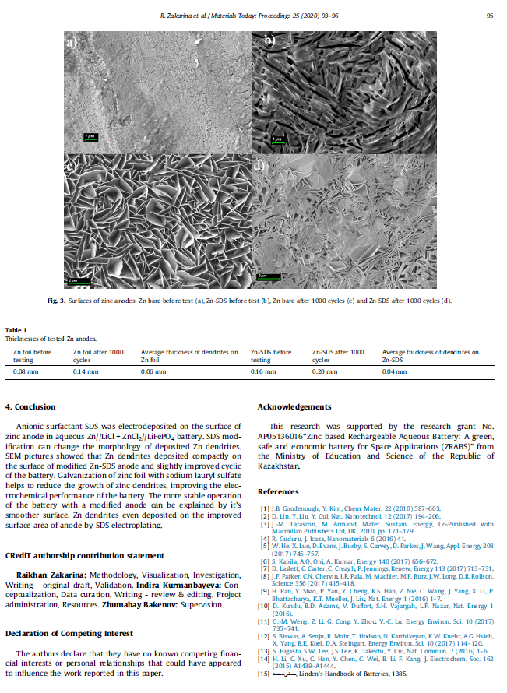

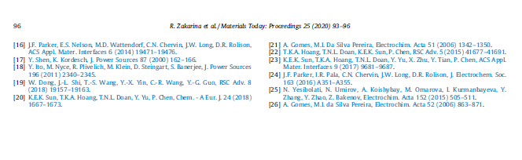

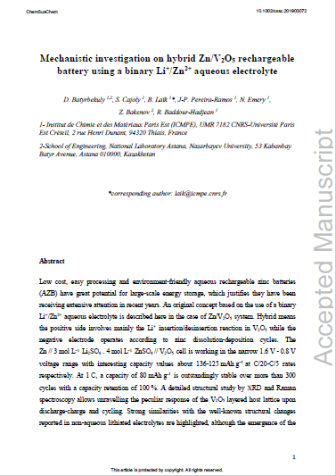



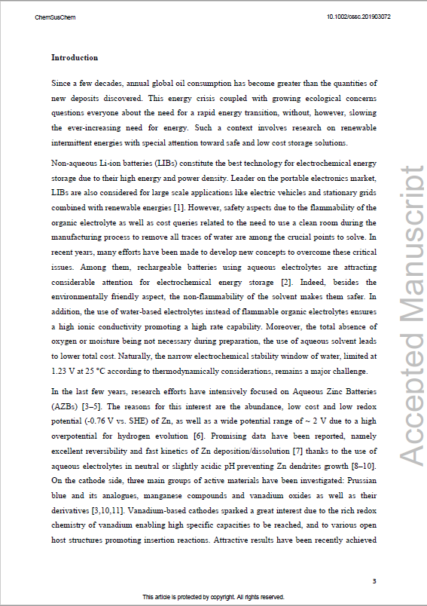

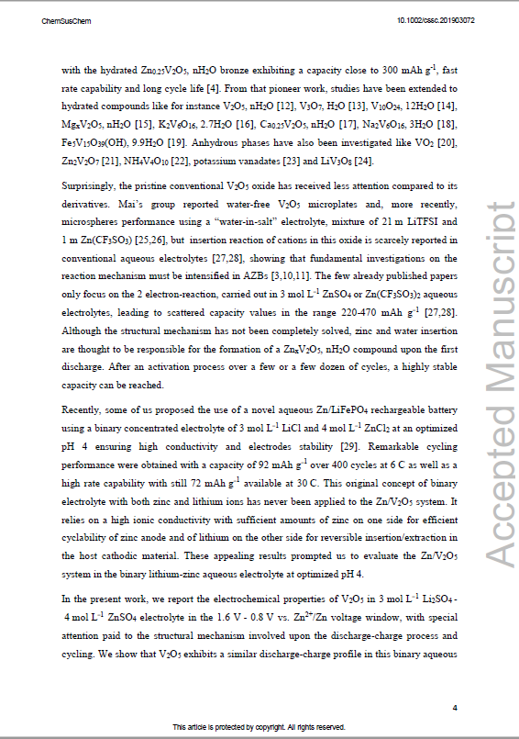

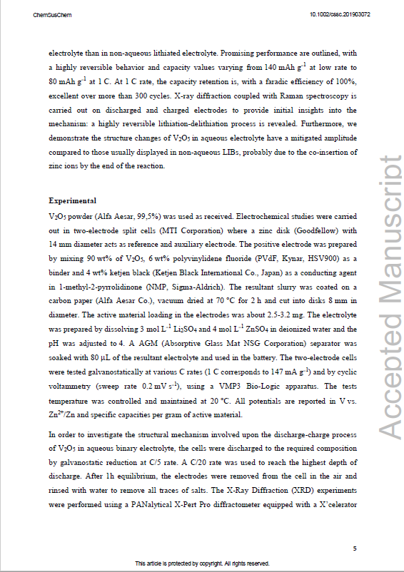

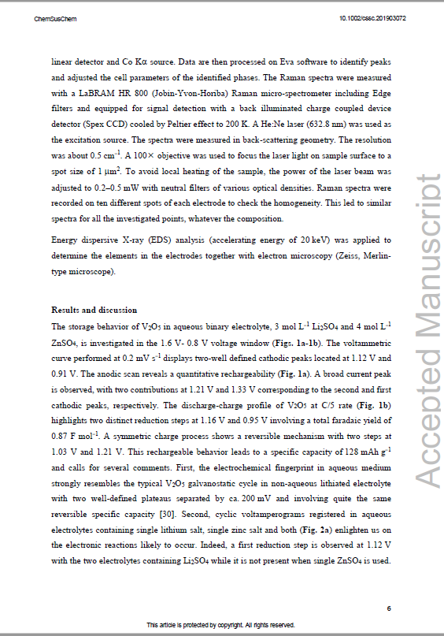

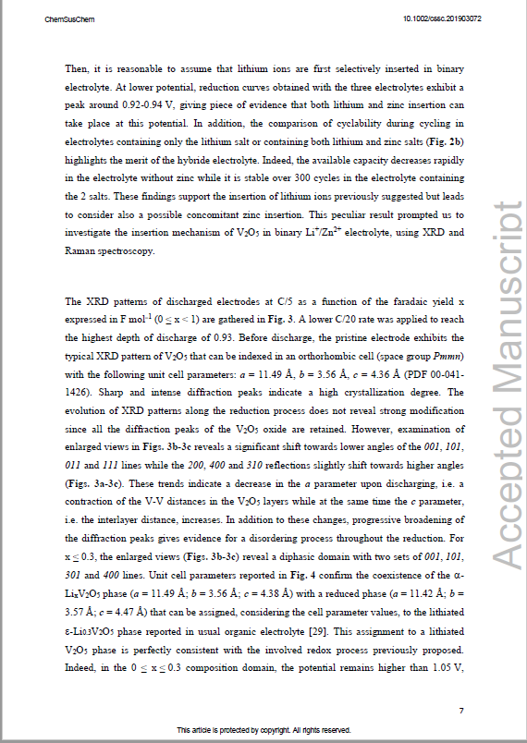

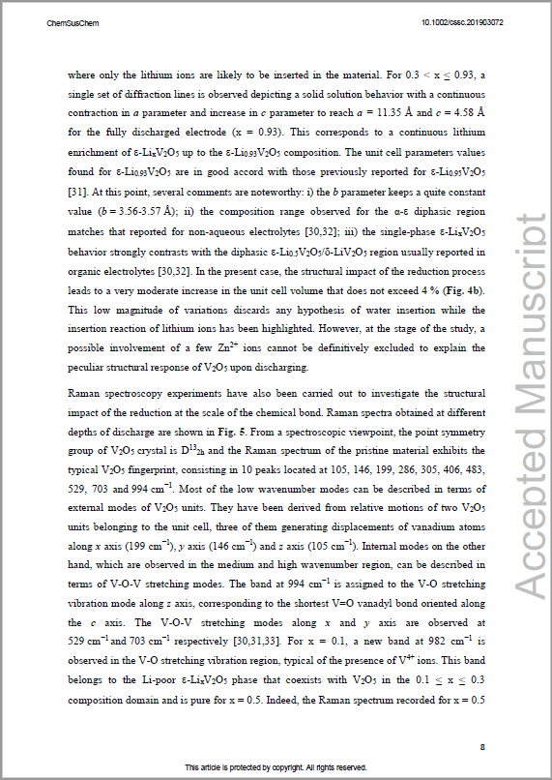

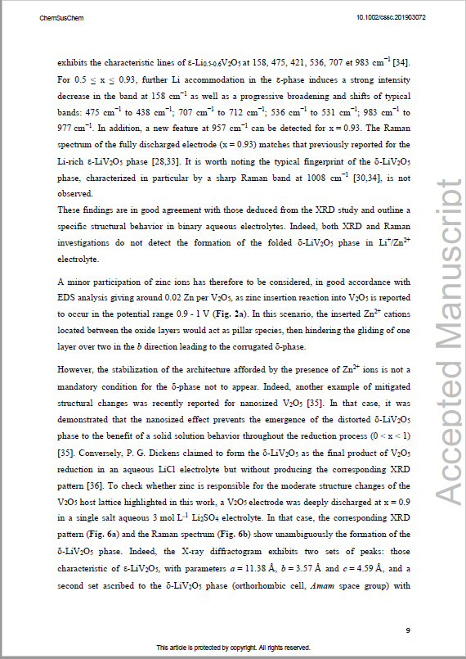

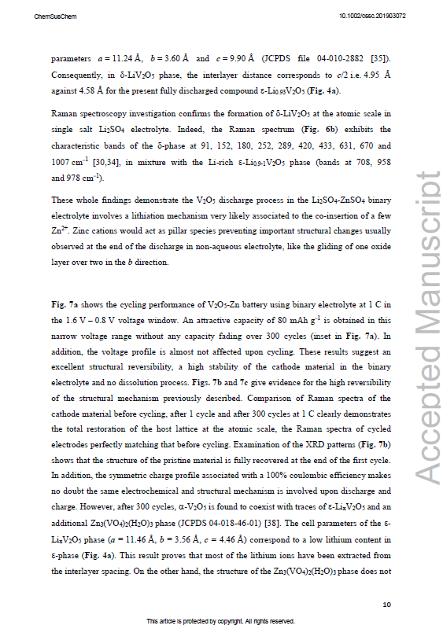

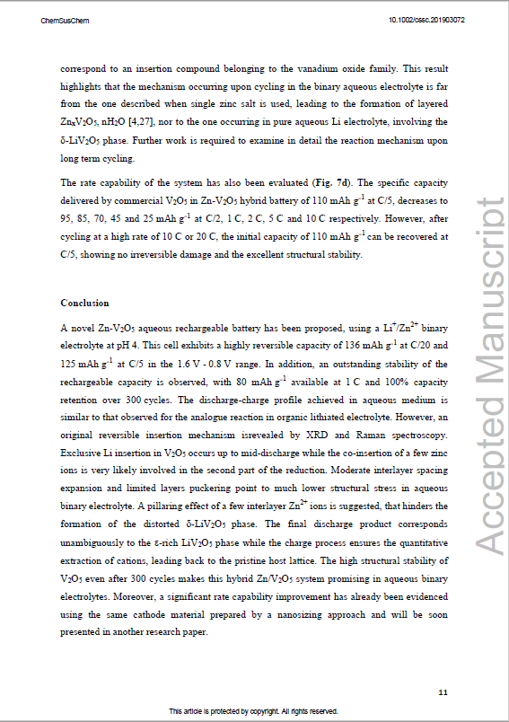



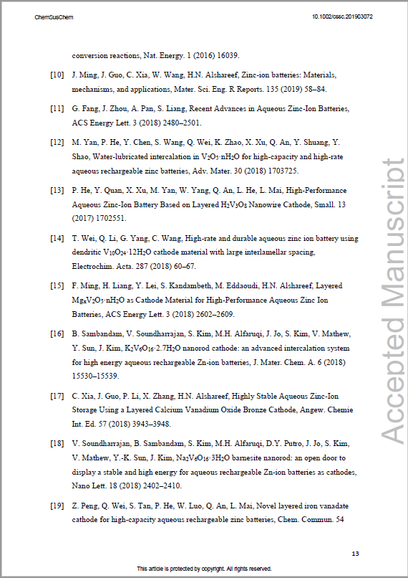

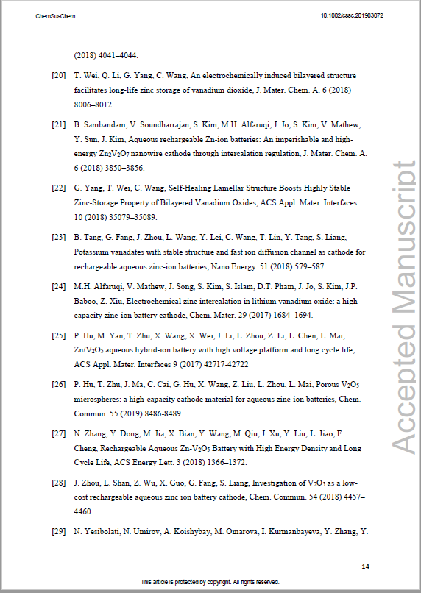

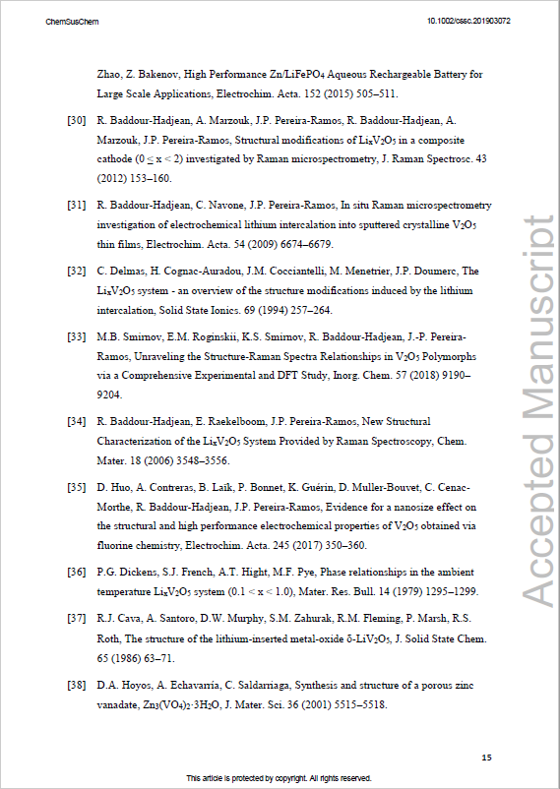



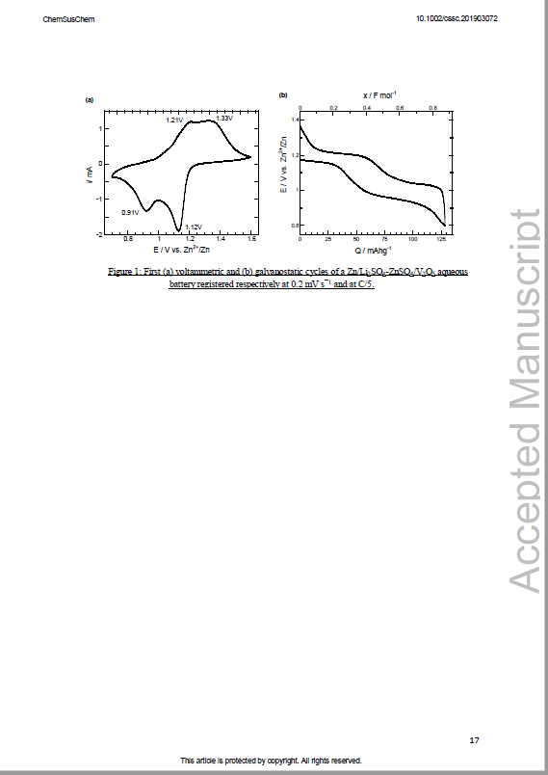

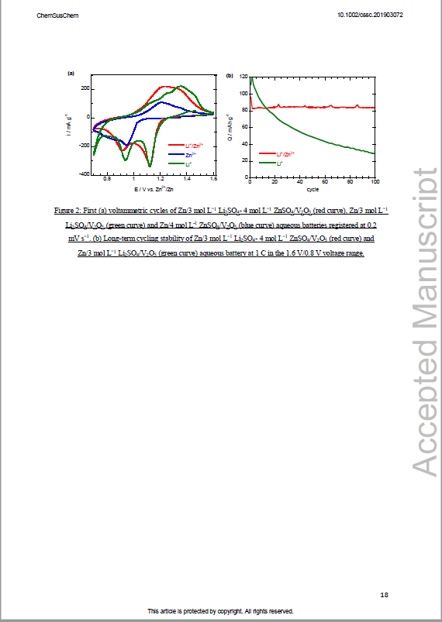

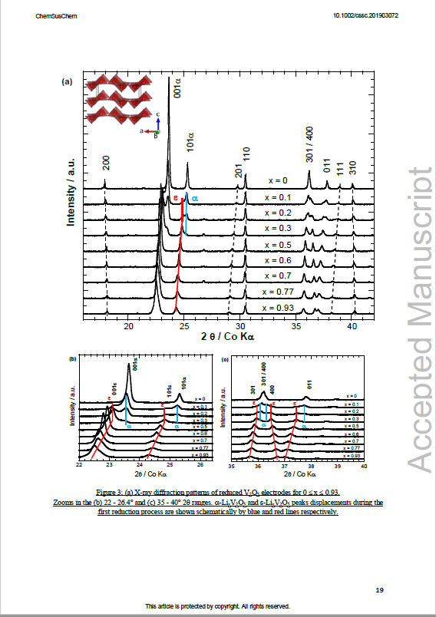

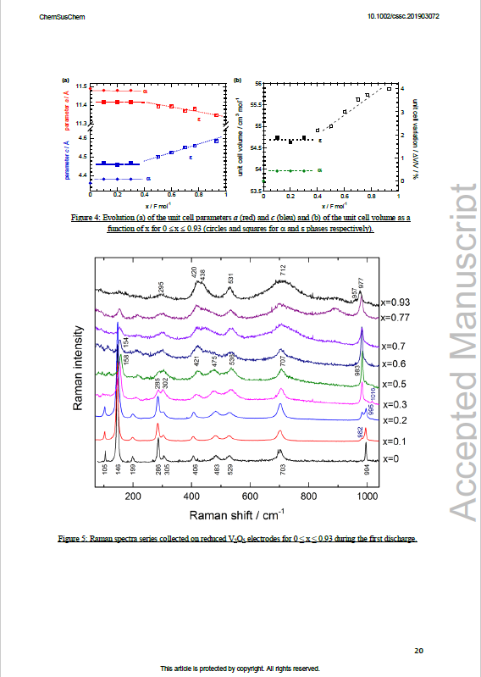

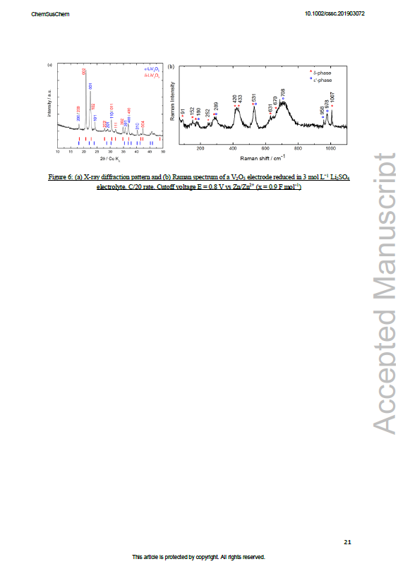

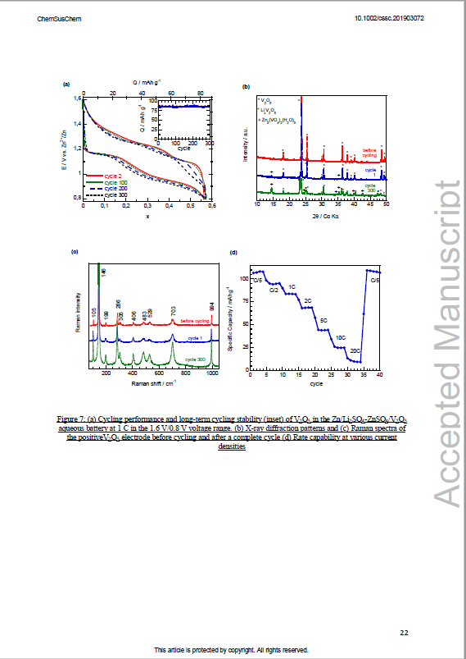

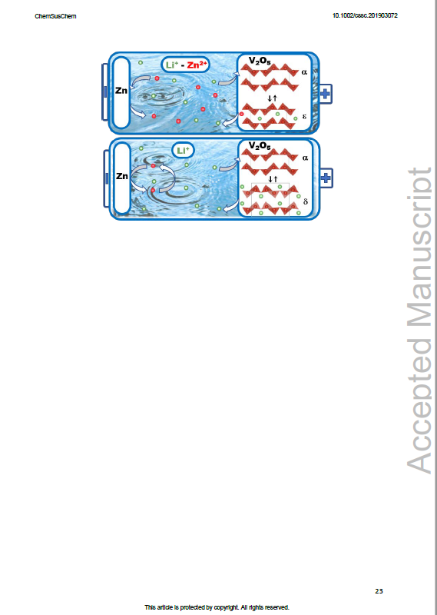



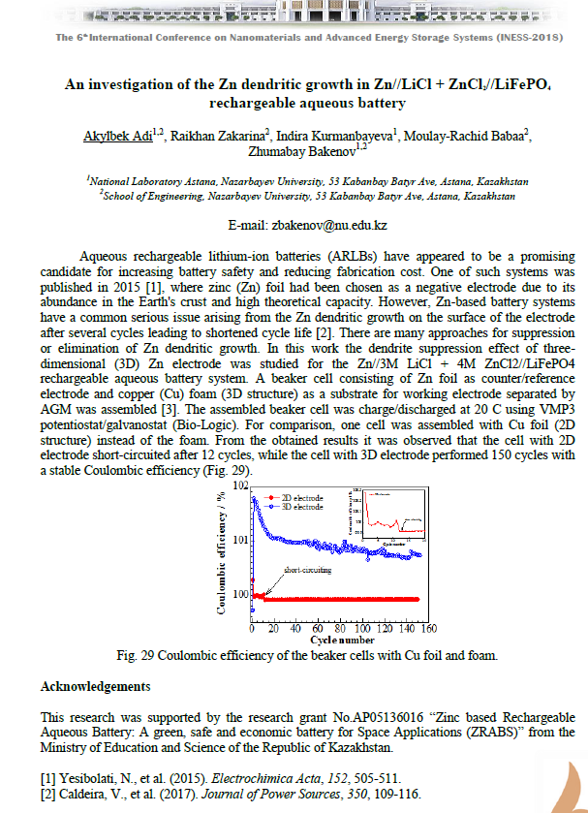

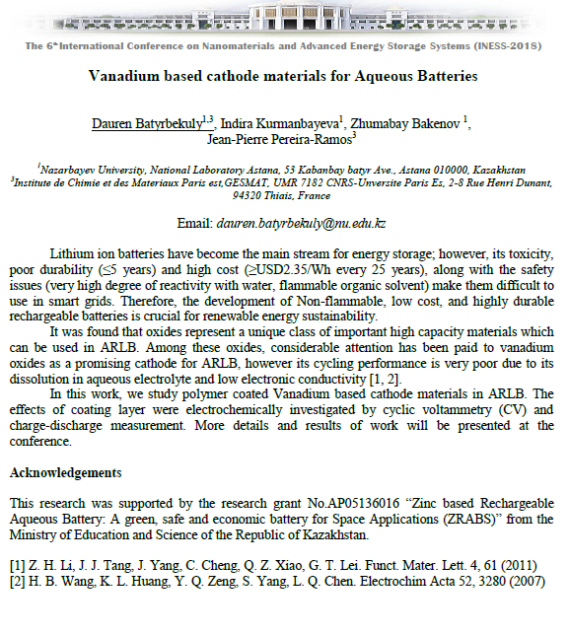

The 59th Battery Symposium Japan, November 27-29, 2018. Оsaka, Japan.
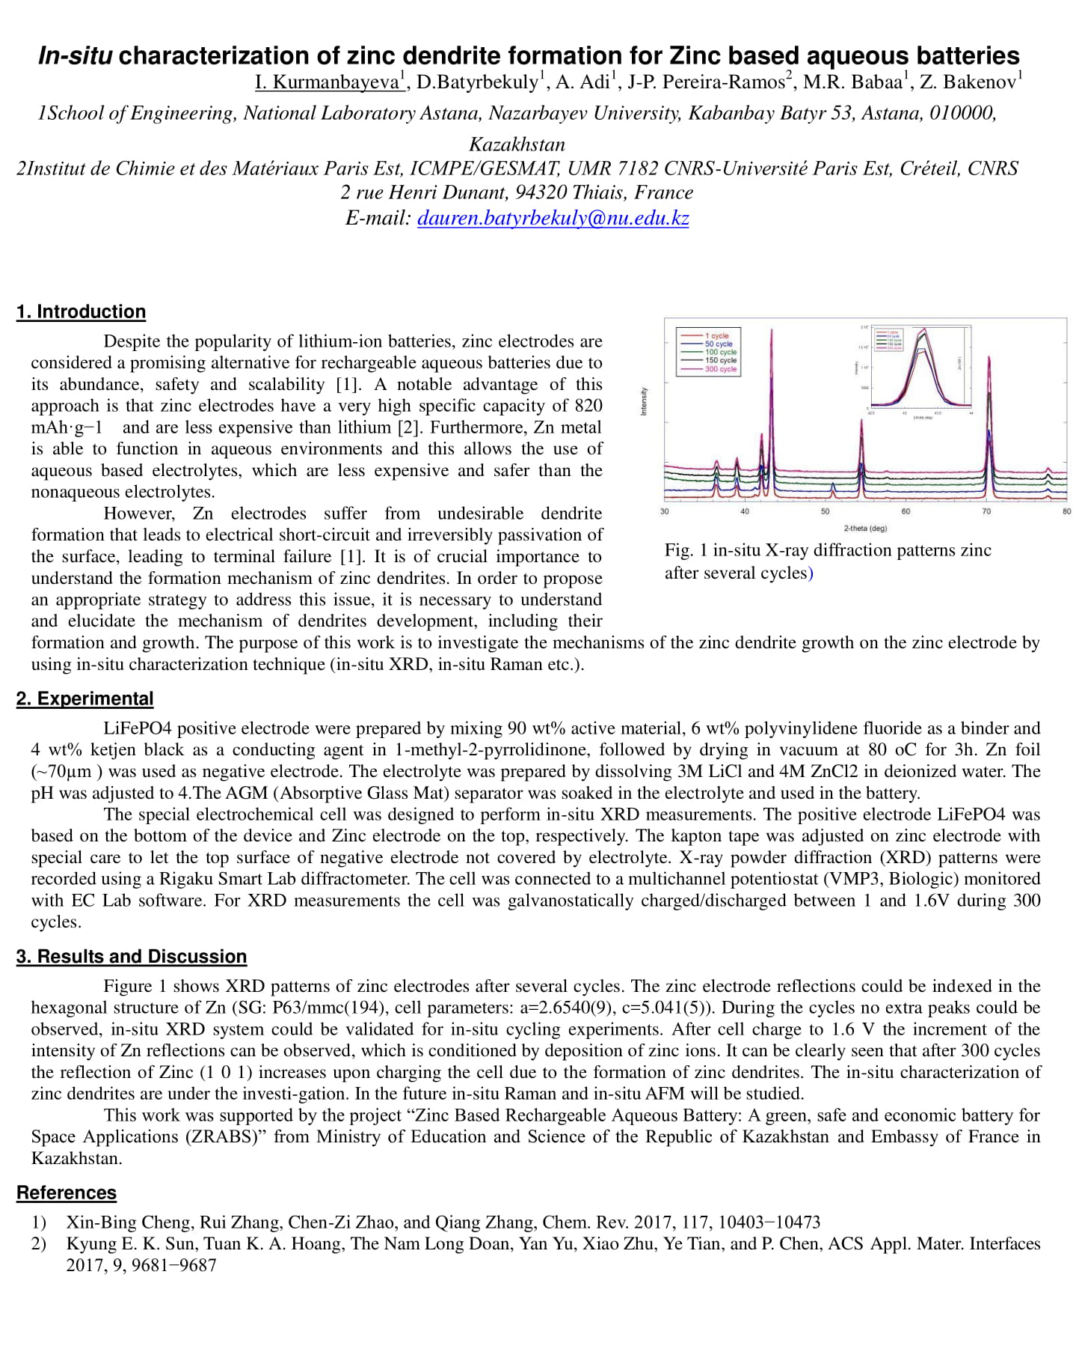

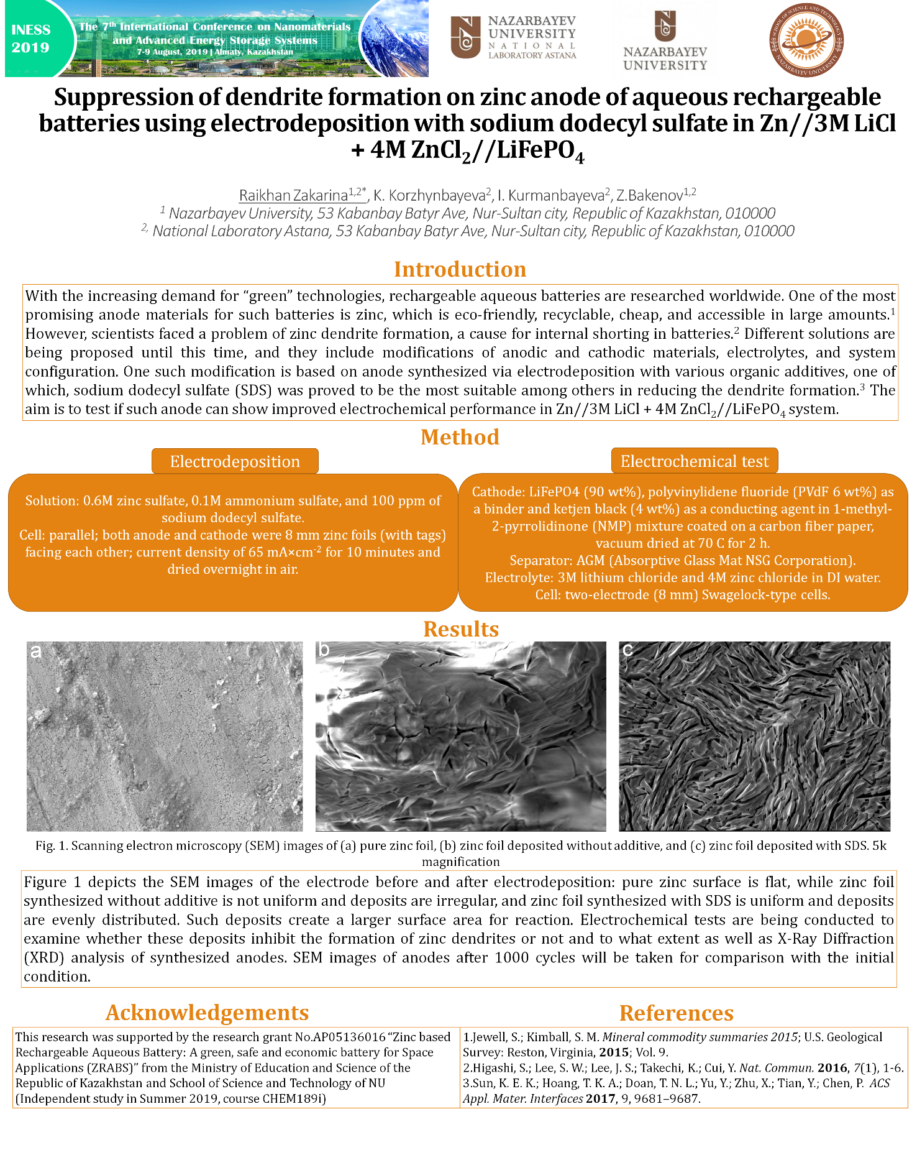

the European Materials Research Society (E-MRS)
