



REPORT

*The report contains* 66 pages, 15 figures, 7 tables, 18 reference sources, 5 appendices.

QUARRY, GEODETIC CONTROL NETWORK, REFERENCE FRAME, HIGH-PRECISION SATELLITE POSITIONING, DIFFERENTIAL CORRECTION BASE STATION (DCBS), ACCEPTANCE TESTS, DIFFERENTIAL CORRECTION CENTER (DCC), ACTIVE REPEATER SATELLITE

*The research object* - high-precision satellite positioning system.

*The work objective* is to create a high-precision positioning system of the Kachar field to determine geodetic coordinates using modern satellite navigation technologies in real time and post-processing.

*The research subject* - the technology of differential correction of Global Navigation Satellite System (GNSS) signals.

*The obtained results and originality.* The developed system has successfully passed all the tests planned for 2020 and has been put into commercial operation at the Kachar quarry (see Appendix B). A copyright certificate was obtained for the software developed in the framework of the study "Updating information management system" (see Appendix B). In July 2019, the award-winning prize for the best innovative report was received at the 19th International Scientific GeoConference SGEM 2019 (Moscow) on the project's topic. Albena, Bulgaria) (see Appendix D). The scientific originality of the research is determined by the fact that for the first time, a high-precision positioning system has been developed for the field of SSGPO JSC, which allows performing all types of measurement work of surveying, geomechanical and geodetic services in open-pit mining conditions. In particular, as part of the DCBS, a mobile module was developed to solve signal transmission problems to the bottom of the quarry and behind the dumps.

*Scope and Efficiency*. The project's significance on a national and international scale is to provide high-precision positioning of mining facilities allowing to solve two main tasks of open mining shortly: increasing labor productivity through the introduction of digital technologies and significantly improving labor safety. The experience of implementing a high-precision positioning system at SSGPO JSC will allow it to be used at other mining enterprises in Kazakhstan and other countries of the world.

|  |  |  |
| --- | --- | --- |
|  | INTRODUCTION……………………………………………………………….. | 8 |
| 1 | DEVELOPMENT OF DESIGN DOCUMENTATION FOR GEODETIC CONTROL NETWORK AND DESIGN OF STATION POINTS ON THE SSGPO JSC DEPOSIT, PROJECT DOCUMENTATION FOR A DIFFERENTIAL CORRECTION BASE STATION (DCBS) ……………………..……………………………………… | 10 |
| 1.1 | Development of the draft design for the geodetic control network and the design of the station point …………………………………….……………………………….. | 10 |
| 1.2 | Development of a project plan for the geodetic control network and the design of a station point ……………………….…………….……..………………………….…. | 13 |
| 1.3 | DCBS draft design development ….………….….………………………………. | 17 |
| 1.4 | DCBS project plan development …….……….……………………………….… | 21 |
| 2 | CREATION OF A GEODETIC CONTROL NETWORK FOR THE SSGPO JSC FIELD AND DCBS PRODUCTION …………………………………………………. | 23 |
| 2.1 | Development of documentation for the geodetic control network of the field….. | 23 |
| 2.2 | Development of working design documentation for the station point and DCBS ………………………………………………………………………………………….. | 25 |
| 2.3 | Development of scientific software (SSW) for processing satellite measurement data at the station point of the field ……………………………….…………………… | 29 |
| 2.4 | Production of station points and DCBS…….…………………………………….. | 31 |
| 3 | IMPLEMENTATION OF A HIGH-PRECISION POSITIONING SYSTEM INTO COMMERCIAL OPERATION ……….……………………………………. | 34 |
| 3.1 | Development of a center of differential correction ……….………………….. | 34 |
| 3.2 | Preliminary tests of the high-precision positioning system (HPPS)….………. | 34 |
| 3.3 | Trial operation of the HPPS …………………..……………………………….. | 35 |
| 3.4 | Conducting acceptance tests of HPPS for industrial operation of HPPS ……… | 37 |
|  | CONCLUSIONS…..……………………………………………………………. | 40 |
|  | LIST OF REFERENCE………………………….……………………………… | 41 |
|  | APPENDIX A - Copies of schedules………….................................................... | 43 |
|  | APPENDIX B – Protocols and acts of implementation ……..…..………………. | 46 |
|  | APPENDIX B1 - Protocol of preliminary tests of the center of differential correction......................................................................................................................... | 46 |
|  | APPENDIX B 2 – Act of preliminary tests of the high-precision positioning system.............................................................................................................................. | 50 |
|  | APPENDIX B 3 – Act of putting the high-precision positioning system into trial operation........................................................................................................................... | 56 |
|  | APPENDIX B 4 – Act acceptance test of the high-precision positioning system into industrial operation .................................................................................................. | 59 |
|  | APPENDIX C – Certificate No. 12049…..………………………………………. | 62 |
|  | APPENDIX D – Award for an innovative project …………………….………… | 63 |
|  | APPENDIX E - List of published works on research and development for  2018 - 2020………………………………………………………………………. | 64 |

DEFINITIONS, DESIGNATIONS AND ABBREVIATIONS

The following definitions, designations, and abbreviations are used in this research report:

ARP - Antenna Reference Point, a marker on the antenna body used as a reference point when determining the position of the antenna's phase center

GPS (NAVSTAR) - US Global Positioning System

IGS - International GNSS Service is a voluntary association of more than 200 agencies that collect data from GPS, GLONASS, and other satellite navigation systems from constantly operating base stations located around the world. IGS is designed to provide high-quality data of the GNSS (Global Navigation Satellite Systems) standard to support scientific research in the field of earth exploration, multidisciplinary applications, and ITRF-2014 education.

ITRF — International Terrestrial Reference Frame - implementation of the ITRS coordinate system using Cartesian coordinates of some reference points on Earth. The current implementation of ITRS is the ITRF-2014 decision, published by IERS on January 22, 2016.

RINEX - international hardware-independent format for presenting navigation data for transmitting and receiving "raw data" (Receiver Independent Exchange format)

WGS-84 or WGS-1984 - 1984 World Geodetic System based on the NAVSTAR satellite system (GPS).

SSGPO JSC - Sokolov-Sarbay Mining and Production Association Joint-Stock Company.

Base station - Permanent ground-based fixed-installed station for receiving GLONASS/GPS/BeiDou/Galileo satellite signals.

DCBS - Differential Correction Base Station - a complex of radio-electronic and technical means located at a station with known spatial coordinates, which are used for receiving and processing navigation signals, calculating differential corrections, and transmitting them as part of the correction information via communication channels to the GNSS user to improve the accuracy of determining its spatial coordinates when the GNSS user is located in the range.

GLONASS - Global Navigation Satellite System of the Russian Federation.

GNSS - Global Navigation Satellite System - a system consisting of a constellation of navigation satellites, a monitoring and control service, and navigation user equipment that allows determining the location (coordinates) of the antennas of user receivers on the surface of the Earth and in near-space. Examples of GNSS are GLONASS, GPS (NAVSTAR), BeiDou, and Galileo.

DC - differential correction - a correction defined as the difference between the measured pseudo-range value and the distance value between the navigation equipment of the differential station and the GNSS navigation spacecraft (NSC), calculated from the known values of the spatial coordinates of the differential station and the onboard ephemerides of the GNSS NSC

USDD - Unified System of Design Documentation

IS - initial station

D. A. Kunayev MI - D. A. Kunayev Mining Institute

ISET - Institute of Space Engineering and Technology

FN - framed network

UI - updating information - data containing time-bound differential corrections to the measured navigation signals and other messages used in the Navigation User Equipment (NUE) to improve the accuracy and reliability of navigation-time definitions

LGN - local geodetic network

LCS - local coordinate system

GCN - geodetic control network

IS - industry standard

SW - software

ROVER - mobile navigation user equipment of high accuracy geodesic class, which is used for high-precision positioning by using clarifying corrections from the HPSNS RK system or using corrections from other differential correction base stations.

WD - working documentation - design documentation, including maintenance and repair (DD), technical documentation (TD), software documentation (SD), and design and estimate documentation

RK - Republic of Kazakhstan

MM - mine management

HPSNS RK - high-precision satellite navigation system that provides high accuracy, quality, and integrity of navigation data throughout the territory of the Republic of Kazakhstan

SGN - satellite geodetic network

RMSE - root-mean-square error

RMSE-dRMS - root-mean-square measurement error (RMSE, RMS, dRMS, root-mean-square deviation) - error (deviation) of the measured value from the true value with a confidence level of 63.2%. When measuring the coordinates of an object, RMSE-dRMS means the radius of a circle whose center is aligned with the true coordinates of the object, in which 63.2% of the statistical measurement results are inscribed, but 36.8% of the measurement results are outside the dRMS circle

CS-42 - a geodesic geocentric coordinate system based on the Krasovsky ellipsoid. CS-42 by decree of the Council of Ministers No. 760 was put into effect in 1946 to perform geodetic works on the USSR's entire territory.

Raw data - navigation messages of the GNSS NSC received and recoded by the DCBS navigation equipment into its data format. Generally accepted hardware-independent navigation data formats, such as RINEX, are also used. In addition to the "raw data," the packet is transmitted to the differential correction center (DCC).

OSSS - Occupational Safety Standards System

Tribrach - a device for attaching a geodesic instrument to the base. The antenna's phase center is a fictitious point located inside or outside the antenna body, which is the center of an equivalent antenna that is a source of spherical waves. The position of the phase center of the antenna depends on the signal's angle of arrival and is determined by the calibration results.

PP - project plan (design stage as part of the design and development work)

DCC - differential correction center

SIPS - special information processing center

DD - draft design (design stage as part of the design and development work)

INTRODUCTION

Scientific and technological progress has created conditions for the rapid development and introduction of fundamentally and qualitatively new measuring and processing technologies in the surveying and geodetic production. These technologies lay the Foundation for the formation and practical application of geodetic measurement results, which are characterized by higher productivity, technological efficiency and, crucially, significantly greater accuracy than traditional technologies.

In order to maximize the automation of field and field surveying and geodetic works, as well as to improve the accuracy and efficiency of determining the coordinates of objects in post-processing and real-time modes, a permanent base station for differential correction (DCBS) has been installed at the Kacharsky field).

The main task assigned to the continuously operating station is to collect code and phase data from GPS/GLONASS satellites and distribute this data to users (services of SSGPO JSC and specialists of contractors performing surveying and geodetic works at the field).

Work on the development and implementation of a high-precision satellite positioning system at the SSGPO JSC field was carried out following the work schedule (see Appendix A) within research No. AR05136083 "Development of a software and hardware complex for a high-precision satellite positioning system for the SSGPO JSC field.

For the 2018-2019 research work, the following interim reports were prepared (State registration number: 0118RK01228) by stages:

* Development of design documentation for the geodetic control network and design of the station point at the SSGPO JSC field, design documentation for the differential correction base station (DCBS), in particular:

- development of a draft design for the geodetic control network and the design of a station point;

- development of a technical project for a geodetic control network and the station point construction;

- draft design development of the DCBS;

- project plan development of the DCBS.

* Develop documentation for geodetic control network of Kachar field, working design documentation on the station point and DCBS, in particular:

- development of documentation for the geodetic control network of the field;

- development of working design documentation for the station point and DCBS;

- development of scientific software (SSW) for processing satellite measurement data at the station point of the field;

- production of station points and DCBS.

In 2020, work was completed to put the high-precision satellite positioning system into commercial operation, in particular:

- creation of a differential correction center;

- preliminary tests of the high-precision positioning system (HPPS);

- pilot operation of the HPPS;

- conducting acceptance tests of HPPS for the industrial operation of HPPS.

This report is a summary and contains a summary of the results for all three years of the study.

More detailed results obtained at the previous stages of research are given in the interim research reports on the topic AR05136083 " Development of the software and hardware complex of the high-precision satellite positioning system for the field of JSC SSGPO "(№ GR0118RK01228) for 2018. (Inv. No. 0218RK00979) and 2019 (Inv. No. 0219РК00979).

**1 DEVELOPMENT OF DESIGN DOCUMENTATION FOR GEODETIC CONTROL NETWORK AND DESIGN OF STATION POINTS ON THE SSGPO JSC DEPOSIT, PROJECT DOCUMENTATION FOR A DIFFERENTIAL CORRECTION BASE STATION (DCBS)**

**1.1 Development of the draft design for the geodetic control network and the design of the station point**

*Justification of the draft project for the GCN reconstruction*. The high-precision geodetic control network of the Kachar quarry is designed to provide practical tasks [1]:

* field survey and updates of quarry plans of all scales;
* land management, land surveying, land inventory;
* field and geodetic surveys on the territory of the quarry;
* engineering and geodetic preparation of construction objects;
* geodesic study of local geodynamic natural and human-made phenomena on the territory of the quarry [2];

- navigation and monitoring of ground and partially air mobile technical facilities.

The purpose of GCN creation and reconstruction is to improve the network accuracy, the reliability of determining the conversion parameters between the geocentric earth-wide coordinate system, international and local geodetic coordinate systems, and the ability to create a catalog of station coordinates in all the coordinate systems used in the quarry [3], [4].

The main feature of the work on the creation and reconstruction of the geodetic control network is the need to preserve the local coordinate system, in which large-scale surveys of the quarry area were previously performed (1:500-1:2000), and at the same time to ensure high uniform accuracy of the geodetic control network for solving other tasks [3] – [5].

Quarry form in the plan is close to a circle; its approximate size at the end of testing is as follows: surface length (in the latitudinal direction) - 3,000 meters; surface width (in the meridional direction) - 2,900 meters; bottom length - 430 meters, bottom width - 175 meters; quarry depth - 723 meters; elevation of the quarry bottom — 530 meters; the surface area of the quarry 7,372,000 m2.

The technology of work execution.From economic expediency, it was decided to create a GCN of 8 stations, 7 of which are fully combined with 7 preserved stations of the local geodetic network of the Kachar quarry, and 1 station is on the administrative building of the Kachar mine management (MM). Thus, the GSN must consist of 1 IS, 3 FN stations, and 8 SGN stations. Following paragraph 31 of WD 07-603-03 [3], this number of GSN stations is sufficient to create and maintain a high-precision geodetic base on the territory of the Kachar quarry with an area of approximately 8 square kilometers. In this case, the GSN stations should be located as follows:

* 1 initial station ("Baza") is on the mine management building, where the permanent DCBS installed at the Kachar quarry is located. This arrangement will ensure the IS and DCBS safety from theft and vandalism and reduce the cost of installing and maintaining the DCBS in working condition. The IS coordinates are specified by linking to the international IGS network.
* 3 stations of the framed network are combined with two stations of the existing LGN ("1010" and "Kuzduktomar") and the initial station ("Baza"). This choice of stations in the framed network is due to the fact that these stations must be located as far as possible from each other, and the framed network must consist of equilateral triangles as much as possible. The network method of network equalization based on satellite navigation measurements is used to determine the station and FN lines coordinates.
* All 8 GSN stations ("1010", "Baza," "Sorkul," "Yasny," "Nurkopa," "Druzhny," "0604" and "Kuzduktomar") meet the requirements for stations of the satellite geodetic network, including an open view of the radio navigation sky. The ray method of network equalization based on satellite navigation measurements is used for economic feasibility to determine SGN points' coordinates.

The location of the GSN points is shown in Figure 1.1. The initial station is indicated by a triangle (Δ), the stations of the framed network are indicated by a square, and the SGN stations are indicated by a circle.

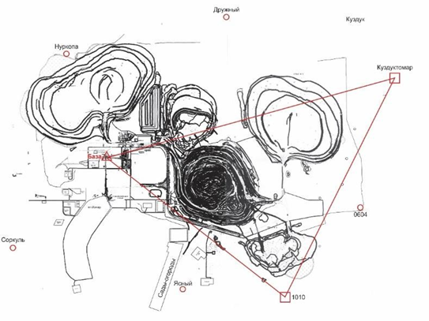

Figure 1.1 - GSN stations location

The process flow scheme for processing GSN is shown in Figure 1.2.

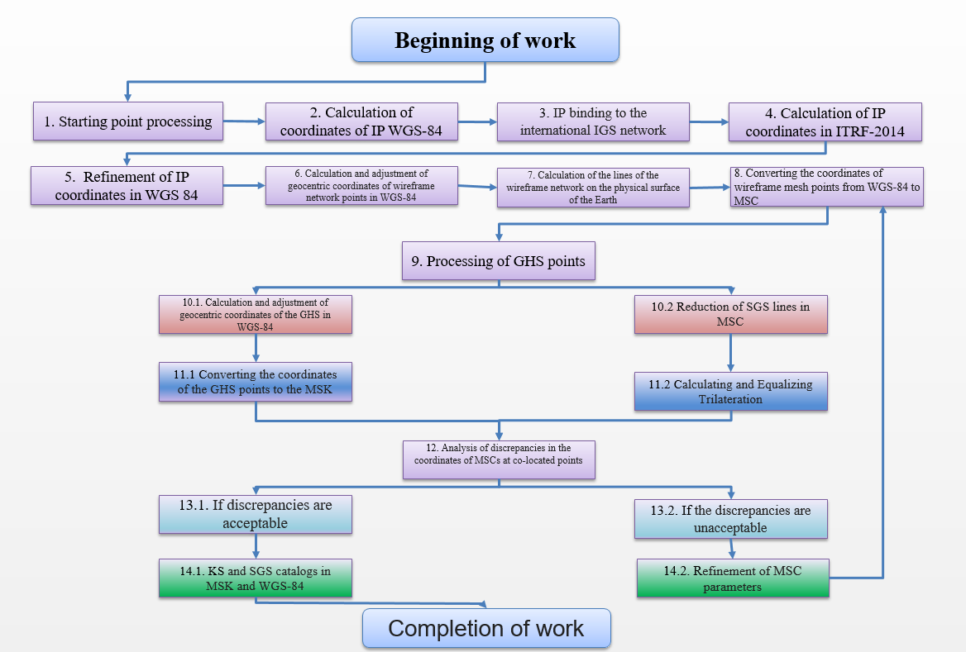

Figure 1.2 - Process flow scheme for GSN processing

*Description and justification of the selected design of the station point.* The expediency of fixing the design of the initial station on the building of the Kachar mine management is consistent with the recommendations set out in the regulatory documents [6].

Kachar mine management is a reinforced concrete building built at least 7 years before the center of the initial station was laid. The building has no cracks in the walls and visible violations of the foundation. This mine management is also located far enough away from the railway and places of blasting operations at the quarry.

It was decided to fix the structure to the load-bearing wall in the front part of the building, as shown in Figure 1.3. This choice of location is due to the following reasons [7]:

* GNSS antenna is fixed on a small elevation near the roof, which allows easy access to the antenna and structure directly from the roof surface for maintenance and repair work;
* the structure is located between the second and third windows, while the Kachar quarry survey service occupies the first, second, and third windows on the third floor of the structure, which minimizes the length of the cable drawn from the antenna to the DCBS GNSS receiver. Minimizing the length of the antenna cable is important for amplifying the navigation satellite signal at the input of the GNSS receiver to minimize the pseudo-range measurement error that occurs due to noise in the radio path of the GNSS base station;
* the antenna that receives GNSS signals is placed at the roof of the building with the condition that there are no obstacles to receiving signals (trees, buildings, etc.) above the angle of 10□ above the antenna horizon.

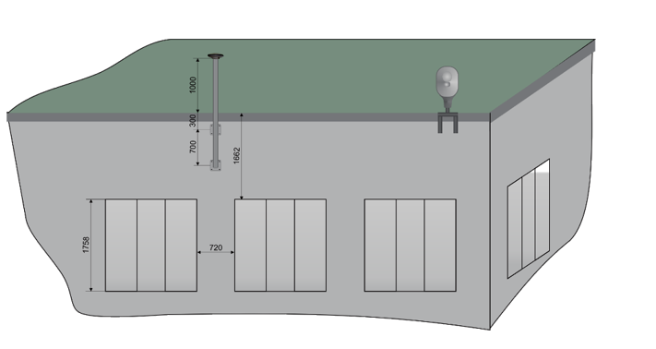

Figure 1.3 - Illustration of the mounting place of the station point on the front part of the building of Kachar MM

A station point's design consists of two main elements, an antenna mast (bracket) and a positioner for the antenna. The mast is a rigid F-shaped structure made of grade 3 steel. Depending on the conditions determined during the installation site survey, the question of the type of antenna mast and its attachment options for ensuring immobility is decided. A tribrach-positioner is installed on the upper part of the mast by a rigid threaded connection. This tribrach is used to properly orient the antenna to the North and in the horizontal plane. Design drawings of the station point and its elements are presented in Appendix B.

**1.2 Development of a project plan for the geodetic control network and the design of a station point**

Due to significantly outdated data on LGN, it became necessary to perform control measurements to determine the precise accuracy of the existing geodetic network at the Kachar quarry. Control measurements are performed between the initial stations of the previously created LGN and the initial and node stations of polygonometry.

Modern high-precision satellite navigation receivers are used to perform control measurements at LGN stations. A description of the relevant fieldwork, a description of satellite observations' processing, and the results of control measurements are provided below.

Control measurements were conducted at 7 LGN stations, described in the previous section, namely "Yasny" and "Sorkul," "Nurkopa," "Druzhny,”

"Kuzduktomar," "0604", "1010", the coordinates of the reference point on the roof of the Kachar mine management (MM) were also measured. The measurements were carried out using 5 GNSS receivers of geodetic accuracy class, four devices of which served as rovers (mobile stations) and plied between 7 LGN stations located in the field on the territory of the Kachar quarry mining claim, and one satellite navigation receiver served as a base station and continuously measured the coordinates of the reference point during the entire observation cycle. The rovers conducted static observations at each point for 2 hours with a "raw data" output frequency of 1 Hz, with the first hour of observations at one height of the GNSS antenna and the second hour of observations at a different height. Thus, the control measurements were carried out as follows:

* the first Trimble R10 receiver performed long-term measurements at a reference point on the roof of the Kachar MM as a base station;
* at stations "1010" and "Druzhny" measurements were made by the second Trimble R10 receiver as a rover;
* at stations "Yasny" and "Kuzduktomar" measurements were carried out by Novatel FLEX6-T5S-BOG-TTN dual-frequency GPS receiver as a rover;
* at stations "0604", "Nurkopa" and "Sorkol" observations were made using dual-frequency dual-system GNSS receivers, Spectra Precision Epoch 35 as mobile stations.

The "raw data" obtained from control measurements from the GNSS receivers used in the observations were converted to RINEX files for further joint processing in Trimble Business Center SW version 3.4 (see Figure 1.4).

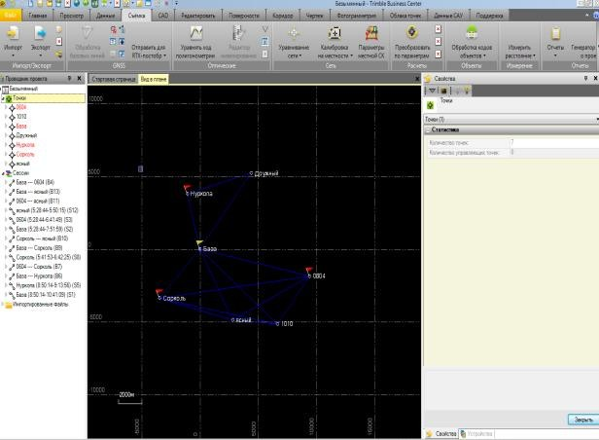

Figure 1.4 - Importing stations and setting the problem of equalizing the geodetic network in Trimble Business Centre SW

At the first stage of processing, based on coordinates' measurements at the 8 stations above, the geodetic network was equalized using a combined method (ray and network methods). During the first stage of processing, it was found that satellite measurements obtained at the "Kuzduktomar" stations significantly degrade the accuracy of network equalization, namely, the RMSE of equalization becomes higher than 1 m, so it was decided not to use the "raw data" obtained at this station in further calculations. The results of network equalization based on observations at 7 stations (without the "Kuzduktomar") are shown in Figure 1.5 and Tables 1.1 and 1.2

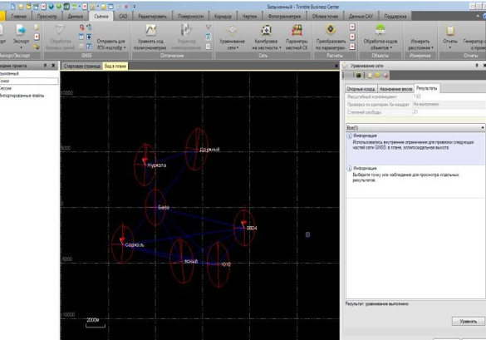

Figure 1.5 - Results of network equalization in Trimble Business Center SW

Table 1.1 - PRECISION OF THE EQUALIZATION NETWORK IN THE CS WGS-1984

|  |  |  |  |  |  |  |  |
| --- | --- | --- | --- | --- | --- | --- | --- |
| Network station | X-axis (meter) | X-axis error (meter) | Y-axis (meter) | Y-axis error (meter) | Z-axis  (meter) | Z-axis error (meter) | 3D  error (meter) |
| 0604 | 1730604.824 | 0.004 | 3398635.141 | 0.007 | 5095306.489 | 0.011 | 0.014 |
| 1010 | 1734263.939 | 0.004 | 3399736.439 | 0.006 | 5093343.056 | 0.010 | 0.012 |
| Sorkol | 1742639.187 | 0.005 | 3393853.070 | 0.008 | 5094419.312 | 0.013 | 0.016 |
| Reference point (Base) | 1738311.304 | 0.003 | 3393019.227 | 0.006 | 5096444.492 | 0.009 | 0.011 |
| Druzhny | 1732480.157 | 0.007 | 3391281.316 | 0.009 | 5099542.339 | 0.014 | 0.018 |
| Nurkopa | 1737883.559 | 0.006 | 3389805.332 | 0.009 | 5098694.758 | 0.014 | 0.017 |
| Yasny | 1737593.876 | 0.005 | 3397778.809 | 0.009 | 5093519.504 | 0.015 | 0.018 |
| Average  value |  | 0.005 |  | 0.008 |  | 0.012 | 0.015 |

Table 1.2 - EQUALIZATION RESULTS IN THE GEODETIC COORDINATE SYSTEM

|  |  |  |  |  |
| --- | --- | --- | --- | --- |
| Station name | Latitude | Longitude | Height (meter) | Height error (meter) |
| 0604 | 53°22'09.29106" | 63°00'52.34528" | 172.262 | 0.013 |
| 1010 | 53°20'22.79755" | 62°58'23.12729" | 174.283 | 0.011 |
| Sorkol | 53°21'20.47095" | 62°49'15.22521" | 189.088 | 0.015 |
| Reference  point (Base) | 53°23'10.08400" | 62°52'22.91862" | 193.241 | 0.011 |
| Druzhny | 53°25'58.96972" | 62°56'21.09130" | 175.192 | 0.017 |
| Nurkopa | 53°25'12.81931" | 62°51'24.18363" | 178.393 | 0.016 |
| Yasny | 53°20'32.14065" | 62°54'54.72473" | 179.259 | 0.016 |
| *Average error in altitude (meter)* | | | | 0.014 |

Thus, we have obtained the following accuracy of the network adjustment at control measurements:

* RMSE-dRMS in space is equal to 15 mm;
* RMSE-dRMS in height is equal to 14 mm;
* RMSE-dRMS in the plan is equal to 5 mm.

Since the Trimble Business Center SW does not allow calculating transition keys, the Leica Geo Office version 5.0 SW was used to get the transformation parameters from WGS-1984 to Kachar quarry LCS at the second stage of measurement processing. In this SW, two projects were created, the first project imported the coordinates of 6 stations ("Yasny," "Sorkul," "Nurkopa," "Druzhny," "0604", "1010"), updated in the WGS-84 CS at the stage of network equalization, and in the second project imported coordinates in LCS of the same points from Table 1.1. The Leica Geo Office SW tool allows transforming coordinates by selecting these two projects and linking the corresponding network points, automatically calculating the transition parameters from one CS to another.

At the second stage of measurement processing, it was decided not to use the coordinates of the stations "Druzhny" and "0604" for calculating transition keys since the inclusion of these network points leads to a significant deterioration in the accuracy of transformation, namely, the RMSE of determining transformation parameters falls by more than 10 meters. The specified transformation uses Helmert transformation, which is used to calculate the transition keys:

dE = 4071.2103 meters; dN = 5543.0144 meters.

The calibration results for the calculated transition keys from WGS-1984 to Kachar quarry LCS are shown in Table 1.3.

Table 1.3 - ACCURACY OF CALCULATING TRANSITION KEYS

|  |  |  |  |  |  |
| --- | --- | --- | --- | --- | --- |
| Item name | East (meter) | North (meter) | Height (meter) | Plan discrepancy (meter) | Spatial discrepancy (meter) |
| Nurkopa | 0.6916 | 0.0261 | -0.2252 | 0.6921 | 0.7278 |
| Yasny | 0.0084 | 0.0062 | -0.6958 | 0.0104 | 0.6959 |
| 1010 | -0.1878 | 0.3544 | 0.3807 | 0.4010 | 0.5530 |
| Sorkol | -0.5122 | -0.3867 | 0.5403 | 0.6418 | 0.8389 |
| *mat. expectation of*  *discrepancies* | 0.3500 | 0.1934 | 0.4605 | 0.4368 | 0.7039 |

**1.3 DCBS draft design development**

*Description and justification of decisions on the organization of DCBS.* The DCBS modules location is shown in Figure 1.6.

The need to organize the DCBS in the form of two remote modules, navigation and transmitting, located respectively in the buildings of the Kachar MM and the Control Room, arises for 4 reasons [8]:

* constant blasting operations at the Kachar quarry make it undesirable to place the DCBS navigation module near the sides of the quarry since, due to strong soil fluctuations, this does not guarantee the relative constancy of the coordinates of the phase center of the GNSS antenna fixed at the GCN station point;

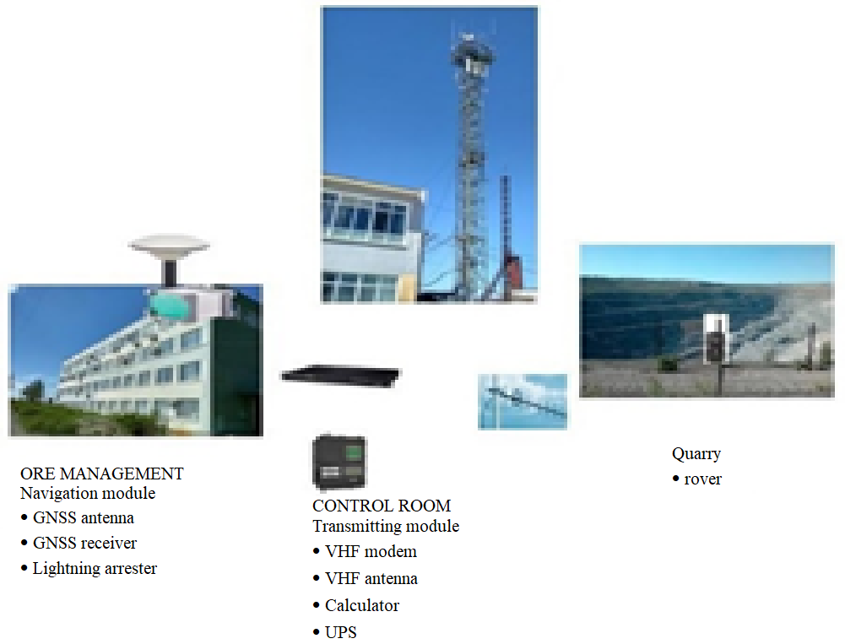

Figure 1.6 - Location of DCBS modules

* to enable high-precision satellite navigation measurements in RTK mode on the sides and bottom of a quarry, the transmission of differential corrections via radio signals emitted by GSM antennas and VHF, as close from the quarry is required; for this task, antenna mast of the Control Room is best suited to accommodate directional VHF antenna, and hence the building of the Control Room is the optimal location for the remaining parts of the DCBS transmitter module;
* the building of Kachar MM meets the requirements of structures where it is allowed to place SGN stations and permanent differential correction base stations;
* placement of the GNSS receiver of the DCBS navigation module in the premises of the survey service located on the third floor of the Kachar MM is economically feasible since this will reduce the cost of administration, maintenance, and protection of equipment from theft and vandalism; in the same premises, in the future, it is planned to place the differential correction center (DCC), which is also created as part of the project No. AR05136083 "Development of a software and hardware complex of a high-precision satellite positioning system for the SSGPO JSC field.

*Description and justification of information and software-mathematical solutions of the DCBS.* Within the framework of the DCBS, the formation, transmission, and transformation of digital data and basic information is organized in stages as follows [9]:

1. the GNSS antenna receives and amplifies radio signals transmitted on frequency bands from GPS, GLONASS, and BeiDou ground-based spacecraft (GBS);
2. the GNSS receiver receives signals from the antenna and demodulates GPS L1/L2 signals, GLONASS L1/L2, BDS B1/B2/B3, decodes useful information from these signals, makes estimated measurements of distances to visible GPS, GLONASS, and BeiDou NSCs, solves the main navigation problem of determining the coordinates of the GNSS antenna phase center, then stores this data in memory, and generates differential corrections in the form of RTCM and CMR messages;
3. a computer with an SSW for processing navigation measurements receives a stream of updating information (UI) by the LAN of Kachar quarry from the GNSS receiver; then the UI stream is decoded, and based on the decoded data is formed by two parallel streams; the first stream in the RTCM and CMR messages through the serial port is sent to a VHF modem; the second stream in the form of NRTIP messages generated based on the RTCM messages via a local Ethernet network of Kachar quarry is transmitted to the Internet;
4. the VHF radio modem receives RTCM and CMR messages from the computer, modulates them to a given radio frequency, and directs the UI to a directional antenna, which in turn transmits differential corrections via a VHF radio line;
5. NTRIP messages from the Internet are sent to the base station of the mobile

operator "Activ" JSC " Kcell," and are transmitted via the appropriate antenna, which is fixed to the antenna mast near the Control Room building, via the GSM radio line;

1. a rover located onboard or at the bottom of a quarry receives UI via a VHF radio channel and/or GSM radio channel, and based on the obtained differential corrections and own satellite navigation measurements, performs high-precision calculation of its coordinates in RTK mode.

The described method of organizing data transfer to the DCBS is shown in Figure 1.7.

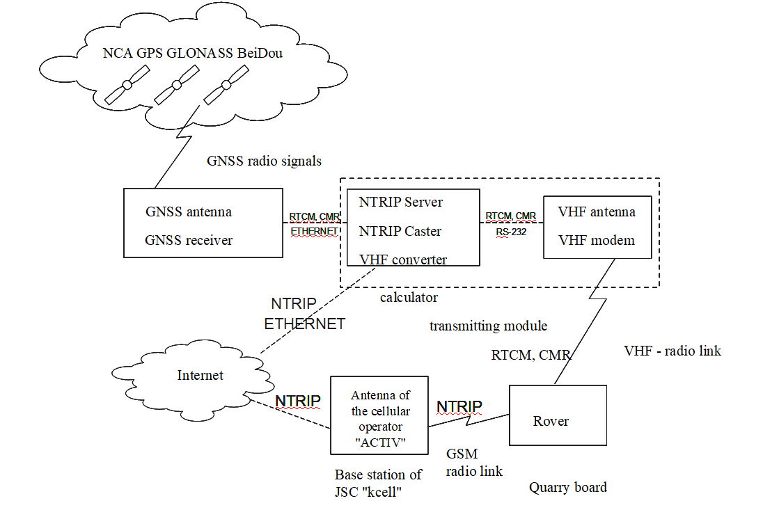

Figure 1.7 - Data transfer organization to the DCBS

The presented method of organizing data transmission is the most economically feasible since it meets all the functional requirements for the DCBS while making maximum use of the infrastructure available on the Kachar quarry territory.

SSW for processing satellite measurement data is structurally divided into three subsystems:

* subsystem for interaction with external ports;
* user interface subsystem;
* storage subsystem.

The general structure of the SSW is shown in Figure 1.8.

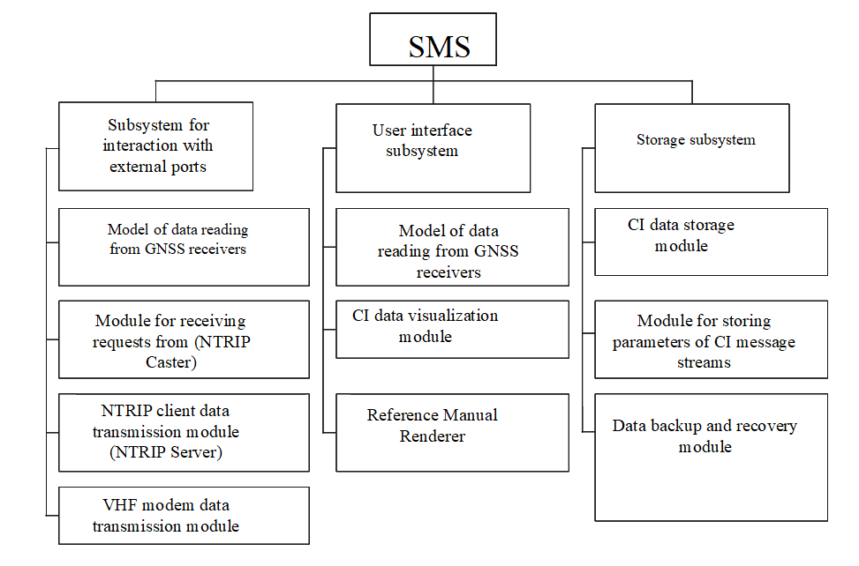

Figure 1.8 - SSW structure for processing satellite measurement data

**1.4 DCBS project plan development**

For the project plan, the solutions for the design of the differential correction base station remained the same as in the preliminary design presented in Section 1.3. The rationale for including the mobile module in the DCBS has been added to the project plan section.

An active repeater satellite is a receiving and transmitting radio engineering device located at intermediate points of radio communication lines, the function of which is to amplify the received signals and their further transmission [10]. In general, the equipment of the DCBS mobile complex is shown in Figure 1.9.

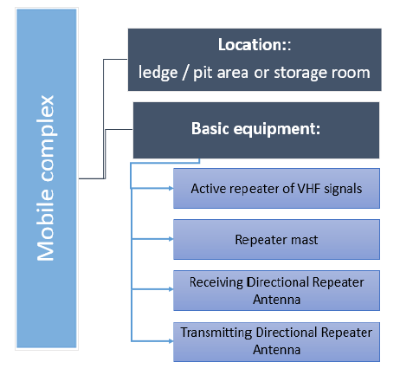

Figure 1.9 - Equipment of the DCBS mobile complex [11]

*The orientation of antennas under various operating conditions in an open pit.* If the working area is located on the quarry's surface behind the dumps, it is necessary to orient the receiving antenna of the repeater (upper) in the control tower's direction using the tilt group. The secondary radio coverage area (on the F2 frequency) will be provided in the transmitting (lower) directional antenna sector. The width of the secondary sector will be approximately 35o. The length of the secondary radio coverage area can be from 3 to 5 km, depending on the repeater antennas' height above ground level.

If the repeater is significantly removed from the control tower, the repeater should be positioned at a height (see Figure 1.10).

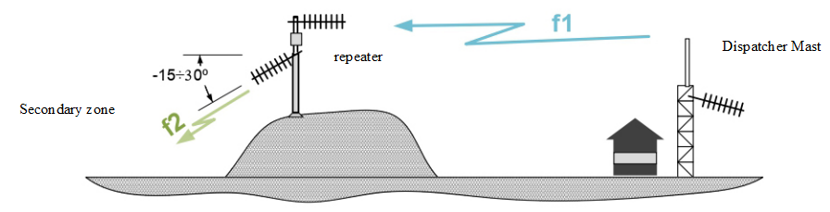

Figure 1.10 - Orientation of antennas when installed on dumps [11]

When placing the repeater in the quarry, fix the antennas in the tilt groups 3 and 4 using the locking screws to the + 30o and - 30o positions, respectively. The secondary radio coverage area (on the F2 frequency) will be located at the bottom of the quarry (see Figure 1.11).

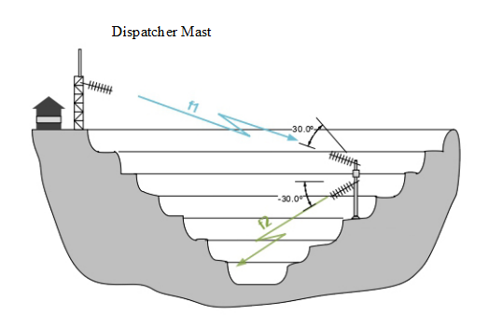

Figure 1.11 - Antenna orientation during installation in a quarry [11]

**2 CREATION OF A GEODETIC CONTROL NETWORK FOR THE SSGPO JSC FIELD AND DCBS PRODUCTION**

**2.1 Development of documentation for the geodetic control network of the field**

A method and program for GSN verification have been developed that allows redefining the coordinates of the centers of the corresponding stations in LCS, CS-42, and WGS-84 once a year by conducting satellite navigation measurements and processing the results of these measurements in computer programs [12], [13]. In particular, instructions for entering new coordinates for the navigation antenna of the DCBS, the accuracy of equalizing the geodetic network, and calculating the transition keys from WGS-84 to LCS and from WGS-84 to CS-42.

*Verification operations.* During verification, perform the operations specified in Table 1.4.

Table 1.4 - OPERATIONS FOR CHECKING THE GEODETIC CONTROL NETWORK

|  |  |  |  |  |
| --- | --- | --- | --- | --- |
| Operation name | Item number of the verification method | Conducting operations | | |
| at initial verification | | at periodic  verification |
| when released from production | after repair |
| External inspection of the GSN station | 6.1 | Yes | Yes | Yes |
| Testing the station for stability relative to the ground surface | 6.2 | Yes | Yes | Yes |
| Conducting field satellite observations at the station.  Conducting field observations of satellite navigation parameters in static mode at each station for 2 hours with a frequency of "raw data" output of 1 Hz, while the first hour of observations is carried out at one height of the GNSS antenna, and the second hour of observations at a different height | 7 | Yes | Yes | Yes |
| Determination of metrological ­characteristics:  Determination of the GSN station coordinates in the WGS-84, CS-42, and LCS systems (local coordinate system) of the Kachar quarry.  - Determination of the relative accuracy (root-mean-square deviation (RMSE) relative to the mathematical expectation) of calculating the coordinates of the GSN station in the WGS-84 system | 8 | Yes | Yes | Yes |

*Verification means.* The following measuring instruments and auxiliary equipment specified in Table 1.5 are used for verification.

Table 1.5 - VERIFICATION TOOLS

|  |  |
| --- | --- |
| Item number of the verification method | Name and type of the main or auxiliary verification tool |
| 6 | Trimble R10 GNSS geodetic receiver and its components as a stationary rover |
| 6 | Trimble R10 GNSS geodetic receiver and its components as a stationary rover |
| 6 | GNSS OC-103 geodetic receiver as a permanent differential correction base station (DCBS), located at the "Baza" station |
| 6 | GNSS geodesic receiver Spectra Precision Epoch 35 and its components as a stationary rover |
| 6 | GNSS geodesic receiver Spectra Precision Epoch 35 and its components as a stationary rover |

It is allowed to use other geodetic GNSS receivers and their components that provide the required measurement accuracy. The means used for verification must have documents proving their suitability for use [14], [15].

*Safety requirements.* The following safety requirements must be observed during verification:

* When performing verification, it is necessary to follow the general rules ­for performing work following the technical documentation on safety requirements in force at this enterprise.
* Persons familiar with the rules of operation of the system and the "Rules of technical operation of user electrical installations," "Rules on safety in the production of topographic and geodetic works PTB -73" are allowed to conduct verification.

*Conditions of verification.* During verification, the following conditions must be met at the satellite observation stations:

- ambient temperature from minus 30 °C to plus 50 °C;

- relative humidity from 40 to 80 %;

- atmospheric pressure from 84 to 106 kPa (630 to 800 mm Hg).

*Preparation for verification.* Preparation for GSN verification should consist of the following stages:

1 Before conducting field measurements, all GSN stations are checked out and inspected for satellite observations' suitability. If necessary, the GSN stations are repaired and restored.

2 Before conducting field measurements, the measuring instruments, and their components are checked for operability. If defects are detected, the necessary measuring instruments are repaired or replaced.

3 A convenient one or two days are chosen for field measurements, depending on the weather, availability of vehicles, and operators of satellite navigation receivers.

*Conducting fieldwork for GCN verification.* The field of satellite monitoring for GSN verification held on 8 GSN stations, namely: "Yasny," "Sorkul," "Nurkopa," "Druzhny," "Kuzduktomar," "0604", "1010", as well as measured station coordinates of "Baza" GSN station, in which the GNSS antenna of permanent DCBS is installed.

Measurements are carried out using at least 4 GNSS receivers of geodetic accuracy class, of which four devices must act as rovers (mobile stations) and run between 7 stations of the GSN located in the field on the border with the territory of the Kachar quarry, and one satellite navigation receiver must act as a base station and conduct continuous measurements of the coordinates of the reference point "Baza" during the entire observation cycle. It is undesirable to use a smaller number of receivers for this work since this can significantly increase the GSN equalization errors [16].

Observations by rovers are carried out in static mode at each station for 2 hours with a frequency of "raw data" output of 1 Hz, while the first hour of observations is carried out at one height of the GNSS antenna, and the second hour of observations at a different height. Thus, the field satellite monitoring is conducted as follows:

- the geodetic receiver as part of the DCBS performs long-term measurements at a reference point on the roof of the Kachar MM as a base station; the time intervals of observations using all rovers should be included in the time interval of observations using the base station;

- at stations "1010" and "Druzhny," measurements are made by the first receiver as a rover;

- on the stations "Yasny" and "Kuzduktomar" measurements are performed employing a second receiver as a rover;

- at stations "0604", "Nurkopa," and "Sorkol," observations are carried out using 2 two-frequency two-system GNSS receivers as mobile stations.

* The ideal case is a simultaneous observation by rovers at all 7 measured stations.

**2.2 Development of working design documentation for the station point and DCBS**

*DCBS composition.* The DCBS can be divided into 3 interconnected complexes (navigation, transmitting, and mobile complex) containing the following main types of equipment 17]:

* navigation equipment;
* computing equipment;
* telecommunication equipment;
* other equipment and devices.

There are several different implementation options for each type of equipment related to the production technology and manufacturers. A description of the equipment selected for the DCBS is given in Table 2.1.

Table 2.1 - DESCRIPTION OF THE EQUIPMENT INCLUDED IN THE DCBS

|  |  |  |
| --- | --- | --- |
| Module | Location | Main equipment |
| Navigation complex | Navigation module in the office of the Chief Surveyor, antennas, and the design of the station point on the roof of the Kachar MM building | GNSS antenna |
| Server case |
| Satellite radio link-up |
| Navigation receiver (inside the server case) |
| UPS (inside the server case) |
| Serial interface server (SIS) (inside the server case) |
| Router (inside the server case) |
| Lightning arrester |
| Transmitting complex | Control Room building and antenna mast near the building | VHF directional antenna |
| VHF circular antenna |
| Mounting cabinet |
| VHF modem (inside the data rack) |
| Serial interface server (SIS) (inside the data rack) |
| UPS (inside the data rack) |
| Router (inside the server case) |
| Satellite radio link-up |
| Mobile complex | Sides, quarry area, or storage area | Active VHF signal repeater |
| Repeater mast |
| Host directional antenna of the repeater |
| Transmission directional antenna of the repeater |

The location of the DCBS complexes is shown in Figure 2.1.

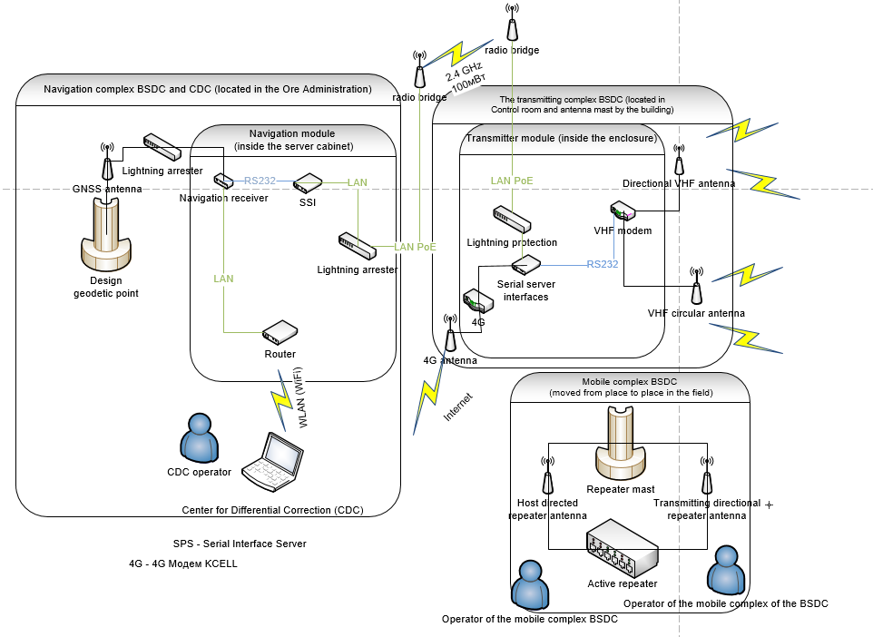

Figure 2.1 - Location of DCBS complexes

A detailed diagram of the navigation module, which consists of the contents of the server case, is shown in Figure 2.2.

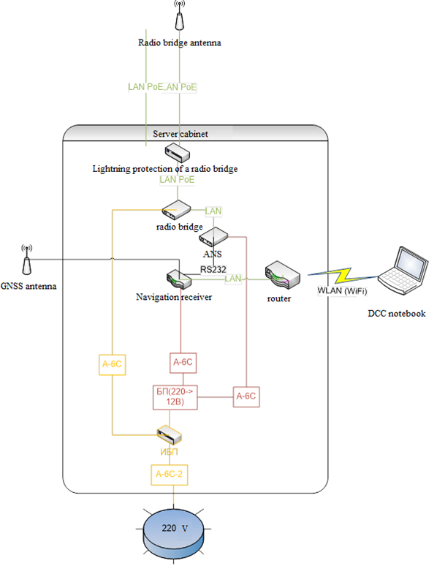

Figure 2.2 - General diagram of the navigation module

A detailed diagram of the transmitting module, which consists of the contents of the data rack, is shown in Figure 2.3.

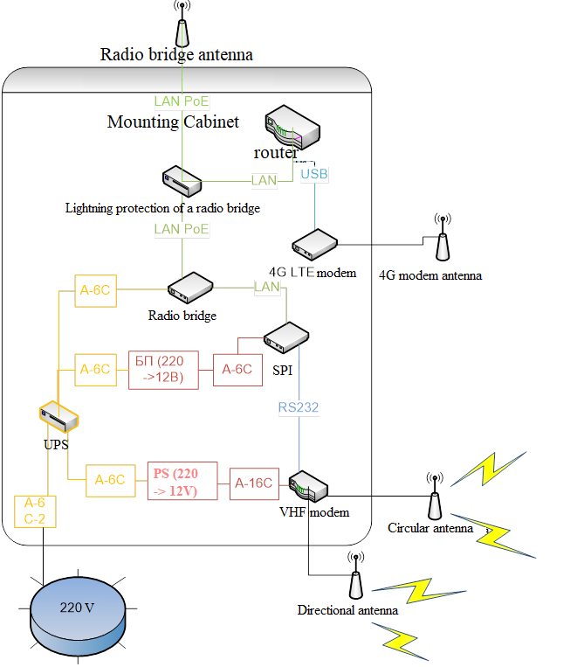

Figure 2.3 - General diagram of the transmitting module

**2.3 Development of scientific software (SSW) for processing satellite measurement data at the station point of the field**

As part of this research, the software "System for managing the flow of updating information" was developed, and a copyright certificate was obtained (see Appendix B).

*Application.* This computer program controls the flow of satellite navigation data coming from the differential correction base station (DCBS). The scope of the computer program: surveying services (conducting surveying/geodetic works), satellite navigation (increasing the accuracy of satellite navigation receivers), land cadastre and GIS (creating digital maps), etc.

The software product "Updating information flow control system" is designed for receiving, processing, and transmitting satellite navigation parameters via the Internet to mobile GNSS stations (global navigation satellite system) via messages in the NTRIP format (Networked Transport of RTCM via Internet Protocol). The main purpose of the program:

-

-

-

-

*Application.* The software product "Updating information flow control system" is designed for receiving, processing, and transmitting satellite navigation parameters via the Internet to mobile GNSS stations (global navigation satellite system) via messages in the NTRIP format (Networked Transport of RTCM via Internet Protocol). The main purpose of the program:

* receiving and registering updating information from the DCBS;
* storage of updating information with the DCBS;
* encoding and decoding of updating information coming from the DCBS;
* transmission of updating information via the Internet to GNSS mobile stations (rovers).

*Functionality.* "Updating information flow control system" is a program for managing the flow of satellite navigation data from a differential correction base station (DCBS). This software is installed and works in the DCC (differential correction center), which serves as a portable or desktop PC. Data from the input stream from the GNSS receiver as part of the DCBS can be divided and output into several streams for subsequent transmission of satellite navigation differential corrections to the end user's GNSS rovers. In the user interface, the input stream can be a serial virtual port, a TCP client, a TCP server, an NTRIP client, or a file. The output stream can be a serial port, a TCP client, a TCP server, an NTRIP server, or a file. This software is a resident application, and the -msg option is used to specify output messages. Main functions performed by the "Updating information flow management system" [18]:

* recording and storage of satellite navigation observations of DCBS;
* setting the rate of receiving, processing, and recording navigation data;
* reception and registration of updating information (UI) with the DCBS on DCC;
* transmission of UI via the Internet in NTRIP format.

The stream types can be selected from the following parameters:

(a) Serial port: data input via serial port (RS232C or USB)

(b) TCP client: connect to a TCP server and enter data over a TCP connection.

(C) NTRIP client: connects to the NTRIP caster and sends updating information over the NTRIP protocol. The NRTK server (Network Real Time Kinematics (RTK) mode), which supports the NTRIP and RTCM (Radio Technical Commission for Maritime Services) 2/3 transmission protocols, can also be used as a base station over the Internet.

(d) File: input or output data from a text file.

*Main technical characteristics.* The software "Updating information flow control system" requires a connection to the DCBS and the Internet, except for the case when the DCC works inside the local network together with the GNSS rover or the GNSS rover is directly connected to the DCC via the RS232 or USB port.

Operating system: Windows.

Main technical characteristics:

* executable file - 1;
* address of the central updating information server: rtk2go.com;
* executable file size - 3,563 KB;
* Supports many standard formats and protocols for working with satellite navigation parameters: RINEX 2.10, 2.11, 2.12 OBS / NAV / GNAV / HNAV, RINEX 3.00 OBS / NAV, RINEX 3.00 CLK, RTCM v.2.3, RTCM v.3.1, NTRIP 1.0, NMEA 0183.

*Computer language.* The "Updating information flow management system" software consists of a portable software library and a graphical user interface (GUI) in the form of an application program (AP) that uses this library.

All library functions and APIs are developed in the ANSI C programming language (C89). The library uses Winsock and WIN32 streams for Windows with the-DWIN32 compiler option. The graphical user interface (GUI) AP is developed in the C++ programming language and uses the Embarcadero/Borland VCL (visualization component library http://www.embarcaadero.com) for the GUI Toolkit. The executable binary AP included in the program was developed using the free version of Embarcadero C++ builder XE2 Starter Edition on Windows 7. The GUI AP executable has been tested on 64-bit Windows 7. System requirements is shown in Table 2.2.

Table 2.2 - SYSTEM REQUIREMENTS

|  |  |
| --- | --- |
| Operating system | Windows 7 and higher |
| Processor | 64-bit (x64) processor with a clock frequency of 800 MHz or higher |
| RAM | 1 GB min. |
| Disk space | 200 MB min |

**2.4 Production of station points and DCBS**

Based on business trip results in November 2019, a station point and a differential correction base station (DCBS) were installed at the Kachar field. In general, the equipment included in the DCBS was divided into the following modules:

* Navigation complex: the navigation module is installed in the office of the Chief Surveyor, the antennas, and the design of the station point - on the roof of the administrative building (AB) of the Kachar complex.
* The transmitting complex is constructed in the Control Room building and on the antenna mast.
* Mobile complex - mobile on board, is constructed on the territory of a quarry or warehouse.

For more information about the composition of the DCBS, see section 2.1.2.2.

A permanent station point with the name "Baza" is installed on the AB roof. The GNSS antenna is mounted on this station point and the corresponding cables, which is part of the DCBS.

During testing, the station point's location on the AB roof, the placement of the navigation and transmitting complexes DCBS on AB, Control Room buildings, and antenna mast near the Control Room were checked (see Fig. 2.4). The compliance of the station point’s location and DCBS complexes with the requirements of technical, industrial safety, and operational and design documentation of the HPSNS (high-precision satellite navigation system) was checked.

The possibilities of functioning, operability, and technical characteristics of the three DCBS complexes separately and in general, when the DCBS operates as a single system, are checked. DCBS complexes operating in the normal mode were tested. DCBS complexes are considered to have passed the tests. After switching on the equipment as part of the DCBS, they work in normal mode and do not give false information under any operating modes. The parameters correspond to the established operating modes of the equipment in the DCBS; the characteristics correspond to the data specified in the operational documentation for these products.

The acceptance and installation certificate confirm the installation of a station point in accordance with the requirements of the SSGPO (see Appendix G).

The DCBS transmits satellite navigation differential corrections on the Kachar field's territory via NTRIP messages (which are transmitted via the Internet and cellular networks available at the field) and via VHF radio channels.

The DCBS transmitting complex transmits GNSS differential corrections over the VHF channel at 408.025 MHz, and the mobile DCBS complex retransmits the VHF signal at 411.025 MHz. For each station, the possibility of high-precision positioning is recorded using GNSS rovers and using corrections transmitted over VHF channels and via NTRIP messages. The DCBS transmitting complex is temporarily deployed each time between the antenna mast of the DCBS transmitting complex and the GNSS rovers' location.

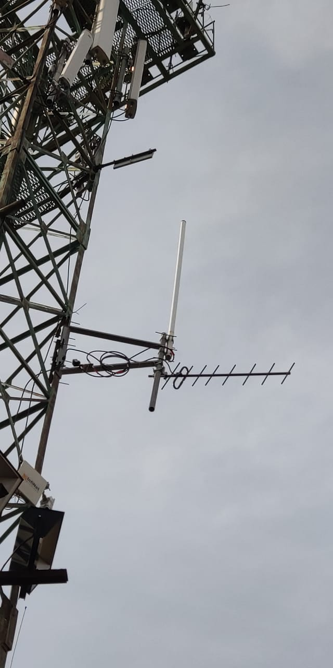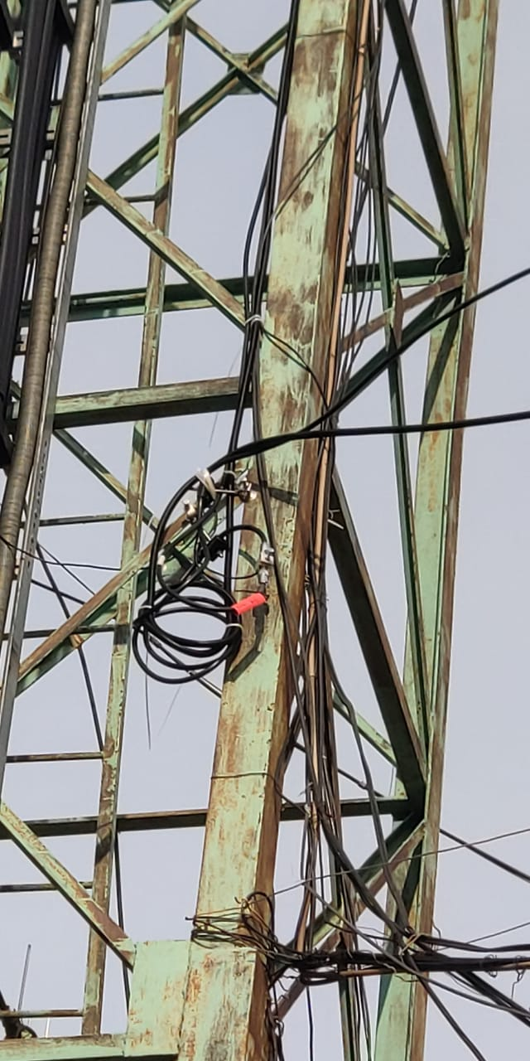

Figure 2.4 - VHF antennas and corresponding cables of the DCBS transmitting complex on the antenna mast near the Control Room building

**3 IMPLEMENTATION OF A HIGH-PRECISION POSITIONING SYSTEM INTO COMMERCIAL OPERATION**

**3.1 Development of a center of differential correction**

The Center for Differential Correction (CDC) is a software and hardware complex for managing and monitoring the state of the Base Station for Differential Correction (BSDC), which in turn refers to systems of receiving and processing navigation signals, as well as issuing correcting satellite navigation information. CDC is also used to receive, process, and transmit satellite navigation parameters via the Internet.

CDC consists of two parts: hardware, namely a portable computer (laptop) HP 15-rb034ur, and software installed and running on the basis of the Windows 10 operating system on this laptop. CDC software includes:

1) software and mathematical support (SMS) of own development; used to receive, process and transmit satellite navigation parameters via the Internet through messages in the NTRIP format;

2) the software application for working with the Trimble BD 930 receiver is used to enter the constant coordinates of the BSDC, and can also be used to control the generation and delivery of corrective information to the VHF modem, which is part of the Transmitting complex of the BSDC;

3) the "airOS" software application supplied by the manufacturer of the PowerBeam PBE-M2-400 radio bridge; it is used to monitor and configure wireless data transmission between the Navigation and Transmitting complexes of the BSDC via the PowerBeam PBE-M2-400 radio bridge, which is part of the BSDC. (This application is recommended for use only by a technician trained in tuning similar radio bridges or experienced with such radio bridges).

Preliminary tests were carried out after the completion of work on the creation of a CDC for a base station of differential correction (BSDK). The test results are presented in the Preliminary Test Report of the Differential Correction Center (see Appendix B1).

**3.2 Preliminary tests of the high-precision positioning system (HPPS)**

In connection with the completion of work on the creation of a high-precision positioning system (HPPS), preliminary tests of the HPPS were carried out. The Commission consisting of representatives of the Private Partner JSC SSGPO (Kacharsky Mining Complex), executors of the branch «RSE «NC CPMRM RK» Kunayev Mining Institute and co-executors of the Subsidiary SLLP «Institute of Space Engineering and Technology» carried out preliminary tests of the HPPS SVP.

The purpose of the preliminary tests was a comprehensive check of the operability of the technical and software support of the HPPS, which consists of three parts, namely the base station of differential correction (BSDC), the center of differential correction (CDC), and the geodetic point "Base" on the roof of the Ore Administration.

The tests were carried out on the territory of the Kacharsky mining complex following the "Program and methodology for testing the BSDC" (included in the working design documentation for the geodetic point and the BSDC) and the "Program and methodology for preliminary tests of the CDC" (see Appendix 1 of the Protocol of preliminary tests of the CDC, which is presented in Appendix B1).

Preliminary testing program is fully completed. The composition and completeness of the HPPS corresponds to the technical documentation "Specification of the BSDC", "Description of the software for processing satellite measurements" and "Drawing of a geodetic point". HPPS and its technical documentation ("BSDC Specification", "BSDC Operation Manual", "Description of the software for processing satellite measurements data", "Operator's manual for processing satellite measurement data" and "Drawing of a geodetic point") passed preliminary tests according to "Program and methodology for testing BSDK" and "Program and methodology for preliminary testing of CDC"*.*

The characteristics of the HPPS correspond to the requirements, and the HPPS also performs all stipulated functions. The technical documentation for the HPPS in the technical and patent legal aspects complies with the GOST 34 Complex of standards for automated systems. HPPS and its technical documentation are ready for further acceptance into trial operation.

The test results are presented in the Preliminary Testing Act of the high-precision positioning system (see Appendix B2).

**3.3 Trial operation of the HPPS**

The trial operation was carried out on the territory of the Kacharsky mining complex. The purpose of the trial operation was to determine the actual values ​​of the quantitative and qualitative characteristics of the HPPS and the readiness of the mine surveying service to work in the conditions of the HPPS functioning, to determine the actual efficiency of the HPPS, as well as to correct the corresponding working design documentation.

The following structure of the HPPS functions was accepted for trial operation:

- the presence and mechanical integrity of equipment in the CDC and BSDC;

- the presence and mechanical integrity of the structure of the geodetic point "Base";

- the construction of the geodetic point "Base" is firmly fixed to the building and is constantly stationary relative to the Earth's surface;

- reception and processing of satellite navigation signals GPS (С/А - code) L1, L2 and L5,

GLONASS (CT-code) L1 and L2, BeiDou B1, B2 and B3;

- generation and transmission of corrective information (CI) to the rovers of the Kacharsky quarry of JSC "SSGPO", including rovers at the bottom of the quarry;

- saving and processing of navigation measurements and parameters for issuance in RINEX format;

- wireless connection to the navigation complex BSDC through the CDC;

- wireless connection of CDC and BSDC via GSM network to the Internet;

- recording and storage of satellite navigation observations of the BSDC;

- transformation of satellite navigation observations of the BSDC into the RINEX format;

- setting the rate of reception, processing and registration of navigation data;

- input of BSDC coordinates and setting of modes of local transmission of CI using a VHF radio channel in RTCM SC-104 (v.2.x, v.3.x) and CMR formats;

- transmission of corrective information to the VHF modem;

- reception and registration at the CDC of corrective information (CI) from the CDC;

- transmission of CI via the Internet in NTRIP format.

In the process of trial operation, the following list of components of the technical support of the HPPS was checked:

* all components of the BSDC (Navigation, Transmitting and Mobile complexes of the BSDC);
* construction of the geodetic point "Base";
* technical support of the CDC (laptop HP 15-rb034ur).

During the trial operation, the following list of components of the HPPS software installed in the CDC was checked:

- software and mathematical support (SMS) of its own design;

- software application that comes with the Trimble BD930 receiver;

- software application "airOS" supplied by the manufacturer of the PowerBeam PBE-M2-400 radio bridge.

In the process of trial operation, the following list of components of the information support of the HPPS was checked, which are recorded and stored on the CDC:

- Trimble BD 930 receiver satellite navigation recording files;

- files for recording satellite navigation measurements in RINEX format.

When putting into trial operation, the commission was presented with the following list of documents: "BSDC specification", "BSDC operating manual", "Description of the software for processing satellite measurement data", "Operator's manual for processing satellite measurement data" and "Drawing of a geodetic point ".

The test results are presented in the Act of putting the high-precision positioning system into trial operation (see Appendix B3).

**3.4 Conducting acceptance tests of HPPS for industrial operation of HPPS**

In connection with the completion of work on the commissioning of a high-precision positioning system (HPPS) into permanent operation, acceptance tests of the HPPS were carried out for industrial operation. The HPPS consists of three parts, namely the base station of differential correction (BSDK), the center of differential correction (CDC) and the geodetic point "Base" on the roof of the Ore Administration. HPPS was developed on the basis of the following documents: "Explanatory note of the preliminary design OGSKK.15.EPPZ-KIT", "Explanatory note of the technical design OGSKK.15.TPPZ-KIT", "Explanatory note of the conceptual design BSDK.PZEP-KIT" and "Explanatory note of the technical project BSDK.PZTP-KIT".

Acceptance tests of the hovercraft for industrial operation were carried out by the Acceptance Commission consisting of representatives of the Private Partner JSC SSGPO (Kacharsky Mining Complex), executors of the branch «RSE «NC CPMRM RK» Kunayev Mining Institute and co-executors of the Subsidiary SLLP «Institute of Space Engineering and Technology» carried out preliminary tests of the HPPS SVP.

The acceptance tests of the HPPS for the industrial operation were carried out on the territory of the Kacharsky mining complex. The purpose of the Acceptance Tests was to determine the conformity of the HPPS to the working-design documentation, to assess the quality of the HPPS trial operation, and to resolve the issue of the possibility of accepting the HPPS for permanent operation.

The following composition of functions of the HPPS was taken into industrial operation:

- the presence and mechanical integrity of equipment in the CDC and BSDC;

- the presence and mechanical integrity of the structure of the geodetic point "Base";

- the structure of the geodetic point "Base" is firmly fixed to the building and is constantly stationary relative to the Earth's surface;

- reception and processing of satellite navigation signals GPS (С/А - code) L1, L2 and L5, GLONASS (CT-code) L1 and L2, BeiDou B1, B2, and B3;

- generation and transmission of corrective information (CI) to the rovers of the Kacharsky quarry of JSC "SSGPO", including rovers at the bottom of the quarry;

- saving and processing navigation measurements and parameters for issuing in RINEX format;

- wireless connection to the navigation complex BSDC through the CDC;

- wireless connection of CDC and BSDC via GSM network to the Internet;

- recording and storage of satellite navigation observations of the BSDC;

- transformation of satellite navigation observations of the BSDC into the RINEX format;

- setting the rate of reception, processing and registration of navigation data;

- input of BSDC coordinates and setting of local transmission modes of CI using VHF radio channel in RTCM SC-104 (v.2.x, v.3.x) and CMR formats;

- transmission of corrective information to the VHF modem;

- reception and registration at the CDC of corrective information (CI) from the CDC;

- transmission of CI via the Internet in NTRIP format.

The list of components of the technical support of the HPPS taken into industrial operation:

* all components of the BSDC (Navigation, Transmitting and Mobile complexes of the BSDC);
* construction of the geodetic point "Base";
* technical support of the CDC (laptop HP 15-rb034ur).

The list of software components of the SVP installed in the CDC, taken into industrial operation:

- software and mathematical support (SMS) of its own design;

- software application that comes with the Trimble BD930 receiver;

- software application "airOS" supplied by the manufacturer of the PowerBeam PBE-M2-400 radio bridge.

The list of components of the information support of the HPPS accepted for industrial operation:

- Trimble BD 930 receiver satellite navigation recording files;

- files for recording satellite navigation measurements in RINEX format.

When putting into industrial operation, the acceptance committee was presented with the following list of documents: "The act of putting the HPPS into trial operation", "Specification of the BSDC", "Manual for the operation of the BSDC", "Description of the software for processing satellite measurements data", "Operator's manual of software for processing satellite measurements" and "Drawing of a geodetic point".

A brief description and the main results of the work performed on the creation of a hovercraft are presented in the Acceptance Testing Act of the high-precision positioning system for industrial operation (see Appendix B4).

CONCLUSIONS

The result of research for 2018-2020 performed the following activities:

* developed project documentation for geodetic control network and design of geodetic points in Kachar open pit mine field of JSC “SSGPO”; project documentation for a base station for differential correction (BSDC); working design documentation on the geodesic point and BSDC; software and mathematical support for processing of satellite data;
* geodesic point and base station of differential correction were made, installation and commissioning works were performed;
* the developed high-precision positioning system successfully passed all types of planned tests and was implemented into commercial operation at the Kachar quarry.

The use of global navigation satellite systems (GNSS) in open pit environments has some specific features. The design of pit walls at the end of ledges with steep slopes and a constant increase in the pit depth entails not only a decrease in the number of visible satellites, but also an increase in sighting angles, which leads to an increase in the DOP coefficient (dilution of precision) [5]. One of the possible ways to solve this problem was the development of a mobile BSDC complex, in particular, the use of an active repeater.

The significance of this project on a national scale consists in providing high-precision positioning of the territory of a mining enterprise and allows solving two main problems of open-pit mining in the near future: increasing labor productivity through the introduction of digital technologies and significantly increasing its safety [6], [7]. The introduction of the developed high-precision positioning system at the Kachar field can also be used at other mining enterprises in Kazakhstan.

We wish to express our appreciation to the private partner JSC "SSGPO" for co-financing the project and the possibility of its implementation at the mining enterprise.

LIST OF REFERENCE

1 Kuzmenko S. V., Shamganova L. S., Akhmedov D. Sh., Baltieva A. A. Information and navigation support of mining operations at the quarries of the Sokolov-Sarbay mining and processing production Association / / Mining journal.2018. № 5. P. 72–76. DOI: 10.17580/gzh.2018.05.11 (in Russian)

2 A. A. Baltiyeva, L.S. Shamganova, S. A. Sedina, K. K. Tulebayev. The choice of rational and effective technical tools when conducting the uniform combined geomonitoring for the open-pit mines //25th World Mining Congress 2018. – Astana, 2018, p. 1-10 (in English)

3 GKINP (ONTA) -01-271-03 Guidelines for the creation and reconstruction of urban geodetic networks using satellite systems GLONASS / GPS. - M.: CRIGAPC 2003 (in Russian)

4 Akhmedov D.Sh., Raskaliev A.S., Urazbekov A.K. Satellite system for high-precision positioning of infrastructural and mobile objects of the backbone network of JSC “NC “Kazakhstan Temir Zholy”. Automation Bulletin. ISSN 1810-8626. No. 1 (55), March, 2017 (in Russian)

5 Guidelines for the creation and reconstruction of urban geodetic networks using GLONASS / GPS satellite systems. - M.: CRIGAPC, 2003 (in Russian)

6 Rules for fixing the centers of points of the satellite geodetic network. - M.: CRIGAPC, 2001 (in Russian)

7 L.S. Shamganova, A. A. Baltiyeva D. S. Akhmedov, E. S. Kalyuzhny. Development of a system of high-precision satellite positioning in the open-pit of Northern Kazakhstan // 18th International Multidisciplinary Scientific Geoconference SGEM 2018. Conference proceeding volume 18. Informatics, Geoinformatics and remote sensing issue 2.2 – Albena, 2018, p. 723-728 (in English)

8 Baltiyeva A.A., Shamganova L.S., Raskaliyev A., Kuzmenko S. «Telecommunication decisions for high-precision satellite positioning on the Kacharsky pit»// XIX International Multidisciplinary Scientific Geoconference SGEM 2019 Conference proceeding volume 19. Informatics, Geoinformatics and Remote Sensing. Issue 2.2 – Albena, 2019, p. 333-339 (in English)

9 Baltieva A.A., Shamganova L.S., Raskaliev A.S., Murzaliev A.T. "Development of a unified coordinate-time support for mine surveying and geodetic measurements at the Kacharsky quarry" // Scientific and technical support of mining production, works, volume 89, pp. 187-193 (in Russian)

10 Great Soviet Encyclopedia "Dictionaries and Encyclopedias on Academician". Internet resource:<https://dic.academic.ru/dic.nsf/bse/127310/%D0%A0%D0%B5%D1%82%D1%80%D0%B0%D0%BD%D1%81%D0%BB%D1%8F%D1%82%D0%BE%D1%80> (date of the application: 7.10.2020) (in Russian)

11 Baltiyeva A. A., Raskaliyaev A. S., Samsonenko A. I., Shamganova L. S., Fan H. Development of the software and technical complex of the high-precision satellite positioning system in the conditions of open pit mining processes. Kompleksnoe Ispol’zovanie Mineral’nogo Syr’a. = Complex Use of Mineral Resources = Mineraldik Shikisattardy Keshendi Paidalanu. - 2020. № 4 (315), pp. 42-48. <https://doi.org/10.31643/2020/6445.35> (in English)

12 SAUS R (Project 1) Global Navigation Satellite System. Satellite geodetic networks. Methods for accounting for the movements of geodetic points. Moscow. Standartinform 2018 (in Russian)

13 RD 07-603-03 "Instruction for the production of mine surveying" - M.: Gosgortekhnadzor of Russia, 2003 (in Russian)

14 SAUS R 56408—2015 “Global Navigation Satellite System. Geodetic satellite networks. General requirements "- M.: Standartinform, 2015 (in Russian)

15 SAUS R 57372-2016 Global navigation satellite system. Methods and technologies for performing geodetic works. points of a high-precision geodetic network (VGS). Technical conditions. Moscow. Stamdartinform 2017 (in Russian)

16 RD BGEI 36-01 Occupational safety requirements during the operation of topographic and geodetic equipment and methods of their control. FSUE "CRIGAPC" (in Russian)

17 Configuring Powerbeam in Bridge Mode. Website: http://www.ubnt.su/ubiquiti/nastroika-powerbeam.htm (date of the application 20.12.2019 г.) (in Russian)

18 Raskaliyev A., Patel S.H., Sobh T.M., Ibrayev, A. (2020): GNSS-Based Attitude Determination Techniques—A Comprehensive Literature Survey. IEEE Access, Vol. 8, pp. 24873-24886, 2020. Available at: <https://ieeexplore.ieee.org/document/8972427> (in English)

APPENDIX A

Appendix 2

to Agreement No._____ from ______________ 2018 y.

for grant funding

**TECHNICAL SPECIFICATIONS AND WORK SCHEDULE**

to Agreement No._____ from ______________ 2018 y.

**1. BRANCH REPUBLICAN STATE ENTERPRISE «NATIONAL CENTER FOR**

**COMPLEX PROCESSING OF MINERAL RAW MATERIALS**

**OF THE REPUBLIC OF KAZAKHSTAN»**

**INSTITUTE OF MINING AFTER D. A. KUNAYEV**

**1.1** Priority: Rational use of natural resources, including water resources, geology, processing, new materials and technologies, safe products and structures.

**1.2** Sub-priority: Information systems and databases.

**1.3** Theme of the Project: № AP05136083 «Development of the software and hardware complex of the system of high-precision satellite positioning for the deposit take of JSC «SSGPO».

**1.4** Total project amount 24160000 (*twenty-four million one hundred sixty thousand*) *KZT*, including by year, for the performance of work in accordance with paragraph 3:

- for 2018 year – in sum *8000000* (eight million) *KZT*;

- for 2019 year – in sum *8072000* (eight million seventy-two thousand) *KZT*;

- for 2020 year – in sum *8088000* (eight million eighty-eight thousand) *KZT*.

***2.Characteristics of scientific and technical products by qualification***

***criteria and economic indicators***

**2.1** Field of work: Applied research in the field of automation and automated systems in mining.

**2.2** Field of application: Mining.

**2.3** Final result:

- for 2018: project documentation will be developed for a reference geodetic network, the construction of one geodetic point, BSDC, an article in peer-reviewed foreign scientific journals, indexed in the Web of Science or Scopus databases with a non-zero impact factor

- for 2019: documentation for a geodetic reference network, working design documentation for a geodetic point, BSDC, an article in peer-reviewed foreign scientific journals indexed in the Web of Science or Scopus databases with a non-zero impact factor will be developed;

- for 2020: a high-precision positioning system will be implemented into commercial operation at the JSC “SSGPO”, two articles in peer-reviewed foreign and domestic scientific publications with a non-zero impact factor, a patent application in the Republic of Kazakhstan.

**2.4** Patentability: The project is patentable.

**2.5** Scientific and technical level (novelty): the novelty of the project of creating a high-precision positioning system in the framework of this Project is the development of technical documentation and setting the geodetic point of the geodetic network on the ground, which makes it possible to differentiate the causes of the displacement of the phase center; and the determination of normal heights based on the use of a quasigeoid height model and satellite navigation signals.

**2.6** The use of scientific and technical products is carried out by: the Customer and the Contractor together.

**2.7** Type of use of the result of scientific and (or) scientific and technical activities: security documents and publications.

Continuation of Appendix A

***3. Name of work, terms of their implementation and results***

|  |  |  |  |  |
| --- | --- | --- | --- | --- |
| The cipher of the task, stage | Name of work under the Contract and the main stages of its implementation | Term of performance | | Expected result |
| beginning | end |  |
| 1 | Development of design documentation for the reference geodetic network and design of the geodetic point at the field of JSC “SSGPO”, design documentation for the base station of differential correction (BSDC). | January  2018 | till  1 st November,  2018. | Project documentation will be developed for the reference geodetic network and the design of the geodetic point at the field of JSC SSGPO, project documentation for the base station of differential correction (BSDC). |
| 1.1 | Development of a draft design for a geodetic support network and the construction of a geodetic point. | January  2018 | March  2018 | A draft design will be developed for the reference geodetic network and the design of one geodetic point. |
| 1.2 | Development of a technical project for the reference geodetic network and the design of a geodetic point. | April  2018 | June  2018 | A technical project will be developed for the reference geodetic network and the construction of one geodetic point. |
| 1.3 | Development of a draft design of the BSDC. | July  2018 | September  2018 | A draft design of the BSDC will be developed. |
| 1.4 | Development of the technical design of the BSDC. | October  2018 | till  1 st November,  2018. | A technical draft of the BSDC will be developed. One article will be submitted in peer-reviewed foreign scientific publications indexed in the Web of Science or Scopus databases with a non-zero impact factor. |
| 2 | Creation of a reference geodetic network for the field of JSC "SSGPO" and production of BSDC. | January  2019 | till  1 st November,  2019. | A reference geodetic network will be created for the field of JSC SSGPO and the BSDC will be manufactured. |
| 2.1 | Development of documentation for the reference geodetic network of the field. | January  2019 | March  2019 | Documentation for the reference geodetic network of the field will be developed. |
| 2.2 | Development of working design documentation for the geodetic point and BSDC. | April  2019 | June  2019 | Working design documentation will be developed for the construction of one geodetic point, one BSDC. |
| 2.3 | Development of software and mathematical support (SMS) for processing satellite measurement data at the geodesic point of the field. | July  2019 | September  2019 | A SMS will be developed for processing satellite measurement data at a single geodetic point of the field |
| 2.4 | Production of geodetic points and BSDC. | October  2019 | Till 1st of November, 2019 | A Protocol will be prepared for the transfer of the geodetic point and the BSDC to installation and commissioning works. One article will be submitted in peer-reviewed foreign scientific publications indexed in the Web of Science or Scopus databases with a non-zero impact factor. |
| Continuation of Appendix A | | | | |
| 3 | Implementation of a high-precision positioning system into commercial operation. | January  2020 | Till 1st of November, 2020 | The Act of implementation into industrial operation of the high-precision positioning system will be received. |
| 3.1 | Development of a center of differential correction. | January  2020 | March  2020 | A Protocol will be created for transmitting the differential correction center for preliminary tests. |
| 3.2 | Preliminary tests of the HIGH-PRECISION POSITIONING SYSTEM (HPPS). | April  2020 | June  2020 | A Certificate of preliminary testing will be received. |
| 3.3 | Trial operation of the HPPS | July  2020 | September  2020 | The Act of implementation into trial operation of the HPPS will be received. |
| 3.4 | Conducting acceptance tests of HPPS for industrial operation of HPPS. | October  2020 | Till 1st of November, 2020 | The certificate of acceptance of tests for commercial operation of the HPPS will be received.  Two articles will be submitted in peer-reviewed foreign and domestic scientific publications with a non-zero impact factor. A patent application will be send in the Republic of Kazakhstan. |

|  |  |
| --- | --- |
| From customer:  Chairman of the Committee of Science of the Ministry of Education and Science of the Republic of Kazakhstan  ________________ B.S. Abdrasilov | From the performer  Director «D.A.Kunayev Mining Institute»,  academician of NAS RK, prof., Dr. of tech. sciences  ______________________Buktukov N.S. |
|  | Familiarized:  Scientific supervisor of the project  ______________ Tulebayev K. K. |

APPENDIX B - Protocols and acts of implementation

APPENDIX B1

**APPROVED BY**

***Director of* *Kacharsky mining complex***

***__________________ S.N. Sergeyev***

***«___» _______________2020 year***

**PROTOCOL**

**of preliminary tests of the center of differential correction**

Kachar village «__» _________ 2020 year

As part of the work by the main agreement No. 125 for grant financing dated March 12, 2018, and co-financing agreement No. SSGS/SSG /18-6778 dated August 9, 2018, for the implementation of research work:

*"Development of a software and hardware complex for a high-precision satellite positioning system for the field of JSC "SSGPO"(No. AR 05136083)*:

In connection with the completion of work on the creation of a differential correction center (CDC) for the base station of differential correction (BSDC), preliminary tests of the CDC were carried out.

Preliminary tests of the CDC were carried out by the Commission consisting of representatives of the Client JSC "SSGPO" (Kacharsky mining complex):

Chairman - acting chief surveyor of the Kacharsky mining complex - Koval Ye.Yu.

Commission members: mine surveyor - Yatsenko I.G., mine surveyor - Tokareva L.A.

and Contractors:

branch "RSE "NC CPMRM RK" "Kunayev Mining Institute": junior researcher - Murzaliyev A.T., junior researcher - Rakhimov N.D.

SLLP "Institute of Space Engineering and Technology":

Lead Software Engineer - Zhumagali S.Zh.

The purpose of the tests was a comprehensive operability check of the hardware and software of the CDC, as well as checking the functionality of the CDC during its interaction and joint performance of tasks with the CDC.

Preliminary tests were carried out according to the following list of testing the functions of the CDC:

- external inspection and mechanical integrity of the equipment as part of the CDC and BSDC;

- wireless connection to the navigation complex BSDC through the CDC;

- wireless connection of CDC and BSDC via GSM network to the Internet;

- recording and storage of satellite navigation observations of the BSDC;

- transformation of satellite navigation observations of the BSDC into the RINEX format;

- setting the rate of reception, processing and registration of navigation data;

- input of BSDC coordinates and setting of local transmission modes of CI using VHF radio channel in RTCM SC-104 (v.2.x, v.3.x) and CMR formats;

- transmission of corrective information to the VHF modem;

Continuation of Appendix B1

- reception and registration at the CDC of corrective information (CI) from the CDC;

- transmission of CI via the Internet in the NTRIP format.

The program for conducting preliminary tests of the CDC is detailed in Appendix 1.

Breakdowns, failures and emergencies in the work of the CDC were not revealed during the tests.

Results and conclusions on preliminary tests of the CDC: the hardware and software of the CDC effectively interact with the CDC and allow the CDC to perform the functions assigned to it; the functionality of the CDC fully covers the functionality of the software and mathematical support (SMS), described in the project documentation "Specification of the BSDC", "Manual for the operation of the BSDC", and "Operator's manual for the processing of satellite measurements".

Commission conclusion:

1. Preliminary tests of the CDC were carried out without comments, completely in accordance with the Program and methodology for preliminary tests of the CDC.
2. The characteristics of the CDC correspond to the requirements, and the CDC performs all the stipulated functions.

The protocol was drawn up in two copies (one for each of the parties) on ___ pages, including Appendix 1.

**From Client:**

|  |  |  |
| --- | --- | --- |
| Commission chairman: | ___________________  signature | Koval Ye.Yu |
| Commission members: | ___________________  signature | Yatsenko I.G. |
|  | ___________________  signature | Tokareva L.A. |
| **From Contractors:** |  |  |
|  | ___________________  signature | Zhumagali S.Zh. |
|  |  |  |
|  | ___________________  signature | Murzaliyev A.T. |
|  | ___________________  signature | Rakhimov N.D. |

Continuation of Appendix B1

Appendix 1

**Differential Correction Center Preliminary Test Program**

1 General Terms

The Center for Differential Correction (CDC) is a software and hardware complex for managing and monitoring the state of the Base Station for Differential Correction (BSDC), which in turn refers to systems of receiving and processing navigation signals, as well as issuing correcting satellite navigation information. CDC is also used to receive, process, and transmit satellite navigation parameters via the Internet..

CDC consists of two parts: hardware, namely a portable computer (laptop) HP 15-rb034ur, and software installed and running on the basis of the Windows 10 operating system on this laptop. CDC software includes:

1) software and mathematical support (SMS) of own development; used to receive, process and transmit satellite navigation parameters via the Internet through messages in the NTRIP format;

2) the software application for working with the Trimble BD 930 receiver is used to enter the constant coordinates of the BSDC, and can also be used to control the generation and delivery of corrective information to the VHF modem, which is part of the Transmitting complex of the BSDC;

3) the "airOS" software application supplied by the manufacturer of the PowerBeam PBE-M2-400 radio bridge; it is used to monitor and configure wireless data transmission between the Navigation and Transmitting complexes of the BSDC via the PowerBeam PBE-M2-400 radio bridge, which is part of the BSDC. (This application is RECOMMENDED for use only by a technician trained in tuning similar radio bridges or experienced with such radio bridges).

These preliminary tests are carried out at the completion of work on the creation of a CDC for a base station of differential correction (BSDC).

2 Checklist for preliminary tests

During the tests, the functional tests of the CDC are performed as listed below:

- visual inspection and mechanical integrity of equipment as part of the CDC and BSDC (see clause 6.1);

- wireless connection to the navigation complex BSDC through the CDC (see paragraph 7.1);

- wireless connection of CDC and BSDC via GSM network to the Internet (see clause 7.2);

- recording and storage of satellite navigation observations of the BSDC (see paragraph 7.3);

- transformation of satellite navigation observations of the BSDC into the RINEX format (see clause 7.4);

- setting the rate of reception, processing, and registration of navigation data (see paragraph 7.5);

- input of BSDC coordinates and setting of modes of local transmission of CI using a VHF radio channel in RTCM SC-104 (v.2.x, v.3.x) and CMR formats (see clause 7.6);

- transmission of correction information to the VHF modem (see clause 7.7);

- reception and registration at the CDC of corrective information (CI) from the CDC (see clause 7.8);

- CI transmission via the Internet in NTRIP format (see clause 7.9).

3 Test tools

3.1 When carrying out the tests, the following measuring instruments and auxiliary equipment are used as shown in Table 3.1.

Continuation of Appendix B1

Table 3.1 – Test tools

|  |  |
| --- | --- |
| Test Procedure Clause Number | Name and type of the main or auxiliary test means; designation and name of normative documents regulating technical requirements and/or metrological and basic technical characteristics of a measuring instrument |
| 7.6 – 7.9 | Trimble R10 GNSS geodetic GNSS receiver and its accessories as a rover in fast static mode |
| 7 | Geodetic receiver Trimble BD930 as part of a permanent base station for differential correction (BSDC), transmitting CI via VHF channels and via NTRIP messages |

3.2 It is allowed to use other GNSS geodetic receivers and their components, which provide the required measurement accuracy and are able to process corrections from the BSDC going through the VHF channel and NTRIP messages.

3.3 The means used for testing must have documents certifying their suitability for use.

4 Safety requirements

During the tests, the following safety requirements must be observed:

4.1 When conducting tests, it is necessary to observe the general rules for performing work in accordance with the technical documentation on safety requirements in force at the given enterprise.

4.2 Persons who are familiar with the rules of operation of the system and the "Rules for the technical operation of electrical installations of consumers", "Rules for safety in the production of topographic and geodetic works PTB-73" are allowed to carry out the tests.

5 Conditions for preliminary tests

During the tests, the following conditions must be met at the points of satellite observation:

- ambient air temperature from minus 30° С to plus 60° С;

- relative humidity from 40 to 80%;

- atmospheric pressure from 84 to 106 kPa (from 630 to 800 mm Hg);

6 Preparation for preliminary tests

Preparation for preliminary tests of the CFM should consist of the following steps:

6.1 Before carrying out field measurements, a visual inspection and a check for the mechanical integrity of the technical equipment of the Navigation and Transmitting complexes of the BSDC and CDK are performed. If necessary, the equipment is repaired, replaced, and restored as part of the BSDC and CDC.

6.2 Before carrying out field measurements, the test instruments and their components are checked for operability. In case of flaws identification, the necessary measuring instruments are repaired or replaced.

6.3 Convenient 5-7 days are selected for carrying out field measurements and external examinations, depending on the weather and the availability of operators of measuring instruments.

APPENDIX B 2

**APPROVED BY**

**Director of *Kacharsky mining facilities***

***__________________ S.N. Sergeyev***

***«___» _______________2020 year***

**ACT**

**of preliminary tests of the high-precision positioning system**

Kachar village «___» _________ 2020 year

As part of the work by the main agreement No. 125 for grant financing dated March 12, 2018, and co-financing agreement No. SSGS/SSG /18-6778 dated August 9, 2018, for the implementation of research work:

*"Development of a software and hardware complex for a high-precision satellite positioning system for the field of JSC "SSGPO"(No. AR 05136083)*:

In connection with the completion of work on the creation of a high-precision positioning system (HPPS), preliminary tests of the HPPS were carried out.

Preliminary tests of the HPPS were carried out by the Commission consisting of representatives of the Client JSC "SSGPO" (Kacharsky mining complex):

Chairman - acting chief surveyor of the Kacharsky mining complex - Koval Ye.Yu.

Commission members: mine surveyor - Yatsenko I.G., mine surveyor - Tokareva L.A.

and Contractors:

branch "RSE "NC CPMRM RK" "Kunayev Mining Institute": junior researcher - Murzaliyev A.T., junior researcher - Rakhimov N.D.

SLLP "Institute of Space Engineering and Technology":

Lead Software Engineer - Zhumagali S.Zh.

The purpose of the preliminary tests was a comprehensive check of the operability of the technical and software support of the HPPS, which consists of three parts, namely the base station of differential correction (BSDC), the center of differential correction (CDC), and the geodetic point "Base" on the roof of the Ore Administration.

The tests were carried out on the territory of the Kacharsky mining complex following the "Program and methodology for testing the BSDC" (included in the working design documentation for the geodetic point and the BSDC) and the "Program and methodology for preliminary tests of the CDC" (Appendix 1 of the Protocol of preliminary tests of the CDC).

1. **The Commission established:**

1.1. Preliminary testing program is fully completed.

* 1. The composition and completeness of the HPPS corresponds to the technical documentation "Specification of the BSDC", "Description of the software for processing satellite measurements" and "Drawing of a geodetic point".

Continuation of Appendix B2

* 1. HPPS and its technical documentation ("BSDC Specification", "BSDC Operation Manual", "Description of the software for processing satellite measurements data", "Operator's manual for processing satellite measurement data" and "Drawing of a geodetic point") passed preliminary tests according to "Program and methodology for testing BSDK" and "Program and methodology for preliminary testing of CDC"*.*

1. **Conclusions**
   1. The characteristics of the HPPS correspond to the requirements, and the HPPS also performs all stipulated functions.
   2. The technical documentation for the HPPS in the technical and patent legal aspects complies with the GOST 34 Complex of standards for automated systems.
   3. HPPS and its technical documentation are ready for further acceptance into trial operation.
2. **Notes and Recommendations**

Systematic discrepancies in the measurements of the GNSS rover were revealed when using corrections with the BSDC and the BASAKACHAR base station, previously installed in the Kacharsky mining complex. The reason for the discrepancies was the binding of the BASAKACHAR base station to the Local Coordinate System (LCS) of the Kacharsky quarry, while the BSDC installed by us was tied to the international coordinate system ITRF-2014. On the recommendation of representatives of the Client, JSC "SSGPO", in order to eliminate the discrepancies, it was necessary to change the coordinate values ​​entered in the BSDC, and also to tie the BSDC to the local reference system of the Kacharsky pit. The course of resolving the discrepancies is described in Appendix 1.

The results of the elimination of discrepancies were approved by the Commission, and the corresponding comment was removed from the agenda.

The act is drawn up in two copies (one for each of the parties) on ___ pages.

**From Client:**

|  |  |  |
| --- | --- | --- |
| Commission chairman: | ___________________  signature | Koval Ye.Yu |
| Commission members: | ___________________  signature | Yatsenko I.G. |
|  | ___________________  signature | Tokareva L.A. |
| **From Contractors:** |  |  |
|  | ___________________  signature | Zhumagali S.Zh. |
|  | ___________________  signature | Murzaliyev A.T. |
|  | ___________________  signature | Rakhimov N.D. |

Continuation of Appendix B2

Appendix 1

Elimination of discrepancies in GNSS rover measurements when using corrections from the BSDK and the base station «BASAKACHAR»

In 2019, on the roof and in the premises of the Geokurs Dispatch Company, the BASAKACHAR base station was installed based on the Trimble R9S Base GNSS receiver, which transmits differential corrections in the VHF range on the territory of the Kacharsky mining complex.

As part of the preliminary tests of the SVP, arbitrary points were measured by a rover on the territory of the Kacharsky mining complex to compare the coordinates and elevations in the MSK when receiving corrections through the VHF channels from the BASAKACHAR base and the BSDK. The measurement results are shown in Tables 1 and 2.

Table 1 - Measurements in MSC when receiving amendments from "BASAKACHAR"

|  |  |  |  |
| --- | --- | --- | --- |
| Measurement name | North (X, meters) | East (Y, meters) | Height (meters) |
| BASAKACHAR | 4173,436 | 6218,845 | 202,183 |
| 1 | 6354,566 | 6915,669 | 224,263 |
| 2 | 5239,18 | 7956,081 | -20,895 |
| 3 | 5232,747 | 7964,996 | -21,639 |
| 4 | 5222,579 | 7976,206 | -22,185 |
| 5 | 5208,135 | 7989,342 | -23,098 |
| 6 | 5194,746 | 7999,301 | -24,034 |
| 7 | 5179,652 | 8009,75 | -25,644 |
| 8 | 5356,724 | 7108,363 | 30,781 |
| 9 | 5357,729 | 7102,591 | 31,038 |
| 10 | 5358,371 | 7097,551 | 31,315 |
| 11 | 5358,846 | 7092,268 | 31,599 |
| 12 | 5359,083 | 7086,672 | 31,865 |

Continuation of Appendix B2

Table 2 - Measurements in the MSC when receiving corrections from the BSDK

|  |  |  |  |
| --- | --- | --- | --- |
| Measurement name | North (X, meters) | East (Y, meters) | Height (meters) |
| БСДК | 5688,922 | 3638,041 | 211,545 |
| 1 | 6352,592 | 6917,988 | 223,255 |
| 2 | 5237,177 | 7958,36 | -22,212 |
| 3 | 5230,75 | 7967,283 | -22,98 |
| 4 | 5220,586 | 7978,494 | -23,511 |
| 5 | 5206,148 | 7991,646 | -24,431 |
| 6 | 5192,771 | 8001,598 | -25,365 |
| 7 | 5177,668 | 8012,047 | -26,964 |
| 8 | 5354,724 | 7110,618 | 29,469 |
| 9 | 5355,738 | 7104,879 | 29,727 |
| 10 | 5356,334 | 7099,795 | 30,013 |
| 11 | 5356,836 | 7094,538 | 30,295 |
| 12 | 5357,081 | 7088,92 | 30,552 |

The results of calculating the discrepancies in the measurement values at 12 randomly selected points and the analysis of these discrepancies are presented in Table 3.

Table 3 - Analysis of discrepancies between measurements at the corresponding points

|  |  |  |  |
| --- | --- | --- | --- |
| Measurement name | North (X, meters) | East (Y, meters) | Height (meters) |
| 1 | 1,974 | -2,319 | 1,008 |
| 2 | 2,003 | -2,279 | 1,317 |
| 3 | 1,997 | -2,287 | 1,341 |
| 4 | 1,993 | -2,288 | 1,326 |
| 5 | 1,987 | -2,304 | 1,333 |
| 6 | 1,975 | -2,297 | 1,331 |
| 7 | 1,984 | -2,297 | 1,320 |
| 8 | 2,000 | -2,255 | 1,312 |
| 9 | 1,991 | -2,288 | 1,311 |
| 10 | 2,037 | -2,244 | 1,302 |
| 11 | 2,010 | -2,270 | 1,304 |
| 12 | 2,002 | -2,248 | 1,313 |
| expected value | 1,9960833 | -2,28133 | 1,293167 |
| dispersion | 0,0002875 | 0,000534 | 0,008205 |
| standard deviation | 0,0169569 | 0,023114 | 0,090581 |
| the coefficient of variation | 0,0085 | -0,01013 | 0,070046 |

Continuation of Appendix B2

As can be seen from Table 3, the discrepancies were systematic. On average, the differences were 1.996 meters north, 2.281 meters east and 1.293 meters in height, with a variation coefficient of 0.85% north, 1% east and 7% in height. Therefore, it was assumed that the reason for the discrepancies was the displacement of the centers of the coordinate systems, relative to which the rover coordinates were measured when using corrections from two different base stations. Namely, the reason for the discrepancies was the definition and assignment of coordinates of the base "BASAKACHAR" and BSDK in different coordinate systems. The coordinates of "BASAKACHAR" were determined in the MSK of the Kacharsky open-pit mine, while the coordinates of the BSDK, according to the previously made draft and technical design, were determined in the international coordinate system ITRF-2014.

To eliminate the discrepancy, the coordinates of the BSDK were redetermined and this time set in the MSC of the Kacharsky quarry, for this it was decided to determine and set the coordinates of the phase center of the GNSS antenna of the BSDK using the differential correction operation relative to the base station "BASAKACHAR". This operation included joint processing of satellite navigation measurements in the RINEX format, made simultaneously within 6 hours on the basis of BASAKACHAR and BSDK. During joint processing, the value of the coordinates of the BASAKACHAR base in WGS-84, received from the technical support of the Geokurs company, was also used: in latitude, longitude, and 182.930 meters in height. As a result of the operation, new coordinates for the BSDK were determined and set: 53.38639404 degrees in latitude, 62.87308192 degrees in longitude and 193.3458 meters in height.

After setting the new coordinates of the BSDK, the discrepancies in the measurements of the GNSS rover when using corrections from the BSDK and the BASAKACHAR base station were minimized and constitute an acceptable error within the normal range.

Table 4 - Measurements in MSC upon receipt of amendments from "BASAKACHAR"

|  |  |  |  |
| --- | --- | --- | --- |
| Measurement name | North (X, meters) | East (Y, meters) | Height (meters) |
| BASAKACHAR | 4173,436 | 6218,845 | 202,183 |
| 1 | 5733.351 | 3608.909 | 195.613 |
| 2 | 5755.693 | 3625.089 | 195.688 |
| 3 | 5734.193 | 3628.468 | 195.615 |
| 4 | 4921.392 | 3769.764 | 194.057 |

Table 5 - Measurements in the MSC when receiving corrections from the BSDK

|  |  |  |  |
| --- | --- | --- | --- |
| Measurement name | North (X, meters) | East (Y, meters) | Height (meters) |
| BSDK |  |  |  |
| 1 | 5733.355 | 3608.908 | 195.559 |
| 2 | 5755.692 | 3625.089 | 195.635 |
| 3 | 5734.191 | 3628.471 | 195.525 |
| 4 | 4921.371 | 3769.758 | 193.995 |

The results of calculating the discrepancies in the measurement values at 12 randomly selected points and the analysis of these discrepancies are presented in Table 3.

Continuation of Appendix B2

Table 6 - Analysis of discrepancies between measurements at the corresponding points

|  |  |  |  |
| --- | --- | --- | --- |
| Measurement name | North (X, meters) | East (Y, meters) | Height (meters) |
| 1 | -0,004 | 0,001 | 0,054 |
| 2 | 0,001 | 0 | 0,053 |
| 3 | 0,002 | -0,003 | 0,050 |
| 4 | 0,021 | 0,006 | 0,062 |

APPENDIX B 3

**APPROVED BY**

***Director of Kacharsky mining complex***

***__________________ S.N. Sergeyev***

***«___» _______________2020 year***

**ACT**

**of putting the high-precision positioning system into trial operation**

Kachar village «__» _________ 2020 year

As part of the work by the main agreement No. 125 for grant financing dated March 12, 2018, and co-financing agreement No. SSGS/SSG /18-6778 dated August 9, 2018, for the implementation of research work:

*"Development of a software and hardware complex for a high-precision satellite positioning system for the field of JSC "SSGPO"(No. AR 05136083)*:

In connection with the completion of work on the creation of a high-precision positioning system (HPPS), trial operation of the HPPS was carried out. The HPPS consists of three parts, namely the base station of differential correction (BSDC), the center of differential correction (CDC), and the geodetic point "Base" on the roof of the Ore Administration. HPPS was developed based on the following documents: "Explanatory note of the preliminary design OGSKK.15.EPPZ-KIT", "Explanatory note of the technical design OGSKK.15.TPPZ-KIT", "Explanatory note of the conceptual design BSDK.PZEP-KIT" and "Explanatory note of the technical project BSDK.PZTP-KIT ".

Trial operation of the HPPS was carried out by the Acceptance Commission consisting of representatives of the Client JSC "SSGPO" (Kacharsky mining complex):

Chairman - acting chief surveyor of the Kacharsky mining complex - Koval Ye.Yu.

Commission members: mine surveyor - Yatsenko I.G., mine surveyor - Tokareva L.A.

and Contractors:

branch "RSE "NC CPMRM RK" "Kunayev Mining Institute": junior researcher - Murzaliyev A.T., junior researcher - Rakhimov N.D.

SLLP "Institute of Space Engineering and Technology":

Lead Software Engineer - Zhumagali S.Zh.

The trial operation was carried out on the territory of the Kacharsky mining complex. The purpose of the trial operation was to determine the actual values ​​of the quantitative and qualitative characteristics of the HPPS and the readiness of the mine surveying service to work in the conditions of the HPPS functioning, to determine the actual efficiency of the HPPS, as well as to correct the corresponding working design documentation.

The following structure of the HPPS functions was accepted for trial operation:

- the presence and mechanical integrity of equipment in the CDC and BSDC;

- the presence and mechanical integrity of the structure of the geodetic point "Base";

- the construction of the geodetic point "Base" is firmly fixed to the building and is constantly stationary relative to the Earth's surface;

- reception and processing of satellite navigation signals GPS (С/А - code) L1, L2 and L5,

Continuation of Appendix B3

GLONASS (CT-code) L1 and L2, BeiDou B1, B2 and B3;

- generation and transmission of corrective information (CI) to the rovers of the Kacharsky quarry of JSC "SSGPO", including rovers at the bottom of the quarry;

- saving and processing of navigation measurements and parameters for issuance in RINEX format;

- wireless connection to the navigation complex BSDC through the CDC;

- wireless connection of CDC and BSDC via GSM network to the Internet;

- recording and storage of satellite navigation observations of the BSDC;

- transformation of satellite navigation observations of the BSDC into the RINEX format;

- setting the rate of reception, processing and registration of navigation data;

- input of BSDC coordinates and setting of modes of local transmission of CI using a VHF radio channel in RTCM SC-104 (v.2.x, v.3.x) and CMR formats;

- transmission of corrective information to the VHF modem;

- reception and registration at the CDC of corrective information (CI) from the CDC;

- transmission of CI via the Internet in NTRIP format.

In the process of trial operation, the following list of components of the technical support of the HPPS was checked:

* all components of the BSDC (Navigation, Transmitting and Mobile complexes of the BSDC);
* construction of the geodetic point "Base";
* technical support of the CDC (laptop HP 15-rb034ur).

During the trial operation, the following list of components of the HPPS software installed in the CDC was checked:

- software and mathematical support (SMS) of its own design;

- software application that comes with the Trimble BD930 receiver;

- software application "airOS" supplied by the manufacturer of the PowerBeam PBE-M2-400 radio bridge.

In the process of trial operation, the following list of components of the information support of the HPPS was checked, which are recorded and stored on the CDC:

- Trimble BD 930 receiver satellite navigation recording files;

- files for recording satellite navigation measurements in RINEX format.

When putting into trial operation, the commission was presented with the following list of documents: "BSDC specification", "BSDC operating manual", "Description of the software for processing satellite measurement data", "Operator's manual for processing satellite measurement data" and "Drawing of a geodetic point ".

1. The Commission established:

1.1. The trial operation program has been fully completed.

* 1. The composition and completeness of the HPPS corresponds to the technical documentation "Specification of the BSDC", "Description of the software for processing satellite measurements" and "Drawing of a geodetic point".

1. Conclusions
   1. The quantitative and qualitative characteristics of HPPS meet the requirements of the following documents: "Explanatory note of the preliminary design OGSKK.15.EPPZ-KIT", "Explanatory note of the technical design OGSKK.15.TPPZ-KIT", "Explanatory note of the conceptual design BSDK.PZEP-KIT" and "Explanatory note of the technical project BSDK.PZTP-KIT", as well as the HPPS effectively performs the entire set of functions provided.

Continuation of Appendix B3

* 1. The mine surveying service of the Kacharsky mining complex has a high readiness
  2. to work in the conditions of the functioning of the HPPS.
  3. HPPS and its technical documentation are ready for commissioning.

The act is drawn up in two copies (one for each of the parties) on ___ pages.

From Client:

|  |  |  |
| --- | --- | --- |
| Commission chairman: | ___________________  signature | Koval Ye.Yu |
| Commission members: | ___________________  signature | Yatsenko I.G. |
|  | ___________________  signature | Tokareva L.A. |
| From Contractors: |  |  |
|  | ___________________  signature | Zhumagali S.Zh. |
|  |  |  |
|  | ___________________  signature | Murzaliyev A.T. |
|  | ___________________  signature | Rakhimov N.D. |

APPENDIX B 4

**APPROVED BY**

**Director of *Kacharsky mining complex***

***__________________ S.N. Sergeyev***

***«___» _______________2020 year***

**ACT**

**acceptance test of the high-precision positioning system into industrial operation**

Kachar village «___» _________ 2020 year

As part of the work by the main agreement No. 125 for grant financing dated March 12, 2018, and co-financing agreement No. SSGS/SSG /18-6778 dated August 9, 2018, for the implementation of research work:

*"Development of a software and hardware complex for a high-precision satellite positioning system for the field of JSC "SSGPO"(No. AR 05136083)*:

In connection with the completion of work on the commissioning of a high-precision positioning system (HPPS) into permanent operation, acceptance tests of the HPPS were carried out for industrial operation. The HPPS consists of three parts, namely the base station of differential correction (BSDK), the center of differential correction (CDC) and the geodetic point "Base" on the roof of the Ore Administration. HPPS was developed on the basis of the following documents: "Explanatory note of the preliminary design OGSKK.15.EPPZ-KIT", "Explanatory note of the technical design OGSKK.15.TPPZ-KIT", "Explanatory note of the conceptual design BSDK.PZEP-KIT" and "Explanatory note of the technical project BSDK.PZTP-KIT".

Acceptance tests of the HPPS for industrial operation were carried out by the Commission consisting of representatives of the Client JSC "SSGPO" (Kacharsky mining complex):

Chairman - acting chief surveyor of the Kacharsky mining complex - Koval Ye.Yu.

Commission members: mine surveyor - Yatsenko I.G., mine surveyor - Tokareva L.A.

and Contractors:

branch "RSE "NC CPMRM RK" "Kunayev Mining Institute": junior researcher - Murzaliyev A.T., junior researcher - Rakhimov N.D.

SLLP "Institute of Space Engineering and Technology":

Lead Software Engineer - Zhumagali S.Zh.

The acceptance tests of the HPPS for the industrial operation were carried out on the territory of the Kacharsky mining complex. The purpose of the Acceptance Tests was to determine the conformity of the HPPS to the working-design documentation, to assess the quality of the HPPS trial operation, and to resolve the issue of the possibility of accepting the HPPS for permanent operation.

The following composition of functions of the HPPS was taken into industrial operation:

- the presence and mechanical integrity of equipment in the CDC and BSDC;

- the presence and mechanical integrity of the structure of the geodetic point "Base";

Continuation of Appendix B4

- the structure of the geodetic point "Base" is firmly fixed to the building and is constantly stationary relative to the Earth's surface;

- reception and processing of satellite navigation signals GPS (С/А - code) L1, L2 and L5, GLONASS (CT-code) L1 and L2, BeiDou B1, B2, and B3;

- generation and transmission of corrective information (CI) to the rovers of the Kacharsky quarry of JSC "SSGPO", including rovers at the bottom of the quarry;

- saving and processing navigation measurements and parameters for issuing in RINEX format;

- wireless connection to the navigation complex BSDC through the CDC;

- wireless connection of CDC and BSDC via GSM network to the Internet;

- recording and storage of satellite navigation observations of the BSDC;

- transformation of satellite navigation observations of the BSDC into the RINEX format;

- setting the rate of reception, processing and registration of navigation data;

- input of BSDC coordinates and setting of local transmission modes of CI using VHF radio channel in RTCM SC-104 (v.2.x, v.3.x) and CMR formats;

- transmission of corrective information to the VHF modem;

- reception and registration at the CDC of corrective information (CI) from the CDC;

- transmission of CI via the Internet in NTRIP format.

The list of components of the technical support of the HPPS taken into industrial operation:

* all components of the BSDC (Navigation, Transmitting and Mobile complexes of the BSDC);
* construction of the geodetic point "Base";
* technical support of the CDC (laptop HP 15-rb034ur).

The list of software components of the SVP installed in the CDC, taken into industrial operation:

- - software and mathematical support (SMS) of its own design;

- software application that comes with the Trimble BD930 receiver;

- software application "airOS" supplied by the manufacturer of the PowerBeam PBE-M2-400 radio bridge.

The list of components of the information support of the HPPS accepted for industrial operation:

- Trimble BD 930 receiver satellite navigation recording files;

- files for recording satellite navigation measurements in RINEX format.

When putting into industrial operation, the acceptance committee was presented with the following list of documents: "The act of putting the HPPS into trial operation", "Specification of the BSDC", "Manual for the operation of the BSDC", "Description of the software for processing satellite measurements data", "Operator's manual of software for processing satellite measurements" and "Drawing of a geodetic point".

Brief description and main results of the work performed on the creation of HPPS:

- within the framework of the creation of the HPPS, the BSDC and the CDC were developed. BSDC is a ground stationary station for receiving and processing GLONASS/GPS/BeiDou signals. The base station of differential correction is designed for automated reception of navigation signals, processing, storage, and provision of navigation data to consumers in the serviced area, as well as transmission of navigation data and service information to the CDC.

- as part of the creation of the HPPS, the satellite navigation antenna of the BSDC was fixed at the geodetic point "Base" on the roof of the Ore Administration. Point "Base" is included in the geodetic reference network of the Kacharsky field of JSC "SSGPO", the coordinates of which in SC WGS-84 were recalculated in SC ITRF-2014 to link to the international geodetic network IGS.

Continuation of Appendix B4

The scientific and technical level of HPPS development corresponds to the world level of development of permanent GNSS base stations. Also, the introduction of HPPS at the Kacharsky site has significantly increased the economic efficiency of geodetic measurements carried out by the mine surveyor service. According to preliminary results of trial operation, the cost of mine surveying in the open pit as a result of the use of the HPPS has decreased approximately 5.5 times..

1. **Commission decision:**

1.1. The program of Acceptance tests of the HPPS for industrial operation is completed.

* 1. The composition and completeness of the HPPS corresponds to the technical documentation "Specification of the BSDC", "Description of the software for processing satellite measurements" and "Drawing of a geodetic point".
  2. Based on the positive Conclusion on the results of the trial operation of the HPPS, this positioning system is accepted for industrial operation..

1. **Conclusions made by the Commission:**
   1. The quantitative and qualitative characteristics of the HPPS meet the requirements of the following documents: "Explanatory note of the preliminary design OGSKK.15.EPPZ-KIT", "Explanatory note of the technical design OGSKK.15.TPPZ-KIT", "Explanatory note of the conceptual design BSDK.PZEP-KIT " and "Explanatory note of the technical project BSDK.PZTP-KIT", as well as the HPPS effectively performs all the prescribed range of functions listed above.
   2. The mine surveying service of the Kacharsky mining complex has a high competence when performing work using the functionality of the HPPS.
   3. HPPS and its technical documentation were accepted for industrial operation at the Kacharsky site.
   4. The Commission recommends the further development of the HPPS by creating and installing additional base stations of differential corrections at other sites of SSGPO in the Kostanay region and their integration with this system.

The act is drawn up in two copies (one for each of the parties) on ___ pages.

**From Client:**

|  |  |  |
| --- | --- | --- |
| Commission chairman: | ___________________  signature | Koval Ye.Yu |
| Commission members: | ___________________  signature | Yatsenko I.G. |
|  | ___________________  signature | Tokareva L.A. |
| **From Contractors:** |  |  |
|  | ___________________  signature | Zhumagali S.Zh. |
|  | ___________________  signature | Murzaliyev A.T. |
|  | ___________________  signature | Rakhimov N.D. |

APPENDIX C

APPENDIX D



APPENDIX E

List of published works on research and development for 2018 - 2020

|  |  |  |
| --- | --- | --- |
| № | Output data of works | Web link |
| 2018 year | | |
| 1 | Baltiyeva A.A., Shamganova L.S., Sedina S.A., Tulebayev K.K. The choice of rational and effective technical tools when conducting the uniform combined geomonitoring for the open-pit mines // 25th World Mining Congress 2018. – Astana, 2018. (in eng) | [http://files.iteca.kz/web/download/wmc/2018/Processing/Safety_and_Hea lth_in_Mining.pdf](http://files.iteca.kz/web/download/wmc/2018/Processing/Safety_and_Hea%20lth_in_Mining.pdf)  <https://wmc2018.org/en/test/43-congress/halls/235-june-21-2018-hall-7-aluminium>  Presentation and electronic publication |
| 2 | Kuzmenko S.V., Shamganova L.S., Akhmedov D.Sh., Baltieva A.A. Information and navigation support for mining operations at the open pits of the Sokolovsko-Sarbaisky mining and processing production association. Mining magazine, No. 5, 2018 JSC "Publishing house" Ore and Metals ". ISSN 00172278, IF 0.38 (Scopus). DOI 10.17580 / gzh.2018.05.11 (in rus) | <http://www.rudmet.ru/journal/1722/a> [rticle/29555/](http://www.rudmet.ru/journal/1722/article/29555/) |
| 3 | Shamganova L.S., Baltiyeva A.A., Akhmedov D.S., Kalyuzhny E.S. Development of a system of high-precision satellite positioning in the open-pit of Northern Kazakhstan. 18th SGEM 2018. Conference proceeding volume 18. Informatics, Geoinformatics and Remote sensing issue 2.2 – Albena, 2018, p. 723-728. IF 0,25 (Scopus) DOI: 10.5593/sgem2018/2.2/S09.091 (in eng) | <https://www.sgem.org/index.php/elibrary?view=publication&task=show&id=692> |
| 2019 year | | |
| 1 | Baltiyeva A.A., Shamganova L.S., Raskaliyev A., Kuzmenko S. Telecommunication decisions for high-precision satellite positioning on the Kacharsky pit. XIX International Multidisciplinary Scientific GeoConference SGEM 2019. Albena, Bulgaria. 2019. p. 333-340. IF 0,25 (Scopus) DOI: 10.5593/sgem2019/2.2/S09.041 (in eng) | <https://www.sgem.org/index.php/elibrary-research-areas?view=publication&task=show&id=5505> |
| 2 | Sedina S., Berdinova N., Shamganova L., Kalyuzhnyy E. **«**Geomechanical support the stability of dip open-pits**»//**XIX International Multidisciplinary Scientific GeoConference SGEM 2019  Conference proceeding volume 19. Science and Technologies in Geology, Exploration and Mining. Issue 1.2 – Albena, 2019, p. 265-272 SJR = 0.211 (SCOPUS 17%) (in eng) | <https://www.researchgate.net/publication/334290046_ON_THE_VARIATION_IN_SEVERAL_ROCK_PROPERTIES_DUE_TO_MAGNESIUM_SULFATE_WEATHERING_TESTS_-_A_CASE_STUDY_FOR_LIMESTONES> |
| 3 | Baltiyeva A.A.Awarded the CRYSTAL AWARD for Best PRESENTATION, 19th INTERNATIONAL SCIENTIFIC CONFERENCE SGEM 2019 (in eng) | <https://www.sgem.org/index.php/committee-and-partners/sgem-award-certificate/21-sgem-award-certificates/181-sgem-award-certificate-2019> |
| 4 | Baltiyeva A.A., Shamganova L.S., Raskaliev A.S., Murzalyiev A.T. "Development of a unified coordinate-time support for mine surveying and geodetic measurements at the Kacharsky quarry" // Scientific and technical support of mining production, works, volume 89, pp. 187-193 (in rus) | <https://www.sgem.org/index.php/elibrary-research-areas?view=publication&task=show&id=5505> |
| 5 | Baltieva A.A., Raskaliev A.S., Shamganova L.S., Syedina S.A. "Technical solutions for the implementation of a high-precision satellite positioning system in quarries" // Collection of Materials of the International Scientific and Practical Conference "Innovations in the Field of Natural Sciences as the Basis for Export-Oriented Industrialization of Kazakhstan", dedicated to the 10th anniversary of the Kazakhstan National Academy of Natural Sciences and the 25th anniversary of the National Center for complex processing of mineral raw materials of the Republic of Kazakhstan. Almaty, S. 76-79 (in rus) | Presentation and electronic publication |
| 2020 год | | |
| 1 | Baltiyeva A. A., Raskaliyev A. S., Samsonenko A. I., Shamganova L. S., Fan H. Development of the software and technical complex of the high-precision satellite positioning system in the conditions of open pit mining processes. Kompleksnoe Ispol’zovanie Mineral’nogo Syr’a. = Complex Use of Mineral Resources = Mineraldik Shikisattardy Keshendi Paidalanu. - 2020. № 4 (315), pp. 42-48. (in eng) | <https://doi.org/10.31643/2020/6445.35> |
| 2 | A.A. Baltiyeva, A.S. Raskaliyev, L.S. Shamganova, H. Fan, G.B. Abdykarimova ACCEPTANCE TESTS OF THE SOFTWARE AND TECHNICAL COMPLEX OF THE HIGH-PRECISION SATELLITE POSITIONING SYSTEM IN THE KACHARSKY MINE. / N e w s of the national academy of sciences of the republic of Kazakhstan series of geology and technical sciences. IF 0.209 (Scopus, 26%)(in eng) | Will be published in magazine № 6, November 2020 |
| 3 | Raskaliyev A., Patel S.H., Sobh T.M., Ibrayev, A. (2020): GNSS-Based Attitude Determination Techniques—A Comprehensive Literature Survey. IEEE Access, Vol. 8, pp. 24873-24886, 2020. Available at: https://ieeexplore.ieee.org/document/8972427(in eng) | <https://ieeexplore.ieee.org/stamp/stamp.jsp?tp=&arnumber=8972427> |
| 4 | Aminyam Baltiyeva, Lyazzat Shamganova, Almat Raskaliyev, Elena Koval. APPROVAL OF THE DOMESTIC DEVELOPMENT OF A SOFTWARE AND TECHNICAL COMPLEX FOR A HIGH-PRECISION SATELLITE POSITIONING SYSTEM AT THE KACHARSKY OPEN- PIT MINES. // XX International Multidisciplinary Scientific Geoconference SGEM 2020 (in eng) | In the press |
| 5 | «Corrective information flow control system» (in rus) | Certificate of entering information into the state register of rights to objects protected by copyright  No. 12049 dated September 17, 2020 |