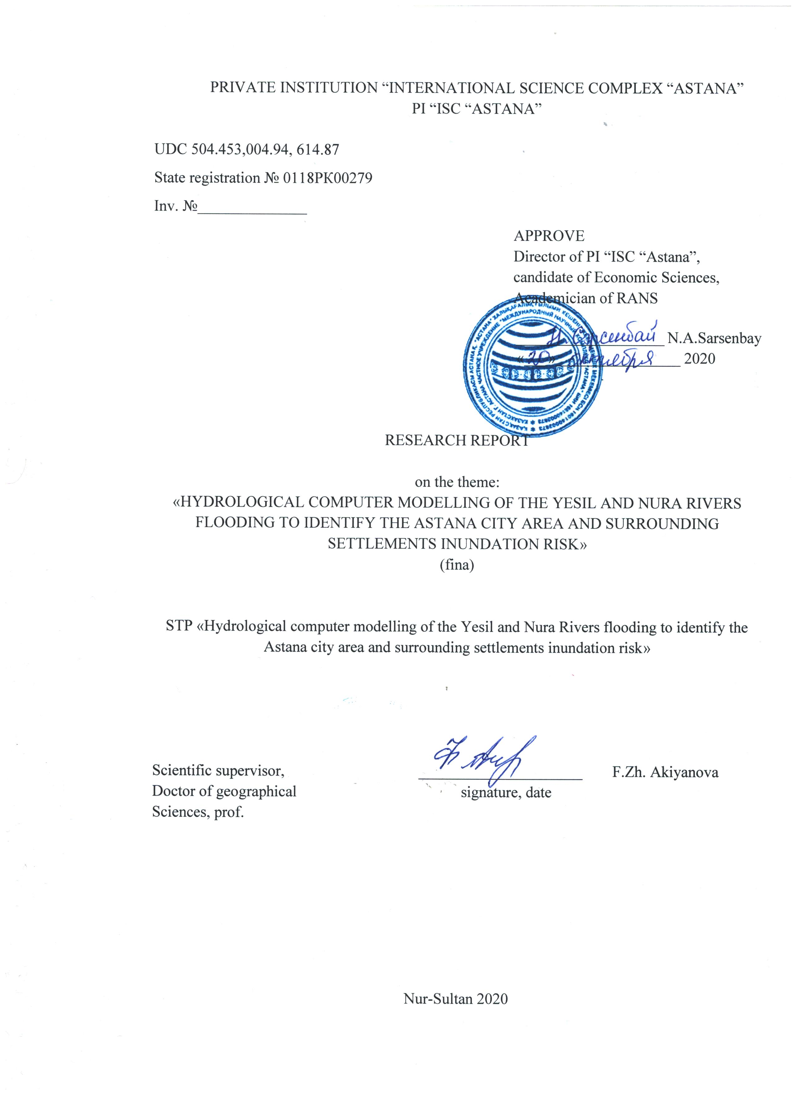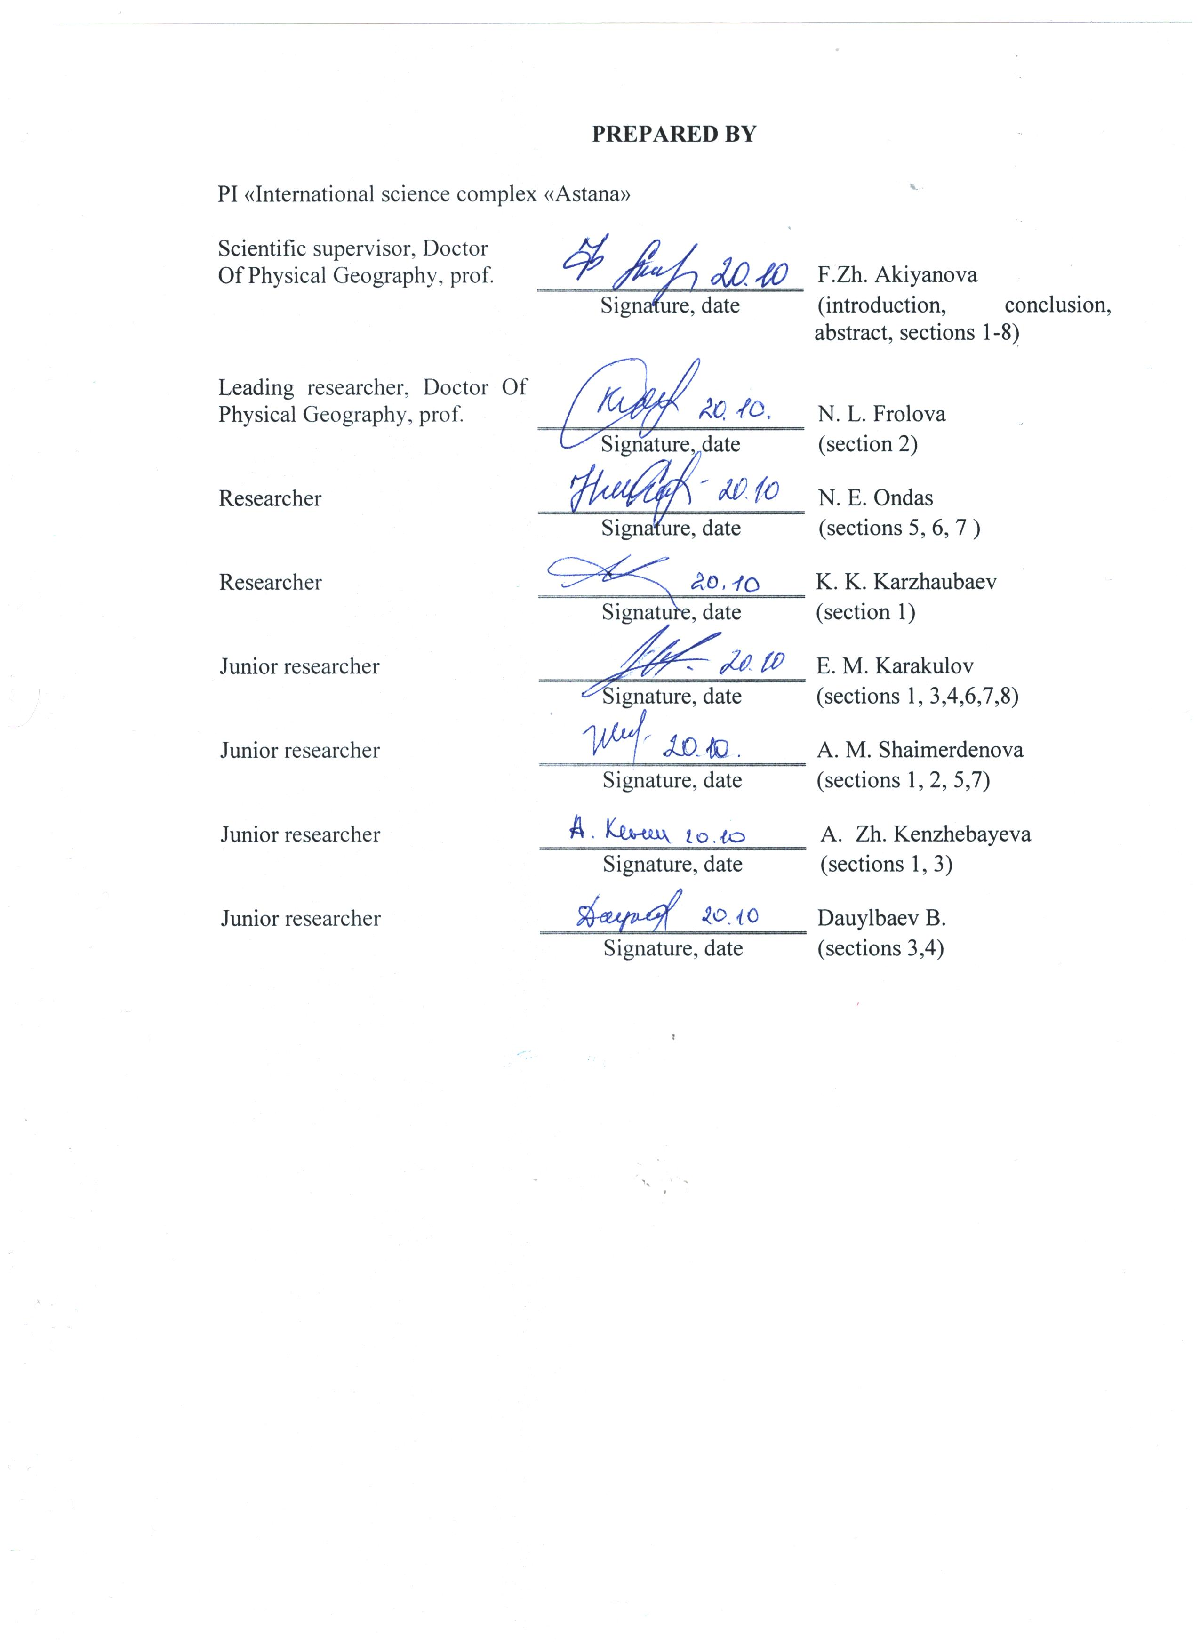

**REPORT**

The report consists of 194 pages, 1 book, 24 figures, 5 tables, 37 sources, 17 applications.

HYDROLOGICAL MODELING, GIS MAPPING, REMOTE SENSING, FLOOD RISK ASSESSMENT, ESIL.

Object of research: Floods in the valleys of the Esil and Nura rivers within the suburban area of ​​the city Nur-Sultan (Astana).

Purpose of the work: To determine the flood risk for the territory of the city Nur-Sultan and adjacent settlements during the flooding events of the Esil and Nura rivers based on computer hydrological modeling, the use of remote sensing data and the creation of digital maps of impact scenarios. Research methods: comparative, typological, statistical, hydrological modeling, GIS-mapping, remote sensing data processing, methods for creating a digital elevation model, methods of field research.

The results of the work and their novelty: 1) The geodatabase of the project was created; 2) Methods for assessing flooding of territories, taking into account hydrological modeling, have been studied; 3) Cartography of natural and demographic conditions of river valleys was carried out; 4) Up-to-date DEM with built-in bathymetric data of river channels was created; 5) The tendencies of variability of discharge and water levels in the flood of the Esil and Nura rivers are revealed, the novelty is associated with the assessment of water losses as a result of the extraction of sand and gravel mixture; 6) For the first time, hydrological modeling of flood risk of settlements during high flow was carried out in the HEC-RAS program; 7) GIS mapping of the risk of suburban flooding was carried out, 12 maps were created; 8) A scientifically grounded recommendations have been developed to reduce the risk of flooding; 9 articles: 1 in Web of Science, 3 in Scopus, 2 CCES.

The scope of the report results: scientific, educational, forecasting flood floods, damage assessment, design of engineering protection;

Recommendations for implementation: Thematic maps are introduced into the educational process of undergraduates of Eurasian National University named after L. Gumilyov (Agreement on cooperation No. 362 dated 26.10.2018). The “Bathymetry Map of the Astana Reservoir” at a scale of 1: 25,000 was introduced in the RSE “Kazvodkhoz” RSI MEGPR RK to clarify the volume of water resources of the reservoir; The significance of the work is associated with the introduction of the "Bathymetry Map of the Astana Reservoir" in the Republican State Enterprise "Kazvodkhoz", which developed proposals for their protection, as well as carrying out hydrological modeling under various conditions. Forecast assumptions on the development of the object. The results of hydrological modeling will be used in the design of preventive measures and planning of engineering protection structures against flooding event.

**РЕФЕРАТ**

Есеп 194 бет, 1 кітап, 24 сурет, 5 кесте, 37 дереккөз, 17 қосымша.

ГИДРОЛОГИЯЛЫҚ МОДЕЛЬДЕУ, ГАЖ-КАРТОГРАФИЯЛАУ, ҚАШЫҚТЫҚТАН ЗОНДТАУ, СУ ТАСҚЫНЫ ҚАУПІН БАҒАЛАУ, ЕСІЛ

Зерттеу объектісі: Нұр-Сұлтан қаласының (Астана) қала маңы аймағының шегіндегі Есіл және Нұра өзендері аңғарларындағы тасқын сулары. Жұмыстың мақсаты: Компьютерлік гидрологиялық модельдеу, ЖҚЗ деректерін қолдану және әсер ету сценарийлерінің сандық карталарын жасау негізінде Есіл және Нұра өзендерінің су тасқыны кезеңінде Нұр-Сұлтан қаласының аумағын және іргелес елді мекендерін су басу қаупін анықтау. Зерттеу әдістері: салыстырмалы, типологиялық, статистикалық, гидрологиялық модельдеу, ГАЖ-картографиялау, ЖҚЗ деректерін өңдеу, рельефтің сандық моделін құру әдістері, далалық зерттеу әдістері.

Жұмыс нәтижелері және олардың жаңалығы: 1) Жобаның геодеректер базасы құрылды; 2) Гидрологиялық модельдеуді ескере отырып, аумақтарды су басуын бағалау әдістері зерттелді; 3) Өзен аңғарларының табиғи және демографиялық жағдайларын картографиялау жүргізілді; 4) Өзен арналарының батиметриялық деректері бар жер бедерінің өзекті цифрлық моделі жасалды; 5) Есіл және Нұра өзендерінің су тасқынындағы шығыстардың және су деңгейлерінің өзгергіштік үрдістері анықталды, жаңалық бұл жерде құм-қиыршық тас қоспасын өндіру нәтижесінде су ысырабын бағалаумен байланысты; 6) HEC-RAS бағдарламасында су тасқыны кезінде елді мекендерді су басу қаупін алғаш рет гидрологиялық модельдеу жүргізілді; 7) Қала маңындағы аймақты су басу қатерін ГАЖ-картографиялау жүргізіліп, 12 карта құрылды; 8) Су басу қатерінің деңгейін төмендету бойынша ғылыми негізделген ұсыным әзірленді; 9 мақала:Web of Science-те 1, Scopus-та 2, ККСОН-да 3 жарияланды. Есеп нәтижелерін қолдану саласы: ғылыми, білім беру, су тасқынын болжау, залалды бағалау, инженерлік қорғанысты жобалау болды. Енгізу бойынша ұсыныстар: Тақырыптық карталар Л.Гумилев атындағы ЕҰУ (26.10.2018 ж. № 362 ынтымақтастық туралы шарт) магистранттарының оқыту процесіне енгізілген. 1:25 000 масштабтағы " Астана су қоймасының батиметрия картасы "ҚР ЭГТРМ" Қазсушар " РМК-ға су қоймасындағы су ресурстарының көлемін нақтылау үшін енгізілді. Жұмыстың маңыздылығы "Қазсушар" РМК-ға "Астана су қоймасының батиметрия картасын" енгізіп, сондай-ақ әртүрлі жағдайларда гидрологиялық модельдеуді жүргізумен және оларды қорғау бойынша ұсыныстар әзірленуіне байланысты. Объектінің дамуы туралы болжамды пайымдаулар. Гидрологиялық модельдеу нәтижелері алдын алу іс-шараларын жобалау және су тасқыны кезіндегі инженерлік-қорғау құрылыстарын жоспарлауға пайдаланылатын болады.

**CONTENT**

|  |  |
| --- | --- |
| INTRODUCTION………………………………………………………………………….. | 10 |
| MAIN PART OF THE R&D REPORT……………………………………………………. | 11 |
| 1 Collection and systematization of published, cartographic and statistical materials on |  |
| natural and anthropogenic conditions, monitoring climate and hydrological data and |  |
| remote sensing data………………………………………………………………………. | 11 |
| 2 Analysis of modern domestic and foreign methods of research on the risks of flooding |  |
| of territories, taking into account the methods of hydrological computer modeling…….. | 13 |
| 3 Assessment and mapping of natural, socio-economic conditions of the territory of the |  |
| valleys of the Esil and Nura rivers within the suburban zone, affecting the risk of |  |
| flooding of Nur-Sultan (Astana) and adjacent settlements during the flood of the Esil |  |
| and Nura rivers…………………………………………………………………………… | 17 |
| 4 Creation of a digital relief model of the Esil and Nura river valleys within the suburban |  |
| area of Nur-Sultan, as a basis for hydrological computer modeling…………………… | 24 |
| 5 Analysis of hydrological parameters of the Esil and Nura rivers in high water within the |  |
| suburban zone of the city of Nur-Sultan to identify the main trends in spatial and |  |
| temporal variability of river flow rates and water levels in high water…………………... | 27 |
| 6 Hydrological computer modeling of flooding during the flood period of the Esil and |  |
| Nura rivers within the suburban area of Nur-Sultan under various hydrological |  |
| conditions…………………………………………………………………………………. | 32 |
| 7 Assessment and geoinformation mapping of the risk of flooding of the territory of the |  |
| city of Nur-Sultan and adjacent settlements of the suburban zone during the flood of the |  |
| Esil and Nura rivers based on hydrological computer modeling…………………………. | 40 |
| 8 Development of scientifically grounded recommendations to reduce the risk of flooding |  |
| of the territories of Nur-Sultan and adjacent settlements of the suburban area during the |  |
| flood of the Esil and Nura rivers…………………………………………………………. | 45 |
| CONCLUSION…………………………………………………………………………….. | 48 |
| REFERENCES…………………………………................................................................... | 50 |
| APPLICATION A List of collected published, cartographic and statistical materials on |  |
| natural conditions ……………………………….……………………….. | 54 |
| APPLICATION B List of collected published, cartographic and statistical materials on |  |
| anthropogenic conditions………………….…………………………….... | 59 |
| APPLICATION C List of collected monitoring climate and hydrological data for 2017…. | 62 |
| APPLICATION D Earth remote sensing data………………………………………............ | 65 |
| APPLICATION E PostgreSQL data storage codes and structures E.1 SQL codes for |  |
| creating a database table………………………………………………...... | 75 |
| APPLICATION F Normalized baseline data on natural and anthropogenic conditions…… | 82 |
| APPLICATION G Cartographic materials on natural and anthropogenic conditions……... | 118 |
| APPLICATION H Digital terrain model…………………………………………………… | 127 |
| APPLICATION J Maximum water discharge at the gauging stations of the Esil and Nura |  |
| rivers within the suburban area of Nur-Sultan and their calculated values |  |
| of different supply………………………………………………………... | 128 |
| APPLICATION K Technical characteristics of hydraulic structures on the Esil and Nura |  |
| rivers within the suburban area of Nur-Sultan……………………………. | 130 |
| APPLICATION L Roughness coefficients n according to Manning………………………. | 134 |
| APPLICATION M Transverse profiles of the flood zone based on the results of modeling |  |
| 1% and 5% supply through settlements…………………………………...…. | 147 |
| APPLICATION N Work schedule for 2018-2020……………………………. | 156 |
| APPLICATION P Cooperation agreement with the Eurasian National University. L. |  |
| Gumilyov No. 362 dated 26.10.2018…………………………………….. | 164 |
| APPLICATION Q The act of implementing the results of scientific research No. 918 |  |
| dated 15.10.2019………………………………………………………….. | 166 |
| APPLICATION R Publications, participation in conferences, appearances in the media |  |
| for 2018-2020……………………………………………………….……. | 168 |
| APPLICATION S Scanned versions of extracts from the meetings of the Academic |  |
| Council of the Institute of Geography and Environmental Management |  |
| of PI "International Science Complex" Astana "……………..………...… | 189 |

**TERMS AND DEFINITIONS**

The following terms and definitions are used in this research report.

|  |  |  |
| --- | --- | --- |
| Database | – | collection of data organized according to certain rules that establish General principles for describing, storing, and manipulating data. Data storage in the database provides centralized management, compliance with standards, data security and integrity, reduces redundancy and eliminates data inconsistency; |
| Digital terrain model | – | a digital representation of spatial features that correspond to the object composition of topographic maps and plans, used for the production of digital topographic maps; |
| Flood | – | a phase of the river's water regime that can be repeated many times in different seasons, characterized by an intense, usually short-term increase in water flow and levels, and caused by rain or snowmelt during thaws; |
| High water | – | phase of the river's water regime that repeats annually in the same season under these climatic conditions, is characterized by the highest water content, high and prolonged rise in the water level, and is caused by snowmelt or joint melting of snow and glaciers; |
| Hydrological modeling | – | simplified representation of the hydrological cycle or part of it. Hydrological models are mainly used to predict and understand hydrological processes |
| Natural hazard | – | a threatening event or probability of occurrence of a potentially destructive phenomenon indicating the place and time of its development; |
| Natural risk | – | expected losses (from death and loss of human health, loss of property, disruption of economic activity) caused by the manifestation of a specific natural hazard in a given area over a certain period of time; |
| Remote sensing data | – | data on the Earth's surface and objects located on it or in its interior, obtained by the survey equipment of the space system in one or more sections of the electromagnetic spectrum; |

|  |  |  |
| --- | --- | --- |
| Remote sensing data processing | – | process of performing operations on aerospace images, including their correction, transformation and improvement, decryption, and visualization; |
| Spatial resolution | – | the value of the image pixel in spatial units. Characterizes the size of the smallest objects visible in the image; |
| Suburban area | – | the territory adjacent to the city and located with it in close functional, cultural,household and other relationships; |
| Water bodies | – | concentrations of water in land surface topography and the earth's interior that have borders, volume, and water regime (seas, rivers, channels equated to them, lakes, glaciers, and other surface water bodies, parts of the subsurface that contain underground water); |
| Water discharge (Q) | – | the volume of water flowing through the cross-section of a watercourse per unit of time; |
| Water regime | – | changes in water levels, flow rates, and volumes in water bodies and soils over time; |
| Water resources | – | reserves of surface and underground water concentrated in water bodies that are used or can be used. |

­

**LIST OF ABBREVIATIONS AND DESIGNATIONS**

The following designations and acronyms are used in this research report

|  |  |  |
| --- | --- | --- |
| CWR МEGNR | – | Committee on water resources of Ministry of Ecology, Geology and Natural resources |
| DB | – | database |
| DMS | – | database management system |
| DTM | – | digital terrain model |
| ERS | – | Earth remote sensing |
| GIS | – | geographic information system |
| МEGNR | – | Ministry of Ecology, Geology and Natural resources |
| МES | – | Ministry of Education and Science |
| RSE | – | Republican state enterprise |
| RSI | – | Republican state institution |
| SBRA | – | Shchuchinsk-Borovoye resort area |
| SQL | – | Structured Query Language |
| SRTM | – | [Shuttle Radar Topography Mission](https://www.google.kz/url?sa=t&rct=j&q=&esrc=s&source=web&cd=3&cad=rja&uact=8&ved=0CC8QFjAC&url=http%3A%2F%2Fsrtm.usgs.gov%2F&ei=3dWGVai_DoOQsgGu85noAg&usg=AFQjCNEijOSIvPtYmxoLwyYrxOzDoZ_5lg&bvm=bv.96339352,d.bGg) |
| UAV | – | unmanned aerial vehicle |

**INTRODUCTION**

Assessment of the current state of the problem. Floods represent an extreme disaster that causes significant natural and economic damage. Over the past 15 years, more than 300 floods have occurred in Kazakhstan, 70% of which are caused by spring floods [1]. The justification for the need for scientific research is the existing risk of flooding for settlements in the suburban area located within the valleys of the Esil and Nura rivers. The basis for the research was the Agreement No. 156 dated 03/15/2018 between the State Institution "Science Committee" of the Ministry of Education and Science of the Republic of Kazakhstan and the PI "ISC" “Astana”. The initial data is the materials from the akimat of Akmola region and the city of Nur-Sultan, the Committee on Statistics, websites of research institutes and universities, geological funds, world electronic resources, office and field work of the project executors. The relevance of research is associated with an increase in the frequency of manifestations of dangerous floods and their impact on residential areas and engineering and transport infrastructure.

The aim of the project was to determine the risk of flooding the territory of Nur-Sultan and adjacent settlements during the flood of the Esil and Nura rivers on the basis of computer hydrological modeling, the use of remote sensing data and the creation of digital maps of impact scenarios. Objectives 2018-2020 are completed in full in accordance with the schedule. The main results of the project are related to the implementation of the following tasks: 1) Creation of an integrated database; 2) Analysis of domestic and foreign research methods of flooding risks, taking into account the methods of hydrological modeling; 3. Assessment and mapping of natural and demographic conditions affecting the risk of flooding; 4. Creation of the DEM of the Esil and Nura river valleys; 5) Analysis of hydrological parameters of the Esil and Nura rivers during high water; 6) Hydrological computer modeling of flooding during flood periods under various hydrological conditions; 7) Assessment and GIS-mapping of the risk of flooding during high water periods based on hydrological computer modeling; 8) Development of scientifically grounded recommendations to reduce the risk of flooding in the territory of the city of Nur-Sultan and adjacent settlements during river floods.

The list of titles of the prepared interim reports by stages: 2018: IRN No. AP05136087 "Hydrological computer modelling of the Esil and Nura Rivers flooding to identify the Astana city area and surrounding settlements inundation risk", state registration number: 0118RK00279; Inv. No. 0218RK00971; 2019: IRN No. AP05136087 "Hydrological computer modelling of the Esil and Nura Rivers flooding to identify the Astana city area and surrounding settlements inundation risk", state registration number: 0118RK00279; Inv. No. 0219RK00916.

**MAIN PART OF THE R&D REPORT**

**1 Collection and systematization of published, cartographic and statistical materials on natural and anthropogenic conditions, monitoring climate and hydrological data and remote sensing data**

Published, cartographic and statistical materials according to the requests of the official central and local executive bodies, websites of the Committee on Statistics of the Ministry of Investment and Development of the Republic of Kazakhstan, electronic libraries, geological funds were collected (Application A, B, C). The data base contains:

- lists and maps of the location of 5 meteorological stations (category, year of opening, district) and 10 gauging stations with coordinates (RSE "Kazhydromet»);

- published hydrological reference books and collections: "Basic hydrological characteristics", "Surface water resources of virgin and fallow lands development areas of Akmola region of the Kazakh SSR"; "Surface water of virgin and fallow lands development area, Kokchetav region of the Kazakh SSR"; "Surface water resources of the USSR, Central and South Kazakhstan, Karaganda region", etc .;

- statistics and diagrams for hydraulic works of the Akmolinsky branch of RSE "Kazvodkhoz" and PUC "Astana su Arnasy" RSI Esil basin inspection on regulation of use and protection of water resources CWR of RK MEGNR; data for flood tributaries and discharges into the downstream of the Astana reservoir, "the Protection of the city of Nur-Sultan from flood waters of the Esil river" counterregulator, Preobrazhensky hydroengineering complex on the Nura river for the period of 1976-2020.;

- statistical and schematic data provided by the DES of Nur-Sultan, DES of Akmola and Karaganda regions of the Ministry of internal Affairs of the Republic of Kazakhstan on the nature of the flood of the Esil and Nura rivers, floods, their consequences and protection measures;

- data for 2007-2020 on emergency hydrological situations in the districts of Akmola and Karaganda regions, on flooded settlements, critical water levels, road and bridge washout, etc.;

- quantitative data provided by the Ministry of agriculture of the Republic of Kazakhstan on the main indicators of water intake, use and discharge in Tselinograd, Arshalyn and Shortandinsky districts of Akmola region for 2017;

- cartographic material on natural and anthropogenic conditions, including: the Plan-circuit of susceptibility of the territory of Nur-Sultan emergency situations of natural and technogenic character; Maps and charts of exposure of areas of Akmola region emergency situations of natural and technogenic character; Map of soils of Akmola region and Nur-Sultan city; Map of agricultural land use of suburban areas of Nur-Sultan and Nur-Sultan agglomeration; Map of lands of water Fund of the suburban zone of Astana and Nur-Sultan agglomeration; Map of functional zoning of the territory of the suburban zone of Astana and the Astana agglomeration;

Data from remote sensing of the Earth on the research area (Landsat-8, Sentinel for 2015-2020) were collected. Optical and radar images, aerial photographs, and data from open sources were collected (Application D), as a result of bathymetric surveys, data on the depths of rivers and the Astana reservoir were included in the database. Database has been created based on systematization of monitoring climate and hydrological data, including data for 2017-2020 (figure 1.1).

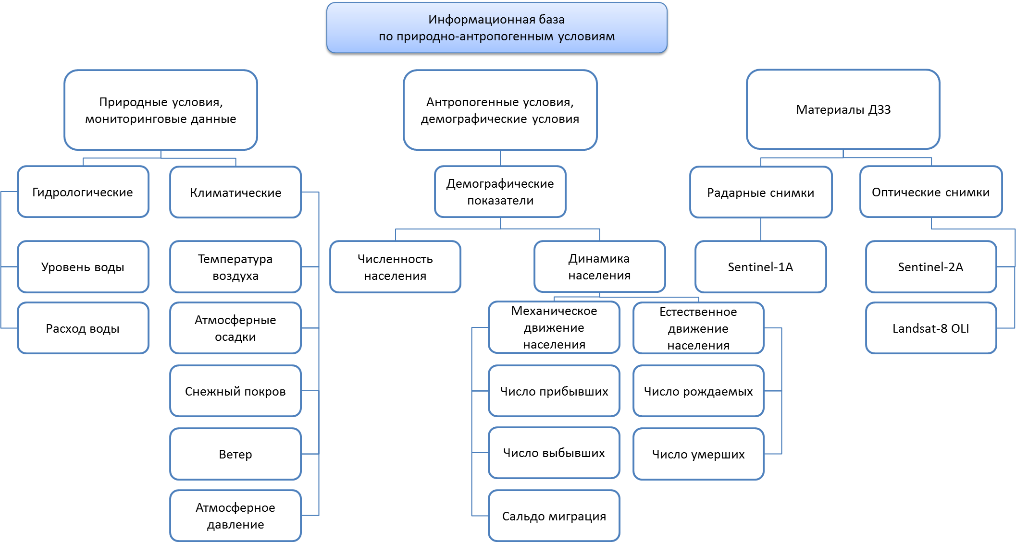

Figure 1.1 – block diagram of the data base structure

Based on the analysis of the properties of various databases, it was determined that the PostgreeSQL database with the activated PostGIS extension is optimal for solving project tasks. According to the developed database structure, tables and relationships between tables are created in SQL (Application E). Thus, for further work on the project, an extensive information database has been created containing published, cartographic, statistical and field data on natural and anthropogenic conditions, demography, climate and hydrological data, remote sensing data, which is necessary for assessing the flood risk and hydrological modeling.

**2 Analysis of modern domestic and foreign methods of research on the risks of flooding of territories, taking into account the methods of hydrological computer modeling**

Currently, there are a number of methodological developments for assessing natural hazards and risks. Hydrological processes become dangerous if natural and anthropogenic changes in water bodies, their condition and regime lead to the risk of economic, environmental and social damage. The danger of hydrological phenomena includes the frequency of the phenomenon and the intensity of the impact, taking into account the area of distribution, the duration of the impact, and the rate of flooding [2, 3]. After identifying hazards, i.e. identifying fundamentally possible risks, it is necessary to assess their possibility( probability), level and consequences. The main method of risk analysis is the probabilistic method. It is based on the following methods: statistical (probability of adverse events by frequency, according to statistical data), probability-theoretic (rare events, in the absence of statistical data), heuristic (expert assessment of complex risks in the absence of statistical data).

To predict the occurrence of natural hazards, a probabilistic deterministic approach is widely used, based on identifying patterns of development of phenomena, their cyclicity, for the purpose of medium - and long-term forecasting. In 1981, Kaplan, S. & Garrik, B. J. proposed a quantitative definition of risk that has found wide application in many areas of risk analysis. Risk (R) depends on 3 main components: R= {Si,Pi,Di}, i=1,2,…k, where S – characterizes a possible scenario (the risk of flooding, in the case under consideration), P – the probability of an accident, D – the damage associated with the event (in monetary terms), k – the number of scenarios of the incident [4].

The most simple formula for the estimation of risk assessment is (1):

R(t) = PхD,

(1)

where

R(t) is the risk value for time t,

P is the probability of a natural hazard,

D is the damage caused by this natural hazard [5].

To calculate the probability of flooding, it is necessary to use a continuous time series of monitoring observations from gauging stations, and build a series of maximum flow rates and levels. After determining the water discharges of analytical or graphical-analytical method, determine the estimated high water level.

A damage indicator is required for risk assessment. Damage assessment is based on the cost of objects located in the affected area and their degree of vulnerability. Damage occurs only in territories where there are objects of the material sphere. The flood risk can be quantified using the amount of damage (in natural or economic terms) of varying frequency or its mathematical expectation [6]. This indicator is calculated using the formula (2):

$М\left(D\right)=\frac{С×р_{зат }}{100}$,

(2)

where

M (D) is the mathematical expectation of damage,

C is the cost of the estimated object,

p\_(ZAT ) is the security of the flood level, %.

Features of analysis and risk assessment of dangerous hydrological phenomena are determined by the spatial scale of the study. The composition of the source information, the methods of its processing, the choice of appropriate indicators and applied mathematical models, and the features of mapping phenomena depend on the spatial level of the study [3]. A comprehensive assessment creates a series of thematic maps that reflect changes in the quantitative indicators of natural hazards in space. They show the conditions and factors of natural hazards, the probability of their occurrence, the characteristics of the vulnerability of the social environment and industrial facilities, and assess the likely damage [7].

Flood risk assessment includes blocks of natural and socio-economic indicators. Hydrological indicators are determined by the area, duration and depth of flooding during the passage of the maximum flow, the probability of these events and the degree of impact on society and the economy. The socio-economic block takes into account the material resources of the development area and the amount of damage from possible flooding.

For the obtained values, the "weight" (significance) of individual qualities is established by introducing a qualimetric coefficient, using expert assessments and literature data. When assessing the natural component of flood risk characteristics for the duration of flooding selected factor of 0.5; depth – 0,2; other factors of 0.1. Based on the results of calculations of hazard indices and vulnerability is, in matrix form, typology of regions by degree of natural hazard floods, on the one hand, and socio-economic vulnerability, on the other [7].

The natural risk assessment block is based on the analysis of the hydrological conditions and water regime of the watercourse and includes meteorological, hydrological, geomorphological, and anthropogenic characteristics of the flow formation. Using the collected data and the use of GIS technologies, a digital terrain model of the studied territory is created, which is used for hydrodynamic modeling.

Currently, hydrological modeling is most effectively performed using geoinformation systems. A large number of models have been developed and applied in practical calculations in different countries: Russian software systems River-1D and Stream-2D developed By V. V. Belikov et al. [8, 9, 10], Mike 11, Mike 21 of the Danish hydrological Institute [11], Delft 3D (multi-layer two-dimensional model) Deltares Institute of Delft (Netherlands) [12], American HEC-RAS of the American Ceorps of Cengineers [13], FLO-2D [14], French TELEMAC, etc.

Models differ mainly in the ways of schematization of the computational domain (triangular, quadrilateral, and mixed grids), the computational schemes and methods used (finite differences, finite elements), and a set of additional blocks. Depending on the detail of the source data and the problem being solved, one-dimensional and two-dimensional models of water flow are used. One-dimensional models are used for extended sections based on data on the morphometric characteristics of river valleys, represented as separate transverse profiles located at a distance from each other of the order of several channel widths or more (figure 2.1).

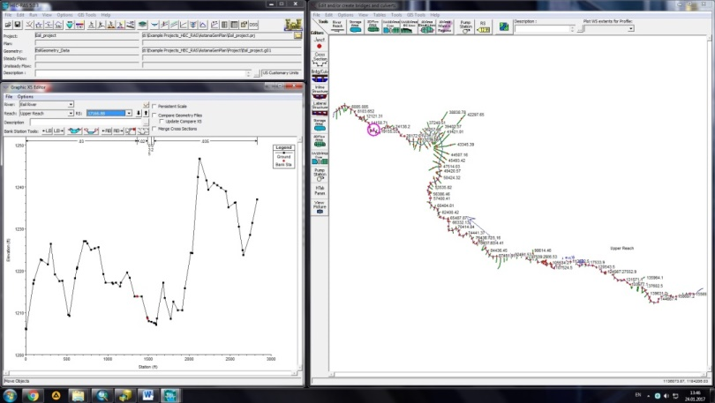

Figure 2.1 – Creation of the map of the R section. Esil for the one-dimensional HEC-RAS model

The results of calculations are changes in water surface levels and water flow rates over time on each cross-section within the calculated area (figure 2.2). In accordance with the analysis, the project uses the model of the river analysis system HEC-RAS 5.0.7. This publicly available free software was developed by the hydrological center of the us Army Ceorps of Engineers. It is widely used for performing 1D and 2D calculations of river hydraulics with steady and unsteady flow, sediment transport modeling, and water quality analysis. HEC-RAS 2D uses shallow water equations that describe the movement of water in terms of depth-averaged 2D velocity and water depth in response to gravity and friction.

|  |  |
| --- | --- |
| Описание: \\Geoinst\geo\1. Акиянова Ф.Ж\10 от Ергали\Статья 2018\СЦЕНА_1.jpg | Описание: \\Geoinst\geo\1. Акиянова Ф.Ж\10 от Ергали\Статья 2018\СЦЕНА_2.jpg |

Figure 2.2 – Visualization of calculation results based on the one-dimensional HEC-RAS model

These equations represent the conservation of mass and momentum in the plane. The finite volume method used in HEC-RAS is described as advantageous because of its conservativeness, geometric flexibility, and conceptual simplicity. This solution approximates the average integral over the reference volume and allows a more general approach to unstructured meshes. 2D modeling using HEC-RAS allows you to model variability across and along the flow path. The model area is sampled into grid cells, where each cell uses the underlying terrain data with less resolution loss (a sub-grid model). This leads to improved computational time. For each cell and cell face, HEC-RAS generates a detailed table of hydraulic properties (for example, height-volume ratio, height-area ratio, and so on). This allows you to increase the size of cells that can store terrain details and use higher time steps.

Water can move in any direction based on a given terrain and flow resistance controlled by the type of land use and the associated manning coefficient. The main values used in this software can be found in the open access engineering reference [15].

**3 Assessment and mapping of natural, socio-economic conditions of the territory of the valleys of the Esil and Nura rivers within the suburban zone, affecting the risk of flooding of Nur-Sultan (Astana) and adjacent settlements during the flood of the Esil and Nura rivers**

The assessment and mapping of the main natural (climatic, hydrological, geomorphological) and socio-economic (demographic) conditions of the territories of the valleys of the Esil and Nura rivers within the suburban zone of Nur-Sultan, affecting the risk of flooding of the adjacent settlements of the suburban zone during flooding of the Esil and Nura rivers was completed.

Assessment and mapping of climatic conditions was studied based on data from Nur-Sultan (Astana) and Arshaly meteorological stations, which have a continuous series of observations from 1981 to 2017. The average annual air temperature varies from 2.8°C at the Arshaly meteorological station and up to 3.6°C at the Nur-Sultan station (Application G). The air temperature regime in the suburban area of ​​ Nur-Sultan is characterized by strong contrast in cold and warm seasons (figure 3.1). The highest temperatures are observed in July, mainly in Nur-Sultan and amount to 20.7 ° C. The temperature regime of the cold period is more variable from year to year and fluctuations from -8.7°C to -13.5°C.

|  |  |
| --- | --- |
|  |  |
| a) | b) |

a – average monthly air temperatures, оС; b – monthly precipitation, mm

Figure 3.1 – Annual variation of temperatures and precipitation

According to long-term average data on the territory of the suburban area, the amount of precipitation falling during the year is more than 300 mm and increases from 313 mm at Arshaly station to 325 mm in Nur-Sultan (Application G). The amount of precipitation in the warm season prevails over the cold one by 2.2-2.5 times. The nature of the distribution of atmospheric precipitation in the suburban area changes submeridianally, in the south and southwest there is the smallest amount (189-197 mm per year), but as it moves to the northwest, the amount of precipitation increases (265-274 mm/year). The maximum precipitation occurs in July, with an average of 55 mm of precipitation in Astana and 48 mm in Arshaly. The minimum precipitation is recorded in February, an average of 15-16 mm throughout the suburban area. In the cold season, the least precipitation falls in Arshaly (91 mm). In general, in the suburban area, the frequency of occurrence of the warm period (April-October) with good moisture and precipitation of 290 mm or more is 15%, i.e. 1.5 times every 10 years. The recurrence of a warm period with insufficient moisture (less than 190 mm of precipitation) is 12%. In the remaining 7.5 years out of 10, the usual moisture conditions inherent in this territory are observed. Over the past 35 years, the least rainy years were 1991, 1997 and 2010. Precipitation more than 30 mm (heavy rain), most intensively contribute to the development of planar erosion. An increase in such days is recorded from south to north: in April-October, 4.3 total hours are observed in Arshaly, and 12.7 hours in Nur-Sultan.

The average annual wind speed gradually increases from the southeast (Arshaly) to the north (Nur-Sultan) and east of Nur-Sultan (Application G). The annual variation of average monthly wind speeds has a general dynamic of an increase in the winter months and a decrease in the summer.

On the basis of the analysis of climatic parameters, the territories of the suburban area of Nur-Sultan, which are most susceptible to the effects of water erosion, have been identified. Taking into account the average monthly air temperature and the total number of hours of more than 30 mm during the warm period, the soils in the study area are at a high risk of the development of erosion processes from May to August. Thus, in the warm season of the year on the territory of the suburban area, there are two periods of development of negative exogenous processes: a high risk of erosion from May to August and in September.

Assessment and mapping of hydrological conditions. The research area of ​​the suburban area of ​​Nur-Sultan belongs to two water basins (HEB): Esil and Nura-Sarysu. The area of ​​the Esilskiy HEB within the suburban area is 18203 km² (83.8%), Nura-Sarysu – 3232 km² (14.9%) (Table 3.1).

The rivers belong to the Kazakh type of regime with a predominant snow supply. The occurrence of hazardous hydrological situations during the flood period is due to the depth of the snow cover at the beginning of the flood, the water content in the snow, the course of air temperature, the depth of freezing and soil moisture reserves, to a lesser extent rainfall, flow regulation, discharges from reservoirs.

The main phase of the water regime in the natural period for rivers of this type was the high water (April-May), which account for about 90% of the annual runoff, for the period of summer-autumn low-water period (June-October) - no more than 3-10%, for winter low-water period (November-March) - 0-4% of runoff [16]. Analyzing the average long-term course of the average monthly water discharge for the conditionally natural period, it was determined that the peak of the spring flood occurs in April [16].

Table 3.1 – Hydroeconomicbasins, districts and sections of the Esil and Nura river valleys within the suburban area of Nur-Sultan

|  |  |  |
| --- | --- | --- |
| Name of the HEB, HE of the region and HE of the site | Area | |
| km2 | % |
| Esilskiy HEB | 18203 | 83,8 |
| Hydroeconomic area of the Esil river | 7207 | 33,1 |
| Astana reservoir | 2843 | 13,1 |
| lake Tanakol | 1613 | 7,4 |
| Esil river (bottom) | 2751 | 12,6 |
| Hydroeconomic area of ​​Nura-Esil village | 1671 | 7,7 |
| Esil river (Nura Esil canal) | 1433 | 6,6 |
| Kozykosh river | 238 | 1,1 |
| Nura-Sarysusky HEB | 3232 | 14,9 |
| Hydroeconomic area of thr Nura river | 2403 | 11,1 |
| Nura river | 1947 | 9 |

For the Esil river (Nur-Sultan) the maximum value is 58.4 m³/s, for the Nura river – v. Romanovskoe - 120 m³/s. The duration of the spring flood on medium rivers (3000-30 000 km²), which includes the Esil river in the alignment of the gauging station in Nur-Sultan (7400 km²), is from 30 to 80 days. On rivers with a discharge of more than 40,000 km², to which Nura river belongs in the alignment of the Romanovka gauging station near the village named after R. Koshkarbaeva (48 100 km²) [16], the duration of the spring flood 50 days or more. The high water is single-peak, in years with significant rainfall in the spring, it is complicated by the passage of floods. Congestion is almost uncommon.

Data analysis for the past decades, i.e. during the period of river regulation, also showed that up to 95-98% of the annual runoff falls on the share of spring floods [17]. Clearing ice from the river bed on the Esil and Nura rivers occurs in late March – early April. Analysis of the main characteristics of water flow at the gauging stations of the Esil and Nura rivers for the spring period, according to the monitoring data of the RSE "Kazhydromet", showed that 2014-2015 are high-water, while 2011-2013 characterized by relatively low water content.

Average long-term water discharge of the Esil river near the city of Nur-Sultan 3.65 m3/s (1974-2007), by the city of Petropavlovsk it increases to 53.7 m3/s (1975-2016) [18,19]. Intra-annual variation of water discharge of the Esil river shows an increase in the flow rate of high water in dry and medium-water years for the period of disturbed runoff (1974-2007) as compared to the conditionally natural period (1933-1973) (figure 3.2). Fluctuations in river levels above low water within Nur-Sultan city are 4.5-5 m, in other areas 8-12 m [18].

Average long-term runoff of the Nura river at the village named after R. Koshkarbaeva is 0.68 km3. Average long-term water discharge of the Nura river at the village named after Koshkarbaev is 20,3 m3/s (1974-2007). For the Nura river, there is a decrease in flood discharge in years of different water content for the period of disturbed runoff (1974-2007) in comparison with the conditionally natural period (1933-1973). Intra-annual variation of water discharge of the Nura river is shown in Figure 2.2. Fluctuations in levels above low water average 2.5-6 m [18].

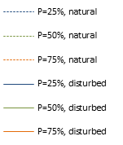

|  |  |
| --- | --- |
| a)  а - along the Esil river, Nur-Sultan | b)  b - along the Nura river, village n.a. R. Koshkarbaeva |

Figure 3.2 – Water discharges of different flow availability in the conditionally natural (1933-1973) and disturbed (1974-2007) periods along the Esil and Nura rivers [18]

Based on the analysis of the main characteristics of the Esil river flow for the spring period it was determined that 2014-2015 are a period of increased water content. The value of the maximum water level in 2015 exceeded the corresponding value in 2012 by 6 times (figure 3.3). On the Nura river, the value of the maximum water level in 2015 is 2 times higher than the value of 2012. In general, this water body is characterized by a uniform increase in the indicator of the maximum water level for 2011-2015 (figure 3.4).

|  |  |
| --- | --- |
|  |  |
| 2012 | 2016 |

Figure 3.3 – The course of the level and discharge of the Esil river for the spring

at the gauging station near the Volgodonovka village

A characteristic feature of the Nura River is bifurcation, which is due to the weakly expressed watersheds of the Esil-Nura interfluve and the presence of a general slope towards the Esil river with a fall of 12.5 m. In this regard, in addition to the connection of these two rivers, a part of the water flows. The connection takes place along three channels – Sarkrama, Kozgosh and Mukhor, which are completely within the suburban zone and increase the risk of flooding of Nur-Sultan and adjacent settlements.

|  |  |
| --- | --- |
|  |  |
| 2012 | 2016 |

Figure 3.4 – The course of the level and flow rate of the Nura river for the spring period

according to the gauging station near A. R. Koshkarbaeva

Assessment and mapping of geomorphological conditions. Geomorphological conditions in general determine the risk of the spatial impact of flood waters, controlling them through the morphological features of the types and forms of relief of valley and watershed complexes. The relief of the study area is characterized by weak dissection, with a general slope of the surface from southeast to northwest from 425 to 320 meters and a variety of morphogenetic types and forms. In the eastern and northern parts of the region, it is represented by denudation basement plains with areas of low erosion-tectonic watershed and denudation riparian shallow hills. Accumulative lacustrine-alluvial, lacustrine and deluvial-proluvial plains of the Quaternary age are developed in the southwestern and areas in the northeastern part. The development of slightly wavy stratal plains is observed in small areas on the Paleogene and Neogene sediments. The weak energy of the relief predetermined the conditions for the dispersion and interception of runoff, the formation of gentle sloping lake depressions, especially within the Nura-Esil watershed.

In geomorphological terms, the risk of flood impact is high for the surfaces of the high floodplain and the first above-floodplain terrace of the Esil and Nura rivers, increased for the second above-floodplain terrace and lacustrine-alluvial flat and slightly wavy plain of the interfluve with numerous lake basins. The river channels meander, consist of stretches and rifts, the depth varies from 0.5 to 5 m.The high floodplain of the Esil and Nura rivers is clearly expressed in relief, its width varies from several meters to a kilometer. The height of the low floodplain is up to 1-1.2 m, the height of the surface of the high floodplain varies within 2.5-3 m. The first terrace above the floodplain is developed almost everywhere, the width varies from several hundred meters to 1.5 km, slightly sloping. Above the average long-term edge of the water rises from 4 to 6 m, on the surface there are numerous traces of old speech. The second terrace above the floodplain is fragmentary, the width in some areas reaches 3-4 km, the scarp is distinctly expressed, the excess above the edge varies from 6 to 8 m.

The flow formation of the Nura River occurs in the upper and middle reaches of the river. Part of the lower reaches of the river is represented within the suburban area. The valley is not clearly expressed, gentle slopes merge with the watershed. The river has a well-defined floodplain on both banks, it is a water flow that does not dry out in summer, with a predominance of stretches over ripple areas [16].

The modern period was characterized by flow regulation and active anthropogenic restructuring of river valleys. The assessment of the degree and rate of anthropogenic impact on the relief was carried out on the basis of a detailed analysis of maps of land use types within the main types and large relief forms. The assessment of the degree of anthropogenic impact on the relief was determined on the basis of the area affected by positive and negative forms of anthropogenic relief, morphometric (slopes, dissection, etc.) and morphological features of the relief.

Assessment and mapping of demographic conditions. The population of the suburban area of ​​Nur-Sultan in 2017 amounted to 180.447 thousand people (excluding Nur-Sultan city). The population of Nur-Sultan at the beginning of 2017 was 972. 692 thousand people. The average population density in the suburban area, excluding Nur-Sultan city, is 33.9 people/km2. The highest indicator of population density in the context of rural districts.

On the territory of the suburban zone of Nur-Sultan city in the context of rural districts, a map of population density and population was compiled (Application G). Researches have shown that the proximity of most settlements and the economic complex to rivers determines their increased exposure to flood waters, which can lead to economic damage and increased social tension.

The studies were carried out within the valleys of the Esil and Nura rivers, which are part of the suburban area of ​​ Nur-Sultan, located within an hour's reach from the city boundaries and constituting a single social and natural-economic territory with it.

Due to the fact that the risk of the impact of floods on residential facilities and infrastructure increases when approaching river beds and floodplains, an analysis of the location of these facilities within water protection zones was carried out.

The minimum width of the water protection zone of the Esil and Nura rivers within the suburban zone is 1000 m from the water's edge, but in most of the territory it expands to 2000 m (Application G). On the territory of water protection zones, coastal water protection strips are established, the minimum width of which varies within 35-100 m, and in settlements the strip varies from 50 to 75 m. In accordance with the rules, the boundaries of water protection zones are established without taking land from landowners and land users, on maps are displayed in accordance with the scale.

Within the boundaries of the water protection zone of the Nura River, 6 rural settlements with a total number of 10,316 people are located in the suburban area. Within the boundaries of the water protection zone of the Esil River, 19 settlements with a total number of 44,852 people are located in the suburban zone.

The analysis of the territories of water protection zones in the context of the Tselinograd district, in general, in the district – 53 settlements with a total population of 121,789 people, of which 18 settlements with a population of 36,745 people are located within the water protection zones. In general, there are 32 settlements in Arshali district with a total population of 28,478 people, of which 7 settlements with a population of 18,423 people are within the water protection zone.

Thus, an assessment was made of the climatic, hydrological, geomorphological and demographic conditions of the suburban area of ​​ Nur-Sultan, which affect the risk of flooding of settlements during the flood of the Esil and Nura rivers. Based on the research, a number of scorecards were created in ArcGIS 10.1, which will form the basis of project research in 2019-2020.

**4 Creation of a digital relief model of the Esil and Nura river valleys within the suburban area of ​​Nur-Sultan, as a basis for hydrological computer modeling**

When creating a digital elevation model (DEM) of the Esil and Nura river valleys within the suburban area of ​​Nur-Sultan, a set of tasks of 3 blocks was performed:

1)Cameral preparatory: determination of the projection, processing of topographic maps with the creation of a point cloud with coordinates and absolute heights, the creation of vector layers of lakes, rivers and reservoirs based on the interpretation of the current autumn images of 2018 in the ArcGIS 10.7 program, the collection of medium and high resolution satellite images over the territory of the suburban area, the collection of digital models for the territory that are freely available;

2) Field instrumental: conducting a bathymetric survey of the Astana reservoir [20] and the channels of the Esil and Nura rivers within the suburban area of ​​Nur-Sultan using a Lowrance Elite 9 TI echo sounder-chartplotter, carrying out leveling profiles of river valleys near gauging stations with an electronic Leica TS06 plus R500 5 "EGTacheometer ; creation of a network of control points with a Leica GS 16 Viva GNSS receiver over the suburban area with an emphasis on settlements located close to river beds; aerial photography of riverbed and floodplain parts of rivers from a DJI Phantom 4 quadcopter.

3) Cameral data processing with the construction of a digital elevation model: Unloading and processing data from the Lowrance Elite 9 TI echo sounder-chartplotter, creating bathymetric maps of the Astana reservoir and the channels of the Esil and Nura rivers within the suburban area of ​​Nur-Sultan; Unloading aerial photographs from a DJI Phantom 4 quadcopter and processing them in the Agisoft PhotoScan program to obtain connected mosaics along river channels and floodplain parts of rivers. Data upload and processing via a network of control points from a Leica GNSS receiver. Bringing the received data into a single point cloud format and building a digital elevation model.

The detail of the digital model depended on a number of criteria, including the type and resolution of space images. The work used radar images of the Sentinel-1A satellite with a spatial resolution of 10 m, which are characterized by a high-quality image regardless of weather conditions and provide information on the physical properties of the earth's surface [21-23]. The images are freely available on the official portal of the Copernicus program. Of the 4 data types, processed images of Level 1 Single Look Complex (SLC) were used, which are complex images with the phase and amplitude of the indicated areas and ground level data (GRD) of level 1. The main technical characteristics of the spacecraft are 12-day repetition cycle, dimensions 3.9 mx 2.6 mx 2.5 m; the geographic coordinate system is WGS-84 [24]. To obtain the DEM, data from the orbital level 1 Single Look Complex (SLC) for June 2018 were used.

The processing cycle for Sentinel-1 radar images was performed in ESA SNAP Desktop. In its primary form, the image consists of complex data such as real and imaginary (i, q) channels, VV and VH polarizations and without incoherent accumulation.

The construction of the elevation map was based on the interferometric processing of a pair of radar images. The method for analyzing the shapes and deformations of the Earth's surface is based on the phase difference of the SAR re-absorption signals. In this case, the interferometric processing of images consists of 6 basic steps: combining the main and auxiliary interferometric pair of images; generating an interferogram; building a mosaic from separate parts that make up radar images; filtering the results of interferometric processing, with a decrease in phase noise or interference; conversion of relative phase values ​​into absolute values, elimination of phase discontinuities; phase deployment to the absolute height of the surveyed area [25].

The result of this processing was the transformation of the interferometric phase into a digital elevation model (DEM). The model was created with a spatial resolution of 10 m in the WGS-84 geographic coordinate system. Due to the fact that the DEM was created in a spheroidal (ellipsoidal) vertical coordinate system, and a gravitational (geoid) system is used on the territory of Kazakhstan, it was transformed in the ArcGIS 10.7 software package based on the formula (3):

H = h – N (3)

where

«Н» – orthometric height,

«h» – height of a topographic surface above a spheroid or ellipsoid,

«N» – the distance between the surfaces of the geoid and the spheroid.

As a result of these transformations, a corrected DEM image was obtained. Due to the fact that the spatial resolution of the DEM as a whole is 10 meters, and in the valleys it is 3-5 m, which is permissible for accuracy along the x and y axes for the territory of a suburban area for a scale of 1: 100,000. the z-axis (absolute value of the height of the terrain) was insufficient for a flat territory with small amplitudes of heights. To achieve the required accuracy, not exceeding 0.5-1.0 m vertically, aerial photography of the channels and floodplains of the Esil and Nura rivers within the suburban area was carried out using a Phantom 4 multi-rotor unmanned aerial vehicle (UAV) and a reference reference network was created with high-precision geodetic equipment (GNSS -receiver Leica).

The use of imagery from the Phantom 4 UAV with maximum stability during flight and automatic aerial photography of high accuracy made it possible to study the river bed in detail. The main parameters of shooting that affect its efficiency and quality of images are the degree of overlap, speed of movement, flight altitude, type of camera and sensor. In aerial photography, the degree of overlap of images of 70% was used with an average speed of movement during shooting from 7 to 10 m/s, with a flight height of 150 meters. The use of these parameters made it possible to increase the area without losing quality. The filming was carried out offline using pre-laid down tracks, mission control and planning were carried out using the Pix4DCapture mobile application. Survey materials processed in the licensed program Agisoft PhotoScan Pro 4.2.

To further clarify the DEM, the following list of data processing was carried out:

- the position and orientation of the cameras of each image was determined, a sparse point cloud was created;

- images were georeferenced based on the collected ground control points from the Leica Viva GS16 GNSS receiver. The survey was taken in RTK mode with corrected values ​​from Leica Geosystems base stations. The maximum allowable planning and altitude error was up to 5 cm at points;

- a dense point cloud was built, processing was performed using previously calculated cameras, calculating depth maps for each camera;

- classification and editing of a dense point cloud, during processing, based on the classification, non-natural objects and tall vegetation are removed, noise created by water bodies and residential buildings is removed;

- building a height map. A heightmap is a gridded model of the earth's surface with elevation values. Map calculated based on dense point cloud.

To obtain an accurate DEM within the valley, the data of the orthomosaic of the terrain and the digital terrain model obtained on the basis of satellite images and the topographic base, as well as the results of bathymetric surveys of the river channels, were combined (figure 4.1).

Based on drawing on this map vector layers of natural and anthropogenic objects, a digital relief model of the suburban area of ​​Nur-Sultan was created (Application G, Application H). The created digital elevation model formed the basis for hydrological computer modeling when determining the risk of flooding the territory of the city of Nur-Sultan and adjacent settlements during the flood of the Esil and Nura rivers.

**5 Analysis of hydrological parameters of the Esil and Nura rivers in high water within the suburban zone of the city of Nur-Sultan to identify the main trends in spatial and temporal variability of river flow rates and water levels in high water**

The main hydrological parameters that characterize high water include maximum water levels, flow rates, start and end dates, and duration of high water. These parameters are determined by natural and climatic conditions and anthropogenic transformation of the runoff formation zone.

The influence of climatic factors on the hydrological parameters of the Esil and Nura rivers.

In the basins of the Esil and Nura rivers for the period 1941-2015, there is a trend towards an increase in surface air temperatures and precipitation (figure 2.3, 2.4) [26]. The greatest temperature anomalies are observed in the spring period and are 0.33 and 0.37 ° C for 10 years. There is a trend to increase precipitation during the cold period of the year (November-March) in the Nura (from 0.4% to 1.6%) and Esil (from 0.7% to 1.6%) river basins. Winter season precipitation increases by 2.8 and 2.3 mm/10 years for the Esil and Nura river basins, respectively [26].

In addition, an analysis of climate change over the period from 1944 to 2018 has been conducted, which indicates an increase in annual precipitation within the Esil river basin (figure 5.1). According to the meteorological station of the city of Nur-Sultan, precipitation increased on average from 300 to 350 mm/year, along with precipitation, the amount of river flow increased.

Figure 5.1 – Multi-year chart of the progress of average annual flow rates. Esil and annual precipitation amounts of the Esil river: discharges at the Turgen gauging station, precipitation at the Nur-Sultan meteorological station

The influence of climate factors on the upper reaches of the Esil river was assessed using the conditionally natural gauging station of Turgen village for the period from 1975 to 2018. The relationship between the volume of flood runoff at the Turgen gauging station and precipitation for the cold period of the year at the Nur-Sultan meteorological station is traced.

It should be noted that in some years, the connection between runoff and precipitation decreases under the influence of other factors. An increased volume of runoff with a small amount of precipitation may occur due to the receipt of additional volumes from the steppe lakes located above, which in some years may overflow and discharge water into the Esil river. A factor that reduces the volume of spring runoff entering the river can be low soil humidity in the basin, when meltwater is spent on humidification and infiltration, and also accumulates in numerous closed depressions.

The influence of anthropogenic factors on the hydrological parameters of the Esil and Nura rivers.

According to the General scheme of integrated use and protection of water resources, the Esil river is regulated by the Esil Basin inspection [27]. There are 17 gauging station of the national hydrometeorological service "Kazhydromet"located on the Esil river within Kazakhstan. In the pool of the Esil river has 45 reservoirs with a total useful capacity of 1583.5 million m3 and a water mirror area of 311.95 km2 [28]. Of these, 6 reservoirs with a total volume of 1132.3 million m3 are located on the Esil river [29]. Long-term deep regulation of the flow of the Esil river is carried out by two reservoirs. Since 1969, it has been regulated by the Sergievsky reservoir, located in ≈800 km downstream from the city of Nur-Sultan (Wuseful =635 million m3). And since 1970 Astana (Vyacheslav) reservoir, located 84 km upstream from the «city of Astana» (Wuseful =375,4 million/m3). After the commissioning of these reservoirs, the flood became more extended. The maximum discharges of the spring flood decreased, while the average discharges increased [30]. About 8% of the average annual volume of runoff is used for economic purposes, of which 50% is a fence for municipal needs, and 20% of the total fence goes to industry and estuary irrigation [31]. In 2010, a protective dam on the Esil river was built within the suburban zone of Nur-Sultan to accumulate flood runoff of 450 million m3 and organize the release of flood waters into the urban riverbed [32].

The Nura river is regulated by the Nura-Sarysu Basin inspection [27]. Six gauging station of the national hydrometeorological service "Kazhydromet"are located on the Nura river. There are 21 reservoirs in the river basin, with a total useful capacity of 585.6 million m3 and a water mirror area of 162.58 km2. The major ones on the Nura river include 3 reservoirs. Samarkand reservoir (1941 Wuseful = 0,1 million m3) seasonal regulation, used by industrial enterprises of Temirtau. Intumak reservoir (Wuseful = 0,18 million m3) after many years of regulation, a small hydroelectric power station with a capacity of 700-750 kW has been commissioned here since 2015. It is also a tributary of the Nura river Sherubai-Nur is located Sherubainura reservoir (1960, Wuseful = 0,18 million m3). In 1973, the Irtysh-Karaganda canal was built, from which a water pipeline was built to the Esil river in 2002, then - to the Astana reservoir for water supply in Nur-Sultan. The total water consumption on the Nura river is more than 1 km3 per year, and more than 90% is used by utilities and industry. The Preobrazhensky hydroelectric complex with the Nura-Esil canal is located within the suburban zone of Nur-Sultan for the purpose of water supply to Nur-Sultan and agricultural irrigation.

Influence of regulation of the Esil river on the flow regimeand volume.The presence of long-term series of observations on gauging stations allowed us to analyze water c flow rate in the period from 1933 to 1970. (before the construction of large reservoirs of multi-year and seasonal regulation) and after their commissioning. The analysis of quantitative changes in the flow of the Esil river at the gauging stations "Astana" from 1933 to 2016, divided into periods "before" and "after" the construction of reservoirs. The average annual discharge values for the periods before and after the construction of reservoirs are 5.88 m3/s (1933 – 1970) and 3.52 m3/s (1971 – 2016), respectively.

To assess the impact of the Astana reservoir on the flow of the Esil river, an analysis of the chronological course of the annual values of maximum water discharge from 1933 to 2017 was also carried out. The analysis of the annual values of the maximum water discharge over a multi-year period most clearly reflects the periods of high water and will reveal certain trends in their changes. Analysis of the chronological course of the annual values of the maximum water consumption shows that after the construction of the reservoir, there is a decrease in the average values of the maximum water discharge for the hydraulic station "Astana" from 310 to 121 m3/s (figure 5.2).

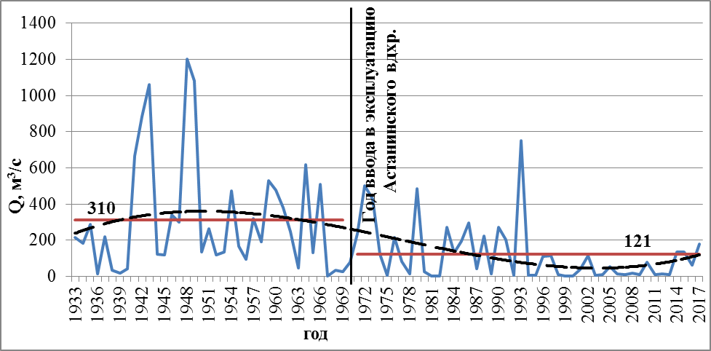

Figure 5.2 – Dynamics of annual maximum water discharges of the Esil river on the gauging station "Astana city" from 1933 to 2017

Below the Astana reservoir, the schedule of water discharge in the Esil river is smoothed: the maximum monthly expenditure decreases by more than 3 times from the village of Turgen to the village of Volgodonovka. Further, to the city of Nur-Sultan, where the flow is regulated and the riverbed is concreted, the maximum expenses decrease and stretch from April to May (figure 5.3).

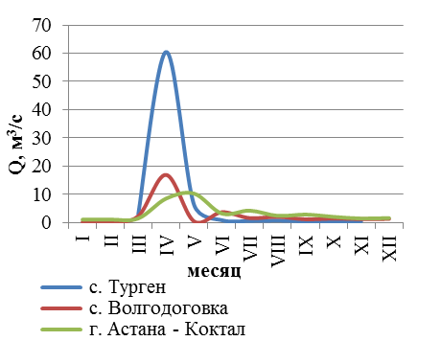

Figure 5.3 – variations of water discharge of the Esil river from a gauging station in the village Turgen to a gauging station Astana Koktal [33]

Trends in the variability of river flow rates and water levels in high water. Since 1975, there has been a 1.8-fold increase in the flow of the Esil river (the Turgen gauging station) during the flood period (figure 5.4). The duration of the flood was reduced by 20%. The beginning of the flood moved to earlier dates, about a week earlier, from the first days of April to the end of March, and the end of the flood, respectively, from mid-may to early may.

**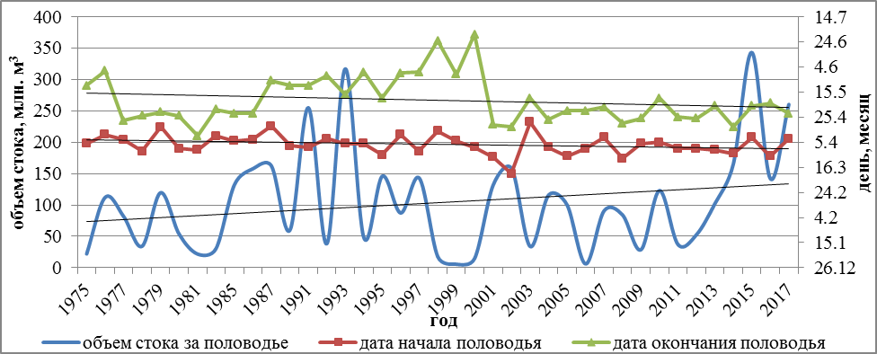**

Figure 5.4-Dynamics of flood flow volumes for 1975-2017, dates of the beginning and end of the flood of the Esil river at the gauging station of the Turgen village

These trends reflect climate changes in the basin: an increase in spring temperatures leads to a faster snowmelt process, which leads to an earlier onset of high water, and an increase in winter precipitation leads to an increase in flood runoff.

For the Nura river within the suburban zone of the city of Nur-Sultan, there is a decrease in the volume of flood runoff for the entire observation period from 1979-2017 (figure 5.5).

Figure 5.5 – dynamics of flood flow volumes for 1979-2017 of the Nura river at

the Preobrazhenskoe hydroengieniring complex

The Esil and Nura rivers have been characterized by high flood volumes in recent years. Maximum water discharges and levels of rare occurrence, as a hydrological characteristic, determine the risk of flooding, the frequency and degree of flooding of territories. The last decade has seen low-water (2011-2013) and high-water (2014-2019) periods (figure 5.5, 5.6).

|  |  |
| --- | --- |
|  |  |
| Esil river, gauging station of Turgen village | Nura river, gauging station near the village named after R. Koshkarbayev |

Figure 5.6 – Dynamics of maximum flow rates (Q) and water levels (H)

It should be noted that in recent years, the Esil and Nura rivers are in a high-water phase, so the risks of flooding are especially high.

**6 Hydrological computer modeling of flooding during the flood period of the Esil and Nura rivers within the suburban area of Nur-Sultan under various hydrological conditions**

Main characteristics and necessary parameters for the HEC-RAS simulator. Hydrological computer modeling was performed using the HEC-RAS 5.0.7 software package for hydraulic calculations (U.S. Army Corps of Engineers, 1995). The preparation of the input geometric data was carried out in the ArcGIS 10.7 program. To create a file with geometric information in the HEC-RAS software package, it is necessary to fill in the layers with input information. Further, the creation of the necessary files is performed automatically due to the built-in function.

The necessary input data for hydrological computer modeling in the HEC-RAS 5.0.7 software package are:

1) Digital elevation model (DEM) of the suburban area of ​​Nur-Sultan, with detailed rendering of river valleys, with data on bathymetry of water bodies (rivers, lakes, reservoirs) (described in the fourth chapter). DEM is one of the most important inputs for 2D models, as topographic data influences flood simulation results. The commonly available SRTM and ASTER-GDEM datasets have a resolution of 30 m, which may not be good enough for some locations. The importance of correct DEM is pointed out by Kim et al. [24], who argue that uncertainties in topographic and hydrological data are the main sources of uncertainty in flood forecasts. Therefore, it was decided to improve the accuracy of the open source DEM through several processing steps. The initially available DEM was obtained from Sentinel-1B at 10 m resolution. It was used as a base DEM, on which improvements were made. In the summer of 2019, a bathymetric survey was carried out using a Lowrance Elite 9 TI echo sounder-chartplotter. In addition, aerial photographs of the river and floodplain were made using a DJI Phantom 4 quadcopter (with a Sony EXMoR ½.3 ″ sensor and a FOV 94o 20mm f / 2.8 lens). Sentinel-1B images were processed using ESA SNAP Desktop, while terrain data from aerial photographs were processed using Agisoft PhotoScan Pro 4.2. Thus, as a result of processing, the resolution of the digital elevation model (DEM) in most of the study area remains at the level of 10 m, while in the areas with bathymetric survey of the river and aerial photography of the coastal floodplain zone improved to 2.5 m.

2) Simulated water flow rates: maximum water flow rates of varying availability by gauging stations. The obtained characteristics are calculated based on the data of the maximum annual discharge for the period of observations at gauging stations (Application J) according to the Code of Rules 33-101-2003, Determination of the main calculated hydrological characteristics [34]. To analyze the dynamics of maximum flow rates, as well as to study precipitation in the study area, we used the data of the RSE "Kazhydromet" and open sources (<http://www.pogodaiklimat.ru/>).

The model includes parameters for the sections of the Esil and Nura river valleys and the main hydraulic structures located within the suburban zone of Nur-Sultan: the calculated flood discharge of 1% of the supply from the Astana reservoir is 1420 m3/s, the maximum discharge is 1910.0 m3/s at a forced level of the reservoir up to a mark of 404.40 m [35]. The costs of the gauging station "Astana "are not taken into account, because since 2010, the river flow in the city is controlled by the hydraulic structure “Protection of Nur-Sultan (Astana) from flooding by flood waters of the “Esil” river. This is a protective dam with a throughput capacity, depending on outlets, up to 20 m3/s into the main channel and up to 450 m3/s into the supply channel to Nur-Sultan. Simulation was carried out for two scenarios. 1) The maximum possible flow rates of the Esil and Nura rivers were used for modeling. 2) The 2017 water discharges were taken as the basis (table 6.1).

Table 6.1 – Maximum estimated water discharge and maximum discharge in 2017 for the Esil and Nura rivers within the suburban zone of Nur-Sultan, m3/s

|  |  |  |
| --- | --- | --- |
| Gauging station, hydraulic structures | Max. estimated water flow rate, m3/s | Max. water discharge in 2017, m3/s |
| R. Esil – discharge from the Astana reservoir | 1910 | 1110 |
| R. Esil – discharge from a hydraulic structure  "Protective dam for the city of Nur-Sultan" | 100 | 45 |
| R. Nura – a gauging station near the village named after R. Koshkarbaeva | 2140,88 | 1870 |

It should be noted that 2017 was a high-water year, the values of the Nura river corresponded to 2% probability. The choice is also justified by the fact that it is possible to verify the obtained simulation results based on comparison with the results of decoding high-resolution satellite images for the dates of the flood passage.

3) Technical characteristics of hydraulic structures. Information on the technical characteristics and rules for the functioning of hydraulic structures is necessary, both at the stage of compiling the DEM, and for entering hydrological parameters into the model. According to the technical passports of hydraulic structures received from the RSE "Kakhvodkhoz" CWR MEGNR RK, the model includes the technical characteristics of hydrological structures on the Esil and Nura rivers within the suburban area of ​​Nur-Sultan. Hourly data on water release, characteristics of hydraulic structures, as well as hydrographs for 10, 20 and 100-year floods were obtained from the Kazsushar RSE. The opening of the reservoir and regulator gates took place in accordance with the current operating rules (Application K).

4) The roughness coefficients of the earth's surface were set according to the HEC-RAS Hydraulic Handbook [36]. The roughness assessment is based on the land use map of the suburban area of ​​Nur-Sultan. Each type of land use was assigned the values ​​of the Manning roughness coefficients n (Application L). When assigning roughness values ​​to objects, the recommended n values ​​(according to Manning's formula) for various surfaces were used [8].

When modeling in the HEC-RAS program, the following algorithm of actions was applied:

* Importing a digital elevation model file;
* Creation of a network (mesh) to define computational points;
* Correction of the network to highlight special elevations (dams, roads, etc.);
* Entering the lines of profile and boundary conditions into the program;
* Assignment of the roughness coefficient to the territories;
* Calculation of tables of hydraulic properties based on the entered information;
* Entering data for culverts with entering data on terms and volumes;
* Entering data on water discharge (hydrograph) and other parameters (slope, etc.) for the selected modeling scenarios;
* Running the model for each of the scenarios;
* Processing of the obtained data, calculation of areas and assessment of territories according to the degree of impact of flood waters.

Hydrological computer modeling of flooding during the flood of the Esil and Nura rivers under various hydrological conditions. To analyze the data obtained, sections were introduced into the HEC-RAS program to determine the runoff passed through them (figure 6.1). A total of 7 sections (4 on the Esil River, denoted by the letter E with increasing numbering downstream and 3 on the Nura River, denoted by the letter H), which are mainly confined to the river sections where the runoff was calculated.

Gates E.1 for the Esil River and H.1 for the Nura River are the initial sections where the rivers flow into the suburban area of ​​Nur-Sultan, here the required hydrograph is set in HEC-RAS. Section E.2 of the Esil River is located 60 km downstream of E.1, after the protective structure “Protection of the city of Nur-Sultan (Astana) from flooding by flood waters of the Esil river", within the city of Nur-Sultan. For the Esil and Nura rivers, intermediate sections are set downstream of Е.3 and Н.2, 25 km to the final sections Е.4 and Н.3, located at the exit of the rivers from the suburban zone. Hydrographs obtained at the given sections are used to determine the nature of water distribution during the period of simulated floods.

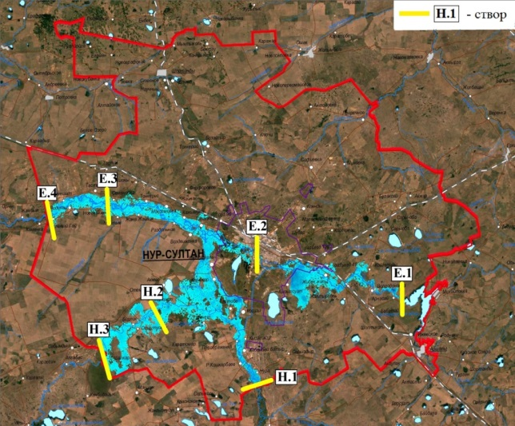

Figure 6.1 – Scheme of sites introduced into the HEC-RAS program

1) Modeling the first scenario. The modeling of the maximum discharge was carried out: the maximum value of the discharge from the Astana reservoir for the Esil river (1910.0 m3/s) and a flood period of 1% availability for the Nura river – village named after R. Koshkarbaeva (2140.88 m3/s). The model contains hydrographs calculated in the HEC-RAS program for the maximum flow rates of rivers at sections E.1 and H.1, where the maximum flow from the low-water level is reached in 3 days, lasts 1 day, then goes down (figure 6.2).

The total number of simulated days is 18. An analysis of the hydrographs calculated by the program showed that high peaks of discharges at the initial sections E.1 and H.1 are decreasing downstream (figure 6.2). The Esil river is characterized by a decrease in maximum discharge by a factor of 8 or more from the initial section E.1 to the discharge at the section of the city channel E.2. Such a significant decrease occurs due to the accumulation of water and flow regulation by a protective dam for the city of Nur-Sultan. It should be noted an increase in runoff at sections E.3 and E.4, the maximum flow peaks in which exceed the peaks in the city channel (E.2) by 2.8 times, which is due to the overflow of a part of the Nura river flow into the Esil river.There is a decrease in the peaks of discharge in the lower reaches of the Esil river within the suburban area, from section E.3 to section E.4, which is explained by the widening of the channel and a decrease in the current velocity. The Nura River is also characterized by a 6.5-fold decrease in discharge peaks from Н.1 to lower sections.

а – Esil river b – Nura river

Figure 6.2 – Hydrographs specified (in sections E.1 and H.1), calculated

in the HEC-RAS program for maximum river flows

The model showed that for a given hydrograph, floods pass through the suburban area of ​​Nur-Sultan in 18 days (the Esil river) (figure 6.2). Despite the presence of a protective structure “Protection of the city of Nur-Sultan (Astana) from flooding by flood waters of the Esil river", there is a high risk of flooding of vast territories of adjacent settlements and some parts of the city of Nur-Sultan. According to the model, the flood waters of the Esil River reach the protective structure “Protection of the city of Nur-Sultan (Astana) from flooding by flood waters of the Esil river" on the fifth day of passage (figure 3.3 a). The overflow of water from the Nura river to the Esil river valley is observed on the tenth day of the passage of floods (figure 6.3). The maximum flood zone is shown in figure 3.3 в. The total volume of water passed through the sections E.1 and H.1 at the maximum simulated flow rates amounted to 2020.9 million m3.

2) Modeling the second scenario. Simulation of the 2017 flood was carried out for comparison with the real situation in a high-water year and further adjustment of the input parameters of the model. The maximum daily expenses in 2017 for the Nura river (gauging station of the village named after R. Koshkarbaev) amounted to 1810 m3/s, and on the Esil river (discharge from the Astana reservoir) – 1010 m3/s, these values ​​correspond to 2% of the maximum flow availability.

|  |  |
| --- | --- |
| C:\Users\User\AppData\Local\Microsoft\Windows\INetCache\Content.Word\1.png | max3 |

Figure 6.3 – Simulation of flooding within the suburban area of ​​Nur-Sultan at maximum flows of the Esil (1910.0 m3/s) and Nura (2140.88 m3/s) rivers

In 2017, the course of the obtained hydrographs is generally similar to the results of the calculated data, where high peaks of flow rates at the initial sections E.1 and H.1 downstream decrease (figure 6.4 а, 3.6 b ). The Esil river is characterized by a 15-fold decrease in the maximum discharge from the initial section E.1 to the discharge at the section of the city channel E.2. From the structure “Protection of the city of Nur-Sultan (Astana) from flooding by flood waters of the Esil river”do not discharge more than 60 m3/s of water, as there is a danger of flooding in the city. Downstream, due to the overflow of part of the water from the Nura River to the Esil River, there is an increase in runoff parameters in sections E.3 and E.4, and a decrease in section H.3.

Hydrological computer modeling of flooding during the flood period of the Esil and Nura rivers in 2017, in comparison with the modeling of the maximum flow rates, showed a decrease in flooding of territories in the Esil river valley, but the flooding area in the Nura river valley was practically preserved (figure 6.5). The total volume of water passed through the sections E.1 and H.1, at the simulated flow rates in 2017, became larger than the volume in the simulation of the maximum values, and amounted to 2147.5 million m3, which is due to the peculiarities of the specified hydrograph. Due to the fact that the 2017 water discharge was taken as the basis for model 2, it was possible to verify the obtained modeling results based on comparison with the results of decoding high-resolution satellite images on the dates of the flood passage. Space Planet Com (3 m resolution) for April 17-19, 2017, the dates of the maximum level rise at the E1 and H1 sections were decoded. As a result of comparing the areas of flooded areas during the 2017 flood period (model 2), we obtained that the flooded area at simulated 2017 costs is 38% larger than the area actually flooded in 2017. It should be taken into account that the water from the indicated sections with the maximum discharge reaches the rest of the territory with a lag of 2-4 days. Due to this, the difference in area will decrease. Comparative analysis of flooded areas at simulated maximum flows (model 1) is 12% larger than the area of ​​the 2017 flood model.

а – Esil b – Nura

Figure 6.4 – Hydrographs of river flood flow rates in 2017 specified (E.1 and H.1) and obtained in the HEC-RAS program for maximum river flow rates

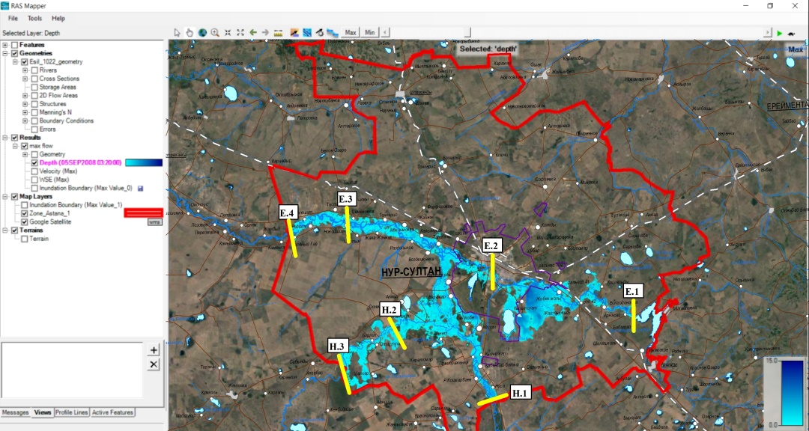

Figure 6.5 – Simulation of flooding during the 2017 flood period at maximum flow rates on the Esil river (1010.0 m3/s) and Nura (1810.0 m3/s)

Figure 6.6 shows the flooded area resulting from simulations using calibrated parameters. Correctly modeled areas are shown in blue, areas underestimated by the model are shown in yellow, and areas with an overestimated forecast are highlighted in red. It can be seen that there is a close correspondence between the observed and modeled flood zones, although some areas are overestimated.

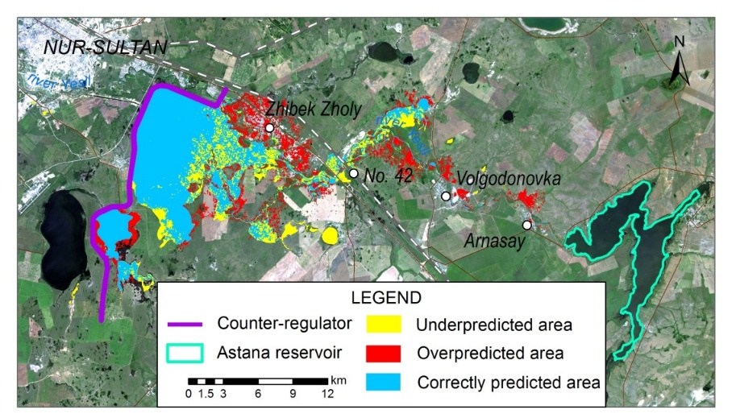

Figure 6.6 – Inundated areas derived from satellite imagery and HEC-RAS simulations (yellow – underestimated, red– overestimated, blue – correct forecast).

The area in front of the counter-regulator is significantly overestimated. Taking into account the satellite image resolution and other possible errors in the input data (for example, the accuracy of the DEM), the simulation results were found to be satisfactory. It should be noted that it is possible to improve the modeling results by further refinement of the digital elevation model with more accurate rendering of the terrace and floodplain levels of river valleys; the possibility of modeling additional scenarios.

**7 Assessment and geoinformation mapping of the risk of flooding of the territory of the city of Nur-Sultan and adjacent settlements of the suburban zone during the flood of the Esil and Nura rivers based on hydrological computer modeling**

Assessment and mapping of the risk of flooding of localities were carried out on the basis of the results of hydrological computer modeling of various probability of occurrence. Calibrated parameters for modeling hydrographs of 10, 20, and 100-year return periods were used to estimate the area of flooding during runoff from different return periods. The maximum flows of each return period were 744, 962 and 1289 m3/s. The results of flooding were classified in accordance with MLIT (2005), the classification takes into account only the risk of flooding at a depth of 5 classes. In addition to the MLIT classification [37], a more complete flood risk classification system (classification 2) has been developed for Kazakhstan conditions (table 7.1).

Table 7.1 – flood hazard classification for the study area

|  |  |  |  |
| --- | --- | --- | --- |
| Risk level | Flooding depth, m | Flow speed, m / s | Duration of flooding, hour |
| low | up to 1 | up to 0,01 | up to 5 |
| medium | 1–3 | 0,01–0,05 | 5–24 |
| high | 3–5 | 0,1 | 24–72 |
| crisis | 5–7 | 0,1–1,0 | 72–120 |
| catastrophic | more than 7 | more than 1,0 | more than 120 |

The classification takes into account not only the depth of flooding, but also the flow rate (for calculating the arrival of a flood wave), as well as the duration of the flood. The classification criteria were based on the natural characteristics of the study area and the impact of past floods. Hazard classification maps for selected flow hydrographs are shown in figure 7.1.

|  |  |
| --- | --- |
|  |  |
| according to the hydrograph 5 % security | according to the hydrograph 10 % security |

Figure 7.1 - map of the risk of flooding of the territory by hydrograph 5 and 10% security

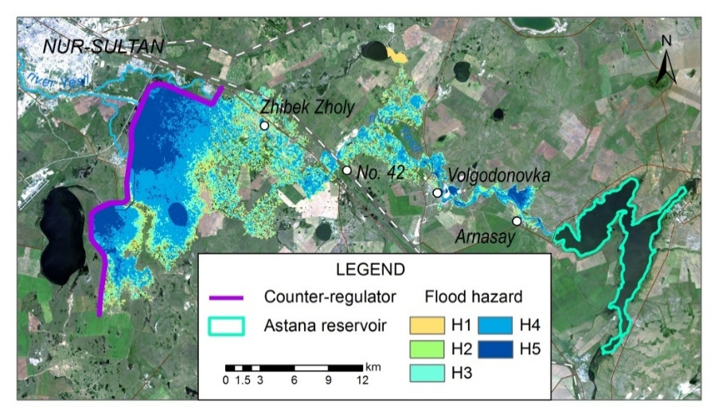

Figure 7.1 – map of the risk of flooding of the territory according to the hydrograph of 1% security

According to table 7.2, modeling the 100-year flow of the hydrograph resulted in the largest area being classified as an extreme risk. The same can be observed for medium and high flood risk classes. There was no significant difference between the three events in the size of the flood zone for very low and low hazard classes. The total area of flooding has a distinct tendency to decrease as the return periods of the flow hydrograph decrease. This classification identifies areas that are more prone to flooding and can be used as a useful tool in flood mitigation measures.

Table 7.2 – calculations of the risk of flooding of territories

|  |  |  |  |  |
| --- | --- | --- | --- | --- |
| Risk classification | Depth of flooding, m | Flooding area, ha | | |
| 100 year =1% | 20 year=5% | 10 year=10% |
| 1 | 0-0.5 | 2329.3 | 2180.3 | 2204.9 |
| 2 | 0.5-1 | 2313.7 | 2159.1 | 2140.8 |
| 3 | 1-2 | 4246.8 | 3740.6 | 3858.4 |
| 4 | 2-5 | 8121.7 | 7051.3 | 6162.9 |
| 5 | >5 | 4295.2 | 1538 | 734.1 |
| 1-5 | Total area | 21306.7 | 16669.3 | 15101.1 |

One of the main results of the project was an assessment of whether the counter-regulator, whose main function is to protect the capital from flood waters and extreme emissions from the Astana reservoir, can keep the volume of water 1% secure. According to the model, the maximum water cut on the counter-regulator was 360.732 meters. This height is lower than the height of the dam crest by about 2 meters, and we can assume that during such an event, with the appropriate operation of the water discharge structures that were assumed in the current study, the dam is not expected to overflow. In addition, the analysis of maps of the risk of flooding of territories allowed us to draw a conclusion about which localities are at high/low/extreme risk of flooding.

According to table 7.3, modeling the volume of water of 1% availability resulted in the largest area classified as particularly dangerous. The same can be observed for the medium and high hazard classes. There was no significant difference in the size of the flood zones for very low and low classes. The total area of flooding shows a distinct tendency to decrease as the periods of repeatability of runoff hydrographs decrease. This classification identifies areas that are prone to flooding and is a useful tool for taking flood mitigation measures. The greatest flooding is observed in the area of the village of Zhibek Zholy, the area of flooding increased from 10% to 1% of the flow supply. In all three scenarios, the largest area of flooding was observed for the middle hazard class. As a result of the 100-year event (1% security), 3.2 hectares of land with a depth of more than five meters were affected by flooding; 172 hectares of land had a water depth of about 1-2 m. In the case of railway junction 42, all three scenarios have a low level of danger due to engineering protection of buildings along the entire perimeter.

Table 7.3 – results of flood hazard classification (classification 2) for each scenario.

|  |  |  |  |
| --- | --- | --- | --- |
| Classification of the risk level | 1% provision,  100 years (ha) | 5% provision,  20 years (ha) | 10% provision,  10 years (ha) |
| H1 (very low) | 751.83 | 17.54 | 19.16 |
| H2 (low) | 157.21 | 156.02 | 163.44 |
| H3 (medium) | 1316.05 | 1520.49 | 1520.5 |
| H4 (высокий) | 4886.73 | 4756.58 | 4405.25 |
| H5 (extreme) | 14646.93 | 10624.94 | 9398.22 |
| Total area, ha | 21758.75 | 17075.57 | 15506.57 |

The area of this hazard class was also small for all three scenarios (<0.9 ha). In the village of Volgodonovka, territories were flooded as a result of 10 - and 20-year floods of less than 1 ha. During the 100-year flood, the total area of flooding was 35.8 hectares of land, of which about 1.7 hectares were classified as high-risk and 8.3 hectares as medium-risk. According to the results of modeling on the Esil river, the village of Arnasay is the second locality that was subjected to significant flooding in terms of the area of flooding. As a result of the 100-year event, 13.7 ha of land with a water depth of 2-5 m was formed, and 14.8 ha of the total area of localities were classified as medium hazard.

Figures 7.3 and Application 7.4 illustrate the different flood hazard classes in the localities of Arnasay and Zhibek Zholy, and show the areas in each locality with different levels of risk of flooding.

|  |  |  |
| --- | --- | --- |
|  |  |  |

Figure 7.3 – flood risk maps for the territory of the village of Arnasay under various scenarios of flow security. Left – 1%, average – 5%, right – 10%

|  |  |  |
| --- | --- | --- |
|  |  |  |

Figure 7.4-flood risk Maps for the territory of the village of Zhibek Zholy under various scenarios of flow security. Left – 1%, average – 5%, right – 10%

These settlements are located in different geomorphological positions and hydrological conditions. The village of Arnasay is located on the right Bank of the Esil river within a high terrace above the floodplain. In all three scenarios, the flood zone where dry riverbeds are present is exposed to the greatest depth and area of flooding.

Based on the results of modeling for localities within the Esil and Nura river valleys within the boundaries of the suburban zone of Nur-Sultan, modeling and mapping for 1% of the flow security were carried out and flood risk areas were shown (Application M ). For example, the results of modeling in the village of Volgodonovka are shown (figure 7.5). According to the results of hydrological modeling with 1% of the flow availability, the following localities were identified that are not subject to the risk of flooding in the Esil river valley: 42 Siding, kuygenzhar, Michurino, International, Kazhymukan, Razdolnoye, Tonkeris, Zhana Zhainak, Mortyk, named after Karamendy Batyr, Zhanaesil, Sadovoe, Rodina, Akmechet, Zeleny Gai; in the Nura river valley: Nura, Zhanazhol, Birlik, Otaukusken, orazak. The area between the Nura- Esil: Maitobe village, the village of Kosshy.

|  |  |  |
| --- | --- | --- |
|  | \\Geoinst\geo\1. Акиянова Ф.Ж\от Ергали\depth.jpg |  |
| а) | | b) |
|  | | |
|  | | |

The map (a) shows the area and the depth of the risk of flooding by flood waters of the territory of the village of Volgodonovka (yellow color contour) according to the hydrograph of 1% provision (a) and 5% (b); profile (c) shows the location of the village and the estimated level of 1% and 5%, which exceeds the average by 5.85 m and 1.75 m accordingly

Figure 7.5 – Results of modeling the risk of flooding in the village of Volgodonovka using the 1% provision hydrograph

**8 Development of scientifically grounded recommendations to reduce the risk of flooding of the territories of Nur-Sultan and adjacent settlements of the suburban area during the flood of the Esil and Nura rivers**

Due to the fact that flood floods are the most dangerous of hydrometeorological events and lead to significant economic losses and deaths of people, there is a need for a quick response to these events to reduce their impact on the population and infrastructure. Simulation of floods using hydraulic models is one of the main tools used both for the development of preventive measures and rapid response. Modeling, carried out taking into account different scenarios of water availability, climatic and soil conditions and the degree of development of territories, makes it possible to accurately determine the areas, settlements and infrastructure at risk of flooding. The simulation results allow us to develop a system of flood control measures and preventive recommendations, consisting of engineering protection, as well as prompt warning and notification of the population.

Based on the studies carried out to study flooding during the flood period of the Esil and Nura rivers within the natural zone of Nur-Sultan and adjacent settlements using modeling, recommendations were developed to reduce the risk of their flooding. Recommendations take into account climatic conditions, hydrological regime, relief, distribution of flood waters and the presence of hydraulic structures.

Hydrological computer modeling of flooding during the flood period was carried out under various hydrological conditions. When modeling a hydrograph of 1% availability, the flood area of ​​the Esil and Nura rivers was 1051.21 km2, the total volume of water passed through the sections amounted to 2020.9 million m3. In total, when modeling a hydrograph of 1% of availability, 12 settlements are partially exposed to the risk of flooding, of which in the Esil river valley 6 (Nur-Sultan, Arnasai village, Volgodonovka village, Zhibek Zholy village, Talapker village, Araily village), the Nura river – 4 (R. Koshkarbaev village, Kabanbai batyr village, Kyzylzhar village, Preobrazhenka village), on the Nura-Esil interfluve – 2 (Karazhar village and Karaotkel village) (Application M). With 5 and 10% provision, the number of settlements decreases by 30%. The main risk factors, in addition to natural (climate change, flat relief, eutrophication of streams and reservoirs), are flow regulation (sometimes complete blockage of the channel with pipe laying), non-observance of the rules of economic activity in water protection zones and strips, extraction of sand and gravel mixture, destruction of floodplain forests, contamination of water bodies, which generally affect the carrying capacity and conservation of flood waters. In order to counteract flood processes, on the basis of the results of comprehensive studies and modeling, flood prevention recommendations have been developed to reduce the risk of flood impacts. From engineering (preventive) measures, it should be noted the need for: strengthening the coastal ledges of watercourses, lakes and reservoirs; formation of reservoirs for the retention of flood waters; construction of dams and other engineering protective structures near settlements and economic facilities; cleaning, dredging and, if necessary, straightening sections of river channels; construction/repair of drainage devices along the engineering and transport network. On the territory of the study, 5 districts were identified that have a certain similarity in terms of the risk of flood floods, for which recommendations on combating flood processes have been developed:

1) For the section of the Esil River from the Astana reservoir to the protective dam of the city of Nur-Sultan. There are 4 settlements in the risk zone (Zhibek-Zholy village, Arnasai village, Volgodonovka village and 42 crossing). The greatest risk of flooding is determined for the village. Zhibek Zholy. It is necessary to increase the throughput of the channel (cleaning of overgrown areas, dredging, control of construction objects in the water protection zone and the strip, restoration of the natural channel in front of the village of Volgodonovka (road to a stone quarry).

2) For a site within the boundaries of Nur-Sultan. The protective dam created to prevent flooding of the city of Nur-Sultan in 2010 has 3 outlets with different throughput capacity up to 20 m3/s into the main channel and up to 450 m3/s into the supply channel to the city. The third water outlet with water discharge into Lake Maybalyk is closed due to the threat of flooding of the International Airport. Based on the simulation results, the dam has the ability to retain water at maximum discharge rates. To avoid flooding and flooding of certain sections of the city of Nur-Sultan, as well as to create conditions for navigation within the city, the CWR MEGPR of the Republic of Kazakhstan is implementing a project (until 2021) to reconstruct and expand the Esil river on 8 sites with dredging and bank protection works and the construction of a dam that will allow regulating the water level in the river. Modeling the hydrograph of 1% availability showed that, despite the presence of a flood protection structure and reconstruction of the channel, there is a risk of flooding the territories of settlements and some parts of the city of Nur-Sultan. The eastern part of the city, Saryarka and Esil districts are characterized by an increased risk of flooding.

3) The third section includes the Esil river valley downstream from the border of Nur-Sultan to the village. Green Guy. According to the modeling results, the flood risk zone includes all coastal settlements. Of these, s. Talapker is included in the flooding risk zone only when modeling a hydrograph of 1% availability. In the third section, it is necessary to straighten and deepen the channel, remove vegetation, silt and modern sediments to increase the throughput. Until now, from 2015-2016, to protect settlements from flood waters, a system of earthen dams of various lengths and heights (2-4 m high, 15-30 m wide at the base, 100 m to several kilometers long. , construction in the shortest possible time, but weak resistance to wave, wind influences and erosion.It is recommended to strengthen the pressure slope and the ridge, laying/cleaning pipes, development of a general plan of engineering flood control structures.

4) The fourth section includes the Nury river valley. It has relatively stable banks and channels, which undergo deformation in certain areas depending on natural (rock lithology, flow rate) and anthropogenic (quarries on the floodplain, destruction of soils and vegetation, changes in the main channel, large losses due to evaporation, destruction of banks, reduced stability ). At maximum water discharge (hydrograph 1% of supply), the coastal structures of the villages of named after R. Koshkarbaeva, Kabanbay batyr, Preobrazhenki and Kyzylzhar are flooded. On the sections of the Nura River near these villages, embankment of coastlines (1.5-2 m), dredging and bank protection works (2.5 m wide) were carried out. The villages of Birlik, Otautusken and Zhanazhol are protected by earthen dams. It is recommended to develop a unified system of protective structures with reinforcement and in some areas with an increase in the height of the dam, reinforcement of slopes, laying of drainage pipes. Reclamation of quarries within the channel and floodplain of the river is necessary to restore the natural flow of the river, restore the soil and vegetation layer with tree and shrub plantations, control compliance with environmental requirements and stop unauthorized mining.

5) The fifth section is the interfluve of the Nura-Esil rivers. Strong impact on the extraction of sand and gravel mixture, numerous abandoned and active quarries, destruction of soils and tugai forests of the floodplain, silting and overgrowing of the bottom of the three main channels from Nura to Esil, unauthorized development of the coastal zone. Works on engineering protection with. Karazhar, from Karaotkel, s. Taitobe with the construction of earthen dams with a height of 1.5-4 m, m, up to 500 m long.Recommendations: cleaning channel channels, strengthening the slopes of the dams, laying drainage pipes in the body of dams, developing a system for the rational use of flood waters for the development of agriculture with the revival of the system irrigation Alva, development and creation of a unified and interconnected system of protective flood protection structures, taking into account the results of modeling.

**CONCLUSION**

Brief conclusions of the project research results in 2018-2020 in accordance with the tasks: 1. An information database has been created on natural and anthropogenic conditions, monitoring climatic and hydrological data, remote sensing data of the research area; 2. On the basis of the analysis of domestic and foreign methods for studying the risks of flooding of territories by flood floods, the most promising for modeling the research area was determined by the HEC-RAS program; 3. The assessment of the main factors affecting the risk of flooding during the flood period of the Esil and Nura rivers was carried out, a complex of climatic, hydrological, geomorphological and socio-economic maps was created in the GIS; 4. A digital model of the relief of the Esil and Nura river valleys has been created as a basis for hydrological computer modeling. The DEM was created on the basis of Sentinel satellite images with a resolution of 10 m, which was improved on the basis of bathymetric surveys of river channels and the Astana reservoir, creation of a system of control points, UAV surveys of river channels and floodplains; 5. The analysis of hydrological parameters of rivers during high water was carried out, which revealed: tendencies of changes in discharge and water levels during high water, shift of the beginning of high water to earlier dates, alternation of high-water and low-water phases with a frequency of 4-7 years; the regulating role of reservoirs for runoff; 6. A hydrological computer modeling of flooding during the flood period of the Esil and Nura rivers within the suburban zone of Nur-Sultan was carried out at the maximum calculated flow rates (1% supply for the Nura river (Model 1) and the maximum discharge from the Astana reservoir at a forced level ( Model 2). According to model 1. Modeling was carried out at the maximum value of the discharge from the Astana reservoir for the river. Esil (1910.0 m3/s) and a flood period of 1% for the Nura River - the village named after R. Koshkarbaev (2140.88 m3/s). The model has a hydrograph, where the maximum discharge from the low-water level is reached in 3 days, lasts 1 day, then a decline. The duration of the simulation is 18 days. The model showed that for a given hydrograph, floods pass through the suburban area of ​​the city of Nur-Sultan in 18 days (Esil river). Despite the presence of a protective dam, there is a high risk of flooding of the territories of adjacent settlements and some parts of the city of Nur-Sultan. According to the model, the flood waters of the The Esil reach the protective dam on the fifth day, and the overflow of water from the Nura River to the Esil River valley is observed on the tenth day. The total volume of water passed through sections E.1 and H.1 at the maximum simulated flow rates amounted to 2020.9 million m3. Model 2 was used to simulate the 2017 flood. The maximum daily flow rates on the Nura River were 1810 m3/s, and on the Esil River, 1010 m3/s, these values correspond to 2% of the maximum flow availability. The hydrographs run is similar to the calculated data. The Esil River is characterized by a 15-fold decrease in the maximum discharge from the initial section E.1 to the discharge at the section of the city channel E.2. Downstream, due to the overflow of a part of the water from the Nura River to the Esil River, there is an increase in runoff parameters in sections E.3 and E.4 and a decrease in section H.3.7). Geoinformation mapping of the risk of flooding of settlements. Calibrated modeling parameters of hydrographs of 1, 5 and 10% availability were used to estimate the flooded area. Flood risk maps and profiles have been compiled for settlements. In total, when modeling a hydrograph of 1% availability, 12 settlements are partially exposed to the risk of flooding, including 6 in the Esil river valley (Nur-Sultan cities, Arnasai, Volgodonovka, Zhibek Zholy, Talapker, Araily villages), in the valley the Nura rivers - 4 (R. Koshkarbaeva, Kabanbai batyr, Kyzylzhar, Preobrazhenka villages), on the Nura-Esil interfluve ­­­­­- 2 (Karazhar and Karaotkel villages). With 5 and 10% provision, the number of settlements decreases by 30%. 8) Based on the carried out hydrological modeling, scientifically grounded recommendations have been developed to reduce the risk of flooding of settlements. The recommendations took into account climatic conditions, hydrological regime, relief, distribution of flood waters and the presence of hydraulic structures. The territory was zoned according to the level of risk and recommended methods of protecting the population and infrastructure from flood floods with the identification of 5 districts: 3 - in the Esil river valley, 1 - along the Nura river valley and 1 - along the Nura-Esil interfluve. The project tasks were completed in accordance with the schedule in full (Application P).

Recommendations for implementation: research Methods and thematic maps introduced in the learning process of students and undergraduates of L. Gumilyov ENU (the Contract on cooperation No. 362 of 26.10.2018) (Application P); "Map of the bathymetry of the Astana reservoir" in scale 1:25 000 introduced in RSE "Kazvodkhoz" CWR of the Ministry of Ecology, Geology and Natural Resources of RK to clarify the volumes of water resources of the Astana reservoir (Application Q).

In total, there are 9 scientific publications under the project, including: 1 article in the Web of Science database, 3 in the Scopus database, 2 in journals recommended by Committee for control in the field of education and science of RK (Application R). The technical and economic efficiency of the implementation of the "Astana Reservoir Bathymetry Map" in the RSE Kazvodkhoz of the CWR is associated with the transfer to the authorized body of the current bathymetric model with refined calculations of water resources at different levels of the mirror. The scientific and technical level of research and development, when compared with the best achievements in the field of flood modeling, testifies to its compliance with modern developments. This study on the application of hydrological modeling is one of the first in the republic.

**REFERENCES**

1 Burlibaev, M. Zh. Hydrological natural phenomena (world trends, chronicles of Belarus and Kazakhstan) / M. Zh. Burlibaev, A. A. Volchek, M. Yu. Kalinin // Water resources of Central Asia and their use, vol. 2: materials of the international scientific and practical conference, dedicated to summing up the results of the UN decade "Water for Life". - Almaty, 2016 .- P. 372-377;

2 Thieken, A. H. [et al.]. Methods for flood risk assessment: Concepts and challenges / A. H. Thieken [et al.] // International workshop on flash floods in urban areas. – 2006. – P. 1-12;

3 Frolov, N. L. [and others]. Assessment of the hazard of hydrological phenomena at the regional and local levels / N.L. Frolov [and others]. // Water management of Russia. - 2014. - No. 3. - P. 58-74;

4 Kaplan, S. On the quantitative definition of risk / S. Kaplan, B. J. Garrick // Risk analysis. – 1981. – Т. 1. – № 1. – P. 11-27;

5 Osipov, V.I.Management of natural risks / V.I. Osipov // Bulletin of the Russian Academy of Sciences. - 2010. - T. 80. - No. 4. - P. 291-297;

6 Shalikovsky, A. V. System of numerical indicators of the level of risk for floods of various genesis / A. V. Shalikovsky // Scientific support for the implementation of the "Water Strategy of the Russian Federation for the period up to 2020". T. 2: Collection of scientific works. / Federal Agency for Scientific Organizations, Scientific Council of the ONZ RAS "Land Water Resources", Institute of Water Problems of the Russian Academy of Sciences, Institute of Water Problems of the North, KarRC RAS; Ed .: Pryazhinskaya V.G., Gelfan A.N., Stepanova M.I., Bednaya R.I., Kazakov Yu.E. - Petrozavodsk: KarRC RAS, 2015. - P.64;

7 Gladkevich, G. I. Flood hazard assessment in the territory of the Russian Federation / G. I. Gladkevich, P. N. Tersky, N. L. Frolova // Water management of Russia: problems, technologies, management. - 2012. - No. 2. - P. 29-46;

8 Engineering handbook. Recommended values ​​of the roughness coefficient n in Manning's formula for various wall materials of pipelines, trays, pipes, artificial gutters, etc [Electronic resource]. – Access mode: <https://dpva.ru>;

9 Belikov, V. V. [and others]. Computer hydraulic model of a river basin - the basis for determining the damage to the national economy from floods / V.V.Belikov // Safety of energy structures. - 2003. - No. 11. - P.132-148;

10 Belikov, V.V., Improvement of methods and technologies of applied numerical modeling in hydraulics of open flows: dis. / Vitaly Vasilievich Belikov. - Moscow: [Research Institute of Energetics. structures (JSC NIIES)], 2005. - 358 p.;

11 STREAM\_2D software package for calculating currents, bottom deformations and pollution transfer in open streams / VV Belikov, VV Kochetkov // Certificate of state registration of computer programs. - 2014. - No. 2014612181;

12 Modeling the World of Water. DHI Water & Environment. [Electronic resource]. – 2005. – Access mode: <https://www.dhigroup.com>;

13 Delft3D-FLOW Version 3.06 User Manual. WL | Delft hydraulics. 2018. [Electronic resource]. – Access mode: <https://content.oss.deltares.nl/delft3d/manuals/Delft3D-FLOW_User_Manual.pdf>;

14 HEC-RAS river analysis system User’s Manual. 2002. [Electronic resource]. – Access mode: <http://www.hec.usace.army.mil/software/hec-ras/documentation/HEC-RAS%205.0%20Reference%20Manual.pdf>;

15 FLO-2D. Version 2006.01 User Manual [Electronic resource]. – Access mode: <http://www.flo-2d.com>;

16 Ресурсы поверхностных вод районов освоения целинных и залежных земель Акмолинская область Казахской ССР; / под общ. ред. В. А. Урываева //Л.: Гидрометеоиздат, 1958. вып. I. – 790 с.;

17 Water Resources of Kazakhstan: Assessment, Forecast, Management: in 21 tons / ch. ed. A.R. Medeu. - Almaty, 2012 .-- ISBN 978-601-7150-32-7. T. VII: Resources of the river flow of Kazakhstan. Book. 1: Renewable surface water resources of Western, Central and Northern Kazakhstan / under scientific. ed. R.R. Galperin. - 684 p. ISBN 978-601-7150-32-7.

18 Water Resources of Kazakhstan: Assessment, Forecast, Management: in 21 tons / ch. ed. A.R. Medeu. - Almaty, 2012 .-- ISBN 978-601-7150-32-7. T. VII: Resources of the river flow of Kazakhstan. Book. 2: Renewable surface water resources of Western, Central and Northern Kazakhstan / under scientific. ed. R.R. Galperin. - 684 p. ISBN 978-601-7150-32-7;

19 Annual data on the regime and resources of surface waters. Basin of the Esil River / Republican State Enterprise “Kazhydromet”. - 2018. - Issue 2. - 194 p.;

20 Akiyanova, F. et al. Application of the methods of remote sensing of the Earth to study the bathymetry of the coastal part of the Astana reservoir (Kazakhstan) / F. Akiyanova, A. Oleshko, Y. Karakulov, A. Shaimerdenova // The 19th International Multidisciplinary Scientific GeoConference SGEM. – Albena, Bulgaria, 2019. – P. 457-464;

21 Official website of the European Space Agency. [Electronic resource]. – Access mode: <https://sentinel.esa.int/web/sentinel/missions/sentinel-1>;

22 Baldina, E.A., Troshko, K.A., Nikolaev, N.R. Sentinel-1 radar data and the possibility of their processing for interpreting the relief forms of Kotelny Island / E.A. Baldina, K.A. Troshko, N. R. Nikolaev // News of higher educational institutions. Geodesy and aerial photography. - 2016. - No. 3. - P. 78-85;

23 Akiyanova, F. Zh. et al. Application of remote sensing data analysis methods to assess planar erosion on the example of the territory of Akmola region / F. Zh. Akiyanova EM. Karakulov N.B. Zinabdin N.I. Vasilchenko // Hydrometeorology and Ecology. - 2019. - No. 2. - P. 23-38;

24 Attema, E. et al. Sentinel-1-the radar mission for GMES operational land and sea services / E. Attema et al. // ESA bulletin. – 2007. – Vol. 131. – P. 10-17;

25 Kantemirov, Yu. I. Brief theoretical foundations of radar interferometry and its multipass variations Ps and SBass / Yu. I. Kantemirov // Geomatics. - 2012. - No. 1. - P. 22-26;

26 Seventh national communication and third biennial report of the Republic of Kazakhstan to the UN Framework Convention on Climate Change / UN Development Program. - Astana, 2017 .- P. 304.;

27 Medeu, A. R. et al. Water security of the Republic of Kazakhstan: problems of sustainable water supply / A. R. Medeu et al. // Water management of Kazakhstan. - 2011. - No. 9. - P. 37];

28 Medeu, A. R. et al. Water security of the Republic of Kazakhstan: problems of sustainable water supply / A. R. Medeu et al. // Water management of Kazakhstan. - 2011. - No. 9. - P. 37;

29 Burlibaeva, D. M. Hydroecological bases of water apportioning of transit (surface) runoff of transboundary rivers in Kazakhstan: dis. for a job. step. Doctor of Philosophy (PhD). - Almaty, 2016 .- 262 p.;

30 Akiyanova F. Z. et al. Water resources and system of the River Yesil (ISHIM) under conditions of active anthropogenous transformation and climate change / F. Zh. Akiyanova, N. L. Frolova, А. A. Avezova, A. M. Shaimerdenova, A. B. Oleshko // EurAsian Journal of BioSciences. – 2019. – Т. 13. – №. 2. – P. 1275-1289. – e-ISSN 1307-9867;

31 Scheme of the integrated use and protection of water resources in the Esil river basin on the territory of the Republic of Kazakhstan / Ministry of Agriculture of the Republic of Kazakhstan. Committee for Water Resources. Production cooperative "Institute Kazgiprovodkhoz"; ch. Project Engineer A. Tverdovsky - Almaty, 2006;

32 “Protection of Astana city from flooding by flood waters. Esil ": Technical passport of a hydraulic structure No. 37: approved. by order of the Minister of Agriculture of the Republic of Kazakhstan dated June 4, 2009 No. 326 / Committee for Water Resources of the Ministry of Agriculture of the Republic of Kazakhstan. Akmola branch Republican State Enterprise on the right of economic management "Kazvodkhoz". - Astana, 2018;

33 Republic of Kazakhstan: in 3 volumes.Vol. 1. Natural conditions and resources / under total. ed. A.R. Medeu. - 2nd ed. - Almaty, Kazakhstan, 2010 .-- S. 237-241. - ISBN 978-601-7150-02-0;

34 Determination of the main calculated hydrological characteristics: SP 33-101-2003: approved. Decree of the Gosstroy of Russia No. 218 dated 26.12.2003: effective from 01.01.2014. - Moscow, 2004 .-- 75 p. - ISBN 5-88111-162-1;

35 "Astana water reservoir": Technical data sheet for reservoir No. 30: approved. by order of the Minister of Agriculture of the Republic of Kazakhstan dated June 4, 2009 No. 326 / Committee for Water Resources of the Ministry of Agriculture of the Republic of Kazakhstan. Akmola branch Republican State Enterprise on the right of economic management "Kazvodkhoz". - Astana, 2016;

36 Ahmed, S. et al. Modeling Flood & Drought Scenario for Water Management in Porali River Basin, Balochistan / S. Ahmed, S.I. Ahmed, H. Maqsood, B. Lakhani // International Journal of Economic and Environmental Geology. – 2019. – P. 1-9;

37 Ongdas N. et al. Application of HEC-RAS (2D) for Flood Hazard Maps Generation for Yesil (Ishim) River in Kazakhstan //Water. – 2020. – Т. 12. – №. 10. – С. 2672.