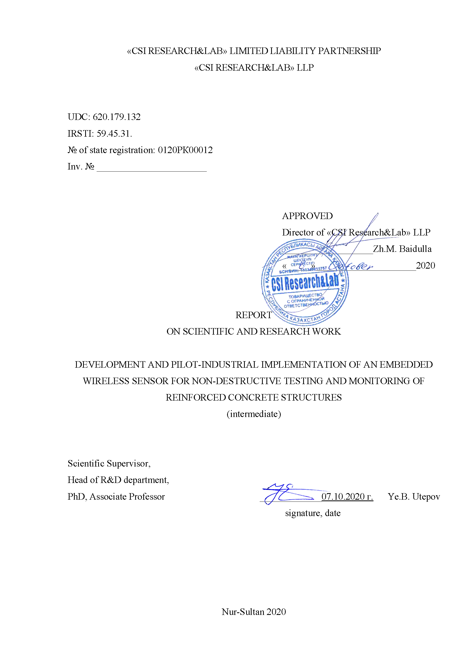«CSI RESEARCH&LAB» LIMITED LIABILITY PARTNERSHIP

«CSI RESEARCH&LAB» LLP

UDC: 620.179.132

IRSTI: 59.45.31.

№ of state registration: 0120РК00012

Inv. № _______________________

APPROVED

Director of «CSI Research&Lab» LLP

___________________Zh.M. Baidulla

«_____»_____________________2020

REPORT

ON SCIENTIFIC AND RESEARCH WORK

DEVELOPMENT AND PILOT-INDUSTRIAL IMPLEMENTATION OF AN EMBEDDED WIRELESS SENSOR FOR NON-DESTRUCTIVE TESTING AND MONITORING OF REINFORCED CONCRETE STRUCTURES

(intermediate)

Scientific Supervisor,

Head of R&D department,

PhD, Associate Professor _____________07.10.2020 г. Ye.B. Utepov

signature, date

Nur-Sultan 2020

**LIST OF AUTHORS**

|  |  |  |
| --- | --- | --- |
| Scientific Supervisor,  Head of R&D department,  PhD, Associate Professor | ____________07.10.2020 г.  подпись, дата | Ye.B. Utepov  Introduction, Chapter 3, Conclusions |
|  |  |  |
| Senior Researcher,  PhD, Associate Professor | ____________07.10.2020 г.  подпись, дата | А.S. Tulebekova  Chapter 1 |
|  |  |  |
| Junior Researcher, MSc. | ____________07.10.2020 г.  подпись, дата | А.B. Kazkeyev  Chapter 2 |

**ABSTRACT**

Report 41 pages, 17 figures, 9 tables, 56 sources, 1 appendix.

EMBEDDED SENSOR, CONCRETE STRENGTH, REINFORCED CONCRETE STRUCTURES, STRENGTH CONTROL, MONITORING

Grant project АР08052033 “Development and pilot-industrial implementation of an embedded wireless sensor for non-destructive testing and monitoring of reinforced concrete structures” is focused on the release of an embedded wireless sensor for monitoring of reinforced concrete structures (WSM RCS) implementing the method of temperature and strength control to the construction market of Kazakhstan, which has no analogues in the country.

The study revealed that analogues of such a solution are represented by various foreign manufacturers. Sensors developed in the project have similar functionality and principle of operation to analogs. However, foreign analogs have a number of shortcomings that create a certain discomfort for builders on the construction site. The principal difference of the solution developed in the project is the use of wireless communication protocol LoRaWan instead of Bluetooth, which synchronizes the collection of measurement data from all sensors simultaneously. The analysis of best practices and reliable sources showed the expediency of adaptation in WSM RCS of the method of concrete maturity, presented by the standard ASTM C1074-19.

In the project, the optimal IT-architecture of the developed solution was selected, resembling the concept of the Internet of Things (IoT), the main components of which are the WSM RCS itself, the data collection station (DCS) and the server application. Prior to the development of technical requirements of the solution, there was a survey of representatives of various construction companies in Nur-Sultan, in order to take into account in advance the expectations of potential users. Thus, the electronic board of the WSM was created on the basis of a wireless interface microcontroller Semtech SX1278 433MHz, on which various modules were soldered. The body of the WSM is printed on a 3D printer. The DCS was created on the basis of ESP32 microcontroller, and the server application - on HTML, PHP, CSS, JavaScript. In total, eight databases and one DCS were produced. Testing of joint work of the WSM, DCS and the server application showed full functionality. Also, to further test the functionality of the solution were carried out laboratory tests of concrete specimens in the city of Almaty, the results of which will be used as a source matrix, uploaded to the server application.

The project is still in progress. Further a number of tests and certification are planned.

**CONTENTS**

INTRODUCTION. 5

1 ANALYSIS OF THE CURRENT STATE AND BEST PRACTICES, REGULATORY, TECHNICAL AND LITERARY SOURCES ON MEASURING INSTRUMENTS USED FOR DESTRUCTIVE AND NON-DESTRUCTIVE STRENGTH CONTROL AND MONITORING OF CONCRETE AND REINFORCED CONCRETE STRUCTURES 6

1.1 Current state analysis 6

1.2 Comparative analysis of best practices 6

1.3 Comparative analysis of normative documentation 7

1.4 Analysis of literary sources 11

1.5 Developing the methodological framework of the project 12

1.6 Project development and promotion model 14

2 DEVELOPMENT, TESTING AND DEBUGGING OF THE SENSOR PROTOTYPE AND ITS SOFTWARE. 18

2.1 Collecting user stories and requirements 18

2.2 Developing the IT-architecture of the sensor 22

2.3 Factory assembly of sensors 25

2.4 Software development 27

2.5 Testing of sensors and software at the factory 30

3 CONDUCTING LABORATORY TESTS OF INDUSTRIAL SAMPLES OF THE SENSOR AND ITS SOFTWARE 32

3.1 Laboratory testing in Almaty 32

CONCLUSIONS 34

REFERENCES 37

APPENDIX А – Foreign analogues of concrete maturity sensors 41

# INTRODUCTION.

This intermediate report of research work (R&D) for 2020 contains the main provisions and results of the project AR08052033 “Development and pilot-industrial implementation of an embedded wireless sensor for non-destructive testing and monitoring of reinforced concrete structures” on grant funding for young scientists in scientific and (or) research projects for 2021-2023. The project is aimed at solving the problem of timely strength control of reinforced concrete structures by means of embedded sensors controlled via wireless communication by special software. This solution will allow to reduce labor costs for strength control due to real-time monitoring of RCS with minimal involvement of human resources.

Strength control of RCS is an independent direction of construction activities, covering a range of issues related to the reliability of buildings. Determination of true properties of concrete in the structure and their change in time allows to solve many important problems associated with the design of reliable, durable and economical buildings and structures. The aim of this study is a development and pilot implementation of an embedded sensor for non-destructive control of reinforced concrete structures by wireless method, which allows monitoring data on the current concrete strength gain, internal temperature and humidity with the help of special software.

When promoting the project, the following competitive advantages will be used, which qualitatively distinguish the product from its foreign analogues:

* The status of the only domestic manufacturer in this industry;
* Certificate of type approval of measuring instruments;
* Affordable price, lower than competitors;
* Real-time monitoring of reinforced concrete structures on request;
* Reliability of results is higher than that of analogues, as laboratory tests are carried out on the same composition of concrete, which is cast on the construction site in Kazakhstan;
* LoRaWan data transmission network, allowing simultaneous connection to all installed sensors, which saves time of builders (for example, foreign analogues use Bluetooth);
* The accumulation of an extensive database (Big Data) for further analysis.

# Analysis of the current state and best practices, regulatory, technical and literary sources on measuring instruments used for destructive and non-destructive strength control and monitoring of concrete and reinforced concrete structures

## Current state analysis

Construction, being a fast growing industry, is undergoing constant changes, directly affecting the quality and value of the final product [1]. Development of new materials, equipment and methods of quality control allows to obtain products with high characteristics of durability, longevity and wear resistance [2]. In addition to high quality products in the form of construction structures of buildings and facilities, construction companies are also aimed at making a profit. At the same time, the price of the final product should not be too high for the consumer, but this task is complicated by many factors: improper planning of the construction process, delays in supplies of materials, unfavorable weather conditions at the site, the cost of raw materials, as well as human factor. The above factors directly or indirectly affect the company's costs, which increases the cost of products, for example, the cost per square meter of living space. In an effort to reduce costs, quality loss is often inevitable [3].

One of the effective ways to reduce costs is to optimize the construction process. For example, by optimizing formwork removal cycles it is possible to save time, reduce overheads and labor costs [4]. Timely detection of the moment of maturity of the reinforced concrete structure (RCS) and making a decision about its loading allows to gain additional profit by reducing the construction time [5]. At present, there are two main methods of concrete strength control: non-destructive and destructive [6].

There are alternative methods for calculating and predicting the strength of concrete based on modern technologies such as embedded sensors and gauges, machine learning and artificial intelligence. These methods are particularly effective in the case of a non-linear relationship between different system parameters, as well as in the behavior of concrete parameters. They can also ensure rapid measurements through continuous monitoring of the internal condition of the reinforced concrete structure, which will allow timely dismantlement of the formwork, saving time and, therefore, financial resources [7,8].

## Comparative analysis of best practices

Analysis of best practices - experience of application, shows that there are different types of sensors for temperature and strength control of concrete, temperature recorders and concrete maturity meters, presented in table 1 [9].

Table 1 – Types of measuring systems

|  |  |  |  |  |
| --- | --- | --- | --- | --- |
| System name, manufacturer (country) | Thermocouples | Wired temperature and maturity recorders | Wired sensors with external wireless transmitter | Fully embedded wireless concrete sensors |
| Command Center, Transtec Group Inc. (USA) |  | + | + |  |
| Concremote, Doka (Germany) |  |  | + |  |
| Concrete Sensors, Hilti (USA) |  |  |  | + |
| Con-Cure Nex, Con-Cure (USA) |  | + | + |  |
| Converge Signal, Converge (UK) |  |  | + | + |
| Exact, Exact Technology (Canada) |  |  | + |  |
| HardTrack,Wake Inc.( USA) |  |  | + | + |
| HOBO, Onset (USA) | + |  |  |  |
| intelliRock, Flir (USA) |  | + | + |  |
| Lumicon, AOMS Technologies (Canada) |  |  | + |  |
| Maturix, Sensohive (Denmark) | + |  | + |  |
| SmartRock, Giatec (Canada) |  |  |  | + |
| Terem, Interpribor (Russia) |  |  | + |  |
| MCR-21, Verboom (Netherlands) |  |  | + |  |
| Humboldt, Humboldt (USA) |  |  | + |  |

As can be seen from table 1, different types of sensors are represented by the manufacturers mainly from the USA, Canada and the UK, which are the leaders in this field. These sensors and many others have found application at many sites around the world: One York Street (Canada), Construction site in Copenhagen, Construction site in Denmark (train bridge), Mercedes-Benz Stadium in Atlanta, 16-storey high-rise building (USA), Lake Crave Coeur Memorial Bridge, Stadium, Dallas (Texas, USA), Project "Sound Transit" (USA), Project "Masquerade Falls" (Canada), London High Tower, Tottenham Hotspur Stadium (UK), South Lambert (UK), Gordie Hawe International Bridge Project (USA), CIBC Square (Canada), Indiana Cancer Center, Roggeveld Wind Energy Complex (South Africa), Black Friars (UK).

Experience with measuring sensors shows that each of them has its own technical features (Appendix A).

## Comparative analysis of normative documentation

Modern high-speed and, above all, construction in winter time dictates a given pace of construction of the building, which causes the need to organize a careful control of the strength of concrete in the process of curing, especially in the first 24-48 hours. Temperature is an important parameter that must be taken into account when working with concrete, especially at the stage of its curing [5]. Methods of temperature control include a set of rules for performing temperature control, linking the used tools and methods of temperature measurements, control schemes and periodicity of measurements, taking into account the type of structures and methods of their maintenance: recommendations on the maintenance of monolithic structures at early demolding; principles for assessing the structural strength of concrete monolithic structures by the value of the strength of concrete in the outer layers [10]. Types of these systems and methods of their work are regulated by the standards presented in table 2.

Table 2 – Sensor types

|  |  |
| --- | --- |
| Name of the system (country) | Standards regulating the working procedure |
| Giatec SmartRock (Canada) [9]; Concrete Sensors (USA) [11]; Command Center (USA) [12]; Con-Cure Nex (USA) [13]; Exact (Canada) [14]; HOBO (USA) [15]; Converge Signal [16] (UK); HardTrack Cloud Sensor (USA) [17]; AOMS (Canada); intelliRock (USA) [18]; Maturix (Denmark) [19]; vOrb (USA); H-2680 and H-2682 (USA)[20] | ASTM C1074-19 [21] |
| Concremote (Germany) [22] | DIN EN 13670 [23], ASTM C1074-19 [21] |
| Терем 4.0, 4.1 (Russia) [24] | ST-NP SRO SSC-04-2013[25] |
| MCR-21 (Netherlands) [26] | DIN EN 13670 [23], NEN 5970 [27] |

Russian standard ST-NP SRO SSC-04-2013 contains requirements for control with the use of thermocouples, thermometers, pyrometers or temperature sensors with the transfer of information about the current temperature of concrete in the measuring instrument [25]. The data transfer can be carried out either wired or wirelessly. Obtained values of concrete temperatures and time of their measurement are used to calculate the current concrete strength. Calculations can be performed using several methods.

1. By temperature graphs:

Calculation of strength by temperature graphs can be recommended to control the current strength of concrete at construction sites. Creation of the graph of strength gain should be performed by the construction laboratory using steam chambers. When building the graph, it is necessary to experimentally obtain isotherms for 10, 20, 40, 60 and 80˚C of concrete curing. Current strength is calculated by depositing the average temperature isotherms of each stage in the temperature graph of sections of duration of each stage. The transition from one isotherm to another occurs horizontally. It is not allowed to perform the calculation on the graphs for the concrete of inappropriate composition, even if the graph is taken from a regulatory document and refers to the class of concrete, similar to that used at the construction site. After receiving isotherm for 10, 20, 40, 60 and 80°C concrete exposure graphs are built.

1. By concrete maturity:

Calculation of the strength by concrete maturity is the least accurate of all methods. However, due to its simplicity can be used at a construction site, but only as an appraisal method of calculation. Results of the concrete strength obtained by this method are not recommended to use in the verification and acceptance of the structure on the concrete strength.

Расчет прочности бетона осуществляется путем:

а) concrete strength is calculated by [25]:

$ЗР_{б}=\sum_{i=1}^{m}{t_{i}∙τ_{i}}$ (1)

б) determination of the concrete curing time, equivalent to its curing at 20°С [25]:

$τ_{экв}=\frac{ЗР_{б}}{20}$ (2)

According to the concrete curing graph, a given period of time is deposited, the end of which will indicate the obtained concrete strength.

1. By analytical dependencies:

Calculation of strength by analytical dependencies has a wide range of opportunities, including the prediction of concrete behavior. However, this method is computationally complex and requires special software [25].

Foreign analogues have adopted ASTM C1074-19, SHRP-C-376 [21,28] standards regulating methods of temperature and strength control of concrete. The method of concrete maturity strength assessment is based on the notion of "maturity index". The maturity index is the duration, which is calculated from the chronology of changes in the temperature of concrete curing using the function of maturity [21]. Maturity index is calculated by one of two indicators: temperature-time factor (TTF) or equivalent age at 20-degree curing.

Temperature-time factor is calculated by Nurse-Saul equation [21]:

$M \left(t\right)= Σ_{0}^{t}(T_{a}-T_{0})∆t$ (3)

where M(t) – temperature-time factor at the age of t, ºC-days or ºC-hours;

Ta – average temperature during the time interval Δt, ºC;

To –datum temperature, ºC;

Δt – time interval, days or hours.

Datum temperature is the temperature below which the hydration reaction of cement does not occur, on which the strength gain is highly dependent. The value of the datum temperature is influenced by: the type of cement used, the type and quantity of additives, the temperature of concrete during curing.

ASTM C1074-19 recommends a reference temperature of 0°C if Type I cement is used without impurities and the curing temperature is between 0 and 40°C. The standard provides another indicator of the maturity of concrete, called equivalent age, i.e., the number of days or hours at a given temperature required to achieve maturity. It is based on the Arrhenius equation to describe the speed of a chemical reaction and its dependence on temperature [21]:

$t_{e}=\sum_{0}^{t}{e^{-Q\left(\frac{1}{T_{a}}-\frac{1}{T_{s}}\right)}∆t}$ (4)

where $t_{e}$– equivalent age at reference temperature, day or hour;

Q – activation energy, determined in construction laboratory, J/mole;

Тa – average absolute temperature of concrete mixture in the time interval Δt, K;

Ts – absolute reference temperature, К;

∆t – time interval, days or hours.

In 1979 [29] proposed a method of maturity called “Weighted Maturity”, which was based on a study conducted by [30], which subsequently formed the basis of the standard NEN 5970 [27] performing the following calculations:

$M_{w}=\sum{tTC^{n}}$ (5)

where Mw – weighted maturity, °С⋅hours or °С⋅days;

t – concrete age / curing time, hours or days;

T – average concrete temperature over time, Δt (°C);

n – temperature-dependent parameter;

C – a constant for which the strength curves for isothermal strength tests at 20 and 65°C match, or the unit value of cement.

However, parameter “C” is specific to cement and can be used depending on the strength of cement, although it also allows the use of additives. Parameter “n” allows nonlinear temperature influence on strength development. It depends on temperature and can be calculated from the following equation [31]:

$n=0.1∙T-1.245$ (6)

The values of “C” and “n” combined as C^n represent the “weighted coefficient”, which for "C" values exceeding one, increases almost exponentially with temperatures above 12.45°C. Some values for "C" have been provided in standard [27], e.g. C = 1.25 for C I 32.5R, 52.5R and C II/B-V 32.5R. Values can also be determined by pouring ten 150 mm concrete or 40 mm cubes for mortar (at a ratio of water to cement 0.5) and determining their strength at 20 and 65°C. The C value is determined by the trial and error method in such a way that the compressive strength calculated in relation to the weighted maturity overlap each other.

Based on the abovementioned methods used by different types of sensors, the maturity method has found wide spread [21], as it is a convenient approach for forecasting the growth of concrete strength at an early age. This method can potentially solve many urgent tasks, such as predicting the appropriate time for removal of formwork and after tension, especially at low temperatures, when the development of concrete strength is difficult; optimization of the design of the concrete mixture and concrete curing conditions (e.g., heating the concrete at low temperatures or protection of the surface in hot dry weather).

## Analysis of literary sources

Despite the similar functionality (concrete strength determination), the maturity sensor market is constantly growing and nowadays is represented by a large variety of manufacturers [32]. In world practice, the use of sensors has proven to be an effective method for monitoring the strength of concrete. And if earlier maturity sensors were more often used in the country where they were produced, today foreign manufacturers are expanding the supply zone of their products, entering the international market.

One of the first mentions [33] of the use of maturity sensors as an effective method for determining the strength of concrete falls back on 2004. The authors use the iButton sensor, whose principle of operation is based on the maturity method. As a communication module in the sensor was provided Bluetooth module. Despite the positive results of the study, the authors mentioned the inconvenience of collecting information from the sensors.

Increasingly popular in foreign studies [34,35] is a wireless SmartRock sensor for measuring the maturity of concrete, working on a similar principle as the iButton. It also allows the strength of concrete to be estimated through its maturity. The SmartRock is mounted on the rebar before pouring [36]. Measurements are continuously recorded in the internal memory and can be viewed at any time during the setting and curing of concrete mix at the construction site with a free application on a smartphone or tablet. As with the iButton, SmartRock sensors have a similar problem with data synchronization via Bluetooth, making it impossible to connect to more than one device at a time. As a result, the data collector needs to connect in series to each sensor individually, which can be extremely difficult when there are large numbers of sensors. The maturity method used by the above sensors has since been expanded to include not only temperature but also humidity. In the article [37], devoted to the study of the influence of humidity and temperature on the mechanical properties of concrete, the authors tested several concrete specimens that hardened at different values of temperature and humidity. According to the results of compression testing of specimens it was found out that the strength and modulus of elasticity of concrete is inversely proportional to the temperature, as well as moisture content in concrete. Concrete Sensors has gone further and introduced humidity measurements into its sensors, unlike the sensors that measure only the temperature and strength of concrete.

One of the features of maturity sensors is the need to immerse them in the body of concrete [38]. However, there are solutions that allow multiple use of the sensors by changing the temperature recorders. For example, this principle is described in detail in the article [39], where the Command Center sensor was used as a control one. At the same time, not the whole sensor was placed into the concrete but only a wire at the end of which there was a temperature recorder. Thus, after the end of the test, the sensor could be reused, because the wire with the temperature recorder could easily be taken out of the sensor body. However, despite all the advantages and potential benefits of using the sensors, their use in our country is limited due to the relative cost compared to traditional methods and the presence of certain problems in the IT-architecture, the main disadvantage of which is the inability to synchronous concrete strength control due to Bluetooth restrictions. Unfortunately, the concept of sensor application in concrete is also poorly studied in our country. However, work in this direction is still being done. So, for example, the research group of this project developed a prototype sensor for monitoring reinforced concrete structures, which was described in the article [40], for which the patent was obtained. In addition to the development of the prototype, the strategies of optimal allocation of sensors in concrete structures have been studied in detail. Thus, it was found that the location of the sensors directly affects their number required for a particular monolithic frame of the building [38].

In this connection, in the sensor being developed within the framework of the project, it is accepted to modernize existing solutions in order to eliminate the disadvantages of analogues. In general, the concept of Internet of Things (IoT) can be applied to improve the process of control and monitoring of concrete strength by improving methods of data collection, storage and transmission, which was impossible in the past [41].

## Developing the methodological framework of the project

The methodological basis of the project is proposed to be understood as a set of approaches, methods and models of project, program and portfolio management, reflected in professional standards of project management of global, international, national, industry and corporate level, as well as in various scientific and practical sources that organize the theory and practice of project management in order to achieve the desired result [42]. In order for project management as a tool to increase project efficiency to bring maximum efficiency, each organization should choose the project management methodology that best suits the specifics of its tasks. Theoretical and empirical research methods are used for project implementation. Theoretical research methods are applied at the preparatory stage for the analysis of the current state, regulatory, technical and literary sources, the result of which are the methodological basis of project development, as well as the model of project development and promotion. Methodological bases include a detailed plan of work necessary for realization of tasks and achievement of the project goal. Empirical methods are used for experimental research in the project. The knowledge obtained by theoretical research is applied for qualitative performance of tests in factory, laboratory and field conditions.

The full list of works includes 7 tasks (stages), designed to ensure optimal performance of each subtask of a particular task. For example, most of the subtasks are performed in parallel, which allows optimizing the work of each member of the research team.

At the first stage, the analysis of the current state and best practices, regulatory, technical and literature sources on the measuring instruments used for destructive and non-destructive strength control and monitoring of concrete and reinforced concrete structures is carried out, methodological bases for project development, model of development and promotion of the project are worked out. At the second stage, development, testing and debugging of the industrial design of the sensor and its software, development of working samples of the sensor and its components, software, as well as technical documentation are performed. Also a technological line for sensor production will be set up. The third stage includes work on laboratory testing of industrial samples of the sensor and its software. The fourth stage will include work on conducting tests for type approval of measuring instruments. The purpose of this stage is to obtain a certificate of type approval of measuring instruments for a period of 5 years. Further on the fifth stage will be developed technological regulations for monitoring of reinforced concrete structures with wireless embedded sensors. At the sixth stage the work on pilot implementation of the development will be carried out. The seventh stage includes scientific and organizational support of the project. It is planned to obtain security documents from NIIS “Kazpatent”. Also, as part of the scientific and organizational support of the project it is planned to participate in scientific conferences and write scientific articles, which will allow to present the development to a wider audience.

To identify strengths and weaknesses, as well as opportunities and threats to the project, SWOT-analysis was carried out, presented in table 3 below.

Table 3 – SWOT-analysis of the project

|  |  |
| --- | --- |
| Strengths | Weaknesses |
| * The status of the only manufacturer in Kazakhstan; * High construction growth rates in Kazakhstan; * High interest from construction companies; * Stable financing from the MES of the Republic of Kazakhstan. | * Lack of regulations in Kazakhstan on the use of sensors to control the strength of concrete. |
| Opportunities | Threats |
| * Scaling up production across the country; * Entering the foreign market; * Creation of regulations for concrete testing by means of sensors. | * Appearance of competitors on the market; * Decrease in construction volumes in Kazakhstan; * Decrease in interest of potential customers. |

When a project is implemented, there is a probability that certain risks (events or conditions) will be realized, which as a rule have a negative impact on the achievement of the project goal and objectives, otherwise called critical points. To identify critical points in this project, key performance indicators (KPIs) and three main factors influencing their achievement were identified. Factor analysis was performed on the basis of the established performance indicators (table 4) and alternative ways of project implementation were identified (table 5).

Table 4 – Factor analysis

|  |  |  |  |
| --- | --- | --- | --- |
| KPI | Factor 1* | Factor 2* | Factor 3* |
| Realization of all tasks and achievement of the project goal | Lack of funding (0,65) | Lack of time (0,25) | Circumstances of irresistible force (0,1) |
| The cost of the end product is lower than that of its analogues | Small production scale (0,3) | Increase in the cost of assembly services at the plant (0,3) | Increase in the cost of components (0,4) |
| Successful commercialization of project results | Poor quality of end products (0,1) | Conservative mood of potential consumers (0,5) | Product demand in the market (0,4) |

* Weights of factors are based on logical assumptions and are subjective.

Table 5 – Alternative ways of project implementation

|  |  |  |  |
| --- | --- | --- | --- |
| KPI | Factor 1 | Factor 2 | Factor 3 |
| Realization of all tasks and achievement of the project goal | Reducing of less significant items of expenditure from the project budget | Parallel execution of work | Prompt notification of all project participants and the customer |
| The cost of the end product is lower than that of its analogues | Increase in scale, reduce periodicity | Change of service provider (factory) | Search for alternative suppliers |
| Successful commercialization of project results | Customer support, product repair or replacement | Consumer education, presentations, demonstrations | Marketing analysis and promotion through advertising |

## Project development and promotion model

Sensors planned for development under this project are focused on import substitution of its foreign analogues and will be characterized by lower cost and expanded functionality. The target customers of the product are construction companies.

One of the indicators of social and economic growth of our country is the statistics of civil construction (figure 1), which allows to give an objective assessment of the state and trends of the construction industry in Kazakhstan. Thus, according to the latest published data of the Committee on Statistics of the Republic of Kazakhstan from January to December 2019 for the construction of housing stock was allocated 1423000 million tenge, exceeding the last year by 16.9%. In total, 13133762 m2 of the total area of residential buildings were commissioned in the country last year. Of these, 1793513 m2 was commissioned in the capital, the city of Nur-Sultan, which is the second highest building area after Almaty. The average actual cost of erecting one square meter of the total area of residential buildings in the period from January to December 2019 amounted to 106.6 thousand tenge, and in residential buildings built by individual developers – 84.5 thousand tenge [43].



Рисунок 1 – Indices of physical volume of commissioning of total area of residential buildings in Kazakhstan

Any project should be aimed at optimizing the production process or the process of construction works in such a way that the implementation of the results of scientific activity was possible and economically viable. Currently, intensively developing areas of construction such as monolithic and prefabricated monolithic house-building, based on the results of existing theoretical research, new modern materials and electronic devices.

The analysis showed that there are no competitors on the market selling maturity sensors, which will have a positive impact on the commercialization of the wireless sensor for monitoring reinforced concrete structures (WSM) developed in the project. According to the surveys, about 40% of the total number of erected residential buildings is the share of premium class housing. On this basis, the target buyers of the WSM RCS will be the construction companies in the segment of premium housing.

According to the data provided by the Committee on Statistics of the Republic of Kazakhstan, the volume of construction work performed in 2019 in the money equivalent amount to 1423000 million tenge. However, it is important to specify that the above data characterize only cash spent directly on the construction of buildings and structures. Thus, taking into account that about 40% of erected buildings belong to the sector of premium class housing, we can assume that about 569200 million tenge is spent to erect this class of housing. However, this does not take into account the profit gained from the sale of the constructed housing, which, depending on the developer, may vary to a large extent. Taking into account the share of premium housing in Kazakhstan, the total area in this class only for 2019 is about 5253505 m2. With an average cost per square meter of premium class housing of 500 thousand tenge (on the example of BI Group [44]), the total cost of housing built in 2019 is about 2626752.5 million tenge. Taking into account the spent cash, the net profit of construction companies is ~2057552.5 million tenge. In this case, if construction companies are ready to spend 30% of their profits on innovations (according to the survey), only 1% may amount to ~6173 million tenge. Comparison of WSM RCS with foreign maturity sensors also shows qualitative differences that make this product the most attractive for the end consumer.

Thus, the following competitive advantages of the product, which qualitatively distinguish it from its foreign analogues, will be used at project promotion: existence of patents; status of the only domestic manufacturer in this industry; certificate of type approval of measuring instruments; reasonable price, lower than that of competitors (approximate cost and planned retail price - 10 thousand tenge and 15 thousand tenge, respectively); monitoring of reinforced concrete structures in real time on request; reliability of the results is higher than that of competitors.

In this project, it is planned to obtain two security documents:

1. Copyright to the computer program, which is a server application for sensor management, computing and visualization;
2. A patent for a utility model, representing the features of the WSM RCS.

Obtaining the abovementioned security documents will help protect project results from unauthorized use. Also, the availability of security documents is a competitive advantage, which will raise the status of the developed WSM RCS in the eyes of potential consumers. In addition to intellectual property protection, further commercialization of the project results is also planned in the future. For this purpose, the trademark "WSM RCS" will be registered by filing an appropriate application to the RSE "NIIS". This step will also improve the status of the product in the eyes of consumers and distinguish it from potential competitors.

According to preliminary estimates, the expected cost of WSM RCS for the batch of 1000 units is 5 thousand tenge, which at a retail value of 10 thousand tenge will give a profit of 5 thousand tenge per unit. On average, for a monolithic frame of a 10-storey building with a number of spans of 8×2 and a span width of 6 meters about 330 sensors will be required (as sensors are recommended to be built in the middle of each inter-column section and one in each column). Thus, the amount of investment required to assemble the 330 units of WSM RCS will be 1.65 million tenge, as well as the amount of profit. Also, it is necessary to take into account the cost of wages of employees, rental of office space, payment of taxes, further improvement of production and marketing promotion of the WSM RCS. We can consider the scenario of receiving phased investments for commercialization of the project in the amount of 30 million tenge (figure 2). For successful start of commercialization, it will be required to implement at least 600 sensors (~ 2 construction sites) per month. In this case net profit for the month will make 3 million tenge. Under the condition of implementation of the WSM RCS for at least two sites under construction each month, the return on the project will come in a year and a half, and the following months will be considered profitable. At the same time, the budgeted investment funds through an aggressive marketing campaign will help attract more customers not only in Nur-Sultan but also in other major cities of Kazakhstan, creating a favorable basis for business scaling.

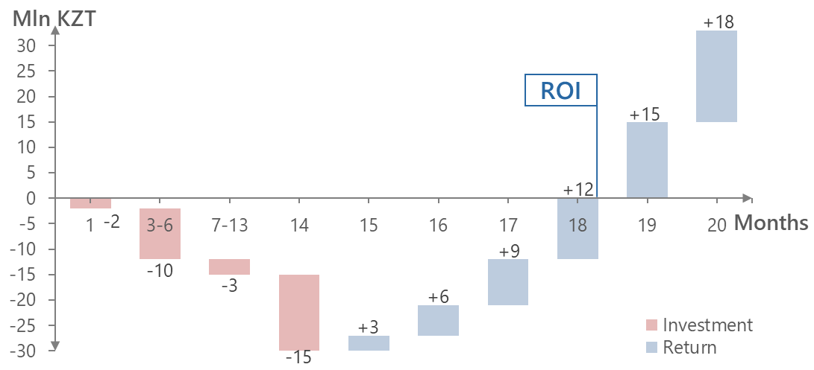

Figure 2 – Economic effect of commercialization

# Development, testing and debugging of the sensor prototype and its software.

This stage of the project has a duration of 24 months, from April 2020 to March 2022. However, the current document describes only those works that have been completed at the time of submission of the Interim Report for 2020.

## Collecting user stories and requirements

The construction industry, traditionally considered to be quite conservative, is now going through significant changes. In the conditions of increasing competition, companies began to gradually apply various digital technologies to reduce construction costs, for instance WSM RCS, which is being developed in this project. To make the WSM RCS really useful in the end, it is necessary to hear the opinion and vision of its potential users, from which it is necessary to form technical requirements before creation. This process is commonly called a collection of user stories and requirements. For its production there are different methodologies such as XP, Agile, Waterfall [45].

XP methodology uses methods to increase customer confidence in the software product, providing real facts of the development process, which also leads to a reduction in time of product development [46]. At the same time, user history is written by the customer of the system and does not exclude the fact that the developer has correctly understood the requirements to the system.

In the Agile methodology, the software is written to the customer's requirements in small parts, which allows for timely response in case of deviation. This distinguishes this methodology from cascading code writing, where the result is provided at the end of the period allocated for software development [47]. Moreover, the user story is written by the middle link between the developer and the customer of the system, i.e. the owner of the product, which makes understanding the requirements and perception of the requirements and opportunities clear to both sides.

In the Waterfall user history, stakeholder and customer requirements are collected at the beginning of the process, and a consistent plan for their implementation is created [48,49]. The advantage of Waterfall development is the selection and control of stages. A schedule can be set for each development phase together with a period. In this way, the product can pass through the phases of the development model one after another. Each stage of the project runs in a strict order. The disadvantage of the Waterfall model is the lack of time for reflection or revision. When the software goes through the testing phase, it is difficult to go back and make changes, something that was not thought through and documented during the development phase.

George Kölsch in his book [50] compares Agile and Waterfall methodologies on the result from the user stories and the result that the customer has received. The results are summarized in table 6 below.

Table 6 – Comparison of results obtained by customers for writing user stories using two methodologies

|  |  |  |  |
| --- | --- | --- | --- |
| Methodologies | Successful | Challenge | Fails |
| Agile | 42% | 49% | 9% |
| Waterfall | 14% | 57% | 29% |

The Agile methodology significantly benefits in terms of customer satisfaction in software development, and the most applicable for software system development. Taking into account the fact that the system being developed (i.e. the WSM RCS) has not only software, but also device development, it is not quite right to be completely guided by the methodology of Agile. To satisfy all components of the system, the methodology of interviewing every available participant [51] of the project from construction team is applied.

The interview should be conducted during the working hours of the interviewees directly on the construction site, not in the office space, so that the interviewees could clearly show [52], how they see the fixation of devices in the body of concrete, the desired distance between the sensors, the method of placement and the number of sensors on the vertical and horizontal structure, show the speed and strength of the flow of concrete mixture during casting in the form of future construction, show the distance from where and who should receive a signal from the sensors, show the height of the object being built and other factors. Interviewees should be interviewed at different objects and different classes of buildings to identify the project team's attitude towards innovations from the financial point of view [53] of each object.

In the course of the interview, feedback was received from the members of the project team on the implementation of the WSM RCS, and the following conclusions can be drawn:

* The sensor should give a complete picture of what is happening in the body of the RCS;
* The sensor must be embedded;
* Sensor must be wireless, i.e. it must have a battery in the case;
* To obtain the degree of curing, the sensor will need data on temperature and humidity in the body of concrete and reinforced concrete structures;
* The user should obtain data of concrete strength condition when necessary, using a mobile device or personal computer;
* The sensor must have a physical activation function;
* The sensor must have a light indicator when activated;
* The Sensor needs identifiers for easy display on the map of the object.

Also, an online survey was conducted and feedback was collected on the use of WSM RCS by the teams of projects for construction of residential complexes in Nur-Sultan of different classes of housing, such as “comfort”, “business” and “premium”, the results of which are summarized in table 7. Absolutely all the respondents were for the reduction of the time for the construction of the monolithic frame and all for the idea of monitoring the condition of concrete from inside.

Table 7 – Results of the survey of construction site teams

|  |  |  |  |  |
| --- | --- | --- | --- | --- |
| Name of the object, RC | Building class | Positions of surveyed staff | Attitude to the idea of WSM RCS | Attitude to purchase WSM RCS |
| Capital Park | Comfort | Superintendent | Positive | Negative |
| Foreman | Positive | Negative |
| Concrete worker | Positive | Negative |
| Tokyo | Business | Superintendent | Positive | Negative |
| Supervisor | Positive | Positive |
| Ray Residence | Premium | Superintendent | Positive | Positive |
| Supervisor | Positive | Positive |
| Supervisor | Positive | Negative |
| NAK | Business | Deputy Superintendent | Positive | Positive |

The interviewees were against the idea of implementing the WSM RCS, as well as against any additional item of procurement, since their project budget does not include additional items of expenditure. The project team sees a reduction in the construction of a monolithic frame only in the grade of concrete higher than that specified in the project. They also argue their position with regard to the relatively small number of floors and the area of their projects.

The business class participating in the survey already has a positive attitude, because the height and area of the objects requires them to be confident in making a decision to start building each next level. Leaders want a full picture of what is happening in the body of the reinforced concrete structure.

Premium class interviewees give such arguments as *“Digitalization of construction - the reputation of the object and an additional device to control the strength of concrete to make decisions”*. The team is ready to spend up to 30% of the saved money on the purchase of WSM RCS.

After the interview, a list of wishes and requirements of members of the project construction teams was compiled (table 8).

Table 8 – System requirements

|  |  |  |
| --- | --- | --- |
| № | Component | Requirements |
| 1 | 2 | 3 |
| 1 | WSM RCS | * measure the temperature and humidity of concrete with an error of ±1%; * remotely transfer measurement data to the Data Collection Station (DCS), which transmits them to a server for further processing and visualization through the interface of a mobile device and/or PC; * have a guaranteed serviceability within 1 month; * shall consist of: case, temperature sensor cable, humidity sensor, controller, memory module, wireless network module, clock module, power source, QR code, switch. |
| 2 | Body of WSM RCS | * have dimensions not exceeding 50×50×20 mm; * protect internal components from dust and moisture according to IP68 standard (full dustproof, resistant to high temperature and pressure water jet); * be resistant to aggressive alkaline environment; * be resistant to mechanical impact: shock, vibration, pressure (0.2 MPa); * be externally mounted as a clamp (or clamp hole); * have a clamp for fixing to the steel framework or a hole in the clamp. |
| 3 | Temperature sensor cable | * have a length of at least two variations: 300 and 1000 mm; * connect on one side - to the controller located in the body of WSM, on the other - to the temperature sensor; * be resistant to aggressive alkaline and acidic environments; * be resistant to mechanical impacts: shocks, vibration, pressure (0.2 MPa); * maintain serviceability at the temperature range from -50 to +100 ° C; * provide data transmission from temperature sensor to the controller. |
| 4 | Temperature sensor | * measure the temperature in the concrete body in the range from -50 to +100 ° C with a given periodicity; * transfer measurement data to the controller via cable; * be resistant to aggressive alkaline and chemical environments; * be resistant to mechanical impacts: shocks, vibration, pressure (0.2 MPa); * maintain serviceability at the temperature range from -50 to +100 ° C. |
| 5 | Moisture sensor | * to be placed inside or outside the body of the WSM and be connected to the controller; * measure humidity in the concrete body; * transfer measurement data to the controller; * be resistant to aggressive alkaline and chemical environments; * maintain serviceability in the temperature range from -50 to +100 ° C; * prevent the penetration of dust and moisture through itself. |
| 6 | Controller | * have optimal dimensions for its placement inside the body of the WSM; * be protected from mechanical, moisture and temperature influences; * accommodate all modules. * have an LED indicator. |
| 7 | Memory Module | * fit inside the body WSM and be connected to the controller; * store information about temperature and humidity measurements; * have enough memory capacity to store information about measurements for 1 month. |
| 8 | Wireless Network Module | * fit inside the body WSM and be connected to the controller; * perform data synchronization from the WSM to the DCS (data collection station) without loss or modification of data. |
| 9 | Clock Module | * fit inside the body WSM and be connected to the controller; * variable on/off switching of the device at a specified interval. |
| 10 | Power Source | * fit inside the body WSM and be connected to the controller; * to ensure the performance of the WSM is guaranteed within 1 month after the activation of the WSM. |
| 11 | QR code | * be glued to the WSM body from the outside; * contain identification information about a particular instance of the WSM contained on the server. |

Continuation of table 8

|  |  |  |
| --- | --- | --- |
| 1 | 2 | 3 |
| 11 | QR code | * be glued to the WSM body from the outside; * contain identification information about a particular instance of the WSM contained on the server. |
| 12 | Switcher | * have a convenient network short circuit mechanism when removing the dielectric film, which should be adhesive to the printed paper; * be connected to the controller. |
| 13 | DCS-data collection station | * be mobile, to be able to transfer from object to object; * have support for a wireless interface to obtain data from the WSM RCS; * send the obtained values to the cloud storage; * have the ability to be powered from the network and the built-in battery; * have the ability to switch instantly when the power is off; * have the ability to notify on the web-interface of the personal computer and the application about the external power failure; * have an internal memory for storing values of at least 100 sensors during the last 24 hours; * to have Wi-Fi module for communication with the Internet; * maintain serviceability at a temperature range from -50 to +50 ° C with the possibility of heating the case from the inside; * have a plastic, radio transparent, airtight body; * have an external antenna. |
| 14 | Software for WSM RCS | * be hosted on a server; * installed and used on iOS and Android platforms; * be used on several devices simultaneously; * have a clear and intuitive user interface; * have the ability to use the software for the WSM RCS on personal computers and have support for browsers Chrome, Internet Explorer, Mozilla Firefox; * receive data from the WSM RCS and convert them into values of strength of reinforced concrete structures; * to store data for a minimum of 2 years; * visualize graphs of all values; * upload reports in .pdf and .csv formats; * to have numbering from incoming sensors and to be able to rename them for user-friendly accounting; * to have an opportunity to scan individual QR codes of the WSM RCS; * to have different roles in the system as an administrator/user for delimitation of users' rights. |

## Developing the IT-architecture of the sensor

Based on the requirements for the creation of WSM RCS, is the principal architecture of the system, shown in figure 3. Transmission of data from the WSM RCS is required in small quantities, but the WSM must be compact and have its own autonomous power supply for a long period of time. As an interface of wireless communication system that meets the requirements was chosen energy efficient network LPWAN with LoraWAN protocol. To collect data from the WSM using the selected protocol will be used Data Collection Station (DCS), also called in the network topology as a "gateway". DCS will have wireless interfaces to receive LPWAN and Wi-Fi. Next to the DCS there will be a Wi-Fi access point with 3G/4G interfaces for access to the Internet. The node of connection, data storage, processing requests and sending results will be a virtual server on its own or leased out facilities, which will have a web interface for access from a personal computer and virtual ports and outputs for receiving and transmitting data from the mobile application.

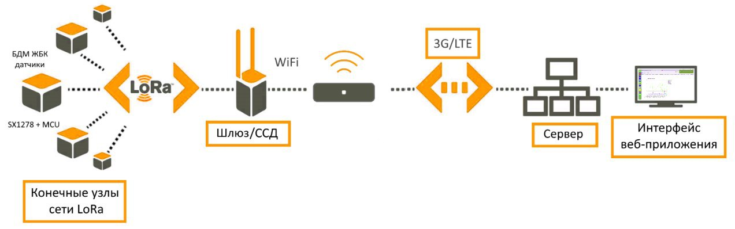

Figure 3 – Principal architecture of WSM RCS

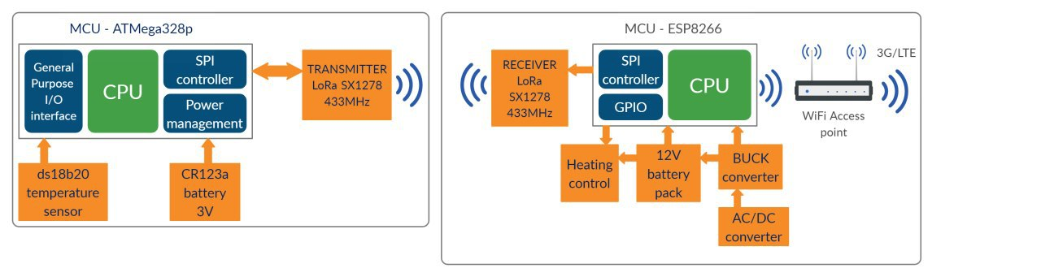

Figure 4 – Architecture of the components and a gateway of the WSM RCS

Figure 4 shows the connection of one of the nodes of the WSM RCS to the DCS, ie to the network gateway via LoRaWAN protocol. Each WSM RCS will work as follows: microcontroller ATMega328p with autonomous power supply from 3V battery type CR123A receives data from external temperature and humidity sensors, which transmits via SPI interface to the transmitter Semtech SX1278. Further data is modulated and broadcast in the range 433MHz with a capacity of 18dBm (63mW) via LoRaWAN protocol. DCS (gateway) received data, demodulates them via SPI interface, transmits to the microcontroller ESP8266, which has a wireless module Wi-Fi. DCS sends the received data from all WSM RCS to the cloud through an access point. The link between the cloud and the gateway is the access point. The Gateway will be able to heat itself up while operating in temperatures below -10°C. The Gateway will be permanently powered by the 230V network and will be able to switch instantly to an internal 12V battery when the 230V network is disconnected.

It was decided to use the data exchange between DCS and WSM according to the topology “Star” [54], that is, there is one DCS and many WSM RCS in the network, and all of them address DCS directly. The propagation coefficient and the LoRaWAN protocol bandwidth will be configured before the communication session starts.

Telemetry transport of message requests (MQTT) is used in the part of web interface. MQTT is a well-known machine-to-machine (M2M) communication protocol in many created Internet of Things (IoT) devices. MQTT is an internal TCP/IP communication protocol with a low data transfer level [54].

The ESP8266 in the LoRaWAN gateway will publish the data received from the WSM RCS and the Node-RED software installed in the cloud will be used to display the packages received from the WSM RCS when subscribing to the same MQTT hub.

To display the life cycle of the system and the interaction of users of the WSM RCS, DCS and the user of a mobile application or web application from a personal computer, figure 5 shows a diagram of the sequence of the system under development.

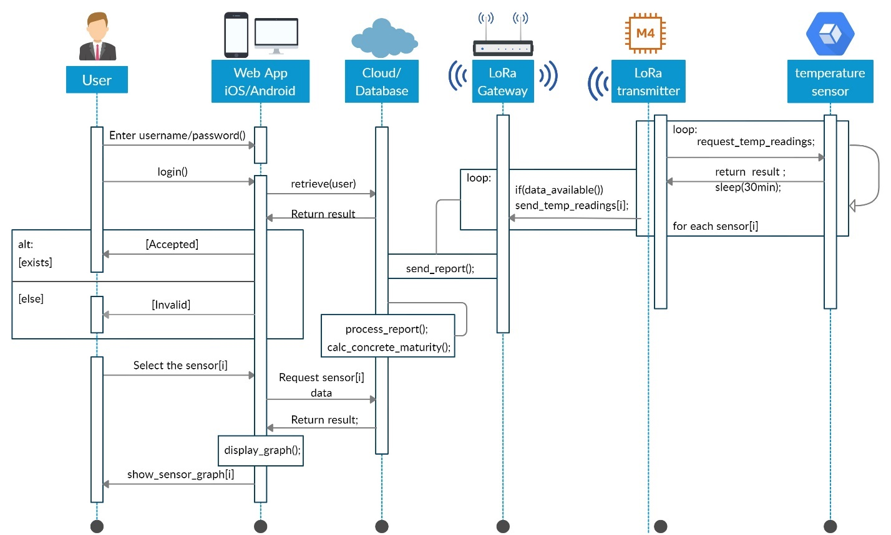

Figure 5 – The system sequence diagram

The user enters the system through the browser of a personal computer, mobile application of a smartphone or tablet by entering correctly his login and password, which he was previously given by the system administrator. Correctness of login and password is checked by the application or web interface for validity from the cloud. In case of mismatch the user gets an error of entering the authorization data and in case of coincidence the application or the web interface asks the user to enter the ID of the new WSM RCS manually or to read a QR code from the sticker at the WSM RCS through the built-in camera of the smartphone or to choose the one that is already available in the system. The application or the web interface asks for the chosen by the user data from the cloud and if there are any, it gets the data, which can be displayed in the chart with the dependence of the strength values on time. Strength values are displayed in the application or web interface after cloud calculations of the actual data cyclically entering the cloud from the DCS. The actual data contain the ID of the WSM RCS, the values of temperature and humidity, and the time in which the measurements were made.

## Factory assembly of sensors

Development of the WSM RCS was carried out in a room equipped for small-scale production, which can be called a factory (figure 6).Overlaying of devices on the board, soldering, flushing of boards and testing of software and electrical properties, manufacturing of housings for the WSM RCS on a 3D printer, post-processing of housings, placement of the device board in the housing and strength testing were performed at the workplace.

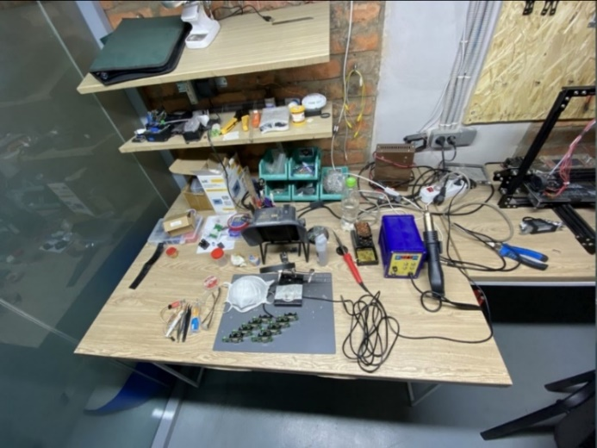

Figure 6 – Workplace for the production of WSM RCS

In the production of WSM RCS used solder equipment with a stinger-shaped "axe" with a temperature of 330 ° C, soldering dryer 327 ° C, flux RMA-UV35, tin and lead solder with a diameter of 0.8 mm. To ensure airway safety of an employee, a mask and a filter-extractor with a coal filter were used to detain heavy metal vapors, and transparent plastic glasses were used for eye safety.

The fees were designed on Eagle software, which is free of charge. The gerber file obtained from this software was sent to the globally used Chinese PCB factory JLCPCB, which manufactured and delivered bilateral PCBs to Nur-Sultan. The following components were soldered to the board:

* Microcontroller wireless interface Semtech SX1278 433MHz
* Atmega 328p Logic Microcontroller and components:
* 0.1μF, 10μF, 1μF and 15pF Capacitors
* 10 kOhm, 4.7 kOhm resistors
* 8 MHz frequency generator
* Battery compartment for 14250 type batteries
* Battery ER 14250 1/2 3,6 v 1200 mA/h
* MIC5205 voltage regulator
* Clamp for external sensor wires KF128
* Antenna with 3dBi, U.FL amplification
* Temperature sensor DS18B20

 The first batch of the WSM RCS comprised 8 prototypes of the WSM RCS. During the manufacturing process, a production line consisting of two workplaces was set up. Production began with soldering the legs of the radio chip SX1278, which used a special soldering paste BGA [55], which consists of flux and solder in the form of small round tin balls inside the paste (figure 7a). Next, on the contacts of the board lubricated with BGA paste chips were installed (figure 7b) for further soldering by blow-drying the soldering station (figure 7c), heated to 325 ºC. When heated by hairdryer paste (figure 7d) solder together with flux melt and solder the board contacts and the chip feet. The paste itself evaporates and leaves no trace on the board (figure 7e). On the back side of the board solder the battery compartment and screw terminals for external sensors (figure 7f). Each of the assembled devices (figure 7g, h) is placed in its own plastic case, which has dimensions 80×40×30 mm, isolating the device from dust and moisture. The case withstands mechanical impacts such as non-intensive shocks, vibration and pressure from all sides. It is designed on free Blender software and printed on Tevo Tarantulla 3D printer with PLA plastic. The shape of the body is trapezoidal. The longitudinal bottom of the body has longitudinal projections for reliable grip on rebar. In the body there is an hole for sliding the plastic clamp (figure 8).

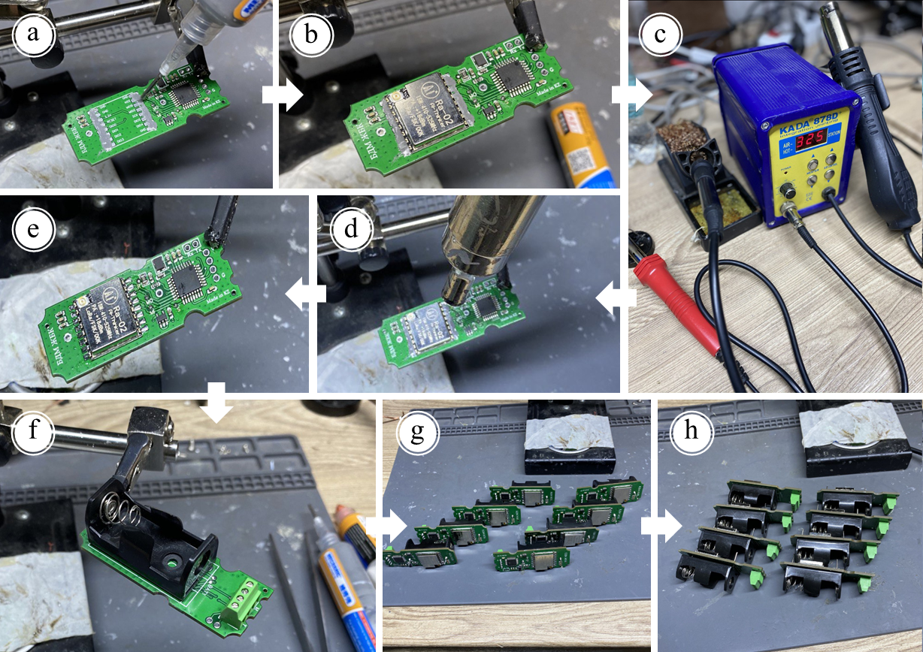

Figure 7 – Sequence of assembly of the electronic board of the WSM RCS

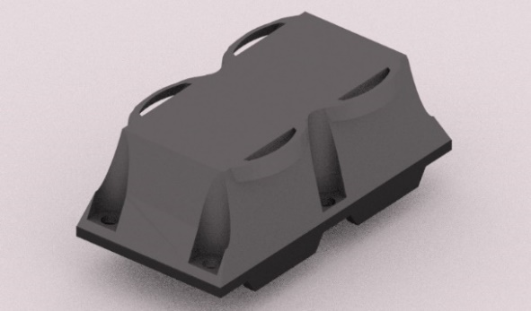

Figure 8 - The housing of the WSM RCS

## Software development

The software was written in C++ language in VisualStudio Code: Platformio environment for Atmega328p microcontroller work with sensors and data transfer module.

Atmega328p microcontrollers come from the factory with a completely empty memory and to be ready to accept and store the codes, you must first download the standard software "Bootloader" in the Atmega328p microcontroller, allowing the microcontroller to accept and record all the new codes for later use. Bootloader and the program code itself is written to the microcontroller USB-TTL programmer, shown in figure 9.

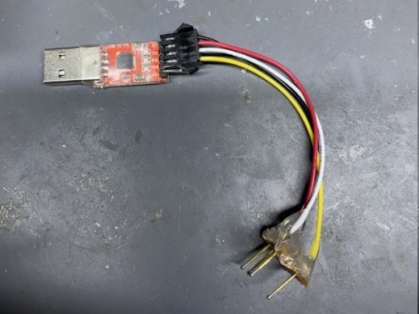

Figure 9 – USB TTL programmer adapted for serial programming

Special contacts for connection to the programmer jacks are prepared for recording codes on the board. The process of connecting the programmer stubs to the contacts of the WSM RCS is shown in figure 10.

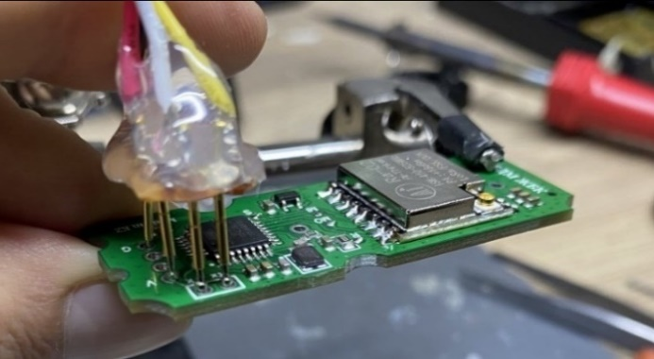

Figure 10 - Software upload in WSM RCS via USB TTL programmer

To download the standard Bootloader into the Atmega 328p microcontroller, a free Arduino IDE software was used, the interface of which is shown in figure 11.

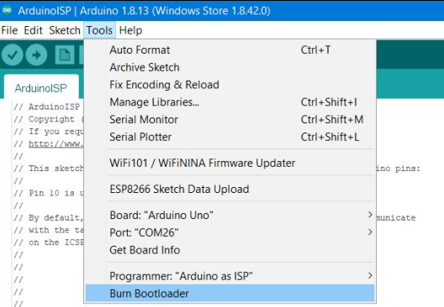

Figure 11 - Bootloader download interface via Arduino IDE software.

Once Bootloader is loaded, the microcontroller is able to accept and store in its memory more complex and targeted WSM RCS codes, which were developed on the free Visual Studio software with a plugin to work with a series of different energy efficient microcontrollers Platformio. The Platformio interface is shown in figure 12.

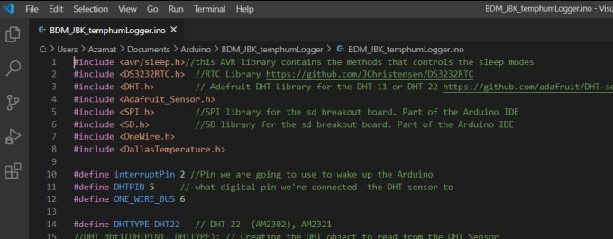

Figure 12 - VisualStudio Interface: Platformio

All data from the 8 WSM RCS comes to a server application developed in HTML, PHP, CSS JavaScript and installed on a laptop. The interface of the server application is shown in figure 13.

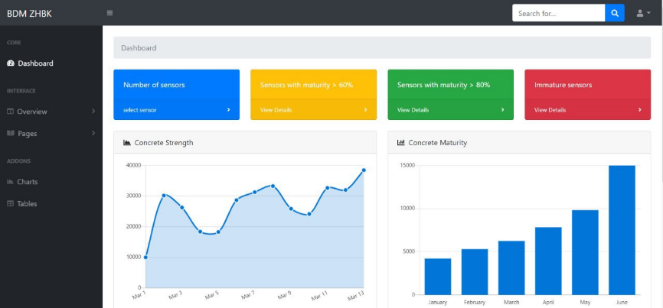

Figure 13 - Interface of the window with the received data from 8 sensors of the WSM RCS

In the server web-application you can select the desired WSM and display the real readings of the degree of curing of RCS.

## Testing of sensors and software at the factory

WSM RCS and its software were tested at the production facility. The purpose of the tests was to confirm the operability of the WSM and its software, i.e., the ability to perform measurements of concrete temperature at a given time interval. To achieve this goal, it was not necessary to embed the entire WSM in the body of the concrete structure. It was enough to immerse a cable with a temperature sensor at the end (figure 14, left). And the WSM RCS was fixed on the rebar above the surface of freshly placed concrete (figure 14, right).

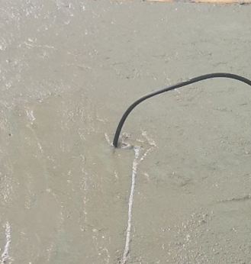 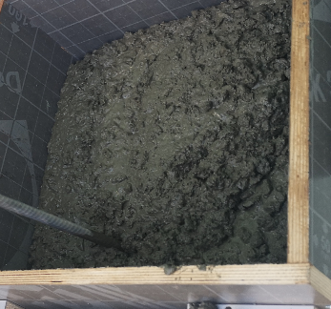

Figure 14 – Installation of WSM RCS for testing

The WSM RCS demonstrated its performance during the testing and proved its stated characteristics to measure temperature and humidity of concrete with an error of no more than ± 1ºC. The device is able to remotely transmit measurement data to the data collection station, which in turn sends them to the server for further processing (figure 15) and visualization through the PC interface. The turned on device has been operating on battery for more than 1 month. However, the software requires additional adjustments, calibration and setting of measurement intervals.

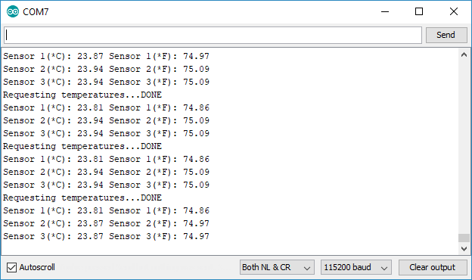

Figure 15 – Obtaining temperature data on the Arduino IDE Serial Monitor software

# Conducting laboratory tests of industrial samples of the sensor and its software

This stage of the project has a duration of 7 months, from July 2020 to January 2021. However, the current document describes only those works that have been carried out by the time the intermediate report for 2020 was submitted.

## Laboratory testing in Almaty

Laboratory tests in Almaty were conducted on the basis of the Research Institute of Building Materials and Design of "NIISTROMPROJECT" LLP. The tests were mainly aimed at determining the influence of temperature conditions of storage on curing dynamics and concrete strength gain. The purpose of the work was to test specimen-cubes for compression in the amount of 105 pcs. for 1, 3, 7, 14 and 28 days (5 approaches), 21 specimens for each day of testing. The batch of 105 specimens was molded from one batch of commercial concrete of B25 M350 class on the territory of "Temirbeton-1" LLP plant (Almaty). Prior to the test to determine the compressive strength, the specimens were held for at least 1 hour in the test laboratory in special climatic chambers at temperatures of 10, 20, 30, 40, 50, 60 and 70°C (to build 7 isotherms according to [25]). Climatic chamber - a chamber, which allows to accurately model the aggressive environmental impact. It has high-precision measuring devices for humidity and air temperature control. The working volume is made in the form of a cabinet with heat exchangers placed inside to provide test modes. The working volume is equipped with a swing door with an inspection window and anti-freeze protection system. The principle of operation of the climatic chamber is to provide the temperature and humidity set by the operator for tests.

For each temperature regime and corresponding day a series of 3 cube specimens with a rib length of 100 mm was tested. Accordingly, during one day of testing for 7 isotherms 3×7=21 specimens were tested. Determination of compressive strength was carried out on hydraulic press, according to [56] (figure 16). Results of conducted tests are presented in table 9 and figure 17 below.

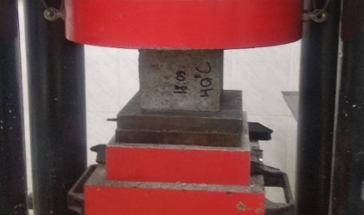 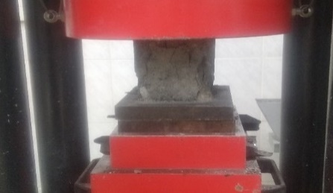

Figure 16 – Determination of compressive strength of concrete cube specimens

Table 9 – Test results

|  |  |  |  |  |  |  |  |
| --- | --- | --- | --- | --- | --- | --- | --- |
| Curing time, days | Concrete strength gain at different temperature regimes, N/mm2 | | | | | | |
| 10°С | 20°С | 30°С | 40°С | 50°С | 60°С | 70°С |
| 1 | 12.5 | 12.2 | 12.5 | 12.85 | 12.8 | 13.25 | 13.35* |
| 3 | 17.6 | 20.45 | 22.15 | 22.25 | 22.9 | 23.5* | 23.2 |
| 7 | 23.1 | 24.25 | 24.3 | 24.85* | 24.1 | 24 | 24.25 |
| 14 | 31.55* | 26.75 | 25.1 | 24.4 | 26 | 26.85 | 28.1 |
| 28 | 34.6* | 34.2 | 34 | 33.95 | 33.8 | 33.05 | 33 |

*\** *Maximum strength gain values*

Figure 17 – Concrete curing isotherms

According to the obtained isotherms, the maximum strength gain at 1, 3, 7, 14 and 28 days showed the specimens cured at 70, 60, 40, 10 and 10°C, with values of 13.35, 23.5, 24.85, 31.55, and 34.6 N/mm2 respectively. From these test results, the following conclusions can be drawn:

- The curing temperature of the specimens has a particular effect on the strength characteristics of the specimens at the early stages of curing - from 1 to 7 days. The dynamics of strength increase from temperature increase is observed.

- During the period of curing from 14 to 28 days there is an increase in the strength of concrete when holding specimens at a temperature of 10°C. Also, during the curing period from 14 to 28 days decreases the jump in strength characteristics of specimens tested after holding at temperatures from 20 to 70°C.

# CONCLUSIONS

Thus, the planned schedule of work in 2020 for the grant project AR08052033 “Development and pilot-industrial implementation of an embedded wireless sensor for non-destructive testing and monitoring of reinforced concrete structures” has been completed in full before the report is issued:

1. The analysis of the current state was performed. An understanding of the level of technology development in the research area was obtained. Sensors for non-destructive testing of concrete strength are an alternative to existing traditional methods, such as shock impulse methods or the elastic rebound method. The disadvantage of traditional non-destructive concrete strength testing methods is the limited radius and depth of the equipment, so that one large structure requires multiple measurements to obtain accurate strength data, which increases laboriousness and takes more time. Sensors solve this problem because they measure at a given interval of time, so that the builder can obtain the latest data on request. The use of sensors embedded in the body of concrete is quite common abroad, and the market for maturity sensors is represented by a wide range of manufacturers. However, despite the advantages of such solutions, there are no analogues in Kazakhstan.

2. A comparative analysis of best practices was made. The advantages and disadvantages of analogues and the list of necessary components of the sensor are revealed. Comparative analysis of best practices showed the effectiveness of embedded sensors compared with traditional destructive and non-destructive methods. The experience of using different types of sensors on construction sites around the world are considered, such as: Giatec SmartRock2 (Canada), Concrete Sensors (USA), Command Center Wireless (USA), Con-Cure NEX (USA), Exact Technology (Canada), Hobo (USA), Converge Signal (UK), HardTrack Cloud Sensor (Canada), AOMS Lumicon concrete sensor (Canada), intelliRock III Maturity Logger (USA), Sensohive Maturix sensor (Denmark), vOrb sensors (USA), Concremote (Geramnia), Humboldt (USA), Terem 4. 0 (Russia), Maturity computer MC(R)-21 (Germany). The comparative analysis of technical characteristics of these sensors is carried out.

3. A comparative analysis of regulatory documentation was made. Determined the principle and methods of work with the sensor. According to the requirements of standards, the strength of concrete can be calculated by several methods: temperature graphs, concrete maturity, analytical dependencies. The requirements to methods of temperature and strength control of concrete regulated in standards ASTM C1074-19 (USA), SHRP-C-376 (USA), ST-NP SRO SSC-04-2013 (Russia), EN 13670 (EU), DIN 1045-3 (Germany), NF EN 13670 (France), ACI 228.1R (USA) are considered.

4. The analysis of literature sources was carried out. An understanding of trends, market expectations, ways to upgrade the sensor is obtained. The market of wireless maturity sensors is constantly growing. Foreign analogues are expanding the supply zone. However, due to the high cost and the presence of certain problems in the IT-architecture (the inability to synchronously control the strength of concrete due to Bluetooth), their use is limited in Kazakhstan. In this regard, the sensor being developed in the project accepted to modernize existing solutions in order to eliminate the shortcomings of analogues. With further modernization of the sensors under development it will make its integration with BIM and Big Data technologies.

5. The methodological basis of the project was developed. A step-by-step project implementation plan was developed. Plans and methods of interviewing and online surveys were developed to collect user stories from potential users of project results. SWOT-analysis of the project was performed, where its strengths and weaknesses were considered. Critical points (risks) in the project, affecting the achievement of the goal, and alternative ways of project implementation were identified.

6. The project promotion model was developed. The model reflects the analysis of the market of erected housing and the industry as a whole, where there is a positive trend of growth in construction volumes. The analysis of competitors is carried out. Within the framework of the project promotion, the concept of “Wireless sensor monitoring of reinforced concrete structures” was introduced, which will be used in the form of the trademark “WSM RCS”.

7. User stories are collected. The opinion and vision of potential users of the sensor are obtained, from which the technical requirements were then formed. Taking into account the expectations and requirements of the members of the construction teams of the construction projects after the interview a list of requirements to the components of the sensor was made: case, temperature sensor cable, controller, memory module, wireless module, switch, data collection station, software.

8. The IT-architecture of the sensor is defined. The sensor has its own autonomous power supply for a long period of time. As an interface of wireless communication system that meets the requirements of the system was selected energy efficient LPWAN with LoRaWAN protocol. To collect data from the database using the selected protocol will be used Data Collection Station (DCS), also called in the network topology as a "gateway". DCS will have wireless interfaces to receive LPWAN and Wi-Fi. Next to the DCS there will be a Wi-Fi access point with 3G/4G interfaces for access to the Internet. The node of connection, data storage, processing requests and sending results will be a virtual server on its own or leased out facilities, which will have a web interface for access from a personal computer and virtual ports and outputs for receiving and transmitting data from the mobile application.

9. The first batch of WSM RCS from 8 pilot samples was developed. During the manufacturing process, a production line consisting of two workplaces was set up. Sensor assembly at the plant continues. Software further development is in progress.

10. Laboratory tests of industrial samples of the sensor and its software were carried out, as a result of which dependences and dynamics of strength increase on temperature increase were obtained. Test protocols confirming characteristics and functionality of the sensors are still being received.

Summing up the work performed, we can conclude about the successful implementation of the tasks planned from the beginning of the project to the date of this report.

# REFERENCES

#### Перминов М.О., Яськова Н.Ю. Развитие новых методов инвестирования в строительстве // Сборник докладов научно-технической конференции по итогам научно-исследовательских работ студентов института экономики, управления и информационных систем в строительстве и недвижимости. – Москва: МГСУ, 2017. – С.28–33.

#### Савушкина Т.Ю., Зенов В.С., Зеленцов А.С., Лапидус А.А. Потенциал эффективности комплексной оценки качества строительства от этапа проектирования до ввода объекта в эксплуатацию // Инженерный вестник Дона. – 2019. – № 1 (52). – 10 с.

#### Болтачев А.В., Крыцовкина А.В. Пути снижения себестоимости в строительных организациях // Сборник статей Международной научно - практической конференции. – 2017. – С.20–22.

#### Лукин М.И. Оптимизация технологии, организации и управления строительными процессами на этапе возведения // Синергия Наук. – 2017. № 11. – С.1056–1060.

#### Романчиков А.Д. Определение прочности бетона неразрушающими методами с учетом его зрелости. – Челябинск: ЮУГУ, 2016. – 94 с.

#### Hakan K., Öztürk T. Determination of concrete quality with destructive and non-destructive methods // Comput. Concr. – 2015. – Vol. 15, № 3. – P.473–484.

#### Hannan M.A., Hassan K., Jern K.P. A review on sensors and systems in structural health monitoring: Current issues and challenges // Smart Struct. Syst. – 2018. – Vol. 22, № 5. – P.509–525.

#### Dutta S., Samui P., Kim D. Comparison of machine learning techniques to predict compressive strength of concrete // Comput. Concr. – 2018. – Vol. 21, № 4. – P.463–470.

#### The best concrete sensor in 2020 [Electronic resource]. – 2020. – URL: https://www.giatecscientific.com/education/the-best-concrete-sensors-2020/ (date of access 07.10.2020).

#### Thandavamoorthy T.S. Determination of concrete compressive strength: A novel approach // Pelagia Res. Libr. Adv. Appl. Sci. Res. – 2015. – Vol. 6, № 10. – P.88–96.

#### Smart Sensor Allows for Quick, Real-time Strength Data [Electronic resource]. – 2019. – URL: https://www.forconstructionpros.com/concrete/equipment-products/technology-services/article/21080647/smart-sensor-allows-for-quick-realtime-strength-data (date of access 07.10.2020).

#### COMMAND Center Sensor [Electronic resource]. – 2020. – URL: https://www.commandcenterconcrete.com/pricing/command-center-sensor/ (date of access 07.10.2020).

#### The next generation of concrete temperature monitoring and maturity [Electronic resource]. – 2020. – URL: https://www.concure.com/ (date of access 07.10.2020).

#### Advancing the construction industry [Electronic resource]. 2020. URL: https://www.exacttechnology.com/ (date of access 07.10.2020).

#### HOBO UX100 Data Loggers [Electronic resource]. – 2020. – URL: https://www.onsetcomp.com/products/data-loggers/UX100-data-loggers (date of access 07.10.2020).

#### Concrete temperature and strength data in real-time [Electronic resource]. – 2020. – URL: https://converge.io/converge-signal/ (date of access 07.10.2020).

#### HardTrack Cloud Sensor [Electronic resource]. – 2020. – URL: https://www.wakeinc.com/index.php/services/architecture/ (date of access 07.10.2020).

#### Improving Automatic Emergency Braking with FLIR Thermal Imaging [Electronic resource]. – 2020. – URL: https://www.flir.com/news-center/ (date of access 07.10.2020).

#### Real-time monitoring of concrete Why use Maturix? [Electronic resource]. – 2020. – URL: http://sensohive.com/maturix/ (date of access 07.10.2020).

#### Humboldt Concrete Maturity Sensor System [Electronic resource]. – 2020. – URL: https://www.humboldtmfg.com/humboldlt-concrete-maturity-sensor-system.html (date of access 07.10.2020).

#### ASTM C1074-19. Standard Practice for Estimating Concrete Strength by the Maturity Method. – 2019. – 10 p.

#### Due to the low temperatures the formwork is completely enclosed and heated in the winter months [Electronic resource]. – 2020. – URL: https://structurae.net/en/media/242993-due-to-the-low-temperatures-the-formwork-is-completely-enclosed-and-heated-in-the-winter-months (date of access 07.10.2020).

#### DIN EN 13670. Execution of concrete structures. – 2011. – 70 p.

#### Терем 4.0 [Electronic resource]. – 2020. – URL: https://www.interpribor.ru/monitoring-system-terem-4 (date of access 07.10.2020).

#### СТ-НП СРО ССК-04-2013. Температурно-прочностной контроль бетона при возведении монолитных конструкций в зимний период. – 2013. – 25 с.

#### MCR 21 Rijpheidscomputer van Verboom Techniek [Electronic resource] // Verboom. – 2020. – URL: https://www.youtube.com/watch?v=TvnNRjHypj4 (date of access 07.10.2020).

#### NEN 5970. Determination of strength of fresh concrete with the method of weighted maturity. – 2001. – 21 p.

#### SHRP-C-376. Manual on Maturity and Pullout for Highway Structures. – 1993. – 84 p.

#### De Vree R.T. Gewichtete reife des betons // Beton. – 1998. – Vol. 48. – P.674–678.

#### Papadakis M., Bresson J. Contribution to the Study of the Maturity of Hydraulic Binders // Rev. Mater Constr Trav Pub’Ciments Betons’. – 1973. – Vol. 678. – P.18-22.

#### Soutsos M., Kanavaris F., Hatzitheodorou A. Critical analysis of strength estimates from maturity functions // Case Stud. Constr. Mater. – 2018. – Vol. 9. – P.e00183.

#### Taheri S. A review on five key sensors for monitoring of concrete structures // Constr. Build. Mater. – 2019. – Vol. 204. – P.492–509.

#### Rasmussen R.O., Cable J.K., Turner D.J., Voigt G.F. Strength prediction by using maturity for Portland cement concrete pavement construction at airfields // Transp. Res. Rec. – 2004. – Vol. 1893, № 1. – P.18–25.

#### Dan H.-C., Yang D., Liu X., Peng A.-P., Zhang Z. Experimental investigation on dynamic response of asphalt pavement using SmartRock sensor under vibrating compaction loading // Constr. Build. Mater. – 2020. – Vol. 247. – P.118592.

#### Zeng K., Qiu T. Bian X., Xiao M., Huang H. Identification of ballast condition using SmartRock and pattern recognition // Constr. Build. Mater. – 2019. – Vol. 221. – P.50–59.

#### Christiaan E.B. Investigation of a practical application of the Maturity Method to estimate the early-age strength of concrete. – Stellenbosch: SU, 2019. – 144 p.

#### Shoukry S.N. William G.W., Downie B., Riad M.Y. Effect of moisture and temperature on the mechanical properties of concrete // Constr. Build. Mater. – 2011. – Vol. 25, № 2. – P.688–696.

#### Utepov Ye.B., Aniskin A., Ibrashov A.P., Tulebekova A.S. Maturity sensors placement based on the temperature transitional boundaries. // Mag. Civ. Eng. – 2019. – Vol. 90, № 6. – P.93–103.

#### Blaschke J.H.V., Torrico F.A. Estimating concrete strength using the orrelation of the concrete maturity method applied to the materials of Cochabamba -Bolivia // Rev. Investig. Desarro. – 2018. – Vol. 18, № 1. – P.117-127.

#### Utepov Ye., Khudaibergenov O.A., Kabdush Ye.B., Kazkeev A.B. Prototyping an embedded wireless sensor for monitoring reinforced concrete structures // Comput. Concr. – 2019. – Vol. 24, № 2. – P.95–102.

#### Lim J.S., Cruz H., Pourhomayoun M., Mazari M. Application of IoT for Concrete Structural Health Monitoring // 2018 International Conference on Computational Science and Computational Intelligence. – 2018. – P.1479–1482.

#### Ильина О.Н. Методологическое обеспечение управления проектами, программами и портфелями проектов в организации // Менеджмент в России и за рубежом. – 2010. – № 1. – С.19–23.

#### О вводе в эксплуатацию жилья в Республике Казахстан [Electronic resource]. – 2019. – URL: https://stat.gov.kz/api/getFile/?docId=ESTAT342283 (date of access 01.05.2020).

#### Четырехкомнатная квартира №2 [Электронный ресурс]. – 2020. – URL: https://bi.group/ru/ (дата обращения 01.05.2020).

#### Hunt J.A. Scrum and eXtreme Programming (XP) // PMI-ACP Project Management Institute Agile Certified Practitioner Exam Study Guide. – Hoboken: John Wiley & Sons, Inc., 2018. – P.21–59.

#### Feng Y. Cui D., Li H., Zhao Y., Liu J. Analysis of extreme programming // MATEC Web Conf. – 2020. – Vol. 309. – P.02016.

#### Summers B.L. Agile for Software Engineering // Effective Methods for Software Engineering. – Boca Raton: CRC Press, 2020. – P.99–107.

#### Doolittle J. Jeremy Miller on Waterfall Versus Agile // IEEE Softw. – 2020. – Vol. 37, № 4. – P.107-C3.

#### Poort E. Between the Waterfall Wasteland and the Agile Outback // IEEE Softw. – 2020. – Vol. 37, № 1. – P.92–97.

#### Koelsch G. Requirements Writing for System Engineering. – Berkeley: Apress, 2016. – 409 p.

#### Gant W. Why Software Development Interviews Are Hard // Surviving the Whiteboard Interview. – Berkeley: Apress, 2019. – P.1–6.

#### Hansen E.C. Successful Qualitative Health Research. – Routledge, 2020. – 224 p.

#### Klaus K. Interview Protocol and List of Interviews // Political Violence in Kenya. – Cambridge: Cambridge University Press, 2020. – P.298–306.

#### Kodali R.K., Gorantla V.S.K. Weather tracking system using MQTT and SQLite // 3rd International Conference on Applied and Theoretical Computing and Communication Technology. – 2017. – P.205–208.

#### Adachi T., Goto H., Araki W., Omori T., Kawamura N., Mukai M., Kawakami T. Testing method for measuring impact strength of bga solder joints on electronic package // Int. J. Mod. Phys. B. – 2008. – Vol. 22, № 09n11. – P.1050–1055.

#### ГОСТ 10180-2012. Бетоны. Методы определения прочности по контрольным образцам. – М., 2013. – 30 с.

# APPENDIX А

**Foreign analogues of concrete maturity sensors**

***Technical parameters***

|  |  |  |  |  |  |  |  |  |
| --- | --- | --- | --- | --- | --- | --- | --- | --- |
| № | Name (country) | Wireless network | Units* | Temperature range | Accuracy | Measurement interval | Transmission range | Battery life |
| 1 | SmartRock (Canada) [9] | Bluetooth, GPS | T, R | from -30 to +60°C | T: ±1 °C | 30 min | up to 8 m | up to 4 months |
| 2 | Concrete Sensors (USA) [11] | Bluetooth, GPS | T, W, R | from -40 to +85°C | T: ±0,4°C, W: ±3% | 30 min | up to 20 m | up to 2 years |
| 3 | Command Center (USA) [12] | Bluetooth | T, R | from -30 to +85°C | T: ±1 °C | customizable | up to 9 m | up to 10 years |
| 4 | Con-Cure Nex (USA) [13] | GPS, SD-card | T | from -20 to +70° C | T: ±0.1 °C | 10 min | up to 100 m | continuously |
| 5 | Concremote (Germany) [22] | Bluetooth | T, R | from -40 to +20°C | T: ±0.1 °C | 10 min | up to 10 m | up to 4 months |
| 6 | Converge Signal (UK) [16] | Bluetooth | T, W, R | from -20 to 80°C. | T: ±0.2 °C | 20 min | up to 15 m | 2 years |
| 7 | Exact (Canada) [14] | Bluetooth, GPS | T, W, R | from -20 to +85°C | T: ±0.5 °C | customizable | up to 45 m | 2 years |
| 8 | Maturix (Denmark) [19] | Sigfox Connectivity | T, W | from -40 to + 50℃ | T: ±1.5 °C | 10 min | up to 100 m | up to 5 years |
| 9 | Terem 4.0, 4.1 (Russia) [24] | USB / GSM | T, W | from -10 to +50°C | T: ±0.1 °C | customizable | up to 20 m | continuously |
| 10 | MCR-21 (Netherlands) [26] | GPRS | T, W, R | from -10 to +110°C | T: ±1.0 °C | 10 min | up to 150 m | continuously |

***Illustrations\****

|  |  |  |  |  |
| --- | --- | --- | --- | --- |
| Related image | Image result for Concrete Sensors |  | C:\Users\asus\Desktop\idrop-kit-285x214.png | C:\Users\asus\Desktop\co.jpg |
| (1) | (2) | (3) | (4) | (5) |
| https://converge.io/wp-content/uploads/2019/09/geo-render.png | https://exact-public-assets.s3-us-west-2.amazonaws.com/landing/assets/img/landing/img15.jpg | Maturix - Maturix Smart Monitoring of Concrete Curing |  | https://scontent-waw1-1.xx.fbcdn.net/v/t1.0-9/168512_508862929149102_135235193_n.jpg?_nc_cat=102&_nc_sid=cdbe9c&_nc_ohc=q8wND2X3OjMAX_YtApN&_nc_ht=scontent-waw1-1.xx&oh=5166e97cd0431b195efb053d17772cd8&oe=5F49ABEE |
| (6) | (7) | (8) | (9) | (10) |

* Sensor illustrations are numbered in accordance with their technical parameters