Ministry of Agriculture of the Republic of Kazakhstan
Non-commercial JSC «National Agr arian Science and Educational Centre»
LLP «AGRICULTURAL EXPERIMENTAL STATION «ZARECHNOE»
(LLP «AES «ZARECHNOE»)

UDC 631.58
State registration number 0118РК01394
Inv. No
APPROVE
Chairman of the Board of LLP «Agricultural experimental station «Zarechnoe»
_______________ S.I. Dzhurabaev
October 09, 2020

REPORT
ABOUT SCIENTIFIC RESEARCH WORK

STP: TRANSFER AND TECHNOLOGY ADAPTATION FOR EXTRASIC FARMING
IN PRODUCTION PRODUCTION PLANTS BY PRINCIPLE «DEMONSTRATION
ECONOMIES (POLYGONS)» IN KOSTANAY REGION
(final)

Program cipher – О.0917

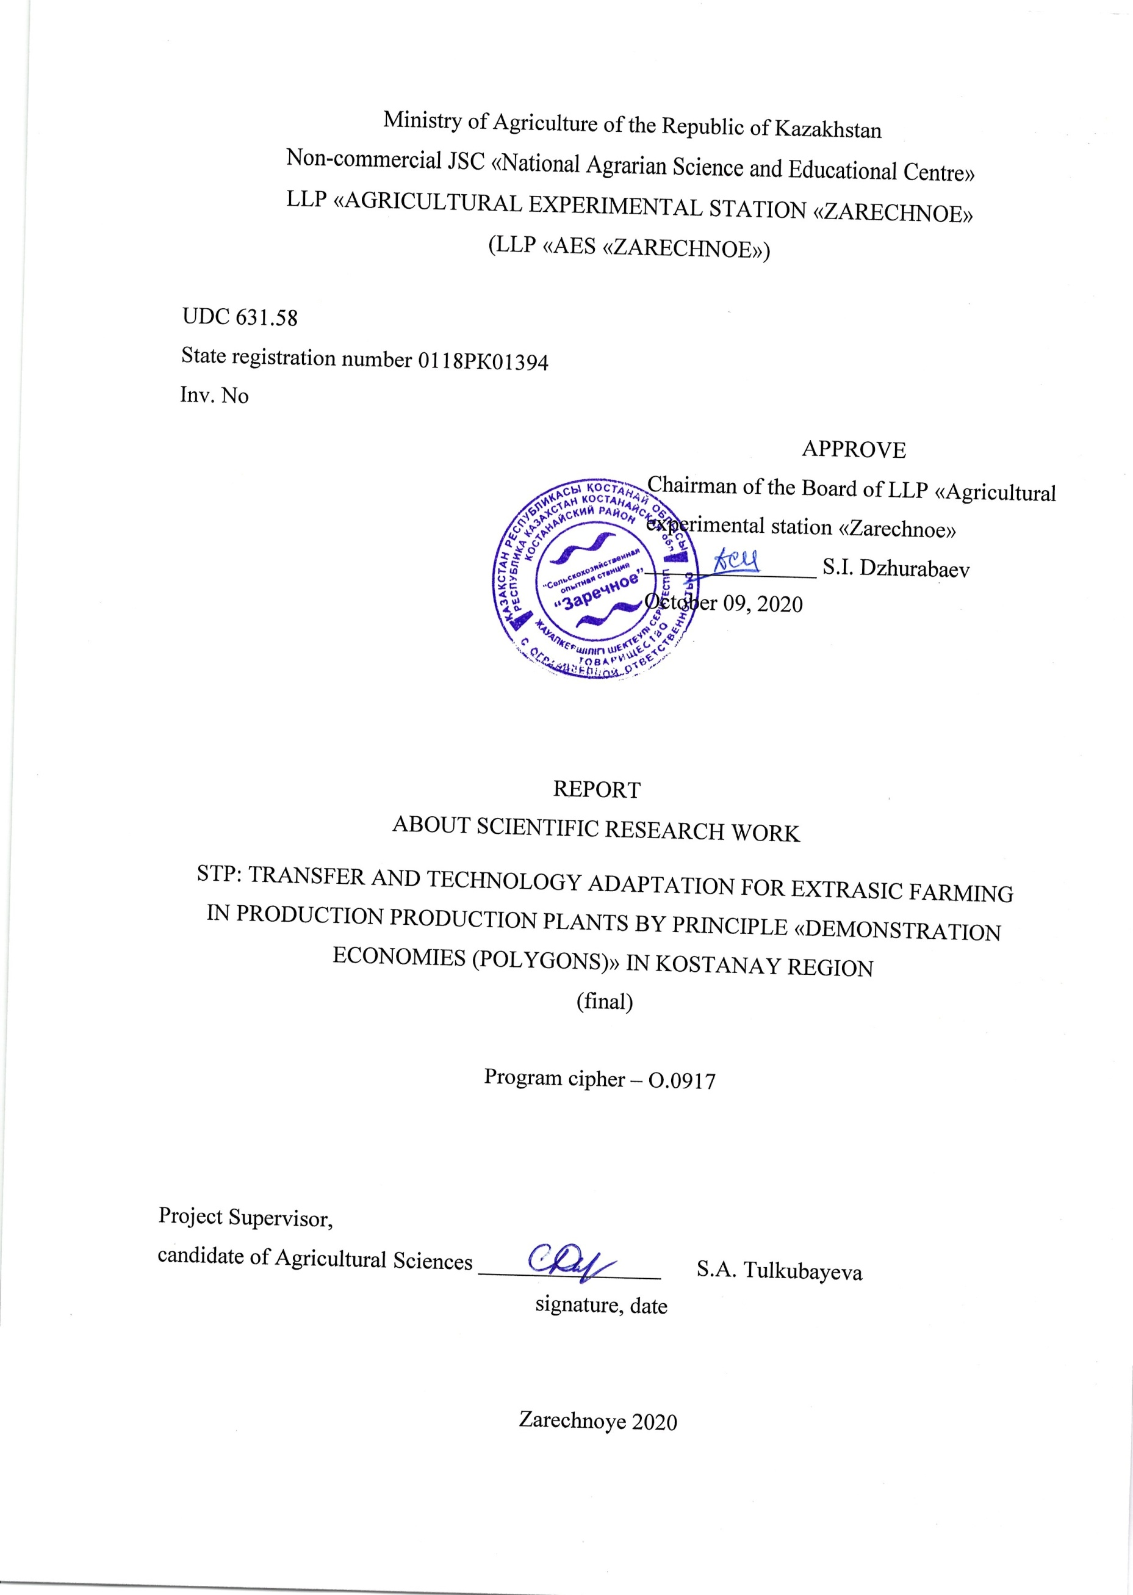
Project Supervisor,
candidate of Agricultural Sciences ________________ S.A. Tulkubayeva
signature, date

Zarechnoye 2020

LIST OF EXECUTORS

Project supervisor, candidate of Agricultural Sciences | _______________  signature, date | S.A. Tulkubayeva (introduction, main part, conclusion, appendixces)
Executive officer, candidate of Agricultural Sciences | _______________  signature, date | Yu.V. Tulayev (sections 1, 2, 3.1, 3.2)
Performers:
Doctor of Agricultural Sciences, associate professor, corresponding member of IAAE | _______________  signature, date | A.B. Abuova (introduction, section 3.1, conclusion)
Candidate of Agricultural Sciences | _______________  signature, date | S.V. Somova (sections 1, 3.1)
Master of Agriculture | _______________  signature, date | A.O. Kasenov (sections 1.2, 1.3, 3.1)
Master of Agricultural Sciences | _______________  signature, date | V.A. Vyhodtsev (sections 1.2, 1.3)
Master of Agricultural Sciences, PhD student | _______________  signature, date | V.V. Taykov (section 1)
Scientist agronomist | _______________  signature, date | I.V. Sidorik (sections 1, 3.1)
Master of Agricultural of Sciences | _______________  signature, date | A.V. Zinchenko (sections 1, 3.1)
Master of Agriculture | _______________  signature, date | M.B. Nurgalieva (section 1)
Master of Agricultural Sciences, PhD student | _______________  signature, date | A.I. Sidorik (section 3.1)
Doctor of Biological Sciences, professor | _______________  signature, date | A.A. Kurmanbaev (section 3.3)
Candidate of Biological Sciences | _______________  signature, date | Zh.A. Baygonusova (section 3.3)
Master in Biotechnology | _______________  signature, date | A.B. Rysbek (section 3.3)
Doctor of Technical Sciences, professor | _______________  signature, date | V.L. Astafiev (section 3.4)
Candidate of Technical Sciences | _______________  signature, date | P.G. Ivanchenko (section 3.4)
Master of Engineering and Technology | _______________  signature, date | I.I. Sultanov (section 3.4)
Master of Engineering and Technology | _______________  signature, date | A.N. Tabuldenov (section 3.4)
Master student | _______________  signature, date | R.F. Tashmukhamedov (section 3.4)
Norm controller | _______________  signature, date | S.A. Tulkubaeva

ABSTRACT

Report 326 p., 33 figures, 16 tables, 44 sources, 24 appendixes.
PRECISION AGRICULTURE, TRANSFER, IMPLEMENTATION, TRAINING, INFORMATION AND ANALYTICAL RESOURCES, DIFFERENTIATED APPLICATION OF MINERAL FERTILIZERS AND PLANT PROTECTION PRODUCTS, REMOTE EARTH SENSING, YIELD MAPPING, BIOPESTICIDES, AGRICULTURAL MACHINERY AND EQUIPMENT, ECONOMIC MODEL
The object of study is the elements of precision farming technology.
The research method is stationary field experience, geostatistical methods, methods of remote sensing of the Earth.
Objective – Transfer and adaptation of precision farming technology elements on the basis of a pilot demonstration site in the Kostanay region using a biological product to increase crop yields, increasing labor productivity in crop production by 2.0-2.5 times due to the use of modern technologies and precision farming tools based on the development of economic models for the implementation of precise technologies.
The elements of precision farming have been introduced on the basis of the production and demonstration field of the LLP «AES «Zarechnoe» on a demonstration plot with an area of ​​3800 hectares. Through training activities, specialists have been trained who adapt the elements of precision farming in agriculture. production – more than 700 people. The coverage of farms in Kostanay region by 2021 will be 15% of the sown area. 5 recommendations on the use of elements of precision farming in the cultivation of grain crops, technological maps have been developed. Applications were submitted for obtaining 3 patents for a useful model, 1 patent for an invention, and positive decisions on granting a patent were received. 20 scientific articles have been published, 5 of them – in collections of international conferences (Web of Science) and in publications with a non-zero impact factor included in the Scopus and Web of Science databases. 11 undergraduates and 10 PhD doctoral students, university and college students (more than 200 people) are involved in the project. 5 scientific internships have been completed in scientific institutions of Russia, Belarus, Germany. Foreign scientists from Russia, the USA and other countries were attracted. 1 biological product based on the cultures of azotobacter has been developed. Complexes of machines and equipment have been developed for the comprehensive mechanization of crop cultivation in the system of precision farming. Economic models have been developed for the introduction of precision farming technologies for different types of farms. The leading farms of the Kostanay region were attracted, taking into account their production experience – «Troyana» LLP, «Agrofirma Qargyn» LLP, «Zhanakhai» farm.
CONTENT

INTRODUCTION……………………………………………………………………………… | 10
MAIN PART OF THE RESEARCH REPORT ………………………………………………… | 15
1 Justification of the chosen research area……………………………………………………… | 15
1.1 Research Methodology………………………………………………………………… | 16
1.2 Accounting and observation…………………………………………………………… | 20
1.3 Agricultural technology and layouts…………………………………………………… | 22
2 Meteorological conditions…………………………………………………………………… | 23
3 Research results……………………………………………………………………………… | 26
3.1 Introduction of precision farming elements at the demonstration site…………………… | 26
3.2 Economic efficiency of spring wheat cultivation depending on the supply of nutrients to the soil……………………………………………………………………………………… | 49
3.3 Development of a biological product based on Azotobacter cultures to increase the productivity of agricultural crops…………………………………………………………… | 52
3.4 Development of complexes of machines and equipment for complex mechanization of crop cultivation in the system of precision agriculture……………………………………… | 55
3.5 Development of an economic model for the introduction of precision technologies for farms of the Kostanay region with different equipment capability………………………… | 57
CONCLUSION………………………………………………………………………………… | 63
LIST OF USED SOURCES…………………………………………………………………… | 66
APPENDIX A – Maps of availability of fields. Task cards. Digital agrochemical maps……… | 73
APPENDIX B – The results of agrochemical investigation of soil, «AES «Zarechnoe» LLP… | 77
APPENDIX C – Yield after harvesting in the conditions of 2018-2020 by fields of the testing area, «AES «Zarechnoe» LLP…………………………………………………………………… | 82
APPENDIX D – Spring wheat average yield information in the Kostanay region…………… | 84
APPENDIX E – Test reports of the quality of grain grown using a biological product………… | 87
APPENDIX F – Conclusion on the results of the study of strains for toxicity………………… | 90
APPENDIX G – Strain passport………………………………………………………………… | 92
APPENDIX H – Data base……………………………………………………………………… | 94
APPENDIX J – The protocol of comparative tests of technical equipment in the precision farming system………………………………………………………………………………… | 100
APPENDIX K – Technological maps…………………………………………………………… | 101
APPENDIX L – Comparative characteristics of the existing and recommended composition of machine complexes……………………………………………………………………………… | 109
APPENDIX M – Economic models…………………………………………………………… | 114
APPENDIX N – Report on the implementation of the plan of speeches/publications in the media «AES «Zarechnoe» LLP, 2018-2020. Seminars, Field days……………………………… | 120
APPENDIX P – Reprints of scientific works, publications in the media……………………… | 130
APPENDIX Q – Acts of implementation, scientific support contracts………………………… | 156
APPENDIX R – Patent Research Report……………………………………………………… | 166
APPENDIX S – Attraction and training of young personnel…………………………………… | 221
APPENDIX T – Lists of workshop participants, Field Days…………………………………… | 253
APPENDIX U – Figures………………………………………………………………………… | 271
APPENDIX V – Foreign internships and training……………………………………………… | 285
APPENDIX W – Application for the grant of a patent of the Republic of Kazakhstan, notification of a positive examination result…………………………………………………………… | 301
APPENDIX X – Study guide, recommendations……………………………………………… | 312
APPENDIX Y – Purchase of equipment, technologies and computer facilities………………… | 322
APPENDIX Z – Copy of the protocol of the Academic Council of «AES «Zarechnoe» LLP… | 324

TERMS AND DEFINITIONS

The following terms and definitions are used in this research report:
ArcGIS | – is a family of geographic information software products of the American company ESRI. They are used for land cadastres, in land management tasks, accounting for real estate, engineering communications systems, surveying and subsoil use and other areas
GIS (Geographical information system) | – geographic information system, GIS: a class of software systems related to the input, processing, storage and display of spatial data, such as terrain maps, plans, diagrams, etc.
GNDVI (Green Normalized Difference Vegetation Index) | – this index is similar to NDVI, except that it measures the green spectrum from 540 to 570 nm instead of the red spectrum
Google Earth (Google Earth) | – Google’s program, which contains satellite images of the entire earth’s surface. Photos of some regions have unprecedented high resolution
GPS (Global Positioning System) | – is a satellite navigation system that provides distance, time and location e in the world coordinate system
Greenseeker | – the portable touch sensor for determining biomass is an easy-to-use measuring device that can be used to assess the condition and yield of a crop
The NDVI (Normalized Difference the Vegetation the Index) | – normalized relative vegetation index; quantitative measure of photosynthetically active biomass, commonly called the vegetation index
N-tester | – is a portable device that helps you quickly and easily measure the level of nitrogen absorption by a crop to determine its exact need
Off-line | – two-stage approaches or approaches based on mapping
On-line | – one-stage approaches or approaches with making decisions in real time or sensory approaches
Quantum GIS (or QGIS) | – is an application that belongs to the class of user geographic information systems (GIS), and is intended for visualization, editing and analysis of spatial data
Fuel consumption sensor | – determines the amount of fuel consumed by the vehicle engine
Remote sensing of the Earth | – is the process of obtaining information about the Earth’s surface by observing and measuring from space the intrinsic and reflected radiation of land, ocean and atmosphere elements in various ranges of electromagnetic waves in order to determine the location, describe the nature and temporal variability of natural parameters and phenomena, natural resources, environment, as well as anthropogenic factors and formations
Differentiated fertilization | – the process of making liquid and solid fertilizers and pesticides on the field, according to the technological map, in order to reduce consumption of fertilizers and increase productivity
Map agrochemical examination | – field map, which displays the data on the content of nutrients and chemical elements in the soil as a result of soil sampling followed by laboratory analysis
Prescription map | – a data file containing information on target fertilization rates by zone within the field. These maps are used by the agronavigator-dispenser to automatically change the target rate when working in a particular control zone
Parallel driving of agricultural machines | – is the process of manually controlling the direction of movement of agricultural machines along a given path, including using a direction indicator
Bow thruster | – designed for automatic driving of agricultural machinery according to the signals received from the parallel driving system
The yield mapping system | – is a hardware and software complex installed on the harvesting equipment, which allows you to determine and record the amount of harvested agricultural products in short periods of time
An elementary plot | – is the smallest area that can be characterized by one combined soil sample

LIST OF ABBREVIATIONS AND SYMBOLS

The following abbreviations and designations are used in this research report:
⁰C – degrees Celsius
EO – geographic longitude of a point
K₂O – exchange potassium
N – geographical latitude of the point
N-NO₃ – nitrate nitrogen
P₂O₅ – mobile phosphorus
S – mobile sulfur
V – variability
UAV – unmanned aerial vehicle
g – gram
g/cm³ – grams per cubic centimeter
ha – hectare
d.v. – active substance
CFU/g – colony forming unit in gram
l/ha – liters per hectare
m ^{2 –} square meter
mg – milligram
mg/kg – milligrams per kilogram
million – million
mm – millimeter
SHOS – agricultural experimental station
tng. – tenge
LLP – limited liability partnership
t/ha – centners per hectare
EPV – economic threshold of harmfulness

INTRODUCTION

For the Republic of Kazakhstan, issues of reforming the country's agrarian complex, introducing precision farming technologies that contribute to increasing soil fertility and obtaining stable crops at minimal cost are relevant.
The most important stage in the transition to precision farming is the assessment of the spatial heterogeneity of the fields and the calculation of the doses of differential fertilizer application. Obtaining operational information on the properties of arable soils is necessary for monitoring and timely assessment of their condition. In precision farming, this information is used to spatially differentiate tillage technologies, fertilizers, meliorants, plant protection products and growth regulators, which allows for more efficient management of crops, lowering the environmental burden, reducing the costs of agricultural production and more efficiently utilizing the resource potential of agricultural lands [1].
The differential application of fertilizers consists the fact that fertilizers are applied not with a single dose to the entire field being treated, but taking into account the needs of individual elementary sections of the field nutrition. At the same time, the dose of application and the ratio of nutrients are selected so that the payback of fertilizers is maximum and environmental pollution is minimized [2, 3].
Under optimal cultivation conditions and a high level of mineral nutrition, the grain yield of modern wheat varieties reaches 18.4 c/ha. In real business conditions, when high prices for mineral fertilizers limit their use, the yield of spring wheat in the Kostanay region is 11.2 c/ha [4].
The use of agricultural technologies without taking into account the intra-field variability of soil fertility parameters and the action of risk factors leads to an imbalance in agroecosystems [5].
Remote sensing methods using satellite imagery have not found wide application in the differentiated accounting of field clogging, since the geometric resolution is not enough to determine weeds in the early phases of their development. In addition, optical shooting is possible only in cloudless weather. An alternative is monitoring weed fields by airplanes or remotely controlled ultralight aircraft, which require an algorithm for analyzing the processing of numerous data [6].
A practical, economic and environmental rationale for the targeted application of fungicides is the differentiation of consumption rates in heterogeneous crops of grain, rape or other crops, depending on the size of the plant surface. The following goal is pursued: taking into account differences in growth and development in different places of the same field, to ensure even coverage of plant surfaces with fungicides throughout the field [7].
For differential application of plant protection products, systems operating in real time are of practical importance. All technological steps are carried out at the same time, that is, data collection, processing and control of the sprayer are carried out in one working pass. To implement this technological approach, various sensor systems and electronically controlled sprayers with direct and multicamera power are available on the market [8].
One of the problems of setting and monitoring field experiments is the operational monitoring of plant vegetation during the experiment. The most promising method for remote control of industrial field experience is the use of aerospace remote sensing (ARS) [9].
In recent years, satellite imagery has been widely used to solve problems associated with predicting the spatial distribution of environmental data. However, this source of information has a number of disadvantages, the main of which are the following: high cost of images; limiting the possibility of obtaining images in a short time and with the necessary frequency; the need for decryption of pictures; errors caused by weather, clouds and haze [10].
In this regard, a promising alternative to this method is the use of radio-controlled unmanned aerial vehicles (UAVs). The use of UAVs for monitoring and collecting remote sensing data can significantly reduce the cost of research and speed up the process of obtaining relevant data with high temporal and spatial resolution [11, 12].
In European countries, they widely use the achievements of space technologies in agriculture, starting from GPS, which allow to determine the location of equipment, organize parallel driving, control the operation of actuators, to use images in the near infrared range to determine the heterogeneity of crop growth, their further alignment using systems and precision fertilizer units. Most agricultural enterprises in Germany are equipped with computers and modern equipment. Soil maps, aerial photographs are available to any entrepreneur [13].
Inspection of agricultural fields using aerial photography allows you to optimize agricultural operations (for example, determine the timing and dose of applying agrochemicals) and identify various plant stresses, which helps to reduce the economic costs of producing crop products [10].
Aerial photography has been widely used in the framework of precision farming technologies, which are based on a small-scale differentiated approach to the «field-sowing» system as an object of control [14].
New methods based on the analysis of aerial photographs are promising alternative methods for assessing the supply of plants with useful substances and the need to use agrochemicals [10].
According to some scientists, when comparing NDVI indicators obtained by means of remote and ground surveys for three years of observations, it was found that for cereals, the largest discrepancies between the results of ground and remote assessment were noted in the initial phases of development (25-33%), and the smallest – at the time of reaching the peak of NDVI in the earing phase. In addition to the necessary atmospheric correction procedure, the results of satellite imagery should be calibrated for ground reference objects: a pond, asphalt, plowed soil without vegetation, crops with different backgrounds of fertilizers. For calibration, a sensor with an active radiation source in the red and infrared spectral regions, for example, GreenSeeker [15, 16], should be used.
With the introduction of precision farming technologies in agricultural production, the use of parallel driving systems has become the most popular area. There are three options for the implementation of parallel driving. In the first case, the tractor’s movement is corrected by the driver using the steering wheel, which is guided by the readings of the LED or graphic track indicator located in the cab; in the second case, the tractor’s direction of movement is supported by a thruster driven by an electric motor mounted on the steering column. In the third version, the tractor movement is adjusted by an actuator connected to the steering hydraulic system [17].
Monitoring of crop yields allows us to identify its heterogeneity for each crop within the field and present it in digital map format. They document what yield indicators are provided for certain sections of the field and what is the range of differences within one field. Mapping yield most received practical application in the cultivation of grain [18].
The creation of biological products based on associative nitrogen-fixing and growth-promoting bacteria to increase crop productivity and produce environmentally friendly products is of great scientific and practical importance. However, the use of such biological products is largely restrained due to the lack of necessary knowledge in the ecology of these microorganisms and the role of agroecological factors that determine the effective functioning of plant-bacterial associations [19].
Currently, one of the most important areas is the development of ways to provide leguminous plants with accessible nitrogen through the use of the potential of nitrogen-fixing bacteria, which will contribute to the transition to a sustainable agricultural development strategy [20].
To ensure maximum return when cultivating agricultural crops and the industry as a whole is only possible in the transition from costly agricultural technologies to resource and energy-saving technologies using digital technologies in crop production, in particular, precision farming systems [21]. With the advent of new technologies in agriculture, such as precision agriculture, there are great opportunities for achieving optimal results.
Currently, agricultural enterprises of the Kostanay region apply various technologies using domestic and foreign agricultural machinery. At the same time, the equipment purchased by agricultural producers has model lines with various technical and operational indicators [22, 23]. Often, engineering services of economic entities, intending to acquire equipment, are not aware of its technical and technological capabilities (traction capabilities, performance as a part of different units, fuel consumption, etc.) and its options for equipping with instruments and equipment for working in the precision farming system from due to lack of scientific and technical information. At the same time, the use of agricultural machinery and expensive digital equipment for other purposes, only increases the cost of crop production, without solving the problem of increasing labor productivity. This problem can be solved through the rational use of modern tractors, combines and agricultural machines in the precision farming system based on scientific and technical information about their capabilities for specific natural-production conditions [24, 25, 26].
The scientific novelty of the proposed program is that, as a result of the research, the following elements will be transferred: the transfer and adaptation of the elements of exact farming technology with the creation of a pilot demonstration site, a high-quality biopreparation for stimulating plant growth, a concept for the formation of complexes of machines and equipment for cultivating crops in a exact farming system; an optimal model for the application of exact farming systems by farms has been substantiated; new knowledge about the influence of natural and industrial conditions of management in the conditions of the Republic of Kazakhstan on technical and economic indicators of application of exact technologies was obtained.
The purpose of the program – Transfer and the adaptation of the elements of the technology of exact farming on the basis of a pilot demonstration site in Kostanay region with the use of a biological product for increasing the yield of agricultural crops, an increase in labor productivity in plant growing by 2.0-2.5 times due to the use of modern technologies and means precise agriculture based on the development of economic models for the introduction of accurate technologies.
Research tasks for 2018-2020:
– creation of a pilot demonstration site for exact farming in the Kostanay region;
– transfer and adaptation of modern technologies that make it possible to achieve yield: spring wheat – 20 c/ha, with an increase in labor productivity of 2.0-2.5 times on an area of at least 3,800 hectares;
– introduction of modern management systems of equipment and analysis of economic activity of enterprises;
– development of economic models for the introduction of precise technologies for different types of farms in the Kostanay region, for assessing the effectiveness of introducing accurate farming systems and forecasting the economic development of farms;
– creation of a biological preparation for increasing the productivity of agricultural crops in the conditions of the Kostanay region;
– development of technological maps of cultivation of agricultural crops with allowance for elements of exact farming;
– development of methodological recommendations for large-scale replication and adaptation of exact farming technology, taking into account soil and climatic conditions of cultivation. Development of the scientifically approached elements of exact farming in the conditions of production. Development of methods of application of modern analytical and agronomic equipment for the conditions of exact farming;
– development of a production agricultural system aimed at optimizing the long-term productivity of the economy that changes throughout the economy, with minimal negative impact on the environment;
– development of technological methods for the purposeful differentiated processing of individual parts of the field, taking into account the small-scale features of natural conditions. Development of agrotechnical parameters of crop management, including the implementation of technological operations in accordance with the electronic map of fields and the specification of the region;
– publication of at least 5 scientific articles, 3 of them in editions with non-zero-factor-factors included in the Scopus database. Development of 3 recommendations. Involvement of 11 undergraduates and 2 doctoral PhD students, at least 5 internships in CIS and non-CIS countries;
– the formation of optimal complexes of machines and equipment for the implementation of advanced technologies for maize, soybean, wheat and barley cultivation in the system of exact farming and their evaluation by functional, operational, technological, energy and economic indicators. Development of technical specifications for adapting machines to soil and climatic conditions and recommended technologies; works on adaptation of machines;
– in the implementation of the research and implementation program, the involvement of foreign scientists from Canada, Germany, Russia and Ukraine in various specialties;
– filing 3 patent applications.
Reports on research work under the scientific and technical program «Transfer and adaptation of technologies for precision agriculture when producing crop production according to the principle of “demonstration farms (testing areas)» in the Kostanay region» (state registration number 0118RK01394) for 2018 (inventory number 0218RK01423) and for 2019 (inventory number 0219RK01366) were registered by the National Center for State Scientific and Technical Expertise JSC.

MAIN PART OF THE RESEARCH REPORT

1 Justification of the chosen research area
LLP «AES «Zarechnoe» has always been the initiator of the introduction and dissemination of advanced innovative technologies; in this regard, the economy has been identified as the basis for the introduction of elements of digitalization, precision farming.
The implementation of the proposed project will contribute to the achievement of the following target indicators of the State program for the development of the agro-industrial complex of the Republic of Kazakhstan for 2017-2021:
– creation of soil maps in electronic form within the project on 3.8 thousand hectares;
– providing agrochemical inspection for precision farming within the framework of the project 3.8 thousand hectares;
– in modernizing and partially updating the used machine and tractor fleet for precision farming, along with the purchase of new agricultural equipment, a methodological basis for large-scale replication in Kazakhstan will be developed and developed.
The main task of modern adaptive technologies of crop cultivation is biologization and greening, which eliminates soil and plant pollution by substances harmful to them, preservation and reproduction of processes to increase soil fertility. The development of environmentally friendly resource-saving technologies for the cultivation of grain crops in the region is an urgent task [27, 28, 29].
For the justified formation of machine complexes in the precision farming system, it is necessary to conduct comparative tests of technical means to perform basic operations in the cultivation of crops, adaptation of existing machines. Farms in their economic development and technical support are very heterogeneous. The purchase of expensive equipment for the application of precision farming systems, mainly produced by the EU and the USA, is possible mainly by large economically strong enterprises, but for a number of farms it is possible to use only domestic machines or countries of the Customs Union. Therefore, it is necessary to find ways to effectively use elements of the precision farming system in farms with different levels of technical equipment.
An accurate farming system is not a strictly defined set of techniques and technical means, but rather a general concept based on the use of satellite positioning technologies (GPS), geographic information systems (GIS), accurate mapping of fields, etc.
The introduction of each of the stages of the precision farming system allows for the more economical use of resources involved in agricultural production: labor, equipment and materials. This is the basis for the economic efficiency of the introduced elements of precision farming.

1.1 Research Methodology
In accordance with the purpose of the implementation of the scientific and technical program «Transfer and adaptation of technologies for precision agriculture when producing crop production according to the principle of «demonstration farms (testing areas)» in the Kostanay region» an experimental and technological platform for precision agriculture was created with an area of 2000 hectares, which in 2019 amounted to 2500 hectares and by 2020 reached 3800 hectares.
Varieties used for the production of cereals, including those being tested in primary seed production are: soft wheat – Omskaya 18, Omskaya 30, Omskaya 31, Omskaya 36, Aina, Darkhan Den, Kazakhstani early-maturing; durum wheat – Bezenchukskaya 182, Altyn Dala, Asangali 20.
Types of crop rotations: grain-steam, fruit-bearing.
1. Fallow land. 2. Wheat. 3. Wheat. 4. Wheat.
1. Fallow land. 2. Durum wheat. 3. Rape. 4. Wheat.
1. Peas. 2. Wheat. 3.Rape. 4. Wheat.
Spring field work was carried out to cover moisture. The initial data were entered into the information and analytical service from 3800 hectares. Technological methods of tillage and sowing provided by the program were carried out using elements of precision agriculture and positioning systems for 3800 hectares.
NDVI images were used for decision making. The optimal rates and doses of pesticides were selected, taking into account the phytosanitary situation of the fields. Recommendations for the differentiated fertilization were given. Portable devices were used to quickly determine the nitrogen status of plants. Information and analytical service was used.
An information and analytical resource was introduced and used for the effective management of crop production in the enterprise on an area of 3800 hectares. The data obtained from an automatic meteorological station, which makes it possible to predict agricultural models in crop production, were used.
Technological maps of agricultural crops cultivation have been developed for Zarechnoye AES LLP using elements of precision agriculture. The possibility of using differentiated application of herbicides in fallow lands, depending on the prevailing conditions, has been substantiated.
The analysis of the work done has been carried out. Modern analytical equipment was used in the production conditions of the Kostanay region. The data on the spatial variability of fertility parameters for the production of Zarechnoye AES LLP were processed.
Recommendations have been developed for Zarechnoye AES LLP, taking into account the use of digital systems. Agrotechnical requirements were developed taking into account the data of the electronic map of fields and the specifics of the region.
The effectiveness of different forms of biological products Azotobacter has been studied. The survival rate of Azotobacter bacteria cells in the selected preparative form is estimated. The effectiveness of the preparation has been tested in laboratory and vegetation conditions. Evaluation of the effectiveness of the tests of the biological product is given.
Optimal complexes of machines and equipment have been formed for the complex mechanization of crop cultivation in the system of precision agriculture for different levels of equipment capability of farms of the Kostanay region.
The main hypotheses that explain the relationship between the parameters of the model are highlighted. Data collection completed. Economic models have been developed for the introduction of precision technologies for different types of farms with high equipment capability in the Kostanay region.
Electronic field maps were created by ArcGIS in compliance with all topological standards (i.e., loops, shortcomings, intersection of contours, etc. were not allowed). Topology control is carried out visually and with built-in GIS tools. Digitization of agricultural the contours were made with a screen zoom size of not more than 1 cm 20 m. The field boundaries were determined according to the spectral density of satellite images from the Landsat US Geological Survey database for 2019 [https://landsatlook.usgs.gov/viewer.html]
The breakdown of fields into elementary sections was carried out in ArcGIS. using the utility Repeating Shapes [v. 1.5.152].
Electronic maps of the content of batteries were created in QGIS, based on previously conducted agrochemical surveys.
Fertilizing was carried out by the Bourgault (Canada) sowing complex, which was specially equipped with an electric actuator and the Agronavigator-doser navigation complex for this purpose. Development of task maps, calibration of the actuator flap of the complex for fertilizer application, as well as other types of work was carried out in accordance with the «Supplement to the user manual of the NC «Agronavigator plus».
Using a portable instrument N-Tester, the level of nitrogen absorption by the culture was measured to determine its exact need. Work with the N-Tester was carried out by measuring the chlorophyll content in the leaves, directly in the field, without the use of auxiliary means, which is associated with the nitrogen state of the plant. The measurement point should be in the middle of the plate of the first, fully developed sheet. Thirty random measurements in the field, performed using the usual «W» pattern, give the average value that is used to determine the amount of nitrogen a plant needs.
For the NDVI and GNDVI indices, Sentinel-2 satellite imagery was used. The range of index values ​​is -1-1. Maps of a qualitative assessment of the nitrogen content in the leaves of GNDVI plants were obtained in the Geoanalysis service. A gros are generated according to Landsat data with a spatial resolution of 30 meters. Temporary resolution: 16 days. The normalized difference Red Edge Index (Normalized Difference Red Edge Index, NDRE) indicator of photosynthetic activity of vegetation used to estimate the nitrogen concentration in the plant leaves using near infrared (750-1000 nm) and extreme red (690-730 nm) channels. The index is applicable in assessing depressed and aging vegetation. It is effective in assessing the nitrogen content in plant leaves according to multispectral data, which have extreme red and near infrared spectral channels.
To study the effect of liquid preparative forms of bacterial fertilizers on the growth of grain crops, a vegetation experiment was laid in the greenhouse of the Republican State Enterprise «National Center for Biotechnology» of the Science Committee of the Ministry of Education and Science of the Republic of Kazakhstan. The effect of individual bacterial strains was also studied: Azotobacter sp. PC. 4/3, Arthrobacter aurensens pcs. 13, Azotobacter sp. pcs. 6, Azotobacter sp. pcs 2/1, Azotobacter sp. PC. 9/2, Azotobacter sp. Pcs. Az-34 and 3 strains of nodule bacteria Rhizobium leguminosarum Rh-1, Rhizobium leguminosarum Rh-4, Rhizobium sp. Rh-5 for the growth and development of spring wheat varieties «Omskaya-36».
Field experience was also laid in the fields of Zarechnoye AES LLP on a fallow land, 3.5 km south-west of the village Zarechnoye. Height – 185 m above sea level. Location coordinates for the variant 1 – N53°13'11,2487" E63°46'21,5719"; N53°13'11,8298" E63°46'20,1187"; N53°13'12,1506" E63°46'18,7041"; for the variant 2 – N53°13'11,3615" E63°46'21,1567"; N53°13'11,9743" E63°46'19,7131"; N53°13'12,3703" E63°46'18,3468"; for the variant 3 – N53°13'11,5262" E63°46'20,9298"; N53°13'12,0090" E63°46'19,4235"; N53°13'12,4657" E63°46'18,1151"; for the variant 4 – N53°13'11,7430" E63°46'20,3359"; N53°13'12,1824" E63°46'18,9648"; N53°13'12,6710" E63°46'17,5019".
Sowing of spring wheat was carried out in 3 replicates according to the scheme: 1st variant – control without a dressing agent; 2nd variant – a biological product; 3rd variant – Lamador; 4th variant – lamador + biological product.
The soil is represented by southern chernozem (rich black soil); the counting area of each plot is 5000 m². In total there are 12 plots. As a pesticide, a broad-spectrum chemical preparation "Lamador" (made in the USA) was used. Wheat seeds were treated with a consortium of microorganisms in liquid form at the rate of 15 liters of bacterial suspension per 1 ha. Biometric studies were carried out according to the phases of wheat growth and development.
Biometric studies were carried out at the phase of growth and development of wheat. The results of the test for the percentage of protein, humidity, gluten and IDK on an IR analyzer, at an ambient temperature of 21°C (18-25 ±), relative humidity: 64% (30... 80%) [30].
The quantitative content of protein was determined according to state standard [31]. For mathematical processing of the results, standard methods for finding the mean values ​​and their average errors were used [32].
Assessment of the conditions for comparative testing of equipment for sowing, tillage units, plant protection products and harvesting of grain crops in selected field areas was carried out in accordance with state standard 20915 [33], state standard 31345 [34], state standard 33687 [35], state standard 33736 [36], state standard 53053 [37], state standard 28301 [38].
Evaluation of agricultural indicators was carried out in accordance with state standard 31345 [34] for sowing units, in accordance with state standard 33687 and state standard 33736 [35, 36] for tillage units, state standard R 53053 [37] for machines for plant protection and state standard 28301 [38] – for cleaning machines.
Energy assessment of agricultural machinery was carried out in accordance with state standard R 52777 [39]. Energy assessment is carried out simultaneously with the agricultural. According to the results of the assessment identified: traction resistance; fuel consumption; working speed; working width; traction power; specific energy consumption.
Operational and technological evaluation of the operation of units in various technological operations was carried out according to state standard 24055, 24057 [30].
The efficiency of the use of machines and equipment in the precision agriculture system can be achieved by taking into account the interaction of various factors within the framework of a systematic approach. The use of a systematic approach will allow to study the functioning of complexes of machines and equipment in various conditions, to create a synthesis of solutions to a problem-containing system, to develop technological maps for the cultivation of agricultural crops, and also to substantiate the optimal composition of complexes of machines and equipment for the comprehensive mechanization of cultivation of crops in a precision agriculture system [40-42].
Building the database is based on the application of a systematic approach, which consists in the fact that the base is considered as a large system, consisting of a set of interrelated and interacting elements.
The obtained data of comparative tests were processed by the method of mathematical statistics [31, 32, 40]. During processing, the statistical characteristics of the sample were calculated with quantitative variability of the characteristic, and the mean value, variance, standard deviation, coefficient of variation, etc. were determined. The calculations were carried out using the computer program Excel.
Evaluation of the economic efficiency of technical equipment in the precision farming system was carried out in accordance with the requirements of RK state standard R 53056 [41].
When conducting research, the methods used in international practice were used: a review of sources, brainstorming, comparative analysis, a monographic method for determining economic efficiency, methods of mathematical modeling and other methods.
To analyze the economic efficiency of the simulated measures to increase the degree of technical equipment with elements of precision farming of the machine and tractor fleet of the enterprise under study were:
– determined the saving of current production costs from the introduction of precision farming elements;
– calculation of the indicator of a simple payback period required for such an investment.
The cost-benefit method was used to calculate the efficiency of information systems. Cost-benefit analysis uses monetary units to quantify costs and benefits. This type of analysis has a broader scope than other types of analysis, providing information on the distribution of resources between different sectors of the economy.

1.2 Accounting and observation
In the experiment, the following counts and observations were carried out (in duplicate) in the system of grain-steam and fruit-bearing crop rotations:
1. Determination of reserves of productive moisture in the soil after thawing the soil, before sowing wheat with thermostat-weight method.
2. The use of calculations of agronomic parameters by using tools of information-analytical systems (calculation of the growing season of agricultural crops, agronomical models of the appearance of diseases).
3. Determination of nitrogen status of plants (N-tester YARA) and analysis of green biomass (GreenSeeker) in the cultivation of crops.
4. The use of an accurate positioning system for pre-sowing treatment and processing of steam fields.
5. Accounting for field germination and plant density according to options using elements of precision farming.
6. Phenological observations of crops of grain, legumes and oilseeds (the methodology for conducting experiments with oilseeds of VNIIMK edited by V. Lukomets, the method of state variety testing of agricultural crops, Issue 1. M. 1985).
7. Accounting for weediness of crops. The method of quantitative weight accounting with the determination of the species composition of weeds.
8. Crop accounting (structural analysis, direct harvesting).
9. Evaluation of the use of leaf diagnostics to establish the need for foliar top dressing (use guide N-tester).
10. The calculation of the economic efficiency of the application of precision farming elements (use of seed, yield size and quality) by using the tools of the information-analytical system.
During the implementation of the project, the following work was carried out:
1. Determining the efficiency of using modern technology in a production environment, evaluating agronomic parameters.
2. Using calculations by using digital systems, aerial and satellite monitoring (calculation of the growing season of agricultural crops, etc.).
3. The selection of differentiated norms of pesticides in the treatment of steam fields and crops.
4. Creation of digital agrochemical field survey maps, GPS reference of survey sites, use of satellite imagery, recommendations for introducing differentiated doses of fertilizers.
5. Calculation of the economic efficiency of the application of precision farming elements (use of seed, crop size and quality) by using the tools of an information-analytical system.
6. Dissemination of knowledge. Use of regional and republican information resources, television, print media, and media. Conducting field days, workshops with the participation of the Qostanai Center for the Development of Health.
7. Creation of conditions for the growth of labor productivity by automating accounting systems for grain flows, using parallel driving systems and autopilot systems for agricultural machinery, and a yield mapping system.
In the work on the creation of a biological product, routine methods for isolating and studying bacteria, adopted from classical microbiology, were used. The isolation and quantification of microorganisms was carried out according to generally accepted methods, based on the identification of bacteria in nutrient solutions containing components of nutrition and energy necessary for the vital activity of bacteria of each species.
When conducting comparative tests of technical means for sowing, plant protection, technical means for basic tillage, harvesting spring wheat in the precision farming system, agrotechnical, energy, operational-technological and economic indicators were determined, and the equipment is compared with installed digital systems and equipment without them. Based on the obtained values ​​of the indicators, an economic calculation was carried out and the economic efficiency of using the precision farming system and its elements was determined.
In carrying out work on the development of economic models for the implementation of precise technologies, methods used in international practice were used: a review of sources, brainstorming, comparative analysis, SWOT analysis, a monographic method, economic analysis and other methods.

1.3 Agricultural technology and layouts
Minimum tillage technology. The preference is given to the use of modern equipment and implements, which make it possible to fully implement the technology and elements of precision farming provided by the program, which help to reduce the energy consumption for cultivating crops in the crop rotation system and have a positive effect on the water-physical properties of the soil and fertility in general.
For the sowing of wheat in the experiment, cool seeds of higher reproductions (superelite, elite) of varieties being in production of «AES «Zarechnoe» LLP were used. Care for grain crops was carried out in accordance with the research program. Agricultural background: stubble + chopped straw.
Sowing of crops is carried out by anchor openers against the background of pre-sowing chemical treatment. Fertility is maintained by leaving all crop residues on the field. Weed, disease and pest control – the use of modern pesticides both before sowing (seed dressing) and during the growing season of crops.
In a fallow field, the use of continuous glyphosate-based herbicides using parallel driving systems. Combined vapor processing technology (herbicides and small mechanical treatments since the second half of summer).
Fallow field.
1. Herbicidal treatment of steam – 2 times 450-900 g ai/ha, depending on the type of weed.
2. 2-3 small mechanical cultivations.
Cereal crop rotation fields.
1. Moisture closure with BTsD-12 harrow.
2. Field treatment with herbicides 2nd decade of May (optional) using parallel driving systems.
3. Direct sowing (in accordance with the scheme of experiments).
4. Herbicidal, fungicidal, insecticidal (tank mixtures) treatments against weeds diseases and pests.
5. Harvesting by direct or separate combine harvesting at a high cut of 25-30 cm (spring wheat) with chopping and spreading straw across the field.
In 2018-2020, for the implementation of the experiment, all foreseen crops were sown using minimum technology using high-precision technologies.

2 Meteorological conditions
Currently, modern production management systems include modern weather alert systems. Weather station Caipos, acquired and installed in the test area. This weather station is a universal autonomous system of instrumental monitoring, which provides: local agronomic weather forecast; models of the appearance of pests and infection of diseases on agricultural cultures; warning of adverse environmental factors; calculation of the growing season of crops; selection of the optimal time for chemical and biological treatments against pests and diseases; calculation of the protective action period pesticides; integration with any control and monitoring systems (appendix U, figure U.1).
The climate in the research area is sharply continental with cold, little snowy winters and hot, dry summers. Lingering colds in spring, earlier cooling in autumn and late summer rainfall are typical of the region’s climate and distinguish it from other arid regions (for example, the Volga region). Large insolation, a sharp temperature difference day and night, low humidity, cloud cover and frequent winds cause intense evaporation of moisture, 2-5 times the amount of precipitation. Especially arid is the end of May, and most of June, when spring cereals are at the tillering stage – going into the tube. Before rainfall, plants have to spend rapidly disappearing moisture reserves accumulated in the soil as a result of winter rainfall. All climatic factors vary greatly in different years, both in tension and in time of manifestation.
According to long-term data, the annual rainfall in the experimental area is 340 mm. Precipitation of the warm period (April-October) is 71.2% of the annual amount. Most of them fall in the second half of summer.
The amount of precipitation for the period October-September in 2018 amounted to 328.8 mm or 96.7% of the annual norm, in 2019 – 285.1 mm (83.9% of the norm) and in 2020 – 449.2 mm (152.7% of the norm) (table 1).

Table 1 – Distribution of precipitation by periods of the year in comparison with long-term norm
Year | Amount of precipitation, mm
Year | Total for a year  (October-September) | cold period (November-March) | warm period (April-October) | for the growing season (May-August)
Long-term norm | 340.0 | 98.0 | 242.0 | 162.0
2018 | 411.2 | 70.8 | 313.9 | 239.2
2019 | 285.1 | 74.7 | 217.1 | 106.9
2020 | 449.2 | 134.3 | 268.6 (to September) | 190.6

Considering the precipitation for the growing season of 2018, it is worth noting that precipitation in May, June and August exceeded the multi-year norm, while in August precipitation was 235.4% of the norm, which led to an extension of the growing season and created significant difficulties during the harvesting campaign. Precipitation for the entire growing season of 2019 was several times less than the multi-year norm, with the exception of August, which led to stress on cultivated crops and, accordingly, to a decrease in yield. The precipitation that fell in August fell on the last days of the month, which did not in any way affect the quantity and quality of agricultural crops, since the harvesting campaign was already underway. Precipitation in May and August 2020 was many times higher than the mult-iyear average. In May, most of the precipitation fell in the second decade of the month, which made it a little difficult to sow grain crops, but, nevertheless, contributed to friendly and good seedlings in the future. Precipitation in June and July was insignificant, and this led to acceleration in the phases of development of grain crops and subsequently to a decrease in grain yield (table 2).

Table 2 – Distribution of precipitation by months of the growing season, mm
Year | May | June | July | August
Long-term norm | 36.0 | 35.0 | 56.0 | 35.0
2018 | 44.7 | 76.4 | 35.7 | 82.4
2019 | 18.1 | 12.8 | 23.0 | 53.0
2020 | 80.6 | 23.1 | 17.4 | 69.5

It is also worth noting that our analysis of the relationship between the grain yield and the amount and time of precipitation showed that in northern Kazakhstan, its height is determined (among other factors) by precipitation in June-July, and the quality of grain by precipitation in August-September (figure 1). In the first case, the more precipitation in June-July, the higher the yield; in the second, the less precipitation and the higher the temperature at the end of ripening and harvesting, the better the technological qualities of the grain [10].
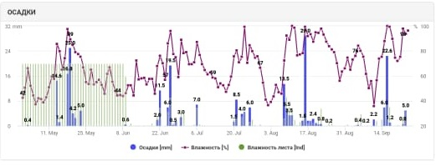Figure 1 – Distribution of precipitation in the study area according to the Caipos automatic weather station, 2020
Regarding the average daily air temperature, it should be noted that in the warm period of 2018 it was close to the average long-term values. There is a significant increase in the average daily temperature in July in comparison with long-term values. During the warm period of 2019 and 2020 the average daily air temperature was higher than the average long-term values, with the exception of June 2020. There is also an increase in the average daily temperature in July compared to long-term values. High air temperatures during the flowering period lead to a decrease in the grain content in the ear and negatively affect the quality of wheat grain (table 3, figure 2).

Table 3 – Average daily air temperature, ⁰С
Year | May | June | July | August | Year | May | June
Long-term norm | 5.3 | 13.7 | 20.0 | 20.9 | 18.9 | 12.5 | 4.9
2018 | 4.5 | 11.9 | 16.6 | 22.1 | 18.1 | 13.2 | 6.2
2019 | 5.4 | 15.4 | 18.5 | 23.1 | 19.4 | 10.9 | 7.3
2020 | 7.7 | 17.2 | 17.8 | 23.3 | 19.8 | 11.9 | –

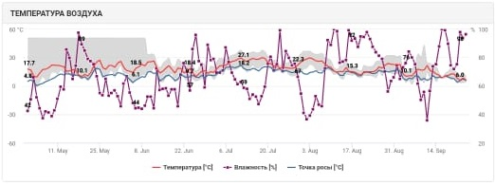
Figure 2 – The graph of the temperature regime in the research area according to the Agrosmart system, 2020

3 Research results
3.1 Introduction of precision farming elements at the demonstration site
In 2018, a demonstration site for precision agriculture with an area of 2,000 hectares was created on the basis of the production and demonstration testing area of Zarechnoye AES LLP, which in 2019 amounted to 2,500 hectares and in 2020 reached 3,800 hectares.
Zarechnoye AES LLP digitized agricultural elementary plots using the Qoldau digital platform on a total area of 22984.3 hectares, including hayfields and pastures (4231.4 hectares).
The use of glyphosate-containing products during pre-sowing treatments is an important component of conservation agriculture. So during the period of its implementation, a qualitative assessment of the contamination of fields gives tangible savings in protection means and money.
The data obtained under the conditions of 2020 before sowing indicate that all fields at the time of the chemical pre-sowing treatment had a low degree of weediness – for stubble predecessors, the second crop after fallow, and to medium – in all other fields. Thus, using the example of field No. 104.106, it can be seen that in the conditions of the year it was not possible to use selective spraying, while remote monitoring of satellite images made it possible to timely carry out high-quality pre-sowing treatment, which in early spring 2020 was carried out earlier than usual (figure 3).
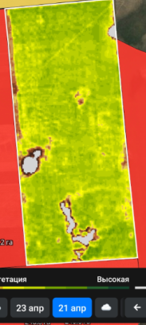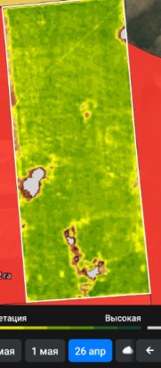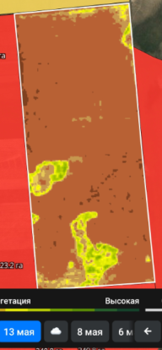
Figure 3 – Monitoring of the vegetation index of weediness in order to timely combat weeds during the pre-sowing treatment

The simplest stage of introducing elements of digital technologies into crop production is the use of parallel driving and autopilot systems. Well-known world brands install this equipment on their machinery, but there are other solutions on the market that allow equipping most of the used machinery with parallel driving and autopilot systems.
A John Deere 4730 sprayer equipped with an autopilot system and a WeedSeeker system was used at the testing area of Zarechnoye AES LLP for the introduction of precision agriculture elements. Pre-sowing chemical treatment was carried out on the testing area. The use of the automatic driving system made it possible to reduce the number of overlaps, thereby increasing the accuracy of the unit’s movement along the lines and improving its performance (figure 4). Thus, savings of up to 7% of glyphosate were achieved.
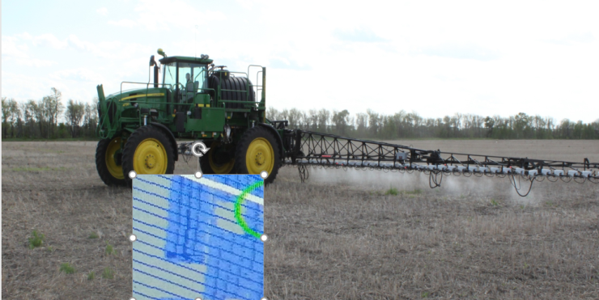
Figure 4 – Using a parallel driving system, LLP «AES «Zarechnoe»

On the contrary, the use of only a direction indicator led to a significant increase in lines of intersection. Thus, the use of manual control of the machine leads to an over consumption of the drug, as well as an increase in the consumption of fuel and lubricants and has a direct relationship with the experience of the operator.
In addition, one of the main factors restraining the growth of crop yields is the low supply of soil with nutrients. It is possible to compensate for their deficiency by applying fertilizers. However, the effectiveness of this agricultural admission significantly depends on the compliance of the accepted doses with the actual content of nutrients in the soil. Existing technique, in which agricultural commodity producers assess the condition of the entire field with an elementary survey area of ​​75 hectares, outdated and ineffective. It is being replaced by technologies of differential fertilizer application, which allow you to change the dose of application during the movement of the unit across the field.
The smaller the area of ​​elementary soil areas into which the field will be divided, the more accurate the information about the presence of nutrients in the soil will be. In this case, the area of ​​elementary sites is recommended to be determined – 0.5-1.0 ha. The relief, the hydrological system, the amount of precipitation, the variegation of the soil cover can affect the area of ​​the elementary site. Under more leveled conditions, the area of ​​the elementary site can be increased to 5-10 ha. This is very relevant for the conditions of Northern Kazakhstan. Since, among other factors, increased areas of elementary plots here are more preferable from an economic point of view at the initial stages of the introduction of precision farming systems in farms.
As part of this research on high-resolution satellite imagery, ArcGIS has created electronic field maps of SCAR «AES «Zarechnoe» (figure 5).
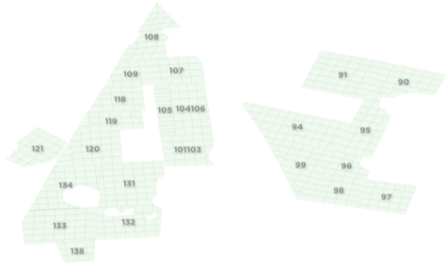
Figure 5 – Electronic field maps of «AES «Zarechnoe»

The division of fields into elementary sections was carried out using the utility Repeating Shapes [v. 1.5.152] (figure 6).
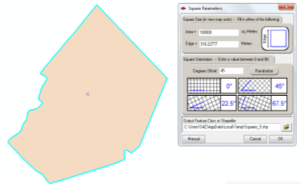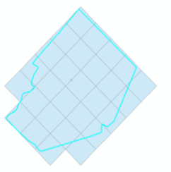
a b c
Figure 6 – Separate stages of the process of breaking into elementary plots with an area of ​​10 hectares of an electronic field map, «AES «Zarechnoe», sheet 1
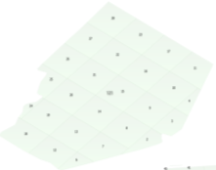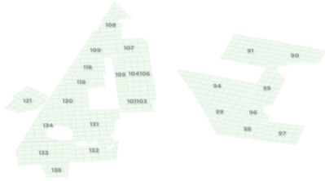
d e
a – polygon of field №121; b – setting grid parameters in repeating shapes [v.1.5.152]; c – created grid; d – is the type of elementary sections cut off along the field contour; e – a general view of the fields of the economy with elementary plots
Figure 6, sheet 2

Based on the data of the agrochemical survey of fields of «AES «Zarechnoe» LLP for 2018, QGIS 3.6 created maps of the availability of fields with humus, mobile phosphorus, exchange potassium, sulfur and nitrate nitrogen. To do this, in the properties of each vector layer with elementary sections of farm fields, differentiated staining styles were applied based on logical rules, according to the degree of soil supply with the corresponding nutrition elements (appendix A, figures A.1– A.5).
According to the survey data, 30% of the area of the studied fields belongs to soils with very low (less than 5 mg/kg), 38% – with low (5-10 mg/kg), 18% – with medium (10-15 mg/kg), and also 14% (more than 15 mg/kg) – with a high content of nitrate nitrogen. The maximum indicator was 26.3 mg/kg; the minimum was 1.5 mg/kg.
The provision of soils with mobile phosphorus at a low level (20.01-50.00 mg/kg) is noted on 2% of the area, at a high level (more than 125.00 mg/kg) – on 37% of the area, and 36% of the area (50.01-100 mg/kg) is with an average content. An increased content of mobile phosphorus (100.01-125.00 mg/kg) was noted in 25% of the elementary plots. The maximum phosphorus content was 404; the minimum was 31 mg/kg of soil.
The sulfur content in the soil of the studied fields in 41% of the elementary plots was less than 5.0 mg/kg, in 27% it was in the range from 5.01-10.00 mg/kg, in 11% – from 10.01 to 15.00 mg/kg, in 19% – from 15.01 to 20, and in 2% it exceeded 20 mg/kg.
At the next stage of research, we began to develop task maps for the differential application of fertilizers.
According to Rychagova A.F. (1980) on southern chernozems in the steppe zone of Kostanay oblast with an average level of soil availability of P2O5, sowing of phosphorus fertilizers in a dose of 20 kg of active substance is equivalent to the main application of 60 kg of active substance.
In this regard, the development of task maps for differential application was carried out for nitrogen-phosphorus fertilizer of ammophos under spring wheat when sowing in accordance with the following scale of soil supply with mobile phosphorus (table 4).

Table 4 – Doses of ammophos for differential application on the experimental fields of «AES «Zarechnoe» in accordance with their availability of mobile phosphorus
The degree of provision of soils with mobile phosphorus according to Chirikov, mg/kg | Ammophos dose in physical weight, kg/ha
Very low and low (<50.00) | 38
Medium (50.01-100.00) | 29
Elevated, high or very high (> 100,00) | 19

According to the created task map, the following standards for the introduction of ammophos were adopted: on an area of ​​1240 ha – 22 kg/ha; 954 ha – 33 kg/ha; 61 ha – 43 kg/ha and 50 ha to control plots – without application (appendix A, figure A.6).
Fertilizing was carried out by the Bourgault (Canada) sowing complex, which was specially equipped with an electric actuator and NK Agronavigator-doser specially for this purpose (appendix U, figure U.2). To this navigation complex, according to the instructions, task maps can be created either directly in the navigator itself or in the Google Earth program. However, the capabilities of this program are inferior in functionality to special geographic information software products such as ArcGIS and QGIS. So, in order to set the fertilizer application rate, it must be manually entered into the polygon properties of each elementary site. To simplify this task, when transferring annotated shape-files with elementary field sections to Google Earth, a special polygon style template was applied in accordance with the required dose of fertilizers.
Next, each elementary site was prepared in accordance with the following sequence of actions:
1) found in the Google Earth program an image of the field on which will be performed the cultivation;
2) in the «My Tags» section of the «Google Earth» program they called folders with a task map according to the template: «pk_field name»;
3) for each cell in the «Properties» menu entered data on the cell number (N_UCH =) and the required norms (NORMA =);
4) Saved the location as: «pk_field name», KML format.
Calibration of the damper of the actuator of the amofos complex for fertilizer application was carried out on the basis of the flowability of the fertilizer, according to the «Supplement to the user manual of NC «Agronavigator plus». The resulting calibration values ​​are shown in table 5.

Table 5 – Calibration scale for differentiated application of ammophos N – 12%, P₂O₅ – 52% using the navigation complex "Agronavigator-batcher" in the "position" mode
Degree of opening of the valve, % | Fertilizer flow rate, kg/sec
0 | 0,00
10 | 0,01
20 | 0,06
30 | 0,13
40 | 0,18
50 | 0,25
60 | 0,33
70 | 0,37
80 | 0,43
90 | 0,47
100 | 0,50

To carry out further work within the framework of the project, working maps for the selection of soil samples for agrochemical analysis were prepared. Each sampling point has geographical coordinates, which provides the opportunity for many years of objective monitoring of the state of the soil cover and monitoring of negative and positive processes.
To assess the initial state of the soil according to the content of the main elements of mineral food, an agrochemical survey was carried out at the testing area on a total area of 4000 hectares: in 2018 – on 2200 hectares, in 2019 – on 1800 hectares, according to the results of which fertilizers were applied during sowing (appendix U, figure U.3).
A modern agrochemical survey to determine the exact content of nutrients is structured as follows. Schematic maps of soil sampling are formed with the division of the entire study area into elementary plots of the same size.
Option 1. With the help of special programs, such as TrimbleAg, RepeatingShapes, where it is possible to apply a grid with a division in the coordinate system of the field contour for carrying out an agrochemical survey by elementary plots (figure 7).
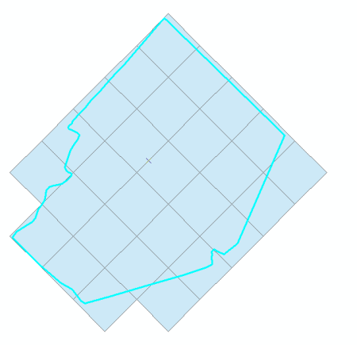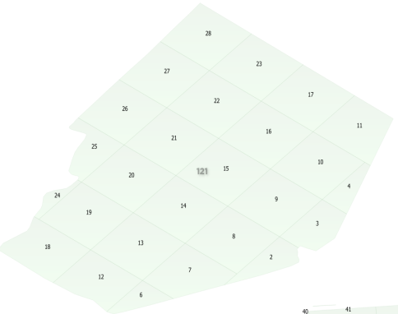
Figure 7 – Creation of a field contour in a coordinate system for agrochemical examination

Option 2. Qoldau.kz service. On its basis, a grid is created along the contours of the fields with a division into elementary plots at the moment; this is the free and easiest way (figure 8).
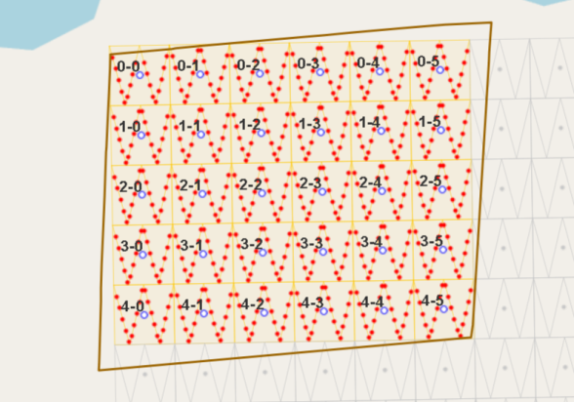
Figure 8 – Creation of a task for agrochemical examination

The next step is to download the file in KML format after concluding an agreement with the laboratory, which opens on the tablet in a special application or using the AgroConsultant application that is available in GooglePlayMarket for Android and is activated through your personal account on Qoldau and opens with your specific task. It should be noted that when concluding an agreement for Qoldau, the farmer has access to independent soil selection, which he can carry out, guided by the AgroConsultant application (figure 9).
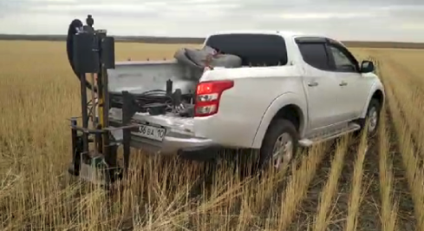
Figure 9 – Soil sampling with an automatic sampler

Soil sampling is carried out using a mobile sampler, guided by the terms of the technical task in the coordinate system, using a tablet or a special GPS receiver.
After the selection of composite samples from each elementary plot, packages with soil were handed over to their own accredited laboratory for appropriate analyzes (appendix B).
On the basis of the data, cartograms of supply of humus, mobile phosphorus, exchangeable potassium, sulfur, as well as supply of nitrate nitrogen in the fields of the farm were created (figure 10).
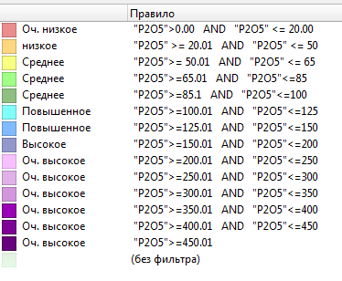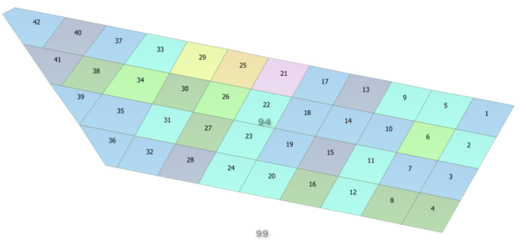
Figure 10 – Map of the content of mobile phosphorus in the field No. 94, Zarechnoye AES LLP

In order to establish the effectiveness of fertilization in individual areas with varying degrees of provision, control plots were provided where fertilizers were either not applied at all, or an average dose of 29 kg in physical weight was applied. Task maps are shown in figures 11-13.
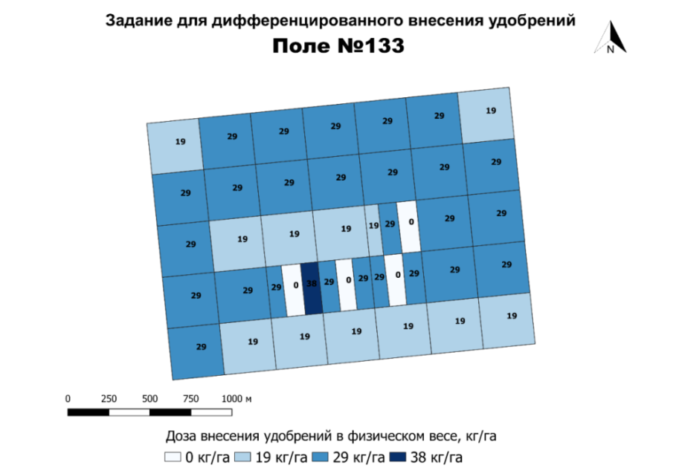
Figure 11 – Field No. 133, Zarechnoye AES LLP, 2020

On the field No. 133, a total of 8.65 tons of fertilizers were applied on a total area of 350 hectares, of which with a rate of 38 kg/ha per 3.35 hectares, 29 kg/ha on an area of 219.88 hectares, 19 kg/ha per area of 112.71 hectares, and 14.06 hectares were without fertilization.

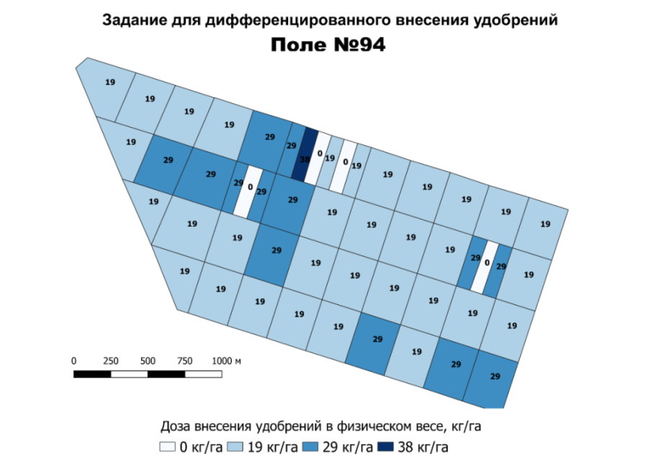
Figure 12 – Field No. 94, Zarechnoye AES LLP, 2020

On the field No. 94, a total of 8.73 tons of fertilizers were applied on a total area of 417.74 hectares, of which with a rate of 38 kg/ha per 3.2 hectares, 29 kg/ha on an area of 97.94 hectares, 19 kg/hectares on an area of 303.45 hectares, and 13.15 hectares were without fertilization.
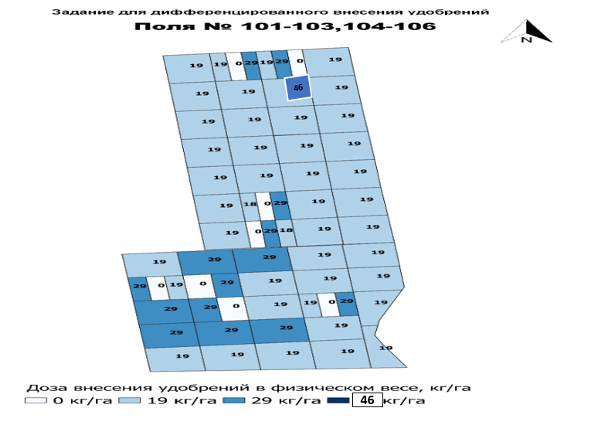
Figure 13 – Fields No. 101-103 and No. 104-106, Zarechnoye AES LLP, 2020

On the field No. 101-103, a total of 5.6 tons of fertilizers were applied on a total area of 255.5 hectares, of which with a rate of 29 kg/ha on an area of 93.27 hectares, 19 kg/ha on an area of 145.56 hectares, and 16.63 hectares were without fertilization.
On the field No. 104-106, a total of 5.3 tons were applied on a total area of 281.5 hectares, of which with a rate of 46 kg/ha on an area of 2 hectares, 29 kg/ha each on an area of 12.99 hectares, 19 kg/ha on an area of 253.61 ha, and 12.93 ha were without fertilization.
On the field No. 109, a total of 4.2 tons of fertilizers were applied on a total area of 163.1 hectares, of which with a rate of 40 kg/ha on an area of 2 hectares, with a rate of 29 kg/ha on an area of 114.2 hectares, 19 kg/ha, on an area of 33.59 ha, and 13.35 ha were without fertilization.
Seed material was prepared (heat heating, pickling). Then, sowing was carried out together with differentiated fertilization on fields No. 94, No. 101-103, No. 133, No. 109 with a total area of 1200 hectares using parallel driving systems. Based on the results of the differentiated application of phosphorus fertilizers, a saving of 25% in mineral fertilizers was revealed.
All work on the calibration of the complex and the preparation of task maps were carried out in accordance with the instructions "Supplement to the user manual for the navigation complex "Agronavigator plus ".
The technology of differentiated fertilization with the use of the navigation complex "Agronavigator-batcher" has been developed in the conditions of Zarechnoye AES LLP and Troyana LLP. Working maps of soil sampling were developed for the remaining fields of Zarechnoye AES LLP.
The next stage in the introduction of elements of precision agriculture is the regulation of the nutritional regime of soils through the introduction of mineral fertilizers. As a result of the agrochemical survey, areas that require regulation of the nutrient regime of the soil were identified (appendix A, figure A.7).
To establish the effectiveness of various norms at different degrees of supply in production conditions, in the terms of technical tasks for fields No. 109, No. 101-103, No. 104-106 and No. 94, control areas were identified (appendix A, figure A.8) and research work was carried out (appendix U, figure U.4).
In addition to the planned studies in the base farm of Troyana LLP, in accordance with the data of the cartogram of the distribution of mobile forms of phosphorus as of 2020, a method of pre-sowing differentiated fertilization was introduced.
The development of task maps for differentiated application in Troyana LLP was carried out for nitrogen fertilization of carbamide in its physical weight for wheat during sowing in accordance with the scale of the soil supply for nitrate nitrogen.
So, to assess the initial state of the soil by the content of the main elements of mineral food before sowing, the content of nitrate nitrogen (N-NO3), mobile phosphorus (P2O5), exchangeable potassium (K2O) and mobile sulfur (S) and the content of organic matter in the 0– 30 cm was determined. The results of analyzes for 2020 are shown in table 6.

Table 6 – The content of the main nutrients in the soil layer 0-30 cm before sowing spring wheat according to the results of an agrochemical survey, 2020
Supply | N-NO₃, mg/kg | Supply | P₂O₅, mg/kg | Supply | К₂О, mg/kg | Supply | S, mg/kg | Supply | Humus, % | Content
1 | 2 | 3 | 4 | 5 | 6 | 7 | 8 | 9 | 10 | 11
У.2-11 | 4.9 | very low | 71 | average | 380 | very high | 7.1 | average | 4.64 | average
У.2-12 | <2.8 | very low | 76 | average | 310 | very high | 4.3 | low | 4.36 | average
У.2-13 | <2.8 | very low | 63 | average | 264 | very high | 6.1 | average | 4.55 | average
У.2-14 | 6.5 | low | 96 | average | 264 | very high | 19.2 | very high | 4.73 | average
У.2-15 | 5.6 | low | 48 | low | 257 | very high | 6.8 | average | 4.51 | average
У.2-16 | 8.7 | low | 65 | average | 244 | very high | 14.0 | high | 5.27 | average
У.2-17 | 4.0 | very low | 66 | average | 287 | very high | 5.9 | very high | 4.61 | average
У.3-11 | 5.4 | low | 71 | average | 191 | very high | 6.6 | low | 4.35 | average
У.3-12 | 4.0 | very low | 72 | average | 165 | high | 7.6 | average | 4.38 | average
У.3-13 | 3.5 | very low | 70 | average | 347 | very high | 4.4 | low | 4.85 | average

Continuation of table 6
1 | 2 | 3 | 4 | 5 | 6 | 7 | 8 | 9 | 10 | 11
У.3-14 | 5.9 | low | 69 | average | 372 | very high | 5,8 | low | 4,59 | average
У.3-15 | <2.8 | very low | 56 | average | 353 | very high | 5,3 | low | 4,88 | average
У.3-16 | 4.7 | very low | 70 | average | 384 | very high | 9,7 | increased | 5,19 | average
У.3-17 | 4.2 | very low | 66 | average | 335 | very high | 5,9 | low | 4,90 | average
У.4-11 | 5.2 | low | 65 | average | 337 | very high | 7,8 | average | 4,68 | average
У.4-12 | 5.2 | low | 70 | average | 387 | very high | 5,8 | low | 4,76 | average
У.4-13 | 5.2 | low | 67 | average | 403 | very high | 4,3 | low | 4,90 | average
У.4-14 | 4.2 | very low | 55 | average | 365 | very high | 7,2 | average | 5,04 | average
У.4-15 | 4.8 | very low | 52 | average | 322 | very high | 5,7 | low | 4,80 | average
У.4-16 | 5.5 | low | 56 | average | 443 | very high | 9,0 | increased | 5,15 | average
У.4-17 | 5.9 | low | 67 | average | 458 | very high | 13,5 | high | 4,93 | average
V | 27.8 |  | 14.7 |  | 22.8 |  | 46.8 |  | 5.5

If we take into account that the optimal content of N-NO3 is not less than 10-15 mg/kg, then according to the data of 2020, before sowing spring wheat, the soil had a low supply of nitrates 2.8-8.7 mg/kg of soil (in the layer 0-30 cm). Assessing the content of mobile phosphorus in the soil, it is worth noting the following – only 4.8% of the plots had a low supply, less than 50 mg/kg of soil, the rest of the plots had an average degree. The content of exchangeable potassium in all areas was characterized as very high, that is, there were no problems with this element.
The most interesting data were obtained on the content of mobile sulfur compounds. 43% of the plots had a content of 4.3 to 5.9 mg/kg of soil, which corresponds to a low degree of supply. 57% of the surveyed area had an average and high level of supply. Thus, as a result of the work done, we made a calculation for the application of mineral nitrogen fertilizers (figures 14-15).
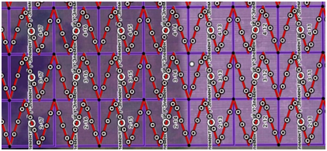
Figure 14 – Schematic map of the selection of soil samples with the allocation of elementary plots with an area of 5 hectares, Troyana LLP
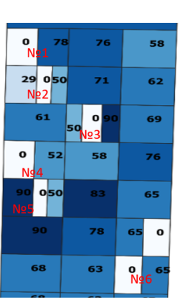
Figure 15 – Schematic map of differentiated fertilization in Troyana LLP with the allocation of control areas for each degree of N-NO3 supply, the total area of the surveyed testing area is 110 hectares

As a result, our studies prove that for the practical use of technologies for the differentiated application of fertilizers, it is necessary to more accurately determine the features of the intra-field variability of soil fertility. On the basis of this, in the future, it is possible to construct a scheme of the mineral nutrition of plants that limit plant productivity. It is shown that the area of ​​intra-field plots with different contents of humus, mobile forms of phosphorus, exchangeable potassium and mobile sulfur compounds have a non-uniform distribution within one field.
To build the most complete picture of the effectiveness of the use of differentiated nutrition at the production testing area, we carried out a set of measures for remote and ground control at the designated plots.
In addition, a targeted effect of nitrogen fertilizers was carried out at the testing area, which implies feeding with liquid forms of mineral fertilizers during the growing season of spring wheat. The basis for foliar feeding is the measurement of the actual level of chlorophyll in the leaves, which is carried out by the portable device for leaf diagnostics "N-tester".
In the period when spring wheat plants reached the stage of development "4-5 leaves – full tillering", photometric diagnostics of wheat plants with a portable device N-tester "YARA" and analysis of green biomass with a GreenSeeker device were carried out. Determination of the nitrogen status of plants during this period and its timely correction can reduce the impact of unfavorable factors and improve the general condition of plants (figures 16-17).
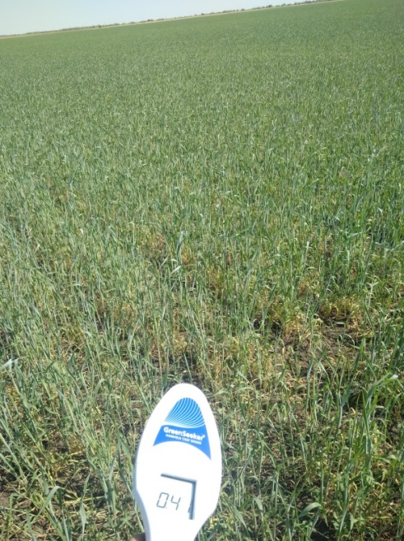
Figure 16 – Working with a portable device Greenseeker on field No. 109 account. 9, experiment with the introduction of liquid fertilizer "Strada N" on spring wheat according to the stubble predecessor at a rate of 3.0 l/ha, 13.07.2020
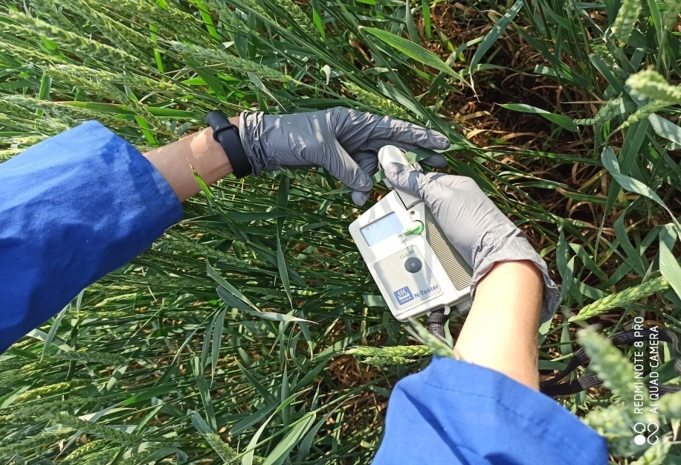
Figure 17 – Determination of the nitrogen content in the leaves of spring wheat on seed crops with a portable device N-tester, 28.07.2020

With values ​​for the stubble predecessor below 300-350 units, corresponding to a low level of nitrogen supply to spring wheat plants, and for a fallow predecessor – below 400 units, which also correspond to a low level of plant nitrogen supply, the spring wheat crops were sprayed using the John Deere 4730 sprayer with a liquid mineral fertilizer "Strada N" with a consumption rate of 3.0 l/ha, a working fluid flow rate of 100-150 l/ha, with a wind speed not exceeding 3-4 m/s. This fertilizer is used for foliar feeding of plants. The nitrogen concentration in the fertilizer is 27%.
For the purpose of additional diagnostics of the degree of supply of spring wheat plants with nitrogen in the phase of development "4-5 leaves – full tillering", aerial photography by an unmanned aerial vehicle GeoScan 101 was applied. This made it possible to normalize the obtained index GDVI images according to the values of the N-tester according to the data of ground measurements.
The data on the flight of the fields by the unmanned aerial vehicle GeoScan 101 served as the basis for creating a map of the differential application of foliar nutrition. The construction of prescription maps is based on taking into account the state of vegetation (figure 18).
Figure 18 – Stages of creating a technological map for the differentiated application of nitrogen foliar nutrition for field No. 109, 2019

So the calculated doses of the liquid mineral fertilizer "Strada N" were experimentally introduced in doses of 1.5; 3.0 and 5.0 l/ha during the tillering period with further tracking of all morphometric parameters (appendix U, figure U.5).
Considering the readings of the N-tester and the nitrogen content in the leaves of spring wheat plants during the period of “leaf-tube formation-heading”, according to the results of applying liquid fertilization, an increase in these indicators can be noted, which indicates a positive dynamics in the nitrogen status of plants. Thus, the increase in the N-tester readings, taking into account the foliar nutrition for the stubble predecessor, was 123 units, for the fallow one – 163. The increase in nitrogen content in the leaves of spring wheat in terms of dry matter was 0.22% for the stubble, 0.27% for fallow (table 7).

Table 7 – Data on the change in the nitrogen status of spring wheat plants by the period " leaf-tube formation – heading" depending on the use of foliar nutrition
Variants | Nitrogen content
Variants | increase in instrument readings (N-tester coefficient) | nitrogen growth  (dry matter),%
Control (no treatment) | – | –
Foliar feeding according to stubble predecessors | +123 | 0.22
Foliar feeding according to fallow predecessors | +163 | 0.27

As a result of using the proposed method of cultivating spring wheat with a differentiated foliar application of nitrogen fertilization, the yield of spring wheat according to the stubble predecessor increased by 38.5% compared to the control. According to the fallow predecessor, the increase in yield in the variant with the introduction of liquid fertilizer "Strada N" with consumption rate of 3.0 l/ha was 24.3% (table 8).

Table 8 – The effectiveness of the use of differentiated foliar nutrition of spring wheat plants
Variants | Increase in yield, %
Control (no treatment) | –
Foliar feeding according to stubble predecessors | 38.5
Foliar feeding according to fallow predecessors | 24.3

Aerial photography from a drone gives larger and more detailed data in high resolution (including digital images), allows you to work in any weather (except for wind), and examines large areas of crops. However, adequate lighting is essential for the camera to function properly.
Survey of agricultural fields using aerial photography allows you to optimize agricultural operations, identify various plant stresses, which helps to reduce the economic costs of crop production.
In 2019, Zarechnoye AES LLP purchased a Geoscan 101 unmanned aerial vehicle (UAV) equipped with a Sony A6000 multispectral camera. There is also a parachute that provides a soft landing. A flight task for a drone is created in the Geoscan Planer program, it is enough to select the boundaries of the studied field or download it from a file, and the program will send it to the drone (figures 19, 20).
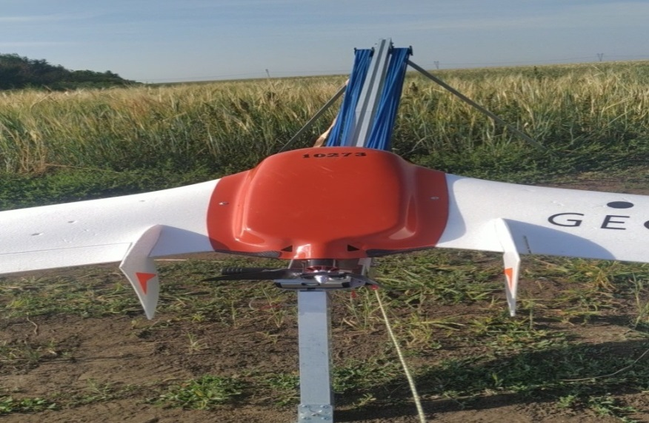
Figure 19 – Launch of the Geoscan 101 UAV from the catapult, Zarechnoye AES LLP
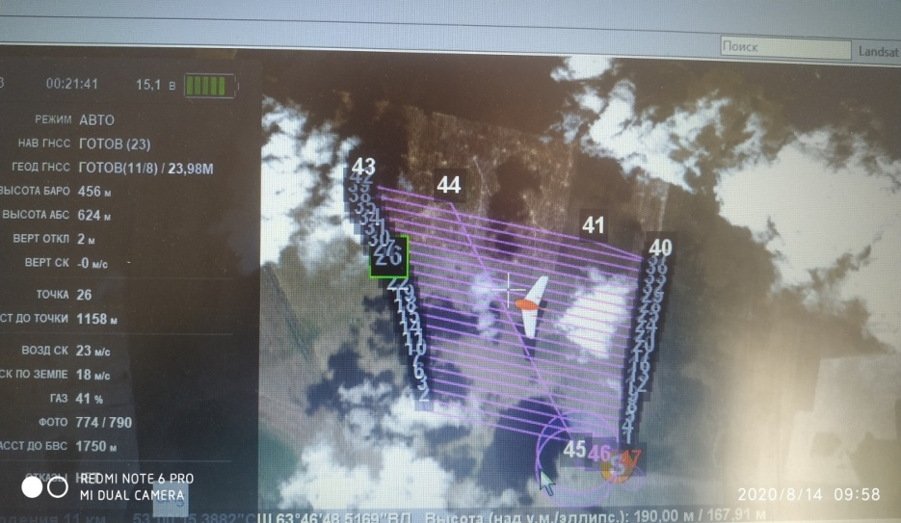
Figure 20 – Flight task for the UAV "Geoscan 101", Zarechnoye AES LLP

The obtained images are processed in the program ‘Agisoft Metashape’, the vegetation indices are calculated (figure 21).
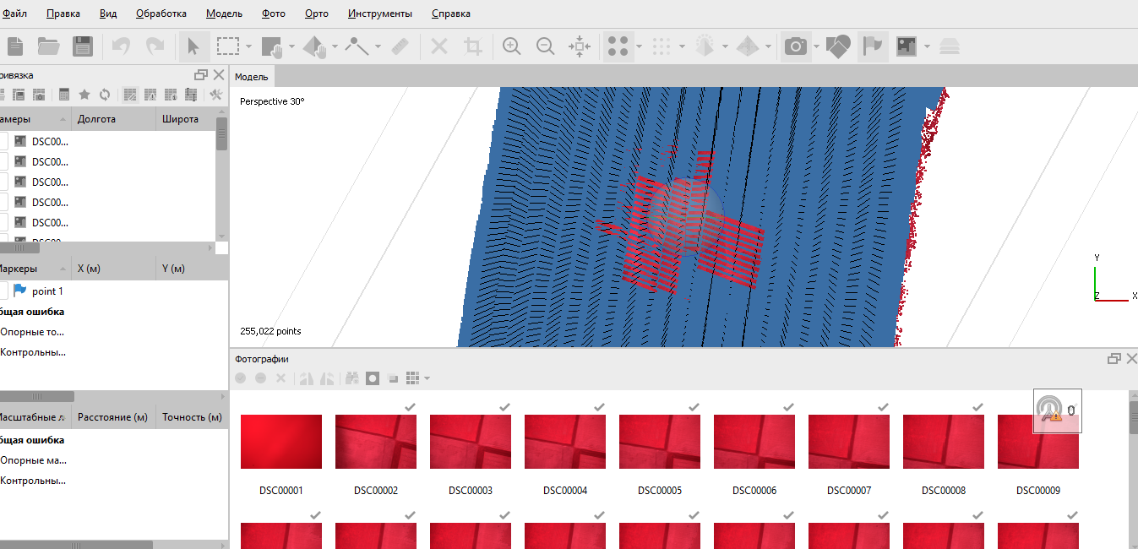
Figure 21 – Processing of images from the UAV "Geoscan 101" in the program "Agisoft Metashape", Zarechnoye AES LLP

Aerial photography of the investigated area was carried out at an altitude of 300 meters using a MicasenseRed-Edge camera, while simultaneously obtaining photographic images of the object in different parts (zones) of the electromagnetic wave spectrum.
The survey was carried out over 19 fields in five spectral ranges: blue, green, red, extreme red, near infrared. The total area of the rented territory was 3800 hectares.
The aerial survey data were processed with specialized photogrammetric software to obtain multichannel (multispectral) field maps and orthophotomaps.
Based on the results of aerial photography for each field, the following products were generated: orthomosaic, dense point cloud, digital surface model (elevation map), processed digital surface model, textured georeferenced model of the territory (3-D model). On the basis of the created orthophotomaps, index maps of vegetation state were built (figure 22).
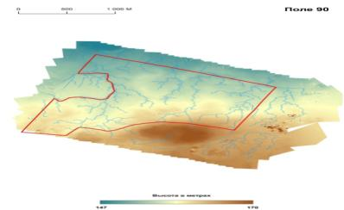
Figure 22 – Digital elevation model and watercourses for field No. 90

At the main stage of image processing and analysis, maps of the normalized vegetation index (NDVI) and normalized vegetation index of greenness (GNDVI) were constructed using the spectral channels of the near infrared (NIR), red (RED), red edge (REDEDGE), green (GREEN).
NDVI (NormalizedDifferenceVegetationIndex) – Normalized difference vegetation index is a simple quantitative measure of the amount of photosynthetically active biomass (commonly referred to as the vegetation index).
The NDVI calculation is based on the two most stable (independent of other factors) portions of the vascular plant reflectance spectral curve. In the red region of the spectrum, the maximum absorption of solar radiation by chlorophyll of higher vascular plants is manifested, and in the infrared region there is the region of maximum reflection of the cellular structures of the leaf.
As a result of the aerial photography, the NDVI index was obtained. In the tillering phase, the average NDVI value in field No. 94 ranged from 0.4-0.5, deviation from the average indicated a possible strong weediness of crops (figure 23). In the course of the ground survey, it was confirmed that these plots had a strong degree of infestation with annual millet weeds. Thus, the use of such data in agriculture is highly justified.
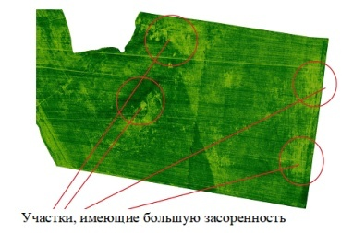
Figure 23 – Detection of areas with a high level of weediness using UAVs, Zarechnoye AES LLP
Similar work was carried out on the field No. 107. It also showed a high level of millet infestation (figure 24), which was confirmed by a ground survey. Millet weeds develop faster than wheat and inhibit its growth, which in turn affects the yield. In particularly heavily infested areas, the NDVI is around 0.3 and the N-tester (nitrogen content in plants) is low. The NDVI map does not show bare areas of the field, while the wheat has not yet closed in rows, which is a sign of severe weediness.
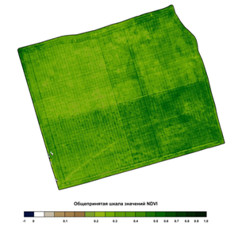
Figure 24 – Generally accepted scale of NDVI values

Scientific research for the period 2018-2020, carried out at the precision agriculture testing area of Zarechnoye AES LLP on an area of 4000 hectares, showed the effectiveness of Earth remote sensing (ERS) means in terms of accurately determining the stages of crop maturation. In parallel with the use of an unmanned aerial vehicle (UAV), monitoring was carried out using satellite images (figure 25).
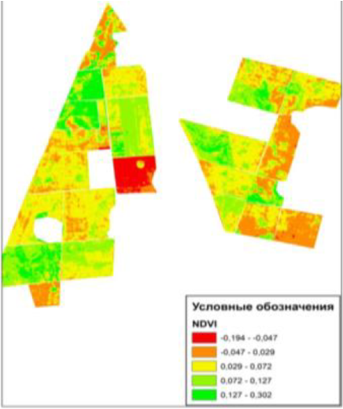
Figure 25 – Monitoring of NDVI images by fields during the growing season 2019,
Zarechnoye AES LLP
So the monitoring of the vegetation index as a whole for the fields of the testing area made it possible to reveal the following in the conditions of 2019. In early August, a natural decrease in the index was observed, which was associated with a shortening of the growing season by more than 14 days due to an unusually severe drought and lack of productive precipitation, which to a greater extent manifested itself in stubble predecessors at the testing area. The higher index from 0.127 to 0.302 belonged to the fields on which the crop was cultivated according to the fallow predecessor. The index in the range from -0.194 to -0.047 had fallow lands after treatment.
It is known that in Northern Kazakhstan one of the main limiting factors of the yield of grain crops, including spring wheat, is the reserves of productive moisture. A common way of accumulating moisture in fields is a fallow land. The efficiency of fallowing largely depends on how clean it can be from weeds. The use of a normalized vegetation index has proven itself very well during the pre-sowing campaign and while fallow lands treatment.
Thus, on the example of one of the fields of Zarechnoye AES LLP it can be seen that during the processing of glyphosate-containing products a flaw was made. In general, after processing over the entire field, this index decreased, and the remaining green stripe, which, by the way, is not very noticeable from the edge of the field, was also processed after studying satellite images (figure 26).
Figure 26 – Satellite image with the detection of flaws in the chemical treatment of the fallow land, Zarechnoye AES LLP

The algorithm for assessing the state of crops based on satellite data makes it possible to carry out an assessment at the level of a region, district and an individual farm, where the state of crops is assessed in each individual field. Crop assessment maps are generated for each cloudless survey date.
Ground route surveys are carried out in the main phases for all test fields; the assessment of the state of crops according to remote sensing data is built in such a way that each pixel of the satellite raster is assessed on the territory corresponding to the “arable land” object. Nevertheless, the percentage ratio of the gradations of the assessment of the state of crops of ground and satellite data practically coincides. However, in 2018-2020, the assessment of the state of some crops of grain crops based on ground surveys of fields on the farm and using satellite data was slightly different – according to remote sensing data, the percentage of good condition of crops is lower. So the actual yield of cereals (spring wheat) in 2018 was 25.4 c/ha, in 2019 – 13.2 c/ha, in 2020 – 17.2 c/ha (Appendix C).
At the same time, the weather can make significant adjustments to the types of crops in the conditions of Northern Kazakhstan. So, on crops with the earliest sowing dates (the first ten days of May) under the conditions of 2020, grain was poured in extremely hot weather in the absence of precipitation and dry winds. At the same time, in the heading phase on these fields, the vegetation index was noted within 0.5, and the visual assessment of the crops made it possible to draw conclusions about the expected yield at the level of 12-15 c/ha. However, the actual weather, as mentioned above, did not allow the grain to fill up normally, which reduced the yield by 2 times. This is a low yield even for the climatic conditions of Northern Kazakhstan.
However, it is also worth noting that the level of agricultural technology, the use of modern technologies have made it possible to minimize the influence of adverse factors at the landfill, reduce production costs and obtain a yield level that exceeds the average regional level (appendix D).
At the next stage of the research, the yield on the control elementary plots of fields No. 101-103, No. 104-106 and No. 109 was revealed using the yield mapping system of the John Deere combine. The yield maps used for comparison are presented in figures 27-31.
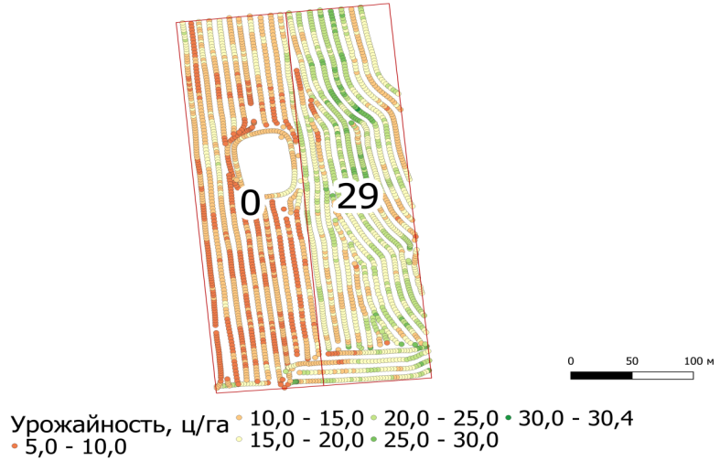
Figure 27 – Crop yield on the control elementary plot 14, fields No. 104-106

Figure 27 clearly shows that in the control variant, most of the elementary counting dots are colored orange and red, which corresponds to a yield in the range from 5 to 15 c/ha, while in the variant with fertilization there are many dots with a green color, which corresponds to a yield of more than 20 c/ha. At the same time, it should be noted that there are distinct boundaries between the variants and the uniformity of coloring within the testing areas. According to the analysis of the obtained data on the plot without the application of fertilizers, the average yield was 14.1 c/ha, and in the variant with the application of 29 kg/ha in the physical weight of ammophos it is 22.5 c/ha. Consequently, the increase due to fertilization was 8.4 c/ha.
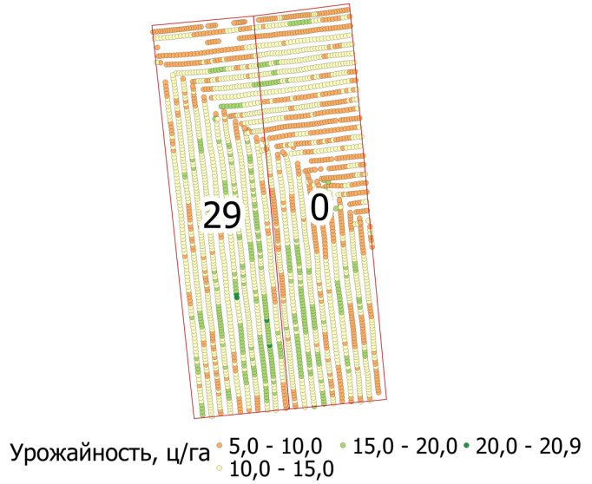
Figure 28 – Crop yield on the control elementary plot 15, fields No. 104-106

Figure 28 shows the comparison results on the plot 15 of the field No. 104-106. In the control variant, an accumulation of orange dots with an area of ​​about 1/3 of the plot is highlighted, at the same level, but in the variant with fertilization, as well as on a larger plot area, dots with white color are displayed, which corresponds to a yield of 10 to 15 c/ha. Two adjacent passes of the combine on the border between the plots over a greater distance indicate a higher yield when fertilizing. The average yield on the plot without fertilization was 13.2 c/ha, and in the variant with the application of 29 kg/ha in the physical weight of ammophos was 14.6 c/ha. The increase was 1.4 c/ha.
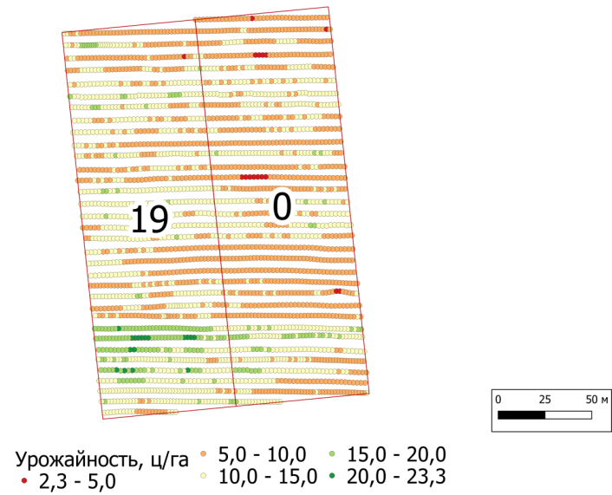
Figure 29 – Crop yield on the control elementary plot 18, fields No. 101-103

Figure 29 shows the yield mapping data for plot 18 of field No. 101-103. On it you can see orange and white stripes passing through both variants of the experiment, there is no clear border between the variants. However, the average yield in the control variant is 11.6 c/ha, and in the variant with the introduction of ammophos at a dose of 19 kg/ha in physical weight was 14.0 c/ha. The difference between the variants is 2.4 c/ha.
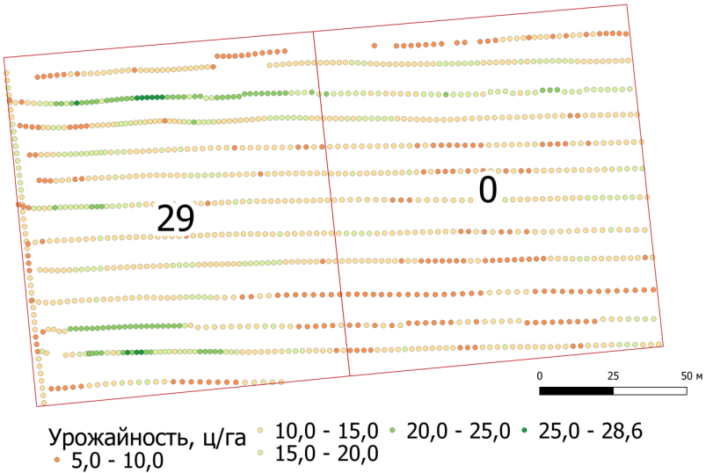
Figure 30 – Crop yield on the control elementary plot 2, fields No. 101-103

In figure 30, which shows the yield mapping data for plot 2, field No. 101-103, you can see 11 passes of the combine through both comparison variants. Most of these lines show a change in color towards an increase in yield when moving towards the variant with fertilization. According to the results of the analysis, the average yield on the plot without fertilization was 15.1 c/ha, and in the variant with the application of 29 kg/ha in the physical weight of ammophos – 16.9 c/ha, which exceeded the control one by 1.8 c/ha.
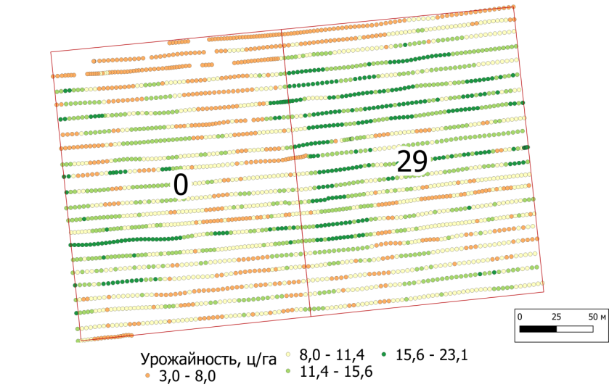
Figure 31 – Crop yield on the control elementary plot 6, field No. 109

A similar picture is observed in figure 31, which shows the results of mapping the yield in the sixth plot of the field No. 109. At the border of the control and experimental variants, the yield increases in most of the bands. The average yield according to the results of all observations on the control was 10.5 c/ha, and in the variant with the introduction of 29 kg/ha in the physical weight of ammophos was 14.2 c/ha. The increase was 3.7 c/ha.
Thus, according to the results of comparing the yield maps of the John Deere combine in neighboring elementary plots, the following increments were obtained from the introduction of ammophos: at a dose of 29 kg/ha on the plots with a low degree of P2O5 supply – 1.4; 1.8; 3.7 and 8.4 c/ha, as well as 2.4 c/ha on the plot with the introduction of 19 kg/ha with an average supply of mobile phosphorus.

3.2 Economic efficiency of spring wheat cultivation depending on the supply
of nutrients to the soil
The main result of the cultivation of crops is always evaluated during harvesting and is made up of the profitability of production.
According to the results of calculating the economic efficiency with the differentiated application of mineral fertilizers in 2019, it is worth noting an increase in the cost of applying fertilizers with different degrees of supply of mobile phosphorus. However, this event in all variants turned out to be profitable. Thus, the application of mineral fertilizers when sowing on field No. 94 was more effective in the case of an average degree of phosphorus supply – the profitability is higher than the control by 13.2%. On field No. 107, with high and medium degrees of supply, the highest profitability was obtained – 86.0 and 85.3%, which was higher than their control variants by 40.3 and 11.7%, respectively.
Regarding the economics of spring wheat grain production with the use of foliar nutrition of plants, it can be noted as the most advantageous variant according to the two types of predecessors, the use of foliar fertilizer Strada N at a dose of 3.0 l/ha, the profitability of which was 49.4% higher than the control variant in field No. 109, and on field number 107 – by 43.8%.
Analyzing the economic efficiency of differentiated fertilization by stubble predecessors in 2020, it is worth noting that the maximum profit of 86,111 tenge was obtained on the variant with the application of ammophos fertilizer 19 kg/ha in physical weight or 10 kg at the application rate of with an increased degree of soil supply for phosphorus.
For the fallow predecessor, the maximum profit was obtained in the variant of 29 kg of ammophos in physical weight or 15 kg at the application rate of 184,744 tenge with an average degree of soil supply for phosphorus (table 9).
In addition, under the conditions of 2020, foliar nitrogen nutrition of plants was effective. Based on the results of experiments laid on stubble and fallow predecessors at the production site, a high increase in yield was obtained, which also led to an increase in profit on variants for foliar plant nutrition. Thus, the use of Strada N at a dose of 3.0 and 5.0 l/ha for the stubble predecessor increased the profit by 6,913 and 24,077 tenge per 1 ha, respectively.

Table 9 – Total costs per 1 ha of spring wheat cultivation, 2020
Field No. | Variant | Crop yield, c/ha | Harvesting with straw chopping, tenge/ha | Grain removal from combines, sorting tenge/ha | Cultivation costs, tenge/ha | Total costs, tenge/ha | Gross production, tenge | Profit, tenge/ha | Profitability,%
1 | 2 | 3 | 4 | 5 | 6 | 7 | 8 | 9 | 10
94 | Very high (control) | 13.0 | 1235 | 260 | 51146 | 52641 | 97500 | 44859 | 85.2
94 | Very high (norm 19) | 15.7 | 1492 | 314 | 54757 | 56563 | 117750 | 61187 | 108.2
94 | Average (control) | 11.3 | 1074 | 226 | 51146 | 52446 | 96050 | 43604 | 83.1
94 | Average (norm 29) | 14.7 | 1397 | 294 | 56563 | 58254 | 110250 | 51996 | 89.2
109 | Average (control) | 11.7 | 1112 | 234 | 51146 | 52492 | 87750 | 35258 | 67.2
109 | Average (norm 29) | 14.1 | 1340 | 282 | 56563 | 58185 | 105750 | 47565 | 81.7
109 | Average (norm 40) | 14.2 | 1349 | 284 | 58736 | 60369 | 106500 | 46131 | 76.4
109 | Increased (control) | 12.3 | 1169 | 246 | 51146 | 52561 | 104550 | 51989 | 98.9
109 | Increased (norm 19) | 16.8 | 1596 | 336 | 54757 | 56689 | 142800 | 86111 | 151.9
109 | Increased (norm 29) | 17.6 | 1672 | 352 | 56563 | 58587 | 132000 | 73413 | 125.3
104.106 | Very high (control) | 16.4 | 1558 | 328 | 49481 | 51367 | 123000 | 71633 | 139.4
104.106 | Very high (norm 19) | 19.9 | 1891 | 398 | 53092 | 55381 | 169150 | 113769 | 205.4
104.106 | Very high (norm 29) | 21.3 | 2024 | 426 | 54898 | 57348 | 181050 | 123702 | 215.7
104.106 | High (norm 46) | 17.5 | 1663 | 350 | 58210 | 60223 | 131250 | 71027 | 117.9
104.106 | Average (control) | 17.4 | 1653 | 348 | 49481 | 51482 | 130500 | 79018 | 153.5
104.106 | Average (norm 19) | 18.5 | 1758 | 370 | 53092 | 55220 | 138750 | 83530 | 151.3
104.106 | Average (norm 29) | 21.4 | 2033 | 428 | 54898 | 57359 | 160500 | 103141 | 179.8

Continuation of table 9
1 | 2 | 3 | 4 | 5 | 6 | 7 | 8 | 9 | 10
101.103 | Average (control) | 15.3 | 1454 | 306 | 49481 | 51241 | 114750 | 63509 | 123.9
101.103 | Average (norm 29) | 21.6 | 2052 | 432 | 54481 | 56965 | 162000 | 105035 | 184.4
101.103 | Increased (control) | 11.8 | 1121 | 236 | 49481 | 50838 | 88500 | 37662 | 74.1
101.103 | Increased (norm 19) | 14.4 | 1368 | 288 | 53092 | 56404 | 108000 | 51596 | 91.5
101.103 | Increased (norm 29) | 17.4 | 1653 | 348 | 54898 | 56899 | 130500 | 73601 | 129.3
stubble predecessor | Control | 14.0 | 1330 | 280 | 51146 | 52756 | 105000 | 52244 | 99.0
stubble predecessor | Norm 3.0 l/ha | 15.5 | 1473 | 310 | 55310 | 57093 | 116250 | 59157 | 103.6
stubble predecessor | Norm 5.0 l/ha | 18.2 | 1729 | 364 | 58086 | 60179 | 136500 | 76321 | 126.8
fallow | Control | 23.6 | 2242 | 472 | 49481 | 52195 | 177000 | 124805 | 239.1
fallow | Norm 3.0 l/ha | 26.7 | 2537 | 534 | 53645 | 56716 | 226950 | 170234 | 300.2
fallow | Norm 5.0 l/ha | 29.0 | 2755 | 580 | 56421 | 59756 | 246500 | 184744 | 309.2
Note: * – The cost of using fertilizers per 1 ha: ammophos 19 kg – 3611 tenge; ammophos 29 kg – 5,417 tenge; ammophos 40 kg – 7590 tenge; ammophos 46 kg – 8729 tenge; Strada N – 1388 tenge
** The cost of spring wheat grain: 4th class – 75,000 tenge/ton; 2nd-3rd class – 85,000 tenge/ton; 1st class – 90,000 tenge/ton.

At the same time, the use of the same dosages for the fallow predecessor increased the profitability of production by 45,429 and 59,939 tenge, respectively.
In general, the application of fertilizers in 2020 brought a high economic effect, which is directly related to the abundant moisture of the soil in the spring, as a result of the better development of the root part of plants on the variants with fertilization, which, under subsequent arid conditions, made it possible to form a better yield than on control plots.

3.3 Development of a biological product based on Azotobacter cultures to increase the productivity of agricultural crops
8 promising strains of microorganisms capable of stimulating plant growth, fixing nitrogen and possessing antifungal activity were isolated from the soil of the testing area.
Based on the results obtained, 4 associations were created from consortia of microorganisms for further research in vegetation and field conditions. Biological products were used in liquid form. Association composition: association No. 1 – Azotobacter sp. strain Az 9/2 + Agrobacter sp. strain Az 6; association No. 2 – Azotobacter sp. strain Az 34 + Azotobacter sp. strain Az 13 + Azotobacter chroococcum sp. strain Az 4/3; association No. 3 – Rhizobium leguminosarum strain Rh-1 + Rhizobium leguminosarum strain Rh-4 + Rhizobium leguminosarum strain Rh-5; association No. 4 – Azotobacter chroococcum strain Az 4/3 + Agrobacter sp. strain Az 6 + Rhizobium leguminosarum strain Rh-5 + Rhizobium leguminosarum strain Rh-1.
The selection of optimal storage conditions with different types of carriers for the nitrogen-fixing bacterium Azotobacterchrooccocum Az-34 strain: alginate, silica gel, clay, flour (figure 32) was carried out.
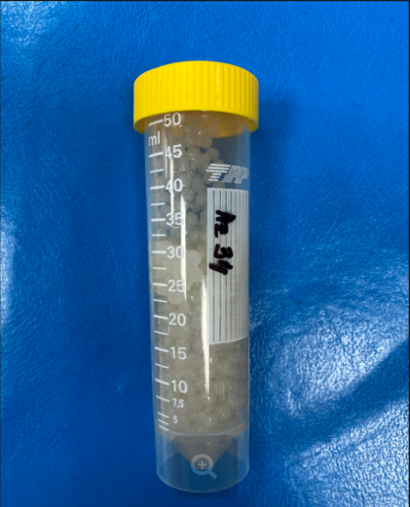 | 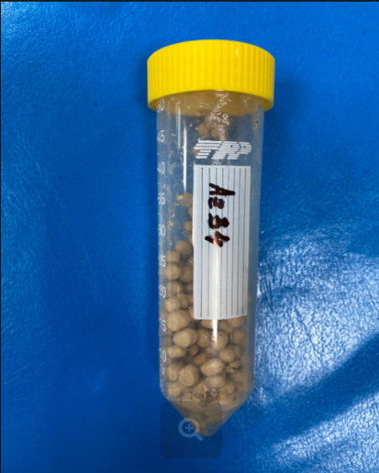
а | б
a – Azotobacter chrooccocum Az-34 in alginate carriers;
b – Azotobacter chrooccocum Az-34 in granules using wheat bran

Figure 32 – Storage in different types of carriers for the strain of the nitrogen-fixing bacterium Azotobacter chrooccocum Az-34
When studying the effect of carriers with alginate on the viability of the studied strains for three months, the titers averaged 1.3 × 10⁹-7.8 × 10¹¹ CFU/ml, and by 3.5 months the amount decreased by three orders of magnitude. In silica gel and clay, the titer of viable cells is kept at the same level, in wheat flour during the entire experiment there was an increase in the amount of the studied bacterial strain Azotobacter chrooccocum Az-34 and was 4.0 × 10⁹ CFU/ml.
A study was carried out to search for and assess the survival rate of azotobacter in various forms of a biological product. It is known that of all microcapsules, sodium alginate remains expensive at cost (figure 33).
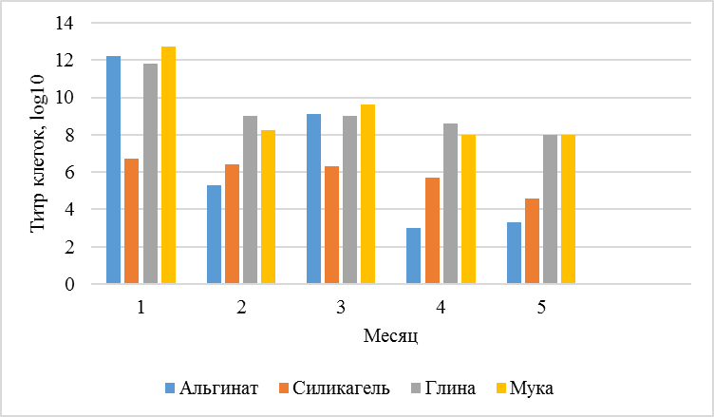
Month

Alginate Silica Gel Clay Flour
Cell titer, log10
Figure 33 – Survival of cells of the bacterium Azotobacter chrooccocum Az-34 in microcapsules for seven months

It was revealed that the titer of cells in alginate capsules after 4 months of storage decreases, and vice versa, microcapsules based on wheat bran retain the viability of the investigated strain. Wheat bran-based microcapsules are much cheaper in cost than other microcapsules.
Thus, microcapsules based on wheat bran turned out to be the most optimal variant, which can later be used for a dry form of a biological product.
In 2020, in order to solve the assigned tasks, experiments with 4 variants for sowing spring wheat of the Lyubava-5 variety were laid on the experimental field of Zarechnoye AES LLP. The recommended variant without treatment of spring wheat seeds was adopted for the control (table 10). The value of the mass of 1000 grains for winter wheat can vary depending on external factors in a wide range from 31 to 36 g. The higher the weight of the grain, the better it is done, has more dry matter and quality characteristics.

Table 10 – Biometric indicators of wheat "Lyubava-5" at the end of the growing season
Experiment variants | Plant height, cm | Ear length, cm | Accounting for density, pcs/m² | Productivity of stems, pcs. | The number of grains per ear, pc. | Weight of 100 grains, g
The control | 73.0 | 9.9 | 159 | 1.74 | 25.8 | 32.4
Biological product | 80.5 | 11.0 | 130 | 1.77 | 29.1 | 31.5
Lamador | 81.7 | 10.5 | 134 | 2.0 | 31.8 | 31.5
Lamador + biological product | 78.4 | 10.9 | 107 | 2.1 | 32.5 | 36.1

It was found that the largest mass of 1000 grains was in the variant with the biological product – 40.5 g, and the smallest – in the variant "Lamador" + biological product – 36.1 g, respectively, in the control variant it was 32.4 g. Plant height in the variant "Lamador" was 81.7 cm, in the control variant the height was 8 cm lower. The same applies to the length of the ear. (table 11).

Table 11 – Test results for grain quality indicators
Experiment variants | Protein,% | Gluten,% | Grain-unit, g/l
The control without treatment | 15.37±0.14 | 30.2±0.34 | 742±0.27
The control Lamador | 15.54±0.03 | 29.17±0.18 | 730±0.41
Biological product | 16.2±0.09 | 30.6±0.43 | 730±0.25
Biological product + Lamador | 16.5±0.03 | 31.47±0.12 | 735±0.37

Analysis of the grain quality of spring wheat variety "Lyubava-5" showed that the best in this respect was the variant with a biological product and pesticide "Lamador". At a moisture content of 11.6%, the mass fraction of wet gluten was 31.47%, the quality of the raw gluten, nature – 735 g/l, the mass fraction of protein – 16.5% (appendix E).
In all variants of the study, the biological product provided an increase in yield compared to the control. Thus, the wheat yield in the variants treated with the biological product and the complex "biological product + Lamador" was approximately at the same level and averaged 20.1 c/ha and 21.18 c/ha, respectively, while the yield in the control variant was an average of 18.25 c/ ha. Thus, the biological product provided an average yield increase of 1.93 c/ha, which is more than 16% (table 12).
Thus, the most effective effect on the yield of spring wheat was obtained when the seeds were treated with a biological product of 20.1 c/ha, which is 2.15 c/ha higher than the control; the yield increase was 10% under conditions of acute drought.

Table 12 – The effectiveness of the biological product on spring wheat variety "Lyubava-5"
Experiment variants | The resulting yield, c/ha | Humidity,%
The control | 18.25±0.26 | 11.7±0.07
Biological product | 20.1±0.49 | 11.77±0.11
Lamador | 21.57±0.23 | 11.77±0.09
Lamador + biological product | 21.18±0.44 | 11.6±0.19

The result of evaluating the pathogenicity of the Rhizobium Rh-1 strain from Nutritest LLP (appendix F) was obtained.
Effective strains of bacteria included in the association are deposited in the depository of industrial microorganisms (appendix G). All informational data of the deposited strains are entered into the database on the website http://kzgenbank.com.

3.4 Development of complexes of machines and equipment for complex mechanization of crop cultivation in the system of precision agriculture
A database of machines and equipment for cultivation of crops in the system of precision agriculture, consisting of three main blocks [1]-[3]: machinery for cultivation and harvesting of agricultural crops, digital systems and equipment for precision agriculture, natural production conditions of the Kostanay region, has been developed. The developed database (fragment) is presented in appendix H.
Comparative tests of machinery for sowing, plant protection, basic tillage and harvesting of spring wheat, equipped with an automatic driving system, were carried out. For the base for comparison, similar units with the autopilot system turned off were used.
Based on the results of the studies carried out by the Kostanay branch of Scientific and Production Center of Agroengineering LLP, it was revealed:
– the use of the automatic driving system "Claas GPS PILOT" when sowing spring wheat with the PK-12.2 sowing complex in the unit with the AXION 950 tractor allows to increase the output per shift of the unit by 3.8%, to reduce the specific fuel consumption by 4.6% and the total cost of funds by 3%.
– the use of the automatic driving system "AutoTrac" for chemical weeding of spring wheat allowed to increase the output per shift of the self-propelled sprayer "John Deere 4730" by 22.1%, to reduce the specific fuel consumption by 18.4%, the actual consumption of the working fluid by 20.6%, total cash costs by 14%.
– the use of the AutoTrac automatic driving system for harvesting spring wheat allows to increase the output per shift of the John Deere W540i combine harvester with a John Deere 930D direct combine header by 4.8%, and to reduce the specific fuel consumption by 5.3%.
– the use of the Claas GPS PILOT automatic driving system in the main tillage of spring wheat allows to increase the output per shift of the John Deere disc subsoiler model 2720 in the aggregate with the AXION 950 tractor by 4.8%, to reduce the specific fuel consumption by 4.9% and reduce total cash costs by 3%.
Based on the results of the research, a report for comparative tests of machinery equipped with an automatic driving system and without it was prepared (appendix J).
Technological maps for four categories of agricultural organizations, taking into account the structure of sown areas, were developed (appendix K).
Based on the tests carried out on technical means and elements of the precision agriculture system, calculations for four categories of agricultural organizations, typical for the conditions of the Kostanay region with different levels of equipment capability: peasant farms, small, medium and large agricultural enterprises, were made as well as optimal machine complexes for them were formed.
In appendix L, table L.1 presents comparative characteristics of the existing and recommended composition of machine complexes for peasant farms, with a planned yield of wheat and barley of 10 c/ha. In peasant farms, only the parallel driving system is recouped, the payback period will be 2.5 years. An increase in labor productivity by 1.6 times is achieved through the use of high-speed, energy-rich tractors of the 3rd class and the replacement of combines of the 3rd class with the 4th class with a minimum set of equipment and the use of elements of the precision agriculture system.
In appendix L, table L.2 presents the comparative characteristics of the existing and recommended composition of machine complexes for small agricultural enterprises with a planned yield of wheat and barley of 10 c/ha. It has been established that in small agricultural enterprises the system for remote monitoring of equipment with fuel consumption sensors and the parallel driving system pays off in 0.1 years, the system for differentiated application of mineral fertilizers – in 4.1 years. The use of the recommended set of machines provides a decrease in labor costs by 2.3 times in comparison with the existing set of machines by increasing the traction class of the used tractors from 3 to 5, the class of used combines from 3 to 4 and the use of elements of the precision agriculture system.
In appendix L, table L.3 presents the comparative compositions of the existing and recommended complexes of machines for medium-sized agricultural enterprises, with a planned yield of wheat and barley of 10 c/ha and soybeans of 5 c/ha. It has been established that for medium-sized agricultural enterprises it is economically feasible to use a parallel driving system, an automatic driving system, a differential fertilizer application system, remote monitoring of equipment with fuel consumption sensors, as well as a complex of elements of a precision agriculture system (automatic driving system, differentiated mineral fertilization, differentiated introduction of plant protection products, monitoring of seed sowing, remote monitoring of equipment with fuel consumption sensors, yield mapping). The payback period of the parallel driving system is 0.7 years, of the automatic driving system is 2.3 years, of the differential fertilizer application system is 4.5 years, of the remote monitoring system of machinery with fuel consumption sensors is 0.1 years, and of the complex of elements of the precision agriculture system is 5.4 years. The use of the recommended set of machines provides a reduction in labor costs by 1.9 times in comparison with the existing set of machines by increasing the traction class of the used tractors from 1.4 to 2 and from 5 to 6, the class of used combines from 4 to 6 and the use of elements of the precision agriculture.
In appendix L, table L.4 presents the comparative characteristics of the existing and recommended composition of the machine and tractor fleet for large agricultural enterprises with an actual yield of wheat and barley of 10 c/ha, soybeans – of 5 c/ha, corn – of 100 c/ha. The calculations show that in large agricultural enterprises it is economically expedient to use an automatic driving system, a parallel driving system, a differential fertilizer application system, a remote equipment monitoring system, as well as a complex of elements of a precision agriculture system (automatic driving system, differential mineral fertilization, differential application plant protection products, monitoring of seed sowing, remote monitoring of equipment with fuel consumption sensors, yield mapping). The payback period of the automatic driving system is 0.7 year, of the parallel driving system is 0.1 year, of the system of differentiated fertilization is 2.9 years, of the remote monitoring of equipment with fuel consumption sensors is 0.02 year, of the complex of elements of the precision agriculture system is 1 year. It was found that the use of the recommended set of machines provides a decrease in labor costs by 2.1 times in comparison with the existing set of machines by increasing the traction class of the used tractors from 1.4 to 2 and from 5 to 6, the class of used combines from 5 to 6 and using elements of the precision agriculture system.
Thus, the use of modern technology with elements of a precision agriculture system makes it possible to increase labor productivity in various categories of agricultural organizations by 1.6-2.3 times in comparison with the existing fleet of machines.

3.5 Development of an economic model for the introduction of precision technologies for farms of the Kostanay region with different equipment capability
To develop economic models for the introduction of precision technologies for farms of the Kostanay region with low equipment capability, the data of the corresponding farm were obtained and processed.
This farm can be classified as a farm with low equipment capability, since the machinery fleet lacks equipment with the introduced elements of precision agriculture:
In the developed economic model No. 1 (appendix M, table M.1), the transition of the machine and tractor fleet of the specified farm to the next stage of precision agriculture will be modelled, which gives even greater savings in resources, namely:
– introduction of a parallel driving system for tractors;
– introduction of a system of differentiated fertilization.
In the developed economic model No. 2 (appendix M, table M.2), the transition of the machine and tractor fleet of the specified farm to the next stage of precision agriculture will be modelled, giving even greater savings in resources, namely:
– introduction of automatic driving systems into all self-propelled vehicles involved in the main technological operations for processing wheat;
– introduction of a system of differentiated fertilization.
The following are data on the current state of technology and simulated transitions to the next stage of introducing precision agriculture in the farm according to model No. 2. It simulates the option of equipping the self-propelled vehicles of the farm involved in growing wheat with automatic driving systems, as well as equipping the sowing complexes with a differential fertilization system.
Partial transfer of machinery to a parallel driving system, introduction of a differential fertilization system, and modernization of tractors with automatic driving equipment according to model No. 1, will allow recouping the investment due to cost savings in 2.3 years. In this case, the total cost savings will be 3.2 million tenge, or 1% of direct production costs (table 13).

Table 13 – Calculation of a simple payback period for the transition to the next stage of precision agriculture
Indicator | Model No. 1 | Model No. 2
Investments for the transition to the next stage of precision agriculture, thousand tenge | 7 400.0 | 46 100.0
Potential cost savings from implementing a simulated transition to the next stage of precision agriculture | 3 217.8 | 7 183.3
Simple investment payback period, years | 2.3 | 6.4
Source: Kostanay branch of Scientific and Production Center of Agroengineering, own calculations.
The machinery of all self-propelled vehicles involved in the main production operations with automatic driving systems and the introduction of a differential fertilization system, according to model No. 2, can be recouped in 6.4 years. According to this model, the total cost savings will be 7.2 million tenge or 2.0% of direct production costs.
To develop economic models for the introduction of precision technologies for farms of the Kostanay region with average equipment capability, the data of the farm Agrofirm Karkyn LLP LLP, which processes about 25 thousand hectares of sown area in the Mendykara region of the Kostanay region, including about 12 thousand hectares of wheat, were obtained and processed.
This farm can be classified as a farm with average equipment capability, since the machinery fleet has vehicles with the introduced elements of precision agriculture:
– tractors equipped with a parallel driving system, including a Trimble GFX-750 display with a NAV-900 CONTROLLER navigation system;
– all machinery is equipped with GPS trackers;
– all machinery is equipped with fuel level control systems.
In the developed economic model No. 1 (appendix M, table M.3), the transition of the machine and tractor fleet of the specified farm to the next stage of precision agriculture will be modelled, giving even greater savings in resources, namely:
– introduction of an automatic driving system in tractors with a parallel driving system;
– introduction of parallel driving systems in the rest of the self-propelled vehicles involved in the main technological operations for processing wheat;
– introduction of a system of differentiated fertilization.
In the developed economic model No. 2 (appendix M, table M.4), the transition of the machine and tractor fleet of the specified farm to the next stage of precision agriculture will be modelled, which gives even greater savings in resources, namely:
– introduction of automatic driving systems into all self-propelled vehicles involved in the main technological operations for processing wheat;
– introduction of a system of differentiated fertilization.
Partial transfer of machinery to a parallel driving system, introduction of a differential fertilization system, and modernization of tractors with automatic driving equipment according to model No. 1, will allow recouping the investment due to cost savings in 2.8 years. In this case, the total cost savings will be 15.2 million tenge, or 3.1% of direct production costs (table 14).
The machinery of all self-propelled vehicles involved in the main production operations with automatic driving systems and the introduction of a differential fertilization system, according to model No. 2, can be recouped in 4.4 years. According to this model, the total cost savings will be 19.36 million tenge or 4.0% of direct production costs.
Table 14 – Calculation of a simple payback period for the transition to the next stage of precision agriculture
Indicator | Model No. 1 | Model No. 2
Investments for the transition to the next stage of precision agriculture, thousand tenge | 43 100.0 | 84 900.0
Potential cost savings from implementing a simulated transition to the next stage of precision agriculture | 15 225.8 | 19 360.5
Simple investment payback period, years | 2.8 | 4.4
Source: Agrofirm Karkyn LLP, Kostanay branch of Scientific and Production Center of Agroengineering, own calculations.

To develop economic models for the introduction of precision technologies for farms of the Kostanay region with high equipment capability, on the basis of real data, technological processes of the "model farm of a high level of technological equipment of Troyana LLP" (Kostanay region, Mendykara district), including about 3.38 thousand hectares of wheat in the Kostanay region, were modelled.
This farm can be classified as a farm with high equipment capability, since the machinery fleet has vehicles with the introduced elements of precision farming:
– tractors, harvesting and other self-propelled vehicles are equipped with a parallel driving system;
– the seeding complex with a fertilizer application system is equipped with a differential fertilization system;
– all machinery is equipped with GPS trackers;
– all machinery is equipped with fuel level control systems.
In the developed economic model No. 1 (appendix M, table M.5), the transition of the machine and tractor fleet of the specified farm to the next stage of precision agriculture will be modelled, which gives even greater savings in resources, namely:
– introduction of an automatic driving system in tractors and self-propelled vehicles (except for combine harvesters) with a parallel driving system.
In the developed economic model No. 2 (appendix M, table M.6), the transition of the machine and tractor fleet of the specified farm to the next stage of precision agriculture will be modelled, which gives even greater savings in resources, namely:
– introduction of automatic driving systems in all self-propelled vehicles involved in the main technological operations for processing wheat.
Partial transfer of machinery to the automatic driving system, according to model No. 1, will recoup the investment due to cost savings in 9.0 years. In this case, the total cost savings will be 2.1 million tenge. or 1.6% of direct production costs (table 15).

Table 15 – Calculation of a simple payback period for the transition to the next stage of precision agriculture
Indicator | Model No. 1 | Model No. 2
Investments for the transition to the next stage of precision agriculture, thousand tenge | 19 000.0 | 34 200.0
Potential cost savings from implementing a simulated transition to the next stage of precision agriculture | 2 102.4 | 4 109.7
Simple investment payback period, years | 9.0 | 8.3
Source: Troyana LLP, Kostanay branch of Scientific and Production Center of Agroengineering, own calculations.

The machinery of all self-propelled vehicles involved in the main production operations with automatic driving systems and the introduction of a differential fertilization system, according to model No. 2, can be recouped in 8.3 years. According to this model, the total cost savings will be 4.1 million tenge or 3.0% of direct production costs.
To simplify the conduct of production processes in the cultivation of agricultural crops, the Agricultural Experimental Station “Zarechnoye” LLP uses the ANT (AgroNetwork Technologies) web service for crop management (appendix U, figure U.6).
The first step in assessing the economic efficiency of an information system (IS) is to assess the volume of investments for the implementation of the system. In our case, the system is based on cloud solutions, which makes it possible to reduce the cost of creating infrastructure and paying staff for its maintenance. In general, the cost of implementing the system includes only the acquisition of a license for this IS. In the case of ANT, the cost of the license is 300 tenge per 1 ha per year. In the case of a farm with an area of ​​18 thousand hectares, the cost of a license for one year will amount to 5.4 million tenge.
The second step is to estimate the cost of operating the system. Since this solution is cloud-based, the cost of maintaining the ground infrastructure is not required. However, it is necessary to take into account the salaries of the personnel who will serve the IS itself, namely, loading and processing data, uploading reports, etc. According to statistics, the salary of a professional specialist in the agricultural industry in 2019 was 148,711 tenge per month, or 1.7 million tenge per year.
Thus, the total expenses for the implementation and operation of the ANT IS amount to 7.1 million tenge per year.
The next step is to assess the benefits of IS implementation. According to the data declared by the developer, as a result of the implementation of the ANT system, the saving of fertilizers and seed material is 10%, and the increase in yield is 15%, due to the prompt receipt of information and subsequent prompt decision-making (table 16).

Table 16 – Cost items of the study farm
Cost item | Total, thousand tenge | Per 1 ha, tenge
Salary with accrual | 133 235.1 | 7 401.9
Fuels and lubricants | 231 994.6 | 12 888.6
Seeds | 175 500.0 | 9 750.0
Mineral fertilizers, chemicals | 546 697.8 | 30 372.1
Current repair, spare parts | 89 881.0 | 4 993.4
Overheads | 128 402.0 | 7 133.4
Total direct costs | 1 305 710.4 | 72 539.5

As a result of the introduction of IS, the savings in fertilizers and seed material will amount to 72.2 million tenge per year.

CONCLUSION

For 2018-2020, the introduction of the main elements of precision agriculture on the experimental and technological platform of Zarechnoye AES LLP has proven its effectiveness:
Differentiated application of mineral fertilizers by the sowing complex "Bourgault" with the system of differentiated application of mineral fertilizers "Agronavigator-Batcher" allowed saving mineral fertilizers (ammophos) up to 34% and increasing grain yield by 21%. Cultivation of spring wheat with differentiated foliar application of nitrogen fertilizer "Strada N" allows increasing the yield of spring wheat by 38.5%.
Differentiated use of plant protection products – pre-sowing chemical treatment with a John Deere 4730 sprayer equipped with an autopilot system and a WeedSeeker system, reduced the number of overlaps, thereby increasing the accuracy of the unit’s movement along the lines and improving its productivity, saving glyphosate up to 7%.
Earth Remote Sensing (ERS) using unmanned aerial vehicles is an operational monitoring of the state of fields, the quality of processing of fallow lands; provides control of the degree of weediness of fields during the period of spring field work, which makes it possible to rationally distribute agricultural machinery for closing moisture, intermediate treatments and pre-sowing chemical treatments sowing quality control; monitoring the vegetation index makes it possible to construct effective schemes for plant feeding, as well as effectively distribute agricultural machinery during the harvesting period, depending on the degree of crop maturation.
Using the parallel driving system on various types of vehicles has its advantages:
– the use of the automatic driving system "Claas GPS PILOT" when sowing spring wheat with the PK-12.2 sowing complex in the unit with the AXION 950 tractor allows to increase the output per shift of the unit by 3.8%, to reduce the specific fuel consumption by 4.6% and the total cost of funds by 3%.
– the use of the automatic driving system "AutoTrac" for chemical weeding of spring wheat allowed to increase the output per shift of the self-propelled sprayer "John Deere 4730" by 22.1%, to reduce the specific fuel consumption by 18.4%, the actual consumption of the working fluid by 20.6%, total cash costs by 14%.
– the use of the AutoTrac automatic driving system for harvesting spring wheat allows to increase the output per shift of the John Deere W540i combine harvester with a John Deere 930D direct combine header by 4.8%, and to reduce the specific fuel consumption by 5.3%.
– the use of the Claas GPS PILOT automatic driving system in the main tillage of spring wheat allows to increase the output per shift of the John Deere disc subsoiler model 2720 in the aggregate with the AXION 950 tractor by 4.8%, to reduce the specific fuel consumption by 4.9% and reduce total cash costs by 3%.
The yield mapping system allows evaluating the effectiveness of precision agriculture techniques, makes it possible to accumulate data on productivity zones, taking into account the actual yield.
A new biological product based on Azotobacter cultures provided a grain yield of 20.1c/ha, which is 2.15 c/ha (10%) higher than the control.
The formed optimal complexes of machines and equipment for the complex mechanization of crop cultivation in the precision agriculture system are competitive in terms of their scientific and technical level in comparison with the best developments in this area.
Based on the built financial and economic models, calculations have shown that the introduction of elements of precision agriculture will reduce production costs in a farm with low equipment capability to 0.8 thousand tenge per hectare of cultivated area, or by 2% of all production costs. The payback period of the simulated improvements in the introduction of elements of precision agriculture for the farm, while maintaining the current processing area, will be 6.4 years. In a farm with average equipment capability for growing wheat up to 1.6 thousand tenge from 1 hectare of cultivated area, or 4% of all production costs, the payback period of simulated improvements in the introduction of elements of precision agriculture for the farm, while maintaining the current processing area, will be 4.4 years. For a farm with high equipment capability and wheat cultivation up to 1.2 thousand tenge from 1 hectare of cultivated area, or 3% of all production costs, the payback period of simulated improvements in the introduction of precision agriculture elements for the farm, while maintaining the current processing area, will be 8.3 years.
According to the results of the calculations, the cost advantage from the implementation of ANT IS amounted to 67.7 tenge benefits per 1 tenge spent on the implementation and operation of the system.

Introduction of scientific developments in production and their promotion

For 2018-2020 published 20 scientific articles, 5 conference proceedings (Web of Science) and journals with non-zero impact factor included in the database Scopus and Web of Science, 10 articles – in journals recommended CCSES MES RK. Published 5 articles in the media (appendices N, P).
Scientists of Zarechnoye AES LLP introduced elements of precision agriculture in the basic farms of Kostanay region. Scientists of Zarechnoye AES LLP introduced elements of precision agriculture in the basic farms of Kostanay region – "Troyana" LLP (on an area of 8200 ha), "Agrofirma Karkyn" LLP (20868 ha), "Zhanakhay" farm (3380 ha). Specialists of basic farms were provided with scientific and methodological support by scientists of Zarechnoye AES LLP during the main types of field work. Paid services were provided to farms for scientific support and introduction of modern methods of nutrition based on agrochemical analysis of the soil selected in the coordinate system for a total amount of 4.0 million tenge (appendix Q).
A patent search was conducted for the research area under study (appendix R).
The project involved 11 undergraduates and 10 PhD students, University and College students – more than 200 people (appendix S).
In 2018-2020, 7 Field Days, 4 seminars and 5 training seminars with the issuance of certificates were held on the basis of Zarechnoye AES LLP, where more than 700 representatives of agricultural formations were involved (appendix T, appendix U, figures U.7-U.28). To date, the project involves foreign scientists from Russia and the United States. Negotiations are underway to attract foreign experts from Germany and Belarus by the end of 2020.
Completed 5 research internships in scientific institutions in Russia, Belarus, and Germany (appendix V). It is planned to complete an online internship at the Belarusian state University.
Applications were filed for 3 utility model patents, 1 invention patent, and positive decisions on granting a patent were received (appendix W).
Developed 5 recommendations for the use of precision farming elements in the cultivation of grain crops (appendix X).
For the period 2018-2020, equipment and software were purchased for a total of 75.4 million tenge (appendix Y).
The results of research for 2018-2020 were discussed and approved at the Scientific Council of Zarechnoye AES LLP (appendix Z).
The list of acts implementation, 2018-2020

Document name | Place of introduction | Implementation area, ha | Year
Implementation report | "Experimental farm "Zarechnoye" LLP (Kostanay district, Kostanay region) | 2000 | 2018
Implementation report | "Troyana" LLP (Fedorov district, Kostanay region) | 7269 | 2019
Implementation report | "Agrofirma Karkyn" LLP (Mendykara district, Kostanay region) | 4000 | 2019
Implementation report | "Zhanakhay" farm (Fedorov district, Kostanay region) | 3369,9 | 2019
Implementation report | "Troyana" LLP (Fedorov district, Kostanay region) | 8200 | 2020
Implementation report | "Agrofirma Karkyn" LLP (Mendykara district, Kostanay region) | 20868 | 2020
Implementation report | "Zhanakhay" farm (Fedorov district, Kostanay region) | 3380 | 2020
Implementation report | Zarechnoye AES LLP (Kostanay district, Kostanay region) | 1200 | 2020

LIST OF USED SOURCES

1. Nukeshev S.O., Yeskhodin D.Z., Romaniuk N.N., Akhmetov E.S., Yeskhodin K.D., Zolotukhin E.A., Tleumbetov K.M. Some results of experimental studies of the metering system of a grain-fertilizer machine with a control and management unit // Vestnik Nauki Saken Seifullin KATU (interdisciplinary). – 2015. – №1 (84). – 198-208 p. [Нукешев С.О., Есхожин Д.З., Романюк Н.Н., Ахметов Е.С., Есхожин К.Д., Золотухин Е.А., Тлеумбетов К.М. Некоторые результаты экспериментальных исследований дозирующей системы зернотуковой машины с блоком контроля и управления// Вестник науки КАТУ им. С.Сейфуллина (междисциплинарный). – 2015. – №1(84). – С.198-208].
2. Nukeshev S., Dzhadyger E., Karaivanov D. Determination of parameters of the main distributor for fertilizer applying machine // Bulgarian Journal of Agricultural Science. – 2014. – Vol. 20, №6. – Р.1513-1521.
3. Kurishbaev A.K., Nukeshev S.O. Prospects for the technology of differentiated use of mineral fertilizers in the conditions of Northern Kazakhstan // Integrated development of rural territories and innovative technologies in the agricultural sector: Materials of international conference. – Novosibirsk, 2012. – P.181-185 [Куришбаев А.К., Нукешев С.О. Перспективы технологии дифференцированного применения минеральных удобрений в условиях Северного Казахстана// Комплексное развитие сельских территорий и инновационные технологии в агропромышленном комплексе: Матер. междунар. конф. – Новосибирск, 2012. – С.181-185].
4. Zharlygasov Zh.B. Kalimov N.E. Spring wheat nutrition and fertilizer system // Multidisciplinary scientific journal of Kostanay State University named after A. Baitursynova «3i: intellect, idea, innovation – intelligence, idea, innovation». – 2018. – №2. – P.45-50 [Жарлыгасов Ж.Б. Калимов Н.Е. Питание яровой пшеницы и система удобрений// Многопрофильный научный журнал Костанайского государственного университета им. А. Байтурсынова «3i: intellect, idea, innovation – интеллект, идея, инновация». – 2018. – №2. – С.45-50].
5. Konstantinov M.M. Workshop on precision farming: textbook. n special/under total. ed. M.M. Konstantinova. – SPb., Publ.: Doe, 2015. – 224 p. [Константинов М.М. Практикум по точному земледелию: учеб. пособие/под общ. ред. М.М. Константинова. – СПб., Изд.: Лань, 2015. – 224 с.].
6. Truflyak E.V., Trubilin E.I., Buksman V.E., Sidorenko S.M. Precision farming. – Krasnodar: KubSAU, 2015. – 376 p. [Труфляк Е.В., Трубилин Е.И., Буксман В.Э., Сидоренко С.М. Точное земледелие. – Краснодар: КубГАУ, 2015. – 376 с.].
7. Precision Agriculture/Ed. D. Shpaara, A.V. Zakharenko, V.P. Yakusheva. – SPb.: Pushkin, 2009. – 397 p. [Точное сельское хозяйство (Precision Agriculture)/ под ред. Д. Шпаара, А.В. Захаренко, В.П. Якушева. – СПб.: Пушкин, 2009. – 397 с.].
8. Truflyak E.V., Trubilin E.I. Intelligent technical means of agribusiness. – Krasnodar: KubSAU, 2016. – 266 p. [Труфляк Е.В., Трубилин Е.И. Интеллектуальные технические средства АПК. – Краснодар: КубГАУ, 2016. – 266 с.].
9. Tugarinov L.V., Zherebin P.M., Petrushin A.F., Muntyan A.N. Prospects for field experiments on the introduction of crop correction tools using data from remote sensing of the Earth. // Materials of the II All-Russian scientific conference with international participation «The use of remote sensing of the Earth in agriculture». – St. Petersburg, September 26-28, 2018 – SPb.: FSBIU AFI, 2018. – P.209-213 [Тугаринов Л.В., Жеребин П.М., Петрушин А.Ф., Мунтян А.Н. Перспективы проведения полевых экспериментов по внедрению средств коррекции урожая с помощью данных дистанционного зондирования Земли // Материалы II Всероссийской научной конференции с международным участием «Применение средств дистанционного зондирования Земли в сельском хозяйстве». – Санкт-Петербург, 26-28 сентября 2018 г. – СПб.: ФГБНУ АФИ, 2018. – С.209-213].
10. Mitrofanov E.P., Petrushin A.F., Mitrofanova O.A. The use of aerial photographs to justify precision agricultural practices for the use of agrochemicals. // Materials of the II All-Russian scientific conference with international participation «The use of remote sensing of the Earth in agriculture». – St. Petersburg, September 26-28, 2018 – SPb.: Federal State Budgetary Institution of Higher Education, 2018. – P.197-202 [Митрофанов Е.П., Петрушин А.Ф., Митрофанова О.А. Использование данных аэрофотосъемки для обоснования прецизионных агроприемов применения агрохимикатов.// Материалы II Всероссийской научной конференции с международным участием «Применение средств дистанционного зондирования Земли в сельском хозяйстве». – Санкт-Петербург, 26-28 сентября 2018 г. – СПб.: ФГБНУ АФИ, 2018. – С.197-202].
11. Yakushev V.P. On the way to precision farming. – SPb., PNPI RAS, 2002. – 458 p. [Якушев В.П. На пути к точному земледелию. – СПб., ПИЯФ РАН, 2002. – 458 с.].
12. Pestunov I.A., Melnikov P.V., Rylov S.A. Automated assessment of crop seedlings from survey data from unmanned aerial vehicles. // Materials of the II All-Russian scientific conference with international participation «The use of remote sensing of the Earth in agriculture». – St. Petersburg, September 26-28, 2018 – SPb.: FSBIU AFI, 2018. – 253-260 p. [Пестунов И.А., Мельников П.В., Рылов С.А. Автоматизированная оценка всходов сельскохозяйственных культур по данным съемки с беспилотных летательных аппаратов.// Материалы II Всероссийской научной конференции с международным участием «Применение средств дистанционного зондирования Земли в сельском хозяйстве». – Санкт-Петербург, 26-28 сентября 2018 г. – СПб.: ФГБНУ АФИ, 2018. – С.253-260].
13. Truflyak E.V. Experience in the application of precision farming systems/E.V. Truflyak. – Krasnodar: KubSAU, 2016. – 22 p. [Труфляк Е.В. Опыт применения систем точного земледелия/Е.В. Труфляк. – Краснодар: КубГАУ, 2016. – 22 с.].
14. Precision agriculture (PrecisionAgriculture)/Under the general. p units D. Shpaara, A.V. Zakharenko, V.P. Yakusheva. – SPb.: Pushkin, 2009. – 397 p. [Точное сельское хозяйство (PrecisionAgriculture)/Под общ. ред. Д. Шпаара, А.В. Захаренко, В.П. Якушева. – СПб.: Пушкин, 2009. – 397 с.].
15. Hmiminaa G. et al. Evaluation of the potential of MODIS satellite data to predict vegetation phenology in different biomes: An investigation using ground-based NDVI measurements // Remote Sensing of Environment. – 2013. – Vol. 132. – P. 145-158.
16. Spitkó T., Nagy Z., Zsubori Z. T., Szőke C. еt al. Connection between normalized difference vegetation index and yield in maize // Plant Soil Environ. – 2016. – Vol. 62, №7. – Р. 293-298. doi: 10.17221/676/2015-PSE.
17. Goltyapin V.Ya. Systems of parallel driving of machine-tractor units // Т ехн. and equip. for the village. – 2013. – №11. – P.12-14 [Гольтяпин В.Я. Системы параллельного вождения машинно– тракторных агрегатов// Техн. и оборуд. для села. – 2013. – №11. – С.12-14].
18. Truflyak E.V. Differentiated technologies. – Krasnodar: KubSAU, 2016. – 44 p. [Труфляк Е.В. Дифференцированные технологии. – Краснодар: КубГАУ, 2016. – 44 с.].
19. Kunakova A.M. Interaction of associative rhizobacteria with plants under various agroecological conditions: abstract of thesis. Candidate of biological sciences: 03.00.07/All-Russian Research Institute of Agricultural Sciences. microbiology. – SPb., 1998. – 18 p. [Кунакова А.М. Взаимодействие ассоциативных ризобактерий с растениями при различных агроэкологических условиях: автореферат дис. ... кандидата биологических наук: 03.00.07/ВНИИ с.-х. микробиологии. – СПб., 1998. – 18 с.].
20. Schott P.R., Litvintsev P.A. The role of atmospheric nitrogen in the nutrition of crops // Soil-agrochemical studies in Siberia: Sat. Scien. Tr. – Barnaul: Publishing house of the ASAU, 2000. – Issue 5. – P.3-7 [Шотт П.Р., Литвинцев П.А. Роль атмосферного азота в питании сельскохозяйственных культур // Почвенно-агрохимические исследования в Сибири: сб. научн. тр. – Барнаул: Изд-во АГАУ, 2000. – Вып.5. – С.3-7.
21. Training materials [Electronic resource]/Decision support system for managing economic parameters in crop production. – The electron. d an. – Access mode: http://studwood.ru. – Zagl. from the screen [Учебные материалы [Электронный ресурс]/Система поддержки принятия решений управления экономическими параметрами в растениеводстве. – Электрон. дан. – Режим доступа: http://studwood.ru. – Загл. с экрана].
22. Agriculture, forestry and fisheries in the Republic of Kazakhstan. – Statistical compilation. – Astana, 2013 – 217 p. [Сельское, лесное и рыбное хозяйство в Республике Казахстан. – Статистический сборник. – Астана, 2013 г. – 217 с.].
23. Catalog of tractor factories, manufacturers of tractor equipment [Electronic resource]/Russian tractor server. – The electron. d an. – Access mode: http://www.traktor.ru. – Zagl. from the screen [Каталог тракторных заводов, производителей тракторной техники [Электронный ресурс]/Российский тракторный сервер. – Электрон. дан. – Режим доступа: http://www.traktor.ru. – Загл. с экрана].
24. Lichman G.I., Smirnov I.G., Lichman A.A., Belenkov A.I. Fundamental and applied research in precision farming: main directions // Niva Russia. – 2016. – №9. – P.74-76 [Личман Г.И., Смирнов И.Г., Личман А.А., Беленков А.И. Фундаментальные и прикладные исследования по точному земледелию: основные направления // Нивы России. – 2016. – №9. – С.74-76].
25. Leonard EC Precision Agriculture // Encyclopedia of Food Grains (Second Edition). – 2016. – Vol.4. – P.162-167.
26. Baerdemaeker, JD Precision agriculture technology and robotics for good agricultural practices // IFAC Proceedings Volumes. – 2013. – Vol.46. – P.1-4.
27. Orsik L.S. Saving technologies in the Russian Federation // Proceedings of the V International Scientific.-Scient. conf. «Conservation agriculture is the future of agriculture in Russia. Resource-saving technologies are the key to economical and safe farming». – Samara, 2005. – P.11-14 [Орсик Л.С. Ресурсосберегающие технологии в Российской Федерации // Материалы V Международной науч.-практ. конф. «Сберегающее земледелие – будущее сельского хозяйства России. Ресурсосберегающие технологии – залог экономичного и безопасного земледелия». – Самара, 2005. – С.11-14].
28. Gilgenberg I.V. Efficiency of resource-saving technologies in the forest-steppe of the Tyumen region: abstract of thesis. ... candidate of agricultural sciences: 06.01.01./Tyumen. state S.-kh. Acad. – Tyumen, 2007. – 16 p. [Гильгенберг И.В. Эффективность ресурсосберегающих технологий в лесостепи Тюменской области: автореферат дис. ... кандидата сельскохозяйственных наук: 06.01.01./Тюмен. гос. с.-х. акад. – Тюмень, 2007. – 16 с.].
29. Kuzychenko Yu.A. The experience of introducing resource-saving systems for primary tillage on solonetzic chernozems of the Stavropol Territory // Transactions of Kuban GAU. – 2012. – №2. – P.189-191 [Кузыченко Ю.А. Опыт внедрения ресурсосберегающих систем основной обработки почвы на солонцеватых черноземах Ставропольского края // Труды Кубанского ГАУ. – 2012. – №2. – С.189-191].
30. GOST 24055-88, 24057-88. T agricultural machinery. Methods of operational and technological assessment. – Enter. 1988-30-03. – M.: USSR State Committee for Standards, 1988. – 15 p. [ГОСТ 24055-88, 24057-88. Техника сельскохозяйственная. Методы эксплуатационно-технологической оценки. – Введ. 1988-30-03. – М.: Государственный комитет СССР по стандартам, 1988. – 15 с.].
31. Blokhin V.G., Gludkin O.P., Gurov A.I., Khanin M.A. Modern experiment: preparation, conduct, analysis of results/Ed. O.P. Gludkina. – M.: Radio and communication. – 1997. – 232 p. [Блохин В.Г., Глудкин О.П., Гуров А.И., Ханин М.А. Современный эксперимент: подготовка, проведение, анализ результатов/Под ред. О.П. Глудкина. – М.: Радио и связь. – 1997. – 232 с.].
32. Vedenyapin G.V. General methodology for experimental research and processing of experimental data. – M.: Kolos. – 1967. – 159 p. [Веденяпин Г.В. Общая методика экспериментального исследования и обработки опытных данных. – М.: Колос. – 1967. – 159 с.].
33. GOST 20915-2011. Tests of agricultural machinery. Methods for determining test conditions. – Enter. 2013-01-01. – M.: FSUE «Standartinform», 2013. – 23 p. [ГОСТ 20915-2011. Испытания сельскохозяйственной техники. Методы определения условий испытаний. – Введ. 2013-01-01. – М.: ФГУП «Стандартинформ», 2013. – 23 с.].
34. GOST 31345-2007. Tractor seeders. Test methods. – Enter. 2009-01-01. – M.: FSUE « Standartinform «, 2008. – 53 p. [ГОСТ 31345-2007. Сеялки тракторные. Методы испытаний. – Введ. 2009-01-01. – М.: ФГУП «Стандартинформ», 2008. – 53 с.].
35. GOST 33687-2015 Tools machines for surface tillage. Test methods. – Enter. 2017-01-06. – M.: FSUE «Standartinform», 2016. – 41 p. [ГОСТ 33687-2015 Машины орудия для поверхностной обработки почвы. Методы испытаний. – Введ. 2017-01-06. – М.: ФГУП «Стандартинформ», 2016. – 41 с.].
36. GOST 33736-2016 Agricultural machinery. Machines for deep tillage. Test methods. – Enter. 2018-01-01. – M.: FSUE « Standartinform», 2017. – 39 p. [ГОСТ 33736-2016 Техника сельскохозяйственная. Машины для глубокой обработки почвы. Методы испытаний. – Введ. 2018-01-01. – М.: ФГУП «Стандартинформ», 2017. – 39 с.].
37. GOST R 53053-2008. Machines for plant protection. Sprayers. Test methods. – Enter. 01/01/2009. – M.: Standartinform, 2009. – 42 p. [ГОСТ Р 53053-2008. Машины для защиты растений. Опрыскиватели. Методы испытаний. – Введ. 01.01.2009. – М.: Стандартинформ, 2009. – 42 с.].
38. GOST 28301-2007. Combine harvesters. Test methods. – Enter. 2010-04-28. – Minsk: Eurasian Council for Standardization, Metrology and Certification, 2007. – 53 p. [ГОСТ 28301-2007. Комбайны зерноуборочные. Методы испытаний. – Введ. 2010-04-28. – Минск: Евразийский совет по стандартизации, метрологии и сертификации, 2007. – 53 с.].
39. GOST R 52777-2007. Agricultural machinery. Energy assessment methods. – Enter. 2007-11-13. – M.: Standartinform, 2007. – 7 p. [ГОСТ Р 52777-2007. Техника сельскохозяйственная. Методы энергетической оценки. – Введ. 2007-11-13. – М.: Стандартинформ, 2007. – 7 с.].
40. Utkin V.F., Kryuchkov Yu.V. Reliability and efficiency in machinery. – M.: Mechanical Engineering, 1988. – Vol. 3. – 327 p. [Уткин В.Ф., Крючков Ю.В. Надежность и эффективность в технике. – М.: Машиностроение, 1988. – Т.3. – 327 с.].
41. Shpilko A.V., Dragaytsev V.I. Methodology for determining the economic efficiency of technologies and agricultural machinery. – M.: Minselkhozizdat, 1998. – Part 2. – 200 p. [Шпилько А.В., Драгайцев В.И. Методика определения экономической эффективности технологий и сельскохозяйственной техники. – М.: Минсельхозиздат, 1998. – Ч. 2. – 200 с.].
42. Saklakov V.D. The potential of production processes in plant growing and the development of methods for its effective use: abstract of the dissertation of a doctor of technical sciences: 05.20.03 / Chelyabinsk Institute of Mechanization and Electrification of Agriculture. – Chelyabinsk, 1990. – 44 p. [Саклаков В.Д. Потенциал производственных процессов в растениеводстве и разработка методов его эффективного использования: автореферат дис. ... доктора технических наук: 05.20.03/ Челяб. ин-т механизации и электрификации сел. хоз-ва. – Челябинск, 1990. – 44 с.].
43. Armor, B.A. Methodology of field experience. – M.: Agropromizdat. – 1985. – 351 p. [Доспехов, Б.А. Методика полевого опыта. – М.: Агропромиздат. – 1985. – 351 с.].
44. ST RK GOST R 53056-2010. Agricultural machinery. Methods of economic assessment. – Enter. 2010-10-04. – Astana: Committee for Technical Regulation and Metrology of the Ministry of Industry and Trade of the Republic of Kazakhstan, 2010. – 26 p. [СТ РК ГОСТ Р 53056-2010. Техника сельскохозяйственная. Методы экономической оценки. – Введ. 2010-10-04. – Астана: Комитет по техническому регулированию и метрологии Министерства индустрии и торговли Республики Казахстан, 2010. – 26 с.].

APPENDIX A

Maps of availability of fields. Task cards. Digital agrochemical maps
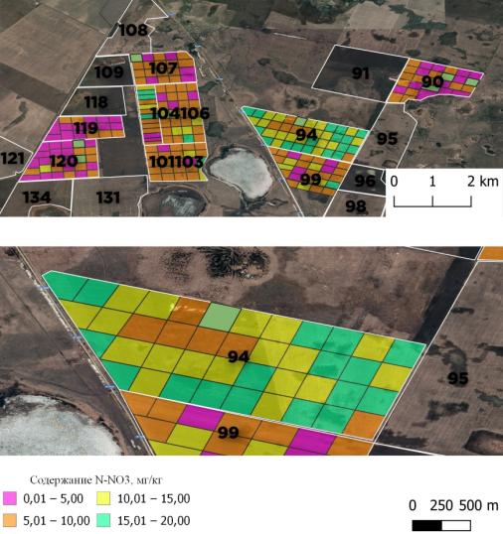
Figure A.1 – Soil supply with nitrate nitrogen N-NO₃ by A.E. Kochergin,
at «AES «Zarechnoe» LLP, mg/kg
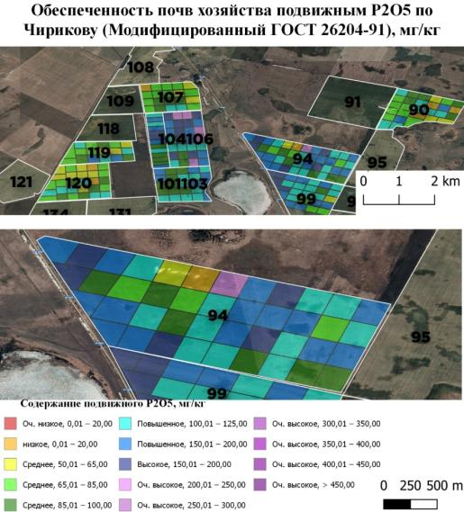
Figure A.2 – Soil availability of «AES «Zarechnoe» LLP with mobile P₂O₅
according to Chirikov (modified by state standart 26204-91), mg/kg
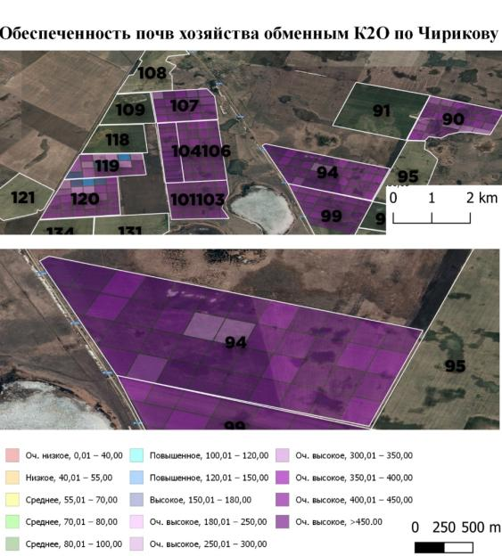
Figure A.3 – Soil availability of «AES «Zarechnoe» LLP with exchange K₂O according to Chirikov (Modified by state standart 26204-91), mg/kg
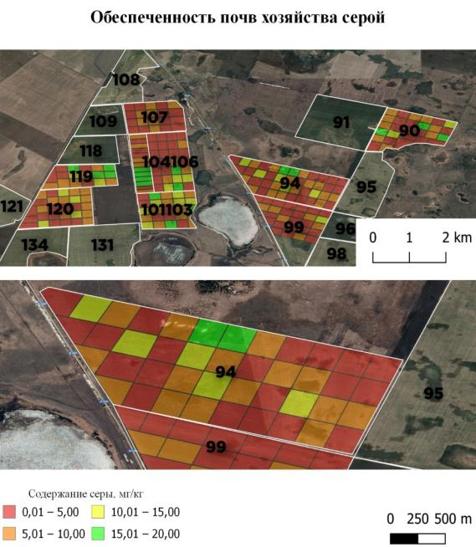
Figure A.4 – Sulfur content in soils of «AES «Zarechnoe» LLP, mg/kg
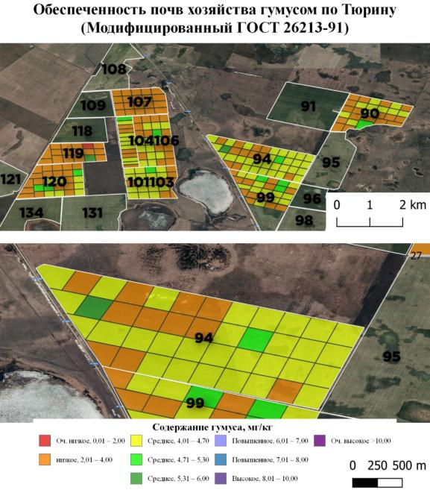
Figure A.5 – Soil availability of «AES «Zarechnoe» LLP humus
according to Tyurin (modified by state standart 26213-91), mg/kg
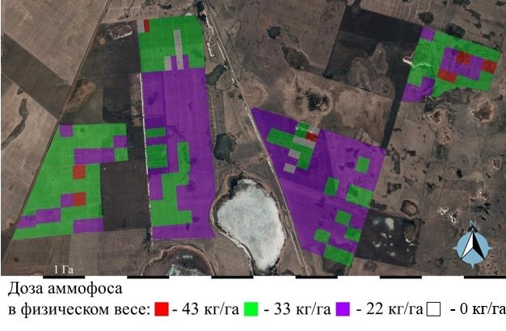
Figure A.6 – Task map for differentiated sowing application of ammophos,
«AES «Zarechnoe» LLP
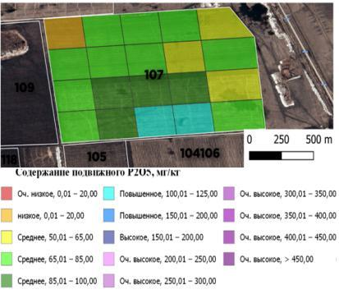
Figure A.7 – Digital agrochemical map of the provision of the field №107 with mobile phosphorus, «AES «Zarechnoe» LLP
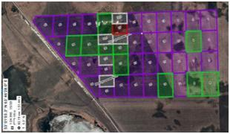
a
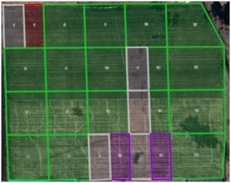
b
a – field №94; b – field №107
Figure A.8 – Electronic task map for the agro navigation of fields
«AES «Zarechnoe» LLP with a division into elementary areas of 10 ha

APPENDIX B

The results of agrochemical investigation of soil, «AES «Zarechnoe» LLP
Field and plot number | Coordinates | Contained, mg/kg of soil
Field and plot number | Coordinates | NO₃ | P₂O₅ | К₂О | S | humus
1 | 2 | 3 | 4 | 5 | 6 | 7
Field 94 plot 1 | 53°00'56.1'' N 63°47'34.5'' E | 21,4 | 133 | 463 | 2,82 | 4,18
2 | 53°00'45.8'' N 63°47'29.5'' E | 13,5 | 112 | 400 | 4,70 | 4,07
3 | 53°00'34.4'' N 63°47'23.2'' E | 15,9 | 127 | 447 | 5,17 | 4,18
4 | 53°00'23.0'' N 63°47'16.5'' E | 10,0 | 100 | 368 | 2,35 | 4,18
5 | 53°00'59.0'' N 63°47'20.9'' E | 13,8 | 111 | 439 | 3,29 | 4,59
6 | 53°00'48.3'' N 63°47'14.7'' E | 18,2 | 78 | 368 | 3,76 | 4,49
7 | 53°00'36.9'' N 63°47'09.0'' E | 20,4 | 150 | 557 | 5,64 | 4,26
8 | 53°00'25.8'' N 63°47'02.6'' E | 18,6 | 100 | 525 | 7,14 | 3,97
9 | 53°01'01.8'' N 63°47'07.0'' E | 16,6 | 123 | 505 | 3,06 | 4,39
10 | 53°00'51.4'' N 63°47'00.8'' E | 22,9 | 133 | 502 | 9,40 | 4,07
11 | 53°00'40.0'' N 63°46'54.5'' E | 13,8 | 114 | 510 | 11,05 | 4,39
12 | 53°00'29.1'' N 63°46'48.6'' E | 16,2 | 102 | 447 | 3,06 | 4,18
13 | 53°01'04.3'' N 63°46'52.4'' E | 17,0 | 150 | 470 | 3,06 | 4,67
14 | 53°00'53.7'' N 63°46'46.4'' E | 14,5 | 139 | 439 | 8,93 | 4,80
15 | 53°00'42.8'' N 63°46'40.4'' E | 13,8 | 158 | 392 | 3,53 | 4,59
16 | 53°00'32.1'' N 63°46'34.1'' E | 10,2 | 86 | 416 | 2,59 | 4,49
17 | 53°01'07.6'' N 63°46'37.8'' E | 11,8 | 130 | 376 | 5,64 | 4,39
18 | 53°00'56.8'' N 63°46'32.5'' E | 14,8 | 133 | 416 | 2,35 | 4,39
19 | 53°00'45.7'' N 63°46'26.2'' E | 18,6 | 128 | 538 | 9,87 | 4,44
20 | 53°00'34.8'' N 63°46'19.7'' E | 15,5 | 117 | 478 | 4,47 | 4,39
21 | 53°01'10.2'' N 63°46'23.9'' E | 13,8 | 216 | 496 | >20 | 3,45
22 | 53°00'59.2'' N 63°46'18.0'' E | 6,2 | 101 | 269 | 9,87 | 3,76
23 | 53°00'48.4'' N 63°46'12.7'' E | 14,8 | 122 | 508 | 12,69 | 4,18
24 | 53°00'37.6'' N 63°46'06.3'' E | 18,6 | 123 | 586 | 6,58 | 4,39
25 | 53°01'12.9'' N 63°46'09.6'' E | 8,7 | 44 | 490 | 16,92 | 3,66
26 | 53°01'02.3'' N 63°46'04.4'' E | 5,4 | 78 | 251 | 14,57 | 3,13
27 | 53°00'51.5'' N 63°45'57.9'' E | 11,5 | 89 | 526 | 7,05 | 4,59
28 | 53°00'40.5'' N 63°45'52.0'' E | 21,4 | 163 | 544 | 7,10 | 4,07
29 | 53°01'15.8'' N 63°45'55.4'' E | 9,6 | 64 | 478 | 9,64 | 4,18
30 | 53°01'04.9'' N 63°45'49.7'' E | 8,7 | 89 | 425 | 4,23 | 3,96
31 | 53°00'54.2'' N 63°45'43.4'' E | 12,9 | 111 | 466 | <2 | 4,07
Continuation of the appendix B
1 | 2 | 3 | 4 | 5 | 6 | 7
32 | 53°00'43.5'' N 63°45'37.8'' E | 13,5 | 128 | 347 | 3,06 | 3,66
33 | 53°01'18.8'' N 63°45'40.9'' E | 10,5 | 105 | 574 | 2,12 | 2,77
34 | 53°01'08.0'' N 63°45'34.1'' E | 6,9 | 83 | 460 | 12,69 | 3,97
35 | 53°00'57.3'' N 63°45'27.0'' E | 10,5 | 150 | 472 | 4,70 | 4,39
36 | 53°00'47.0'' N 63°45'23.3'' E | 15,9 | 128 | 437 | 5,41 | 3,92
37 | 53°01'21.6'' N 63°45'27.0'' E | 11,5 | 133 | 371 | 5,73 | 4,18
38 | 53°01'11.3'' N 63°45'19.1'' E | 10,2 | 87 | 392 | <2 | 5,60
39 | 53°01'02.7'' N 63°45'13.6'' E | 15,5 | 133 | 466 | 7,57 | 4,39
40 | 53°01'24.8'' N 63°45'12.8'' E | 16,2 | 155 | 478 | 11,99 | 3,81
41 | 53°01'15.7'' N 63°45'05.5'' E | 13,2 | 155 | 532 | 3,29 | 4,18
42 | 53°01'28.5'' N 63°44'57.5'' E | 17,8 | 139 | 520 | 4,75 | 4,18
 | V | 29,6 | 26,0 | 16,2 | 58,3 | 10,8
Field 101, 103 plot 1 | 53°00'35.7'' N 63°42'42.7'' E | 6,9 | 129 | 561 | 3,29 | 4,39
2 | 53°00'25.8'' N 63°42'44.0'' E | 6,8 | 136 | 549 | 4,47 | 4,07
3 | 53°00'15.9'' N 63°42'45.5'' E | 6,2 | 97 | 525 | 13,16 | 3,66
4 | 53°00'05.5'' N 63°42'47.5'' E | 7,4 | 94 | 578 | 8,93 | 4,39
5 | 52°59'55.5'' N 63°42'48.7'' E | 7,2 | 105 | 578 | 14,10 | 4,18
6 | 53°00'36.3'' N 63°43'00.0'' E | 4,4 | 94 | 590 | 19,27 | 4,13
7 | 53°00'26.5'' N 63°43'01.1'' E | 6,0 | 89 | 584 | 11,75 | 4,41
8 | 53°00'16.3'' N 63°43'02.5'' E | 6,3 | 89 | 560 | 7,14 | 4,02
9 | 53°00'06.5'' N 63°43'04.5'' E | 6,6 | 89 | 543 | 2,35 | 4,44
10 | 52°59'55.6'' N 63°43'06.2'' E | 6,9 | 103 | 602 | 6,82 | 4,07
11 | 53°00'36.9'' N 63°43'16.7'' E | 5,5 | 91 | 590 | 6,58 | 4,80
12 | 53°00'27.1'' N 63°43'18.4'' E | 6,9 | 122 | 596 | 9,40 | 4,07
13 | 53°00'17.5'' N 63°43'20.3'' E | 6,2 | 105 | 596 | 4,75 | 4,18
14 | 53°00'07.3'' N 63°43'21.5'' E | 6,0 | 86 | 484 | 4,47 | 4,60
15 | 52°59'56.8'' N 63°43'23.0'' E | 7,8 | 122 | 531 | >20 | 4,28
16 | 53°00'37.9'' N 63°43'35.1'' E | 7,4 | 133 | 502 | 12,69 | 4,13
17 | 53°00'28.5'' N 63°43'36.3'' E | 10,2 | 111 | 572 | 11,99 | 4,60
18 | 53°00'18.1'' N 63°43'37.4'' E | 4,8 | 133 | 366 | 6,11 | 3,81
19 | 53°00'08.6'' N 63°43'38.7'' E | 7,9 | 125 | 549 | 7,43 | 4,60
20 | 52°59'57.5'' N 63°43'40.8'' E | 6,9 | 119 | 413 | 4,70 | 3,97
21 | 53°00'39.3'' N 63°43'51.2'' E | 8,1 | 105 | 428 | 5,41 | 3,66
22 | 53°00'28.8'' N 63°43'53.0'' E | 7,2 | 147 | 454 | 12,69 | 3,81
23 | 53°00'17.9'' N 63°43'51.0'' E | 15,1 | 133 | 407 | >20 | 3,86
Continuation of the appendix B
1 | 2 | 3 | 4 | 5 | 6 | 7
24 | 52°59'58.4'' N 63°43'52.7'' E | 12,3 | 128 | 389 | 5,64 | 3,86
 | V | 31,2 | 16,5 | 14,2 | 51,6 | 7,4
Field 104,106 plot 1 | 53°01'58.7'' N 63°42'55.2'' E | 7,2 | 167 | 458 | 3,06 | 3,60
2 | 53°01'47.6'' N 63°42'57.2'' E | 4,9 | 146 | 406 | <2 | 3,44
3 | 53°01'34.9'' N 63°42'58.5'' E | 8,3 | 127 | 403 | <2 | 3,73
4 | 53°01'23.4'' N 63°43'00.8'' E | 12,3 | 125 | 480 | 2,35 | 4,02
5 | 53°01'11.7'' N 63°43'03.1'' E | 9,8 | 119 | 626 | 4,35 | 4,13
6 | 53°00'59.4'' N 63°43'03.9'' E | 10,0 | 165 | 620 | <2 | 3,94
7 | 53°00'47.9'' N 63°43'05.7'' E | 6,6 | 104 | 586 | <2 | 4,12
8 | 53°01'59.9'' N 63°43'10.7'' E | 7,1 | 216 | 434 | <2 | 3,60
9 | 53°01'48.0'' N 63°43'11.9'' E | 8,1 | 162 | 538 | <2 | 4,39
10 | 53°01'36.5'' N 63°43'13.6'' E | 4,6 | 152 | 388 | <2 | 3,89
11 | 53°01'24.2'' N 63°43'15.6'' E | 10,5 | 160 | 434 | <2 | 4,05
12 | 53°01'12.5'' N 63°43'17.5'' E | 10,0 | 106 | 465 | 4,32 | 4,41
13 | 53°01'00.1'' N 63°43'18.7'' E | 10,2 | 91 | 607 | 7,76 | 4,44
14 | 53°00'49.1'' N 63°43'20.4'' E | 7,8 | 86 | 481 | 12,22 | 4,02
15 | 53°02'00.6'' N 63°43'24.6'' E | 7,1 | 225 | 390 | <2 | 3,60
16 | 53°01'48.7'' N 63°43'26.7'' E | 7,8 | 170 | 446 | <2 | 4,05
17 | 53°01'36.9'' N 63°43'27.7'' E | 7,2 | 141 | 608 | 3,76 | 4,83
18 | 53°01'25.6'' N 63°43'29.8'' E | 5,1 | 140 | 452 | 9,87 | 4,12
19 | 53°01'13.4'' N 63°43'32.0'' E | 9,3 | 124 | 485 | 17,39 | 3,97
20 | 53°01'01.2'' N 63°43'33.2'' E | 12,3 | 171 | 744 | 13,39 | 4,18
21 | 53°00'49.4'' N 63°43'35.4'' E | 26,3 | 214 | 496 | >20 | 3,76
22 | 53°02'00.9'' N 63°43'39.1'' E | 6,6 | 188 | 508 | 4,47 | 3,99
23 | 53°01'49.4'' N 63°43'40.8'' E | 4,0 | 144 | 491 | 5,17 | 4,39
24 | 53°01'37.4'' N 63°43'42.5'' E | 9,1 | 224 | 441 | 4,0 | 3,60
25 | 53°01'25.6'' N 63°43'44.2'' E | 8,5 | 205 | 496 | <2 | 3,52
26 | 53°01'13.5'' N 63°43'46.4'' E | 11,0 | 114 | 575 | 8,23 | 3,76
27 | 53°01'01.6'' N 63°43'47.9'' E | 10,0 | 149 | 607 | 13,16 | 3,45
28 | 53°00'49.8'' N 63°43'50.2'' E | 9,6 | 132 | 496 | 4,94 | 3,42
 | V | 44,9 | 25,8 | 17,1 | 61,1 | 8,9
Field 109 | 53°02'04.9'' N 63°41'00.6'' E | 4,20 | 78 | 290 | >15,00 | 3,29
 | 53°02'05.8'' N 63°41'17.5'' E | <2,80 | 65 | 280 | >15,00 | 3,36
 | 53°02'16.0'' N 63°41'15.9'' E | 4,10 | 50 | 248 | >15,00 | 3,22
 | 53°02'26.2'' N 63°41'14.3'' E | 8,50 | 130 | 269 | >15,00 | 3,17
Continuation of the appendix B
1 | 2 | 3 | 4 | 5 | 6 | 7
 | 53°02'06.8'' N 63°41'34.5'' E | <2,80 | 60 | 188 | >15,00 | 2,57
 | 53°02'17.0'' N 63°41'32.8'' E | <2,80 | 65 | 277 | >15,00 | 2,86
 | 53°02'27.2'' N 63°41'31.2'' E | 6,20 | 95 | 329 | >15,00 | 3,57
 | 53°02'37.4'' N 63°41'29.6'' E | 6,20 | 95 | 329 | >15,00 | 3,57
 | 53°02'07.8'' N 63°41'51.4'' E | <2,80 | 56 | 253 | 5,30 | 3,09
 | 53°02'18.0'' N 63°41'49.8'' E | <2,80 | 68 | 402 | 5,82 | 3,29
 | 53°02'28.2'' N 63°41'48.2'' E | <2,80 | 58 | 375 | >15,00 | 3,75
 | 53°02'38.4'' N 63°41'46.5'' Е | <2,80 | 58 | 375 | >15,00 | 3,75
 | 53°02'08.8'' N 63°42'08.4'' E | <2,80 | 59 | 247 | 7,47 | 3,40
 | 53°02'19.0'' N 63°42'06.7'' E | 3,50 | 93 | 356 | 5,39 | 3,37
 | 53°02'29.2'' N 63°42'05.1'' E | 4,40 | 115 | 348 | 6,72 | 3,63
 | 53°02'39.3'' N 63°42'03.5'' E | 9,10 | 250 | 590 | >15,00 | 3,82
 | V | 36,6 | 56,4 | 28,6 | 15,2 | 10
Field 133 | 52°57'48.8'' N 63°38'58.9'' E | <2,80 | 100 | 312 | 2,70 | 3,12
 | 52°57'59.0'' N 63°38'57.3'' E | <2,80 | 93 | 256 | >15,00 | 3,41
 | 52°58'09.2'' N 63°38'55.8'' E | <2,80 | 94 | 254 | 7,43 | 3,29
 | 52°58'19.4'' N 63°38'54.2'' E | 4,50 | 88 | 287 | >15,00 | 3,44
 | 52°58'29.6'' N 63°38'52.7'' E | 4,70 | 123 | 430 | 5,11 | 3,56
 | 52°57'49.8'' N 63°39'15.8'' E | <2,80 | 404 | 179 | 7,10 | 2,92
 | 52°58'00.0'' N 63°39'14.2'' E | <2,80 | 92 | 171 | 6,15 | 2,85
 | 52°58'10.2'' N 63°39'12.7'' E | <2,80 | 126 | 444 | >15,00 | 3,28
 | 52°58'20.3'' N 63°39'11.1'' E | <2,80 | 70 | 198 | 4,12 | 2,95
 | 52°58'30.5'' N 63°39'09.6'' E | 3,50 | 98 | 306 | 2,93 | 3,34
 | 52°57'50.7'' N 63°39'32.7'' E | 4,50 | 108 | 292 | 7,57 | 3,12
 | 52°58'00.9'' N 63°39'31.2'' E | 9,10 | 31 | 504 | 3,31 | 3,72
 | 52°58'11.1'' N 63°39'29.6'' E | <2,80 | 101 | 410 | 9,74 | 3,38
 | 52°58'21.3'' N 63°39'28.1'' E | 4,00 | 81 | 350 | 3,26 | 3,25
 | 52°58'31.5'' N 63°39'26.5'' E | 3,90 | 91 | 590 | 2,13 | 3,17
 | 52°57'51.6'' N 63°39'49.6'' E | 4,10 | 101 | 469 | 4,40 | 3,43
 | 52°58'01.8'' N 63°39'48.1'' E | 10,50 | 60 | 557 | >15,00 | 4,07
 | 52°58'12.0'' N 63°39'46.6'' E | 4,30 | 111 | 590 | 4,49 | 3,35
 | 52°58'22.2'' N 63°39'45.0'' E | <2,80 | 78 | 330 | >15,00 | 2,95
 | 52°58'32.4'' N 63°39'43.5'' E | <2,80 | 61 | 168 | 3,88 | 2,82
 | 52°57'52.6'' N 63°40'06.6'' E | 3,60 | 150 | 331 | >15,00 | 3,38
 | 52°58'02.7'' N 63°40'05.0'' E | 3,90 | 62 | 480 | 11,40 | 3,35
Continuation of the appendix B
1 | 2 | 3 | 4 | 5 | 6 | 7
 | 52°58'12.9'' N 63°40'03.5'' E | 6,60 | 125 | 585 | 8,51 | 3,76
 | 52°58'23.1'' N 63°40'01.9'' E | 5,50 | 100 | 500 | >15,00 | 3,70
 | 52°58'33.3'' N 63°40'00.4'' E | <2,80 | 56 | 189 | 4,02 | 2,91
 | 52°57'53.5'' N 63°40'23.5'' E | <2,80 | 117 | 293 | >15,00 | 3,11
 | 52°58'03.7'' N 63°40'22.0'' E | 4,50 | 69 | 300 | 11,83 | 3,43
 | 52°58'13.9'' N 63°40'20.4'' E | 5,90 | 94 | 441 | >15,00 | 3,69
 | 52°58'24.1'' N 63°40'18.9'' E | 5,60 | 67 | 498 | >15,00 | 3,77
 | 52°58'34.3'' N 63°40'17.3'' E | 6,20 | 73 | 434 | >15,00 | 3,25
 | 52°57'54.4'' N 63°40'40.4'' E | 4,00 | 108 | 306 | >15,00 | 3,12
 | 52°58'04.6'' N 63°40'38.9'' E | 6,30 | 84 | 435 | >15,00 | 3,68
 | 52°58'14.8'' N 63°40'37.3'' E | 4,20 | 66 | 354 | 3,50 | 3,10
 | 52°58'25.0'' N 63°40'35.8'' E | <2,80 | 89 | 512 | 1,94 | 3,23
 | 52°58'35.2'' N 63°40'34.2'' E | 4,20 | 114 | 334 | 4,97 | 2,95
 | V | 34,2 | 58,5 | 33,7 | 33,7 | 9,1

APPENDIX C

Yield after harvesting in the conditions of 2018-2020 by fields of the testing area,
«AES «Zarechnoe» LLP
Field number | Crop | Crop yield, c/ha
1 | 2 | 3
2018
107 | Wheat (Omskaya 36) | 24.9
107 | Rape (Lipetskaya) | 8.1
119 | Wheat (Omskaya 36) | 20.9
105 | Wheat (Omskaya 36) | 33.2
106 | Wheat (Omskaya 36) | 24.6
104 | Sunflower (Almaz) | 17.5
101, 103 | Wheat (Omskaya 36) | 23.8
94 | Wheat (Omskaya 36) | 30.4
94 | Rapeseed (LipCar 2014) | 10.4
99 | Wheat (Omskaya 36) | 19.7
90 | Wheat (Omskaya 36) | 26.1
Average yield for wheat |  | 25.4
2019
91 | Wheat (Bezenchukskaya 182) | 8.2
94 | Wheat (Omskaya 36) | 13.2
99 | Wheat (Omskaya 36) | 10.2
105 | Wheat (Omskaya 36) | 29.1
107 | Wheat (Omskaya 36) | 9.8
108 | Wheat (Omskaya 18) | 9.9
109 | Wheat (Omskaya 18) | 20.3
118 | Wheat (Omskaya 18) | 16.7
119 | Wheat (Omskaya 36) | 8.9
120 | Wheat (Omskaya 18) | 9.1
133 | Wheat (Omskaya 36) | 10.3
Average yield for wheat |  | 13.3
96 | Rapeseed (LipCar 2014) | 3.1
103 | Peas (Aksay leafless 55) | 10.2
2020
105 | Omskaya 18 | 20.5
105 | Omskaya 31 | 24.4
Continuation of the appendix C
1 | 2 | 3
105 | Omskaya 30 | 28.3
105 | Bezenchukskaya 182 | 28.3
105 | Asangali 20 | 19.5
105 | Darkhan Dun | 28.6
105 | Aina | 25.0
68 | Wheat Omskaya -36 | 15.1
62 | Wheat Omskaya -36 | 12.2
70 | Wheat Omskaya -36 | 14.8
90 | Wheat Omskaya -36 | 10.3
104-106 | Wheat Omskaya -36 | 16.5
104-106 | Wheat Omskaya -36 | 13.7
101-103 | Wheat Omskaya -36 | 14.3
101-103 | Wheat Omskaya -36 | 14.6
100 | Wheat Omskaya -36 | 11.7
96 | Wheat Kazakhstani early-maturing | 17.1
59 | Wheat Omskaya -36 | 14.3
54 | Aina wheat | 17.4
128 | Wheat Omskaya -36 | 10.0
133 | Wheat Omskaya -36 | 9.7
138 | Wheat Omskaya -36 | 11.5
Average yield for wheat |  | 17.2

APPENDIX D

Spring wheat average yield information in the Kostanay region
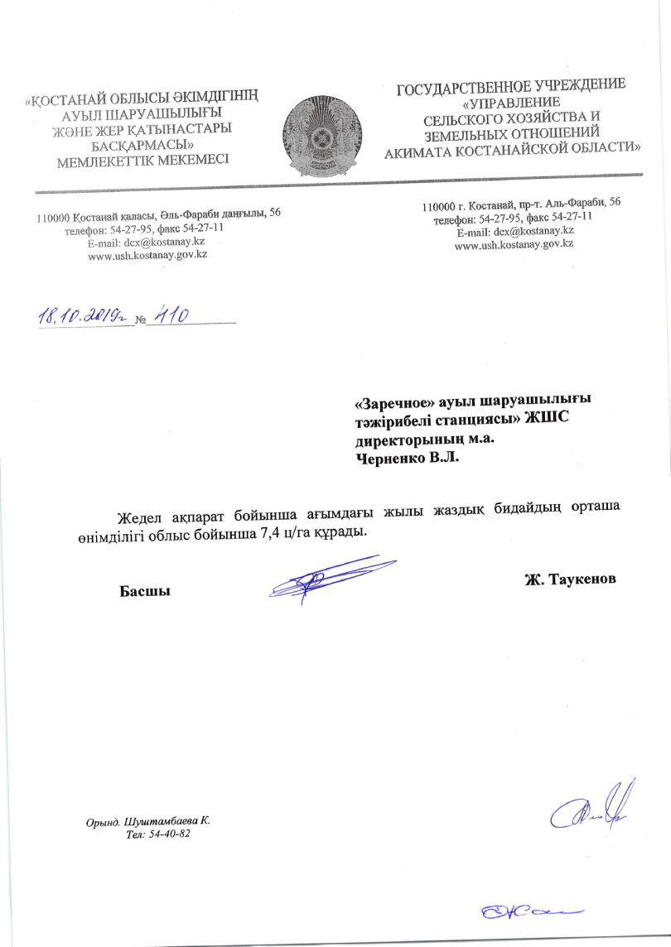
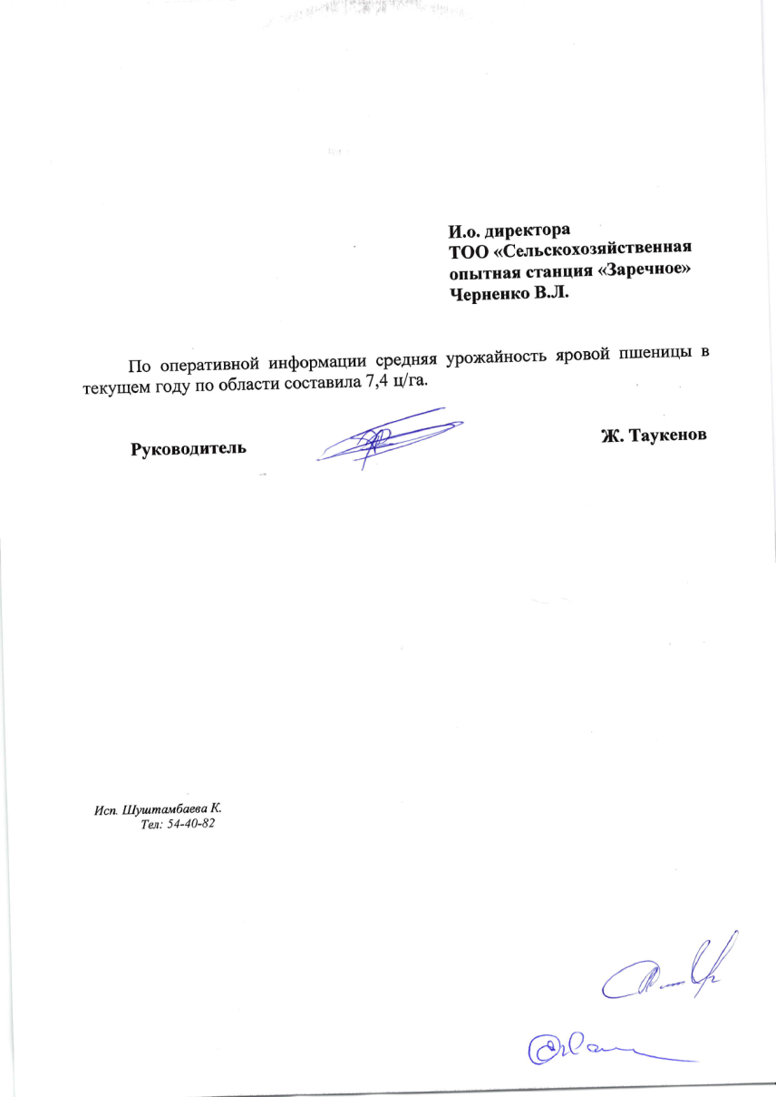

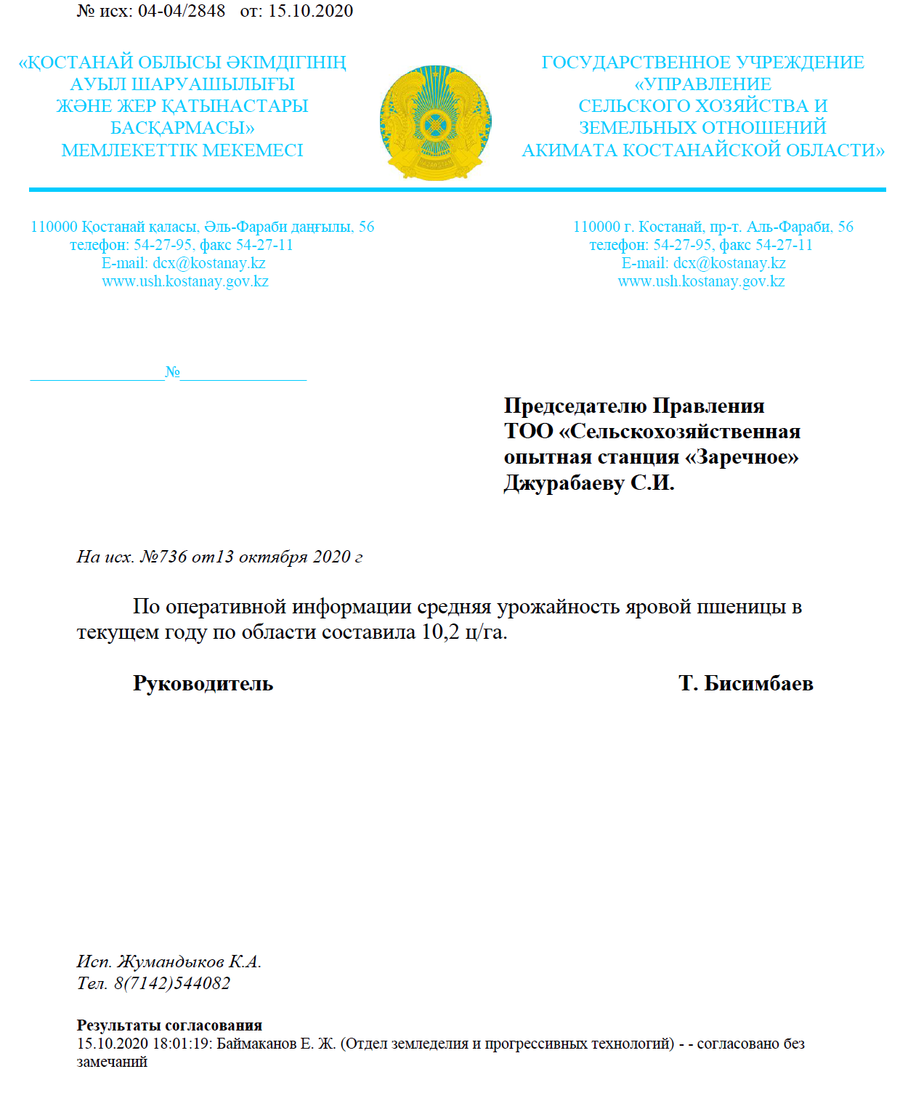
APPENDIX E

Test reports of the quality of grain grown using a biological product
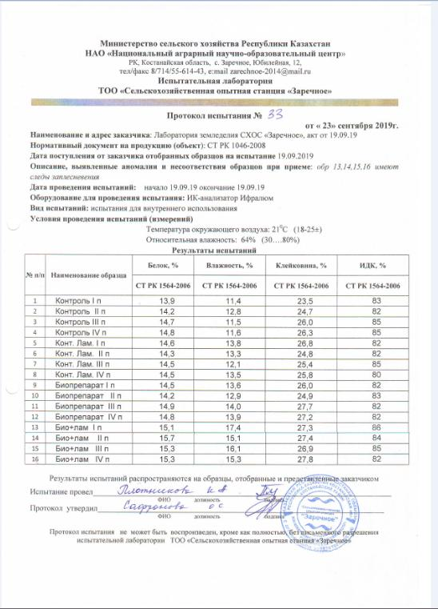
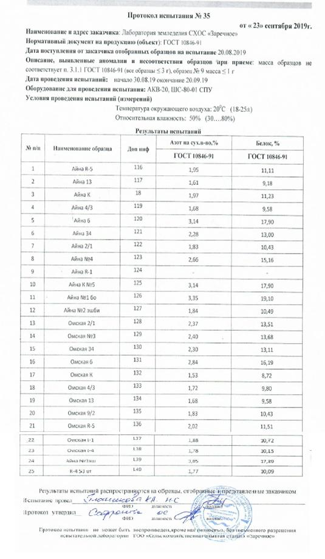

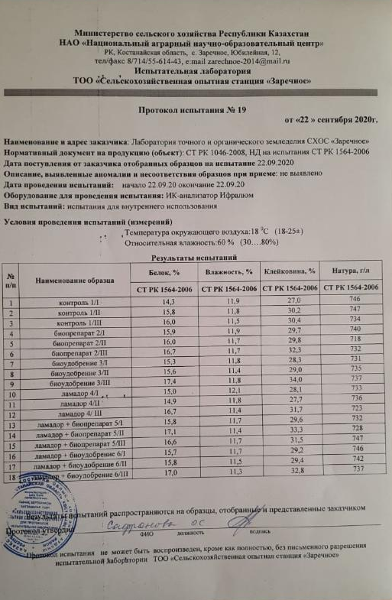
APPENDIX F

Conclusion on the results of the study of strains for toxicity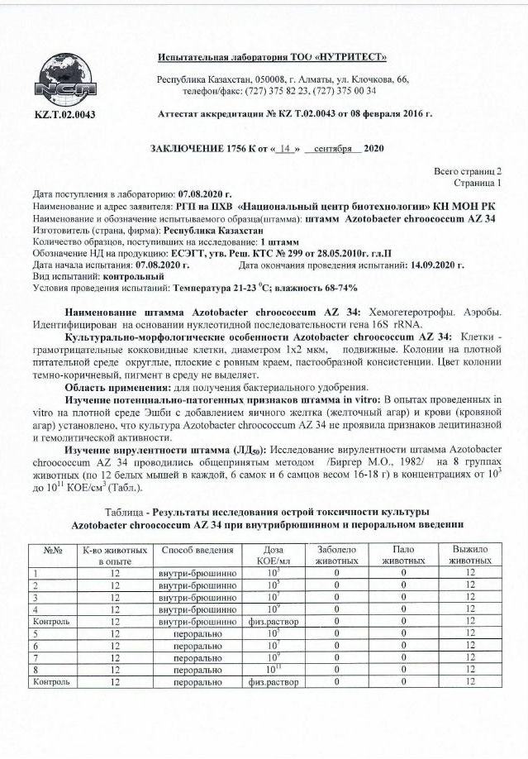
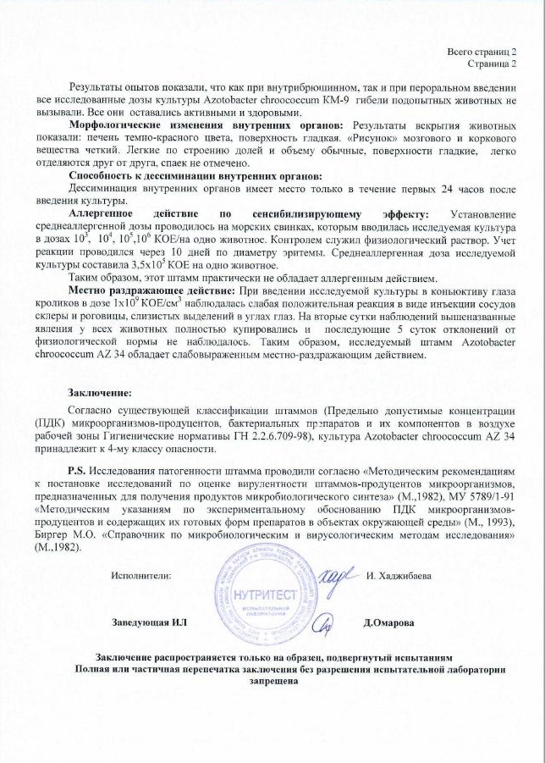

APPENDIX G

Strain passport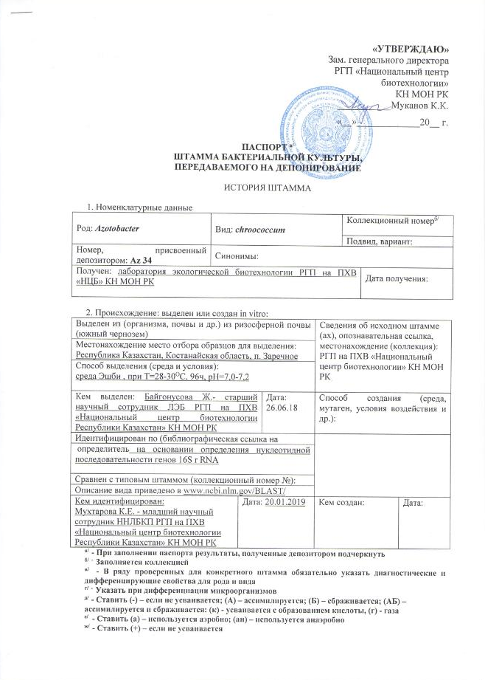

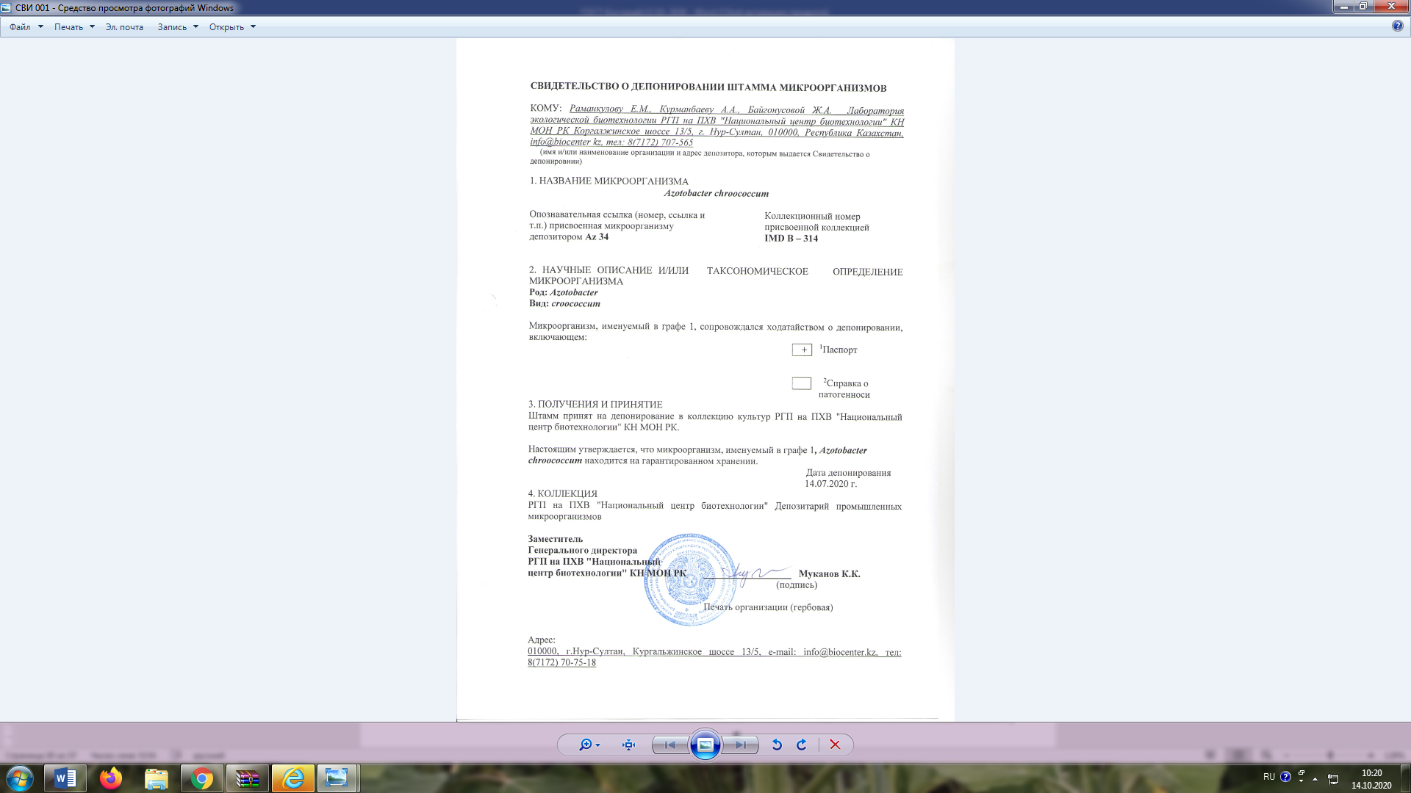

APPENDIX H

Data base

Элементы модулей базы данных (сетевая структура)

Блок «Техника для возделывания и уборки сельскохозяйственных культур»
Модуль «Энергетические средства» (фрагмент)

Трактор Buhler Versatile серия 2375
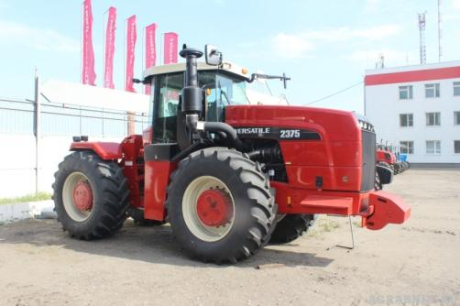

Показатель | Значение показателя
Назначение | трактор сельскохозяйственный общего назначения
Техническая характеристика:  – тяговый класс  – эксплуатационная масса, кг  – марка двигателя  – мощность двигателя, кВт (л.с.)  – номинальная частота вращения коленчатого вала, об/мин  – максимальный крутящий момент, Н·м  – частота вращения ВОМ, об/мин  – грузоподъемность навесного устройства , кгс | 5-6  11690  Cummins QSМ11  280 (375)  2100  1880  1000  5900
Цена, тыс. тенге | 76 720
Завод изготовитель | ООО «Комбайновый завод «Ростсельмаш»
Источник информации | https://rostselmash.com  /products/tractors/  http://agroline.optorg.ru  /catalog/traktory/
Ф.И.О. исполнителя | Бобков С.И.

Трактор может быть оснащен системами параллельного вождения, системами подруливания и автоматического вождения, системами автопилота с применением GPS/ Глонасс навигации. Также на трактор возможна установка датчиков мониторинга за техникой (RFID механизатора, датчики уровня и расхода топлива).

Модуль «посевная и уборочная техника» (фрагмент)

Модульный посевной комплекс КСКП – 2,1Дх5

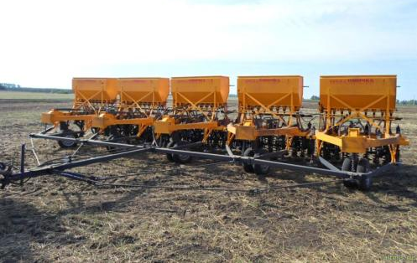

Показатель | Значение показателя
Назначение | Предназначен для полосного посева семян зерновых и зернобобовых культур полосой 18-20 см с одновременной предпосевной культивацией, внесением минеральных гранулированных удобрений и полосным прикатыванием почвы после посева на стерневых и безотвальных стерневых фонах, а также для культивации паров
Рабочая скорость, км/ч | до 10
Ширина захвата, м | 10,25
Производительность основного времени, га/ч | до 10,25
Ширина междурядий, см | 22,8
Ширина полосы посева, см | 18-20
Количество сошников, шт. | 45
Глубина заделки семян, см | 4-10
Норма высева семян зерновых, кг/га | 50-500
Потребная мощность, кВт | 220
Цена, тыс. тенге | 6 594,2
Завод-изготовитель | ООО "Сибзавод" г. Омск
Источники информации | http://www.sibzavod.ru/103/  https://sibzavodagro.ru/tehnika/posevnaya/modulnye-posevnye-kompleksy-kskp-omich
Ф.И.О. исполнителя | Курач А.А.

В системе точного земледелия может работать с оборудованием для контроля качества высева компаний «Аргонавт», «Монада», «Скиф».

Модуль «Техника для обработки почвы» (фрагмент)

Культиватор "СТЕПНЯК" КС 12.0

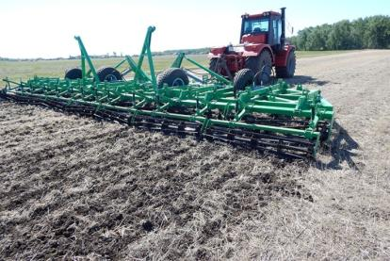

Показатель | Значение показателя
Назначение | Предназначен для предпосевной обработки почвы, культивации паровых полей, основной обработки почвы, выравнивания поверхности поля, уничтожения сорняков, прикатывания почвы.
Тип | прицепной, гидрофицированный
Ширина захвата, м | 12
Рабочая скорость, км/ч | до 12
Производительность основного времени, га/ч | до 14,4
Ширина захвата стрельчатой лапы, мм | 410
Глубина обработки, см | 10-18
Крошение почвы (фракции до 25мм), % | 80-85
Подрезание сорняков, % | 100
Потребная мощность, кВт | 260-300
Цена, тыс. тенге | 9 007,0
Завод-изготовитель | ФГУП «Омский экспериментальный завод», (Россия, Омская область)
Источники информации | http://www.oezomsk.ru/view_products.php?id=6  https://www.agrobase.ru/catalog/machinery/machinery_ae1d883e-2ea3-4cf0-bd9e-670dcd905b34
Ф.И.О. исполнителя | Курач А.А.

В системе точного земледелия может работать с оборудованием для контроля качества обработки почвы компании «Аргонавт», «Монада», «Скиф».

Блок «Цифровые системы и оборудование для точного земледелия» Модуль «Системы параллельного и автоматического вождения» (фрагмент)

Курсоуказатель Trimble CFX-750
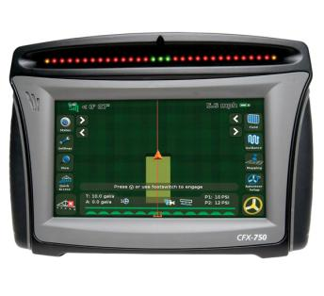
Показатель | Значение показателя
Назначение | Предназначен для:  - параллельного вождения по курсоуказателю вдоль рядов в условиях любой видимости в ручном режиме, либо в автоматическом режиме в составе автопилота;  - управления секциями опрыскивателей и сеялок точного высева;  - управления нормой высева;  -дифференцированного внесения удобрений.
Точность | 30 - 40 см
Рабочая температура | от 0 °C до +50 °C
Температура хранения | от -20 ºC до +80 ºC
Корпус | Алюминиевый с двойной защитой
Вода/пыль | IP65
Экран | Цветной антибликовый дисплей с изменяемой яркостью
Частота обновления позиции | 5 Гц
Цена | 950000тн
Производитель | Trimble Navigation США
Источник информации | ТОО "NAVISTAR ASIA"г.Костанай  http://www.geomir.ru/info110.html  https://skbm.tiu.ru/p172619871-displej-trimble-cfx.html  http://geocourse.kz/catalog/navigaciya-dlya-selkhoztekhniki/kursoukazatel-trimble-cfx-750-detail
Ф.И.О. исполнителя | Крикало Е.Н.

Модуль «Оборудование для дифференцированного применения средств защиты растений» (фрагмент)

Система дифференцированного внесения «UX AmaSpot» для опрыскивателей «Amazone»
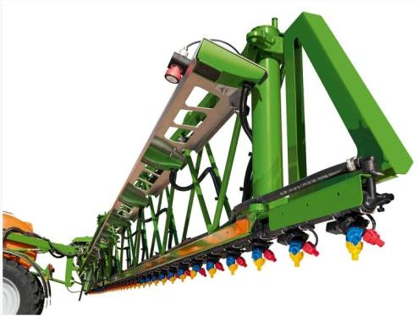

Показатель | Значение показателя
Назначение | Предусматривает оперативное дифференцированное внесение СЗР, которое осуществляется за счет инфракрасных датчиков GreenSense, распознающих наличие сорной растительности на поле
Бортовой компьютер | AmaSpot
Программа для дифференцированного внесения | AMATRON 3
Протокол передачи данных | ISOBUS
Навигатор, GPS приемник | AMATRON 3 с функцией GPS-Switch, GPS-Track и GPS-Maps
Автоматическое отключение секций | Да
Режим работы | on-line
Ширина сканирования сенсора, мм | 250
Скорость работы, км/ч | до 20
Цена, тыс. тенге | нет данных
Завод изготовитель | «Amazone»
Источники информации | http://go.amazone.de/agritechnica/2017/innovations/crop-protection-technology/ux-amaspot-trailed-sprayer/
Ф.И.О. исполнителя | Токарев И.В.

Модуль «Оборудование для картирования урожайности» (фрагмент)

Система картирования урожайности SmartYield Pro


Показатель | Значение показателя
Назначение | Система предназначена для контроля урожайности и влажности зерна в реальном времени, а также создания карт урожайности зерновых.
Точность DGPS-системы от прохода к проходу  Тип датчика потока зерна  Погрешность датчика потока зерна  Тип датчика влажности  Интервал измерения влажности зерна  Погрешность датчика влажности  Датчик положения жатки  Датчик скорости транспортирующего элеватора  Датчик скорости комбайна  Датчик ширины среза  Совместимость с комбайнами | ±33 см  оптический  ±5%  емкостной  0…100%  ±5%  транспортное/рабочее положение  не входит в комплектацию  не входит в комплектацию, скорость измеряется GPS-системой  не входит в комплектацию  Challenger, Fendt, Massey Ferguson, Valtra, Claas, Rostselmash, John Deere, Case
Цена, тыс. тенге | 3912,725
Завод-изготовитель | Raven Industries (США)
Источники информации | https://portal.ravenprecision.com/ProductDocumentation/Category?categoryId=79
Ф.И.О. исполнителя | Киркилевский В.В.

APPENDIX J

The protocol of comparative tests of technical equipment in the precision farming system

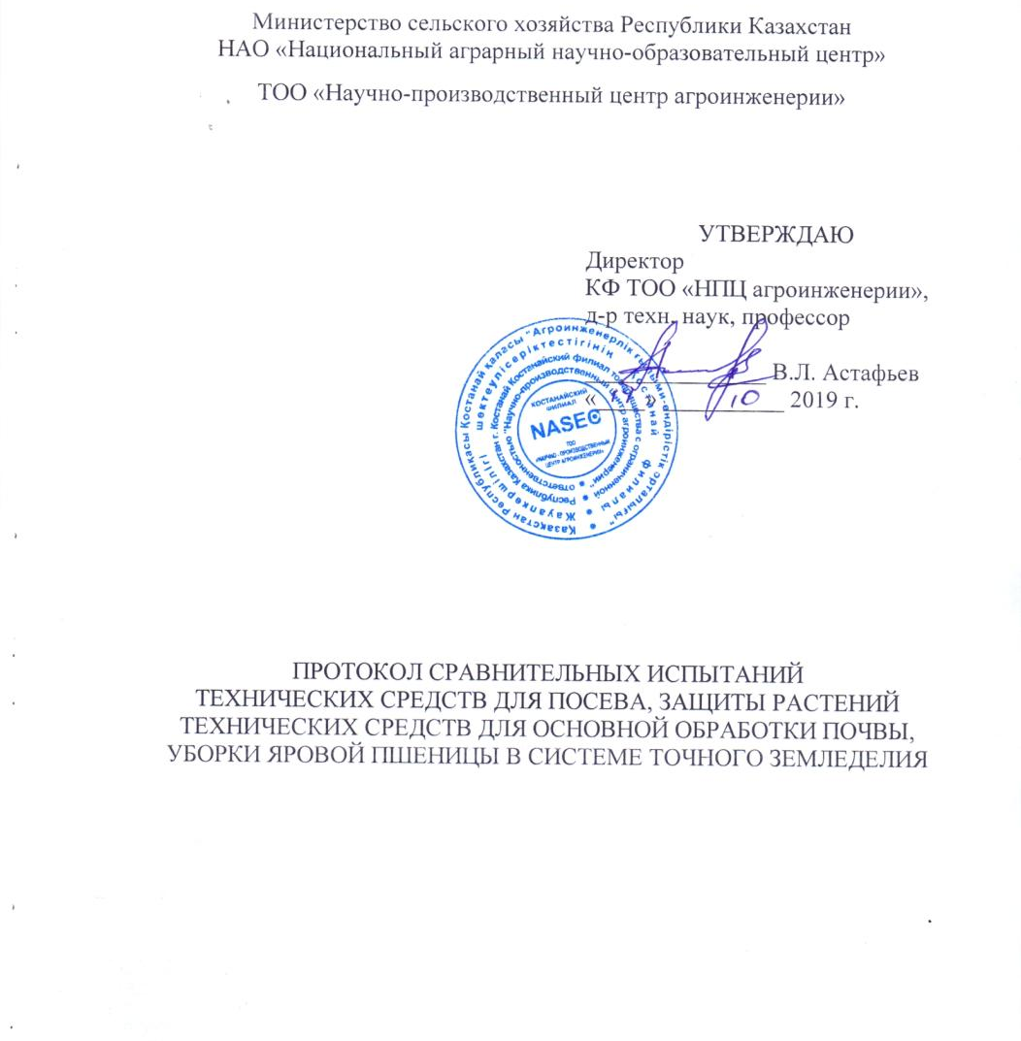
Министерство сельского хозяйства Республики Казахстан
НАО «Национальный аграрный научно-образовательный центр»

ТОО «Научно-производственный центр агроинженерии»

УТВЕРЖДАЮ
Директор
КФ ТОО «НПЦ агроинженерии»,
д-р техн. наук, профессор
_______________ В.Л. Астафьев
«____» __________ 2019 г.

ПРОТОКОЛ СРАВНИТЕЛЬНЫХ ИСПЫТАНИЙ
ТЕХНИЧЕСКИХ СРЕДСТВ ДЛЯ ПОСЕВА, ЗАЩИТЫ РАСТЕНИЙ
ТЕХНИЧЕСКИХ СРЕДСТВ ДЛЯ ОСНОВНОЙ ОБРАБОТКИ ПОЧВЫ,
УБОРКИ ЯРОВОЙ ПШЕНИЦЫ В СИСТЕМЕ ТОЧНОГО ЗЕМЛЕДЕЛИЯ

Костанай 2019

APPENDIX K

Technological maps
Таблица Л.1.1 – Технологическая карта по возделыванию и уборке зерновых культур по минимальной технологии
обработки почвы (существующий парк техники).
Производственное направление – зерновое Категория хозяйства – крестьянское
Зерновые – 370 га
Пашня – 370 га
Посевная площадь – 370 га
Пары – 370 га

Операция | Агрегат | Объем работ, га | Начало операции, м, ч | Срок дни | Кратность | Производительность за час |  | Разряд |  | Про-долж. смены | Коэф. сменнос-ти | Расход горючего, кг/га | Количество
 |  |  |  |  |  | сменного времени | экспл. времени | мех. | раб. | Про-долж. смены | Коэф. сменнос-ти | Расход горючего, кг/га | мех. | раб.
1 | 2 | 3 | 4 | 5 | 6 | 7 | 8 | 9 | 10 | 11 | 12 | 13 | 14 | 15
Ранневесеннее боронование | МТЗ-80+БЗТС-1х9 | 370 | 25.04 | 4 | 1 | 6,46 | 4,52 | 6 | 6 | 14 | 1 | 1,42 | 1 | 1
Гербицидная обработка перед посевом | МТЗ-80+ ОПШ-15-01 | 370 | 10.05 | 8 | 1 | 4,75 | 3,32 | 6 | 6 | 10 | 1 | 1,94 | 1 | 1
Посев | ДТ-75+ СЗС-2,1х3 | 370 | 15.05 | 10 | 1 | 2,79 | 1,95 | 6 | 6 | 14 | 1 | 4,59 | 1 | 1
Прикатывание после посева | МТЗ-80+3ККШ-6х2 | 370 | 15.05 | 10 | 1 | 7,52 | 5,26 | 6 | 6 | 10 | 1 | 1,22 | 1 | 1
Первая культивация пара | ДТ-75+ КПЭ-3,8 | 370 | 01.06 | 10 | 1 | 2,3 | 1,61 | 6 | 6 | 10 | 1 | 5,57 | 1 | 1
Вторая культивация пара | ДТ-75+ КПЭ-3,8 | 370 | 30.06 | 10 | 1 | 2,17 | 1,52 | 6 | 6 | 10 | 1 | 5,9 | 1 | 1

Продолжение таблицы Л.1.1
1 | 2 | 3 | 4 | 5 | 6 | 7 | 8 | 9 | 10 | 11 | 12 | 13 | 14 | 15
Гербицидная обработка по вегетации (эстет) | МТЗ-80+ ОПШ-15-01 | 370 | 12.06 | 8 | 1 | 4,75 | 3,325 | 6 | 6 | 10 | 1 | 1,94 | 1 | 1
Гербицидная обработка по вегетации(титул) | МТЗ-80+ ОПШ-15-01 | 370 | 10.07 | 8 | 1 | 4,75 | 3,325 | 6 | 6 | 10 | 1 | 1,94 | 1 | 1
Третья культивация пара | ДТ-75+ КПЭ-3,8 | 370 | 28.07 | 10 | 1 | 1,76 | 1,232 | 6 | 6 | 10 | 1 | 7,27 | 1 | 1
Уборка | СК-5 "Нива" | 370 | 20.08 | 10 | 1 | 1,7 | 1,19 | 6 | 6 | 10 | 1 | 11,76 | 1 | 1
Основная обработка | ДТ-75+ КПГ-250 | 370 | 09.10 | 10 | 1 | 1,22 | 0,854 | 6 | 6 | 10 | 1 | 10,49 | 1 | 1

Таблица Л.2.1 – Технологическая карта по возделыванию и уборке зерновых культур по минимальной технологии
обработки почвы (существующий парк техники).
Производственное направление – зерновое Категория хозяйства – мелкое сельхозпредприятие
Зерновые – 825 га
Пашня – 1100 га
Посевная площадь – 825 га
Пары – 275 га

Операция | Агрегат | Объем работ, га | Начало операции, м, ч | Срок дни | Кратность | Производительность за час |  | Разряд |  | Про-долж. смены | Коэф. сменнос-ти | Расход горючего, кг/га | Количество
 |  |  |  |  |  | сменного времени | экспл. времени | мех. | раб. | Про-долж. смены | Коэф. сменнос-ти | Расход горючего, кг/га | мех. | раб.
1 | 2 | 3 | 4 | 5 | 6 | 7 | 8 | 9 | 10 | 11 | 12 | 13 | 14 | 15
Ранневесеннее боронование | МТЗ-80+БЗТС-1х9 | 1100 | 25.04 | 4 | 1 | 6,46 | 4,52 | 6 | 6 | 14 | 1 | 1,42 | 1 | 1
Гербицидная обработка перед посевом | МТЗ-80+ ОПШ-15-01 | 825 | 10.05 | 8 | 1 | 4,75 | 4,75 | 6 | 6 | 10 | 1 | 1,94 | 1 | 1
Посев | Т-150К+ СЗС-2,1х3 | 825 | 15.05 | 10 | 1 | 3,77 | 2,64 | 6 | 6 | 14 | 1 | 6,01 | 1 | 1
Прикатывание после посева | МТЗ-80+3ККШ-6х2 | 825 | 15.05 | 10 | 1 | 7,52 | 5,26 | 6 | 6 | 10 | 1 | 1,22 | 1 | 1
Первая культивация пара | Т-150К + КПЭ-3,8 | 275 | 01.06 | 10 | 1 | 2,6 | 1,82 | 6 | 6 | 10 | 1 | 8,71 | 1 | 1
Вторая культивация пара | Т-150К + КПЭ-3,8 | 275 | 30.06 | 10 | 1 | 2,45 | 1,72 | 6 | 6 | 10 | 1 | 9,24 | 1 | 1

Продолжение таблицы Л.2.1
1 | 2 | 3 | 4 | 5 | 6 | 7 | 8 | 9 | 10 | 11 | 12 | 13 | 14 | 15
Гербицидная обработка по вегетации (эстет) | МТЗ-80+ ОПШ-15-01 | 825 | 12.06 | 8 | 1 | 4,75 | 4,75 | 6 | 6 | 10 | 1 | 1,94 | 1 | 1
Гербицидная обработка по вегетации(титул) | МТЗ-80+ ОПШ-15-01 | 825 | 10.07 | 8 | 1 | 4,75 | 4,75 | 6 | 6 | 10 | 1 | 1,94 | 1 | 1
Третья культивация пара | Т-150К + КПЭ-3,8 | 275 | 28.07 | 10 | 1 | 2,31 | 1,62 | 6 | 6 | 10 | 1 | 9,8 | 1 | 1
Уборка | Енисей-1200 | 825 | 20.08 | 10 | 1 | 2,33 | 1,63 | 6 | 6 | 10 | 1 | 9,73 | 1 | 1
Основная обработка | Т-150К + КПГ-2,2 | 550 | 09.10 | 10 | 1 | 1,36 | 0,95 | 6 | 6 | 10 | 1 | 16,65 | 1 | 1
Основная обработка с внесением удобрений | Т-150К + КПГ-2,2 | 275 | 09.10 | 10 | 1 | 1,2 | 0,84 | 6 | 6 | 10 | 1 | 18,87 | 1 | 1

Таблица Л.3.1 – Технологическая карта по возделыванию и уборке пшеницы яровой по минимальной технологии
обработки почвы (существующий парк техники)
Производственное направление – зерновое Категория хозяйства – среднее сельхозпредприятие
Зерновые – 2500 га
Пашня – 5000 га Зернобобовые – 1250га
Посевная площадь – 3750 га
Пары – 1250 га

Операция | Агрегат | Объем работ, га | Начало операции, м, ч | Срок дни | Кратность | Производительность за час |  | Разряд |  | Про-долж. смены | Коэф. сменнос-ти | Расход горючего, кг/га | Количество
 |  |  |  |  |  | сменного времени | экспл. времени | мех. | раб. | Про-долж. смены | Коэф. сменнос-ти | Расход горючего, кг/га | мех. | раб.
1 | 2 | 3 | 4 | 5 | 6 | 7 | 8 | 9 | 10 | 11 | 12 | 13 | 14 | 15
Ранневесеннее боронование | МТЗ-80+БЗТС-1х9 | 3750 | 16.04 | 4 | 1 | 7,11 | 4,98 | 6 | 6 | 14 | 1 | 1,22 | 1 | 1
Гербицидная обработка перед посевом | МТЗ-80+ ОПШ-15-01 | 2500 | 10.05 | 8 | 1 | 7,81 | 5,467 | 6 | 6 | 10 | 1 | 1,18 | 1 | 1
Посев | ДТ-75+ СЗС-2,1х3 | 2500 | 15.05 | 10 | 1 | 5,45 | 3,815 | 6 | 6 | 14 | 1 | 7,71 | 1 | 1
Прикатывание после посева | МТЗ-80+3ККШ-6х2 | 2500 | 15.05 | 10 | 1 | 7,52 | 5,26 | 6 | 6 | 10 | 1 | 1,22 | 1 | 1

Продолжение таблицы Л.3.1
1 | 2 | 3 | 4 | 5 | 6 | 7 | 8 | 9 | 10 | 11 | 12 | 13 | 14 | 15
Первая культивация пара | ДТ-75+ КПЭ-3,8 | 2500 | 1.06 | 10 | 1 | 5,99 | 4,19 | 6 | 6 | 10 | 1 | 2,14 | 1 | 1
Вторая культивация пара | ДТ-75+ КПЭ-3,8 | 2500 | 30.06 | 10 | 1 | 5,24 | 3,67 | 6 | 6 | 10 | 1 | 2,45 | 1 | 1
Гербицидная обработка по вегетации (эстет) | МТЗ-80+ ОПШ-15-01 | 2500 | 12.06 | 8 | 1 | 7,81 | 5,46 | 6 | 6 | 10 | 1 | 1,18 | 1 | 1
Гербицидная обработка по вегетации(титул) | МТЗ-80+ ОПШ-15-01 | 2500 | 10.07 | 8 | 1 | 7,81 | 5,46 | 6 | 6 | 10 | 1 | 1,18 | 1 | 1
Третья культивация пара | ДТ-75+ КПЭ-3,8 | 2500 | 28.07 | 10 | 1 | 4,49 | 3,14 | 6 | 6 | 10 | 1 | 2,86 | 1 | 1
Уборка | СК-5 "Нива" | 2500 | 20.08 | 10 | 1 | 3,8 | 2,66 | 6 | 6 | 10 | 1 | 6,49 | 1 | 1
Основная обработка | ДТ-75+ КПГ-250 | 5000 | 9.10 | 10 | 1 | 2,18 | 1,52 | 6 | 6 | 10 | 1 | 19,29 | 1 | 1
Основная обработка | ДТ-75+ КПГ-250 | 5000 | 9.10 | 10 | 1 | 1,92 | 1,34 | 6 | 6 | 10 | 1 | 21,9 | 1 | 1

Таблица Л.4.1 – Технологическая карта по возделыванию и уборке зерновых культур по минимальной технологии
обработки почвы (существующий парк техники).
Производственное направление – зерновое Категория хозяйства – крупное сельхозпредприятие Зерновые – 10000 га
Пашня – 20000 га Зернобобовые – 2500 га
Посевная площадь – 15000 га Силосные – 2500 га
Пары – 5000 га

Операция | Агрегат | Объем работ, га | Начало операции, м, ч | Срок дни | Кратность | Производительность за час |  | Разряд |  | Про-долж. смены | Коэф. сменнос-ти | Расход горючего, кг/га | Количество
 |  |  |  |  |  | сменного времени | экспл. времени | мех. | раб. | Про-долж. смены | Коэф. сменнос-ти | Расход горючего, кг/га | мех. | раб.
1 | 2 | 3 | 4 | 5 | 6 | 7 | 8 | 9 | 10 | 11 | 12 | 13 | 14 | 15
Ранневесеннее боронование | МТЗ-82+БЗТС-1х9 | 15000 | 16.04 | 4 | 1 | 6,22 | 4,35 | 6 | 6 | 14 | 1 | 1,48 | 1 | 1
Гербицидная обработка перед посевом | МТЗ-82+ОП-2500 | 10000 | 10.05 | 8 | 1 | 7,81 | 7,81 | 6 | 6 | 10 | 1 | 1,18 | 1 | 1
Посев | К-701+СКП-2,1Дх5 | 10000 | 15.05 | 10 | 1 | 6,13 | 4,29 | 6 | 6 | 14 | 1 | 6,86 | 1 | 1
Прикатывание после посева | МТЗ-82+ЗККШ-6 | 10000 | 15.05 | 10 | 1 | 7,52 | 7 | 6 | 6 | 10 | 1 | 1,22 | 1 | 1
Вторая культивация пара | К-701+КТС-10-2 | 5000 | 30.06 | 10 | 1 | 5,24 | 3,66 | 6 | 6 | 10 | 1 | 8,03 | 1 | 1

Продолжение таблицы Л.4.1
1 | 2 | 3 | 4 | 5 | 6 | 7 | 8 | 9 | 10 | 11 | 12 | 13 | 14 | 15
Гербицидная обработка по вегетации (эстет) | МТЗ-82+ОП-2500 | 10000 | 20.06 | 8 | 1 | 4,75 | 4,75 | 6 | 6 | 10 | 1 | 1,94 | 1 | 1
Гербицидная обработка по вегетации(титул) | МТЗ-82+ОП-2500 | 10000 | 11.07 | 8 | 1 | 4,75 | 4,75 | 6 | 6 | 10 | 1 | 1,94 | 1 | 1
Третья культивация пара | К-701+КТС-10-2 | 5000 | 28.07 | 10 | 1 | 4,49 | 3,14 | 6 | 6 | 10 | 1 | 9,37 | 1 | 1
Уборка | Дон-1500 | 10000 | 20.08 | 10 | 1 | 4,00 | 2,80 | 6 | 6 | 10 | 1 | 7,62 | 1 | 1
Основная обработка | К-701 2хКПГ-2,2 | 5000 | 17.10 | 10 | 1 | 2,18 | 1,53 | 6 | 6 | 10 | 1 | 19,3 | 1 | 1
Основная обработка | К-701 2хКПГ-2,2 | 5000 | 17.10 | 10 | 1 | 1,92 | 1,34 | 6 | 6 | 10 | 1 | 21,92 | 1 | 1

APPENDIX L

Comparative characteristics of the existing and recommended composition of machine complexes

Таблица М.1 – Составы существующего и рекомендуемого комплексов машин для возделывания зерновых культур в крестьянских хозяйствах (средняя площадь 370 га, урожайность 10 ц/га)
Технология | Составы комплексов машин
Технология | Существующий |  | Рекомендуемый
Технология | Тракторы/комбайны | С/х машины | Тракторы/комбайны | С/х машины
Ранневесеннее боронование;  Гербицидная обработка пред посевом;  Посев;  Прикатывание после посева;  Первая культивация пара;  Вторая культивация пара;  Гербицидная обработка по вегетации;  Третья культивация пара;  Уборка;  Основная обработка. | МТЗ-80 – 1 ед.  ДТ-75 – 1 ед.  СК-5 "Нива" – 1ед. | БЗТС-1,0 – 18 ед,  в два следа;  ОПШ-15-01 – 1 ед.;  СЗС-2,1 – 3 ед.;  3ККШ-6 – 2 ед.;  КПЭ-3,8 – 1 ед.;  Жатка ЖКН-5, – 1 ед.;  КПГ-250 – 1 ед. | МТЗ-82.1 – 1 ед.  ХТЗ-17221-19 – 1 ед.  Вектор-410- 1 ед. | БЗЦ-12 – 1 ед.;  ОП-2000-21-1 ед.;  Сеялка Алтын Дән 2,05 – 3 ед.;  ККШС-10-2 – 1 ед.;  КПК-6 – 1 ед.;  Жатка «Power stream-900» – 1 ед.;  Stavr ПГ-3 – 1 ед.
Затраты труда, чел.ч | 1108,8 |  | 678,3

Таблица М.2 – Составы существующего и рекомендуемого комплексов машин для возделывания зерновых культур в малых сельхозпредприятиях (средняя площадь 1100 га, урожайность 10 ц/га)
Технология | Составы комплексов машин
Технология | Существующий |  | Рекомендуемый
Технология | Тракторы/комбайны | С/х машины | Тракторы/комбайны | С/х машины
Ранневесеннее боронование  Гербицидная обработка пред посевом  Посев  Прикатывание после посева  Первая культивация пара  Вторая культивация пара  Гербицидная обработка по вегетации  Третья культивация пара  Уборка  Основная обработка с внесением удобрений  Основная обработка | МТЗ-80 – 2 ед.  Т-150К – 2 ед.  Енисей-1200 – 3 ед. | БЗТС-1,0 – 36 ед,  в два следа.  ОПШ-15-01 – 2 ед.  СЗС-2,1 – 6 ед.  3ККШ-6 – 2 ед.  КПЭ-3,8 – 1 ед.  Удобритель  КПГ-2,2 – 2 ед.  Жатка ЖКН-6 – 3 ед. | Беларус-82.1 – 2 ед.  К-730ТМЗ – 2 ед.  Вектор-410 – 2 ед. | БЗЦ-12 – 2 ед.  ОП-2000-21 – 1 ед.  КСКП-2,1Д – 10 ед.  ККШС-10-2 – 1 ед.  КПК-10 – 1 ед.  Удобритель  КСТ-9У – 1 ед.  Жатка Power stream-900 – 2 ед.
Затраты труда, чел.ч | 4357,1 |  | 1898,0

Таблица М.3 – Составы существующего и рекомендуемого комплексов машин для возделывания зерновых культур и сои в средних сельхозпредприятиях (средняя площадь 5000 га, урожайность 10 ц/га, сои 5 ц/га)
Технология | Составы комплексов машин
Технология | Существующий |  | Рекомендуемый
Технология | Тракторы/комбайны | С/х машины | Тракторы/комбайны | С/х машины
Ранневесеннее боронование  Гербицидная обработка пред посевом  Посев  Прикатывание после посева  Первая культивация пара  Вторая культивация пара  Гербицидная обработка по вегетации  Третья культивация пара  Уборка  Основная обработка с внесением удобрений  Основная обработка | МТЗ-82 – 11 ед.  К-701 – 5 ед.  Вектор-410 – 7 ед. | БЗТС-1.0 – 198 ед,  в два следа.  ОП-2500 – 5 ед.  КСКП-2,1 – 20 ед.  3ККШ-6 – 8 ед.  КТС-10-2 – 2 ед.  Удобритель  КПГ-2,2 – 10 ед.  Жатка ЖУ-7 – 5 ед. | МТЗ-1221 – 7 ед.  К-742 – 3 ед.  Есиль -760.1 – 5 ед. | БЗП-15 – 7 ед.  Авагро ТТ-25 – 2 ед,  ПК Agrator Ancer  12200 – 3 ед.  ККШС-12-2 – 3 ед.  Лидер-12 – 2 ед.  Удобритель  РСП-5,4У – 3 ед,  Жатка ЖЗК-9 – 5 ед.
Затраты труда, чел.ч | 12580,7 |  | 6590,4

Таблица М.4 – Составы существующего и рекомендуемого комплексов машин для возделывания сельскохозяйственных культур в крупных сельхозпредприятиях (средняя площадь 20000 га), при фактической урожайности пшеницы и ячменя 10 ц/га, сои 5 ц/га, кукурузы 100 ц/га
Технология | Составы комплексов машин
Технология | Существующий |  | Рекомендуемый
Технология | Тракторы/комбайны | С/х машины | Тракторы/комбайны | С/х машины
1 | 2 | 3 | 4 | 5
Ранневесеннее боронование  Гербицидная обработка перед посевом  Посев зерновых и сои  Прикатывание после посева  Предпосевная культивация кукурузы  Предпосевное прикатывание кукурузы  Посев кукурузы  Боронование до всходов кукурузы  Боронование по всходам кукурузы  Первая культивация пара  Вторая культивация пара | Беларус-82, – 30 ед.  К-701 – 13 ед.  КСК-100 – 11 ед.  ДОН-1500 – 25 ед. | БЗТС-1,0х18 – 30 ед.  КТС-10-2 – 10 ед.  ЗККШ-6 – 20 ед.  ОП-2500 – 17 ед.  СУПН-8 – 8 ед.  СКП-2,1х5 – 13 ед.  КСКП-2,1х5 – 4 ед  КРН-5,6 – 11 ед.  ЖКЕ-3,0 – 11 ед.  ЖУ-7 – 25 ед.  КПГ-2,2х2 – 15 ед  ПЛН-8-40 – 6 ед. | МТЗ-1221 – 19 ед.  К-742 – 9 ед.  Есиль-760.1 – 19 ед.  ДОН-680 – 6 ед. | БПЗ-15 – 19 ед.  Лидер-12 – 7 ед.  ККШС-12-2 – 8 ед.  Авагро ТТ-25 – 6 ед,  СПБ-12М – 6 ед.  AGRATOR ANCER 12200 – 9 ед.  КРН-8,4 – 8 ед.  Kemper 445 – 6 ед.  ЖЗК-9 – 19 ед.  Плуг ПП 11-35 – 4 ед.  РСП-5,4У – 9 ед.

Продолжение таблица М.4
1 | 2 | 3 | 4 | 5
Первая междурядная культивация кукурузы
Вторая междурядная культивация кукурузы
Гербицидная обработка по вегетации зерновых, сои и кукурузы
Третья культивация пара
Уборка зерновых, сои и кукурузы
Основная обработка с внесением удобрений
Основная обработка зерновых, сои и кукурузы
Затраты труда, чел.ч | 51978,1 |  | 24364,1

APPENDIX M

Economic models

Таблица Н.1 – Моделируемое оснащение техники хозяйства низкой технической оснащенности для перехода на следующий этап точного земледелия по модели №1
Наименование оборудования | Фактическое текущее оснащение |  |  |  | Планируемый переход по модели №1 | Стоимость перехода 1 единицы*, тыс. тнг. | Инвестиции для перехода на следующий этап точного земледелия, тыс. тнг.
Наименование оборудования | количество, шт. | параллельное вождение | GPS-трекер | контроль горючего | Планируемый переход по модели №1 | Стоимость перехода 1 единицы*, тыс. тнг.
К-700А | 1 | нет | нет | есть | параллельное вождение | 700 | 700
МТЗ-80 | 2 | нет | нет | есть | параллельное вождение | 700 | 1 400
К-701 | 2 | нет | нет | есть | параллельное вождение | 700 | 1 400
Бюллер | 1 |  |  |  | дифф. внесение удобрений | 1100 | 1 100
МТЗ-82 | 1 | нет | нет | есть | параллельное вождение | 700 | 700
вектор | 2 | нет | нет | есть | параллельное вождение | 700 | 1 400
Енисей | 1 | нет | нет | есть | параллельное вождение | 700 | 700
Джон Дир | 1 | нет | нет | есть | параллельное вождение | 700 | 700
 |  |  |  |  |  | Итого | 7 400
Примечание: * – составлено по данным КФ НПЦ агроинженерии.

Таблица Н.2 – Моделируемое оснащение техники хозяйства низкой технической оснащенности для перехода на следующий этап точного земледелия по модели №2
Наименование оборудования | Фактическое текущее оснащение |  |  |  | Планируемый переход по модели №2 | Стоимость перехода 1 единицы*, тыс. тнг. | Инвестиции для перехода на следующий этап точного земледелия, тыс. тнг.
Наименование оборудования | количество, шт. | параллельное вождение | GPS-трекер | контроль горючего | Планируемый переход по модели №2 | Стоимость перехода 1 единицы*, тыс. тнг.
К-700А | 1 | нет | нет | есть | автоматическое вождение | 4 500 | 4 500
МТЗ-80 | 2 | нет | нет | есть | автоматическое вождение | 4 500 | 9 000
К-701 | 2 | нет | нет | есть | автоматическое вождение | 4 500 | 9 000
Бюллер | 1 |  |  |  | дифф. внесение удобрений | 1 100 | 1 100
МТЗ-82 | 1 | нет | нет | есть | автоматическое вождение | 4 500 | 4 500
вектор | 2 | нет | нет | есть | автоматическое вождение | 4 500 | 9 000
Енисей | 1 | нет | нет | есть | автоматическое вождение | 4 500 | 4 500
Джон Дир | 1 | нет | нет | есть | автоматическое вождение | 4 500 | 4 500
 |  |  |  |  |  | Итого | 46 100
Примечание: * – составлено по данным КФ НПЦ агроинженерии.

Таблица Н.3 – Моделируемое оснащение техники хозяйства ТОО «Агрофирма Қарқын» для перехода на следующий этап точного земледелия по модели №1
Наименование оборудования | Фактическое текущее оснащение |  |  |  | Планируемый переход по модели №1 | Стоимость перехода 1 единицы**, тыс. тнг. | Инвестиции для перехода на след. этап точного земледелия, тыс. тнг.
Наименование оборудования | количество, шт. | параллельное вождение | GPS-трекер | контроль горючего | Планируемый переход по модели №1 | Стоимость перехода 1 единицы**, тыс. тнг.
Трактор BUHLER VERSATILE 2375 | 6 | есть | есть | есть | параллельное-автоматическое | 3 800,0 | 22 800,0
Трактор BUHLER VERSATILE 435 | 1 | есть | есть | есть | параллельное-автоматическое | 3 800,0 | 3 800,0
Опрыскиватель Император 3100 | 1 | нет | есть | есть | параллельное вождение | 700 | 700,0
Самоходный опрыскиватель модели FAVOT | 1 | нет | есть | есть | параллельное вождение | 700 | 700,0
Комбайн РСМ-142 ACROS-550 | 5 | нет | есть | есть | параллельное вождение | 700 | 3 500,0
Комбайн зерноуборочный MEGA 350 CLAAS+жатка 7,5 м | 4 | нет | есть | есть | параллельное вождение | 700 | 2 800,0
Посевной комплекс с системой внесения удобрений | 8 |  |  |  | дифференцированное внесение удобрений | 1 100,0 | 8 800,0
Итого |  |  |  |  |  |  | 43 100,0
Примечание: * – переход «параллельное-автоматическое» означает переход с заменой оборудования параллельного вождения на систему автоматического вождения;
** – составлено по данным КФ НПЦ агроинженерии.

Таблица Н.4 – Моделируемое оснащение техники хозяйства ТОО «Агрофирма Қарқын» для перехода на следующий этап точного земледелия по модели №2
Наименование оборудования | Фактическое текущее оснащение |  |  |  | Планируемый переход по модели №2 | Стоимость перехода 1 единицы**, тыс. тнг. | Инвестиции для перехода на след. этап точного земледелия, тыс. тнг.
Наименование оборудования | количество, шт. | параллельное вождение | GPS-трекер | контроль горючего | Планируемый переход по модели №2 | Стоимость перехода 1 единицы**, тыс. тнг.
Трактор BUHLER VERSATILE 2375 | 6 | есть | есть | есть | параллельное-автоматическое * | 3 800,0 | 22 800,0
Трактор BUHLER VERSATILE 435 | 1 | есть | есть | есть | параллельное-автоматическое | 3 800,0 | 3 800,0
Опрыскиватель Император 3100 | 1 | нет | есть | есть | автоматическое вождение | 4 500,0 | 4 500,0
Самоходный опрыскиватель модели FAVOT | 1 | нет | есть | есть | автоматическое вождение | 4 500,0 | 4 500,0
Комбайн РСМ-142 ACROS-550 | 5 | нет | есть | есть | автоматическое вождение | 4 500,0 | 22 500,0
Комбайн зерноуборочный MEGA 350 CLAAS+жатка 7,5 м | 4 | нет | есть | есть | автоматическое вождение | 4 500,0 | 18 000,0
Посевной комплекс с системой внесения удобрений | 8 |  |  |  | дифференцированное внесение удобрений | 1 100,0 | 8 800,0
Итого |  |  |  |  |  |  | 84 900,0
Примечание: * – переход «параллельное-автоматическое» означает переход с заменой оборудования параллельного вождения на систему автоматического вождения;
** – составлено по данным КФ НПЦ агроинженерии.

Таблица Н.5 – Моделируемое оснащение техники хозяйства «модельное хозяйство высокого уровня технологической оснащенности» для перехода на следующий этап точного земледелия по модели №1
Наименование оборудования | Фактическое текущее оснащение |  |  |  | Планируемый переход по модели №1 | Стоимость перехода 1 единицы **, тыс. тнг. | Инвестиции для перехода на следующий этап точного земледелия, тыс. тнг.
Наименование оборудования | количество, шт. | параллельное вождение | GPS-трекер | контроль горючего | Планируемый переход по модели №1 | Стоимость перехода 1 единицы **, тыс. тнг.
Трактор 6-7-ой тяговый класс | 2 | есть | есть | есть | параллельное-автоматическое | 3 800,0 | 7 600,0
Трактор 6-7-ой тяговый класс | 1 | есть | есть | есть | параллельное-автоматическое | 3 800,0 | 3 800,0
Опрыскиватель | 1 | есть | есть | есть | параллельное-автоматическое | 3 800,0 | 3 800,0
Самоходный опрыскиватель | 1 | есть | есть | есть | параллельное-автоматическое | 3 800,0 | 3 800,0
Комбайн РСМ-142 ACROS-550 | 2 | есть | есть | есть
Комбайн зерноуборочный MEGA 350 CLAAS + жатка 7,5 м | 2 | есть | есть | есть
Посевной комплекс с системой внесения удобрений | 3 | дифференцированное внесение удобрений |  |  |  |  | –
Итого |  |  |  |  |  |  | 19 000,0
Примечание: * – переход «параллельное-автоматическое» означает переход с заменой оборудования параллельного вождения на систему автоматического вождения;
** – составлено по данным ТОО «Трояна», КФ НПЦ агроинженерии.

Таблица Н.6 – Моделируемое оснащение техники хозяйства «модельное хозяйство высокого уровня технологической оснащенности» для перехода на следующий этап точного земледелия по модели №2
Наименование оборудования | Фактическое текущее оснащение |  |  |  | Планируемый переход по модели №2 | Стоимость перехода 1 единицы **, тыс. тнг. | Инвестиции для перехода на следующий этап точного земледелия, тыс. тнг.
Наименование оборудования | количество, шт. | параллельное вождение | GPS-трекер | контроль горючего | Планируемый переход по модели №2 | Стоимость перехода 1 единицы **, тыс. тнг.
Трактор 6-7-ой тяговый класс | 2 | есть | есть | есть | параллельное-автоматическое | 3 800,0 | 7 600,0
Трактор 6-7-ой тяговый класс | 1 | есть | есть | есть | параллельное-автоматическое | 3 800,0 | 3 800,0
Опрыскиватель | 1 | есть | есть | есть | параллельное-автоматическое | 3 800,0 | 3 800,0
Самоходный опрыскиватель | 1 | есть | есть | есть | параллельное-автоматическое | 3 800,0 | 3 800,0
Комбайн РСМ-142 ACROS-550 | 2 | есть | есть | есть | параллельное-автоматическое | 3 800,0 | 7 600,0
Комбайн зерноуборочный MEGA 350 CLAAS + жатка 7,5 м | 2 | есть | есть | есть | параллельное-автоматическое | 3 800,0 | 7 600,0
Посевной комплекс с системой внесения удобрений | 3 | дифференцированное внесение удобрений |  |  |  |  | –
Итого |  |  |  |  |  |  | 34 200,0
Примечание: * – переход «параллельное-автоматическое» означает переход с заменой оборудования параллельного вождения на систему автоматического вождения;
** – составлено по данным ТОО «Трояна», КФ НПЦ агроинженерии.

APPENDIX N

Report on the implementation of the plan of speeches / publications in the media
«AES «Zarechnoe» LLP, 2018-2020
Month | Title of the topic of publication, article | Print edition,  the name of the media source | Full name of the speaker, published employee
December | Introduction of elements of precision agriculture in agriculture of the Kostanay region. | Scientific and practical journal of the Zhangir Khan West Kazakhstan Agrarian Technical University “Gylym zhane bilim”. – Uralsk, Zhangir Khan West Kazakhstan Agrarian Technical University. – No. 4, 2018. – pp.3-10 – Committee for Control in the Sphere of Education and Science of the Ministry of Education and Science of the Republic of Kazakhstan (CCSES MES RK). | Abuova A.B., Kikebayev N.A., Chernenko V.L., Tulayev Yu.V.
March | Methods for differentiated fertilization in precision agriculture. | Scientific and practical journal of the Zhangir Khan West Kazakhstan Agrarian Technical University “Gylym zhane bilim”. – Uralsk, Zhangir Khan West Kazakhstan Agrarian Technical University. – No. 1, 2019. – pp. 15-22 – CCSES MES RK. | Abuova A.B., Tulkubayeva S.A., Tulayev Yu.V., Somova S.V.
April | The Technology of Cultivating Agricultural Crops Based on Ortho photomaps, Digital and 3-D Surface Models. | International Journal of Engineering and Advanced Technology (IJEAT). ISSN: 2249-8958, Volume-8, Issue-4, April 2019. pp. (775-778), Scopus database (no percentile). | A.B. Abuova, S.A. Tulkubayeva, Yu.V. Tulayev, S.V. Somova, M.B. Tashmukhamedov
May | Implementation of specific elements of agriculture in agriculture of Kostanay region. | "Scientific youth in agricultural science: achievements and prospects": collection of materials of the 23d international scientific and practical conference of young scientists and students in the framework of the Year of Youth of the Republic of Kazakhstan. – Almaty: KazNAU, 2019. – pp. 165-170. | Tulkubayeva S.A., Tulayev Yu.V., Yergazina D.S.
June | Assessment of the spatial heterogeneity of agrochemical soil parameters within the plot of the field experiment. | Multidisciplinary scientific journal of A. Baitursynov Kostanay State University “3i: intellect, idea, innovation”. – No. 2, 2019. – pp.36-43. – CCSES MES RK. | Abuova A.B., Tulkubayeva S.A., Tulayev Yu.V.
July | Effect of soil fertility variability on the yield of grain crops in Northern Kazakhstan. | Annals of Agri-Bio Research. 24 (2): 183-190, 2019. ISSN: 09719660. – Scopus database (percentile 11). | A.B. Abuova, S.A. Tulkubayeva, Yu.V. Tulayev, M.B. Tashmukhamedov, V.G. Plotnikov
December | Elements of GIS technologies in agriculture. | Scientific and practical journal of the Zhangir Khan West Kazakhstan Agrarian Technical University “Gylym zhane bilim”. – Uralsk, Zhangir Khan West Kazakhstan Agrarian Technical University, Vol.2. – No. 4, 2019. – pp.8-15. – CCSES MES RK. | Abuova A.B., Tulkubayeva S.A., Tulayev Yu.V., Sidorik A.I.
August | Productivity regardless of the weather. | Regional newspaper "Kostanay Agro". – No. 30 (494), dated 15.08.2019 – P.12. | Chernenko V.L.
September | First steps of agro-industrial complex digitalization. | Information and advertising agrarian newspaper "Agro Info". – No. 16 (210), dated September 16, 2019 – pp.6-7. | Chernenko V.L., Tulayev Yu.V.
September | Direct seeding as protection against drought. | Regional newspaper "Kostanay Agro". – No. 35 (499), dated 19.09.2019 – P.20. | Chernenko V.L.
April | Isolation and study of nitrogen-fixing strains of microorganisms, promising for the development of a preparation for leguminous crops. | "The contribution of young scientists to innovative technologies for the agro-industrial complex" dedicated to the 80th anniversary of Academician Suleimenov M.K.: Collection of reports, abstracts of the Republican scientific conference of young scientists. – Shortandy, 2019. – pp. 113-116. | Rysbek A.B., Baigonusova Zh.A., Kurmanbayev A.A.
June | A resource-saving method for mapping yields at harvest. | Scientific and technical journal "International Agroengineering". – Almaty, No. 2 (30), 2019. – pp.36-45. | Astafyev V.L., Ivanchenko P.G., Sultanov I.I.
March | Application of IT-technologies in the system of precision agriculture in the Kostanay region. | Scientific and practical journal of the Zhangir Khan West Kazakhstan Agrarian Technical University “Gylym zhane bilim”. – Uralsk, Zhangir Khan West Kazakhstan Agrarian Technical University, Vol.2 – No.1-2, 2020. – pp.29-35 – CCSES MES RK. | Vykhodtsev V.A., Tulayev Yu.V., Ergazina D.S., Akhmet A.Z.
March | Application of effective methods of agrochemical research in the conditions of Northern Kazakhstan. | Scientific and practical journal of the Zhangir Khan West Kazakhstan Agrarian Technical University “Gylym zhane bilim”. – Uralsk, Zhangir Khan West Kazakhstan Agrarian Technical University, Vol.2. – No. 1-2 (58), 2020. – pp.74-81. – CCSES MES RK. | Tulayev Yu.V., Tulkubayeva S.A., Abuova A.B., Kassyanov P.F.
March | Sustainable development of crop production with elements of precision agriculture in Northern Kazakhstan. | Entrepreneurship and Sustainability Issues, 7(4), 2020. 3200-3214. https://doi.org/10.9770/jesi.2020.7.4(41). ISSN 2345-0282 (online). – Web of Science database (Q1). | Abuova A.B., Tulkubayeva S.A., Tulayev Y.V., Somova S.V., Kizatova M.Zh.
March | Field interpretation of earth remote sensing data and ground field surveys in the Republic of Kazakhstan, Kostanay region in the pre-sowing Season. | E3S Web of Conferences 176, 04001 (2020), IDSISA 2020. https://doi.org/10.1051/e3sconf /202017604001. eISSN: 2267-1242. – Scopus database (percentile 18). | Sabit Ismuratov, Aida Dukeyeva, Saniya A. Tulkubayeva, and Yuriy V.Tulayev
March | Culture of priority oil crops in the north of Kazakhstan. | BIO Web of Conferences 17, 00029 (2020). https://doi.org/10.1051/bioconf/20201700029. FIES 2019. ISSN: 21174458. –Web of Science database (Q1). | Vasilij G. Vasin, Altynaj B. Abuova, Saniya A. Tulkubayeva, Dinara B. Zhamalova, and Marat B. Tashmuhamedov
June | Differentiated foliar nutrition of spring wheat with liquid nitrogen fertilizer "Strada N" in precision agriculture. | Multidisciplinary scientific journal of A. Baitursynov Kostanay State University “3i: intellect, idea, innovation”. – No. 2, 2020. – pp.158-166 – CCSES MES RK. | Tulkubayeva S.A., Tulayev Yu.V., Sidorik I.V.
June | Monitoring the phytosanitary situation of spring wheat crops using an unmanned aerial vehicle. | Scientific and practical journal of the Zhangir Khan West Kazakhstan Agrarian Technical University “Gylym zhane bilim”. – Uralsk, Zhangir Khan West Kazakhstan Agrarian Technical University, Vol.2. – No.2-2 (59), 2020. – pp.34-39 – CCSES MES RK. | Kassenov A.O., Vykhodtsev V.A., Somova S.V., Nurgaliyeva M.B.
June | The results of the introduction of elements of precision agriculture in Troyana LLP. | Scientific and practical journal of the Zhangir Khan West Kazakhstan Agrarian Technical University “Gylym zhane bilim”. – Uralsk, Zhangir Khan West Kazakhstan Agrarian Technical University, Vol.2. – No. 2-2 (59), 2020. – pp.71-77 – CCSES MES RK. | Somova S.V., Tulayev Yu.V., Tulkubayeva S.A., Abuova A.B.
September | The introduction of elements of precision agriculture in the production conditions of the Kostanay region on the example of Troyana LLP. | Multidisciplinary scientific journal of A. Baitursynov Kostanay State University “3i: intellect, idea, innovation”. – No.3, 2020. – pp.100-106 – CCSES MES RK. | Tulkubayeva S.A., Tulayev Yu.V., Abuova A.B.
July | To help farmers. | Arna newspaper. – No. 26 dated 02.07.2020 | Dzhurabayev S.I.
March | Yield mapping system and its elements in the implementation of precision agriculture technology. | Bulletin of the Kurgan State Agricultural Academy. – No. 1 (33). – 2020. – pp.57-61. | Ivanchenko P.G., Sultanov I.I.
September | Analytical Criteria for Evaluation of Engineering Level of Grain Harvesters. | International Journal of Emerging Trends in Engineering Research (IJETER). ISSN: 2347-3983. – V.8, No 9, september 2020. – P. 6546-6552. – Scopus database (percentile 31). | E.V. Zhalnin, V.L. Astafyev, M.E. Chaplygin
June | Technological and technical support of harvesting works on the example of the Kostanay region. | Agrarian magazine “Agro-Business. Kazakhstan". – No. 6. – 2020. – P.24-26. | Astafyev V.L., Ivanchenko P.G., Tashmukhamedov R.F.

Отчет по исполнению плана выступлений/ публикаций в СМИ
ТОО «СХОС «Заречное», 2018-2020 гг.
Месяц | Название темы публикации, статьи | Печатное издание,  название СМИ | ФИО выступающего, публикуемого сотрудника
декабрь | Внедрение элементов точного земледелия в сельское хозяйство Костанайской области. | Научно-практический журнал Западно-Казахстанского аграрно-технического университета имени Жангир хана «Ғылым және білім». – Уральск, ЗКАТУ им. Жангир хана. – №4, 2018. – C.3-10 – КОКСОН МОН РК. | Абуова А.Б., Кикебаев Н.А., Черненко В.Л., Тулаев Ю.В.
март | Приемы дифференцированного внесения удобрений в точном земледелии. | Научно-практический журнал Западно-Казахстанского аграрно-технического университета имени Жангир хана «Ғылым және білім». – Уральск, ЗКАТУ им. Жангир хана. – №1, 2019. – C.15-22 – КОКСОН МОН РК. | Абуова А.Б., Тулькубаева С.А., Тулаев Ю.В., Сомова С.В.
апрель | The Technology of Cultivating Agricultural Crops Based on Ortho photomaps, Digital and 3-D Surface Models. | International Journal of Engineering and Advanced Technology (IJEAT). ISSN: 2249-8958, Volume-8, Issue-4, April 2019. pp. (775-778), база данных Scopus (без процентиля). | A.B. Abuova, S.A. Tulkubayeva, Yu.V. Tulayev, S.V. Somova, M.B. Tashmukhamedov
май | Қостанай облысының ауылшаруашылығында нақты егіншілік элементтерін енгізу. | «Научная молодежь в аграрной науке: достижения и перспективы»: сборник материалов XXIІI международной научно-практической конференции молодых ученых и студентов в рамках проведения года Молодежи Республики Казахстан. – Алматы: КазНАУ, 2019. – С.165-170. | Тулькубаева С.А., Тулаев Ю.В., Ергазина Д.С.
июнь | Оценка пространственной неоднородности агрохимических параметров почвы в пределах делянки полевого опыта. | Многопрофильный научный журнал Костанайского государственного университета им. А. Байтурсынова «3i: intellect, idea, innovation – интеллект, идея, инновация». – №2, 2019. – С.36-43 – КОКСОН МОН РК. | Абуова А.Б., Тулькубаева С.А., Тулаев Ю.В.
июль | Effect of soil fertility variability on the yield of grain crops in Northern Kazakhstan. | Annals of Agri-Bio Research. 24 (2): 183-190, 2019. ISSN: 09719660. – база данных Scopus (процентиль 11). | A.B. Abuova, S.A. Tulkubayeva, Yu.V. Tulayev, M.B. Tashmukhamedov, V.G. Plotnikov
декабрь | Элементы ГИС-технологий в сельском хозяйстве. | Научно-практический журнал Западно-Казахстанского аграрно-технического университета имени Жангир хана «Ғылым және білім». – Уральск, ЗКАТУ им. Жангир хана, II том. – №4, 2019. – C.8-15 – КОКСОН МОН РК. | Абуова А.Б., Тулькубаева С.А., Тулаев Ю.В., Сидорик А.И.
август | Урожайность независимо от погоды. | Региональная газета «Костанай Агро». – №30 (494), от 15.08.2019 г. – С.12. | Черненко В.Л.
сентябрь | Первые шаги цифровизации АПК. | Информационно-рекламная аграрная газета «Агро Инфо». – №16 (210), от 16.09.2019 г. – С.6-7. | Черненко В.Л., Тулаев Ю.В.
сентябрь | Прямой посев как защита от засухи. | Региональная газета «Костанай Агро». – №35 (499), от 19.09.2019 г. – С.20. | Черненко В.Л.
апрель | Выделение и исследование азотофиксирующих штаммов микроорганизмов, перспективных для разработки препарата под зернобобовые культуры. | «Вклад молодых ученых в инновационные технологии для АПК», посвященная 80-летию академика Сулейменова М.К.: Сб. докладов, тезисов Республиканской научной конференции молодых ученых. – Шортанды, 2019. – С.113-116. | Рысбек А.Б., Байгонусова Ж.А., Курманбаев А.А.
июнь | Ресурсосберегающий способ картирования урожайности при уборке урожая. | Научно-технический журнал «Международная агроинженерия». – Алматы, №2(30), 2019. – С.36-45. | Астафьев В.Л., Иванченко П.Г., Султанов И.И.
март | Применение IT-технологий в системе точного земледелия Костанайской области. | Научно-практический журнал Западно-Казахстанского аграрно-технического университета имени Жангир хана «Ғылым және білім». – Уральск, ЗКАТУ им. Жангир хана, II том. – №1-2, 2020. – C.29-35 – КОКСОН МОН РК. | Выходцев В.А., Тулаев Ю.В., Ергазина Д.С., Ахмет А.З.
март | Применение эффективных методов агрохимических исследований в условиях Северного Казахстана. | Научно-практический журнал Западно-Казахстанского аграрно-технического университета имени Жангир хана «Ғылым және білім». – Уральск, ЗКАТУ им. Жангир хана, II том. – №1-2 (58), 2020. – C.74-81 – КОКСОН МОН РК. | Тулаев Ю.В., Тулькубаева С.А., Абуова А.Б., Касьянов П.Ф.
март | Sustainable development of crop production with elements of precision agriculture in Northern Kazakhstan. | Entrepreneurship and Sustainability Issues, 7(4), 2020. 3200-3214. https://doi.org/10.9770/jesi.2020.7.4(41). ISSN 2345-0282 (online). – база данных Web of Science (Q1). | Abuova A.B., Tulkubayeva S.A., Tulayev Y.V., Somova S.V., Kizatova M.Zh.
март | Field interpretation of earth remote sensing data and ground field surveys in the Republic of Kazakhstan, Kostanay region in the pre-sowing Season. | E3S Web of Conferences 176, 04001 (2020), IDSISA 2020. https://doi.org/10.1051/e3sconf /202017604001. eISSN: 2267-1242. – база данных Scopus (процентиль 18). | Sabit Ismuratov, Aida Dukeyeva, Saniya A. Tulkubayeva, and Yuriy V.Tulayev
март | Culture of priority oil crops in the north of Kazakhstan. | BIO Web of Conferences 17, 00029 (2020). https://doi.org/10.1051/bioconf/20201700029. FIES 2019. ISSN: 21174458. – база данных Web of Science (Q1). | Vasilij G. Vasin, Altynaj B. Abuova, Saniya A. Tulkubayeva, Dinara B. Zhamalova, and Marat B. Tashmuhamedov
июнь | Дифференцированное некорневое питание яровой пшеницы жидким азотным удобрением «Страда N» в точном земледелии. | Многопрофильный научный журнал Костанайского государственного университета им. А. Байтурсынова «3i: intellect, idea, innovation – интеллект, идея, инновация». – №2, 2020. – С.158-166 – КОКСОН МОН РК. | Тулькубаева С.А., Тулаев Ю.В., Сидорик И.В.
июнь | Мониторинг фитосанитарной обстановки посевов яровой пшеницы с использованием беспилотного летательного аппарата. | Научно-практический журнал Западно-Казахстанского аграрно-технического университета имени Жангир хана «Ғылым және білім». – Уральск, ЗКАТУ им. Жангир хана, II том. – №2-2 (59), 2020. – C.34-39 – КОКСОН МОН РК. | Касенов А.О., Выходцев В.А., Сомова С.В., Нургалиева М.Б.
июнь | Результаты внедрения элементов точного земледелия в ТОО «Трояна». | Научно-практический журнал Западно-Казахстанского аграрно-технического университета имени Жангир хана «Ғылым және білім». – Уральск, ЗКАТУ им. Жангир хана, II том. – №2-2 (59), 2020. – C.71-77 – КОКСОН МОН РК. | Сомова С.В., Тулаев Ю.В., Тулькубаева С.А., Абуова А.Б.
сентябрь | Внедрение элементов точного земледелия в производственных условиях  Костанайской области на примере ТОО «Трояна. | Многопрофильный научный журнал Костанайского государственного университета им. А. Байтурсынова «3i: intellect, idea, innovation – интеллект, идея, инновация». – №3, 2020. – С.100-106 – КОКСОН МОН РК. | Тулькубаева С.А., Тулаев Ю.В., Абуова А.Б.
июль | В помощь фермерам. | Газета «Арна». – №26 от 02.07.2020 г. | Джурабаев С.И.
март | Система картирования урожайности и ее элементы при внедрении технологии точного земледелия. | Вестник Курганской ГСХА. – №1 (33). – 2020. – С.57-61. | Иванченко П.Г., Султанов И.И.
сентябрь | Analytical Criteria for Evaluation of Engineering Level of Grain Harvesters. | International Journal of Emerging Trends in Engineering Research (IJETER). ISSN: 2347-3983. – V.8, No 9, september 2020. – P. 6546-6552. – база данных Scopus (процентиль 31). | E.V. Zhalnin, V.L. Astafyev, M.E. Chaplygin
июнь | Технологическое и техническое обеспечение уборочных работ на примере Костанайской области. | Аграрный журнал «Агро-Бизнес. Казахстан». – №6. – 2020. – С.24-26. | Астафьев В.Л., Иванченко П.Г., Ташмухамедов Р.Ф.

Seminars, Field days:
On July 25, 2018, the Field Day for digitalization of the agro-industrial complex took place. The organizers were Zarechnoye AES LLP, Kostanay Research Institute of Agriculture LLP.
On August 3, 2018, the Field Day on the introduction of elements of precision agriculture into production with a visit to the experimental fields and to the base farm of Troyana LLP was held. The organizer was Kostanay Research Institute of Agriculture LLP.
On October 12, 2018, a training seminar on the topic “Innovative technologies for the cultivation of highly profitable agricultural crops, their production for export, measures of state support for agriculture commodity producers" was held. The organizers were the National Chamber of Entrepreneurs of the Republic of Kazakhstan "Atameken", Kostanay Research Institute of Agriculture LLP.
On January 10, 2019, a seminar on the topic "Fundamentals of Precision Agriculture and Detailed Management of Agricultural Lands" was held. The purpose of the seminar was professional advice, transfer of practical knowledge, discussion on the topic "Precision agriculture". The seminar was attended by 25 people – a representative of the leadership of the National Agrarian Research and Education Center NJSC, representatives of local executive authorities, agricultural, commodity producers, and researchers. The seminar ended with a demonstration of the available equipment and agricultural machinery for precision agriculture.
On June 28, 2019, on the basis of the Qostanai Knowledge Center, a training seminar for agricultural producers with the issuance of certificates on the topic "Effective saving technologies for the cultivation of agricultural crops" was held. The participants of the training seminar were told about the methodology for conducting agrochemical land survey; modern equipment and agricultural machinery for precision agriculture were demonstrated. 32 people took part in the training seminar.
On July 03, 2019, on the basis of Zarechnoye AES LLP, a Field Day on the use of highly productive agriculture equipment and tools with elements of digitalization, diversification of the structure of sown areas was held. The Field Day was chaired by A.B. Mukhambetov, the head of the Kostanay region. This event was attended by 220 representatives of agricultural organizations.
On August 9, 2019, a Field Day (scientific and practical seminar) on the introduction of elements of precision agriculture into the production of the Kostanay region was held at Zarechnoye AES LLP with a visit to the experimental fields and to the base farm of Troyana LLP. The participants of the Field Day were shown scientific developments – new technologies, varieties, agricultural machinery and equipment for precision agriculture. In the production conditions of Troyana LLP, the experience of using differentiated fertilization, the use of binary and trinary crops of agricultural crops was shown. The Field Day was attended by over 30 representatives of agricultural formations, universities.
On September 16, 2019, a seminar on the topic "Foreign experience in the use of innovative technologies: direct seeding and elements of precision agriculture" was held at Zarechnoye AES LLP. In this seminar, the lecturer was Rick Bieber – farmer, international expert on the development of direct seeding technology, director of the association "No-Till on the Plains", South Dakota, USA. He spoke about the use of cover crops to preserve fertility and improve the soil, the features of direct seeding and the elements of precision agriculture used. After the theoretical part, the participants of the seminar took a practical one with a visit to Agrofirma Kargyn LLP of the Mendykara region. The chief specialists of this basic farm for precision agriculture, Rick Bieber, a foreign scientist-expert, were provided with methodological assistance and recommendations for the cultivation of agricultural products. The seminar was attended by over 50 representatives of agricultural organizations, universities, scientific organizations.
On April 27, 2020, an online seminar on the topic “Recommendations for conducting spring field work in the Kostanay region. Agrochemical soil survey” was held.
On April 29, 2020, an online seminar on the topic "Soybeans in the north of Kazakhstan, elements of technology, recommended varieties" was held.
In 2020, 3 online training seminars were organized with the involvement of a foreign scientist-expert on precision agriculture for agricultural producers and organizations working in the agricultural sector of Kazakhstan. As a result of the seminars, certificates were issued. Truflyak Yevgeniy Vladimirovich – Head of the Forecasting and Monitoring Center of the Federal State Budgetary Educational Institution of Higher Education "Kuban State Agrarian University" (Krasnodar, Russian Federation), Doctor of Technical Sciences, Professor, Expert of the direction "Digitalization of the agro-industrial complex" Expert Council of the Eurasian Technology Platform, was involved in the project as a foreign expert.
On July 09, 2020, the first online training seminar on the topic "Digital transformation of agriculture" was held.
On July 23, 2020, the second online training seminar on the topic "Differentiated technologies in precision agriculture" was held.
On July 30, 2020, the third online training seminar on the topic "Practical application of precision agriculture technologies" was held.
On July 29, 2020, an online Field Day was held based on the results of selection and environmental testing of oilseeds (spring rapeseed, soybeans, oil flax, oilseed sunflower).
On August 4, 2020, an online Field Day was held at the Scientific Research Station for Precision, Conservation and Organic Farming.
On August 06, 2020, a Field Day was held in the online format on the basis of the production and demonstration of testing area for precision agriculture of Zarechnoye AES LLP.
In 2020, 336 people took part in training events held by Zarechnoye AES LLP within the framework of the precision agriculture project.
Total for the period 2018-2020 more than 700 specialists were trained for the subsequent introduction of elements of precision agriculture in agricultural production.
APPENDIX P

Reprints of scientific works, publications in the media
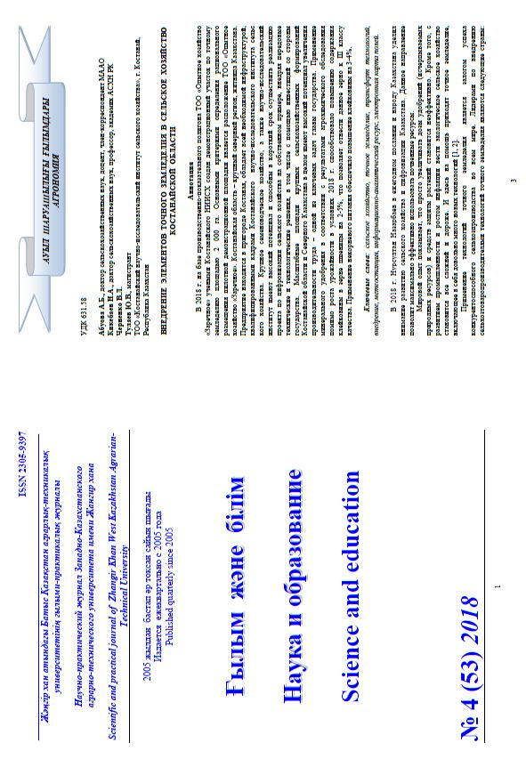

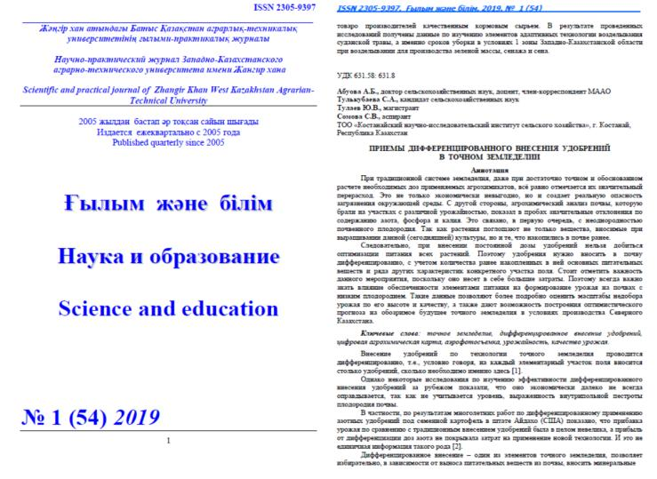

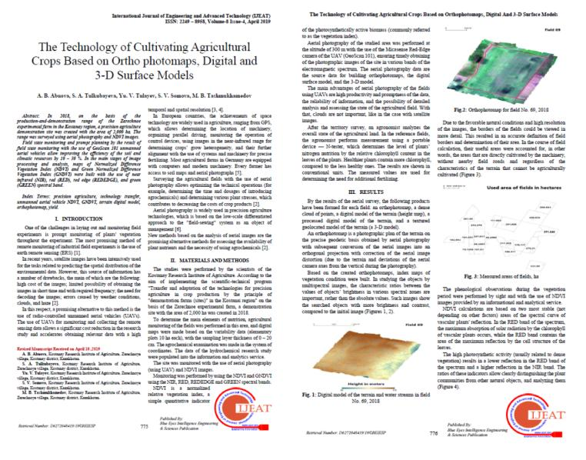
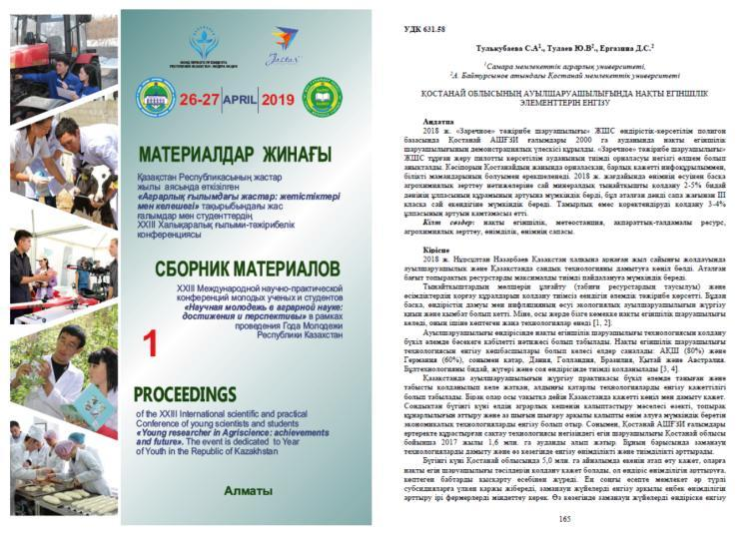

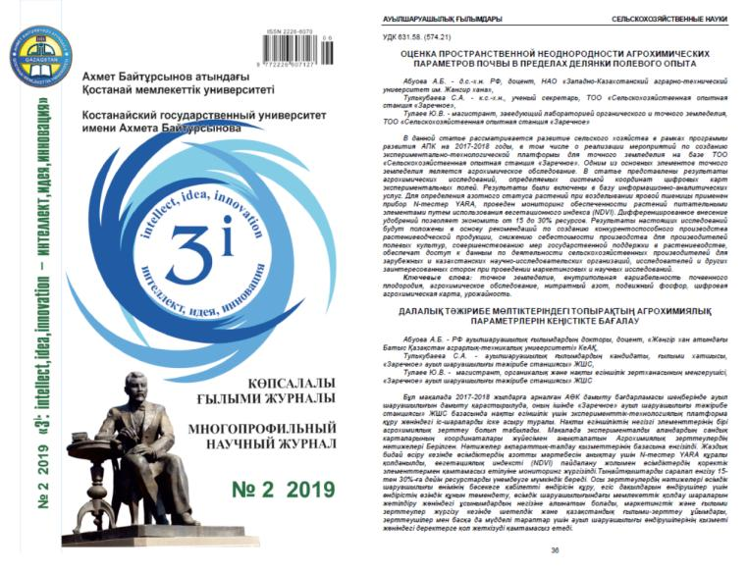

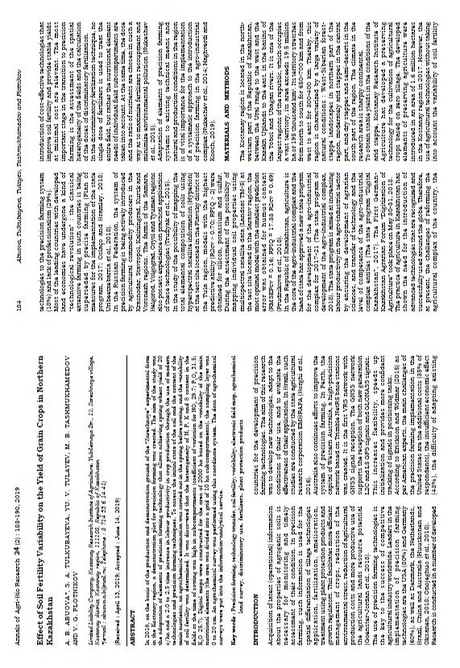

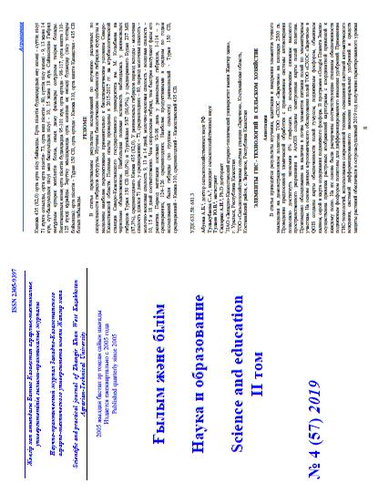
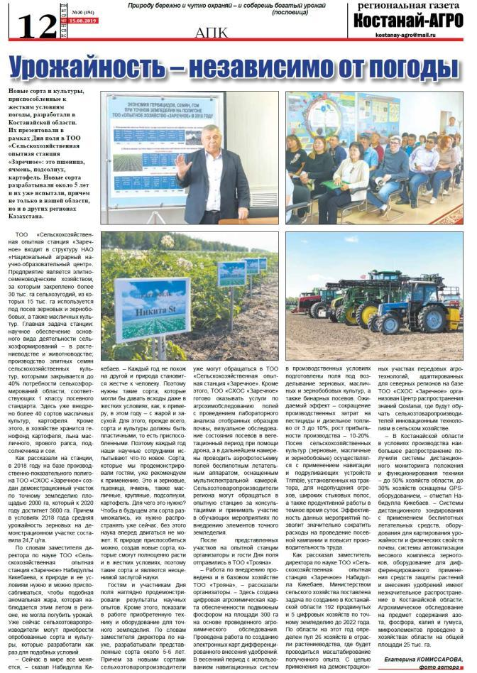
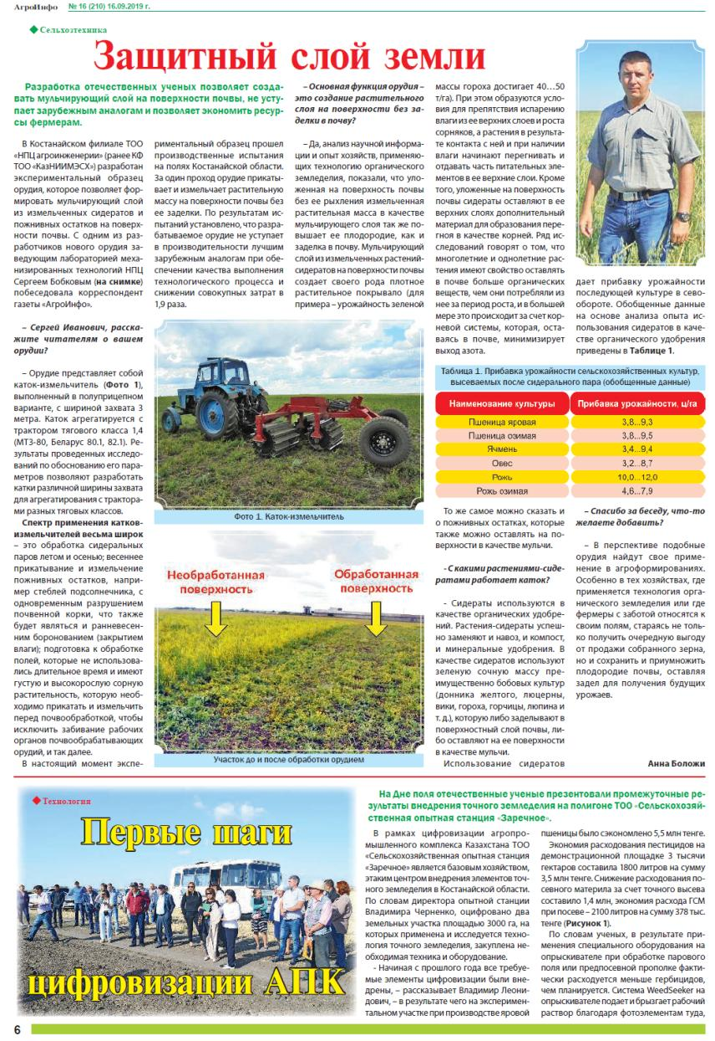
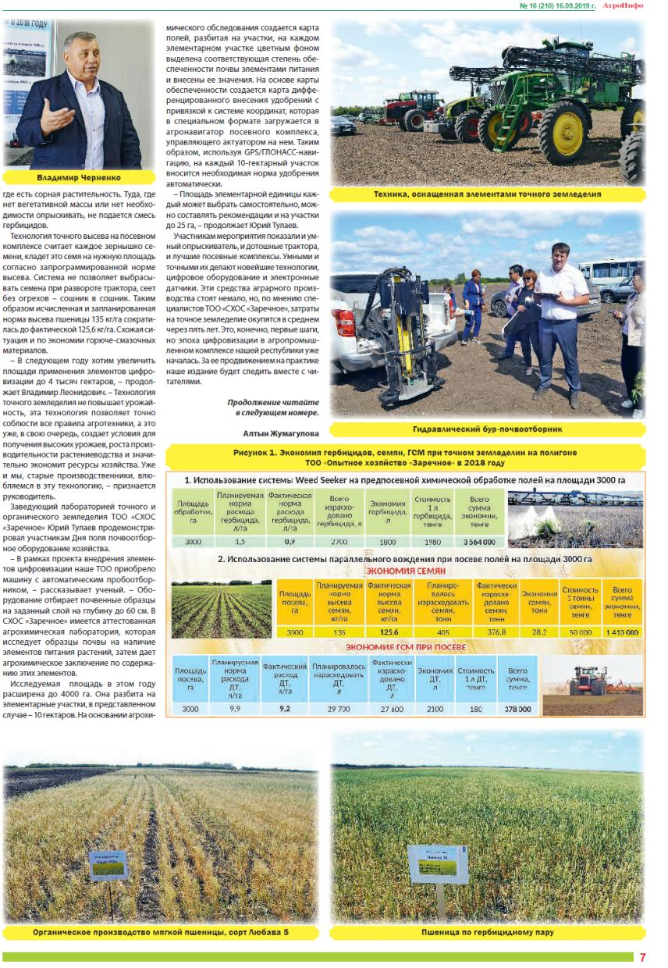
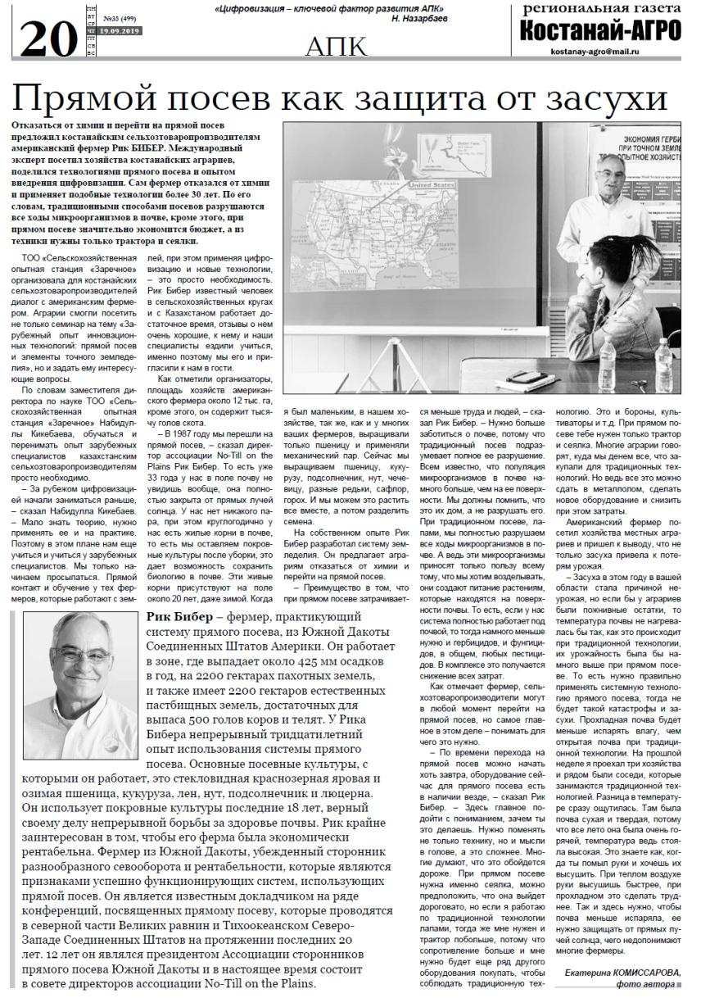

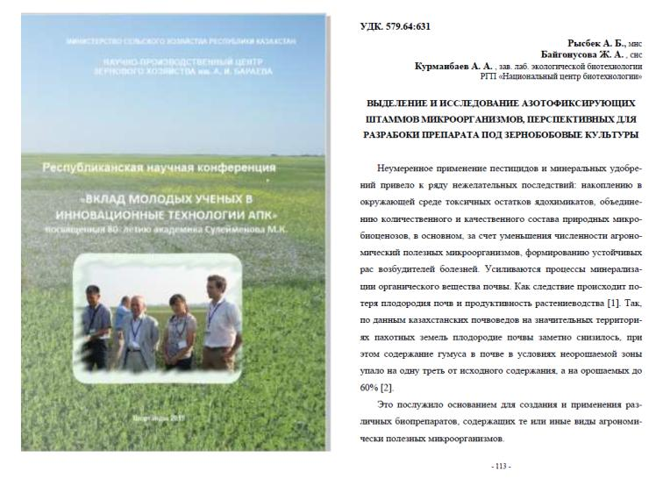
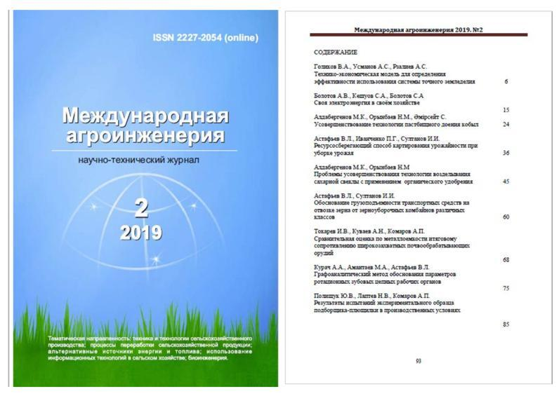

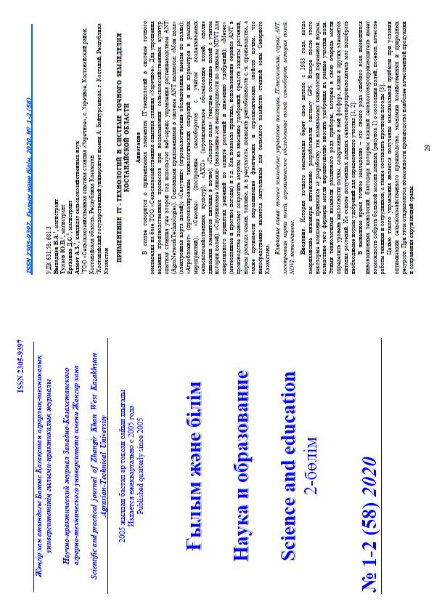
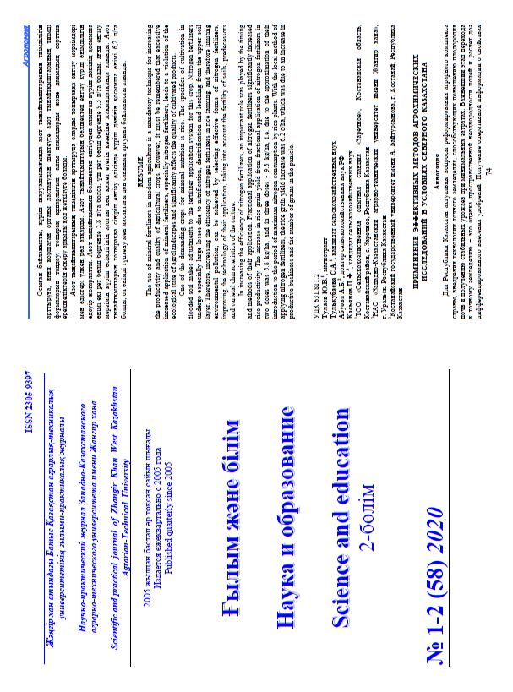
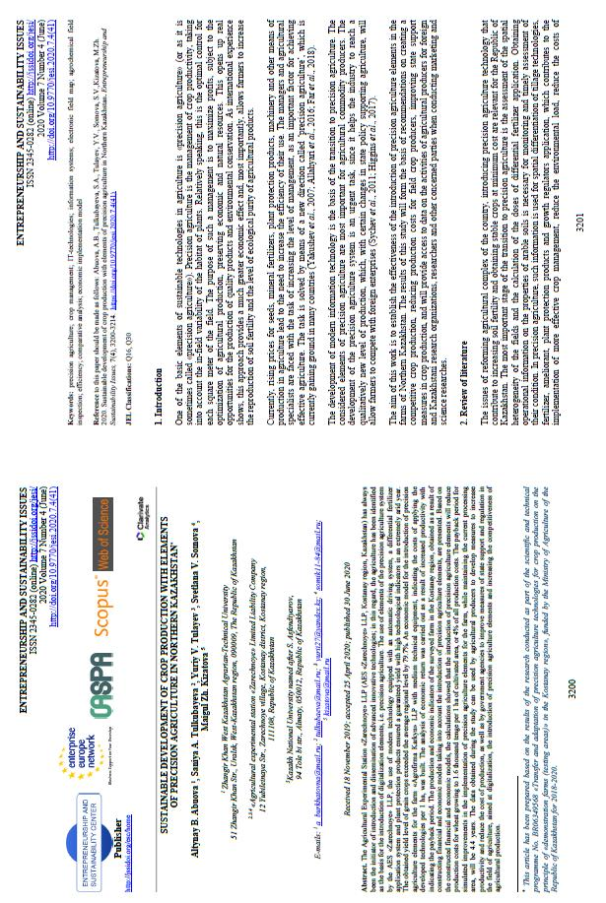
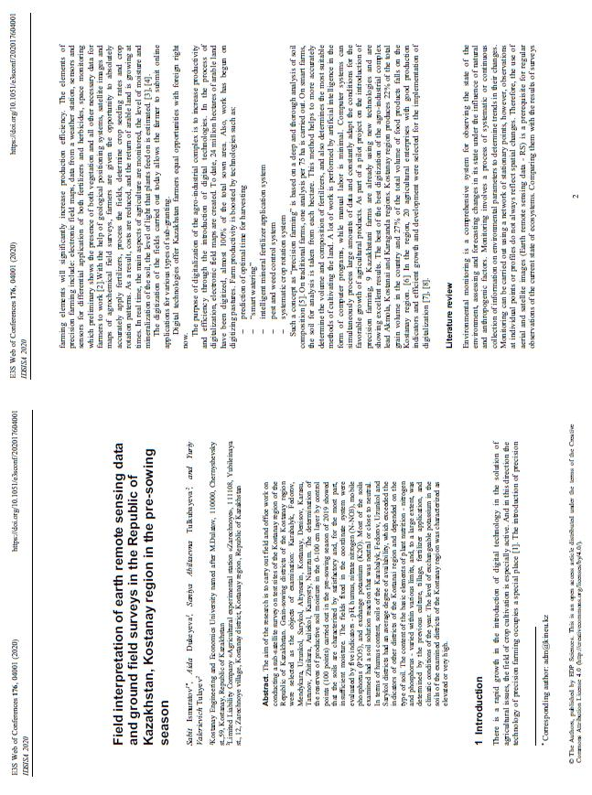
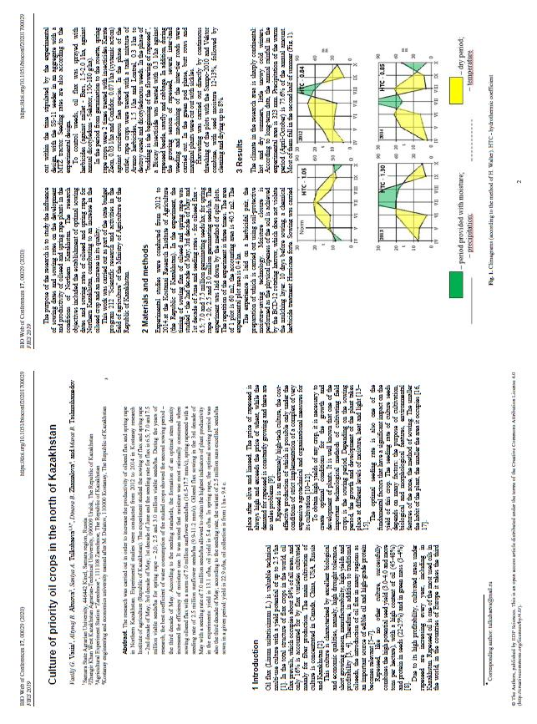

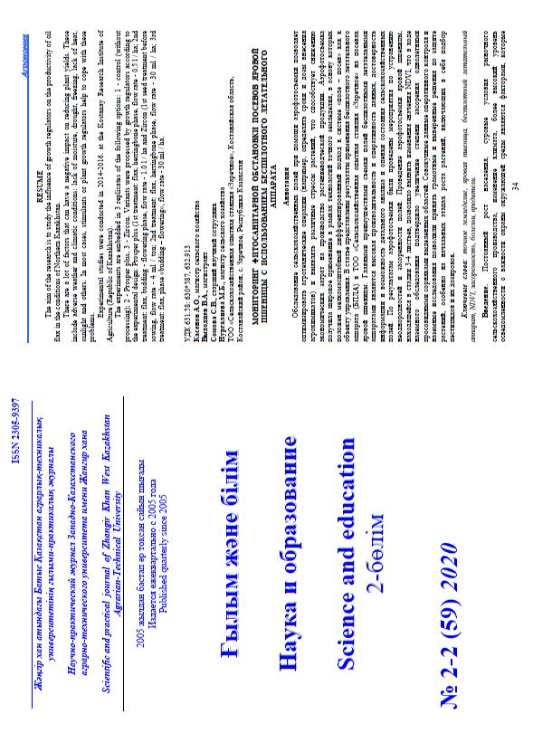
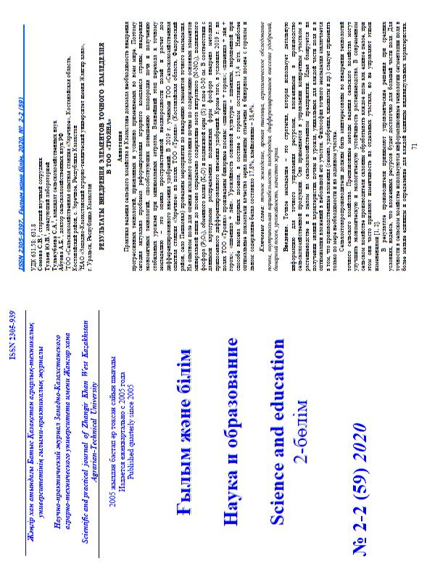
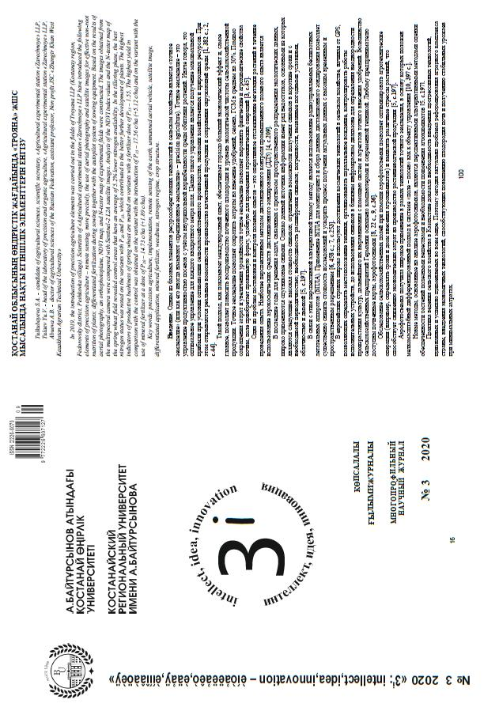
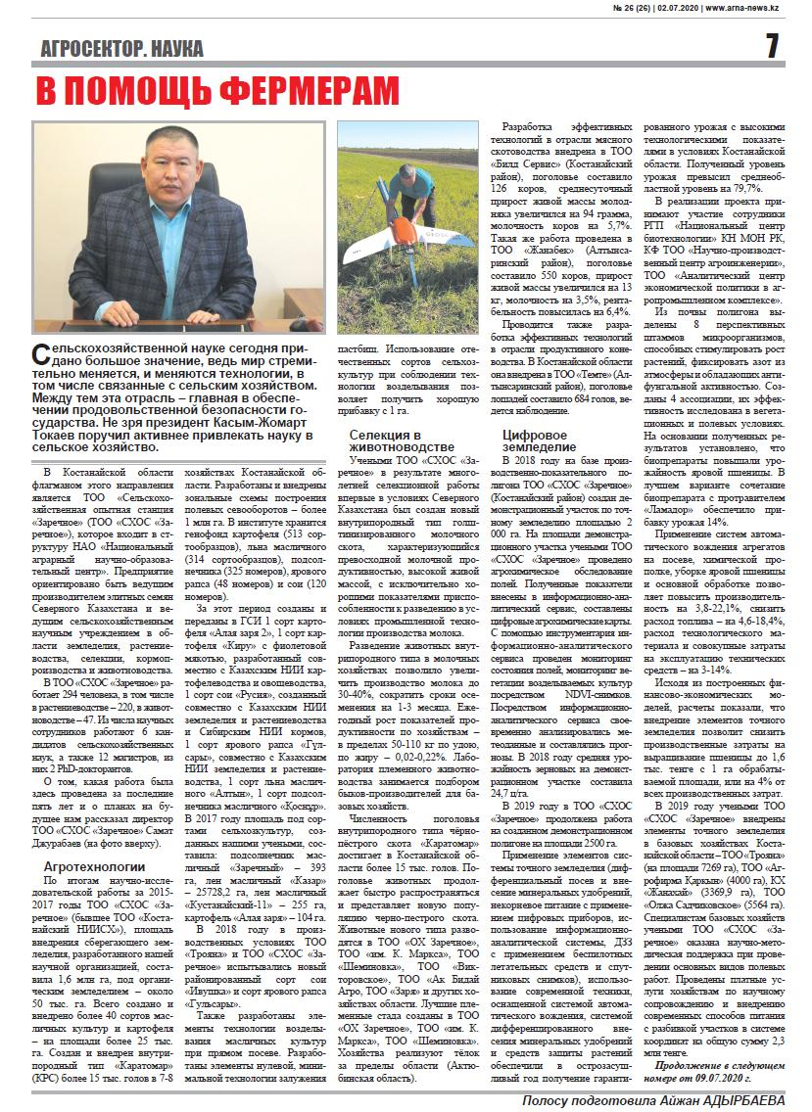
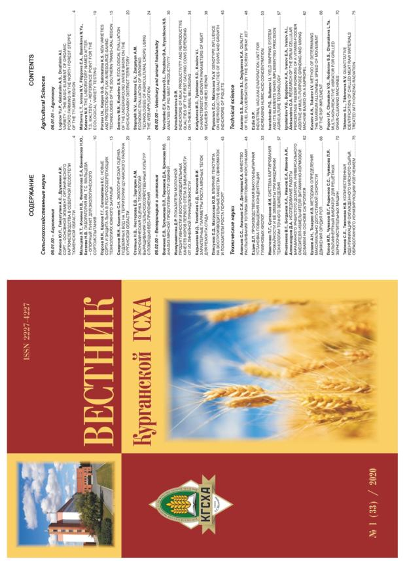
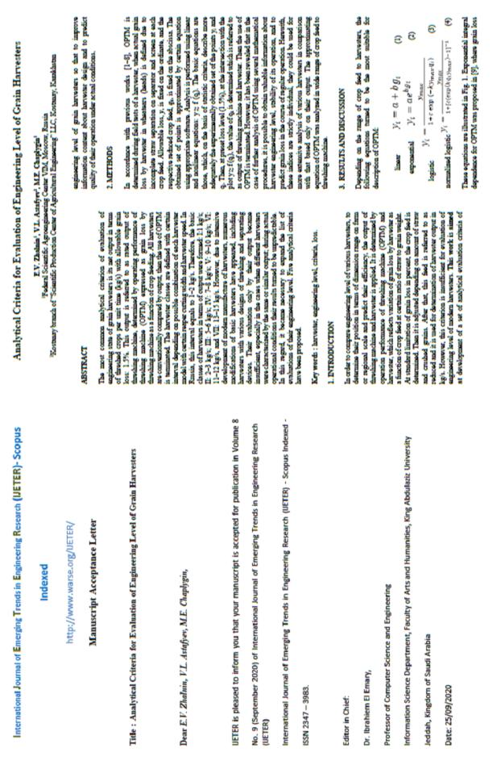
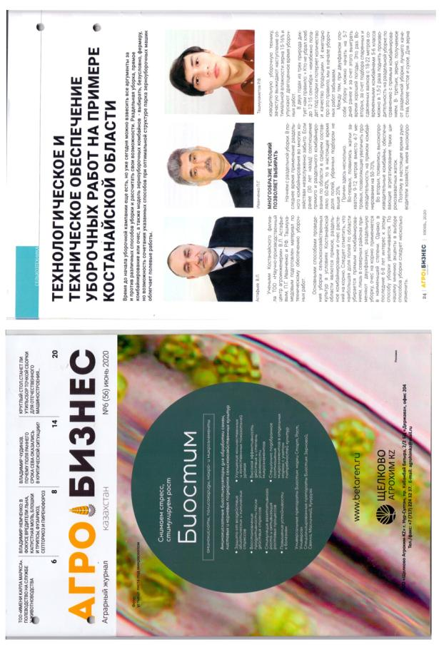

APPENDIX Q

Acts of implementation, scientific support contracts
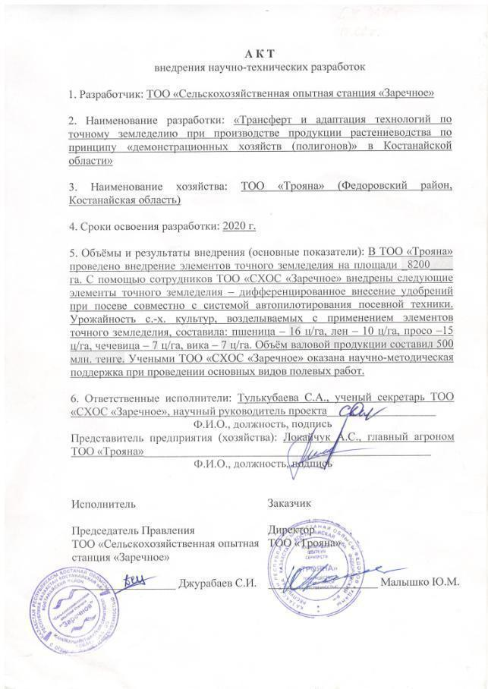
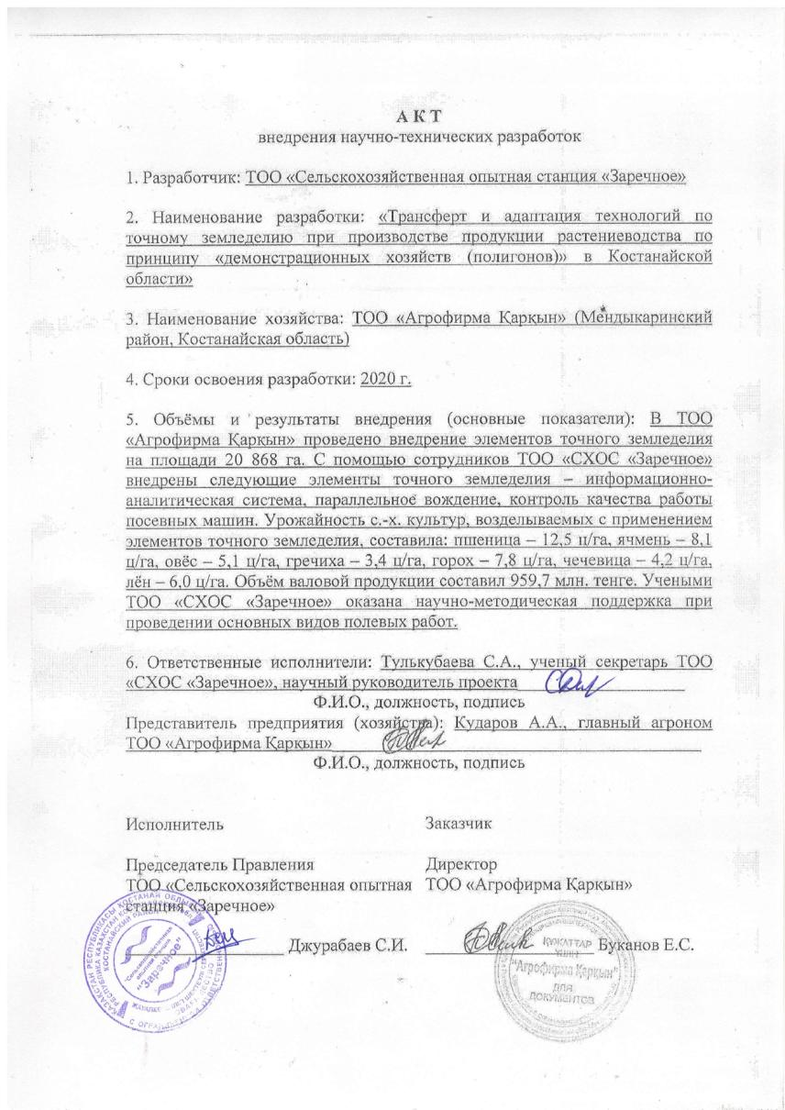

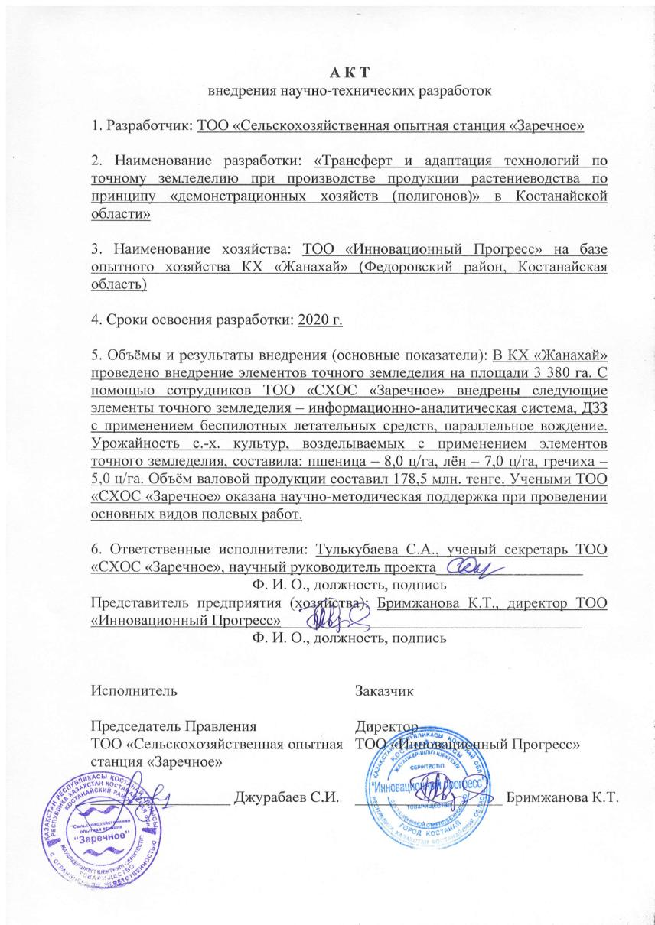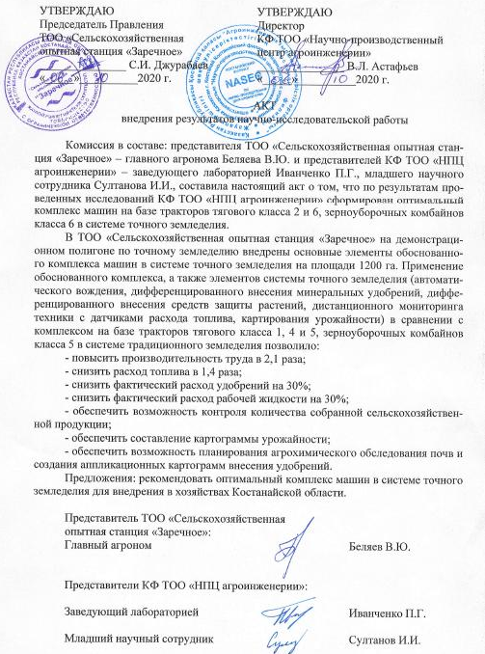

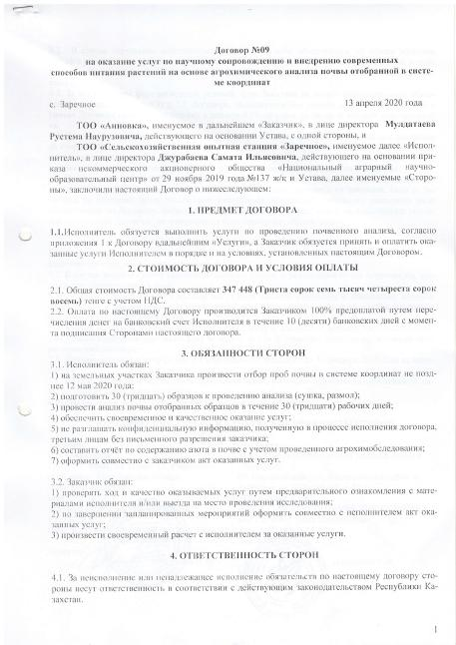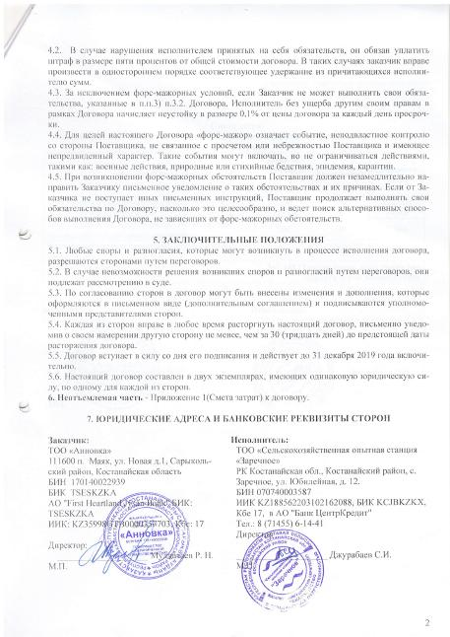
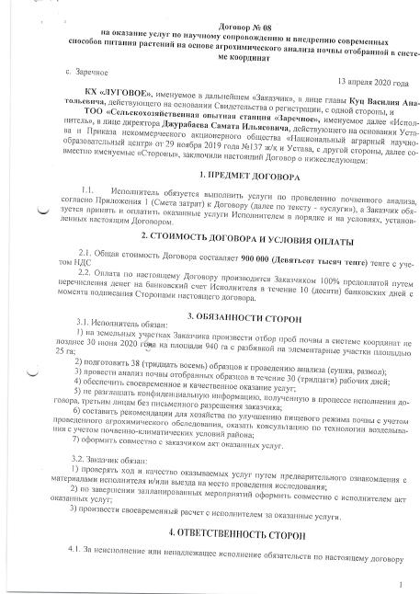
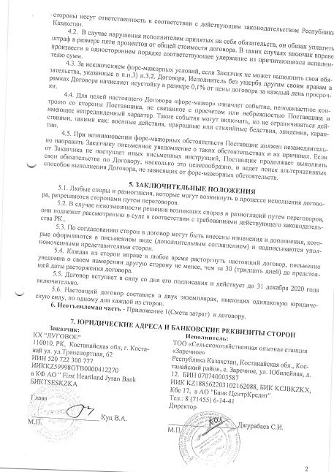
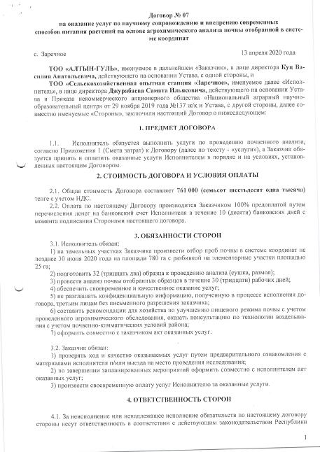
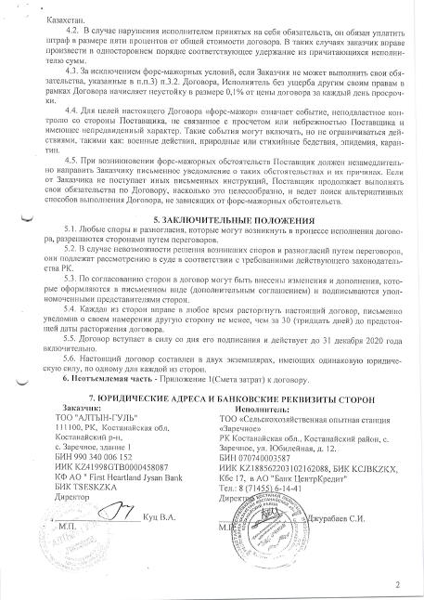

APPENDIX R
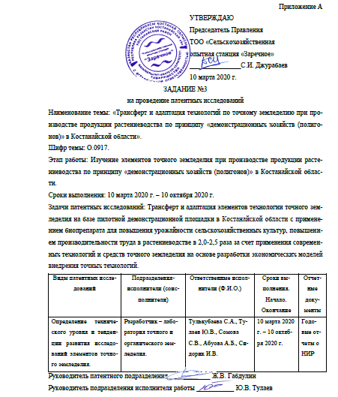
Patent Research Report
Приложение А

Утверждаю
Председатель Правления
ТОО «Сельскохозяйственная
опытная станция «Заречное»
_______________С.И. Джурабаев
10 марта 2020 г.

ЗАДАНИЕ №3
на проведение патентных исследований

Наименование темы: «Трансферт и адаптация технологий по точному земледелию при производстве продукции растениеводства по принципу «демонстрационных хозяйств (полигонов)» в Костанайской области».
Шифр темы: О.0917.
Этап работы: Изучение элементов точного земледелия при производстве продукции растениеводства по принципу «демонстрационных хозяйств (полигонов)» в Костанайской области.
Сроки выполнения: 10 марта 2020 г. – 10 октября 2020 г.
Задачи патентных исследований: Трансферт и адаптация элементов технологии точного земледелия на базе пилотной демонстрационной площадки в Костанайской области с применением биопрепарата для повышения урожайности сельскохозяйственных культур, повышением производительности труда в растениеводстве в 2,0-2,5 раза за счет применения современных технологий и средств точного земледелия на основе разработки экономических моделей внедрения точных технологий.
Виды патентных исследований | Подразделения-исполнители (соисполнители) | Ответственные исполнители (Ф.И.О.) | Сроки выполнения. Начало. Окончание | Отчетные документы
Определение технического уровня и тенденции развития исследований элементов точного земледелия. | Разработчик – лаборатория точного и органического земледелия. | Тулькубаева С.А., Тулаев Ю.В., Сомова С.В., Абуова А.Б., Сидорик И.В. | 10 марта 2020 г. – 10 октября 2020 г. | Годовые отчеты о НИР
Р уководитель патентного подразделения ____________ Ж.В. Габдулин
Руководитель подразделения исполнителя работы ___________ Ю.В. Тулаев

Приложение Б
Регламент поиска №13-2/30 от 10 марта 2020 г.

Наименование темы: «Трансферт и адаптация технологий по точному земледелию при производстве продукции растениеводства по принципу «демонстрационных хозяйств (полигонов)» в Костанайской области».
Шифр темы: О.0917.
Этап работы: Изучение элементов точного земледелия при производстве продукции растениеводства по принципу «демонстрационных хозяйств (полигонов)» в Костанайской области.
Цель поиска информации: Получение исходных данных для определения, достигнутого уровня и тенденции развития в данной отрасли.
Обоснование регламента поиска: Глубина поиска по источникам патентной и научно-технической информации 10 лет.
Страны: Казахстан, Россия, Великобритания, Германия, США, Франция, Япония, ВОИС (Всемирная организация интеллектуальной собственности), ЕПВ (Европейское патентное ведомство), ЕАПВ (Евразийское патентное ведомство).
Начало поиска – 10 марта 2020 г. Окончание поиска – 10 октября 2020 г.
Предмет поиска (объект исследования, его составные части, товар) | Страна поиска | Источники информации, по которым будет проводиться поиск |  |  |  |  |  |  |  | Ретроспективность | Наименование информационной базы
 | Страна поиска | Патентные |  | научно-технические |  | конъюнктурные |  | другие |  | Ретроспективность | Наименование информационной базы
 | Страна поиска | наименование | классификационные рубрики МКИ | наименование | рубрики УДК | наименование | код товара ГС, СМТК | наименование | кл. инд. | Ретроспективность | Наименование информационной базы
Трансферт и адаптация технологий по точному земледелию при производстве продукции растениеводства по принципу «демонстрационных хозяйств (полигонов)» в Костанайской области. | Россия, Казахстан, СГН,  ЕА, Великобритания, Германия, США, Франция, Япония, ВОИС, ЕПВ | Официальный бюллетень РФ «Изобретения», 2006-2019 гг.  Официальный бюллетень РК «Промышленная собственность», ч.1, 2006-2019 гг.  РЖ ВНИИПИ «Изобретения стран мира», №1, 2013-2018 гг. | A01B 79/02;  A01C 3/06;  A01C 21/00;  A01N 59/06;  A01G 7/00;  G01N 33/24;  G01V 9/00;  C05D 9/02;  B64D 9/00;  G06F 17/30;  G01S 13/89. |  |  |  |  |  |  | 10 лет | Евразийская патентная информационная система ЕАПАТИС.  АСПИ Web of Science, компании Thomson Reuters.

Руководитель патентного подразделения ____________ Ж.В. Габдулин

Руководитель подразделения исполнителя работы ___________ Ю.В. Тулаев
Приложение В
Отчет о поиске
В.1 Поиск проведен в соответствии с заданием Председателя Правления Джурабаева С.И. по теме «Трансферт и адаптация технологий по точному земледелию при производстве продукции растениеводства по принципу «демонстрационных хозяйств (полигонов)» в Костанайской области», задание №3 от 10 марта 2020 г. и Регламентом поиска №13-2/30 от 10 марта 2020 г.
В.1.2 Этап работы: Изучение элементов точного земледелия при производстве продукции растениеводства по принципу «демонстрационных хозяйств (полигонов)» в Костанайской области.
В.1.3 Начало поиска – 10.03.2020 г. Окончание поиска – 10.10.2020 г.
В.1.4 Сведения о выполнении регламента поиска: Поиск проведен.
В.1.5 Предложения по дальнейшему проведению поиска и патентных исследований – Тема является патентоспособной.
В.1.6 Материалы, отобранные для последующего анализа.

Таблица В 6.1 – Патентная документация
Предмет поиска (объект исследования, его составные части) | Страна выдачи, вид и номер охранного документа. Классификационный индекс | Заявитель (патентообладатель), страна. Номер заявки, дата приоритета, конвенционный приоритет, дата публикации | Наименование изобретения (полной модели, образца) | Сведения о действии охранного документа или  причина его  (только для анализа патентной чистоты)
1 | 2 | 3 | 4 | 5
Трансферт и адаптация технологий по точному земледелию при производстве продукции растениеводства по принципу «демонстрационных хозяйств (полигонов)» в Костанайской области. | Россия.  С1-2617163  B64D 1/18 (2006.01) B64D 3/00 (2006.01) A01C 23/04 (2006.01) | Федеральное государственное бюджетное научное учреждение «Федеральный научный агроинженерный центр ВИМ» (ФГБНУ ФНАЦ ВИМ) (RU)  №2016114570, 15.04.2016 | Комплекс летательных аппаратов для внесения жидких средств химизации в точном земледелии | патент действует с 21.04.2017 г.
 | С2-2537908  G01N 33/24 (2006.01)  A01B 13/10 (2006.01)  A01B 79/00 (2006.01) | Государственное научное учреждение Агрофизический научно-исследовательский институт Российской академии сельскохозяйственных наук (ГНУ АФИ Россельхозакадемии) (RU)  №2013111641/13, 06.03.2013 | Устройство для внутрипочвенного измерения агротехнологических характеристик пахотного слоя почвы в движении | последнее изменение статуса: 09.07.2018 г.

Продолжение таблицы В 6.1
1 | 2 | 3 | 4 | 5
 | С1-2661458  G01C 11/02 (2006.01) | Федеральное государственное бюджетное научное учреждение «Всероссийский научно-исследовательский институт агрохимии имени Д.Н. Прянишникова» (ФГБНУ «ВНИИ агрохимии») (RU)  №2017131126, 05.09.2017 | Способ фотометрической диагностики азотного питания растений с использованием беспилотных летательных аппаратов (БПЛА) | действует (последнее изменение статуса: 27.07.2018 г.)
 | С2-2537908  G01N 33/24 (2006.01)  A01B 13/10 (2006.01)  A01B 79/00 (2006.01) | Государственное научное учреждение Агрофизический научно-исследовательский институт Российской академии сельскохозяйственных наук (ГНУ АФИ Россельхозакадемии) (RU)  №2013111641/13, 06.03.2013 | Устройство для внутрипочвенного измерения агротехнологических характеристик пахотного слоя почвы в движении | может прекратить свое действие (последнее изменение статуса: 09.07.2018 г.)
 | С2-2436281  A01D 91/00 (2006.01) | Бабиков Анатолий Борисович (RU), Воронков Владимир Николаевич (RU), Корф Дмитрий Владимирович (RU), Окороков Юрий Аркадьевич (RU), Шишов Станислав Александрович (RU) | Система оперативного информационного обслуживания сельскохозяйственного предприятия, использующего технологии точного земледелия | действует (последнее изменение статуса: 19.02.2018 г.)

Продолжение таблицы В 6.1
1 | 2 | 3 | 4 | 5
 | RU2249324  A01D41/02 | Хомбург Г. и др. RU2249324  25.01.1999 Опубл. 10.04.2005  Бюл.№10 | Устройство для измерения объемной производительности элеватора, в особенности для сельскохозяйственной продукции
 | RU2447640  A01D41/127  A01D41/12 | Ефанов В.В. RU2447640  08.12.2010 Опубл. 20.04.2012  Бюл.№11 | Способ управления технологическим процессом уборочной машины  и система для его осуществления
 | RU2566989  A01D41/127 | Бенке В. RU2566989  27.06.2011 Опубл. 27.10.2015  Бюл.№30 | Устройство для регистрации и определения состава сыпучего материала
 | RU2633431  B25J1/00  A01B51/02  G01C11/00 | Измайлов А.Ю. и др.  RU2633431  01.03.2016 Опубл. 12.10.2017  Бюл.№29 | Беспилотный робот для картирования урожайности
 | US006584424B2  A01D61/04 | Ivan E. US006584424B2  05.07.2002 Опубл. 06.24.2003 | Yield monitoring system for grain harvesting combine

Продолжение таблицы В 6.1
1 | 2 | 3 | 4 | 5
 | US009578808B2  A01D75/00  A01D41/1271  A01D45/021 | Niels Dybro and others US009578808B2  16.05.2014 Опубл. 02.28.2017 | Multi-sensor crop yield determination
 | US20140174199A1  G01F1/20 | Michael D. and others US20140174199A1  10.08.2012 Опубл. 26.06.2017 | Yield monitoring apparatus, systems, and method
 | RU2207750  A01D91/00  A01D41/00 | Клаас Зельбстфаренде Эрнтемашинен ГМбХ RU2207750  25.09.1998 Опубл. 10.07.2003 | Способ составления карт измеренных величин
 | RU2462019  A01D41/127  A01D41/12 | Винокуров В. и др. RU2462019  27.04.2011 Опубл. 27.09.2012  Бюл.№27 | Способ информационного обеспечения процесса уборки зерна комбайном и устройство для его осуществления
 | US009642309B2  A01D75/00 | Oxbo international corporation US009642309B2  14.03.2014 Опубл. 09.05.2017 | Yield monitoring system
 | US009714856B2  A01C7/10  G01F1/20 | Ag Leader Technology US009714856B2  09.12.2014 Опубл. 25.07.2017 | Automatic compensation for the effect of grain properties on mass flow sensor calibration
 | WO00/70930A1  A01D41/12 | AGCO Limited WO00/70930A1  25.05.1999 Опубл. 30.11.2000 | Improvements in yield mapping

Продолжение таблицы В 6.1
1 | 2 | 3 | 4 | 5
 | WO02/41687A2  A01D41/127 | New Holland Belgium N.V. WO02/41687A2  24.11.2000 Опубл. 30.05.2002 | A method of estimating crop yields
 | WO02/063942A1  A01D41/127 | AGCO Limited WO02/063942A1  13.02.2001 Опубл. 22.08.2002 | Improvements in mapping techniques
 | WO02/074061A1  A01D41/12 | Deere & Company WO02/063942A1  29.01.2001 Опубл. 26.09.2002 | Measuring device for measuring the throughput rate of a harvest crop in an agricultural harvesting machine
 | WO03/039239A1  A01D41/127 | Case Harvesting Systems GMBH WO03/039239A1  08.11.2001 Опубл. 15.05.2003 | Throughput measuring device in a harvester
 | WO2010/083823A1  A01D41/127 | Hochschule Für Technik Und  Wirtschaft Dresde WO2010/083823A1  20.01.2009 Опубл. 29.07.2010 | Device and method for determining the mass-related yield of grains in harvesting machines
 | WO2012/088405A1  A01D41/127 | Precision Planting, Inc. WO2012/088405A1  22.12.2010 Опубл. 28.06.2012 | Methods, systems, and apparatus for monitoring yield and vehicle
 | WO2014/205455A1  A01D34/00 | Precision Planting, Inc. WO2014/205455A1  21.06.2013 Опубл. 24.12.2014 | Yield monitoring apparatus, systems, and methods
 | WO2015/048499A1  A01D41/127 | Acheson J.E. and others WO2015/048499A1  27.09.2013 Опубл. 02.04.2015 | Yield monitor calibration method and system

Продолжение таблицы В 6.1
1 | 2 | 3 | 4 | 5
 | WO2017/075036A1  A01D41/127  G06F3/048  G06T11/20 | CNH Industrial America LLC WO2017/075036A1  27.10.2015 Опубл. 04.05.2017 | Graphical yield monitor static (previous) data display on in-cab display
 | WO2018/092718A1  A01D41/127  A01F12/50 | Anmar Co., Ltd., WO2018/092718A1  15.11.2016 Опубл. 24.05.2018 | Yield distribution calculation device and yield distribution calculation method
 | RU2258341  A01B69/04, H03M1/60 | Государственное научное учреждение Всероссийский научно-исследовательский и проектно-технологический институт по использованию техники и нефтепродуктов в сельском хозйстве (ГНУ ВНИИТиН)  2004102792/09, заяв 30.01.2004, Опубл. 20.08.2005, Бюл. №23 | Устройство автоматического контроля заданной глубины обработки почвы
 | RU2419271  A01B61/00 | Санкт-Петербургский государственный аграрный университет  2088062/, Заявл. 24.04.1995, Опубл. – 27.08.1997 | Устройство для контроля и управления качеством обработки почвы фрезой
 | US20170188507A1  A01C7/20  A01B27/00  G01B11/22 | On-the-go soil sensors and control methods for agricultural machines  (US) US2017/0188507A1, Заявл. 06.06.2017. | Датчики и методы контроля для сельскохозяйственных машин
Продолжение таблицы В 6.1
1 | 2 | 3 | 4 | 5
 | C12N 1/20  C12N 1/02  C05F 11/08 | Пат.30491 Республика Казахстан,  СадановА.К.  №2014/1093.1; заявл.15.08.2014;  опубл.15.10.2015, Бюл. №10. – 3 с. | Способ получения пастообразного препарата  азотфиксирующих бактерий под сою
 | C12N 1/20  C12N 1/02  C05F 11/08 | Пат. 30597 Республика Казахстан,  Саданов А.К  №2014/1091.1; заявл. 15.08.2014;  опубл.16.11.2015,  Бюл. №11. – 3 с. | Способ получения пастообразного препарата  азотфиксирующих бактерий под нут
 | C12N 1/00  C12N 1/20 | Пат. 27900 Республика Казахстан,  Науанова А.П – №2013/0483.1;  заявл. 15.04.2013;  опубл. 25.12.2013,  Бюл. №12. – 6 с. | Штамм Аzotobacter Сhroococcum az-3, повышающий продуктивность пшеницы и обогащающий почву азотом
 | C05F 11/08 | Пат.23471 Республика Казахстан,  Саданов А.К.  №2009/0991.1; заявл. 31.07.2009;  опубл.15.12.2010,  бюл. №12. – 3 с. | Способ получения сухого препарата азотфиксирующих бактерий
 | C05F 11/08 | Пат. 26067 Республика Казахстан Астафьева Е.А.  №2011/1155.1; заявл. 07.11.2011; опубл.  14.09.2012, Бюл. №9. – 2 с. | Питательная среда для культивирования микроорганизма Аzotobacter chroococcum
Продолжение таблицы В 6.1
1 | 2 | 3 | 4 | 5
 | C05G 3/04  C05G 3/00  C05G 1/00 | Пат. 27897 Республика Казахстан,  Сауран Ә.Ж.  №2012/1309.1; заявл.12.12.2012;  опубл.25.12.2013,  бюл. №12. – 2 с. | Способ получения бактериального удобрения «Азотобактер»
 | C05F 11/08 | Пат. 30785 Республика Казахстан, Идрисова У.Р.  №2014/1816.1; заявл.08.12.2014;  опубл.25.12.2015,  бюл. №12. – 3 с. | Способ получения бактериального препарата пастообразной формы на основе азотфиксирующих бактерий
 | C12N 1/20  A01N 63/00  C12R 1/065 | Пат. 2 414 509 Российская Федерация,  Кандыба Е.В.  №2009127881/10; заявл.21.07.2009;  опубл.20.03.2011,  Бюл. №8. – 7 с. | Штамм бактерий Аzotobacter chroococcum, обладающий антагонистической активностью по отношению к фитопатогенным микроорганизмам и его применение

Продолжение таблицы В 6.1
1 | 2 | 3 | 4 | 5
 | A01N 63/00  C12N 1/20 | Пат. 2 529 958 Российская Федерация.  Султанов И.М.  №2013138952/10; заяв. 20.08.2013;  опубл. 10.10.2014, Бюл. №28. – 6 с. | Штамм азотфиксирующих бактерий Рseudomonas sp. для получения биопрепарата против заболеваний пшеницы, вызываемых фитопатогенными грибами, и повышения урожайности
 | C12N 1/20  C12N 1/02  C05F 11/08 | Пат. 30492 Республика Казахстан.  Саданов А.К.  №2014/1094.1  заяв. 15.08.2014;  опубл. 15.10.2015, бюл. №10 – 3 с. | Способ получения пастообразного препарата азотфиксирующих бактерий под люцерну
 | C12N 1/20  C12N 1/02  C05F 11/08 | Пат. 30598 Республика Казахстан.  Саданов А.К.  №2014/1092.1  заяв. 15.08.2014;  опубл. 16.11.2015, бюл. №11 – 4 с. | Способ получения пастообразного препарата азотфиксирующих бактерий под горох
 | C12N 1/20  C05F 11/08 | Пат.27631 Республика Казахстан.  Балпанов Д.С.  №2012/1342.1; заяв. 19.12.2012;  опубл. 15.11.2013, Бюл. №11 – 4 с. | Штамм азотфиксирующих Клубенькообразу-ющих микроорганизмов Sinorhizobium fredii, используемый для получения биологического удобрения под сою

Продолжение таблицы В 6.1
1 | 2 | 3 | 4 | 5
 | C12N 1/00 | Пат. 28715  Республика Казахстан.  Балпанов Д.С.  №2013/0775.1; заяв. 10.06.2013;  опубл. 15.07.2014, Бюл. №7 – 4 с. | Штамм азотфиксирующих микроорганизмов Вradyrнizobium Japonicum Sr5, используемый для получения биологического удобрения под сою
 | C05F 11/08  C12N 1/20  C12R 1/065 | Пат. 2 390 517 Росийская Федерация.  Скрипникова М.К.  №2008129928/13,  заяв. 27.01.2010  опубл. 27.05.2010 Бюл. №15 – 9 с. | Способ приготовления бактериального удобрения на основе бактерий рода Аzotobacter
 | C12N 1/20  C12R 1/01  C05F 11/08 | Пат. 2 528 874 Росийская Федерация.  / Дегтярева И.А. –  №2012145908/10,  заяв. 26.10.2012;  опубл. 20.09.2014; Бюл. №26 – 9 с. | Питательная среда для выращивания консорциума азотфиксирующих и фосфатмобилизующих микроорганизмов
 | C12N 1/20  C05F 11/08  C12R 1/065 | Пат. 2 464 308. Росийская Федерация.  Дегтярева И.А. – №010146021/10,  заяв. 11.11.2010;  опубл. 20.10.2012 Бюл. №29 – 7 с. | Штамм бактерий Аzotobacter chroococcum 5 v(e), используемый для получения азотфиксирующего удобрения для зерновых и кормовых культур

Продолжение таблицы В 6.1
1 | 2 | 3 | 4 | 5
 | C12N 1/20  A01N 63/00  C05F 11/08 | Пат. 2 514 217  Российская Федерация.  Лактионов Ю.В.  №2012151105/10,  заяв. 29.11.2012;  опубл. 27.04.2014, Бюл. №12. – 9 с. | Биопрепарат под бобовую культуру жидкой формы на основе клубеньковых бактерий
 | C12N 1/20  A61K 35/74  A23C 9/123  C12R 1/225 | Пат. 2 528 862.  Российская Федерация  Абрамов В.М.  №2013118084/10,  заяв. 19.04.2013;  опубл. 20.09.2014 Бюл. №26. – 17 с. | Штамм Lactobacillus fermentum, обладающий широким спектром антагонистической активности и пробиотический консорциум лактобактерий для изготовления бактериальных препаратов
 | C12N1/20  C12R 1/01  А 63/02 | Пат. WO 2017/082761 А 1.  Пластинин С.А.  №pct/ru2015/000929. заяв. 25. 12.2015; опубл. 18.05.2017. – 16 с. | Штамм Рaenibacillus mucilaginosus, используемый в качестве удобрения и для стимуляции роста и защиты растений от грибковых болезней

Продолжение таблицы В 6.1
1 | 2 | 3 | 4 | 5
 | Казахстан, полезная модель патент  №3878  МПК  A01B 79/02 | Филонов Валерий Михайлович, Наздрачёв Яков Павлович, Мамыкин Евгений Владимирович, Назарова Перизат Ержанаткызы  Товарищество с ограниченной ответственностью «Научно-производственный центр зернового хозяйства им. А.И. Бараева  з. KZ2017/0674.2  от 17.10.2017  публ. 19.04.2019 | Способ возделывания яровой пшеницы с внесением азотного удобрения
 | Казахстан, патент  №32288  МПК  A01C 21/00 | Черненок Валентина Григорьевна  Акционерное общество «Казахский агротехнический университет им. С. Сейфуллина  з. KZ2015/1170.1  от 14.10.2015  публ. 15.08.2017 | Способ определения потребности сельскохозяйственных культур в азотных удобрениях
 | Россия, патент  №2075076  МПК  G01N 33/24 | Афанасьев Р.А., Ширинян М.Х., Благов А.В., Мейер О.Н.  Всероссийский научно-исследовательский институт удобрений и агропочвоведения им.Д.Н. Прянишникова  з. 94013149/15  от 14.04.1994  публ. 10.03.1997 | Способ дистанционной диагностики питания почвенного покрова земли, например озимой пшеницы, вне зависимости от погодных условий и времени суток

Продолжение таблицы В 6.1
1 | 2 | 3 | 4 | 5
 | Россия, патент  №2120754  МПК  A01N 59/06 | Королева Т.А., Белицкая М.Н., Максюта В.Н., Мелихов В.В., Ермаков В.А.  з. 97107368/13  от 06.05.1997  публ. 27.10.1998 | Средство для внекорневой подкормки зерновых культур
 | Россия, патент  №2377227  МПК  C05D 9/02 | Куликов Сергей Сергеевич (RU), Куликов Роман Сергеевич (RU)  Общество с ограниченной ответственностью «Научно-производственная фирма Минерал» (RU)  з. 2008141986/15  от 23.10.2008  публ. 27.12.2009 | Средство для некорневой обработки сельскохозяйственных культур
 | Россия, патент  №2381644  МПК  A01G 7/00 | Александров Михаил Тимофеевич (RU), Афанасьев Рафаил Александрович (RU), Гапоненко Олег Геннадьевич (RU), Хоменко Владимир Александрович (RU), Смышляев Геннадий Викторович (RU)  Общество с ограниченной ответственностью «Научно-производственный центр медицинских и промышленных биотехнологий Спектролюкс» (RU)  з. 2007136907/12  от 05.10.2007  публ. 20.02.2010 | Способ экспресс-диагностики азотного питания растений

Продолжение таблицы В 6.1
1 | 2 | 3 | 4 | 5
 | Россия, патент  №2417576  МПК  A01G 7/00 | Гуреев Иван Иванович (RU)  Государственное научное учреждение Всероссийский научно-исследовательский институт земледелия и защиты почв от эрозии Российской академии сельскохозяйственных наук (RU)  з. 2009134741  от 16.09.2009  публ. 10.05.2011 | Способ диагностики потребности растений в минеральных элементах питания
 | Россия, патент  №2455660  МПК  G01S 13/89 | Афанасьев Рафаил Александрович (RU), Байбеков Роман Федорович (RU), Беличенко Майя Алексеевна (RU), Березовский Егор Викторович (RU), Рухович Ольга Владимировна (RU), Смирнов Михаил Олегович (RU), Сычев Виктор Гаврилович (RU), Шишов Станислав Александрович (RU)  Государственное научное учреждение Всероссийский научно-исследовательский институт агрохимии им. Д.Н. Прянишникова (RU)  з. 2011111095/28  от 24.03.2011  публ. 10.07.2012 | Способ ускоренного выделения устойчивых внутрипольных контуров почвенного плодородия на сельскохозяйственных полях
 | Россия, патент  №2469993  МПК  C05D 9/02 | Куликов Сергей Сергеевич (RU), Куликов Роман Сергеевич (RU)  Общество с ограниченной ответственностью «Волски Биохим» (RU)  з. 2011125222/13  от 17.06.2011  публ. 20.12.2012 | Средство для предпосевной обработки семян и некорневой обработки сельскохозяйственных культур
Продолжение таблицы В 6.1
1 | 2 | 3 | 4 | 5
 | Россия, патент  №2471338  МПК  A01G 7/00 | [RU] Башилов Алексей Михайлович, [RU] Королёв Владимир Александрович, [RU] Головко Вадим Александрович, [RU] Суляев Сергей Александрович, [RU] Башилов Сергей Алексеевич, [RU] Евдокимов Павел Борисович  Российская академия сельскохозяйственных наук Государственное научное учреждение Всероссийский научно-исследовательский институт электрификации сельского хозяйства Российской академии сельскохозяйственных наук (ГНУ ВИЭСХ Россельхозакадемии)  з. RU2010107548  от 02.03.2010  публ. 10.01.2013 | Устройство позиционирования мобильных агрегатов при возделывании агрокультур
 | Россия, патент  №2511311  МПК  A01G 7/00 | Поздеев Александр Викторович (RU), Поздеев Михаил Викторович (RU), Казанок Татьяна Сергеевна (RU)  Общество с ограниченной ответственностью «Лаборатория N1» (RU)  з. 2012147885/13  от 09.11.2012  публ. 10.04.2014 | Способ диагностики потребности растений в элементах питания с учетом физиологического состояния растений

Продолжение таблицы В 6.1
1 | 2 | 3 | 4 | 5
 | Россия, патент  №2555007  МПК  A01C 21/00 | Шоба Владимир Николаевич (RU), Ким Станислав Александрович (RU), Каличкин Андрей Владимирович (RU), Малыгин Александр Евгеньевич (RU)  Федеральное государственное бюджетное научное учреждение «Сибирский научно-исследовательский институт земледелия и химизации сельского хозяйства» (ФГБНУ «СибНИИЗиХ») (RU)  з. 2013140567/13  от 02.09.2013  публ. 10.07.2015 | Способ применения органо-минерального удобрения для некорневой обработки сельскохозяйственных культур
 | Россия, патент  №2648696  МПК  G01N 35/10 | Гаврилов Николай Андреевич (RU)  з. 2017117895  от 23.05.2017  публ. 28.03.2018 | Агротехнический комплекс с беспилотным летательным аппаратом
 | Россия, патент  №2661458  МПК  G01C 11/02 | Сычев Виктор Гаврилович (RU), Афанасьев Рафаил Александрович (RU), Ворончихин Виктор Викторович (RU)  Федеральное государственное бюджетное научное учреждение «Всероссийский научно-исследовательский институт агрохимии имени Д.Н. Прянишникова» (ФГБНУ «ВНИИ агрохимии») (RU)  з. 2017131126  от 05.09.2017  публ. 16.07.2018 | Способ фотометрической диагностики азотного питания растений с использованием беспилотных летательных аппаратов (БПЛА)

Продолжение таблицы В 6.1
1 | 2 | 3 | 4 | 5
 | Беларусь, патент  №14047  МПК  C05G 1/00 | Пироговская Галина Владимировна; Лапа Виталий Витальевич; Русалович Алексей Михайлович; Сороко Виктор Иванович; Сазоненко Олег Петрович; Исаева Олеся Ивановна; Привалов Федор Иванович; Ганусевич Александр Геннадьевич; Туболец Анатолий Александрович (BY)  Республиканское научное дочернее унитарное предприятие «Институт почвоведения и агрохимии» (BY)  з. BYA20090193  от 12.02.2009  публ. 28.02.2011 | Комплексное удобрение для зерновых культур и способы его внесения
 | EA, патент  №19791  МПК  C05C 13/00 | [BY] Пироговская Галина Владимировна, [BY] Лапа Виталий Витальевич, [BY] Русалович Алексей Михайлович, [BY] Сороко Виктор Иванович, [BY] Исаева Олеся Ивановна, [BY] Хмелевский Сергей Станиславович, [BY] Костюкевич Василий Васильевич, [BY] Вовк Василий Иосифович, [BY] Серебряков Геннадий Федорович, [BY] Скулович Захар Борисович  BY] Республиканское научное дочернее унитарное предприятие «Институт почвоведения и агрохимии, [BY] Республиканское унитарное предприятие «Светлогорское производственное объединение «Химволокно  з. EA201101201  от 22.07.2011  публ. 30.06.2014 | Жидкое азотно-серосодержащее удобрение с модифицирующими добавками и способ его получения

Продолжение таблицы В 6.1
1 | 2 | 3 | 4 | 5
 | EA, патент  №26995  МПК  A01B 79/00 | [DE] Майдль Франц-Ксавер, [DE] Технише Универзитет Мюнхен  з. EA201391276  от 02.03.2012  публ. 30.06.2017 | Способ определения потребности в удобрениях, в частности потребности в азотных удобрениях, и устройство для осуществления способа
 | EA, патент  №28406  МПК  C05D 9/00 | RU] Массалимов Исмаил Александрович, [RU] Гайфуллин Радик Разильевич, [RU] Массалимов Исмаил Александрович  з. EA201600266  от 15.04.2016  публ. 30.11.2017 | Удобрение, содержащее в качестве действующего вещества высокодисперсную серу
 | Китай, патент  №1054452229  МПК  G01N21/47 | FENG WEI; GUO BINBIN; WANG YONGHUA; XIE YINGXIN; WANG CHENYANG; GUO TIANCAI  UNIV HENAN AGRICULTURAL  з. CN201510934601  от 15.12.2015  публ. 30.03.2016 | Nitrogen balance spectroscopy-based wheat spring nitrogenous fertilizer application method, and construction method of nitrogen topdressing amount model thereof
 | Китай, патент  №109089790  МПК  A01G22/20 | XIAO KAI  UNIV HEBEI AGRICULTURE  з. CN20181181211  от 17.09.2018  публ. 28.12.2018 | Method for diagnosing application time of water and fertilizer by using spad (soil and plant analyzer development) values of third and fourth leaves of spring wheat
Продолжение таблицы В 6.1
1 | 2 | 3 | 4 | 5
 | Казахстан (KZ), патент  №33602  МПК A01B 49/06, [**] A01B 79/02 | Акционерное общество «Казахский агротехнический университет имени Сакена Сейфуллина» (KZ)  Нукешев Саяхат Оразович (KZ), [**] Черненок Валентина Григорьевна (KZ), [**] Есхожин Джадыгер Зарлыкович (KZ), [**] Романюк Николай Николаевич (BY), [**] Агейчик Валерий Александрович (BY), [**] Есхожин Кайрат Джадыгерович (KZ), [**] Кусаинов Руслан Комекович (KZ), [**] Ахметов Ержан Советович (KZ), [**] Тлеумбетов Калдыбек Мирамбекович (KZ), [**] Рустембаев Арман Базарханович (KZ)  з. KZ2017/0748.1 от 11.09.2017  публ. 08.05.2019 | Способ внесения минеральных удобрений и устройство для его осуществления
 | Россия (RU), патент  №02059241  МПК G01N 33/24 | Донской сельскохозяйственный институт Мокриевич Г.Л., Юрьев С.Н., Шумидуб Н.Н., Ткачев С.М. з. RU4856971  от 07.06.1990  публ. 27.04.1996 | Способ определения потребности сельскохозяйственной культуры в азотном удобрении
 | Россия (RU), патент  №02102748  МПК [6] G01N 33/24, [6] G01S 13/89 | Всероссийский научно-исследовательский институт удобрений и агропочвоведения им.Д.Н.Прянишникова Афанасьев Р.А., Благов А.В., Мейер О.Н. з. RU94004566  от 08.02.1994  публ. 20.01.1998 | Усовершенствованный способ агрохимического обследования почв

Продолжение таблицы В 6.1
1 | 2 | 3 | 4 | 5
 | Россия (RU), патент  №02105974  МПК [6] G01N 33/24, [6] G01V 8/00, [6] G03B 37/00 | Почвенный институт им.В.В.Докучаева Королюк Т.В. з. RU92015630  от 30.12.1992  публ. 27.02.1998 | Способ диагностики почвенного покрова по данным дистанционной информации
 | Россия (RU), патент  №02231246  МПК [7] A01C 3/06 | ОАО «Научно-исследовательский институт комплексных проблем машиностроения для животноводства и кормопроизводства»  [RU] Кудзиев Э.П., [RU] Мальцев Ю.В., [RU] Микоян С.А., [RU] Пузанков А.Г. з. RU2002130266  от 13.11.2002  публ. 27.06.2004 | Устройство для дифференцированного внесения удобрений
 | Россия (RU), патент  №02246697  МПК [7] G01C 11/10 | ИПБОЮЛ Ващенко Ю.Е. [RU] Ващенко Ю.Е., [RU] Русинов П.С., [RU] Ломакин С.В  з. RU2003119186  от 30.06.2003  публ. 20.02.2005 | Способ актуализации карты обследуемой земной поверхности
 | Россия (RU), патент  №02265839  МПК [7] G01N 33/24, [7] G01V 9/00 | Государственное учреждение Всероссийский научно-исследовательский институт агролесомелиорации[RU] Кулик К.Н., [RU] Юферев В.Г., [RU] Рулев А.С., [RU] Бакурова К.Б. з. RU2004111328  от 13.04.2004  публ. 10.12.2005 | Способ определения состояния почвы, подверженной деградации
Продолжение таблицы В 6.1
1 | 2 | 3 | 4 | 5
 | Россия (RU), патент  №02285278  МПК [8] G01V 11/00 | [RU] Кострюкова Наталья Константиновна, [RU] Кострюков Олег Мстиславович з. RU2004120418  от 02.07.2004  публ. 10.10.2006 | Способ дистанционного зондирования при выявлении динамически напряженных зон земной коры
 | Россия (RU), патент  №02308679  МПК [8] G01C 11/00 | ИПБОЮЛ Ващенко Юрий Ефимович  [RU] Ващенко Юрий Ефимович, [RU] Евтушенко Татьяна Юрьевна, [RU] Русинов Павел Сергеевич, [RU] Серебрякова Елена Дмитриевна, [RU] Шишлянникова Мария Сергеевна з. RU2005128541  от 08.09.2005  публ. 20.10.2007 | Способ картографирования земель
 | Россия (RU), патент  №02337518  МПК [8] A01C 21/00 | ФГОУВПО ОМСКИЙ ГОСУДАРСТВЕННЫЙ АГРАРНЫЙ УНИВЕРСИТЕТ [RU] Сергеева Ольга Сергеевна, [RU] Березин Леонид Владимирович, [RU] Климович Денис Андреевич з. RU2006143977  от 11.12.2006  публ. 10.11.2008 | Способ внесения органических удобрений

Продолжение таблицы В 6.1
11 | 2 | 3 | 4 | 5
 | Россия (RU), патент  №02381644  МПК [8] A01G 7/00 | ООО «Научно-производственный центр медицинских и промышленных биотехнологий Спектролюкс» (RU)  Александров Михаил Тимофеевич (RU), [RU] Афанасьев Рафаил Александрович (RU), [RU] Гапоненко Олег Геннадьевич (RU), [RU] Хоменко Владимир Александрович (RU), [RU] Смышляев Геннадий Викторович (RU) з. 2007136907  от 05.10.2007  публ. 20.02.2010 | Способ экспресс-диагностики азотного питания растений
 | Россия (RU), патент на полезную модель  №99682  МПК [8] A01C 15/00, [8] A01C 17/00, [8] A01C 23/00 | ФГОУВПО «Саратовский государственный аграрный университет имени Н.И. Вавилова» (RU) з. 2010118621  от 07.05.2010  публ. 27.11.2010 | Автоматизированный агрегат поадресного внесения удобрений в почву

Продолжение таблицы В 6.1
1 | 2 | 3 | 4 | 5
 | Россия (RU), патент  №02422858  МПК [8] G01V 9/00 | Козодеров Владимир Васильевич (RU) з. 2010104429  от 10.02.2010  публ. 27.06.2011 | Способ распознавания образов природно-техногенных объектов и оценки параметров их состояния по гиперспектральным данным аэрокосмического зондирования
 | Россия (RU), патент  №02424540  МПК [8] G01V 9/00 | Государственное учреждение Научный центр проблем аэрокосмического мониторинга – ЦПАМ «АЭРОКОСМОС» (RU Дмитриев Егор Владимирович (RU), [RU] Козодеров Владимир Васильевич (RU) з. 2009136722  от 06.10.2009  публ. 20.07.2011 | Способ определения параметров состояния почвенно-растительного покрова по данным многоспектрального аэрокосмического зондирования
 | Россия (RU), патент  №02443977  МПК [8] G01C 11/00 | Учреждение Российской академии наук Институт биологии Коми научного центра Уральского отделения РАН (RU) Елсаков Владимир Валериевич (RU), [RU] Володин Владимир Витальевич (RU), [RU] Чадин Иван Федорович (RU), [RU] Марущак Юрий Владимирович (RU) з. 2010133214  от 06.08.2010  публ. 27.02.2012 | Способ оценки распределения и запасов ресурсных и редких видов растений в пределах крупных территориальных массивов

Продолжение таблицы В 6.1
1 | 2 | 3 | 4 | 5
 | Россия (RU), патент  №02455660  МПК [8] G01S 13/89 | ГНУ Всероссийский научно-исследовательский институт агрохимии им. Д.Н. Прянишникова (RU) Афанасьев Рафаил Александрович (RU), [RU] Байбеков Роман Федорович (RU), [RU] Беличенко Майя Алексеевна (RU), [RU] Березовский Егор Викторович (RU), [RU] Рухович Ольга Владимировна (RU), [RU] Смирнов Михаил Олегович (RU), [RU] Сычев Виктор Гаврилович (RU), [RU] Шишов Станислав Александрович (RU) з. 2011111095  от 24.03.2011  публ. 10.07.2012 | Способ ускоренного выделения устойчивых внутрипольных контуров почвенного плодородия на сельскохозяйственных полях
 | Россия (RU), патент  №02477597  МПК A01C 15/00, A01C 17/00 | ФГБОУВПО «Самарская государственная сельскохозяйственная академия» Милюткин Владимир Александрович, [RU] Канаев Михаил Анатольевич, [RU] Котов Дмитрий Николаевич з. RU2011119379  от 13.05.2011  публ.20.03.2013 | Способ дифференцированного внесения минеральных удобрений при уборке зерновых культур
 | Россия (RU), патент  №02497112  МПК G01N 33/24, G01N 21/25, G01C 11/06 | ФГБНУ «Научно-исследовательский институт аэрокосмического мониторинга «АЭРОКОСМОС» Бондур Валерий Григорьевич, [RU] Мурынин Александр Борисович, [RU] Давыдов Вячеслав Федорович, [RU] Гороховский Константин Юрьевич з. RU2012123643  от 08.06.2012  публ. 27.10.2013 | Способ дистанционного определения деградации почвенного покрова

Продолжение таблицы В 6.1
1 | 2 | 3 | 4 | 5
 | Россия (RU), патент  №02511311  МПК A01G 7/00 | ООО «Лаборатория N1» Поздеев Александр Викторович, [RU] Поздеев Михаил Викторович, [RU] Казанок Татьяна Сергеевна з. RU2012147885  от 09.11.2012  публ.10.04.2014 | Способ диагностики потребности растений в элементах питания с учетом физиологического состояния растений
 | Россия (RU), патент  №02538997 МПК A01G 1/00, G01N 33/24, B64D 9/00 | ГНУ ВИЭСХ Россельхозакадемии Башилов Алексей Михайлович, [RU] Королев Владимир Александрович з. RU2012156362  от 25.12.2012  публ. 10.01.2015 | Способ и устройство автоматического управления процессами возделывания сельскохозяйственных культур
 | Россия (RU), патент  №02572712  МПК G01N 33/24 | ФГБОУЧВПО «Омский государственный аграрный университет имени П.А. Столыпина», [RU] ФГБУ «Центр агрохимической службы «Омский» Березин Леонид Владимирович, [RU] Красницкий Владимир Михайлович, [RU] Шмидт Александр Генрихович, [RU] Шаяхметов Марат Рахимбердыевич з. RU2014112148  от 28.03.2014  публ. 20.01.2016 | Способ агрохимического обследования почв

Продолжение таблицы В 6.1
1 | 2 | 3 | 4 | 5
 | Россия (RU), патент  №02589801  МПК [8] B64D 1/18, [8] B64C 27/02 | ФГБНУ ВИМ Измайлов Андрей Юрьевич (RU), [RU] Годжаев Захид Адыгезалович (RU), [RU] Марченко Леонид Анатольевич (RU), [RU] Козлов Игорь Борисович (RU), [RU] Смирнов Игорь Геннадьевич (RU), [RU] Степанов Борис Емельянович (RU), [RU] Бирюков Владимир Михайлович (RU), [RU] Нурбагандова Рукият Магомедовна (RU), [RU] Козлова Анастасия Игоревна (RU) з. RU2014151556  от 19.12.2014  публ. 10.07.2016 | Автожир для дифференцированного внесения жидких средств химизации
 | Россия (RU), патент  №02612326  МПК [8] G06F 17/18 | ИУБиП Акперов Имран Гурру оглы (RU), [RU] Крамаров Сергей Олегович (RU), [RU] Лукасевич Виктор Иванович (RU), [RU] Повх Виктор Иванович (RU), [RU] Храмов Владимир Викторович (RU), [RU] Радчевский Александр Николаевич (RU) з. RU2015105923  от 24.02.2015  публ. 07.03.2017 | Способ формирования цифровой план-схемы объектов сельскохозяйственного назначения и система для его реализации
 | Россия (RU), патент  №02613468  МПК [8] A01C 21/00 | ФГБНУ ВНИМС Белых Сергей Анемподистович (RU), Марченко Николай Михайлович (RU), Личман Геннадий Иванович (RU) з. RU2015140784  от 24.09.2015  публ. 16.03.2017 | Способ пропорционально-дифференцированного внесения удобрений

Продолжение таблицы В 6.1
1 | 2 | 3 | 4 | 5
 | Россия (RU), патент  №02617163  МПК [8] B64D 1/18, [8] B64D 3/00, [8] A01C 23/04 | ФГБНУ ФНАЦ ВИМ Измайлов Андрей Юрьевич (RU), Марченко Леонид Анатольевич (RU), Годжаев Захид Адыгезалович (RU), Смирнов Игорь Геннадиевич (RU), Личман Геннадий Иванович (RU), Мочкова Татьяна Васильевна (RU) з. RU2016114570  от 15.04.2016  публ. 21.04.2017 | Комплекс летательных аппаратов для внесения жидких средств химизации в точном земледелии
 | Россия (RU), патент  №02621876  МПК [8] G01C 11/00, [8] A01G 16/00 | Акционерное общество «Российская корпорация ракетно-космического приборостроения и информационных систем» (АО «Российские космические системы») Язерян Георгий Гургенович (RU), Гектин Юрий Михайлович (RU) з. RU2016100930  от 14.01.2016  публ. 07.06.2017 | Способ дистанционного мониторинга рисовых оросительных систем
 | Россия (RU), патент  №02658143  МПК [8] G01C 11/02 | Акционерное общество «Российская корпорация ракетно-космического приборостроения и информационных систем» (АО «Российские космические системы») (RU) Язерян Георгий Гургенович (RU), [RU] Гектин Юрий Михайлович (RU) з. RU2016144500  от 14.11.2016  публ. 19.06.2018 | Способ контроля микрорельефа увлажнённого грунта

Продолжение таблицы В 6.1
1 | 2 | 3 | 4 | 5
 | Россия (RU), патент  №02661458  МПК [8] G01C 11/02 | ФГБНУ «ВНИИ агрохимии»Сычев Виктор Гаврилович (RU), [RU] Афанасьев Рафаил Александрович (RU), [RU] Ворончихин Виктор Викторович (RU) з. RU2017131126  от 05.09.2017  публ. 16.07.2018 | Способ фотометрической диагностики азотного питания растений с использованием беспилотных летательных аппаратов (БПЛА)
 | Россия (RU), патент  №02628500  МПК [8] A01B 79/00 | ФГБНУ «ВНИИГиМ им. А.Н. Костякова» Пунинский Виталий Станиславович (RU), [RU] Кизяев Борис Михайлович (RU) з. RU2016131889  от 03.08.2016  публ. 17.08.2017 | Способ биомелиорации деградированных богарных земель
 | Россия (RU), патент  №02668319  МПК [8] A01B 79/02, [8] B64C 39/02, [8] G01N 21/00 | Общество с ограниченной ответственностью «АгроДронГрупп» Андряков Дмитрий Александрович (RU), [RU] Кладко Сергей Геннадьевич (RU), [RU] Рубин Дмитрий Трофимович (RU) з. RU2017137635  от 27.10.2017  публ. 28.09.2018 | Способ и система обработки зон посева сельскохозяйственных культур на основании данных мониторинга

Продолжение таблицы В 6.1
1 | 2 | 3 | 4 | 5
 | Россия (RU), патент  №02693255  МПК[8] A01G 7/00, [8] G06K 9/52, [8] A01C 21/00 | Общество с ограниченной ответственностью «АгроДронГрупп» Абрамов Виктор Иванович (RU), Андряков Дмитрий Александрович (RU), Кладко Сергей Геннадьевич (RU), Рубин Дмитрий Трофимович (RU), [RU] Михайлов Дмитрий Михайлович (RU), [RU] Труфанов Александр Владимирович (RU) з. RU2018125365  от 11.07.2018  публ. 01.07.2019 | Методика дистанционной рекогносцировочной диагностики обеспечения растений азотом (с помощью мультиспектральной камеры и беспилотных летательных аппаратов)
 | Россия (RU), патент  №02693880  МПК [8] G01C 11/04, [8] G06K 9/46, [8] G06K 9/64 | АО «Российские космические системы»Стрыков Александр Иванович (RU), [RU] Морозов Николай Павлович (RU) з. RU2018139174  от 07.11.2018  публ. 05.07.2019 | Способ идентификации растительных объектов по космическим снимкам дистанционного зондирования
 | Россия (RU), патент  №02705549  МПК [8] G01N 33/24 | ФГБНУ «РосНИИПМ» Васильев Сергей Михайлович (RU), [RU] Домашенко Юлия Евгеньевна (RU), [RU] Митяева Лилия Андреевна (RU) з. RU2019108628  от 25.03.2019  публ. 07.11.2019 | Способ агрохимического обследования земель сельскохозяйственного назначения

Продолжение таблицы В 6.1
1 | 2 | 3 | 4 | 5
 | Россия (RU), патент  №02703198  МПК [8] B64D 5/00, [8] B64C 39/02, [8] B64B 1/06, [8] B64D 1/18 | ФГБНУ ФНАЦ ВИМ Измайлов Андрей Юрьевич (RU), Марченко Леонид Анатольевич (RU), Годжаев Захид Адыгезалович (RU), Смирнов Игорь Геннадиевич (RU), Мочкова Татьяна Васильевна (RU) з. RU2019112653  от 25.04.2019  публ. 15.10.2019 | Воздухоплавательный роботизированный аппарат для мониторинга и внесения средств защиты растений, удобрений в точном земледелии
 | WO, международная заявка  №2017147682  МПК  A01C 21/00, G06Q 50/02 | [CA]; STAPLES THOMAS EDWARD [CA]; MILLER REGAN CHARLES [US]; HOOSEIN MEHZABEEN [US] FINN MICHAEL VINCENT  [CA] CROP PRODUCTION SERVICES (CANADA) INC  з. CA2016/050323  от 21.03.2016  публ. 08.09.2017 | System and method for prescribing fertilizer application rates for spatial distribution of a product

Продолжение таблицы В 6.1
1 | 2 | 3 | 4 | 5
 | WO, международная заявка  №2017170984  МПК  [8] A01C21/00 | HANYA, Issei; SHU, Shinkai; ZHAO, Peng; AKIYAMA, Shugo; OKAMOTO, Hiroshi; HARA, Keisuke  TOPCON CORPORATION  з. PCT/JP17/013539  от 31.03.2017  публ. 05.10.2017 | Способ получения карты удобрения, система получения карты удобрения, приспособление получения карты удобрения и программа получения карты удобрения
 | США (US), патент  №4630773  МПК  A01B79/00; A01C17/00 | [US] ORTLIP EARL W  [US] SOIL TEQ INC  з. US19860827225  от 05.02.1986  публ. 23.12.1986 | Method and apparatus for spreading fertilizer
 | США (US), патент  №10048382  МПК  [8] G01S 19/14, [8] G01S 19/29 | [US] Yunck Thomas Patrick  [US] GeoOptics, Inc.  з. US15852332  от 22.12.2017  публ.14.08.2018 | Cellular interferometer for continuous earth remote observation (cicero) satellite

Продолжение таблицы В 6.1
1 | 2 | 3 | 4 | 5
 | США (US), патент  №10247717  МПК  [8] H04N 7/18, [8] G01N 33/24 | [US] Fang Joseph Y.  [US] SAFENET INTERNATIONAL LLC  з. US15679677  от 17.08.2017  публ. 02.04.2019 | Method of efficient acquisition of soil data using image mapping
 | США (US), патент  №10386296  МПК  G01N21/00; G01N21/25 | [US] WOLF LAWRENCE ADAM  [US] ARABLE LABS INC  з. US201816212105  от 06.12.2018  публ. 20.08.2019 | Systems and methods for determination and application of nitrogen fertilizer using crop canopy measurements
 | США (US), заявка  №2001016788  МПК  A01B79/00 | [US]; HAUWILLER JOSEPH I JIN [US] YOUXUAN  [US] CHEM EQUIPMENT COMPANY INC AG  з. US20010815225  от 22.03.2001  публ. 23.08.2001 | System and method for creating agricultural decision and application maps for automated agricultural machines

Продолжение таблицы В 6.1
1 | 2 | 3 | 4 | 5
 | США (US), заявка  №2003019408  МПК  A01B49/06; A01B79/00 | [US]; FRAISSE CLYDE SU [US]; HAIPING HARROUN PAUL [US]; JOSEPH LINDGREN [US] TIMOTHY A  FRAISSE CLYDE,; SU HAIPING,; HARROUN PAUL JOSEPH,; LINDGREN TIMOTHY A,; THE MOSAIC COMPANY  з. US20020083681  от 26.02.2002  публ. 30.01.2003 | Method for prescribing site-specific fertilizer application in agricultural fields
 | США (US), заявка  №2011246915  МПК  A01C21/00; A01G7/00 | [JP]; NARA TOMOYUKI YAMAGATA [JP] NORIKO  [JP] HITACHI SOLUTIONS LTD  з. US201113030446  от 18.02.2011  публ. 06.10.2011 | Map-linked fertilization design system
 | США (US), заявка  №2014303814  МПК  B64C39/02 | [BR]; BUREMA HARM FILIN [RU] ANATOLY  [US] BEE ROBOTICS CORP  з. US201414220990  от 20.03.2014  публ. 09.10.2014 | Aerial farm robot system for crop dusting, planting, fertilizing and other field jobs

Продолжение таблицы В 6.1
1 | 2 | 3 | 4 | 5
 | США (US), заявка  №2017090068  МПК  G01N33/24; G01V99/00 | [US]; XIANG HAITAO YANG [US]; XIANYUAN KOSHNICK [US]; NICK [US] CISEK NICK  [US] CLIMATE CORP  з. US201514866160  от 25.09.2015  публ. 30.03.2017 | Estimating soil properties within a field using hyperspectral remote sensing
 | США (US), заявка  №2019017984  МПК  B64C39/02; G01J3/28 | [US] FANG JOSEPH Y  [US] SAFENET INT LLC  з. US201715679677  от 17.08.2017  публ. 17.01.2019 | Method of efficient acquisition of soil data using image mapping
 | США (US), заявка  №2019059203  МПК  A01B79/00; A01C21/00 | [CA]; STAPLES THOMAS EDWARD [CA]; MILLER REGAN CHARLES [US]; HOOSEIN MEHZABEEN FINN [US] MICHAEL VINCENT  [CA] NUTRIEN AG SOLUTIONS CANADA INC  з. US201616081327  от 21.03.2016  публ. 28.02.2019 | System and method for prescribing fertilizer application rates for spatial distribution of a product

Продолжение таблицы В 6.1
1 | 2 | 3 | 4 | 5
 | Канада(CA), патент  №2392962  МПК  A01B79/00; G06Q10/06 | [US] HANSON GLENN P  [US] MZB TECHNOLOGIES LLC  з. CA20022392962  от 10.07.2002  публ. 13.01.2003 | Methods and systems for managing farmland
 | Канада(CA), патент  №2663917  МПК  A01B79/00; A01C21/00 | [CA]; SCHMALTZ TASHA [CA] MELNITCHOUK ALEX  [CA] DYNAGRA CORP  з. CA20092663917  от 22.04.2009  публ. 22.10.2010 | Variable zone crop-specific inputs prescription method and systems therefor
 | Канада(CA), патент  №3016216  МПК  G06Q 50/02, A01C 21/00 | STAPLES, THOMAS EDWARD, MILLER, REGAN CHARLES, HOOSEIN, MEHZABEEN, FINN, MICHAEL VINCENT  NUTRIEN AG SOLUTIONS (CANADA) INC.  з. CA003016216  от 21.03.2016  публ. 08.09.2017 | System and method for prescribing fertilizer application rates for spatial distribution of a product

Продолжение таблицы В 6.1
1 | 2 | 3 | 4 | 5
 | Австралия (AU), патент  №2017101749  МПК  B64C39/02 | HARRIS BENJAMIN  NAT DRONES PTY LTD  з. AU20170101749  от 14.12.2017  публ. | Smart data – utilizing a combination of airborne sensor imagery capture from drone and satellite, as well as ground based sensors automatically recognized in airborne imagery, and combined with smart processing to automate detection and presciption areas on farmland
 | Австралия (AU), патент  №2017365145  МПК  G06G7/48; G06G7/58 | CHEN YE; XU YING  CLIMATE CORP  з. AU20170365145  от 21.11.2017  публ. 27.06.2019 | Determining intra-field yield variation data based on soil characteristics data and satellite images

Продолжение таблицы В 6.1
1 | 2 | 3 | 4 | 5
 | Япония (JP), патент  №2006280289  МПК  A01G7/00 | HONGO CHIHARU; SANO YOSHIHIKO  з. JP20050105489  от 31.03.2005  публ. 19.10.2006 | Method for analyzing farm product, method and system for expressing agricultural and fishery information, music generating device, traceability system and system for advance notice of start-up of work
 | Япония (JP), патент  №2011254711  МПК  A01C21/00; G06T1/00 | ENOMOTO YOSHINORI; HOSHIYAMA KENICHI; YOKOBORI JUN; YONEYAMA AKIRA  ZUKOSHA:KK  з. JP20100129493  от 05.06.2010  публ. 22.12.2011 | Fertilization map generating system, method for the same, industrial helicopter, server, and controlled fertilizer applicator
 | Китай (CN), патент  №102156886  МПК  G06K9/66 | DANFENG SUN; HONG LI; WEIWEI ZHANG; LIANDI ZHOU; YA WANG; JIANGUANG LIU  UNIV CHINA AGRICULTURAL  з. CN201010621790  от 27.12.2010  публ. | Statistical data and remote sensing image data based regional fertilizer application spatialization method

Продолжение таблицы В 6.1
1 | 2 | 3 | 4 | 5
 | Китай (CN), патент  №102645350  МПК  G01N1/04 | ZHOU SHI; YAN GUO; YIN ZHOU; LIANQING ZHOU  UNIV ZHEJIANG  з. CN20121060278  от 08.03.2012  публ. 22.08.2012 | Soil-sampling method based on high-resolution satellite remote sensing data
 | Китай (CN), патент  №104697937  МПК  G01N21/25 | WANG GUOQIANG; FANG QINGQING; LI JIAWEI; YANG HUICAI; ZHANG LEI  UNIV BEIJING NORMAL  з. CN201510119440  от 18.03.2015  публ. 10.06.2015 | Technical method for high-spectrum identification of soil property
 | Китай (CN), патент  №105432205  МПК  A01C21/00; G06Q50/02 | JIANG YI; HANG TIANWEN; LIU SHAOGUI; ZHANG YUEPING; CHEN MING; CHEN XIN; GAO HUI; YAN YI; WU BING; WU ZHENG; ZHANG FUCHUN  YANGZHOU SOIL AND FERTILIZER EXTENSION SERVICE  З. CN201410248042  ОТ 05.06.2014  ПУБЛ. 30.03.2016 | Soil attribute parameter estimation method, fertilizer application program recommended method and fertilizer preparation program recommended apparatus

Продолжение таблицы В 6.1
1 | 2 | 3 | 4 | 5
 | Китай (CN), патент  №105701250  МПК  G06F 17/30, G06F 17/50 | [EN] SHI RONGGUANG, [EN] ZHENG XIANGQUN, [EN] ZHAO YUJIE, [EN] DING YONGZHEN, [EN] ZHANG CHUNXUE, [EN] CHENG WEIMIN, [EN] YANG BO  [EN] AGRO-ENVIRONMENTAL PROTECTION INSTITUTE OF MINISTRY OF AGRICULTURE  з. CN201610123591  от04.03.2016  публ. 22.06.2016 | Agricultural producing area soil monitoring point arrangement method based on step-by-step grid refinement
 | Китай (CN), патент  №108088818  МПК  G01N21/55 | LI MINZAN; PEI XIAOSHUAI; ZHENG LIHUA; YANG WEI; SUN HONG; ZHOU PENG; LIU HAOJIE  UNIV CHINA AGRICULTURAL  з. CN201711371226  от 19.12.2017  публ. 29.05.2018 | Vehicle-mounted soil moisture content ad total nitrogen content spectral measurement system and method
 | Китай (CN), патент  №108112325  МПК  A01C21/00 | ZHAO LIANG  JIANGSU HAGONG DRUG MACHINE TECH CO LTD  з. CN201711306574  от 11.12.2017  публ. 05.06.2018 | Automatic fertilizer preparation and application method

Продолжение таблицы В 6.1
1 | 2 | 3 | 4 | 5
 | Китай (CN), патент  №108662998  МПК  G01B21/00; G01B21/18 | XIA JUNFANG; ZHOU HUA; ZHANG JUMIN; ZHOU YONG; ZHU YINGHAO; ZHANG CHUNLING; ZHANG WENLIANG; LI DONGDONG; YANG QUANJUN  UNIV HUAZHONG AGRICULTURAL  з. CN201810439626  от 09.05.2018  публ. 16.10.2018 | Method for measuring spatial distribution of straw in soil
 | Китай (CN), патент  №108959661  МПК  G06N3/08; G06Q10/06 | ZHAO JINLING; DONG YINGYING; HUANG LINSHENG; LIANG DONG; XU CHAO; ZHANG DONGYAN; RUAN LIMIN; WENG SHIZHUANG  UNIV ANHUI; INST REMOTE SENSING & DIGITAL EARTH CAS  з. CN201810946788  от 20.08.2018  публ. 07.12.2018 | A soil nutrient classification map generation method based on 3s technology and precision evaluation method thereof
 | Китай (CN), патент  №109142240  МПК  G01N21/27 | HAN WENTING; ZHANG LIYUAN; NIU YAXIAO; PENG XINGSHUO  UNIV NORTHWEST A&F  з. CN20181116252  от 02.09.2018  публ. 04.01.2019 | Field crop water stress monitoring method based on unmanned aerial vehicle remote sensing

Продолжение таблицы В 6.1
1 | 2 | 3 | 4 | 5
 | Китай (CN), патент  №109814472  МПК  G05B19/048 | AN TAI  CHENGDU YUZHUO SHIDAI TECH CO LTD  з. CN201711159106  от 20.11.2017  публ. 28.05.2019 | Remote intelligent management system for soil sampling

Руководитель патентного подразделения ____________ Ж.В. Габдулин

Руководитель подразделения исполнителя работы ___________ Ю.В. Тулаев
Таблица В 6.2 – Научно-техническая, конъюнктурная, нормативная документация и материалы государственной регистрации (отчеты о научно-исследовательских работах)
Предмет поиска | Наименование источника информации, с указанием страницы источника | Автор (ы), фирма (держатель) технической документации | Год, место и орган издания (утверждения, депонирования источника)
1 | 2 | 3 | 4
Трансферт и адаптация технологий по точному земледелию при производстве продукции растениеводства по принципу «демонстрационных хозяйств (полигонов)» в Костанайской области. | Информационные технологии в системе точного земледелия. | Акинчин А.В., Левшаков Л.В., Линков С.А., Ким В.В., Горбунов В.В.  Белгородский государственный аграрный университет имени В.Я. Горина | Вестник Курской государственной сельскохозяйственной академии.
 | Научное обеспечение инновационного развития сельского хозяйства Курской области. С. 3-10. | Семыкин В.А., Пигорев И.Я. | Региональные проблемы повышения эффективности агропромышленного комплекса: материалы всероссийской научно-практической конференции. – 2007.
 | Современные системы ведения сельского хозяйства. С. 222-223. | Кучкарова Д.Ф., Хаитов Б.У. | Молодой ученый. 2015. №12.
 | Основные элементы системы точного земледелия. 39 с. | Труфляк Е. В. | Краснодар: КубГАУ, 2016.
 | Основы технологии точного земледелия. Зарубежный и отечественный опыт. 120 с. | Рунов Б.А., Пильникова Н.В. | 2-е изд., исправ. и дополн. – СПб.: АФИ, 2012.
 | Точное земледелие: практикум. 116 с. | Завражнов А.И. и др.; под ред. М.М. Константинова. | Мичуринск: Изд-во Мич ГАУ, 2012.

Продолжение таблицы В 6.2
1 | 2 | 3 | 4
 | Современные технологии и оборудование для систем точного земледелия: научно-аналитический обзор. 80 с. | Щеголихина Т.А., Гольтяпин В.Я. | М.: ФГБНУ «Росин-формагротех», 2014.
 | Интеллектуальное земледелие как дальнейшее развитие идей точного земледелия. С.21-24. | Личман Г.И., Личман Г.И., Смирнов И.Г. | Нивы Зауралья. – 2015. – №1 (123).
 | Реализация элементов точного земледелия в полевом опыте. | Беленков А.И., Тюмаков А.Ю., Сабо Умар Магаммед.  РГАУ-МСХА имени К.А. Тимирязева, Россия | Земледелие. №3. 2015.
 | Технологии и основные направления точного земледелия. | Mахотлова М.Ш.  Кабардино-Балкарский государственный аграрный университет имени В.М. Кокова», г. Нальчик, РФ | Международный научный журнал «Символ науки». №1/2016.
 | Эффективность ресурсосберегающих технологий в системе точного земледелия. | Якимова Л.А. | Вестник КрасГАУ. 2017. №9.
 | Изучение внутрипольной вариабельности агрохимических показателей пахотных почв и определение потребности в удобрениях и мелиорантах в технологиях точного земледелия. | Шемняков Д.В., Налиухин А.Н.  ФГБОУ ВПО «Вологодская государственная молочнохозяйственная академия имени Н.В. Верещагина» | Молочнохозяйственный вестник, №2 (18), II кв. 2015.

Продолжение таблицы В 6.2
1 | 2 | 3 | 4
 | Пространственная неоднородность электрического сопротивления почвы ее связь с урожайностью ячменя в полевом опыте центра точного земледелия | Железова С.В., Самсонова. В.П.  Московский государственный университет им. М.В. Ломоносова | Вестник Алтайского государственного аграрного университета №6 (116), 2014.
 | Точное земледелие теория и практика. 364 с. | Якушев В.В. | СПб., 2016.
 | Основные элементы системы точного земледелия. 39 с. | Труфляк Е.В. | Краснодар: Изд-во КубГАУ, 2016.
 | Опыт применения и развитие систем точного земледелия. 100 с. | Соловьева Н.Ф. | Науч.-ан. обзор / Н. Ф. Соловьева. – М.: Росинформагротех, 2008.
 | Технологии точного земледелия, их перспективы и возможности использования на мелиорированных землях. 110 с. | Белавецкая Т.М. | Научно-технический обзор/ Т.М. Белавецкая. – М.: ФГНУ ЦНТИ «Мелиоводинформ», 2009.
 | Точное земледелие и животноводство – генеральное направление развития сельскохозяйственного производства в 21-м веке. С. 8-11. | Лачуга Ю.Ф. | Машинные технологии производства продукции в системе точного земледелия и животноводства (16-18 июня 2004 г., Москва). – М.: ГНУ ВИМ, 2005.
 | Информационное обеспечение технологий точного земледелия. С. 10-13. | Байбеков Р.Ф., Афанасьев Р.А. | Мелиорация и водное хозяйство. 2012. №1.

Продолжение таблицы В 6.2
1 | 2 | 3 | 4
 | Сенсорные датчики управляют нормой внесения азотных удобрений. С. 54-55. | Тенеков А.А. | Агромаркет. 2011. №5.
 | Видеонаблюдение и навигация в системах точного земледелия. | Башилов А.М., Королёв В.А.  ФГОУ ВПО «Московский государственный агроинженерный университет имени В.П. Горячкина». | Вестник ФГОУ ВПО МГАУ №3, 2009.
 | Точное (координатное) земледелие в РГАУ – МСХА имени К.А. Тимирязева: реальность и перспективы. | Беленков А.И., Тюмаков А.Ю., Сабо М.У. | Вестник Алтайского государственного аграрного университета №4 (126). 2015.
 | Элементы технологии точного земледелия в полевом опыте РГАУ – МСХА им. К.А. Тимирязева. С. 90-100. | Беленков А.И., Железова С.В., Березовский Е.В., Мазиров М.А. | Известие ТСХА. 2011. Вып. 6.
 | Опыт составления карт для точного земледелия. С. 43-46. | Березовский Е.В., Железова С.В., Самсонова В.П. | Аграрное обозрение. 2010. №2.
 | Влияние разных доз биопрепаратов на урожайность и биометрический показатель люцерны. | Жакеева М.Б., Бекенова У.С., Жумадилова Ж.Ш., Шорабаев Е.Ж., Абдиева К.М., Саданов А.К. | Современные проблемы науки и образования. – 2015. – №5.
 | Дифференцированное внесение минеральных удобрений в условиях лесостепи Самарской области. С.11-15. | Боровкова А.С., Цирулев А.П. | Агрономия и защита растений. 2012. №3.

Продолжение таблицы В 6.2
1 | 2 | 3 | 4
 | Ресурсосберегающая технология возделывания зерновых культур с применением элементов точного земледелия – С.46-48. | Любчич В.А. | 2009, Правдинский (Россия), Техника и оборудование для села №6.
 | Электронная карта урожайности как информационная основа прецизионного внесения удобрений – С.16-19. | Якушев В.П. | 2009, Москва (Россия), Земледелие №3.
 | Дифференцированное внесение удобрений в системе точного земледелия – С.73-75. | Любчич В.А. | 2012, Оренбург (Россия), Известия Оренбургского государственного аграрного университета.
 | Точное (координатное) земледелие: реальность и перспективы – С.96-101. | Плескачев Ю.Н. | 2016, Волгоград (Россия), Известия Нижневолжского агроуниверситетского комплекса: наука и высшее профессиональное образование №2 (42).
 | Использование технологий точного земледелия при создании агрохимических картограмм – С.25-31. | Бобкова Ю.А. | 2017, Орел (Россия), Вестник ОрелГАУ №4(67).
 | Точное (координатное) земледелие в РГАУ – МСХА Имени К.А. Тимирязева: реальность и перспекти – С.5-10. | Беленков А.И. | 2015, Барнаул (Россия), Вестник Алтайского государственного аграрного университета №4 (126).
 | Автоматизированная система как средство повышения качества обработки почвы лесными дисковыми орудиями. | Дручинин Д. Ю. | Машины и оборудования 2014. – №1. – С. 158-162.

Продолжение таблицы В 6.2
1 | 2 | 3 | 4
 | Адаптивный энергосберегающий культиватор для обработки каменистых почв. | Кудзаев А.Б. | Сельскохозяйственные машины и технологии 2015. – №2. – С 28-32.
 | К вопросу энергетической оценки образца пропашного культиватора с самонастраивающимися секциями в сравнении с базовым вариантом. | Уртаев Р.А. | Достижения науки сельского хозяйства 2016. – №2. – С. 185-189.
 | Техническое описание ультразвукового измерителя расстояния «ДГВ-200». | ТОО «Geos Co» | – Электрон. дан. – Режим доступа: https://navixy.nethouse.ru/static/doc/0000/0000/0415/415416.jrh26b07na.pdf.
 | An adaptable tillage depth monitoring system for tillage machine. | Honglei Jia | Электрон. дан. – Режим доступа: https://www.researchgate.net/publication/308876930_An_adaptable_tillage_depth_monitoring_system_for_tillage_machine.
 | Measuring tillage depth for tractor implement automatic using inclinometer. | Xie B. | Электрон. дан. – Режим доступа: https://www.researchgate.net/publication/289213268_Measuring_tillage_depth_for_tractor_implement_automatic_using_inclinometer.

Продолжение таблицы В 6.2
1 | 2 | 3 | 4
 | Adaptive tillage systems. | Jørgensen M.H. | Agronomy Research 2014, №12(1), р. 95-100.
 | Применение новых биоудобрений и биопрепаратов при возделывании яровой пшеницы (Тriticum Аestivum L.) и картофеля (Solanum Tuberosum L.). | Рабинович Г.Ю., Ковалев Н.Г., Смирнова Ю.Д. | Сельскохозяйственная биология, 2015, том 50, №5, с. 665-672.
 | Эффективность штаммов Вradyrhizobium Japonicum на фоне местных популяций ризобий сои. | Крутило Д.В. | Вестник Алтайского государственного аграрного университета №4 (114), 2014.
 | Роль азота микробной биомассы в азотном питании растений на почвах лесостепной зоны Западной Сибири. | Назарюк В.М., Калимуллина Ф.Р. | Агрохимия, 2017, №1, с. 3-11.
 | Обоснование потребности сельскохозяйственных растений в азотных удобрениях в системе комплексных мелиораций земель. | Айдаров И.П., Завалин А.А. | Агрохимия, 2017, №5, с. 56-65.
 | Свойства дрожже-бактериального препарата. | Мадзу О.Б. | Агрохимия, 2017, No 6, с. 68-72.
 | Еffect of heavy metal ions on the number and activity of Аzotobacter and melaninsynthesizing micromycetes. | Malynovska I.M. | Biotechnologia Acta» V. 10, No 2, 2017.
 | Влияние Аzotobacter на активность пероксидазы и содержание перекиси водорода в корнях проростков гороха, инокулированных Rhizobium. | Акимова Г.П., Верхотуров В.В., Соколова М.Г. | Известия вузов. Прикладная химия и биотехнология том 7. Nо 4, 2017.
 | Влияние бактериальных препаратов используемых в быту для растений. | Солдатова Е.С. | Научные Горизонты,2017,  No 4, с.262-265

Продолжение таблицы В 6.2
1 | 2 | 3 | 4
 | Активность микроорганизмов рода Аzotobacter в почвах города Астрахани. | Куаталиева Д.Т. | Научно-методический электронный журнал Концепт. 2017. №Т39. С. 3876-3880.
 | Информационное обеспечение точного земледелия. 382 с. | Якушев В.П., Якушев В.В. | СПб, 2007.
 | Применение и перспективы технологий точного земледелия. С.44-46. | Рунов Б.А., Пильникова Н.В. | Техника и оборудование для села. – 2009. – №7.
 | Технология точного земледелия. С.45-49. | Бикбулатова Г.Г. | Омский научный вестник. – 2008. – №2 (71).
 | Перспективы проведения полевых экспериментов по внедрению средств коррекции урожая с помощью данных дистанционного зондирования земли. С.209-213. | Тугаринов Л.В., Жеребин П.М., Петрушин А.Ф., Мунтян А.Н. | Материалы II Всероссийской научной конференции с международным участием «Применение средств дистанционного зондирования Земли в сельском хозяйстве». – СПб.: ФГБНУ АФИ, 2018.
 | Опыт применения систем точного земледелия. 22 с. | Труфляк Е.В. | Краснодар: КубГАУ, 2016.
 | Точное сельское хозяйство (Precision Agriculture). 397 с. | Шпаар Д., Захаренко А.В., Якушев В.П. | СПб., Пушкин: АФИ, 2009.

Продолжение таблицы В 6.2
1 | 2 | 3 | 4
 | Использование данных аэрофотосъемки для обоснования прецизионных агроприемов применения агрохимикатов. С.197-202. | Митрофанов Е.П., Петрушин А.Ф., Митрофанова О.А. | Материалы II Всероссийской научной конференции с международным участием «Применение средств дистанционного зондирования Земли в сельском хозяйстве». – СПб.: ФГБНУ АФИ, 2018.
 | Автоматизированная оценка всходов сельскохозяйственных культур по данным съемки с беспилотных летательных аппаратов. С.253-260. | Пестунов И.А., Мельников П.В., Рылов С.А. | Материалы II Всероссийской научной конференции с международным участием «Применение средств дистанционного зондирования Земли в сельском хозяйстве». – СПб.: ФГБНУ АФИ, 2018.
 | Оценка пространственной неоднородности агрохимических параметров почвы в пределах делянки полевого опыта. С.36-43. | Абуова А.Б., Тулькубаева С.А., Тулаев Ю.В. | Многопрофильный научный журнал Костанайского государственного университета им. А. Байтурсынова «3i: intellect, idea, innovation – интеллект, идея, инновация». – №2. – 2019.

Таблица В 6.3 – Перечень покупных комплектующих изделий, по которым запрошена документация
Дата запроса. Реквизиты письма запроса | Наименование и обозначение покупных комплектующих изделий | Запрашиваемая документация (ответ о ПИ, выписка, ТУ, ПФ выписка из ПФ). Цель получения запрашиваемой документации | Вид и номер документа,  полученного при запросе или причина отказа. Реквизиты письма-ответа | Наименование запрашиваемой организации или предприятия с указанием местонахождения (адрес)

ПИ – патентные исследования;
ТУ – технические условия;
ПФ – патентный формуляр.

На данном этапе исследований в объекте разработки не будут использованы покупные комплектующие изделия.

APPENDIX S

Attraction and training of young personnel
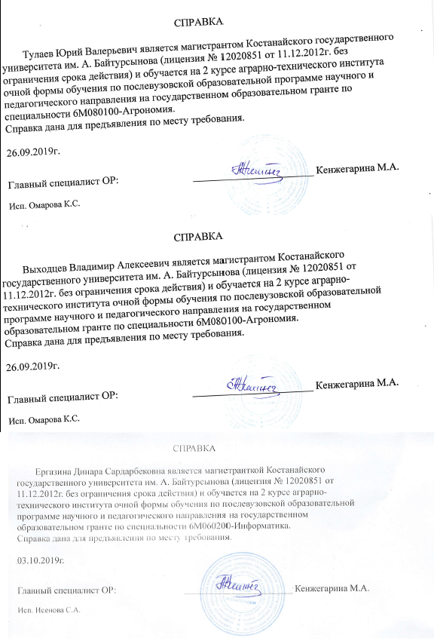
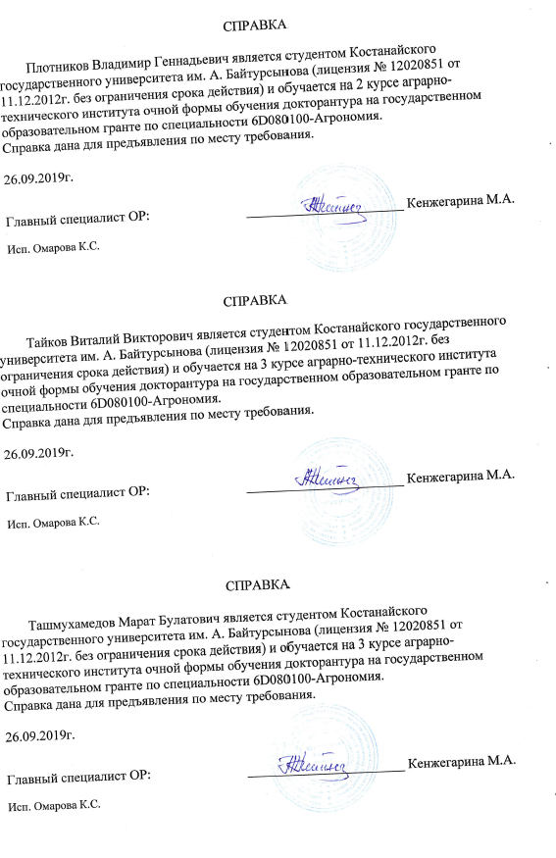










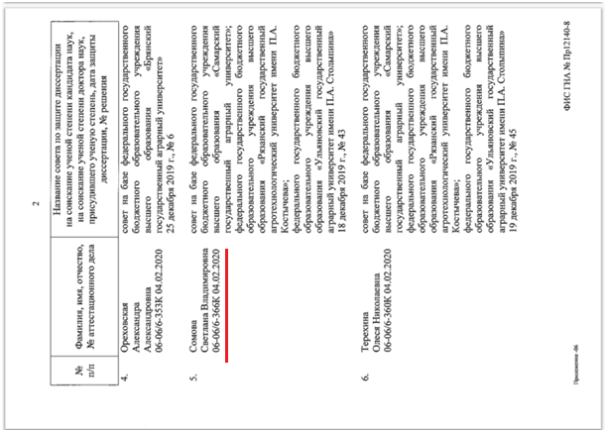

APPENDIX T

Lists of workshop participants, Field Days 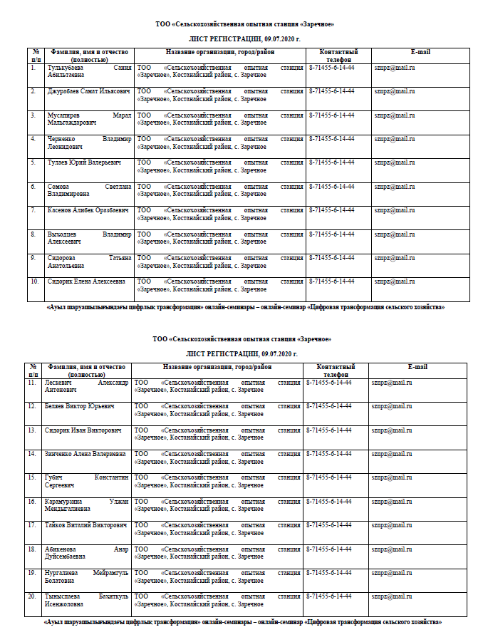

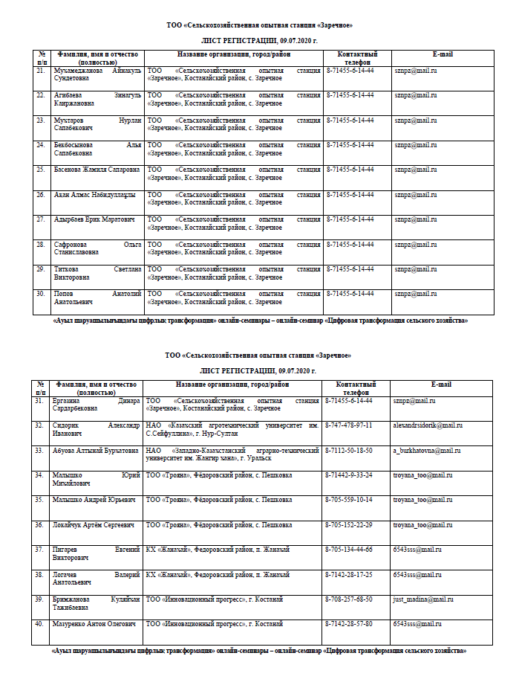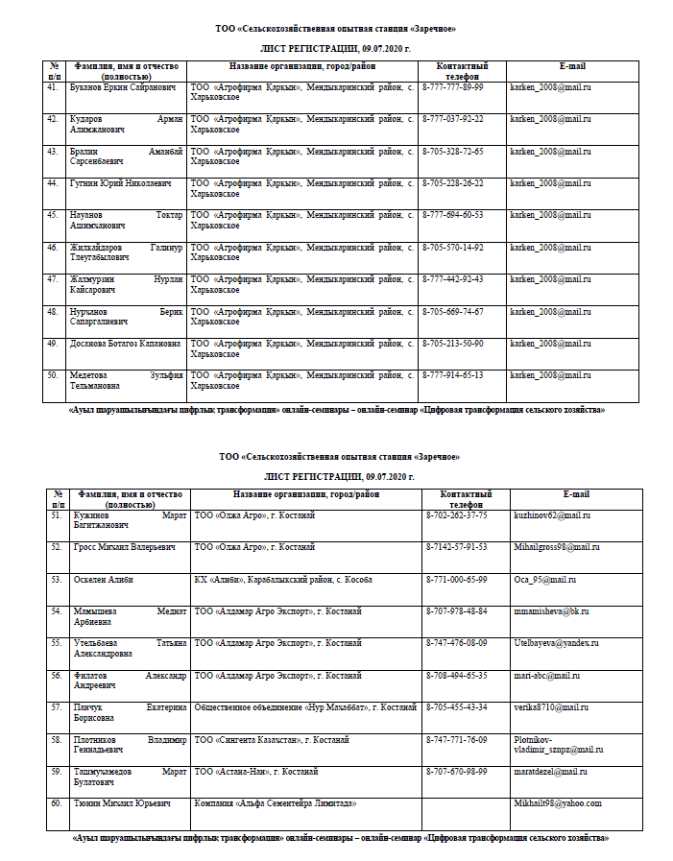
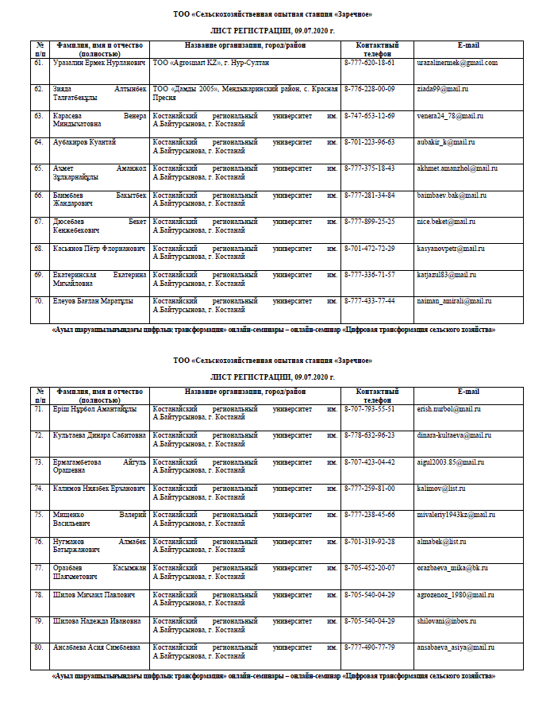
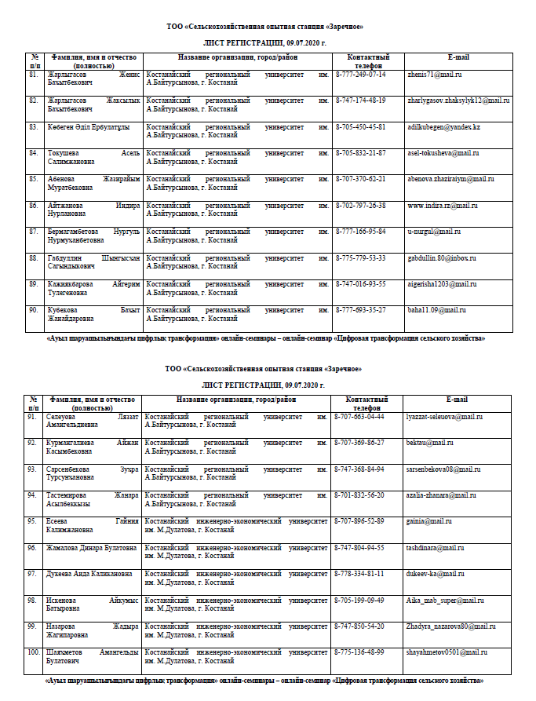
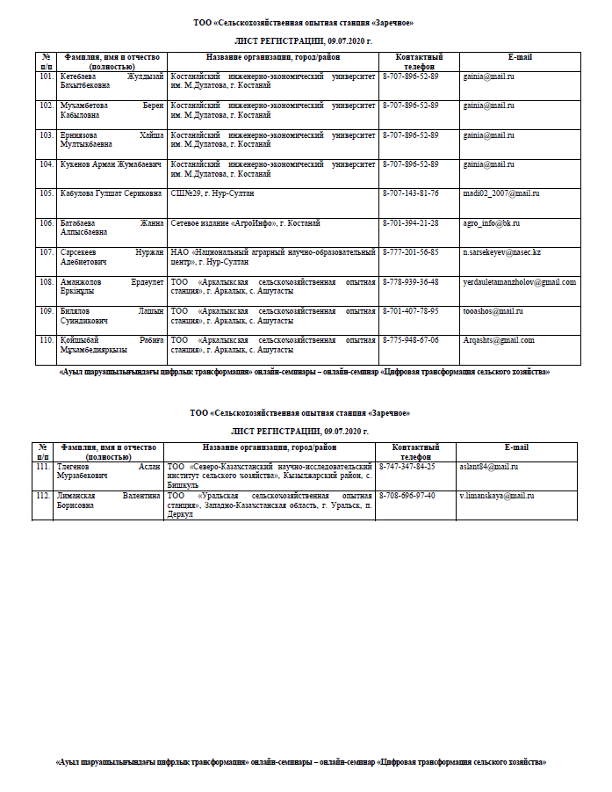
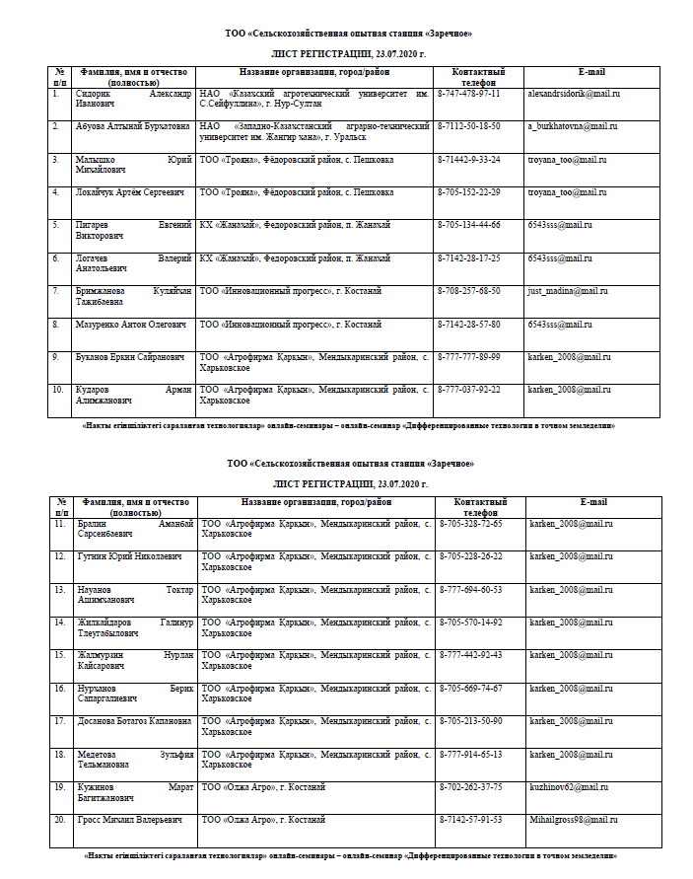
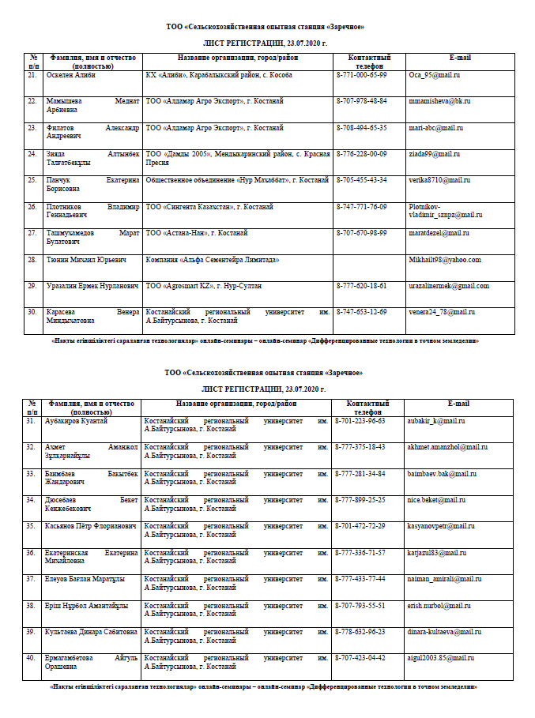
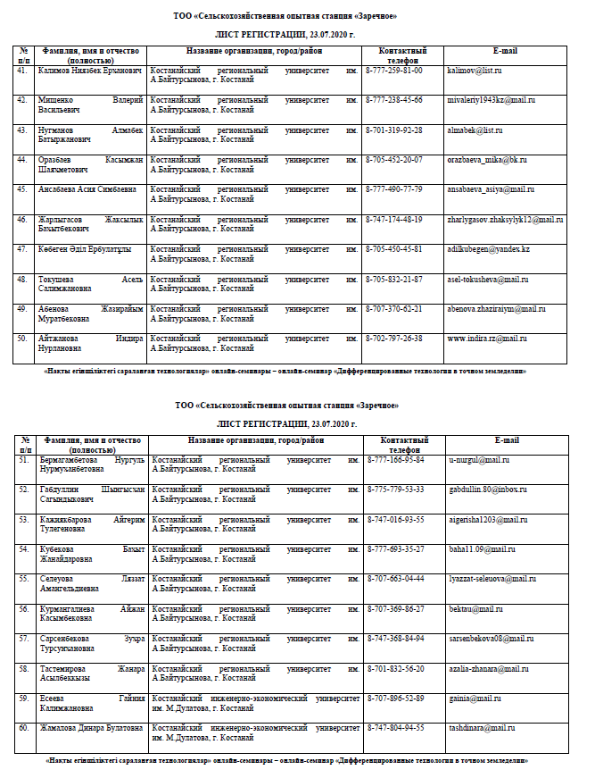
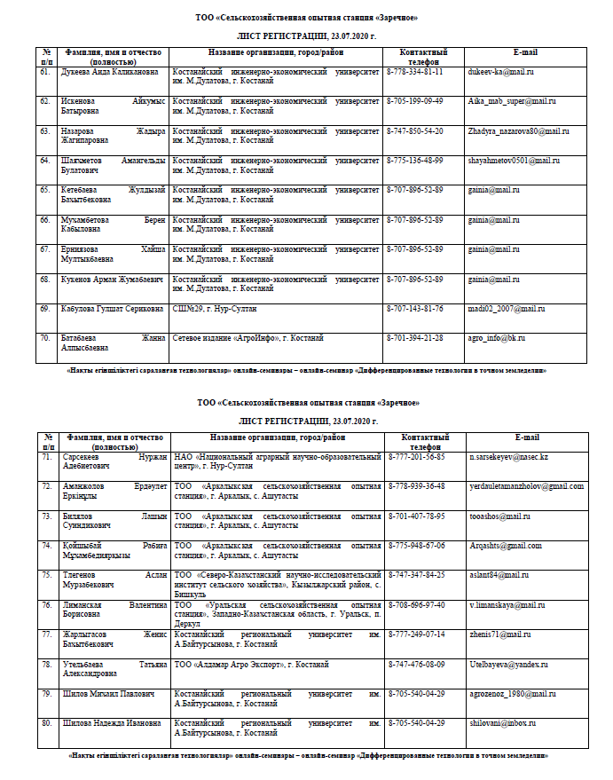
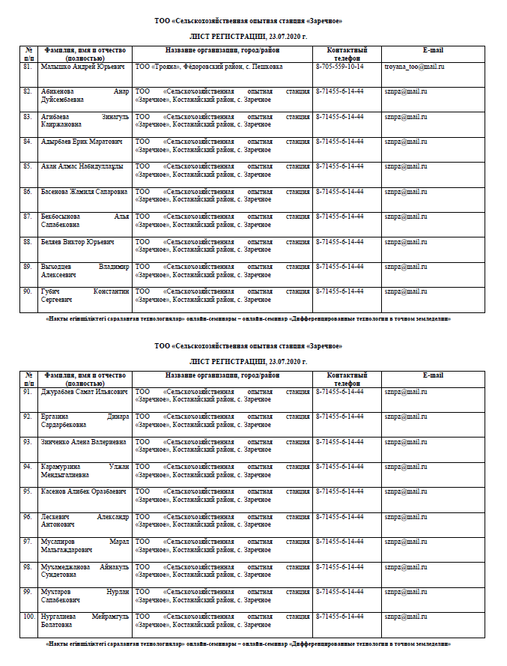
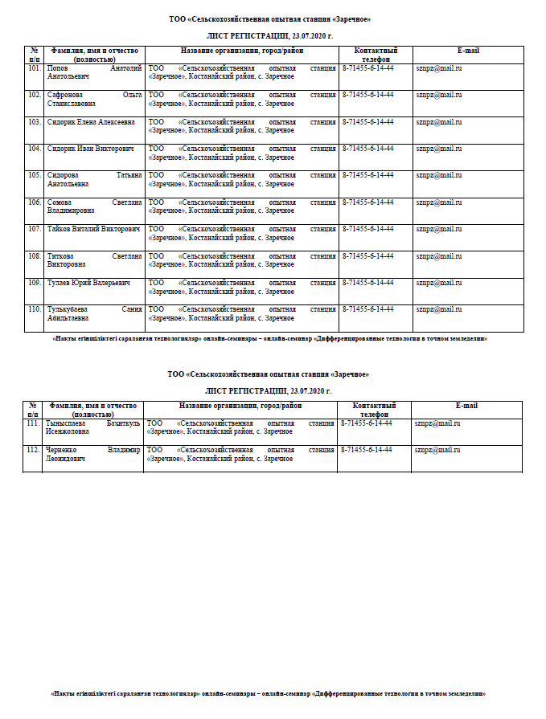
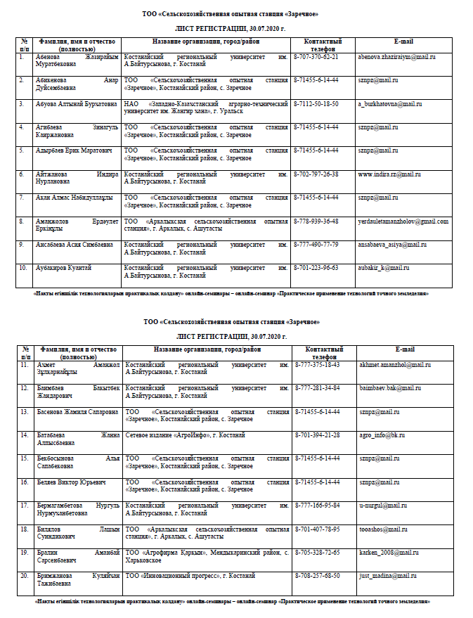
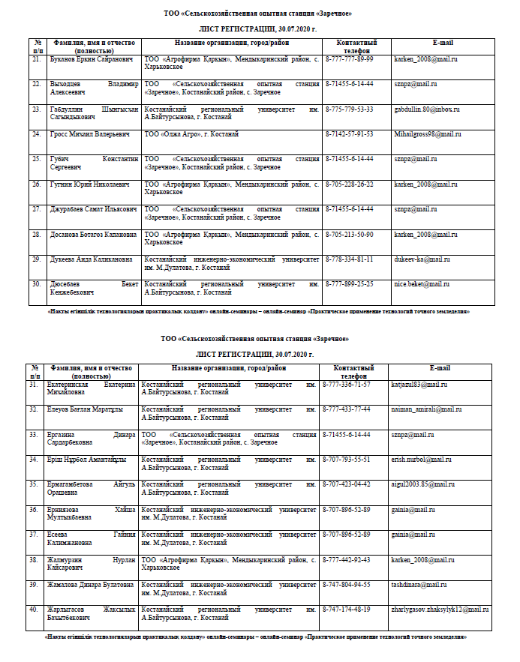
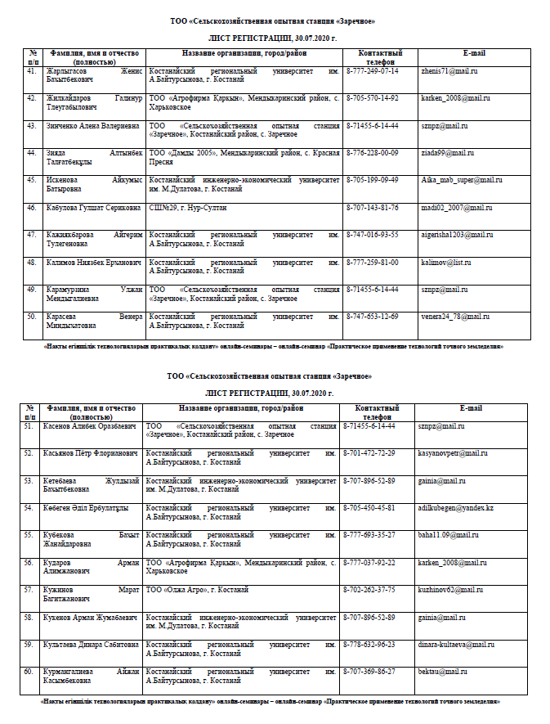
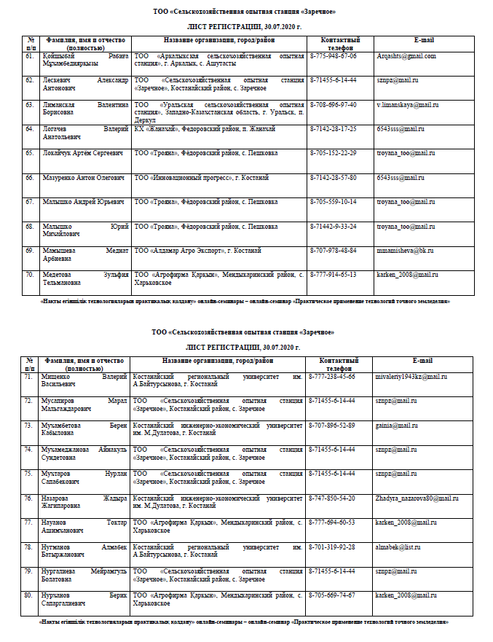
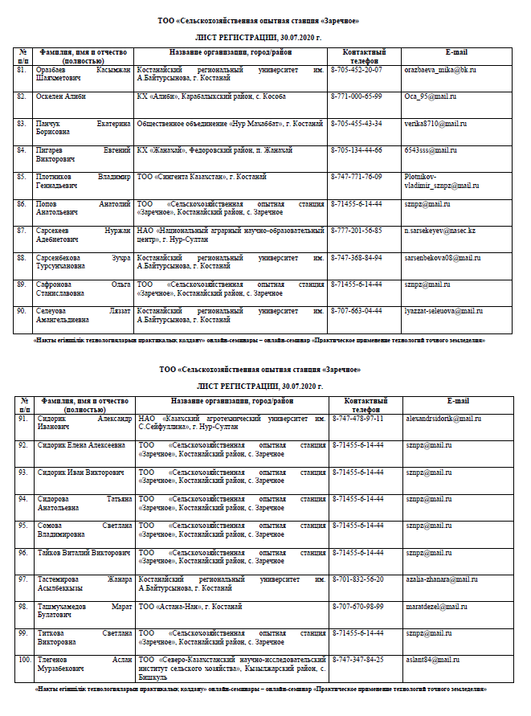
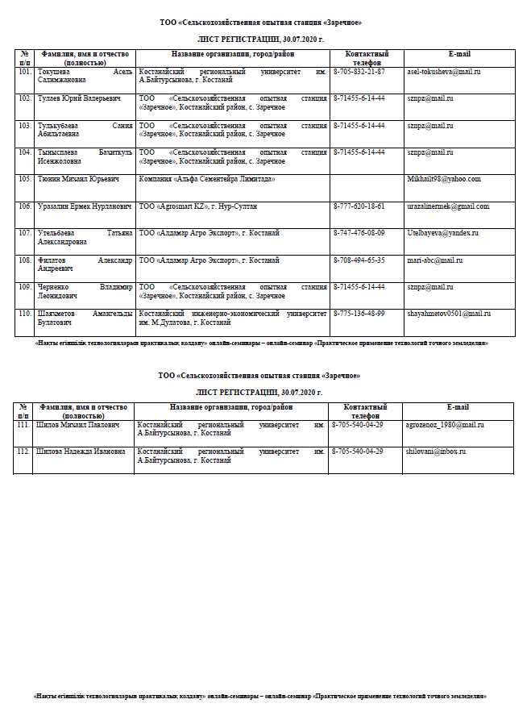

APPENDIX U

Figures
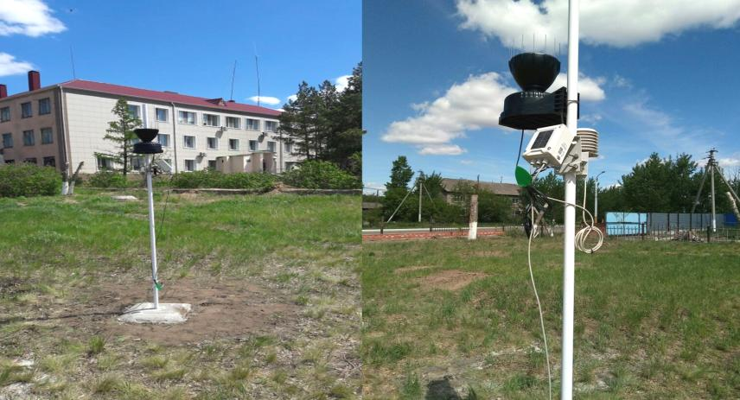
Figure U.1 – In 2018 acquired an autonomous meteorological station for monitoring weather conditions and connecting models for predicting the appearance of diseases

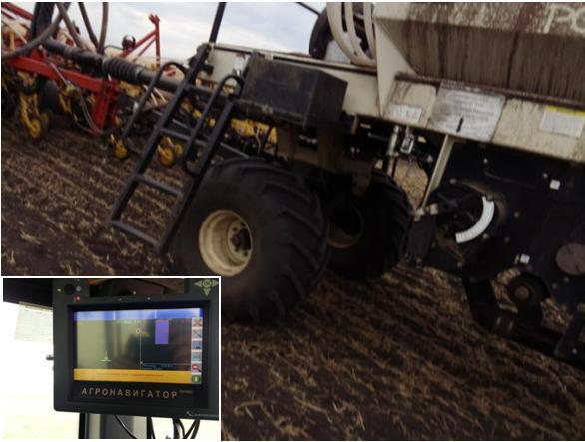
Figure U.2 – Differentiated fertilizer application by the Bourgault (Canada) sowing complex at the landfill

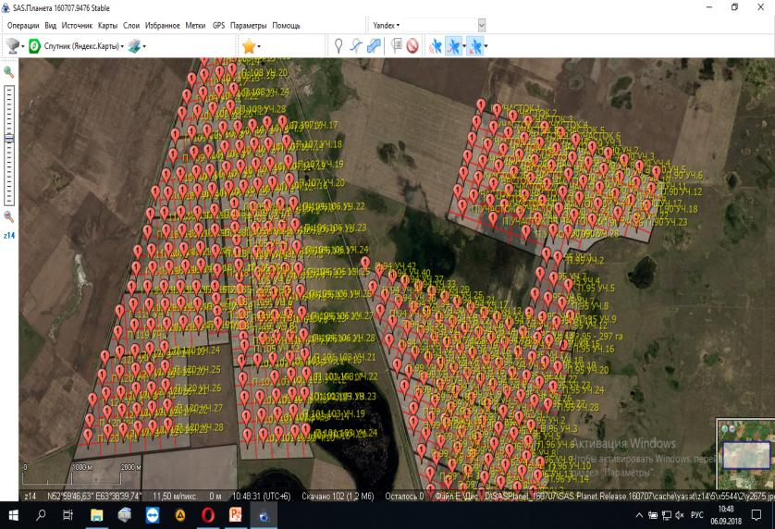
Figure U.3 – On the demonstration plot of the «Zarechnoye» Experimental farm» LLP with an area of 3,800 hectares, the contours of the fields are indicated. Fields are divided into elementary areas of 10 hectares for agrochemical examinations

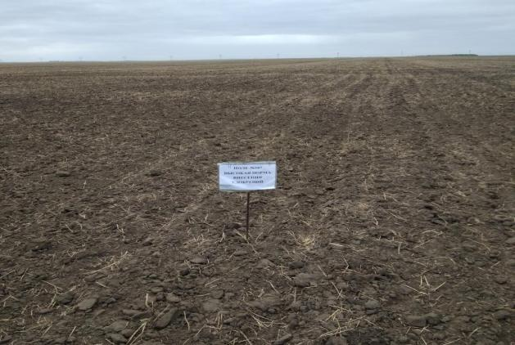
Figure U.4 – Condition of the field №107 after sowing spring wheat

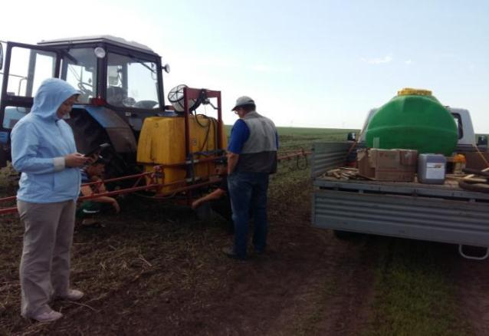 Figure U.5 – Conducting the experiment on the differential application of mineral liquid fertilizer «Strada N»

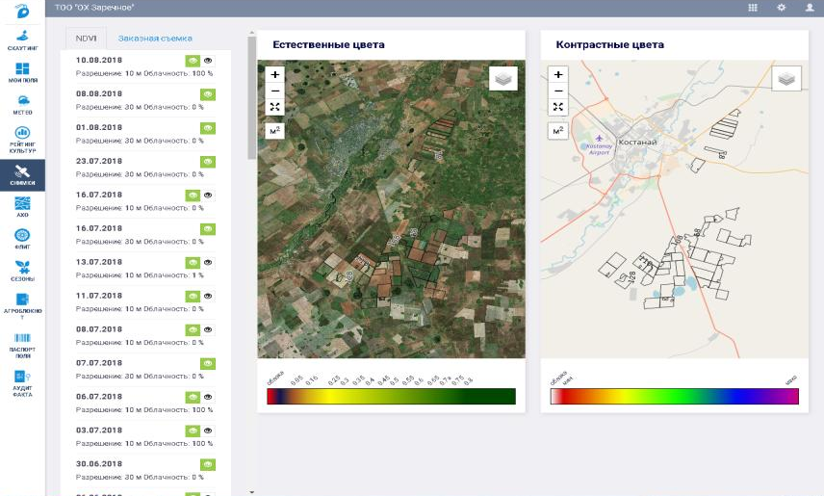
Figure U.6 – Access to the information service «ANT» for control and visualization of the production process of the entire enterprise in a single system in accordance with the map-scheme of on-farm land management

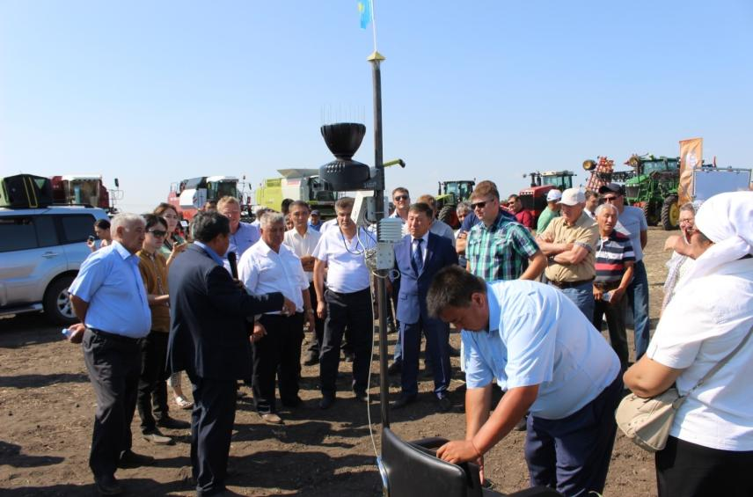
Figure U.7 – July 25, 2018 Field Day on digitization of the agro-industrial complex was held, in which over 60 representatives of agricultural formations took part

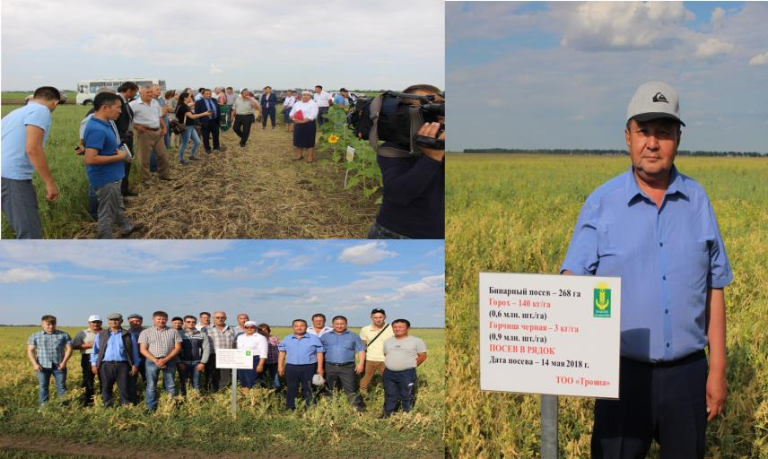
Figure U.8 – August 03, 2018 Field Day was held on the introduction of elements of precision farming in production with departure to the experimental fields and the basic farm of «Troyana» LLP

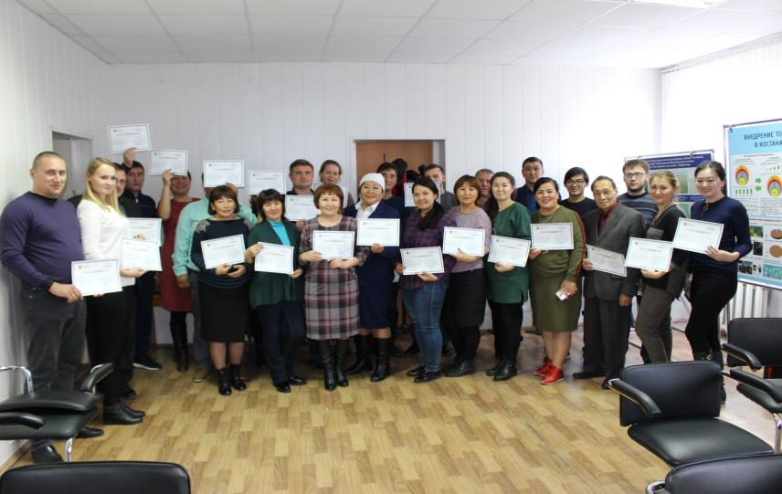
Figure U.9 – October 12, 2018 a training seminar was held on the topic «Innovative technologies of cultivating highly profitable crops, their production for export, measures of state support for agricultural producers»

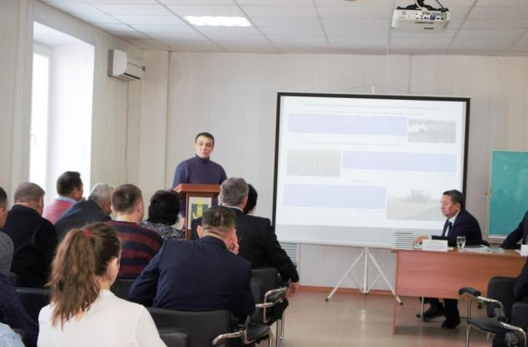
Figure U.10 – Seminar on the theme «Fundamentals of precision farming and detailed management of agricultural land», 10.01.2019
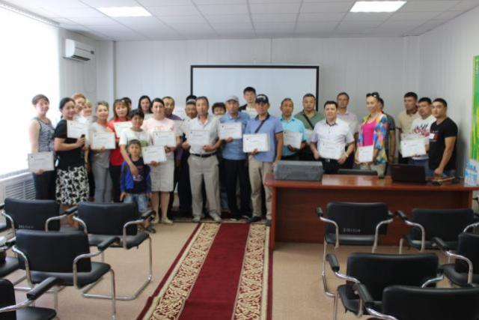
Figure U.11 – Seminar on the topic «Effective conservation technologies for the cultivation of crops», 06.28.2019

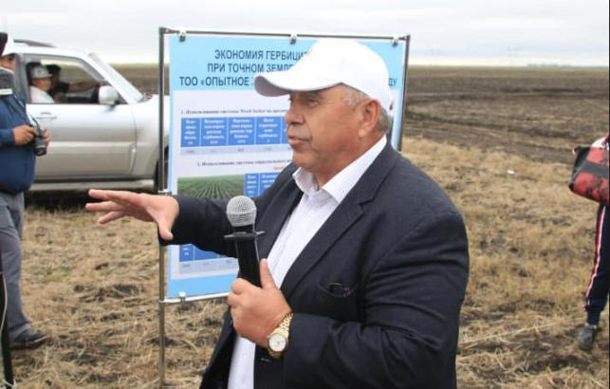 Figure U.12 – Field Day on the basis of «AES «Zarechnoe» LLP for the use of high-performance agricultural equipment and tools with elements of digitalization, diversification of the crop area, 07.03.2019
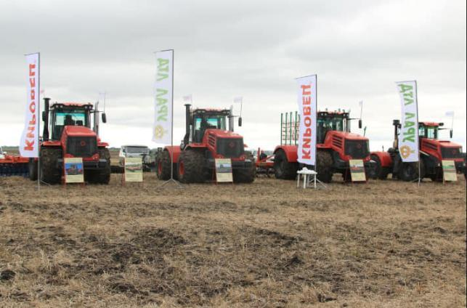 Figure U.13 – Showing high-performance agricultural equipment and tools, 07.03.2019

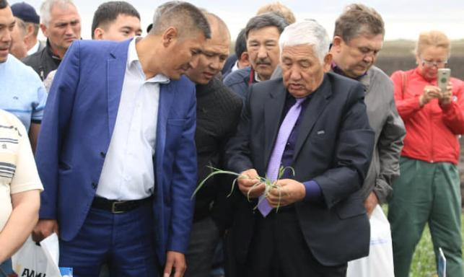Figure U.14 – 220 representatives of agricultural organizations took part in the Field Day, 07.03.2019

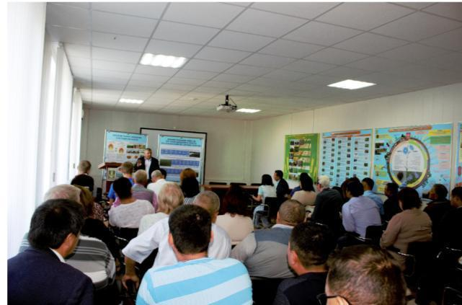Figure U.15 – Field Day (scientific and practical seminar) on the introduction of precision farming elements in the production of the Kostanay region, 08.09.2019

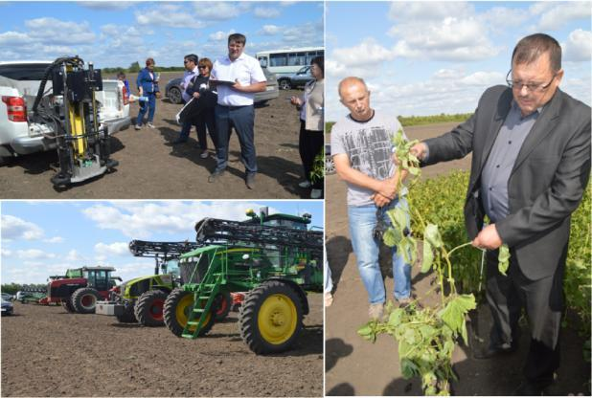
Figure U.16 – Demonstration of crops, agricultural machinery and equipment for precision farming, 08.09.2019
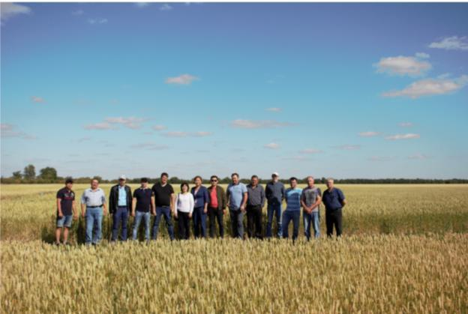
Figure U.17 – Visit the base farm «Troyana» LLP, 08.09.2019

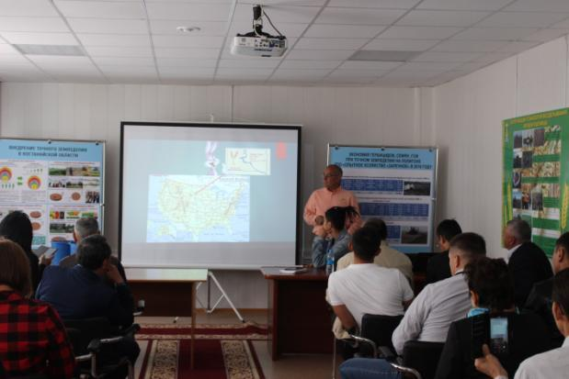
Figure U.18 – Seminar on the topic «Foreign experience in the application of innovative technologies: direct sowing and elements of precision farming». Lecturer: Rick Bieber – farmer, international expert on the development of direct sowing technology, director of the association «No-Till on the Plains», 16.09.2019
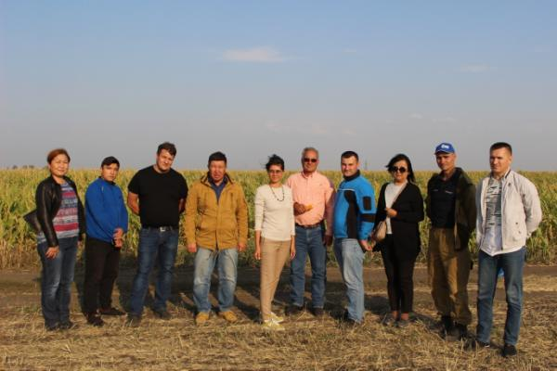
Figure U.19 – Visit the base farm «Agrofirma Karkyn» LLP, 16.09.2019

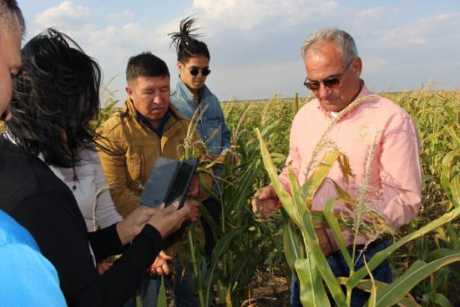
Figure U.20 – Foreign expert Rick Bieber advises farmers on the cultivation of agricultural crops cultures, 09.16.2019

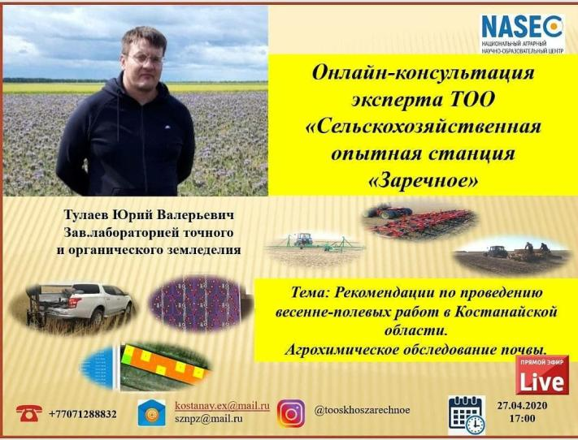
Figure U.21 – Online a seminar on "Recommendations on carrying out spring and field works in Kostanay region. Agrochemical examination of soil", 27.04.2020

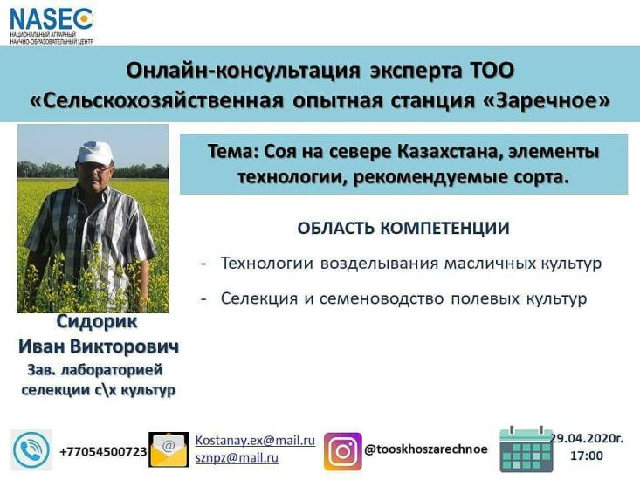
Figure U.22 – Online seminar on "Soy in the North of Kazakhstan, technology elements, recommended varieties", 29.04.2020

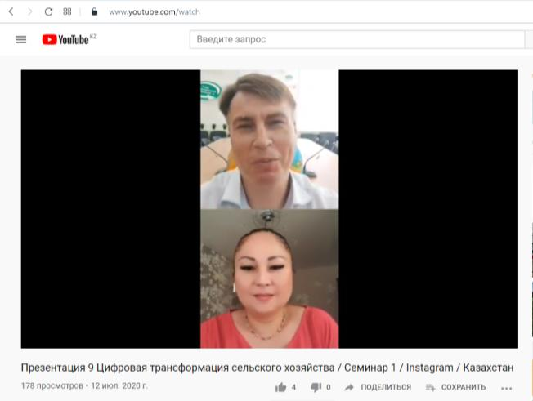
Figure U.23 – Online seminar on "Digital transformation of agriculture" with the involvement of a foreign expert – Doctor of Technical Sciences, Professor Truflyak E.V., 09.07.2020 (https://www.youtube.com/watch?v=RkTIh6OvAw0)

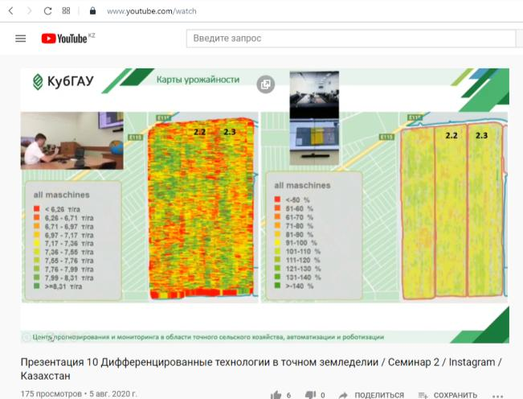
Figure U.24 – Online seminar on "Differentiated technologies in precision agriculture" with the involvement of a foreign expert – Doctor of Technical Sciences, Professor Truflyak E.V., 23.07.2020 (https://www.youtube.com/watch?v=y9hbITy6Mnk)

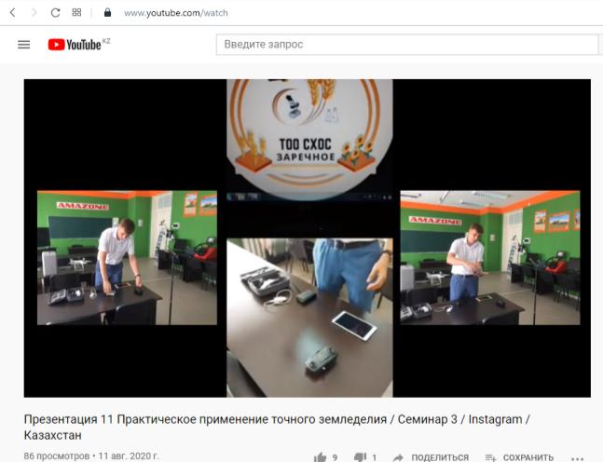
Figure U.25 – Online seminar on "Practical application of precision farming technologies" with the involvement of a foreign expert – Doctor of Technical Sciences, Professor Truflyak E.V., 30.07.2020 (https://www.youtube.com/watch?v=BxrsoC0VGok)

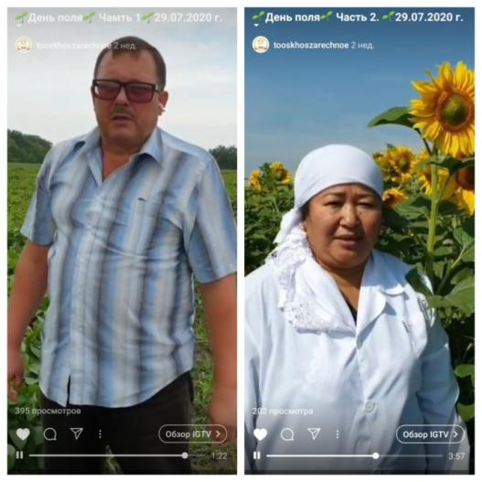
Figure U.26 – Field Day in online format based on the results of selection and environmental testing of oilseeds (spring rape, soy, oilseed flax, sunflower), 29.07.2020

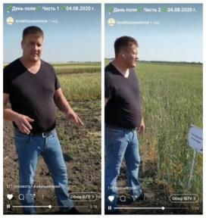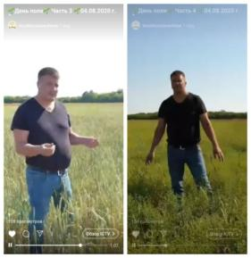
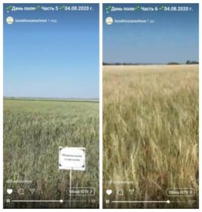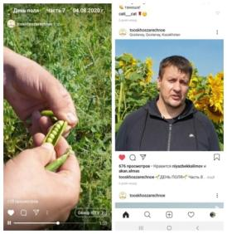
Figure U.27 – Field Day in online format at the scientific hospital for research on precision, conservation and organic farming, 04.08.2020
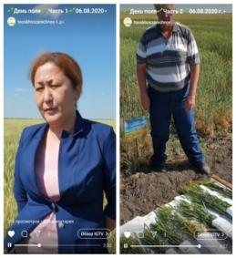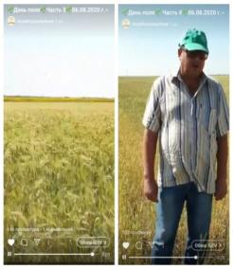
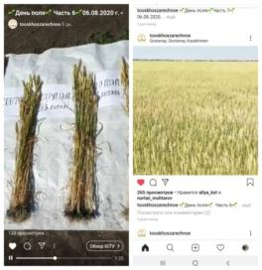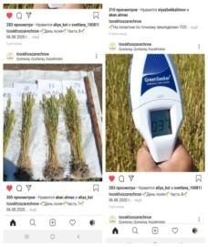
Figure U.28 – Field Day in online format on the basis of the production and demonstration polygon for precision farming of «AES «Zarechnoe» LLP, 06.08.2020

APPENDIX P
Foreign internships and training






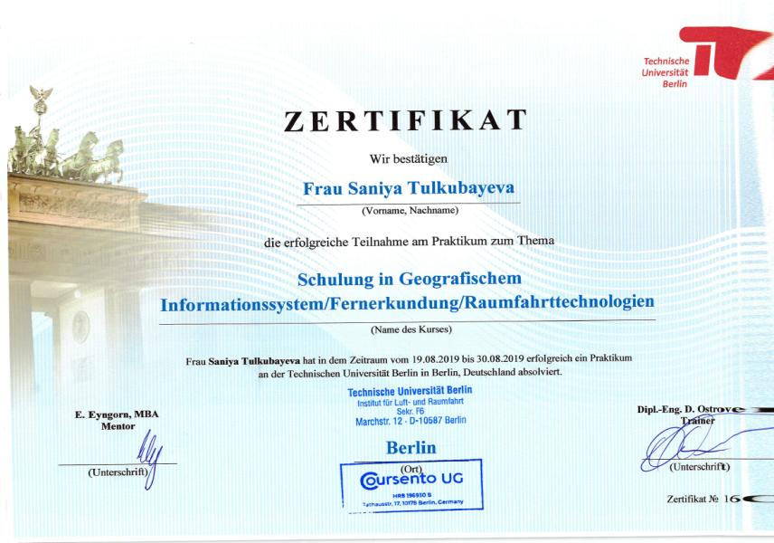
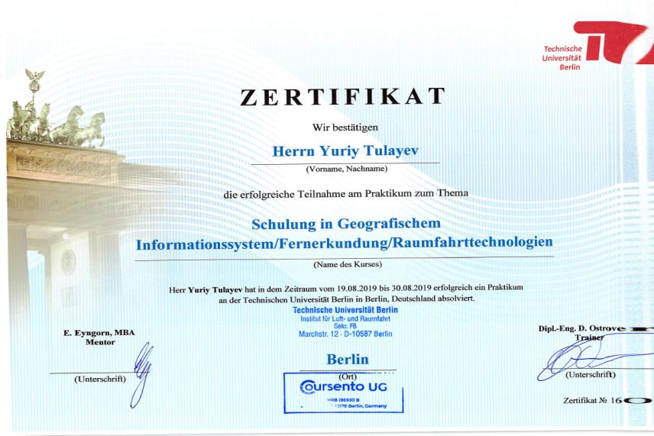

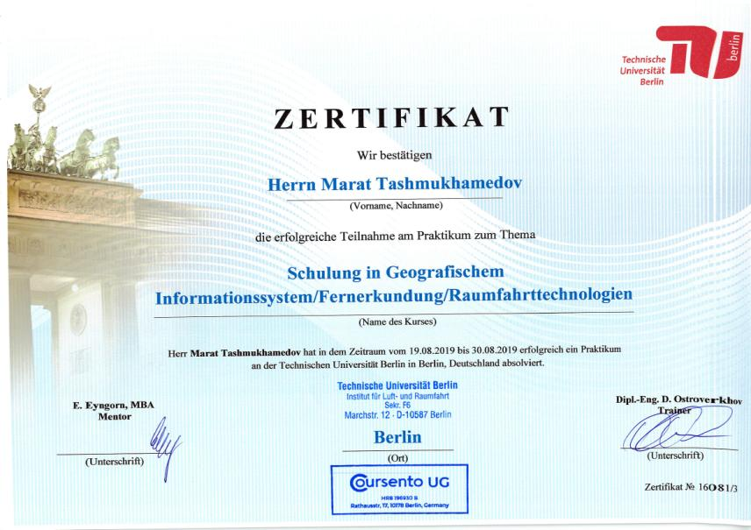
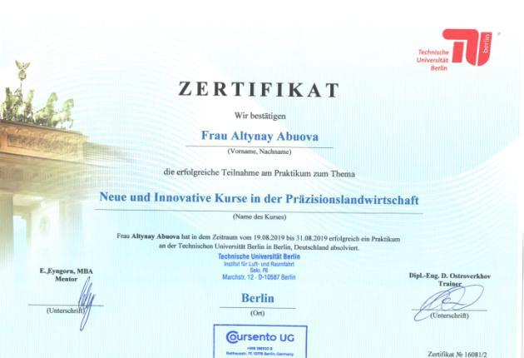

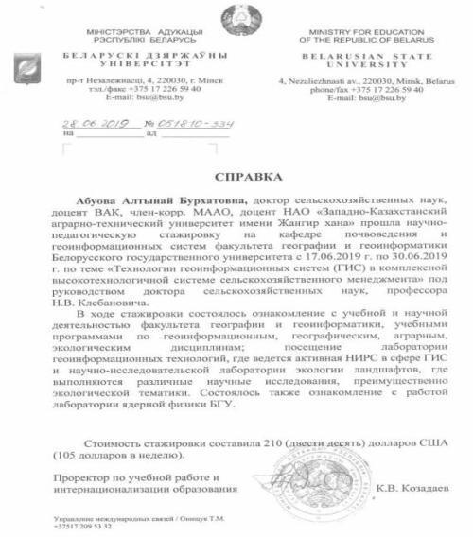
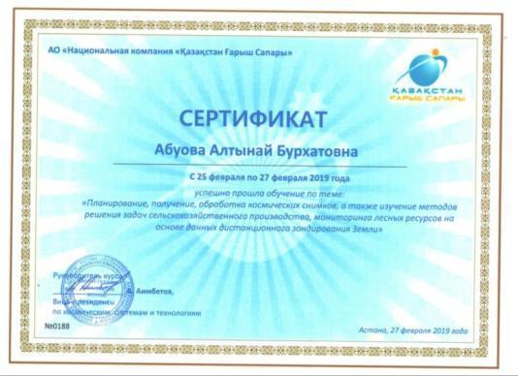
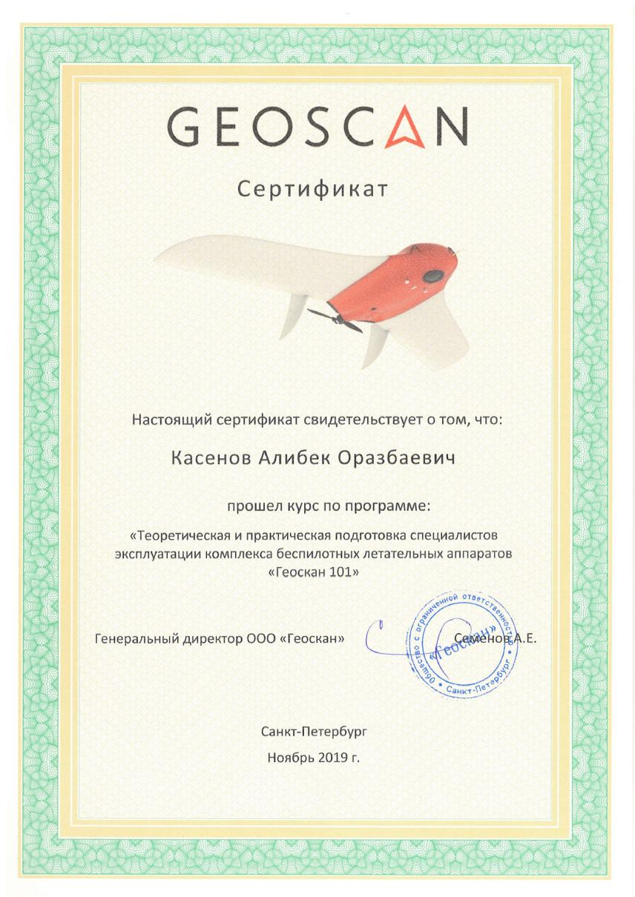
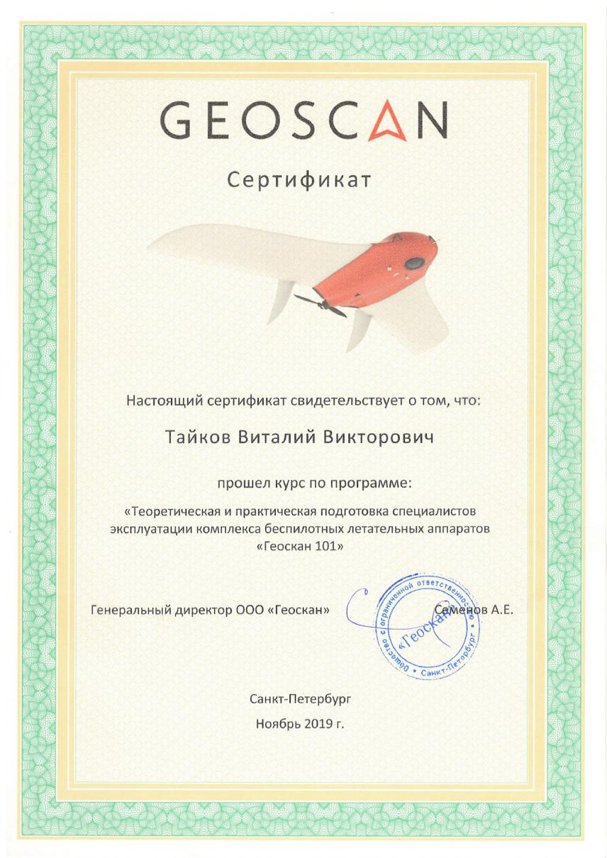
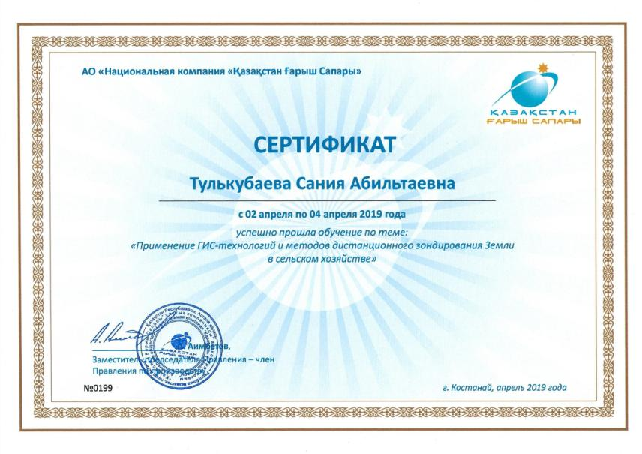
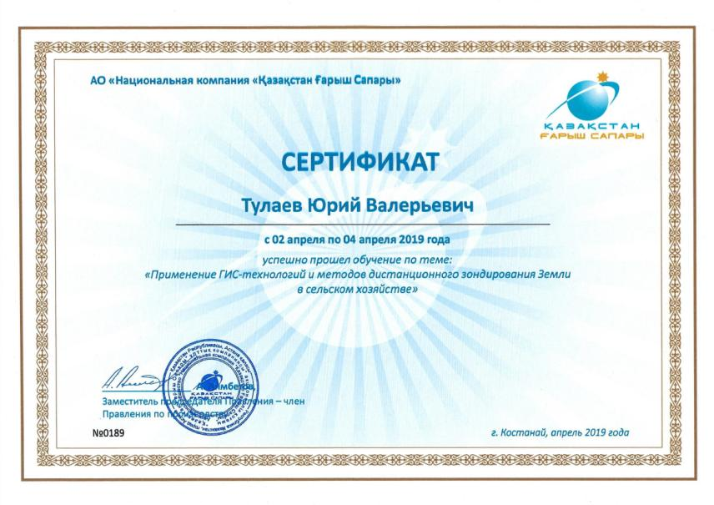

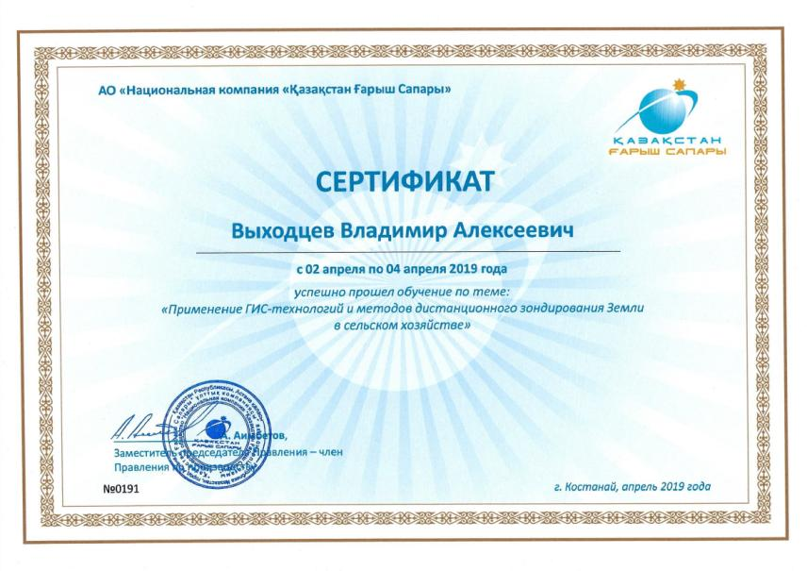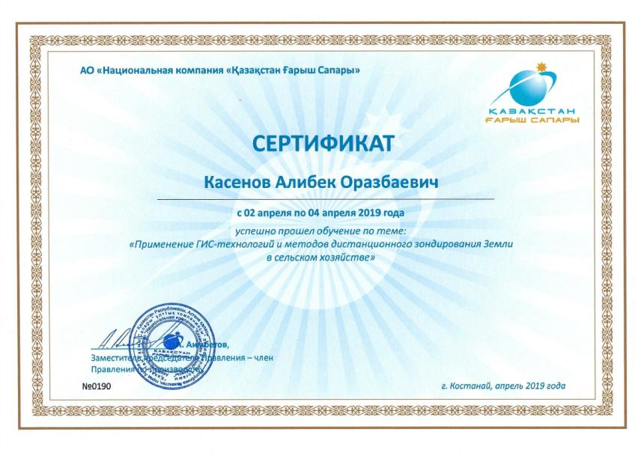
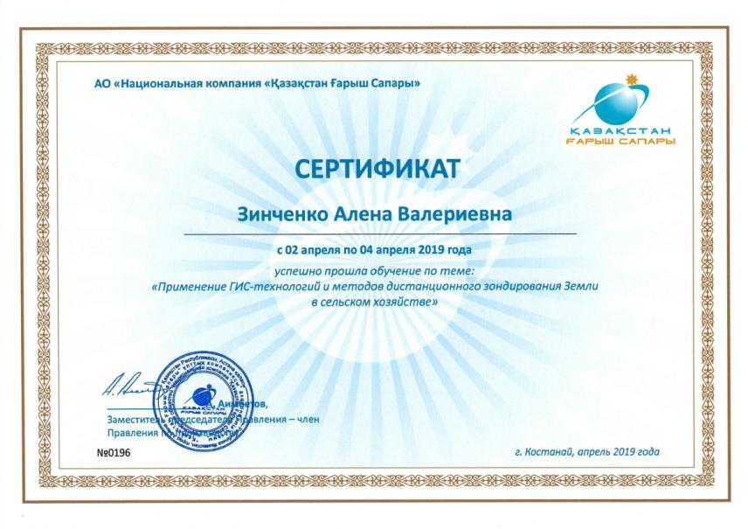
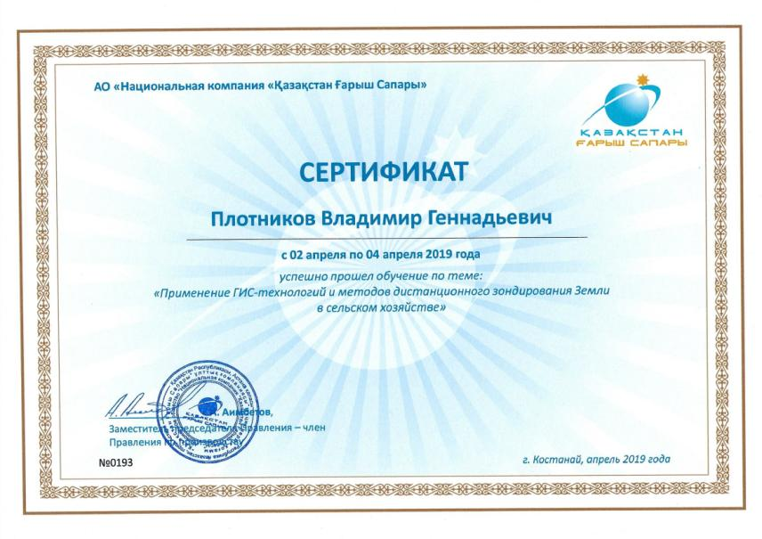
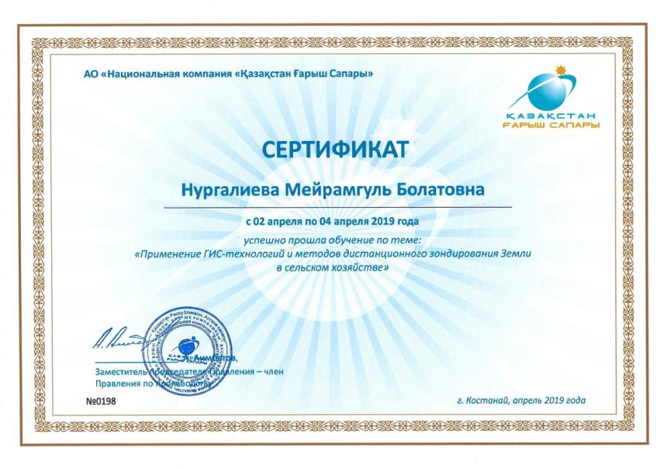
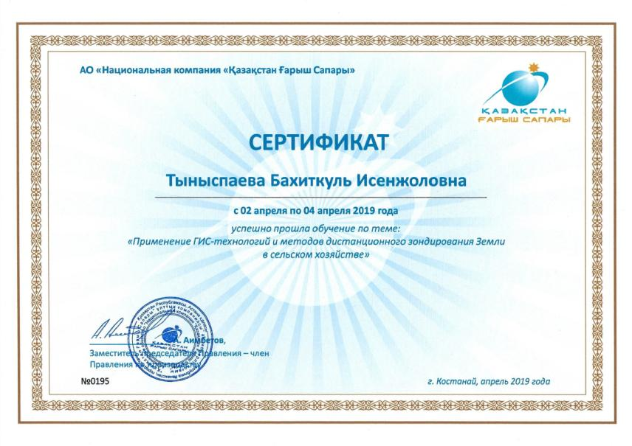
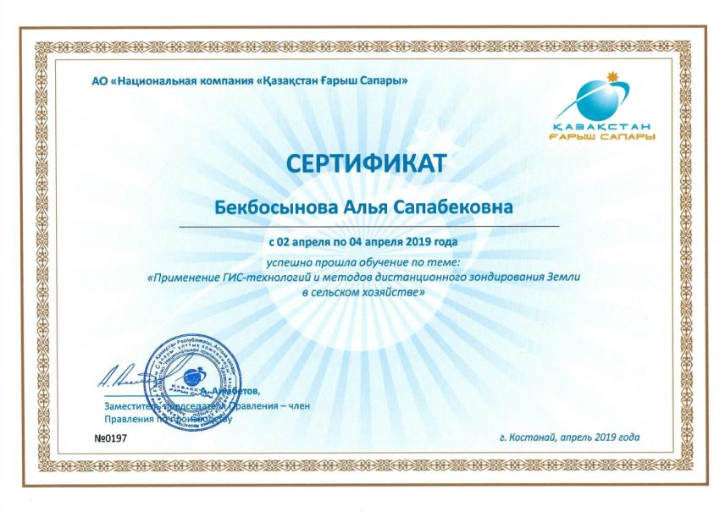
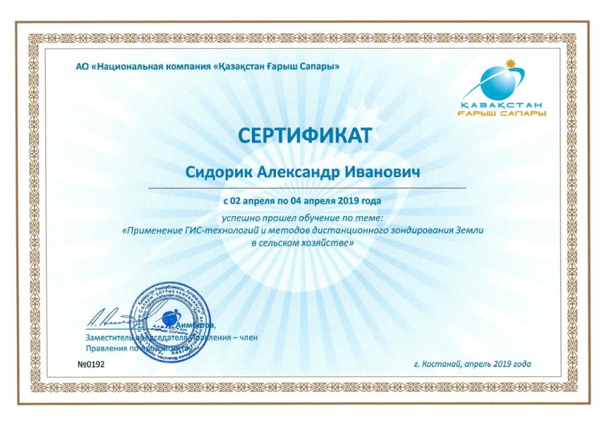

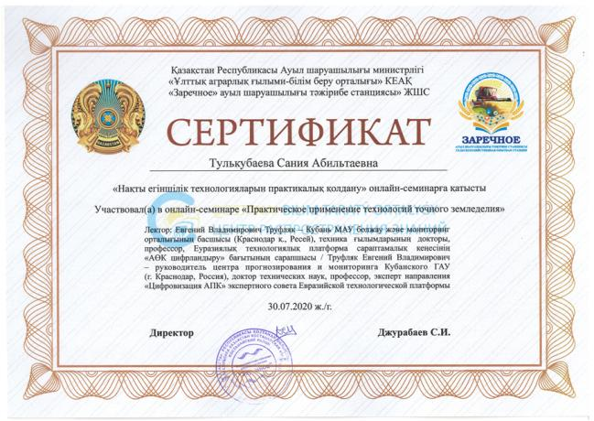


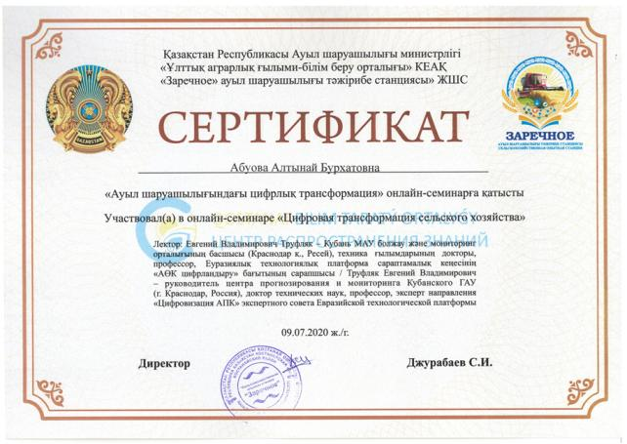


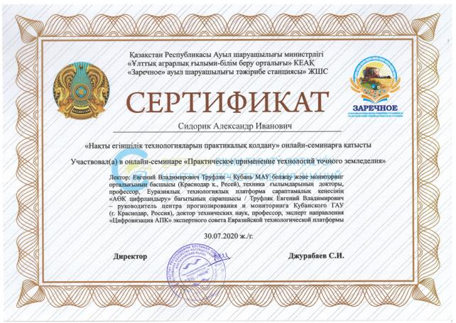


APPENDIX W

Application for the grant of a patent of the Republic of Kazakhstan, notification of a positive examination result
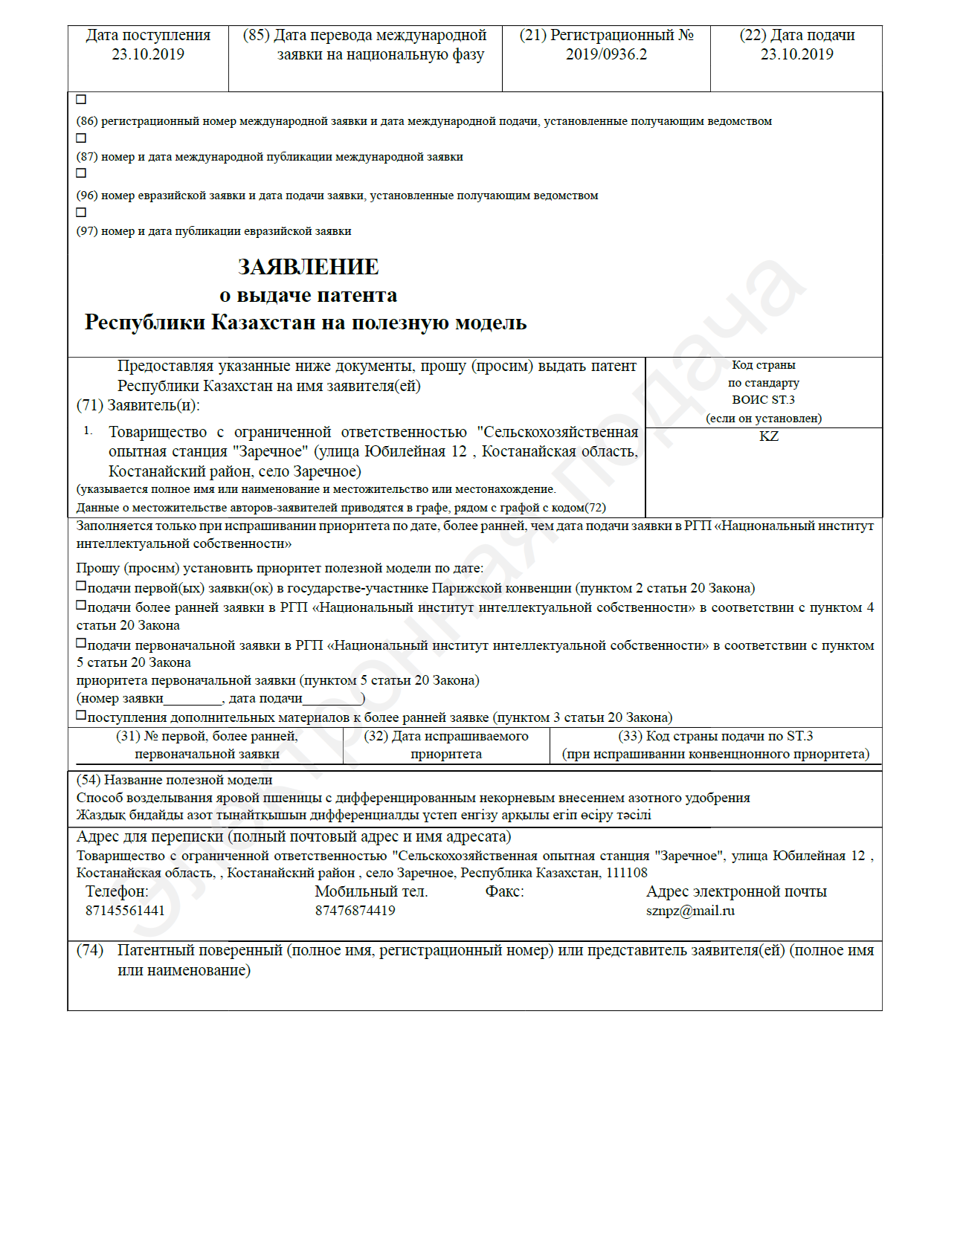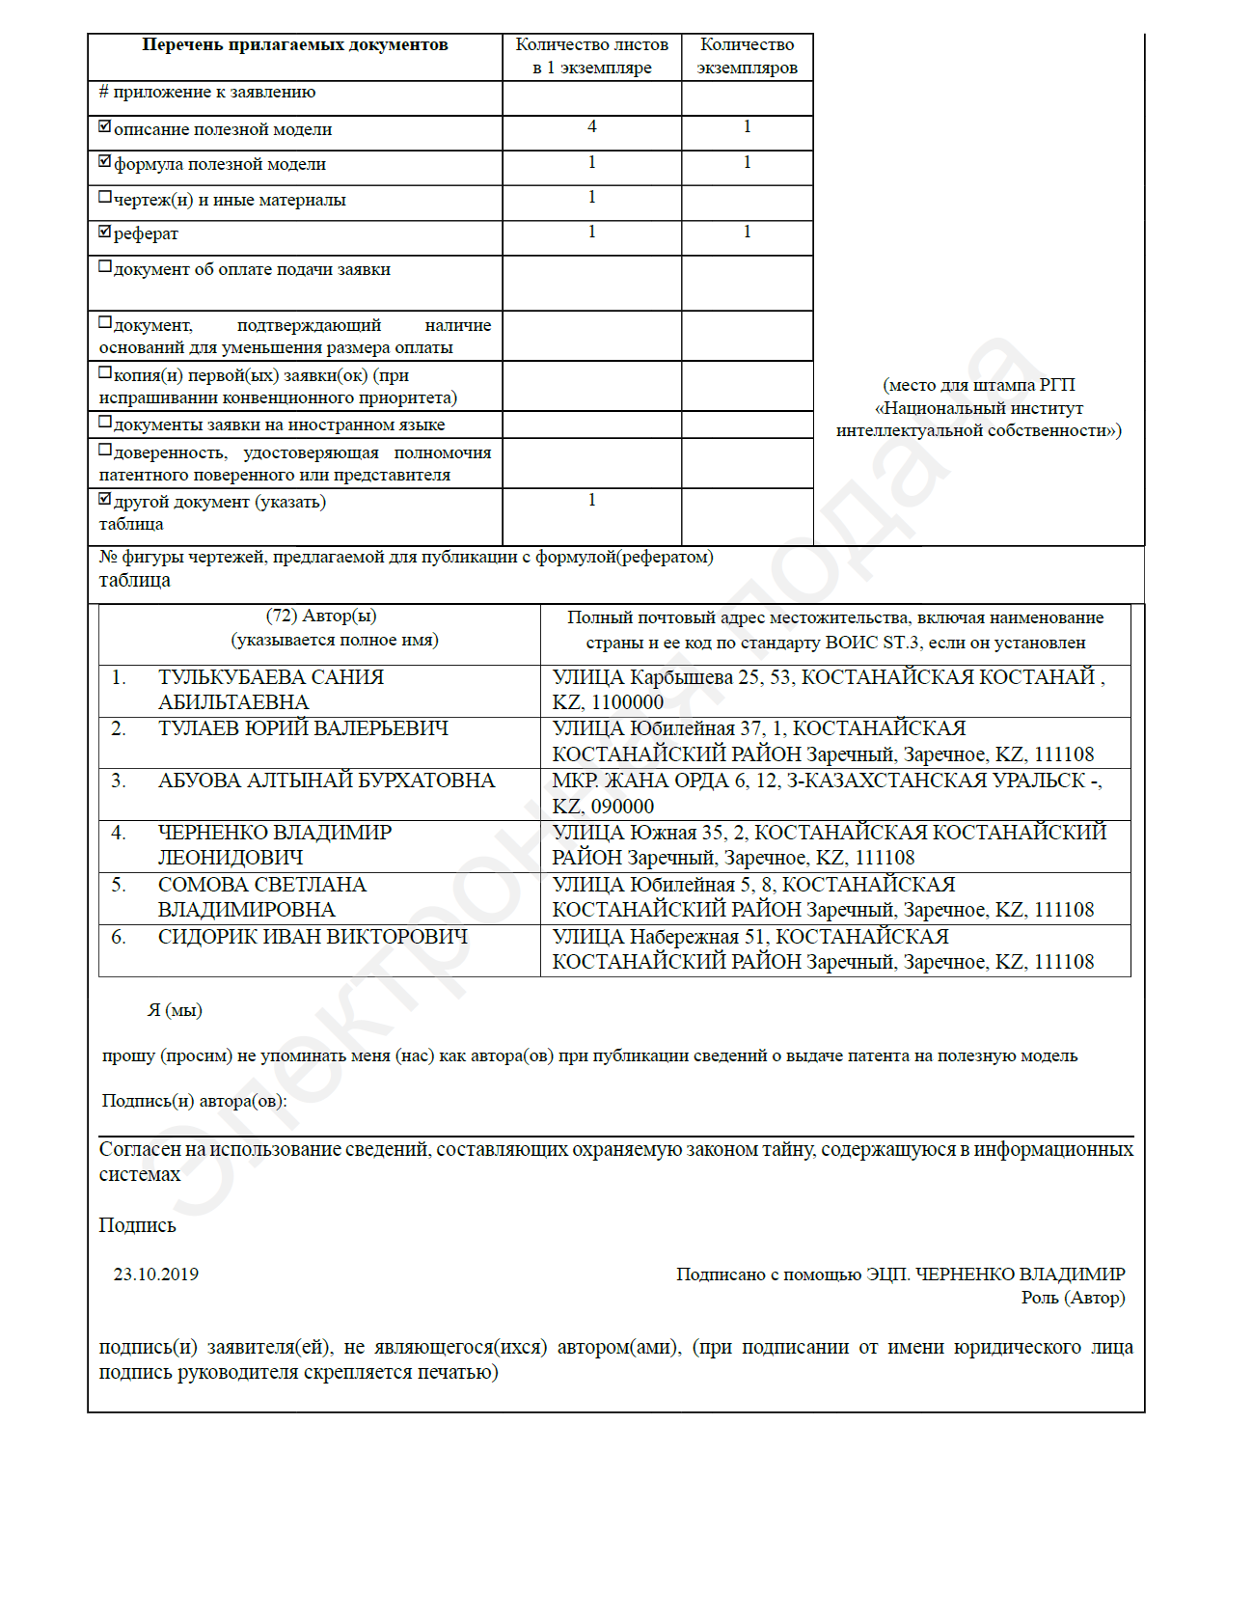

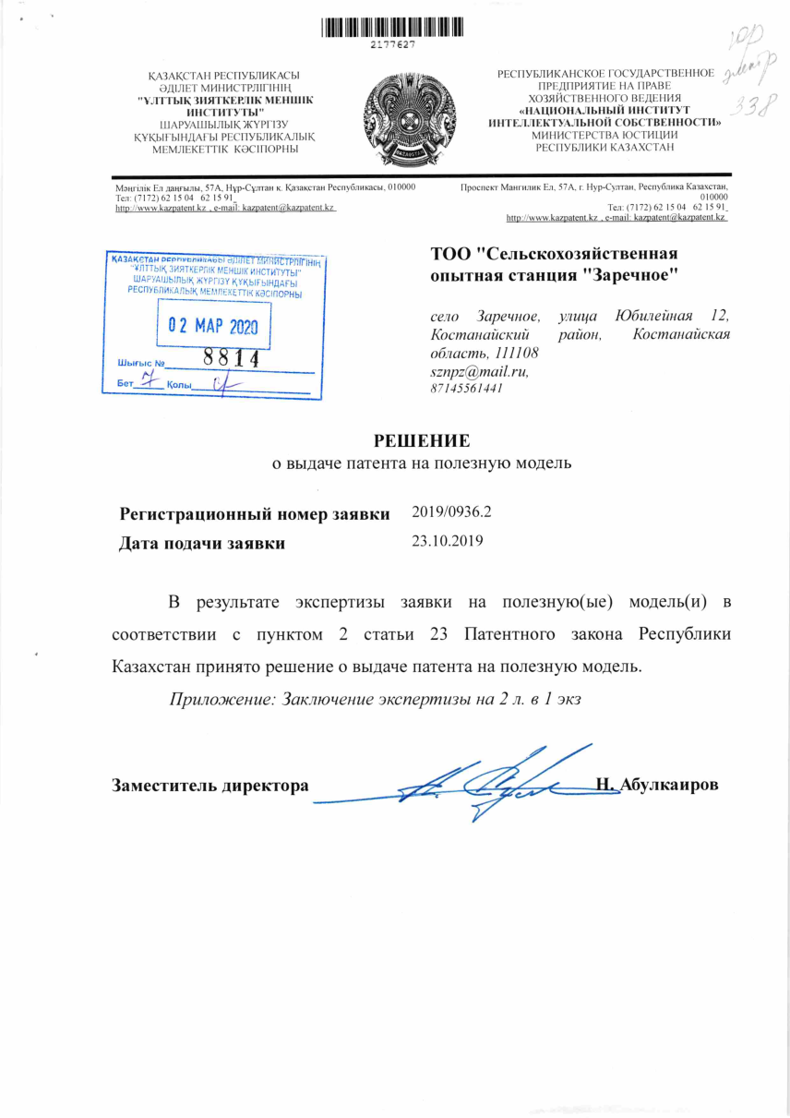
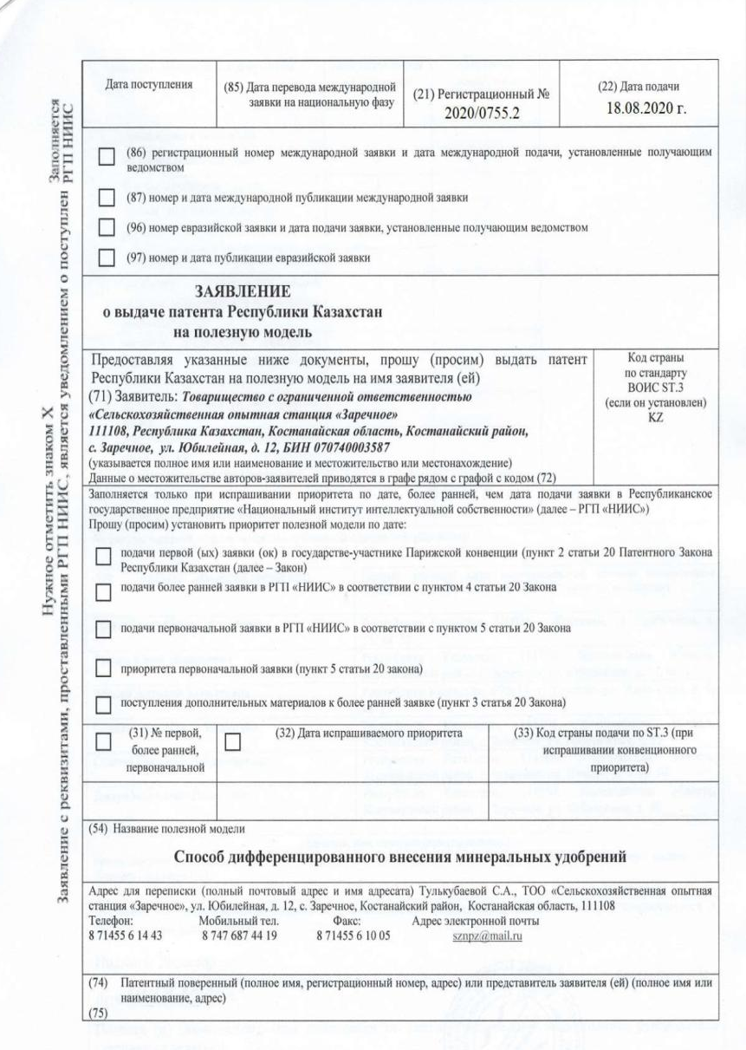

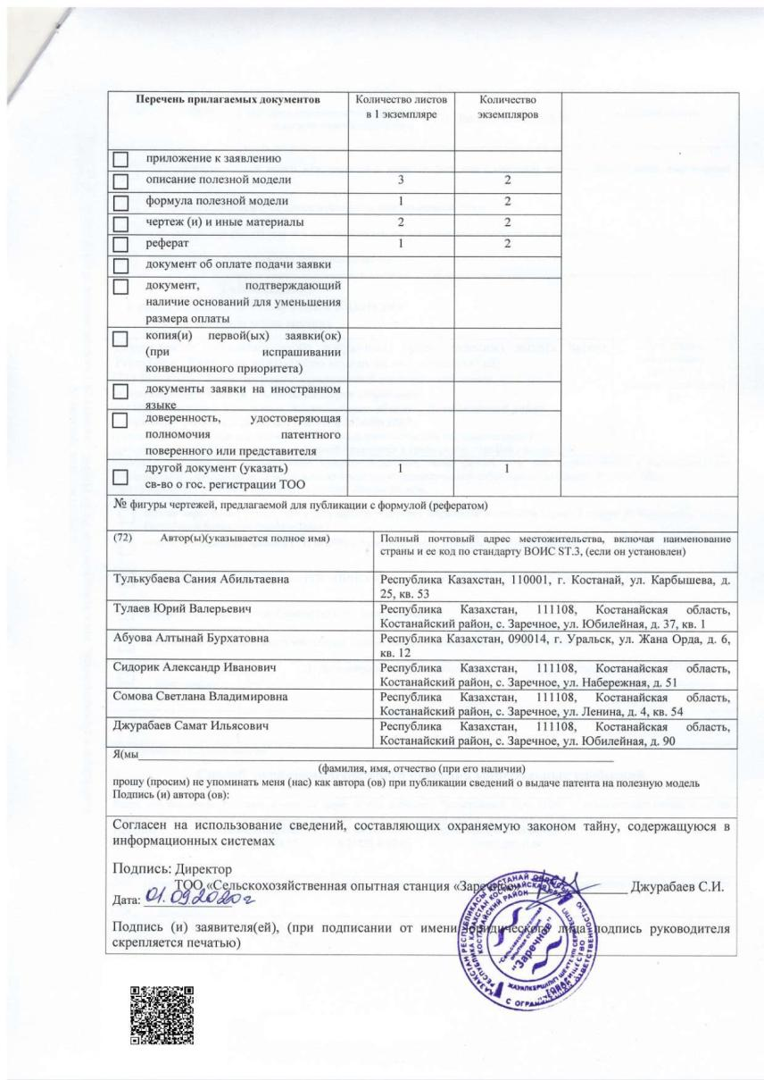

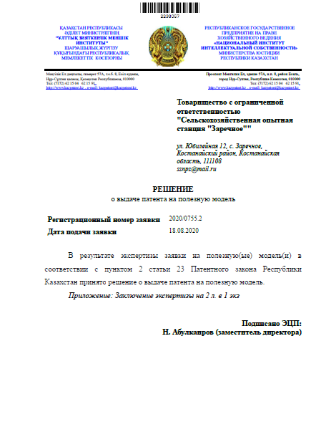
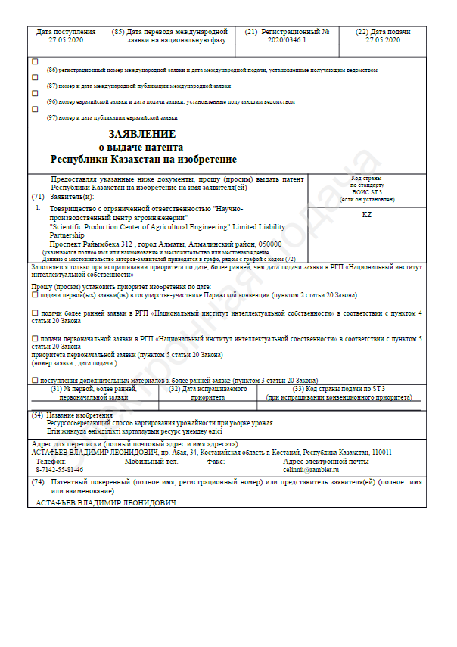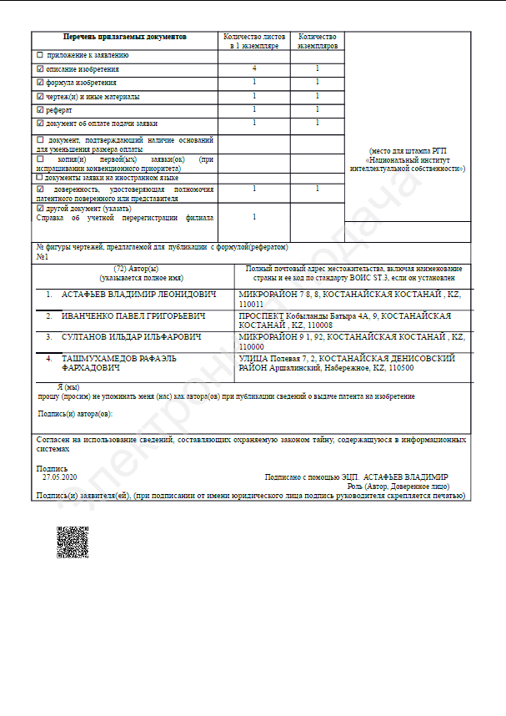
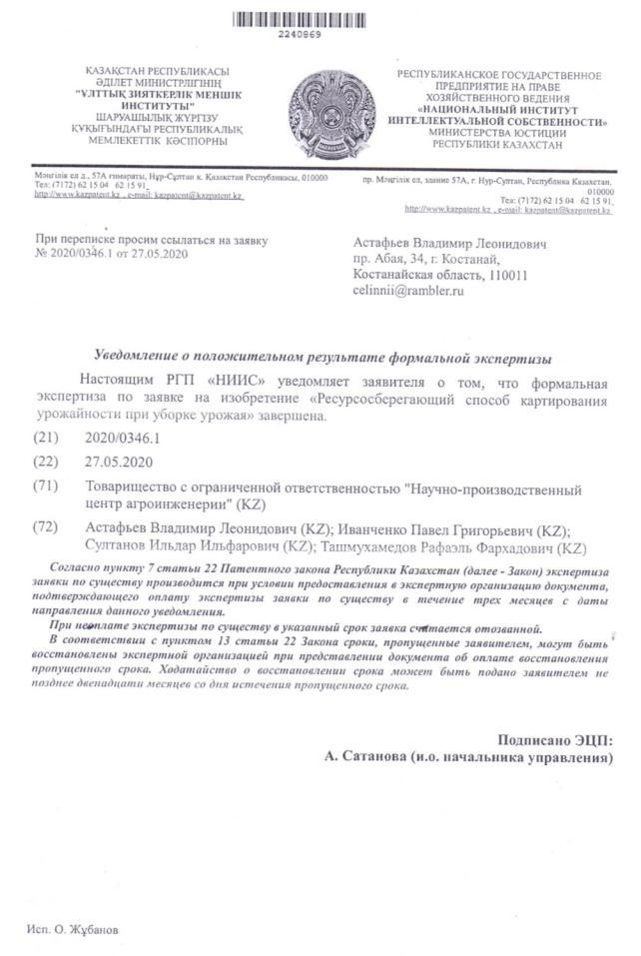
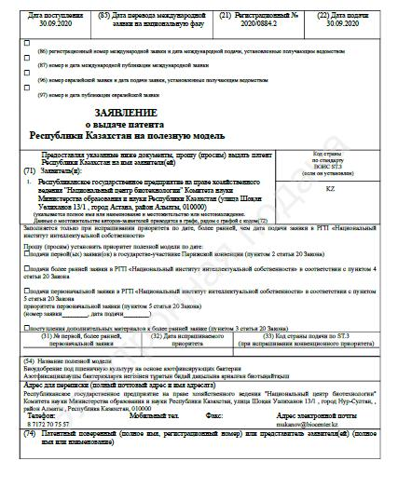

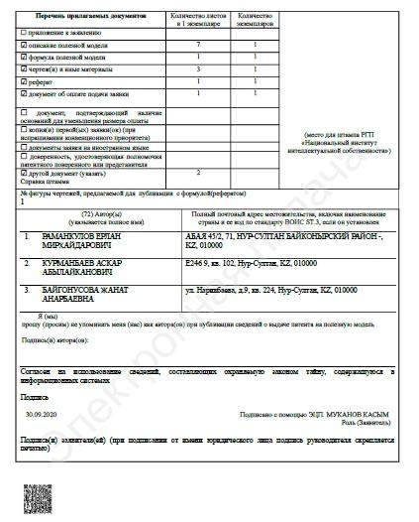
APPENDIX X

Study guide, recommendations
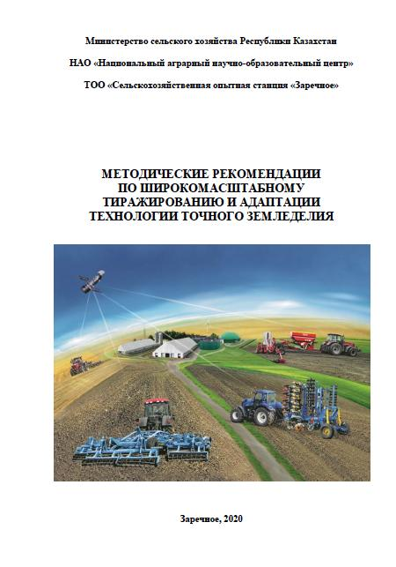
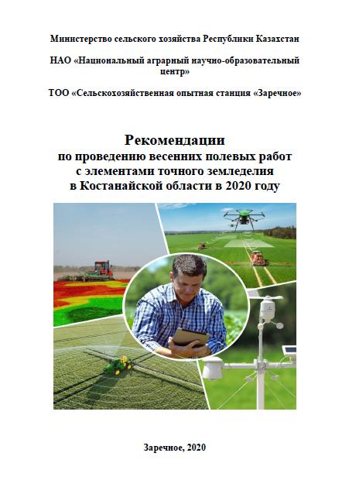
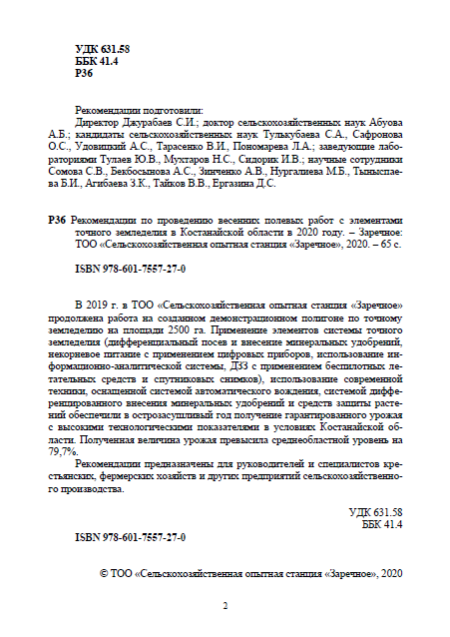
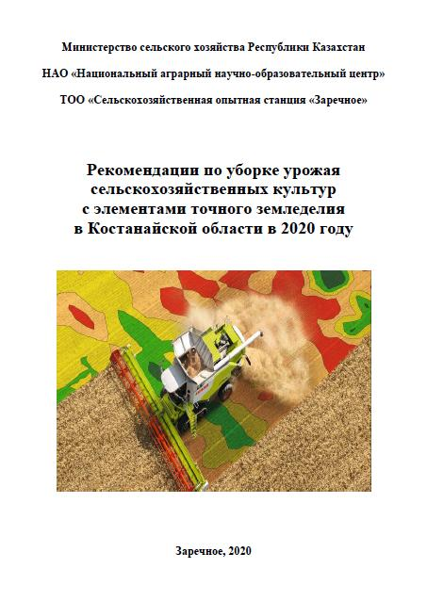
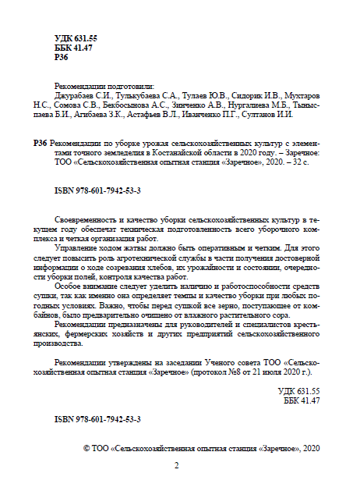
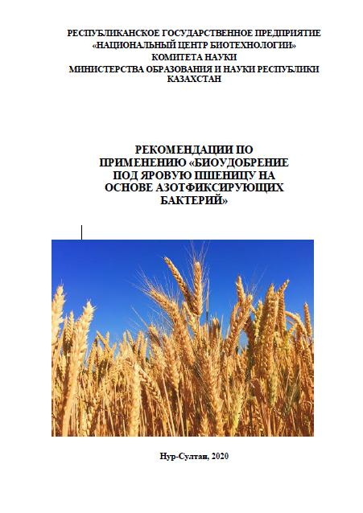
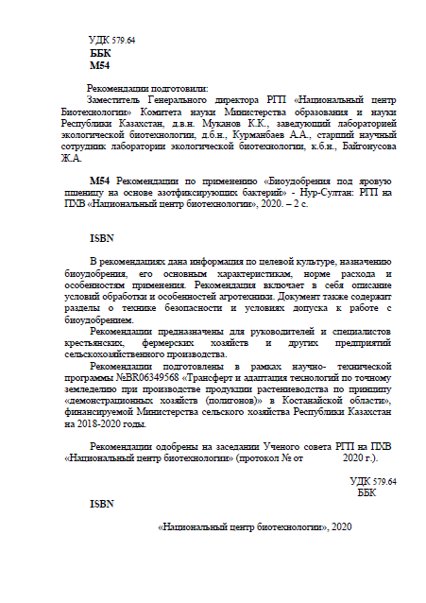
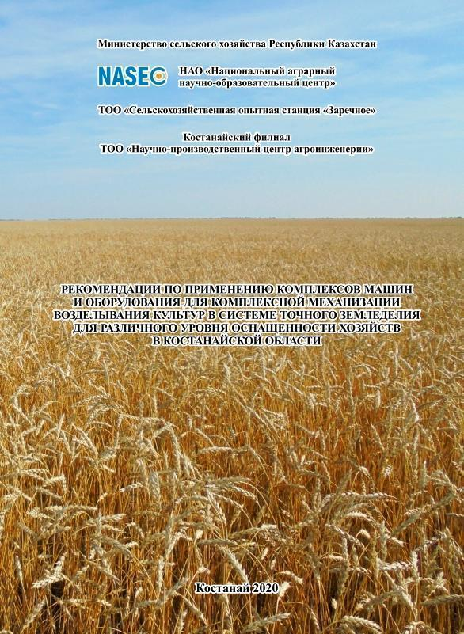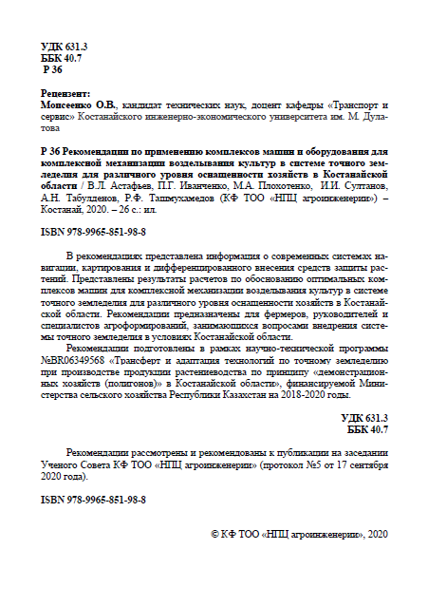
APPENDIX Y

Purchase of equipment, technologies and computer facilities

2018
Sampler unit AgriSoilSampler – 1 unit
Expedition car Mitsubishi L200 (auto insurance, alarm, diesel fuel) – 1 unit
Bow-thruster TrimbleEz-Steer – 1 unit
Equipment set for Kjeldahl analysis based on AKV-20 – 1 unit
Pneumatic sorting machine VIM-1 – 1 unit
Mill for soil samples Vyuga M – 1 unit
Ultrabook (Intelcore i5, RAM 8 GB, video memory 2 GB, weight no more than 1.3 kg) – 2 units
Computer monitor (27-inch diagonal, matrix type PLS) – 1 unit
External hard drive (1000 GB, USB 3.0) – 2 units
Petrol trimmer (engine power – 2.5 kW) – 1 unit
Laptop bag – 2 units
Laptop bag – 1 unit
Soil drill AM-26– 2 units
Tablet Samsung Tab4 – 1 unit

2019
Agronavigator-ASUR-Batcher system – 2 units
Laboratory furniture – 12 units
Geoscan aerial photography system (with a 4S rechargeable battery and a multispectral camera based on Sony A6000) – 1 unit
Software (Sputnik Agro and Agisoft Metashape Professional Edition) for buyers of the Geoscan complex – 1 unit
Digital hardness tester S600 – 1 unit
A set of laboratory cabinets – 1 unit
Photometer "EXPERT-003" Set for soil analysis in accordance with GOST with verification – 1 unit.
Glass cabinet BIRYUSA 290 – 1 unit
Refrigerator BEKO RDSK 240M00W – 1 unit
Laboratory balance VLTE-210S – 1 unit
Multimedia Monoblock ACER Aspire C22-865 – 2 units
Laptop Lenovo/Ideapad 330-15IKB / 15.6" (with accessories: USB mouse, memory card, USB flash drive, surge protector) – 1 unit
Laboratory water bath STEGLER TB-6A – 1 unit
Orbital shaker SKO-300 – 1 unit
Digital anemometer Mastech MS6252A (in the register of Means of measuring of the RK) – 1 unit
Multi-parameter monitor COM-300 PH/EC/TDS/⁰C – 1 unit

2020
Sorting machine SMM-4 with sieves – 1 unit
Bottle-top dispenser 10-100 ml with verification, registration in the Republic of Kazakhstan – 2 units
Inverter – 1 unit
System unit for decoding UAV images (computer) – 1 unit
Yield mapping system for John Deere combines – 2 units
Seeder SKP-2.1A – 1 unit
Component parts for the SKP-2.1 seeder – 2 units
Mavic 2 zoom drone with accessories – 1 unit
Automatic soil sampler Wintex 1000S – 1 unit.
Compressor – 1 unit
Soil collector plate – 1 unit
System unit for processing satellite images – 1 unit
Color printer for printing pictures – 1 unit
Portable device GreenSeeker – 1 unit

APPENDIX Z

Copy of the protocol of the Academic Council of «AES «Zarechnoe» LLP
